UNIVERSITY OF OKLAHOMA

GRADUATE COLLEGE

PREPARATION FOR AUDITION VERSUS PERFORMANCE:

AN EXAMINATION OF FOUR

PROMINENT ORCHESTRAL EXCERPTS FOR TRUMPET

A DOCUMENT

SUBMITTED TO THE GRADUATE FACULTY

in partial fulfillment of the requirements for the

Degree of

DOCTOR OF MUSICAL ARTS

By

LACEY JARAE HAYS
Norman, Oklahoma
2014

PREPARATION FOR AUDITION VERSUS PERFORMANCE:
AN EXAMINATION OF FOUR
PROMINENT ORCHESTRAL EXCERPTS FOR TRUMPET

A DOCUMENT APPROVED FOR THE
SCHOOL OF MUSIC

BY

________________________
Dr. Karl Sievers, Co-Chair

________________________
Dr. Irvin Wagner Co-Chair

________________________
Dr. Roland Barrett

________________________
Dr. Eugene Enrico

________________________
Dr. Kurt Gramoll

© Copyright by LACEY JARAE HAYS 2014
All Rights Reserved.

Acknowledgements

First and foremost, I would like to thank the members of my Doctoral committee: Dr. Roland Barrett, Dr. Eugene Enrico, Dr. Irvin Wagner, and Dr. Kurt Gramoll. Your investment in me has shaped me as a student, teacher, performer and person. Thank you to my Mom, for encouraging me to follow my dreams. Thank you Matt Stock for the idea of this project and thank you Scott Copeland, Adam Miller and Dr. Sanna Pederson for your help on this document. I would also like to thank my very good friends: Brock Bowman, Patrick Horton, and Scott Ayers. Your friendship is priceless.
Thank you Susan Clothier for helping me find my purpose in life; your dedication to music education is unmatched. Dr. Karl Sievers, thank you for believing in me and helping me refine my skills as a trumpet player, musician, and (perhaps most importantly) as a person. Finally, and most importantly, thank you to my husband, Chad Hays; this document would not have been possible without your love and support. Thank you for making my dreams come true every day.

TABLE OF CONTENTS

PREPARATION FOR AUDITION VERSUS PERFORMANCE:
AN EXAMINATION OF FOUR
PROMINENT ORCHESTRAL EXCERPTS FOR TRUMPET

CHAPTER PAGE

1 PURPOSE OF THE STUDY 1
PARTICIPANTS 1
NEED FOR THE STUDY 4
DESIGN AND PROCEDURES 6
RELATED LITERATURE 7
LIMITATIONS 12

2 Petrouchka, Igor Stravinsky 13

3 Symphony No. 5, Gustav Mahler 20

4 Pines of Rome, Ottorino Respighi 26

5 Pictures at an Exhibition,
Modest Mussorgsky/Maurice Ravel 32

6 SUMMARY 39

7 CONCLUSIONS 53
AVENUES FOR FURTHER STUDY 56

BIBLIOGRAPHY 57

APPENDIX A:
IRB INFORMATION SHEET 68

APPENDIX B:
QUESTIONNAIRE WITH RESPONSES 71
APPENDIX C:
IRB APPROVAL LETTER 96

Abstract
The purpose of this document is to examine the preparation for orchestral audition versus performance situations for four of the most commonly requested trumpet excerpts: Petrouchka by Igor Stravinsky; Symphony No. 5 by Gustav Mahler, Pines of Rome by Ottorino Respighi; and Pictures at an Exhibition by Modest Mussorgsky/orchestrated by Maurice Ravel. This document shares knowledge obtained from a survey that included the input of five prominent orchestral trumpet players who are also educators: Ryan Anthony, Tom Booth, Steve Hendrickson, Boyde Hood and Michael Sachs. The document specifically provides the following information from each respondent: (1) key fundamentals of each excerpt, (2) recommended recording(s) of each work containing the excerpt, (3) the respondents’ choice of instrument for each excerpt (for both audition and performance situations), (4) the respondents’ ideas on imagery for each excerpt, and (5) any additional/other factors that respondents chose to include about each excerpt, or additional passages from the work as a whole from which the excerpt came.
The exact words of the respondents themselves are included as an appendix in this document. Each excerpt is covered, in detail, by chapter. This document is intended to serve as a resource for those who wish to research, study, and understand differences between orchestral audition and performance situations.

CHAPTER 1

PURPOSE OF THE STUDY

The amount of information relevant to the preparation of orchestral literature for trumpet is limited. Although books containing excerpts have been compiled, none strictly addresses the differences between preparation practices for an audition versus performance. The purpose of this study was to investigate the difference in preparation of four specific orchestral excerpts for performance versus audition.
Five highly regarded performers/teachers have answered specific questions pertaining to the preparation of four of the most often requested orchestral excerpts for orchestral auditions. In addition, the interviewees have described differences as to how these same excerpts might be prepared for performance.
PARTICIPANTS
Five experts participated in the study: Ryan Anthony (Principal Trumpet of the Dallas Symphony Orchestra); Tom Booth (Fourth Trumpet, Dallas Symphony Orchestra Professor of Trumpet, Southern Methodist University); Steve Hendrickson (Principal Trumpet, National Symphony in Washington D.C.); Boyde Hood (Utility Trumpet, Los Angeles Philharmonic, retired); Michael Sachs (Principal Trumpet of the Cleveland Orchestra and Professor of Trumpet at Cleveland Institute of Music). They have all had substantial careers as orchestral players and are educators.
Ryan Anthony is known for his career as a soloist, educator, chamber musician, and orchestral trumpet player. Currently he serves as Principal Trumpet of the Dallas Symphony Orchestra (2004-present). However, he is also well known for having been a trumpeter in the Canadian Brass. He served as assistant professor of trumpet at Oberlin College from1998-2000 and regularly presents master classes and clinics. He is recognized as an outstanding clinician and performer. His teachers include David Zauder, Bernard Adelstein and Michael Sachs. Mr. Anthony holds B.M. and M.M. degrees from the Cleveland Institute of Music.
Tom Booth currently serves as fourth and assistant principal trumpet in the Dallas Symphony Orchestra (1977 to present). Previously he played second trumpet with the San Antonio Symphony (1975-1977). He currently serves as Adjunct Professor of Trumpet at Southern Methodist University in Dallas (since 1978) where he is head of the Winds, Brass and Percussion Department. Mr. Booth also teaches at the prestigious Round Top Music Festival every summer. In addition to teaching at Southern Methodist University, he held teaching positions at the University of Texas at San Antonio, The University of Illinois, and Illinois Wesleyan University. His teachers include James Darling, Mary Squire, and David Hickman.
Steve Hendrickson serves as principal trumpet of the National Symphony Orchestra, which he joined in 1982. Additionally, he freelances in the Washington area as a soloist and chamber musician and has appeared as a soloist with the National Symphony Orchestra numerous times. Previous to living in the DC area, he freelanced in the Chicago area where he performed with the Chicago Symphony Orchestra and the Lyric Opera, as well as the Chicago Brass Ensemble. Currently he teaches at the University of Maryland. He holds a bachelor degree in philosophy and music from Luther College in Iowa (1973). His teachers included Adolph Herseth, William Scarlett, and Arnold Jacobs.
Boyde Hood joined the Los Angeles Philharmonic in 1982 and has served as principal trumpet of the Los Angeles Chamber Orchestra, Royal Ballet, and American Ballet Theater. He is a former member of the Dallas Symphony, Rochester Philharmonic, Milwaukee Symphony, and the Victoria, British Colombia Symphony. He currently teaches at the Thornton School of Music at the University of Southern California where he serves as senior lecturer of winds and percussion. He has extensively recorded for motion picture and television studios and has held teaching appointments at Ball State University, the University of Victoria in British Columbia and the University of Southern California. He studied at Ball State University where he earned a B.M. in Performance and Music Education. His teachers include Earl D. Irons, Adolph Herseth, Arnold Jacobs and James Stamp.
Michael Sachs is internationally recognized as a leading soloist, recitalist, chamber musician, orchestral musician, teacher, author and clinician. Currently he serves as principal trumpet of the Cleveland Orchestra (1988-present). Prior to that he was a member of the Houston Symphony and performed with the Houston Grand Opera. In addition to appearing on over 150 recorded works, Mr. Sachs serves as Chairman of the Brass Division and Head of the Trumpet Department at the Cleveland Institute of Music. He has also served on the Faculty of the Shepherd School of Music at Rice University. He has several publications including: Daily Fundamentals for the Trumpet; Mahler: Symphonic Works, Complete Trumpet Parts; 14 Duets for Trumpet and Trombone; and The Orchestral Trumpet, a comprehensive (book and CD) overview of standard orchestral trumpet repertoire which was released in May of 2012. Mr. Sachs attended the University of California, Los Angeles where he earned a B.A. in History. He also attended The Juilliard School. His teachers include James Stamp, Anthony Plog, and Mark Gould.
NEED FOR THE STUDY
Of the published literature relating to orchestral excerpts for trumpet, none clarify any differences there may be in preparation for performance versus audition. This study will attempt to elucidate differences between preparing to perform each excerpt versus preparing to audition on each excerpt.
Michael Sachs’ second edition of The Orchestral Trumpet was published in 2013 and includes a supplemental CD. In the introduction to this book, he emphasizes many of the factors necessary for preparation of a successful audition. However, Sachs’ book does not address specific differences between preparing for an audition versus performance.
Brian Shook’s Last Stop, Carnegie Hall, David Hickman’s Trumpet Pedagogy, Vincent Cichowicz’ Orchestral Excerpts for Trumpet with piano reduction accompaniments, and Timothy Kent’s Within the Sphere of the Master are all excellent resources, but they do not directly address the differences relevant to preparation for an audition versus performance.
Philip Smith’s approach to sharing his expertise on orchestral excerpts was to record Orchestral Excerpts for Trumpet. On this CD, his verbal commentary is heard before each excerpt is performed. Other publications include Philip Norris’ Top 50 Orchestral Audition Excerpts for Trumpet, and Rob Roy McGregor’s Audition and Performance Preparation for Trumpet; Orchestral Literature Studies series, the International Trumpet Guild Journal, The Brass Bulletin, and The Instrumentalist. These resources are general in approach and do not specifically differentiate preparation of these excerpts for audition versus performance.
Of the few dissertations on the subject of preparation of orchestral excerpts, none discuss the difference between preparations for audition versus performance. David Hunsicker’s dissertation, titled “Professional Orchestral Auditions for Trumpet: Criteria for Evaluation of Candidates, Common Mistakes and Concerns, and a Discussion of the Top Fifteen Excerpts Asked at Auditions” addresses procedures for preparation and defines frequent problems in auditions. However, the interviewees are not identified and the comparison of audition versus live performance is not defined. Additionally, recordings are not mentioned or recommended.
The aim of this document is to define these differences with the support of the opinions of highly regarded teachers and performers. Anyone aspiring to attain success in orchestral performance will presumably participate in both auditions and live performances. This study will serve as a scholarly resource for players who need to know how to adapt to the situation when performing these excerpts.
DESIGN AND PROCEDURES

Each subject was contacted via email and asked to participate in this study. Each was provided an information sheet (see Appendix A) via email as approved by the University of Oklahoma Internal Review Board. The participants were provided the link for the web address for the questionnaire. The questionnaire was also made available in hard copy format to be mailed to participants upon request. All interviewees chose to answer the questionnaire via survey monkey with the exception of Mr. Boyde Hood. The author spoke with him over the phone and typed his responses, via survey monkey, on Mr. Hood’s behalf.
Per Internal Review Board requirements, participants were asked to electronically agree to participate in this study.
The questionnaire used in this study consists of two sections:
- General information about each participant including the subject’s education, orchestral experience, and teaching experience.
- Specific questions about each excerpt that address the fundamentals and preparation of each excerpt, as well as the participant’s instrument of choice for each excerpt (for an audition as well as for performance). The questions also ask what instrumentalists from other sections within the orchestra would be likely to listen for in a trumpet audition. Finally, participants were asked to name their preferred recording of each work. A copy of the questionnaire appears as appendix A of the proposal, as well as the answers of each participant. During the length of the study, the questionnaire was available online at: https://www.surveymonkey.com/s/HaysExcerptStudy
RELATED LITERATURE
Michael Sachs, Philip Smith, Philip Norris, and Rob Roy McGregor have each published and/or recorded material with commentary on the topic of preparation of orchestral excerpts. Michael Sachs has served as Principal Trumpet of the Cleveland Orchestra since 1988 and played in Houston previous to that. Philip Smith became a member of the Chicago Symphony Orchestra in 1975, and joined the New York Philharmonic as Co-Principal Trumpet in 1978. He served as Principal Trumpet from 1988 to 2013. Rob Roy McGregor was assistant principal trumpet in the Baltimore Symphony from 1970 until he joined the Los Angeles Philharmonic in 1981. Dr. Philip Norris has taught at The University of Northwestern St. Paul since 1993. The many books that have been authored by the above names offer insight into preparation of orchestral excerpts. However, the differences between preparing for an audition and a live performance are not addressed.
Publications exist that do not come with supplemental recordings or commentary, but they do offer limited amounts of information pertaining to performance techniques that differ from audition technique. The differences in these publications involve issues of tempo, which instrument to use, and the specific challenges of off-stage parts. For example, Brian A. Shooks’ book Last Stop, Carnegie Hall depicts the life, teaching and performance practices of William Vacchiano (former Principal Trumpet of the New York Philharmonic and Professor at the Mannes College of Music and the Manhattan School of Music). This book mentions more than once that Vacchiano would trade off with his assistant, Nat Prager, during the “Ballerina’s Dance” in Petrouchka. Vacchiano would play the articulated sections and Prager would play the slurred parts, transitioning seamlessly one to another so as to sound like one person. This is a performance technique that would obviously be impossible in an audition situation. Additionally, in this same book, it is mentioned that Vacchiano had to, at least once, record Petrouchka twice in one day with different orchestras and conductors. The choice of tempo between the two conductors was quite different, and Vacchiano claims that this was one of the most difficult things he ever had to do. Thus, information on the aspect of the conductor’s choice of tempo for Petrouchka may differ a great deal from an audition situation, or, in turn, may influence an individual’s preparation for an audition depending on the knowledge he/she may have of the conductor’s preference(s) of a particular work.
Timothy J. Kent’s book, Within the Sphere of the Master, recollects his time with Adolph “Bud” Herseth (former principal trumpet of the Chicago Symphony Orchestra) as a teacher and colleague. Although performance practices and thoughts on auditions are presented in this book, nothing specific is mentioned about the excerpts that this study addresses.
In the first volume of Rob Roy McGregor’s Audition and Performance Preparation for Trumpet, he suggests that while the “Ballerina’s Dance” from Petrouchka is written for Bb Trumpet, “trumpets in other keys present good alternatives (trumpets in C, D, Eb and even F).” However, he does not mention whether he recommends a certain keyed trumpet for an audition or performance situation specifically.
Pertaining to the off-stage trumpet solo in the second movement, “Catacomba,” from Pines of Rome, Michael Sachs, in his book The Orchestral Trumpet, writes: “As with the Mahler Symphony No. 3 posthorn solo, it’s important to know when the strings change chords. This helps greatly with coordination and timing from off [-] stage.” Similarly, in the third volume of Rob Roy McGregor’s Audition and Performance Preparation for Trumpet, he includes a reduction of the string accompaniment to the off-stage trumpet solo from the same passage. He stated that a performer must play with the strings who are on stage while performing this solo off-stage, and that the soloist cannot “be too free with the pulse.” He continued by stating “it can be extremely unnerving to stand off-stage and wonder just when you are to begin playing!” However, neither of these sources mentions any differences between preparations for an audition versus performance, and intonation, which is often a factor in performance, is not mentioned.
In Christopher Leuba’s A Study of Musical Intonation, he states:
It is frequently suggested that the overtone content of instrumental timbre is a major factor of pitch perception and adjustment. It is obvious that when the trumpet is played off- stage, and is deprived of its brilliant high overtones, we perceive it differently, with most persons agreeing that it is “flat.” The player accordingly tunes the instrument sharper…

This information is pertinent in regards to the off-stage solo in the second movement of Pines of Rome when discussing differences between audition and performance. The distance between the off-stage soloist and the orchestra can cause problems with intonation in a live performance, as the distance can cause the soloist to sound flat in relation to the pitch of the rest of the orchestra. This is not a factor in an audition, however, as the committee is in the same room as the player.
Other orchestral preparation and etude books include Orchestral Excerpts from the Symphonic Repertoire for Trumpet (compiled and edited by Roger Voisin) and Vincent Cichowicz’s Orchestral Excerpts for Trumpet with Piano Reduction Accompaniments. There are others that are no longer in print. Additionally, Hal Leonard publishes the Orchestra Musician’s CD-ROM Library for Trumpet, and Gordon Cherry complied The Complete Trumpet Excerpts Collection.
Dissertations on the subject of orchestral excerpts include: “Substitution of Trumpets in Orchestral Music: Origins, Developments, and Contemporary Practices” by James Russell Buckner; “An Orchestral Audition Preparation Tool for Aspiring Trumpeters” by Todd James Hastings; “Selected Excerpts for the Trumpet and Cornet from the Opera Repertory: a Guide for Preparation and Performance” by Timothy Allen Shaffer; “A Guide to Orchestral Audition Repertoire for Trumpet” by Robert Victor Cannon; “The Most Requested Trumpet Excerpts from the Orchestral Repertoire” by Jan-Krzysztof Dobrzelewski; “Preparation for Orchestral Trumpet Audition: The Perspectives of Three Prominent Orchestra Players” by Heather Victoria Rodabaugh, and “Professional Orchestral Auditions for Trumpet: Criteria for Evaluation of Candidates, Common Mistakes and Concerns, and a Discussion of the Top Fifteen Excerpts Asked at Auditions” by David Hunsicker. The subject matter contained within these dissertations is minimally related to this document as these dissertations do not specifically address these particular excerpts for audition versus performance from the perspective of named, accomplished professionals in the orchestra or in the view of well-respected trumpet professors. Nor do these documents recommend recordings of these specific excerpts.
LIMITATIONS
The scope of this study has been limited to an examination between the differences of preparation techniques of trumpet orchestral excerpts for performance versus audition. Because of the nature of the procedures used for the study, some follow-up questions were included or substituted on an individual basis. The four excerpts selected for this study are among the most requested for auditions. The study excerpts are from Stravinsky’s Petrouchka, Mahler’s Symphony No. 5, Respighi’s Pines of Rome and Mussorgsky’s Pictures at an Exhibition.

CHAPTER 2
Petrouchka, Igor Stravinsky
Igor Stravinsky, Petrouchka, 1947 ed. Third Part, “Ballerina’s Dance” (one measure before rehearsal 134 – rehearsal 139)

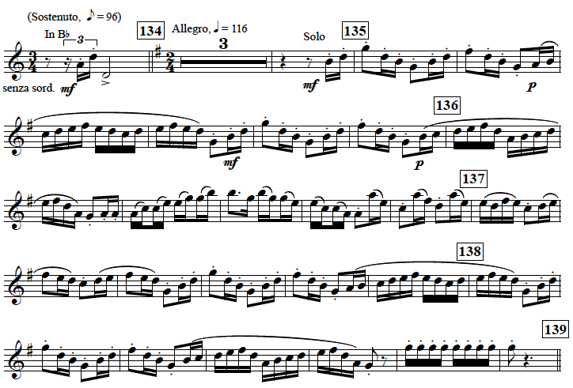

On the questionnaire, the initial question dealt with the most important fundamentals of the excerpt above. For the passage listed above, the “Ballerina’s Dance,” Ryan Anthony chose articulation, flexibility (lip slurs) and accuracy of pulse as the primary fundamentals for this excerpt. For performing in the orchestra and audition situations, Mr. Anthony stated that he plays Bb trumpet for the “Ballerina’s Dance” as it was originally scored for Bb cornet and should be “played with that style.” However, he recommended that students learn this excerpt on C trumpet. He also stated that the “main objective is to make it sound light and easy” in reference to the excerpt only. When asked what instrumentalists from other sections within the orchestra might be listening for on this excerpt, he replied: “rhythm.” He also stated that playing with “dynamics and making it sound easy” are important in regard to what others would like to hear on an audition. Mr. Anthony said that he does not use specific imagery when playing this piece. He simply offered, “You must know that it is music set for a ballerina as the title suggests. It cannot be played heavy.” In terms of overall differences between an audition and a live performance, Mr. Anthony wrote, “I don’t find many differences between audition and performance as it is a solo.”
Mr. Tom Booth chose articulation, accuracy of pulse and overall style as the most important fundamentals for performing this excerpt. He noted that “Intonation is very important, especially in the first [three-]note fanfare.” Observing dynamic changes and playing articulation marks as indicated were also deemed important concept of the excerpt noted by Mr. Booth. The recordings recommended by Mr. Booth include the Chicago Symphony with Adolph “Bud” Herseth playing, the Montreal Symphony with James Thompson playing, and Phil Smith’s Orchestral Excerpts CD. Mr. Booth’s instrument of preference for this excerpt is the C trumpet for both performance and audition. With regard to what instrumentalists from other sections in the orchestra would be listening for on this excerpt, Mr. Booth mentioned style and impeccable time. He continued by stating that “I would start very slowly with exaggerated dynamics and then speed up with [a] metronome to much faster than performance tempo.” He also noted that he practices the excerpt with a metronome sounding the off beats “to cultivate a strong inner sense of time.”
For this work, Mr. Booth said he uses imagery of a ballerina executing specific moves that he envisions for each section. He stated that he would use the same imagery in performance or an audition in order to be consistent in his presentation. “I wouldn’t want it to sound any different with or without the orchestra.” Overall, Mr. Booth does not approach the excerpt any differently for auditions than performance.

Either way, you need to be prepared to play it several different ways, either at the request of a committee in an audition, or a conductor in rehearsal. Also, you need to be prepared to play all the excerpts in this piece, many of which are harder than the Ballerina[‘s] Dance.

Mr. Steve Hendrickson chose the following as the most important fundamentals for the “Ballerina’s Dance”: clear response, tone quality, articulation (single tongued and light in approach), flexibility (lip slurs), accuracy of pulse/rhythm, tempo, intonation, accuracy of intervals, soft dynamics, overall style, and awareness of context. He also added that this excerpt should be “performed to sound effortless, smooth, energetic, [and] clean.” His choice recording of this excerpt was the Cleveland Symphony and he stated that he would perform this excerpt on C trumpet for both performance and audition situations. Concerning the question about imagery for this excerpt, Mr. Hendrickson simply replied, “Dancing ballet.”
Mr. Boyde Hood chose tone quality, articulation (single), and dynamics (loud and soft) as his top choices for the most important fundamentals for this excerpt. For performance, although Mr. Hood stated that he would use a C trumpet, he added that “one should look into performing this excerpt on Eb as an option.” For an audition, he suggested an Eb trumpet. He also noted that “in each setting, one should consider what is most comfortable.” Like Ryan Anthony, Mr. Hood mentioned the need to make this excerpt sound like a cornet, as originally scored. Mr. Hood recommended the Chicago Symphony recording with James Levine conducting, but added that it may be difficult
to find. Additionally, he listed the Boston Symphony with Pierre Monteux conducting and Roger Voisin playing.
Mr. Hood stated that he had served as chairman of the auditions committee in Los Angeles, noting that committees are listening for pitch, sound, and how audition candidates finish phrases. Concerning imagery, Mr. Hood said that in addition to a ballerina, he imagines “a silly little marionette trying to impress a big guy.” He also stated that being aware of what is happening in the ballet during this solo is crucial, and he suggested viewing performances on YouTube.com to see what is occurring onstage during this passage. Furthermore, Mr. Hood noted that, in his opinion, a player’s general dynamic setup should be to take 5 to 10% off all fortissimo markings and play 5 to 10% more on pianissimo markings. This allows the player comfortable dynamic margins that can be expanded if need be.
Michael Sachs chose several different fundamentals as being “essential for performing this passage correctly.” They include clear response, tone quality, articulation (single and light), flexibility (lip slurs), accuracy of pulse/rhythm, tempo, intonation, accuracy of interval(s), dynamics (loud), overall style, and awareness of context. Mr. Sachs listed his top three choices for recordings of Petrouchka as the Cleveland Symphony with Pierre Boulez conducting, the Montreal Symphony with Charles Dutoit conducting, and the Chicago Symphony with Carlo Maria Giulini conducting. In response to the question about his instrument of choice for this passage, Mr. Sachs stated:
Whichever sounds the most appropriate for this passage. I’ve used a C trumpet, C cornet and Eb trumpet at different times in my career. [It] does not matter which one is used in an audition or performance situation so long as the product (sound) suits the passage and the piece.

In reference to what instrumentalists from other sections may be listening for, Mr. Sachs said that this “does not influence my choices at all in either an audition or performance situation.” He continued, “In any case what anyone is listening for is the right sound, style, and character for the moment in the piece along with all the fundamentals in proper place.” His opinion was that imagery is always good and that it is always important to convey a story or character to the listener. Mr. Sachs highlighted the fact that this is a ballet with a specific story that should be considered by the performer “along with the musical context if being played alone in an audition situation.” Being able to gauge acoustical settings in an audition was mentioned as the primary difference between performing and auditioning on this excerpt.

CHAPTER 3
Symphony No. 5, Mahler
Gustav Mahler, Symphony No. 5, I. Trauermarsch.
(Beginning to five measures after rehearsal 1)

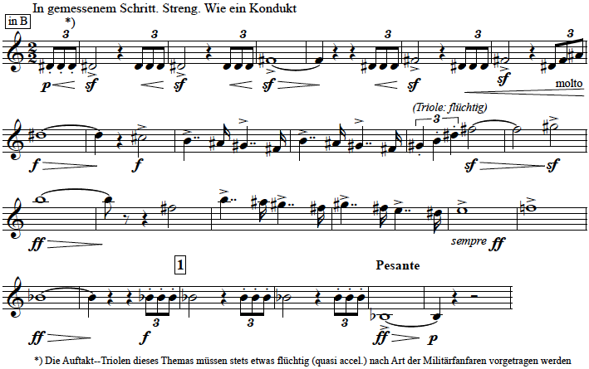

Mr. Anthony chose tone quality, accuracy of pulse/rhythm, and awareness of context as the most important fundamentals associated with this excerpt. The C trumpet was listed as his choice of instrument for both performance and audition. He stated that instrumentalists from other sections would likely be listening for rhythm on this excerpt. Mr. Anthony commented that the soloist must understand when in the excerpt he or she is playing alone, with others, and at which point he/she is playing in unison with the second trumpet. He also pointed out that the solo trumpet is leading the orchestra on this excerpt. Pertaining to imagery for this excerpt, Mr. Anthony replied that he does not use any specific imagery, but that he tends to create an emotional mood when performing this excerpt. Mr. Anthony stated that he would prepare this excerpt in the same manner for audition or performance and that there should be a wide range of dynamics “from the opening triplets to the high A,” but that “dynamics are more controlled by the venue rather than audition versus performance.”
Mr. Booth selected clear response, intonation, and overall style as the three most important fundamentals for the opening trumpet solo of Mahler’s Symphony No. 5. Mr. Booth’s definitive recordings for this work are by the Chicago Symphony with Sir Georg Solti conducting and the Finnish Radio Symphony with Jukka-Pekka Saraste conducting. He listed C trumpet as his instrument of choice for this excerpt for both performance and audition situations. Mr. Booth stated that the primary concern for other instrumentalists observing this excerpt would be articulation, style and the sound quality on loud dynamics. Mr. Booth emphasized that audition candidates should never sound as if playing their maximum volume. In terms of imagery, Mr. Booth stated that he envisions the funeral procession of John F. Kennedy when performing this excerpt. He added that the ability to play this excerpt in many different ways, whether in performance or audition, is extremely important due to the fact that conductors have numerous interpretations of this opening.
For the opening solo of Mahler’s Symphony No. 5, Mr. Hendrickson chose the following fundamentals to best represent a funeral march with “drama, sense of space, [and] breadth of tone”: clear response, tone quality, articulation (multiple tonguing/heavy), accuracy of pulse/rhythm, tempo, intonation, dynamics (loud), overall style, and awareness of context. Specifically, he mentioned that performers should play the opening triplets as if they were in a quarter-note triplet grouping. He also stated that “intonation should be accurate in [the] C sharp arpeggio” and the general style should be “aggressive but controlled.” He suggested the New York Philharmonic recording with Zubin Mehta conducting for this work. His instrument of choice was the C trumpet for both performance and auditions alike. Much like Mr. Booth, Mr. Hendrickson stated that he uses the imagery of a funeral while performing this excerpt. The main difference on this excerpt, between performance and audition, according to Mr. Hendrickson, is that the rhythm in an audition “must be more square.”
In addition to his statement that “the placement of the triplet and sixteenth must be consistent throughout the excerpt,” Mr. Boyde Hood selected articulation (single) and accuracy of pulse/rhythm as the most important fundamentals of the opening solo in Mahler Five. Mr. Hood clarified that the consistency of sound is also important. The recordings suggested by Mr. Hood include the Chicago Symphony (with Adolph “Bud” Herseth playing and Claudio Abbado conducting), the Berlin Philharmonic (with Sir Simon Rattle conducting) and the Vienna Philharmonic recording from the 1980’s (recorded by Deutsche Grammaphon). Mr. Hood said that his instrument of choice for this excerpt is a large orchestral D trumpet, though he stated that he has also used a Db trumpet to perform the first movement. Mr. Hood offered that a large orchestral D trumpet, such as a Bach (long or regular bell) or the Yamaha D (specifically, the model from the mid 1980’s) allows for an audition candidate to “blow into it a little bit more.” He continued that it also provides a “great sound for audition and for live performance.” In response to what other instrumentalists may be listening for on this excerpt, Mr. Hood offered that the “loud dynamic of this excerpt should be altered so that you don’t sound raw.” He added that taking 5 to 10% off one’s dynamic in an audition allows flexibility on the dynamic if the committee asks for more volume. In terms of imagery, Mr. Hood offered that he thinks of this opening solo “as a threat or warning.” Akin to Mr. Booth, Mr. Hood stated that the imagery should be consistent in both performance and auditions.
Clear response, tone quality, articulation (single), range (high and low), accuracy of pulse/rhythm, use of rubato, tempo, intonation, accuracy of interval(s), dynamics (loud and soft), overall style, and awareness of context were the most important fundamentals selected by Mr. Sachs for this excerpt. Mr. Sachs clarified that his choice of “use of rubato” was chosen in reference to the flüchtig triplet figure in the excerpt. As for recordings of this work, Mr. Sachs recommended the New York Philharmonic (with Zubin Mehta conducting) and the Chicago Symphony (with Sir Georg Solti conducting).
Mr. Sachs uses the C trumpet for both audition and performance situations for this excerpt. Mr. Sachs stated that his preparation for performance or audition is not influenced by what other instrumentalists may be listening for on this excerpt, though he did state that the right sound, style and character, in combination with all fundamentals in the proper place, is most ideal. He did not list any specific examples of imagery for this work though he did state that imagery is always good and that it is important to convey a story or character to the listener. Again, as in his earlier reference to the “Ballerina’s Dance” in Petrouchka, Mr. Sachs stated that gauging the acoustics of the performance or audition venue is a must so that “the appropriate dynamics and style” come across appropriately.

CHAPTER 4

Pines of Rome, Ottorino Respighi

Ottorino Respighi, Pines of Rome, II. Pini presso una Catacomba. Off-stage Solo.
(eight measures after rehearsal 10 – nine measures before rehearsal 11)

TROMBA INTERNA in D0
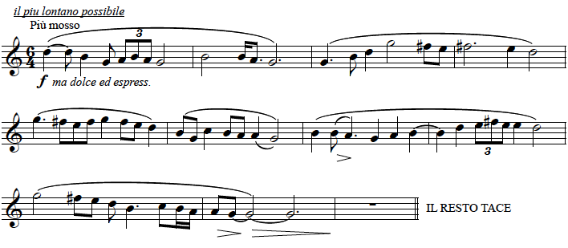

Mr. Anthony selected tone quality, accuracy of pulse/rhythm, and intonation as the most important fundamentals for the off-state solo from the second movement of Pines of Rome. Mr. Anthony listed the C trumpet as his choice of instrument for this excerpt, for both performance and audition. He stated that instrumentalists from other sections within the orchestra would likely be listening for rhythm and intonation on this specific excerpt. “Since the solo part is also played by the violins on stage you must have rhythm and intonation that can be followed.”
In response to the question about imagery, Mr. Anthony replied, “This piece does lend itself to imagery as it was written to depict a place. But I mostly think of just singing.” Overall, Mr. Anthony noted that this excerpt must sound natural, yet in strict time. In terms of differences in playing this solo for audition or performance, Mr. Anthony offered the following on dynamics:
When playing in performance you will most likely have to play it with some volume to make up for the off-stage placement[.] When playing it for an audition DON’T try to create that distant soft sound that would be heard from the stage, just play naturally[,] giving the committee the chance to hear what type of phrasing and sound you possess.

Mr. Booth chose tone quality, intonation and overall style as the most important fundamentals for this off-stage excerpt. He also specified that the “style needs to be very relaxed but time needs to be steady.” Mr. Booth recommended four recordings of the off-stage solo from Pines of Rome: The Montreal Symphony (with James Thompson playing), the Cincinnati Symphony (with Jesus Lopez-Cobos conducting), the NBC Symphony (with Arturo Toscanini conducting) and the Phil Smith Orchestral Excerpts CD. Mr. Booth stated that he prefers the C trumpet for both performance and audition situations for this excerpt. In terms of what other instrumentalists might be listening for, Mr. Booth replied, “Sound, style and intonation.” Additionally, Mr. Booth recommended playing this passage for other instrumentalists to get a “non-trumpet view.” As for imagery, Mr. Booth stated, “I hear the rhythm and then think of an image of pines in the south of Rome near the Catacombs.” He suggested always using the same imagery whether playing an audition or performance. Like Mr. Anthony, Mr. Booth clarified that the excerpt would probably need to be played louder off-stage, in a performance, than in an audition.
In addition to listing several important fundamentals for this excerpt, including clear response, tone quality, intonation, lyrical, overall style, and awareness of context, Mr. Hendrickson noted that the performer should exhibit accurate syncopation and triplet figure in the opening measure of this excerpt. He noted that the excerpt should be performed with a “very warm sound, vibrato, and [be] well phrased.” Chicago Symphony (with Fritz Reiner conducting) was Mr. Hendrickson’s recommended recording of this excerpt. He listed the C trumpet as his instrument of choice for this excerpt. In regard to imagery, Mr. Hendrickson recommended that performers think of a beautiful color, such as lavender, rather than a specific character or idea. Like Mr. Anthony and Mr. Booth, Mr. Hendrickson noted that this excerpt should be played more quietly in an audition than in performance. He added, “It should sound as if far away.”
Mr. Hood chose the following as the primary fundamentals of this excerpt: tone quality, accuracy of pulse (rhythm), and intonation. Mr. Hood recommended the Chicago Symphony (with Fritz Reiner conducting) as well as the Philadelphia Orchestra (with Eugene Ormandy conducting). Unlike the other interviewees, Mr. Hood recommended using a D trumpet for this excerpt for both audition and performance. Playing a D trumpet “puts you in the key of F major and gives you some flexibility on intonation” on this solo.
When asked what he may recommend based on what other instrumentalists might be listening for on this excerpt, he discussed intonation due to the off-stage nature of the solo in performance. “When performing this live, you must push in your tuning slide and play in tune as you will be perceived as flat if you do not.” Unlike any of the other participants in the study, Mr. Hood mentioned Chris Leuba’s treatise on intonation, and the relationship of the root, third and fifth that outline this melody. In performance, “you have to play in tune with the people you’re playing with and where you are in the chord; root, third, fifth, etcetera.”
Mr. Hood offered that in audition situations, committee members often tap their fingers and that audition candidates often played the eighth-note like a triplet, which is incorrect. He said that dropping a half or full beat at the end of every phrase was also a typical mistake on this solo in audition situations. As for imagery, Mr. Hood said that he thinks of this solo as a song, “like singing a beautiful chant.” He mentioned that the melody of this off-stage solo is from the Kyriale, a collection of medieval chants. “When you play through the chant that Respighi based this on, as he was a devout Catholic, you realize the freedom, simplicity and uncluttered nature of the chant.”
Mr. Sachs chose the following as the most important fundamentals of this off-stage solo excerpt: clear response, tone quality, accuracy of pulse/rhythm, tempo, intonation, lyrical, accuracy of interval(s), dynamics (soft), overall style, and awareness of context. He clarified his selections by stating, “This passage also needs an even sound throughout the registers played[,] as well as the right flow and character.” Mr. Sachs recommends recordings of this work by the Chicago Symphony (with Fritz Reiner conducting) as well as the Philadelphia Orchestra (with Eugene Ormandy conducting). Mr. Sachs recommended using a C trumpet in both audition and performance for this off-stage solo and, as in his previous responses, does not allow his preparation practices to be influenced based on what instrumentalists from other sections within the orchestra may be listening for on this excerpt. He did state, however, that “the right sound, style and character” is what anyone is listening for on this solo. Though he answered that he does use specific imagery, he did not give a specific example. He simply stated that it is always important to convey a story or character to the listener. In regard to any other differences between audition and performance, Mr. Sachs stated:
All factors are exactly the same for me whether performing or playing this in an audition situation. The only thing that may be slightly different in an audition would be how the sound is from the part of the stage you are playing since you are not off-stage. The dynamic needs to be as lontano and cantabile as possible. Gauge the acoustics from where you are on-stage and what it sounds like in the hall and play what will be the appropriate dynamics and style so it comes across with the right warmth and lyricism.

CHAPTER 5

Pictures at an Exhibition, Mussorgsky/Ravel

Modest Mussorgsky, orchestration by Maurice Ravel,
Pictures at an Exhibition, I. Promenade.
(Beginning to rehearsal 2)

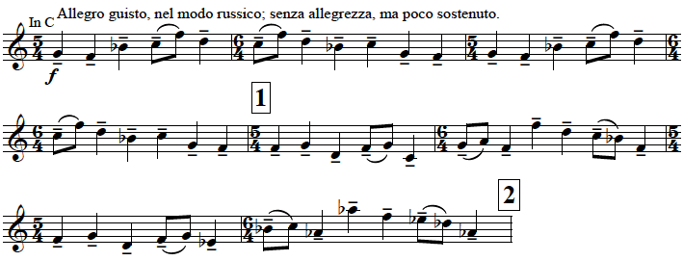

Tone quality, accuracy of pulse/rhythm and awareness of context were the top three choices that Mr. Anthony made pertaining to the opening solo of Pictures at an Exhibition. Mr. Anthony stated that he would use a C trumpet for this excerpt. In response to what other instrumentalists may be listening for on this excerpt, and how that influences his preparation, Mr. Anthony made the point that knowing one’s role, on this excerpt, is very important in terms of fitting into the orchestra as a whole.

Are you playing a solo or playing principal trumpet leading the brass section? I don’t play it all the same as it’s not written that way[,] and you need to play the audition in a way that the committee can hear their own parts and know when to come in.

In terms of imagery, Mr. Anthony clarified that this work was written as imagery and that the “Tempo is based on walking comfortably. [Therefore, the] style should not be rushed or in a hurry.” Mr. Anthony added, “Make sure you know when the brass enters and when you’re by yourself! You don’t have to start loud but I would change my sound slightly[,] a bit broader[,] when the brass enters” in order to show that “you are the leader.” He also offered, “The octave leaps are not that difficult if you think of the top note as a downbeat bringing in the rest of the section.”
Mr. Booth chose tone quality, articulation (single) and intonation as the three most important fundamentals of this opening solo. Mr. Booth recommended two recordings of the Chicago Symphony, one with Carlo Maria Giulini conducting, the other with Neeme Jarvi conducting. Like all participants, Mr. Booth recommended using a C trumpet for both performance and audition situations. Mr. Booth stated that instrumentalists from other sections would likely listen for sound, intonation and articulation but that this does not influence his preparation practices. As for imagery, Mr. Booth said that he imagines a James Bond character in the Louvre and suggests using the same imagery for both performance and audition situations. Concerning this excerpt, he does not see a difference in preparation for an audition or performance. In response to the final question (which asks about any additional factors that illuminate the difference between preparing for a performance versus audition/feel free to comment on any additional passages/excerpts from this work), he noted that the excerpt later in the same work, Goldenberg and Schmuyle, is an endurance issue, especially if you have to play it immediately before or after other excerpts and that mixing it up often in practice auditions is ideal.
Tone quality, intonation and overall style were the three most important fundamentals selected by Mr. Hendrickson for the opening of Pictures at an Exhibition. Under “Other (please specify)” Mr. Hendrickson wrote that this excerpt should “Not [be] too marchy and not too hymn-like.” He stated that evenness, with modest vibrato, and a ringing and full tone are fundamental characteristics for this excerpt. Mr. Hendrickson recommended the recording of this work by the Chicago Symphony (with Fritz Reiner conducting). Like the other participants in the study, Mr. Hendrickson recommended the use of a C trumpet for both performance and audition situations. When answering the question about imagery, Mr. Hendrickson simply stated, “A man walking.” Mr. Hendrickson added that focusing on good intonation, always playing with a great sound, thinking of singing, and playing as an individual are pertinent for good habits for performance and audition situations alike.
In addition to tone quality and articulation (single) being the most important factors of this excerpt, Mr. Hood added that having the same sound and same attack on every note is also important. Additionally, “How you release the last note at the end of every two bars” on this excerpt is of vital importance. He also recommended conducting and singing this excerpt when preparing for performance or audition situations. Mr. Hood listed three recordings of this excerpt. They include the Chicago Symphony (with Fritz Reiner conducting), the Chicago Symphony (with Seiji Ozawa conducting from the 1960s) and the Philadelphia Orchestra (with Eugene Ormandy conducting). Like all other participants, Mr. Hood recommends a C trumpet for this excerpt for performance and auditions.
When asked what other instrumentalists may be listening for and how this would influence his preparation, Mr. Hood replied, “In an audition, the dynamic level at which you play should be more conservative than with a performance.” He also commented, “Breathing is an issue on this excerpt. Breathing must be part of the music.” When preparing this excerpt, “play 2 bar phrases and don’t go on, so as to finish the last note of every phrase.” Mr. Hood also suggested that many players compress the two eighth-notes and that playing the first line without the top line F allows one to hear the sustaining aspect of the excerpt. “When you’ve worked on the music in two bar phrases, you know how you want the music to go.” In terms of imagery, Mr. Hood replied, “I’ve always imagined a large Russian man, walking up the steps and into the Hermitage in St. Petersburg.” He also stated, “I like to keep the imagery consistent on auditions and performance.” Like Mr. Booth, Mr. Hood mentioned Goldenberg and Schmuyle, an often requested excerpt from a movement later in the same work. In contrast to Mr. Booth’s comments, Mr. Hood stated that he prefers to use a D trumpet instead of the more popular choice of piccolo trumpet for the performance of Goldenberg and Schmuyle. He also mentioned that one should consider playing the Promenade on D trumpet in auditions as “…playing the Promenade (just before Goldenberg and Schmuyle) on D trumpet sets you up to play it on D nicely.”
Mr. Sachs chose the following as the most important fundamentals for the Promenade solo: clear response, tone quality, articulation (single), flexibility (lip slurs), accuracy of pulse/rhythm, tempo, intonation, accuracy of interval(s), dynamics (loud), overall style, and awareness of context. He clarified, “I checked ‘dynamics (loud)’ but realistically this is only forte and needs to be played in an easy, stately, and full manner.” Mr. Sachs chose the Montreal Symphony (with Charles Dutoit conducting) and the Chicago Symphony (with Fritz Reiner conducting) as his recordings of choice for preparation of this excerpt. C trumpet is his choice of instrument for both performance and audition situations. As in the case of the previous excerpts, Mr. Sachs stated that there is no influence on his preparation for this excerpt based on what other instrumentalists may be listening for. He again clarified, however, that “In any case what anyone is listening for is the right sound, style, and character for the moment in the piece along with all fundamentals (rhythm, intonation, dynamics, articulation, placement of notes, evenness of sound, etc) in proper place.” As in his previous answers, he recommended using imagery but did not give a specific example. Again, in terms of factors that may be different in audition or performance situations, Mr. Sachs stated that “this is the one passage where they are really listening for your sound quality[.] Avoid over[-]blowing and playing instead [with] a beautiful, stately, and solid forte.”

CHAPTER 6

SUMMARY

While each respondent had his own suggestion(s) on how to execute these excerpts in performance and audition situations, their answers were often similar. General responses included Mr. Hendrickson’s statement, “Play as an individual.” Mr. Hood offered, “There is always a musical solution.” Mr. Booth wrote,
To me, consistency of preparation is the key to excellent auditions and performances. I think it’s important to always think of the same images to present consistent style, and I also think it’s important to be flexible enough to play excerpts many different ways to be able to meet the requests of conductors or audition committees [.]

Like Mr. Anthony, Mr. Sachs offered that playing in accordance with the acoustics is important. Mr. Anthony stated, “dynamics are more controlled by the venue rather than audition vs. performance.” In order to accommodate potential readers, below is a summary of important points and topics for each excerpt. Should an observer want further details, they may be found in the body of this document (Chapters 2 -5) as well as Appendix B where the original written communication from the respondents is located.

Petrouchka, Igor Stravinsky
KEY FUNDAMENTALS
The single most important fundamental selected by every respondent for the “Ballerina’s Dance” was single-tonguing articulation. Accuracy of pulse and/or rhythm was selected by four of the five participants while flexibility (lip slurs) was selected by three of the five respondents. Though there were other selections made by the respondents, these three fundamentals were selected by four or more of the respondents for Petrouchka’s “Ballerina’s Dance.”
Petrouchka, Igor Stravinskty
RECOMMENDED RECORDINGS
Because Mr. Anthony chose not to include any information on recordings for any excerpt in this study, he will not be included in the “Recommended Recordings” sections for this chapter. For Petrouchka, 3 of the 4 remaining candidates recommended listening to both the Montreal Symphony (with Charles Dutoit conducting) and the Chicago Symphony (with Sir Georg Solti conducting). The Cleveland Orchestra (with Boulez conducting) was mentioned by two of the respondents: Mr. Hendrickson and Mr. Sachs. Though there were other recordings mentioned, the consensus was the recommendation to observe these specific recordings.
Petrouchka, Igor Stravinsky
INSTRUMENT OF CHOICE
For Petrouchka, each respondent mentioned the use of C trumpet for this excerpt. Mr. Booth and Mr. Hendrickson mention only a C trumpet for both performance and audition situations. However, though Mr. Anthony uses a Bb trumpet in both performance and audition situations for the “Ballerina’s Dance,” he recommends that students learn this excerpt on C for trumpet. Mr. Hood recommends the use of a C trumpet for performance and an Eb trumpet for audition situations. He clarified that “one should consider what is most comfortable.” Mr. Sachs stated that he had used C trumpet, C cornet and Eb trumpet at different times in his career and that it does not matter which horn is used in any situation, as long as the sound suits the passage and piece.
Petrouchka, Igor Stravinsky
IMAGERY
Every respondent’s answer about imagery for the “Ballerina’s Dance” included the word “ballet: or a “ballerina.” No respondent mentioned specific differences for use of imagery between audition and performance situations, with the exception of Mr. Sachs when he stated, “Since this is a ballet with a specific story that is what needs to be thought of, along with the musical context if being played alone in an audition situation.” While Mr. Anthony stated that he himself did not use imagery when performing this excerpt, he did note, “You must know that it is music set for a ballerina as the title suggests.” Mr. Booth clarified that when playing, he thinks of a ballerina doing specific moves for each section of Petrouchka and that it is important to remain consistent in one’s presentation. Mr. Hendrickson’s reply was quite simple: “Dancing ballerina.” Mr. Hood suggested imagery of the ballerina and “a silly little marionette trying to impress a big guy.”
Petrouchka, Igor Stravinsky
OTHER FACTORS
Mr. Anthony and Mr. Booth were in agreement, that there is not “much difference in this excerpt between auditioning and performing.” However, Mr. Booth did mention that one should be “prepared to play it several different ways, either at the request of a committee in an audition, or a conductor in a rehearsal.” Mr. Anthony stated that the solo nature of the “Ballerina’s Dance” is what limits the differences between an audition and performance situations. Mr. Hood suggested that in an audition situation, one should play fortissimo dynamic markings approximately 5 to 10% less and should play pianissimo dynamic markings 5 to 10% more in order to be able to play more, or less on dynamics if asked by an audition committee.
While Mr. Hendrickson chose not to answer this question, Mr. Sachs offered, “The only thing that may be slightly different in an audition would be the context without the snare drum playing and how the sound is from the part of the stage you are playing if not from the usual position of the trumpet chair.”
Symphony No. 5, Gustav Mahler

KEY FUNDAMENTALS

For the opening solo in Mahler’s Symphony No. 5, accuracy of pulse was listed by four of the five respondents as the most important fundamental. Articulation was selected by three of the five respondents, as was awareness of context. These represent the fundamentals listed by the majority of the respondents.
Symphony No. 5, Gustav Mahler

RECOMMENDED RECORDINGS
Three of the four respondents chose recordings of the Chicago Symphony for the opening solo of Mahler’s Symphony No. 5. While Mr. Booth and Mr. Sachs recommended the recording of Chicago (with Sir Georg Solti conducting), Mr. Hood recommended the Chicago Symphony (with Claudio Abbado conducting). Mr. Hendrickson and Mr. Sachs both recommended the New York Philharmonic (with Zubin Mehta conducting). Additional recordings mentioned individually were: The Finnish Radio Symphony (conducted by Jukka-Pekka Saraste,) the Vienna Philharmonic (conducted by Leonard Bernstein,) and the Berlin Philharmonic (with Simon Rattle conducting).
Symphony No. 5, Gustav Mahler
INSTRUMENT OF CHOICE
Four of the five respondents chose C trumpet for both audition and performance situations for the opening solo of Mahler’s Symphony No. 5. Mr. Hood was the only respondent to recommend a D trumpet as “a good choice to consider for both a performance an audition.” He clarified, “In the audition, [this horn] gives you a great sound for [an] audition and for live performance, I feel this horn gives you more leeway, and you can blow into it a little bit more.” Mr. Hood mentioned that he had also used Tom Stevens’ Db on the first movement as well.

Symphony No. 5, Gustav Mahler
IMAGERY
In response to the question pertaining to imagery, Mr. Booth and Mr. Hendrickson mentioned a funeral, or funeral procession for the opening solo of Mahler’s Symphony No. 5. Mr. Hood mentioned that he envisions this excerpt as a threat or warning and mentioned that keeping the imagery consistent between performance and audition situations is important. Mr. Sachs and Mr. Anthony did not offer a specific example of imagery.
Symphony No. 5, Gustav Mahler
OTHER FACTORS
Three of the five respondents made statements about the dynamics of this excerpt. Mr. Anthony mentioned that the dynamic range needs to be wide from the opening triplets to the high A but that the “dynamics are more controlled by the venue rather than audition vs. performance.” Mr. Booth mentioned, “I would make sure I never sounded like I was playing as loud as I could.” Mr. Hood offered that one should “take 5 to 10% off dynamic[s] in an audition… If they ask for more volume, you have it.”
While Mr. Booth’s response centered around interpretation and being able to perform the excerpt as requested, whether performing or auditioning on the excerpt, Mr. Hendrickson mentioned that rhythm must be “more square” for an audition. Additionally, Mr. Anthony stated that rhythm was likely what other instrumentalists in the orchestra would be listening for in a performance as this excerpt is “leading the orchestra.” Mr. Anthony also commented that the performer should know when he/she is playing alone and with the second trumpet, as this detail must be precise.
Pines of Rome, Ottorino Respighi
KEY FUNDAMENTALS
Tone Quality and Intonation were the two key fundamental selected by all five respondents for this excerpt while Accuracy of Pulse was selected by the majority, three of five respondents.
Pines of Rome, Ottorino Respighi
RECOMMENDED RECORDINGS
Three of the respondents recommended the Chicago Symphony Orchestra (with Fritz Reiner conducting). The second most recommended recording was the Philadelphia Orchestra (with Eugene Ormandy conducting). Additional recordings that were mentioned include the Montreal Symphony (with Charles Dutoit conducting), the Cincinnati Symphony (with Jesus Lopez-Cobos conducting), the NBC Symphony (with Arturo Toscanini conducting), and the Orchestral Excerpts for Trumpet CD by Phil Smith.
Pines of Rome, Ottorino Respighi
INSTRUMENT OF CHOICE
Four of the five respondents stated that they would use a C trumpet for both audition and performance situations. However, as on Mahler V, Mr. Hood recommended a D trumpet for this excerpt as “it puts you in the key of F Major and gives you some flexibility on intonation.” Mr. Hood recommended D trumpet for both audition and performance situations.
Pines of Rome, Ottorino Respighi
IMAGERY
Three respondents gave specific examples of imagery for this excerpt. Mr. Booth offered that he thinks “of an image of the pines in the south of Rome near the Catacombs.” Mr. Hood stated that he thinks of singing a beautiful chant, as Respighi based this melody on a medieval chant. Mr. Hendrickson stated that he thinks of a “beautiful color, like lavender.” While Mr. Anthony acknowledged that this work does lend itself to imagery, “as it was written to depict a place,” he mostly thinks of “just singing.” Mr. Sachs mentioned that imagery is “important to convey a story or character to the listener.” He did not offer a specific example.
Pines of Rome, Ottorino Respighi
OTHER FACTORS
Three of the five respondents mentioned that there is a difference in dynamics depending of if this solo is being performed live (off-stage), or in an audition. Mr. Anthony and Mr. Booth stated that this excerpt should be played louder in a performance situation, as the player is off-stage. Mr. Hendrickson offered, “In an audition, play more quietly. It should sound as if far away.”
While the majority of the respondents focused on dynamics, Mr. Hood’s comments focused on intonation and the importance of playing with a steady pulse. Mr. Hood commented that in performance, one should be aware of the need to push their tuning slide in “as you’ll be perceived as flat if you don’t.” For audition situations, Mr. Boyd pointed out that he has often observed committee members “tapping their fingers” and that audition candidates would “often play the eighth note like a triplet and/or drop a half a beat or a full beat.” He also cautioned that most audition candidates drop a beat at the end of every phrase on this excerpt.
Mr. Boyd also mentioned that the melody of the off-stage solo in the second movement of Pines of Rome was based on a medieval chant. Further research shows that the chant is from the “Sanctus” of Saint Antoine Daniel’s Missa IX, Cum Jubilo (With Joyful Shouting). The chant can be found in multiple sources, including The St. Gregory Hymnal and Catholic Choir Book.
Figure 1. “Sanctus” from Missa IX: Cum Jubilo.

Pictures at an Exhibition, Modest Mussorgsky

KEY FUNDAMENTALS

Tone quality, intonation, and articulation were the fundamentals selected by the majority of the respondents for the opening solo of Pictures at an Exhibition. Awareness of context and style were additional fundamentals selected by more than one respondent.
Pictures at an Exhibition, Modest Mussorgsky

RECOMMENDED RECORDINGS
The Chicago Symphony was the overwhelming recommended ensemble for recordings of Pictures at an Exhibition. While Mr. Hendrickson, Mr. Hood and Mr. Sachs all recommended the Chicago Symphony with Fritz Reiner conducting, Mr. Hood recommended Seiji Ozawa conducting. Mr. Booth recommended Carlo Maria Giulini and Neeme Jarvi conducting the same ensemble. Additionally, Mr. Sachs recommended The Montreal Symphony with (Charles Dutoit conducting) and Mr. Hood recommended the Philadelphia Orchestra (with Eugene Ormandy conducting).
Pictures at an Exhibition, Modest Mussorgsky
INSTRUMENT OF CHOICE
Every respondent recommended the use of a C trumpet for this excerpt for both performance and audition situations.
Pictures at an Exhibition, Modest Mussorgsky
IMAGERY
Three of the respondents, Mr. Anthony, Mr. Hendrickson and Mr. Hood, stated that they envisioned “walking” when performing this excerpt. Mr. Sachs, as in all other cases, simply stated that imagery is important but chose not offer a specific example. Mr. Anthony added that the tempo for this excerpt should be based on “walking comfortably” and that the “style should not be rushed or in a hurry.” Mr. Booth offered that he prefers to think of Odd Job, a character from James Bond, in the Louvre when preparing or performing this excerpt. Mr. Hood specifically stated that he has “always imagined a large Russian man” walking up the steps and into the Hermitage in St. Petersburg.
Pictures at an Exhibition, Modest Mussorgsky
OTHER FACTORS
Mr. Anthony’s response focused on the fact that principal players should be aware of when they are playing alone versus with others on this excerpt. Mr. Booth stated that sound, intonation and articulation are the factors that instrumentalists from other sections within the orchestra would likely be listening for on this excerpt. He added that “Goldenberg and Schmuyle,” an often requested excerpt from a later movement in this work, should be a consideration of the performer in terms of endurance. He recommended preparing for auditions by playing excerpts in different sequential orders in order to be best prepared for auditions due to the demands of “Goldenberg and Schmuyle.” Mr. Hendrickson stated that one should focus on good intonation for this excerpt while Mr. Hood focused on the importance of dynamics, articulation, sustain, and release of notes at the end of phrases. In addition to his opinion on the importance of the acoustical effects of one’s placement in an audition versus performance, Mr. Sachs offered that because audition committees are listening for sound quality on this excerpt, it is important to “avoid over[-]blowing and playing instead a beautiful, stately, and solid forte.”

Chapter 7

Conclusions

In both performance and audition situations, performers are well advised to maintain awareness of acoustics, stylistic concerns, possible unexpected events or surprises, dynamic contrast, difference in pitch perception when performing off-stage solos, and personalized imagery. The respondents in this study recognize that performers not only must play very well and very musically, but they also must be aware of how the acoustics of a room may influence how they are perceived as a member of the orchestra, both in performance and as an audition candidate. Examining the acoustical space in advance is thus advisable for performers who wish to play in a manner that is suitable to the conditions of the performance or audition. In an audition, the committee might be only 10 feet away, whereas in a concert hall, an observer could be in the balcony with a full hall. The performer should be willing and able to gauge and make adjustments to accommodate the acoustics of any situation.
Clearly, performers should take special care to play loud excerpts, such as the opening to Mahler’s Symphony No. 5, at a dynamic level acceptable to any and all members of the audition committee. Likewise, the off-stage solo in the second movement of Pines of Rome should be approached with the consideration that the dynamics should be altered depending on the playing situation. It is prudent for the performer to consider that off-stage solos such as this should be played more softly in an audition situation than in a live performance. Additionally, the performers must be aware that their pitch may be perceived at a lower frequency when performing this excerpt in off-stage.
Whether in an audition or performance situation, and whether playing alone or with an orchestra, the performer should consider adjusting their presentation to fit the situation, depending upon the excerpt being performed. The survey participants’ responses suggest that audition committees may feel more confident in an audition candidate who is able to make adjustments in their playing based on their awareness of context.
According to the survey respondents, the accuracy of pulse/rhythm in an audition situation is more important than in a performance situation. It is understood that in a performance, the pulse or rhythm could vary depending on the musical interpretation of a conductor or other performing musicians. However, in an audition, it is important for the audition candidate to convey to the audition committee that they are able to perform with accurate pulse without dropping beats or losing time due to breaths, phrasing, or other musical considerations not present in live orchestral performance.
Recommended recordings were mentioned by four of the five respondents. Although not every participant listed the same recording in all cases, there was some overlap among the answers. Based on the responses gathered in this study, it is recommended that audition candidates listen to several recordings and acquaint themselves with the stylistic values of each.
For every excerpt, the respondents suggested that the performer use the same instrument in performance and audition situations. The respondents did not always recommend the same instrument for each excerpt, so the best advice is probably that the performer should use the instrument with which they are most comfortable.
The participants’ responses suggest that, although imagery is generally helpful, the specific imagery used for each excerpt certainly might vary from person to person. For some performers, a simple color or feeling might be just as helpful as an idea of a specific character or story.
Moreover, the responses suggest that players should be prepared to play these excerpts in any stylistic manner possible, whether in an audition or a performance situation. In a performance or rehearsal, the ability to adjust to diverse styles will help the performer adapt flexibly to conductor’s instructions and blend with the surrounding instrumentalists. Likewise, stylistic flexibility is beneficial during auditions, when a committee member might request a particular style or interpretation.
Mr. Hood was the only respondent to mention the importance of the release of notes at the ends of phrases or excerpts. Because of his many years of experience with performances, audition candidates, and audition committees, performers might want to pay particular attention to his comments. Mr. Hood also noted that performers should always be prepared for unexpected situations to arise during both live performances and auditions. Bearing in mind that anything is possible at any time is likely to counteract the disruption caused by surprise events, and result in the best possible performance under the circumstances.
AVENUES FOR FURTHER STUDY
This study sought responses only from prominent trumpet players who are also educators. Thus, one direction for further work in this area is the expand the pool to include a more diverse population. For example, a future study could compile input from brass players (other than trumpet players) as well as woodwind, string and percussion performers who are members of major symphony orchestras. Another possibility is to focus on principal brass players other than trumpet players in major symphony orchestras.
All five respondents in this study are from North America and they all play in orchestras in the United States. Therefore, expanding the population sample to prominent trumpet players in other locations, such as Europe, Australia, Asia, or Russia is a research option that would highlight different stylistic or performance practices of these excerpts due to geographical variation. A study of conductors with similar or varying instrumental backgrounds might also be instructive to performers. Another potentially informative research approach might be to interview recording technicians.
Exploring additional orchestral excerpts is another option for further study. Likewise, studying excerpts from band literature or opera orchestra literature, in the same manner as this study, could prove helpful for performers aspiring to join these types of ensembles.

BIBLIOGRAPHY

BOOKS

Bartold, Gabriel, ed. Orchestral Excerpts from the Symphonic Repertoire for Trumpet. Vol. I. New York: International Music Company, 1948.

________, Orchestral Excerpts from the Symphonic Repertoire for Trumpet.
Vol. II. New York: International Music Company, 1948.

________, Orchestral Excerpts from the Symphonic Repertoire for Trumpet.
Vol. III. New York: International Music Company, 1948.

________, Orchestral Excerpts from the Symphonic Repertoire for Trumpet.
Vol. IV. New York: International Music Company, 1948.

________, Orchestral Excerpts from the Symphonic Repertoire for Trumpet.
Vol. V. New York: International Music Company, 1948.

________, Orchestral Excerpts from the Symphonic Repertoire for Trumpet.
Vol. VI. New York: International Music Company, 1948.

________, Orchestral Excerpts from the Symphonic Repertoire for Trumpet.
Vol. VII. New York: International Music Company, 1948.

________, Orchestral Excerpts from the Symphonic Repertoire for Trumpet.
Vol. VIII. New York: International Music Company, 1948.

________, Orchestral Excerpts from the Symphonic Repertoire for Trumpet.
Vol. IX. New York: International Music Company, 1948.

________, Orchestral Excerpts from the Symphonic Repertoire for Trumpet.
Vol. X. New York: International Music Company, 1948.

Broiles, Mel. Orchestral Interpretations for Trumpet: 100 Descriptive Studies. New York: Luther Publisher, 1970.

Cichowicz, Vincent. “Flow Studies” Contained in Orchestral Excerpts for Trumpet with Piano Reduction Accompaniments. Montrose, CA: Balquhidder Music, 2005

Clarke, Herbert L. Technical Studies for the Cornet. New York: Carl Fischer, 1984.

Dobrzelewski, Jean-Christophe. Essential Orchestral Excerpts for Trumpet. Volumes 1-16. Chandler, AZ: Hickman Music Editions, 2005.

Dunkel, Edward Stuart. The Audition Process. Stuyvesant, NY: Pendragon Press, 1989.

Fosse, B. Audition. NY: Bantam Books, 1980.

Getchell, Robert W. Edited by Nilo W. Hovey. First Book of Practical Studies for Cornet and Trumpet. New York: Belwin-Mills Publishing, 1976.

Glymph, Joseph. The Art of Auditioning: A Practical Guide to Preparing and Taking Auditions. Chicago: Classical Symphony Orchestra, 1990.

Goldman, Edwin Franko, and Smith, Walter M., eds. Arban’s Complete Conservatory Method for Trumpet. New York: Carl Fischer, 1982.

Hickman, David. Trumpet Pedagogy; A Compendium of Modern Teaching Techniques. Chandler, AZ: Hickman Music Editions, 2006.

Johnson, Keith. Brass Performance and Pedagogy. Upper Saddle River, NJ: Pearson Education Inc., 2002.

Kent, Timothy, Within the Sphere of the Master; My Recollections as a Student and Long Time Colleague of Adolph Herseth, Trumpeter Supreme of the Chicago Symphony Orchestra. Ossineke, Michigan: Silver Fox Enterprises, 2006.

McGregor, Rob Roy. Audition and Performance Preparation for Trumpet; Orchestral Literature Studies, Volume I. Montrose, CA: Balquhidder Music; Paoli, PA, 1992.

________. Audition and Performance Preparation for Trumpet; Orchestral
Literature Studies, Volume II, 2nd ed. Montrose, CA: Balquhidder Music; Paoli, PA, 1997.

________. Audition and Performance Preparation for Trumpet; Orchestral
Literature Studies, Volume III. Montrose, CA: Balquhidder Music; Paoli, PA, 1992.

________. Audition and Performance Preparation for Trumpet; Orchestral
Literature Studies, Volume IV. Montrose, CA: Balquhidder Music; Paoli, PA, 1992.

Noble, Clyde. The Psychology of Cornet and Trumpet Playing. Missoula, MT: The Mountain Press, 1964.

Norris, Philip. “Top 50” Orchestral Audition Excerpts for Trumpet. Libertyville, IL: Crown Music Press, 1997.

Sachs, Michael. Daily Fundamentals for the Trumpet. New York: International Music Company, 2002.

Sachs, Michael. The Orchestral Trumpet. Second Ed. United States: Copyright by Michael Sachs, 2013.

Sharp, Erica. How to Get an Orchestra Job. . . and Keep It. Encitas, CA: Encitas Press, 1985.

Sherman, Roger. The Trumpeter’s Handbook. Athens, OH: Accura Music, 1979.

Shook, Brian. Last Stop, Carnegie Hall. Denton, TX: University of North Texas Press, 2011.

Voisin, Roger. Orchestral Excerpts for the Symphonic Repertoire for Trumpet, Volume I. New York: International Music Company, 1965.

DISSERTATIONS/THESES/PAPERS/TREATISES

Buckner, James Russel. Substitution of Trumpets in Orchestral Music: Origins, Developments, and Contemporary Practices. Diss. Northwestern University, 1989.

Canon, Robert Victor. A Guide to Orchestral Audition Repertoire for Trumpet. Diss. University of Texas at Austin, 1989. Ann Arbor, MI: University Microfilms, 2002.

Dobrzelewski, Jan-Krzysztof W. The Most Required Trumpet Excerpts from the Orchestral Repertoire. D.M.A. document. Arizona State University, 2004. Ann Arbor, MI: University Microfilms, 2005.

Griffing, Joan. Audition Procedures and Advice from Concertmasters of American Orchestras. D.M.A. document. Ohio State University, 1994. Ann Arbor, MI: University Microfilms, 2002.

Hastings, Todd James. An Orchestral Audition Preparation Tool for AspiringTrumpeters. Diss. University of Texas at Austin, 1998. Ann Arbor, MI: University Microfilms, 1998.

Hunsicker, David. Professional Orchestral Auditions for Trumpet: Criteria for Evaluation of Candidates, Common Mistakes and Concerns, and a Discussion of the Top Fifteen Excerpts Asked at Auditions. Diss. Arizona State University, 2012.

Leuba, Christopher. A Study of Musical Intonation. Vancouver, BC: Prospect Publications and Cherry Classics Music, 1962. Revised 1977, 1984, 1992 & 2004.

Rodabaugh, Heather. Preparation for Orchestral Trumpet Auditions: The Perspectives of Three Prominent Orchestra Players. Diss. University of Oklahoma, 2008.

Shaffer, Timonty Allen. Selected Excerpts for the Trumpet and Cornet for the OperaRepertory: A Guide for Preparation and Performance. Diss. University of Texas at Austin, 1999. Ann Arbor, MI: University Microfilms, 2002.

Woolworth, William Neal. A Biography of Adolph S. Herseth: His Performance and Pedagogical Contributions. Diss. Arizona State University, 1993. Ann Arbor, MI: University Microfilms, 1993.

JOURNAL ARTICLES

Birkemeier, Richard P. “The History and Music of the Orchestral Trumpet of the Nineteenth Century.” International Trumpet Guild Journal 9.3 (February 1985): 23-39.

Briney, Bruce C. “Vincent Cichowicz: Master Teacher.” International Trumpet Guild Journal 23.2 (December 1998): 5-16.

Butler, J. “Preparing for an Orchestra Audition: How to Maximize Your Chances for a Major Symphony Job.” American String Teacher (Winter 1989): 11-16.

Cooper, Grant. Book review of The Trumpet: How to Play the Trumpet in a Symphony Orchestra by Wilfredo Cardoso. International Trumpet Guild Journal 7.3 (February 1983): 26-27.

Cox, Richard H. “The Teacher and Performance Anxiety.” International Trumpet Guild Journal 28.2 (March 2004): 64-65.

Flaste, Richard. “The Power of Concentration.” The Good Health Magazine (Oct. 1989): 26-27.

Golan, J. “The Art of Auditioning.” The Instrumentalist (May 1976): 22-27.

Hendrickson, Steven. “Behind the Scenes of the National Symphony Orchestra Second Trumpet Audition” International Trumpet Guild Journal 30.2 (January 2006): 53-54.

Libs, Jean Moorehead. “Maximizing Audition and Performance Preparation through the Orchestral Literature Studies of Rob Roy McGregor.” International Trumpet Guild Journal 17.1 (September 1992):14-19.

Lupul, Ruth. “Overcoming Audition Jitters.” The Instrumentalist 41.6 (January 1987): 22-24.

Stevens, Thomas. “Suppose They Had an Orchestra Audition and Nobody Won?” Brass Bulletin 111.3 (2000): 106-121.

Theurer, Britton, E. “An Interpretive Discussion of the Solo Passages Most Frequently Requested at Orchestral Trumpet Auditions.” International Trumpet Guild Journal 7.3 (May 1989): 9-21.

ESSAYS

Smith, Philip. Essay accompanying Summit Records recording DCD 144. Orchestral Excerpts for Trumpet. Philip Smith, trumpet. Tempe, AZ: Summit Records, 1994.

INTERVIEWS/SURVEYS

Anthony, Ryan. Survey by Lacey Hays. 17 July 2014. (See Appendix B.)

Booth, Tom. Survey by Lacey Hays. 26 June 2014. (See Appendix B.)

Hendrickson, Steve. Survey by Lacey Hays. 16 Apr. 2014. (See Appendix B.)
Hood, Boyd. Survey by Lacey Hays. 18 Aug. 2014. (See Appendix B.)

Sachs, Michael. Survey by Lacey Hays.24 June 2014. (See Appendix B.)

Hays, Lacey, “Prominent Orchestral Excerpts for Trumpet; Preparation for an Audition Versus Performance. The View of Successful Teachers and Performers.” Last modified 5 Sept. 2014. https://www.surveymonkey.com/s/HaysExcerptStudy

MEDIA

Cherry, Gordon. The Complete Trumpet Excerpt Collection. Interactive CD- ROM. Vancouver: Cherry Classics, 2007.

The Orchestra Musician’s CD-ROM Library – Trumpet. Volume I: Beethoven, Schubert and more. CD Sheet Music. Hal Leonard, 2003.

The Orchestra Musician’s CD-ROM Library – Trumpet. Volume II: Debussy, Mahler and more. CD Sheet Music. Hal Leonard, 2003.

The Orchestra Musician’s CD-ROM Library – Trumpet. Volume III: Brahms, Schumann and more. CD Sheet Music. Hal Leonard, 2003.

The Orchestra Musician’s CD-ROM Library – Trumpet. Volume IV: Tchaikovsky and more. CD Sheet Music. Hal Leonard, 2004.

The Orchestra Musician’s CD-ROM Library – Trumpet. Volume V. Dvorak and more. CD Sheet Music. Hal Leonard, 2004.

RECORDINGS & VIDEO RECORDINGS

Mahler, Gustav. Symphony No. 5. Perf. Berlin Philharmonic. Cond. Sir Simon Rattle. Rec. 2002. EMI Classics (catalog no. 85192), 2012. CD.

Mahler, Gustav. Symphony No. 5. Perf. Chicago Symphony Orchestra. Cond. Claudio Abbado. Hamburg: Deutsche Grammophon (catalog no. 474169): 2003. CD.

Mahler, Gustav. Symphony No. 5. Perf. Chicago Symphony Orchestra. Cond. Sir Georg Solti. Decca (catalog no. 430804), 1992. CD.

Mahler, Gustav. Symphony No. 5. Perf. Finnish Radio Symphony Orchestra. Cond. Jukka-Pekka Saraste. Virgin Classics (catalog no. 62495), 2005. CD.

Mahler, Gustav. Symphony No. 5. Perf. New York Philharmonic. Cond. Zubin Mehta. Apex (catalog no. 4620802), 2005. CD.

Mahler, Gustav. Symphony No. 5. Perf. New York Philharmonic. Cond. Zubin Mehta. Teldec (catalog no. 46152), 1991. CD.

Mussorgsky, Modest. Pictures at an Exhibition. Perf. Chicago Symphony Orchestra. Cond. Carlo Maria Giulini. Rec. 1976. Deutsche Grammophon (catalog no. 001571502), 2011. CD.

Mussorgsky, Modest. Pictures at an Exhibition. Perf. Montreal Symphony Orchestra. Cond. Charles Dutoit. Rec. 1985. Decca (catalog no. 417299), 2007. CD.

Mussorgsky, Modest. Pictures at an Exhibition. Perf. Chicago Symphony Orchestra. Cond. Fritz Reiner. Rec. 1957. RCA Victor Living Stereo (catalog no. 61394), 2004. CD.

Mussorgsky, Modest. Pictures at an Exhibition. Perf. Chicago Symphony Orchestra. Cond. Neeme Jarvi. Rec. 1989. Chandos (catalog # 8849), 1992. CD.

Mussorgsky, Modest. Pictures at an Exhibition. Perf. Philadelphia Orchestra, Cond. Eugene Ormandy. Sony (catalog no. 417202), 2012. CD.

Mussorgsky, Modest. Pictures at an Exhibition. Perf. Chicago Symphony Orchestra. Cond. Seiji Ozawa. Rec. 1967. Sony (catalog no. 69100), 2011. CD.

Sachs, Michael. The Orchestral Trumpet. MSCD-62775. Michael Sachs, trumpet. Copyright 2012 by Michael Sachs.

Smith, Philip. Summit Records recording DCD 144. Orchestral Excerpts for Trumpet. Philip Smith, trumpet. Tempe, AZ: Summit Records, 1994.

Stravinsky, Igor. Petrouchka. Perf. Boston Symphony Orchestra. Cond. Pierre Monteux. Rec. 1959. RCA/Victor Living Stereo (catalog no. 63303), 1999. CD.

Stravinsky, Igor. Petrouchka. Perf. Boston Symphony Orchestra. Cond. Pierre Monteux. Rec. 1959. Video Artists International (catalog no. 4316), 2005. DVD.

Stravinsky, Igor. Petrouchka. Perf. Chicago Symphony Orchestra. Cond. Carlo Maria Giulini. Warner Classics (catalog no. 317522), 2013. CD.

Stravinsky, Igor. Petrouchka. Perf. Chicago Symphony Orch. Cond. Fritz Reiner. Rec. 1959. RCA Victor Living Stereo (catalog no. 71614), 2006. CD.

Stravinsky, Igor. Petrouchka. Perf. Chicago Symphony Orchestra, Cond. James Levine UK: RCA Red Seal (RL 12615), 1978. LP.

Stravinsky, Igor. Petrouchka. Perf. Chicago Symphony Orch. Cond. Sir Goerg Solti. Rec.1993. Decca (catalog no. 443775), 2009. CD.

Stravinsky, Igor. Petrouchka. Perf. Cleveland Orchestra. Cond. Pierre Boulez. Hamburg: Deutsche Grammophon (catalog no. 435769), 1992. CD.

Stravinsky, Igor. Petrouchka. Perf. Montreal Symphony Orchestra. Cond. Charles Dutiot. Rec. 1986. Decca (catalog no. 417619), 2009. CD.

Respighi, Ottorino, Pines Of Rome. Perf. Chicago Symphony Orchestra. Cond. Fritz Reiner, Rec. 1959. Analogue Production Originals (catalog no. 2436), 2014. CD.

Respighi, Ottorino, Pines Of Rome. Perf. Cincinnati Symphony Orchestra. Cond. Jesus Lopez-Cobos. Telarc (catalog no. 80505), 2000. CD.

Respighi, Ottorino, Pines Of Rome. Perf. Montreal Symphony Orchestra. Cond. Charles Dutoit. Rec. 1979. Decca (catalog no. 410145), 1990. CD.

Respighi, Ottorino, Pines Of Rome. Perf. NBC Symphony Orchestra. Cond. Arturo Toscanini. Rec. 1953. RCA (catalog no. 791631), 2012. CD and DVD.

Respighi, Ottorino, Pines Of Rome. Perf. Philadelphia Orchestra. Cond. Eugene Ormandy. Rec. 1958. Sony Classical Essential Classics (catalog no. 48267), 1992. CD.

SCORES

Moussorgsky, Modest. 1929. Orchestration by Ravel, Maurice. Pictures at an Exhibition. New York: Boosey & Hawkes.

Mahler, Gustav. 1991. Symphonies Nos. 5 and 6 in Full Score. Reprint edition. Leipzig: Dover Publications.

Mahler, Gustav. 2002. Symphony Number 5. Score. Frankfurt, Leipzig, London, New York: C.F. Peters.

Resphigi, Ottorino. 1925. Pini di Roma. Score. Milano: Universal Music Publishing Ricordi.

Stravinsky, Igor. 1948. Petrouchka. Third Part “Ballerina’s Dance.” Score. Rev. ed. New York: Boosey & Hawkes.

ONLINE RESOURCES

www.arkivmusic.com, accessed 15 September, 2014.

http://www.ccwatershed.org/kyriale, accessed 17 September, 2014.

http://www.trumpetherald.com/forum/viewtopic.php?p=1136049, accessed 15 September, 2014.

Friedman, Jay, “Winning Trumpet Audition Strategies.”
http://www.jayfriedman.net/articles/winning_trumpet_audition_strategi es, 6 March, 2014.

Frisch, Roger. “The Orchestra Audition: How to Prepare.”
http://orchestraaudition.com/?hop=fcg01, 5 March 2014.

Lev, Elina and Soto, Leonardo. “5 Proven Steps to Win an Orchestra Audition.” http://ultimatesheetmusic.com/win-orchestra-audition,
6 March 2014.

Montani, Nicola A., ed., “The St. Gregory Hymnal and Catholic Choir Book.” http://libraries.ou.edu/access.aspx?url=http://babel.hathitrust.org/cgi/pt ?id=uc1.b4219407;view=1up;s, page 268, electronic page 488, 17 September, 2014.

Montgomery, David, “Standard Orchestral Passages: How to Practice and Prepare For Performance and Auditions,” Report on Master Class presented by Michael Sachs. http://www.trumpetguild.org/2004conference/wed/207.html, 8 April, 2014.

Sachs, Michael, “Michael Sachs on Warming Up.”
http://www.allthingstrumpet.com/learning/technique/michael-sachs-on- warming-up/. 12 April 2014.

Sachs, Michael. “The Orchestral Trumpet.”
http://theorchestraltrumpet.com, 6 March 2014.

Sachs, Michael, http://www.michaelsachs.com/press_bio.html, 10 March 2014.

Scott, James. “Auditioning 101.”
http://www.musicforbrass.com/articles.php?artnum=116, 5 March 2014.

Sievers, Karl. “Lecture/Demonstration: Rob Roy McGregor.” 2003 International Trumpet Guild Conference Report. http://www.trumpetguild.org/2003conference/sat/402.html. 11 April 2014.

__________, “Michael Sachs on Orchestral Excerpts.” 2006 International Trumpet Guild Conference Report. http://www.trumpetguild.org/2006conference/fri/408.html. 11 April 2014.

Spiridonov, Aleksandr. “Preparation For an Orchestra Audition.”
http://ezinearticles.com/?Preparation-For-an-Orchestra- Audition&id=3188260,
6 March 2014.

Yeo, Douglas. “Frequently Asked Questions.”
http://www.yeodoug.com/resources/faq/faq_text/hsaud.html, 5 March 2014.

http://brassmusician.com/excerpt-library, 10 April 2014.

http://www.cherryclassics.com 10 April 2014.

https://www.dallassymphony.com/about-us/people/bios/ryan-anthony,- principaldiane-and-hal-brierley-chair.aspx, 8 April 2014.

https://www.dallassymphony.com/about-us/people/bios/thomas-booth,- assistant-principal.aspx, 17 March, 2014.

www.hickmanmusiceditions.com, 11 April 2014.

http://imslp.org/wiki/Petrushka_(Stravinsky,_Igor), 9 April 2014.

http://imslp.org/wiki/Pictures_at_an_Exhibition_(Mussorgsky,_Modest), 9 April 2014.

http://imslp.org/wiki/Symphony_No.5_(Mahler,_Gustav), 9 April 2014.

http://www.music.umd.edu/faculty/music_directory/wind_and_percussion/stev e_hendrickson, 5 April, 2014.

http://www.ryananthony.com/biography.html, 17 March 2014.

http://smutrumpetstudio.com/tom-booth, 10 March 2014.

http://www.trumpetexcerpts.org/mussorgskyravel.html, 12 March 2014.

http://www.trumpetexcerpts.org/petrouchka.html, 12 March 2014.

http://www.trumpetexcerpts.org/respighi.html, 12 March 2014.

http://www.trumpetguild.org/news/news07/702kutpts.html, 12 April 2014.

http://www.trumpetguild.org/pdf/2007journal/200710Arban.pdf, 12 April 2014.

http://www.trumpetexcerpts.org/symphony-no-5-in-c-minor1.html, 12 March 2014.

http://www.trumpetguild.org/_72820_archive/1999journal/9905yost.pdf, 12 April 2014.

http://www.trumpetguild.org/2013conference/ITG%202013%20- %20Friday.pdf, pgs 4-6. 12 April 2014.

http://www.trumpetherald.com/forum/viewtopic.php?t=107751, 12 April 2014.

http://www.trumpetjourney.com/?tag=audition-preparation, 8 April 2014.

http://trumpetmusician.blogspot.com/2005/09/boyd-hood-trumpeter.html, 12 March 2014.

https://www.dallassymphony.com/about-us/people/bios/thomas-booth,- assistant-principal.aspx, 15 March 2014.

https://music.usc.edu/boyde-hood, 15 March 2014.

APPENDIX A

University of Oklahoma
Institutional Review Board
Information Sheet to Participate in a Research Study
FORM 701-A-2

Project Title: | Prominent Orchestral Excerpts for Trumpet; Preparation for an Audition Verses Performance. The View of Successful Teachers and Performers
Principal Investigator: | Lacey Hays
Department: | Univ. of OK School of Music
You are being asked to volunteer for this research study. This study is being conducted by Lacey Hays (1834 Crosshaven Dr. Lewisville, TX 75077). You were selected as a possible participant because you are a prominent professional trumpet player and/or teacher who’s ideas and opinions will give this study validity. Please read this form and ask any questions that you may have before agreeing to take part in this study.

Purpose of the Research Study

The purpose of this study is to define differences between excerpt preparation for an orchestral JOB audition verses the preparation for a LIVE performance of the same specific work/excerpt. The study will deal with 4 major works that are most often requested for auditions:
- Stravinsky, Petrouchka (Ballerina’s Dance)
- Mahler, Symphony #5 (Opening Solo)
- Respighi, Pines of Rome (Offstage Solo)
- Mussorgsky/Ravel, Pictures at an Exhibition (Promenade)

Number of Participants
About 3-8 people will take part in this study. The total number of participants is dependent upon how many persons agree to participate in the study.

Procedures

If you agree to be in this study, you will be asked to:

1. Answer a Questionnaire pertaining to this study.
The questionnaire is available via email/survey monkey. I ask that you complete the questionnaire within 7-14 days of receipt. Should you prefer a live interview, telephone interview or skype interview, I will be more than glad to set up a time that is convenient for you. A consent form (with your signature) will be needed in advance of a live, telephone or skype interview. However, if you choose to answer the questionnaire via survey monkey (online), no consent form will be needed. Simply click the button below to agree to the online survey.

2. Participate in Follow-Up Emails and/or Phone call.
Follow-up is on an “as needed” basis. I will ONLY contact you about follow-up communication if clarification is needed after the questionnaire has been completed.

Length of Participation
Should you choose to contribute to the study, you are asked to answer the questionnaire via 1)survey monkey or 2)interview within 1-14 days. Should you need more time than 2 weeks, please specify a projected date in an email to laceyhays@yahoo.com.

Should you submit the questionnaire via survey monkey, email will be used in order to follow-up/clarify your response(s) only as needed.

Should you prefer an interview in person, via phone or skype, please call or email me with the type of interview you prefer and a time (or 2) that are convenient for you. A consent form will be sent, via email, to participants that prefer an interview.

Any follow up communication via email and/or telephone will take place 1-60 days (at your convenience) after you have completed the questionnaire/survey.

Risks and Benefits

The study involves no risk to the participants, as the purpose of the study is to gather information from prominent trumpet players with extensive knowledge of audition and performance practices. Because of the nature of this study, there is NO safety risk for those involved. The study deals with the preparation and performance methods of music, specifically orchestral excerpts. NO PERSONAL INFORMATION WILL BE OBTAINED IN THIS STUDY.

Voluntary Nature of the Study
Participation in this study is voluntary. If you withdraw or decline participation, you will not be penalized or lose benefits or services unrelated to the study. If you decide to participate, you may decline to answer any question and may choose to withdraw at any time

Contacts and Questions
If you have concerns or complaints about the research, the researcher(s) conducting this study can be contacted at:
Lacey Hays:
Laceyhays.com - 405-808-8265.
Overseeing Advisor for this Study at the University of Oklahoma:
Karl Sievers:
ksievers@ou.edu - 405-664-4735

If you have any questions about your rights as a research participant, concerns, or complaints about the research and wish to talk to someone other than individuals on the research team or if you cannot reach the research team, you may contact the University of Oklahoma – Norman Campus Institutional Review Board (OU-NC IRB) at 405-325-8110 or irb@ou.edu.
Please keep this information for your records. By clicking the button below, I am agreeing to participate in this study.

Link to online survey:

https://www.surveymonkey.com/s/HaysExcerptStudy

APPENDIX B

ONLINE QUESTIONNAIRE WITH RESPONSES
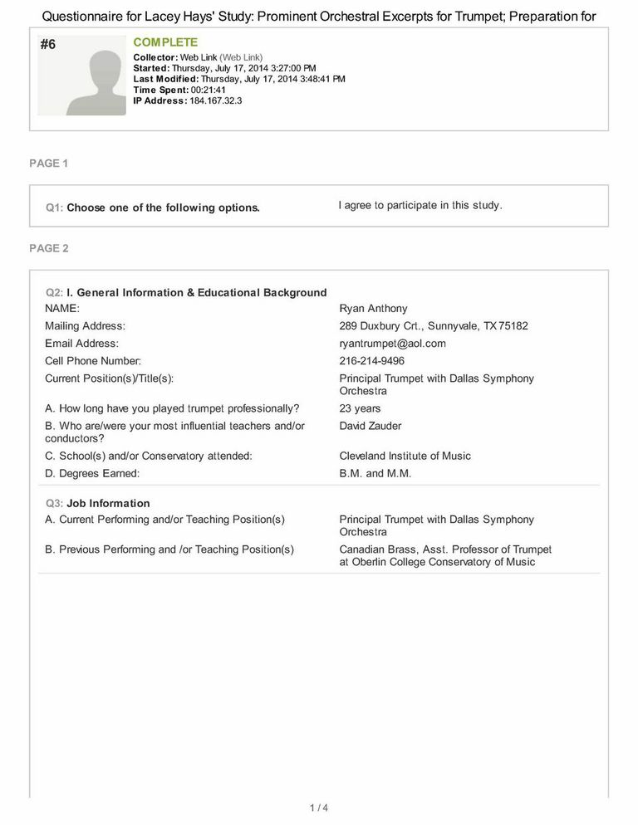

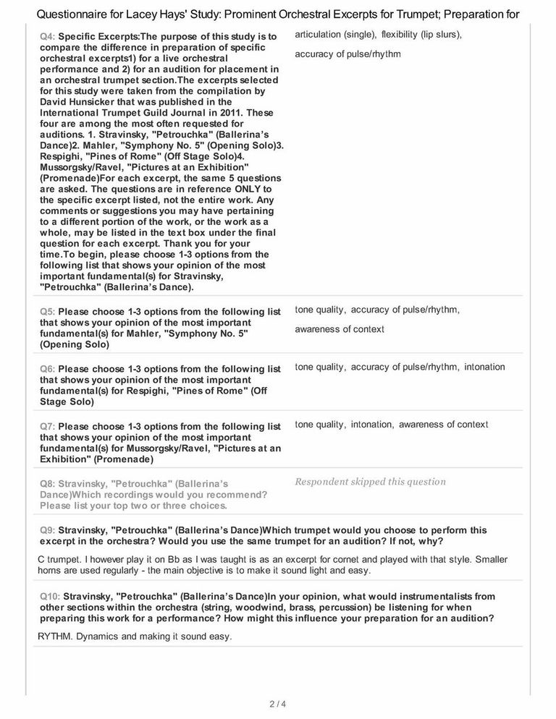

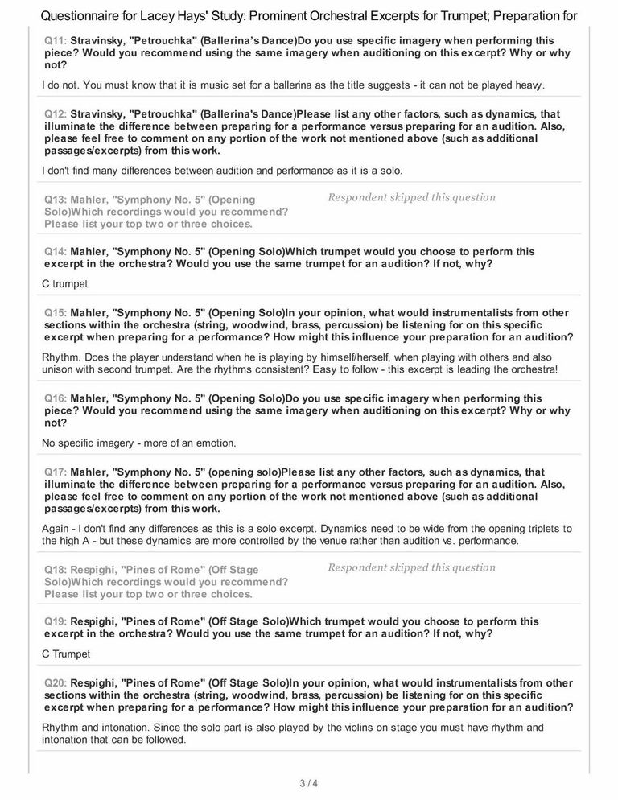

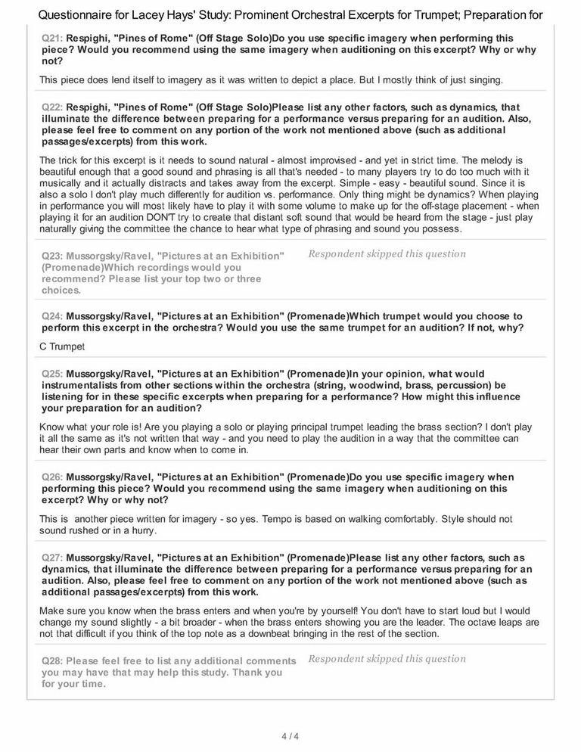

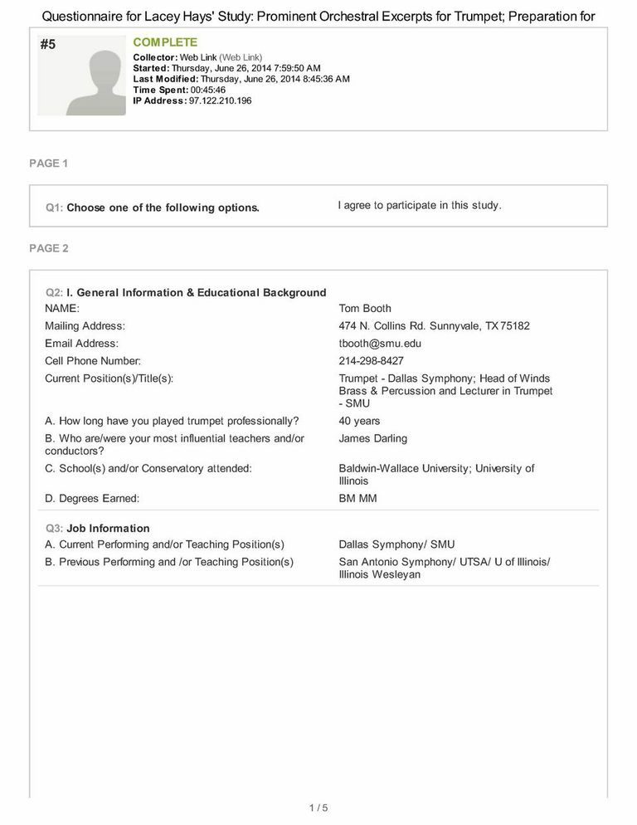

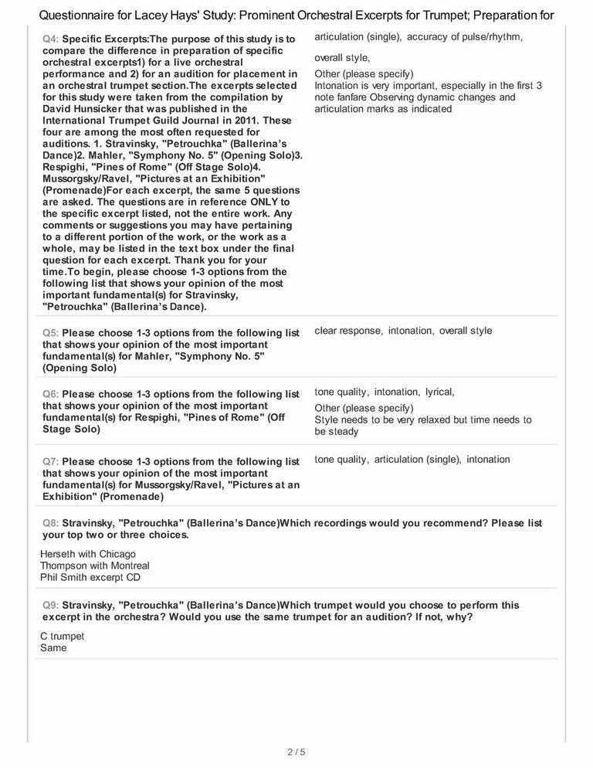

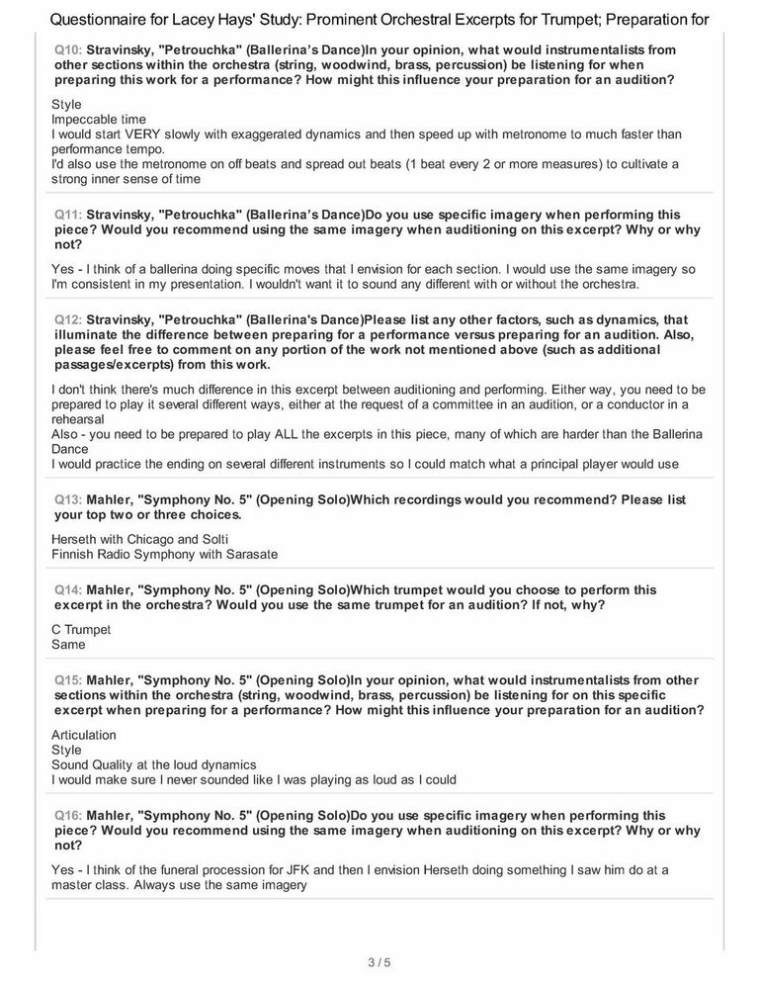

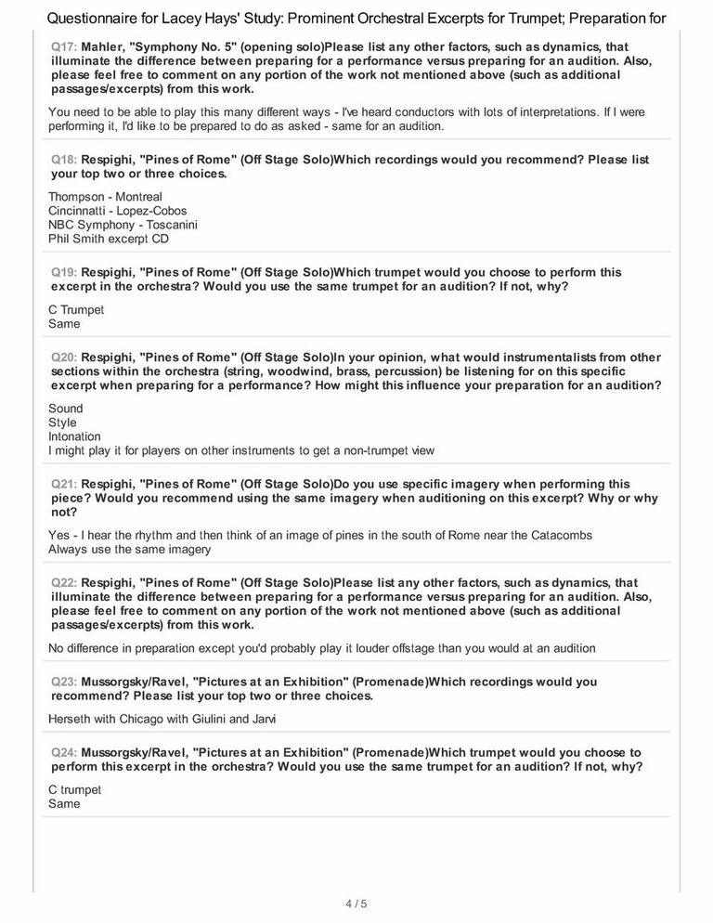

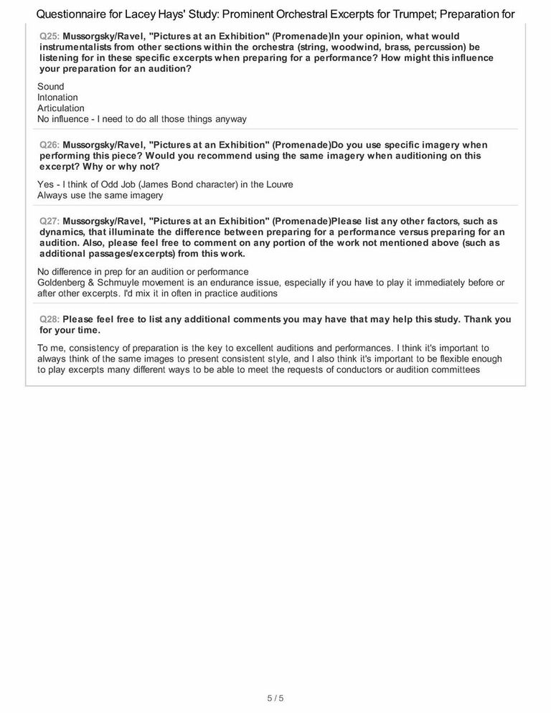

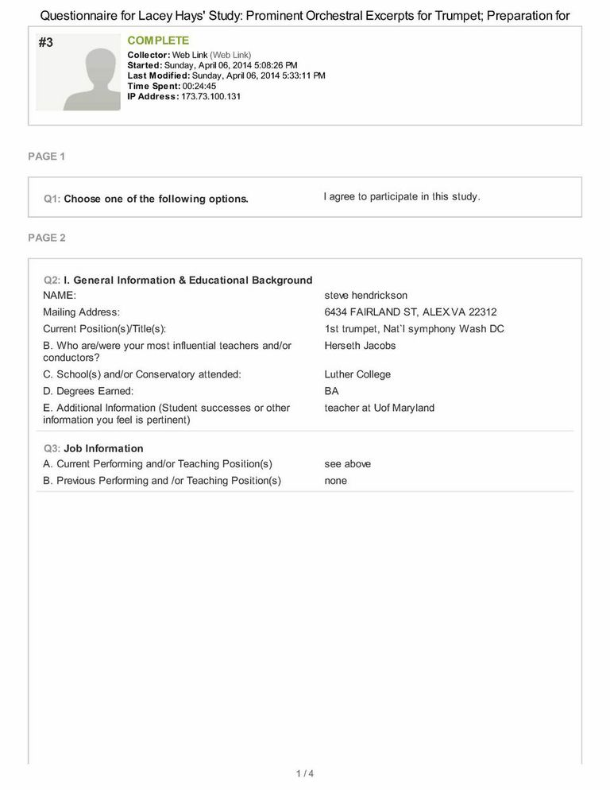

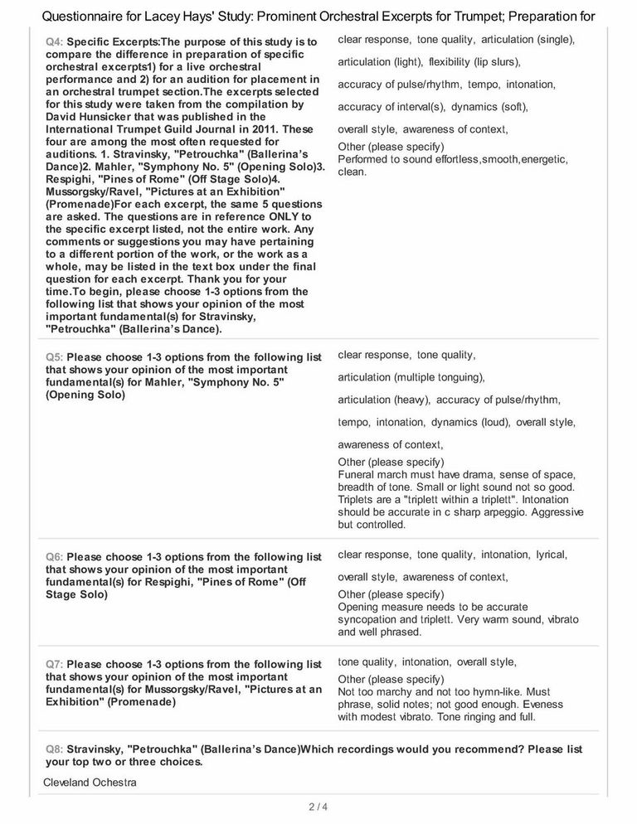

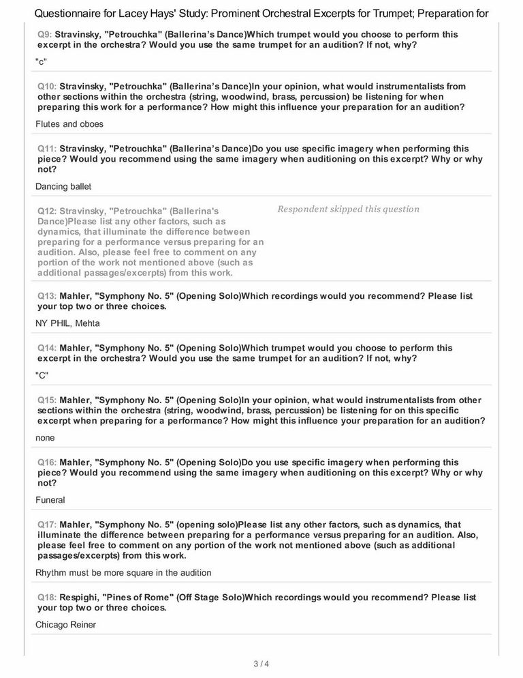

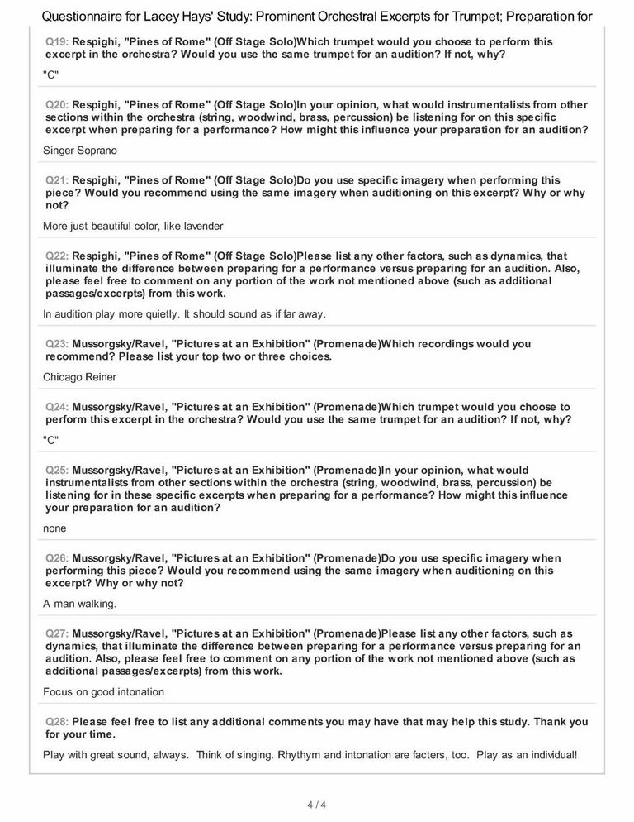

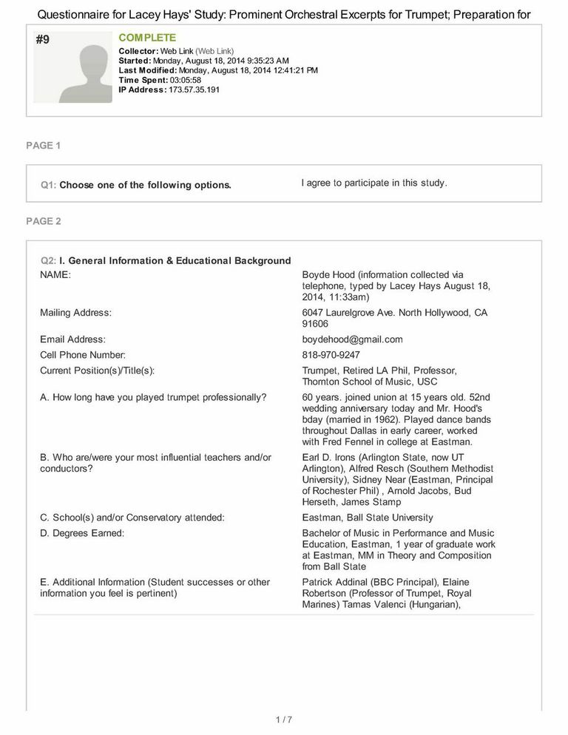

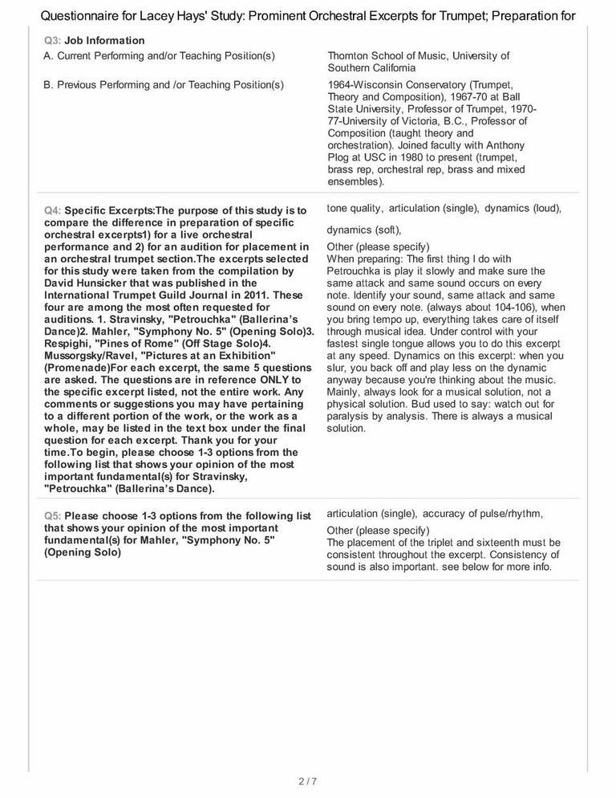
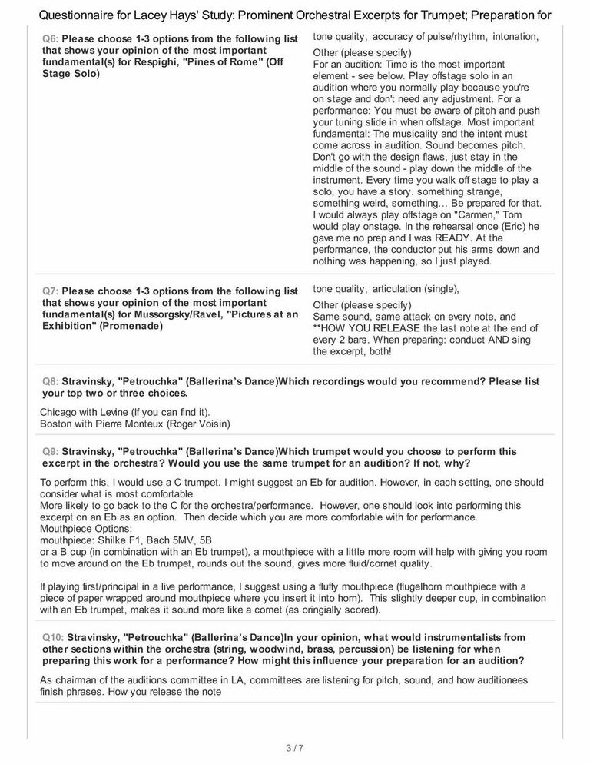

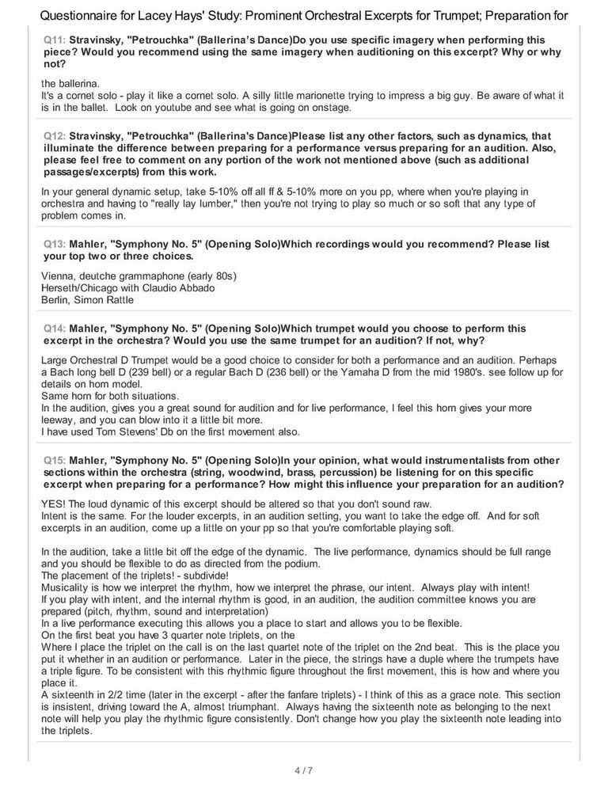

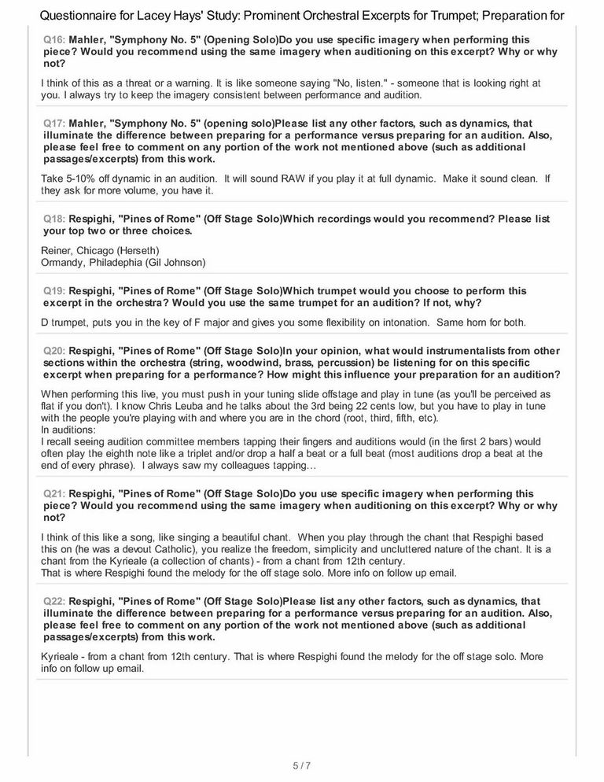

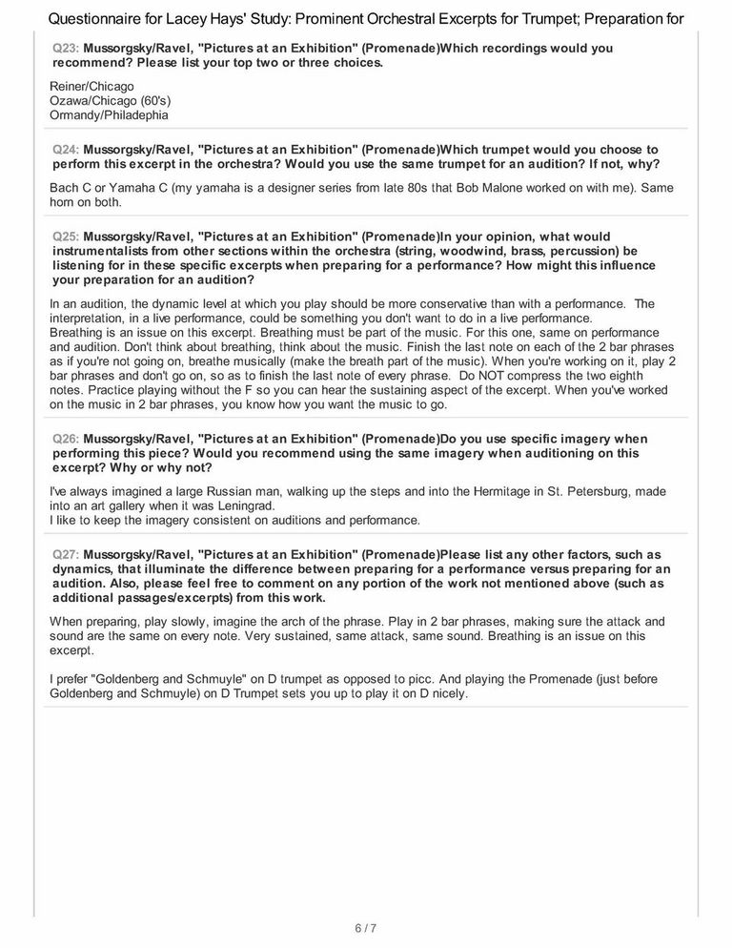

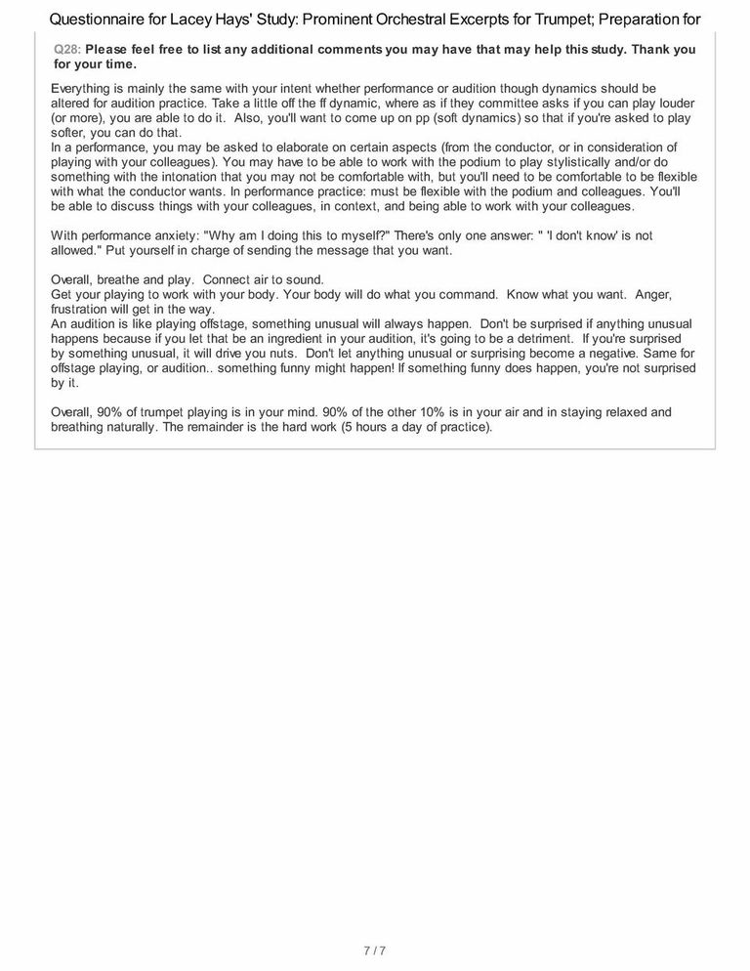

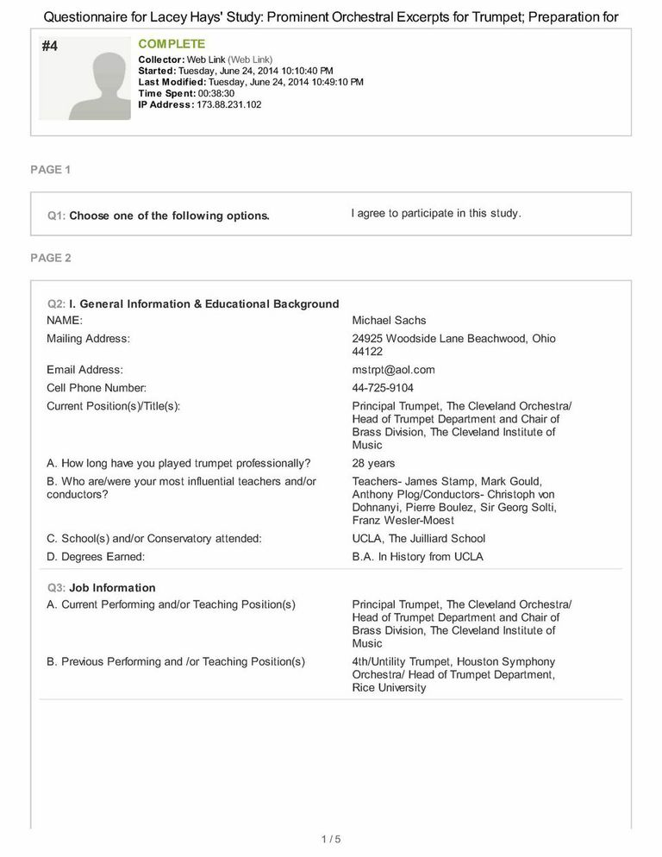

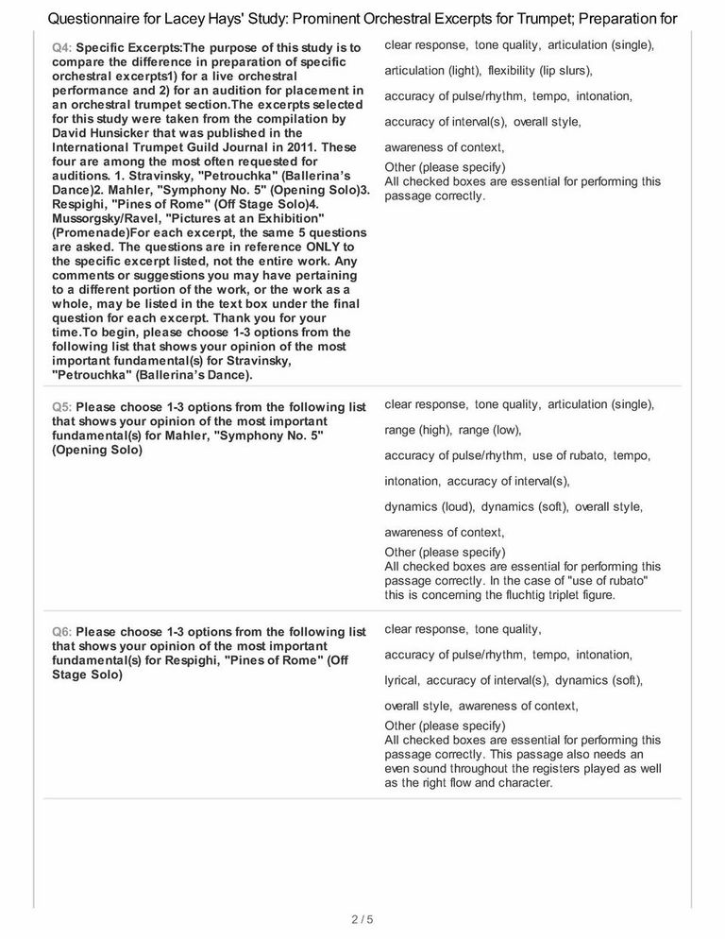

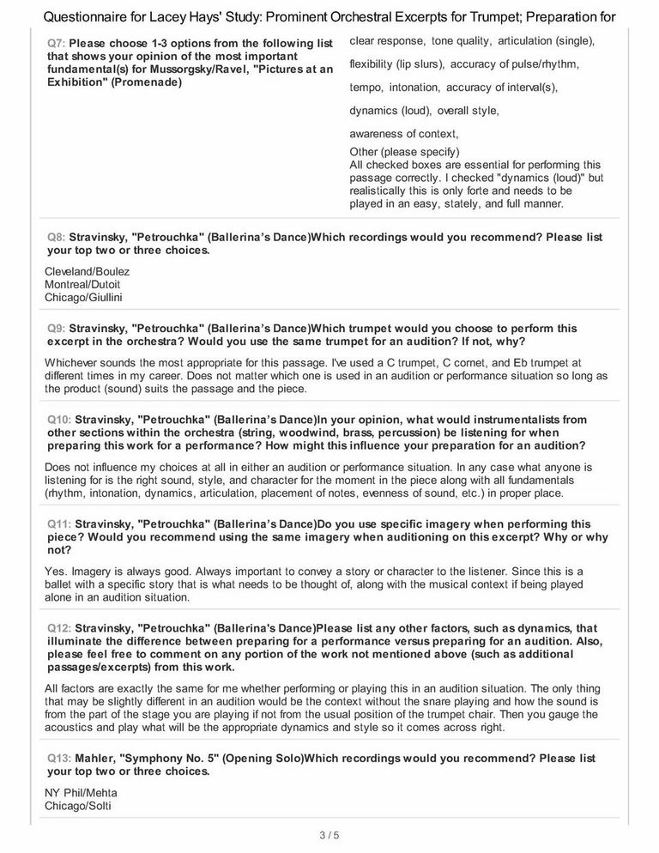

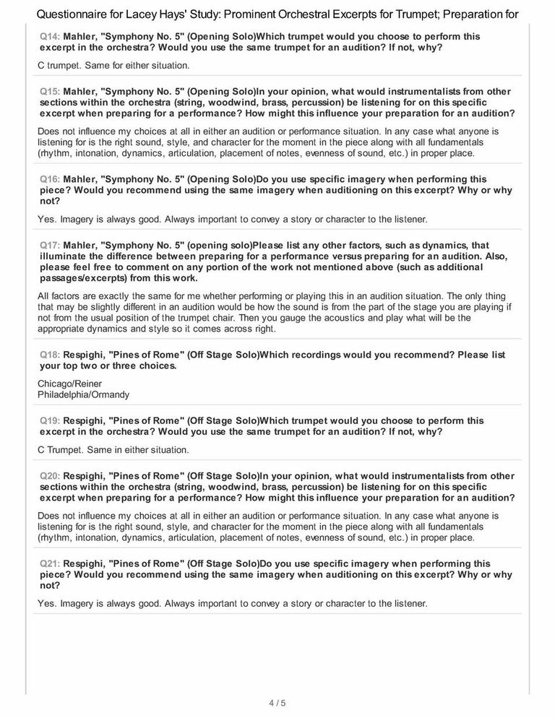

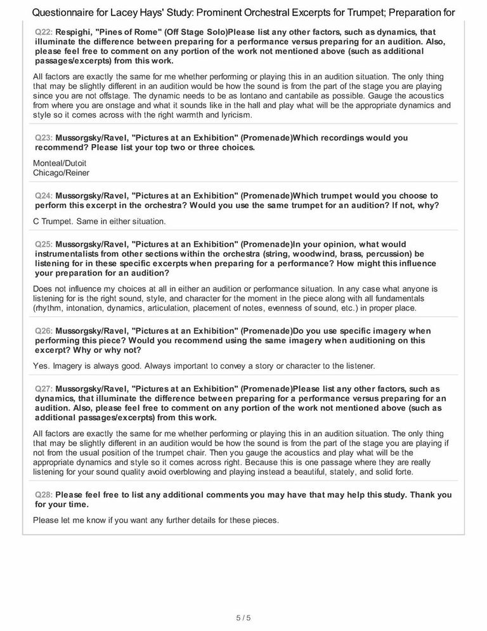

APPENDIX C

INTERNAL REVIEW BOARD LETER OF APPROVAL

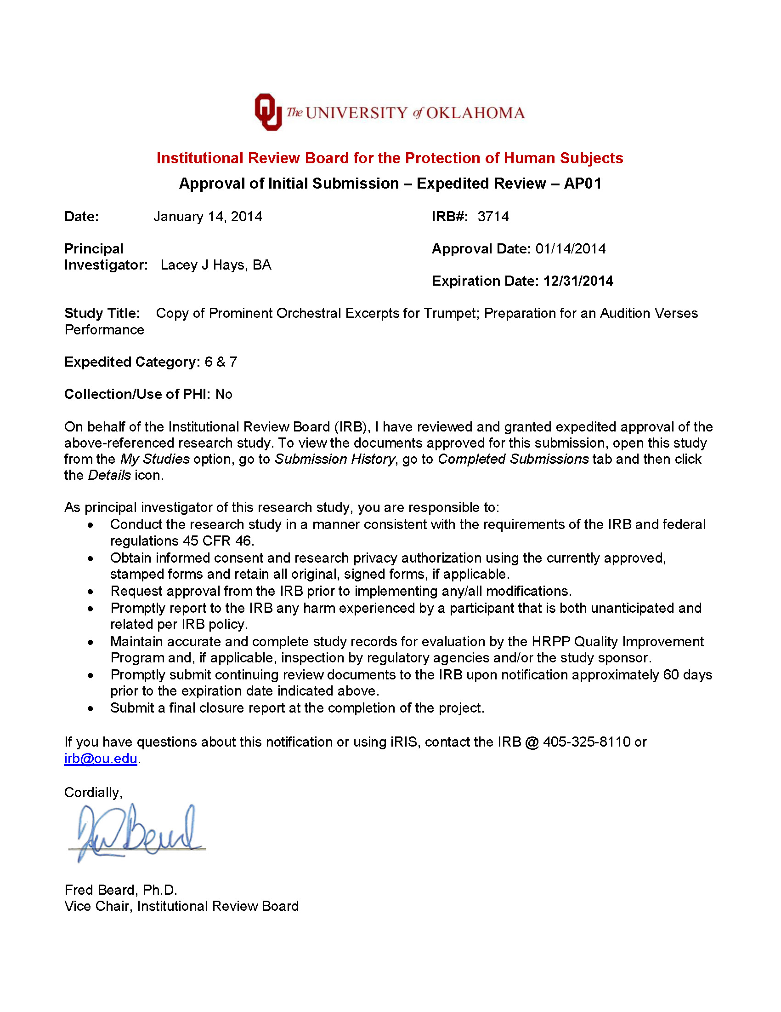

http://www.ryananthony.com/biography.html, 17 March, 2014.
Ryan Anthony, survey response, 17 July, 2014 (see Appendix B).
https://www.dallassymphony.com/about-us/people/bios/thomas-booth,-assistant principal.aspx, 15 March, 2014.
http://smutrumpetstudio.com/tom-booth, 10 March, 2014.
http://www.music.umd.edu/faculty/music_directory/wind_and_percussion/steve_hendrickson, 5 April, 2014.
https://music.usc.edu/boyde-hood, 15 March, 2014
Boyde Hood, personal communication, 26 April, 2014.
Michael Sachs, survey response, 24 June, 2014 (see Appendix B).
Michael Sachs, The Orchestral Trumpet. http://theorchestraltrumpet.com, 6 March, 2014.
Brian Shook, Last Stop, Carnegie Hall (Denton, TX: University of North Texas Press, 2011), 36-37, 41, 56.
Timothy J. Kent, Within the Sphere of the Master: My Recollections as a Student and Long Time Colleague of Adolph Herseth, Trumpeter Supreme of the Chicago Symphony Orchestra. Ossineke, Michigan: Silver Fox Enterprises, 2006.
Rob Roy McGregor, Audition and Performance Preparation for Trumpet; Orchestral Literature Studies, Volumes I-IV. (Montrose, CA: Balquhidder Music, 1992).
Michael Sachs, The Orchestral Trumpet, 2nd ed. (USA: Michael Sachs, 2013), 95.
Rob Roy McGregor, Audition and Performance Preparation for Trumpet, Volume 2. 2nd ed. (Montrose, CA: Balquhidder Music, 1997).
Christopher Leuba, A Study of Musical Intonation. (Vancouver, BC: Prospect Publications, 1962), 32.
David Hunsicker, http://www.trumpetguild.org/_72820_archive/2011journal/201103InsideOrch.pdf. 11 April, 2014.
Igor Stravinsky, Petrouchka, 1947 ed., Third Part “Ballerina’s Dance” (London: Boosey & Hawkes, 1948).
Ryan Anthony, survey response, 17 July, 2014 (see Appendix B).
Ibid.
Ibid.
Ibid.
Ibid.
Ibid.
Tom Booth, survey response, 26 June, 2014 (see Appendix B).
Ibid.
Igor Stravinsky, Petrushka, perf. Chicago Symphony, cond. Sir Georg Solti (New York: Decca [catalog no. 443775], 2009, CD.
Igor Stravinsky, Petrouchka, Song of the Nightingale , perf. Montreal Symphony Orchestra, cond. Charles Dutoit, (London: Decca [Catalog # 417619], 2009, CD.
Phillip Smith, Orchestral Excerpts for Trumpet. (Tempe, AZ: Summit Records, 1994.)
Booth, survey response.
Ibid.
Ibid.
Ibid.
Steve Hendrickson, survey response, 6 April, 2014 (see Appendix B).
Ibid.
Igor Stravinsky, Petrouchka, Le Sacre du Printemps, perf. Cleveland Orchestra, cond. Pierre Boulez, (Deutsche Grammophon [catalog no. 435769], 1992), CD.
Hendrickson, survey response.
Boyde Hood, survey response, 18 August, 2014 (see Appendix B).
Ibid.
Igor Stravinsky, Petrouchka (Complete Ballet 1947), perf. Chicago Symphony Orchestra, cond. James Levine (RCA Red Seal [catalog no. 12615], 1978), LP.
Igor Stravinsky, “Petrouchka,” Symphony in D Minor, Petrouchka, perf. Boston Symphony Orchestra, cond. Pierre Monteux, rec. 1959 (New York: RCA Victor [Living Stereo Catalog no. 63303], 1999), CD.
Igor Stravinsky, “Petrouchka,” Pierre Monteux Conducts the Boston Symphony Orchestra, perf. Boston Symphony Orchestra, cond. Pierre Monteux, rec. 1959 (New York: Video Artists International [catalog no. 4316], 2005), DVD.
Ibid.
Ibid.
Michael Sachs, survey response, 24 June, 2014 (see Appendix B).
Ibid.
Stravinsky, Petrouchka, Le Sacre Du Printemps.
Stravinsky, Petrouchka, Song of the Nightingale.
Igor Stravinsky, “Petrouchka,” The Chicago Years, perf. Chicago Symphony Orchestra, cond. Carlo Maria Giulini (Warner Classics [catalog no. 317522], 2013), CD.
Sachs, survey response.
Ibid.
Ibid.
Ibid.
Ibid.
Gustav Mahler, Symphony Number 5, “Trauermarsch,” (Frankfurt: C.F. Peters, 2002).
Anthony, survey response.
Ibid.
Ibid.
Booth, survey response.
Gustav Mahler, The Symphonies, perf. Chicago Symphony Orchestra, cond. Sir Georg Solti (Decca [catalog no. 430804], 1992), CD.
Gustav Mahler, Symphony No 5, perf. Finnish Radio Symphony Orchestra, cond. Jukka-Pekka Saraste (Virgin Classics [catalog no. 62495], 2005), CD.
Booth, survey response.
Hendrickson, survey response.
Ibid.
Ibid.
Gustav Mahler, Symphony No 5, perf. New York Philharmonic, cond. Zubin Mehta (Apex [catalog no. 4620802], 2005), CD.
Hendrickson, survey response.
Hood, survey response.
Gustav Mahler, Symphony No. 5., perf. Chicago Symphony Orchestra, cond. Claudio Abbado (Deutshe Grammophon [catalog no. 474169], 2003), CD.
Gustav Mahler, Symphony No. 5., perf. Berlin Philharmonic, cond. Simon Rattle (EMI Classics [catalog no. 85192], 2012), CD.
Gustav Mahler, Symphony No. 5., perf. Vienna Philharmonic, cond. Leonard Bernstein (Deutsche Grammophon [catalog no. 000815502], 2007), CD.
Hood, survey response.
Ibid.
Ibid.
Ibid.
Ibid.
Sachs, survey response.
Ibid.
Gustav Mahler, Symphony No. 5., perf. New York Philharmonic, cond. Zubin Mehta (Teldec [catalog no. 46152], 1991), CD.
Gustav Mahler, Symphony No. 5., perf. Chicago Symphony Orchestra, cond. Sir Georg Solti (Decca [catalog no. 430804], 1992), CD.
Sachs, survey response.
Ottorino Respighi, Pini di Roma, “II. Pini presso una Catacomba,” (Milano: Universal Music Publishing Ricordi, 1925).
Anthony, survey response.
Ibid.
Ibid.
Booth, survey response.
Ottorino Respighi, Pines Of Rome, perf. Montreal Symphony Orchestra, cond. Charles Dutoit (Decca, [catalog no. 410145], 1990), CD.
Ottorino Respighi, Pines Of Rome, perf. Cincinnati Symphony Orchestra, cond. Jesus Lopez-Cobos (Telarc [catalog no. 80505], 2000), CD.
Ottorino Respighi, Pines of Rome, perf. NBC Symphony Orchestra, cond. Arturo Toscanini (RCA [catalog no. 791631], 2012, CD and DVD.
Phillip Smith, Orchestral Excerpts for Trumpet. (Tempe, AZ: Summit Records, 1994.)
Booth, survey response.
Ibid.
Ibid.
Ibid.
Ibid.
Ottorino Respighi, Pines of Rome, perf. Chicago Symphony Orchestra, cond. Fritz Reiner (Analogue Production Originals [catalog no. 2436], 2014, CD.
Hendrickson, survey response.
Hood, survey response.
Ottorino Respighi, Pines of Rome, perf. Chicago Symphony Orchestra, cond. Fritz Reinter (RCA Victor Living Stereo [catalog no. 71614], 2006), CD.
Ottorino Respighi, Fontane Di Roma, perf. Philadelphia Orchestra, cond. Eugene Ormandy (Sony Classical Essential Classics [catalog no. 48267], 1992), CD.
Hood, survey response.
Ibid.
Christopher Leuba, A Study of Musical Intonation. (Vancouver, BC: Prospect Publications, 1962).
Hood, survey response.
Ibid.
Kyriale, Medieval Chant Book.
Ibid.
Sachs, survey response.
Ibid.
Ottorino Respighi, Pines of Rome, perf. Chicago Symphony Orchestra, cond. Fritz Reinter (RCA Victor Living Stereo [catalog no. 71614], 2006), CD.
Ottorino Respighi, Fontane Di Roma, perf. Philadelphia Orchestra, cond. Eugene Ormandy (Sony Classical Essential Classics [catalog no. 48267], 1992), CD.
Sachs, survey response.
Modest Mussorgsky, Pictures at an Exhibition, “I. Promenade,” orchestrated by Maurice Ravel (New York: Boosey & Hawkes, 1929).
Anthony, survey response.
Ibid.
Ibid.
Ibid.
Ibid.
Booth, survey response.
Modest Mussorgsky, Pictures at an Exhibition, perf. Chicago Symphony Orchestra, cond. Carlo Maria Guilini (Deutsche Grammophon [catalog no. 001571502], 2011), CD.
Modest Mussorgsky, Pictures At An Exhibition, perf. Chicago Symphony Orchestra, cond. Neeme Jarvi Chandos (Label [catalog no. 8849], 1992, CD.
Booth, survey response.
Hendrickson, survey response.
Modest Mussorgsky, Pictures at an Exhibition, perf. Chicago Symphony Orchestra, cond. Carlo Maria Guilini (Deutsche Grammophon [catalog no. 001571502], 2011), CD.
Hendrickson, survey response.
Hood, survey response
Ibid.
Modest Mussorgsky, Pictures At An Exhibition, perf. Chicago Symphony Orchestra, cond. Fritz Reiner (RCA Victor Living Stereo [catalog no. 61394], 2004), CD.
Modest Mussorgsky, Pictures At An Exhibition, perf. Chicago Symphony Orchestra, cond. Seiji Ozawa (Sony [catalog no. 69100], 2011), CD.
Modest Mussorgsky, Pictures At An Exhibition, perf. Philadelphia Orchestra, cond. Eugene Ormandy (Sony (Nax615) [catalog no. 417202], 2012), CD.
Hood, survey response.
Ibid.
Ibid.
Ibid.
Ibid.
Ibid.
Ibid.
Sachs, survey response.
Modest Mussorgsky, Pictures At An Exhibition, perf. Montreal Symphony, cond. Charles Dutoit (Decca, Catalog no. 417299], 2007), CD.
Modest Mussorgsky, Pictures At An Exhibition, perf. Chicago Symphony Orchestra, cond. Fritz Reinter (RCA Victor Living Stereo [catalog no. 61394], 2004), CD.
Sachs, survey response.
Ibid.
Hendrickson, survey response.
Hood, survey response.
Booth, survey response.
Anthony, survey response.
Igor Stravinsky, Petrouchka/Song of the Nightingale, perf. Montreal Symphony Orchestra, cond. Charles Dutoit, (London: Decca [Catalog # 417619], 2009, CD.
Igor Stravinsky, Petrushka, Je De Cartes, perf. Chicago Symphony Orchestra, cond. Georg Solti (New York: Decca [catalog no. 443775], 2009), CD.
Igor Stravinsky, Petrouchka, Le Sacre du Printemps, perf. Cleveland Orchestra, cond. Pierre Boulez (Hamburg: Deutsche Grammophon [catalog no. 435769], 1992), CD.
Sachs, survey response.
Anthony, survey response.
Hendrickson, survey response.
Hood, survey response.
Booth, survey response.
Ibid.
Sachs, survey response.
Gustav Mahler, Mahler: The Symphonies, perf. Chicago Symphony Orchestra, cond. Sir Georg Solti (Decca, [catalog no. 430804], 1992), CD.
Gustav Mahler, Symphony No. 5., perf. Chicago Symphony Orchestra, cond. Claudio Abbado (Deutshe Grammophon [catalog no. 474169], 2003), CD.
Gustav Mahler, Symphony No. 5., perf. New York Philharmonic, cond. Zubin Mehta (Apex, [catalog no. 4620802], 2005), CD.
Gustav Mahler, Symphony No. 5., perf. Finnish Radio Symphony Orchestra, cond. Jukka-Pekka Saraste (Virgin Classics, [catalog no. 62495], 2005), CD.
Gustav Mahler, Symphony No. 5., perf. Vienna Philharmonic, cond. Leonard Bernstein (Deutsche Grammophon [catalog no. 000815502], 2007), CD.
Gustav Mahler, Symphony No. 5., perf. Berlin Philharmonic Orchestra, cond. Sir Simon Rattle (EMI Classics [catalog no. 85192], 2012), CD.
Hood, survey response.
Ibid.
Anthony, survey response.
Ottorino Respighi, Pines of Rome, perf. Chicago Symphony Orchestra, cond. Fritz Reiner (RCA Victor Living Stereo, [catalog no. 71614], 2006), CD.
Ottorino Respighi, Pini Di Roma, perf. Philadelphia Orchestra, cond. Eugene Ormandy (Sony Classical Essential Classics [catalog no. 48267], 1992) CD.
Ottorino Respighi, Pines Of Rome, perf. Montreal Symphony Orchestra, cond. Charles Dutoit (Decca [catalog no. 410145], 1990), CD.
Ottorino Respighi, Pines Of Rome, perf. Cincinnati Symphony Orchestra, cond. Jesus Lopez-Cobos (Telarc [catalog #80505], 2000), CD.
Ottorino Respighi, Pines Of Rome, perf. NBC Symphony Orchestra, cond. Arturo Toscanini (RCA [catalog no. 791631], 2012), CD and DVD.
Phillip Smith, Orchestral Excerpts for Trumpet. (Tempe, AZ: Summit Records, 1994.)
Hood, survey response.
Booth, survey response.
Anthony, survey response.
Ibid.
Hendrickson, survey response.
Hood, survey response.
http://www.ccwatershed.org/kyriale/, 17 September, 2014.
http://www.trumpetherald.com/forum/viewtopic.php?p=1136049, 5 September, 2014.
“Sanctus and Benedictus” Hymn 268, in The St. Gregory Hymnal and Catholic Choir Book, ed. Nicola A. Montani (Philadelphia: St. Gregory Guild, 1920), p. 488, HathiTrust Digital Library, web, 13 Oct. 2014, http://babel.hathitrust.org.ezproxy.lib.ou.edu/cgi/pt?id=uc1.b4219407;view=1up;seq=5.
http://www.ccwatershed.org/media/pdfs/12/06/20/15-36-26_0.pdf, 17 September, 2014.
Modest Mussorgsky, Pictures At An Exhibition, perf. Chicago Symphony Orchestra, cond. Fritz Reinter (RCA Victor Living Stereo [catalog no. 61394], 2004), CD.
Modest Mussorgsky, Pictures At An Exhibition, perf. Chicago Symphony Orchestra, cond. Seiji Ozawa (Sony [catalog # 69100], 2011), CD.
Modest Mussorgsky, Pictures At An Exhibition, perf. Chicago Symphony Orchestra, cond. Carlo Maria Guilini (Deutsche Grammophon [catalog no. 001571502], 2011), CD.
Modest Mussorgsky, Pictures At An Exhibition, perf., Chicago Symphony, cond. Neme Jarvi (Chandos [catalog no. 8849], 1992), CD.
Modest Mussorgsky, Pictures At An Exhibition, perf. Montreal Symphony, cond., Charles Dutoit (Decca [catalog no. 417299], 2007), CD.
Modest Mussorgsky, Pictures At An Exhibition, perf. Philadelphia Orchestra, cond. Eugene Ormandy (Sony [catalog no. 417202], 2012), CD.
Anthony, survey response.
Sachs, survey response.

