University of Oklahoma

Graduate College

The Roles of stocking rates and lake characteristics in the success of the florida largemouth bass stocking program in oklahoma

A thesis

submitted to the Graduate Faculty

in partial fulfillment of the requirements for the

Degree of

Master of Science

By

CHRISTOPHER ACY
Norman, Oklahoma
2017

the roles of stocking rates and lake characteristics in the success of the florida largemouth bass stocking program in oklahoma

A thesis approved for the
Department of Biology

By

______________________________
Dr. K. David Hambright, Chair

______________________________
Dr. Caryn C. Vaughn

______________________________
Dr. Lawrence J. Weider

© Copyright by christopher acy 2017
All Rights Reserved.

Acknowledgements
I would like to thank my advisor Dr. Dave Hambright and my committee members Dr. Caryn Vaughn and Dr. Lawrence Weider for the support and advice during the project. I would also like to thank the Laboratory for Molecular Biology and Cytometry Research at OUHSC for the use of the Core Facility, which provided the Fragment Analysis service. I would like to express my gratitude to the Oklahoma Department of Wildlife for data gathered by the Florida Largemouth Bass Program and to Cliff Sager, as this project would not have been possible without them. Many individuals assisted with laboratory and molecular work over the years: Karen Glenn, Anne Easton, Anne Morris, James Easton, Richard Zamor, Jessica Beyer, Kathryn Shauberger, Katherine Hooker, Emily Young, and Wyatt DeSpain. Thank you to Jessica Beyer, Thayer Hallidayschult, and Katherine Hooker for help with the statistical analysis, as well as their editorial comments. This work was completed with the funding assistance from the Oklahoma Department of Wildlife Conservation and the University of Oklahoma M. Blanche Adams & M. Frances Adams Summer and Graduate Research Scholarships. Thank you to my parents, friends, and loved ones who have supported me through this journey. This project could not have been completed without my loving wife Caitlynn, who was with me every step of the way. I could not have done this without you.

Table of Contents

Acknowledgements iv
List of Tables vi
List of Figures vii
Abstract viii
Introduction 1
Methods 7
Fish Collection by ODWC 7
Fish Genotype using Microsatellite Size Analysis 7
Stocking Effort 10
Lake Characteristics 11
Models 12
Trophy Bass 13
Statistical Analyses 14
Results 15
Discussion 16
Impact of Florida largemouth bass Introduction 20
Recommendations for Future Work 22
References 26
Appendix 34

List of Tables
Table 1. Lakes in tiers one, two, and three that are stocked with Florida largemouth bass by the Oklahoma Department of Wildlife Conservation (ODWC) 34
Table 2. Variables included in regularized linear regression analysis of 34 Florida Largemouth Bass Management Program lake bass populations 35
Table 3. Top 20 largest trophy largemouth bass caught in Oklahoma, U.S.A 36
Table 4. Coefficients of best regularized linear regression for Florida largemouth bass (FLMB), first generation Flordia-northern bass hybrids (F1), hybrid cross bass (FX), and total bass with at least one Flordia allele (TBFA) 37

List of Figures
Figure 1. HDD (Heating Degree Day) clines and lakes currently stocked with Florida largemouth bass as part of the Oklahoma Department of Wildlife Conservation (ODWC) Florida Largemouth Bass program in Oklahoma, U.S.A 38
Figure 2. Thirty four Oklahoma lakes in tiers one, two, and three of the Florida Largemouth Bass stocking program by the Oklahoma Department of Wildlife Conservaiton included in the stocking effort and regularized linear models analysis.. 39
Figure 3. Total number of Florida largemouth bass stocked (A) and mean number of stocking events (B) since 2009 for lakes in tiers one, two, and three of the Oklahoma Department of Wildlife Conservation’s Florida Largemouth Bass Stocking Program. 40
Figure 4. Genotype percentages in tiers one, two, and three of the Florida largemouth bass stocking program by the Oklahoma Department of Wildlife Conservation (ODWC). 41
Figure 5. Mesonet stations used to calculate the Heating Degree Day (HDD) value for each lake used in regularized linear regression models. 42
Figure 6. Correlation analysis of response variables (Florida largemouth bass (FLMB), first generation Flordia-northern bass hybrids (F1), hybrid cross bass (FX), and total bass with at least one Flordia allele (TBFA)) and predictor variables (surface area (SA), mean depth, Shoreline Development Index (SDI), reservoir age, heating degree days (HDD), total number of Floirda largemouth bass stocked since 2009) used in the regularized linear regression model (n=34). 43
Figure 7. Genotype grouping percentages in trophy and non-trophy lakes in Oklahoma 44

Abstract
Florida largemouth bass, Micropeterus salmoides floridanus (Lesueur 1822), have been introduced throughout the United States in an effort to improve trophy bass fishing appeal by increasing fish size and number. However, there are conflicting results as to whether pure Florida largemouth bass and first generation Florida-northern bass hybrids (F1) actually grow larger and faster than native largemouth bass Micropterus salmoides salmoides, hereafter northern largemouth bass. The Oklahoma Department of Wildlife Conservation (ODWC) has stocked mainly Florida largemouth bass in Oklahoma lakes for over 30 years. The 3400 Heating Degree Day (HDD) isocline has served as the main criterion for determining which lakes should be stocked with Florida largemouth bass with stocking occurring primarily in warmer lakes to the south and southeast of the 3400 isocline. Using an eight-year data set of microsatellite-based genotypic verification in largemouth bass collected from lakes around Oklahoma, as well as six environmental characteristics of lakes and stocking parameters, I assessed: 1) ) if stocking effort and general lake characteristics can explain the success of the Florida largemouth bass stocking program as measured by the frequency of Florida alleles in Oklahoma lakes; and 2) whether the lakes that are producing the largest trophy bass in Oklahoma have higher frequencies of Florida alleles compared to non-trophy bass lakes. Stocking effort was quantified using the currently (since 2013) employed ODWC tier system with tier one lakes having the highest stocking effort, as they are stocked the most frequently and receive the highest number of Florida largemouth bass fingerlings. Quantity and frequency of Florida largemouth bass stocking decreases in tiers two (fewer fingerlings at lower frequencies) and three (fry at very low frequencies). I also examined total number of Florida largemouth bass stocked in each lake since 2009 in order to capture longer term impacts that may not be apparent since the 2013 tier program began. Differences in the effect of stocking effort were observed in hybrid cross bass (FX) and total bass with at least one out of the three measured Florida largemouth bass alleles (TBFA). There was little variation observed for FLMB and F1 genotypes. Ninety percent of fish sampled had at least one Florida allele indicating that Florida alleles are remaining in bass populations in Florida largemouth bass stocked lakes. Regularized linear models identified that total number of stocked Florida largemouth bass had a positive effect on predicting the highest frequencies of FLMB, F1, FX, and TBFA. No differences were detected on genotype or TBFA between trophy and non-trophy lakes. Because nearly every fish examined since 2009 had at least one Florida allele, and the total number of fish stocked since 2009 explained the most success in the bass stocking program, the ODWC could probably begin focusing effort toward other lakes (e.g., tiers two and three). However, there remains substantial uncertainty in the roles of lake characteristics, and the potential influences of natural and fishing-induced mortality, as well as the ecological ramifications of stocking Florida largemouth bass on the overall ecology and food-web stability of stocked lakes, particularly due to the uncertainties introduced by the ever changing climate conditions.

Introduction
Beginning in the mid-1800s, salmonid and centrarchid fishes were stocked into lakes and streams by Euro-American settlers in attempts to create fisheries for recreation and sustenance (Nielson 1999, Knapp et al. 2001). While the turn of the 19th century saw an increase in natural area conservation (namely national parks and wilderness areas), management practices of aquatic habitats within these protected areas were often inconsistent with the goal of maintaining natural processes (Knapp et al. 2001). Little thought was given to the biological or ecological implications of stocking until the 1960s when negative impacts on native species were attributed to introduced fishes (Nielson 1999, Pister 2001). While the necessity of stocking has been debated, stocking of fishes (such as trout and largemouth bass) has continued to present day with the sole goal of creating recreational fishing opportunities (Pister 2001).
Largemouth bass (Micropterus salmoides) (Lacepède 1802) stocking has been utilized by fisheries managers mainly to introduce a biological control on other species (Meronek et al. 1996), increase largemouth bass population size through supplemental stocking (Boxrucker 1986, Hoxmeier and Whal 2002), or to enhance the sports fishery (Heidinger 1999). To accomplish the latter goal, managers have stocked the Florida largemouth bass (Micropterus salmoides floridanus) subspecies into lakes and reservoirs that previously only contained the northern largemouth bass (Micropterus salmoides salmoides) subspecies (Bailey & Hubbs 1949). The American Fisheries Society Committee on Names of Fishes (Page et al. 2013) recognizes these two subspecies of largemouth bass and therefore, subspecies nomenclature was utilized in this study.
In the United States of America, stocking of Florida largemouth bass has primarily been done by southern states (including Texas, Oklahoma, and Arkansas) to increase the size and number of trophy bass (bass over a certain weight determined by each state) in lakes. Fisheries managers in these states stock the Florida largemouth bass with the reasoning that 1) Florida largemouth bass have a greater growth potential (Maceina et al. 1988, Forshage et al. 1995, Gilliland & Whitaker 1989, Horton and Gilliland 1993, Hughes & Wood 1995, Barthel et al. 2015), 2) first generation hybrids between Florida and northern bass (F1) achieve greater weights and lengths than the northern subspecies (Kleinsasser et al. 1990), and 3) to increase the revenue that is associated with trophy bass lakes (Chen et al. 2003). As a result, the largemouth bass is now one of the most sought after and highly managed sport-fish species in the United States (Lamothe et al. 2016).
There has been considerable debate concerning whether Florida largemouth bass or the northern largemouth bass has higher growth potential. In studies with controlled pond conditions, varying performance characteristics were found between the different subspecies and F1 hybrids. Philipp et al. (1991) found that Florida largemouth bass have significantly lower over winter survival in Illinois when compared to northern largemouth bass, F1 hybrids displayed survival intermediate between northern largemouth bass and Florida largemouth bass, and northern largemouth bass were found to grow significantly heavier than Florida largemouth bass and F1 hybrids in the second and third year after being stocked. However, the findings of Isely et al. (1987) showed that Florida largemouth bass spawned earlier and grew larger than northern largemouth bass in the first year of life in Illinois. Kleinsasser et al. (1990) reported that F1 hybrids grew significantly heavier in Texas ponds than either Florida largemouth bass or northern largemouth bass during the second year of life. However, the extrapolation to lakes and reservoirs of results from ponds, which generally have greater temperature fluctuations due to their shallowness and small surface areas, has been questioned (Maceina & Murphy 1992). In addition, Zolczynski and Davies (1976) and Williamson and Carmichael (1990) both argue that northern largemouth bass might be better suited to an aquaculture environment, as northern largemouth bass were found to feed longer and have higher food conversion rates (food weight/fish weight gained) compared to Florida largemouth bass.
Conflicting results were also found when growth of Florida largemouth bass and northern largemouth bass were studied in natural conditions. In Oklahoma in a comparison of reservoirs originally containing Florida largemouth bass and northern largemouth bass, Florida largemouth bass were found to have greater mass and length than northern largemouth bass (Gilliland 1992). Maceina et al. (1988) found that female Florida largemouth bass at age three were larger than northern largemouth bass in a Texas reservoir. However, no differences were found between the two subspecies or their hybrids by Allen et al. (2009) in a survey of Arkansas reservoirs. These studies provide evidence that growth is variable between different lakes where differences in food supply, lake productivity, and length of growing season can influence fish growth. Moreover, factors such as discrepancies between definitions of what constitutes a “trophy bass”, make evaluating how long it takes for a fish to grow to trophy size difficult (Beamesderfer & North 1995, Myers & Allen 2005). In Oklahoma, a trophy bass is defined as any largemouth bass over 2.7 kg (Oklahoma Department of Wildlife Conservation 2016).
Included in its native range, the northern subspecies was the only largemouth bass present in Oklahoma prior to Florida largemouth bass stocking. Starting in 1973, the Oklahoma Department of Wildlife Conservation (ODWC) developed a Florida Largemouth Bass Program with the goal of stocking Florida largemouth bass into Oklahoma reservoirs to improve the trophy bass fishery (Gilliland 1992, Horton and Gilliland 1993). Stocked fish are reared in the Durant Hatchery until they are at a suitable size to stock as either fingerlings (3.8 cm) or fry (1.9 cm). The ODWC stocking regime and number of stocked lakes have changed over time with variation in the number of bass stocked in each lake as well as changes in which lakes are stocked. Until 2013, the primary stocking regime had been stocking fish based on the size of the reservoir with lakes stocked either during even or odd numbered years at 41 fish per hectare. The ODWC would use a point-based system to rank lakes and prioritize those that were deemed to be the best potential trophy bass lakes. However, it was determined later that stocking based on lake size was impractical since a hectare of surface water did not necessarily equate to a hectare of quality bass habitat (Cliff Sager, ODWC, pers. communication). Starting in 2013, the stocking regime changed to a stocking program with 49 lakes divided into three tiers (based on the OWDC perceived trophy bass potential) with each tier receiving different numbers and sizes of Florida largemouth bass (Table 1). Tier one lakes are annually stocked with 100,000 fingerlings. Tier two lakes are stocked with leftover fingerlings not stocked in tier one lakes as available from the hatchery. Once stocked, second tier lakes rotate to the bottom of the stocking list and will generally not be stocked again until all other second tier lakes have been stocked. Tier three lakes are stocked with fry (as they are available from the hatchery) and similar to the tier two lakes, these lakes are on a rotating stocking schedule (Cliff Sager, ODWC, pers. communication).
The primary ODWC stocking criterion for Florida bass has not changed since the 1990s and is based on the 3400 cumulative heating degree day (HDD) isocline recommended by Gilliland (1992) (Fig. 1). Cumulative HDD, a measurement that quantifies the energy demand for home heating, is calculated as the annual sum of the number of degrees that the average daily air temperature is less than 18.3°C. Gilliland (1992) used the HDD index as a means of exploring the possibility that general climate might affect the success of Florida largemouth bass stocking, but did not find a statistically significant relationship between Florida largemouth bass survival and HDD. However, lakes in the southeastern part of Oklahoma displayed substantially higher Florida largemouth bass mean survival compared with northwestern lakes. Therefore, he recommended that the ODWC use a northern boundary equal to the 3400 HDD isocline until further research could be done.
Interested in increasing the number of Florida largemouth bass and Florida alleles since fish with Florida alleles are thought to grow larger than northern largemouth bass, the ODWC has been sampling bass populations in stocked lakes to monitor the proportions of Florida largemouth bass in these populations to assist in future stocking decisions. However, the morphological differences between Florida largemouth bass and northern largemouth bass are minute. Thus identifying the fish based solely on these morphological differences is difficult. For example, the Florida largemouth bass has 69-73 scales along its lateral line while the northern largemouth bass has 59-65, with hybrids displaying a scale count in the intermediate range (Phillip et al. 1983). As a result, there has been considerable work to identify the genotype of a bass using genetic markers. Two allozyme loci that are fixed for different alleles between subspecies were historically used to make genetic distinctions between Florida largemouth bass and northern largemouth bass. However, due to the frequency of incorrect identification of fish genotype using these allozymes (Maceina et al. 1988), a protocol using microsatellite markers was designed by Lutz-Carrillo et al. (2008) to allow for improved reliability of genotypic categorization. Since 2009, the Plankton Ecology and Limnology Laboratory (PELL) at the University of Oklahoma has been cooperating with the ODWC to determine the genotype of largemouth bass sampled from lakes stocked with Florida largemouth bass using three of the Lutz-Carrillo et al. (2008) microsatellites. Using an eight-year data set of microsatellite-based genotypic verification in largemouth bass collected from lakes around Oklahoma, as well as six environmental characteristics of lakes and stocking parameters, I assessed: 1) if stocking effort and general lake characteristics can explain the success of the Florida largemouth bass stocking program as measured by the frequency of Florida alleles in Oklahoma lakes; and 2) whether the lakes that are producing the largest trophy bass in Oklahoma have higher frequencies of Florida alleles compared to non-trophy bass lakes.

Methods

Fish Collection by ODWC
Adult and juvenile largemouth bass were collected annually between 2009 and 2016 by the ODWC from 41 of the lakes within the Florida Largemouth Bass Program. Each lake was sampled every five years and approximately 40 fish were collected by electrofishing. Small fin clips of at least 3x1 mm in size were taken from each fish and preserved in 95% ethanol before being delivered to the PELL. Information on fish length, weight, sex, gender, etc. was not provided with the samples upon delivery.

Fish Genotype using Microsatellite Size Analysis
Samples were stored in the dark at room temperature and inspected for proper preservation and quality condition before being processed. DNA extraction followed the protocol outlined by Lutz-Carrillo et al. (2008). Fin clips were lysed using a 2X lysis buffer, proteinase K (Life Technologies), and a 55 °C hot water bath. Following sample lysis, DNA was salted out and isolated by ethanol precipitation, dried, and reconstituted in ultrapure water. Purified DNA was then amplified by Polymerase Chain Reaction (PCR) using three sets of diagnostic microsatellite primers developed for genotyping largemouth bass by Lutz-Carrillo et al. (2008). All PCRs were performed with 25 µL volumes on an iCycler Thermal Cycler (BioRad iQ 5 RTPCR QPCR). Reactions consisted of 2 µL of DNA template, 12.5 µL of iQ SuperMix (containing dNTPs, 6 mM MgCl₂, and 50 U/mL hot start iTaq DNA polymerase; Bio-Rad), 4.5 µL UltraPure H₂0 (Invitrogen), 1.15 µL of forward and reverse triplex primers designed to target loci MiSaTPW111 and MiSaTPW169 (GenBank Accession number EF590093 and EF590110, respectively), and 0.7 µL of forward and reverse triplex primers targeting locus MiSaTPW112 (GenBank Accession number EF590094). The forward primer of each set had a fluorescent marker, allowing for microsatellite sizing of the amplified product. Cycling parameters were 94 °C for 1 min and 50 s, followed by 27 cycles of denaturation at 94 °C for 30 s, annealing for 30 s at 60 °C, extension at 72 °C for 60 s, and a final extension at 72 °C for 10 min. PCR fragments from each fish (2 µL) were sent to the University of Oklahoma Health Sciences Center Laboratory for Molecular Biology and Cytometry Research for sequencing of microsatellite fragments using a 96 capillary 3730xl DNA Analyzer (ThermoFisher Scientific).
Each fragment was visually inspected (appearing as a sharp colored peak on a standardized electropherogram graph) and the length (in base-pairs) was recorded based on a known DNA size standard using the Peak Scanner Software program (version 2.0, ThermoFisher Scientific). Both Florida largemouth bass and northern largemouth bass have known diagnostic fragment lengths (i.e., allele sizes) for each set of microsatellite markers used in the analysis and fish were genotyped based on the length of each fragment. If one peak appeared for a particular marker, the fish was scored as homozygous for that locus. If two peaks occurred for a marker, then the fish was determined to be heterozygous for that locus and thus had some genetic material from both Florida largemouth bass and northern largemouth bass. Fish classified as pure Florida largemouth bass (hereafter FLMB) and northern largemouth bass were homozygous at all three loci, but the fragment base pair length at each locus was used to differentiate between the two genotypes. If a fish was heterozygous at all three markers, then it was deemed an F1 hybrid. Any other combination of alleles signified that the fish was a hybrid-cross bass (FX). Occasionally DNA from samples would not amplify correctly and thus could not be analyzed. By utilizing three distinct markers, a good indication of the genotype could be determined.
Only lake samples that had more than 30 successfully amplified fish were used in further analyses (n=34) (Fig. 2). Three genotypes were calculated for each reservoir; FLMB, F1, and FX fish, plus the total sum of all fish containing one or more Florida alleles (TBFA). The percentage of FLMB, F1, and FX fish provided estimates of each genotype’s proportion in the population while Florida allele introgression (transfer of Florida alleles into the bass population) was indicated by percent TBFA. As proportions, the distributions of the response variables were positively skewed and thus square-root transformed for all analyses (McDonald 2009). Several lakes had samples from multiple years since 2009. For lakes with two samples, paired t-tests (McDonald 2009) were computed for FLMB, F1, FX, and TBFA, separately, and revealed no significant differences between years for FLMB (t₄=0.98, p=0.38), F1 (t₄=0.04, p=0.96), FX (t₄=1.92, p=0.13), or TBFA (t₄=0.98, p=0.38). For lakes with three samples, repeated measures ANOVAs (McDonald 2009) were conducted for FLMB, F1, FX, and TBFA, separately, and revealed no significant differences in genotype percentages between years for FLMB (F_{2,8}=2.7, p=0.13), F1 (F_{2,8}=0.53, p=0.61), FX (F_{2,8}=0.0032, p=0.95), and TBFA (F_{2,8}=0.6, p=0.57). As there was no significant difference between years, samples from all years were combined for each lake.

Stocking Effort
Hypothetically, increased stocking effort should result in increased proportions of all genotypes with Florida alleles in the population. However, due to natural mortality and the role of lake characteristics on fish growth and survival, one might also expect that stocking effort may not be the sole variable responsible for the highest percentages of fish with Florida alleles. Unfortunately, for this study, there is no evaluation available detailing fishing mortality across the different lakes, and so I have made the assumption in my analyses that both natural and fishing mortality are similar across all lakes.
Stocking effort was first quantified using the currently employed ODWC tier system. Lakes in tier one had the highest stocking effort as they have been stocked most frequently and with the highest quantity of Florida largemouth bass (Fig. 3). Lakes in tiers two and three had lower stocking efforts respectively as the quantity and stocking frequency of Florida largemouth bass decreases with each tier. One-way ANOVAs were conducted separately for each genotype grouping (FLMB, F1, FX, and TBFA) to test the effect of tier on Florida allele frequency. Lake Eufaula had a relatively low TBFA percentage (29%) compared with the median (93%) of the other tier two lakes while falling substantially outside the interquartile range (16.6%) (Fig. 4). As a result, Lake Eufaula TBFA was not included in any further analyses. Secondly, since the ODWC stocking protocol changed in 2013, the number of Florida largemouth bass stocked and the stocking frequency were measured, allowing for stocking effort to be quantified before and after the tier system was implemented. Stocking variables were collected using the 2009-2016 ODWC stocking record. The total number of Florida largemouth bass stocked was summed for each reservoir since 2009 while stocking frequency was simply the number of stocking events since 2009.

Lake Characteristics
The most obvious environmental parameter of interest is water temperature, as temperature will be important in fish growth rates and survival in general (e.g., northern largemouth bass are more cold-tolerant than Florida largemouth bass) (Cichra et al. 1980, Guest 1985, Fields et al 1987, Beitinger et al. 2000). I used multiple indicators of the thermal regime that Oklahoma largemouth bass may experience. First, since ODWC uses the HDD index to delineate the boundary below which Florida largemouth bass are stocked, and because HDD does vary within the stocked region from 2700 to 3400, I explored for any relationship to stocking success within this narrow range of the HDD index as a proxy for general lake thermal characteristics similar to Gilliland (1992) to see whether warmer lakes had higher success in Florida largemouth bass stocking. HDD was calculated using the Oklahoma Mesonet network of environmental monitoring stations (McPherson et al. 2007). This network is comprised of 121 stations that measure air temperature every five minutes at a height of 10 m. A 20-year average of HDD was calculated from 1997-2016 for each station (Fig. 5). The Haversine formula (Robusto 1957) was used to calculate the distance between each reservoir and each station and thus find the closest station to each reservoir, thereby assigning an HDD value to each reservoir. The farthest distance between a station and reservoir was 22.5 km.
Secondly, studies have demonstrated that water temperature and stratification can vary based on lake morphology (Fee et al. 1996, Brönmark & Hansson 2005). Other potentially important lake characteristics that can affect largemouth bass stocking success include reservoir age, which can affect lake productivity (Kulzer et al. 1987, Gilliland & Whitaker 1989, Forshage & Fries 1995, Brönmark & Hansson 2005, Myers & Allen 2005) and lake morphology, which can dramatically affect the amount of suitable largemouth bass habitat (Myers & Allen 2005). As such I collected physical information from each lake using Lakes of Oklahoma (3rd Edition) (Oklahoma Water Resources Board and Oklahoma Department of Wildlife Conservation, 2015). Surface area (m²) was measured at conservation pool elevation and reservoir age was calculated in the year 2017. Mean depth (m) was calculated by dividing the surface area by maximum depth of the reservoir. The Shoreline Development Index (SDI) was calculated as the ratio of the shoreline length divided by the circumference of a circle of area equal to the reservoir surface area with a value of one indicating that the reservoir was a perfect circle in shape.

Models
The potential roles of the five lake and environmental parameters and the two stocking parameters in affecting the presence of Florida alleles in reservoirs were explored using regularized linear regression models. Each genotype grouping (FLMB, F1, FX, and TBFA) was a separate response variable resulting in the creation of four different models.
Regularized linear regression models were constructed to determine which stocking and lake characteristics explain the highest frequencies of Florida alleles. When a dataset contains a small ratio between the number of observations and predictor variables, ordinary least-squares modeling methods tend to give poor predictions and results in overfitting. Regularized linear regression modeling is an extension of the ordinary least-squares method where, in addition to minimizing the sum of the squares of the differences between predicted and actual values of the response variables, a penalty is imposed based on the size of the estimated coefficients in the model, thus shrinking the coefficients toward zero. By shrinking the estimated coefficients, regularization modeling reduces the variance in the model by introducing a small amount of bias, commonly referred to as the bias-variance trade-off (Zou & Hastie 2005). In addition, variable selection occurs in regularized modeling which allowed me to determine which variables had no effect on the genotype grouping used as the response variable. Regularized linear regression was selected due to: 1) the high ratio of predictors compared to the sample size of lakes (n=34) that had more than 30 successfully amplified fish and measured stocking and lake variables selected for analysis (Fig. 2); 2) potential collinearity between variables; and 3) the large degree of variance in the data (Zou & Hastie 2005) (Fig. 4).

Trophy Bass
A list of the top 20 largest trophy largemouth bass caught in Oklahoma is listed on the ODWC website (Oklahoma Department of Wildlife (2017)). The list consists of the angler’s name, weight of the fish, date caught, location caught, and the genetic strain (if genotype was known) allowing for identification of trophy bass lakes that produce the largest fish in Oklahoma (Table 3). Of the 20 largest trophy largemouth bass caught in Oklahoma, 14 came from lakes that are currently being stocked with Florida largemouth bass. Six came from tier-one lakes (Arbuckle: two, Broken Bow: two, Sardis: one, Murray: one), six came from tier-two lakes (Cedar: two, Mountain: four), and two came from tier-three lakes (Fuqua: one, Longmire: one). Using the 34 lakes with greater than 30 fish successfully amplified, lakes were divided into two categories: trophy (Arbuckle, Broken Bow, Sardis, Murray, Cedar, Mountain) or non-trophy. Due to unequal sample sizes and unequal variances, a Welch’s t-test was calculated for each genotype group (FLMB, F1, FX, and TBFA) to test if these trophy-fish producing lakes had higher frequencies of Florida alleles.

Statistical Analyses
All statistical analyses were carried out in R (version 3.3.1; R Core Team, 2016). Variance inflation factors (VIF) were used to test for multicollinearity between predictor variables to remove potential effects of multicollinearity on parameter estimates (Zuur et al. 2010). Variables with a VIF value greater than 5 were discarded using the threshold recommended by Zuur et al. (2010). The final models therefore included a total of six variables as stocking frequency was removed (Table 2). While some of these variables still displayed some collinearity, VIF values were sufficiently low suggesting that multicollinearity was not likely a problem (Zuur et al. 2010) (Fig. 6). The glmnet function in the glmnet package was used to fit an elastic net regularized linear regression model via penalized maximum likelihood (Friedman et al. 2010). Optimal alpha values for each model were found using cv.glmnet for 10-fold cross validation based on mean square error criterion. Since these folds (equal sized subsamples of the variables) are randomly partitioned, cv.glmnet was rerun 50 times and error curves were averaged (as advised in the glmnet R documentation). Standardization of the predictor variables was done automatically by the glmnet function allowing for more accurate comparison between coefficients of the model. Models were cross validated and the best model was chosen with the minimum mean cross-validated error.

Results
Ninety percent of fish sampled had at least one Florida allele indicating that Florida alleles are remaining in bass populations in Florida largemouth bass stocked lakes (Fig. 4). The effect of stocking effort on FX and TBFA was substantial, with little variation attributable to stocking effort in FLMB and F1. There were no significant differences in genotype frequencies between tiers for FLMB (F_{2, 32} = 0.0458, p = 0.9) or for F1 (F_{2, 32} = 1.68, p = 0.2). A one way ANOVA revealed significant differences between tiers for FX fish (F_{2, 32} = 14.9, p < 0.01) and significant differences were found between tier one and tier three (p < 0.01) and between tier two and tier three (p < 0.01) using a post-hoc Tukey test. No significant differences were found between tier one and two lakes (p = 0.9). Significant differences were found between tiers for TBFA (F_{2, 31} = 4.57, p = 0.02) using a one way ANOVA. A post-hoc Tukey test revealed significant differences between tiers one and three (p=0.04), but not between tiers one and two (p=0.9) or between tiers two and three (p=0.07).
Total number of Florida largemouth bass stocked since 2009 had a positive influence on all three genotypes, as well as TBFA, as indicated by the regularized regression analyses (Table 4). Simpler and smaller lakes seem to have the highest success for Florida largemouth bass as surface area, mean depth, and shoreline development index all negatively influenced or had no effect on the four genotype groups. Reservoir age was included in the best model for both F1 and FX, but had differing effects as reservoir age was positive for F1 and negative for FX. The differences in the effect of reservoir age on F1 and FX was due to a negative relationship between FX and F1 frequency (Fig. 6). HDD was not included in any of the models for the four genotype groups.
There was little variation in Florida allele frequencies between trophy and non-trophy lakes in all four genotype groups (Fig. 7). No significant differences were found between trophy and non-trophy lakes for any of the four genotype groups; FLMB (t₃₂ = 0.018, p = 0.86), F1 (t₃₂ = 1.26, p = 0.22), FX (t₃₂ = 0.80, p = 0.44), and TBFA (t₃₁ = 1.42, p = 0.17).

Discussion
The lack of a difference between tier stocking effects for the FLMB and F1 genotype groups suggest that it may be too early to expect a tier effect for FLMB and F1 fish, but interestingly, that 90% of all fish analyzed had at least one Florida allele indicates that Florida alleles are remaining in bass populations (see below). Since Florida largemouth bass are being stocked at different frequencies and densities between tiers, it would be expected that FLMB percentage should display the largest differences between tiers. Continued monitoring over time may be necessary to determine whether the current stocking regime will result ultimately in increased FLMB and F1 fish in stocked lakes. However, the significant differences between tiers one and three for FX and TBFA and between tiers two and three for FX suggest that Florida largemouth bass allele introgression is higher in lakes that are stocked more frequently and with increased numbers of Florida bass. However, the differences in the current stocking effort between tier one and tier two lakes does not appear to be making a significant difference in increased FLMB, F1, FX, or TBFA.
The regularized linear regression indicated that increased stocking of Florida largemouth bass (i.e., propagule pressure) into reservoirs across Oklahoma led to higher percentages of FLMB, F1, FX, and TBFA fish, a result similar to a study done in Texas by Kulzer et al. (1987). While stocking Florida largemouth bass resulted in higher percentages of FLMB, F1, FX, and TBFA, newly stocked Florida bass may not be surviving to adulthood and reproducing. Since largemouth bass are cannibalistic and the high level of stocking effort could be increasing competition (Lewis et al. 1974, Cochran and Adelman 1982, Hickley et al. 1994), it is possible that newly stocked fish are being eaten by the existing population of largemouth bass (Boxrucker 1986, Garvey et al. 1998) as evidenced by a 27.5% loss of stocked fingerlings due to predation within 12 hours of stocking in a Texas reservoir (Buckmeier et al. 2005). Cannibalistic feeding could result in sustained or increased numbers of the existing fish with Florida alleles as the increase in body weight could be aiding survival over winter (Phillip & Whitt 1991).
Nearly every fish in this study (90%) had at least one Florida allele, similar to the findings of Horton and Gilliland (1993). This suggests that the stocking program, irrespective of tier or previous stocking approach, has succeeded in establishing Florida alleles in most reservoir bass populations. Since the ODWC’s primary goal of stocking Florida largemouth bass is to produce trophy-sized bass, it is important to note that Myers and Allen (2005) found that trophy largemouth bass catch occurrence in Texas was significantly higher in lakes stocked with Florida largemouth bass compared with non-stocked reservoirs. However, they did not find a significant effect of Florida largemouth bass stocking frequency or density on trophy largemouth bass catch occurrence leading them to conclude that increased stocking leading to increased Florida allele introgression does not necessarily support a higher trophy bass potential in a reservoir.
My study identified a positive influence of reservoir age and a negative influence of surface area (SA) and shoreline development index (SDI) on FLMB proportions in largemouth bass populations. SDI and reservoir age are associated with reservoir habitat and productivity as lakes with a higher SDI indicate a high ratio of inshore vs. offshore habitat (more littoral habitat) (McMahon et al. 1996) and newer reservoirs are generally advantageous for largemouth bass growth (Kimmel & Groeger 1983, Myers & Allen 2005). Newer reservoirs and higher shoreline development index values should consequently provide increased largemouth bass growth potential. Therefore, the negative effect of SDI on FLMB was unexpected and indicates that the FLMB genotype succeeds in lakes and reservoirs with a lower SDI. Previous studies have found positive effects of larger values of SDI and younger-aged reservoirs on Florida largemouth bass proportions in lakes (Gilliland & Whitaker 1989, Forshage & Fries 1995, Hughes & Wood 1995, Crawford et al. 2002, Myers & Allen 2005, Allen et al. 2009). However, Lamothe et al. (2016) found no relationship between physical lake characteristics and stocking success in Arkansas. Warden and Lorio (1975) tracked the movement of Florida largemouth bass in a lake in Mississippi to study habitat use and reported that Florida largemouth bass are very territorial during the breeding season and will move from the limnetic zone to the littoral zone during the morning and evening hours. Otherwise, Florida largemouth bass tend to remain in the limnetic zone during the non breeding season (Lewis and Flickinger 1967, Colle et al. 1989, Hanson et al. 2007). The top four lakes in this study with the highest SDI values (greater than 10), as well as the largest surface areas, were Skiatook, Broken Bow, Texoma, and Eufaula with zero Florida largemouth bass found in the latter three reservoirs. Since Broken Bow is a tier one reservoir and Texoma and Eufaula are both tier two, there is strong reason to believe that Florida largemouth bass are currently in these lakes and were likely not sampled. Mean depth was not found to have an effect on any of the four genotype groupings. Previous studies have also found that mean depth does not have an effect on Florida largemouth bass and F1 fish in Oklahoma (Gilliland & Whitaker 1989), Arkansas (Lamothe et al. 2016) or on trophy bass in Texas (Myers & Allen 2005). Since mean depth is measured at the conservation pool elevation, it would not accurately reflect the changing water levels both within and between years. As water levels change, there will be increases and decreases in the area of littoral habitat available. Since bass use littoral habitat for breeding and to feed (Warden and Lorio 1975), water level fluctuation might therefore be a better indicator of aquatic conditions and thus a better predictor of Florida largemouth bass allele frequency (Gilliland & Whitaker 1989).
While there is support in the literature that latitude (Forshage & Fries 1995) and HDD (Gilliland & Whitaker 1989) increases introgression of Florida largemouth bass, there is also evidence that these are poor predictors of Florida largemouth bass stocking success (Myers & Allen 2005, Lomothe et al. 2016). While HDD was used by Gilliland (1992) as a proxy for winter severity and temperature, this measure of air temperature may not be a strong indicator for water temperature. As northern largemouth bass have a higher cold water tolerance than Florida largemouth bass (Cichra et al. 1980, Guest 1985, Fields et al. 1987, Beitinger et al. 2000), growth of northern largemouth bass was greater than Florida largemouth bass in Illinois (Phillip & Whitt 1991), and warmer water temperatures caused Florida largemouth bass to start spawning earlier than northern largemouth bass (Isley et al. 1987), water temperature may be a more precise predictor than HDD in determining the success of Florida largemouth bass and Florida alleles in lakes.

Impact of Florida largemouth bass Introduction
While largemouth bass have been stocked across the country in the hopes of increasing trophy bass size and number, there are potential impacts on the ecosystem that must be considered when stocking Florida largemouth bass or even northern largemouth bass into a new environment. Like many other piscivores, largemouth bass are gape-limited and select prey based on prey body depth more than taxonomy (Hambright 1991). Therefore, as can be expected when introducing large piscivores into a new system, largemouth bass can decimate populations of small fishes, frogs, and salamanders to the point of extinction (Miller & Pister 1971, Minckley 1973, U.S. Fish and Wildlife Service 1985, U.S. Fish and Wildlife Service 1994). Largemouth bass have been documented to reduce native prey species abundances and diversity in Pacific Northwest rivers (Hughes & Herlihy 2012) and in Adirondack lakes in New York (Findlay et al. 2000). Hayes and Jennings (1986) attributed the decline of native frogs and tiger salamanders in California to the introduction of bass. Rosen et al. (1994) reported a similar effect of introduced bass on Chiricahua leopard frogs (Rana chiricahuensis) in Arizona. Due to its trophic plasticity and negative effect on native fish fry and other aquatic and semi-aquatic species, some places, such as the Canadian Province of New Brunswick, have labeled the largemouth bass as an invasive species (Maezona & Miyashita 2003, Roots 2006, Almeida et al. 2012).
While reasoning for stocking Florida largemouth bass has included the findings of Kleinsasser et al. (1990) that F1 bass achieve greater weights and lengths than northern largemouth bass, other researchers have reported conflicting results regarding F1 hybrid vigor. Goldberg et al. (2005) reported a 14 % reduction in fitness and increased infectious disease susceptibility and mortality of F1 bass compared to Florida largemouth bass and northern largemouth bass. In Illinois, Phillip et al. (2002) also found evidence of outbreeding depression with a 50% reduction in reproductive success of hybrid crosses compared to Florida bass and northern largemouth bass populations. All three of these studies were conducted in ponds and therefore more research regarding the likelihood of outbreeding depression in reservoirs is needed. However, the risks of outbreeding depression (including increased disease susceptibility) could harm the entirety of the bass population as well as other fish species within the lake. It is therefore recommended that community and ecosystem-wide impacts of largemouth bass be considered before future stockings occur, especially in lakes with no prior largemouth bass presence.

Recommendations for Future Work
In order to further evaluate the success of the ODWC Florida Bass Stocking Program, additional factors should be considered. One of the assumptions of this study is that fishing pressure is equal across all lakes. Since the stocking program encompasses such a wide variety of lakes that experience large differences in fisher visitation, fishing mortality due to fishing pressure is presumably not equal between lakes. Fishing tournaments are common on lakes Murray, Texoma, and Arbuckle which inevitably reduces the number of largemouth bass more than less visited lakes. However, the effect of fishing may not be large in terms of reducing largemouth bass populations in lakes due to the increased prevalence of catch and release fishing (Jeff Boxrucker, pers. communication, ODWC, retired). This hypothesis can be tested by assessing fishing pressure through creel surveys (Glass & Maughan 1984, Myers & Allen 2005, Bisping & Thompson 2017). In this way, fishing mortality can be accounted and evaluated in the model.
As previously stated, the research of natural mortality of Florida largemouth bass, northern largemouth bass, and hybrid crosses has resulted in varying results and discussion regarding validity and application of results from artificial to natural settings due to differences between research ponds and reservoirs in water level and temperature fluctuations, stocking rates, and food availability (Zolczynski & Davies 1976, Isley et al. 1987, Maceina et al. 1988, Kleinsasser et al. 1990, Phillip & Whitt 1991, Maceina & Murphy 1992, Horton & Gilliland 1993, Hughes & Wood 1995, Johnson & Fulton 1999, Lamothe & Johnson 2013). In addition, there is some evidence for angling selection on northern largemouth bass (Kleinsasser et al. 1990, Garrett 2002). Because longevity is critical to trophy largemouth bass production (Crawford et al. 2002), angling vulnerability (fish susceptibility of being caught by attacking or avoiding lures) might have more of an effect than genetic differences (Garrett 2002), an issue that can be addressed through creel surveys.
The ODWC should also consider measuring population size of largemouth bass in stocked lakes. Tier one lakes are stocked annually with 100,000 fingerlings suggesting that there may be increasing densities and therefore an increase in the level of competition occurring between all largemouth bass. Even if large numbers of these fish are being removed by anglers annually, the remaining population could be competing for the same habitat and prey resources. Schindler et al. (1997) reported that largemouth bass populations display high levels of diet consistency even with high densities of largemouth bass. This suggests that bass tend to eat the same prey species regardless of the number of bass in the lake and thus an increased number of bass will have a proportional impact on the abundance of prey. By calculating population sizes of largemouth bass using methods such as catch per unit effort, proportional stock density, or Peterson mark-and-recapture estimates (Guy & Willis 1990, Schindler et al. 1997), it can be determined if there are increasing densities of largemouth bass in annually stocked Oklahoma lakes and if this density is overwhelming the prey populations.
The use of three microsatellite markers allowed for improved accuracy of genotyping fish compared to the historical use of two diagnostic allozyme loci (Gilliland & Whitaker 1989, Lamothe et al. 2016). However, using only three microsatellite markers might not provide an accurate representation of the genetic diversity of these different genotypic groups. Loci can become fixed with only a single allele present between subspecies. If a fixed locus is utilized to genotype between subspecies, all fish would appear homozygous for that allele resulting in an incorrect genotypic classification. This has been reported in bass populations as Lamothe et al. (2013) utilized seven diagnostic microsatellite markers but found that one locus was fixed between Florida largemouth bass and northern largemouth bass subspecies. While there is no evidence that any of the three loci used in this study had become fixed in any of the lake populations, an increase in loci number used for microsatellite analysis would decrease the chance of fish being incorrectly genotyped in future studies. In addition, since a fish that is homozygous at three loci could be quantified as FLMB but could be heterozygous at other loci that were not analyzed, increased usage of microsatellite markers would minimize the risk of incorrect genotypic classification.
While I was able to determine the effect of the lake and stocking variables using regularized linear regression models, a drawback of using this approach is the inability to allow for significance testing of the lake and stocking variables. By introducing bias to reduce the variance, this bias is a significant part of the mean squared error. Therefore, since it is impossible to separate the bias from the variance, any significance testing of the variance or standard errors is not useful (Witten & Tibshirani 2009). As a result, the variables identified in this study should act as a guide for future management decisions with the caveat of the need for additional studies with an increased number of lakes.
While HDD was not useful in this study, additional research should explore if the 3400 HDD isocline is the best predictor for Florida largemouth bass success. A multi-year study observing the genotype percentages of FLMB, NLMB (fish classified as northern largemouth bass), F1, FX, and TBFA annually with the variables listed in this study and a set-up including Oklahoma lakes both above and below the 3400 HDD isocline with no previous stocking of Florida largemouth bass would allow for re-evaluation of Gilliland’s (1991) conclusion that Florida largemouth bass survival is substantially higher in lakes below the 3400 HDD isocline.
The ODWC Florida largemouth bass stocking program has resulted in increased Florida alleles throughout the stocked lakes. However, in order to identify the general success of the Florida largemouth bass stocking program, the ODWC should consider deeper analyses into the role of fish mortality, fishing pressure, habitat availability, and population size in order to optimize the stocking program and increase the rate of production of trophy largemouth bass in Oklahoma.

References
Allen, R., Cato, C., Dennis, C., & Johnson, R. (2009). Condition relative to phenotype for bass populations in southern Arkansas lakes. Journal of the Arkansas Academy of Science, 63, 20.

Almeida, D., Almodóvar, A., Nicola, G. G., Elvira, B., & Grossman, G. D. (2012). Trophic plasticity of invasive juvenile largemouth bass Micropterus salmoides in Iberian streams. Fisheries Research, 113(1), 153-158.

Bailey, R.M., and C.L.Hubbs. 1949. The black basses (Micropterus) of Florida, with description of a newspecies. University Michigan Museum Zoology Occasional Papers 516:1-40.

Barthel, B. L., Allen, M. S., Porak, W. F., & Kerns, J. (2015). Florida Bass Micropterus floridanus (LeSueur, 1822). In M. D. Tringali, J. M. Long, T. W. Birdsong, & M. S. Allen (Eds.), Black bass diversity: multidisciplinary science for conservation. American Fisheries Society, Symposium (Vol. 82, pp. 43-53).

Beamesderfer, R. C., & North, J. A. (1995). Growth, natural mortality, and predicted response to fishing for largemouth bass and smallmouth bass populations in North America. North American Journal of Fisheries Management, 15(3), 688-704.

Beitinger, T. L., Bennett, W. A., & McCauley, R. W. (2000). Temperature tolerances of North American freshwater fishes exposed to dynamic changes in temperature. Environmental Biology of fishes, 58(3), 237-275.

Bisping, S. M., & Thompson, B. C. (2017). Importance of Canals for Florida Largemouth Bass: Lake Griffin, Florida. Journal of Fish and Wildlife Management.

Boxrucker, J. (1986). Evaluation of supplemental stocking of largemouth bass as a management tool in small impoundments. North American Journal of Fisheries Management, 6(3), 391-396.

Brönmark, C., & Hansson, L. A. (2005). The biology of lakes and ponds. Oxford University Press.

Buckmeier, D. L., Betsill, R. K., & Schlechte, J. W. (2005). Initial predation of stocked fingerling largemouth bass in a Texas reservoir and implications for improving stocking efficiency. North American Journal of Fisheries Management, 25(2), 652-659.

Chen, R. J., Hunt, K. M., & Ditton, R. B. (2003). Estimating the economic impacts of a trophy largemouth bass fishery: Issues and applications. North American Journal of Fisheries Management, 23(3), 835-844. doi:10.1577/m02-014

Cichra, C. E., Neill, W. H., & Noble, R. L. (1980). Differential resistance of northern and Florida largemouth bass to cold shock [Micropterus salmoides salmoides, Micropterus salmoides floridanus]. In Proceedings of the Annual Conference-Southeastern Association of Fish and Wildlife Agencies (USA).

Cochran, P. A., & Adelman, I. R. (1982). Seasonal aspects of daily ration and diet of largemouth bass, Micropterus salmoides, with an evaluation of gastric evacuation rates. Environmental Biology of fishes, 7(3), 265-275.

Colle, D. E., Cailteux, R. L., & Shireman, J. V. (1989). Distribution of Florida largemouth bass in a lake after elimination of all submersed aquatic vegetation. North American Journal of Fisheries Management, 9(2), 213-218.

Crawford, S., Porak, W. F., Renfro, D. J., & Cailteux, R. L. (2002). Characteristics of trophy largemouth bass populations in Florida. In American Fisheries Society Symposium (pp. 567-582). American Fisheries Society.

Fee, E. J., Hecky, R. E., Kasian, S. E. M., & Cruikshank, D. R. (1996). Effects of lake size, water clarity, and climatic variability on mixing depths in Canadian Shield lakes. Limnology and Oceanography, 41(5), 912-920.

Fields, R., Lowe, S. S., Kaminski, C., Whitt, G. S., & Philipp, D. P. (1987). Critical and chronic thermal maxima of northern and Florida largemouth bass and their reciprocal F1 and F2 hybrids. Transactions of the American Fisheries Society, 116(6), 856-863.

Findlay, C. S., Bert, D. G., & Zheng, L. (2000). Effect of introduced piscivores on native minnow communities in Adirondack lakes. Canadian Journal of Fisheries and Aquatic Sciences, 57(3), 570-580.

Forshage, A., Fries, L., & Schramm Jr, H.(1995). Evaluation of the Florida largemouth bass in Texas, 1972–1993. Paper presented at the Uses and effects of cultured fishes in aquatic ecosystems. American Fisheries Society, Symposium.

Friedman, J., Hastie, T., & Tibshirani, R. (2010). Regularization paths for generalized linear models via coordinate descent. Journal of statistical software, 33(1), 1.

Fuller, P., & Neilson, M. (2017). Micropterus salmoides. USGS Nonindigenous Aquatic Species Database, Gainesville, FL.
https://nas.er.usgs.gov/queries/factsheet.aspx?SpeciesID=401 Revision Date: 7/23/2015

Garrett, G. P. (2002). Behavioral modification of angling vulnerability in largemouth bass through selective breeding. In American Fisheries Society Symposium (pp. 387-392). American Fisheries Society.

Garvey, J. E., Wright, R. A., & Stein, R. A. (1998). Overwinter growth and survival of age-0 largemouth bass (Micropterus salmoides): revisiting the role of body size. Canadian Journal of Fisheries and Aquatic Sciences, 55(11), 2414-2424.

Gilliland, E. R. (1992). Experimental stocking of Florida largemouth bass into small Oklahoma reservoirs. Paper presented at the Proceedings of the Annual Conference Southeastern Association of Fish and Wildlife Agencies.

Gilliland, E. R., & Whitaker, J. (1989). Introgression of Florida largemouth bass introduced into northern largemouth bass populations in Oklahoma reservoirs. Paper presented at the Proceedings of the Annual Conference Southeastern Association of Fish and Wildlife Agencies.

Glass, R. D., & Maughan, O. E. (1984). Angler compliance with length limits on largemouth bass in an Oklahoma reservoir. North American Journal of Fisheries Management, 4(4A), 457-459.

Goldberg, T. L., Grant, E. C., Inendino, K. R., Kassler, T. W., Claussen, J. E., & Philipp, D. P. (2005). Increased infectious disease susceptibility resulting from outbreeding depression. Conservation Biology, 19(2), 455-462.

Guest, W. C. (1985). Temperature tolerance of Florida and northern largemouth bass: effects of subspecies, fish size and season. Tex. J. Sci, 37, 75-81.

Guy, C. S., & Willis, D. W. (1990). Structural relationships of largemouth bass and bluegill populations in South Dakota ponds. North American Journal of Fisheries Management, 10(3), 338-343.

Hambright, K. D. (1991). Experimental analysis of prey selection by largemouth bass: role of predator mouth width and prey body depth. Transactions of the American Fisheries Society, 120(4), 500-508.

Hanson, K., Cooke, S., Suski, C., Niezgoda, G., Phelan, F., Tinline, R., & Philipp, D. (2007). Assessment of largemouth bass (Micropterus salmoides) behaviour and activity at multiple spatial and temporal scales utilizing a whole-lake telemetry array. Hydrobiologia, 582(1), 243-256.

Hayes, M. P., & Jennings, M. R. (1986). Decline of ranid frog species in western North America: are bullfrogs (Rana catesbeiana) responsible? Journal of herpetology, 490-509.

Heidinger, R. C. (1999). Stocking for sport fisheries enhancement. Inland fisheries management in North America, 2nd edition. American Fisheries Society, Bethesda, Maryland, 375-401.

Hickley, P., North, R., Muchiri, S., & Harper, D. (1994). The diet of largemouth bass, Micropterus salmoides, in Lake Naivasha, Kenya. Journal of Fish Biology, 44(4), 607-619.

Horton, R. A., & Gilliland, E. R. (1993). Monitoring trophy largemouth bass in Oklahoma using a taxidermist network. In Proceedings of the Annual Conference Southeastern Association of Fish and Wildlife Agencies (Vol. 47, pp. 679-685).

Hoxmeier, R. J. H., & Wahl, D. H. (2002). Evaluation of supplemental stocking of largemouth bass across reservoirs: effects of predation, prey availability, and natural recruitment. In D. P. Philipp, & M. S. Ridgway (Eds.), American Fisheries Society Symposium (pp. 639-648). American Fisheries Society.

Hughes, J. S., & Wood, M. G. (1995). Development of a trophy largemouth bass fishery in Louisiana. Paper presented at the Proceedings of the Annual Conference of the Southeastern Association of Fish and Wildlife Agencies.

Hughes, R. M., & Herlihy, A. T. (2012). Patterns in catch per unit effort of native prey fish and alien piscivorous fish in 7 Pacific Northwest USA rivers. Fisheries, 37(5), 201-211.

Iguchi, K. i., Matsuura, K., McNyset, K. M., Peterson, A. T., Scachetti-Pereira, R., Powers, K. A., Vieglais, D. A, Wiley, E. O., Yodo, T. (2004). Predicting invasions of North American basses in Japan using native range data and a genetic algorithm. Transactions of the American Fisheries Society, 133(4), 845-854.

Isely, J. J., Noble, R. L., Koppelman, J. B., & Philipp, D. P. (1987). Spawning period and first-year growth of northern, Florida, and intergrade stocks of largemouth bass. Transactions of the American Fisheries Society, 116(5), 757-762.

Johnson, R. L., & Fulton, T. (1999). Persistence of Florida largemouth bass alleles in a northern Arkansas population of largemouth bass, Micropterus salmoides Lacepede. Ecology of Freshwater Fish, 8(1), 35-42. doi:10.1111/j.1600-0633.1999.tb00050.x

Kimmel, B. L., & Groeger, A. W. (1983). Limnological and ecological changes associated with reservoir aging (No. CONF-8306160-1). Oak Ridge National Lab., TN (USA).

Kleinsasser, L. J., Williamson, J. H., & Whiteside, B. (1990). Growth and catchability of northern, Florida, and F, hybrid largemouth bass in Texas ponds. North American Journal of Fisheries Management, 10(4), 462-468.

Knapp, R. A., Corn, P. S., & Schindler, D. E. (2001). The introduction of nonnative fish into wilderness lakes: good intentions, conflicting mandates, and unintended consequences. Ecosystems, 4(4), 275-278.

Kulzer, K. E., Noble, R. L., & Forshage, A. A. (1987). Genetic effects of Florida largemouth bass introductions into selected Texas reservoirs: Texas Parks & Wildlife Department, Inland Fisheries.

Lamothe, K., & Johnson, R. (2013). Microsatellite analysis of trophy largemouth bass from Arkansas reservoirs. J Arkansas Acad Sci, 67, 71-80.

Lamothe, K. A., Allen, R. M., Winningham, K., Dennis, C., & Johnson, R. L. (2016). Stocking for a trophy bass fishery: searching for size differences among largemouth bass and hybrids in southern Arkansas reservoirs. Lake and Reservoir Management, 32(2), 194-207. doi:10.1080/10402381.2016.1149258

Lewis, W. M., & Flickinger, S. (1967). Home range tendency of the largemouth bass (Micropterus salmoides). Ecology, 48(6), 1020-1023.

Lewis, W. M., Heidinger, R., Kirk, W., Chapman, W., & Johnson, D. (1974). Food intake of the largemouth bass. Transactions of the American Fisheries Society, 103(2), 277-280.

Lutz‐Carrillo, D. J., Hagen, C., Dueck, L. A., & Glenn, T. C. (2008). Isolation and characterization of microsatellite loci for Florida largemouth bass, Micropterus salmoides floridanus, and other micropterids. Molecular Ecology Resources, 8(1), 178-184.

Maceina, M. J., Murphy, B. R., & Isely, J. J. (1988). Factors regulating Florida largemouth bass stocking success and hybridization with northern largemouth bass in Aquilla Lake, Texas. Transactions of the American Fisheries Society, 117(3), 221-231.

Maceina, M. J., and B. R. Murphy. (1992). Stocking largemouth bass outside its native range. Transactions of the American Fisheries Society 121:686–690.

Maezono, Y., & Miyashita, T. (2003). Community-level impacts induced by introduced largemouth bass and bluegill in farm ponds in Japan. Biological Conservation, 109(1), 111-121.

Magnuson, J., Webster, K., Assel, R., Bowser, C., Dillon, P., Eaton, J., Evans, H.E., Fee, E.J., Hall, R.I., Mortsch, L.R., Mortsch, L. (1997). Potential effects of climate changes on aquatic systems: Laurentian Great Lakes and Precambrian Shield Region. Hydrological processes, 11(8), 825-871.

McDonald, J. H. (2009). Handbook of biological statistics (Vol. 2): Sparky House Publishing Baltimore, MD.

McMahon, T. E., Zale, A. V., & Orth, D. J. (1996). Aquatic habitat measurements. Fisheries techniques, 2nd edition. American Fisheries Society, Bethesda, Maryland, 83-120.

McPherson, R. A., Fiebrich, C. A., Crawford, K. C., Kilby, J. R., Grimsley, D. L., Martinez, J. E., . . . Kloesel, K. A. (2007). Statewide monitoring of the mesoscale environment: A technical update on the Oklahoma Mesonet. Journal of Atmospheric and Oceanic Technology, 24(3), 301-321.

Meronek, T. G., Bouchard, P. M., Buckner, E. R., Burri, T. M., Demmerly, K. K., Hatleli, D. C., Klumb, R. A., Schmidt, S. H., & Coble, D. W. (1996). A review of fish control projects. North American Journal of Fisheries Management, 16(1), 63-74.

Miller, R. R., & Pister, E. P. (1971). Management of the Owens Pupfish, Cyprinodon radiosus, in Mono County, California. Transactions of the American Fisheries Society, 100(3), 502-509.

Minckley, W. L. (1973). Fishes of Arizona. Arizona Game and Fish Department, Phoenix, Arizona, USA.

Myers, R. A., & Allen, M. S. (2005). Factors related to angler catch of trophy largemouth bass in Texas reservoirs. Lake and Reservoir Management, 21(3), 309-315.

Nielsen, L. A. (1999). History of inland fisheries management in North America. Inland fisheries management in North America, 2nd edition. American Fisheries Society, Bethesda, Maryland, 3-30.

Oklahoma Department of Wildlife Conservation. (2016). Oklahoma Fishing: Official 2016-2017 Regulation Guide. Oklahoma Dept. of Wildlife Conservation.

Oklahoma Department of Wildlife Conservation. (n.d.). Oklahoma's Top 20 Largemouth bass. Retrieved April 8, 2017, from https://www.wildlifedepartment.com/bigbass/default.aspx

Oklahoma Water Resources Board and Oklahoma Department of Wildlife Conservation. (2015). Lakes of Oklahoma (3rd ed.).

Page, L. M., Espinosa-Pérez, H., Findley, L. T., Gilbert, C. R., Lea, R. N., Mandrak, N. E., Maden, R.L., & Nelson, J. S. (2013). Common and scientific names of fishes from the United States, Canada, and Mexico (p. 243). Bethesda, Maryland: American Fisheries Society.

Philipp, D. P., Childers, W. F., & Whitt, G. S. (1983). A biochemical genetic evaluation of the northern and Florida subspecies of largemouth bass. Transactions of the American Fisheries Society, 112(1), 1-20.

Philipp, D. P., & Whitt, G. S. (1991). Survival and growth of northern, Florida, and reciprocal Fl hybrid largemouth bass in central Illinois. Transactions of the American Fisheries Society, 120(1), 58-64.

Philipp, D. P., Claussen, J. E., Kassler, T. W., & Epifanio, J. M. (2002). Mixing stocks of largemouth bass reduces fitness through outbreeding depression. In D. P. Philipp, & M. S. Ridgway (Eds.), American Fisheries Society Symposium (pp. 349-364). American Fisheries Society.

Pister, E. P. (2001). Wilderness fish stocking: history and perspective. Ecosystems, 4(4), 279-286.

R Core Team (2016). R: A language and environment for statistical computing. R Foundation for Statistical Computing, Vienna, Austria. URL https://www.R-project.org/.

Robusto, C. C. (1957). The cosine-haversine formula. The American Mathematical Monthly, 64(1), 38-40.

Roots, C. (2006). Flightless birds: Greenwood Publishing Group.

Rosen, P. C., Schwalbe, C. R., Parizek, D., Holm, P. A., & Lowe, C. H. (1994). Introduced aquatic vertebrates in the Chiricahua region: Effects of declining native ranid frogs. Biodiversity and management of the Madrean Archipelago: the sky islands of the southwestern United States and northwestern Mexico, 251-261.

Schindler, D. E., Hodgson, J. R., & Kitchell, J. F. (1997). Density-dependent changes in individual foraging specialization of largemouth bass. Oecologia, 110(4), 592-600.

U.S. Fish and Wildlife Service. (1985). Recovery plan for the Pahranagat roundtail chub, Gila robusta jordani: US Fish and Wildlife Service, Portland, Oregon.

U.S. Fish and Wildlife Service. (1994). White River spinedace, Lepidomeda albivallis, recovery plan. U.S. Fish and Wildlife Service, Portland, Oregon.

Warden Jr, R. L., & Lorio, W. J. (1975). Movements of largemouth bass (Micropterus salmoides) in impounded waters as determined by underwater telemetry. Transactions of the American Fisheries Society, 104(4), 696-702.

Williamson, J. H., & Carmichael, G. J. (1990). An aquacultural evaluation of Florida, northern, and hybrid largemouth bass, Micropterus salmoides. Aquaculture, 85(1-4), 247-257.

Witten, D. M., & Tibshirani, R. (2009). Covariance‐regularized regression and classification for high dimensional problems. Journal of the Royal Statistical Society: Series B (Statistical Methodology), 71(3), 615-636.

Zolczynski Jr, S. J., & Davies, W. D. (1976). Growth characteristics of the northern and Florida subspecies of largemouth bass and their hybrid, and a comparison of catchability between the subspecies. Transactions of the American Fisheries Society, 105(2), 240-243.

Zou, H., & Hastie, T. (2005). Regularization and variable selection via the elastic net. Journal of the Royal Statistical Society: Series B (Statistical Methodology), 67(2), 301-320.

Zuur, A. F., Ieno, E. N., & Elphick, C. S. (2010). A protocol for data exploration to avoid common statistical problems. Methods in Ecology and Evolution, 1(1), 3- 14.

Appendix
Table 1. Lakes in tiers one, two, and three that are stocked with Florida largemouth bass by the Oklahoma Department of Wildlife Conservation (ODWC)
Tier One | Tier Two | Tier Three
Arbuckle | Bixhoma | Ardmore City
Broken Bow | Cedar | Beggs
McGee Creek | Dripping Springs | Carl Albert
Murray | Durant | Carlton
Sardis | Elmer Thomas | Church
 | Eufaula | Clayton
 | Holdenville City | Clear Creek
 | Lawtonka | Comanche
 | Mountain | Coon Creek
 | Nanih Waiya | Crowder
 | Okemah | Fuqua
 | Okmulgee | Humphreys
 | Ozzie Cobb | Longmire
 | Pine Creek | Onapa
 | Prague | Purcell
 | Raymond Gary | Schooler
 | Scott King* | Skiatook
 | Sooner | Taft
 | Sportsman | Talawanda
 | Texoma | Wayne Wallace
 | Thunderbird | Weleetka
 | Veterans
 | Wetumka
*Scott King was removed from the stocking program after the first year

Table 2. Variables included in regularized linear regression analysis of 34 Florida Largemouth Bass Management Program lake bass populations sampled from 2010-2016
Lake and Environment Parameters
SA – surface area of the reservoir (m²)
MDepth – mean depth of the reservoir (m)
SDI – Shoreline Development Index
Age – reservoir age (yr)
HDD – annual mean of heating degree days
Stocking Parameters
TotalFLMB – cumulative total of Florida largemouth bass stocked since 2009

Table 3. Top 20 largest trophy largemouth bass caught in Oklahoma, U.S.A. Modified from (Oklahoma Department of Wildlife, n.d.). Bold indicates fish caught in lakes currently stocked with Florida largemouth bass.
Rank | Weight (kg) | Weight (g) | Date Caught | Location | Genotype
1 | 6.35 | 388.4 | 3/13/2013 | Cedar | F1
2 | 6.35 | 348.7 | 3/23/2012 | Cedar | FLMB
3 | 6.35 | 311.8 | 3/14/1999 | Broken Bow | FLMB
4 | 6.35 | 283.5 | 3/25/1993 | Mountain | F1
5 | 6.35 | 226.8 | 2/27/2008 | Arbuckle | Unknown
6 | 6.35 | 5167.3 | 3/7/2009 | Unknown | Unknown
7 | 6.35 | 56.7 | 3/5/2001 | Broken Bow | Unknown
8 | 6.35 | 47.3 | 3/30/2008 | Coal Co. Pond | Unknown
9 | 6.35 | 28.3 | 3/1/2001 | Mountain | Unknown
10 | 6.35 | 28.3 | 2/28/2009 | Pottawatomie Co. Pond | Unknown
11 | 6.35 | 0 | 6/23/1993 | Comanche Co. Pond | FLMB
12 | 5.9 | 396.9 | 3/25/2001 | McIntosh Co. Pond | Unknown
13 | 5.9 | 311.8 | 3/26/2008 | Coal Co. Pond | Unknown
14 | 5.9 | 283.5 | 3/18/1995 | Mountain | F1
15 | 5.9 | 226.8 | 3/22/1990 | Fuqua | F1
16 | 5.9 | 226.8 | 10/4/1994 | Sardis | FLMB
17 | 5.9 | 198.4 | 2/27/1997 | Murray | Unknown
18 | 5.9 | 170.1 | 3/25/1995 | Mountain | Unknown
19 | 5.9 | 113.4 | 3/14/2010 | Longmire | Unknown
20 | 5.9 | 85 | 3/17/2009 | Arbuckle | Unknown

Table 4. Coefficients of best regularized linear regression for Florida largemouth bass (FLMB), first generation Florida-northern bass hybrids (F1), hybrid cross bass (FX), and total bass with at least one Florida allele (TBFA). Models were assessed through cross validation and the best models were those having the lowest mean squared error. … indicates that predictor was not included in the model. HDD - annual sum of heating degree days, TotalFLMB - cumulative total of Florida largemouth bass stocked since 2009.
 | FLMB | F1 | FX | TBFA
(Intercept) | 2.91 | 3.66 | 8.82 | 9.58
Surface area | -2.45x10⁻⁹ | … | … | -1.41x10⁻⁹
Mean depth | … | … | … | …
Shoreline Development Index | -8.44x10⁻² | … | … | …
Reservoir age | 1.60x10⁻³ | 9.44x10⁻³ | -4.77x10⁻³ | …
HDD | … | … | … | …
Total FLMB stocked | 2.35x10⁻⁷ | 2.77x10⁻²² | 1.46x10⁻⁷ | 8.42x10⁻¹⁰

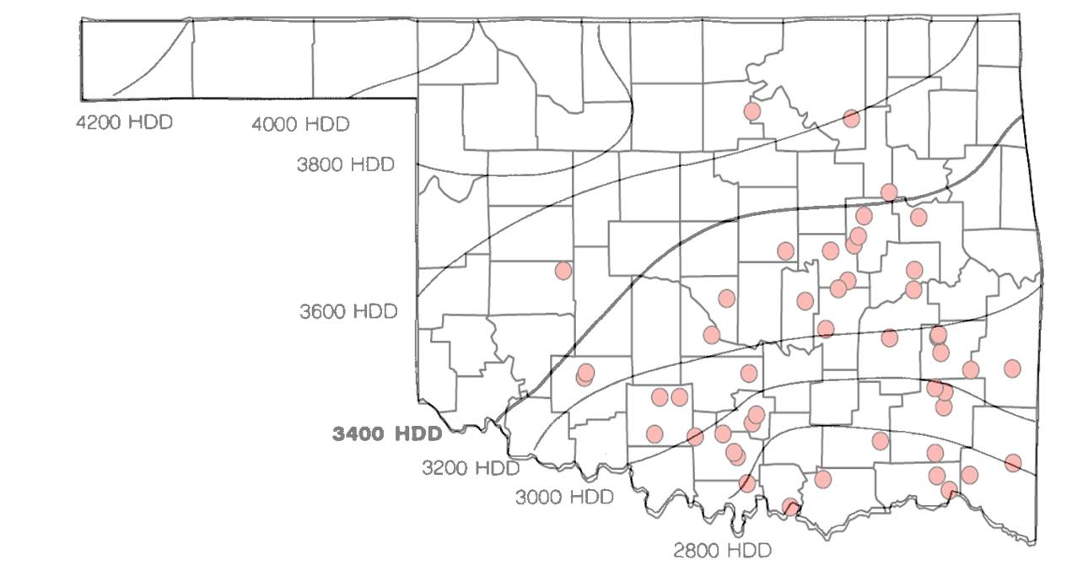
Figure 1. Heating Degree Day (HDD) clines across Oklahoma, U.S.A. Red dots are lakes currently stocked with Florida largemouth bass (FLMB) as part of the Oklahoma Department OF Wildlife Conservation (ODWC) Florida Largemouth Bass program. A majority of the currently stocked lakes are below the 3400 HDD cline. Modified from Gilliland (1992).

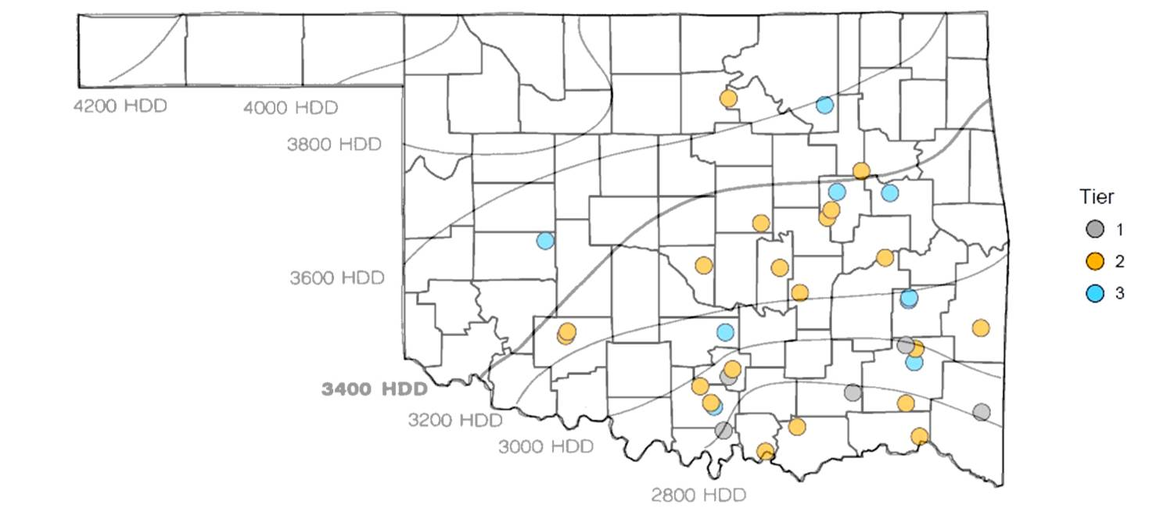
Figure 2. Thirty four Oklahoma, U.S.A. lakes in tiers one, two, and three of the Florida Largemouth Bass (FLMB) stocking program by the Oklahoma Department of Wildlife Conservaiton included in the stocking effort and regularized linear models analysis.
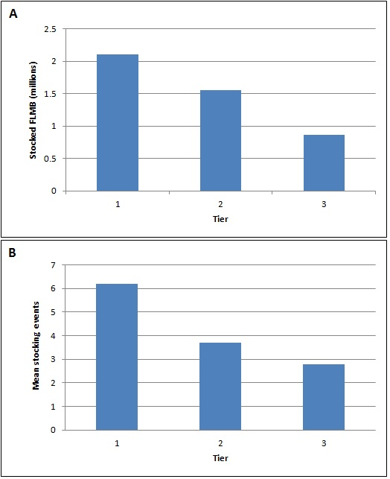
Figure 3. Total number of Florida largemouth bass stocked (A) and mean number of stocking events (B) since 2009 for lakes in tiers one, two, and three of the Oklahoma Department of Wildlife Conservation’s Florida Largemouth Bass Stocking Program.
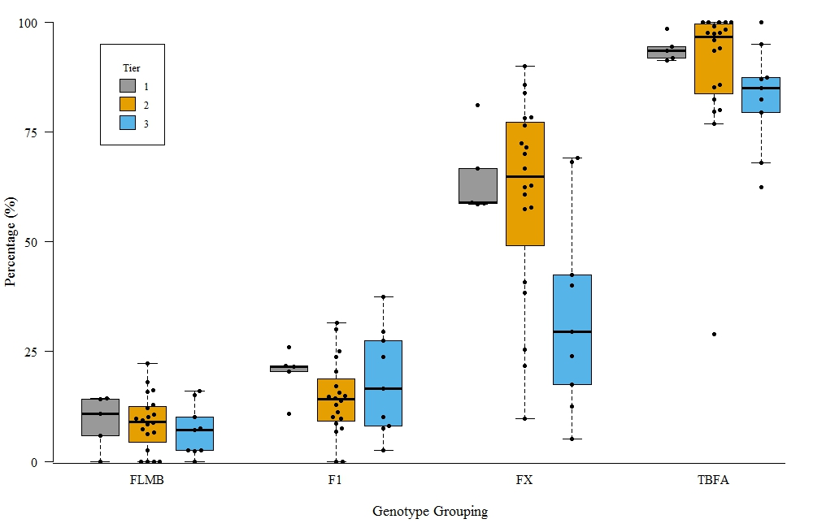
Figure 4. Genotype grouping percentages in tiers one, two, and three of the Florida largemouth bass (FLMB) stocking program by the Oklahoma Department of Wildlife Conservation (ODWC). The red circled point indicates the TBFA in Lake Eufaula and was excluded from the regularized linear regression models. NS- No significant difference. Letters indicate significant differences between tiers.
a
ab
a
b
a
a
NS
NS
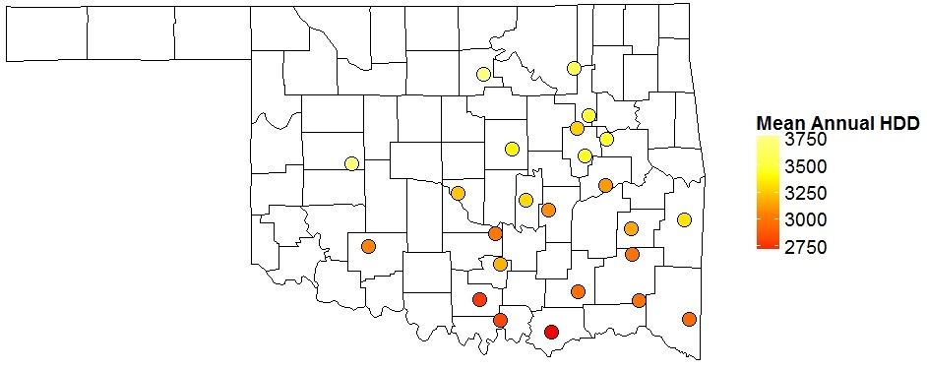
Mean Annual HDD
Figure 5. Mesonet stations used to calculate the Heating Degree Day (HDD) value for each lake used in regularized linear regression models. HDD values are the twenty year means for each station in Oklahoma, U.S.A (1997-2016). Lower values indicate warmer climates while higher values indicate colder climates.
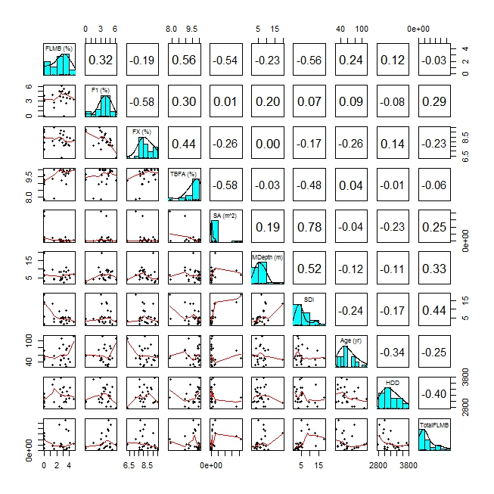
Figure 6. Correlation analysis of response variables (Florida largemouth bass (FLMB), first generation Florida-northern bass hybrids (F1), hybrid cross bass (FX), and total bass with at least one Florida allele (TBFA)) and predictor variables (surface area (SA), mean depth, Shoreline Development Index (SDI), reservoir age, heating degree days (HDD), total number of Florida largemouth bass stocked since 2009) used in the regularized linear regression model (n=34). Pearson’s Correlation Coefficients are displayed above the diagonal, histograms are displayed on the diagonal (FLMB, F1, FX, and TBFA have been square root transformed), and scatterplots with LOESS fits are displayed below the diagonal. HDD - annual mean of heating degree days, TotalFLMB - cumulative total of Florida largemouth bass stocked since 2009.

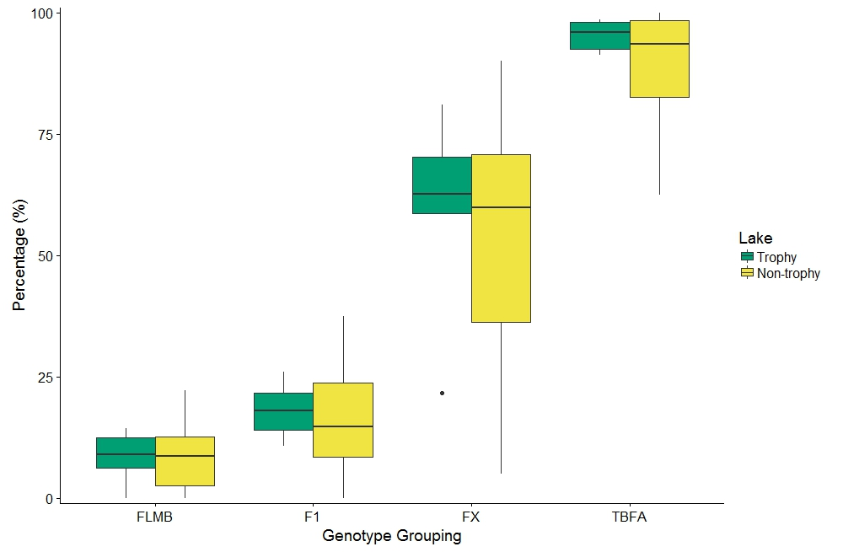
NS
NS
NS
NS
Figure 7. Genotype grouping percentages in trophy and non-trophy lakes in Oklahoma. NS- No significant difference

