UNIVERSITY OF OKLAHOMA
GRADUATE COLLEGE

HYBRID DECISION MAKING MODEL USING LINEAR PROGRAMMING AND ANALYTICAL HIERARCHICAL PROCESS FOR COMPARISON OF MANUFACTURING CHOICES (ADDITIVE AND TRADITIONAL) (A PILOT STUDY)

A THESIS
SUBMITTED TO THE GRADUATE FACULTY
in partial fulfilment of the requirements for the
Degree of
MASTER OF SCIENCE

By
RAVI SHANKAR GUNTURI
Norman, Oklahoma
2023
HYBRID DECISION MAKING MODEL USING LINEAR PROGRAMMING AND ANALYTICAL HIERARCHICAL PROCESS FOR COMPARISON OF MANUFACTURING CHOICES (ADDITIVE AND TRADITIONAL) (A PILOT STUDY)

A THESIS APPROVED FOR THE SCHOOL OF INDUSTRIAL AND SYSTEMS ENGINEERING

BY THE COMMITTEE CONSISTING OF

DR. SHIVAKUMAR RAMAN, CHAIR

DR. ANDRES GONZALEZ

DR. THEODORE TRAFALIS

© Copyright by Ravi Shankar Gunturi 2023
All Rights Reserved.
Acknowledgments
I would like to express my deepest gratitude to my advisor, Dr. Shivakumar Raman, for his unwavering support, guidance, and encouragement throughout this journey. His expertise and insights have been invaluable in shaping both this research and my understanding.
I am deeply grateful for the financial support given which made this research possible.
I am grateful to my professors at the department of Industrial and Systems Engineering, OU for their time and teaching. They have been invaluable for my career pursuits as an engineer.
My heartfelt appreciation goes to my parents and friends for their love, understanding, and constant encouragement. This work is dedicated to the memory of my late grandfather, Suryanaryana Murthy, whose wisdom, stories, and belief in my potential continue to inspire me. His influence has been an important light in my life, and I strive to uphold his values in my academic and personal pursuits.

Abstract

This research is built upon existing knowledge of additive manufacturing and traditional manufacturing to gain insights into the cost differences associated with different manufacturing processes as a pilot study. The researcher proposed a novel mathematical framework comprising a hybrid decision-making model comprising a linear optimization part entailed by the two distinct manufacturing procedures and an Analytical Hierarchical Process (AHP) part for choosing the best technology based on a set of qualitative factors. The model integrates diverse cost components, including but not limited to labor, materials, and equipment costs. Through a hybrid decision-making model, the research study analyzes additive manufacturing and traditional manufacturing in light of quantitative factors (cost) and qualitative factors (quality, speed of production, sustainability, and flexibility). By using a pilot case study, the results suggest that AM provides a reduction in cost due to optimization in various cost components but also considers TM as a preferable alternative over AM using the integrated qualitative criteria.

Table of Contents

Chapter 1: Introduction 1
1.1 Background 1
1.2 Rationale of Research 3
1.3 Problem Statement 4
1.4 Research Questions 5
1.5 Aims and Objectives 5
1.6 Structure of Thesis 5
Chapter 2: Literature Review 7
2.1 Additive Manufacturing in Aerospace 7
2.2 Cost Modeling in Additive Manufacturing Supply Chain 16
2.3 Literature on Analytic Hierarchy Process (AHP) for AM 25
2.4 Gaps in Literature and Contribution to Current Study 27
Chapter 3: Problem Description and Mathematical Modeling 29
3.1 Reason for Choosing Linear Optimization for Cost Estimation 29
3.2 Expansion of LP Model to AHP Framework 35
Chapter 4: Results and Discussion 37
4.1 LP for Cost Estimation for AM and TM 38
4.2 Case Study Analysis 41
4.3 Application of AHP and Hybrid Decision-Making Approach 45
4.4 Implications of Research 53
4.5 Limitations of Research 55
Chapter 5: Conclusion and Future Recommendations 57
5.1 Summary of Results 57
5.2 Future Recommendations 58
5.3 References 62

Introduction

1.1 Background
The aerospace industry comprises a range of applications, including both civilian and military aircraft, space launch and in-orbit systems, missiles, satellites, and general aviation. The aerospace industry has experienced a significant reduction in revenue as a result of the COVID-19 pandemic, with a decrease from $342.2 billion in 2019 to $298 billion in 2020 (Campanella et al., 2022). The aerospace industry's manufacturing processes are influenced by a multitude of goals related to cost and sustainability. These objectives are interdependent and interact with one another. The interdependence of these objectives necessitates a meticulous evaluation of each factor to determine the most suitable design solution.
The pursuit of enhanced efficiency via cost reduction, lead time minimization, and weight reduction of flight components necessitates the utilization of high-performance materials featuring intricate designs. It is imperative to execute this task within a feasible budget and timeline to fulfill commercial demands or mission objectives. The aerospace industry has relied on established manufacturing systems and strategies for several decades to meet various design objectives (Hueber, Horejsi and Schledjewski, 2016). Nonetheless, the advent of additive manufacturing (AM) has had and will continue to have a significant influence on both design and manufacturing processes. The digital transformation of additive manufacturing, commonly referred to as Industry 4.0, is projected to expand its market share within the aerospace industry to $3.187 billion by 2025, exhibiting a mean compound annual growth rate (CAGR) of 20.24% (Hueber, Horejsi and Schledjewski, 2016). The field of aerospace has experienced a significant surge in research about additive manufacturing (AM) over the past ten years, exhibiting a notable increase in growth. Apart from the scholarly literature, a considerable amount of pertinent
material is available in the form of technical reports, popular literature, and promotional articles from commercial aerospace vendors. However, technical information may be limited for commercial purposes.
As opposed to conventional subtractive manufacturing techniques, additive manufacturing employs a stratified methodology for production, utilizing a communal feedstock, commonly in the form of powder or wire (Negi, Dhiman and Sharma, 2013). The given feedstock undergoes a thermal treatment, leading to its liquefaction or fusion, followed by its solidification into the intended shape, as directed by a heat source trajectory that is defined digitally. The implementation of additive manufacturing in aerospace components confers numerous advantages, such as reduced lead time and related expenses, the ability to fabricate intricate geometries that promote weight reduction, the amalgamation of multiple components, and improvements in overall performance. The aforementioned benefits are attained through strict adherence to financial and temporal constraints, thereby enhancing programmatic and technical hazard mitigation (Negi, Dhiman and Sharma, 2013). This has been documented in various sources (Negi, Dhiman and Sharma, 2013). Through the utilization of the design flexibility afforded by metal additive manufacturing (AM), it becomes feasible to optimize the distribution of material, thereby decreasing the mass of the component, all while preserving its mechanical and other performance criteria. The amalgamation of components is a viable option that can curtail both risk and cost associated with multiple components, while concurrently mitigating potential failure modes across joints. Moreover, it is feasible to achieve improved performance that surpasses that of traditional manufacturing by employing mechanical, thermal, and other optimization techniques for the development of intricate components that were previously unfeasible to produce. This includes the integration of internal features like conformal cooling channels on combustion chambers or turbine blades, as exemplified in references. The utilization of additive manufacturing (AM) in aerospace applications is currently primarily motivated by the decreased lead times. However, certain manufacturing scenarios provide additive manufacturing with distinct advantages over conventional manufacturing methods.

1.2 Rationale of Research
The aerospace sector holds significant importance across diverse domains, spanning from commercial and defense aviation to space exploration, encompassing missiles, satellites, and general aviation. Notwithstanding, the industry has encountered formidable obstacles, notably amidst the COVID-19 pandemic, culminating in a diminution of earnings. This mandates a thorough investigation to tackle the precise intricacies and demands of the aerospace sector.
The advent of additive manufacturing (AM) has engendered substantial progressions in the realm of design and manufacturing procedures in the aerospace sector. Additive Manufacturing, commonly referred to as 3D printing, presents distinctive benefits such as the capacity to fabricate complex geometries, reduce weight, combine components, and enhance functionality. The aforementioned advantages are following the aerospace sector's requirement for manufacturing solutions that are both economical and productive.
Moreover, the utilization of additive manufacturing bears the possibility of curtailing lead times and concomitant expenses. The capacity to generate intricate components with reduced assembly prerequisites can optimize the manufacturing workflow, culminating in enhanced programmatic and technical hazard mitigation.
In light of the transformative potential of additive manufacturing in the realm of aerospace production, we must undertake a basic-level pilot study to fully elucidate its capabilities and constraints. It is of utmost importance to evaluate the relative cost-effectiveness of additive manufacturing versus conventional subtractive manufacturing techniques in the context of the aerospace industry's manufacturing supply chains. The assessment ought to encompass a range of considerations, such as expenses incurred for materials, workforce, and machinery, to furnish discernment into the economic soundness and practicability of embracing additive manufacturing.
Moreover, it is important to consider a range of qualitative factors like quality, speed of production, etc. for decision-making regarding the best technology for the given application. This study will propose a hybrid model comprising the integration of AHP with LP to provide a holistic approach to choosing between AM and TM based on a set of quantitative and qualitative factors. The importance of this approach lies in the significance of different factors that designers consider while manufacturing products through approaches of 3D printing or conventional means.

1.3 Problem Statement
The aerospace sector is perpetually exploring avenues to enhance its production methodologies, with a specific focus on cost optimization. Given the advent of additive manufacturing (AM) as a technology with great potential, it is imperative to undertake a pilot study toward understanding the differences between AM and subtractive methods in the realm of cost optimization.
The crux of the inquiry lies in evaluating the benefits of additive manufacturing versus conventional manufacturing in the aerospace sector as a pilot study by using a set of quantitative and qualitative factors. The task at hand pertains to the assessment of various elements, including cost-related aspects like machine cost, labor cost, and other qualitative criteria like quality of production, speed of production, etc. Through a comprehensive examination of these constituents, the study endeavors to furnish discernment into the fiscal ramifications of embracing additive manufacturing within the aerospace manufacturing supply chains. It is imperative to evaluate how these benefits manifest as tangible economic benefits, influencing the aggregate production expenses, encompassing primary installation expenses, functional expenses, and upkeep expenses. Comprehending the cost dynamics and qualitative aspects inherent in additive manufacturing vis-à-vis conventional manufacturing techniques shall empower industry stakeholders to make judicious choices concerning technology adoption and supply chain streamlining.

1.4 Research Questions
- Which manufacturing method provides better cost feasibility between AM and TM using a linear programming approach?
- Considering both quantitative cost factors and qualitative factors like quality, flexibility, and sustainability, which method between AM and traditional manufacturing provides a better alternative?

1.5 Aims and Objectives
- Analyzing the impact of cost and qualitative factors, like quality, speed of manufacturing, sustainability, and flexibility, on choosing the right manufacturing method between additive manufacturing and traditional manufacturing in the aerospace industry.
- Developing a hybrid model comprising quantitative factors of cost and qualitative criteria for integrated decision-making for the choice of the manufacturing method

1.6 Structure of Thesis
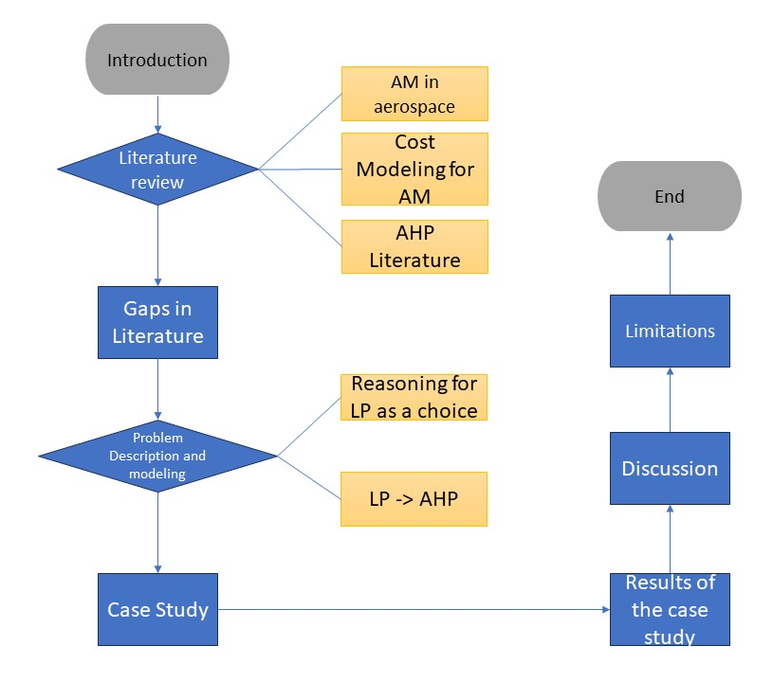
The structure of the thesis is as follows. The next section will review the scholarly literature regarding cost estimation for AM and how it provides benefits over traditional manufacturing methods. The section on problem description and mathematical modeling will formulate the problem and analyze the cost associated with AM and traditional manufacturing. The researcher will discuss the decision making when qualitative factors also to be considered in the next section, followed by the results and conclusion of the thesis.

Literature Review

2.1 Additive Manufacturing in Aerospace
The aerospace industry comprises a range of applications including commercial and military airplanes, space launch and in-orbit systems, missiles, satellites, and general aviation. The aerospace industry has experienced a significant reduction in revenue as a result of the COVID-19 pandemic, with a decrease from $342.2 billion in 2019 to $298 billion in 2020 (Blakey-Milner et al., 2021). The decrease in the commercial aviation industry can be attributed mainly to the implementation of air travel limitations, social distancing measures, and other restrictions imposed in response to the COVID-19 pandemic. Notwithstanding this obstacle, it is anticipated that the aerospace industry will experience an expansion in revenue to reach $430.87 billion by 2025 (Blakey-Milner et al., 2021). The expansion can be attributed mainly to the sustained need for fresh commercial airplanes, augmented worldwide military spending, elevated market engagement in the space industry, and significant research and development efforts that have persisted during the pandemic (Blakey-Milner et al., 2021).
The aerospace industry's manufacturing process is influenced by a multitude of technical and economic goals, including but not limited to functional performance, lead time minimization, weight reduction, complexity, cost control, and sustainability (Blakey-Milner et al., 2021). Each of these objectives exhibits significant interrelationships, and it is imperative to carefully consider the various factors associated with each objective when selecting an optimal design solution.
The pursuit of enhancing efficiency through cost reduction, lead time minimization, and weight reduction of flight components has led to the utilization of high-performance materials and intricate designs. It is imperative to execute this task within a feasible budget and timeline to fulfill commercial demands or mission objectives (Blakey-Milner et al., 2021). The aerospace industry has relied on conventional manufacturing systems and strategies for several decades to meet the design objectives of various applications. Nevertheless, the advent of additive manufacturing (AM) has had and will continue to have a significant influence on both the design and manufacturing processes. The digital transformation of additive manufacturing, commonly referred to as Industry 4.0, is anticipated to expand its market share within the aerospace industry to $3.187 billion by 2025, exhibiting a mean compound annual growth rate (CAGR) of 20.24% (Blakey-Milner et al., 2021). The field of aerospace has experienced a significant surge in research about additive manufacturing (AM) over the past ten years.
In contrast to traditional subtractive manufacturing methods, additive manufacturing employs a layer-by-layer approach that relies on a shared feedstock, typically in the form of powder or wire. This feedstock is melted or fused by a heat source and subsequently solidifies to yield the final geometry, which is determined by a digitally defined heat source trajectory (Herzog et al., 2016). The utilization of additive manufacturing in the production of aerospace components presents certain benefits such as decreased lead time and associated expenses, the capacity to create and fabricate intricate geometries that facilitate lightweight, consolidation of multiple components, and enhancements in performance. These advantages are achieved while adhering to cost and timeline limitations, thereby providing an improved approach to programmatic and technical risk management (Blakey-Milner et al., 2021). Through the utilization of the design flexibility afforded by metal additive manufacturing, it becomes feasible to optimize the material allocation, resulting in a reduction of mass without compromising the mechanical and other performance criteria of the constituent part. The integration of components is a viable strategy that can mitigate risks and costs associated with multiple components, while also minimizing potential failure modes across joints. Furthermore, it is feasible to achieve improved efficiency levels surpassing those of traditional manufacturing methods through the utilization of mechanical, thermal, and other optimization techniques in the development of intricate components that were previously unfeasible to produce. This involves integrating internal characteristics like conformal cooling channels on combustion chambers or turbine blades, as exemplified in references (Snyder and Thole, 2019; Kerstens, Cervone and Gradl, 2021). The current primary impetus for the utilization of additive manufacturing (AM) in aerospace applications is the decreased lead times. However, certain manufacturing scenarios endow AM with benefits that surpass those of conventional manufacturing.
The AM process offers a significant advantage in terms of complexity, as it enables the creation of new designs that can improve mechanical and thermal performance while reducing system mass (Blakey-Milner et al., 2021). This is a capability that is not achievable through other manufacturing methods. The innate potential for intricacy in additive manufacturing (AM) design facilitates the reduction of weight through the amalgamation of numerous components into a singular entity, as well as the possibility of heightened technical efficiency. Despite common misunderstandings about the unrestricted nature of additive manufacturing (AM) technologies, they are well-suited for producing highly complex outcomes (Blakey-Milner et al., 2021). This allows for lightweight by utilizing materials following the technical requirements, such as structural, vibratory, or thermal needs, rather than being limited by the manufacturing process. Yadroitsev et al. (2021) presented a comprehensive analysis of the design limitations of AM through a systematic review. It is important to acknowledge that the intricacy of additive manufacturing (AM) components should be suitably balanced in the design phase and throughout their lifecycle. Failure to fully comprehend the complexity may result in the need for additional post-processing procedures or unforeseen operational difficulties.
Yadroitsev et al. (2021) also provided a comprehensive analysis of algorithmic design techniques, commonly known as generative design, and their potential for topology optimization. The term "part consolidation" pertains to the process of redesigning multiple components that interact with each other into a single integrated system. This results in a significant improvement in the technical performance of the system. The incorporation of numerous constituents facilitates the elimination of interlocking surfaces and frameworks, leading to a rise in structural effectiveness and a decrease in expenses linked with the scrutiny and validation of interlocking structures. In addition, the amalgamation of various components has the potential to significantly decrease the total expenses associated with manufacturing (Yadroitsev et al., 2021). The reduction in costs is made possible through the direct reduction of manufacturing lifecycle costs and the decrease in non-recurring costs related to design, certification, and risk management of failure modes linked to part interactions.
The aerospace industry heavily depends on machined forged and billet structures to support high-value structural systems. The aforementioned manufacturing methodology offers a heightened level of assurance in the ultimate quality of the component. This is because billet materials are easily certified for both porosity and microstructure. However, it is important to note that this approach also incurs significant direct manufacturing expenses, as well as additional costs resulting from prolonged production lead times. The process of forging necessitates costly activities such as designing, manufacturing, and testing performing dies. Additionally, billet machining is inherently expensive, with estimated buy-to-fly ratios of 20:1. As discussed in (Gebler, Uiterkamp and Visser, 2014), the production of a final product with a mass of 10 kg necessitates the utilization of 200 kg of stock materials. According to some sources, the aforementioned ratio is approximately 40:1 (Dutta and Froes, 2017). The surplus material is deemed as refuse and is subjected to recycling or reprocessing, whenever feasible, thereby incurring substantial expenses for all undertakings.
Due to the layer-by-layer manufacturing technique employed in additive manufacturing (AM), the production process results in minimal waste generation, with buy-to-fly ratios ranging from 1:1 to 3:1. According to Horn & Harrysson (2012), Additive Manufacturing offers a notable benefit in that it obviates the necessity for tooling and protracted lead times that are typically associated with part production. By delving deeper into this notion, the utilization of Additive Manufacturing enables the progression of the manufacturing process toward the consumer, thereby facilitating the production of products or product groups that cater to the specific demands of individual consumers. The research (Horn and Harrysson, 2012) posited that additive manufacturing (AM) holds significant promise in the aerospace sector, particularly concerning weight reduction vis-à-vis conventional techniques for numerous aerospace components. The aforementioned ratio holds the potential to be of considerable significance, with a possible value of 20:1 (Horn and Harrysson, 2012). An additional benefit of additive manufacturing lies in its capacity to seamlessly incorporate various components, such as pumps, fluid passages, and pistons, into mesh structures that are both lightweight and robust. The incorporation of said constituents in a straightforward manner significantly diminishes the aggregate mass, production duration, substance excess, and monetary expenditures (Horn and Harrysson, 2012). The initial utilization of additive manufacturing pertained to the realm of expeditious prototyping, followed by tool fabrication. The aforementioned domains persist in their utilization for immediate production. Additive manufacturing presents itself as a highly promising technological advancement for various industries, particularly the aerospace sector. Enterprises operating in the aerospace sector, which necessitate the fabrication of a limited quantity of intricate components, have already recognized their capabilities and are dedicating resources towards enhancing their dependability and versatility (Guo and Leu, 2013). The evolution of AM has seen it progress from a mere Rapid Prototyping technology to a comprehensive manufacturing process, thereby presenting opportunities for the production of functional parts.
As per the findings of Gebler et al. (2014), additive manufacturing confers a degree of latitude in design and facilitates the reconfiguration of products and components. The utilization of AM technology facilitates the mitigation of expenses, temporal constraints, and quality concerns that arise from the necessity of assembling diverse materials. The minimization or complete elimination of assembly costs can be achieved via the implementation of part stabilization techniques (Gebler, Uiterkamp and Visser, 2014). The expeditious design-to-build cycle inherent in additive manufacturing (AM) facilitates the optimization of the strength-to-weight ratio of products by manufacturers. The implementation of AM lightweight components has the potential to curtail energy consumption and yield substantial cost savings amounting to $56-219 billion by the year 2025 (Gebler, Uiterkamp and Visser, 2014).
As per Sandström (2015) findings, the medical industry is well-suited for the application of additive manufacturing technology owing to its ability to produce bespoke, individualized products. It is noteworthy that AM technology predominantly produces in-ear hearing aids. The proposition put forth by Chen et al. (2015) posits that additive manufacturing (AM) may confer certain health advantages vis-à-vis conventional manufacturing methodologies. The utilization of Additive Manufacturing enables laborers to circumvent prolonged exposure to arduous and conceivably hazardous occupational settings. The study conducted by Owens et al. (2015) aimed to measure the benefits of additive manufacturing proficiency, specifically concerning the reduction of mass, to provide valuable insights for strategic technology development investments. The researchers (Owens et al., 2015) conducted an analysis of the spares logistics prerequisites for a hypothetical multi-decade Mars exploration initiative, taking into account the utilization of conventional spares and two theoretical levels of additive manufacturing (AM) capability, along with the possibility of producing raw material on-site. The results of the study (Owens et al., 2015) indicated that even a modest AM capability can lead to a reduction of 2.87 metric tons in the mass of Environmental Control and Life Support (ECLS) spare logistics throughout the mission campaign. An elevated degree of amplitude modulation proficiency yields a diminution of 5.71 metric tons. The generation of feedstock in situ has been observed to result in a significant reduction in logistics mass, with reductions of up to 5.21t and 9.80t being reported for low- and high-capability scenarios, respectively (Owens et al., 2015).
The distinctive capabilities of Additive Manufacturing stem from its layer-by-layer approach to material addition. The primary capacity is the ability to achieve intricate geometries, enabling the construction of near-net shapes and internal channels that are unattainable through conventional manufacturing methodologies (Lamei, 2021). The second distinctive attribute pertains to the concept of "hierarchical complexity," which centers on the intricate design of a component that encompasses multifaceted shapes across various magnitudes. This particular attribute facilitates alterations to the intrinsic configuration and reinforces components with minimal mass, such as honeycombs, foams, or lattices (Lamei, 2021). The third facet of Additive Manufacturing pertains to the attribute of "functional complexity," which enables the fabricator to construct individual components as a unified entity. The ultimate distinguishing feature of additive manufacturing (AM) is the property of "material complexity," which can be manipulated as a singular material or amalgamated into a single layer, as posited by Gibson et al. in 2015 (Lamei, 2021).
As per Thomas (2016) findings, the utilization of Additive Manufacturing enables the construction of an entire assembly in a single build, thereby reducing transportation and inventory expenses, consequently leading to a ripple effect throughout the supply chain. Baumers et al. (2012) analyzed the benefits and drawbacks inherent in the utilization of said technology. The benefits and drawbacks of additive manufacturing have significant economic implications for the firms that employ this technology (Baumers et al., 2012). The utilization of Additive Manufacturing (AM) can yield both benefits and drawbacks, which may either augment the worth of the product or escalate its expenses.
The utilization of Additive Manufacturing techniques empowers manufacturers to fabricate intricate geometries with ease. The exceptional capacity in question engenders long-lasting commodities and engenders services that hold greater economic worth throughout the lifespan of said products (Baumers et al., 2012). The capacity to fabricate limited quantities of merchandise sans the need for specialized equipment confers the advantages of personalized mass production tailored to specific use cases or end-users. The constraints imposed by the availability of conventional building materials have necessitated the utilization of alternative materials that deviate from the norm (Baumers et al., 2012). The augmented duration of the processing speed has led to a rise in time-dependent costs that are not directly incurred. Additionally, the suboptimal surface finish has necessitated additional post-processing measures that demand more time and laborious efforts. Attaran (2017) research posits that the implementation of AM technology presents novel prospects for enterprises seeking to optimize their manufacturing processes. The implementation of Additive Manufacturing (AM) facilitates a decrease in the expenses associated with the supply chain. The author posits that additive manufacturing (AM) offers a quintet of salient advantages, namely cost-effectiveness, expediency, superior quality, innovation/transformation, and consequential impact, as depicted in the accompanying diagram. Attaran (2017) further contends that AM technology facilitates the curtailment of repair durations, minimizes labor expenses, and mitigates warehousing costs. The advantages of additive manufacturing include the ability to eliminate tooling, the potential to update repaired components to the most current design, and the ability to achieve mass customization at a reduced expense. The aforementioned study has provided a comprehensive overview of the benefits that Additive Manufacturing technology offers in comparison to traditional manufacturing methods across various domains of implementation. Attaran (2017) presented a comprehensive overview of the benefits of Additive Manufacturing in diverse sectors, including but not limited to aerospace, automotive, machine tooling, healthcare, architectural, apparel, and food.
Conversely, as posited by Hopkinson & Dicknes (2003), additive manufacturing technology is not without its drawbacks. Employing the utilization of AM may potentially incur significant expenses attributed to machinery, upkeep, and resources. Insufficiency in precision, intricacy, substandard refinement of surface texture, and restricted options for material assortment are additional inadequacies of additive manufacturing methodology (Hopkinson and Dicknes, 2003). The imperative of constructing a supportive framework may engender the necessity for reworking in additive manufacturing. One of the drawbacks of additive manufacturing technology is the correlation between the temporal investment required for construction and the dimensions of the component housed within the fabrication chamber.

2.2 Cost Modeling in Additive Manufacturing Supply Chain
The efficacy and success of a company are intricately linked to its ability to accurately estimate costs, as an overestimation thereof may result in a detrimental loss of business and goodwill within the market. Conversely, it is imperative to acknowledge that the act of undervaluing may potentially result in detrimental fiscal ramifications for corporations, as posited by (Niazi et al., 2006). To delineate the scope of cost analysis, it is advantageous to classify costs by type, thereby facilitating the identification of which costs to incorporate. A classification scheme has surfaced in the realm of advanced manufacturing technologies, which pertains to the evaluation of costs. This scheme is predicated on the factors of productivity, quality, and flexibility.
Furthermore, in the pursuit of analyzing expenses in intricate systems, it is advantageous to discern the distinction between well-organized expenditures and those that are disorganized. Costs that are deemed well-structured are those that are comprehensively comprehended by accounting professionals, such as the expenses associated with acquiring raw materials. The notion of ill-structured costs pertains to costs that are inadequately comprehended owing to constraints in knowledge or data, or the absence of established accounting procedures. The interrelation among these distinct classifications of expenditures, accompanied by illustrative instances, is visually depicted in the following Figure.
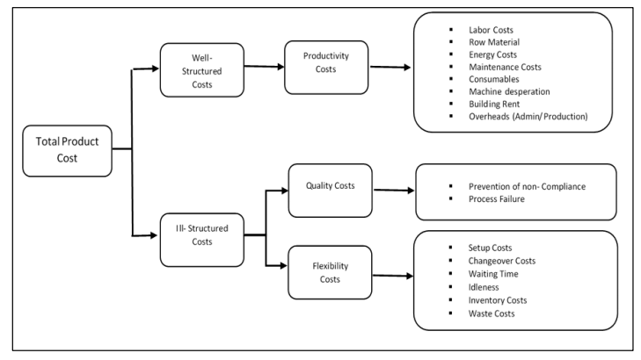
Types of Cost in Product Cost Estimation (Son, 1991)
According to Lindemann (2012), Activity Based Costing serves as the foundation for all approaches. One of its primary benefits, as outlined by Lindemann, is its ability to take into account various influencing factors by utilizing resources. The model proposed by Lindemann in 2012, which is based on the ABC approach, has contributed to enhancing our comprehension of the cost structure associated with products manufactured using additive manufacturing (AM).
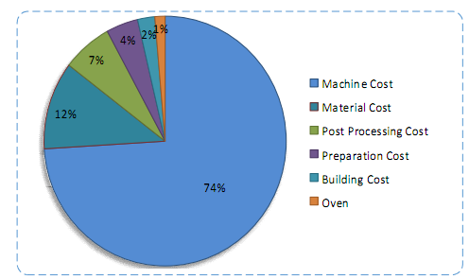
AM Cost Structure (Lindermann et al., 2012)
In contrast to conventional manufacturing methods, additive manufacturing does not enjoy the advantages of economies of scale. There are two primary factors contributing to this situation: the slow rates at which deposition occurs and the limited capacity for construction. Hopkinson and Dickens (2003) found that the behavior of AM costs concerning units produced exhibits an initial decrease in manufacturing costs, followed by a stabilization in the trend.
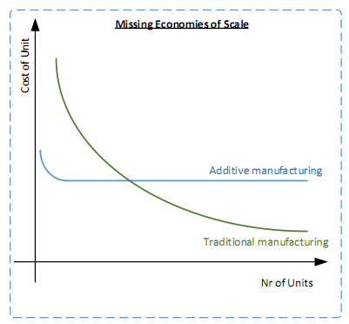
AM Economies in Different Cost Models (Hopkinson and Dicknes, 2003)

Cavalieri et al. (2004) have partitioned the process of approximating the cost of a product into three distinct quantitative methodologies. The initial approach entails the utilization of the analogy-based methodology. The methodology employed is predicated upon the congruence between the novel product and a prior offering previously manufactured by the organization. The subsequent quantitative methodology pertains to the parametric technique. This methodology entails the application of an analytical function to a collection of variables, including but not limited to performances, morphological characteristics, and material composition.
The customary nomenclature for these analytical functions is Cost Estimation Relationships (CER). The ultimate methodology entails the utilization of engineering techniques. The present methodology entails the derivation of approximations through a comprehensive examination of the intricacies inherent in the production process, as well as the salient attributes of the resultant commodity. The projected expense of the merchandise is derived from a comprehensive evaluation of the worth of the resources employed at every phase of the manufacturing procedure, encompassing raw materials, components, labor, and equipment. Consequently, the implementation of the engineering methodology is contingent upon the comprehensive delineation of all facets of both the manufacturing process and the resultant product. The categorization of product cost estimation techniques was conducted by Niazi et al. (2006) and was divided into two distinct categories: qualitative and quantitative. The fundamental basis of qualitative methodologies lies in the juxtaposition of a novel product with antecedent iterations to discern any resemblances in the former.
The utilization of quantitative methodologies is predicated upon a comprehensive examination of the intricacies inherent in manufacturing procedures. The realm of qualitative methodologies is bifurcated into two distinct categories: intuitive techniques and analogical techniques. The realm of quantitative methodologies can be further partitioned into two distinct categories, namely parametric and analytical, as visually depicted in the accompanying Figure.
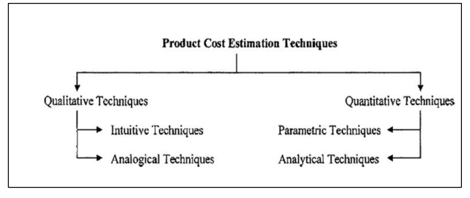
Product Cost Estimation Methods (Son, 1991)
The development of an intuitive technique is predicated upon the experiential knowledge of an estimator who possesses a deep familiarity with the intricacies of manufacturing tasks. The analogical technique involves the juxtaposition of past historical data with present descriptions for comparison. The parametric methodology entails the systematic gathering and arrangement of past data through statistical means that pertain to diverse cost variables. The final methodology under consideration is the analytical technique. Ultimately, the analytical approach is founded upon mathematical methodologies that pertain to the process of transforming a given component into a series of unitary decompositions, predicated upon their respective operations or activities. As per the findings of Smart et al. (2007), the utilization of process-based cost modeling can potentially enhance the efficacy of parametric cost estimation methodologies. The modeling approach that centers on processes is concerned with how costs are incurred, as it establishes a connection between cost drivers and the discrete processes that constitute the program's design, development, testing, and production phases. The genesis of process-based modeling can be traced back to activity-based modeling, a methodology that adopts a granular perspective to cost modeling and is commonly employed to gauge production costs.
The Cost-Benefit Analysis (CBA) methodology presents itself as an alternative approach to evaluating the merits and demerits of various options, with the ultimate goal of ascertaining the optimal course of action that would yield the greatest benefits. The utilization of CBA is primarily observed in two principal domains. Initially, one must ascertain the soundness of an investment or decision by evaluating the extent to which its benefits surpass its costs. Subsequently, to establish a framework for evaluating investments or resolutions, it is imperative to juxtapose the aggregate anticipated expenses of each alternative with its corresponding aggregate anticipated advantages (David, Dube, and Ngulube, 2013). The classification of product cost estimation techniques has been expounded upon by Hueber et al. (2016), who have identified three primary categories: analogous, parametric, and bottom-up cost estimation.
The analogous costing technique is distinguished by the process of modifying the cost of a comparable product concerning the dissimilarities it bears with the intended product. Parametric cost estimation and cost estimation relationships refer to the utilization of mathematical equations to establish a correlation between the cost of a product and various variables, including but not limited to weight and size. The methodology of bottom-up estimations involves the summation of all individual production steps to derive the ultimate cost of the final product. The accurate approximation of this phenomenon necessitates a profound comprehension of the underlying mechanisms and their interdependent relationships.
Baumers & Tuck (2019) posit that the examination of production costs serves a twofold purpose, namely the estimation and modeling of costs. The disparity amidst these rationales is contingent upon their respective objectives. The objective of cost estimation is to provide a deeper understanding of the cost performance of a manufacturing process, and its evaluation is contingent upon the precision and uniformity of the estimates (Baumers and Tuck, 2019). Cost models are formulated to demonstrate cost interdependencies. Consequently, these estimations not only demonstrate validity but also effectively illustrate the interconnections among varying viewpoints. The evaluation of cost models is contingent upon their capacity to effectively encapsulate significant viewpoints, alongside the precision and uniformity of their outcomes.
As per the research conducted by Kadir et al. (2020), the categorization of cost estimation methodologies is contingent upon various viewpoints, contingent on the intended employment of the cost. According to Mahadik & Masel (2018) perspective, the expenses incurred in the production of an object through an AM system are closely tied to the resources utilized during the manufacturing process. The resources deemed pertinent for additive manufacturing were those of material, machinery, labor, and tooling. To derive an approximation of the overall cost of the product, an estimation of the expenses incurred by the resources utilized was conducted.
The Additive Manufacturing Cost Estimation Tool (AMCET) was implemented by Mahadik & Masel (2018) utilizing a cost estimation methodology that employs a breakdown approach. The findings of their research indicate that the act of estimating time is a pivotal component, given the strong correlation between manufacturing expenses and the duration of the process. Thus, to derive an accurate approximation of the overall expenditure utilizing their model, it is imperative to gauge the temporal requirements for producing a solitary stratum. This entails factoring in the duration of the printer's forward motion, the deposition of material, the fusion of said material to form a layer, and the subsequent lowering of the platform following the completion of a layer. Each of these perspectives utilizes distinct classification methodologies, namely method-based, task-based, and level-based, correspondingly. The perspectives of finance and accounting are classified as either qualitative or quantitative. The nomenclature assigned to this categorization is predicated upon the methodology-oriented approach.
The cost model employed by (Yang and Li, 2018) was predicated on the utilization of the ABC estimation methodology. The model in question comprises expenses about three distinct procedures. The initial stage involves pre-processing, wherein the machine operator exercises control over the software and machine configuration. The subsequent phase, namely processing, ensues during the incremental fabrication of the object in the additive manufacturing system, where it is produced in a stratified manner. In the culminating stage of this model, known as post-processing, the machinist retrieves the printed components and proceeds to cleanse the AM system in preparation for the subsequent production batch. As per the findings of Yang and Li (2018), the determination of per part unit cost for mixed geometries in a batch necessitates a systematic arrangement of the parts followed by discernment of distinct unit costs. The sorting algorithm has meticulously evaluated multiple tiers of component elevation, magnitude, and intricacy. The aggregate expense of the heterogeneous assemblage is equivalent to the summation of the diverse tiers of elevation, the manifold tiers of volume for elevation, and the sundry tiers of intricacy for elevation volume. The cost of energy consumption is contingent upon the maximal elevation of the geometries present within the production batch, in conjunction with a prescribed layer thickness. The expenditure incurred in labor is solely associated with the tasks that precede and succeed the production process. The operator is responsible for configuring the amplitude modulation system and the corresponding control software in both the pre-processing and post-processing stages of production. The cost of materials encompasses two distinct sources, namely the cost of the constituent parts and the cost of the support structure materials. The present model has taken into account the expenses incurred due to machine depreciation, maintenance, and administrative costs, which are included in the overhead expenditure. A cost model has been interdicted, which delves into the cost performance analysis of mixed geometries.
The model proposed by Ulu et al. (2019) pertains to the estimation of costs associated with Additive Manufacturing systems utilizing metal materials. The individuals in question have devised a cost model utilizing a methodology centered around process-based cost estimation. The authors incorporated material, labor, energy, and machine costs as significant determinants within their cost framework. The study (Ulu et al., 2019) demonstrated that by utilizing concurrent process variables, one can achieve more economical outcomes while using a comparable amount of material. This can be accomplished by constructing high-stress regions with lower power values, thereby obtaining greater yield strength, and by raising the power in other areas to reduce the number of passes and the duration of the building process. The model that was put forth failed to take into account the expenses incurred in addition to the main costs.
The techniques employed for cost analysis can be broadly categorized into two distinct categories, namely intuitive and analogical methods, both of which are qualitative. The classification of quantitative cost models is commonly divided into two distinct categories: parametric and analytical methodologies. Task-oriented categorization methodologies are employed in the realm of manufacturing viewpoints, which may be further subcategorized as either design-centric or process-centric cost models. The design-oriented approach entails undertaking preliminary steps, such as part design, process planning, and redesign, before commencing production. The process-oriented approach primarily pertains to the phase of production. The manufacturing perspective takes into account both direct costs, such as those associated with materials, labor, machinery, and energy, as well as indirect costs, including administrative and secondary operational expenses. Finally, within a tiered framework, it is common to employ economic and managerial viewpoints to categorize cost methodologies. This particular viewpoint is dichotomized into either the microcosmic process level or the macrocosmic system level. The process level pertains to the expenses incurred in the production phase, while the system level pertains to the costs associated with services, the supply chain, and the entire life cycle of the product.

2.3 Literature on Analytic Hierarchy Process (AHP) for AM
The Analytic Hierarchy Process (AHP) is a Multicriteria Decision Analysis (MCDA) tool that employs analytical principles (Wind and Saaty, 1980). These principles are rooted in the integration of psychological concepts and mathematical analysis (Wind and Saaty, 1980). The overall hierarchy process can be classified based on the figure below. This figure consists of three layers: 1) the highest layer represents the desired outcome or goal of the problem, 2) the middle layer represents the main factor selected or the sub-factor, and 3) the bottom layer represents the available options or alternatives. The frequency at which the analysis must be conducted to perform a pairwise comparison can be observed in Equation (1), wherein n represents the matrix's dimensions determined by the number of factors. Subsequently, the outcomes are examined by assigning weighted values (known as relative weight) to both the factors and/or the alternatives.
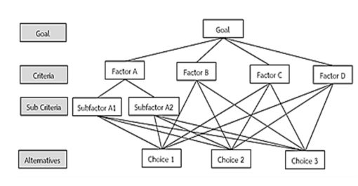
Layers of AHP Framework (Khamhong, Yingviwatanapong and Ransikarbum, 2019)
Different research studies evaluated the role of AHP in selecting the best 3D printing technologies by using the chosen criteria. Khamhong, Yingviwatanapong and Ransikarbum (2019) considered 3D printing characteristics and material factors as criteria for the choice of AM technology. Similarly, Sonar, Khanzode and Akarte (2021) considered 11 different factors to come up with a solution for AM technology based on these factors. These studies provide and several other scholarly efforts consider criteria for choosing the best technology in AM regime. However, the literature lacks evidence regarding the comparison of AM and TM using AHP or the utilization of AHP in tandem with tools like Linear Programming to arrive at a decision.

2.4 Gaps in Literature and Contribution to Current Study
The scholarly examination of the contrasting supply chain expenses and mathematical modeling of additive manufacturing (AM) and conventional manufacturing within the aerospace sector has brought to light several deficiencies that require additional scrutiny. Primarily, it is worth noting that although there exists a reasonably large volume of literature about the prospective economic advantages of additive manufacturing (AM) within the aerospace supply chain, there is a deficiency in the optimization of costs and a comprehensive framework like an Analytical Hierarchy Process (AHP) for decision-making regarding the manufacturing method.

Over time, each author contributes to the existing cost model, thereby enhancing its precision. Previous studies have demonstrated the lack of cost-effectiveness for large-scale production when comparing Laser Sintering to Injection Moulding, as evidenced by the research conducted by Hopkinson and Dicknes (2003) and Ruffo, Tuck and Hague (2006). Limited comprehension of the technology precipitated the creation of rudimentary cost models that inadequately account for all pertinent variables and their optimization with different constraints. Moreover, existing AHP methods provide a narrow scope in terms of including criteria for choosing between different manufacturing strategies. Inclusion of both quantitative and qualitative elements is essential for bringing a broader perspective for decision-makers regarding alternative options. The AHP framework could diversify the criteria regarding different factors by integrating with another approach like LP depending on the goal of the process.

Therefore, this research study minimizes the gap in the research literature by proposing a hybrid decision-making model comprising AHP and LP for choosing between AM and TM. The reason for choosing a hybrid model is the stringent requirement of estimating costs as optimization functions as a quantitative aspect and including other qualitative factors simultaneously in some applications like the aerospace sector. With the help of a pilot case study, the researcher will demonstrate how the hybrid AHP and LP model could contribute towards decision-making regarding the choice of AM and TM using a step-wise approach.

Problem Description and Mathematical Modeling
I will provide a detailed hybrid decision-making model for both traditional manufacturing and additive manufacturing in the aerospace sector. Firstly, this section will provide a rigorous mathematical framework to optimize the cost function for both using a linear programming approach for comparison and finding out which is optimal in terms of cost. Secondly, it will deal with the expansion of the cost optimization LP model to include the qualitative factors through the AHP process to make a hybrid decision-making approach.

3.1 Reason for Choosing Linear Optimization for Cost Estimation
Linear programming is an efficient way to optimize things and it's super useful for saving money in both regular manufacturing and additive manufacturing. The distinctive qualities of this make it a good fit for addressing cost estimation issues in these manufacturing processes. One of the main benefits of using linear programming for cost optimization is its capability to manage intricate limitations and numerous variables at the same time. In both traditional and additive manufacturing, there are usually limits on materials, labor, and other factors that need to be taken into account. Linear programming enables us to create models and efficiently optimize these limitations. By using a linear programming model, we can include constraints like material availability, labor requirements, and time limitations. This makes it easier to solve the problem. This allows us to find the best values for decision variables that reduce the overall cost while still meeting these limitations.

One more benefit of linear programming is its capability to grasp non-linear connections between variables using linear approximations. In manufacturing, the cost functions can sometimes show non-linear behavior because of economies of scale, production efficiencies, or other reasons. Nevertheless, linear programming can offer reasonably accurate estimations by dividing the problem into smaller linear segments. This rough estimation lets us use the advantages of linear programming while getting useful cost estimates.

Moreover, linear programming offers a methodical and organized way to optimize costs. It provides a straightforward mathematical framework that enables unbiased comparisons among various manufacturing scenarios. By using mathematical formulas and notations, we can clearly define the objective function and constraints of the problem. This results in strong and reliable decision-making using numerical analysis.
Linear programming algorithms have been extensively studied and improved in terms of computational efficiency. They can efficiently manage big problems, allowing for the improvement of cost estimation models for complicated manufacturing processes. The ability to scale up is especially important in industries like aerospace, where the size and complexity of production can be quite significant.

Although there are various sophisticated cost estimation models for AM in aerospace and other industries, linear programming is suitable in cases where the relationship between inputs and costs is a linear function. It means that the cost factors and their overall integration in the cost function could be represented in the form of linear equations. Moreover, LP is suitable for cases where the designers face constraints based on inputs or decision variables and cost estimation must consider these constraints. Furthermore, when the cost is dependent on the batch or volume of production, the LP methods could determine the optimal volume for minimizing overall cost. Therefore, the LP-based cost estimation strategy proposed in this study is suitable in the aerospace industry for manufacturing different parts through AM methods.
Traditional Manufacturing Cost Estimation Model:
Let's define the following variables:
Decision Variables:
$$x_{i}$$ | Quantity of material i used in traditional manufacturing.
$$y_{j}$$ | Number of times labor operation j is performed in traditional manufacturing.
Cost Parameters:
$$c_{i}$$ | Cost per unit of material i in traditional manufacturing.
$$l_{j}$$ | Cost per unit of labor operation j in traditional manufacturing.
s | Machine setup cost in traditional manufacturing.
o | Overhead cost in traditional manufacturing.
f | Fixed cost in traditional manufacturing.
m | Material Cost
p | Post Processing Cost
Objective Function:
Minimize the total cost of traditional manufacturing:
$$minimize Z_{traditional}= ∑\left(c_{i}* x_{i}\right)+ ∑\left(l_{j}* y_{j}\right)+ s + o + f+m+p$$
Constraints:
- Material balance constraint: $∑(x_{i}) = Demand_i for all materials i$.
- Labor balance constraint: $∑(y_{j}) = Required_j for all labor operations j.$
- Non-negativity constraint:
x_i ≥ 0 and y_j ≥ 0 for all variables.

Additive Manufacturing Cost Estimation Model:
Let's define the following variables:
Decision Variables:
$$z_{k}$$ | Quantity of material k used in additive manufacturing.
t | Machine cost corresponding to the time required in additive manufacturing.
Cost Parameters:
$$c_{k}$$ | labor cost for producing certain units of production.
s | Machine setup cost in additive manufacturing.
o | Overhead cost in additive manufacturing.
f | Fixed cost in additive manufacturing.
m | Material Cost
p | Post Processing Cost
Objective Function:
Minimize the total cost of additive manufacturing:
$$minimize Z_{additive}= ∑\left(c_{k}* z_{k}\right)+ machine_cost (t) + s + o + f+m+p$$
Constraints:
- Material balance constraint:
$∑(z_k) = Demand_k for all materials k$.
- Time constraint:
t ≤ Available_time (maximum machine time available).
- Non-negativity constraint:
z_k ≥ 0 and t ≥ 0 for all variables.
This formulation allows us to find the optimal values of $z_{k}$ and t that minimize the total cost while satisfying the material balance and time constraints.
This model showcases the various variables and parameters associated with additive manufacturing. The objective is to diminish the overall expenditure associated with the utilization of resources, duration of machine operation, arrangement, indirect costs, and permanent obligations. The $Z_{additive}$ objective function is the sum of various components, including material costs ($c_{k}$* $z_{k}$), machine time (t), setup cost (s), overhead cost (o), and fixed cost (f). The objective is to ascertain the optimal values for decision variables $z_{k}$and t that minimize the overall cost while simultaneously satisfying the criteria for material balance and time constraints.
The variables employed in this model consist of $z_{k}$ and t. In this scenario, $z_{k}$ symbolizes the quantity of material k utilized in additive manufacturing, while t denotes the duration required for the manufacturing process. These variables aid us in determining the precise amounts of materials and machine time needed for additive manufacturing. The cost parameters hold significant importance within the model. The cost associated with utilizing materials in additive manufacturing is represented by the symbol $c_{k}$, which signifies the price for each unit of material k. The inclusion of machine setup cost (s), overhead cost (o), and fixed cost (f) are supplementary factors that contribute to the overall manufacturing expenses.
The primary objective of the function known as $Z_{additive}$is to minimize the total cost associated with additive manufacturing. It consolidates the expenditures incurred for materials, machine usage, setup costs, overhead costs, and fixed costs to establish a comprehensive assessment of the overall manufacturing expenses. The objective is to ascertain the optimal values of $z_{k}$ and t that minimize the machine cost. To ensure the model's practicality, it integrates distinct constraints. The material balance constraint ensures that the aggregate quantity of materials utilized (represented by the sum of $z_{k}$) aligns with the specific requirement for each material k. The temporal constraint imposes limitations on the machine's utilization period, ensuring it remains within the prescribed maximum duration. We employ non-negativity constraints ($z_{k}$ ≥ 0 and t ≥ 0) to ensure that the quantities of materials and machine time are not below zero.
Upon careful examination of this model in comparison to the traditional manufacturing model, several notable differences become evident. The traditional approach to manufacturing considers the quantities of materials ($x_{i}$) and labor ($y_{j}$) required, whereas the modern approach to manufacturing focuses on the quantities of resources ($z_{k}$) and the duration (t) that the machine necessitates. Moreover, the cost parameters differ in each model, indicating the unique cost structures of the corresponding manufacturing processes.
Furthermore, the traditional method of production incurs costs associated with human labor ($l_{j}$), whereas the additive manufacturing method considers the expenditure of machine setup (s) and the duration of machine operation (t) as its primary objective. These disparities illustrate the distinctive characteristics and variables that impact the expenditures associated with each manufacturing technique. In essence, the additive manufacturing paradigm provides a tailored approach to assess the expenses associated with additive manufacturing procedures. The decision-making process primarily considers the quantity of material utilized and the duration of machine operation. It aids manufacturers in enhancing their operational procedures, optimizing the utilization of resources, and achieving cost savings, all while adhering to predetermined constraints of efficiency and timeliness. On the contrary, the conventional method of production is devised to ascertain expenses by considering the quantity of materials and workforce needed. Both models provide valuable insights into cost optimization, yet they employ distinct methodologies to cater to the unique requirements of each manufacturing approach.

3.2 Expansion of LP Model to AHP Framework
The Analytic Hierarchy Process (AHP) has been a valuable tool for decision-makers and researchers since its inception. It is widely recognized as one of the most employed methods for making decisions that involve multiple criteria. The distinguishing characteristic of AHP is its adaptability to be combined with various methodologies such as Linear Programming, Quality Function Deployment, Fuzzy Logic, and so on. This allows the user to derive advantages from the collective techniques, thereby attaining the intended objective more effectively.
The Analytic Hierarchy Process (AHP) is a tool used for making decisions when there are multiple criteria to consider. This method utilizes eigenvalues to analyze and compare pairs of elements. It also offers a systematic approach to adjust the numerical scale used to measure both quantitative and qualitative achievements. The scale spans from 1/9, indicating a lesser value, to 1, indicating equality, and up to 9, indicating significantly greater importance. This scale encompasses the entirety of the comparison spectrum. The AHP comprises the following steps for arriving at a decision.
- The initial step in this methodology is to clearly articulate the problem at hand.
$$Alternative 1:TM$$
$$Alternative 2:AM$$
- Determine the factors that impact behavior as criteria.
$$Criteria \left(Factors for AHP\right):Quality, Cost, Speed of Manufacturing, Sustainability,$$
$Flexibility$
- Organize the problem into a hierarchical structure consisting of various levels, including the overarching goal, criteria, sub-criteria, and alternatives.
- Analyze each component at the corresponding tier and standardize them using a numerical rating system. This calculation involves n multiplied by (n-1) divided by 2 comparisons. Here, n represents the total number of elements. It is important to note that when comparing the elements, we assume that the diagonal elements are either equal or have a value of '1'. Additionally, the remaining elements will be the reciprocals of the earlier comparisons.
- Compare the choices (AM and TM in this case) for the given qualitative or quantitative factors and find the weighted priority.
- Find the composite weighted score for the given criteria that will provide the basis for decision-making between choices.
For the given study, the decision-making framework will comprise a hybrid approach of LP and AHP. The role of LP will be the optimization of the quantitative factor of cost for both TM and AM and the output will give the result regarding cost effectiveness of either method. The role of AHP will be expanding the choice between AM and TM from merely a quantitative aspect of cost to a combination of quantitative (cost) and qualitative factors. The advantage of using a hybrid approach of LP and AHP is the integration of the strengths of both methods and the diversification of the factors for choosing the required manufacturing method.

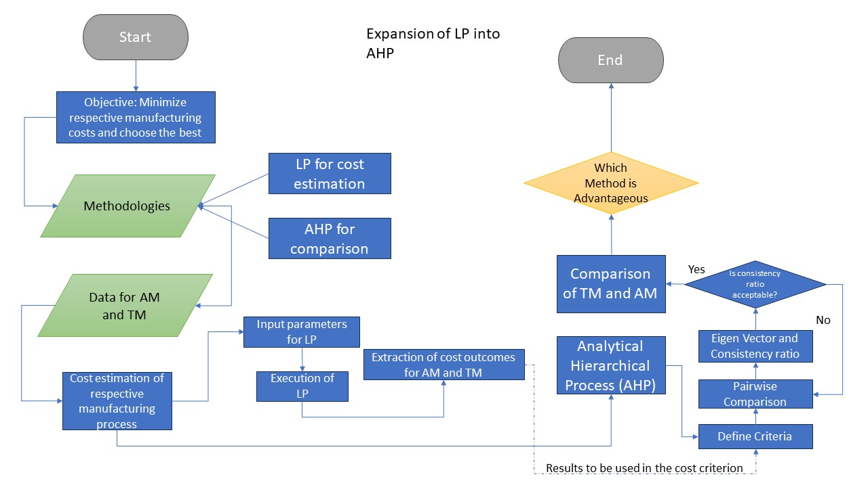
Expansion of LP into AHP

Results and Discussion

4.1 LP for Cost Estimation for AM and TM
The cost modeling of additive manufacturing (AM) exhibits substantial differences when compared to subtractive or conventional manufacturing, primarily stemming from the distinctive attributes and procedural distinctions inherent in each approach. Here are several fundamental rationales for the disparities:
Utilization of Resources: In the realm of conventional manufacturing, the act of subtractive processes frequently engenders the production of material waste, wherein surplus material is extracted from a larger block or stock. On the other hand, additive manufacturing constructs components in a step-by-step manner, selectively depositing material solely in areas that require it. The decrease in material waste has the potential to greatly influence cost considerations within the realm of additive manufacturing.
Design Complexity: Additive manufacturing in aerospace enables the fabrication of intricate internal structures and complex geometries that would pose significant challenges or even insurmountable obstacles when employing subtractive manufacturing techniques. The level of intricacy in the design of additive manufacturing (AM) can significantly influence the overall cost, as elaborate designs may necessitate increased time, material usage, or the inclusion of supplementary support structures.
Time Investment: The expenses and time investment associated with the development of specialized tooling, such as molds, dies, or jigs, are frequently encountered in traditional manufacturing processes. Additive manufacturing (AM) obviates or diminishes the necessity for such tooling, leading to decreased initial expenses linked to tooling development in aerospace.
Setup Time: In the realm of traditional manufacturing, a considerable amount of time is typically allocated to the preparation of machines, fixtures, and tooling to facilitate production. In contrast, AM exhibits comparatively reduced setup durations due to its lack of necessity for extensive tool modifications or reconfiguration when transitioning between distinct production cycles. The decreased duration required for setup can influence the computation of costs in additive manufacturing.
Scalability: Additive manufacturing provides enhanced adaptability in terms of production scalability when contrasted with conventional manufacturing methods. In contrast to conventional manufacturing methods that necessitate substantial investments and time to enhance production capacity, additive manufacturing (AM) offers a more flexible and responsive approach to production. This allows for cost-efficient production of small batches or customized products, thereby facilitating agile and on-demand manufacturing.
Diversity of Materials: The utilization of Additive Manufacturing (AM) allows for the incorporation of a diverse array of materials, encompassing both specialized and exotic variants. The accessibility and price of materials for additive manufacturing (AM) can exhibit substantial variations in comparison to conventional manufacturing methods, wherein material selections are frequently confined to a more restricted range of conventional alternatives.
Post-production necessities: Additive manufacturing components may necessitate subsequent procedures such as the elimination of support structures, refinement of surface characteristics, or application of thermal treatments to attain the intended level of excellence and operational effectiveness. The expenses and duration linked to post-processing can fluctuate based on the intricacy of the component and the preferred surface quality, necessitating meticulous deliberation in additive manufacturing cost estimation.
In Conclusion, AM cost modeling encompasses the distinct attributes of the technology, encompassing factors such as diminished material waste, intricate design, expenses related to tooling, the time required for setup, the potential for expansion, material choice, and the demands of post-processing. The distinctions between AM cost estimation and traditional manufacturing approaches necessitate the need for specific considerations and models that are customized to the additive manufacturing process.

Table: Differences Between Additional and Conventional Manufacturing in Aerospace
Factors | Additive Manufacturing | Conventional/Subtractive Manufacturing
Material Usage | Minimal material waste | Excess material waste
Design Complexity | High design complexity | Limited design freedom
Tooling Costs | Reduced need for tooling | Expensive specialized tooling
Setup Time | Reduced setup time | Longer setup time
Scalability | Agile and on-demand production | Challenges in scaling production
Material Selection | Wide material selection | Limited material options
Post-processing Requirements | Reduced post-processing | Additional post-processing requirements
Surface Finish | - | Additional post-processing for desired finish
Geometric Complexity | - | Limitations in producing complex geometries
Customization and Personalization | - | Limited customization and personalization
Production Speed | - | Longer production lead times
Waste Generation | - | Higher waste generation
Environmental Impact | - | Higher environmental impact
Cost-Effectiveness for Small Batch Production | Cost-effective for small-batch production | -

4.2 Case Study Analysis
For comparing the cost of AM and traditional manufacturing methods using the proposed linear optimization methods, we choose a pilot case study. A component that has been designed and manufactured using laser-based powder bed fusion (PBF) has been chosen from the available literature (Jarrar, Belkadi and Bernard, 2021). The component in question was constructed utilizing the EOS Titanium Ti64 material and produced by the EOS M280 DMLS machine (Jarrar, Belkadi and Bernard, 2021). The estimated cost will be determined by applying the process described in the previous section, which involves both additive manufacturing (AM) and traditional manufacturing methods.
In the broader exploration of additive versus traditional manufacturing costs within the aerospace sector, this study introduces a pilot case study centered on the automotive upright—a crucial vehicular component. The primary objective is not to suggest a direct application of the automotive upright in aerospace but rather to utilize it as a representative model. By comparing the manufacturing costs of such a complex component in both additive and traditional methods, we aim to garner insights that could hint at potential cost dynamics when producing intricate aerospace parts like turbine blades, engine nozzles, or satellite brackets. These components demand high precision, and their manufacturing costs can be significantly impacted by the choice of technique. This comparative approach, drawing from real-world data, provides a tangible basis for understanding the cost implications of the two manufacturing methods.
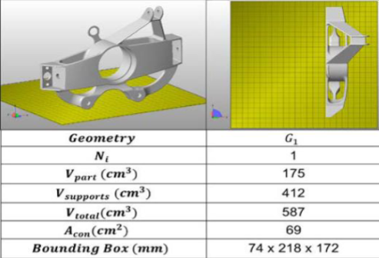
Jarrar, Belkadi and Bernard, 2021

The traditional manufacturing costs have been hypothesized while the additive manufacturing costs were taken from the paper mentioned above. The rationale for the costs chosen is as follows:
The hypothetical costs for traditional manufacturing, also known as subtractive manufacturing, are typically higher than those for additive manufacturing. The fundamental reason behind this lies in the process differences. In traditional manufacturing, processes like milling, turning, and drilling are used, all of which involve removing material from a larger block to create the desired part. This subtractive nature can lead to a higher waste of material, which in turn elevates the material cost.
In the hypothetical cost table, the material cost for traditional manufacturing is set at $3000, compared to $2652 for additive manufacturing. This reflects the higher waste and associated costs in traditional manufacturing.
The machine setup cost for traditional manufacturing is also greater ($800) than for additive manufacturing ($450). This accounts for the often complex setup and calibration procedures involved in traditional manufacturing processes.
The fixed cost for traditional manufacturing is higher ($400) than for additive manufacturing ($300). This is due to the fact that traditional manufacturing often requires a larger facility, more machinery, and more manual labor, all contributing to higher fixed costs.
Cost Element | Traditional Manufacturing | Additive Manufacturing
Machine Setup Cost | 800 | 450
Overhead Cost | 200 | 200
Fixed Cost | 400 | 300
Material Cost | 3000 | 2652
Post Processing Cost | 300 | 480
Post-processing cost for traditional manufacturing is lower ($400) compared to additive manufacturing ($480). This is because additive manufacturing parts often require additional post-processing steps to reach the desired finish and tolerance, such as heat treatments or surface finishing.
It's important to keep in mind, however, that these are hypothetical costs, and the actual costs can vary widely depending on a variety of factors, including the type of materials used, the complexity of the parts being produced, the efficiency of the machines, labor costs, and many more. The figures used in this example are illustrative and meant to highlight the possible cost differences between the two manufacturing methods.

The cost optimization has been performed in MATLAB and the result of the total cost for traditional manufacturing comes out to be 84700$ and for additive manufacturing, the final cost is 56082$ which is significantly less than that for traditional manufacturing. Hence, for the given pilot study, the linear optimization for AM is better and cheaper than for traditional manufacturing due to better design and engineering approaches.

4.3 Application of AHP and Hybrid Decision-Making Approach
The hybrid model of AHP and LP regarding the choice between additive manufacturing and traditional manufacturing will comprise different steps regarding the choice of weighting factors for different choices, subjective criteria selection, choices, and final decision-making through the AHP framework. The role of AHP will be during the steps of choices, weighting factor assignment for different factors, and criteria selection for costing, while the final choice of the manufacturing method will depend on the total weighted objective score for alternatives (AM, TM) for the given Objective. Firstly, the quantitative aspect of the cost will be calculated for the pilot study that contains different costing factors and provides the model for the overall cost of AM and TM. These costs are determined from the LP model to minimize the cost for AM and TM. After the determination of the quantitative factor of cost, the mathematical model of LP will be expanded to contain qualitative factors of quality, speed of production, sustainability, and flexibility. The advantage of the expanded model is that it considers a wide range of qualitative factors in addition to the quantitative aspect of cost to diversify the approach toward the objective of achieving the choice of AM or TM.
Hierarchy Structure:

- Goal: Most Suitable Manufacturing Process
- Criteria:
  - Quality
  - Total Cost
  - Speed of Production
  - Sustainability
  - Flexibility (Lowest Priority)
- Alternatives: A1: Traditional Manufacturing A2: Additive Manufacturing
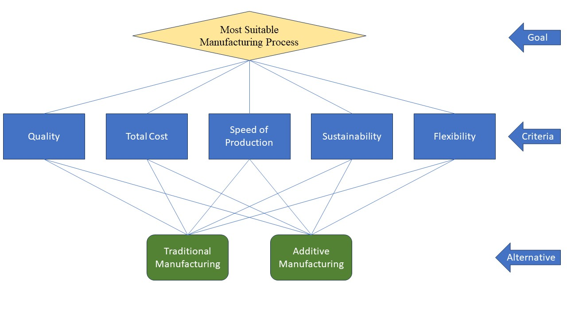
Before moving on with the AHP process to compare the different qualitative factors mentioned above, it is important to assess the quantitative aspects of the cost estimation for AM and TM.
The cost optimization through the LP model has been performed in MATLAB and the result of the total cost for traditional manufacturing comes out to be 84700$ and for additive manufacturing, the final cost is 56082$ which is significantly less than that for traditional manufacturing. In terms of the quantitative aspect of cost, AM is preferable over TM and this aspect will be reflected in the AHP model also as a qualitative factor by assigning cost for these alternative suitable weights.

Step 1: Pairwise Comparison Matrix:
The Decision Maker (DM) will provide pairwise comparisons of the criteria based on their relative importance. A scale of 1 to 9 is commonly used, where 1 means equal importance, and 9 means extremely important.

Step 1: Pairwise Comparison of Priorities of Factors
 | Quality | Cost | Speed | Sustainability | Flexibility
Quality | 1 | 3 | 5 | 3 | 5
Cost | 0.333333333 | 1 | 3 | 5 | 3
Speed | 0.2 | 0.333333333 | 1 | 5 | 5
Sustainability | 0.333333333 | 0.2 | 0.2 | 1 | 7
Flexibility | 0.2 | 0.333333333 | 0.2 | 0.142857143 | 1
Sum | 2.066666667 | 4.866666667 | 9.4 | 14.14285714 | 21

Step 2: Weight Calculation
Normalize the columns of the pairwise comparison matrix by dividing each element by the sum of its column:
Step 2: Normalize the Comparison Matrix and Find Priority Weights
 | Quality | Cost | Speed | Sustainability | Flexibility | Priority
Quality | 0.483870968 | 0.616438356 | 0.5319149 | 0.212121212 | 0.238095238 | 0.416488134
Cost | 0.161290323 | 0.205479452 | 0.3191489 | 0.353535354 | 0.142857143 | 0.236462241
Speed | 0.096774194 | 0.068493151 | 0.106383 | 0.353535354 | 0.238095238 | 0.172656183
Sustainability | 0.161290323 | 0.04109589 | 0.0212766 | 0.070707071 | 0.333333333 | 0.125540643
Flexibility | 0.096774194 | 0.068493151 | 0.0212766 | 0.01010101 | 0.047619048 | 0.0488528

The Priority Weighting factor for each qualitative factor as determined from the last column of the above table is as follows:
Weight (Quality) = 0.4165
Weight (Cost) = 0.2364
Weight (Speed) = 0.17265
Weight (Sustainability) = 0.1255
Weight (Flexibility) = 0.05
The weights of the factors show that quality has the highest priority and flexibility has the lowest priority in the criterion established for AHP to achieve the given goal. The next step is to evaluate the alternatives against each of these factors independently.
Step 3: Choice of Alternatives Against Each Factor
In this step, the researcher will determine the choice of alternative (AM, TM) concerning each qualitative factor and also the quantitative factor of cost. For TM, quality is 3 times more preferable or higher priority over AM as a qualitative assessment. This is demonstrated as a pairwise matrix below.

Quality | AM | TM | Priority
AM | 1 | 0.333333333 | 0.25
TM | 3 | 1 | 0.75
The pairwise weighting factors are chosen according to the priority of each alternative over the other for the given factor of quality. The priority weighting factor of TM comes out to be 0.75 and that for AM is 0.25 which means that TM is preferable over AM in terms of quality of production.
For AM, cost is 1.51 times more preferable or higher priority over TM because the overall cost of the AM is 1.51 times lower than that of TM as determined from the pilot case study. This is demonstrated as a pairwise matrix below.
Cost | AM | TM | Priority
AM | 1 | 1.510288506 | 0.6016394
TM | 0.662125148 | 1 | 0.3983606

The pairwise weighting factors are chosen according to the priority of each alternative over the other for the given factor of cost. The priority weighting factor of AM comes out to be 0.601 and that for TM is 0.398 which means that AM is preferable over TM in terms of cost of production.
For AM, Speed is 2 times less preferable or lesser priority over TM as a qualitative assessment because the focus of AM is enhancing the reliability of production without errors that could be achieved with a slightly lower speed of production as compared to TM. This is demonstrated as a pairwise matrix below.

Speed | AM | TM | Priority
AM | 1 | 0.5 | 0.3333333
TM | 2 | 1 | 0.6666667

The pairwise weighting factors are chosen according to the priority of each alternative over the other for the given factor of speed. The priority weighting factor of AM comes out to be 0.33 and that for TM is 0.67 which means that TM is preferable over AM in terms of Speed of production.
For AM, sustainability is 4 times more preferable or higher priority over TM as a qualitative assessment. This is demonstrated as a pairwise matrix below.
Sustainability | AM | TM | Priority
AM | 1 | 4 | 0.8
TM | 0.25 | 1 | 0.2
The pairwise weighting factors are chosen according to the priority of each alternative over the other for the given factor of sustainability. The priority weighting factor of AM comes out to be 0.8 and that for TM is 0.2 which means that AM is preferable over TM in terms of Sustainability of production.
For AM, flexibility is 2 times more preferable or higher priority over TM as a qualitative assessment. This is demonstrated as a pairwise matrix below.
Flexibility | AM | TM | Priority
AM | 1 | 2 | 0.6666667
TM | 0.5 | 1 | 0.3333333

The pairwise weighting factors are chosen according to the priority of each alternative over the other for the given factor of flexibility. The priority weighting factor of AM comes out to be 0.67 and that for TM is 0.33 which means that AM is preferable over TM in terms of flexibility of production.
Step 4: Calculation of Final Composite Scores of Alternatives
Once the weights for each criterion have been determined using the Analytic Hierarchy Process (AHP), we can integrate these weights into the overall composite weight of each choice. For this purpose, we take the sum of the product of weighting factors of each qualitative criterion and its weight relative to that alternative. The mathematical formulations are as follows:
$$Total Weight \left(AM\right)=W_{quality}×AM_{quality}+W_{cost}×AM_{cost}+W_{Speed}×AM_{Speed}+W_{Sustainability}×AM_{Sustainability}+W_{flexibility}×AM_{flexibility}$$
$$Total Weight \left(AM\right)=0.4164×0.25+0.2364×0.6016+0.1726×0.33+0.1255×0.8+0.049×0.67=0.4369$$
$$Total Weight \left(TM\right)=W_{quality}×TM_{quality}+W_{cost}×TM_{cost}+W_{Speed}×TM_{Speed}+W_{Sustainability}×TM_{Sustainability}+W_{flexibility}×TM_{flexibility}$$
$$Total Weight \left(TM\right)=0.4164×0.75+0.2364×0.3983+0.1726×0.67+0.1255×0.2+0.049×0.33=0.5631$$
Step 5: Choice of AM Versus TM
By utilizing the integrated weights of AM and TM as computed from the composite weights in the previous step, the result is that TM is preferable over AM for the given criteria (Quality, Cost, Speed of Production, Sustainability, and Flexibility). The scores assigned to different factors are just for reference calculations. The weights may vary depending on the preferences of the given product and stakeholders. Correspondingly, the composite weights may change and hence the final choice of alternative as AM or TM.

4.4 Implications of Research
The implications of aerospace research, particularly in the realm of additive manufacturing (AM) and its economic viability in the production supply chain, are extensive and noteworthy. The pilot study about the cost-effectiveness of Additive Manufacturing (AM) in the aerospace manufacturing supply chains and assessment of qualitative factors signifies the importance of considering a diverse range of factors for choosing the suitable manufacturing method. Through an integrated quantitative and qualitative framework, the researcher provided a holistic framework to find the weighted score for AM and TM for comparison and final decision-making.
The utilization of additive manufacturing has facilitated a heightened level of customization and personalization for aerospace components. The aerospace industry is characterized by a high degree of relevance, especially in terms of component customization to meet distinct specifications. The field of Additive Manufacturing (AM) provides aerospace enterprises with the opportunity to delve into the realm of bespoke production, wherein components can be fabricated as per specific client requirements and produced as needed. The degree of personalization achievable can potentially result in heightened aircraft efficacy, diminished upkeep necessities, and amplified patron contentment.
The integration of Additive Manufacturing (AM) within the aerospace manufacturing sector holds the promise of advancing environmental sustainability efforts. The utilization of AM techniques frequently yields diminished material waste in contrast to conventional subtractive manufacturing, thereby resulting in a decreased carbon footprint and the preservation of resources. Furthermore, the capacity to fabricate lightweight components through additive manufacturing can make a valuable contribution towards enhancing fuel efficiency and mitigating emissions in aviation activities. The study of additive manufacturing has the potential to provide valuable insights to the aerospace sector regarding the optimization of ecological advantages and the attainment of sustainability objectives.

4.5 Limitations of Research
Whilst the study of the decision-making model through a hybrid AHP and LP method for comparison of TM and AM within the aerospace industry's manufacturing supply chains provides significant intellectual value, it is imperative to recognize specific constraints that may impede the universality and practicality of the conclusions. A limitation that must be acknowledged pertains to the dependence on conjectures and abridged frameworks. The process of conducting a pilot study frequently entails formulating presumptions regarding diverse parameters, including but not limited to material costs, labor costs, and equipment costs, to approximate the cost-effectiveness and other qualitative factors of additive manufacturing while acknowledging its inherent limitations. The limitations of these assumptions may impede their ability to comprehensively capture the intricacies and diversities inherent in the aerospace sector, thereby engendering the possibility of imprecision in the cost projections. Furthermore, the utilization of rudimentary models, such as linear programming and AHP, may fail to account for particular subtleties and complexities inherent in actual manufacturing operations, culminating in a reductionist depiction of the intricacies of supply chain dynamics. It is imperative to acknowledge such limitations. Henceforth, it is imperative to exercise prudence in interpreting the findings and subject them to rigorous validation through the utilization of more exhaustive and intricate real-world data, given the inherent limitation.
An additional limitation pertains to the emphasis on a set of qualitative factors while neglecting to comprehensively incorporate other salient factors. This limitation must be acknowledged and addressed to ensure a comprehensive evaluation of the potential of AM in this industry. As an illustration, the investigation may exhibit certain limitations in comprehensively examining the caliber and dependability of additively manufactured constituents, adherence to regulatory standards, apprehensions about intellectual property, or the proficiencies essential for executing additive manufacturing methodologies. Disregarding these variables could potentially impose a constraint on the pragmatic feasibility of the research outcomes and impede the wider integration of AM within the aerospace sector. Henceforth, it is imperative for forthcoming investigations to endeavor towards assimilating a comprehensive outlook that encompasses not solely cost-related deliberations but also other pertinent determinants that impact the decision-making mechanism in the realm of aerospace production, while acknowledging the presence of limitations.
In essence, the recognition of these limitations serves to furnish a comprehensive comprehension of the research outcomes and stimulates additional inquiry aimed at remedying these deficiencies. By acknowledging and tackling these limitations, forthcoming research endeavors can furnish more sophisticated and all-encompassing perspectives regarding the cost-effectiveness and wider ramifications of integrating Additive Manufacturing (AM) in the supply chains of aerospace manufacturing.

Conclusion and Future Recommendations

5.1 Summary of Results
The research provided a comparison between AM and traditional manufacturing by proposing a hybrid decision-making model of LP and AHP. The comprehensive evaluation encompassed a multitude of variables including cost as a quantitative approach and quality, speed of production, sustainability, and flexibility as qualitative factors. The Additive manufacturing yielded significant abatements in the financial constituents, culminating in a more economically efficient production methodology. The assessment of qualitative factors through AHP modeling resulted in the conclusion that TM is preferable over AM. However, the choice of AM or TM would also depend on certain applications as the criteria may vary.
Through the strategic utilization of additive manufacturing, aerospace industry stakeholders can capitalize on its inherent benefits, including but not limited to, the mitigation of material waste, expedited production timelines, and amplified design adaptability. As a result, these entities can realize significant economic efficiencies, encompassing both upfront investment expenditures and ongoing operational expenses. Furthermore, the study underscored the necessity of factoring in the expenses incurred for upkeep concerning additive manufacturing techniques, as they have the potential to influence the comprehensive cost-benefit analysis of implementing this production approach.
The research underscores the significance of precise demand forecasting and production capacity planning as key strategies and practices for cost savings in the integration and execution of additive manufacturing within aerospace manufacturing supply chains. Through the synchronization of production quantities with customer demand and the maximization of manufacturing facility utilization, enterprises can circumvent the pitfalls of overproduction or underproduction, thereby mitigating the risk of escalated expenses. Furthermore, the results underscored the importance of streamlined transportation logistics and optimized inventory management to mitigate expenses linked to product conveyance and stock retention. Through the strategic placement of distribution centers and the optimization of lead times, corporations can effectively streamline their supply chain operations while simultaneously mitigating transportation and inventory expenses.
The research outcomes accentuate the enduring cost-effectiveness and superiority of traditional manufacturing in various qualitative aspects—such as quality, production speed, sustainability, and flexibility—within the aerospace industry's supply chains. While additive manufacturing presents certain advantages, the comparative analysis distinctly underscores the financial prudence of AM when measured against the contemporary allure of TM. By sticking to or refining well-established subtractive manufacturing techniques and leveraging effective strategies, aerospace manufacturers can continue to attain significant savings in realms spanning material, labor, equipment, and even in both pre and post-processing stages. These insights provide aerospace industry decision-makers with a clearer perspective, emphasizing the proven reliability and efficiency of conventional manufacturing methods. This research offers a roadmap for those in the sector, guiding them on how to optimize their production methodologies and logistical operations to ensure maximum economic value.
This study embarked on a detailed exploration and comparison between Additive Manufacturing (AM) and Traditional Manufacturing (TM), leveraging the Analytic Hierarchy Process (AHP) as a pivotal decision-making tool. The investigation illuminated the distinctive advantages and limitations intrinsic to both AM and TM, contingent upon a range of criteria including cost, speed, flexibility, sustainability, and quality. A crucial revelation emerged from this analysis: the decision-making process in manufacturing need not be confined to a binary choice between AM and TM. Instead, there exists a compelling potential for a hybrid approach, synergistically melding the strengths of both AM and TM. Such an approach can lead to innovative solutions, combining AM's prowess in creating intricate, customized designs with TM's proficiency in large-scale, efficient production.

5.2 Future Recommendations
Notwithstanding the valuable insights gleaned from extant research on the cost-effectiveness of additive manufacturing (AM) in the aerospace industry's manufacturing supply chains, there exist several limitations that warrant attention in forthcoming investigations. The identified limitations present opportunities for additional inquiry and investigation. Thus, suggestions for forthcoming research endeavors may center on remedying these deficiencies.
Primarily, a constraint of the investigation is the presupposition of specific parameter values owing to the inadequacy of comprehensive data. Subsequent investigations may be directed toward procuring more precise and all-encompassing information about material expenses, workforce expenditures, machinery expenditures, and other pertinent variables. By integrating empirical data from the actual world, the outcomes can attain greater resilience and dependability, thereby furnishing a more precise evaluation of the economical feasibility of Additive Manufacturing in the aerospace domain. Furthermore, it would be prudent to conduct additional research to investigate the ramifications of diverse cost scenarios and fluctuations in parameter values, to furnish a more all-encompassing comprehension of the cost dynamics within additive manufacturing supply chains.
In the second instance, the research primarily centered its attention on cost-related variables, including but not limited to material expenses, workforce expenditures, and equipment outlays. Nonetheless, it is imperative to acknowledge that there exist additional crucial factors that can exert a significant impact on the comprehensive cost-benefit analysis of additive manufacturing. These factors encompass procedural fluctuations and enduring upkeep expenditures. Prospective investigations may further explore these variables to acquire a comprehensive comprehension of the financial ramifications of additive manufacturing in the aerospace industry. Through the contemplation of a wider spectrum of cost determinants, scholars can furnish more all-encompassing perspectives regarding the advantages and obstacles of embracing additive manufacturing in the aerospace sector.
In the final analysis, using a hybrid decision-making model that combined Linear Programming (LP) and Analytic Hierarchy Process (AHP), traditional manufacturing (TM) methods emerged as a more effective alternative when compared to additive manufacturing (AM). This outcome can be attributed to a myriad of factors. Notably, the advanced design and fabrication techniques associated with AM, while innovative, might not always translate to better quality in every context. Specific decision variables such as per unit material cost and per unit labor cost in AM might have influenced this outcome. It underscores the importance of a comprehensive approach when comparing these manufacturing paradigms, ensuring that both quantitative and qualitative criteria are considered.
In light of the insights gleaned from this comprehensive study, it becomes evident that the manufacturing landscape is at a pivotal crossroads. While the comparative analysis between Additive Manufacturing (AM) and Traditional Manufacturing (TM) has shed light on their respective strengths and limitations, it has also uncovered a path less traversed - one that amalgamates the virtues of both AM and TM. It is in this context that the following recommendations are proposed, aiming to navigate the complex terrain of manufacturing towards a more integrative and synergistic future.
Expanding the AHP Model for Hybrid Manufacturing Choices: Future research should focus on broadening the AHP model to encapsulate the complexities inherent in a hybrid manufacturing approach. This expanded model would offer a more sophisticated decision-making framework, reflecting the multifaceted nature of combining AM and TM processes.
Empirical Investigations of Hybrid Manufacturing Implementations: The theoretical foundations laid by this study should be extended through empirical research, particularly focusing on practical implementations of hybrid manufacturing. Case studies in industries where both AM and TM are used in tandem could provide valuable practical insights and inform future strategic and policy decisions in the manufacturing realm.
Inclusive Stakeholder Engagement and Policy Considerations: As the manufacturing industry evolves towards integrated approaches, engaging with a diverse array of stakeholders, including industry professionals, policymakers, and consumers, becomes crucial. This engagement, bolstered by the structured insights from the AHP, will facilitate a more comprehensive understanding of the practical and policy implications of hybrid manufacturing models.
Technological and Interdisciplinary Research for Hybrid Manufacturing: Hybrid manufacturing is likely to necessitate cutting-edge technological advancements and cross-disciplinary research efforts. Delving into the confluence of material science, engineering, design, and other related fields could lead to significant innovations, making hybrid manufacturing approaches more viable and efficient.

References
Attaran, M. (2017) ‘The rise of 3-D printing: The advantages of additive manufacturing over traditional manufacturing’, Business horizons, 60(5), pp. 677–688.
Baumers, M. et al. (2012) ‘Combined build-time, energy consumption and cost estimation for direct metal laser sintering’, in 2012 International Solid Freeform Fabrication Symposium. University of Texas at Austin.
Baumers, M. and Tuck, C. (2019) ‘Developing an understanding of the cost of additive manufacturing’, Additive Manufacturing–Developments in Training and Education, pp. 67–83.
Blakey-Milner, B. et al. (2021) ‘Metal additive manufacturing in aerospace: A review’, Materials & Design, 209, p. 110008.
Campanella, D. et al. (2022) ‘Mechanical and microstructural characterization of titanium gr. 5 parts produced by different manufacturing routes’, The International Journal of Advanced Manufacturing Technology, 122(2), pp. 741–759.
Cavalieri, S., Maccarrone, P. and Pinto, R. (2004) ‘Parametric vs. neural network models for the estimation of production costs: A case study in the automotive industry’, International Journal of Production Economics, 91(2), pp. 165–177.
Chen, D. et al. (2015) ‘Direct digital manufacturing: definition, evolution, and sustainability implications’, Journal of Cleaner Production, 107, pp. 615–625.
David, R., Dube, A. and Ngulube, P. (2013) ‘A cost-benefit analysis of document management strategies used at a financial institution in Zimbabwe: A case study’, South African Journal of Information Management, 15(2), pp. 1–10.
Dutta, B. and Froes, F.H.S. (2017) ‘The additive manufacturing (AM) of titanium alloys’, Metal powder report, 72(2), pp. 96–106.
Gebler, M., Uiterkamp, A.J.M.S. and Visser, C. (2014) ‘A global sustainability perspective on 3D printing technologies’, Energy policy, 74, pp. 158–167.
Guo, N. and Leu, M.C. (2013) ‘Additive manufacturing: technology, applications and research needs’, Frontiers of mechanical engineering, 8, pp. 215–243.
Herzog, D. et al. (2016) ‘Additive manufacturing of metals’, Acta Materialia, 117, pp. 371–392.
Hopkinson, N. and Dicknes, P. (2003) ‘Analysis of rapid manufacturing—using layer manufacturing processes for production’, Proceedings of the Institution of Mechanical Engineers, Part C: Journal of Mechanical Engineering Science, 217(1), pp. 31–39.
Horn, T.J. and Harrysson, O.L.A. (2012) ‘Overview of current additive manufacturing technologies and selected applications’, Science progress, 95(3), pp. 255–282.
Hueber, C., Horejsi, K. and Schledjewski, R. (2016) ‘Review of cost estimation: methods and models for aerospace composite manufacturing’, Advanced Manufacturing: Polymer & Composites Science, 2(1), pp. 1–13.
Jarrar, Q., Belkadi, F. and Bernard, A. (2021) ‘An Activity-Based Costing Model for Additive Manufacturing’, in IFIP International Conference on Product Lifecycle Management. Springer, pp. 492–507.
Kadir, A.Z.A., Yusof, Y. and Wahab, M.S. (2020) ‘Additive manufacturing cost estimation models—a classification review’, The International Journal of Advanced Manufacturing Technology, 107, pp. 4033–4053.
Kerstens, F., Cervone, A. and Gradl, P. (2021) ‘End to end process evaluation for additively manufactured liquid rocket engine thrust chambers’, Acta Astronautica, 182, pp. 454–465.
Khamhong, P., Yingviwatanapong, C. and Ransikarbum, K. (2019) ‘Fuzzy analytic hierarchy process (AHP)-based criteria analysis for 3D printer selection in additive manufacturing’, in 2019 Research, Invention, and Innovation Congress (RI2C). IEEE, pp. 1–5.
Lamei, Z. (2021) ‘A comprehensive cost estimation for additive manufacturing’. Wichita State University.
Lindermann, C. et al. (2012) ‘Analyzing product lifecycle costs for a better understanding of cost drivers in additive manufacturing’, in 2012 International Solid Freeform Fabrication Symposium. University of Texas at Austin.
Mahadik, A. and Masel, D. (2018) ‘Implementation of additive manufacturing cost estimation tool (AMCET) using break-down approach’, Procedia Manufacturing, 17, pp. 70–77.
Negi, S., Dhiman, S. and Sharma, R.K. (2013) ‘Basics, applications and future of additive manufacturing technologies: A review’, Journal of Manufacturing Technology Research, 5(1/2), p. 75.
Niazi, A. et al. (2006) ‘Product cost estimation: Technique classification and methodology review’.
Owens, A. et al. (2015) ‘Benefits of additive manufacturing for human exploration of mars’, in. 45th International Conference on Environmental Systems.
Ruffo, M., Tuck, C. and Hague, R. (2006) ‘Cost estimation for rapid manufacturing-laser sintering production for low to medium volumes’, Proceedings of the Institution of Mechanical Engineers, Part B: Journal of Engineering Manufacture, 220(9), pp. 1417–1427.
Sandström, C. (2015) ‘Adopting 3D printing for manufacturing—The case of the hearing aid industry’, Ratio Working Papers, 262(1), p. 20.
Smart, C. et al. (2007) ‘Process-Based Cost Modeling’, Journal of Parametrics, 26(1), pp. 79–100.
Snyder, J.C. and Thole, K.A. (2019) ‘Effect of additive manufacturing process parameters on turbine cooling’, in Turbo Expo: Power for Land, Sea, and Air. American Society of Mechanical Engineers, p. V05BT21A002.
Son, Y.K. (1991) ‘A cost estimation model for advanced manufacturing systems’, The International Journal of Production Research, 29(3), pp. 441–452.
Sonar, H.C., Khanzode, V.V. and Akarte, M.M. (2021) ‘Ranking of additive manufacturing implementation factors using analytic hierarchy process (AHP)’, Journal of The Institution of Engineers (India): Series C, 102, pp. 421–426.
Thomas, D. (2016) ‘Costs, benefits, and adoption of additive manufacturing: a supply chain perspective’, The International Journal of Advanced Manufacturing Technology, 85, pp. 1857–1876.
Ulu, E. et al. (2019) ‘Concurrent structure and process optimization for minimum cost metal additive manufacturing’, Journal of Mechanical Design, 141(6).
Wind, Y. and Saaty, T.L. (1980) ‘Marketing applications of the analytic hierarchy process’, Management science, 26(7), pp. 641–658.
Yadroitsev, I. et al. (2021) Fundamentals of laser powder bed fusion of metals. Elsevier.
Yang, Y. and Li, L. (2018) ‘Cost modeling and analysis for Mask Image Projection Stereolithography additive manufacturing: Simultaneous production with mixed geometries’, International Journal of Production Economics, 206, pp. 146–158.

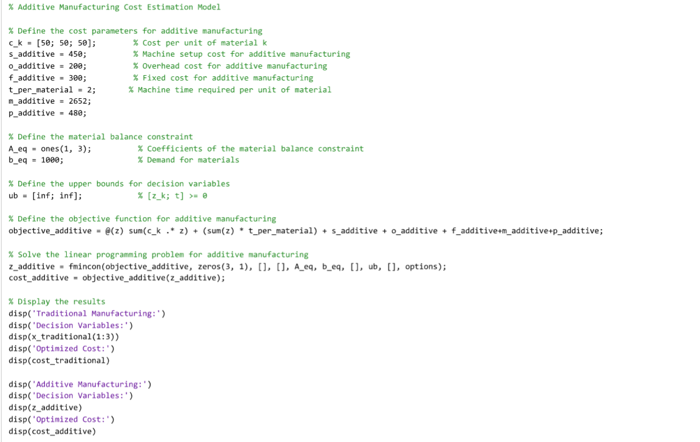
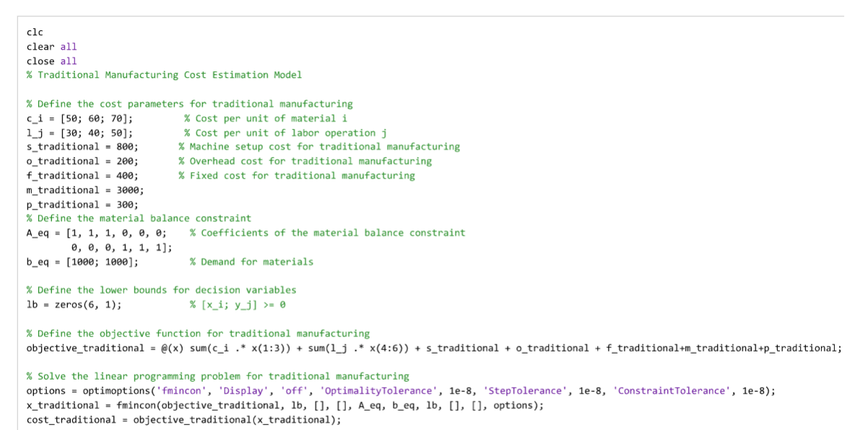
APPENDIX

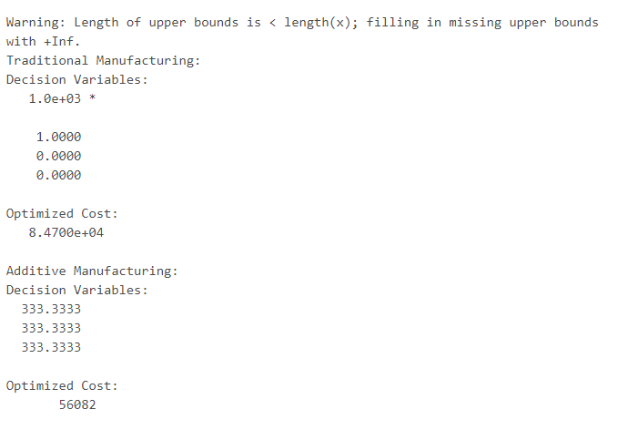

The vector “$c_{i}$” shows the cost of using different types of materials in traditional or additive manufacturing. It comprises three values: 50, 60, and 70 that provide the cost for using three different materials. The vector $c_{i}$ is used in the optimization function for traditional and additive manufacturing. Three different material costs are mentioned as an example suited for the case study mentioned and there could be more materials with different costs or even same costs.
Similarly, the vector of cost per unit of labor operation contains three different costs related to cost of performing three different tasks, The part in the case study could be recreated with three consecutive tasks which would have sub-tasks. Again, the items or tasks could be more than three and the costs for each labor could be same or different, depending on the case study. The choice of labor cost in this case is random.
The role of coefficients of the material balance constraint “A-eq” is related to the constraints associated with the balance of materials to ensure that sum of the quantities of different materials employed in the given manufacturing method meets the demand for those materials. The values in the first row correspond to the balance of constraints for material cost in the manufacturing method. The second row corresponds to the balance of constraints related to labor cost for different units in the given manufacturing method. In short, the vector “A_eq” is used for finding the minimum objective function for traditional and additive manufacturing. Similarly, “b_eq” is used in conjunction with “A_eq” on the right hand side of the material balance constraint to have the optimization function. These vectors assign weights to the constraints. The value of “1” for each factor indicates equal weight for factors.

