UNIVERSITY OF OKLAHOMA
GRADUATE COLLEGE

ARCHAEOASTRONOMY: COMPARING ASTRONOMIC TRADITIONS OF TORRES STRAIT ISLANDERS WITH QUANTITATIVE EVIDENCE

A THESIS
SUBMITTED TO THE GRADUATE FACULTY
in partial fulfillment of the requirements for the
Degree of
MASTER OF ARTS

By
ELIZABETH BROOKER
Norman, Oklahoma
2024

ARCHAEOASTRONOMY: COMPARING ASTRONOMIC TRADITIONS OF
TORRES STRAIT ISLANDERS WITH QUANTITATIVE EVIDENCE

A THESIS APPROVED FOR THE
COLLEGE OF PROFESSIONAL AND CONTINUING STUDIES

BY THE COMMITTEE CONSISTING OF

Dr. Steven Gullberg, Chair
Dr. Paul Ketchum
Dr. John Duncan
Dr. Duane Hamacher

© Copyright by ELIZABETH BROOKER 2024
All Rights Reserved.

Acknowledgements

I would like to thank my graduate advisor Dr. Steven Gullberg for the establishment of the archaeoastronomy track of the Integrated Studies Master’s Degree at OU. His passion for continuing research in archaeoastronomy has allowed me to pursue a lifelong dream. Acknowledgement also goes to Dr. Duane Hamacher, without access to his career-long research of the Torres Strait, this paper would not have been possible. Additionally, I would like to acknowledge my brother James Kell who is responsible for the majority of the Stellarium code, and my dad David Kell for his tireless hours editing and proofreading this thesis. Lastly, I would also like to acknowledge Dr. Samuel Jones for his advice on the quantitative statistical evaluation methods used in this paper.

Thanks also to my husband, Dr. R. Paul Brooker, without his technical and emotional support this project would not have been possible. And to our children Kent, Jane, and Paige whose support, assistance, and understanding have been invaluable.
Table of Contents
Chapter 1: Introduction to Archaeoastronomy 1
1.1 History of Archaeoastronomy 1
1.2 Best Practices 3
1.3 Ethnography 7
1.4 Astronomy 8
Chapter 2: Literature Review of the Torres Strait Islanders 17
2.1 Understanding the Torres Strait 17
2.2 Ethnography in the Torres Strait 22
2.3 Future Research 26
Chapter 3: Methodology 28
3.1 Collecting Ethnographic Astronomic Knowledge 28
3.2 Collecting Quantitative Evidence 30
Chapter 4: Astronomy of the Torres Strait 40
4.1 Astronomy of the Western Islands 41
4.2 The Astronomy of the Eastern Islands 58
4.3 Further Evaluation 70
Chapter 5: Eseli’s Notebook 74
5.1 Western Islands Astronomy 74
5.2 Conclusion 101
Chapter 6: Isolating Star and Constellation Identities 104
6.1 The Biru Biru Bird (Rainbow Bee-eater) 104
6.2 Kek 106
6.3 Getalai (or Gitalai) 109
Chapter 7: How Moon Phase Influences Fishing Traditions 116
7.1 Mud Crabs 117
7.2 Crayfish (Rock Lobster) 119
7.3 Oysters and Shellfish 121
7.4 Conclusion 122
Chapter 8: Results and Discussion 123
8.1 Eseli’s Statements 123
8.2 Getalai Evaluations 127
8.3 Moon Phases Influence on Sea Life 129
8.4 Integrated Approach to Archaeoastronomy 130
Chapter 9: Summary and Conclusion 131
Appendix A: Stellarium Scripting Description and Code for Star Rising Position Data 133
Bibliography 136

Abstract
Located north of Cape York in Australia lies the Torres Strait and the indigenous people who call it home. Torres Strait Islanders have a rich culture including song, dance, folk tales, and other traditions. Western ethnographers have diligently sought to record this culture. Imbedded in these traditions are generations of astronomic observations that correlate the motions of celestial objects with animal migrations, times of cultivation, and seasonal weather changes. Records gathered from modern Torres Strait Islander elders and artists come together with published Western ethnographic resources (such as the journals from A. C. Haddon) and published indigenous resources (like Eseli’s Notebook) to be able to piece together a more complete record of astronomic traditions. This ethnographic evidence when combined with modeled celestial motion, patterns of animal migration and behavior, and documented weather patterns allows for quantitative data analysis and further correlation of Western star identities with the celestial objects in Torres Strait astronomy. In turn these studies help archaeoastronomers better understand the reasons for the traditions that describe the patterns of sky motion that have been understood by Torres Strait Islanders for generations.

List of Figures
Figure 1.1. Composite Picture Showing Shifting Sunrise Horizon Position Throughout the Year 10
Figure 1.2. Diagram of Earth’s Revolution Around the Sun Causing Seasons. 11
Figure 1.3. Visualization of Heliacal Rise and Set, Acronychal Rise and Set, and Meridional Crossings 12
Figure 1.4. Diagram of Moon Orbiting the Earth and Resulting Phases 13
Figure 1.5. Time Lapse Image of Star Motion Showing Nightly Paths of the Stars in the Sky 15
Figure 1.6. Illustration of Star Trails in the Night Sky. (a) Shows the Paths as Seen from the Tropical Latitudes, (b) Shows the Paths as Observed from a Non – Equatorial Northern Location 15
Figure 2.1. Map of the Torres Strait 18
Figure 2.2. Satellite Image of the Torres Strait Showing the Many Atolls, Reefs, and Shallow Waters 19
Figure 2.3. The Flag of the Torres Strait 21
Figure 3.1. Observability Analysis Plug-in Screen 33
Figure 3.2. Observability Plug-in Configuration Window 34
Figure 3.3. Tool Configuration Window to Allow for Keyboard Navigation 35
Figure 3.4. Keyboard Shortcut Window in Tools 36
Figure 4.1. Map of Language Boundary in the Torres Strait 41
Figure 4.2. Sketch from Haddon’s Notes of Awai Dated October 25 at 7:30pm 42
Figure 4.3. Sketch of Baydham (the Shark) 44
Figure 4.4. Sketch of Bu 45
Figure 4.5. Sketch of Dogai 47
Figure 4.6. Sketch of Metakurab by Gizu of Mabuyag 48
Figure 4.7. Sketch of Dogai Kukilaig 48
Figure 4.8. Sketch of Ii by Gizu of Mabuyag 49
Figure 4.9. Sketch of the Dogai Orientations from Thursday Island 50
Figure 4.10. Sketch by Gizu and Waria of Getalai and Other Associated Constellations 52
Figure 4.11. Drawing of Kang and Thoegay by Gizu of Mabuyag 53
Figure 4.12. Drawing of Thoegay by Mariget of Mabuyag 56
Figure 4.13. Thoegay’s Spear Touching the Ground Starts the Rain 56
Figure 4.14. Sketch of Thoegay as Drawn by Waria 57
Figure 4.15. Diagram of Dogai Wuralag with Buu 61
Figure 4.16 Sketch of Getalai in Reference to Seg and Other Stars with a Note that is Dated February 4, 1889, at Sunset 63
Figure 4.17. Eastern Island Tagai Sketch by Davies 64
Figure 4.18. Seg, Beizam, and the Zugubals 67
Figure 4.19. Sia 68
Figure 4.20. Sketch of Positions of Tagai’s Right Hand 69
Figure 5.1. Altair Sky Position Graph 78
Figure 5.2 . Vega Sky Position Graph 79
Figure 5.3. Achernar (Kek) Sky Position 81
Figure 5.4. Antares (Kang) Sky Position 83
Figure 5.5. Crux (Thoegay) Sky Position 83
Figure 5.6. Thoegay “Journey North” 85
Figure 5.7. Kang “Journey North” 85
Figure 5.8. Image of Baydham with Snout Pointed Toward the Horizon. 86
Figure 5.9. Arcturus Sky Position 87
Figure 5.10. Dubhe Sky Position 88
Figure 5.11. Pleiades Sky Position 89
Figure 5.12. Hyades Sky Position 90
Figure 5.13. Kang’s Calm 91
Figure 5.14. Kek’s Calm 91
Figure 5.15. Usal’s Calm - Hyades Data 92
Figure 5.16. Usal’s Calm- Pleiades Data 92
Figure 5.17. Thoegay’s Dead Calm 93
Figure 5.18. Accuracy vs. Brightness 94
Figure 5.19. Accuracy vs. Angular Size 94
Figure 5.20. Calendar Year vs. Truth Value 96
Figure 5.21. Calendar Year vs Truth Value with Season Overlay 96
Figure 5.22. Distribution of True vs False Statements in Kuki vs Sager 97
Figure 5.23. Average Interval Value vs Calendar Year 100
Figure 5.24. Interval Accuracy Values with Seasonal Overlay 100
Figure 5.25. Interval Value vs Season Distribution 101
Figure 5.26. Angular Size vs Average Interval Value 101
Figure 5.27. Average Brightness vs Average Interval Value 102
Figure 6.1. Rainbow Bee-eater. 105
Figure 6.2 . Map of Yearly Migration Areas of the Rainbow Bee-eater Birds 106
Figure 6.3. Overlay of the Motion of Achernar (Kek) and the Migration Times of the Rainbow Bee-eater 107
Figure 6.4. Average Rainfall on Horn Island from 1995-2023 108
Figure 6.5. Rainfall vs Kek (Achernar) Position 109
Figure 6.6. Rainfall vs Kek (Achernar) Position vs Biru Biru Migrations 109
Figure 6.7. Screenshot of Stellarium Compared with the Haddon Sketch 110
Figure 6.8. Beehive Cluster Sky Position at Sunrise and Sunset 111
Figure 6.9. Beehive Cluster Position vs Biru Biru Bird Migration vs Rainfall 112
Figure 6.10. Coma Berenices Sky Position Graph 113
Figure 6.11. Coma Berenices Position vs Biru Biru Migration s Rainfall 113
Figure 6.12. Map of Coma Berenices 114

List of Tables
Table 4.1. List of stars and constellations with the number and source of references 73
Table 5.1. Dates of Heliacal Rise/Set and Acronychal Rise/Set 77
Table 5.2. Dhogay Statements of Star Motion 80
Table 5.3. Dhogay Truth Values, Brightness, and Angular Size 80
Table 5.4. Kek Sky Position Statements 82
Table 5.5. Kek Average Truth Value, Brightness, and Angular Size 82
Table 5.6. Thoegay and Kang Statements 84
Table 5.7. Thoegay and Kang’s Average Truth Value, Brightness, and Angular Size 84
Table 5.8. Baydham (the Shark) Statements 87
Table 5.9. Baydham Average Truth Value, Brightness, and Angular Size 88
Table 5.10. Usal Statements 89
Table 5.11. Usal Average Truth value, Brightness, Angular size 89
Table 5.12. Interval Ranking of Eseli’s Statements 99
Table 8.1 Comparison of Usal statements with Pleiades and Hyades Horizon Events 127

Introduction to Archaeoastronomy

History of Archaeoastronomy
Defined as the study of astronomic thought and interpretation by ancient civilizations, Archaeoastronomy is considered a new discipline in academia. Most of the archaeoastronomic research has been completed in only the last 50 years. Some professionals in the field would claim the start of archaeoastronomy as an academic discipline started in 1965 with the publication of Stonehenge Decoded by Gerald Hawkins (1965). Computer modeling was used by Hawkins to identify significant angles and alignments of the stones that make up Stonehenge, concluding that the monument was actually an ancient computer. Many arguments followed concerning the background and cultural context of the researchers and how these may have influenced the studies’ findings.
Then archaeologists joined the conversation and pointed out additional issues with the suggested findings, such as the differences in the construction dates of the various parts of Stonehenge. Hawkins’s analysis assumed all parts of Stonehenge were built concurrently. These differing construction dates explained that measured alignments that could be observed now could not have been possible or intended at the various times of construction.
Researchers learned the importance of collaboration from these academic contributions from various disciplines. Soon, astronomers began collaborating with archaeologists, anthropologists, and others. This collaboration is the foundation of Archaeoastronomy as an academic discipline. With lessons learned from those early reviews of Hawkins’ work the current academic definition of archaeoastronomy requires interdisciplinary work and collaboration.
Over the last 50 years, additional refinements in the processes and methods of archaeoastronomy have evolved. In Europe, Africa, and Asia (sometimes referred to as the “Old World”) archaeoastronomy analysis was applied to sites, ruins, and structures built by diverse ancient peoples whose history, customs, belief systems, and values had been lost. Such is the case with sites like Stonehenge and the ancient stone circles found throughout the United Kingdom (UK). In North and South America (the “New World”) archaeoastronomy involved studies of structures as well, but these were not as ancient. The sites in the new world, e.g. Mayan pyramids and structures, are separate from the history of the people who built them, but more ethnographic information has become available from ethnographic work done with descendant indigenous peoples.
This disparity between resources and practices of evaluation became defined as Old-World vs New-World methods in archaeoastronomy. The Old-World method started evaluation by measuring a structure and applying principles of statistical evaluation and physical measurements of alignment with celestial objects. The New-World method started with the ethnography as recorded by Spanish colonizers combined with the available physical evidence.
The disparity of methods in archaeoastronomy is sometimes referred to as the difference between Green vs Brown methods, named after the color of the bindings in which these geographic regions’ papers were published (Ruggles, 2015d). Archaeoastronomical researchers have tried to bridge the gap between these two methods to create a more cohesive system of analysis, a method that would not create a bias for conclusions derived from the cultural background of the researchers (e.g. Hawkins), and a method that integrated ethnographic material from the culture associated with the sites.
Researchers like Anthony Aveni and Clive Ruggles have introduced more integrated and cohesive methods into their work, creating a responsible model for conducting archaeoastronomical research. They emphasize how simple premises including perceptions of time and space, interpretations of the meaning of objects (such as assuming that references to ‘the morning star’ are of Venus) and looking for horizon events such as the equinox all have innate connections to modern interpretations. They have coached future researchers to avoid integrating these assumptions in their research of other cultures (Iwaniszewski, 2015). As a result of their work, archaeoastronomy is becoming more valuable in academia.
As part of this disciplinary evolution, more recently the term archaeoastronomy (which has roots in collaborative archaeology and astronomy) has been broadened to a more inclusive name: “cultural astronomy.” This effort shows the need for not only astronomy, and archaeology, but also anthropology, ethnography, and input from many other disciplines (Salt, 2015).

Best Practices
Agreed best practices in archaeoastronomical research involve using context, obtained through associating correct ethnography, statistical evaluation, removal of modern or Western biases, and data reporting integrity.

Statistical Evaluation Methods
Ironically, it was Alexander Thom (a researcher who had previously and famously predicted the incorrect uses of Stonehenge) who first demonstrated better evaluation practices (Thom, 1955). Thom’s extensive studies of multiple sites within similar categories created a statistical database to compare singular findings within stone circles (such as Stonehenge) in the UK. His work provided greater context and additional data points, making it possible to make more responsible conclusions about the purpose and use of these structures, and to support finding intentionality where not a lot of ethnographic evidence was available.
Notably, archaeoastronomers have also learned to be more cautious when choosing sites for their datasets to perform statistical evaluations. Site choices must reflect the same cultural context and time period to create meaningful data for evaluation (McCluskey, 2015a). Thom illustrated proper statistical evaluation by creating a large enough dataset to be able to analyze structures for repeated patterns and possible similar purposes (Thom, 1955).
These practices were part of a study evaluating e-group structures in Central America (Aylesworth, 2004). E-group structures are a set of buildings when one central building is adjacent to a triple structure of three additional pyramids on an elevated platform. The term E-group describes the arrangement of these buildings to form a shape similar to the capital letter “E”.
The first of these E-groups to be evaluated by archaeoastronomers was found to have the central pyramid aligned to solar solstice risings and sunsets over the corners of the three adjacent pyramids. Such accuracy could have been easily used for calendrical prediction purposes. It was then assumed (based on Aylesworth’s work) that all of these E-groups were used for the same calendrical purpose.
But Aimers and Rice (2006) investigated further. They created a database of dozens of E-groups and compared the number of E-groups with the number of observed and measured alignments to the solstice risings and setting as found in the original E-group. The results were surprising, with only a very small percentage of E-groups aligned accurately with the sunset and sunrise on solstice days.
These study results negated Aylesworth’s conclusions about the calendrical purpose of these structures, because of the inaccurate alignments in most of the E-groups. Sprajc (2021) suggested a solution to explain these inaccuracies. Instead of measuring an exact date or calendrical event, he argued that the E-groups measure a length of time or indicate a general time of year. They do not offer more precise measurements such as would be used to predict a specific date (Ruggles, 2015b). This was an example of how implementation of statistical evaluation methods prevents fraudulent or excessive conclusions about the purposes or uses of sites with archaeoastronomical significance. Other accepted methods of evaluation have included quantitative analysis methods to determine accuracy or to negate random chance in found alignments.

Remove Modern Context
Archaeoastronomers also have had to learn how to avoid modern context when selecting which celestial objects were deemed important or significant to a location or culture. Often, in previous archaeoastronomical research, if a culture referred to a morning or evening star then assumptions would be made that these were references to the planet Venus, not to a star.
In modern research about stars of significance in other cultures there is often no connection between cultural importance and the brightness of the star. Instead, a celestial object’s significance was associated with when the object (usually a star) appeared in connection to the agricultural patterns of the location. In this way a morning star reference might not be an identification of Venus, but another object appearing in the morning at an important time of year.
Another important example of this has been in the popularity among researchers to look for lunar rising and setting positions along the horizon. They were looking for instances of alignment with the northern and southernmost points of lunar risings along the horizon. Similar to the Sun’s pattern of having a cycle of maximum and minimum positions of rising along the horizon, the Moon also has a pattern of positional risings on the horizon. But instead of cycling in only one year like it does with the Sun, the Moon’s position cycles every 18.6 years. In modern contexts this seems like a discernable pattern, but in cultures where 18.6 years is an entire generation this lunar pattern is insignificant (Ruggles, 2015a).
Additionally, instead of simply looking for sighting alignments at a site, researchers have learned to understand the value of observing horizon markers to ancient people to indicate times of the year and the passing of time. An example of Western bias influencing investigated uses of archaeoastronomical sites is shown in researchers looking for places that could be identified as observatories. An “astronomic observatory” is a Western concept which does not necessarily fit inside the framework of ancient star observation (Belmonte, 2015a).

Consult with Appropriate Ethnography
It has been especially important for archaeoastronomers to be careful in choosing their ethnographical resources. At Chaco Canyon in New Mexico work has led to incorrect conclusions when based on incorrect ethnographic resources. Navajo (Diné) people now occupy the area around Chaco Canyon, and at first work done in Chaco Canyon referenced Diné astronomic customs and worldviews. But historical references and modern research show that these lands have not always been controlled by the Diné Actually, the modern Puebloan nation is more appropriately identified as the descendants of the builders of the ruins in Chaco Canyon. When this new ethnographic information (including cultural worldview and culturally significant celestial bodies) is considered, it changes the conclusions made about the purpose and intentionality of the Chaco Canyon structures studied (Munro & Malville, 2011).

Report Everything
Researchers now suggest describing possible alignments at a site before identifying supportive ethnographic information (Ruggles, 2015b). With the idea of removing modern context, this ordering is done to avoid research using measurements that are taken with a desired outcome in mind. It is equally important to report all results, not just the data that seems to fit a desired conclusion (Ruggles, 2015b)

Ethnography
Ethnographical studies among modern indigenous people have proved invaluable to modern research. Cultural context has helped researchers understand different worldviews, identify the significance of light and shadow effects, and identify important astronomic tools used by ancient people that are now lost and unavailable for direct modern research.
The work of Gary Urton (1981) with the Misminay community in Peru introduced researchers to the significance of sky quartering. Quartering, while foreign to Western thinking, was also seen in Hopi traditions (in the southwestern United States) and in various cultures throughout Latin America (McCluskey, 2015b; Salt, 2015). Only after interacting with modern indigenous people did researchers understand the significance of sky quartering to ancient cultures and start to identify it as a possible pattern of sky knowledge distribution. But it should also be noted that researchers must recognize that correlation does not imply causation. Archaeoastronomers should not imply that similarities in depictions of sky knowledge prove any cultural connections. Cultures without any direct influence on each other have been found to have independent but similar ways of organizing sky knowledge. But considering celestial organization in non-Western cultures has helped researchers to understand patterns that are sometimes repeated in other cultures. One example of this was work illustrating the similarities in some Southern Hemisphere cultures and their depictions of the dark spaces in the bands of the Milky Way as dark sky constellations (Gullberg et al., 2020).
Ethnographic studies in modern cultures have illustrated the significance to indigenous people of celestial objects, but also of the importance of light and shadow effects (Munro & Malville, 2011). These different patterns valued in various indigenous cultures broadened the possible archaeoastronomic observations and evaluations. But care still had to be taken to avoid the common disservice of jumping to conclusions. This was the case in Chaco Canyon where three slits between large boulders on Fajada Butte produced a sun dagger on the June solstice. Initial observation of this phenomena was exciting, but work done by some researchers was not done with the best statistical evaluation methods, or with the current most accurate ethnographic resources available for that area (Munro & Malville, 2011).
Ethnography has proven to be a great asset in understanding the astronomic significance of structures and other sites. In Cusco, Peru, records from Spanish colonizers describe the Incas using large pillars to mark the passage of the Sun along the horizon throughout the year. But modern evaluation or validation of these pillars were speculative as no current pillars exist (Malville, 2010). It was in Urubamba, another city in Peru, where researchers located similar pillars on the horizon hilltop with alignments to the June summer solstice which verified the claims in the old Spanish texts. Evaluations of the Urubamba pillars indicate accurate astronomic use and support the ethnographic records of possible pillars in Cusco (Malville, 2015).

Astronomy
Common celestial bodies such as the stars, the Moon, and the Sun create nightly observations which are important to understand while studying archaeoastronomy. The observed and expected patterns and motions of these objects and the basic mechanics of these observations are significant aspects of positional and horizon astronomy connected with archaeoastronomy.

The Sun
The Earth orbits our Sun in the solar system. This orbit is completed once every 365.25 days which is the reason we call this period time “one year.” In addition to that motion, the Earth also rotates on its axis creating a repeated 24-hour period of solar motion from the Sun rising on the eastern horizon to setting on the western horizon called “one day.” The observations seen as a result of these motions are altered by the Earth’s rotational axis not being perpendicular to its motion while orbiting around the Sun. The Earth rotates on a 23.5-degree axial tilt; as a result as the Earth rotates around the Sun on its axis, the Sun changes its apparent position of rising and setting along the horizon throughout the year. At the summer solstice (in June) the Sun will rise at its northernmost position on the eastern horizon. At the winter solstice (in December) the Sun will rise in the southernmost position on the horizon. In the time between the December and June solstice the Sun gradually changes its position of rising to be farther north until it reaches the position of the June solstice. Then the Sun repeats its path from June to December moving back to the southernmost point of rising. Figure 1.1 is an illustration of this changing position of the Sun on the horizon during sunrise (as photographed in Mumbai). The latitude of the observer on the Earth changes the amount of difference between these two most extreme positions. For example, in London at a latitude of over 50 degrees North, the sunrise on the December Solstice occurs at an azimuth (the degrees from north) of 128 degrees and experiences a sunset at 230 degrees on June Solstice for a difference from rising position to setting position on the horizon of just over 100 degrees. On the tropical island of Mabuyag in the Torres Strait (at a latitude roughly 10 degrees south of the equator), the Sun rises at an azimuth of 114 degrees and sets at an azimuth of 246 degrees for a difference in rising position on the horizon of just over 130 degrees (Hoffman, 2022).
During solstices, declination of the Sun in the sky remains the same for a few days before and after the actual day identified as the solstice. This makes the Sun seem to stand still in its successive sky positions. The equinox is the day perfectly between the days of solstices, but the Sun does not maintain the same declination for days at a time for this event. The position of the Sun changes rapidly before and after the equinox and as described by Schaefer (1993) such an event could easily be missed by an observer with poor sky visibility due to weather. This makes the day of the solstice a less accurate measure of exact date, while the equinox is a more accurate date to track time, but less easily observable (Belmonte, 2015b).
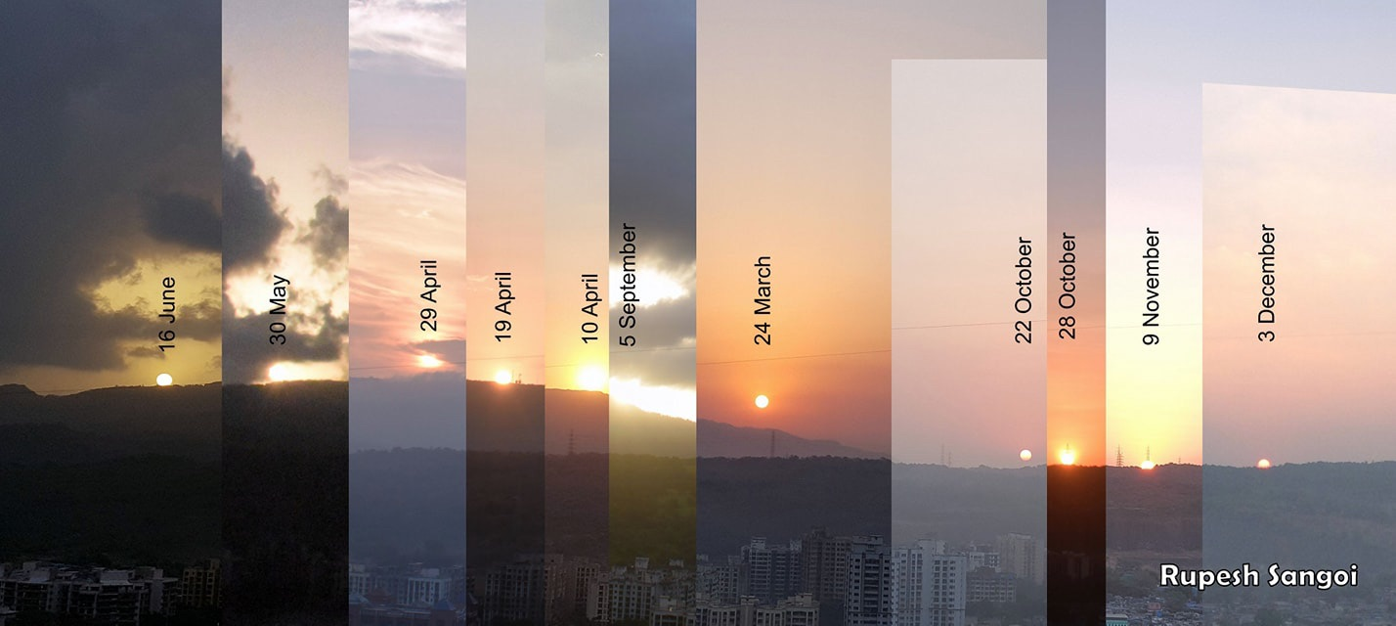
Figure 1.1.
Composite Picture Showing Shifting Sunrise Horizon Position Throughout the Year (EarthSky. https://earthsky.org/earthsky-community-photos/entry/25344/ accessed on March 9, 2024)

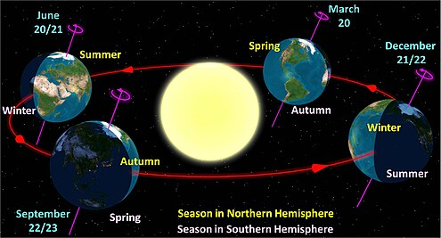
The tilt of the Earth’s axis causes the Northern and Southern Hemispheres of the Earth to alternate facing the Sun more prominently as shown in Figure 1.2. The varying direct light of the Sun on different parts of the Earth yields different seasons and regular changes in temperatures. Because the Northern and Southern Hemispheres alternate which is closest to the Sun this creates seasonal changes that are opposite to each other. These motions and their effects are important to understand as they are the basis for the regular observations made by ancient peoples. These regular celestial motions were used to establish calendars for consistent time keeping methods to track and predict seasonal changes and the resulting need for the times of agricultural harvesting and of food migrations (Ruggles, 2015c).
Figure 1.2.
Diagram of Earth’s Revolution Around the Sun Causing Seasons (Wikipedia https://en.wikipedia.org/wiki/Earth%27s_orbit accessed on September 1, 2023).

Horizon Events.
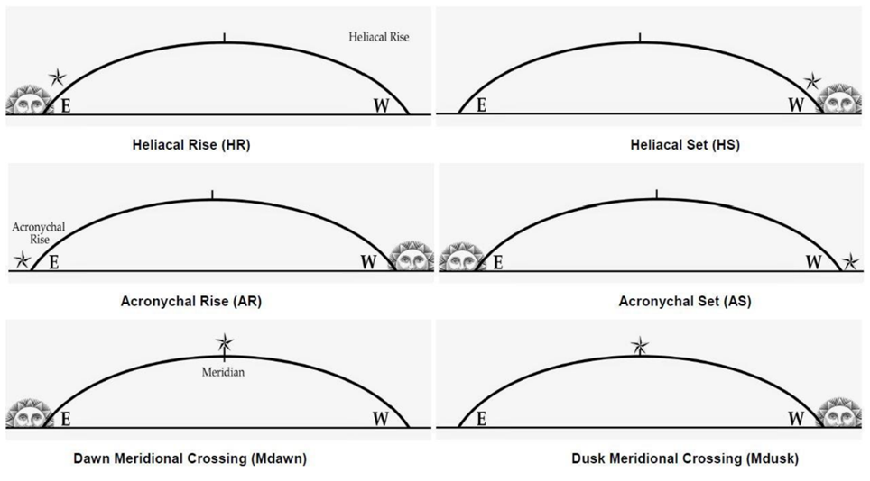
An important concept to understand when discussing the position of the Sun is how it relates to star position. Heliacal and acronychal rising and setting are all terms to describe observations made about a star at the time of sunrise or sunset. They each distinguish if the Sun is rising with a star (heliacal rise, HR), or the Sun is rising while a star is setting (acronychal set, AS), or if the Sun is setting while a star is setting (heliacal set, HS), or the Sun is setting while a star is rising (acronychal rise, AR). Another observation may be important: the meridional crossing, also called the meridian altitude. This is when the star reaches its highest point in the sky at sunrise or at sunset. For visual reference Figure 1.3 illustrates heliacal, acronychal, and meridional rising and setting.
Figure 1.1.
Visualization of Heliacal Rise and Set, Acronychal Rise and Set, and Meridional Crossings (Leaman et al., 2016).

The Moon
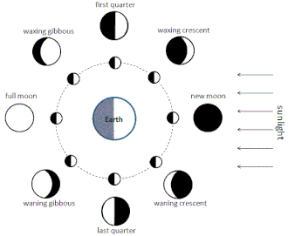
Another significant celestial body influencing many cultural traditions is the Moon. The orbit of the Moon around the Earth is closer than the distance of the Earth to the Sun. This creates light and shadow areas on the Moon from the perspective of the Earth by sunlight shining on the Moon. Unlike the Earth, which rotates in its orbit around the Sun, the Moon’s rotation is equivalent to the rate of its revolution around the Earth which results in a synchronous orbit with the same side (the near side) of the Moon always pointing toward the Earth. From the perspective of an observer on the Earth, as the shadowed Moon orbits around the Earth each month it creates the appearance of shifts in the amount of shadow versus light areas seen. Figure 1.4 shows the result of these changes in the appearance of the Moon which are called the phases of the Moon.
Figure 1.4.
Diagram of Moon Orbiting the Earth and Resulting Phases (Wikipedia. https://en.wikipedia.org/wiki/Lunar_phase accessed September 1, 2023)
The regular orbit of the Moon around the Earth creates a repeating cycle of approximately 29.5 days when these phases repeat, going from a fully lit Moon to a quarter lit Moon to a nearly non-visible Moon and eventually back to a fully lit Moon. This regular period, so easily observed by ancient cultures, created an easy marker of the passing of time known in Western culture as the month. Notably, in many cultures the term used to define this interval of time is related to the cultural word for the Moon.
In addition to the changes in the appearance of the phases of the Moon, as the Moon orbits the Earth it creates gravitational pull on the Earth that, at times, is aligned with the direction of gravitational pull from the Sun and at other times is perpendicular to the pull of the Sun. When these changes in the directionality of gravity from the location of the Moon combine with the directional pull of gravity from the Sun at the times of Full Moon and New Moon, they create tides of greater magnitudes during the month called Spring tides. Neap tides are smaller, and they are the result of the gravitational pulls from the Sun and the Moon being perpendicular to each other.

The Stars
While the Earth orbits around the star of our solar system, the Sun, the distance of other stars from the solar system causes them to appear stationary in space relative to the Earth and to each other. This overhead arrangement of seemingly unmoving stars is referred to as the celestial sphere. As the Earth moves along its yearly path around the Sun distinct groups of stars (constellations) are seen at different times of night. The stars closest to the North and South Poles of the Earth’s axis appear to orbit around the celestial poles of north and south, while the other stars track a path across the sky from rising in the west and setting in the east. These paths have best been shown by photographers who leave their camera’s shutter open for the duration of the night. The result, in Figure 1.5, is a clear image of star trails showing the paths the stars take across the sky on a given night.
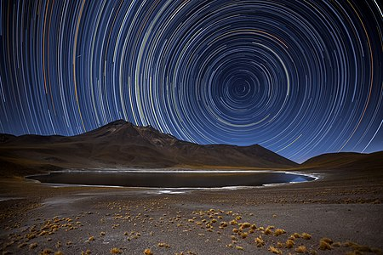
Figure 1.5.
Time Lapse Image of Star Motion Showing Nightly Paths of the Stars in the Sky (Wikipedia. https://en.wikipedia.org/wiki/Star_trail accessed on September 1, 2023.)
When an observer is standing at or near the Earth’s equator these star paths appear to move in straight lines perpendicular to the horizon that go directly overhead. However, an observer at latitudes north or south of the tropics see the stars move in diagonal lines across the sky with the angle of their paths equal to the latitude of the observer as shown in Figure 1.6.
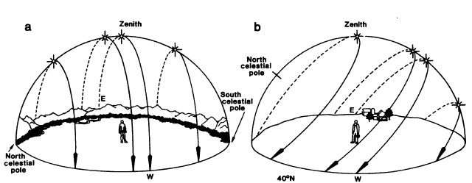
Figure 1.6.
Illustration of Star Trails in the Night Sky. (a) Shows the Paths as Seen from the Tropical Latitudes, (b) Shows the Paths as Observed from a Non – Equatorial Northern Location (Aveni, 1981).
As discussed earlier and shown in Figure 1.5, stars that align with the position of the rotational axis of the earth appear to never set, creating circling tracks centered on the celestial poles. Circumpolar stars rotate in the night sky in particular ways unseen with other star constellations (Aveni, 1981; Gullberg, 2020). Each night, the time of the appearance or rising of a specific (non-circumpolar) star in the sky shifts by a few minutes. Gradually, throughout the course of the year, these stars will disappear completely from the night sky as they rise at the same time as the Sun and the star’s light is overwhelmed by the bright sunlight. This results in a part of the year for every non-circumpolar star when it will not be visible due to the glare from the Sun during daylight hours. In the tropical latitudes, this will also occur for circumpolar stars. This time of invisibility differs from one star to another and ranges from only a few days to weeks or months each year. The amount of time the star is obscured depends on the latitudes of the star and of the observer. This period is the time between the acronychal set and the heliacal rise. Following a star’s period of daylight invisibility, that star will appear again in the early hours of the morning as the star gradually increases its perceived distance, or angle, from the Sun (Ruggles, 2015a). This event relates back to the descriptions of horizon events and the diagram provided in Figure 1.3.

Literature Review of the Torres Strait Islanders
Two groups of the indigenous people in Australia are recognized: (1) the Aboriginal people from mainland Australia, and (2) the people from the islands in the Torres Strait (H., 1941). As studies of indigenous people in Australia have increased, so has also interest in the traditions of Torres Strait Islanders.

Understanding the Torres Strait
The Torres Strait is an archipelago of islands between the northernmost point of Australia’s Cape York peninsula and the island nation of Papua New Guinea. Once a land bridge connected Papua New Guinea and Australia. As the waters levels rose around 8000 BP only the highest points of that former land bridge are now visible (Lemckert et al., 2009). The Torres Strait includes hundreds of islands, atolls, and reefs. But only sixteen of those islands are inhabited.
The Torres Strait is divided geographically into five different regions, each with distinct but similar cultural practices. These regions are the Inner Islands of Muralag, Waiben, and Horn Island; these are closest to mainland Australia. The Western Islands are Mabuyag, Moa, and Badu. The Central Islands include the islands of Iama, Masig, Poruna, and Warraber. The Northwestern islands consist of Boigu, Dauan, and Saibai; they are the islands closest to Papua New Guinea (PNG). Finally, the Eastern Islands (which include a group sometimes referred to as the Murray islands), these are Mer, Ugar, Erub, Dauar, and Waier. Mer is the furthest east and borders Australia’s Great Barrier Reef.
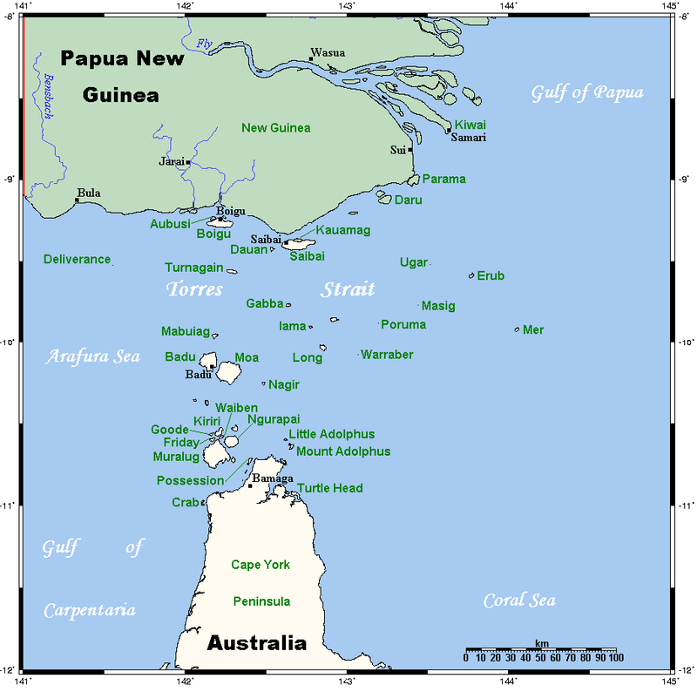
The Western and Central regions share the same language of Kala Lagaw Ya (within which there are differing dialects), while the Eastern region speaks the language of Meriam Mir. These two languages are very distinct yet do share a significant amount of the same vocabulary. With a rich tradition of seafaring, each of these regions within the Torres Strait mingled historically and have many overlapping cultural similarities. Other similarities and influence can also be seen by neighboring Australian and Micronesian populations in the closer corresponding locations of the Torres Strait.
Figure 2.1.
Map of the Torres Strait (Wikipedia. https://en.wikipedia.org/wiki/Torres_Strait_Islanders Accessed September 1, 2023)

History of the Torres Strait
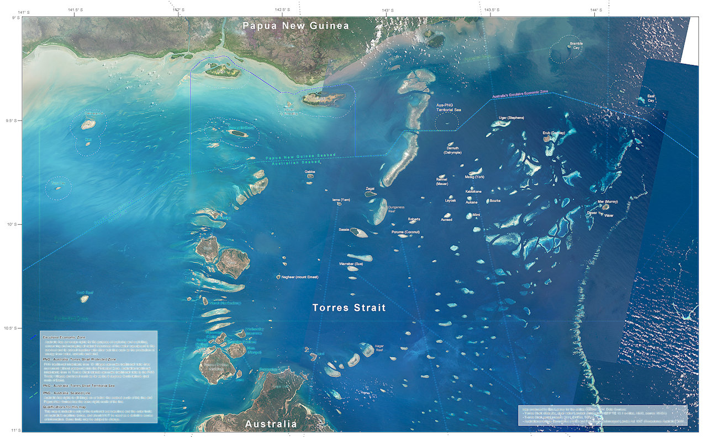
The Torres Strait was first explored by Westerners in the 1600s in an expedition headed by Luis Vaz de Torres, whose name was applied to the area. Western explorers were searching for a navigable path to the lands west of the island of New Guinea. They sought a way to traverse the narrow, sometimes shallow, and dangerous seas between Australia and Papua New Guinea as shown in Figure 2.2. With odd and extreme shifts in tides and currents, the Strait was originally considered impassable by Western sailors after many shipwrecks on the shallow reefs.
Figure 2.2.
Satellite Image of the Torres Strait Showing the Many Atolls, Reefs, and Shallow Waters (Torres Strait eAtlas. ts.eatlas.org.au)
Recent studies of the unique bathymetry of the Torres Strait have contributed to understanding the Westerners’ difficulties in traversing west from the Coral Sea to the Arafura Sea through the many obstructions in the narrow strait (Harper et al., 2011). Despite these difficulties, Torres and his crew did successfully navigate and chart the Torres Strait as a passage between Australia and New Guinea, but his expedition did not travel as far south as Australia, so they were still unaware of the large southern continent. As other Western explorers further charted the Torres Strait, they named the islands they encountered, but the inhabitants of these islands already had names for their homes. As a result, it is common to see different names for each island e.g. Turnagain vs Buru Island, Murray vs Mer Island, and Mabuiag vs Mabuyag Island etc. This paper will use indigenous names for each island, including the names (and spellings) preferred by the Torres Strait Islanders.

Astronomy in the Torres Strait
The flag of the Torres Strait as shown in Figure 2.3 symbolizes a long and significant tradition of astronomy. Featuring a traditional ceremonial headdress called a Dhari, the flag also features an unidentified star labeled as the “navigation star” with each point of the star representing each of the five regions of the Torres Strait. Astronomy found in the culture of the Torres Strait Islanders has become important in understanding indigenous knowledge.
Interestingly, long before Western culture studied indigenous astronomy, events since the beginning of Western involvement in the Torres Strait have also had astronomic connections. Torres’ early expedition to the Torres Strait was riddled with conspiracies, but the sailor’s log are replete with astronomic observations which have helped to verify and analyze details and dates of the journey. These sailors witnessed two lunar eclipses, and noted observations of the Large Magellanic clouds, the Coalsack of the Milky Way, and other southern constellations making it possible to check the accuracy of the voyage records (H., 1941).


Archaeology in the Torres Strait
Figure 2.3.
The Flag of the Torres Strait (Wikipedia. https://en.wikipedia.org/wiki/Torres_Strait_Islander_Flag)
Greater attention has been given to the traditions of Torres Strait Islanders. This has been especially helpful to promote and encourage archaeological studies. David and Wiesler’s (2004) study of turtle shell remnants in the western Torres Strait supported the fishing habits first documented by Haddon (1890). Further archaeological work has verified that these same fishing habits were practiced for hundreds of years before Haddon’s (1890) arrival in the area. Additional archaeological studies have connected the Torres Strait Islanders to other findings throughout Polynesia, Melanesia, and Micronesia (Lewis, 1974). Recent discoveries of pottery from the Torres Strait are physical evidence supporting connections to the pre–Polynesian Lapita people. This is further evidence of connections between the Torres Strait Islanders and the Polynesians (McNiven et al., 2012).
Archaeological evidence continues to grow, supporting the direction of migrations within the Torres Strait archipelago, starting with the Eastern Islands, and migrating towards the Western Islands (David et al., 2004). This migration has been further substantiated by linguistic analysis of the connections between the island’s two main language groups. Languages spoken in the Torres Strait consist primarily of Meriam Mir (in the east) and Kalaw Lagaw Ya with progressive influence seen in the areas closest to Papua New Guinea and to Australia. Further analysis of the intricate differences of Torres Strait languages also supports the pattern of westward migration throughout the islands (Dixon, 1996).

Ethnography in the Torres Strait
In addition to archaeological evidence, ethnographic evidence has been especially critical in understanding the Torres Strait Islanders. This work was pioneered by A.C. Haddon (1890).

A.C. Haddon
A.C. Haddon first traveled to the Torres Strait as a zoologist in the late 1800s. Besides recording unique specimens of plant and animal life, he was most struck with the unique culture of the Torres Strait Islanders (Haddon, 1890). When Haddon would ask members of the younger generations about cultures and customs, he would often receive uncertain answers or referrals to community elders. Considering the islanders’ culture as at risk of going extinct, Haddon (1890) left with a resolve to return for the sole purpose of collecting ethnographic information. His focus changed, from zoology and botany to preserving the traditions of the Torres Strait Islanders. Those traditions made many connections between natural events and aspects of culture. These connections were used to track times of the year to predict weather patterns, tides, animals’ availability for hunting, and times of planting and harvest.
Islands in the Torres Strait region annually experience two defining and extreme seasons of weather, the northwestern summer monsoon season, and the southeastern winter tradewinds, each with distinct weather patterns. The two seasons defined timing for predicting agricultural success (Harper et al., 2011). When Haddon (1890) returned to the Torres Strait in 1898, he traveled to many of the Torres Strait islands (including Mabuyag, Mer, and Waiben) as well as Papua New Guinea. With the help of colleagues such as Sidney Ray, a linguist, et al. and other indigenous informants he diligently recorded the oral traditions, songs, and dances he experienced, in journals and with photographs. Accruing an extensive collection of artifacts to catalog, Haddon transported his collection back to England upon his departure. He then worked to record the ethnography of the Torres Strait Islanders. While Haddon’s work was extensive, it wasn’t exhaustive. Information originally shared with Haddon was limited by the bounds of language interpretation, trust, and the preservation of sacred tradition and ceremony.
Haddon’s (1890) large collection of purchased and donated artifacts and cultural material has since been dispersed and stored in various museums around the world including at Cambridge University Museum, the National Museum of Ireland, and in the Smithsonian Museum in the United States (Moore, 1984). Haddon’s (1890) work described astronomic observations of the native people, local customs, and basic language, and was also critical to understanding the mathematical system of Torres Strait Islanders.
Haddon (1890) recounted the cultural hero stories of figures in Torres Strait history who were thought to have introduced specific survival skills to each island. Other culturally significant ideologies were also recorded by Haddon (1890) such as the role of women and their position in society as property but also the ones who proposed marriages. Overall, Haddon published six volumes describing his expeditions to the Torres Strait. His extensive work elevates him to be considered by many as the father of ethnography as we now know it. Haddon (1890) provided the groundwork of what we know about life in the Torres Strait before Western missionary influences. It allows us to be able over the last century to compare cultural adaptation with Western influence.
Further work suggests that one such way communities can maintain cultural integrity with growing outsider influence is in the native songs which seem to be immune to Western influence and time (Mua & Beckett, 2014). One example of the strength of oral traditions and song amidst the influence of Western colonization, was the perpetuation of song traditions from the Taibobo people. The Taibobos once lived among the Torres Strait Islanders; for generations they have been separated. Yet the song traditions still survive.

Peter Eseli
Primary sources from Torres Strait Islanders greatly augment ethnographic evidence (Eseli et al., 1998). Peter Eseli (1998) was born in 1886, a native of Mabuyag Island. His father, Papi Eseli, was an associate of Haddon who helped him document many of the Islander’s traditions. Peter continued his father’s legacy by keeping a journal, a manuscript that recorded and described in great detail common chants and traditions of astronomic movements and traditional indicators used to predict seasons, times of turtle and fish availability, times of crop harvesting, extensive family genealogies, etc. His record included specific names of significant stars with dates and their correlations with times, patterns of animal availability, seasons, and times of harvest. Eseli’s Notebook was translated and published in 1998, but the contents are of value today.
Connections have also been identified between the timing of the yam harvest and similar customs throughout Polynesia (Lewis, 1974). Ethnographic information has been additionally strengthened by recordings of oral mythological stories of the Torres Strait Islanders. Laade (1968) contributed by researching Torres Strait Islander origin stories in their own words and oral traditions. Despite much conflicting information, different informants all agreed that the western-most island, Badu, was settled last. This ordering aligns with the linguistic analysis and the archaeological evidence.
Informants also occasionally include tales of possible Polynesian seafaring explorers who comingled with the people in the eastern edge of the Torres Strait. Lawrie (1970) also contributed significantly to the record of folklore and stories told on each island. These include more stories of cultural heroes, but also stories of the constellations and their origins. Lawrie (1970) also specifically noted the different island origins of each story, documenting the subtle differences in traditions and folklore from one island to another.

Ethnography and Astronomy
With this ethnographical evidence, recent astronomic work has combined this ethnographic evidence with analyses of astronomic phenomena and their significance in Torres Strait Islander culture. Hamacher et al. (2020) have worked with local indigenous artists, living tribal elders, and astronomers to understand the astronomic oral traditions still used by Torres Strait Islanders.
Recent specific work on the significance of astronomy to the Torres Strait people has included understanding the modern religious ideology around shooting stars (meteors) and their connection to mortuary rites (Guedes et al., 2018). Included are the current mourning process of the Torres Strait Islanders and how they view a shooting star as representing the spirit of the deceased. These shooting stars are often associated with warnings of the deceased’s displeasure with their living relatives’ treatment.
Extensive work to understand the Islanders’ observations of the twinkling of bright stars, their varying magnitude indicating the arrival of monsoon seasons (Hamacher et al., 2019). This work showed that in oral traditions rapidly twinkling stars were signs of approaching storms, while for fishermen the twinkling was an indication of good winds and suggested the opportunity to go home. In the Torres Strait this twinkling (caused by the refractive index of the atmosphere) was best seen from the changes of humidity and temperature and pressure that accompany significant storm systems. Islanders recognized the increase in twinkling near the trade winds arrival, as heard in the traditional song sung in Meriam.
Further investigations of astronomy’s significance have included work showing modern Islander astronomers using distant islands and other horizon markers to identify solar solstice dates in the western Torres Strait (Hamacher et al., 2020). Only by thoroughly analyzing the concepts and ideas in seemingly simple astronomic traditions have Guedes et al. (2018) and Hamacher (2019) reached an in-depth understanding of how the Torres Strait Islanders had learned about their area and how the world works around them.

Future Research
While Eseli (1998), Lawrie (1970), and Haddon (1890) et al., are a significant source of ethnographic information archaeoastronomers currently working with living Torres Strait Islanders have just begun to scratch the surface of what can be learned from these records. Specifically, with respect to the work of Eseli (1998), his many references to astronomic markers and traditions for the purpose of timing the seasons, linking to rituals, and knowledge related to agriculture and fishing. Eseli’s work has not been extensively studied for accuracy and compared with the motions of celestial objects as seen from the Torres Strait. Unfortunately, Eseli’s published journals are occasionally misinterpreted or inaccurately translated. Much of this information remains unexplored and unverified. To accurately review these sources as well as other information collected from previously mentioned resources, this thesis will include further study of seasonal changes, tides, monsoons, tradewinds, and times of inclement weather.
For example, identifying patterns of migration and availability of animal food sources, and the timing of planting and harvesting cycles for primary original indigenous plant food sources (such as the yam and, possibly, the banana). Also, understanding the different ecological systems’ impacts on various agricultural resources in differing regions of the Torres Strait. This study should also include further analysis to verify the existing star and constellation identifications. With the differences between the islands, any analysis of the astronomic systems should specify the individual island. If that is not possible, the analysis should at least categorize the astronomic systems by geographic region or linguistic group within the Torres Strait archipelago.
This analysis will be most valuable by combining all the various available resources referencing astronomy by the Torres Strait Islanders. Confirming the accuracy and sophistication of these comprehensive cultural astronomic descriptors would give an overarching framework and would be a significant contribution. Failing to fully compile and compare these resources and to evaluate their accuracy would be a great disservice to research the astronomy of the Torres Strait Islanders.

Methodology
Best practices in archaeoastronomy methods have been evolving over the last couple of decades. However, much of what researchers in the field have found is that the best methods for archaeoastronomical research depend on the geographical area being studied and the resources available. The Torres Strait has unique resources available that favor specific research methods. The archaeoastronomical evaluation methods used in this paper include two main elements: collecting ethnographic astronomic knowledge and collecting quantitative evidence to better understand the ethnographic evidence.

Collecting Ethnographic Astronomic Knowledge
Many sources of ethnographic knowledge are found in published works by Western ethnographers and in indigenous sources, such as interviews with indigenous elders, review of indigenous art and artifacts, and texts from indigenous manuscripts.

Published Ethnography by Western Ethnographers
Recording the ethnography of the Torres Strait Islanders by the Western world began with notes from the ethnographical expedition of A. C. Haddon in 1898. This documentation of the indigenous peoples’ ways of life, language, and astronomic knowledge is an invaluable trove of information, and is vital to the research done in this paper to collect and organize the astronomy of the Torres Strait Islanders. Haddon’s expedition occurred in 1898, but his complete six-volume set about his experiences was not published until 1935.
Haddon collected his journals and notes, compiling them into the published version of his work. The hundreds of pages compiled from his journals were examined for astronomic data. In addition to the published version of his journals, the Cambridge Library in the UK owns the Haddon Collection, containing his raw original journals, notes, articles, and other written sources organized into numbered boxes. Hamacher (D. Hamacher, personal communication, December 1, 2023) provided meticulously taken photographed digital image files of the boxes’ contents that had been taken previously. These were simply sorted by file names that matched the original box number they were found in. Included were images of quickly scrawled handwritten notes; they had to be deciphered and any astronomic content had to be identified. Ethnographic astronomic knowledge was collected from the pages of Haddon’s published volumes and from the contents of the boxes of the Haddon Collection, as imaged by Hamacher.
Additional published ethnographic information was found in the works of Margaret Lawrie. For many years, Lawrie lived in the Torres Strait recorded the folk tales and stories of the indigenous people from many different islands (Lawrie, 1970; Lawrie, 1972). Her works were each examined to find any mention of astronomic objects.

Indigenous Sources of Ethnography
Eseli’s Notebook is a primary resource for information about the Torres Strait Islanders (Eseli, 1998). Eseli offers a unique published record of indigenous traditions as they were recorded by an indigenous person and then translated by modern linguists. Eseli’s translated and published notebook is a primary resource for ethnographic astronomic information. It includes writings in a poetry-like format with specific mentions of astronomic objects with their expected movements at specific times of the year on specific dates.
Additional indigenous ethnographic information was found from indigenous Elders in video interviews by Hamacher. These included multiple interviews with elders such as David Bosun, Alo Tapim, and others from both the Western and Eastern Island groups. These interviews had to be meticulously transcribed into searchable text to obtain any mentions or descriptions of the understood movement or behavior of astronomic objects.
Other indigenous resources included artwork produced by modern indigenous artists. Art by Tommy Pau, and others was often inspired by indigenous astronomic traditions. Images and captions of that art offered additional insights into indigenous traditions and understanding of associations with specific constellations and other astronomic objects.
Another resource for ethnographic astronomic knowledge has been found in the Dictionary of the Torres Strait Indigenous Languages written by Haddon’s linguist research partner (Ray, 2001). By understanding the meanings of the names and descriptions of the astronomic objects, some references to astronomic objects could be combined as it was determined they were references to the same celestial object. The dictionary also provided additional evidence for astronomic objects, sometimes identifying erroneous information from other resources. The ethnographic astronomic knowledge found from all these diverse resources is collected, summarized, and separated into the two primary island and linguistic groups in Chapter 4.

Collecting Quantitative Evidence
Ethnography is important to give context to indigenous astronomic traditions, but its academic significance is increased by combining ethnography with quantitative evidence of astronomic and other natural patterns. These patterns include charted migratory patterns of animals, seasonal weather patterns, and models of astronomic movement.

Charted Migratory and Seasonal Weather Patterns
Often, the astronomic traditions of the Torres Strait Islanders are related to seasonal changes and the migratory patterns of various animals. Hence, it was important to gather information on the local seasonal changes and weather patterns experienced throughout the year. Plotting data from the Australian Bureau of Meteorology from their weather station on Horn Island, the closest location to the Western islands of the Torres Strait showed the times and changing patterns of rainfall in the area (Bureau of Meteorology, 2023).
Similarly, information was also obtained and plotted about the migratory patterns of specifically mentioned creatures, such as the Biru Biru bird, also known as the Rainbow Bee-eater (Fry & Boesman, 1992). Other specifically mentioned animals in the astronomic traditions included the behavior and availability of mud crabs, the predicted behavior of various shellfish, and the availability and quality of crayfish. Published studies and information collected about these animals were researched and included in evaluating indigenous traditions.

Graphing Star Position
Further quantitative evidence was obtained by utilizing star position modeling. Indigenous traditions about the stars, indicating their expected positions and behavior at specific times of the year, are illustrated in Chapter 5 by examining Eseli’s Notebook (Eseli, 1998). Eseli offers a unique resource as he documented specific indigenous calendrical-like sayings used by Islanders to identify times of seasonal changes in the Torres Strait. These are specific to individual stars and describe expected observed motions with correlating times of year.
These analyses were especially important to further understand the reasons for indigenous star lore and the significance of some celestial objects over others in Islander culture. To evaluate Eseli’s information, his notebook statements are organized by star group, with charts matching the exact (translated) wording of Eseli’s statement with the date(s) of the anticipated motion(s).

Stellarium
Evaluations were accomplished using Stellarium (Chéreau, 2019). Stellarium is free and open-source software used by both astronomers and the public to model star positions at various dates and times, and at locations around the world. Our study utilized version 1.2 of Stellarium for desktop computers. For our study, the position provided to Stellarium was specified as “Mabuiag Island”, the home of Eseli (1998), at 9.95° South, 142.18° East. The positions of the stars are evaluated in this paper for dates when Eseli (1998) was alive and could have been making these astronomic observations. For simplicity the year used is 1900. Occasionally there were issues found with different versions of Stellarium, for example, inconsistent location settings for Mabuyag/Mabuiag Island. If necessary, the actual latitude and longitude for Mabuyag (as indicated above) was used instead.
Generally, stars near the horizon have limited visibility. Even when the Sun is 5 degrees below the horizon, smaller wavelengths of sunlight still produce a purple glare limiting visibility. And, in the Torres Strait visibility is further impaired by aerosolized water vapor from wave spray and from tropical humidity. These all can diminish near horizon visibility. Schaefer (1993) indicates that when the Sun is close to the horizon the glare of the sunlight makes stars with a brightness less than -0.3 magnitude invisible (in star magnitudes, the lower the number, the brighter the object). The brightest stars of greatest interest in the Torres Strait, as indicated by Eseli, have magnitudes between -0.05 to 1.79, which only leaves very few within the -0.3 limitation of visibility.
To account for the limitations of visibility with the positions of stars on the horizon during times of sunrise and sunset, for this study the altitude of the Sun was set to -10 degrees (after then setting and below the horizon). Each star was set to a minimum altitude of 5 degrees above the horizon (Schaefer, 1993). When the altitude of the star was at 5 degrees, these parameters provided dates of the horizon events such as heliacal rise and set (as described in Chapter 1) of specific stars obtained by entering the dates and times in Stellarium, and manually adjusting the position of the star and Sun to the altitudes described above.

Observability Analysis Plug-in.
A faster way to obtain the dates of specific stars’ horizon events was also obtained by using the Observability Analysis Plug-in provided by Stellarium. The procedure to add this plug-in, as follows, is to open the configuration window of Stellarium (using the wrench icon in the sidebar or by pressing F2), then selecting the plugins tab as shown in Figure 3.1. In the plugins tab navigate to the item labeled Observability Analysis in the left column. Activate the Observability Analysis Plug-in by first checking the box for loading at start-up, then the program was then shut down and restarted, and the configuration window of Stellarium was reopened.
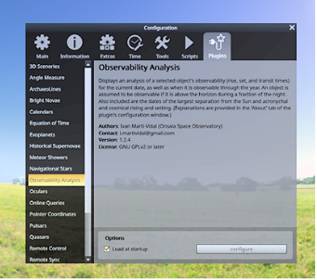
Figure 3.1.
Observability Analysis Plug-in Screen (Author’s Image from Chereau, 2019)
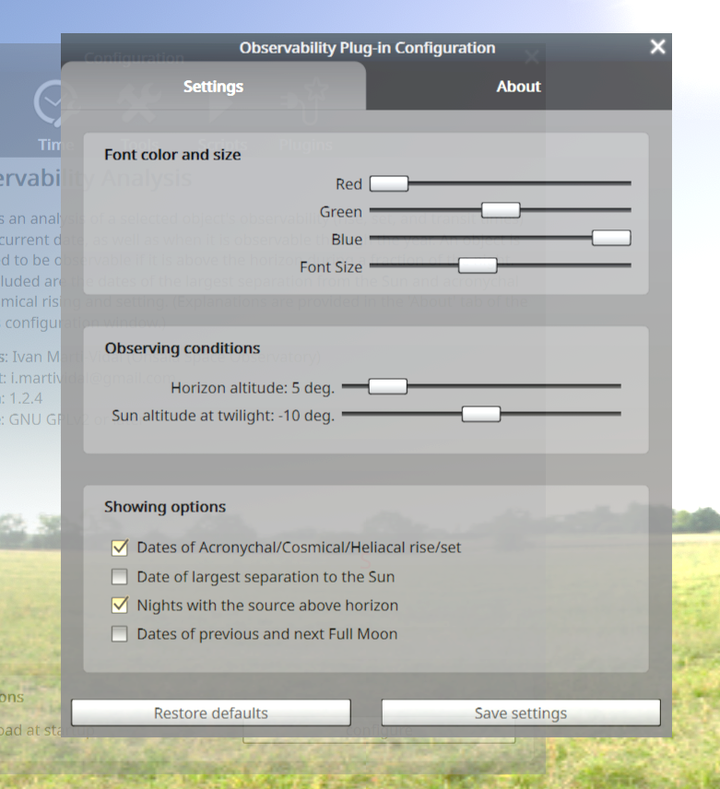
In the Observability Analysis Plug-in’s Configuration Window, the observing condition parameters were changed to specify the horizon altitude at 5 degrees, and the Sun’s “twilight altitude” was -10 degrees as shown in Figure 3.2. The boxes to show the dates of heliacal, cosmical, and acronychal rise/set and the dates of nights above the horizon were also checked. These settings were saved.
Figure 3.2.
Observability Plug-in Configuration Window (Author’s Image from Chereau, 2019)

To see the results of the Observability Plug-in, a specific astronomic object must be selected (for example, a star). For easy access to this feature, a keyboard shortcut must be assigned. This is done by clicking the button marked with the wrench icon as shown in Figure 3.3. Enable keyboard navigation must be selected and then the option identified with the wrench icon is chosen.
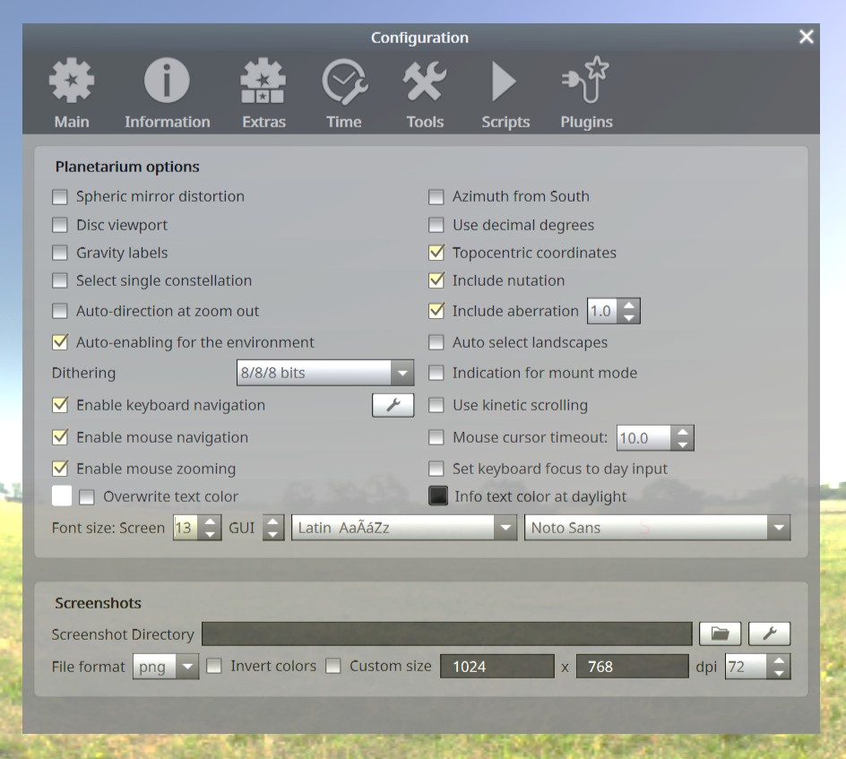
As shown in Figure 3.4 scroll to the bottom of the list, find the option for Observability, and type in a chosen primary keyboard shortcut. In this example, by pressing the shift key and the letter “O” simultaneously and applying the changes. Once activated, this plugin can be utilized by using the Shift-O keyboard shortcut or by clicking on the newly activated symbol in the bottom toolbar, a bar with a star above it with an up arrow.
Figure 3.3.
Tool Configuration Window to Allow for Keyboard Navigation (Author’s Image from Chereau, 2019)
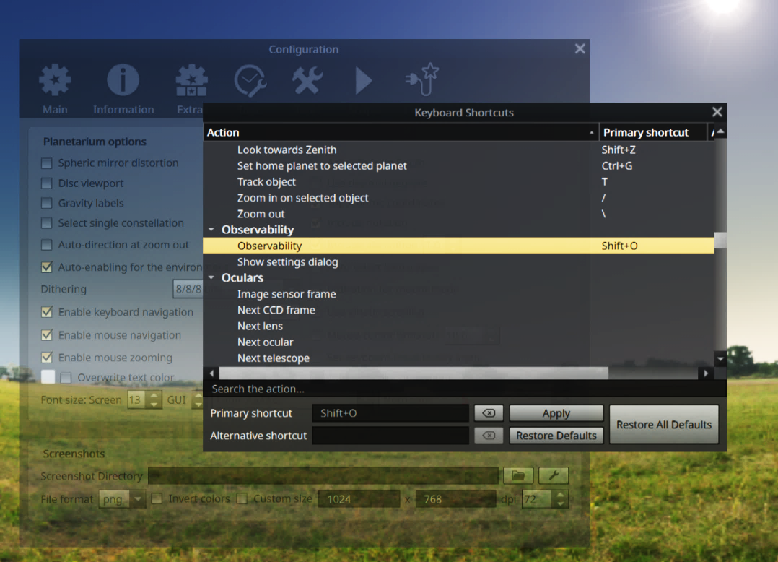
While using this feature, the dates of heliacal rise and set matched the dates that were obtained for these events by using the grid feature of Stellarium and manually manipulating the position of the Sun and the desired star at the preferred altitudes. However, when using this plug-in, the date data for acronychal rise and set disagreed with the date data for the manually obtained dates of acronychal rise and set. Sometimes the acronychal dates disagreed by only a couple of days, such as with the star alpha Crux (in the Southern Cross). But sometimes, as was the case with Arcturus, the dates disagreed by weeks, a month, or even more.
Figure 3.4.
Keyboard Shortcut Window in Tools (Author’s Image from Chereau, 2019)
Additionally, when the dates obtained from the Observability Plug-in were manually entered, the positions did not match the desired positions of 5 degrees for the star and -10 degrees for the Sun. Because of this discrepancy, the manually obtained dates (which also agreed with the position data obtained through the coding process described in the next section) for acronychal rise and set were used as the basis for our analysis.
The dates of heliacal rise and set as well as acronychal rise and set are significant markers of the positions of the stars as observed at sunrise and sunset. These dates were extremely helpful as post markers to the expected positions of the stars, but additional data (from Stellarium) was needed to understand the general motion of the stars as observed at sunrise and at sunset between the dates of horizon events and throughout the year. To graphically visualize the changing altitude of a star at sunrise or sunset from one night to the next, we needed position data for the star throughout the year. Although this data could be obtained manually, by using the grid feature and dragging the screen so the star is at the desired location and recording the altitudes, that would be prohibitively tedious to repeat 365 times. Instead, we used the scripting feature of Stellarium to expedite data collection.
3.2.2.1.2. Scripting in Stellarium.
The added scripting to obtain the needed star position data was installed in the Stellarium scripting window, accessed with the F12 command key. Script details and documentation are shown in Appendix A.
Once collected by the script in Stellarium, the resulting CSV (comma delimited, spreadsheet compatible) file was opened in Excel. The spreadsheet sorted all the acquired data into rows and columns and highlighted graphically to represent the changing star position throughout the year with the axes showing of star altitude versus date.
A technical note: this process encountered problems with values on the first date of the 365-day series. The script output from Stellarium showed the results in UTC (once known as Greenwich Mean Time) which is ten hours earlier than the time zone of the Torres Strait Islands. Therefore, script results were output for the first day of 1900 (local time) in UTC as occurring in the on the last day of 1899. But because Microsoft Excel can only calculate date values on or before January 1, 1900, for this first date only the day and time had to be input manually.
In general use, this script program was run twice to obtain results for both the sunrise and sunset positions of the selected stars. The script produced all the star positions, but the graphs only included the data where the star’s altitude (position above the horizon) was a value greater than 5 degrees. Once the graphs of the observed star positions through the year were created, they were compared with the statements provided by Eseli (1998) to determine their accuracy.
In cases where Eseli’s statements referred to a specific rise or set event, these dates were compared to the dates of the heliacal or acronychal rise or set. Sometimes specific dates were mentioned that seemed to indicate a meridional crossing. Those statements were then compared to dates that were obtained manually as the star passed an azimuth of 0 or 180 degrees (depending on if the celestial object was primarily in the northern or southern sky). In the analysis to determine the truth of Eseli’s statements, the statements were determined to be true only if the event was found to be within 5% accuracy of the statement date.
For analysis using incremental levels of accuracy, those levels were determined to be in varying degrees of accuracy using quantitative analysis of stratified sampling. The stratification levels were based on accuracy within 1 - 2 weeks, accuracy within 3 - 4 weeks, accuracy within 5 - 6 weeks, and accuracy greater than 6 weeks.
Once given values indicating the statement’s accuracy, the data was analyzed with descriptive statistics. The descriptive statistics were determined within the groups of the star traditions by a comparison of the mean level of agreement. This was done by coding the different levels of agreement with numerical values and finding the average level of agreement per star group. The mean levels of agreement were then compared with other mean values specific to that star group for variables (such as brightness and angular size) to determine any correlations. The mean values of stratified sampling were also sorted as dates related to heliacal rise or set versus acronychal rise or set to determine a more prevalent correlation of star traditions with a specific type of rise or set event. These were also compared with observations made at sunset versus observations made at sunrise, to ascertain a more prevailing observation time.
This same procedure was used in Chapter 6 to obtain graphs of the positions of the Beehive Cluster (M44 in the constellation Cancer) and the constellation Coma Berenices. These were possible identities of what Torres Strait Islanders called “Getalai.” The star positions were then compared with the average rainfall, and the migration times of key species as discussed in Chapter 6.

Astronomy of the Torres Strait
After the initial publication of some of A.C. Haddon’s field work in the magazine Nature in 1898, Haddon advertised that he was seeking additional research topics to pursue on his next expedition to the Torres Strait. Haddon received a letter from an intrigued reader. This letter from Mary Anne Baily, dated February 1, 1898, specifically requested more information about the ways Torres Strait Islanders grouped the stars, their constellations, and the astronomy there (Haddon, n.d.-g). It was later in that same year, 1898, after this letter was received, that Haddon went on his next expedition to the Torres Strait, where he did include as much astronomic information as possible.
Haddon’s volumes of notes have been a significant resource for preserving Torres Strait astronomic traditions. But Haddon traveled to many islands in a relatively short amount of time, some comments and references in his work are not identified with specific islands or with specific informants. Similarly, records from Lawrie’s (1970) collections of folkloric stories, are often but not always identified with specific island sources of origin, such as from the Western Islands or Eastern Islands. Similarly, information from contemporary informants (like from artists and tribal elders David Bosun or Tommy Pau) are not easily categorized by island. Often a modern individual’s ancestry cannot be isolated to only one island within the archipelago.
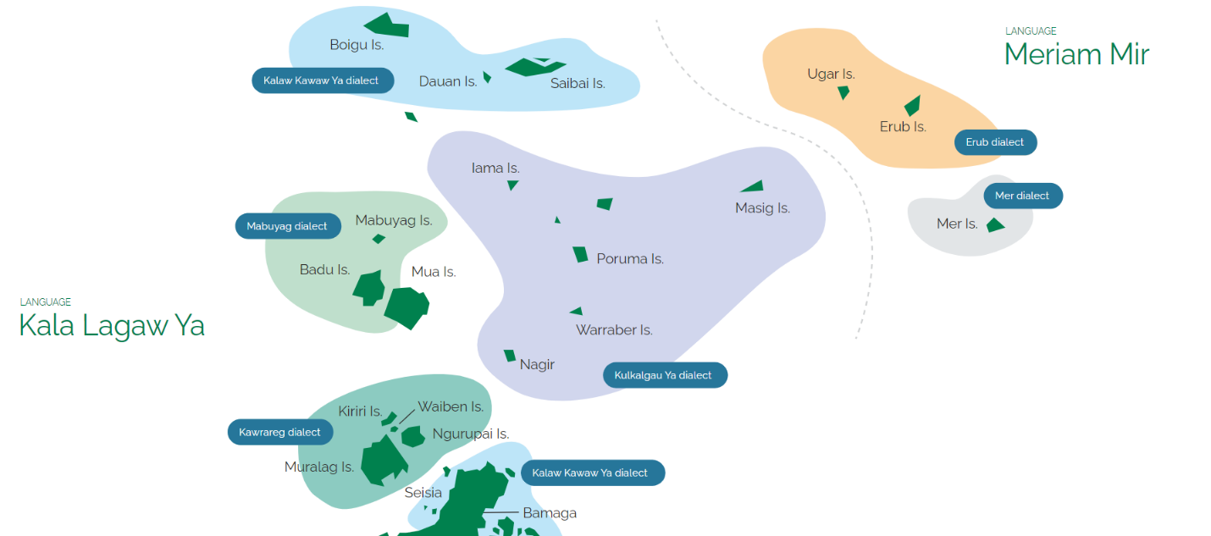
For these reasons, the astronomy presented in this chapter has been broken into two main groups aligned with the two main linguistic groups found within the Torres Strait shown in Figure 4.1. The first group, the Western Islands, includes those who speak variations of Kala Lagaw Ya. This region includes the Inner Islands, the Central Islands, the Western Islands, and the Northwestern Islands with most information coming from Mabuyag and Moa Islands. The Eastern Islands are where the language is Miriam Mir, with most information coming from the easternmost island of Mer.
Figure 4.1.
Map of Language Boundary in the Torres Strait (Torres Strait Island Language Plan. https://www.tstlanguages.org/our-languages )

Astronomy of the Western Islands
One of the most prolific resources we have of the astronomic traditions of the Western Islands comes from Eseli (1998) who was from Mabuyag Island. In addition to his record, there are also many stories recorded by Lawrie (1970), and many notes by Haddon (1890), whose entire published fifth volume is specific Western Islander traditions and culture. Additional information is derived from art and interviews with David Bosun, who is from the island of Moa (Hamacher, 2018).
For the sake of organization, the stars and constellations of the Western and Eastern Islands are presented here in alphabetical order.

Awaitui
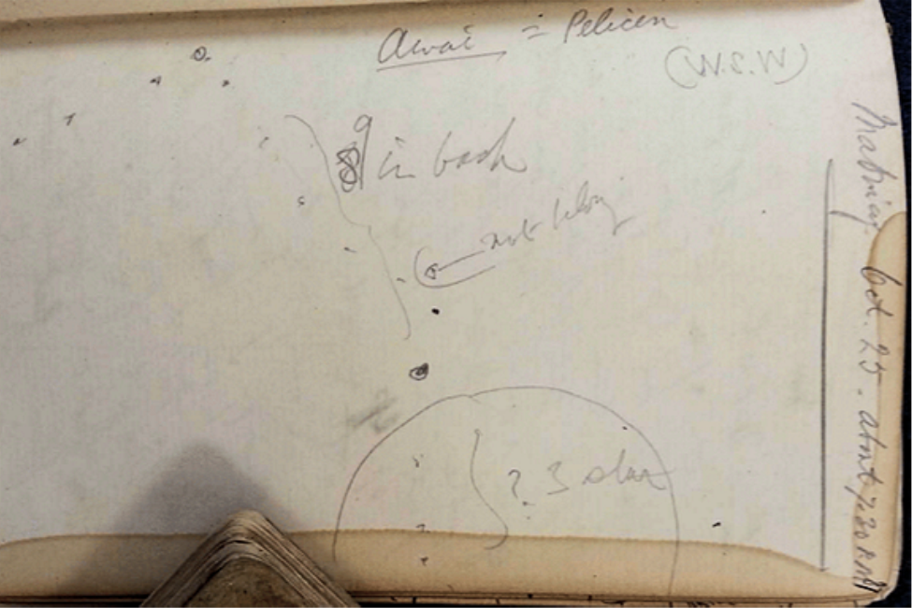
Awaitui is the pelican. Figure 4.2 shows the sketch in the Haddon’s notes as found in the Cambridge library but not included in the published volumes from his expedition. In the same notebook Haddon mentions a possible connection to the Western constellation of Cassiopeia but gives no supporting details. Most of the credible references about Awai tui (also called Awai tutuil) were from David Bosun. In his linocut art, Bosun (2007b) mentions several specific Torres Strait constellations, including Awaitui, in his description of the importance of the Zugubau Mabuyag or tribal astronomer, who observed the stars and gave important updates to his people about the expected patterns of weather, hunting, and planting (Bosun, 2007b).
Figure 4.2.
Sketch from Haddon’s Notes of Awai Dated October 25 at 7:30pm (Haddon, n.d.-e, p. 315)

The Back Fish
Our understanding of the Back Fish is very limited, knowledge of this constellation only comes from a mention of this star group by David Bosun in an interview with Hamacher (2017).

Baydham
Baydham, the shark, is a constellation that the Eastern and Western Islands have in common, although their names for the constellation and the specific stars included in the constellations between the islands differ in minor details. In the Eastern Islands, the shark is Beizam. Made up of the stars in the European constellation of Ursa Major including the “Big Dipper,” in the Northern Hemisphere Baydham is a northern circumpolar constellation with specific rotating movement patterns in the night sky throughout the year. (A circumpolar constellation doesn’t simply rise and set like other constellations, but it rotates in a narrow space in the northern sky.) However, at the tropical latitude of the Torres Strait the constellation does rise and set in the night sky. These observational differences are illustrated in Figure 1.6.
The people of the Torres Strait use the constellation’s rotation to describe the availability of fish, the onset of rain, etc. Eseli (1998) records traditions such as when the shark’s nose touches the horizon and vomits out tiny fish, or when the shark plunges down below the horizon and its splash causes rain and strong winds. In his interview, Bosun indicated that he preferred navigating with the aid of Baydham because of its association with a cardinal direction, it also has an angular size much smaller than some of the other constellations in the Torres Strait which makes directional navigation more accurate (Hamacher, 2017). Figure 4.3 shows one of the most significant differences between Baydham of the Western Islands and Beizam of the Eastern Islands, the inclusion of the two stars in front of the shark. In the Western Islands these two stars are part of the constellation Wapi.
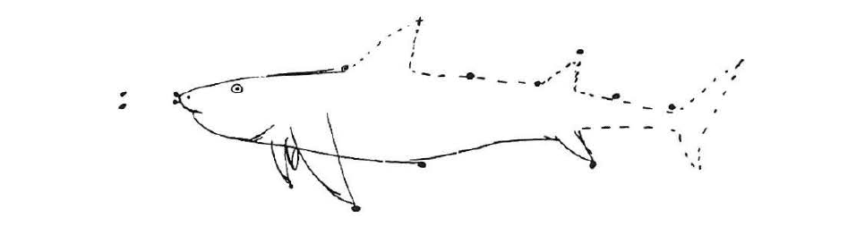
Figure 4.3.
Sketch of Baydham (the Shark) (Eseli et al., 1998, p. 52)

Buu/Bu
Buu is understood to be a trumpet shell (Syrinx araunus) made of five stars who were some of the zugubals. On Earth, Zugubals were normal looking individuals with super-human abilities. But when they were sent to the sky by the hero Thoegay they are able to summon seasons, and cause rain, tides, winds, etc (Lawrie, 1970). The trumpet shell is native to the Torres Strait (David et al., 2005). Haddon (1912) records that Buu is the European constellation of Delphinus. In the Western Islands there is a story of the Dogai who was killed by a brave archer Buu, who upon the death of the Dogai, was killed by the townspeople and went into the sky to follow the Dogai in the celestial sphere (Haddon, 1890). This tale is linked with Figure 4.4 which shows Buu near the Dogai in Haddon’s sketch.
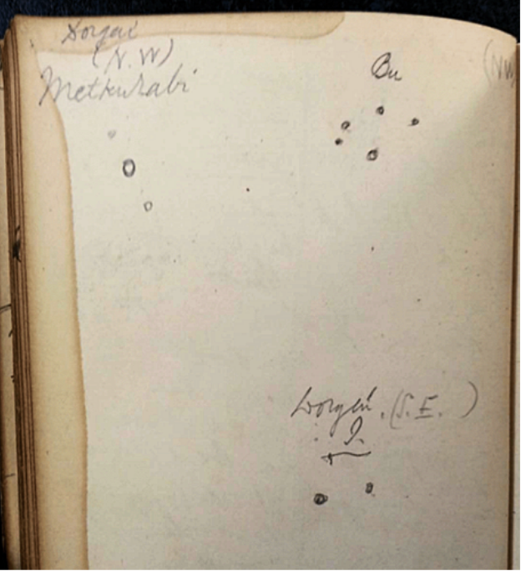
Figure 4.4.
Sketch of Bu (Haddon, n.d.-e, p. 314)

Bu Shell
Bu Shell is a constellation reference by David Bosun in his interview with Hamacher (2017). At that time while reviewing star gazing software, Bosun indicated that Bu Shell is the European star Pollux. Other descriptions by Bosun indicate it includes a red star at the tip of the Buu Shell and it is a triangle shape that sits in the galaxy. Further investigation needs to be done to determine if the Bu Shell referenced by Bosun is the same as the constellation Buu which is also understood to be a trumpet shell.

Dakatir
One of Haddon’s informants was Waria, the chief on Mabuyag Island (Haddon, 1912). As part of the information Waria provided, Haddon included a diagram which included two stars near the tail of the scorpion called Dakatir. Haddon seemed confident that the stars labeled referenced stars in the European constellation Ara (the altar). Dakatir is also identified as two big stars, that are in the southern sky (Eseli et al., 1998).

Dede
Haddon (1912) indicated that he received information from Mabuyag that in the month of May there are several constellations prominent in the sky including Pagas and Dede. Haddon (1912) indicated in a specific note that Dede is Betelgeuse although there is no further justification for this identification.

Dogai
The Dogai are mythological mis-shapen women who live in the Torres Strait and who long to live among the Islanders but who often cause havoc. Of these Dogai, the two most often associated with star lore are Methakurab and Ii. As illustrated in Figure 4.5, these stars are also associated with Kap (the word for star rituals) and they indicate to the people when it is time to make Kap, sometimes referred to as the Kap star (Haddon, n.d.-e).

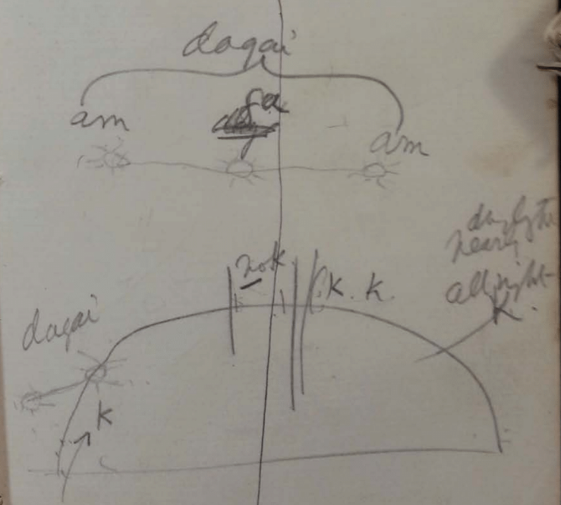
Figure 4.5.
Sketch of Dogai (Haddon, n.d.-e, p. 69)

Metakurab Kukilaig.
Metakurab is the northwest person. Eseli (1998) indicates that it is also called Kai Dogai, meaning big Dogai, and is composed of the European star Altair with two of the surrounding stars on either side. The appearance of this constellation indicates Kuki, the start of the monsoon season. This constellation is also followed by Bu in the night sky. Eseli (1998) describes it as three stars in a v shape. Diagrams of Dogai Kukilaig can be found in Figure 4.6 and Figure 4.7.
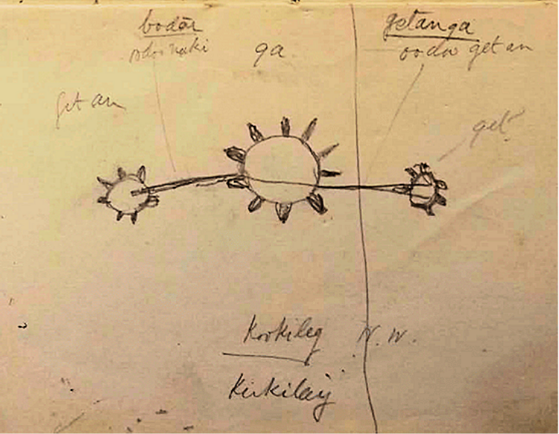
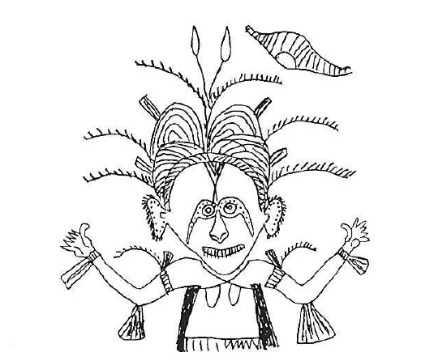
Figure 4.7.
Sketch of Metakurab by Gizu of Mabuyag (Eseli et al., 1998, p.16)
Figure 4.6.
Sketch of Dogai Kukilaig (Haddon, n.d.-e, p. 535)

Waralaig Ii.
Dogai Ii is the southwest person. Also a Dogai, Haddon (1912) indicated that this was the European star Vega. Ii is also distinguishable from the other Dogai as the folktale of Ii includes the details of when Ii lost her arm and as a result, this is arm is depicted askew in the constellation in the sky and explains why she has only two stars instead of three stars like the other Dogai as shown in Figure 4.8 (Lawrie, 1970). Haddon (1890) also explains that the constellation is only made up of two stars instead of three like Metakurab and this is explained by the story of the lost arm. Diagrams of these two constellations are found in the notes of Haddon collection and are shown in Figure 4.9 and Figure 4.15.
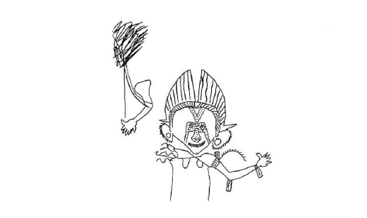
Figure 4.8.
Sketch of Ii by Gizu of Mabuyag (Eseli et al., 1998, p. 64)

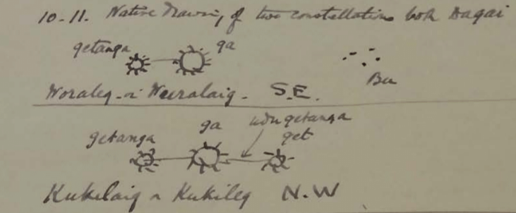
Figure 4.9.
Sketch of the Dogai Orientations from Thursday Island (Haddon, n.d.-f, p. 22)

Dedeal/Dideal
Lawrie (1970) describes Dedeal as being the breastbone of a turtle. Notes from Eseli (1998) indicate that it is the star Betelgeuse, but also that it is a constellation made of eight stars who are zugubals. Haddon (1912) indicates it is in the vicinity of Usal followed by Gapukwik and the Dedeal. Haddon’s notes also indicate that Dedeal is associated with Taurus, Orion, and Sirius (Haddon, n.d.-d). Because both Dede and Dedeal have references from Haddon that associate this star with Betelgeuse, it is possible that these two star groups are references to the same object.

Dhoeybawal
Dhoeybawal is a southern star mentioned by Eseli (1998) in his notebook. The root meaning of this name is the same as a type of yam.

Dugal
The only reference for Dugal is from the artist Nona (2008) from Badu. He indicates the tradition is the star appears in the early morning for two weeks in August and September to indicate the time of harvesting specific yams.

Gil/Giil
Associated with bringing rain with the Pleiades as the Wooewra (the southeast trade wind) develops. It is also described as appearing in May with other stars and constellations such as Usal. Eseli (1998) describes some specific times of star motion such as the appearance of Giil in July and October. Eseli (1998) offers that the name Giil means good fish and is a southern constellation.

Gapukwiiku
Gapuk wiiku is also known as the suckerfish. Suckerfish were commonly used in fishing for turtles. Fishermen would attach rope to the fish and cast it out to the deeper parts of the water, the fish would then attach itself to the turtle shell and allow the Islanders to pull the turtle in thus allowing Islanders to hunt turtle when they are submerged. In his interview, David Bosun indicated that Gapukwiiku is located under the bow of Tagai’s canoe (Hamacher, 2017). Eseli (1998) indicated that it was a group of five zugubals. It was indicated by Haddon (1912) to appear just after Usal to the south.

Gitalai/ Getalai/Githalai
Getalai is a mud crab. It is reported by Eseli (1998) as rising after the Wapi with the Sun in October and is a group of six zugubals who are stars. There are also descriptions of Getalai as ashes and was thought by Haddon (1912) to possibly be a nebula or something like it. Haddon (1912) included a sketch of it with other constellations in its vicinity in Figure 4.10. It is also noted that Getalai’s appearance coincides with the migration of the Biru Biru birds. There are also references to Getalai in the Eastern Islands as illustrated in Figure 4.16.
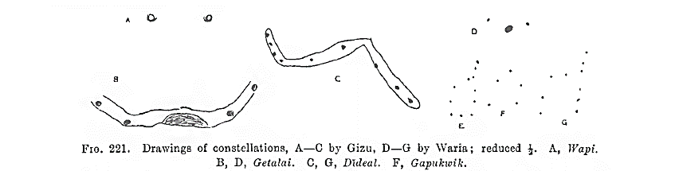
Figure 4.10.
Sketch by Gizu and Waria of Getalai and Other Associated Constellations (Haddon, 1912, p.223)

Goeyga Thithuuyi/ Geoiga bo
Both of these names are alternates for the morning star. Goeyga Thithuuyi is the Mabuyag term and Geoiga bo is the term in Moa. Its variation in brightness is a significant indicator to the people of different tidal currents, the strength of the wind, and where to hunt (Hamacher, 2017).

Kang
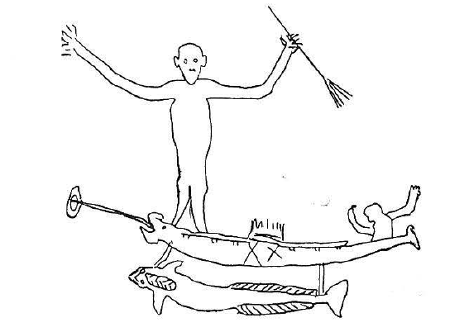
Kang is the brother of Tagai who remains with Tagai when his shipmates betray him and eat his rations. Kang is considered to be Antares. Bosun described thunder as the sound of Kang throwing a tantrum and stomping his foot (Hamacher, 2018). Kang is described by Eseli (1998) as setting in November.
Figure 4.11.
Drawing of Kang and Thoegay by Gizu of Mabuyag (Eseli et al., 1998, p. 16)

Kek
Kek is the Yam star. Comments in Eseli’s Notebook indicate possible identities of Kek as being interpreted differently by different researchers. Possible identities have included Venus, Sirius, and Achernar. Most researchers agree that Kek is Achernar, but the firmest evidence was given by Eseli (1998) who specifically describes the rise of Kek over Mt Augustus. Measurements of the direction from Mabuyag to Mt. Augustus give the same sky position as Achernar.
Other descriptions about Kek include it rising just after the Dogai rise (Eseli, 1998). Its rising and setting are indicated by Eseli (1998) and mark the start of the Wooewra (the southeast tradewind), it also indicates the migration of the rainbow bird. There is some confusion about whether Kek is a single star or a group of multiple stars. Kek is a star name that is in common between both the Eastern and Western Islands.

Keken tonar
Referenced by Haddon (1912) as Keaken lonar, these are two stars which rise as an indication of the imminent rising of Kek. Haddon (1912) speculated that they were stars of the European constellation of Phoenix. It is also referred to as Keken Thonar which translates to Kek’s season.

Kek’s Canoe
The only reference for Kek’s Canoe is by Eseli (1998) but nowhere else. There has been much discussion of if could have been a translation error or a misunderstanding of what stars were being described, possibly it is a reference to Tagai’s canoe. It is described by Eseli (1998) as setting in May.

Kwoior
According to Haddon and Ray (1904) from Mabuyag, Kwoior is seen to rise over Buru. The end of the rainy season in the Torres Strait is also indicated by its rising.

Maita kupai/ Maythakupay
According to the translation of Eseli’s (1998) notebook, Maita kupai is a group of stars. The word literally translates to navel. Maythakupay is found in the southern sky.

Pagas
Pagas is described by Haddon (1912) immediately following mention of Dede. It is associated with the appearance of Kek around May. In the same entry, Giil, Utimal, and Wapil are also mentioned, followed by Baydham and Gitalai with the Biru Biru bird.

Panuana Graz
Haddon (1912) mentions Panuana Graz is confirmed to be the European star Fomalhaut.

Singeyal
Eseli (1998) describes Singeyal as being the European asterism of Orion’s belt. This is presumed to be the Western Island equivalent of Seg in the Eastern Islands.

Thoegay
Thoegay is the most well-known constellation in the Torres Strait. Common in both the astronomic traditions of the Eastern and the Western Islands. Figure 4.12 shows a depiction of Thoegay from Mariget of Mabuyag. Thoegay is the cultural hero who threw the other zugubals into the sky in rage after he was betrayed, and his rations were consumed.
Eseli (1998) describes the motions of Thoegay often in conjunction with Kang. Thoegay is understood to be a large constellation containing parts of the European constellations of Corvus, Crux, Centaurus, and Lupus. His spear touching the ground causes the rain that starts the wet season and also indicates the end of the wet season and the approaching time of harvest as shown in Figure 4.13 (Bosun, 2007a).
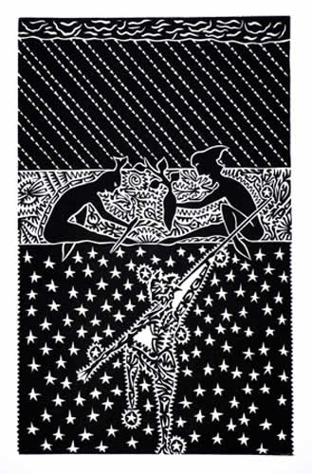
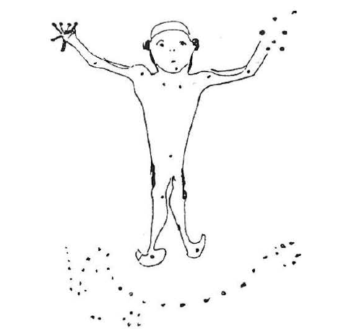
Figure 4.12.
Drawing of Thoegay by Mariget of Mabuyag (Eseli et al., 1998, p. 18)
Figure 4.13.
Thoegay’s Spear Touching the Ground Starts the Rain (Bosun, 2007a)
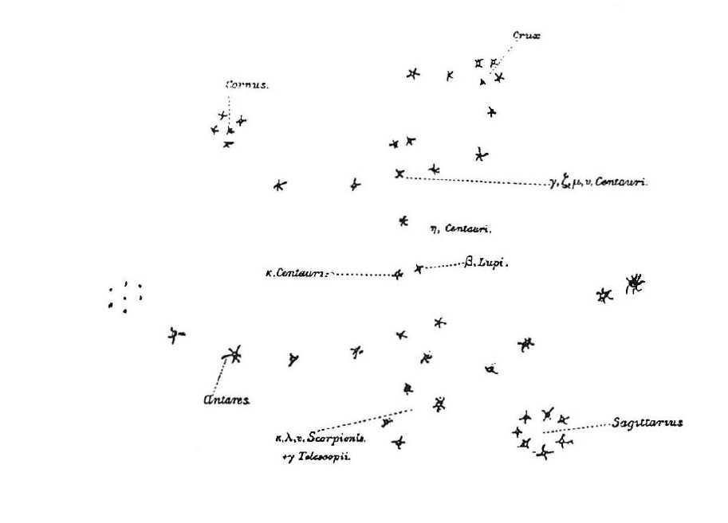
Figure 4.14.
Sketch of Thoegay as Drawn by Waria (Eseli et al., 1998, p. 66)

Thaykuywal
Thaykuywal is the name of a star mentioned by Eseli (1998). It is found in the southern sky and is also the name of a specific type of yam.

Ukasar kunar
Ukasar kunar is a word used by Eseli (1998) which is translated as the two ashes. This has been interpreted to mean a reference to two groups of ash or two nebulae. Eseli (1998) also indicates that it is found in the southern sky.

Usal
Eseli (1998) indicates that Usal rises in October. It is generally accepted to be the European star group called the Pleiades. It is described by Lawrie (1970) as having six stars.

Utimal
Eseli (1998) describes this constellation as a bunch of bananas. It is a group of six zugubals who were thrown into the sky by Tagai. Bosun describes that it rises at the beginning of the year, not at the same time as Tagai (Hamacher 2017). It is also seen in May with Kek and other stars (Haddon, 1912).

Wapial
According to Eseli (1998) it appears in October with Gil and Usal.

Wapi
Unique to Mabuyag, Wapi are the two pilot fish in the front of Baydham. Eseli (1998) indicates that Wapi is made of the European identified stars Iota and Kappa Ursae Majoris.

Woey/ Wooeyi Goeyga Thithuuyi
Eseli (1998) indicates that this is the evening star and is a zugubal. Haddon (1912) interpreted this to be Venus.

Zugo hi th
There isn’t much information about this constellation, other than it was mentioned by Bosun in his interview as being the constellation of his father (Hamacher 2017).

The Astronomy of the Eastern Islands
Many of the resources for the knowledge we have of the astronomy in the Eastern Islands is from the records of Haddon and Ray (1935) from their visits to the island of Mer. Additional resources are found in the published works of Sharp (1993). Contemporary information is from interviews with Torres Strait elders conducted by Hamacher (2015) with Alo Tapim, Ron Day, and John Barsa and from the indigenous artist Tommy Pau (2015a, 2015b, 2015c, 2015d, 2015e, 2015f, 2015g, 2015h).

Adud Wer
Adud Wer is the name of a star referred to as the evil star (Haddon, 1935). Sharp (1993) indicates that it is visible in the southwest at the start of the rains. Haddon (1935) also explains that Adud Wer is one of two stars that follows Naurwer.

The Anchor
The Anchor is a constellation connected to the boat of Tagai. It is included in a sketch of Tagai contained in the notes of Haddon (n.d.-b) as shown in Figure 4.17. Haddon (1912) indicated that the anchor is the European constellation Sagittarius and could be seen in the night sky during Haddon’s visit.

Awaitui
Awaitui is a pelican that Haddon’s notes indicate has a possible connection to Cassiopeia. Haddon’s notes are the only reference to Awaitui in connection with the Eastern Islands (Haddon, n.d.-e).

Beizam
Beizam is the shark and it’s comparable to the Western Islands’ constellation of Baydham with a few subtle differences. Alo Tapim described the observations of the movements of Beizam with the prediction of coming rains (Hamacher, 2015). Ron Day indicated that when Beizam dips its head in the sea and its gills are below the horizon the water rushes through its gills and causes the seasonal rains (D. Hamacher, personal communication, December 1, 2023). Day further describes that when lightning is seen through the gills, it is an indication of the changing winds to the winds from the northwest. Lawrie (1970) shares a story of four girls and how they were caught by Beizam, and all became a constellation.
Haddon’s (1912) observations from Mer indicate that the stars of Beizam are made up of Ursa Major, Arcturus and Gemma Corona Borealis. The two stars iota and kappa ursa majoris are the eyes of the shark. Haddon (1908) described a garden stone formation that was a representation of the constellation. This construction included five large stones behind the head of the shark called kemdogeneuror, with an additional five stones behind the dorsal fin called waigizsaineur. Pau (2015a) describes the significance of Beizam. The glow of the constellation is thought to provide an abundance of coconuts, yams, and bananas. Beizam also had shrines on the island where the people would ask for plenty of food and protection.

Bokani
Bokani is a scorpion. It is located near Beizam, and using Beizam and Bokani together can help navigators go from Mer to Papua New Guinea. Barsa indicated that watching the rising of Bokani above Erub means good weather and rain can be predicted by when the scorpion is seen at night (D. Hamacher, personal communication, December 1, 2023).

Buu
Figure 4.15 shows a diagram of Buu with the Dogai from Haddon’s notes and comments from Bruce on Mer, but this is the only known connection of Buu with the Eastern Islands. Because of the connection of this sketch of Buu associated with the Dogai who are identified only with the Western Islands, this reference to Buu in the Eastern Islands will be disregarded.
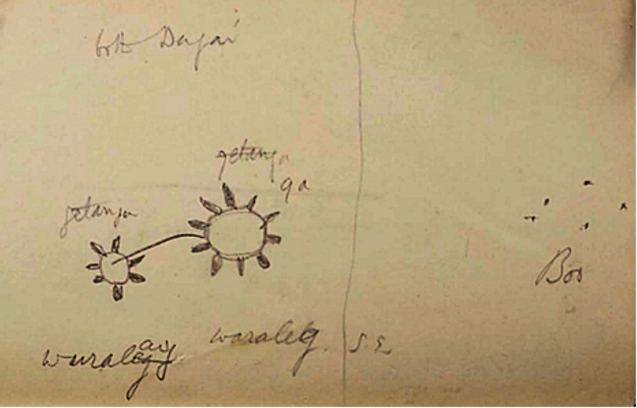
Figure 4.15.
Diagram of Dogai Wuralag with Buu (Haddon, n.d.-e, p. 535)

Bune
Bruce on Mer indicates that Bune is the morning star (Haddon, n.d.-a).

Dede
Dede is a star mentioned in a vague comment from Haddon (n.d.-d), but there are no other references to Dede in the Eastern Islands.

Dhuga
Often confused with the Dogai of the Western Islands, Dhuga is the name for the star at the tail of the shark Beizam. This star is said to swing the shark around causing its change in position and rotation around the north celestial pole and therefore causes extreme high tides (Haddon, 1908; Pau, 2015a). The Dhuga also tells people of the availability of octopus, and various other fish life. Barsa also indicated that the Dogai is a red star somehow related to the octopus (D. Hamacher, personal communication, December 1, 2023). It is also regarded as a harvesting star which indicated the time for the people to harvest food resources such as cassava, bananas, and yams.

The Duck
Ron Day references the Duck constellation indicating that it is in close proximity to Tagai, Seg, and Usiam but this is the only information about it (D. Hamacher, personal communication, December 1, 2023).

Gep
Gep is a star that was identified by artist Tommy Pau (2015d). Gep is a suckerfish, used by islanders to catch turtles. Pau (2015d) identifies Gep as being the European constellation Sagittarius.

Gergerneseur
Gergerneseur is the morning star (Haddon, 1912; Sharp 1993). It is visible in the night sky at the end of the year in the early hours of the morning.

Gil
Gil is a star mentioned in a vague comment from Haddon (n.d.-d), but there are no other references to Gil in the Eastern Islands.

Gitilai/Getalai
Gitilai is a star mentioned in a vague comment from Haddon (n.d-d). The only other reference to Gitilai is a diagram included in Haddon’s notes shown as Figure 4.16 with other identified surrounding constellations including Seg from February 1889. There are no other references to Gitilai in the Eastern Islands.
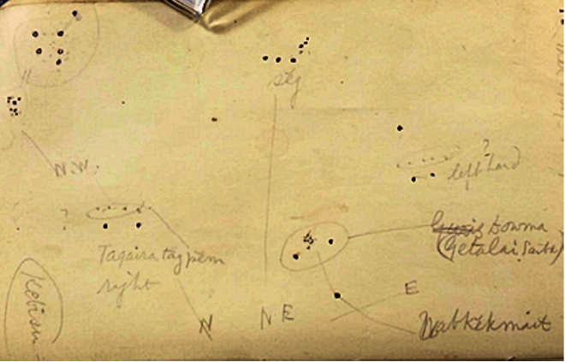
Figure 4.16
Sketch of Getalai in Reference to Seg and Other Stars with a Note that is Dated February 4, 1889, at Sunset (Haddon, n.d.-e, p. 488)

Ilwel
Ilwel is the evening star (Haddon, 1912). Haddon (1935) reported that there was a stone on the island of Erub where men and boys would throw stones at it to make the evening star shine brighter. In the Eastern Islands, Ilwel is the lover of the Moon (Meb) who come together for a time and then spend most of their time separated. Haddon (1908) describes the shine of Ilwel as comparable to the Moon and clarified that the Moon and Ilwel cohabitate once a month.

Kareg
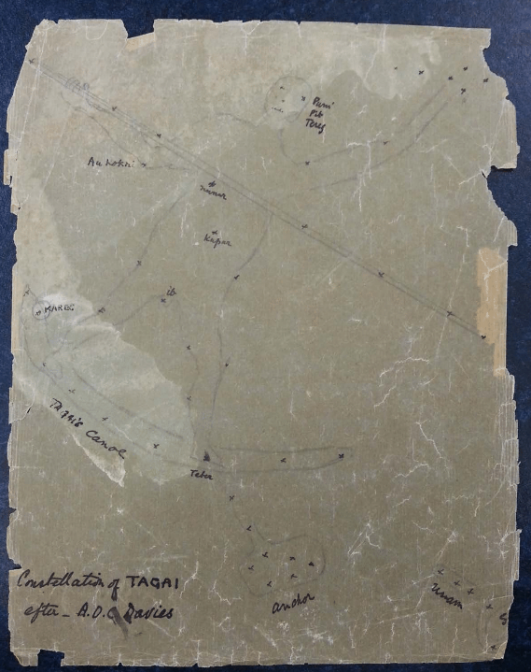
Kareg is the Eastern Island equivalent to Kang from the story of Tagai. In the story from Dauar, Kareg is Tagai’s friend. It is shown in Figure 4.17 and is identified with the European star Antares. In the Eastern Islands it is said that as it rises, Kareg brings a little red bug Mormor that attacks the yams. At the same time the turtles are infested with maggots, called kuper, but as the star continues to rise the maggots and bugs go away. Lawrie (1970) included an image in her book of two rocks named Tagai and Kareg located on Las beach on the island of Mer, as pictured one rock is very large and long while the second rock is red and more than half the size of the other.
Figure 4.17.
Eastern Island Tagai Sketch by Davies (Haddon, n.d-b, p. 16)

Kapil
Kapil is a star that the Islanders use to navigate at night from Mer to Erub (Haddon, 1935).

Kek/kik
Kek is the same in the Eastern and Western Islands. It is identified with Achernar. Haddon (1935) indicates that Kek rises opposite to Er and sets opposite to Terker around the same time as the constellation Usiam. There are also some references in Haddon’s notes (Haddon, n.d.-a) of a star named Kikwer. Upon closer investigation, the description of Kikwer indicated that this star was associated with Iwar sab (Haddon, n.d.-a). In the description of Kek in Haddon’s (1935) publication on the expedition to the Torres Strait he describes Kek or kik as being the foundation for the Iwar sab. In addition, further exploration of the Miriam translation of wer determined that the word means ‘star’. This evidence combines to indicate that kikwer is a reference to kek.

Keike
Keike is a star mentioned in the notes from Bruce on Mer (Haddon, n.d.-a). A southern star, when Keike sets, the people can eat the new food.

Kwoior
Kwoiorium rangadal is a star mentioned in a vague comment from Haddon (n.d.-d), but there are no other references to Kwoior in the Eastern Islands.

Lid
Lid was referenced by Davies in Haddon’s notes as being a star cluster in the Milky Way (Haddon, n.d.-b). Tapim also referenced Lid in his interview with Hamacher (2015). Haddon’s notes from Bruce on Mer mention Lid and describe that it rises before the right hand of Tagai and is an indicator of the coming of Tagai and allows for the people to plan for the ceremonies that pertain to Tagai (Haddon, n.d.-a).

Maima
Any reference of Maima include it mentioned with Sia. Pasi described to Haddon (1935) that Maima is similar to the southern cross but is not as bright. Maima also helps predict the rising of Tagai (Pau, 2015c). Haddon claimed Maima is seen just before the left hand of Tagai rises (Haddon, 1935).

Naurwer/Mabersor
This constellation was known to Haddon (1912) as the brothers. Haddon (1912) identifies the two main stars as Altair and Vega. Vega’s name is the older brother Narbet, who is holding two sticks. Altair is the younger brother, Keimer, who is also holding two sticks.
Naurwer is the name of the stars as they descend in the sky, while Mabersor (the name for the trumpet shell) is the name of the stars as they ascend in the sky. Haddon (1935) also referred to them as the sisters when relating the constellation identity in terms of what the tribes who owned the constellation call it. As it passes through the meridian and switches from ascension to declension the stars change names and ownership from the Ulag to the Sebeg. When Naurwer is high in the sky the Kuki (rainy season) is finished and then there is Sager (Haddon, 1935). Naurwer is thought to cause spring or zauber. Neurwer gerser was the morning star (Haddon, n.d.-d).

Seg
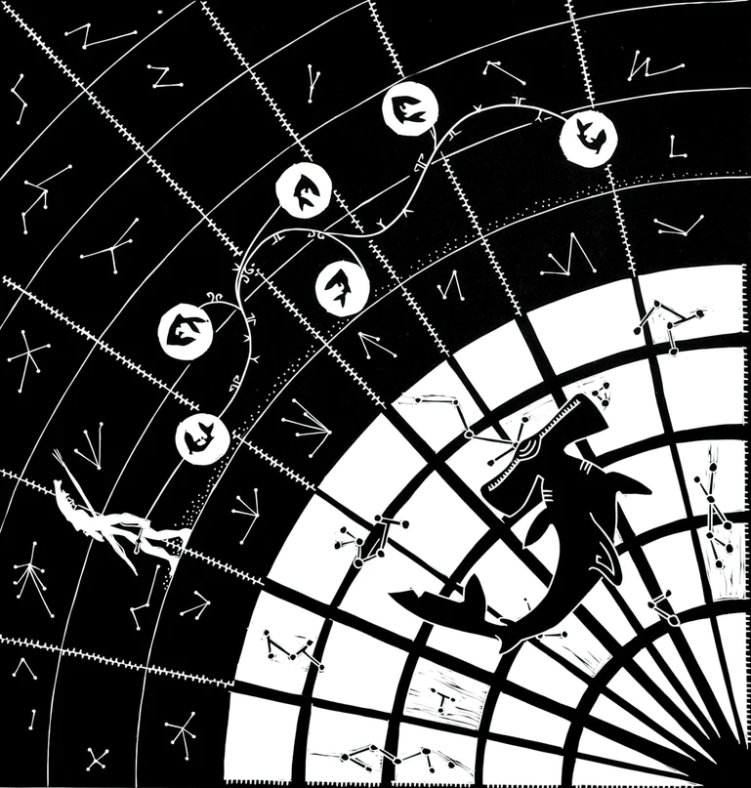
Seg is specific to the Eastern islands. Sharp (1993) indicated that it appears in the northeast at sunset, and that it is near Usiam. The stars of Usiam plus the stars of Seg equal the 12 bound zugubals (Pau, 2015b). Haddon (1912) suggests that the stars of Seg are the belt of the European constellation Orion. When Seg rises it is a sign to the people that it is almost time to clear the land from the previous crops. Haddon also suggests that Seg is Aldebaran (Haddon, n.d.-c). An interesting addition to understanding the identity of Seg is from Pau (2015b) who explains that the word Seg means anything hung in a line as included in the art of Figure 4.18.
Figure 4.18.
Seg, Beizam, and the Zugubals (Pau, 2015b)

Sia
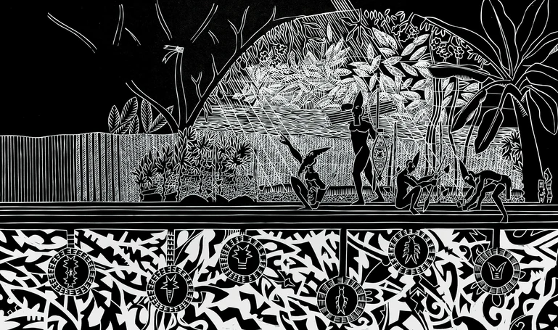
Haddon (1935) describes Sia as a nebula that follows the rising of Usiam and Seg. As seen in Figure 4.19, Artist Tommy Pau (2015c) identifies Sia as the Carina nebula and indicates that its rise over the horizon, along with Maima, signal to the tribal elders that the time to celebrate Tagai is coming.
Figure 4.19.
Sia (Pau, 2015c)

Tagai
Tagai is the most infamous cultural hero in the Torres Strait. In the Eastern Islands there is a song about him with references to the position of the Dogai and Kareg. Tapim describes a time during Naygay when the island is the hottest Tagai would appear to hug the hill in the distance (Hamacher, 2015). When Tagai and Kareg dive into the sea they cause the first rains of the monsoon season, Kuki (Lawrie, 1970). Tagai is a very large constellation encompassing Centaurus, Lupus, Scorpio, Corvus, and Crux. Figure 4.17 is a depiction of Tagai standing in his canoe with his friend Kareg, with the suckerfish, and anchor adjacent to the constellation. As shown in Figure 4.20, Tagai’s left hand is considered the southern cross with the two pointer stars of alpha and beta Centauri being two of Tagai’s crew: Or and Kok (Haddon, 1935).
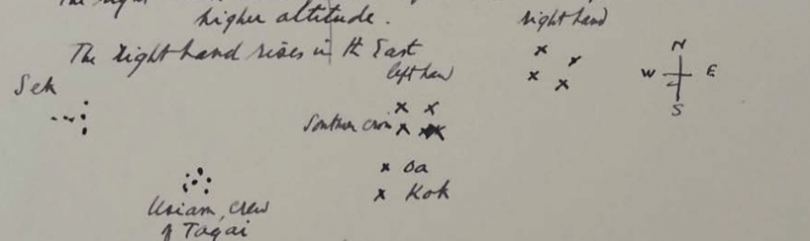
The position of Tagai in the sky tells the people when the turtles will arrive. When Tagai’s hands descend in the sky it tells the people it is time to plant bananas and yams (Haddon, 1935). John Barsa indicates that Tagai is used as a compass where the navel and eyes of Tagai can navigate from Papua New Guinea to Mer (D. Hamacher, personal communication, December 1, 2023).
Figure 4.20.
Sketch of Positions of Tagai’s Right Hand (Haddon, n.d-a, p. 134)

Usiam
Usiam is the Eastern Island’s equivalent to Usal. It rises around the same time as Seg, but the people know to wait until Usiam is about nine degrees above the horizon to clear their gardens in preparation for the new planting (Haddon, 1912). Bruce, Haddon’s informant, indicated that this time was in August (Haddon, n.d.-c). Interestingly, the people watch for Usiam ascending to know that new food is coming, but by the time the constellation is descending the people watch the constellation and mock it knowing they have already had their new food (Haddon, n.d.-a). Usiam is also shown in respect to Tagai and other stars in Figure 4.17.

Waisu
Waisu is one of two stars in the Eastern Islands that follow Naurwer. Also called Mune, Waisu is an indicator for the production of yams when the ground becomes cracked, and the yams swell in size (Haddon, 1935). Waisu was also mentioned by Davies in Haddon’s notes (Haddon, n.d.-b).

Wal
Wal is a pair of stars that follow Kareg (Pau, 2015d). The two stars of Wal represent two of Tagai’s crew in a small canoe (Haddon, n.d.-a).

Further Evaluation
It is significant to note that not each of these stars or constellations mentioned by Torres Strait Islanders have the same number of references or the same amount of information known about them. A summary of the stars and constellations with a ranking of how many references there are to each is indicated in Table 4.1. Further evaluation will be needed to identify the Torres Strait star names with those identified in Western astronomy.
Torres Strait Star or Constellation References
Star/Constellation | Source | Island Source | No.*
Adud wer | Sharp (1993), Haddon (1935) | Mer | 2
Aerolite | Haddon (1935) | Saibai | 1
Anchor | Haddon (1912, n.d.-a) | Mabuyag, Mer | 2
Awaitui | Bosun (2007b), Bosun (2017), Haddon (n.d.-e) | Moa, Mabuyag, Mer | 3
backfish | Hamacher (2017) | Moa | 1
Baydham/beizam | Hamacher (2017), Eseli (1998), Hamacher (2015), Pau (2015a), Haddon (1912, 1935, 1905, n.d.-d), Day & Barsa (D. Hamacher, personal communication) | Moa, Mabuyag, Mer, Waiben, Badu | 11
Baretak | Haddon (n.d.-b) | - | 1
Star/Constellation | Source | Island Source | No.*
Bokani | Barsa (Hamacher, personal communication), Hamacher (2015) | Mer | 2
Bu/buu | Eseli (1998), Lawrie (1970), Haddon (1890, 1904, 1912, n.d.-a, n.d.-e) | Boigu, Mabuyag, Mer | 7
Bu shell | Hamacher (2017, 2018) | Moa | 2
Bune | Haddon (n.d.-a) | Mer | 1
Dakatir | Haddon (1912), Eseli (1998) | Mabuyag | 2
Dede | Haddon (1912, n.d.-d) | Mabuyag, Mer | 2
Dhogay/ Dogai | Eseli (1998), Lawrie (1970, 1972), Haddon (1890, 1904, 1908, 1912, n.d.-a, n.d.-d, n.d-e, n.d.-f) | Mabuyag, Badu, Mer, Muralag | 11
Dhuga | Nona (2008), Barsa (D. Hamacher, personal communcation), Eseli (1998), Haddon (1935, 1908, n.d-d), Pau (2015e) | Muralag, Mer | 7
Dideal | Eseli (1998), Haddon (1912, n.d.-d), Day (D. Hamacher, personal communication) | Mabuyag | 4
The duck | Day (D. Hamacher, personal communication) | Mer | 1
Dugal | Nona (2008) | Badu | 1
Giil | Eseli (1998), Haddon (1912, n.d-d) | Mabuyag, Mer | 2
Gapukwiiku | Hamacher (2017), Eseli (1998), Haddon (1904, 1912) | Moa, Badu, Mabuyag | 3
Gep | Pau (2015f) | Eastern Islands | 1
Gergerneseur | Haddon (1912), Sharp (1993), Day (D. Hamacher, personal communication) | Mer | 3
Gitalai | Eseli (1998), Lawrie (1970, 1972), Haddon (1912, 1935, n.d.-d, n.d.-e) | Mabuyag, Saibai | 7
Goeyga thithuuyi | Eseli (1998) | Mabuyag | 1
Geoiga bo | Hamacher (2017) | Moa | 1
Ilwel | Haddon (1908, 1912, 1935, n.d.-a, n.d.-c, n.d.-d), Pau (2015f), Tapim (Hamacher, personal communication) | Mer, Erub | 8

Star/Constellation | Source | Island Source | No.*
Kang/kareg | Eseli (1998), Haddon (1904, 1908, 1935, n.d.-a), Pau (2015d), Hamacher (2018) | Mabuyag, Moa, Mer | 7
Kapil | Haddon (1935, n.d.-a) | Mer | 2
Kek | Mackie (2015), Sharp (1993), Eseli (1998), Herle & Philp (2020), Haddon (1904, 1935, n.d.-a, n.d.-e, n.d.-h) | Mabuyag, Muralag, Mer, Saibai, Iama | 9
Keike | Haddon (n.d.-a) | Mer | 1
Keken Tonar | Haddon (1912) | Mabuyag | 1
Kek's canoe | Eseli (1998) | Mabuyag | 1
Kik wer | Haddon (n.d.-a, 1935) | Mer | 2
kwoior | Haddon (1904, 1912, n.d.-d) | Mer, Mabuyag | 3
Lid | Hamacher (2015), Haddon (n.d.-a, n.d.-b) | Mer | 3
Maima | Haddon (1935), Pau (2015c) | Mer | 2
Naurwer/Mabersor | Haddon (1912, 1935, n.d.-a, n.d.-d), Hamacher (2015), Pau (2015g) | Mer, Dauar, Waier | 6
Pagas | Haddon (1912, n.d.-d), Eseli (1998) | Mabuaig, Mer | 3
Panuana Graz | Haddon (1912) | Mabuyag | 1
Seg/sek | Pau (2015b), Sharp (1993), Lawrie (1970), Haddon (1908, 1912, 1935, n.d.-a, n.d.-c.) | Eastern Islands, Mer | 8
Sere sere | Pau (2014) | Eastern Islands | 1
Sia | Pau (2015c), Bosun (2015), Haddon (1935) | Mer, Moa, Dauar, Waier | 3
Singeyal | Eseli (1998) | Mabuyag | 1
Thoegay/Tagai | Lawrie (1970), Pau (2015b), Eseli (1998), Day (D. Hamacher, personal communication), Bosun (2007a), Hamacher (2015), Sharp (1993), Mackie (2019), Barsa (D. Hamacher, personal communication), Haddon (1904, 1912, 1935, n.d.-a, n.d.-b) | Moa, Mabuyag, Mer, Badu | 14
Usal/Usiam | Eseli (1998), Lawrie (1970), Sharp (1993), Haddon (1904, 1908, 1912, 1935, n.d.-a, n.d.-c, n.d.-d) | Mabuyag, Mer, Muralag | 10

Star/Constellation | Source | Island Source | No.*
Utimal | Eseli (1998), Lawrie (1970), Hamacher (2017), Haddon (1904, 1935, 1912, n.d.-e) | Mabuyag, Moa, Poruma | 7
Waisu | Haddon (1935, n.d.-b) | Mer | 2
Wal | Pau (2015h), Haddon (n.d.-a) | Mer, Eastern Islands | 2
Wapial | Eseli (1998), Haddon (1912, n.d.-d) | Mer, Western Islands, Mabuyag | 3
Wapi | Eseli (1998), Haddon (1912) | Mabuyag | 2
Wooeyi Goeyga Thithuuyi | Eseli (1998), Haddon (1912) | Mabuyag | 2
Zugo hi th | Hamacher (2017) | Moa | 1
Zugubals | Lawrie (1970), Eseli (1998) | Mer, Mabuyag | 2
*No. refers to the number of different references
Color Key: | Stars with 1 reference
 | Stars with 2 references
 | Stars with 3 references
 | Stars with 4+ references

Table 4.1.
List of stars and constellations with the number and source of references (Author’s table)

As described in Chapter 3, Methodology, the next step is to combine this ethnographic astronomic knowledge with additional quantitative information. This will allow the proper association of the correct astronomic objects and help further the understanding of Torres Strait Islander astronomy.

Eseli’s Notebook
Peter Eseli’s father was one of three indigenous informants of the Haddon expedition in 1898 (Eseli et al., 1998). Using his own words, Eseli (1998) followed his father’s example and created manuscripts documenting his knowledge of the astronomic traditions of Torres Strait Islander culture. These manuscripts were kept by Eseli’s family, and it was his daughter Mauare who allowed their translation to English by linguistic scholars. The original manuscripts were written in the native language of the Western Islands, Kala Lagaw Ya. Published 100 years after Haddon’s 1898 expedition, the translated English version of Peter Eseli’s Notebook is now available for research. Some of the translations were poetry-like and contained names of specific stars or star groups and their expected motion with associated dates. Eseli, a native of Mabuyag island, described patterns that are part of the astronomy of the Western Islands and are examined further here.

Western Islands Astronomy
As described in Chapter 4, the constellations and stars in the Torres Strait Western Islands include Awaitui, the Back Fish, Baydham, Bu, Bushell, Dakatir, Dede, Dhogay Metakurab and Dhogay Ii, Dedeal, Dhoeybawal, Dugal, Giil, Gapuk wiiku, Getalai, Goeyga Thithuuyi, Kang, Kek, Keken Thonar, Kek’s Canoe, Kwoior, Maythakupay, Pagas, Panuana Graz, Singeyal, Thoegay, Thaykuywal, Ukasar kunar, Usal, Utimal, Wapial, Wapi, Wooeyi Goeyga Thithuuyi, and Zugo hi th. Many of these are identified because they were mentioned by Eseli’s (1998) but, as shown in Table 4.1, some star groups have only minimal information and no identifications have been made.
The purpose of this chapter is to focus statistical evaluation on the constellations, star groups, and celestial objects where Eseli (1998) gave several specific statements about directions and gave details about expected dates and star positions and movement behavior. This level of detail is available for only five star groups, specifically the Dhogay, Kek, Usal, Thoegay and Kang, and Baydham. Eseli (1998) did include two statements about the rising and setting of Giil but (as shown in Table 1 of Chapter 4), Giil’s identity is undetermined with only three references to it. Therefore, Giil has been omitted from consideration.
The Dhogay were identified by Haddon (1890) as being associated with Altair and Vega, and as discussed in Chapter 4, Kek is Achernar (Eseli, 1998).
As described by Haddon, Thoegay is a very large constellation with parts belonging to Corvus, Lupi, Centaurus, Crux, Telescopium, Sagittarius, and Scorpius. For this reason, evaluating the position of Thoegay is complicated to pinpoint for statistical analysis. When evaluating the astronomic traditions of the Torres Strait Islanders in Chapter 4, there were many instances where the rising of Thoegay was determined by the position of his hands. Thoegay’s hands are identified as the constellation Crux, also known as the Southern Cross. For this reason, Crux was used to evaluate the accuracy of Eseli’s (1998) statements about Thoegay. Kang has been identified as the star Antares in Scorpius, thus, analysis of Eseli’s (1998) statements about Kang are addressed by evaluating the motions of Antares.
Haddon (1890) identifies constellation Baydham as Ursa Major. Arcturus has been identified as the tail of the shark and the Dhuga star as being responsible for the rotation of the shark. But as many of the statements indicate the position of the snout of Baydham this constellation has been evaluated with the position of the star Arcturus but also with the position of the star nearest the snout of the shark, Dubhe.
Usal was described by Haddon (1890) as being the Pleiades, but some have argued for a possible association with the Hyades instead. For this reason, Eseli’s (1998) statements are evaluated by comparing the statements to determine their accuracy using the positions of both the Pleiades (the seven sisters) and the Hyades (the face of Taurus the bull).

Horizon Event Comparisons
Often the statements made by Eseli (1998) include mentions of stars falling, moments of setting, or rising. Because of this, it was important to compare Eseli’s statements with horizon events such as the heliacal rise and set and the dates of the acronychal rise and set, as obtained from Stellarium and shown in Table 5.1.
Additionally, after analyzing the evidence from the astronomy of the Torres Strait Eastern Islands (included in Chapter 4), it was observed that there were some specific instances when the people distinguished between the ascension of a star to its highest point in the sky (also known as its zenith) and the descension of the star back to the horizon. Mabersor and Neurwer are an example of a star with one name in ascension and another name in descension. This reference to the distinction of a star rising to the highest point and then descending from the highest point suggested a possible reference to the meridional rising or setting as shown in Figure 1.3. For this reason, the meridional rising and setting dates of each star are also sometimes included when there is a statement from Eseli (1998) that seems to refer to such an event.
The dates of the heliacal rise, the heliacal set, the acronychal rise, and the acronychal set for the stars of greatest concern with connection to Eseli’s statements, as obtained by the methods described in Chapter 3, are indicated in Table 5.1.

Star | Heliacal Set | Heliacal Rise | Acronychal Set | Acronychal Rise
Achernar | 12 April | 20 April | 8 November | 30 September
Altair | 25 December | 4 February | 18 July | 17 July
Antares | 14 November | 15 December | 3 June | 24 May
Arcturus | 6 October | 22 November | 25 April | 29 April
Crux | 26 September | 7 October | 13 April | 9 March
Dubhe | 26 July | 25 October | 13 February | 28 March
Hyades | 12 May | 13 June | 6 December | 25 November
Pleiades | 30 April | 5 June | 25 November | 21 November
Vega | 2 December | 26 January | 22 June | 8 July
Table 5.1.
Dates of Heliacal Rise/Set and Acronychal Rise/Set (Author’s table)

Determining the Truth of Eseli’s Statements
Figure 5.1 through Figure 5.16 with the exception of Figure 5.8 are star position graphs. These graphs illustrate how the position of a given star just before dawn or just after dusk changes in the night sky throughout the year. The orange line shows the altitude (or height in the sky) of the star at sunset, while the blue line shows the position of the star at sunrise. The initial point when the blue and orange lines start are the days when the star appears to rise according to the position parameters for a horizon event as described previously. The point at the start of the sunrise plot (graphed in blue) when the star is rising at sunrise is the heliacal rise (HR) as discussed in Chapter 1. The ending point of the sunrise plot is the acronychal set (AS). Conversely, the starting point on the sunset plot (graphed in orange) is the date of the acronychal rise (AR), and the ending point of the sunset plot is the date of heliacal set (HS).
By placing the date of Eseli’s (1998) statements in context of the position path provided by the graphs of star motion and comparing them with the dates of horizon events, his statements were determined to be either true as represented by a one or false as represented by a zero. The statement is considered true if it falls within a 5 % accuracy range for the given date, equivalent to being within two weeks of the known event date as defined by Stellarium (Chéreau, 2019).
If a statement has a possible association with multiple stars, and it is deemed to be true for at least one of the stars, the statement is also considered to be true. The numerical interpretation of the truth of Eseli’s (1998) statements will hopefully allow further quantitative statistical evaluation and analysis to provide insight into the purpose of these statements and their significance in Torres Strait Islander life and culture.

Dhogay.
In Eseli’s (1998) notebook there are seven statements about the expected motion of the Dhogay throughout the year. Because there are two Dhogay and two associated stars, each of Eseli’s statements was compared with the graphical representation of the observed position of Altair and Vega throughout the year at the times of sunset and sunrise. In some cases, both the Dhogay Metakurab and Dhogay Ii are mentioned together, in these instances the statements are compared to both star graphs of Altair and Vega, Figure 5.1 and Figure 5.2 respectively.
Figure 5.1.
Altair Sky Position Graph (Author’s graph from Chereau, 2019)
Figure 5.2.
Vega Sky Position Graph (Author’s graph from Chereau, 2019)

Eseli’s (1998) statements and the determinations of the truth values about the Dhogay stars are indicated in Table 5.2 with the average truth value shown in Table 5.3. One recurring issue with Eseli’s (1998) three statements for January 8th - January 13th is the references to the expected sightings of the Dhogay in the January sky. Figure 5.1 and Figure 5.2 clearly show that during the month of January neither Altair nor Vega are visible in the night sky. This recurring inaccuracy could be due to a translation error (from Kala Lagaw Ya to English) but for the statistical evaluation in this paper, we will include the existing information as it is currently presented in the translation of Eseli’s (1998) Notebook.
Eseli’s (1998) statement about the position of Methakurab and Ii on February 18th and February 19th is only 14 days after the heliacal rise of Altair on February 4th, and 23 days after the heliacal rise of Vega on January 26th. Even more interesting, however, is that these dates have proximity to the heliacal rise of both Vega and Altair, but the description offered by Eseli says that the stars wait for the Sun in the northwest. If the stars are in the west at the time of the Sun rising in the east this would describe the acronychal set which does not occur until June and July. This could be further evidence of errors in translation from Kala Lagaw Ya into English. Regardless, because the heliacal rise of Altair is within 14 days, this statement is considered true.
Another interesting element illustrated by Eseli’s (1998) statement dated October 26th and October 27th is the motion described suggests the change in motion across the sky. The date of the meridian crossing of Altair at sunset is October 9th which is 17 days earlier than the date mentioned by the statement. The dates of the meridional crossing of Vega are October 16th at sunrise and September 21st at sunset which are respectively 10 days and 35 days from the date proposed by Eseli (1998). Because the meridional crossing of Vega at sunrise is only 10 days previous, this is within the 14-day window and is considered true.
Date | Statement | Truth Value
Jan 6 | One of the Dhogay, the northwester, races ahead there over Buru (p.40) | 0
Jan 8 | Take a good look for the 2 Dhogay (p. 40) | 0
Jan. 10 &11 | The 2 Dhogay are seen (p. 40) | 0
Jan. 12 & 13 | The two Dhogay are seen, keep watch for Dhogay (p.42) | 0
Jan. 18 & 19 | The southwesterly that butts the backs of the Dhogay (p.42) | 0
Feb. 18 &19 | Methakurab and Ii are seen, they position themselves just above the northwest horizon to await the Sun (p. 44) | 1
Oct. 26 & 27 | The Dhogay embark again on their westward journey from the NE corner of the sky… (p. 56) | 1
Table 5.2.
Dhogay Statements of Star Motion (Author’s Table)

 | Number of Statements | Average Truth Value | Brightness | Angular Size (arcsec)
Dhogay | 7 | 0.29 | 0.375 | 122400
Table 5.3.
Dhogay Truth Values, Brightness, and Angular Size (Author’s Table)

Kek.
Kek is a significant star in the Western Island astronomic traditions. As such, this star has six statements as presented by Eseli (1998). A graph of Achernar’s sky position is included in Figure 5.3.
Figure 5.3.
Achernar (Kek) Sky Position (Author’s graph from Chereau, 2019)

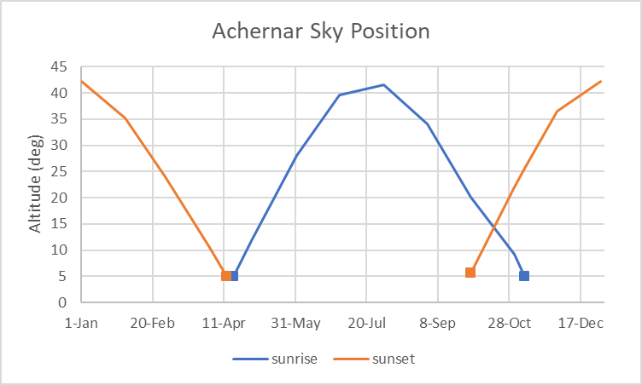

Eseli’s (1998) statements and their final determinations of the truth values about Kek are included in Table 5.4 with the average truth values shown in Table 5.5. It is considered here that the statement for March 26th and March 27th when ‘Kek falls’ describes a general trend of motion but not a specific moment or date of set, as such it is deemed true as that general trend of motion is seen and could be described as falling in the sky. One specific concern that these statements highlight is the confusion between Kek’s identity as a single star versus Kek as a constellation with features like legs or a canoe. For this statistical evaluation, the statements about Kek’s legs and Kek’s Canoe are omitted in the evaluation of accuracy as there is no context for how to determine what these statements describe. Similarly, Eseli (1998) mentions something called Kek’s calm. This reference to a calm associated with an astronomic object is also repeated in other statements for Thoegay, Kang, and Usal but is not well understood. Specifically, the connection between the star location and the ownership of the time of calm, this connection is
Date | Statement | Truth Value
Mar 26 & 27 | Kek falls. in the morning there are rainburst everywhere in the northeast… (p. 48) | 1
Apr 5 | darts up between Kek's leg (p. 48) | -
April 22-24 | Kek the yam star rises over Mt Augustus (p.50) | 1
May 3-5 | Kek's Canoe plunges toward edge of reef (p. 50) | -
May 6 | Kek's calm arrives (p.50) | -
investigated in more detail in a future section of this chapter.
Table 5.4.
Kek Sky Position Statements (Author’s Table)

Kek | Number of Statements | Average Truth Value | Brightness | Angular Size (arcsec)
 | 2 | 1 | 0.45 | 0.0001
Table 5.5.
Kek Average Truth Value, Brightness, and Angular Size (Author’s Table)

Thoegay and Kang.
Thoegay is a great cultural hero in the Torres Strait, he is well known for his interactions with the betraying zugubals and his faithful friend/brother Kang. The motion of Antares that represents Kang and the motion of Thoegay’s hand as portrayed as Crux are included in Figure 5.4 and Figure 5.5.

Figure 5.4.
Antares (Kang) Sky Position (Author’s graph from Chereau, 2019)
Figure 5.5.
Crux (Thoegay) Sky Position (Author’s graph from Chereau, 2019)

Eseli’s (1998) five statements about Thoegay or Kang and the final determinations of the truth values about Thoegay and Kang are included in Table 5.6 with the average truth values shown in Table 5.7. As mentioned previously, Eseli’s (1998) mention of the dead calm associated with celestial objects is not understood in relation to the star position, for this reason, those statements have been omitted from this statistical analysis. The most interesting of the statements considered is the connection between Eseli’s (1998) statement dated Nov. 17th and Nov. 18th and the correlation between the dates of the heliacal set of Crux on Sep. 26th and Antares on Nov. 16th. The heliacal set of Crux is 52 days before the date provided in Eseli’s (1998) statement, but the heliacal set of Antares is only one day before the date provided here. For this reason, this statement is considered true.
Date | Statement | Truth Value
Nov. 14 | Kang's dead calm arrives (p.56) and the fish guts heat up | -
Nov. 17- 18 | Both Thoegay and Kang plunge into the sea (p. 58) | 1
Dec. 2 | Thoegay's dead calm arrives (p. 58) | -
Dec. 3 | Thoegay… begin their journey north (p. 58) | 0
Dec. 3 | Kang begins journey north (p. 58) | 0
Table 5.6.
Thoegay and Kang Statements (Author’s Table)

Thoegay and Kang | Number of Statements | Average Truth Value | Brightness | Angular Size (arcsec)
 | 3 | 0.33 | 1.675 | 151200
Table 5.7.
Thoegay and Kang’s Average Truth Value, Brightness, and Angular Size (Author’s Table)

Journey North.
To determine the meaning of the phraseology of “begin their journey north” both the star motions of Thoegay and Kang were evaluated on the date of Eseli’s (1998) statement and are marked with the grey vertical line in Figure 5.6 and Figure 5.7. The December 3rd statement falls on the path of Kang when Kang is unseen in the night sky. The December 3rd statement falls on the path of Thoegay during the ascension of Thoegay into the sky. As such it was determined to not have any immediate correlations between each other. Thoegay and Kang are southern constellations and the terminology to ‘journey north’ seemed to imply a possible shift in the directionality of the rising or setting of the star such as seen with a meridional crossing, but the closest date of meridional crossing is of Crux at sunrise on January 11th over a month after the December 3rd statement, determining these statements to be false.
Figure 5.6.
Thoegay “Journey North” (Author’s graph from Chereau, 2019)
Figure 5.7.
Kang “Journey North” (Author’s graph from Chereau, 2019)

Baydham.
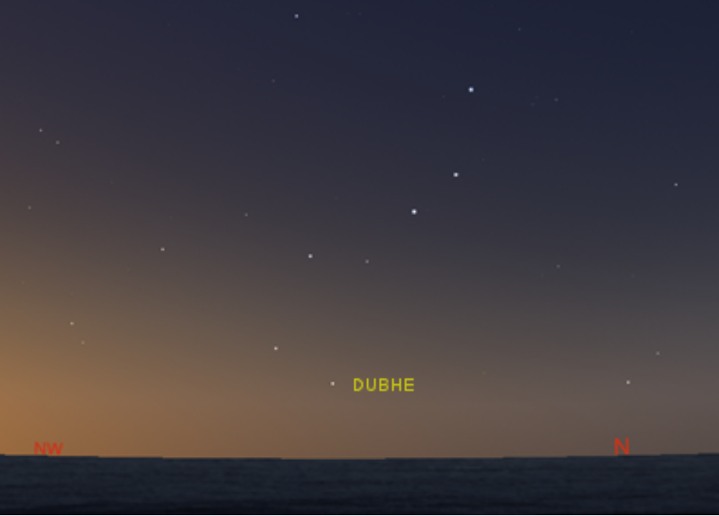
Baydham or Baidum (the shark) is also a well-known constellation in the Torres Strait with similar star groupings found in both the astronomy of the Western and Eastern Islands. Eseli (1998) includes five statements about the motion of Baydham in the northern night sky, their truth value determinations are given in Table 5.8 with the average truth values in Table 5.9. Several of Eseli’s statements about the shark have references to the position of snout over the horizon this is demonstrated in Figure 5.8.
Figure 5.8.
Image of Baydham with Snout Pointed Toward the Horizon. (Author’s image from Chereau, 2019)

Figure 5.9 and Figure 5.10 are the star position graphs of Arcturus and Dubhe, respectively. These show that Eseli’s statements (which all occur June and July) about the position of Baydham near the horizon occur at sunset and are a better match for the motions of Dubhe. The motion of Arcturus during those times is far from the horizon but is nearing the highest altitude of the star in the sky. Additional evidence correlating Dubhe as a better match for the described motion of Baydham is shown in the horizon event dates for Dubhe. Dubhe’s date of heliacal set is July 26th which corresponds with the date of Eseli’s (1998) statement on July 24th and July 26th.
Figure 5.9.
Arcturus Sky Position (Author’s graph from Chereau, 2019)

Date | Statement | Truth value
June 7&8 | The shark appears just above the horizon (p. 50) | 1
June 15 | The shark's dorsal fin dries out the reef, the shark's snout touches the northeastern horizon (p. 50) | 1
June 21- 23 | The shark's snout now stands upright (p. 52) | 1
July 22&23 | The shark plunges down and splashes up strong wind and rain | 1
July 24 -26 | The shark's snout rests on the horizon, and it vomits out tiny fish (p. 52) | 1
Table 5.8.
Baydham (the Shark) Statements (Author’s Table)

Baydham | Number of Statements | Average Truth value | Brightness | Angular Size (arcsec)
 | 5 | 1 | 2 | 90,000

Table 5.9.
Baydham Average Truth Value, Brightness, and Angular Size (Author’s Table)
Figure 5.10.
Dubhe Sky Position (Author’s graph from Chereau, 2019)

Usal.
Eseli’s (1998) statements and the final determinations of the truth values about Usal are included in Table 5.10 with the average truth value given in Table 5.11. The wording in the statement for May 21st and May 22nd indicates the stars are setting. Comparing this with the heliacal set of Hyades is May 13th, eight days before May 21st determines this statement to be true, the date of the heliacal set of Pleiades is April 30th is 21 days before the May 21st statement date. The statement on April 18th indicates a nearness to the horizon which can be seen in the graphs of both Pleiades and Hyades sky position in Figure 5.11 and Figure 5.12, respectively.
Date | Statement | Truth Value
Apr 18 | The seven sisters shine like fingernails upon the water (p. 48) | 1
May 21& 22 | Usal, the pleiades or seven sisters sets (p. 50) | 1
July 18& 19 | The seven sisters climb over the hill (p. 52) | 1
July 24-26 | The seven sisters climb over the hill… and there is calm | 1

Table 5.10.
Usal Statements (Author’s Table)

Usal | Number of Statements | Average Truth Value | Brightness | Angular Size (arcsec)
 | 4 | 1 | 1 | 6,600
Table 5.11.
Usal Average Truth value, Brightness, Angular size (Author’s Table)
Figure 5.11.
Pleiades Sky Position (Author’s graph from Chereau, 2019)
Figure 5.12.
Hyades Sky Position (Author’s graph from Chereau, 2019)

Times of Calm.
With Kang, Thoegay, and Kek there are statements from Eseli (1998) that relate times in the season called calms that are said to be associated with these celestial objects. Before moving on with any additional analysis of the truth values it seemed important to try to clarify the connection between these stars and their position as observed in the night sky and the statement of when the time of calm was suggested. This was done graphically, with the date associated with the time of calm indicated with a grey line in Figure 5.13 through Figure 5.17. For Usal, the mention of calm is different than from Kang, Thoegay, and Kek. In Eseli’s statements, he mentions the setting of Usal on July 18th and then mentions again the setting of Usal on July 24th only this time he adds that there begins a time of calm. For this reason, a graph depicting the time of this calm is added here to contribute to the understanding of the use of the term ‘calm’.

Figure 5.13.
Kang’s Calm (Author’s graph from Chereau, 2019)
Figure 5.14.
Kek’s Calm (Author’s graph from Chereau, 2019)

Figure 5.15.
Usal’s Calm - Hyades Data (Author’s graph from Chereau, 2019)
Figure 5.16.
Usal’s Calm- Pleiades Data (Author’s graph from Chereau, 2019)
While there does not appear to be a consistent connection between the star’s position and the association of its name with a seasonal time of calm, there is a notable similarity in that each claim of a time of calm is near a time as the star is approaching or coming away from a day of heliacal rise. In the statement of Kang’s calm on November 14th is only two days away from the date associated with the heliacal set of Antares on November 16th but this date also is only 31 days from the date of heliacal rise. In Figure 5.14 the statement of Kek’s calm is dated May 6th and is positioned within 18 days following the heliacal rise of Achernar on April 18th. When looking at the position of Pleiades in Figure 5.15, the time of Usal’s calm occurs within 49 days of the heliacal rise of Pleiades. When considering Usal as Hyades as in Figure 5.16, the time of Usal’s calm is 41 days from the heliacal rise. As shown in Figure 5.17, the statement of Thoegay’s dead calm, dated December 2nd, also corresponds with a time after the heliacal rise of Crux, although it occurs 60 days later which is significantly later than the amount of time between the other stars heliacal rise and associated times of calm.

Analysis.
Figure 5.17.
Thoegay’s Dead Calm (Author’s graph from Chereau, 2019)
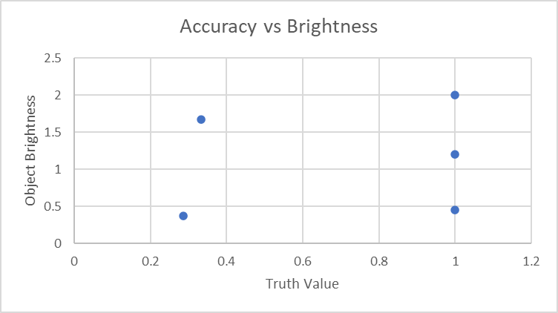
Once the accuracy of Eseli’s (1998) statements was determined with a simple truth value, each star group’s average truth value was calculated from the corresponding statements from Eseli (1998) in Table 5.3, Table 5.5, Table 5.7, Table 5.9, and Table 5.11. Upon determining the average truth value, the next step was to determine what reasons could explain the differences in accuracy from one star group to another. Initially suspected reasons for the differences in the average truth value were possible differences in the average star brightness or angular size of the star group. These possible variables were then plotted against the calculated average truth value to determine any possible correlation as shown in Figure 5.18 and Figure 5.19.
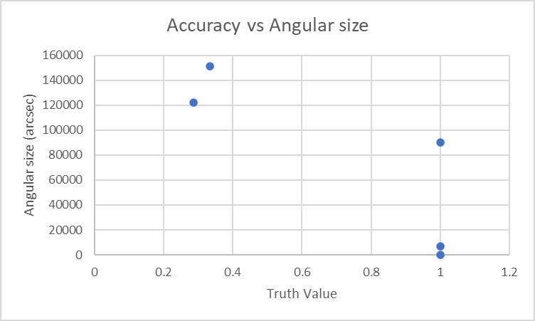
Figure 5.18.
Accuracy vs. Brightness (Author’s graph)
Figure 5.19.
Accuracy vs. Angular Size (Author’s graph)

Figure 5.18 shows that the brightness of the star group was not correlated with the accuracy of Eseli’s (1998) statements. However, Figure 5.19 shows an increase in truth values for the star groups with a smaller angular size. Meaning that the accuracy of Eseli’s (1998) statements was independent of the brightness of the star grouping and there was a possible correlation between the truth and the angular size of the star grouping. Further investigation is required to understand the variation in truth values for different star constellations.
As shown in Figure 6.4, mean rainfall data from nearby Horn Island supports separating the year into the rainy season, called the Kuki, and the dry season, called the Sager. The Kuki starts in December and goes on until April, while the rest of the year from May to November is the Sager.
Crop success and harvesting and planting times are closely tied to the seasonal rain patterns to maximize the success of food production. The changing times of seasons in the Torres Strait were considered as another possible variable. First, the truth values were graphed in calendar order to see the distribution of true vs false statements throughout the year in Figure 5.20. These were then overlaid with the times of seasonal changes experienced in the Torres Strait as shown in Figure 5.21. This yielded a potential correlation between truth statements from Eseli (1998) and specific seasonal changes in the Torres Strait. The number of true statements in the time of Sager vs during the time of Kuki is illustrated in Figure 5.22
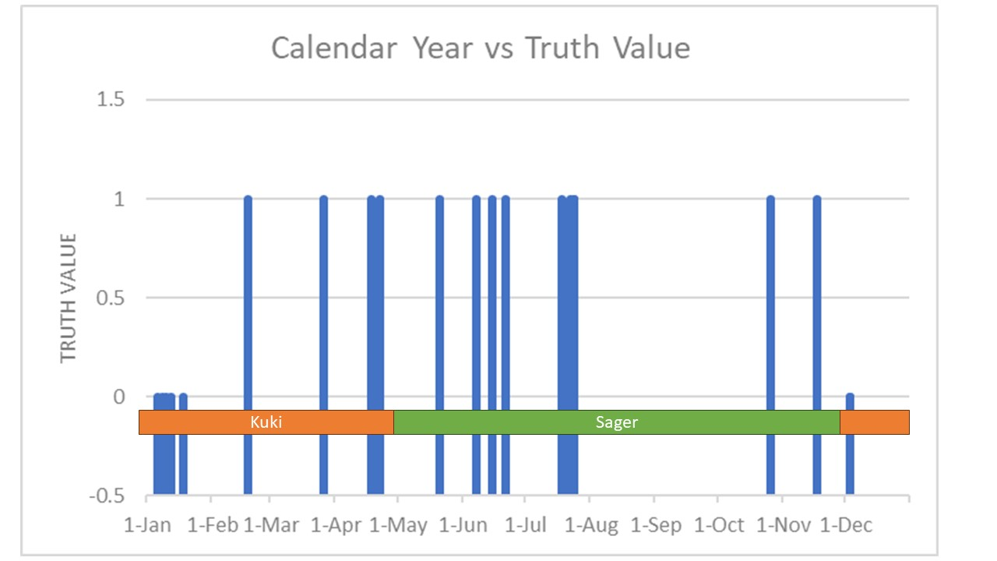
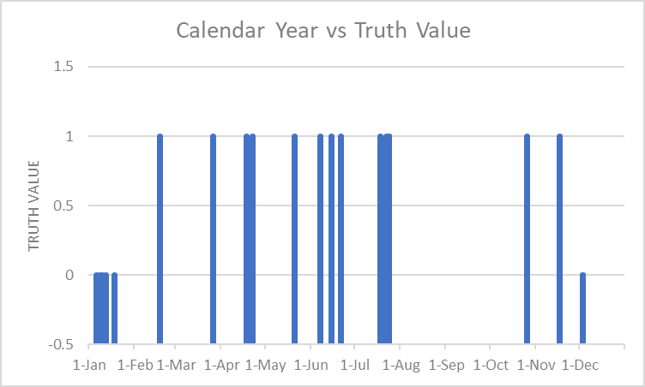
.
Figure 5.21.
Calendar Year vs Truth Value with Season Overlay (Author’s graph)

Note: Statements considered True are one, and statements considered False are zero.
Figure 5.20.
Calendar Year vs. Truth Value (Author’s graph)

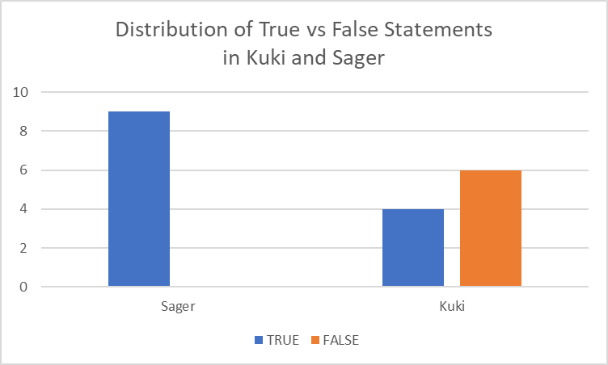
Determining the Truth of Eseli’s Statements in Intervals
Figure 5.22.
Distribution of True vs False Statements in Kuki vs Sager (Author’s graph)
A second evaluation was then performed on Eseli’s statements. This time instead of a simple binary ranking of true or false, after Eseli’s (1998) statements about specific star motion were compared with the horizon event dates throughout the year, these were then ranked with levels of accuracy. These intervals were with increments established if a statement was within 1-2 weeks of the horizon event, within 3-4 weeks, within 5-6 weeks, or greater than 6 weeks as determined by the established dates of HR, HS, AR or AS given by Stellarium modeling. The results of this interval ranking of the truth of Eseli’s statements are shown in Table 5.12
Initially, two interesting points were discovered when comparing these statements with the dates of heliacal rise (HR), heliacal set (HS), acronychal rise (AR), and acronychal set (AS). First, none of the statements had any reasonable accuracy (as shown by the red color for more than 6 weeks between the horizon event and Eseli’s date) when compared with the AR or AS dates. The statements only had close proximity to dates of the heliacal set (HS) or heliacal rise (HR) (as shown by the green, yellow, and orange color). Schaefer (1993) argued of the problematic nature of indigenous cultures using AR. Because of the limitations of visibility within the first few degrees of the horizon in addition to the decrease of light from the Sun setting, the AR would be invisible or determining an exact date of AR would be uncertain. Secondly, when looking at the number of true statements and their degree of accuracy it was equally divided as to when during the day the observations were made. The number of times the observations of these statements happen at sunrise were the same as the number of times these events could be observed at sunset. There was no clear distinction between the two, indicating no preferred observation time.
Further evaluation of the interval value data was done to see the distribution of the accuracy of the statements throughout the year as shown in Figure 5.23. This plot of statements throughout the year was then compared with the seasons of the Kuki and the Sager in Figure 5.24 shows the results of that analysis. Unlike the analysis with the truth values, once we compared the accuracy of the statements incrementally there was no distinction between the average accuracy of the statements in the time of Sager vs the time of Kuki as shown in Figure 5.25.
Similar to the analysis of the truth values there was no correlation between the angular size and the average interval value as shown in Figure 5.26. Additionally, Figure 5.27 shows there was no correlation between the brightness of the star group and the interval value. In general, the interval analysis did not yield results that were easily discernable.

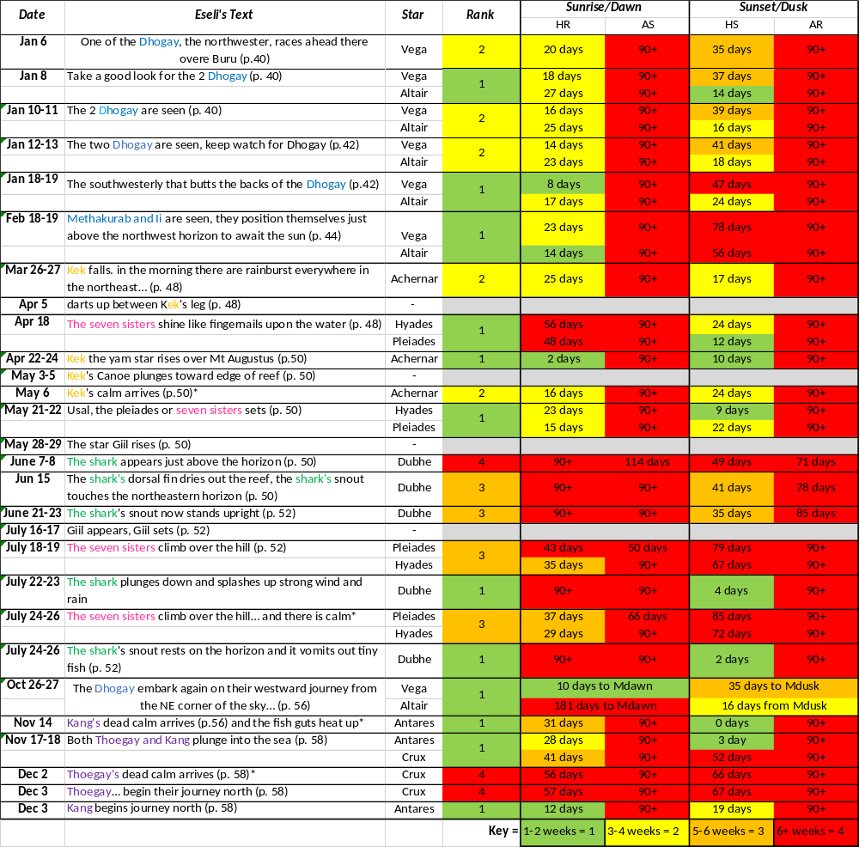
Table 5.12.
Interval Ranking of Eseli’s Statements (Author’s table)

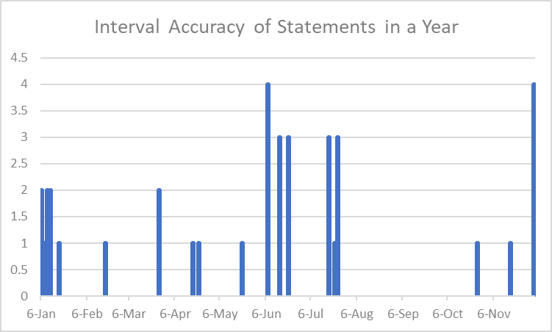
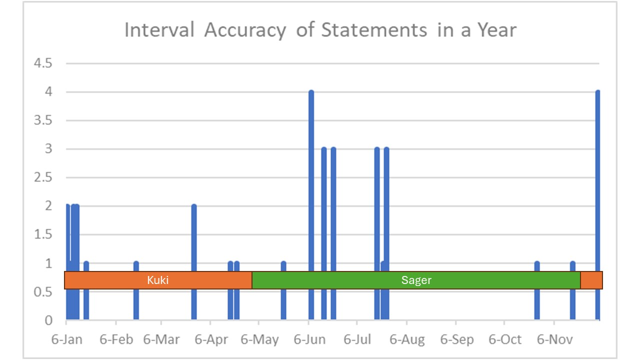
Figure 5.24.
Interval Accuracy Values with Seasonal Overlay (Author’s graph)
Figure 5.23.
Average Interval Value vs Calendar Year (Author’s graph)

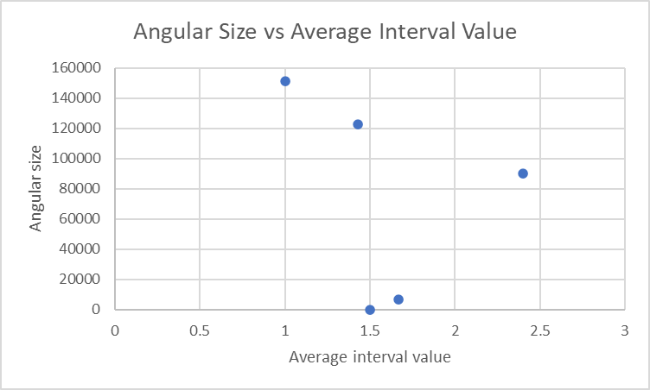
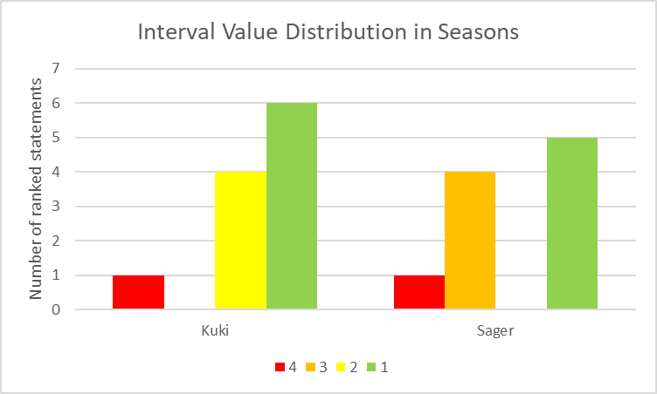
Conclusion
Figure 5.26.
Angular Size vs Average Interval Value (Author’s graph)
Figure 5.25.
Interval Value vs Season Distribution (Author’s graph)
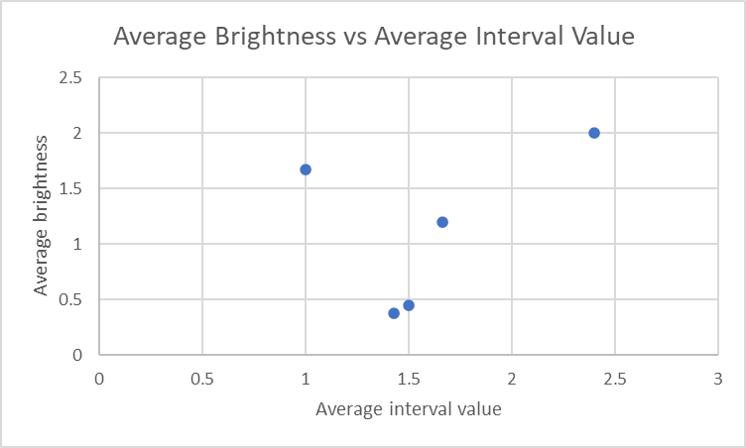
After evaluating Eseli’s (1998) statements and comparing the truth values of the statements with the described locations of the star groups, no correlation was found between the magnitude of the brightness of the star and the accuracy of Eseli’s (1998) statements. However, there was a potential correlation between the angular size of the star grouping and the accuracy of Eseli’s (1998) statements. Similarly, when comparing the interval values to the brightness of the star there was no correlation found. Different from the results of the analysis with the truth value, the comparison between the angular size and the interval value did not yield a correlation. In the evaluation of the truth values, what was also found to correlate was the number of true statements in the dry time of year, Sager.
Figure 5.27.
Average Brightness vs Average Interval Value (Author’s graph)

The statements made during the wet and rainy monsoon season did not have a consistent truth value and the truth of those statements was ambiguously random. This agrees with the agricultural patterns of the Torres Strait Islanders who use the time at the beginning and end of Sager to plant and harvest food respectively after the rains of Kuki. The importance of knowing and predicting the time of the Kuki shows the truth in Eseli’s (1998) statements corresponding with that time of year. This could also explain possible issues with translation and false determinations of the positions of the Dhogay which do not correspond with the Kuki and therefore would not be as important to retain an accurate statement.
While helping to understand the Islanders’ astronomic traditions, this analysis gives further understanding to archaeoastronomers of the importance of ethnographical information in general archaeoastronomy techniques, and how to consider the significance of specific stars to indigenous people.
Western thought often draws attention to the brightness of a star, or how prominent a star or constellation is in the sky. But here we see that what was more significant to the Torres Strait Islanders was the use of the stars to predict agricultural food planting and availability and they used the star rising and setting time and other movements to create a means to track and remember those important times of the year. Evaluating the interval value distribution in the two seasons did not yield discernable results. It was the Kuki season that had the most accurate statements, which was opposite to the results yielded by the truth value analysis. However, the average interval value for the Kuki was 1.6 while the average interval value for the Sager was 2.1, which is a low difference between the two values. These are opposite results to those yielded by the truth value analysis.

Isolating Star and Constellation Identities
After reviewing (in Chapter 4) the Torres Strait Islander’ identifications of significant stars and constellations, the next step was to understand their identities in the islanders’ traditions. This understanding could be accomplished by combining quantitative data with ethnographic information including clues associated with each star group.

The Biru Biru Bird (Rainbow Bee-eater)
References to animals in nature in the records are valuable hints. In the context of the seasonal changes and observed stars, there are two distinct references to the Biru Biru bird (Eseli et al., 1998; Haddon, 1912). Eseli’s Notebook indicates that the Biru Biru bird is the Rainbow Bee-eater (merops ornatus) as shown in Figure 6.1. Much is known and included here about the Biru Biru’s migration patterns independent of Torres Strait ethnography.
Haddon made one of the first ethnographic references to the Biru Biru. He made mention of the significance of the Biru Biru bird and the known connection between the observed star motion of Kek and changes in the seasonal rains:
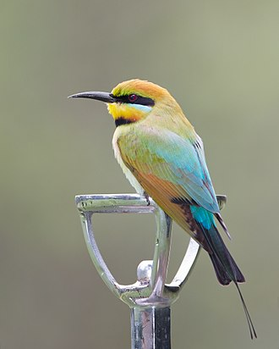
I obtained from Tom of Mabuiag the following list of stars associated with this season: "Kek, come up and is the sign [mek] for everything to be done, start meeting," that is ceremonies which are dependent upon a good food supply can now be held at the present time the "May meetings "take place at this season; Gil; Usal (the Pleiades) at this time the ovaries of the turtle enlarge; Pagas and Dede (Betelgeux [Betelgeuse]). Utimal; and Wapil. Towards the end of aibaud the large constellation of Baidam (shark) is seen, and then the Torres Straits pigeon [Ducula spilorrhoa] migrates from New Guinea to Australia, as do the Biru Biru birds when the crab constellation, Gitalai, appears. (Haddon, 1912, p. 227)
Figure 6.1.
Rainbow Bee-eater. (Wikipedia, accessed December 13, 2023).

Eseli recorded additional ethnographic information about the relationship of Kek to the Biru Biru bird, “Kek is the forerunner of the southeast season, March to April. It is known throughout the Torres Strait as the Yam Star, the sign (like the appearance of the Biru Biru) for the harvest of the new yams” (Eseli, 1998, p. 49). In other statements given by Eseli (1998) and evaluated in Chapter 5, there is a statement about the Biru Biru bird that indicates that on the 12th and 13th of March “The fine weather Rainbow bird returns from the southern mainland, heading for the northern mainland” (Eseli, 1998, p. 46).
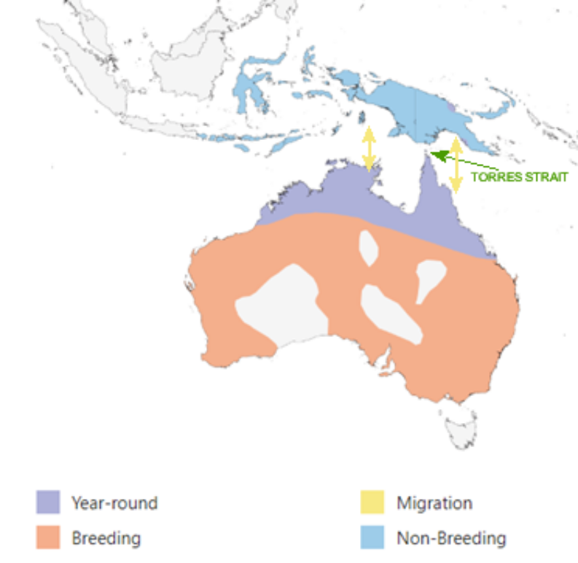
Fry and Boesman (1992) give key information about the Rainbow Bee-eater. It primarily breeds in mainland Australia, but the primary wintering grounds are on the island of New Guinea resulting in a migration pattern between Papua New Guinea and mainland Australia that flies directly over the Torres Strait as shown in Figure 6.2. Migrations of the Rainbow Bee-eater occur during two times of the year as the birds fly to and from their wintering grounds. These migrations occur mostly in April and then again from September to October. Occasionally during the migration of the Rainbow Bee-eater, headwinds can cause a high mortality rate leaving large numbers of dead birds in the Torres Strait, thus their migrations would be a very notable time marker.
Figure 6.2 .
Map of Yearly Migration Areas of the Rainbow Bee-eater Birds (Fry & Boesman, 1992)

Kek
In addition to understanding the migration of the Rainbow Bee-eater, Eseli (1998) connects the movements of Kek with the same time of year. Since Kek is known as the star Achernar, as discussed in Chapter 5, a graph of the motion of the rising and setting of Kek is particularly helpful for this discussion. As shown in Figure 5.3, the date of the heliacal set of Achernar is April 13th followed by the heliacal rise of Achernar on April 18th leaving only five days without Achernar in the night sky. These dates of rise and set are significant events in the observations of that star. Also notable are the dates of acronychal rise and set which occur on October 1st and November 8th, respectively.
An overlay of the migration times of the Rainbow Bee-eater and the motion of Achernar is shown in Figure 6.3. This is especially important to identify how the times of the first migration of the Rainbow Bee-eater (Biru Biru) coincide with both the heliacal rise and the heliacal set of Achernar (Kek). It is notable how there is a correlation between both migration times of the Rainbow Bee-eater (Biru Biru), congruent with the time of heliacal rise and heliacal set in April and with the acronychal rise of Achernar in October coinciding with the second time of migration of the Rainbow Bee-eater. Figure 6.3 shows the clear connection between the migration patterns of the Rainbow Bee-eater with the motion of Achernar.
Figure 6.3.
Overlay of the Motion of Achernar (Kek) and the Migration Times of the Rainbow Bee-eater (Author’s graph)
As the Biru Biru bird and the movement of Kek identify markers for predicting the times of the rainy season, adding information about the average rainfall from the Australian Bureau of Meteorology contributed to the analysis. It is important to note that the sources for this ethnographic information were from Haddon (1912) and attributed to Tom of Mabuyag, and Eseli (1998). Both individuals are from the Western Islands of the Torres Strait. Therefore, the data shown here is from Horn Island (the closest weather station to Mabuyag Island in the Torres Strait) and is shown in Figure 6.4.
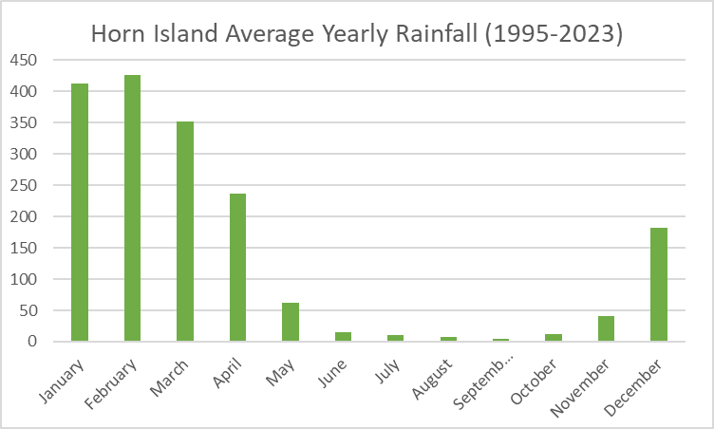
Figure 6.4.
Average Rainfall on Horn Island from 1995-2023 (Bureau of Meteorology, 2023)

When the position data of Kek, the timing of the Biru Biru bird migrations, and average rainfall is combined, it is apparent that the migration times of the Rainbow Bee-eater and the heliacal rise of Achernar occur at the same time of year while the rainfall in the Torres Strait is declining at the start of the drier months of the year. Similarly, the second time of migration for the Rainbow Bee-eater and the acronychal rise of Achernar are synchronous with the time of year when the rainfall starts to increase in the Torres Strait leading into the rainiest months of the year.
Figure 6.5.
Rainfall vs Kek (Achernar) Position (Author’s graph)

Getalai (or Gitalai)
Figure 6.6.
Rainfall vs Kek (Achernar) Position vs Biru Biru Migrations (Author’s graph)
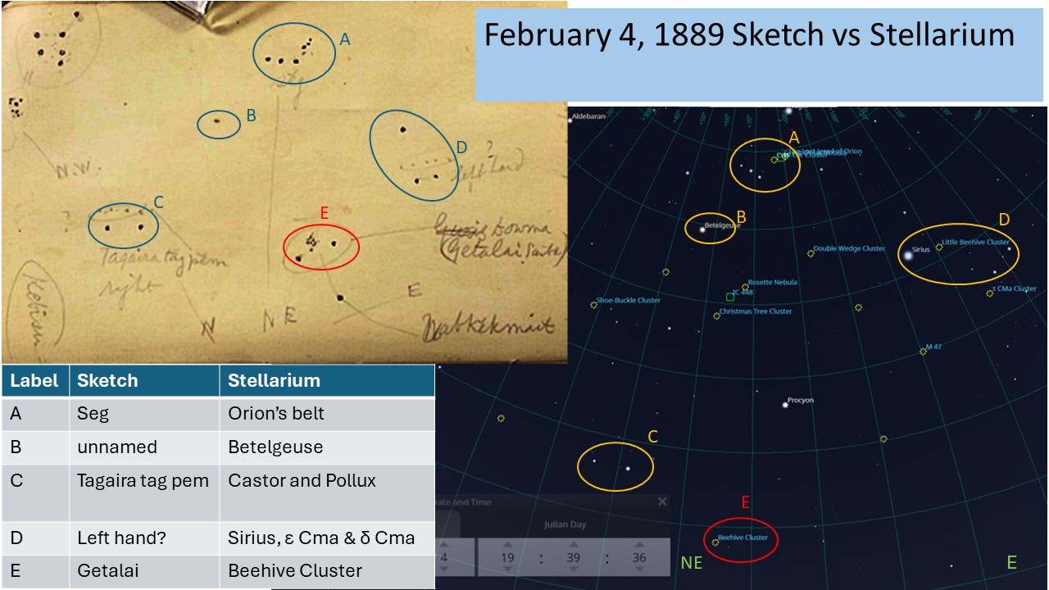
Getalai, is one named but unidentified star group in both the Western and Eastern Islands. Haddon (1912) indicates that the crab constellation, Getalai, appears during the time of the Biru Biru bird migration. It is described as something that looks like ashes with two stars on either side and was sketched by Haddon (n.d.-e), as shown in Figure 4.16. Haddon (1912) himself suggested that the identity of Getalai may not be a traditional star but instead, perhaps, a nebula. Ethnographical evidence from Haddon (1935) supports this idea, as he relates a tale from Dauan of a crab named Getalai who was pierced and then burnt by fire then extinguished with water. A similar tale was recorded by Lawrie (1972) from Saibai Island that connects Getalai with fire and ashes. These tales indicate that the appearance of Getalai as ashes is significant. By using Stellarium to visualize the night sky on the date of Haddon’s sketch at sunset on February 4, 1889, aligning the display to the cardinal directions as marked on the sketch (shown in Figure 6.7) and with all celestial objects (not only stars) enabled, Stellarium displays the Beehive Cluster as being located in the area suggested as the location of Gitalai. The two stars Gamma and Delta Cancer on either side of the cluster correspond to the sketch as the crab’s arms.
Figure 6.7.
Screenshot of Stellarium Compared with the Haddon Sketch (Author’s image)

Beehive Cluster
Documented in other indigenous astronomies such as the Boorong people this star cluster is visible with the naked eye (Hamacher & Frew, 2010). Based on Figure 6.7, the Beehive Cluster was input to see what the motion of the Beehive Cluster is in the night sky at times of sunrise and sunset throughout the year. This is shown in Figure 6.8. While the position of the Beehive Cluster matches the sketch given in Haddon’s notebook, the dates of the heliacal rise/set or the acronychal rise/set are not aligned with the dates defined by the migration of the Biru Biru bird as shown in Figure 6.9 (Haddon, n.d.-e).
Figure 6.8.
Beehive Cluster Sky Position at Sunrise and Sunset (Author’s graph)

Figure 6.9 shows how the dates of the meridional crossing of the Beehive Cluster do occur during the times of the Biru Biru bird migration, but as currently understood from the terms of Eseli’s (1998) Notebook, Getalai appears or should be rising during the time of migration, not at the zenith. Although it is understood from the Eastern Island traditions about Naurwer and Mabersor, two names for the same star that passes zenith, that the zenith position of the star is culturally significant to Torres Strait Islanders. Additionally, the Torres Strait language dictionary describes Getalai as a crab that appears during the time of Waur, which is the dry season that coincides with the southeasterly trade winds (Ray, 2001). This is then compared with the overlaid rainfall data in Figure 6.9. The heliacal rise of the beehive cluster in August is still several months before the increase of the rains in the end of October.
Figure 6.9.
Beehive Cluster Position vs Biru Biru Bird Migration vs Rainfall (Author’s graph)

Coma Berenices
Eseli (1998) described the position of Getalai as appearing in October. This suggests a date of heliacal or acronychal rise occurring in October. According to the previous analysis of the frequency of agreement of Eseli’s statements with acronychal vs heliacal dates in Chapter 5, the date of heliacal rise was targeted. Additional information from Eseli (1998) also helped narrow down the search. Eseli (1998) listed Getalai as a northern constellation. Knowing that Getalai is a northern constellation with a heliacal rise in October, Stellarium was searched for a celestial object (potentially a nebula) that rose between the azimuth of 0 – 90 degrees. Once set to the date of October 1st at the time of sunrise, Stellarium was run to watch for any rising objects.
The Coma Berenices cluster (shown in Figure 6.12) was easily identified as meeting the described requirements. When analyzed for the position of the Coma Berenices throughout the year it produced the data presented in Figure 6.10. This position information was then overlaid with the times of the Biru Biru bird migration and the monthly rainfall as shown in Figure 6.11.
Figure 6.11.
Coma Berenices Position vs Biru Biru Migration s Rainfall (Author’s graph)
Figure 6.10.
Coma Berenices Sky Position Graph (Author’s graph)

The date of the heliacal rise of Coma Berenices aligns better with the migration time of the Biru Biru bird, but it is 4 hours off from the time and positions as indicated by the sketch by Haddon (1912). It does, however, match the requirements suggested by Eseli (1998) to rise in October, and it is a Northern Hemisphere object.
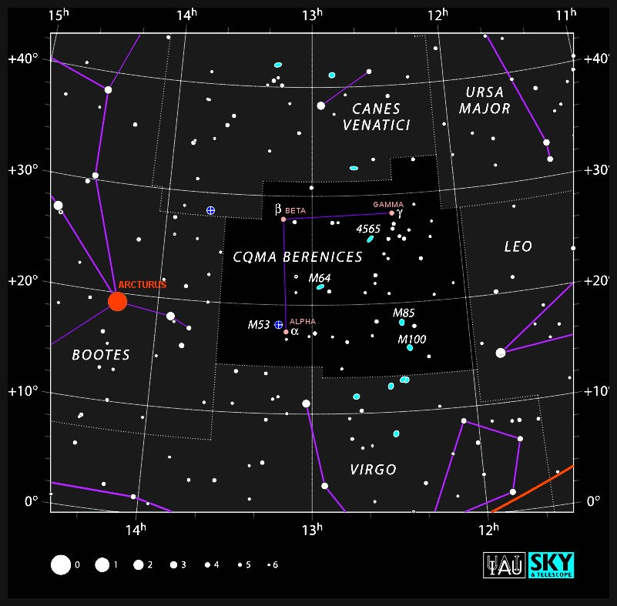
Additionally, Coma Berenices is a celestial object that was well known in antiquity in both the Western Hemisphere and in the traditions of other islanders, such as in Tonga and in other places in Australia, indicating substantial visibility in the naked eye observation (Hamacher & Frew, 2010). Depictions of Coma Berenices include a trio of stars including Alpha, Beta, and Gamma Coma as shown in Figure 6.12. With a central star and stars on either side, this potentially matches the descriptions of Getalai by Eseli (1998) and Haddon (1912) as an ash-like star with two stars on either side, as the arms of the crab.
Figure 6.12.
Map of Coma Berenices (Wikipedia. https://en.wikipedia.org/wiki/Coma_Berenices#/media/File:Coma_Berenices_IAU.svg accessed 1/6/2024)

Additional evidence in support of Coma Berenices as the identity of Getalai is the description by Eseli (1998) of Getalai being near the Wapi (or pilot fish). The Wapi are described as being the leading fish of the shark constellation, Baydham, known in Western astronomy as 23- UMa and 29- UMa. These Wapi are one of the distinguishing differences between the Eastern Island tradition of Beizam and the Western Island tradition of Baydham. As discussed previously, Baydham has universally been identified as Ursa Major, and Coma Berenices is also near Ursa Major.

How Moon Phase Influences Fishing Traditions
In addition to indigenous traditions about the stars, the Torres Strait Islanders have many traditions about the Moon. Following the methodology described in Chapter 3, these traditions were combined with quantitative evidence to further understand the traditions.
The Torres Strait Islanders are an agricultural society surrounded by the ocean and its resources. Use of these ocean resources is manifested in traditions concerning the availability and timing of different species as food sources. The people of the Torres Strait have a long history of fishing for turtles, crayfish, mud crabs, and dugongs to obtain food. There is evidence dating back hundreds of years of Islanders eating shellfish and other sea resources. Patterns of shellfish hunting have existed for many generations (Bird et al., 2002).
In fishing societies like those in the Torres Strait indigenous food foragers would have had to prioritize collecting food sources with high nutritional value. This means accounting for the time it takes to prepare or extract nutrition from these sources and considering the benefits of expending effort to collect that food resource. Generational indigenous knowledge of fishing patterns and food availability and finding ways to correlate them with celestially-observed phenomena would have been critical. Star and sky knowledge is one of the tools that indigenous Torres Strait Islanders still use for timing, to obtain the best quantity and quality of catch from the sea.
Most helpful to these indigenous people have been the phases of the Moon. The brilliant moonlight in the nighttime sky and tidal forces can create several impacts on biology (Zimecki, 2006). Tidal forces change throughout the lunar month corresponding to the changing position of the Moon in its revolution about the Earth. Other impacts include the cyclic changes in nighttime illumination, and in the changes in gravitational pull experienced by biological species when the gravity of the Moon is directionally combined with the gravity of the Sun (Hasnidar & Tamsil, 2019). These studies and others showed the effects of the Moon on marine life. The impact of Moon phases varied depending on the species and its location. These studies illustrate that while correlation does not necessarily equate to causation, a definite connection and perceptible changes occur in diverse types of sea life, related to the cycles of the Moon (Sulaiman, 2018).

Mud Crabs
Long before these academic studies, the indigenous people of the Torres Strait were aware of connections between the Moon phases and the habits and conditions of the certain animals in their area.

Indigenous Knowledge
In an interview with David Bosun, a tribal elder of the Torres Strait Island of Moa, he illustrated the indigenous knowledge of the Moon phases’ impacts on sea life. In referring to the Mud Crabs found in the Torres Strait, Bosun explained:
And during that time [during the New Moon] as well, it's also when we gather crabs: mud crabs because mud crabs comes out they are plentiful at that time, so there are a lot of them. So there are mud crabs available during that time and also even went before the K__ when the Moon is full there are more of them, but they are also more heavy-they have more meat in them. Then in any part of any time something physic[al] happens in the area, you know, it's they get lean and not much meat on them, they are lighter. (Hamacher, 2018, 10:41)

Quantitative Evidence
A study done by Hasnidar and Tamsil (2019) provides further scientific evidence of the changes observed by Bosun in mud crabs; changes corresponding to the phases of the Moon. This study, done in Indonesia, measured changing levels of crab molting hormones (ecdysteroids) and how they correlated with the changing moon phases. Measurements of the hormone were taken at the times of the New Moon, First Quarter, Full Moon, and Third Quarter. The ecdysteroids were at their highest concentration during the Quarter Moon. The molting cycle of the mud crab is such that these hormones have sharp peaks and drops, which trigger molting of the crab’s exoskeleton (called the carapace). Once a crab sheds its hard exoskeleton, the soft new exoskeleton is exposed, and the crab is considered soft-shelled.
Interestingly, the Last Quarter Moon was determined to be the time when there was the highest number of soft-shelled crabs. But most notably, this study showed that this cycle of crab molting resulted in the time of the New Moon as being the time when the crabs were foraging and eating extensively to prepare for their upcoming molting. The results showed that the New Moon was associated with the fullest fleshy body of the crab (Hasnidar & Tamsil, 2019). This agrees with the observations of Bosun describing increased numbers and the fleshiness of the mud crabs gathered during a New Moon (Hamacher, 2018).
Sulaiman (2018) studied how the Moon phases impacted the amount of fish activity and found up to 90% increases for activity during the New Moon versus other times in the lunar cycle. Similar studies have been conducted all over the world including Indonesia, Brazil, and at various coral reefs. Almost without exception, these studies have found connections between the fish population increasing or decreasing cyclically during specific moon phases. Other studies also have found links between lunar phases and the size of the fish caught, the biomass of the catches, and how ocean tides (corresponding to phases of the Moon) caused fish migrations from deeper habitats to shallower reefs.
Studies by Zimecki (2006) have also shown that lunar cycles have known impacts on the hormones of certain fish, specifically hormones like melatonin. In laboratory settings, fish in conditions without light variation, as experienced by the changing phases of the Moon, often resulted in reproductive failure. When fish were exposed to variations in light cycles mimicking lunar phases, the New Moon or Full Moon marked significant increases and decreases in their hormones. These hormones determine the fish size and/or biomass, as well as their amount of activity, as described by Bosun (Hamacher, 2018).

Crayfish (Rock Lobster)
Quantitative evidence by Zimecki (2006) and Sulaiman (2018) have given evidence of connections between the Moon and hormone levels increasing activity and biomass the general fish population, but Bosun gives more information about impacts of the Moon on specific kinds of marine life.

Indigenous Knowledge
Bosun’s indigenous knowledge about marine species and connections to the phase of the Moon continued:
The Quarter is, the Quarter Moon where we actually the crayfish plentiful. This is the time period where the tides are not stronger, and the water is clear, not murky. It's crystal clear and all the fishes they actually, because of all the other time the tide is strong, so they actually swimming against the strong current and they are in the cave or in the bommies is all in the shelter. But during this time, at Quarter, they actually come out of that of the bommies or the shelter where, we call it Ghana and call those also Isis Ghana where they stay in part of the reef where the ecosystem [is]. They come out which provides a real plentiful and they're pretty tight so they swim really slow so they’re easier to spear and the Turtle and dugong and course the water is really, really clear and you can see them from far. (Hamacher, 2018, 11:35)
Understanding the phases of the Moon as shown in Figure 1.4 and the gravitational forces that impact tides, makes this statement by Bosun clearer. During the New and Full Moon phases, the Moon is aligned with the Sun and its gravitational pull on the Earth is amplified. Meanwhile, in times of the Quarter Moons, the Moon’s orbital position makes its gravitational force perpendicular to the gravitational force of the Sun, and these forces counteract each other resulting in lower tides (Byrd, 2023).

Quantitative Evidence
Additional information to help in understanding Bosun’s comments can be found in scientific studies done on crayfish. Cousins of the crayfish found in the Torres Strait are found all over the world, but a study done in Louisiana found a decided correlation between the number of crayfish and the Moon phase. In this study, it was indicated that there was a decrease in the number of crayfish at the time of the Full Moon as indicated by the recorded numbers of the crayfish in the fisherman’s catch (Araujo & Romaire, 1989).
A study by Franke and Hoerstyn-Schwark (2013) of another type of crayfish, the noble crayfish, determined the molting pattern for crayfish and their correlation to the light variation caused by the Moon’s phases. In a laboratory setting with artificial light sources, the crayfish maintained a molting cycle synchronous with the length of the Moon cycle. While exposed to light equivalent to the Full Moon, the crayfish consistently molted during the time of the New Moon. When the exposure to moon-like light sources ceased in the experimentation, the molting cycle also ceased. Although the cessation of the molting cycle of the crayfish could be the result of their artificial summer-like light exposure and could resemble a seasonal stall in the molting cycle, the other data obtained by the experiment concluded a direct correlation between light exposure and the molting cycle of the crayfish (Franke & Hoerstgen-Schwark, 2013).
Similarly, a study in Western Australia of Rock Lobster indicated a similar correlation between the Moon’s phases and catch numbers of lobsters (Srisurichan et al., 2005). Bosun’s descriptions and observations concerning the crayfish in the Torres Strait are consistent with in the increase of activity and numbers of crayfish during the Quarter Moon phases (Hamacher, 2018).

Oysters and Shellfish
In addition to understanding the abundance of crabs and crayfish, Bosun indicated a connection between the behaviors of other marine life with Moon phase.

Indigenous Knowledge
In describing the optimal fishing habits to catch oysters and shellfish, Bosun further explained:
But fishings are great also at the time as well as a Quarter time so you can fish there. The Shellfish as well as during the Quarter tide the clamshell they're actually they open themselves up so some scientific reaction happens there and yeah you can you can actually see them from on your boat that's when we go together with all the shellfishes in different phases of the Moon. (Hamacher, 2018, 13:36)

Quantitative Evidence
Bosun’s observations are further validated by scientific studies connecting shellfish behavior and the Moon phases. Payton and Tran (2019) studied oysters and found that they have a Moon connection. As the light from the Moon increases and decreases, oysters have a matching rhythm with the moonlight. In this study the number of open valves in the oysters increased significantly at the Last Quarter Moon but not repeated at the First Quarter, which suggested to the researchers that perhaps this was not caused by the changes in the light coming from the Moon, but another impact of the lunar cycle (Payton & Tran, 2019).
Observations like those made by Bosun about timing when shellfish are open and easier to harvest would be key information to expedite food gathering and meet the people’s nutritional needs. Even more significant is the ability to connect observations easing food collection with natural celestial patterns to allow for increasingly predictable and successful food gathering in the future.

Conclusion
Indigenous knowledge in the Torres Strait has been passed down from generation to generation for thousands of years. The knowledge shared by David Bosun was passed down to him through his father, and grandfather, going back generations (Hamacher, 2018). These are just a few examples of how the indigenous Torres Strait Islanders used visual cues of Moon phases to understand crayfish, mud crab, and oyster habits and track the optimum conditions for food gathering and fishing. Not only are these descriptions accurate and helpful in food gathering practices, but they were also verified by modern studies. While recognizing that this knowledge is based on scientific fact, the mechanisms of why and how the Moon impacts these biological creatures’ habits and patterns are still to be further understood.

Results and Discussion
Chapter 1 summarized best practices of archaeoastronomical research including the importance of integrated study. Consequently, this research began with a large survey to collect ethnographic information about the astronomy of the Torres Strait Islanders. This work, while not exhaustive, is significant in gathering various sources of astronomic information. Only by understanding all the various references to celestial objects, may there be any clarity in obtaining reliable identification of the stars and constellations by the Torres Strait Islanders.
Chapter 3 shows the next step in archaeoastronomical research, pairing existing ethnography with quantitative evidence to identify the significance of celestial bodies in a cultural context. Using positioning data from sky position graphs, obtained from scripting Stellarium software, this visual representation showing the positions of the stars at sunrise and sunset has enabled ethnographic information to become supportable by quantifiable data. The next most significant piece of quantitative evidence has been the comparison of the location of the stars in comparison with the calendar dates of horizon events. This integrated approach has yielded significant findings and clarity.
Without the aid of modern technology (such as clocks and calendars), over many generations Torres Strait Islanders (dispersed over an archipelago of small islands) developed a complex and comprehensive store of knowledge based on their observations of the night sky and of the climate.

Eseli’s Statements
Peter Eseli’s (1998) manuscripts with the understood movements of the stars and the connections between the calendar in the Western Islands is a unique and profound ethnographical resource for the Torres Strait Islanders. But when reviewing the statements (as translated) there is some confusion about the intended interpretation and significance when reviewed in cultural context. His documents were greatly clarified when they were paired with quantitative evidence, as provided by the star position graphs and dates of horizon events.

Potential Clarification of Term Definitions
Both Thoegay and Kang were described to have (in the sky) a journey north. There could be many different interpretations inherent in assigning meaning to this phrase. Only by comparing the graphical positions of Crux, and Antares with the date referred to as the reference for when the journey north starts could this be more accurately understood as shown in Figure 5.6 and Figure 5.7. There is no obvious correlation with the level accuracy as evaluated by the interval analysis as shown in Table 5.12. However, when compared visually on the star positions graphs it is apparent that the “journey north” does occur at a time as the stars are or will be ascending in the sky at the time of sunrise.
Another misunderstood reference used by Eseli was his description “times of calm” for Kek, Thoegay and Kang, and Usal. “Calm” seems to refer to a time with a change in seasonal weather or winds, but the specifics were not understood. It was only as these times of calm were graphed relative to the position of the stars during the sunrise and sunset in Figure 5.13 through Figure 5.17 that a connection could be shown. Each graph shows a link between the times of calm and the date of the heliacal rise (HR) of the named star with whom the time of calm is associated.

Importance of Horizon Events
When first reading Eseli’s statements about dates and the stellar events, one of the first questions when looking for a position confirmation was whether to look for alignments at sunrise or sunset. Statements from David Bosun indicated that most of the star positions were observed at sunset (Hamacher, 2018). Notes by the translators of Eseli’s Notebook (1998) indicate that this was a topic of debate among researchers of Eseli’s manuscripts. One benefit of the star position graphs is they show, in the same graph, the position of the star both at sunrise and at sunset simultaneously. This also allowed for a correlation to be made between the number of statements that aligned at sunrise versus at sunset and to be able to determine if there was a preferred time of observation. As shown in the two columns in Table 5.12, there was no preference of the number of observations that aligned during the time of sunset and sunrise. The more important connection was that these observations correlated to the position of the Sun relative to the star. While there were hardly any observations that aligned with acronychal rise (AR) or acronychal set (AS) all of the aligned observations were connected to times of heliacal rise (HR) and heliacal set (HS).
Similar to the analysis of Leaman et al., (2016) this evaluation of Eseli’s notebook benefited greatly from comparing of the stated dates from Eseli with the dates of horizon events, giving a more concrete point of reference to determine the truth of the statement. It also allowed the evaluation of intervals between the date and the horizon events. This was critical to understand the reasons why some statements were true, and others were false. It was only when these true and false rated statements were compared to the seasonal calendar, as shown in Figure 5.21, was it clearly shown how the seasonal calendar and times of harvest and planting impacted the integrity of the statements provided by Eseli. As the statements aligned with planting and harvesting season, they were true, but when they aligned with times of rain and the non-growing season, the statements were false.

Better Understanding of Star Positions
An additional benefit of the analysis of the star position graphs and correlating them with Eseli’s statements was the clarity they gave to understanding star motion throughout the year. In the case of the Dhogay stars, Altair and Vega, it was only when seeing the graph of the stars that it was understood that during the times of the January statements by Eseli, the stars are invisible in the night sky at either sunrise or sunset for a duration of a few weeks.

Further Evidence of Star Identities
Eseli (1998) gave suggestions for the identities of Kek, Usal, Thoegay, Kang, Baydham, and the Dhogay in his book. But other researchers have doubted his identification. Kek has been speculated as possibly being Venus, Achernar, or Sirius. While evaluation of the star Kek with the position of its azimuth over Mt Augustus gives substantial justification for the identity of Kek as Achernar, this conclusion was further supported by the graphical position data, When graphed with the times of migration with the Biru Biru bird, and the seasonal rainfall as shown in Figure 6.6 , it is clear that Achernar aligns with the described motion of Kek. And it appropriately aligns with the weather and other events that happen at the time of its heliacal rise (HR).

Usal as Either Hyades or Pleiades
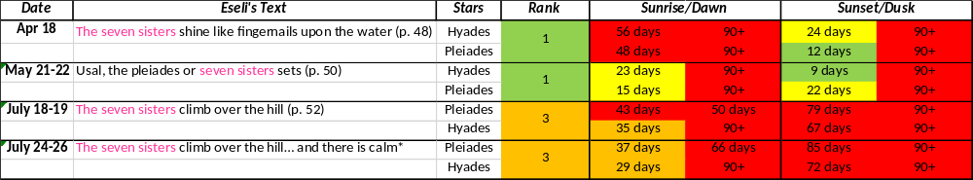
One debate among modern archaeoastronomers is the identity of the Pleiades as Usal. Some researchers have argued that perhaps Usal is better identified with the Hyades. Both the Pleiades and the Hyades are found in the same general location in the celestial sphere, so isolating Usal’s identity has been difficult. Comparing Eseli’s statements about Usal with the interval accuracy of the Hyades horizon event dates with the accuracy of Pleiades horizon events is an additional way to get more information about this dispute. Table 8.1 shows the interval rankings for Hyades and Pleiades for the Usal statements by Eseli. The number of times Hyades had a better correlation with Eseli’s statements is greater than the number of times that Pleiades was a better match. The comparison of these rankings from each star group was one more dataset to help determine the identity of Usal, supporting the idea that identity of Usal may be the Hyades and not the Pleiades.
Table 8.1.
Comparison of Usal statements with Pleiades and Hyades Horizon Events (Author’s table)

Getalai Evaluations
The collection of ethnographical references to the identifications of stars and constellations by Torres Strait Islanders will make it possible to identify more of the celestial objects in the future. This was modeled in Chapter 6 to demonstrate the integrated method to determine the potential identity of Getalai.

Evidence
The evidence available to understand the identity of Getalai was mostly given by Haddon and Eseli. Haddon provides a sketch of the sky dated on February 4, 1889, as well as the recorded tales of the people on Dauan about the ash-like appearance of Getalai, Eseli offers several mentions of Getalai, in relation to the seasons and other stars visible at the same time. Specifically, Eseli discusses Getalai in reference to the migration time of the Biru Biru bird. Eseli also describes the rise of Getalai around the time of Kek and that its rise indicates a change of weather. This was all combined with the star position data of the suspected celestial objects of Coma Berenices in Figure 6.10 and the Beehive Cluster in Figure 6.8, both of which have references in other indigenous astronomies in Australia (Hamacher & Frew, 2010). Of these various forms of evidence, the star position graph of Coma Berenices rising was a better match than the Beehive Cluster with the time of year as described by Eseli (1998). Additionally, the graph of rainfall data points to the time of year when Coma Berenices rises, however this event is the acronychal rise and may not be significant based on the statistical inconsistency with acronychal rise and set events in the Torres Strait as shown in Table 5.12. Further evidence regarding Coma Berenices is the chart of the migration times of the Biru Biru bird in Figure 6.11, and the proximity of Coma Berenices to Ursa Major and the Wapi stars (23- UMa and 29- UMa). Evidence in favor of the Beehive Cluster is the map comparison with the sketch provided by Haddon shown in Figure 6.7.
Even this source of evidence brings up some additional questions. Eseli’s statement about Getalai indicates that it rises in the months of April or May with the Biru Biru bird migration, but the date on the sketch is from February. These two dates do not align. Another troubling aspect of Haddon’s sketch is that none of the other words he gives for the other celestial objects in the sketch match any of the other known terms for celestial objects from the area. Additionally, the sketch by Haddon curiously includes both Getalai, a Western Island constellation, and Seg, an Eastern Island constellation. Inclusion of both star groups from different astronomic traditions leads to a question of the sources used to produce this sketch. This study increased the amount of evidence we have toward possible identification of Getalai, but the confirmed identity is still inconclusive.

Moon Phases Influence on Sea Life
Best practices of archaeoastronomical research were also helpful to further understand the relationship between the Moon phase and the availably of marine food resources for the Torres Strait Islanders.

Ethnographic Evidence
In his interview with Duane Hamacher (2018), David Bosun gave specific descriptions of the condition, quality, and availably of various kinds of marine food sources. Including mud crabs, oysters, and crayfish. Each animal was described to have different traits of size, activity, and abundance related to the Moon phase. Bosun also discussed the abundance of the crayfish with the Quarter Moon and mentioned the connection between their abundance and the tides caused by the Moon. And Bosun also indicated that oysters were impacted by the Moon phase. He stated that during the times of the Quarter Moon that the oysters were more open and easier to catch (Hamacher, 2018)

Quantitative Evidence
Studies by Hasnidar and Tamsil (2009) showed evidence of the increase in the number of mud crabs and their activity at the time of the New Moon. Additionally, they explained that the hormone that impacts the size and fullness of the crab was also connected to the New Moon. Crayfish studies in Louisiana and Indonesia showed a direct correlation between the amount of light from the Full Moon and crayfish availability (Franke & Hoerstgen-Schwark, 2013; Srisurichan et al., 2005). For oyster activity, Payton and Tran (2019) studied the connection between Moon phase and the openness of the oysters and found that the oysters were more open in the Third Quarter Moon.

Integrated Approach to Archaeoastronomy
This paper shows the importance of the integrative and collaborative approach to archaeoastronomy research. It was only by first carefully collecting ethnographical information and then using astronomy, computer coding, understanding details about zoology, ornithology, geography, tidal currents, etc., that a more complete analysis of the Torres Strait Islanders’ beliefs was able to be scientifically substantiated with quantitative data. Research with the methods used here can lead archaeoastronomers to more sound and believable conclusions. It adds credibility to the oral traditions of indigenous cultures like that of the Torres Strait Islanders. In some cases, as with Getalai, there are no firm conclusions made, but the identification of the ethnographic evidence paired with the various sources of quantitative data lead future researchers to new possibilities and methods.

Summary and Conclusion
In recent years much work has been done to better understand the indigenous cultures of Australia now and from before the time of Western influence.
One of the trailblazers in studying the people of the Torres Strait, A. C. Haddon, first traveled to the region because of the unique Zoology and Ecology found there. Once Haddon arrived, he found that the Torres Strait Islanders had a culture even more unique than the plant and animal life and needed preservation and documentation. Ethnographic work by Haddon was followed by other Western ethnographers like Margaret Lawrie who lived in the region and tried to record all of the cultural tales found.
100 years after Haddon visited the Torres Strait, manuscripts written by Peter Eseli were given to linguists to translate into English. This translation created a primary resource of ethnographic information about the Torres Strait Islanders. Published after his death, the words of Eseli helped astronomers understand more of the calendrical like patterns observed by Torres Strait Islanders. But there were possible errors in some of the translations, and more information was needed. Additional ethnographic resources were gathered from the study of the languages of the Eastern and Western Islands and interviews with living indigenous astronomers and artists to create a foundation of ethnographic material. This all combined to give a better foundation of the names and patterns expected of the stars in the area.
But ethnographic evidence was not enough. Ironically, information about the same animals and plant life that first attracted Haddon to the Torres Strait was needed to further understand the importance of the ethnographic record. Modern insights into the patterns of animal migration within the Torres Strait and modeling by current astronomic computer programs allowed us to obtain quantitative evidence to compare with the ethnographic information collected. By combining this quantitative data with ethnographic resources, we understand the reasons behind the astronomic traditions. This integrated analysis, incorporating knowledge from many different disciplines, deepened our understanding of Torres Strait Islander traditional knowledge and helped answer questions about its meaning and significant celestial objects.
Using these same methods of combining ethnographic information with quantitative analysis future work can continue to identify additional indigenous stars with their Western identities to be able to document and map out the astronomy of the Torres Strait to share with future generations.
With these findings it can clearly be shown that Torres Strait Islanders developed a complex and comprehensive store of knowledge based on their observations of the night sky and of the climate. Remarkably, these accomplishments, made without the aid of modern technology, such as clocks and calendars, can now be described, validated, and understood through the integrated methods of research that are part of archaeoastronomy.

Appendix A: Stellarium Scripting Description and Code for Star Rising Position Data
Lines 1 - 6 of this script identify the observation position using latitude and longitude and setting the altitude of the observed object at 5 degrees, just above sea level. In lines 7 - 15 the date of observation was also identified by the program starting with January 1, 1900, using the local time. Because the exact time of sunrise and sunset change by a few minutes from one day to the next, the script would start looking for the time of sunset by obtaining the star position at 17:00 (5pm), and the program would start at this time to look for the exact minute that the Sun achieved an altitude between the parameters of -9.75 and -10.25 (below the horizon) as indicated at line 37. By specifying the position of the Sun between these two altitude parameters (instead of simply indicating once the Sun had passed -10) the same code could be used to obtain the location of the stars at both times of sunset and sunrise by simply changing the starting time of analysis from 17:00 to 6:00, respectively. Note here that while the input times were given in local time, the resulting times as indicated in the output of this program are given in Coordinated Universal Time (UTC, previously known as Greenwich Mean Time). UTC is ten hours earlier than local time in the Torres Strait. The code indicates being run for a date range of 365 to cover the length of the calendar year (noting that 1900 was not a leap year: otherwise, 366 days would need to be input to obtain the full year of data). The program then includes instructions for Stellarium to write the output for this program into a separate CSV (comma delimited, spreadsheet compatible) file in lines 16 & 17, with the destination of the file defined in the code.
To coincide with the statements given by Eseli (1998), there were only specific stars for which we needed location information. These specific stars were listed (using their Western names) in the program script at lines 18 - 25.

Line 1 observer = core.setObserverLocation( // Set the location data below:
142.1833, // Longitude first (as required by the API)
9.9553, // Latitude
5, // Altitude
0," ","Earth"
);

Line 7 core.setTimeRate( 0 );
core.setMinFps( 120 ); // This line is required for consistent results; higher is better. core.resetOutput();
startDate = "1900-01-01T00:00:01"; // Set the starting date. Don't change the hour here, use whenHours below.
core.setDate( startDate , "local" );
daysToRun = 365; // Set the number of days of data to acquire
whenHours = "17"; // 24h time. Set the desired time of day for the script to begin its search for the desired Sun position. For example, if sunset is desired, and the earliest possible sunset at the location is 18:01, set this to 17 to ensure the script doesn't miss the next sunset and find dawn instead.
Line 14 concatenatedString = "+ " + whenHours + " hours";
core.setDate( concatenatedString );

//Define where to save the data and the file name
Line 16 const savefile_loc = "C:/Users/Inspiron 15 5000/One Drive/Desktop/"; // Location for saving file. Change the location as needed.
const savefile_name = "sunsetData.csv"; //Location for file name. Change the name as needed.

//Define which stars you would like to get locations for at the moment of desired solar position:
Line 18 const myStars = [ "Pleiades",
"Arcturus",
"Vega",
"Altair",
"Hyades",
"Crux",
"Antares",
"Dubhe" ];
const header = [ "UTC date/time","Sun Altitude",myStars ];

Line 27 core.output(header);
infoOnMyStars = myStars.map((x) => core.getObjectInfo(x));
sunInfo = core.getObjectInfo("Sun"); // This line prevents a bug

Line 30 for( daysRun = 0; daysRun < daysToRun; daysRun++ ) { // Loop through days sunCheckIterations = 0;
do {
sunInfo = core.getObjectInfo("Sun");
core.setDate("+ 1 minutes");
core.wait(0.01); // This line is required sunCheckIterations++;
} while ( sunInfo.altitude < -10.25 || sunInfo.altitude > -9.75 ); // While the Sun is above or below its desired position, the script performs the steps between "do {" and "} while"

Line 38 infoOnMyStars = myStars.map((x) => core.getObjectInfo(x));
altitudesOfMyStars = infoOnMyStars.map((x) => (x.altitude));
core.output(( core.getDate("utc") + "," + sunInfo.altitude + "," + altitudesOfMyStars.join()));
core.setDate("+ 1438 minutes");
}
core.saveOutputAs( savefile_loc + savefile_name);

Bibliography
Aimers, J. T., & Rice, P. M. (2006). Astronomy, ritual, and the interpretation of Maya “e-group” architectural assemblages. Ancient Mesoamerica, 17(1), 79-96.
Araujo, M. A., & Romaire, R. P. (1989). Effects of water quality, weather and lunar phase on crawfish catch. Journal of the World Aquaculture Society, 20(4), 199–207. https://doi.org/10.1111/j.1749-7345.1989.tb01003.x
Aveni, A. F. (1981). Tropical archeoastronomy. Science, 213(4504), 161–171. https://doi.org/10.1126/science.213.4504.161
Aylesworth, G. R. (2004). Astronomical interpretations of ancient Maya e-group architectural complexes. Archaeoastronomy, 18, 34-66.
Aylesworth, G. R. (2015). E-Group arrangements. In C. L. N. Ruggles (Ed.), Handbook of Archaeoastronomy and Ethnoastronomy (pp. 783–791). Springer.
Belmonte, J. A. (2015a). Ancient “Observatories” - A relevant concept? In C. L. N. Ruggles (Ed.), Handbook of Archaeoastronomy and Ethnoastronomy (pp. 133–145). Springer.
Belmonte, J. A. (2015b). Solar alignments - Identification and analysis. In C. L. N. Ruggles (Ed.), Handbook of Archaeoastronomy and Ethnoastronomy (pp. 483–492). Springer.
Bird, D. W., Richardson, J. L., Veth, P. M., & Barham, A. J. (2002). Explaining shellfish variability in middens on the Meriam Islands, Torres Strait, Australia. Journal of Archaeological Science, 29(5), 457–469. https://doi.org/10.1006/jasc.2001.0734
Bosun, D. (2007a). Thagay [Linocut]. Australian Aboriginal Art Network. https://australianartnetwork.com.au/shop/region/torres-strait-islands/thagay/
Bosun, D. (2007b). Zugubau Mabaig [Linocut]. Australian Aboriginal Art Network. https://australianartnetwork.com.au/shop/region/torres-strait-islands/zugubau-mabaig/
Bosun, D. (2015). Kuki gub [Linocut]. Australian Aboriginal Art Network. https://australianartnetwork.com.au/shop/region/torres-strait-islands/kuki-gub/
Bureau of Meteorology (2023). Horn Island average monthly rainfall. http://bit.ly/487A0tf
Byrd, D. (2023, August 2). Tides, and the pull of the Moon and Sun. EarthSky. https://earthsky.org/earth/tides-and-the-pull-of-the-moon-and-sun/
Chéreau, F., Wolf, A., Chéreau, G., Zotti, G., & Chardinot, M. (2019). Stellarium (Version 1.2) [Computer software]. https://stellarium.org/en/
David, B., Crouch, J., & Zoppi, U. (2005). Historicizing the spiritual: Bu shell arrangements on the island of Badu, Torres Strait. Cambridge Archaeological Journal, 15, 71–91. https://doi.org/10.1017/S0959774305000041
David, B., Mcniven, I., Mitchell, R., Orr, M., Haberle, S., Brady, L., & Crouch, J. (2004). Badu 15 and the Papuan-Austronesian settlement of Torres Strait. Archaeology in Oceania, 39(2), 65–78.
Dixon, R. (1996). Origin legends and linguistic relationships. Oceania, 67, 127-139.
Eseli, P. (1998). Eseli's Notebook (A. Shnukal, R. Mitchell, & Y. Nagata, Ed. & Trans.). The University of Queensland. (Original work published n.d.)
Franke, R., & Hoerstgen-Schwark, G. (2013). Lunar-rhythmic molting in laboratory populations of the Noble Crayfish Astacus astacus (Crustacea, Astacidea): An experimental analysis. PLoS ONE, 8(7), e68653. https://doi.org/10.1371/journal.pone.0068653
Fry, H, & Boesman, P. F. D. (1992). Rainbow bee-eater: Merops ornatus. In J. del Hoyo, A. Elliott, J. Sargatal, D. A. Christie, and E. de Juana (Eds), Birds of the World, (6). Lynx Edicions.
Guedes, C., Hamacher, D., Barsa, J., Day, E., Day, R., Passi, S., & Tapim, A. (2018). Death and maier: Meteors and mortuary rites in the eastern Torres Strait (Eud kerker: Na korep maierira asmer opged Torres Straitge). Australian Journal of Indigenous Issues, 21(3), 39-59.
Gullberg, S. R. (2020). Astronomy of the Inca Empire: Use and significance of the Sun and the night sky. Springer.
Gullberg, S. R., Hamacher, D. W., Martín-Lopez, A., Mejuto, J., Munro, A. M., & Orchiston, W. (2020). A cultural comparison of the "dark constellations" in the Milky Way. Journal of Astronomical History and Heritage, 23(02), 390–404. https://doi.org/10.3724/SP.J.1440-2807.2020.02.10
H., A. R. (1941). The discovery of Torres Strait. The Geographical Journal, 98(2), 91. https://doi.org/10.2307/1787204
Haddon, A. C. (n.d.-a). Folder 1011. The Haddon collection, University of Cambridge Library.
Haddon, A. C. (n.d.-b). Folder 1014. The Haddon collection, University of Cambridge Library.
Haddon, A. C. (n.d.-c). Folder 1025. The Haddon collection, University of Cambridge Library.
Haddon, A. C. (n.d.-d). Folder 1053. The Haddon collection, University of Cambridge Library.
Haddon, A. C. (n.d.-e). Folder 1054. The Haddon collection, University of Cambridge Library.
Haddon, A. C. (n.d.-f). Folder 2073. The Haddon collection, University of Cambridge Library.
Haddon, A. C. (n.d.-g). Folder 1050. The Haddon collection, University of Cambridge Library.
Haddon, A. C. (n.d.-h). Folder 1013. The Haddon collection, University of Cambridge Library.
Haddon, A. C. (1890). The ethnography of the western tribe of Torres Straits. The Journal of the Anthropological Institute of Great Britain and Ireland, 19, 297. https://doi.org/10.2307/2842024
Haddon, A. C. (1912). Reports of the Cambridge anthropological expedition to Torres Straits, (4). University Press.
Haddon, A. C., & Ray, S. H. (1901). Reports of the Cambridge anthropological expedition to Torres Straits, (2). University Press.
Haddon, A. C., & Ray, S. H. (1904). Reports of the Cambridge anthropological expedition to Torres Straits, (5). University Press.
Haddon, A. C., & Ray, S. H. (1907). Reports of the Cambridge anthropological expedition to Torres Straits, (3). University Press.
Haddon, A. C., & Ray, S. H. (1935). Reports of the Cambridge anthropological expedition to Torres Straits, (1). University Press.
Hamacher, D. (2015, June). Introduction - Torres Strait astronomy [Video]. YouTube. https://youtu.be/Bgm9D3fS5T8?si=p35eEeTsKKI3_OHF
Hamacher, D. (2017, December). Torres Strait astronomy with David Bosun [Video]. YouTube. https://youtu.be/cR7csT8st9A
Hamacher, D. (2018, June). Torres Strait astronomy with David Bosun [Video]. YouTube. https://youtu.be/3BkcFUymD7o
Hamacher, D. W., Barsa, J., Passi, S., & Tapim, A. (2019). Indigenous use of stellar scintillation to predict weather and seasonal change. Proceedings of the Royal Society of Victoria, 131(1), 24. https://doi.org/10.1071/RS19003
Hamacher, D. W., & Frew, D. J. (2010). An Aboriginal Australian record of the great eruption of Eta Carinae. Journal of Astronomical History and Heritage, 13(3).
Hamacher, D. W., Fuller, R. S., Leaman, T. M., & Bosun, D. (2020). Solstice and solar position observations in Australian Aboriginal and Torres Strait Islander traditions. Journal of Astronomical History and Heritage, 23(1), 89–99. https://doi.org/10.3724/SP.J.1440-2807.2020.01.05
Hamlyn-Harris, R. (1913). Ethnographical notes of the Torres Strait. Anthony James Cumming.
Harper, B., Mason, L., Hanslow, D., & Rainbird, J. (2011). Estimating extreme water levels in Torres Strait, final report. Torres Strait Regional Authority.
Hasnidar, & Tamsil, A. (2019). Concentration of mud crab (Scylla olivacea Herbst, 1796): Moulting hormones based on Moon phase. IOP Conference Series: Earth and Environmental Science, 253, 012011. https://doi.org/10.1088/1755-1315/253/1/012011
Hawkins, G., & White, J. B. (1965). Stonehenge decoded. Doubleday.
Herle, A., & Philp, J. (Eds.). (2020). Recording kastom. Sydney University Press.
Hoffmann, T. (2022). SunCalc. suncalc.org. Retrieved on December 19, 2023 at https://www.suncalc.org/#/-9.9566,142.1868,14/2023.12.19/14:02/1/3
Iwaniszewski, S. (2015). Concepts of space, time, and the cosmos. In C. L. N. Ruggles (Ed.), Handbook of Archaeoastronomy and Ethnoastronomy (pp. 3–14). Springer.
Johnson, D. (1998). Night skies of Aboriginal Australia: A noctuary. The University of Sydney.
Laade, W. (1968). The Torres Islanders’ own traditions about their origin. Ethnos: Journal of Anthropology, 33, 141-158.
Lawrie, M. (1970). Myths & legends of Torres Strait. Taplinger Publishing Company.
Lawrie, M. E. (1972). Tales from Torres Strait . University of Queensland Press.
Leaman, T., Hamacher, D., & Carter, M. (2016). Aboriginal astronomical traditions from Ooldea, South Australia, Part 2: Animals in the Ooldean sky. Journal of Astronomical History and Heritage, 19. https://doi.org/10.3724/SP.J.1440-2807.2016.01.05
Lemckert, C. J., Zier, J., & Gustafson, J. (2009). Tides in Torres Strait. Journal of Coastal Research, 524–528.
Lewis, D. (1974). Voyaging stars: Aspects of polynesian and micronesian astronomy. Royal Society of London. https://books.google.com/books?id=UfZ0nQEACAAJ
Lopez, A. M. (2015). Cultural interpretation of ethnographic evidence relating to astronomy. In C. L. N. Ruggles (Ed.), Handbook of Archaeoastronomy and Ethnoastronomy (pp. 341–352). Springer.
Malville, J. M. (2010). Cosmology in the Inca empire: Huaca sanctuaries, state-supported pilgrimage, and astronomy. Journal of Cosmology, 9, 2106-2120.
Malville, J. M. (2015). Inca royal estates in the Sacred Valley. In C. L. N. Ruggles (Ed.), Handbook of Archaeoastronomy and Ethnoastronomy (pp.865-877). Springer.
McCluskey, S. C. (2015a). Disciplinary perspectives on archaeoastronomy. In C. L. N. Ruggles (Ed.), Handbook of Archaeoastronomy and Ethnoastronomy (pp. 227–237). Springer.
McCluskey, S. C. (2015b). Hopi and Puebloan ethnoastronomy and ethnoscience. In C. L. N. Ruggles (Ed.), Handbook of Archaeoastronomy and Ethnoastronomy (pp. 649–658). Springer.
McNiven, I. J., Bruno, D., Richards, T. Rowel, C., Leavesley, M., Mialanes, J., Connaughton, S. P., Barker, B., Aplin, K., Asmussen, B., Faulkner, P., & Ulm, S. (2012). Response: Lapita on the south coast of Papua New Guinea: Challenging horizons in pacific archaeology. Australian Archaeology, 75, 16-22.
Moore, David R. (1984). The Torres Strait collections of A.C. Haddon : a descriptive catalogue .British Museum Publications
Mua, M., & Beckett, J. (2014). Taibobo: Dancing over the oceans, from Rotuma to Torres Strait and back again. Oceania, 84(3), 331–341.
Munro, A. M. (2012). The astronomical context of the archaeology and architecture of the Chacoan culture (Unpublished doctoral thesis). James Cook University.
Munro, A. M., & Malville, J. M. (2011). Ancestors and the Sun: Astronomy, architecture and culture at Chaco Canyon. Proceedings of the International Astronomical Union, 7(S278), 255–264. https://doi.org/10.1017/S1743921311012683
Nona, D. (2008). Dugal [etching]. Australian Aboriginal Art Network. https://australianartnetwork.com.au/shop/region/torres-strait-islands/dugal-winner-works-on-paper-at-the-25th-telstra-indigenous-art-award/
Pau, T. (2014). Sere Sere [Linocut]. Umbrella studio contemporary arts. https://archive.umbrella.org.au/product/seri-seri/
Pau, T. (2015a). Beizam [Linocut]. Umbrella studio contemporary arts. https://shop.umbrella.org.au/products/beizam-tommy
Pau, T. (2015b). Seg (Orion) [Linocut]. Umbrella studio contemporary arts. https://shop.umbrella.org.au/products/seg-orion
Pau, T. (2015c). Sia (Carina Nebula) [Linocut]. Umbrella studio contemporary arts. https://shop.umbrella.org.au/products/sia-carina-nebula
Pau, T. (2015d). Kareg [Linocut]. Umbrella studio contemporary arts. https://shop.umbrella.org.au/products/kareg-tommy?_pos=1&_sid=7d0b3483c&_ss=r
Pau, T. (2015e). Dogai (Arcturus) [Linocut]. Umbrella studio contemporary arts. https://shop.umbrella.org.au/products/dogai-arcturus
Pau, T. (2015f). Gep (Sagittarius) [Linocut]. Umbrella studio contemporary arts.
https://live.staticflickr.com/65535/49980121557_0f4358f883_o.jpg
Pau, T. (2015f). Meb [Linocut]. Umbrella studio contemporary arts. https://issuu.com/umbrellastudio/docs/ad-wer-exhibition_catalogue
Pau, T. (2015g). Mabersor (Delphinus) [Linocut]. Umbrella studio contemporary arts. https://live.staticflickr.com/65535/49979342293_14e23ffe52_o.jpg
Pau, T. (2015h). Wal (two of Tagai’s crew) [Linocut]. Umbrella studio contemporary arts. https://live.staticflickr.com/65535/49980121637_91d09d0b1b_o.jpg
Payton, L., & Tran, D. (2019). Moonlight cycles synchronize oyster behaviour. Biology Letters, 15(1). https://doi.org/10.1098/rsbl.2018.0299
Philp, J. (1998). Owning artefacts and owning knowledge: Torres Straits island material culture. Cambridge Anthropology, 20(1/2), 7–15.
Ray, S. H. (2001). Dictionary of Torres Strait languages. Rams Skull Press.
Ruggles, C. L. N. (2015a). Basic concepts of positional astronomy. In C. L. N. Ruggles (Ed.), Handbook of Archaeoastronomy and Ethnoastronomy (pp. 459–472). Springer.
Ruggles, C. L. N. (2015b). Best practice for evaluating the astronomical significance of archaeological sites. In C. L. N. Ruggles (Ed.), Handbook of Archaeoastronomy and Ethnoastronomy (pp. 373–388). Springer.
Ruggles, C. L. N. (2015c). Calendars and astronomy. In C. L. N. Ruggles (Ed.), Handbook of Archaeoastronomy and Ethnoastronomy (pp. 15–30). Springer.
Ruggles, C. L. N. (2015d). Nature and analysis of material evidence relevant to Archaeoastronomy. In C. L. N. Ruggles (Ed.), Handbook of Archaeoastronomy and Ethnoastronomy (pp. 353–372). Springer.
Salt, A. (2015). Development of Archaeoastronomy in the english-speaking world. In C. L. N. Ruggles (Ed.), Handbook of Archaeoastronomy and Ethnoastronomy (pp. 213–226). Springer.
Schaefer, B. E. (1993). Astronomy and the limits of vision. Vistas in Astronomy, 36, 311–361. https://doi.org/10.1016/0083-6656(93)90113-X
Sharp, N. (1993). Stars of Tagai: The Torres Strait Islanders. Aboriginal Studies Press.
Sprajc, I. (2021). Astronomical aspects of group E-type complexes and implications for understanding ancient Maya architecture and urban planning. PloS ONE, 16(4).
Srisurichan, S., Caputi, N., & Cross, J. (2005). Impact of lunar cycle and swell on the daily catch rate of western rock lobster (Panulirus cygnus) using time series modeling. New Zealand Journal of Marine and Freshwater Research, 39(3), 749–764. https://doi.org/10.1080/00288330.2005.9517350
Sulaiman, N. A. A. (2018). Fisherman’s knowledge of the Moon phenomenon in fishing activities. International Journal of Academic Research in Business and Social Sciences, 8(11), 941-949. https://doi.org/10.6007/IJARBSS/v8-i11/4971
Thom, A. (1955). A statistical examination of the megalithic sites in Britain. Journal of the Royal Statistical Society. Series A (General), 118(3), 275–295. https://doi.org/10.2307/2342494
Urton, G. (1981). At the crossroads of the Earth and sky: An Andean cosmology. University of Texas Press.
Williams, R. N., Wright, D., Crowther, A., & Denham, T. (2020). Multidisciplinary evidence for early banana cultivation on Mabuyag Island, Torres Strait. Nature Ecology & Evolution, 4(10), 1342-1350.
Zimecki, M. (2006). The lunar cycle: Effects on human and animal behavior and physiology. Postepy Higieny I Medycyny Doswiadczalnej, 60, 1–7.

