University of Oklahoma

Graduate College

Using capacity to model school effectiveness

A Dissertation

submitted to the Graduate Faculty

in partial fulfillment of the requirements for the

Degree of

Doctor of Philosophy

By

ryan c. miskell
Norman, Oklahoma
2014

Using capacity to model school effectiveness

A Dissertation approved for the
Department of Educational Leadership and Policy Studies

By

______________________________
Dr. Patrick B. Forsyth, Co-Chair

______________________________
Dr. Curt M. Adams, Co-Chair

______________________________
Dr. Beverly Edwards

______________________________
Dr. Hollie Mackey

______________________________
Dr. Chan Hellman

© Copyright by ryan c. miskell 2014
All Rights Reserved.

Acknowledgements

I would like to express my gratitude to my committee members for their intellectual support and guidance. The direction and leadership from my co-chairs, Dr. Patrick B. Forsyth and Dr. Curt M. Adams, provided a challenging and rewarding experience that has shaped my ambitions and life goals.
I would like to thank my family and friends who encouraged me throughout this process. Your unwavering support, from start to defense, means more than I can say.
Finally, thank you to my parents. Mom and dad, your encouragement and love know no bounds.

Table of Contents

Acknowledgements iv
List of Tables x
List of Figures xii
Abstract xiv
Chapter 1: Introduction 1
Research Questions 3
Chapter 2: Review of Literature 4
Systems Theory and Systems 4
Utility of General Systems Theory 4
Definition of System 5
Open Systems 6
Categorical Components of Systems Theory 6
Organizations 7
Organizations as Systems 7
Organizational Goals 9
Quality ……………………………………………………………………………...11
Quality Assurance 11
Quality Control 12
Quality Management 12
The Subjectivity of Quality 13
The Goals of Education 15
Accountability Systems 18
Balanced Performance Measures 24
Chapter 3: Theoretical Framework 30
Capacity 30
Organizational Capacity 32
Intellectual Capital 34
Social Capital 34
Organizational Capital 35
Instructional Capacity 36
Learning Capacity 39
Home Capacity 41
Student Psychological Health 43
Hypothesized Structural Equation Model 45
Chapter 4: Conceptualization and Measurement 46
Use of Surveys 46
Organizational Capacity 46
Transformational Leadership 47
Principal Support for Student Psychological Needs 47
Faculty Trust in Principal 48
Enabling School Structure 49
Program Coherence 49
Instructional Capacity 50
Perception of Teacher Evaluation System 50
Professional Learning Community Performance 51
Faculty Trust in Colleagues 51
Collective Teacher Efficacy 52
Learning Capacity 52
Competence Support 53
Student Trust in Teachers 53
Autonomy Support 54
Faculty Trust in Students 54
Peer Academic Support 55
Home Capacity 55
Parent Social Network 56
School Outreach 56
Parent Trust in School 57
Home Academic Emphasis 57
Faculty Trust in Parents 58
Student Psychological Health 59
Self-Regulated Learning 59
Self-Efficacy in Math and Reading 60
Alienation 60
Student Identification with School 61
Student Achievement 61
Chapter 5: Method 62
Data Source 62
Data Collection and Reduction 62
Data Analysis 63
Chapter 6: Results 66
Confirmatory Factor Analysis 66
Organizational Capacity 66
Instructional Capacity 71
Learning Capacity 75
Home Capacity 80
Student Psychological Health 86
Structural Equation Modeling 90
Direct Effects 94
Indirect Effects 94
Chapter 7: Discussion 97
Empirical Support for Five School-Level Capacities and their Interactions 98
Potential Use of Capacities 99
Implications 101
Future Research 103
Limitations 104
Conclusion 105
References 107
Appendix A: IRB Letter of Review Outcome 122
Appendix B: Conceptualization of Organizational Capacity 123
Appendix C: Conceptualization of Instructional Capacity 126
Appendix D: Conceptualization of Learning Capacity 129
Appendix E: Conceptualization of Home Capacity 131
Appendix F: Conceptualization of Student Psychological Health 133
Appendix G: Structural Equation Model and Results – Learning Capacity and Instructional Capacity 136

List of Tables

Table 1: Correlations of the Observed Variables of Organizational Capacity 67
Table 2: Regression Coefficients and Model Fit Indices for Hypothesized Organizational Capacity CFA 67
Table 3: Regression Coefficients and Model Fit Indices for Revised Organizational Capacity CFA 70
Table 4: Correlations of the Observed Variables of Instructional Capacity 71
Table 5: Regression Coefficients and Model Fit Indices for Hypothesized Instructional Capacity CFA 72
Table 6: Regression Coefficients and Model Fit Indices for Revised Instructional Capacity CFA 75
Table 7: Correlations of the Observed Variables of Learning Capacity 76
Table 8: Regression Coefficients and Model Fit Indices for Hypothesized Learning Capacity CFA 77
Table 9: Regression Coefficients and Model Fit Indices for Revised Learning Capacity CFA 79
Table 10: Correlations of the Observed Variables of Home Capacity 81
Table 11: Regression Coefficients and Model Fit Indices for Home Capacity CFA 81
Table 12: Regression Coefficients and Model Fit Indices for the Revised Home Capacity CFA 86
Table 13: Correlations of the Observed Variables of Student Psychological Health 87
Table 14: Regression Coefficients and Model Fit Indices for Hypothesized Student Psychological Health CFA 87
Table 15: Regression Coefficients and Model Fit Indices for Revised Student Psychological Health CFA 90
Table 16: Correlations of the Observed Capacities and Achievement 91
Table 17: Results from Hypothesized Structural Equation Model – Regression Coefficients and Model Fit Indices 93
Table 18: Results from Revised Structural Equation Model – Regression Coefficients and Model Fit Indices 96
Table 19: Results from Hypothesized Structural Equation Model – Regression Coefficients and Model Fit Indices 137

List of Figures

Figure 1: Visual Path Model of Organizational Capacity 33
Figure 2: Visual Path Model of Instructional Capacity 37
Figure 3: Visual Path Model of Learning Capacity 40
Figure 4: Visual Path Model of Home Capacity 42
Figure 5: Visual Path Model of Student Psychological Health 44
Figure 6: Visual Path Model of the Structural Equation Model 45
Figure 7: Hypothesized Organizational Capacity CFA Results - Standardized Estimates and SMCs 68
Figure 8: Revised Organizational Capacity CFA Results - Standardized Estimates and SMCs 70
Figure 9: Hypothesized Instructional Capacity CFA Results - Standardized Estimates and SMCs 72
Figure 10: Revised Instructional Capacity CFA Results - Standardized Estimates and SMC's 75
Figure 11: Hypothesized Organizational Capacity CFA Results – Standardized Estimates and SMCs 77
Figure 12: Revised Learning Capacity CFA Results – Standardized Estimates and SMCs 80
Figure 13: Hypothesized Home Capacity CFA Results – Standardized Estimates and SMCs 82
Figure 14: Revised Home Capacity CFA Results – Standardized Estimates and SMCs .86
Figure 15: Hypothesized Student Psychological Health CFA Results – Standardized Estimates and SMCs 88
Figure 16: Revised Student Psychological Health CFA Results - Standardized Estimates and SMCs 90
Figure 17: Results from the Hypothesized SEM 92
Figure 18: Results from the Revised SEM 95
Figure 19: Results from the Hypothesized Structural Equation Model – Standardized Estimates and SMCs 136

Abstract
This study examines concepts and conditions that show promise for creating more accurate indicators of school performance than those currently in use and dominated by student outcome measures. Data were collected from randomly sampled students and their parents from the 5th, 8th, 9th, and 11th grades in 71 urban-setting schools, and from the teachers and principals of these schools. The study hypothesized that identified school-level capacities (organizational capacity, instructional capacity, learning capacity, and home capacity) are latent variables comprised of social indicators predictive of school outcomes (student achievement on standardized tests and student psychological health measures).
Using confirmatory factor analysis and structural equation modeling through Amos 7.0 in SPSS, this study investigated the formation of these capacities and their effects on one another and student outcomes. Confirmatory factor analysis provided empirical results that support the conceptualization and measure of each hypothesized capacity as consisting of the proposed observed variables. The structural equation model demonstrated the relationships that exist among capacities as well as their effect on achievement and student psychological health. Organizational capacity relates positively to home capacity, instructional capacity, and learning capacity. Home capacity relates positively to learning capacity and instructional capacity. Learning capacity is predictive of greater math achievement and student psychological health. Instructional capacity is predictive of greater math achievement. These findings provide evidence for how school performance can be more accurately and comprehensively understood, assessed, and acted on.

Chapter 1: Introduction
A cursory examination of current American education policy reveals a heated environment among education stakeholders. Much of the dialogue centers on how best to hold schools accountable for being successful with students. The passage of No Child Left Behind (NCLB) in 2001 continued and augmented practices of external accountability meant to promote student proficiency and eliminate achievement gaps, largely through the use of rewards and sanctions (Finnigan & Gross, 2007; Schwartz, Hamilton, Stecher, & Steele, 2011).
Research over the past decade has demonstrated flaws in the NCLB framework and the negative effects it has had on the work of schools (Linn & Haug, 2002; Porter, Linn, & Trimble, 2005; Balfanz, Legters, West, & Weber, 2007; Ho, 2008; Davidson, Reback, Rockoff, & Schwartz, 2013; Polikoff & Wrabel, 2013). As disappointing evidence on the outcomes of NCLB mounted, in 2011, the US Department of Education offered states a waiver option to the requirements of NCLB (USDOE, 2011). This option provided states a way, following the principles outlined by the US Department of Education, to structure and implement their own accountability systems to work toward student proficiency and the elimination of achievement gaps (“ESEA Flexibility, 2012; Schwartz, et al., 2011”).
Despite the flexibility allowed by the waiver option, states have implemented accountability systems closely resembling those they are meant to replace, continuing, or in some cases exacerbating, the problems of NCLB (Polikoff, McEachin, Wrabel, & Duque, 2014). States that do make attempts to correct NCLB’s deficiencies incorporate these improvements with little significance to the overall state accountability system (Polikoff, McEachin, Wrabel, & Duque, 2014). With Congress failing to amend or reauthorize NCLB in 2007, and with no broad consensus at the federal level likely in the near future, it is up to states to determine how best to improve education outcomes.
Schools have a variety of goals, including the very important one of academic achievement. NCLB requires schools to focus narrowly on tested content areas in the hope that doing so will raise student test scores in those areas, and subsequently, school performance. This approach distorts the understanding of a school’s true academic performance, as well as a school’s performance on the other broad goals of education (Rothstein, 2008; Schwartz et al., 2011). The trend moving away from narrowly conceived outcome measures is evident in other sectors (e.g. business and health) where more balanced performance indicators are sought and incorporated into accountability policies (Campbell, 1979; Kaplan, 1998; Rothstein, 2008; Schwartz et al., 2011); as Sirotnick (2002) argues, “no modern organization would ever use a lone indicator to judge the worth of its operation” (p. 665).
Education, for the most part, continues to incorporate narrowly focused systems on a broad scale. A less myopic approach to accountability is emerging from research into school-level capacities that provides education stakeholders with concepts and measures that are more useful for understanding, improving, and sustaining school performance (Hargreaves, 2011). At present, however, there is insufficient evidence to make specific choices about the conceptualization and operation of these capacities (Schwartz, Hamilton, Stecher, & Steele, 2011). In order to evolve the current understanding of accountability in American education, it is imperative to construct a measurement system that combines process indicators with outcome data to present a more complete picture of school performance. This study explores what school-level variables comprise different capacity domains within schools that have indirect and direct effects on the learning and development of students.

Research Questions
- What school-level capacities provide a comprehensive picture of school performance?
  - What school process variables constitute these capacities?
  - How do these capacities interact and affect one another?
  - Do these capacities have a relationship to traditional measures of school performance (student achievement)?
  - Do these capacities have a relationship to nontraditional measures of school performance (student psychological health)?

Chapter 2: Review of Literature
An examination of the capacities that might constitute a comprehensive picture of school performance requires a review of literature on social entities from both a systems and an organizational perspective. For decades, researchers examining organizations, organizational performance, and organizational change have grounded their analyses in the foundations and key concepts of General Systems Theory (GST). A review of GST is found below, especially providing the language and knowledge needed to understand how systems function in and interact with their environments.
A review of organizational literature follows, exploring in greater detail the workings within and among the specialized components inside discrete social entities. Both systems and organizational literature inform the conceptualization of quality and performance of social organizations (Pardo, 2013). Quality is, in part, determined by how well an organization achieves its goals. Thus, literature examining the broad goals of education is also reviewed, followed by an examination of how society and stakeholders attempt to hold schools accountable for achieving these goals. Finally, literature that analyzes how sectors outside the education field seek to provide comprehensive overviews of organizational performance is examined. Literature on performance measurement in business and other fields suggests practices that might be useful in building a comprehensive overview of school performance.

Systems Theory and Systems

Utility of General Systems Theory
General Systems Theory originates from research in economics, sociology, engineering, physiology, and management science; it is a multidisciplinary framework that explains the interdependence of system parts and the performance of the whole (Boulding, 1956). Boulding (1956) noted that GST falls along the spectrum containing highly generalized constructions of pure mathematics on one end, where all possible relationships are abstracted from any concrete situation or body of empirical knowledge, and specific theories from particular disciplines on the other end, where the knowledge from separate fields and sciences is well established. The key tenants of systems theory guide analyses across varied fields and disciplines (Heylighen, 1992).
The role of systems theory is to look for analogies across disciplinary boundaries in case these analogies lead to models that can be of use in explaining the performance of complex phenomena (Viskovatoff, 1999). It serves as the optimum degree of generality (Boulding, 1956), providing understanding of how organizations function across disciplines and fields. Boulding (1956) stated that it does no good for individual sectors to only learn from others within their particular field. For fields and organizations to improve and inform their operations, they must be sensitive to the contributions of other fields.

Definition of System
As GST is a multidisciplinary product (Boulding, 1956), the definition of the “system” concept varies across disciplines. Definitions, however, have merged to present a clear description of system. A system is an entity that is comprised of separate parts [items, people, or processes (Nolan, 1990)] that relate and connect to one another to form a whole working toward a common purpose (Angyal, 1941; Bertalanffy, 1968; Nolan, 1990), and where a change in one part may affect other parts (Nadler, 1980).
Almost every discipline studies some kind of individual (e.g. an electron, atom, cell, plant, animal, man, student, family, school, church, state, corporation, or university) and that individual’s interaction with its environment (Nolan, 1990; Boulding, 1956). Within the study of a particular individual, each individual is understood to consist of a structure of the individuals below it (e.g. atoms are an arrangement of molecules, men of cells, social organizations of men) (Boulding, 1956). Disciplines study the behaviors, actions, or changes of their focal individuals and how this behavior is related to the surrounding environment and explained by the structure and arrangement of the lower individuals (Boulding, 1956).

Open Systems
As Boulding (1956) stated, disciplines study the behavior of individuals and how this behavior is related to the surrounding environment. Systems that interact with the surrounding environment are referred to as open systems (Nadler, 1980). Open systems are comprised of parts that take inputs, subject them to a transformation process, and produce outputs (Nadler, 1980). Social systems are conceived as open systems, as they are engaged in complicated processes of interchange with environments (Parsons, 1960).

Categorical Components of Systems Theory
GST affords researchers the theoretical understanding to review the empirical knowledge across disciplines and articulate system categories of almost universal significance (Boulding, 1956). Ackoff (1960) first detailed four essential categories useful for understanding the function of systems and how systems are organized to accomplish goals. These four categories are content, structure, communications, and decision-making. The term “content” refers to the personnel within a system, how they are hired, trained, and used. It also refers to the psychological and social environment of the system (e.g. how personnel interact, are motivated, and what tools and resources personnel can rely on). “Structure” refers to the division of labor within the system. “Communications” refers to how information is shared with the appropriate parts of the system at appropriate times. Finally, “decision-making” refers to how resources are used throughout the system (Ackoff, 1960).
As systems theory is a multidisciplinary product and has been broadly studied and applied for decades, several researchers have expanded on Ackoff’s four essential categories, further delineating and refining their implications for understanding systems (Deming, 1986, 1994; Goldratt, 1986; Langley, 2009; Senge, 1990; Watzlawick, 1974). A detailed analysis of these enhancements on Ackoff’s work is beyond the scope of this review. Pertinent to this review is the conclusion that the propositions of GST are useful in explaining how systems are organized to pursue stated goals while responding to various challenges, changes, and demands. Systems must be mindful of their particular inputs, processes, and environments to achieve these goals. GST research demonstrates the great effects the environment has on systems functioning; differing environments mean that, even when systems share common goals, they are unlikely to have identical inputs, processes, organizational structures, and evaluation systems.

Organizations

Organizations as Systems
Formal organizations are a subset of social systems (Nadler, 1980). Organizations can be defined as an arrangement of personnel working in conjunction to accomplish an agreed upon purpose through the allocation of functions and responsibilities (Blau, 1965; Gaus, 1936). Formal organizations are commonplace (e.g. schools, corporations, hospitals, and governments) and they use tools fashioned to address collective problems (Goodman, 2003). It is necessary to think of organizations as total systems because, to be effective in addressing collective problems, organization subparts and components must be consistently structured, managed (Nadler, 1980) and adapted to particular contexts (Ackoff, 1960; Langley, 2009). As such, organizations are dynamic and open social systems (Feibleman & Friend, 1945; Katz, 1966, 1977; Nadler, 1980; Nolan, 1990).
Organizations are comprised of and affected by many factors: structure, leadership behavior, environment effects, informal relations, and power distribution (Feibleman & Friend, 1945; Nadler, 1980). GST provides a way of thinking about organizations in complex and dynamic terms (Nadler, 1980). Using the lens of GST, organizations can be said to display a number of systems characteristics: 1) organizations have internal interdependence, where changes in one component or subpart have repercussions for other parts; 2) organizations have the capacity for feedback, allowing for information about the output to control the system, correct for errors, and change operations; 3) organizations strive for equilibrium, where organizations seek to be in balance and will react when out of balance; and 4) organization processes are examples of Equifinality, where there is no universal or one best way to organize to achieve stated goals – different system configurations can lead to the same outcome or to the same type of input-output conversion (Nadler, 1980). These four systems characteristics emphasize the conclusion that understanding contexts, processes, and the interactions of processes is vital to understanding a system.

Organizational Goals
Thompson (1967) and Parsons (1960) theorized how systems and organizations perform and achieve stated goals. Over several decades, Parsons advanced an understanding of how social systems and organizations integrate their different parts in an effort to achieve goals, which can be summarized in the AGIL four functional imperatives: A – adaption; G – goal attainment; I – integration; L – latency (Parsons, 1951, 1960, 1968, 1971). Adaptation refers to the system’s need to respond to its external conditions. This can include any inputs or characteristics of the environment the system is in: boundaries, resources, physical environment, and territory. Goal attainment refers to the need for systems to define goals they will achieve, resolve conflicts as they work towards each goal, and direct resources and energy to each goal. Integration refers to how each system integrates every effort and organizational part into a cohesive system. Latency refers to the patterns of behavior that are established and maintained within a system (Parsons, 1951, 1968, 1971). As a whole, the AGIL four functional imperatives provide a foundation for understanding the key components that must operate effectively within successful systems.
In focusing on the components of successful organization, Parsons (1960) and Thompson (1967) discussed the need for organizations to meet and handle uncertainty, which requires them to focus on, plan around, and respond to inputs, processes, and environment. Tasks associated with this focus can be analyzed at three levels of responsibility within an organization. These levels of responsibility are understood as technical, managerial, and institutional (Parsons, 1960; Thompson, 1967). The technical level concerns the effective performance of the technical function of an organization. At this level, members of the organization are responsible for materials and cooperation that result in effective technical delivery (Parsons, 1960; Thompson, 1967).
The managerial level supports the technical level in two key ways. First, the managerial level mediates between members of the technical level and those served by the technical level (Thompson, 1967). Second, the managerial level procures the resources necessary for executing the technical functions of the organization (Parsons, 1960; Thompson, 1967).
An organization is created within a larger social system that has some need for the organization (Parsons, 1951), establishing the institutional level. This larger social system legitimizes the existence of an organization and helps shape the organization’s goals (Parsons, 1960; Thompson, 1967), through regulations or accountability policies.
Parson and Thompson’s work provide insight into how organizations as a whole and their individual parts have responsibility for and control over the organization’s performance as it seeks established goals. One aspect of understanding organizational performance is through an examination of data. An organization’s observed and measured data will vary over time and across instances of observation or measurement (Shewhart, 1931). This variation in data affects how it is interpreted and incorporated into the work of an organization. Shewhart (1931) focused on the importance of understanding and making sense of this variation in data by plotting it over time across many instances. This practice allows actors within organizations, and within the society in need of the organization, to understand if data are predictable or unpredictable and if the organization is operating at an effective level that is deemed to be of the quality expected by stakeholders and sought by the organization. A review of research on quality within organizations provides an understanding of how organizations are deemed to be effective.

Quality
Analyzing the work of public organizations and how organizations accomplish their goals leads to a discussion on quality – what it is and how it informs and guides the work of systems. Simplistic definitions of quality refer to it as the productivity of work that is measured by the degree it produces reproduction – practices that conform to guiding principles (Bourdieu, 2000). However, quality in many public organizations cannot rely on how well work is able to be reproduced.
Many organizations must respond to varying elements and change their practices and behaviors to produce a desired product. Luhmann (1996) refers to this as “interpenetration”: the capacity of system parts to generate a reciprocal relationship that allows each part to “enable each other by introducing their own already-constituted complexity into each other” (p. 213). In analyzing what quality is, Juran (1999) delineates the construct of quality from three aspects of quality: quality assurance, quality control, and quality management (Padro, 2013). These three aspects of quality provide an overview and definition of quality as a construct.

Quality Assurance
Quality assurance describes the need to serve those actors who are not directly responsible for the operations of a system but who have some obligation or need to be informed of the system’s progress and results (Juran, 1999). Frazer (1992) further delineates quality assurance into four components: 1) everyone in the organization has a responsibility for enhancing the quality of the product/service; 2) everyone in the organization has a responsibility for maintaining the quality of the product or service; 3) everyone in the organization understands, uses, and feels ownership of the processes which are in place for maintaining and enhancing quality; and 4) management regularly checks the validity of the system for checking quality. These four components provide external stakeholders with quality assurance information.

Quality Control
Quality assurance’s focus on information sharing demonstrates a relationship between actors within a system and actors invested in what the system does. Quality control, in contrast, has a primary purpose of maintaining control over a system (Juran, 1999). An external actor imposes feedback loops on an organization that provide standards for the system to meet. If these standards cannot be met, the organization is expected to change processes in order to comply (Padro, 2013). As an organization makes improvements in what it produces, the outside actors may impose new standards and controls to prevent the performance level from deteriorating (Juran, 1999).

Quality Management
Quality assurance describes the sharing of information between systems and external stakeholders. Quality control describes the standards external stakeholders place on organizations. Quality management describes a combination of these two aspects (Padro, 2013). Leadership and management within an organization are responsible for building an institutional climate that supports and documents continuous improvement (Juran, 1999; Padro, 2013). Deming (1994, 2000/1986) discussed the importance of organizations within government, industry, and education to engage in a process of significant improvement that continues to transform the organization. When the leadership within an organization establishes these processes, quality management becomes the framework for overseeing the quality of the organization’s product (Marquardt, 1999). The establishment of these procedures is manifested in the organization altering its philosophy, managerial procedures, and technology to support the system in meeting the needs of the customer (Marquardt, 1999). Once an organization has an established climate committed to supporting and documenting quality improvement (Padro, 2013), the organization is then able to effectively respond to the market it serves with the level of quality the market demands (Feigenbaum, 1983). In congruence with GST research, research into the construct of quality concludes that understanding, informing, and improving system processes is paramount to achieving expected results.

The Subjectivity of Quality
The three aspects of quality demonstrate that varying actors can be involved in the process that determines what quality is, and what is not, for particular industries and particular organizations. As such, “quality” is a subjective term, having different meanings for different people. It is possible for the same person to adopt different conceptualizations of quality at different moments (Harvey, 1993). Who determines the meaning of quality for an organization or industry is an important guiding principle of the quality movement (Harvey, 1993). Internal and external stakeholders will differ in their perspective on quality (Harvey, 1993) and it is in these differences that researchers diverge in their conceptual definitions of what quality is and who determines it (Padro, 2013).
The different aspects of quality build toward general definitions described throughout organizational research. Winder (1993) defines quality as the ongoing process of building and sustaining relationships by assessing and anticipating demands to fulfill stated and implied needs. Feigenbaum (1983) defines quality as “a customer determination, not an engineer’s determination, not a marketing determination. It is based upon the customer’s actual experience with the product or service, measured against his or her requirements – stated or unstated, conscious or merely sensed, technically operational or entirely subjective – and always representing a moving target in a competitive market market…the purpose of most quality measures is to determine and evaluate the degree or level to which the product or service approaches this total composite” (p. 7).
In discussing how the understanding of quality affects an organization’s work, Ishikawa (1985) wrote that all work must include corrective and preventative action to uncover and resolve problems downstream from the customer engagement point, making it the most cost-effective way to operate. Ishikawa refers to the need for an organization to have measures in place that allow it to assess its performance on an ongoing basis. The concepts of quality, its definitions, and its effect on how an organization operates inform an understanding of how to assess the work that organizations do.
An application of the concepts of quality to schools provides a framework for understanding how schools organize themselves to accomplish goals and how policies seek to determine the quality products that schools produce. Quality assurance reflects the needs for schools to inform and be accountable to stakeholders. Quality control reflects accountability systems and regulations imposed on schools to ensure the fulfillment of expected goals and change. Quality management reflects the processes and behaviors of school staff directed at accomplishing teaching, learning, and other desired goals. Assessments (output data) are currently used as a proxy for understanding education quality. However, standardized tests do not effectively measure quality (Council, 2009; Koretz, 2008; Padro, 2013; Popham, 1999). In determining the quality in the American education system, it is first necessary to evaluate the goals schools seek to accomplish and the goals society expects schools to be working toward.

The Goals of Education
Delineating set goals of education is a difficult process. Varied stakeholders are involved at varied levels of education as well as at varied levels in society. School districts and states largely rely on elected school boards, state legislators, and state departments of education to make decisions that define the goals of public schools (Rothstein, 2008). Since the enactment of No Child Left Behind (NCLB) in 2001, Congress and the Department of Education have had a larger role in shaping educational goals. Officials within all levels of decision making (schools, school districts, school boards, state legislatures, state departments of education, Congress, and the federal Department of Education), consider public opinion when shaping and pursuing education goals. Over the past few decades, education policy has been increasingly affected by state and national politicians, enhancing the stake that public opinion has in education policy. However, education goals and policy should not solely be directed by public opinion (Burke, 1774). Vital to purposeful and responsive education goals is the collaboration of stakeholders, practitioners, and researchers.
The American education system was largely designed to accomplish civic purposes, to ensure the citizenry could protect and develop the newly created democracy. Citizens needed to have good political judgment, the ability to learn from history, and values rooted in honesty, integrity, and compassion (Rothstein, 2008). Benjamin Franklin pioneered thinking on the goals of public education, emphasizing a focus on varied pursuits and outcomes: academics (history, morality, reading, math, and science), physical fitness, political knowledge, and various character traits (charity, determination, honesty, punctuality, and sincerity) (Franklin, 1749; Rothstein, 2008). Franklin considered it dangerous for schools to focus solely on academics (Rothstein, 2008). Such a concern connects to the discussion on the work of systems: focusing on one part or goal of the system can have unexpected consequences and distort the work of the system.
In 1818, Jefferson summarized these established views on public education into six areas of focus: 1) to give every citizen the information he needs for the transaction of his own business; 2) to enable him to calculate for himself, and to express and preserve his ideas, his contracts and accounts, in writing; 3) to improve, by reading, his morals and faculties; 4) to understand his duties to his neighbors and country, and to discharge with competence the functions confided to him by either; 5) to know his rights; to exercise with order and justice those he retains; and to choose with discretion the fiduciary of those he delegates; and to notice their conduct with diligence, with candor, and judgment; and 6) in general, to observe with intelligence and faithfulness all the social relations under which he shall be placed (Jefferson, 1818; Rothstein, 2008). These areas demonstrate the variety of outcomes society has desired for students since the establishment of the American public education system (Rothstein, 2008).
Contemporary studies on the desired goals of education find similar conclusions. A study was conducted in 1959 to synthesize the education goals embraced by Americans. Lawrence Downey and his doctoral students from the University of Chicago polled twelve representative communities around the nation. Instead of randomly sampling adults from these communities, the researchers surveyed educators and members from service, social, labor, management, church, ethnic, and racial organizations (Downey, 1960; Rothstein, 2008). People from these organizations represented groups with knowledge in policy and social areas and were stakeholders in some way to the efforts of public education. Respondents received sixteen cards, each describing a distinct education goal. Nearly 1,300 educators and 2,500 non-educators sorted these cards by relative importance (Downey, 1960). Cards included the following goals: intellectual skills, desire for knowledge, creativity, ability to cooperate with others in daily life, ethics, good citizenship, emotional health, patriotism, world citizenship, selecting vocations, physical health, preparing for vocations, knowledge, aesthetic, home and family, and consumer sophistication (Downey, 1960).
Results from this study demonstrated that educators and community leaders embraced a consensus on eight broad goals of education (Downey, 1960). Rothstein (2008) summarized these eight goals: 1) basic academic knowledge and skills (basic skills in reading, writing, and math, and knowledge of science and history); 2) critical thinking and problem solving (the ability to analyze information, apply ideas to new situations, and develop knowledge using computers); 3) appreciation of the arts and literature (participation in and appreciation of musical, visual, and performing arts as well as a love of literature); 4) preparation for skilled employment (workplace qualification for students not pursuing college education; 5) social skills and work ethic (communication skills, personal responsibility, and the ability to get along with others from varied backgrounds); 6) citizenship and community responsibility (public ethics, a knowledge of how government works, and participation by voting, volunteering, and becoming active in community life); 7) physical health (good habits of exercise and nutrition); and 8) emotional health (self-confidence, respect for others, and the ability to resist peer pressure to engage in irresponsible personal behavior) (Rothstein, 2008). It is success in these varied categories and goals that schools should be supported in and held accountable to.
An overview of the historically agreed upon and varied goals of education demonstrates the complexity of schools as organizations and the complex work schools engage in. As stated earlier, schools cannot simply focus on just one of these goals or sub-goals and expect the whole system to improve and succeed. Such a practice can distort the work of schools.

Accountability Systems
From the release of A Nation at Risk: The Imperative for Education Reform by The National Commission on Excellence in Education in 1983, standards based accountability has been the most prominent state and federal K-12 policy (Polikoff, 2014). The passage of No Child Left Behind (NCLB) in 2001 served as the reauthorization of the Elementary and Secondary Education Act (ESEA), which outlines the funding of primary and secondary education. NCLB created the first mandatory national accountability structure that held schools and districts responsible for student achievement (Polikoff, 2014), with an end goal of having all students proficient at grade-level (as measured through state testing systems) by 2014.
No Child Left Behind contained many problems that negatively affected the work of schools (Linn & Haug, 2002; Porter, Linn, & Trimble, 2005; Balfanz, Legters, West, & Weber, 2007; Ho, 2008; Davidson, Reback, Rockoff, & Schwartz, 2013; Polikoff & Wrabel, 2013). The US Department of Education stated that parts of NCLB act as barriers to education reform (USDOE, 2011). These barriers prevent what education reform has been focused on: efforts to close achievement gaps and support an education system that leads to proficient students. The body of research pertaining to the limitations and detriments of NCLB is vast and comprehensive; highlighted below are findings which direct the focus of this study.
A major limitation of NCLB is that it lacks construct validity – it fails to provide defensible inferences on school performance (Cronbach & Meehl, 1955; Croker & Aligna, 2006). NCLB accountability measurement and reporting assumes that the use of objective performance measures – aggregate student test scores for math and English language arts (ELA) – closely proxy desired education goals and provide accurate and appropriate inferences of school performance (Polikoff, McEachin, Wrabel, & Duque, 2014). However, student test scores are not a trustworthy measure of school performance, nor can they be dissected and manipulated into valid indicators of performance (Linn, 2005; Rothstein, Jacobsen & Wilder, 2008).
The reliance on status measures of achievement (percent of students who are proficient) within this accountability system also fails to account for school contributions to student learning (Heck, 2006; Krieg & Storer, 2006; Weiss & May, 2012). Additionally, a focus on only math and ELA proficiency falls short of capturing all the important expected outcomes of schools (Polikoff, 2014; Rothstein, 2008); Such a narrow focus provides schools with strong incentives to direct resources to tested subjects and test scores at the expense of nontested or low-stakes subjects (Dee, Jacob, & Schwartz, 2013).
NCLB’s accountability framework created a system that failed to measure and report actual school effects on student achievement, narrowed curriculum, limited student time learning nontested subjects (Schwartz et al., 2011), and incentivized gaming practices within schools [e.g. teaching to the test, focusing on tested subjects at the expense of nontested subjects, cheating practices to increase test scores (Rothstein, 2008), and narrowly focusing on students near proficiency thresholds – “bubble students” (Schwartz et al., 2011)].
In 2011, it was apparent that no state would meet the requirement of 100% proficiency by 2014. With Congress failing to amend and reauthorize ESEA when it was up for renewal in 2007 and in the years since, the federal Department of Education offered states a waiver option to the requirements of NCLB (Polikoff, 2014). States that did not apply for waivers or that were not granted waivers would still be held accountable to the 2001 NCLB requirements. As of April, 2014, 45 states, the District of Columbia, Puerto Rico, and the Bureau of Indian Education submitted requests for ESEA flexibility. Of those 45, 42 states, the District of Columbia, and Puerto Rico are approved for ESEA flexibility ("ESEA Flexibility," 2014). Requests for flexibility must address for principles with details on how each will be met and when. The four principles are: 1) College- and Career-Ready Expectations for All Students; 2) State-Developed Differentiated Recognition, Accountability, and Support, 3) Supporting Effective Instruction and Leadership; and 4) Reducing Duplication and Unnecessary Burden (“ESEA Flexibility, 2012”).
Of the four waiver principles outlined by the ESEA Flexibility requirements, the one pertinent to school accountability is principle number two: State-Developed Differentiated Recognition, Accountability, and Support (Polikoff, McEachin, Wrabel, & Duque, 2014). This principle delineates four requirements: 1) states identify which subject areas will be assessed and used for accountability; 2) states outline their new annual measurable objectives (AMOs), by either creating their own plan or choosing between two prescribed options; 3) States determine how subgroups will be included in accountability policy; and 4) states outline how they plan to evaluate school performance using the new AMOs and performance indicators (“ESEA Flexibility, 2012”).
This principle makes clear the requirements to be met and affords states a great deal of flexibility in determining how their accountability systems are comprised. Despite the flexibility allowed by the waiver option, states have implemented accountability systems closely resembling those they are meant to replace, continuing, or in some cases exacerbating, the problems of NCLB. Many of these systems use growth-to-proficiency models, which do not meaningfully account for school improvement (Polikoff & Wrabel, 2013; Weiss & May, 2012). Some states continue to rely heavily on math and ELA achievement scores while others are incorporating additional tested subjects. Even if additional subjects are tested and incorporated into the accountability system, a focus on test scores – which almost always make up 70% or more of the total performance index (Polikoff, McEachin, Wrabel, & Duque, 2014) – still fails to capture other important and expected educational outcomes (Heck, 2006; Krieg & Storer, 2006; Rothstein, 2008; Weiss & May, 2012). Some states have broadened their accountability systems to include creative nontested measures in their indices; however, these rarely account for a substantial proportion of the total school performance measure and are limited to secondary schools. These practices and policies maintain incentives to focus on tested material and do not correct for NCLB’s flaws and shortcomings (Dee, Jacob, & Schwartz, 2013).
Although much research has discussed the flaws of NCLB, researchers largely agree that one area in which NCLB was successful was in exposing achievement gaps within schools. Under NCLB, schools are required to report achievement by subgroups. This reporting highlights the inequitable achievement plaguing American schools, enabling schools to better analyze how they meet the needs of particular populations of students. However, the waiver system allows states to do away with the reporting of subgroup performance and instead compose a “super subgroup” of the lowest performing students within a school or of a combination of subgroups within a school (Polikoff, McEachin, Wrabel, & Duque, 2014). This super subgroup can potentially mask the low performance of any traditional subgroup (Polikoff, McEachin, Wrabel, & Duque, 2014) and can result in students from disadvantaged subgroups not receiving the attention and support they need (Hernandez, 2006).
As stated in the second waiver principle, states decide how to evaluate school performance and what performance indicators will be used in each system. Decades of research have contributed to an understanding of what variables affect student achievement. Understanding what school-level variables – those actions, processes, and outcomes that are controlled and affected by schools – affect student achievement is critical to establishing an accountability system that provides accurate and fair inferences and evaluation of the work of schools. It should be the aim of an accountability system to avoid capturing variables beyond the school’s control that aid or hinder student achievement. However, under the current waiver systems in place, schools with diverse populations are more likely to be deemed as failures (Polikoff, McEachin, Wrabel, & Duque, 2014) due to factors beyond a school’s control.
Current accountability policies look to effect those variables most critical to the within-school influence on student learning, of which teaching is the most critical (Haertel, 2013). However, these policies are structured to rely on easily measured data that do not demonstrate or validly measure desired school outcomes (Rothstein, 2008). In addition, out-of-school factors have been shown to matter even more than within-school factors (Haertel, 2013). Studies consistently find that out-of-school factors [e.g. family background, neighborhood environment, peer influences, and differences in students’ aptitudes for schooling (Coleman, 1966; Haertel, 2013)] account for 60% of the variance in student test scores, with the influence of teachers at around 9% (Goldhaber, 1999; Nye, 2004).
It is possible to control for the problem of capturing out-of-school factors by explicitly controlling for student and school demographics (Elhert, 2013; Reardon & Radenbush, 2009), those factors beyond the reach of school control and education policy control (Haertel, 2013). However, the US Department of Education prohibits the use of demographics in determining student growth (Polikoff, McEachin, Wrabel, & Duque, 2014). As states can determine which performance indicators comprise accountability systems, the question becomes: How can states capture evidence of the work that schools do in effecting student achievement while avoiding capturing variables beyond the control of schools and what are ideal ways to capture these school-controlled variables to augment and improve the inferences of school performance? These questions lead to a discussion on measures used in other systems and organizations and how this knowledge applies to schools.

Balanced Performance Measures
The current framework of education accountability is inadequate to measuring and assessing school performance and effectiveness (Schwartz et al., 2011). Defects within the framework include its reliance on high-stakes decisions based on student outcome data, its narrow focus on limited aspects and goals of education, and its inability to provide defensible inferences on school performance. The defects within this system can be discussed through an examination and application of an accountability system used in other sectors: balanced performance measures.
For decades, research has shown that organizations that provide public services cannot have their operations easily defined in numerical terms (Ridley, 1938, 1943). Researchers from the International City Managers’ Association in Chicago examined the work of public organizations, such as schools, and how they were being evaluated. The authors’ conclusions very much apply to current education accountability practices (Rothstein, 2008).
One finding was that it is difficult or impossible to have satisfactory measurement techniques for organizations that strive to attain varied and nuanced goals (Ridley, 1938, 1943). A second finding is education evaluation systems that seek to denote value to teachers or schools based solely on test data are faulty (Ridley, 1938, 1943). While test results may provide some understanding of the quality of teaching, students themselves are responsible for putting any knowledge gained to use (Haertel, 2013). And third, an appraisal of schools cannot be made solely on academic achievement (Ridley, 1938, 1943). Rather, such an appraisal must be made on how the school affects the students in varied ways. This effect cannot be determined solely from evaluation systems relying heavily on tests. The authors of the Chicago public organizations study concluded that further research was needed in order to devise appropriate measures to better approximate the effect schools have on society (Ridley, 1938, 1943).
The failure of policies that focus on single and/or easily quantifiable measures to determine overall effectiveness has been understood in many other fields involving complex organizations. Research continues to show that when evaluative agencies or policies attempt to hold other organizations accountable or promote improvement within organizations through the use of simple numerical outputs, performance on those measured outputs does, usually, increase. However, the overall performance of that organization, in general, declines (Rothstein, 2008). This finding is consistent with the research behind systems theory and organizations presented earlier – a narrow focus on one part or subpart of a system can have negative effects for the whole system (Langley, 2009).
As a result, economists, sociologists, and management theorists caution against accountability systems that rely primarily on simple numerical measures (Campbell, 1979; Rothstein, 2008). In fact, Campbell (1979) developed a law of performance measurement that aligns with the prior discussion of high stakes in education accountability. Campbell’s law is “the more any quantitative social indicator is used for social decision-making, the more subject it will be to corruption pressures and the more apt it will be to distort and corrupt the social processes it is intended to monitor” (pg. 85). Campbell’s law is evident with the flaws of NCLB described above.
Other fields have begun instituting balanced performance measures to enhance understanding, improve the work of organizations, and avoid the negative consequences associated with Campbell’s law. By the 1980’s, many business executives became convinced that traditional measures of financial performance did not allow them to manage effectively (Kaplan & Norton, 1992). Business and industry research contains well-documented instances where a narrow focus on financial measures led to organizational inadequacies, due to their backward-looking focus and inability to reflect actionable information (Kaplan & Norton, 1992). To address this problem of having simple quantitative data being used to evaluate performance, most private sector accountability systems blend multiple quantitative and qualitative measures (Rothstein, 2008).
Within the business sector, executives and researchers have found that what you measure is what you get; an organization’s measurement system strongly affects the behavior of managers and employees (Kaplan & Norton, 1992). As no single measure can provide a clear performance target or focus attention on the critical areas of an organization, balanced performance measures are used to provide managers with a comprehensive view of the business. These measures are organized into what is known as the “balanced scorecard” (Kaplan & Norton, 1992). This comprehensive view affords managers the opportunity to determine if improvement in one area may have been achieved at the expense of improvement of another area (Kaplan & Norton, 1992).
For example, some restaurants evaluate store managers on several variables: sales volume, profitability, product quality, service, cleanliness, and training provided to employees (Kaplan & Anthony, 1998) rather than relying on outcome variables like store profits. This balanced system of easily quantifiable measures and less easily quantifiable measures represent the varied goals sought by the organization and efforts from each part of the organization (Rothstein, 2008) that contribute to its overall performance. Such systems are used throughout the private sector regularly and with much better results than prior systems based on simple quantitative measures (Rothstein, 2000).
As Kaplan and Norton note (1992), “the scorecard puts strategy and vision, not control, at the center. It establishes goals but assumes that people will adopt whatever behaviors and take whatever actions are necessary to arrive at those goals” (pg. 180). Prescriptive actions and policies do not allow employees to assess their unique conditions and contexts and plan for and respond to constantly changing environments (Kaplan & Norton, 1992). This element of the balanced scorecard addresses the fact that organizational context matters. In order for organizations to achieve their goals, they must be able to assess their unique situations, contexts, and stakeholders served (Kaplan & Norton, 1992). From this information, they can target behaviors accordingly.
Potential negative side effects of exploring appropriate school-level variables that effect the work of schools, and including these in accountability systems, include the possibility that more measures will dilute the work of schools rather than focus attention on key areas, and they could bring additional costs and time commitments (Schwartz et al., 2011). However, as was seen in the business community with the balanced scorecard, broadening the scope of evaluation policies to include balanced multiple measures limited to critical functions of the organization leads to improved performance (Kaplan & Norton, 1992). Identifying these expanded school focused measures could lead to more accurate inferences of school performance, more accurate assessments of the varied educational goals expected from schools, and a more balanced set of incentives to teacher and school leaders to improve performance in multiple areas (Schwartz et al., 2011).
Although decades of research show the harm done, or possibly done, by evaluating complex social organizations on limited numeric indicators, and although more balanced evaluative systems are being incorporated in other sectors, such a balanced performance measurement system has yet to emerge in American education. A responsible and effective accountability system uses multiple indicators, both quantitative and qualitative, to inform professional judgments of educators who are proximate to the performance needs of the school or district (Sirotnik, 2002). As allowed through the ESEA waiver, some states are incorporating additional measures beyond student outcome measures (Polikoff, McEachin, Wrabel, & Duque, 2014), but researchers evaluating these measures have found little published research on their technical quality, theories of action, utility in supporting decisions, or the effects they have on school practice and outcomes (Schwartz et al., 2011).
There is currently insufficient evidence to make specific choices about which measures should be used (Schwartz et al., 2011). As stated earlier, one area NCLB has been successful in is the expansion and improvement of state capacity to collect varied data on schools. Now, more than ever, states are able to capture complex data on schools, from a variety of stakeholders and processes (Schwartz et al., 2011). In order to evolve the current understanding of accountability in American education, states and/or school districts must construct and test multiple measures to build a balanced school performance system.

Chapter 3: Theoretical Framework
Researchers have made clear the lack of technical evidence and support for making decisions on which measures provide a more fair and accurate evaluation of school performance (Schwartz et al., 2011). This study will explore what school-level conditions provide a more accurate and comprehensive picture of school performance. In doing so, if the goal of accountability systems is to delineate the effectiveness of the practices, processes, and people within individual schools, it is necessary to analyze and study those variables that capture the work that schools do and control, while limiting the capture of variables that are outside the control of schools (Haertel, 2013). Research on capacity provides insight into how these variables can be studied and collected.

Capacity
The concept of capacity provides a framework for analyzing school effectiveness while omitting variables beyond the control of schools. Capacity refers to organizational resources and practices that can be increased, developed, or built through the actions of management and leadership personnel (Hargreaves, 2011); it is composed of the competencies, resources, and motivation that exist within an organization (Fullan, 2010a). The establishment and development of capacity leads to improved and sustained organizational performance.
Education has experienced decades of reform but little sustained improvement (Hargreaves & Fink, 2006; Payne, 2008) due to the reckless speed of change imposed on schools (Hargreaves & Shirley, 2009). Instead, this approach to reform distracts the work of schools and diverts valuable school resources (Cheng & Walker, 2008). The external accountability put in place through policy focuses on the “wrong drivers” for system reform (Fullan, 2011). While current accountability systems may succeed initially in raising education performance, research has shown that high performing organizations balance pressure and support to achieve goals (Harris, 2011).
The punitive measures imposed by current accountability systems distract schools from making real improvement based on increasing the support and motivation of people working in schools (Levin, 2008). While these current systems may point out organizational deficiencies, they will not lead to improved school performance if they do not build and support the ability of organization members to implement appropriate measures that lead to desired change (Fullan, 2011a; Fullan, 2011b, Harris, 2011).
This issue of implementation support is an example of the capacity building that must occur and be sustained within schools. Accountability measures absent deliberate efforts to build and support capacity are likely to flounder and fail (Fullan, 2010b; Harris, 2011). As Harris (2011) points out, unless people within a school know what to do differently and are supported in those efforts, no amount of external pressure will lead to improved performance.
There exists a body of research on efforts to build capacity within schools (Hopkins & Jackson, 2003; Stoll & Seashore Louis, 2007; Lambert, 2007; Crowther, 2011) and the notion of capacity building has been linked to a wide range of constructs and concepts (Harris, 2011). There is a need to demonstrate which capacities – if understood, continuously examined, and acted on within schools – will lead to improved school performance. A more comprehensive picture of school performance can be constructed by understanding key capacities capturing two broad areas of school performance: 1) school level processes, relationships, and resources controlled and affected by school personal; and 2) student and home level processes affected by students themselves, parents, and relationships between schools and families. Two capacities hypothesized to capture school level processes are organizational capacity and instructional capacity. Two capacities hypothesized to capture student and home level processes are learning capacity and home capacity.
In addition to exploring the processes that capture the work of schools and that affect achievement, it is also necessary to explore variables that can more accurately describe the broad goals of education. While academic achievement is an important outcome expected of schools, it does not capture the mental and social health society expects schools to be fostering within students. A fifth capacity, student psychological health, is explored to do just that, and is hypothesized to be an outcome of schools. These five capacities (organizational capacity, instructional capacity, learning capacity, home capacity, and student psychological health) are examples of capacities that may have direct and indirect effects on achievement and school outcomes. Together, these capacities may provide a targeted and balanced evaluation of school performance.

Organizational Capacity
Organizational capacity is hypothesized to demonstrate a critical aspect of school performance. It is hypothesized to have effects on other school level capacities as well as indirect effects for student achievement and student psychological health. The elements of organizational capacity influence resources and personnel who in turn influence students. It is proposed that five school-level variables (transformational leadership, principal support for student psychological needs, faculty trust in the principal, program coherence, and enabling school structure) combine to form a latent variable of organizational capacity (Figure 1).
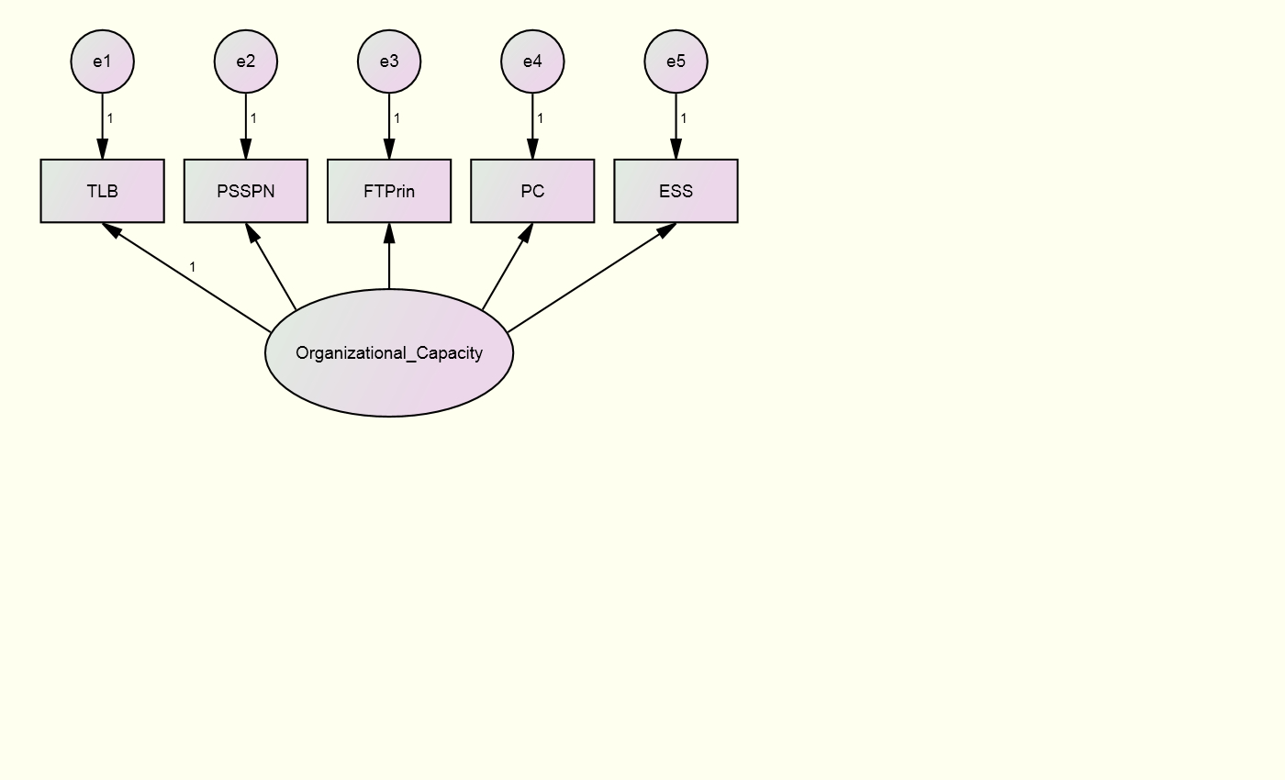
Figure 1: Visual Path Model of Organizational Capacity

Note: e = error; TLB = transformational leadership behavior; PSSPN = principal support for student psychological needs; FTPrin = faculty trust in principal; PC = program coherence; ESS = enabling school structure.

There is existing empirical support for the hypothesized model. The business literature describes the notion of organizational capacity to represent what can be done at the organizational level to achieve performance (Hargreaves, 2011). In this case, it refers to the school’s capital (resources and processes) that bears directly or indirectly on what happens in classrooms (e.g. the use of financial resources; physical and technological resources; the qualifications and deployment of personnel; the quality of a school’s management and leadership; and the school’s governance structure) (Hargreaves, 2011). From an examination of organizational literature, Hargreaves (2011) identifies three concepts comprising organizational capacity of schools: 1) intellectual capital; 2) social capital; and 3) organizational capital.

Intellectual Capital
Intellectual capital refers to the human capital within a school – the knowledge, skills, competencies, and expertise of school members (Stewart, 1997, 2001) – which inform how open school members are with one another and how healthy their interactions are. Measures of openness and healthy interactions are common perspectives to examine a school’s organizational climate (Forsyth, Adams, & Hoy, 2011). Open school climates can be characterized by the degree to which a principal creates an environment that supports and encourages teacher autonomy. Where this is high, teachers are able to have their needs considered and met, contributing to an overall healthy an open organizational climate.
Research on trust demonstrates that open and healthy schools are marked by high levels of faculty trust in the principal. High levels of faculty trust in the principal indicate schools where the faculty perceive the principal to be supportive, open, dependable, competent, and honest. Measuring this level of trust provides a way to examine a school’s organizational climate and enables school personal to analyze strengths and weaknesses, implement or sustain appropriate actions, and increase and improve the school’s organizational capacity.

Social Capital
Examining faculty trust in principal also provides evidence to the existence and health of another concept of organizational capacity: social capital. Social capital is the degree of trust among members of the school [and the degree that trust is reciprocated (Gouldner, 1960)]. Research over the past 15 years has demonstrated trust levels to be an important component to sustained school improvement (Orr, 1999; Bryk & Schneider, 2002; Tschannen-Moran, 2004; Cochrane, 2005; Forsyth, Adams, & Hoy, 2011). Examining the levels of faculty trust in the principal provides evidence of the degree to which school members trust one another.

Organizational Capital
The third concept, organizational capital, refers to the capability of a school’s leaders to deploy and maximize potential intellectual and social capital (Hargreaves, 2011). Organizational capital is commonly observed by its absence, in which organizational members exhibit low levels of interpersonal trust and have few options to mobilize their talents (Hargreaves, 2011). When present, leadership skills can be used to mobilize and enhance intellectual and social capital (Hargreaves, 2011).
Organizational capital comprises the leadership and organizational structure components of a school. Leaders exhibiting enhanced leadership skills demonstrate themselves to be transformational leaders and supportive of student psychological needs. Transformational leaders are leaders who “lift ordinary people to extraordinary heights” (Boal & Bryson, 1988, p. 11) by inspiring followers to perform beyond the level of expectation (Bass, 1985). Leaders who are supportive of student psychological needs demonstrate a focus for teaching and learning rather than general managerial tasks. This type of leader can positively affect the structure of the organization which can affect teachers’ attitudes and behaviors (Hirsch, 1987).
Principals of effective schools provide enabling school structures (Persell, 1982), where the organization and management of a school and classroom positively affect the work and cooperation of personnel within the school (Casanova, 1987). Capturing the degree to which school leaders are transformational and support student psychological needs and the degree to which an enabling school structure is in place provide evidence of the organizational capital within a school.
Effective schools research suggests that schools should exhibit a coherent curriculum (Duckworth, 1987). In schools with strong structures, program coherence (the degree to which instructional programs are coordinated and aligned) exists and its existence is perceived by the staff. Evidence of a school’s program coherence also provides rationale for a school’s organizational capital. In summary, five school-level variables are hypothesized to provide evidence of school organizational capacity: transformational leadership (TLB), principal support for student psychological needs (PSSPN), faculty trust in principal (FTPrin), program coherence (PC), and enabling school structure (ESS) (Figure 1).

Instructional Capacity
Instructional capacity is hypothesized to demonstrate a critical aspect of school performance. It is hypothesized to have direct and indirect effects for student achievement and student psychological health. Instructional capacity explores the resources and process in schools that improve teaching effectiveness and facilitate professional learning. It is proposed that four school-level variables (perceptions of the teacher evaluation system, professional learning community performance, faculty trust in colleagues, and collective teacher efficacy) combine to form a latent variable of instructional capacity (Figure 2).

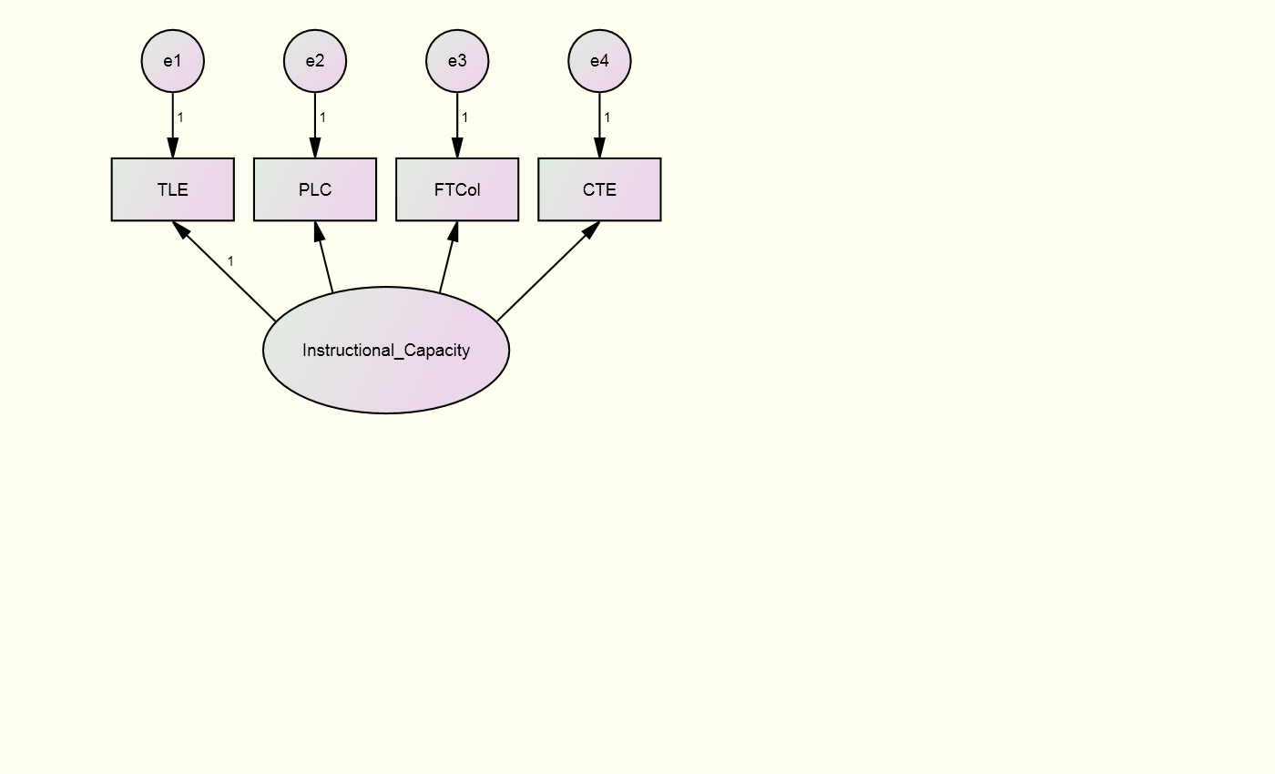
Figure 2: Visual Path Model of Instructional Capacity

Note: e = error; TLE = teacher-leader effectiveness; PLC = professional learning communities; FTCol = faculty trust in colleagues; CTE = collective teacher efficacy.

There is existing empirical support for the hypothesized model. Early research on capacity found that interactions among instructional materials, teachers, and students contributed to the capacity of a school to enhance student learning (Newman & Wahlage, 1995; Newman, King, & Rigdon, 1997; Corcoran & Goertz, 1995; Cohen & Ball, 1999; Adams, 2013). Instructional capacity is based on the availability and use of two interdependent properties: 1) resources in schools that improve teaching effectiveness and 2) social processes that facilitate professional learning (Adams, 2013). Adams (2013) builds on the theoretical understanding of instructional capacity and provides descriptive evidence of the social indicators that measure levels of instructional capacity within schools.
Building instructional capacity is reliant on a school’s ability to improve teaching effectiveness. For instructional resources to advance student learning across classrooms, school processes and conditions must facilitate the continuous study of teaching and learning (Bryk, Sebring, Allensworth, Luppescu, & Easton, 2010; Forsyth, Adams, & Hoy, 2011; Hatch, 2006). This continuous study can be implemented and maintained through the establishment of professional learning communities (PLCs), which build instructional capacity (Andrews, 2011). Barriers to establishing PLC’s exist (e.g. tension between professionals and difficulty in holding colleagues responsible) (Harris, 2011), making it vital that these practices are measured and understood by school staff and leadership to be appropriately implemented. Instructional resources also include the school-level evaluation systems in place that intend to direct and inform teaching practices. Teachers who understand these evaluation processes and see their implementation as helpful have additional instructional resources that facilitate continuous study of teaching and learning.
Social processes within a school must support professional learning for instructional capacity to be sustained. Collective trust is a social condition that facilitates information exchange and knowledge transfer within a school (Adams, 2013), enhancing instructional capacity. The concept of trust refers to the beliefs based on the perceived openness, honesty, benevolence, reliability, and competence of the trustee (Hoy & Tschannen-Moran, 1994). As defined by Forsyth et al. (2011), collective trust is “a stable group property rooted in the shared perceptions and affect about the trustworthiness of another group or individual” (p. 22). Different forms of trust among and between different stakeholders will influence capacity in different ways (Adams, 2013). Cosner (2009) observes that faculty trust in colleagues (FTC) facilitates knowledge creation by supporting professional interactions, sense making between colleagues, and the sharing of understanding of instructional performance. In these ways, high levels of FTC support the social processes within schools.
Instructional capacity is effected by teacher efficacy, a teacher’s belief and confidence in his or her ability to positively promote student learning (Hoy, 2001; Henson, 2001). Efficacious beliefs can be measured within individual teachers and across a school’s collective faculty. Collective efficacy refers to the teacher perceptions that the faculty as a whole can act to positively affect student achievement (Goddard, Hoy, & Woolfolk Hoy, 2001). When collective efficacy is high, the teachers of a school see themselves as an effective agent of change in improving student achievement (Hoy & Miskel, 2002). Collective efficacy is a vital component of instructional capacity because not only can schools and school leaders develop teacher efficacy (Goddard, Hoy, & Woolfolk Hoy, 2000), there is a positive relationship between collective efficacy and student achievement (Hoy, Sweetland, Smith, 2002).
In summary, four variables are hypothesized to provide evidence of a school’s instructional capacity: perceptions of the teacher evaluation system (TLE), professional learning community performance (PLC), faculty trust in colleagues (FTC), and collective teacher efficacy (CTE) (Figure 2). These variables can act as indicators of sustained instructional capacity where school professionals gather information, convert information into knowledge, and use knowledge to adapt practices to changing needs (Adams, 2013).

Learning Capacity
Learning capacity is hypothesized to demonstrate a critical aspect of school performance. It is hypothesized to have direct effects for student achievement and psychological health. Learning capacity explores how the learning context within the school facilitates student intrinsic motivation. It is proposed that five school-level variables (student perceptions of competence support and autonomy support, student trust in teachers, faculty trust in students, and peer academic support) combine to form a latent variable of learning capacity (Figure 3).
Figure 3: Visual Path Model of Learning Capacity
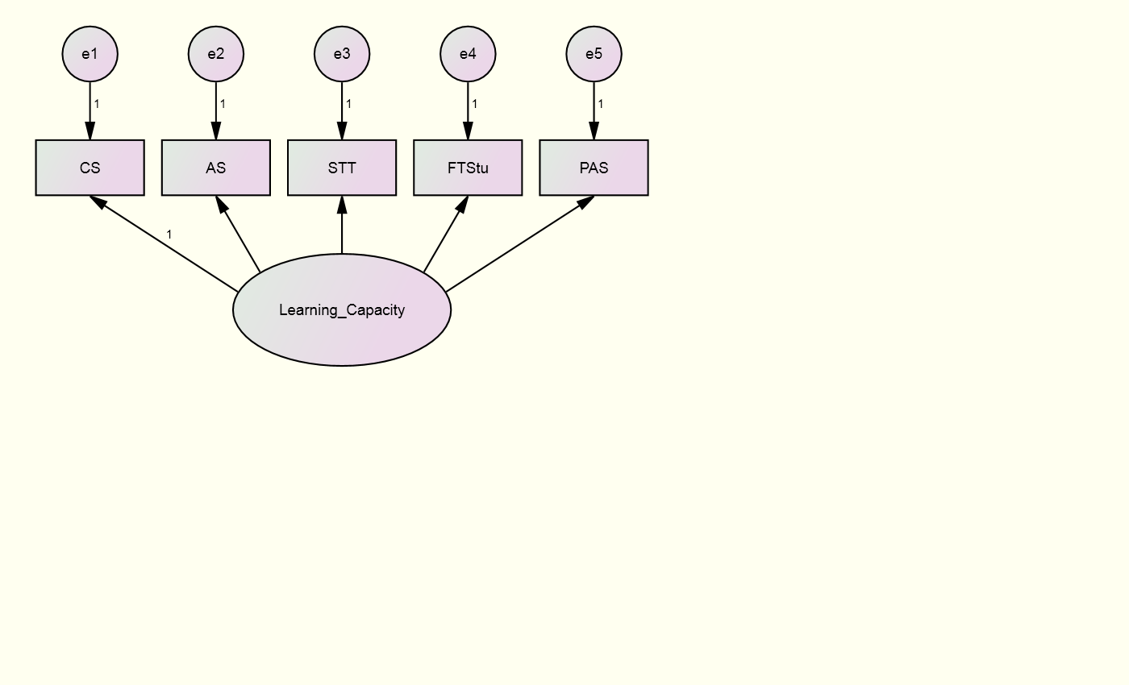

Note: e = error; CS = competence support; AS = autonomy support; STT = student trust in teachers; FTStu = faculty trust in students; PAS = peer academic support.

There is existing empirical support for the hypothesized model. The learning context created by a school can either facilitate or impede student intrinsic motivation (Deci, 1985). Ryan and Deci (2000) have examined the factors that enhance versus undermine intrinsic motivation, self-regulation, and well-being. From this research, three innate psychological needs – competence, autonomy, and relatedness – emerge that, when satisfied, yield enhanced self-motivation and mental health (Ryan & Deci, 2000) and intrinsic motivation (Deci, 1985). When these needs are thwarted, individuals experience diminished motivation and well-being (Ryan & Deci, 2000).
Two areas in which schools can build learning capacity are 1) by supporting the psychological needs of students – the three psychological needs of competence, autonomy, and relatedness – and 2) by enabling a social climate that supports the psychological needs of students. Competence and autonomy support have been shown to be measurable from the student perspective (Assor, Kaplan, & Roth, 2002). As measures of trust provide evidence of the quality of relationships between groups (Hoy & Tschannen-Moran, 1999), student trust in teachers can provide evidence to the relational support students feel in individual schools. When faculty perceive students as trustworthy, they are more inclined to learn and grow professionally (Tschannen-Moran, 2004) and use autonomy-supportive practices. Understanding and measuring peer academic support contributes to a school’s social climate and enhances overall learning capacity as it can enhance or deter a student’s academic success (Wentzel & Caldwell, 2007; Ream & Rumberger, 2008). In summary, five variables are hypothesized to provide evidence of a school’s learning capacity: competence support (CS), student trust in teachers (STT), autonomy support (AS), faculty trust in students (FTStu), and peer academic support (PAS) (Figure 3).

Home Capacity
Home capacity is hypothesized to demonstrate a critical aspect of school performance. It is hypothesized to have indirect effects for student achievement and psychological health. Home capacity explores how a student’s home environment engages, affirms, and interacts with the school. It is proposed that five school-level variables (school outreach, parent social network, parent trust in school, home academic emphasis, and faculty trust in parents) combine to form a latent variable of home capacity (Figure 4).

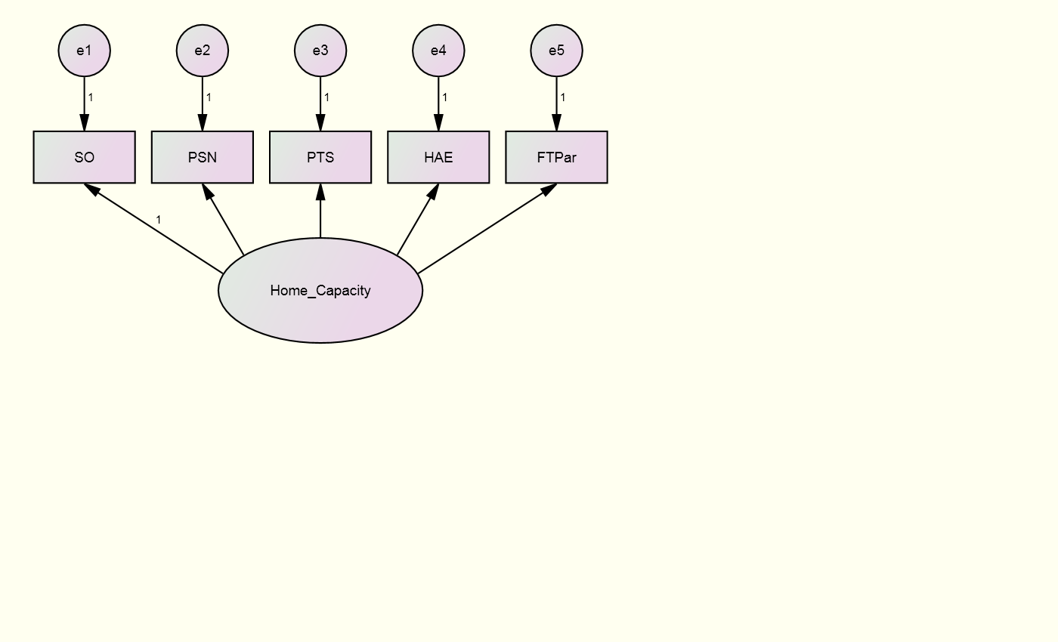
Figure 4: Visual Path Model of Home Capacity

Note: e = error; SO = school outreach; PSN = parent social network; PTS = parent trust in school; HAE = home academic emphasis; FTPar = faculty trust in parents

There is existing empirical support for the hypothesized model. Families and communities play an essential role in the success of schools and in the life chances of children. A student’s home environment can engage, affirm, and value education. Schools can direct resources and align policies and practices to affect the home capacity (Simon, 2004; Adams, Forsyth, & Mitchell, 2009), which can affect student academic performance and psychological development.
The way in which schools reach out to parents and establish trusting relationships can effect parent involvement and shape how they emphasize academics at home (Simon, 2004; Bower, Bowen, & Powers, 2011). Studies on school outreach have found that school environments more responsive and supportive of parents are integral to raising achievement (Roderick et al., 1998). Trust measures the quality of social interactions between individuals and groups; faculty trust in parents has been found to be positively related to achievement (Tschannen-Moran & Hoy, 2000) and parent trust in the school has been found to be positively related to achievement and to parent influence (Forsyth, Barnes, & Adams, 2006).
Home academic emphasis studies have found that the levels at which children receive home support for their work in school is critical to academic success (Henderson & Berla, 1994; Roderick et al., 1998; Russell, 1996). Social network analysis provides a precise way to define important social concepts and a theoretical alternative to the assumption of independent social actors (Wasserman & Faust, 1994). Research on the importance of parent social networks has demonstrated that the size of a parent’s social network predicts the degree to which parents are involved at home or at school (Sheldon, 2002). Parental social networks can function as a resource for schools and teachers (Morgan & Sorenson, 1999; Sheldon, 2002), increasing a school’s home capacity and ability to positively affect student achievement. In summary, five variables are hypothesized to provide evidence of a school’s home capacity: school outreach (SO), parent social network (PSN), parent trust in school (PTS), home academic emphasis (HAE), and faculty trust in parents (FTPar) (Figure 4).

Student Psychological Health
Student psychological health represents a latent variable that captures and represents some of the broad goals of education. Rothstein (2008) outlined eight broad goals expected from American education. Current accountability systems often rely exclusively on school tests scores, largely in reading and mathematics. These achievement scores represent, albeit in a limited way, two of the eight broad goals: basic academic knowledge and skills and critical thinking and problem solving. Student psychological health incorporates elements from at least five of the broad goals: basic academic knowledge and skills, critical thinking and problem solving, social skills and work ethic, citizenship and community responsibility, and emotional health. It is hypothesized that the construct of student psychological health will have direct effects for student achievement. It is proposed that five school-level variables (self-regulated learning, math efficacy, reading efficacy, social well-being, and student identification with school) combine to form a latent variable of student psychological health (Figure 5).
Figure 5: Visual Path Model of Student Psychological Health
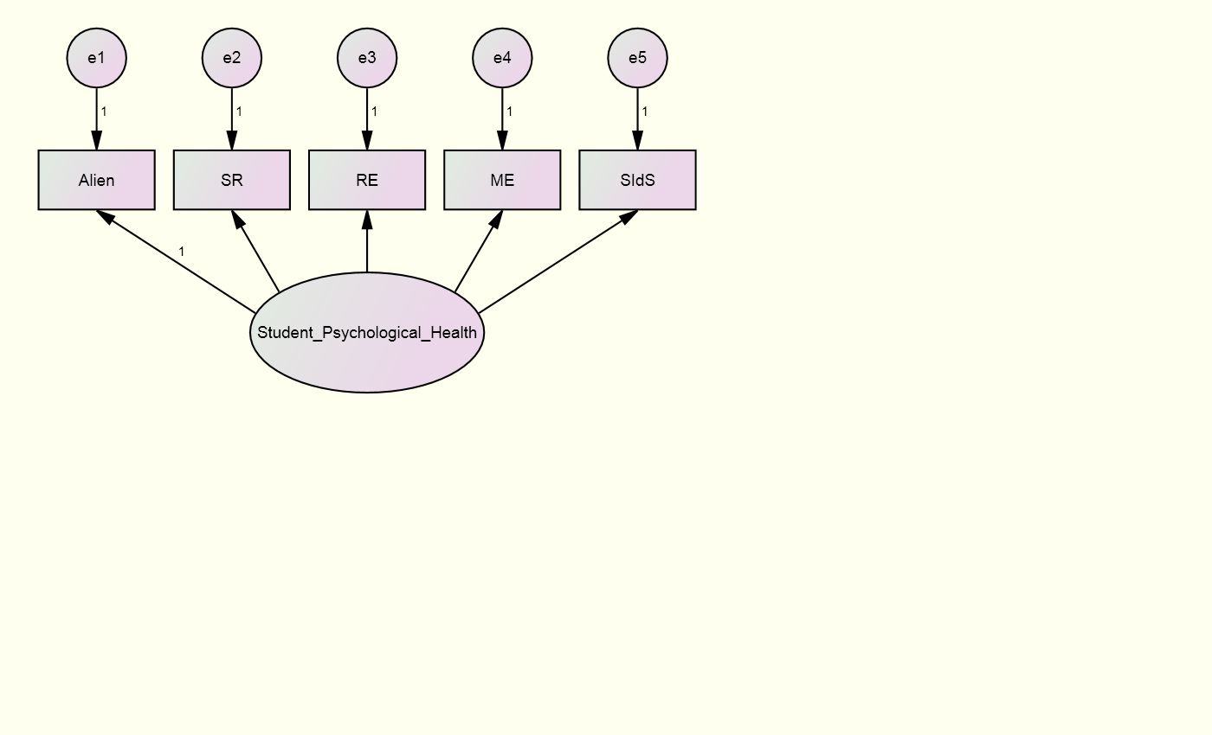

Note: e = error; Alien = alienation; SR = self-regulated learning; RE = reading efficacy; ME = math efficacy; SIdS = student identification with school

There is existing empirical support for the hypothesized model. The four capacities described previously (organizational, instructional, learning, and home and community) depict essential conditions for effective teaching, quality learning, and school improvement (Bain, Walker, & Chan, 2011). Together, these conditions work to accomplish the varied goals expected of schools (Rothstein, 2008): they support student self-regulated learning, they increase and support student academic efficacy, promote the social well-being of students (Mau, 1992), and promote positive identification with school (Voelkl, 1997). In addition, all of these variables represent school-level elements that can be observed, studied, and acted on by school-level personal. These conditions and the knowledge of them enable stakeholders to act in ways that promote long-term student psychological health and positive future outcomes (Bandura, 1996). In summary, five variables are hypothesized to provide evidence of a school’s support of student psychological health: student self-regulated learning (SR), student math efficacy (ME), student reading efficacy (RE), social well-being (Alien), and student identification with school (SIdS) (Figure 5).

Hypothesized Structural Equation Model
The hypothesized structural equation model (SEM) is described graphically in Figure 6. It is hypothesized that: a school’s organizational capacity relates positively to home, learning, and instructional capacity; home capacity and instructional capacity relate positively to learning capacity; learning capacity and instructional capacity are predictive of higher levels of student psychological health and math achievement; and student psychological health is predictive of higher levels of math achievement.
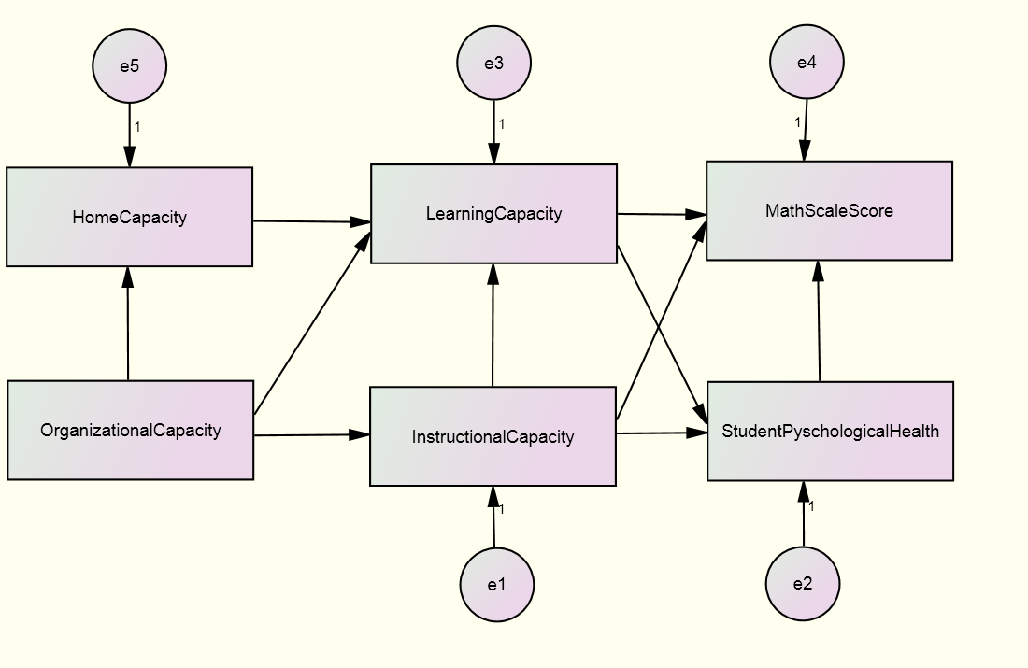
Figure 6: Visual Path Model of the Structural Equation Model

Note: e = error

Chapter 4: Conceptualization and Measurement

Use of Surveys
Public administration literature has consistently questioned the rationale for using surveys as a measure of public organization performance, particularly in comparison with more objective and official measures (e.g. test scores, state accountability ratings) (Brown & Coulter, 1983; Kelly & Swindell, 2002, 2003; Stipak, 1979, 1980; Swindell & Kelly, 2005). However, recent evidence supports strong links between subjective and objective measures of public organization performance (James, 2009; Licari, McLean, & Rice, 2005; Van Ryzin, Immerwahr, & Altman, 2008). Research specific to surveying school stakeholders found that official measures of school performance (e.g. test scores, state accountability ratings) are significant and important predictors of aggregate stakeholder perceptions collected from surveys, even after controlling for school and student characteristics (Charbonneau & Van Ryzin, 2012). Charbonneau and Van Ryzin (2012) conclude that school stakeholders form their judgments in ways that correspond closely with officially measured school performance. These findings support the use of survey data to aggregate stakeholder perceptions in an effort to describe school performance.

Organizational Capacity
As explained in the theoretical framework, measures of leadership (transformational leadership and principal support for student psychological needs), organizational climate (faculty trust in the principal), and organizational structure (enabling school structure and program coherence) provide evidence of a school’s organizational capacity. The rationale for using these variables as indicators of organizational capacity depends on the relationship with the latent construct. The lack of shared variance would indicate little to no relationship among the observable dimensions of the capacity (Law, Wong, & Mobley, 1999). Empirical data need to support the theoretical relationship between a school’s leadership, organizational climate, organizational structure, and organizational capacity.

Transformational Leadership
The transformational leadership measure was based on the Transformational Leadership Behavior Scale (Podsakoff, 1990). Theory and evidence suggest that transformational leadership positively influences organizational citizenship behaviors (Podsakoff, 1990) and that transformational leaders “lift ordinary people to extraordinary heights” (Boal & Bryson, 1988, p.11) by causing followers to perform beyond the level of expectation (Bass, 1985). Transformational leadership is marked by seven key behaviors: 1) Articulating a vision, 2) modeling, 3) fostering group cohesion, 4) setting high performance expectations, 5) providing individualized support, 6) challenging assumptions and the status quo, and 7) recognizing outstanding work (Podsakoff, 1990). These factors are measured with seven items that use a six-point Likert response set ranging from strongly disagree coded as 1 to strongly agree coded as 6 and can be found in Appendix B. Tests of the measure found strong internal validity and strong reliability, as measured by Cronbach’s alpha, at 0.94.

Principal Support for Student Psychological Needs
The principal support for student psychological needs measure was based on measures of instructional leadership. This measure gauges principal concerns for and a focus on teaching and learning rather than general managerial tasks. Principals who are instructional leaders support teachers so they can improve their technical knowledge and ability to facilitate student learning. Teacher perceptions of these qualities are measured with eleven items that use a six-point Likert response set ranging from strongly disagree coded as 1 to strongly agree coded as 6 and can be found in Appendix B. Tests of the measure found strong internal validity, with items loading on a single factor and coefficients ranging from 0.77 to 0.94, and strong reliability, as measured by Cronbach’s alpha, at 0.97.

Faculty Trust in Principal
Faculty trust measures are based on the Omnibus Trust Scale. Trust is an individual’s or group’s willingness to be vulnerable to another party based on the confidence that the latter party is benevolent, reliable, competent, honest, and open. Thus, vulnerability, benevolence, reliability, competence, honesty, and openness characterize measures of faculty trust in the principal (Hoy & Tschannen-Moran, 1999). Faculty trust in the principal (FTP) measures cooperative interactions between the faculty and the principal with seven items that use a six-point Likert response set ranging from strongly disagree coded as 1 to strongly agree coded as 6. Questions ask faculty about the support, openness, dependability, competence, and honesty of the principal and can be found in Appendix B. Higher levels of principal trust indicate that faculty respect and trust the leadership of the principal. Field tests of the measure found strong internal validity with item loadings ranging from 0.75 to 0.93, and strong reliability, as measured by Cronbach’s alpha, ranging from 0.90 to 0.98 (Hoy & Tschannen-Moran, 1999).

Enabling School Structure
Enabling school Structure (ESS) is measured with the scale developed by Hoy and Sweetland (2000, 2001), which accounts for how formalization (rules and regulations) and centralization (hierarchical control) are carried out in the school. Faculty respond to the degree that school authority helps rather than impedes collective action with twelve items that use a six-point Likert response set ranging from strongly disagree coded as 1 to strongly agree coded as 6. These items can be found in Appendix B. Higher scores reflect more enabling school structures, and conversely, lower scores represent more hindering structures. Results of field tests show high item reliability, as measured by Cronbach’s alpha, at around 0.90 and the construct and predictive ability have been strongly supported in a number of studies (Hoy & Sweetland, 2000, 2001).

Program Coherence
Program coherence measures the degree to which faculty feel the instructional programs at their school are coordinated with each other and with the school’s mission. Items originate from the Consortium on Chicago School Research (Newmann, Smith, Allensworth, & Bryk, 2001). Program coherence measures the degree to which faculty find instructional materials to be consistent within and across grades and if there is sustained attention to quality program implementation. These perceptions are captured with six items that use a six-point Likert response set ranging from strongly disagree coded as 1 to strongly agree coded as 6, which can be found in Appendix B . High levels indicate that school programs are coordinated and consistent with goals for student learning. Tests of the measure found strong internal validity and strong reliability, as measured by Cronbach’s alpha, ranging from .84-.90.

Instructional Capacity
As explained in the theoretical framework, measures of the resources (the perceptions of the teacher evaluation system and the performance of professional learning communities) and the social processes (faculty trust in colleagues and collective teacher efficacy) within a school provide evidence of a school’s instructional capacity. The argument for using these variables as indicators of instructional capacity depends on their empirical relationship with the latent construct. The lack of shared variance would indicate little to no relationship among the observable dimensions of the capacity (Law, Wong, & Mobley, 1999). Empirical data need to support the theoretical relationship between a school’s resources, social processes, and instructional capacity.

Perception of Teacher Evaluation System
Perception of the teacher evaluation system assesses teacher perception of their understanding of the evaluation rubric and process they are subject to within the district, the implementation of the rubric and process, and the importance of the rubric and process. Faculty respond to twelve items that use a six-point Likert response set ranging from strongly disagree coded as 1 to strongly agree coded as 6, which can be found in Appendix C. Such perceptions provide data on which to base professional learning opportunities and on which to assess the strength of the evaluation process as a resource to a school (Bogart, 2013). Tests of the measure found strong internal validity and strong reliability, as measured by Cronbach’s alpha, at 0.88.

Professional Learning Community Performance
Professional learning community (PLC) performance assesses the degree to which faculty feel that the inquiry team structure enables a team to accomplish its task. These perceptions are measured with fifteen items that use a six-point Likert response set ranging from strongly disagree coded as 1 to strongly agree coded as 6. These items can be found in Appendix C. High levels of PLC performance indicate that the inquiry team structures are coordinated and consistent with its goals for student learning. Survey items are adapted from Talbert, Cor, Chen, Kless, and McLaughlin (2012), where reliability ranged from 0.82 to 0.96. Tests of this measure found strong internal validity with item loadings ranging from 0.72 to 0.92 and strong reliability, as measured by Cronbach’s alpha, at 0.97.

Faculty Trust in Colleagues
Faculty trust measures are based on the Omnibus Trust Scale (Hoy and Tschannen-Moran, 1999). Trust is an individual’s or group’s willingness to be vulnerable to another party based on the confidence that the latter party is benevolent, reliable, competent, honest, and open. Thus, vulnerability, benevolence, reliability, competence, honesty, and openness characterize measures of faculty trust in colleagues (Hoy & Tschannen-Moran, 1999). Faculty trust in colleagues (FTC) measures the quality of relationships among teachers with a eight items that use a six-point Likert response set ranging from strongly disagree coded as 1 to strongly agree coded as 6. Questions ask faculty about their colleagues’ openness, commitment to students, honesty, competence in the classroom, cooperation with each other, and reliability and can be found in Appendix C. Higher faculty trust suggests that faculty perceive their colleagues as being open, honest, reliable, competent, and benevolent in their thoughts and actions. Field tests found good internal validity and reliability estimates ranging from 0.90 to 0.94 (Hoy & Tschannen-Moran, 1999).

Collective Teacher Efficacy
The collective teacher efficacy scale is based on the Short Form of the Collective Efficacy Scale developed by Goddard, Hoy, and Woolfolk (2002). Collective teacher efficacy measures the shared perceptions of the faculty that their efforts as a whole will have positive effects on students. These perceptions are measured with twelve items that use a six-point Likert response set ranging from strongly disagree coded as 1 to strongly agree coded as 6. These items can be found in Appendix C. The internal validity was strong at 0.64 and the reliability, as measured by Cronbach’s alpha, was strong at 0.74 (Goddard, 2002).

Learning Capacity
As explained in the theoretical framework, measures of the school’s support of psychological needs (competence support, student trust in teachers, autonomy support, peer academic support, and faculty trust in students) and the school’s social climate (peer academic support) provide evidence of a school’s learning capacity. The rationale for using these variables as indicators of learning capacity depends on the relationship with the latent construct. The lack of shared variance would indicate little to no relationship among the observable dimensions of the capacity (Law, Wong, & Mobley, 1999). Empirical data need to support the theoretical relationship between a school’s support for student psychological needs, social climate, and learning capacity.

Competence Support
The competence support measure was based on Lee, Smith, Perry, and Smylie’s measure of academic press (1999). Competence support measures student views of their teachers’ efforts to push them to higher levels of academic performance and teachers’ expectations of student effort and participation. Seven items are used to measure competence support, using a four-point Likert response set ranging from strongly disagree coded as 1 to strongly agree coded as 4. These items can be found in Appendix D. High levels of competence support indicate that most teachers press all students toward academic achievement. The measure has strong internal validity and strong reliability, as measured by Cronbach’s alpha, ranging from 0.79 to 0.93.

Student Trust in Teachers
The student trust in teachers (STT) measure was based on Forsyth, Adams, and Hoy’s trust scale (2011). Trust is an individual’s or group’s willingness to be vulnerable to another party based on the confidence that the latter party is benevolent, reliable, competent, honest, and open. Thus, vulnerability, benevolence, reliability, competence, honesty, and openness characterize measures of faculty trust in the principal (Hoy & Tschannen-Moran, 1999). Students are asked about the reliability of teacher actions, teacher concern for students, teacher competence in their teaching, teacher willingness to help students, teacher honest, and teacher dependability. Ten items are used to measure STT, using a four-point Likert response set ranging from strongly disagree coded as 1 to strongly agree coded as 4. These items can be found in Appendix D. Higher levels of student trust suggest that students perceive teachers as being open, honest, reliable, competent, and benevolent in their social interactions with students. Tests of the measure found strong internal validity and strong reliability, as measured by Cronbach’s alpha, at 0.90.

Autonomy Support
The autonomy support measure was based on Lee, Smith, Perry, and Smylie’s measure of academic press (1999). Autonomy support measures the degree to which students perceive that teachers allow criticism, encourage independent thinking, foster relevance, and provide choice. Seven items are used to measure autonomy support, using a four-point Likert response set ranging from strongly disagree coded as 1 to strongly agree coded as 4. These items can be found in Appendix D. Tests of the measure found internal validity of item loadings to range from 0.37 to 0.63 and good reliability, as measured by Cronbach’s alpha, at 0.71.

Faculty Trust in Students
Faculty trust measures are based on the Omnibus Trust Scale. Trust is an individual’s or group’s willingness to be vulnerable to another party based on the confidence that the latter party is benevolent, reliable, competent, honest, and open. Thus, vulnerability, benevolence, reliability, competence, honesty, and openness characterize measures of faculty trust in colleagues (Hoy & Tschannen-Moran, 1999). Faculty trust in students (FTS) measures the quality of the student-teacher relationship with five items that use a six-point Likert response set ranging from strongly disagree coded as 1 to strongly agree coded as 6. Questions ask faculty about their perception of the openness, honesty, reliability, competence, and benevolence of students and can be found in Appendix D. Higher faculty trust indicates the faculty perceive students as responsible learners. Field tests of the measure support the construct and discriminant validity of the concept and reveal good item reliability, as measured by Cronbach’s alpha, ranging from 0.90 to 0.98 (Hoy & Tschannen-Moran, 2003).

Peer Academic Support
The peer academic support measure was based on Murdock’s (1994, 1999) pilot study on an independent sample and reconfirmation in a later study. Peer academic support refers to a set of descriptive characteristics present in a student’s associative peer group. Thee facets of the construct include: 1) Peer Academic Aspiration, 2) Peer Resistance to School Norms, and 3) Peer Academic Support. Students respond to four items using a four-point Likert response set ranging from strongly disagree coded as 1 to strongly agree coded as 4. These items can be found in Appendix D. Murdock’s original scales demonstrated strong internal validity and good reliability, as measured by Cronbach’s alpha, at 0.74, 0.73, and 0.70, respectively.

Home Capacity
As explained in the theoretical framework, measures of perceptions from parents (school outreach, parent social network, and parent trust in school), students (home academic emphasis), and teachers (faculty trust in parents) provide evidence of a school’s home capacity. The rationale for using these variables as indicators of home capacity depends on the relationship with the latent construct. The lack of shared variance would indicate little to no relationship among the observable dimensions of the capacity (Law, Wong, & Mobley, 1999). Empirical data need to support the theoretical relationship between a school’s outreach to parents, strength of parent social networks, home academic emphasis, levels of trust parents have in teachers, levels of trust faculty have in parents, and home academic emphasis.

Parent Social Network
The measurement of parent social network (PSN) is adapted from the work of Wasserman and Faust (1994) and Blake and Mouton (1960). PSN measures the connectedness of parents to other parents within a school community. Using a one item, nine point scale from 1 (zero parent interactions) to 9 (nine or more parent interactions), parents indicate, in a straight forward manner, how many sets of parents they know and with whom they interact. After identifying the number of parent interactions, parents write the appropriate number of initials of parent names for the number of interactions they identified. This measure can be found in Appendix E. There is evidence to support measures that capture how relationships among parents compliment the school culture and provide students with a backbone of supportive relationships to build and grow upon (Blake & Mouton, 1960; Wasserman & Faust, 1994).

School Outreach
The school outreach measure was based on Roderick, Stone, Arney, Chiong, DaCosta, and Waxman’s (1999) school outreach measure. School outreach measures the pattern of communication and interactions between parents and school authorities. Questions ask parents about how well the school communicates information, about parent opportunities to provide feedback to school authorities, and about parent feelings of belonging in the school community. Eight items use a six-point Likert response set ranging from strongly disagree coded as 1 to strongly agree coded as 6 and can be found in Appendix E. Higher perceived school outreach suggests that parents perceive school-parent communication and interactions as open and supportive. Previous administrations of the scale produced strong internal validity and strong reliability, as measured by Cronbach’s alpha, falling around 0.85.

Parent Trust in School
The parent trust in school (PTS) measure was based on Forsyth, Barnes, and Adams’ scale development (2006). Trust is an individual’s or group’s willingness to be vulnerable to another party based on the confidence that the latter party is benevolent, reliable, competent, honest, and open. Thus, vulnerability, benevolence, reliability, competence, honesty, and openness characterize measures of faculty trust in the principal (Hoy & Tschannen-Moran, 1999). PTS measures the quality of relationships between parents and teachers and the school. Questions ask parents about teacher academic standards for all students, teacher concern for students, teacher communication with parents, teacher competence in teaching, teacher honesty, and teacher reliability in their actions and commitments. Parent perceptions are measured with ten items on a six-point Likert response set ranging from strongly disagree coded as 1 to strongly agree coded as 6; these items can be found in Appendix E. Higher parent trust suggests that parents perceive teachers as being open, honest, reliable, competent, and benevolent. Reliability, as measured by Cronbach’s alpha, is 0.95, suggesting strong internal consistency among items. Factor analysis supports the construct validity of the scale (Forsyth, Barnes, & Adams, 2006).

Home Academic Emphasis
The home academic emphasis (HAE) measure was based on the measure available from the Consortium on Chicago School Research (2007). HAE asks students to identify the degree to which they communicate with their parents about their academic work. High levels indicate that the parents regularly talk to students about what they are doing in school and how well they are performing. These student perceptions are measured with five items on a four-point Likert response set ranging from strongly disagree coded as 1 to strongly agree coded as 4; these items can be found in Appendix E. Reliability, as measured by Cronbach’s alpha, is 0.77, suggesting strong internal consistency among the items.

Faculty Trust in Parents
The faculty trust in parents measure was based on the Omnibus Trust Scale. Trust is an individual’s or group’s willingness to be vulnerable to another party based on the confidence that the latter party is benevolent, reliable, competent, honest, and open. Thus, vulnerability, benevolence, reliability, competence, honesty, and openness characterize measures of faculty trust in colleagues (Hoy & Tschannen-Moran, 1999). Faculty trust in parents measures the quality of social interactions between faculty and parents. Questions ask faculty about parents’ reliability in their commitments, parent support, parent honesty, and parent openness. High levels of faculty trust suggest that teachers perceive parents as being open, honest, reliable, competent, and benevolent in their social interactions with faculty. These perceptions are measured with five items on a six-point Likert response set ranging from strongly disagree coded as 1 to strongly agree coded as 6; these items can be found in Appendix E. Reliability, as measured by Cronbach’s alpha, is 0.95, suggesting strong internal consistency among the items for both scales. The structure of the factor analysis supports the construct validity of the scale (Forsyth, Adams, & Forsyth, 2011).

Student Psychological Health
As explained in the theoretical framework, measures of academic motivation (self-regulated learning), academic efficacy (self-efficacy in reading and math), social well-being (levels of student alienation), and school attachment (student identification with school), provide evidence of school support of student psychological health. The rationale for using these variables as indicators for student psychological health depends on the relationship with the latent construct. The lack of shared variance would indicate little to no relationship among the observable dimensions of the capacity (Law, Wong, & Mobley, 1999). Empirical data need to support the theoretical relationship between student academic motivation, academic efficacy, social well-being attachment to school, and student psychological health.

Self-Regulated Learning
Self-regulated learning (SRL) is the belief in one’s self-regulatory capabilities. It is an important predictor of student self-regulatory skills and strategies across academic domains (Bandura, Barbaranelli, Caprara, & Pastorelli, 1996, 2001; Bandura, Barbaranelli, Caprara, Gerbino, & Pastorelli, 2003; Bong, 2001; Zimmerman & Bandura, 1994; Zimmerman, Bandura, & Martinez-Pons, 1992; Zimmerman & Martinez-Pons, 1990). Student self- regulation is related to motivation and achievement for students at all levels of schooling in diverse academic areas. The SRL measure is adapted from Blackwell, Trzesniewski, and Dweck’s (2007) work on Implicit Theories of Intelligence. Eight items are used to measure student perceptions of their self-regulatory capabilities, using a four-point Likert response set ranging from strongly disagree coded as 1 to strongly agree coded as 4. These items can be found in Appendix F. Tests of this measure show internal consistency, with alpha coefficients ranging from 0.78 to 0.84, Confirmatory factor analysis tests of this measure demonstrate the fit of all items to the latent construct of self-regulated learning (CFI = 0.98, RMSEA = 0.05).

Self-Efficacy in Math and Reading
The math and reading self-efficacy measure is adapted from the work of Zimmerman (1995) and Dorman (2001). Academic efficacy measures personal judgments of one’s capabilities to organize and execute courses of action to attain designated levels of achievement. The items assess student perceptions of their competence to do specific activities. Students respond to ten items on a four-point Likert response set, ranging from strongly disagree coded as 1 to strongly agree coded as 4. These items can be found in Appendix F. Tests of the measure suggest strong internal consistency among the items, with reliability, as measured by Cronbach’s alpha, at 0.88.

Alienation
The alienation measure is adapted from Hoy (1971) and Kolesar’s (1967) work, studying the four dimensions of alienation (Mau, 1992; Seeman, 1959). Alienation’s four dimensions are normlessness, meaninglessness, isolation, and powerlessness. Normlessness refers to an individual’s high expectation that socially unapproved behaviors are required to achieve given goals. Meaninglessness (self-estrangement) refers to the loss of pride in one’s work or activity. Isolation refers to an individual’s assigning low reward value to goals or beliefs that are typically highly valued in a given society. Powerlessness is an individual’s expectation that his own behavior cannot determine the occurrence of the outcomes he seeks. Students respond to eight items on a four-point Likert response set, ranging from strongly disagree coded as 1 to strongly agree coded as 4. These items can be found in Appendix F. Tests of the measure suggest internal consistency among the items, with reliability, as measured by Cronbach’s alpha, at 0.85, and factor loadings ranging from 0.45 to 0.74.

Student Identification with School
The student identification with school measure has been used extensively in empirical studies (Voelkl, 1996, 1997). Student identification with school measures student sense of belonging and perceived value in receiving an education. Eight items ask students if they feel proud of being part of their school, if they value learning, if they feel teachers care about students, and if they feel people at the school listen to what they have to say. These items use a four-point Likert response set ranging from strongly disagree coded as 1 to strongly agree coded as 4. These items can be found in Appendix F. Higher student identification suggests that students feel connected to other students and to adults in the school and that students value the importance of an education. Reliability, as measured by Cronbach’s alpha, produces strong internal consistency, with a value of 0.84. Internal validity has been found to be strong, with factor loadings ranging from 0.40 to 0.70.

Student Achievement
NCLB largely conceptualized student achievement as student performance on state-mandated reading and math tests. Student scores on math Oklahoma Core Curriculum Tests (OCCT) during the 2012-2013 school year are used as a measure of student achievement.

Chapter 5: Method

Data Source
Data were collected from school site principals, faculty members, parents, and students in 71 urban schools during the 2012-2013 school year. Forty family units (students and parents) were randomly sampled from the 5th, 8th, 9th, and 11th grades. If a grade had less than 55 students, surveys were given to every student and parent within that grade. Student surveys were administered during the school day by school personnel. Students were randomly assigned to one of two student surveys (survey A or survey B) to allow for shorter surveys that could be completed in about ten minutes. Parent surveys were distributed to students and returned in a postage paid envelope, or returned to the school in person or in the postage paid envelope. Each site principal received an electronic survey through email using Qualtrics. All faculty members from all grades were randomly assigned to one of two online faculty surveys (survey A or survey B), which were delivered through email using Qualtrics. This made it possible to complete each teacher survey in about fifteen minutes.

Data Collection and Reduction
Survey data from principals and teachers were collected using online surveys created in Qualtrics. Survey data from students and their parents was collected using paper surveys. Students completed the surveys in school and took the parent survey home. Parents could return their completed survey to the school in a sealed envelope provided to them or through the mail in an addressed postage-paid-envelope provided to them. Survey results were scanned into survey software, Remark OMR and were uploaded into SPSS. Survey items were factor analyzed in SPSS.
Individual teacher data were aggregated to the school level to determine average levels of transformational leadership behavior (TLB), a principal’s support for student psychological needs (PSSPN), faculty trust in the principal (FTPrin), program coherence (PC), enabling school structure (ESS), teacher-leader effectiveness (TLE), professional learning communities (PLC), faculty trust in colleagues (FTCol), collective teacher efficacy (CTE), faculty trust in students (FTStu), and faculty trust in parents (FTPar). Individual student data were aggregated to the school level to determine average levels of alienation (Alien), self-regulated learning (SR), reading efficacy (RE), math efficacy (ME), student identification with school (SIdS), competence support (CS), autonomy support (AS), student trust in teachers (STT), peer academic support (PAS), and home academic emphasis (HAE). Individual parent data were aggregated to the school level to determine average levels of school outreach (SO), parent social networks (PSN), and parent trust in school (PTS).

Data Analysis
A confirmatory factor analysis (CFA) was specified and tested in Amos 7.0 for all hypothesized capacities, using maximum likelihood estimation because the data were distributed normally. The rationale for using the variables as observable factors for each capacity depended on the relationships with the latent constructs. Model fit indices (RMSEA, CFI, and TLI) and parameter estimates were used to determine if the sample data align with the hypothesized specification of each capacity (Anderson & Gerbing, 1988; Anderson, Gerbing, & Hunter, 1987; Browne, MacCallum, Kim, Anderson, & Glaser, 2002; Iacobucci, 2009). The lack of shared variance would indicate little to no relationship among the observable dimensions of the capacity (Law, Wong, & Mobley, 1999). All hypothesized capacities were modeled as endogenous variables and treated as latent conditions observable through the observed variables. Modeling each capacity as a latent construct allowed for measurement error to be accounted for in the analysis. Unit loading identification was used by constraining the path residuals to 1.0 (Schumacker & Lomax, 2004).
Each CFA met the assumptions of multivariate analysis. Analysis for each CFA included a correlation table with means and standard deviations, model fit indices, chi square, levels of significance, degrees of freedom, parameter estimates, and squared multiple correlations (SMCs). Post-hoc modifications were explored to address poor-fitting indices where applicable. The CFA results provide evidence for the properties of the different school capacities and student psychological health. The results supported proceeding to an examination of the path structure model (Anderson & Gerbing, 1988; Anderson et al., 1987; Browne et al., 2002; Iacobucci, 2009).
Structural Equation Modeling (SEM) was used to examine the proportion of variance accounted for in the relationships between the capacities (Hu & Bentler, 1999). To reduce the complexity and number of paths of the overall SEM, each latent variable was respecified as an observed variable. For organizational capacity, learning capacity, student psychological health, and instructional capacity, this was accomplished by averaging the observed variables of each latent construct and then using that value as each school’s capacity measure. Home capacity combines measures collected from students and parents, surveys which did not use the same response scales. To address this, z-scores were calculated for each observed variable within home capacity and then averaged to form the construct used in the SEM. Analysis of the SEM included a correlation table with means and standard deviations, model fit indices, chi square, levels of significance, degrees of freedom, parameter estimates, and squared multiple correlations (SMCs). Post-hoc modifications were explored to address poor-fitting paths where applicable.

Chapter 6: Results

Confirmatory Factor Analysis

Organizational Capacity
Measures of teacher perceptions of school leadership [transformational leadership behavior (TLB) and support for student psychological needs (PSSPN)], organizational climate [faculty trust in principal (FTPrin)], and organizational structure [enabling structure (ESS) and program coherence (PC)] were hypothesized as factors of a school’s organizational capacity (Figure 7). A correlation table with means and standard deviations is shown in Table 1. Model fit indices, parameter estimates, and squared multiple correlations (SMCs) are shown in Table 2 and Figure 7. Model fit indices suggest a marginal fit between the hypothesized model and the sample data (RMSEA = 0.629, CFI = 0.941, and TLI = 0.881). A statistically significant χ² (χ² = 24.061, p < 0.001, df = 5) suggests there was a difference between the specified hypothesized model and the sample variance-covariance matrix derived from the data (Schumacker & Lomax, 2004; Schumaker & Lomax, 2004). Post-hoc modifications were explored to address poor-fitting indices.

Table 1: Correlations of the Observed Variables of Organizational Capacity
Observed variable | 1 | 2 | 3 | 4 | 5
- Transformational Leadership Behavior | 1 | - | - | - | -
- Principal Support for Student Psychological Needs | 0.604** | 1 | - | - | -
- Faculty Trust in Principal | 0.702** | 0.760** | 1 | - | -
- Program Coherence | 0.355** | 0.618** | 0.684** | 1 | -
- Enabling School Structure | 0.599** | 0.750** | 0.941** | 0.748** | 1
Note: N = 71; M1 = 4.54, SD1 = 0.70; M2 = 4.25, SD2 = 0.62; M3 = 4.47, SD3 = 0.86; M4 = 3.43, SD4 = 0.64; M5 = 4.26, SD5 = 0.67.
** = p < 0.01; * = p < 0.05

Table 2: Regression Coefficients and Model Fit Indices for Hypothesized Organizational Capacity CFA
Observed variable | β | B | SE | SMC
TLB | 0.680 | 1.000 | 0.047 | 0.463
PSSPN | 0.783 | 1.018 | 0.026 | 0.613
FTPrin | 0.977 | 1.759 | 0.019 | 0.955
PC | 0.727 | 0.979 | 0.035 | 0.528
ESS | 0.963 | 1.340 | 0.012 | 0.928
Fit Index | Criteria |  | Model fit estimates
χ² | Non-significant |  | 24.061 (p < 0.001, df = 2)
RMSEA | < 0.06 |  | 0.629
CFI | > 0.95 |  | 0.941
TLI | > 0.95 |  | 0.881
Note: TLB = transformational leadership behavior; PSSPN = principal support for student psychological needs; FTPrin = faculty trust in principal; PC = program coherence; ESS = enabling school structure; β = standardized regression weights; B = unstandardized regression weights; SE = standard error; SMC = squared multiple correlation

Figure 7: Hypothesized Organizational Capacity CFA Results - Standardized Estimates and SMCs

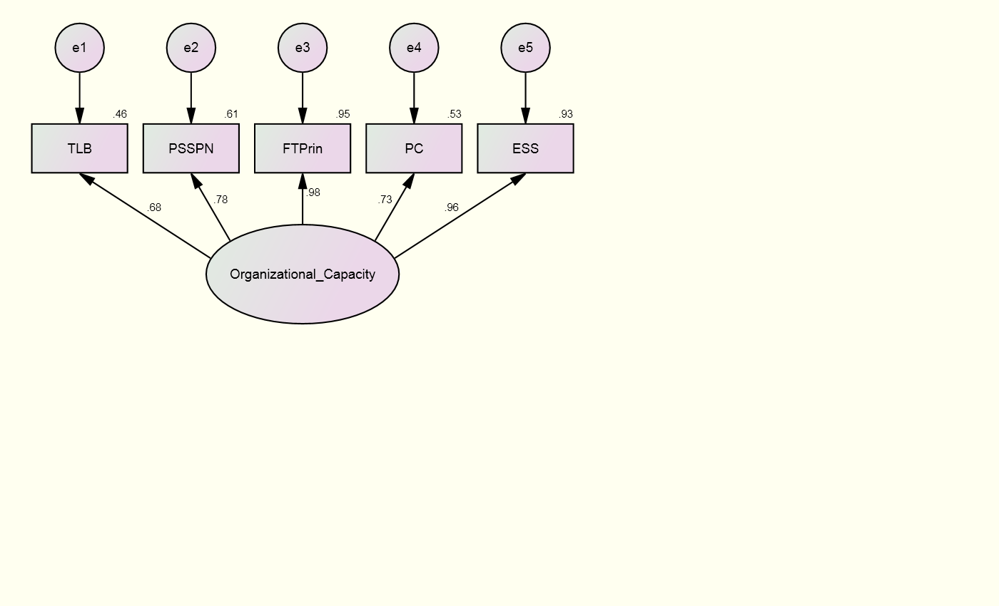

Note: e = error; TLB = transformational leadership behavior; PSSPN = principal support for student psychological needs; FTPrin = faculty trust in principal; PC = program coherence; ESS = enabling school structure.

When a good fitting model is not achieved, it is ideal to examine the estimates of the indicator variables and determine if as close to three variables can be used to form the construct, as four or more variables can be excessive to the model (Iacobucci, 2010). Parameter estimates (β) and squared multiple correlations (SMCs) show that four of the five factors had strong relationships with organizational capacity (Figure 7): faculty trust in principal (β = 0.98, SMC = 0.96), enabling school structure (β = 0.96, SMC = 0.93), principal support for student psychological needs (β = 0.78, SMC = 0.61), and program coherence (β = 0.73, SMC = 0.53). Transformational leadership behavior did not load as strongly as the other observed variables (β = 0.68, SMC = 0.46). The model’s overall poor fit indices and TLB’s weak factor loading suggest that a more parsimonious model may explain organizational capacity. A revised model with TLB removed was specified and tested (Figure 8). The decision to remove TLB was based on the poor model fit, weakest factor loading, and the inclusion of other leadership variables that have stronger theoretical and empirical alignment with the latent variable.
Model fit indices for the trimmed model (Table 3) suggest a good fit (RMSEA = 0.000, CFI = 0.988, and TLI = 0.963). A χ² that was not statistically significant (χ² = 5.286, p = 0.071, df = 2) suggests there was no difference between the specified hypothesized model and the sample variance-covariance matrix derived from the data. Appropriate fit indices mean the theoretical specification of the hypothesized model was observed in the pattern of the relationships among the principal’s support for student psychological needs, faculty trust in the principal, the school’s program coherence, and the level at which the school has an enabling school structure (Schumacker & Lomax, 2004).
Parameter estimates and squared multiple correlations (SMCs) for the trimmed model are shown in Table 3 and Figure 8. Results show strong positive effects of the latent variable on each observable variable. Specifically, a school’s organizational capacity accounted for 59% of the variance in PSSPN, 91% of the variance in FTPrin, 56% of the variance in PC, and 97% of the variance in ESS. These findings imply that the observed variables contribute to a latent school capacity centered on the organizational structure of the school.
In summary, the trimmed organizational capacity model provided empirical results that support the conceptualization and measure of organizational capacity as consisting of a principal’s support for student psychological needs (PSSPN), faculty trust in the principal (FTPrin), program coherence (PC), and enabling school structure (ESS). The revised model had strong fit with the sample variance-covariance matrix and parameter estimates established a strong relationship between each factor and the latent construct.
Table 3: Regression Coefficients and Model Fit Indices for Revised
Organizational Capacity CFA
Observed variable | β | B | SE | SMC
PSSPN | 0.771 | 1.000 | 0.028 | 0.594
FTPrin | 0.955 | 1.716 | 0.020 | 0.912
PC | 0.751 | 1.009 | 0.031 | 0.563
ESS | 0.985 | 1.368 | 0.011 | 0.971
Fit Index | Criteria |  | Model fit estimates
χ² | Non-significant |  | 5.286 (p = 0.071, df = 2)
RMSEA | < 0.06 |  | 0.000
CFI | > 0.95 |  | 0.988
TLI | > 0.95 |  | 0.963
Note: PSSPN = principal support for student psychological needs; FTPrin = faculty trust in principal; PC = program coherence; ESS = enabling school structure; β = standardized regression weights; B = unstandardized regression weights; SE = standard error; SMC = squared multiple correlation

Figure 8: Revised Organizational Capacity CFA Results - Standardized Estimates and SMCs

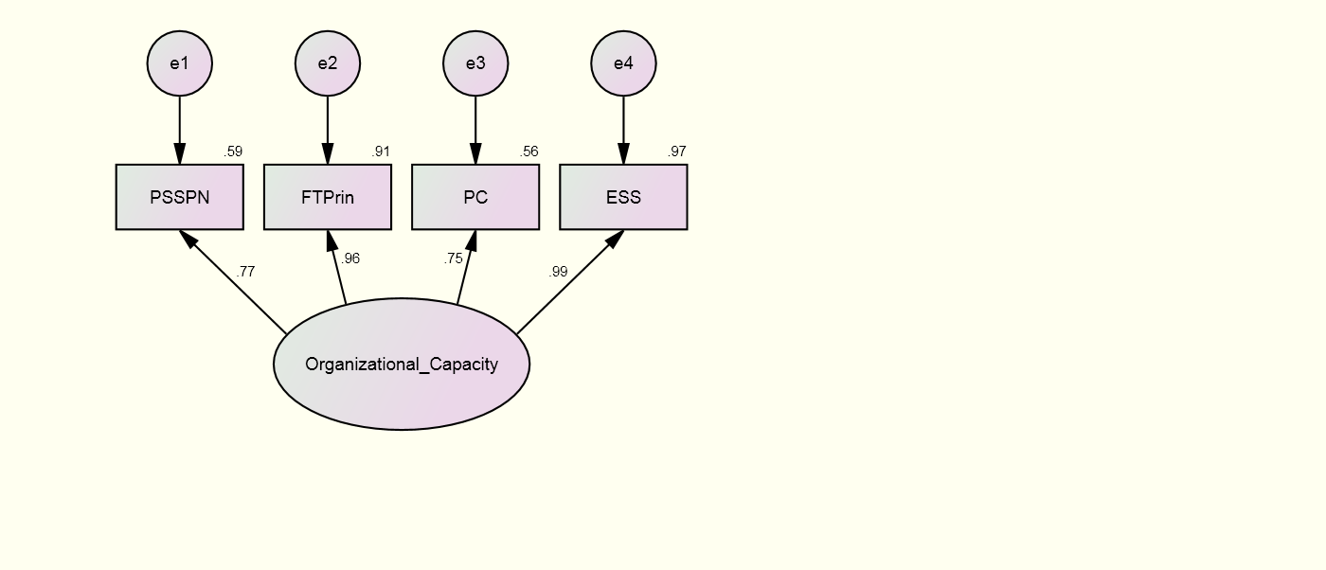

Note: e = error; PSSPN = principal support for student psychological needs; FTPrin = faculty trust in principal; PC = program coherence; ESS = enabling school structure.

Instructional Capacity
Measures of teacher perceptions of the teacher evaluation system (TLE), the performance of professional learning communities (PLC), faculty trust in colleagues (FTC), and collective teacher efficacy (CTE) were hypothesized as factors of a school’s instructional capacity (Figure 9). A correlation table with means and standard deviations is shown in Table 4. Model fit indices, parameter estimates, and SMCs are shown in Table 5 and Figure 9. Model fit indices suggest a marginal fit between the hypothesized model and the sample data (RMSEA = 0.194, CFI = 0.923, and TLI = 0.768). A statistically significant χ² (χ² = 7.257, p = 0.027, df = 2) suggests there was a difference between the specified hypothesized model and the sample variance-covariance matrix derived from the data; (Schumacker & Lomax, 2004; Schumaker & Lomax, 2004). Post-hoc modifications were explored to address poor-fitting indices.
Table 4: Correlations of the Observed Variables of Instructional Capacity
Observed variable | 1 | 2 | 3 | 4
- Teacher Leader Effectiveness | 1 | - | - | -
- Professional Learning Community | 0.550** | 1 | - | -
- Faculty Trust in Colleagues | 0.310** | 0.552** | 1 | -
- Collective Teacher Efficacy | 0.308** | 0.394** | 0.502** | 1
Note: N = 71; M1 = 4.35, SD1 = 0.36; M2 = 4.23, SD2 = 0.47; M3 = 4.56, SD3 = 0.47; M4 = 3.81, SD4 = 0.57
** = p < 0.01; * = p < 0.05

Table 5: Regression Coefficients and Model Fit Indices for Hypothesized Instructional Capacity CFA
Observed variable | β | B | SE | SMC
TLE | 0.603 | 1.000 | 0.016 | 0.363
PLC | 0.825 | 1.786 | 0.031 | 0.681
FTCol | 0.674 | 1.469 | 0.029 | 0.455
CTE | 0.546 | 1.441 | 0.047 | 0.298
Fit Index | Criteria |  | Model fit estimates
χ² | Non-significant |  | 7.257 (p = 0.027, df = 2)
RMSEA | < 0.06 |  | 0.194
CFI | > 0.95 |  | 0.923
TLI | > 0.95 |  | 0.768
Note: TLE = teacher-leader effectiveness; PLC = professional learning community; FTCol = faculty trust in colleagues; CTE = collective teacher efficacy; β = standardized regression weights; B = unstandardized regression weights; SE = standard error; SMC = squared multiple correlation

Figure 9: Hypothesized Instructional Capacity CFA Results - Standardized Estimates and SMCs
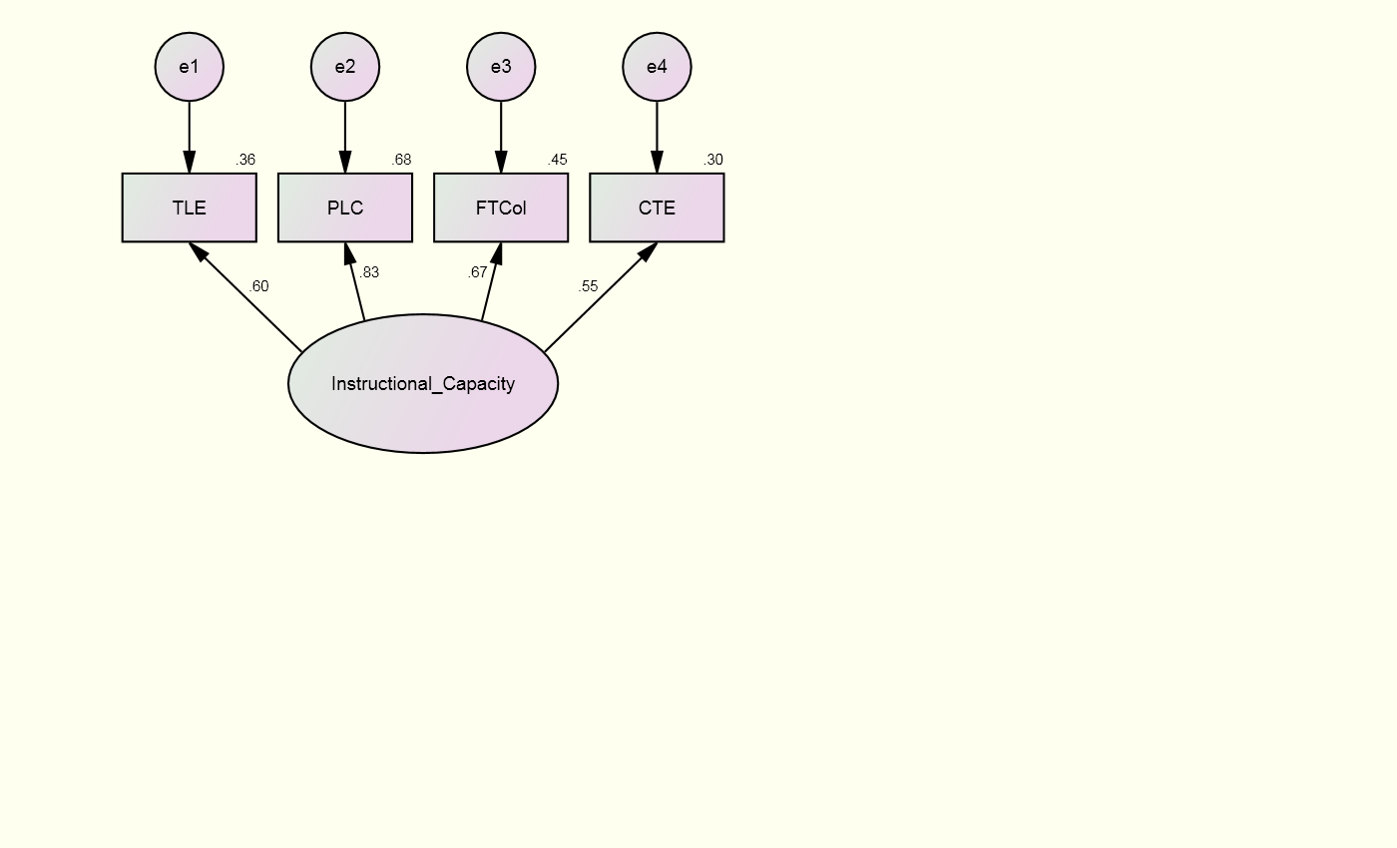

Note: e = error; TLE = teacher-leader effectiveness; PLC = professional learning community; FTCol = faculty trust in colleagues; CTE = collective teacher efficacy

Parameter estimates (β) and SMCs show that two of the observed factors had strong relationships with instructional capacity (Figure 9): professional learning communities (β = 0.83, SMC = 0.68) and faculty trust in colleagues (β = 0.67, SMC = 0.46). Teacher-leader effectiveness (β = 0.60, SMC = 0.36) and collective teacher efficacy (β = 0.55, SMC = 0.30) did not load as strongly with the latent variable. TLE and CTE were examined in order to remove one from the model to reduce complexity and establish a more parsimonious model that explains instructional capacity.
A theoretical examination of TLE and CTE demonstrated that CTE is better captured in the larger concept of a school’s instructional capacity than is TLE. As a latent variable, instructional capacity is intended to capture two elements: 1) the resources within schools that contribute to teaching effectiveness; and 2) the social processes within schools that facilitate professional development and learning (Adams, 2013). CTE captures the degree to which teachers believe that faculty in the school can positively affect students, whereas TLE captures the degree to which teachers understand and perceive the value and implementation of their evaluation process by the school principal. While the evaluation process can support teaching and teacher development over the course of time, CTE captures perceptions of the resources immediately available to teachers and students – resources that can directly and immediately affect teaching and learning. For these empirical and theoretical reasons, TLE was trimmed from the model and a revised model of instructional capacity was proposed (Figure 10).
As three variables were used to construct the latent variable, this is a just-identified model and fit indices demonstrate a perfect fitting model (RMSEA = 0.0, CFI = 1.0, and TLI = 1.0) (Schumacker & Lomax, 2004; Schumaker & Lomax, 2004). A χ² that was not statistically significant suggests there was no difference between the specified hypothesized model and the sample variance-covariance matrix derived from the data (Schumacker & Lomax, 2004). Appropriate fit indices and parameter estimates falling between 0 and 1 mean the theoretical specification of the hypothesized model was observed in the pattern of the relationships among the perceived effectives of professional learning communities, the trust faculty members have in their colleagues, and the degree to which teachers believe that they are efficacious in their work with students (Schumacker & Lomax, 2004).
Parameter estimates and squared multiple correlations (SMCs) are shown in Table 7 and Figure 10. Results of the measurement model show strong positive effects of the latent variable on each observable variable. Specifically, a school’s instructional capacity accounted for 43% of the variance in PLC, 70% of the variance in FTCol, and 36% of the variance in CTE. These findings imply that the observed variables contribute to a latent school capacity centered on the instructional resources and processes of the school.
In summary, the trimmed instructional capacity model provided empirical results that support the conceptualization and measure of instructional capacity as consisting of professional learning community effectiveness (PLC), faculty trust in colleagues (FTCol), and collective teacher efficacy (CTE). The revised model had strong fit with the sample variance-covariance matrix and parameter estimates established a strong relationship between each factor and the latent construct.

Table 6: Regression Coefficients and Model Fit Indices for Revised Instructional Capacity CFA
Observed variable | β | B | SE | SMC
PLC | 0.658 | 1.000 | 0.030 | 0.433
FTCol | 0.838 | 1.281 | 0.037 | 0.702
CTE | 0.599 | 1.109 | 0.044 | 0.359
Fit Index | Criteria |  | Model fit estimates
χ² | Non-significant |  | 0.000 (p not computed, df = 0)
RMSEA | < 0.06 |  | 0.000
CFI | > 0.95 |  | 1.000
TLI | > 0.95 |  | 1.000
Note: PLC = professional learning communities; FTCol = faculty trust in colleagues; CTE = collective teacher efficacy; β = standardized regression weights; B = unstandardized regression weights; SE = standard error; SMC = squared multiple correlation.

Figure 10: Revised Instructional Capacity CFA Results - Standardized Estimates and SMC's
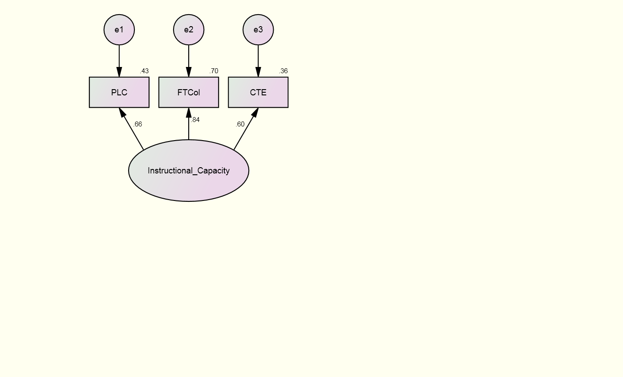

Note: e = error; PLC = professional learning communities; FTCol = faculty trust in colleagues; CTE = collective teacher efficacy

Learning Capacity
Measures of student perceptions of how the school supports student psychological needs [competence support (CS), autonomy support (AS), and relational support as measured by student trust in teachers (STT) and faculty trust in students (FTStu)] and how the school’s social climate supports student academic motivation and positive development [peer academic support (PAS)] were hypothesized to provide evidence of a school’s learning capacity (Figure 11). A correlation table with means and standard deviations is shown in Table 8. Model fit indices, parameter estimates, and SMCs are shown in Table 9 and Figure 11. Model fit indices suggest a poor fit between the hypothesized model and the sample data (RMSEA = 0.187, CFI = 0.926, and TLI = 0.851). A statistically significant χ² (χ² = 17.286, p = 0.004, df = 5) suggests there was a difference between the specified hypothesized model and the sample variance-covariance matrix derived from the data (Schumacker & Lomax, 2004). Post-hoc modifications were explored to address poor-fitting indices.
Table 7: Correlations of the Observed Variables of Learning Capacity
Observed variable | 1 | 2 | 3 | 4 | 5
- Competence Support | 1 | - | - | - | -
- Autonomy Support | 0.791** | 1 | - | - | -
- Student Trust in Teachers | 0.660** | 0.788** | 1 | - | -
- Faculty Trust in Students | 0.285* | 0.274* | 0.389** | 1 | -
- Peer Academic Support | 0.367** | 0.377** | 0.429** | 0.472** | 1
Note: N = 71; M1 = 3.03, SD1 = 0.27; M2 = 2.87, SD2 = 0.22; M3 = 2.97, SD3 = 0.31; M4 = 3.84, SD4 = 0.60; M5 = 3.01, SD5 = 0.22.
** = p < 0.01; * = p < 0.05

Table 8: Regression Coefficients and Model Fit Indices for Hypothesized Learning Capacity CFA
Observed variable | β | B | SE | SMC
CS | 0.830 | 1.000 | 0.005 | 0.689
AS | 0.938 | 0.898 | 0.003 | 0.879
STT | 0.837 | 1.165 | 0.006 | 0.701
FTStu | 0.351 | 0.933 | 0.053 | 0.123
PAS | 0.442 | 0.439 | 0.007 | 0.196
Fit Index | Criteria |  | Model fit estimates
χ² | Non-significant |  | 17.286 (p = 0.004, df = 5)
RMSEA | < 0.06 |  | 0.187
CFI | > 0.95 |  | 0.926
TLI | > 0.95 |  | 0.851
Note: CS = competence support; AS = autonomy support; STT = student trust in teachers; FTStu = faculty trust in students; PAS = peer academic support; β = standardized regression weights; B = unstandardized regression weights; SE = standard error; SMC = squared multiple correlation

Figure 11: Hypothesized Organizational Capacity CFA Results – Standardized Estimates and SMCs
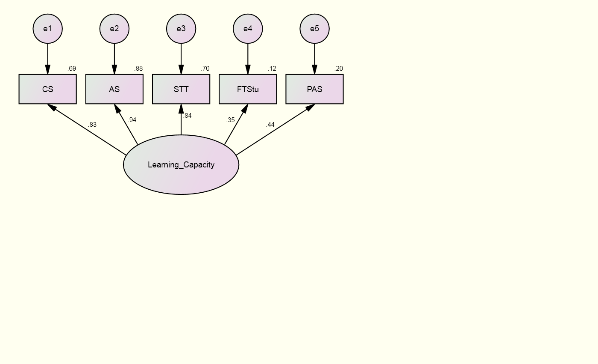

Note: e = error, CS = competence support; AS = autonomy support; STT = student trust in teachers; FTStu = faculty trust in students; PAS = peer academic support

Parameter estimates (β) and SMCs show that three of the five factors had strong relationships with learning capacity (Figure 11): competence support (β = 0.83, SMC = 0.69), autonomy support (β = 0.94, SMC = 0.88), and student trust in teachers (β = 0.84, SMC = 0.70). Faculty trust in students (β = 0.35, SMC = 0.12) and peer academic support (β = 0.44, SMC = 0.20) did not load as strongly as the other observed variables. FTStu and PAS were examined in order to remove a variable from the model to reduce complexity and establish a more parsimonious model that explains learning capacity (Iacobucci, 2010).
The variable FTStu captures the degree to which teachers believe that students are open, honest, competent, reliable, and benevolent. Unlike the other four student-measured variables hypothesized to form the learning capacity latent variable, FTStu is a teacher-measured variable. Differences in how variables are collected and analyzed can affect how they form an empirical relationship with other variables in a model (Schumacker & Lomax, 2004). To examine this possibility, FTStu was trimmed from the model and a revised model of learning capacity was proposed (Figure 12).
Model fit indices (Table 10) suggest a good fitting model (RMSEA = 0.082, CFI = 0.994, and TLI = 0.981). A χ² that was not statistically significant (χ² = 2.934, p = 0.231, df = 2) suggests there was no difference between the specified hypothesized model and the sample variance-covariance matrix derived from the data. Appropriate fit indices mean the theoretical specification of the hypothesized model was observed in the pattern of the relationships among the competence and autonomy support perceived by students, the trust students have in their teachers, and the academic support students perceive to have from their peers (Schumacker & Lomax, 2004).
Parameter estimates and squared multiple correlations (SMCs) are shown in Table 10 and Figure 12. Results of the measurement model show strong positive effects of the latent variable on each observable variable. Peer academic support did not load as strongly as the other variables, but its theoretical fit with the formation of learning capacity as well as the overall empirical fit of the model provide evidence for retaining PAS in the CFA. Specifically, a school’s learning capacity accounted for 68% of the variance in CS, 91% of the variance in AS, 68% of the variance in STT, and 18% of the variance in PAS. These findings imply that the observed variables contribute to a latent school capacity centered on the psychological needs supports provided to students by a school and the social climate students are immersed in.
In summary, the trimmed learning capacity model provided empirical results that support the conceptualization and measure of learning capacity as consisting of a student’s competence support (CS), autonomy support (AS), trust in his/her teachers (STT), and perceived academic support from peers (PAS). The revised model had strong fit with the sample variance-covariance matrix and parameter estimates established a strong relationship between each factor and the latent construct.
Table 9: Regression Coefficients and Model Fit Indices for Revised Learning Capacity CFA
Observed variable | β | B | SE | SMC
CS | 0.825 | 1.000 | 0.005 | 0.681
AS | 0.954 | 0.920 | 0.003 | 0.911
STT | 0.825 | 1.154 | 0.007 | 0.680
PAS | 0.421 | 0.421 | 0.007 | 0.177
Fit Index | Criteria |  | Model fit estimates
χ² | Non-significant |  | 2.934 (p = 0.231, df = 2)
RMSEA | < 0.06 |  | 0.082
CFI | > 0.95 |  | 0.994
TLI | > 0.95 |  | 0.981
Note: CS = competence support; AS = autonomy support; STT = student trust in teachers; PAS = peer academic support; β = standardized regression weights; B = unstandardized regression weights; SE = standard error; SMC = squared multiple correlation

Figure 12: Revised Learning Capacity CFA Results – Standardized Estimates and SMCs

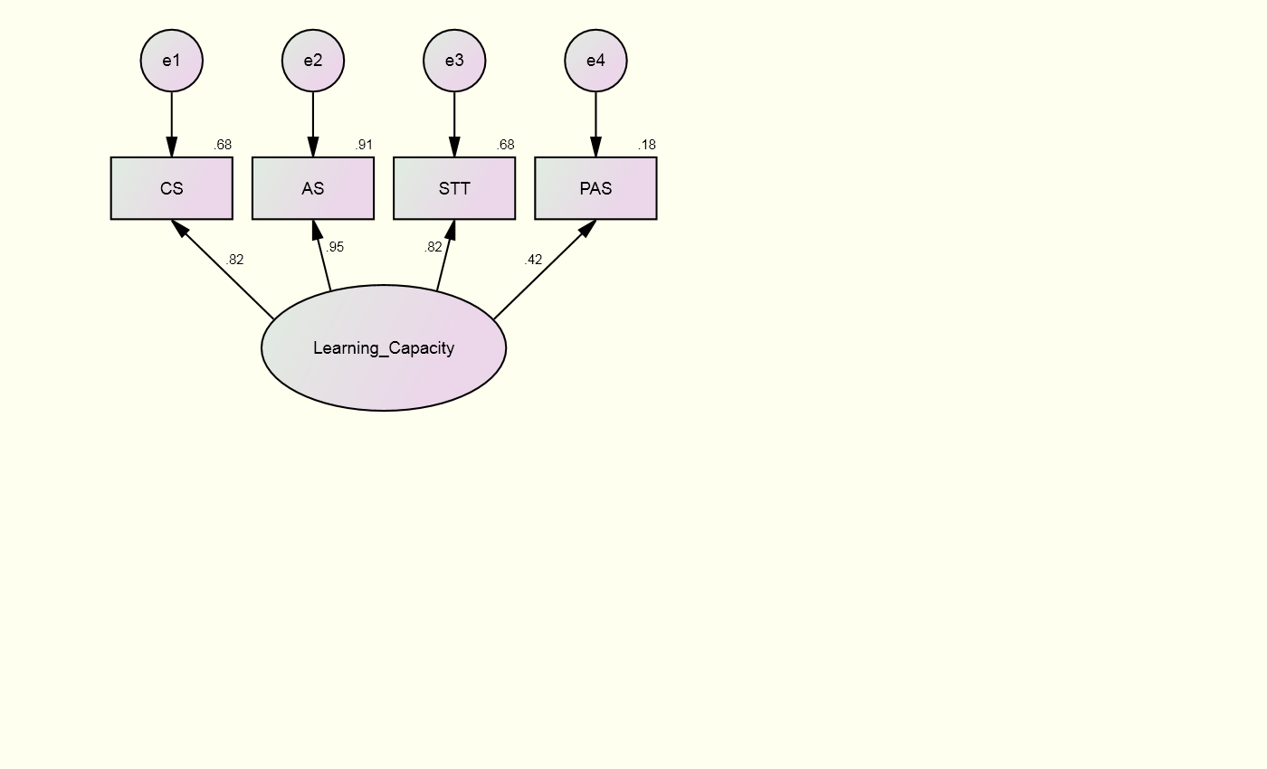

Note: e = error; CS = competence support; AS = autonomy support; STT = student trust in teachers; PAS = peer academic support

Home Capacity
Measures of parent, student, and teacher perceptions were hypothesized to provide evidence of a school’s home capacity (Figure 13). Parents report the degree to which they trust the school (PTS), believe the school connects with parents through outreach (SO), and self-report the number of parents they communicate with (PSN). Students report the degree to which their home environment emphasizes academics (HAE). Teachers report the degree to which they trust parents (FTPar). A correlation table with means and standard deviations is shown in Table 11; the hypothesized model is presented in Figure 13. Model fit indices, parameter estimates, and SMCs are shown in Table 12 and Figure 13. Model fit indices suggest a poor and inadmissible fit between the hypothesized model and the sample data (RMSEA, CFI, TLI, χ², p, and df are inadmissible), suggesting there was a difference between the specified hypothesized model and the sample variance-covariance matrix derived from the data (Schumacker & Lomax, 2004). Post-hoc modifications were explored to address poor-fitting indices and inadmissible results.
Table 10: Correlations of the Observed Variables of Home Capacity
Observed variable | 1 | 2 | 3 | 4 | 5
- School Outreach | 1 | - | - | - | -
- Parent Social Network | 0.216 | 1 | - | - | -
- Parent Trust in School | 0.823** | 0.450** | 1 | - | -
- Home Academic Emphasis | 0.526** | 0.304** | 0.469** | 1 | -
- Faculty Trust in Parents | 0.191 | 0.631** | 0.534** | 0.259* | 1
Note: N = 71; M1 = 4.15, SD1 = 0.66; M2 = 2.08, SD2 = 1.58; M3 = 4.32, SD3 = 0.72; M4 = 3.06, SD4 = 0.26; M5 = 3.36, SD5 = 0.72.
** = p < 0.01; * = p < 0.05

Table 11: Regression Coefficients and Model Fit Indices for Home Capacity CFA
Observed variable | β | B | SE | SMC
SO | 0.780 | 1.000 | 5.238 | 0.608
PSN | 0.393 | 1.208 | 5.852 | 0.154
PTS | 1.074 | 1.514 | -1.465 | 1.153
HAE | 0.353 | 0.180 | 5.622 | 0.125
FTPar | 0.524 | 0.734 | 6.152 | 0.275
Fit Index | Criteria |  | Model fit estimates
χ² | Non-significant |  | Not admissible
RMSEA | < 0.06 |  | Not admissible
CFI | > 0.95 |  | Not admissible
TLI | > 0.95 |  | Not admissible
Note: SO = school outreach; PSN = parent social network; PTS = parent trust in school; HAE = home academic emphasis; FTPar = faculty trust in parents; β = standardized regression weights; B = unstandardized regression weights; SE = standard error; SMC = squared multiple correlation

Figure 13: Hypothesized Home Capacity CFA Results – Standardized Estimates and SMCs

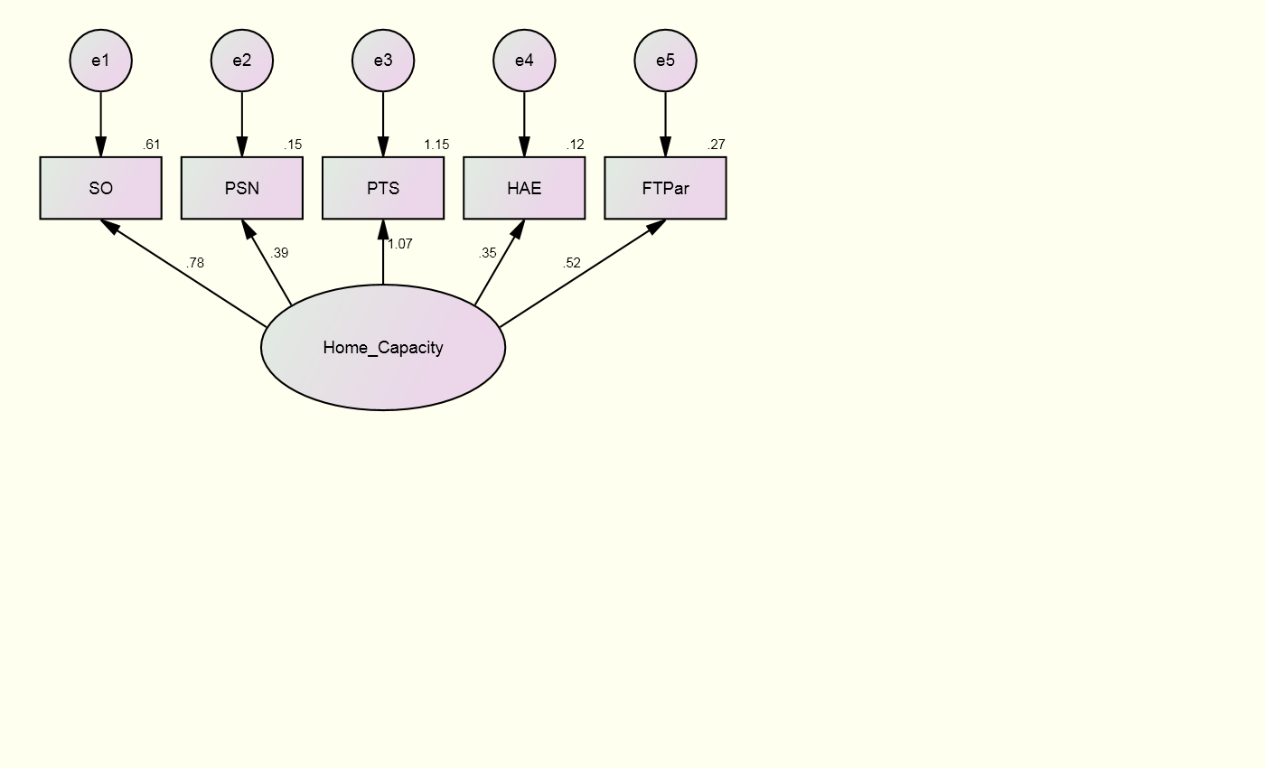

Note: e = error; SO = school outreach; PSN = parent social network; PTS = parent trust in school; HAE = home academic emphasis; FTPar = faculty trust in parents

Parameter estimates (β) and SMCs (Figure 13) show that school outreach (β = 0.78, SMC = 0.61) and parent trust in school (β = 1.07, SMC = 1.15) have the strongest factor loadings. However, the parameter estimate value exceeding 1.0 for PTS presents a Heywood case, resulting in an inadmissible model. A Heywood case can occur for several reasons: linear dependence among observed variables, a variable that is a linear combination of other variables, a sample size less than the number of variables, or collinearity among the observed variables (Schumacker & Lomax, 2004). As SO and PTS are variables measured through parent perceptions and administered on the same parent survey at the same time, concerns about collinearity were investigated.
An examination of the correlations of these observed variables shows a correlation of 0.823 between SO and PTS, a very strong, positive, and significant (p < 0.01) relationship. It may be possible that, while these constructs capture different elements of the relationship parents have with the school, there may be collinearity, making it difficult to separate the influence of the two variables. Collinearity occurs when correlations, or multiple correlations, of a significant magnitude exist between two or more independent variables (Cohen, Cohen, West, & Aiken, 2003). These correlations have the potential to adversely affect regression estimates.
Examination of possible collinearity between SO and PTS reveals empirical evidence for addressing this concern. After identifying a strong correlation between the two independent variables, it is recommended to examine the variance inflation factor (VIF), which gives an indication to the degree to which the standard errors will be inflated due to collinearity (Cohen et al., 2003). Literature on collinearity provides a common rule of thumb of 10 as a value to be concerned with and address collinearity issues. However, for most behavioral science applications, a value of 10 is probably too high (lenient) (Cohen et al., 2003) and a VIF value of 4 is more appropriate. The VIF values for PSN, HAE, and FTPar were all at acceptable levels (1.743, 1.573, and 2.449, respectively). The VIF values for SO and PTS were more concerning, at 4.779 and 5.57, respectively.
Possible remedies to addressing collinearity include respecifying the model by combining like constructs, increasing the sample size, or trimming less important and/or redundant measures (Cohen et al., 2003). As theory and research have demonstrated the unique constructs of SO and PTS, it does not make sense to combine these measures. While it may be possible to increase the sample size in future studies, that was not an option for this study. As a result, it was necessary to trim a variable and examine how this affected the model.
An assessment of the variables within the hypothesized model provided evidence for which to trim. As a capacity of schools, home capacity seeks to capture two elements: 1) the degree to which a student’s home environment is supportive of education and 2) the perception that the home environment is supported by the school. Trust among the actors in both the home and school environment can provide a strong indication of this relationship. However, in seeking to trim a variable from the model while retaining the theoretical underpinnings of the capacity, trimming FTPar and keeping PTS makes sense. While a latent variable comprised of both FTPar and PTS captures elements of the relationship between schools and families from multiple indicators, PTS has more influence on how education and schools are perceived within the home context than does FTPar.
In addition, an assessment on the collection of PSN revealed difficulties in accurately capturing a parent’s unique social network within a school environment. Of the 1,126 surveys received from parents, 19% were returned incorrectly completed. While parent social networks can have implications for parent involvement with and connection to the school, such a large percentage of inaccurately recorded surveys may negatively affect how this variable interacts with the other variables comprising the latent variable. For these reasons, FTPar and PSN were trimmed from the model and a revised model of home capacity was proposed (Figure 14).
An examination of possible collinearity within the revised model yielded desirable results. VIF values for SO, PTS, and HAE were all at desirable levels (3.367, 3.124, and 1.390, respectively). These results demonstrate that the elimination of FTPar and PSN from the overall model addressed much of the initial collinearity concerns.
A revised model with FTPar and PSN removed was specified and tested (Figure 14). Model fit indices, parameter estimates, and SMCs are shown in Table 13 and Figure 14. As three variables were used to construct the latent variable, this is a just-identified model and fit indices demonstrate a perfect fitting model (RMSEA = 0.0, CFI = 1.0, and TLI = 1.0) (Schumacker & Lomax, 2004). A χ² that was not statistically significant suggests there was no difference between the specified hypothesized model and the sample variance-covariance matrix derived from the data (Schumacker & Lomax, 2004). Appropriate fit indices and parameter estimates falling between 0 and 1 mean the theoretical specification of the hypothesized model was observed in the pattern of the relationships among the perceived outreach conducted by the school to parents, the trust parents have in the school, and the degree to which students believe their home environment emphasizes academics (Schumacker & Lomax, 2004).
Results of the measurement model show strong positive effects of the latent variable on each observable variable. Specifically, a school’s home capacity accounted for 92% of the variance in SO, 73% of the variance in PTS, and 30% of the variance in HAE. These findings imply that the observed variables contribute to a latent school capacity variable centered on the supports and beliefs existing in the home environment.
In summary, the trimmed home capacity model provided empirical results that support the conceptualization and measure of home capacity as consisting of school outreach (SO), parent trust in school (PTS), and home academic emphasis (HAE). The revised model had strong fit with the sample variance-covariance matrix and parameter estimates established a strong relationship between each factor and the latent construct.

Table 12: Regression Coefficients and Model Fit Indices for the Revised Home Capacity CFA
Observed variable | β | B | SE | SMC
SO | 0.961 | 1.000 | 0.049 | 0.923
PTS | 0.857 | 0.981 | 0.052 | 0.735
HAE | 0.547 | 0.226 | 0.008 | 0.300
Fit Index | Criteria |  | Model fit estimates
χ² | Non-significant |  | 0.000 (p not computed, df = 0)
RMSEA | < 0.06 |  | 0.000
CFI | > 0.95 |  | 1.000
TLI | > 0.95 |  | 1.000
Note: SO = school outreach; PTS = parent trust in school; HAE = home academic emphasis; β = standardized regression weights; B = unstandardized regression weights; SE = standard error; SMC = squared multiple correlation

Figure 14: Revised Home Capacity CFA Results - Standardized Estimates and SMCs
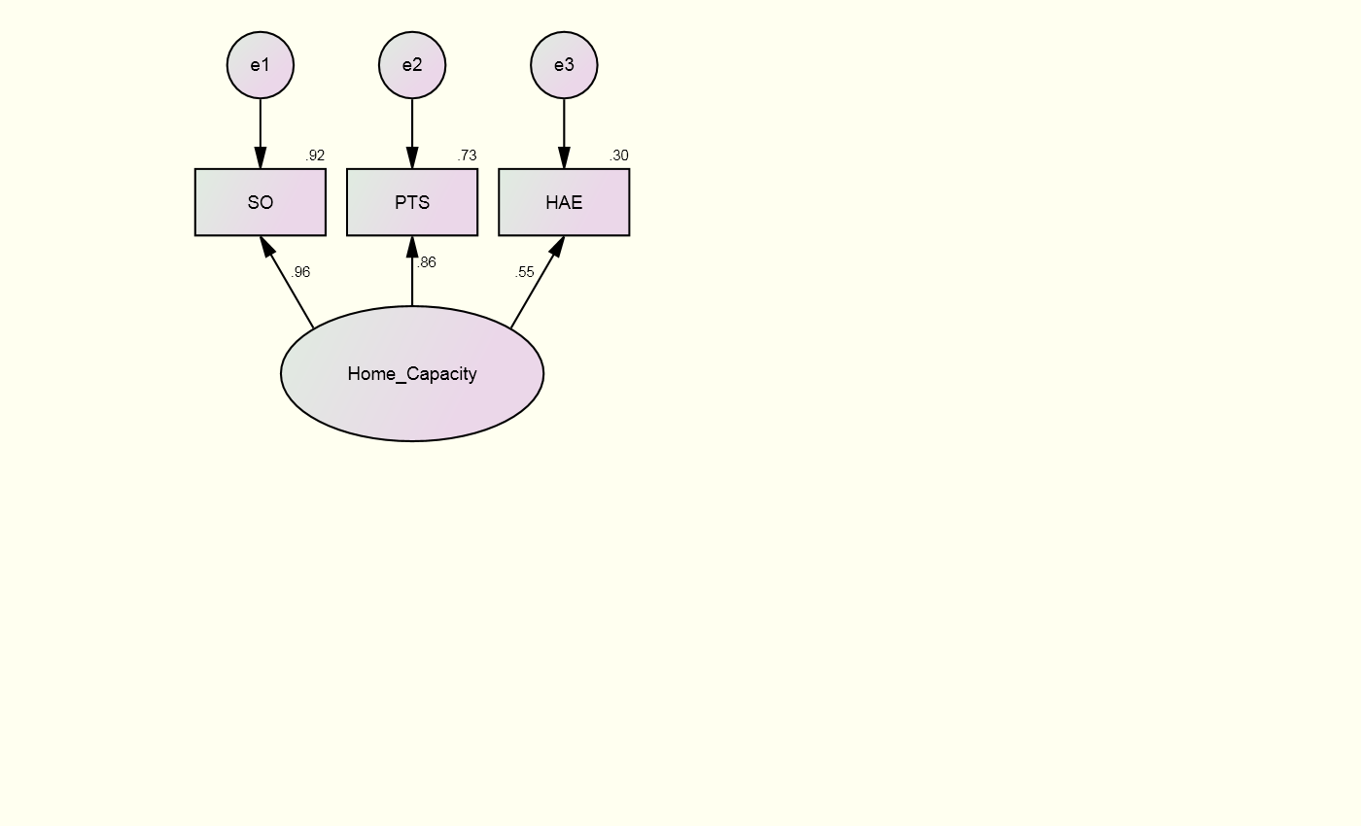

Note: e = error; SO = school outreach; PTS = parent trust in school; HAE = home academic emphasis

Student Psychological Health
Measures of student perceptions of their academic motivation (SR), academic efficacy (ME and RE), social well-being (Alien), and attachment to school (SIdS) were hypothesized to provide evidence of a school’s capacity to support student psychological health (Figure 15). A correlation table with means and standard deviations is shown in Table 14. Model fit indices, parameter estimates, and SMCs are shown in Table 15 and Figure 15. Model fit indices suggest a poor fit between the hypothesized model and the sample data (RMSEA = 0.244, CFI = 0.922, and TLI = 0.844). A statistically significant χ² (χ² = 25.768, p < 0.001, df = 5) suggests there was a difference between the specified hypothesized model and the sample variance-covariance matrix derived from the data; (Schumacker & Lomax, 2004). Post-hoc modifications were explored to address poor-fitting indices.
Table 13: Correlations of the Observed Variables of Student Psychological Health
Observed variable | 1 | 2 | 3 | 4 | 5
- Alienation | 1 | - | - | - | -
- Self-Regulated Learning | -0.939** | 1 | - | - | -
- Reading Efficacy | -0.362** | 0.447** | 1 | - | -
- Math Efficacy | -0.429** | 0.480** | 0.546** | 1 | -
- Student Identification with School | -0.799** | 0.763** | 0.340** | -0.481** | 1
Note: N = 71; M1 = 2.20, SD1 = 0.44; M2 = 3.19, SD2 = 0.33; M3 = 3.24, SD3 = 0.19; M4 = 3.10, SD4 = 0.23; M5 = 2.93, SD5 = 0.26.
** = p < 0.01; * = p < 0.05

Table 14: Regression Coefficients and Model Fit Indices for Hypothesized Student Psychological Health CFA
Observed variable | β | B | SE | SMC
Alien | 0.970 | 1.000 | 0.005 | 0.941
SR | -0.967 | -0.752 | 0.003 | 0.935
RE | -0.423 | -0.192 | 0.005 | 0.179
ME | -0.481 | -0.265 | 0.007 | 0.231
SIdS | -0.809 | -0.494 | 0.004 | 0.654
Fit Index | Criteria |  | Model fit estimates
χ² | Non-significant |  | 25.768 (p < 0.001, df = 5)
RMSEA | < 0.06 |  | 0.244
CFI | > 0.95 |  | 0.922
TLI | > 0.95 |  | 0.844
Note: Alien = alienation; SR = self-regulated learning; RE = reading efficacy; ME = math efficacy; SIDS = student identification with school; β = standardized regression weights; B = unstandardized regression weights; SE = standard error; SMC = squared multiple correlation
Figure 15: Hypothesized Student Psychological Health CFA Results – Standardized Estimates and SMCs
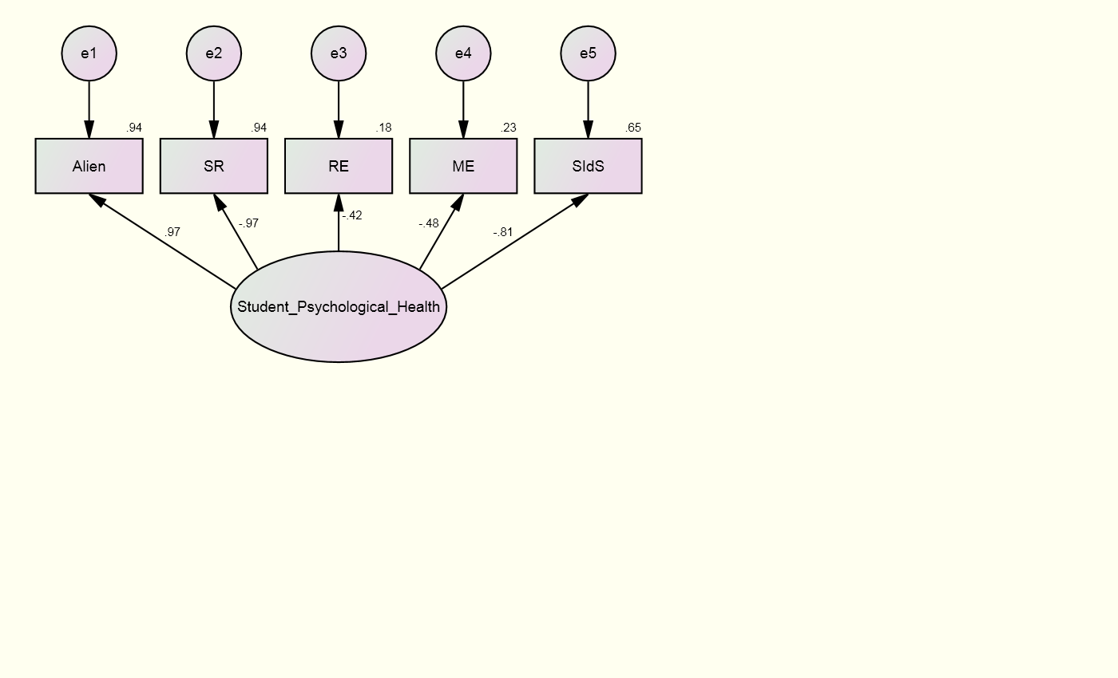

Note: e = error; Alien = alienation; SR = self-regulated learning; RE = reading efficacy; ME = math efficacy; SIDS = student identification with school

When a good fitting model is not achieved, it is ideal to examine the estimates of the indicator variables and determine if as close to three variables can be used to form the construct, as four or more variables can be excessive to the model (Iacobucci, 2010). Parameter estimates (β) and SMCs show that three of the five factors had strong relationships with student psychological health (Figure 15): student alienation (β = 0.97, SMC = 0.94), student self-regulated learning (β = -0.97 SMC = 0.94), and student identification with school (β = -0.81, SMC = 0.65). Reading and math efficacy did not load as strongly as the other observed variables (β = -0.42, SMC = 0.18; β = -0.48, SMC = 0.23, respectively).
Poor fit indices and RE and ME’s weak factor loadings suggest that a more parsimonious model may explain organizational capacity. A revised model with RE and ME removed was specified and tested (Figure 16). The decision to remove RE and ME was based on the poor model fit, weakest factor loadings, and the inclusion of other student academic motivation variables that have stronger theoretical and empirical alignment with the latent variable.
As three variables were used to construct the latent variable, this is a just-identified model and fit indices demonstrate a perfect fitting model (RMSEA = 0.0, CFI = 1.0, and TLI = 1.0) (Schumacker & Lomax, 2004). A χ² that was not statistically significant suggests there was no difference between the specified hypothesized model and the sample variance-covariance matrix derived from the data (Schumacker & Lomax, 2004). Appropriate fit indices and parameter estimates falling between 0 and 1 mean the theoretical specification of the hypothesized model was observed in the pattern of the relationships among student alienation, student self-regulated learning, and student identification with school (Schumacker & Lomax, 2004).
Parameter estimates and SMCs are shown in Table 16 and Figure 16. Results of the measurement model show strong positive effects of the latent variable with SR and SIdS and a strong negative effect of the latent variable with Alien. Specifically, student psychological health accounted for 98% of the variance in Alien, 90% of the variance in SR, and 65% of the variance in SIdS. These findings imply that the observed variables contribute to a latent school capacity centered on student psychological health.
In summary, the trimmed organizational capacity model provided empirical results that support the conceptualization and measure of student psychological health as consisting of student levels of alienation (Alien), student’s self-regulating behaviors (SR), and student identification with school (SIdS). The revised model had strong fit with the sample variance-covariance matrix and parameter estimates established a strong relationship between each factor and the latent construct.
Table 15: Regression Coefficients and Model Fit Indices for Revised Student Psychological Health CFA
Observed variable | β | B | SE | SMC
Alien | 0.991 | 1.000 | 0.003 | 0.983
SR | -0.947 | -0.721 | 0.011 | 0.897
SIdS | -0.806 | -0.481 | 0.023 | 0.649
Fit Index | Criteria |  | Model fit estimates
χ² | Non-significant |  | 0.000 (p not computed, df = 0)
RMSEA | < 0.06 |  | 0.000
CFI | > 0.95 |  | 1.000
TLI | > 0.95 |  | 1.000
Note: Alien = alienation; SR = self-regulated learning; SIdS = student identification with school; β = standardized regression weights; B = unstandardized regression weights; SE = standard error; SMC = squared multiple correlation

Figure 16: Revised Student Psychological Health CFA Results - Standardized Estimates and SMCs
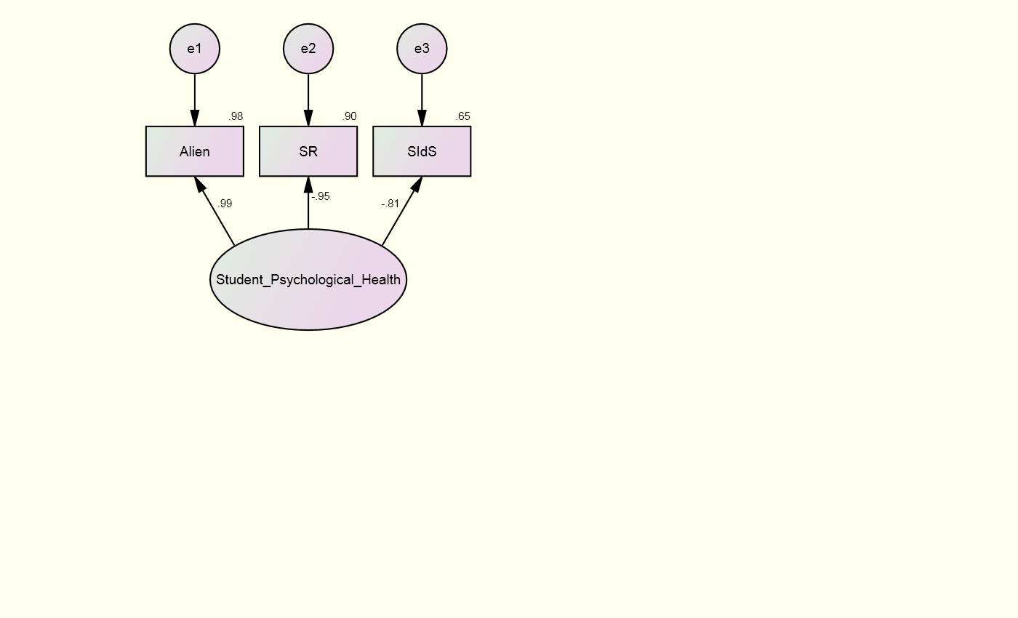

Note: e = error; Alien = alienation; SR = self-regulated learning; SIdS = student identification with school

Structural Equation Modeling
SEM was used to examine the proportion of variance accounted for in the relationships between the capacities (Hu & Bentler, 1999). A correlation table with means and standard deviations is shown in table 17. The newly formed observed variables representing the capacities each have a significant and positive relationship to achievement: organizational capacity, learning capacity, and instructional capacity have strong positive relationships with achievement (Pearson’s r = 0.45, 0.45, and 0.50, respectively); home capacity has a moderate positive relationship with achievement (Pearson’s r = 0.33); and student psychological health has a weak positive relationship with achievement (Pearson’s r = 0.26).
Table 16: Correlations of the Observed Capacities and Achievement
Observed variable | 1 | 2 | 3 | 4 | 5 | 6
- Math Scale Score | 1 | - | - | - | - | -
- Organizational Capacity | 0.452** | 1 | - | - | - | -
- Learning Capacity | 0.445** | 0.467** | 1 | - | - | -
- Instructional Capacity | 0.503** | 0.764** | 0.384** | 1 | - | -
- Home Capacity | 0.333** | 0.335** | 0.530** | 0.320** | 1 | -
- Student Psychological Health | 0.263* | 0.248* | 0.444** | 0.142 | 0.228 | 1
Note: N = 71; M1 = 693.41, SD1 = 47.41; M2 = 4.10, SD2 = 0.63; M3 = 2.97, SD3 = 0.21; M4 = 4.20, SD4 = 0.41; M5 = 0.00, SD5 = 0.86; M6 = 2.98, SD6 = 0.33.
** = p < 0.01; * = p < 0.05

The hypothesized SEM is described graphically in Figure 17. It was hypothesized that a school’s organizational capacity relates positively to a school’s home, learning, and instructional capacity; home capacity and instructional capacity relate positively to learning capacity; and learning capacity and instructional capacity are predictive of higher levels of student psychological health and math achievement. The hypothesized model has a perfect fit to the data. The CFI is 1.0; TLI is 1.0; the RMSEA is 0.0; and χ² is not significant (χ² = 2.799, p = 0.834, df = 6). The direct and indirect effects are reported in Figure 17 and Table 18. While perfect fitting indices and a χ² that was not statistically significant do not call for post-hoc modifications to be explored, insignificant regression coefficients (Figure 17) can be addressed by deleting paths to produce a more accurate model that best represents the empirical relationships between variables.
Figure 17: Results from the Hypothesized SEM
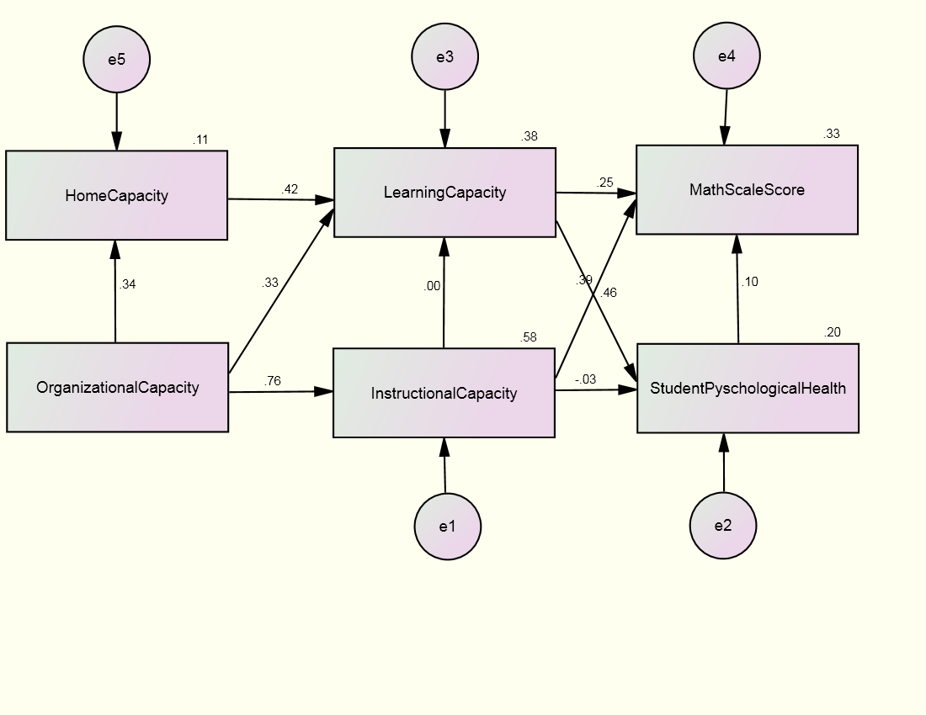

Note: e = error

Table 17: Results from Hypothesized Structural Equation Model – Regression Coefficients and Model Fit Indices
 | β |  |  |  |  |  | B
Variable | 1 |  | 2 | 3 | 4 | 5 | 1 |  | 2 | 3 | 4 | 5 | SE | R²
Direct
- Org. |  |  |  |  |  |  |  |  |  |  |  |  | 0.067
- Instruc. | 0.764 |  |  |  |  |  | 0.493 |  |  |  |  |  | 0.012 | 0.583
- Psych. |  |  | -0.033 |  | 0.457 |  |  |  | -0.027 |  | 0.704 |  | 0.014 | 0.199
- Learn. | 0.327 |  |  |  |  | 0.420 | 0.109 |  |  |  |  | 0.104 | 0.005 | 0.375
- Home. | 0.335 |  |  |  |  |  | 0.455 |  |  |  |  |  | 0.109 | 0.112
- Ach. |  |  | 0.391 |  | 0.296 |  |  |  | 45.364 |  | 66.049 |  | 251.807 | 0.324
Indirect
- Org.
- Instruc.
- Psych. | 0.188 |  |  |  |  | 0.192 | 0.097 |  |  |  |  | 0.073
- Learn. | 0.141 |  |  |  |  |  | 0.047
- Home.
- Ach. | 0.437 |  |  |  |  | 0.124 | 32.708 |  | -0.001 |  |  | 6.844
Total
- Org.
- Instruc. | 0.764 |  |  |  |  |  | 0.493
- Psych. | 0.188 |  | -0.033 |  | 0.457 | 0.192 | 0.097 |  | - 0.027 |  | 0.704 | 0.073
- Learn. | 0.467 |  |  |  |  | 0.420 | 0.157 |  |  |  |  | 0.104
- Home. | 0.335 |  |  |  |  |  | 0.455
- Ach. | 0.437 |  | 0.391 |  | 0.296 | 0.124 | 32.708 |  | 45.363 |  | 66.049 | 6.844
Fit Index |  | Criteria |  |  |  |  |  | Model fit estimates
χ² |  | Non-significant |  |  |  |  |  | 2.031 (p = 0.834, df = 6)
RMSEA |  | < 0.06 |  |  |  |  |  | 0.000
CFI |  | > 0.95 |  |  |  |  |  | 1.000
TLI |  |  |  |  |  |  |  | 1.000
Note: 1. Org. = Organizational Capacity; 2. Instruc. = Instructional Capacity; 3. Psych = Student Psychological Health; 4. Learn. = Learning Capacity; 5. Home = Home Capacity; 6. Ach. = Math Achievement; Direct = direct effects; Indirect = indirect effects; Total = total effects; β = standardized regression weights; B = unstandardized regression weights; SE = standard error; R² = SMC

An analysis of the regression coefficients (Figure 17) demonstrated empirical issues with the relationships between instructional capacity and learning capacity and between instructional capacity and student psychological health. These paths were removed from the model and a revised model was proposed to more accurately explore the significant relationships and effects between the school-level capacities and outcome variables (Figure 18). An SEM analysis was specified and tested with the Amos 7.0 statistical package in SPSS. The revised model is a perfect fit to the data. The CFI is 1.0; TLI is 1.0; the RMSEA is 0.0; and chi square is not significant (χ² = 2.881, p = 0.942, df = 8). The direct and indirect effects are reported in Figure 18 and Table 19.

Direct Effects
A school’s organizational capacity relates positively to three different school capacities: the school’s home capacity (β = 0.34, p < .01), student learning capacity (β = 0.33, p < .01) and teacher’s instructional capacity (β = 0.76, p < .01). A school’s home capacity relates positively to student learning capacity (β = 0.42, p < .01). Student learning capacity is predictive of greater math achievement (β = 0.30, p < .01) and student psychological health (β = 0.44, p < .01). Teachers’ instructional capacity is predictive of greater math achievement (β = 0.39, p < .01).

Indirect Effects
A school’s organizational capacity has indirect effects on student psychological health (β = 0.21) through its direct effects on learning capacity. Organizational capacity also has indirect effects on student math achievement (β = 0.44) through its direct effects on learning capacity and instructional capacity. A school’s home capacity has indirect effects on student psychological health (β = 0.19) and math achievement (β = .12) through its direct effects on learning capacity.

Figure 18: Results from the Revised SEM

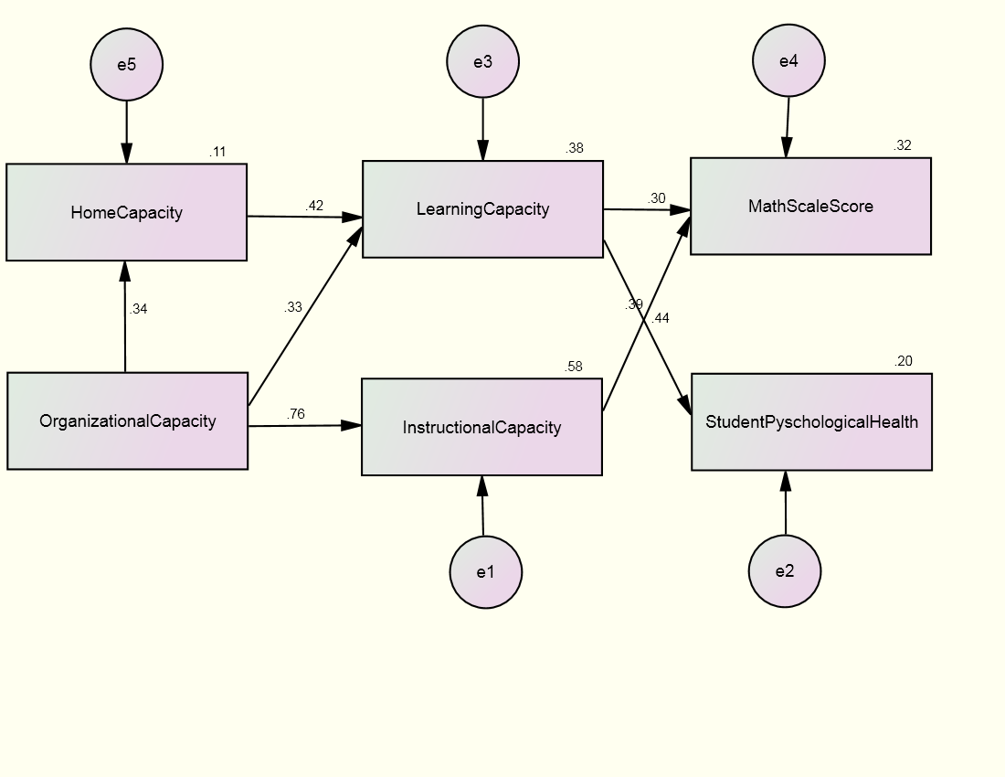

Note: e = error

Table 18: Results from Revised Structural Equation Model – Regression Coefficients and Model Fit Indices
 | β |  |  |  |  |  | B
Variable | 1 |  | 2 | 3 | 4 | 5 | 1 |  | 2 | 3 | 4 | 5 | SE | R²
Direct
- Org. |  |  |  |  |  |  |  |  |  |  |  |  | 0.067
- Instruc. | 0.764 |  |  |  |  |  | 0.493 |  |  |  |  |  | 0.012 | 0.583
- Psych. |  |  |  |  | 0.444 |  |  |  |  |  | 0.685 |  | 0.014 | 0.197
- Learn. | 0.327 |  |  |  |  | 0.420 | 0.109 |  |  |  |  | 0.104 | 0.005 | 0.375
- Home. | 0.335 |  |  |  |  |  | 0.455 |  |  |  |  |  | 0.109 | 0.112
- Ach. |  |  | 0.391 |  | 0.296 |  |  |  | 45.364 |  | 66.049 |  | 251.807 | 0.324
Indirect
- Org.
- Instruc.
- Psych. | 0.208 |  |  |  |  | 0.187 | 0.107 |  |  |  |  | 0.071
- Learn. | 0.141 |  |  |  |  |  | 0.047
- Home.
- Ach. | 0.437 |  |  |  |  | 0.124 | 32.708 |  |  |  |  | 6.844
Total
- Org.
- Instruc. | 0.764 |  |  |  |  |  | 0.493
- Psych. | 0.208 |  |  |  | 0.444 | 0.187 | 0.107 |  |  |  | 0.685 | 0.071
- Learn. | 0.467 |  |  |  |  | 0.420 | 0.157 |  |  |  |  | 0.104
- Home. | 0.335 |  |  |  |  |  | 0.455
- Ach. | 0.437 |  | 0.391 |  | 0.296 | 0.124 | 32.708 |  | 45.364 |  | 66.049 | 6.844
Fit Index |  | Criteria |  |  |  |  |  | Model fit estimates
χ² |  | Non-significant |  |  |  |  |  | 2.881 (p = 0.942, df = 8)
RMSEA |  | < 0.06 |  |  |  |  |  | 0.000
CFI |  | > 0.95 |  |  |  |  |  | 1.000
TLI |  | > 0.95 |  |  |  |  |  | 1.000
Note: 1. Org. = Organizational Capacity; 2. Instruc. = Instructional Capacity; 3. Psych = Student Psychological Health; 4. Learn. = Learning Capacity; 5. Home = Home Capacity; 6. Ach. = Math Achievement; Direct = direct effects; Indirect = indirect effects; Total = total effects; β = standardized regression weights; B = unstandardized regression weights; SE = standard error; R² = SMC

Chapter 7: Discussion
Education reform efforts have centered on accountability policies and practices. A goal of these efforts has been to establish a conclusion that high test scores are the result of schools with strong leadership and high teaching quality; low test scores are the result of schools with weak leadership and poor teaching quality. These policies assert that an increase in test scores provides evidence that leadership and teaching have improved. This framework for education reform is incorrect, misleading, and threatens the achievement of meaningful and lasting school effectiveness.
This study extended the framework of balanced measurement (BPM) systems to schools. BPM literature finds that for organizations to sustain change, improve, and succeed, they must pay attention to and continuously monitor relationships between strategic objectives, multiple internal processes, and the intangible resources that facilitate processes (Grubb, 2009; Kaplan & Norton, 1992; Kaplan & Norton, 2004; Marr & Adams, 2004; Rothstein, 2000, 2008). For several years, policy makers, researchers, and practitioners have argued for similar performance data that present a comprehensive picture of school performance. Despite this support, holistic measures have been slow to gain traction. State governments continue to rely on achievement data as the single type of evidence to hold professionals accountable. This presents harmful constraints to important school capacities and long-term school improvement.
It is the existence, strength, and continuous improvement of essential school capacities that characterize effective schools with strong leadership and high teaching quality. Capacity is composed of the resources, practices, competencies, and motivation existing within an organization that can be increased, developed, or built (Fullan, 2010a; Hargreaves, 2011; Harris, 2011; Sleegers, Thoonen, Oort, & Peetsma, 2014). Capacities inform and drive a school’s ability to achieve and sustain desired outcomes. Education reform efforts must be centered on supporting and improving capacity.
The purpose of this study was to explore what observable variables combine to form the essential capacity domains of the school organization: organizational capacity, instructional capacity, learning capacity, home capacity, and student psychological health. Likely compositional variables were identified based on theory and empirical research. Various analytical procedures were used to explore the formation of these capacities, their influence on one another, and their influence on two outcome variables: academic achievement and student psychological health. This work emphasizes an organic understanding of performance, school functions, and student and school outcomes.

Empirical Support for Five School-Level Capacities and their Interactions
The analyses of empirical evidence completed for this research permit two general conclusions. First, the observed variables that measured student, parent, and teacher perceptions combined to form five capacities that describe school process. Second, these capacities interact, influence one another, and are predictive of traditional and nontraditional measures of school performance (explaining 32% of the variance in math achievement and 20% of the variance in student psychological health). The conceptual strength of the capacities and the empirical support of their formation and interaction suggest they are important processes within schools.
The capacities within this research are established around a conceptual framework and provide a lens to understand, study, and affect process. It is clear that school performance does not have to be understood solely through an analysis of aggregated student test data. Instead, data can be collected from multiple stakeholders concerning multiple areas of focus to better affect multiple aspects of schools. This holistic approach better informs the work of principals and teachers and ultimately improves child development and academic achievement.

Potential Use of Capacities
This research affords researchers, practitioners, and stakeholders a conceptual framework for studying and examining ongoing processes within schools. It supports opportunities to manage cycles of inquiry to affect change. This framework permits the monitoring of areas in which schools are doing well and where resources and development are needed. Leaders are enabled to gather multiple sources of data, turn that data into information, take action from what was learned, and assess effects. This process compensates for the gaps left by a system focusing narrowly on student test scores (Ittner & Larcker, 2003).
For example, organizational capacity is critical to effective school function because it supports other essential school capacities: home capacity, instructional capacity, and learning capacity. This study identified four areas critical to school organizational capacity: principal support for student psychological health, faculty trust in the principal, program coherence, and enabling school structure. Principals can assess strengths and weaknesses across these variables in order to assess their school’s organizational capacity. They can then focus resources, professional development, or further study to address areas of concern while being mindful of how school processes are connected. An assessment can then be completed to examine if these interventions had the desired effects or resulted in unexpected changes.
Imagine a principal learns that teachers do not believe a school has a coherent instructional program. Perhaps curriculum changes in second grade did not align to the foundational knowledge third grade teachers had come to expect. As the instructional leader of the school, a principal may respond by introducing new controls for how curriculum is changed and how teachers must review expected foundational knowledge at the beginning of each school year and/or unit. These control mechanisms may very well increase program coherence. However, if teachers do not agree that these decisions improve their ability to teach, they may begin to question the competency of the principal as an instructional leader. Teachers may not view the new mechanisms put in place as actions that enable them to teach and work cooperatively with colleagues. The principal may find that efforts to improve the school’s curriculum alignment have instead deteriorated the faculty’s trust in the principal and created structures that hinder rather than support teachers. Thus, the school’s organizational capacity is decreased, which may negatively affect teacher’s instructional capacity, student’s learning capacity, the home capacity, or student outcomes.
This example highlights the benefits that a focus on capacity provides. It is easy to narrowly assess one area of function within schools and attempt to affect that area. If improvements in that one area are made, negative consequences in others may be overlooked or ignored (Campbell, 1979; Rothstein, 2008). Capacity requires practitioners to think through the relationships within and across capacity domains (Kaplan & Norton, 2004). Practitioners must assess if actions resulted in expected improvements and then understand how those changes affected other domains within the school.

Implications
Results have implications for policy and practice. For policy, federal and state governments have all but neglected measures of process and conditions associated with better teaching and learning. Part of the problem is that many policy matters lack a framework to inform the identification of affective alternative measures. As a result, attempts to include other measures in accountability plans end up using poor indicators. For example, in some state NCLB waivers, points are awarded to schools that simply have a certain number of teachers return a parent survey. Some use attendance at parent conferences as a measure of parent involvement. Some look to enrollment in advanced placement or IB courses. These measures do not tell schools anything about the actual processes and conditions indicative of quality teachers and leaders, responsible parenting, healthy partnerships, deep learning, or long-term student outcomes.
For practitioners, there is no reason why school districts cannot design their own balanced performance measurement plans. This process is one that business organizations of varying size have engaged in for decades. To do this, districts need a useful theoretical framework. The capacities conceptualized and tested in this study direct attention to universal conditions in school organizations that make teaching and learning fun, engaging, meaningful, and challenging. Ongoing study of these conditions can inform practice and provide practitioners with clear examples of how to affect school performance and child development.
One of the many limitations of NCLB applicable to the results of this study concerns the issue of construct validity. Existing evidence suggests the inability for NCLB policies to provide defensible inferences on school performance (Cronbach & Meehl, 1955; Croker & Aligna, 2006). A measurement system that broadly captures processes within schools better accomplishes this goal than does an accountability system based narrowly on the interpretation of state test results. According to the NCLB waiver, states can determine what comprises their annual measurable objectives (AMOs) and how they plan to evaluate school performance using the new AMOs and performance indicators. This research provides a theoretical framework from which to conceptualize and measure school processes.
The balanced performance measurement literature calls on business organizations to engage in a long term process to identify performance measures that provide a fuller picture of the organization and its work, determine how these indicators are measured and acted on, and assess how they affect outcomes (Ittner & Larcker, 2003). So too can states empower and support school systems in working with stakeholders and regional partners to identify multiple performance measures, determine how best to measure and act on them, and assess their short-term and long-term effects. Policies that support this work will better assist schools in learning from the past, improving and affecting the present, and sustaining long-term improvement in the future (Edvinsson, 1997). Instead of pursuing and enacting policies that tie education performance and accountability to test scores, research on capacities provides states and school systems with the knowledge and theoretical frameworks to enact policies that reshape the definition and understanding of school performance to include multiple and varied measures. Policies can be enacted to allow regions and partnerships the ability to study capacities and enact measurement systems that inform and improve the work of schools.

Future Research
Student psychological health is an outcome of schools vital to the long-term success and well-being of students. This study conceptualized student psychological health as an aggregated outcome of school processes. Understanding variation among students requires multi-level analysis using Hierarchical Linear Modeling or similar statistical packages. Multi-level analysis can better explore individual differences, augmenting the knowledge of how school processes affect student outcomes (Fidell & Tabachnick, 2007).
This study sets the stage for future research assessing the formation and technical merit of school-level capacities, their interactions with one another, and their effects on various school outcomes. Specifically, replication of this study in another school district or across school districts would provide important testing and confirmation of the formation and interaction of each capacity. Quantitative studies can test additional measures of each capacity, to more accurately explain their formation and narrow the focus of key concepts critical to a balanced performance measurement system used to understand school performance.
Longitudinal studies exploring the formation and interaction of key school-level capacities would provide an understanding of how these capacities affect one another and key school outcomes over time. For example, do schools with higher levels of organizational capacity do a better job of recruiting and retaining high quality teachers? Can a school’s organizational and instructional capacity lead to long-term improvements in the resources available to students outside of school, helping to effect more of the variance that explains student achievement (Haertel, 2013)? Understanding how school-level capacities are formed and the implications they have for the work that schools do can inform numerous research designs and alter the way school performance is understood and acted upon.
Qualitative studies can be designed to examine the practices and actions that comprise various levels of these capacities within schools. Such studies can provide a clearer picture as to why schools are able to achieve high levels of certain capacities where others struggle. These studies can inform practice and provide practitioners with clear examples of how to affect school performance throughout the school year on an ongoing basis.

Limitations
One limitation of this study is the relatively small sample size. While the sample includes every school in a Midwestern district, a sample size of 71 is considered small for SEM analysis. Schumacker and Lomax (2004) recommend a sample size of 200, or at least 10 cases per observed variable. A small sample size produces less stable covariances, on which SEM is dependent (Schumacker & Lomax, 2004). This instability can be seen in the post-hoc analyses following the CFAs. Once these models were trimmed and their complexity reduced, fit indices that correct for sample size demonstrated models with good fit.
This study serves as an exploration of capacity formation, interaction, and effects on outcomes. The urban sample limits generalizability. Additional research is needed to understand capacity formation and further assess the technical merit of those developed within the sample.
The paths explored in the final SEM do not reflect the exact relationships among the capacities. Given the sample size and model complexity, it is not possible to determine exact empirical relationships. This limitation can be seen in the post-hoc analysis done to explore the final SEM (Figure 18). The model did conclude a significant relationship between instructional capacity and learning capacity, a relationship that is theoretically established and supported by research (Deci & Ryan, 1985). However, when the model’s complexity was reduced and this relationship was explored (Appendix G), instructional capacity did have a significant relationship with learning capacity and accounted for 15% of its variance, consistent with research examining teaching effects on student development and outcomes (Haertel, 2013).
Of course, the variables comprising each capacity may not be the only variables to form these capacities; other variables yet to be identified may have stronger effects and explain more variance or may be a better fit for certain schools than others. Consistent with the balanced performance measurement literature, capacities capture essential processes required to achieve strategic objectives (Kaplan & Norton, 2004). The areas of focus within each capacity will fluctuate based on contextual differences. The theoretical underpinnings and causal models of each capacity must remain consistent, however (Ittner & Larcker, 2003).

Conclusion
The work of schools is complex. Understanding performance is complex. It is vital that practitioners and policy makers embrace this complexity to better measure and support the work of schools. Reform efforts that ignore and overlook this complexity fail to provide an accurate portrayal of performance and often fail to achieve meaningful and long-lasting results (Rothstein, 2008). Knowledge, research, and resources exist to aid in studying and reporting the complex work of schools. This work must be embraced and implemented to sustain long-term, positive reform efforts.
Capacity provides the framework on which to ground reform efforts and affect school processes. This study identified, tested, and established five broad capacity domains within schools. Understanding capacity enables practitioners and partners of education to continuously inform and direct the work of schools to improve child development and academic achievement.

References

Ackoff, R. L. (1960). Systems, Organizations, and Interdisciplinary Research. In F. E. Emery (Ed.), Systems Thinking (pp. 330-347). Baltimore, Maryland: Penguin Books.

Adams, C. M. (2006). Promoting a Culture of Parent Collaboration and Trust: An Empirical Study. Paper presented at the Annual Meeting of the Educational Research Association, San Francisco, CA.

Adams, C. M. (2013). “Collective trust: A social indicator of instructional capacity”. Journal of Educational Administration, 51(3), 363-382.

Anderson, J. C., Gerbing, D. W., & Hunter, J. E. (1987). On the assessment of unidimensional measurement: Internal and external consistency, and overall consistency criteria. Journal of Marketing, 54(January), 42-58.

Anderson, J. C. & Gerbing, D. W. (1988). Structural equation modeling in practice: A review and recommended two-step approach. Psychological Bulletin, 103(3), 411-423.

Andrews, L. (2011). “Teaching makes a difference”. Paper presented at Reardon Smith Theatre Cardiff, 2 February. Available at: wales.gov.uk/docs/dcells/publications/110202teachingmakesadifferenceen.pdf

Angyal, A. (1941). Foundations for a Science of Personality. In F. E. Emery (Ed.), Systems Thinking (pp. 17-29). Baltimore, Maryland: Penguin Books.

Assor, A., Kaplan, H. & Roth, G. (2002). “Choice is good, but relevance is excellent: Autonomy-enhancing and suppressing teacher behaviors predicting students’ engagement in schoolwork.” British Journal of Educational Psychology, (72), 261-278.

Bandura, A., Barbaranelli, C., Caprara, G. V., & Pastorelli, C. (1996). Multifaceted impact of self-efficacy beliefs on academic functioning. Child Development, 67, 1206-1222.

Bandura, A., Barbaranelli, C., Caprara, G. V., & Pastorelli, C. (2001). Self-efficacy beliefs as shapers of children’s aspirations and career trajectories. Child Development, 72(1, January/February), 187-206.

Bandura, A., Caprara, G. V., Barbaranelli, C., Gerbino, M., & Pastorelli, C. (2003). Role of affective self-regulatory efficacy in diverse spheres of psychosocial functioning. Child Development, 74, 769-782.

Bass, B. M.. (1985). Leadership and performance beyond expectations. New York: Free Press.

Bertalanffy, L. V. (1968). General System Theory: Foundations, Development, Applications. New York: George Braziller.

Blackwell, L. S., Trzesniewski, K. H., & Dweck, C. S. (2007). Implicit theories of intelligence predict achievement across an adolescent transition: A longitudinal study and an intervention. Child Development, 78(1, January/February), 246-263.

Blake, R. R. & Mouton, J. S. (1960). The reliability and validity of socioeconomic measures: Introduction. In J.L. Moreno et al. (Eds.), The Sociometry Reader, Glencoe, IL: The Free Press.

Blau, P. M. (1965). The Comparative Study of Organizations. Industrial and Labor Relations Review, 18(3), 323-338.

Bliese, P. D. (2000). “Within-group agreement, non-independence, and reliability: implications for data aggregation and analysis”, in Klein, K. and Kozlowski, S. (Eds), Multilevel Theory, Research, and Methods in Organizations, Jossey-Bass, San Francisco, CA, pp. 349-381.

Boal, K. B. & Bryson, J. M. (1988). Charismatic leadership: A phenomenological and structural approach. In J. G. Hunt, B. R. Baliga, H. P. Dachler, & C. A. Schriesheim (Eds.), Emerging leadership vistas (p. 11-28). Lexington, MA: Lexington Books.

Bogart, C. D. (2013). “Teacher evaluation and classroom practice: Teacher perceptions in northeast Tennessee”. Electronic Theses and Dissertations. Paper 1177. Available at: http://dc.etsu/etd/1177

Bollen, K. A. (1989). Structural Equations with Latent Variables. New York: Wiley.

Bong, M. (2001). Between- and within-domain relations of academic motivation among middle and high school students: Self-efficacy, task-value, and achievement goals. Journal of Educational Psychology, 93, 23-34

Boulding, E. K. (1956). General Systems Theory - The Skeleton of Science. Management Science, 2(3), 197-208.

Bourdieu, P. & Passeron, J. C. (2000). Reproduction in Education, Society and Culture (2nd ed.). London: Sage.

Brown, K. & Coulter, P. B. (1983). Subjective and objective measures of police service delivery. Public Administration Review, 43(1), 50-58.

Browne, M. W., MacCallum, R. C., Kim, C., Anderson, B. L., & Glaser, R. (2002). When fit indices and residuals are incompatible. Psychological Methods, 7(4), 403-421.

Bryk, A. S. & Schneider, B. (2002). Trust in Schools: A Core Resource for Improvement, Russell Sage Foundation. New York, NY.

Bryk, A. S., Sebring, P. B., Allensworth, E., Luppescu, S. & Easton, J. Q. (2010). Organizing Schools for Improvement: Lessons from Chicago, University of Chicago Press, Chicago, IL.

Burke, E. (1774). Speech to the Electors of Bristol, November 3. Select Works of Edmund Burke, and Miscellaneous Writings, from http://www.econlib.org/library/LF-Books/Burke.brkSWv4c1.html

Campbell, D. T. (1979). Assessing the impact of planned social change. In G.M. Lyons (Ed.), Social Research and Public Policies. Hanover, NH: University Press of New England. (Reprinted from: 1975)

Casanova, U. (1987). Ethnic and Cultural Differences. Educators handbook: A research perspective, 370-391.

Charbonneau, E. & Van Ryzin, G. G. (2012). Performance measures and parental satisfaction with New York City schools. The American Review of Public Administration, 42(1, March), 54-65.

Cheng, Y. C. & Walker, A. (2008). “When reform hits reality: the bottleneck effect in Hong Kong primary schools”. School Leadership and Management, 28(5), 505-521.

Cohen, A., Doveh, E., & Eick, U. (2001). “Statistical properties of the rwg(i) index of agreement”. Psychological Methods, 6(3), 297-310.

Cohen, D. K. & Ball, D. L. (1999). “Instruction, capacity, and improvement”. CPRE Research Report Series No. RR-43, CPRE, Ann Arbor, MI, available at: http://www-personal.umich.edu/~dball/papers/CohenBallInstructonCapacity.pdf

Cohen, J., Cohen, P., West, S. G., & Aiken, L. S. (2003). Applied Multiple Regression/Correlation Analysis for the Behavioral Sciences (3 ed.). New York: Routledge.

Coleman, J. S., Campbell, Ernest Q., Hobson, Carol, J., McPartland, James, Mood, Alexander, M., Weinfeld, Frederic, D., & York, Robert, L. (1966). Equality of Educational Opportunity. Washington, DC: US Department of Health, Education, and Welfare.

Corcoran, T. & Goertz, M. (1995). “Instructional capacity and high performance schools”. Educational Researcher, 24(9), 27-31.

Cosner, S. (2009). “Building organizational capacity through trust”. Educational Administration Quarterly, 45(2), 248-291.

Crocker, L. & Aligna, J. (2006). Introduction to classical and modern test theory. Independence, KU: Wadsworth Publishing Company.

Cronbach, L. J. & Meehl, P. E. (1955). Construct validity in psychological tests. Psychological Bulletin, 52, 281-302.

Crowther, F. (2011). From School Improvement to Sustained Capacity. Corwin Press: Thousand Oaks, CA.

Deci, E. L. & Ryan, R. M. (1985). Intrinsic Motivation and Self-Determination in Human Behavior. New York: Plenum.

Dee, T., Jacob, B., & Schwartz, N. L. (2013). Promoting equity in state education accountability systems. Dover, NH: National Center for the Improvement of Educational Assessment.

Deming, W. E. (1986). Out of the Crisis. Cambridge, MA: Massachusetts Institute of Technology.

Deming, W. E. (1994). The New Economics (2nd ed.). Cambridge: Center for Advanced Educational Services, Massachusetts Institute of Technology.

Dorman, J. P. (2001). Association between classroom environment and academic efficacy. Learning Environments Research, 4, 243-257.

Downey, L. W. (1960). The Task of Public Education. The Perceptions of People. Chicago: Midwest Administration Center, University of chicago.

Duckworth, E. (1987). The having of wonderful ideas. New York, NY: Teachers College Press.

Edvinsson, L. (1997). Developing intellectual capital at Skandia. Long Range Planning, 30(3), 320-331.

Emery, F. E. & Trist, E. L. (1965). The Causal Texture of Organiztional Environments. In F. E. Emery (Ed.), Systems Thinking (pp. 241-257). Baltimore, Maryland: Penguin Books.

ESEA Flexibility. (2014). Retrieved April 1, 2014, from http://www2.ed.gov/print/policy/elsec/guid/esea-flexibility/index.html

Feibleman, J. F. & Friend, J. W. (1945). The Structure and Function of Organization. In F. E. Emery (Ed.), Systems Thinking (pp. 30-55). Baltimore, Maryland: Penguin Books.

Feigenbaum, A. V. (1983). Total quality control (3rd ed.). New York: McGraw-Hill.

Fidell, B. G., & Tabachnick, L. S. (2007). Using multivariate statistics (5th ed.). Boston: Pearson.

Forsyth, P. B., Barnes, L. B., & Adams, C. M. (2006). Trust-effectiveness patterns in schools. The Journal of Educational Administration, 44(2), 122-141.

Forsyth, P. B., Adams, C. M., & Hoy, W. K. (2011). Collective Trust: Why Schools Can't Improve Without It. New York, NY: Teachers College Press.

Forsyth, P.B., Adams, C. M., & Hoy, W. K. (2011). Collective Trust: Why Schools Can’t Improve Without It. Teachers College: New York, NY.

Franklin, B. (1728). The Busy-Body, No. 3. On Virtue. In John Hardin Best (Ed.), Benjamin Franklin on Education. New York: Bureau of Publications, Teachers College, Columbia University.

Franklin, B. (1749). Proposals Relating to the Education of Youth in Pensilvania (Facsimile Reprint ed.). Philadelphia: University of Pennsylvania Press (1931).

Frazer, M. (1992). Quality assurance in higher education. In A. Craft (ed.), Quality assurance in higher education. London: Falmer. 9-25.

Fullan, M. (2010). All Systems Go: The Change Imperative for Whole System Reform. Corwin Press: Thousand Oaks, CA.

Fullan, M. (2011a). Choosing the Wrong Drivers for Whole System Reform. Centre for Strategic Education Seminar series paper no. 24, available at: www.cse.edu.au.

Fullan, M. (2011b). The Moral Imperative Realized. Corwin Press and Ontario Principals Council: Thousand Oaks, CA.

Gaus, J. M. (1936). A Theory of Organization in Public Administration. The Frontiers of Public Administration, University of Chicago Press.

Goddard, R. D. (2002). A theoretical and empirical analysis of the measurement of collective efficacy: The development of a short form. Educational and Psychological Measurement, 62(1), 97-110.

Goddard, R. D., Hoy, W. K., & Woolfolk Hoy, A. (2000). Collective teacher efficacy: Its meaning, measure, and impact on student achievement. American Educational Research Journal, 37(2), 479-507.

Goldhaber, D. D., Brewer, D. J., & Anderson, D. J. (1999). A three-way error compnents analysis of educational productivity. Education Economics, 7(3), 199-208.

Goldratt, E. C., Jeff. (1986). The Goal. New York: North River Press.

Goodman, R. & Jinks, Derek. (2003). Toward an Institutional Theory of Sovereignty. Stanford Law Review, 55, 1749-1788.

Gouldner, A. (1960). “The norm of reciprocity: a preliminary statement”. American Sociological Review, 25(2). 167-178.

Grubb, W. N. (2009). The Money Myth. New York: Russell Sage Foundation.

Haertel, E. H. (2013). Reliability and validity of inferences about teachers based on student test scores. In ETS (Ed.), William H. Angoff Memorial Lecture Series. Washington, DC: The National Press Club.

Hargreaves, A. & Fink, D. (2006). Sustainable Leadership. Jossey-Bass: San Francisco, CA.

Hargreaves, A. & Shirley, D. (2009). The Fourth Way: the Inspiring Future for Educational Change. Corwin Press: Thousand Oaks, CA.

Hargreaves, David H. (2011). System redesign for system capacity building. Journal of Educational Administration, 49(6), 685-700.

Harris, A. (2011). “System improvement through collective capacity building”, Journal of Educational Administration, (49)6, 624-636.

Harris, A. & Jones, M. (2011). Professional Learning Communities in Action, Leannta Press, London.

Harvey, L. & Green, D. (1993). Assessment and evaluation in higher education. Assessment and Evaluation in Higher Education, 18(1), 9-34.

Hatch, T. (2006). Into the Classroom: Developing the Scholarship of Teaching and Learning. Jossey-Bass: San Francisco, CA.

Heck, R. H. (2006). Assessing school achievement progress: Comparing alternative approaches. Educational Administration Quarterly, 42(5), 667-699.

Henderson, A. & Berla, N. (1994). A New Generation of Evidence: The Family is Critical to Student Achievement. Washington, DC: National Committee for Citizens in Education.

Henson, R. K. (2001). Teacher self-efficacy: Substantive implications and measurement dilemmas. Paper presented at the Annual Meeting of the Educational Research Association, College Station, TX.

Hernandez, R. A. (2006). Assessing school achievement progress: Comparing alternative approaches. Educational Administration Quarterly, 42(5), 667-699.

Heylighen, F. & Joslyn, C. (1992). What is Systems Theory? Principia Cybernetica Web, from http://pespmc1.vub.ac.be/SYSTHEOR.html

Hirsch, E. D. (1987). Cultural Literacy. Boston: Houghton Mifflin.

Hopkins, D. & Jackson, D. (2003). “Building the capacity for leading and learning”, in Harris A., Day, C., Hadfield, M., Hopkins, D., Hargreaves, A., and Chapman, C. (Eds), Effective Leadership for School Improvement. Routledge Falmer: London, 84-104.

Hoy, W. K. & Miskel, C. G. (2002). “Theory and Research in Educational Administration”. Information Age: Greenwich, CT.

Hoy, W. K. & Sweetland, S. R. (2000). “School bureaucracies that work: enabling, not coercive”. Journal of School Leadership, 10(6), 525-541.

Hoy, W. K. & Sweetland, S. R. (2001). “Designing better schools: the meaning and measure of enabling school structures”. Educational Administration Quarterly, (37)3, 296-321.

Hoy, W. K., Sweetland, S. R. & Smith, P. A. (2002). Toward an organizational model of achievement in high schools: The significance of collective efficacy. Educational Administration Quarterly, 38(1), 77-93.

Hoy, W. K. & Tschannen-Moran, M. (1999). “Five faces of trust: an empirical confirmation in urban elementary schools”. Journal of School Leadership, 9(4), 184-208.

Hoy, W. K. & Tschannen-Moran, M. (2003). The conceptualization and measurement of faculty trust in schools. In Wayne K. Hoy & Cecil Miskel (Eds.), Studies in leading and organizing schools (pp. 181-207). Greenwich, CT: Information Age.

Hu, L. & Bentler, P. M. (1999). Cutoff criteria for fit indexes in covariance structure analysis: Conventional criteria versus new alternatives. Structural Equation Modeling, 6(1), 1-55.

Iacobucci, D. (2009). Everything you always wanted to know about SEM (structural equations modeling) but were afraid to ask. Journal of Consumer Psychology, 19(October), 673-680.
Iacobucci, D. (2010). Structural equations modeling: Fit indices, sample size, and advanced topics. Journal of Consumer Psychology, 20, 90-98.

Ishikawa, K. (1985). What is Total Quality Control? The Japanese Way. Englewood Cliffs, NJ: Prentice-Hall.

Ittner, C. D. & Larcker, D. F. (2003). Coming up short on nonfinancial performance measurement. Harvard Business Review, November, 1-10.

James, O. (2009). Evaluating the expectations disconfirmation and expectations anchoring approaches to citizen satisfaction with local public services. Journal of Public Administration Research and Theory, 19(1), 107-123.

Jefferson, T. (1818). Report of the Commissioners Appointed to Fix the Site of the University of Virginia, etc. In Roy J. Honeywell (Ed.), The Educational Work of Thomas Jefferson (pp. 249-250). New York: Russell and Russell.

Juran, J. M. (1999). How to think about quality. In J. M. Juran, Godfrey, A.B., Hoogstoel, R.E., & Schilling, E.G. (Ed.), Juran's quality handbook (5th ed., pp. 2.1-2.18). New York: McGraw-Hill.

Kaplan, R. S. & Anthony A. (1998). Advanced Management Accounting (Third ed.). Englewood Cliffs, NJ: Prentice Hall.

Kaplan, R. S. & Norton, D. P. (2004). Measuring the Strategic readiness of Intangible Assets. Harvard Business Review, February, 19-34.

Kaplan, R. S. & Norton, D. P. (1992). The balanced scorecard: Measures that drive performance. Harvard Business Review, Best of HBR, 172-180.

Katz, D. & Kahn, Robert L. (1966, 1977). The Social Psychology of Organizations. New York: John Wiley and Sons.

Kelly, J. M. & Swindell, D. (2002). A multiple-indicator approach to municipal service evaluation: Correlating performance measurement and citizen satisfaction across jurisdictions. Public Administration Review, 62, 610-621.

Kelly, J. M. & Swindell, D. (2003). The case for the inexperienced user: Rethinking filter questions in citizen satisfaction surveys. American Review of Public Administration, 33(1), 91-108.

Kochanek, J. R. (2005). Building Trust for Better Schools. Corwin Press, Thousand Oaks, CA.

Kolesar, H. (1967). “An empirical study of client alienation in the bureaucratic organization”. Ph.D. Dissertation, University of Alberta, Edmonton, Canada.

Koretz, D. M. (2008). Measuring Up: What Educational Testing Really Tells Us. Cambridge, Mass.: Harvard University Press.

Krieg, J. M. & Storer, P. (2006). How do students matter? Applying the Oaxaca Decomposition to explain determinants of Adequate Yearly Progress. Contemporary Economic Policy, 24(4), 563-581. doi: 10.1093/cep/by1003.

Lambert, L. (2007). “Lasting leadership: towards sustainable school improvement”. Journal of Educational Change, 8(4), 311-323.

Langley, G. J., Moen, Ronald D., Nolan, Kevin M., Nolan, Thomas W., Norman, Clifford L., & Provost, Lloyd P. (2009). The Improvement Guide: A Practical Approach to Enhancing Organizational Performance (2nd ed.). San Francisco, CA: Jossey-Bass.

Law, K. S., Wong, C., & Mobley, W. H. (1999). “Toward a taxonomy of multidimensional constructs”. Academy of Management, 15(2), 741-755.

Lee, V. E., Smith, J. B., Perry, T. E., & Smylie, Mark A. (1999). “Social support, academic press, and student achievement: A view from the middle grades in Chicago”. Improving Chicago’s Schools, Consortium on Chicago School Research, (October). Available at https://ccsr.uchicago.edu/sites/default/files/publications/p0e01.pdf

Levin, B. (2008). How to Change 5000 Schools: A Practical and Positive Approach for Leading Change at Every Level. Harvard Education Press: Cambridge, MA.

Licari, M. J., McLean, W., & Rice, T. W. (2005). The condition of community streets and parks: A comparison of resident and nonresident evaluations. Public Administration Review, 65, 360-368.

Linn, R. L. (2005). Conflicting demands of No Child Left Behind and state systems: Mixed messages about school performance. Education Policy Analysis Archives, 13(33), 1-20.

Luhmann, N. (1996). Social systems (J. Bednarz Jr. & D. Baecker, Trans.). Stanford, CA: Stanford University Press.

Marquardt, D. W. (1999). Process industries. In J. M. Juran, Godfrey, A.B., Hoogstoel, R.E., & Schilling, E.G. (Ed.), Juran's quality handbook (5th ed., pp. 27.21-27.37). New York: McGraw-Hill.

Marr, B. & Adams, C. (2004). The balanced scorecard and intangible assets: similar ideas, unaligned concepts. Measuring Business Excellence, 8(3), 18-27.

Nolan, T. W. & Provost, Lloyd P. (1990). Understanding Variation. Quality Process, May, 2-10.

Nye, B., Konstantopoulos, S., & Hedges, L. V. (2004). How large are teacher effects? Educational Evaluation and Policy Analysis, 26(3), 237-257.

Mau, R. Y. (1992). The validity and devolution of a concept: Student alienation. Adolescence, 27(107), 731-741.

Mishra, S. (2006). Quality assurance in higher education: An introduction. Bangalore, India: National Assessment and Accreditation Council.

Murdock, T. B. (1999). The social context of risk: Status and motivational predictors of alienation in middle school. Journal of Educational Psychology, 91(1), 62-75.

Nadler, D. A. & Tushman, Michael L. (1980). A Model for Diagnosing Organizational Behavior. Organizational Dynamics, Autumn, 35-51.

National Research Council. (2009). Letter Report to the U.S. Department of Education on the Race to the Top Fund. Washington, DC: National Academies Press.

Newmann, F. M., King, M. B., & Rigdon, M. (1997). “Accountability and school performance: implications from restructuring schools”. Harvard Educational Review, University of Wisconsin: Madison, WI.

Newmann, F. M., Smith, B., Allensworth, E., & Bryk, A. S. (2001). School Instructional Program Coherence: Benefits and Challenges. Improving Chicago’s Schools, Consortium on Chicago School Research, (January). Available at https://ccsr.uchicago.edu/sites/default/files/publications/p0d02.pdf

Newman, F. M. & Wahlage, G. (1995). Successful School Restructuring: A Report to the Public and Education. Center on Organization and Restructuring of Schools. University of Wisconsin: Madison, WI.

Nolan, T. W. & Provost, Lloyd P. (1990). Understanding Variation. Quality Process, May, 2-10.

Nye, B., Konstantopoulos, S. & Hedges, L. V. (2004). How large are teacher effects? Educational Evaluation and Policy Analysis, 26(3), 237-257.

Orr, M. (1999). Black Social Capital: The Politics of School Reform in Baltimore, 1986-1998. Kansas University Press, Lawrence, KS.

Padro, F. F. (2013). High-Stakes Testing Assessment: The Deus ex Machina of Quality in Education. In J. T. Bower, P.L. (Ed.), De-Testing + De-Grading Schools: Authentic Alternatives to Accountability and Standardization (Vol. 451). New York: Peter Lang.

Parsons, T. (1951). The Social System. London: Routledge & Kegan Paul.

Parsons, T. (1960). Structure and Process in Modern societies. New York: The Free Press of Glencoe.

Parsons, T. (1968). The Structure of Social Action: A Study in Social Theory with Special reference to a Group of Recent European Writers. New York: The Free Press.

Parsons, T. (1971). Societies: Evolutionary and Comparative Perspectives. Englewood Cliffs, New Jersey: Prentice-Hall.

Payne, C. (2008). So Much Reform, So Little Change: The Persistence of Failure in Urban Schools. Harvard Education Press: Cambridge: MA.

Persell, C. H. (1982). The Effective Principal in Action. The Effective Principal. Reston, VA: National Association of Secondary School Principals.

Podsakoff, P. M., Mackenzie, Scott B., Moorman, Robert H., & Fetter, Richard. (1990). Transformational leader behaviors and their effects on followers' trust in leader, satisfaction, and organizational citizenship behaviors. Leadership Quarterly, 1(2), 107-142.

Polikoff, M. S., McEachin, Andrew J., Wrabel, Stephani L., Duque, Mattew. (2014). The waive of the future? School accountability in the waiver era. Educational Researcher, 43(45), 45-54.

Polikoff, M. S. & Wrabel, S. L. (2013). When is 100% not 100%? The use of safe harbor to make Adequate Yearly Progress. Education Finance and Policy, 8(2), 251-270.

Popham, J. (1999). Why Standardized Tests Don't Measure Educational Quality. Educational Leadership, 56(6), 14-21.

Rafalides, M. & Hoy, W. K. (1971). Student sense of alienation and pupil control orientation of high schools. The High School Journal, 55(3, Dec.) 101-111.

Ream, R. K. & Rumberger, R. W. (2008). Student engagement, peer social capital, and school dropout among Mexican American and non-Latino white students. Sociology of Education, 81(April), 109-139.

Ridley, C. E. & Simon, Herbert A. (1938, 1943). Measuring Activities: A Survey of Suggested Criteria for Appraising Administration. Chicago, Illinois: International City Managers' Association.

Roderick, M., Stone, S., Arney, M., Chiong, J., DaCosta, K., & Waxman, E. (1998). “Changing standards, changing relationships: Building family-school relationships to promote achievement in high schools.” Student Life in High Schools Project, School of Social Service Administration, University of Chicago, Consortium on Chicago School Research, (August). Available at https://ccsr.uchicago.edu/sites/default/files/publications/p0e02.pdf

Rothstein, R. (2000). Making a Case Against Performance Pay, New York Times. April 26.

Rothstein, R., Jacobson, R., & Wilder, T. (2008). Grading education: Getting accountability right. New York, NY: Teachers College.

Russell, A. (1996). Great transitions: preparing adolescents for a new century. Washington, DC: Carnegie Council on Adolescent Development.

Ryan, R. M. & Deci, E. L. (2000). Self-Determination Theory and the Facilitation of Intrinsic Motivation, Social Development, and Well-Being. American Psychologist, 55(1), 68-78.

Schumacker, R. E. & Lomax, R. G. (2004). A Beginner's guide to Structural Equation Modeling (2 ed.). Mahwah, NJ: Erlbaum.

Schumaker, R. E. & Lomax, R. G. (2004). A Beginner's guide to Structural Equation Modeling (2 ed.). Mahwah, NJ: Erlbaum.

Schwartz, H. L., Hamilton, L. S., Stecher, B. M., & Steele, J. L. (2011). Expanded Measures of School Performance Technical Report: Rand Corporation.

Seeman, M. (1959). “On the meaning of alienation.” American Sociological Review, 34(December), 783-791.

Senge, P. M. (1990). The Fifth Discipline: The Art and Practice of the Learning Organization. New York: Doubleday.

Sheldon, S. B. (2002). Parents' Social Networks and Beliefs as Predictors of Parent Involvement. The Elementary School Journal, 102(4), 301-306.

Shewhart, W. (1931). Economic Control of Quality of Manufactured Product. New York: Van Nostrand.

Sirotnik, Kenneth A. (2002). Promoting Responsible Accountability in Schools and Education. The Phi Delta Kappan, 83(9), 662-673.

Stewart, T. (1997). Intellectual Capital: The New Wealth of Organizations. Nicholas Brealey, London.

Stewart, T. (2001). The Wealth of Knowledge: Intellectual Capital and the Twenty-first Century Organization, Nicholas Brealey, London.

Stipak, B. (1979). Citizen satisfaction with urban services: Potential misuse as a performance indicator. Public Administration Review, 39(1), 46-52.

Stipak, B. (1980). Local governments’ use of citizen surveys. Public Administration Review, 40(5), 521-525.

Stoll, L. & Seashore, Louis K. (2007). Professional Learning Communities: Divergence, Depth and Dilemmas. Open University Press: Maidenhead.

Swindell, D. & Kelly, J. M. (2005). Performance measurement about school choice. Journal of Policy Analysis and Management, 20, 609-631.

Talbert, J. E., Cor, M. K., Chen, P., Kless, L.M., McLaughling, M. (2012). “Inquiry-based school reform: Lessons from SAM in NYC”. Center for Research on the Context of Teaching. Stanford University (January).

Thompson, J. D. (1967). Organizations in Action: Social Science Bases of Administrative Theory. New Brunswik, New Jersey: Transaction Publishers.

Tschannen-Moran, M., & Hoy, W. K. (2000). A multidisciplinary analysis of the nature, meaning, and measurement of trust. Review of Educational Research, 70(4), 547-593.

Tschannen-Moran, M. (2004). Trust Matters: Leadership for Successful Schools. Jossey-Bass: San Francisco, CA.

U.S. Department of Education. (2012). ESEA Flexibility, June 7, 2012. Retrieved from https://www2.ed.gov/policy/gen/guid/secletter/110923.html

U.S. Department of Education. (2011). Letter from the Education Secretary, September 23, 2011. Retrieved from https://www2.ed.gov/policy/gen/guid/secletter/110923.html

Van Ryzin, G. G., Immerwahr, S., & Altman, S. (2008). Measuring street cleanliness: A comparison of New York City’s scorecard and results from a citizen survey. Public Administration Review, 68, 295-303.

Viskovatoff, A. (1999). Foudnations of Niklas Luhmann's Theory of Social Systems. Philosophy of the Social Sciences, 29(December), 481-516.

Voelkl, K. E. (1996). Measuring students’ identification with school. Educational and Psychological Measurement, 56, 760-770.

Voelkl, K. E. (1997). Identification with school. American Journal of Education, 105(3, May), 294-318.

Wasserman, S. & Mouton, J. S. (1994). Social Network Analysis: Methods and Applications. Cambridge, UK: Cambridge University Press.

Watzlawick, P., Weakland, J., & Fisch, R. (1974). Change: Principles of Problem Formation and Problem Resolution. New York: Norton.

Weick, K. E. (1976). “Educational organizations as loosely coupled systems”. Administrative Science Quarterly, (21), 1-19.

Weiss, M. J. & May, H. (2012). A policy analysis of the federal growth model pilot program’s measures of school performance: The Florida case. Education Finance and Policy, 7(1), 44-73.

Wentzel, K. R.& Caldwell, K. (2007). Friendships, peer acceptance, and group membership: Relations to academic achievement in middle school. Child Development, 68, 1198-1209.

Winder, R. E. (1993). Fulfilling quality’s five dimensions. Paper presented at the 47th Annual Quality Congress, Transactions, in Atlanta, GA.

Zimmerman, B. J. (1995). Self-efficacy and educational development. In A. Bandura (Ed.), “Self-Efficacy in Changing Societies”, 202-231. New York, NY: Cambridge University Press.

Zimmerman, B. J. & Martinez-Pons, M. (1990). Student differences in self-regulated learning: Relating grade, sex, and giftedness to self-efficacy and strategy use. Journal of Educational Psychology, 82, 51-59.

Zimmerman, B. J., Bandura, A., & Martinez-Pons, M. (1992). Self-motivation for academic attainment: The role of self-efficacy beliefs and personal goal setting. American Educational Research Journal, 29, 663-676.

Zimmerman, B. J. & Bandura, A. (1994). Impact of self-regulator influences on writing course attainment. American Educational Research Journal, 31, 845-862.

Appendix A: IRB Letter of Review Outcome


Appendix B: Conceptualization of Organizational Capacity

Transformational Leadership: 7 items, 1-6 Likert scale, strongly disagree (score 1) to strongly agree (score 6), as reported by the faculty member. Reliability, as measured by Cronbach's alpha, was .94 for the Transformational Leadership Behavior Scale, suggesting strong internal consistency among the items. The structure of the factor analysis supported the construct validity, as did concurrent and predictive validity procedures.
The principal at this school…
- Inspires others with his/her plans for the future.
- Provides a good model for me to follow.
- Develops a team attitude and spirit among employees.
- Insists on only the best performance.
- Behaves in a manner thoughtful of my personal needs.
- Asks questions that prompt me to think.
- Commends me when I do a better than average job.

Principal Support for Student Psychological Needs: 11 items, 1-6 Likert scale, strongly disagree (score 1) to strongly agree (score 6), as reported by the faculty member. Reliability, as measured by Cronbach’s alpha, was .97. Items load strongly on a single factor, ranging from .77-.94.
- My principal consults with me about the social adjustment of individual students.
- My principal asks me about how I make course content relevant.
- My principal wants to know how I convey realistic but high expectations to learners.
- My principal is interested in what approaches I take with students struggling in my class.
- My principal wants to know how I make my class personally exciting to learners.
- My principal wants to know what steps I take to motivate those learners who appear disengaged.
- My principal asks how I help discouraged students build their confidence.
- My principal asks how I convey acceptance and respect to students, especially those who appear disengaged.
- My principal asks to see how I use performance and attitudinal information about individual students to improve my teaching.
- My principal asks how I collaborate with other teachers to engage disengaged or low-performing students.
- My principal asks about my contact with parents/guardians of learners, regardless of their academic and social standing in the class.

Faculty Trust in Principal: 8 items, 1-6 Likert scale, strongly disagree (score 1) to strongly agree (score 6), as reported by the faculty member. Reliability, as measured by Cronbach’s alpha, typically ranges from .90 to .98. Factor analytic studies of the scale support the construct and discriminant validity concept.
- Teachers in this school trust the principal.
- Teachers in this school are suspicious of most of the principal’s actions.
- The teachers in this school have faith in the integrity of the principal.
- The principal in this school typically acts in the best interests of teachers.
- The principal in this school does not show concern for the teachers.
- Teachers in this school can rely on the principal.
- The principal in this school is competent in doing his or her job.
- The principal doesn’t tell teachers what is really going on.

Program Coherence: 6 items, 1-6 Likert scale, strongly disagree (score 1) to strongly agree (score 6), as reported by the faculty members. Reliability, as measured by Cronbach’s-alpha, ranged from .84-.90 indicating strong item consistency.
- Once we start a new program, we follow up to make sure that it is working.
- We have so many different programs in this school that I can’t keep track of them all.
- Many special programs come and go at this school.
- You can see real continuity from one program to another at this school.
- Curriculum, instruction, and learning materials are well coordinated across different grade levels at this school.
- There is consistency in curriculum, instruction and learning materials among teachers in the same grade level at this school.

Enabling School Structure: 12 items, 1-5 Likert scale, never (score 1) to very often (score 5), as reported by the teacher. The reliability of the scale is consistently high – usually .90 higher (Hoy, 2001). The construct and predictive validity have been strongly supported in a number of studies (Hoy, 2000, 2001).
  - Administrative rules in this school enable authentic communication between teachers and administrators.
  - In this school, red tape is a problem.
  - The administrative hierarchy of this school enables teachers to do their job.
  - The administrative hierarchy obstructs student achievement.
  - Administrative rules help rather than hinder.
  - The administrative hierarchy of this school facilitates the mission of this school.
  - Administrative rules in this school are used to punish teachers.
  - The administrative hierarchy of this school obstructs innovation.
  - Administrative rules in this school are substitutes for professional judgment
  - Administrative rules in this school are guides to solutions rather than rigid procedures.
  - In this school, the authority of the principal is used to undermine teachers.
  - Administrators in this school use their authority to enable teachers to do their job.

Appendix C: Conceptualization of Instructional Capacity

Perception of Teacher Evaluation System: 13 items, 1- 6 Likert scale, strongly disagree (score 1) to strongly agree (score 6), as reported by the faculty member. Reliability, as measured by Cronbach’s-alpha, was .88.
  - I understand the 4 domains of the TLE rubric.
  - I understand the 20 dimensions of the TLE rubric.
  - I understand the 5 levels of teacher effectiveness.
  - The dimensions of the TLE rubric describe effective teaching.
  - Working toward the dimensions of the TLE rubric will help me improve my instruction.
  - Evaluation domains and dimensions were made clear in a pre-observation conference.
  - Face to face feedback from the evaluation was provided after each observation.
  - The evaluation process takes more effort than the results are worth.
  - The evaluation process helped me develop as a teacher.
  - I am confident the evaluation process fairly reflects my teaching effectiveness
  - The TLE rubric clearly defines standards for teaching effectiveness.
  - I am satisfied with the discussions of my performance with the principal or assistant principal who evaluated me.
  - I am satisfied with the feedback I received from the principal or assistant principal who evaluated me.

Professional Learning Community Effectiveness: 15 items, 1- 6 Likert scale, never (score 1) to always (score 6), as reported by the faculty member.
Our PLC members…
- Are open and honest about their instructional weaknesses and mistakes.
- Solve important issues during team meetings.
- Discuss decisions that are key to the school’s success.
- Challenge one another in order to make informed decisions.
- Nurture the interpersonal vitality of the team.
- Are able to come to agreement without compromising individual members’ perspectives.
- End team meetings with clear and specific understandings of actions to be taken.
- Work as a group equitably to distribute the workload.
- Know what team members are working on.
- Leave meetings confident that there is consensus on decisions.
- Share ownership of team learning.
- Are concerned about the prospect of letting one another down.
- Establish clear measurements for assessing our success.
- Stay on task despite distractions and competing priorities.
- Willingly make sacrifices for the achievement of our goals.

Faculty Trust in Colleagues: 8 items, 1- 6 Likert scale, strongly disagree (score 1) to strongly agree (score 6), as reported by the faculty member. The Omnibus T-Scale is a short operational measure of three dimensions of faculty trust (trust in principal, trust in colleagues, and trust in clients), which can be used for either elementary or secondary schools. The reliabilities of the three subscales typically range from .90 to .98. Factor analytic studies of the Omnibus T-Scale support the construct and discriminant validity of the concept.
- Teachers in this school trust each other.
- Teachers in this school typically look out for each other.
- Teachers in this school are suspicious of each other.
- Even in difficult situations, teachers in this school can depend on each other.
- Teachers in this school do their jobs well.
- Teachers in this school have faith in the integrity of their colleagues.
- The teachers in this school are open with each other.
- When teachers in this school tell you something, you can believe it.

Collective Teacher Efficacy: 12 items, 1- 6 Likert scale, strongly disagree (score 1) to strongly agree (score 6), as reported by the faculty member. Content and predictive validity of the scale is strong, and an alpha of .96 indicates strong item consistency (Goddard, 2000).
- Teachers in this school are able to get through to the most difficult students.
- Teachers here are confident they will be able to motivate their students.
- If a child doesn’t want to learn, teachers here give up.
- Teachers here don’t have the skills needed to produce meaningful student learning.
- Teachers in this school believe that every child can learn.
- These students come to school ready to learn.
- Home life provides so many advantages that students here are bound to learn.
- Students here just aren’t motivated to learn.
- Teachers in this school do not have the skills to deal with student disciplinary problems.
- The opportunities in this community help ensure that these students will learn.
- Learning is more difficult at his school because students are worried about their safety.
- Drug and alcohol abuse in the community make learning difficult for students here.

Appendix D: Conceptualization of Learning Capacity

Competence Support: 7 items, 1- 4 Likert scale, strongly disagree (score 1) to strongly agree (score 4), as reported by the student. Reliability, as measured by the Cronbach-alpha, ranged from .79-.93.
  - Teachers in this school really make students think.
  - Teachers in this school expect students to do their best all of the time.
  - Teachers in this school expect students to work hard.
  - Teachers in this school challenge students to achieve academic goals.
  - Teachers in this school help students with difficult assignments.
  - Teachers in this school celebrate the achievement of students.
  - Teachers in this school make learning interesting.

Student Trust in Teachers: 10 items, 1- 4 Likert scale, strongly disagree (score 1) to strongly agree (score 4), as reported by the student. Reliability, as measured by the Cronbach-alpha, was .90.
- Teachers are always ready to help at this school.
- Teachers at this school are easy to talk to.
- Students are well cared for at this school.
- Teachers at this school always do what they are supposed to.
- Teachers at this school really listen to students.
- Teachers at this school are always honest with me.
- Teachers at this school are good at teaching.
- Students at this school can believe what teachers tell them.
- Students learn a lot from teachers at this school.
- Students at this school can depend on teachers for help.

Autonomy Support: 8 items, 1- 4 Likert scale, strongly disagree (score 1) to strongly agree (score 4), as reported by the student.
- Teachers encourage students to work in their own way.
- Teachers talk about the connection between what is studied in school and what happens in real life.
- Teachers allow students to decide things for themselves.
- Teachers listen to the opinions and ideas of students.
- Teachers tell students what to do all the time.
- Teachers respect students when they share what they really think.
- Teachers explain why it is important to study certain subjects in school.
- Teachers show students how to solve problems themselves.

Faculty Trust in Students: 5 items, 1-6 Likert scale, strongly disagree (score 1) to strongly agree (score 6), as reported by the teacher. The reliability ranges from .90-.98.
- Teachers in this school trust their students.
- Students in this school care about each other.
- Students in this school can be counted on to do their work.
- Teachers here believe students are competent learners.
- Students in this school are secretive.

Peer Academic Support: 6 items, 1- 4 Likert scale, strongly disagree (score 1) to strongly agree (score 4), as reported by the student. Three facets comprise peer academic support. Peer academic aspiration has a Cronbach-alpha of .74, peer resistance to school norms has a Cronbach-alpha of .73, and peer academic support has a Cronbach-alpha of .70.
- Most of my good friends plan to go to college.
- Most of my good friends won’t drop out.
- Most of my good friends don’t like to associate with kids who study.
- Most of my good friends make fun of kids who are concerned about grades.
- Most of my good friends help each other study for tests.
- I can call my friends for help with homework when I’m stuck.

Appendix E: Conceptualization of Home Capacity

School Outreach: 8 items, 1- 6 Likert scale, strongly disagree (score 1) to strongly agree (score 6), as reported by the parent. Reliability, as measured by alpha coefficients, is around 0.85.
  - Parents are invited to visit classrooms to observe the instructional program.
  - Teachers communicate regularly with parents
  - Parents are greeted warmly when they call or visit the school
  - Teachers work closely with parents to meet students’ needs
  - This school regularly communicates with parents about how they can help their children
  - Parents are encouraged to give feedback to the school
  - Teachers really try to understand parents’ problems and concerns
  - The school regularly communicates to parents about how they can help advance the mission of the school.

Parent Social Network: 1 item, 1- 9 scale, as reported by the parent. Reliability, as measured by alpha coefficients, is 0.85.
- Parents indicate how many sets of parents they know and with him they interact with.

Parent Trust in School: 10 items, 1-6 scale, strongly disagree (score 1) to strongly agree (score 6), as reported by the parent.
- This school always does what it is supposed to
- This school keeps me well informed
- I really trust this school
- Kids at this school are well cared for
- This school is always honest with me
- This school does a terrific job
- This school has high standards for all kids
- This school is always ready to help
- I never worry about my child when he/she is there
- At this school, I know I will be listened to

Home Academic Emphasis: 9 items, 1-4 scale, strongly disagree (score 1) to strongly agree (score 4)
- I often discuss classes at school with my parent(s) or guardian(s)
- I often discuss school activities or events of interest with my parent(s) or guardian(s)
- I often discuss going to college and careers with my parent(s) or guardian(s)
- I often discuss my school work and grades with my parent(s) or guardian(s)
- My parent(s) or guardian(s) often help me with my homework.
- My parent(s) or guardian(s) often check to see if I did my homework.
- My parent(s) or guardian(s) often praise me for doing well in school.
- My parent(s) or guardian(s) often encourage me to take responsibility.
- My parent(s) or guardian(s) encourage me to work hard at school.

Faculty Trust in Parents: 5 items, 1- 6 Likert scale, strongly disagree (score 1) to strongly agree (score 6), as reported by the faculty member. The reliability ranges from 0.90-0.98.
- Teachers in this school trust the parents.
- Parents in this school are reliable in their commitments.
- Teachers can count on parental support.
- Teachers think that most of the parents do a good job.
- Teachers can believe what parents tell them.

Appendix F: Conceptualization of Student Psychological Health

Self-regulated learning: 12 items, 1-4 Likert scale, strongly disagree (score 1) to strongly agree (score 4), as reported by the student. In terms of reliability and validity, scores on the items below have proven internally consistent, with alpha coefficients ranging from .78-.84, Confirmatory factor analysis confirms that all items fit the latent construct well (CFI = .98, RMSEA = .05).
  - I try to do well in school because I will get in trouble if I don’t.
  - I do my classwork because I think it is important.
  - I do my classwork because I want to learn new things.
  - I do my classwork so the teacher won’t yell at me.
  - I do my classwork because I’ll feel bad about myself if it doesn’t get done.
  - I do my classwork because doing well in school is important to me.
  - I try to do well in school because that’s what I’m supposed to do.
  - I try to answer hard questions in class because I want other kids to think I’m smart.
  - I try to do well in school because I like doing a good job on my work.
  - I do my homework because I want to learn new things.
  - I do my classwork because I want the teacher to think I’m a good student.
  - I do my homework because I want to understand the subject.

Math and Reading Efficacy: 10 items, 1-4 Likert scale, strongly disagree (score 1) to strongly agree (score 4), as reported by the student. In terms of reliability and validity, the Cronbach alpha was .88.
- I’m certain that I can master the skills taught in math this year.
- I can do even the hardest work in math class if I try.
- I can do all math classwork if I don’t give up.
- Even if the math is hard, I can learn it.
- I’m certain I can figure out how to do the most difficult math work.
- I’m certain that I can master the skills taught in reading this year.
- I can do even the hardest work in reading class if I try.
- I can do all reading classwork if I don’t give up.
- Even if the reading is hard, I can learn it.
- I’m certain I can figure out how to do the most difficult reading work.

Social Well-Being (Alienation): 20 items, 1-4 Liker scale, strongly disagree (score 1) to strongly agree (score 4), as reported by the student. In terms of reliability and validity, the Cronbach alpha was .85 and the factor loadings ranged from .45 to .74. The 20 items capture normlessness (N), meaninglessness (M), social isolation (SI), and powerlessness (P).
- (N) There just aren’t any rules to live by.
- (N) Students have the right to cheat if it keeps them from failing.
- (N) I like the rules of this school.
- (N) In order to be successful, sometimes you have to do things that are not right.
- (N) Copying another student’s homework is OK.
- (M) School is helping me get ready for what I want to do after leaving school.
- (M) I feel I am wasting my time in school.
- (M) I’m pretty sure my life will work out the way I want it to.
- (M) I am really interested in my schoolwork.
- (M) Usually I’d rather be absent from school than be there.
- (SI) I do not know anyone that I can confide in.
- (SI) I often feel left out of things that others are doing.
- (SI) I have friends I can count on.
- (SI) When I’m unhappy, I can turn to friends for support.
- (SI) I feel close to my family.
- (P) The problems of life are sometimes too big for me.
- (P) It is hard to know what is right and wrong because the world is changing so fast.
- (P) I’m afraid to ask teachers questions when I don’t understand something.
- (P) Sometimes I feel school is like a jail.
- (P) Teachers don’t listen to complaints of students.

Student Identification with School: 10 items, 1-4 Likert scale, strongly disagree (score 1) to strongly agree (score 4), as reported by the student. In terms of reliability and validity, the Cronbach alpha was .84. Factor loadings ranged from .40 to .70.
- I feel proud of being a part of my school.
- School is one of the most important things in my life.
- Many of the things we learn in class are useless.
- Most of my teachers don’t really care about me.
- Most of the time, I would like to be any place other than in school.
- Most of what I learn in school will be useful when I get a job.
- School is one of my favorite places to be.
- People at school are interested in what I have to say.
- School is often a waste of time.
- There are teachers or other adults in my school that I can talk to if I have a problem.

Appendix G: Structural Equation Model and Results – Learning Capacity and Instructional Capacity

Figure 19: Results from the Hypothesized Structural Equation Model – Standardized Estimates and SMCs

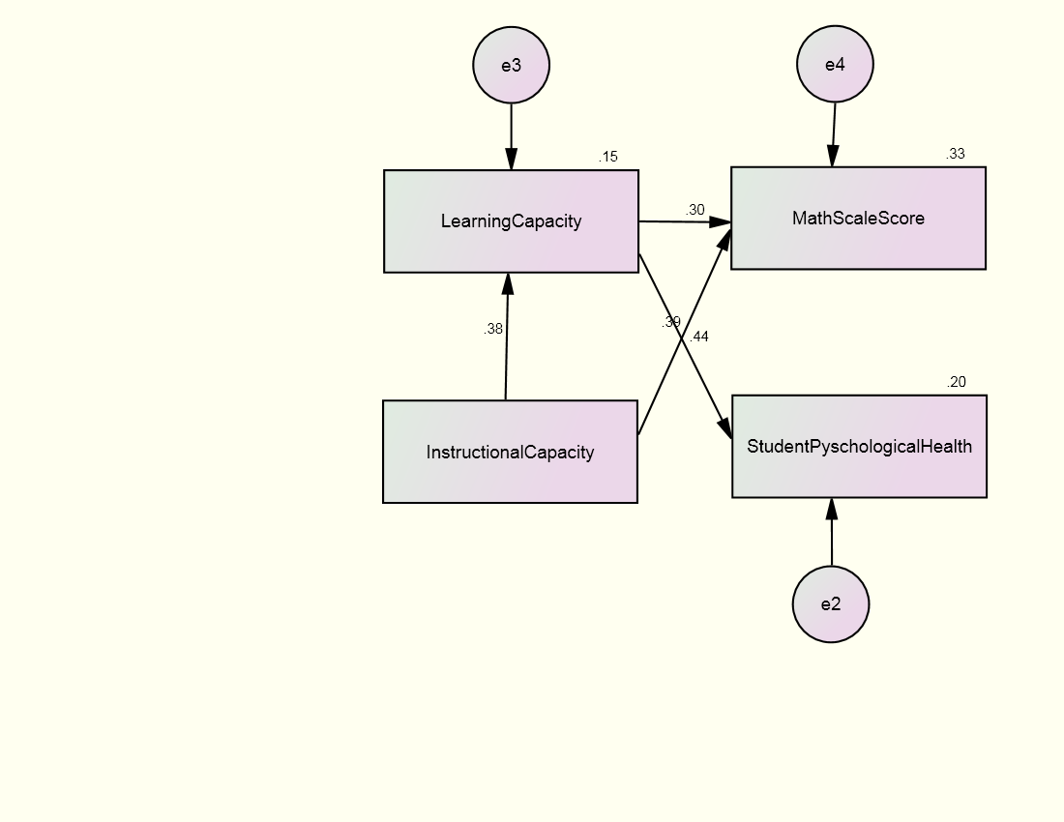

Note: e = error

Table 19: Results from Hypothesized Structural Equation Model –
Regression Coefficients and Model Fit Indices
 | β |  |  | B
Variable | 1 | 2 | 3 | 1 | 2 | 3 | SE | R²
Direct
- Learn. |  | 0.384 |  |  | 0.199 |  | 0.006 | 0.147
- Instruc. |  |  |  |  |  |  | 0.028
- Psych. | 0.444 |  |  | 0.685 |  |  | 0.014 | 0.197
- Ach. | 0.295 | 0.390 |  | 66.049 | 45.364 |  | 251.807 | 0.328
Indirect
- Learn.
- Instruc.
- Psych. |  | 0.170 |  |  | 0.137
- Ach. |  | 0.113 |  |  | 13.168
Total
- Learn. |  | 0.384 |  |  | 0.199
- Instruc.
- Psych. | 0.444 | 0.170 |  | 0.685 | 0.137
- Ach. | 0.295 | 0.503 |  | 66.049 | 58.532
Fit Index | Criteria |  |  | Model fit estimates
χ² | Non-significant |  |  | 0.850 (p = 0.654, df = 2)
RMSEA | < 0.06 |  |  | 0.000
CFI | > 0.95 |  |  | 1.000
TLI | >0.95 |  |  | 1.000
Note: Learn = learning capacity; Instruc = instructional capacity; Psych = student psychological health; Ach = math scale score; Direct = direct effects; Indirect = indirect effects; Total = total effects; β = standardized regression weights; B = unstandardized regression weights; SE = standard error; R² = SMC

Another area NCLB has been successful in is the expansion and improvement of state data collection systems. This will be explored in the discussion on balanced performance measures
The absence of an empirical relationship between instructional capacity and learning capacity is problematic to the theoretical argument made for the formation of these capacities and their relationship to one another. With such a small sample size, it is possible that a complex model, as initially run, may not accurately capture all empirical relationships. A separate SEM was specified and tested based on data from all 71 schools in the sample with the Amos 7.0 statistical package in SPSS. This model is simplified and explores the hypothesized relationship between instructional capacity, learning capacity, achievement, and student psychological health. The model is a perfect fit to the data. The CFI is 1.0; TLI is 1.0; the RMSEA is 0.0; and chi square is not significant (χ² = 0.850, p = 0.654, df = 2). The direct and indirect effects are reported in Appendix G. This analysis supports the theoretical and hypothesized formation and relationship between these capacities while highlighting the limitations in the study due to the small sample size. A school’s instructional capacity does indeed affect the learning capacity of students, which influences their psychological health and academic achievement.

