UNIVERSITY OF OKLAHOMA
GRADUATE COLLEGE

HIGH RESOLUTION SEQEUNCE STRATIGRAPHY OF THE NPRA, NORTH SLOPE, ALASKA:

A THESIS
SUBMITTED TO THE GRADUATE FACULTY
In partial fulfillment of the requirements for the
Degree of
MASTER OF SCIENCE

BY
SAMUEL WALL BERG
Norman, Oklahoma
2019

HIGH RESOLUTION SEQEUNCE STRATIGRAPHY OF THE NPRA, NORTH SLOPE, ALASKA

A THESIS APPROVED FOR THE
SCHOOL OF GEOSCIENCES

BY THE COMMITTEE CONSISTING OF

Dr. John D. Pigott, Chair

Dr. Heather Bedle

Dr. Roger Slatt

© Copyright by SAMUEL WALL BERG 2019
All Rights Reserved.

“All we have to decide is what to do with the time that is given us”
-Gandalf the Grey

ACKNOWLEDGEMENTS

First and foremost, I would like to thank my advisor, Dr. John Pigott, for his enthusiasm and support throughout this entire process. Without his suggestions and guidance, this thesis never would have been started, much less completed. I will always remember the kindness he has shown me and the lessons he taught me.

I would also like to thank my committee members, Dr. Roger Slatt, and Dr. Heather Bedle for their time, their suggestions, and their interest in my research. Their expertise was invaluable in the revision and completion of this thesis.

This research would not have been possible if not for the tireless efforts of the USGS, from which all the data used in this thesis was gathered.

I wish to thank the OU School of Geosciences for the resources provided in order to conduct my research. This includes the use and licenses of Petrel 2016 and HampsonRussel, as well as the education I received at this institution.

Thank you to my colleagues and friends for acting as a sounding board for me when you didn’t have to, including Abidin Caf, Matt Lynch, Andrew Layden, Cyril Frazier, and Dr. Jerry Zhai. My time with you all is what kept me sane through the trials and tribulations of this thesis.

Lastly, I would like to thank my father, John Berg, my family, and my lovely girlfriend, Darian Cook, for their unending support and patience in one of the most trying times of my life.

TABLE OF CONTENTS
List of Figures…………………………………………………………………………viii
ABSTRACT…………………………………………………………………….…..….xv
1.INTRODUCTION……………………………………………………………………..1
1.1 Location of Study..………………………….………………….…….……...1
1.2 Sequence Stratigraphy Background..…………………………………….….2
1.3 Problem Statement……………………………………………………...…...5
2. GEOLOGIC HISTORY………………………………………………………………6
2.1 Tectonic and Structural Framework...………………………………….…....6
2.2 Megasequence Description…………………….…………………….……...8
3. STRATIGRAPHY………………………………………………...…………………11
3.1 Endicott Group..…………………………………………………………….11
3.2 Lisburne Group…………………………………………..…………………13
3.3 Sadlerochit Group.………………………………………………………….14
3.4 Shublik Formation………………………………………………………….15
3.5 Sag River Formation…………………………..………..…………...…..….16
3.5 Kingak Formation…………………………..…………..…………...…..….16
3.5 Pebble Shale………………………………...…………..…………...….…..17
3.5 Torok Formation………………………………………..…………...….…..17
4. DATA AND INTERPRETATIONS………………………………………………...18
4.1. Data and Study Area....……………….…………...………….………..….18
4.2. Lithologic Formations……………………………………………….…….21
4.3 Sequence Stratigraphy Method…….………………………………………25
4.4 Sequence Stratigraphic Interpretations.……………………………………28
4.5 Seismic Facies Interpretation and Petroleum Implications………………...51
5. DISCUSSION……………………………………………………………………….55
6. CONCLUSIONS………………...………………………..……………………..…..63
REFERENCES……………………………………………………………………...….65
APPENDIX….……………………………………………………………………...….69

LIST OF FIGURES
Figure 1: Map of NPRA boundaries in Northern Alaska showing the locations of the Meade and Ikpikpuk-Umiat basins as well as the locations of the Ikpikpuk 1 well, the Inigok 1 well, and the North Inigok 1 well. (Modified from Fulk, 2010)
Figure 2: Model of an idealized deltaic sequence. Galloway sequence boundaries are indicated by G, and Vail sequence boundaries are indicated by V. Relative location of parasequence sets are also shown. Important surfaces are shown with the black arrows. See text for explanation. (Modified from Van Wagoner, 1988).
Figure 3: Figure 3: Idealized sea level curve showing maximum flooding surface (MFS), Highstand Systems Tracts (HST), Sequence Boundary (SB), Lowstand Systems Tracts (LST), Transgressive Surface (TS), and Transgressive Systems Tracts (TST) as they relate to changes in sea-level (SL) and base-level (from Pigott and Bradley, 2014).
Figure 4: Figure 4: Diagram showing the different types of reflector terminations. Truncation is associated with base level drop and erosion, toplap is associated with static base level, and onlap is associated with rising base level and transgression. (Pigott, unpublished seismic stratigraphy lecture notes)
Figure 5: Map showing the rotation of the Arctic Alaska microplate rotating away from the Canadian Arctic islands. Heavy dashed line is inferred to be the extinct seafloor spreading center that forced the Arctic Alaska microplate to move. (Laxon,1994: McAdoo, 1998)
Figure 6: Generalized stratigraphic column of the North Slope. (Modified from Houseknecht, 2002)
Figure 7: Map showing a thickness isopach of the Endicott Group and location of wells that pierced it. (Modified from Wilson, 2001)
Figure 8: Map showing a thickness isopach of the Lisburne Group on the North Slope. Ikpikpuk-Umiat basin is labeled “A” and Meade basin is labeled “B”. (Modified from Dumoulin and others, 2008)
Figure 9: Map showing study area in the eastern NPRA as well as interpreted 1981 seismic lines and key wells. All lines were interpreted, but this study will focus on the key lines and wells mentioned previously.
Figure 10: Seismic Line 27-81 annotated to show major lithologic formation tops crossing through two wells: Inigok 1(left) and North Inigok 1 (right). The formation tops shown include: Lisburne (Pink), Sadlerochit-Shublik (Orange), Kingak (Light green), Pebble Shale (Cyan), and Torok (Blue).
Figure 11: Seismic Line 18-81 annotated to show major lithologic formation tops crossing through two wells: Ikpikpuk 1(left) and North Inigok 1 (right). The formation tops shown include: Lisburne (Pink), Sadlerochit-Shublik (Orange), Kingak (Light green), Pebble Shale (Cyan), and Torok (Blue).
Figure 12: Seismic Line B-81 annotated to show major lithologic formation tops crossing through the North Inigok 1 well. The formation tops shown include: Lisburne (Pink), Sadlerochit-Shublik (Orange), Kingak (Light green), Pebble Shale (Cyan), and Torok (Blue).
Figure 13: Well-to-Seismic tie at Inigok 1 well. 66% correlation coefficient was achieved in analysis window (between yellow lines).
Figure 14: Accommodation Succession stacking patterns. progradation-aggradation is understood to represent Lowstand Systems Tracts, retrogradation represents Transgressive Systems Tracts, and aggradation-progradation-degradation represents Highstand Systems Tracts. (Modified from Neal and Abreu, 2009)
Figure 15: Seismic Line 27-81 showing reflector terminations and corresponding unconformity surfaces. Red arrows indicate downlap and onlap while the yellow arrows indicate toplap and truncation. Operational sequence boundaries are colored by tectonic phase. The black line is the acoustic basement, the red lines are Ellesmerian aged, the blue lines are Beaufortian aged, and the green lines are Brookian aged. Black vertical lines show positions of Inigok 1 well (left) and North Inigok 1 (right). Faults are shown as curved black lines.
Figure 16: Seismic line 27-81 showing operational sequence boundaries and corresponding systems tracts. Green polygons indicate transgressive systems tracts, blue polygons indicate highstand systems tracts, and red polygons indicate lowstand systems tracts. Black vertical lines show positions of Inigok 1 well (left) and North Inigok 1 (right). Faults are shown as curved black lines.
Figure 17: Seismic Line 18-81 showing reflector terminations and corresponding unconformity surfaces. Red arrows indicate downlap and onlap while the yellow arrows indicate toplap and truncation. Operational sequence boundaries are colored by tectonic phase. The black line is the acoustic basement, the red lines are Ellesmerian aged, the blue lines are Beaufortian aged, and the green lines are Brookian aged. Black vertical lines show positions of Ikpikpuk well (left) and North Inigok (right). Faults are shown as curved black lines.
Figure 18: Seismic line 18-81 showing operational sequence boundaries and corresponding systems tracts. Green polygons indicate transgressive systems tracts, blue polygons indicate highstand systems tracts, and red polygons indicate lowstand systems tracts. Black vertical lines show positions of Ikpikpuk well (left) and North Inigok (right). Faults are shown as curved black lines.
Figure 19: Seismic Line B-81 showing unconformity surfaces traced from ties on line 27-81. Operational sequence boundaries are colored by tectonic phase. The black line is the acoustic basement, the red lines are Ellesmerian aged, the blue lines are Beaufortian aged, and the green lines are Brookian aged. Black vertical line shows position of North Inigok 1 well. Faults are shown as curved black lines.
Figure 20: Gamma ray log motif analysis conducted on Ikpikpuk 1, North Inigok 1, and Inigok 1 wells showing cycles of shoreline regression, transgression, and stasis. Third order cycle boundaries from seismic are shown as tops on the logs, and seismically unresolvable fourth order cycles are shown with arrows and block columns.
Figure 21: Seismic line 27-81 showing operational sequence boundaries and corresponding systems tracts along with seismically unresolvable fourth order cycles shown by the block columns. Green polygons indicate transgressive systems tracts, blue polygons indicate highstand systems tracts, and red polygons indicate lowstand systems tracts. Black vertical lines show positions of Inigok 1 well (left) and North Inigok 1 (right).
Figure 22: Seismic line 18-81 showing operational sequence boundaries and corresponding systems tracts along with seismically unresolvable fourth order cycles shown by the block columns. Green polygons indicate transgressive systems tracts, blue polygons indicate highstand systems tracts, and red polygons indicate lowstand systems tracts. Black vertical lines show positions of Ikpikpuk well (left) and North Inigok (right).
Figure 23: Chronostratigraphic Wheeler Diagram and local Sea Level Curve on seismic line 27-81. Operational sequence boundaries are colored by tectonic phase. The black line is the acoustic basement, the red lines are Ellesmerian aged, the blue lines are Beaufortian aged, and the green lines are Brookian aged. Lowstand, Highstand, and Transgressive systems tracts are represented by red, blue, and green polygons, respectively. Diagonal lines indicate the limit of control.
Figure 24: Chronostratigraphic Wheeler Diagram on seismic line 18-81. Operational sequence boundaries are colored by tectonic phase. The black line is the acoustic basement, the red lines are Ellesmerian aged, the blue lines are Beaufortian aged, and the green lines are Brookian aged. Lowstand, Highstand, and Transgressive systems tracts are represented by red, blue, and green polygons, respectively. Diagonal lines indicate zone of control.
Figure 25: Isopach map of the Ellesmerian Megasequence with locations of seismic lines and wells.
Figure 26: Time-structure map of the Basement through seismic. Considered to be the top of the Franklinian Megasequence. Sediment transport toward the south from a northern source.
Figure 27: Time-structure map of the EL2 parasequence set boundary through seismic. This surface correlates to the top of the Lisburne Group. Sediment transport towards the south from a northern source.
Figure 28: Time-structure map of the BE1 parasequence set boundary through seismic. This surface correlates to the top of the Sadlerochit-Shublik formations. VE=50. Sediment transport towards the south from a northern source.
Figure 29: Isopach map of the Beaufortian Megasequence through seismic lines and wells.
Figure 30: Time-structure map of the BE4 parasequence set boundary through seismic. This surface correlates to the top of the Kingak formation. VE=50. Sediment transport towards the south from a northern source.
Figure 31: Time-structure map of the BE5 parasequence set boundary through seismic. This surface correlates to the top of the Pebble Shale. VE=50. Sediment transport predominantly towards the north.
Figure 32: Isopach map of the Brookian Megasequence through seismic lines and wells.
Figure 33: Time-structure map of the BR10 parasequence set boundary through seismic lines 27-81, 18-81, and B-81. This surface is representative of the clinoforms seen in the Torok Formation. VE=50. Sediment transport to the northeast from the Brooks mountain range in the southwest.
Figure 34: Figure showing various types of seismic facies. (A) Parallel to divergent facies. (B) Draping parallel facies. (C) Transparent sigmoid clinoform facies. (D) Hummocky facies. (E) Chaotic facies. (Modified from Lofi et al., 2003)
Figure 35: Figure showing a zoomed in image of the Brookian clinoforms near the North Inigok 1 well. Seismic Facies have been grouped by color. The blue polygon corresponds to parallel to divergent facies. The green polygon corresponds to draping parallel facies. The yellow polygons correspond to transparent sigmoid clinoform facies. Important geological components of a delta are shown with black arrows.
Figure 36: Comparison of line 27-81 local sea level curve on the left to Global Sea level curve (Haq et al., 1987) on the right.
Figure 37: Comparison of line 18-81 local sea level curve on the left to Global Sea level curve (Haq et al., 1987) on the right.
Figure 38: Lithologic boundaries picked on the East Teshekpuk 1 well.
Figure 39: Lithologic boundaries picked on the North Kalikpik 1 well.
Figure 40: Lithologic boundaries picked on the West Fish Creek 1 well.
Figure 41: Seismic Line 12-81 annotated to show major lithologic formation tops crossing through two wells: East Teshekpuk 1(left) and West Fish Creek (right). The formation tops shown include: Lisburne (Pink), Sadlerochit-Shublik (Orange), Kingak (Light green), Pebble Shale (Cyan), and Torok (Blue).
Figure 42: Seismic Line 16-81 annotated to show major lithologic formation tops crossing through two wells: Ikpikpuk 1(left) and North Inigok 1 (right). The formation tops shown include: Lisburne (Pink), Sadlerochit-Shublik (Orange), Kingak (Light green), Pebble Shale (Cyan), and Torok (Blue).
Figure 43: Seismic Line 22-81 annotated to show major lithologic formation tops crossing through the Ikpikpuk 1 well. The formation tops shown include: Lisburne (Pink), Sadlerochit-Shublik (Orange), Kingak (Light green), Pebble Shale (Cyan), and Torok (Blue).
Figure 44: Seismic Line 28-81 annotated to show major lithologic formation tops. The formation tops shown include: Lisburne (Pink), Sadlerochit-Shublik (Orange), Kingak (Light green), Pebble Shale (Cyan), and Torok (Blue).
Figure 45: Seismic Line 31-81 annotated to show major lithologic formation tops. The formation tops shown include: Lisburne (Pink), Sadlerochit-Shublik (Orange), Kingak (Light green), Pebble Shale (Cyan), and Torok (Blue).
Figure 46: Seismic Line 33-81 annotated to show major lithologic formation tops crossing through the Inigok 1 well. The formation tops shown include: Lisburne (Pink), Sadlerochit-Shublik (Orange), Kingak (Light green), Pebble Shale (Cyan), and Torok (Blue).
Figure 47: Seismic Line 37-81 annotated to show major lithologic formation tops. The formation tops shown include: Lisburne (Pink), Sadlerochit-Shublik (Orange), Kingak (Light green), Pebble Shale (Cyan), and Torok (Blue).
Figure 48: Seismic Line A-81 annotated to show major lithologic formation tops crossing through the East Teshekpuk 1 well. The formation tops shown include: Lisburne (Pink), Sadlerochit-Shublik (Orange), Kingak (Light green), Pebble Shale (Cyan), and Torok (Blue).
Figure 49: Seismic Line C-81 annotated to show major lithologic formation tops. The formation tops shown include: Lisburne (Pink), Sadlerochit-Shublik (Orange), Kingak (Light green), Pebble Shale (Cyan), and Torok (Blue).
Figure 50: Seismic Line D-81 annotated to show major lithologic formation tops. The formation tops shown include: Lisburne (Pink), Sadlerochit-Shublik (Orange), Kingak (Light green), Pebble Shale (Cyan), and Torok (Blue).
Figure 51: Seismic Line 28-81 showing unconformity surfaces. Operational sequence boundaries are colored by tectonic phase. The black line is the acoustic basement, the red lines are Ellesmerian aged, the blue lines are Beaufortian aged, and the green lines are Brookian aged.
Figure 52: Seismic Line 33-81 showing unconformity surfaces crossing through the Inigok 1 well. Operational sequence boundaries are colored by tectonic phase. The black line is the acoustic basement, the red lines are Ellesmerian aged, the blue lines are Beaufortian aged, and the green lines are Brookian aged.
Figure 53: Seismic Line A-81 showing unconformity surfaces crossing through the East Teshekpuk 1 well. Operational sequence boundaries are colored by tectonic phase. The black line is the acoustic basement, the red lines are Ellesmerian aged, the blue lines are Beaufortian aged, and the green lines are Brookian aged.
ABSTRACT

The deposition of sediment in the Ikpikpuk-Umiat Basin of the NPRA has been governed by four distinct tectonic phases: 1) Franklinian crustal shortening, 2) Ellesmerian continental sag, 3) Beaufortian continental rifting, and 4) Brookian crustal shortening and tectonic inversion. These tectonic phases and changes in global sea-level resulted in identifiable depositional packages (megasequences). Utilization of the Vail seismic method and corresponding Galloway petrophysical motif analysis identify four parasequence sets: Highstand Systems Tract (HST), Regressive Systems Tract (RST), Lowstand Systems Tract (LST), and Transgressive Systems Tract (TST). These parasequence sets are separated and divided by 25 operational sequence boundaries from the Mississippian to the Cretaceous. Comparison of local and global sea-level curves indicate that the Ikpikpuk-Umiat basin was controlled by allocyclic processes until Brookian time, in which depositional loading of sediment forced the basin to subside. Chronostratigraphic Wheeler diagrams illustrate the results of the complex relationship between auto- and allocyclic accommodation changes. An understanding of the relationship between these depositional phases will substantially increase hydrocarbon exploration strategies. Recent studies suggest the Nanushuk in particular has promising potential for hydrocarbon production, and the relative locations of the underlying systems tracts provide information on the most likely locations of traps, seals, reservoirs, and source rocks.

INTRODUCTION
The Northern Petroleum Reserve in Alaska (NPRA) is over 95,000 square kilometers in area and consists of all the land north of the Brooks Range and Colville River and south and east of the Chukchi and Beaufort Seas, respectively (Fulk, 2010). This study focuses primarily on the sequence stratigraphy of the Ikpikpuk-Umiat basin, which covers roughly 7,000 square kilometers of the eastern section of the NPRA, and extends west into an area just south of the Barrow Arch.
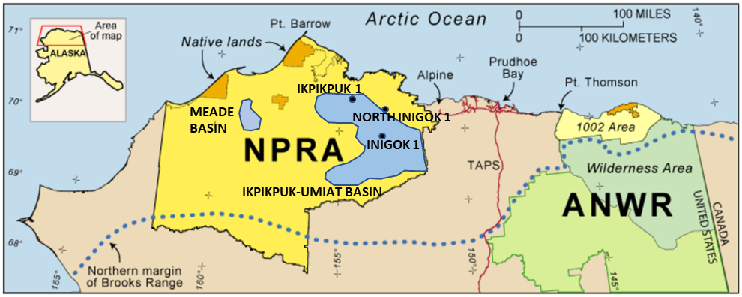
Figure 1: Map of NPRA boundaries in Northern Alaska showing the locations of the Meade and Ikpikpuk-Umiat basins as well as the locations of the Ikpikpuk 1 well, the Inigok 1 well, and the North Inigok 1 well. (Modified from Fulk, 2010)

The NPRA consists of four main stratigraphic megasequences: The Franklinian Megasequence, the Ellesmerian Megasequence, the Beaufortian Megasequence and the Brookian Megasequence (Bird, 1987; Housknecht 2003). The Franklinian Basement complex is comprised of pre-Mississippian metamorphic rocks and is regarded as the economic basement. The Ellesmerian Megasequence was deposited during the Mississippian to early Cretaceous times from a northern-derived source. The Beaufortian Megasequence, deposited during early to middle Jurassic and early Cretaceous time, formed during the rifting event that opened up the Arctic Ocean (Houseknecht, 2003). The Brookian Megasequence was derived from the Brooks Range in the south from the Early Cretaceous to Cenozoic. The Ellesmerian, Beaufortian, and Brookian Megasequences are all considered prospective for petroleum and have been explored and developed by the US Government from 1944 to 1981 (Bird, 1987), and new oil and gas leases commenced in 1999.
The stratigraphy of the Ellesmerian, Beaufortian, and Brookian Megasequences has been the subject of numerous studies in the NPRA, and a general framework of the strata has long been established. However, these studies have focused primarily on the major sequence boundaries and do not delve into the finer parasequence sets contained within. Using a combination of seismic sequence stratigraphy and well-log sequence stratigraphy, it is possible to further constrain the sequence stratigraphic model of the NPRA. A higher resolution model of the NPRA subsurface would substantially assist in the acquisition of hydrocarbons in the area. This study focuses on the integrated application of Vail Seismic sequence stratigraphy and Galloway log motif analysis to create a higher resolution model of the NPRA.
The methods used in this thesis are largely derived from the works of Peter Vail (1977), Robert Mitchum (1977), and William Galloway (1981), all of whom played a large part in developing the study of sequence stratigraphy. Sequence stratigraphy is a framework for describing the deposition of conformable packages of strata that are bound by surfaces in time as opposed to lithology or depositional environment. These surfaces in time are referred to as sequence boundaries, and are understood to be significant erosional unconformities and their correlative conformities (Mitchum and Vail, 1977).
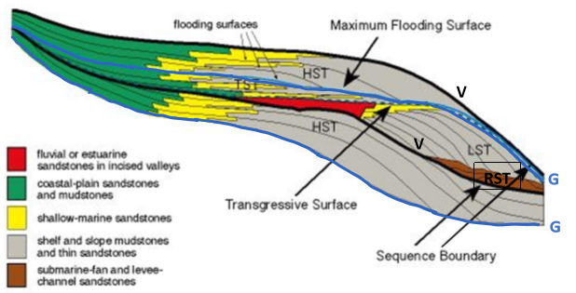
Figure 2: Model of an idealized deltaic sequence. Galloway sequence boundaries are indicated by G, and Vail sequence boundaries are indicated by V. Relative location of parasequence sets are also shown. Important surfaces are shown with the black arrows. See text for explanation. (Modified from Van Wagoner, 1988).

Alternatively, Galloway (1989) proposed the maximum flooding surface as the sequence boundary for his genetic stratigraphic sequence. There are advantages to both approaches, the main distinction being that in seismic it is easiest to use Vail and Mitchum’s framework (Mitchum and Vail, 1977) due to the ease of spotting unconformities, while Galloway’s approach (Galloway, 1989) works better for well logs, where maximum flooding surfaces are commonly reflected in gamma ray logs (Pigott and Bradley, 2014);. For the pragmatic seismic interpretive purposes of this thesis, Vail and Mitchum’s sequence boundary will be used, while gamma ray logs from sparse well control in the region will provide a proxy for process energy to indicate times of shoreline regression, transgression, and stasis (Pigott, 2018).
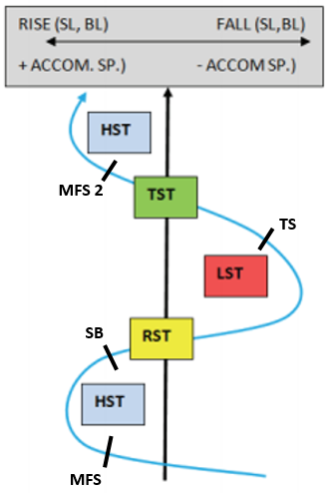
Figure 3: Idealized sea level curve showing maximum flooding surface (MFS), Highstand Systems Tracts (HST), Sequence Boundary (SB), Lowstand Systems Tracts (LST), Transgressive Surface (TS), and Transgressive Systems Tracts (TST) as they relate to changes in sea-level (SL) and base-level (from Pigott and Bradley, 2014).

Sequences may be further divided into parasequence sets known as systems tracts: highstand systems tracts (HST), lowstand systems tracts (LST), transgressive systems tracts (Catuneanu, 2006) and regressive systems tracts (Pigott et al., 2012). In seismic, these systems tracts are divided based on reflector geometry and termination patterns. The geometries within a sequence are dependent on several different variables, such as rate of sedimentation, tectonic activity, and eustatic sea level changes (Galloway, 1989). The different types of reflector termination and their implications can be seen in Figure 4. Mitchum and Vail (1977) provide a detailed method for determining sequence boundaries in seismic data.
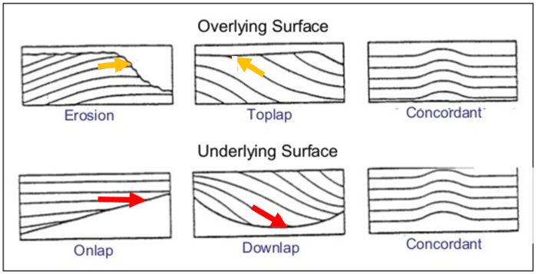
Figure 4: Diagram showing the different types of reflector terminations. Truncation is associated with base level drop and erosion, toplap is associated with static base level, and onlap is associated with rising base level and transgression. (Modified from Mitchum, 1977)

An understanding of sequence stratigraphy can provide valuable insight into the location and production of hydrocarbons. Statements from the USGS indicate that the Nanushuk Group in particular shows promising potential for hydrocarbon production, and as such the stratigraphic framework of the underlying units may influence decisions moving forward.

GEOLOGIC HISTORY
The NPRA is located on a small continental fragment called the Arctic Alaska Microplate (Hubbard et al. 1987), whose boundaries are only approximately known. The North Slope, most of the Brooks Range, and part of Siberia are included on this microplate. While the plate tectonic history of Northern Alaska remains a controversial subject, the most common interpretation is the rotational hypothesis put forth by Carey (1958), Tailleur (1973), and Grantz (1998). In this hypothesis, the Arctic Alaska Microplate was originally located adjacent to the Canadian Arctic Islands. Rifting in the Cretaceous caused a rotational opening in the Canada Basin, forcing the Arctic Alaska Microplate to move counter-clockwise away from Canada in a 60-degree arc about the Mackenzie Delta. Other leading hypotheses are summarized by Lawver and Scotese (1990).
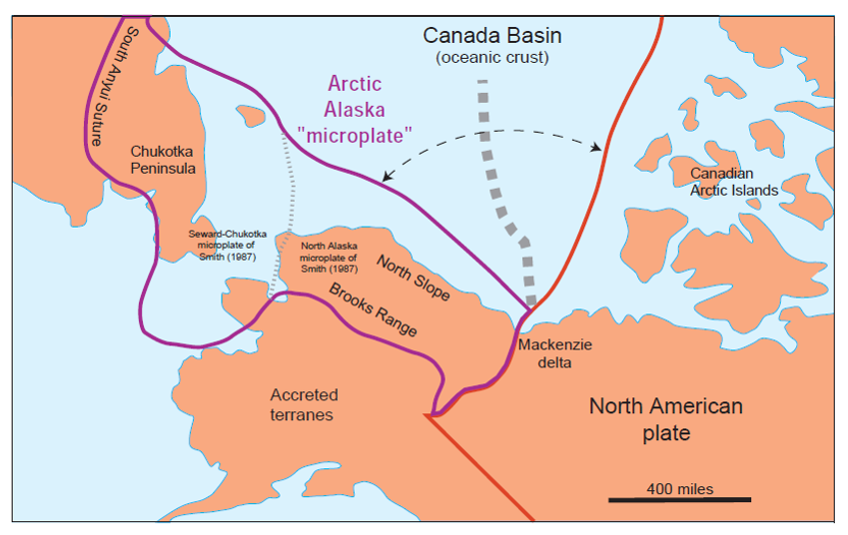Figure 5: Map showing the rotation of the Arctic Alaska microplate rotating away from the Canadian Arctic islands. Heavy dashed line is inferred to be the extinct seafloor spreading center that forced the Arctic Alaska microplate to move. (Laxon,1994: McAdoo, 1998)
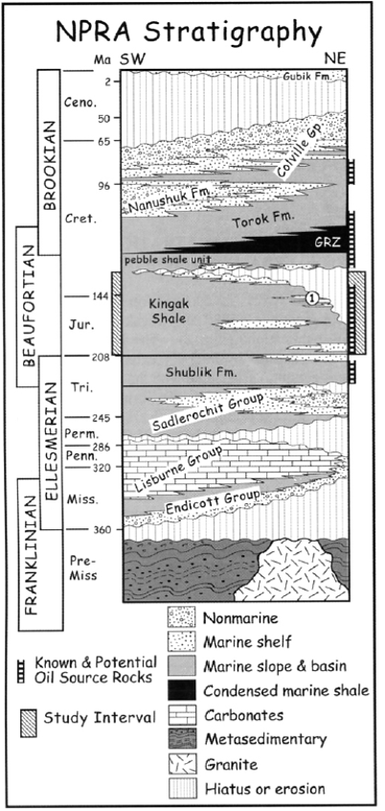
Figure 6: Generalized stratigraphic column of the North Slope. (Modified from Houseknecht, 2002)
The geologic history of the NPRA has resulted in four distinct stratigraphic packages which will be referred to as megasequences for the purposes of this paper (Houseknecht, 2003). These megasequences are the Franklinian, Ellesmerian, Beaufortian, and Brookian, from oldest to youngest. These megasequences reflect major tectonic events and result in significant differences in sediment source area, structural frameworks, and depositional environments. Changes in global sea-level further influenced deposition and created internal complexities within the megasequences.
The Franklinian Megasequence formed more than 400 million years ago, before the Middle Devonian time on a stable continental platform. Some of the sequence may have formed on a passive margin sloping under a sea that deepened to the south. Franklinian deposition ended in the Middle to Late Devonian during the Ellesmerian Orogeny and the megasequence became moderately metamorphosed and highly deformed throughout the mountain belt. The formation of failed rift sub basins such as the Meade and Ikpikpuk-Umiat accelerated the erosion of the continental uplands to a low-lying south-facing coastal plain that began to subside below sea level. A wide range of rock-types are prevalent throughout the sequence, including metamorphosed argillites, graywackes, quartzite, carbonates, and volcanics. The Franklinian Megasequence is often considered the non-prospective basement due to high thermal maturity and generally poor reservoir quality. (Petroleum News, 2008)
Overlying the Franklinian Basement, the Ellesmerian Megaequence is comprised of sediments eroded from Franklinian rock in the landmass north of the Beaufort Sea (Bird, 1981). These sediments moved southward and accumulated in coastal and marine settings of the Arctic Alaska basin. The Ellesmerian Megasequence is characterized by this south-facing passive margin deposition and continues over 150 million years, ending in the early or middle Jurassic. The megasequence is thickest in the center of the Colville basin and thins to the north due to onlap against the landmass and to the south due to distance from sediment source. Deposition was highly varied in Ellesmerian time, resulting in both carbonate and clastic formations that contain petroleum source rocks, excellent reservoirs, and strong seals (Petroleum News, 2008). The Ellesmerian Megaequence is commonly understood to contain multiple prominent groups and formations. From youngest to oldest these are: Endicott group, Lisburne Group, Sadlerochit Group, Shublik Formation, and Sag River Formation (Kupecz, 1995).
The Beaufortian Megasequence, often referred to as the rift sequence, was deposited between Early to Middle Jurassic and Early Cretaceous time. This megasequence was heavily influenced by the counter-clockwise rotational rifting that opened up the Arctic Ocean (Hubbard and Others, 1987). During this time, the east-west trending structural high known as the Barrow Arch began to form in a series of uplift-phases, resulting in a system of rift grabens to the north and widespread surface erosion known as the Lower Cretaceous Unconformity (LCU) (Petroleum News, 2008). Beaufortian strata are distinguished by northern provenance and seismically defined clinoforms that indicate offlap to the south and southeast (Bird, 1987). The Beaufortian Megasequence is comprised of the Kingak Shale and overlying Pebble Shale, which are separated regionally by the LCU (Houseknecht, 2003). Some Beaufortian sediments accumulated on the uplifted margin of the Barrow Arch, forming important sandstone reservoirs (Petroleum News, 2008).
In late Jurassic and early Cretaceous time, thick sheets of fault thrusted rock from the formation of the Brooks Range began to depress the Earth’s crust to the north, causing the Colville Basin to begin to sink (Petroleum News, 2008). Sediments eroded from these thrust sheets began to fill the basin progressively from the southwest to the northeast, forming the Brookian Megaequence. The older Brookian sediments were deposited under relatively deepwater settings and are most commonly shales and sandstones, while the younger Brookian sediments were deposited in shallow water settings such as river deltas or coastal plains. This transition from deep to shallow depositional environments demonstrates the progressive infill of the Colville Basin (Houseknecht and Schenk, 2001). The most prominent formation contained within the Brookian Megasequence is the Torok Formation, a series of prograding clinoforms that grow younger to the east (Houseknecht and Schenk, 2001). Overlying the Torok Formation are several other packages of Brookian strata, however these are beyond the scope of this thesis.

STRATIGRAPHY
This chapter will focus on the major groups and formations present within the Ikpikpuk-Umiat basin. From oldest to youngest these are: the Endicott Group, the Lisburne Group, the Sadlerochit Group, the Shublik Formation, the Sag River Formation, the Kingak Formation, the Pebble Shale Formation, and the Torok Formation. See Figure 2.
Endicott Group
The Endicott Group is made up of the Mississippian aged clastic rocks beneath the Lisburne group. It forms the basal part of the northern-sourced Ellesmerian Megasequence, and is comprised almost entirely of nonmarine and shallow marine clastic rocks, representing an overall transgressive sequence (Bird and Jordan, 1977). This group has been penetrated by a number of wells drilled in the NPRA, most notably the Ikpikpuk 1 well and the Inigok 1 well, though the group is poorly represented in core (Wilson and others, 2001). Bird and Jordan (1977) divided the Endicott Group into three formations: the Kekituk Conglomerate, the Kayak Shale, and the Itkilyariak Formation.
Nilson (1981) describes the three members within the Kekituk Conglomerate. The lowest member is a 90 foot thick section of breccia and conglomerate, interpreted to be of fluvial origin. The middle member is a 90 foot thick section of fining upward conglomerates and sandstones, likely deposited by braided streams. The highest member is a 60 foot thick section of repeated cycles of fining upward conglomerate and sandstone that is rich with plant fossils, interpreted to be deposited by meandering streams.
The Kayak Shale consists of a base sandstone layer overlain by black marine shale with thin interbedded sandstone layers, most likely of debris flow origins. The uppermost section of the Kayak is made up of interbedded shale and limestone beds. The abrupt shift from the basal sandstone layer to marine shale heavily indicates strong marine transgression (Nilsen, 1981).
Mull and Mangus (1972) added the Itkilyariak Formation to the group because of distinctive red beds they were able to correlate from the Sadlerochit mountains to the Prudhoe bay area subsurface. The Itkilyariak Formation is not believed to be contained in the Ikpikpuk-Umiat Basin (Mauch, 1985).
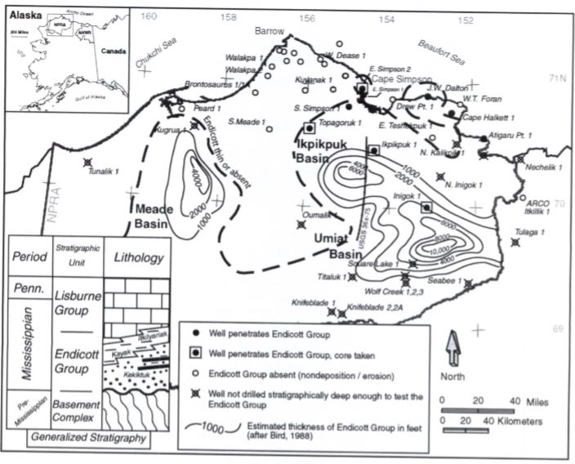
Figure 7: Map showing a thickness isopach of the Endicott Group and location of wells that pierced it. (Modified from Wilson, 2001).

Lisburne Group
The Lisburne Group is a carbonate platform that directly overlies the Kayak Shale in the Ikpikpuk-Umiat basin. In the NPRA, and particularly in the Ikpikpuk-Umiat Basin, the Lisburne Group shows highly variable thickness, ranging from 2000 to 6000 feet (Mauch, 1985). Deposited on an irregular surface with high topographic relief, this group is discontinuously present throughout the region, growing progressively older to the south. Having formed on a south-facing passive continental margin, the Lisburne represents several northward transgressions, though in the NPRA it has a westward component as well (Fulk, 2010). Dumoulin and Bird (2001) divided the Lisburne Group into Mississippian age strata and Pennsylvanian age strata, with an overlying transition zone into the Sadlerochit Group.
Dumoulin and Bird (2001) further divide the Mississipian strata into three units: the lower limestone, middle dolostone, and the upper limestone. The lower limestone unit consists mostly of bryozoan rich wackestones and packestones and contains thin interbedded shales as well as grey dolomites and is the thickest unit of the Mississippian strata. Overlying the lower limestone is the middle dolostone. The middle dolostone grades into bioclastic packestones, though aside from these packestones fossil abundance was very low. The upper limestone unit is more laterally extensive than previous units, and is comprised of white/tan/grey limestone, grey dolostone, and some infrequent siltstone and sandstone (Dumoulin and Bird, 2001).
Pennsylvanian age strata in the Ikpikpuk-Umiat Basin is made up of limestone and dolomitic limestone overlain by limestones interbedded with shales and siltstones. This unit is thickest at the Inigok 1 well, where it is over 1,500 feet thick (Haywood, 1983). Dumoulin and Bird (2001) report 10-50 feet thick shallowing upward cycles marked by ooids and bioclastic grainstones, interpreted to represent a shift in environment from open marine, sub-wave base to higher energy nearshore shoals. Above the Pennsylvanian age strata exists a transition zone in which carbonate deposition was halted either because of an influx of siliciclastic sediment or a shift to a deeper, colder marine setting (Dumoulin and Bird, 2001).
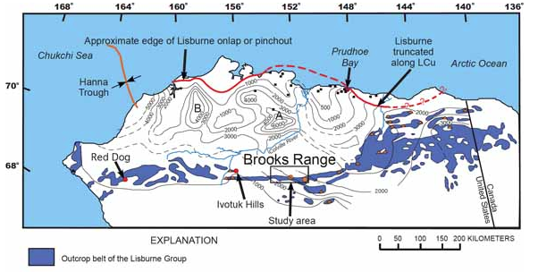
Figure 8: Map showing a thickness isopach of the Lisburne Group on the North Slope. Ikpikpuk-Umiat basin is labeled “A” and Meade basin is labeled “B”. (Modified from Dumoulin and others, 2008)

Sadlerochit Group
Overlying the Lisburne Group disconformably is the Sadlerochit Group. This group is composed of primarily coarsening upward siliciclastic sediment, with the exception of the uppermost member, which is silty. The Sadlerochit shows variable thickness and thins to the north, from 1,550 feet in the Inigok 1 well to 600 feet at the West Fish Creek well owing to distance from the sediment source and erosion (Bird and Jordan, 1977). Wilson and others (2001) divide the Sadlerochit into four formations: the Echooka Formation, the Kavik Shale, the Ivishak Formation, and the Fire Creek Formation.
The Echooka Formation was deposited from the Early to Late Permian and is a fine grained silty sandstone that is rich in fossils (Wilson and others, 2001). Near the top of the Lisburne unit the siltstones are more calcareous, grading upwards into a more quartzose heavy sandstone-siltstone mixture (Mauch, 1985). The Echooka Formation is interpreted to have formed in a shallow marine depositional environment, such as a prodelta (Mauch, 1985; Bird, 2001).
The Kavik Shale overlies the Echooka Formation in the Ikpikpuk-Umiat Basin. Near the top of the Echooka Formation, it is composed primarily of shale with thin interlayers of siltstone and grades upward into a slightly shaley siltstone, abundant with plant fragments (Wilson and others, 2001). The Kavik Shale was most likely deposited in a more distal shelf or deltaic environment.
The Ivishak Formation unconformably overlies the Kavik Shale. The Ivishak coarsens upward from siltstones and interbedded shales at the base to argillaceous sandstones and shales at the top. It is believed to have been deposited in a fluvial deltaic environment during a shoreline regression (Mauch, 1985; Wilson and others, 2001).
The uppermost formation in the Sadlerochit Group is the Fire Creek Siltstone. This formation contains siltstone, mudstone and some sandstones. Wilson and others (2001) cite the transition from sandstone to mudstone as evidence that the Fire Creek Siltstone was deposited during a time of transgression.
Shublik Formation
The Shublik Formation was deposited atop the Sadlerochit Group from Middle to Late Triassic time. Ranging from 250 to 500 feet thick in the NPRA, the Shublik Formation contains a number of lithologies: calcareous siltstones, limestones and dolomites, and shales and sandstones (Mauch, 1985). This formation is very high in phosphate and organic material, and is considered the prominent source rock of the Prudhoe Bay (Fulk, 2010). Detterman (1970) suggests a low-energy, deep-water depositional environment, with mud to silt sized sediment sourced from the north.
Sag River Formation
The Sag River Formation is a very thin (<70 feet) Late Triassic sandstone unit that conformably overlies the Shublik Formation (Mauch, 1985). This formation is interpreted to be correlative with the upper Shublik sandstone found in the Northeastern Brooks Range. This glauconitic orthoquartzite thins towards the North and East, it is only 30 feet thick in the Inigok 1 well (Bird, 1982).
Kingak Formation
The Kingak Formation is primarily a marine shale with small amounts of fine-grained sandstone and siltstone, deposited during Jurassic and Early Cretaceous time from a sediment source in the North (Kirschner and others, 1983). Unlike the Sadlerochit Group, Shublik Formation, and Sag River Formation, the Kingak Formation is very thick and grows thicker to the south, reaching 2900 feet at the Inigok 1 well (Tetra Tech, 1982). In the NPRA, the Kingak is generally characterized by a lower transgressive sequence with interbedded sandstones and shales at the base, followed by a middle regressive sequence with erosion or a depositional hiatus, and finally an upper transgression during which marine shales and siltstones were deposited (Mauch, 1985; Tetra Tech, 1982). The Kingak is interpreted to either be a turbidite sequence or prograding shelf deposit (Kirschner and others, 1983). This formation is overlain by the Lower Cretaceous Unconformity, on which sits the Pebble Shale.
Pebble Shale
The Pebble Shale is an Early Cretaceous shale derived mostly from a sediment source in the south, though a northern upland provided some sandstones to the northernmost reaches of the Pebble Shale (Balkwill and others, 1983). This unit is a black shale containing well rounded quartz grains throughout, as well as highly polished chert pebbles. The exact origin of the pebbles is unknown, though it is hypothesized that the pebbles were transported in by moving ice or vegetation (Detterman and others, 1975; Molenaar, 1981).
Torok Formation
The Torok Formation is a Middle Cretaceous prograding predeltaic wedge that consists of shale, siltstone, and very fine grained sandstone (Molenaar, 1981; Maunch 1985). This formation progrades to the northeast from sediment derived from the southern Brooks Range. The Torok uniformly grows in thickness to the southwest, ranging from 2,000 feet thick in the Colville Delta in the Northeastern NPRA to 19,000 feet in the Knifeblade wells (Tetra Tech, 1982). In seismic data, the Torok Formation is visible as a series of prograding clinoforms that onlap onto the Pebble Shale below.

DATA AND INTERPRETATIONS
The dataset used in this study contains 590 miles of post-stack, unmigrated 2D seismic line data centered around the Ikpikpuk-Umiat Basin in the NPRA (Kulander and others, 2005). Shot in 1981, this data is 12-fold with a 2 millisecond sample rate and 6 second record length. The distance between traces is a uniform 110 feet. In this dataset, wavelet peaks represent positive reflection coefficients and the wavelets are zero-phase. The quality of this seismic data is considered moderate to poor due to surface topography, permafrost, shallow gas hydrate anomalies, or an inability to shoot directly on the planned path because of sensitive wild life or weather conditions (Fulk, 2010). In addition to seismic data, sparse well control in the basin allows for synthetic well ties to seismic, using depth converted sections from density and velocity logs. All data in this study was provided by the United States Geological Survey.
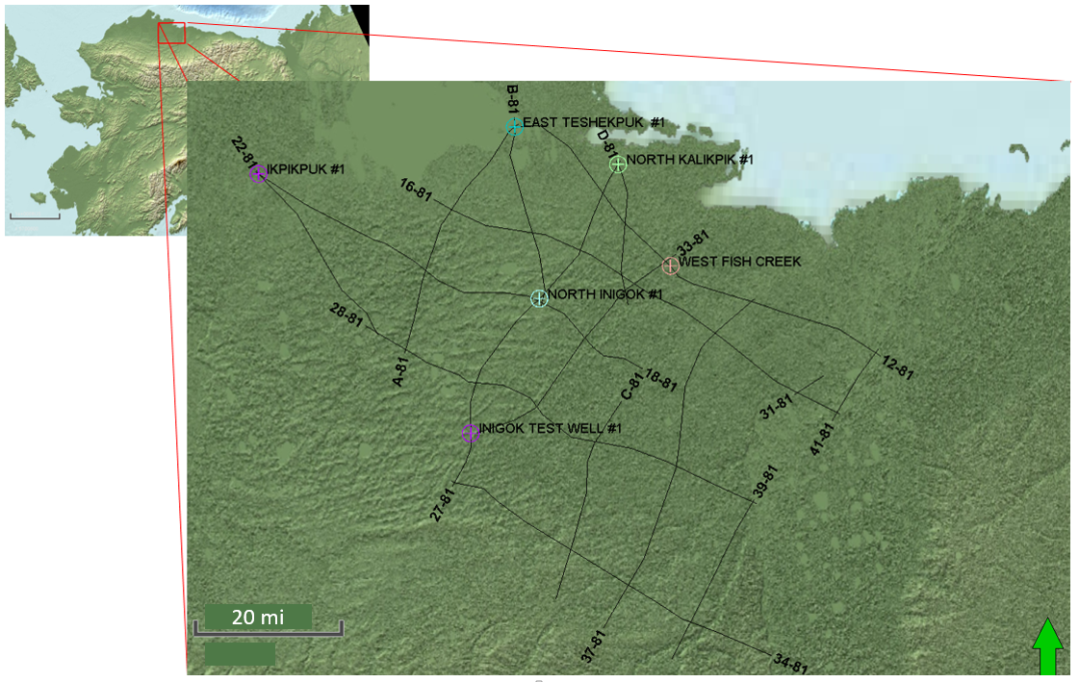
Figure 9: Map showing study area in the eastern NPRA as well as interpreted 1981 seismic lines and key wells. All lines were interpreted, but this study will focus on the key lines and wells mentioned previously.

This study will focus on the sequence stratigraphic interpretations of lines 18-81, 27-81, and B-81, which have been tied to the North Inigok 1, Inigok 1, and Ikpikpuk 1 wells. Seismic interpretation was completed in Petrel 2016, and HampsonRussel Geoview was used for well-ties, both of which were licensed by University of Oklahoma.
Using paleontology and lithostratigraphy reports provided with the well logs to infer tops, seven horizons that correspond to lithologic formation tops have been interpreted in the seismic data. These lithologic horizons include the Franklinian Basement, the Lisburne, the Sadlerochit-Shublik, the Sag River, the Kingak, the Pebble Shale, and the Torok.
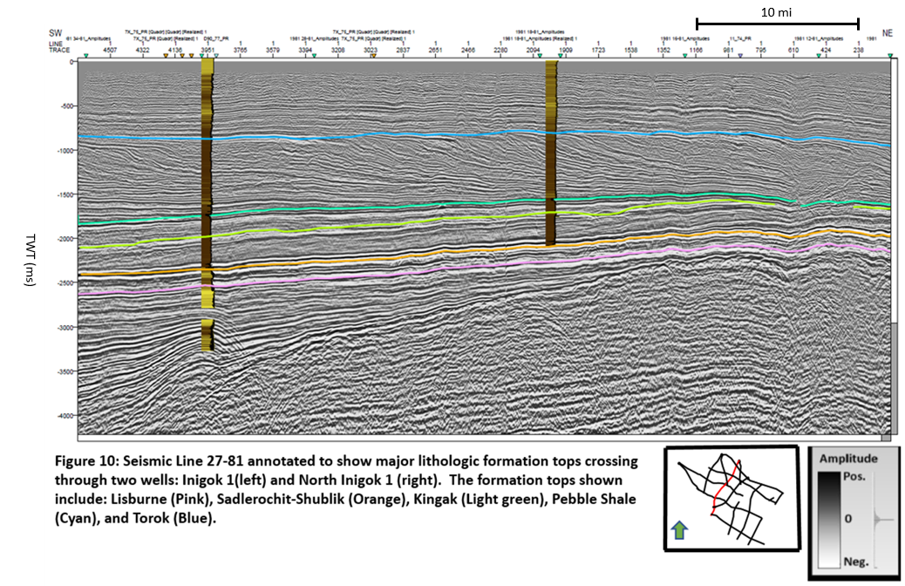
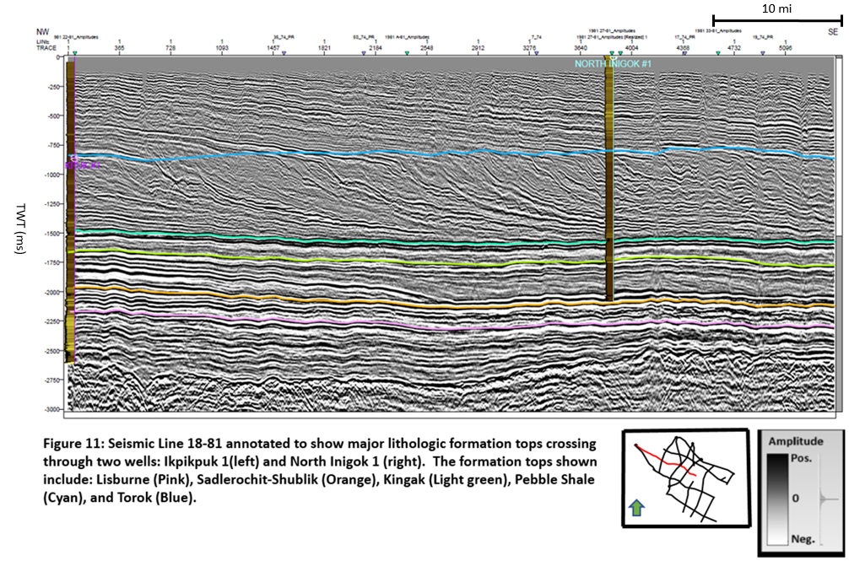
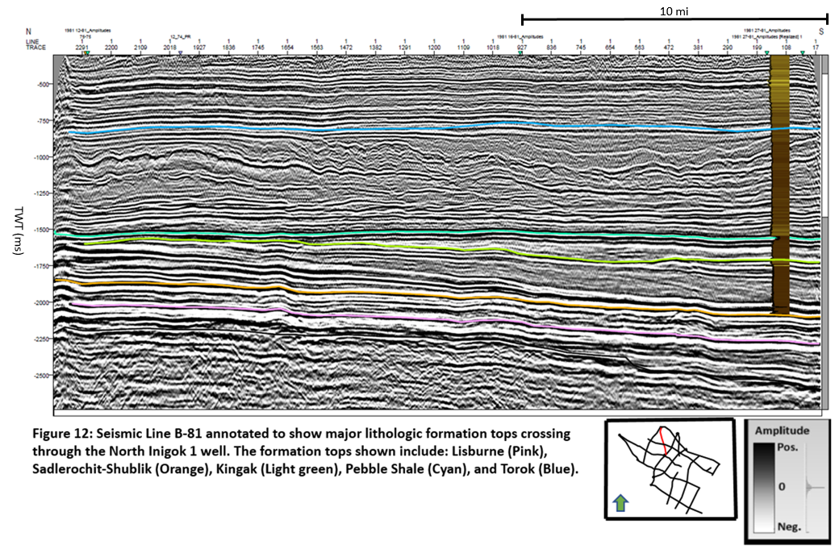
In order to constrain the seismic to the borehole data, sonic and density logs from five wells in the area were used along with their statistically extracted wavelets to perform well-ties. The correlation coefficients for tied wells vary from 64% to 66%. Figure 13 shows the well to seismic tie at the Inigok 1 well.
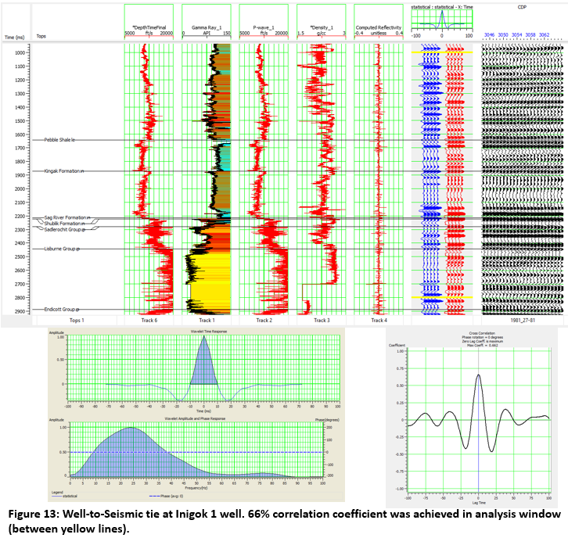
Once the seismic data was constrained to the borehole and major lithologic formations were picked, a sequence stratigraphic interpretation was performed. The rest of this chapter will focus on the methodology used for sequence stratigraphy and the interpretations that followed.

Methods
In 1977, Mitchum and Vail provided the initial theory and methodology for sequence stratigraphy. Since then, several other approaches to the study of sequence stratigraphy have been developed. Some of the more prominent approaches important for this study are Galloway’s genetic sequence stratigraphy (1989) and Neal and Abreau’s (2009) accommodation succession approach. Pigott and Radicojevic (2010) term Mitchum and Vail’s method and Galloway’s method as the “Vail Approach” and the “Galloway Approach” respectively. These three approaches form the sequence stratigraphic framework utilized in this study, thus the pragmatic rationale behind utilizing the Vail approach on the seismic and then refining it with the Galloway approach. The specific methods can be seen below:
- Identify reflector terminations from seismic and identify whether they downlap, onlap, truncate, or toplap.
- Draw in unconformity surfaces between downlapping and onlapping reflectors above and truncating or toplapping reflectors below.
- Extend unconformity surface across the complete section and tie to intersecting seismic lines.
- Interpret well log motifs using gamma ray as a proxy for grainsize to indicate periods of shoreline stasis, transgression, and regression.
- Correlate to other interpreted boreholes located in the seismic section.
- Constrain well logs with seismic and match unconformities to shifts in log motif.
- Identify the type of unconformity as a sequence boundary or a downlap surface.
- The packages of strata between two boundaries is a systems tract, and the geometry of the strata within aids in the identification of Systems tracts. (Figure 14)
  - Prograding to Aggrading is indicative of a Lowstand Systems Tract.
  - Retrogradation is indicative of a Transgressive Systems Tract.
  - Aggradation to Progradation to Degradation is indicative of a Highstand Systems Tract.
- Match interpreted systems tracts to log motif trends.
- Construct chronostratigraphic chart.
The methodology for construction of a chronostratigraphic chart was described in detail by Pigott and Radivojevic (2010). A brief summary of the methods used to construct a chronostratigraphic diagram follows:
- Identify and date the reflectors that correspond to operational sequence boundaries from oldest (bottommost reflector) to youngest (uppermost reflector).
- Transfer this information to a chart with age on the Y-axis and horizontal location on the x-axis (denoted by shotpoints).
- Beginning with the oldest reflector, mark the lateral extent of that reflector at the appropriate time.
- Continue this process for every reflector.
- Void spaces left on the chart represent zones of missing time. Four types of recognized time gaps exist:
  - Non-depositional hiatus
  - Unconformity
  - Vertical or horizontal limits of control
  - Combinations of the previous three
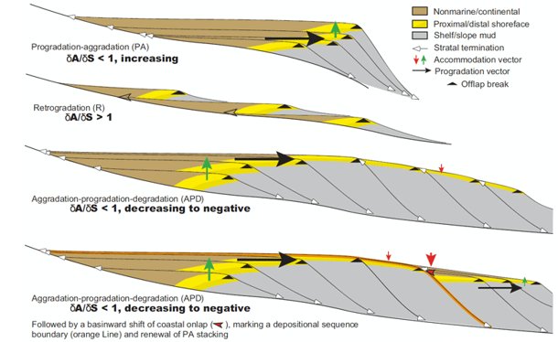
Figure 14: Accommodation Succession stacking patterns. progradation-aggradation is understood to represent Lowstand Systems Tracts, retrogradation represents Transgressive Systems Tracts, and aggradation-progradation-degradation represents Highstand Systems Tracts. (Modified from Neal and Abreu, 2009)

Sequence Stratigraphic Interpretation
In addition to the lithologic formation horizons, 25 operational sequence boundaries have been interpreted in the seismic using reflector termination patterns to show unconformities, depositional hiatuses, and maximum flooding surfaces according to the operational procedures outlined in Pigott and Radiovejic (2010). These operational sequence boundaries are grouped and colored by tectonic phase, with Ellesmerian, Beaufortian, and Brookian boundaries colored red, blue, and green, respectively. Operational sequence boundaries delineate systems tracts and provide valuable insight into ancient depositional conditions (Van Wagoner and others, 1988). Figures 15 through 19 show the interpreted operational sequences and systems tracts.
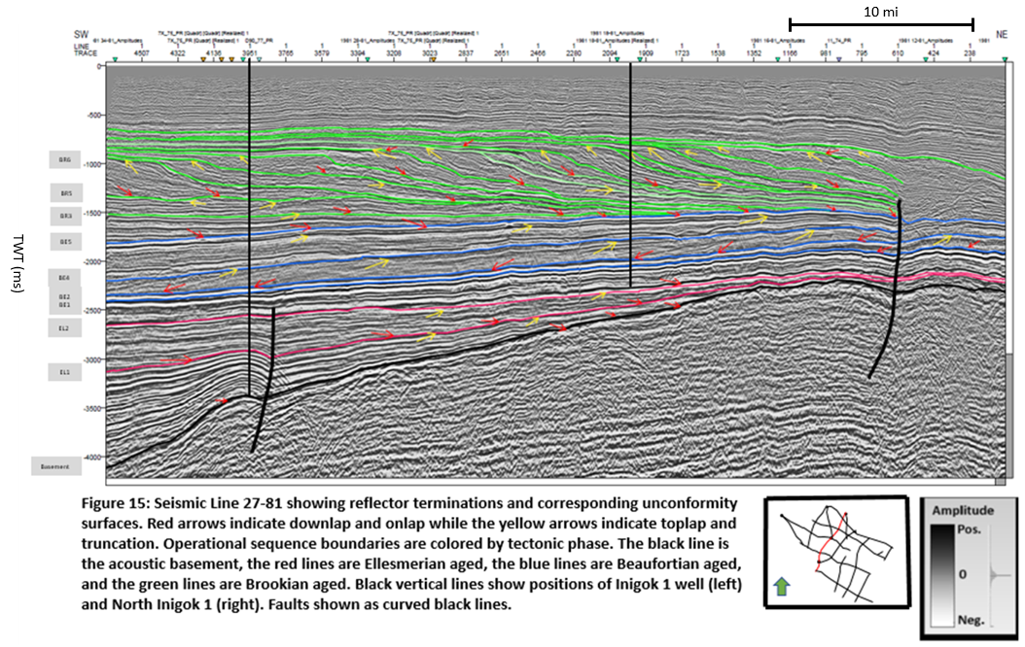
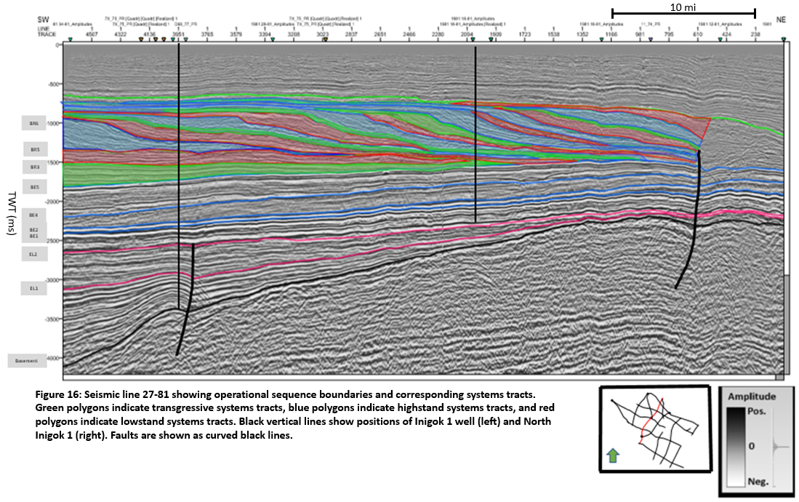
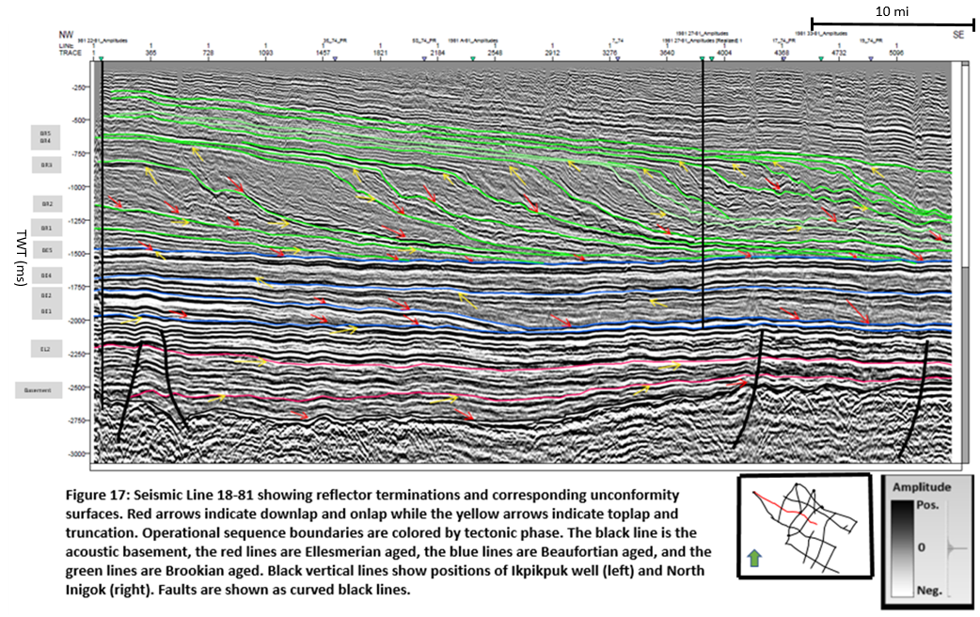
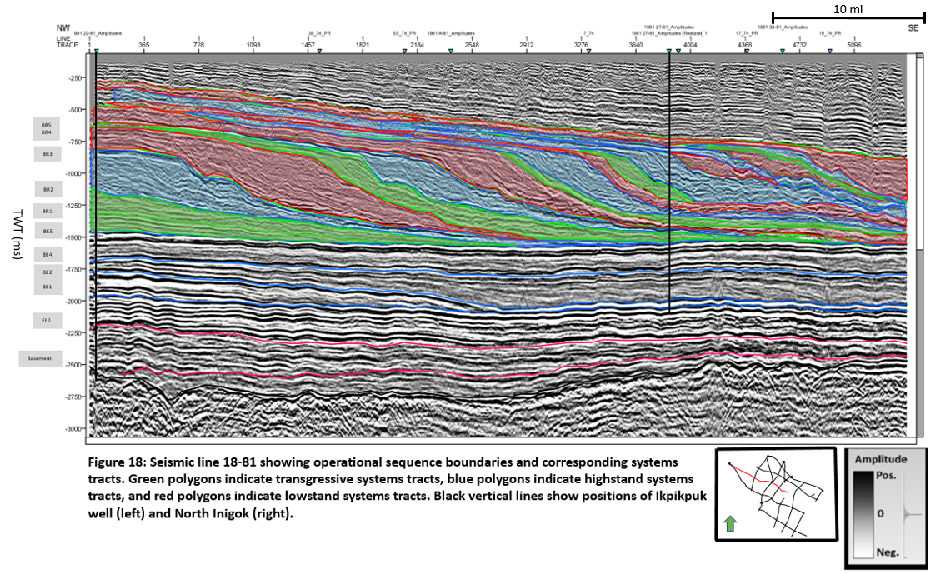
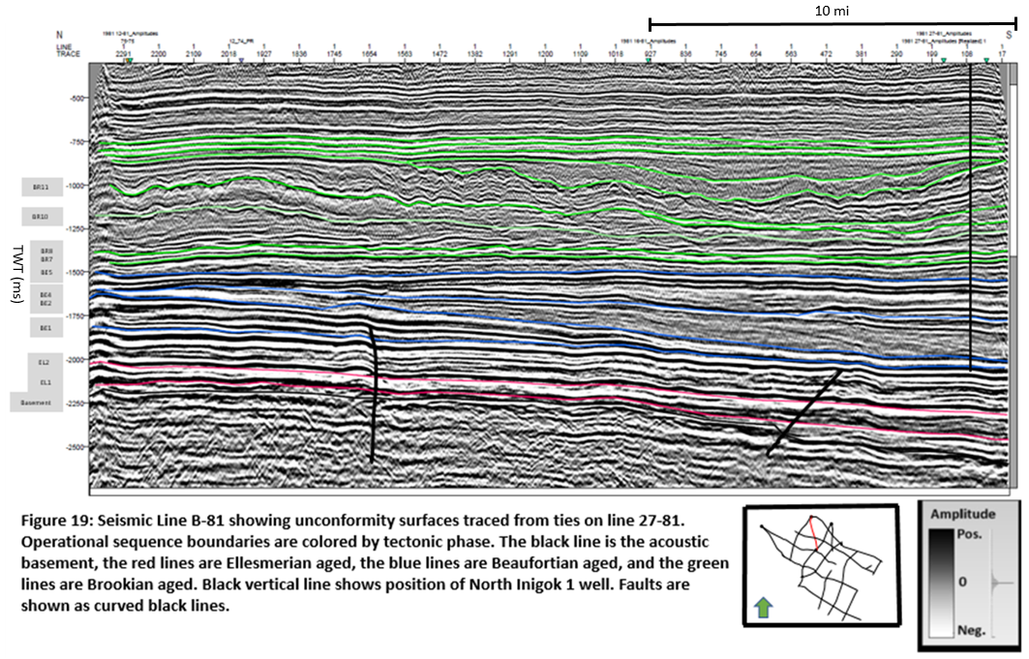
Several of the unconformity surfaces shown above correspond directly to the lithologic formation tops shown earlier in this chapter. From oldest to youngest these are:
- Lisburne Group to EL2
- Sadlerochit-Shublik to BE1
- Kingak to BE4
- Pebble Shale to BE5
These operational sequence boundaries were picked independently of the lithologic formation tops, solely based on reflector termination patterns. Arriving at the same conclusion in both seismic and well analysis lends confidence to the interpretation, which will be further explored with Galloway log motif analysis as shown in Figure 20 (procedure of Pigott, 2018).
Comparison of the Vail and Galloway analyses show both similarities and differences in the results. Third order parasequence boundaries are seismically resolvable while the Galloway motifs show fourth order parasequence boundaries.
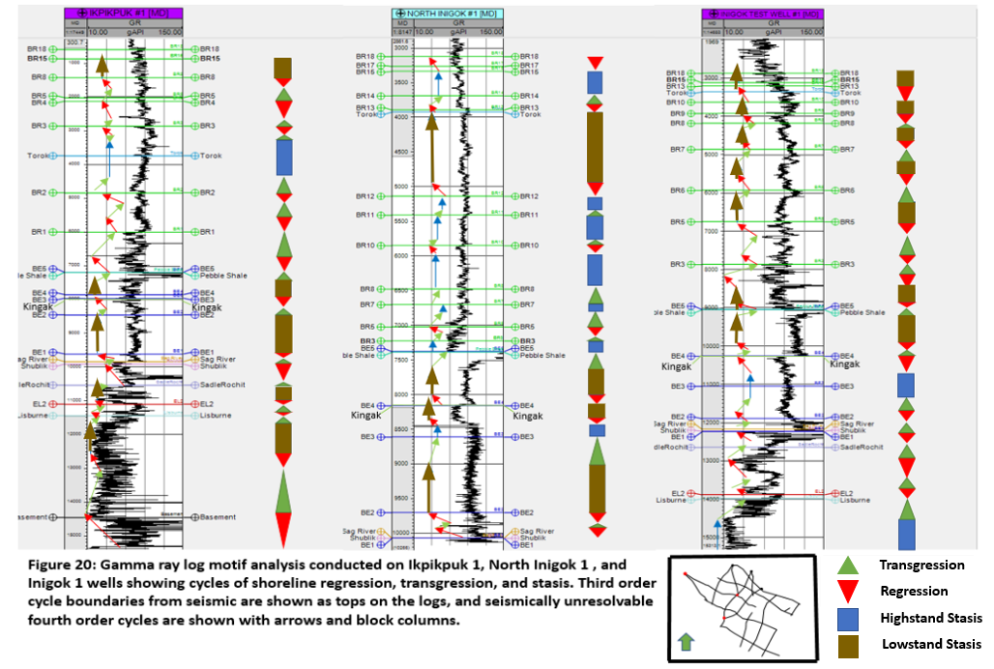
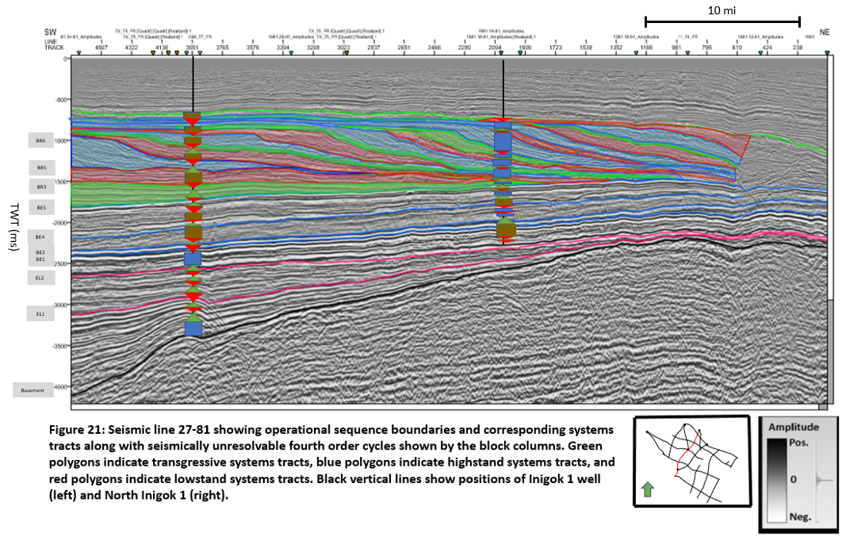
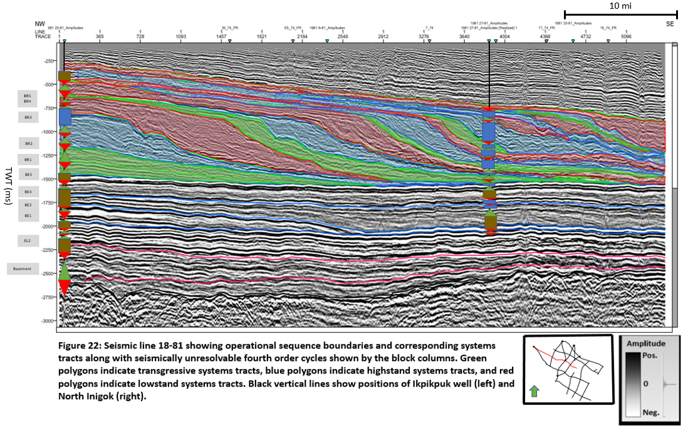 The vertical resolution of borehole data is much greater than the vertical resolution of seismic data. As a result of this, the fourth order sequences visible in the well logs are much thinner than the third order sequences shown in the seismic. The trends shown in the borehole data show much more detail than the overall trends noted in the seismic data.
As a result of seismic sequence analysis, a chronostratigraphic Wheeler Diagram was constructed on seismic lines 27-81 and 18-81 using the methodology described at the beginning of this chapter. Wheeler Diagrams are useful for describing the temporal and spatial distribution of rocks as well as the accommodation conditions at the time of deposition. Perhaps most importantly, constructing Wheeler Diagrams makes the interpreter question the geological integrity of the interpretation.
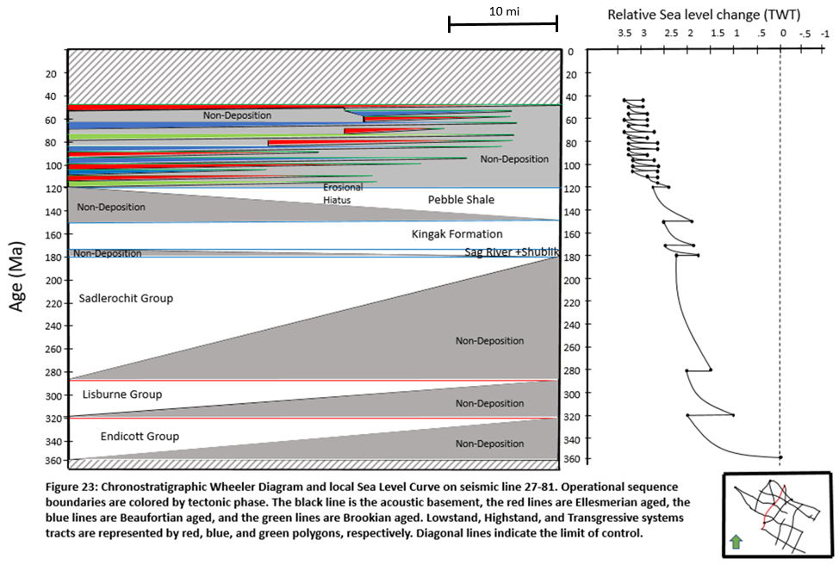
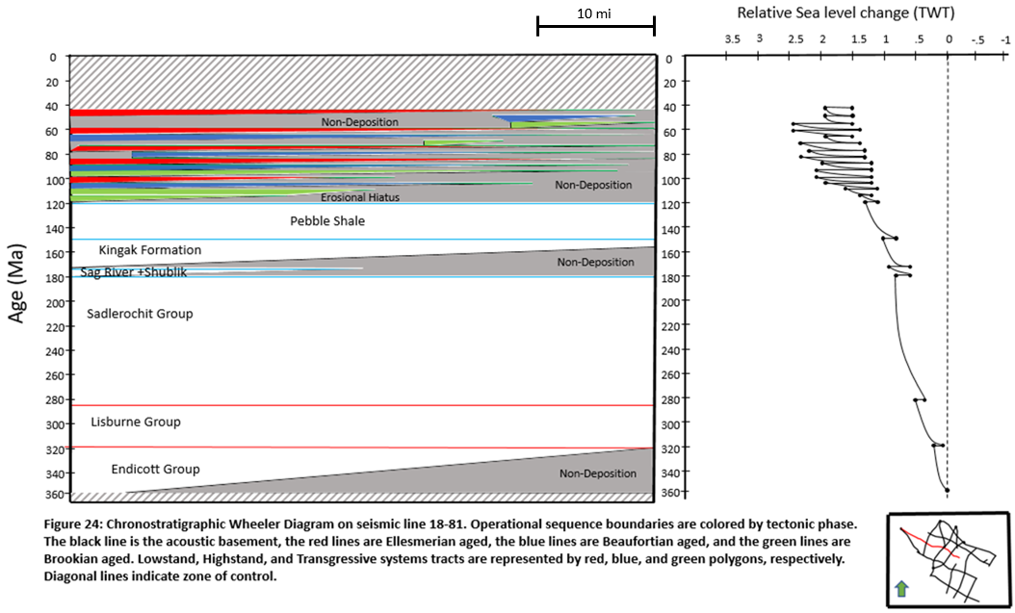
As mentioned previously, the paraseqeuence set boundaries shown above are grouped based on tectonic phase. These groupings are the Ellesmerian, Beaufortian, and Brookian Megasequences. Isopach maps as well as time-structure maps showing key surfaces in each megasequence are shown in the Figures 25 through 33.
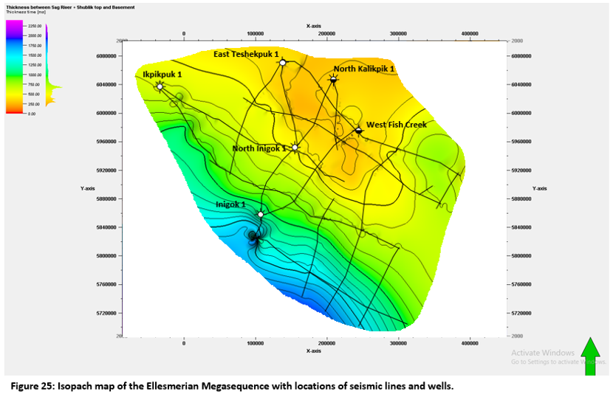
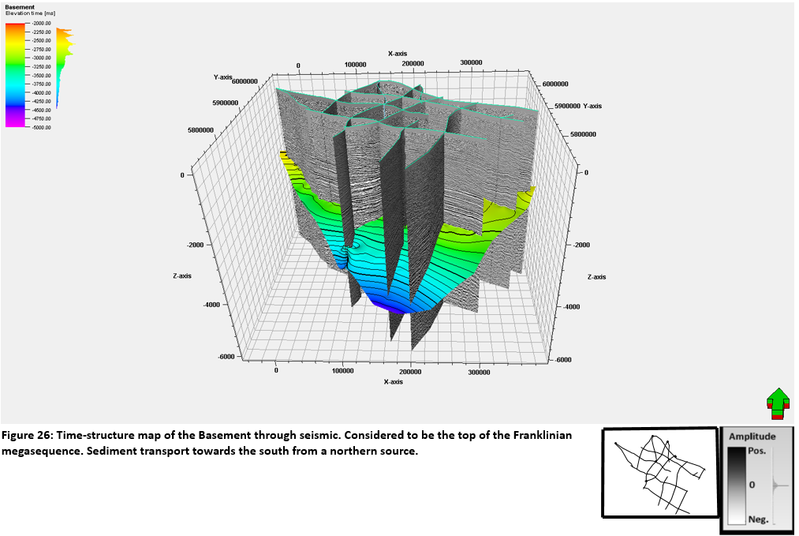
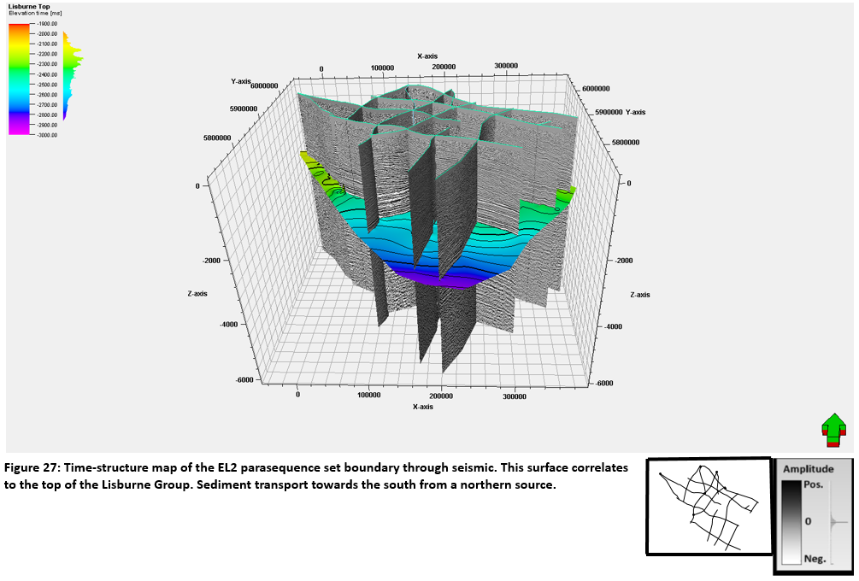
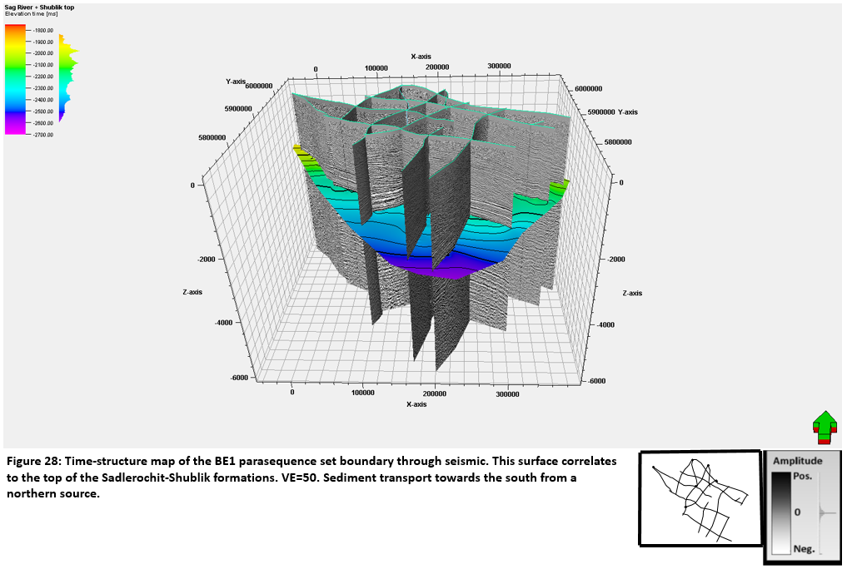
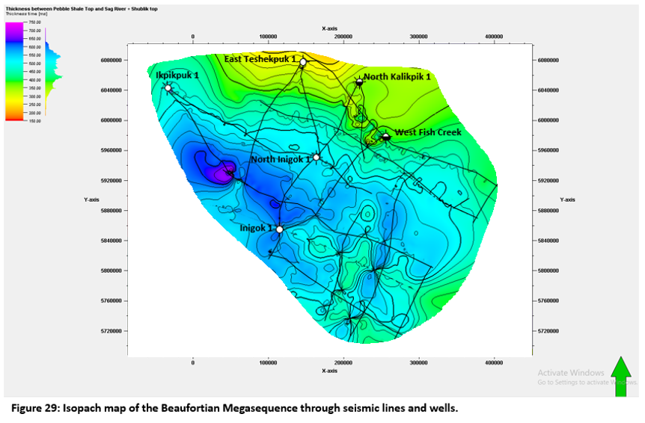
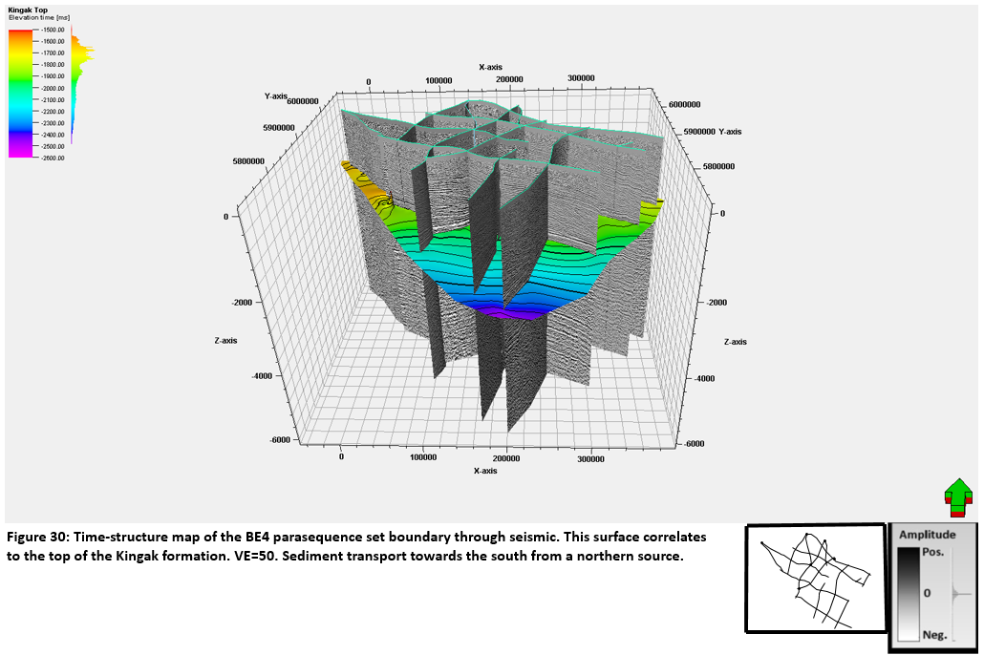
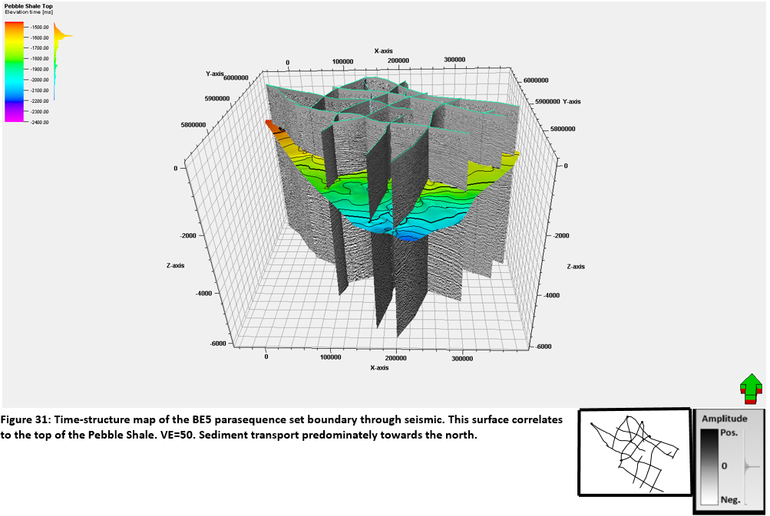
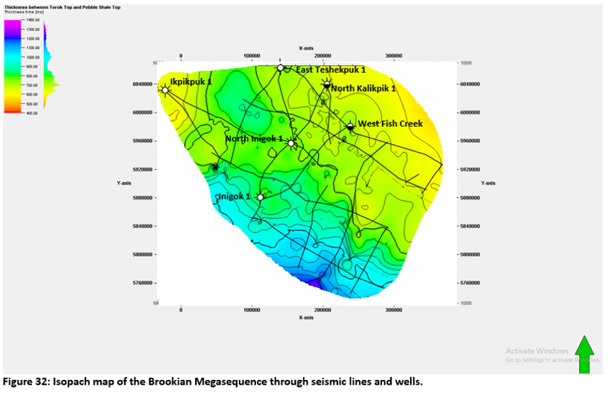
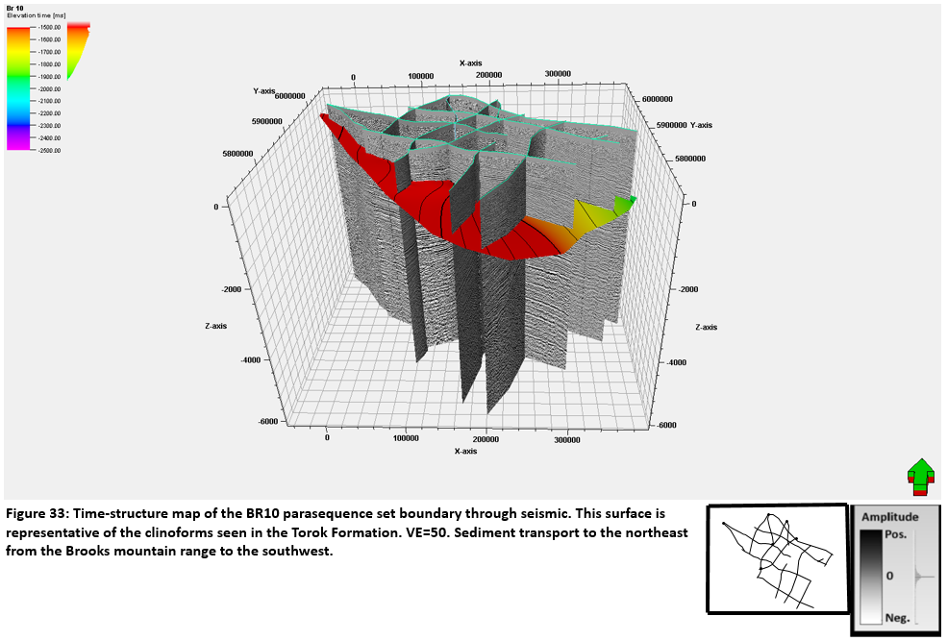
Seismic Facies Interpretation and Petroleum Implications
This section of the study uses seismic reflector geometry to interpret seismic facies as well as important seismic features in the Brookian clinoforms discussed previously. Figure 34 shows how seismic reflector geometries are used to identify seismic facies. The most prevalent seismic facies discernable in the Brookian clinoforms are parallel to divergent, draping parallel, and transparent sigmoid clinoform facies.
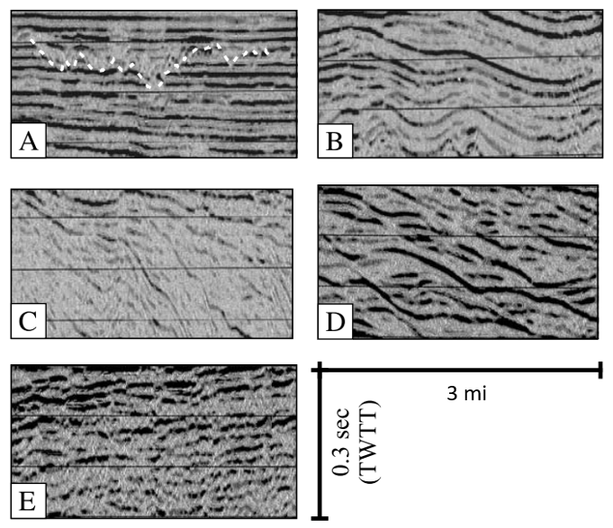
Figure 34: Figure showing various types of seismic facies. (A) Parallel to divergent facies. (B) Draping parallel facies. (C) Transparent sigmoid clinoform facies. (D) Hummocky facies. (E) Chaotic facies. (Modified from Lofi et al., 2003)

Parallel to divergent facies is represented by variably continuous high amplitude reflections and are most common in the middle shelf. These facies are typically interpreted to have been deposited in shallow marine environments. They are commonly characterized by erosional features that have been filled with parallel, transparent or chaotic reflections. (Lofi et al., 2003)
Draping parallel facies is represented by gently dipping, continuous, low to high amplitude drape reflections. This facies is commonly found at the base of clinoforms and are interpreted to be deposited under low energy, deep water conditions. (Lofi et al., 2003)
Transparent sigmoidal clinoform facies is usually represented by moderate to high amplitude seismic reflections showing distinct topsets, foresets, and bottomsets. In between the clinoforms are discontinuous low amplitude reflections. This facies is characteristic of prograding units and shelf deposits. This facies is commonly interpreted to be shallow-marine to slope depositional environments. (Lofi et al., 2003)
The type of facies present in any area can give important indications of the lithology of that package of strata. These seismic facies expressions can offer insight into the probable location of petroleum system elements. For the purposes of this study, seismic facies and important seismic features were distinguished in the Brookian clinoforms near the North Inigok 1 well, shown below in Figure 35.
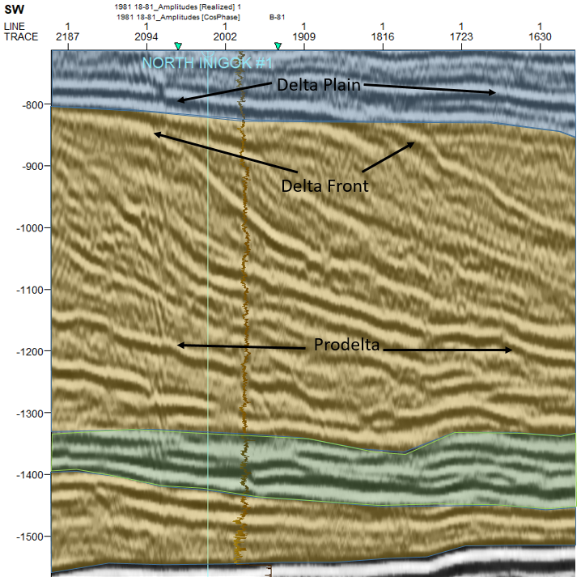
Figure 35: Figure showing a zoomed in image of the Brookian clinoforms near the North Inigok 1 well. Seismic Facies have been grouped by color. The blue polygon corresponds to parallel to divergent facies. The green polygon corresponds to draping parallel facies. The yellow polygons correspond to transparent sigmoid clinoform facies. Important geological components of a delta are shown with black arrows.
The various component parts making up a delta can indicate the most likely location of petroleum system elements. Deposited in deep water during low energy conditions, prodeltas consist almost entirely of muds and fine grained organic material. These deposits make excellent source rocks and seals. Above the delta plain is the delta front. The delta front is where distributary mouth bar sands are located, and are found on the crest of the shelf before the slope, which serve as stratigraphic traps. The presence of sand and overlying stratigraphic traps, as well as the organic rich prodeltas below make delta fronts excellent reservoirs. In the delta plain, the deposited sediment is commonly deltaic mud along with sporadic and compartmentalized channel sands. These delta plains often make good seals and can aid in trapping any hydrocarbons that have migrated into the sand-rich delta fronts.
In the Brookian clinoforms, the foreset and the bottomset are part of the Torok Formation, and the topset is part of the Nanushuk formation. The Torok Formation is made up almost entirely of silt and mud, whereas the overlying Nanushuk has a higher concentration of sands. These observations are consistent with the seismic facies expressions depositional environments. Accordingly, the sandy delta fronts could be potentially lucrative targets for petroleum exploration.

DISCUSSION
The preceding interpretations demonstrate the variable nature of deposition in the Ikpikpuk-Umiat Basin and provides a sequence stratigraphic framework for the resolvable parasequence sets in the seismic data. The following discussion describes those interpretations in greater detail and will be grouped by megasequence. Following this is a comparison of local sea level curves to the global sea level curve (Haq et al., 1987) in order to distinguish autocyclic or allocylcic dominance in the Ikpikpuk-Umiat basin. The discussion will be concluded with a comparison of this study to previous works.
Ellesmerian Megasequence
As mentioned previously, the Ellesmerian Megasequence consists of the Endicott Group, the Lisburne Group, the Sadlerochit Group, the Shublik Formation, and the Sag River Formation. In the seismic, only two operational sequence boundaries were distinguished: EL1 and EL2. Boundary BE1 marks the top of this group and coincides with the top of the Sag River Formation. This megasequence sits on top of the interpreted basement horizon, which is the top of the Franklinian Megasequence discussed earlier in this work.
Figure 25 shows an isopach map of the Ellesmerian Megasequence. This sequence is thickest in the southwest of the basin, thinning to the North and North-East. This is largely due to the structure of the basement (Figure 26) which is deepest in the southwest and shallows to the North. The reflectors between the basement and EL2 consistently onlap towards the northeast, backstepping towards the sediment source. Parasequence set boundary EL1 truncates underlying strata in places, indicating at least some erosion.
Figure 27 shows the EL2 parasequence set boundary, which corresponds directly to the top of the Lisburne Group. This boundary is laterally continuous and is interpreted to mark the shift between Lisburne carbonates and the shallow marine siliciclastic rocks of the Sadlerochit Formation. This surface truncates several underlying reflectors, but ultimately is not considered to be an erosional surface, but a non-depositional one.
Figure 28 shows the BE1 parasequence set boundary which is interpreted to be the top of the Ellesmerian Megasequence. Between boundaries EL2 and BE1 few reflector terminations are visible and the strata are mostly conformable, though some onlap and truncation is present. This surface is interpreted to be a non-depositional hiatus.
Beaufortian Megasequence
The Beaufortian Megasequence consists of the Kingak Formation, and the Pebble Shale Formation. In seismic, five operational sequence boundaries have been distinguished: BE1, BE2, BE3, BE4, and BE5. As mentioned above, BE1 corresponds to the top of the Sadlerochit-Shublik Formations and marks the base of the Beaufortian Megasequence. The top of the Beaufortian Megasequence is BE5, which corresponds to the Pebble Shale.
Figure 29 shows an isopach map of the Beaufortian Megasequence. This sequence is thickest in the middle of the study area and thins outward from the center. This sequence reaches it’s thickest near the Inigok 1 well.
Figure 30 shows boundary BE4, which corresponds to the top of the Kingak Formation. BE4 is deepest in the south and shallows to the North. BE2 is interpreted to be the base of the Kingak Formation. Within the interval bounded by these two surfaces, reflector terminations are abundant. The Kingak exhibits onlap onto the BE2 boundary and above reflectors are truncated by the BE4 boundary. Between the BE4 and BE5 surfaces, reflector terminations are mostly absent, tough truncation against the BE5 surface provides evidence that parasequence set boundaries BE4 and BE5 are both erosional surfaces.
Figure 31 shows boundary BE5, which corresponds to the top of the Pebble Shale Formation. Boundary BE5 truncates the reflectors beneath it, and the reflectors above it onlap down on to it. As mentioned previously in this work, the Pebble Shale sits directly atop a regional unconformity, the Lower Cretaceous Unconformity.
Brookian Megasequence
For the purposes of this thesis, the Torok Formation was the only member of the Brookian megasequence to be analyzed. In the seismic, 18 operational sequence boundaries were distinguished. These are BR1 through BR18. The Torok Formation sits directly atop the Pebble Shale Formation in the study area.
Figure 32 shows an isopach map of the clinoforms in the Brookian Megasequence. The Brookian Megasequence is thickest in the South and thins moving Northward and Eastward. Figure 33 shows parasequence set boundary BR10, which is representative of the other clinoforms in the Torok formation. These clinoforms prograde to the East and represent a huge influx of sediment in a relatively short amount of geologic time.
The base of the Brookian Megasequence is BE5, or the Pebble Shale. In the seismic, this is a regional onlap surface, and many of the clinoform reflectors in the Torok terminate against it. Reflector terminations are abundant in the Brookian Megasequence, especially within the Torok clinoforms, showing all of the forms of reflector termination shown in Figure 4. BR1 through BR18 are interpreted to represent non-depositional surfaces, though the presence of truncation in the clinoforms indicates periods of erosion as well.

Comparison of Sea-Level Curves 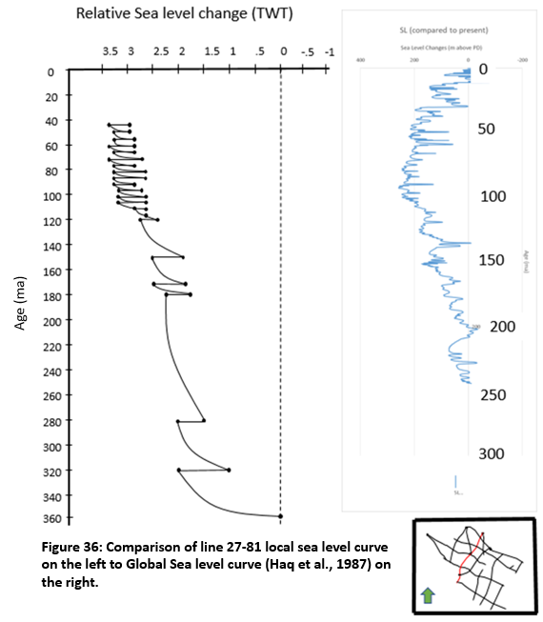
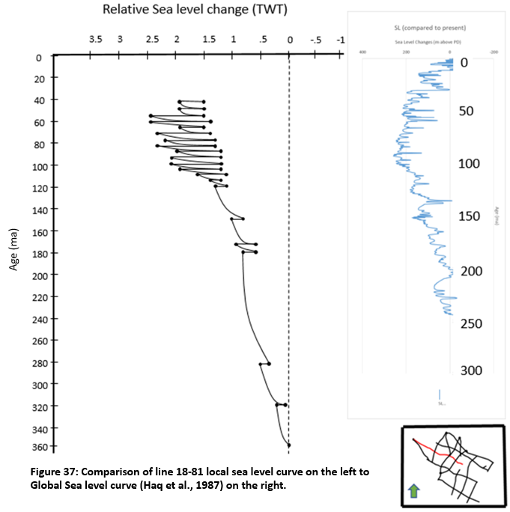

Comparison of local sea level curves to the global sea level curve can give insights into the forces that control deposition in a basin, whether those forces be autocyclic or allocyclic. Until around 80 million years ago, the local sea level curves match the shape of the global sea-level curve, which indicates that the dominant controls on deposition were allocyclic through that time. However, after that point, the global sea-level curve and local sea level curves diverge. The local sea level curves indicate that accommodation in the basin was increasing despite the decrease in global sea-level, which indicates the control on the basin was autocyclic dominated. One possible reason for this divergence is the Brooks Mountain Range. Erosion of sediment from the Brooks Mountain Range and subsequent deposition may have caused the basin to subside slowly under the depositional load.

Comparison to Previous Studies
As stated previously in this study, the NPRA has been the subject of numerous previous studies as a result of its potential for hydrocarbon production. Studies conducted by the likes of Bird (1977, 1981, 1982, 2018), Hubbard (1987), Parrish (2010), and Wilson (2010) focused almost entirely on the appraisal of hydrocarbon resources in the NPRA.
Other studies, conducted by those such as Detterman (1973), Houseknecht (2004, 2009, 2010), Molenaar (1981), and Schultz (2013) focused on a sequence stratigraphic approach to understanding the NPRA. The primary difference between the studies mentioned above and the sequence stratigraphic interpretation of this study is one of scale. While the studies above provide excellent sequence stratigraphic models, they are generally regional in scale whereas this study focuses on a higher resolution model of the Ikpikpuk-Umiat sub-basin in particular. Fulk (2010) and Mauch (1985) also focused on the Ikpikpuk-Umiat sub-basin, but these studies were concerned with the structural aspects of the sub-basin as opposed to sequence stratigraphy.

CONCLUSIONS
Seismic sequence stratigraphic interpretation of the rock strata of the Ikpikpuk-Umiat basin of the National Petroleum Reserve in Alaska constrained against Galloway log motif analysis shows 25 operational sequence boundaries from the Mississippian to the Cretaceous. These operational sequence boundaries occur across three phases of tectonism and their depositional character reflects this fact. The Ellesmerian Megasequence contains two operational sequence boundaries and was derived from a sediment source in the North and consists of both carbonate and clastic rocks. The Beaufortian Megasequence contains five operational sequence boundaries and is dominated by southward progradation of sand and shale, which are easily identifiable due to extensive onlap and truncation. The Brookian Megasequence contains 18 operational sequence boundaries which prograde to the East and downlap onto the Pebble Shale Formation, which is regionally distinguishable in the seismic. Construction of a chronostratigraphic chart illustrate the results of the complex relationship between auto- and allocyclic accommodation changes. The interpretation of these operational sequence boundaries may assist in renewed hydrocarbon exploration in the NPRA.
The cyclic variation in accommodation detailed by this study has resulted in a largely compartmentalized subsurface. Abundant shales and TST deposits form seals that overly and divide sand-rich LST deposits which make ideal reservoirs. The Brookian Megasequence is almost entirely characterized by the interplay of systems tracts. However, it is important to note that the upper boundary of the Torok Formation is a time transgressive lithostratigraphic boundary, and as such it does not correspond to any operational sequence boundary. Though the Brookian Megasequence was deposited during a time of relative tectonic stability, tectonic inversion and structural flexure associated with Beaufortian rifting and Brookian deposition may have opened up migration pathways through local faults in the Franklinian and Ellesmerian Meagasequences. Several prominent organic-rich shales represent source rocks in the Ellesmerian, Beaufortian, and Brookian Megasequences. An understanding of these petroleum system elements may contribute to improved hydrocarbon exploration strategies in the Ikpikpuk-Umiat basin.

REFERENCES
Balkwill, H. R., Cook, D. 6., Detterman, R. L, Embry, A.F., Hakansson, E., Miall, A. D., Poulton, T. P., and Young, F. G., 1983, Arctic North America and Northern Greenland: reprint from; The Phanerozoic Geology of the World, II The Mesozoic B, Elsevier, The Netherlands, p. 1-31.
Bird, K., 2018, Hydrocarbon Resources in the National Petroleum Reserve of Y the Play-Appraisal Method:
Bird, K. J., 1982, Rock Unit Reports of 228 Wells Drilled on the North Slope, Alaska: U. S. Geol. Surv. Open File Rpt. 82-278.
Bird, K.J., 1981, United states department of the interior geological survey:
Bird, K. J., 1977, and Jordan, C. F., 1977, Lisburne Group (Mississippian and Pennslyvanian), potential major hydrocarbon objective of Arctic slope, Alaska: AAPG Bulletin, y. 61, no. 9, p. 1493-15 12.
Bruynzeel, J.W., Guldenzopf, E.C., and JPickard, E., 1982, Petroleum exploration of NPRA, 1974-1981 : final report: , p. 940.
Detterman, R. L, 1973, Mesozoic sequence in Arctic Alaska: jn Proceedings of the International Arctic Symposium: Am. Assoc. Petrol. Geol. Mem. 19, p. 376-387.
Dumoulin, Julie A., Whalen, Michael T., and Harris, Anita G., 2008, Lithofacies, age, and sequence stratigraphy of the Carboniferous Lisburne Group in the Skimo Creek area, central Brooks Range, in, Haeussler, Peter J., and Galloway, John P., eds., Studies by the U.S. Geological Survey in Alaska, 2006: U.S. Geological Survey Professional Paper 1739-B, 64 p. [http://pubs.usgs.gov/pp/pp1739/b/].
Dumoulin, J. A., and Bird, K .J., 2001, Stratigraphy and lithofacies of Lisburne Group carbonate rocks (Carboniferous - Permian) in the National Petroleum Reserve - Alaska, in D. W. Houseknecht (ed.), NPRA Core Workshop--Petroleum Plays and Systems in the National Petroleum Reserve – Alaska: SEPM Core Workshop No. 21, p. 141-166.
Fulk, B. R. 2010, Seismic analysis of the Ikpikpuk-Umiat basin, NPRA, North Slope, Alaska (Doctoral dissertation, Sciences).
Galloway, W.E., and Galloway, L.E., 2015, Genetic stratigraphic sequences in basin analysis I : architecture and genesis of flooding- surface bounded depositional units Genetic Stratigraphic Sequences in Basin Analysis 1 : Architecture and Genesis of Flooding-Surface Bounded Depositional Units: v. 2.
Haq, B. U., Hardenbol, J. A. N., & Vail, P. R., 1987, Chronology of fluctuating sea levels since the Triassic. Science, 235(4793), 1156-1167.
Haywood, H., 1983, Inigok test well no. 1: National Petroleum Reserve in Alaska Geological Report of Husky Oil NPR Operations, Inc., National Geophysical Data Center, NOAS E/GC3 Department 874, Boulder, CO.
Houseknecht, D.W., 2010, Sequence Stratigraphy and Sedimentology of Beaufortian Strata (Jurassic – Lower Cretaceous) in the National Petroleum Reserve – Alaska (Npra): Petroleum Plays and Systems in the National Petroleum Reserve–Alaska, p. 57–88, doi:10.2110/cor.01.01.0057.
Houseknecht, D.W., Bird, K.J., and Schenk, C.J., 2009, Seismic analysis of clinoform depositional sequences and shelf-margin trajectories in Lower Cretaceous (Albian) strata, Alaska North Slope: Basin Research, v. 21, p. 644–654, doi:10.1111/j.1365-2117.2008.00392.x.
Houseknecht, D.W., and Schenk, C.J., 2004, Sedimentology and sequence stratigraphy of the Cretaceous Nanushuk, Seabee, and Tuluvak Formations exposed on Umiat Mountain, North-Central Alaska: USGS Professional Paper, v. 1709B, p. 1–18.
Houseknecht, D.W., and Schenk, C.J., 2010, Depositional Sequences and Facies in the Torok Formation, National Petroleum Reserve – Alaska (Npra): Petroleum Plays and Systems in the National Petroleum Reserve–Alaska, p. 179–199, doi:10.2110/cor.01.01.0179.
Houseknecht, D.W., and Bird, K.J., 2004, Seq_Strat_Kingak_Shale: v. 3, p. 279–302.
Hubbard, R. J., Edrich, S. P., and Rattey, R. P., 1987, Geologic evolution and hydrocarbon habitat of the ‘Arctic Alaska microplate,’: Marine and Petroleum Geology, v. 4, p. 2-8.
Kirschner, C. E., Gryc, G., and Molenaar, C. M., 1983, Regional seismic lines in the N. P. R. A. in Alaska: in A. W. Bailey (ed.), Seismic Expression of Structural Styles - A Picture and Work Atlas: Am. Assoc. Petrol. Geol. Studies in Geology.
Kulander, C.S., Grow, J.A., Potter, C.J., Saltus, R.W., and Killgore, M.L., 2005, Interpreted Regional Seismic Reflection Lines, National Petroleum Reserve in Alaska: USGS Open File Report 2005-1402, p. 1–25, http://pubs.usgs.gov/of/2005/1402/of2005-1402_text.pdf.
Kupecz, J.A., 1995, and Reservoir Potential of a Mixed-Lithology , Upwelling Deposit : Upper Triassic Shublik Formation , Prudhoe Bay , Alaska / Prudhoe Bay: North, v. 9, p. 1301–1319.
Lofi, Johanna et al., 2003, Plio–Quaternary prograding clinoform wedges of the western Gulf of Lion continental margin (NW Mediterranean) after the Messinian Salinity Crisis.
Mauch, E.A., 1985, A seismic stratigraphic and structural interpretation of the middle Paleozoic Ikpikpuk-Umiat basin, National Petroleum Reserve in Alaska:
Mitchum Jr, R., Vail, P., and Thompson III, S., 1977, Seismic Stratigraphy and Global Changes of Sea Level: Part 2. The Depositional Sequence as a Basic Unit for Stratigraphic Analysis: Section 2. Application of Seismic Reflection Configuration to Stratigraphic Interpretation: Seismic Stratigraphy: Application to Hydrocarbon Exploration. AAPG Memoir, v. 26, p. 5362
Mitchum Jr, R., and Vail, P., 1977, Seismic stratigraphy and global changes of sea level, part 7: seismic stratigraphic interpretation procedure: Seismic Stratigraphy: Application to Hydrocarbon Exploration.AAPG Memoir, v. 26, p. 135-143.
Molenaar, C. M., 1981, Depositional History and Seismic Stratigraphy of Lower Cretaceous Rocks, N. P. R. A. in Alaska and Adjacent Areas: U. S. Geol. Surv Open File Rpt. 81-1084.
Mull, C. G., and Mangus, M. D., 1972, Itkilyariak Formation: new Mississippian Formation of Endicott Group, Arctic slope of Alaska: AAPG Bulletin, y. 56, no. 8, p. 1364 -1369.
Neal, J., and Abreu, V., 2009, Sequence stratigraphy hierarchy and the accommodation succession method, Geology, v. 37, p. 779-782
Nilsen, T. H., 1981, Upper Devonian and lower Mississippian redbeds, Brooks Range, Alaska: in A. D. Miall (ed.), Sedimentation and Tectonics in Alluvial Basins: Geol. Assoc. Can. Spec. Paper 23, p. 187-219.
Noonan, W.G., and An, G.N., 1983, Alaskan North Slope Geology , Volumes I and II , 1987 Copyright © 201 2 Pacific Section , SEPM ( Society for Sedimentary Geology ):
Parrish, J.T., Whalen, M.T., and Hulm, E.J., 2010, Shublik Formation Lithofacies, Environments, and Sequence Stratigraphy, Arctic Alaska, U.S.a.: Petroleum Plays and Systems in the National Petroleum Reserve–Alaska, p. 89–110, doi:10.2110/cor.01.01.0089.
Parrish, J.T., Droser, M.L., and Bottjer, D.J., 2001, A triassic upwelling zone: The shublik formation, Arctic Alaska, U.S.A: Journal of Sedimentary Research, v. 71, no. 2, p. 272-285.
Petroleum News, 2008, Northern Alaska's Oil and Gas Province: Dispelling the Alaska Fear Factor, www.arlis.org/docs/vol1/61764701/61764701-2005.pdfpp. 3.1–3.18.
Pigott, J., D., D. Radivojevic, 2010, Seismic stratigraphy based chronostratigraphy (SSBC) of the Serbian Banat region of the Pannonian Basin, Central European Journal of Geosciences, 2, 481-500.
Pigott, John D., Zhai, Rui, Pigott, Kulwadee L., and Tonianse, T. 2012, Searching for the Missing Link: The Regressive System Tract – Seismic Stratigraphic Evidence from the Southern Gulf of Thailand, International Petroleum Technology Conference, Bangkok, Thailand IPTC 1511-PP, 21pp.
Pigott, John D. and Bradley, Bryant W., 2014, Application of production decline curve analysis to clastic reservoir facies characterization within a sequence stratigraphic framework: Example- Frio Formation, South Texas, GCAGS Journal, Vol 3, p. 112-133.
Schultz, L.E., 2013, Sequence Stratigraphic and Structural Interpretation, Modeling and Restoration in the National Petroleum Reserve in Alaska (NPRA): , p. 63.
Tetra Tech, Inc., 1982, Petroleum Exploration of the N. P. R. A., 1974-1981; Final Report, Vol. 1,2,3.
Vail, P.R., 1987, Seismic stratigraphy interpretation procedure: Atlas of seismic stratigraphy, v. 27 (2), p. 1–10.
Van Wagoner, J.C., H. W. Posamentier, R. M. Mitchum, P. R. Vail, J. F. Sarg, T. S. Loutit and J. Hardenbol, 1988, An overview of sequence stratigraphy and key definitions. In: C. K. Wilgus, B. S. Hastings, C.G. St. C. Kendall, H. W. Posamentier, C. A. Ross and J. C. Van Wagoner, Editors, Sea level changes – an integrated approach, special publication vol. 42, Society of Economic Paleontologists and Mineralogists (SEPM), 39–45.
Van Wagoner, J.C., Mitchum, R. M., (1, 2003, Siliciclastic Sequence Stratigraphy in Well Logs, Cores, and Outcrops: Concepts for High-Resolution Correlation of Time and Facies:, doi:10.1306/bf9ab431-0eb6-11d7-8643000102c1865d.
Wilson, G.C., McGowen, J.H., and Veidhuis, J.H., 2010, Facies Associations and Depositional Environments of the Mississippian Endicott Group in the National Petroleum Reserve – Alaska (Npra): Petroleum Plays and Systems in the National Petroleum Reserve–Alaska, p. 167–178, doi:10.2110/cor.01.01.0167.

APPENDIX

