UNIVERSITY OF OKLAHOMA
GRADUATE COLLEGE

Experiences of Social Isolation in Rural Communities: A Multidisciplinary Approach

A THESIS
SUBMITTED TO THE GRADUATE FACULITY
In partial fulfillment of the requirements for the degree of
MASTER OF SCIENCE

By
BRENNA ARLEDGE
Norman, Oklahoma
2024

Experiences of Social Isolation in Rural Communities: A Multidisciplinary Approach

A THESIS APPROVED FOR THE
DEPARTMENT OF PSYCHOLOGY

BY THE COMMITTEE CONSISTING OF

Dr. Lauren Ethridge, Chair
Dr. Erin Freeman
Dr. Michael Wenger

© Copyright by Brenna Arledge 2024
All Rights Reserved.
Acknowledgements
This project and thesis would not have been possible without the help of so many incredibly talented people. I am utterly appreciative and ecstatic to be in this position and I am honored to thank those who made this dream reality.
Firstly, I am incredibly grateful to my advisor, Dr. Lauren Ethridge, whom without her help I would still be on page 1 of my prospectus. Lauren took a huge chance on me in undergrad by offering me an opportunity to prove myself in upper education. Lauren has showed me true patience and kindness, with a little bit of ‘get it done’ attitude, some of the most important characteristics I have found in a mentor. I aspire to be even a fraction of the educator, mentor, and human that she has just started showing me how to be.
I want to thank my committee members for allowing me to share my work and receive invaluable advice and feedback from you. I value the support I have garnered from both Dr. Michael Wenger and Dr. Erin Freeman. Another huge thanks goes to Dr. Constance Chapple without whom this project would not exist. Thank you for adding context and realness to our project, with the passion to make this state a better place for everyone.
To my lab, thank you for all your hard work and dedication to a project that wasn’t yours. I could not have completed all the processing and analysis without the help of the lab undergrads. One of the biggest thanks goes to Emma Auger and Jordan Norris, who taught me almost everything I know about MATLAB, analyses, and making my way through the program. Also, giving me a shoulder to cry on and most importantly a person to complain to.
To my cohort and friends, who have dragged me (sometimes kicking and screaming) to the end, a huge thank you for all of your support. I could not have survived these last two years without some of the best people I have ever met. You all truly inspire me to continue working by watching you succeed. You have taught me so much about what it means to be a friend and how it feels to be known. You have also taught me to laugh, enjoy a little treat, and to take the occasional break to yap. Special shout out to Raechel for being the best codependent friend ever, I would die without your infinite cat videos and infectious attitude, and to Catherine for giving me a real home (with cats, bonus!).
Lastly, I want to thank my family. I would not be here without your undying support and love. Thank you for never questioning my goals and ambitions and only providing what you can to make them happen for me. Thank you for keeping me humble, ambitious, and a little devious. You have shown me time and time again how to be gracious and kind, and I am forever grateful to spend this lifetime being loved by you.

Table of Contents
Acknowledgements iv
Abstract vii

Background 1
Social Exclusion 1
Adverse Childhood Experiences 3
Resilience 5
Purpose and Research Objectives 8
Methods 10
Participants 10
Procedure 11
Materials 12
Cyberball Social Exclusion Task 15
EEG Recording and Preprocessing 16
Data Analysis 17
Results 20
Frontal Asymmetry Results 29
Connectivity Results 31
Clinical Correlations 32
Discussion 34
Social Rejection 35
Childhood Trauma 37
Social Support & Resilience 40
Clinical Correlations 43
Exploratory Connectivity 45
Conclusions and Future Directions 46
Limitations 50
References 52
Supplementary Figures 69
Abstract
Rural communities often struggle due to a lack of funding, resources, and support, which can put residents at risk for adverse experiences. Merely living within a rural area is considered an influential contributing risk factor for experiencing social isolation and loneliness. Experiences of social isolation and loneliness are classified as major public health concerns due to the damaging effects they can have on mental and physical health. However, little is known about neural responses to social isolation seen in rural residents. Thus, this study aimed to examine the issues rural communities in Oklahoma face, how these communities respond to experiences of social isolation, and how different experiences and behavioral traits affect this response. Electroencephalography (EEG) was used to assess differences in neural activity in response to rejection; while undergoing EEG, healthy adults across rural Oklahoma played a cyberball game specifically designed to elicit acute feelings of social rejection. In addition, a detailed survey was distributed that encompasses many facets of social experience that may influence their response to social isolation. Specifically, adverse childhood experiences (ACEs), resilience, and social support may serve as important factors for explaining differences in these responses. Results suggest that social support, resilience, and childhood trauma play important roles in how an individual responds to rejection. Social support appeared to foster the formation and continuation of a resilient mindset. Resilient and non-resilient individuals responded differently to rejection, further indicating the importance of a resilient mindset. Understanding the interactions between these variables and an individual’s neural response to rejection will inform future studies on rural communities, which may provide more opportunities for improvement within these communities. The use of a multidisciplinary approach allows for a thorough investigation of adverse childhood experiences, resilience, and social support in the context of rural communities.

Background
Life in rural communities is frequently coupled with higher-than-average rates of chronic health issues, restricted access to healthcare services, and deficient infrastructure. Additionally, rural communities deal with challenges relating to social and geographical isolation, poverty, unemployment, and lack of transportation (RHIhub, 2022). Furthermore, the lack of access and support needed to address these issues contributes to an increased risk of exposure to adverse and stressful events that often result in compounding health issues. This stark difference in health status, known as rural health disparities, refers to higher mortality rates, higher incidences of disease, and lower life expectancies within rural communities in contrast to the general population (Chaudry & Wimer, 2016; RHIhub, 2022). Merely living in a rural community is considered a contributing risk factor for experiencing social exclusion, loneliness, and adverse childhood experiences (ACEs) (Kelly et al. 2019; National Advisory Committee on Rural Health and Human Services, 2018). Critically, there is very little research available connecting social exclusion and ACEs in the context of rural communities, making it essential to examine the long-term effects of these aspects of their environment.
Social Exclusion
Social exclusion refers to the exclusion of a group or individual from social situations. Social exclusion falls under the category of social pain, which is described as a stressful experience typically resulting from the loss of interpersonal connections (Cristofori et al., 2013). However, this definition may differ slightly for rural communities, whereby social exclusion may be extended beyond just social situations and include denial of resources, goods, and services (Walsh et al., 2012). In addition, rural communities appear to be more likely to experience social exclusion or isolation than urban areas (Bertolini, 2019). It has been suggested that social exclusion is particularly distressing because, during rejection, the fundamental needs to belong, control, and maintain self-esteem are threatened (Williams, 2007). Thus, the lingering effects of social exclusion can have drastic effects on mental health, which can lead to struggles with self-esteem (Doi et al., 2022), social anxiety (Derin et al., 2022), and PTSD (Brockie et al., 2015). Physical health can also be affected by social exclusion (Ford and Collins, 2013). Specifically, those who report chronic loneliness or a lack of strong social bonds showed an increased risk for disease and psychophysiological disorders (Hawkley & Cacioppo, 2010; Brendgen & Vitaro, 2008). Additionally, studies have shown that rejection can induce both emotional and physiological effects that when triggered repeatedly can have long-term effects on physical health (Ford and Collins, 2013). It is unknown the extent to which social exclusion may affect mental and physical health and these impacts may differ significantly based on personal experiences, character traits, or environment. However, social exclusion does have intense and potentially long-term effects, which prompts a detailed investigation into the long-term effects of social exclusion.
Simulations of social exclusion are often done with the help of cyberball. Cyberball is a task that consists of a virtual game of catch used to examine the psychological and neural correlates of social isolation. It has been shown to successfully mimic the feelings and experiences of social exclusion while giving insight into neural mechanisms that underlie the reactions (Williams & Sommer, 1997). The task involves the participant playing games of catch with two other virtual players, whom the participant believes to be real and who eventually exclude the participant from the game. EEG and fMRI studies have shown that social exclusion, simulated by cyberball, affects neural activity. Theta (3-7Hz) oscillatory activity is commonly implicated in responses to rejection because of its connection to emotional processing (Knyazev & Slobodskoj-Plusnin, 2007; Uusberg et al., 2014; Bekkedal et al., 2011). Differences in theta have been observed during social exclusion, suggesting that there is active emotional processing occurring during rejection (Cristofori et al., 2013; van Noordt et al., 2015; Tang et al., 2018). This relationship has been consistently observed across cyberball studies and has identified theta as a neural signature for rejection. Together, these studies suggest that social exclusion can have drastic effects on neural functioning related to mood and emotion processing. However, these effects can fluctuate based on individual factors such as past experiences, age, gender, and underlying health issues (Tang et al., 2018; Cacioppo & Hawley, 2003). It is probable that in a rural population, these fluctuations may be different or more significant as a result of preexisting vulnerabilities that put them at a greater risk of experiencing social exclusion, to begin with.
Adverse Childhood Experiences (ACEs)
Childhood is a delicate but crucial period of development. Adolescence is a time of increasing vulnerability to the damaging effects of stressful and traumatic experiences (Reh et al., 2020). Childhood trauma is surprisingly common, one in six adults in the United States has experienced at least one type of adverse experience during their childhood (Merrick et al., 2018). However, research suggests that adverse childhood experiences are more prevalent in certain populations, like rural communities. Over half of rural individuals in the US have experienced at least one ACE, a significant increase from the country average (Lukens, 2017). Adverse childhood experiences (ACEs) are traumatic events experienced in childhood. ACEs are typically defined and grouped based on type: abuse, neglect, and household dysfunction. Abuse refers to either emotional, physical, or sexual abuse. Neglect refers to emotional and physical neglect. Other traumas are included under the household dysfunction category, which is defined as experiences that occur within the household, which can result in exposure to additional traumatic experiences. Common experiences included under household dysfunction are having a family member who struggled with substance abuse or mental health, an incarcerated family member, intimate partner violence between parents, and parental divorce. A 2020 Health Resources & Services Administration (HRSA) report found that children in rural areas were more likely to experience certain kinds of ACEs, compared to urban children. The most prevalent ACEs experienced by rural children fall into the category of household dysfunction, which demonstrates the significance of not only direct harm but indirect harm to a child’s long-term health and well-being (HRSA, 2020; RHIhub, 2022).
The original ACEs study showed a strong relationship between experiences of childhood trauma and long-term health impacts. That is, individuals with more types of ACEs had a significantly increased risk of mental and physical health problems later in life (Felitti et al., 1998). Individuals who experienced a wider range of traumatic experiences also showed a higher risk of developing mental or physical health issues and disorders. Additionally, the categories of ACEs have exhibited strong and cumulative relationships, by which individuals who have experienced one type of ACEs were more likely to experience other types of ACEs as well (Felitti et al., 1998; Bateson et al., 2020). Further investigations into ACEs have discovered that the total number of ACEs experienced also has an effect. Specifically, those who reported higher ACE scores were more likely to have experienced problems with education, jobs, and overall life satisfaction (Bellis et al., 2013). Additionally, EEG studies have observed that childhood trauma influences a combination of cognitive and emotional outcomes, such as self-regulatory behaviors. Self-regulatory behaviors, in particular, could prevent such disorders, putting these individuals at a greater disadvantage for life-long struggles with health (Lackner et al., 2018; Curtis & Cicchetti, 2007). These effects and relationships may be more pronounced for those living in rural areas because of a preexisting vulnerability to experiences of trauma. Regardless, experiencing trauma during childhood can be detrimental to many areas of life, including mental, physical, and social later on in life. Thus, it is evident that exposure to childhood trauma can drastically increase the risk for not only unfavorable health outcomes but also unfavorable quality of life outcomes. It is important to note that there is significant variability among individuals in the long-term effects of trauma.
Resilience
The possibility of individual response variation after trauma has led to research on the concept of resilience and the consideration of it as a potential outcome for individuals with a history of traumatic experiences. Rather than developing problem behaviors or health issues that are typically linked with trauma, those who are resilient appear to adapt to adverse or traumatic life experiences (Cicchetti, 2010). Resilience can be reflected in a multitude of ways, such as health coping skills, self-righting tendencies, absence of psychiatric or mood disorders (Cicchetti, 2010; Cicchetti, 2013; Werner & Smith, 1992; Daníelsdóttir et al., 2022; Sapienza & Masten, 2011) The concept of resilience can also be extended to systems, like communities; community resilience is often used when referring to resilience within rural or tight-knit communities. Community resilience refers to both an individual’s and the community’s ability to effectively cope with stress by utilizing personal strengths and available resources (Norris et al., 2008; Ganor & Ben-Lavy, 2003). Rural communities, in particular, while isolated from larger societies, may paradoxically possess high levels of protective factors due to the high level of close social ties and networks that exist within small but tight-knit communities (Cohen et al., 2017). Valuable information may be gained from closely examining these experiences and the relationships with character traits or other environmental factors.
Notably, the presence of protective factors such as social support and emotional regulation is thought to reduce vulnerability to stressful events and contribute to the onset of resilient behaviors (Fritz et al., 2020). Protective factors are characteristics or conditions that protect an individual from the full extent of the negative outcomes associated with trauma. Social support has proven to be one of the most important protective factors by showing significant protective abilities against the negative effects of early life trauma. Social support refers to the exchange of psychological and material resources between individuals that can be perceived as improving the well-being of the recipient (Shumaker & Brownell, 1984). It has been hypothesized that social support works by decreasing neural and physiological reactivity to stressors (Eisenberger et al., 2007; Morese et al., 2019). Furthermore, the presence of social support may influence how an individual perceives situations that are potential sources of threats, which may be reflected in the absence of mental health struggles. Social support is particularly helpful in reducing the chances of psychopathology in individuals with a history of childhood trauma (Fritz et al., 2020). It has been shown to be negatively associated with depressive factors in adolescents exposed to early life stress, indicating that social support is an important aspect of mental, physical, and social health, especially in populations with vulnerabilities (Harmelen et al., 2016). Since the likelihood of negative outcomes is more pronounced in rural communities and individuals with previous experiences of trauma, protective factors are critical in avoiding or dampening significant adverse outcomes later in life within these communities (Rennie & Dolan, 2010). This literature suggests that resilience, specifically brought on by these protective factors, might protect against future traumatic events, such as social exclusion.
Beyond behavioral measures, resilience outcomes have been examined using EEG and fMRI approaches. The available research on resilience using these approaches has found distinct differences in EEG frontal asymmetry between those exposed to childhood trauma and controls (Curtis & Cicchetti, 2007; Miskovic et al., 2009). Frontal asymmetry is a measure commonly used to assess the difference in alpha activity across the frontal brain regions. Frontal asymmetry is thought to reflect emotional and behavioral responses and motivational states (Smith et al., 2017). More specifically, greater left than right frontal activity indicates an approach motivation, which is commonly seen in relation to positive emotions. On the other hand, greater right than left frontal activity suggests a withdrawal motivation and is associated with negative emotions (Meiers et al., 2020; Barros et al., 2022; Curtis & Cicchetti, 2007). Research on frontal asymmetry has suggested that it may be considered a neural biomarker of resilience (Kawamoto et al., 2013; Miskovic et al., 2009). For example, in a study of children with maltreatment, those in the maltreated group showed greater left hemispheric activity across cortical regions that reliably predicted resilience (Curtis & Cicchetti, 2007). Resilience has also been assessed using connectivity measures. Connectivity refers to the correlation of brain activity across various regions of the brain (Herzberg & Gunnar, 2020). Connectivity has been especially useful in characterizing the neural network organization associated with childhood trauma (Cisler et al., 2013). Much of the research on resilience using connectivity places a focus on the amygdala and hippocampus given their direct roles in emotion and memory. Greater connectivity from the amygdala to the prefrontal cortex has been implicated as a protective factor of resilience, suggesting that resilience may occur before or during trauma as well as after (Yoon et al., 2017; Roekner et al., 2021). There have been many potential biomarkers found for resilience, but no consensus has been made due to the lack of research and reproducibility. Additionally, there have been efforts to study resilience in connectivity, but resilience is often operationalized as the strength or robustness of the regional connections rather than a scale. Despite these findings, there is very little research on the neural mechanisms behind resilience and protective factors or the role of rurality and previous trauma within these relationships.
Childhood trauma has known effects on social, mental, and physiological health and well-being. The manner and extent to which these effects interact with each other and lead to changes in neuronal activity are not fully understood in a normal population. These same interactions are entirely unknown in the context of rural communities. A multidimensional examination of childhood trauma, resilience, and social support may provide novel insight into both the underlying neurophysiological mechanisms and the interconnectedness of these factors. Furthering the understanding of the neural mechanisms of resilience following traumatic experiences in a rural community could help to provide resources directed at reducing these experiences for these communities.
Purpose and Research Objectives
In an attempt to provide a further understanding of this relationship, I aimed to explore the scope of problems rural communities face and how they respond neurally when confronted with experiences of social rejection and loneliness. Additionally, this study aimed to determine the connection between ACEs, social support and perceived resilience as it relates to neural responses to isolation. The use of EEG was used to investigate these relationships by assessing neural activity following games of cyberball, with a specific focus on theta. A more extensive analysis of theta activity was conducted using frontal asymmetry and connectivity measures. Survey measures were used to examine and address potential interactions between neural activity and ACE and resilience scores. The information gained from this study can be used to inform legislators and other policymakers on possible underlying issues that occur in rural communities and their impact on brain health.
I hypothesized that theta power would differ significantly between inclusion and rejection conditions, with power being greater in the rejection condition. An increase in power would indicate that there is an increase in theta activity occurring during rejection, reflecting active emotional processing of rejection. I predicted individuals with higher ACE scores (3+) would show an increased sensitivity to social rejection, with the possibility of rural resilience playing a mediating role in this relationship. This association provides information on how childhood trauma affects the perception and processing of adverse events, like social rejection. Connectivity and frontal asymmetry analysis are exploratory in nature and contribute to the understanding of the patterns observed in response to rejection. I hypothesized that both connectivity and frontal asymmetry would differ between high and low scores for ACEs, resilience, and social support across conditions. Specifically, frontal alpha asymmetry would reflect that individuals who have higher ACE scores would show a withdrawal mindset for both inclusion and rejection conditions, while those with lower ACE scores would show an approach mindset for inclusion and rejection conditions. This trend would suggest that people who experienced more childhood trauma have an automatic disengagement response to social rejection. Additionally, I hypothesized that those who reported higher resilience would withdraw from rejection and approach inclusion, while those who reported lower resilience would withdraw from both rejection and inclusion. This trend would provide evidence for disengagement from rejection as a protective factor.

Methods
Participants
Forty-two adults (28 women) aged 18-75 (M=40.88, SD=18.32) years and living in rural areas across Oklahoma participated in this study. Data was collected from five separate rural community sites (Anadarko, McAlister, Vinita, Elk City, and Poteau). Participants at each site participated in three games of cyberball while their EEG data was collected and then completed a survey. Participants were recruited by the University of Oklahoma’s Educational Training, Evaluation, Assessment & Measurement (E-TEAM) department. Participants were required to be at least 18 years old to participate in the experiment. Those who completed the entire experiment were compensated $80 and lunch for their participation. Out of a total of 42 participants, 18 were removed from final analyses; seven participants were removed due to unusable EEG data, six were removed due to significant missing questionnaire data, four were removed due to issues with the EEG files, and one was removed due to technical difficulties during cyberball. An additional participant was removed from any analyses utilizing MSPSS scores due to missing data points. The criteria for unusable EEG data are explained in more detail in the EEG recording and preprocessing section. Missing data points were a result of misprinted questionnaires, in which participants at the Anadarko site did not receive half of the questionnaires. Since the data was missing completely at random, listwise deletion was used and participants were removed from all analyses involving the missing data. In addition, the recruitment nature used for this site was not random and many of these participants were friends and relatives, furthering the need for the complete removal of all participants from this site.

Table 1. ACE list with the percentage of participants exposed (N=42).
ACE | N | Percent Exposed
Emotional Abuse | 18 | 42.9%
Physical Abuse | 9 | 21.4%
Sexual Abuse | 9 | 21.4%
Emotional Neglect | 11 | 26.2%
Physical Neglect | 5 | 11.9%
IPV | 11 | 26.2%
Substance Abuse | 17 | 40.5%
Mental Health | 18 | 42.9%
Incarceration | 3 | 7.1%
Divorce | 24 | 57.1%
Table 2. Prevalence of ACE exposure (N=33).
Number of ACEs Exposed to | N | Percent Exposed
0 | 5 | 15.2%
1 | 4 | 12.1%
≥1 | 28 | 84.8%
2 | 6 | 18.2%
3 | 6 | 18.2%
4+ | 12 | 36.3%

Procedure
Five different community spaces distributed across eastern, western, and central areas of the state of Oklahoma were used for data collection. Communities were specifically recruited from areas with high levels of adversity and isolation from major metropolitan centers. All sites were carefully assessed for electrical noise prior to collecting data. Groups of participants were recruited from each community to participate via contact with local community leaders through the OU E-TEAM network. Each participant sat approximately 60 cm from the laptop screen in an acoustically and electronically quiet room while completing the cyberball task. Before the experiment, participants watched a brief pre-recorded video that explained how to play cyberball. Participants were told that they were going to play a game called cyberball with other participants and that the purpose of the experiment was to investigate how different nature scenes would affect their relaxation levels during the game. Participants were instructed to think about the given background scene during the games. Each block has a different nature scene for them to focus on while playing cyberball, for a total of three different scenes. The scenes were then used after the experiment to ask participants questions about how they felt during certain blocks of the experiment, without giving away that a certain block was an inclusion or rejection condition. Prior to participating, participants filled out a survey consisting of approximately 208 questions from a variety of scales that are listed above, in addition to basic demographic information. Participants also contributed to a focus group session discussing experiences related to rural communities. Qualitative data was collected during this group session for further analysis by collaborators.
Materials
Clinical self-report assessments included the Brief Resilience Scale (BRS, Smith et al., 2008), Multidimensional Scale of Perceived Social Support (MSPSS, Zimet et al., 1988), Shortened UPPS Impulsivity Scale (Cyders et al., 2014), Generalized Anxiety Disorder 7-item scale (GAD-7, Spitzer et al., 2006), Center for Epidemiologic Studies Depression Scale (CESD, Radloff, 1977), NIDA Clinical Trials Network The Tobacco, Alcohol, Prescription medications, and other Substance (TAPS) Tool-Part 1 (McNeely et al., 2016), Adverse Childhood Experiences Questionnaire for Adults (California Surgeon General’s Clinical Advisory Committee, 2020), Philadelphia ACE Telephone Survey, PTSD-8 (Hanson et al., 2010), UCLA Loneliness Scale 6 Item Short Form (Wongpakaran, 2020), The Need Threat Scale (Williams, 2009), Honor Ideology of Manhood Scale (Barnes, Brown & Osterman, 2012), and The Need to Belong Scale (NTBS, Leary et al., 2013). Participants gave written consent before participation in the study, as approved by the University of Oklahoma Institutional Review Board.
The Adverse Childhood Experience Questionnaire for Adults is a 10-item scale that examines abuse, neglect, and household dysfunction experienced in childhood or adolescence (California Surgeon General’s Clinical Advisory Committee, 2020). The questionnaire measures abuse in terms of emotional “before age 18, did a parent or other adult in your household often or very often swear at you, insult you, put you down, humiliate you, or act in a way that made you afraid that you might be physically hurt?”, physical “before age 18, did a parent or other adult in your household often or very often push, grab, slap, throw something at you, or ever hit you so hard that you had marks or were injured?”, and sexual abuse “before age 18, did an adult or person at least five years older than you ever touch or fondle you, have you touch their body in a sexual way, or attempt to have oral, anal, or vaginal intercourse with you?” Neglect is measured by both emotional neglect, “before age 18, did you often or very often feel that no one in your family loved you, thought you were important or special, or your family didn't look out for each other, feel close to each other, or support each other?” and physical neglect “before age 18, did you often or very often feel that you didn't have enough to eat, had to wear dirty clothes, had no one to protect you, or your parents were too drunk or high to take care of you or take you to the doctor if you needed it?” Household dysfunction measures various elements of familial dysfunction, such as inter-partner violence “before age 18, was a parent or other adult often or very often pushed, grabbed, slapped, have something thrown at them, kicked, bitten, hit with a fist, hit with something hard, ever hit repeatedly over at least a few minutes, or threatened with a gun or knife?”, drug addiction “before age 18, did you live with anyone who was a problem drinker or alcoholic, or who used street drugs?”, mental health struggles “before age 18, did you live with anyone who was a problem drinker or alcoholic, or who used street drugs?”, prison time “before age 18, did a household member go to prison?”, and divorce “before age 18, were your parents ever separated or divorced?” The participants were instructed to put a checkmark next to each experience they encountered prior to their 18th birthday. The total scores were obtained by counting the number of yeses each participant recorded, out of a score of ten. Higher scores reflect that an individual had more experiences with the traumas listed.
The Brief Resilience Scale (BRS) was used to assess resilience in terms of being able to bounce back from adverse experiences, such as stress (Smith et al., 2013). The scale consists of six questions regarding an individual’s ability to recover from stress. It is measured on a 7-point scale, ranging from 1=strongly disagree to 7=strongly agree, with higher numbers indicating higher levels of resilience. Examples of negatively worded items and reverse-coded examples include “It is hard for me to snap back when something bad happens,” and “I have a hard time making it through stressful events.” Positively worded include “I tend to bound back quickly after hard times,” “it does not take me long to recover from a stressful event,” and “I usually come through difficult times with little trouble.” BRS is scored by reverse coding negatively worded items 2, 4, and 6 and calculating the mean of all items. The sum is then divided by the number of questions answered out of six. A score of 1.00-2.99 indicates low resilience, 3.00-4.30 indicates normal resilience, and a score above 4.30 indicates high resilience.
The Multidimensional Scale of Perceived Social Support (MSPSS) is a 12-item questionnaire that measures an individual’s level of perceived social support from three sources: friends, family, and significant others (Zimet et al., 1988). The items are measured on a 7-point scale, where 1= strongly disagree and 7= strongly agree. Example items for friends include “my friends really try to help me” and “I can count on my friends when things go wrong.” Example items for family include “my family really tries to help me” and “I get the emotional help and support I need from my family.” Example items for significant other include “there is a special person who is around when I am in need” and “there is a special person with whom I can share my joys and sorrows.” There are four items for each section, for a total of 12 items. Scores for each area are added up and divided by four to determine the score for that section. The total score is a combined score of the three sections, with higher numbers suggesting a higher level of perceived social support. A score of 12-25 indicates a low level of perceived social support, 36-60 a medium level of perceived social support, and a score above 60 indicates a high level of perceived social support.
Cyberball Social Exclusion Task
Cyberball is a computer game that has consistently been shown to successfully induce feelings of social rejection (Williams, 2009). Cyberball is a task that involves a participant playing an online game of catch with two other players. The participants were told that they would play three games of cyberball with two other players, each game lasting approximately three minutes. Unknown to the participant, the other players were preprogrammed computer avatars and not real participants. The cyberball task involved two conditions, inclusion and exclusion. For the inclusion condition, the participant was thrown the virtual ball 33% of the time. In the exclusion condition, the participant was thrown the ball twice at the beginning of the game and then did not receive it again for the rest of the game, in order to induce feelings of rejection. The order of each participant’s cyberball games was randomized, with each participant having played two games of inclusion and one game of exclusion. EEG was continuously recorded throughout the cyberball task to measure differences and patterns in neural activity during the 3-minute rest periods preceding and following the two conditions. During the rest periods, participants were asked to sit quietly.
EEG Recording and Preprocessing
EEG recordings were collected using a 24-channel, saline-based GREENTEC cap (mBrainTrain, Belgrade, Serbia) with Smarting mobi wireless technology, with sensors placed according to the International 10-20 system. EEG data was continuously recorded throughout the entirety of each participant’s cyberball task. EEG was sampled at 250 Hz, filtered from 1 to 80 Hz, and referenced to Cz. Raw data files were reviewed offline. Bad sensors were interpolated using the spherical spline interpolation (no more than 5% of sensors were removed for bad data, for a total of one electrode). Data was digitally filtered from 1 to 80 Hz with a 60 Hz notch filter, and data segments with an excessive amount of artifact (large movements or electrical spiking) were removed before individual component removal (ICA). ICA was implemented using EEGLAB in Matlab 2021.0 software (Delorme and Makeig, 2004; The Mathworks, Natick, MA, United States). ICA components were examined and removed if they contained primarily artifact, and data was re-referenced to an average reference. Lastly, data was then segmented into 2-second epochs, and epochs with an amplitude exceeding 120 µV were removed prior to analysis. Only data collected during the rest periods of the cyberball task was included in the current analyses.

Data Analysis
All statistical analyses were conducted in Matlab 2021.0. In order to examine neural activity, power responses to cyberball conditions paired t-tests were run. The paired t-tests were performed for each frequency band, delta (1-3.5 Hz), theta (4-7 Hz), alpha (7.5-12.5 Hz), beta (13-30 Hz), and gamma (30.5-80 Hz), and different areas of the brain, temporal, posterior, and frontal, comparing power changes in frequency bands across conditions and brain regions. Changes in power were obtained by comparing the activity during the rest periods following each of the inclusion games, averaged together, and the rejection game. To examine power differences across conditions and ACE groups, a two-way mixed model ANOVA was conducted with condition (inclusion and rejection) as the within-subjects factor, and ACE score threshold as the between-subjects factor. Separate ANOVAs were run for each frequency band, for a total of 5 ANOVAs. To determine ACE scores, ACEs that were marked as yes were added up for each participant, yeses were dummy coded as 1 and noes as 0. ACEs were then grouped based on their score out of ten to create the ACE score threshold, where a high ACE score is 4 or more ACEs and a low ACE score is 0-3 ACEs, a generally accepted practice for grouping ACEs (Anda, et al. 2020, Hughes, et al. 2017). Additional one-way repeated measure ANOVAs were performed separately for both resilience and social support for each frequency band, with condition (inclusion, rejection) as the within-subjects factor, and total resilience or social support score as the covariate. Resilience and social support scores are the sum of each participant’s responses for the BRS and MSPSS. Follow-up Pearson’s correlations were run to examine the relationships between ACE, resilience, and social support scores and provide additional insight into the connections between these variables.
Frontal asymmetry analyses were conducted using neural activity within the alpha band during rest periods in order to analyze asymmetrical brain activity between the left and right hemispheres. Frontal asymmetry serves as an indicator of emotional processing and response motivation, utilizing neural activity occurring at electrodes F3 and F4. The asymmetry score was calculated for each of the homologous electrode pairs by subtracting alpha power for the left side from the right side. The score is a ratio of the difference in absolute power between the two locations and is denoted by the following equation:
$$\frac{(F4-F3)}{(F4+F3)}$$
A more positive value indicates greater left than right frontal alpha activity, whereas a more negative value indicates greater right than left frontal alpha activity. Additional pairings (P3/P4, and F7/F8) were tested to assess other potential asymmetry across the head (Zhao et al., 2018; Curtis & Cicchetti, 2007). ANOVAs were performed with the asymmetry values to examine relationships between asymmetry, ACEs, resilience, and social support scores. A two-way mixed model ANOVA was conducted with condition (inclusion and rejection) as the within-subjects factor, and ACE score threshold as the between-subjects factor. Two one-way repeated measures ANOVAs were performed separately for both resilience and social support, with condition (inclusion, rejection) as the within-subjects factor, and total resilience or social support score as the covariate.
Connectivity analyses were performed using the neural activity obtained during the rest periods to assess topographical relationships across the brain in the context of ACEs, resilience, and social support. Functional connectivity was calculated using the debiased weighted phase lag index (dwPLI), an adjustment of the phase lag index (PLI). The PLI is an estimation of the asymmetry synchronization based upon the distribution of instantaneous phase difference between two signals, or electrodes. The dwPLI is calculated by assigning weights to the leads and lags using the magnitude of the imaginary part of the signal and is denoted by the following formula (Youseff et al., 2021; Vinck et al., 2011).
WPLI=xy1n∑ni=1|imag(Sxyt)|sgn(imag(Sxyt))1n∑ni=1|imag(Sxyt)|
DwPLI values were calculated between all electrode pairings, for a total of 276 pairs for each frequency band. In order to ensure the condition mean connectivity values obtained are significantly better than random noise, a distribution of connectivity values was obtained by bootstrapping 500 times, randomized by a sensor within a pair and participant for each possible sensor pairing. After obtaining the bootstrapped values, the threshold of the top 5% of values were determined for each condition and frequency band. Original condition mean connectivity values below the thresholds were then removed as they were not statistically better than random noise. To assess connectivity differences across conditions and ACE groups, a two-way mixed model ANOVA was conducted with condition (inclusion and rejection) as the within-subjects factor, and ACE score threshold as the between-subjects factor. This same concept was explored using two-way repeated measures ANOVAs for resilience and social support. Two-way repeated measures ANOVAs were performed separately for both resilience and social support, with condition (inclusion, rejection) as the within-subjects factor, and total resilience or social support score as the covariate. To correct for multiple comparisons, a Benjamini-Hochberg FDR correction was run using the P-values from the ANOVA at a 5% false discovery rate.

Results
To examine fluctuations in neural activity across conditions paired t-tests were conducted. The t-tests were conducted using relative power from each frequency band and specified area. Assessing changes in power across conditions resulted in statistically significant differences in delta (t(1,23)=2.504, p=0.019) and beta (t(1,23)=-2.681, p=0.014) relative power in the temporal region. Delta power during inclusion conditions was greater than that delta power during the rejection condition (Figure 1). Beta exhibited opposite patterns, with greater relative power values during the rejection condition in comparison to the inclusion conditions (Figure 2).
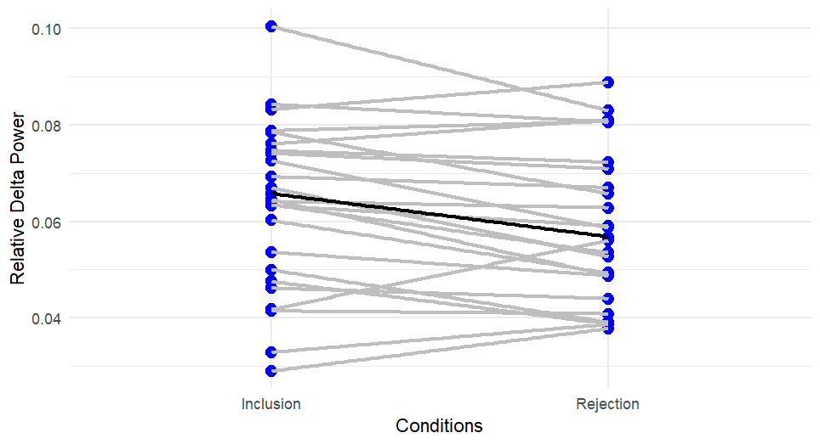
Figure 1: Relative delta power across conditions.
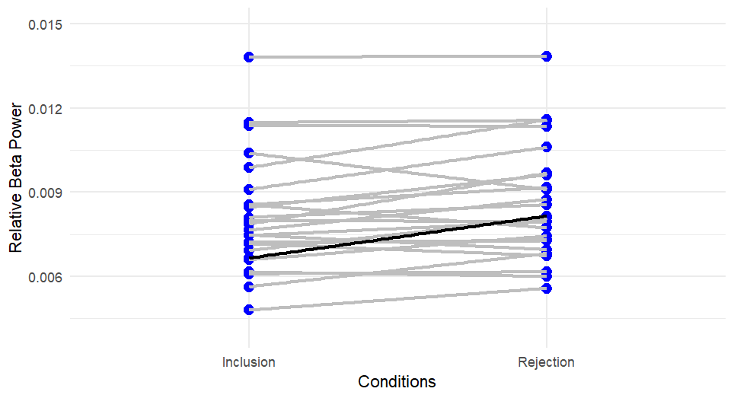
Figure 2: Relative beta power across conditions.
A two-way 2x2 mixed model ANOVA was run to assess power changes across conditions (inclusion, rejection) and ACE scores (low, high) for each frequency band. Analysis of changes in relative power revealed a significant interaction effect for condition x ACE threshold for relative gamma in the frontal (F(1,22)=5.697, p=0.026) and temporal regions (F(1,22)=5.6543, p=0.027). For both frontal and temporal regions, individuals with low ACE scores showed gamma power enhancement in response to rejection, while those with high ACE scores did not discriminate between conditions (Figures 3 and 4). No other frequency bands produced significant results.

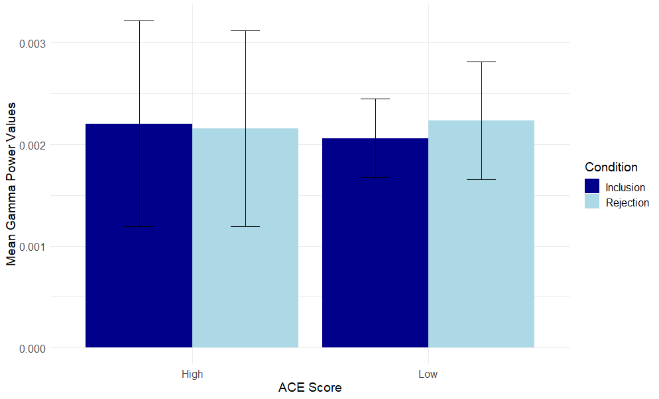
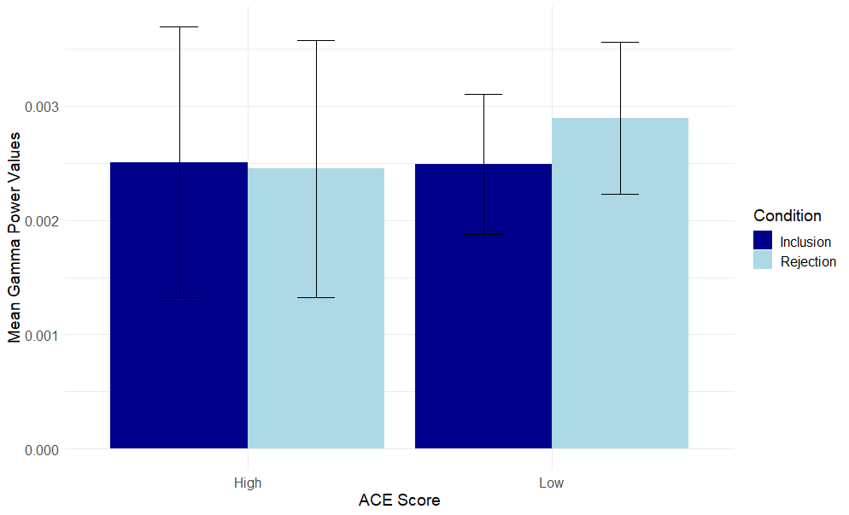
Figure 3: Mean Gamma Power Across ACE scores in the frontal region.
Figure 4: Mean Gamma Power Across ACE Scores in the temporal region.
To further explore potential causes of changes in relative power across conditions, two additional one-way repeated measures ANOVAs were run covarying for MSPSS and resilience total scores. Inclusion power values differed significantly from rejection power values when covarying for MSPSS scores (Figures 5-10) across all three regions (frontal, posterior, and temporal) for alpha, exhibiting a significant main effect of condition (F(1,22)=7.502, p=.012; F(1,22)=6.965, p=.015; F(1,22)=4.755, p=.040) and interaction of condition x MSPSS score (F(1,22)=7.828, p=.010; F(1,22)=6.419, p=.019; F(1,22)=5.707, p=.026). Beta power also saw a significant main effect of condition (F(1,22)=11.673, p=.002; F(1,22)=22.789, p<.001; F(1,22)=9.790, p=.005) and significant interaction of condition x MSPSS score (F(1,22)=14.373, p=.001; F(1,22)=22.896, p<.001; F(1,22)=15.404, p<.001). Power values during the inclusion conditions did not differ significantly from those in the rejection condition when covarying for resilience scores for all frequency bands and regions.
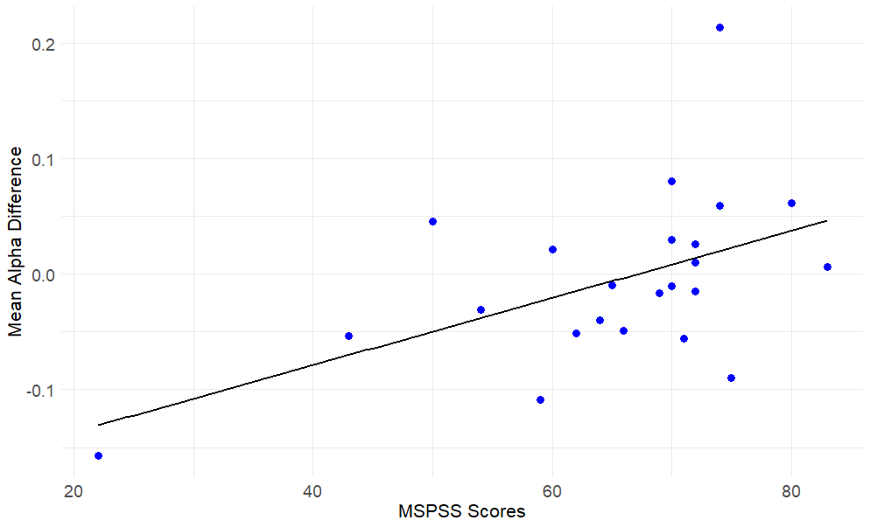
Figure 5: Mean alpha power difference between conditions across MSPSS scores in the frontal region. Difference values were calculated by subtracting inclusion alpha power from rejection alpha power and dividing by the sum of the two.

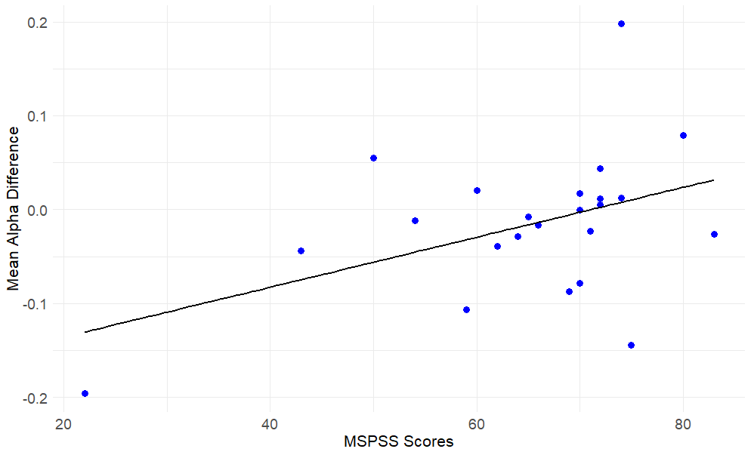
Figure 6: Mean alpha power difference between conditions across MSPSS scores in the posterior region. Difference values were calculated by subtracting inclusion alpha power from rejection alpha power and dividing by the sum of the two.

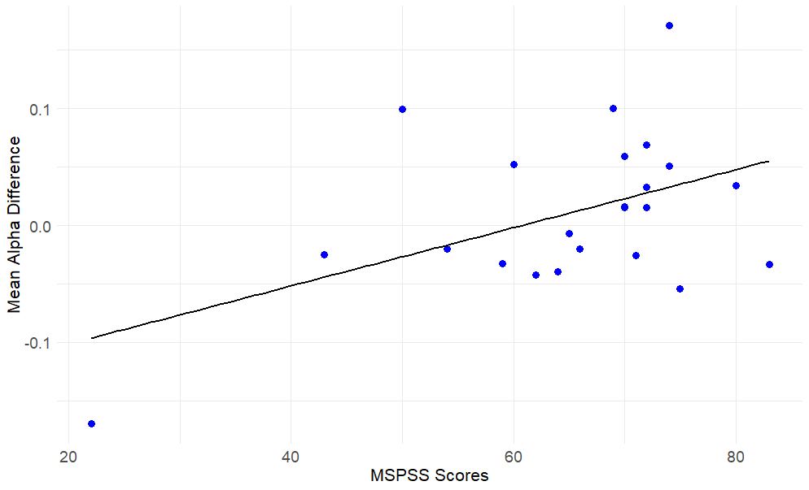
Figure 7: Mean alpha power difference between conditions across MSPSS scores in the temporal region. Difference values were calculated by subtracting inclusion alpha power from rejection alpha power and dividing by the sum of the two.

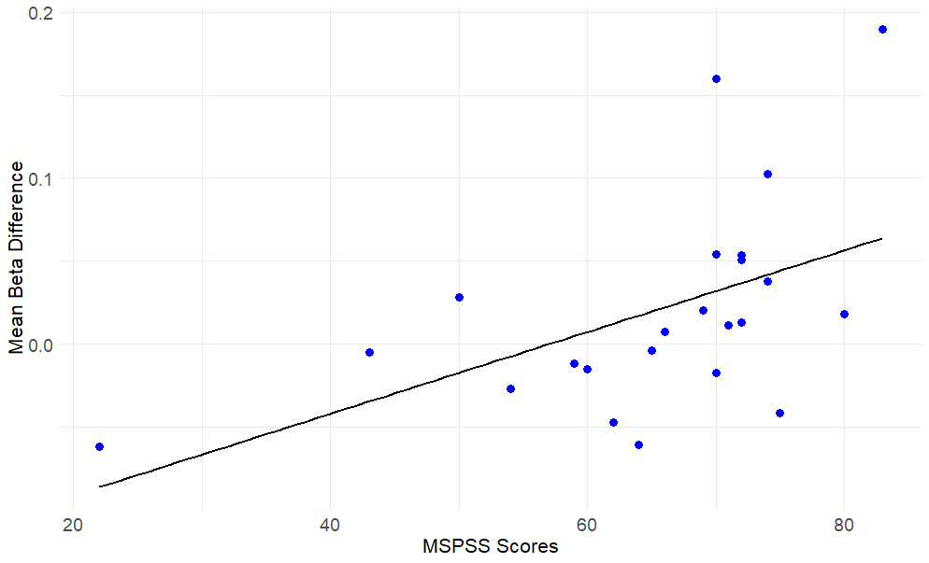
Figure 8: Mean beta power difference between conditions across MSPSS scores in the frontal region. Difference values were calculated by subtracting inclusion alpha power from rejection alpha power and dividing by the sum of the two.

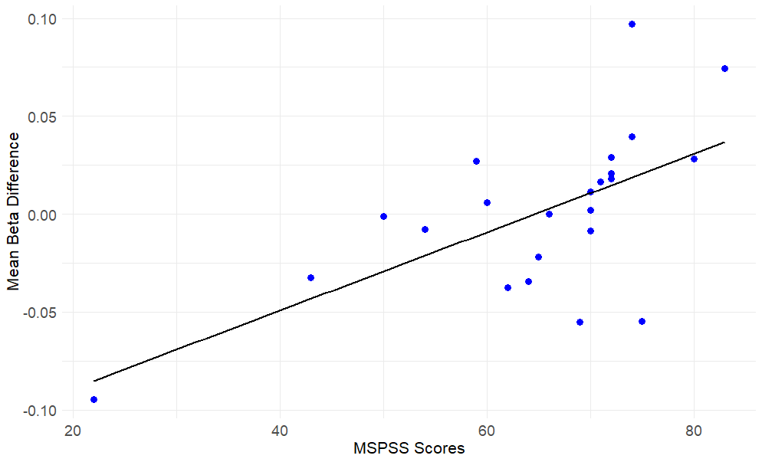
Figure 9: Mean beta power difference between conditions across MSPSS scores in the posterior region. Difference values were calculated by subtracting inclusion alpha power from rejection alpha power and dividing by the sum of the two.

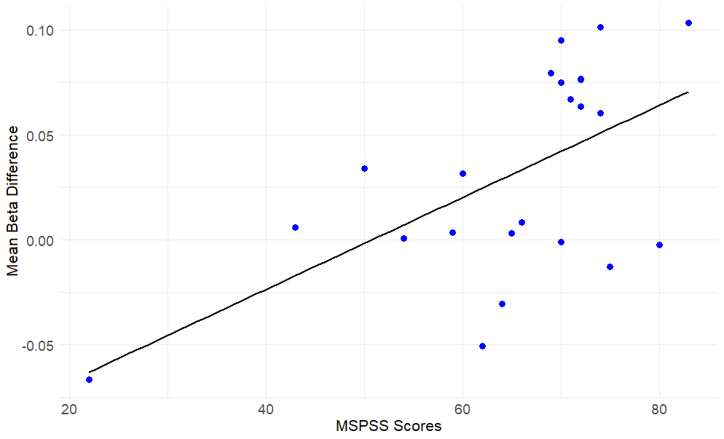
Figure 10: Mean beta power difference between conditions across MSPSS scores in the temporal region. Difference values were calculated by subtracting inclusion alpha power from rejection alpha power and dividing by the sum of the two.
Frontal Asymmetry
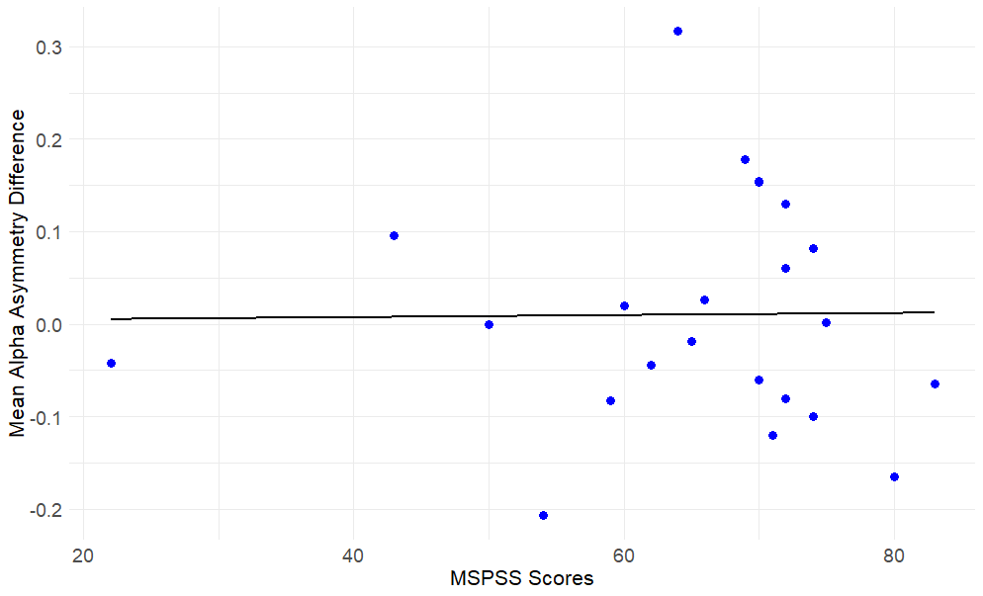
Frontal asymmetry was examined utilizing the numerical difference between left and right relative alpha power for each condition. Using these difference values a two-way mixed model ANOVA was run to assess the relationship between alpha asymmetry and ACE scores. No significant values were found for F3/F4. Additional homologous pairs (P3/P4, F7/F8) were tested for significance and no significant results were found. The same repeated measures ANOVAs covarying for MSPSS and resilience described in the previous subsection were run with alpha asymmetry values. Significant interactions between MSPSS scores and asymmetry values were found for alpha for the P3/P4 pair when covarying for MSPSS scores (F(1,22)= 4.4379, p=0.047). Individuals with higher MSPSS scores had more positive posterior asymmetry values for both inclusion and rejection conditions (Figure 11). This indicates greater leftward posterior activity. Results for resilience total scores showed a main effect of condition (F(1,21)=5.151, p=0.034) and significant interaction between condition and resilience total scores (F(1,21)=4.7844, p=0.040) for alpha asymmetry values at the F3/F4 pairing. Those with lower resilience scores show greater leftward asymmetry for both inclusion and rejection. As resilience scores increase, the values lower significantly for both conditions, with rejection values being significantly higher than inclusion values across resilience scores (Figure 12).

Figure 11: Posterior Alpha asymmetry average across MSPSS scores. The average was calculated by adding together inclusion and rejection values for each participant and dividing by 2.
Figure 12: Frontal Alpha Asymmetry Values across resilience scores.
Exploratory Connectivity
Connectivity was explored using the debiased weight phase lag index (dwPLI) measure. After bootstrapping each possible pairing randomly 500 times, the 5% threshold was obtained for each of the frequency bands and conditions, for a total of 10 different thresholds. None of the previously calculated dwPLI values were lower than the threshold, indicating that the prior values obtained were significantly better than random noise, and thus no connections were removed prior to the FDR correction. A two-way mixed model ANOVA was then run to determine the effect of ACEs on connectivity across conditions. The ANOVA had various significant connections, but none remained following the FDR correction. One-way RM ANOVAs were conducted to assess the influence of resilience and social support on connectivity across conditions. Social support did not show significant effects on connectivity. Resilience was the only score that impacted connectivity values across the head. Significant relationships were found for each band (Figure 13). Delta showed the most significant pairs with 26 significant connections and only one connection survived FDR correction. This pairing was between Cz and M1 and showed a main effect for condition (F(1,21)=5.878, p=0.024) and significant interaction between condition and resilience score (F(1,21)=24.752, p<0.001). All significant delta connections were only found in or near the left posterior sensors.
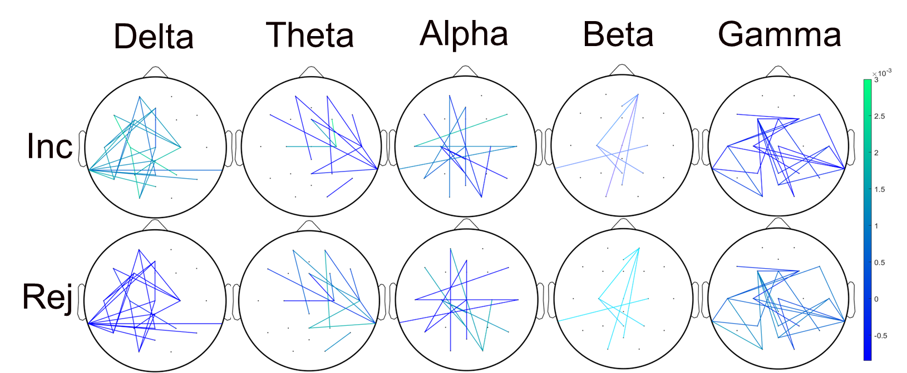
Figure 13: Significant connections for each frequency band (delta, theta, alpha, beta, gamma) for inclusion (top) and rejection (bottom) conditions, prior to FDR correction.
Clinical Correlations
Pearson correlations were run using the total score from each self-assessment listed in the methods section. The correlations listed are supplemental to the initial hypotheses and understanding of the results found and thus not FDR-corrected (Figure 14). Importantly, resilience total scores were significantly correlated with MSPSS, SUPPS, depression, anxiety, PTSD, and loneliness total scores. In addition to resilience, loneliness total scores showed significant relationships with depression, anxiety, PTSD, and need to belong scores. Anxiety total scores were also significantly correlated with SUPPS, PTSD, and depression total scores.
ACE total score was only significantly correlated with PTSD total score. No other total scores were correlated with ACE scores. Age, however, was a significant factor in determining an individual’s total ACE score. Older individuals had lower scores overall compared to their younger counterparts. ACE categories showed patterns of correlation that occurred primarily between traumas within the same categories (abuse, neglect, household dysfunction) or type (emotional, physical). For example, emotional neglect was significantly correlated with emotional abuse and physical neglect. Physical abuse was significantly correlated with physical neglect and emotional abuse (Figure 15).
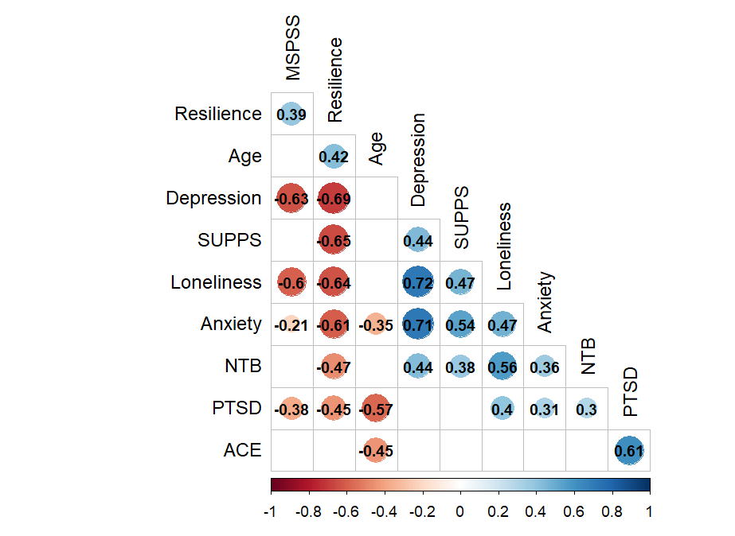

Figure 14: All correlations are Pearson’s rho. All significant correlations are listed on colored circles. Blank = N.S.
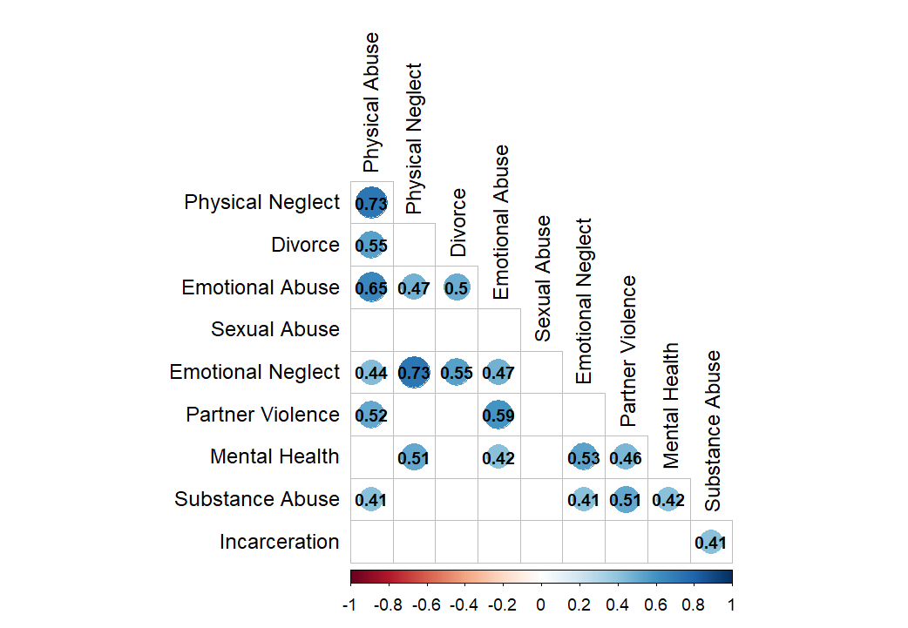
Figure 15: All correlations are Pearson’s rho. All significant correlations are listed on colored circles. Blank = N.S.
Discussion
Rural communities are drastically underfunded, disadvantaged, and misunderstood. Rural communities make up roughly 34% of Oklahoma’s population, making up a substantial part of Oklahoma’s residents. Despite these communities not holding the majority of Oklahoma’s population, their health and well-being are of equal importance. Currently, Oklahoma is rated as one of the highest states in economic hardship, child victimization, children in poverty, and adverse childhood experiences (United Health Foundation, 2021). All areas of Oklahoma are affected by these experiences, but rural communities are consistently hit the hardest (Talbot et al., 2016; National Advisory Committee on Rural Health and Human Services, 2018). Long-term exposure to experiences of trauma and stress can have detrimental effects on mental and physical health which can then lead to negative life outcomes like drug abuse, depression, anxiety, and younger life expectancy (Chartier et al., 2010; Hughes et al., 2017). Rural communities demonstrate the severe side of abuse and neglect exposure, which may be seen in their physiological response to negative experiences like rejection. The lack of research on rural communities as a whole leaves an entire at-risk population without the proper resources and information to combat and prevent these types of experiences. Examining and properly addressing these issues using supported self-reports and EEG measures can help determine the physiological effects of these issues as well as the specific strengths that exposed individuals may have.
Social Rejection
Experiences of social rejection have been shown to have quick and evident effects seen in brain activity. The paired t-tests run to examine the effect of rejection on changes in frequency bands showed that delta power during inclusion conditions was greater than during the rejection condition in the temporal region (Figure 1). The opposite was true for beta, with greater relative power values during the rejection condition in comparison to inclusion conditions (Figure 2). Increases in delta have been seen in correlation with positive emotions, like joy, which may be reflective of a positive experience playing the inclusion games (Aftanas et al., 2006). However, these studies mentioned that delta increases are often seen when there is an increase in attention or arousal. This concept may be applicable here since the participants were watching the gameplay in the rejection condition rather than playing it during the inclusion condition, thus seeing higher engagement during the inclusion rest periods. Given that the participants are not actively participating in the rejection conditions, the increase in delta power in the inclusion conditions may simply reflect an increase in arousal from actively playing a game or the movement associated with their game choices (Reuderink et al., 2013; Klados et al., 2009). Additionally, the expectations of the participants may be important to take into account. Studies on expectations have found that increases in delta power were observed when participants expected to be liked during feedback from their peers (van der Veen et al., 2016; van der Veen et al., 2014; Cohen et al., 2009). If participants went into the experience with the expectation of playing the game cooperatively with other individuals rather than being ostracized, the increase in delta could be a reflection of the dissonance between expectation and reality. Beta power increases, on the other hand, have been shown to occur with the onset of both cognitive and emotional processes. Specifically, increases in beta power have been seen during the reactive phase, or the phase where an individual is actively experiencing a stressor (Hafeez et al., 2018; Izhar et al., 2019; Minguillon et al., 2016). Beta power also seems to increase even in the recovery phase after a stressor, which indicates that significant increases in beta can be observed even minutes after the experience has ended (Vanhollebeke et al., 2022; Guo et al., 2019; Perrin et al., 2019). This suggests that when an individual is experiencing a stressful experience, there is an increase in both cognitive and emotional processing reflected in beta power that can be directly observed long after the experience has ended. This may be reflective of the long-lasting and potentially distressing effects of social rejection and ostracism for the individual. Alternatively, beta has shown consistent increases and decreases in correlation with movement. Specifically, an increase in beta power is associated with planned movement that was not performed, which is possible to have occurred during the rejection periods where participants assumed they would be actively playing a game (Kilavik et al., 2013). No other frequency bands were significant for any regions. These results are not entirely unexpected, as research on these effects utilizing a rural population is not comprehensive and scarce. Interestingly, theta was not significant for any test. Thus, the hypothesis that theta would differ significantly between conditions was not supported by the current results. This is the opposite of what is seen in cyberball studies, that theta is typically affected by situations of rejection that are experienced by the participants (Mills et al., 2023; van Noordt et al., 2015; Cristofori et al., 2013). However, in this study, there were no significant findings related to theta. This may reflect the differences in populations used in these studies. The use of a random and generalizable population that is often used in cyberball studies instead of a particular population chosen specifically for their attributes might not share the same characteristics thus leading to different results. Further studies are required to determine the effects that rejection has on theta in this particular subset of the population.
Childhood Trauma
Research on the effects of childhood trauma on brain activity has connected a variety of impacts on mental and physical health to the presence of trauma during childhood. These effects may have specific connections with changes in brain activity during rejection. A two-way mixed model ANOVA assessing the effects of childhood trauma on changes in frequency band power resulted in significant differences across conditions for relative gamma power in the frontal and temporal regions. Gamma power for those who were classified as having low ACE scores consistently showed greater values during the rejection condition in comparison to the inclusion conditions for both frontal and temporal areas. High ACE score individuals showed somewhat greater values during inclusion conditions compared to the rejection condition but did not significantly distinguish between the conditions (Figures 3 and 4). These findings are opposite of what was initially hypothesized, so the original hypothesis is not supported. Gamma power is commonly associated with a variety of cognitive processes such as attention, memory, and learning. Increases in gamma power have been observed during the processing of auditory and visual stimuli as well as active memory recall (Kaiser & Lutzenberger, 2005). It is possible that individuals with less childhood trauma were able to successfully distinguish between the two conditions as a result of increased attention and active learning during the rejection condition. This increase may reflect their ability to effectively adapt to a given situation by redirecting their attention as needed.
The effect of childhood trauma on gamma is not well understood. However, gamma power is heavily affected by age and changes dynamically throughout childhood development (Anderson and Perone, 2018). Children who experience trauma during any stage of development often develop various behavioral concerns and show deviations from normal brain activity (Brockie et al., 2015; Chartier et al., 2010; Hughes et al., 2017; Mclaughlin et al., 2013). However, the current research on gamma power cannot directly determine the possibility of any alterations in response to childhood trauma during childhood or adulthood. A paper by Lee et al. (2017) found that individuals who reported high levels of childhood trauma, as measured by the Childhood Trauma Questionnaire (CTQ), had significantly higher gamma power when compared to those with low levels of childhood trauma (Lee et al., 2017; Bernstein et al., 2003). The CTQ is a Likert scale that is used to assess the quantity of an individual’s trauma rather than the simple presence of trauma during childhood which is measured by the ACE questionnaire used in this study. The difference in measures could be the reason for the deviation between the results they obtained, and the results discussed here. In addition, they related these results through a measure of anxiety scores, stating that this measure is associated with childhood trauma that then causes higher levels of gamma power. In this current study, anxiety measures were not included in the detailed analysis. However, there was not a significant correlation between anxiety and ACE scores which might explain the difference in results. The population used may not reflect the same distribution of scores and experiences as the population used in the Lee paper, making it difficult to compare the two. Although there is a lack of research on gamma power specifically in relation to childhood trauma, there is substantial information on the influences of stress on gamma power. Stress has been reflected in increases in gamma power (Minguillon et al., 2016; Priya et al., 2020) However, these increases are not long-lasting, and gamma oscillations, in general, are relatively short-lived (Buzsáki and Wang, 2012). Since the data used for this analysis were collected after the conditions were completed as opposed to during the task, the results here may simply reflect the return to baseline from the increase that occurred during the task. No other frequency bands were significant for this analysis, in any regions. In addition, no significant findings were found for any frontal asymmetry analyses when covarying for ACE scores. Thus, the hypothesis that asymmetry would differ across ACE scores is not supported. It is difficult to determine the reason for the lack of significant results. Perhaps childhood trauma is not best examined through this type of measure. However, past research has found significant frontal asymmetry in relation to high/low scores of childhood trauma (Curtis & Cicchetti, 2007; Meiers et al., 2020). It is probable that these discrepancies are due to the utilization of different questionnaires, populations, or tasks. The use of an at-risk population rather than a ‘normal’ and representative population may have impacted these results to have more variability in their childhood trauma scores. Follow-up studies comparing this measure to a normative distribution may help us better understand these discrepancies. More research on childhood trauma using the same measures is necessary to make accurate judgments on the long-term effects of childhood trauma on brain activity, and physiology in general.

Social Support and Resilience
Social relationships are an integral part of maintaining healthy mental and physical states. Social groups can provide the necessary support and socialization needed to promote beneficial coping strategies (Eisenberger et al., 2007; Sarason et al., 1997; Sulaiman et al., 2013). Thus, social support may act as a potential barrier against disadvantaged situations, like trauma and stress. Alpha and beta power showed significant differences across all regions when covarying for MSPSS total scores. As MSPSS scores decreased, both alpha and beta power increased, for both inclusion and rejection conditions. Power differences calculated between conditions showed that alpha and beta power differences increased linearly with MSPSS scores (Figures 5-10). As MSPSS scores increased, alpha and beta power differences between conditions became more positive. This suggests that participants with higher MSPSS scores can distinguish more between the conditions than those with lower MSPSS scores. This may indicate an increased ability of individuals with more social support to effectively evaluate and adapt to various situations. Their capacity to successfully distinguish between distinct experiences may directly reflect the positive effects that higher levels of social support can have. Interestingly, both alpha and beta power values were increased for both conditions. It would be expected that the rejection condition would result in higher power values of power in comparison to the inclusion conditions, which were not seen. There was an increase in power for both conditions, which may be due to other factors that are influencing these individuals’ responses to social rejection. Other factors like resilience and childhood trauma are likely playing supplementary roles in how this population is reacting and coping with this situation that are difficult to parse out. However, if individuals with higher perceived social support are continuously showing successful distinguishing responses to different conditions, this may still reflect the positive effects of social support or social relationships on their responses to social situations.
In addition to the power changes seen in alpha and beta, a one-way RM ANOVA using frontal asymmetry values was significant when covarying for MSPSS scores. Specifically, alpha asymmetry was significant at the P3/P4 pairing. There was no significant main effect of MSPSS scores, but there was a significant interaction between MSPSS scores and condition. Individuals appear to be differing in response to the different conditions, which is to be expected, but not as a result of MSPSS scores. This suggests that MSPSS scores do not directly affect the pattern of positive and negative asymmetry values observed, but rather these scores are moderating an individual’s response to the different conditions. This supports the hypothesis that social support would take on a modulating role, even though it was not shown specifically for ACEs which was the original hypothesis. Because this was a simple measure of whether an individual perceives themselves as having social support rather than directly employing social support during the conditions, the modulatory relationship between the MSPSS scores and frontal asymmetry is more appropriate. This particular analysis was exploratory given the lack of research on social support and frontal asymmetry as well as the lack of research on parietal asymmetry in previous studies. However, this finding converges well with past literature on the modulatory effects of social support on changes in brain activity. Specifically, social support has been shown to provide buffer effects against social and physical pain stimuli (DeVries et al., 2003; Eisenberg, et al., 2007; Morese et al., 2019). Social support does not appear to have a direct and drastic effect on the outcomes of painful or traumatizing experiences, but social support does consistently prove to be useful in moderating the relationship between the two. Consequently, proving to be a very important aspect in research on social and physical pain research as well as stressful or traumatic experiences.
A one-way RM ANOVA examining the relationship between resilience scores and frontal alpha asymmetry showed significance at the F3/F4 pairing. Individuals with lower resilience scores showed more positive values, or more frontal leftward activity for both inclusion and rejection conditions. Individuals, regardless of resilience score, showed higher rejection values in comparison to inclusion values. More leftward activity is associated with approach-related motivation and is often seen in conjunction with positive emotions or well-being (Poole and Gable, 2014; Zhao et al., 2018). Previous research on frontal asymmetry has implicated greater leftward frontal activity as being a predictor of resilience (Meiers et al., 2020; McLaughlin et al., 2011; Curtis & Cicchetti, 2007). The results found here are the opposite of what would be expected of individuals with lower levels of resilience. Thus, the hypothesis was not directly supported due to the opposite effects being found. However, the general hypothesis was simply expecting a difference in frontal asymmetry as a result of resilience scores. This may indicate a significant difference in what constitutes rural resilience in comparison to a general population’s resilience. Literature on rural resilience suggests that due to the myriad of differences that occur between urban and rural populations, it is likely that they also differ in their resilience practice (Song et al., 2022; Rapaport et al., 2018; Leykin et al., 2013; Cutter et al., 2016). In light of the current results, it may be more beneficial for rural individuals to practice withdrawal to protect themselves, particularly when the stimulus is negative. Social isolation in these rural communities might play a role in the development of the nature of their response to negative experiences. Additionally, there is a lack of research on the differences between urban and rural resilience in terms of the individual, which could explain the divergence of the current results from previous findings. Future studies should focus on expanding the current research on resilience differences between urban and rural communities in terms of the community and the individual.
Clinical Correlations
Significant clinical correlations were important in further determining the specific characteristics of these particular rural populations, as well as the impact of their connections on responses to experiences of rejection. Social support was significantly correlated to many of the total scores, which suggests that social relationships are extremely influential in the development and continuity of disorders like depression, anxiety, and PTSD, among others not tested in this study. Specifically, social support was negatively correlated with all three disorders, indicating that the more social support an individual has, the less likely they are to struggle with these particular disorders or related symptoms. Additionally, social support was positively correlated with resilience scores; signifying that the more social support an individual has, the more resilient they are. Resilience scores were also significantly negatively correlated with depression, SUPPS, loneliness, anxiety, need to belong, and PTSD. This relationship indicates that an individual with higher resilience scores has lower scores for each of the listed concerns. Higher resilience scores indicate a higher level of resilience an individual possesses, whereas a higher depression or anxiety score, for example, indicates a greater quantity of experience with depression or anxiety symptoms. These findings align with previous research on the benefits of social support on physical and mental health outcomes (Eisenberger et al., 2007; Morese et al., 2019; Kelly et al., 2019). The positive influence of social support and thus, resilience, are evident when examining these correlations. These results are extremely important in determining how best to assist these at-risk populations. This information is necessary to provide accurate and tailored help for these communities.
In addition to the clinical correlations, significant correlations were found in relation to specific types of ACEs. ACEs were not significantly correlated with any of the clinical correlations. However, age was negatively correlated with ACEs. This finding aligns with previous research on an age-related effect on ACE scores (Briggs et al., 2021, Chartier et al., 2010). Older individuals consistently reported fewer experiences with ACEs. This may be due to a generational difference or merely the timing between the original experience and when the individual was asked to recall these situations. Significant correlations between ACEs appeared to correlate most often with those in the same categories (abuse, neglect, household dysfunction) or type (physical, emotional). Physical abuse was significantly correlated with physical neglect, substance abuse, emotional abuse, and emotional neglect. Similarly, emotional neglect was correlated with emotional abuse, physical abuse, and physical neglect. These results mirror previous research that found significant correlations between single categories of trauma exposure. When an individual had experienced emotional abuse, for example, they were more likely to have also experienced physical abuse (Felitti et al., 1998). Interestingly, the mental health struggles of a family member correlated with physical abuse, emotional abuse, emotional neglect, substance abuse, and intimate partner violence. This indicates the importance of mental health in not only the child but individuals in a child’s environment and these individuals can have drastic and widespread effects on all three categories of ACEs, fully encompassing every aspect of ACEs that was explored in this particular study. The overall pattern of correlations is similar to past studies examining the factor structure of ACEs (Afifi et al., 2020; Choi et al., 2020). Interestingly, all significant correlations were positively correlated. This suggests that it is more likely that an individual will experience additional ACEs given the experience of any ACE rather than the opposite. This particular finding has been found consistently in ACE literature, confirming that ACEs are inherently cumulative both in experience and in risk (Felitti et al., 1998; Choi et al., 2020; Afifi et al., 2020). The ACEs findings found here fit in with previous research on more representative populations, suggesting that rural populations are comparable in terms of ACE relationships. However, the prevalence found in the sample (tables 1-2) was high compared to both the national average and prior findings on rural communities (Inignez & Stankowski, 2016; Swedo et al., 2023; Talbot et al., 2016; National Advisory Committee, 2018). The lack of research on these communities, particularly in Oklahoma, makes it difficult to effectively determine the accuracy of the characteristics found in this study in comparison to others. Further research is required to evaluate the attributes of these communities as well as the extent to which these individuals are affected by prior experiences.
Exploratory Connectivity
The use of connectivity as a measure of brain activity across the brain provides a holistic view of the way in which the brain operates during specific events. Prior research on connectivity has found significant patterns across the brain that researchers suggest are related to resilience adaptation. The current results show that resilient individuals had lower delta connectivity values during rejection. The opposite was seen for non-resilient individuals, who had lower delta connectivity values during inclusion. In addition, these results were only seen within the left posterior sensors, which is commonly associated with decision-making and mediating emotional processes (Heekeren et al., 2006; Maddock et al., 2002). These results partially support the hypothesis that connectivity would differ as a result of ACEs, social support, and resilience. The lower connectivity values obtained reflect less communication occurring between the different brain regions examined, indicating that resilient and non-resilient individuals process rejection differently. These results align with previous research showing that resilient individuals showed a decrease in connectivity in comparison to non-resilient individuals in the left hemisphere (Cisler et al., 2013). Resilient individuals also showed higher connectivity values across conditions. This finding might indicate that resilient individuals are exhibiting more connectivity across the brain but are significantly differing in their response to rejection in comparison to non-resilient individuals. Overall, the results here suggest a modulatory effect of resilience score on connectivity values. The lack of previous research on connectivity using a resilience questionnaire measure makes it difficult to determine the full extent of the role that resilience plays in brain networks. Thus, the current results are exploratory in nature and serve to improve the current knowledge of connectivity literature on childhood trauma and resilience.
Conclusions and Future Directions
Examining an at-risk population using a multi-disciplinary approach exhibits an in-depth and comprehensive approach to assessing and addressing the key issues that rural communities are facing. The use of EEG measures along with diverse clinical measures used in this study has yielded a specific and expansive perspective of how rural communities are being treated and the how these communities and individuals adapt to these conditions. Current results promote the effectiveness of cyberball as a way to actively assess an individual's response to social rejection. Additionally, these responses are still visible moments after the initial experience which suggests that some lingering effects may be observed after the games have ended. The full extent of the timing and lingering effects is not well known, and additional research will be needed to determine the consistency of the results found here. Importantly, rural individuals, regardless of resilience, social support, and childhood experiences, appeared to be affected by the experience of social rejection. This information is important in making the case that despite the significant differences observed in previous populations and the current rural populations, they are similarly affected by experiences of rejection. Specifically, both populations appear to be affected by rejection in some manner. Given the lack of resources in rural communities, it was a possibility that rural communities would perhaps have no significant reactions to rejection as a result of maladaptive coping strategies. Importantly, there are pertinent differences in the specific changes observed in the frequency bands across studies, which are likely to be a result of the characteristics of the population used. The differences observed in the manner in which rural communities are adapting and processing an experience of rejection provide necessary information on the inner workings of resilience even in the absence of resources and support. Future studies should focus on replicating the results of previous studies as well as determining the accuracy of the results obtained here.
The current population was chosen as a result of their high prevalence of childhood trauma (Tables 1 & 2). The presence of childhood trauma was particularly influential on gamma power, suggesting that trauma occurring within childhood can have drastic impacts on an individual's ability to effectively distinguish between the two conditions. This ability to distinguish between the two conditions may arise from an individual’s ability to successfully adapt to their current situation by altering their attention and awareness. Alternatively, the differences seen in gamma power may be a result of an individual’s stress response to the task. Gamma increases in response to stress are not long-lasting and may not be observed in the rest periods that were examined in the current analysis. Further analysis using the task data will be needed to assess this possibility.
Social support is known to play an integral role in an individual’s response to various types of pain. The results obtained here align with previous research validating these ideas. Specifically, individuals with higher perceived social support were better able to distinguish between the conditions for alpha and beta power. In addition to these direct effects, social support also provided a buffering effect against the negative effects of social rejection in the context of posterior asymmetry. Furthermore, resilience scores were influential in an individual’s frontal asymmetry. Those with lower resilience scores showed more approach-motivated behaviors than those with higher resilience scores, which was the opposite of what prior research would suggest. This discrepancy may reflect specific and important differences in this rural population in comparison to a more generalized population. Rural communities might have significant differences in the way that they approach and adapt to situations that reflect their past and current experiences living in a rural area. More importantly, the deviation from past research observed here may be a result of the differences that occur on the individual level as compared to the community level. The connectivity results obtained correspond well with the frontal asymmetry results, suggesting that resilient and non-resilient individuals differ in their responses to rejection. It also provides more information on the nature of the effects of resilience on this response. A mix of modulating and direct effects appears to be affecting various measures of brain activity. Together these effects convey the complicated and intricate nature of the inner workings of social support and resilience within a rural community. Importantly, the lack of research on resilience through the lens of the individual makes it difficult to fully understand and determine the underlying mechanisms at play. Future research should focus on examining resilience on the individual and community levels in order to determine the overlap and distinctions between the two. Frontal asymmetry has proven to be particularly consistent as a biomarker for resilience, making it a good choice for the continuation of this research (Curtis & Cicchetti, 2007; Cicchetti, 2013; Quaedflieg 2015). Importantly, frontal asymmetry has good test-retest reliability and high internal consistency over months making it highly useful for future studies that want to implement biofeedback procedures (Towers & Allen, 2008). Biofeedback has shown promising results in depression and anxiety studies by teaching individuals how to alter a specific band frequency, resulting in a decrease in negative symptomology (Tolin et al., 2020; Hou et al., 2020). Future research should focus on the development of resiliency using frontal asymmetry that can then be adapted into biofeedback treatments for individuals at risk for traumatic life experiences.
Current results support previous research on the complex but consistent interactions between individual ACEs and their respective categories. Importantly, these were observed within a rural population, which has not been studied in depth previously. These results validate the use of a rural community for these types of studies in addition to confirming prior theories regarding the increased risk of experiencing trauma in rural communities. These results provide important context for future research that validates the reliability of ACEs as a measurement of childhood trauma at baseline. Future research should focus on the inclusion of timing and quantity measurements of childhood trauma in order to obtain a more in-depth understanding of how these variables change the long-term effects.
It is evident through the results obtained here that social support, resilience, and childhood trauma considerably impact rural individuals’ responses to rejection. The complicated nature of these variables and the lack of previous research make it difficult to fully determine the impacts and interactions that these variables have on rural individuals. However, the results do determine that factors like social support are of extreme importance in fostering a resilient mindset that can occur even after years of childhood trauma and abuse. The results of this study will shed light on the influence of social rejection on the neural activity of rural individuals and the role ACEs, resilience, and social support play in this response, as well as increasing knowledge and awareness of the impactful experiences that occur in rural communities.

Limitations
Previous research on rural communities is limited due to a lack of accessibility to these areas, prior knowledge, and funding. The lack of foundational information on these areas can lead to certain preconceived notions of how these communities operate. Preconceived notions might result in certain assumptions being made about these communities which can be harmful in the direction of future research. Without a cohesive foundation of information on this population, it is difficult to effectively determine the detailed characteristics and inner workings that are necessary to fully understand these communities. Current and future research on rural communities needs to start from the beginning by exploring the issues that these communities are facing and the ways in which they have found to adapt to their particular struggles.
Examining childhood trauma via questionnaires can provide an initial look into how an individual’s childhood might have been affected by negative experiences like neglect and abuse. These questionnaires provide extremely useful information that has consistently shown to map on to various outcomes later on in life. However, the current state of ACE questionnaires does not take into account the amount, timing, or seriousness of these events, which are necessary to fully understand the way that childhood trauma affects these individuals later in life. In addition, these questionnaires are not consistent and often have widespread differences in the experiences and ways in which these experiences are examined. The lack of clarity, depth, and consistency in these questionnaires as a whole directly limits the amount of information that will be obtained from these measures. Future work should focus on increasing the accuracy, consistency, and comprehensiveness of current questionnaires that may be used to foster better options for future use.
Five separate sites were used to test the effects of social rejection on rural communities. Despite the original calculations of power and sample size being adequate, many participants were lost due to unusable EEG data or data loss in other modalities than EEG. Specifically, seven participants were removed from analyses as a result of unusable EEG data. Given the uncertainty and inability to control the specifics of the community sites used, this aspect of the data loss is not entirely surprising and was expected. The data loss as a result of issues with the questionnaires and improper recruitment at the Anadarko site was not expected and significantly reduced the original sample size obtained. These unexpected difficulties are common in multidisciplinary studies that consist of many people attempting to coordinate simultaneously. Future research should be aware of the pros and cons of multidisciplinary research in that it provides a comprehensive view of a particular population as well as the drawbacks related to effectively coordinating among various disciplines. The final sample size of 24 that was used for most of the final analyses is much lower than would be preferred for the designed study. The lack of sample size and subsequent power likely affected the results obtained from this population. Importantly, the small sample size resulted in significantly less variation in total scores across a majority of the questionnaires. The lack of representation in the full extent of scores can directly affect the outcome of the results and the extent to which significant results can be fully interpreted.

References
Afifi, T., et al. (2020). Confirmatory factor analysis of adverse childhood experiences (ACEs) among a community-based sample of parents and adolescents. BMC Pediatrics, 20(178). https://doi.org/10.1186/s12887-020-02063-3.
Aftanas, L., et al. (2006). Neurophysiological Correlates of Induced Discrete Emotions in Humans: An Individually Oriented Analysis. Neuroscience and Behavioral Physiology, 36(2), 119-130. https://doi.org/10.1007/s11055-005-0170-6.
Anda, R., Porter, L., & Brown, D. (2020). Inside the Adverse Childhood Experience Score: Strengths, Limitations, and Misapplications. American Journal of Preventative Medicine, 59(2), 293-295. https://doi.org/10.1016/j.amepre.2020.01.009.
Anderson, A & Perone, S. (2018). Developmental change in the resting state electroencephalogram: Insights into cognition and the brain. Brain and Cognition, 126, 40-52. https://doi.org/10.1016/j.bandc.2018.08.001.
America's Health Rankings analysis of U.S. Census Bureau, American Community Survey, United Health Foundation, AmericasHealthRankings.org.
Barnes, C., et al. (2012). Don’t Tread on Me: Masculine Honor Ideology in the U.S. and Militant Responses to Terrorism. Society for Personality and Social Psychology, 38(8), 1018-1029. https://doi.org/10.1177/0146167212443383.
Barros, C., et al. (2022). Frontal Alpha Asymmetry and Negative Mood: A Cross-Sectional Study in Older and Younger Adults. Symmetry, 14(1579). https:// doi.org/10.3390/sym14081579.
Bateson, K., et al. (2020). Understanding the use, and misuse, of Adverse Childhood Experiences (ACEs) in trauma-informed policing. The Police Journal: Theory, Practice and Principles, 93(2), 131-145. https://doi.org/10.1177/0032258X19841409.
Bekkedal, M., et al. (2011). Human brain EEG indices of emotions: Delineating responses to affective vocalizations by measuring frontal theta event-related synchronization. Neuroscience and Biobehavioral Reviews, 35(9), 1959-1970. https://doi.org/10.1016/j.neubiorev.2011.05.001.
Bellis, M., et al. (2013). Adverse childhood experiences: retrospective study to determine their impact on adult health behaviours and health outcomes in a UK population. Journal of Public Health, 36(1), 81-91. https://doi.org/10.1093/pubmed/fdt038.
Bernstein, D. P., et al. (2003). Development and validation of a brief screening version of the childhood trauma questionnaire. Childhood Abuse & Neglect, 27, 169–190. https://doi.org/ 10.1016/s0145-2134(02)00541-0.
Bertolini, P. (2019). “Overview of Income and Non-income Rural Poverty in Developed Countries.” United Nations Economic Commission for Africa. chrome-extension://efaidnbmnnnibpcajpcglclefindmkaj/https://www.un.org/development/desa/dspd/wp-content/uploads/sites/22/2019/03/bertolini-Overview-rural-poverty-developed-countries-1.pdf.
Brendgen, M. & Vitaro, F. (2008). Peer Rejection and Physical Health Problems in Early Adolescence. Journal of Developmental and Behavioral Pediatrics, 29(3), 183-190. https://doi.org/ 10.1097/DBP.0b013e318168be15.
Briggs, E., et al. (2021). All adverse childhood experiences are not equal: The contribution of synergy to adverse childhood experience scores. American Psychologist, 76(2), 243–252. https://doi.org/10.1037/amp0000768.
Brockie, T., et al. (2015). The Relationship of Adverse Childhood Experiences to PTSD, Depression, Poly-Drug Use and Suicide Attempt in Reservation Based Native American Adolescents and Young Adults. American Journal of Community Psychology, 55(3), 411-421. https://doi.org/10.1007/s10464-015-9721-3.
Buzsáki, G & Wang, X-J. (2012). Mechanisms of Gamma Oscillations. Annual Review of Neuroscience, 35, 203-225. https://doi.org/10.1146/annurev-neuro-062111-150444.
California Surgeon General’s Clinical Advisory Committee. (2020). Adverse Childhood Experience Questionnaire for Adults. ACEs Aware. https://www.acesaware.org/wp-content/uploads/2022/07/ACE-Questionnaire-for-Adults-Identified-English-rev.7.26.22.pdf.
Cacioppo, C. & Hawley, L. (2003). Social Isolation and Health, with an Emphasis on Underlying Mechanisms. Perspectives in Biology and Medicine, 46(3), S39-S52. https://doi.org/10.1353/pbm.2003.0063.
Chartier, M., et al. (2010). Separate and cumulative effects of adverse childhood experiences in predicting adult health and health care utilization. Child Abuse and Neglect, 34, 454-464. https://doi.org/10.1016/j.chiabu.2009.09.020.
Chaudry, A., & Wimer, C. (2016). Poverty is Not Just an Indicator: The Relationship Between Income, Poverty, and Child Well-Being. Academic Pediatrics, 16(3), S23-S29. https://doi.org/10.1016/j.acap.2015.12.010.
Choi, C., et al. (2020). Validity of an expanded assessment of adverse childhood experiences: A replication study. Children and Youth Services Review, 117. https://doi.org/10.1016/j.childyouth.2020.105216.
Cicchitti, D. (2010). Resilience under conditions of extreme stress: a multilevel perspective. World Psychiatry, 9(3), 145-54. https://doi.org/10.1002/j.2051-5545.2010.tb00297.x.
Cicchitti, D. (2013). Annual Research Review: Resilient functioning in maltreated children – past, present, and future perspectives. Journal of Child Psychology and Psychiatry, 54(4), 402-422. https://doi.org/10.1111/j.1469-7610.2012.02608.x.
Cisler, J.M., et al. (2013). Differential functional connectivity within an emotion regulation neural network among individuals resilient and susceptible to the depressogenic effects of early life stress. Psychological Medicine, 43, 507-518. https://doi.org/10.1017/S0033291712001390.
Cohen, O., et al. (2017). Building resilience: The relationship between information provided by municipal authorities during emergency situations and community resilience. Technological Forecasting and Social Change, 121, 119-125. http://dx.doi.org/10.1016/j.techfore.2016.11.008.
Cohen, M., et al. (2009). Oscillatory activity and phase-amplitude coupling in the human medial frontal cortex during decision making. Journal of Cognitive Neuroscience, 21, 390–402. https://doi/10.1162/jocn.2008.21020.
Cristofori, I., et al. (2013). Theta Signal as the Neural Signature of Social Exclusion. Cerebral Cortex, 23(10), 2437-2447. https://doi/10.1093/cercor/bhs236.
Curtis, J., and Cicchetti, D. (2007). Emotion and resilience: A multilevel investigation of hemispheric electroencephalogram asymmetry and emotion regulation in maltreated and nonmaltreated children. Development and Psychopathology, 19(3), 811-840. https://doi.org/10.1017/S0954579407000405.
Cutter, S., et al. (2016). Urban–Rural Differences in Disaster Resilience. Annals of the American Association of Geographers, 106(6), 1236-1252. https://doi.org/10.1080/24694452.2016.1194740.
Cyders, M., et al. (2014). Examination of a short English version of the UPPS-P Impulsive Behavior Scale. Addictive Behaviors, 39(9), 1372-1376. https://doi.org/10.1016/j.addbeh.2014.02.013.
Daníelsdóttir, H., et al. (2022). Adverse childhood experiences and resilience among adult women: A population-based study. eLife, 11. https://doi.org/10.7554/eLife.71770.
Delorme, A. & Makeig, S. (2004). EEGLAB: an open source toolbox for analysis of single-trial EEG dynamics including independent component analysis. Journal of Neuroscience Methods, 134(1), 9-21. https://doi.org/10.1016/j.jneumeth.2003.10.009.
Derin, S., et al. (2022). The role of adverse childhood experiences and attachment styles in social anxiety disorder in adolescents. Clinical Child Psychology and Psychiatry, 27(3), 644-657. https://doi.org/10.1177/13591045221078085.
DeVries, A., et al. (2003). Social modulation of stress responses. Physiology & Behavior, 79(3). 399-407. https://doi.org/10.1016/S0031-9384(03)00152-5.
Doi, S., et al. (2022). Association between maternal adverse childhood experiences and child resilience and self-esteem: Results from the K-CHILD study. Child Abuse & Neglect, 127. https://doi.org/10.1016/j.chiabu.2022.105590.
Eisenberger, N., et al. (2007). Neural pathways link social support to attenuated neuroendocrine stress responses. Neuroimage, 35(4), 1601-1612. https://doi.org/10.1016/j.neuroimage.2007.01.038.
Felitti, V., et al. (1998). Relationship of childhood abuse and household dysfunction to many of the leading causes of death in adults. The Adverse Childhood Experiences (ACE) Study. American Journal of Preventative Medicine,14(4),245-58. https://doi.org/10.1016/s0749-3797(98)00017-8.
Ford, M. & Collins, N. (2013). Self-esteem Moderates the Effects of Daily Rejection on Health and Well-being. Self and Identity, 12(1), 16-38. https://doi.org/10.1080/15298868.2011.625647.
Fritz, J., et al. (2020). Mood and neural responses to social rejection do not seem to be altered in resilient adolescents with a history of adversity. Development and Psychopathology, 32(2), 411-423. https://doi:10.1017/S0954579419000178.
Ganor, M., & Ben-Lavy, Y. (2003). Community resilience: Lessons derived from Gilo under fire. Journal of Jewish Communal Service, 79(2/3), 105–108.
Guo, L., et al. (2019). Stress recovery of campus street trees as visual stimuli on graduate students in autumn. International Journal of Environmental Research and Public Health, 17(1). https://doi.org/10.3390/ijerph17010148.
Hafeez, M., et al. (2018) Stress effects on exam performance using EEG. 2018 14th International Conference on Emerging Technologies (ICET), pp. 1-4. https://doi.org/10.1109/ICET.2018.8603652.
Hanson, M., et al. (2010). PTSD-8: A Short PTSD Inventory. Clinical Practice and Epidemiology in Mental Health, 6, 101-108. https://doi.org/10.2174/1745017901006010101.
Harmelen, A-L., et al. (2016). Friendships and Family Support Reduce Subsequent Depressive Symptoms in At-Risk Adolescents. PLoS ONE, 11(5). https://doi.org/10.1371/journal.pone.0153715.
Hawkley, L. & Cacioppo, C. (2010). Loneliness Matters: A Theoretical and Empirical Review of Consequences and Mechanisms. Annals of Behavioral Medicine, 40(2), 218-227. https://doi.org/10.1007/s12160-010-9210-8.
Health Resources and Services Administration’s (HRSA) Maternal and Child Health Bureau
(MCHB). (2020). “Rural/Urban Differences in Children’s Health.” https://mchb.hrsa.gov/sites/default/files/mchb/data-research/rural-urban-differences.pdf.
Heekeren, H., et al. (2006). Involvement of human left dorsolateral prefrontal cortex in perceptual decision making is independent of response modality. Proceedings of the National Academy of Sciences, 103(26), 10023–10028. https://doi.org/10.1073/pnas.0603949103.
Herzberg, M. & Gunnar, M. (2020). Early life stress and brain function: Activity and connectivity associated with processing emotion and reward. NeuroImage, 209. https://doi.org/10.1016/j.neuroimage.2019.116493.
Hou, Y., et al. (2020). Neurofeedback training improves anxiety trait and depressive symptom in GAD. Brain and Behavior, 11. https://doi.org/10.1002/brb3.2024.
Hughes, K., et al. (2017). The effect of multiple adverse childhood experiences on health: a systematic review and meta-analysis. Lancet Public Health, 2, e56-e66.
Iniguez, K & Stankowski, R. (2016). Adverse Childhood Experiences and Health in Adulthood in a Rural Population-Based Sample. Clinical Medicine & Research, 14(2-3), 126-137. https://www.doi.org/10.3121/cmr.2016.1306.
Izhar, L., et al. (2019). Classification of neuroticism using psychophysiological signals during speaking task based on two different baseline measurements. International Journal of Integrated Engineering, 11(3).
Kaiser, J. & Lutzenberger, W. (2005). Human gamma-band activity: A window to cognitive processing. NeuroReport, 16(3), 207-211.
Kawamoto, T., et al. (2013). Cognitive, Affective, and Motivational Changes during Ostracism: An ERP, EMG, and EEG Study Using a Computerized Cyberball Task. Neuroscience Journal. http://dx.doi.org/10.1155/2013/304674.
Kelly, D. et al., 2019. Filling a void? The role of social enterprise in addressing social isolation and loneliness in rural communities. Journal of Rural Studies, 70, 225-236. https://doi.org/10.1016/j.jrurstud.2019.01.024.
Kilavik, B., et al. (2013). The ups and downs of beta oscillations in sensorimotor cortex. Experimental Neurology, 245, 13-26. https://doi.org/10.1016/j.expneurol.2012.09.014.
Klados, M.A., et al. (2009). A framework combining delta event-related oscillations (EROs) and synchronisation effects (ERD/ERS) to study emotional processing. Computational Intelligence and Neuroscience. https://doi.org/10.1155/2009/549419.
Knyazev, G. & Slobodskoj-Plusnin, J. (2007). Behavioural approach system as a moderator of emotional arousal elicited by reward and punishment cues. Personality and Individual Differences, 42(1), 49-59. https://doi.org/10.1016/j.paid.2006.06.020.
Lackner, C., et al. (2018). Adverse childhood experiences are associated with self-regulation and the magnitude of the error-related negativity difference. Biological Psychology, 132, 244-251. https://doi.org/10.1016/j.biopsycho.2018.01.006.
Leary, M. (2013). Need to Belong Scale (NTBS). https://psycnet.apa.org/doi/10.1037/t27154-000.
Lee, S-H., et al. (2017). Childhood Trauma Associated with Enhanced High Frequency Band Powers and Induced Subjective Inattention of Adults. Frontiers in Behavioral Neuroscience, 11, 148. https://doi.org/10.3389/fnbeh.2017.00148.
Leykin, D., et al. (2013). Conjoint Community Resiliency Assessment Measure-28/10 Items (CCRAM28 and CCRAM10): A Self-report Tool for Assessing Community Resilience. American Journal of Community Psychology, 52, 313-323. https://doi.org/10.1007/s10464-013-9596-0.
Lukens, J. (2017). “Confronting Adverse Childhood Experiences to Improve Rural Kids' Lifelong Health.” https://www.ruralhealthinfo.org/rural-monitor/adverse-childhood-experiences.
Maddock, R., et al. (2002). Posterior cingulate cortex activation by emotional words: fMRI evidence from a valence decision task. Human Brain Mapping, 18(1), 30-41. https://doi.org/10.1002/hbm.10075.
McLaughlin K., et al. (2011). Adverse Rearing Environments and Neural Development in Children: The Development of Frontal Electroencephalogram Asymmetry. Biological Psychiatry, 70(11), P1008-1015. https://doi.org/10.1016/j.biopsych.2011.08.006.
McLaughlin, K., et al. “Adverse childhood experiences and brain development: neurobiological mechanisms linking the social environment to psychiatric disorders.” A life course approach to mental disorders (2013): 249-258.
McNeely, J. et al. (2016). Performance of the Tobacco, Alcohol, Prescription Medication, and Other Substance Use (TAPS) Tool for Substance Use Screening in Primary Care Patients. Annals of Internal Medicine, 165(10), 690-699. https://doi.org/10.7326/M16-0317.
Meiers, G., et al. (2020). Alpha EEG asymmetry, childhood maltreatment, and problem behaviors: A pilot home-based study. Child Abuse & Neglect, 101. https://doi.org/10.1016/j.chiabu.2020.104358.
Merrick, M.T., et al. (2018). Prevalence of Adverse Childhood Experiences From the 2011-2014 Behavioral Risk Factor Surveillance System in 23 States. JAMA Pediatrics, 172(11), 1038-1044. https://doi.org/10.1001/jamapediatrics.2018.2537.
Mills, L., et al. (2023). A Systematic Review and Meta‑analysis of Electrophysiological Studies of Online Social Exclusion: Evidence for the Neurobiological Impacts of Cyberbullying. Adolescent Research Review. https://doi.org/10.1007/s40894-023-00212-0.
Minguillon, J., et al. (2016). Stress assessment by prefrontal relative gamma. Frontiers in Computation Neuroscience, 10. https://doi.org/10.3389/fncom.2016.00101.
Miskovic, V., et al. (2009). Stability of Resting Frontal Electroencephalogram (EEG) Asymmetry and Cardiac Vagal Tone in Adolescent Females Exposed to Child Maltreatment. Development and Psychobiology, 51(6), 474-487. https://doi.org/10.1002/dev.20387.
Morese, R., et al. (2019). Social support modulates the neural correlates underlying social exclusion. Social Cognitive and Affective Neuroscience, 14(6), 633-643. https://doi.org/10.1093/scan/nsz033.
National Advisory Committee on Rural Health and Human Services. “Exploring the Rural Context for Adverse Childhood Experiences (ACEs).” Aug. 2018.
Norris, F.H., et al. (2008). Community Resilience as a Metaphor, Theory, Set of Capacities, and Strategy for Disaster Readiness. American Journal of Community Psychology, 41, 127–150. https://doi.org/10.1007/s10464-007-9156-6.
Perrin, S., et al. (2019). Waking qEEG to assess psychophysiological stress and alertness during simulated on-call conditions. International Journal of Psychophysiology, 141, 93-100. https://doi.org/10.1016/j.ijpsycho.2019.04.001.
Poole, B. D., and Gable, P. A. (2014). Affective motivational direction drives asymmetric frontal hemisphere activation. Experimental Brain Research, 232. 2121–2130. https://doi.org/10.1007/s00221-014-3902-4.
Priya, T., et al. (2020). Stress detection from EEG using power ratio. 2020 International Conference on Emerging Trends in Information Technology and Engineering (ic-ETITE).
Quaedflieg, C., et al. (2015). The functional role of individual-alpha based frontal asymmetry in stress responding. Biological Psychology, 104, 75-81. http://dx.doi.org/10.1016/j.biopsycho.2014.11.014.
Radloff, L. S. (1977). The CES-D Scale: A self-report depression scale for re- search in the general population. Applied Psychological Measurement, 1, 385- 401.
Rapaport, C., et al. (2018). The relationship between community type and community resilience. International Journal of Disaster Risk Reduction, 31, 470-477. https://doi.org/10.1016/j.ijdrr.2018.05.020.
Reh, R., et al. (2020). Critical Period Regulation Across Multiple Timescales. PNAS, 117 (38) 23242-23251. https://doi.org/10.1073/pnas.1820836117.
Rennie, C. & Dolan, M. (2010). The significance of protective factors in the assessment of risk. Criminal Behavior and Mental Health, 20(1), 8-22. https://doi.org/10.1002/cbm.750.
Reuderink, B., et al. (2013). Valence, arousal and dominance in the EEG during game play. International Journal of Autonomous and Adaptive Communications Systems, 6(1), 45-62. https://doi.org/10.1504/IJAACS.2013.050691.
RHIhub, 2022. “Rural Health Disparities.” https://www.ruralhealthinfo.org/topics/rural-health-disparities.
Roekner, A., et al. (2021). Neural contributors to trauma resilience: a review of longitudinal neuroimaging studies. Translational Psychiatry, 11(508). https://doi.org/10.1038/s41398-021-01633-y/.
Sapienza, J. & Masten, A. (2011). Understanding and promoting resilience in children and youth. Current Opinion in Psychiatry, 24(4), 267-273. https://doi.org/10.1097/YCO.0b013e32834776a8.
Sarason, B., et al. (1987). Interrelations of social support measures: theoretical and practical implications. Journal of Personality and Social Psychology, 52(4), 813-832.
Shumaker, S.A., Brownell, A. (1984). Toward a theory of social support: closing conceptual gaps. Journal of Social Issues, 40(4), 11–36.
Smith, B.W., et al. (2008). The brief resilience scale: assessing the ability to bounce back. International Journal of Behavioral Medicine, 15(3), 194-200. https://doi.org/10.1080/10705500802222972.
Smith, E., et al. (2017). Assessing and Conceptualizing Frontal EEG Asymmetry: An Updated Primer on Recording, Processing, Analyzing, and Interpreting Frontal Alpha Asymmetry. International Journal of Psychophysiology, 111, 98–114. https://doi.org/10.1016/j.ijpsycho.2016.11.005.
Song, J., et al. (2022). Urban-Rural Disparity in Community Resilience: A Multilevel Analysis of the Relief Progress after the 2015 Nepal Earthquake. Sustainable Cities and Society, 79. https://doi.org/10.1016/j.scs.2022.103698.
Spitzer, RL, et al. (2006). A brief measure for assessing generalized anxiety disorder: the GAD-7. Archives of Internal Medicine, 166(10), 1092-1097. https://doi.org/10.1001/archinte.166.10.1092.
Sulaiman, W., et al. (2013). Structural Relations Between Personality Traits, Coping Strategy, Social Support and Well-Being Among Adolescents. Social Sciences and Humanities, 21(S), 121-134.
Swedo, E.A., et al. (2023). Prevalence of Adverse Childhood Experiences Among U.S. Adults — Behavioral Risk Factor Surveillance System, 2011–2020. Morbidity and Mortality Weekly Report, 72, 707–715. http://dx.doi.org/10.15585/mmwr.mm7226a2.
Talbot, J., et al. (2016). Adverse Childhood Experiences in Rural and Urban Contexts Adverse Childhood Experiences in Rural and Urban Contexts. Portland, ME: University of Southern Maine, Muskie School of Public Service, Maine Rural Health Research Center. PB-64.
Tang, A., et al. (2018). Neurodevelopmental Differences to Social Exclusion: An Event-Related Neural Oscillation Study of Children, Adolescents, and Adults. Emotion. http://dx.doi.org/10.1037/emo0000456.
Tolin, D., et al. (2020). Biofeedback and Neurofeedback for Anxiety Disorders: A Quantitative and Qualitative Systematic Review. In: Kim, YK. (eds) Anxiety Disorders. Advances in Experimental Medicine and Biology, vol 1191. Springer, Singapore. https://doi.org/10.1007/978-981-32-9705-0_16.
Towers, D. & Allen, J. (2009). A Better Estimate of the Internal Consistency Reliability Of Frontal EEG Asymmetry. PsychoPhysiology, 46(1), 132-142. https://doi.org/10.1111/j.1469-8986.2008.00759.x.
Uusberg, A., et al. (2014). Using distraction to regulate emotion: Insights from EEG theta dynamics. International Journal of Psychophysiology, 91, 254-260. http://dx.doi.org/10.1016/j.ijpsycho.2014.01.006.
van der Veen, F.M., et al. (2016). Thumbs up or thumbs down? Effects of neuroticism and depressive symptoms on psychophysiological responses to social evaluation in healthy students. Cognitive Affective Behavioral Neuroscience, 16, 836-847. https://doi.org/10.3758/s13415-016-0435-2.
van der Veen, F. M., et al. (2014). The heart-break of social rejection versus the brain wave of social acceptance. Social Cognitive and Affective Neuroscience, 9, 1346–1351. https://doi.org/10.1093/scan/nst120.
van Noordt, S., et al. (2015). Social exclusion modulates event-related frontal theta and tracks ostracism distress in children. Neuroimage, 118, 248-255. https://doi.org/10.1016/j.neuroimage.2015.05.085.
Vanhollebeke, G., et al. (2022). The neural correlates of psychosocial stress: A systematic review and metanalysis of spectral analysis EEG studies. Neurobiology of Stress, 18. https://doi.org/10.1016/j.ynstr.2022.100452.
Vinck, M., et al. (2011). An improved index of phase-synchronization for electrophysiological data in the presence of volume-conduction, noise and sample-size bias. Neuroimage 55, 1548–1565. https://doi.org/10.1016/j.neuroimage.2011.01.055.
Walsh, K. (2012). Social Exclusion and Ageing in Diverse Rural Communities. Findings of a cross-border study in Ireland and Northern Ireland. Irish Centre for Social Gerontology,
National University of Ireland Galway. ISBN: 978-1-908358-03-5.
Werner, E. and Smith, R. (1992). Overcoming the odds: High risk children from birth to adulthood. NY: Cornell University Press.
Williams, K. (2007). Ostracism: The Kiss of Social Death. Social and Personality Psychology Compass, 1(1), 236-247. https://doi.org/10.1111/j.1751-9004.2007.00004.x.
Williams, K. (2009). Ostracism: A Temporal Need‐Threat Model. Advances in Experimental Social Psychology, 41, 275-314. https://doi.org/10.1016/S0065-2601(08)00406-1.
Williams, K., & Sommer, K. (1997). Social Ostracism by Coworkers: Does Rejection Lead to Loafing or Compensation? Personality and Social Psychology Bulletin, 23(7), 693-706.
Wongpakaran, N., et al. (2020). Development and validation of a 6‐item Revised UCLA Loneliness Scale (RULS‐6) using Rasch analysis. British Journal of Health Psychology, 25(2), 233-256. https://doi.org/10.1111/bjhp.12404.
Yoon, S., et al. (2017). Recovery from posttraumatic stress requires dynamic and sequential shifts in amygdalar connectivities. Neuropsychopharmacology, 42(2), 454–61. https://doi.org/10.1038/npp.2016.136.
Youssef, N., et al. (2021) Functional Brain Networks in Mild Cognitive Impairment Based on Resting Electroencephalography Signals. Frontiers in Computations Neuroscience, 15. https://doi.org/10.3389/fncom.2021.698386.
Zhao, G., et al. (2018). Frontal EEG Asymmetry and Middle Line Power Difference in Discrete Emotions. Frontiers in Behavioral Neuroscience, 12(225). https://doi.org/ 10.3389/fnbeh.2018.00225.
Zimet, G., et al. (1988). The Multidimensional Scale of Perceived Social Support. Journal of Personality Assessment, 52(1), 30-41. https://doi.org/10.1207/s15327752jpa5201_2.

Supplemental Figures:

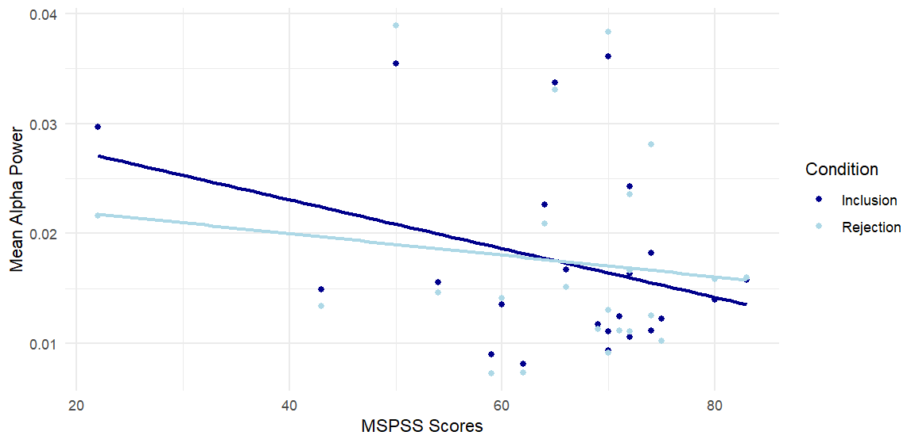
Figure S1: Mean alpha power in the frontal region. Dark blue shows the inclusion values and light blue shows the rejection values for each participant.
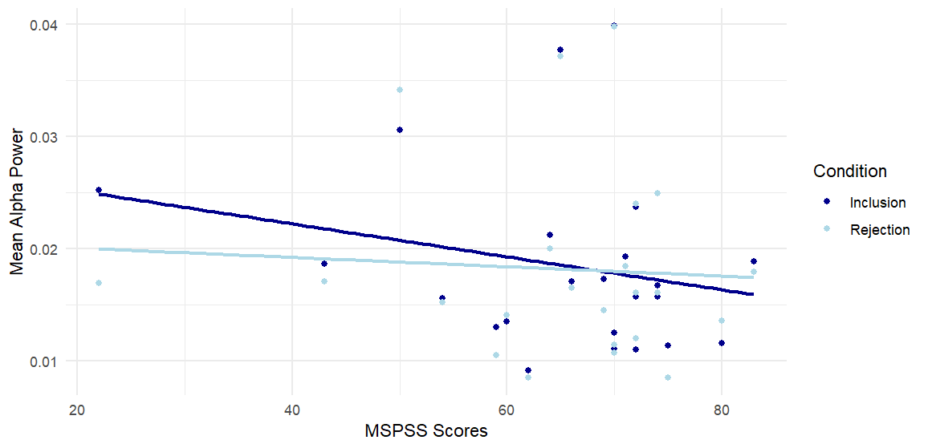
Figure S2: Mean alpha power in the posterior region. Dark blue shows the inclusion values and light blue shows the rejection values for each participant.

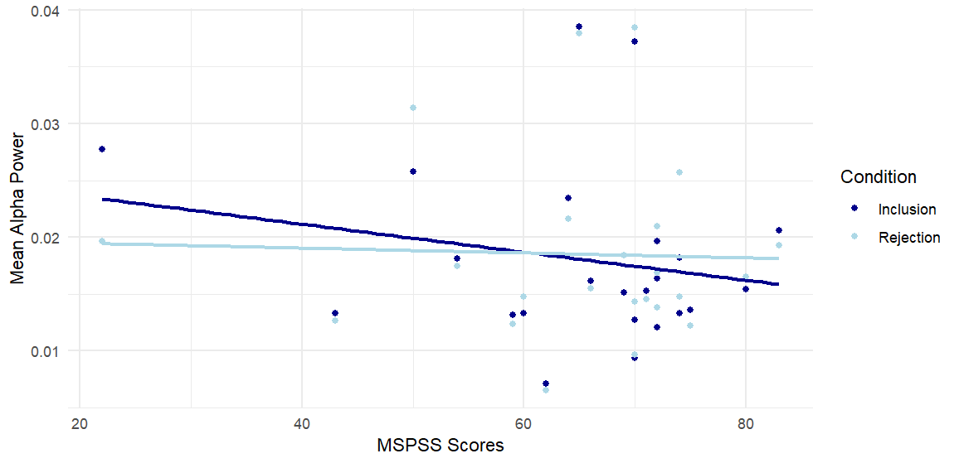
Figure S3: Mean alpha power in the temporal region. Dark blue shows the inclusion values and light blue shows the rejection values for each participant.
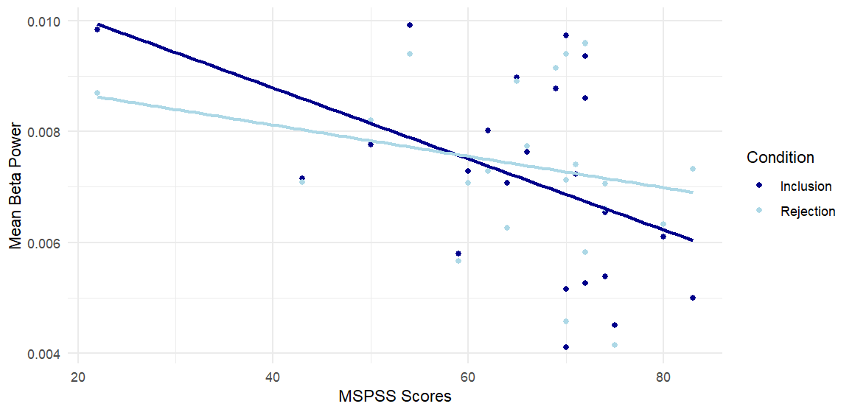
Figure S4: Mean beta power in the frontal region. Dark blue shows the inclusion values and light blue shows the rejection values for each participant.

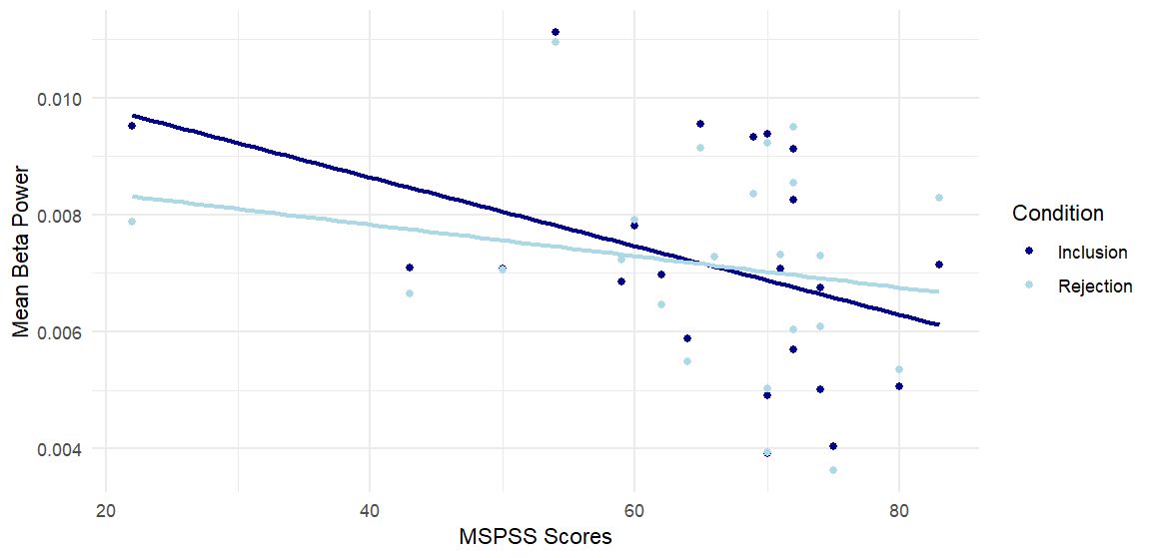
Figure S5: Mean beta power in the posterior region. Dark blue shows the inclusion values and light blue shows the rejection values for each participant.
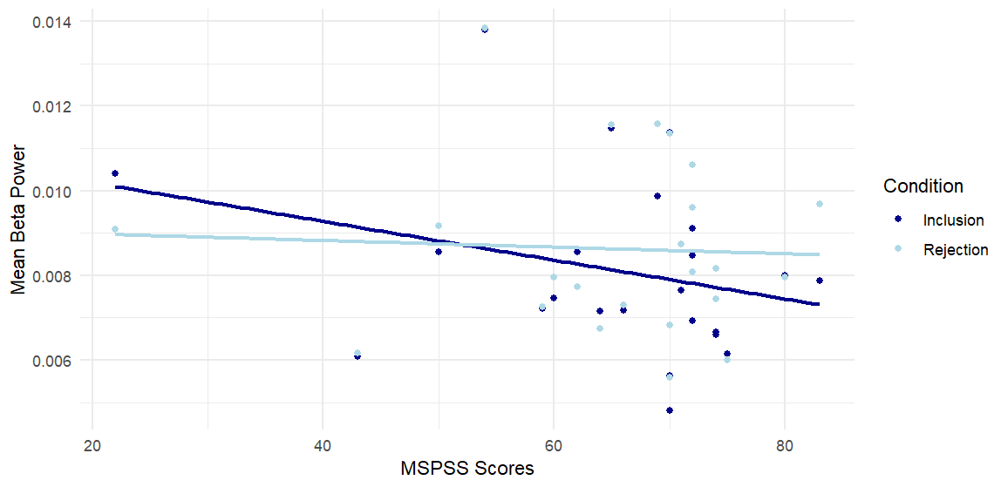
Figure S6: Mean beta power in the temporal region. Dark blue shows the inclusion values and light blue shows the rejection values for each participant.

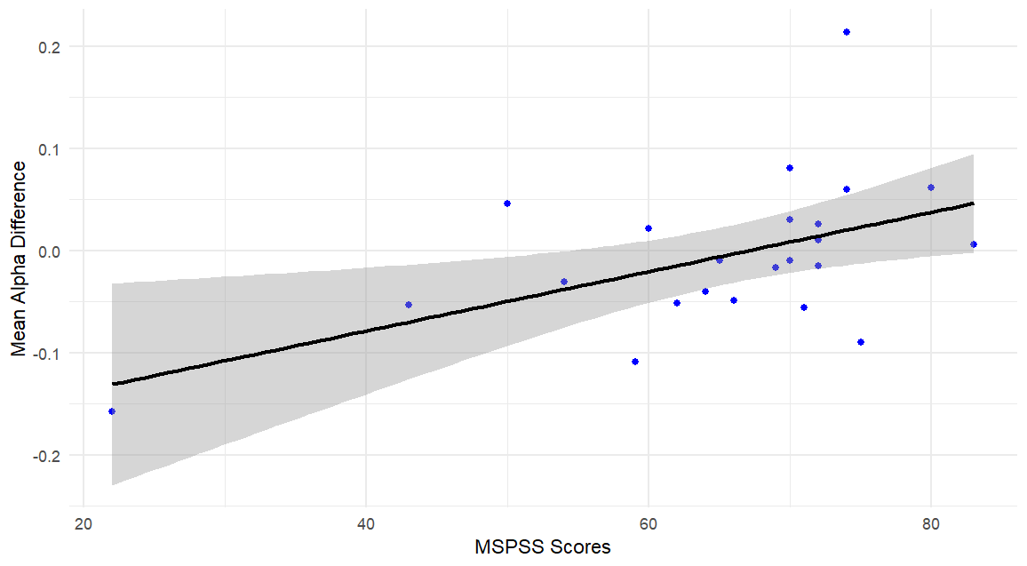
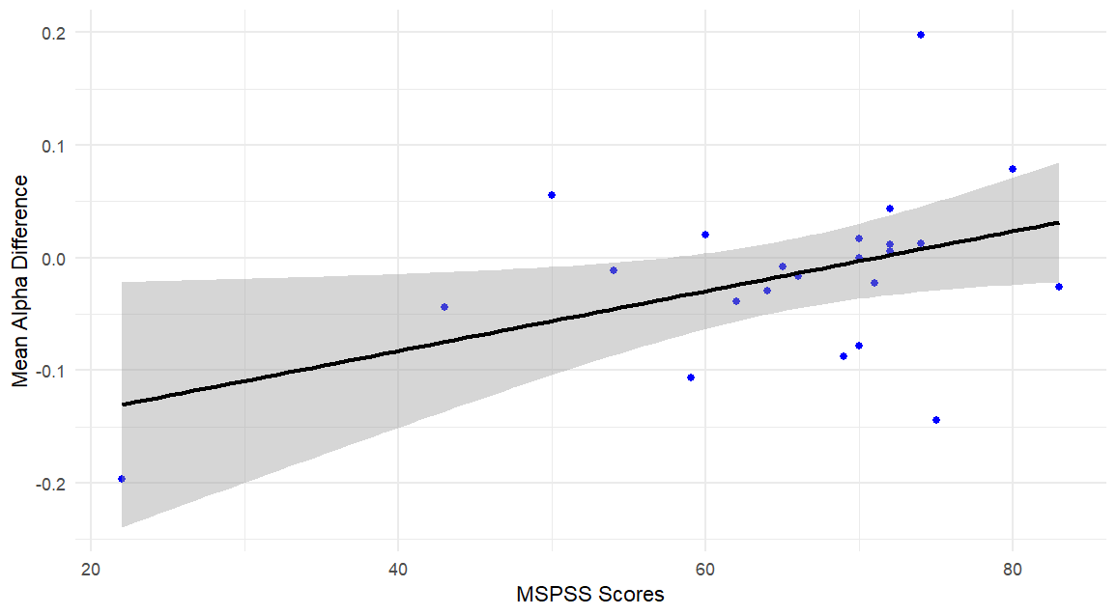
Figure S7: Mean alpha power difference between conditions across MSPSS scores in the frontal region, containing a 95% confidence interval. Difference values were calculated by subtracting inclusion alpha power from rejection alpha power and dividing by the sum of the two.

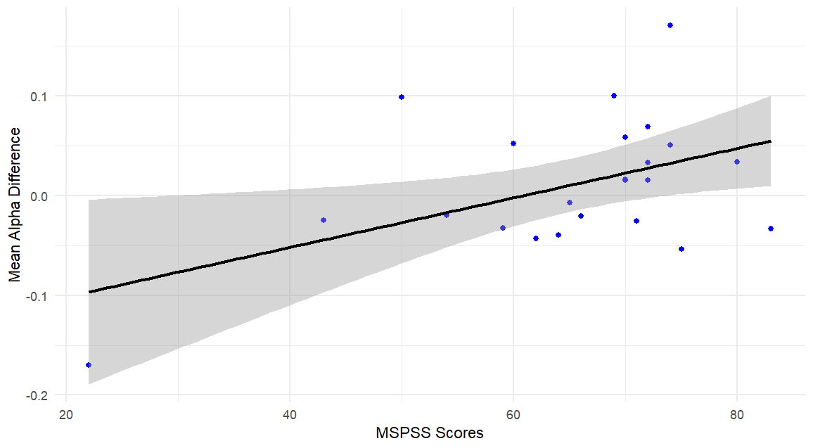
Figure S8: Mean alpha power difference between conditions across MSPSS scores in the posterior region, containing a 95% confidence interval.
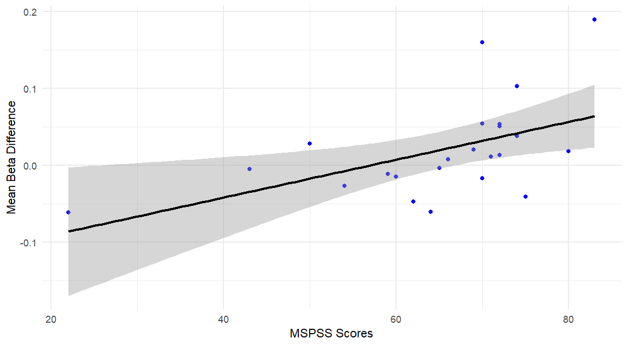
Figure S9: Mean alpha power difference between conditions across MSPSS scores in the temporal region, containing a 95% confidence interval.
Figure S10: Mean beta power difference between conditions across MSPSS scores in the frontal region, containing a 95% confidence interval.
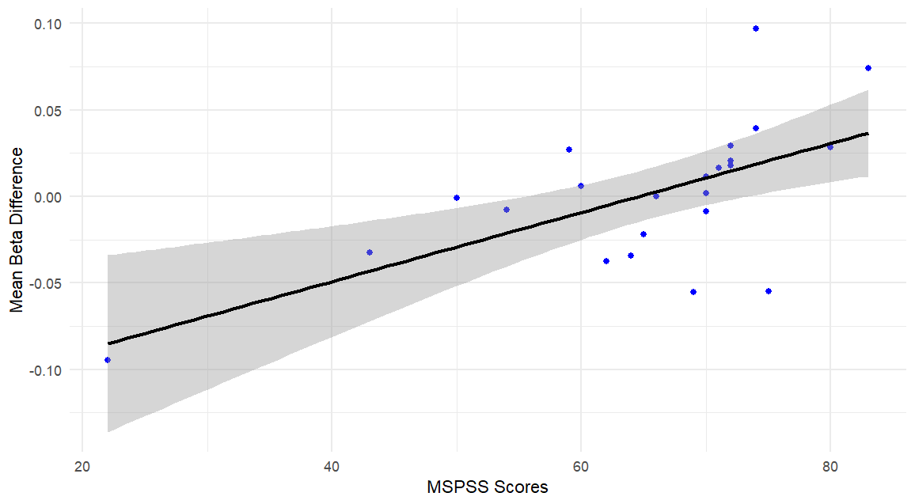

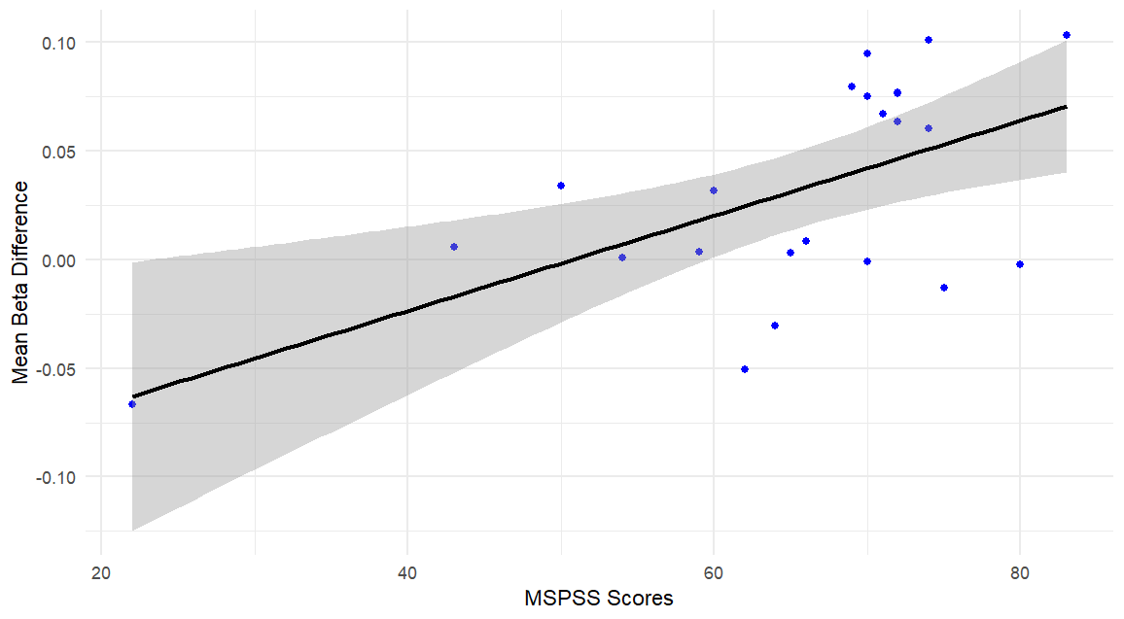
Figure S11: Mean beta power difference between conditions across MSPSS scores in the posterior region, containing a 95% confidence interval.

Figure S12: Mean beta power difference between conditions across MSPSS scores in the temporal region, containing a 95% confidence interval.

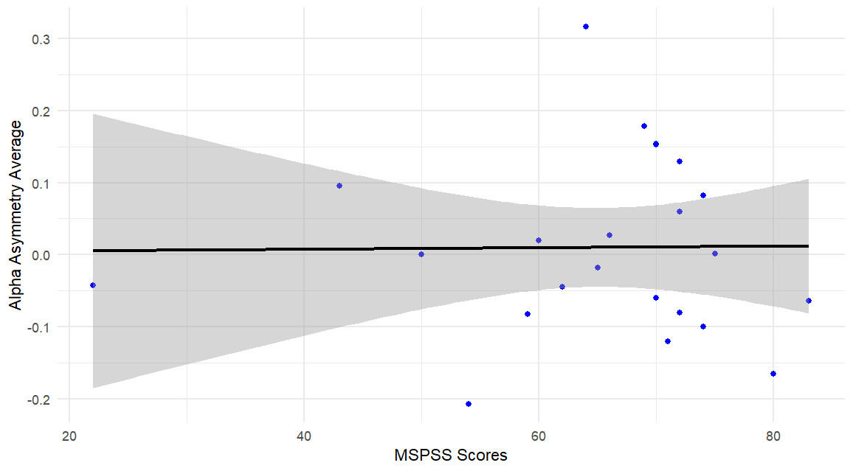
Figure S13: Averaged asymmetry values across MSPSS scores with a 95% confidence interval.

