UNIVERSITY OF OKLAHOMA
GRADUATE COLLEGE

GRASSROOTS ETHNONATIONALISM: SERBIAN ETHNONATIONALISM AND HERITAGE (RE)PRODUCTION THROUGH FOLKLORE AND ETHNOMUSICOLOGY

A THESIS
SUBMITTED TO THE GRADUATE FACULTY
in partial fulfillment of the requirements for the
Degree of
MASTER OF ARTS

By

MARTINA DIMITRIJEVIĆ
Norman, Oklahoma
2022

GRASSROOTS ETHNONATIONALISM: SERBIAN ETHNONATIONALISM AND HERITAGE (RE)PRODUCTION THROUGH FOLKLORE AND ETHNOMUSICOLOGY

A THESIS APPROVED FOR
THE DEPARTMENT OF ANTHROPOLOGY

BY THE COMMITTEE CONSISTING OF

Dr. Kimberly Marshall, Chair
Dr. Sean O’Neill
Dr. Amanda Minks

© Copyright by MARTINA DIMITRIJEVIĆ 2022
All Rights Reserved.
Abstract
This essay explores the relationships between ethnic nationalism and folklore and ethnomusicology through a particular case of Serbia. My research is informed by personal experiences and interviews as well as participant observations with folk and ethno groups in Kruševac, Serbia. Grassroots ethnonationalism captures the formation of the collective ethnonational Serbian identity from the bottoms-up through participation and engagement with folk and ethno groups in singing, dancing, and other forms of heritage (re)production.
I begin by contextualizing Serbia in history and discuss the specificities of Serbian folklore and ethnomusicology. Then I identify and explain the intellectual tools used in the paper. I dedicate the next section to talking about my identity where grassroots nationalism arises from. Next, I discuss public (cultural manifestations) and private (folk and ethno groups) places of heritage (re)production. Finally, I analyze about the embodiment of traditions in forms of human difference including ethnonationalism, gender, age, socio-economic status, emotion, geography, and anatomy.
Key words: ethnonationalism, folklore, ethnomusicology, Serbia

Table of Contents
Introduction……………………………………………………………………………………….1
Chapter 1………………………………………………………………………………………….3
History of Serbia………………………………………………………………………….3
Serbian folklore and ethnomusicology……………………………………………………6
Methodology………………………………………………………………………………9
Chapter 2: Literature on Nationalism and Music..………………………………………………11
Chapter 3: Enculturation and Socialization...……………………………………………………18
Personal Background…………………………………………………………………….18
Family……………………………………………………………………………………20
Personal enculturation and cultural intimacy…………………………………………….32
Chapter 4: Cultural manifestations and cultural (re)production…………………………………42
Vidovdan…………………………………………………………………………………43
Ethno Group Lazarice……………………………………………………………………53
Folk Ensemble Lazarica………………………………………………………………….59
Jokes……………………………………………………………………………...61
Concerts………………………………………………………………………….67
Chapter 5: Anatomy and embodiment of tradition………………………………………………71
Ethnonationalism………………………………………………………………………...71
Gender……………………………………………………………………………………75
Age……………………………………………………………………………………….77
Socio-economic status…………………………………………………………………...79
Emotion…………………………………………………………………………………..81
Geography………………………………………………………………………………..83
Anatomy………………………………………………………………………………….84
Chapter 6: Conclusion……………………………………………………………………………91
Works Cited……………………………………………………………………………………...92

Introduction
Serbia is not one of the most well-known countries in the world, it is not a very popular tourist place, or anthropological research site. Yet, the people there operate like the rest of the world – Serbians make meaning out of everyday lives, and are influenced by and influence others. Serbia’s liminal position geographically, politically, socially, and economically (which are all interrelated) in the world makes it easily fall through the cracks and not be represented in social studies. Nevertheless, Serbians think of their country as unique, which is what I explore in this thesis. In particular, I focus on the way Serbian folklore and ethnomusicology are performed in the last decade to reflect national values and promote nation-building. In the following pages of the introduction, I trace the history of Serbia to examine the rise of nationalism in Serbia, the history of the fields of folklore and ethnomusicology with a focus on the differences in genre, and I talk about the methodology of my research. Then I offer a theoretical background that helped me as tools for thinking about nationalism and culture in a broad sense followed by examples of my life as well as cultural groups involved with folklore and ethnomusicology. Lastly, I discuss the ways in which tradition is embodied and naturalized on the individual and collective levels.
On top of my exploration of nationalism, folklore, and ethnomusicology, I had another goal in writing this thesis. That goal was capturing personal histories of myself, my family, and friends I acquired during fieldwork or before. My main motivation behind this was to collect and make available to a broader audience the stories of those who do not get the recognition they deserve. All my informants, including myself, care about preserving Serbian cultural traditions and folklore without expecting anything in return and for selfless reasons. Hence, I use the stories, real names, and pictures of these people to honor them and show respect for their work. Traditions and cultures are at the mercy of memory and history, which are very fallible and incomplete, but these people give life to history by actively engaging with it and ensuring its continuation. My input through this paper is to honor the work folklorists and ethnomusicologists do, but also raise awareness of the ways in which their work constitutes ethnonationalism in Serbia.
In Chapter 1, I begin by providing a brief account of Serbian history. Then I focus on Serbian folklore and ethnomusicology, specifically how those terms have different meanings in Serbia than in the U.S. Lastly, I describe my fieldwork methodology. In Chapter 2, I provide a literature review discussing some concepts relevant to my research and clarifying some of the main terms I use. Chapter 3 consists of a personal reflection on the subject and doing fieldwork, and traces my grandpa’s history in relation to music. I also reflect on my own enculturation and embodiment of Serbian traditions. In Chapter 4, I talk about public (cultural manifestations) and private (folk and ethno groups) (re)production of heritage. Lastly, in Chapter 5 I talk about the anatomy, embodiment, and naturalization of traditions. These chapters are arranged in a way that the reader moves from broad, general levels of analysis to a deeper, specific analyses of Serbian folklore and ethnomusicology. The conclusion zooms back out to the bigger picture and ties the chapters together.

Chapter 1

History of Serbia
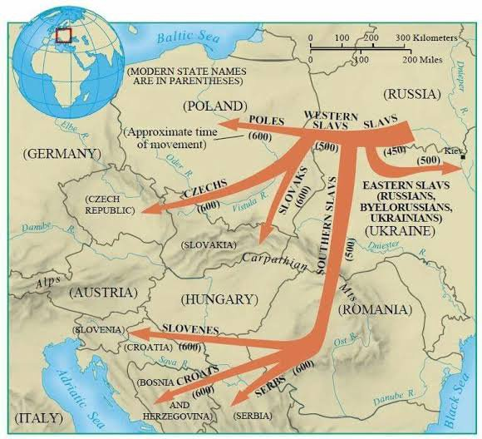
Serbians are of Slavic origin, particularly Southern Slavic, who migrated to the Balkan peninsula from North-Eastern Europe in early 6th century AD (as shown on the picture). We do not know much about Slavs before then because history was “veiled by the silence of their neighbors, the muteness of their own oral tradition, and the ambiguity of such nonverbal sources of information as archaeology, anthropology, or paleobotany” (Schenker 1). When they came, they did not inhabit bare land, but they lived together with other cultural groups like the Avars, Dacians, Illyrians, Thracians, and Romans. Place-names (Basso) are good indictors of the impact that Slavs had on the Balkan peninsula, changing many Roman and Celtic names into Slavic like Singidunum into Beograd (Belgrade) or Naissus into Niš. In the beginning, Southern Slavs, consisting of Serbs, Croats, and Slovenes, had their own traditions and pagan beliefs. However, Southern Slavs became and remained the primary place of cultural contestation between the Eastern and the Western cultures as we understand them today. While accepting and incorporating Eastern and Western elements of culture like language, politics, education, etc., Southern Slavs still continuously fought against foreign domination (Schenker).
Figure 1: Migration of Slavs in the 6th century AD, https://qph.cf2.quoracdn.net/main-qimg-4922a388dec44ea5fc12d307b218619e-lq
Massive changes in the Southern Slavic ways of life happened around 8th and 9th century AD. The Franks and other groups around the area began forming first nation-states, so Serb, Croat, and Slovene tribes united under various family dynasties. Around that time, Christianity also began to spread to the Balkans, and it was accepted by the new state as a mark of humanism and culture. The first kingdom was established, and the first constitution was written during the Nemanjić dynasty in the early 13th century. A major turning point in Serbian history was the Battle of Kosovo in 1389 against the Ottoman Empire. The battle is still very significant today and I talk more about it in my section on “Vidovdan”, but it marks the beginning of the fall of Serbia to Ottoman rule. The Ottoman rule did not spread further due to the Austro-Hungarian resistance, but they continued to occupy the Serbian territory until the 18th century. Ottoman Empire left a major footprint on Serbian language by incorporating Turkish words, religion through forced conversion to Islam, political formations by recruiting young Serbian men into slavery, kinship system through forced marriage and rape of Serbian women, and material culture through economic exchange.
The Ottoman Empire ended its rule over Serbians after two uprisings led by Đorđe Petrović – Karađorđe, and Miloš Obrenović. The two dynasties, Petrović and Obrenović, established the Principality of Serbia and later the Kingdom of Serbia. At the beginning of 20th century, a series of events that happened around the area led to World War I in which Serbia had successful military strategies but also suffered the most casualties. In the aftermath, an alliance was formed to form the Kingdom of Serbs, Croats, and Slovenes which was later renamed “Jugoslavia” (jug = South jug-o-slavia = Southern Slavs). During WWII, the three states were separated by the Nazis who Serbians fought against. Just like WWI, Yugoslavia was among those who suffered the most losses at the end of the second world war. One of the politicians who stood out the most in the Nazi regime resistance was Josip Broz Tito who became the life-long president of the new socialist Yugoslavia which was comprised of 6 republics (7 modern countries: Slovenia, Croatia, Bosnia & Herzegovina, Serbia, Montenegro, North Macedonia, and Kosovo).
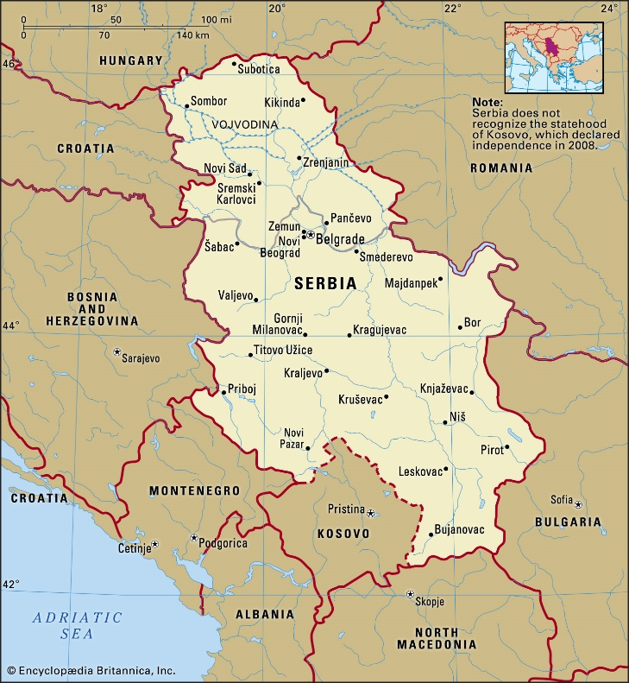
After Tito’s death, Yugoslavia became weak because it was difficult to replace Tito’s charismatic leadership. Some republics aspired to become independent, some to join the European Union, and some regions aspired to become republics, which led to the Yugoslav Wars between roughly 1991-2001 and eventual breakup of Yugoslavia (Stanojević, Ćorović). The modern Republic of Serbia has been independent since 2006 after Montenegro was the last to declare independence from Yugoslavia. I must also recognize that there are ongoing disputes between Kosovo and Serbia after Kosovo decided to separate from Serbia in 2008 (hence, the dotted line on the map). Nevertheless, Serbian folk groups perform dances and songs from Kosovo as a significant part of Serbian cultural heritage.
Figure 2: The Republic of Serbia, Encyclopedia Britannica, https://www.britannica.com/place/Serbia#/media/1/654691/90048, accessed March 27, 2022
Due to the long history of resistance against the foreign powers and disagreements with other Slavs, Serbians have developed a strong sense of ethnonationalism articulating the premises of one people-one nation-one language, which is discussed in the theory section with examples given throughout this paper. As this is an exploration of the role of folklore and ethnomusicology in ethnonationalism, next section traces the history of the two fields in relevance to Serbia.

Serbian folklore and ethnomusicology
In order to talk about Serbian folklore and ethnomusicology, it is important to explain the meaning of the terms used to talk about Serbian culture and tradition. “Folklore” is usually used to refer to Serbian traditional dances “kolo” (pl. “kola”). For example, one might say, “I am going to folklore,” (“Idem na folklor”) which means being a member of a traditional dancing group. As for traditional music, Serbians often say “narodna,” a Serbian term for “folk” (which is a German word). One instance when “folk” is used in Serbian is “turbo folk,” a genre of newly composed popular music with elements of folk music from around the world. “Narodna muzika” or folk music is separate from “etno” or ethno music. “Etno” music is considered to be older, more “izvorna” (sourced), performed without instruments, and in groups of same-sex and roughly the same age. The term “sourced” has a value quality attached to it, that of “ethno” singing being older and more traditional, making it more indexical (Duranti 17) of Serbian ethnonational identity. Another term used by scholars to describe folk music is “world music,” but it is focused on the differences between Western and non-Western or Other music. Ethnomusicologist Bohlman described world music as “a group of musical styles based largely on a variety of confluences of Western, African, and secondarily South Asian, Middle Eastern, and Latin American styles widely distributed and heard throughout the world” (46). This term is less commonly used to describe Serbian music, so I will be mostly talking about folk(lore) and ethno singing. Next, I turn to the background of the fields of folklore and ethnomusicology.
Ethnologist Regina Bendix attributed the formation of folklore as a scholarly discipline to Johann Gottfried Herder who travelled around Europe and Asia collecting and preserving oral stories that he believed best captured folk authenticity. Folk has often been tightly related to the ideology of authenticity or the conception that folklore is pure and unaffected by modernity and globalization. Moreover, what is not authentic is deemed worthless to scholars. I believe that the idea of authenticity is a misconception because cultures do not operate in vacuum bubbles, free from any influences. On top of this, searching for authenticity or having it as a goal is neither achievable nor useful because it limits human expression and eliminates forms of expression that are not seen as authentic. Bendix identified the paradox of authenticity where labeling aspects of culture authentic might lead to them losing authenticity due to commodification of cultures by tourist agencies and governments. As she pointed out, “the most powerful modern political movement, nationalism, builds on the essentialist nations inherent in authenticity, and folklore in the guise of native cultural discovery and rediscovery has continually served nationalist movements since the Romantic era” (7). In other words, the nation is built by those in power making people believe that the culture and folklore of their nation are valuable due to their authenticity to earn profit and unite the people based on difference from other nations.
Herder’s work on folklore influenced Vuk Stefanović Karadžić to do the same work in Serbia in the 19th century. Most folklorists consider Vuk Stefanović Karadžić (1787-1864) “the father of Serbian folk-literature scholarship” (Vuk Stefanović Karadžić). Not only did he collect Serbian folk stories, but he initiated major reforms of the Serbian language and standardized it. Furthermore, Vuk had also “undertaken […] a redefinition of South Slavic nationalism – or indeed of the Serbian nation itself” (Holton and Mihailovich, 2-6). Vuk’s main project was to form the Serbian nation united by common folk history and language, which is a project that continues today, as I discuss further throughout this paper. He wrote down many songs sung by Filip Višnjić (1767-1834), famous Serbian epic poet and guslar (fiddle player). Brothers Grimm, who are famous worldwide for their collections of European folklore, collaborated with Herder and Karadžić, and they made Serbian poems and stories known throughout Europe. These connections enabled Serbian folklorists to participate in cultural and scholarly exchanges in Europe.
Technological advancements of 20th century Europe, especially the invention of the phonograph, enabled scholars to record sounds around the world for future reproduction and analysis. Hence, the field of comparative musicology was born in 20th century Germany, out of which the field of ethnomusicology emerged. The works of German scholars and education was very influential in Serbia, leading to the formation of the field in Serbian schools. In the United States, the field of ethnomusicology initially concentrated on the theoretical and formulistic analysis of music from around the world. On the contrary, in Serbia and Europe in general ethnomusicologists practiced collecting and recording folk tradition for further reproduction. The most famous Serbian ethnomusicologists include:
- Stevan Stojanović Mokranjac (1856-1914), “the father of Serbian music”, most famous for his 82 Garlands (“Rukoveti”)
- Petar Konjović (1883-1970) with his opera Koštana
- Stevan Hristić (1885-1958) and his ballet The Legend of Ohrid (“Ohridska legenda”)
- Stanislav Binički (1872-1942), most famous for March on the Drina (“Marš na Drinu”) and an opera At Dawn (“Na Uranku”)
- Kornelije Stanković (1831-1865)
All of the above-mentioned ethnomusicologists are composers, which is not odd for European schools of ethnomusicology. Mozart, Chopin, Beethoven, and Brahms, just to name a few, found inspiration for their compositions from various folk cultures around the world. The professor that led my singing group “Lazarice” is also an ethnomusicologist and most of her work was stylizing songs she recorded from the elderly for our group to reproduce. This form of scholarship is important to keep in mind as I also provide an account of the “ethno” rather than the “musicology” part of “ethnomusicology”.

Methodology
I did my fieldwork in Serbia during the Summer of 2021, mostly in the city of Kruševac where I was born and raised. Being Serbian myself, I had easier access to the community due to already established past connections. I reflected more on my identity and positionality in a separate section. My initial plan was to contact my old music professor and ethnomusicologist who led “Etno Grupa Lazarice” (“Ethno Group Lazarice”), a singing group I was a part of. I was so excited to reconnect with her because I know she went to different villages around Kruševac and recorded traditional songs from the elderly, so I was hoping to learn more about her experience or even join her in that project. However, I was unable to get in touch with her, so I decided to start by attending a concert by a folklore dancing group “Kolo” (named after Serbian traditional dance) from Belgrade hoping to make some connections or get ideas. At the concert I met my friend, Andrijana (read An-dree-ya-nah), who was a part of “Etno Grupa Lazarice” as well, and she invited me to attend rehearsals with her new folklore ensemble “Folklorni Ansambl Lazarica, Kruševac” (“Folk Ensemble Lazarica”). I was very excited about that because knowing a member of a group makes it easier to access any group.
I asked Andrijana to talk with the director of the “Folk Ensemble Lazarica” about my project and announce my arrival. They were happy to have me, and we developed a mutually beneficial relationship through which they gave me full access to the group, and in return I performed with them during concerts. Naturally, I made friends in the group that I am still in contact with, and I plan to perform with them whenever I go back to Serbia. I spent a lot of time talking with the orchestra director and music teacher, Marjan (read Mar-yan), who became one of my main informants and interviewee. I also managed to interview the Hinić family who were involved in “Etno Grupa Lazarice”. Lastly, I gathered a lot of information about Serbian folklore and ethnomusicology from my grandparents, Slobodan and Ružica, during the casual conversations we had during our morning coffees.

Chapter 2: Literature on Nationalism and Music
I titled my thesis “grassroots ethnonationalism” after talking to my committee chair about the specific context I write about and operate within. We both came to conclusion that “grassroots” is one of the best ways to describe Serbian folk and ethno groups. I realize that sometimes (social) scientists choose to propose a new term to describe the same phenomena simply because they want/need to brand themselves in the academia. While it is true that I could have chosen a different name or one of the already established concepts, by choosing a unique term I intend to capture the unique ethnonationalistic practice in which nationalism is not built top-down, but rather bottom-up. In other words, the sense of community and belonging is built from small-scale interactions within groups dedicated to preserving and performing culture. Such community can be easily united as a nation.
My understanding of “grassroots” aligns with that of a scholar in business, Rashedur Chowdhury et al. In their article “Power of Paradox: Grassroots Organizations’ Legitimacy Strategies Over Time,” Chowdhury et al. define grassroots organization as “the basic local building blocks of society, that is, the small rural communities or urban neighborhoods where the ‘common man’ – or woman – lives” (423). He also added some of the characteristics of grassroots organizations – perceived to possess authenticity, have a moderate level of formality, and have limited resources. Both “Ethno Group Lazarice” and “Folk Ensemble Lazarica” fit this description well; they are small, often rural in case of folklore, communities where people (falsely) believe authentic culture can be found, where moderate formality is practiced (as can be seen in the section on jokes in the Folk Ensemble), and depend on outside sources for provision of resources. Nevertheless, “grassroots organizations” are usually thought of in economic terms rather than artistic or socio-cultural. By using this term, I expand the meaning of “grassroots organizations” to show that we can think of them in non-economic terms.
Chowdhury et al. reference Uphoff (1993) who explained grassroots organizations as having a bottom-up development instead of top-down (608). This means that the organizations did not form because people in power told them to or organized the people. On the contrary, organization is initiated by individuals who start from ground zero. In my case, me and about 5 other girls decided to form a singing group when we were 12. Our music teacher supported us and taught us how to sing traditional ethno songs, but we did not have any resources and were not under any government or even school programs. All the support came from the teacher and our parents, so our organization was built bottom-up, from the grassroots.
The other part of the title is “ethnonationalism”. This is a term commonly used to refer to the Balkan countries where nationalism tends to merge with the idea of ethnic identity. While the United States is one nation that is multiethnic, Serbians see themselves as a uni-ethnic nation. It is important to note that ethnonationalism can be seen as negative and constructive due to the Yugoslavian wars which were fueled by ethnonationalism. However, the way I talk about ethnonationalism focuses on unification processes in modern day Serbia. Ethnonationalism in my fieldwork has never been explicitly mentioned, but it conditions the formation of grassroots folk and ethno groups. The main reason these groups form is not to challenge any other groups or cultural traditions, but there is a potentiality for such groups to become exclusive and destructive. Extending Bakhtin’s language analogy to culture, it operates as a constant battle between centripetal (uniting) and centrifugal (dividing) forces. My research focuses more on the centripetal forces in Serbian folklore and ethnomusicology.
The congruence between nationality and ethnicity makes it easier and seemingly natural for people to unite and divide. Herder explains that “It is nature which educates families: the most natural state is, therefore, one nation, an extended family with one national character...” (Herder 324). Just as family is natural, so is the nation, according to Herder. Another way to think about continuity in nationality is in terms of “primordialism”. Political Scientist Ozkirimli defines “primordialism” as “an umbrella term used to describe the belief that nationality is a natural part of human beings, as natural as speech, sight or smell, and that nations have existed from time immemorial” (51). In the chapter about anatomy, I provide some examples of the ways in which Serbian tradition and culture are related to nature in general. Sound has the power to naturalize difference just as much as other senses have. This can then be further used to naturalize the relationships between politics and folklore. Naturalization can be problematic because humans tend to resort to biology, numbers, and nature when phenomena are too complex to explain, which reduces culture to prejudice and typifies them. In this essay, I hope to deconstruct the notion that culture can be reduced to facts and labels, as well as to shed light on the ideologies behind, the means of, and the consequences of performing culture.
Political scientist and historian Benedict Anderson talks about the nation as an “imagined community,” “imagined because the members of even the smallest nation will never know most of their fellow-members, meet them, or even hear of them, yet in the minds of each lives the image of their communion” (6). He believes that this shared sense of community between the people is enabled especially thanks to technology. At the time, Anderson was talking about the printing press as the main technological means of uniting a nation, but this can be extended to more recent forms of technology. Having the ability to listen to the same radio stations and watch the same TV channels creates a sense of shared identity and experiences for people. Hence, media is an important tool for building a national consciousness. Specifically, Serbian media is packed with various shows and movies featuring Serbian folk traditions: “Šarenica” (“Colorful”), “Šljivik” (“Plum field”), “Raspevana Subota” (“Singing Saturday”), “Prelo u Našem Sokaku” (“Spinning in Our Alley”), “Zona Zamfirova” (“Zamfir’s Zona”), and “Ivkova Slava” (“Ivko’s Saint’s Day”), to name a few. In comparison to the printing press, modern forms of media allow people to unite on other levels experienced through multiple senses and engagement for a prolonged period of time. However, in both cases the language and the music become standardized and emblematic of the culture and are reproduced as such.
Another important concept to deconstruct is “heritage”. Even though heritage and tradition both refer to cultural (re)production, I understand heritage based on Kirshenblatt-Gimblett’s definitions. As she explains, heritage is “the transvaluation of the obsolete, the mistaken, the outmoded, the dead, and the defunct. Heritage is created through a process of exhibition (as knowledge, as performance, as museum display)” (149). Heritage involves a return of something forgotten or dormant. Tradition, on the other hand, implies continuation rather than interruption and reevaluation. This distinction can be helpful in some cases, but it poses the danger of ignoring the fact that all tradition and heritage is constructed at all times, rather than it being something a group can (re)possess, lose, gain, or in some way objectify.
There has not been much written about Serbia from the anthropological perspective, especially in English. Even visiting the library back home was not that successful as I was able to find only two books that are somewhat related to Serbian music (that are not in the field of musicology). Nevertheless, there are a lot of social scientists whose theory was useful for me to think about Serbian folklore, ethnomusicology, and nationalism. Anthropologist and ethnomusicologist Ana Hofman explores music, sound, and politics in post-socialist societies, especially post-Yugoslavia choirs and activism. Her descriptions of the ways music and sound connect people resonated with me,
Speaking from the perspective of sonic affect, ‘being in tune’ as shared vibrational experience is crucial for music’s power to produce sociality (see Turino 1993) or to attract and galvanize collectivities (Goodman 2010: 172). However, the people involved in such collectivities do not necessarily feel the same about the same object: every person’s memory produces an array of potential realities, engaging numerous contingents of imaginations. People participating in a musical event invest their own affective dispositions, moods, and emotions, and affect as transmissible through a music and sound is shaped by the personal emotional experience (Garcia 2011: 186). (158)
The “sonic affect” described by Hofman refers to the shared, but individually felt, auditory experiences which people bond over. An example of the “sonic affect” would be national anthems. When national anthem is played, people often feel pride and patriotism. Although everybody experiences it in a unique, individual way, people bond over the shared “affect” of the anthem.
Similarly, ethnomusicologist, anthropologist, and linguist Feld proposes a term “acoustemology”, combining “acoustics” and “epistemology”, to talk about ways of knowing through sound. Feld explains that “one does not simply ‘acquire’ knowledge, but knows through an ongoing cumulative and interactive process of participation and reflection” (13, 14). Eidsheim also argues that “ontologies of music and voice structure our understanding and practice of listening” (133). In other words, our knowledge and experiences of music affect our perception of sound. Sounds we are exposed to around us set the foundation of how we will react to new sounds and interpret the world. For example, in interviews with non-Serbians, I discuss more later, many participants described Serbian music by comparing it to the sounds of more familiar music like Latino or Bollywood. This aural knowledge allows people to connect and divide themselves. As Barth recognized in Ethnic Groups and Boundaries, the formation of “us” directly implies the formation of “them”. Hence, the creation of Serbian ethnonationalism is simultaneously constructive and destructive because it implies that some people can claim difference from others. My research focuses on the constructive aspects of nation-building, but there is space for exploring its destructiveness in the future. Most research done in that geographic area focuses on the negative aspects of ethnonationalism, so my account provides a personal, insider perspective on folklore and ethnomusicology as unifying practices within Serbia, including what kinds of identities they produce and how these identities become felt and embodied.
In his introduction to “The Inventing of Tradition,” historian Hobsbawm defines invented tradition and its relation to history. “’Invented tradition’ is taken to mean a set of practices, normally governed by overtly or tacitly accepted rules and of a ritual or symbolic nature, which seek to inculcate certain values and norms of behaviour by repetition, which automatically implies continuity with the past. In fact, where possible, they normally attempt to establish continuity with a suitable historic past” (1). While the whole conception of “invented tradition” resonates with folklore and ethnomusicology, I want to point out the continuity with a suitable historic past. Serbian history, including the one I recounted earlier, is a construction and not hard-set facts about our past. Some aspects of history are better known than others, and some are deliberately chosen to be preserved or forgotten. People consciously and sub- or un-consciously decide what aspects of history are worthy of preserving, chosen with the aim of promoting historical continuity of the people. This is also related to “historicity” (Trouillot), the idea that there is continuity between the people in the past and those in the present and, in my case, they are connected through performing the same practices and traditions.
One of the aspects of performing culture is cultural intimacy as anthropologist Michael Herzfeld defined it. He explained that cultural intimacy is “the recognition of those aspects of a cultural identity that have been considered a source of external embarrassment but that nevertheless provide insiders with their assurance of common sociality” (3). The sources of external embarrassment Herzfeld refers to are commonly stereotypes which, regardless of their nature, they still make the community unique and unites them. An example that immediately comes to mind is that often those who perform or listen to traditional songs and dances can be labeled as “seljak” or “hillbilly”, which has a pejorative connotation. One of my interviewees expressed that she would only listen to turbo folk music when she visits her uncle because her parents would never allow it. Some people believe that folk and newer turbo-folk music is of lower degree of value and intelligence. Some even express gendered beliefs about dancing where male dancing in folklore is ridiculed because it seen as less “macho”. But regardless, this kind of music is still representative of Serbia and bonds people on so many levels, as I show in my essay. Herzfeld criticized Benedict Anderson in his book saying that his theory lacks culturally specific examples despite its appeal. Nevertheless, my essay gives specific examples where Anderson’s “imagined community” is useful to describe Serbian ethnonationalism.

Chapter 3: Enculturation and Socialization
In this chapter I talk about how I got involved in folklore and ethnomusicology tracing it back to my childhood. My family played a large role in developing my passion for culture preservation and performance, so I dedicate a section to my grandpa’s story to show how enculturation happens over generations. Lastly, I reflect on interviews I did as a school project interviewing non-Serbians on describing Serbian music. These interviews led me to a major realization about my own enculturation and adoption of Serbian ethnonational identity.

Personal background
Music has been a major part of my identity ever since I was a baby, and my family played a significant role in developing my musical taste, persona, and interests. In her diary my mom said that I loved singing to the radio before I knew how to talk and that the radio would play the whole night so that I can sleep peacefully. Most of my family sings, my father was a radio DJ, and his father plays the accordion while his wife, my grandma, accompanies him singing. As my grandparents live in the same house as me, I had plenty of opportunities to hear them performing or even join them. My grandma would often swing me in our backyard, and we would sing children’s songs like “Leptiriću Šareniću” (“Colorful Butterfly”), “Razbole se Lisica” (“A Fox Got Ill”), and “Vuče, Vuče, Bubo Lenja” (“Wolf, Wolf, You Lazy Bug”), among other animal-themed songs. We sang some of them so much that to this day we joke about them. What further helped develop my musical abilities was when my parents signed me up for kindergarten choir. Not only was I into music from a young age, but I also wrote poetry, acted in school plays, and danced. My cousins and I would always come up with new plays to act and new songs to sing. When I got to elementary school, I was not even worried about whether I would get into the school choir; it was a logical next step for me.
My interest in ethnomusicology in general stems from forming and singing in “Etno Grupa Lazarice” for six years in my hometown during middle and high school. Hence, I acquired practical and basic theoretical knowledge of Serbian folklore and ethnomusicology. Relationships I made in that group enabled me to gain access to a different group I did fieldwork with over the summer of 2021. A friend from “Etno Grupa Lazarice” invited me to join a new group she plays with, the “Folk Ansambl Lazarica Kruševac”. This folk group was very familiar with my singing group from past collaborations, so that contributed to my building of trust in the community. During the fieldwork, members of the folk group and I developed a mutually beneficial relationship: they agreed to be my main fieldwork participants, while I performed songs with them at concerts. Furthermore, my participant-observation involved me playing a double-hand drum, as well as attempting to dance during one of their rehearsals. I understood these as my rites of passage into the community through shared experiences and love for Serbian culture and tradition.
Doing fieldwork in Serbia was probably easier for me than it would have been for a non-Serbian. I was born and raised in Serbia, and Serbian is my first language. However, back home I feel as both an insider and an outsider. Just like Serbia’s undetermined socio-political position in Europe, my positionality in Serbia is liminal. I lived in Serbia until junior year of high school when I was accepted to attend the United World Colleges (UWC) in Mostar, Bosnia & Herzegovina. UWC is an international boarding school program in 18 countries around the world and is “a global movement that makes education a force to unite people, nations and cultures for peace and a sustainable future” (UWC 2022). After two years of UWC, I was accepted to the University of Oklahoma (OU) and have been at OU ever since, occasionally going back home for the summer. Even though I was in Serbia for the majority of my life, every time I return, I feel more and more like a stranger, or even a tourist. When talking about Serbians in this paper I occasionally use “we” because I identify as a Serbian and feel national belonging. I can easily relate to Barbara Myerhoff, a Jewish anthropologist who worked with her fellow Jews in California. She experienced the same feeling of (not) belonging to her community (46). That said, in both my case and hers, our liminal positions benefited us because we were able to get an insider perspectives and information, but distance ourselves enough as anthropology researchers to be able to analyze that information in a more objective way.

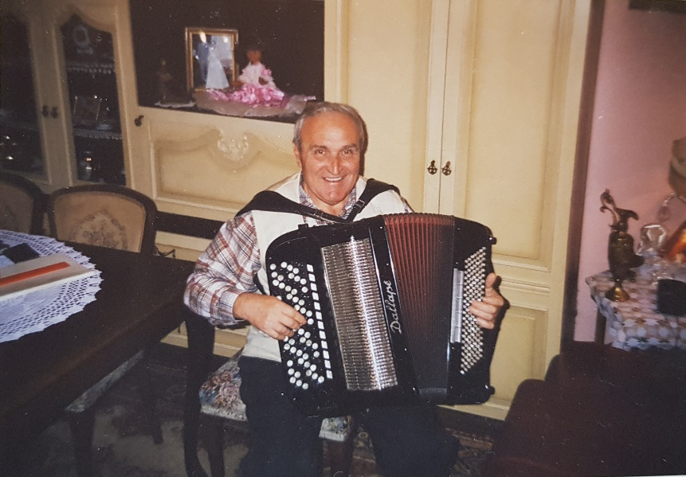
Family
Family support was one of the most important factors that influenced me and many other musicians I encountered to pursue this path. In their desire to support me and my project, my grandparents shared their knowledge, memories, and collections they have in relation to music. My grandpa plays the accordion, as shown in the image below, so a lot of his story is centered around this instrument. He loves this image because, according to his recalling, I was a toddler standing on the other side of the camera curiously pointing at the accordion which made my grandpa very happy and fulfilled. Grandpa loves telling stories, whether through poetry, anecdotes, jokes, or songs. I present my grandparents’ biography in what follows.
Figure 3: My grandpa Slobodan Dimitrijević playing his 6-rowed button Dallape accordion in my grandparents' dinning room
Before I left back to the U.S. at the end of my fieldwork period, my grandpa, Slobodan (read Slow-bow-dawn) Dimitrijević, decided to write a few pages about his life. He wanted me to primarily keep this document for myself to look back at in the future, but he also let me use it for my research if I wanted to. When I came back to analyze all my material, this letter was the last thing that remained to be analyzed. It was not easy for me to pull myself together and read it because I knew I needed to prepare myself for an emotional rollercoaster. If you have ever felt nostalgic, you can imagine how I felt. Even writing about this gave me a lump in the throat.
Grandpa began his story with a quote: “Can place of birth determine somebody’s life trajectory? Somebody once said that their place of birth is the center of the world and that other places are just provinces.” My grandpa did not grow up in Kruševac, but in a nearby village Kamenica. He then describes the provenience and context of his village as a significant part of his identity. Kamenica is a hilly settlement around 390 meters in elevation. In the rear of the village are Mali Jastrebac (Small Hawk) and Veliki Jastrebac (Big Hawk) mountains. Mali Jastrebac is in the South with its peak Crni Vrh (Black Peak) at 846 meters. Thirty kilometers South-West is Veliki Jastrebac with its peak Velika Đulica (Big Rose) at 1492 meters. Kamenica is located 15 km from Aleksinac, the municipality it falls under, 50 km from Niš (my mom’s hometown), and 50 km from Kruševac (see image below).
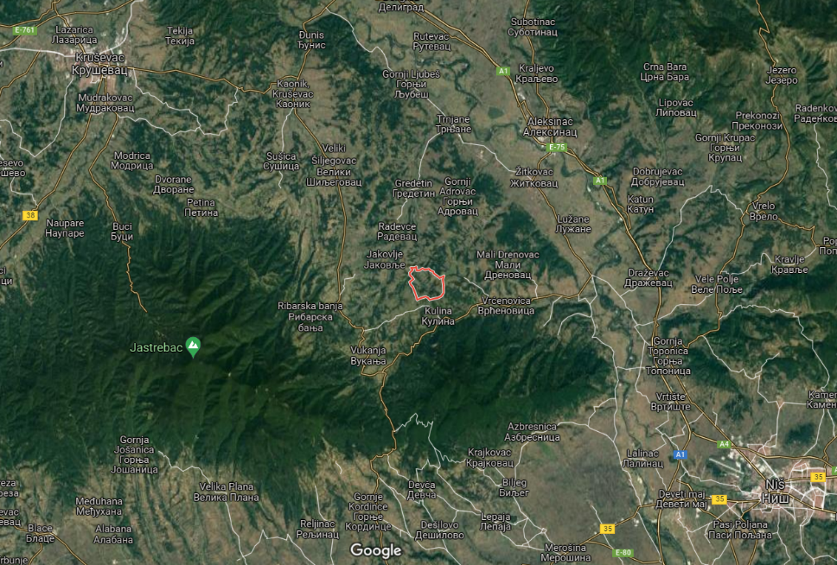
Figure 4: The Village of Kamenica in the center, surrounded by the red circle; Kruševac and Niš on the opposite corners (upper left and lower right); Jastrebac mountains marked with the green pin, Google Maps
Figure 5: Village houses "čatmare" from my great-grandpa's village near Niš, Serbia
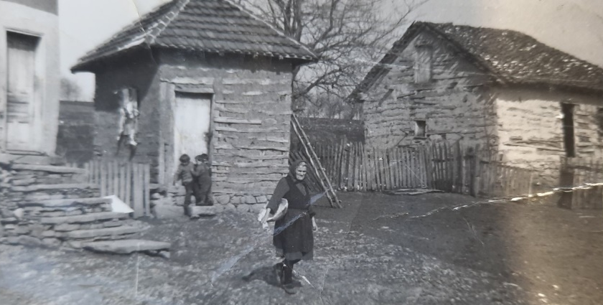
The infrastructure of the village after the war period (post-1945) includes: village roads – muddy and unfilled; houses “čatmare” – stone block foundations, wooden armature glued with a mixture of mud and chaff, oak tree pillars and roofs covered with ceramic tiles “ćeramida”, the floors were made of compacted earth, wooden beds with pallets and pillows filled with straw, for lighting they used petroleum lamps and lanterns for night visits to the animals. Electricity came to the village in 1963.
Grandpa further expands on the impact of living in tune with nature: “Observing the village ambience and the natural surroundings: forests, meadows, various herbs and weeds, diurnal and nocturnal birds, songbirds, domestic and wild animals such as rabbits, foxes, badgers, wolfs; regardless of whether we like it or not, one adapts to that kind of an environment.” Serbians pay special attention to nature, and nature represents a significant part of Serbian identity through a shared chronotope or time-space continuum (Bakhtin). Grandpa continues, “If you grow up in an environment where the smells are strong, visibility is low (except during a full moon and a cloudless sky), where roosters and nightingales wake you up along with cries from the domesticated animals, and owl and bat hooks put you to sleep, the environment must impact your senses: smell, vision, hearing, to develop a sense of responsibility, self-discipline, persistence…” In this quote grandpa relates his physical senses to personality development, which is characteristic of Serbian fables, songs, and Eastern Orthodox Christianity.
Figure 6: Examples of old houses "čatmare"
Grandpa is also constructing a felt sense of place through embodied sensory memory. Similarly, Basso (1996) discussed Apache connections to places that “reach deeply into other cultural spheres, including conceptions of wisdom, notions of morality, politeness, and tact in forms of spoken discourse, and certain conventional ways of imagining and interpreting the Apache tribal past” (xv). A significant number of Serbian folk songs mention Serbian rivers, birds and other animals, trees, and flowers. However, these references were not chosen by the author solely for aesthetic purposes; they stand as symbols and motifs conveying Serbian values and require deeper understanding. For example, in the folk song “Moj Golube” (“My dove”) the author warns a dove not to land on the raspberries until they ripen. This song serves to indirectly instruct men not to place their hands on girls who have not matured yet. Such allegories teach Serbian values and beliefs, demonstrate their oneness with nature, understanding natural laws, and encourage appropriate behavior. Serbians did not choose to talk about raspberries randomly either; for instance, Serbia is the largest global transporter of raspberries in the world. This is an example of how unique aspects of cultural continuity are used to build nationalistic values.
Grandpa had an opportunity to hear sounds other than the usual natural sounds. He heard people playing Serbian flutes, bagpipes, and clarinets, but those were rare occasions because the players came from distant villages. One day in the fall of 1947, when my grandpa was 5 years old, he entered a room and noticed a vibrant red machinery with golden yellow decorations on the bed. He sat on the bed and began to play around with this three-rowed instrument called “Victoria”. That was the first time he ever heard the sound of an accordion, the sound which continues to please his ear to this day.
My grandpa’s father, my great-grandfather Ranko, was teaching a boy from the village how to play the accordion. But when the boy would go home for lunch and Ranko would take a nap, grandpa would replay by ear what his father taught the other boy. An accordion was my grandpa’s forbidden love – his father did not want him to play and neglect school. The story of wanting something that is forbidden or unobtainable is relatable worldwide. From the Christian creation story of the forbidden fruit, Romeo and Juliet, Dorian Gray, King Midas, and similar stories, but also smaller scale day-to-day experiences. Mozart became a musician the same way as my grandpa; he observed his sister’s piano lessons and began experimenting with music himself. My grandpa also relates to and was significantly inspired by Radojka Živković, the most famous Serbian female accordion player.
Radojka Živković (1923-2002) grew up in a village Globoder near Kruševac. Her father was giving accordion lessons to a boy Milutin, better known as Tine, and she would sneakily practice by herself the same melodies she would hear them practice. It was unimaginable for a woman to play an instrument because it assumed playing in kafana (pub) or places where people get drunk and do dishonorable things. But Radojka’s love for playing prevailed and soon her father noticed that she played better than Tine, his student. Eventually she ended up marrying Tine and they were both successful accordion players; he on his Vienna accordion, and she on her Russian accordion. She wrote the most famous song about my city of Kruševac, “Odakle si Sele” (“Where are you from, village girl?”).
While my great-grandfather was serving in the military, my grandpa stopped playing because his father brought the accordion with him. Once he came back, my grandpa had more musical education from school, so he taught himself some songs like: “Hvalila se Lipa kod Bagrema” (“Linden bragged to an Acacia”), and “Čuvam Ovce Kraj Zelene Jove” (“I Keep Sheep Near the Green Alder”). Over time, he broadened his repertoire and showed preference for playing kolo, Serbian traditional dances. “Kolo” literally means “round” and corresponds to the circular formation of dancers while symbolically indexing perfection, life cycle, and infinity. Some examples of kolo from different regions can be found in the section about the “Folk Ensemble Lazarica”.
One day, my grandpa heard some kolo by Radojka and Tine Živković on the radio and rushed back home to play it on his accordion. But to no avail, by the time he went home, he forgot the melody until one day he heard it again in his dream. Music is indeed a whole-body experience, material as much as ideological. Melodies are effortlessly and sub- or un-consciously perceived by our bodies and, like riding a bike, become a part of our muscle-memory difficult to describe in words. My grandpa further reflected on the difference in music education then and now. Sometimes it took him days and weeks to master a melody, but today that can be done more easily thanks to the technologies we have. Technology further enables the creation and maintenance of our “imagined community” (Anderson) through song reproduction and accessibility. Despite the technological advancements, grandpa believes that today we lack the will and the motivation he had to learn because everything is served to us. This is not just his opinion, but in later sections this idea resurfaces in Marjan’s criticisms of today’s society.
Figure 7: My grandpa's record of Radojka Živković's songs dedicated to the 40 years of her work; Radojka is wearing a typical Serbian costume, playing a Serbian 6-rowed Dallape accordion just like my grandpa
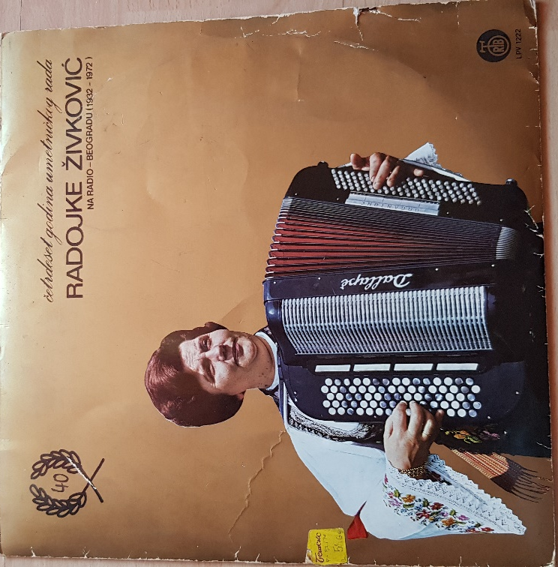
While grandpa was studying at the Mechanical Faculty in Belgrade, he came across an advertisement for Radojka’s concert at the Union House on Terazije in the center of Belgrade. The concert was dedicated to celebrating 30 years of her musical career. My grandpa did not have enough money for the ticket, so he sold his dinner coupon (a coupon to the university students’ cafeteria) to be able to watch his idol play live. As he recalled, “it has been a long time since the concert, and the sounds of those melodies that Radojka performed with such emotion still echo in me, making her indisputable virtuosity complete. It was the unforgettable Radojka Živković, unique, unrepeatable.” Many kola that she composed she dedicated to her place of birth – Globodare kolo, Župa kolo, Čarapansko kolo, songs like “Odakle si Sele” (“Where are you from Village Girl”), “Harmoniko Moja” (“My Accordion”), and others. Her 71-year-long career has been recorded in the Guinness Book of Records in 2005.
Serbian accordions and their players were not famous only in Serbia – Italian accordion makers like Dallape and Guerrini produced special Serbian button accordions with six rows of buttons arranged according to the Vienna arrangement. These accordions were specially made for artists such as: Dragan Matić-Žilić (he won First Yugoslavian Accordion in Soko Banja in 1963, and played at my grandparents’ wedding), Miodrag Todorović-Kranjevac (he wrote a children’s book on how to play the six-rowed accordion together with his musical notations and folk kolo), and Jovica Petković (self-taught musician from Smederevo, moved to Bosnia and Herzegovina, famous for his interpretations of Bosnian folk songs called “sevdalinke”). The forementioned Italian factories also produced piano accordions for Serbian musicians including: Vladeta Kandić – a.k.a. Bata Kanda, and Ljubiša Pavković (whose performances are as recognizable to my grandpa as Radojka’s).
Before modern technology, my grandpa had a chance to hear these people’s performances during weddings and Village Gatherings or “Sabori Sela”. Ana Hofman wrote about these Village Gatherings in her book Staging Socialist Femininity: Gender Politics and Folklore Performance in Serbia. As Hofman described, a Gathering is a “free, unsupervised space, an outlet for subversive activities, allowing people to express their feelings and opinions” (64). These celebrations often take place around churches and monasteries, dedicated to Eastern Orthodox Saints’ Days. However, Village Gatherings were a part of a nationalistic project – a Yugoslavian cultural policy to promote ethnic identity and multiculturalism (Hofman). This is a new folk culture where folklore is modernized and viewed as entertainment. Technological advancements, especially the radio, enabled people to hear songs from different places and reproduce them. With technological advancements, people began to value authenticity and their goal was to (re)produce songs that are exact matches to the originals they hear on the radio.
My grandpa still holds this ideal of authenticity despite being aware that his playing is not authentic. He would attend these village gatherings and memorize melodies he liked to reproduce later himself. As he admitted, many of the songs he plays are partial to his memory welded with his improvisation, but he continues to improve. Hence, it is a delight to him when somebody compliments his playing saying, “Is that that one Radojka’s kolo?” or “That’s how Jovica Petkovic would play that!”. In my interview with Marjan, an accordion player from “Folk Ensemble Lazarica, Kruševac”, we further discuss the idea of authenticity, arguing that it is a limitation even though people deem it valuable.
Figure 8: Ethno Group Lazarice performing at the Village Gathering in Krušak, Medveđa
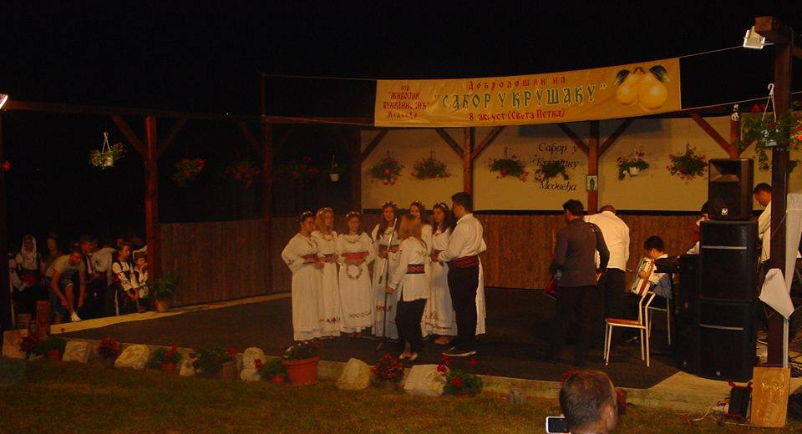
After the fall of Yugoslavia, Village Gatherings took on a new form. With Milošević coming to power with his democratic agenda, the Gatherings were now controlled and censured by the government. Hofman noted that the Village Gatherings were becoming less popular due to the limitations imposed by the government. However, Village Gatherings are still happening today, and my singing group “Lazarice” performed at a handful of them (like on the image above). Village Gatherings have now taken a new form that promotes nationalism and imposes the continuity of history.
Every May, a Technical Fair in Belgrade takes place where between 1960’s and 1980’s one could find new Guerrini and Dallape accordions; musical notebooks with folk kolo; pop songs from concerts in San Remo (Italy), Opatija (Croatia), and Belgrade; and single and long-play records with pop, folk, and classical music. My grandpa showed me his archive of the things he bought at these Fairs.

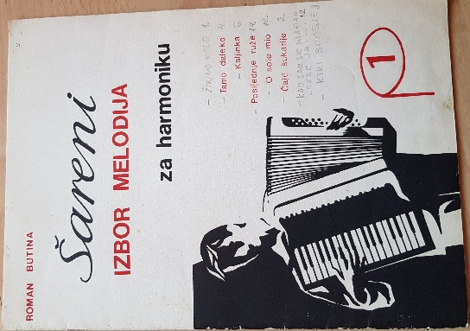
Figure 9: "Colorful Choices of Melodies for an Accordion" by Roman Butina
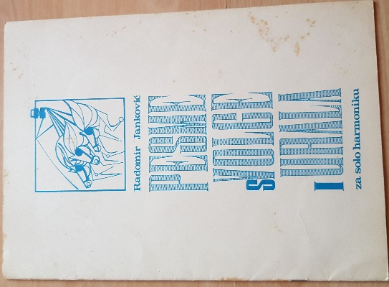
Figure 10: "Songs from Volga and Ural for a Solo Accordion" by Radomir Janković
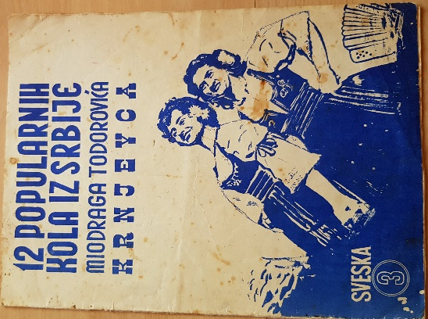
Figure 11: "12 Popular Kola from Serbia" by Miodrag Todorović-Kranjevac
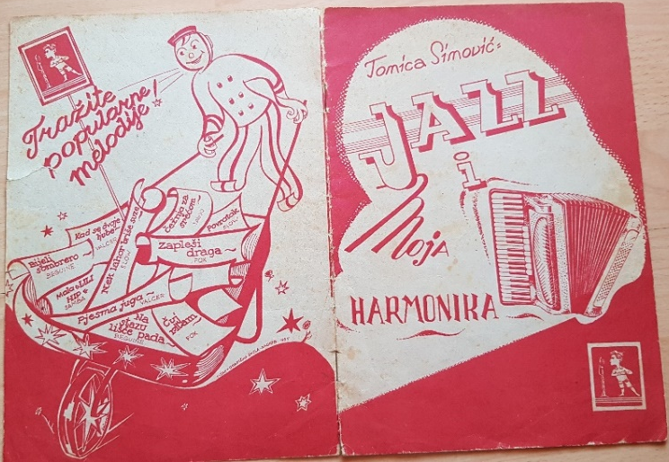
Figure 12: "Jazz and My Accordion" by Tomica Simović

During Yugoslavia, from 1945 to 1991, it was a tradition for cultural-artistic societies (“kulturno-umetnicko drustvo or “KUD”) to perform at important events. These performances were first aired on the radio, and later shown on TV. The “Folk Ensemble Lazarica, Kruševac” I did fieldwork with one of those KUDs. They sing, dance, and play folk songs from many different regions, displaying the diversity of Serbian culture through songs, movements, clothes, and customs. Through these KUD performances, my grandpa learned to play songs from other places like Slovenia, Zagor, Dalmatia, Montenegro, Bosnia, Macedonia, and Serbian songs from different regions: Šumadija, Vranje, Niš, Mačva, Kosovo and Metohija, Vojvodina (a mix of Hungarian, Romanian, Rusyn, Slovakian, Bunjevac, and Bećarac).
My grandpa was a part of the Kruševac Youth Work Brigade (“Omladinska Radna Brigada” or “ORB”) and volunteered during the tunnel construction on the highway between Niš and Vranje. The tunnel was built by the village of Manajle in the summer of 1961. Grandpa and other members, including people from neighboring countries, formed a musical group. Grandpa was playing the accordion, a friend from the Kruševac ORB played the clarinet, a youth from Bosnia played the guitar, a boy from Macedonian ORB played the darbuka, and a girl from the same ORB was singing. This group eventually won the first place against other ORB groups.
Knowing the nature of my research, my grandpa also reflected on foreign influences in Serbian culture. After the liberation from the Ottoman Empire in 1804, in the second half of the 19th century other foreign influences began to spread on the Serbian territory. Despite being genetically more related to Russians, Belarusians, Ukrainians, and Polish, according to my grandpa, we were more eager to accept Western European influences. Many hotel, shop, and restaurant names still stand today as monuments of these influences: Hotel Paris, London, etc. My grandpa believes that these names were given to catch people’s attention and ensure good profit, reflecting Serbian fascination and admiration for the Western European lifestyles.
Serbians started building schools and colleges to resemble Western European educational institutions, but in the past and today it is still more prestigious to finish school in one of those Western European colleges. Many famous Serbians got educated at those prestigious schools, and unfortunately for us, some decided to stay there, like Nikola Tesla and Stevan Mokranjac. Grandpa claimed that people decide not to come back to Serbia where people are more hesitant to accept novelties or differences. Many things have changed since then judging by how Western European culture dominates in Serbia, but the change is still slower when it comes to accepting different gender, racial, and religious identities.
Grandpa poses a question: “What kept us together as people through centuries?”. He answers with “love, faith, hope, and song”. Indirectly speaking to non-Serbians, grandpa argues that others can label us whatever they wish, but he is at peace because he knows where our place in the world is. He relates his peace of mind to Serbian religiosity. Citing a book on Eastern Orthodoxy, grandpa writes “Orthodoxy is not clerical, it brings great freedom to an individual, it doesn’t suppress personal feelings, it makes spiritual freedom a choice, it does not oppose one man to another, it yearns for the Kingdom of Heaven, but honors the Kingdom of the Earth.” This quote, in grandpa’s opinion, sufficiently describes his worldviews that are centered on his belief.
Despite the circumstances related to wars, recovery of what’s lost, and building of the new infrastructures, grandpa strongly believes that Serbians are returning to their traditional values. Media, especially television, has a major role in this revival through shows like “Šarenica” (“Colorful”), “Prelo u Mom Sokaku” (“Spinning in My Alley), “Raspevana Subota” (“Songful Saturday”), and “Šljivik” (“Plum Garden”). My grandpa ends his letter saying that now in his elderly years he is returning to his accordion, his childhood love. He supplements his absolute hearing with musical notations, leaning more about thrillers used in our music. Finally, he says wittingly, “My accordion, you are as heavy as copper – but you embellish every moment.”

Personal enculturation and cultural intimacy
During my fieldwork I realized that my project ties back to a linguistics class project of the Spring of 2021. I was curious about how non-Serbians perceive Serbian music regardless of their musical background. So, I decided to interview four of my friends, play them fifteen Serbian songs of my choice on YouTube, and ask them to describe the songs in their own words. My research focus was on the descriptions and metaphors they used while discussing and evaluating Serbian music. None of the interviewees had any prior contact with Serbian music, so most of the descriptions involved comparing Serbian music to more familiar music genres and styles to the participant. Samuels calls this “transparent indexicality” or the idea that to us Serbians it is clear how our music is Serbian and not Bosnian or Croatian, but to non-Serbians these distinctions are less notable.
A couple of my interviewees asked me my reasoning behind the Serbians songs I chose to play to them. I wish I had an elaborate, systemic answer to that question, but most of my choices were based on what I thought might represent Serbia holistically. The reader can imagine my surprise when during my fieldwork I began hearing the same songs on many different occasions. This is almost the opposite way of doing fieldwork – anthropologists usually go to a field site, record what is there, analyze the data, and share it with the world. In my case, I analyzed and shared with others what I thought represented Serbia and only then did I go to my field site and recorded the data. Perhaps it was a self-fulfilling prophecy, but it supports the notion that nationalism is built on shared community experiences. I was an example of my own research, and my song choices reify my belonging to the community. I dedicate this section to describing some of the songs I used, my rationale behind it, and where I heard these songs during my fieldwork to give the reader a better sense of the unity of Serbian music, folklore, and nation.
The first song that was played to the participants was Serbia’s representation at the Eurovision Song Contest in 2004 “Lane Moje” (“My Fawn”) by Željko Joksimović. I chose this song because Eurovision songs are made specifically to represent the country and their cultural elements. That year, Serbia won second place after Ukrainian Ruslana’s song “Wild Dances”. Maria Sonevytsky (2019), a Ukrainian-American ethnomusicologist, wrote a book about this song analyzing its representation of Ukrainian “Wildness” and sovereignty. With the same goal in mind, I chose to play the Serbian Eurovision song first as a nation-representing performance. Based on the responses, the interviewees associate this song with Western and Latin music, medieval, and pop music. It is both traditional and modern, showing the liminality of Serbian music. The instruments and clothing in this performance are one example of this dualism. The instruments used were the hand drum, the kaval (shepherd’s flute), and the tamburitza (Yugoslavian long lute) as traditional, and the violin as the modern. Nonetheless, all the instruments were made in modern times, out of modern materials which are mostly imported rather than native to Serbia. The same stands for clothing – the singer wore a modern white suit combined with a traditional woolen sash as a symbol of Serbia. Despite the usage of modern materials that make up these elements, they are still seen as authentic Serbian elements because they successfully carry the same meaning and value.
The next song the participants listened to was a traditional Serbian folk song “Veseli se srpski rode” or “Rejoice Serbian People”. The theme is patriotic and nationalistic, and the video was filmed in an Eastern Orthodox Christian church symbolizing Serbian identity. Today, around 85% of Serbians are Eastern Orthodox. Religious belonging became important during the Yugoslavian wars because ethnic conflicts were closely tied to Orthodox, Catholic, and Islamic group ideologies. This made religion relevant in nation-building in the 21st century, which the song testifies to. I found it surprising that all participants were wrong about the dominant instrument in the song, saying that it was the flute. To me, there was no doubt that the accordion was being played, but I am accustomed to this sound because I grew up in a house (and country) where accordion is often played. This again shows how our life experiences affect how we perceive and interpret novel phenomena, an example of Feld’s “acoustemology”. It was not that nobody knew what an accordion sounds like, but the way it is used in Serbian music is particular and insider knowledge one can gain from being surrounded by it.
I heard this song during my fieldwork at one of the rehearsals with the “Folk Ensemble Lazarica”. I was standing in the entrance hallway of the main rehearsal building with a couple of friends when I heard singing coming from the stage. I was told that a new girl, Marija, came to sing with the group at the next concert, so they were rehearsing. First, the song did not stand out to me as the one I used for the interviews; I just recognized the song as one of many that belong to that particular time and space. However, as the song went on, I made the connection. I was pleasantly surprised to hear others singing this song because I heard about it through YouTube and was unaware of its actual popularity. The ensemble directors ended up choosing different songs for the performance, but that was not the last time I heard that song.
The Olympic Games took place in the Summer of 2021, delayed by the COVID-19 pandemic in the 2020. Serbians won a lot of medals, so there was a large celebration to welcome the medal recipients coming back from Tokyo. The celebration took place in the capital city of Belgrade, right outside of the Capitol building. My parents and I were watching this celebration on TV and, lo and behold, I heard two songs that I used for my interviews. The first one was “Rejoice Serbian People”, and the second song was my tenth song played during the interviews. The other song is called “Moje Zlato” meaning “My Gold”. The singers are one male and one female, with trumpets as signature instruments. It was not difficult for my interviewees to guess the theme as the song began with the male singer singing in English saying, “party people, come on, hands in the air”. The song is about love and partying, but it was reframed during the event to refer to golden medals instead of being a euphemism for romantic partners. Both songs are modern, pop songs, used to evoke pride in the Serbian people by relating it to the Serbian representations in sports.
The third video shown during the interviews contained two different songs which were so well-connected that none of the interviewees were able to tell that they were not the same song. Both are traditional, communal songs about harvest. The first song is “Kad Ljevčansko Žito Zatalasa” meaning “When the Ljevač Wheat Billows”, and the second song is “Oj Posavlje Ravno Polje” meaning “Oj Posavlje, Flat Field”. Both songs contain place names (Basso), which is now evidently characteristic of Serbian folk songs. The songs also show Serbians’ tight connection with nature as an important aspect of life and life-provider. The main reason I showed this song to my interviewees was because the video showcases some Serbian customs and traditions like harvesting, breaking bread, washing clothes, baking, as well as clothing and tools used in the past. I used to sing this song with my singing group “Lazarice” and enjoyed the harmonies, so I wanted to share that with others.
When I was deciding what to sing with the “Folk Ensemble Lazarica” this was one of the songs that crossed my mind. I was told jokingly that I should sing a very long song so that the dancers have as much time to prepare for their dance as possible. I suggested singing this song because it was really two songs in one making it longer. In the end, we decided against it, but it was another instance where my project song reoccurred and there was common knowledge and understanding of this song as an element of Serbian nation and culture. It is uncommon for folk songs to be long because of the settings they were sung in. Sometimes they came at the spur of the moment while working in the field, and other times it was during communal chores where shorter songs were easier for the group to remember and reproduce. Later in history when the first cities were built, people began gathering for leisure more often. Those occasions were fit for longer songs and were usually sung by one artist. They would tell a story that could go on as long as the singer had the crowd’s attention. In the Balkans, fiddle players like Filip Višnjić were popular epic singers.
The following song, “Ona se Budi” (“She is Waking Up”) by Šarlo Akrobata is a punk rock song about a girl who is maturing and starting to realize how the world functions. As a less common genre, a lot of the interviewees were trying to identify the genre it belongs to. Many Serbians agree that ex-Yu rock artists produced some of the best and most popular songs. At the time, musicians were influenced by British rock, as well as British fashion and culture. I had an opportunity to hear this song again during my fieldwork. I was in a pub “Kruška” (“Pear”) with some of my friends, and there was one of the guest groups that perform every weekend. They mostly performed ex-Yu rock, including this song. However, what stood out to me the most in their performance was the fact that they changed words in a few Bosnian or Croatian songs to Serbian. This differs from the usual goal of “authenticity”. People’s understanding of the song would not have changed if the lyrics were in Bosnian, which means that there was intention behind this change. The deliberate change directly corresponds with other language reforms happening in ex-Yugoslavian countries as a project to create sovereign nations. I told one of my interviewees who is Bosnian about this change, and she was very unhappy arguing that music should not be politicized in that way but sung to bond people. This example evokes Irvine and Gal’s (1995) “linguistic ideologies” over Macedonian language tying language and political contestation.
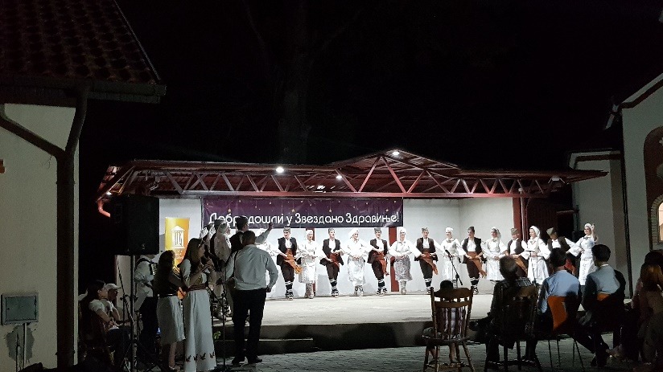
The following song was “Ne Koči” (“Don’t Break”) by Elitni Odredi (Elite Orders). The group “Elitni Odredi” gained popularity in the early 2010s as one of the first groups to incorporate electronic sounds in their songs. Today we might say that they have overdone their use of autotune and be embarrassed by it (Herzfeld), but back then that was popular. Common associations among my interviewees included EDM (Electronic Dance Music) and Latino American music. I was in Zdravinje, a village near Kruševac where a yearly cultural manifestation takes place. This manifestation called “Zvezdano Zdravinje” (“Stary Zdravinje”) lasts for about twenty days in August and is filled with various activities, contests, and performances (which I talk about in my section on concerts with the Folk Ensemble). Some of the happenings include goulash-making competition, contest in making šljivovica (Serbian alcoholic plum brandy), night of the Serbian flutes, humanitarian concert, sport competitions, and other. “Folk Ensemble Lazarica” opened this manifestation in August of 2021.
Marija and I sang between the dances to give the dancers time to change and prepare for their next act. After our final rehearsal, Marija asked Milica to play her guitar for a bit. She first chose a song by Ariana Grande “Side to Side”, which I thought was an interesting choice because I would not have connected that song to a guitar. Nevertheless, it was not surprising because it is a popular song for younger generations. However, the second song she played was “Ne Koči” by Elitni Odredi. This caught me by surprise, especially since I did not expect the song to still be popular among any other generation besides mine. Again, this proves why our “imagined community” (Anderson) can be sustained even though we are not always aware of our shared knowledge and experiences.
Figure 13: "Folk Ensemble Lazarica" at the opening of the 2021 manifestation "Zvezdano Zdravinje"
The genre switches to an older turbo folk song, commonly heard at weddings or pubs where one goes to drink their sorrows away. Turbo folk combines “non-Western” folk melodies with modern instruments and is one of the most popular genres in Serbia (for more information, Ashley Green’s thesis paper provides a deeper focus on this genre). This song, “Kraljice Moga Srca” (“Queen of my Heart”) by Šaban Šaulić, was one of the few turbo folk songs I knew because I do not listen to this genre in general. But one does not have to listen to a genre to know the songs, which is why community-building can take place through common knowledge. I was at my friend’s birthday party celebration at his house. About a dozen of us were in his backyard, with plenty of smoked meat, alcohol, and speakers blasting music from YouTube. In the beginning, we were all sitting and talking, while more modern Serbian pop songs were playing in the background. But as people got more drunk, the mood switched to turbo folk songs. People began hugging each other, singing, and swaying together left and right to the somber rhythm. They often raised their arms up in this turbo folk trance.
One of the friends asked me why I was not raising my arms to the music like everyone else, and I replied that it doesn’t suit me to do so. I felt like I did not know how to enjoy this type of music, and it felt awkward and unnatural to me to delight in it. He replied jokingly, “It doesn’t suit only those who have not shaved their armpits,” suggesting that responding to turbo folk has nothing to do with personal preferences. Turbo folk is all about communal, emotional bonding, which is why it is the most popular genre at different celebrations. Embarrassment I felt to dance to turbo folk ties back to Herzfeld’s “cultural intimacy”. However, Herzfeld talks about being embarrassed from the outsiders, but in my case, there was embarrassment among the insiders in relation to the music genre. This might have to do with my outsider part of identity unfamiliar with current cultural practices at parties. In his speech play (Scherzer), my friend also suggested that there is a bourgeois aspect to turbo folk or to cultural ideologies in general in which having shaved armpits is seen as desirable and the opposite is seen as unwanted or embarrassing.
Interviewees’ recognition of these song themes based on the timbre reminded me of Gray’s (2013) fieldwork with Portuguese Fado music. Gray was a participant observer trying to learn Fado but learning the melodies or how to speak Portuguese was just a small step. There was much greater emphasis on “feeling” the music on a personal level in opposition to mimicking other singers. This quality can be seen in turbo folk songs in which on top of mastering the melody, one has to convey the feeling of desperation and hopeless romanticism. As a result, these feelings become transferable regardless of the knowledge of the language. To be authentic in this case is to convey the same feeling that the original song evokes. However, the problem with many artists is that they try to reevoke the feeling by copying the original instead of putting their own interpretation into it (which Marjan and I talk about in later chapters).
Finally, the last video that was played to the participants was church music that can be heard in Eastern Orthodox Christianity. Eastern Orthodoxy is predominant in Serbia (around 85%), so I was curious to hear an outsiders’ impression of this type of music. The evaluations or feelings that this music evoke was “somber”, “lamenting”, “reflective”, “solemn”, “showing reverence to God”, “contemplative”, and “awe-struck”. It was not surprising to hear these metaphors, nor that they considered this music “traditional”. Christian contemporary music is more popular in America, replacing these timbres or sounds with more modern music in churches. The ideologies reflected in this example reflect the idea of purity and contamination of language and sound, since in Serbia there is still a notion that singing scripture is more sacred. Religion makes Serbians different from some surrounding countries where Islam and Catholicism is more dominant. Hence, the common history of Christianity in Serbia is an easy way to form the “imagined community” (Anderson).

Chapter 4: Cultural manifestations and heritage (re)production
“Kulturna manifestacija” (“cultural manifestation”) is a Serbian term for folk festivals, events, competitions, and places in general where Serbian traditional cultures are performed. I use this term instead of saying “cultural festival” or similar because of the cultural specificity. Cultural manifestations an even be thought of as places where culture is manifested, or a manifesto of a culture due to the variety of events that take place. These can include workshops, exhibitions, award ceremonies, concerts, and other. “Vidovdan” (St. Vid’s Day) is an example of a cultural manifestations that takes place throughout the month of June in my city of Kruševac. I attended some of these events during my fieldwork in June of 2021, and below I described my experience attending one day of the „Vidovdanske Svečanosti” (“Vidovdan Ceremonies”). To show the kinds of events that take place during one such cultural manifestation, Vidovdan, I also recreated the schedule of events based on the poster used to advertise them. These ceremonies combine history, politics, religion, and art to evoke a sense of belonging and cultural continuity. All of these events appeal to different social categories and types of people in terms of their age, gender, status, and personal preferences.
However, cultural manifestations are not primary spaces of heritage (re)production. Cultural manifestations are, as the name suggests, places where culture is manifested, but, looking from the grassroots nationalism point of view, heritage (re)production happens at rehearsals, back stages, and informal venues of groups that participate in the manifestations. The people performing traditional songs and dances are not just random people who decided to attend the same event and perform, which was often the case in the past. Cultural manifestations are just that – manifestations of groups whose dynamics and relationships get formed in the backstage, rehearsal sites, on the buses, and whatever comes in-between manifestations. Moreover, these private places of heritage (re)production and public places of cultural manifestations are in a constant dialogue and build off of one another. After my ethnographic account of “Vidovdan,” I talk about two groups who practice traditional singing and dancing. The first one is “Etno Grupa Lazarice”, with whom I used to sing, informed by a family that was involved with the group in various ways. The second group I did participant-observation with during the Summer of 2021, “Folk Ansambl Lazarica”. Hence, I share stories about times where intimacy between the members and community-building takes place through shared experiences, jokes, and various forms of kinship.

Vidovdan
The city of Kruševac was built in 1371 AD by Prince Lazar when he renounced it the capital of The Kingdom of Serbia. Lazar is the most famous to non-Kruševac citizens for the Battle of Kosovo against the Ottoman Empire under Murad. This battle, which happened in 1389, is very important to Serbians and is still celebrated today on Vidovdan (St. Vid’s Day) on June 28. Both Lazar and Murad lost their lives during this battle and Serbians eventually fell under the Ottoman Empire, which occupied Serbia until the 19th century. However, throughout history Serbians interpreted this event differently based on the socio-political circumstances of the time. Before 1389 Vidovdan was one of the many Saints’ Days celebrated in Serbia, but many important events that took place on that day contributed to Vidovdan becoming a strong nationalistic and patriotic holiday.
Whether by chance or not, many events significant to Serbia happened on Vidovdan:
- The Battle of Kosovo in 1389, Serbian declaration of war against the Ottoman Empire in 1876
- the assassination of Franz Ferdinand by a Serb Gavrilo Princip which led to the First World War in 1914
- the Treaty of Versailles was signed to end World War I in 1919
- Serbian King Alexander I proclaims the new kingdom Constitution in 1921
- Slobodan Milošević, former Serbian president who committed war crimes during the ’90s wars, delivers the famous Gazimestan Speech in 1989 (600th anniversary of the battle)
- the National Museum of Serbia in Belgrade reopened in 2018, and other similar events.
Both battles against the Ottoman Empire and the Austro-Hungarian Empire are celebrated in Serbia as symbols of resistance. Resisting conversion to Islam under the Ottomans and territory occupations under the Austro-Hungarians is a source of pride for Serbians. This resistance and pride offer Serbians a sense of historical continuity. Politicians like Milošević use this idea of continuity and primordialism to (re)evoke nationalism. Anthropologist Edit Petrović notices that Milošević uses historical continuity to promote “the illusion that the Serbs who fought against the Turks in Kosovo in 1389 are somehow the same as the Serbs fighting for Serbian national survival today” (170). Historian Dimitrije Đorđević confirms this by saying “Historians and intellectuals referred to the cult of Vidovdan in transforming the instinctive popular national feelings into modern, mass nationalism” (35). Scholars often refer to Vidovdan and its events as “cult”, “myth”, or “legend”, but that does not make the feeling of nationalism any less real or powerful.
Today Kosovo is a disputed territory because Serbians do not recognize its sovereignty. The Battle of Kosovo, as well as many churches that were built on Kosovo, are just a few reasons why Serbians feel a strong nationalistic tie to Kosovo. The first church in Serbia was built by Saint Sava on Kosovo and was also the first school in Serbia. Moreover, Kosovo is home to one of the Eastern Orthodox Christian patriarchies, “Pećka Patrijaršija”, which had an important religious, economic, and political role in the region in the 14th and 15th century. As Petrović noticed, Serbians do feel the same sense of belonging and historical continuity with the people in the 14th century.
Vidovdan has inspired many Serbian artists to depict various scenes from the Battle of Kosovo. One example is the “Vidovdan Temple” which Aleksandar Ignjatović, architecture professor, calls “Primordial Yugoslavism”. According to Ignjatović, “the Vidovdan Temple was decisive for the cultural imagination of Yugoslavism’s primordialist variant, based on the idea of South Slavs as a single, primordial nation, united by common descent, pre-schismatic historical unity, and, most important, the obliteration of cultural and religious differences between Serbs, Croats, and Slovenes” (831). I would add to this that the temple, which remained only a model never to be built, symbolically represents the ideology of unity that did not hold up in practice.
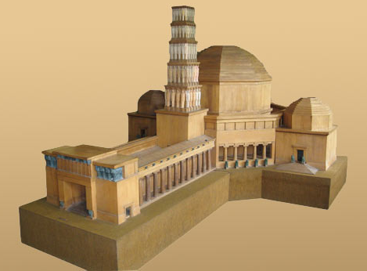
Another example of Vidovdan-inspired art is a famous song “Vidovdan” by Gordana Lazarević. Not surprisingly, this song is listed as one of the RTS “60 Most Beautiful Serbian Songs” (which I talked about in the Media section). This song is the epitome of Serbian nationalism and primordialism, and it is sung at almost every occasion and celebration. Below are the lyrics in both Serbian and English.
Figure 14: Vidovdan Temple, https://royalfamily.org/vidovdan-temple-model-and-kosovo-cycle-sculptures-of-ivan-mestrovic-at-the-white-palace-for-the-night-of-the-museums/

Vidovdan Serbian Vidovdan English
S1: Vidovdan V1: Vidovdan
U nebo gledam I look at the sky
Prolaze vekovi Centuries pass
Secanja davnih To our memories
Jedini lekovi. The only remedies.

Ref. 2x Chorus 2x
Kud god da krenem Wherever I go
Tebi se vracam ponovo I return to you all over again
Ko da mi otme Who can separate
Iz moje duse Kosovo. Kosovo from my soul.

S2: Vidovdan V2: Vidovdan
K'o vecni plamen Like eternal flame
U nasim srcima In our hearts
Kosovskog boja The Battle of Kosovo
Ostaje istina. Remains the truth.

Ref. 2x Chorus 2x

S3: Vidovdan V3: Vidovdan
Oprosti Boze Forgive God
Sve nase grehove For all our sins
Junastvom daruj Gift with bravery
Kceri i sinove Daughters and sons.

In the first verse, the artist expresses pain and wounds that only time can cure, suggesting that as long as The Battle of Kosovo is remembered by people, they will feel hurt by the losses. This is, again, primordialism in a sense that time between then and now is connected because of people’s memories that still live. Furthermore, in verse two the artists suggests that the truth about what happened remains in our (Serbian) hearts, countering any doubt that descriptions like “myth” or “legend” might evoke. In this verse, there is a visceral form of nationalism where history becomes ingrained in people’s bodies and souls. Verse three evokes nationalism through religion in a form of prayer to God.
In one of my interviews, a friend from the singing group “Lazarice” reflected on songs about Kosovo like “Vidovdan”. In her words, “the two of us [referring to her sister] listen to Kosovo songs, and we have nothing to do with Kosovo. […] we get goosebumps and like to listen to those songs. I cry every time, I don't know why. It affects me so much, those words.” There is power in words, and they carry so much meaning behind to evoke bodily responses, which has been recognized by scholars a long time ago. One of the first anthropologists, Malinowski, and later Austin argued that all utterances are performative, pragmatic, and that people are constantly “doing things with words” (Austin). The agency in language is why national anthems are successful in evoking a sense of “imagined community” (Anderson).
In what follows I present the poster of events that took place in June 2021 to show the diversity of activities that happen during cultural manifestations. After that, I included my reflection on one of the events I attended, which helped me connect with the “Folk Ansambl Lazarica” where I did my fieldwork.
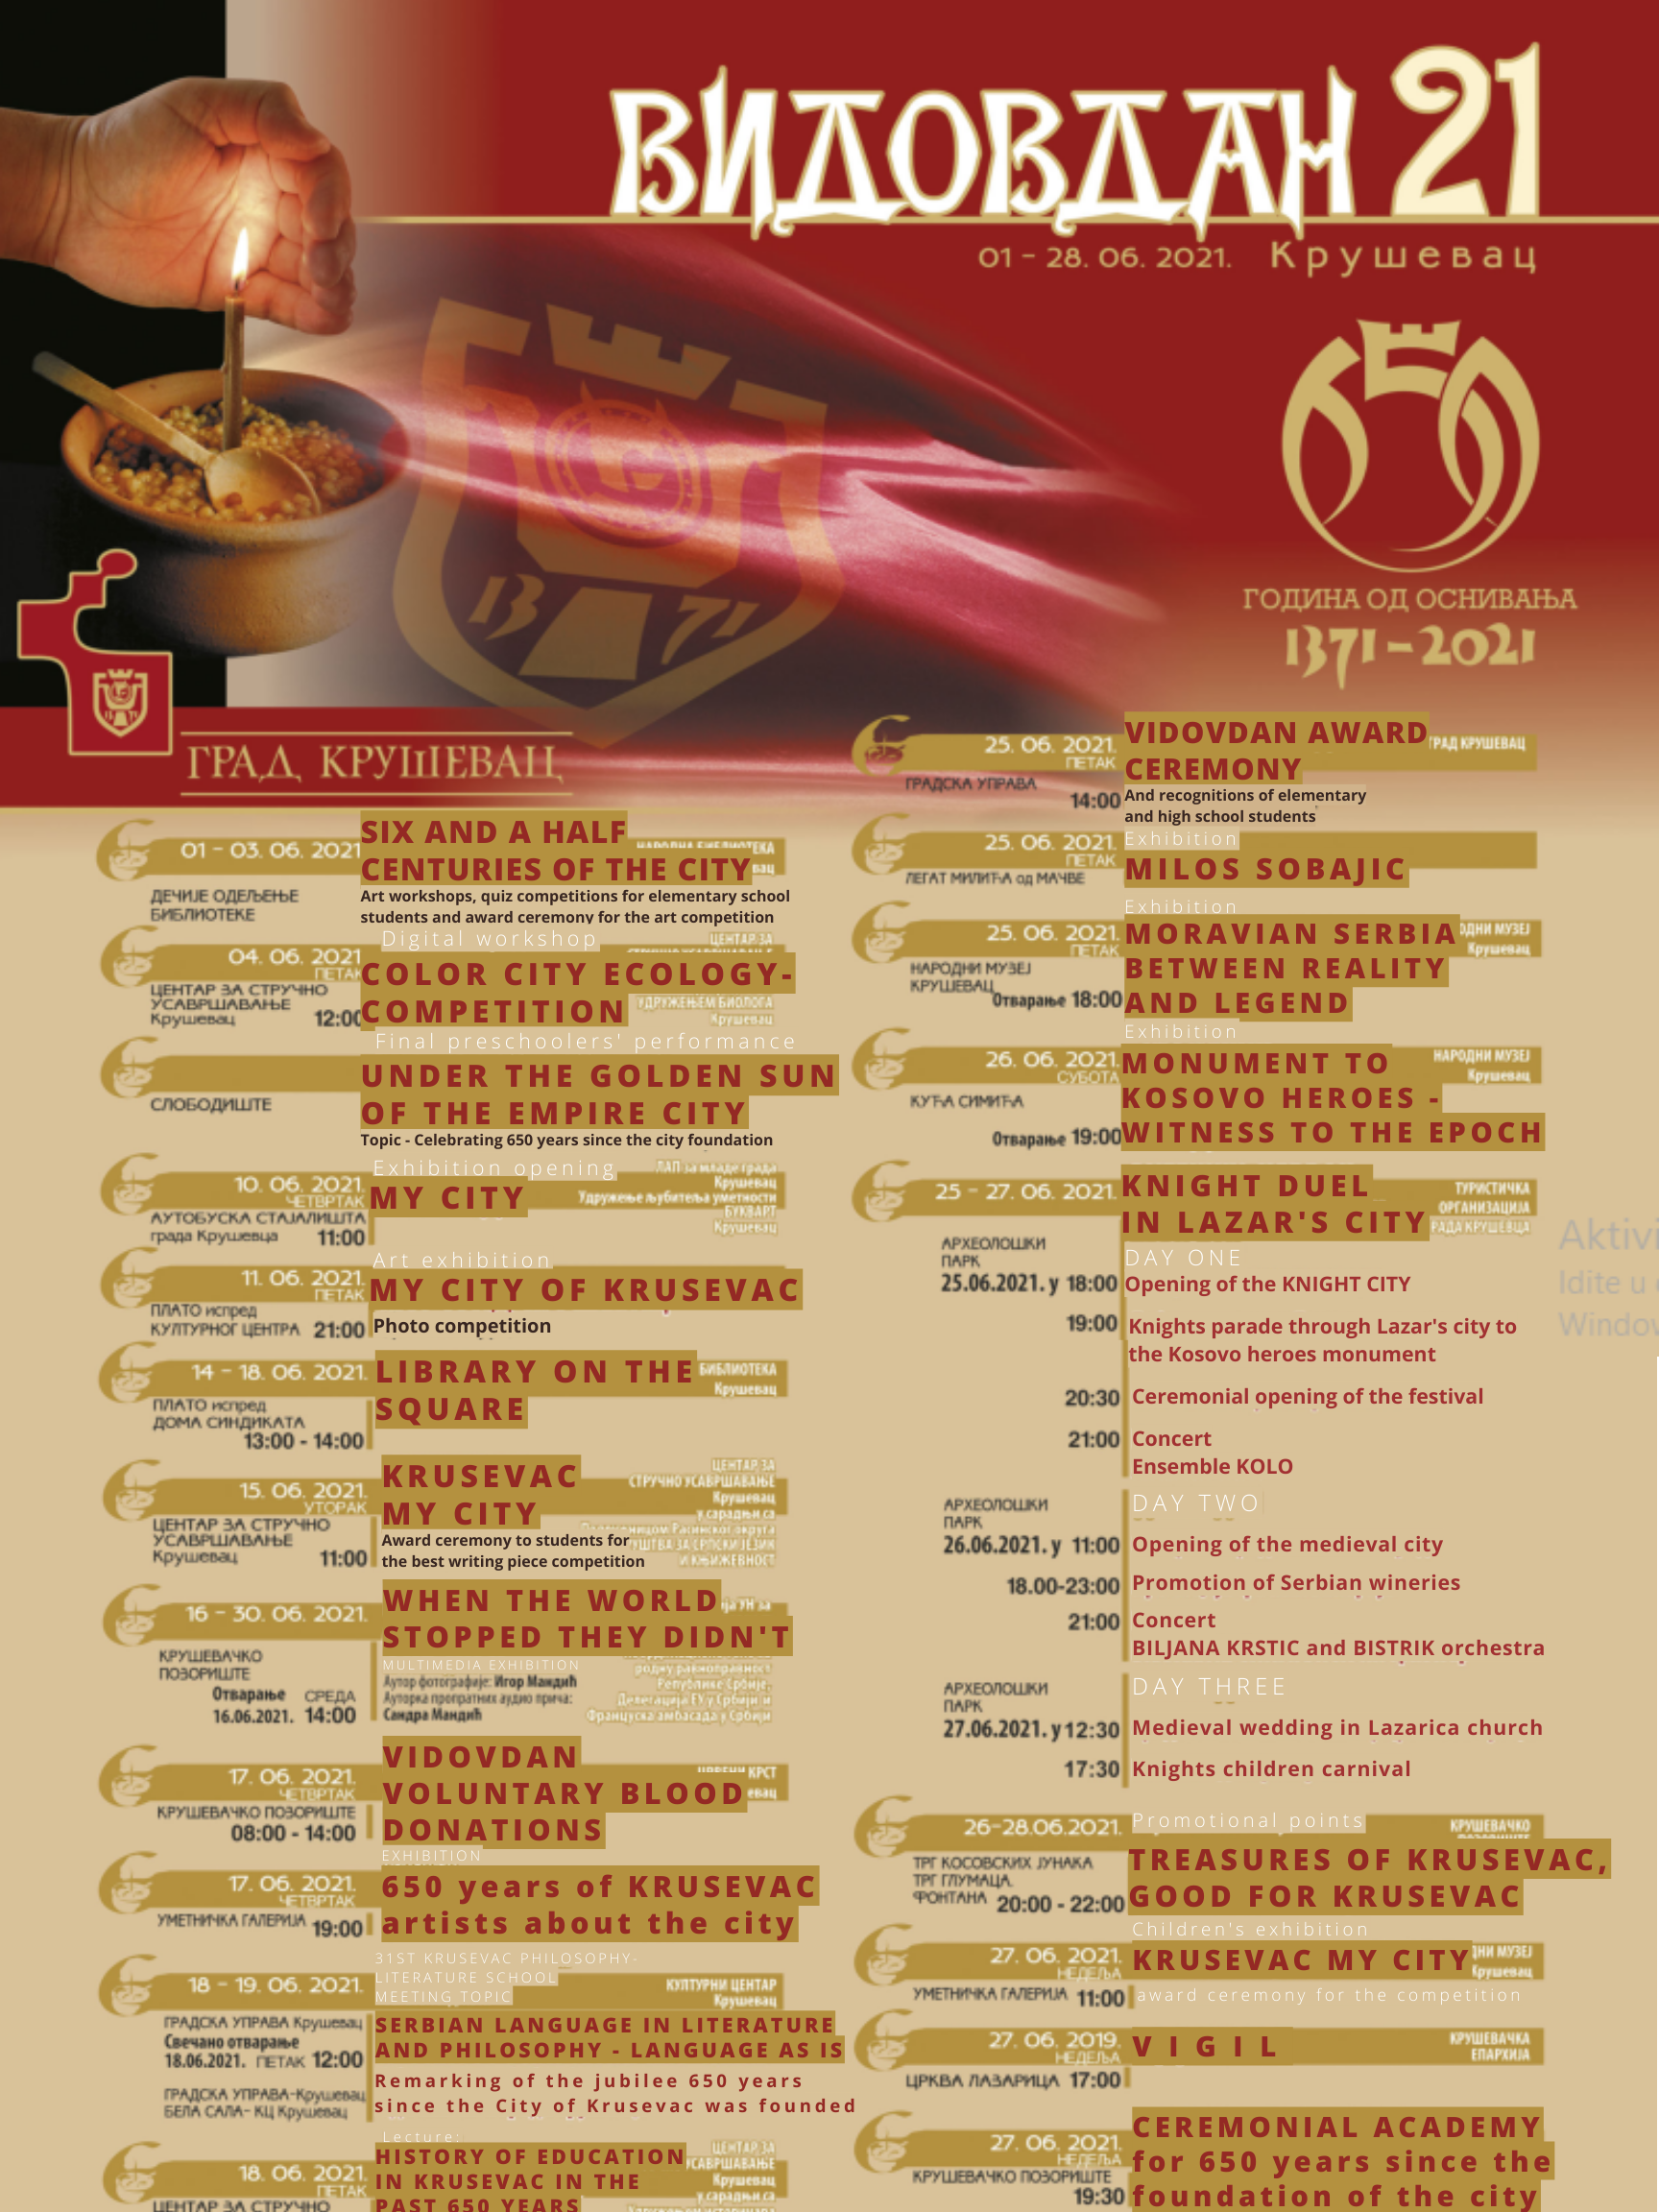
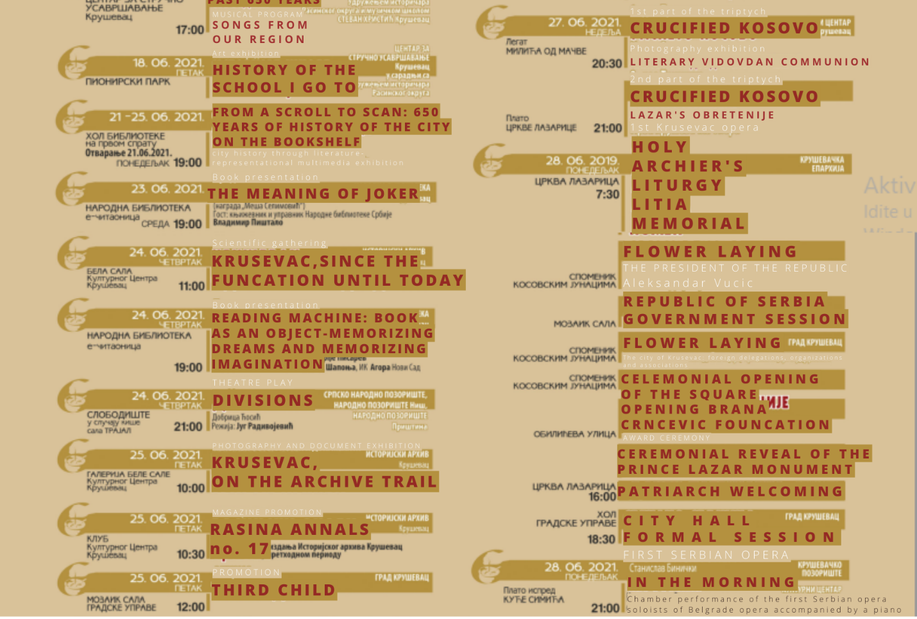
06/25/2021
Figure 15: Vidovdan poster
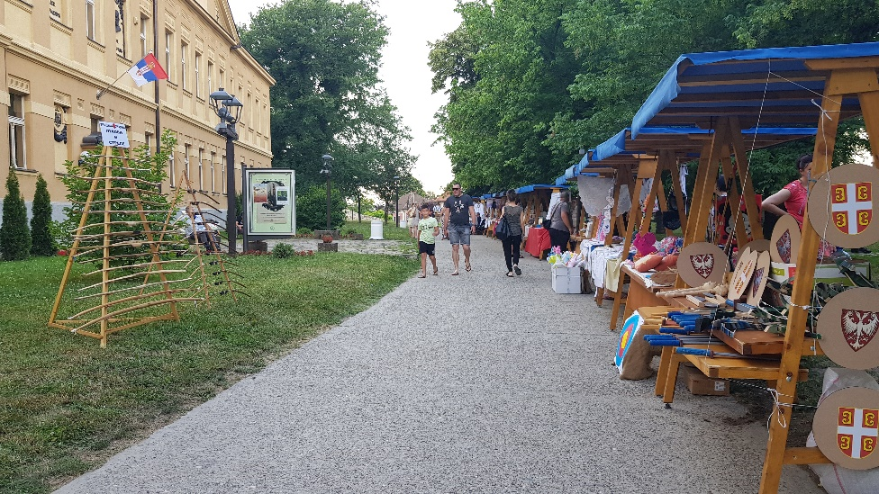
I was standing on the grounds of the medieval capital of the Kingdom of Serbia. In all four directions I was surrounded by the sunbaked dirt-colored wall fortifications. This stone is called “Krušac” after which the city itself got its name – Kruševac. The watch tower remains standing of what used to be Lazar’s city. And the church too, ocher with tints of Byzantine red, are simple on the outside compared to the vivid depictions of Biblical stories and golden icons inside. This church is in the center of this fortified city. It was named “Lazarica” after its creator, emperor Lazar. West of the church are a bell tower, a drinking water tap, a small shop, and a hostel for the priests. I noticed a big arch-shaped gate leading to the church standing alone to mark the entrance. The gate was continued by small wooden booths where locals are showing off their products: jars of natural honey and remedies, hand-crocheted aprons, vests, gloves, home-made rakija, children’s toys and gadgets, popcorn, and lollipops, etc. I looked at these vendors and thought pitifully about how they stood there for a long time in the dreadful heat of June’s sun.
Figure 16: Serbian National Museum on the left and street vendors on the right
On the other side of the path, I noticed an archery attraction, just like the one from Disney’s “Robin Hood”. Moving on I came across the building where my high school used to be located. Some might think that a school still stands there today because of the unaltered sign above the doors. However, today this is our Serbian National Museum. I decided to go in there first because an exhibition was about to open. The empty hallway suggested that the event may have taken place upstairs, so I made my way up the spiraling staircase. To my left there was the exhibition poster „Moravska Srbija: između stvarnosti i legende“ or “Moravian Serbia: between reality and legend”. As I was approaching the exhibition, a police officer was coming out, slowly walking out, gently squeezing the arm of a seemingly lifeless body of a young girl. She was as pale as flour, and her eyes seemed fixed onto something in front of her. No wonder, she must have felt sick because of the scorching heat and lack of air in the crowded room. I swallowed my saliva hoping that I wouldn’t be the next one taken out.
I entered a room lit with red lights like in a photography dark room. I was wondering whether this light was chosen to convey a certain message as I have never seen anything like that before. Somebody was making a speech. I found a place to stand next to one of the columns in the lower left side of the room. After the speech, about a dozen people dressed in black made their way into the room and stood in the upper left corner. They were the church choir, and they began their performance. The room echoed in a very church-like way, making their song sound more spiritual and holy. Soon after the performance the exhibition was officially opened, but I decided to leave because there were a lot of people and I needed fresh air.
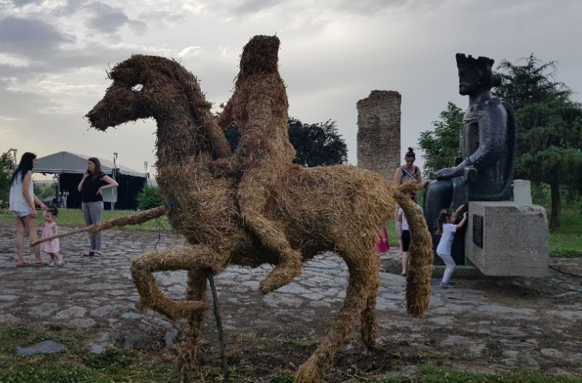
At the east end of the medieval city are some of the most popular tourist attractions. I saw a big monument of King Lazar where every child who visits has a picture next to. I also noticed a new hay statue of Lazar on a horse. These seem to be popular picture spots as there were many parents around wanting to take pictures of their children with the statues. I remember the monument looking bigger and more difficult to climb, but now that I am older it seems less amusing. Looking north, I could see the big watch tower, knights’ tents, and a big structure that obviously stands out and does not belong to the whole frame. That was the stage – black and infused with metal bars and branches of wires. The stage area was gated with yellow gates for the time being until the performance. The performance was the heart of the night.
Figure 17: Hay statue of Prince Lazar in the front, the monument to Prince Lazar to the right, with a ruin of the old town in between, and a tent for the concert on the left
After the knights made their way to the city square and the monument to Kosovo heroes, it seemed like forever until the concert starting time. There was even a brief rain shower promising a cool-down from the scorching summer heat, but to no avail. When the knights came back, they performed a duel, but the center of attention was a dog who was barking at the “violent” knights’ sword fight. Children also had an opportunity to try dueling with foam swords, or ride horses in a circle. The performance that night was a KUD (“kulturno umetničko društvo” or “cultural artistic society”, like the one my grandpa talked about) “Kolo” (named after Serbian traditional dance meaning “round”). I did not know much about the group prior to the concert, but I got to learn more as the night progressed. The group set their tents behind the stage and began dressing up and getting ready for tonight’s performance. To warm up, the performers stretched to the sounds of “Thunderstruck” by AC/DC, “Paranoid” by Black Sabbath, and a jazz version of “Everybody Wants to be a Cat” from The Aristocats.
While I was watching the performers and the orchestra get ready, I recognized a friend Andrijana from “Etno Grupa Lazarice”. I decided to say hi and that decision influenced the rest of my fieldwork. Andrijana shared that she now plays the flute with “Folk Ansambl Lazarica, Kruševac”. I told her about my research, and she suggested that I should come to their rehearsals. Hence, she became my entry point to the group where I did my participant-observation. “Folk Ansambl Lazarica” is a dancing group which performs traditional kolo dances from regions in Serbia and the surrounding countries. They have an orchestra that follows them, as well as singers who perform during their concerts while the dancers are getting ready for their dances. As a part of the group, Andrijana was very excited about the KUD “Kolo” concert that night. She expressed her admiration for “Kolo” by explaining that they are professionals (as opposed to “Lazarica” who she considers amateurs) and they practice 8 hours a day or full time. After arranging my visitation to her group, we parted and soon thereafter the concert began.
The opening act involved a fire show by Haos Animatori (“Chaos Animators”) from Novi Sad, Serbia. The performers were two fire fairies whose acting contributed to constructing the medieval atmosphere of the event. After the fire show, “Kolo’s” performance finally began. They performed many various dances, often broken up by narrative videos about the group or the dances performed. Examples of regions and dances they performed include Istočna Hercegovina (Eastern Herzegovina), Gornja Nišava (Upper Nišava), Stragari Šumadija, Ciganska (Roma Peoples’), Jugoslovenski nacionalni balet (Yugoslavian national ballet), Leskovac, and other. Most dancing groups perform dances from generally the same regions, but each group has a unique interpretation, thus inventing tradition in the present (Hobsbawm). I have not spent enough time with “Kolo” to be able to compare it to “Lazarica”, but the biggest difference I could notice was the scale. “Kolo” is older, has more members, and performs more dances per concert than “Lazarica”. They also travel more because they have better funding and come from the capital city as opposed to a small city group “Lazarica”.

Ethno Group Lazarice
In this section I talk about the founding of “Etno Grupa Lazarice,” and the Hinić family and my reminiscence of our experiences being a part of the group.
I have been singing for as long as I could remember. I was in choir in kindergarten and in elementary school. In elementary school, a few girls and I would often stay after choir rehearsals to continue practicing. We enjoyed playing around with pitches, drones, and words, and exploring our vocal abilities. Seeing the potential in us, our music teachers began giving us solo parts or entirely new songs to sing at concerts. At the time, I did not know that my music teacher, Živka, is an ethnomusicologist. She studied Serbian folk music and did fieldwork in villages where she recorded old songs from the elderly. She later stylized them by writing musical scores for future reproduction. Her mother was also a singer, so Živka inherited her passion and talent for music. My choir friends and I happened to gain interest in Serbian folk music while Živka dreamed of leading a folk singing group. As a result, in 2010 about half-a-dozen of us formed “Etno Grupa Lazarice” (“Ethno Group Lazarice”).
“Etno Grupa Lazarice” took our name from a Serbian folk tradition. Lazarice were young girls who would wear flower wreaths and go from house to house to sing for Lazarus Saturday. That day was also a rite of passage into adulthood as the girls who participated were allowed to get married afterward. Today, the ritual is not practiced anymore, except perhaps in a few villages. However, the name was suitable for our group because of our age and singing. What about the “ethno” part of the name? Generally, dancing groups are referred to as “folk”, while singing groups are “ethno”. The terms are interchangeable, and both refer to traditional, historical culture. It is noticeable that both groups have similar names – Lazarica and Lazarice. However, the folk ensemble Lazarica refers to the church Lazarica in the medieval city in Kruševac, not the tradition described above.
My friends and I were about twelve at the time, so forming the group was a big commitment and responsibility. But our parents were very supportive and, based on conversations I had during my fieldwork, parents were glad we had a group that kept us off the streets. We started small – we would perform a few songs during choir concerts. But as more and more people around Serbia heard about us or saw us on television, we began performing during many different occasions. Mia, Ina, Lola, and I reminisced about various concerts and events that stood out to us. Mia and Ina Hinić are sisters who were also members of the singing group, while their mom, Lola Hinić, was our secretary. She was like a second mother to all of us because she followed us on every concert and always made sure everything ran smoothly. One hot August morning during my fieldwork, I visited the Hinić house for an interview. As our customs require, when visiting somebody’s house one should not come empty-handed, so I brought some coffee and chocolate for them. We sat in their much cooler living room and they served me coffee and juice. To my right was a big TV where Novak Djoković, the Serbian number one tennis player in the world, was playing a match.
We began by sharing our musical beginnings. Mia’s and Ina’s stories are similar to mine – they began singing in kindergarten, followed by the school choir, and they ended up singing in “Lazarice”. They also grew up in musical families, and they both play instruments. Lola is also musically inclined, but she later found out that she has a very unique hearing ability. While she can unmistakably hear when somebody is singing out of tune, she is unable to reproduce it herself. This skill proved to be very useful during our group’s rehearsals. Once both of her daughters joined the group, Lola began to follow us everywhere to photograph, video, or assist us with various things. As the group started to grow, Živka asked Lola to become our secretary. Looking back at the whole experience, it was probably more stressful to Lola than it was fun, making her experience much different from ours, the singers’.
Lola was born and raised in Bosnia and Herzegovina, in the city of Mostar where I went to high school. She married a Serbian man and moved to Kruševac not knowing anybody. However, as the secretary of “Etno Grupa Lazarice”, Lola gained the rite of passage into the community. As she reflects, “my participation in Lazarice made it possible for me to enter the municipality, the court, the, I don't know, the police administration, anywhere, and to say ‘Yes, I'm Lola from Lazarice.’ Since people remembered me that way. […] So, I met a lot of these people, important at that time, in the city where we could do some work for us, to knock [on their door] without shame and say ‘Good afternoon, we need this and that. I am this and that, I came here for that.’ In fact, very quickly we all became very recognizable in our city and beyond. Here we can recognize the distinction between citizenship and membership as forms of belonging to a group (Simpson). By marrying a Serbian man, Lola had Serbian citizenship, but her participation in our group offered her membership to the Serbian community and power of influence in the public sphere.
Ina reflected on how comfortable and familiar she felt with public spaces after spending so much time there during performances. We had to change and get ready for performances in classrooms, personal offices, libraries, gyms, back stages, et cetera. She found it funny when her friends tell her they have never been to the City Hall, and she is able to say that she knows the building inside out. To our group, public spaces became both private and intimate. In addition to the physical buildings, we got to know the people who were the main organizers and developed relationships that opened doors for us to become the staple of our schools and town. The four of us also recalled some members and where they are today.
In Lola’s opinion, the performance that made us the most famous was our concert at the Belgrade Capitol. Lola believes that this was when we received the best media coverage, and invitations to other happenings around Serbia started arriving more frequently. “Lazarice” were invited to open the Spring Assembly by singing our national anthem. Our group’s repertoire was generally mostly old ethno songs, so singing the national anthem was new for us. Our interpretation of the national anthem was filled with ethno, throat singing which made the song a concoction of old and new, of traditional and modern. After that performance, we were invited to a manifestation in Aranđelovac to perform the national anthem once again as the opening act. However, there was something else that made that event more memorable for all of us.
As I mentioned, our group has seen many different backstages, but the one in Aranđelovac was very special. We had to dress up on the bus and there were no toilets, so we had to go behind a building. Mia and I went together, but while we were heading back, I noticed that I stepped into something soft. I tried to move, but both of my feet began sinking. I yelled asking for help, but others were laughing because they thought I stepped into feces. However, once they came closer, they understood the gravity of the situation and rushed to get me out of the thick, black tar. The house we went behind to use as the toilet used to be a smeltery. To make matters worse, I was wearing white All-Star Converse shoes, so everybody began to joke around how I turned my white Converse into black Dr. Martin’s. Thankfully, our guitar player went to a nearby gas station to use the oil to clean my feet. On the bright side, I had an extra pair of shoes for the performance to wear that day.
Mia and I were reflecting on this incident, but also how helpful parents were to us and how much support they gave us. Even though Lola often embarrassed Mia and Ina, our group was glad to have someone to take care of us, support us, and be an authority. The guitar player, who helped me during the tar incident, was there too with his two sons who played the accordion and the clarinet. Other parents drove us to and from concerts; one parent even bought a van so they could provide us with transportation. Looking back, I realize that many things went so smoothly and carelessly for us, children in the group, because the adults were there to aid us. As Ina pointed out, “we never ended a performance being very dissatisfied”. We only had to worry about our performances, who had a crush on whom, and what would be served for dinner at the event.
The discrepancy between Lola’s experiences and our, the singers’, experiences can be seen in our trips to Bjeljina, Republika Srpska in 2012 and 2019 (Bosnia and Herzegovina). The first time we went, we were very excited because we had never been outside of Serbia to perform. We were going to compete at the May Festivities. What most of us remember, though, is not the competition itself, but the night before the competition. We were guests at a monastery, hidden up in the hills. We dined with priests in the cafeteria in the basement, and then all of us girls slept together in a huge room with bunk beds. Monasteries are places where priests come to find peace, to pray and meditate in the nature, focusing on God. Naturally, being at such a serious, solemn place, everything was funny to two dozen young teenagers. We had a hard time staying silent during dinner, and an even harder time going to sleep from excitement about being together and travelling to a new place.
Lola, on the other hand, remembers sitting in the bathroom the whole night writing multiple copies of our names, contact information, and passport numbers. Similarly, the second trip to Bjeljina was Lola’s worst memory because one of the girls broke her arm, and Lola had to settle a situation with a missing document at the border. Before the interview, I was unaware of how much responsibility it was to lead our group. We girls mostly remember how much fun we had together, but fun was crucial for us to stay motivated and excited to perform and travel. We were always happy and proud because of this parental support we had. Even some parents who were less involved in helping the group showed up at times to provide support. Parents also used our commitment to “Lazarice” to motivate us to do well in school. If we were getting bad grades, our parents would punish us by not letting us go to “Lazarice”. In the same way, Živka would not let us rehearse or perform if the teachers complained about our grades. Lola added that these disciplinary measures continue to be fruitful today as we count all the former members who ended up successful. Three of them graduated from the Music Academy in Belgrade and one just enrolled, three are in the Academy in Niš, one is majoring in the accordion in Bratislava (Slovenia), one is doing her masters in Bulgaria, etc. Our violinist also went to represent Serbia in the Eurovision Song Contest (which never actually happened due to COVID-19) and played with other famous bands and music groups around Serbia.

Folk Ensemble Lazarica
This section is dedicated to describing my impressions from participant-observation with the folk ensemble. I particularly focus on jokes as ways to build the cultural community and concerts as cultural manifestations.
My friend Andrijana, a flute player, her friend, and I headed to Trayal’s tire factory for the rehearsal. The factory is located in the suburbs of Kruševac, so it took us about 45 minutes on foot. I have been there before when we celebrated our 150-year anniversary of my high school, so I was vaguely familiar with the place. We arrived at the entrance gate a bit before 8 pm and greeted the security guard. There were a lot of buildings in the area, but there were also many trees making the place appear less urban. We headed to the first building on the left where a dozen members of the group were sitting on the stairs, waiting for the director Ivan to unlock the doors. The door leads to a big reception hall. The hall is pretty dark and smells like old, damp wood. Straight ahead are the stairs to the balcony, and on each side of the stairs are the doors to the main stage. We took a left to the room where the performers were changing into their practice clothing – guys were mostly wearing sweatpants and t-shirts, while ladies wore leggings, skirts, and t-shirts. Everyone was wearing some sorts of tennis shoes, and everyone had a belt around their waist.
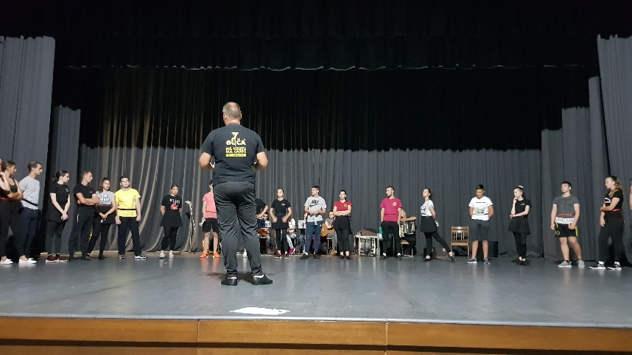
We arrived onto the stage from the backstage. In the very back, adjacent to the curtain, there were around a dozen chairs arranged in a single line for the instruments. They had microphone stands and musical note stands in front of them. There were 7 instruments in total: two violines, a flute, a guitar, two accordions, and a double-headed drum “tapan”. Around 30 dancers came to the rehearsal– 15 males and 15 females, arranged with alternating male-female and by height. They were mostly around my age, but this folk group has two other groups for beginners and for veterans (their name for older dancers).
Figure 18: Ivan standing facing the dancers giving them instructions, while the orchestra is in the back preparing to practice
The artistic director Ivan stood across from the dancers and the orchestra. He decides which dances will be performed, when to start or stop the music, and who will get to dance and where. Throughout the rehearsal, he takes up many roles such as replacing a dancer who may not be present, playing the drums, singing, etc., so he is very active and engaged with the members. The orchestra also has their director, Marjan. He is the oldest man in the orchestra who plays a red Chinese accordion. The accordion is the most prominent instrument in all of their songs, probably because of its variability. The accordion player’s daughter is also a part of the group playing the violin.
During the rehearsal I was sitting in the audience, but I decided to switch to a chair next to the orchestra in order to hear them better. In the middle of the rehearsal was a short break for the dancers, which the women’s singing group used to practice songs. They knew my background in singing, so they asked me to sing “Nazli Petko”, a particularly difficult song which I was able to master over the years. In fact, I was asked to sing it three times – once for pleasure, then for recording, and third time after Marjan explained its elements so I could demonstrate it. I felt like this was my first passing moment into their community.
Figure 19: Tapan, Serbian double-handed drum I played, with the drumsticks on the chair
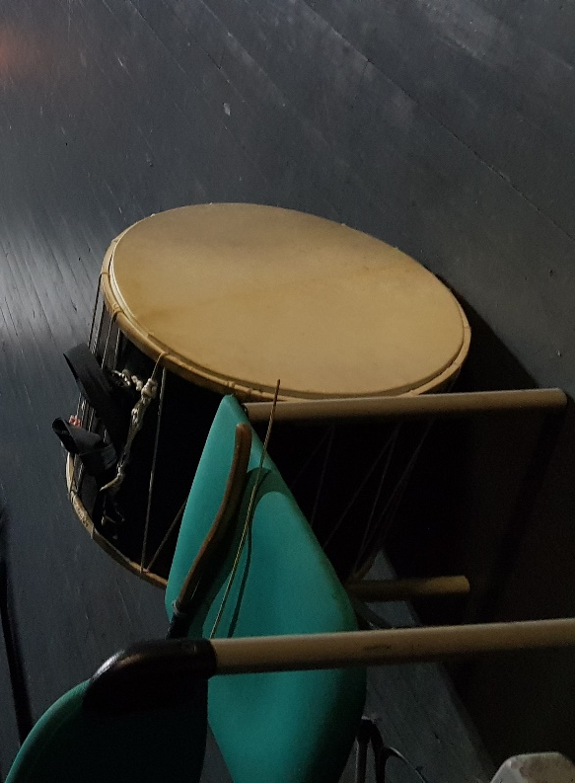
Next “test” by the community was the participant part of the participant-observation. During one of the rehearsals Marjan encouraged me to play tapan or also known as goč, a double-handed drum (see image above). One plays it by either wearing it strapped in front while standing or placing it between the legs while sitting. In this instance I was sitting and Marjan and Boban, the drum player, showed me how to play. There were two different drumsticks – one was like a long wooden pestle, and the other one was like a long slim stick. It did not matter which hand they are held by, that was a matter of personal preference, but it did matter that the drummer hits the middle of the drum while playing. They were satisfied with my playing, it seemed, so we joked around that my next task will be to play the accordion. Jokes were a major part of building community and I paid special attention to the jokes because they can relay a lot of information and layers of contexts. Jokes reveal grassroots ethnonationalism on an intimate level, building a shared identity which is manifested at large public events.

Jokes
Jokes that I recorded during the participant-observation often included metaphors and plays on words. Also, in most cases it was males who were joking around, but I would also contribute to embrace this form of community-building. Not everyone in the orchestra is musically literate, so Marjan often used funny metaphors and speech play (Scherzer) to describe how one should play. One of those examples was Marjan telling them to play “kao da te jure komarci” or “as if mosquitos were chasing you”. He was instructing them to play faster, but using a joke made it seem less of a command but more helpful and friendly. During a different rehearsal, Marjan compared their playing to a fly, which again provokes laughter and bonding. In another instance Marjan wanted them to play slower, so he said “ide kao puž uz bukvu” or “it goes like a snail up a beech”. Marjan, who is a music professor, understood that using these metaphors not only makes him sound friendly, but also makes it easier and more fun for the instrumentalists to play.
Metaphors used were not always positive, though; Ivan used some to critique the dancers. Referring to a group of guys who were dancing in a circle he commented, “idu kao mušice bez glave” or “they’re going like flies without heads”. Another time he used a different metaphor “more se kao sakati mačići” or “they’re tormenting themselves like crippled cats”. Nevertheless, these comments evoked the same reaction as Marjan’s instructions – people found it funny, and they were not offended by his criticism. By choosing to joke, Ivan and Marjan show that they care about the performance and the people there and pay special attention to their words to avoid offending anybody.
During one rehearsal with the veterans (“veterani”), Boban and Zoka tucked towels in their belts to have them near when they need to wipe off the sweat. But Ivan made a connection with a Serbian tradition saying “vi kao da ste pošli u svatove” meaning “you look like wedding guests”. “Wedding guest” or “witness” are correct, but inadequate translations of the word “svat” because the word carries a specific connotation in relation to our culture. “Svatovi” have a special role in Serbian weddings during which “Stari Svat” (“Old Witness”) leads the procession of specific group of wedding attendees to pick up the bride from her home. They usually have decorative towels or scarves which Ivan was reminded of. Unlike the previous jokes, one needs to have a certain knowledge of Serbian culture to understand the meaning behind this joke and this exclusivity is what helped me become a part of the group more easily.
Besides metaphors, the group practiced word plays and puns. During a singing practice, Andrijana asked one of the girls “Koji si glas?” (“Which voice are you?) and she responded with “Nisam” (“I am not.”). Andrijana’s question had two possible answers – first voice/soprano and second voice/alto. However, the singer joked that she is neither, which is practically impossible, but through her response she indicated that she is not a good singer because she cannot sing either soprano or alto well. The singer could have said “I don’t know” or something else, but by making a joke she avoided embarrassment and directly admitted that she believed that she cannot sing well.
Ivan and Marjan also joke with each other, showing that their relationship is also built on humor and friendly interactions. One time, Marjan asked “Može iz D?” (“Can we play from D?”) and Ivan responded “Može iz ‘de oćeš.” (“You can play from wherever you want.”). Clearly, this joke needs explanation because the word play is lost in translation. “D” and “’de”, which is a short form of “gde”, are pronounced the same with the first one referring to the pitch they are playing from, and the other one meaning “where”. So, the pun is that Ivan said a meaningful sentence but in response to this particular question the “’de” can be understood both as the pitch and the place. Similarly, one time I asked Marjan “Može ‘Ja u Bašti’?” (“Can I do ‘I’m in the Garden’?”) and his response was, “Može ti u bašti.” (“You can be in the garden.”). This one is easier to understand when translated, but as was the case with the previous joke, Marjan’s response is only funny in response to my question. While I was asking if I could sing a song called “I’m in the Garden”, Marjan pretended I asked if I, myself, could be in the garden.
Both of these jokes were intended to show friendliness and comfort with each other. The next one reflects friendliness even more explicitly. Milica, the guitar player, asked Boban “Možete da me vozite [kući]?” (“Can You drive me [home]?”). He responded, “Možemo.” (“Yes, we can.”). When Milica addressed Boban, she used the polite form of “you” which has the same grammatical form as the plural “you” and is used to refer to those we respect, usually those older than us. Instead of telling Milica that she does not need to use the polite form when addressing him, Boban made a joke responding as if she used the plural form of “you” sarcastically to imply that the polite form is unnecessary and funny for him. Just telling Milica that she is allowed to talk to Boban as to a peer does not always lead into action, but by joking with her Boban showed that he considers Milica a friend.
All the jokes mentioned so far were relatively short, but some were more elaborate or in a form of anecdotes. Some of the dances performed include vocalizations in the forms of “povriskivanje” or “short screaming”. After one dance where girls performed the scream, Boban commented, “Što su sinhronizovano vrisnule.” (“They screamed in a very synchronized way.”), which was in itself a funny remark considering who said it and in what manner at that moment. Marjan jokingly added “Ma uplašile se.” (“They just got scared.”). I continued with “Mnogo bile blizu [ivice].” (“They were too close [to the edge].”), and Marjan topped the joke with, “Da ne padnu.” (“So that they don’t fall.”). In this example Marjan and I both took a part of the previous comment and added onto it like a chain reaction. This joke chain served as a way of showing each other we are on the same page and feel connected through this mutual understanding of jokes.
While the previous layering of jokes happened between different people, there was an instance when joke layering was done by one person over a short period of time. For example, on somebody’s birthday who was not present that day Ivan just wished them “da je živa i zdrava” (“may she be alive and healthy”), but then continued, “da je živa i zdrava ona bi bila ovde” (“if she was alive and healthy, she would be here”). In this case, “’may she be-‘ and ‘if she was-‘ alive and healthy” are the same words that change meaning based on the rest of the sentence which attests to the word play Ivan used. Furthermore, Ivan usually counts down for the orchestra to begin playing. One time he began counting down from 3 to 1. He began with “Tri” (“Three”), but to that Marjan responded with “Šta ti?” (“What about you?”) because “tri” (three) and “ti” (“you”) sound very similar. Ivan responded positively to this joke with “Šta ja?” (“What about me?”). Next time Ivan began counting from one to three, Marjan did not start playing on three. Confused, Ivan looked at Marjan to which Marjan responded “Čekao sam pet.” (“I waited for five.”). Marjan knew that Ivan never counts to five, but he continued his joking about counting from the previous time. However, this time Ivan did not respond so positively and told everybody to get serious. This example shows that there is a limit to how much people can joke before Ivan needs to remind them about the responsibilities of performing and the importance of staying focused on the performances.
Marjan shared an anecdote with me once, which is related in a way to the first joke that the singer made about her singing. It goes (simplified),
Čovek iz Varvarina napravio audiciju za ženske pevače. Nije našao nikog dugo. Na kraju dođe dete i one ne može da nađe intonaciju na harmonici pa se iznervira i baci je. Kaže, ‘Tebe, dete, nema u ovu ramoniku, nego odi uzmi motiku da ne izgubiš red u njivu.’
A man from Varvarin [near Kruševac] made an audition for female singers. He couldn’t find one for a long time. At the end of the day, a girl came to him for audition. He couldn’t follow her on the accordion, so he gets angry, throws away the accordion, and says, ‘You, child, are not in this accordion, but go get a plow so you don’t lose your row in the fields.’.
First of all, my English translation does not include the dialect-specific words that contribute to the humorous nature of this joke. Secondly, one could speculate whether this accordion player was a bad player, or if the singers were so bad that they “belong” in the fields. Regardless, just like the singer from the first joke said she does not have a voice, here the lack of talent is redirected and justified by the accordion instead of personal lack of skill which makes the joke funny.
Sometimes jokes were not understood in the way they were intended which happened to me one time when I was being sarcastic. Ivan wanted to repeat a certain part of the dance, but Marjan was confused about which part they were supposed to play. Trying to help, Ivan told him to play “kad izađu devojke” or “when the girls come out”. That information was not helpful at that moment because musical notes do not correspond with dancing moves and arrangements. Hence, I told Marjan sarcastically, “A ne piše ti u notama da izlaze devojke?” (“Oh, it doesn’t say in your notes that girls are coming out?”). However, Marjan did not get my sarcasm, but responded that I was right, and he should write it in his notes when girls are supposed to come out. Perhaps he did get my sarcasm, but he took it as a serious suggestion that would help him when playing. This reflects the friendly atmosphere and even respect Marjan has for me not to be offended by my sarcasm but consider my comment positive.
Generally speaking, I could tell that people became more comfortable with me once they began to joke on my behalf. After a practice where I was singing for the next concert one of the dancers came to me and asked when he will hear me singing. I said, “Ja dve otpevala već, šta da ti radim.” (“I already sung two, what can I do.”), and he joked “A ja čujem tamo neko zavija.” (“Oh, I heard somebody over here howling.”). We also joked about mentioning tornados because I study in Oklahoma. The more time I spent with the group, the more comfortable people got around me and joking was a way for me to gauge their attitudes toward me. However, it was not just time that I spent with the group, but also deliberate conversations and actions that made me gain their trust. A few times I gave members of the group my little red notebook to see what kind of notes I was taking. I also reassured them that I will be sharing my work with them in case they want to change something I said. Hence, jokes served as an indicator of my acceptance and trust of the group.

Concerts
During my fieldwork, I attended all the rehearsals with the group and performed at two concerts. The first concert was in Ribarska Banja, a spa village about 45 minutes South-East from Kruševac. I have had concerts in Ribarska Banja with “Etno Grupa Lazarice” before, so I was already familiar with the space. This village is popular for older people and those who have permanent health conditions because of its medicinal waters, clean air, and trees around the area. Hence, the village is perfect for folk concerts because the elderly often enjoy this type of entertainment the most. Our repertoire for that day was: dances from Crna Trava, three songs, dances from Upper Nišava (river), dances from Leskovac, three songs, group of singers, and dances from Binačka Morava. All these dances come from South-Eastern Serbia where most of the audience is more likely to come from. We performed at an outdoor amphitheater built specifically for concerts like ours. What made this concert special for me was that my parents came to watch us perform, motivating me in my project as well as my pursuit of ethno singing.
I sang two of the six songs between the dances. The first one was “Karanfil se na put sprema” (“Carnation is getting ready for the road”), and the second one was “Svu noć mi bilbil prepeva” (“Nightingale sung to me the whole night”). The first song is about a man whose wife is preparing him to go on a long trip, perhaps to war, and weeping. Marjan later told me that he has an emotional bond with this song because that was the last song his grandfather asked him to play before he passed away, making it more meaningful to me as well. The second song is more cheerful and humorous, describing a situation where a nightingale is trying to wake up young Jovan who is supposed to get married that day. However, he dismisses the nightingale saying that he will show up later to the celebration. Both of these songs are examples of invented tradition (Hobsbawn). We can-not point back to a time these songs were made, but we know they are originally from Bosnia and Herzegovina, and Northern Macedonia respectively. However, we know who incorporated these songs into the Serbian tradition by translating them and reinterpreting them, and when. Media plays a big role in inventing tradition, especially Radio-Television Serbia (RTS) project “60 Najlepših Narodnih Pesama” (“60 Most Beautiful Folk Songs”).
“60 Najlepših Narodnih Pesama” began in 2017 as a competition on RTS for their 60th birthday. People from Serbia (and perhaps the region?) voted for their top 60 out of 488 songs through social media like YouTube, Facebook, Instagram, Twitter, or other forms of communication. What this project led to was branding of songs that were “just” cultural heritage to being specific people’s songs. When we were practicing “Odakle si sele” (“Where are you from, village girl”), we were told to practice the Snežana Đurišić version of the song from this project. In other words, RTS and people in charge of the project have standardized traditional songs and branded them for future reproduction. It is not entirely bad to have a playlist of all the staple Serbian songs, but it is changing the way we interact with our tradition.
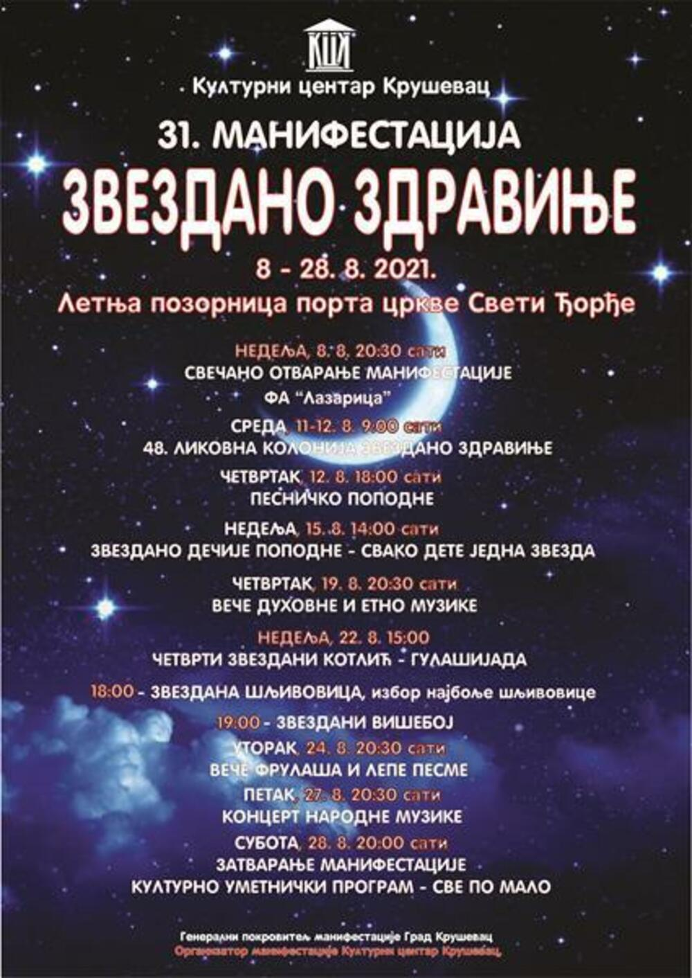
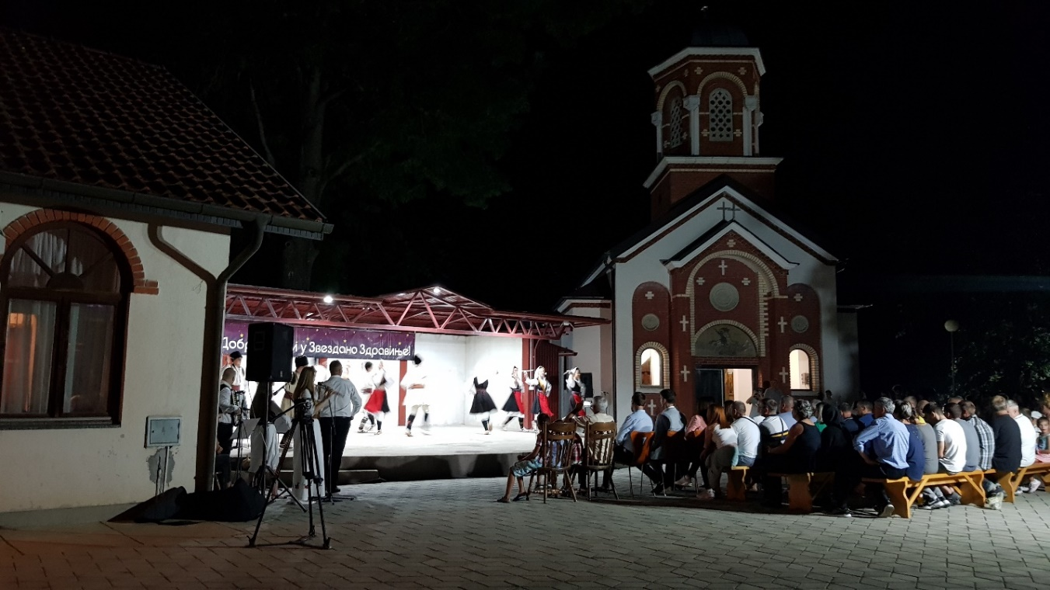
At the second concert with “Folk Ansambl Lazarica” we performed the same dances and songs, just in a different order. This time we were opening Zvezdano Zdravinje (Stary Zdravinje) cultural manifestation in a village near Kruševac. Zvezdano Zdravinje is a 20-day festival that happens in August at the grounds of St. George church in Zdravinje. The poster (Figure 6) contains similar happenings to the Vidovdan manifestation. Our group “Lazarica” opened the manifestation, followed by a visual art competition, poetic afternoon, children’s afternoon, night of spiritual and ethno music, competition in cooking goulash, brewing plum brandy “šljivovica”, athletic competitions, a night of flute and fine music, folk music concert, and closing with “sve po malo” (“a little bit of everything”). What made this concert meaningful for me was Marjan’s personal connection with the place. His wife is from Zdravinje, so he showed me the café where the first met, and I also got to know the rest of his family better.
Figure 20: Poster for Zvezdano Zdravinje cultural manifestation

Figure 21:Folk Amsambl Lazarica dancing on stage during Zvezdano Zdravinje, the orchestra is to the left of the stage, audience is sitting on wooden benches, St. George church courtyard with the church on the right

Chapter 5: Anatomy and embodiment of tradition
Folklore cannot exist without the people or the “folk”, but its existence is not merely in people’s heads and their shared beliefs and values. Folklore is in a constant, dynamic dialogue with nature and bodies, human or non-human. Music in particular has the power to affect physical bodies and physical bodies have the ability, and even need, to produce music. As such, music is a powerful aspect of a nation and is felt and experienced on both individual and collective bodies. The body is the smallest, grassroots place of identity (re)formation and further ethnonationalism. In order to explore how cultures and traditions can be embodied, I discuss their dialogues with nature (human and non-human), metaphors used to describe the embodied nature of folklore, language ideologies, and the pedagogy of performing.
Human and non-human nature came up as themes many times during my fieldwork. When talking about human nature, participants discussed socio-cultural and biological aspects such as ethnicity/nationality, gender, class, age, emotions, geography/regionality, and human anatomy. Non-human nature is more self-explanatory referring to the natural world. This is not to say that humans and nature are opposites because they are both comprised of living and non-living aspects. However, breaking down these different meanings of human and non-human nature allows me to go deeper into the topic and show various forms tradition can take.

Ethnonationalism
Ethnicity or nationality is often tied to forms of membership to a group. As Simpson distinguishes in describing two ways of becoming a member of the Mohawk people, there are members and there are citizens. To be a member of a group, one usually must have blood and kinship relations with the group. On the contrary, citizenship requires that a member lives (or lived) on the territory, interacts with the people, and participates in all the required responsibilities required by those in positions of power. Ethnicity is tied to membership, while nationality corresponds to citizenship (174). In some cases, these two forms of belonging overlap, which is often the case with Serbia. One exception would be the Serb population in Bosnia and Herzegovina which has strong ethnic ties to Serbia but remains nationally Bosnian. More recently, Serbians began moving to other countries to seek better living situations and became more transnational. In the future, I suspect membership and citizenship, or ethnicity and nationalism will be seen as more distinct. But as of now, ethnic and national belonging are still thought of as interchangeable at the expense of minority groups in Serbia, not only for Serbians but also other culture groups my interviewees reference. Hence, I will use the term “ethno-nationalities” to refer to this combination of membership and citizenship.
Marjan, the music teacher and orchestra director in the folk group with which I did participant-observation, often contrasted Serbians to other ethno-nationalities such as Germans, French, Italians, Canadians, Swiss, and Americans (excluding Native Americans). This is a form of negative identification based on who or what one group is not, and it is an important tool used by empowered members of the group to draw boundaries with other groups. One such example was when Marjan criticized Serbian (music) schools for implementing German, Italian, and French educational systems. His main criticism was that Serbian people have a different nature and Western European education is not suitable for Serbian mentality. In his words,
I cannot say that they are on a maybe higher level musically, but that is their sensibility, it is their emotion, it is their place. We try to understand it, but we cannot understand it. We do not have that kind of temperament, we are a different type of people, simply. And now you can, I can learn it, of course, because you have to learn to finish school. But you will probably never understand it completely because you don’t live with it. It is not a part of you. [italicized for emphasis].
What Marjan reflected on here is how foreign education and curricula are specifically tailored to the members of the community rather than a presumably generalized audience. However, he did not concretely locate the problem of schooling in history and or other institutions but explained it through essential human nature.
Marjan further characterizes Serbians by contrasting us with Canadians and Swiss in terms of how we experience nature. As he said, “Even though Canadians, or Swiss, they go out every week to spend time in nature, but they somehow, they somehow falsely, they did not relate to nature, they don’t feel it. Well, they go to use nature, but do not feel, do not live in accordance with it.” The same argument can be heard by many who are opposed to industrialization and/or have lost land due to various state projects that value profit more than care about the environment. Simpsons, whom I mentioned earlier, talks about the devastating consequences of European settlement in North America on nature which led to major displacements of the Native Americans. Anthropologist Perrenas also advocates for humans and orangutans in Sarawak whose homelands have been destroyed due to massive plantations and industrialization in general as a consequence of British colonialism. In De Leon’s “Land of Open Graves”, nature is more clearly used by the government to prevent migration through death in the harsh desert conditions, thus shifting the blame for their own agenda.
Serbians, like many other people, communicate with nature through music and sound. Lola mentioned the deep rootedness of music in humans as a way to communicate with the natural world. Their voices and music were reactions to animals or thunder or other happenings in the environment. Over time, specific songs were performed in relation to specific goals – “dodolske” songs were sung to summon rain, “žetelačke” songs were sung during harvest, “koledarske” songs were sung early in the year to welcome the Sun and are often tied to Christmas.
Even though Serbia has never been colonized and Marjan’s example does not involve Serbian territory, he reinforces that Serbians have a different nature in the way we interact with it. The word I translated to “relate” is Serbian “srodili” which comes from “rod” or family. So, what Marjan is saying is that perhaps there is a form of kinship and relatedness between Serbians and nature that is lacking in what we commonly referred to as “Western” societies. “Western” is not the best term to describe the differences because it lacks specificity. However, many people seem to have a mutual understanding of what is meant by the term, and I take it as societies that were significantly influenced by Enlightenment ways of thinking from the 18th century. In the same example, Marjan assimilates Serbians to Africans, which is another label that is too broad and can be disrespectful of the diversity of peoples in Africa. Marjan explained that Serbian and African music is similar because we both come from poorer areas and live more primitively than the others. He then corrected himself, knowing that “primitive” is not the right term to describe our ways of life, but he failed to find a better term. Here the ideas of primordialism, or that the people today are the same as people in the history, as well as of contemporary ancestors, or that one can go experience history in the present, occur again. For Marjan, to be a remnant of history is to have connections to nature.
In my interview with the Hinić family, Serbian nature as distinct from other ethno-nationalities came up as well. They did not concretely compare it to other ethno-nationalities, but they made a universal claim of a unique Serbian nature. “We are just about the only people, and I do not mean only Serbia, I mean all the Serbian people, despite religious orientation, that cheer to a sad song in a pub.” Lola noted that by “Serbian” she does not mean only the people in Serbia, so her identification extends to members on top of citizens. Lola also gave examples of where this happens – in weddings, on baptisms, and parties. Ina jokingly added that the only thing left is to start dancing at funerals. The types of songs that people cheer to, but are sad in character, I already talked about in terms of what I played to non-Americans before my fieldwork. “The Queen of My Heart” is an example of those types of songs. This claim points back to the idea of a Serbian nature. Historically, Serbians did not face anything that other people have not as well, but the unique dynamics and history do play a role in forming the Serbian “nature”.

Gender
Embodied traditions are gendered based on socio-cultural roles and expectations for how men and women should act. Dances are always performed in a way that everybody has a pair from the opposite sex, or they are only male or female dances. The clothing also diminishes any ambiguity as men always wear pants and women always wear skirts and dresses in performances. Full Serbian national clothing has the same basic formula – for women, it includes a long dress, a vest, an apron, a sash, woolen socks, and leather shoes, while men wear a long-sleeved shirt, baggy pants, a vest, a sash, woolen socks, and leather shoes (see image below). This formula also extends to many other Slavic groups. However, just like different counties might have unique songs and dances, so does the clothing vary between different regions in Serbia. These variations include colors, materials, patterns, or additions of elements like hats, ducats, scarfs, skirts, et cetera.
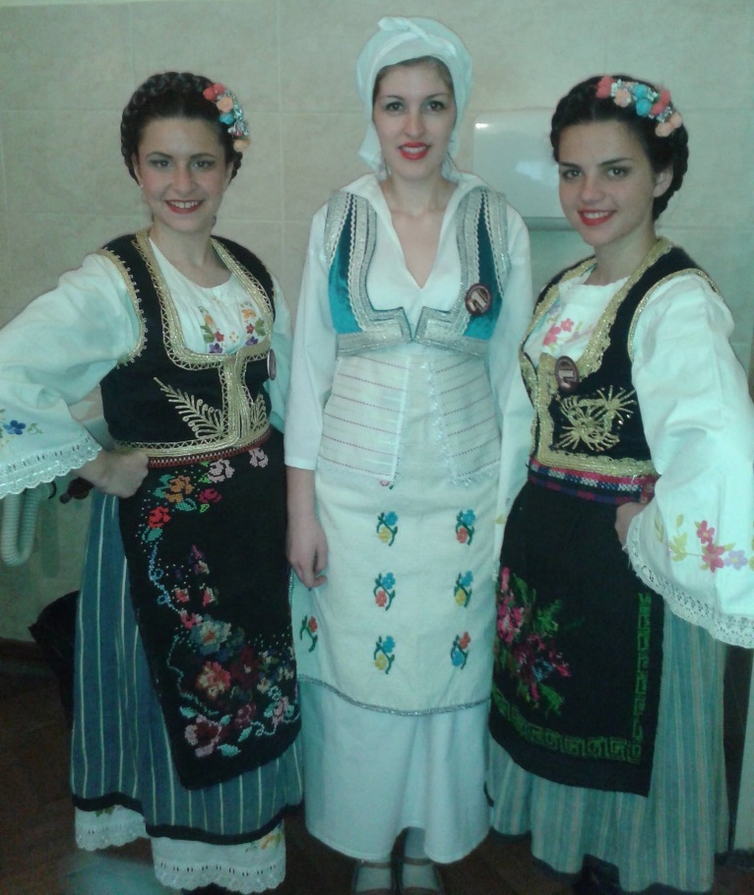
Women’s dresses are usually long white dresses, just like we had in “Etno Grupa Lazarice”. They often have the same embroidery on the chest and/or the front bottom. However, unlike “Lazarice”, these dresses would commonly be long-sleeved, and women would tie red ribbons around the upper arms. Often these ribbons matched the ones used to tie the braids in their hair. Red ribbons are deemed functional in Serbian culture as protections against spells. Parents would tie a red string around their newborn baby’s wrist, a practice that is still common today. Over the dresses, women wear a vest. Vests are waist-length, but some can be longer like the Montenegrian vests which are knee-length. Usually, vests are velvet black embroidered with golden thread, but sometimes they can be velvet red with golden thread. It is uncommon to see any different colored vests, but it is common for the vest to match the apron. The apron can be either the same material as the vest or woolen. They represent the most colorful part of women’s clothing, and the patterns vary geographically. Sometimes the apron is supported with a woolen sash tied around the waist. Woolen sashes and woolen socks are worn by both men and women. Socks are often black and also embroidered with colorful patterns. The most common embroidery pattern are flowers. Finally, brown leather shoes worn are made out of animal skin, usually pigs, which makes them waterproof, soft, and flexible. Men’s shoes usually have a hook at the top of the toes to differentiate from women’s shoes.
Figure 22: Various examples of women's Serbian traditional clothing
People from my hometown of Kruševac and the region are often referred to as “Čarapani” or the “sock people”. There are two stories, or perhaps legends, about the etymology of “Čarapani” that both Marjan and my grandpa mentioned. The first story is that during the Ottoman occupation Kruševac people made a surprise attack on the Ottoman army one night. They took off their shoes and walked in socks only, which enabled them to sneak up and kill Ottoman army officers and commandments one by one. Due to this military strategy, we became the “sock people”. The other story that I heard from Marjan for the first time is that the people from Kruševac danced so vigorously that their shoes eventually fell off and they continued dancing in their socks. Both stories are examples of how material and physical characteristics from history become a part of one’s identity, just like skin color, sexual characteristics, and other visual markers become a marker of a people. The first story is gendered because men were the only ones who fought the Ottomans, but the term “sock people” was extended to identify the whole population, reflecting the patriarchal social values.

Age
Age and gender are often interrelated in embodied tradition as singing is more common in older females. My singing group “Lazarice” was an exception at the time because of our young age. At most competitions and performances that we went to other competitors and guests were older women who are themselves the source of most of the recorded songs today. There were older men as well, but they were competing in a separate category. Today there are more younger singing groups, often formed within folk ensembles (KUDs). After the Eurovision hosted by Ukraine, Ukrainians experienced a return to folklore and ethnomusicology, as Sonevytsky describes. I suspect that the same is happening in Serbia but resulting from the contested national identity due to Kosovo and aspiring membership with the European Union. However, Ina reflected on the time when we were the only young group expressing her frustrations with the “grandmas” always winning. To comfort herself, Ina jokes that these “grandmas” are awarded because the occasion might be their last opportunity to win an award. I believe that Ina’s comment has some truth in it, but I also believe that awards were influenced by the idea of authenticity, and Marjan’s descriptions of what makes “grandmas” unique offers a perspective on that.
Marjan describes how the “grandmas’” style of singing differs from our group’s and other more modern interpretations of folk songs by grounding it in human and non-human nature. Marjan emphasized that the way older women sang corresponded to the way they talked, which was related to their natural environment. They were “throaty” as he would describe them. Since they lived in the hills and mountains, they had to talk more loudly to bridge the distance, and I will talk more about the idea of how geography influences bodies. While the older generations talked and sang louder, the younger ones have to yell and shout in order to achieve authenticity. Authenticity is the idea that one thing is more real and true than the other, often discriminating the non-authentic forms. However, authenticity is always fluid and not everyone agrees on what is authentic. What is authentic is based on who has the power and/or knowledge to say what is authentic and what is not. In Serbia, those who claimed a song, or a dance are seen as authentic, and everybody else’s goal is to replicate that. I was told to sing a song that I knew before, but I was asked to do the version from a particular artist who claimed it and had the power to make it famous. In the same manner, younger singing groups try to imitate these “grandmas” to retain authenticity.
Marjan continued his comparison saying that “grandmas” talked through a smile and today people talk with a closed mouth. “Grandmas” had blush in their cheeks, and they were not ashamed to say anything because they lived naturally. They were not cunning but spoke their minds. To give an example, Marjan recalled an encounter with the elderly from the Kopaonik mountain, “I cannot describe to you how beautiful it is when one talks with a full voice. Every letter explodes. That is incredible how they talk. You cannot learn that in school. This man has not been in school even for a day. But he speaks clearly because it is important for him that others understand him.” In this quote Marjan again contrasts nature and nurture in a way that suggests that it is impossible for younger generations to learn that authenticity. This is a clear example of how tradition and heritage are seen as different – while for the “grandmas” singing is tradition because this tradition is more “natural” for them, for our group it is heritage or reproduction of tradition. While appealing, this ideology erases the ways the “grandmas” were enculturated just like us. The new ways of life after globalization and modernization have changed the natural world, and hence, people’s nature, making the old ways seem more authentic.

Socio-economic status
Class or socio-economic status is often inseparable from the body and is determined by existing ideologies of difference. In Serbia, Roma people are systemically discriminated which needs to be addressed, but for this purpose I will focus on class distinctions which happened because of urbanization. During the Middle Ages, people began building more dense fortifications, like the one I described during the Vidovdan Manifestations. Those were the first cities and, as my grandpa described, that was where managers of the workers lived. The physical and functional separation of village workers and city dwellers led to different clothing styles, as well as art. Serbian music genre that characterized those who lived in the city as a way of separating from the folk was the “old town music” or “starogradska muzika”.
The folk clothing that I described earlier was not the typical Serbian clothing at the time. Lola explains that only those who were able to afford better outfits wore skirts and vests or had golden thread. The only exceptions were during special occasions. However, today’s definition of traditional clothing does not go as far back in time, and it is more easily traced back. Some changes came as a result of modern laws. Traditional dresses were made out of hemp, but since hemp is a form of cannabis its production was terminated to discourage drug production in the ‘50s and ‘60s. It is worth mentioning that Serbia is the biggest drug exporter in Europe today, but traditions have already been changed when security and profit were deemed more important, and tradition was deemed expandable.
Going back to class and status, Marjan highlighted the importance of admitting and remembering that Serbians, and even the whole world, originated from villagers. He saw the problem with people forgetting their origins and becoming preoccupied with their upward social and economic mobility. But he believes that Serbians are still more attached to their families and have a better awareness of their origins and are not ashamed to admit it. I would say that there is more to this awareness, and I do not believe that Serbians are the only people who are more aware. Modernization and massive urbanization came later in some places than others, so therefore it is easier for Serbians to remember more traditional ways of living.

Emotion
The relationship between music and emotion is a clear one – music allows people to express their natural responses and feelings. So, how is this portrayed in Serbian folklore and ethnomusicology? Marjan often ponders how the people who wrote the songs were thinking and feeling to better interpret them. He gives an example of a well-known folk song “Tri Livade” or “Three Meadows” and imagines what circumstances may have led to its production. Marjan describes,
“Nobody made them [songs] up, but it simply came out of them. For example, a man goes to harvest today and in 45 degrees [Celsius] and he gets too worked up and sees a shade and them makes up, says ‘three meadows, nowhere a shade’. […] He did not imagine that, but suffering made him do it. […] So only one grafted rose he can’t hide under. And then, pay attention, he sings and everybody else joins. They, our ancestors, had that moment where they organized themselves very quickly. So, it wasn’t only one man in the field to work. But the whole village goes to his field. And then they go to the second field, to the third field. And then, one starts singing ‘three meadows’, and if they like it everybody starts singing. And they sing the whole day. And they go to do spinning in the evening and sing there.”
Through this example, Marjan was reiterating that music is a natural response to emotional situations. It is not an action one is actively trying to have control over. Moreover, even though singing is an individualistic expression, it is taken up by others who support each other during their work.
Marjan also commented that our ancestors were not motivated by money, unlike people today, but their motivations were relief and community building. Marjan gave an example from the past, “It [a song] describes the nature and it has to be cheerful. Why does it have to be cheerful? Because these people were in tough situations when they produced them. They didn’t need sad music that will make them more miserable. He’s been digging all day – don’t sing him a sad song, he will kill you with his hoe.” Still, in another example, Marjan showed that people today also seek relief in music saying that when he is sleepy and has a lot of work to do, he doesn’t want to listen to ballads because he will fall asleep. In both cases, music retains the same function, but other factors influenced the change in the way music infuses our lives.
Technology has enabled us today to have constant access to music, while in the past people were only exposed to sounds from nature and what they produced. The need to express one’s emotion through music is the same today as it was in the past, but the means of expression have changed. This is also not a one-way street where humans respond emotionally to foreign stimuli. The process is much more complicated and the foreign stimuli impact emotions and vice versa continuously and simultaneously. However, Marjan continues his criticism of today’s society by saying that people’s emotions today are mixed or polluted, while back in the days people’s emotions were clean. This brings back his idea that “grandmas” have no shame and speak their mind because they lived naturally. On the contrary, modern people are overwhelmed by an abundance of emotional stimuli so that our emotions and emotional relations became much more complicated. There is no way we can test this today, but we can say for sure that in this time of globalization everybody has an ability to take in a larger amount of information at a faster pace than ever before.
One major issue Marjan often came back to when comparing old and new musicians is individual expression. He explained, “When I hear a musician, I know who is playing. I know exactly who is playing that accordion because they have that kind of an impression. I only cannot recognize these new musicians because they don’t have that. They are dactylographers.” Marjan used the metaphor of a “dactylographer,” or somebody who types what they hear, to explain how the styles and motivations of new musicians have changed. In the past, the main goal of a musician is to be original, but today most artists aim to reproduce these songs as authentically as possible, and as fast as possible. Marjan further added that children are the best musicians because they do not know how to imitate authenticity and “they do it from their own heart”. But once they get educated, children lose this ability and are taught to be dactylographers and robots. This is a powerful statement coming from Marjan because it shows that Marjan as a teacher is also bounded by the educational system which is controlled by those in power. Their goal is to implement Western European ideals into Serbian schools and encourage reproduction of tradition because it further aligns with their primordialist projects.

Geography
Emotions expressed by musicians are also dependent on geography and are seen as regionally authentic. Responding to my question about what is authentic, Marjan responded,
authentic is how those people expressed their hearts. If that Vlah [Eastern Serbia] poured his heart out in that way, it is authentic. It’s his heart. If this Šumadinac [Western Serbia] poured it out like that, it’s his heart and it’s authentic. And that should not be changed. […] One shouldn’t mix Šumadinac with Vlah. One shouldn’t mix ornaments and emotions of Šumadija with ornaments and emotions of Vlah. And unfortunately, our musicians do that.
In his response, Marjan combined emotion, authenticity, regionality, and anatomy. By doing this, Marjan demonstrated the connection between cultural and natural elements in music. Geographic regions are determined based on natural and cultural boundaries; emotions are universally natural but how they are expressed varies culturally; what is authentic is seemingly universally understood even though it is a learned cultural category (Naomi Leite calls this phenomenon “productive miscommunication”); and human anatomy is biologically the same, but culturally different in this example.
Lola also compares different regions which further affect the singing styles. Where she grew up in Herzegovina, the geography is more mountainous, and the villages are widely dispersed. Hence, people have to naturally speak more loudly to be heard over the hill. She contrasted Herzegovina with Vojvodina, the North of Serbia’s part of the big Pannonian Basin. The geography of the Basin is very flat in comparison to the mountainous Herzegovina, so communication and singing styles are different. Once again, Lola’s example suggests that there is a relationship between one’s environment, and their nature and culture. This relationship is not only seen as a correlation, but causation – the geography of the area a person grew up in will influence the way they talk and express themselves.

Anatomy
Finally, music production and reception happen through physical bodies, and these experiences were described in many ways to explain as well as teach musical forms. When it comes to musical production, depending on the genre, various body techniques are used to learn how to produce desirable sounds. In a choir, for example, one might be told to round the mouth. In Serbian ethno-singing, however, we are often told to smile while we sing. Marjan explains that smiling in ethno-singing is not just a technique; our ancestors would naturally smile while singing both to look attractive but also because singing gave them joy. From my experiences singing with “Lazarice”, we would also smile to look pretty on stage, but we were also taught by our teacher to smile while we sing in order to produce the “authentic” sounds. Mia and Ina expressed discomfort they felt singing sad or disturbing songs with a smile on their face. Even though we do not know for sure whether people in the past always smiled while singing the songs, we also do not know much about the contexts the stories behind the songs came from and the contexts during which they were sung. For today’s generations, leisure music sounds a lot different, and smiling does not seem “natural” anymore.
In addition to smiling, Marjan adds another component to ethno-singing in the past. He talks about having a relaxed throat as opposed to tightened. In his criticism of today’s music educational system, Marjan points at the mistake professors make teaching their students to tighten their throats. For him, tightened throat is typical for stylized singing where everybody needs to sing like one. However, this is not how people in the past used to sing because their aims were different. To Marjan, a tightening one’s throat is not natural because everyone’s throat vibrates differently as the result of different throat and cord lengths. If all singers relax their throats there would be a clash of vibrations, which is not characteristic of Serbian folk music. On the contrary, one person would lead in a way that is natural to them, and others would support them by “droning” one tone in unison. Ethno-singing is also called “front voice” by Marjan, and it is easier to explain it by contrasting it with choir singing or “back voice”. To better understand the difference between head/stomach/choral/diaphragm singing and throat singing, I included two videos in the footnote. The first one is a member of our group singing with her head voice, and the second one is with our group all singing throatly.
Marjan continued to describe choir singing through anatomy. Choir singing starts from the stomach, the vibrations are felt in the vocal cords and those impulses are further sent to the brain. As Marjan explained, “we don’t let it [the tone] pass through the mouth but using our tongue we bounce it back to our brain to hear it”. That tone usually leaves the body through the mouth shaped in a certain way. In ethno singing it is impossible to, using the same metaphor, prevent a tone from passing through the mouth. The tone is created in the throat and cannot be heard before it is let out. But despite its “wildness,” as Sonevytsky characterizes ethno singing, there are some rules that need to be followed. Marjan warned that one should not sing louder than their natural talking voice because that would mean yelling and shouting, which he described as “ugly”. He went back to the example of the “grandmas” who lived in the mountains because their natural voice was loud, so their singing was naturally louder. But if we today try to replicate their style of singing with authenticity in mind, most of us would have to yell. Good singing for Marjan is not identical replicating of “grandmas’” singing but singing in a way that feels natural, which often means giving up on the ideology of authenticity. Furthermore, instead of trying to sing loudly, Marjan found it imperative to sing clearly. With the technology we have today, it is always possible to turn up the volume, but if a singer lacks clarity there is little that could help.
Ina recalled a frustrating situation when sound people at a recording studio tried to compensate her singing with technology. Ina was given little time to prepare for recording a new song and even though she went to the recording studio she was very dissatisfied with her performance. But instead of giving her more time to practice, the sound people kept encouraging her that she was going great, and they can use autotune to, as we say in Serbia, “iron” or flatten the melody. Ina’s example reinforced what Marjan said about the inability to fix the lack of clarity or confidence in oneself. As Marjan explained, if you sing clearly and with a smile you look confident even if your singing is not perfect. Marjan further gave an example of how quiet but clear singing can be very affective (evoking emotion). Toše Proeski was a Macedonian pop singer in the early 2000s who was popular all over the Balkans. BBC even called him the “Elvis Presley of the Balkans”. In Marjan’s words, “Do you know how much, for example, Toše Proeski whispered, ‘man of God’!? And what a singer he was in comparison to the others! One can yell as much as they want, but they can’t sing a song by Toše Proeski the way he sung it. He whispered! And how clear! How emotional, how beautiful! That’s the end. I don’t need to tell you anything else, it’s all clear when I say ‘Toše Proeski’. So, he never yelled in his life. Why are you yelling so your throat hurts later? There is no reason for that”. We are all unique by nature and Marjan encourages us to embrace that in our singing instead of trying to be somebody else.
Marjan further expressed beliefs about God as the main actor determining human nature, which then influences how one expresses themselves. He talked about the “color of the voice”, which is a Serbian expression for tone of voice, as a gift from God. One cannot change the “color of their voice”. He gave himself as an example differentiating between his skills and his nature. Marjan believes that he does not have a nice “voice color” and thus, cannot sing perfectly, but regardless he can sing accurately. Through this example, Marjan revealed a common belief that some people are naturally more talented than others because there are certain things that cannot be taught. Lola gives herself as an example of someone who has perfect pitch in listening but is unable to replicate it with her voice. Lola’s anatomy or human nature or gift from God, however one might call it, prevents her from singing perfectly. Again, this is an ideology that there is such a thing as “perfect” singing. What is “perfect” is culturally determined and always in flux. However, humans tend to seek explanations for human differences by resorting to biology, nature, and numbers as “more concrete” and tangible. The same debates surround race, gender, and other ways of categorization that combine human nature and culture to help us explain why some people are similar or different from one another.
When I told Marjan that there is no logical explanation why I sing ethno music because my parents listen to completely different genres, he replied, “Well genes. It’s blood, you can’t change that. That’s in you. That will, thank God, be in your child as well”. There is no gene for singing ethno music, but the idea that my blood carries many generations of Serbians is a powerful explanation for the continuation of a nation, another example of the primordialism of nationalist ideologies. Marjan gave an example of how epic songs evoke the sense of nationality. National anthems are modern epic songs which function to build morale and patriotism in citizens. In Marjan’s words, “When the anthem plays you have a responsibility to stand up, not because you are supposed to stand up, but because you have to, your legs are making you stand up. You have a responsibility towards that anthem”. Nationalism in this case is an embodied experience where the song creates a sense of unity between the people. Benedict Anderson calls this “imagined community” because the unity of singing the anthem is more powerful than the individual differences.
In some cases, biological human nature can be broken down even further for Serbians. Using common sayings about people from different regions, Marjan continued to describe human differences through anatomy. He gave an example of Vlah people of Eastern Serbia who say about themselves that their hearts beat differently. Instead of flat “tak-tak”, they explain that their hearts beat “ták-tak, ták-tak”. They joke around this to explain why their music sounds differently than in other regions in Serbia. Marjan was open to the possibility of this being true, but it remains an anecdote. It also highlights how difficult it is to separate biological and cultural aspects of music or expressing oneself through art. In dancing, Marjan explained that one has to dance almost like they have a bad hip and waddle, embodying Vlah music and rhythms. When I was talking to Lola, Mia, and Ina about music we discussed how babies hear their mother’s heartbeat and that is widely thought to relate to people’s sense of rhythm. The connection between music and bodies is certain, but the ideologies and beliefs around this vary cross-culturally.
In some cases, human bodies act as instruments, and in other cases music is thought of as a living thing. Lola gives an example of “Gluvo Glamočko Kolo”, a “deaf” dance from Glamoč (Bosnia and Herzegovina). As the name suggests, the dance is performed without any music, but human bodies create the rhythm everyone follows. During my fieldwork, I observed how stomping, clapping, and vocalizing are often used as signals to everyone else to set the pace. Nevertheless, for singing and playing an instrument, there is a fine line between following the rhythm and being like a machine. During one of our rehearsals, Marjan tried to explain Boban, the tapan (double-handed drum) player, that he should not play like a computer. As he explained, if he wanted a computer, he would have played the rhythm on a computer. When a human plays, they can switch between speed, volume, and control everything in relation to the rest of the orchestra. Their playing is imperfect but at the same time must be good enough to lead the dancers and/or singers.
Music can be alive or dead, according to Marjan. It is the musician’s role to bring music to life by becoming so familiar with it through practice that it becomes an extension of oneself. In relation to the previous example, computers play dead music and only humans can bring music to life. There are exceptions to this rule – Marjan gave an example of Aretha Franklin who can evoke an emotion in you even if you listen to her through a dead computer. To better describe the way humans can bring music to life, Marjan provided an analogy of Frankenstein bringing his monster to life. Without Frankenstein, the monster would never have come to life on its own. Frankenstein arranged all the elements together to create something meaningful, just like a musician arranges the musical elements together in a meaningful way. Going back to a previous example, national anthems are alive because they evoke an embodied response in those who hear it. Music evokes an emotional response or affect, regardless of whether that emotion is positive or negative, but it physically affects the body. Both the producer and the receiver embody music so deeply that it becomes a significant part of one’s identity. As such it can also serve as a tool to bolster a sense of community through shared experiences of embodied identity.

Chapter 6: Conclusion
In this paper, I offered examples of what I identified as grassroots ethnonationalism. As seen through many stories offered in this essay, the sense of community and heritage production happens from the bottoms-up, from the youngest age and family up to the level of a nation through enculturation. The example of Serbia provides a nuanced view on what we think of in terms of ethnic identity and nationalism, folklore and ethnomusicology, authenticity, embodiment of tradition, and categories of human difference. I began my account by tracing the history of Serbia, Serbian folklore and ethnomusicology, and my personal history. Then I talked about cultural manifestations as public and two groups as private sites of heritage (re)production. Finally, I broke down aspects of identity where culture is embodied, and heritage is (re)produced.
I remain hesitant to generalize Serbian example to other Southern Slavic or ex-Yugoslavia countries. There are valuable differences that should be accounted for before nonchalantly putting them under the same label. In the future, I would be curious to broaden my research to non-Serbian folklore and singing groups to uncover the power hierarchies that operate in the Balkan territories. I am also interested to see the reception of the term “grassroots ethnonationalism” and possible applications of this thinking tool in other contexts.
WORKS CITED
Anderson, Benedict. “Introduction.” In Imagined Communities: Reflections on the Origin and Spread of Nationalism, London: Verso Books, Revised Edition, 1983.
Austin, J. L. How to Do Things with Words. Oxford University Press, 1962.
Bakhtin, Mikhail M. “Forms of Time and the Chronotope of the Novel.” The Dialogic Imagination: Four Essays, University of Texas Press, Austin, 1895-1975, pp. 84-110.
Barth, Fredrik, and Universitetet i Bergen. Ethnic Groups and Boundaries: the Social Organization of Culture Difference, edited by Fredrik Barth, Waveland Press, Inc., 1998.
Basso, Keith. Wisdom Sits in Places: Landscape and Language Among the Western Apache. University of New Mexico Press, 1996.
Bendix, Regina. In Search of Authenticity: The Formation of Folklore Studies. University of Wisconsin Press, 1997.
Chowdury, R, et al. “Power of Paradox: Grassroots Organizations’ Legitimacy Strategies Over Time.” Business & Society, vol. 60, no. 2, 2021, pp. 420–453.
Ćorović, Vladimir. Istorija Srpskog Naroda. CreateSpace Independent Publishing Platform, 2015.
De León, Jason. The Land of Open Graves: Living and Dying on the Migrant Trail / Jason De Leon; with Photographs by Michael Wells. University of California Press, 2015.
Dimitrijević, Slobodan, & Ružica. Personal Interview, Summer 2021.
Duranti, Alessandro. “The Scope of Lingustic Anthropology.” Linguistic Anthropology, Cambridge University Press, 2013 [1997].
Đorđević, Dimitrije. “The role of St. Vitus Day in modern Serbian history.” Serbian Studies. North American Society for Serbian Studies. Vol. 5 (3), 1990, pp. 33–40.
Eidsheim, Nina Sun. Sensing Sound: Singing and Listening as Vibrational Practice. Duke University Press, 2015.
Feld, Steven. “acoustemology.” In keywords in sound, edited by David Novak and Matt Sakakkeeny, Duke University Press, 2015, pp. 12-21.
Gal, Susan, and Judith T. Irvine. “The Boundaries of Languages and Disciplines: How Ideologies Construct Differences.” Social Research, vol. 62, no. 4, 1995, pp. 967-1001.
Gray, Lila Ellen. Fado Resounding: Affective Politics and Urban Life. Duke University Press, 2013.
Herder, Johann Gottfried, and Barnard, F. M. J. G. Herder on Social and Political Culture; Translated, Edited and with an Introduction by F. M. Barnard. Cambridge University Press, 1969.
Herzfeld, Michael. Cultural Intimacy, 2nd edition, Routledge, New York, 2005.
Hinić, Lola, Mia, and Ina. Personal Interview, 07/30/2021.
Hobsbawm, Eric. “Introduction: Inventing Tradition.” In The Invention of Tradition, edited by Hobsbawm and Ranger, Cambridge University Press, 1983 [2012].
Hofman, Ana. “Introduction to the Co-Edited Issue ‘Music, Affect and Memory Politics in Post-Yugoslav space.” Southeastern Europe, Vol. 39, 2015.
Hofman, Ana. “Staging Socialist Femininity: Gender Politics and Folklore Performance in Serbia.” Brill Academic Hub, 2010.
Ignjatović, Aleksandar. “Images of the Nation Foreseen: Ivan Meštrović’s Vidovdan Temple and Primordial Yugoslavism.” Slavic Review, vol. 73, no. 4, [Cambridge University Press, Association for Slavic, East European, and Eurasian Studies], 2014, pp. 828–858, https://doi.org/10.5612/slavicreview.73.4.828.
Kirshenblatt-Gimblett, Barbara. Destination Culture: Tourism, Museums, and Heritage. Barbara Kirshenblatt-Gimblett. University of California Press, 1998.
Myerhoff, Barbara. Number Our Days: A Triumph of Continuity and Culture Among Jewish Old People in an Urban Ghetto. E. P. Dutton, 1978.
Nettl, Bruno. “The Dual Nature of Ethnomusicology in North America: The Contributions of Charles Seeger and George Herzog.” In Comparative Musicology and Anthropology of Music, edited by Bruno Nettl and Phillip V. Bohlman, University of Chicago Press, 1991.
Nikolić, Marjan. Personal Interview, 08/06/2021.
Ozkirimli, Umut. “Chapter 3: Primordialism/Perennialism.” In Theories of Nationalism: A Critical Introduction, 3rd edition, Palgrave, 2000 [2017].
Petrović, Edit. “Ethnonationalism and the Dissolution of Yugoslavia.” in Neighbors at War: anthropological perspectives on Yugoslav ethnicity, culture, and history, edited by Joel Martin Halpern, David A. Kideckel, Penn State Press, 2000.
Samuels, David William. Putting a Song on Top of it: Expression and Identity on the San Carlos Apache Reservation. 3rd edition, University of Arizona Press, 2006.
Schenker, Alexander M. The Dawn of Slavic: An Introduction to Slavic Philology. Yale University Press, 1995.
Sherzer, Joel. Speech Play and Verbal Art / by Joel Sherzer. 1st ed., University of Texas Press, 2002.
Simpson, Audra. Mohawk Interruptus: Political Life Across the Borders of Settler States. Durham: Duke University Press, 2014.
Sonevytsky, Maria. Wild Music: Sound and Sovereignty in Ukraine. Wesleyan University Press, 2019.
Songs of the Serbian People: From the Collections of Vuk Karadžić, translated and edited by Milne Holton and Vasa D. Mihailovich, University of Pittsburg Press, 1997.
Stanojević, Stanoje. Istorija Srba, Hrvata i Slovenaca. Napredak, 1920.
The Cambridge History of World Music, edited by Philip Bohlman, Cambridge University Press, 2013.
Trouillot, Michel-Rolph. Silencing the Past: Power and the Production of History. Beacon Press, 2015.
Uphoff, Norman. “Grassroots Organizations and NGOs in Rural Development: Opportunities with Diminishing States and Expanding Markets.” World Development, vol. 21, no. 4, 1993, pp. 607–622.0
“UWC – What is UWC?.” 2017-2022, https://www.uwc.org/about, Accessed 2 April 2021.
“Vuk Stefanović Karadžić.” Britannica Academic, Encyclopædia Britannica, 16 Nov. 2009. academic.eb.com/levels/collegiate/article/Vuk-Stefanovi%C4%87-Karad%C5%BEi%C4%87/44674. Accessed 15 December 2021.

Based on Borisav Stanković’s play
Ohrid is a lake in Macedonia
Drina is a river mostly following the border between Serbia and Bosnia and Herzegovina
Željko Joksimović – Lane Moje (2004) https://www.youtube.com/watch?v=z7OvpjplJ_8
Danica Crnogorčević – Veseli Se Srpski Rode (2020) https://www.youtube.com/watch?v=50t-8B0v9CI
Mc Yanko ft Milica Todorović – Moje Zlato (2014) https://www.youtube.com/watch?v=7mKnLVqDCIM
Grupa Trag – Kad Ljevčansko Žito Zatalasa (2013) https://www.youtube.com/watch?v=Gh1CxDSiQWg
Šarlo Akrobata – Ona Se Budi (1981) https://www.youtube.com/watch?v=XqkP4YORpZk
Elitni Odredi – Ne Koči (2012) https://www.youtube.com/watch?v=b9k889LgJp0
Šaban Šaulić – Kraljice Srca Moga (1985) https://www.youtube.com/watch?v=63aVTXx73mY
Serbian Orthodox music compilation https://www.youtube.com/watch?v=nolrXkQZ6Zs
“Vidovdan” by Gordana Lazarević, https://www.youtube.com/watch?v=-NzlnPNWEOM.
Kolo’s website http://kolo.rs/en/
Haos Animatori (Chaos Animators) website https://www.haosanimatori.com/
60 Najlepših Narodnih Pesama RTS YouTube https://www.youtube.com/playlist?list=PL1B3hFrP7wdr8JYcVGIsNfx0fKtflVHvA
Head singing: https://www.youtube.com/watch?v=9HPQpxcEPls
Throat singing: https://www.youtube.com/watch?v=_DmrqOELAVI
Here is my favorite song by Toše: https://www.youtube.com/watch?v=kFPebe7Tgg0
Gluvo Glamočko Kolo performed by Kulturno Umetničko Društvo (KUD) „Dimitrije Tucović“ https://www.youtube.com/watch?v=mGj2wCs7g-A

