University of Oklahoma

Graduate College

Understanding Specific Ion effects and interfacially active solutes using the cOLLIGATIVE pROPERTIES of mICROEMULSIONS

A Dissertation

submitted to the Graduate Faculty

in partial fulfillment of the requirements for the

Degree of

Doctor of Philosophy

By

michael Taylor warren
Norman, Oklahoma
2020

UNDERSTANDING SPECIFIC ION EFFECTS AND INTERFACIALLY ACTIVE SOLUTES USING THE COLLIGATIVE PROPERTIES OF MICROEMULSIONS

A Dissertation approved for the
School of Chemical, Biological and Materials Engineering

BY THE COMMITTEE CONSISTING OF

Dr. Jeffrey H. Harwell, Chair

Dr. Bor-Jier (Ben) Shiau

Dr. Keisha Walters

Dr. Paul Huang

Dr. Michele Galizia

© Copyright by michael taylor warren 2020
All Rights Reserved.

This dissertation is the culmination of many years of hard work and determination that could not have been possible without the support of my family, friends and colleagues. I am especially grateful for the opportunity the State of Oklahoma provided me and it was my hope to uplift the State through scholarship.

This work is dedicated to my late grandfather, Charles P. O’Farrell, my loving family, and my patient, supportive wife Meghan.

Acknowledgements
It is the author’s wish to thank the following:
First to the Asahi Glass Foundation in Chemical Engineering at the University of Oklahoma for funding this research. It was my hope to leave the blueprints and provide a path forward for Oklahomans within the advancing formulation field.
To my chair Dr. Harwell. If not for your confidence and advice this dissertation would not have been possible. Thank you for convincing me to take a chance on the University of Oklahoma.
To the co-chair Dr. Shiau, thank you for the insightful discussions and questions you posed during this time. A sincere thank you to my committee members, Dr. Walters, Dr. Huang, and Dr. Galizia for being available and providing encouragement to carry on throughout this work.
To the numerous postdocs, graduate students and undergraduates that I had the absolute pleasure of working with including Dr. Su, Parichat Phaodee, Pattamas Rattanaudom, Alexis Penny, Vikas Rudrappa, Sarah Stuart, and Marian Nhanga.

Table of Contents

Acknowledgements iv
List of Tables viii
List of Figures ix
Abstract xiii
CHAPTER 1: Introduction 1
CHAPTER 2: Background and Theory 4
Colligative Properties 4
Solute Hydration 7
Interfacially Active Solutes: Surfactants and Amphiphiles 9
Microemulsions and Bicontinuous Structures 12
CHAPTER 3: Evaluating Surfactant Interactions using the Hydrophilic Lipophilic Deviation (HLD) Concept 15
Introduction 15
Materials and Methods 18
Materials 18
Microemulsion Phase Behavior 19
Determination of Surfactant HLD Properties; Optimum Salinity 20
HPLC Method-Partition Coefficient 21
Results and Discussion 22
Reference Surfactants 22
Anionic Mixtures 26
Anionic-Nonionic Mixtures 31
Determination of HLD Parameters of Nonionic Surfactants 35
Correlating Lipophile Structure to K Parameter 37
Relating HLB to Cc 43
Conclusion: 47
CHAPTER 4: Incorporation of Specific Ion Effects in the HLD Model for Microemulsion Formulations 48
Introduction 48
Materials and Methods 55
Materials 55
Freezing Point Determination 56
Microemulsion Phase Behavior 56
Determining Optimum Salinity, Interfacial Tension and Solubility Parameter 57
Results and Discussion 58
Hydrodesimic Numbers of Ionic Surfactants 58
Effects of Chloride Salts on S* for Anionic Surfactants 61
Effects of Chloride Salts on S* for Nonionic Surfactants 66
Evaluation of Salt Models 69
Conclusion 75
CHAPTER 5: Extending Colligative Properties of Surfactants to Model Alcohol Effects on Type III Microemulsions 77
Introduction 77
Materials and Methods 84
Materials 84
Microemulsion Phase Behavior 85
Determining Optimum Salinity and Solubility Parameter 85
Results and Discussion 86
Effects of Alcohols on Anionic Surfactants 86
Effects of Alcohols on Nonionic Surfactants 91
Evaluation of Alcohol Hydration Numbers 94
Conclusion 99
CHAPTER 6: Conclusions and Future Implications 101
BIBLIOGRAPHY 105
Appendix 113
Nomenclature 113
Surfactant and Amphiphile HLD Values 115
Supplementary Graphs and Figures 116

List of Tables

Table 1 Commerical surfactants utilized in study 18
Table 2 Anionic Surfactants Selected for SDHS Mixtures 27
Table 3 Anionic Surfactants Selected for C₈₁₀E3.5-Anionic Mixtures 33
Table 4 Nonionic Surfactants Selected for C₈₁₀E_{3.5}-Nonionic Mixtures; HLB values vs Experimental HLD parameters & ~∆SP (mL/g) *Octane/Decane Oil Phases 36
Table 5 SDHS HLD (K, Cc) Parameters Varying Chloride Salts 64
Table 6 Left: K2-41S Right: K3-41S HLD (K, Cc) Parameters Varying Chloride Salts 64
Table 7 C₈₁₀E_{3.5} HLD (K, Cc) Parameters Varying Chloride Salts 68
Table 8 Polysorbate-4 in octane b coefficients and extract h_{C} for selected chloride salts 74
Table 9 SDHS-Alcohol (1.5-6 g/100mL) HLD Parameters Averaged 88
Table 10 C₈₁₀E_{3.5}-Alcohol (1.5-6 g/100mL) HLD Parameters Averaged 93
Table 11 Hydrodesimic Number* vs the average h_{C} for SDHS and C₈₁₀E_{3.5} 96

List of Figures
Figure 1: Wilhelm Ostwald’s (pictured left) organization of properties exhibited by solutions 4
Figure 2 Freezing Point of Pure Solvent (Water) compared to Freezing Point of Solution 5
Figure 3 Solute Hydration Parameters: (a) Solute/Solvent Ratio (b) Solute Size (c) Solute Charge/Polarity (d) Solute Hydrophobicity 8
Figure 4: Common Surfactant Headgroups 10
Figure 5 Amphiphiles Structures from Left to Right: Sodium Xylene Sulfonate (hydrotrope), Ibuprofen (API), Alcohol (Hydrotrope-Linker), Cholesterol (Lipophobic Linker), Glycol Ether (Linker) 11
Figure 6 Phase Behavior Scan of Ibuprofen-Loaded Nonionic Microemulsions 13
Figure 7 Triply minimum surfaces: Primitive, Schwarz P (left) and the gyroid, Schoen G (right) 14
Figure 8 (Top) SDHS-Alkane Coalescence (sec, closed symbols) and IFT (mN/m, open symbols); (Bottom) C₈₁₀E_{3.5}-Alkane Coalescence (sec, closed symbols) and IFT (mN/m, open symbols) 22
Figure 9 Ln(S*) for SDHS-Alkane systems; Reproduced experimental commercial lots compared to Witthayapanyanon’s reference 24
Figure 10 Reproduced experimental b(S*) of C₈₁₀E3.5-Alkane system at 25ºC 25
Figure 11 Experimental optimum salinities, S*, of SDS-SDHS mixtures compared to predicted values from linear mixing using Budhathoki’s SDS HLD parameters 27
Figure 12 SDOS K and Cc obtained through linear mixing to using SDHS, K2-41S, 123-2S as reference surfactants. Data* extracted from Surisetti³⁹. 28
Figure 13 Nonideality of SDHS-Anionic surfactant mixtures in Hexane at 25ºC; AOT_{REF,} AOT_{Surrisetti,} and SDS_{Budhathoki} nonideality is obtained using the HLD parameters reported.^{38,39} 29
Figure 14 Optimum Salinity vs Nonionic Molar % for SDHS-C₈₁₀E3.5 Mixtures at 25ºC 31
Figure 15 Nonideality of SDHS-Nonionic Surfactants at 25 º C; Gray Symbols extracted from [35], Green symbols-SDHS-C₈₁₀E3.5 in Hexane 32
Figure 16 Lipophile Interaction (K value) vs Carbon Number of Lipophile (CN) 38
Figure 17 Lipophile Interaction (K value) vs Carbon Number of Lipophile (CN) 40
Figure 18 Partition Coefficient (K_{p}) vs Surfactants (K value) 41
Figure 19 SP* (ml/g) vs Surfactant (K value) against various alkanes 43
Figure 20 HLB values vs Experimental Cc values of selected Anionic and Nonionic surfactants at 25ºC 45
Figure 21 Phase behavior Scan (Type I-III-II) of SDHS with Heptane (EACN=7) 48
Figure 22 The Hofmeister Series for Common Cations; average “hydration” number from literature in ( ) ^{62–66} 50
Figure 23 Original Beckmann apparatus for determining freezing points. 56
Figure 24 Freezing Point Determination (ºC) of SDHS (200mM) in DI water 58
Figure 25 Freezing Point Determination (ºC) of K2-41S (200mM) in DI water 59
Figure 26 (a) Left: S* (g/100ml) vs EACN Right: IFT* (mN/m) vs EACN of SDHS at 25ºC (b) Left: S* (g/100ml) vs EACN Right: IFT* (mN/m) vs EACN of K2-41S at 25ºC (c) Left: S* (g/100ml) vs EACN Right: IFT* (mN/m) vs EACN of K3-41S at 25ºC 61
Figure 27 SDHS SP* vs EACN at 25ºC 62
Figure 28 (Top) K2-41S SP* vs EACN at 25ºC: (Bottom) K3-41S SP* vs EACN at 25ºC 63
Figure 29 S* (g/100ml) vs EACN of C₈₁₀E3.5 at 25 º C 66
Figure 30 SP* (ml/g) vs EACN of C₈₁₀E3.5 at 25ºC 67
Figure 31a-c (a) SDHS extracted h_{C} vs EACN (b) K2-41S extracted h_{C} vs EACN (c) K3-41S extracted h_{C} vs EACN 69
Figure 32 Log [S*_{pre}/S*_{exptl}] plots using Anton Equation (Eq 14), Ionic Strength (Eq 13) and the Modification (Eq 15) using both the experimentally found hydration number, h_{C,} and Zavitsas’ hydrodesimic numbers, h_{D:} (a) SDHS (b) K2-41S (c) K3-41S 71
Figure 33 Polysorbate21-KCl Phase Behavior Scan with 73
Figure 34 C₈₁₀E3.5 extracted h_{c} vs EACN 73
Figure 35 Average Colligative Hydration Number, h_{C} vs Average literature range of known hydration numbers (hydrodesimic number, h_{D,} coordination numbers, etc.) 75
Figure 36 Schematic representation of the different types of anionic (red) and nonionic (light blue) micellar structures; interfacial molecules are usually found inside or outside the palisade layer (black) 80
Figure 37 Freezing Temperatures ºC vs. Alcoholic Solute Concentrations (%) 82
Figure 38a-c: (a) Top left: S* (g/100ml) vs Alcohol (g/100ml) for SDHS-Hexane at 25ºC (b) Top Right: S* (g/100ml) vs Alcohol (g/100ml) for SDHS-Heptane at 25ºC (c) Bottom: S* (g/100ml) vs Alcohol (g/100ml) for SDHS-Octane at 25ºC 86
Figure 39 Coalescence times of SDHS-Glycerol (Green) & SDHS Reference (Black) in Heptane vs Salinity (g/100ml) 89
Figure 40a-c:(a) Top left: S* (g/100ml) vs Alcohol (g/100ml) for C₈₁₀E3.5-Hexane at 25ºC (b) Top Right: S* (g/100ml) vs Alcohol (g/100ml) for C₈₁₀E3.5-Heptane at 25ºC (c) Bottom: S* (g/100ml) vs Alcohol (g/100ml) for C₈₁₀E3.5-Octane at 25ºC 91
Figure 41 C₈₁₀E_{3.5}-Alcohols Solubilization Parameters at Optimum Salinity; (a) Left: Hexane (b) Right: Octane 93
Figure 42 Averaged h_{c} from associated oil phases for (a) Left: SDHS (b) Right: C₈₁₀E_{3.5} 94
Figure 43 SDHS-Alcohol Systems Log [S*_{pre}/S*_{exptl}] plots using Hydration Modification (Eq 22) using both the experimentally found hydration number, h_{C,} 95
Figure 44 C₈₁₀E_{3.5}-Alcohol Systems Log [S*_{exptl} /S*_{pre}] plots using Hydration Modification (Eq 22) using both the experimentally found hydration number, h_{C} 95
Figure 45 Average h_{C} for SDHS and C₈₁₀E_{3.5} vs Coordinated Waters 97
Figure 46 Experimental Surfactant-Alcohol Factors vs Reference Factors 98

Abstract
Designing and optimizing surfactant formulations continues to be of great interest to many industrial endeavors. Many of these applications utilize an assortment of ingredients including electrolytes, alcohols and other interfacially active solutes. Using the Hydrophilic Lipophilic Deviation (HLD), and specifically Type III microemulsion structures, changes to amphiphilic behavior can be quantified. This study highlights the use of HLD parameters in predicting optimal formulations as well as approximating unknown surfactants using specific molar ratios of the binary surfactants. Mixtures of heterogeneous surfactants were evaluated and the nonideality determined, where the highest deviation was found using anionic-nonionic solutions. Further, the structure of the amphiphiles were considered using their respective HLD parameters, providing evidence that the K value relates to the lipophile length and may be observed in changes in surfactant solubility. Cc values were found to be analogous to HLB values and empirical regressions were provided for quick approximation.
This work considered the colligative properties of microemulsions to address the effects of additional solutes to amphiphilic behavior. It was demonstrated that specific cations as well as interfacially active solutes like alcohols are able to shift surfactant HLD parameters as well as the microemulsion properties such as the solubilization parameter. A proposed colligative hydration model was successfully implemented, providing better predictions of optimum salinities for chloride salts for anionic amphiphiles than what is found in literature. The use of nonionic reference surfactant suggests the specific ion effects behave similarly towards an uncharged molecule as the colligative hydration numbers, h_{C,} remained consistent. This approach was extended to alcohols where the h_{c} values qualitatively agreed with the alcohol’s hydrodesimic numbers, h_{D}, found through freezing point depressions. The general trend of increasing the alcohol alkyl length was observed, decreasing the alcohol's ability to interact with free interfacial water as it tends to partition further into the surfactant palisade layer.
Ultimately the colligative approach provided evidence that the additive properties of polar solutes appear within the changes in amphiphilic behavior and can be utilized properly to return HLD to a colligative equation. Such an approach should be widely beneficial as formulators now can quickly screen and predict optimum formulations by simply using common additive properties of solutes such as size, valency, and hydration.

Keywords– Colligative Properties, Microemulsions, Amphiphiles, Nonionic Surfactants, Anionic Surfactants, Specific Ion Effects, Coalescence Times, Hydrophilic Lipophilic Deviation Concept, Lipophile structure, Characteristic Curvature, Alcohols, Hydrotropes, Linkers, Hydrocarbon Solubilization, Chloride Salts

CHAPTER 1: Introduction
Formulation chemistry is a science that most people have interacted with and essentially take for granted in their everyday lives. It is still an art form as much as it is a science to determine the proper or optimum combinations of ingredients, while balancing costs, quality, and many other factors. Classical formulations include the food and dairy that many enjoy, as well as, consumer products consisting of personal care to specialty chemicals. Many modern formulations are increasingly available for retail markets using advanced materials, such as polymers and composites that are applied in ways to optimize the specific properties even to the nanometer level.
Surfactants and other interfacially active molecules are principal components within these classic and advancing commercial products. As such, characterizing surfactants along with predicting their respective behaviors in complex solutions continues to be of massive importance to formulators and manufacturers alike. The competitive nature of the formulation field is well known. Many manufacturers employ empirical modeling and largely this work remains proprietary. Scholastic research done heroically by many individuals have provided immense information of amphiphiles and excipients useful to a number of fields. However, much work remains on addressing fundamental properties of surfactants all while applying them semi-empirically for end use.
Currently for accepted surfactant behavior models, such as the Hydrophilic Lipophilic Balance (HLB) or its counterpart the Hydrophilic Lipophilic Deviation-Net Average Curvature (HLD-NAC), there are only general rules of thumb to address the common additives used in formulation endeavors ranging from co-solvents, like alcohols, to predicting solution behavior with mixtures of inorganic ions. Both are significant in advancing new generation formulations, like drug or genetic delivery systems for example. Lipid delivery vehicles used in drug delivery require precisely quantifying the amphiphilic response to temperature, salinity, and other additional interfacially active solutes in order to predict properties such as drop size, solubility, and phase behavior. Currently, formulators are without models to address the changes to surfactant activity with the addition of solute or electrolyte without empirically figuring it out themselves. Without the ability to forecast or pre-formulate, many formulators have typically employed the “throwing darts” approach through batch studies, leading to large costs in time and labor.
Therefore, this study attempts to overcome these challenges by setting the following objectives:
- To investigate and understand the nonideality of heterogeneous binary surfactant mixtures at various ratios using the Hydrophilic Lipophilic Deviation (HLD) concept.
- Identification of commercial nonionic reference surfactants along with further characterizing other nonionic amphiphiles without the use of temperature or other co-solvents.
- Understand the HLD parameter K using solution properties such as the surfactant’s solubilization parameters (SP*) and surfactant partitioning, as well as correlate the surfactants lipophile structure.
- To determine whether the surfactant’s Cc will correlate with appropriate HLB values using Griffin and Davies’ correlations.
- To explore the specific ion effects on anionic and nonionic microemulsions.
- Examine the potential differences in amphiphilic structure using freezing point depression to conclude the number of colligative bound water molecules.
- To determine whether the colligative properties of surfactant solutions, such as microemulsions, can be modelled utilizing the salt’s additive properties of molecular size, electrostatics, and hydration.
- To study the effects of alcohols on anionic and nonionic microemulsions.
- To determine whether the colligative property approach can be extended to characterize alcohols; further predicting the surfactant behavior by using the alcohol additive properties.
The following three chapters discuss the results of this study. These chapters will be submitted for publication in high impact peer-review journals, and are presented here as a detailed, yet concise version of their submitted forms. The topics of these chapters and the journals where these chapters will be submitted are listed below:
- Chapter 3: “Evaluating Surfactant Interactions Using the Hydrophilic Lipophilic Deviation (HLD) Concept”. Will be submitted to “Journal of Surfactants and Detergents”.
- Chapter 4: “Incorporation of Specific Ion Effects in the HLD Model for Microemulsion Formulations”. Will be submitted to “Journal of Industrial & Engineering Chemistry Research”.
- Chapter 5: “Extending Colligative Properties to Model Alcohol Effects on Type III Microemulsions”. Will be submitted to “Journal of Surfactants and Detergents”.

CHAPTER 2: Background and Theory

Colligative Properties
The central approach to this research was based around Wilhelm Ostwald’s generalizations of solutions that he derived from his work alongside colleagues Henricus van’t Hoff and Svante Arrhenius. In 1891, Ostwald proposed three interrelated properties of solutions and is listed below:
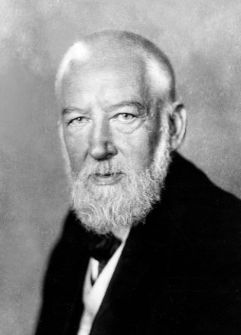
Figure 1: Wilhelm Ostwald’s (pictured left) organization of properties exhibited by solutions
His proof relied on his work on proportionality of osmotic pressure and concentration as well as included his interpretations of thermodynamics of the time, which included his sincere appreciation of Gibb’s famous “Equilibrium of Heterogeneous Substances.”¹
The historical context of Ostwald’s work, as well as other founders of physical chemistry at the time, is captured quite well in Homer Smith’s 1960 review “Theory of Solutions,”² as well as Wilhelm’s autobiography³.
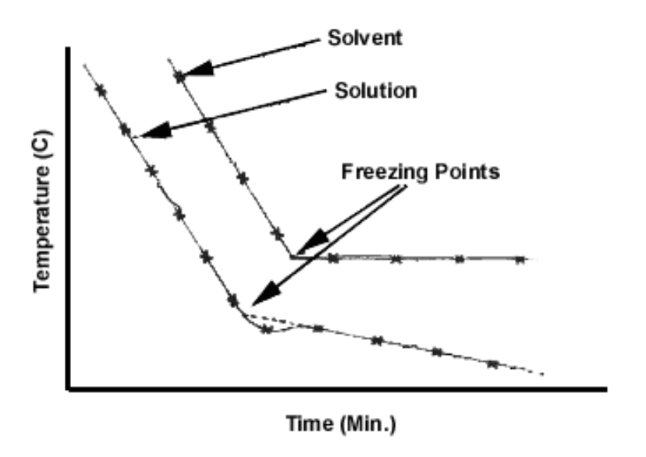
Colligative properties simply rely on the proportional increase in entropy within the solution as the concentration of dissolved solutes increases.⁴ This is commonly measured and observed through phenomena such as osmotic pressure, depression of vapor pressure, and the changes in thermodynamic phase transitions.
Figure 2 Freezing Point of Pure Solvent (Water) compared to Freezing Point of Solution
One straightforward experiment found in general chemistry is solubilizing various solutes such as sugar in water at multiple concentrations to find the freezing point. Figure 2 shows the freezing point graph of a pure solvent and solution.
Modern work in physical chemistry primarily identifies or varies the additive and constitutive variables to model changes within solutions, commonly found to be empirical and requiring highly specialized equipment or experiments.⁴ True colligative equations like Raoult's law, are ideal and do not require additive properties of the solutions. As such, for aqueous solutions, the idealized chemical potential can be written as shown in the ideal chemical potential equation below, where μ^{liquid} is the pure liquid chemical potential, and x_{w} is the molar fraction of water.
$$= + RTLn(x_{w})$$
It’s well understood that ideal solutions are rare. Real solutions present nonideal deviations to Raoult's law, indicative of the interactions occurring between solute and solvent. These deviations are commonly accommodated through activity coefficients found empirically and can be modeled through theoretically constructed equations.⁵
Ostwald considered the nonideality of solutions to arrive from the additive properties of the solutes, where the intermolecular forces occurring between solute and solvent are observed to depend on the solute’s “nature”.² An example being a simple solute-solvent mixture, while taking account of the van’t Hoff factor, i_{e}, where the additive properties resulted in the same deviations found using colligative means.
Ostwald’s’ colligative approach to utilizing the additive properties provided a foundation of chemical logic to design the equations proposed in this study. These equations were developed to account for the specific ion effects and solute interactions on amphiphilic molecules using the additive properties of the solutes. It will be shown in the following chapters of this work that the colligative properties of surfactant solutions can be employed successfully to produce reasonable predictions only using simple additive properties such as molecular weight, valency, and descriptors of hydration.

Solute Hydration
A solute is defined as a molecule or substance that is dissolved in a given solution.⁶ Solute behavior has been primarily associated with a molecule's functional groups, with many attributing the interesting properties to the ubiquitous yet still mysterious solvent, water. Water molecules are known to be dynamic through hydrogen bonding forming cohesive networks as well as coordinate around polar functional groups.⁷ Water’s complexity has brought about many conclusions and remains controversial.
Within a mixed confined space, for example a hydrophilic and hydrophobic interface, micelle, or biological membrane, water molecules begin to influence the hydrogen bonding networks, disturbing coherence of polar and nonpolar solutes in order to fit within a specific volume.⁸ These water molecules, referred to as interfacial water, have been observed to effect negatively charged molecules aligned or configured in self-assembled structures, altering hydrophobicity and increasing hydrogen bonding coordination.⁹ Depending on the solute’s structure, orientation, or thermodynamic conditions (temperature/pressure), the interfacial water molecules can influence sought after physical properties of solutions such as rheology.¹⁰
Solutes are commonly classified into charged and uncharged solutes. Charged solutes include inorganic molecules that can dissociate into ions as well as organic compounds with ionic functionality. Uncharged solutes consist of mostly organic compounds that manipulate the solvent through hydrogen bonding. Charged solute interactions in water, also known as specific ion effects, have been a topic of immense interest and a solution sought after by multiple fields.¹¹ Most of the current understanding has been developed with the help of new analytical methods to determine and describe solute-solvent, solute-protein, solute-surfactant interactions that are of interest.
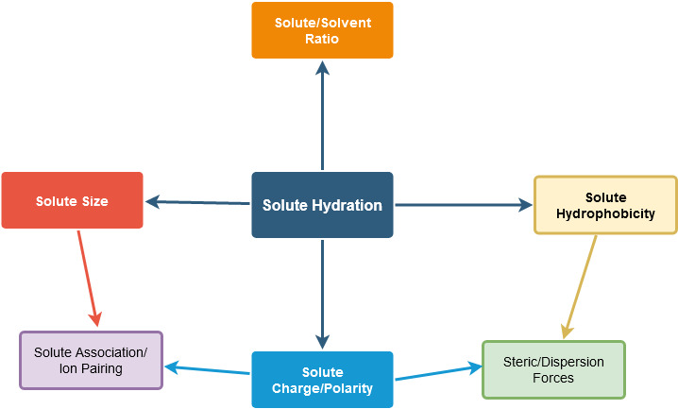
The importance of understanding ionic and nonionic interactions that contribute to macromolecular properties can be seen directly today in advancements in proteomics, where the biological functions, structuring, and movement of the membrane lipids and proteins depend substantially on their hydration.^{11,12} It was realized that specific ions or nonionic solutes tended to withdraw water molecules or manipulate the water structure around the protein, additionally influencing the hydrophobic effects occurring within the system. Further, the solute concentration plays a significant role, mainly where there is competition from solute and solvent for the remaining water molecules, with both reducing the total number of water molecules involved in inner-shell hydration.
Figure 3 Solute Hydration Parameters: (a) Solute/Solvent Ratio (b) Solute Size (c) Solute Charge/Polarity (d) Solute Hydrophobicity
The current evidence points to two possible contributions affecting solute-solvent interactions. The first is steric effects as a part of an ion or solutes hydration shell and is a consequence of its pronounced hydrogen-bonded structure. The second is the dynamic water structure transforming through ion or solvent dissociation/association and electrostatics involving long-range hydrogen networks.¹³ Both are difficult to quantify and screen without advanced experiments or the use of computational models. The extensive studies together point to what is not being accounted for, where solute hydration is dictated by a combination of electrostatic or nonelectrostatic dispersion forces, also called dynamic hydrophobic forces, ranging from interactions between the solute-ion and the ion-ion.¹³ It is speculated that solute properties such as solute size, charge distribution and the hydrophobicity are pertinent to the solute's ability to interact with surrounding water molecules within a solution. Figure 3 illustrates the forces and parameters influencing solute hydration. These specific solute properties that are considered within this work should be reflected in future theories.

Interfacially Active Solutes: Surfactants and Amphiphiles
This study employed interfacially active solutes to empirically describe the hydrophobic and hydrophilic interactions occurring within aqueous and biphasic solutions. Surfactants are part of a class of molecules called amphiphiles that contain both functional groups of hydrophilic and hydrophobic moieties. A surfactant’s hydrophobic structure is usually a linear or branched alkyl attached to a sizeable hydrophilic head group of ionic or nonionic character.¹⁴ It is well understood that surfactants can self-assemble into micelles, readily adsorb to polar/non-polar interfaces, aid in solubilization of hydrophobic molecules, and are useful in lowering the interfacial tension of biphasic solutions.^{15,16}
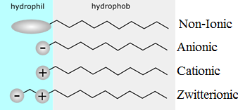
Surfactants are categorized based on dissociative behavior within a solution. Ionic surfactants contain charged head groups being of anionic or cationic character. These types of surfactants behave primarily through electrostatics and are affected mainly by varying the salt concentration. The charged surfactants prefer to form thick interfacial mono-layers at the air-water surface where the surfactant head-group can be at different depths depending on the counter-ions.¹⁷
Figure 4: Common Surfactant Headgroups

Non-ionic surfactants are biodegradable amphiphiles that contain non-charged hydrophilic groups such as polyoxyethylene (EO) and polyoxypropylene (PO). These hydrophilic head groups provide resistance to polar ions yet are very inclined to receiving hydrogen bonding interactions that make them appropriate for detergency and food emulsification processes.¹⁵ Similarly, zwitterionic, also termed polymeric surfactants contain multi-charged (positive and negative) head groups with large hydrophobic groups.
Surfactant properties such as aggregation number, solubility coefficients, wettability, etc. are significant to many modern applications. Many are interested in a surfactant’s critical micelle concentration, CMC, or the concentration at which the surfactant monomers aggregate and undergo micelle formation.^{18,19} Micelle formation is the dynamic mechanism imperative to the success of formulations such as detergents and cleaners where surfactant monomers self-assemble into spherical, rod-like, or vesicle micelles. The affinity towards self-assembly in aqueous solutions depends on the surfactant structure primarily through the hydrophobic effect from the alkyl group and can be modified by increasing the hydrophilicity of the head group. These interactions are reviewed in detail by Rosen’s “Surfactants and Interfacial Phenomena” 4th ed. and contains extensive collections of CMC values.¹⁸
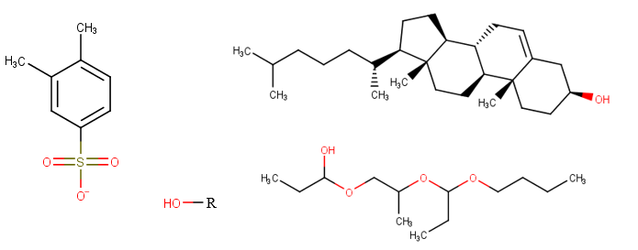
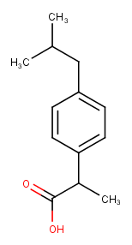
Small amphiphiles such as alcohols, glycol ethers, fatty acids, and phospholipids like cholesterol are essential to a wide range of industrial and pharmaceutical applications. An example of the structures exhibited by other amphiphiles is presented in Figure 5.
Figure 5 Amphiphiles Structures from Left to Right: Sodium Xylene Sulfonate (hydrotrope), Ibuprofen (API), Alcohol (Hydrotrope-Linker), Cholesterol (Lipophobic Linker), Glycol Ether (Linker)
The amphiphilic molecules are similar to surfactants where the moiety dramatically depends on the hydrophile and hydrophobe structure. The amphiphiles are distinctly different than surfactants in that they are unable to create micelles spontaneously as either the head group or lipophile dominates.²⁰ The hydrophobic effect is still observed however, as many investigations have provided evidence of aggregates beyond certain concentrations. The high diffusion and mobility of the amphiphilic solutes can, at times, provide greater flexibility for an interface as well as can stabilize other self-assembling molecules through hydrogen bonding.^{21,22} Though the opposite can occur if the solvents weak van der Waal interactions are disrupted by the solutes, such is the case for removing liquid crystal phases.²³

Microemulsions and Bicontinuous Structures
In biphasic systems such as nonpolar oils with water, added surfactants and amphiphiles can lower the interfacial tension to the extent of creating isotropic solutions known as microemulsions.^{24,25} Unlike typical emulsions or dispersions that are kinetically active, microemulsions are thermodynamically stable systems that depend on the amphiphiles’ moiety to solubilize into either the aqueous or oil phases. Bancroft observed that the type of emulsion, either oil-in-water or a water-in-oil, behaved based on which phase the emulsifier is more soluble.²⁵
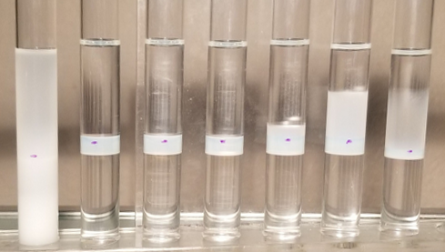
Microemulsions at certain concentrations of surfactant mixed with equal or differing volumetric ratios of oil and water can produce up to four distinct phases after returning to equilibria.²⁶ Figure 6 shows a phase behavior scan where Winsor Type I, III, and II microemulsions are labeled.
II
II
III
III
III
III
III
I
Figure 6 Phase Behavior Scan of Ibuprofen-Loaded Nonionic Microemulsions
The two commonly observed microemulsion phases are Type 1 and Type 2 microemulsion, which are oil-in-water and water-in-oil microemulsions, respectively. These phases have been witnessed to produce stable spherical and worm-like structures with various amphiphilic molecules for long periods and have been developed to fit numerous industrial applications. Current experimental methods of studying Type I and II microemulsions consists of light and electron microscopy, an array of spectroscopic and scattering approaches, with many innovative techniques continuing to be found.²⁴
Type III/IV microemulsions, however, are extraordinary thermodynamic systems that have been proven to form triply periodic minimum surfaces.^{27,28} A minimal surface is considered the smallest possible area for a surface spanning a confined boundary of space. To create these surfaces requires the interface to have zero mean curvature, i.e., at an interface, the sum of the principal curvatures at each point is zero.²⁹ Thermodynamically the repeating of the minimum surfaces in three dimensions (x,y,z) increases coordination of that of crystalline structures, forming what is known as triply periodic minimum surfaces. Type III and IV microemulsions have been observed to form many triply periodic minimal surfaces, primarily the primitive Schwarz P and the gyroid structure, Schoen G, found in Figure 7.³⁰
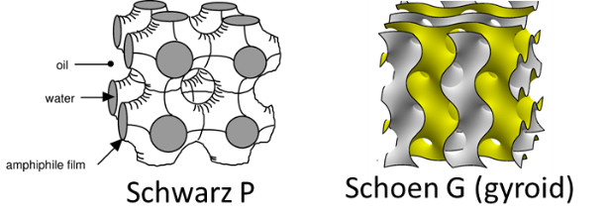
Figure 7 Triply minimum surfaces: Primitive, Schwarz P (left) and the gyroid, Schoen G (right)
Naturally, within the middle phase microemulsion, the immiscible solvents are ordered by the amphiphiles. The amphiphile head groups are hydrated by water, and the lipophile is extended into the oil. Based on the environment conditions, i.e., pressure, temperature, pH, as well as the amphiphiles’ structure, the phases are acting ideally as channels as seen in the Schwarz P or ribbon-like as presented by the gyroid surface. In order to form these structures, the surfactant’s hydrophile and lipophile interactions between the phases are required to be balanced. In this work, this thermodynamic behavior of the Type III microemulsions was taken advantage of to study the amphiphilic changes with the addition of interfacially active solutes.

CHAPTER 3: Evaluating Surfactant Interactions using the Hydrophilic Lipophilic Deviation (HLD) Concept

Introduction
Important markets involving surfactants include pharmaceutical, energy, and many heavy industries that require quick and accurate formulating to continue to operate flawlessly within a continually changing regulatory environment. Many commercial applications are composed of multi-component mixtures of one or more surfactants, additional amphiphiles, and excipients within different solvents. These sophisticated solutions, at times, require balancing of varying interactions in order to optimize or enhance performance, giving great importance to surfactant behavior.
The study of amphiphilic behavior has been a topic of research for over 100 years. Winsor began modeling the behavior of surfactants on microemulsions starting in the 1950s.^{26,31} He observed that at specific concentrations of surfactant, mixed with equal or differing volumetric ratios of oil and water, four distinct phases existed after reaching equilibrium. Salager introduced a similar concept that utilized the balance between the amphiphiles' hydrophilic and hydrophobic affinities while considering the biphasic solution called the Surfactant Affinity Difference (SAD).³² As shown by Acosta, SAD can be further modified and is known today as the Hydrophilic Lipophilic Deviation (HLD) ^{33,34}
The HLD concept or framework utilizes the addition of salinity (S, in g/100ml) or heat (T, ºC) to observe the reversal in amphiphilic behavior known as the phase inversion point (PIP). The phase inversion point is a significant thermodynamic value for specific concentrations of surfactants that can either show a Type I to Type II transition or form a Winsor Type III microemulsion. ³⁵
${HLD}_{i}= ln\left(S\right)- {K\left(EACN\right)+Cc-a}_{T}(ΔT)$ (1)
${HLD}_{ni}= b\left(S\right)- {K\left(EACN\right)+Cc-C}_{T}(ΔT)$ (2)
${HLD}_{Mixed}={\sum{(X_{i})}HLD}_{i}+{\sum{\left(X_{ni}\right)}HLD}_{ni}$ (3)
Equations 1 and 2 show the HLD equation for ionic (${HLD}_{i})$ and nonionic (${HLD}_{ni})$ surfactants without utilizing co-solvents. For nonionic systems, the salt concentration ($S$, g/100 ml) correction term, b, is typically assumed to be 0.13 for sodium chloride.³⁶ At the phase inversion point, where HLD is considered zero, the determination of a solutions HLD parameters, K and Cc, can be found using a series of non-polar oils. Detailed studies involving non-polar and polar oils have shown an effective n-alkane carbon number (EACN), reflecting the oil's hydrophobic nature. For n-alkanes, it is merely the number of carbons within a linear chain. At the same time, the EACN for branched or polar oils can be found experimentally through either Phase Inversion Temperature (PIT) or mixed oil experiments.³⁷
K and Cc are the lipophilic interaction term and the characteristic curvature, respectively. At the phase inversion point, both hydrophilic and lipophilic interactions are considered balanced; the resulting Cc term then represents net curvature or the overall hydrophobicity (Cc>0) or hydrophilicity (Cc<0) of the mixture or the specific amphiphile.³⁸ Currently, K is interpreted as the amphiphiles or solutions hydrophobic interaction with a series of particular oils. It is a relevant term largely neglected by the literature, yet crucial to the accuracy of the HLD values.
$S_{mix}^{*}=K_{mix}\left(EACN\right)-{Cc}_{mix}$ (4)
$S_{mix=}^{*}\sum{x_{i}}({lnS}_{i}^{*})+\sum{x_{ni}}{(b*S}_{ni}^{*})$ (5)
For a solution of mixed amphiphiles at the PIP, ionic and nonionic HLD contributions are arranged, assuming linear mixing to form Equation 3. When HLD_{mix} is at optimum Equation 4 can be utilized with both of the K and Cc values being considered additive, as shown in Equations 6 and 7.
$K_{mix}=\sum{x_{i}K_{i}+ \sum{x_{ni}K_{ni} } }$ (6)
${Cc}_{mix}=\sum{x_{i}}{Cc}_{i}+\sum{x_{ni}}{Cc}_{ni}$ (7)
There is a debate within the literature as to when the K_{mix} and Cc_{mix} terms begin to deviate from linear mixing. The use of this linear mixing rule to extract HLD parameters appears to start with Salager for the SAD model. Work done by Acosta³⁶, Surisetti³⁹, and others^{40,41} reports differing conclusions, with most noticing that for anionic surfactant mixtures using a linear mixing model provides a reasonable approximation for surfactant K and Cc values. For surfactant mixtures of similar head groups, there is evidence to show that these parameters do behave "ideally" at a set molar concentration. However, for combinations of heterogeneous head groups, such as nonionic-anionic, the HLD parameters tend to show considerable deviation from ideal mixing even at room temperature.³⁶ Equation 3 can be modified to account for the nonideality and has been used previously by Acosta and Surisetti, shown as Equation 8.^{36,39}
${HLD}_{Mixed}={\sum{(X_{i})}HLD}_{i}+{\sum{\left(X_{ni}\right)}HLD}_{ni}+\frac{G_{ex}}{RT}$ (8)
Using the surfactant's HLD parameters, the G_{EX}/RT represents the mixed system normalized excess free energy, where positive and negative values indicate a hydrophobic or hydrophilic deviation, respectively. There exists a limited number of known surfactants that can form Type III microemulsions without the use of co-surfactant or co-solvents known as reference surfactants. Many conventional surfactants cannot independently provide a full Winsor phase transition (WI-WIII-WII), which further complicates obtaining accurate estimates of K and Cc values, potentially limiting the usefulness of the HLD model.
By recognizing the limits of the ideality of surfactant mixtures, a formulator should be able to characterize similar amphiphiles and gain better insights into the effects that surfactant structures exhibit within a solution. Industrially significant properties such as the surfactant’s partitioning and solubilization parameter was examined against the experimentally found K values. Further considerations included relating the amphiphile structure, referring to the alkyl carbon number or number of head groups, to understand how the surfactant structure affects the HLD parameters. From this exercise, there is evidence that the surfactants HLB values, while limited, are still significant quantities and are interrelated to HLD values, providing a path for formulators to be able to use well known HLB correlations within HLD.

Materials and Methods

Materials
The surfactants utilized in this study are found in Table 1 with their denoted properties.
Table 1 Commercial surfactants utilized in study

Surfactants | Commercial name | Supplier(s) | MW (g/mol) | Active wt. %
C₁₂-SO₄Na | Sodium dodecyl sulfate (SDS) | MP Biomedicals | 288 | 99
C₁₂-(EO)₂-SO₄Na | Isalchem 123-2S | Sasol North America | 397 | 70
C₈-(PO)₄-(EO)₁-SO₄Na | K2-41S | Sasol North America | 507 | 32.3
C₁₀-(PO)₄-(EO)₁-SO₄Na | K3-41S | Sasol North America | 538 | 27.8
(C₂₀H₃₉O₄)-SO₃Na | Dioctyl Sulfosuccinate (SDOS) | Fisher | 388 | 100
(C₁₆H₂₉O₄)-SO₃Na | Dihexyl Sulfosuccinate (SDHS) | Sigma Aldrich/ Croda | 388 | 80/75
(C₁₆H₂₅O₄)-SO₃Na | Dicyclohexyl Sulfosuccinate (SDCHS) | Sigma Aldrich/ Croda | 388 | 98
C₈₁₀EO_{3.5} | Novel 810-3.5 | Sasol North America | 344 | 100
C₁₂-EO₄ | Laureth-4 (L4) | Croda | 363 | 99
C₁₂-EO₅ | C12E5 | Croda | 407 | 99
C₁₃-EO₆ | TDA-6 | Sasol North America | 467 | 100
C₄-EO₂ | C4 glycol ether | -- | 248 | 98
C₆-EO | C6 glycol ether | -- | 146 | 98
C₁₁-(POE)₄ | Tween 21- Polysorbate-4 | Croda | 565 | 100

The author thanks the suppliers of these commercial surfactants that graciously donated to this research. All the industrial surfactants were applied as received and followed the manufacturer’s mixing recommendations, as necessary. The sodium chloride (>98%, Sigma Aldrich) was added to deionized filtered water to make solutions up to 20 wt%. The alkanes, n-hexane (>98% EACN=6), n-heptane (>98% EACN=7), and n-octane (>99.5% EACN=8) was obtained from Sigma Aldrich.

Microemulsion Phase Behavior
The various surfactant solutions were added to a 15ml sealed vial at a constant molar surfactant concentration (~200mM) at increasing NaCl concentration (increments of 0.25 or 1 g/100ml) to find the phase inversion point (S*). The aqueous solution's meniscus was marked to determine Winsor type and underwent mixing with a vortex mixer at room temperature for a minimum of 30 seconds. An equal volume of alkanes with known EACNs ranging from six to eight was added, with the sample sequentially sealed. The samples would be further hand mixed and left to equilibrate for 24 hours in an incubator set at 25ºC. This procedure was utilized for all surfactant systems.

Determination of Surfactant HLD Properties; Optimum Salinity
After 24 hours, the equilibrated samples were removed from the incubator with the phase behavior, Winsor type I, III, or II, being recorded. Each series of samples were video recorded after being well mixed in a standard mixing procedure and left to equilibrate at room temperature 25ºC; the difference in time from mixing to equilibration of the samples was considered the coalescence time. This procedure was repeated in triplicate.
The determination of optimum salinity was found from plotting and interpolating the observed rates with the Akima spline and taking the NaCl concentration of the lowest fitted coalescence time.⁴² After the determination of optimum salinity, the sealed vials were stored up to 3 months in a dark, dry room at room temperature to determine the thermodynamic stability of the resulting microemulsions. All surfactant systems referred to in this study were found to be stable after the allocated time. For the reference surfactants, the results of the coalescence method were confirmed by the interfacial tension (IFT) using a spinning drop tensiometer (M6500 Grace Instrument, Houston, Texas). For each sample, the capillary is filled with three-quarters of the equilibrated aqueous phase and then approximately 1-3 μL of the excess oil phase is applied as a drop. The drop size was recorded every 5 minutes at room temperature above 3000 rpm. The lowest IFT was determined by using Akima spline similarly to the coalescence time.

HPLC Method-Partition Coefficient
The nonionic reference surfactant and anionic sulfosuccinates utilized in this study were selected to make Type I microemulsion in order to determine the surfactant partition coefficient. Using a 12ml vial, the surfactants were mixed with deionized water up to 5ml to a set concentration of 5%. After mixing, 2 ml of the stock solution is extracted as the control. The solutions were then vigorously mixed with 3ml of decane or warm n-dodecanol and allowed to equilibrate over 24 hours. The remaining surfactant aqueous phase (~3ml) is then removed, filtered, and separated into three samples.
A high-performance liquid chromatography system (HPLC), Agilent 1100 series, was employed to determine the concentrations of the stock and post-equilibrated samples using a calibration curve. The HPLC utilized a UV-ELSD detector scheme, where the non-active chromophore molecules like sulfosuccinates were realized using ELSD. The developed method used a 150x4.6mm C18 reverse-phase column (Hypersil Gold Thermo Fisher) and an isocratic acetonitrile/water (40/60) regime at 1.25ml/min flow rates for 10 minutes. The ELSD nitrogen flowrate and nebulizer temperature were constrained to 1.5 bar and 80ºC, respectively. The resulting data was analyzed using the Chemstation B.04.03 and OpenChrom 1.3.0.

Results and Discussion

Reference Surfactants
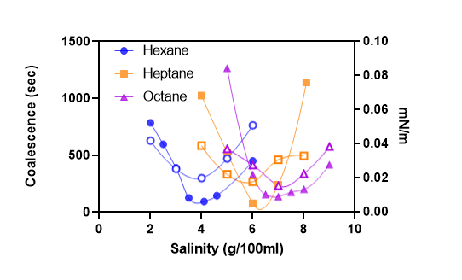
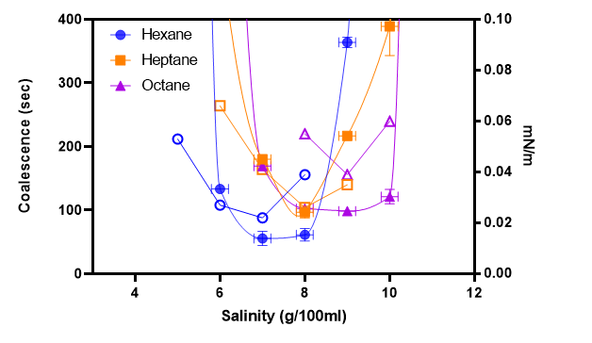
The surfactants SDHS and C₈₁₀E3.5 are the references for the selected anionic and nonionic surfactants in this study, due in part to their ability to coalesce quickly and the concentration ranges that can produce type III microemulsions. Work done by Budhathoki indicates that the reference surfactant K and Cc values are of great importance in order to acquire approximate HLD parameters using a reference surfactant and assuming ideal mixing.³⁸ Figure 8 show the observed coalescence times as well as the interfacial tension for the two reference surfactants. The figures validate the current methodology found in literature, where the optimum salinity taken from the coalescence method correlates with that of the IFT method.⁴³
Figure 8 (Top) SDHS-Alkane Coalescence (sec, closed symbols) and IFT (mN/m, open symbols); (Bottom) C₈₁₀E_{3.5}-Alkane Coalescence (sec, closed symbols) and IFT (mN/m, open symbols)
The resulting K and Cc values of SDHS, obtained for this study, differ from earlier values. Witthayapanyanon⁴⁰ and Acosta⁴⁴ obtained similar HLD parameters for SDHS and reported K to be 0.2 and the corresponding Cc value to be around -0.9. Witthayapanyanon used a wider EACN range, from benzene (assumed EACN=0) to decane (EACN=10). Our methodology, using hexane, heptane and octane, finds commercial SDHS to have a K= ~0.1 ± 0.03 and the Cc to be -1.4 ± 0.2 using multiple lots from different suppliers. Qualitative HPLC methods were also applied to differentiate the samples of commercial SDHS in which there were slight deviations found in the retention times, suggesting varying hydrophobicity. Even though SDHS has well-known K and Cc values, the chance of reactivity, hydrolysis, and potentially batch to batch polydispersity, requires a formulator to preform phase behavior experiments on each batch of reference surfactant; one cannot assume that the K and Cc SDHS will be constant from batch to batch.
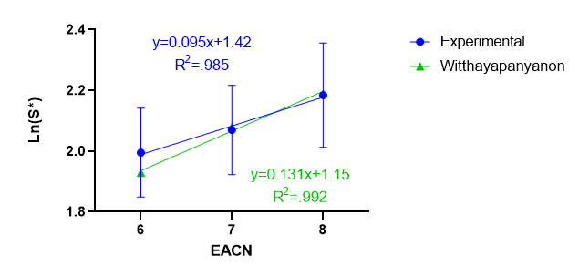
Further, by considering only the optimum salinities for linear alkanes of EACNs six through eight, Witthayapanyanon's data reports a K value of 0.13 and Cc of -1.2. Figure 9 shows the comparison of the optimum salinities using both Witthayapanyanon’s and the averaged experimentally found parameters.
Figure 9 Ln(S*) for SDHS-Alkane systems; Reproduced experimental commercial lots compared to Witthayapanyanon’s reference
It can be speculated that the oil phases selected and the solubility of the surfactant could influence different HLD parameters, observed in the slope of Figure 9. Unlike Witthayapanyanon's surfactant, the SDHS employed in this study, unfortunately, could not reach decane (EACN=10) without precipitating or forming coacervate phases. It is most likely that the surfactant mixtures are not identical either through hydrolysis from long term storage or contain different free additives such as alcohols or short-chain esters. It is recommended that any study or formulation effort utilizing or reporting a set of parameters for a specific surfactant system also state which oil phases were employed.
The search for a nonionic reference surfactant led us to acquire various commercial surfactants that were stated to be within an HLB value of 8-12. These included mixtures of alcohol ethoxylates, polysorbates, and alkyl polyglucosides. Without the use of temperature, it proved to be challenging to find a consistent and reproducible nonionic surfactant at multiple concentrations. The only acquired commercial surfactant that was able to form a Type III microemulsion at room temperature without co-solvents or co-surfactants was a mixture of alkyls ranging from C₆-C₁₆ that underwent 3.5 moles of ethoxylation. It is assumed that the average nonionic alkyl structure is between C₈-C₁₀ while the head groups are polydispersed (i.e., C₈₁₀E_{3.5}).
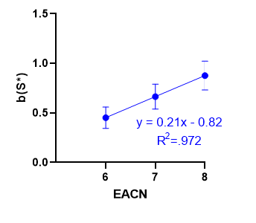
This mixture was characterized in triplicate with numerous batches from the same commercial lot. The HLD parameters for C₈₁₀E_{3.5} were found to vary slightly, with the K variable around 0.21 ± 0.05 and the Cc to be 0.82 ± 0.3; the resulting optimum salinity (bS*) is seen in Figure 10.
Figure 10 Reproduced experimental b(S*) of C₈₁₀E3.5-Alkane system at 25ºC

Unlike other nonionic surfactants, C₈₁₀E_{3.5} showed consistent HLD parameters for various concentrations; however, at higher concentrations (>10 wt.%), the surfactant becomes slightly more hydrophobic. Though being a clear, isotropic solution, one difficulty of using this product is its phase separation in water, requiring the formulator to apply the surfactant directly to the aqueous phase, rather than using a concentrated stock solution. Besides this one minor issue, the nonionic mixture has a smaller solubilization parameter to that of extended alkyl sulfates but larger than that of SDHS and can remain stable for large salinity ranges. The temperature dependence term, Ct, was found by increasing the temperature of the hexane and octane reference scans to 35ºC. The Ct was approximated to be around -0.4 and agrees with the reported nonionic value of -0.6.⁴³ These properties of C₈₁₀E_{3.5} make it not only a suitable reference surfactant but also potentially utilizable for commercial applications.

Anionic Mixtures
With SDHS as the reference surfactant, phase behavior studies were conducted on a number of anionic commercial surfactants. The anionic surfactants selected have been previously studied with only three of the five able to transition into Type III microemulsions without co-surfactants or co-solvents. Table 2 shows the literature and experimental HLD parameters for the chosen anionic surfactants in this study.

Table 2 Anionic Surfactants Selected for SDHS Mixtures
Surfactants | Commercial name | K | Cc | K_{exp} | Cc_{exp}
C12-SO4Na | Sodium dodecyl sulfate (SDS) | 0.1 | -2.6 | 0.1 | -2.3
C16-C2(O2)2-SO3Na | Sodium dioctyl sulfosuccinate (SDOS) | 0.17 | 2.6 | -- | --
C₈-(PO)₄-(EO)-SO₄Na | K2-41S | 0.05 | -2.5 | 0.06 | -2.3
C₁₀-(PO)₄-(EO)-SO₄Na | K3-41S | 0.07 | -2.2 | 0.06 | -2.1
C₁₂-(EO)₂-SO₄Na | Isalchem 123-2S | 0.06 | -2.2 | 0.11 | -2.0
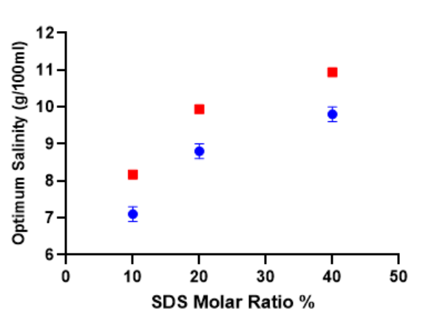
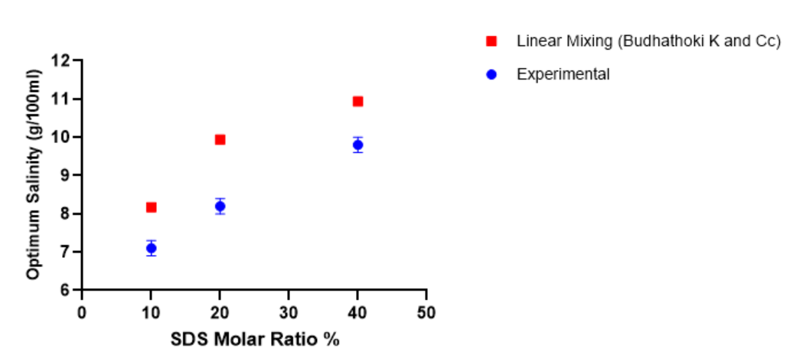
Sodium dodecyl sulfate (SDS) and sodium dioctyl sulfosuccinate (SDOS) are found in an array of specialty products and drastically differ in amphiphilic behavior. SDS was studied by Budhathoki using SDHS, as a reference surfactant, and was reported to have K and Cc values of 0.1 and -2.6, respectively.³⁸ These first studies involved using these values, keeping the total
Figure 11 Experimental optimum salinities, S*, of SDS-SDHS mixtures compared to predicted values from linear mixing using Budhathoki’s SDS HLD parameters
surfactant concentration constant, and increasing the ratio of SDS from 10% to 40%. Figure 11 shows the optimum salinities obtained from SDS-SDHS solutions. These mixtures were observed behaving slightly hydrophobic, with the 60/40% mixtures showing the most significant deviation from the predicted salinity from linear mixing.
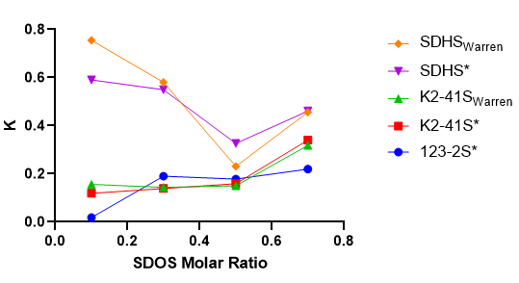
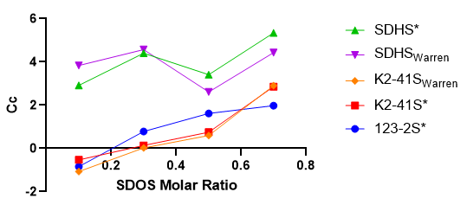
SDOS, the branched analog of SDHS, was reported by Surisetti to behave nonideal for a number of the selected reference surfactants. This work was reproduced, here, using the coalescence and IFT methods, at Surisetti's concentrations, where the differences in HLD parameters of the mixtures were considered. Figure 12 show the comparison of the extracted SDOS HLD parameters to Surisetti’s findings using SDHS and K2-41S as reference surfactants.
Figure 12 SDOS K and Cc obtained through linear mixing to using SDHS, K2-41S, 123-2S as reference surfactants. Data* extracted from Surisetti³⁹.

For SDOS-Anionic mixtures, the pure component of SDOS was extrapolated by finding the mixed HLD parameters at different surfactant ratios using a range of alkanes. The resulting K and Cc for SDOS were found to range between 0.25 to 0.4 and 3 to 5.5, considerably more hydrophobic than what has been previously referenced. Using these values, Surisetti concluded that the mixtures acted more hydrophilic than expected, with the largest nonideality reported using the SDHS-SDOS systems, while SDOS-123-2S showed the closest to ideal behavior. Moreover, it was indicated that SDHS-SDOS mixtures, both containing dimeric lipophilic structures, may deviate considerably and that the chosen reference surfactant structure is of importance.
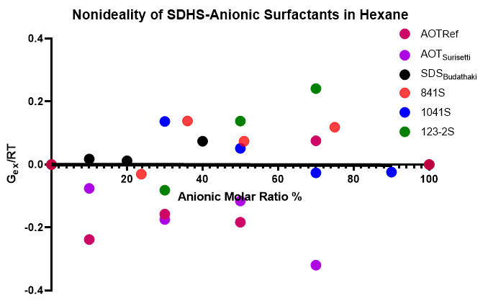
Fortunately, the alkyl polypropoxyethoxy sulfates can make Type III microemulsions without co-surfactants or co-solvents and underwent a series of phase behavior studies. The experimental HLD parameters agreed with what has been reported for the selected surfactants.^{33,38,40} These extended surfactants were then added to SDHS at varying ratios, again at a constant surfactant concentration using hexane, and the excess Gibbs free energy was found using the experimental HLD parameters. The resulting nonideality changed at different ratios with K2-41S and 123-2S, revealing a hydrophilic deviation at lower surfactant ratios and becoming more hydrophobic at higher ratios. In contrast, the K3-41S behaved more hydrophobic at a lower ratio and vice versa.
Figure 13 Nonideality of SDHS-Anionic surfactant mixtures in Hexane at 25ºC; AOT_{REF,} AOT_{Surrisetti,} and SDS_{Budhathoki} nonideality is obtained using the HLD parameters reported.^{38,39}
Careful consideration of Surisetti's work, as well as the experimental results, reveal some interesting patterns. Figure 13 shows the plot of the selected systems and the associated surfactant ratios to the resulting nonideality for chosen oil hexane. All selected anionic surfactants behaved in a nonideal manner, but taking the regression of all values concludes the excess Gibbs free energy (bolded) is negligible. Using the mixture HLD parameters, the largest deviation can be calculated and falls to be around a 10% difference in the optimum salinity concentration. Such error is considered insignificant as commercial surfactants are known to vary significantly to their pure counterparts, though it is important to acknowledge in future formulation endeavors.
In the case of SDOS, using a reference surfactant with a linear hydrophobe while comprising above 80% of the total molar concentration can extract reasonable HLD parameters. Each surfactant mixture that reached above 25% SDOS resulted in a more hydrophobic solution than predicted by ideal mixing. The increase in hydrophobicity then results in an overestimation of the extrapolated K and Cc values when compared to that of the pure SDOS. However, it should be noted that Surriseti’s SDHS-SDOS mixtures varied the total surfactant concentration, which may explain the increasing variability in the extracted K and Cc values as a function of SDOS concentration. The resulting phase behaviors utilizing many anionic surfactants show that extrapolating HLD parameters using different conditions or concentrations may lead to significant deviations.

Anionic-Nonionic Mixtures
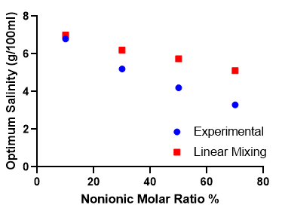
The discovery of C₈₁₀E_{3.5} as a nonionic reference surfactant was a massive leap in designing and understanding surfactant mixtures without the need to use temperature, thus avoiding the necessity of estimating C_{T}. The two reference surfactants were tested against each other using the same oil phase at various molar ratios. Figure 14 shows the experimental optimum salinities of the mixtures against the expected salinities from linear mixing. The resulting mixtures behaved more hydrophobically than predicted using ideal mixing and this behavior increased with nonionic concentrations.
Figure 14 Optimum Salinity vs Nonionic Molar % for SDHS-C₈₁₀E3.5 Mixtures at 25ºC
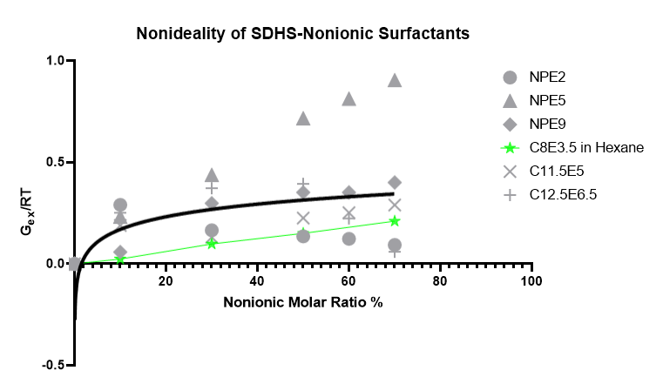
Acosta and colleagues previously reported the excess Gibbs free energy of series of mixtures comprised of SDHS with nonylphenol ethoxylates and alcohol ethoxylates, providing an opportunity to differentiate C₈₁₀E_{3.5}. Figure 15 includes the normalized deviation from ideal mixing extracted from Acosta.³⁶
Figure 15 Nonideality of SDHS-Nonionic Surfactants at 25 º C; Gray Symbols extracted from [35], Green symbols-SDHS-C₈₁₀E3.5 in Hexane
Qualitatively C₈₁₀E_{3.5} matches the behavior of the selected alcohol ethoxylates studied and additionally followed the trend of increasing hydrophobicity at higher nonionic ratios. It was exciting to find that C₈₁₀E_{3.5} on average behaved as more “ideal” than its more extended and more ethoxylated counterparts, so that linear mixing could be used below 20% molar ratio. In comparison to all of the anionic-anionic surfactant solutions studied, where the obtained averaged nonideality (G_{ex}/RT) was around 0, the anionic-nonionic solutions exhibited only hydrophobic deviations that averaged to be G_{ex}/RT ~ + 0.4. It is only nonionic molar ratios below 20%, where the mixtures behaved within the same nonideality of anionic solutions.
It could be reasoned that since the ethoxylated alcohols tend to partition more easily into the oil phase, when compared to its anionic counterparts, then the increase in nonionic concentration should increase the hydrophobicity of the solution. Salager illuminated the nonideality of anionic-nonionic surfactant systems and speculated that it depended on the nonionic surfactant partitioning into the three-phase solution.⁴⁵ Of course, the mixed partitioning within a heterogeneous interface depends significantly on the configuration of the surfactant but has been observed to vary at different concentrations for specific systems.⁴⁶
Table 3 Anionic Surfactants Selected for C₈₁₀E3.5-Anionic Mixtures
Surfactants | Commercial name | K | Cc | K_{eep} | Cc_{exp}
C₁₂-SO₄Na | Sodium dodecyl sulfate (SDS) | 0.17 | -2.6 | 0.09 | -2.3
(C₂₀H₃₉O₄)-SO₃Na | Sodium dioctyl sulfosuccinate (SDOS) | 0.17 | 2.6 | 0.08 | 1.9
(C₁₆H₂₅O₄)-SO₃Na | Sodium dicyclohexyl sulfosuccinate (SDCHS) | 0.07 | -0.9 | 0.08 | -1.2
C₁₂-(EO)₂-SO₄Na | Isalchem 123-2S | 0.06 | -2.2 | 0.09 | -2.1
At a certain point, the addition of a nonionic surfactant to an anionic interface begins to influence not only the electrostatic interactions but the dynamics of the interfacial water being shared by the anionic surfactant head groups. This is observed by the decrease of the surfactant’s hydrophilicity of the surfactant by reducing the number of free water molecules available at the

interface. Further, the SDHS- C₈₁₀E_{3.5} mixture behavior provided a mixing region of concentration (X₂ < 20%) that is necessary to approximate HLD parameters quickly by ignoring the nonideality that occurs as the concentration of nonionic surfactant increases.
This region was further investigated like the anionic mixture studies in which C₈₁₀E_{3.5}, the nonionic reference surfactant, was mixed with SDS⁴⁴, SDOS, SDCHS, and 123-2S to determine the accuracy of previously determined HLD parameters. Samples were mixed at a set concentration, ~100mM, with a constant molar ratio of 20% anionic surfactant using hexane, heptane, and octane as the oil phases. The resulting mixed HLD parameters were extracted and listed in Table 3. The obtained amphiphilic variables for the anionic surfactants was in general agreement with that found by SDHS. The Cc values were similar, especially in regard to the linear surfactants SDS and 123-2S. The K values were discovered to be comparable for all selected surfactants with SDS and SDOS showing the most considerable difference to their referenced values. The overall behavior of SDOS still remained hydrophobic though less so for the SDOS- C₈₁₀E_{3.5} mixture, yet again large deviations occur within the oil interaction term, K. It may well be that the SDOS’ branched tails allow for another degree of freedom not occurring with linear molecules and can be thought of in terms of the surfactant’s packing parameter, where the positioning of the tails could increase or decrease the lipophile volume within the interface.¹⁶ As such, the lipophile interactions may not occur linearly by concentration and cannot be addressed by HLD in its current form.
The results of the nonionic-anionic surfactants provide evidence that for the systems studied there exists a range of molar ratios (x₂ < 20%) where the non-ideality can be considered insignificant. Staying within this limit provides good approximations of pure surfactant HLD parameters and could be used to quickly determine amphiphilic behavior of unknown interfacially active solutes or whole solutions. We propose that this may be regarded as a general rule of thumb for formulators, as one should first utilize the same type of surfactant to characterize another. The deviations will likely vary and render this rule unreliable when the solution’s temperature is changed due to large hydrogen bonding fluctuations that occur within nonionic hydrophiles. Thus, it is imperative to characterize the thermal dependence of nonionic surfactants if varying the temperature.

Determination of HLD Parameters of Nonionic Surfactants
During this study, we attempted to find additional commercial nonionic surfactants that could form a Type III microemulsion at room temperature within the EACN range selected. The surfactants surveyed were primarily alcohol ethoxylates with HLB values from 8-13; only a single product was found to meet the requirements of being a reference surfactant. However, it presented an opportunity to extract other nonionic amphiphiles HLD parameters without having to deal with the inherent deviations from ideal mixing that would be involved using an anionic reference surfactant. Samples were mixed at a set total concentration (~200mM) with the additional nonionic surfactant remaining within a constant molar ratio of 20% using hexane, heptane, and octane as the oil phases.
The resulting mixed HLD parameters were extracted using Equation 2 and C₈₁₀E_{3.5} as the nonionic reference surfactant. The resulting HLD parameters and solubilization parameters are listed in Table 4. Though it is somewhat difficult to compare the K and Cc values from literature to those obtained in this study due to changes in polydispersity within commercial surfactants, the data is encouraging. We found that the nonionic surfactants with HLB values below 10 showed positive Cc values while the inverse was found after HLB > 10. This is not surprising since HLB values around ten can be considered the point where most become water-soluble. One would expect a hydrophobic alcohol ethoxylate that has difficulty to solubilize in water to have HLB values below 10, thus, a positive Cc value.

Surfactants | Commercial name | Carbon Number (CN) | HLB | K_{exp} | Cc_{exp} | ~∆SP*
C₈₋₁₀EO_{3.5} | -- | 9 | 10 | 0.22 | 0.8 | 0
C₁₂-EO₄ | Laureth-4 (L4) | 12 | 10 | 0.23 | 1.3 | 2.8
C₁₂-EO₅ | C12E5 | 12 | 11 | 0.19 | -0.7 | 2.3
C₁₃-EO₆ | TDA-6 | 13 | 13 | 0.22 | 0.1 | 3.1
C₄-EO₂ | C4 glycol ether | 4 | 10 | 0.06 | 0.1 | -0.9
C₆-EO | C6 glycol ether | 6 | 8 | 0.07 | 1.5 | -0.8
C₈₋₁₀EO_{4.5}³⁶ | -- | 9 | 11 | 0.28³⁶ | -0.6³⁶ | --
C₁₀-EO₅³⁶ | -- | 10 | 13 | 0.14³⁶ | -1.3³⁶ | --
C₁₃-EO₆³⁶ | TDA-6 | 13 | 13 | 0.22³⁶ | 0.7³⁶ | --
C₁₁-POE₄ | Tween 21* | 11 | 13 | 0.29* | 1.8* | 2.9*
Studies relating to nonionic surfactants' cloud point and adsorption have shown to decrease the hydrophobic interactions with increasing ethoxylation.^{48,49} Assuming the surfactants have an average structure, a mixture of polydispersed head groups and heterogeneous tails, one can then start to account for the differences in HLD parameters. The data suggest that for nonionic surfactants, the hydrophile and hydrophobe structure are important constraints.⁵⁰ For L4, C12E5, and TDA-6, the increase in ethoxylated head groups is observed in the decrease in hydrophobicity. As shown by Baker’s dissertation, as the degree of ethoxylation decreases, the area per surfactant molecule is reduced, additionally increasing the hydrophobic interactions
Table 4 Nonionic Surfactants Selected for C₈₁₀E_{3.5}-Nonionic Mixtures; HLB values vs Experimental HLD parameters & ~∆SP* (mL/g) *Octane/Decane Oil Phases

observed in solution.⁵¹ This behavior is also apparent even in interfacially active solvents like glycol ethers, in this case, treated as a surfactant, where the increase in the alkyl tail by two carbons shows a substantial hydrophobicity increase.
The K values obtained in this experiment also seem to behave based on the hydrophile and hydrophobe structure, where the lowest surfactant-oil interaction was found using the glycol ethers. Table 4 provides the difference in ~∆SP* from the reference SP* with mixed systems. This data suggests a general relationship in that the larger K values (>.2) indicate a more significant solubilization parameter than that of an anionic surfactant (<.1). The implication is that the K value is interrelated to SP* and requires additional experimentation in order to conclude the dependence of the lipophile structure on exhibited solution behavior.

Correlating Lipophile Structure to K Parameter
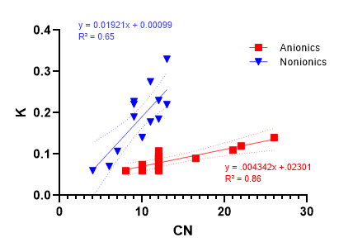
We attempted to qualitatively connect the basic structure of the surfactants based on the results of the extracted K value as well as selected systems found in the literature. It is of current understanding that none have attempted to identify whether the K variable means more than just representing an experimental artifact in the HLD concept. It is difficult to compare previous studies’ results to the K and Cc values extracted in this work due to changes in methodology as well as the inherent polydispersity within commercial surfactants; thus, we made do with a number of limited available data sets.^{34,36,38,44} A broad range of lipophilic structures, C₄-C₂₄ were examined and relied on either the averaged number or the maximum number from supplier regulatory or information sheets.
Figure 16 Lipophile Interaction (K value) vs Carbon Number of Lipophile (CN)
Figure 8 reports the K values of anionic and nonionic surfactants as a function of the average alkyl carbon number (CN). The surfactant values used in Figure 16 are found in Tables 2, 3, and 4. The 95% confidence intervals were also plotted to show the significant variance within the surfactants, where the anionics reported the smallest interval qualitatively. The nonionic molecules tend to have more extensive ranges of polydispersity within the alkyl and hydrophile groups when manufactured that may affect the surfactant activity.⁴⁹
Linear regressions of the compiled data show significant correlations for both surfactant types using the hydrophobe carbon number. Both head groups behaved as one would expect by increasing the alkyl group, i.e., increasing overall hydrophobicity and length, and thus the surfactant interaction with an oil phase will increase as indicated by the increase in the K value. The differences in the slopes of the regressions can be explained by the relative hydrophilicity of the head groups. The nonionic containing a relatively flexible and bulky hydrophile will increasingly become hydrophobic with branching or an increase in the length of the hydrophobe. This is a well-understood phenomenon and observed through the decrease in critical micelle concentrations resulting in an increase in entropy contribution with increasing the lipophile length.¹⁸ The strong interaction of the anionic headgroup with the water reduces the effect of increasing hydrophobe size on the value of K, while the relatively weaker interaction of the polyethoxy chain allows the increasing hydrophobicity of the tail to pull the ethoxy chain deeper into the oil phase, making nonionic K-values more sensitive to the size of the hydrophobe.
The selected anionic surfactant head groups are "stronger" hydrophiles in comparison to their nonionic counterparts. Sulfonated and sulfated functional groups are water-soluble and tend to dissociate readily in aqueous solutions, so when it is exposed to a biphasic system, the head groups remain solvated in the aqueous phase. One can imagine the hydrophilic groups actively searching for interfacial water, reducing the oil interaction as the surfactant is positioned within the palisade layer. Nonionics, like ethoxylated alcohols, simply have larger hydrophile structures that are able to interact within the palisade and oil interfaces through hydrogen bonding, effectively reducing the affinity towards the aqueous phase.
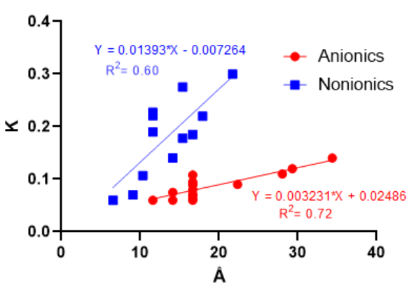
The intercept of the plot is also of interest as it should note the point at which nonionic and anionic head groups have the same relative affinity to water. The intercept could also represent the minimum carbon number necessary to influence the HLD parameters. Rearranging both of the linear regressions finds the intercept to be around three carbons or n-propyl alkyl. This was an interesting coincidence as recent advanced studies of surfactant mixtures using experimental methods NMR 2D NOESY ^{52,53} as well as molecular dynamics simulations⁵⁴ reveal a similar trend beginning at two to four carbons. If the K variable are correctly found to be correlated to the carbon number, then a formulator now has access to modeling an approximate K by merely knowing the alkyl tail and the hydrophile of the surfactant.
Figure 17 Lipophile Interaction (K value) vs Carbon Number of Lipophile (CN)
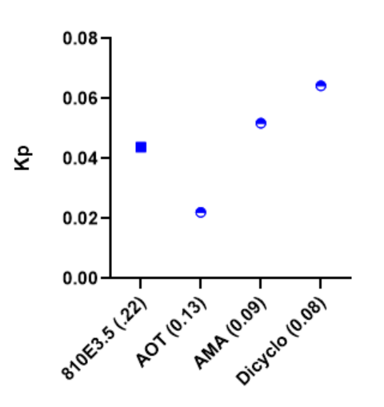
When using net-average curvature (NAC), the HLD extension produced by Acosta, the length of the surfactant, L, is an essential consideration to model properties such as IFT and solubility. It can now be found by rearranging the linear regressions and incorporating the Tanford Equation, Lc = 1.5 + 1.265Cn, where Lc's unit is in angstroms, Å.^{55,56} The K values are plotted against the Tanford lengths in Figure 17. Like the previous intersection, the minimum alkyl length was around 3 Å. Intensive studies have observed similar values for multiple classes of detergents, where the addition of each carbon to the alkyl tail increased the distance between the surfactant head groups across the micelle by 2.5–3.0 Å.⁵⁷
Figure 18 Partition Coefficient (K_{p}) vs Surfactants (K value)
The question remains if the K variable is just an artifact or does it relate to characteristics of the solution such as partitioning or solubility. Using the sulfosuccinates and the nonionic C₈₁₀E_{3.5} Type I microemulsions with similar HLD values (<-1) were designed and mixed with decane as the oil phase. The standard solution, along with the dispersed phase, were analyzed via HPLC, and the partition coefficient for decane was reported in Figure 18. The surfactants primarily remained partitioned within the equilibrated aqueous phase with only a tiny percentage of the surfactant mixture partitioning into the excess oil phase. The results indicate the opposite of what one might expect: as K increased, the partitioning into the oil phase decreased. Consequently, K is most likely not a descriptor of surfactant partitioning as C₈₁₀E_{3.5} which has a K value of 0.22 had smaller K_{p} in comparison to the dimeric anionic surfactants with lower K values.
Since it has been shown that K is related to the lipophile structure, NAC predicts the increase of solubilization with the increase of the length of the lipophile.³³ This conclusion seems to be presented previously with the nonionic mixtures ∆SP* increasing or decreasing with higher or lower K value in Table 19. For anionic surfactants studied the opposite trend exists when plotting the K value of the pure surfactant with its observed SP*. Figure 12 displays the SP* vs. the K values of the anionic surfactants, where SDHS with the largest K value had the lowest SP*.
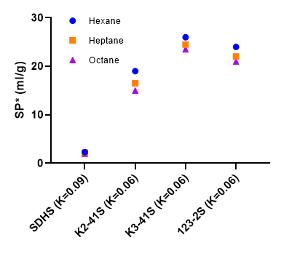
Though it is valid to challenge whether the di-alkyl structure of SDHS is appropriate to compare against the extended surfactants, these results provide different representations of the K value.
Figure 19 SP* (ml/g) vs Surfactant (K value) against various alkanes
Clearly, more work is required to determine whether or not the K value depends on the solution properties. While unsuccessful in relating to surfactant partitioning and solubility alone, it has been presented that the K value is influenced by the carbon length of the lipophile and is not dependent only on the hydrophile. The K parameter should continue to be measured and not assumed to be constant for a homologous series of surfactants. As more phase behavior studies on anionic and nonionic surfactants are performed, we expect that this will only strengthen these empirical findings.

Relating HLB to Cc
Many previously have reported correlations of the resulting surfactant behavior on certain chemical functional groups. The most well-known to many in the field of formulation science are the hydrophilic lipophilic balance (HLB) correlations developed by Griffin and Davies to characterize nonionic surfactants. Griffin first described the surfactant's tendency to be hydrophobic or hydrophilic by taking the ratio of the mass of the head group to the overall molecular weight of the molecule for polyethoxylates.⁵⁸ By multiplying the quotient by 20, Griffins HLB value is found in the equation below, where large values (HLB >15) in most cases behave as hydrophilic solutes, readily soluble in water.
$${HLB}_{Griffin}=20 x \frac{M_{h}}{M}$$
Davies additionally correlated HLB values by providing group contributions for specific hydrophiles within the surfactant molecule, also allowing for predictions of ionic head groups.⁵⁹ Davies’ HLB equation is given below, where H_{i} is the hydrophile parameter described in Davies’ 1954 paper, and n is the number of carbons.⁵⁹
${HLB}_{Davies}=7+ \sum_{i=1}^{m}{H_{i}-n(0.475)}$
Both methods can be arranged to find what is termed the required HLB value, or the oil phase value, to create stable emulsions.
The differences between the two methods come from the approximation of hydrophilicity of the head groups, where Davies considered the polarization over the size. Comparatively, the Davies’ method can reproduce Griffin’s HLB values for certain nonionics (ex: Span series) but deviates with simple alcohol ethoxylates. Many have noted that HLB can be flawed if engaged to assist in formulation efforts, where methodologies have been determined to fit specific surfactants better than others.⁶⁰ Like HLD parameters, care must be taken in referencing any HLB values predicted or experimentally found without understanding the method employed. Nonetheless, the HLB approach to characterizing surfactants continue to be applicable for many disciplines, and the research using a combination of the methodologies will most likely persist in the future.
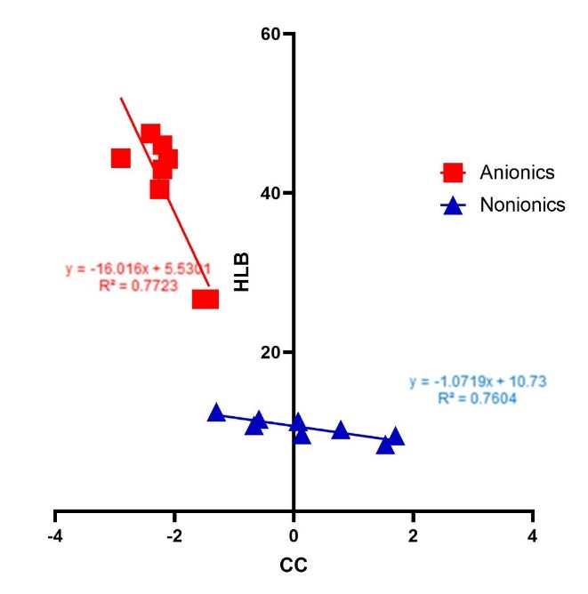
If the surfactant properties and hydrophilic/hydrophobic interactions are dependent on the chemical structure, then kinetically stable emulsions found through the HLB experiments should be considered as the inverse to the thermodynamically stable microemulsions. As pointed out earlier by Schechter, et al., in restating Bancroft’s rule, in a kinetically stable emulsion, the equilibrium microemulsion phase becomes the continuous phase. At optimum salinity, the Cc variable, representing the overall affinity of the molecule, should correlate with its HLB value calculated with the appropriate correlation, i.e., Griffin for nonionics⁵⁸ and Davies for ionic surfactants⁵⁹. Figure 20 reports the Cc values of the same surfactants as previously used in Tables 2, 3, and 4, but now plotted against their respective Griffin and Davies HLB values.
Figure 20 HLB values vs Experimental Cc values of selected Anionic and Nonionic surfactants at 25ºC
Both types of surfactants show a statistically significant correlation when taking the linear regression between the two models, and using the HLB values to predict the Cc values for the HLD model. The anionic surfactants utilize the Davies’ model that scales the ionic head group’s hydrophilicity to that of a nonionic, providing much larger HLB values. The Cc values exhibited seem to relate to this as the majority of the tested products were found to have Cc values less than -2. This is also encouraging when taking into account the nonionic surfactants, in which the model is primarily constructed for.⁶¹ While having a better fit (R²=.75), the Griffin model uses a smaller HLB range for nonionic surfactants. The regression shows that nonionic surfactants, as a whole, have a broader range of Cc values available with only slight changes to the amphiphilic structure. The most hydrophilic Cc values arise from increasing the amount of ethoxylation and reducing the length of the lipophile. Meanwhile, the hydrophobic nonionic surfactants (HLB < 10) are found to be driven by the lipophile with weak head groups. C₁₃EO₆ and C₄ glycol ether show Cc values close to zero indicating the surfactant’s hydrophilic and hydrophobic interactions are somewhat equal. Considering the structures, this reveals that the hydrophilicity exhibited by one EO group can be negated by two carbons. This relationship could prove helpful in determining or selecting surfactants for formulation or synthesis purposes.
The HLB-Cc regressions can also be used to get an approximate SDOS Cc value using an HLB_{Davies}=-25.78, where it is found to be -1.25. This appears to agree with Surisetti’s values found, using the extended surfactants, that SDOS is hydrophilic with Cc at -0.68 ± 0.2.³⁹ However, this result does go against what has been found using the SDHS and C₈₁₀E_{3.5} reference surfactants. Using the positive Cc value extracted from SDHS and C₈₁₀E_{3.5} presents the SDOS HLB to be negative, which is impossible. Interestingly SDHS can be appropriately fitted to the HLB, yet SDOS again behaves drastically out of order from all anionics tested.

Conclusion:
From this work, the recognition of nonideality occurring between surfactant mixtures was demonstrated. It was determined that the largest nonideality occurs between anionic and nonionic mixtures, where the deviations are generally hydrophobic. For surfactant mixtures of all types, a region (x₂ = 0-20%) of low nonideality was found through observation of many reference systems, in which it is feasible to assume ideal mixing and still acquire approximate HLD parameters. Dimeric surfactants, when used in mixtures, account for an extra degree of freedom affecting the surfactant packing as such HLD parameters were found to vary drastically from that of linear surfactants.
The discovery of a nonionic reference surfactant was of great aid to examining the nonideality of solutions as well as furthering the understanding of the HLD parameters, K and Cc. This exercise revealed that the K value correlates with the carbon number of the lipophile, yet did not seem to follow surfactant partitioning or solubility. Further, it was shown that Griffin and Davies HLB values do connect quite well with experimentally found Cc values from single and mixed surfactant systems. It provides additional evidence that kinetically stable emulsions as well the thermodynamically stable microemulsions depend and can be related to the surfactants structure. Thus, Cc values can be thought of as a new HLB value that is correctly attributing the hydrophilic and lipophilic interactions within a biphasic solution. Group contribution methods have been produced and could be used to correlate specific amphiphile structures. Such correlations should be helpful to formulators attempting to work between HLB and HLD models. As more phase behavior studies on anionic and nonionic surfactants are performed, it is assumed that these empirical findings will only improve.

CHAPTER 4: Incorporation of Specific Ion Effects in the HLD Model for Microemulsion Formulations

Introduction
Microemulsions are meaningful solutions within colloid science that have relevance in advancing technologies like drug delivery, enhanced oil recovery, and other optimized applied formulations. P. A. Winsor classified the three common types of microemulsions that are used in an array of formulations; an oil-in-water microemulsion (Type I), a water-in-oil microemulsion (Type II), and the microemulsion solubilizing both phases within a middle phase (Type III).²⁶ Type III microemulsions are impressive isotropic thermodynamic systems that reside where the phase inversion transition occurs from Type I to II. In the type III domain, low to ultralow interfacial tension and catastrophic emulsion instability is found and often desirable for formulation optimization. Scholastically Type IIIs are useful, in that being thermodynamically stable the changes in amphiphilic behavior are readily reproducible with the use of known reference surfactants. Such systems create the ability to study interfacial phenomena such as specific ion effects systematically.
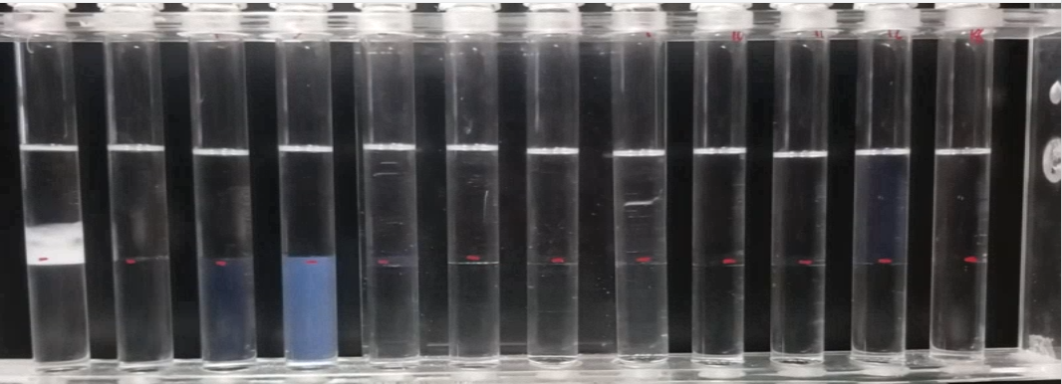
Figure 21 Phase behavior Scan (Type I-III-II) of SDHS with Heptane (EACN=7)

Microemulsions have been modeled by the Hydrophilic Lipophilic Balance (HLB) and, more commonly now, with the Hydrophilic Lipophilic Deviation (HLD) model.³⁶ Unlike HLB, as it has been noted by formulators, the apparent benefit to HLD is its ability to relate amphiphilic behavior to changes in salinity or temperature as well as screening surfactants for applied uses. The HLD model for surfactants have been discussed previously and is simplified using Equations 11 and 12, assuming room temperature and no additional solvents or co-surfactants.
${HLD}_{i}= ln\left(S\right)- {K\left(EACN\right)+Cc}_{}$ (11)
${HLD}_{ni}= b\left(S\right)- {K\left(EACN\right)+Cc}_{}$ (12)
HLD describes the surfactant behavior by assigning the phase transition point to be 0 or where the hydrophilic and lipophilic sections are at a net balance with both phases. By using oils with known EACN values, the surfactant’s hydrophobic interaction term, K, and overall affinity, Cc, can be determined. The “characteristic curvature” or Cc can be thought similarly as an HLB value, in which it describes the hydrophobicity (Cc > 0) or hydrophilicity (Cc < 0) of the surfactant.³⁸
Specific ion effects on surfactants have been a topic of interest for some time.¹¹ Historically, specific ion effects are described based on the molecular environment (ion-solvent, ion-protein, ion- surfactant, etc.) and remain somewhat controversial. As such, it is common to find references of the Hofmeister Series, the original account for common inorganic ions.^{62,63} Developed through the observation of the salting effects occurring with egg white proteins, the Hofmeister series, as originally observed, is shown in Figure 22.
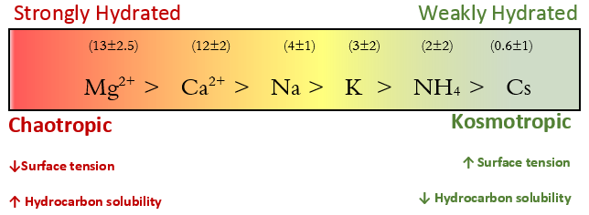
Figure 22 The Hofmeister Series for Common Cations; average “hydration” number from literature in ( ) ^{62–66}
Hofmeister qualitatively ranked the ions based on the salting-out behavior, which gave rise to the terms such as ‘chaotropes’ and ‘kosmotropes,’ both meaning “disorder maker” and “order maker”, respectively. Both describe the observed effects of the ion on a solution independent of the extent of hydrogen bonding and have been shown to revert based on the systems temperature, pH, and concentration leading to some confusion.⁶⁴ Nonetheless, the Hofmeister series continues to be useful in addressing the qualitative effects on simple and complex solutions, although reversals in the series and other intricacies have been reported.
Within ionic solutes, such as chloride salts, much effort has been applied to model the properties of simple solutions by using the ions hydrated radii or its electronegativity.^{65,66} Molecular dynamic and ab initio calculations have been shown to help quantify the ion-solute and ion-solvent interactions, yet are very case-specific and not exactly useful to common industrial problems.^{67,68} Subsequent work of multiple fields, including experimental and computational modeling, has provided evidence that specific ion effects originate through an ions tendency to manipulate the surrounding molecular waters inducing changes to the overall water activity.^{63,69} A recent review of ion hydration and the influence of water structures can be found by Ohtaki and Radnai.⁷⁰
Evaluation of amphiphile-ion interactions in aqueous solutions has mostly agreed with the ion hydration argument to a degree. Liu found that when using a chemical probe to study anion and cation specific salt effects on SDOS micelles that the difference in the anion from sodium salts found no significant change in the molarity of interfacial water. However, when monovalent and divalent chloride salts were utilized, a significant decrease in interfacial water resulted, from which they determined that the specific ion effect on micelle transition was due to interfacial dehydration by the counterions.⁷¹ Another recent study by Hansel looked at the same surfactant SDOS and utilized vibrational sum-frequency scattering spectroscopy to study the effects of alkali metals on planar and spherical nanoemulsions. They confirmed the sulfonate head group portion was highly and evenly solvated with each counter ion. However, the degree of interfacial water orientation around the head group followed Na⁺ > K⁺ > Mg²⁺, where the less hydrated Na⁺ ion had the highest degree of water orientation, and vice versa for the water alignment found using the highly hydrated Mg²⁺ ion.⁷² They further present that the di-alkyl branched tails of SDOS hindered the packing of the surfactant affecting the head group position.⁷²
Similarly, the CMCs of nonionic surfactants have been found to vary consistently with the Hofmeister series.⁷³ They seem to form large hydrogen bonding networks using divalent counterions, such as calcium and magnesium, suggestive of a similar mechanism of that of ethoxylated co-polymers. Baker found that the presence of calcium ions decreases the adsorption density of polyethoxylated octyl and nonyl phenols surfactants by increasing the hydrophobicity, in which it was concluded the conformation of the surfactants changed in part due to the ion selected.⁵¹ The hydroxyl groups of nonionic amphiphiles are expected to depend significantly on the surrounding hydrogen provided by water. Depending on the size of the nonionic head group, the solubility of the surfactant should shift with the increased concentrations of ions of differing valency and size.⁵¹
The Hofmeister series has also been studied by the use of colligative properties, where the solution behavior depends on the concentration of ions but not particularly the additive properties of the ion such as size or valency.^{64,74} Colligative properties of specific ion effects have been studied using osmotic pressure, freezing point depression, and boiling point elevation. We point out that HLD is a colligative equation in regards to the surfactant chemical activity, as it only relies on the concentration of salinity or temperature. Thus, one would expect to see a similar salting-out series at least qualitatively within surfactant phase behavior.
At this time, there are only two methods to account for the ion species other than sodium chloride for HLD, relating the difference in ionic strength, Equation 13⁴⁷, and Anton’s reported direct modification of counter ions found through experimental observations, Equation 14⁷⁵. Both require the normalization of the chloride salt to sodium chloride by their relative molar masses, where X is the cation.
$SIonic Strength =S x\left[\left(\frac{{Mw}_{NaCl}}{{Mw}_{XCl}}\right)\right]x [\frac{({Z_{NaCl}}^{2})}{({Z_{XCl}}^{2})}]$ (13)
$SAnton =S x\left[\left(\frac{{Mw}_{NaCl}}{{Mw}_{XCl}}\right)\right]x [\frac{2}{1+Z}]$ (14)

The differences between the two methods derive from how the valency, Z, of the ion, X, contributes to observed behavior. From Anton’s modification, Equation 14, the valency contribution was much higher in comparison to the ionic strength, Equation 13, where the valency is squared. The ionic strength correction tends to overestimate the electrostatic contributions for multivalent ions as well as assumes complete dissociation between ion-surfactant head group, failing to account for counterion binding to micelles and Gibbs monolayers.⁷⁶ While both methods relate the size and ionic interaction via valency of the counterion, at best both are used as a general rule of thumb to aid in formulation endeavors.⁴⁷
The non-ideality of these historical salt models appear to be due to coupled interactions mainly from the cation and surrounding water molecules.⁶⁴ Anions such as chloride and bromide have been shown to have negligible hydration numbers, though certain anions like fluoride or sulfate can have positive hydration numbers.⁶⁴ Nonetheless, the anion’s size contribution and dissociation should also be taken into consideration when trying to model specific ion effects.⁷⁷
It has been shown by Zikavitas that the Hofmeister effects of inorganic salts can be quantified using a hydration term, called the hydrodesimic number, which relates the changes in water activity.^{77,78} The amount of “free” bulk water is reduced by the addition of solute and the average number of “bound” water molecules to the solute can be determined. This hydrodesimic number is a colligative property and holds significance above infinite dilute conditions, i.e. >10 mM salt. Furthermore, the ion hydration numbers have been correlated to several thermodynamic properties and additive quantities such as Jones Dole coefficients, and water coordination numbers from x-ray and neutron scattering.^{64,77}
A new specific ion modification term is proposed to relate the ion’s interactions with water via hydration to the specific ion effects being observed in Type III microemulsions. Using Anton’s original modifiers, the product of the normalized molecular mass (Mw) and the valency (Z) of the salt are multiplied by the natural log of the hydration number, h_{C}, determined colligatively from changes in the optimum salinity.⁷⁵ The h_{C} variable is deemed the colligative hydration number. The three variables, in this case, are considered the additive properties of the chloride salt. Equation 15 shows the anionic modified equation where each contribution, the mass, valency, and hydration are bracketed in order. In these equations $S^{*}$ is the optimal salinity for a Type III microemulsion using the appropriate form of the HLD equation.
${S^{*}}_{Anionic Hydration}=S^{*}x\left[\left(\frac{{Mw}_{NaCl}}{{Mw}_{XCl}}\right)\right]x \left[\frac{2}{1+Z}\right]x [ln\left(hC \right)]$ (15)
$b* {S^{*}}_{Nonionic Hydration}=\frac{S^{*}}{10}x\left[\left(\frac{{Mw}_{NaCl}}{{Mw}_{XCl}}\right)\right]x \left[\frac{2}{1+Z}\right]x [ln\left(hC \right)]$ (16)
Any shifts in the optimum salinities from NaCl concentration predicted by the HLD equation that arises from varying the cation within the chloride salts should be found in changes in h_{C}, in addition to changed related to the molecular weight (size) and valence. The model is constructed for the use of sodium as the reference ion, as it is the most commonly used cation in formulation science. As such, the h_{C} for sodium is not truly considered in this model, yet it can be found through extrapolation of linear mixing of univalent cations and can be used to find b, the salinity modifier used for nonionic surfactants. The term h_{C} is dimensionless and relies on empirical results to quantify. The utilization of a natural log nicely accounts for the general behavior of solute interactions within aqueous environments.⁷⁹ For h_{C,} values below and above one are indicative of a decrease or increase in the colligative number of bound water molecules. Whether one considers either the coordinated waters using hydration shells or the colligative “bound” water approach, a solute always interacts with free water molecules. Thus, negative hydration numbers should not occur. However, there are cases where a solute or ion interaction with free waters show no effect on the behavior of the solution. In this scenario, h_{c} is commonly found to be around one, rendering the hydration term null and is thought to occur primarily through entropic effects to either the molecular mass contribution, confined space effects, or hydrogen bonding.^{9,80,81}
One of the benefits of the modified equations is that the surfactant’s K and Cc values determined using sodium chloride will remain constant. A formulator now could quickly model the approximate optimum salinities of common inorganic salts by a single sodium chloride phase behavior scan. Additionally, if the equation is addressing the fundamental interactions occurring between the amphiphile head group, cation, and the surrounding medium, then the colligative hydration number should remain reproducible for both anionics and nonionic surfactants.

Materials and Methods

Materials
Ionic reference surfactants: Sodium dihexyl sulfosuccinate, SDHS (Sigma Aldrich), AF K2-41S (Sasol), and AF K3-41S (Sasol). The nonionic reference surfactant: Novel 810-3.5 (Sasol). Salts: Sodium Chloride (99% Sigma Aldrich). Ammonium Chloride (98% BDH), Calcium Chloride Anhydrous (99% Sigma Aldrich), Calcium Chloride Dihydrate (99% Sigma Aldrich), Cesium Chloride (99% VWR), Magnesium Chloride (98% Sigma Aldrich), and Potassium Chloride (99%VWR Life Science),
The alkane oils used have defined EACN values and are simple in handling; n-Hexane (98% EACN=6), n-Heptane (99% EACN=7), and n-Octane (99% EACN=8). The aqueous solutions of surfactant and salt were well mixed with filtered deionized water. All solutions were handled under a standard ambient temperature (25ºC) and pressure (1 atm).

Freezing Point Determination
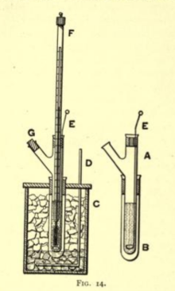
A reconfigured Beckmann apparatus, Figure 23, was constructed using a 12 ml vial (A) as the sample holder and a 30ml vial as the air shell (B).⁸² The cooling bath (C) was a solution of dry ice-isopropyl alcohol. Two K-type thermocouple probes were arranged to take the internal temperature of the solution, as well as the cooling bath temperature, to maintain a reasonable cryogenic temperature (-40 ºC). The temperature recording and stirring via a magnetic bar were controlled via a computer terminal. The sample volume was set to 3 mL and the concentrations were set for >10x the CMC of the selected surfactant.
Figure 23 Original Beckmann apparatus for determining freezing points.

Microemulsion Phase Behavior
Microemulsion phase behavior scans were performed using a single reference surfactant. The chosen monovalent or divalent chloride salts were added to a 17ml sealed vial or 10ml glass pipette at a constant molar surfactant concentration (100mM SDHS/~200mM C₈₁₀E_{3.5}) to find the optimum salinity (S*). The aqueous solution’s meniscus was marked in order to determine Winsor type and underwent mixing with vortex mixer at room temperature for a minimum of 30 seconds. An equal volume of a known alkane oil phase would then be added and the sample was sealed using a cap for a vial or flame sealed if in pipette. The sealed samples would be further hand mixed and left to equilibrate for 24 hours in an incubator set at 25ºC. This procedure was utilized and using hexane, heptane, and octane. The glass pipette samples were allowed to sit for three months to be used for stability and solubility behavior. The sealed vials underwent coalescence and interfacial tension methods to determine the amphiphiles optimum salinities.

Determining Optimum Salinity, Interfacial Tension and Solubility Parameter
After 24 hours, the equilibrated samples were removed from the incubator and the phase behavior, Type I, III, II, was recorded. The middle phase volume of the resulting Type III microemulsions was measured using image processing software, ImageJ, and the volume marks on the pipette samples. The equilibrium interfacial tension of the Type III’s was measured using a spinning drop tensiometer (M6500 Grace Instrument, Houston, Texas). The ultimate determination of optimum salinity was based on the lowest experimentally found interfacial tension from the salinity scans within 0.2 g/100ml.

Results and Discussion

Hydrodesimic Numbers of Ionic Surfactants
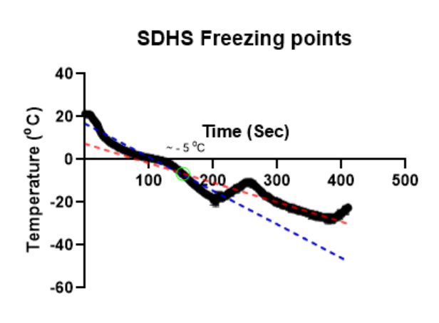
The freezing point depression of anionic surfactant solutions was applied to approximate the colligative hydration number of the surfactant to evaluate the differences in hydrophilic structure. This experiment set the constant surfactant concentration to 200 mM well above the CMC, as it was found to be readily reproducible after many laborious attempts. The solidification temperature was acquired by taking the intersection of the linear regressions of temperature trends pre and post-crystallization. Figures 24 and 25 report the average freezing point of SDHS and extended surfactant K2-41S.
Figure 24 Freezing Point Determination (ºC) of SDHS (200mM) in DI water

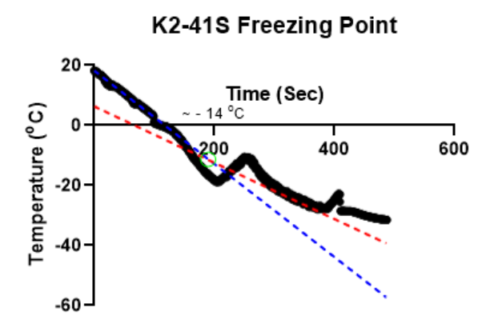
The difference in the freezing points from pure water (0ºC) is input into Equation 17, the ideal relationship of freezing point depression to the molar fraction of solute derived from Raoult's law. Equation 17 can be approximated to form the cryoscopic equation, where K_{f} is the cryoscopic variable of water, and m_{s} is the molality of the solute.⁸³
Figure 25 Freezing Point Determination (ºC) of K2-41S (200mM) in DI water
$∆T=x_{S}\frac{R{T_{m}}^{2}}{∆H_{fus}} ≅m_{S}K_{f}$ (17)
$x_{w}=\frac{m_{pure water}-m_{s} x h_{D}}{m_{pure water}-m_{s} x h_{D}-m_{s} x i_{e}}$ (18)
Zavitsas’ hydrodesimic number, h_{D,} is presented in Equation 18, where the molar fraction of water now accounts for the total of bound waters no longer in the bulk. It also considers the dissociation of the solute using the van’t Hoff factor, i_{e}.^{64,78}
The two surfactants selected are considered salts and dissociate readily in water, so it was assumed the dissociation followed similarly to monovalent salts, i_{e}=2. The hydrodesimic numbers for SDHS and K2-41S were found to be 2.9 and 2.72 by employing the cryoscopic molar fraction of water, x_{w} = (1-x_{s}), to equal Equation 18 and using Excel goal seek.
In regards to HLD parameters, K2-41S is more hydrophilic to SDHS, yet the colligative hydration indicates that SDHS binds with more water. Studies involving polymer interactions between alkyl sulfates and alkyl sulfonates have observed similar behavior where the sulfonates tended to coordinate more water molecules in comparison to the sulfates.^{84,85} Additionally, the hydrophilic moieties of the two surfactants are different and should be considered. SDHS, along with its sulfonate group, has two active ester groups that can interact with the solvent through hydrogen bonding. Likewise, K2-41S has a strong hydrophile in sulfate but also has four PO groups that can extend the surfactant lipophile and ultimately acts neutral, if not hydrophobic.⁸⁶ The slight difference in the hydrodesimic number between the surfactants was observed later when accounting for the differences in the colligative hydration numbers, h_{C,} extracted and will be presented in detail.

Effects of Chloride Salts on S* for Anionic Surfactants
(a)

(b)

(b)

(b)
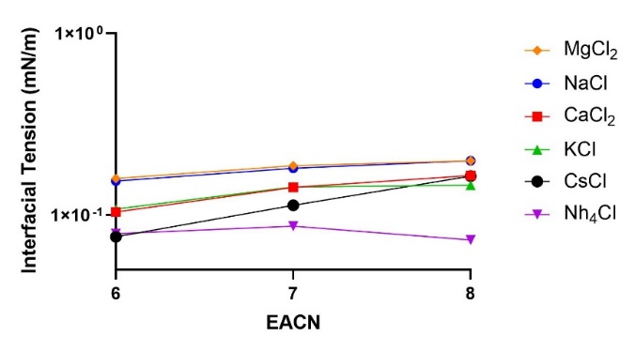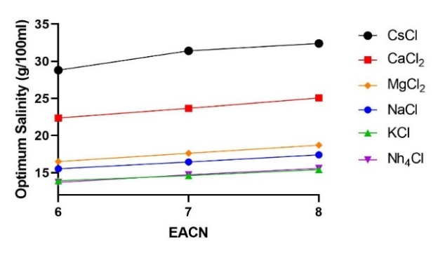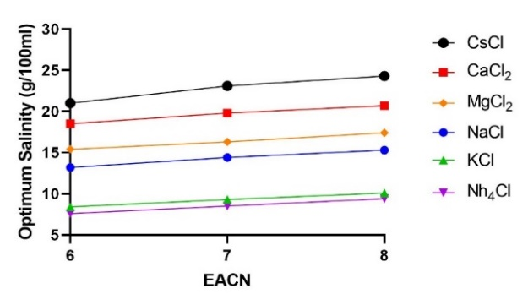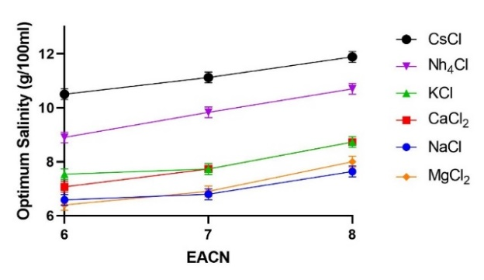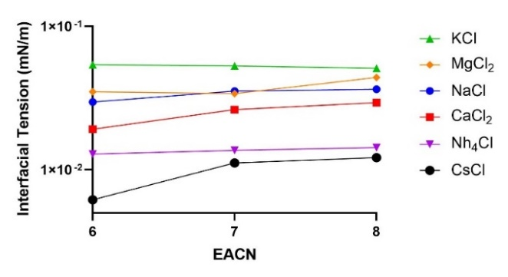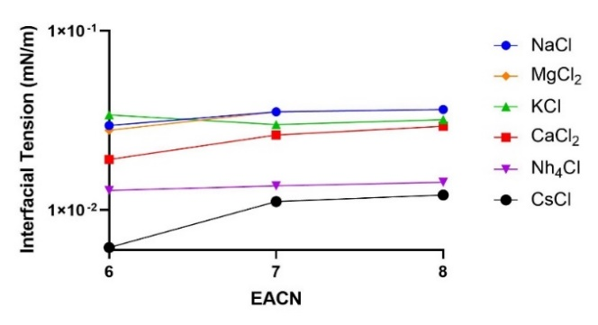
(b)

(b)

(b)

(b)
(c)

(c)

(c)

(c)
Figure 26 (a) Left: S* (g/100ml) vs EACN Right: IFT* (mN/m) vs EACN of SDHS at 25ºC (b) Left: S* (g/100ml) vs EACN Right: IFT* (mN/m) vs EACN of K2-41S at 25ºC (c) Left: S* (g/100ml) vs EACN Right: IFT* (mN/m) vs EACN of K3-41S at 25ºC
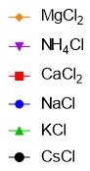
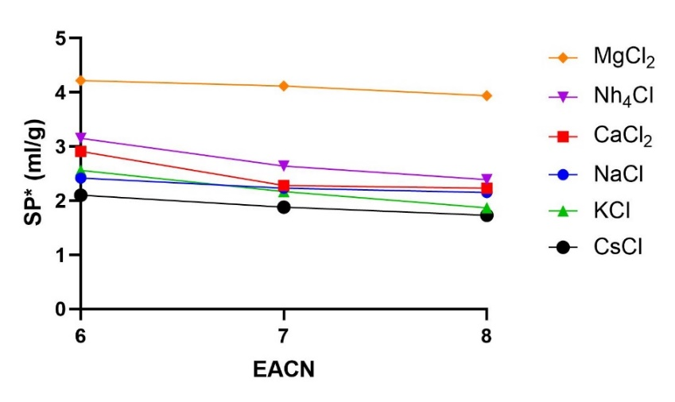
Figures 26a-c show the lowest experimentally found interfacial tension and the resulting optimum salinities for the anionic surfactants. As referenced from previous counter ion studies, there were no noticeable differences between the Type III microemulsions besides the observed coalescence times and volume of the middle phase. None of the samples had any indication of precipitation or coacervation occurring for the oils utilized. The results for SDHS showed the optimum salinities of the chlorides from high to low concentrations were ranked quantitatively, where Cs⁺ > NH₄⁺ > K⁺ > Ca²⁺ > Na⁺ > Mg²⁺. The interfacial tensions were found within the same magnitude at 10⁻¹ mN/m but also correlate in the same order. Disregarding the position of sodium and regarding it as the reference state, the observed series follows what one would expect as the original Hofmeister series.
Figure 27 SDHS SP* vs EACN at 25ºC
The changes in the middle phase volume were quantified via the solubility parameter of the surfactant by varying the oil phase and are shown in Figure 27. The SP* for each counterion using SDHS was reasonably consistent between the monovalent ions with the exception of ammonium. The divalent cation, magnesium, exhibited the largest SP* with roughly a 2 mL/gram of surfactant increase. Comparing the experimental IFT to SP* qualitatively agrees roughly with the Chun Huh relation, where the IFT and SP* are inversely related depending on the thickness of the interface, except for cesium and magnesium.⁸⁷ The reasoning is the hydration shells of such ions have been found to be loosely bound when the cations are chaotropes (large) and vice versa for kosmotropes.⁸⁸ Cesium’s large size will create a thicker interface by the volume it takes up while magnesium creates a larger hydrogen network, allowing for the head groups to occupy a larger surface area.
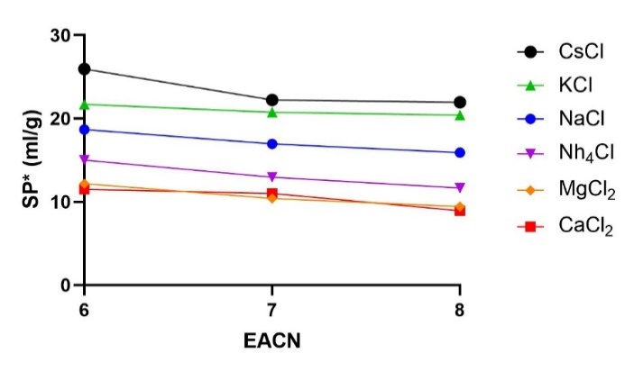
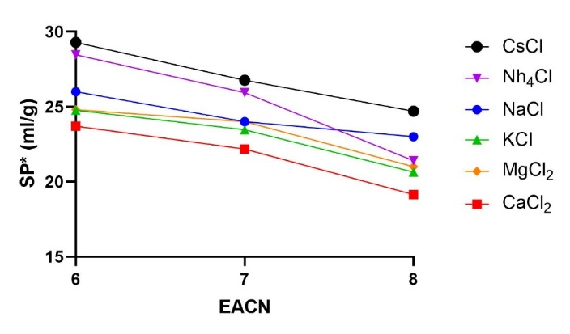
For both selected extended reference surfactants, an interesting reversal in the specific ion effects on chemical activity was observed. Opposing SDHS, the observed optimum salinities for K2-41S and K3-41S ranked Cs⁺ > Ca²⁺ > Mg²⁺ > Na⁺ > K⁺ > NH₄⁺, from high to low concentration. The interfacial tension of the extended surfactants and respective oil phases again correlated as seen in Figures 18b and 18c, remaining within the same low magnitude of 10⁻² mN/m indicative of a thicker interface. Similarly, the reversal in the Hofmeister series was observed in the SP*. Figure 28 plots the solubilization parameter for both extended surfactants and displays the large effect the counter ion has on surfactants' ability to solubilize both phases. Again the experimental SP* appears to follow the Chun Huh relation.⁸⁷ In comparison to SDHS, where the middle phase volumes were similar and somewhat hard to tell differentiate visually, the SP* differences for each counterion could be easily observed after formulating. The increase in the middle phase volumes was seen in all ions with the additional carbons between K2-41s and K3-41s, being roughly three times the amount of SDHS.
Figure 28 (Top) K2-41S SP* vs EACN at 25ºC: (Bottom) K3-41S SP* vs EACN at 25ºC
Through changing the counterion of the chloride salt, the HLD parameters of the surfactants were determined by fitting the experimentally found optimum salinities (g/100ml of chloride salt) without any modification of Equation 11. The HLD parameter values of SDHS and the extended surfactants are reported in Tables 5 and 6, respectively. The chloride salts are listed from hydrophobic to hydrophobic in relation to the found Cc values. At first glance these tables seem to indicate that different values of K and Cc are required for each chloride salt; we will show, however, that this is not the case, once adjustment is made for the hydrodesimic numbers of the cations.
Table 5 SDHS HLD (K, Cc) Parameters Varying Chloride Salts
Salt | K SDHS | Cc SDHS
MgCl₂ | 0.11 | -1.18
CaCl₂ | 0.11 | -1.29
NaCl | 0.07 | -1.45
KCl | 0.08 | -1.55
NH₄Cl | 0.10 | -1.62
CsCl | 0.06 | -1.98

Table 6 Left: K2-41S Right: K3-41S HLD (K, Cc) Parameters Varying Chloride Salts
Salt | K K2-41S | Cc K2-41S | K K3-41S | Cc K3-41S
NH₄Cl | 0.06 | -2.28 | 0.11 | -1.39
KCl | 0.05 | -2.32 | 0.09 | -1.58
NaCl | 0.06 | -2.39 | 0.06 | -2.17
MgCl₂ | 0.06 | -2.42 | 0.06 | -2.36
CaCl₂ | 0.06 | -2.77 | 0.07 | -2.44
CsCl | 0.06 | -3.02 | 0.07 | -2.61

If one accepts the Cc value as a quantity of surfactant affinity, the specific counter ion effect, observed years ago by Hofmeister is again reflected through HLD. SDHS K and Cc values presented a standard Hofmeister series where the surfactant became more hydrophobic when the divalent, kosmotropic, ions are employed and hydrophilic with the addition of monovalent, chaotropic, cations.
Interestingly the K values of the hydrophobic ions, as well as ammonium, are the largest of the salts tested. It can be inferred that larger K values indicate an increase in the hydrophobic interactions of the alkyl tail with the nonpolar phase.³⁸ In turn, the larger oil-lipophile interaction must be compensated by the surfactant head group and is reflected in the surfactant Cc value. This seems to be the case for the ammonium ion that was found to have the largest solubilization parameter of the monovalents tested, but remained hydrophilic to that of sodium, which is most likely attributed to its ability to hydrogen bond. Cesium remains the odd ion out of the rest of the chlorides, behaving hydrophilic for all anionic surfactants and exhibiting low IFT values. The ion itself is known to efficiently compensate around an external negative surface charge in comparison to the other cations studied in this work; thus, cesium may depend more on the electronic interactions rather than hydration.^{88,89}
The reversal of the order of the specific ion effects on the extended surfactants is exciting but not entirely surprising. This reversal may be explained through the head group structure and observed change in the interfacial thickness. Using the idea of a dynamic interface proposed by Salager et al., in which the surfactant head groups are exposed to the aqueous phase, interacting with the solute or solvent, while the hydrophobes are interacting with each other called the palisade layer and further extend into the oil phase. In this case, it is assumed the specific ion effects are limited to the head group. Alkyl sulfonates alone have been shown to have a lower hydration capacity in comparison to its alkyl sulfate counterparts with FTIR/NMR methods, in contrast to our previous freezing point findings.^{84,85}
The polar structure of SDHS, the sulfosuccinate head group, is a sulfonate surrounded by two ester groups. These esters will interact with the palisade layer through hydrogen bonding as well as the interfacial water.⁹⁰ It is likely the surfactant behavior exhibited is due to the surfactant’s short alkyl chains sterically hindering itself, presenting less surface area into the palisade layer, and thus having a smaller interfacial thickness interpreted from the observed interfacial tensions and solubilization parameters.⁹¹ This is not the case for the alkyl propoxyethoxy surfactants, which having four propylene oxide and one ethylene oxide in conjunction with its sulfate head group increases the characteristic length of the surfactant. By pushing the lipophile further into oil phase and assuming the head group volume slightly decreases within aqueous phase, the surface area is increased, exhibiting a thicker interface via lower interfacial tensions, simultaneously increasing the amount of interfacial water available for sharing with the counterions.

Effects of Chloride Salts on S* for Nonionic Surfactants
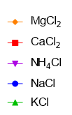
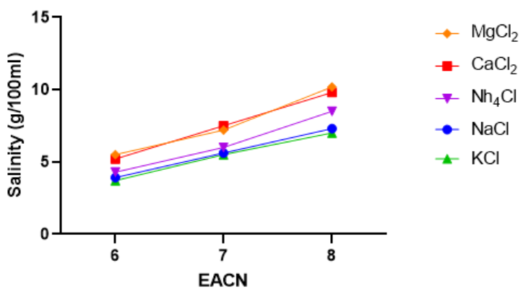
The hypothesis that the specific ion effects behaving on surfactants are not entirely dependent on electrostatics but also involves the sharing of interfacial water was supported by employing nonionic surfactants. The logic followed that the qualitative effects of the salts should continue to be observed in microemulsion behavior regardless of a nonionic surfactant not having a charged head group.
Figure 29 S* (g/100ml) vs EACN of C₈₁₀E3.5 at 25 º C
With C₈₁₀E_{3.5} as the reference surfactant, the optimum salinity for each chloride salt was determined by way of the coalescence method. The solubilization parameters were recorded in lieu of interfacial tension measurements, which we justify in that the two methods gave the same results for the anionic surfactants studied. Figure 29 accounts for the optimum salinities for the employed alkanes. Unlike the anionic surfactants that had significant variance in optimum salt concentration between the counterions, C₈₁₀E_{3.5} optimal salinities remained relatively close with the largest optimal salinity being observed using octane as the oil phase. The colligative order ranked similarly to the extended surfactants, from largest to smallest optimum concentration Mg²⁺ > Ca²⁺ > NH₄⁺ > Na⁺ > K⁺.
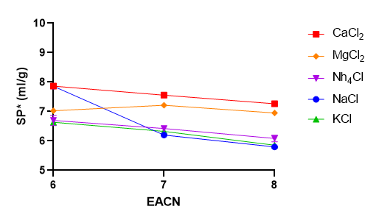
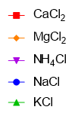
The specific ion effects on C₈₁₀E_{3.5}’s solubilization parameter were found to behave similarly to SDHS, where the divalent ions present the largest SP*. Figure 30 illustrates the SP* for C₈₁₀E_{3.5} with associated oil phases, where the qualitative ranking from largest to smallest SP* was Ca²⁺ > Mg²⁺ > NH4⁺ > Na⁺ > K⁺. The divalent chaotropes exhibited only an increase in SP* of about ~1.5 mL/gram of surfactant, as expected from kosmotropes, should interact with the hydrogen dependent ethoxylated head groups. It was interesting to find that ammonium and potassium only provided a slight increase to the volumes of Type III middle phases.
Figure 30 SP* (ml/g) vs EACN of C₈₁₀E3.5 at 25ºC
The optimum salinities S* (in g/100ml) for the chloride salts besides cesium were all multiplied by the b value used for NaCl (0.13) to determine the changes in HLD parameters without any modification using Equation 12. Table 7 shows the K and Cc values ranked from hydrophobic to hydrophilic. At first glance, the amphiphilic order mirrors that of SDHS, generally following the standard Hofmeister series with the difference being the position of the ammonium ion. Divalent magnesium and calcium were again presented as hydrophobic, owing to the largest K and positive Cc parameters observed. Ammonium chloride remarkably also acted more hydrophobic along with a larger K parameter in regards to chaotropic ions sodium and potassium.
Table 7 C₈₁₀E_{3.5} HLD (K, Cc) Parameters Varying Chloride Salts
Salt | K C₈₁₀E3.5 | Cc C₈₁₀E3.5
MgCl₂ | 0.31 | 1.14
CaCl₂ | 0.30 | 1.12
NH₄Cl | 0.27 | 1.10
NaCl | 0.22 | 0.82
KCl | 0.21 | 0.79
Unlike the sulfate or sulfonate head groups, where the lipophile interaction remained consistent (∆K+.05), C₈₁₀E_{3.5} had the largest variance in K values of all surfactants studied (∆K+.09). Potassium and sodium ions exhibit similar amphiphilic behavior, which is in agreement with the work done by Baker in regards to adsorption of nonionic surfactants, where the monovalent ions likewise had an equal salting-out effect.⁵¹ It is plausible that the nonionic head groups are more susceptible to dehydration from the introduction of divalent and ammonium cations, considering that chaotropes are more hydrated than the kosmotropes and ammonium’s ability to readily hydrogen bond. The dehydration of the head group will, in turn, increase the penetration of the surfactant into the oil phase layer, increasing the lipophile interactions.

Evaluation of Salt Models
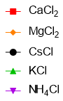
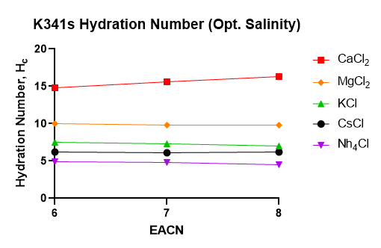
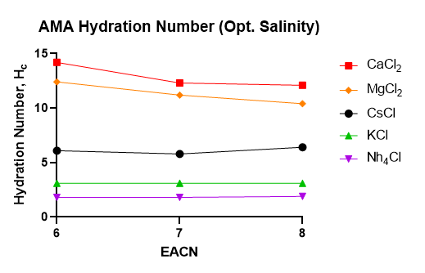
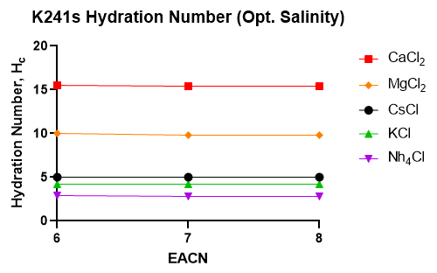
The exhibited solution properties such as IFT, SP* as well as extracting the HLD parameters, K and Cc, have shown that specific ion effects are reoccurring between anionic and nonionic surfactants. Since the qualitative behavior that depends on the additive properties of the ion continues to emanate between heterogeneous molecules, then it is probable that the sharing of water is universal for surfactant head groups in the structures between the bulk phases.⁶⁴ Thus, the salt model proposed previously for both surfactant types, reflecting the shifts in amphiphilic behavior, will be observed through the colligative hydration number h_{c}. The properties of each chloride salt, as well as the optimum salinities, experimentally found was fitted using Equation 15 and 16 described previously to extract h_{c} for all amphiphiles.
Figure 31a-c (a) SDHS extracted h_{C} vs EACN (b) K2-41S extracted h_{C} vs EACN (c) K3-41S extracted h_{C} vs EACN

The evaluation begins with the anionics respective hydration numbers for each oil phase shown in Figures 31a-c. The anionic surfactants h_{c}, when ranked coarsely, follows the Hofmeister series except for the positions of the divalent ions and the largest ion, cesium. Within the oil phases studied the hydration numbers did not vary considerably with the divalent cations displaying the largest hydration, whereas the monovalent cations exhibited smaller hydration capacities.
Between the surfactants, the counter ion’s h_{c} for alkyl propoxyethoxy sulfates were larger than observed for SDHS. These results corroborate the freezing point behavior discussed previously, where sulfates tend to shed or share their interfacial water.⁸⁴ The increase in alkyl length between K3-41S and K2-41S is also realized through the rise in the counter ions hydration number. It was speculated earlier that the reason for the extended surfactant's large solubility parameters is the propoxy groups extending the lipophile further into the oil phase. Increasing the hydrophobicity would only reduce the head group’s affinity, granting the counter ion more interfacial water. Cesium remains the odd ion out of the rest of the chlorides, behaving hydrophobic for all anionic surfactants. The largest cation showed the largest interfaces through the low IFT and has been shown to have compensated an external negative charge surface charge, thus the electrostatics is distributed most efficiently of the chlorides studied.

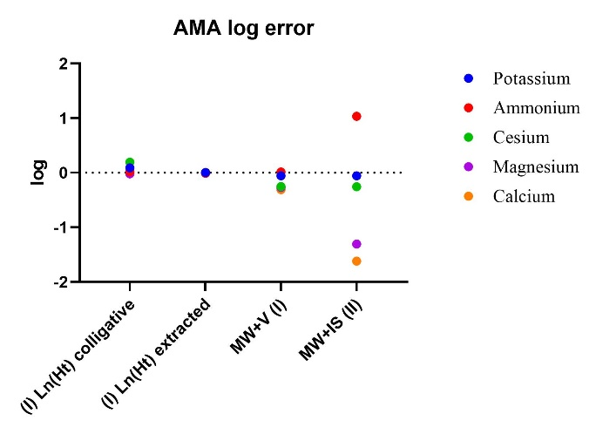
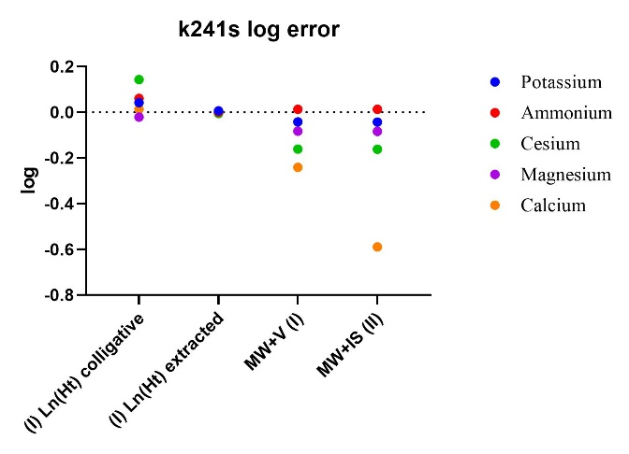
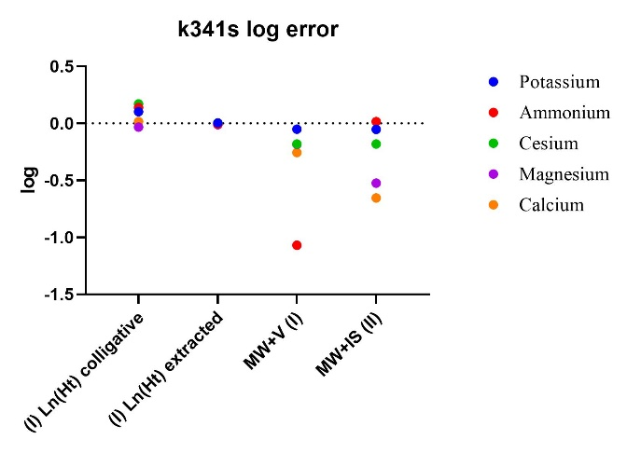
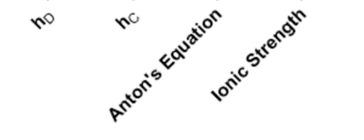
Comparison of the historical salt models, the ionic strength (Equation 13), or Anton’s Equation (Equation 14), to the modified colligative equation for anionic surfactants (Equation 15) was performed. Zavitsas’ hydrodesimic numbers in literature, h_{D}, as well as the averaged experimentally found colligative hydration values, h_{c,} were also compared.⁶⁴ Figures 32a-c show the log of the quotient between the predicted S*, S*_{pre,} and the experimental S*, S*_{exptl}, was taken for each counter ion. The log of the quotients are useful as they cannot be overestimated like absolute error and can be interpreted based on how close the error is to zero, indicative of a very close approximation.⁹² Consequently, positive log errors report overestimations of the optimum salinities and vice versa. The evaluation showed overall for all ions the quantitative ranking from most accurate to least: Hydration Modification (Eq 15) > Anton’s Equations (Eq 14) > Ionic strength (Eq 13).
Figure 32 Log [S*_{pre}/S*_{exptl}] plots using Anton Equation (Eq 14), Ionic Strength (Eq 13) and the Modification (Eq 15) using both the experimentally found hydration number, h_{C,} and Zavitsas’ hydrodesimic numbers, h_{D:} (a) SDHS (b) K2-41S (c) K3-41S
(c)
(b)
(a)
Both historical models, in general, were observed to underestimate the optimum salinities for most of the cations. Specifically, the under prediction of divalent ions, particularly calcium, was found to be dramatic for the ionic strength model. Likewise, Anton’s model also tended to underestimate S* but to a lesser extent, pointing to how each model addresses the electrostatic interactions through valency. Using the proposed equation presented previously in Equation 15 and employing Zivatsas’ hydrodesimic values, h_{D,} reported only slight overestimates for the cations while not being entirely applicable for cesium, providing better predictions than the previous models.
Nonionic surfactants already have had empirical coefficients determined to address the change in salinity using different cations, known as b constants, which are multiplied against the salt concentration. Typical b values have been stated for NaCl and CaCl₂, being 0.13 and 0.1, respectively. Figure 33 presents the colligative hydration numbers, h_{c}, for the C₈₁₀E_{3.5} surfactant. The cation’s h_{C} were extracted in the same manner as the anionic surfactants while considering the normalization of the salt contribution by 1/10th to apply towards a nonionic head group using Equation 16.
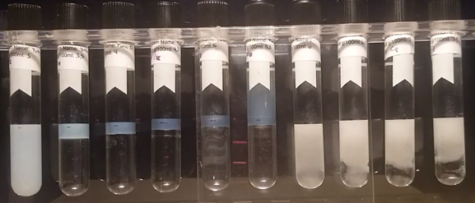
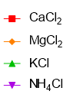
The obtained colligative hydration numbers, h_{c,} for the nonionic surfactant ranked Ca²⁺ > Mg²⁺ > K ⁺ > NH₄⁺, and stayed consistent with increasing alkane phase. Excitingly the chloride salt h_{C}’s were within the error of their anionic counterparts, essentially reproducing the cation hydration. The ammonium ion was found to act hydrophobic to C₈₁₀E_{3.5} through both HLD parameters, yet remains in series with the rest of the kosmotropes. Calcium and magnesium were flipped in a position similar to the extended surfactants, though the extracted h_{C}’s generally followed the normal Hofmeister series. Contrasting anionic surfactants where the electrostatic contribution is obvious, the size of the ion could be the real difference in the behavior of the divalent cations. The ionic radius of magnesium is 3/4th that of calcium and has been found to be able to direct pair with the hydroxyl groups of small ethoxylated solutes while shedding water in the process.^{93,94}
Figure 33 Polysorbate21-KCl Phase Behavior Scan with

Figure 34 C₈₁₀E3.5 extracted h_{c} vs EACN
Using the value of Equation 15 as an empirical constant reveals the following: b_{calcium}= 0.11, b_{magnesium} = 0.096, b_{potassium} = 0.14, and b_{ammonium} = 0.12. The reproduction of the calcium empirical was impressive as well as potassium’s close approximation to sodium’s b value. Assuming Equation 16 is correctly approximating the ion’s “bounded water,” the sodium’s colligative hydration number, h_{C,} can be determined using the known b_{sodium} value 0.13. This exercise produces the sodium h_{C} to be around 3.9, in close agreement with Zavitsas’ hydrodesimic number.^{64,77} These values were further verified for ammonium, potassium, and calcium chlorides by utilizing a commercial polysorbate, which was able to produce a phase inversion point and, at times, Type III microemulsions using octane as the oil phase at room temperature. The optimum salinities qualitatively behaved the same as C₈₁₀E_{3.5} though the surfactant acted more hydrophilic. The experimental b coefficients and extracted h_{c} for polysorbate-4 with octane are plotted in Table 8 displaying good agreement.
Table 8 Polysorbate-4 in octane b coefficients and extract h_{C} for selected chloride salts
Salt | b | h_{c}
CaCl₂ | 0.09 | 13.8
NH₄Cl | 0.12 | 3.1
KCl | 0.15 | 7.2

The anionic and nonionic surfactant averaged h_{c} for each chloride salt was compared to the average comparable hydration number found in literature and is illustrated in Figure 35. The obtained h_{c}’s were found to be successfully reproducible between both types of amphiphiles using the modified equations. Furthermore, the values are roughly within the known range of hydration numbers for all besides cesium. It is impressive to reproduce ammonium with both surfactants as its hydrogen bonding has made it quite famous as it likes to jump around the Hofmeister series.
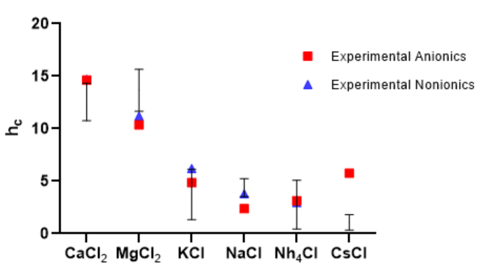
The size contribution of the ions within Anton’s Equation could be inefficient, accounting for larger molecular weights as cesium’s h_{c} is greatly overestimated (h_{c} =6). It should be emphasized that though these values are empirical, the colligative hydration number, h_{C,} obtained in this work were able to be correlated with known hydrodesimic numbers.
Figure 35 Average Colligative Hydration Number, h_{C} vs Average literature range of known hydration numbers (hydrodesimic number, h_{D,} coordination numbers, etc.)

Conclusion
Surfactants affect the water structure in solution, where the head groups are interacting and sharing water molecules. The sulfonate and sulfate surfactants were found to colligative “bound” up to three water molecules determined through the freezing point depression. The differences in anionic head groups are considered where added propoxy groups may dehydrate or reduce the surfactant head group’s access to interfacial water.
This work demonstrates that specific cations will affect amphiphilic behavior as observed shifts in surfactants extracted HLD parameters as well as the microemulsion properties such as the solubilization. The change in the amphiphile Cc parameters indicated that the specific ion effects primarily occur at the head group level. There were differences seen in structure as nonionic lipophile interactions (K constant) was dramatically increased for hydrophobic ions, yet negligible change was found in anionics.
A proposed colligative hydration model was successful in providing better predictions of optimum salinities for chloride salts for anionic amphiphiles than what is found in literature. Furthermore, the nonionic surfactants provided further evidence of the specific ion effects towards an uncharged molecule as well as reproduced similar colligative hydration numbers, h_{C}, observed from anionic experiments. The same values were found to correlate well with literature values of hydration numbers including the colligative hydrodesimic number, coordination number, and other sources. Now a formulator can reproduce optimum salinities of various salts using their additive properties and model surfactants readily with a single-phase behavior scan.

CHAPTER 5: Extending Colligative Properties of Surfactants to Model Alcohol Effects on Type III Microemulsions

Introduction
Alcohols are significant components in applications such as active pharmaceutical ingredient (API) delivery, industrial cleaners, cosmetics, and other specialty chemical formulations. Relatively safe, useful solvents that are soluble with many organic solutions, alcohols are interfacially active solutes that can freely interact with other dissolved molecules in aqueous mixtures. Many of the commercial formulations are constrained in regards to the alcohol concentration and are limited due to transportation (flammability) and environmental (VOC) regulations. Many formulators apply alcohols as co-surfactants to induce behavioral change on amphiphilic solutions, changing properties such as hydrocarbon solubilization, modifying the electrolyte tolerance, as well as being useful for inhibiting liquid crystal formation.⁵⁰
It is well known that surfactant behavior can be manipulated through the addition of polar solutes with observed changes to adsorption, wetting, and cloud points.^{48,51} Critical micelle concentrations of single and binary solutions of amphiphiles are frequently found in literature and many infer the resulting thermodynamic response to the character of the alcohol.⁹⁵ Just as surfactant micellization is affected by salt concentration, low molecular weight alcohols have been found to induce similar inversions to surfactant affinity as with the reversal of microemulsions, where an O/w Type I system transitions into a W/o Type II.^{96,97} Microemulsions, like micelles, are thermodynamically stable systems that are related to the surfactant’s amphiphilic interactions occurring between two immiscible phases. These systems have been revealed previously to be beneficial in characterizing ions as well as interfacial solutes. Of particular interest are the solute effects on Type III microemulsions, forming impressive zero net-curvature structures, in which to study interfacial phenomena.
The HLD concept has been described previously for microemulsion studies. The model helps understand the changes in amphiphilic behavior via fluctuations in phase inversion point (PIP) of a biphasic solution as a function of solute concentration. Equations 19 and 20 show the HLD Equations for ionic and nonionic surfactants accounting for the aqueous salinity (S), added alcohol or co-solvent f(A), and temperature (T),
${HLD}_{i}= ln\left(S\right)-f\left(A\right)- {K\left(EACN\right)+Cc-a}_{T}(ΔT)$ (19)
${HLD}_{ni}= b\left(S\right)-f\left(A\right)- {K\left(EACN\right)+Cc-C}_{T}(ΔT)$ (20)
HLD, with the use of phase behavior studies, can address the surfactant’s affinity as well as the interactions occurring at the surfactant hydrophilic and lipophilic groups.
While both are inherently connected, K and Cc values are essential quantities to be able to predict surfactant behavior utilizing different oil phases as well as co-surfactants for mixed solutions. At the PIP, HLD is considered zero, and Equations 19 and 20 can be rearranged to account for the changes in lipophilic and hydrophilic interactions reflected in the characteristic curvatures. Analogous to an HLB value, Cc can be interpreted in Equation 21 where the bracketed terms are the hydrophile and lipophile interactions in order.
$Cc=[-S*+f(A)]+[K × (EACN)]$ (21)
Historically, the f(A) term has been used to empirically fit the changes to the phase inversion point utilizing the concentration of polar co-solvents like alcohols, hydrotropes, as well as hydrophilic or lipophilic linkers. The role of hydrotropes and hydrophilic linkers have been presented by Acosta, where the location of interaction was determined to be at the amphiphile’s headgroup and neglects the oil phase completely.⁹⁸ In comparison, lipophilic linkers will only interact within the palisade and oil layers, increasing the hydrophobicity of the solution.⁹⁹
As of current knowledge, there have been no fundamental equations proposed to predict surfactant affinity with co-solvency. For methanol, ethanol, 1-propanol, and 1-octanol, the common f(A) factors are -0.6, -0.4, -0.2, and 0.8, respectively. Typically the concentrations of the alcohols are multiplied against the factors and can only be considered a general rule of thumb.
Laborious work prepared by Salager, Sabatini, and the Acosta groups has identified the role of polar solutes in increasing or decreasing the surfactant's ability to solubilize nonpolar phases such as hydrocarbons.⁹⁹ For Type III microemulsions, both immiscible phases are partitioned in the middle phase. The solubilization parameter, SP*, is quantified by the volume of the middle phase (V_{m}) in mL to the grams of amphiphile. The SP* is a pertinent parameter of amphiphilic solutions as it provides information on the interfacial thickness as per Chun Huh’s relationship.^{87,100} In line with their hydrophobic nature, alkylated alcohols will adsorb to interfaces, generally resulting in lowered SP*, indicative of a reduced or hindered interface. However, it should be noted that large polar solutes such as polyols and polyvinyl alcohols have been found to increase solubilization occasionally.^{101,102}
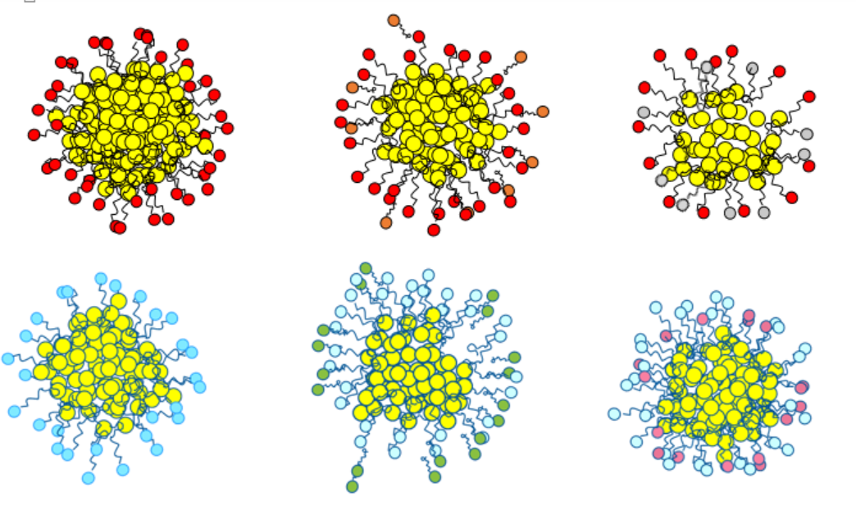
The mechanism for these behaviors primarily relies on the structure of the polar solute and the surfactant, as pointed out roughly 40 years ago. Bourrel and Chambu in the 1970s provided a formulation map considering ethoxylated nonylphenols surfactants with added n-alcohols.¹⁰³ It was discovered that solutions using methanol and ethanol behaved more hydrophilic than the non-alcohol reference while decreasing the solution's solubilization capacity. Interestingly, using 1-propanol or 1-butanol, neither acted hydrophobic or hydrophilic but instead just dropped the surfactant solubilization, working as Salager remarked like “bad alcohol.”⁹⁹ The reversal in amphiphilic behavior occurred at n-butyl or 2-butanol as the surfactants began behaving considerably more hydrophobic. Increasing the concentration of these alcohols were found to increase the lipophilic surfactant interactions as well as reducing the solubilization.¹⁰³ It was only with alcohols with alkyls greater than n-hexanol that the surfactant had similar or increased solubilization, nonetheless the overall surfactant affinity remained prominently hydrophobic.
Figure 36 Schematic representation of the different types of anionic (red) and nonionic (light blue) micellar structures; interfacial molecules are usually found inside or outside the palisade layer (black)
Ethanol
Hexanol
Pure Surfactant
The position of the dissolved interfacially active solutes within the palisade layer is of importance as polar solutes tend to interact not only with the head groups being repelled in the case for anionic amphiphiles but with surrounding interfacial water molecules. Advanced techniques using NMR 2D NOESY^{12,53}, fluorescence spectroscopy^{104,105}, and molecular modeling⁹¹ have provided further evidence that this may be the case. The general behavior indicates that there is a minimum lipophile, at n-propyl alkyl, to interact within a surfactant palisade layer. Figure 36 displays the generalized locations of the polar solute-surfactant interactions based on the length and type of surfactant.
It has been reported through experimental methods such as DSC as well as theoretical molecular modeling that clustering of water molecules exist and form hydrogen-bonded structures as a function of alcohol concentration^{106,107}. In general, methanol and ethanol can influence large water clusters since the hydrophobic driving forces are relatively low to that of the dipole-dipole and hydrogen bonding.¹⁰⁸ There are geometric considerations in regards to the alcohol's molecular structure, as larger solutes cannot efficiently pack one component of molecules into the other, leading to volume expansion. This was observed for small amphiphiles where the steric hindrance and the loss of dipolar association was observed to expand the excess volume of a mixture.¹⁰⁹ For larger or branched monohydric alcohols like 2-butanol, the hydrophobic forces increase, and the polar molecules tend to self-associate forming aggregates coordinating water molecules.¹¹⁰
The overall conclusion is that the predominant interaction for dilute alcohol-water solutions was primarily dictated by the alkyl group and hydrogen bonding between the two species. Studies considering the thermodynamic quantities of the alcoholic solutions are available and colligative techniques have been applied to determine the excess free energies.¹¹¹ The concentration ranges of alcoholic activity in water have been described using colligative properties through vapor pressure and freezing point evaluations. This phenomenon is noted in Figure 37, reporting the freezing points of selected alcohol solutions. The freezing point depression of alcohol-water mixtures begins to behave nonideally at varying concentrations, with most occurring with concentrations higher than ten %w/w, based on the alcohol’s degree of hydrophobicity.¹¹⁰
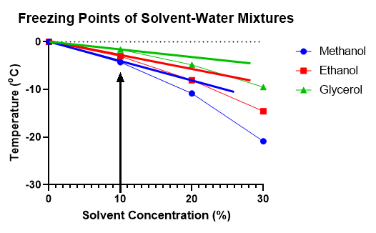
The overall conclusion is that the predominant interaction for dilute alcohol-surfactant solutions is primarily dictated by the alkyl group as well as the hydrogen bonding between the two species. It is assumed that the performance of the solution properties are based on the changes to bulk water, x_{w}, when free, unbounded, water molecules are now interacting with the solute. This assumption can be applied using Zavitsas’ approach, where he introduced the hydrodesimic number, h_{D,} accounting for the average number of waters “bound” to the dissolved solutes and has been shown to allow Raoult's law to be extended to higher solute concentrations dependent on the molecular structure.⁷⁷ Similar to ion hydration, the number of waters within a hydration shell and other properties such as coordination number has been reported for monohydric alcohols and is found to depend on the method of study or model utilized. One example is ethanol-water solutions, which Zivatsas’ Equation finds the hydrodesimic number to be around 1.8 water molecules.⁷⁷ Likewise, dynamic studies of methanol-water solutions have provided evidence of strong and weak hydrogen bonding networks, where two to four molecules of waters are coordinated within the first shell.¹¹²
Figure 37 Freezing Temperatures ºC vs. Alcoholic Solute Concentrations (%)
Previously it has been shown that the HLD Equations, when modified to account for the colligative hydration number of ions (h_{C}), were not significantly different than Zivatsas hydration number (h_{D}) obtained through freezing point depression. Further both hydration numbers can be used to model specific ion effects on both ionic and nonionic surfactants within the HLD framework. Similarly to cations, the alcohol structure will dictate the impact of the hydration interactions around the surfactant head groups, where the small alkyl alcohols are more likely to take away interfacial water. In contrast, larger alkyl alcohols will interact and compete with a surfactant lipophile for interfacial area. A colligative model for alcohols, Equation 22, was proposed to model these behaviors and replace the f(A) in the HLD equation as a function of alcohol concentration, C_{A}, on the surfactant affinity accommodating the alcohol’s size (Mw_{alcohol}) and as well as the alcohol’s colligative hydration number (h_{C}) obtained through phase behavior experiments.
$f\left(A\right)=C_{A}\frac{{Mw}_{Alcohol}}{{Mw}_{Surfactant}}ln⁡(h_{C})$ (22)
Similarly to the colligative approach used for specific ion effects, the h_{C} term is dimensionless and was obtained through shifts in optimum salinities, S*, by varying the alcohol-type and its concentration. The volume contributions of the polar solutes interacting with surfactant molecules is considered through a normalization of the size of the alcohol to the surfactant. Once more, the alcohol hydration term requires a natural log to refer to the water interactions with the alcohol’s hydroxyl group in solution. The position of the polar group was not considered in the case of 2-butanol. The h_{C} values below and above one are suggestive of a decrease or increase in the colligative number of bound water molecules. For solutes exhibiting h_{C} values below 1, this is indicative of the lack the hydration capacity and commonly these molecules will have difficulty solubilizing in water.
Understanding of the alcohol effects on surfactant behavior will be beneficial to apply these active solutes within solutions. Not only will it cut down on time and labor costs standard in pre-formulation, recognizing how alcohols influence the amphiphilicity of solutions opens new opportunities for other surfactants of study, such as hydrophilic surfactants that are unable to be characterized without a co-surfactant like SDS. Furthermore, if the equation is successful in reproducing the colligative hydration number, h_{C,} it implies that the additive properties of the alcohol are observed between ionic and nonionic amphiphiles. The goal of this study is to provide a first order approximation of the effect of alcohol concentration on S* using the K and Cc values obtained using NaCl as the phase optimization variable and a reference surfactant. The purpose in doing so is to make it easier for formulators to use the HLD framework for formulations that require the presence of an alcohol.

Materials and Methods

Materials
Two reference surfactants utilized in this study, the anionic sodium dihexyl sulfosuccinate, SDHS (MM80, Croda), and the nonionic C₈₁₀E_{3.5} (Sasol North America). For phase behavior experiments, Sodium Chloride (99%) purchased from Sigma Aldrich and was added to deionize filtered water. The alkane oils hexane (98% EACN=6), heptane (98% EACN=7), octane (99 EACN=8), and decane (99, EACN=10) were purchased from VWR. The alcohols selected in this study consisted of methanol (99%), ethanol (99%), and 1-propanol (99%), 2-butanol (99%), n-octanol (98%) and glycerol (99%) from Sigma Aldrich. All materials were used as received.

Microemulsion Phase Behavior
Microemulsion phase behavior scans were performed using a single reference surfactant. Aqueous samples of increasing concentration of sodium chloride (increments of .5g/100ml for SDHS, 1g/100ml for C₈₁₀E_{3.5}) were mixed with a constant concentration of surfactant using a 15ml sealed vial to find the optimum salinity. The selected alcohols were added at 1.5, 3, and 6 g/100ml concentrations quickly to the selected aqueous phases where the meniscus was marked and underwent mixing at room temperature for a minimum of 30 seconds. The alkane oil phase (hexane, heptane, octane, or decane) of equal volume would then be added and the sample was sealed. The sealed samples would be further hand mixed and left to equilibrate for 24 hours in an incubator set at 25ºC. This procedure was reproduced in triplicate.

Determining Optimum Salinity and Solubility Parameter
After 24 hours, the equilibrated samples were removed from the incubator and the phase behavior, Type I, III, II, was recorded. The middle phase volume of the resulting Type III microemulsions was measured using a micro caliper to measure the height and taking the dimensions of the vial. The optimum salinity (S*) was determined using the coalescence methods, where the lowest equilibration time from a mixed sample is considered. The phase behavior samples are placed in a rack that is in a temperature-controlled environment and undergoes thorough mixing. The samples are then allowed to equilibrate while being recorded with a video camera. It was standard to consider the samples equilibrated when there were no longer any changes in the phase volumes (middle phase for Type III).

Results and Discussion

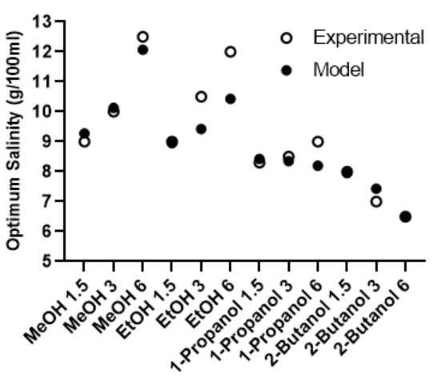
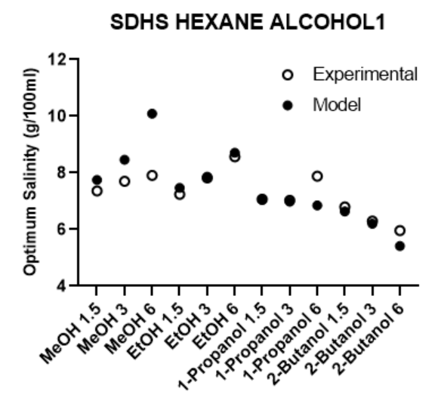
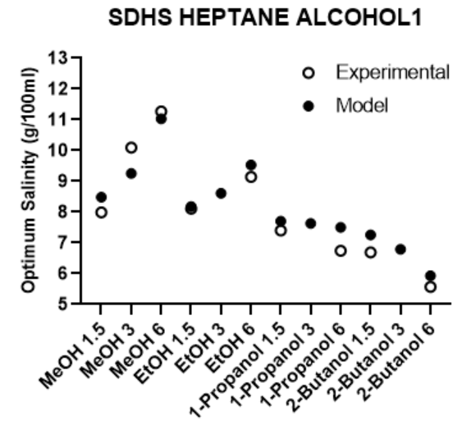
Effects of Alcohols on Anionic Surfactants
Figure 38a-c: (a) Top left: S* (g/100ml) vs Alcohol (g/100ml) for SDHS-Hexane at 25ºC (b) Top Right: S* (g/100ml) vs Alcohol (g/100ml) for SDHS-Heptane at 25ºC (c) Bottom: S* (g/100ml) vs Alcohol (g/100ml) for SDHS-Octane at 25ºC

For SDHS-alcohol mixtures, the changes to amphiphilic behavior were determined by means of phase behavior scans using the previously described methodology. Figures 38a-c reports the optimum salinities for hexane, heptane and octane in conjunction with predicted salinities using the average colligative hydration number, h_{c}, obtained through phase behavior experiments.
The SDHS-alcohol optimum salinities were found to reflect Bourrel and Chambu’s observations as both methanol and ethanol behaved more hydrophilic with the increase in concentration, meaning that the addition of methanol or ethanol to a formulation required an increase in NaCl to reach S*. Additionally, for SDHS, 1-propanol, considered a “weak” alcohol, behaved slightly hydrophilic compared to the non-alcohol reference. 2-butanol was the only alcohol noted to consistently reduce the S* with increase concentration, driving an increase in hydrophobic affinity, thus the additional 2-butanol lead to a reduction of NaCl at S*.
The most substantial increase in solution hydrophilicity was found by the addition of methanol, followed by ethanol. The trends of the lower molecular weight alcohols as the EACN increased behaved inconsistently, as seen in the differences with methanol from hexane vs heptane or octane and likewise ethanol acting more hydrophilic for octane. This disparity may be due to the lack of hydrophobe length, though it is feasible for ethanol to make contact with the surfactant’s palisade layer.
In cases where the amphiphiles alkyl residue is not significant, the alcohol will be unable to drive partitioning but instead competes and interacts with the surrounding anionic hydrophiles. Considering the surfactant head group, the increase in hydrophilicity points to the solutes destabilizing the hydrogen networks since their respective hydrophobic moieties are too weak to affect the palisade layer of the surfactant interface significantly.¹¹³ Thus, methanol and ethanol are influencing the anionic head group which will further influence the surfactant’s curvature through increasing the number of interfacial water molecules available for the head group.^{114,115}

Table 9 SDHS-Alcohol (1.5-6 g/100mL) HLD Parameters Averaged
Alcohol | K_{SDHS} | CC_{SDHS}
Methanol | 0.14 | -1.4
Ethanol | 0.08 | -1.6
1-Propanol | 0.08 | -1.5
2-Butanol | 0.06 | -1.5
Reference | 0.09 | -1.4

The solute influences on the lipophilic and hydrophilic interactions were evaluated by attaining the surfactants HLD values, K and Cc, for each alcohol concentration using the selected oil phases. As anticipated, the largest concentrations of the chosen alcohols produced the most significant changes in the surfactant HLD parameters. The averaged K and Cc values, utilizing all alcohol concentrations (1.5-6 g/100ml), are reported in Table 9.
Starting with the lipophilic interaction term, K, methanol surprisingly exhibited the most substantial increase, where ∆K= +.05, while the remaining alcohols, including ethanol, reduced the K value as the alkyl residue increased. Since methanol is considered to only interact with the ionic head groups at most, the increase in the surfactant’s lipophile interaction would indicate the interfacial water being reduced. This isn’t the case for ethanol that shows only a slight decrease, ∆K= -.01, from the reference behavior. 2-butanol had the lowest observed K value though its overall moiety, the Cc value, remained somewhat the same as the reference value, which was unexpected from its affect at lowering the optimum salinities. Nevertheless, there is a corresponding break in the behavior upon increasing the alcohol's carbon number. While ethanol behaved as a hydrophilic additive, 1-propanol demonstrated almost no change in the amphiphilic interactions, though 2-butanol acted hydrophobic. Overall the selected alcohols did not significantly influence the Cc values of the anionic surfactant, consequently implying that the moiety behaved somewhat consistently. In comparison to the nonionic ethoxylated head groups, the anionic sulfosuccinate contain a highly polar sulfonate that is less affected by the presence of weak polar solutes through electrostatic repulsion.
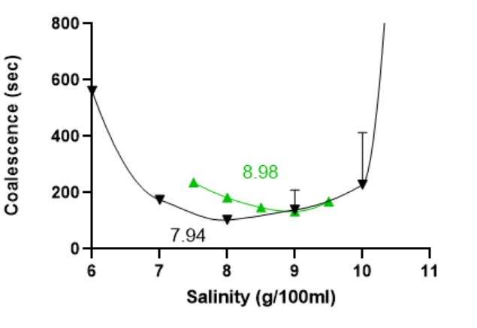
1-octanol was included originally as another co-solvent with both reference surfactants; however, this polar solute behaved extremely hydrophobic with the nonionic surfactant, resulting in the formation of Type II microemulsions using the previous EACN range even at the lowest 1-octanol concentration. To properly compare the two reference surfactants, decane was employed as the oil phase, where the S* for SDHS was found to be 6.5, 4.2 and 1.5 g/100ml for 1.5, 3, and 6 g/100ml of 1-octanol respectively. For 2-butanol, the difference between S* for lowest and highest concentration was only around 1 g/100ml, in comparison, 1-octanol reduced the S* by three times from the reference S*, acting like a hydrophobic linker.
Figure 39 Coalescence times of SDHS-Glycerol (Green) & SDHS Reference (Black) in Heptane vs Salinity (g/100ml)
Glycerol, a common polyol and well-known humectant found in a wide range of applications, including pharmaceuticals, was also formulated with SDHS. Having three hydroxyl groups, glycerol was expected to act as a hydrotrope as previous work has indicated the molecule acts in a salting-out manner.¹¹⁶ Low concentrations were applied to reduce coacervation of SDHS, and the coalescence was recorded, using heptane as the oil phase. Figure 39 shows the coalescence time and S* for glycerol compared to the reference S*. The increase of the surfactant’s hydrophilicity was captured in the rise in the salinity with only a small concentration, <0.5% of glycerol. The coalescence difference in the addition of solute and reference behavior is captured well in Figure 39, as there was no significant difference observed for the alcohols besides 1-octanol.
Recording the SDHS-alcohol SP* was somewhat tricky as there was not a dramatic change from the reference SP* as similarly encountered in the shift in amphiphilic behavior. Qualitatively ranking the SDHS-alcohol mixture SP* in order from largest to smallest showed 1-octanol, methanol, glycerol, 2-butanol, ethanol, and 1-propanol for all concentrations tested, all being within the error of each other. It could be speculated that the dialkyl tail of SDHS may be able to conform within the interface in ways that a linear surfactant may not.⁷² Though it is also possible that the alcohols are limited by the ionic head group’s stronger affinity to water.

Effects of Alcohols on Nonionic Surfactants
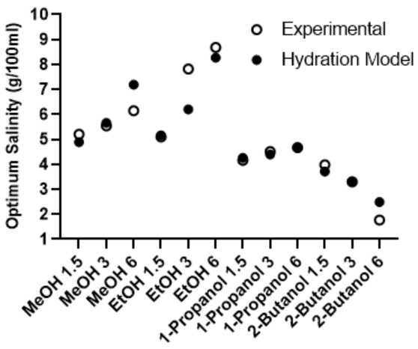
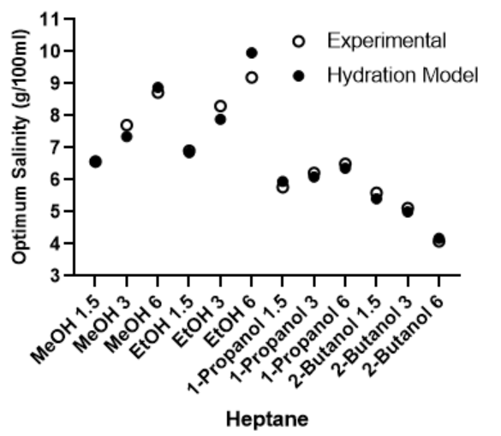
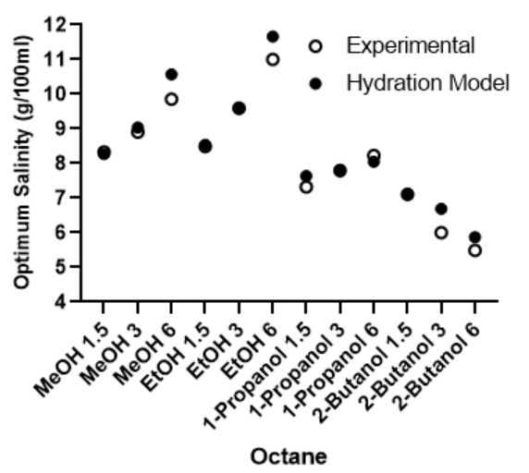
Alkyl alcohol ethoxylates can be thought of as extended alcohols and primarily dominated by hydrogen bonding. Unlike ionic surfactants, greater shifts in amphiphilic behavior occur as the alcohols disrupt hydrogen networks while also sharing interfacial water with the polyethoxylated head groups.¹¹⁷ Figures 40a-c show the experimentally found optimum salinities of the reference surfactant with concentration additive alcohol (in g/100ml) for hexane, heptane, and octane. The hydration model predicted values using the average h_{c} are plotted alongside showing relative agreement. The first observations that can be made are that the alcohols are behaving in the same way regardless of the amphiphile head group.
Figure 40a-c:(a) Top left: S* (g/100ml) vs Alcohol (g/100ml) for C₈₁₀E3.5-Hexane at 25ºC (b) Top Right: S* (g/100ml) vs Alcohol (g/100ml) for C₈₁₀E3.5-Heptane at 25ºC (c) Bottom: S* (g/100ml) vs Alcohol (g/100ml) for C₈₁₀E3.5-Octane at 25ºC

Methanol and ethanol at all concentrations shift the optimum salinity higher, indicating a more hydrophilic solution. Unlike for the anionic surfactants, 1-propanol remains slightly hydrophilic staying within close proximity to the reference optimum with no alcohol. The inversion in behavior yet again is found in 2-butanol, working as a lipophilic additive. Though a small shift is noticed at 1.5g/100ml, the decrease in optimum salinity is drastic as you increase the concentration. For the addition of 2-butanol concentrations above 6 g/100ml, the trend predicts that the optimum salinity will be very close to zero, indicating a reduction in hydrophobicity equivalent to the decrease of the EO number by approximately one similar to what has been reported previously. ^{99,103}
The surfactant average HLD values, K and Cc, for each alcohol concentration are shown Table 10. The interfacial behavior can be deduced based on the changes in the HLD parameters. Unlike, anionic SDHS where the Cc values remained consistent, C₈₁₀E_{3.5}’s Cc shifted with the increases and decreases in optimum salinities with the addition of alcohol. Yet again, methanol and ethanol mixtures behaved more hydrophilic, as observed in the Cc parameter. Ethanol presented the lowest Cc and K values of the alcohols tested. The lipophile interactions remained fairly constant to that of the reference surfactant. Propanol mixtures again remain negligible in effecting the HLD parameters. No dramatic change in the lipophile interactions, as measured by K, were seen in the 2-butanol mixtures, however the surfactants affinity (Cc) shifted more hydrophobic.

Table 10 C₈₁₀E_{3.5}-Alcohol (1.5-6 g/100mL) HLD Parameters Averaged
Alcohol | K C₈₁₀E_{3.5} |  | Cc C₈₁₀E_{3.5}
Methanol | 0.23 |  | 0.58
Ethanol | 0.15 | 0.05
1-Propanol | 0.22 |  | 0.73
2-Butanol | 0.23 |  | 1.0
Reference | 0.22 |  | 0.78

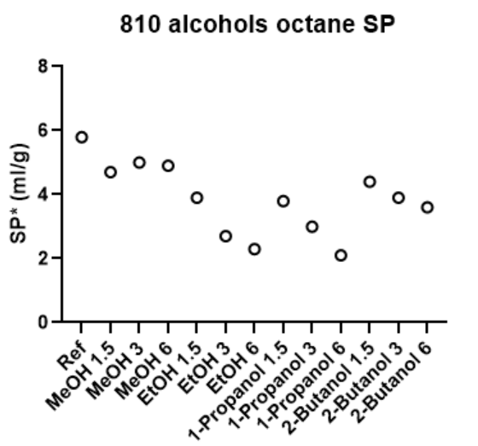
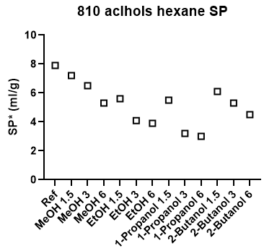
The decrease in solubilization parameters, SP*, is much more apparent when using the C₈₁₀E_{3.5}-alcohol solutions. The nonionic mixtures are reported in Figures 41a and 42b, where the trend of methanol > 2-butanol > ethanol > 1-propanol was found. Comparable to alcohol effects for nonylphenols, the increase in the alcohol concentration decreases the surfactants ability to solubilize both phases.⁹⁹ Methanol and ethanol reduced the SP by 3 mL/gram of surfactant, while 1-propanol was the largest reduction by around 5 mL/gram of surfactant. C₈₁₀E_{3.5}-2-butanol systems, however, revealed a slight increase in the solubilization, comparatively to the other selected alcohols, and may be due to the branching of the alcohol providing a more extensive volume if partitioned within an interface, and somewhat acting as a very weak surfactant.
Figure 41 C₈₁₀E_{3.5}-Alcohols Solubilization Parameters at Optimum Salinity; (a) Left: Hexane (b) Right: Octane

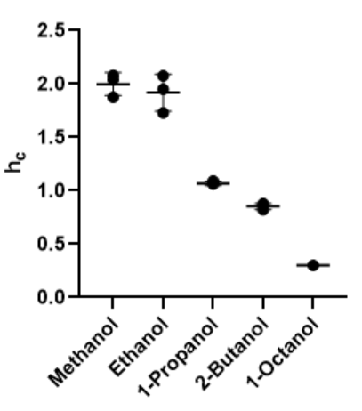
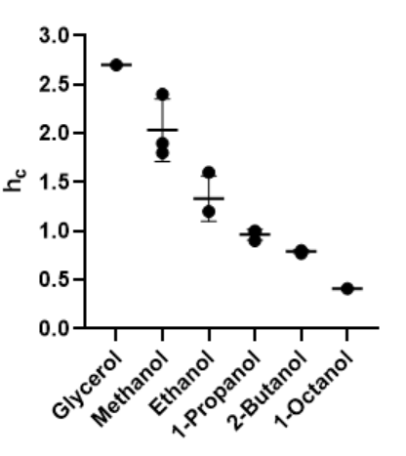
Evaluation of Alcohol Hydration Numbers
Figure 42 Averaged h_{c} from associated oil phases for (a) Left: SDHS (b) Right: C₈₁₀E_{3.5}
Using the experimental S* of the alcohol-reference surfactant mixtures, and fitting Equation 4 in the f(A) term of Equations 19 and 20 using the reference K and Cc value, the alcohol’s colligative hydration number, h_{C,} was extracted using Excel goal seek.
The alcohol’s h_{C} values for each oil phase tested are found in Figures 42a and 42b, demonstrating excellent agreement as well as confirming the additive properties of alcohols appearing between the two surfactants. The general trend of increasing the alcohol alkyl length was observed, decreasing the alcohol's h_{C}.¹¹¹ The highest h_{C}’s were exhibited, as expected by methanol and ethanol. 1-propanol, which had neglible effect on surfactant hydrophilicity, similarly had an h_{c} around one. 2-butanol and 1-octanol both produced h_{C}’s below one, indicative of the alcohol now no longer exposed to free water but interacting the surfactant within the palisade layer, increasing the hydrophobic effect.⁵⁶
The average of the alcohols h_{C} were employed to predict the S* of both surfactants to compare against the experimentally found S* shown previously in Figures 31a-c and 33a-c. The most significant deviations using the average h_{C} was 18% for SDHS and 9% for C₈₁₀E_{3.5}. Figures 43 and 44 show the average log of the quotient between the predicted S*, S*_{pre,} and the experimental S*, S*_{exptl}, was taken for each alcohol concentration and each oil phase associated.
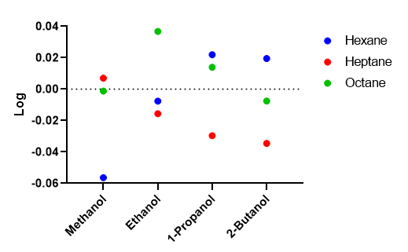
Figure 43 SDHS-Alcohol Systems Log [S*_{pre}/S*_{exptl}] plots using Hydration Modification (Eq 22) using both the experimentally found hydration number, h_{C,}
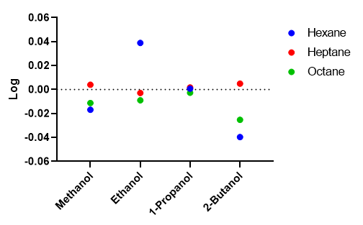
Figure 44 C₈₁₀E_{3.5}-Alcohol Systems Log [S*_{exptl} /S*_{pre}] plots using Hydration Modification (Eq 22) using both the experimentally found hydration number, h_{C}

Lower deviations for the nonionic surfactant may be due to the alcohols having similar hydrophilic structures, leading perhaps to a more efficient sharing of interfacial water. As discussed previously for anionic-nonionic surfactant mixtures, hydrophobic nonideality is observed as the ratio of nonionic surfactant increases. This is realized for SDHS at higher concentrations of methanol as well as ethanol and may explain the overestimations by the model. 1-propanol’s and 2-butanol’s experimental S* values were fit quite well with the average h_{C} for both surfactants. It is speculated that the added alkyl length is the reason for this behavior, as the alcohol now can imbed itself into the palisade layer more efficiently.
Table 11 Hydrodesimic Number* vs the average alcohol h_{C} for SDHS and C₈₁₀E_{3.5}
Alcohol | h_{D}* | h_{c} (SDHS) | h_{c}(C₈₁₀E3.5)
Gylcerol¹¹⁸ | 5.1 | 2.7 | --
Methanol¹⁰⁶ | 2.8 | 2.0 | 2.0
Ethanol¹⁰⁶ | 1.8 | 1.3 | 1.9
1-Propanol¹⁰⁶ | 1.6 | 1.0 | 1.1
2-Butanol | -- | 0.8 | 0.9
1-Octanol | -- | 0.4* | 0.3*

The hydrodesimic number, h_{D,} was calculated using the Zavitsas approach with freezing point data of alcohol-water solutions from the literature.^{77,106,118} Only the freezing plots for glycerol through 1-propanol were extracted as there were not 2-butanol or 1-octanol references available. Table 11 compares the alcohol's calculated hydrodesimic number, h_{D,} to the average colligative hydration number, h_{C,} utilizing each surfactant. Qualitatively, the hydration numbers followed the hydrodesimic numbers in the same trend. The colligative hydration numbers were all slightly lower quantities than those found in the simple alcohol-water solutions. Since the model behaves on the sharing of interfacial water, it is speculated that the involvement of the head groups is observed in the reduction of waters bound to the solute. Furthermore, the coordination numbers of water around the alcohols were also evaluated to correlate the experimental h_{c}. Figure 45 plots both surfactant’s average colligative hydration number, h_{C,} against coordination numbers found via terahertz (THz) absorption coefficient measurements.¹¹⁹
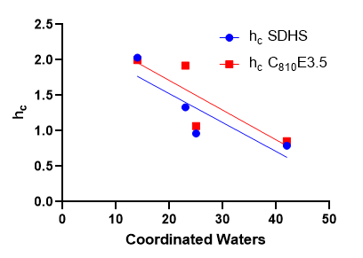
Figure 45 Average h_{C} for SDHS and C₈₁₀E_{3.5} vs Coordinated Waters
No direct correlation can be found between h_{C} and the coordinated waters as both linear regression R² values are not significant with 0.74 for SDHS and 0.70 for C₈₁₀E_{3.5}. Nevertheless, the hydrodesimic numbers for ethanol and 1-propanol are observed to agree within close approximation of coordinated waters.¹¹⁹
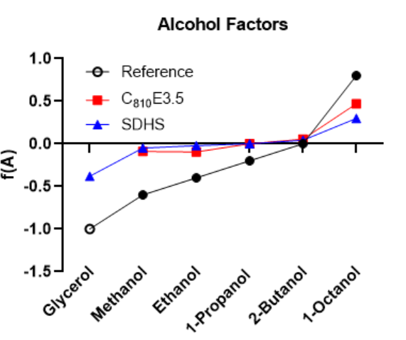
Correspondingly, we compared Equation 22 against the common f(A) factors for alcohol that were previously mentioned as the prior general way of addressing alcohol's effect on the surfactant’s S* and is provided by Abbott.⁴⁷ Figure 46 plots Equation 22 as an F(A) factor using the averaged h_{c} against the reference F(A). For the most part, the literature F(A) values greatly overestimated the alcohol effects on surfactant behavior, besides 2-butanol, and the use of these factors would likely lead to additional experimental work to optimize a formulation. Using the colligative hydration model for various alcohols was successful in predicting the same empirical behavior. Admittedly, the h_{C} values used here are obtained by fitting to the observed S* values; nevertheless, it is encouraging that a single parameter model is so effective in reproducing the behavior of such a complex system.
Figure 46 Experimental Surfactant-Alcohol Factors vs Reference Factors

Conclusion
In this work, the utilization of low molecular weight alcohols as co-solvents to induce behavioral change on microemulsions such as solubilization and modifying the amphiphilic behavior was presented. The surfactant-alcohol systems optimum salinities were reproduced and were consistent with Bourrel and Chambu’s original observations. Methanol and ethanol acted more hydrophilic with the increase in concentration, primarily effecting the surfactant headgroups as observed in significant rises in lipophilic behavior; i.e., the alcohol increased the surfactant headgroup water interaction, leading to the need to increase NaCl at S*. 1-propanol, considered the “weak” alcohol, behaved slightly hydrophilic for both surfactants, and had negligible changes to the surfactant’s Cc values.
As the length of the alkyl chain length of the alcohol increased, the interaction between the ionic head groups of the surfactants and water are further weakened, and the amphiphilic behavior turned hydrophobic. 2-butanol regularly reduces the S* with increase concentration, driving an increase in hydrophobic affinity, ie. Cc increased. 1-octanol and glycerol were examined and determined to act as hydrophobic linker and hydrotropes, respectively. The nonionic–alcohol mixtures exhibited the most significant variance in SP* where the trend of 2-butanol > methanol > ethanol > 1-propanol and followed the general trend established by Salager.⁹⁹
The alcohol h_{c} values for each oil phase were found to be between the two surfactants. Overall, the proposed colligative hydration concept was a success, where the results confirm that the additive properties of alcohol will be observed regardless of the amphiphilic head group. Similar to how it has been observed that specific ion effects can be explained by accounting for the ion size and the ion hydration number, alcohol hydration number values, h_{C}, where qualitatively comparable to the Zavitsas hydrodesimic numbers, h_{D}, found through freezing point depressions, which are close to the traditional colligative hydration numbers. The general trend of increasing the alcohol alkyl length was observed, decreasing the alcohol's ability to interact with free interfacial water as it tends to partition deeper into the surfactant palisade layer. By quantifying the interfacial behavior, using the additive properties of polar solutes will be beneficial as a formulator can now quickly model the approximate optimum salinities of common alcohols by concentration without changing the surfactant’s HLD parameters.

CHAPTER 6: Conclusions and Future Implications
This dissertation has shown the significance of using a colligative approach to specific ion effects and alcohols by utilizing their respective additive properties. Additionally the research has promoted the use of microemulsion systems, specifically the Type III, as a useful tool in the study of amphiphilic behavior. The important highlights of the conclusions will be discussed along with the implications of these findings on future work and applications.
In Chapter 3, the recognition of nonideality occurring between surfactant mixtures was demonstrated. For surfactant mixtures of all types, a region (x₂ = 0-20%) of low nonideality was found; whereas the general deviations were hydrophobic. The findings discussed provide a formulator the ability to assume ideal mixing and still acquire reasonable HLD parameters, while still recognizing the possible deviations. The discovery of a nonionic reference surfactant was an important step to examining not only the nonideality of solutions, but the understanding of the HLD parameters, K and Cc, of other commercial surfactants. The surfactant structure was shown to emerge through HLD parameters such as the K value which correlated with the carbon number of the lipophile. The linear regressions were found to be K_{Nonionic}=0.2*(CN) + 0.001 and K_{Anionics}=0.004*(CN) + 0.23. Furthermore, it was shown that the HLB values do connect quite well with experimentally found Cc values providing additional evidence that the surfactant structure are apparent for kinetically stable emulsions as well as thermodynamically microemulsions. For anionic surfactants the relationship between HLB_{Davies} and Cc was HLB= -16*(Cc_{anionic}) + 5.5, whereas for nonionics HLB_{Griffin}= -1.1*(Cc_{nonionic}) + 11. Such correlations should be helpful to formulators attempting to work between HLB and HLD models for a range of commercially important surfactants whose HLD parameters have not yet be determined.
Chapter 4 explores the specific ion effects of anionic and nonionic microemulsions where it was demonstrated that specific cations affect amphiphilic behavior as well as the microemulsion properties such as the solubilization parameter. The change in the amphiphile Cc variable indicated that the specific ion effects primarily occur at the head group level. The sulfonate and sulfate surfactants were found to “bind” up to three water molecules determined through the freezing point depression. The differences in the anionic head groups were considered; where the added propoxy groups may dehydrate or reduce the surfactant head group’s access to interfacial water. The proposed colligative hydration models shown below,
$${S^{*}}_{Anionic Hydration}=S^{*}x\left[\left(\frac{{Mw}_{NaCl}}{{Mw}_{XCl}}\right)\right]x \left[\frac{2}{1+Z}\right]x [ln\left(hC \right)]$$
$$b \sim {S^{*}}_{Nonionic Hydration}=\frac{S^{*}}{10}x\left[\left(\frac{{Mw}_{NaCl}}{{Mw}_{XCl}}\right)\right]x \left[\frac{2}{1+Z}\right]x [ln\left(hC \right)]$$
were successful in providing better predictions of optimum salinities for chloride salts for anionic amphiphiles than what is available currently in literature. Additionally, the nonionic surfactants reproduced similar colligative hydration numbers, h_{C,} in which the additive properties of the cations were concluded to be present for both types of amphiphiles. The use of this new approach will provide an avenue for formulators to reproduce optimum salinities of various salts using their additive properties and model surfactants readily with a single-phase behavior scan.
Chapter 5 presented the study of the effects of alcohols when added to anionic and nonionic microemulsions, additionally extending the colligative approach in order to predict surfactant behavior using alcohol additive properties. Low molecular weight alcohols, methanol to 2-butanol as well as 1-octanol and glycerol, shifted the amphiphilic behavior. The results of the alcohol-surfactant mixtures shadowed Bourrel and Chambu’s original observations. As the length of the alkyl chain of the alcohol increased, the hydrophilicity of ionic head groups are further weakened, and the amphiphilic behavior turned hydrophobic. Only the nonionic–alcohol mixtures had the largest differences in SP* where the trend of methanol> 2-butanol > ethanol > 1-propanol was exhibited. Similarly to the previous findings of chloride salt-surfactant mixtures, the alcohol’s colligative hydration number, h_{C,} for each oil phase were found to reappear between the two surfactants. Likewise, the proposed colligative hydration concept was considered for alcohols and is reiterated here: $f\left(A\right)=C_{A}\frac{{Mw}_{Alcohol}}{{Mw}_{Surfactant}}ln⁡(h_{C})$. It was found to reasonably predict the optimum salinities using the alcohol’s averaged h_{C.} The results confirm that the additive properties of alcohols and potentially other interfacially actives solutes will be observed regardless of the amphiphilic head group. The alcohol h_{C} values where qualitatively similar to Zavitsas’ hydrodesimic numbers, h_{D}, found through freezing point depression of alcohol-water mixtures. By quantifying the interfacial behavior, using the additive properties of polar solutes, a formulator can now quickly model the approximate optimum salinities of common alcohols by concentration without changing the surfactant’s HLD parameters.
In order to provide evidence that the colligative hydration number, h_{C,} is accounting for the solute hydration, further testing is required. It is recommended that more solute-surfactant systems be evaluated using the equations proposed in this study. Freezing point or melting point data of surfactants and other additional solutes should be considered using Zivatsas’ hydrodesimic approach and compared against the h_{c} values obtained using Type III microemulsions. Additionally, colligative properties should be examined in other amphiphilic behaviors using other techniques such as NMR, microscopy, and DLS.
Additionally, more empirical data is needed for exotic molecules, such as active pharmaceutical ingredients (APIs) that have low permeability and largely remain insoluble in hydrophilic systems. There is desperate need in some cases, an example of which is chemotherapies that could be supported with the results presented in this study. As such, it is imperative to continue researching and gain further understanding of amphiphilic behaviors as well as the interactions that interfacially active solutes exhibit on simple to complex solutions.

BIBLIOGRAPHY
(1) Moore, C. E.; von Smolinski, A.; Jaselskis, B. The Ostwald-Gibbs Correspondence: An Interesting Component in the History of the Energy Concept. Bull Hist Chem 2002, 27(2), 115.
(2) Smith, H. W. I. THEORY OF SOLUTIONS. 1960, 10.
(3) Wilhelm Ostwald: The Autobiography; Jack, R. S., Scholz, F., Eds.; Springer Biographies; Springer International Publishing: Cham, 2017. https://doi.org/10.1007/978-3-319-46955-3.
(4) Jensen, W. B. Logic, History, and the Chemistry Textbook: I. Does Chemistry Have a Logical Structure? J. Chem. Educ. 1998, 75 (6), 679. https://doi.org/10.1021/ed075p679.
(5) Felder, R. M.; Rousseau, R. W. Elementary Principles of Chemical Processes, 3rd ed., 2005 ed. with integrated media and study tools.; Wiley: Hoboken, NJ, 2005.
(6) Solutions http://www.chemistry.wustl.edu/~coursedev/Online%20tutorials/Solutions.htm (accessed Apr 5, 2020).
(7) Finney, J. L. The Water Molecule and Its Interactions: The Interaction between Theory, Modelling, and Experiment. J. Mol. Liq. 2001, 90 (1–3), 303–312. https://doi.org/10.1016/S0167-7322(01)00134-9.
(8) Thompson, W. H. Perspective: Dynamics of Confined Liquids. J. Chem. Phys. 2018, 149 (17), 170901. https://doi.org/10.1063/1.5057759.
(9) Hande, V. R.; Chakrabarty, S. Exploration of the Presence of Bulk-like Water in AOT Reverse Micelles and Water-in-Oil Nanodroplets: The Role of Charged Interfaces, Confinement Size and Properties of Water. Phys. Chem. Chem. Phys. 2016, 18 (31), 21767–21779. https://doi.org/10.1039/C6CP04378J.
(10) Canale, L.; Comtet, J.; Niguès, A.; Cohen, C.; Clanet, C.; Siria, A.; Bocquet, L. Nanorheology of Interfacial Water during Ice Gliding. Phys. Rev. X 2019, 9 (4), 041025. https://doi.org/10.1103/PhysRevX.9.041025.
(11) Kunz, W. Specific Ion Effects in Colloidal and Biological Systems. Curr. Opin. Colloid Interface Sci. 2010, 15 (1–2), 34–39. https://doi.org/10.1016/j.cocis.2009.11.008.
(12) Cui, D.; Zhang, B. W.; Matubayasi, N.; Levy, R. M. The Role of Interfacial Water in Protein–Ligand Binding: Insights from the Indirect Solvent Mediated Potential of Mean Force. J. Chem. Theory Comput. 2018, 14 (2), 512–526. https://doi.org/10.1021/acs.jctc.7b01076.
(13) Pollard, T. P.; Beck, T. L. Toward a Quantitative Theory of Hofmeister Phenomena: From Quantum Effects to Thermodynamics. Curr. Opin. Colloid Interface Sci. 2016, 23, 110–118. https://doi.org/10.1016/j.cocis.2016.06.015.
(14) Lombardo, D.; Kiselev, M. A.; Magazù, S.; Calandra, P. Amphiphiles Self-Assembly: Basic Concepts and Future Perspectives of Supramolecular Approaches. Adv. Condens. Matter Phys. 2015, 2015, 1–22. https://doi.org/10.1155/2015/151683.
(15) Salager, J. Surfactants Types and Uses. Firp Bookl. 2002.
(16) Israelachvili, J. N.; Mitchell, D. J.; Ninham, B. W. Theory of Self-Assembly of Lipid Bilayers and Vesicles. Biochim. Biophys. Acta BBA - Biomembr. 1977, 470 (2), 185–201. https://doi.org/10.1016/0005-2736(77)90099-2.
(17) Peng, M.; Nguyen, A. V. Adsorption of Ionic Surfactants at the Air-Water Interface: The Gap between Theory and Experiment. Adv. Colloid Interface Sci. 2020, 275, 102052. https://doi.org/10.1016/j.cis.2019.102052.
(18) Rosen, M. J.; Kunjappu, J. T. Surfactants and Interfacial Phenomena: Rosen/Surfactants 4E; John Wiley & Sons, Inc.: Hoboken, NJ, USA, 2012. https://doi.org/10.1002/9781118228920.
(19) Aniansson, E. A. G. Theory of Micelle Formation Kinetics. Berichte Bunsenges. Für Phys. Chem. 1978, 82 (9), 981–988. https://doi.org/10.1002/bbpc.19780820961.
(20) Dhakal, S.; Sureshkumar, R. Topology, Length Scales, and Energetics of Surfactant Micelles. J. Chem. Phys. 2015, 143 (2), 024905. https://doi.org/10.1063/1.4926422.
(21) Aramaki, K.; Olsson, U.; Yamaguchi, Y.; Kunieda, H. Effect of Water-Soluble Alcohols on Surfactant Aggregation in the C ₁₂ EO ₈ System. Langmuir 1999, 15 (19), 6226–6232. https://doi.org/10.1021/la9900573.
(22) Weinheimer, R. M.; Evans, D. F.; Cussler, E. L. Diffusion in Surfactant Solutions. J. Colloid Interface Sci. 1981, 80 (2), 357–368. https://doi.org/10.1016/0021-9797(81)90194-6.
(23) da Rocha-Filho, P.; Maruno, M.; Ferrari, M.; Topan, J. Liquid Crystal Formation from Sunflower Oil: Long Term Stability Studies. Molecules 2016, 21 (6), 680. https://doi.org/10.3390/molecules21060680.
(24) Bourrel, M.; Schlechter, R. S. Microemulsionas and Related Systems: Formulation, Solvency, and Physical Properties.; Editions Technip: Paris, 2010.
(25) Ruckenstein, E. Microemulsions, Macroemulsions, and the Bancroft Rule. Langmuir 1996, 12 (26), 6351–6353. https://doi.org/10.1021/la960849m.
(26) Winsor, P. A. Hydrotropy, Solubilisation and Related Emulsification Processes. Trans. Faraday Soc. 1948, 44, 376. https://doi.org/10.1039/tf9484400376.
(27) Góźdź, W. T.; Hołyst, R. Triply Periodic Surfaces and Multiply Continuous Structures from the Landau Model of Microemulsions. Phys. Rev. E 1996, 54 (5), 5012–5027. https://doi.org/10.1103/PhysRevE.54.5012.
(28) Tasinkevych, M.; Ciach, A. Ternary Surfactant Mixtures in Semi-Infinite Geometry. J. Chem. Phys. 1999, 110 (15), 7548–7555. https://doi.org/10.1063/1.478658.
(29) Younes, R. Construction of Triply Periodic Minimal Surfaces. ArXiv10024805 Math 2010.
(30) Gompper, G.; Schick, M.; Domb, C.; Green, M. S.; Lebowitz, J. L.; Gompper, G. Self-Assembling Amphiphilic Systems, 2. printing.; Phase transitions and critical phenomena; Acad. Press: London, 1995.
(31) Stauff, J. Solvent Properties of Amphiphilic Compounds, von P. A. Winsor. Butterworths Scientific Publ. Ltd., London. 1954. 1. Aufl. IX, 270 S., gebd. 40 s. Angew. Chem. 1956, 68 (15), 504–504. https://doi.org/10.1002/ange.19560681521.
(32) Salager, J. L.; Morgan, J. C.; Schechter, R. S.; Wade, W. H.; Vasquez, E.; others. Optimum Formulation of Surfactant/Water/Oil Systems for Minimum Interfacial Tension or Phase Behavior. Soc. Pet. Eng. J. 1979, 19 (02), 107–115.
(33) Acosta, E.; Szekeres, E.; Sabatini, D. A.; Harwell, J. H. Net-Average Curvature Model for Solubilization and Supersolubilization in Surfactant Microemulsions. Langmuir 2003, 19 (1), 186–195. https://doi.org/10.1021/la026168a.
(34) Acosta, E. Modeling and Formulation of Microemulsions: The Net-Average Curvature Model and the Combined Linker Effect, University of Oklahoma, 2004.
(35) Salager, J. L. Quantifying the Concept of Physico-Chemical Formulation in Surfactant-Oil-Water Systems — State of the Art. In Trends in Colloid and Interface Science X; Progress in Colloid & Polymer Science; Steinkopff, 1996; pp 137–142. https://doi.org/10.1007/BFb0115768.
(36) Acosta, E. J.; Bhakta, A. S. The HLD-NAC Model for Mixtures of Ionic and Nonionic Surfactants. J. Surfactants Deterg. 2009, 12 (1), 7–19. https://doi.org/10.1007/s11743-008-1092-4.
(37) Lemahieu, G.; Ontiveros, J. F.; Molinier, V.; Aubry, J.-M. Using the Dynamic Phase Inversion Temperature (PIT) as a Fast and Effective Method to Track Optimum Formulation for Enhanced Oil Recovery. J. Colloid Interface Sci. 2019, 557, 746–756. https://doi.org/10.1016/j.jcis.2019.09.050.
(38) Budhathoki, M.; Hsu, T.-P.; Lohateeraparp, P.; Roberts, B. L.; Shiau, B.-J.; Harwell, J. H. Design of an Optimal Middle Phase Microemulsion for Ultra High Saline Brine Using Hydrophilic Lipophilic Deviation (HLD) Method. Colloids Surf. Physicochem. Eng. Asp. 2016, 488, 36–45. https://doi.org/10.1016/j.colsurfa.2015.09.066.
(39) Surisetti, S. QUANTIFICATION OF NON-IDEAL MIXING IN SODIUM DI (2-ETHYLHEXYL) SULFOSUCCINATE – ANIONIC SURFACTANT MIXTURES.; University of Oklahoma, 2017.
(40) Witthayapanyanon, A.; Harwell, J. H.; Sabatini, D. A. Hydrophilic–Lipophilic Deviation (HLD) Method for Characterizing Conventional and Extended Surfactants. J. Colloid Interface Sci. 2008, 325 (1), 259–266. https://doi.org/10.1016/j.jcis.2008.05.061.
(41) Nguyen, T. T.; Morgan, C.; Poindexter, L.; Fernandez, J. Application of the Hydrophilic–Lipophilic Deviation Concept to Surfactant Characterization and Surfactant Selection for Enhanced Oil Recovery. J. Surfactants Deterg. 2019, jsde.12305. https://doi.org/10.1002/jsde.12305.
(42) Akima, H. A New Method of Interpolation and Smooth Curve Fitting Based on Local Procedures. J. ACM JACM 1970, 17 (4), 589–602. https://doi.org/10.1145/321607.321609.
(43) Zarate-Muñoz, S.; Texeira de Vasconcelos, F.; Myint-Myat, K.; Minchom, J.; Acosta, E. A Simplified Methodology to Measure the Characteristic Curvature (Cc) of Alkyl Ethoxylate Nonionic Surfactants. J. Surfactants Deterg. 2016, 19 (2), 249–263. https://doi.org/10.1007/s11743-016-1787-x.
(44) Acosta, E. J.; Yuan, J. Sh.; Bhakta, A. Sh. The Characteristic Curvature of Ionic Surfactants. J. Surfactants Deterg. 2008, 11 (2), 145–158. https://doi.org/10.1007/s11743-008-1065-7.
(45) Salager, J. L.; Bourrel, M.; Schechter, R. S.; Wade, W. H. Mixing Rules for Optimum Phase-Behavior Formulations of Surfactant/Oil/Water Systems. Soc. Pet. Eng. J. 1979, 19 (05), 271–278. https://doi.org/10.2118/7584-PA.
(46) Binks, B. P.; Fletcher, P. D. I.; Taylor, D. J. F. Microemulsions Stabilized by Ionic/Nonionic Surfactant Mixtures. Effect of Partitioning of the Nonionic Surfactant into the Oil. Langmuir 1998, 14 (18), 5324–5326. https://doi.org/10.1021/la980520w.
(47) HLD (Expert Mode) | Practical Surfactants Science | Prof Steven Abbott https://www.stevenabbott.co.uk/practical-surfactants/hld-expert.php (accessed Apr 5, 2020).
(48) Alam, Md. S.; Nareshkumar, V.; Vijayakumar, N.; Madhavan, K.; Mandal, A. B. Effect of Additives on the Cloud Point of Mixed Surfactant (Non-Ionic Triton X-114+cationic Gemini 16-6-16) Solutions. J. Mol. Liq. 2014, 194, 206–211. https://doi.org/10.1016/j.molliq.2014.02.042.
(49) Kim, H. C.; Kim, J.-D. The Polydispersity Effect of Distributed Oxyethylene Chains on the Cloud Points of Nonionic Surfactants. J. Colloid Interface Sci. 2010, 352 (2), 444–448. https://doi.org/10.1016/j.jcis.2010.08.078.
(50) Loraine, G. A. Effects of Alcohols, Anionic and Nonionic Surfactants on the Reduction of Pce and Tce by Zero-Valent Iron. Water Res. 2001, 35 (6), 1453–1460. https://doi.org/10.1016/S0043-1354(00)00422-X.
(51) Baker, D. K. CHARACTERIZATION OF POLYETHOXYLATED ALKYL PHENOLS WITH A HIGH DEGREE OF ETHOXYLATION AT THE SOLID-LIQUID INTERFACE. 2016.
(52) Denkova, P. S.; Lokeren, L. V.; Verbruggen, I.; Willem, R. Self-Aggregation and Supramolecular Structure Investigations of Triton X-100 and SDP2S by NOESY and Diffusion Ordered NMR Spectroscopy. J. Phys. Chem. B 2008, 112 (35), 10935–10941. https://doi.org/10.1021/jp802830g.
(53) Pillai, S. A.; Chavda, S.; Bahadur, P. Aqueous Solution Behavior of Cationic Surfactant Modulated by Glycol Additives: Investigating Aggregation and Microstructure of Tetradecyltrimethylammonium Bromide Micelles in the Presence of Propylene Glycol, Its Ethers and Esters. J. Mol. Liq. 2016, 223, 1291–1296. https://doi.org/10.1016/j.molliq.2016.09.051.
(54) Fakhraee, M.; Gholami, M. R. Biodegradable Ionic Liquids: Effects of Temperature, Alkyl Side-Chain Length, and Anion on the Thermodynamic Properties and Interaction Energies As Determined by Molecular Dynamics Simulations Coupled with Ab Initio Calculations. Ind. Eng. Chem. Res. 2015, 54 (46), 11678–11700. https://doi.org/10.1021/acs.iecr.5b03199.
(55) Tanford, C. Micelle Shape and Size. J. Phys. Chem. 1972, 76 (21), 3020–3024. https://doi.org/10.1021/j100665a018.
(56) Tanford, C. The Hydrophobic Effect: Formation of Micelles and Biological Membranes. J. Polym. Sci. Polym. Lett. Ed. 1980, 18 (10), 687–687. https://doi.org/10.1002/pol.1980.130181008.
(57) Oliver, R. C.; Lipfert, J.; Fox, D. A.; Lo, R. H.; Doniach, S.; Columbus, L. Dependence of Micelle Size and Shape on Detergent Alkyl Chain Length and Head Group. PLoS ONE 2013, 8 (5), e62488. https://doi.org/10.1371/journal.pone.0062488.
(58) Griffin, W. C. Classification of Surface-Active Agents by “HLB”. J. Soc. Cosmet. Chem. 1949, No. 1, 311–326.
(59) Davies, J. A Quantitative Kinetic Theory of Emulsion Type. I. Physical Chemistry of the Emulsifying Agent.". Butterworths Sci. Publ. 1957, 426.
(60) Schott, H. Comments on Hydrophile-Lipophile Balance Systems. J. Colloid Interface Sci. 1989, 133 (2), 527–529. https://doi.org/10.1016/S0021-9797(89)80068-2.
(61) Griffin, W. C. Calculation of HLB Values of Non-Ionic Surfactants. J Soc. Cosmet. Chem. 1954, 259.
(62) Hofmeister, F. Zur Lehre von der Wirkung der Salze: Zweite Mittheilung. Arch. Für Exp. Pathol. Pharmakol. 1888, 24 (4–5), 247–260. https://doi.org/10.1007/BF01918191.
(63) Jungwirth, P.; Cremer, P. S. Beyond Hofmeister. Nat. Chem. 2014, 6 (4), 261–263. https://doi.org/10.1038/nchem.1899.
(64) Zavitsas, A. A. Some Opinions of an Innocent Bystander Regarding the Hofmeister Series. Curr. Opin. Colloid Interface Sci. 2016, 23, 72–81. https://doi.org/10.1016/j.cocis.2016.06.012.
(65) Conway, B. E.; Ayranci, E. Effective Ionic Radii and Hydration Volumes for Evaluation of Solution Properties and Ionic Adsorption. J. Solut. Chem. 1999, 28 (3), 163–192. https://doi.org/10.1023/A:1021702230117.
(66) Li, K.; Li, M.; Xue, D. Solution-Phase Electronegativity Scale: Insight into the Chemical Behaviors of Metal Ions in Solution. J. Phys. Chem. A 2012, 116 (16), 4192–4198. https://doi.org/10.1021/jp300603f.
(67) Miertuš, S.; Scrocco, E.; Tomasi, J. Electrostatic Interaction of a Solute with a Continuum. A Direct Utilizaion of AB Initio Molecular Potentials for the Prevision of Solvent Effects. Chem. Phys. 1981, 55 (1), 117–129. https://doi.org/10.1016/0301-0104(81)85090-2.
(68) Karampinos, D. C.; Georgiadis, J. G. Ab Initio Study of the Energetics of Ionic Hydration with the Polarizable Continuum Model. Nanoscale Microscale Thermophys. Eng. 2007, 11 (3–4), 363–378. https://doi.org/10.1080/15567260701715529.
(69) Henry, M. Hofmeister Series: The Quantum Mechanical Viewpoint. Curr. Opin. Colloid Interface Sci. 2016, 23, 119–125. https://doi.org/10.1016/j.cocis.2016.08.001.
(70) Ohtaki, Hitoshi.; Radnai, Tamas. Structure and Dynamics of Hydrated Ions. Chem. Rev. 1993, 93 (3), 1157–1204. https://doi.org/10.1021/cr00019a014.
(71) Liu, C.; Wang, Y.; Gao, Y.; Zhang, Y.; Zhao, L.; Xu, B.; Romsted, L. S. Effects of Interfacial Specific Cations and Water Molarities on AOT Micelle-to-Vesicle Transitions by Chemical Trapping: The Specific Ion-Pair/Hydration Model. Phys. Chem. Chem. Phys. 2019, 21 (17), 8633–8644. https://doi.org/10.1039/C8CP05987J.
(72) Hensel, J. K.; Carpenter, A. P.; Ciszewski, R. K.; Schabes, B. K.; Kittredge, C. T.; Moore, F. G.; Richmond, G. L. Molecular Characterization of Water and Surfactant AOT at Nanoemulsion Surfaces. Proc. Natl. Acad. Sci. 2017, 114 (51), 13351–13356. https://doi.org/10.1073/pnas.1700099114.
(73) Hishida, M.; Kaneko, Y.; Okuno, M.; Yamamura, Y.; Ishibashi, T.; Saito, K. Communication: Salt-Induced Water Orientation at a Surface of Non-Ionic Surfactant in Relation to a Mechanism of Hofmeister Effect. J. Chem. Phys. 2015, 142 (17), 171101. https://doi.org/10.1063/1.4919664.
(74) Dawin, U. C.; Lagerwall, J. P. F.; Giesselmann, F. Electrolyte Effects on the Stability of Nematic and Lamellar Lyotropic Liquid Crystal Phases: Colligative and Ion-Specific Aspects. J. Phys. Chem. B 2009, 113 (33), 11414–11420. https://doi.org/10.1021/jp9017772.
(75) Anton, R. E.; Salager, J. L. Effect of the Electrolyte Anion on the Salinity Contribution to Optimum Formulation of Anionic Surfactant Microemulsions. J. Colloid Interface Sci. 1990, 140 (1), 75–81. https://doi.org/10.1016/0021-9797(90)90323-G.
(76) Lebedeva, N. V.; Shahine, A.; Bales, B. L. Aggregation Number-Based Degrees of Counterion Dissociation in Sodium n -Alkyl Sulfate Micelles. J. Phys. Chem. B 2005, 109 (42), 19806–19816. https://doi.org/10.1021/jp052822u.
(77) Zavitsas, A. A. Quest To Demystify Water: Ideal Solution Behaviors Are Obtained by Adhering to the Equilibrium Mass Action Law. J. Phys. Chem. B 2019, 123 (4), 869–883. https://doi.org/10.1021/acs.jpcb.8b07166.
(78) Zavitsas, A. A. Aqueous Solutions of Calcium Ions: Hydration Numbers and the Effect of Temperature. J. Phys. Chem. B 2005, 109 (43), 20636–20640. https://doi.org/10.1021/jp053909i.
(79) Reid, D. S. Water Activity: Fundamentals and Relationships. In Water Activity in Foods; Barbosa-Cnovas, G. V., Fontana, A. J., Schmidt, S. J., Labuza, T. P., Eds.; Blackwell Publishing Ltd: Oxford, UK, 2007; pp 15–28. https://doi.org/10.1002/9780470376454.ch2.
(80) Giovambattista, N.; Debenedetti, P. G.; Rossky, P. J. Hydration Behavior under Confinement by Nanoscale Surfaces with Patterned Hydrophobicity and Hydrophilicity. J. Phys. Chem. C 2007, 111 (3), 1323–1332. https://doi.org/10.1021/jp065419b.
(81) Hamon, J. J.; Tabor, R. F.; Striolo, A.; Grady, B. P. Atomic Force Microscopy Force Mapping Analysis of an Adsorbed Surfactant above and below the Critical Micelle Concentration. Langmuir 2018, 34 (25), 7223–7239. https://doi.org/10.1021/acs.langmuir.8b00574.
(82) Oesper, R. E. Ernst Beckmann, 1853-1923. J. Chem. Educ. 1944, 21 (10), 470. https://doi.org/10.1021/ed021p470.
(83) Zavitsas, A. A. Properties of Water Solutions of Electrolytes and Nonelectrolytes. J. Phys. Chem. B 2001, 105 (32), 7805–7817. https://doi.org/10.1021/jp011053l.
(84) Yan, P.; Xiao, J.-X. Polymer–Surfactant Interaction: Differences between Alkyl Sulfate and Alkyl Sulfonate. Colloids Surf. Physicochem. Eng. Asp. 2004, 244 (1–3), 39–44. https://doi.org/10.1016/j.colsurfa.2004.06.023.
(85) Roscigno, P.; D’Errico, G.; Ortona, O.; Sartorio, R.; Paduano, L. A Comparison Study between Sodium Decyl Sulfonate and Sodium Decyl Sulfate with Respect to the Interaction with Poly(Vinylpyrrolidone). In Aqueous Polymer — Cosolute Systems; Anghel, D. F., Ed.; Progress in Colloid and Polymer Science; Springer Berlin Heidelberg: Berlin, Heidelberg, 2003; Vol. 122, pp 113–121. https://doi.org/10.1007/3-540-36114-6_14.
(86) He, W.; Ge, J.; Zhang, G.; Jiang, P.; Jin, L. Effects of Extended Surfactant Structure on the Interfacial Tension and Optimal Salinity of Dilute Solutions. ACS Omega 2019, 4 (7), 12410–12417. https://doi.org/10.1021/acsomega.9b00495.
(87) Huh, C. Interfacial Tensions and Solubilizing Ability of a Microemulsion Phase That Coexists with Oil and Brine. J. Colloid Interface Sci. 1979, 71 (2), 408–426. https://doi.org/10.1016/0021-9797(79)90249-2.
(88) Mähler, J.; Persson, I. A Study of the Hydration of the Alkali Metal Ions in Aqueous Solution. Inorg. Chem. 2012, 51 (1), 425–438. https://doi.org/10.1021/ic2018693.
(89) Caralampio, D. Z.; Martínez, J. M.; Pappalardo, R. R.; Marcos, E. S. The Hydration Structure of the Heavy-Alkalines Rb+ and Cs+ through Molecular Dynamics and X-Ray Absorption Spectroscopy: Surface Clusters and Eccentricity. Phys. Chem. Chem. Phys. 2017, 19 (42), 28993–29004. https://doi.org/10.1039/C7CP05346K.
(90) Sandoval, C.; Ortega, A.; Sanchez, S. A.; Morales, J.; Gunther, G. Structuration in the Interface of Direct and Reversed Micelles of Sucrose Esters, Studied by Fluorescent Techniques. PLOS ONE 2015, 10 (4), e0123669. https://doi.org/10.1371/journal.pone.0123669.
(91) Vierros, S.; Sammalkorpi, M. Effects of 1-Hexanol on C ₁₂ E ₁₀ Micelles: A Molecular Simulations and Light Scattering Study. Phys. Chem. Chem. Phys. 2018, 20 (9), 6287–6298. https://doi.org/10.1039/C7CP07511A.
(92) Tofallis, C. A Better Measure of Relative Prediction Accuracy for Model Selection and Model Estimation; SSRN Scholarly Paper ID 2635088; Social Science Research Network: Rochester, NY, 2014.
(93) Collins, K. D. Why Continuum Electrostatics Theories Cannot Explain Biological Structure, Polyelectrolytes or Ionic Strength Effects in Ion–Protein Interactions. Biophys. Chem. 2012, 167, 43–59. https://doi.org/10.1016/j.bpc.2012.04.002.
(94) Tongraar, A.; Michael Rode, B. The Role of Non-Additive Contributions on the Hydration Shell Structure of Mg2+ Studied by Born–Oppenheimer Ab Initio Quantum Mechanical/Molecular Mechanical Molecular Dynamics Simulation. Chem. Phys. Lett. 2001, 346 (5–6), 485–491. https://doi.org/10.1016/S0009-2614(01)00923-X.
(95) Hayase, K.; Hayano, S. Effect of Alcohols on the Critical Micelle Concentration Decrease in the Aqueous Sodium Dodecyl Sulfate Solution. J. Colloid Interface Sci. 1978, 63 (3), 446–451. https://doi.org/10.1016/S0021-9797(78)80005-8.
(96) Nakayama, H.; Shinoda, K.; Hutchinson, E. The Effect of Added Alcohols on the Solubility and the Krafft Point of Sodium Dodecyl Sulfate. J. Phys. Chem. 1966, 70 (11), 3502–3504. https://doi.org/10.1021/j100883a022.
(97) Førland, G. M.; Samseth, J.; Gjerde, M. I.; Høiland, H.; Jensen, A. Ø.; Mortensen, K. Influence of Alcohol on the Behavior of Sodium Dodecylsulfate Micelles. J. Colloid Interface Sci. 1998, 203 (2), 328–334. https://doi.org/10.1006/jcis.1998.5539.
(98) Acosta, E.; Uchiyama, H.; Sabatini, D. A.; Harwell, J. H. The Role of Hydrophilic Linkers. J. Surfactants Deterg. 2002, 5 (2), 151–157. https://doi.org/10.1007/s11743-002-0215-z.
(99) Salager, J.-L.; Antón, R. E.; Sabatini, D. A.; Harwell, J. H.; Acosta, E. J.; Tolosa, L. I. Enhancing Solubilization in Microemulsions—State of the Art and Current Trends. J. Surfactants Deterg. 2005, 8 (1), 3–21. https://doi.org/10.1007/s11743-005-0328-4.
(100) De Gennes, P. G.; Taupin, C. Microemulsions and the Flexibility of Oil/Water Interfaces. J. Phys. Chem. 1982, 86 (13), 2294–2304. https://doi.org/10.1021/j100210a011.
(101) Gekko, K. Mechanism of Polyol-Induced Protein Stabilization: Solubility of Amino Acids and Diglycine in Aqueous Polyol Solutions. J. Biochem. (Tokyo) 1981, 90 (6), 1633–1641. https://doi.org/10.1093/oxfordjournals.jbchem.a133638.
(102) Brough, C.; Miller, D. A.; Keen, J. M.; Kucera, S. A.; Lubda, D.; Williams, R. O. Use of Polyvinyl Alcohol as a Solubility-Enhancing Polymer for Poorly Water Soluble Drug Delivery (Part 1). AAPS PharmSciTech 2016, 17 (1), 167–179. https://doi.org/10.1208/s12249-015-0458-y.
(103) Bourrel, M.; Chambu, C.; Schechter, R. S.; Wade, W. H. The Topology of Phase Boundaries for Oil/Brine/Surfactant Systems and Its Relationship to Oil Recovery. Soc. Pet. Eng. J. 1982, 22 (01), 28–36. https://doi.org/10.2118/9352-PA.
(104) Miller, D. D.; Evans, D. F. Fluorescence Quenching in Double-Chained Surfactants. 1. Theory of Quenching in Micelles and Vesicles. J. Phys. Chem. 1989, 93 (1), 323–333. https://doi.org/10.1021/j100338a064.
(105) Gehlen, M. H.; De Schryver, F. C. Time-Resolved Fluorescence Quenching in Micellar Assemblies. Chem. Rev. 1993, 93 (1), 199–221. https://doi.org/10.1021/cr00017a010.
(106) Takaizumi, K.; Wakabayashi, T. The Freezing Process in Methanol-, Ethanol-, and Propanol-Water Systems as Revealed by Differential Scanning Calorimetry. J. Solut. Chem. 1997, 26 (10), 927–939. https://doi.org/10.1007/BF02768051.
(107) Cerar, J.; Jamnik, A.; Pethes, I.; Temleitner, L.; Pusztai, L.; Tomsic, M. Structural, Rheological and Dynamic Aspects of Hydrogen-Bonding Molecular Liquids: Aqueous Solutions of Hydrotropic Tert-Butyl Alcohol. J. Colloid Interface Sci. 2020, 560, 730–742. https://doi.org/10.1016/j.jcis.2019.10.094.
(108) Saiz, L.; Padró, J. A.; Guàrdia, E. Structure and Dynamics of Liquid Ethanol. J. Phys. Chem. B 1997, 101 (1), 78–86. https://doi.org/10.1021/jp961786j.
(109) Rafiee, H. R.; Ranjbar, S.; Poursalman, F. Densities and Viscosities of Binary and Ternary Mixtures of Cyclohexanone, 1,4-Dioxane and Isooctane from T=(288.15 to 313.15)K. J. Chem. Thermodyn. 2012, 54, 266–271. https://doi.org/10.1016/j.jct.2012.05.005.
(110) Yano, Y. F. Correlation between Surface and Bulk Structures of Alcohol–Water Mixtures. J. Colloid Interface Sci. 2005, 284 (1), 255–259. https://doi.org/10.1016/j.jcis.2004.09.059.
(111) Franks, F.; Desnoyers, J. E. Alcohol-Water Mixtures Revisited. In Water Science Reviews; Franks, F., Ed.; Cambridge University Press, 1989; pp 171–232. https://doi.org/10.1017/CBO9780511565380.004.
(112) Moin, S. T.; Hofer, T. S.; Randolf, B. R.; Rode, B. M. Structure and Dynamics of Methanol in Water: A Quantum Mechanical Charge Field Molecular Dynamics Study. J. Comput. Chem. 2011, 32 (5), 886–892. https://doi.org/10.1002/jcc.21670.
(113) Magini, M.; Paschina, G.; Piccaluga, G. On the Structure of Methyl Alcohol at Room Temperature. J. Chem. Phys. 1982, 77 (4), 2051–2056. https://doi.org/10.1063/1.444061.
(114) Jakubowska, A. Interactions of Univalent Counterions with Headgroups of Monomers and Dimers of an Anionic Surfactant. Langmuir 2015, 31 (11), 3293–3300. https://doi.org/10.1021/la5049002.
(115) Kondela, T.; Gallová, J.; Hauß, T.; Barnoud, J.; Marrink, S.-J.; Kučerka, N. Alcohol Interactions with Lipid Bilayers. Molecules 2017, 22 (12), 2078. https://doi.org/10.3390/molecules22122078.
(116) Szumała, P. Structure of Microemulsion Formulated with Monoacylglycerols in the Presence of Polyols and Ethanol. J. Surfactants Deterg. 2015, 18 (1), 97–106. https://doi.org/10.1007/s11743-014-1618-x.
(117) Tummala, N. R.; Shi, L.; Striolo, A. Molecular Dynamics Simulations of Surfactants at the Silica–Water Interface: Anionic vs Nonionic Headgroups. J. Colloid Interface Sci. 2011, 362 (1), 135–143. https://doi.org/10.1016/j.jcis.2011.06.033.
(118) Lane, L. B. Freezing Points of Glycerol and Its Aqueous Solutions. Ind. Eng. Chem. 1925, 17 (9), 924–924. https://doi.org/10.1021/ie50189a017.
(119) Matvejev, V.; Zizi, M.; Stiens, J. Hydration Shell Parameters of Aqueous Alcohols: THz Excess Absorption and Packing Density. J. Phys. Chem. B 2012, 116 (48), 14071–14077. https://doi.org/10.1021/jp305356d.

Appendix

Nomenclature
API- Active Pharmaceutical Ingredient
C_{A}- Alcohol Concentration (g/100ml)
Cc- Characteristic Curvature
CMC- Critical Micelle Concentration
CN- Amphiphile Lipophile Carbon Number
DLS- Dynamic Light Scattering
EACN- Effective Alkane Number
EO- Polyoxyethylene
F(A)- Function of Additive/Alcohol
G_{ex}- Excess Gibbs Free Energy
h_{C}- Colligative Hydration Number
h_{D}- Zavitsas’s Hydrodesmic Number
HLB- Hydrophilic Lipophilic Balance
HLD_{i}- Ionic Hydrophilic Lipophilic Deviation
HLD_{mixed}- Mixed System Hydrophilic Lipophilic Deviation
HLDNAC- Hydrophilic Lipophilic Deviation-Net Average Curvature
HLD_{ni}- Nonionic Hydrophilic Lipophilic Deviation
HPLC- High Performance Liquid Chromatography
i_{e}- van’t hoff coefficient
IFT- Interfacial Tension (mN/m)
K- Amphiphile Lipophile Oil Interaction Term
K_{F}- Cryoscopic factor
L- Length of the Amphiphile
L₄- Laureth 4; C12E4
L_{c}- Tanford’s Length
Mw- Molecular Weight
NMR- Nuclear Magnetic Resonance
PIP- Phase Inversion Point
PIT- Phase Inversion Temperature
PO- Polyoxypropylene
R ratio- Winsors description of microemulsions where R= hydrophobic interaction/hydrophilic interaction
S- Salinity (g/100ml)
S*- Optimum Salinity where HLD=0 (g/100ml)
SAD- Surfactant Affinity Difference
S_{Anton}- Salinity using Anton’s modifications (g/100ml)
SDCHS- Sodium dicyclohexyl Sulfosuccinate
SDHS- Sodium dihexyl Sulfosuccinate
SDOS Sodium dioctyl Sulfosuccinate
SDS- Sodium Dodecyl Sulfate
S_{IonicStrength}- Salinity using Anton’s modifications (g/100ml)
SP- Solubilization Parameter (mL/g of surfactant)
SP*- Optimum Solubilization Parameter where HLD=0 (mL/g of surfactant)
WI WIII WII- Winsor Type I, Winsor Type III, Winsor Type II
Z- Valency

Surfactant and Amphiphile HLD Values
Table S1: HLD parameters of Anionic Surfactants
*Obtained via SDHS
**Obtained via SDHS & C₈₁₀E_{3.5}
***Obtained via SDHS- Dr. Su

Table S2: HLD parameters of Nonionic Surfactants and Amphiphiles
*Obtained via C₈₁₀E_{3.5}

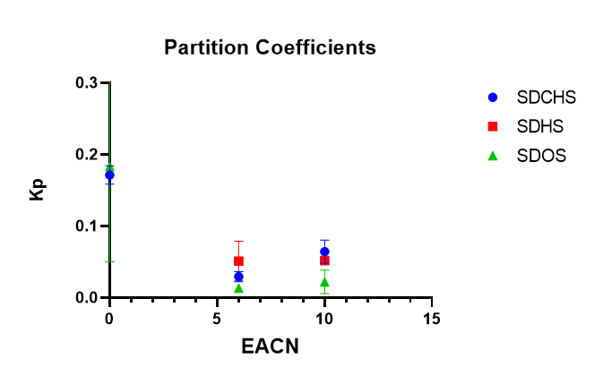
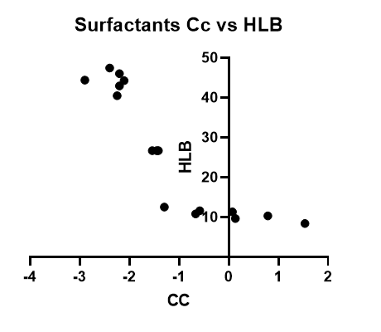
Supplementary Graphs and Figures
Figure S2: Partition Coefficient (Kp) vs EACN (Octanol, Hexane, Decane) for selected sulfosuccinate surfactants
Figure S1: Raw Cc vs HLB for selected surfactant systems

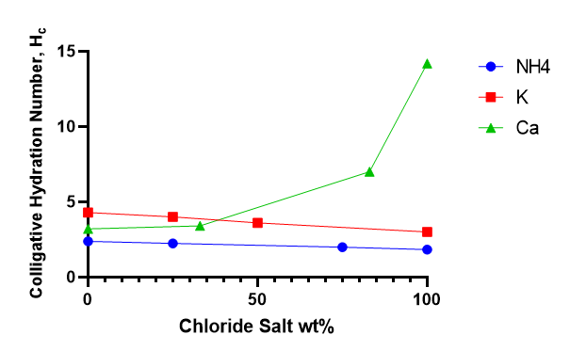
Figure S3: Colligative hydration number, h_{c}, vs wt% ratio of total chloride salt (NaCl) for mixed chloride salt systems for SDHS
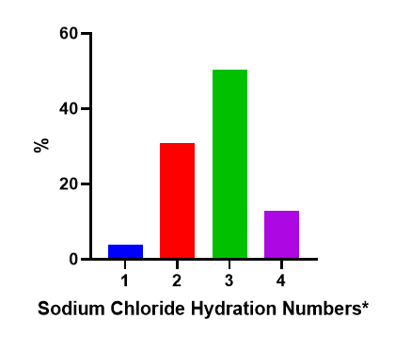
Figure S4: Distribution of colligative hydration number, h_{c}, for sodium chloride for anionic and *nonionic chloride salt mixtures

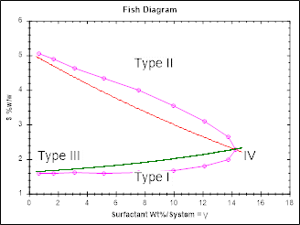
Figure S5: Fish diagram for SDHS for EACN range of 6-8, the precipitation boundary is labeled (blue line)

