University of Oklahoma

Graduate College

Measuring the resiliency of hybrid projects against supply chain disruptions

A thesis

submitted to the Graduate Faculty

in partial fulfillment of the requirements for the

Degree of

Master of Science in construction management

By

Mustafa Hamad
Norman, Oklahoma
2018

Measuring the resiliency of hybrid projects against supply chain disruptions

A thesis approved for the
Christopher C. Gibbs College of Architecture

By

______________________________
Dr. Somik Ghosh, Chair

______________________________
Dr. Anthony Perrenoud

______________________________
Dr. Ben Bigelow

© Copyright by Mustafa hamad 2018
All Rights Reserved.

Acknowledgements
After thanking god for his countless blessings. I would like to express my sincere gratitude to my master’s committee chair, Dr. Somik Ghosh for his encouragement, motivation, and insight. Furthermore, I would like to extend my gratitude to the members of my committee, Dr. Anthony Perrenoud and Dr. Ben Bigelow, for supporting me and making this study possible.
I extend my deep acknowledgement to McCarthy Building Companies, GE Johnson construction company, and the Brandt companies for supporting me in this effort.
My special gratitude to my family, parents Isam and Wanda, sisters, and brothers for their endless support and love. Most importantly for the special one who is always there by my side, my amazing wife Hala.

Table of Contents
Acknowledgements iv
List of Tables viii
List of Figures ix
Abstract xi
Chapter 1: Introduction 1
Research goal 2
Research questions 3
Research objectives 3
Research methods 3
Research outcome 4
Chapter 2: Literature review 6
Hybrid projects 7
On-site construction 8
Definition 8
Uncertainties of onsite construction logistics 9
Off-site construction 9
Supply Chain Management (SCM) 10
SCM resilience 11
SCM roles 12
Supply Chain Network (SCN) 14
SCN configuration 14
Uncertainties in SCM 16
Risk exposure model approach 18
Disruption Risk 20
Summary 20
Chapter 3: Research goal and objectives 23
Problem statement 23
Research goal 24
Research questions 24
Research objectives 25
Chapter 4: Research methodology 26
Section 1 Literature Review 26
Section 2 Developing the model 28
The first stage 29
The second stage 32
The third stage 37
Section 3 Case study 43
Project background 43
Case study analysis 46
The schedule 49
Applying the model 51
Chapter 5: Findings 56
Case study 56
Industry professionals 57
Chapter 6: Conclusion 60
Limitations 61
Significance of study 62
Future research 63
References 64
Appendix A: Interview questions 1 68
Appendix B: Interview questions 2 69
Appendix C: Pilot case study model 70
Appendix D: Interview questions 3 73
Appendix E: Case study model 74

List of Tables
Table 1- On-site construction logistics uncertainties 9
Table 2- SCM characterstics 17
Table 3- Off-site uncertainties 18
Table 4- Case study inputs 51

List of Figures
Figure 1 Off-site construction activities converging with on-site construction activities 6
Figure 2- Prefabrication utilization level 7
Figure 3- The four roles of SCM in construction (Virjhoef & Koskela, 2000) 12
Figure 4- Data collection steps for developing the model 28
Figure 5- Pure supply chain for headwall construction 30
Figure 6-Headwall prefabrication SCN 31
Figure 7 Model process flow chart 36
Figure 8- The 4 types of headwalls 38
Figure 9- Material supply screen example 39
Figure 10- Production screen 40
Figure 11-Transportation screen 41
Figure 12- Disruption risk value 42
Figure 13- Total time 42
Figure 14- case study layout 44
Figure 15- Case study phases of construction 45
Figure 16- Headwall illustration 46
Figure 17-Case study headwall prefabrication SCN 47
Figure 18- Case study headwall assembling sequence 48
Figure 19- Milestone schedule 49
Figure 20- List of activities in the framing/rough-ins period 50
Figure 21- Converging of on-site and off-site construction activities 50
Figure 22- Case study material supply screen 52
Figure 23- Case study production screen 53
Figure 24- Case study transportation screen 53
Figure 25- Case study disruption risk value 55
Figure 26- case study total time 55

Abstract
The construction industry has unique supply chain relationships given the fact it is project based. As a result, the collaboration in supply chain relationships face a variety of problems that affect one or more of the project objectives: time, cost, quality, scope, or safety. Many uncertainties exist in the prefabrication supply chain as a result of which the on-site activities have to stop and wait. These uncertainties are the basis for many failures and misunderstandings that occur during construction, resulting in high failure costs due to rework and time delay. It is a challenge for the risk managers to ascertain the potential uncertainties and manage the operational disruption risk in the prefabrication supply chain of a construction project. Therefore, risk managers may employ countermeasures that leave their project or company exposed to significant risks. The goal of this research study is to examine the resiliency of hybrid projects against supply chain disruption by investigating the disruption risk exposure inherited from uncertainties in the prefabrication supply chain. A model capable of evaluating and measuring the impact of a disruption originating anywhere in the supply chain was developed and implemented to test its usability in front-end planning of hybrid construction projects. The test demonstrated that the application of this model exposed significant uncertainties found in the prefabrication process, and that the model provided valuable information to risk managers on the operational disruption risk allowing them to make informed decisions and allocate resources more judiciously.

Chapter 1: Introduction
With recent business trends towards globalization, competition is getting fierce especially with continuous advances in information technology. These trends urged companies to better their business schemes and processes, distinguishing themselves from competitors and responding to new market challenges. Supply chain management is one aspect of advanced business schemes (Hamzeh, Tommelein, Ballard, & Kaminsky, 2007). Currently, the situation in the construction industry regarding the collaboration in the supply chain is troubling, and a change is required (Van Vught, & Van Weele, 2015).
Off-site construction, in other words prefabrication, has been a topic of research in the construction industry over the last decade (Pan, Gibb, & Dainty, 2012). The use of prefabrication with on-site construction activities concurrently results in hybrid projects. Numerous benefits have been associated with the use of prefabrication; these benefits include reductions in cost, time, defect, waste, non-value-added activities, environmental impact, health, and safety risks. These benefits extend to improve the life cycle cost and whole life performance of the built facilities thus increasing profitability (Zhai, Zhong, & Huang, 2015). However, these benefits come at a price; utilizing prefabrication introduces risks and uncertainties that cause complexity in the management of projects and their respective supply chains (Arashpour & Wakefield, 2015).
The construction industry has unique supply chain relationships given the fact it is project based. As a result, a variety of problems face collaboration in supply chain relationships. These problems affect more than their respective domain as they are the basis for many failures and misunderstandings that occur during construction, resulting in high failure costs due to rework and time delays (Van Vught, & Van Weele, 2015). The construction industry is witnessing problems in managing the supply chain and pinpointing the required integration in construction processes (Bankvall, Bygballe, Dubois, & Jahre, 2010).
Many uncertainties exist in the prefabrication supply chain as a result of which the on-site assembly process has to stop and wait. It is a challenge for the risk managers to ascertain the potential uncertainties in the supply chain while finding corresponding methods to cope with them not to affect one or more of the project objectives: time, cost, quality, scope, or safety (Arashpour, Wakefield, Lee, Chan, & Hosseini, 2016). Although evidence of hybrid project benefits are well documented, the interaction of uncertainties from off-site construction and on-site construction in hybrid projects remains a less researched area in the construction literature (Arashpour et al., 2016). There is a need for a holistic analysis of uncertainty and an integrated risk management approach to increase the success of prefabrication projects.
This project aims to bridge the gap of knowledge in managing operational disruption risk in the prefabrication supply chain of a construction project. This practical need is addressed with a model that evaluates the impact of a disruption originating anywhere in the supply chain. This approach allows for the opportunity to know the effect of a disruption on the project progress before estimating the probability associated with that disruption helping risk managers in making informed decisions about where to focus their limited resources.

Research goal
Examine the resiliency of hybrid projects against supply chain disruption by investigating the disruption risk exposure inherited from uncertainties in the prefabrication supply chain.

Research questions
RQ 1 – What are the uncertainties that face a hybrid project?
RQ 2 – How do these uncertainties affect a hybrid project?
RQ3 – How to identify risk exposure from uncertainties in a hybrid project?

Research objectives
Obj. #1: Identify the uncertainties that face a hybrid construction project.
- Systematic literature review
- Interview industry professionals
Obj. #2: Develop a model of a production system of a hybrid construction project.
- Conduct a pilot case study
Obj. #3: Apply the developed model to a hybrid construction project
- Conduct a case study

Research methods
The technique used for conducting the literature review consisted of a model of five steps: (i) online database searching and information clustering, (ii) citation and sample refinement, (iii) abstract review refinement, (iv) full-text review refinement, and (v) final sort around core ideas. The interviews were conducted on a one-to-one basis with five construction industry professionals from two general contracting firms and one specialty trade contractor who are involved in hybrid construction projects.
Developing the model involved two types of data; qualitative and quantitative. Data collection was done in three stages. Each stage consisted of an interview, documenting the project progress, and developing the results. The first stage consisted of developing a supply chain network. The second stage consisted of developing the model. In the third stage, a pilot case study was used to test the model.
Applying the developed model to a hybrid construction project involved collecting quantitative and qualitative data. Data collection consisted of interviews and project progress documentation. Qualitative data analysis was used to test the model.

Research outcome
The model offers a better opportunity for industry professionals to identify activity risks and expose uncertainties that may affect the project objectives or construction schedule. The model identifies potential disruption risks that are of significant impact on project performance and assesses the impact of a disruption originating anywhere in the supply chain. Also, the model uncovers two significant uncertainties. The first is when to start the prefabrication processes, and the second is the required production rate to meet the schedule.
The implication of the outcome of the study can be measured on two levels. At the theoretical level, the study will explore the utilization of a novel disruption risk exposure model that has not been utilized in the construction environment. At the operational level, the model will be able to identify the potential disruption risks that are of high impact to the project performance, which will aid the risk managers to allocate resources more judiciously. Also, the model will be able to compute the time off-site construction activities need to meet with on-site construction activities.
After the introduction, the document presents an extensive literature review on the topic and identifies a gap of knowledge in the problem statement. Afterward, the document introduces the research questions and objectives set to explore this knowledge gap. Then the methodology section provides detailed description of the steps taken to achieve the study objectives followed by a discussion of the study finding. Finally, the conclusions are summarized, limitations are highlighted, the significance of the study and future research are identified.

Chapter 2: Literature review
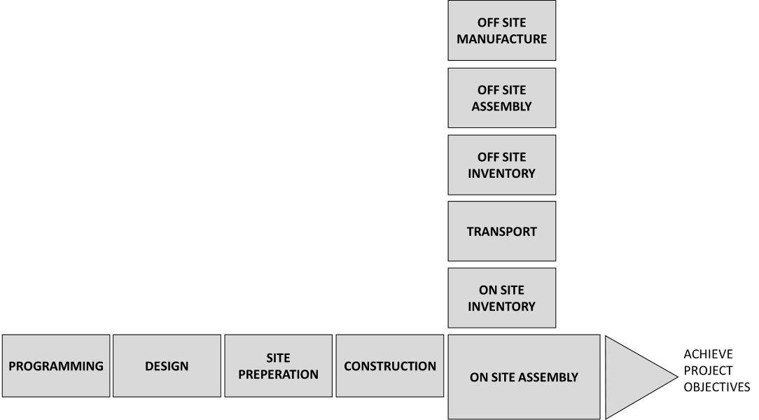
In recent years, construction companies are utilizing both off-site and on-site activities concurrently in their projects, which is referred to as ‘hybrid’ projects’ in this document. In a typical hybrid construction project, some structural elements are constructed on-site while the remaining building components are built off-site and shipped to the construction site for installation (Arashpour, Wakefield, Blismas, & Minas, 2015). Figure 1 depicts a simplified schematic of the off-site chain of activities converging with the on-site activities to accomplish the project objectives.

Figure 1 Off-site construction activities converging with on-site construction activities

This chapter presents background information on hybrid projects, on-site construction, and off-site construction followed by a review of existing literature on supply chain management and supply chain network. This chapter also presents a discussion on the disruption risk in hybrid construction supply chain.

Hybrid projects
Despite the growing popularity of coupling off-site construction with on-site construction, it is not a new concept. Yet the industry lacks a definitive definition of what constitutes as a hybrid construction project (Tennant, McCarney, & Tong, 2012). Hybrid construction project is an elusive term much like green building; there is no consensus on one specific definition. Off-site construction is classified into five categories; volumetric, panelized, sub-assemblies, components, and non-off-site manufactured (Gibb & Pendiebury, 2005; Ross, Cartwright, & Novakovic, 2006). Hybrid construction is any construction project that prefabricates more than the typical prefabricated components such as pipes, outlets, tiles, etc. Hybrid construction integrates sub-assembly systems with any other system. Examples will be mechanical, electrical, and plumbing systems, exterior walls, or superstructure that can be constructed as volumetric units, meanwhile the rest of the project can be constructed with a different system (Tennant et al., 2012). The term ‘hybrid’ is used in this document for projects that prefabricate more than the typical prefabricated components. Figure 2 shows the level of utilization of prefabrication in the different categories of construction projects.
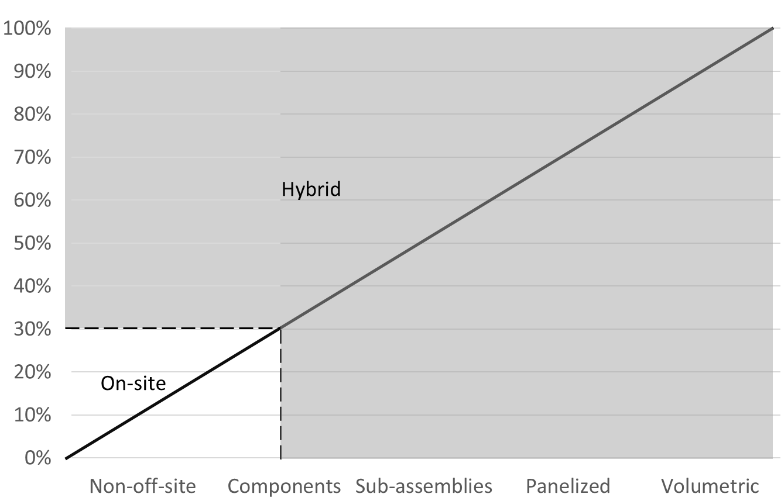
Figure 2- Prefabrication utilization level

On-site construction

Definition
In a construction project, the placement of facilities, equipment, and material within its space is known as site layout planning. The site layout includes the footprint of the building, access roads, temporary facility locations, parking, and storage areas (Zolfagharian & Irizarry, 2014). Construction logistics and site layout planning are considered to be decisions taken by the project participants to support the construction production (Skjelbred, Fossheim, & Drevland, 2015). These components must be appropriately managed to ensure the success of a project (Almohsen & Ruwanpura, 2011).
Construction logistics defined by Almohsen and Ruwanpura (2011) as the management of the flow of materials, tools, and equipment from the point of extraction to the point of final use. Mossman (2007) defined it as all the processes needed to deliver a structure, except for the assembling activity. Construction logistics include the planning and execution, the steering, documentation, and monitoring of project flow in regard to material, personnel, and information (Lange & Schilling, 2015).
During construction, a variety of processes take place such as material ordering, transportation, delivery, moving around, and storage. Steps such as temporarily storing material and moving it around are waste and ideally should be eliminated from the construction process (Skjelbred et al., 2015). The construction process is dynamic; expectations of having day to day changes in the processes are vital (Zolfagharian & Irizarry, 2014). Ineffective management of these challenges will result in unnecessary costs, time waste and an increase in work errors (Sundquist, Gadde, & Hulthén, 2017).

Uncertainties of onsite construction logistics
Lange and Schilling (2015) mention a universal basic problem of logistics which is the variability in production and supply systems. In a production system, the supply chain demonstrates variances from provisions as well as requirements. Problems in the construction industry include missing or delayed deliveries, inefficient storage space management, installation of wrong or damaged material, and insufficient separation of waste. Table 1 presents current uncertainties of on-site construction logistics.
Table 1- On-site construction logistics uncertainties
Uncertainty category | Type | Author
Space allocation | - Site layout  - Construction activities  - Storage | (Zolfagharian & Irizarry, 2014)  (Zolfagharian & Irizarry, 2014)  (Sundquist et al.,2017).
Material | - Storage condition  - Specification  - Order time  - Quantity  - Condition | (Sundquist et al.,2017).  (Zolfagharian & Irizarry, 2014)  (Said, & El-Rayes, 2010).  (Seppänen & Peltokorpi, 2016).  (Sundquist et al., 2017).

These problems negatively affect the productivity of a construction site as they show problems of insufficient production planning. However, these uncertainties can be eliminated or reduced by focusing on site logistics planning at an early stage.

Off-site construction
Off-site construction involves all the activities carried off-site in support of the construction project. For this document, off-site construction includes all the different construction elements prefabricated in manufacturing facilities and their supply chain. These facilities are part of an extended supply chain. The downstream of that supply chain are the activities that are executed at the construction job site. This arrangement results in multiple supply chain members to have uncertainties that need managing. Ekeskär and Rudberg (2016) mentioned that supply chains exist whether they are managed or not. Thus, there is a distinction between supply chains as a procedure of business and the management of the said supply chains. Supply Chain Management (SCM) is typically interrelated with off-site construction.

Supply Chain Management (SCM)
On-site logistics deals with the physical flow planning and handling the material, while SCM relates to the requirement, acquirement, transportation, and delivery of material to the construction job site (Sundquist et al., 2017). The effectiveness of a construction project depends highly on the integration of on-site logistics and SCM. Construction logistics enhances with improving the connection between activities at the construction site with the logistics and manufacturing operations within the supply chain (Sundquist et al., 2017).
The concept of SCM originated in the manufacturing industry; the Toyota Production System introduced SCM as part of the Just-In-Time (JIT) system (Vrijhoef & Koskela, 2000). The SCM profession continued to evolve based on changing needs of the global supply chain. Due to this growth, SCM can get confused with the term logistics management.
The Council of Supply Chain Management Professionals (CSCMP) (2013) defined SCM as the planning and management of all activities involved in logistics. Additionally, SCM includes the coordination and collaboration between members, which can be suppliers, manufacturers, transportation providers, and end customers.
Mossman (2007) defines SCM as an alignment of social and commercial goals by a constructor to create a network of suppliers. The constructor can depend on these suppliers as specialists that understand the constructors’ way of doing business and are available to perform work on current and future projects. In this definition, SCM a development process that can occur within and between projects. Another definition from Vrijhoef and Koskela (2000) view SCM as a network of organizations that are interrelated and linked through the upstream and downstream of different processes and activities that produce value to the final customer either by product or services.
Ekeskär and Rudberg (2016) believe that SCM at its core is the coordination of supply chain entities and orientation towards stronger relationships between supply chain members. SCM is a holistic view of the entire supply chain, the primary goal of SCM is to recognize the interdependency in supply chain activities rather than just paying attention to the next process or activity. Thus, increasing transparency, alignment of the supply chain’s coordination, and improving its configuration and controls based on factors such as the integration of business processes regardless of functional or corporate boundaries (Vrijhoef & Koskela, 2000).

SCM resilience
Disruptive events degrade the performance of the supply chain; this degradation is not immediate, most supply chains suffer a more gradual decrease of performance over time (Hosseini, Barker, & Ramirez-Marquez, 2016). Resilience is a widely used concept in many fields including engineering, industrial, environmental science, and organizational research (Elleuch, Dafaoui, Elmhamedi, Chabchoub, 2016). Resiliency reduces risks associated with systems disruption. However, there is no consensus on the definition of resilience. Elleuch et al. (2016) define resiliency as a system’s ability to keep functioning regardless of a significant disruption. Hosseini et al., (2016) considers resiliency as the ability to recover and return to a stable state after a major disturbance.
Resilience definitions revolve around three system characteristics; the ability to absorb, adapt and recover (Hosseini et al., 2016). Vugrin, Warren, and Ehlen (2011) identified resilience being comprised of absorptive, adaptive, and restorative capacity. The absorptive capacity refers to the amount in which a system can absorb disruptions. Adaptive capacity refers to the degree in which a system can temporarily adapt to the new disrupted conditions. Restorative capacity is the degree to which a system can recover its functions when adaptive capacity is not sufficient (Hosseini et al., 2016). Supply chain resilience is the ability of a supply chain to return to its original state or move towards a new, more desirable state after disruption (Cordoso, Paula, Barbosa-Povoa, Relvas, and Novais, 2014).

SCM roles
Vrijhoef and Koskela (2000) suggest that SCM has four major roles in construction depending on whether the focus is on the supply chain, the site, or both. These four roles and their focus area are shown in Figure 3. These roles are not performed exclusively of each other; they are used jointly.

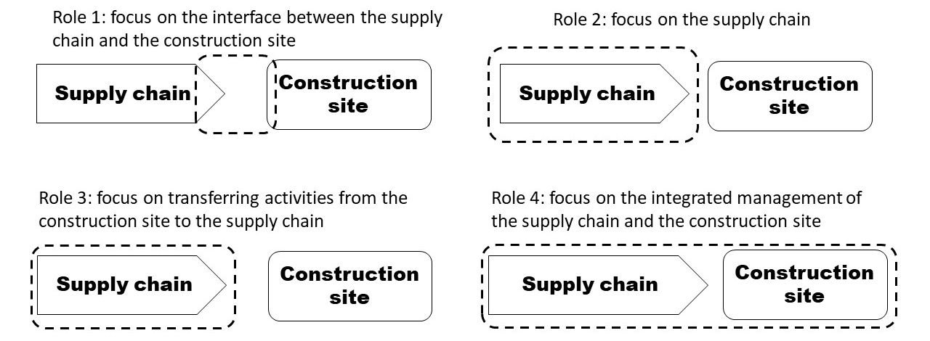
Figure 3- The four roles of SCM in construction (Virjhoef & Koskela, 2000)

The first role is concerned with supply chain impact on construction activities. The purpose of this role is to lower costs and durations of site activities by ensuring reliable flow of material and labor to the construction site, preventing disruption to the workflow. This role emphasizes on construction site cooperation with direct suppliers. This role is best for a contractor with interest in onsite activities. The second role focuses on the supply chain itself, such as the supply chain for prefabricated elements like stairs. The goal is to reduce costs, lead time, and inventory that relate to logistics. This role needs in-depth cost and time analysis for identifying improvement areas. Material suppliers benefit from this role. The third role addresses moving activities from the construction site to the supply chain. This aims to transfer on-site activities off-site, such as prefabrication of elements. This helps in avoiding site conditions and increases the overlapping between activities, the goal of this focus is to reduce costs and durations of activities. Contractor and suppliers benefit from this role. The fourth role aims to integrate the management of the construction site and the supply chain. Contractors, suppliers, or clients might adopt this role. Suggested initiatives for the integrated management include open building and sequential procedure. The open building offers the benefit of postponing decisions on the interior of the building, achieved by splitting the interior work from the structure. This gives the spaces adaptability to be reconfigured. As for sequential procedure, successive autonomous sequences represent the construction site. The goal of these two alternatives is to change the temporary construction supply chains with permanent ones.

Supply Chain Network (SCN)
A supply chain is comprised of a network of organizations, companies, and facilities, referred to as the Supply Chain Network (SCN) (Govindan, Fattahi, & Keyvanshokooh, 2017). A SCN consists of nodes and arcs; nodes represent suppliers, facilities, plants, distribution centers, and customers. Arcs are the connections between those nodes, and they represent the direction of flow; flow includes material, production, and information (Sanei, Mahmoodirad, & Niroomand, 2016). The SCN might be spread over a vast geographical area or even a global area and is expected to provide the right products and services on time, with the correct specifications to the right customer. This is done by synchronizing the interrelated activities throughout the SCN (Carvalho, Barroso, Machado, Azevedo, & Cruz-Machado, 2012). Supply Chain Network Design (SCND) has a major impact on the performance of the SCN, as network design decisions determine the supply chain configuration and set the constraints that govern the relationship between supply chain components (Chopra & Meindl, 2007).

SCN configuration
SCM is a significant factor for success with the competitive increase in doing business. However, how much of the supply chain needs managing depends on several factors including complexity of the product, available suppliers, and availability of raw material (Lambert & Cooper, 2000). Other factors include the length of the supply chain, the total suppliers, and customers at each level. The supply chain is not a one-to-one relationship as it will be unlikely to find a company participating in only one supply chain. Most supply chain graphs look like an uprooted tree where the branches and roots represent the extensive network of suppliers and customers (Lambert & Cooper, 2000).
Not all connections in the supply chain need integration and coordination. Deciding what part of the supply chain needs management’s attention follows the capabilities, goals, and importance to the organization. It is of utmost importance to have knowledge and understanding of the structural configuration of the supply chain network. Lambert and Cooper (2000) identified three key components for a supply chain network, the members of the supply chain, the structural dimension of the network, and the type of process links between the members.
The first step in determining the supply chain network configuration is to Identify the supply chain members. Managing all process links between all members deemed counterproductive. Members of the supply chain are companies and organizations that interact with the focal company directly/indirectly.
The structural dimensions of the supply chain network represented by the horizontal and vertical structure, and the positioning of the focal company within the endpoints of the supply chain. The horizontal structure represents the number of tiers in a supply chain. A supply chain will stretch if it has many tiers. Meanwhile, supply chains with limited tiers will be short. The vertical dimensions represent the total of suppliers or consumers within each tier. The last structural dimension is the horizontal positioning of the focal company; a company can be anywhere between the endpoints of the supply chain. The number of suppliers or customers affects the supply chain structure, companies with single source suppliers have a narrow supply chain while companies with multiple source supplier have wider spread supply chain.
Allocating resources to manage process links across the supply chain is crucial. As mentioned before, not all supply chain process links need integration and management; integration drivers are different from process link to another as some links are more critical than others.
Lambert and Cooper (2000) categorized process links between supply chain members into four types of business process links, managed process links, monitored process links, not managed process links, and non-member process links. Managed process links are links important to the focal company to be managed and integrated, the focal company actively manages these links. These links can extend beyond the first tier of suppliers/customers to any tier the focal company sees fit. Monitored process links are less critical to the focal company. However, it is important to the focal company that these process links are integrated and managed between other members of the supply chain. The focal company simply monitors how the process links are integrated and managed. Not managed process links are links that are not critical to the focal company and do not require allocating resources to monitor them, other members of the supply chain are responsible for managing them appropriately. Non-member process links are not links to the focal company supply chain structure, but they affect the structure of the supply chain. These links are connecting different supply chains together (Lambert & Cooper, 2000).

Uncertainties in SCM

SCM relationships
SCM characteristics dictate the type of relationship between key stakeholders in the SC and construction site. Existing research identified numerous characteristics for SCM relationships shown in Table 2 (Behera, Mohanty, & Prakash, 2015). SCM characteristics affect the supply chain and cause disruptions in flow processes.

Table 2- SCM characteristics
Characteristic | Reason
Clients influence | Clients are the basic source of changes in a construction project; they control the final product regarding physical aspects and logistics parameters.
Number of stakeholders | The main stakeholders are owners, designers, contractors, and suppliers. Any typical network includes multiple organizations and actors. As the number of stakeholders increases the flow of information, material, services, products, and funds hinder.
Fragmentation | The complexity of the construction industry is seen in the various subcontractors and vendors that are involved in a group of institutions operating to achieve different business goals.
Temporary organizations | The project-based relationship focuses on short-term thinking, production at a temporary site leads actors to attempt leveraging what they can from the contract, thus creating an opportunism environment.

SCM disruptions
Problems in the supply chain can arise from various sources, some of these sources are labor disputes, supplier bankruptcy, natural disasters, and acts of war. These problems can disrupt or delay material, information, and cash flows affecting the project objectives. Supply chain risks are categorized into delays, disruptions, inaccurate forecast, system breakdown, procurement failure, inventory problems, and capacity issues. With each category having its drivers and mitigation strategies (Chopra & Sodhi, 2004).
Disruption risks can either be frequent or infrequent, short or long term and will cause problems in the supply chain, ranging from minor to severe (Chopra & Sodhi, 2004). For instance, a transportation delay along the supply chain may create a temporary risk, while a sole supplier holding up material to force a price increase represents a long-term risk. A machine breakdown is not serious when there is excess inventory, but a war that disrupts transportation will have significant effects on a project.
Traditional methods for managing supply chain risks depends on knowing the likelihood of occurrence and the magnitude of impact for all scenarios that can materially disrupt the flow of operations (Simchi-Levi, Schmidt & Wei, 2014). Chopra and Sodhi (2004) mentioned that a company manages risks depending on the type of disruption and the level of preparedness. Probability-impact models are based on project size and the ability of the organization to react to the risk, and typically assign resources to high probability, high impact risks. The identified project risks are prioritized and rated for further analysis. Current off-site disruption uncertainties are shown in Table 3.
Table 3- Off-site uncertainties
Uncertainty category | Type | Author
Coordination between on-site and off-site | - Forecast  - Start date  - On-site requirements  - Transportation | (Chopra & Sodhi ,2004)  (Arashpour et al., 2016)  (Arashpour et al., 2016)  (Chopra & Sodhi ,2004)
Off-site | - Delays  - Procurement  - Capacity  - Available resources  - Equipment failure | (Chopra & Sodhi ,2004)  (Chopra & Sodhi ,2004)  (Chopra & Sodhi ,2004)  (Arashpour et al., 2016)  (Arashpour et al., 2016)

Risk exposure model approach
Project risk management is a methodical approach to identify, analyze, respond, and control risks, aiming to increase the likelihood and impact of positive results, and reduce those of negative results (Arashpour et al., 2016). Project risk identification uses various tools and techniques such as checklist analysis, documentation reviews, assumption analysis, diagraming techniques, and expert judgment (Arashpour, Abbasi, Arashpour, Hosseini, & Yang, 2017). Risks are rated and prioritized based on their occurrence probability and impact on project objective(s). Probability-impact models are designed based on project size and the ability of the organization to react to the risk, and typically assign resources to high probability, high impact risks. In terms of tools and techniques, more dimensions have been added to the conventional probability–impact model. These dimensions include the risk exposure extent (Jannadi & Almishari, 2003), risk manageability level (Aven, Vinnem, & Wiencke, 2007; Chan, Yuen, Lee, & Arashpour, 2015), surrounding environment influence and interdependencies between risks (Zeng, An, & Smith, 2007), and risk significance (Han, Kim, Kim, & Jang, 2008). These dimensions help improve the traditional probability-impact model to analyze the interacting risks in hybrid projects better.
A disruption risk model evaluates the impact of a disruption originating anywhere in the supply chain, allowing the opportunity to know the effect of a disruption on the project progress before estimating the probability associated with that disruption. The approach helps risk managers in making an informed decision about where to focus their limited resources by emphasizing on the impact of a disruption. This is because the impact of a disruption depends on its duration rather than the cause. Also, the potential mitigation actions in response to a supply chain disruption are often the same regardless of the exact cause (Simchi-Levi, William, Wei, Zhang, Combs, Ge, Gusikhin, Sander, and Zhang, 2015).
Risk exposure analysis in supply chain nodes allows for prioritizing resource allocation; the analysis can be combined with the total spending at different nodes. This combination allows for developing different mitigation strategies for different nodes (Simchi-Levi et al., 2015).

Disruption Risk
The disruption risk model is a novel risk exposure model that assesses the impact of a disruption originating anywhere in the supply chain on the prefabrication process. This model is unique to the construction industry as supply chains are temporary and have limited demand. In a typical construction project, the primary concern is to meet the final product demand with no regard to the time it takes to build-up inventory levels to reach that final demand. The disruption risk model acts as tracking method of the time-period and product inventory accumulated to reach the final demand. The disruption risk is a percentage value that represents the impact of a disruption originating anywhere in the supply chain on the prefabrication operations. Therefore, we can analyze the impact of a disruption on the project objectives at any time yielding significant information for risk managers. Nodes with a low disruption risk value indicate that in case of a disruption minimal impact on performance will occur. Therefore, that node is not exposed to a risk that needs to be addressed. In the same way, nodes with a high disruption risk value indicate that in case of a disruption significant impact on performance will occur. Therefore, that node is a risk and needs to be addressed. The disruption risk value can help recognize potential waste and excessive protection within the supply chain. Therefore, some of the common risk-mitigation strategies may lead to unnecessary resource allocation at low-exposure nodes and inadequate protection at high-exposure nodes.

Summary
Existing literature in project management show examples of time overruns, cost overruns, safety issues, and quality problems due to underestimating the extent of risks in various project dimensions (Arashpour et al., 2017). Delays in both on-site and off-site activities cause risks of deviating from project plans and late completion. Three hybrid project dimensions have noteworthy risks, these dimensions are on-site, off-site, and the coordination (Arashpour et al., 2016). The coordination dimension has the ability to affect both the upstream off-site activities and the downstream on-site operations. Therefore, the most significant risks are the ones associated with the coordination between off-site and on-site dimensions
A significant risk in the coordination dimension is to identify the correct time for the upstream activities to start so they can converge with on-site operations in time. If the prefabricated elements are delayed later than the due date, the on-site operations will stop and wait, incurring a penalty for loss of working hours (Zhai et al., 2015). This factor is the root of time and cost overruns in hybrid projects. Thus, it is understandable to spend more time on planning the reliability of the coordination process.
In addition to the coordination dimension, the off-site dimension identifies risks related to disruptions in the supply chain. Each disruption scenario is unique due to the nature of the prefabrication supply chain which once scheduled is relatively fixed and unchangeable (Zhai et al., 2015). Disruption outcomes depend on the time and location of the disruption. The impact of a disruption on project objectives changes with time (Simchi-Levi et al., 2015). Thus, it is of utmost importance to know the impact of a disruption risk at different stages and time periods of the project to allocate resources better.
The interaction of uncertainties in hybrid projects and its consequence on the project planning remains an overlooked area of research in the construction literature (Arashpour et al., 2016).

Chapter 3: Research goal and objectives

Problem statement
The integrated uncertainty present in hybrid construction projects results in risks that potentially affect one or more of the project objectives (Arashpour et al., 2017). However, the risk probability within off-site and on-site dimensions of the project are not the same (Arashpour et al., 2016). The occurrence probability of off-site project risks is lower than on-site project risks due to the minimal involvement of the human element in the automated processes and limited exposure to workflow variability (Arashpour et al., 2017). Off-site construction uncertainties include when to start activities, the availability/ constraints of resources, equipment failure, and lack of compliance of the manufactured elements to the on-site requirements (Arashpour et al., 2016). Meanwhile, on-site construction uncertainties include bad weather conditions, rework and quality problems, and worksite accidents (Arashpour et al., 2017). The mentioned uncertainties of off-site and on-site construction interact and result in risks of delay and longer project durations.
Existing studies show that off-site project related risks have a greater impact on project objectives than that of on-site project risks (Construction, 2011). Risks associated with the upstream activities in the supply chain of hybrid projects can have a significant impact on the downstream activities and can cause deviations from project objectives (Arashpour et al., 2016). Hybrid construction projects face considerable operational and supply chain risks that can have a significant impact on project performance. Scholars and researchers agree that operational disruptions have the most significant impact on performance. Most projects do not prepare for low-probability, high-impact disruptive risks (Simchi-Levi et al., 2015).
Simchi-Levi et al. (2015) stated that any supply chain is exposed to a range of low-probability, high-impact risks that can disrupt their flow. This type of risks is difficult to manage as it is hard to predict and calculate (Cardoso, Barbosa-Póvoas, Relvas, & Novais, 2014). As a result, risk managers may employ countermeasures that leave their project or company exposed to significant risks while wasting resources to address other risks that cause minimal damage and disruption in the supply chain. In the event of a disruption, the construction production system might not immediately stop and display negative impact on the project outcome(s).
The interaction of uncertainties in hybrid projects and its consequence on the project planning remains an overlooked area of research in the construction literature (Arashpour et al., 2016). Therefore, a holistic analysis of uncertainty and an integrated risk management approach is required to increase project plan reliability in hybrid projects.

Research goal
The broad goal of this project is to examine the disruption risk exposure of hybrid projects related to the interactions of uncertainties from the prefabrication supply chain and the on-site construction activities. The specific goal of the study is to examine the resiliency of hybrid projects against supply chain disruption by investigating the disruption risk exposure inherited from uncertainties in the prefabrication supply chain.

Research questions
Supply chain uncertainties play a critical role in achieving the objectives of a hybrid project, the broad research question ‘how to eliminate the uncertainties in hybrid construction projects?’ is broken down into the following specific questions:
RQ 1 – What are the uncertainties that face a hybrid project?
RQ 2 – How do these uncertainties affect a hybrid project?
RQ3 – How to identify risk exposure from uncertainties in a hybrid project?
The next section discusses a set of objectives that are developed to answer these questions.

Research objectives
Specific objectives of the document are as follows:
Obj. #1: Identify the uncertainties that face a hybrid construction project.
- Systematic literature review
- Interview industry professionals
Obj. #2: Develop a model of a production system of a hybrid construction project.
- Conduct a pilot case study
Obj. #3: Apply the developed model to a hybrid construction project
- Conduct a case study

Chapter 4: Research methodology
This chapter describes the methods employed for data collection at each stage of the study and the procedures for data analysis. The research is divided into three sections. The first section is a literature review on the uncertainties that face a hybrid project. The second section is developing a model of a production system for a hybrid construction project. The third section, applying the model to a hybrid construction project.

Section 1 Literature Review
In this section, two methods were applied to collect data. The first method consisted of a systematic literature review to identify the uncertainties faced in a hybrid construction project. The second method consisted of interviews with construction industry professionals at different stages of the research.
The literature review aims to provide a broad perspective on the performance and setting of hybrid projects in the construction industry. The work was developed in a systematical order consisting of an extensive literature review involving fields of construction site logistics, SCM, SC networking, SC resilience, construction risk management, prefabrication, and hybrid construction. The technique used for conducting the literature search consisted of a model of five steps: (i) online database searching and information clustering, (ii) citation and sample refinement, (iii) abstract review refinement, (iv) full-text review refinement, and (v) final sort. The search for information was done in databases containing a large body of literature including peer-reviewed full-text articles, such as Science Direct, Engineering Village, ASCE Library, and Emerald. The search focused on well-cited literature reviews to get a comprehensive perspective on the topics. Research criteria was established for keywords, as articles considered for reviewing featured the word/phrase “construction logistics”, “construction site logistics”, “off-site construction logistics”, “logistics management”, “material logistics”, “site organization”, “production management”, “supply chain management”, “supply chain resilience”, “logistics center”, “prefabrication”, “modular construction”, “standardization”, and “hybrid construction”. A timeframe constraint was applied to consider research conducted after the year 2000. Reviewing the gathered articles was done in a systematic approach reducing them to the ones that are highly relevant. Then, the final selection was organized around core ideas, articles that summarize other researcher’s work were excluded from the literature due to the repetition of ideas.
The interviews were conducted with five construction industry professionals from two general contracting firms and one specialty trade contractor who are involved in hybrid construction projects. The participants held different positions within the construction industry and had varying level of experience in hybrid projects. The positions included project manager, superintendent, and project engineer. The participants were engaged based on the level of authority and the current state of their hybrid projects. The interviews were conducted one-to-one, the remarks from these professionals assisted in understanding how hybrid projects process information.

Section 2 Developing the model
The development of the model involved two types of data; qualitative and quantitative. The two types allowed the analysis of different project aspects including current practices and processes performed in the construction industry. This section utilized two methods for data collection. The first was interviews used to gather qualitative data, and the second was documenting project progress to collect quantitative data. Data collection was done in three stages. Each stage consisted of an interview, documenting the project progress, and developing the results to generate a supply chain, model, and verify the model respectively. Figure 4 illustrates the steps taken for data collection in this section.
Figure 4- Data collection steps for developing the model

The first stage
The first interview was conducted with a general contractor in a job site trailer. The participants were provided with a description of the subject of study to understand the context better. After the introduction, the participants were asked a series of questions -shown in Appendix A- developed from the literature review to acquire accurate information about the prefabrication supply chain setting given the knowledge and experience they have in the industry.
The first documentation of project progress consisted of reviewing the project's options for prefabrication, the members involved and their roles in the process. Another aspect of the documentation process was the review of project documents, drawings, and schedule to provide a holistic overview of the scope of work involved in the prefabrication process. The project team used a prefabrication plan to determine the feasibility of each prefabrication option, this was not part of the study but was essential to understand the sequence of information processing in the industry.
The identified prefabrication options varied in their supply chain members, complexity, and information exchange. The project team decided the feasible prefabrication option was to prefabricate the patient headwalls. The next step was to develop a supply chain network of the prefabrication process in aims to provide an understanding of the hierarchical and organizational positioning of the supply chain members involved. This document did not consider the whole supply chain in the study; a portion that well represents the overall network was selected.
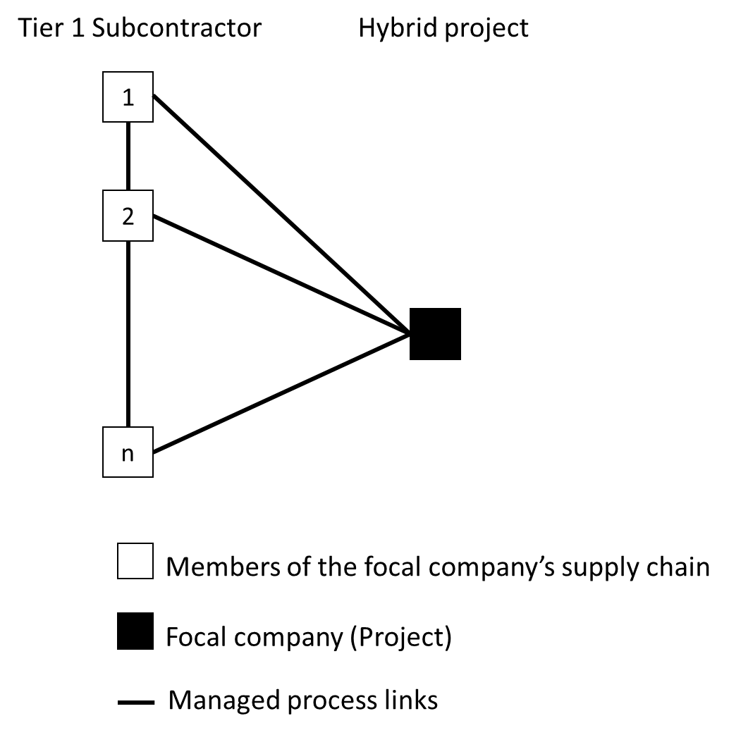
From the project scope of work, it was found that the subcontractors are the responsible members for delivering the finished headwall to the job site. The headwall supply chain reflects the uniqueness of construction supply chains. Figure 5 represents the headwall supply chain in its purest form, from the origin point to finish point. More members between these two are required to produce and assemble the headwall. Developing an accurate supply chain that represents the process of producing the headwalls was carried out in the three steps as described by Lambert and Cooper (2000).

Figure 5- Pure supply chain for headwall construction
First, members of the supply chain were identified. The subcontractors are the supplier's node responsible for the headwall material. The prefabrication shop is the manufacturing facility node which is also used to store the finished product, so there is no need for a warehouse node. The transportation node, and job site node.
Second, the structural dimension of the network is identified. The horizontal dimension refers to the number of tiers in the network. The supply chain has four tiers consisting of the job site, transportation, manufacturing facility, and the suppliers. The vertical dimensions represent the number of members within each tier. The last structural dimension is the horizontal positioning of the focal company which is at the end of the SCN.
Third, types of process links between the members are identified. Two types of process links were found, managed and monitored process links. Managed process links are essential to the project and are actively managed. Monitored process links are less critical to the project and are managed by other members of the supply chain. Figure 6 represents the developed SCN.
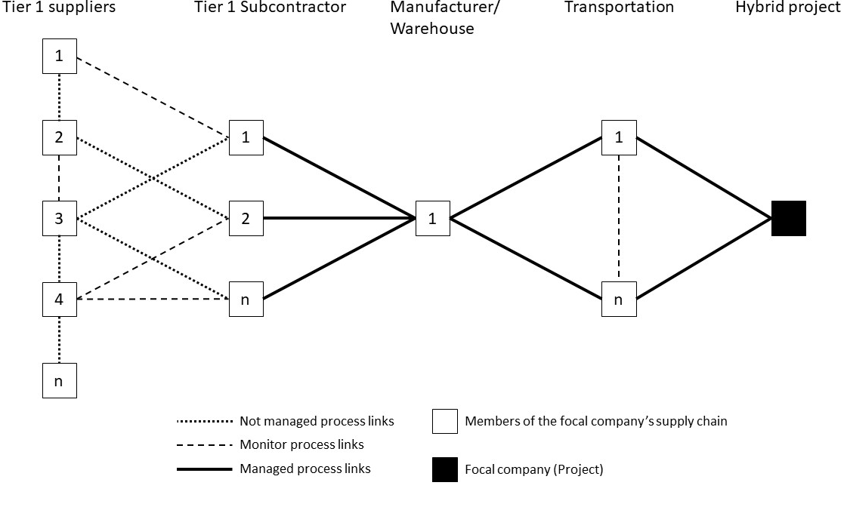
Figure 6-Headwall prefabrication SCN

The second stage
The second interviews started with presenting the developed SCN to the participants and making sure it accurately reflected the construction industry setting. The participants were asked questions -shown in Appendix B- about each stage of the prefabrication process to determine the accurate sequence of activities, processes, and flow of information required to prefabricate the headwalls. Also, participants were asked about lead time and constraints between the different stages. An important outcome of these interviews was to identify what the industry lacks in planning for prefabrication; the participants agreed that the uncertainty of when to start the prefabrication process dominates the construction industry. The information obtained from the interviews combined with the data collected from the first stage were used to develop a model that represents the flow of information and processes required in the prefabrication of the headwalls.
The model reflected the SCN in the sequence of activities required for the prefabrication process which consisted of three phases. The first phase is contacting the material suppliers and delivering the material to the prefabrication plant, the second phase is prefabricating and assembling the headwall, and the third phase is transporting the finished product to the job site. Each phase consists of inputs, processes, outputs and time constraints. The primary challenge faced in developing the model was to account for the time constraints between processes and phases. This challenge was addressed by establishing a time unit of one week and adding a time loop for each phase to capture the passed time accurately.
For the first phase, three inputs are required for the model, material lead time, material quantity takeoff, and the delivery quantity each time. As for the processes, two processes take place. The first is a count for the delivered material each time unit, as shown in Eq. (1). The second process calculates the material disruption risk value each time, as shown in Eq. (2).
$\sum_{i}{ Delivered quantity= }\sum_{i}{Delivered quantity+{Delivery quantity}_{i} }$ (1)
$Material disruption risk factor=\frac{({Quantity takeoff}_{i}-\sum_{i}{Delivered quantity)}}{{Quantity takeoff}_{i}}\%$ (2)
A decision variable shown in Eq (3) controls the time loop for the first phase. If the decision variable is not met, the time loop is activated and another time unit is added to the time count. If the decision variable is met, then the model continues to the second phase.
$\sum_{i}{ Delivered quantity≥ {Quantity takeoff}_{i} }$ (3)
The outputs of the first phase are the material disruption risk value each time and the total time required to reach the material takeoff. It is important to note that phase two does not require the decision variable in phase one to be satisfied before starting the activities in phase two. The decision variable is set to ensure that material quantity takeoff is met and the time to reach the takeoff is accounted for.
As for the second phase, two inputs are required for the model, the number of finished products required by the project and the desired production rate. The production rate is assumed to be constant throughout the prefabrication process. Prefabrication processes are assumed to begin after the first delivery of material. Two processes are included in this phase. The first process calculates the number of finished products at a specific time according to Eq. (4). The second process calculates the production disruption risk each time, as shown inEq. (5).
$Finished product=Production rate ×time units$ (4)
$Production disruption risk factor=\frac{(Quantity of finished product-Finished product)}{Quantity of finished product}\%$ (5)
A decision variable shown in Eq (6) controls the time loop for the second phase. If the decision variable is not met, the time loop is activated and another time unit is added to the time count. If the decision variable is met, then the model continues to the third phase.
$Finished product ≥Quantity of finished product$ (6)
The outputs of the second phase are the production disruption risk value each time and the total time required to reach the number of finished products. It is important to note that the production rate is a variable that can be manipulated to adjust the time required for the production. Also, phase three requires the decision variable in phase two to be satisfied before starting the activities in phase three. The decision variable is set to ensure that quantity of finished product is satisfied, and the time it took to reach that quantity is accounted for.
As for the third phase, the total quantity is taken from the quantity of finished product in phase two. One input is required for the model which is the transportation quantity each time. The transportation is done according to the installation rate assumed by the project team. As for the processes, two processes are considered. The first is a count for the delivered products each time, as shown in Eq. (7). The second process computes the transportation disruption risk value each time, as shown in Eq. (8).
$\sum_{k}{ Delivered product= }\sum_{k}{Delivered product+{transportation quantity}_{k} }$(7)
$Transportation disruption risk factor=\frac{(Quantity of finished product-\sum_{k}{Delivered product)}}{{Quantity of finished product}_{}}\%$ (8)
A decision variable shown in Eq (9) controls the time loop for the third phase. If the decision variable is not met, the time loop is activated and another time unit is added to the time count. If the decision variable is met, the model ends.
$\sum_{k}{Delivered product}=Quantity of finished product$ (9)
The outputs of the third phase are the transportation disruption risk value each time and the total time required to transport the number of finished products. An output of the whole model is a graph of the project disruption risk value, and the total time required from the start of the model to the end, this is calculated by Eq. (10). Figure 7 illustrates the developed model.
$Total time=Material lead time+Production time+Transportation time$ (10)

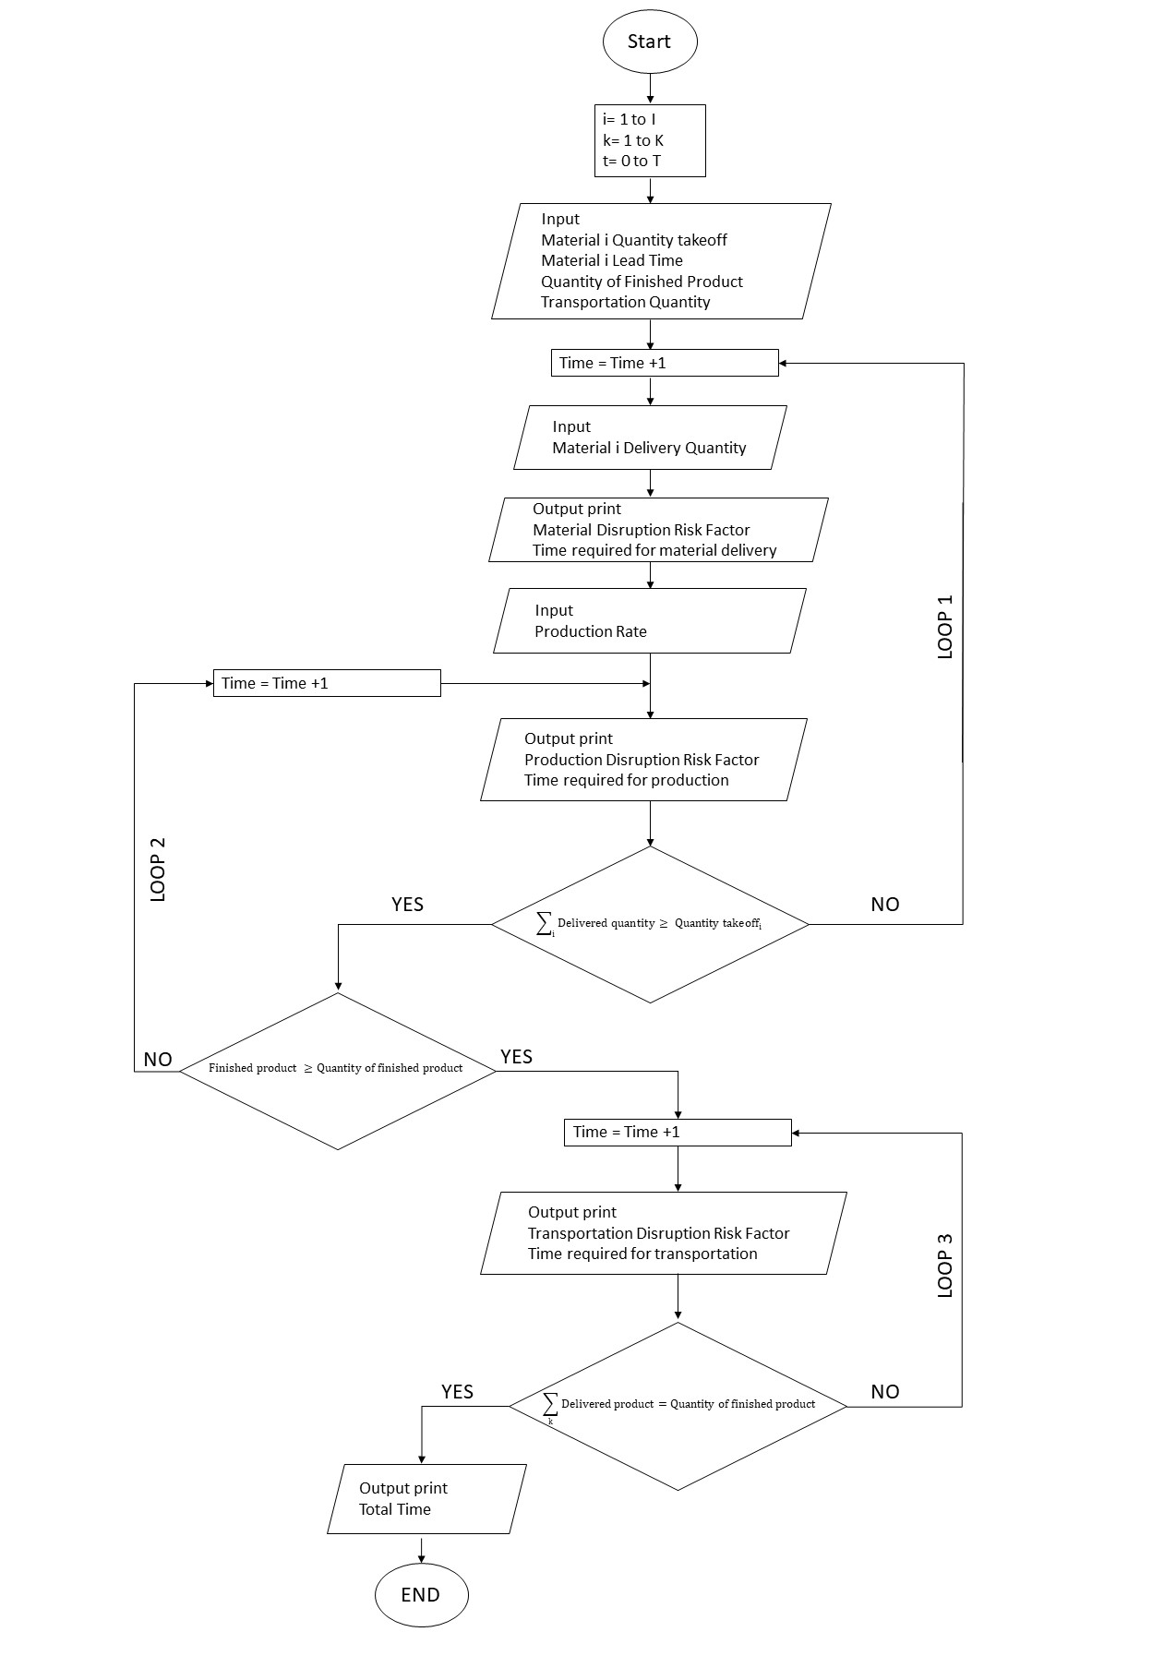
Figure 7 Model process flow chart

The third stage

Pilot case study background
A healthcare facility located in one of the Mountain States of the United States is expanding their existing facility. The new addition will be a five-story building, totaling 168,000 square-feet with an estimated cost of $71 million and an estimated finish date of 20 months. The project structure consisted of a precast first-floor structure, and rest of the structure built of structural steel. The construction was carried out by floor from north to south.
The construction team utilized the opportunity to prefabricate patient headwall elements in a controlled environment. The patient headwall has all the equipment and gas hookups required for the hospital equipment. The headwall construction took three months of mockups that involved the coordination of multiple subcontractors including the carpenter, framing, mechanical, and electrical contractor.
The electrical subcontractor facility was used for the assembling processes as well as storing the finished headwalls. The shop floor is located 10 miles from the job site with an approximate floor area of 1000 SF. There were four types of headwalls illustrated in Figure 8 with a total count of 85 units. The headwall scope of work consisted of pre-cut metal stud framing, medical gas piping and connections, electrical and low voltage piping and connections, and wood blocking. All the required material was delivered to the facility at once. Each of the subcontractors had a crew assigned to the assembling facility; crew sizes were two framers, two mechanics, four electricians, and one carpenter. The headwall production rate was 4 completed units/week.
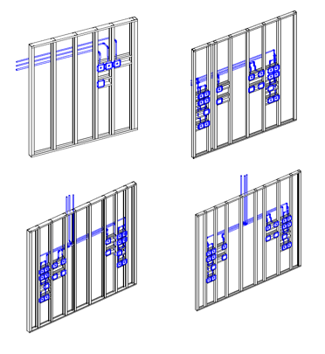

Figure 8- The 4 types of headwalls

Applying the model to the pilot case study
The pilot case study was of a forward supply chain with limited demand from the hybrid project. The supply chain was comprised of four echelons: 1) raw-material suppliers, 2) manufacturer where production, assembling and storing take place, 3) transportation, and 4) the job site.
The quantitative data inputs required for the model were acquired from the project team. The inputs consisted of 1) material lead time, 2) material quantity takeoff, 3) material delivery quantity, 4) headwall takeoff, 5) production rate, 6) transportation quantity. The next section shows the screens in which these inputs are used to run the model.

1.Material supply screen
The first screen in the model is the material supply screen. In this screen, the user is required to input the material lead time, material quantity takeoff, and material order quantity. Once the required fields are populated, the model calculates the material disruption risk value associated with each period. Figure 9 depicts an example of material supply screen for metal studs. From the figure we see that the material lead time is two weeks, material quantity takeoff is 6000 LF of metal studs, and the first order quantity is going to be for the whole takeoff quantity of 6000 LF. In this example, the material is going to be delivered at once, the disruption risk value is zero indicating there is no disruption risk.
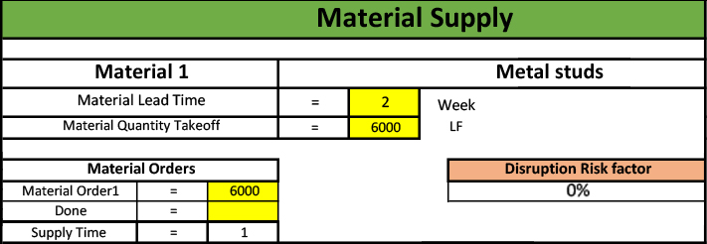
Figure 9- Material supply screen example

2.Production screen
The second screen in the model is the production screen. In this screen, the user is required to input the production quantity takeoff and the production rate. Once the required fields are populated, the model calculates the production disruption risk value associated with each period. Figure 10 depicts the production screen. From the figure, it is apparent that 85 headwalls are required with a production rate of 4 finished units per week. In this case, there are 22 time periods for the entire production process. The disruption risk value decreases each time unit until it reaches a value of zero.
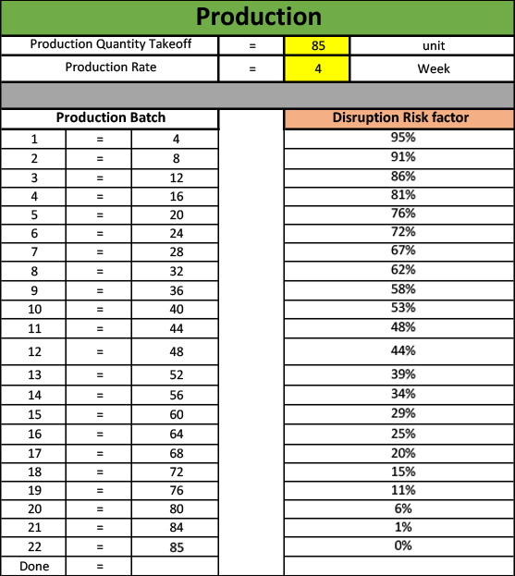
Figure 10- Production screen

3.Transportation screen
The third screen in the model is the transportation screen. In this screen, the user is required to input the transportation quantity each time. Once the required fields are populated, the model calculates the transportation disruption risk value associated with each period. Figure 11 depicts the transportation screen. From the figure, the total quantity of transportation is 85 units to be delivered over five weeks. The disruption risk value decreases each time unit until it reaches a value of zero.
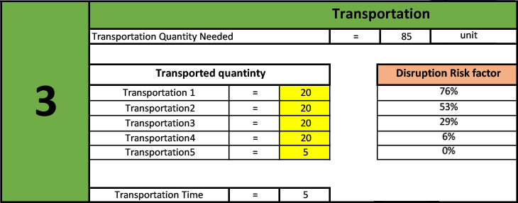
Figure 11-Transportation screen

After all the input fields are populated, the model presents a graph of the project disruption risk illustrated in Figure 12. Additionally, the model computes the total time required for the entire prefabrication process from material ordering to receiving all the finished headwall at the job site. Figure 13 illustrates the total time calculated by the model for this case.
From the graph, the disruption risk value starts at week one with a value of 100% then decreases to 50% at week two. From week two to four, the disruption risk value increases from 50 % to 95%. After that, week four to week twenty-three the disruption risk value decreases from 95% to 1%. Then, increases again from week twenty-three to twenty-five as the disruption risk value reaches 80%. Finally, the disruption risk value decreases from week twenty-five to twenty-nine reaching zero. The fluctuation in disruption risk value is a result of risk transfer between activities. The first increase is at week two where the material supply activity is finished making the disruption risk value zero. Meanwhile, the production activity starts at week two with a disruption risk value of 95% resulting in week two to have a disruption risk value of 50%. At week three the only disruption risk is from the production activity with a value of 91%. The same goes for the time period from week twenty-three to twenty-six, where the production activity finishes and the transportation activity sarts.

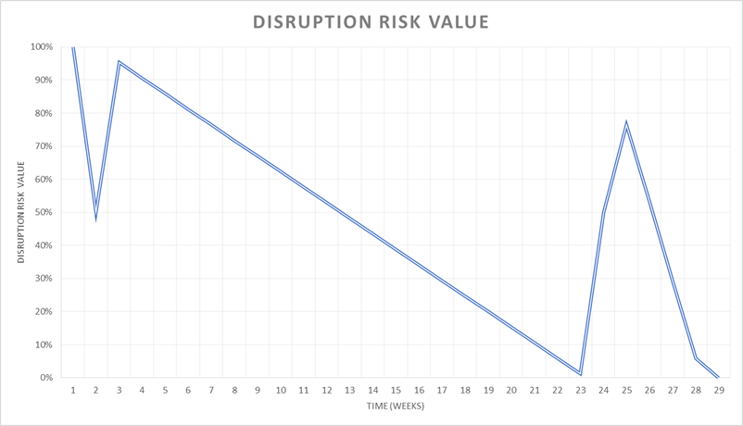

Figure 12- Disruption risk value

Figure 13- Total time

The project team allocated 37 weeks for the entire process broken out to; 2 weeks for material lead time, 30 weeks for the prefabrication processes, and five weeks for the transportation. Resulting in the finished headwalls to be stored for an extra eight weeks before they could be installed at the job site. By using the model, the project team could have saved the extra cost of storing the headwalls and used that time for modifications or mockups. A complete screen of the model can be found in Appendix C.

Section 3 Case study
The case study chosen is similar to the pilot case study in the choice of prefabricating patient headwalls. However, at the time of conducting this study, the pilot case study had already prefabricated the headwalls while this project was still in the prefabrication planning phase. The data collection involved interviews with project personnel and documenting project progress. The interviews started with presenting the SCN developed in the pilot case study and adjusting it to reflect the new case study configuration accurately. After configuring the SCN, the participants were asked a series of question -shown in appendix D- to collect quantitative data to run the model. The results from the model were used to help in the prefabrication planning efforts.

Project background
A healthcare facility located in one of the Midwest States of the United States is expanding their existing facility. The new addition will be a six-story building/tower, totaling 228,000 square-feet with an estimated cost of $150 million and an estimated finish date of 30 months. The new addition will include:
- Space for up to 72 patient beds
- Space for an intensive care unit
- Surgery and endoscopy (internal imaging camera) suites
- Outpatient imaging for X-rays, radiography, computed CT scans and MRI
- Cancer and infusion services
- An inpatient pharmacy
- Chapel
- Shell space for additional growth
- Helipad
- Surface parking
- Two level, 180 spaces parking garage
- Connecting structures to the existing facility
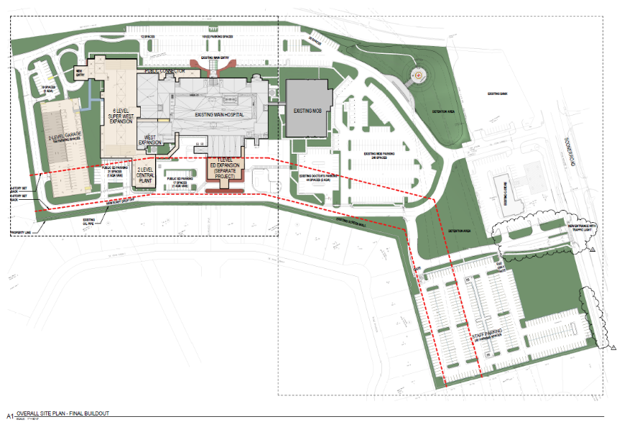
The construction will utilize advanced technologies, including BIM, real-time estimating, and virtual planning, to ensure optimal quality and efficiency. The construction team will also utilize the opportunity to prefabricate elements in a controlled environment. The construction will be carried out in phases due to demands of not disturbing the ongoing operations in and around the hospital, and to ensure the safety of patients, staff, and visitors. Figure 14 illustrates the layout of the new expansion with the existing structure.

Figure 14- case study layout
The construction will be carried out in four phases as depicted in Figure 15:
- Tower structure and fit out from north to south
- Plant structure and fit out from north to south
- Parking garage structure and finished from south to north
- Connecting structure and fit out from west to east
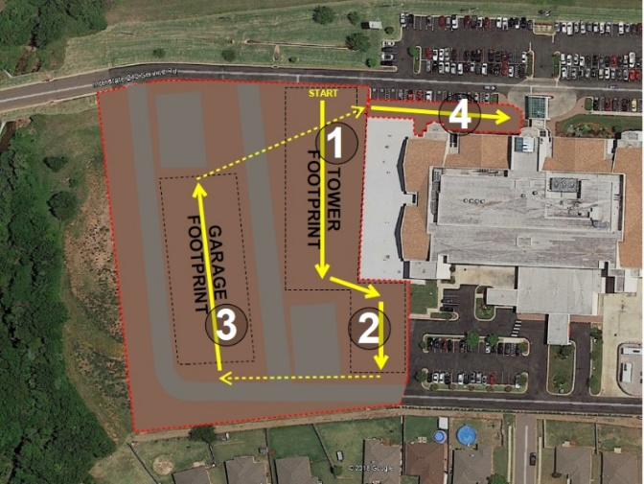
The 6-story tower structure will consist of structural steel and concrete superstructure. The tower structure is split into two sections, A being the north part and B being the south part of the tower.
Figure 15- Case study phases of construction

As mentioned before, the construction team will utilize the opportunity to prefabricate elements in a controlled environment. The team developed a prefabrication plan for proposed prefabrication opportunities, which includes MEP racks, panelized building exterior, patient room headwalls, and patient room bathroom pods. The plan includes the prefabrication scope and evaluates savings to the overall project regarding time, quality, performance, and cost. After finishing the prefabrication plans, the construction team decided that prefabricating the patient headwalls is the most feasible option of the proposed opportunities. The patient headwall will have all the equipment and gas hookups required for the hospital. Figure 16 illustrates the configuration of a patient headwall.
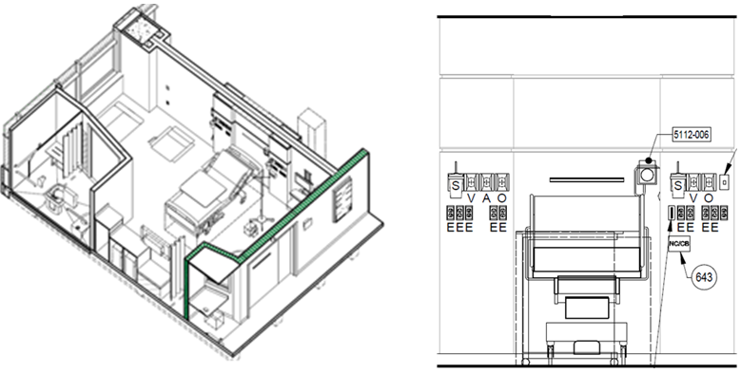

Figure 16- Headwall illustration

Case study analysis
The document examined the SCN responsible for the headwall prefabrication. The subcontractors involved are the mechanical, electrical, carpentry and framing contractors. The assembling process will take place in a prefabrication shop located 6 miles away from the job site with an approximate floor area of 800 SF. The shop will accommodate crew members of all involved trade contractors to encourage communication and collaboration. The necessary material will be delivered directly to the shop floor that serves as the warehouse for storing the material and the finished headwalls. Once all headwalls are prefabricated, they will be transported to the job site for JIT installation.
The headwall is approximately 76 SF in size (9.5 feet by 8 feet), the new addition will require 52 headwalls to be constructed on two separate floors. It will consist of framing, blocking, medical gas piping and connections, electrical piping and connections. Figure 17 depicts the prefabrication SCN broken out by material supply. The sequence of assembling the headwall is illustrated in Figure 18. Material quantities for producing one headwall are as follows:
- Metal studs 70 feet
- Medical gas piping for five connections 25 feet
- Electrical piping for 13 connections 92 feet
- Wood blocking 40 feet
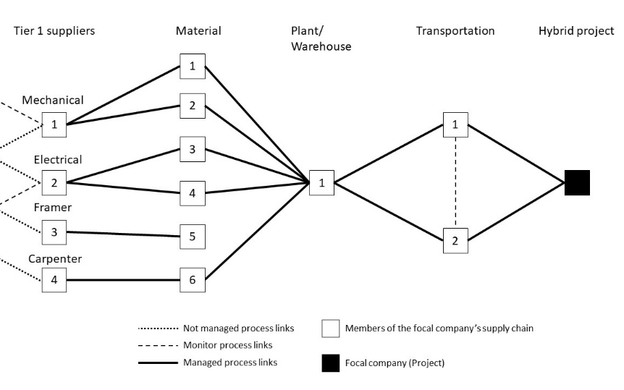

Figure 17-Case study headwall prefabrication SCN
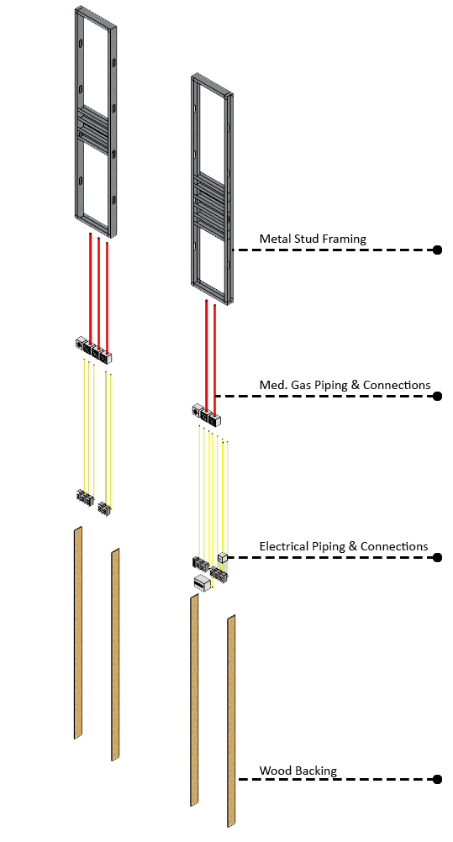

Figure 18- Case study headwall assembling sequence

The schedule
A construction schedule lists out the project’s milestones, activities, and deliverables. The schedule estimates a start and finish date for each identifiable scope of work. In hybrid construction projects, the schedule is critical in avoiding uncertainties from off-site activities converging with on-site activities and making sure that on-site activities do not stop and wait for off-site activities. Multiple types of schedules show a different level of information depending on the time unit used. Our case study has a schedule of 30 months from start to completion. For this document, the concern from the schedule is the meeting time of on-site and off-site activities. Figure 19 shows the project milestones schedule with an approximate time for needing the off-site activities being finished with the end of the framing/rough-in period. Figure 20 lists out all the activities that are required in the framing/rough-ins period.
Figure 19- Milestone schedule

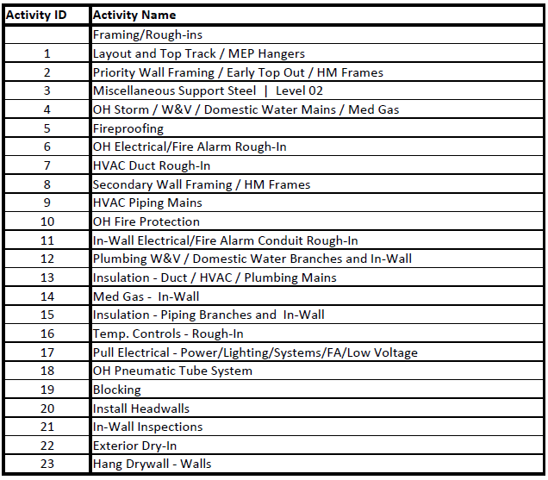
Figure 20- List of activities in the framing/rough-ins period
However, not all these activities are required to be done before the installation of the headwall. Only the predecessors of the headwall need to be finished before installation procedure. Figure 21 illustrates the required tasks before installing the headwall. From Figure 21 it is apparent that we need the headwalls to be ready for installation after the framing of secondary walls. From here the project team can estimate a time frame as to when the prefabrication processes need to finish to meet with the on-site activity schedule.
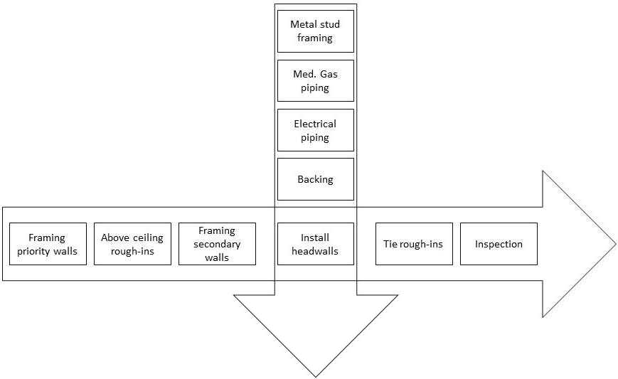
Figure 21- Converging of on-site and off-site construction activities

Applying the model
The first step in applying the model was to consult the project team on the required inputs. Table 3 presents the inputs that were used to run the model. After deciding the inputs, they were inserted in their respective model. The next section shows the screens in which these inputs are used to run the model.
Table 4- Case study inputs
Material supply
Material | Takeoff |  | Delivery | Lead time
Metal Studs | 3640 LF |  | 2 Batches | 2 Weeks
Medical gas pipes | 1300 LF |  | 1 Batch | 1 week
Medical gas connections | 260 EA |  | 1 Batch | 3 Weeks
Electrical pipes | 4790 LF |  | 1 Batch | 1 Week
Electrical connections | 676 EA |  | 1 Batch | 1 Week
Wood blocking | 2080 LF |  | 1 Batch | 1 Week
Production
Takeoff |  | 52 units
Production rate |  | 3 units per week
Transportation
Transportation quantity |  | 20 units per week

1.Material supply screen
The first screen is the material supply screen shown in Figure 22. After populating this screen, the model computed the disruption risk value for each material. From Figure 22 it is evident that only one material has a disruption risk value more than zero. The metal studs have the most significant material disruption risk exposure since they are going to be delivered in 2 batches.
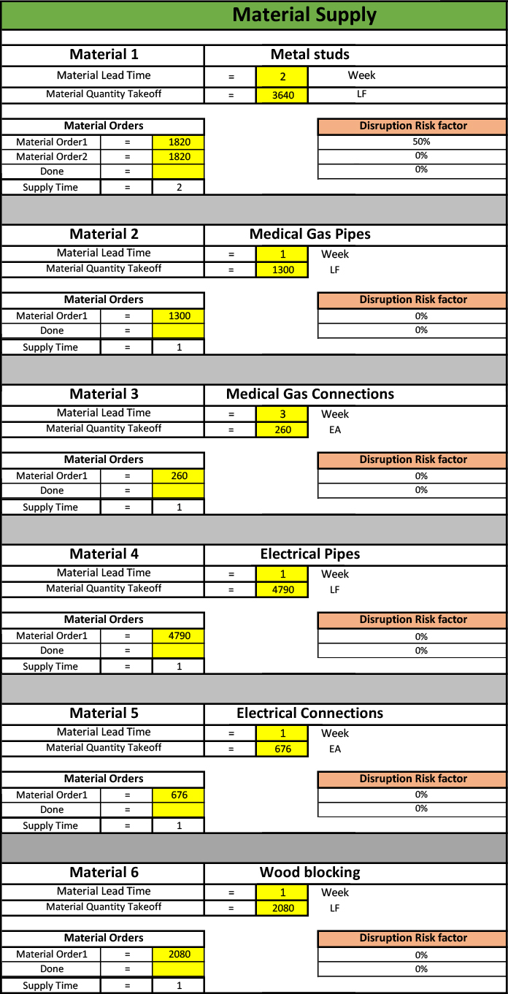
Figure 22- Case study material supply screen

2.Production screen
The second screen is the production screen shown in Figure 23. After populating this screen, the model computed 18-time units for the production processes and computed the disruption risk value for each time unit. From Figure 23 it is clear the disruption risk value decreases each time unit indicating the risk exposure is higher at the start of production and decreases gradually over time.
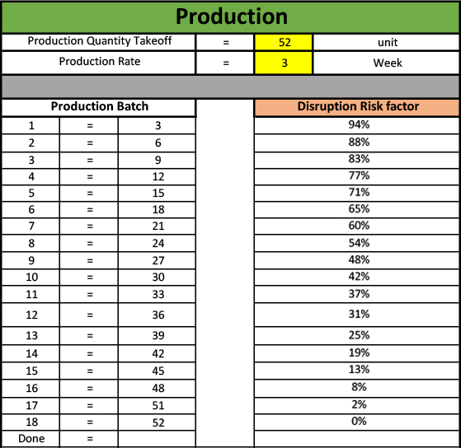
Figure 23- Case study production screen

3.Transportation screen
The third screen is the transportation screen shown in Figure 24. After populating this screen, the model computed 3-time units for the transportation processes and computed the disruption risk value for each time unit. From Figure 24 it is noticeable the disruption risk value decreases each time unit indicating the risk exposure is higher at the start of transportation and decreases gradually over time.
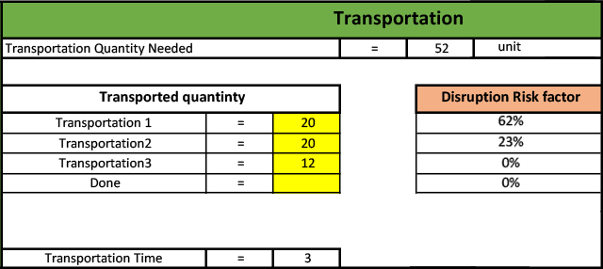

Figure 24- Case study transportation screen
After all the input fields are populated, the model presents a graph of the project disruption risk value shown in Figure 25. Also, the model calculates the total time required for the entire prefabrication process from material ordering to receiving all the finished headwall at the job site. Figure 26 illustrates the total time calculated by the model for this case. The model calculated a 24-week time frame for the entire prefabrication process. The time frame is broken out to a 3-week period for the material lead time, 18-week period for the prefabrication and assembling processes, and a 3-week period for transporting the finished headwalls to the job site. A complete screen of the model can be found in Appendix D.
From the graph, the disruption risk value starts at week one with a value of 100% then decreases to 50% at week three. From week three to five, the disruption risk value increases from 50 % to 88%. After that, week five to week twenty the disruption risk value decreases from 88% to 2%. Then, another increases is witnessed from week twenty to twenty-two as the disruption risk value reaches 60%. Finally, the disruption risk value decreases from week twenty-two to twenty-four reaching zero. The fluctuation in disruption risk value is a result of risk transfer between activities. At the start of an activity, the disruption risk value at its peak and starts to gradually decrease with time until it reaches zero at the end of that activity. The seen increase in the disruption risk value is a result of finishing an activity and starting another activity with a high disruption risk value. From the graph, the first increase takes place from week three to week five. The material supply activity is finished at week three making the disruption risk value zero. Meanwhile, the production activity starts at week three with a disruption risk value of 100% resulting week three to have a disruption risk value of 50%. As for week five, the only disruption risk value existing is from the production activity. The same goes for the increase between week twenty and twenty-two, where the production activity finishes with a zero disruption risk value, and the transportation activity starts with a 100% disruption risk value.
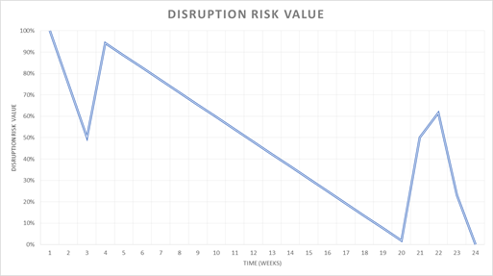

Figure 25- Case study disruption risk value
Figure 26- case study total time

The next section will discuss the findings of the model application on a hybrid construction prefabrication project followed by findings from sharing the model with construction industry professionals for consideration and observations in planning for the prefabrication processes.

Chapter 5: Findings
This chapter analyzes the outcome of the research in two stages. The first stage consisted of analyzing the results from applying the model to the case study and validate the findings with the project team. The second stage involved sharing the model with construction industry professionals and documenting their observations on the applicability of the model in planning for prefabrication in the current industry setting.

Case study
As mentioned in chapter 5, the case study started with developing the SCN responsible for prefabricating the headwalls. Developing the SCN provided important information on the characteristics of construction supply chains, key members of supply chain, type of relationship between key members, and the sequence of activities required in the prefabrication process. The SCN was a temporary supply chain that involved 4 material suppliers, 1 prefabrication facility that also stored the finished headwalls, and a transportation provider to deliver the headwalls to the construction job site. The construction project involvement in the supply chain stopped with the first tier of suppliers indicating the limited engagement in the supply chain activities.
The model computes the disruption risk value for all prefabrication processes. From analyzing the disruption risk value of individual processes, it is apparent there is a direct linear relationship between the value of the disruption risk and the time required for that process. The disruption risk value is at its highest at the beginning of an activity then steadily decreases reaching a value of zero at the end of that activity. This correlation reflects the temporality of the construction supply chain. Thus, it is concluded that the production process has the highest disruption risk exposure amongst all the processes as it takes the longest time for completion amongst the prefabrication processes.
Meanwhile, analyzing Figure 25 that shows the disruption risk value for the entire prefabrication processes as one entity did not result in the same direct linear relationship. The disruption risk value is highest at the beginning of the prefabrication process and decreases steadily when a sudden increase in the value is observed. Then the disruption risk value decreases and encounters another sudden increase in the value. These sudden increases are a result of risk transfer from one activity to another; the sudden increase represents the end of an activity where the disruption risk value is at its lowest and the start of an activity where the disruption risk value is at its highest.
From the computed total time for the prefabrication processes, it is evident that the production process has the most significant time impact on the prefabrication processes. At the start of the model, the project team is required to make some assumptions to run the model, one of these assumptions is the production rate. The production rate controls the required time for the production process, by increasing the production rate, the project team has the chance to reduce the production process time reducing the overall time.

Industry professionals
The model was shared with the participants to have the opportunity to test the model and comment their observations. The participants provided important insights when describing the applicability and usability of the model in the construction industry. The participants agreed that the model is a useful tool in front-end planning as it allows the project team to think through and explore the entire prefabrication process and associated risks.
As for the disruption risk value, the participants perceived it as an informative analysis tool for various risk scenarios including what-if scenarios. Moreover, they believed the disruption risk value is a practical tool in identifying the source of risks with project progress, especially when risks are transferred between supply chain members.
The participants view on the design of the model was positive; they explained that it allows the user to quickly understand how to use the model and analyze the displayed information. Additionally, the design allows the user to understand the general sequence of activities involved in the prefabrication process as the design reflects the actual activity progress in the construction industry. The participant's observations on navigating and interpreting the information shown in the model demonstrated they were able to analyze the information quickly with little indication of content. The fast comprehension of information confirmed that the model is easy to use, understand, and analyze.
A significant contribution of the model is the ability to identify the hidden uncertainties underlying the prefabrication process and allowing the project team to address them well before they become a severe problem. The participants described the model as being a backward calculation process seeing that it exposes significant uncertainties. The participants highlighted two significant uncertainties the model addresses. The first being when to start the prefabrication processes. If the project team starts the prefabrication too far in advance, they are limited in making changes or adjustments, and they will face several challenges such as where to store the finished product, the cost of storage, and protecting the products from damage.
The second uncertainty is the required production rate to meet the schedule. Addressing this uncertainty allows the project team to allocate resources and crew members to the prefabrication processes accurately. The model allows the user to easily manipulate the production rate and see the effect it has on the process duration. If the project team excessively assigns resources and crews to the prefabrication process, they are faced with the same problems as to starting the prefabrication processes too far in advance. In the same way, if the project team does not assign enough resources and crews to the prefabrication process, they face the possibility of not meeting the schedule and causing time overrun.
Because of the fast comprehension, the participants identified the opportunity of sharing the information and improving communications within the project team and other project stakeholders. The participants saw the opportunity of communicating the information to the project owner to help convey the risks associated with prefabrication and current project status. Also, a participant commented that the model might be utilized as a selling tool on justifying the use of prefabrication as it indicates the involved members and the time required for the entire prefabrication processes.
In addition to providing sufficient information of usability, the participants identified the model’s capability of producing even more useful information. Collecting and storing activity data allows for developing historical activity information that can be used as a comparison tool for production rates at different time periods and projects as well. Also, historical activity information can be combined with various data groups to create different analysis scenarios and explore data relationships.

Chapter 6: Conclusion
The research started with the goal of measuring the resiliency of hybrid projects against supply chain disruption by investigating the disruption risk exposure inherited from uncertainties in the prefabrication supply chain. The uncertainties were identified through an extensive literature review. The research adopted a pilot case study to explore the disruption risk exposure from supply chain uncertainties on hybrid projects. The pilot case study resulted in developing a model that identifies potential disruption risks that are of significant impact on project performance and assesses the impact of a disruption originating anywhere in the supply chain. The research applied the model on a hybrid construction case study to verify the results.
Temporary supply chains dominate the construction industry seeing that each construction project has unique supply chain. It is of utmost important to identify the key members of a construction supply chain as well as the type of relationship between those members to understand the responsibilities of key members and the configuration of the SCN.
A linear relationship is found between the disruption risk value of a process and the time to finish that process, verifying the temporality of the construction supply chains. On the other hand, the disruption risk value of the whole project acts differently. The disruption risk value decreases as an activity gets closer to finish. However, at the same time an activity ends a new activity starts with a high disruption risk value resulting in a sudden increase in the disruption risk of the project, the increase is a result of risk transfer between activities.
The projects’ team best chance to modify the total time for the prefabrication processes is by controlling the production rate in the production process. The production process time can be shortened by increasing the production rate.
Based on the research findings, the model offers a better opportunity for industry professionals to identify activity risks and expose uncertainties that may affect the project objectives or construction schedule. The model uncovers two significant uncertainties. The first is when to start the prefabrication processes, and the second is the required production rate to meet the schedule. Moreover, the model supports the tracking of project activity progress by comparing the planned period to the actual time spent on that activity or by comparing planned production rate to the actual production rate. Additionally, the model facilitates information coordination across disciplines more effectively aiding in decision making and problem-solving processes. Also, the results of the model can be used as historical data for future comparison or for analysis with different data sets.

Limitations
There were a few limitations during the execution of this study. The supply chain study was limited to the headwall prefabrication supply chain. Limitations of headwall prefabrication supply chain consisted of it being a short supply chain with a small number of tiers and key members, and the supply chain products were general commodities that can be found from multiple sources. The supply chain influenced the results of the study as different supply chains have different practices, configuration, and products. Another limitation was the absence of historical data on this kind of investigation. However, it was still possible to collect information to test and validate the model.

Significance of study
The study introduces a novel risk exposure model that has not been utilized in the construction industry. The model contributes to current construction practices by accurately capturing the prefabrication supply chain including its members, structural configuration, and process links between members. The model assesses the impact of a disruption originating anywhere in the supply chain. The model also identifies potential disruption risks that are of significant impact on project performance, helping risk managers to allocate resources more judiciously. Based on the research findings, the model provides information on supply chain disruptions by computing the disruption risk value for all activities involved in the prefabrication process throughout the duration of the prefabrication process. This information identifies a project’s exposure to a disruption risk at any given time.
Additionally, the model addresses the significant uncertainty of when to start the prefabrication process. The model identifies the optimal time for starting the prefabrication process through identifying the time required for each activity in the entire prefabrication process. Recognizing the time required for each activity helps in controlling the duration of the prefabrication process. Since the production process has the longest duration, the model allows the planned production rate to be adjusted in order to control the duration of the prefabrication process.
The study provides information on current prefabrication practices in the construction industry. Based on the findings of this study, it is of value to the construction industry to consider the model as a source of information that can support project decisions of prefabrication. The current prefabrication practices justify the need for an effective model that exposes significant uncertainties about the prefabrication processes. Accordingly, construction industry professionals who participated in this study were able to recognize the benefits of having such model for analysis.

Future research
Future research may use the information provided in this document to continue the investigation throughout the execution phase and track the actual progress of production and duration of the prefabrication process to compare it to the planned production and duration to explore new data combinations. Also, the model can be further developed to include new dimensions such as material procurement cost. Another topic would be to develop other construction prefabrication supply chains and explore the applicability of the model to improve construction project planning, analysis, and execution.
Another research opportunity is to explore the SCM of a lean construction supply chain or a sustainable construction supply chain and compare it a hybrid construction SCM and test the applicability of the model on such supply chains. Another interesting research topic would be to develop a supply chain of a trade contractor or specialty contractor whose supply chain relationships are permanent rather than temporary and explore the different SCM strategies employed and test the applicability of the model on such supply chain.

References
Arashpour, M., Abbasi, B., Arashpour, M., Hosseini, M. R., & Yang, R. (2017). “Integrated management of on-site, coordination and off-site uncertainty: theorizing risk analysis within a hybrid project setting.” International Journal of Project Management, 35(4), 647-655.
Arashpour, M., Wakefield, R., Lee, E. W. M., Chan, R., & Hosseini, M. R. (2016). “Analysis of interacting uncertainties in on-site and off-site activities: Implications for hybrid construction.” International Journal of Project Management, 34(7), 1393-1402.
Arashpour, M., & Wakefield, R. (2015). “Developing an uncertainty analysis model for off-site building production.” In ISEC-08: Implementing Innovative Ideas in Structural Engineering and Project Management (pp. 1121-1125). ISEC Press.
Arashpour, M., Wakefield, R., Blismas, N., & Minas, J. (2015). “Optimization of process integration and multi-skilled resource utilization in off-site construction.” Automation in Construction, 50, 72-80.
Almohsen, A. and Ruwanpura, J., 2011. Logistics management in construction industry. Proceeding of the International Council for research and Innovation in Building and construction (CIB), p.10.
Aven, T., Vinnem, J. E., & Wiencke, H. S. (2007). A decision model for risk management, with application to the offshore oil and gas industry. Reliability Engineering & System Safety, 92(4), 433-448.
Bankvall, L., Bygballe, L. E., Dubois, A., & Jahre, M. (2010). Interdependence in supply chains and projects in construction. Supply Chain Management: An International Journal, 15(5), 385-393.
Behera, P., Mohanty, R. P., & Prakash, A. (2015). Understanding construction supply chain management. Production Planning & Control, 26(16), 1332-1350.
Cardoso, S. R., Barbosa-Póvoas, A. P. F., Relvas, S., & Novais, A. Q. (2014). Resilience assessment of supply chains under different types of disruption. In Computer Aided Chemical Engineering (Vol. 34, pp. 759-764). Elsevier.
Carvalho, H., Barroso, A. P., Machado, V. H., Azevedo, S., & Cruz-Machado, V. (2012). Supply chain redesign for resilience using simulation. Computers & Industrial Engineering, 62(1), 329-341.
Construction, M. H. (2011). Prefabrication and modularization: increasing productivity in the construction industry. Smart Market Report.
Chan, R. W., Yuen, J. K., Lee, E. W., & Arashpour, M. (2015). “Application of Nonlinear-Autoregressive-Exogenous model to predict the hysteretic behaviour of passive control systems.” Engineering Structures, 85, 1-10.
Chopra, S., & Meindl, P. (2007). Supply chain management. Strategy, planning & operation. In Das summa summarum des management (pp. 265-275). Gabler.
Chopra, S., & Sodhi, M. S. (2004). Managing risk to avoid supply-chain breakdown. MIT Sloan management review, 46(1), 53.
CSCMP (2013), Supply chain management definitions and glossary [Online], Council of Supply Chain Management Professionals (CSCMP), Available: http://bit.ly/1sYBIlP [Accessed: 26th of February 2016].
Ekeskär, A., & Rudberg, M. (2016). Third-party logistics in construction: the case of a large hospital project. Construction Management and Economics, 34(3), 174-191.
Elleuch, H., Dafaoui, E., Elmhamedi, A., & Chabchoub, H. (2016). Resilience and Vulnerability in Supply Chain: Literature review. IFAC-PapersOnLine, 49(12), 1448-1453.
Govindan, K., Fattahi, M., & Keyvanshokooh, E. (2017). Supply chain network design under uncertainty: A comprehensive review and future research directions. European Journal of Operational Research, 263(1), 108-141.
Hamzeh, F. R., Tommelein, I. D., Ballard, G., & Kaminsky, P. (2007, July). Logistics centers to support project-based production in the construction industry. In Proceedings of the 15th Annual Conference of the International Group for Lean Construction (IGLC 15) (pp. 181-191).
Han, S. H., Kim, D. Y., Kim, H., & Jang, W. S. (2008). A web-based integrated system for international project risk management. Automation in construction, 17(3), 342-356.
Hosseini, S., Barker, K., & Ramirez-Marquez, J. E. (2016). A review of definitions and measures of system resilience. Reliability Engineering & System Safety, 145, 47-61.
Jannadi, O. A., & Almishari, S. (2003). Risk assessment in construction. Journal of construction engineering and management, 129(5), 492-500.
Lambert, D. M., & Cooper, M. C. (2000). Issues in supply chain management. Industrial marketing management, 29(1), 65-83.
Lange, S., & Schilling, D. (2015). Reasons for an optimized construction logistics. In Proceedings of the 23rd Annual Conference of the International Group for Lean Construction (pp. 733-742).
Mossman, A. (2007). Lean Logistics: Helping to create value by bringing people, information, plan and equipment and materials together at the workface. International Group for Lean Construction. Michigan, EE. UU.
Pan, W., Gibb, A. G., & Dainty, A. R. (2012). “Strategies for integrating the use of off-site production technologies in house building.” Journal of Construction Engineering and Management, 138(11), 1331-1340.
Ross, K., Cartwright, P., & Novakovic, O. (2006). A guide to modern methods of construction. IHS BRE Press.
Said, H., & El-Rayes, K. (2010). Optimizing material procurement and storage on construction sites. Journal of Construction Engineering and Management, 137(6), 421-431.
Sanei, M., Mahmoodirad, A., & Niroomand, S. (2016). Two-stage supply chain network design problem with interval data. International Journal of e-Navigation and Maritime Economy, 5, 74-84.
Seppänen, O., & Peltokorpi, A. (2016). A New Model for Construction Material Logistics: From Local Optimization of Logistics Towards Global Optimization of On-Site Production System. In 24th Annual Conference of the International Group for Lean Construction.
Simchi-Levi, D., Schmidt, W., & Wei, Y. (2014). From superstorms to factory fires: Managing unpredictable supply chain disruptions. Harvard Business Review, 92(1-2), 96-101.
Simchi-Levi, D., William, S., Wei, Y., Zhang, P. Y., Combs, K., Ge, Y., Gusikhin, O., Sander, M., and Zhang, D. (2015). “Identifying Risks and Mitigating Disruptions in the Automotive Supply Chain.” Interfaces 45, no. 5.
Skjelbred, S., Fossheim, M. E., & Drevland, F. (2015). Comparing Different Approaches to Site Organization and Logistics: Multiple Case Studies. In Proc. 23rd Ann. Conf. of the Int’l. Group for Lean Construction (pp. 13-22).
Sundquist, V., Gadde, L. E., & Hulthén, K. (2017). Reorganizing construction logistics for improved performance. Construction Management and Economics, 1-17.
Tennant, S., McCarney, M., & Tong, M. (2012, September). Re-engineering the Construction Supply Chain: Transferring on-site activity, off-site. In 28th. annual ARCOM conference (Vol. 2, pp. 739-749). Edinburgh: ARCOM.
Van Vught, R. P. A. C., & Van Weele, A. J. (2015). Managing supply chain relationships in construction industry: compete or collaborate. In conference; IPSERA; 2015-03-29; 2015-04-01. Vrije Universiteit Amsterdam.
Vrijhoef, R., & Koskela, L. (2000). The four roles of supply chain management in construction. European journal of purchasing & supply management, 6(3), 169-178.
Vugrin, E. D., Warren, D. E., & Ehlen, M. A. (2011). A resilience assessment model for infrastructure and economic systems: Quantitative and qualitative resilience analysis of petrochemical supply chains to a hurricane. Process Safety Progress, 30(3), 280-290.
Zeng, J., An, M., & Smith, N. J. (2007). Application of a fuzzy based decision-making methodology to construction project risk assessment. International journal of project management, 25(6), 589-600.
Zhai, Y., Zhong, R. Y., & Huang, G. Q. (2015). Towards Operational Hedging for Logistics Uncertainty Management in Prefabrication Construction. IFAC-PapersOnLine, 48(3), 1128-1133.
Zolfagharian, S., & Irizarry, J. (2014). Current trends in construction site layout planning. In Construction Research Congress 2014: Construction in a Global Network (pp. 1723-1732).

Appendix A: Interview questions 1
- How do you decide on using prefabrication?
- What specific information do you look for?
- What is the most common element to prefabricate in a health care facility?
- What is impact of prefabrication on project’s schedule, time, cost, and rework?
- Describe the prefabrication process for that element.
- How long does the process described in question #3 usually take to complete?
- What is the project’s point of contact with the prefabrication supply chain?
- How is the information exchanged?
- What are the challenges and concerns you face in prefabrication?

Appendix B: Interview questions 2
- How many material suppliers are involved?
- How many shipments for each material?
- What is the lead time for material shipping?
- Is all the material stored at the manufacturer?
- Who is the manufacturer?
- where is the manufacturing facility located?
- What is the production rate?
- How many crew members each trade has?
- Where do you store the finished products?
- When are the finished products needed on site?
- When did the prefabrication process start?
- How often do you ship finished products to the job site?
- What is the quantity of product you ship to the job site?
- How many units are installed per week?

Appendix C: Pilot case study model
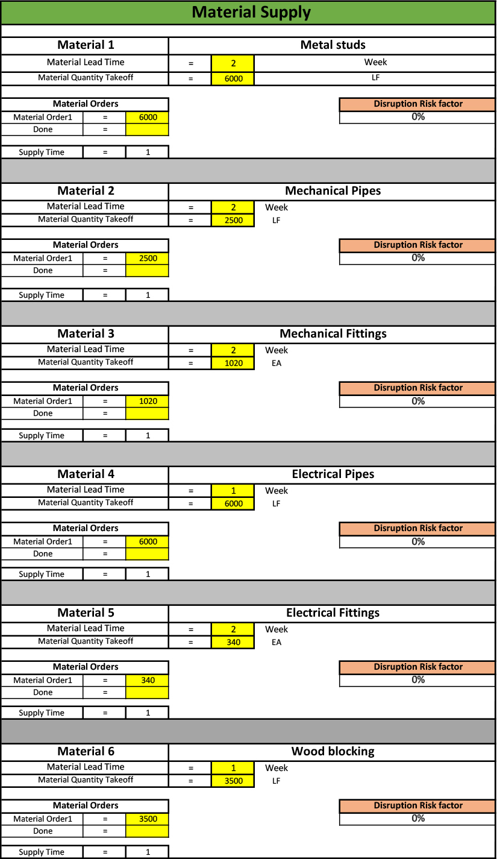
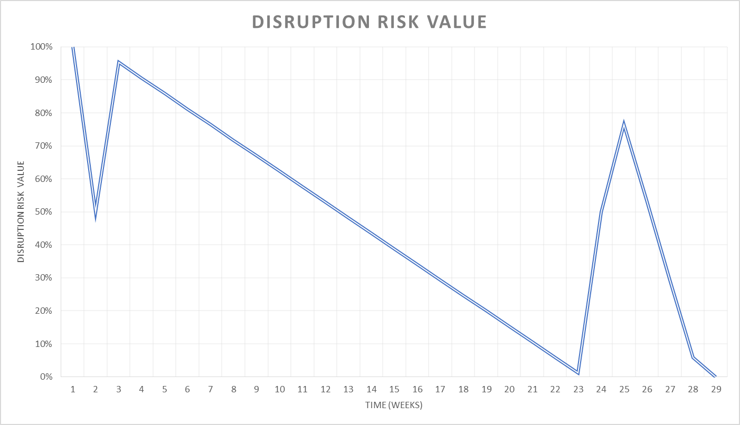

Appendix D: Interview questions 3
- What are the benefits of this model to you?
- Will you use this model to plan your future prefabrication process?
- What are your recommendations for improvements?
- What do you think of the design usability of the model?

Appendix E: Case study model

