UNIVERSITY OF OKLAHOMA

GRADUATE COLLEGE

DIFFERENCES IN PREDICTED EXTERNAL TRAINING LOAD VALUES ACROSS AN NCAA DIVISION I MEN’S BASKETBALL SEASON

A THESIS

SUBMITTED TO THE GRADUATE FACULTY
in partial fulfillment of requirements for the
Degree of
MASTER OF SCIENCE

By
CONSTANTINE WILLIAM KUTSON
Norman, Oklahoma
2023

DIFFERENCES IN PREDICTED EXTERNAL TRAINING LOAD VALUES ACROSS AN NCAA DIVISION I MEN’S BASKETBALL SEASON

A THESIS APPROVED FOR THE
DEPARTMENT OF HEALTH AND EXERCISE SCIENCE

BY THE COMMITTEE CONSISTING OF

Dr. Rebecca D. Larson, Chair

Dr. Daniel J Larson

Dr. Blake D McLean

© Copyright by CONSTANTINE WILLIAM KUTSON 2023
All Rights Reserved

Table of Contents
Introduction 1
Purpose 4
Significance 4
Research Questions 5
Hypothesis 5
Delimitations 6
Limitations 6
Assumptions 7
Operational Definition 7
Literature Review 8
Related Literature 9
Importance of Load Monitoring 9
External Load Monitoring 10
Load Demands of Male College Basketball Players 12
Differences in practice vs competition in basketball 14
Summary 16
Methodology 16
Population and Sampling 17
Research Design 17
Measurement Protocols 18
Data Collection Procedures 18
Data Cleaning and Storage 20
Statistical Methods for Data Analysis and Prediction 21
Results 23
Discussion 34
Conclusions 39
Research Questions 39
Practical Significance 39
Suggestions for Future Research 40

References 41

Abstract

Tracking and monitoring of external load is an important consideration for sport performance practitioners. Despite its relative importance, there is very little research surrounding the external load demands of NCAA Division I Men’s Basketball athletes. Therefore, the purpose of this study was to examine the demands encountered by student-athletes across a season. External training load was measure during practice sessions using Catapult T6 inertial sensors from one NCAA DI Men’s Basketball team over the course of the 2021-2022 NCAA basketball season. Game external training load data was unable to be recorded, and was predicted utilizing fixed-effects panel regression, a linear regression variant in order to have an entire season of data. Players were split into Starters (N = 5), Rotation (N = 5), and Bench (N = 5) players based on average minutes per game. After players were categorized, one-way ANOVA tests with Tukey’s HSD post-hoc analysis was conducted to determine differences in external load values among playing groups. The results indicated that Starters experienced statistically significant differences in external load with starters averaging 4177 ± 2451 AU per month, Rotation players averaging 2949 ± 1927 AU per month, and Bench players averaging 2510 ± 1826 AU per month. Practitioners should be aware that NCAA DI Men’s basketball players experience highly stratified loads across a team, and should utilize this information appropriately to plan and periodize training to reduce injury risk and optimize skill development and physical preparation.

Chapter 1: Introduction

In recent years, there has been a notable increase in the use of technology in team sport with the purpose of gaining an understanding of the physiological status of athletes during competitive seasons and training. Sport performance practitioners across all levels of sport are tasked with optimally preparing their athletes for competition through the use of periodized training programs, be it sport specific (practices, skill acquisition drills, etc.) or more generalized physical training through resistance or cardiovascular training (G. Gregory Haff & N. Travis Triplett, 2016). However, in order to properly prepare athletes for the demands of competition, practitioners must have a detailed understanding of the physiological demands of their sport, as well as the current physiological state of their athletes (Schelling & Torres-Ronda, 2013). This information is critically important to be able to modify variables in a training program to prepare athletes for competition (Halson, 2014). When attempting to quantify the physiological demands of competition or training, the term “training load” has come to define a set of physiological variables that can be measured to determine the overall status of an athlete (Halson, 2014). Within this umbrella term there are two separate but related terms that can be used to quantify training load: internal and external load (Halson, 2014). Internal load is defined as the biological or physiological factors that are affected by training competition (Halson, 2014), while external load is defined as the work or activities performed by an athlete (Torres-Ronda et al., 2022). In addition to the numerous technologies that are used to measure internal load such heart rate monitors, blood/hormonal profiling, or rate of perceived exertion scales (RPE) (Impellizzeri et al., 2019), the use of athlete tracking systems such as GPS or accelerometer based devices has become commonplace as a means to measure external load accrued by an athlete during training or competition (Torres-Ronda et al., 2022). Furthermore, these athlete tracking systems are the basis of many attempts to quantify physiological demands in an applied setting, as the measurement of external load is both non-invasive and user friendly (Torres-Ronda et al., 2022).
There are generally two broad categories of external athlete tracking systems: local positioning units (LPS) and global positioning units (GPS), each of which have their own benefits and drawbacks. Additionally, many of these systems have dual functionality; they often contain tri-axial accelerometers that measure movement in three dimensional space (Alanen et al., 2021). Both LPS and GPS have been found to be reliable in measuring external load, and their usage is often dependent on the requirements of the sport (Hoppe et al., 2018). LPS systems commonly function by placing anchors or antennae around the field or court of play and utilize a triangulation system to calculate player position at different intervals of time (Luteberget et al., 2018). With this information, variables such as speed, acceleration, and external load can be calculated which are then used to derive external load (Luteberget et al., 2018). This differs slightly from GPS systems, which utilize satellites to determine similar variables based on positioning (Russell, McLean, Impellizzeri, et al., 2021). Because LPS systems use individual antennae and GPS systems utilize satellites, indoor sports such as basketball or hockey often utilize an LPS system, while GPS systems are more commonly founded in outdoor sports such as soccer (Torres-Ronda et al., 2022). As previously mentioned, these systems are often paired with accelerometer-based technology to measure movements in vectorized quantities (i.e., movement variables with both magnitude and direction) (Beenham et al., 2017). One of the most widely used athlete tracking systems, which is manufactured and distributed by Catapult Sports (Catapult Sports, Melbourne, Australia), utilizes triaxial accelerometers within a wearable device to derive a metric, PlayerLoad™ (hereby referred to as PL), that provides an easily quantifiable value for external load (Bredt et al., 2020). This ability to provide a single metric to calculate external training load, as well as the unobtrusive profile of an LPS system such as Catapult (athletes are only required to wear a form fitting garment that houses a small microsensor between the scapulae), and the cheaper cost compared to GPS systems have made LPS systems one of the primary tools for practitioners to measure external load and provide coaches and key stakeholders with relevant information to optimize training for athletes (Luteberget et al., 2018).
The measurement of external load is commonplace across a number of different sports such as soccer, Australian rules football, and basketball (J. J. Malone et al., 2015; Ritchie et al., 2016; Russell, McLean, Impellizzeri, et al., 2021). Indeed, the sport of basketball is no different, as there are a number of different articles in the literature that discuss external load across all levels of basketball, with nearly all relevant studies relying on athlete tracking systems to measure external load (J. L. Fox et al., 2018; Heishman et al., 2019; Manzi et al., 2010; Reina et al., 2020). More specifically, there are a number of studies that examine loads (both internal and external) across different phases of a competitive season in both male and female NCAA Division I college basketball (Conte et al., 2018; Heishman et al., 2019, 2020; Olthof et al., 2021; Peterson & Quiggle, 2017; Ransdell et al., 2020; Stone et al., 2022). In addition to quantifying the loads experienced by professional basketball players, practitioners have also attempted to differentiate the physical demands of practice drills relative to the demands of competition (Vazquez-Guerrero et al., 2020). This understanding of the differences between game and practice demands may be beneficial to practitioners, as the ability to appropriately structure training sessions to replicate the most demanding portions of competition (an idea known as the “worst-case scenario”) has gained traction in the literature as an effective strategy for physical preparation (Novak et al., 2021).
While the overall training load studies do examine loads at different points of a competitive season (pre-season, in-season, etc.) or on different days (such as game or practice days), there are significant gaps in the research regarding external load and college basketball players. To the authors knowledge, there are currently no published studies in the literature that examine external training load with the use of LPS over the course of an entire NCAA Division I Men’s Basketball season. Although there have been attempts to answer this question, studies have only been able to assess season long demands with subjective measures of load (Conte et al., 2018), or within select portions of the season (Heishman et al., 2019). Furthermore, there is limited research in examining the difference between practice and competition demands in basketball. This gap in the research proves a challenge to practitioners seeking to gain an understanding of the demands of NCAA Division I Men’s Basketball and was the impetus for the development of this particular study.

Purpose

The purpose of this study is to explore the training demands of athletes on an NCAA Division I Men’s Basketball team across a competitive season by utilizing an external load monitoring system to capture data during practices, and to use linear regression variants to generate game data in order to develop a comprehensive profile of physical demands placed on NCAA DI Men’s Basketball athletes and measure differences in external loads during practice and competition.

Significance

The lack of research regarding the physical demands of NCAA Division I Men’s Basketball athletes warrants further investigation, which this study hopes to provide. By understanding the demands placed on athletes over the course of a season, this study could provide practitioners with a framework and comparative data to which they can reference to prescribe training in accordance. By informing practitioners about these physical demands, the study hopes to allow practitioners to optimize athletic performance, as well as ensure the health and wellbeing NCAA DI Men’s Basketball athletes. Additionally, this study hopes to develop and test a methodology for predicting relevant data relating to external load monitoring.

Research Questions

- What are the external training loads experienced by college basketball players over the course of an NCAA Division I Men’s Basketball season?

Hypotheses
- It is hypothesized that external training load values across an NCAA Division I (DI) Men’s Basketball team will be heavily stratified, with a select few players experiencing statistically significant differences in external training load relative to their teammates.
  - Null: There is no difference in physical demands across an NCAA DI Men’s Basketball team over the course of a season.
- It is hypothesized that live practice sessions will be able to effectively predict game demands.
  - Null: Live practice does not effectively predict game demands.

Delimitations

The study has the following delimitations:

- All players on an NCAA DI Men’s Basketball team from the same university.
- Selected variables from the Catapult T6 ClearSky system
  - PlayerLoad™ (PL)
  - Duration

- Data will be collected through the course of normal team activities, as players are already required to wear specialized garments housing devices as part of team operations.
- Data will be collected at all team practices.
- Game data will not be collected but will be predicted utilizing linear regression variants.
Limitations
This study will have the following limitations:

- Players are not permitted to wear microsensor devices in game.
- Athletes are not mandated to wear microsensor devices during data collection periods and can remove them at any time.
- Subject participation during data collection periods (i.e., practices) is dependent on the coaching staff as well as subject health and injury status.
- Sample size of relevant drills to be used for prediction is dependent on coaching staff.
- The population involved in this study is from one specific basketball team.

Assumptions

This research has the following assumptions:

- External training load data collected from scrimmages is assumed to be analogous to data that would be collected in a game.
- The basketball knowledge of the research team will use their best judgement to select data that is “game-like” for inclusion in imputation methods.

Operational Definitions

Training Load: A broad set of measures (see below) that can be used to quantify what athletes do or experience (Jeffries et al., 2021).
External Load: The activities or work performed by an athlete during training or competition (Torres-Ronda et al., 2022).
Athlete Tracking System: A system that utilizes technology to quantify training and competition characteristics in a valid and reliable manner (Torres-Ronda et al., 2022).
Local Positioning System (LPS): An athlete tracking system that utilizes locally placed sensors to detect the location of microsensor devices at a specific time, as well as the use of accelerometers within the device to derive external load metrics (Russell, McLean, Impellizzeri, et al., 2021).
PlayerLoad™ (PL): A proprietary formula that uses accelerometers to derive a calculation for external load (Nicolella et al., 2018).
Live Practice Drills: Simulated or actual competition, players must interpret and respond to unplanned stimuli. All games are considered live.
Non-Contact Practice Drills: Skill acquisition (passing, shooting, etc.) drills, as well as practice drills where players exhibit actions in accordance with direct instruction in a “scripted” fashion.
Scrimmages: Periods of play designed to mimic competition parameters. The game clock and shot clock are operated within the rules of NCAA Division I basketball, fouls are called in accordance with the NCAA rulebook, and substitution procedures are equivalent to those found in a game.

Chapter 2: Literature Review

A systematic review of the literature was performed from the earliest possible date to February 2023. Searches were conducted utilizing three academically oriented online databases (Google Scholar, EBSCO, and PubMed) and searches were performed utilizing the keywords: ‘basketball load’, ‘basketball load monitoring’, ‘college basketball load’ and ‘college basketball load monitoring’, 'college load’, ‘NCAA load’, ‘college load monitoring’. The titles and abstracts were scanned by the author to determine relevance to the proposed study.
Despite the benefits of having a clear understanding of the physical demands of college basketball players, very little research has been done in the area. To date, there are only three published studies that examine the load demands of college basketball players over the course of an NCAA DI basketball season, and only one such study which utilizes male athletes. Therefore, the paucity of research in this area allows this paper to contribute to the current literature regarding load demands in basketball. In order to further understand this topic, the current literature regarding the importance of load monitoring in high performance sport, the current methodologies surrounding load monitoring, and similar studies to the present study will be discussed.

Related Literature

Importance of Monitoring Load

One of the most important concepts in sport performance is the relationship between training/competition stimuli and its effect on physiological adaptations (Jeffries et al., 2021). There have been a number of articles that discuss the appropriate training interventions to generate maximum physical adaptations, but the focus of this review will be regarding overapplication of training stimulus that often results in athlete fatigue and subsequent impairment sport performance. In order to further elucidate this concept, it is important that a theoretical concept of the relationship between prescription of training stimulus and performance outcomes be established. Training stimulus can be sufficiently quantified by separating the stimulus, or load, into two different categories: internal or external load (Jeffries et al., 2021). Internal load is defined as the physiological stresses that are imposed in response to a stimulus (Halson, 2014), while external load is the amount of activity done or work completed by an athlete (Torres-Ronda et al., 2022).
Internal and external load contribute to acute and chronic training effects (both of which can be quantified) and combine to produce overall outcomes in sport performance. However, an accumulation of chronic training effects without appropriately planned rest periods can lead to fatigue, which can result negative outcomes in sport performance (Jeffries et al., 2021). If chronic training effects are allowed to build over an extended period of time (weeks to months), athlete safety can be compromised and health issues could arise. Thus, the balance of measuring chronic training effects and appropriate rest is of the utmost importance to practitioners to not only promote athlete performance, but also ensure athlete safety (Jeffries et al., 2021). In order to manage this key relationship, the load placed on an athlete must be constantly monitored. Internal load, as it is a measurement of physiological variables, can be measured through heart rate monitoring, hormonal profiles, or athlete questionnaires (Halson, 2014). External load, which is easier to quantify, forms the basis of most athlete monitoring systems and will be discussed in the next section.

External Load Monitoring

The proliferation of new technologies have given practitioners a host of tools in which to monitor external load (Torres-Ronda et al., 2022). All of these systems have been extensively studied and have been determined to be both valid and reliable, but for the purposes of this study, LPS systems will be reviewed as this was the tool of choice for the present research. Local positioning systems, or LPS, utilize sensors or receivers placed at different points around the field of play, and players are required to wear microsensor devices on their person in order to transmit data to these sensors. Prior to usage, the field of play is mapped by the sensors so the microsensor devices are able to transmit positional data, which is then used to derive key external load metrics (Torres-Ronda et al., 2022). In addition to the use of sensors to triangulate position, microsensor devices also contain triaxial accelerometers, which are able to measure vectors (i.e., magnitude and direction of movement) in order to derive load (Torres-Ronda et al., 2022). In each device, there are accelerometers that measure movement in 3 planes of motion: side to side (X axis), forward and backwards (Z axis), and up and down (Y Axis). At a specific moment in time, typically at a rate of 100hz, the intensity of the movement in each direction is captured. These values are then summed over the entire the length of the session to generate a specific value which is used to represent external load (Nicolella et al., 2018). While each company who manufactures these devices has their own unique formula, Catapult Sports uses the below formula to generate a metric called PlayerLoad™(PL), which is a singular number used to represent the external load of an athlete.

$$\sum_{i=0}^{n}{×}\sqrt{{({ax}_{i} - {ax}_{i-1})}^{2}+ {({az}_{i} - {az}_{i-1})}^{2}+ {({ay}_{i} - {ay}_{i-1})}^{2}}$$

A number of studies have examined the validity and reliability of Catapult systems (specifically, Catapult T6 ClearSky, the company’s flagship model) and have found that Catapult technologies are a valid tool to measure external load. In one study, researchers set out to determine the validity of the Catapult T6 ClearSky system with regards to its use of sensors for triangulation of position and the metrics that are derived from it. Data was collected from a variety of sport specific drills involving male and female handball athletes, and researchers sought to determine the validity of position, distance travelled, and instantaneous speed. In order to determine validity, the data from the Catapult T6 ClearSky devices was compared to data from a camera system for reference to determine differences in position at different time intervals. With respect to positioning and distance data, LPS data differed from the camera data by a mean difference of 0.21 ± 0.13 m and 0.31 ± 0.40 m respectively. Both differences were well below 2%, making LPS a valid measurement of position, distance, and as a result, average speed. However, the system showed greater error (>35%) when measuring instantaneous speed, making the LPS sub-optimal for measuring instantaneous speed (Luteberget et al., 2018).
Regarding the calculation of accelerometer-derived PL, Catapult systems have demonstrated mixed reliability. In a study involving another Catapult LPS (Catapult OptimEye S5), Catapult microsensor devices were tested at varying levels of acceleration in different vectors to determine reliability. Devices were mounted to a shaker table, which is capable of movement in all three planes of motion (X, Y, and Z) in order for researchers to be able calculate the true values of different movement vectors. These measurements would then be used to compare differences between the true movement vectors and those reported by the Catapult PL formula. The primary differences were found in mean peak accelerations and PL with the effect sizes for differences between devices being 0.54 (95% CI: 0.34 – 0.74) (small) to 1.20 (95% CI: 1.08-1.30) (large), respectively. Additionally, PL values that were calculated from the true movement of the shaker table were found to be 15% higher than the values reported from the Catapult PL formula. (Nicolella et al., 2018).

Load Demands of Male College Basketball Players

To date, there are only four published studies that examine the load demands of NCAA Division I Men’s Basketball players, none of which provide a comprehensive overview of the demands of an entire season. In a 2019 study by Heishman, et al., researchers examined the external training loads of male college basketball players over the course of a preseason and compared their relationship to the neuromuscular performance. This study involved 14 male NCAA Division I basketball players, and researchers compared external training load to neuromuscular performance using a countermovement jump (CMJ) on force plates. External training load was measured through PL, and neuromuscular performance was quantified with jump height, a flight time to contraction time ratio, and reactive strength index (RSI), all of which are calculated from countermovement jumps on force plates using ForceDecks software. The research team found that external training loads had no significant effect on neuromuscular performance variables, indicating that athletes may be able to effectively manage training loads over a preseason (Heishman et al., 2019). While this study did examine external training load in male college basketball players, the study was limited to a small portion of the season and as a result, could not provide a comprehensive overview of the training load demands over the course of an entire season. However, another study was able to examine training loads over the course of an entire NCAA DI men’s basketball season. In a 2018 study, Conte et. al. examined the weekly training loads of all 10 players on a Division I men’s college basketball team. The study sought to analyze the weekly training loads experienced by NCAA DI men’s college basketball players over the course of a season. Training load was calculated using session rate of perceived exertion (sRPE). The RPE scale chosen was the Borg 10-point scale, and this RPE scale value was then multiplied by the duration of each session to calculate a single training load measure in arbitrary units (AU). The study found that players experienced high variations in training load on a week to week basis, with some weeks containing training load increases of 220% and that starters experienced more training load than their teammates (Conte et al., 2018). While these findings are helpful, the research term utilized an alternative method of calculating internal training load. Therefore, the study has only marginal relevance for the purposes of this proposal.
Despite these significant limitations of these two studies as they relate to the research at hand, the research team was able to find two additional studies that utilized external load monitoring techniques. In one study, the research team utilized Kinexon IMU devices to quantify external training load during Men’s NCAA DI competitions, as the study involved 10 NCAA DI men’s basketball athletes. The purpose of this study was to use Principal Component Analysis (a statistical technique that reduces the size and dimensions of datasets to the data points that are most responsible for the variance (Stone et al., 2022)) to determine key metrics for measuring the load demands of NCAA DI basketball players. The study was able to determine that the following metrics accounted for 81.42% of the total variance in the total external load metric: total decelerations, total accelerations, total mechanical load, and total jump load were primary responsible for determining total external load through the course of a basketball competition. While this information may be useful for practitioners in the field, the purpose of this study was not to map seasonal demands, nor did it involve the same Catapult technology used in the present research. Lastly, a final study utilized Catapult S5 devices to determine the relationship between biomechanical loads in basketball games and game performance (Olthof et al., 2021). The researchers collected data over two NCAA DI men’s basketball seasons, having 16 players from the first season and 23 players from the second season wear Catapult S5 microsensor devices. The research team found through a mixed-effects regression model that training load two days prior to the game had the greatest effect on game load, and that training load two days prior to game also had a significant impact on points scored. While this information may be relevant to practitioners looking to periodize training prior to competition, it does little to elucidate the load demands of an entire NCAA Division I men’s basketball season. Thus, there are no studies to the authors knowledge that examine the training load demands over the course of an entire NCAA DI basketball season.

Differences in practice vs competition in basketball

Similar to the studies that examined the seasonal external training load demands of college basketball players, there are a limited number of studies that compare practice and competition demands within the same team. While there have been numerous studies that examine competition external training loads or practice training loads across all levels of basketball (Petway et al., 2020), these studies do not compare the values within the same cohort. This is a key distinction, as the differences in coaching philosophies, play styles, and competition level may all impact training and competition external load values (Petway et al., 2020). However, there are three studies that examine both training and competition external load values in basketball players but none of these studies utilize the same population as the present research. In one study, researchers examined the cumulative load demands of National Basketball Association (NBA) players over the course of a season. Results indicated that players who played the most minutes (termed “starters” by the research team) experienced significantly higher levels of external load values than those who played less (p < 0.001, d = 0.77), with no significant differences to be found between positions (Russell, McLean, Stolp, et al., 2021). In another study involving junior male basketball players (age 19 ± 2.1 yr.), external load measurements were collected across three game days and seven practice days to determine the differences between “live” practice drills and game play. This is one major weakness with this selected research, as it fails to quantify data across an entire season. The results found that accumulated load compared between competition and practice drills indicated a moderate difference (d = 1.17), with “live” drills averaging 171 ± 84 AU and game periods averaging 279 ± 58 AU. These results indicate that practice drills designed to replicate game demands may not provide enough of a stimulus to replicate competition demands when viewed through the lens of external training load. Lastly, in a study involving semi-professional basketball players, results demonstrated that physical preparation training sessions (632 ± 139 AU) and practice sessions (624 ± 113 AU) exceeded the external load values of competition sessions (449 ± 118 AU) (J. L. Fox et al., 2018). Because these results run contrary to the previously discussed study, the contradictory evidence would indicate that there is no clear consensus among the differences in practice and competition demands of basketball players and that external training loads experienced may be highly variable across teams or playing levels, indicating the need for further research to examine this area.

Summary

Upon examination of the literature, there is a lack of knowledge regarding the external load demands of NCAA DI men’s basketball players. Despite this, there is a great deal of research in the field that points to this being a topic that requires further examination. The theoretical concepts behind load have been well documented, as have the need for monitoring load in practical and applied settings (Halson, 2014; Jeffries et al., 2021; Torres-Ronda et al., 2022). The increase of technology within applied settings, such as the use of LPS systems like Catapult, have made the monitoring and manipulation of training loads significantly easier. Although Catapult systems have demonstrated mixed reliability, they have become the tool of choice for applied load monitoring in the field of sport performance due to the practicality and ease of use of the system (Bredt et al., 2020; Nicolella et al., 2018; Schelling & Torres-Ronda, 2013). Therefore, the purpose of this study is to explore the external loads of NCAA Division I men’s basketball athletes across a competitive season and to determine the differences in external training load values between practice and competition at this level of basketball.

Chapter 3: Methodology

As previously mentioned, the use of external load monitoring that is made possible through commercially available athlete tracking systems has become the most common form of measuring and managing athlete load across a season. While the technology available to practitioners has made quantifying load significantly easier, there are still a number of other factors that make a comprehensive understanding of physical demands challenging. Available funds, athlete compliance, and the acceptance of information provided by external load monitoring technology are some of the issues that are most prevalent. In the context of this research project, a major limiting factor is the inability for external load data to be collected during competitions, meaning that a significant portion of physical demands are unable to be quantified. Therefore, linear regression estimates were used to explore the external training loads of NCAA DI men’s basketball players, and quantify the physical demands encountered.
In the following section, the methods, procedures, and overall research design used to answer this question will be discussed.

Population and Sampling

A total of 15 NCAA Division I men’s basketball players from one NCAA Division I University were chosen as the sample for this study. Participants were selected for this study due to their status as members of an NCAA Division I basketball team. This specific team was selected due to physical proximity of the researcher, as well as the fact that the use of external load monitoring with an LPS (Catapult T6 ClearSky, Catapult Sports, Melbourne, Australia) had already been implemented within the normal day-to-day operation of the chosen team, making data collection unobstructive and non-invasive to team and player operations. Subjects were previously informed of the data being utilized for research purposes.

Research Design

The design of this experiment was longitudinal in nature and employed a retroactive analysis of data collected over the course of the 2022-2023 NCAA Division I men’s basketball season. The season began in October 2022 with the opening of fall practices and ran until the beginning of March 2023. There are a selected number of threats to the validity of the study that must be discussed. With respect to internal validity, the variable nature of team sport means that a wide number of events (injuries, cancelled practices, etc.) impacted data collection. Unfortunately, these events were almost always at random and could not be controlled by the research team. The use of only one basketball team could pose a threat to the generalizability of the study, as the specific coaching staff and seasonal schedules make the data specific to only one basketball team. This could lead to findings that may not truly be indicative of all NCAA DI men’s basketball programs. However, additional research into this area could alleviate some of these concerns.

Measurement Protocols

In order to collect data on external load, an LPS (Catapult T6 ClearSky, Catapult Sports, Melbourne, Australia) was utilized as part of the day-to-day operations of an NCAA DI men’s basketball team. The system chosen has been determined to be a reliable and valid measure of external training load, and is one of the most commonly utilized systems for measuring external training load (Hoppe et al., 2018; Luteberget et al., 2018; Rico-González et al., 2020; Russell, McLean, Impellizzeri, et al., 2021; Torres-Ronda et al., 2022). External training load was quantified using the metric derived from a Catapult Sports proprietary formula, known as PlayerLoad™ (PL).

Data Collection Procedures

External training load data through the use of a Catapult T6 ClearSky system (hereby referred to as Catapult) was collected over the course of the NCAA DI men’s basketball season. Pre-season practices began in October 2022, with games beginning at the start of November and running to the beginning of March. Data was collected during all practices with the selected team, but data was unable to be collected during games due to the preferences of the coaching staff and NCAA uniform restrictions. During practices, the preparation and operation of the Catapult system was performed by team staff. Data was collected by placing a microsensor device into a specially fitted, manufacturer provided garment that was worn by all players during the entire duration of a practice. Each garment contained a pouch that was located between the scapulae to house the unit. Data was sampled at 100hz, which is the standard sampling frequency for the Catapult T6 ClearSky system. Before practice, the Catapult software was opened and connected to a receiver unit provided by the manufacturer which allowed the monitoring and recording of live data during practices. During practices, team data was recorded using software provided by the manufacturer. Practice was observed in order to name and classify specific practice drills to ensure accurate data collection and organization.
During practices, practice drills were classified as either “live” or “non-contact” in order to categorize the intensity of the drill; live drills were designed by the coaching staff to mimic the intensity and demands of game like situations while non-contact drills were intended to be less intense and focus more on skill acquisition or specific tactics. This classification system was used to appropriately select drills for use in predicting values for games (i.e., live drills are drills that are selected to replicate competition intensity and will be chosen for modeling). Additionally, practice drills were also named in accordance with the number of players on court. For example, the name of a drill with 5 players on offense and 5 players on defense would start with “5 on 5” in order to ensure that only drills where there were 5 players on each side were selected for use in the analysis and modeling. Lastly, drills were classified as either “full-court” or “half-court” depending on the chosen playing dimensions for the drill as determined by the coaching staff. For the purposes of this analysis, only practice drills that were classified as live, had full “5 on 5” participation, and were full court drills were selected for analysis, as these were practice drills that demonstrate the highest degree of similarity with regular gameplay. Practices were monitored to ensure that only portions of drills where the players were actively participating in the basketball portion of the drill were recorded, and players were “benched” (i.e., their data was not recorded) during periods of the drill where players were on the sidelines observing, drinking water, receiving instruction, etc. This ensures that durations were in accordance with the amount of time actually spent on the court and ensured that values recorded from the microsensor devices reflected only basketball activity.
During home games, the software was prepared for data collection but was not connected to the receiver nor did players wear their assigned microsensor devices. The games were observed from a seat next to the playing court and playing durations were recorded in a similar fashion the methodology utilized during practice. During away games, the games were watched on a television broadcast, and player durations were recorded with the same methodology as home games and practices. Lastly, scrimmages were recorded as their own separate activity, independent of both practices and games. Scrimmages were periods designed by the coaching staff to represent the parameters of competition as close as possible. Both the shot and game clock were operated according to the NCAA rulebook, and substitution procedures were also held to the same standard. Additionally, third-party referees officiated the scrimmages in order to enforce the rules in a consistent manner with the NCAA rulebook.

Data Cleaning and Storage

After data was collected during a game or practice, all microsensor devices were returned to a housing unit in order to download the data to a computer. The data was then cleaned in order to ensure accurate classification of drills and accurate durations of practice for each player, and then uploaded to a cloud-based software program (Catapult OpenField Cloud, Catapult Sports, Melbourne, Australia). The data was then downloaded from the online cloud server and uploaded into a local Excel database for storage. From the Excel database, the data was loaded into R (R Core Team, 2022) for analysis and prediction.

Statistical Methods for Data Analysis and Prediction

In order to predict game loads, regression models were built utilizing data from both practices and scrimmages. All data from practices and scrimmages were downloaded from the cloud server into an Excel database and then uploaded into R. Due to date and time formatting methodologies utilized by Excel, all date and time variables had to be reformatted into standard UNIX time. Duration was then derived from this UNIX time into a minutes and seconds format. Data was then cleaned to remove all missing values, and any misspellings or incorrectly typed period names were corrected to ensure a standard naming and categorization methodology. Additionally, all PL outliers were removed. Data points were considered outliers if they presented obvious signs of measurement errors (i.e., PL values that were 20,000 AU or 30,000 AU per session were deleted). These outliers were also confirmed through construction of box plots to ensure that they were statistical outliers.
After data ingestion and cleaning, a series of fixed-effect panel regression models were built to predict game PL from both scrimmage PL and practice PL. The first model was built utilizing scrimmage data. All assumptions for linear regression were met in accordance with their respective statistical procedures: a Shapiro-Wilk test ensured that the data was normally distributed, the calculation of a variance inflation factor (VIF) of 4.8 determined that multicollinearity would not interfere with the results of the regression estimates, and visual estimates of homoscedasticity determined relatively equal variances between groups. A fixed effect panel data regression model was constructed to examine the relationship between PL and duration, while accounting for individual player effects in order to generate a vector of intercept coefficients for each player. Additionally, an interaction term between Player (i.e., player identity) and Duration was added in order to account for individual differences in rate of PL accumulation per unit time. The function for this model can be found below, and was constructed in R using the plm package (Croissant & Millo, 2008).
$${PL}_{ij} = f({Duration}_{ij}, {Player}_{ij}, {{Player}_{i} * Duration}_{j})$$
In this model, PL for player i in the j-th game is defined as a function of the game duration (Duration) for player i in game j, the specific player i in game j, and the product of the individual PL adjustments for player i and the duration of game j. After running the model, the model output gave each player an estimate for the Player variable (which is the offset of the intercept relative to the comparison player) and gave each player another estimate for the interaction term of Player and Duration, which is the slope adjustment for individual differences in PL accumulation per unit time. Because the chosen software package generated a model that used a specific player as the intercept (i.e., the reference point to which other players are compared), a pooled ordinary least squares (OLS) model was created in order to generate a PL coefficient for the reference player. This model was created using the lm package (Bates et al., 2015), utilizing the same formula but running the model with the lm package. Once this process was completed with the scrimmage data, the same process was repeated to generate predicted game PL from practice data (i.e., practice data was utilized for model construction rather than scrimmage data). As with the scrimmage data, each player had a predicted PL for every game over the course of a season.
In order to test for statistical differences in PL between players, players were grouped into three categories: Bench, Rotation, and Starter. These categories correspond to the average minutes per game played, with Bench players averaging <8 minutes per game (mpg), Rotation players averaging 8-20 mpg, and starters averaging >20 mpg. Season long values for external training loads were calculated by combining data collected from practices and game data predicted from the previously described models. Weekly and monthly average values (mean ± SD) were calculated for each player. Weekly and average values were then calculated for each category, and multiple one-way analysis of variance (ANOVA) tests were conducted to compare group means and test for statistical differences. Tukey’s HSD post-hoc tests were conducted to examine pairwise differences in weekly and monthly PL values between player categories. This post-hoc test was selected in order to compare mean differences between all combinations of group pairings.

Chapter 4: Results

The outputs for both the Scrimmage and Practice regression models can be found in Tables 1 and 2, respectively. After categorizing players based on average game minutes played, five players were categorized as “Starter”, five players were categorized as “Rotation”, and five players were categorized as “Bench”. The descriptive statistics can be found in Table 3, where the observed values were collected from devices and predicted values (italicized) were generated from a prediction equation.
Table 1. Regression Output for Scrimmage Model
Variable | Estimate | Std. Error | t value | p value
Duration | 8.19399 | 0.63414 | 12.9215 | <.001
Player 1 | 13.01056 | 12.40031 | 1.0492 | .295
Player 2 | 15.05356 | 12.23870 | 1.2300 | .220
Player 3 | 17.18482 | 12.52762 | 1.3718 | .171
Player 4 | 8.75922 | 12.68658 | 0.6904 | .491
Player 5 | 35.37714 | 12.23368 | 2.8918 | .004
Player 6 | 17.36127 | 12.99183 | 1.3363 | .183
Player 7 | 17.66819 | 12.37506 | 1.4277 | .155
Player 8 | -3.18159 | 13.91030 | -0.2287 | .819
Player 9 | 15.61114 | 13.11785 | 1.1901 | .235
Player 10 | 23.58843 | 13.32781 | 1.7699 | .078
Player 11 | -8.63871 | 13.59454 | -0.6355 | .526
Player 12 | 4.27340 | 28.08772 | 0.1521 | .879
Player 13 | 4.14337 | 13.11193 | 0.3160 | .752
Player 14 | 13.48540 | 12.65384 | 1.066 | .287
Player 15 | -4.11448 | 12.35464 | -0.3330 | .491
Player 1*Duration | 0.66741 | 0.77925 | 0.8565 | .392
Player 2*Duration | 0.81723 | 0.75106 | 1.0881 | .278
Player 3*Duration | 0.88368 | 0.78750 | 1.1221 | .263
Player 4*Duration | 1.16426 | 0.81201 | 1.4338 | .153
Player 5*Duration | -0.27986 | 0.74214 | -0.3771 | .706
Player 6*Duration | -0.23315 | 0.78692 | -0.2963 | .767
Player 7*Duration | 0.01996 | 0.78950 | 0.0253 | .980
Player 8*Duration | 0.12203 | 0.96725 | 0.1262 | .900
Player 9*Duration | 0.26223 | 0.88817 | 0.2952 | .768
Player 10*Duration | -1.00530 | 0.84010 | -1.1966 | .232
Player 11*Duration | -5.48270 | 1.19249 | -4.5977 | <.001
Player 12*Duration | -6.92094 | 3.60922 | -1.9176 | .056
Player 13*Duration | 0.12372 | 0.81085 | 0.1526 | .879
Player 14*Duration | 0.21347 | 0.66112 | 0.2833 | .761
Player 15*Duration | 1.50044 | 0.88512 | 1.6952 | .091
N | 326 | Residual Sum of Squares | 115210
R² | 0.854 | f Statistic | 54.807
Adj. R² | 0.825 | p Value | <.001
Total Sum of Squares | 788400

Table 2. Regression Output for Practice Model
Variable | Estimate | Std. Error | t value | p value
Duration | 6.44806 | 0.37619 | 17.1405 | <.001
Player 1 | 3.79369 | 6.36705 | 0.5958 | .551
Player 2 | 1.87686 | 7.17077 | 0.2617 | .794
Player 3 | 24.42440 | 6.04812 | 4.0383 | <.001
Player 4 | -1.33049 | 6.14103 | -0.2167 | .829
Player 5 | -3.84564 | 6.60354 | -0.5824 | .561
Player 6 | -5.74197 | 6.68880 | -0.8584 | .391
Player 7 | -8.42817 | 6.41263 | -1.3143 | .189
Player 8 | -6.02305 | 6.50914 | -0.9253 | .355
Player 9 | -1.93072 | 6.90999 | -0.2794 | .780
Player 10 | -0.99964 | 7.03884 | -0.1420 | .887
Player 11 | -10.29170 | 6.48564 | -1.5868 | .113
Player 12 | -4.61906 | 7.24800 | -0.6373 | .524
Player 13 | -5.34945 | 6.74224 | -0.7934 | .428
Player 14 | 9.54945 | 6.96247 | 1.371 | .171
Player 15 | 6.95374 | 8.67135 | 0.8019 | .423
Player 1*Duration | 0.79762 | 0.51965 | 1.5349 | .125
Player 2*Duration | 1.72518 | 0.63560 | 2.7143 | .006
Player 3*Duration | -1.09583 | 0.45196 | -2.4246 | .016
Player 4*Duration | 1.10445 | 0.53843 | 2.0512 | .041
Player 5*Duration | 2.03928 | 0.57778 | 3.5295 | <.001
Player 6*Duration | 1.48520 | 0.62327 | 2.3829 | .017
Player 7*Duration | 2.16480 | 0.60460 | 3.5806 | <.001
Player 8*Duration | 0.53005 | 0.66193 | 0.8008 | .424
Player 9*Duration | 1.63343 | 0.60129 | 2.7165 | .007
Player 10*Duration | 0.73501 | 0.61875 | 1.1879 | .235
Player 11*Duration | 2.00230 | 0.49256 | 4.0651 | <.001
Player 12*Duration | -2.61208 | 0.98249 | -2.6586 | .008
Player 13*Duration | 0.18819 | 0.55774 | 0.3374 | .736
Player14*Duration | 1.32763 | 0.50243 | 1.8476 | .005
Player 15*Duration | 0.28321 | 0.67477 | 0.4197 | .675
N | 784 | Residual Sum of Squares | 280410
R² | 0.78221 | f Statistic | 87.0646
Adj. R² | 0.75742 | p Value | <.001
Total Sum of Squares | 1287500
Table 3. Descriptive Statistics
Player ID | N Game | N Practice | PL Per Game | Minutes Per Game | PL Per Practice | Minutes Per Practice | Category
Player 1 | 29 | 74 | 282.9 ± 42.6 | 32.9 ± 5.2 | 487.2 ± 188.7 | 79.1 ± 31.5 | Starter
Player 2 | 29 | 78 | 275.3 ± 47.6 | 31.7 ± 5.8 | 469.3 ± 186.8 | 82.0 ± 54.3 | Starter
Player 3 | 29 | 74 | 245.5 ± 62.2 | 27.8 ± 7.6 | 498.4 ± 172.6 | 82.8 ± 30.4 | Starter
Player 4 | 29 | 77 | 214.4 ± 46.9 | 25.0 ± 5.7 | 422.2 ± 162.6 | 80.1 ± 29.0 | Starter
Player 5 | 29 | 72 | 200.4 ± 67.3 | 20.2 ± 8.2 | 437.0 ± 191.9 | 73.6 ± 28.1 | Starter
Player 6 | 29 | 66 | 135.4 ± 76.1 | 14.8 ± 8.6 | 395.2 ± 184.8 | 72.8 ± 28.9 | Rotation
Player 7 | 28 | 71 | 121.0 ± 82.7 | 12.8 ± 9.8 | 420.4 ± 175.7 | 76.5 ± 30.4 | Rotation
Player 8 | 29 | 70 | 100.9 ± 39.1 | 12.7 ± 4.8 | 335.3 ± 148.4 | 70.6 ± 27 | Rotation
Player 9 | 26 | 59 | 101.9 ± 74.8 | 10.9 ± 8.6 | 390.7 ± 164.7 | 69.7 ± 22.0 | Rotation
Player 10 | 21 | 70 | 86.5 ± 77.7 | 8.7 ± 8.5 | 416.4 ± 166.2 | 76.9 ± 29.4 | Rotation
Player 11 | 1 | 71 | 0.4 ± 0.2 | 0.2 ± 0.1 | 343.1 ± 168.9 | 68.8 ± 34.6 | Bench
Player 12 | 0 | 53 | 0.4 ± 1.4 | 0.1 ± 0.1 | 151.8 ± 103.9 | 64.7 ± 31.5 | Bench
Player 13 | 0 | 72 | 0 ± 0 | 0 ± 0 | 370.7 ± 147.2 | 80.0 ± 29.2 | Bench
Player 14 | 0 | 55 | 0 ± 0 | 0 ± 0 | 378.2 ± 174.5 | 80.4 ± 32.5 | Bench
Player 15 | 0 | 37 | 0 ± 0 | 0 ± 0 | 418.1 ± 172.9 | 74.1 ± 32.3 | Bench
Note: Italicized indicates values generated from prediction equation.
Two separate fixed-effects panel regression models were constructed, one using data collected from scrimmages (scrimmage model, Table 2) and one using data collected from live practice situations (practice model, Table 3). Coefficient of determination results indicated that the scrimmage model had an R² of 0.85387, while the practice model had an R² of 0.78221. However, insufficient data quantity made it challenging to comprehensively determine which model performed better and was better able to predict game PL values. Therefore, the scrimmage model was chosen as the model to predict PL for all game values due to the similarities in situational constraints between scrimmages and games.

Figure 1. PlayerLoad Collected from Practices

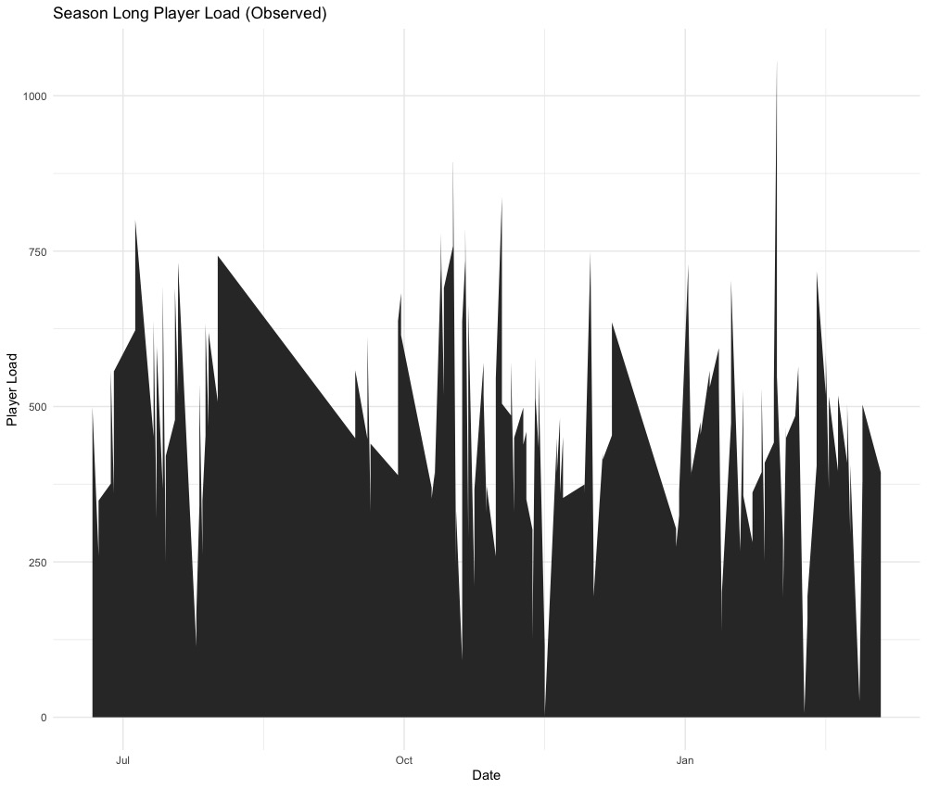

Figure 2. PlayerLoad Predicted from Games

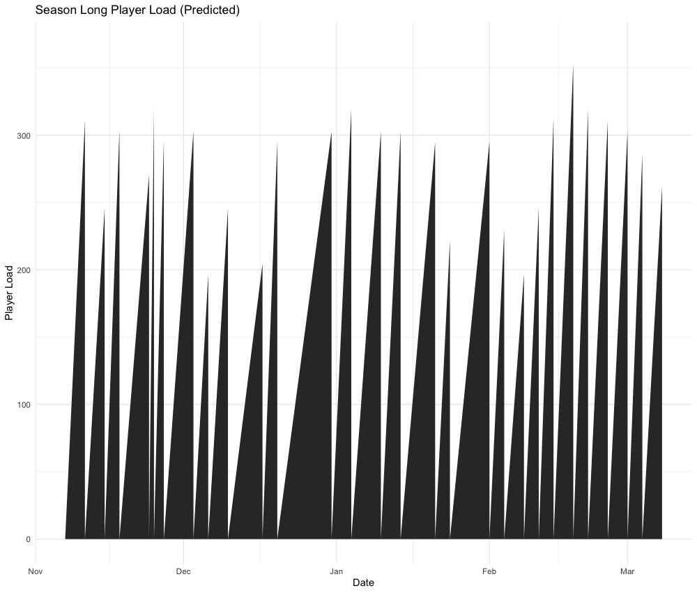

Furthermore, as PL values got larger (due to increased time on the court, more external training load, or a combination of both), there was a concomitant increase in the disparity between the estimates produced by the models (Figure 2).

Figure 2. Bland-Altman Plot Comparing Differences Between Predicted Values
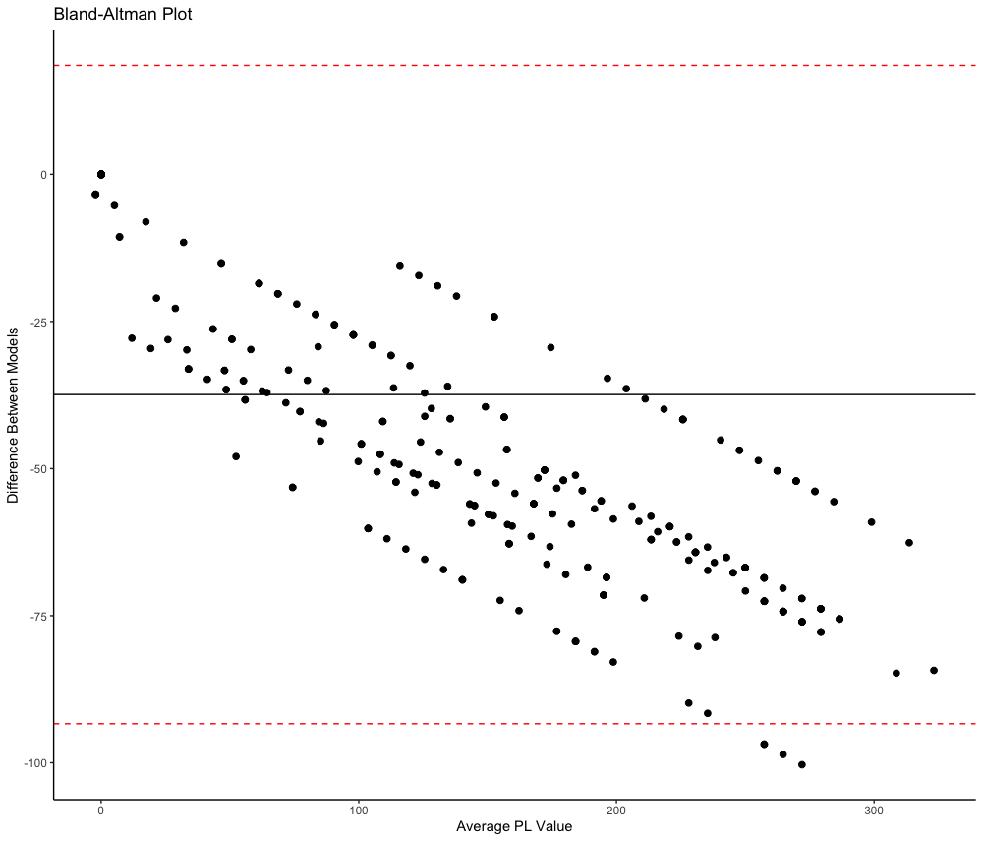

When comparing models, Starters had an average predicted PL of 284 ± 43.9 AU in the scrimmage model and 238 ± 37.9 AU in the practice model. Rotation averaged 116 ± 74.6 AU in the scrimmage model and 97.1 ± 64 AU in the practice model, and Bench players averaged 76.2 ± 71.8 AU in the scrimmage model and 64.4 ± 61.3 AU in the practice model (Figure 3).

Figure 3. Differences in Average Predicted PlayerLoad Between Scrimmage and Practice Models
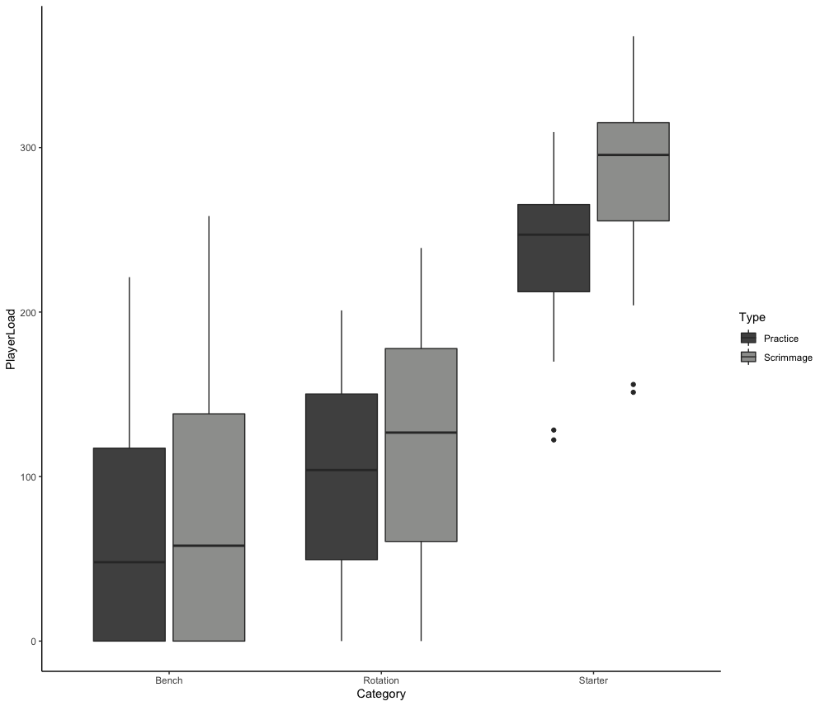

When comparing average weekly PL values (including both practices and games), Starters averaged 1339 ± 685 AU per week, Rotation players averaged 964 ± 632 AU per week, and Bench players averaged 795 ± 589 AU per week (Figure 4).
Figure 4. Average Weekly PL Values by Player Category
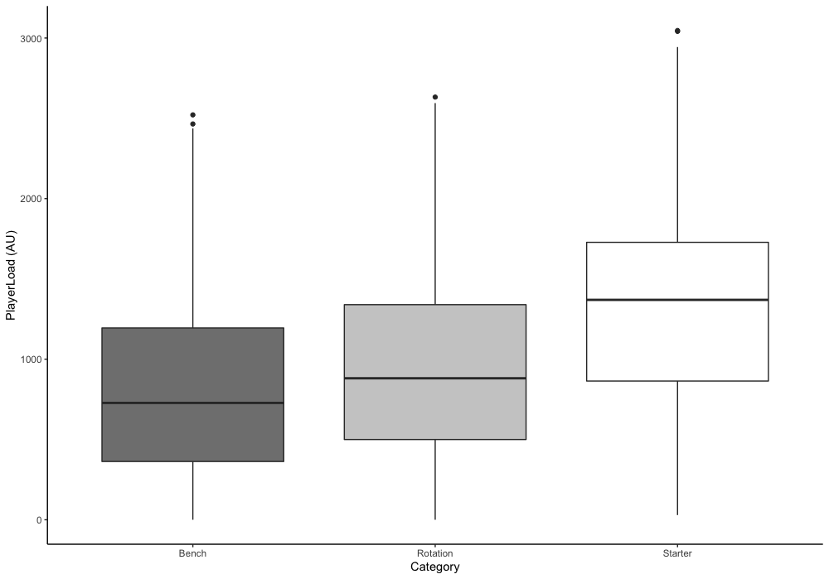
For average monthly PL values, starters averaged 4177 ± 2451 AU per month, Rotation players averaged 2949 ± 1927 AU per month, and Bench players averaged 2510 ± 1826 AU per month (Figure 5).
Figure 5. Average Monthly PL Values by Player Category
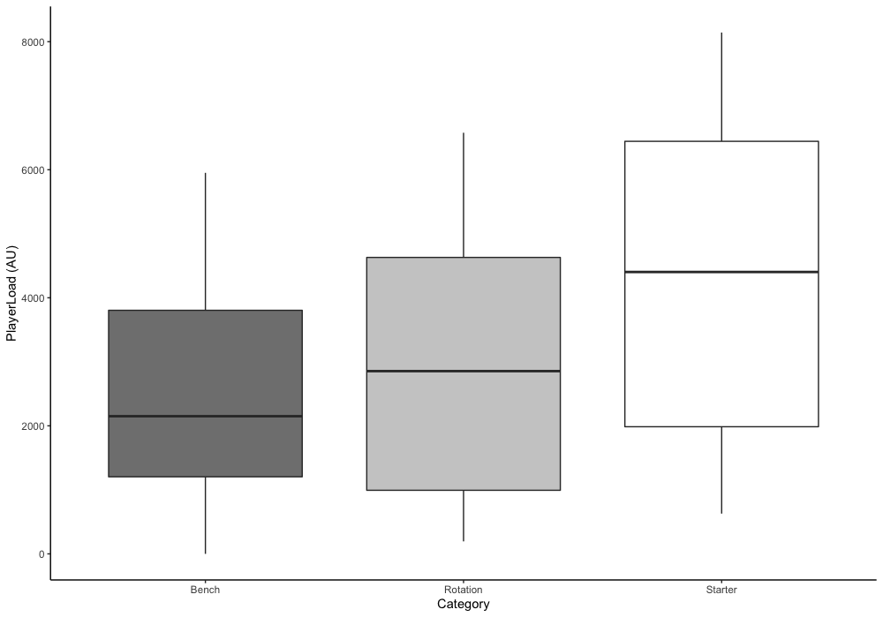
Results of a one-way ANOVA test with a Tukey’s HSD test also indicated statistically significant differences between player categorizations when examining weekly PL values. ANOVA results can be found in Table 4, and results of Tukey’s HSD can be found in Table 5. All significance levels were set at p < 0.05.
Table 1. ANOVA Results for Weekly Average PL
 | Df | Sum of Squares | Mean Square | F | p value
Category | 2 | 21957241 | 10978621 | 26.76 | <.001*
Residuals | 426 | 174757453 | 410229
Table 2. Tukey's HSD for Weekly Average PL Between Groups
 |  |  | 95% Confidence Interval
 | Mean Difference | p value | Lower Bound | Upper Bound
Rotation-Bench | 168.7004 | .079 | -14.98863 | 352.3893
Starter-Bench | 543.8801 | <.001* | 360.96909 | 726.7910
Starter-Rotation | 375.1797 | <.001* | 203.78028 | 546.5791
Note: * denotes statistical significance

These results suggest that the Starter category has a significantly higher mean value than both the Bench and Rotation categories, and is statistically different from the two other groups.
Comparisons between monthly averages yielded similar results, where the player category factor was again found to have a significant effect. The results of the ANOVA can be found in Table 6, while Tukey’s HSD comparing differences between groups can be found in Table 7. Significance levels were again set at p < 0.05 for monthly comparisons between groups.

Table 3. ANOVA Results for Monthly Average PL
 | Df | Sum of Squares | Mean Square | F | p value
Category | 2 | 68231669 | 34115835 | 7.682 | <.001
Residuals | 135 | 599574588 | 4441293
Note: * denotes statistical significance

Table 4. Tukey's HSD for Monthly Average PL Between Groups
 |  |  | 95% Confidence Interval
 | Mean Difference | p value | Lower Bound | Upper Bound
Rotation-Bench | 438.4075 | .599 | -636.4215 | 1513.236
Starter-Bench | 1666.7836 | <.001* | 591.9546 | 2741.613
Starter-Rotation | 1228.3761 | 0.01* | 229.5157 | 2227.237
Note: * denotes statistical significance

These results demonstrate that the Starter category has a significantly higher mean value than both the Bench and Rotation categories when comparing average monthly PL values. These results confirm the significant influence of the player category factor (and by extension, playing time) on the PL variable, and the Starter category consistently shows a statistically significant difference when compared to the other two categories across both analyses.

Chapter 5: Discussion

The key findings of this study indicated that external training load values from scrimmages ultimately captures more of the information regarding external training load values than those from practices, but there is not enough information to definitely compare the models and say which model is more effective at predicting game demands . This study also found that across an NCAA Division I (DI) men’s basketball team the distribution of external training load values is heavily stratified, with a select few players incurring significantly higher physical demands over the course of a season relative to the rest of the team.
One of the primary purposes of this study was to determine the efficacy of developing a series of models that could effectively predict the competition training loads incurred by NCAA DI men’s basketball players. While direct measurement of these values is the gold standard, this is not always possible in an applied team setting (Torres-Ronda et al., 2022). The results of this study indicated that there is more variance in the practice models as evidenced by the wide range of estimates generated by the models, as well as the lower R-squared value. However, there is not enough information to be able to properly determine which model more effectively predicted game PL. The greater variance in the practice model could be attributed to the key differences in the basketball parameters established by the coaching staff across these two categories. Scrimmage periods were designed to be as close to the competition environment as possible (i.e., a game clock that adheres to NCAA regulations, the presence of an officiating crew, NCAA scoring rules, etc.), while live practice periods were designed to both mimic game-like situations but also allow for instruction of specific basketball skills and tactical schemes that the coaching staff wished to emphasize, therefore having a greater range of parameters for practice periods relative to scrimmage periods.
Results also demonstrated that while weekly and monthly average PL values were consistent with other findings in the literature, individual estimates of game PL from the scrimmage model were lower than external training load values directly measured from basketball competition (J. Fox et al., 2020; J. L. Fox et al., 2018). However, it is important to note that these studies collected data during the entirety of the competition, while the present study only collected data while the participants were actively participating in the game and therefore potentially offering higher results than this present study. These results of this study may also have been influenced by the independent variables used to construct the models. Indeed, one major limitation of this study was the relatively simplistic nature of the predictive models chosen. While this was out of necessity due to restrictions on data collection, other literature indicates that the inclusion of additional parameters, such as distance traveled by individual players during practices, would improve the accuracy and predictive capabilities of the chosen models (Heishman et al., 2020).
Another major finding of this study was that a select number of players (in this instance, five) experienced significantly higher average weekly and monthly training loads than their counterparts. Grouping players into Starters, Rotation, and Bench players highlighted very large differences between the playing categories, and statistical tests indicated significant differences between average weekly and monthly PL values across different categories. This method was chosen due to the fact that it is similar to methodologies chosen in other similar studies (Russell, McLean, Stolp, et al., 2021). These differences can most likely be attributed to the disparity in skill between the starters and other players, which is consistent with other works that indicate that players of a higher skill level are more likely to encounter higher physical demands (Lorentzen, 2017; Scanlan et al., 2011). These findings may have practical significance, as increased levels of training load have been found to be related to increased levels of fatigue and decreases in physical capabilities which can impact competition performance (Halson, 2014). Furthermore, due to the ages of NCAA DI basketball student-athletes, increased levels of training load without proper rest or adequate physical preparation have been shown to lead to increased risk of injury (Killen et al., 2010; S. Malone et al., 2017; Weiss et al., 2017), as well as an increased risk of chronic health outcomes such as impaired tendon function (Circi et al., 2017; Zwerver et al., 2011). Indeed, research has indicated that 33% of the population found in this study could present with patellar tendinopathy issues (Hutchison et al., 2019).
In addition to the potential negative outcomes associated with chronically high training loads, these findings may also have practical impacts on the players on the opposite end of the spectrum (i.e., Bench players). Research has indicated that insufficient levels of training load may leave an athlete unprepared for the demands of competition, thereby incurring a greater risk of injury (Caparrós et al., 2018). Furthermore, low levels of training load (which are often attributed to limited participation in practices and competitions) may not provide enough stimulus to improve motor and sport-specific skills (Farrow & Robertson, 2017). Therefore, this information could improve the understanding of physical demands experienced by NCAA DI men’s basketball student-athletes and could inform practitioners as they structure short and long-term training plans.
Lastly, the findings of this research demonstrate that NCAA DI men’s basketball student-athletes experience relatively similar training loads to basketball athletes at the semi-professional and amateur level, but significantly less than those at the professional level. At the semi-professional level, on-court PL was found to be 1,036 ± 403, 1,259 ± 637, and 2,137 ± 775 AU in weeks with 1, 2 or 3 games, respectively (J. Fox et al., 2020). Starters at the professional level experienced PL of 2664 AU, 2302 AU, and 1699 AU depending on if they were classified as Starters, Rotation, or Bench players (Russell, McLean, Stolp, et al., 2021). These results may be of particular importance to practitioners at the NCAA DI level, as 86% of players that play professional basketball in the United States played basketball at the NCAA DI level (Men’s Basketball: Probability of Competing beyond High School, 2020). These practitioners should be aware of the increased physical demands that are present in professional competitions and may design training programs to prepare these athletes for professional competition in order to minimize injury risk.

Chapter 6: Conclusions

The primary purpose of this study was to evaluate the efficacy of predicting competition training load values from live practice data, and to determine the differences in PL across an NCAA DI men’s basketball team.

Research Questions

Research Question 1: What are the external training loads experienced by college basketball players over the course of an NCAA Division I Men’s Basketball season?
Hypothesis 1: It is hypothesized that external training load values across an NCAA Division I (DI) Men’s Basketball team will be heavily stratified, with a select few players experiencing statistically significant differences in external training load relative to their teammates.
Hypothesis 1 will be accepted, as there were statistically significant differences in mean weekly and monthly external training load values when comparing Starters to Rotation and Bench players.
Research Question 2: Do practice sessions sufficiently replicate the game demands of an NCAA Division I Men’s basketball game in order to adequately prepare athletes for competition?
Hypothesis 2: It is hypothesized that live practice sessions will be able to effectively predict game demands.
Hypothesis 2 will not be accepted, as there is insufficient evidence to definitively state which model more effectively predicted game demands.

Practical Significance

The findings from this research provide several practical recommendations for
practitioners working with this population. Practitioners working with NCAA DI men’s basketball players should be aware that a select portion of the team may encounter significantly higher physical demands than the rest of the team. These findings should impact the periodization of training plans as well as the structure of physical development programs in order to optimally prepare student-athletes for competition as well as prepare them for the potential demands of professional basketball.

Suggestions for Future Research

Future studies around this topic should either include additional variables to improve
the predictive capabilities of the regression models or should directly measure external training load values during competitions in order to paint a more complete picture of the demands experienced by NCAA DI men’s basketball players. Additionally, a similar study methodology should be utilized with a different team, as these findings may be heavily influenced by the coaching staff and could be different with other coaching staffs.

References

Alanen, A., Räisänen, A., Benson, L., & Pasanen, K. (2021). The use of inertial measurement units for analyzing change of direction movement in sports: A scoping review. International Journal of Sports Science & Coaching, 16(6), 1332–1353. https://doi.org/10.1177/17479541211003064
Bates, D., Mächler, M., Bolker, B., & Walker, S. (2015). Fitting linear mixed-effects models using lme4. Journal of Statistical Software, 67(1). https://doi.org/10.18637/jss.v067.i01
Beenham, M., Barron, D. J., Fry, J., Hurst, H. H., Figueirdo, A., & Atkins, S. (2017). A Comparison of GPS Workload Demands in Match Play and Small-Sided Games by the Positional Role in Youth Soccer. Journal of Human Kinetics, 57(1), 129–137. https://doi.org/10.1515/hukin-2017-0054
Bredt, S. da G. T., Chagas, M. H., Peixoto, G. H., Menzel, H. J., & Andrade, A. G. P. de. (2020). Understanding Player Load: Meanings and Limitations. Journal of Human Kinetics, 71(1), 5–9. https://doi.org/10.2478/hukin-2019-0072
Caparrós, T., Casals, M., Solana, Á., & Peña, J. (2018). Low external workloads are related to higher injury risk in professional male basketball games. Journal of Sports Science & Medicine, 17, 289–287.
Circi, E., Atalay, Y., & Beyzadeoglu, T. (2017). Treatment of Osgood–Schlatter disease: Review of the literature. MUSCULOSKELETAL SURGERY, 101(3), 195–200. https://doi.org/10.1007/s12306-017-0479-7
Conte, D., Kolb, N., Scanlan, A. T., & Santolamazza, F. (2018). Monitoring Training Load and Well-Being During the In-Season Phase in National Collegiate Athletic Association Division I Men’s Basketball. International Journal of Sports Physiology and Performance, 13(8), 1067–1074. https://doi.org/10.1123/ijspp.2017-0689
Croissant, Y., & Millo, G. (2008). Panel Data Econometrics in R: The plm Package. Journal of Statistical Software, 27(2). https://doi.org/10.18637/jss.v027.i02
Farrow, D., & Robertson, S. (2017). Development of a Skill Acquisition Periodisation Framework for High-Performance Sport. Sports Medicine, 47(6), 1043–1054. https://doi.org/10.1007/s40279-016-0646-2
Fox, J. L., Stanton, R., & Scanlan, A. T. (2018). A Comparison of Training and Competition Demands in Semiprofessional Male Basketball Players. Research Quarterly for Exercise and Sport, 89(1), 103–111. https://doi.org/10.1080/02701367.2017.1410693
Fox, J., O’Grady, C., & Scanlan, A. T. (2020). Game schedule congestion affects weekly workloads but not individual game demands in semi-professional basketball. Biology of Sport, 37(1), 59–67. https://doi.org/10.5114/biolsport.2020.91499
G. Gregory Haff & N. Travis Triplett. (2016). Essentials of Strength Training and Conditioning (4th ed.). Human Kinetics.
Halson, S. L. (2014). Monitoring Training Load to Understand Fatigue in Athletes. Sports Medicine, 44(S2), 139–147. https://doi.org/10.1007/s40279-014-0253-z
Heishman, A., Miller, R. M., Freitas, E. D. S., Brown, B. S., Daub, B. D., & Bemben, M. G. (2019). Monitoring external training loads and neuromuscular performance for Division I basketball players over the pre-season. Journal of Sports Science & Medicine, 51(6S), 35–35. https://doi.org/10.1249/01.mss.0000560595.64671.b6
Heishman, A., Peak, K., Miller, R., Brown, B., Daub, B., Freitas, E., & Bemben, M. (2020). Associations Between Two Athlete Monitoring Systems Used to Quantify External Training Loads in Basketball Players. Sports, 8(3), 33. https://doi.org/10.3390/sports8030033
Hoppe, M. W., Baumgart, C., Polglaze, T., & Freiwald, J. (2018). Validity and reliability of GPS and LPS for measuring distances covered and sprint mechanical properties in team sports. PLOS ONE, 13(2), e0192708. https://doi.org/10.1371/journal.pone.0192708
Hutchison, M. K., Houck, J., Cuddeford, T., Dorociak, R., & Brumitt, J. (2019). Prevalence of Patellar Tendinopathy and Patellar Tendon Abnormality in Male Collegiate Basketball Players: A Cross-Sectional Study. Journal of Athletic Training, 54(9), 953–958. https://doi.org/10.4085/1062-6050-70-18
Impellizzeri, F. M., Marcora, S. M., & Coutts, A. J. (2019). Internal and external training load: 15 years on. International Journal of Sports Physiology and Performance, 14(2), 270–273. https://doi.org/10.1123/ijspp.2018-0935
Jeffries, A. C., Marcora, S. M., Coutts, A. J., Wallace, L., McCall, A., & Impellizzeri, F. M. (2021). Development of a revised coneptual framework of physical training for use in research and practice. Sports Medicine. https://doi.org/10.1007/s40279-021-01551-5
Killen, N. M., Gabbett, T. J., & Jenkins, D. G. (2010). Training Loads and Incidence of Injury During the Preseason in Professional Rugby League Players: Journal of Strength and Conditioning Research, 24(8), 2079–2084. https://doi.org/10.1519/JSC.0b013e3181ddafff
Lorentzen, T. (2017). Allocation of playing time within team sports – a problem for discussion. Open Review of Educational Research, 4(1), 20–32. https://doi.org/10.1080/23265507.2016.1266694
Luteberget, L. S., Spencer, M., & Gilgien, M. (2018). Validity of the Catapult ClearSky T6 Local Positioning System for Team Sports Specific Drills, in Indoor Conditions. Frontiers in Physiology, 9, 115. https://doi.org/10.3389/fphys.2018.00115
Malone, J. J., Di Michele, R., Morgans, R., Burgess, D., Morton, J. P., & Drust, B. (2015). Seasonal training-load quantification in elite English Premier League soccer players. International Journal of Sports Physiology and Performance, 10(4), 489–497. https://doi.org/10.1123/ijspp.2014-0352
Malone, S., Owen, A., Newton, M., Mendes, B., Collins, K. D., & Gabbett, T. J. (2017). The acute:chonic workload ratio in relation to injury risk in professional soccer. Journal of Science and Medicine in Sport, 20(6), 561–565. https://doi.org/10.1016/j.jsams.2016.10.014
Manzi, V., D’Ottavio, S., Impellizzeri, F. M., Chaouachi, A., Chamari, K., & Castagna, C. (2010). Profile of weekly training load in elite male professional basketball players. Journal of Strength and Conditioning Research, 24(5), 1399–1406. https://doi.org/10.1519/JSC.0b013e3181d7552a
Men’s Basketball: Probability of competing beyond high school. (2020, April 20). NCAA. https://www.ncaa.org/sports/2015/3/6/men-s-basketball-probability-of-competing-beyond-high-school.aspx
Montgomery, P. G., Pyne, D. B., & Minahan, C. L. (2010). The Physical and Physiological Demands of Basketball Training and Competition. International Journal of Sports Physiology and Performance, 5(1), 75–86. https://doi.org/10.1123/ijspp.5.1.75
Nicolella, D. P., Torres-Ronda, L., Saylor, K. J., & Schelling, X. (2018). Validity and reliability of an accelerometer-based player tracking device. PLOS ONE, 13(2), e0191823. https://doi.org/10.1371/journal.pone.0191823
Novak, A. R., Impellizzeri, F. M., Trivedi, A., Coutts, A. J., & McCall, A. (2021). Analysis of the worst-case scenarios in an elite football team: Towards a better understanding and application. Journal of Sports Sciences, 39(16), 1850–1859. https://doi.org/10.1080/02640414.2021.1902138
Olthof, S. B. H., Tureen, T., Tran, L., Brennan, B., Winograd, B., & Zernicke, R. F. (2021). Biomechanical Loads and Their Effects on Player Performance in NCAA D-I Male Basketball Games. Frontiers in Sports and Active Living, 3, 670018. https://doi.org/10.3389/fspor.2021.670018
Perri, T., Norton, K. I., Bellenger, C. R., & Murphy, A. P. (2018). Training loads in typical junior-elite tennis training and competition: Implications for transition periods in a high-performance pathway. International Journal of Performance Analysis in Sport, 18(2), 327–338. https://doi.org/10.1080/24748668.2018.1475198
Peterson, K. D., & Quiggle, G. T. (2017). Tensiomyographical responses to accelerometer loads in female collegiate basketball players. Journal of Sports Sciences, 35(23), 2334–2341. https://doi.org/10.1080/02640414.2016.1266378
Petway, A. J., Freitas, T. T., Calleja-González, J., Medina Leal, D., & Alcaraz, P. E. (2020). Training load and match-play demands in basketball based on competition level: A systematic review. PLOS ONE, 15(3), e0229212. https://doi.org/10.1371/journal.pone.0229212
Rago, V., Muschinsky, A., Deylami, K., Mohr, M., & Vigh-Larsen, J. F. (2022). Weekly Training Load in Elite Male Ice Hockey: Practice Versus Competition Demands. International Journal of Sports Physiology and Performance, 17(2), 270–277. https://doi.org/10.1123/ijspp.2021-0188
Ransdell, L. B., Murray, T., Gao, Y., Jones, P., & Bycura, D. (2020). A 4-Year Profile of Game Demands in Elite Women’s Division I College Basketball. Journal of Strength and Conditioning Research, 34(3), 632–638. https://doi.org/10.1519/JSC.0000000000003425
Reina, M., García-Rubio, J., Esteves, P. T., & Ibáñez, S. J. (2020). How external load of youth basketball players varies according to playing position, game period and playing time. International Journal of Performance Analysis in Sport, 20(6), 917–930. https://doi.org/10.1080/24748668.2020.1818973
Rico-González, M., Los Arcos, A., Clemente, F. M., Rojas-Valverde, D., & Pino-Ortega, J. (2020). Accuracy and Reliability of Local Positioning Systems for Measuring Sport Movement Patterns in Stadium-Scale: A Systematic Review. Applied Sciences, 10(17), 5994. https://doi.org/10.3390/app10175994
Ritchie, D., Hopkins, W. G., Buchheit, M., Cordy, J., & Bartlett, J. D. (2016). Quantification of training and competition load across a season in an elite Australian Football club. International Journal of Sports Physiology and Performance, 11(4), 474–479. https://doi.org/10.1123/ijspp.2015-0294
Russell, J. L., McLean, B. D., Impellizzeri, F. M., Strack, D. S., & Coutts, A. J. (2021). Measuring physical demands in basketball: An explorative systematic review of practices. Sports Medicine, 51(1), 81–112. https://doi.org/10.1007/s40279-020-01375-9
Russell, J. L., McLean, B. D., Stolp, S., Strack, D., & Coutts, A. J. (2021). Quantifying training and game demands of a National Basketball Association season. Frontiers in Psychology, 12, 793216. https://doi.org/10.3389/fpsyg.2021.793216
Scanlan, A., Dascombe, B., & Reaburn, P. (2011). A comparison of the activity demands of elite and sub-elite Australian men’s basketball competition. Journal of Sports Sciences, 29(11), 1153–1160. https://doi.org/10.1080/02640414.2011.582509
Schelling, X., & Torres-Ronda, L. (2013). Conditioning for Basketball: Quality and Quantity of Training. Strength & Conditioning Journal, 35(6), 89–94. https://doi.org/10.1519/SSC.0000000000000018
Stone, J. D., Merrigan, J. J., Ramadan, J., Brown, R. S., Cheng, G. T., Hornsby, W. G., Smith, H., Galster, S. M., & Hagen, J. A. (2022). Simplifying External Load Data in NCAA Division-I Men’s Basketball Competitions: A Principal Component Analysis. Frontiers in Sports and Active Living, 4, 795897. https://doi.org/10.3389/fspor.2022.795897
Torres-Ronda, L., Beanland, E., Whitehead, S., Sweeting, A., & Clubb, J. (2022). Tracking Systems in Team Sports: A Narrative Review of Applications of the Data and Sport Specific Analysis. Sports Medicine - Open, 8(1), 1–22. https://doi.org/10.1186/s40798-022-00408-z
Vazquez-Guerrero, J., Reche, X., Cos, F., Casamichana, D., & Sampaio, J. (2020). Changes in External Load When Modifying Rules of 5-on-5 Scrimmage Situations in Elite Basketball. Journal of Strength and Conditioning Research, 34(11), 3217–3224. https://doi.org/10.1519/JSC.0000000000002761
Weiss, K. J., Allen, S. V., McGuigan, M. R., & Whatman, C. S. (2017). The Relationship Between Training Load and Injury in Men’s Professional Basketball. International Journal of Sports Physiology and Performance, 12(9), 1238–1242. https://doi.org/10.1123/ijspp.2016-0726
Zwerver, J., Bredeweg, S., & van den Akker-Scheek, I. (2011). Prevalence of jumper’s knee among non-elite athletes from different sports; a cross-sectional survey. British Journal of Sports Medicine, 45(4), 324–324. https://doi.org/10.1136/bjsm.2011.084038.40

