University of Oklahoma

Graduate College

Surfactants Derived from 2-Hydroxy-4-(methylthio)butyric Acid: Phase Behavior, Interfacial Activity, Microemulsions and More

A Dissertation

submitted to the Graduate Faculty

in partial fulfillment of the requirements for the

Degree of

Doctor of Philosophy

By

Guangzhe Yu
Norman, Oklahoma
2013

Surfactants Derived from 2-Hydroxy-4-(methylthio)butyric Acid: Phase Behavior, Interfacial Activity, Microemulsions and More

A Dissertation approved for the
Department of Engineering

By

______________________________
Dr. Brian Grady, Chair

______________________________
Dr. Jeffrey Harwell

______________________________
Dr. David Sabatini

______________________________
Dr. Tohren Kibbey

______________________________
Dr. Ben Shiau

© Copyright by GUANGZHE YU 2013
All Rights Reserved.

This dissertation is dedicated to my family and friends, especially to my parents:
Jiashu Dong and Aiping Yu

Acknowledgements
My highest gratitude goes to my advisor, Dr. Brian Grady, who during the four years has not only showed me the excitement of research, but also the way of thinking as a true engineer. I could not have accomplished as much without his guidance. I would also love to thank Dr. Jeffrey Harwell, who has been working with Dr. Grady on both of my graduate projects, and provided his wisdoms which constantly inspired me. Both of them have welcomed me into the world of engineers with their warm hearts and sophisticated minds. They have been my mentors in this pursuit, and will always be in the future.
I would also like to acknowledge Dr. Grace Arhancet, Mr. Scott Long, Dr. Andrew Woodside and Dr. Moniraj Ghosh. The kind funds and close collaboration from them and their companies have made the research in this dissertation possible. My colleagues, Dr. Yanjun Liu, Mr. Kyle Karinshak, Mr. Ian Pleasant, Miss Katie Burlas, Miss Khanh Ho and Mr. R.J. Ponder, have also made huge contributions to this dissertation.
I want to also mention my lab mates, Louis, JJ, Jiaxi, Yanjun, Annie, Hao, Tzu-ping, Peter and many others, who have been around for all these years and made me feel I am not alone on this quest. The same is to my dear friends in the CBME department, the Sarkeys Energy Center and this great university. You all have been so kind to me.
Last but not least, I would like to thank my awesome parents, who stayed cool at all times and constantly got my back when I could barely stand. My girlfriend, Lu, thank you for your tireless support, those fun memories that made me happy and the daily arguments that kept me sharp. I cannot imagine how these years would have been without you.

Table of Contents

Acknowledgements iv
Table of Contents vi
List of Tables xi
List of Figures xiv
Abstract xvii
Chapter 1 Introductions 1
1.1 Surfactants 1
1.1.1 Anionic surfactants 2
1.1.2 Nonionic surfactants 3
1.1.3 Nonionic surfactants with enhanced amphiphilicity 5
1.2 Microemulsions 6
1.2.1 Winsor’s R ratio 7
1.2.2 Fish diagram 8
1.2.3 Hydrophilic-lipophilic difference (HLD) model 9
Chapter 2 Experimental Procedures 11
2.1 Materials 11
2.1.1 2-hydroxy-4-(methylthio) butyric acid derived surfactants 11
2.1.2 Other surfactants 13
2.1.3 Other materials 14
2.2 Methods 14
2.2.1 Solid-liquid interface adsorption 14
2.2.2 Surface tension 16
2.2.3 Molecular interaction in micelles and surface monolayer 16
2.2.4 Upper and lower critical solution temperatures 17
2.2.5 Draves wetting 18
2.2.6 Foaming 18
2.2.7 Laundry performance 19
2.2.8 Microemulsions 20
Chapter 3 Anionic Surfactants 25
3.1 Surfactants 25
3.1.1 Nomenclatures 25
3.1.2 HPLC 26
3.2 Surface chemical properties 27
3.3 Surfactant phase behavior 30
3.3.1 Krafft point 30
3.3.2 Calcium tolerance 31
3.4 Draves wetting test 32
3.5 Ross-Miles foaming test 32
3.6 Summary 33
Chapter 4 Nonionic Surfactants 35
4.1 Surfactants 35
4.1.1 Nomenclatures 35
4.1.2 HPLC 36
4.2 Surface chemical properties 37
4.3 Adsorption at the Solid-Liquid Interface 40
4.4 Mixtures with anionic surfactants 43
4.5 Cloud Temperature 44
4.6 Draves wetting test 45
4.7 Foaming ability and stability profile 46
4.7.1 Ross-Miles foaming test 46
4.7.2 Foam collapse profile 47
4.8 Laundry performance 49
4.9 Summary 50
Chapter 5 Nonionic Surfactants with Enhanced Headgroup Hydrophilicity 52
5.1 Surfactants 52
5.1.1 Nomenclatures 52
5.1.2 HPLC 53
5.2 Surface chemical properties 54
5.3 Upper and lower critical solution temperatures 58
5.4 Draves wetting test 59
5.5 Foaming ability and stability profile 60
5.5.1 Ross-Miles foaming test 60
5.5.2 Foam collapse profile 62
5.6 Laundry performance 65
5.7 Summary 67
Chapter 6 Microemulsions Based on Sulfoxide Surfactants 68
6.1 Phase behavior 68
6.2 Interfacial tension 69
6.3 HLD model parameters 71
6.3.1 Parameters from PIT vs. EACN scan 71
6.3.2 K parameter 73
6.4 Summary 74
Chapter 7 Conclusions and Future Work 75
7.1 Hydrophilicity of the Sulfoxide Ester Units 75
7.2 Conclusions 76
7.3 Future Work 78
References 80

List of Tables

Table 2-1 Laundry formulation used to determine nonionic surfactant laundry performance 20
Table 3-1 Anionic surfactants based on 2-hydroxy-4-(methylthio) butyric acid 25
Table 3-2 Water solubility and surface chemical properties of various anionic surfactants 27
Table 3-3 Krafft point and calcium tolerance of sulfoxide/sulfide carboxylate surfactants with comparisons 30
Table 3-4 Draves wetting test results of sulfoxide/sulfide carboxylate surfactants with comparisons 32
Table 4-1 Nonionic surfactants based on 2-hydroxy-4-(methylthio) butyric acid 35
Table 4-2 Contents and fraction of mixtures of sulfoxide ester/amide nonionic surfactants 36
Table 4-3 Purity of the nonionic surfactants determined by HPLC 37
Table 4-4 Surface chemical properties of sulfoxide surfactants and their mixtures comparing with NPE9 and C₁₂EO₇ 39
Table 4-5 Parameters in two-step adsorption model of C8ESO and other nonionic surfactants on two solid surfaces 42
Table 4-6 Molecular interaction parameters between C₈ESO and two anionic surfactants 43
Table 4-7 Cloud temperature of sulfoxide surfactants and their mixtures 44
Table 4-8 Draves wetting performance of sulfoxide ester surfactants comparing with SDS and NPE9 45
Table 4-9 Ross-Miles foaming property of sulfoxide surfactants and their mixtures comparing to SDS and NPE9 46
Table 4-10 Parameters of the foam collapse profile of C₈ESO, C₈ASO, C₈/C₁₂ESO-mix, C₈/C₁₂ASO-mix and NPE9 48
Table 4-11 Laundry performance (reflectance improvement at 460nm) of C₈/C₁₂ESO-mix comparing to NPE9 49
Table 5-1 Purity of the nonionic surfactants determined by HPLC 53
Table 5-2 Surface chemical properties of monomer/dimer ester sulfoxides, ethoxylated ester sulfides/sulfoxides and commercial nonionic surfactants 56
Table 5-3 LCST/UCST of 1.0 wt% aqueous solutions of ester sulfoxide monomers, dimers, ester sulfides/sulfoxides of ethoxylated alcohols and other nonionic surfactants 58
Table 5-4 Draves wetting performance of ethoxylated ester sulfides/sulfoxides and other nonionic surfactants 60
Table 5-5 Parameters of the foam collapse profile of various C_{n}EO_{m}ES, C_{n}EO_{m}ESO and C_{n}EO_{m} in comparison with two nonionic surfactants 62
Table 5-6 Laundry performance of C₁₂EO₄ESO compared with NPE9 66
Table 6-1 T_{I/III} and T_{III/II} of C_{n}ESO with various oils 68
Table 6-2 PITs and minimum IFTs of C₁₂ESO with various alkanes 71
Table 6-3 HLD parameters of C₁₀ESO and C₁₂ESO compared with three AE surfactants¹⁷ 73
Table 6-4 c_{T} and σ of C₁₀ESO and C₁₂ESO compared with three AE surfactants¹⁷ 74
Table 7-1 CMC and cloud point of monomer/dimer ester sulfoxides and ethoxylated alcohols 76

List of Figures

Figure 1-1 Schematic structure of 2-hydroxy-4-(methylthio) butyric acid 1
Figure 1-2 “Fish” diagram of nonionic surfactants vs. n-octane systems²²; ○: C₁₂EO₆; ●: technical grade C₁₂EO₆ (mixture of different n_{EO} and n_{CH}) 8
Figure 2-1 Structural schematics of various molecules used in this study. 1) 2-hydroxy-4-(methylthio) butyric acid, 2) ester sulfide acid (C_{n}ESCOOH), 3) ester sulfoxide acid (C_{n}ESOCOOH), 4) monomer ester sulfoxides (C_{n}ESO), 5) oligomer ester sulfoxide (C_{n}ESO_{m}), 6) ethoxylated ester sulfides (C_{n}EO_{m}ES), 7) ethoxylated ester sulfoxides (C_{n}EO_{m}ESO) 12
Figure 2-2 Illustration of relations between spinning and droplet shape in spinning drop tensiometry (from Viades-Trejo and Gracia-Fadrique, 2007) 23
Figure 3-1 Overlay of HPLC traces of C₁₂ESOCOONa with C₁₂ESOCOOH 26
Figure 3-2 CMC determination of C₁₂ESCOONa, C₁₂ESOCOONa and C₁₆ESOCOONa via surface tension 28
Figure 3-3 Ross-Miles foam test results of C₁₂ESCOONa comparing with SDS, SDBS, AES (alkyl ether sulfate, a commercial sample Steol CS-460). Top of the bars correspond to the initial height of foam; the bottom of the bars correspond to the foam height after 5 mins. 33
Figure 4-1 CMC determination of C₆ESO, C₈ESO, C₈/C₁₀E-mix and C₈/C₁₂ESO-mix via surface tension 38
Figure 4-2 CMC determination of C₈ASO, C₈/C₁₀ASO-mix and C₈/C₁₂ASO-mix via surface tension 38
Figure 4-3 Adsorption density of C₈ESO, NPE9 and C₁₂EO₆ on carbon nanotube (top) and silica (bottom) 41
Figure 4-4 Foam collapsing profile: foam volume (solid) and gas content (dashed) in the foam of 1.0 wt% water solutions of C₈ESO, C₈ASO, C₈/C₁₂ESO-mix, C₈/C₁₂ASO-mix and NPE9 47
Figure 4-5 Laundry performance (reflectance improvement at 460nm) of C₈/C₁₂ESO-mix normalized to NPE9 50
Figure 5-1 Structural comparison of 1. 2-hydroxy-4-(methylthio) butyric acid, 2. monomer ester sulfoxides (C_{n}ESO), 3. oligomer ester sulfoxide (C_{n}ESO_{m}), 4. ethoxylated ester sulfides (C_{n}EO_{m}ES) and 5. ethoxylated ester sulfoxides (C_{n}EO_{m}ESO) 52
Figure 5-2 Surface tension measurements of monomer and dimer ester sulfoxides (C₁₈ESO₂ measured at 35˚C) 54
Figure 5-3 Surface tension measurements of ethoxylated ester sulfoxides/sulfides (C_{n}EO_{m}ES/ C_{n}EO_{m}ESO) and commercial ethoxylated alcohols (C_{n}EO_{m}) 55
Figure 5-4 Ross-Miles foaming performance of ethoxylated ester sulfoxides/sulfides and monomer ester sulfoxides comparing with various nonionic surfactants (AE-LF is a low-foaming AE surfactant). The top of the bar represents foam height at time=0, while the bottom represents foam height at time=5 min. 61
Figure 5-5 Foam collapse profile in the foam of 1.0 wt% water solutions of various C_{n}EO_{m}ES, C_{n}EO_{m}ESO and C_{n}EO_{m} in comparison with two nonionic surfactants (AE-LF and NPE9) 63
Figure 5-6 Illustration of proposed surface arrangement with higher surface area of LHL surfactant (top) and conventional LH surfactants (bottom), with the unoxidized C_{n}EO_{m}ES (C₁₆EO₁₀ES) structure in the zoom-in 65
Figure 5-7 Laundry performance of C₁₂EO₄ESO normalized to NPE9 67
Figure 6-1 IFT vs. temperature graphs of C₁₀ESO (top) and C₁₂ESO (bottom) with various alkanes 70
Figure 6-2 EACN vs. PIT curves for C₁₀ESO and C₁₂ESO in comparison with various AE surfactants by Sottman and Strey 72

Abstract
Surfactants derived from 2-hydroxy-4-(methylthio) butyric acid were investigated. Anionic surfactants derived from this molecule have excellent water solubility, hardness tolerance and surface activity. Nonionic surfactants based on this molecule presented excellent phase behavior in water, high surface activity, good foaming/wetting ability, and good laundry performance. The headgroup hydrophilicity of the nonionic surfactants were enhanced with oligomeric sulfoxide ester units or extra ethylene oxide units, and their water solubility and surface activity were improved from the monomer sulfoxide esters, while maintaining good foaming, wetting and laundry performances. The application of these surfactant classes was further explored; a potential foam- breaker class and a promising emulsifier family were found.

Introductions

Surfactants
Surfactants have been known for thousands of years. From soaps to novel products such as alkylbenzene sulfonates and alkyl poly-glucosides, surfactants are interface-altering compounds for liquids, typically water, which act at low concentrations. The structure of a surfactant contains at least one lyophilic (solvent liking) and one lyophobic (solvent hating) groups, to drive interfacial adsorption. In most cases, surfactants are made of one hydrophilic “headgroup” and one hydrophobic “tailgroup”. Based on the nature of the headgroups, surfactants are classified as anionic (- charge), cationic (+ charge), zwitterionic (both charges) and nonionic (no charge).
In this dissertation, surfactant structures derived from a water soluble molecule 2-hydroxy-4-(methylthio)butyric acid (see Figure 1-1) are discussed. Based on various synthetic strategies, anionic surfactants, nonionic surfactants and nonionic surfactants with enhanced amphiphilicity were produced, their performances were characterized, and their applications were explored.
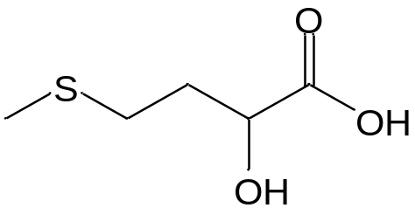
Figure 1-1 Schematic structure of 2-hydroxy-4-(methylthio) butyric acid

Anionic surfactants
Anionic surfactants with carboxylate moieties have been used for thousands of years; soap was first made from the hydrolysis of naturally-occurring oils/fats. Fatty-acid surfactants have an excellent combination of properties including low critical micelle concentration (CMC), low surface tension at the CMC, good foaming characteristics, and mildness when applied to skin. However, the 20th century has seen the use of these surfactants relative to other anionic surfactants decrease significantly for many reasons. From a property perspective, the most significant disadvantage of these surfactants is their propensity for precipitating when divalent cations are present, e.g., calcium and magnesium (hardness tolerance).
One well-known strategy to increase the hardness tolerance of anionic surfactants is to add branches to the linear main chain.¹ However, early attempts to produce hardness tolerant soaps such as highly-branched alkylbenzene sulfonates made from polypropylene failed because of its poor biodegradability.² People then started to examine less recalcitrant branching in the surfactants, for example, a lower degree of branching in the hydrophobic group.^{1a} Another synthetic strategy to produce branched carboxylic acid molecules is to use a head group with multiple hydrophilic moieties. As presented in Figure 1-1, 2-hydroxy-4-(methylthio)butyric acid has the potential to combine both the aforementioned structural aspects in one molecule. This molecule contains both hydroxyl functionality and carboxylic acid functionality where there is a sulfur-containing branch between the two. This particular compound is produced commercially in large quantities because it can convert into L-methionine in animal liver and is used extensively in animal feed.³ By esterifying the alcohol and neutralizing the acid group, a branched carboxylic acid surfactant was generated. The branching in this molecule should be considered biodegradable, because of the absence of secondary/tertiary carbons which caused the recalcitrance of highly branched hydrophobes. Further, the ester linkage is easily broken via hydrolysis.
In Chapter 3, three anionic surfactants synthesized from 2-hydroxy-4-(methylthio) butyric acid are investigated. Their structures were characterized with high performance liquid chromatography (HPLC). Their properties as surfactants, such as water solubility, CMC, surface tension at CMC (γ_{CMC}), Krafft temperature, calcium tolerance, foaming ability and wetting performance were studied and compared with anionic surfactants with similar structures. The effect of the branching and sulfoxide group of the molecules in their performance as a surfactant is explored by comparing the results to alkylcarboxylate salts.

Nonionic surfactants
Nonionic surfactants are widely formulated into household, personal care and industrial products. Alkyl-phenol ethoxylates, the majority being nonyl-phenol ethoxylates (NPEs), are a common type of nonionic surfactant. NPE surfactants have low CMC, low surface tension and high feedstock availability. In 2000, NPEs dominated the nonionic surfactant market with a 45% share.⁴ However, NPE formulation has been and will keep decreasing because of its potential environmental issues. Researchers claim that potential hormone disruptors, namely estradiol analogues, occur during degradation of NPEs.⁵ In 2010, the US Environmental Protection Agency announced their support of phasing-out NPEs in industrial and household formulations.⁶ As a result, candidates for NPE replacements are being sought. The nonionic surfactants described here based on the sulfoxide moiety were investigated as NPE replacements.
Surfactants containing sulfoxide functional groups have not been broadly studied. These surfactants were described in the mid-20th century in several patents.⁷ Clint and Walker studied the behavior of sulfoxide surfactants in homologous and mixed micelles because of their “compact head groups”.⁸ Iyota et al.’s work is a continuation to Clint and Walker, exploring non-ideal mixing of sulfoxide-containing surfactants and other nonionic surfactants.⁹ Hennaux and Laschewsky reported a new group of polymerizable sulfoxide containing surfactants in 2001. The polymerization is not based on the hydrophilic groups, but rather the double bonds in the hydrophobe.¹⁰ The current work marks the first time that esters or amides were used along with sulfoxide groups in a surfactant molecule.
In Chapter 4, nonionic surfactants derived from 2-hydroxy-4-(methylthio) butyric acid were studied. The structures of various molecules based on these synthetic steps were characterized with ¹H NMR. The properties of sulfoxide surfactants, such as CMC, γ_{CMC}, cloud temperature, Draves wetting kinetics, Ross-Miles foaming ability, foam collapse profile and laundry performance as nonionic surfactant in an enzyme and brightener containing liquid formulation were investigated and compared to other surfactants.

Nonionic surfactants with enhanced amphiphilicity
Nonionic surfactants containing ethylene oxide (EO) repeating units are widely formulated for their compatibility with other surfactants, low CMC and low γ_{CMC}. EOs are popular building blocks for the hydrophilic portion of nonionic surfactants because these groups are inexpensive, highly available, and compatible with other hydrophilic groups. In addition, adding such groups to alcohol moieties is chemically straightforward and the average number of ethylene oxide groups per molecule can be controlled. Alcohol ethoxylates (AEs) currently claim most of the nonionic market⁴ and is replacing NPEs in many applications.¹¹ However, AEs sometimes form unwanted gels in water, which are problematic to formulation and applications. More AEs are often required for equivalent performance with NPEs as well.
As stated previously, Chapter 4 describes molecules containing sulfoxides as NPE replacements; however the molecules described in Chapter 4 had limited hydrophobic chain lengths because the molecule had only one sulfoxide unit. In Chapter 5, molecules containing more headgroup hydrophilicity were introduced via two routes. In one route, ethylene oxide units were added to the molecule. Instead of alcohols, alcohol ethoxylates were reacted with the 2-hydroxy-4-(methylthio) butyric acid. In another route, oligomeric sulfoxide headgroups can be produced through esterification, since 2-hydroxy-4-(methylthio) butyric acid contains both carboxyl and hydroxyl groups. The properties of these surfactants, such as CMC, γ_{CMC}, lower/upper critical solution temperatures, Draves wetting kinetics, Ross-Miles foaming ability, foam collapse profile and laundry performance as nonionic surfactant replacement in an enzyme-containing liquid formulation were investigated and compared to other surfactants.

Microemulsions
Microemulsions are thermodynamically stable emulsion of two phases, usually a water phase and an oil phase, homogenized with emulsifiers. The term “microemulsion” was first introduced by Schulman¹², but the sizes of the emulsion droplets in such mixtures were later found to be nanometer scales.
Nonionic surfactants are excellent for formulating microemulsions, because of their high hydrophobicity and insensitivity to electrolytes, especially multivalent ions. Other advantages of nonionic emulsifiers include higher adsorption capacity, low price and less foam.¹³
Nonionic surfactant microemulsions were first studied in the early 1970s,¹⁴ in the light of early ionic surfactant microemulsion studies by Shulman and his co-workers¹⁵. Shinoda and Kunieda found that nonionic alcohol ethoxylates turn from water soluble to oil soluble in a microemulsion system upon raising temperature.^{14b} Due to Bancroft’s rule¹⁶, the microemulsion phases are switching correspondingly. Sottmann and Strey studied the ultralow interfacial tension (IFT) of ternary alcohol ethoxylated surfactants/n-alkane/water systems, and correlated the structures of surfactants and oils with the IFT and phase behaviors.¹⁷ Salager et al. used octylphenol ethoxylates as the surfactant in microemulsion systems to correlate more physicochemical variables with microemulsion phase behaviors.¹⁸ Based on the phase behavior studies above, a hydrophilic-lipophilic deviation (HLD) model of nonionic surfactant microemulsions was proposed, including the effect of temperature, oil content, aqueous salinity, surfactant structure and cosurfactants/linkers.¹⁹

Winsor’s R ratio
A traditional model called Winsor R ratio model can help us understand microemulsion systems, which was proposed by Winsor²⁰ and later on improved by Bourrel and Schechter²¹:
 | $$R=\frac{A_{SO}-1/2A_{OO}-1/2A_{LL}}{A_{SW}-1/2A_{WW}-1/2A_{HH}}$$ | Equation 1-1
where the R is called the Winsor R ratio, A_{SO} (A_{SW}) is the interaction between the adsorbed surfactant at the interface and the oil (water) molecules, A_{OO} (A_{WW}) is the interaction between two oil (water) molecules, and A_{LL} (A_{HH}) is the interaction between two lipophiles (hydrophiles).
The criterion for optimum microemulsion is R=1, when the interaction of the surfactant to the oil and the water phases are balanced out by each other. R<1 and R>1 correspond with type I and II behaviors, respectively. The premise of Winsor’s model is that the phase behavior at R=1 is determined by the magnitude of the numerator and the denominator in Equation 1-1. In other words, the stronger the interactions of the surfactant with both phases are, the lower minimum IFT will be reached, and hence the higher solubilization capacity.

Fish diagram
Figure 1-2 shows the “fish diagram” of nonionic surfactants including a pure C₁₂EO₆ and a technical grade C₁₂EO₆ which is made up of a mixture with different EO numbers and hydrophobe lengths.²² The change of Types I-III-II microemulsions with temperature is only observed within a range of surfactant concentration. If the surfactant concentration is lower than the appropriate range of values, the middle phase microemulsion will not be observed even if PIT is reached. If the surfactant concentration is higher than the appropriate range of values, the bicontinuous microemulsion will become a single phase (type IV, thermodynamically stable single-phase water/oil mixture).
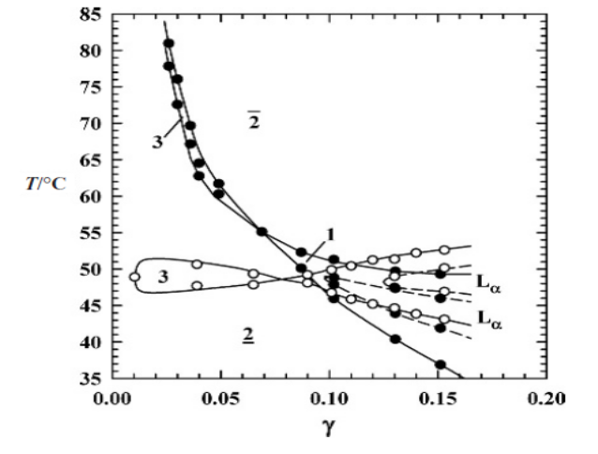
Figure 1-2 “Fish” diagram of nonionic surfactants vs. n-octane systems²²; ○: C₁₂EO₆; ●: technical grade C₁₂EO₆ (mixture of different n_{EO} and n_{CH})

Hydrophilic-lipophilic difference (HLD) model
In order to describe the behavior of nonionic surfactant induced microemulsions, a model called the hydrophilic-lipophilic difference (HLD) model was proposed by Salager et al.:^{18a, 19}
 | $$HLD=b*S-K\left(EACN\right)-f\left(A\right)+σ+c_{T}(∆T)$$ | Equation 1-2
where S is salinity, b is the salinity dependency, EACN is the equivalent alkyl carbon number, K is the coefficient of EACN, f(A) is a function of the consurfactant/linker type and concentration, σ is the characteristic curvature of the surfactant, ΔT is the temperature deviation from a reference (25°C) and c_{T} is temperature dependency. For primary alkanes, EACN is the number of hydrocarbon units. For oils other than primary alkanes, EACN is a characteristic number of the oil determined by microemulsion tests representing how hydrophobic the oil is. For EO-based nonionic surfactants, K is in the range of 0.1-0.2 for numerous surfactant-oil pairs, and c_{T} is typically around 0.06 T⁻¹. When HLD=0, the microemulsion is at its optimum state, when the IFT is the lowest and the SP is the highest. HLD can be translated to the chemical potential difference between the water and oil phase in the system. When HLD<0, the surfactant is more hydrophilic, and a type I microemulsion will be formed, and vice versa for HLD>0.
In Chapter 6, sulfoxide-based surfactants were used to formulate microemulsions. These surfactants are proposed to have excellent emulsifying ability, because the strong interaction between sulfoxide group and water suggests these surfactants may exhibit a high characteristic length, and hence high solubilization capacity.²³ The structural aspects of the sulfoxides indicating an enhanced emulsifying performance include a. the hydrocarbon-ester-sulfoxide structure of the ester sulfoxides resembles those of extended surfactants,^{23a} and b. the high interaction of sulfoxide groups with water molecules due to its strong dipole point to high characteristic lengths, i.e., the interaction range on a length scale of surfactants at the oil/water interface. The HLD model parameters of the ester sulfoxide surfactants were studied by looking at the PIT of various oils, surfactant hydrophobe unit numbers and salt concentrations. The minimum IFTs of various surfactant/oil/water systems were measured.

Experimental Procedures

Materials

2-hydroxy-4-(methylthio) butyric acid derived surfactants
The 2-hydroxy-4-(methylthio) butyric acid derived surfactants were synthesized by Novus International. Some surfactants were further purified with silica liquid chromatography columns. In the case for anionic surfactants, the samples were neutralized by ion-exchange columns.

Nomenclatures
The compounds that consist of a significant distribution of species, for example, ethoxylated ester sulfoxides (C_{n}EO_{m}ESO), are italicized in the current dissertation to distinguish from the compounds that contain essentially one molecule. Schematic structures of 2-hydroxy-4-(methylthio) butyric acid, ester sulfide carboxylate sodium salt (C_{n}ESCOONa), ester sulfoxide carboxylate sodium salt (C_{n}ESOCOONa), monomer sulfoxide esters (C_{n}ESO), oligomer sulfoxide esters (C_{n}ESO_{m}), ethoxylated ester sulfides (C_{n}EO_{m}ES) and ethoxylated ester sulfoxides (C_{m}EO_{n}ESO) are shown in Figure 2-1. The samples are abbreviated so that the name represents all the functional groups in the surfactant structure. For example, C₁₂EO₄ESO (3,6,9,12-tetraoxatetracosyl 2-hydroxy-4-(methylsulfinyl)butanoate) represents a mixture with the major content being the ester of 2-hydroxy-4-(methylthio) butyric acid reacted with a commercial AE surfactant, tetraoxyethylene lauryl ether, which contains a dodecyl chain (C₁₂), an oligomer with 4 repeating ethylene oxide units (EO₄) followed by partial oxidation of the sulfide moiety.
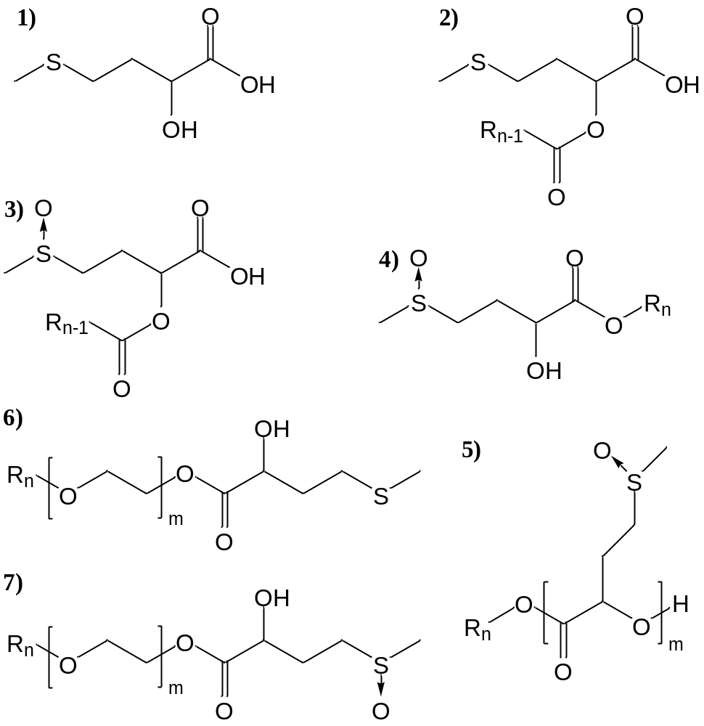
Figure 2-1 Structural schematics of various molecules used in this study. 1) 2-hydroxy-4-(methylthio) butyric acid, 2) ester sulfide acid (C_{n}ESCOOH), 3) ester sulfoxide acid (C_{n}ESOCOOH), 4) monomer ester sulfoxides (C_{n}ESO), 5) oligomer ester sulfoxide (C_{n}ESO_{m}), 6) ethoxylated ester sulfides (C_{n}EO_{m}ES), 7) ethoxylated ester sulfoxides (C_{n}EO_{m}ESO)

Ion-exchange neutralization
Ion exchange chromatography was used to neutralize the carboxylic acid (i.e., C₁₂ESCOOH, C₁₂ESOCOOH, etc.) instead of direct neutralization with alkali because of the susceptibility to hydrolysis of the ester group. A weakly acidic resin Dowex MAC-3 was used because of the weak acidity of the carboxylic group. In order to avoid precipitation during neutralization, a mixture of 70% ethanol and 30% water was used as a solvent. Dowex MAC-3 resin (proton form) was swollen and neutralized in excess NaOH/water solution, and then assembled into a column. After the resin was balanced with 2 column volumes of ethanol/water solvent, a 0.1g/ml acid solution was loaded then added and run through the resin 3-5 times for complete neutralization. Subsequently, the resin was rinsed with 2 column volumes (CV) of the ethanol/water solution, and the elution was collected. The solvent was then evaporated under vacuum at mild heat (40°C). Extra methanol was added 2-3 times to help remove water. The pH of the solution was raised from 4.1 to 7.5 after running through the column. The neutralized material was fully soluble in water (deionized with 18MΩ resistivity) while the unneutralized material was insoluble.

Other surfactants
Sodium dodecyl sulfate (>99%), sodium dodecylbenzenesulfonate (98%), hepta(oxyethylene) mono-n-dodecyl ether (C₁₂EO₇, >99%), hexa(oxyethylene) mono-n-dodecyl ether (C₁₂EO₆, >99%) and nona(oxyethylene) nonylphenyl ether (Igepal CO-630, NPE9 in average, Rhodia) were all purchased from Sigma-Aldrich. These surfactants were used without further purification.

Other materials
Sodium chloride (>99%), sodium bicarbonate (>99.7%), hydrogen peroxide (30%), sodium bisulfite (ACS reagent), ethanol (HPLC grade), methanol (HPLC grade), dodecyl chloride (>98%), hexadecyl chloride (98%), meta-chloroperoxybenzoic acid (mCPBA, 77%), 4-dimethylaminopyridine (DMAP, 99%), n-octanol (99%), n-decanol (>99%), n-dodecanol (>98%), n-tetradecanol (97%), n-hexadecanol (99%), n-octadecanol (99%) and dichloromethane (DCM, HPLC grade) were purchased from Sigma-Aldrich. Sodium hydroxide (>97%) was purchased from EMD. Toluene (99.5%) was purchased from VWR. Ethyl acetate (99.6%) was purchased from J.T.Baker. The low-foaming AE surfactant Plurafac SLF-180 (AE-LF) and the fluorescer Tinolux CBS-X were kindly provided by BASF. The protease, mannase and amylase were kindly provided by Novozymes. The PVP K30 and PVPNO Chromabond S403E were kindly provided by Ashland Inc. All the chemicals were used without further purification, except specified. Pre-soiled fabric swatches were purchased from Testfabrics Inc.. Silica gel liquid chromatography columns were purchased from Thomson Instrument Company.

Methods

Solid-liquid interface adsorption
Adsorption isotherms were performed on a hydrophilic surface (Aerosil 300, specific surface area=300m²/g) and a hydrophobic surface (carbon nanotubes, SMW-100 [Southwest Nanotechnology], diameter=7.8 nm, length=735 nm, specific surface area=252 m²/g). 5mL water solutions of surfactants at different concentrations were made and mixed with 75mg of adsorbent at room temperature. Mixtures were maintained at room temperature for 48h to reach equilibrium, and then the supernatant were characterized with HPLC (Aglient 1050; Phenomenex Kintex C18 column; methanol: water=80:20; flow rate 0.7mL/min; pressure: 220bar; UV detector at 210nm) to avoid any unwanted interference from contamination. The adsorption density was calculated with the equation:
 | $$Γ=Adsorption density=\frac{m_{sur,0}-m_{sur, super}}{A_{ads}}$$ | Equation 2-1
where $m_{sur,0}$ is the mass of surfactant in the solution before adsorption, $m_{sur,super}$ is the mass of surfactant in the supernatant after adsorption and $A_{ads}$ is the surface area of adsorbent. Adsorption density was plotted against the equilibrium supernatant concentration. The supernatant concentration where the adsorptions density reaches maximum is the CMC. The adsorption isotherms were fitted with a two-step model described by the equations below considering both monomer adsorption and surface micellization:²⁴
 | $$Γ=\frac{Γ_{m}k_{1}C_{e}\left(\frac{1}{n}+k_{2}C_{e}^{n-1}\right)}{1+k_{1}C_{e}\left(1+k_{2}C_{e}^{n-1}\right)}$$ | Equation 2-2
where Γ_{m} is saturated adsorption density, k₁ is the equilibrium constant of monomer adsorption, k₂ is the equilibrium constant of surface micellization, C_{e} is the equilibrium surfactant constant and n is the average number of monomers in the surface micelles. The standard free energy of monomer adsorption ($ΔG_{m}^{0}$) and surface micellization ($ΔG_{sm}^{0}$) was calculated from the equations below:
 | $$ΔG_{m}^{0}=-RTln\left(k_{1}\right)$$ | Equation 2-3
 | $$ΔG_{sm}^{0}=-\left(1/n\right)RTln\left(k_{2}\right)$$ | Equation 2-4

Surface tension
Surface tension of the surfactant water solutions was determined with a Wilhelmy Plate tensiometer (Cahn DCA-322) at room temperature. Glass slides manufactured by Corning with a width of 22mm and thickness of 0.1mm were used as probes; the motor speed was set to be 100µm/s. The CMC was determined from the break point of γ vs. log C diagram. The C20 is the concentration at the intersection of γ vs. log C curve and the line of γ= γ_{pure water} - 20mN/m.

Molecular interaction in micelles and surface monolayer
For binary surfactant mixtures, CMC at different mole fractions of the nonionic surfactant was analyzed according to Rubingh’s one parameter model. In this model, the molecular interaction parameter (β) is used to describe the strength of the interactions. The constant β relates to the free energy change upon mixing¹³:
 | $$ΔG_{mix}=βΧ\left(1-Χ\right)RT$$ | Equation 2-5
where X is the mole fraction of surfactant 1 of the total surfactants in the mixture. The intermolecular interactions between two surfactants for mixed micelle or monolayer formation can be described by the following equations based on nonideal solution theory²⁵:
 | $$αC_{12}=ΧC_{1}exp\left[β{\left(1-Χ\right)}^{2}\right]$$ | Equation 2-6
 | $$(1-α)C_{12}=(1-Χ)C_{2}exp\left[βΧ^{2}\right]$$ | Equation 2-7
where α is the mole fraction of surfactant 1 in total surfactants, X is the mole fraction of surfactant 1 in the mixed micelle or the air/liquid monolayer, C₁, C₂ are the CMC or the C20 of pure surfactants 1 and 2, and C₁₂ is the CMC or the C20 of the mixture. When β=0 mixing in the micelle/monolayer is random, and when β<0 mixing is more alternating than random. When β is negative and |β|>|log(C₁/C₂)|, there is synergism between the surfactants. The β parameter was calculated from mixed CMCs (β^{M}) and C20s (β^{σ}) with a custom-written Microsoft Visual Basic program.

Upper and lower critical solution temperatures
The cloud temperature (upper critical solution temperature, UCST) of the surfactant was determined according to ASTM D2024-09.²⁶ A 1.0 wt% surfactant solution was heated to 75°C, and then cooled at a 1°C/min rate to see if precipitation occurred. The solution was held at a temperature for at least 5 min, and then visually inspected. The temperature at which the precipitation disappeared was recorded as the UCST. For the Krafft temperature (lower critical solution temperature, LCST), the solutions were first cooled down to 4°C before it was heated.

Draves wetting
The Draves wetting test was run according to ASTM D2281-68.²⁷ 500 mL of surfactant solution was poured into a 500 mL graduated cylinder (38 cm in height), and 5.0 g of a standard skein hooked with a lead anchor was dropped in the solution. The skein floats in the solution because of the trapped air and sinks when wetted, and the time it took to sink after initially being added to the solution was recorded as the time of wetting.

Foaming

Ross-Miles
The Ross-Miles foam test was run according to the test protocol given by ASTM D1173-07.²⁸ 50mL of surfactant solution, also known as the receiver, was carefully poured into the 1 meter glass column, without creating any foam. A 200 mL pipette with the surfactant solution was placed 90cm above the receiver and the solution was allowed to drop into the foam receiver. The height of the foam produced was measured immediately and after 5 min.

Foam collapse profile
In order to study the foam collapse profile, an apparatus similar to that in Lunkenheimer et al.’s report was built.²⁹ A cylindrical glass funnel of 30mm inner diameter and 25cm length with a sintered glass G3 plate at the bottom was used. 50 mL of surfactant solution was slowly poured into the funnel without creating any foam. 50 mL of air was then injected with a syringe through the sintered glass plate at a 10 mL/min rate, to forcibly create 100 mL of foam. The volume of the entire air/liquid mixture (V_{total}) and that of the excess solution on the bottom (V_{excess}) was recorded. From V_{total} and V_{excess}, the volume of foam (V_{f}) and the volume of gas content in the foam (%gas) can be calculated.
 | $$V_{f}=V_{total}-V_{excess}$$ | Equation 2-8
 | $$\%gas=\left(1-\frac{50mL-V_{excess}}{V_{f}}\right)×100\%$$ | Equation 2-9
A model of foam collapse profile considering gravitational draining and gas diffusion by Monslave and Schechter, and Lawrence et al.³⁰ was used to fit the foam profile data:
 | $$V_{f}=V_{f, initial}∙\left(C_{A}e^{-K_{A}t}+C_{B}e^{-K_{B}t}\right)$$ | Equation 2-10
 | $$C_{A}+C_{B}=1$$ | Equation 2-11
where 100mL is the total initial foam volume, C_{A} and K_{A} are the proportion and rate constant of foam collapse due to gas diffusion between bubbles and C_{B} and K_{B} are the proportion and rate constant of foam collapse due to gravitational draining.

Laundry performance
Laundry performance was evaluated with a terg-o-meter. The temperature was stabilized at 30°C with a water bath. The detergent according to the formulation given in Table 2-1 was dosed at 3g/L in 1L of tap water in the cylinder. The washing cycle was 20 min, followed by a 5 min rinsing cycle. The reflectance at 460 nm of the soiled fabrics was measured with a photoelectric colorimeter (HunterLab, UltraScan VIS) both before and after washing. The improvement in reflectance (ΔR) was used to characterize the laundry efficiency.
Table 2-1 Laundry formulation used to determine nonionic surfactant laundry performance
Ingredients | Content (wt%)
Fatty acid | 0.2%
Sodium DETPMP | 0.2%
Sodium citrate | 5%
Sodium chloride | 0.8%
Boric Acid | 0.3%
Propylene glycol | 3%
NaOH | 2% (to pH=7-9)
Fluorescer | 0.08%
Protease | 0.4%
Mannase | 0.15%
Amylase | 0.4%
PVP | 0.2%
PVPNO | 0.2%
Nonionic surfactant | 10%
Anionic surfactant | 10%
Tap water | to 100%
The formulation was chosen to determine the performance of the nonionic surfactants as the nonionic component in a standard laundry formulation with enzymes and flourescers. Tests were done with fabrics pre-soiled with 7 different soils, including blood/ink/milk, tea, coffee, grass, wine, lipstick and chocolate drink. The soils were applied on two types of fabric substrates, cotton and a polyester/cotton=7/3 blend (PE/C).

Microemulsions

Phase inversion temperatures
In a ternary system with nonionic surfactant/water/oil, the surfactant and its concentration can be selected for the oil to form a microemulsion. When temperature is increased and the surfactant concentration is right, the microemulsion undergoes oil in water (O/W or type I), bicontinuous phase (type III/IV) and water in oil (W/O, or type II) emulsions. The reason for the change is that the surfactants become more hydrophobic with higher temperatures when hydrogen bonding becomes less important, and hence the interaction between surfactant and water (R denominator) is decreasing. Phase inversion temperature (PIT) is the temperature where R=1 in the ternary system, which is the middle point of the type III region and the minimum interfacial tension (IFT). In order to measure the PIT, an 1:1 (v:v) oil/water mixture with various surfactant concentrations ranging from 1 wt% to 5 wt% surfactant were made, and a water bath was used to control temperature. The temperature at which the emulsion changed from type I to type III or type III to type II was recorded as T_{I/III} or T_{III/II}. The PIT is close to the middle point between T_{I/III} and T_{III/II}.

Interfacial tension (IFT)
IFT is an important indicator of microemulsion quality, not only because it can be translated to the mechanical properties of microemulsion droplets, but also as it is related to the solubilization capability (SP=Mass of maximum solubilized oil or water/Mass of total surfactant), according to Chun Huh relationship³¹:
 | $$IFT=\frac{c}{{SP}^{2}}$$ | Equation 2-12

where c is called the Chun Huh constant, and is reported to be around 0.3mN/m for numerous systems.³² Solubilization capacity, which is an important figure of microemulsion surfactants, indicates the surfactants’ ability to homogenize incompatible phases. The lower the minimum IFT is, the higher SP can be, according to Equation 2-12. Usually, microemulsions are associated with ultralow IFTs below 10⁻² mN/m.
Another reason to perform IFT measurements is the confirmation of PIT. PIT of a nonionic surfactant/water/oil system is the middle point of the T_{I/III} and T_{III/II}, when the minimum IFT is reached. Due to the lack of accuracy in observing the microemulsions with human eyes, the PIT need to be confirmed with more quantitative ways. Therefore, the IFT between the oil and water phases at a given surfactant concentration can be measured at a series of temperatures to obtain the PIT. IFT measurements were performed with a spinning drop tensiometer. The principle of spinning drop measurements is illustrated in Figure 2-2.³³ The idea is to measure the radius of the spinning drop (R_{m}) at certain angular velocity (ω), and calculate the IFT with the following equation (Vonnegut Formula)³⁴:
 | $$γ=∆ρ∙ω^{2}R_{m}^{3}/4$$ | Equation 2-13
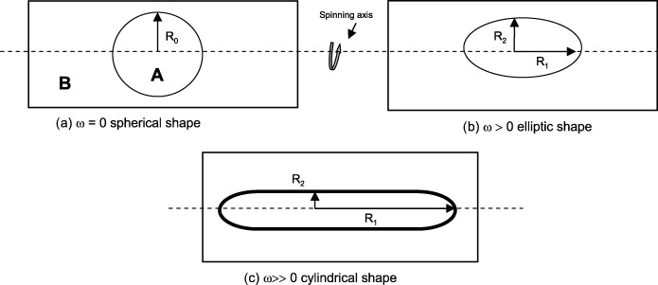
Figure 2-2 Illustration of relations between spinning and droplet shape in spinning drop tensiometry (from Viades-Trejo and Gracia-Fadrique, 2007)

Hydrophilic-lipophilic difference (HLD) model
In order to understand the characteristic behaviors of a surfactant in microemulsions, some of the parameters in the HLD model needs to be determined. Not all parameters need to be determined, for example, S can be zero if no salt is added to the water. If no cosurfactant is used, f(A) is 0 as well. Once the PITs of one surfactant vs. various oils are obtained, the parameters c_{T}/K and σ/K can be obtained from the re-written HLD equation when S=0 and f(A)=0:
 | $$EACN={c_{T}}/K∙\left(PIT-25\right)+σ/K$$ | Equation 2-14
σ/K is also known as the optimum EACN of an emulsifier; this ratio is equal to the EACN of the oil that forms an optimum microemulsion with the target surfactant at 25˚C with pure water. c_{T}/K is the PIT dependence of EACN for a target surfactant.
Individual parameters cannot be determined by just varying EACN; a second variable must be varied as well. Such second variable can be the surfactant structure, preferably the hydrophobe, because the interaction between the hydrophobe and the oil phase and their behaviors upon changing conditions should resemble other hydrocarbon based surfactants, such as AE surfactants. Surfactants with various hydrophobe sizes must be tested, in order to scale the HLD parameters to the change of hydrocarbon unit numbers. According to Acosta³⁵, the characteristic curvature of AE surfactants can be predicted by their structures:
 | $$σ=0.28×N_{C,S}-N_{E,S}+2.4$$ | Equation 2-15
where N_{E,S} is the number of EO units in the hydrophile and N_{C,S} is the number of hydrocarbon units in the hydrophobe. Once a second set of σ/K is obtained, then ∆σ/K (=σ₁/K-σ₂/K, assuming K is constant for the particular surfactant class) can be compared with ∆σ (=$0.28×∆N_{C,S}$) to calculate K, and hence σ and c_{T}.

Anionic Surfactants

Surfactants

Nomenclatures
The acronyms, chemical name and structures of the anionic surfactants discussed in this chapter are presented in Table 3-1.
Table 3-1 Anionic surfactants based on 2-hydroxy-4-(methylthio) butyric acid
Acronyms | Chemical Name | Structure
C₁₂ESCOONa | sodium 2-(dodecanoloxy)-4-(methylthio)butanoate | 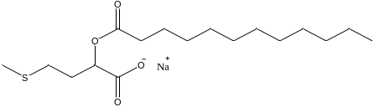
C₁₂ESOCOONa | sodium 2-(dodecanoloxy)-4-(methylsulfinyl)butanoate | 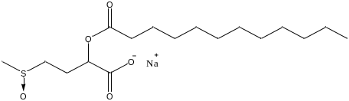
C₁₆ESOCOONa | sodium 2-(hexadecanoloxy)-4-(methylsulfinyl)butanoate | 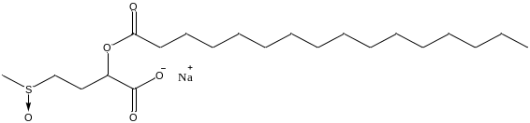
SDS | sodium dodecyl sulfate | 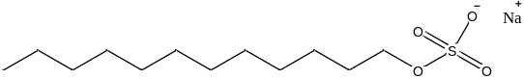
SDBS | sodium dedecylbenzene sulfonate | 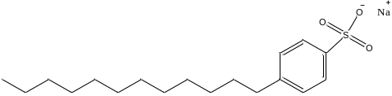
NaL | sodium laurate | 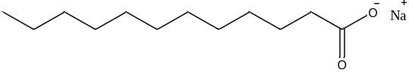
NaMy | sodium myristate | 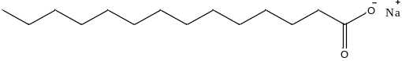
NaPa | sodium palmitate | 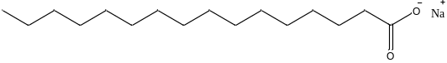

HPLC
The HPLC were performed in an Agilent 1260 system with acetonitrile / 2.5 mmol H₂SO₄ solvent and Dionex Acclaim® Organic Acid (OA 5µm, 120Å, 4 x 150mm) column. In order to confirm the integrity of the ester after the ion exchange chromatography, the salts were dissolved in water and analyzed by HPLC. The salts will be neutralized by the acid additive in the HPLC and the resulting chromatogram should look similar to the starting acid.
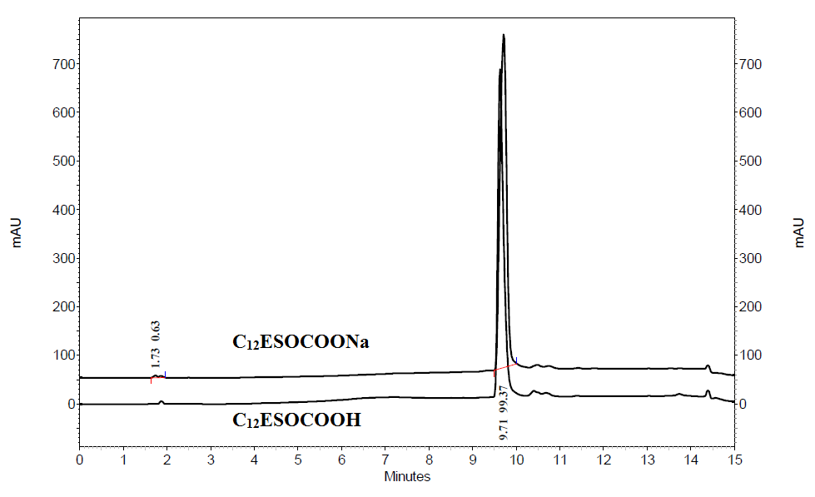
Figure 3-1 Overlay of HPLC traces of C₁₂ESOCOONa with C₁₂ESOCOOH
Figure 3-1 shows the HPLC of C₁₂ESOCOOH and C₁₂ESOCOONa with H₂SO₄ present in the solvent. Evidence of hydrolysis will be evident by the appearance of the sulfoxide of 2-hydroxy-4-(methylthio)butyric acid which has a retention time of 1.6 min. As can be seen from Figure 3-1, there is only a small amount of material present in the salt after ion exchange when compared to the starting acid. Therefore, the ion exchange chromatography had little effect on the integrity of the ester.

Surface chemical properties
Surface properties of C₁₂ESCOONa, sodium 2-dodecanoloxy-4-(methylsulfinyl)butanoate (C₁₂ESOCOONa) and 2-hexadecanoloxy-4-(methylsulfinyl)butanoate (C₁₆ESOCOONa) are presented in Table 3-2 in comparison to anionic surfactants with similar structures, including the linear carboxylates, sodium dodecyl sulfate (SDS) and sodium dodecylbenzene sulfonate (SDBS).
Table 3-2 Water solubility and surface chemical properties of various anionic surfactants
Surfactant | Water  Solubility  (mM) | CMC  (mM) | γ_{CMC}  (mN/m) | pC20 | CMC/C20 | Γ_{max}  (×10⁻¹⁰ mol/m²) | a_{min}/ion  (Å²)
C₁₂ESCOONa | 282 | 1.0 | 35 | 3.84 | 5.55 | 2.10 | 40
C₁₂ESOCOONa | >1000 | 1.7 | 40 | 3.27 | 3.15 | 2.33 | 34
C₁₆ESOCOONa | 117 | 0.54 | 42 | 4.07 | 4.56 | 1.26 | 65
SDS | 350³⁶ | 12.4³⁷  8.0³⁸  8.2³⁹ | 40³⁷ | 2.36³⁷ | 2.6³⁷ | 2.93³⁷ | 57³⁷
SDBS | 575⁴⁰ | 3.1 | 34 | 3.24 | 5.30 | 2.25 | 52³¹
NaL | 90 | 19.1  28.1⁴¹  31.2⁴²  27.2⁴³ | 29⁴⁴  30 | 3.32 | 38.5 | 1.06 | 78  47³¹
NaMy | 6⁴⁵ | 4.5(50°C)³⁸  4.0⁴⁵  6.9⁴⁶ | -- | 3.67 | -- | 1.39 | 60
NaPa | -- | 2.1(30°C)⁴³  1.8(62°C)³⁸ | -- | -- | -- | -- | --
Note: If not specified, all data are measured at room temperature, 1 atm; if not referenced, all data are measured in this study.
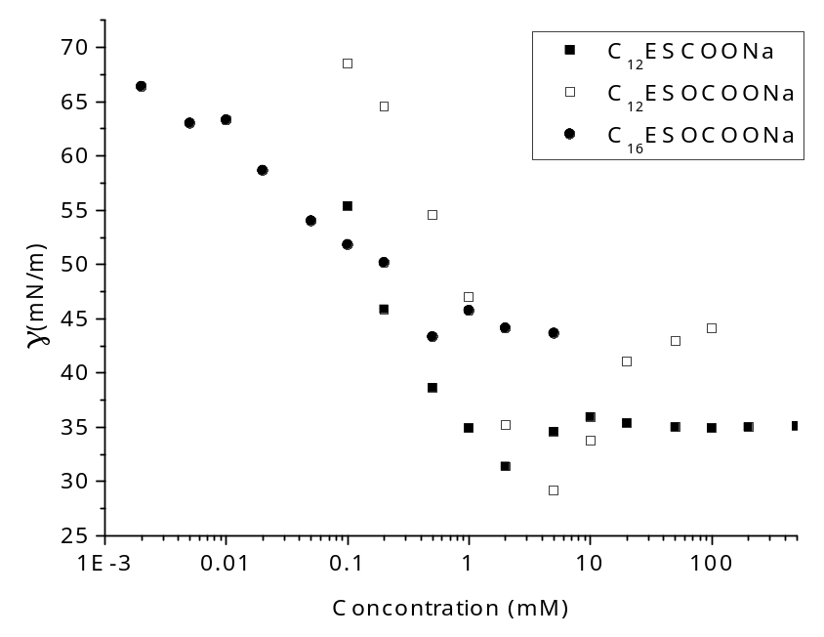
Figure 3-2 CMC determination of C₁₂ESCOONa, C₁₂ESOCOONa and C₁₆ESOCOONa via surface tension

Surface chemical properties of C₁₂ESCOONa, C₁₂ESOCOONa and C₁₆ESOCOONa were computed from the surface tension data in Figure 3-2. The slight undershoots near the CMCs are attributed to the presence of a small amount of impurity, possibly straight chain carboxylic acids and their sodium salts from the residue of the esterification reaction or hydrolysis during neutralization.
Relative to the solubility of sodium laurate (NaL) (0.02 g/ml) and sodium myristate (NaMy) (0.0015 g/ml), C₁₂ESCOONa’s is much higher (0.1 g/ml). Comparing the molecular structure of C₁₂ESCOONa and NaMy in Figure 3-2, C₁₂ESCOONa has an additional ester group on the main chain and a methyl-sulfur-ethyl group as a branch. The combination increased the solubility by 2 orders of magnitude while lowering the CMC by a factor of 4. The explanation is that the sulfur containing branch interferes with intermolecular arrangement and hence increases the solubility. At the same time, the additional three carbon atoms are able to overcome the hydrophilic effect of the ester group and the sulfur atom and increase the molecule’s tendency to form micelles, i.e lower the CMC.
All CMCs of the sulfoxide/sulfide carboxylate surfactants based on 2-hydroxy-4-(methylthio) butyric acid are lower than that of SDS, SDBS, NaL, and NaMy measured at the same temperature, or sodium palmitate (NaPa) at higher temperatures. Sulfoxide/sulfide carboxylate surfactants also possess relatively high pC20, indicating high efficiency in lowering the surface tension. However, surface tensions at the CMC and surface excess concentrations are not superior to other anionic surfactants, suggesting comparable effectiveness of surface adsorption. The noticeable property is CMC/C20, which is an indicator of the tendency of liquid air adsorption versus micelle formation (the higher, the more inclined to surface adsorption). The reason that sulfoxide/sulfide carboxylate surfactants favor micelle formation more than its carboxylate counterpart might be a result of molecular geometry; sulfoxide/sulfide carboxylate surfactants have a bulkier head group and a straight chain hydrophobe which would favor spherical geometries. The anomaly is C₁₆ESOCOONa, which has a high surface area per molecule (i.e., low effectiveness), and a very high pC20 (i.e., high efficiency). The latter is to be expected since the carbon chain is longer, but the former is less likely since longer hydrophobe usually increases the adsorption effectiveness. Our suspicion is that the surface active impurities in this sample interfered with surface arrangement of C₁₆ESOCOONa.
The comparison between C₁₂ESCOONa and C₁₂ESOCOONa can be translated to the difference between sulfur and sulfoxide functional groups. Oxidation increased the water solubility and CMC, which was expected. The increase of surface tension at the CMC is usually the result of one of two reasons: a. high surface area per molecule (a_{min}) and b. low tendency of liquid/air interface participation versus micelle formation (CMC/C20). C₁₂ESOCOONa has both a lower a_{min} and a lower CMC/C20, suggesting that the latter is true. The reason sulfoxide surfactant favors micelle formation relative to air-liquid adsorption is unknown.

Surfactant phase behavior
The precipitation tendencies of sulfoxide/sulfide carboxylate surfactants are presented in Table 3-3 in comparison with common anionic surfactants.
Table 3-3 Krafft point and calcium tolerance of sulfoxide/sulfide carboxylate surfactants with comparisons
Sample Name | Krafft Point  (°C) | CaCl₂ Tolerance  (µM) | Hardness Tolerance  (ppm as CaCO₃)
C₁₂ESCOONa | <4 | 100 | 10
C₁₂ESOCOONa | <4 | 5000 | 500
C₁₆ESOCOONa | <4 | 100 | 10
NaL | 13⁴⁷ | 0.5 | 0.05
SDS | 15³⁸, 16⁴² | 40⁴⁴ | 4⁴⁴
Note: if not referenced, all data are measured in this study.

Krafft point
Within 48 hours, 1 wt.% solutions of C₁₂ESCOONa, C₁₂ESOCOONa nor C₁₆ESOCOONa did not show precipitation in the 4°C water bath, and hence the Krafft points of all three sulfoxide/sulfide carboxylate surfactants are lower than 4°C. Based on the reported data, the sulfoxide/sulfide carboxylate salts have better low temperature operability than SDS (Krafft point at 15°C).

Calcium tolerance
In terms of hardness tolerance, the C₁₂ESCOONa solution showed precipitate with CaCl₂ only above 100µM. NaL and SDS were also tested; the results show that the C₁₂ESCOONa has approximately 2.5 orders of magnitude better calcium tolerance than the linear carboxylate (which agrees with the water solubility data) and about half an order of magnitude better than the linear sulfate, SDS. The improved hardness tolerance is a combined effect of the increased hydrogen bonding due to the ester group and the sulfur atom, and the branching in the head group. Oxidation of the sulfur atom further improved its hardness tolerance. C₁₂ESOCOONa has a hardness tolerance of 5000 mM of CaCl₂, which is a factor of 50 better than the unoxidized form. In fact, the increased hardness tolerance from sulfur oxidation is exactly offset by 4 additional hydrocarbon units, by comparing the data of C₁₂ESCOONa and C₁₆ESOCOONa. Due to its good water solubility, low CMC and high hardness tolerance, C₁₂ESOCOONa is a potential calcium tolerant anionic surfactant and a candidate to be a builder in hard water formulations.

Draves wetting test
For the Draves wetting test, 0.1 wt.% surfactant solutions were used for all the surfactants. As presented in Table 3-4, C₁₂ESCOONa outperforms NaL in the wetting time with a comparable performance to SDS. Since C₁₂ESCOONa is a larger molecule than NaL and SDS, it should have a smaller diffusion coefficient and hence a higher wetting time. One explanation is that C₁₂ESCOONa adsorbs more strongly to the interface so that a higher fraction of each collision of the molecule with the interface results in adsorption.
Table 3-4 Draves wetting test results of sulfoxide/sulfide carboxylate surfactants with comparisons
Sample Name | Draves wetting time (s)  of 0.1 wt% solution
C₁₂ESCOONa | 11
NaL | 52
SDS | 11

Ross-Miles foaming test
For the Ross-Miles foam test, all surfactants were used at 1 wt.% concentration, which is above all CMCs. The results in Figure 3-3 show that the C₁₂ESCOONa generates foam comparable to the reference anionic surfactants (measured in our laboratory using the identical equipment and procedure), but dissipates much faster. Fast dissipation indicates lack of surface cohesiveness. Judging from its structure, the branch could have disturbed the surface arrangement of surfactant molecules. Quick dissipation of foams is a desirable property in automatic dishwashing and laundry, which is another possible application suggested by sulfoxide/sulfide carboxylate surfactants.
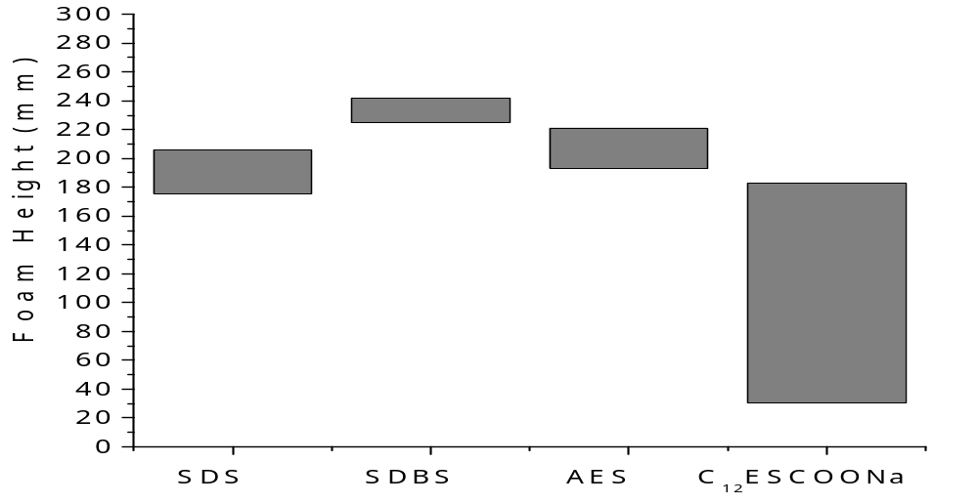
Figure 3-3 Ross-Miles foam test results of C₁₂ESCOONa comparing with SDS, SDBS, AES (alkyl ether sulfate, a commercial sample Steol CS-460). Top of the bars correspond to the initial height of foam; the bottom of the bars correspond to the foam height after 5 mins.

Summary
A family of anionic surfactants, sodium 2-alkanoloxy-4-(methylthio)butanoate or sodium 2-alkanoloxy-4-(methylsulfinyl)butanoate, were successfully synthesized. This family have good water solubility, low Krafft point, high surface tension reduction efficiency, low critical micelle concentrations and improved calcium tolerance compared to sodium laurate and sodium dodecyl sulfate. The solutions of the surfactants have comparable wetting performance as sodium dodecyl sulfate, which exceeds that of sodium laurate. The surfactant generates foam roughly equivalent with similar anionic surfactants, which dissipates much more quickly. The combination of the improved critical micelle concentration, Krafft point, calcium tolerance, wetting time and foam dissipation shows the new surfactant has some promise in detergency formulations.

Nonionic Surfactants

Surfactants

Nomenclatures
The acronyms, chemical names and schematic structures of the sulfoxide esters/amides derived from 2-hydroxy-4-(methylthio) butyric acid are shown in Table 4-1.
Table 4-1 Nonionic surfactants based on 2-hydroxy-4-(methylthio) butyric acid
Sample Acronym | Chemical Name | Structure
C₆ESO | hexyl 2-hydroxy-4-(methylsulfinyl)butanoate | 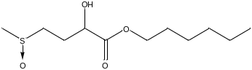
C₈ESO | octyl 2-hydroxy-4-(methylsulfinyl)butanoate | 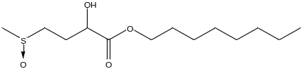
C₁₀ESO | decyl 2-hydroxy-4-(methylsulfinyl)butanoate | 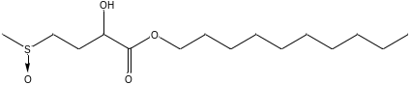
C₁₂ESO | dodecyl 2-hydroxy-4-(methylsulfinyl)butanoate | 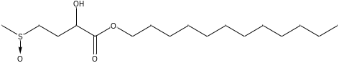
C₈ASO | octyl 2-hydroxy-4-(methylsulfinyl)butanamide | 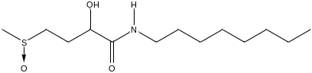
C₁₀ASO | decyl 2-hydroxy-4-(methylsulfinyl)butanamide | 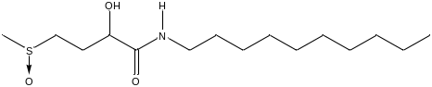
C₁₂ASO | dodecyl 2-hydroxy-4-(methylsulfinyl)butanamide | 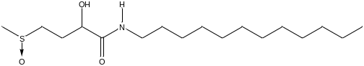
NPE9 | nona(oxyethylene) nonylphenylether | 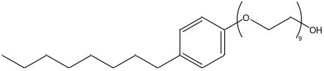
C₁₂EO₆ | hexa(oxyethylene) mono-n-dodecyl ether | 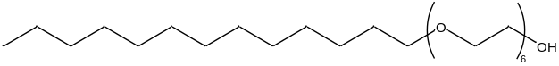
C₁₂EO₇ | hepta(oxyethylene) mono-n-dodecyl ether | 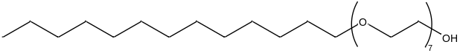
Schematic structures of 2-hydroxy-4-(methylthio) butyric acid, the sulfoxide esters and the sulfoxide amides are shown in Table 4-1. As presented in Table 4-2, octyl 2-hydroxyl-4-(methylsulfinyl)butanoate (C₈ESO) or 2-hydroxyl-4-(methylsulfinyl)-n-octylbutanoamide (C₈ASO) and their analogues with longer hydrocarbon chains, namely decyl 2-hydroxyl-4-(methylsulfinyl)butanoate (C₁₀ESO), 2-hydroxyl-4-(methylsulfinyl)-n-decylbutanoamide (C₁₀ASO), dodecyl 2-hydroxyl-4-(methylsulfinyl)butanoate (C₁₂ESO) or 2-hydroxyl-4-(methylsulfinyl)-n-dodecylbutanoamide (C₁₂ASO) were mixed, because the dodecyl-/decyl-ester/amide sulfoxides are not water soluble alone at room temperature. The mixtures were named to indicate the type and fraction of the contents, as summarized in Table 4-2. For example, C₈/C₁₀ESO-mix represents a mixture of 70 wt% of C₈ESO and 30 wt% of C₁₀ESO.
Table 4-2 Contents and fraction of mixtures of sulfoxide ester/amide nonionic surfactants
Mixtures | Contents (wt%) | Average Carbon Number  Post Ester/Amide Groups
C₈/C₁₀ESO-mix | C₈ESO (70%) and C₁₀ESO (30%) | 8.6
C₈/C₁₂ESO-mix | C₈ESO (70%) and C₁₂ESO (30%) | 9.1
C₈/C₁₀ASO-mix | C₈ASO (60%) and C₁₀ASO (40%) | 8.8
C₈/C₁₂ASO-mix | C₈ASO (75%) and C₁₂ASO (25%) | 8.9

HPLC
The HPLC were performed in an Agilent 1260 system with acetonitrile as solvent and Dionex Acclaim® Organic Acid (OA 5µm, 120Å, 4 x 150mm) column. In order to confirm the purity of the surfactants after the ion exchange chromatography, the salts were dissolved in water and analyzed by HPLC. The purity of the main components were characterized by the peak area.
Table 4-3 Purity of the nonionic surfactants determined by HPLC
Compound | HPLC purity by area %
C₆ESO | 98.2
C₈ESO | 98.9
C₁₀ESO | 98.5
C₁₂ESO | 94.1
C₁₂ESO₂ | 94.9
C₁₄ESO₂ | 98.3
C₁₆ESO₂ | 99.3
C₁₈ESO₂ | 99.5
Table 4-3 shows the HPLC determined purity of C₆ESO, C₈ESO, C₁₀ESO and C₁₂ESO. All the surfactants presented purity level above 98%, except for C₁₂ESO with a 94.1% purity.

Surface chemical properties
Results of the surface tension vs. concentration measurements are presented in Figure 4-1 and Figure 4-2.
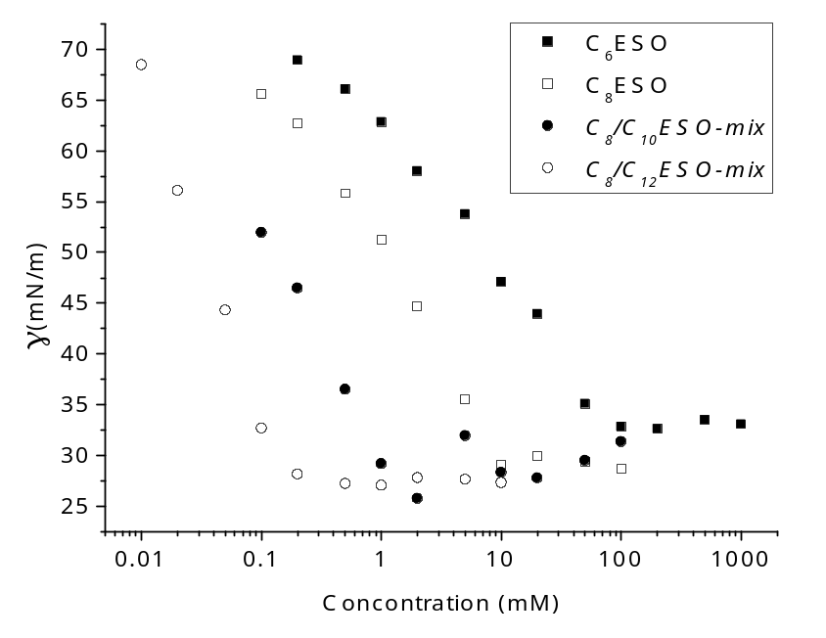
Figure 4-1 CMC determination of C₆ESO, C₈ESO, C₈/C₁₀E-mix and C₈/C₁₂ESO-mix via surface tension
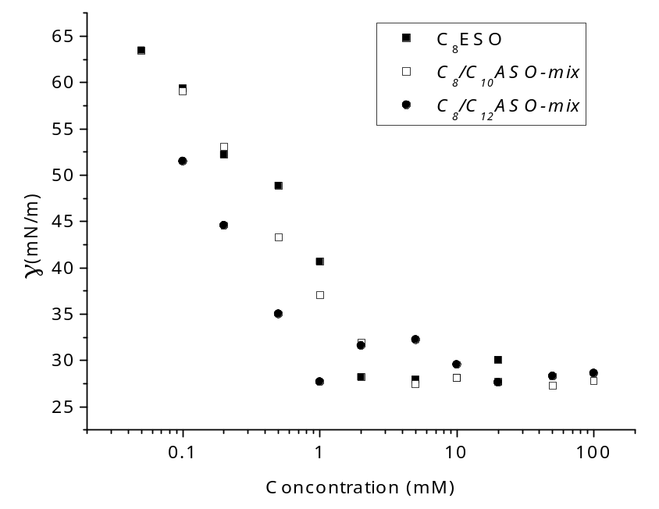
Figure 4-2 CMC determination of C₈ASO, C₈/C₁₀ASO-mix and C₈/C₁₂ASO-mix via surface tension

Surface chemical properties, including CMC, surface tension at CMC (γ_{CMC}), pC20, CMC/C20, surface excess concentration (Γ_{max}) and minimum area per molecule at the interface (a_{min}),¹³ were calculated from the γ vs. log C diagrams and are presented in Table 4-4.
Table 4-4 Surface chemical properties of sulfoxide surfactants and their mixtures comparing with NPE9 and C₁₂EO₇
Surfactants | CMC  (mM) | CMC  (wt%) | γ_{CMC}  (mN/m) | pC20 | CMC/C20 | Γ_{m}  (μmol/m²) | a_{min}  (Å²)
C₆ESO | 104 | 2.6 | 33 | 2.4 | 23.9 | 2.5 | 66.9
C₈ESO | 11.7  9.4^{AD} | 0.33 | 29 | 3.2 | 17.5 | 3.3 | 50.8  34.5^{AD}
C₈/C₁₀ESO-mix | 1.1 | 0.037 | 28 | 4.0 | 12.5 | 4.1 | 41.0
C₁₀ESO | 0.59* | 0.018* | -- | -- | -- | -- | --
C₈/C₁₂ESO-mix | 0.11 | 0.0032 | 27 | 4.5 | 9.9 | 4.8 | 34.5
C₁₂ESO | 0.060* | 0.0020* | -- | -- | -- | -- | --
C₈ASO | 6.9 | 0.29 | 29 | 3.3 | 15.4 | 3.5 | 47.3
C₈/C₁₀ASO-mix | 2.9 | 0.084 | 28 | 3.7 | 14.6 | 3.7 | 44.4
C₁₀ASO | 1.8* | 0.055* | -- | -- | -- | -- | --
C₈/C₁₂ASO-mix | 0.39 | 0.011 | 30 | 4.4 | 10.4 | 3.9 | 42.4
C₁₂ASO | 0.16* | 0.0053* | -- | -- | -- | -- | --
NPE9 | 0.038  0.078^{AD} | 0.0038 | 33 | 5.8 | 26.5 | 2.1 | 79.4  61.1^{AD}
C₁₂EO₇⁴⁸ | 0.082 | 0.0041 | 34 | 5.3 | 14.9 | 2.9 | 57
Note: all data, if not referenced, were measured in our labs by surface tension measurement
AD: measured by adsorption at the solid/liquid interface. CMC is the bulk concentration when adsorption reaches maximum
*: extrapolated from the CMCs of C8ESO and the mixtures, assuming that β in the mixtures are all 0
For calculation of Γ_{m} and a_{min} of the mixtures, the surfactant mixtures were treated as single component compounds. CMCs of C₁₀ESO and C₁₂ESO were extrapolated from the CMCs of C₈ESO, C₈/C₁₀ESO-mix and C₈/C₁₂ESO-mix using regular solution theory, assuming that mixing was ideal in the micelle phase (β^{M}=0). Both C_{n}ESO and C_{n}ASO followed Traube’s rule⁴⁹ in that every two additional hydrocarbon unit in the main hydrophobic chain decreases the CMC by roughly an order of magnitude. With increasing hydrocarbon content, the surface tension reduction efficiency (pC20) and effectiveness (-γ_{CMC}) increased as expected while the surface area per molecule (a_{min}) decreased. The tendency to form micelles versus surface adsorption (-CMC/C20) also increased with increasing hydrophobic chain length. Comparison of esters and amides indicate that the identity of these two functional groups did not affect surface chemical properties. C₈/C₁₂ESO-mix and C₈/C₁₂ASO-mix showed CMCs comparable to or lower than hepta(oxyethylene) mono-n-dodecyl ether (C₁₂EO₇, AEs) and a commercial NPE surfactant (Igepal CO-630) with main component nona(oxyethylene) nonylphenyl ether (NPE9). Besides their smaller molecular weight, the sulfoxide esters/amides showed lower a_{min} at the liquid-air interface than the ethoxylates, in compliance with Clint and Walker’s statement that sulfoxide headgroups are compact.^{8b} C₈/C₁₂ESO-mix and C₈/C₁₂ASO-mix also presented higher micelle formation tendencies (-CMC/C20) than NPE9 and C₁₂EO₇, which is also indicative of lower CMCs.

Adsorption at the Solid-Liquid Interface
Figure 4-3 presents adsorption isotherms of C₈ESO, NPE9 and hexa(oxyethylene) mono-n-dodecyl ether (C₁₂EO₆, AEs) at solid/liquid interfaces. The CMC and a_{min} of C₈ESO and NPE9 were obtained from the curve with the latter assuming monolayer adsorption, and compared to those at the air-water interface in Table 4-4. CMCs measured on the two interfaces were comparable, but the a_{min} were lower at the solid-liquid interface, which was to be expected if surface micellization or double layer adsorption occurred at the solid-liquid interface.
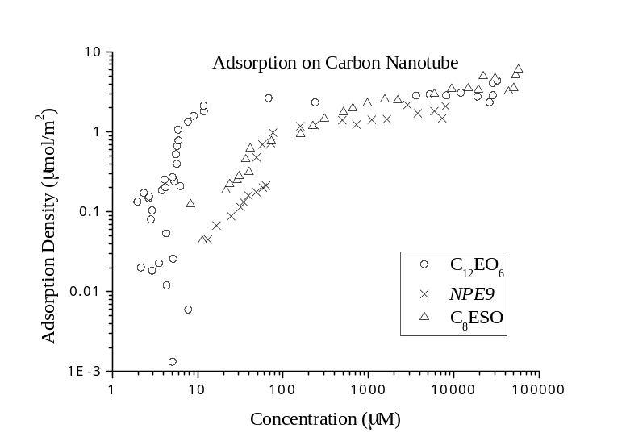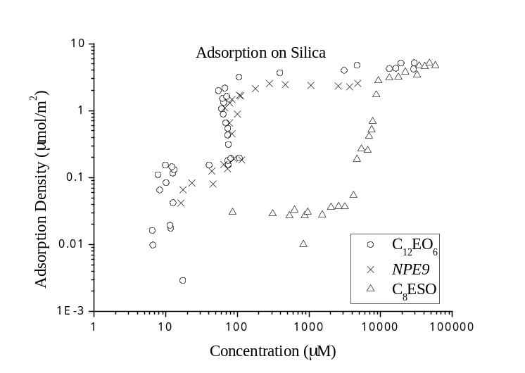
Figure 4-3 Adsorption density of C₈ESO, NPE9 and C₁₂EO₆ on carbon nanotube (top) and silica (bottom)
These adsorption isotherms were further studied by applying a two-step model²⁴, which takes both monomer adsorption and surface micellization into account. The model parameters of the isotherms are presented in Table 4-5.

Table 4-5 Parameters in two-step adsorption model of C8ESO and other nonionic surfactants on two solid surfaces
Substrates | Surfactants | Γ_{m}  (μmol/m²) | k₁ | k₂ | n | ΔG_{m}⁰/RT | ΔG_{sm}⁰/RT
SMW-100 | NPE9 | 1.71 | 1.76×10⁴ | 4.02×10²³ | 6.7 | -9.8 | -8.1
SMW-100 | C₁₂EO₆ | 2.96 | 1.89×10⁵ | 2.06×10⁴¹ | 9.2 | -12.1 | -10.3
SMW-100 | C₈ESO | 4.10 | 1.07×10⁴ | 6.68×10³ | 2.5 | -9.3 | -3.5
Aerosil-300 | NPE9 | 2.34 | 1.53×10⁴ | 1.38×10³² | 9.5 | -9.6 | -7.8
Aerosil-300 | C₁₂EO₆ | 4.15 | 4.95×10⁴ | 1.00×10⁶⁵ | 17.4 | -10.8 | -8.6
Aerosil-300 | C₈ESO | 4.20 | 1.38×10² | 1.24×10²⁶ | 13.6 | -4.4 | -4.9
The saturated adsorption density (Γ_{m}) on both surfaces followed the relationship C₈ESO>C₁₂EO₆>NPE9, which is the reverse trend of a_{min} at the air/water interface. The ethoxylated surfactants have higher adsorption density on silica than carbon nanotubes. Both the standard free energy of monomer adsorption (-ΔG_{m}⁰) and surface micellization (-ΔG_{sm}⁰) followed the sequence C₁₂EO₆>NPE9>C₈ESO on the surfaces. Based on the curves, the slope of the isotherms at both the monomer adsorption and surface micellization regions followed the same trend. -ΔG_{m}⁰ positively correlates with the length of the hydrophobes of the surfactants, and is lower on the hydrophilic surface than the hydrophobic surface for the same surfactant. C₈ESO has the shortest hydrophobe, and C₁₂EO₆ is a more pure compound than NPE9 used in the current study, which explains why -ΔG_{sm}⁰, or the slope of isotherm was ranked as C₁₂EO₆>NPE9>C₈ESO.

Mixtures with anionic surfactants
Table 4-6 presents the molecular interaction parameters between C8ESO and two anionic surfactants, sodium dodecyl sulfate (SDS) and 4-(methylsulfinyl)-2-(dodecyl)butyric acid, sodium salt (C₁₂ESOCOONa). C₁₂ESOCOONa is a sulfoxide-based anionic surfactant reported by Grady et al. in an earlier manuscript.⁵⁰ β^{M} is the interaction parameter in the micelle phase and β^{σ} is the interaction parameter in the liquid-air monolayer. The extended application of the Rubingh’s molecular interaction model^{25a} to the surface monolayer was proposed and done by Rosen and Hua^{25b}. The more negative the β is, the more attractive the surfactants are in this phase. Mixing of both the surfactant pairs favored micelle formation and surface tension reduction based on negative βs. Synergies were stronger, i.e. β was more negative, for micelles vs. the surface monolayer, which is the opposite of most ethylene oxide based surfactants.¹³ This result suggests that loose micelles were formed by C8ESO, where additional hydrophobes can be easily inserted, and in a planar formation there might be less steric effect between the tail groups. The synergy of C₈ESO with C₁₂ESOCOONa was higher than with SDS.
Table 4-6 Molecular interaction parameters between C₈ESO and two anionic surfactants
Surfactants | β^{M} | β^{σ}
C₈ESO/SDS | -1.2 | -0.4
C₈ESO/C₁₂ESOCOONa | -1.9 | -0.1

Cloud Temperature
As shown in Table 4-7, sulfoxide surfactants have no observable cloud temperatures below 75°C, except those of C₈/C₁₀ESO-mix and C₈/C₁₂ESO-mix, which are still higher than NPE9 and comparable to C₁₂EO₇.
Table 4-7 Cloud temperature of sulfoxide surfactants and their mixtures
Sample | Cloud Temperature (°C)
C₆ESO | >75
C₈ESO | >75
C₈/C₁₀ESO-mix | 60
C₈/C₁₂ESO-mix | 57
C8ASO | >75
C₈/C₁₀ASO-mix | >75
C₈/C₁₂ASO-mix | >75
NPE9 | 53
C₁₂EO₇⁵¹ | 58.5
Phase separation at the cloud temperature is explained as a sharp increase in aggregation number,⁵² which happens when the surfactant critical packing parameter⁵³ (V_{H}/l_{c}a₀, where V_{H} is the volume in the micelle core taken by the hydrophobe, l_{c} is the length of the hydrophobe and a₀ is the area occupied by the hydrophilic group at the interface) approaches 1.^{53c} A high cloud point of a nonionic surfactant is attributed to a small critical packing parameter and low aggregation number at room temperature.¹³ The high cloud temperatures of these sulfoxide surfactants were a combination of three factors: straight chain hydrophobic groups, which lead to lower packing parameter; multiple hydrophilic groups in the hydrophilic groups favoring lower aggregation number and the sulfoxide’s high tendency to form hydrogen bonds with water.⁵⁴ Higher cloud temperatures of the sulfoxide based surfactants mean wider operable temperature windows and easier formulation.

Draves wetting test
Table 4-8 presents the Draves wetting performance of the surfactant solutions. C₈ESO and C₈/C₁₀ESO-mix have comparable wetting performance at or above their CMCs as compared to NPE9.
Table 4-8 Draves wetting performance of sulfoxide ester surfactants comparing with SDS and NPE9
Wetting agent | t_{sink} (s)  @ 0.50% | t_{sink} (s)  @ 0.25% | t_{sink} (s)  @ 0.10% | t_{sink} (s)  @ 0.05% | CMC  (wt%)
C₆ESO | >300 | >300 | >300 | >300 | 2.6
C₈ESO | instant | 5 | >300 | >300 | 0.33
C₈/C₁₀ESO-mix | instant | 6 | 8 | >300 | 0.037
C₈/C₁₂ESO-mix | 12 | 21 | 55 | >300 | 0.0032
SDS | instant | 7 | 11 | 68 | 0.23
NPE9 | instant | 7 | 12 | 30 | 0.0092
C₈/C₁₂ESO-mix wetting kinetics were slower than NPE9, and surprisingly even slower than C₈ESO. The observed wetting kinetics are influenced by two factors: a thermodynamic component which is represented by the contact angle (surface tension) of the solution on the substrate and a kinetic component which is represented by the diffusion of the molecules at the wetting front when the surfactants are being depleted.¹³ Since the diffusional kinetics should be determined by smaller molecules in the mixtures, the C₈/C₁₂ESO-mix should have had a similar diffusion constant as C₈ESO alone. The anomaly requires more study. All the sulfoxide surfactants had dramatically slower wetting times when the concentration was lowered from 0.10 wt% to 0.05 wt%. Since the adsorption density was very high due to the low a_{min} of sulfoxide ester surfactants, perhaps a larger number of moles of surfactant vs. the NPE was required to wet the fabric sufficiently to cause it to sink, and hence mass transfer limitations were the fundamental cause of the slower wetting time.

Foaming ability and stability profile

Ross-Miles foaming test
Table 4-9 presents Ross-Miles foaming ability and foam stability of 1.0 wt% aqueous surfactant solutions. C₆ESO presented very low foam, possibly because of its high CMC. C₈ESO created significant foam that dissipated rapidly after 5 min, while all mixtures created and maintained foam well. C₈ESO may have too short a hydrophobe to form a cohesive surface monolayer for foam stabilization.
Table 4-9 Ross-Miles foaming property of sulfoxide surfactants and their mixtures comparing to SDS and NPE9
Sample | Foam Height (mm)
Sample | t=0min | t=5min
C₆ESO | 23 | 2
C₈ESO | 213 | 49
C₈/C₁₀ESO-mix | 206 | 152
C₈/C₁₂ESO-mix | 236 | 198
C₈ASO | 194 | 99
C₈/C₁₀ASO-mix | 219 | 196
C₈/C₁₂ASO-mix | 213 | 158
SDS | 206 | 175
NPE9 | 191 | 162

Foam collapse profile
Figure 4-4 shows the foam collapse profile of 1.0 wt% surfactant water solutions. Foam collapse profiles were fitted with the model described in the experimental section, and the parameters are presented in Table 4-10.
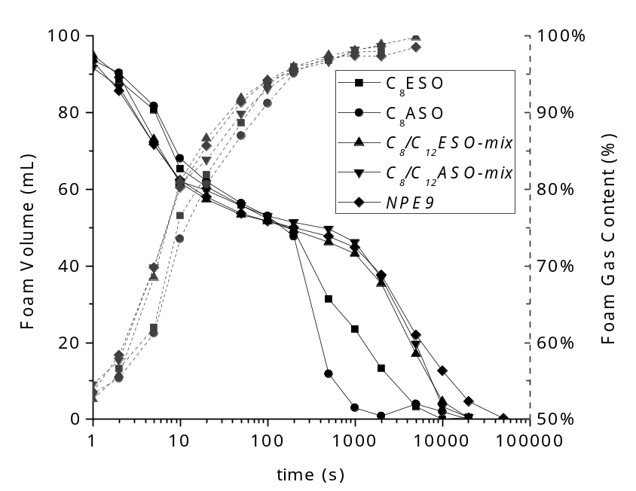
Figure 4-4 Foam collapsing profile: foam volume (solid) and gas content (dashed) in the foam of 1.0 wt% water solutions of C₈ESO, C₈ASO, C₈/C₁₂ESO-mix, C₈/C₁₂ASO-mix and NPE9
The foams decreased in height rapidly in the first 10s due to liquid drainage, and then the decrease slowed. Beyond 10s, the foams dissipated slowly because of gas diffusion through lamellae. The start of diffusion coincided with liquid draining in lamellae effectively ceasing and %gas (see Equation 2-9) stopping increasing. In the initial 100s, the foams of C₈ESO and C₈ASO was higher than those of C₈/C₁₂ESO-mix, C₈/C₁₂ASO-mix and NPE9, and the %gas of the former two foams are smaller than the latter two. The observation that draining of C₈ESO and C₈ASO are slower coincides with Dreger et al.’s work that the surfactants with faster diffusion rates creates higher initial foams in Ross-Miles foaming tests.⁵⁵ Rosen argued that quick diffusion of surfactants to the surface helps to lower the surface tension, and hence maintain the large air-water surface area in the initial foam.¹³
Table 4-10 Parameters of the foam collapse profile of C₈ESO, C₈ASO, C₈/C₁₂ESO-mix, C₈/C₁₂ASO-mix and NPE9
Surfactants | C_{A}  (Diffusion) | K_{A} (×10⁻³ s⁻¹)  (Diffusion) | C_{B}  (Draining) | K_{B} (s⁻¹)  (Draining)
C₈ASO | 0.55 | 4.5 | 0.45 | 0.11
C₈ESO | 0.56 | 0.90 | 0.44 | 0.13
C₈/C₁₂ASO-mix | 0.56 | 0.22 | 0.44 | 0.20
C₈/C₁₂ESO-mix | 0.52 | 0.22 | 0.48 | 0.15
NPE9 | 0.53 | 0.18 | 0.47 | 0.18
Gas diffusion occurred much faster in C₈ESO and C₈ASO foams than in C₈/C₁₂ESO-mix and NPE9, and both the former two foams have higher C_{A} as well. In total, the collapsing rate of the five foams goes in the order: C₈ASO > C₈ESO > C₈/C₁₂ESO-mix ≈ C₈/C₁₂ASO-mix > NPE9, which agrees with the order of K_{A}, or the air diffusion rate. The permeability to air of the lamellae can be related to the arrangement of the surface monolayer and the thickness of the lamellae. C₈ASO and C₈ESO have larger a_{min} and shorter hydrophobic chains, and hence faster gas diffusion in their foams. NPE9 has a large a_{min}, but also larger and more flexible head groups and longer (C₁₂) hydrophobes, which can lead to a tighter and more elastic monolayer. Therefore, the NPE9 foam was the most stable to diffusion. C₈ASO foam presented a much higher diffusion rate than the other surfactants. The difference between amide and ester groups should not be the reason since C₈/C₁₂ESO-mix and C₈/C₁₂ASO-mix presented essentially the same foam collapsing profiles. The outlying behavior of C₈ASO might be due to some trace amount of foam-destabilizing impurities.

Laundry performance
Laundry performance tests were done to evaluate the performance of C₈/C₁₂ESO-mix replacing NPE9 in a liquid laundry formulation. The enzyme containing liquid laundry formulation used in the current study is presented in Table 2-1. The reflectance improvement (ΔR) data of the laundry at 460nm is presented in Table 4-11. Data for the C₈/C₁₂ESO-mix containing formulation was normalized to NPE9 as shown in Figure 4-5 to compare performance between the two surfactants.
Table 4-11 Laundry performance (reflectance improvement at 460nm) of C₈/C₁₂ESO-mix comparing to NPE9
Sample Soil Name | NPE9 | C8/C12ESO-mix
Blood/milk/ink on cotton | 8.5±1.1 | 8.2±0.9
Tea on cotton | 1.4±0.4 | 1.3±0.4
Coffee on cotton | 2.6±0.4 | 3.6±0.4
Grass on cotton | 18.8±1.9 | 19.7±2.8
Wine on cotton | 14.9±0.8 | 15.3±0.6
Lipstick on cotton | 13.5±1.7 | 14.1±1.8
Chocolate drink on cotton | 20.5±2.3 | 19.6±2.2
Blood/milk/ink on PE/C | 8.6±0.7 | 6.1±0.7
Tea on PE/C | 1.7±0.6 | 1.4±0.4
Coffee on PE/C | 3.5±0.4 | 3.3±0.4
Grass on PE/C | 20.1±1.1 | 20.7±1.4
Wine on PE/C | 10.8±0.6 | 10.2±0.5
Lipstick on PE/C | 8.4±1.4 | 6.3±0.7
Chocolate drink on PE/C | 23.2±1.8 | 23.5±1.5
Average | 11.2±1.0 | 11.0±1.1

Figure 4-5 Laundry performance (reflectance improvement at 460nm) of C₈/C₁₂ESO-mix normalized to NPE9
Differences were apparent on some soil/fiber pairs of C₈/C₁₂ESO-mix and NPE9, but on the average, there was essentially no statistical deviation between the performances of the two surfactants. In other words, C₈/C₁₂ESO-mix was a good replacement for NPE9 based on laundry performance data in an enzyme-containing formulation.

Summary
Sulfoxide-based nonionic surfactants derived from 2-hydroxy-4-(methylthio) butyric acid were highly surface active and can be water soluble at room temperature. Unique properties, such as very high cloud temperature, very low surface tension at the CMC, and very low surface area at the solution-air interface were found. These surfactants have good wetting kinetics and their foams dissipate faster than a nonyl-phenol ethoxylate surfactant. These surfactants were synergistic with sodium dodecyl sulfate at the same level with other nonionic surfactants as determined by surface tension measurements. In laundry testing, the performance of the formulation with one of these surfactants was on the average identical to the same formulation with nonyl-phenol ethoxylate surfactant instead.

Nonionic Surfactants with Enhanced Headgroup Hydrophilicity

Surfactants

Nomenclatures
Schematic structures of 2-hydroxy-4-(methylthio) butyric acid, monomer ester sulfoxides (C_{n}ESO), oligomer ester sulfoxides (C_{n}ESO_{m}), ethoxylated ester sulfides (C_{n}EO_{m}ES) and ethoxylated ester sulfoxides (C_{n}EO_{m}ESO) are shown in Figure 5-1.
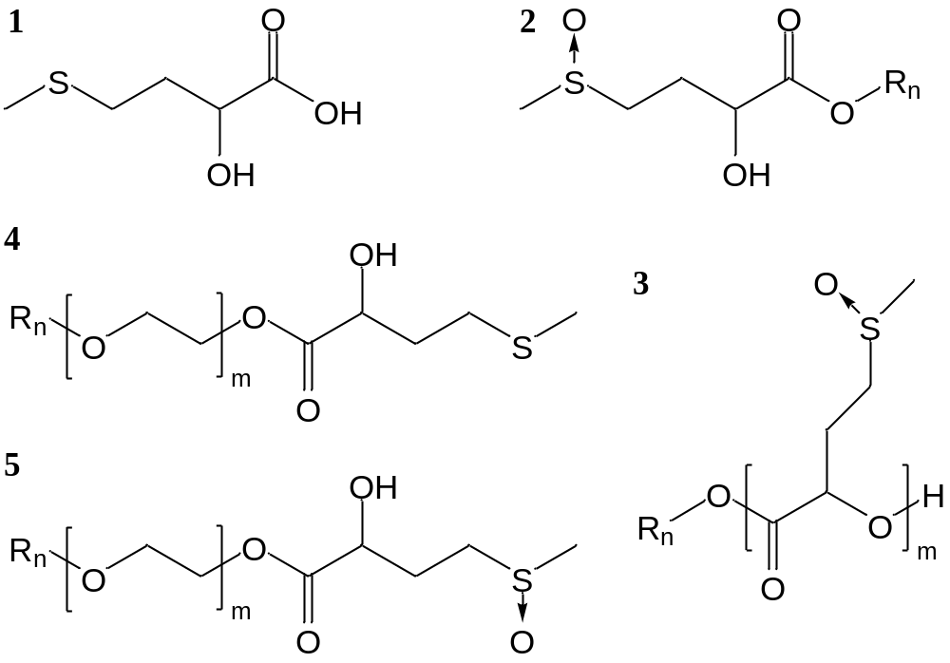
Figure 5-1 Structural comparison of 1. 2-hydroxy-4-(methylthio) butyric acid, 2. monomer ester sulfoxides (C_{n}ESO), 3. oligomer ester sulfoxide (C_{n}ESO_{m}), 4. ethoxylated ester sulfides (C_{n}EO_{m}ES) and 5. ethoxylated ester sulfoxides (C_{n}EO_{m}ESO)

The samples are abbreviated so that the name represents all the functional groups in the surfactant structure. For example, C₁₂EO₄ESO (3,6,9,12-tetraoxatetracosyl 2-hydroxy-4-(methylsulfinyl)butanoate) represents the ester of 2-hydroxy-4-(methylthio) butyric acid reacted with a commercial AE surfactant, tetraoxyethylene lauryl ether, which contains a dodecyl chain (C₁₂), an oligomer with 4 repeating ethylene oxide units (EO₄) followed by partial oxidation of the sulfide moiety. Compounds that consist of essentially more than one molecule, for example, ethoxylated ester sulfoxides (C_{n}EO_{m}ESO), are italicized to distinguish from the compounds that contain a significant distribution of species, for example, all ethoxylated materials.

HPLC
The HPLC were performed in an Agilent 1260 system with acetonitrile as solvent and Dionex Acclaim® Organic Acid (OA 5µm, 120Å, 4 x 150mm) column. In order to confirm the purity of the dimer surfactants after the ion exchange chromatography, the surfactants were dissolved in water and analyzed by HPLC. The purity of the main components were characterized by the peak area.
Table 5-1 Purity of the nonionic surfactants determined by HPLC
Compound | HPLC purity by area %
C₁₂ESO₂ | 94.9
C₁₄ESO₂ | 98.3
C₁₆ESO₂ | 99.3
C₁₈ESO₂ | 99.5
Table 4-3 shows the HPLC determined purity of C₁₂ESO₂, C₁₄ESO₂, C₁₆ESO₂ and C₁₈ESO₂. All the surfactants presented purity level above 98%, except for C₁₂ESO₂ with a 94.9% purity.

Surface chemical properties
Surface tensions are plotted against surfactant concentration in water in Figure 5-2 and Figure 5-3. C₁₈ESO₂ was tested at 35˚C because of an upper critical solution temperature at 32˚C. Surface chemical properties of various surfactants, including CMC, surface tension at CMC (γ_{CMC}), pC20, CMC/C20, surface excess concentration (Γ_{max}) and minimum area per molecule at the interface (a_{min}), were calculated according to the γ vs. log C graphs and presented in Table 5-2.
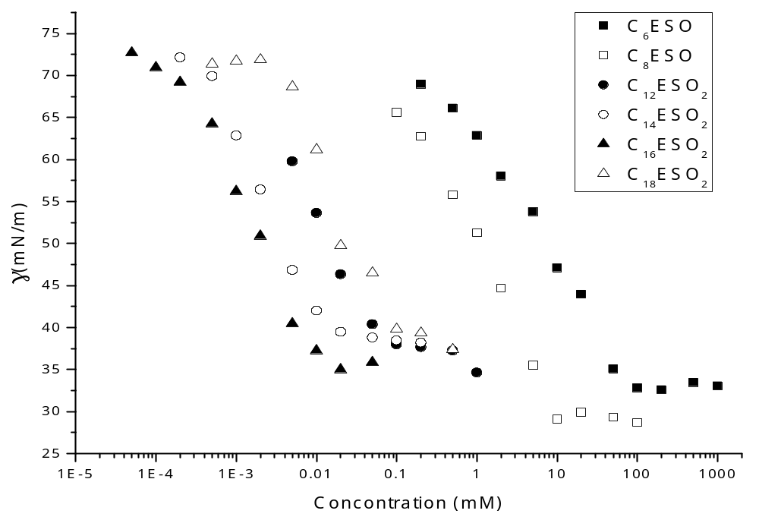
Figure 5-2 Surface tension measurements of monomer and dimer ester sulfoxides (C₁₈ESO₂ measured at 35˚C)

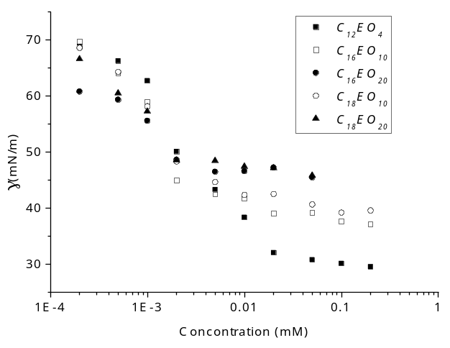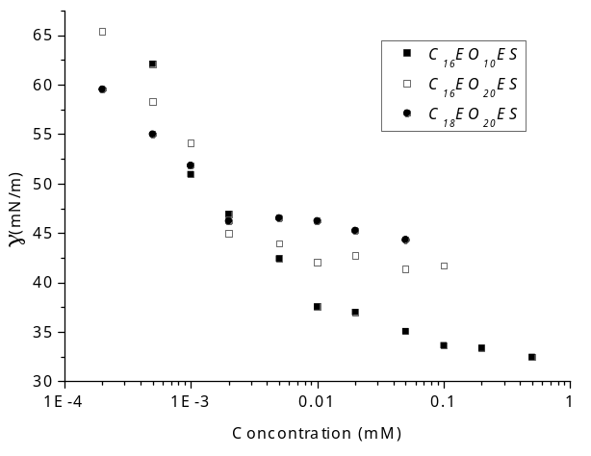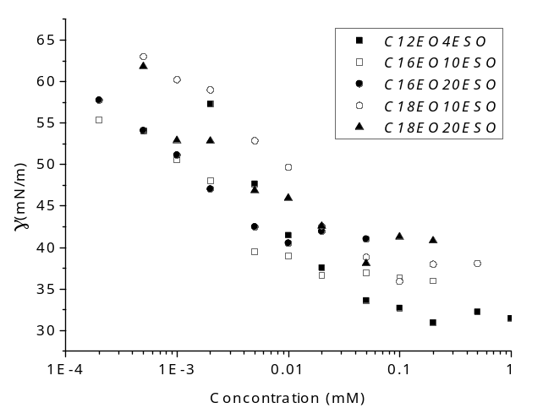
Figure 5-3 Surface tension measurements of ethoxylated ester sulfoxides/sulfides (C_{n}EO_{m}ES/ C_{n}EO_{m}ESO) and commercial ethoxylated alcohols (C_{n}EO_{m})

Table 5-2 Surface chemical properties of monomer/dimer ester sulfoxides, ethoxylated ester sulfides/sulfoxides and commercial nonionic surfactants
Sample | CMC  (mM) | CMC  (wt%) | γ_{CMC}  (mN/m) | pC20 | CMC/C20 | Γ_{max}  (mol/m²) | a_{min}  (Å²)
C₆ESO | 104 | 2.6 | 33 | 2.4 | 23.9 | 2.5×10⁻¹⁰ | 66.9
C₈ESO | 11.7 | 0.33 | 29 | 3.2 | 17.5 | 3.3×10⁻¹⁰ | 50.8
C₁₂ESO₂ | 0.050 | 0.0024 | 38 | 5.0 | 4.7 | 3.9×10⁻¹⁰ | 42.4
C₁₄ESO₂ | 0.0083 | 0.00043 | 41 | 6.0 | 3.1 | 4.0×10⁻¹⁰ | 41.3
C₁₆ESO₂ | 0.0073 | 0.00040 | 37 | 5.8 | 4.7 | 4.1×10⁻¹⁰ | 40.7
C₁₈ESO₂ (35˚C) | 0.023 | 0.0013 | 41 | 6.0 | 2.6 | 4.7×10⁻¹⁰ | 35.6
C₁₂EO₄ | 0.018 | 0.00065 | 32 | 5.7 | 8.3 | 3.9×10⁻¹⁰ | 43.1
C₁₂EO₄ESO | 0.039 | 0.0020 | 33 | 5.5 | 11.7 | 3.2×10⁻¹⁰ | 51.1
C₁₆EO₁₀ | 0.013 | 0.00092 | 41 | 5.6 | 5.4 | 2.8×10⁻¹⁰ | 59.7
C₁₆EO₁₀ES | 0.019 | 0.0015 | 37 | 6.0 | 14.4 | 2.3×10⁻¹⁰ | 72.2
C₁₆EO₁₀ESO | 0.029 | 0.0024 | 37 | 5.5 | 9.7 | 2.8×10⁻¹⁰ | 59.9
C₁₆EO₂₀ | 0.0031 | 0.00035 | 48 | 5.8 | 2.1 | 2.4×10⁻¹⁰ | 69.9
C₁₆EO₂₀ES | 0.0057 | 0.00073 | 43 | 6.2 | 8.7 | 1.9×10⁻¹⁰ | 89.5
C₁₆EO₂₀ESO | 0.016 | 0.0021 | 41 | 5.8 | 2.8 | 2.1×10⁻¹⁰ | 79.0
C₁₈EO₁₀ | 0.018 | 0.0013 | 40 | 5.6 | 7.4 | 2.6×10⁻¹⁰ | 64.8
C₁₈EO₁₀ESO | 0.020 | 0.0014 | 41 | 5.5 | 6.1 | 2.5×10⁻¹⁰ | 67.0
C₁₈EO₂₀ | 0.0094 | 0.0011 | 46 | 5.6 | 3.3 | 2.0×10⁻¹⁰ | 82.6
C₁₈EO₂₀ES | 0.0086 | 0.0011 | 45 | 6.0 | 9.2 | 1.4×10⁻¹⁰ | 115.2
C₁₈EO₂₀ESO | 0.018 | 0.0024 | 42 | 5.7 | 8.9 | 1.9×10⁻¹⁰ | 89.3
NPE9 | 0.038 | 0.0038 | 33 | 5.8 | 26.5 | 2.1×10⁻¹⁰ | 79.4
The monomer and dimer sulfoxides followed Traube’s rule⁴⁹ in that every two additional hydrocarbon units decrease the CMC or C20 by an order of magnitude. However, the CMC and C20 of dimer ester sulfoxide surfactants stops decreasing when C₁₆ is reached (e.g. compare C₁₆ESO₂ and C₁₄ESO₂). Such result agrees with Greiss’ results that when hydrocarbon chain length exceeds a certain value the CMC or C20 stops decreasing⁵⁶; a later study attributed the behavior in linear alkane surfactants to hydrocarbon chains longer than 18 units starting to coil.⁵⁷ However, CMC and C20 of dimer ester sulfoxide surfactants stops decreasing at C₁₆, probably because these surfactants have some extra hydrocarbon units in the hydrophilic headgroup. The γ_{CMC} of the dimer ester sulfoxides are larger than monomer ester sulfoxides, presumably because the large size of the dimer headgroup limits packing effectiveness at the water/air interface. The C_{n}ESO₂ surfactants have very low CMC/C20, or high micelle formation tendency. The a_{min} of the dimers are quite low compared to the ethoxylated surfactants, suggesting that the dimer sulfoxides are still more compactly packed compared with the ethylene oxide oligomers.
CMCs of the ethoxylated ester sulfoxides are larger than the corresponding ethoxylated ester sulfides and alcohol ethoxylate surfactants because the additional sulfoxide group makes the molecules more hydrophilic. The difference is most considerable between C₁₂EO₄ESO and C₁₂EO₄ compared to the other molecules in the current study, because, as the number of EO molecules increases, the addition of a sulfoxide has a lower relative impact on the hydrophilicity. Similar to C_{n}ESO₂, the change from C₁₆ to C₁₈ has little effect on the CMC and pC20 for the ethoxylated ester sulfoxides. γ_{CMC} increases with the number of EO groups in C_{n}EO_{m}ES, C_{n}EO_{m}ESO and C_{n}EO_{m}, due to increased hydrophilic head group size. The CMC/C20 value, or the tendency of micelle formation decreased with increasing hydrocarbon number, or with decreasing number of EO groups in C_{n}EO_{m}ES, C_{n}EO_{m}ESO and C_{n}EO_{m}, which is probably because the shape of the surfactants became more favorable for spherical micelles. For C_{n}EO_{m}ES, C_{n}EO_{m}ESO and C_{n}EO_{m}, Γ_{m} decreased while the number of EO groups increased, because of the increased hydrophile size. As a result, a_{min} increased with increasing EO number.

Upper and lower critical solution temperatures
The upper critical solution temperature (UCST) and the lower critical solution temperature (LCST) of 1.0 wt% water solutions of the C_{n}ESO, C_{n}ESO₂ and C_{n}EO_{m}ESO are presented in Table 5-3 in comparison with commercial AE surfactants, NPE9 and SDS.
Table 5-3 LCST/UCST of 1.0 wt% aqueous solutions of ester sulfoxide monomers, dimers, ester sulfides/sulfoxides of ethoxylated alcohols and other nonionic surfactants
Samples  (1.0 wt%) | Lower critical  solution temperature (°C) | Upper critical  solution temperature (°C)
C₆ESO | <4 | >75
C₈ESO | <4 | >75
C₁₂ESO₂ | <4 | >75
C₁₄ESO₂ | <4 | >75
C₁₆ESO₂ | 21 | >75
C₁₈ESO₂ | 32 | >75
C₁₂EO₄ES | Insoluble | Insoluble
C₁₂EO₄ESO | <4 | >75
C₁₂EO₄ | <4 | >75
C₁₆EO₁₀ES | 23 | 40
C₁₆EO₁₀ESO | 16 | >75
C₁₆EO₁₀ | 42 | 55
C₁₆EO₂₀ES | <4 | >75
C₁₆EO₂₀ESO | <4 | >75
C₁₆EO₂₀ | <4 | >75
C₁₈EO₁₀ES | Insoluble | Insoluble
C₁₈EO₁₀ESO | <4 | >75
C₁₈EO₁₀ | 49 | 61
C₁₈EO₂₀ES | <4 | >75
C₁₈EO₂₀ESO | <4 | >75
C₁₈EO₂₀ | <4 | >75
Sodium Dodecyl Sulfate | 22 | N/A
NPE9 | <4 | 53
The monomer and dimer ester sulfoxide surfactants with hydrophobes below hexadecyl do not have measurable UCST/LCST between 4˚C and 75˚C. C₁₆ESO₂ and C₁₈ESO₂ presented UCST at 21˚C and 32˚C, respectively. Longer hydrocarbon chains lead to higher UCST because of stronger hydrophobicity. C₁₆EO₁₀ and its corresponding ester sulfides/sulfoxides have UCST of 42˚C, 26˚C and 16˚C, respectively. C₁₈EO₁₀ presented UCST of 49˚C, but C₁₈EO₁₀ESO has no observable UCST above 4˚C. The ester sulfoxide/sulfide groups lowered the UCST probably because these groups introduced a branch into the headgroup structure and made the formation of a surfactant-rich phase less desirable. The LCST, or the cloud temperature, is related to the weakening of hydrogen bonds from increased temperatures. Two commercial AE surfactants, C₁₆EO₁₀ and C₁₈EO₁₀ had LCST below 75˚C. The C_{n}EO_{m}ES generally have lower LCST than their corresponding AEs, indicating that the ester sulfide group lowers the average hydrogen bonding tendency of the molecules. In other words, ester sulfide groups are more hydrophobic than the EO group. The corresponding C_{n}EO_{m}ESO surfactants, however, presented higher LCST, meaning these surfactants are more hydrophilic than molecules with just EO units, which is to be expected since the sulfoxide groups have very high hydrogen bonding tendency.⁵⁴

Draves wetting test
Table 5-4 presents Draves wetting test results for C_{n}ESO and C_{n}EO_{m}ESO compared with NPE9.
Table 5-4 Draves wetting performance of ethoxylated ester sulfides/sulfoxides and other nonionic surfactants
Wetting agent | t_{sink} (s)  @ 0.50% | t_{sink} (s)  @ 0.25% | t_{sink} (s)  @ 0.10% | t_{sink} (s)  @ 0.05% | γ_{CMC}  (mN/m)
C₈ESO | instant | 5 | >300 | >300 | 29
NPE9 | instant | 7 | 12 | 30 | 33
C₁₂EO₄ESO | 8 | 10 | 18 | 50 | 33
C₁₆EO₁₀ESO | 110 | 98 | >300 | >300 | 37
C₁₆EO₁₀ES | 46 | 56 | 124 | >300 | 37
C₁₆EO₂₀ESO | >300 | >300 | >300 | >300 | 43
The C_{n}EO_{m}ES/C_{n}EO_{m}ESO wetted the skeins slowly, except for C₁₂EO₄ESO which has a comparable wetting kinetics with NPE9. The wetting performance of these surfactants at 0.50 or 0.25 wt% correlated with their surface tension at the CMC very well; a lower surface tension yielded faster wetting kinetics. The molecular weight of the sulfoxide molecules are significantly larger than that of the NPE, which in turn should lead to a lower diffusion coefficient and slower wetting.

Foaming ability and stability profile

Ross-Miles foaming test
Ross-Miles foaming results of C_{n}ESO and C_{n}EO_{m}ESO at 1 wt% are presented in Figure 5-4, in comparison with NPE9 and a commercial low-foaming alcohol alkoxylate surfactant (AE-LF).
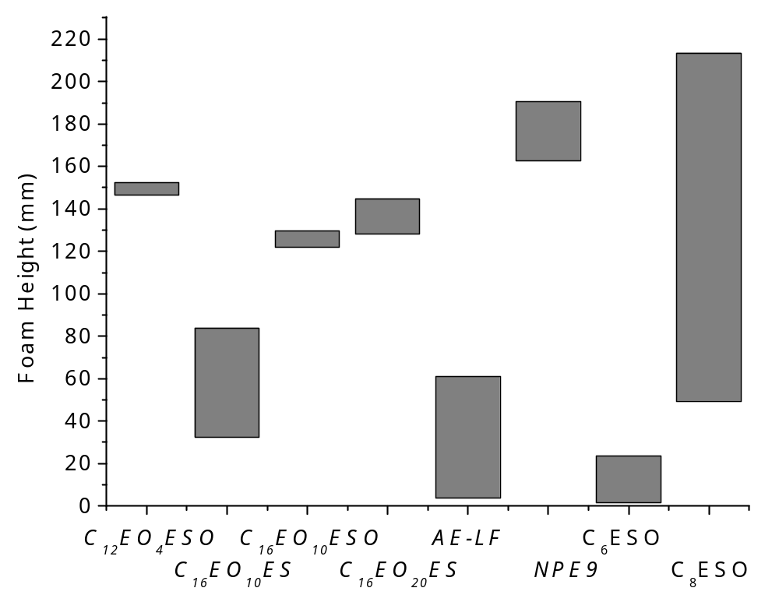
Figure 5-4 Ross-Miles foaming performance of ethoxylated ester sulfoxides/sulfides and monomer ester sulfoxides comparing with various nonionic surfactants (AE-LF is a low-foaming AE surfactant). The top of the bar represents foam height at time=0, while the bottom represents foam height at time=5 min.
NPE9 has the second highest initial foam and the highest foam after 5 min. AE-LF had a low initial foam (61mm) and minimal foam after 5 min (2mm). C₆ESO has very low initial foam (23mm) which completely disappeared after 5 min, probably because the surfactant concentration is below the CMC. C₈ESO created high foam initially, which dissipated very quickly, indicating a weakly packed surface monolayer. C₁₂EO₄ESO, C₁₆EO₁₀ESO and C₁₆EO₂₀ESO solutions created quite high and persistent foams, indicating that these surfactants forms quite cohesive surface. C₁₆EO₁₀ES created a small foam (84mm) which dissipated quite quickly within 5 min (32mm). The initial and dissipated foam of C₁₆EO₁₀ES is lower than all the surfactants except AE-LF and C₆ESO. The comparison between C_{n}EO_{m}ESO and C_{n}EO_{m}ES suggests that ethoxylated ester sulfoxides created more cohesive surface than ethoxylated ester sulfides.

Foam collapse profile
The foaming ability of selected surfactants was further studied with foam collapse profile. Figure 5-5 shows the foam collapse profile of 1.0 wt% surfactant water solutions. Foam collapse profiles were fitted with the model described in the experimental section, and the parameters are presented in Table 5-5.
Table 5-5 Parameters of the foam collapse profile of various C_{n}EO_{m}ES, C_{n}EO_{m}ESO and C_{n}EO_{m} in comparison with two nonionic surfactants
Surfactants  (1.0 wt%) | C_{A}  (Diffusion) | K_{A} (×10⁻³ s⁻¹)  (Diffusion) | C_{B}  (Draining) | K_{B} (s⁻¹)  (Draining)
C₁₂EO₄ESO | 0.50 | 0.23 | 0.50 | 0.13
C₁₆EO₁₀ES | 0.57 | 1.2 | 0.43 | 0.22
C₁₆EO₁₀ESO | 0.54 | 0.11 | 0.46 | 0.16
C₁₆EO₂₀ | 0.56 | 0.16 | 0.44 | 0.16
C₁₆EO₂₀ES | 0.56 | 0.85 | 0.44 | 0.16
C₁₆EO₂₀ESO | 0.56 | 0.13 | 0.44 | 0.15
AE-LF | 0.92 | 53 | 0.08 | 0.15
NPE9 | 0.53 | 0.18 | 0.47 | 0.18

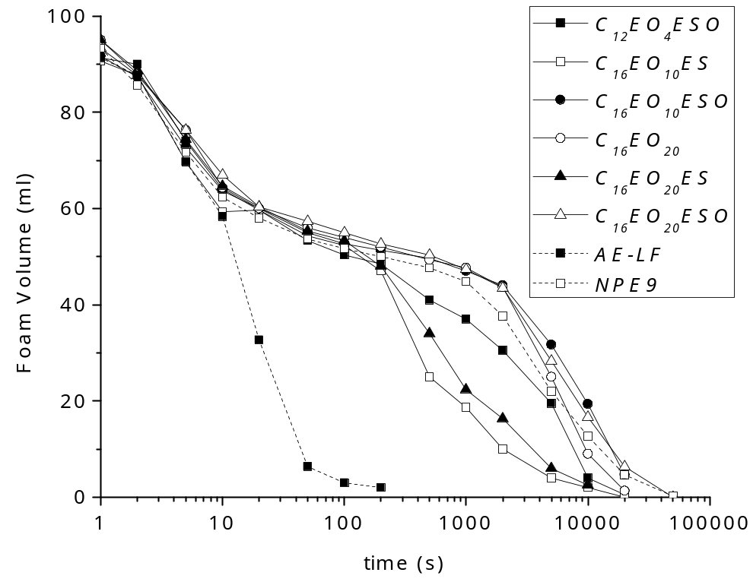
Figure 5-5 Foam collapse profile in the foam of 1.0 wt% water solutions of various C_{n}EO_{m}ES, C_{n}EO_{m}ESO and C_{n}EO_{m} in comparison with two nonionic surfactants (AE-LF and NPE9)
The foams decreased in height rapidly in the first 10s due to liquid drainage which then slowed down. Then the foams dissipates slowly because of gas diffusion through lamellae. All the foam draining profiles in the initial 10s coincided, except for C₁₆EO₁₀ES and AE-LF. These two surfactants presented the fastest diffusion in their foams, which may became significant in the initial 10s while the rest of the samples still had little or no diffusion.
Air diffusion occurred the fastest within AE-LF, C₁₆EO₁₀ES and C₁₆EO₂₀ES foams than the others. The AE-LF diffusion was the fastest. In general, the collapsing rate of the eight foams goes in the order: AE-LF > C₁₆EO₁₀ES > C₁₆EO₂₀ES > C₁₂EO₄ESO > NPE9 > C₁₆EO₂₀ > C₁₆EO₂₀ESO ≈ C₁₆EO₁₀ESO, which is reflected by K_{A} or the air diffusion rate. AE-LF presented the fastest dissipating foam. The permeability to air of the lamellae is correlated with the arrangement of the surface monolayer and the thickness of the lamellae. Therefore, the longer the hydrophobes are, the slower the C_{n}EO_{m}ESO foams collapsed. Another reason for AE-LF to have very unstable foam is that its cloud point is below room temperature (16-21˚C), and the separated surfactant phase can perform as a foam breaker.
Another observation is that the C_{n}EO_{m}ES foams presented much higher diffusion rate than C_{n}EO_{m}ESO, C_{n}EO_{m} and NPE9. In contrast to the traditional lipophilic-hydrophilic surfactants, these lipophilic-hydrophilic-lipophilic (LHL) or hydrophilic-lipophilic-hydrophilic (HLH) molecules occupy a larger area at the surface and form an incoherent film, as illustrated in Figure 5-6. Similar low-foaming polymers have been reported previously.⁵⁸
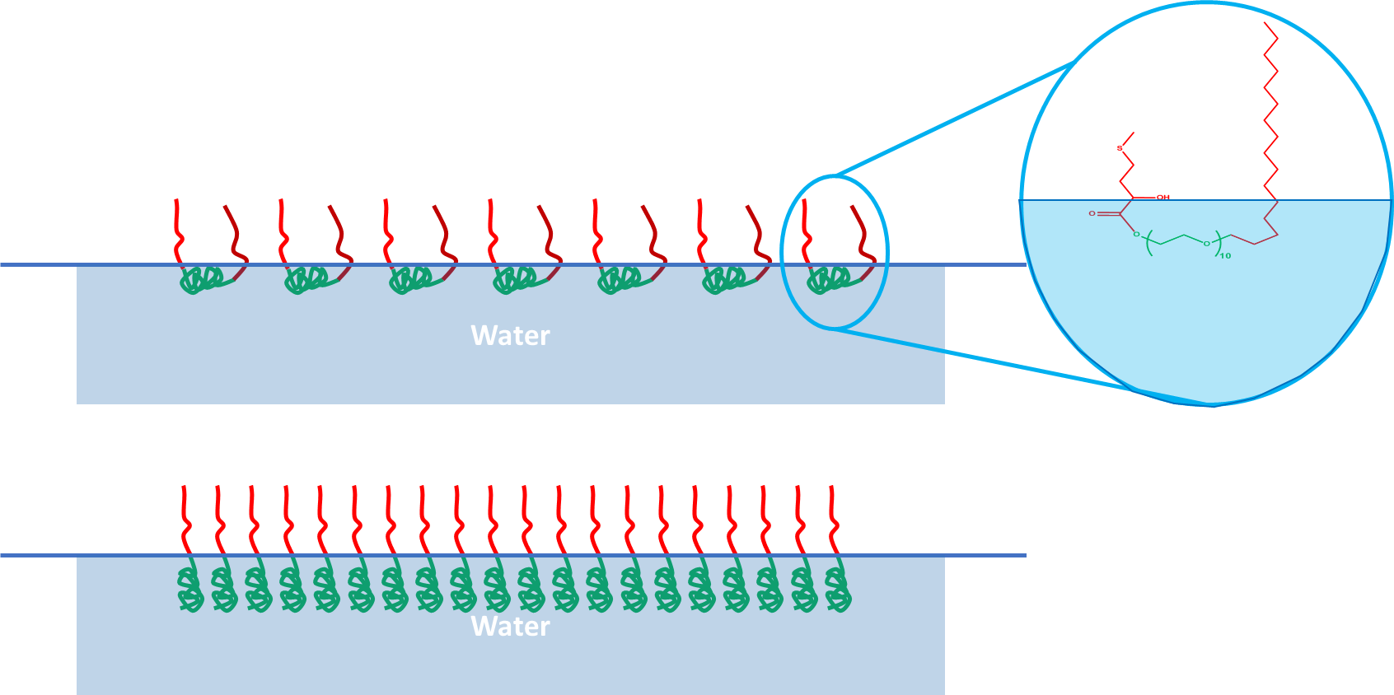
Figure 5-6 Illustration of proposed surface arrangement with higher surface area of LHL surfactant (top) and conventional LH surfactants (bottom), with the unoxidized C_{n}EO_{m}ES (C₁₆EO₁₀ES) structure in the zoom-in
The C_{n}EO_{m}ES molecules are LHL type structures because the unoxidized methylthio-butyl (S) group is hydrophobic. During the previous studies, we found that unoxidized sulfide ester had much lower solubility than sulfoxides. Hence, the ES groups in the C_{n}EO_{m}ES surfactants prefer to reside in the hydrophobic phase causing an LHL structural form and hence fast gas diffusion.

Laundry performance
The formulation given in Table 2-1 was used to determine the performance of the nonionic surfactants as the nonionic component of a standard laundry formulation with enzymes and flourescers. Our concern was that the sulfoxide might affect the efficacy of these agents so we wanted to be sure to include those in the formulation.
Table 5-6 presents the reflectance improvement (∆R) at 460 nm as the laundry efficiency data of the soiled fabrics washed with the formula containing C₁₂EO₄ESO or NPE9. The laundry efficiency data in Table 5-6 of C₁₂EO₄ESO were normalized against NPE9 and presented in Figure 5-7.
Comparing to NPE9, C₁₂EO₄ESO performed better on blood/milk/ink, tea and lipstick (only on cotton), less efficient on coffee, and within statistical error on other soils. On average, C₁₂EO₄ESO and NPE9 performed equally well statistically.
Table 5-6 Laundry performance of C₁₂EO₄ESO compared with NPE9
Soil Sample Name | Reflectance Improvement (∆R)
Soil Sample Name | NPE9 | C₁₂EO₄ESO
Blood/milk/ink on cotton | 9.3±1.1 | 15.7±2.0
Tea on cotton | 1.0±0.4 | 1.3±0.6
Coffee on cotton | 3.0±0.6 | 1.7±0.4
Grass on cotton | 18.8±2.7 | 17.9±2.5
Wine on cotton | 24.1±0.6 | 19.7±0.7
Lipstick on cotton | 13.8±1.8 | 18.1±2.8
Chocolate drink on cotton | 20.5±2.3 | 20.0±1.9
Blood/milk/ink on PE/C | 11.1±1.0 | 15.2±2.9
Tea on PE/C | 2.0±0.7 | 3.3±1.6
Coffee on PE/C | 4.9±0.9 | 2.6±0.6
Grass on PE/C | 26.3±1.7 | 25.8±1.8
Wine on PE/C | 18.6±0.9 | 17.7±0.8
Lipstick on PE/C | 8.5±2.1 | 8.3±1.2
Chocolate drink on PE/C | 29.2±1.9 | 25.8±2.8
Average | 13.7±1.5 | 13.8±1.8

Figure 5-7 Laundry performance of C₁₂EO₄ESO normalized to NPE9

Summary
Sulfoxide/sulfide-based surfactants were synthesized from 2-hydroxy-4-(methylthio) butyric acid with an oligomeric headgroup or in combination with EO groups. C_{n}ESO₂ surfactants have high water solubility, very low CMC and low surface tension at CMC, and low surface area at the water-air interface. C_{n}EO_{m}ESO have good water solubility, low CMC, and good Draves wetting kinetics. C_{n}EO_{m}ES solutions made foams which dissipated very fast. In an enzyme-containing laundry formulation, the performance of the formulation containing C₁₂EO₄ESO as the nonionic surfactant was statistically the same to the performance of the formulation containing a commercial nonyl-phenol ethoxylate surfactant.

Microemulsions Based on Sulfoxide Surfactants

Phase behavior
Phase transition temperatures (T_{I/III} and T_{III/II}) of the sulfoxide surfactants/water/oil systems are presented in Table 6-1. Please note that the EACN for the aromatic oils and the cyclic alkanes are obtained from previous microemulsion studies, and the apparent EACN values of these oils may vary with different surfactants.²¹
Table 6-1 T_{I/III} and T_{III/II} of C_{n}ESO with various oils
Surfactants | Oils | EACN | T_{I/III} (˚C) | T_{III/II} (˚C)
C₈ESO (3%) | Xylenes | 1~2 | <0 | 1
C₈ESO (3%) | Trimethylbezene | 1~3 | <0 | 34
C₈ESO (3%) | Diethylbenzene | 2~4 | 25 | 74
C₈ESO (3%) | Cyclohexane | 2.2⁵⁹ | 49 | >80
C₁₀ESO (3%) | Diethylbenzene | 2~4 | <0 | 6
C₁₀ESO (3%) | Cyclohexane | 2.2 | 14 | 25
C₁₀ESO (2%) | Methylcyclohexane | 3.2⁵⁹ | 20 | 70
C₁₀ESO (2%) | Ethylcyclohexane | 3.8⁶⁰ | 29 | >80
C₁₀ESO (2%) | Propylcyclohexane | 5.6⁶⁰ | 45 | >80
C₁₀ESO (5%) | n-Hexane | 6 | 37 | >80
C₁₀ESO (5%) | n-Heptane | 7 | 45 | >80
C₁₀ESO (3%) | n-Octane | 8 | 48 | >80
C₁₂ESO (1%) | n-Hexane | 6 | 14 | 16
C₁₂ESO (1%) | n-Heptane | 7 | 18 | 22
C₁₂ESO (1%) | n-Octane | 8 | 28 | 31
C₁₂ESO (1%) | n-Nonane | 9 | 30 | 36
C₁₂ESO (1%) | n-Decane | 10 | 41 | 46
Type III microemulsions are formed with these systems within the temperature range of 0-80˚C. The T_{I/III} and T_{III/II} increase with reducing surfactant hydrophobe length and increasing EACN of oils. The sulfoxide surfactants behave similarly to nonionic surfactants because the emulsion phase behaviors are sensitive to temperature. Most of the T_{I/III} and T_{III/II} are within the measurable range of 0-80˚C, but some of the emulsions do not see phase transitions within this range. These data cannot precisely determine the PITs because a. the determination of T_{I/III} and T_{III/II} is based on visual observation, and b. it is impossible to obtain the middle point of T_{I/III} and T_{III/II} if T_{I/III} or T_{III/II} is outside the measurement range.

Interfacial tension
The oil/water IFT vs. temperature curves of C₁₀ESO/C₁₂ESO-alkanes are presented in Figure 6-1. All curves showed concave shapes with a minimum IFT at the PIT. PITs and the minimum IFTs of these microemulsions are presented in Table 6-2. The IFT of these systems are in the ultralow range (<10⁻²mN/m), therefore having very high solubilization ratio according to Chun Huh relationship³¹. PITs increase with increasing EACN for both C₁₀ESO and C₁₂ESO microemulsions. Comparing to C₁₂ESO, C₁₀ESO was able to emulsify oils with lower EACN with a similar PIT (C₁₂ESO/n-octane vs. C₁₀ESO/methylcyclohexane), which means that PIT decrease with increasing hydrophobe size of the surfactant. The change of PIT with varied hydrophobe length and EACN agreed with the behaviors of EO-type nonionic surfactants in microemulsions.¹⁷⁻¹⁸

Figure 6-1 IFT vs. temperature graphs of C₁₀ESO (top) and C₁₂ESO (bottom) with various alkanes

Table 6-2 PITs and minimum IFTs of C₁₂ESO with various alkanes
Surfactants | Oils | EACN | PIT (˚C) | IFT_{min} (mN/m)
C₁₀ESO | Cyclohexane | 2.2 | 21.1 | 1.6×10⁻³
C₁₀ESO | Methylcyclohexane | 3.2 | 27.8 | 2.3×10⁻³
C₁₀ESO | Ethylcyclohexane | 3.8 | 40 | 2.1×10⁻³
C₁₀ESO | Propylcyclohexane | 5.6 | 50 | 9.3×10⁻³
C₁₂ESO | n-Hexane | 6 | 15.0 | 1.0×10⁻³
C₁₂ESO | n-Heptane | 7 | 18.9 | 2.3×10⁻⁴
C₁₂ESO | n-Octane | 8 | 30.0 | 7.5×10⁻⁴
C₁₂ESO | n-Nonane | 9 | 35.0 | 3.3×10⁻⁴
C₁₂ESO | n-Decane | 10 | 43.9 | 5.8×10⁻⁴

HLD model parameters

Parameters from PIT vs. EACN scan
When S=0 and f(A)=0, the HLD model presented in Chapter 2 was simplified to obtain:
 | $$EACN={c_{T}}/K∙\left(PIT-25\right)+σ/K$$ | Equation 6-1
Therefore, by doing a simple linear regression of the PIT vs. EACN data, one can obtain the HLD parameters c_{T}/K and σ/K. Hence, PIT vs. EACN data C₁₀ESO and C₁₂ESO in comparison with various AE surfactants by Sottman and Strey¹⁷ are fitted with lines as presented in Figure 6-2.

Figure 6-2 EACN vs. PIT curves for C₁₀ESO and C₁₂ESO in comparison with various AE surfactants by Sottman and Strey
From the linear regression, the value of c_{T}/K and σ/K of C₁₀ESO and C₁₂ESO can be obtained, as presented in Table 6-3, in comparison with AE surfactants.
Both the sulfoxide surfactants presented lower c_{T}/K than the AE surfactants, which means their PITs are more sensitive to a change in EACN. However, the temperature sensitivity of the surfactants cannot be determined, since the K parameter might be the source of the sensitivity of PIT to EACN. σ/K has been termed the “optimum EACN”, the optimum EACN is the EACN of the oil that forms an optimum microemulsion with the lowest IFT with this surfactant at T=25˚C in pure water. Further, Salager reported that for EO-type nonionic surfactants, ${∂(σ/K)}/{∂N_{C,S}}=2.25$; for sulfoxides, this number is 2.44, which is quite close to those of EO-type surfactants.

Table 6-3 HLD parameters of C₁₀ESO and C₁₂ESO compared with three AE surfactants¹⁷
Surfactants | $${c_{T}}/K$$ | $$σ/K$$
C₁₀ESO | 0.11 | 2.6
C₁₂ESO | 0.13 | 7.5
C₈EO₃ | 0.36 | 11.2
C₁₀EO₄ | 0.37 | 8.1
C₁₂EO₅ | 0.36 | 5.1

K parameter
The following equation is true assuming K is constant for a surfactant class:
 | $$K=\frac{{∂σ}/{∂N_{C,S}}}{{∂(σ/K)}/{∂N_{C,S}}}$$ | Equation 6-2
Equation 2-11 gives the value of the numerator in Equation 6-2 equal to 0.28 for hydrocarbon based nonionic surfactants. Assuming this value is the same for sulfoxide surfactants, then K of sulfoxide based surfactants and alkanes systems is equal to 0.28/2.44=0.11, and hence the values of c_{T} and σ can be calculated, as presented in Table 6-4 (K_{AEs}=0.17³⁵). The emulsion temperature sensitivity is a measure of how much temperature needs to be changed in order to adjust for a change in oil hydrophobicity, a lower temperature sensitivity means more temperature change is needed for a given change in hydrophobicity. The emulsion temperature sensitivity (c_{T}) of the sulfoxide surfactants is significantly lower than that of the AE surfactants, which is in compliance with the high cloud temperature of this surfactant family, possibly because of the strong hydrogen bonding of the sulfoxide group with water. Based on σ, the indicator of surfactant hydrophobicity at 25˚C with no added salt, C₁₂ESO (σ=0.86) is almost equally hydrophobic to C₁₂EO₅ (σ=0.87), indicating that 1 ester sulfoxide (ESO) unit is as hydrophilic as 5 EO groups. Similar comparison can be done between C₁₀ESO (σ=0.30) and C₁₀EO₄ (σ=1.4), that 1 ester sulfoxide (ESO) unit is more hydrophilic than 4 EO groups.
Table 6-4 c_{T} and σ of C₁₀ESO and C₁₂ESO compared with three AE surfactants¹⁷
Surfactants | c_{T} | σ
C₁₀ESO | 0.012 | 0.30
C₁₂ESO | 0.015 | 0.86
C₈EO₃ | 0.061 | 1.9
C₁₀EO₄ | 0.063 | 1.4
C₁₂EO₅ | 0.061 | 0.87

Summary
Middle phase microemulsions were produced with water solutions of sulfoxide based surfactants and hydrocarbon oils without added salt. The PITs were screened with temperature scan of phase behaviors and determined with IFT measurements. Ultralow water/oil IFT as low as 10⁻⁴mN/m were obtained with such systems. The PIT data were fitted with the HLD model to obtain the parameters such as characteristic curvature and temperature sensitivity. Based on microemulsion behavior, 1 sulfoxide ester moiety was found to be equally hydrophilic as 5 EO groups.

Conclusions and Future Work

Hydrophilicity of the Sulfoxide Ester Units
Hydrophilicity of a headgroup unit can be determined from its effect on the surfactant properties, such as CMC, solubility, cloud point, and microemulsion test. An interesting question for the researchers is how many equivalent EO groups is one ESO group in terms of hydrophilicity. At the end of Chapter 6, the hydrophilicity of the ESO unit was discussed according to the microemulsion studies. It was found that each ESO unit is as hydrophilic as 5 EO groups in AE surfactants in terms of microemulsion behavior. The CMC, solubility and cloud point of the sulfoxide based surfactants are summarized and compared to AE surfactants in Table 7-1. The CMCs seem to be varying significantly with hydrophobes, and very slightly with number of EO groups in the headgroup. Therefore, CMC is not a good variable for comparing the hydrophilicity of ESO and EO. Cloud point, on the other hand, presented a much more obvious change with the number of EO groups. C₆ESO has a cloud point higher than C₆EO₅ and C₈ESO has a cloud point higher than C₈EO₆. When comparing the ESO dimers, C₁₆ESO₂ presented higher cloud point than C₁₆EO₈, and possibly than C₁₆EO₁₂, too. What is quite the contrary is that C₁₀ESO and C₁₂ESO presented lower cloud point than C₁₀EO₄ and C₁₀EO₄, respectively. As discussed in Chapter 4, cloud point is not only affected by the hydrophilicity, but also by the shape of the molecules, which is the possibly the reason for the sudden drop of cloud point from C₈ESO to C₁₀ESO. In summary, based on cloud point, one ESO group is as hydrophilic as 3-6 EO groups, which agrees with the microemulsion results.
Table 7-1 CMC and cloud point of monomer/dimer ester sulfoxides and ethoxylated alcohols
Sample | CMC  (mM) | Cloud Point  (˚C)
C₆ESO | 104 | >75
C₈ESO | 11.7 | >75
C₁₀ESO | 0.59* | <4
C₁₂ESO | 0.060* | <4
C₁₂ESO₂ | 0.050 | >75
C₁₄ESO₂ | 0.0083 | >75
C₁₆ESO₂ | 0.0073 | >75
C₆EO₃ | 90⁶¹ | 37⁶²
C₆EO₅ | 90⁶¹ | 75⁶²
C₆EO₆ | 70⁶³ | 83⁶²
C₈EO₄ | 8⁶³ | 35.5⁶²
C₈EO₆ | 9.9⁶¹ | 68⁶⁴
C₁₀EO₄ | 0.68⁶⁵ | 21⁶⁶
C₁₀EO₅ | 0.76⁶⁷ | 44⁶⁶
C₁₀EO₆ | 0.90⁶¹ | 60⁶²
C₁₂EO₄ | 0.064⁴⁸ | 4⁶⁶
C₁₂EO₅ | 0.064⁴⁸ | 27⁶⁶
C₁₂EO₆ | 0.087⁶¹ | 52⁶⁸
C₁₂EO₇ | 0.082⁴⁸ | 62⁶⁸
C₁₂EO₈ | 0.11⁴⁸ | 79⁶²
C₁₂EO₁₀ | 0.09⁶³ | 95⁶²
C₁₄EO₆ | 0.010⁶¹ | 45⁶²
C₁₆EO₆ | 0.0017⁶¹ | 32⁶²
C₁₆EO₈ |  | 63⁶⁶
C₁₆EO₁₂ |  | 92⁶⁶

Conclusions
The pursuit of quality in life is an ever-lasting aspiration of efforts to improve human knowledge. In this dissertation, we have seen attempts and successes to cater to such needs. The anionic surfactants provided an excellent alternative to sulfate soaps because both have high hardness tolerance. The sulfoxide nonionic surfactants were the outcome of a carefully engineered design to replace a product that is being removed from the market. Higher amphiphilicity was added to match the broad spectrum of surface active additive consumer demands.
Anionic surfactants derived from 2-hydroxy-4-(methylthio) butyric acid are hardness tolerating compounds with significant surface activity. High surface tension reduction and low CMC make these chemicals economical anionic surfactants. Their good solubility and low crystallization tendency is another advantage over conventional sulfates. The unique fast foam dissipation of these compounds may offer them another market niche.
The sulfoxide esters/amides were targeted at replacing nonylphenol ethoxylates (NPE) in the laundry detergent market. Outstanding phase behavior in water solution was observed of the sulfoxides, such as total miscibility and high cloud points. In combination with anionic surfactants, sulfoxides have CMC with minimal dosage, resulting from their low CMC and high synergistic constant with the anionics. One sulfoxide compound shares similar performances with a typical commercial NPE on adsorption isotherm and foaming tests, and more importantly, laundry performance tests.
Sulfoxide surfactants with enhanced headgroup hydrophilicity include dimer sulfoxide esters and ethoxylated sulfoxide esters. The two classes are based on different schemes, but share one purpose, to contain more hydrocarbon units in a water-soluble molecule. Lower CMCs and hence formula costs are one of the resolutions of enhanced amphiphilicity. More importantly, a surfactant family with tunable hydrophilicity promises to fit variable scopes of surfactant applications.
More functions of the surfactants derived from 2-hydroxy-4-(methylthio) butyric acid were investigated. Ethoxylated sulfide esters presented quickly dissipating foams, useful in applications including automatic dish/laundry cleaning and metal processing. Microemulsions of alkanes and water were formed with sulfoxide esters. Ultralow IFT between excess water and oil phases was obtained in such emulsions. Phase inversion temperatures lower to marginally higher than room temperature make these emulsions convenient in applications such as enhance oil recovery and hard surface cleaning.

Future Work
One has seen the potentials of the novel sulfoxide containing headgroups in this dissertation. Multiple research routes can be proposed to further understand the new headgroup units.
For application investigations, one reasonable plan is to carry out more tests to understand the microemulsion behavior of the sulfoxide surfactants. The sulfoxide microemulsion’s salinity sensitivity, their hydrolysis profiles and aqueous stability should be studied. It would also be interesting to study the mixture of sulfoxide nonionic surfactants and anionic emulsifiers, and see how the sulfoxides can affect the IFT of the anionic microemulsions.
The discussions of sulfoxide hydrophilicity in Chapter 6 and 7 raise another question; why are the sulfoxides so hydrophilic? One proposed explanation is the strong hydrogen-bonding tendency of the sulfoxides, but it would be an interesting research to confirm the hypothesis. Another interesting property of the sulfoxide surfactants is their γ_{CMC} in aqueous solutions as low as 27mN/m, indicating a very high adsorption density despite the branching in the sulfoxide ester headgroup. Raman spectrum and/or NMR may be good tools for such research.
One ever-suspending question about the sulfoxides is whether these groups are uncharged (nonionic) or charged (amphoteric, similar to amine oxides) in water solutions. If the sulfoxides are charged, then the surfactant properties (i.e., solubility, cloud point, CMC and/or adsorption) are likely reacting to pH change. Sulfoxide amides are good candidates for this study because of their tolerance to low/high pHs. Amphoteric surfactants are also probably more sensitive to salt concentration as well. Investigation of the sulfoxide-surfactant property change with varying salinity should also be interesting, i.e., CMC, liquid/solid adsorption, microemulsions, etc.

References
1. (a) van Duynhoven, J.; Leika, A.; van der Hoeven, R., Quantitative assessment of alkyl chain branching in alcohol-based surfactants by nuclear magnetic resonance. J Surfactants Deterg 2005, 8 (1), 73-82; (b) Atwood, J. L.; Steed, J. W., Encyclopedia of supramolecular chemistry. M. Dekker: New York, 2004.
2. (a) Sweeney, W.; Anderson, R., Biodegradability of alkylbenzene sulfonates. Journal of the American Oil Chemists' Society 1989, 66 (12), 1844-1849; (b) Testing for Surfactant Biodegradability. Industrial & Engineering Chemistry 1965, 57 (3), 45-46.
3. Dibner, J. J.; Knight, C. D., Conversion of 2-Hydroxy-4-(Methylthio)Butanoic Acid to L-Methionine in the Chick - a Stereospecific Pathway. J Nutr 1984, 114 (9), 1716-1723.
4. Myers, D., Surfactant science and technology. 3rd ed.; J. Wiley: Hoboken, N.J., 2006; p xvi, 380 p.
5. Warhurst, M. A., An Environmental Assessment of Alkylphenol Ethoxylates and Alkylphenols. Friends of The Earth: London, 1995.
6. U.S. Environmental Protection Agency. Nonylphenol (NP) and Nonylphenol Ethoxylates (NPEs) Action Plan [RIN 2070-ZA09]. 2010.
7. (a) Anderson, D. J. Methyl-beta-hydroxydodecyl sulfoxide containing detergent compositions. 1966; (b) Crawford, R. J. W., OH) Alpha-sulfoxide and alpha-sulfone carboxyl compounds. 1983; (c) Lyness, W. I., O'connor, David E. Reactions of alkali metal salts of sulfinyl carbanions and alkanesulfenates with epoxy compounds and novel compounds derived therefrom. 1966; (d) Webb, I. D. Sulfoxide containing detergent compositions. 1957.
8. (a) Clint, J. H., Micellization of mixed nonionic surface active agents. Journal of the Chemical Society, Faraday Transactions 1: Physical Chemistry in Condensed Phases 1975, 71 (0), 1327-1334; (b) Clint, J. H.; Walker, T., Thermodynamics of micellization of homologous series of n-alkyl methyl sulphoxides and n-alkyl(dimethyl)phosphine oxides. Journal of the Chemical Society, Faraday Transactions 1: Physical Chemistry in Condensed Phases 1975, 71 (0), 946-954.
9. Iyota, H.; Todoroki, N.; Ikeda, N.; Motomura, K.; Ohta, A.; Aratono, M., Structure Effect on Nonideal Mixing of Alkyl Methyl Sulfoxide and Alkyldimethylphosphine Oxide in Adsorbed Film and Micelle. Journal of Colloid and Interface Science 1999, 216 (1), 41-49.
10. (a) Hennaux, P.; Laschewsky, A., Novel nonionic polymerisable surfactants based on sulfoxides. 1. Monomer synthesis and general surfactant behaviour. Colloid Polym Sci 2001, 279 (12), 1149-1159; (b) Hennaux, P.; Laschewsky, A., Novel nonionic surfactants based on sulfoxides. 2. Homo- and copolymers. Colloid Polym Sci 2003, 281 (9), 807-814.
11. E.P.A., Alternatives Assessment for Nonylphenol Ethoxylates. 2012.
12. Schulman, J. H.; Stoeckenius, W.; Prince, L. M., Mechanism of Formation and Structure of Micro Emulsions by Electron Microscopy. J Phys Chem-Us 1959, 63 (10), 1677-1680.
13. Rosen, M. J., Surfactants and interfacial phenomena. 3rd ed.; Wiley-Interscience: Hoboken, N.J., 2004; p xiii, 444 p.
14. (a) Kunieda, H.; Shinoda, K. o. z. o., Correlation between critical solution phenomena and ultralow interfacial tensions in a surfactant/water/oil system. Bulletin of the Chemical Society of Japan 1982, 55 (6), 1777-1781; (b) Shinoda, K.; Kunieda, H., Conditions to produce so-called microemulsions: Factors to increase the mutual solubility of oil and water by solubilizer. Journal of Colloid and Interface Science 1973, 42 (2), 381-387.
15. (a) Schulman, J. H.; Friend, J. A., Light scattering investigation of the structure of transparent oil-water disperse systems. II. Journal of Colloid Science 1949, 4 (5), 497-509; (b) Schulman, J. H.; Riley, D. P., X-ray investigation of the structure of transparent oil-water disperse systems. I. Journal of Colloid Science 1948, 3 (4), 383-405; (c) Stoeckenius, W.; Schulman, J.; Prince, L., The structure of myelin figures and microemulsions as observed with the electron microscope. Kolloid-Zeitschrift 1960, 169 (1-2), 170-180.
16. Bancroft, W. D., The theory of emulsification, V. The Journal of Physical Chemistry 1913, 17 (6), 501-519.
17. Sottmann, T.; Strey, R., Ultralow interfacial tensions in water-n-alkane-surfactant systems. J Chem Phys 1997, 106 (20), 8606-8615.
18. (a) Salager, J.-L.; Marquez, N.; Graciaa, A.; Lachaise, J., Partitioning of Ethoxylated Octylphenol Surfactants in Microemulsion−Oil−Water Systems: Influence of Temperature and Relation between Partitioning Coefficient and Physicochemical Formulation. Langmuir 2000, 16 (13), 5534-5539; (b) Márquez, N.; Graciaa, A.; Lachaise, J.; Salager, J.-L., Partitioning of Ethoxylated Alkylphenol Surfactants in Microemulsion−Oil−Water Systems: Influence of Physicochemical Formulation Variables. Langmuir 2002, 18 (16), 6021-6024.
19. Salager, J.-L.; Antón, R.; Forgiarini, A.; Márquez, L., Formulation of Microemulsions. In Microemulsions, John Wiley & Sons, Ltd: 2009; pp 84-121.
20. Winsor, P. A., Solvent properties of amphiphilic compounds. Butterworths Scientific Publications: London,, 1954; p 207 p.
21. Bourrel, M.; Schechter, R. S., Microemulsions and related systems : formulation, solvency, and physical properties. M. Dekker: New York, 1988; p xii, 483 p.
22. Stubenrauch, C., Microemulsions : background, new concepts, applications, perspectives. Wiley: Chichester, West Sussex, U.K. ; Ames, Iowa, 2009; p xxiii, 375 p.
23. (a) Minanaperez, M.; Graciaa, A.; Lachaise, J.; Salager, J. L., Solubilization of Polar Oils with Extended Surfactants. Colloid Surface A 1995, 100, 217-224; (b) Phan, T. T.; Harwell, J. H.; Sabatini, D. A., Effects of Triglyceride Molecular Structure on Optimum Formulation of Surfactant-Oil-Water Systems. J Surfactants Deterg 2010, 13 (2), 189-194.
24. Gu, T.; Zhu, B. Y.; Rupprecht, H., Surfactant adsorption and surface micellization. In Advances in Colloid Structures, Sjöblom, J.; Lindman, B.; Stenius, P., Eds. Steinkopff: 1992; Vol. 88, pp 74-85.
25. (a) Mittal, K. L., Solution chemistry of surfactants. Plenum Press: New York, 1979; (b) Rosen, M. J.; Hua, X. Y., Surface concentrations and molecular interactions in binary mixtures of surfactants. Journal of Colloid and Interface Science 1982, 86 (1), 164-172.
26. ASTM Standard D2024, 2009, "Standard Test Method for Cloud Point of Nonionic Surfactants," ASTM International, West Conshohocken, PA, 2009, DOI: 10.1520/D2024-09, www.astm.org
27. ASTM Standard D2281, 2010, "Standard Test Method for Evaluation of Wetting Agents by the Skein Test," ASTM International, West Conshohocken, PA, 2010, DOI: 10.1520/D2281-10, www.astm.org
28. ASTM Standard D1173, 2007, "Standard Test Method for Foaming Properties of Surface-Active Agents," ASTM International, West Conshohocken, PA, 2007, DOI: 10.1520/D1173-07, www.astm.org
29. Lunkenheimer, K.; Malysa, K.; Winsel, K.; Geggel, K.; Siegel, S., Novel Method and Parameters for Testing and Characterization of Foam Stability. Langmuir 2009, 26 (6), 3883-3888.
30. (a) Monsalve, A.; Schechter, R. S., The stability of foams: Dependence of observation on the bubble size distribution. Journal of Colloid and Interface Science 1984, 97 (2), 327-335; (b) Callaghan, I. C.; Lawrence, F. T.; Melton, P. M., An equation describing aqueous and non-aqueous foam collapse. Colloid Polym Sci 1986, 264 (5), 423-434.
31. Huh, C., Interfacial-Tensions and Solubilizing Ability of a Microemulsion Phase That Coexists with Oil and Brine. Journal of Colloid and Interface Science 1979, 71 (2), 408-426.
32. Pope, G. A.; Wade, W. H., Lessons from Enhanced Oil-Recovery Research for Surfactant-Enhanced Aquifer Remediation. Acs Sym Ser 1995, 594, 142-160.
33. Viades-Trejo, J.; Gracia-Fadrique, J., Spinning drop method: From Young–Laplace to Vonnegut. Colloids and Surfaces A: Physicochemical and Engineering Aspects 2007, 302 (1–3), 549-552.
34. Vonnegut, B., Rotating bubble method for the determination of surface and interfacial tensions. Rev Sci Instrum 1942, 13 (1), 6-9.
35. Acosta, E. J., The HLD-NAC equation of state for microemulsions formulated with nonionic alcohol ethoxylate and alkylphenol ethoxylate surfactants. Colloid Surface A 2008, 320 (1-3), 193-204.
36. "Material Safety Data Sheet Sodium lauryl sulfate MSDS" http://www.sciencelab.com/msds.php?msdsId=9925002
37. Akhter, M. S., Effect of acetamide on the critical micelle concentration of aqueous solutions of some surfactants. Colloids and Surfaces A: Physicochemical and Engineering Aspects 1997, 121 (2-3), 103-109.
38. Tanaka, S.; Kawasaki, H.; Maeda, H., Complex formation in alkyldimethylamine oxide/sodium palmitate/water mixtures. Journal of Colloid and Interface Science 2005, 283 (1), 238-244.
39. Campbell, A. N.; Lakshmin.Gr, Conductances and Surface Tensions of Aqueous Solutions of Sodium Decanoate Sodium Laurate and Sodium Myristate at 25 Degrees and 35 Degrees. Can J Chemistry 1965, 43 (6), 1729-&.
40. "Material Safety Data Sheet Sodium Dodecylbenzene Sulfonate MSDS" http://www.tcieurope.eu/en/msds/search
41. Kralchevsky, P. A.; Danov, K. D.; Pishmanova, C. I.; Kralchevska, S. D.; Christov, N. C.; Ananthapadmanabhan, K. P.; Lips, A., Effect of the precipitation of neutral-soap, acid-soap, and alkanoic acid crystallites on the bulk pH and surface tension of soap solutions. Langmuir 2007, 23 (7), 3538-3553.
42. Weil, J. K.; Smith, F. D.; Bistline, R. G.; Stirton, A. J., Long Chain Alkanesulfonates and 1-Hydroxy-2-Alkanesulfonates - Structure and Property Relations. J Am Oil Chem Soc 1963, 40 (10), 538-&.
43. Elworthy, P. H.; Mysels, K. J., Surface Tension of Sodium Dodecylsulfate Solutions and Phase Separation Model of Micelle Formation. Journal of Colloid and Interface Science 1966, 21 (3), 331-&.
44. Stellner, K. L.; Scamehorn, J. F., Hardness Tolerance of Anionic Surfactant Solutions .1. Anionic Surfactant with Added Mono-Valent Electrolyte. Langmuir 1989, 5 (1), 70-77.
45. Wen, X.; Franses, E. I., Effect of Protonation on the Solution and Phase Behavior of Aqueous Sodium Myristate. Journal of Colloid and Interface Science 2000, 231 (1), 42-51.
46. Ingram, T.; Jones, M. N., Membrane Potential Studies on Surfactant Solutions. Transactions of the Faraday Society 1969, 65 (553P), 297-&.
47. DeLisi, R.; Inglese, A.; Milioto, S.; Pellerito, A., Demixing of mixed micelles. Thermodynamics of sodium perfluorooctanoate sodium dodecanoate mixtures in water. Langmuir 1997, 13 (2), 192-202.
48. Rosen, M. J.; Cohen, A. W.; Dahanayake, M.; Hua, X. Y., Relationship of Structure to Properties in Surfactants .10. Surface and Thermodynamic Properties of "2-Dodecyloxypoly(Ethenoxyethanol)S, C12h25(Oc2h4)Xoh, in Aqueous-Solution. J Phys Chem-Us 1982, 86 (4), 541-545.
49. Traube, J., Ueber die Capillaritätsconstanten organischer Stoffe in wässerigen Lösungen. Justus Liebigs Annalen der Chemie 1891, 265 (1), 27-55.
50. Yu, G.; Long, S. A.; Karinshak, K. A.; Grady, B. P.; Harwell, J. H.; Arhancet, G. B., Synthesis and Characterization of Anionic Surfactants Based on Esters of 2-Hydroxy-4-(methylthio) Butyric Acid. 2014.
51. Schott, H., Hydrophile-Lipophile Balance and Cloud Points of Nonionic Surfactants. J Pharm Sci 1969, 58 (12), 1443-&.
52. (a) Staples, E. J.; Tiddy, G. J. T., Nuclear Magnetic-Resonance Technique to Distinguish between Micelle Size Changes and Secondary Aggregation in Anionic and Non-Ionic Surfactant Solutions. J Chem Soc Farad T 1 1978, 74, 2530-2541; (b) Tiddy, G. J. T., Surfactant-Water Liquid-Crystal Phases. Phys Rep 1980, 57 (1), 1-46.
53. (a) Israelachvili, J. N.; Mitchell, D. J.; Ninham, B. W., Theory of Self-Assembly of Lipid Bilayers and Vesicles. Biochim Biophys Acta 1977, 470 (2), 185-201; (b) Israelachvili, J. N.; Mitchell, D. J.; Ninham, B. W., Theory of Self-Assembly of Hydrocarbon Amphiphiles into Micelles and Bilayers. J Chem Soc Farad T 2 1976, 72, 1525-1568; (c) Mitchell, D. J.; Ninham, B. W., Micelles, Vesicles and Micro-Emulsions. J Chem Soc Farad T 2 1981, 77, 601-629.
54. Rasmussen, D. H.; Mackenzie, A. P., Phase Diagram for the System Water-Dimethylsulphoxide. Nature 1968, 220 (5174), 1315-1317.
55. Yu, G.; Long, S.; Liu, Y.; Grady, B. P.; Harwell, J.; Arhancet, G., Synthesis and Characterization of Surfactants Based on Sulfoxides of 2-Hydroxy-4-(methylthio) Butyric Acid. J Surfactants Deterg under preparation.
56. Grieß, W., Über die Beziehungen zwischen der Konstitution und den Eigenschaften von Alkylbenzolsulfonaten mit jeweils einer geraden oder verzweigten Alkylkette bis zu 18 Kohlenstoff-Atomen III. Fette, Seifen, Anstrichmittel 1955, 57 (4), 236-240.
57. Mukerjee, P., The nature of the association equilibria and hydrophobic bonding in aqueous solutions of association colloids. Advances in Colloid and Interface Science 1967, 1 (3), 242-275.
58. (a) Dahanayake, M.; Cohen, A. W.; Rosen, M. J., Relationship of Structure to Properties of Surfactants .13. Surface and Thermodynamic Properties of Some Oxyethylenated Sulfates and Sulfonates. J Phys Chem-Us 1986, 90 (11), 2413-2418; (b) Schott, H.; Han, S. K., Effect of Inorganic Additives on Solutions of Nonionic Surfactants .4. Krafft Points. J Pharm Sci 1976, 65 (7), 979-981.
59. Bouton, F. o.; Durand, M.; Nardello-Rataj, V. r.; Borosy, A. P.; Quellet, C.; Aubry, J.-M., A QSPR Model for the Prediction of the “Fish-Tail” Temperature of CiE4/Water/Polar Hydrocarbon Oil Systems. Langmuir 2010, 26 (11), 7962-7970.
60. Queste, S.; Salager, J. L.; Strey, R.; Aubry, J. M., The EACN scale for oil classification revisited thanks to fish diagrams. Journal of Colloid and Interface Science 2007, 312 (1), 98-107.
61. Corkill, J. M.; Goodman, J. F.; Harrold, S. P., Thermodynamics of Micellization of Non-Ionic Detergents. Transactions of the Faraday Society 1964, 60 (4931), 202-&.
62. Mulley, B. A., Nonionic surfactants. M. Dekker: New York,, 1967; p xxv, 1085 p.
63. Berthod, A.; Tomer, S.; Dorsey, J. G., Polyoxyethylene alkyl ether nonionic surfactants: physicochemical properties and use for cholesterol determination in food. Talanta 2001, 55 (1), 69-83.
64. Shinoda, K. z., Solvent properties of surfactant solutions. M. Dekker: New York,, 1967; p ix, 365 p.
65. Hudson, R. A.; Pethica, B. A., Chemistry, Physics and Application of Surface Active Substances: Proceedings of the 4th International Congress on Surface Active Substances, Brussels, 7-12 September, 1964. Gordon and Breach: 1967; Vol. 4.
66. Mitchell, D. J.; Tiddy, G. J. T.; Waring, L.; Bostock, T.; Mcdonald, M. P., Phase-Behavior of Polyoxyethylene Surfactants with Water - Mesophase Structures and Partial Miscibility (Cloud Points). J Chem Soc Farad T 1 1983, 79, 975-1000.
67. Eastoe, J.; Dalton, J. S.; Rogueda, P. G. A.; Crooks, E. R.; Pitt, A. R.; Simister, E. A., Dynamic surface tensions of nonionic surfactant solutions. Journal of Colloid and Interface Science 1997, 188 (2), 423-430.
68. Cohen, A. W.; Rosen, M. J., Wetting Properties of Non-Ionic Surfactants of Homogeneous Structure C12h25(Oc2h4)Xoh. J Am Oil Chem Soc 1981, 58 (12), 1062-1066.

