UNIVERSITY OF OKLAHOMA
GRADUATE COLLEGE

Effects of tDCS on Stroke Rehabilitation:
A Systematic Review and Meta-analysis

A THESIS
SUBMITTED TO THE GRADUATE FACILITY
In partial fulfillment of the requirements for the
Degree of
Master of Science

By
Alan-Michael Chow
Norman, Oklahoma
2021

Effects of tDCS on Stroke Recovery:
A Systematic Review and Meta-analysis

A THESIS APPROVED FOR THE
Department of Health and Exercise Science

BY THE COMMITTEE CONSISTING OF

Dr. Hugo Pereira
Dr. Jeremy Mikhail Kellawan
Dr. Hongwu Wang

© Copyright by Alan-Michael Chow 2021
All Rights Reserved.

Table of Contents
List of Tables………………………………………………………………………………….VIII
List of Figures…………………………………………………………………………..………IX
Abstract……………………………………………………….……………..…………...……..XI
Chapter I: Introduction………………………………………………………….….…………..1
Purpose of the Study………………………………………………………………..……..2
Research Questions………….………………………………………………………….....2
Research Hypothesis…………………………………………………………………...….3
Significance of the Study…………………………………………………………………..4
Delimitations………………………………………………………………………………4
Limitations………………………………………………………………………………...4
Assumptions……………………………………………………………………………….4
Operational Definitions…………………………………………………………………...4
Chapter II: Review of Literature……………………………………………………………….6
Stroke……………………………………………………………………………………...6
Barthel Index………………………………………………………………………………8
Fugl-Meyer Assessment…………………………………………………………………...8
Modified Ashworth Scale………………………………………………………………….9
Transcranial Direct Current Stimulation………………………………………...……….9
Chapter III: Methods…………………………………………………………………………..12
Literature Search………………………………………………………………………...12
Inclusion and Exclusion Criteria………………………………………………………...13
Data Extraction…………………………………………………………………………..13
Quality Assessment………………………………………………………………………15
Statistical Analysis……………………………………………………………………….15
Chapter IV: Results…………………………………………………………………………….17
Risk of Bias…………………………………………………………………………..…..27
Effects of tDCS on Post-Stroke Motor Recovery………………………………………...31
Transcranial Direct Current Stimulation as a Standalone Therapy…………………….45
Effect of Therapy Type on Recovery……………………………………………………..52
Dose Effect of tDCS……………………………….…...………………………………...63
Influence of Stimulation Type…………………………………………….……….……..73

Chapter V: Discussion…………………………………………………………….……………85
Effect of tDCS on Recovery………………………………….……………………….…..86
Effect of tDCS as a Standalone Therapy……………………….………………...………89
Effect of Therapy Type Combined with tDCS………………….………….……………..89
Dose Effect of tDCS…………………………………………….………………………..89
Influence of Stimulation Type…………………………………………….……….……..90
Limitations and Future Directions…………………………………………….…………91
Chapter VI: Conclusion………………………………………………………………….…….92
References……………………………………………………………………………….……....94
Appendices……………………………………………………………..…………...………….103
Appendix A – Barthel Index………………………………………...……….…..……...103
Appendix B – Upper Extremity Fugl-Meyer Assessment.…………………….………...104
Appendix C – Lower Extremity Fugl-Meyer Assessment…………………….….…..….105
Appendix D – Modified Ashworth Scale…………………………………….………….106
Appendix E – BI Post-Intervention Funnel Plot……………..….……………..……….107
Appendix F – UEFMA Post-Intervention Funnel Plot………………..…….………….108
Appendix G – LEFMA Post-Intervention Funnel Plot………...…………….………….109
Appendix H – MAS Post-Intervention Funnel Plot………………………….………….110
Appendix I – BI Change-Score Funnel Plot…………………………...……………….111
Appendix J – UEFMA Change-Score Funnel Plot………………………….………….112
Appendix K – LEFMA Change-Score Funnel Plot……………………………….…….113
Appendix L – MAS Change-Score Funnel Plot……………..……………….………….106

List of Tables
Table 1. Study Characteristics…………………………………………………………………...22
Table 2. tDCS Information………………………………………………………………………25
Table 3. Overall Correlation Matrix……………………………………………………………..81
Table 4. Anodal Correlation Matrix……………………………………………………………..82
Table 5. Cathodal Correlation Matrix………………………………………………..…………..83
Table 6. Bihemispheric Correlation Matrix……………………………...………………..……..84
Table 7. Results Summary……………………………………………………………………….89

List of Figures
Figure 1. Prisma Flow Chart……………………………………………………………………..19
Figure 2. Risk of Bias……………………………………………………………………………28
Figure 3. Risk of Bias Percentages………………………………………………………………30
Figure 4. Barthel Index Post-Intervention……………………...………………………………..33
Figure 5. Barthel Index Change Scores………………………...………………………………..34
Figure 6. Upper Extremity FMA Post-Intervention……………………………...………………37
Figure 7. Upper Extremity FMA Change Scores…….…………………………..………………38
Figure 8. Lower Extremity FMA Post-Intervention…………………………………..…………40
Figure 9. Lower Extremity FMA Change Scores…………………………………………..……41
Figure 10. Modified Ashworth Post-Intervention………………………………………………..43
Figure 11. Modified Ashworth Change Scores……………..……………………………………44
Figure 12. tDCS as a Standalone Therapy (BI Post-Intervention)………………..……………...47
Figure 13. tDCS as a Standalone Therapy (BI Change Scores)...………………..……………...48
Figure 14. tDCS as a Standalone Therapy (UE-FMA Post-Intervention)…………………….....50
Figure 15. tDCS as a Standalone Therapy (UE-FMA Change Scores)…...……...……………...51
Figure 16. Effect of Therapy combined with tDCS (BI Post-Intervention)…………………….54
Figure 17. Effect of Therapy combined with tDCS (BI Change Scores)……………………….55
Figure 18. Effect of Therapy combined with tDCS (UE-FMA Post-Intervention)…………..….58
Figure 19. Effect of Therapy combined with tDCS (UE-FMA Change Scores)…………..…….59
Figure 20. Effect of Therapy combined with tDCS (LE-FMA Post-Intervention)……...……….61
Figure 21. Effect of Therapy combined with tDCS (LE-FMA Change Scores)……………..….62
Figure 22. Dose Effect of tDCS on Barthel Index……………………………………………….66
Figure 23. Dose Effect of tDCS on Upper Extremity Fugl-Meyer Assessment………………....69
Figure 24. Dose Effect of tDCS on Lower Extremity Fugl-Meyer Assessment……………..….70
Figure 25. Dose Effect of tDCS on Modified Ashworth Scale……………………………….….72
Figure 26. Type of Stimulation and Type of Therapy Crosstabulation……………………….…74
Figure 27. Type of Stimulation and Duration of Stroke Crosstabulation……………………..…75
Figure 28. Type of Stimulation and BI Statistical Significance Crosstabulation………………..76
Figure 29. Type of Stimulation and UE-FMA MCID Crosstabulation………………………….77
Figure 30. Type of Stimulation and UE-FMA Statistical Significance Crosstabulation….……..78
Figure 31. Type of Stimulation and LE-FMA MCID Crosstabulation…………………………..79
Figure 32. Type of Stimulation and LE-FMA Statistical Significance Crosstabulation……...…80

Abstract
Transcranial direct current stimulation is a non-invasive brain stimulation technique in which a constant, weak electrical current is delivered to alter the excitability of neurons. It is believed that transcranial direct current stimulation may be able to aid in recovery of post-stroke patients, though, findings are inconclusive, which may be due to the heterogeneity of protocols. PURPOSE: The primary purpose of this systematic review is to determine the impact of total exposure time to tDCS, number of sessions or concurrent therapy types on the recovery of motor function in stroke patients. METHODS: Fifty-four studies were included in this review. Studies underwent risk of bias assessment and meta-analyses were conducted to determine the effects of tDCS exposure time on the recovery of motor function in individuals with stroke. RESULTS: There was a small, but significant improvement of post-intervention motor function evaluated with the Barthel Index when tDCS is added to the rehabilitation protocol. Similarly, there was an improvement in change scores of motor function evaluated by the Barthel Index and Upper Extremity Fugl-Meyer Assessment. However, there was no improvement in change scores of motor function evaluated with the Lower Extremity Fugl-Meyer Assessment or the Modified Ashworth Scale when tDCS was added to the rehabilitation protocol. Meta-analyses of post-intervention results revealed that combination of tDCS with conventional and assisted-type therapy improves motor function recovery evaluated by the BI, while miscellaneous therapy showed no improvements. Similarly, meta-analyses of change scores revealed significant effect of tDCS combined with conventional and assisted-type therapy on BI, and also revealed significant effect of tDCS combined with conventional and miscellaneous-type therapy on UE-FMA. There appears to be no dose-response relationship of tDCS. There appears to be no association between stimulation type with therapy type, MCID of the tDCS group or statistical significance between the tDCS and sham groups. However, there was an association between stimulation type and stroke duration. CONCLUSION: Transcranial direct current stimulation appears to be useful in improving motor function recovery of post-stroke patients as assessed by the Barthel Index and the Upper Extremity Fugl-Meyer Assessment. However, tDCS does not appear to be useful in improving motor function recovery as assessed by the Lower Extremity Fugl-Meyer Assessment or the Modified Ashworth Scale, perhaps due to low number of study inclusion.

Chapter I: Introduction
In the United states alone, it has been estimated that every 40 seconds, someone suffers a stroke; averaging more than 795,000 incidents of stroke every year with around 185,000 of those stroke occurrences happening in people who have already suffered a stroke (CDC, 2021). Stroke is also regarded as one of the leading causes for disability, leading to reduced motor function, which limits participation in normal activities of daily life, such as locomotion, dressing or eating (Hatem et al., 2016; K. Kim, Kim, & Kim, 2014). This reduction in daily activities of life and physical activity due to disability further worsens the affected person’s risk for further cardiovascular disease, which may lead to a subsequent stroke (Adeyemo, Simis, Macea, & Fregni, 2012). Therefore, it is important that rehabilitative techniques are available and well-studied in an effort to prevent the reoccurrence of strokes. It has been shown that stroke patients have significant increases in cortical excitability of the primary cortex in the unaffected hemisphere as well as significant reductions in cortical excitability in the affected hemisphere, which lead to the idea that manipulating the cortical excitability in an effort to reduce excitability in the unaffected hemisphere or increase excitability in the affected hemisphere may have an influence on stroke recovery (Hummel & Cohen, 2006).
One such tool that has the ability to increase and decrease cortical excitability by modulating the subthreshold of neuronal membranes is transcranial direct current stimulation (tDCS), which is a non-invasive brain stimulation technique that involves sending a weak current to the head in order to either increase or decrease cortical excitability (Bikson et al., 2016; Nitsche & Paulus, 2000; Orrù, Conversano, Hitchcott, & Gemignani, 2019; Stagg, Bachtiar, & Johansen-Berg, 2011). Previous reviews investigated the effects of tDCS on stroke recovery focused on physical and cognitive function (Elsner, Kugler, Pohl, & Mehrholz, 2020) or the dose-response relationship to the effectiveness of tDCS on post-stroke recovery (Chhatbar et al., 2015) and suggest that post-stroke patients allocated to tDCS groups showed significant improvements in motor recovery compared to those allocated to sham groups. It is also suggested that various tDCS parameters used across studies may lead to differences in the recovery of upper limb function following stroke (Van Hoornweder et al., 2021). The primary purpose of this thesis is to determine any dose response of tDCS application (i.e., total duration of tDCS exposure, number of sessions, current density and addition of other therapies) on typical rehabilitation practices applied to improve activities of daily living and motor function after stroke. Activities of daily living and motor function were be assessed by the Barthel Index, the Fugl-Meyer assessment and the Modified Ashworth Scale that are valid, reliable, and widely used tools to assess these constructs in this population. This thesis aims to add to previous published systematic reviews by investigating the influence of different therapy types and current density of tDCS application. We hypothesize the dosage of the applied tDCS will impact the benefit of stroke rehabilitation in presence or absence combined assisted therapy.
Purpose of the Study
The primary purpose of this thesis is to conduct a systematic review with meta-analysis to determine the effectiveness of tDCS in combination with a concurrent therapy and to investigate if there is a dose-response of tDCS application on the recovery of motor function in stroke survivors. We investigated the effects of 1) tDCS as a standalone therapy, 2) concurrent therapy types 3) dosage of tDCS, and 4) association of stimulation type with multiple variables. Motor function was assessed by the Barthel Index, Upper Extremity Fugl-Meyer Assessment, Lower Extremity Fugl-Meyer Assessment and Modified Ashworth Scale.
Research Questions
- Does tDCS influence motor function recovery after stroke?
- Can tDCS by itself significantly improve stroke recovery?
- Does concurrent therapy combined with tDCS (i.e., tDCS combined with other therapies) have an added benefit on the recovery of motor function after stroke?
- Does the number of tDCS intervention sessions, number of tDCS intervention sessions per week, session time, total tDCS application time, current, electrode size, current density, charge, charge density, total charge, or total charge density influence motor function recovery after stroke?
- Does stimulation time (i.e., anodal, cathodal or bihemispheric) have a significant association with therapy type, stroke duration, MCID of the tDCS group or statistical significance between the tDCS and sham groups?

Research Hypothesis
From the retrieved studies that recruited stroke survivors, the ones with greater tDCS exposure (i.e., total charge density) will present greater improvements in motor function compared with studies involving less tDCS exposure. The effectiveness of tDCS on motor function will also be dependent on the combined rehabilitation technique used (e.g., conventional vs assisted).

Significance of the study
Determining an adequate dosage of tDCS for stroke survivors, and any beneficial effect when combined with other rehabilitation techniques can help clinicians when prescribing rehabilitation protocols for motor function in this population. Further determining the effectiveness of tDCS montage types (i.e., anodal, cathodal, and bihemispheric), if any, can also aid clinicians with rehabilitation protocols.
Delimitations
- Studies included patients who suffered either ischemic or hemorrhagic stroke.
- Studies include results for Barthel Index, Fugl-Meyer Assessment or Modified Ashworth Scale as they are widely used by clinicians.
- Studies included anodal, cathodal, and bihemispheric tDCS montages.
Limitations
- Because of the nature of review studies, this thesis depends on previous collected data.
- Assessments of anaerobic or aerobic capacity and cognition were not evaluated.
Assumptions
- The retrieved data was published without errors.
Operational Definitions
- Stroke – blood supply to part of the brain is suddenly interrupted or a blood vessel in the brain bursts (NINDS, 2019).
- Transcranial Direct Current Stimulation (tDCS) – a technique in which the dose is a waveform of single sustained direct current applied to the head using at least on cephalic electrode (Bikson et al., 2016).
- Anodal Transcranial Direct Current Stimulation (aTDCS) – tDCS in which cortical neurons are depolarized to increase excitability by placing an anode, a positively charged electrode, over the unaffected hemisphere (Nitsche et al., 2003; Stagg, Antal, & Nitsche, 2018).
- Cathodal Transcranial Direct Current Stimulation (cTDCS) – tDCS in which cortical neurons are hyperpolarized to decrease excitability by placing a cathode, a negatively charge electrode, over the affected hemisphere (Nitsche et al., 2003; Stagg et al., 2018).
- Bihemispheric Transcranial Direct Current Stimulation - tDCS in which cortical neurons of the unaffected hemisphere are depolarized to increase excitability while cortical neurons of the affected hemisphere are hyperpolarized to decrease excitability simultaneously (Chhatbar et al., 2015; Van Hoornweder et al., 2021).
- Lesion – damage or abnormal change that has occurred in an organ or tissue caused by injury or disease; in stroke patients, it is characterized by a core tissue surrounded by dead brain tissue (A. Pinto et al., 2018).
- Affected Hemisphere – hemisphere of the brain which has affected by a lesion.
- Unaffected Hemisphere – hemisphere of the brain that is opposite of the lesioned side.
- Minimal Clinically Important Difference (MCID) – the lowest benchmark by which to determine whether or not differences seen between groups are clinically important (Hsieh et al., 2007).

Chapter II: Review of Literature
Stroke
According to the NIH, a stroke occurs when either of two situations occur; the brain’s supply of blood is suddenly interrupted or when a blood vessel within the brain ruptures, causing blood to spill out onto the surrounding blood cells (NINDS, 2019). The first situation, where blood supply to the brain gets interrupted, such as a blockage of the brain’s blood vessels, is referred to as an ischemic stroke. An ischemic stroke can happen in various ways, mainly either a thrombotic stroke, where a blood clot develops directly in the brain’s blood supplying arteries, or an embolic stroke, which are generally caused by a blood clot that forms in the arteries not directly supplying the brain (Pare & Kahn, 2012). The second situation, where the blood vessel ruptures and spills out blood onto or around the brain, is known as hemorrhagic stroke. Just like ischemic stroke, hemorrhagic stroke can also be further classified into two separate categories; the first classification being intracerebral hemorrhage where the bleeding occurs into the brain parenchyma, and the second being subarachnoid hemorrhage where the bleeding occurs, as the name would suggest, in the subarachnoid space (Unnithan & Mehta, 2020).
Whether a person suffers either an ischemic or hemorrhagic stroke, a common occurrence post-stroke is the onset of hemiparesis, which is muscle weakness or partial paralysis on one side of the body (Hatem et al., 2016). Another common disability that affects people who have suffered a stroke is hemiplegia, which is a complete paralysis of one side of the body (NINDS, 2019). People affected by either hemiparesis or hemiplegia have worsened ability to live independently and may be unable to perform daily activities of life (Hatem et al., 2016). Stroke sufferers may have different disabilities depending on where the occlusion occurred. For example, a stroke that occurred due to a carotid artery occlusion may cause the patient to experience contralateral loss of motor/sensory functions in the face, arms, and leg, while a stroke that occurred due to an occlusion of the anterior inferior cerebral artery may cause ipsilateral deafness and decreased pain and temperature sensation on the contralateral side (Pare & Kahn, 2012).
A couple of additional disabling factors related to stroke survivors are muscle weakness, where muscles have an impaired motor unit rate coding, and spasticity, where the muscles exhibit a prolonged duration of motor unit firing after muscle activation (Chou, Palmer, Binder-Macleod, & Knight, 2013; Mottram, Heckman, Powers, Rymer, & Suresh, 2014; Mottram, Suresh, Heckman, Gorassini, & Rymer, 2009). It has been suggested that the reason for the appearance of muscle spasticity in the paretic muscle is at least in part due to an inward flow of ions which increase the neuron excitability, otherwise known as persistent inward current, therefore modulating the subthreshold and increasing the likelihood of an action potential firing and the muscle generating a contraction (Mottram et al., 2014; Mottram et al., 2009).
Knowing that people experience debilitating effects that may severely impact their life after suffering a stroke, there should be an urgency on implementing recovery and rehabilitation in an attempt to diminish the negative effects such as reduced motor function (Chou et al., 2013; Hatem et al., 2016; Mottram et al., 2014; Mottram et al., 2009; Pare & Kahn, 2012). There is evidence that rehabilitation can lead to restoration of at least some motor function (Coleman et al., 2017; Di Lazzaro & Rothwell, 2014; Veerbeek et al., 2013). To assess motor function restoration, numerous tests and questionnaires have been created. This paper explored three methods of assessing motor function that are commonly used in post-stroke patients.

Barthel Index
The Barthel Index (BI) is a functional assessment commonly used in post-stroke patients in order to determine independence based on Activities of Daily Living (ADL) (Quinn, Langhorne, & Stott, 2011). The Barthel Index has been proven as a valid and reliable general assessment of measuring physical disability and has had numerous modified versions to it to make it specific to conditions, such as for stroke patients (Quinn et al., 2011; Wade & Collin, 1988). This scale explains ten different scenarios, two scenarios are scored from 0-5, six scenarios are scored from 0-10, and two scenarios are score from 0-15 depending on the amount of time or dependence required by the patient (Quinn et al., 2011). A score range between 0-100 is assigned to the patient with lower scores indicating increased dependency. A 1.85 point change in the score of the 20-point scale of the Barthel Index is considered to be the minimal clinically important difference (Hsieh et al., 2007).
Fugl-Meyer Assessment
The Fugl-Meyer Assessment (FMA) is a method of clinical examination designed specifically to measure recovery after stroke (Gladstone, Danells, & Black, 2002). This scale assesses five domains based on a 3-point ordinal scale with multiple items in each domain. The domains that can be assessed are motor function, sensory function, balance, joint range of motion and joint pain. In terms of recovery, the motor domain is considered one of the most important domains and is often used to assess changes in motor functions before and after an intervention, with some studies looking at primarily the upper extremity or lower extremity portions (Gladstone et al., 2002). This assessment has shown interrater and intrarater reliability as well as construct validity (Gladstone et al., 2002; Woodbury et al., 2007). The motor scale is divided into two portions and has a score range of 0-100, with higher scores indicating greater functionality. The Upper Extremity Fugl-Meyer Assessment (UE-FMA) ranges from 0-66 points with a minimal clinical difference (MCID) being a change in 4.25 to 7.25 depending on the difference facets of UE movement, with an change in 5.25 being considered a MCID for the overall upper extremity portion (Page, Fulk, & Boyne, 2012). The Lower Extremity Fugl-Meyer Assessment (LE-FMA) contributes to the other 0-34 points and with a minimal clinically important difference being a change in 6 points (Pandian, Arya, & Kumar, 2016).
Modified Ashworth Scale
The Modified Ashworth Scale (MAS) is another assessment of motor function after stroke. This scale uses a 5-point rating scale to measure muscle tone, with higher scores indicating increased tone (Blackburn, Vliet, & Mockett, 2002). This scale has shown to have acceptable reliability, as well as being a valid measure of resistance to passive movement (Blackburn et al., 2002; Gregson et al., 1999; Pandyan et al., 1999). Using effect sizes of 0.5 and 0.8, the minimal clinically important differences for upper extremity muscles are seen at 0.48 and 0.76 standard deviations, respectively, while for the lower extremity muscles at 0.45 and 0.73, respectively (C. L. Chen et al., 2019).
Transcranial Direct Current Stimulation
Transcranial direct current stimulation (tDCS) is a non-invasive brain stimulation technique in which electrodes deliver direct constant currents to the brain to modulate the subthreshold of neuronal membranes and alter cortical excitability (Stagg et al., 2018). While there may be variances in the protocol, such as duration of electrical current application to induce longer lasting effects, the generalized procedure to utilize tDCS is to deliver a single, fixed weak current through the use of cephalic electrodes over a period of time over the region of the head that the researcher is trying to elicit change in excitability (Bikson et al., 2016; Nitsche & Paulus, 2000). There are three montages of tDCS: anodal, cathodal, and bihemispheric. Anodal tDCS aims to increase cortical excitability by depolarizing neuronal membranes, cathodal tDCS aims to reduce cortical excitability by hyperpolarizing neuronal membranes, and bihemispheric aims to increase cortical excitability in one region of the brain and decrease cortical excitability in another region (Chhatbar et al., 2015; Nitsche et al., 2003; Stagg et al., 2018; Van Hoornweder et al., 2021). In order to perform a sham condition for tDCS, the same procedure is followed for normal intervention, however, the electrical current is cut off within the first 30 seconds of stimulation, as this has been shown to produce the same minimal discomfort as regular tDCS application and being indistinguishable between both healthy and post-stroke patients (Allman et al., 2016; Bornheim, Croisier, Maquet, & Kaux, 2020; Cosmo et al., 2015; Gandiga, Hummel, & Cohen, 2006).
At the neuronal level, tDCS aims to affect excitability in one of two ways. The first way is to hyperpolarize the neuronal membrane, which makes an action potential require stronger afferent activity to be generated, while the second way is to depolarize the neuronal membrane, making the generation of an action potential require less afferent activity (Stagg et al., 2018). In order to elicit depolarization, the anode is placed on the primary motor cortex, while placing the cathode over the primary motor cortex will reduce spontaneous activity (Stagg et al., 2018). The combination of the two can be used to elicit an increase in excitability in one region using an anode and a decrease in excitability in another region using a cathode, referred to as bihemispheric tDCS (Chhatbar et al., 2015; Van Hoornweder et al., 2021). Neuroplastic effects, such as synaptic strength measured with magnetic resonance spectroscopy (MRS), can also be seen to last after tDCS application lasting from a few minutes to longer than 24 hours, with duration of the effects lasting longer if the time or amplitude of stimulation increases (Nitsche et al., 2003; Stagg et al., 2018). It is suggested that tDCS can alter neuroplasticity with the involvement of the glutamatergic synapse and N-methyl-D-aspartate receptors (NMDAR) (Nitsche et al., 2003).
NMDAR are involved in the excitation of neurons, such that as its binds with its ligand glutamate, the ligand-gated ion channel opens up allowing sodium to enter the postsynaptic neuron, which then depolarizes the neuron and increases the likelihood of an action potential firing (Li & Tsien, 2009). NMDAR is proposed to play a critical role in synaptic plasticity and learning as it has been shown in studies with mice that enhancement of NMDAR function leads to improved memory and NMDAR blocking impairs synaptic plasticity and memory (Cao et al., 2007; Li & Tsien, 2009; Tsien, 2000). In humans, NMDAR blockage through the administration of the antagonistic drug carbamazepine has also been shown to negate the excitatory effects of tDCS, implicating that NMDAR is a vital avenue for which the effects of tDCS are dependent upon (Nitsche et al., 2003). An additional premise for how tDCS may impact motor learning is through its interaction with Gamma-aminobutyric acid (GABA) concentrations, which is an inhibitory neurotransmitter that when bound with its receptor decreases the likelihood of an action potential firing. Studies have shown that GABA_{A} concentrations correlate with motor learning; measured through magnetic resonance spectroscopy, concentrations of GABA_{A} are decreased during motor learning, and individuals with lower concentrations of GABA_{A} during motor learning appear to show more evident responses to motor learning (Floyer-Lea, Wylezinska, Kincses, & Matthews, 2006; Inoue & Taneda, 2019; Stagg et al., 2011). This is noteworthy as it has been shown that application of tDCS leads to decreased concentrations of GABA_{A} (Stagg et al., 2018; Stagg et al., 2011).
It has been suggested that tDCS may improve the rehabilitation of motor recovery in stroke survivors either on its own or with the addition of therapy (Hatem et al., 2016; Orrù et al., 2019; Schlaug & Renga, 2008). While inconclusive, it seems that tDCS may be attributable to an enhancement in ADL and upper extremity rehabilitation efforts (Elsner, Kugler, Pohl, & Mehrholz, 2013). Therefore, in this review, we investigated the effects of tDCS on motor function recovery as determined by the Barthel Index, Upper Extremity Fugl-Meyer Assessment, Lower Extremity Fugl-Meyer Assessment, and the Modified Ashworth Scale. We further investigated tDCS as a standalone therapy, type of concurrent therapy used with tDCS and the dose-response relationship of tDCS to determine if tDCS influenced motor function recovery. We hypothesize that tDCS used with concurrent therapy type will have greater improvements in motor function recovery. We also hypothesize that a higher dosage of tDCS will result in improved motor function recovery.
Chapter III: Methods
Literature Search
The literature search performed for this thesis systematic review was comprehensive. Original studies were retrieved using three separate online databases. The latest search for articles was conducted on June 25, 2021. The online databases that were searched are PubMed, Medline (EBSCO), and CINAHL. In each of these databases, a search was conducted using a combination of the terms “stroke,” “tDCS OR transcranial direct current stimulation,” “Fugl-Meyer OR Ashworth OR Barthel” to locate relevant articles. The most recent search of PubMed, Medline (EBSCO) and CINAHL using the combined terms produced forty-five, eighty-nine and thirty-four results, respectively. A total of ninety-one studies were collectively obtained from these three databases, with forty-five being duplicates. Along with studies obtained from manual search (i.e., searches of the references of the retrieved studies), a total forty-eight studies were included in this review, but were counted as fifty-four due to some studies including multiple stimulation types in comparison to sham (e.g., anodal and cathodal).
Inclusion and Exclusion Criteria
Articles that contained results for one of or a combination of the Barthel Index, Upper Extremity Fugl-Meyer Assessment, Lower Extremity Fugl-Meyer Assessment, and Modified Ashworth Scale were included in this study. Studies included also used either anodal, cathodal, or bihemispheric tDCS to rehabilitate patients after suffering either a hemorrhagic or ischemic stroke. As this review focuses on effects tDCS on stroke, any study which includes the use of brain stimulation aside from tDCS such as, transcranial random noise stimulation, were excluded. Additionally, the use of combined stimulation techniques, such as the use of tDCS in combination with repetitive transcranial direct current stimulation, were excluded.
Data Extraction
The data was extracted by the author (ADC). The following variables were extracted from each article 1) type of assessment being used to measure functional recovery along with the mean score and SD before and after treatment (i.e., Barthel Index, Fugl-Meyer Assessment and the Modified Ashworth Scale); 2) number of intervention sessions in which tDCS was applied; 3) application time of tDCS during each session; 4) total time of tDCS application during all testing sessions, 5) current; 6) electrode size; 7) current density of tDCS; 8) charge of tDCS; 9) charge density of tDCS; 10) total charge of tDCS; 11) total charge density of tDCS; 12) placement of the tDCS electrodes (e.g. ipsilesional hemisphere or contralesional supraorbital region); 13) stimulation type (e.g. anodal, cathodal or bihemispheric); 14) type of stroke, whether ischemic or hemorrhagic; 15) time after occurrence of stroke before intervention; and 16) type of therapy used. Studies that presented data in figures were extracted using Web Plot Digitizer (Version 4) (Beaulieu, Blanchette, Mercier, Bernard-Larocque, & Milot, 2019; Bolognini et al., 2020; Bolognini et al., 2011; Bornheim et al., 2020; Fusco et al., 2014; Khedr et al., 2013; D. Y. Kim et al., 2010; Prathum et al., 2021; Wu et al., 2013). Studies that presented data as mean ± SE or 95% CI were manually calculated to mean ± SD. Authors were contacted via email for studies whose data could not be extracted from visual inspection or the use of Web Plot Digitizer (Andrade et al., 2017; Cheng et al., 2021; Ilic et al., 2016; Rossi, Sallustio, Di Legge, Stanzione, & Koch, 2013), but none replied.
Total charge density was calculated with the following formulae based on (Chhatbar et al., 2015):
- Current Density (mA/cm²) = current (mA) ÷ electrode size (cm²)
- Charge = current (mA) x tDCS duration (minutes) ÷ 60
- Charge Density (mAh/cm²) = charge (mAh) ÷ electrode size (cm²)
- Total Charge (mAh) = charge (mAh) x number of sessions (cm²)
- Total Charge Density (mAh/cm²) = charge density (mAh/cm²) x tDCS sessions
Two additional equations were used to calculate total tDCS application time and number of sessions per week:
- Total tDCS time (minutes) = number of sessions x session time (minutes).
- Sessions per week = number of sessions ÷ intervention period (weeks)
Information regarding the characteristics of the studies, such as number of tDCS sessions and stroke duration, can be found on Table 1 and information regarding the calculation of tDCS total charge density, such as electrode size and current, can be found on Table 2.
Quality Assessment
The Cochrane Risk of Bias 2 tool (August 2019 version) Appendix D was be used to assess the risk of bias for the articles examined in this systematic review. This risk of bias tool assesses selection, reporting, performance, detection and attrition biases in a 5-domain list containing multiple items with risk of bias being declared as high, low or unclear. A collaborator (JS) and the author (ADC) separately assessed each article's risk of bias using this tool and discussed the results. Any conflicting results were further discussed in extensive detail with a third investigator (HMP) to come to a consensus. Risk of bias results is displayed in figure 2 generated using the Risk of Bias Visualization (robvis) tool.
Statistical Analysis
Meta-analyses were conducted using data from the randomized clinical trials. Data were managed, and forest plots were generated using Review Manager (RevMan 5.4.1). To determine the influence of tDCS on motor recovery meta-analyses were performed for each of the four assessments for motor function recovery comparing post-intervention data as well as comparing change scores for tDCS and sham groups. Comparisons were made between tDCS group versus sham group. Mean differences were calculated with 95% confidence intervals. For each analysis a fixed-effect model was used if the results were homogenous (P > 0.10), and a random effect model was used if heterogeneity is present. Sensitivity analysis was performed by determining the influence of each study from the model. To determine the influence of treatment type subgroups were created and effect size of each intervention type was compared with sham.
Meta-analyses of change scores used mean difference of pre-post intervention for the mean of the tDCS and sham groups, and the pooled standard deviation for the standard deviation. Pooled standard deviation was calculated as follows, where SD₁ is the pre-intervention standard deviation, SD₂ is the post-intervention standard deviation, N₁ and N₂ are pre- and post-intervention sample size, respectively:
- Pooled SD = Sqrt ((SD₁² x (N₁ – 1) + SD₂² x (N₂ - 1)) / (N₁ + N₂ – 2))
Hedge’s g was calculated as follows:
- Hedge’s g = Effect size x (N₁ + N₂ – 2)
In order to calculate effect size, we used the following equation:
- Effect size = Mean difference / pooled SD
Hedge’s g was used to calculate change scores and it was used to assess its association with dosage (i.e., current density, charge, charge density, total charge, total charge density and total tDCS time). Pearson or Spearman’s correlations were calculated depending on the normality of data. Chi-square test was used to assess the association between type of stimulation (i.e., cathodal, anodal, bihemispheric) or stroke duration (i.e., acute, subacute and chronic) and clinical significance. The Statistical Package for the Social Sciences (SPSS version 27) and for these analyses the significance was set at (P < 0.05).
Minimal clinically important difference (MCID) was determined by the difference in pre- and post-intervention scores reaching a minimal value. To indicate an MCID in the tDCS or sham group an increase must be shown in the score of BI by at least 1.85 points, UE-FMA by at least 5.25 points, and LE-FMA by at least 6 points. To indicate an MCID for the MAS, however, a reduction of at least 0.48 points must be shown.

Chapter IV: Results
A summary of the number of included and excluded studies is indicated in Table 1. Fort-eight original articles are included as part of this systematic review. However, several studies (Hesse et al., 2011; Khedr et al., 2013; D. Y. Kim et al., 2010; Ochi, Saeki, Oda, Matsushima, & Hachisuka, 2013; Rocha et al., 2016; Yi et al., 2016) included multiple stimulation type (e.g., anodal and cathodal) and for the purpose of analyses, were listed as individual studies using the sham group multiple times to compare with each stimulation included. Studies were excluded for several reasons such as 1) Pilot studies that were later published (Hesse et al., 2007; Mazzoleni, Tran, Iardella, Dario, & Posteraro, 2017); 2) Proof of concept studies without results (Garrido et al., 2020; Kasashima-Shindo et al., 2015; S. H. Lee, Kim, Park, Kim, & Paik, 2020; Levin et al., 2018; Luvizutto et al., 2016; Middleton, Fritz, Liuzzo, Newman-Norlund, & Herter, 2014; Milot, Palimeris, Corriveau, Tremblay, & Boudrias, 2019; Powell et al., 2016); 3) Other forms of brain stimulation (Arnao et al., 2019; Chervyakov et al., 2018; Etoh et al., 2019; Gong, Long, Xu, Cai, & Ye, 2021; Guan et al., 2017; Hosomi et al., 2016; Kondo, Kakuda, Yamada, Shimizu, & Abo, 2015; Niimi et al., 2016); 4) tDCS in combination with other forms of electrical stimulation, such as repetitive transcranial direct current stimulation or neuromuscular electrical stimulation (J. Y. Cho et al., 2017; Halakoo, Ehsani, Masoudian, Zoghi, & Jaberzadeh, 2020; J. Lee et al., 2018; Shaheiwola, Zhang, Jia, & Zhang, 2018; Wei et al., 2021); 5) Studies with electrode placements to rehabilitate cognition instead of motor function (Yun, Chun, & Kim, 2015); 6) not reporting data on stroke individuals (Iodice, Dubbioso, Ruggiero, Santoro, & Manganelli, 2015); 7) Studies that failed to indicate post-intervention descriptive or numerical results (Coppens, Staring, Nonnekes, Geurts, & Weerdesteyn, 2019; Hodics et al., 2012; Kasashima et al., 2012; Kindred, Kautz, Wonsetler, & Bowden, 2019; Lindenberg, Zhu, & Schlaug, 2012; Mitsutake, Sakamoto, Nakazono, & Horikawa, 2021; O'Shea et al., 2014); 8) Review studies or secondary analyses were excluded (J. L. Chen et al., 2021; Chhatbar et al., 2015; Elsner et al., 2013; Elsner, Kwakkel, Kugler, & Mehrholz, 2017; Ghayour-Najafabadi, Memari, Hosseini, Shariat, & Cleland, 2019; Powell, Westgate, Goldstein, & Sawaki, 2019; Valkenborghs, Callister, Visser, Nilsson, & Vliet, 2019; Van Hoornweder et al., 2021); and 9) No use of the Fugl-Meyer, Barthel Index or Modified Ashworth Scale (D'Agata et al., 2016; Di Lazzaro et al., 2014; Geroin et al., 2011; Hamoudi et al., 2018; D. Y. Kim, Ohn, Yang, Park, & Jung, 2009; K. U. Kim, Kim, & An, 2016; Mortensen, Figlewski, & Andersen, 2016; Rabadi & Aston, 2017; Saeys et al., 2015).

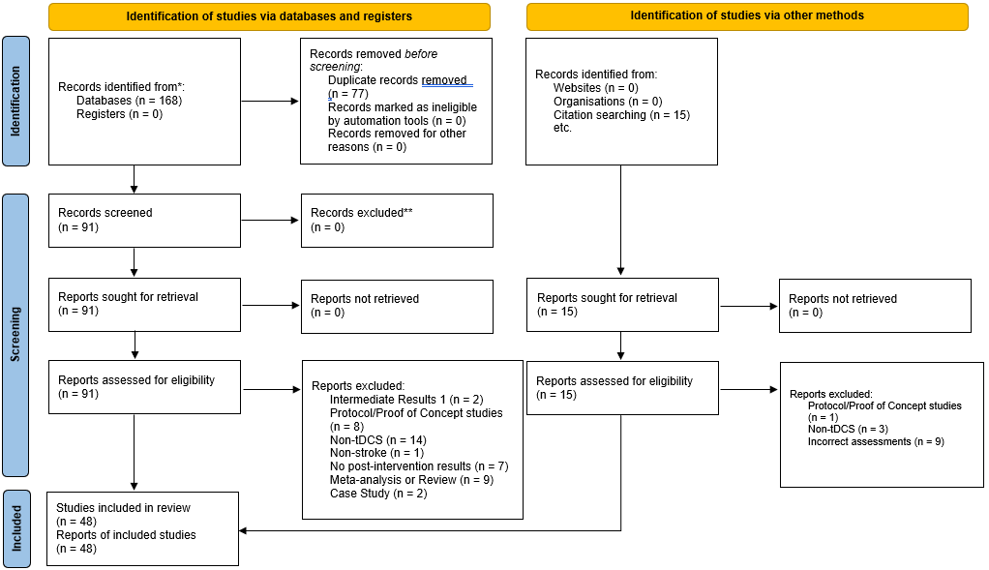

Figure 1 – Prisma Flow Chart
Details of the literature search. Databases searched were Medline (EBSCO), CINAHL and PubMed. Manual search was conducted using the references in original articles and reviews. Studies which were used as individual studies in the results due to having multiple stimulation types (e.g., anodal and cathodal tDCS) were not counted individually in the literature search.

Some studies were included in the descriptive portion of this thesis, but not in the meta-analysis for the following reasons 1) It used a subscale of the Fugl-Meyer Assessment (Cheng et al., 2021; Chew et al., 2020); 2) failed to include sham tDCS group (Baltar, Piscitelli, Marques, Shirahige, & Monte-Silva, 2020; J. L. Chen & Schlaug, 2016; Miu, Ching, Shan, Chan, & Wong, 2020; Ochi et al., 2013); and 3) failed to provide sufficient data to calculate effect size (Andrade et al., 2017; Cheng et al., 2021; Ilic et al., 2016; Nicolo et al., 2018; Pavlova et al., 2017; Rossi et al., 2013).
Table 1 indicates the characteristics of each study. Out of the forty-eight studies included, six studies recruited different participants in multiple independent groups to test any effect of stimulation type (e.g., anodal and cathodal) in comparison to sham, and thus were counted as individual studies for a total of fifty-four individual studies (Hesse et al., 2011; Khedr et al., 2013; D. Y. Kim et al., 2010; Ochi et al., 2013; Rocha et al., 2016; Yi et al., 2016). Out of those fifty-four individual studies sixteen of them investigated the Barthel Index, forty-one studies included the Upper Extremity Fugl-Meyer Assessment, six studies included the Lower Extremity Fugl-Meyer Assessment, and nine studies included the Modified Ashworth Scale. The number of test sessions which the intervention was given to subjects varied from as little as a single session to as many as forty. Application time per session of tDCS ranged from ten minutes to thirty minutes, with more than half of the studies applying tDCS for twenty minutes per session. One study did not state how long they applied tDCS for (Andrade et al., 2017)and one study did not state the number of sessions used (Cheng et al., 2021). A majority of the studies investigated tDCS effects on rehabilitation in patients with ischemic stroke, while a little less than half investigated hemorrhagic stroke. Six studies gave insufficient data to calculate total charge density (table 2). Six studies did not report the use of additional therapy (i.e., conventional therapy, assisted therapy, or miscellaneous-type therapy) with tDCS during the intervention, twenty studies used conventional therapy, seventeen studies used assisted therapy, four studies used miscellaneous therapy types and one study used a combination of both conventional and robotic therapy. Studies that included multiple stimulation types (e.g., anodal and cathodal) were counted as individual studies, but careful consideration was taken to not include the sham groups twice in the total sample size. For the assessments, a total of 648 participants were assessed using the Barthel Index, 1190 participants were assessed using the Upper Extremity Fugl-Meyer Assessment, 199 participants were assessed using the Lower-Extremity Fugl-Meyer Assessment, and 372 participants were assessed using the Modified Ashworth Scale. Out of the fifty-four individual studies that were included in this review, one study mentioned significant differences between the tDCS and sham groups at baseline (E. F. Pinto, Gupta, Kulkarni, & Andrade, 2021). Six studies made no mention of baseline differences either in their discussion or with a statistical analysis (Achacheluee et al., 2018; Allman et al., 2016; J. L. Chen & Schlaug, 2016; H. S. Cho & Cha, 2015; Oveisgharan, Organji, & Ghorbani, 2018; Zheng & Schlaug, 2015). The rest of the included studies reported the sham and tDCS groups were similar at baseline.
Table 1. Study Characteristics
Study | Stroke type | Time after stroke | Therapy type | Stimulation | Anode location | Cathode location | Assessment used
Achacheluee et al. 2018 | Ischemic | 8-24 months | None | Anodal | Ipsilesional M1 | Contralesional supraorbital region | UE-FMA
Alisar et al. 2019 | Ischemic/Hemorrhagic | > 3 months | Conventional | Bihemispheric | Ipsilesional M1 | Contralesional M1 | UE-FMA
Allman et al. 2016 | Ischemic/Hemorrhagic | > 6 months | Conventional | Anodal | Ipsilesional M1 | No second electrode | †*UE-FMA
Andrade et al. 2017a | Ischemic | 1-3 months | Miscellaneous | Anodal | Ipsilesional M1 | No second electrode | §†*BI, §UE-FMA, §MAS
Ang et al. 2015 | Ischemic/Hemorrhagic | > 9 months | Assisted | Bihemispheric | Ipsilesional M1 | Contralesional M1 | UE-FMA
Bang & Bong 2015 | No information | Not stated | Assisted | Bihemispheric | P4 | P3 | §†*BI
Beaulieu et al. 2019 | Ischemic/Hemorrhagic | > 6 months | Conventional | Bihemispheric | Ipsilesional M1 | Contralesional M1 | †UE-FMA, MAS
Bolognini et al. 2011 | Ischemic/Hemorrhagic | > 6 months | Miscellaneous | Bihemispheric | Ipsilesional M1 | Contralesional M1 | †UE-FMA
Bolognini et al. 2020 | Ischemic/Hemorrhagic | > 3 months | None | Bihemispheric | Ipsilesional M1 | Contralesional M1 | †*BI
Bornheim et al. 2019 | Ischemic | 2 days - 1 year | Conventional | Anodal | Ipsilesional M1 | Contralesional supraorbital region | †*BI, §†UE-FMA, §†LE-FMA
Cha et al. 2014 | No information | > 9 months | Conventional | Anodal | Ipsilesional M1 | Contralesional supraorbital region | §†*UE-FMA, §†*LE-FMA
Chang et al. 2015 | Ischemic | 7-30 days | Conventional | Anodal | Ipsilesional precentral gyrus | Contralesional supraorbital region | §LE-FMA
Chen & Schlaug 2016 | Ischemic | > 3 months | Conventional | Bihemispheric | Ipsilesional M1 | Contralesional M1 | UE-FMA
Cheng et al. 2021 | No information | > 9 months | Assisted | Bihemispheric | Ipsilesional M1 | Contralesional M1 | UE-FMA
Chew et al. 2020 | Ischemic/Hemorrhagic | > 9 months | Assisted | Bihemispheric | Ipsilesional M1 | Contralesional M1 | §UE-FMA
Cho & Cha 2015 | Ischemic/Hemorrhagic | > 6 months | Assisted | Anodal | Ipsilesional M1 | Contralesional supraorbital region | UE-FMA
Edwards et al. 2019 | Ischemic | > 6 months | Assisted | Anodal | Ipsilesional M1 | Contralesional supraorbital region | †*UE-FMA
Fusco et al. 2014 | Ischemic | < 30 days | None | Cathodal | Unaffected shoulder | Contralesional M1 | †*BI, UE-FMA
Hesse et al. 2011 | Ischemic | 3-8 weeks | Assisted | Anodal | Ipsilesional M1 | Contralesional supraorbital region | †*BI, †*UE-FMA, MAS
Hesse et al. 2011 | Ischemic | 3-8 weeks | Assisted | Cathodal | Ipsilesional supraorbital region | Contralesional C3 | †*BI, †*UE-FMA, MAS
Ilić et al. 2016 | Ischemic | > 9 months | Conventional | Bihemispheric | Ipsilesional M1 | Contralesional supraorbital region | UE-FMA

Table 1. Study Characteristics (continuation)
Jin et al. 2019 | Ischemic/Hemorrhagic | > 6 months | Assisted | Bihemispheric | Ipsilesional M1 | Contralesional M1 | UE-FMA
Khedr et al. 2013 | Ischemic | 10-20 days | Conventional | Anodal | Ipsilesional M1 | Contralesional supraorbital region | §†*BI
Khedr et al. 2013 | Ischemic | 10-20 days | Conventional | Cathodal | Ipsilesional supraorbital region | Contralesional M1 | §†*BI
Kim et al. 2010 | Ischemic | > 2 months | Conventional | Anodal | Paretic first dorsal interossei | No second electrode | †*BI, §†*UE-FMA
Kim et al. 2010 | Ischemic | > 2 months | Conventional | Cathodal | No second electrode | Intact first dorsal interossei | §†*BI, §†*UE-FMA
Koo et al. 2018 | Ischemic | < 1 month | None | Anodal | Ipsilesional S1 | No second electrode | §†*BI
Lee & Chun 2014 | Ischemic/Hemorrhagic | < 1 month | Assisted | Cathodal | Ipsilesional supraorbital region | Contralesional M1 | †*BI, §†*UE-FMA, MAS
Liao et al. 2020 | Ischemic/Hemorrhagic | > 6 months | Assisted | Anodal | Ipsilesional M1 | Contralesional supraorbital region | †UE-FMA
Lindenberg et al. 2010 | Ischemic | > 3 months | Conventional | Bihemispheric | Ipsilesional M1 | Contralesional M1 | §†UE-FMA
Mazzoleni et al. 2019 | Ischemic/Hemorrhagic | < 1 month | Assisted | Anodal | Ipsilesional M1 | Contralesional supraorbital region | †*UE-FMA, MAS
Miu et al. 2020 | Ischemic/Hemorrhagic | < 1 month | Conventional | Bihemispheric | Ipsilesional supraorbital region | Contralesional M1 | UE-FMA, MAS
Nair et al. 2011 | No information | 0-56 months | Conventional | Cathodal | Ipsilesional supraorbital region | Contralesional M1 | §UE-FMA
Nicolo et al. 2018 | Ischemic/Hemorrhagic | < 10 weeks | Conventional | Cathodal | Ipsilesional supraorbital region | Contralesional M1 | UE-FMA
Ochi et al. 2013 | Ischemic/Hemorrhagic | > 6 months | Assisted | Anodal | Ipsilesional M1 | Contralesional supraorbital region | UE-FMA, MAS
Ochi et al. 2013 | Ischemic/Hemorrhagic | > 6 months | Assisted | Cathodal | Contralesional supraorbital region | Contralesional M1 | UE-FMA, MAS
Oveisgharan et al. 2018 | Ischemic | < 4 days | None | Bihemispheric | Ipsilesional M1 | Contralesional M1 | §†*UE-FMA
Pavlova et al. 2017 | Ischemic/Hemorrhagic | > 6 months | Conventional | Anodal | Ipsilesional M1 | No second electrode | UE-FMA
Pinto et al. 2021 | Ischemic/Hemorrhagic | 9-258 days | Conventional and Robot Assisted | Bihemispheric | Ipsilesional M1 | Contralesional M1 | †*BI, UE-FMA, LE-FMA
Prathum et al. 2021 | Ischemic | 6 months - 5 years | Conventional | Bihemispheric | Ipsilesional M1 | Contralesional M1 | §†UE-FMA, §LE-FMA
Rocha et al. 2015 | Ischemic/Hemorrhagic | > 6 months | Miscellaneous | Anodal | Ipsilesional M1 | Supraorbital region | §†UE-FMA

Table 1. Study Characteristics (continuation)
Rocha et al. 2015 | Ischemic/Hemorrhagic | > 6 months | Miscellaneous | Cathodal | Supraorbital region | Contralesional M1 | §†UE-FMA
Rossi et al. 2012 | Ischemic | 1 day | None | Anodal | Ipsilesional M1 | Contralesional supraorbital region | †*BI, UE-FMA
Seo et al. 2017 | Ischemic/Hemorrhagic | > 6 months | Assisted | Anodal | Ipsilesional leg area | Contralesional supraorbital region | LE-FMA
Shibata et al. 2020 | Ischemic/Hemorrhagic | > 1 week | Conventional | Anodal | Ipsilesional M1 | Contralesional supraorbital region | UE-FMA
Straudi et al. 2016 | Ischemic/Hemorrhagic | < 6 months & > 6 months | Assisted | Bihemispheric | Ipsilesional M1 | Contralesional M1 | UE-FMA
Takebayashi et al. 2017 | No information | > 180 days | Miscellaneous | Bihemispheric | Ipsilesional M1 | Contralesional M1 | §†UE-FMA
Triccas et al. 2015 | Ischemic/Hemorrhagic | > 2 weeks | Assisted | Anodal | Ipsilesional M1 | Contralesional supraorbital region | †*UE-FMA
Viana et al. 2014 | Ischemic | < 6 months | Assisted | Anodal | Ipsilesional M1 | Contralesional supraorbital region | †*UE-FMA, MAS
Wu et al. 2013 | Hemorrhagic | 2-12 months | Conventional | Cathodal | Unaffected shoulder | Contralesional M1 | §BI, §UE-FMA, §MAS
Yao et al. 2020 | Ischemic | 2 weeks - 1 year | Assisted | Cathodal | Ipsilesional supraorbital region | Contralesional M1 | §†*BI, §†*UE-FMA
Yi et al. 2016 | Ischemic/Hemorrhagic | Not stated | Conventional | Anodal | Right posterior parietal cortex | None | †*BI
Yi et al. 2016 | Ischemic/Hemorrhagic | Not stated | Conventional | Cathodal | None | Left posterior parietal cortex | †*BI
Zheng & Schlaug 2015 | No information | > 4 months | Conventional | Bihemispheric | Ipsilesional M1 | Contralesional M1 | §†UE-FMA

Study Characteristics of included studies. § Indicates statistical significance were found post-intervention between tDCS and sham groups. † Indicates a minimal clinically important difference (MCID) seen in the tDCS group. * Indicates a minimal clinically important difference (MCID) seen in the sham group. Barthel Index (BI). Upper Extremity Fugl-Meyer Assessment (UE-FMA). Lower Extremity Fugl-Meyer Assessment (LE-FMA). Modified Ashworth Scale (MAS).
Table 2. tDCS Information
Study | N° of tDCS Sessions | Session tDCS time (minutes) | Total tDCS time (minutes) | Current (mA) | Electrode Size (cm2) | Current Density (mA/cm2) | Charge (mA) | Charge Density (mAh/cm2) | Total Charge (mAh) |  | Total Charge Density (mAh/cm2)
Achacheluee et al. 2018 | 1 | 20 | 20 | 1 | 62.5 | 0.02 | 0.33 | 0.01 |  | 0.33 |  | 0.01
Alisar et al. 2019 | 15 | 30 | 450 | 2 | 22 | 0.09 | 1.00 | 0.05 |  | 15.00 |  | 0.68
Allman et al. 2016 | 9 | 20 | 180 | 1 | 35 | 0.03 | 0.33 | 0.01 |  | 3.00 |  | 0.09
Andrade et al. 2017a | 10 | No info | No info | 0.7 | 16 | 0.04 | No info | No info |  | No info |  | No info
Ang et al. 2015 | 10 | 20 | 200 | No info | No info | No info | No info | No info |  | No info |  | No info
Bang & Bong 2015 | 15 | 20 | 300 | 1 | 35 | 0.03 | 0.33 | 0.01 |  | 5.00 |  | 0.14
Beaulieu et al. 2019 | 12 | 20 | 240 | 2 | 35 | 0.06 | 0.67 | 0.02 |  | 8.00 |  | 0.23
Bolognini et al. 2011 | 10 | 40 | 400 | 2 | 35 | 0.06 | 1.33 | 0.04 |  | 13.33 |  | 0.38
Bolognini et al. 2020 | 10 | 15 | 150 | 2 | 35 | 0.06 | 0.50 | 0.01 |  | 5.00 |  | 0.14
Bornheim et al. 2019 | 20 | 20 | 400 | 2 | 50 | 0.04 | 0.67 | 0.01 |  | 13.33 |  | 0.27
Cha et al. 2014 | 20 | 20 | 400 | 1 | 35 | 0.03 | 0.33 | 0.01 |  | 6.67 |  | 0.19
Chang et al. 2015 | 10 | 10 | 100 | 2 | 7.07 | 0.28 | 0.33 | 0.05 |  | 3.33 |  | 0.47
Chen & Schlaug 2016 | 10 | 30 | 300 | 1.5 | 16 | 0.09 | 0.75 | 0.05 |  | 7.50 |  | 0.47
Cheng et al. 2021 | No info | 20 | No info | 1 | No info | No info | No info | No info |  | No info |  | No info
Chew et al. 2020 | 10 | 20 | 200 | 1 | 35 | 0.03 | 0.33 | 0.01 |  | 3.33 |  | 0.10
Cho & Cha 2015 | 18 | 20 | 360 | 2 | 24 | 0.08 | 0.67 | 0.03 |  | 12.00 |  | 0.50
Edwards et al. 2019 | 36 | 20 | 720 | 2 | 35 | 0.06 | 0.67 | 0.02 |  | 24.00 |  | 0.69
Fusco et al. 2014 | 10 | 10 | 100 | 1.5 | 35 | 0.04 | 0.25 | 0.01 |  | 2.50 |  | 0.07
Hesse et al. 2011 | 30 | 20 | 600 | 2 | 35 | 0.06 | 0.67 | 0.02 |  | 20.00 |  | 0.57
Ilić et al. 2016 | 10 | 20 | 200 | 2 | 25 | 0.08 | 0.67 | 0.03 |  | 6.67 |  | 0.27
Jin et al. 2019 | 10 | 30 | 300 | 1 | 35 | 0.03 | 0.50 | 0.01 |  | 5.00 |  | 0.14
Khedr et al. 2013 | 6 | 25 | 150 | 2 | 35 | 0.06 | 0.83 | 0.02 |  | 5.00 |  | 0.14
Kim et al. 2010 | 10 | 20 | 200 | 2 | 25 | 0.08 | 0.67 | 0.03 |  | 6.67 |  | 0.27
Koo et al. 2018 | 10 | 20 | 200 | 1 | 25 | 0.04 | 0.33 | 0.01 |  | 3.33 |  | 0.13
Lee & Chun 2014 | 15 | 20 | 300 | 2 | 25 | 0.08 | 0.67 | 0.03 |  | 10.00 |  | 0.40
Liao et al. 2020 | 20 | 20 | 400 | 2 | 35 | 0.06 | 0.67 | 0.02 |  | 13.33 |  | 0.38
Lindenberg et al. 2010 | 5 | 30 | 150 | 1.5 | 16 | 0.09 | 0.75 | 0.05 |  | 3.75 |  | 0.23
Mazzoleni et al. 2019 | 30 | 20 | 600 | 2 | 35 | 0.06 | 0.67 | 0.02 |  | 20.00 |  | 0.57
Miu et al. 2020 | 10 | 20 | 200 | 1.5 | 35 | 0.04 | 0.50 | 0.01 |  | 5.00 |  | 0.14

Table 2. tDCS Information (continuation)
Nair et al. 2011 | 5 | 30 | 150 | 1 | No info | No info | 0.50 | No info | 2.50 | No info
Nicolo et al. 2018 | 9 | 25 | 225 | 1 | 35 | 0.03 | 0.42 | 0.01 | 3.75 | 0.11
Ochi et al. 2013 | 5 | 10 | 50 | 1 | 35 | 0.03 | 0.17 | 0.00 | 0.83 | 0.02
Oveisgharan et al. 2018 | 10 | 30 | 300 | 2 | 16 | 0.13 | 1.00 | 0.06 | 10.00 | 0.63
Pavlova et al. 2017 | 40 | 20 | 800 | 0.5 | 18 | 0.03 | 0.17 | 0.01 | 6.67 | 0.37
Pinto et al. 2021 | 24 | 20 | 480 | 2 to 3 | Range | 0.8 - 0.12 | Range | Range | Range | Range
Prathum et al. 2021 | 12 | 20 | 240 | 2 | 35 | 0.06 | 0.67 | 0.02 | 8.00 | 0.23
Rocha et al. 2015 | 12 | 13 | 156 | 1 | 35 | 0.03 | 0.22 | 0.01 | 2.60 | 0.07
Rossi et al. 2012 | 5 | 20 | 100 | 2 | 35 | 0.06 | 0.67 | 0.02 | 3.33 | 0.10
Seo et al. 2017 | 10 | 20 | 200 | 2 | 35 | 0.06 | 0.67 | 0.02 | 6.67 | 0.19
Shibata et al. 2020 | 40 | 20 | 800 | 1 | 35 | 0.03 | 0.33 | 0.01 | 13.33 | 0.38
Straudi et al. 2016 | 10 | 30 | 300 | 1 | 35 | 0.03 | 0.50 | 0.01 | 5.00 | 0.14
Takebayashi et al. 2017 | 2 | 20 | 40 | 1 | No info | No info | 0.33 | No info | 0.67 | No info
Triccas et al. 2015 | 18 | 20 | 360 | 1 | 35 | 0.03 | 0.33 | 0.01 | 6.00 | 0.17
Viana et al. 2014 | 15 | 13 | 195 | 2 | 35 | 0.06 | 0.43 | 0.01 | 6.50 | 0.19
Wu et al. 2013 | 20 | 20 | 400 | 1.2 | 43 | 0.03 | 0.40 | 0.01 | 8.00 | 0.19
Yao et al. 2020 | 10 | 20 | 200 | 2 | 35 | 0.06 | 0.67 | 0.02 | 6.67 | 0.19
Yi et al. 2016 | 15 | 30 | 450 | 2 | 25 | 0.08 | 1.00 | 0.04 | 15.00 | 0.60
Zheng & Schlaug 2015 | 10 | 30 | 300 | 1.5 | 16 | 0.09 | 0.75 | 0.05 | 7.50 | 0.47

Information regarding the tDCS intervention during the sessions it was used in each study. Studies which failed to provide information on a variable are noted as “No info.” Studies which provided a range of values were noted as “Range.”

Risk of Bias
There are five domains in the Cochrane Risk of Bias 2 tool: 1) risk of bias arising from the randomization process; 2) risk of bias due to deviations from the intended interventions; 3) risk of bias due to missing outcome data; 4) risk of bias in measurement of the outcome; and 5) risk of bias in selection of the reported result. Only 6 studies had low risk of bias for all domains. The most common problem in domain 1, 2 and 4 are related either no mention or inadequate randomization process, allocation concealment, blinding of researchers, and blinding of assessors.
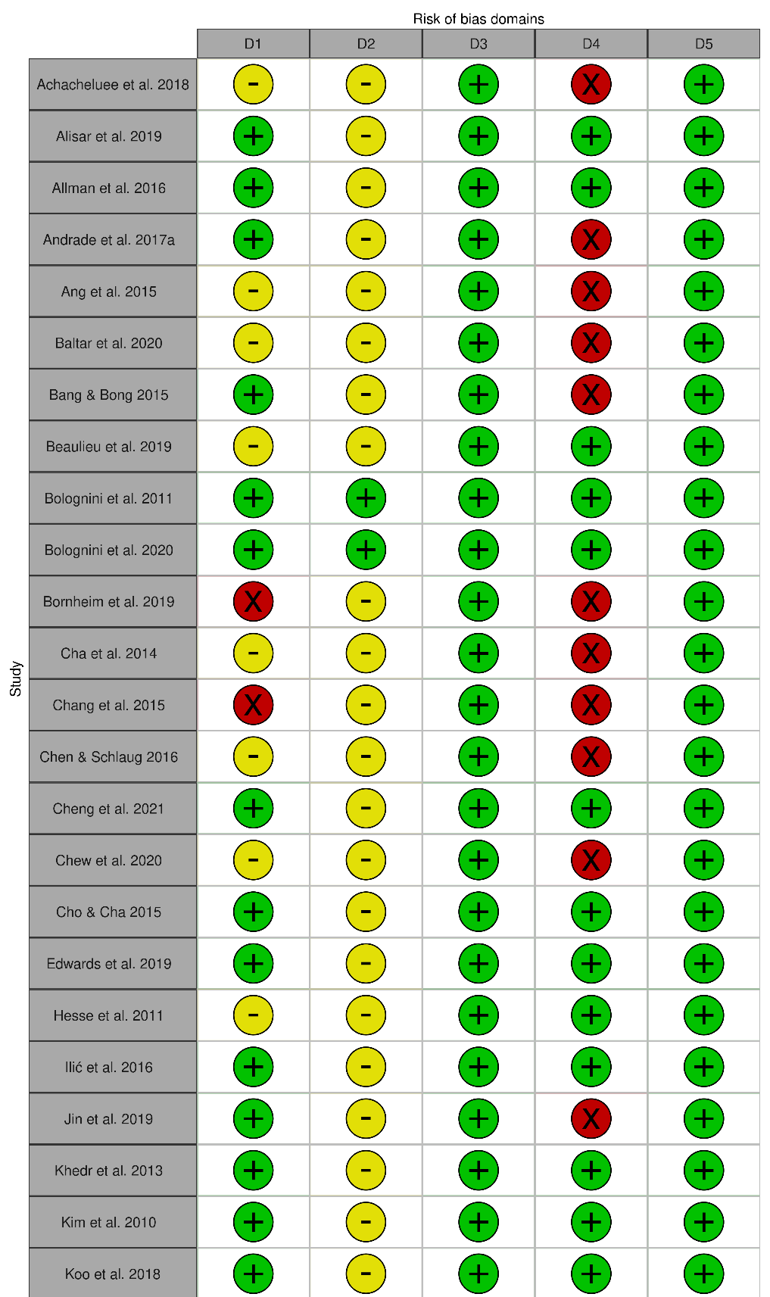
Figure 2 – Risk of Bias
Risk of bias for included studies. Assessed by a collaborator (JS) and the author (ADC) using the Cochrane Risk of Bias 2.
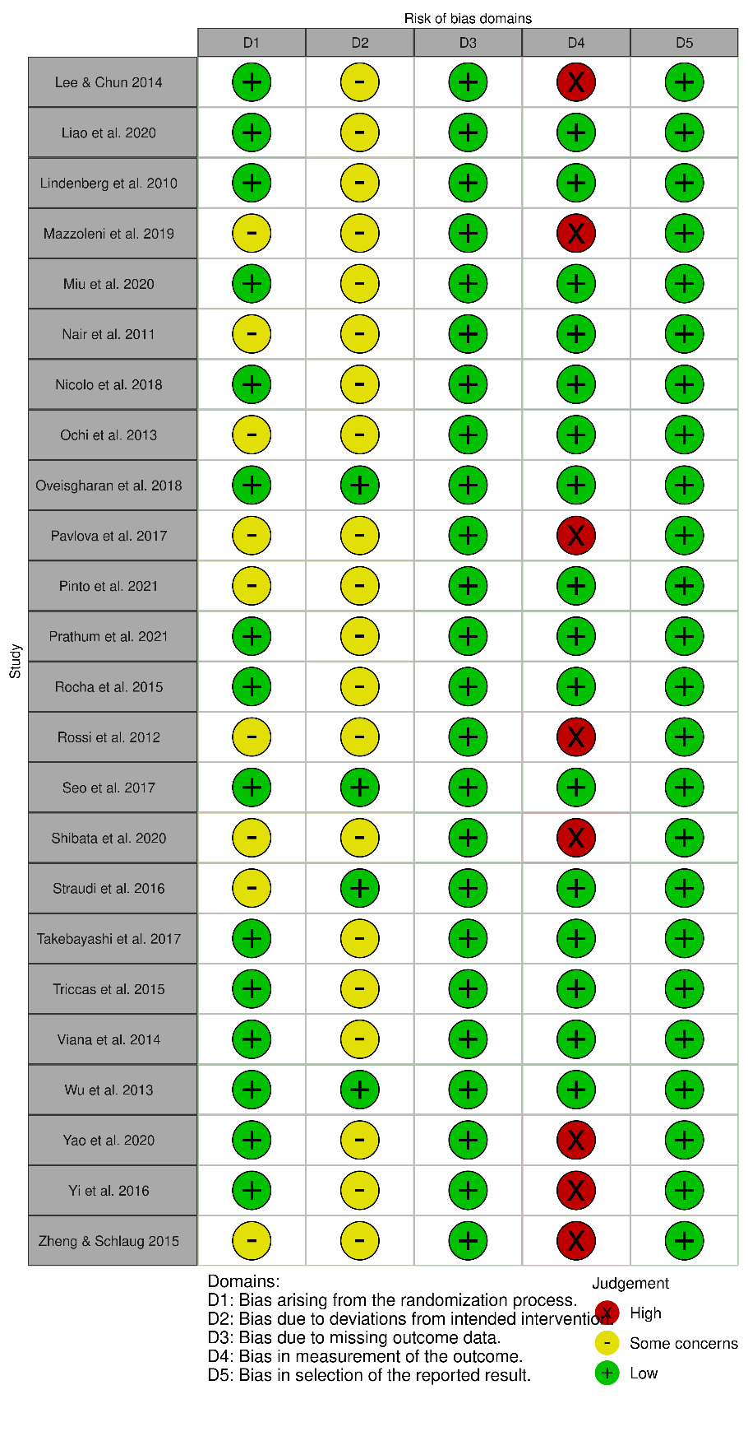
Figure 2 – Risk of Bias (continued)
Risk of bias for included studies. Assessed by a collaborator (JS) and the author (ADC) using the Cochrane Risk of Bias 2.
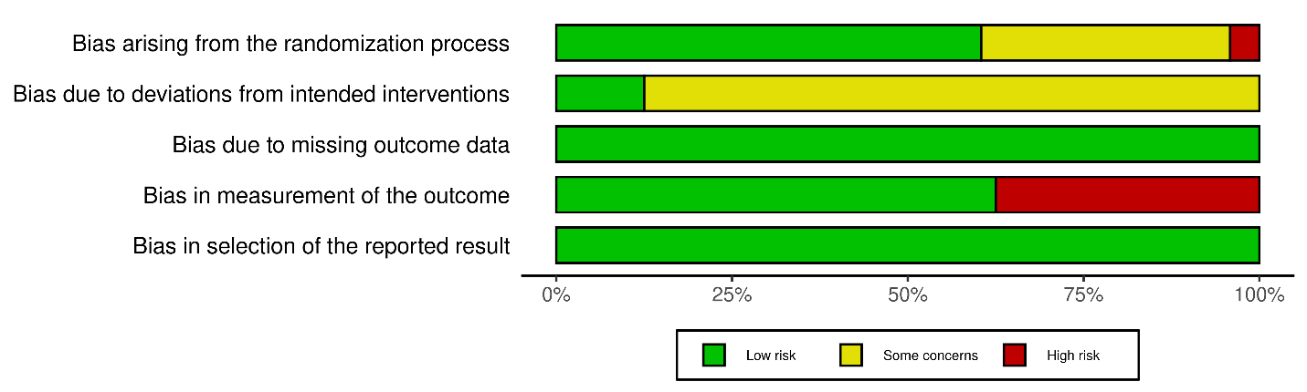
Figure 3 – Risk of Bias Percentages
Risk of bias separated into domains and presented as percentages of the total amount of studies. Assessed by a collaborator (JS) and the author (ADC) using the Cochrane Risk of Bias 2.

Effects of tDCS on Post-Stroke Motor Recovery
To determine if tDCS can be used as an effective therapy for motor function recovery in patients who have suffered a stroke, descriptive and meta-analyses were conducted on the Barthel Index, Upper Extremity Fugl-Meyer Assessment, Lower Extremity Fugl-Meyer Assessment, and the Modified Ashworth Scale. All information regarding study characteristics, including MCID, which was determined by a minimal increase in the score of the assessment used from pre- to post-intervention values for the tDCS group, and statistical results can be found on Table 1.
Barthel Index (BI)
- Descriptive
Out of the sixteen studies that used BI, only eight concluded that there was a significant difference between the tDCS group and the sham group. Eleven of the studies concluded that there were no differences between groups. One study did not include a sham group and could not determine between group differences, however, still concluded positive and significant improvements using tDCS (Miu et al., 2020). All sixteen studies that included pre- and post-intervention data had a MCID by indicating an increase in BI score of at least 1.85 points in both the sham and tDCS groups (Table 1).
- Meta-analysis
Sixteen of those studies provided post-intervention results and were included in a meta-analysis comparing post-intervention data for tDCS and sham groups (Figure 4) as well as comparing change scores between groups (Figure 5). Results from the meta-analysis of post-intervention data showed that tDCS had a positive, but small effect [8.10 (4.37; 11.83)] on enhancing recovery on this scale. Similarly, meta-analysis using the change scores showed a small, but positive effect of tDCS [6.21 (3.19, 9.23)].

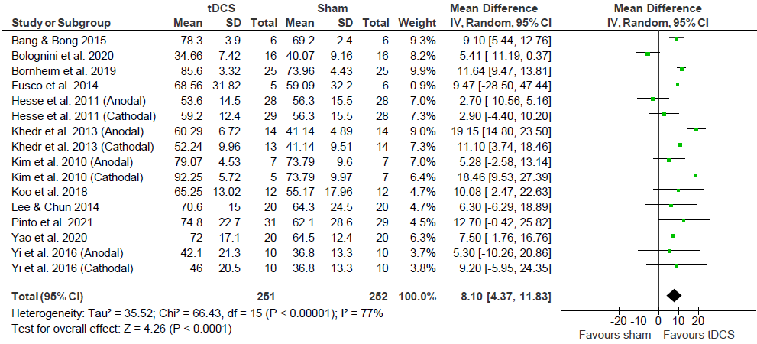
Figure 4 – Barthel Index Post-Intervention
Effects of tDCS on stroke recovery as assessed by post-intervention data of the tDCS and sham groups for the Barthel Index. A random effects model was used because of heterogeneity (P < 0.10).

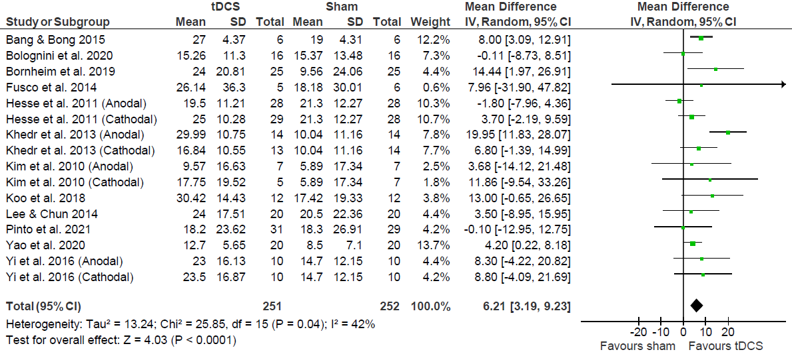
Figure 5 – Barthel Index Change Scores
Effects of tDCS on stroke recovery as assessed by change-scores (mean difference between baseline and after intervention) of the tDCS and sham groups for the Barthel Index.

Upper Extremity Fugl-Meyer Assessment (UE-FMA)
- Descriptive
Out of the forty-four included studies, seventeen concluded that the use of tDCS was able to significantly improve recovery compared to sham groups (Andrade et al., 2017; Bornheim et al., 2020; Cha, Ji, Kim, & Chang, 2014; Chew et al., 2020; D. Y. Kim et al., 2010; S. J. Lee & Chun, 2014; Lindenberg, Renga, Zhu, Nair, & Schlaug, 2010; Nair, Renga, Lindenberg, Zhu, & Schlaug, 2011; Oveisgharan et al., 2018; Prathum et al., 2021; Rocha et al., 2016; Takebayashi, Takahashi, Moriwaki, Sakamoto, & Domen, 2017; Wu et al., 2013; Yao et al., 2020; Zheng & Schlaug, 2015). Twenty-two of the studies concluded that there were no significant differences between groups using tDCS and those not using. Five studies could not determine between group comparisons because they did not include a sham group, however they all concluded positive and significant improvements from pre-intervention using tDCS (Baltar et al., 2020; J. L. Chen & Schlaug, 2016; Miu et al., 2020; Ochi et al., 2013; Shibata et al., 2020). Out of the thirty-two studies that included pre- and post-intervention data for sham and tDCS groups, thirteen of those studies determined that both groups had a MCID by an increase in UE-FMA score by at least 5.25 points (Table 1). Nine of those studies did not determine a MCID in either the tDCS or sham group. Ten of those studies determined a MCID in the tDCS group, but not in the sham group.
- Meta-analysis
Out of the forty-four studies that used the UE-FMA, thirty-two of those studies provided post-intervention data to be included in a meta-analysis comparing post-intervention data for the tDCS and sham groups (Figure 6) as well as comparing change scores between groups (Figure 7). The meta-analysis comparing post-intervention data showed no effect of tDCS [1.75 (-0.41, 3.92)]. However, the meta-analysis of change scores showed a small, but positive effect of tDCS [2.94 (1.71, 4.16)].

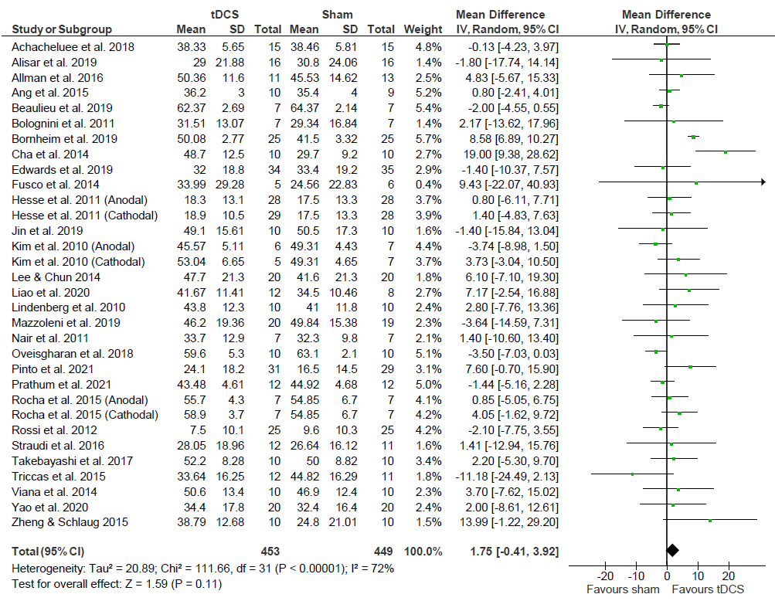
Figure 6 – Upper Extremity FMA Post-Intervention
Effects of tDCS on stroke recovery as assessed by the post-intervention data of the tDCS and sham groups for the Upper Extremity Fugl-Meyer Assessment. A random effects model was used because of heterogeneity (P < 0.10).

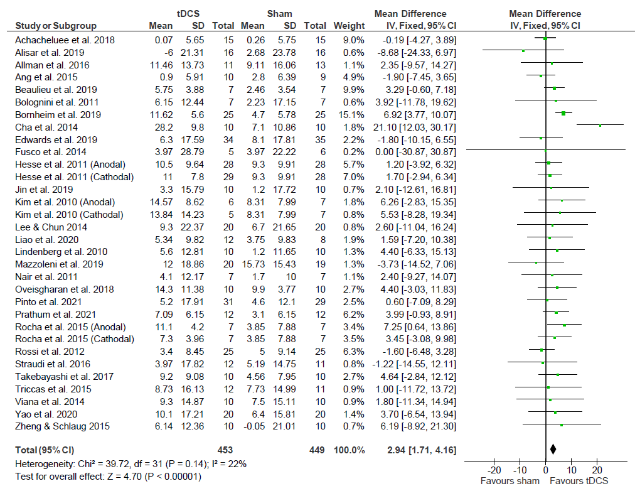

Figure 7 – Upper Extremity FMA Change Scores
Effects of tDCS on stroke recovery as assessed by the change scores (mean difference between baseline and post-intervention) of the tDCS and sham groups for the Upper Extremity Fugl-Meyer Assessment..

Lower Extremity Fugl-Meyer Assessment (LE-FMA)
- Descriptive
Out of the six included studies, four concluded that the use of tDCS was able to significantly improve recovery compared to sham. The remaining two studies concluded that there were no between group differences. Out of the six studies that included pre-and post-intervention data, one determined a MCID by an increase in score of at least 6 points in both the sham and tDCS groups (Table 1). One study also determined a MCID in the tDCS group, but not the sham.
- Meta-analysis
All six studies that used the LE-FMA provided post-intervention data and were included in a meta-analysis of post-intervention data for the tDCS and sham groups (Figure 8) as well as the change scores between groups (Figure 9). Results from the meta-analysis of post-intervention data concluded that tDCS had no effect on enhancing recovery using LE-FMA. Similarly, the meta-analysis of change scores showed no effect of tDCS [0.48 (-1.51, 2.47)].

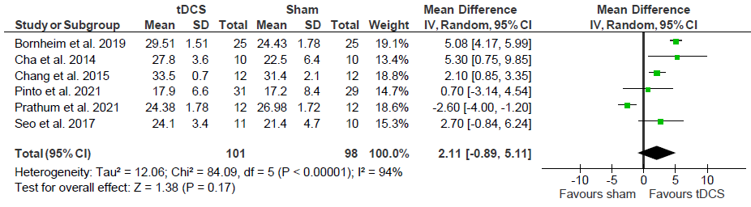
Figure 8 – Lower Extremity FMA Post-Intervention
Effects of tDCS on stroke recovery as assessed by the post-intervention data of the tDCS and sham groups for the Lower Extremity Fugl-Meyer Assessment. A random effects model was used because of heterogeneity (P < 0.10).

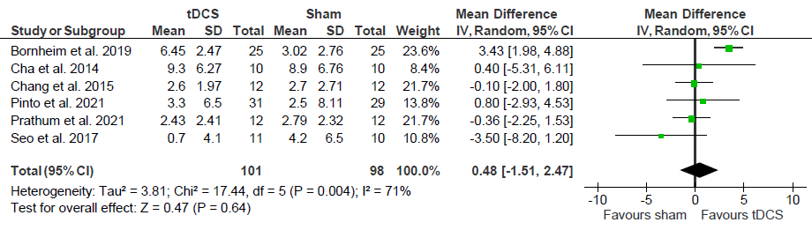
Figure 9 – Lower Extremity FMA Change Scores
Effects of tDCS on stroke recovery as assessed by the change scores of the tDCS and sham groups for the Lower Extremity Fugl-Meyer Assessment. A random effects model was used because of heterogeneity (P < 0.10).

Modified Ashworth Scale (MAS)
- Descriptive
Out of the total ten studies being reviewed, only two of them described positive effects of tDCS on stroke recovery. Six of those studies concluded that there were no significant improvements in stroke recovery when using tDCS. The remaining two studies failed to include a sham group, and therefore could not draw between group comparisons (Miu et al., 2020; Ochi et al., 2013). However, they concluded positive and significant improvements from pre-intervention when using tDCS. Out of the four studies that provided pre- and post-intervention data, none determined a MCID of a reduction in score by at least 0.48 in either the tDCS or sham groups (Table 1).
- Meta-analysis
Five studies were included in a meta-analysis because they provided post-intervention data for tDCS and sham groups (Figure 10) as well as change scores for the groups (Figure 11). The meta-analysis of post-intervention data showed no effect of tDCS on MAS [-0.25 (-0.58; 0.09)]. Likewise, the meta-analysis of change scores showed no effect in favor of tDCS [-0.15 (-0.44, 00.14)].
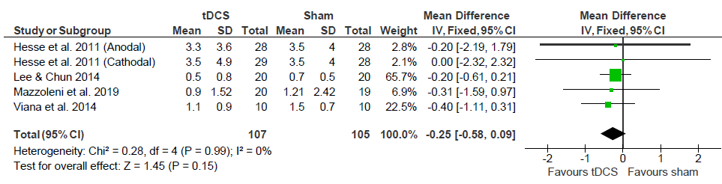
Figure 10 – Modified Ashworth Scale Post-Intervention
Effects of tDCS on stroke recovery as assessed by the post-intervention results of the tDCS and sham groups for the Modified Ashworth Scale.

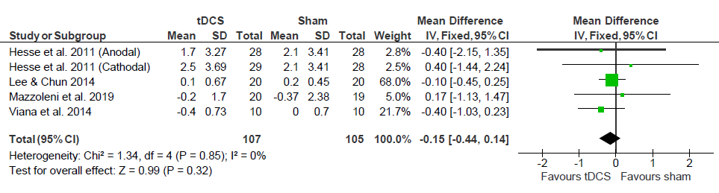
Figure 11 – Modified Ashworth Scale Change Scores
Effects of tDCS on stroke recovery as assessed by the change scores of the tDCS and sham groups for the Modified Ashworth Scale. Meta-analysis showed no effect in favor of tDCS [-0.15 (-0.44, 00.14)].

Transcranial Direct Current Stimulation as a Standalone Therapy
To determine if tDCS can be used as a standalone therapy, subgroup meta-analyses were conducted on each of the assessments aside from the Lower-Extremity Fugl-Meyer Assessment and Modified Ashworth Scale. All information regarding study characteristics, including MCID results can be found on Table 1.
- Descriptive
BI
Four studies used tDCS as a standalone therapy and measured recovery using BI. There was only one study that determined a significant difference using tDCS. Three studies determined pre- and post-intervention data, and all determined a MCID for both the tDCS and sham groups (Table 1).
- Meta-analysis
Three studies provided post-intervention data for tDCS as a standalone therapy using BI to measure recovery and included in the meta-analysis comparing post-intervention results of tDCS and sham. The meta-analysis showed no effect of tDCS [1.84 (-10.94, 14.63)]. It is important to note, however, that one study (Bolognini et al., 2020) had a considerable weighting of 81.0%, and a second meta-analysis conducted excluding it also showed there was no effect of tDCS [10.02 (-1.90, 21.94)] (Figure 12). The meta-analysis of change scores (Figure 13) showed no effect of tDCS as a standalone therapy [3.77 (-3.40, 26.65)]. While one study (Bolognini et al., 2020) had a considerable weight of 69.2%, a separate meta-analysis conducted still concluded that there was no effect of tDCS [12.47 (-0.44, 25.38)].

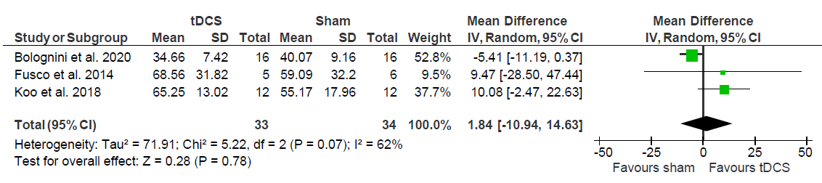
Figure 12 – tDCS as a Standalone Therapy (BI Post-Intervention)
Effects of tDCS as a standalone therapy on stroke recovery as assessed by the post-intervention data of the tDCS and sham groups for the Barthel Index. Meta-analysis showed no effect of tDCS [-2.47 (-7.67, 2.72)].

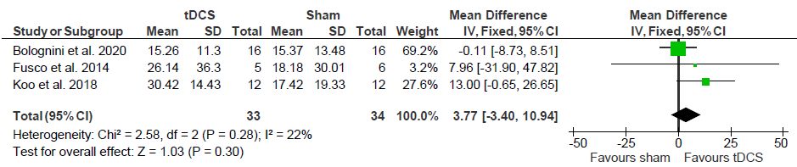
Figure 13 – tDCS as a Standalone Therapy (BI Change Scores)
Effects of tDCS as a standalone therapy on stroke recovery as assessed by the change scores of the tDCS and sham groups for the Barthel Index. Meta-analysis showed no effect of tDCS as a standalone therapy [3.77 (-3.40, 10.94)].

UE-FMA
- Descriptive
Four studies used tDCS as a standalone therapy and measured recovery using UE-FMA. Two of those studies determined a significant difference using. Out of the four studies that provided pre- and post-intervention data, only one determined a MCID in both sham and tDCS groups (Table 1). The remaining three did not determine a MCID in either group.
- Meta-analysis
Four studies provided post-intervention data and were included in a meta-analysis of tDCS as a standalone therapy using UE-FMA as a measurement of recovery using post-intervention data of the tDCS and sham groups (Figure 14) as well as change scores (Figure 15). Meta-analysis of post-intervention data determined there was no effect of tDCS as a standalone therapy using UE-FMA [-2.00 (-4.42, 0.41)]. Similarly, the meta-analysis of the change scores showed no effect of tDCS as a standalone therapy using UE-FMA [0.01 (-2.86, 2.88)].

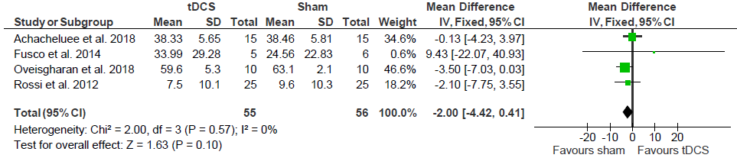
Figure 14 – tDCS as a Standalone Therapy (UE-FMA Post-Intervention)
Effects of tDCS as a standalone therapy on stroke recovery as assessed by the post-intervention data of the tDCS and sham groups for the Upper Extremity Fugl-Meyer Assessment. Meta-analysis showed no effect of tDCS [-2.00 (-4.42, 0.41)].

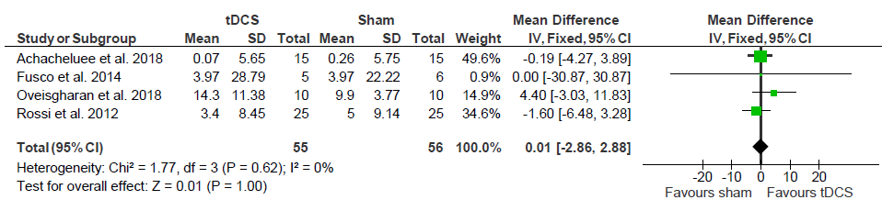
Figure 15 – tDCS as a Standalone Therapy (UE-FMA Change Scores)
Effects of tDCS as a standalone therapy on stroke recovery as assessed by the change scores of the tDCS and sham groups for the Upper Extremity Fugl-Meyer Assessment. Meta-analysis showed no effect of tDCS [0.01 (-2.86, 2.88)].

LE-FMA & MAS
There were no studies using tDCS as a standalone therapy measuring recovery with the LE-FMA or MAS, so a descriptive and meta-analyses for these two assessments could not be conducted.
Effect of Therapy Type on Recovery
Three subgroups of therapy types were created 1) conventional (e.g., physical therapy or occupational therapy); 2) assisted (e.g., mirror, virtual reality, robot-assisted, or brain-computer interface-assisted motor imagery); and 3) miscellaneous (e.g., constraint-induced movement therapy). These subgroups were used in the descriptive portion of this section and separate meta-analyses for the BI, UE-FMA, LE-FMA and MAS to determine if there is an effect of therapy type on recovery. Because no original study directly compared different therapy types, comparison between conventional vs assisted vs miscellaneous were performed using the relative effect size of each intervention (e.g., effect size of conventional vs effect size of assisted intervention). One study was excluded from these analyses because it used a combination of two of the subgroups (E. F. Pinto et al., 2021). All information regarding study characteristics, including MCID results can be found on Table 1.
BI
A) Descriptive
There was a total of fifteen studies that used therapy in addition to tDCS and measured recovery using BI. Nine studies used conventional. While there was one study that failed to include a sham group (Miu et al., 2020), four studies determined there was a significant difference using tDCS and conventional therapy. Five studies used assisted therapy. Two studies determined there was a significant difference using tDCS and assisted therapy. Only one study used miscellaneous therapy (i.e., constraint-induced movement therapy)(Andrade et al., 2017) but determined there was a significant difference using tDCS. Out of the twelve studies that provided pre- and post-intervention data, seven studies used conventional therapy and determined a MCID in both sham and tDCS groups (Table 1). The remaining five studies used assisted therapy and determined a MCID in both sham and tDCS groups.
B) Meta-Analysis
A meta-analysis was conducted on the twelve studies with available post-intervention data for tDCS and sham groups on BI (Figure 16) as well as change scores (Figure 17). No study included post-intervention data for the miscellaneous group, thus it was not included in the forest plots. Seven studies used conventional therapy and tDCS, and found a positive effect [12.64 (8.59, 16.69)]. Five studies used assisted therapy and tDCS and found a but positive effect [4.97 (0.25, 9.70)]. Likewise, in the meta-analysis of change scores, the studies using conventional therapy with tDCS had a positive effect on recovery assessed with the BI [11.65 (6.97, 16.33)] and assisted therapy in combination with tDCS had a small, but positive effect on recovery assessed with the BI [3.89 (0.73, 7.05)].

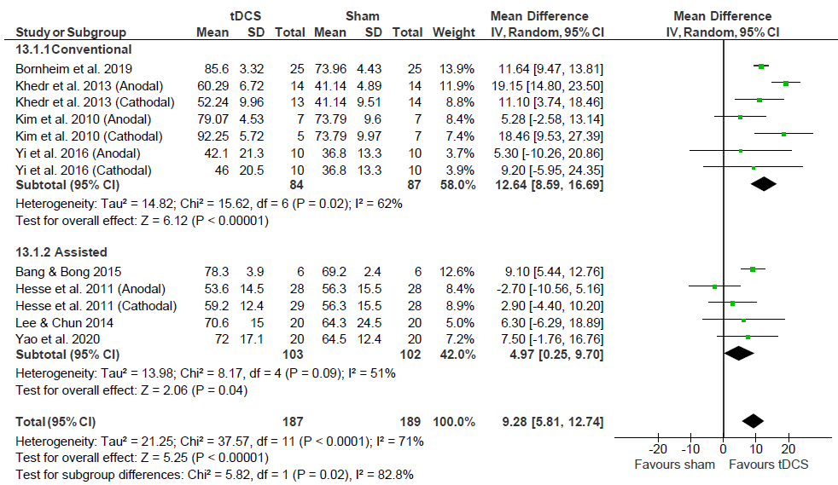
Figure 16 – Effect of Therapy Combined with tDCS (BI Post-Intervention)
Effects of therapy (Conventional vs Assisted) combined with tDCS on stroke recovery as assessed by the post-intervention data of the tDCS and sham groups for the Barthel Index. Meta-analysis showed positive effects of conventional therapy combined with tDCS [12.64 (8.59, 16.69)] and of assisted therapy combined with tDCS [4.97 (0.25, 9.70)].

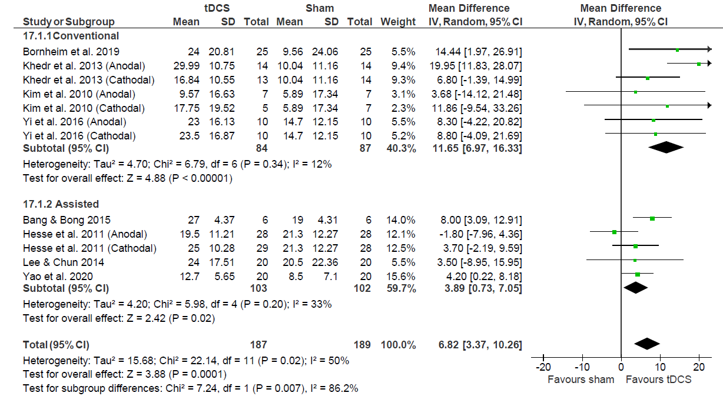
Figure 17 – Effect of Therapy Combined with tDCS (BI Change Scores)
Effects of therapy (Conventional vs Assisted) combined with tDCS on stroke recovery as assessed by the change scores of the tDCS and sham groups for the Barthel Index. Meta-analysis showed a positive effect of conventional therapy combined with tDCS [11.65 (6.97, 16.33)] and assisted therapy combined with tDCS [3.89 (0.73, 7.05)].

UE-FMA
A) Descriptive
There was a total of thirty-nine studies that used therapy in addition to tDCS and measured recovery using UE-FMA. Eighteen of those studies included the use of UE-FMA as a measurement of motor recovery while using tDCS combined with conventional therapy. While three of these studies failed to include a sham group (J. L. Chen & Schlaug, 2016; Miu et al., 2020; Shibata et al., 2020), nine studies determined there was a significant difference using tDCS combined with conventional therapy. Sixteen studies used assisted therapy. While two studies failed to include sham groups (H. S. Cho & Cha, 2015; Ochi et al., 2013), three studies determined there was a significant difference using tDCS with assisted therapy. Five studies used miscellaneous therapy. Four studies determined there was a significant difference using tDCS and miscellaneous. Out of the twenty-seven studies that provided pre- and post-intervention data, eleven of those studies used conventional therapy, but only four of those studies determined a MCID in both the sham and tDCS groups (Table 1). Two of the twelve studies using conventional therapy determined no MCID in either group. The remaining five studies using conventional therapy determined a MCID for the tDCS group, but not the sham group. Twelve studies used assisted therapy, but only eight of those studies determined a MCID for both the sham and tDCS group. Three of those twelve studies using assisted therapy determined no MCID for either group. The last study using assisted therapy found a MCID in the tDCS group, but not the sham group. Four studies used miscellaneous therapy, and all four determined a MCID for the tDCS group, but not the sham group.

B) Meta-analysis
Post-intervention data shows that conventional therapy associated with tDCS had no effect (P= 0.12) (Figure 18), however, change score data indicates a positive effect of the combined therapy in comparison with sham (P=0.0004) (Figure 19). Assisted therapy with tDCS, had no effect compared with sham when post intervention data was used (P = 0.45) (Figure 18) or change scores (P= 0.67) (Figure 19). Miscellaneous subgroup analysis using post-intervention data showed no effects of tDCS compared with sham (P=0.17), however changes score analysis indicate the combined therapy had a small benefit compared with sham (overall effect size: 5.06; P=0.02) (Figures 18 and 19 respectively).

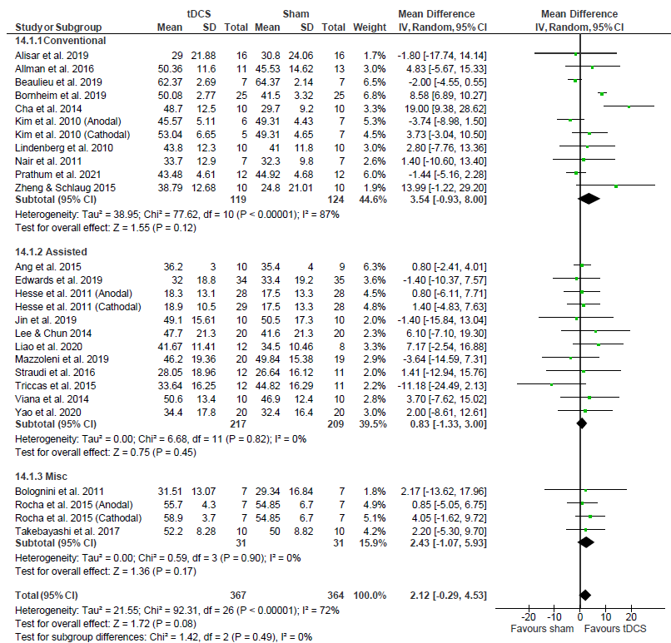
Figure 18 – Effect of Therapy Combined with tDCS (UE-FMA Post-Intervention)
Effects of therapy (Conventional vs Assisted vs Miscellaneous) combined with tDCS on stroke recovery as assessed by the post-intervention data of the tDCS and sham groups for the Upper Extremity Fugl-Meyer Assessment. Meta-analysis showed conventional therapy combined with tDCS had no effect (P =0.12). Assisted therapy combined with tDCS had no effect (P =0.45), and miscellaneous therapy combined with tDCS had no effect (P = 0.17).

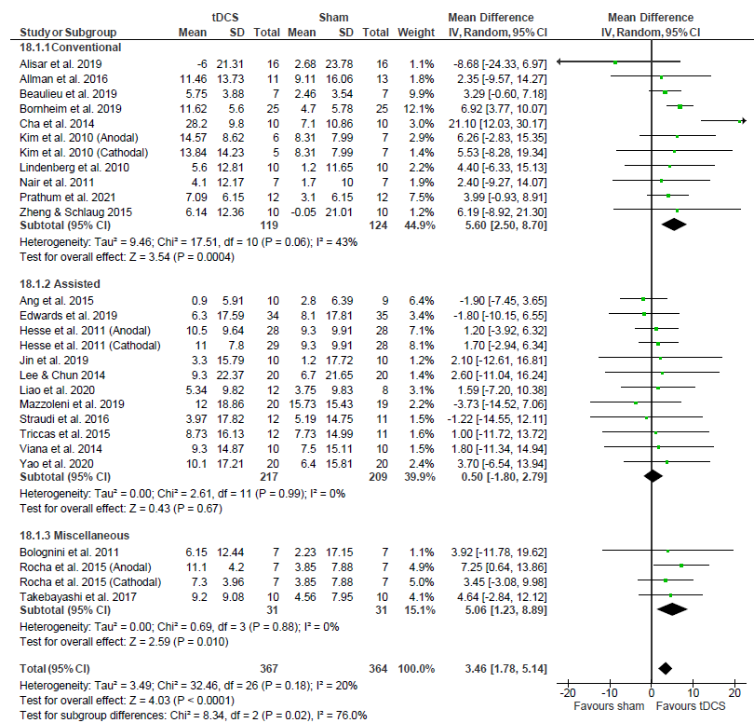

Figure 19 – Effect of Therapy Combined with tDCS (UE-FMA Change Scores)
Effects of therapy (Conventional vs Assisted vs Miscellaneous) combined with tDCS on stroke recovery as assessed by the change scores of the tDCS and sham groups for the Upper Extremity Fugl-Meyer Assessment. Meta-analysis showed conventional therapy combined with tDCS had a positive effect [5.60 (2.50, 8.70): P < 0.01], assisted therapy combined with tDCS had no effect [0.50 (-1.80, 2.79); P = 0.67], and miscellaneous therapy had a positive effect [5.06 (1.23, 8.89); P = 0.02].

LE- FMA
A) Descriptive
There was a total of five studies that used therapy in addition to tDCS and measured recovery using LE-FMA. Four studies used conventional therapy with tDCS, and all determined there was a significant difference between groups. Only one study used assisted therapy with tDCS and there was no difference between sham and tDCS groups (Seo et al., 2017). Out of the five studies that provided pre- and post-intervention data, four of those studies used conventional therapy (Table 1). One of those studies determined a MCID in both the sham and tDCS groups (Cha et al., 2014). Two studies did not determine a MCID for either group (Chang, Kim, & Park, 2015; Prathum et al., 2021). The last study determined a MCID for the tDCS group, but not the sham group (Bornheim et al., 2020). Only one study used assisted therapy but did not determine a MCID for either group. No study used miscellaneous therapy.
B) Meta-analysis:
A meta-analysis was conducted on the five studies with available post-intervention data of the tDCS and sham groups for the LE-FMA (Figure 20) as well as change scores (Figure 21). In the meta-analysis of post-intervention results four studies used conventional therapy with tDCS and found no effect [2.29 (-1.52, 6.11)]. One study used assisted therapy with tDCS but did not find a significant effect [effect size: 2.70 (-0.84, 6.24)]. Likewise, in the meta-analysis of change scores, it was concluded that conventional therapy used with tDCS had no effect on recovery using LE-FMA [0.99 (-1.31, 3.28)] and assisted therapy used with tDCS also had no effect on recovery using LE-FMA [-3.50 (-8.20, 1.20)].
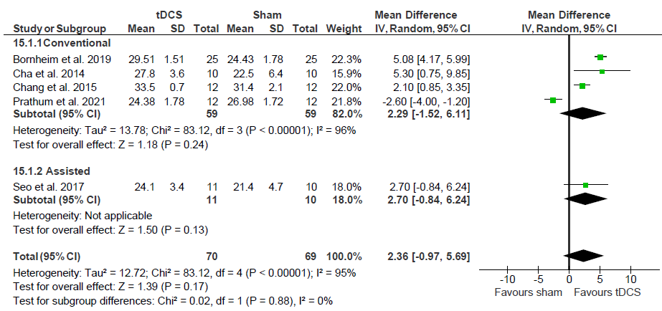

Figure 20 – Effect of Therapy Combined with tDCS (LE-FMA Post-Intervention)
Effects of therapy (Conventional vs Assisted) combined with tDCS on stroke recovery as assessed by the post-intervention data of the tDCS and sham groups for the Lower Extremity Fugl-Meyer Assessment. Meta-analysis showed that conventional therapy combined with tDCS had no effect [2.29 (-1.52, 6.11); P = 0.24], and assisted therapy combined with tDCS had no effect [2.70 (-0.84, 6.24); P = 0.13].

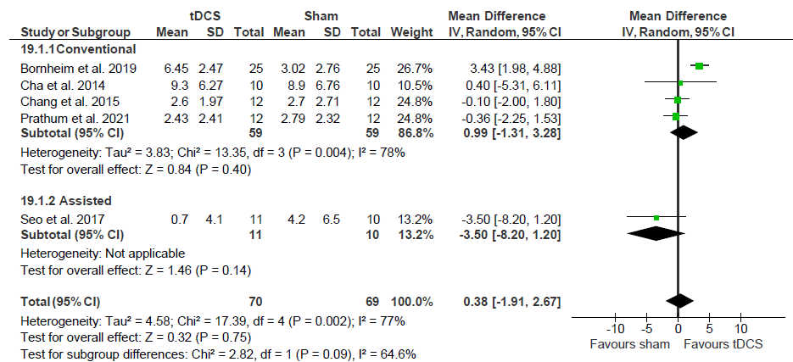
Figure 21 – Effect of Therapy Combined with tDCS (LE-FMA Change Scores)
Effects of therapy (Conventional vs Assisted) combined with tDCS on stroke recovery as assessed by the change scores of the tDCS and sham groups for the Lower Extremity Fugl-Meyer Assessment. Compared with sham there was no benefit of tDCS combined with conventional or assisted therapy.

MAS
A) Descriptive
There was a total of ten studies that used therapy in addition to tDCS and measured recovery using MAS. Three studies used conventional therapy. While one study failed to include a sham group (Miu et al., 2020), only one study determined a significant difference using conventional therapy with tDCS. There were six studies that used assisted therapy with tDCS and while one study failed to include a sham group (Ochi et al., 2013), no study determined a significant difference. Only one study used miscellaneous therapy with tDCS but determined there was a significant difference using tDCS. Five studies provided pre- and post-intervention data using assisted therapy, but none of them determined a MCID on either the tDCS or sham groups.
B) Meta-analysis
A meta-analysis could not be conducted on the effects of therapy type on recovery using MAS as all studies that provided pre- and post-intervention data belonged to the same subgroup (i.e., all used assisted therapy).
Dose Effect of tDCS
To investigate the dose effect, first each study’s Hedge’s g effect size was calculated using change scores from pre- to post-intervention (i.e.: post intervention values -pre intervention/pooled SD) of the tDCS groups for the BI, UE-FMA, LE-FMA and MAS and the values were correlated with: 1) number of sessions, 2) sessions per week, 3) session time, 4) Total tDCS application time, 5) current, 6) electrode size, 7) current density, 8) charge, 9) charge density, 10) total charge, and 11) total charge density. Additional correlations were then conducted based on stimulation type (e.g., anodal, cathodal and bihemispheric) to determine if stimulation type influenced any of these variables. Stroke duration was also considered when conducting correlations. We considered acute stroke as participants undergoing treatment within the first week of stroke, subacute as between one week and three months and chronic as any time after three months.
BI
Correlations including all three stimulation types concluded no significant relationships in any of the variables (Figure 22). Number of sessions (P = 0.75), sessions per week (P = 0.53), session time (P = 0.69), total tDCS application time (P = 0.74), current (P = 0.37), electrode size (P = 0.58), current density (P = 0.26), charge (P = 0.91), charge density (P = 0.44), and total charge density (P = 0.66) (Table 3). For the Barthel Index, an increase in Hedge’s g indicates a better score. A Shapiro-Wilk Test determined data were normal for sessions per week, session time, total tDCS application time, electrode size, total charge, and total charge density, so a Pearson’s Correlation was used to determine those relationships. Data were considered not normal for number of sessions, current, current density, charge, and charge density, so a Spearman’s Correlation was used to determine those relationships.
Correlations only including studies using anodal stimulation also concluded no significant relationships in any of the variables (Table 4). Correlations only including studies using cathodal simulation also concluded no significant relationships (Table 5). Of note, initial correlation of total charge using only cathodal stimulation data indicated a significant relationship (r = 0.81) (P = 0.03), however, after removal of an outlier (Khedr et al., 2013), no significant relationship was shown (P = 0.33).
Correlations only including studies using bihemispheric simulation also concluded no significant relationships in any of the variables (Table 6). For this mode of stimulation, correlations for some variables were unable to be conducted due insufficient study availability: 1) current; 2) electrode size; 3) current density; 4) charge; 5) charge density; 6) total charge; and 7) total charge density.
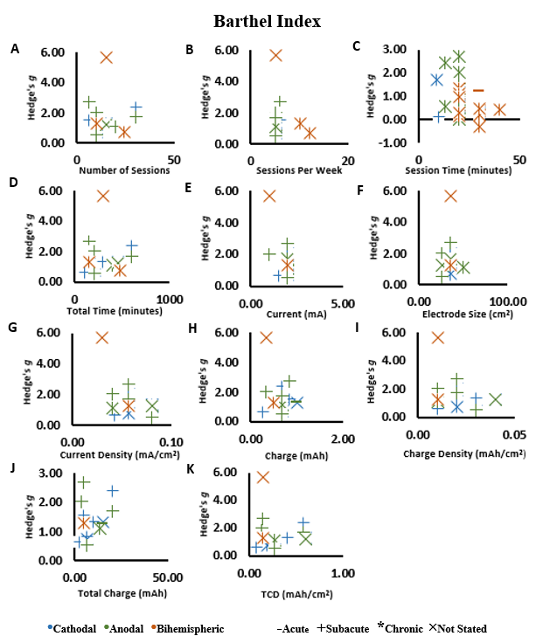
Figure 22 – Dose Effect of tDCS on Barthel Index
Correlations on change scores in tDCS groups as assessed by the Barthel Index. A) number of sessions, B) sessions per week C) session time, D) total tDCS application time, E) current, F) electrode size, G) current density, H) charge, I) charge density, J) total charge, and K) TCD (total charge density). An increase in Hedge’s g indicates a better score.

UE-FMA
Correlations including all three stimulation types concluded no significant relationships in the following variables (Figure 23): number of sessions, sessions per week, total tDCS application time, current, electrode size, current density, charge, charge density, total charge, and total charge density (Table 3). The initial correlation of session time indicated a significant negative relationship (r = -0.36) (P < 0.05), but after removing three outliers (Bornheim et al., 2020; Cha et al., 2014; Rocha et al., 2016), there was no significant relationship (r = -0.32) (P = 0.09) (Figure 23C). For the Upper Extremity Fugl-Meyer Assessment, an increase in Hedge’s g indicates a better score. All data were considered normal after a Shapiro-Wilk Test except for current. Therefore, Pearson’s Correlations were used for all variables except for current, which used a Spearman’s Correlation.
Correlations only including studies using anodal simulation and excluding the three outliers mentioned above also concluded no significant relationships in any of the variables (Table 4). Correlations only including studies using cathodal simulation also concluded no significant relationships in any of the variables (Table 5). Correlations only including studies using bihemispheric simulation also concluded no significant relationships in any of the variables (Table 6).

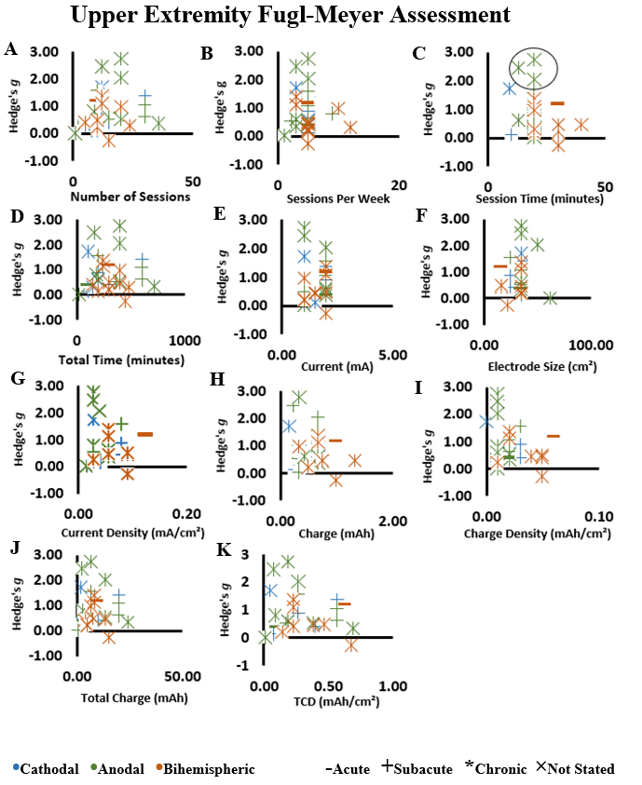

Figure 23 – Dose Effect of tDCS on Upper Extremity Fugl-Meyer Assessment
Correlations on change scores in tDCS groups as assessed by the Upper Extremity Fugl-Meyer Assessment. A) number of sessions, B) sessions per week C) session time, D) total tDCS application time, E) current, F) electrode size, G) current density, H) charge, I) charge density, J) total charge, and K) TCD (total charge density). An increase in Hedge’s g indicates a better score. Outliers are shown with a surrounding circle (23C).

LE-FMA
Correlations including all three stimulation types concluded no significant relationships in any of the variables (Figure 24) (Table 3). For the Lower Extremity Fugl-Meyer Assessment, an increase in Hedge’s g indicates a better score. All data were considered normal after a Shapiro-Wilk Test, so Pearson’s Correlations were used for all variables.
Correlations only including studies using anodal simulation also concluded no significant relationships in any of the variables (Table 4). A correlation for sessions per week could not be conducted due to lack of variance in number of sessions per week used by studies. Correlations only including studies using cathodal simulation could not be conducted as there were no studies available with pre- and post-intervention data (Table 5). Correlations only including studies using bihemispheric simulation could not be conducted as there were insufficient studies available with pre- and post-intervention data (Table 6).

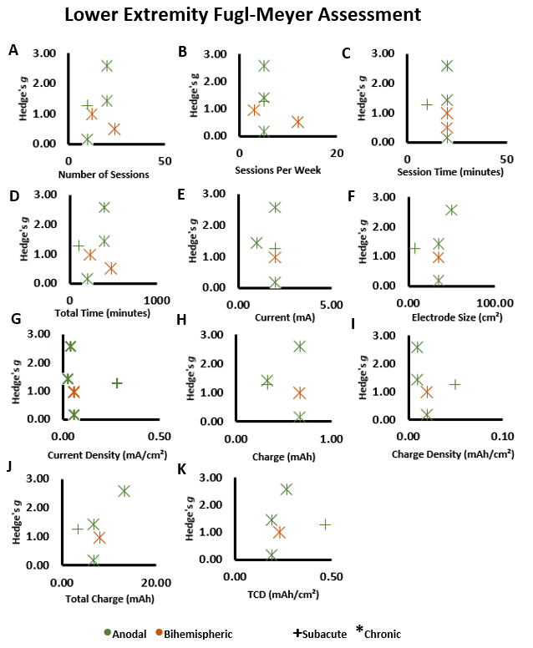
Figure 24 – Dose Effect of tDCS on Lower Extremity Fugl-Meyer Assessment
Correlations on change scores in tDCS groups as assessed by the Lower Extremity Fugl-Meyer Assessment. A) number of sessions, B) sessions per week C) session time, D) total tDCS application time, E) current, F) electrode size, G) current density, H) charge, I) charge density, J) total charge, and K) TCD (total charge density). An increase in Hedge’s g indicates a better score.

MAS
Correlations including all three stimulation types concluded no significant relationships in any of the variables (Figure 25) (Table 3). A correlation on current could not be conducted as all the included studies used the same mA. For the Modified Ashworth Scale, a decrease in Hedge’s g indicates a better score. All data were considered normal after a Shapiro-Wilk Test, so Pearson’s Correlations were used for all variables.
Correlations only including anodal stimulation concluded no significant relationships in any of the variables (Table 3). Correlations could not be conducted on the following variables: 1) current due to all the included studies used the same mA; 2) electrode size due to all the included studies using the same cm²; and 3) current density due to all the included studies using the same mA/cm². Correlations only including studies using cathodal simulation could not be conducted as there were insufficient studies available with pre- and post-intervention data (Table 5). Correlations only including studies using bihemispheric simulation could not be conducted as there were no studies available with pre- and post-intervention data (Table 6).
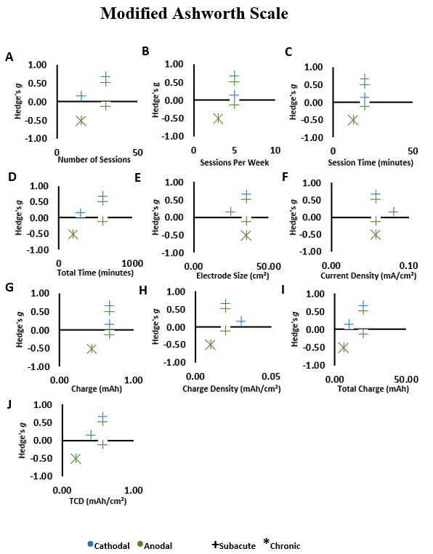

Figure 25 – Dose Effect of tDCS on Modified Ashworth Scale
Correlations on change scores in tDCS groups as assessed by the Modified Ashworth Scale. A) number of sessions, B) sessions per week C) session time, D) total tDCS application time, E) electrode size, F) current density, G) charge, H) charge density, H) total charge, and J) TCD (total charge density). Lower numbers in Hedge’s g indicates a better score.

Influence of Stimulation Type
Crosstabulations were conducted in order to test the association of stimulation type (i.e., anodal, cathodal, and bihemispheric) on therapy type, stroke duration, studies showing MCID in the tDCS group, and statistical significance (i.e., P > 0.05) between tDCS and sham groups. Some calculations were not possible because all studies used same parameters (stimulation type on Barthel Index MCID of the tDCS groups, Modified Ashworth Scale MCID of the tDCS group, and Modified Ashworth Scale statistical significance between tDCS and sham groups). Crosstabulation revealed that stimulation type had no significant association with therapy type (P = 0.98), Barthel Index statistical significance between the tDCS and sham groups (P = 0.93), Upper Extremity Fugl-Meyer Assessment MCID of the tDCS group (P = 0.60), Upper Extremity Fugl-Meyer Assessment statistical significance between the tDCS and sham groups (P = 0.21), Lower Extremity Fugl-Meyer Assessment MCID of the tDCS group (P = 0.22), or Lower Extremity Fugl-Meyer Assessment statistical significance between the tDCS and sham groups (P = 0.54). Crosstabulations revealed a significant association between stimulation type and stroke duration with subacute having lower proportion of bihemispheric and cathodal stimulations (P = 0.04).

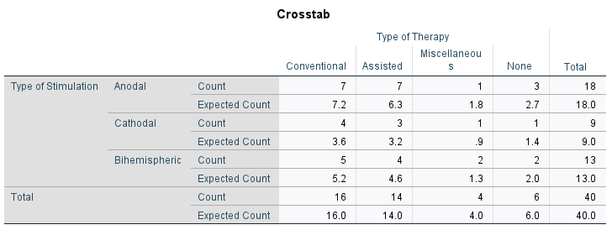

Figure 26 – Type of Stimulation and Type of Therapy Crosstabulation
Crosstabulation for the type of stimulation with type of therapy, which showed no significant association (P = 0.98).

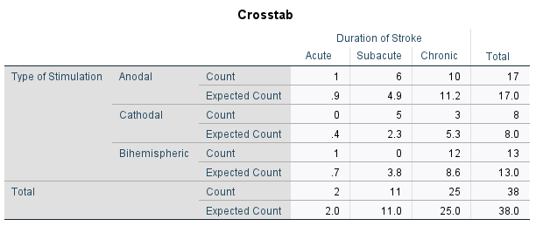

Figure 27 – Type of Stimulation and Duration of Stroke Crosstabulation
Crosstabulation for the type of stimulation with duration of stroke, which showed a significant association (P = 0.04).

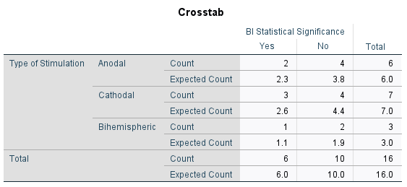

Figure 28 – Type of Stimulation and BI Statistical Significance Crosstabulation
Crosstabulation for the type of stimulation with studies showing Barthel Index statistical significance between the tDCS and sham groups, which showed no significant association (P = 0.93).

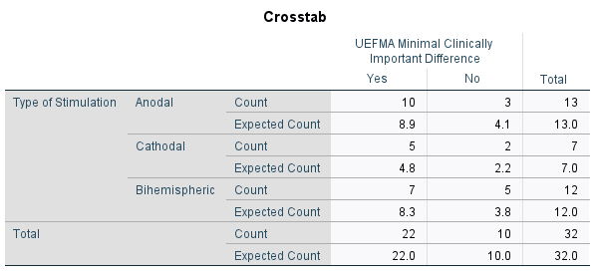

Figure 29 – Type of Stimulation and UE-FMA MCID Crosstabulation
Crosstabulation for the type of stimulation with studies showing Upper Extremity Fugl-Meyer Assessment minimal clinically important difference of the tDCS groups, which showed no significant association (P = 0.60).

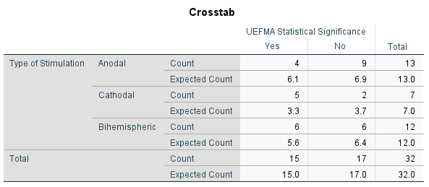

Figure 30 – Type of Stimulation and UE-FMA Statistical Significance Crosstabulation
Crosstabulation for the type of stimulation with studies showing Upper Extremity Fugl-Meyer Assessment statistical significance between the tDCS and sham groups, which showed no significant association (P = 0.21).

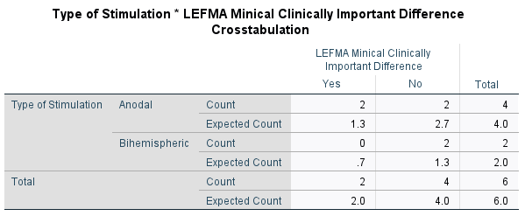

Figure 31 – Type of Stimulation and LE-FMA MCID Crosstabulation
Crosstabulation for the type of stimulation with studies showing Lower Extremity Fugl-Meyer Assessment minimal clinically important difference of the tDCS groups, which showed no significant association (P = 0.22).

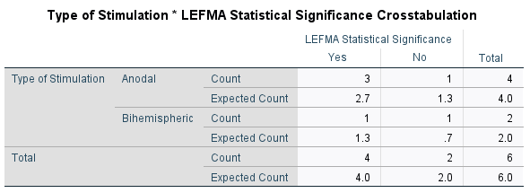

Figure 32 – Type of Stimulation and LE-FMA Statistical Significance Crosstabulation
Crosstabulation for the type of stimulation with studies showing Lower Extremity Fugl-Meyer Assessment statistical significance between the tDCS and sham groups, which showed no significant association (P = 0.54).

Table 3. Overall Correlation Matrix
 |  | Barthel Index | Upper Extremity Fugl-Meyer Assessment | Lower Extremity Fugl-Meyer Assessment | Modified Ashworth Scale
Number of Sessions | r | 0.09 | 0.16 | 0.29 | 0.61
Number of Sessions | P | 0.75 | 0.38 | 0.57 | 0.27
Number of Sessions | n | 16 | 23 | 6 | 5
Sessions Per Week | r | -0.17 | -0.10 | -0.32 | 0.77
Sessions Per Week | P | 0.53 | 0.60 | 0.54 | 0.13
Sessions Per Week | n | 16 | 32 | 6 | 5
Session Time (minutes) | r | 0.11 | -0.31 | -0.07 | 0.77
Session Time (minutes) | P | 0.69 | 0.10 | 0.89 | 0.13
Session Time (minutes) | n | 16 | 30 | 6 | 5
Total tDCS Application Time (minutes) | r | 0.09 | 0.04 | 0.23 | 0.70
Total tDCS Application Time (minutes) | P | 0.74 | 0.84 | 0.67 | 0.19
Total tDCS Application Time (minutes) | n | 16 | 32 | 6 | 5
Current (mA) | r | -0.25 | 0.12 | -0.09 | N/A
Current (mA) | P | 0.37 | 0.54 | 0.88 | N/A
Current (mA) | n | 15 | 30 | 5 | 5
Electrode Size (cm²) | r | 0.16 | 0.08 | 0.36 | -0.01
Electrode Size (cm²) | P | 0.58 | 0.68 | 0.55 | 0.98
Electrode Size (cm²) | n | 15 | 28 | 5 | 5
Current Density (mA/cm²) | r | -0.31 | -0.17 | -0.08 | 0.10
Current Density (mA/cm²) | P | 0.26 | 0.39 | 0.91 | 0.88
Current Density (mA/cm²) | n | 15 | 28 | 5 | 5
Charge (mAh) | r | 0.03 | -0.26 | -0.07 | 0.77
Charge (mAh) | P | 0.91 | 0.17 | 0.91 | 0.16
Charge (mAh) | n | 15 | 30 | 5 | 5
Charge Density (mAh/cm²) | r | -0.22 | -0.26 | -0.26 | 0.49
Charge Density (mAh/cm²) | P | 0.44 | 0.18 | 0.68 | 0.40
Charge Density (mAh/cm²) | n | 15 | 28 | 5 | 5
Total Charge (mAh) | r | -0.05 | -0.01 | 0.65 | 0.70
Total Charge (mAh) | P | 0.85 | 0.94 | 0.24 | 0.19
Total Charge (mAh) | n | 15 | 30 | 5 | 5
Total Charge Density (mAh/cm²) | r | -0.12 | -0.15 | 0.46 | 0.77
Total Charge Density (mAh/cm²) | P | 0.66 | 0.46 | 0.44 | 0.13
Total Charge Density (mAh/cm²) | n | 15 | 28 | 5 | 5

Table 4. Anodal Correlation Matrix
 |  | Barthel Index | Upper Extremity Fugl-Meyer Assessment | Lower Extremity Fugl-Meyer Assessment | Modified Ashworth Scale
Number of Sessions | r | -0.38 | 0.03 | 0.75 | 0.80
Number of Sessions | P | 0.46 | 0.92 | 0.25 | 0.42
Number of Sessions | n | 6 | 13 | 4 | 3
Sessions Per Week | r | 0.74 | 0.20 | N/A | 0.80
Sessions Per Week | P | 0.09 | 0.52 | N/A | 0.42
Sessions Per Week | n | 6 | 13 | 4 | 4
Session Time (minutes) | r | 0.18 | 0.42 | 0.06 | 0.80
Session Time (minutes) | P | 0.74 | 0.91 | 0.94 | 0.42
Session Time (minutes) | n | 6 | 10 | 4 | 3
Total tDCS Application Time (minutes) | r | -0.23 | 0.00 | 0.60 | 0.80
Total tDCS Application Time (minutes) | P | 0.66 | 1.00 | 0.40 | 0.42
Total tDCS Application Time (minutes) | n | 6 | 13 | 4 | 3
Current (mA) | r | -0.39 | -0.13 | -0.04 | N/A
Current (mA) | P | 0.44 | 0.68 | 0.96 | N/A
Current (mA) | n | 6 | 13 | 4 | 3
Electrode Size (cm²) | r | 0.06 | -0.19 | 0.39 | N/A
Electrode Size (cm²) | P | 0.91 | 0.54 | 0.61 | N/A
Electrode Size (cm²) | n | 6 | 13 | 4 | 3
Current Density (mA/cm²) | r | -0.36 | -0.20 | -0.13 | N/A
Current Density (mA/cm²) | P | 0.49 | 0.51 | 0.87 | N/A
Current Density (mA/cm²) | n | 6 | 13 | 4 | 3
Charge (mAh) | r | 0.03 | -0.26 | 0.01 | 0.80
Charge (mAh) | P | 0.95 | 0.40 | 0.99 | 0.42
Charge (mAh) | n | 6 | 13 | 4 | 3
Charge Density (mAh/cm²) | r | -0.29 | -0.19 | -0.27 | 0.80
Charge Density (mAh/cm²) | P | 0.57 | 0.53 | 0.73 | 0.42
Charge Density (mAh/cm²) | n | 6 | 13 | 4 | 3
Total Charge (mAh) | r | -0.27 | -0.13 | 0.68 | 0.80
Total Charge (mAh) | P | 0.60 | 0.67 | 0.33 | 0.42
Total Charge (mAh) | n | 6 | 13 | 4 | 3
Total Charge Density (mAh/cm²) | r | -0.34 | -0.17 | 0.19 | 0.80
Total Charge Density (mAh/cm²) | P | 0.51 | 0.57 | 0.81 | 0.42
Total Charge Density (mAh/cm²) | n | 6 | 13 | 4 | 3

Table 5. Cathodal Correlation Matrix
 |  | Barthel Index | Upper Extremity Fugl-Meyer Assessment | Lower Extremity Fugl-Meyer Assessment | Modified Ashworth Scale
Number of Sessions | r | 0.39 | 0.52 | N/A | N/A
Number of Sessions | P | 0.38 | 0.23 | N/A | N/A
Number of Sessions | n | 7 | 7 | 0 | 1
Sessions Per Week | r | 0.21 | -0.71 | N/A | N/A
Sessions Per Week | P | 0.66 | 0.08 | N/A | N/A
Sessions Per Week | n | 7 | 7 | 0 | 1
Session Time (minutes) | r | 0.37 | -0.34 | N/A | N/A
Session Time (minutes) | P | 0.41 | 0.46 | N/A | N/A
Session Time (minutes) | n | 7 | 7 | 0 | 1
Total tDCS Application Time (minutes)* | r | 0.80 | 0.34 | N/A | N/A
Total tDCS Application Time (minutes)* | P | 0.03 | 0.45 | N/A | N/A
Total tDCS Application Time (minutes)* | n | 7 | 7 | 0 | 1
Current (mA) | r | 0.61 | 0.14 | N/A | N/A
Current (mA) | P | 0.14 | 0.77 | N/A | N/A
Current (mA) | n | 7 | 7 | 0 | 1
Electrode Size (cm²) | r | 0.16 | 0.26 | N/A | N/A
Electrode Size (cm²) | P | 0.74 | 0.62 | N/A | N/A
Electrode Size (cm²) | n | 7 | 6 | 0 | 1
Current Density (mA/cm²) | r | 0.32 | -0.32 | N/A | N/A
Current Density (mA/cm²) | P | 0.62 | 0.54 | N/A | N/A
Current Density (mA/cm²) | n | 7 | 6 | 0 | 1
Charge (mAh) | r | 0.49 | -0.18 | N/A | N/A
Charge (mAh) | P | 0.26 | 0.71 | N/A | N/A
Charge (mAh) | n | 7 | 7 | 0 | 1
Charge Density (mAh/cm²) | r | 0.23 | -0.40 | N/A | N/A
Charge Density (mAh/cm²) | P | 0.23 | 0.43 | N/A | N/A
Charge Density (mAh/cm²) | n | 7 | 6 | 0 | 1
Total Charge (mAh) | r | 0.49 | 0.31 | N/A | N/A
Total Charge (mAh) | P | 0.33 | 0.50 | N/A | N/A
Total Charge (mAh) | n | 6 | 7 | 0 | 1
Total Charge Density (mAh/cm²) | r | 0.66 | 0.13 | N/A | N/A
Total Charge Density (mAh/cm²) | P | 0.11 | 0.80 | N/A | N/A
Total Charge Density (mAh/cm²) | n | 7 | 6 | 0 | 1

Table 6. Bihemispheric Correlation Matrix
 |  | Barthel Index | Upper Extremity Fugl-Meyer Assessment | Lower Extremity Fugl-Meyer Assessment | Modified Ashworth Scale
Number of Sessions | r | -0.50 | -0.01 | N/A | N/A
Number of Sessions | P | 0.67 | 0.99 | N/A | N/A
Number of Sessions | n | 3 | 12 | 2 | 0
Sessions Per Week | r | -0.98 | -0.17 | N/A | N/A
Sessions Per Week | P | 0.11 | 0.59 | N/A | N/A
Sessions Per Week | n | 3 | 12 | 2 | 0
Session Time (minutes) | r | 0.41 | -0.34 | N/A | N/A
Session Time (minutes) | P | .73 | 0.27 | N/A | N/A
Session Time (minutes) | n | 3 | 12 | 2 | 0
Total tDCS Application Time (minutes) | r | -0.16 | -0.29 | N/A | N/A
Total tDCS Application Time (minutes) | P | 0.90 | 0.38 | N/A | N/A
Total tDCS Application Time (minutes) | n | 3 | 12 | 2 | 0
Current (mA) | r | N/A | 0.40 | N/A | N/A
Current (mA) | P | N/A | 0.25 | N/A | N/A
Current (mA) | n | 2 | 10 | 1 | 0
Electrode Size (cm²) | r | N/A | 0.01 | N/A | N/A
Electrode Size (cm²) | P | N/A | 0.80 | N/A | N/A
Electrode Size (cm²) | n | 2 | 9 | 1 | 0
Current Density (mA/cm²) | r | N/A | 0.23 | N/A | N/A
Current Density (mA/cm²) | P | N/A | 0.55 | N/A | N/A
Current Density (mA/cm²) | n | 2 | 9 | 1 | 0
Charge (mAh) | r | N/A | -0.15 | N/A | N/A
Charge (mAh) | P | N/A | 0.67 | N/A | N/A
Charge (mAh) | n | 2 | 10 | 1 | 0
Charge Density (mAh/cm²) | r | N/A | -0.04 | N/A | N/A
Charge Density (mAh/cm²) | P | N/A | 0.92 | N/A | N/A
Charge Density (mAh/cm²) | n | 2 | 9 | 1 | 0
Total Charge (mAh) | r | N/A | -0.17 | N/A | N/A
Total Charge (mAh) | P | N/A | 0.63 | N/A | N/A
Total Charge (mAh) | n | 2 | 10 | 1 | 0
Total Charge Density (mAh/cm²) | r | N/A | -0.12 | N/A | N/A
Total Charge Density (mAh/cm²) | P | N/A | 0.76 | N/A | N/A
Total Charge Density (mAh/cm²) | n | 2 | 9 | 1 | 0

Chapter V: Discussion
This thesis indicates the tDCS alone was ineffective to improve motor recovery after stroke. However, tDCS applied in combination with other therapies was somewhat beneficial for motor recovery of stroke individuals and the improvements could be dependent on the baseline function of the individuals and therapy type. Specifically: 1) meta-analysis using post-intervention data from tDCS and sham groups showed positive effect of tDCS on BI but not UE-FMA, LE-FME or MAS. However, comparisons of change scores, which accounts for minimal differences in baseline characteristics of the individual, showed positive effects of tDCS on BI and UE-FMA but not LE-FMA or MAS; 2) Conventional therapy combined with tDCS had a greater effect size compared with assisted therapy combined with tDCS (~12 vs ~4 respectively) on motor recovery of BI for either post scores or changes scores. For the UE-FMA the conventional and miscellaneous therapies showed a positive effect when baseline groups characteristics was accounted for (i.e., change score analysis) but not post-scores comparisons. No effect of therapy type was evident for the LE-FMA or MAS. 3) Contrary to our hypothesis, tDCS dosage has minimal influence on the recovery of motor function after stroke. Stimulation type (i.e., anodal, cathodal, and bihemispheric) was not associated with the type of therapy used in combination with tDCS, MCID of the tDCS group.
Differences in the participants’ characteristics can potentially explain the discrepant results for the BI and UE-FMA. Out of the sixteen total possible studies included in the BI meta-analyses the majority used subacute participants compared with chronic (approximately 56% vs 25%, respectively), whereas 19% did not state the duration of stroke. Out of the thirty-two total possible studies include in the UE-FMA meta-analyses approximately 6% used acute participants, 25% used subacute participants, and ~69% used chronic participants. Another possibility for discrepancy could be due to the low availability of study data for not only the BI, but especially the LE-FMA and MAS. One more possibility for the discrepancy seen may be due to differences in the scales themselves. Specifically, the BI is an assessment for gross movements used for activities of daily living scored broadly, the UE-FMA and LE-FMA are assessments for specific movements related to motor function with highly detailed scoring, and the MAS assessing muscle spasticity with a small scoring range.
Other reviews have assessed the effects of tDCS on motor recovery and indicated that there may be a significant effect of the treatment on ADL and upper extremity motor function recovery (Chhatbar et al., 2015; Elsner et al., 2020; Van Hoornweder et al., 2021). However, one of those studies, investigating the effects of tDCS on upper extremity motor function recovery, determined that the significance of tDCS as a tool for motor function recovery may depend on several factors, such as duration of time since the participant suffered a stroke (Van Hoornweder et al., 2021). Another of those studies also suggested that their findings on the effectiveness of tDCS as a rehabilitative tool in post-stroke motor function recovery were considered insignificant when limiting their studies to ones with proper allocation concealment (Elsner et al., 2020). One study also suggested that there is a positive dose-response relationship of improvements in upper extremity motor function recovery with current density, charge density and electrode size (Chhatbar et al., 2015).
Effect of tDCS on Motor Recovery
A new aspect in this thesis is the evaluation of MCID. Conversely to statistical differences between tDCS and sham groups, MCID analysis reveals that 1) tDCS improved motor function in all studies that assessed BI, 2) more than half of the included studies using UE-FMA concluded there was a MCID, 3) MCID was found in less than half of the studies using LE-FMA and 4) for the MAS, which was assessed in only five studies, no study found MCID.
When accounting for the baseline characteristics, there was no improvement in motor function assessed by the LE-FMA or MAS (figures 9 and 11), however the BI and UE-FMA had a small improvement (effect size: 6.21, figure 5) (effect size: 2.94, figure 7). Individual analysis on change scores indicates that out of fifty-four studies only twenty-two found that tDCS has a positive effect (i.e. tDCS results in better scores in the assessments) on the recovery of motor function in post-stroke patients using either the BI, UE-FMA, LE-FMA or MAS. For each the BI, UE-FMA and the MAS more than half of the included studies determined that tDCS motor function recovery was not different compared with sham, whereas for the LE-FMA, more than half of the included studies determined that tDCS lower extremity motor function was beneficial compared to sham. This is consistent with previous observations that also accounted for the baseline characteristics of the individual (Chhatbar et al., 2015).
Conversely, using meta-analyses of post-intervention data of the tDCS and sham groups, it was observed that tDCS does have a significant effect on post-stroke recovery only when assessed by the BI. Meta-analyses also revealed that tDCS does not have a significant effect on post-stroke recovery of upper limb motor function as assessed by the UE-FMA, lower limb motor function as assessed by the LE-FMA, or muscle spasticity as assessed by the MAS. Precaution towards the results of BI, LE-FMA and MAS should be given due to a low number of studies with available post-intervention data. These results agree with others (Elsner et al., 2020). Similar to our study, it was previously shown there is no evidence of effect of tDCS on lower limb motor function recovery and no evidence of an effect for upper limb motor function recovery (Elsner et al., 2020).

Table 7. Results Summary
Assessment ​ | # of Studies | Post Score ​Improvement ​ | Change Score Improvement ​ | MCID %
Barthel Index ​ | 16 | Yes ​ | Yes ​ | 100%
Upper Extremity Fugl-Meyer Assessment ​ | 32 | No ​ | Yes ​ | 81%
Lower-Extremity Fugl-Meyer Assessment ​ | 6 | No ​ | No ​ | 33%
Modified Ashworth Scale ​ | 4 | No ​ | No ​ | 0%

Summary of the results. # of Studies includes the number of studies that provided pre- and post-intervention data used in analyses. Sections with “Yes” indicate significant difference was seen and “No” indicate no significant differences were seen. MCID % is the percent of the number of studies that showed a minimal clinically important difference in the tDCS group.

Effect of tDCS as a Standalone Therapy
The results of this thesis suggest tDCS may not be an effective therapy when not used in tandem with another form of therapy. While there were only results for BI and UE-FMA, most of the studies determined that tDCS as a standalone therapy had no effect on post-stroke recovery. While meta-analyses were conducted on post-intervention data and change scores of the tDCS and sham groups for the BI and UE-FMA, those analyses also showed that tDCS had no positive effect on motor recovery. As the available data is scarce, it would be beneficial for future studies to investigate tDCS as a standalone therapy to strengthen conclusions.
Effect of Therapy Type Combined with tDCS
Results from examination and meta-analyses of post-intervention results between tDCS and sham groups may indicate that the type of therapy post-stroke patients receive in combination with tDCS may determine the overall effectiveness of recovery. Specifically, both examination of results from individual studies and meta-analyses of post-intervention and change scores strengthens the evidence that assisted-type and conventional-type therapy have a positive effect on recovery of ADL using the BI. Miscellaneous-type therapy had a positive effect on upper extremity motor recovery using the UE-FMA only. However, evidence of using other miscellaneous therapy in addition to tDCS are scarce and heterogeneous, and results should be interpreted cautiously.
Dose Effect of tDCS
Results from the correlations (Figures 22-25) indicated that there may have been a dose effect of tDCS total charge (mAh) on recovery of ADL assessed by with the Barthel Index, but after removal of an outlier, there was no significant dose effect (Figure 22J). Likewise, there may have been a dose effect of tDCS session time (minutes) on recovery of upper extremity motor function recovery assessed by the Upper-Extremity Fugl-Meyer Assessment, but after the removal of two outliers, there was no significant dose effect (Figure 23C). Similarly, for all other correlations, there was no dose effect of tDCS on ADL, upper limb motor function, lower limb motor function or muscle spasticity as assessed by the BI, UE-FMA, LE-FMA and MAS, respectively. Others also investigated the effects of dosage on motor recovery after stroke however only using the UE-FMA (Chhatbar et al., 2015). They showed that electrode size (cm²), charge density (mAh/cm²), and current density (mA/cm²) had significant dose-response relationships with UE-FMA, which contrast with the current findings. Differences between studies may be due to the limited number of studies available at the time of their review, which only included eight total studies, whereas the correlations included in this review for the UE-FMA ranged from twenty-eight studies to thirty-two studies.
Influence of Stimulation Type
Because stroke alters motor cortical excitability in both the affected and unaffected hemispheres, there are a few approaches that are considered when using tDCS, but none have been proven more effective than the other yet (Chhatbar et al., 2015; Stagg et al., 2018). In general terms, it is speculated that anodal tDCS employed to the affected hemisphere could modulate the stroke induced reduction in excitability (Chhatbar et al., 2015; Stagg et al., 2018). Conversely, increased excitability of the unaffected hemisphere is suggested to occur, and cathodal tDCS has the potential to modulate the stroke induced increased excitability of the unaffected hemisphere (Chhatbar et al., 2015; Stagg et al., 2018). Another approach is to use a method, known as bihemispheric tDCS, combining the aspects of both anodal and cathodal tDCS by increasing excitability levels in the affected hemisphere while also decreasing excitability levels in the unaffected hemisphere to simultaneously return both hemispheres to normal excitability levels (Chhatbar et al., 2015; Stagg et al., 2018). This thesis found no association between stimulation type and proportion of studies showing MCID (Figure 32). Considering this is a review of previous published studies and did not manipulate the type of stimulation used, this calculation does not indicate the stimulation had minimal influence on MCID, but instead shows the characteristics of the stimulation did not affect the overall results showed in the forest plots.
There were also no associations between stimulation type and therapy type, MCID of either the BI, UE-FMA, LE-FMA, and MAS or statistical significance between the tDCS and sham groups of either the BI, UE-FMA, LE-FMA, and MAS. However, there was a significant association between stimulation type and duration of stroke (P = 0.04, figure 27). These findings conflict with previous observations showing that bihemispheric tDCS may improve upper extremity motor function recover assessed by the UE-FMA to a greater extent than anodal or cathodal (Chhatbar et al., 2015). However, in their discussion, they note the limited number of studies in their comparisons as a caution in interpreting their findings as concrete evidence.
Limitations and Future Directions
Risk of bias can be improved in future studies by properly describing and performing proper randomization of participants and allocation concealment. Studies should not simply state participants were randomized or allocated to separate groups but should focus on the description and process of how it was done to ensure that participants could have no significant impact on results due to a poor randomization process that creates baseline differences or knowledge of group allocation that may impact performance of individuals. Likewise, proper description and implementation of blinding researchers and investigators is an area of possible improvement as many studies failed to mention their process of blinding. Particularly, studies should ensure that researchers are not the same people performing the assessments, and that the assessors are blinded from participant group allocation to ensure that the results of the assessments are not skewed in favor of the study’s hypothesis.
Future studies should also better report the baseline motor function of their participants and any group difference between tDCS and sham should be avoided. Other factors that should be investigated are the use of tDCS as a lone therapeutic method to provide more evidence as to the effectiveness of tDCS on improving stroke rehabilitation. Studies should also include separate groups to include anodal tDCS, cathodal tDCS, and bihemispheric tDCS in comparison with a sham group to determine which, if any, of the different stimulation types provide the most effective results in post-stroke motor function recovery. With the lack of studies investigating lower extremity motor function and spasticity, it is also recommended that more studies investigate the effect of tDCS on those types of motor function to provide clearer evidence.

Chapter VI: Conclusion
This thesis provides evidence that tDCS may be an effective tool in post-stroke motor recovery for ADL and upper extremity motor function as evidenced by meta-analyses and examination of MCID seen in studies. However, the effects of tDCS on motor recovery on lower extremity motor function and muscle spasticity failed to show improvements, perhaps due to lack of available studies. Likewise, while there is a limited number of studies, the use of tDCS by itself as a tool for motor function recovery in post-stroke patients appears to be ineffective. While tDCS as a solo therapy failed to show promising results, the use of tDCS in tandem with another form of therapy (i.e., conventional therapy, assisted therapy, and miscellaneous therapy) improves motor function recovery in post-stroke patients. This study has also shown that the dosage of tDCS has no impact on the effectiveness of motor function recovery.

References

Achacheluee, S. T., Rahnama, L., Karimi, N., Abdollahi, I., Arslan, S. A., & Jaberzadeh, S. (2018). The Effect of Unihemispheric Concurrent Dual-Site Transcranial Direct Current Stimulation of Primary Motor and Dorsolateral Prefrontal Cortices on Motor Function in Patients With Sub-Acute Stroke. Front Hum Neurosci, 12, 441. doi:10.3389/fnhum.2018.00441
Adeyemo, B. O., Simis, M., Macea, D. D., & Fregni, F. (2012). Systematic Review of Parameters of Stimulation, Clinical Trial Design Characteristics, and Motor Outcomes in Non-Invasive Brain Stimulation in Stroke. Front. Psychiatry, 3. doi:10.3389/fpsyt.2012.00088.
Allman, C., Amadi, U., Winkler, A. M., Wilkins, L., Filippini, N., Kischka, U., . . . Johansen-Berg, H. (2016). Ipsilesional anodal tDCS enhances the functional benefits of rehabilitation in patients after stroke. Sci Transl Med, 8(330), 330re331. doi:10.1126/scitranslmed.aad5651
Andrade, S. M., Batista, L. M., Nogueira, L. L., de Oliveira, E. A., de Carvalho, A. G., Lima, S. S., . . . Fernandez-Calvo, B. (2017). Constraint-Induced Movement Therapy Combined with Transcranial Direct Current Stimulation over Premotor Cortex Improves Motor Function in Severe Stroke: A Pilot Randomized Controlled Trial. Rehabil Res Pract, 2017, 6842549. doi:10.1155/2017/6842549
Arnao, V., Riolo, M., Carduccio, F., Tuttolomondo, A., D'Amelio, M., Brighina, F., . . . Aridon, P. (2019). Effects of transcranial random noise stimulation combined with Graded Repetitive Arm Supplementary Program (GRASP) on motor rehabilitation of the upper limb in sub-acute ischemic stroke patients: a randomized pilot study. J Neural Transm (Vienna), 126(12), 1701-1706. doi:10.1007/s00702-019-02087-9
Baltar, A., Piscitelli, D., Marques, D., Shirahige, L., & Monte-Silva, K. (2020). Baseline Motor Impairment Predicts Transcranial Direct Current Stimulation Combined with Physical Therapy-Induced Improvement in Individuals with Chronic Stroke. Neural Plast, 2020, 8859394. doi:10.1155/2020/8859394
Beaulieu, L. D., Blanchette, A. K., Mercier, C., Bernard-Larocque, V., & Milot, M. H. (2019). Efficacy, safety, and tolerability of bilateral transcranial direct current stimulation combined to a resistance training program in chronic stroke survivors: A double-blind, randomized, placebo-controlled pilot study. Restor Neurol Neurosci, 37(4), 333-346. doi:10.3233/RNN-190908
Bikson, M., Grossman, P., Thomas, C., Zannou, A. L., Jiang, J., Adnan, T., . . . J.Woods, A. (2016). Safety of Transcranial Direct Current Stimulation: Evidence Based Update 2016. Brain Stimulation, 9, 641-661. doi:10.1016/j.brs.2016.06.004
Blackburn, M., Vliet, P. v., & Mockett, S. P. (2002). Reliability of Measurements Obtained With the Modified Ashworth Scale in the Lower Extremities of People With Stroke. Physical Therapy, 82(1), 25-34. doi:10.1093/ptj/82.1.25
Bolognini, N., Russo, C., Souza Carneiro, M. I., Nicotra, A., Olgiati, E., Spandri, V., . . . Vallar, G. (2020). Bi-hemispheric transcranial direct current stimulation for upper-limb hemiparesis in acute stroke: a randomized, double-blind, sham-controlled trial. Eur J Neurol, 27(12), 2473-2482. doi:10.1111/ene.14451
Bolognini, N., Vallar, G., Casati, C., Latif, L. A., El-Nazer, R., Williams, J., . . . Fregni, F. (2011). Neurophysiological and behavioral effects of tDCS combined with constraint-induced movement therapy in poststroke patients. Neurorehabil Neural Repair, 25(9), 819-829. doi:10.1177/1545968311411056
Bornheim, S., Croisier, J. L., Maquet, P., & Kaux, J. F. (2020). Transcranial direct current stimulation associated with physical-therapy in acute stroke patients - A randomized, triple blind, sham-controlled study. Brain Stimul, 13(2), 329-336. doi:10.1016/j.brs.2019.10.019
Cao, X., Cui, Z., Feng, R., Tang, Y. P., Qin, Z., Mei, B., & Tsien, J. Z. (2007). Maintenance of superior learning and memory function in NR2B transgenic mice during ageing. Eur J Neurosci, 25(6), 1815-1822. doi:10.1111/j.1460-9568.2007.05431.x
CDC. (2021). Stroke Facts. Retrieved from https://www.cdc.gov/stroke/facts.htm
Cha, H. K., Ji, S. G., Kim, M. K., & Chang, J. S. (2014). Effect of transcranial direct current stimulation of function in patients with stroke. J Phys Ther Sci, 26(3), 363-365. doi:10.1589/jpts.26.363
Chang, M. C., Kim, D. Y., & Park, D. H. (2015). Enhancement of Cortical Excitability and Lower Limb Motor Function in Patients With Stroke by Transcranial Direct Current Stimulation. Brain Stimul, 8(3), 561-566. doi:10.1016/j.brs.2015.01.411
Chen, C. L., Chen, C. Y., Chen, H. C., Wu, C. Y., Lin, K. C., Hsieh, Y. W., & Shen, I. H. (2019). Responsiveness and minimal clinically important difference of Modified Ashworth Scale in patients with stroke. Eur J Phys Rehabil Med, 55(6), 754-760. doi:10.23736/S1973-9087.19.05545-X
Chen, J. L., Schipani, A., Schuch, C. P., Lam, H., Swardfager, W., Thiel, A., & Edwards, J. D. (2021). Does Cathodal vs. Sham Transcranial Direct Current Stimulation Over Contralesional Motor Cortex Enhance Upper Limb Motor Recovery Post-stroke? A Systematic Review and Meta-analysis. Front Neurol, 12, 626021. doi:10.3389/fneur.2021.626021
Chen, J. L., & Schlaug, G. (2016). Increased resting state connectivity between ipsilesional motor cortex and contralesional premotor cortex after transcranial direct current stimulation with physical therapy. Sci Rep, 6, 23271. doi:10.1038/srep23271
Cheng, H. J., Ng, K. K., Qian, X., Ji, F., Lu, Z. K., Teo, W. P., . . . Zhou, J. H. (2021). Task-related brain functional network reconfigurations relate to motor recovery in chronic subcortical stroke. Sci Rep, 11(1), 8442. doi:10.1038/s41598-021-87789-5
Chervyakov, A. V., Poydasheva, A. G., Lyukmanov, R. H., Suponeva, N. A., Chernikova, L. A., Piradov, M. A., & Ustinova, K. I. (2018). Effects of Navigated Repetitive Transcranial Magnetic Stimulation After Stroke. J Clin Neurophysiol, 35(2), 166-172. doi:10.1097/WNP.0000000000000456
Chew, E., Teo, W. P., Tang, N., Ang, K. K., Ng, Y. S., Zhou, J. H., . . . Guan, C. (2020). Using Transcranial Direct Current Stimulation to Augment the Effect of Motor Imagery-Assisted Brain-Computer Interface Training in Chronic Stroke Patients-Cortical Reorganization Considerations. Front Neurol, 11, 948. doi:10.3389/fneur.2020.00948
Chhatbar, P. Y., Ramakrishnan, V., Kautz, S., George, M. S., Adams, R. J., & Feng, W. (2015). Transcranial Direct Current Stimulation Post-Stroke Upper Extremity Motor Recovery Studies Exhibit a Dose-Response Relationship. Brain Stimulation, 9(1), 16-26. doi:http://dx.doi.org/doi: 10.1016/j.brs.2015.09.002
Cho, H. S., & Cha, H. G. (2015). Effect of mirror therapy with tDCS on functional recovery of the upper extremity of stroke patients. J Phys Ther Sci, 27(4), 1045-1047. doi:10.1589/jpts.27.1045
Cho, J. Y., Lee, A., Kim, M. S., Park, E., Chang, W. H., Shin, Y. I., & Kim, Y. H. (2017). Dual-mode noninvasive brain stimulation over the bilateral primary motor cortices in stroke patients. Restor Neurol Neurosci, 35(1), 105-114. doi:10.3233/RNN-160669
Chou, L. W., Palmer, J. A., Binder-Macleod, S., & Knight, C. A. (2013). Motor unit rate coding is severely impaired during forceful and fast muscular contractions in individuals post stroke. J Neurophysiol, 109(12), 2947-2954. doi:10.1152/jn.00615.2012
Coleman, E. R., Moudgal, R., Lang, K., Hyacinth, H. I., Awosika, O. O., Kissela, B. M., & Feng, W. (2017). Early Rehabilitation After Stroke: a Narrative Review. Curr Atheroscler Rep, 19(59), 1-12. doi:10.1007/s11883-017-0686-6
Coppens, M. J. M., Staring, W. H. A., Nonnekes, J., Geurts, A. C. H., & Weerdesteyn, V. (2019). Offline effects of transcranial direct current stimulation on reaction times of lower extremity movements in people after stroke: a pilot cross-over study. Journal of NeuroEngineering & Rehabilitation, 16(136), 1-10.
Cosmo, C., Baptista, A. F., de Araujo, A. N., do Rosario, R. S., Miranda, J. G., Montoya, P., & de Sena, E. P. (2015). A Randomized, Double-Blind, Sham-Controlled Trial of Transcranial Direct Current Stimulation in Attention-Deficit/Hyperactivity Disorder. PloS One, 10(8), e0135371. doi:10.1371/journal.pone.0135371
D'Agata, F., Peila, E., Cicerale, A., Caglio, M. M., Caroppo, P., Vighetti, S., . . . Massazza, G. (2016). Cognitive and Neurophysiological Effects of Non-invasive Brain Stimulation in Stroke Patients after Motor Rehabilitation. Front Behav Neurosci, 10, 135. doi:10.3389/fnbeh.2016.00135
Di Lazzaro, V., Dileone, M., Capone, F., Pellegrino, G., Ranieri, F., Musumeci, G., . . . Fregni, F. (2014). Immediate and late modulation of interhemipheric imbalance with bilateral transcranial direct current stimulation in acute stroke. Brain Stimul, 7(6), 841-848. doi:10.1016/j.brs.2014.10.001
Di Lazzaro, V., & Rothwell, J. C. (2014). Corticospinal activity evoked and modulated by non-invasive stimulation of the intact human motor cortex. J Physiol, 592(19), 4115-4128. doi:10.1113/jphysiol.2014.274316
Elsner, B., Kugler, J., Pohl, M., & Mehrholz, J. (2013). Transcranial direct current stimulation (tDCS) for improving function and activities of daily living in patients after stroke. Cochrane Database Syst Rev(11), CD009645. doi:10.1002/14651858.CD009645.pub2
Elsner, B., Kugler, J., Pohl, M., & Mehrholz, J. (2020). Transcranial direct current stimulation (tDCS) for improving activities of daily living, and physical and cognitive functioning, in people after stroke. Cochrane Database Syst Rev, 11, CD009645. doi:10.1002/14651858.CD009645.pub4
Elsner, B., Kwakkel, G., Kugler, J., & Mehrholz, J. (2017). Transcranial direct current stimulation (tDCS) for improving capacity in activities and arm function after stroke: a network meta-analysis of randomised controlled trials. J Neuroeng Rehabil, 14(1), 95. doi:10.1186/s12984-017-0301-7
Etoh, S., Kawamura, K., Tomonaga, K., Miura, S., Harada, S., Noma, T., . . . Shimodozono, M. (2019). Effects of concomitant neuromuscular electrical stimulation during repetitive transcranial magnetic stimulation before repetitive facilitation exercise on the hemiparetic hand. NeuroRehabilitation, 45(3), 323-329. doi:10.3233/NRE-192800
Floyer-Lea, A., Wylezinska, M., Kincses, T., & Matthews, P. M. (2006). Rapid modulation of GABA concentration in human sensorimotor cortex during motor learning. J Neurophysiol, 95(3), 1639-1644. doi:10.1152/jn.00346.2005
Fusco, A., Assenza, F., Iosa, M., Izzo, S., Altavilla, R., Paolucci, S., & Vernieri, F. (2014). The ineffective role of cathodal tDCS in enhancing the functional motor outcomes in early phase of stroke rehabilitation: an experimental trial. Biomed Res Int, 2014, 547290. doi:10.1155/2014/547290
Gandiga, P. C., Hummel, F. C., & Cohen, L. G. (2006). Transcranial DC stimulation (tDCS): a tool for double-blind sham-controlled clinical studies in brain stimulation. Clin Neurophysiol, 117(4), 845-850. doi:10.1016/j.clinph.2005.12.003
Garrido, M. A., Alvarez, E. A., Acevedo, F. L., Moyano, A. I., Castillo, N. P., & Cavada, G. A. (2020). Early non-invasive brain stimulation with modified constraint-induced movement therapy for motor and functional upper limb recovery in stroke patients: Study protocol. British Journal of Occupational Therapy, 83(8), 523-529. doi:10.1177/0308022620904339
Geroin, C., Picelli, A., Munari, D., Waldner, A., Tomelleri, C., & Smania, N. (2011). Combined transcranial direct current stimulation and robot-assisted gait training in patients with chronic stroke: a preliminary comparison. Clin Rehabil, 25(6), 537-548. doi:10.1177/0269215510389497
Ghayour-Najafabadi, M., Memari, A. H., Hosseini, L., Shariat, A., & Cleland, J. A. (2019). Repetitive Transcranial Magnetic Stimulation for the Treatment of Lower Limb Dysfunction in Patients Poststroke: A Systematic Review with Meta-Analysis. J Stroke Cerebrovasc Dis, 28(12), 104412. doi:10.1016/j.jstrokecerebrovasdis.2019.104412
Gladstone, D. J., Danells, C. J., & Black, S. E. (2002). The American Society of Neurorehabilitation, 16(3), 232-240. doi:10.1177/154596802401105171
Gong, Y., Long, X. M., Xu, Y., Cai, X. Y., & Ye, M. (2021). Effects of repetitive transcranial magnetic stimulation combined with transcranial direct current stimulation on motor function and cortex excitability in subacute stroke patients: A randomized controlled trial. Clin Rehabil, 35(5), 718-727. doi:10.1177/0269215520972940
Gregson, J. M., Leathley, M., Moore, A. P., Sharma, A. K., Smith, T. L., & Watkins, C. L. (1999). Reliability of the Tone Assessment Scale and the modified Ashworth scale as clinical tools for assessing poststroke spasticity. Arch Phys Med Rehabil, 80(9), 1013-1016. doi:10.1016/s0003-9993(99)90053-9
Guan, Y. Z., Li, J., Zhang, X. W., Wu, S., Du, H., Cui, L. Y., & Zhang, W. H. (2017). Effectiveness of repetitive transcranial magnetic stimulation (rTMS) after acute stroke: A one-year longitudinal randomized trial. CNS Neurosci Ther, 23(12), 940-946. doi:10.1111/cns.12762
Halakoo, S., Ehsani, F., Masoudian, N., Zoghi, M., & Jaberzadeh, S. (2020). Does anodal trans-cranial direct current stimulation of the damaged primary motor cortex affects wrist flexor muscle spasticity and also activity of the wrist flexor and extensor muscles in patients with stroke?: a Randomized Clinical Trial. Neurol Sci. doi:10.1007/s10072-020-04858-9
Hamoudi, M., Schambra, H. M., Fritsch, B., Schoechlin-Marx, A., Weiller, C., Cohen, L. G., & Reis, J. (2018). Transcranial Direct Current Stimulation Enhances Motor Skill Learning but Not Generalization in Chronic Stroke. Neurorehabil Neural Repair, 32(4-5), 295-308. doi:10.1177/1545968318769164
Hatem, S. M., Saussez, G., della Faille, M., Prist, V., Zhang, X., Dispa, D., & Bleyenheuft, Y. (2016). Rehabilitation of Motor Function after Stroke: A Multiple Systematic Review Focused on Techniques to Stimulate Upper Extremity Recovery. Front Hum Neurosci, 10(442), 1-22. doi:10.3389/fnhum.2016.00442
Hesse, S., Waldner, A., Mehrholz, J., Tomelleri, C., Pohl, M., & Werner, C. (2011). Combined transcranial direct current stimulation and robot-assisted arm training in subacute stroke patients: an exploratory, randomized multicenter trial. Neurorehabil Neural Repair, 25(9), 838-846. doi:10.1177/1545968311413906
Hesse, S., Werner, C., Schonhardt, E. M., Bardeleben, A., Jenrich, W., & Kirker, S. G. (2007). Combined transcranial direct current stimulation and robot-assisted arm training in subacute stroke patients: a pilot study. Restor Neurol Neurosci, 25(1), 9-15. Retrieved from https://www.ncbi.nlm.nih.gov/pubmed/17473391
Hodics, T. M., Nakatsuka, K., Upreti, B., Alex, A., Smith, P. S., & Pezzullo, J. C. (2012). Wolf Motor Function Test for characterizing moderate to severe hemiparesis in stroke patients. Arch Phys Med Rehabil, 93(11), 1963-1967. doi:10.1016/j.apmr.2012.05.002
Hosomi, K., Morris, S., Sakamoto, T., Taguchi, J., Maruo, T., Kageyama, Y., . . . Saitoh, Y. (2016). Daily Repetitive Transcranial Magnetic Stimulation for Poststroke Upper Limb Paresis in the Subacute Period. J Stroke Cerebrovasc Dis, 25(7), 1655-1664. doi:10.1016/j.jstrokecerebrovasdis.2016.02.024
Hsieh, Y. W., Wang, C. H., Wu, S. C., Chen, P. C., Sheu, C. F., & Hsieh, C. L. (2007). Establishing the minimal clinically important difference of the Barthel Index in stroke patients. Neurorehabil Neural Repair, 21(3), 233-238. doi:10.1177/1545968306294729
Hummel, F. C., & Cohen, L. G. (2006). Non-invasive brain stimulation: a new strategy to improve neurorehabilitation after stroke? Lancet Neurol, 5(8), 708-712. doi:10.1016/S1474-4422(06)70525-7
Ilic, N. V., Dubljanin-Raspopovic, E., Nedeljkovic, U., Tomanovic-Vujadinovic, S., Milanovic, S. D., Petronic-Markovic, I., & Ilic, T. V. (2016). Effects of anodal tDCS and occupational therapy on fine motor skill deficits in patients with chronic stroke. Restor Neurol Neurosci, 34(6), 935-945. doi:10.3233/RNN-160668
Inoue, T., & Taneda, K. (2019). Transcranial Direct Current Stimulation Modulates GABA Levels Beyond the Stimulated Region: Perspectives for Stroke Rehabilitation. J Neurosci, 39(10), 1768-1770. doi:10.1523/JNEUROSCI.2524-18.2018
Iodice, R., Dubbioso, R., Ruggiero, L., Santoro, L., & Manganelli, F. (2015). Anodal transcranial direct current stimulation of motor cortex does not ameliorate spasticity in multiple sclerosis. Restor Neurol Neurosci, 33(4), 487-492. doi:10.3233/RNN-150495
Kasashima-Shindo, Y., Fujiwara, T., Ushiba, J., Matsushika, Y., Kamatani, D., Oto, M., . . . Liu, M. (2015). Brain-computer interface training combined with transcranial direct current stimulation in patients with chronic severe hemiparesis: Proof of concept study. Foundation of Rehabilitation Information, 47(4), 318-324. doi:10.2340/16501977-1925
Kasashima, Y., Fujiwara, T., Matsushika, Y., Tsuji, T., Hase, K., Ushiyama, J., . . . Liu, M. (2012). Modulation of event-related desynchronization during motor imagery with transcranial direct current stimulation (tDCS) in patients with chronic hemiparetic stroke. Exp Brain Res, 221(3), 263-268. doi:10.1007/s00221-012-3166-9
Khedr, E. M., Shawky, O. A., El-Hammady, D. H., Rothwell, J. C., Darwish, E. S., Mostafa, O. M., & Tohamy, A. M. (2013). Effect of anodal versus cathodal transcranial direct current stimulation on stroke rehabilitation: a pilot randomized controlled trial. Neurorehabil Neural Repair, 27(7), 592-601. doi:10.1177/1545968313484808
Kim, D. Y., Lim, J. Y., Kang, E. K., You, D. S., Oh, M. K., Oh, B. M., & Paik, N. J. (2010). Effect of transcranial direct current stimulation on motor recovery in patients with subacute stroke. Am J Phys Med Rehabil, 89(11), 879-886. doi:10.1097/PHM.0b013e3181f70aa7
Kim, D. Y., Ohn, S. H., Yang, E. J., Park, C. I., & Jung, K. J. (2009). Enhancing motor performance by anodal transcranial direct current stimulation in subacute stroke patients. Am J Phys Med Rehabil, 88(10), 829-836. doi:10.1097/PHM.0b013e3181b811e3
Kim, K., Kim, Y. M., & Kim, E. K. (2014). Correlation between the Activities of Daily Living of Stroke Patients in a Community Setting and Their Quality of Life. J Phys Ther Sci, 26(3), 417-419. doi:10.1589/jpts.26.417
Kim, K. U., Kim, S. H., & An, T. G. (2016). Effect of transcranial direct current stimulation on visual perception function and performance capability of activities of daily living in stroke patients. J Phys Ther Sci, 28(9), 2572-2575. doi:10.1589/jpts.28.2572
Kindred, J. H., Kautz, S. A., Wonsetler, E. C., & Bowden, M. G. (2019). Single Sessions of High-Definition Transcranial Direct Current Stimulation Do Not Alter Lower Extremity Biomechanical or Corticomotor Response Variables Post-stroke. Front Neurosci, 13, 286. doi:10.3389/fnins.2019.00286
Kondo, T., Kakuda, W., Yamada, N., Shimizu, M., & Abo, M. (2015). Effects of repetitive transcranial magnetic stimulation and intensive occupational therapy on motor neuron excitability in poststroke hemiparetic patients: a neurophysiological investigation using F-wave parameters. Int J Neurosci, 125(1), 25-31. doi:10.3109/00207454.2014.897706
Lee, J., Park, E., Lee, A., Chang, W. H., Kim, D. S., Shin, Y. I., & Kim, Y. H. (2018). Modulating Brain Connectivity by Simultaneous Dual-Mode Stimulation over Bilateral Primary Motor Cortices in Subacute Stroke Patients. Neural Plast, 2018, 1458061. doi:10.1155/2018/1458061
Lee, S. H., Kim, W. S., Park, J., Kim, J., & Paik, N. J. (2020). Effects of anodal transcranial direct current stimulation over the contralesional hemisphere on motor recovery in subacute stroke patients with severe upper extremity hemiparesis: Study protocol for a randomized controlled trial. Medicine (Baltimore), 99(14), e19495. doi:10.1097/MD.0000000000019495
Lee, S. J., & Chun, M. H. (2014). Combination transcranial direct current stimulation and virtual reality therapy for upper extremity training in patients with subacute stroke. Arch Phys Med Rehabil, 95(3), 431-438. doi:10.1016/j.apmr.2013.10.027
Levin, M. F., Banina, M. C., Frenkel-Toledo, S., Berman, S., Soroker, N., Solomon, J. M., & Liebermann, D. G. (2018). Personalized upper limb training combined with anodal-tDCS for sensorimotor recovery in spastic hemiparesis: study protocol for a randomized controlled trial. Trials, 19(1), 7. doi:10.1186/s13063-017-2377-6
Li, F., & Tsien, J. Z. (2009). Memory and the NMDA receptors. N Engl J Med, 361(3), 302-303. doi:10.1056/NEJMcibr0902052
Lindenberg, R., Renga, V., Zhu, L. L., Nair, D., & Schlaug, G. (2010). Bihemispheric brain stimulation facilitates motor recovery in chronic stroke patients. Neurology, 75(24), 2176-2184. doi:10.1212/WNL.0b013e318202013a
Lindenberg, R., Zhu, L. L., & Schlaug, G. (2012). Combined central and peripheral stimulation to facilitate motor recovery after stroke: the effect of number of sessions on outcome. Neurorehabil Neural Repair, 26(5), 479-483. doi:10.1177/1545968311427568
Luvizutto, G. J., Rizzati, G. R. S., Fogaroli, M. O., Rodrigues, R. T., Rebeiro, P. W., de Carvalho Nunes, H. R., . . . Bazan, R. (2016). Treatment of unilateral spatial neglect after stroke using transcranial direct current stimulation (ELETRON trial): study protocol for a randomized controlled trial. Trials, 17(479), 1-9. doi:10.1186/s13063-016-1598-4
Mazzoleni, S., Tran, V. D., Iardella, L., Dario, P., & Posteraro, F. (2017). Randomized, sham-controlled trial based on transcranial direct current stimulation and wrist robot-assisted integrated treatment on subacute stroke patients: Intermediate results. IEEE Int Conf Rehabil Robot, 2017, 555-560. doi:10.1109/ICORR.2017.8009306
Middleton, A., Fritz, S. L., Liuzzo, D. M., Newman-Norlund, R., & Herter, T. M. (2014). Using clinical and robotic assessment tools to examine the feasibility of pairing tDCS with upper extremity physical therapy in patients with stroke and TBI: a consideration-of-concept pilot study. NeuroRehabilitation, 35(4), 741-754. doi:10.3233/NRE-141178
Milot, M. H., Palimeris, S., Corriveau, H., Tremblay, F., & Boudrias, M. H. (2019). Effects of a tailored strength training program of the upper limb combined with transcranial direct current stimulation (tDCS) in chronic stroke patients: study protocol for a randomised, double-blind, controlled trial. BMC Sports Sci Med Rehabil, 11, 8. doi:10.1186/s13102-019-0120-1
Mitsutake, T., Sakamoto, M., Nakazono, H., & Horikawa, E. (2021). The Effects of Combining Transcranial Direct Current Stimulation and Gait Training with Functional Electrical Stimulation on Trunk Acceleration During Walking in Patients with Subacute Stroke. J Stroke Cerebrovasc Dis, 30(4), 105635. doi:10.1016/j.jstrokecerebrovasdis.2021.105635
Miu, K. Y. D., Ching, K., Shan, L. S., Chan, E. Y. L., & Wong, E. (2020). Comparison of Repetitive Transcranial Magnetic Stimulation and Transcranial Direct Current Stimulation on Upper Limb Recovery Among Patients With Recent Stroke. Annals of Rehabilitation Medicine, 44(6), 428-437. doi:10.5535/arm.20093
Mortensen, J., Figlewski, K., & Andersen, H. (2016). Combined transcranial direct current stimulation and home-based occupational therapy for upper limb motor impairment following intracerebral hemorrhage: a double-blind randomized controlled trial. Disabil Rehabil, 38(7), 637-643. doi:10.3109/09638288.2015.1055379
Mottram, C. J., Heckman, C. J., Powers, R. K., Rymer, W. Z., & Suresh, N. L. (2014). Disturbances of motor unit rate modulation are prevalent in muscles of spastic-paretic stroke survivors. J Neurophysiol, 111(10), 2017-2028. doi:10.1152/jn.00389.2013
Mottram, C. J., Suresh, N. L., Heckman, C. J., Gorassini, M. A., & Rymer, W. Z. (2009). Origins of abnormal excitability in biceps brachii motoneurons of spastic-paretic stroke survivors. J Neurophysiol, 102(4), 2026-2038. doi:10.1152/jn.00151.2009
Nair, D. G., Renga, V., Lindenberg, R., Zhu, L., & Schlaug, G. (2011). Optimizing recovery potential through simultaneous occupational therapy and non-invasive brain-stimulation using tDCS. Restor Neurol Neurosci, 29(6), 411-420. doi:10.3233/RNN-2011-0612
Nicolo, P., Magnin, C., Pedrazzini, E., Plomp, G., Mottaz, A., Schnider, A., & Guggisberg, A. G. (2018). Comparison of Neuroplastic Responses to Cathodal Transcranial Direct Current Stimulation and Continuous Theta Burst Stimulation in Subacute Stroke. Arch Phys Med Rehabil, 99(5), 862-872 e861. doi:10.1016/j.apmr.2017.10.026
Niimi, M., Hashimoto, K., Kakuda, W., Miyano, S., Momosaki, R., Ishima, T., & Abo, M. (2016). Role of Brain-Derived Neurotrophic Factor in Beneficial Effects of Repetitive Transcranial Magnetic Stimulation for Upper Limb Hemiparesis after Stroke. PloS One, 11(3), e0152241. doi:10.1371/journal.pone.0152241
NINDS. (2019). Stroke Information Page. Retrieved from https://www.ninds.nih.gov/Disorders/All-Disorders/Stroke-Information-Page
Nitsche, M. A., Fricke, K., Henschke, U., Schlitterlau, A., Liebetanz, D., Lang, N., . . . Paulus, W. (2003). Pharmacological modulation of cortical excitability shifts induced by transcranial direct current stimulation in humans. J Physiol, 553(Pt 1), 293-301. doi:10.1113/jphysiol.2003.049916
Nitsche, M. A., & Paulus, W. (2000). Excitability changes induced in the human motor cortex by weak transcranial direct current stimulation. J Physiol, 527 Pt 3, 633-639. doi:10.1111/j.1469-7793.2000.t01-1-00633.x
O'Shea, J., Boudrias, M. H., Stagg, C. J., Bachtiar, V., Kischka, U., Blicher, J. U., & Johansen-Berg, H. (2014). Predicting behavioural response to TDCS in chronic motor stroke. Neuroimage, 85 Pt 3, 924-933. doi:10.1016/j.neuroimage.2013.05.096
Ochi, M., Saeki, S., Oda, T., Matsushima, Y., & Hachisuka, K. (2013). Effects of anodal and cathodal transcranial direct current stimulation combined with robotic therapy on severely affected arms in chronic stroke patients. J Rehabil Med, 45(2), 137-140. doi:10.2340/16501977-1099
Orrù, G., Conversano, C., Hitchcott, P. K., & Gemignani, A. (2019). Motor stroke recovery after tDCS: a systematic review. Reviews in the Neuroscience, 31(2), 201-218. doi:10.1515/revneuro-2019-0047
Oveisgharan, S., Organji, H., & Ghorbani, A. (2018). Enhancement of Motor Recovery through Left Dorsolateral Prefrontal Cortex Stimulation after Acute Ischemic Stroke. J Stroke Cerebrovasc Dis, 27(1), 185-191. doi:10.1016/j.jstrokecerebrovasdis.2017.08.026
Page, S. J., Fulk, G. D., & Boyne, P. (2012). Clinically important differences for the upper-extremity Fugl-Meyer Scale in people with minimal to moderate impairment due to chronic stroke. Phys Ther, 92(6), 791-798. doi:10.2522/ptj.20110009
Pandian, S., Arya, K. N., & Kumar, D. (2016). Minimal clinically important difference of the lower-extremity fugl-meyer assessment in chronic-stroke. Top Stroke Rehabil, 23(4), 233-239. doi:10.1179/1945511915Y.0000000003
Pandyan, A. D., Johnson, G. R., Price, C. I., Curless, R. H., Barnes, M. P., & Rodgers, H. (1999). A review of the properties and limitations of the Ashworth and modified Ashworth Scales as measures of spasticity. Clin Rehabil, 13(5), 373-383. doi:10.1191/026921599677595404
Pare, J. R., & Kahn, J. H. (2012). Basic neuroanatomy and stroke syndromes. Emerg Med Clin North Am, 30(3), 601-615. doi:10.1016/j.emc.2012.05.004
Pavlova, E. L., Lindberg, P., Khan, A., Ruschkowski, S., Nitsche, M. A., & Borg, J. (2017). Transcranial direct current stimulation combined with visuo-motor training as treatment for chronic stroke patients. Restor Neurol Neurosci, 35(3), 307-317. doi:10.3233/RNN-160706
Pinto, A., Mckinley, R., Alves, V., Wiest, R., Silva, C. A., & Reyes, M. (2018). Stroke Lesion Outcome Prediction Based on MRI Imaging Combined With Clinical Information. Front Neurol, 9(1060), 1-10. doi:10.3389/fneur.2018.01060
Pinto, E. F., Gupta, A., Kulkarni, G. B., & Andrade, C. (2021). A Randomized, Double-Blind, Sham-Controlled Study of Transcranial Direct Current Stimulation as an Augmentation Intervention for the Attenuation of Motor Deficits in Patients With Stroke. J ECT. doi:10.1097/YCT.0000000000000769
Powell, E. S., Carrico, C., Westgate, P. M., Chelette, K. C., Nichols, L., Reddy, L., . . . Sawaki, L. (2016). Time configuration of combined neuromodulation and motor training after stroke: A proof-of-concept study. NeuroRehabilitation, 39(3), 439-449. doi:10.3233/NRE-161375
Powell, E. S., Westgate, P. M., Goldstein, L. B., & Sawaki, L. (2019). Absence of Motor-Evoked Potentials Does Not Predict Poor Recovery in Patients With Severe-Moderate Stroke: An Exploratory Analysis. Arch Rehabil Res Clin Transl, 1(3-4), 100023. doi:10.1016/j.arrct.2019.100023
Prathum, T., Piriyaprasarth, P., Aneksan, B., Hiengkaew, V., Pankhaew, T., Vachalathiti, R., & Klomjai, W. (2021). Effects of home-based dual-hemispheric transcranial direct current stimulation combined with exercise on upper and lower limb motor performance in patients with chronic stroke. Disabil Rehabil, 1-12. doi:10.1080/09638288.2021.1891464
Quinn, T. J., Langhorne, P., & Stott, D. J. (2011). Barthel Index for Stroke Trials Development, Properties, and Application. Stroke, 42(4), 1146-1151. doi:10.1161/STROKEAHA.110.598540
Rabadi, M. H., & Aston, C. E. (2017). Effect of Transcranial Direct Current Stimulation on Severely Affected Arm-Hand Motor Function in Patients After an Acute Ischemic Stroke: A Pilot Randomized Control Trial. Am J Phys Med Rehabil, 96(10 Suppl 1), S178-S184. doi:10.1097/PHM.0000000000000823
Rocha, S., Silva, E., Foerster, A., Wiesiolek, C., Chagas, A. P., Machado, G., . . . Monte-Silva, K. (2016). The impact of transcranial direct current stimulation (tDCS) combined with modified constraint-induced movement therapy (mCIMT) on upper limb function in chronic stroke: a double-blind randomized controlled trial. Disabil Rehabil, 38(7), 653-660. doi:10.3109/09638288.2015.1055382
Rossi, C., Sallustio, F., Di Legge, S., Stanzione, P., & Koch, G. (2013). Transcranial direct current stimulation of the affected hemisphere does not accelerate recovery of acute stroke patients. Eur J Neurol, 20(1), 202-204. doi:10.1111/j.1468-1331.2012.03703.x
Saeys, W., Vereeck, L., Lafosse, C., Truijen, S., Wuyts, F. L., & Van De Heyning, P. (2015). Transcranial direct current stimulation in the recovery of postural control after stroke: a pilot study. Disabil Rehabil, 37(20), 1857-1863. doi:10.3109/09638288.2014.982834
Schlaug, G., & Renga, V. (2008). Transcranial direct current stimulation: a noninvasive tool to facilitate stroke recovery. Expert Rev Med Devices, 5(6), 759-768. doi:10.1586/17434440.5.6.759
Seo, H. G., Lee, W. H., Lee, S. H., Yi, Y., Kim, K. D., & Oh, B. M. (2017). Robotic-assisted gait training combined with transcranial direct current stimulation in chronic stroke patients: A pilot double-blind, randomized controlled trial. Restor Neurol Neurosci, 35(5), 527-536. doi:10.3233/RNN-170745
Shaheiwola, N., Zhang, B., Jia, J., & Zhang, D. (2018). Using tDCS as an Add-On Treatment Prior to FES Therapy in Improving Upper Limb Function in Severe Chronic Stroke Patients: A Randomized Controlled Study. Front Hum Neurosci, 12, 233. doi:10.3389/fnhum.2018.00233
Shibata, T., Urata, A., Kawahara, K., Furuya, K., Ishikuro, K., Hattori, N., & Kuroda, S. (2020). Therapeutic Effects of Diagonal-Transcranial Direct Current Stimulation on Functional Recovery in Acute Stroke: A Pilot Study. J Stroke Cerebrovasc Dis, 29(10), 105107. doi:10.1016/j.jstrokecerebrovasdis.2020.105107
Stagg, C. J., Antal, A., & Nitsche, M. A. (2018). Physiology of Transcranial Direct Current Stimulation. J ECT, 34(3), 144-152. doi:10.1097/YCT.0000000000000510
Stagg, C. J., Bachtiar, V., & Johansen-Berg, H. (2011). The role of GABA in human motor learning. Curr Biol, 21(6), 480-484. doi:10.1016/j.cub.2011.01.069
Takebayashi, T., Takahashi, K., Moriwaki, M., Sakamoto, T., & Domen, K. (2017). Improvement of Upper Extremity Deficit after Constraint-Induced Movement Therapy Combined with and without Preconditioning Stimulation Using Dual-hemisphere Transcranial Direct Current Stimulation and Peripheral Neuromuscular Stimulation in Chronic Stroke Patients: A Pilot Randomized Controlled Trial. Front Neurol, 8, 568. doi:10.3389/fneur.2017.00568
Tsien, J. Z. (2000). Building a brainier mouse. Sci Am, 282(4), 62-68. doi:10.1038/scientificamerican0400-62
Unnithan, A. K. A., & Mehta, P. (2020). Hemorrhagic Stroke. In StatPearls. Treasure Island (FL).
Valkenborghs, S. R., Callister, R., Visser, M. M., Nilsson, M., & Vliet, P. v. (2019). Interventions combined with task-specific training to improve upper limb motor recovery following stroke: a systematic review and meta-analyses. Physical Therapy Reviews, 24(3-4), 100-117. doi:https://doi.org/10.1080/10833196.2019.1597439
Van Hoornweder, S., Vanderzande, L., Bloemers, E., Verstraelen, S., Depestele, S., Cuypers, K., . . . Meesen, R. (2021). The effects of transcranial direct current stimulation on upper-limb function post-stroke: A meta-analysis of multiple-session studies. Clin Neurophysiol, 132(8), 1897-1918. doi:10.1016/j.clinph.2021.05.015
Veerbeek, J. M., van Wegen, E., van Peppen, R., van der Wees, P. J., Hendriks, E., Rietberg, M., & Kwakkel, G. (2013). What Is the Evidence for Physical Therapy Poststroke? A Systematic Review and Meta-Analysis. PloS One, 9(2), 1-32. doi:10.1371/journal.pone.0087987
Wade, D. T., & Collin, C. (1988). The Barthel ADL Index: a standard measure of physical disability? International Disability Studies, 10(2), 64-67. doi:10.3109/09638288809164105
Wei, Y. Y., Koh, C. L., Hsu, M. J., Lo, S. K., Chen, C. H., & Lin, J. H. (2021). Effects of transcranial direct current stimulation combined with neuromuscular electrical stimulation on upper extremity motor function in patients with stroke. Am J Phys Med Rehabil. doi:10.1097/PHM.0000000000001759
Woodbury, M. L., Velozo, C. A., Richards, L. G., Duncan, P. W., Studenski, S., & Lai, S.-M. (2007). Dimensionality and Construct Validity of the Fugl-Meyer Assessment of the Upper Extremity. Archives of physical medicine and rehabilitation, 88(6), 715-723. doi:10.1016/j.apmr.2007.02.036
Wu, D., Qian, L., Zorowitz, R. D., Zhang, L., Qu, Y., & Yuan, Y. (2013). Effects on decreasing upper-limb poststroke muscle tone using transcranial direct current stimulation: a randomized sham-controlled study. Arch Phys Med Rehabil, 94(1), 1-8. doi:10.1016/j.apmr.2012.07.022
Yao, X., Cui, L., Wang, J., Feng, W., Bao, Y., & Xie, Q. (2020). Effects of transcranial direct current stimulation with virtual reality on upper limb function in patients with ischemic stroke: a randomized controlled trial. J Neuroeng Rehabil, 17(1), 73. doi:10.1186/s12984-020-00699-x
Yi, Y. G., Chun, M. H., Do, K. H., Sung, E. J., Kwon, Y. G., & Kim, D. Y. (2016). The Effect of Transcranial Direct Current Stimulation on Neglect Syndrome in Stroke Patients. Ann Rehabil Med, 40(2), 223-229. doi:10.5535/arm.2016.40.2.223
Yun, G. J., Chun, M. H., & Kim, B. R. (2015). The Effects of Transcranial Direct-Current Stimulation on Cognition in Stroke Patients. J Stroke, 17(3), 354-358. doi:10.5853/jos.2015.17.3.354
Zheng, X., & Schlaug, G. (2015). Structural white matter changes in descending motor tracts correlate with improvements in motor impairment after undergoing a treatment course of tDCS and physical therapy. Front Hum Neurosci, 9, 229. doi:10.3389/fnhum.2015.00229
Appendices
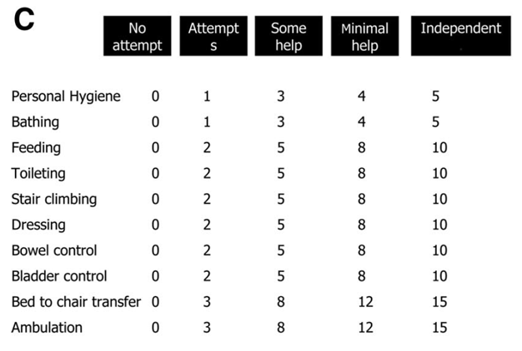
Appendix A – Barthel Index

Appendix B – Upper Extremity Fugl-Meyer Assessment
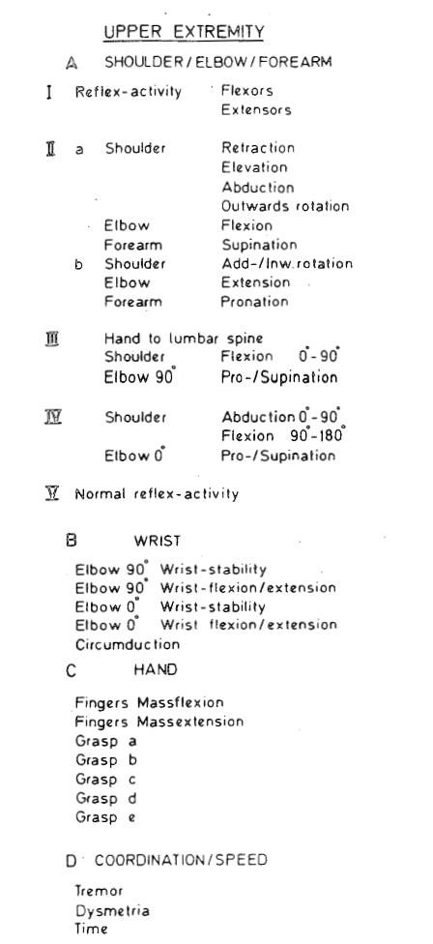

Appendix C – Lower Extremity Fugl-Meyer Assessment
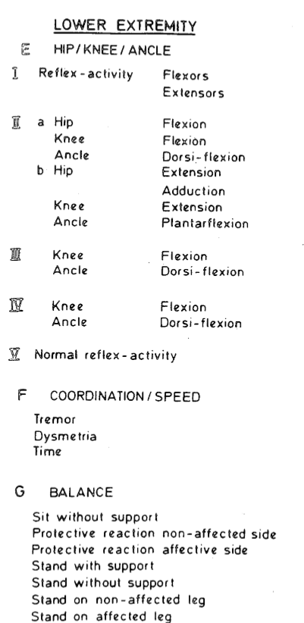
Appendix D – Modified Ashworth Scale

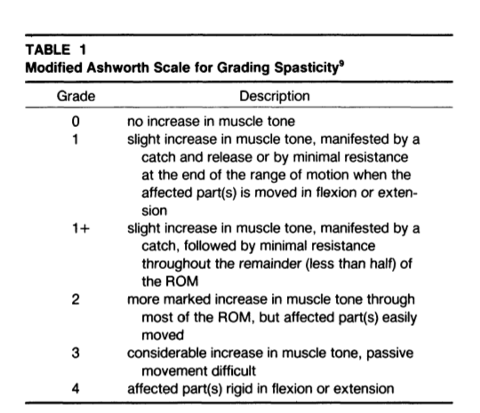
Appendix E – BI Post-Intervention Funnel Plot

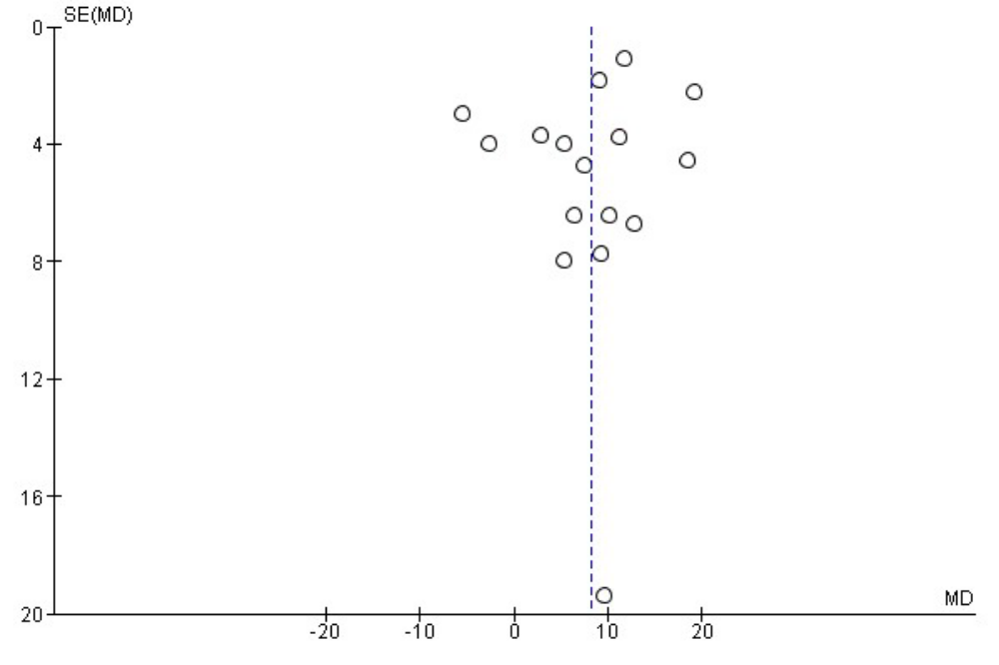

Appendix F – UEFMA Post-Intervention Funnel Plot

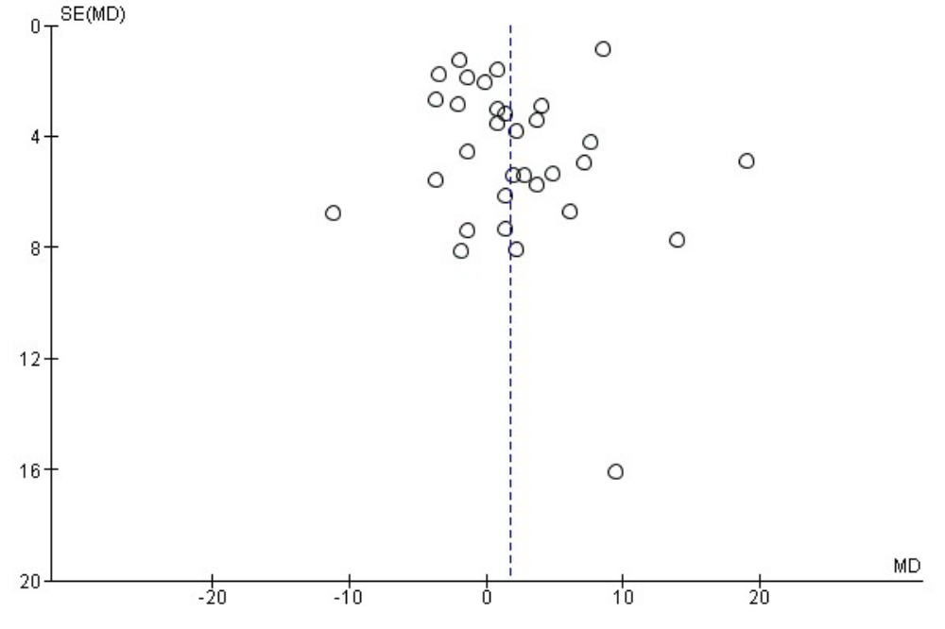

Appendix G – LEFMA Post-Intervention Funnel Plot

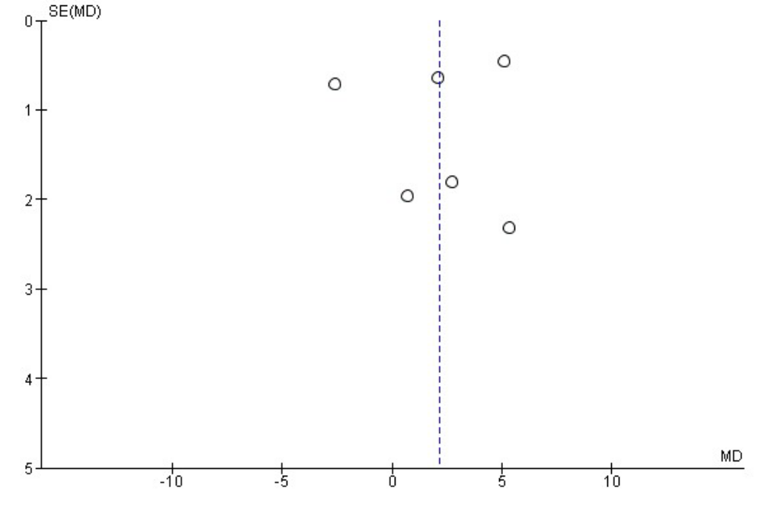

Appendix H – MAS Post-Intervention Funnel Plot

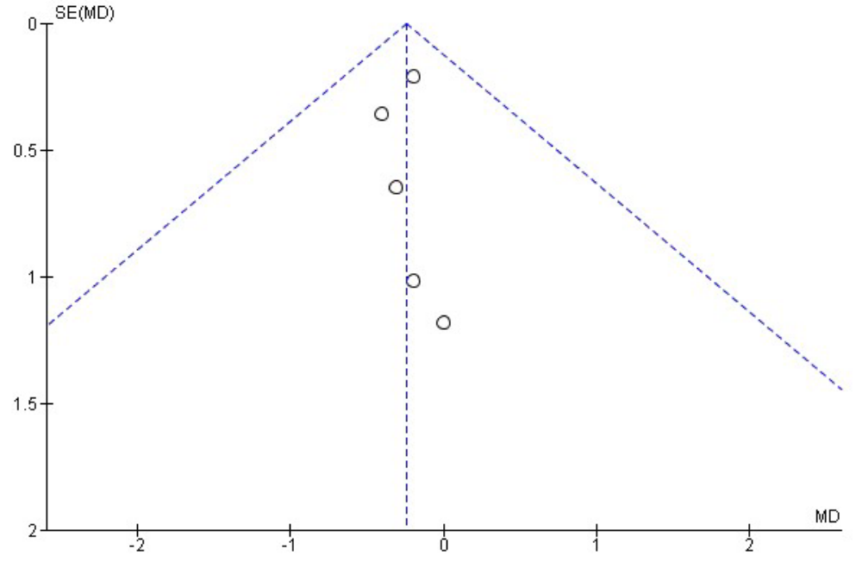

Appendix I – BI Change-Score Funnel Plot
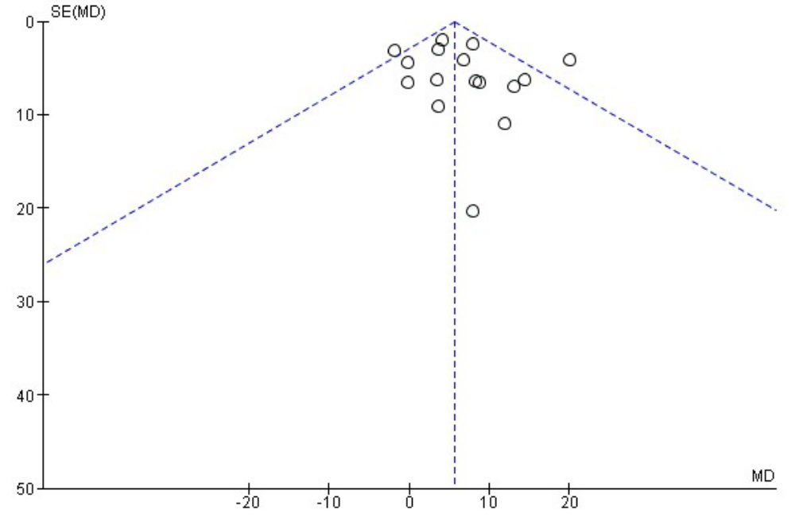

Appendix J – UEFMA Change-Score Funnel Plot
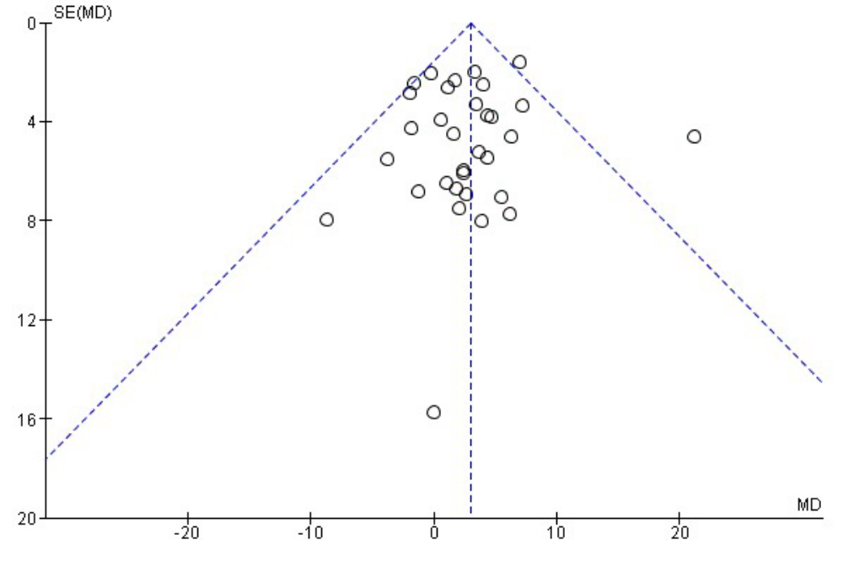

Appendix K – LEFMA Change-Score Funnel Plot
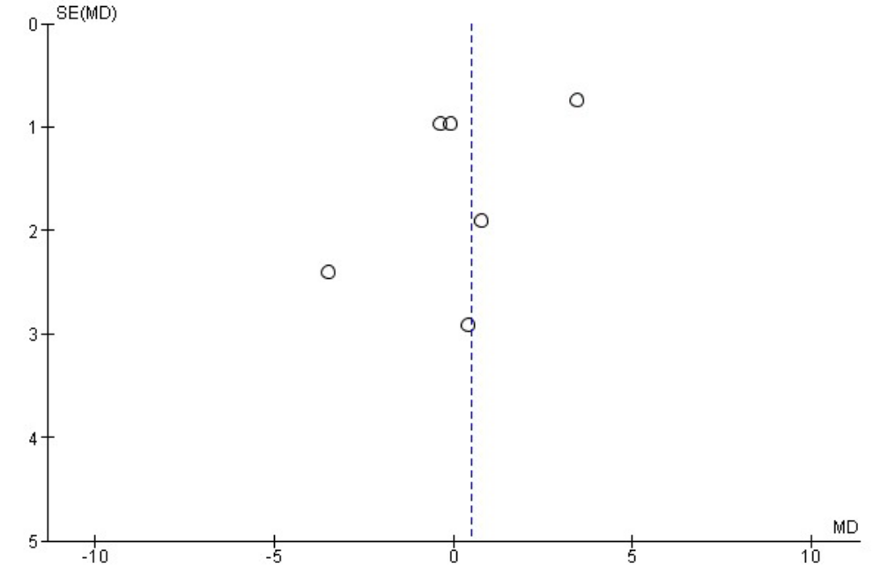

Appendix L – MAS Change-Score Funnel Plot
