University of Oklahoma

Graduate College

KEEPING CALM AND CARRYING ON: RELATING PROACTIVE PERSONALITY, AFFECT SPIN, AND AFFECT PULSE TO LEARNING AND ADAPTIVE TASK PERFORMANCE

A thesis

submitted to the Graduate Faculty

in partial fulfillment of the requirements for the

Degree of

Master of Science

By

kELSEY RICHELS
Norman, Oklahoma
2018

KEEPING CALM AND CARRYING ON: RELATING PROACTIVE PERSONALITY, AFFECT SPIN, AND AFFECT PULSE TO LEARNING AND ADAPTIVE TASK PERFORMANCE

A thesis approved for the
Department of Psychology

By

______________________________
Dr. Eric Day, Chair

______________________________
Dr. Shane Connelly

______________________________
Dr. Hairong Song

© Copyright by KELSEY RICHELS 2018
All Rights Reserved.
To my parents, Roger and Nancy. Thank you for your continued support through every crazy endeavor that I pursue. I would not be where I am today without your guidance. Thank you for not only teaching me how to show dedication and tenacity, but also for modeling that behavior for me to follow every day. I love you.

Acknowledgements
There are many people who deserve boundless gratitude for their part in this process. First, I want to thank my advisor Dr. Eric Day for continued support, guidance, and patience. Thank you for taking the time to mold me as a student and for allowing me to find my own way. Second, I want to thank my lab members for their feedback and encouragement. I would especially like to thank Ashley Jorgensen for her countless hours helping me through this entire process. Finally, I want to thank my friends, family, and other loved ones for their continued support, love, encouragement, and words of wisdom. I truly could not have done it without you. A special thank you to Clayton Metcalf, for believing in me when I did not believe in myself. I love you all.

Table of Contents
Acknowledgements iv
List of Tables vi
List of Figures vii
Abstract viii
Introduction 1
Proactive Personality 3
Affect Variability 5
Direct Effect on Effort 6
Moderation of Effort Effect 6
Adaptation versus Acquisition Effects 7
Proactive Personality in Adaptation versus Acquisition 8
Affect Variability in Adaptation versus Acquisition 9
Method 11
Participants 11
Performance Task 11
Procedure 12
Measures 13
Control variables 13
Proactive personality 14
Affect variability 14
Effort 15
Task performance 16
Results 18
Effort 20
Growth trends 20
Effects of proactive personality and affect variability 22
Performance 24
Growth trends 24
Effects of proactive personality and affect variability 25
Discussion 27
Proactive Personality 28
Affect Variability 29
Limitations and Future Research 34
Practical Implications 37
Conclusion 39
References 53

List of Tables
Table 1. Descriptive Statistics and Correlations 41
Table 2. Coding Scheme of Change Variables in Discontinuous Mixed-Effects Growth Models 42
Table 3. Discontinuous Growth Models of Effort 43
Table 4. Discontinuous Growth Models of Effort as a Function of Proactive Personality and Affect Variability 44
Table 5. Discontinuous Growth Models of Performance 45
Table 6. Discontinuous Growth Models of Performance as a Function of Proactive Personality and Affect Variability 46

List of Figures
Figure 1. Proposed model of the relationship between proactive personality and task performance, via task effort, moderated by affect variability and acquisition/adaptation phase. 47
Figure 2. Effort trends (Panel A) and performance trends (Panel B) across sessions by Session 1 tertiles 48
Figure 3. Effect of affect pulse on effort across sessions 49
Figure 4. Effect of affect spin on effort across sessions 50
Figure 5. Effect of affect pulse on performance across sessions. 51
Figure 6. Effect of affect spin and effort on performance across sessions 52

Abstract
The purpose of this laboratory study involving 214 undergraduate students learning a complex videogame was to address the gaps in the empirical literature regarding the non-cognitive traits that comprise the construct of adaptability, specifically proactive personality and two aspects of affect variability—spin and pulse. Proactive personality was hypothesized to positively impact performance through effort. Two mechanisms for the influence of affect variability were hypothesized: (1) undermining effort directly and (2) undermining the effort-performance relationship. Results showed that proactive personality explained no additional variance in effort or performance beyond the Big Five personality dimensions. Affect variability negatively impacted performance through both of the proposed mechanisms, and also by directly undermining performance. It was theorized that these results are due to the additional cognitive resources required to regulate emotion, along with the haphazard application of performance strategies driven by emotion fluctuations. Implications for a better understanding of the traits that comprise adaptability are discussed, specifically people’s capacity to be successful in environments characterized by unexpected changes in task demands or the need for sustained effort and continuous learning.
Keywords: Proactive personality, affect variability, skill acquisition, adaptive performance, complex task learning, self-regulated learning

Introduction
In today’s workforce, the capacity to acquire and adapt skills is more important than ever. The performance demands of contemporary work environments are increasingly becoming more nuanced and dynamic (Bell, Tannenbaum, Ford, Noe, & Kraiger, 2017). Accordingly, adaptability is now critical to many contemporary occupations (Baard, Rench, & Kozlowski, 2014; Jundt, Shoss, & Huang, 2014; Ployhart & Bliese, 2006; Pulakos, Arad, Donovon, & Plamondon, 2000). For occupations that are unpredictable in nature or that are evolving at a rapid pace, being able to identify employees who have the capacity to adapt to change quickly translates to greater organizational effectiveness (Noe, Clark, & Klein, 2014).
This growing importance of adaptability prompts an ongoing research question: Are there certain characteristics about individuals that make them more or less adaptable? By focusing on how dispositional characteristics relate to adaptive performance, the broad aim of the present research is to shed more light on the construct of adaptability as a constellation of individual difference variables that give rise to people’s capacity to be successful while experiencing unexpected changes in task demands (Baard et al., 2014).
Although there are many studies and models of how individual differences relate to adaptive task performance, including a variety of cognitive and non-cognitive variables (Bell & Kozlowski, 2008; Griffin & Hesketh, 2004; Jundt et al., 2014; Lang & Bliese, 2009; Pulakos et al., 2000), there are a number of unresolved issues that make it difficult to draw clear conclusions about the composition of adaptability. In particular, although adapting to novel and unforeseen changes in task demands is inherently a difficult and emotional process that requires a combination of sustained task effort and emotional control (Bell & Kozlowski, 2008; Niessen & Jimmieson, 2015), there is little empirical research and theory addressing how dispositions involving sustained effort and emotional control relate to adaptive task performance.
Specifically relating to sustained effort, this study builds off literature that shows that effort tends to decrease over the course of learning in relation to diminishing increases in knowledge and skill (Day, Hardy, & Arthur, 2017; Hardy, Day, & Arthur, 2018; Kanfer & Ackerman, 1989). Although much of the decrease in effort can be attributed to ceiling effects—limits to the amount of new knowledge and skill to be gained—some of the decreases are also due to the tendency for individuals to satisfice (Simon, 1972) or settle on suboptimal performance strategies (Day et al., 2017; Hardy et al., 2018). This study incorporates recent research on proactive personality and affect variability to offer a new theoretical perspective to the non-cognitive dispositional components that speak to how effort relates to successful learning and adaptation. In an attempt to examine the effects of sustained effort and emotional control, this study examines the roles played by proactive personality and two aspects of affect variability—spin and pulse—in the process of skill adaptation distinct from skill acquisition. Figure 1 shows the framework of the relationships to be examined.
It is important to understand not only how individuals acquire skill, but also how they adapt to unexpected changes, as change and unpredictability are often an unavoidable experience in today’s workplace. To examine both skill acquisition and adaptation, this study utilized a task-change paradigm to track changes in performance over time as participants are exposed to unexpected changes (Jundt et al., 2014; Lang & Bliese, 2009; Niessen & Jemmieson, 2015). First, participants underwent basic training on a novel and complex task, followed by several performance sessions, which constituted skill acquisition. They then experienced an unexpected change in task demands, inducing an increase in task complexity. The first performance session after the change is referred to as transition adaptation, while subsequent performance sessions constitute reacquisition adaptation. By tracking performance before and after this change using repeated measures, this study examined the effects of proactive personality and affect variability in a way that treats skill acquisition and adaptation as meaningfully distinct but related processes.
Proactive Personality
Proactive personality is a dimension of personality that describes how individuals actively pursue opportunities and take initiative (Spitzmuller, Sin, Howe, & Fatimah, 2015). Proactive personality, which refers to a willingness to sustain effort in the midst of challenges and change, is a dimension of personality that has been proposed to be distinct from the more commonly examined Big Five personality dimensions (Bateman & Crant, 1993; Crant, 1995; Fuller & Marler, 2009; Major, Turner, & Flecher, 2006; Spitzmuller et al., 2015; Thoman, Whitman, & Viswesvaran, 2010). However, Tornau and Frese’s (2013) meta-analysis suggested that proactive personality does not explain any meaningful incremental variance in objective performance or supervisor-rated performance above and beyond the Big Five. Thus, the present study not only examined the effects of proactive personality on adaptive performance, but it also sought to contribute to the debate about whether proactive personality is meaningfully distinct from the Big Five.
Given that a key component of proactive personality is taking early and immediate action to exert influence over one’s environment, those high in proactive personality should be better equipped to handle complexity and changes in their environment (Bateman & Crant, 1993). Attributes of proactive personality such as the desire to explore, plan, control, and attempt change have been related to the ability to reduce uncertainties in novel situations (Parker, Bindl, & Strauss, 2010). For instance, individuals higher in proactive personality are more likely to thrive in their careers as they are more likely to develop more career adaptability resources, such as career concern, control, curiosity, and confidence (Jiang, 2016; Savickas & Porfeli, 2012)
Specific to the design of the present study, I proposed that proactive personality contributes to performance through effort. In other words, persons higher in proactive personality are more likely to devote cognitive resources to both acquisition and adaptation. It is not so much that proactive personality contributes to performance immediately, but rather proactive personality contributes to learning and adaptation when people have the opportunity to continue engaging a task over a period of time. Those high in proactive personality are likely to devote and sustain the effort that is needed to acquire a complex skill and adapt to unexpected change (Jiang, 2016). Accordingly I tested the following hypotheses.
Hypothesis 1: Higher proactive personality will be associated with greater overall effort.
Hypothesis 2: Higher proactive personality will be associated with greater sustained effort.

Affect Variability
Affect spin and pulse are two dispositional aspects of emotional control that speak to the variability in emotions experienced across time and circumstances (Moskowitz & Zuroff, 2004). Affect spin refers to variability in distinct emotional states, and affect pulse refers to variability in the intensity of emotions (Moskowitz & Zuroff, 2004). Persons high in affect spin experience a relatively wide range of emotions across a period of time, while those low in affect spin experience relatively similar emotions across a period of time. Persons high in affect pulse experience a relatively wide range of intensity in their emotions (ranging from intensely-experienced emotions to mildly-experienced emotions), while those low in affect pulse are consistent in their emotion intensity (either consistently experiencing intense emotions or consistently experiencing mild emotions). A key premise of the current study is that affect variability, both spin and pulse, undermine the positive effects of proactive personality because affect variability disrupts the attentional resources needed for successful performance. Although the relationship between affect variability and proactive personality has not been examined in terms of skill acquisition or adaptive performance, affect spin has been shown to lessen the positive effects of proactive personality in terms of career decisions and career maturity (Park, 2015). In the present study, I tested two mechanisms by which affect variability might undermine acquisition and adaptation. One, affect variability may directly influence effort, by directing attention away from task-relevant concerns. Two, affect variability may moderate the relationship between effort and performance by steering effort in a haphazard and inefficient direction.
Direct Effect on Effort
Prior research has linked effective performance and adaptation to emotional control (Bell & Kozlowski, 2008; Jundt et al., 2014; Niessen & Jimmieson, 2015). Being able to maintain control over both the range and intensity of emotions felt over a period of performance (acquisition and adaptation) provides more stability to the individual and prevents emotions from moving one’s focus toward issues outside the task at hand. If individuals are feeling an intense and broad range of emotions, they may feel the need to attempt to regulate these emotions, either to reduce negative or uncomfortable feelings or to stay within a social-norm of emotion projection. Emotion regulation, specifically when regulating negative emotions, leads to decreases in cognitive functioning (Baumeister, Bratslavsky, Muraven, & Tice, 1998; Carver & Scheier, 1981; Larsen, 2000; Richard & Gross, 2000, Richards et al., 2003, & Schmeichel, Vohs, & Baumeister, 2003). Individuals high in affect spin and pulse require more emotion regulation given the greater range and intensity of their emotions, and this depletes the cognitive resources devoted to task-related effort, thus decreasing task performance. Accordingly, I tested the following hypotheses.
Hypothesis 3: Higher levels of (a) affect spin and (b) affect pulse will be associated with lower overall effort.
Hypothesis 4: Higher levels of (a) affect spin and (b) affect pulse will be associated with lower sustained effort.
Moderation of Effort Effects
While it is important to focus and sustain effort, it is equally important that the effort be directed consistently toward the correct aspects of the task demands. Proactive personality may spark effort, but if this effort is not consistently applied, then it will not yield the development of effective strategies for successful task performance. Experiencing a constant flux of emotions may lead to inconsistent application of effort and performance strategy. Research on affect variability provides a basis for better understanding how individual variations in the fluctuation of the range and intensity of emotion may undermine the indirect positive effects of proactive personality on performance via effort.
If individuals are feeling an intense and broad range of emotions, this may lead them to disengage from the task at hand or haphazardly alter or apply their performance strategies. While people may still be exerting effort, if this effort is directed haphazardly, led by the changes in emotion, rather than being directed in a systematic way, then this could lead to a failure to discover, apply, and fine tune needed performance strategies. Following this logic, the positive effects of proactive personality on performance via effort are less likely to occur for persons high in affect spin or pulse. Accordingly, I tested the following hypothesis.
Hypothesis 5: Affect variability will moderate the effects of overall effort on performance such that the positive effects of overall effort will be lower for individuals higher on (a) affect spin and (b) affect pulse.
Adaptation versus Acquisition Effects
Proactive personality, affect spin, and affect pulse can all be expected to have stronger effects on effort and performance during skill adaptation rather than initial acquisition. Over the course of learning, performance becomes more automatic, and fewer cognitive resources are needed to execute task performance (Kanfer & Ackerman, 1989).When changes to the task demands occur, the effectiveness of learned strategies are likely disrupted and in turn, cognitive resources are needed for successful reacquisition adaptation. Novel aspects of the task must be identified and explored, and previous strategies must be replaced, all of which requires effort. This need to override or adjust previous strategies and develop new strategies is likely to lead to an immediate decrease in performance directly following a task change, and a slower increase in performance during reacquisition (Lang & Bliese, 2009).
Proactive Personality in Adaptation versus Acquisition
During adaptation, individuals must not only learn new performance strategies or modify existing performance strategies, but they may also have to unlearn strategies that are no longer effective—forgo automated processes. In other words, an important aspect of successful adaptation includes some degree of breaking old habits. This dual process of simultaneously learning and unlearning requires more cognitive resources than simply learning. Those higher in proactive personality are more likely to sustain their effort in the face of difficulties adapting to unexpected changes, leading to a fuller knowledge of the task itself. This knowledge in turn leads to more effective performance strategies, which directly promotes greater task performance. Those higher in proactive personality would also be more likely to apply effort in situations where they must adapt previously acquired strategies. Accordingly, I tested the following hypotheses.
Hypothesis 6: The positive effect of proactive personality on overall levels of effort will be stronger in adaptation than acquisition.
Hypothesis 7: The positive effect of proactive personality on sustained levels of effort will be stronger in adaptation than acquisition.
Affect Variability in Adaptation versus Acquisition
The same line of logic concerning cognitive resources applies to the effects of affect variability. Given that adaptation requires more cognitive resources than acquisition, a depletion or misdirection of resources should be more detrimental during adaptation. Should it be the case that affect variability directly affects a person’s ability to perform by taking away cognitive resources from the task and instead devoting them to emotion regulation, then the depletion of cognitive resources should be more detrimental during adaptation, when cognitive resources are at a higher premium.
Although no research has linked affect spin or pulse specifically to adaptive performance, previous research has shown a link between affect spin and the ability to recover after a negative event (Beal & Ghandour, 2011). Affect spin is associated with a profile that is generally negative in nature—low emotional stability, low extraversion, low conscientiousness, high pessimism, and low optimism (Kuppens, Van Mechelen, Nezlek, Dossche, & Zuroff, 2007). This general negative profile may then cause those high in affect spin to react more strongly to emotionally-charged events (e.g., unexpected changes in task demands) than those who are lower in affect spin, regardless of whether these events are positive or negative (Beal & Ghandour, 2011). For example, those high in affect spin experience an overall lower level of positive affect than those low in affect spin after experiencing a traumatic natural disaster (Beal & Ghandour, 2011). This lower level of positive affect could lead to a higher need for emotional control, which in turn takes away cognitive resources from the task at hand.
Affect pulse does not show the same profile pattern as does affect spin, with no significant correlations in previous research with any of the Big Five, pessimism, or optimism (Kuppens et al., 2007). However, it could be theorized that emotionally-charged events would lead to strong affective reactions, especially in those who are prone to large variations in their emotional intensity. Thus, a task change could prompt a strong emotional reaction for those high in affect pulse, again requiring more cognitive resources to be devoted to emotional control over the task at hand. According, I tested the following hypotheses.
Hypothesis 8: The negative direct effects of (a) affect spin and (b) affect pulse on overall levels of effort will be stronger in adaptation than acquisition.
Hypothesis 9: The negative direct effects of (a) affect spin and (b) affect pulse on sustained levels of effort will be stronger in adaptation than acquisition.
As previously discussed, affect variability may also moderate the relationship between effort and task performance. Consistent with this perspective, the misdirection of effort caused by affect variability should be more harmful during adaptation when more cognitive resources are required. Haphazardly applying and revising performance strategies during the adaptation phase should be more harmful to performance than it would during acquisition, as adaptation requires the individual to not only learn a new set of strategies, but also to unlearn previous strategies. Accordingly, I tested the following hypothesis.
Hypothesis 10: The negative moderation effect of (a) affect spin and (b) affect
pulse on the effort-performance relationship will be stronger in adaptation than acquisition.
Method
Participants
Data from Jorgensen (2017) was used to test the present study’s hypotheses. Two hundred thirty-two undergraduate students attending a large public university in the Southwestern U.S. participated in exchange for research credit in a psychology course. Data from 18 of the participants were removed before analysis due to incomplete data (n = 12), flatlining repeatedly on performance measures (n = 4), or failure to follow instructions (n = 2). The removal of this data resulted in a final sample of 214 participants (58.4% male, 41.6% female). The age range of participants was from 17 to 32 years (M = 19.20, SD = 1.70). One hundred thirty-four participants reported their ethnicity as Caucasian (62.6%), 23 as Asian (10.7%), 18 as Hispanic/Latino (8.4%), 14 as African American (6.5%), 12 as Native American (5.6%), 8 as Multiple (two or more ethnicities) (3.7%), and 5 reported as other (2.3%).
Performance Task
The experimental task used was Unreal Tournament 2004 (UT2004; Epic Games, 2004), a commercially available first-person shooter computer game that has also been used in previous research on self-regulated learning (Hardy et al., 2014; Hughes et al, 2013). The objective of the task was to destroy computer-controlled opponents (bots), while minimizing the destruction of one’s own character. Participants could also collect new weapons or resources (i.e., power-ups) during each game to increase their own character’s health or offensive or defensive capabilities. Upon destruction of a participant’s character, that character would reappear in a random location with default weapons and capabilities. The game was “every character for him- or herself,” which means that the computer-controlled bots were competing against each other, as well as the participant’s character. UT2004 is a fast-paced, dynamic task which involves both cognitive and perceptual-motor demands. Participants used a mouse and a keyboard simultaneously to move and control their character, while also learning the strengths and weaknesses of different strategies and weapons, quickly deciding which to use in specific circumstances.
Procedure
Individuals participated individually or in groups up to six. They were told upon entry to the lab that the purpose of the study was to examine how people learn to play a complex, dynamic video game. Participants first completed an informed consent form, followed by a battery of self-report control measures. Participants were told that they would be entered into a performance-based lottery to win one of five, $25 gift cards for each trial in which their score was in the top 50% of all participants for that specific trial. Participants then watched a 15-minute training presentation on UT2004 which explained the basic game controls, rules, and power-ups, followed by a 1-minute practice trial that was free of competing bots. The purpose of this trial was to allow participants to become familiar with the controls, display, and the game environment without having to deal with any opponents.
Participants then completed 14 sessions, each consisting of two 4-minute trials. Following each session, participants completed self-report measures of state-based emotions (PANAS) and effort. During the first seven sessions, participants competed against two computer-controlled opponents which were set to a difficultly level of 4 (on a 1-to-8 scale). Changes in task demands occurred following the seventh session (i.e., the halfway point) without any warning, increasing the task complexity (Hughes et al., 2013). During these sessions, players competed against nine computer-controlled opponents at a difficulty setting of 5. Additionally, the game environment (i.e., the game map) was much bigger, with wider spaces, multiple levels of platforms, and edges. The edges allowed players to fall over the end of the map, leading to their own self-destruction. The game characteristics for the pre- and post-change trials were the same as those used by Hardy et al. (2014) to measure analogical and adaptive transfer performance, respectively. Following the 14th session, participants were debriefed.
Measures
Control variables. Self-report ACT/SAT scores were used as a measure of general mental ability (GMA). SAT scores were converted to the ACT scale. Prior video game experience was measured using a 4-item scale. This measure was used as a proxy for pre-training video game knowledge. The first two questions were as follows: (a) “Over the last 12 months, how frequently have you typically played video/computer games?” (M = 2.92, SD = 1.42) and (b) “Over the last 12 months, how frequently have you typically played first-person shooter video/computer games (e.g., Call of Duty, Half-Life, Halo, Unreal Tournament)?” (M = 2.35, SD = 1.33). These questions were measured using a 5-point Likert scale (1 = not at all, 2 = rarely or just a few times, 3 = monthly, 4 = weekly, 5 = daily). The second two items asked how many hours per week participants play (a) any type of video/computer game (M = 4.61, SD = 6.59, min. = 0, max. = 35) and (b) specifically first-person shooter video/computer games (M = 2.03, SD = 4.03, min. = 0, max. = 30). The scores for each of the pairs of items were standardized, and then averaged into an overall standardized composite score.
The Big Five personality dimensions were also used as control variables to examine the independent effects of proactive personality and affect variability. The Big Five were measured using Goldberg’s 100 Unipolar Markers (Goldberg, 1992). Using a nine-point Likert-type scale (1 = extremely inaccurate, 9 = extremely accurate), participants rated a list of 100 common human traits in terms of how accurately the traits described the participant him- or herself. Each of the five factors consisted of 20 items, with a scale score for each factor consisting of the average of their respective item ratings.
Proactive personality. Proactive personality was measured using a 10-item scale from Bateman and Crant (1993). Using a 7-point Likert scale (1 = strongly disagree, 2 = disagree, 3 = somewhat disagree, 4 = neither agree or disagree, 5 = somewhat agree, 6 = agree, 7 = strongly agree), participants were instructed to answer questions in terms of how well a statement describes them in general. Sample items include, “If I see something I don’t like, I fix it” and “I love being a champion for my ideas, even against others’ opposition.” Responses on the 10 items were averaged for an overall proactive personality score.
Affect variability. Scores for affect spin and pulse were based on responses to a 16-item version of the Positive and Negative Affect Schedule that was adapted for the context of this study (PANAS, Watson, Clark, & Tellegen, 1988). Participants were instructed to answer according to how they felt during the previous two trials, responding on a 9 point Likert-scale after each session (1 = very slight/not at all, 3 = a little, 5 = moderately, 7 = quite a bit, 9 = extremely). The scale measured four different areas of affect using 16 different emotions. The adjectives enthusiastic, excited, and happy were used to assess positive activating (PA) emotions. The adjectives at ease, calm, and relaxed were used to assess positive deactivating (PD) emotions. The adjectives angry, anxious, frustrated, irritated, tense, and uneasy were used to assess negative activating (NA) emotions. The emotions bored, disappointed, discouraged, and fatigued were used to assess negative deactivating (ND) emotions. The scores from the PANAS for PA, PD, NA, and ND were used to calculate valence and activation scores, which in turn were used to calculate affect spin and pulse, as discussed below.
Before beginning calculations for affect spin and pulse, valence and activation scores were calculated for each participant for each session of assessment. Valence is calculated as (PA + PD) – (NA + ND) (Kuppens et al., 2007). Activation is calculated as (PA + ND) – (PD + ND) (Kuppens et al., 2007). Mean valence and activation scores were then calculated.
Affect spin was calculated based on the framework provided by Moskowitz and Zuroff (2004) and following the procedure of Kuppens et al. (2007). Spin, defined as “the circular standard deviation of responses,” represents how much a participant moves “between different angles in the core affect space” (Kuppens et al., 2007). Calculations began by finding the unit vector for each session.
$\left(\frac{valⅇnce_{t}}{\sqrt{valence_{t}^{2}+activation_{t}^{2}}} \right.$, $\left.\frac{activation_{t}}{\sqrt{valence_{t}^{2}+activation_{t}^{2}}} \right)$
Next, the vector of all observations for one given participant, R, was calculated as follows.
$\left(\sum_{t=1}^{n}{ }\frac{valⅇnce_{t}}{\sqrt{valence_{t}^{2}+activation_{t}^{2}}} \right.$, $\left.\sum_{t=1}^{n}{ }\frac{activation_{t}}{\sqrt{valence_{t}^{2}+activation_{t}^{2}}} \right)$
The length of R was then calculated as
$$\sqrt{\frac{\sum_{t=1}^{n}{ } \frac{valence_{t}}{valence_{t}^{2}+activation_{t}^{2}}+\sum_{t=1}^{n}{ }\frac{activation_{t}}{valence_{t}^{2}+activation_{t}^{2}}}{n}}$$
The length of R ($\frac{\left\|\vec{R}\right\|}{n}$) can range from 0 to 1. If there is no variability in the angles, then $\frac{\left\|\vec{R}\right\|}{n}$ will equal 1. If the angles are dispersed widely enough to cancel each other out, then $\frac{\left\|\vec{R}\right\|}{n}$ approaches 0 (Kuppens et al., 2007). The final calculation of spin involves the standard deviation of the angles
of the unit vectors, which is calculated as
$$\sqrt{-2ln\left(\frac{\left\|\vec{R}\right\|}{n}\right)}$$
This final calculation of affect spin may range from 0 to infinity (Kuppens et al., 2007).
Affect pulse was also calculated based on the framework provided by Moskowitz and Zuroff (2004) and following the procedure of Kuppens et al. (2007). Pulse, the “within-person standard deviation of the distances” between reports of emotions (Kuppens et al., 2007), was calculated as
$$\sqrt{{valence}_{t}^{2}+ {activation}_{t}^{2}}$$
Effort. Effort was measured using a 6-item scale from Day et al. (2017), based on Hardy et al. (2018). Answers were made on an 11-point Likert scale, with anchors at (0) Not at all and (10) Extremely hard. Participants were instructed to answer in consideration of their last two games after each session. This scale measured two dimensions of learning-oriented effort: exploration and exploitation. There were three items for each of the subscales. The exploration items were, “How hard did you try to learn something new in the previous two games?,” “How hard did you try to better understand Unreal Tournament during the previous two games?,” and “How hard did you try to experiment with different strategies and techniques during the previous two games?” The exploitation items were, “How hard did you try to perform well during the previous two games?,” “How hard did you try to get the highest scores possible on the previous two games?,” and “How hard did you try to focus on what you do best at Unreal Tournament during the previous two games?” Given that the distinction between types of learning-oriented effort was not important to my theoretical model and that items from the two dimensions were highly correlated (across the 14 administrations, the average r = .53, min. r = .42, max. r = .74), an overall effort score for each trial was calculated by averaging all six item responses. Across the 14 sessions, the mean alpha reliability was .90 (min. = .85, max. = .95).
Task performance. Using the same formula as Hardy et. al (2017), task performance scores for each trial were calculated by taking the number of kills (i.e., the number of times that a participant kills another opponent) divided by the quantity of kills plus player deaths (i.e., the number of times a participant themselves is killed), plus player rank (i.e., the participant’s rank relative to other opponents within the trial). To increase ease of interpretability, performance scores were multiplied by 100. A single performance score for each session was calculated by taking the average of the two scores for both trials in that specific session.
Results
Table 1 displays the descriptive statistics and correlations for all the study variables, along with scores averaged across all sessions for performance and effort. Proactive personality was significantly correlated with all of the Big Five traits (r = .23−.42, ps < .01), with the exception of emotional stability (r = −.01, ns) which is not uncommon according to the literature (Fuller & Marler, 2009). Correlations were in the expected positive direction; the strongest was with conscientiousness (r = .42, p < .01). Consistent with the literature (Kuppens et al., 2007), affect spin was significantly, negatively correlated with emotional stability (r = −.23, p < .01). Previous findings have tended to show no relationship for affect pulse with any of the Big Five traits (Kuppens et al., 2007). However, in this data, a statistically significant, positive correlation between affect pulse and agreeableness was found (r = .19, p < .01). No other correlations between affect pulse and the Big Five were statistically significant.
The correlation between proactive personality and affect spin was not statistically significant (r = −.08, ns). The correlation between proactive personality and affect pulse was positive and statistically significant (r = .21, p < .01), albeit small in magnitude. The correlation between affect spin and affect pulse was positive and statistically significant (r = .19, p < .01) but again, small in magnitude. Proactive personality was significantly, positively correlated with effort (r = .15, p < .05), whereas affect spin (r = −.09, ns) and affect pulse (r = −.03, ns) were not significantly correlated with effort. Proactive personality was not significantly correlated with performance (r = −.08, ns), whereas affect spin (r = −.16, p < .05) and affect pulse (r = −.23, p < .01) were significantly, negatively correlated with performance. It should be noted that all of the statistically significant correlations involving proactive personality, affect spin, and affect pulse with effort and performance were small in magnitude. Similarly, although statistically significant, the correlation between effort and performance was small in magnitude (r = .18, p < .05).
The intraclass correlation coefficient (ICC) for effort indicated that 48% of the variance in effort levels existed between participants. For performance, 72% of the variance existed between participants. Figure 2 displays the trends for effort and performance across sessions. As shown in Panel A, which shows effort levels across sessions with groups separated into tertiles based on effort at Session 1, in general, effort levels tended to decrease across sessions, with a discontinuous increase following the task change (Session 8), after which the steady decline resumed. While effort for those in the highest tertile at Session 1 eventually decreased to meet the scores for those in the middle tertile, effort for those in the lowest tertile remained consistently lower than the scores for the other two tertiles. As shown in Panel B, performance increased across pre-change sessions, following a classic learning curve (Fitts & Posner, 1967). Following the task change (Session 8), there was a discontinuous decrease in performance. During the post-change sessions, performance again increased, however, it was at a slower rate than in the pre-change sessions and performance levels did not reach the same level as that in the pre-change sessions.
Discontinuous growth curve modeling was used to model effort and performance scores across acquisition, transition adaptation, and reacquisition adaptation. Using this modeling technique allowed scores following the task change (i.e., post-change period; reacquisition) to be compared to scores prior to the task change (i.e., pre-change period; acquisition) (Bliese & Lang, 2016; Singer & Willet, 2003). I used a coding scheme recommended by Bliese and Lang (2016), which is shown in Table 2. Specifically, skill acquisition (SA) refers to the linear rate of acquisition (e.g., performance improvements; decreases in effort) in the pre-change period. Transition adaptation (TA) models discontinuity with a dummy coded variable indicating when the task change has occurred. In the present study, TA reflects the discontinuity in scores (e.g., expected drop in performance following the unexpected task change), comparing post-change scores to pre-change scores. Reacquisition adaptation (RA) refers to the linear rate of acquisition following the task change taking into account the linear rate of acquisition prior to the task change. Quadratic acquisition (SA2) and reacquisition (RA2) are also included to account for curvilinear change in the pre-change and post-change periods (Lang & Bliese, 2009). R, an open source software, was used to conduct the discontinuous mixed-effects growth modeling and analyses (Pinherio, Bates, DebRoy, & Sarkar, 2016; R Development Core Team, 2016).
Effort
Growth trends. A series of models was first tested following suggestions of Bliese and Lang (2016). I began by testing the basic growth model. Specifically, in Step 1, I tested the effect for each of the time variables included in the equation below (see Model 1 of Table 3):
Y_{ij} = γ₀₀ + γ₁₀SA + γ₂₀TA + γ₃₀RA + γ₄₀SA2 + γ₅₀RA2 + ε_{ij}
It is important to note that the interpretation of the coefficients TA and RA are interpreted relative to SA. The effect of TA reflects a difference in scores after the task change relative to the value predicted by SA immediately following the task change. RA reflects the change in score trends across sessions following the task change relative to the rate score trends across pre-change sessions.
During pre-change, there was no significant SA effect for effort (t(2777) = −.56, B = −.04, ns), but there was a significant, negative quadratic SA (SA2) effect (t(2777) = −4.25, B = −.04, p < .01), showing a decrease in effort scores in pre-change that accelerated across sessions. The results also showed a statistically significant, positive TA effect (t(2777) = 6.32, B = 0.98, p < .01), as well as a statistically significant negative of RA effect (t(2777) = −8.12, B = −0.76, p < .01). These two effects indicate that effort scores were significantly higher immediately following the task change as compared to scores pre-change, and that the rate of decrease in scores seen in post-change sessions was significantly more rapid than that of the pre-change decrease in scores. The quadratic trend for skill reacquisition (RA2) was also statistically significant, but positive (t(2777) = 7.73, B = 0.08, p < .01). This RA2 effect reflects the sudden increase in effort in the last session.
In Step 2, the covariates were included (see Model 2 of Table 3). Videogame experience (t(205) = 2.17, B = 0.26, p < .05), extraversion (t(205) = 2.35, B = 0.21, p < .05), and conscientiousness (t(205), B = 0.26, p < .05) all showed positive, statistically significant effects on effort, with higher levels of videogame experience, extraversion, and conscientiousness associated with higher levels of effort. No other covariate yielded a statistically significant effect.
Effects of proactive personality and affect variability. In Step 3, the main effects of proactive personality, affect spin, and affect pulse on effort were included (see Model 3 of Table 4), none of which yielded statistically significant effects at this point. Hypothesis 1 proposed that higher proactive personality would be associated with greater overall effort and Hypotheses 3a and 3b proposed that higher levels of (a) affect spin and (b) affect pulse would be associated with lower overall effort. Thus, the results in Model 3 did not support Hypotheses 1, 3a, or 3b. Not shown in Table 4, I also examined the effects of proactive personality, affect spin, and affect pulse in Model 3 without including the Big Five. Consistent with Hypothesis 1, the results showed a statistically significant, positive effect of proactive personality (t(207) = 2.57, B = .34, p < .05). Affect spin and affect pulse did not yield statistically significant effects, thus again failing to support Hypothesis 3a and 3b.
In Step 4, interactions between proactive personality, affect spin, and affect pulse with the linear trend for effort were included (see Model 4 of Table 4). Hypothesis 2 proposed that higher proactive personality would be associated with greater sustained effort, while Hypothesis 4a and 4b proposed that higher levels of (a) affect spin and (b) affect pulse would be associated with lower sustained effort. The interaction between proactive personality and the SA effort trend was not statistically significant (t(2774) = 1.422, B = 0.025, ns). Thus, the results did not support Hypothesis 2. However, in support of Hypothesis 4a, there was a statistically significant, negative interaction between affect spin and the SA effort trend (t(2774) = −1.42, B = −.05, p < .10, one-tailed). Specifically, there was a greater decline in effort for individuals higher in affect spin. In relation to Hypothesis 4b, a statistically significant, negative interaction with the SA effort trend was found for affect pulse (t(2774) = −3.77, B = −0.06, p < .01). However, the main effect for affect pulse was positive and statistically significant (t(202) = 2.635, B = 0.32, p < .01 at Step 4). These effects together suggest an initial positive effect of affect pulse that decreases and ultimately becomes negative in later sessions. Thus, although more nuanced than expected, these results supported Hypothesis 4b, in that higher affect pulse was associated with lower sustained effort. Figure 3 illustrates this trend, with the negative effect of affect pulse continuing to grow across the transition and reacquisition sessions. However, because this step does not include TA and RA interactions with affect pulse, this lower sustained effort for those higher in affect pulse occurred regardless of the manipulation of task changes.
In the final step, Step 5, interactions involving proactive personality, affect spin, and affect pulse with TA and RA were included (see Model 5 of Table 4). This step was used to test Hypotheses 6–9. Hypothesis 6 proposed that the positive effect of proactive personality on overall levels of effort would be stronger in adaptation than acquisition. Hypothesis 7 proposed that the positive effect of proactive personality on sustained levels of effort would be stronger in adaptation than acquisition. Hypothesis 8a and 8b proposed that the negative direct effects of (a) affect spin and (b) affect pulse on overall levels of effort would be stronger in adaptation than acquisition. Hypothesis 9a and 9b proposed that the negative direct effects of (a) affect spin and (b) affect pulse on sustained levels of effort would be stronger in adaptation than acquisition. As shown in Model 5 in Table 4, only the interaction between affect spin and TA was statistically significant. Specifically, in support of Hypothesis 8a, the negative effect of affect spin on effort was stronger after the transition than prior (t(2768) = −1.93, B = −.58, p < .10, one-tailed). However, Hypotheses 6, 7, 8b, 9a, and 9b were not supported. Figure 4 shows the relationship between affect spin and effort, with affect spin showing strong negative effects on effort levels during transition, which was sustained throughout reacquisition adaptation.
Performance
Growth trends. The steps for modeling performance trends followed the same as those for effort. As shown in Model 1 of Table 5, there was a statistically significant positive SA effect (t(2777) = 13.78, B = 5.47, p < .01), a statistically significant, negative TA effect (t(2777) = −20.31, B = −18.88, p < .01), and a statistically significant, negative RA effect (t(2777) = −8.52, B = −4.66, p < .01). These effects together indicate that, across pre-change sessions, performance levels increased. However, after the task change, performance levels dropped markedly, and, although performance levels again began to rise, the rate of increase was significantly lower than that of the pre-change rate. The SA2 was significant (t(2777) = −9.17, B = −0.57, p < .01), which indicates that increases in performance decelerated across sessions. The RA2, however, was not significant and therefore was not included in any further model tests.
In Step 2, the covariates were included (see Model 2 of Table 5). The main effects of ACT (t(205) = 5.13, B = 0.89, p < .01) and videogame experience (t(205) = 6.14, B = 4.74, p < .01) were both positive and statistically significant, meaning that higher ACT scores and prior video game experience were associated with higher performance scores. Additionally, the main effects of gender (t(205) = −10.74, B = −17.10, p < .01) and extraversion (t(205) = −2.32, B = −1.34, p < .05) were negative and statistically significant, indicating that females exhibited lower levels of performance than did males, and that those with higher levels of extraversion had lower performance scores. No other covariate yielded a statistically significant effect.
Effects of proactive personality and affect variability. In Step 3, the main effects of proactive personality, affect spin, and affect pulse on performance were included (see Model 3 of Table 6). Although not hypothesized, the main effect of affect pulse showed a statistically significant, negative effect on performance (t(202) = −2.12, B = −1.56, p < .05). Those with higher affect pulse had lower performance scores. Proactive personality was not associated with performance (t(202) = −1.07, B = −1.05, ns). Affect spin yielded a negative effect that was stronger than the effect of affect pulse; however, a relatively large standard error (1.33) yielded a main effect for affect spin that did not reach conventional levels of statistical significance (t(202) = −1.97, B = −2.61, p < .10). Not shown in Table 6, I also examined the effects of proactive personality, affect spin, and affect pulse in Model 3 without including the Big Five variables. The results were similar, thus the inclusion of the Big Five did not influence the results for proactive personality, affect spin, or affect pulse.
In Step 4, the main effect of effort was included (see Model 4 of Table 6). As one would expect, effort was positively related to performance (t(201) = 1.89, B = 0.64, p < .05, one-tailed). In Step 5, the interactions between affect spin and affect pulse with effort were included. This step was used to test Hypotheses 5a and 5b, which proposed that affect variability would moderate the effects of overall effort on performance such that the positive effects of overall effort will be lower for individuals higher on (a) affect spin and (b) affect pulse. As shown in Model 5 of Table 6, none of the effort interactions involving affect spin and affect pulse were statistically significant. Thus, the results did not support Hypotheses 5a and 5b.
Model 6 included the two-way interactions between affect spin, affect pulse, and effort with SA, TA, and RA. Although no hypotheses were made regarding these interactions, statistically significant interactions were found for affect pulse and effort (see Model 6 of Table 6). For affect pulse, there was a statistically significant, positive interaction involving SA (t(2769) = 2.47, B = 0.36, p < .05), and a statistically significant, negative interaction with RA (t(2769) = −3.03, B = −0.57, p < .01). Figure 5 shows what these interactions involving affect pulse and the growth trends look like, specifically showing that the negative main effect of affect pulse (t(199) = −2.97, B = −2.53, p < .05) in Model 6 becomes smaller later in skill acquisition (i.e., pre-change sessions), but in post-change, the negative effect of affect pulse becomes stronger later in reacquisition adaptation (i.e., post-change sessions). For effort, there was a positive SA interaction (t(2769) = 2.63, B = 0.19, p < .01), indicating a stronger positive effect of effort later in skill acquisition.
In the final step, I included three-way interactions between (1) affect spin and affect pulse, (2) effort, and (3) SA, TA, and RA. This model tested Hypotheses 10a and 10b, which proposed that the negative moderation effect of (a) affect spin and (b) affect pulse on the effort-performance relationship would be stronger in adaptation than acquisition. The only statistically significant interaction found was between affect spin, effort, and TA (t(2763) −2.39, B = −2.20, p < .05). While the results did not support Hypothesis 10b, they did support Hypothesis 10a, with stronger negative moderation effects of affect spin found after the task changes (i.e., transition adaptation). As shown in Figure 6, after the task changes, there was a positive effect of effort for individuals low in affect spin, but not for individuals high in affect spin. In other words, after the task change, effort was beneficial to performance only for individuals low in affect spin. Also shown in Figure 6, before the transition, effort yielded small beneficial effects, regardless of affect spin.
Discussion
The aim of this study was to explore the construct of adaptability as a constellation of individual differences involving sustained effort and emotional control in the face of unexpected task changes (Niessen & Jimmieson, 2015; Bell & Kozlowski, 2008). In doing so, this lab study used a repeated measures design to examine the effects of proactive personality and affect variability—both spin and pulse—in relation to the acquisition and adaptation of a complex skill. Although it was hypothesized that proactive personality would have positive effects on overall and sustained effort, and that these effects would be stronger in adaptation than during acquisition, no results pertaining to proactive personality were statistically significant when controlling for the Big Five personality dimensions. Several hypotheses regarding affect variability, however, were supported. Affect spin negatively, directly impacted effort levels during adaptation, indicating that affect spin takes a significant toll on effort levels after an unexpected task change. Affect pulse also undermined effort, however, this was evident in both acquisition and adaptation. Affect spin also moderated the relationship between effort and performance during adaptation, such that effort was only beneficial during adaptation (i.e., post-change sessions) when learners exerting high effort were also low in affect spin. Although affect pulse did not moderate the effort-performance relationship, it had a direct negative effect on performance, with this effect being more intense during adaptation (i.e., after the task change).
In the following sections, I review the findings regarding the effects of proactive personality and affect variability in relation to the acquisition and adaptation of a complex skill. I then discuss the limitations of the current study as well as directions for future research. Finally, I discuss the practical implications of this study.
Proactive Personality
It was hypothesized that proactive personality would have a positive effect on both overall and sustained effort, which in turn would lead to higher performance. It was also hypothesized that these effects would be stronger in adaptation than in acquisition. When including the Big Five personality dimensions in the analyses, it was found that proactive personality had no significant effect on either overall or sustained effort, during either adaptation or acquisition.
Previous literature is currently divided on the legitimacy of proactive personality, with a portion of studies supporting proactive personality as meaningfully distinct from the Big Five (Bateman & Crant, 1993; Crant, 1995; Fuller & Marler, 2009; Major, Turner, & Flecher, 2006; Spitzmuller et al., 2015; Thoman, Whitman, & Viswesvaran, 2010). However, Tornau and Frese’s (2013) meta-analysis found no unique variance accounted for in outcomes by proactive personality beyond what was already accounted for by the Big Five. The findings of the current study provide support for the conclusions of Tornau and Frese (2013), with no unique effects of proactive personality found when including the Big Five, indicating that proactive personality is not distinct from the more commonly studied Big Five personality traits.
Affect Variability
When examining the effects of affect variability, two theoretical mechanisms were tested. First, it was proposed that affect variability would have an indirect effect on performance through effort (both sustained and overall), with those high in affect variability simply not exerting as much effort toward task execution as those low in affect variability, as well as not sustaining effort levels over time. This in turn would lead to lower levels of performance. Results showed that, although affect spin and pulse did not have a negative effect on overall effort as was hypothesized, both affect spin and pulse negatively impacted sustained effort, with those high in affect spin or pulse not being able to maintain effort levels across sessions as well as those lower in affect spin or pulse. These results provide support for the first theoretical mechanism proposed, indicating that those higher in affect variability did not direct as much effort toward the task at hand. It is likely that those high in affect variability were instead directing effort toward emotion regulation, which has been shown to decrease cognitive functioning (Baumeister et al., 1998; Carver & Scheier, 1981; Larsen, 2000; Richard & Gross, 2000, Richards et al., 2003; Schmeichel et al., 2003). Although effort will naturally decrease over time as learning increases and task execution becomes more automatic, it is still important that effort is maintained in such a way that performance is more likely to increase, as opposed to performance levels reaching a point of stagnation, where learners are either satisficing (Simon, 1972) or settling on suboptimal strategies (Day et al., 2017; Hardy et al., 2018). Rather than accepting this plateau in performance scores, the present study shines a light on the individual characteristics associated with maintaining effort over a learning period, with those high in affect variability (both spin and pulse) having difficulty maintaining their effort levels over time. Thus, individuals high in affect spin or pulse are more likely to experience a stagnation in performance earlier than those low in affect variability.
For affect spin, the negative relationship with effort was stronger during adaptation than it was during acquisition. Following the logic of Beal and Ghandour (2011), this result was likely found because those high in affect spin experience stronger reactions to emotionally-charged events (e.g., a task change) than those low in affect spin, which leads to a higher need for cognitive resources to be expended on emotional control (Baumeister et al., 1998; Carver & Scheier, 1981; Larsen, 2000; Richard & Gross, 2000, Richards et al., 2003; Schmeichel et al., 2003). Thus, this stronger negative effect of affect spin during adaptation supports the notion that adaptation by nature requires more cognitive resources than acquisition, due to the replacement and adjustment of already formed performance strategies. Practically speaking, the results of the present study indicate that those with higher affect spin may not be as capable at sustaining effort in performance contexts characterized by unexpected change, consistent with previous research showing how sustained effort and emotional control are critical components to successful adaptation (Niessen & Jimmieson, 2015; Bell & Kozlowski, 2008).
Affect pulse was found to have a negative effect on sustained effort across sessions, regardless of task changes. Unexpectedly, affect pulse showed an initial positive effect on effort. However, this positive effect diminished across sessions, and eventually those high in affect pulse exhibited lower levels of effort than those low in affect pulse. Although initially showing higher levels of effort, it is likely that the amount of emotion regulation required for those high in affect pulse eventually depleted the cognitive resources required to maintain high task-based effort levels (Baumeister et al., 1998; Carver & Scheier, 1981; Larsen, 2000; Richard & Gross, 2000, Richards et al., 2003; Schmeichel et al., 2003). Ultimately, these results suggest that learning plateaus as a result of reduced effort are a particular concern for those high in affect pulse.
The second theoretical mechanism proposed that affect variability would moderate the effort-performance relationship, with those high in affect variability engaging in a more haphazard search for effective performance strategies. This haphazardness would in turn lead to lower performance scores, regardless of effort. Previous research shows that learners do switch between strategies (Hardy et al., 2018), however, effective skill acquisition and adaptation would require this trade-off between strategies to be driven by logic rather than emotion. Although not supported in terms of affect pulse, this theoretical mechanism was supported for affect spin. After the task change, high levels of effort were only beneficial for those low in affect spin. The effort devoted to dealing with unexpected task changes for those high in affect spin was not helpful to performance. By definition, those high in affect spin experience significant fluctuations in emotions (Moskowitz & Zuroff, 2004), which I propose drives individuals to explore performance strategies in a haphazard manner. Coupled with the aforementioned lower levels of effort in adaptation, these results show that high affect spin is a hinderance to handling unexpected changes in task demands. In other words, low affect spin is an important aspect of adaptability.
Although not considered, it was found that affect pulse had a direct, negative impact on performance, meaning that those high in affect pulse had lower performance scores. Along with this main effect, it was found that across acquisition affect pulse had less of a negative impact (i.e., a positive SA × affect pulse interaction), as the task became proceduralized and less cognitive resources were required to sustain performance (Kanfer & Ackerman, 1989). However, across adaptation affect pulse had a greater negative impact (i.e., a negative SA × affect pulse interaction). Although performance after a change in task demands may eventually become proceduralized and thus require less cognitive resources over time (Kanfer & Ackerman, 1989), it is possible that the increased complexity from the task change inhibited individuals from experiencing this procedulization. In this vein, it is possible that the increased complexity prompted a stronger fluctuation of emotions across sessions, leading to a higher need for emotion regulation, depleting necessary cognitive resources (Baumeister et al., 1998; Carver & Scheier, 1981; Larsen, 2000; Richard & Gross, 2000, Richards et al., 2003; Schmeichel et al., 2003). Combined with the previously mentioned negative impact on effort levels (regardless of task change), these results show that high affect pulse is a hinderance to learning, especially during adaptation. Simply put, low levels of affect pulse are an important aspect of adaptability.
Ancillary analyses were conducted to further examine the distinctiveness of affect spin and pulse vis-à-vis the Big Five personality dimensions. Although the current study shows that affect spin and pulse do account for additional variance in effort and performance beyond the Big Five, further analyses were able to shed light on the conceptual overlap between emotional stability and affect spin and pulse, namely whether affect spin and pulse should be considered as meaningfully distinct from or as a components of emotional stability. The ancillary analyses followed the same steps as the primary analyses, however, the predictor variables of proactive personality, affect spin, and affect pulse were removed, and emotional stability was substituted in their place. Thus, the direct effects of emotional stability on effort and performance were tested, along with all the same interactions previously tested involving effort and the growth trends (i.e., SA, TA and RA).
It was found that the results for emotional stability followed the same pattern of results as those for affect spin (although in the opposite direction, given that emotional stability and affect spin are negatively correlated; r = −.23, p < .01). Specifically, emotional stability showed a positive interaction with TA on effort (t(2774) = 2.15, B = 0.30, p < .05), and a positive interaction with TA and effort on performance (t(2769) = 2.05, B = 0.82, p < .05). These results indicate that although affect spin does provide additional insight into adaptability above and beyond the Big Five, it is likely a component of emotional stability rather than a separate construct. This lends support to previous arguments proposing that emotional stability includes affect variability as a key component (Bolger & Zuckerman, 1995).
However, the results for emotional stability did not follow the same pattern as those for affect pulse, specifically lacking a main effect for effort (t(205) = 1.25, B = 0.13, ns), the SA interaction for effort (t(2776) = −1.00, B = −0.01, ns), the main effect on performance (t(205) = 0.68, B = 0.45, ns), the SA interaction on performance (t(2775) = 0.01, B = 0.00, ns), and the RA interaction on performance (t(2775) = 0.41, B = 0.07, ns). Moreover, affect pulse and emotional stability were not correlated with each other (r = −.09, ns). Thus, the findings of the present study indicate that affect pulse is meaningfully distinct from emotional stability.
Altogether, the results of the present study are consistent with previous research that links emotional control to successful adaptive performance (Jundt et al., 2014). As such, this study advances theory in terms of how affect variability—both spin and pulse—are important non-cognitive traits that help comprise the construct of adaptability (Baard et al., 2014).
Limitations and Future Research
There are several limitations to this study that should be considered when attempting to interpret and generalize these results. First, effective task strategies were not specifically communicated to the participants as part of their training. Rather, participants in this study were allowed to perform the task in whatever manner they preferred, without specific directions on how to proceed beyond the general game-play information (e.g., player controls and weapon usage). This approach to training is qualitatively different from a more proceduralized learning environment where learners are given consistent direction and feedback, and thus the results may not apply to more proceduralized training. However, there are advantages to training under this less proceduralized style. Research shows that active-learning environments, where learners are more engaged and in control of their learning, lead to better transfer outcomes, especially in terms of adaptive performance (Keith & Wolff, 2015). Thus, the learning environment of this study fits well with the type of learning environments that are thought to better translate into generalizable performance.
Also of note is the self-report nature of the measure of effort. It is possible that this measure did not fully encompass all aspects of task-based effort. For example, it is likely that participants are unable to fully monitor how much effort they are exerting toward on-task attention, and thus may either over- or underestimate the true amount of effort being exerted. Rather rely solely on self-reports, future research could utilize physiological measures such as eye-tracker technology, which has been used in the past to measure on-task attention, under the assumption that people are focusing on what they fixate upon foveally (Duchowski, 2002; Moran et al., 2016). In the context of the present study, on- and off-screen gazes would reflect on- and off-task attention, respectively. However, it is possible that the eye could be fixed on the computer screen while the mind is focused elsewhere (e.g., on emotion regulation). In this case, there is research showing that pupil size predicts goal-driven behavior. For example, Mathot, Siebold, Donk, and Vitu (2015) demonstrated that larger pupils predict goal-driven eye movements, in that larger pupils are able to guide participants’ gazes toward less salient objects that are goal-relevant. Thus, a larger pupil reflects engagement in goal-driven behavior, while a more constricted pupil reflects goal withdrawal.
An additional option would be the use of electroencephalogram (EEG) technology. By using EEG to monitor brain states that indicate control and utilization of attention, attention could be more directly measured as opposed to only using self-reports. For example, alpha oscillations have been shown to be linked to both attention and arousal in real-time (Mathewson et al., 2012). It could also be possible to use EEG data to measure learner switches between performance strategies. For example, EEG data has been used in the past to measure exploration-exploitation trade-offs (Ashton-Jones & Cohen, 2005). Should EEG data be able to provide information about real-time application of performance strategies, this information could be used to compare trade-off patterns between those low and high in affect variability.
This potential inability to fully capture effort levels may account for the direct effects for affect pulse on performance levels. In this vein, the variance directly accounted for in performance scores by affect pulse may in fact have been due to the theoretical mechanisms proposed. If the full picture of effort exerted by participants was not captured by the self-report measure, there may have been aspects of the affect pulse-effort relationship and the moderation of the effort-performance relationship that were not captured in this study.
Furthermore, although the hypotheses in this study were based on existing theory, the mechanisms by which I proposed affect variability would have an effect on effort and performance were not directly tested. Future research should directly measure off-task attention to more fully capture the mechanisms by which affect variability undermines effort and performance. Future research should also identify what amount of strategy-switching occurs in those at various levels of affect variability, in accordance with the moderation mechanism proposed in this study. A better understanding of the underlying causal mechanisms of affect variability may in turn lead to the development of interventions that could help foster learning and adaptive performance for those high in affect variability. As such, future research should focus on approaches by which the detrimental effects of affect variability might be mitigated. For instance, those high in affect pulse in the present study initially exerted more effort than those low in affect pulse but then struggled to maintain this high effort level over time. Strategies that could help those high in affect pulse maintain these high levels of effort should be identified. Future research could also attempt to replicate these results in a more proceduralized learning environment to determine whether this holds potential to reduce the effort and performance differences between those high and low in affect variability. It is likely that a more structured learning environment may reduce the emotional reaction experienced by those high in affect variability, and thus lessen the withdrawal of cognitive resources from task effort.
Practical Implications
The primary implication involving proactive personality is that it does not provide additional insights into adaptability above and beyond what is provided by the Big Five. Based on the results of the current study, proactive personality does not hold weight beyond the Big Five and would not provide any additional information that could be used to predict learning or performance adaptation.
Affect spin, in this study, operated in a manner that was consistent with it being a component of emotional stability, while affect pulse was meaningfully distinct from the Big Five personality dimensions. Both of these constructs had negative effects on effort and performance, especially during adaptation. Given that both affect spin and pulse provided additional insight into effort and performance above and beyond the Big Five, the measurement of these constructs could be leveraged as selection tools. In other words, those low in affect spin and pulse are well suited for occupations or environments that require an even demeanor, such as fast-paced environments that require continuous or autonomous learning or environments where there are a lot of unpredictable changes.
Although aim of this study was on adaptive performance, it was also found that affect variability had an effect on sustained effort, regardless of any task change. This means that affect variability should also be considered in contexts where the attainment of expertise in general is important, given that enormous amounts of deliberate practice are critical to expertise (Ericsson, 2015; Ericsson & Charness, 1994; Hardy et al., 2018). The attainment of expertise may be considered as a professional milestone, or may also be considered in non-work environments, such as athletics or personal hobbies. The measurement of these traits could also be of use when considering the type of training that individuals will undergo for a particular job or in a particular organization. Active-learning training may not be suitable for those higher in affect variability, as it requires higher levels of sustained task attention as well as emotional control (Bell & Kozlowski, 2008). Should an organization or occupation require more autonomous learning in general, individuals who are able to sustain effort across time will be able to maintain focus on advancing their proficiencies.
However, given the nature of affect variability and the need for repeated measures to measure both affect spin and pulse, it may be more advantageous for organizations to focus on strategies that lessen the negative impacts of affect variability, rather than to base their selection systems around these two variables. This could involve the use of more proceduralized training, which could help balance the emotions of those higher in affect variability by limiting the amount of emotionally-charged events to which they are exposed (e.g., difficulty in figuring things out for oneself). Providing step-by-step instructions would provide a strategy guideline to learners, leading to a less haphazard search for performance strategies in those high in affect spin. Alternatively, in more autonomous learning contexts, error management training might be especially helpful for those higher in affect variability given that improved emotional control is thought to be one of the key mechanisms underlying its effectiveness (Keith & Wolff, 2015).
It is also important to recall that negative impacts on performance due to affect variability are not necessarily solely due to the amount of effort exerted. The results of the current study indicate that those high in affect spin struggled with performance, regardless of the amount of effort exerted. This means that any attempts to mitigate the effects of affect spin would require a direct intervention focused on the expression or control of affect spin, rather than solely a focus on motivating effort in those high in affect spin.
Conclusion
In summary, the current study examined the effects of proactive personality, affect spin, and affect pulse with respect to the acquisition and adaptation of a complex skill. Due to the current nature of work, which is becoming more dynamic every day, it is critically important that research identifies the individual differences that comprise adaptability in order to better understand and support the adaptation of performance in the face of unexpected changes in task demands. This study furthered the current understanding of the non-cognitive aspects of adaptability in several ways. First, this study supported previous research indicating that proactive personality does not explain any additional variance in effort or performance above and beyond the Big Five (Tornau & Frese, 2013). Secondly, it was found that affect variability does have a significant, negative effect on effort and performance in a learning context, the effects of which are stronger during adaptation to an unexpected change in task demands. Thirdly, this study showed that the specific nature of the effects for affect spin and pulse differ and thus are meaningfully different. Related, this study also showed that spin appears to be an important component of emotional stability, whereas pulse is distinct from emotional stability. By expanding the understanding of the various non-cognitive aspects that comprise adaptability, this study provides a clearer understanding of what successful adaptation requires, namely low affect variability. Nevertheless, future research involving different tasks and learning contexts is needed to further test the theoretical framework proposed in this study, especially in terms of the impact of off-task attention on performance and the haphazard search for effective performance strategies during acquisition and adaptation.

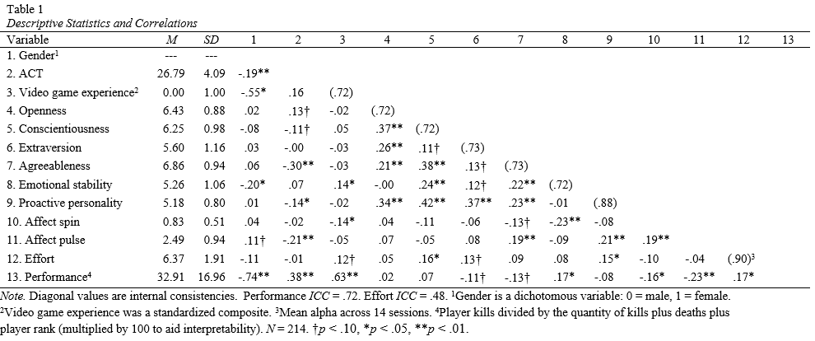

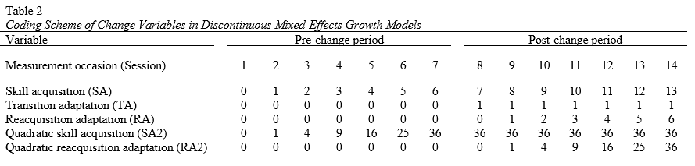

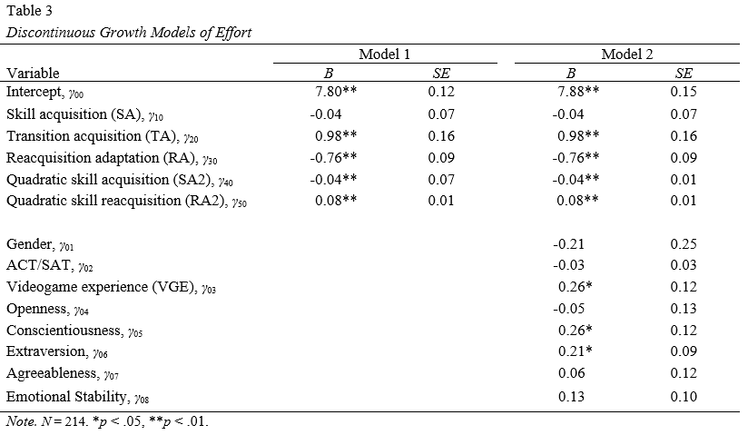
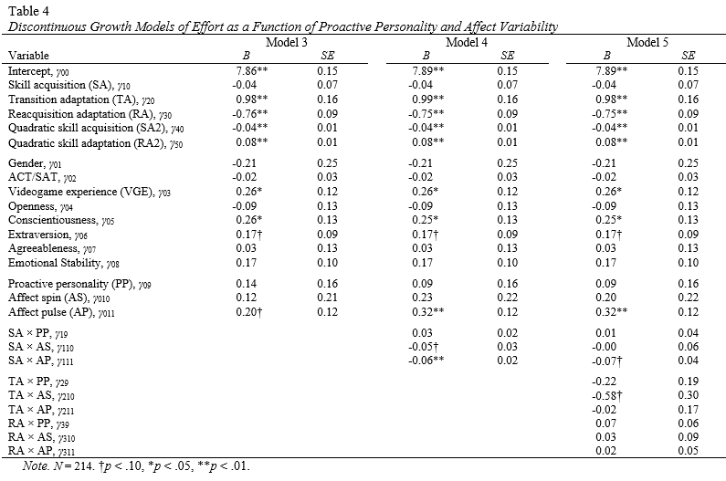

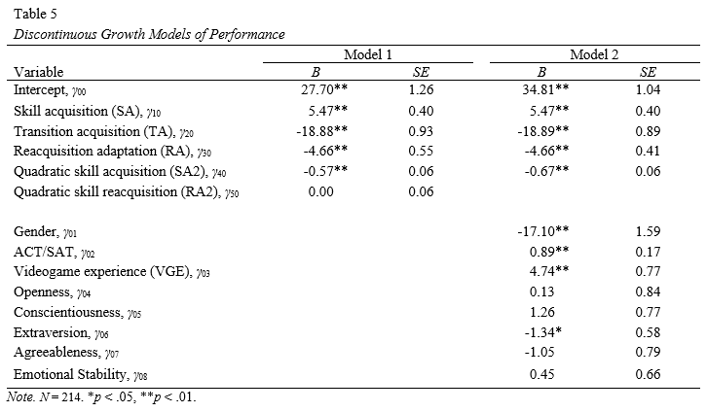

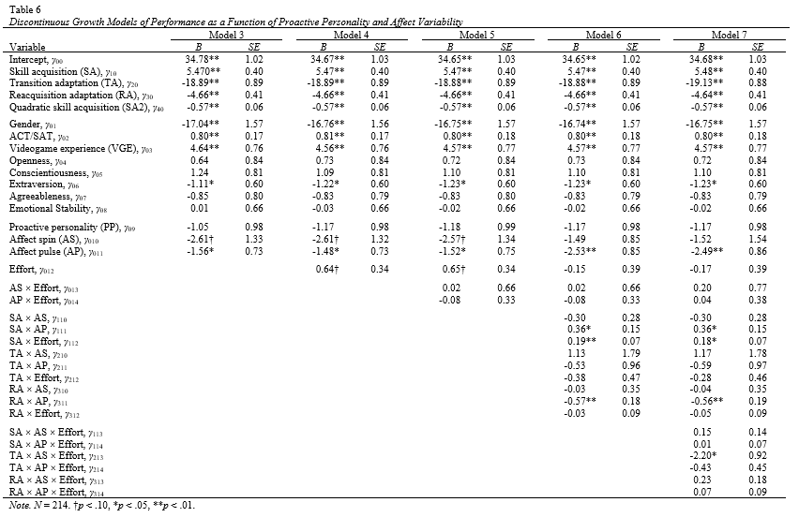

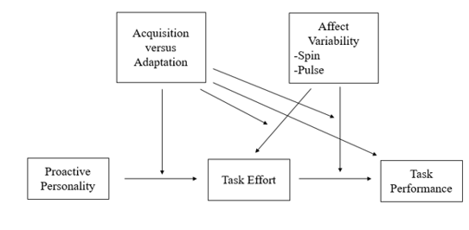
Figure 1. Proposed model of the relationship between proactive personality and task performance, via task effort, moderated by affect variability and acquisition/adaptation phase.

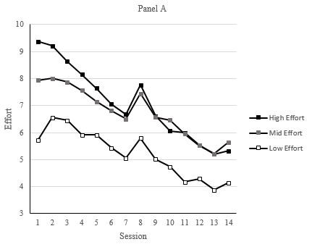

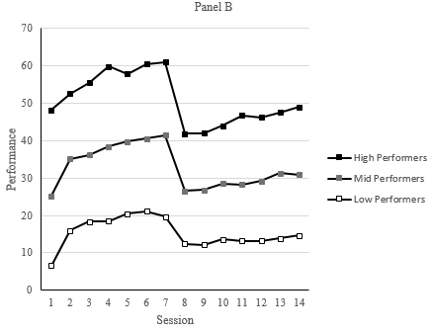

Figure 2. Effort trends (Panel A) and performance trends (Panel B) across sessions by Session 1 tertiles.

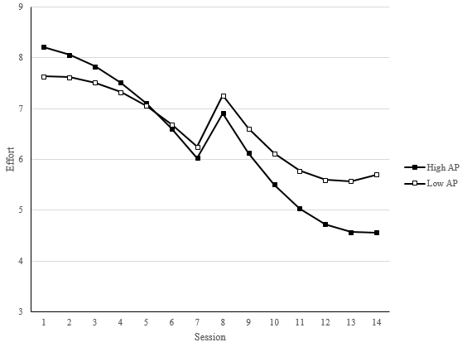

Figure 3. Effect of affect pulse on effort across sessions. High/low affect pulse = ±1standard deviation.

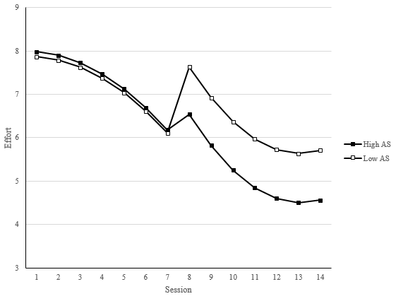

Figure 4. Effect of affect spin on effort across sessions. High/low affect spin = ±1 standard deviation.

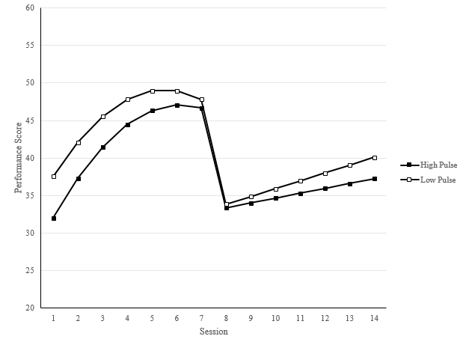

Figure 5. Effect of affect pulse on performance across sessions. High/low affect pulse = ±1 standard deviation.

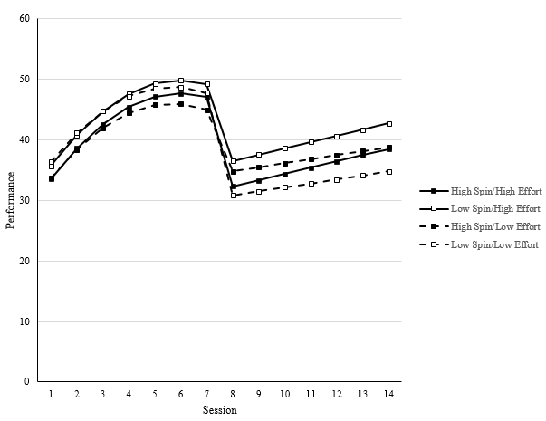

Figure 6. Effect of affect spin and effort on performance across sessions. High/low affect spin and effort = ±1 standard deviation.

References
Ashton-Jones, G., & Cohen, J. D. (2005). An integrative theory of locus coeruleus-norepinephrine function: Adaptive gain and optimal performance. Annual Review of Neuroscience, 28, 403-450. doi: 10.1146/annurev.neuro.28.061604.135709
Baard, S. K., Rench, T. A., & Kozlowski, S. W. J. (2014). Performance adaptation: A theoretical integration and review. Journal of Management, 40, 48-99. doi: 10.1177/0149206313488210
Bandura, A. (1977). Self-efficacy: Toward a unifying theory of behavior change. Psychological Review, 84, 191-215. doi: 10.1037/0033-295X.84.2.191
Bateman, T. S. & Crant, J. M. (1993). The proactive component of organizational behavior: A measure and correlates. Journal of Organizational Behavior, 14, 103-118. doi: 10.1002/job.4030140202
Baumeister, R. F., Bratslavsky, E., Muraven, M. & Tice, D. M. (1998). Ego depletion: Is the active self a limited resource? Journal of Personality and Social Psychology, 74, 1252-1265. doi: 10.1037/0022-3514.74.5.1252
Beal, D. J. & Ghandour, L. (2011). Stability, change, and the stability of change in daily workplace affect. Journal of Organizational Behavior, 32, 526-546. doi: 10.1002/job.713
Bell, B. S. & Kozlowski, S. W. J. (2008). Active learning: Effects of core training design elements on self-regulatory processes, learning, and adaptability. Journal of Applied Psychology, 93(2), 296-316. doi: 10.1037/0021-9010.93.2.296
Bell, B. S. & Kozlowski, S. W. J. (2009). Toward a theory of learner-centered training design: An integrative framework of active learning. In S. W. J. Kozlowski & E. Salas (Eds.), Learning, training, and development in organizations (pp. 263-300). New York: Routledge.
Bell, B. S., Tannenbaum, S. I., Ford, J. K., Noe, R. A., & Kraiger, K. (2017). 100 years of training and development research: What we know and where we should go. Journal of Applied Psychology, 102, 305-323. doi: 10.1037/apl0000142
Bliese, P. D., & Lang, J. W. (2016). Understanding relative and absolute change in discontinuous growth models: Coding alternatives and implications for hypothesis testing. Organizational Research Methods, 19, 562-592. doi: 10.1177/1094428116633502

Bolger, N. & Zuckerman, A. (1995). A framework for studying personality in the stress process. Journal of Personality & Social Psychology, 69, 890-902. doi: 10.1037/0022-3514.69.5.890
Crant, M. C. (1995). The proactive personality scale and objective job performance among real estate agents. Journal of Applied Psychology, 80, 532-537. doi: 10.1037/0021-9010.80.4.532
Carver, C. S. & Scheier, M. F. (1981). Attention and self-regulation: A control-theory approach to human behavior. New York: Springer-Verlag. doi: 10.1007/978-1-4612-5887-2
Day, E. A., Hardy, J. H. III, & Arthur, W. Jr. (2017). Exploration-Exploitation Tradeoffs in Self-Regulated Learning: Implications for Training and Development. SIOP Conference, Orlando, FL.
Duchowski, A. T. (2002). A breadth-first survey of eye-tracking applications. Behavior Research Methods, Instruments, & Computers, 43, 455-470. doi: 10.3758/bf03195475
Epic Games. (2004). Unreal Tournament 2004. Midway: Atari.
Ericsson, K. A. (2015). Acquisition and maintenance of medical expertise: A perspective from the expert-performance approach with deliberate practice. Academic Medicine, 90, 1471-1486. doi: 10/1097/ACM.0000000000000939
Ericsson, K. A. & Charness, N. (1994). Expert performance: Its structure and acquisition. American Psychologist, 49, 725-747. doi: 10.1037/0003-066X.49.8.725
Fitts, P. M. & Posner, M. I. (1967). Human performance. Oxford: Brooks/Cole.
Frese, M, Albrecht, K., Altmann, A., Lang, J., Papstein, P. V., Peyerl, R., et al. (1988). The effects of an active development of the mental model in the training process: Experimental results in a word processing system. Behaviour and
Information Technology, 7, 295-304. doi: 10.1080/01449298808901879
Fuller, B. Jr. & Marler, L. E. (2009). Change driven by nature: A meta-analytic review of the proactive personality literature. Journal of Vocational Behavior, 75, 329-345. doi: 10.1016/j.jvb.2009.05.008
Griffin, B. & Hesketh, B. (2003). Adaptable behaviours for successful work and career adjustment. Australian Journal of Psychology, 55, 65-73. doi: 10.1080/00049530412331312914
Hardy, J., III, Day, E. A., & Arthur, W., Jr. (2018). Exploration-exploitation tradeoffs and information-knowledge gaps in self-regulated learning: Implications for training and development. University of Oklahoma, Norman, OK.
Hardy, J. H., Day, E. A., Hughes, M. G., Wang, X., & Schuelke, M. J. (2014). Exploratory behavior in active learning: A between- and within-person examination. Organizational Behavior and Human Decision Processes, 125, 98-112. doi: 10.1016/j.obhdp.2014.06.005
Hughes, M. G., Day, E. A., Wang, X., Schuelke, M. J., Arsenault, M. L., Harkrider, L. N., & Cooper, O. D. (2013). Learner-controlled practice difficulty in the training of a complex task: Cognitive and motivation mechanisms. Journal of Applied Psychology, 98, 80-98. doi: 10.1037/t10893-000
Jiang, Z. (2017). Proactive personality and career adaptability: The role of thriving at work. Journal of Vocational Behavior, 98, 85-97. doi: 10.1016/j.jvb.2016.10.003
Jorgensen, A. (2017). A dynamic, self-regulatory examination of emotions and complex task learning (master’s thesis). University of Oklahoma, United States.
Jundt, D. K., Shoss, M. K., & Huang, J. L. (2014). Individual adaptive performance in organizations: A review. Journal of Organizational Behavior, 26, 53-71. doi: 10.1002/job.1955
Kanfer, R. & Ackerman, P. L. (1989). Motivation and cognitive abilities: An integrative/aptitude-treatment interaction approach to skill acquisition. Journal of Applied Psychology, 74, 657-690. doi: 10.1037/0021-9010.74.4.657
Kanfer, R., & Ackerman, P. L. (1990). Ability and metacognitive determinants of skill acquisition and transfer (Air Force Office of Scientific Research Final Report). Minneapolis, MN: Air Force Office of Scientific Research.
Kanfer, R., Ackerman, P. L., & Heggestad, E. D. (1996). Motivational skills & self-regulation for learning: A trait perspective. Learning and Individual Differences, 8, 185-209. doi:10.1016/S1041-6080(96)90014-X
Keith, N. & Wolff, C. (2015). In K. Kraiger, J. Passmore, N. Rebelo dos Santos, & S. Malvezzi, The Wiley Blackwell Handbook of the Psychology of Training, Development, and Performance Improvement (92-116). Hoboken, NJ: John Wiley & Sons, Ltd.
Kuppens, P., Van Mechelen, I., Nezlek, J. B., Dossche, D., & Timmermans, T. (2007). Individual differences in core affect variability and their relationship to personality and psychological adjustment. Emotion, 7, 262-274. doi: 10.1037/1528-3542.7.2.262
Lang, J. W. B. & Bliese, P. D. (2009). General mental ability and two types of adaptation to unforeseen change: Applying discontinuous growth models to the task-change paradigm. Journal of Applied Psychology, 94, 411-428. doi: 10.1037/a0013803
Laureiro-Martinez, D., Brusoni, S. & Zollo, M. The neuroscientific foundations of the exploration-exploitation dilemma. Journal of Neuroscience, Psychology, and Economics,3, 95-115. doi: 10.1037/a0018495
Major, D. A., Turner, J. E., & Fletcher, T. D. (2006). Linking proactive personality and big five to motivation to learn and development activity. Journal of Applied Psychology, 91, 927-935. doi: 10.1037/0021-9010.91.4.927
Mathot, S., Siebold, A., Donk, M., & Vitu, F. (2015). Large pupils predict goal-driven eye movements. Journal of Experimental Psychology: General, 144, 513-521. doi: 10.1037/a0039168
Matthewson, K. E., Basak, C., Maclin, E. L., Low, K. A., Boot, W. R., Kramer, A. F.,…Gratton, G. (2012). Different slopes for different folks: Apla and delta EEG power predict subsequent video game learning rate and improvements in cognitive control tasks. Psychophysiology, 49, 1558-1570. doi: 10.1111/j.1469-8989.2012.01474.x
Moran, A., Quinn, A., Campbell, M., Rooney, B., Brady, N., & Burke, C. (2016). Using pupillometry to evaluate attentional effort in quiet eye: A preliminary investigation. Sport, Exercise, and Performance Psychology, 5, 365-376. doi: 10.1037/spy0000066
Moskowitz, D. S. & Zuroff, D. C. (2004). Flux, pulse, and spin: Dynamic additions to the personality lexicon. Journal of Personality and Social Psychology, 86, 880-893. doi: 10.1037/0022-3514.86.6.880
Niessen, C. & Jimmieson, N. L. (2015). Threat of resource loss: The role of self-regulation in adaptive task performance. Journal of Applied Psychology, 1-13. doi: 10.1037/apl0000049
Noe, R. A., Clarke, A. D. M., & Klein, H. J. Learning in the twenty-first century workplace. Annual Review of Organizational Psychology and Organizational Behavior, 1, 245-275. doi: 10.1146/annurev-orgpsych-031413-091321
Park, I. (2015). The role of affect spin in the relationships between proactive personality, career indecision, and career maturity. Frontiers in Psychology, 6, 1-10. doi: 10.3389/fpsyg.2015.01754
Parker, S. K., Bindl, U. K., & Strauss, K. (2010). Making things happen: A model of proactive motivation. Journal of Management, 36, 827-859. doi: 10.1177/0149206310363732
Pintrich, P. R. (2000). The role of goal orientation in self-regulated learning. In M. Boekaerts, P. R. Pintrich, & M. Zeidner (Eds.), Handbook of self-regulation (pp. 451–502). San Diego, CA: Academic Press. doi: 10.1016/B978-012109890-2/50043-3
Ployhart, R. E. & Bliese, P. D. (2006). Individual adaptability (I-Adapt) theory: Conceptualizing the antecedents, consequences, and measurement of individual differences in adaptability. In Understanding adaptability: A prerequisite for effective performance within complex environments (pp. 3-39). Maryland Heights, MI: Elsevier Ltd. doi: 10.1016/S1479-3601(05)06001-7
Pulakos, E. D., Arad, S., Donovan, M. A., & Plamondon, K. E. (2000). Adaptability in the workplace: Development of a taxonomy of adaptive performance. Journal of Applied Psychology, 85, 612-624. doi: 10.1037/0021-9010.85.4.612
Richards, J. M., Butler, E. A., & Gross, J. J. (2003). Emotion regulation in romantic relationships: The cognitive consequences of concealing feelings. Journal of Social and Personal Relationships, 20, 599-620. doi: 10.1177/02654075030205002
Richards, J. M. & Gross, J. J. (2000). Emotion regulation and memory: The cognitive costs of keeping one’s cool. Journal of Personality and Social Psychology, 79, 410-424. doi: 10.1037/0022-3514.79.3.410
Savickas, M. L. & Porfeli, E. J. (2012). Career Adapt-Abilities Scale: Construction, reliability, and measurement equivalence across 13 countries. Journal of Vocational Behavior, 80, 661-673. doi: 10.1016/j.jvb.2012.01.011
Schmeichel, B. J., Vohs, K. D., & Baumeister, R. F. Intellectual performance and ego depletion: Role of the self in logical reasoning and other information processing. Journal of Personality and Social Psychology, 85, 33-46. doi: 10.1037/0022-3514.85.1.33
Simon, H. (1972). Theories of bounded rationality. In Decision and organization (pp. 161-176). Amsterdam: North-Holland Publishing Company.
Spitzmuller, M., Sin, H., Howe, M., & Fatimah, S. (2015). Investigating the uniqueness and usefulness of proactive personality in organizational research: A meta-analytic review. Human Performance, 28, 351-379. doi: 10.1080/08959285.2015.1021041
Thomas, J. P., Whitman, D. S., & Viswesvaran, C. (2010). Employee proactivity in organizations: A comparative meta-analysis of emergent proactive constructs. Journal of Occupational and Organizational Psychology, 83, 275-300. doi: 10.1348/096317910X502359
Tornau, K. & Frese, M. (2013). Construct clean-up in proactivity research: A meta-analysis on the nomological net of work-related proactivity concepts and their incremental validities. Applied Psychology: An International Review, 62, 44-96. doi: 10.1111/j.1464-0597.2012.00514.x.
Watson, D., Clark, L. A., & Lellegren, A. (1988). Development and validation of brief measures of positive and negative affect: The PANAS scales. Journal of Personality and Social Psychology, 54, 1063-1070. doi: 10.1037/0022-3514.54.6.1063

