UNIVERSITY OF OKLAHOMA
GRADUATE COLLEGE

COEVOLUTION OF A MALE NOVEL GENITAL TRAIT AND FEMALE REPRODUCTIVE RESPONSE IN DROSOPHILA MELANOGASTER SISTER SPECIES

A DISSERTATION SUBMITTED TO THE GRADUATE
FACULTY
in partial fulfillment of the requirements for the
Degree of
DOCTOR OF PHILOSOPHY

By
Mehrnaz Afkhami
Norman, Oklahoma
2024

COEVOLUTION OF A MALE NOVEL GENITAL TRAIT AND FEMALE REPRODUCTIVE RESPONSE IN DROSOPHILA MELANOGASTER SISTER SPECIES

A DISSERTATION APPROVED FOR THE
SCHOOL OF BIOLOGICAL SCIENCES

BY THE COMMITTEE CONSISTING OF

Chair: Dr. John P. Masly
Dr. Lawrence J. Weider
Dr. Cameron D. Siler
Dr. Michael R. Markham
Dr. Christina Bourne

© Copyright by Mehrnaz Afkhami 2024
All Rights Reserved.

Acknowledgments:
This journey would not have been possible without the people in my life who helped and guided me. I am most in debt to Dr. JP Masly, who took a chance on me and helped me to be where I am now. He helped me develop not only my science but also my critical thinking and soft skills needed as a researcher, and I am forever grateful.
I thank my committee members: Dr. Christina Bourne, who was always ready to listen to me and supported me through this journey; Dr. Michael Markham, who helped me think outside the box in neurobiology and broadened my perspective; and Dr. Larry Weider, who helped me tremendously with my manuscripts with his keen eye. Every time I got back comments from Larry, I felt mentally stronger after four days. Dr. Cam Siler's questions and suggestions always brought me back to the wild environment and helped me see a broader impact of my studies beyond the laboratory settings.
A big thank you to Dr. Angel Harper, who not only has become one of my dearest friends but also created the best lab protocols, without which many of the experiments here would not have been possible. I would like to thank Dr. Tingting Gu for teaching me about the beautiful art of microscopy and helping me take many of the pictures in this dissertation. I thank Dr. Michal Polak, our collaborator on the fourth chapter, for the opportunity do a unique experiment. I thank Dr. Ari Berkowitz for helping me understand the intricacies of the neurobiology of behavior. My cohort was one of the best Biology cohorts, and I had the pleasure of working with many great people. I am thankful to my friends and colleagues Alex, Azom, Harriet. I had the pleasure to work with great undergraduate researchers, Erica, Ashley, Farris, Albert, Linda and Subah.
I would like to thank my funding sources that financially supported me through this journey: The National Science Foundation (NSF IOS 1453642), OCAST (HR-011), the Department of Biology (now SBS), OU’s Graduate Student Senate, the Biogeography of Behavior initiative (NSF DBI-2021880), Genetic Society of America and OU’s Farzaneh Scholarship.
I would like to thank my family and friends, especially my mom, Shahrzad, and Ulises, for always believing in me and supporting me throughout my path through life.

Abstract:
Novel morphological structures have always fascinated scientists. Developmental processes give rise to structures and morphologies that are often functionally necessary for an organism’s survival and reproduction. But how does evolution shape these developmental processes to give rise to new phenotypes? How do these new phenotypes ultimately give rise to new species? And, how do these new phenotypes interact and coevolve between the sexes, particularly in the context of reproduction? Most studies that have focused on the evolution of novel traits focus on the importance of transcription factors and their pathways, and many studies have shown that evolution in regulatory regions and/or coding regions of transcription factors often gives rise to differences between species. In this dissertation, I investigated how novel traits diverge among the four sister species of Drosophila melanogaster and how novel traits are shaped by female sensory variation, focusing on an unconventional candidate.
In Chapter 1, I used a genetic introgression line called 4C2(A) to identify genes that are involved in the development of a novel male reproductive structure of the external genitalia of the four sister species. The introgression lines were created by crossing a D. mauritiana male carrying a P-element with a D. sechellia white (w) female and back-crossing it to D. sechellia w male for 15 generations to have a small D. mauritiana region in an otherwise D. sechellia w genetic background. These secondary sexual structures are called epandarial posterior lobes (ePLs) and help the male to grasp the female during mating and ensure a tight genital coupling. Using a series of mapping experiments and functional genetic tests, I identified Allnighter (Aln), a pseudokinase, as a gene that directs the development of ePLs. Using additional functional genetic experiments, I showed that Aln is necessary for specifying ePL size differences among the four sister species. Furthermore, our data showed that Aln had a more prominent role when flies developed under stressful thermal conditions. Specifically, when Aln null individuals developed in higher temperatures, they exhibited an even smaller ePL size and an incomplete genitalia rotation, resulting in upside-down male genitalia. This work suggests the co-option of the cellular stress response pathways can result in divergent morphologies and highlights the role of cellular stress response pathways in evolutionary developmental biology.
Most, if not all, traits on the male genitalia are under sexual selection, and no study will be complete without investigating how females respond to and co-evolve with these novel male reproductive traits. Previous studies have shown that when D. melanogaster females mate with males that have smaller or misshapen ePLs, they reduce the number of eggs they lay. In Chapter 2, I studied whether the gene or genes that specify ePLs size and female egg-laying are in the same region or even the same gene. I investigated the effect of the entire collection of available D. sechellia-D. mauritiana introgression lines that had smaller or misshapen ePLs on female egg-laying, with a focus on 4C2(A). We showed that when 4C2(A) females mate with 4C2(A) males, they do not reduce their egg-laying amounts, which suggests that a gene or genes in this region affect the female egg-laying phenotype. I tested the egg-laying amount of Aln null females, and our results show that these females laid significantly fewer eggs compared to the control females. These results demonstrate that Aln specifies not only male genital morphology, but also female reproductive behavior, providing a basis for sexual selection to act on males and females in concordance. These findings have important implications for our understanding of the co-evolution of male and female reproductive traits.
In Chapter 3, I delved deeper into the egg-laying phenotype and how females control this key reproductive event. I conducted a literature review and summarized the studies that show how specific neurons, whether from the peripheral nervous system or the central nervous system, modulate the action of egg deposition or the movement of the egg into the oviduct and other phenomena in the egg-laying behavior. Furthermore, by looking at other insect examples, I show that there are more components in the egg-laying behavior that require further study in Drosophila. Neuronal control of egg-laying in Drosophila provides many understudied avenues and has the potential to provide more robust evidence for phenomena like cryptic female choice.
In Chapter 4, I further explored how females sense the ePLs during mating and how they regulate their reproductive output/responses as a consequence of variation in ePL morphology. First, I identified candidate sensory neurons on female genitalia at the site where the ePLs make contact with the female during copulation. The candidate neurons I identified are mechanosensory sensilla on the epigynial ventral lobe. Interestingly, these bristles vary in average number among the four sister species. I showed that the neurons attached to the sensilla express Piezo, a mechanoreceptor gene, and are cholinergic. My results showed that Piezo knockout females mate normally but lay significantly fewer eggs compared to control females. On the other hand, although Piezo knockout males sire slightly fewer offspring, the difference in the number of eggs laid by females mated to Piezo knockout males compared to females mated to control males is not significant. Laser ablation of only some of these epigynial sensilla does not affect the female egg-laying output. However, when all of these sensilla were ablated, females laid close to no eggs. Additionally, we showed that axons of these neurons arborize the abdominal neuromere through the main abdominal nerve. The abdominal neuromere houses both motor neurons that modulate the female egg-laying and interneurons that carry the sensory signal to the brain, suggesting that the information carried by the epigynial sensilla neurons has the potential to influence the output of central nervous system neurons. Taken together, these neurons are promising candidates for future studies about sensing ePLs. In summary, my studies showed that the co-evolutionary dynamics between male and female reproductive traits are complex. Variation in peripheral sensory neurons can drive the evolution and diversification of novel traits and change in a gene like Aln not only provides the developmental raw material to diversify the size of the ePLs in the males but also reinforces the egg-laying bias in females.

Contents

 | Introduction:  An overview of speciation, development of novel traits, and female choice |  | 1
 |  | The study system: Four sister species of the Drosophila melanogaster species complex | 4
 |  | The conventional and nonconventional developmental tool kit ……… | 5
 |  | Variation in the membrane between the digits of vertebrates…………. | 8
 |  | Drosophila genitalia rotation...……...…………………………………. | 9
 |  | Female sensory preference……………...……………………………... | 10
 |  | Using a novel structure on the Drosophila genitalia to answer several fundamental questions…….………………………….………………... | 12
 |  | References……………………………………………………………... | 13
1 | Allnighter specifies the size of a diversifying male novel trait in the Drosophila melanogaster species complex |  | 25
 | 1.1 | Abstract…………………………………………………………...……... | 25
 | 1.2 | Introduction………………………………………………………..……. | 26
 | 1.3 | Results………………………………………………………………..…. | 30
 | 1.4 | Discussion………………………………………………………….....…. | 35
 | 1.5 | Materials and methods………………………………………….……….. | 40
 | 1.6 | References……………………………….……………………………... | 43
 | 1.7 | Figures…………………………………………………………………... | 56
 | 1.8 | Supplements…………………………………………………………….. | 67
2 | One gene can affect both female reproductive output and male genital morphology……………………………………………………………………….. |  | 78
 | 2.1 | Abstract………………………………………………………………...... | 78
 | 2.2 | Introduction…………………………………………………………..…. | 79
 | 2.3 | Materials and methods………………………………………………..…. | 82
 | 2.4 | Results……………………………………………………………………. | 85
 | 2.5 | Discussion……………………………………………………….……...... | 89
 | 2.6 | References……………………………………………………….……..... | 92
 | 2.7 | Figures…………………………………………………………….…….. | 100
 | 2.8 | Tables……………………………………………………………………. | 111
 | 2.9 | Supplements…………………………………………………………… | 115
3 | Neurobiology of Egg-laying Behavior in Drosophila: Neural Control of the Female Reproductive System |  | 116
 | 3.1 | Abstract………………………………………………………………... | 116
 | 3.2 | Introduction ……….……….…………………………………………. | 117
 | 3.3 | Major sex determination genes as indicators of central neurons involved in female reproduction………….……………….…................................. | 122
 | 3.4 | Peripheral nervous system: Sensory neurons that influence egg-laying... | 126
 | 3.5 | Sensory cues triggered by mating | 126
 | 3.6 | Sensory cues triggered by ovulation and egg delivery………………….. | 128
 | 3.7 | Mechanosensory cues from mating direct egg-laying behavior…………. | 129
 | 3.8 | Central nervous system: The abdominal neuromere in the ventral nerve cord……………………………………………………………………… | 130
 | 3.9 | Central nervous system: The Brain………………………………..……. | 132
 | 3.10 | Motor neurons………………………………………………………..…. | 136
 | 3.11 | Why is neuronal control of egg-laying important in light of evolution?.. | 137
 | 3.12 | References……………………………….…………………………….... | 140
 | 3.13 | Figures…………………………………………………………………... | 168
4 | Mechanosensation has wide implications in the egg-laying behavior of female Drosophila |  | 175
 | 4.1 | Abstract………………………………………………………………... | 175
 | 4.2 | Introduction……………………………………………………………. | 176
 | 4.3 | Materials and methods …...……………………………………………. | 180
 | 4.4 | Results ……………………………………………………………...…. | 182
 | 4.5 | Discussion……………………………………………………….……... | 186
 | 4.6 | References……………………………….……………………………... | 190
 | 4.7 | Figures…………………………………………………………………. | 200
 | 4.8 | Tables…………………………………………………………………… | 209
 | 4.9 | Supplements…………………………………………………………… | 214

List of Figures
1.1 | Figure 1.1: The ePLs of the four Drosophila melanogaster sister species and the introgression line……………………………………………………………….. | 56
1.2 | Figure 1.2: Screen of the genes present in 4C2(A) region……………………….. | 57
1.3 | Figure 1.3: Aln knock-down D. melanogaster flies show a significant decrease in ePL area……………………………………………………………………… | 58
1.4 | Figure 1.4: Both 4C2(A) deletion and Aln null genotypes resulted in a smaller ePL……………………………………………………………………………... | 59
1.5 | Figure 1.5: The spatial and temporal expression of Aln differs between the four sister species…………………………………………………………………..... | 60
1.6 | Figure 1.6: Aln is expressed in female genitalia of D. melanogaster…………… | 61
1.7 | Figure 1.7: No expression of Aln can be seen in the Poxn null mutant in D. melanogaster. ………………………………………………………………….. | 62
1.8 | Figure 1.8: Multiple binding sites are seen upstream, downstream, and in exons of Aln ……………………………………………………….………………….. | 63
1.9 | Figure 1.9: Heat stress interferes with the normal development of genitalia in the Aln null Individuals. …………………………………….………………….. | 64
1.10 | Figure 1.10: F1 hybrids between 4C2(A) introgression line and Aln null flies have significantly smaller ePLs………………………………………………… | 66
2.1 | Figure 2.1: The ePLs of the introgression lines between D. sechellia and D. mauritiana…………………………………………………………………….... | 100
2.2 | Figure 2.2: The ePL area in mm² for multiple genotypes…………….…….…… | 101
2.3 | Figure 2.3: The egg-laying comparison between each genotype combination … | 102
2.4 | Figure 2.4: The egg-laying comparison between each genotype combination … | 105
2.5 | Figure 2.5: The Glds in situ hybridization for adult brain and crop……………. | 107
2.6 | Figure 2.6: Overexpression of Glds using PoxnGAL4 does not affect egg-laying | 108
2.7 | Figure 2.7: Aln null homozygote egg-laying……….…………………………… | 109
2.8 | Figure 2.8: The qPCR results …………………...…………………….……….. | 110
3.1 | Figure 3.1: The female reproductive structures and sensory input …………….. | 168
3.2 | Figure 3.2: The Juvenile hormone (JH) titer throughout the adult female D. melanogaster’s life…………………………………………………..…………. | 169
3.3 | Figure 3.3: Sex determination cascade in Drosophila ……...………………….. | 170
3.4 | Figure 3.4: Diagram of the major components of the female D. melanogaster female reproductive tract……………………………………………………….. | 171
3.5 | Figure 3.5: The schematic diagram neurons arborizing or residing in the abdominal neuromere…………………………………………………………... | 172
3.6 | Figure 3.6: Schematic fly brain and location of neurons known to affect egg laying …………………………………………….…………………………….. | 173
3.7 | Figure 3.7: Interactions between neurons that affect egg-laying ……………….. | 174
4.1 | Figure 4.1: The SEM of D. sechellia and D. mauritina ……………………….. | 200
4.2 | Figure 4.2: The number of epigynium sensilla …………………………….….. | 201
4.3 | Figure 4.3: The effect of laser ablation on female egg-laying…………………. | 202
4.4 | Figure 4.4: The severe laser ablation of epigynium sensilla analysis…………… | 204
4.5 | Figure 4.5: The female abdominal sensory neurons……………………………. | 205
4.6 | Figure 4.6: The effect of Piezo knockout on female egg-laying behavior……… | 206
4.7 | Figure 4.7: The effect of Piezo knockout on male reproductive behavior……… | 207
4.8 | Figure 4.8: The effect of Chat knockdown …………………………………….. | 208
List of Tables
2.1 | Table 2.1: Analysis of introgression lines egg-laying experiment …………….. | 111
4.1 | Table 4.1: List of fly lines and their expression…………….………………….. | 209
4.2 | Table 4.2: The location of sperm in the reproductive tract…………………….. | 211
4.3 | Table 4.3: The location of sperm in the reproductive tract…………………….. | 212

Introduction

An overview of speciation, development of novel traits, and female choice

How do new traits evolve? This is one of the major questions that fascinates evolutionary biologists. In the past, taxonomists relied heavily on divergent phenotypic traits to discern closely-related species from each other (Mayr 1999). Even Darwin himself was inspired by the peculiar morphology of a barnacle and worked extensively on the systematics of cirripedes (Darwin 1851; Deutsch 2010). Using finches, barnacles, and many other natural observations, Darwin thought about novel traits as “peculiarities” in individual members of a population. In his eyes, these novel traits were induced by changes in the environment and were also influenced by the organism’s “constitution”, suggesting some species were more prone to develop “peculiarities” than others (West-Eberhard 2008). Darwin’s thought about an organism’s “constitution” can now be explored more as developmental constraint and flexibility, where some characteristics, for example, spots on a butterfly’s wing, are more readily generated than other characteristics (Beldade et al. 2002). Natural selection acts on heritable variation between individuals within populations. Individuals with higher compatibility (i.e., fitness) with the environment have a higher chance of survival, which leads to the survival of some individuals but not others.
The term species has been debated for many years, and multiple species concepts have arisen that define some biological organization better than others (Coyne and Orr, 2004). Here, I will follow the guidance of Coyne and Orr (2004) and choose the most suitable concept for the questions this study addresses. Initially, Theodosius Dobzhansky (1935) suggested that a species is a group of individuals that are reproductively fertile among themselves, but do not produce offspring with other groups due to physiological properties. Dobzhansky added that no gene exchange between species would exist, meaning absolute reproductive isolation (RI). Ernst Mayr (1942) popularized this so-called biological species concept (BSC). Coyne and Orr (2004) further expanded the BSC to suggest that species may have limited gene exchange with their closely related sympatric species. Although complete RI is important for speciation, relaxing this criterion helps explain phenomena like hybridization and introgression with the BSC, which are extensively used in this dissertation.
Another key evolutionary process in driving the variation between the species is sexual selection. Sexual selection usually affects the traits that are involved in mating and fertilization success (Mendelson and Safran 2021). Darwin wrote about sexual selection as “the advantage which certain individuals have over other individuals of the same sex and species solely in respect of reproduction” (Darwin 1871). He hypothesized that selection could influence the appearance and loss of certain novel traits, giving rise to new species (Darwin 1859, West-Eberhard 2008). However, he had a difficult time explaining exaggerated phenotypes (e.g., elaborate plumage on male peacocks), which we know now typically evolve as a consequence of sexual selection. Darwin’s problem stemmed from not being able to reconcile the opposing effects of sexual and natural selection, where it seemed to Darwin that one force (natural selection) drives the organism to have better adaptability with its environment while the other results in traits that make organism life in its environment more difficult (sexual selection). Exaggerated phenotypes are mostly studied as targets of mate choice and/or mate competition (Andersson 1994). Panhuis et al. (2001) suggested that initial changes in sexual traits can be due to drift, pleiotropy, and adaptation. The direct effect of sexual selection on reproductive traits, for example mate recognition, can give rise to rapid speciation (Panhuis et al. 2001). It has been shown that sexual selection can result in genetic divergence (Andersson 1994). Haldane’s Rule states that in hybrids between two closely-related species, the heterogametic sex would be the sterile/inviable one (Haldane, 1922). Haldane’s rule is widespread and has been studied in organisms like Drosophila (Orr 1997; Masly and Presgraves 2007), mammals (Turelli and Orr 1995), and lepidopterans (Orr 1997).
Many hypotheses have emerged for the evolution of exaggerated traits, including Fisher’s runaway model (Fisher 1930), the sexy son hypothesis (Weatherhead and Robertson 1979; Egan et al. 2016), and the handicap hypothesis (Zehavi and Zahavi 1997; Számadó and Penn 2015; Penn and Számadó 2020). For a long time, sexual section theory did not have a suitable hereditary model. Ronald Fisher qualitatively suggested what is now known as the Fisher’s runaway model (Fisher 1930). Fisher’s runaway model states that female preference can result in an exaggerated male phenotype, and eventually, the genetic basis for the exaggerated trait and the female preference will be passed down together to the offspring, resulting in a race toward a more extreme phenotype (Fisher 1930; Henshaw and Jones 2020). Many studies have shown that the male trait and female preference for that trait localize to the same region of the genome (e.g., Henshaw and Jones 2020). In some cases, female preference is present before the evolution of the trait (Basolo 1990). In this dissertation, I look at both male and female traits that are localized to the same region of the genome using a small introgression on an autosomal chromosome; additionally, animals carrying this introgression are viable and fertile.
The study system: Four sister species of the Drosophila melanogaster species complex
The Drosophila family belongs to the insect group Diptera (the true flies), which includes flies and mosquitoes (Yeates and Wiegmann 2005). The Drosophila melanogaster species group is one of the most diverse Drosophila clades with at least 177 described species (Kopp 2006). The Drosophila melanogaster sister species or Drosophila melanogaster species complex is a monophyletic clade comprising four closely related species in this species group (Jagadeeshan and Singh 2006; Yassin and Orgogozo 2013). The four sister species of the Drosophila melanogaster species complex include D. melanogaster, D. simulans, D. sechellia, and D. mauritiana. The model organism, D. melanogaster, is the sister to the clade composed of the other three species, and the relationship among the other three species had not been resolved until recently. Using single-fly genome assemblies, Kim et al. (2023), showed that D. simulans and D. sechellia grouped closer together, with D. mauritiana being a sister branch of the two species. The four sister species are differentiated from the other D. melanogaster species group members by possessing novel structures on the male genitalia called the epandarial posterior lobes (ePLs) (Yassin and Orgogozo, 2014 ; Rice et al. 2019). Male genital structures are often used by taxonomists to differentiate among closely-related insect species (although in some species that lay eggs in specialized niches, female genitalia can be just as useful, i.e., D. suzukii (Atallah et al. 2014)). Divergence in male genitalia between closely related species is often a consequence of sexual selection (Eberhard, 1985, 2010; Shapiro and Porter 1989; Masly 2012).
The ePLs are cuticular outgrowths of the lateral plate that help the male to hold on to the female during mating and vary dramatically in shape and size among the four sister species (Coyne et al. 1991; Jagadeeshan and Singh 2006; Yassin and Orgogozo 2013). Complete ablation of the ePLs, either using genetic manipulation or lasers, will result in males falling off the females during mating (LeVasseur-Viens et al. 2015; Frazee and Masly 2015). The ePL comes into contact with the female’s abdomen, and studies suggest it inserts between the VII and VIII tergites (Jagadeeshan and Singh 2006; Kamimura and Mitsumoto 2011; Yassin and Orgogozo 2013). Copulation wounds have been observed in Drosophila species (Kamimura 2007; Kamimura and Mitsumoto 2011; Masly and Kamimura 2014). A study by Masly and Kamimura (2014) showed that males with smaller ePLs caused more severe wounding, suggesting a role for ePLs in sexual conflict. Yassin and Orgogozo (2014) studied male and female genitalia coevolution in the four sister species and suggested that the area of oviscapt pouches on the female genitalia was correlated with the size of the ePLs in the males. There are many unresolved questions about male and female genitalia coevolution, as reviewed by Yassin (2016). One of these questions is, “How often do females morphologically coevolve with male genitalia?” In this dissertation, I address a broader perspective of this question. In particular, I examine the notion that in some cases in females, the female neuronal arborization and information processing coevolve with male morphology (Masly 2012).
The conventional and nonconventional developmental tool kit
Carroll (2005) suggested that there is a genetic tool kit for the formation of the animal body. The Hox genes are the most famous gene family in the development of body structure (Grenier et al. 1997; Hughes and Kaufman 2002; Heffer and Pick 2013; Hubert and Wellik 2023), but other gene families that contain DNA binding motifs (e.g. HLH proteins) are also important (Carlsson and Mahlapuu 2002). Even though animals like fruit flies and mice seem far from each other on the phylogenetic tree, they often use the same tool kit. Perhaps one of the most well-studied pathways in animal development is the JAK/STAT pathway and regulation (Aaronson and Horvath 2002; Levy and Darnell 2002; Rawlings et al. 2004; Murray 2007), which plays a central role in the development of ePLs (Glassford et al. 2015; Urum et al. 2024). The Janus kinase (JAK) is associated with receptors at the cell surface, and the binding of ligands with these receptors activates the JAKs (Levy and Darnell 2002; Bach et al. 2003). Activated JAKs, in turn, activate the signal transducer and activator of transcriptions (STATs) (Levy and Darnell 2002; Bach et al. 2003). Upon activation, STATs move from the cytosol to the nucleus, thus activating the transcription of target genes (Levy and Darnell 2002; Bach et al. 2003).
The field of evolutionary developmental biology (evo-devo) has focused on transcription factors and transcription regulators as the conventional toolkit of development (Carroll 2005). Most efforts are focused on the changes in these molecules that give rise to novel traits between closely-related species. However, we should not forget that changes in transcription factors are not the only avenue that can give rise to species differences, and changes can arise due to genes that encode extracellular matrix components and enzymes, regulate cell cycle, and program cell death.
For example, body pigmentation is a well-studied topic in developmental biology (Hoekstra 2006; Wittkopp and Beldade 2009; Patterson and Parichy 2019). While it is true that transcription factors play a critical role in specifying the bounds of body pigmentation, there are other genes that structurally affect it. For example, the genes ebony and tan, code enzymes that affect the melanin biosynthesis pathway (Wittkopp et al. 2009). Drosophila species show a wide variety of body colors, and Wittkop et al. (2009) have shown that both intra and interspecific variations in body color in D. americana and D. novamexicana are due to changes in tan and ebony genes. Simultaneously with studies on genes like tan and ebony, transcription factors have been identified that specify the spatiotemporal patterns of pigment enzyme expression in Drosophila (i.e., the bric-a-back locus), which also have been shown to contribute to pigment variation between species and between sexes (Kopp et al. 2000).
As another example, changes in the extracellular matrix can affect the morphogenesis of an organ (Page-McCaw et al. 2003). In Drosophila, the gene matrix metalloproteinases are involved in pupal development and tissue remodeling but not embryogenesis (Page-McCaw et al. 2003). The Drosophila genome has two matrix metalloproteinases, Mmp1 and Mmp2. Mutant screens have shown that Mmp1 affects tracheal growth, and Mmp2 affects epithelial fusion during the metamorphosis (Page-McCaw et al. 2003). Specifically, Mmp2 has been shown to play an important role in the development of the tracheal system in the wing disc (Guha et al. 2009). Drosophila has one Tissue inhibitor of metalloproteinases (Timp) gene, and its protein product inhibits both MMP1 and MMP2 (Page-McCaw et al. 2003), providing another example of extracellular matrix protein that affects morphology.
An additional mechanism, programmed cell death, can shape organs by removing extra cells from the developing tissue or by introducing a pulling force that shapes the neighboring tissues (Suzanne and Steller, 2013). Organogenesis heavily involves cell death. Specifically, metamorphosis induces cell death in many animals, including Drosophila and amphibians (Penaloza et al. 2006). Autophagy is a type of apoptosis. In autophagy, large vacuoles are present in the cell. However, the cell can recover from this state and survive. Apoptosis co-occurs with expression of some matrix metalloproteinases that degrade the extracellular matrix. Interestingly, depending on the condition, apoptotic cells can produce signals that introduce cell proliferation, suggesting a back-and-forth signal between apoptosis and cell proliferation (Suzanne and Steller 2013). I will describe two famous examples where stress pathways and apoptosis are major contributors to the morphology and diversification of a developing structure and result in novel phenotypes: The interdigital cell death in vertebrates and the male Drosophila genitalia rotation.
Variation in the membrane between the digits of vertebrates
The tetrapod limb has been one of the avenues for studying morphological novelty (Schneider and Shubin 2013). Regulation of Hox genes and the time of their expression give rise to the wide variety of morphologies seen among the tetrapods (Schneider and Shubin 2013), and gradients of genes like Sonic hedgehog give rise to the identity of the digits (Hu and He 2008). Separation of the digits in vertebrates is the oldest example of apoptosis shaping an organ (Suzanne and Steller 2013). The digits are freed by a specific cell death pattern in the tissue between the digits. This pattern is regulated by multiple signaling molecules: fibroblast growth factor 8 (Fgf8) is produced by distal ectoderm and prevents programmed cell death caused by retinoic acid. Bone morphogenic proteins (Bmp) 2/4 down-regulate the expression of Fgf8 and induce retinoic acid mediated cell death (Hernández-Martínez and Covarrubias 2011). In short, Fgf signal promotes cell survival whereas the Bmp signal triggers programmed cell death, and changes in these pathways and their downstream effectors can result in changes in morphologies (Sanz-Ezquerro and Tickle 2003). A set of the cell’s response pathway to Fgf is the mitogen-activated protein kinase/extracellular signal-regulated kinase (MAPK/ERK) pathway (Kawakami et al. 2003). The MAPK/ERK pathway is involved in several cell regulatory processes, including proliferation and apoptosis and misregulation of members of this pathway (for instance, Mkp3), that can result in defective limbs (Kawakami et al. 2003). Sun et al. (2021) overexpressed the dolphin Hox13 gene in zebrafish to identify what gene would be differentially expressed as a result. They suggested that MAPK and Notch signaling pathways were involved in the retention of interdigital tissue in dolphins and other cetaceans (Sun et al. 2021). The expression of reelin, a member of the extracellular matrix, is dependent on Fgf signals, and reelin’s expression is downregulated before interdigital cell death. The story of tetrapod digit diversification has similar components to ePL development and diversification. The gene Poxn is downstream of a hox gene (Abd-b) and codes a transcription factor that is necessary for ePL development (Glassford et al. 2015). My dissertation characterizes a candidate gene that is hypothesized to be involved in the regulation of cell death, and previously unpublished data from the Masly lab shows that another ePL candidate gene is involved in cell proliferation. Lastly, Smith et al. (2020) demonstrated that Dumpy, a gene that encodes a component of the extracellular matrix, is critical to the development of ePLs and knock out of this gene results in smaller and deformed ePLs. The only missing component comparable to the tetrapod digit development seems to be a molecular gradient that specifies the identity of different parts of the male's developing genitalia.
Drosophila genitalia rotation
The male genitalia in many Drosophila species rotates 360 degrees clockwise during development to arrive at its final orientation at the tip of the abdomen (Inatomi et al. 2019). This rotation also loops the spermiduct attached to the genitalia over the hindgut (Ádám et al. 2003; Kuranaga et al. 2011). The rotation in D. melanogaster is directed by a specific myosin called Myo1D, the product of the gene myo31DF (Spéder et al. 2006). Mis-expression of Myo1D not only affects the rotation of male genitalia, but also affects the handedness of Drosophila larval body (Lebreton et al. 2018). In rotating, apoptosis frees up the tissue to move freely (Kuranaga et al. 2011). For example, males of D. pachea have asymmetric genital lobes that help the male copulate with the female. This novel trait and asymmetry is also due to genital rotation and is under the influence of Myo1D (Lefèvre et al. 2022).
Further, the mating position in some Dipterans relies greatly on the genitalia rotation (Inatomi et al. 2019). While some dipterans rely on the developmental rotation of the male genitalia (Inatomi et al. 2019), other insects twist their abdomens to have the correct mating position (Gao and Hua 2013). For instance, hangingflies show a unique face-to-face hanging copulation and provide nuptial gifts (Gao and Hua 2013). To achieve this, the male fly twists its abdomen 180 degrees temporarily and has several genital structures, including well-developed epandarial lobes, suggesting that male genitalia and mating position evolve and develop in tandem (Gao and Hua 2013). Taken together, correct genital orientation and developmental pathways that contribute to it are key players in ensuring that the organism has a successful copulation and, therefore, may contribute to RI.
Female sensory preference
Up to this point, my focus has been on the developmental and genetic building blocks that form the foundation upon which selection forces can act, leading to the emergence of new morphologies. Now, one can ask how exactly do the mechanisms behind the selective pressures work in the context of the evolution of the genitalia? To help answer this question, I will focus now on female choice as a force that potentially shapes male genitalia morphology.
Not all matings are equally likely to result in offspring. For instance, interactions of male and female genotypes affect the egg-hatching rate of the stick insect Timema cristinae (Arbuthnott et al. 2015). Therefore, females have multiple matings and usually bias their sperm use toward one or a few males that are more genetically compatible (Arbuthnott et al. 2015). Drosophila females can exercise their choice before, during, or after mating, but the evidence for the female choice during and/or after mating is rare (Shao et al. 2019; Chen et al. 2019). How females choose their partners based on courtship behavior, and song has been studied extensively in Drosophila and falls under premating choice (Ishimoto and Kamikouchi 2021).
Cryptic female choice (CFC) refers to post-mating female control over sperm usage and the number of offspring produced and sired by one mate (Eberhard 1996; Firman et al. 2017). One of the early studies of CFC was by Thornhill (1983), who studied scorpionflies. The author used egg-laying as a proxy of post-mating female choice and showed that females who received larger nuptial gifts laid more eggs. Eberhard (1996) brought CFC into the spotlight with his seminal book entitled “Female Control: Sexual Selection by Cryptic Female Choice”. Since the publication of these seminal studies, researchers have tried to show direct evidence of CFC using various systems, with varied success (Firman et al. 2017). In many instances, it is difficult to differentiate CFC from other sexual selection processes like sperm competition, which adds to the complexity of studying CFC (Firman et al. 2017). CFC can act through prezygotic mechanisms. For instance, it has been suggested that female guppies can affect mating duration, therefore influencing which male has more sperm in the race (Pilastro et al. 2007). However, there are not many studies on possible postzygotic mechanisms of CFC (Firman et al. 2017; Shao et al. 2019; Chen et al. 2019).
Egg-laying and female reproductive output can be used as an indicator of CFC. It is worth noting that egg-laying is a costly phenomenon (Williams 2005) that needs to be modulated by the female’s physiology and neurons to increase her chance of passing her genes to the next generation. For example, when female frogs perceive the male that is amplexed with her as unfavorable, they reduce the number of eggs they lay (Reyer et al. 1999). Decreasing the number of offspring from one suboptimal mating helps the female minimize the effect on her future offspring from subsequent matings, as fewer resources are allocated to the suboptimal mating progeny.
Using a novel structure on the Drosophila genitalia to answer several fundamental questions
The state of the field today raises several questions, which I will answer using the four sister species of Drosophila:
1. What gene or genes give rise to the development of novel reproductive phenotypes?
2. Can the same gene affect both male and female reproductive phenotypes?
3. How do females control their reproductive output in response to a novel male phenotype?
My dissertation focuses on two related themes that are important in evolutionary biology. As Carroll (2005) suggested, evo-devo is the present generation’s contribution to the modern synthesis. It combines the modern evolutionary synthesis with molecular genetics and allows one to pose major questions like the human impact on evolution. However, the field of evo-devo is still more focused on regulatory genes, and morphology. As noted by West-Eberhard (2003), evo-devo’s focus on speciation has resulted in gaps and lags in our knowledge of the origin of behavioral and physiological traits. Here in my dissertation, I test the Evo-devo aspect of speciation using the development of ePLs between the four sister species in Chapter 1. Surprisingly, the effect of the candidate gene tested in my thesis is intensified by environmental stress, which further highlights the human impact on the development and morphology of our contemporary species. In Chapter 2, I highlight the potential for co-evolution between a male’s morphology and a female’s behavior using a single gene. While most studies show that genes that affect male morphology and female preference localize to the same area in the genome, here we see that the same gene affects both male and female reproductive phenotypes.
The second major theme of my dissertation is cryptic female choice. Egg-laying behavior and how neurons and hormones modulate it provide an excellent basis for studying the female’s control over her reproductive output. With that in mind, in Chapter 3, I review the literature on the neurobiology of egg-laying behavior in Drosophila and suggest with the advancements in recent years, the field is ready to reveal more fine-tuned mechanisms of female control and their subsequent evolutionary implications. In Chapter 4, I show a potential direction for studying the neurobiology of cryptic female choice in flies using the mechanosensory bristles on the female fly’s genitalia that come into contact with ePLs on the male genitalia. Taken together, these focal studies enhance our understanding of evo-devo and female choice. Therefore, my thesis offers another puzzle piece to the already established picture of ePL development by examining the potential role of female choice in shaping ePLs.
References:
Aaronson D. S., and C. M. Horvath, 2002 A Road Map for Those Who Don’t Know JAK-STAT. Science 296: 1653–1655. https://doi.org/10.1126/science.1071545
Ádám G., N. Perrimon, and S. Noselli, 2003 The retinoic-like juvenile hormone controls the looping of left-right asymmetric organs in Drosophila. Development 130: 2397–2406. https://doi.org/10.1242/dev.00460
Andersson M. B., 1994 Sexual selection. Princeton University Press, Princeton, N.J.
Arbuthnott D., B. J. Crespi, and T. Schwander, 2015 Female Stick Insects Mate Multiply to Find Compatible Mates. The American Naturalist 186: 519–530.
Atallah J., L. Teixeira, R. Salazar, G. Zaragoza, and A. Kopp, 2014 The making of a pest: the evolution of a fruit-penetrating ovipositor in Drosophila suzukii and related species. Proceedings of the Royal Society B. 281: 20132840. https://doi.org/10.1098/rspb.2013.2840
Bach E. A., S. Vincent, M. P. Zeidler, and N. Perrimon, 2003 A Sensitized Genetic Screen to Identify Novel Regulators and Components of the Drosophila Janus Kinase/Signal Transducer and Activator of Transcription Pathway. Genetics 165: 1149–1166. https://doi.org/10.1093/genetics/165.3.1149
Basolo A. L., 1990 Female Preference Predates the Evolution of the Sword in Swordtail Fish. Science 250: 808–810. https://doi.org/10.1126/science.250.4982.808
Beldade P., K. Koops, and P. M. Brakefield, 2002 Developmental constraints versus flexibility in morphological evolution. Nature 416: 844–847. https://doi.org/10.1038/416844a
Carlsson P., and M. Mahlapuu, 2002 Forkhead Transcription Factors: Key Players in Development and Metabolism. Developmental Biology 250: 1–23. https://doi.org/10.1006/dbio.2002.0780
Carroll S. B. 2005 Endless Forms Most Beautiful: The New Science of Evo Devo and the Making of the Animal Kingdom. W. W. Norton, USA.
Chapman T., G. Arnqvist, J. Bangham, and L. Rowe, 2003 Sexual conflict. Trends in Ecology & Evolution 18: 41–47. https://doi.org/10.1016/S0169-5347(02)00004-6
Chen D. S., S. Y. N. Delbare, S. L. White, J. Sitnik, M. Chatterjee, et al., 2019 Female Genetic Contributions to Sperm Competition in Drosophila melanogaster. Genetics 212: 789–800. https://doi.org/10.1534/genetics.119.302284
Darwin C., 1851 A monograph on the sub-class Cirripedia, with figures of all the species. Ray society, London.
Deutsch J., 2010 Darwin and barnacles. Comptes Rendus Biologies 333: 99–106. https://doi.org/10.1016/j.crvi.2009.11.009
Eberhard W. G., 1996 Female control: sexual selection by cryptic female choice. Princeton University Press, Princeton, N.J.
Egan A. L., K. A. Hook, H. K. Reeve, and V. K. Iyengar, 2016 Polyandrous females provide sons with more competitive sperm: Support for the sexy-sperm hypothesis in the rattlebox moth ( Utetheisa ornatrix): Polyandrous females have more competitive sperm. Evolution 70: 72–81. https://doi.org/10.1111/evo.12829
Firman R. C., C. Gasparini, M. K. Manier, and T. Pizzari, 2017 Postmating Female Control: 20 Years of Cryptic Female Choice. Trends in Ecology & Evolution 32: 368–382. https://doi.org/10.1016/j.tree.2017.02.010
Fisher R. A., 1930 The genetical theory of natural selection. Clarendon Press, Oxford.
Frazee S. R., and J. P. Masly, 2015 Multiple sexual selection pressures drive the rapid evolution of complex morphology in a male secondary genital structure. Ecology and Evolution 5: 4437–4450. https://doi.org/10.1002/ece3.1721
Gao Q., and B. Hua, 2013 Co-Evolution of the Mating Position and Male Genitalia in Insects: A Case Study of a Hangingfly, (T. M. Jones, Ed.). PLoS ONE 8: e80651. https://doi.org/10.1371/journal.pone.0080651
Glassford W. J., W. C. Johnson, N. R. Dall, S. J. Smith, Y. Liu, et al., 2015 Co-option of an Ancestral Hox-Regulated Network Underlies a Recently Evolved Morphological Novelty. Developmental Cell 34: 520–531. https://doi.org/10.1016/j.devcel.2015.08.005
Grenier J. K., T. L. Garber, R. Warren, P. M. Whitington, and S. Carroll, 1997 Evolution of the entire arthropod Hox gene set predated the origin and radiation of the onychophoran/arthropod clade. Current Biology 7: 547–553. https://doi.org/10.1016/S0960-9822(06)00253-3
Guha A., L. Lin, and T. B. Kornberg, 2009 Regulation of Drosophila matrix metalloprotease Mmp2 is essential for wing imaginal disc: Trachea association and air sac tubulogenesis. Developmental Biology 335: 317–326. https://doi.org/10.1016/j.ydbio.2009.09.005
Heffer A., and L. Pick, 2013 Conservation and Variation in Hox Genes: How Insect Models Pioneered the Evo-Devo Field. Annual Review of Entomology. 58: 161–179. https://doi.org/10.1146/annurev-ento-120811-153601
Henshaw J. M., and A. G. Jones, 2020 Fisher’s lost model of runaway sexual selection. Evolution 74: 487–494. https://doi.org/10.1111/evo.13910
Hernández-Martínez R., and L. Covarrubias, 2011 Interdigital cell death function and regulation: New insights on an old programmed cell death model: Interdigital cell death. Development, Growth & Differentiation 53: 245–258. https://doi.org/10.1111/j.1440-169X.2010.01246.x
Hoekstra H. E., 2006 Genetics, development and evolution of adaptive pigmentation in vertebrates. Heredity 97: 222–234. https://doi.org/10.1038/sj.hdy.6800861
Hu J., and L. He, 2008 Patterning mechanisms controlling digit development. Journal of Genetics and Genomics 35: 517–524. https://doi.org/10.1016/S1673-8527(08)60071-5
Hubert K. A., and D. M. Wellik, 2023 Hox genes in development and beyond. Development 150: dev192476. https://doi.org/10.1242/dev.192476
Hughes C. L., and T. C. Kaufman, 2002 Hox genes and the evolution of the arthropod body plan1. Evol Dev 4: 459–499. https://doi.org/10.1046/j.1525-142X.2002.02034.x
Inatomi M., D. Shin, Y.-T. Lai, and K. Matsuno, 2019 Proper direction of male genitalia is prerequisite for copulation in Drosophila, implying cooperative evolution between genitalia rotation and mating behavior. Scientific Reports 9: 210. https://doi.org/10.1038/s41598-018-36301-7
Ishimoto H., and A. Kamikouchi, 2021 Molecular and neural mechanisms regulating sexual motivation of virgin female Drosophila. Cellular and Molecular Life Sciences 78: 4805–4819. https://doi.org/10.1007/s00018-021-03820-y
Kamimura Y., 2007 Twin intromittent organs of Drosophila for traumatic insemination. Biology Letters 3: 401–404. https://doi.org/10.1098/rsbl.2007.0192
Kamimura Y., and H. Mitsumoto, 2011 Comparative copulation anatomy of the Drosophila melanogaster species complex (Diptera: Drosophilidae): Copulation anatomy of Drosophila. Entomological Science 14: 399–410. https://doi.org/10.1111/j.1479-8298.2011.00467.x
Kawakami Y., J. Rodríguez-León, C. M. Koth, D. Büscher, T. Itoh, et al., 2003 MKP3 mediates the cellular response to FGF8 signalling in the vertebrate limb. Nature Cell Biology 5: 513–519. https://doi.org/10.1038/ncb989
Kopp A., I. Duncan, and S. B. Carroll, 2000 Genetic control and evolution of sexually dimorphic characters in Drosophila. Nature 408: 553–559. https://doi.org/10.1038/35046017
Kopp A., 2006 Basal relationships in the Drosophila melanogaster species group. Molecular Phylogenetics and Evolution 39: 787–798. https://doi.org/10.1016/j.ympev.2006.01.029
Kuranaga E., T. Matsunuma, H. Kanuka, K. Takemoto, A. Koto, et al., 2011 Apoptosis controls the speed of looping morphogenesis in Drosophila male terminalia. Development 138: 1493–1499. https://doi.org/10.1242/dev.058958
Lebreton G., C. Géminard, F. Lapraz, S. Pyrpassopoulos, D. Cerezo, et al., 2018 Molecular to organismal chirality is induced by the conserved myosin 1D. Science 362: 949–952. https://doi.org/10.1126/science.aat8642
Lefèvre B. M., M. Delvigne, J. Vidal, V. Courtier-Orgogozo, and M. Lang, 2022 Evolution of a novel left-right asymmetry involving tissue remodelling and MyoID. Evolutionary Biology.
LeVasseur-Viens H., M. Polak, and A. J. Moehring, 2015 No evidence for external genital morphology affecting cryptic female choice and reproductive isolation in Drosophila: Genital shape and sexual selection. Evolution 69: 1797–1807. https://doi.org/10.1111/evo.12685
Levy D. E., and J. E. Darnell, 2002 STATs: transcriptional control and biological impact. Nature Reviews Molecular Cell Biology Biol 3: 651–662. https://doi.org/10.1038/nrm909
Mayr E., 1999 Systematics and the origin of species, from the viewpoint of a zoologist. Harvard University Press, Cambridge, Mass.
Murray P. J., 2007 The JAK-STAT Signaling Pathway: Input and Output Integration. The Journal of Immunology 178: 2623–2629. https://doi.org/10.4049/jimmunol.178.5.2623
Masly J. P., and D. C. Presgraves, 2007 High-Resolution Genome-Wide Dissection of the Two Rules of Speciation in Drosophila, (N. H. Barton, Ed.). PLoS Biol 5: e243. https://doi.org/10.1371/journal.pbio.0050243
Masly J. P., 2012 170 Years of “Lock-and-Key”: Genital Morphology and Reproductive Isolation. International Journal of Evolutionary Biology 2012: 1–10. https://doi.org/10.1155/2012/247352
Masly J. P., and Y. Kamimura, 2014 Asymmetric mismatch in strain-specific genital morphology causes increased harm to Drosophila females: brief communication. Evolution https://doi.org/10.1111/evo.12436
Mendelson T. C., and R. J. Safran, 2021 Speciation by sexual selection: 20 years of progress. Trends in Ecology & Evolution 36: 1153–1163. https://doi.org/10.1016/j.tree.2021.09.004
Murre C., 2019 Helix–loop–helix proteins and the advent of cellular diversity: 30 years of discovery. Genes & Development 33: 6–25. https://doi.org/10.1101/gad.320663.118
Orr H. A., 1997 Haldane’s Rule. Annual Review of Ecology, Evolution, and Systematics 28: 195–218. https://doi.org/10.1146/annurev.ecolsys.28.1.195
Page-McCaw A., J. Serano, J. M. Santé, and G. M. Rubin, 2003 Drosophila Matrix Metalloproteinases Are Required for Tissue Remodeling, but Not Embryonic Development. Developmental Cell 4: 95–106. https://doi.org/10.1016/S1534-5807(02)00400-8
Panhuis T. M., R. Butlin, M. Zuk, and T. Tregenza, 2001 Sexual selection and speciation. Trends in Ecology & Evolution 16: 364–371. https://doi.org/10.1016/S0169-5347(01)02160-7
Patterson L. B., and D. M. Parichy, 2019 Zebrafish Pigment Pattern Formation: Insights into the Development and Evolution of Adult Form. Annual Review of Genetics 53: 505–530. https://doi.org/10.1146/annurev-genet-112618-043741
Penaloza C., L. Lin, R. A. Lockshin, and Z. Zakeri, 2006 Cell death in development: shaping the embryo. Histochemistry and Cell Biology 126: 149–158. https://doi.org/10.1007/s00418-006-0214-1
Penn D. J., and S. Számadó, 2020 The Handicap Principle: how an erroneous hypothesis became a scientific principle. Biological Reviews 95: 267–290. https://doi.org/10.1111/brv.12563
Pilastro A., M. Mandelli, C. Gasparini, M. Dadda, and A. Bisazza, 2007 Copulation duration, insemination efficiency and male attractiveness in guppies. Animal Behaviour 74: 321–328. https://doi.org/10.1016/j.anbehav.2006.09.016
Presgraves D. C., and C. D. Meiklejohn, 2021 Hybrid Sterility, Genetic Conflict and Complex Speciation: Lessons From the Drosophila simulans Clade Species. Frontiers in Genetics12: 669045. https://doi.org/10.3389/fgene.2021.669045
Rawlings J. S., K. M. Rosler, and D. A. Harrison, 2004 The JAK/STAT signaling pathway. Journal of Cell Science 117: 1281–1283. https://doi.org/10.1242/jcs.00963
Reyer H., G. Frei, and C. Som, 1999 Cryptic female choice: frogs reduce clutch size when amplexed by undesired males. Proceedings of the Royal Society B. 266: 2101–2107. https://doi.org/10.1098/rspb.1999.0894
Rice G., J. R. David, Y. Kamimura, J. P. Masly, A. P. Mcgregor, et al., 2019 A standardized nomenclature and atlas of the male terminalia of Drosophila melanogaster. Fly 13: 51–64. https://doi.org/10.1080/19336934.2019.1653733
Sánchez L., and I. Guerrero, 2001 The development of the Drosophila genital disc: Review articles. Bioessays 23: 698–707. https://doi.org/10.1002/bies.1099
Sanz-Ezquerro J. J., and C. Tickle, 2003 Fgf Signaling Controls the Number of Phalanges and Tip Formation in Developing Digits. Current Biology 13: 1830–1836. https://doi.org/10.1016/j.cub.2003.09.040
Schneider I., and N. H. Shubin, 2013 The origin of the tetrapod limb: from expeditions to enhancers. Trends in Genetics 29: 419–426. https://doi.org/10.1016/j.tig.2013.01.012
Shao L., P. Chung, A. Wong, I. Siwanowicz, C. F. Kent, et al., 2019 A Neural Circuit Encoding the Experience of Copulation in Female Drosophila. Neuron 102: 1025-1036.e6. https://doi.org/10.1016/j.neuron.2019.04.009
Shapiro A. M., and A. H. Porter, 1989 The Lock-and-Key Hypothesis: Evolutionary and Biosystematic Interpretation of Insect Genitalia. Annual Review of Entomology 34: 231–245. https://doi.org/10.1146/annurev.en.34.010189.001311
Sirot L. K., A. Wong, T. Chapman, and M. F. Wolfner, 2015 Sexual Conflict and Seminal Fluid Proteins: A Dynamic Landscape of Sexual Interactions. Cold Spring Harbor Perspectives in Biology 7: a017533. https://doi.org/10.1101/cshperspect.a017533
Spéder P., G. Ádám, and S. Noselli, 2006 Type ID unconventional myosin controls left–right asymmetry in Drosophila. Nature 440: 803–807. https://doi.org/10.1038/nature04623
Sun L., Y. Cao, Q. Kong, X. Huang, Z. Yu, et al., 2021 Over-expression of the bottlenose dolphin Hoxd13 gene in zebrafish provides new insights into the cetacean flipper formation. Genomics 113: 2925–2933. https://doi.org/10.1016/j.ygeno.2021.06.028
Suzanne M., and H. Steller, 2013 Shaping organisms with apoptosis. Cell Death & Differentiation 20: 669–675. https://doi.org/10.1038/cdd.2013.11
Számadó S., and D. J. Penn, 2015 Why does costly signalling evolve? Challenges with testing the handicap hypothesis. Animal Behaviour 110: e9–e12. https://doi.org/10.1016/j.anbehav.2015.06.005
Turelli M., and H. A. Orr, 1995 The dominance theory of Haldane’s rule. Genetics 140: 389–402. https://doi.org/10.1093/genetics/140.1.389
Urum A., G. Rice, W. Glassford, Y. Yanku, B. Shklyar, et al., 2024 A developmental atlas of male terminalia across twelve species of Drosophila. Frontiers in Cell and Developmental Biology 12: 1349275. https://doi.org/10.3389/fcell.2024.1349275
Wagner G. P., and V. J. Lynch, 2010 Evolutionary novelties. Current Biology 20: R48–R52. https://doi.org/10.1016/j.cub.2009.11.010
Weatherhead P. J., and R. J. Robertson, 1979 Offspring Quality and the Polygyny Threshold: “The Sexy Son Hypothesis.” The American Naturalist 113: 201–208. https://doi.org/10.1086/283379
West-Eberhard M. J., 2008 Toward a Modern Revival of Darwin’s Theory of Evolutionary Novelty. Philosophy of science 75: 899–908. https://doi.org/10.1086/594533
Williams T. D., 2005 Mechanisms Underlying the Costs of Egg Production. BioScience 55: 39.
Wittkopp P. J., E. E. Stewart, L. L. Arnold, A. H. Neidert, B. K. Haerum, et al., 2009 Intraspecific Polymorphism to Interspecific Divergence: Genetics of Pigmentation in Drosophila. Science 326: 540–544. https://doi.org/10.1126/science.1176980
Yassin A., and V. Orgogozo, 2013 Coevolution between Male and Female Genitalia in the Drosophila melanogaster Species Subgroup, (D. J. Colgan, Ed.). PLoS ONE 8: e57158. https://doi.org/10.1371/journal.pone.0057158
Yeates D. K., and B. M. Wiegmann (Eds.), 2005 The evolutionary biology of flies. Columbia University Press, New York.
Zehavi A., and A. Zahavi, 1997 The handicap principle: a missing piece of Darwin’s puzzle. Oxford University Press, New York.
Chapter 1

Allnighter specifies the size of a diversifying male novel trait in the Drosophila melanogaster species complex
1.1 Abstract
Understanding the molecular underpinnings of morphological evolution is essential for unraveling the complexities of species diversification. This study focuses on the evolution of genitalia morphology in the four Drosophila melanogaster sister species, including D. melanogaster, D. simulans, D. sechellia, and D. mauritiana. This study aims to uncover the genetic factors that drive variations in male genital structures. This was accomplished by utilizing an introgression line between D. sechellia and D. mauritiana, to identify gene or genes responsible for the development of morphological differences. We studied genes within the introgressed region using gene expression knockdown using RNAi and identified the gene that contributes to the observed size difference in genitalia morphology between these two species. We focused on epandrium posterior lobes (ePLs), and our data showed that knocking down the transcript abundance of the gene Allnighter (Aln) resulted in a reduction of the ePL area. To characterize the evolutionary forces that have shaped genetic differences, we measured the sequence divergence in and around Aln among the four sister species. Aln coding sequence only showed a significant change in the coding region on the last exon. However, there was much more variation in noncoding regions upstream of Aln, especially in D. simulans. Using in situ hybridization, we compared Aln expression patterns between the four sister species. Lastly, we measured the size of ePL in F1 hybrids that only carried the allele from one species. In conclusion, our research advances our understanding of the molecular dynamics behind the evolution of genitalia morphology in Drosophila, thus offering valuable insights into the mechanisms governing species diversification.

1.2 Introduction:
Understanding the molecular bases that are key to the evolution of novel morphological traits can provide valuable insights into the history and diversity of life and inform how selective pressures shape phenotypes among species. For instance, Hox genes are major contributors to the variation in arthropod body design, and many studies have characterized Hox genes such as Ultrabthorax and Abdominal-B that have evolved to specify the origin of metazoan body plans (Grenier et al. 1997, Hughes and Kaufman, 2002; Hubert and Wellik, 2023).
Changes in gene sequence and gene regulation can give rise to morphological differences within and between species. Domesticated animals show a wide variety of “exaggerated” phenotypes, and the genetic basis of many of them has been studied (Courtier-Orgogozo et al. 2020). For instance, one allele of relaxin-like receptor 2 (RXFP2) in sheep results in larger horns and reproductive success, while another allele results in increased survival, showing a tradeoff between natural and sexual selection (Wiedemar and Drögemüller 2015). Many genes that encode transcription factors have been the target of studies on the evolution of diversifying morphology due to their effect on developmental pathways (Lynch and Wagner 2008; Heffer and Pick 2013; Glassford et al. 2015). Genes affecting differential morphology have also been studied in a variety of wild animals (Carroll 2000), including finches (Abzhanov et al. 2004; Lamichhaney et al. 2015), Drosophila (Auradkar et al. 2021), and fish (Hart et al. 2018; Kon et al. 2020).
In many cases, sexual selection shapes morphological differences between closely-related species, especially in the genitalia (Eberhard 2010). Studies suggest that mechanisms of sexual selection, including cryptic female choice (CFC) (Eberhard 1996), sperm competition, and sexual conflict, drive this diversification (Hosken and Stockley 2004). Some studies in Drosophila suggest that the size of a male novel trait corresponds with female egg-laying and is suggestive of CFC (Frazee and Masly 2015, Frazee et al., 2021), while other studies have not uncovered this phenomenon (LeVasseur-Viens et al. 2015). Female reproductive structures can affect both CFC and sperm competition (Firman et al. 2017; Chen et al. 2019). For example, the last male sperm precedent, a phenomenon where the last male fathers the most offspring, has been observed in flies (Schnakenberg et al. 2012, Firman et al. 2017; Chen et al. 2019). In yellow dung flies, high-quality females that have four spermathecae contribute more to CFC and potentially sperm competition (Ward 2000). Sperm competition has been studied in terms of the effect of the first and second-copulating males, and studies have uncovered that female genetic background affects the success of competing males (Chen et al. 2019). Sexual conflict between male and female Drosophila has been well-established (Chapman et al. 2003; Sirot et al. 2015; Presgraves and Meiklejohn 2021). In many cases, traumatic insemination in Drosophila results in wounding and reduced lifespan in female flies (Kamimura 2007; Kamimura and Mitsumoto 2011; Masly and Kamimura 2014). As explored by Eberhard (1985) and many others, animal genitalia are affected by sexual selection and are potential targets for the Fisherian runaway selection model (Fisher 1930), thus showing faster morphological evolution. This rapid divergence and elaborate structures provide an excellent natural laboratory to study the genetic basis of morphological divergence.
Evolutionary forces like sexual selection shape variation at loci that direct the development of male and female phenotypes (Henshaw and Jones 2020). For example, body and organ size and shape show dimorphism between males and females in many species, suggesting the pressure of sexual selection (Ranta et al. 1994). Much of the diversity seen in body and plumage coloration is driven by sexual selection (Kodric-Brown 1985; Wellenreuther et al. 2014). Most noticeably, the diversity seen between the genitalia of closely related species is believed to be the product of sexual selection (Eberhard 1985). The morphology of insect genitalia has been studied extensively in evolutionary biology (Scudder 1971; Arnqvist 1998; Huber 2010) and these studies have contributed to our taxonomic understanding of insect diversity (Shapiro and Porter 1989).
Drosophila melanogaster and its sister species offer an ideal system to study genital evolution in closely related species. Male genitalia in D. melanogaster complex species develop from the larval genital disc (Casares et al. 1997; Sánchez and Guerrero 2001). The adult male external genitalia consists of epandrium, surstylus (claspers), and cercus (Rice et al. 2019). There are drastic differences in male genital morphology between the four sister species (Jagadeeshan and Singh 2006; Yassin and Orgogozo 2013). These morphological differences are especially prominent in the epandarial posterior lobes (ePLs) (previously called the posterior lobes) (True et al. 1997) (Jagadeeshan and Singh 2006). There is some variation between the female terminalia of the four sister species, which is discussed in chapter four and Yassin and Orgogozo (2013). Functional characterization and genetic studies have shown that the genetic basis for the divergence of genital structures among the four sister species of D. melanogaster are complex (True et al. 1997; Masly et al. 2011; Glassford et al. 2015; Tanaka et al. 2015).
As an example of this complexity, Pox-neuro (Poxn) is a transcription factor that has a role in the development of chemosensory organs and also is necessary for the development of ePLs (Boll and Noll 2002; Glassford et al. 2015). The ePLs are male-specific genital structures that are only present in D. melanogaster, D. simulans, D. sechellia and D. mauritiana (Figure 1.1) (Lemeunier et al., 1986). Boll and Noll (2002) have shown that Poxn null mutants do not develop any posterior lobe on the lateral plate. However, Poxn null males cannot eclose on their own and have very limited survival even after aided eclusion (Masly lab, unpublished data). Frazee and Masly (2015) used Poxn RNAi to reduce the size of the ePLs and studied its effect on sexual selection. Reduction of ePL size results in a drastic decrease in male fitness in competitive assays (Frazee and Masly 2015).
Tartan is another gene that results in male genitalia variation between the four sister species and drives some of the differences in the claspers (Hagen et al. 2019). In addition, some studies on the contribution of QTLs to the variation in size and shape of the posterior lobe have not shown the region close to the telomere on the left of the arm of the third chromosome as a significant contributor to the ePL; however, peaks are still observable (Hackett et al. 2016). Further, QTL studies between D. mauritiana and D. simulans and their hybrids have uncovered 9 QTLs but none are close to the 3L telomere (Liu et al. 1996).
In this study, we identified and characterized a gene that specifies ePL size among members of the D. melanogaster species complex. The differential morphologies between species have been studied using introgression between closely-related Drosophila species (Masly and Presgraves 2007; Masly et al. 2011; Tanaka et al. 2015; Glassford et al. 2015). Here, we used pure species D. sechellia, D. mauritiana and an introgression line between them to identify the genomic regions that give rise to the drastic difference in ePL morphology between these species. The D. mauritiana-D. sechellia introgression lines were generated previously by crossing males from individual D. mauritiana lines that possessed a single P-element insertion carrying a w+ visible eye-color marker with D. sechellia w females (Masly and Presgraves 2007). Introgression lines between D. sechellia and D. mauritiana have been used to identify the genomic regions that affect the ePLs (Tanaka et al. 2015; Masly et al. 2011). Here, we used a specific introgression line, 4C2(A), that was shown previously to affect the ePL size to pinpoint gene/genes affecting the size of the ePLs between species. 4C2(A) has around 15% reduction in ePL size (Masly et al. 2011).
Our goal in this paper was to: (1) identify the genes in the introgressed region; (2) identify the gene/genes contributing to the reduced size of the posterior lobe; and (3) study the evolutionary forces and expression patterns of the locus of interest. Our study suggests that a putative kinase is important for posterior lobe size specification and suggests that expression and molecular differences in a kinase gene can contribute to novel morphological diversification between closely-related species.
1.3 Results:
The ePLs of the male 4C2(A) introgression line flies are significantly smaller than D. sechellia (Masly et al. 2011) (Figure 1.1). To identify the gene or genes that contribute to this reduction in size, we identified the breakpoints between the two species’ genomic contributions using whole-genome sequencing. We created a chromosome-level genome assembly for the left arm of the third chromosome for D. sechellia white (w), D. mauritiana w and the 4C2(A) introgression line. We used D. sechellia 3L assembly (CM015604.1) to generate the 4C2(A) 3L chromosome and the D. mauritiana 3L (CM015616.1) to create the reciprocal mapping on the D. mauritiana assembly. The P-element flanking regions were mapped to 4C2(A) 3L chromosome. We aligned the 4C2(A) 3L consensus contig to D. sechellia 3L. A dot plot between D. sechellia 3L and 4C2(A) 3L shows that the breakpoints are between 807,240 and 1,220,595 base pairs (bps) and the P-element flanking regions map to around 881,000 bps (Supplement Figure 1.1). The breakpoints were further validated using primers for each of the breakpoints and amplification using PCR. There are 25 protein-coding and 25 non-protein-coding genes in this region (Supplement Table 1.1). All the genes are present in the same order in D. melanogaster, D. simulans, D. sechellia, and D. mauritiana in the same approximate region of the genome (Supplement Table 1.2). Vincent et al. (2019) created a database of transcription factors that are expressed in the developing terminalia of the male D. melanogaster using in-situ hybridization. Out of the genes present in the introgression line, there are data available on the genes extra macrochaetae (emc), hinge 3, and bric a bac 2 (bab2) which shows that these genes are expressed in the male developing genitalia (Vincent et al. 2019).
Morphological divergence in the genitalia
We conducted a functional RNAi screen in D. melanogaster using Poxn-GAL4 driver to express the RNAi of interest in the primordia of the developing ePLs. Out of the 19 protein-coding genes we tested, one affected the ePL size significantly (Figure 1.2). Allnighter (Shekhar et al. 2023) had a highly significant effect compared to the control (Figure 1.3). We tested Aln with another GAL4 driver. The gene apterous (ap) encodes a transcription factor that is broadly expressed in the developing genitalia (Vincent et al. 2019). We analyzed the Knock down using a student t-test. Knocking down Aln in the domain of ap significantly reduces the posterior lobe area (t[60[=5.30518; p-value< 0.00001) (Figure 1.3).
To further confirm the effect of Aln, we used the deletion line Df(3L)ED4196 (hereafter called the “deletion” line) and a null line for Aln (hereafter called the null line). The deletion line expands over all the 4C2(A) region. The deletion region starts at genome coordinates 3L:639583 and ends at 3L:1478937. The functional null was created by the insertion of a Green Fluorescent Protein (GFP) and GAL4 coding sequence into the coding region of Aln (previously known as CG12038) using transposons (Bellen et al. 2004). We generated multiple genetic combinations to test for the effect of the absence of Aln on the ePL size. Our results show that the homozygote null has a smaller ePL compared to the Aln-RNAi knockdown (t[62]=2.62; p-value=0.005) and heterozygote null flies (t[54]=-3.16; p-value=0.001) (Figure 1.4). Heterozygote deletion flies have even smaller ePLs, and the smallest ePLs belong to the deletion over the null genotype (t[58]=6.18; p-value<0.00001) (Figure 1.4). Both heterozygote deletion and deletion over null flies show a slight change in shape and a slight decrease in clasper bristle numbers. The analysis of the ePL shapes created by these genotypes did not show any significant change in shape (Supplement figure 1.2) Our observations show that some individuals in the deletion and deletion over null stocks die while mating. Further observations showed that the males of these stocks have issues separating from females during mating and some flies die during mating showing signs of traumatic copulation (Supplement Figure 1.3). This peculiar phenomenon is likely due to developmental effects on male genitalia in regions other than ePLs.
Sequence divergence among the four sister species
Aln encodes a secretory 407 amino acids long pseudokinase protein (Shekhar et al. 2023). We studied the rate of evolution in the coding region of Aln using available sequences between D. mauritiana and D. simulans (Garrigan et al. 2012). Tajima’s D revealed a significant difference (D= 2.657, p-value<0.01) only between the last exon and terminator complex of the two species. There are only three amino changes among the sister species, two in D. simulans and one in D. melanogaster, all residing on the last exon. We analyzed the ~1500 bps upstream of Aln. The upstream region of Aln shows an extensive increase in D. simulans compared to the other three sister species (Supplement Figure 1.4), suggesting the possibility of new regulatory motifs. Upon further investigation, we discovered that the increase in the upstream region in D. simulans is a hobo transposon (Supplement Figure 1.4). It has been shown that hobo transposons carry regulatory elements that are active in Drosophila’s nervous system and tracheal system (Deprá et al. 2009).
Aln expression pattern in the developing genitalia
We investigated the spatial pattern of Aln expression throughout male and female developing genitalia among the four sister species (Figure 1.5). Specifically, our goal was to study any correlation of expression patterns with the diverse ePL sizes among the species, possibly indicating changes in regulatory region of Aln. We generated DIG probes using Aln gene cDNA inserted plasmid and used it against pupae between 30 to 50 hours after pupae formation (hAPF) in the four sister species. We observed expression in the 30 hours (hrs) and 35 hrs APF stages in all four sister species (Figure 1.5). At 40 hrs APF, the expression of Aln begins to diverge among the four sister species. In D. simulans, the expression is more focused in the developing ePLs and center of the terminalia, whereas in D. mauritiana, Aln has stronger expression in the developing claspers and anal plates. All species showed expression in the lateral plates to various degrees. There is expression Aln in the developing female terminalia in D. melanogaster (Figure 1.6). Strikingly, the internal reproductive tract shows minimal signal compared to the strong signal in the external terminalia. Additionally, I tested the expression of Aln in a Poxn null genetic background in D. melanogaster. The in-situ experiments show that there is much less signal localization between the experimental Poxn null and control flies (Figure 1.7). However, it is important to mention that Poxn null develops much slower than the control flies because the expression of patterns of Aln varies across time points in D. melanogaster.
Identification of potential transcriptional regulators of Aln in the male genitalia
We used several databases to screen for transcription factor binding sites upstream, downstream, and in introns of Aln (modENCODE, Motifmap). The expression pattern in the developing anal plates (Figure 4) in the early stages matches the expression of the caudal gene, which has a binding site in the upstream regulatory region of Aln (Murali et al. 2011). Our results show many other possible binding sites for transcription factors prominent in genitalia morphogenesis, including Double sex (Dsx), empty spiracles (ems), and ap (Figure 1.8). The Dsx gene is a major player in the Drosophila’s sex determination pathway (Baker and Wolfner 1988; Chatterjee et al. 2011). Urum et al. (2024) recently showed that the ems expression shows striking localization to the developing ePL primordia. Glassford et al. (2015) Showed that stat92E is nessasary for ePL size. We found STAT potential binding site upstream of Aln (Figure 1.8). Other binding sites for transcription factors that are expressed in developing male genitalia (FlyTerminalia) include zeste, escargot (esg), mitochondrial transcription factor A (TFAM) and pleiohomeotic (pho).
The phenotype of Aln null is more severe under developmental stress
Previously, Shekhar et al. (2023) have suggested that Aln functions as part of the unfolded protein response pathway. Here, I test the effect of the high-temperature developmental environment on Aln null. My results show that the Aln null ePL area developed in 29 ºC is significantly smaller compared to both Aln null developed in 25 °C and D. melanogaster white developed in 29 °C (t[12]=-3.8; p-value=0.001027)) (Figure 1.9 A). Surprisingly, Aln null developed in 29 °C showed another phenotype. The male genitalia rotation in these animals is incomplete and fully developed animals exhibited an upside-down genitalia (Figure 1.9 B).
Species-specific copies of Aln are necessary for specifying ePL size
To test the effect of species-specific genetic material, we created F1 hybrids using D. melanogaster males Aln nulls and 4C2(A) introgression line females. In hybridizations between D. melanogaster and the other three sister species, male D. melanogaster by female sister species gives rise to only male offspring. Our data show that there is a significant difference between the D. melanogaster and D. sechellia pure species F1 hybrids and D. melanogaster Aln null and 4C2(A) F1 hybrids (t[23]=-5.8; p-value<0.00001). The D. melanogaster Aln null/4C2(A) F1 hybrids have a much smaller posterior lobe (Figure 1.10), which we hypothesize is due to the D. mauritiana allele.
1.4 Discussion:
This study aimed to investigate the gene or genes responsible for interspecific size differences between the ePL of the four sister species of D. melanogaster. 4C2(A) region has previously been identified as a region near telomere of 3L that affects the size of the ePLs in introgressions between D. sechellia and D. mauritiana (Masly et al. 2011; Frazee et al. 2021).
4C2(A) contains multiple genes that are expressed during genitalia development
Our study shows that this region consists of some protein coding genes and is also enriched in non-protein coding genes including long non-coding RNA, small nuclear RNAs and tRNAs. Recent studies have shown that the combination of long non-coding RNAs affects the identity of neuronal cells (Gaelle Talross 2023). Our data show that the deletion of the 4C2(A) region in D. melanogaster results in an even smaller ePL compared to just the loss-of-function of the Aln gene, which suggests there might be other players involved to a lesser degree. Our data also show that this region is relatively enriched in genes that are expressed in the genitalia, including bab2, emc, hng3 (Vincent et al. 2019), and now CG12028.The genetic screen of 61D1-2 to 61F1-2 showed that there are three lethal genes in the 4C2(A) region (Saito et al. 2002). Saito et al. (2002) identified that emc is an embryonic lethal, while trio and Glut1 are lethal in larvae and pupae/adults, respectively. This is consistent with our observation of deletion over null stocks yielding dead embryos (personal observation). Our other observation suggests that the deletion line missing the complete 4C2(A) region shows other reproductive defects, including the inability to decouple after mating, which we hypothesize is due to issues with the phallus, the intromittent organ compromised of several processes (Rice et al. 2023). In addition, the development of the phallus has been shown to vary between several Drosophila species (Rice et al. 2023).
Aln affects the size of the epandarial posterior lobes
Changes in Aln expression levels have a significant impact on the development of the ePLs. We show that knockdown of Aln reults in a small ePL and the Aln null results in even smaller ePL.One explanation could be that Aln modulates posterior lobe size through its interaction with CG7724. CG7724 is a protein-coding gene ortholog to NAD(P)-dependent steroid dehydrogenase-like (NSDHL) gene in humans, responsible for CHILD syndrome that affects limb development and skin (König et al. 2000). In Drosophila, CG7724 is expressed in posterior spiracles, which suggests a strong connection to ePL development, as Glassford et al. (2015) have shown that the posterior spiracle regulatory network is co-opted in posterior lobe development. Other studies have shown that the development of the ePL is dependent on the extracellular matrix (Smith et al. 2020). The Dumpy protein is a member of the apical extracellular matrix, and disruption of the expression of the dumpy gene results in a drastically misshapen ePL (Smith et al. 2020). These findings provide other targets of kinase activity for Aln.
Another potential pathway of effect could be through unfolded protein response (UPR). UPR is a cellular stress response that occurs when misfolded or unfolded proteins accumulate in the endoplasmic reticulum (ER) and it has been shown that loss of Aln, misregulates UPR in the Drosophila eye (Shekhar et al. 2023). The UPR aims to restore ER homeostasis and ensure proper protein folding. While the UPR is primarily associated with cellular stress and disease, emerging research suggests that it may also play a role in various aspects of development (Mori 2009; Firtina and Duncan 2011). The transcription factor X box binding protein-1 (Xbp1) belongs to a pathway that supports the correct folding of proteins (Huang et al. 2017) and is expressed in the developing genital at time points corresponding with ePL development (Vincent et al. 2019). This suggests that Aln could regulate the ePL size by ensuring the survival of more ePL cells. The UPR is particularly active in the developing nervous system (Murao and Nishitoh 2017). It has been suggested that the UPR may play a role in neuronal differentiation, axon guidance, and synapse formation, and Aln has been shown to regulate proteostasis in the Drosophila eye (Shekhar et al. 2023).
Previous studies on the development of ePLs have shown that cell shape and elongation are crucial for obtaining the final ePL morphology (Smith et al. 2020), and a recent study of Aln suggests that this gene plays a role in promoting cell integrity (Shekhar et al. 2023). The UPR can also influence signaling pathways that are critical for ePL development, such as the JAK/STAT pathway (Wang et al. 2015). The JAK/STAT pathways are members of the posterior spiracle development network that is co-opted in the ePL development (Glassford et al. 2015). Further research is needed to fully elucidate the mechanisms by which Aln and to a greater degree UPR, influence different developmental processes and, in this case, the role of Aln and UPR in the development of Drosophila genitalia.
Aln shows a differential expression pattern between the four sister species in developing male genitalia
Understanding the genetic and molecular processes underlying the emergence of
novel gene-expression regions has been suggested as a basis for the evolution of morphological diversity (Koshikawa et al. 2015). Our data show that the expression of Aln varies between the four sister species in the developing genitalia. For example, the signal is more prominent in the ePL primordia in D. simulans and In the developing claspers in D. mauritiana. Expression patterns resulting in different wing and abdominal pigmentation in Drosophila species are classic cases. Novel pigmentation patterns in D. guttifera are connected to novel activities of three enhancer regions regulating the wingless gene, a transcription factor, one of which resides in an intron of a neighboring gene (Koshikawa et al. 2015). Changes in the regulatory region of the gene ebony, an enzyme, result in variation of abdominal coloration in D. melanogaster (Pool and Aquadro 2007). As depicted by the examples above, both transcription-factor genes and genes encoding other functions, including enzymes and matrix proteins, are targets for uncovering the genetic basis of complex morphologies.
Aln is a candidate gene for morphological diversification
Diverse morphologies are the product of changes in the development of an organ of interest. The protein coding region of Aln shows a difference only on the last exon. However, regulatory regions upstream of Aln show variation between the four sister species, especially in D. simulans, where there are sequences unique only to D. simulans. Our hemi-zygosity test indicates that having only the D. mauritiana copy of Aln in a D. melanogaster/D. sechellia background gives rise to a much smaller ePL compared to individual with D. melanogaster/D. sechellia Aln copies. Suggesting that Aln is necessary for variation among the species in ePLs. There are many studies that have looked at differential expression between male and female genital discs and developing genitalia (Taylor 1989; Casares et al. 1997; Eberhard 2010). However, there are genes like Aln (Shekhar et al. 2023) that would be important in both males and females and still contribute to the diversification of the male novel trait. Our observations show that a smaller posterior lobe reduces female egg-laying. However, our other observations suggest that there is a size threshold for the size difference of the posterior lobe. For example, in D. melanogaster 27% decrease in size, dell/null lines would affect the female’s egg-laying output, while a 12-15%, the homozygote null, decrease would not.
We suggest a closer examination of not only the other protein-coding genes but also the non-protein-coding ones, as the results from the deletion line suggest there are more players affecting the genitalia. Due to the differential expression of Aln in female genitalia, it would be interesting to see the differences between the four sister species and flies with more eccentric female genitalia like D. suzukii (Atallah et al. 2014).
Conclusions
Taken together, our results demonstrate that complex traits can evolve by changes in terminal genes in concordance with major transcription factors. Furthermore, we have identified a novel role for pseudokinase in male genitalia development and the potential effect of this gene in the divergence between the four sister species of D. melanogaster. We suggest that a change in the regulatory region of this gene affects the domain of expression, at least in D. simulans.
1.5 Materials and methods:
Drosophila strains
Details of the construction of the D. mauritiana-D. sechellia introgression lines is described in Masly and Presgraves (2007). Each individual introgression line possesses a small D. mauritiana genomic region in a D. sechellia white (w) genomic background. The introgression line 4C2(A) possesses a D. mauritiana introgression on the left arm of chromosome 3 (3L), which causes a significant reduction in the size of the posterior lobe by approximately 15% compared to the size of the posterior lobe of pure species D. sechellia (Masly et al. 2011). All D. melanogaster UAS-RNAi lines used in our study were generated by the TRiP project (Hu et al. 2021) and obtained from the Bloomington Drosophila Stock Center (Supplemental Table 1.1). All stocks were maintained on standard cornmeal-molasses media at 25℃ on a 12:12 hour light:dark diurnal cycle. Pure species lines of Drosophila melanogaster, D. simulans, D. mauritiana, and D. sechellia that each possess a w allele were used to perform in situ localization experiments.
Genotyping the 4C2(A) introgression breakpoints
To identify the limits of the D. mauritiana genetic material within the 4C2(A) introgression, we sequenced D. sechellia w, D, mauritiana w, and 4C2(A) using a whole genome sequencing approach. Briefly, we constructed Illumna sequencing libraries using NEBnext Ultra II FS DNA library prep kit and NEBnext Multiplex oligos (New England Biolabs, Inc.). The pair-end library sequence lengths were between 120 to 130 bp. All libraries were sequenced on a NovaSeq 6000 at a minimum of 15X coverage. We quality-checked the libraries using FastQC (Andrews, 2010) and mapped the D. sechellia w and 4C2(A) sequence reads to the D. sechellia left arm of the third chromosome assembly (CM015604.1 from PRJNA383250 assembly). We mapped D. mauritiana w to D. mauritiana left arm of the third chromosome assembly (CM015616.1 from PRJNA383250 assembly). We used the P-element flanking sequences to validate the location of the p-element in the 4C2(A) region and validate the existence of the P-element and its location in the stock. We compared the coverage rate between D. mauritiana w, D. sechellia w, and 4C2(A) to estimate the breakpoints regions using IGV Genome browser (Robinson et al. 2011). Additionally, we used Gepard (Krumsiek et al. 2007) to create a dot plot between the newly assembled 4C2(A) 3L and D. sechellia 3L and identified the breakpoints. The proximal and distal 4C2(A) introgression breakpoints were then validated by PCR amplification across the D. mauritiana-D. sechellia introgression breakpoints.
Functional tests of candidate genes within the 4C2(A) region
We tested the functional importance of the genes within the 4C2(A) introgression using RNAi to reduce gene expression of candidates in the ePL primoria. The gene Poxn neuro (Poxn) localizes to the posterior primordia during male genitalia development in the pupal stage (Boll and Noll 2002; Glassford et al. 2015), which makes it an ideal GAL4 candidate to drive the expression of UAS-RNAi transgenes. First, we investigated the candidate genes and used the information available in Flybase (version FB2024_02) and Flyterminalia (Vincent et al. 2019). We crossed males from UAS-RNAi lines to virgin females with w, UAS-Dcr2;; Poxn-GAL4/Sb (Boll and Noll 2002). We compared the size of the ePL between males expressing the UAS-RNAi (experimental flies) and their siblings carrying the Sb marker (control flies).
To further investigate Aln, we crossed UAS- Aln-RNAi to virgin females of w, UAS-Dcr2; ap-GAL4/CyO and compared the size of the ePL between experimental and control CyO flies. We dissected the left and right ePLs and the forelegs from individual males and mounted them on glass slides using PVA mounting media (Bioquip Products). We imaged the ePLs at 200x magnification and we imaged the tibias at 100x using a Zeiss Axioskop. The ePL area, height, width and XY coordinates, and tibia length were measured using ImageJ (Schneider et al. 2012).
Reciprocal hemi-zygosity
To confirm that Aln contributes the difference between the four species, we used Aln nulls in D. melanogaster to create hemizygotes in D. sechellia w and 4C2(A) introgression line. We collected virgin null females and let them age for 10 days. Our observations suggest it is easier to obtain hybrid offspring from older virgin females. We housed one female and 7 males from sister species in a food vial and checked for larvae every two days. We measured the ePL area and tibia length between control and experimental flies.
Statistical analysis
We analyzed the data using R (R Core Team, 2017) and generated the plots using ggplot (Wickham, 2016). We used Bonferroni correction to adjust our significance and compared the area of ePLs and tibia lengths between control and experimental flies using the T-test. Due to the complex shape of the posterior lobe and lack of comparable landmarks between the four species, we used elliptical Fourier analysis using a costume script using a previously described method to analyze the change in shape (Ferson et al. 1985; Frazee and Masly, 2015).
Molecular evolution
We studied the rate of evolution in the coding region by running a sliding window over the available sequences of Aln between D. mauritiana and D. simulans (Garrigan et al. 2012). We used Arlequin (version 3.5) (Excoffier and Lischer 2010) to calculate Tajima’s D and analyze the differences between the species.
In-situ localization of Aln
We used digoxigenin-labeled Aln RNA probes to identify expression patterns in the male developing genitalia. We produced the probe using Aln gene cDNA insert in pFlc-1 plasmid (FI04445: DGRC Stock 1621628). Then we screened the developing genitalia of D. sechellia, D. mauritiana, D. melanogaster, and D. simulans, at time points of 30, 35, 40, 45, and 50 hours after pupaeium formation. We cut the pupae in half and fixed the posterior half overnight in 4% PFA in RNase-free PBT and followed the in situ protocol previously described in (Rebeiz et al. 2009; Glassford et al. 2015). In brief, we used 50% xylene/ 50% ethanol solution for 30 minutes at room temperature to dehydrate the samples followed by several ethanol and methanol wash steps. Samples were rehydrated in DEPC PBT and then fixed in 4% PFA. Samples were incubated in 1:25,000 proteinase K PBT (from a 10mg/mL stock solution) for 9 minutes and then washed in DEPC PBT. Samples were washed in wash buffer 1 and washed and incubated at 65º C in hybridization buffer. Samples were incubated with DIG probes against Aln selected genes for 16 hours at 65°C. The remaining un-hybridized DIG probe was removed using hybridization buffer and DEPC PBT. Samples were incubated overnight in PBT with 1:6000 anti-digoxygenin antibody Fab fragments conjugated to alkaline phosphatase (Roche Diagnostics). Alkaline phosphatase staining was then developed for up to 40 minutes in NBT/BCIP color development substrate (Promega). Samples were then washed several times in Depc PBT to stop the color development and fixed again overnight in PFA 4%. Developing genitalia for both males and females were dissected out from the abdomens and mounted on glass slides in an 80% glycerol 0.1M Tris-HCL.
1.6 References:
Abzhanov A., M. Protas, B. R. Grant, P. R. Grant, and C. J. Tabin, 2004 Bmp4 and Morphological Variation of Beaks in Darwin’s Finches. Science 305: 1462–1465. https://doi.org/10.1126/science.1098095
Arnqvist G., 1998 Comparative evidence for the evolution of genitalia by sexual selection. Nature 393: 784–786. https://doi.org/10.1038/31689
Auradkar A., E. A. Bulger, S. Devkota, W. McGinnis, and E. Bier, 2021 Dissecting the evolutionary role of the Hox gene proboscipedia in Drosophila mouthpart diversification by full locus replacement. Science Advances 7: eabk1003. https://doi.org/10.1126/sciadv.abk1003
Baker B. S., and M. F. Wolfner, 1988 A molecular analysis of doublesex, a bifunctional gene that controls both male and female sexual differentiation in Drosophila melanogaster. Genes and Development. 2: 477–489. https://doi.org/10.1101/gad.2.4.477
Bellen H. J., R. W. Levis, G. Liao, Y. He, J. W. Carlson, et al., 2004 The BDGP Gene Disruption Project. Genetics 167: 761–781. https://doi.org/10.1534/genetics.104.026427
Boll W., and M. Noll, 2002 The Drosophila Pox neuro gene: control of male courtship behavior and fertility as revealed by a complete dissection of all enhancers. Development 129: 5667–5681. https://doi.org/10.1242/dev.00157
Carroll S. B., 2000 Endless Forms. Cell 101: 577–580. https://doi.org/10.1016/S0092-8674(00)80868-5
Casares F., L. Sánchez, I. Guerrero, and E. Sánchez-Herrero, 1997 The genital disc of Drosophila melanogaster . Development Genes and Evolution 207: 216–228. https://doi.org/10.1007/s004270050110
Chatterjee S. S., L. D. Uppendahl, M. A. Chowdhury, P.-L. Ip, and M. L. Siegal, 2011 The female-specific Doublesex isoform regulates pleiotropic transcription factors to pattern genital development in Drosophila. Development 138: 1099–1109. https://doi.org/10.1242/dev.055731
Chen D. S., S. Y. N. Delbare, S. L. White, J. Sitnik, M. Chatterjee, et al., 2019 Female Genetic Contributions to Sperm Competition in Drosophila melanogaster. Genetics 212: 789–800. https://doi.org/10.1534/genetics.119.302284
Courtier-Orgogozo V., L. Arnoult, S. R. Prigent, S. Wiltgen, and A. Martin, 2020 Gephebase, a database of genotype–phenotype relationships for natural and domesticated variation in Eukaryotes. Nucleic Acids Research 48: D696–D703. https://doi.org/10.1093/nar/gkz796
Daily K., V. R. Patel, P. Rigor, X. Xie, and P. Baldi, 2011 MotifMap: integrative genome-wide maps of regulatory motif sites for model species. BMC Bioinformatics 12: 495. https://doi.org/10.1186/1471-2105-12-495
Deprá M., V. L. Da Silva Valente, R. Margis, and E. L. S. Loreto, 2009 The hobo transposon and hobo-related elements are expressed as developmental genes in Drosophila. Gene 448: 57–63. https://doi.org/10.1016/j.gene.2009.08.012
Eberhard W. G., 1985 Sexual Selection and Animal Genitalia: Harvard University Press.
Eberhard W. G., 1996 Female control: sexual selection by cryptic female choice. Princeton University Press, Princeton, N.J.
Eberhard W. G., 2010 Evolution of genitalia: theories, evidence, and new directions. Genetica 138: 5–18. https://doi.org/10.1007/s10709-009-9358-y
Excoffier, L. and H.E. L. Lischer 2010 Arlequin suite ver 3.5: A new series of programs to perform population genetics analyses under Linux and Windows. Molecular Ecology Resources. 10: 564-567.
Ferson S., F. J. Rohlf, and R. K. Koehn, 1985 Measuring Shape Variation of Two-dimensional Outlines. Systematic Biology 34: 59–68. https://doi.org/10.1093/sysbio/34.1.59
Firtina Z., and M. K. Duncan, 2011 Unfolded Protein Response (UPR) is activated during normal lens development. Gene Expression Patterns 11: 135–143. https://doi.org/10.1016/j.gep.2010.10.005
Fisher R. A., 1930 The genetical theory of natural selection. Clarendon Press, Oxford.
Frazee S. R., and J. P. Masly, 2015 Multiple sexual selection pressures drive the rapid evolution of complex morphology in a male secondary genital structure. Ecology and Evolution 5: 4437–4450. https://doi.org/10.1002/ece3.1721
Frazee S. R., A. R. Harper, M. Afkhami, M. L. Wood, J. C. McCrory, et al., 2021 Interspecific introgression reveals a role of male genital morphology during the evolution of reproductive isolation in Drosophila. Evolution 75: 989–1002. https://doi.org/10.1111/evo.14169
Gaelle Talross, 2023 The rich non-coding RNA landscape of the Drosophila antenna. Talross and Carlson
Garrigan D., S. B. Kingan, A. J. Geneva, P. Andolfatto, A. G. Clark, et al., 2012 Genome sequencing reveals complex speciation in the Drosophila simulans clade. Genome Research 22: 1499–1511. https://doi.org/10.1101/gr.130922.111
Glassford W. J., W. C. Johnson, N. R. Dall, S. J. Smith, Y. Liu, et al., 2015 Co-option of an Ancestral Hox-Regulated Network Underlies a Recently Evolved Morphological Novelty. Developmental Cell 34: 520–531. https://doi.org/10.1016/j.devcel.2015.08.005
Grenier J. K., T. L. Garber, R. Warren, P. M. Whitington, and S. Carroll, 1997 Evolution of the entire arthropod Hox gene set predated the origin and radiation of the onychophoran/arthropod clade. Current Biology 7: 547–553. https://doi.org/10.1016/S0960-9822(06)00253-3
Hackett J. L., X. Wang, B. R. Smith, and S. J. Macdonald, 2016 Mapping QTL Contributing to Variation in Posterior Lobe Morphology between Strains of Drosophila melanogaster, (A. Palsson, Ed.). PLoS ONE 11: e0162573. https://doi.org/10.1371/journal.pone.0162573
Hagen J. F. D., C. C. Mendes, A. Blogg, A. Payne, K. M. Tanaka, et al., 2019 tartan underlies the evolution of Drosophila male genital morphology. PNAS 116: 19025–19030. https://doi.org/10.1073/pnas.1909829116
Hart J. C., N. A. Ellis, M. B. Eisen, and C. T. Miller, 2018 Convergent evolution of gene expression in two high-toothed stickleback populations, (L. Stubbs, Ed.). PLoS Genet 14: e1007443. https://doi.org/10.1371/journal.pgen.1007443
Heffer A., and L. Pick, 2013 Conservation and Variation in Hox Genes: How Insect Models Pioneered the Evo-Devo Field. Annual Review of Entomology 58: 161–179. https://doi.org/10.1146/annurev-ento-120811-153601
Henshaw J. M., and A. G. Jones, 2020 Fisher’s lost model of runaway sexual selection. Evolution 74: 487–494. https://doi.org/10.1111/evo.13910
Hosken D. J., and P. Stockley, 2004 Sexual selection and genital evolution. Trends in Ecology & Evolution 19: 87–93. https://doi.org/10.1016/j.tree.2003.11.012
Hu Y., A. Comjean, J. Rodiger, Y. Liu, Y. Gao, et al., 2021 FlyRNAi.org—the database of the Drosophila RNAi screening center and transgenic RNAi project: 2021 update. Nucleic Acids Research 49: D908–D915. https://doi.org/10.1093/nar/gkaa936
Huang H.-W., X. Zeng, T. Rhim, D. Ron, and H. D. Ryoo, 2017 The requirement of IRE1-XBP1 in resolving physiological stress during Drosophila development. Journal of Cell Science jcs.203612. https://doi.org/10.1242/jcs.203612
Huber B. A., 2010 Mating positions and the evolution of asymmetric insect genitalia. Genetica 138: 19–25. https://doi.org/10.1007/s10709-008-9339-6
Hubert K. A., and D. M. Wellik, 2023 Hox genes in development and beyond. Development 150: dev192476. https://doi.org/10.1242/dev.192476
Hughes C. L., and T. C. Kaufman, 2002 Hox genes and the evolution of the arthropod body plan1. Evolution & Development 4: 459–499. https://doi.org/10.1046/j.1525-142X.2002.02034.x
Jenkins, V. K., Larkin, A., Thurmond, J., and FlyBase Consortium., 2022). Using FlyBase: a database of Drosophila genes and genetics. Drosophila: Methods and protocols 1-34.
Kamimura Y., 2007 Twin intromittent organs of Drosophila for traumatic insemination. Biology Letters 3: 401–404. https://doi.org/10.1098/rsbl.2007.0192
Kamimura Y., and H. Mitsumoto, 2011 Comparative copulation anatomy of the Drosophila melanogaster species complex (Diptera: Drosophilidae): Copulation anatomy of Drosophila. Entomological Science 14: 399–410. https://doi.org/10.1111/j.1479-8298.2011.00467.x
Kodric-Brown A., 1985 Female preference and sexual selection for male coloration in the guppy (Poecilia reticulata). Behavioral Ecology and Sociobiology 17: 199–205. https://doi.org/10.1007/BF00300137
Kon T., Y. Omori, K. Fukuta, H. Wada, M. Watanabe, et al., 2020 The Genetic Basis of Morphological Diversity in Domesticated Goldfish. Current Biology 30: 2260-2274.e6. https://doi.org/10.1016/j.cub.2020.04.034
Koshikawa S., M. W. Giorgianni, K. Vaccaro, V. A. Kassner, J. H. Yoder, et al., 2015 Gain of cis -regulatory activities underlies novel domains of wingless gene expression in Drosophila. PNAS 112: 7524–7529. https://doi.org/10.1073/pnas.1509022112
Krumsiek J., R. Arnold, and T. Rattei, 2007 Gepard: a rapid and sensitive tool for creating dotplots on genome scale. Bioinformatics 23: 1026–1028. https://doi.org/10.1093/bioinformatics/btm039
König A., R. Happle, D. Bornholdt, H. Engel, and K.-H. Grzeschik, 2000 Mutations in the NSDHL gene, encoding a 3?-hydroxysteroid dehydrogenase, cause CHILD syndrome. American Journal of Medical Genetics 90: 339–346. https://doi.org/10.1002/(SICI)1096-8628(20000214)90:4<339::AID-AJMG15>3.0.CO;2-5
Lamichhaney S., J. Berglund, M. S. Almén, K. Maqbool, M. Grabherr, et al., 2015 Evolution of Darwin’s finches and their beaks revealed by genome sequencing. Nature 518: 371–375. https://doi.org/10.1038/nature14181
Lemeunier, F., J. R. David, L. Tsacas, and M. Ashburner. 1986.Themelanogasterspecies group. Pp. 147–256inM. Ashburner,H. L. Carson, and J. N. Thompson, eds. The genetics and biology of Drosophila. Vol. 3e. Academic Press, London.
LeVasseur-Viens H., M. Polak, and A. J. Moehring, 2015 No evidence for external genital morphology affecting cryptic female choice and reproductive isolation in Drosophila: Genital shape and sexual selection. Evolution 69: 1797–1807. https://doi.org/10.1111/evo.12685
Liu J., J. M. Mercer, L. F. Stam, G. C. Gibson, Z.-B. Zeng, et al., 1996 Genetic Analysis of a Morphological Shape Difference in the Male Genitalia of Drosophila simulans and D. mauritiana. Genetics 142: 1129–1145. https://doi.org/10.1093/genetics/142.4.1129
Lynch V. J., and G. P. Wagner, 2008 Resurrecting the role of transcription factor change in developmental evolution. Evolution 62: 2131–2154. https://doi.org/10.1111/j.1558-5646.2008.00440.x
Masly J. P., and D. C. Presgraves, 2007 High-Resolution Genome-Wide Dissection of the Two Rules of Speciation in Drosophila, (N. H. Barton, Ed.). PLoS Biology 5: e243. https://doi.org/10.1371/journal.pbio.0050243
Masly J. P., J. E. Dalton, S. Srivastava, L. Chen, and M. N. Arbeitman, 2011 The Genetic Basis of Rapidly Evolving Male Genital Morphology in Drosophila. Genetics 189: 357–374. https://doi.org/10.1534/genetics.111.130815
Masly J. P., and Y. Kamimura, 2014 Asymmetric mismatch in strain-specific genital morphology causes increased harm to Drosophila females: brief communication. Evolution https://doi.org/10.1111/evo.12436
Mori K., 2009 Signalling Pathways in the Unfolded Protein Response: Development from Yeast to Mammals. Journal of Biochemistry 146: 743–750. https://doi.org/10.1093/jb/mvp166
Murali T., S. Pacifico, J. Yu, S. Guest, G. G. Roberts, et al., 2011 DroID 2011: a comprehensive, integrated resource for protein, transcription factor, RNA and gene interactions for Drosophila. Nucleic Acids Research 39: D736–D743. https://doi.org/10.1093/nar/gkq1092
Murao N., and H. Nishitoh, 2017 Role of the unfolded protein response in the development of central nervous system. The Journal of Biochemistry 162: 155–162. https://doi.org/10.1093/jb/mvx047
Pool J. E., and C. F. Aquadro, 2007 The genetic basis of adaptive pigmentation variation in Drosophila melanogaster: Adaptive pigmentation in D. melanogaster. Molecular Ecology 16: 2844–2851. https://doi.org/10.1111/j.1365-294X.2007.03324.x
Presgraves D. C., and C. D. Meiklejohn, 2021 Hybrid Sterility, Genetic Conflict and Complex Speciation: Lessons From the Drosophila simulans Clade Species. Front. Genet. 12: 669045. https://doi.org/10.3389/fgene.2021.669045
Ranta E., A. Laurila, and J. Elmberg, 1994 Reinventing the Wheel: Analysis of Sexual Dimorphism in Body Size. Oikos 70: 313. https://doi.org/10.2307/3545768
Rebeiz M., J. E. Pool, V. A. Kassner, C. F. Aquadro, and S. B. Carroll, 2009 Stepwise Modification of a Modular Enhancer Underlies Adaptation in a Drosophila Population. Science 326: 1663–1667. https://doi.org/10.1126/science.1178357
Rice G., J. R. David, Y. Kamimura, J. P. Masly, A. P. Mcgregor, et al., 2019 A standardized nomenclature and atlas of the male terminalia of Drosophila melanogaster. Fly 13: 51–64. https://doi.org/10.1080/19336934.2019.1653733
Rice G. R., J. R. David, N. Gompel, A. Yassin, and M. Rebeiz, 2023 Resolving between novelty and homology in the rapidly evolving phallus of Drosophila. J Exp Zool Pt B 340: 182–196. https://doi.org/10.1002/jez.b.23113
Robinson J. T., H. Thorvaldsdóttir, W. Winckler, M. Guttman, E. S. Lander, et al., 2011 Integrative genomics viewer. Nature Biotechnology 29: 24–26. https://doi.org/10.1038/nbt.1754
Saito M., T. Awasaki, and C. Hama, 2002 Genetic analyses of essential genes in cytological region 61D1–2 to 61F1–2 of Drosophila melanogaster. Molecular Genetics and Genomics 268: 446–454. https://doi.org/10.1007/s00438-002-0770-6
Sánchez L., and I. Guerrero, 2001 The development of the Drosophila genital disc: Review articles. Bioessays 23: 698–707. https://doi.org/10.1002/bies.1099
Schnakenberg S. L., M. L. Siegal, and M. C. Bloch Qazi, 2012 Oh, the places they’ll go: Female sperm storage and sperm precedence in Drosophila melanogaster. Spermatogenesis 2: 224–235. https://doi.org/10.4161/spmg.21655
Schneider C. A., W. S. Rasband, and K. W. Eliceiri, 2012 NIH Image to ImageJ: 25 years of image analysis. Nat Methods 9: 671–675. https://doi.org/10.1038/nmeth.2089
Scudder G. G. E., 1971 Comparative Morphology of Insect Genitalia. Annual Review of Entomology 16: 379–406. https://doi.org/10.1146/annurev.en.16.010171.002115
Shapiro A. M., and A. H. Porter, 1989 The Lock-and-Key Hypothesis: Evolutionary and Biosystematic Interpretation of Insect Genitalia. Annual Review of Entomology 34: 231–245. https://doi.org/10.1146/annurev.en.34.010189.001311
Shekhar S., A. T. Moehlman, B. Park, M. Ewnetu, C. Tracy, et al., 2023 Allnighter pseudokinase-mediated feedback links proteostasis and sleep in Drosophila. Nature Communication 14: 2932. https://doi.org/10.1038/s41467-023-38485-7
Smith S. J., L. A. Davidson, and M. Rebeiz, 2020 Evolutionary expansion of apical extracellular matrix is required for the elongation of cells in a novel structure. eLife 9: e55965. https://doi.org/10.7554/eLife.55965
Tanaka K. M., C. Hopfen, M. R. Herbert, C. Schlötterer, D. L. Stern, et al., 2015 Genetic Architecture and Functional Characterization of Genes Underlying the Rapid Diversification of Male External Genitalia Between Drosophila simulans and Drosophila mauritiana. Genetics 200: 357–369. https://doi.org/10.1534/genetics.114.174045
Taylor B. J., 1989 Sexually Dimorphic Neurons in the Terminalia of Drosophila Melanogaster : I. Development of Sensory Neurons in the Genital Disc During Metamorphosis. Journal of Neurogenetics 5: 173–192. https://doi.org/10.3109/01677068909066207
True J. R., J. Liu, L. F. Stam, Z.-B. Zeng, and C. C. Laurie, 1997 QUANTITATIVE GENETIC ANALYSIS OF DIVERGENCE IN MALE SECONDARY SEXUAL TRAITS BETWEEN DROSOPHILA SIMULANS AND DROSOPHILA MAURITIANA. Evolution 51: 816–832. https://doi.org/10.1111/j.1558-5646.1997.tb03664.x
Urum A., G. Rice, W. Glassford, Y. Yanku, B. Shklyar, et al., 2024 A developmental atlas of male terminalia across twelve species of Drosophila. Frontiers in Cell and Developmental Biology 12: 1349275. https://doi.org/10.3389/fcell.2024.1349275
Vincent B. J., G. R. Rice, G. M. Wong, W. J. Glassford, K. I. Downs, et al., 2019 An atlas of transcription factors expressed in the Drosophila melanogaster pupal terminalia. Genetics.
Wang L., H. D. Ryoo, Y. Qi, and H. Jasper, 2015 PERK Limits Drosophila Lifespan by Promoting Intestinal Stem Cell Proliferation in Response to ER Stress, (G. P. Copenhaver, Ed.). PLoS Genetics 11: e1005220. https://doi.org/10.1371/journal.pgen.1005220
Ward P. I., 2000 Cryptic female choice in the yellow dung fly Scathophaga stercoraria (L.). Evolution 54: 1680–1686. https://doi.org/10.1111/j.0014-3820.2000.tb00712.x
Wellenreuther M., E. I. Svensson, and B. Hansson, 2014 Sexual selection and genetic colour polymorphisms in animals. Molecular Ecology 23: 5398–5414. https://doi.org/10.1111/mec.12935
Wickham H (2016). ggplot2: Elegant Graphics for Data Analysis. Springer-Verlag New York. ISBN 978-3-319-24277-4
Wiedemar N., and C. Drögemüller, 2015 A 1.8‐kb insertion in the 3′‐UTR of RXFP2 is associated with polledness in sheep. Animal Genetics 46: 457–461. https://doi.org/10.1111/age.12309
Yassin A., and V. Orgogozo, 2013 Coevolution between Male and Female Genitalia in the Drosophila melanogaster Species Subgroup, (D. J. Colgan, Ed.). PLoS ONE 8: e57158. https://doi.org/10.1371/journal.pone.0057158

1.7 Figures:
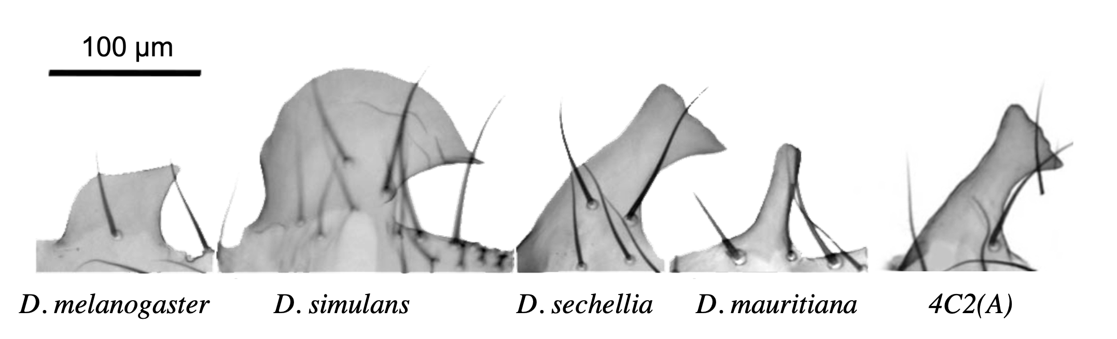
Figure 1.1. The ePLs of the four Drosophila melanogaster sister species and the introgression line.
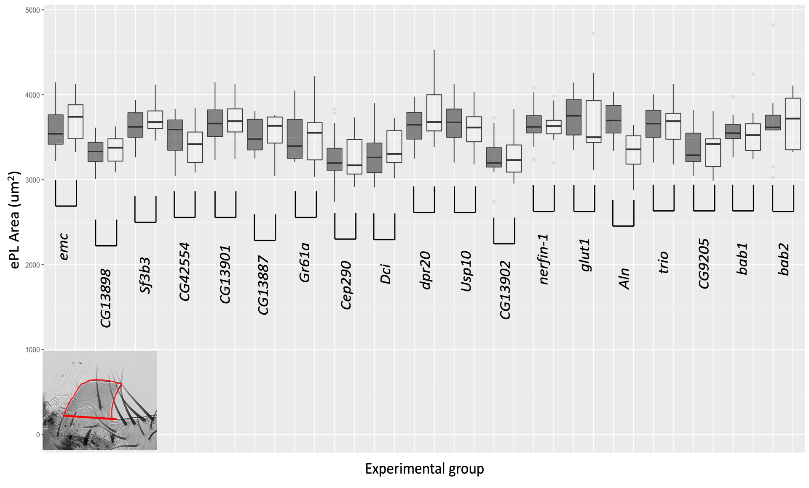
Figure 1.2. Screen of the genes present in 4C2(A) region. The order of the genes follows their order on the chromosome. Aln is the only gene showing a significant change in ePL size. The dark grey box plots indicate the control flies and the light gray box plots indicate the experimental flies. The pair of control and experimental box plot for each gene is indicated by gene name.
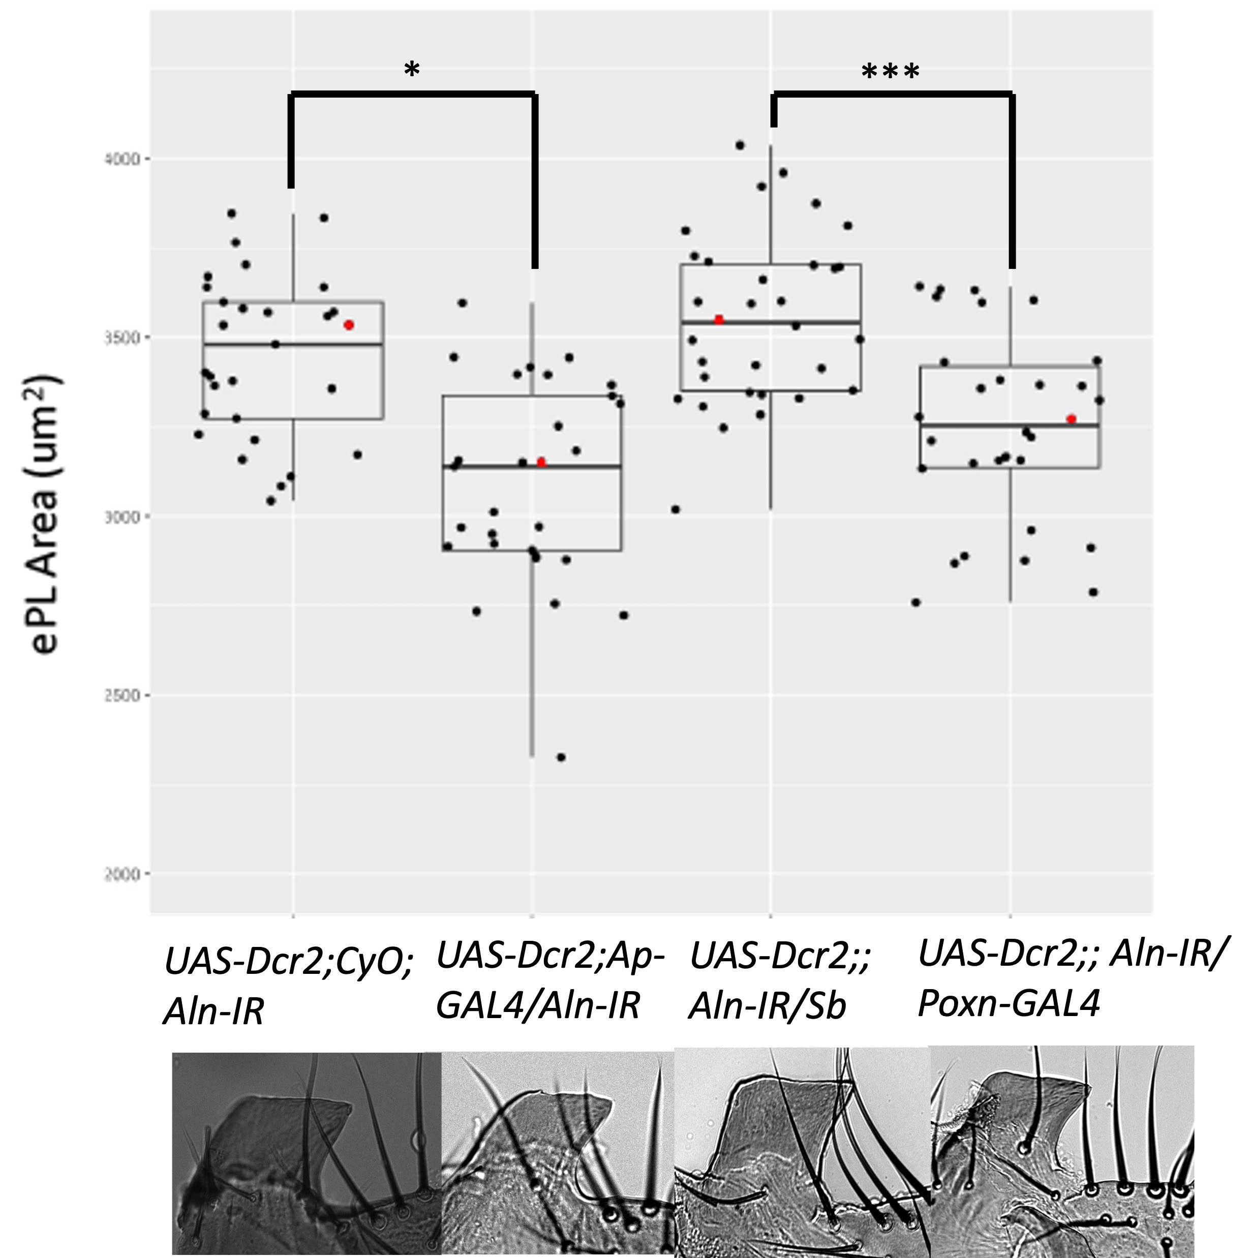
Figure 1.3. Aln knock-down D. melanogaster flies show a significant decrease in ePL area with both Poxn GAL4 and ap GAL4 drivers. The box plots are shown in pairs, with the first box (left to right) plot being the control and the second being the experimental. The red data points are represented with pictures of the ePL underneath each genotype.* p-value <0.05 , *** p-value <0.0001

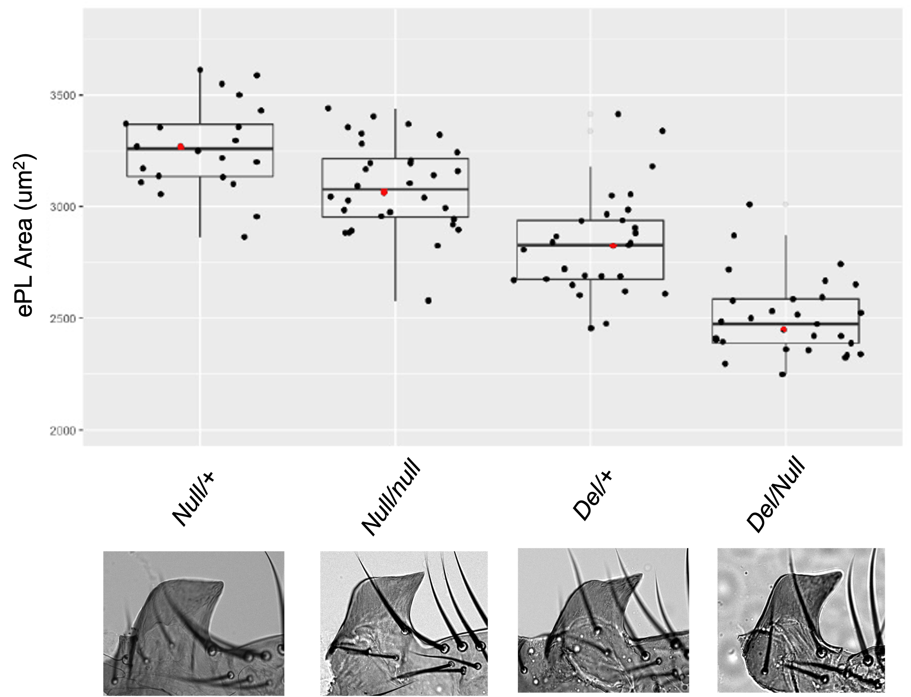
Figure 1.4. Both 4C2(A) deletion and Aln null genotypes resulted in a smaller ePL. In the first two genotypes homozygote null has a smaller ePL compared heterozygote null flies (t(54)=-3.16; p-value=0.001). In the second two genotypes, the smallest ePLs belong to the deletion over the null genotype (t(58)=6.18; p-value<0.00001) compared to the heterozygote deletion. The red data points are represented with pictures of the ePL underneath each genotype.

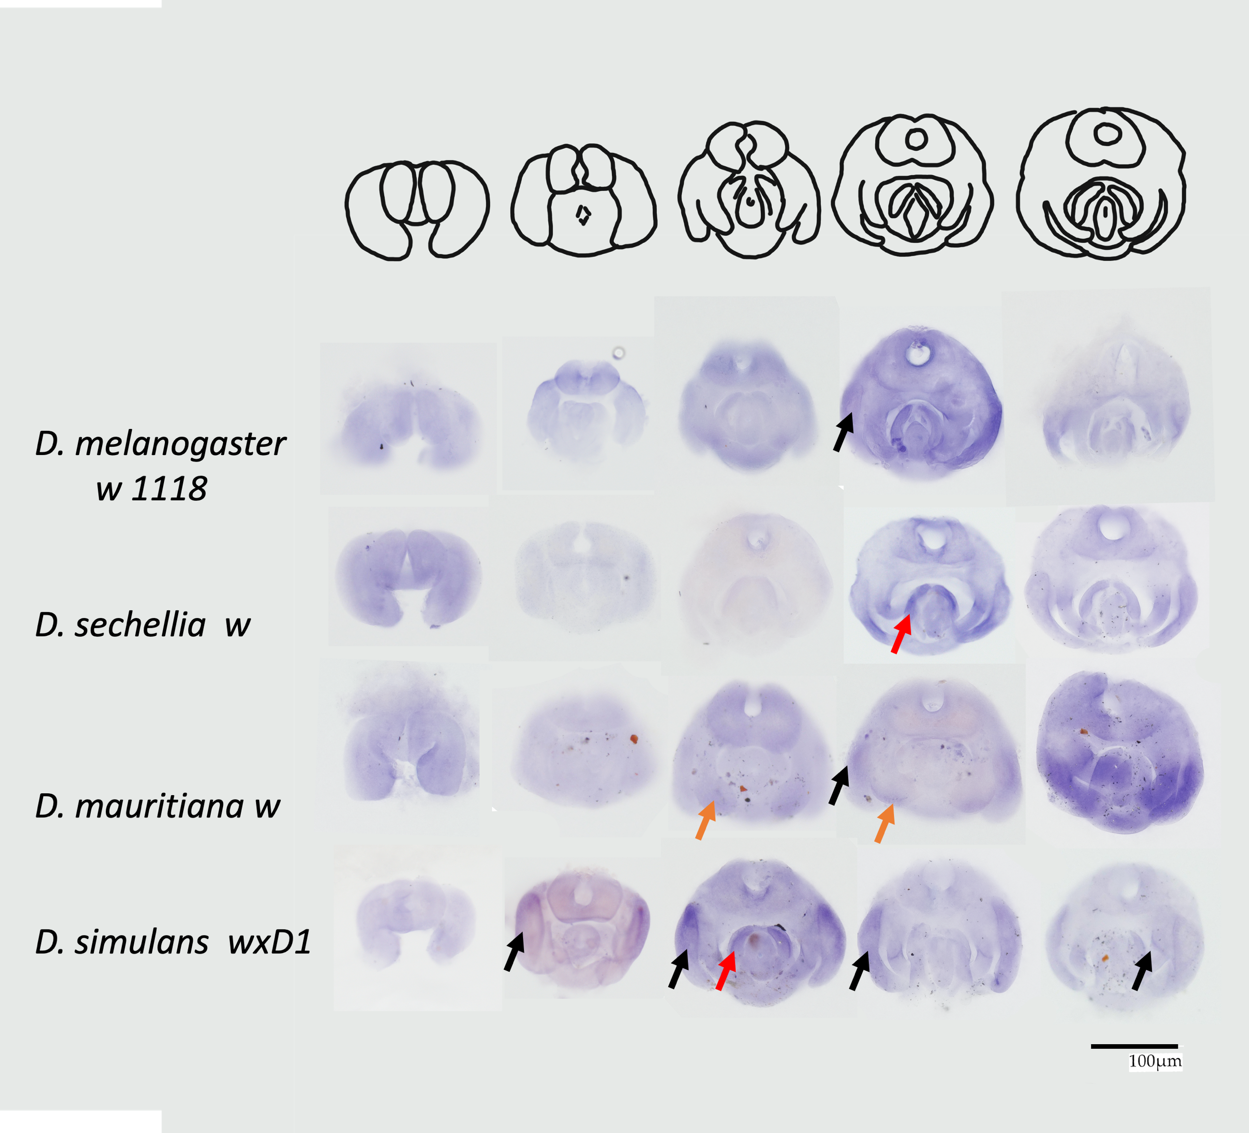
Figure 1.5. The spatial and temporal expression of Aln differs between the four sister species. Expressions are shown in 5-hour intervals starting from 30 hours APF up to 50 hours APF. Black arrows indicate developing ePl, Red arrows indicate developing phallus, and orange arrows indicate developing clasper.
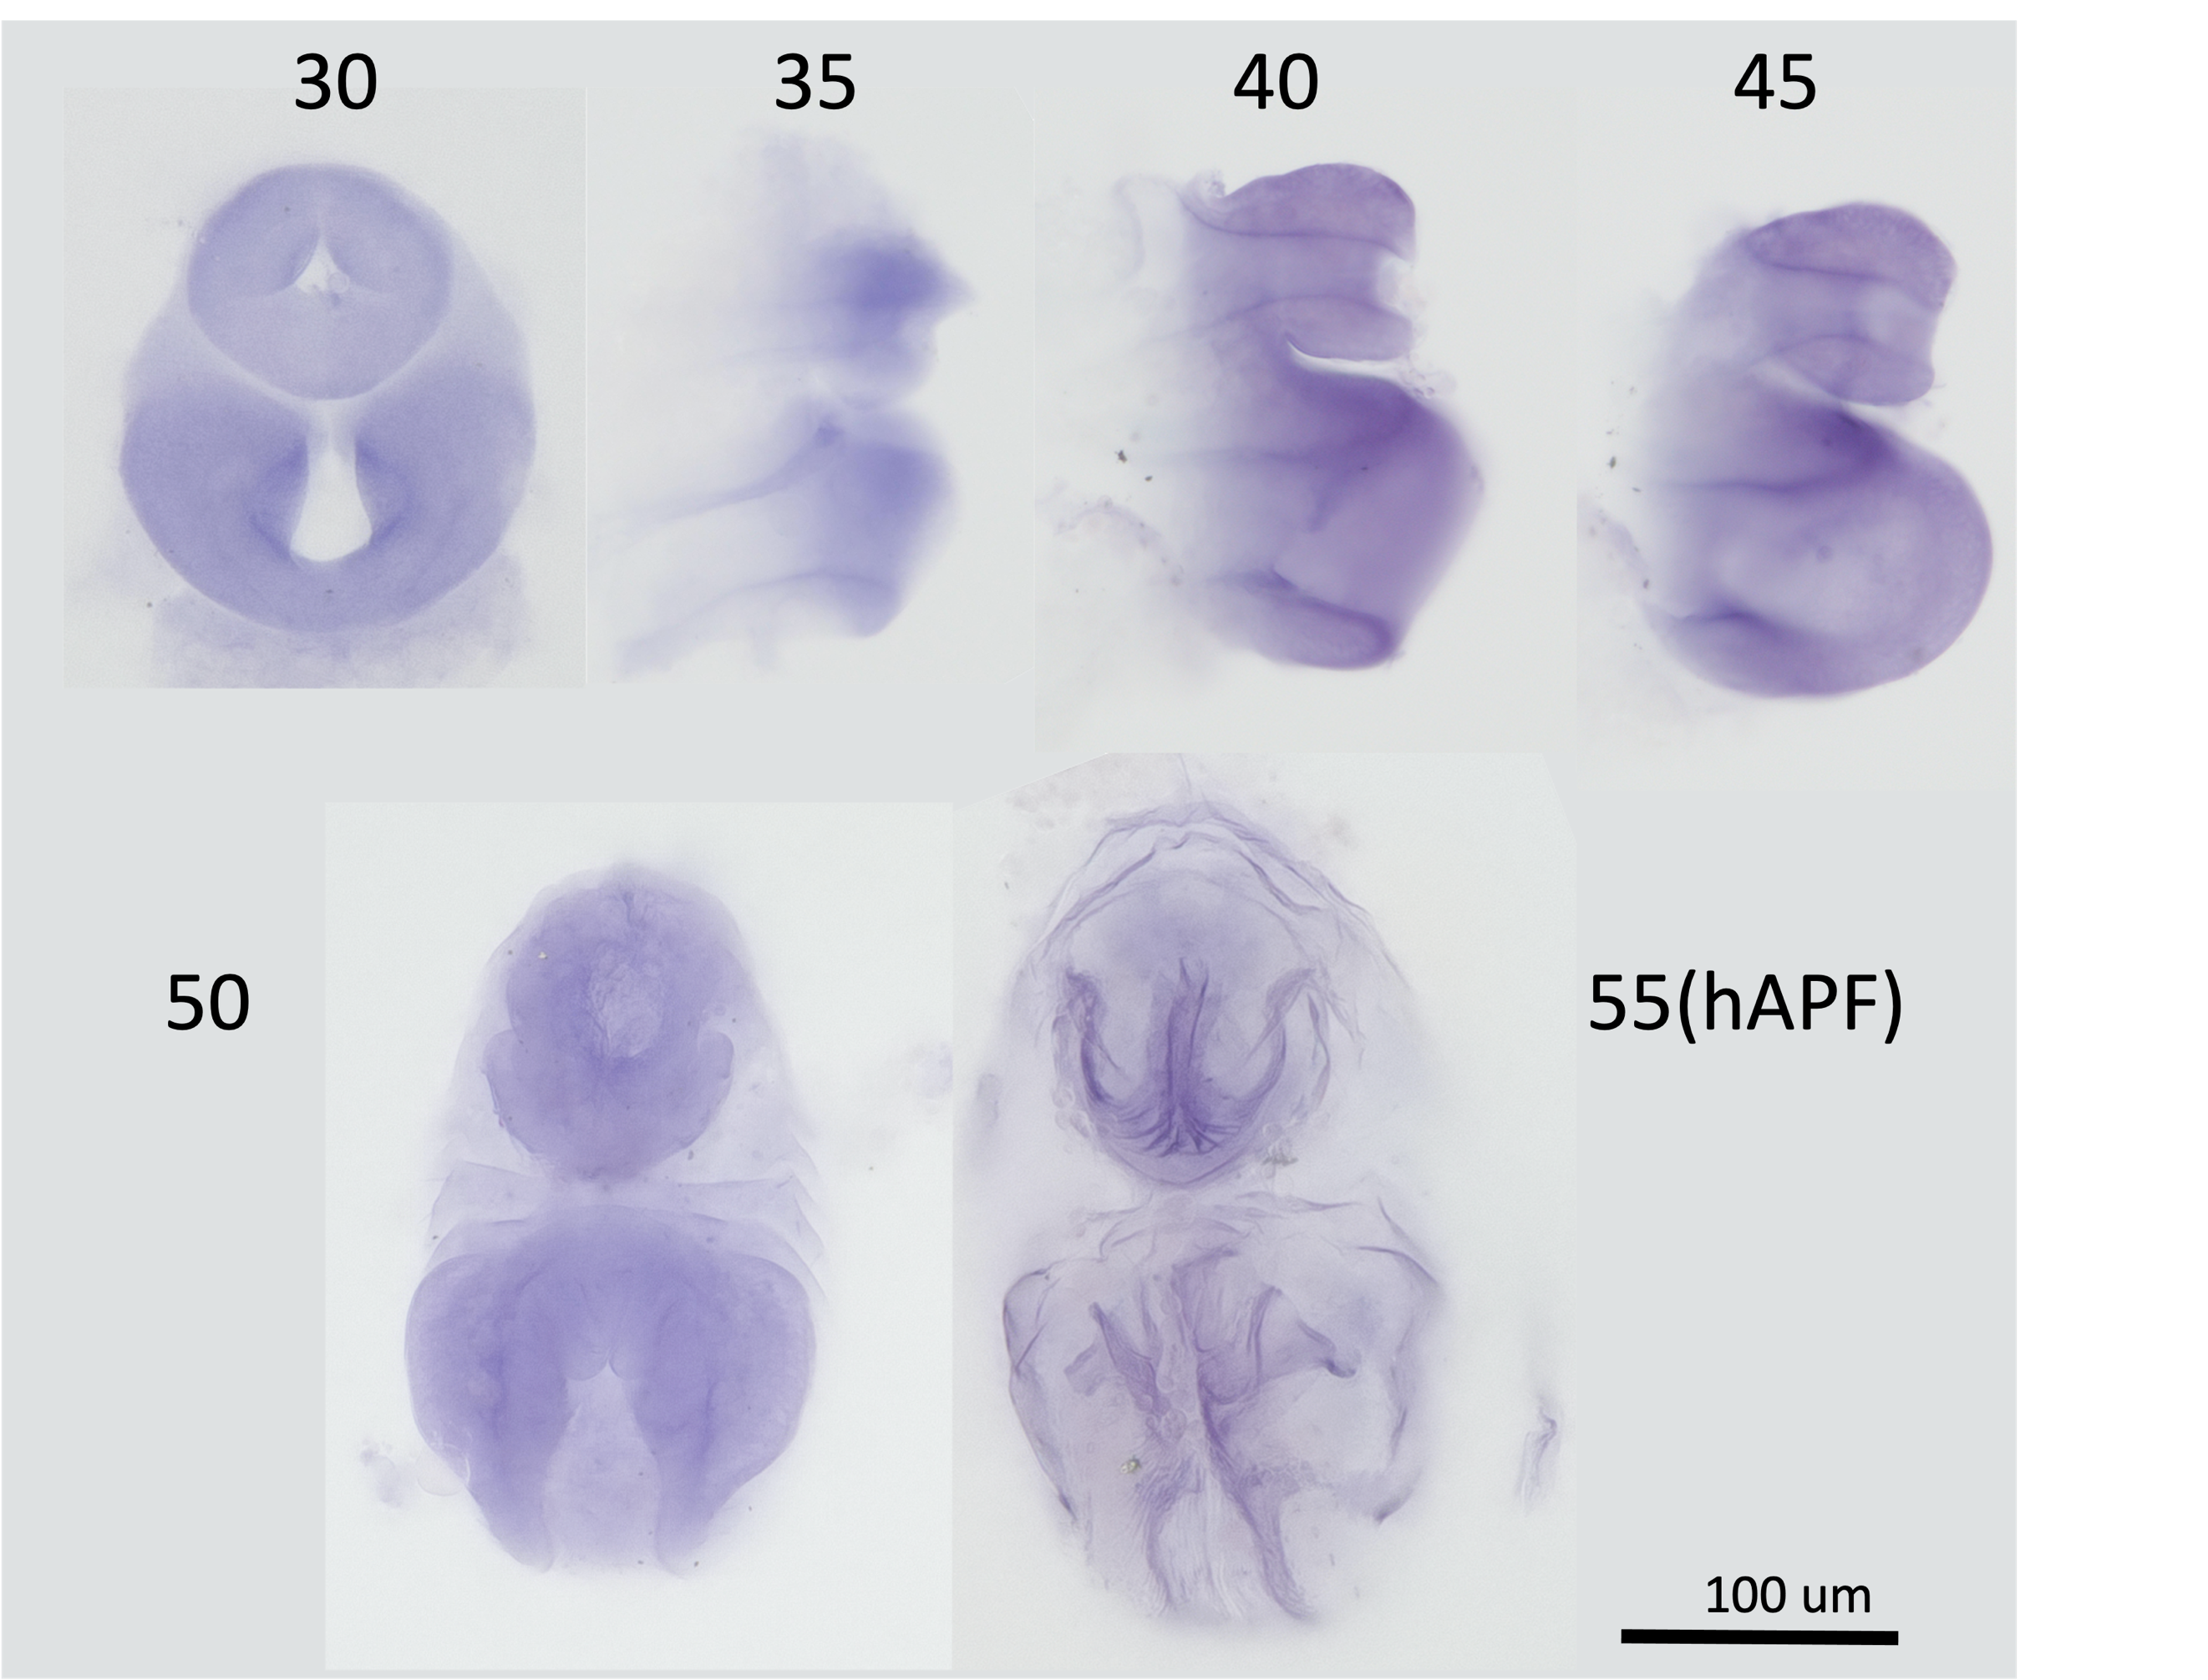
Figure 1.6. Aln is expressed in female genitalia of D. melanogaster with peak expression around 40 and 45 hours APF.

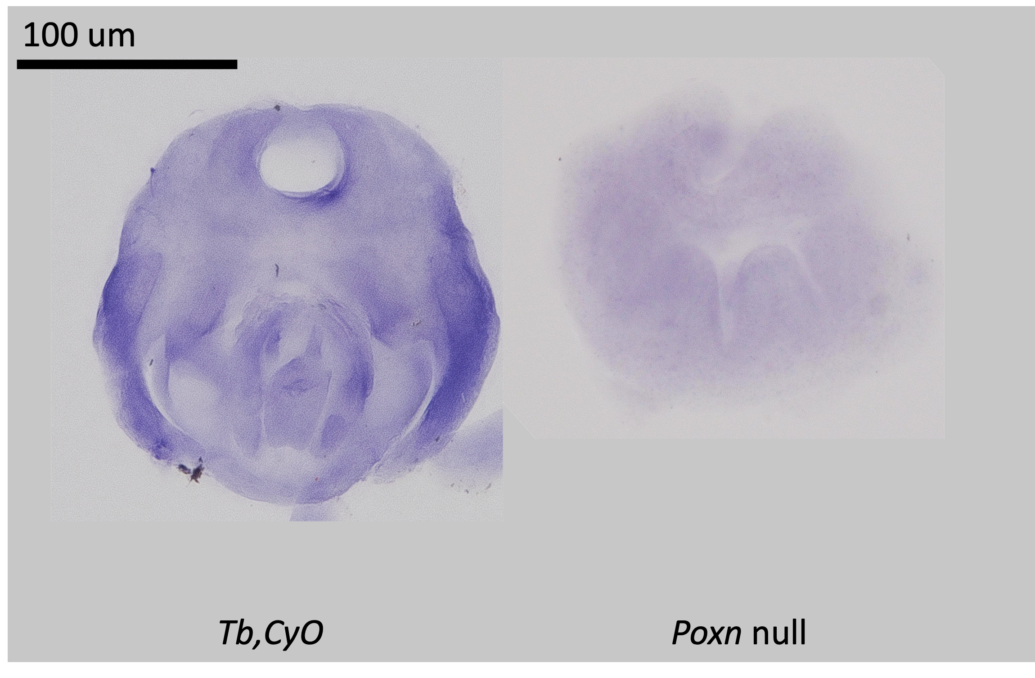
Figure 1.7. No expression of Aln can be seen in the Poxn null mutant in D. melanogaster. Poxn null mutants eventually complete their development but cannot emerge out of the pupal case.

Figure 1.8. Multiple binding sites are seen upstream, downstream, and in exons of Aln for transcription factors that are known to affect genitalia or imaginal disc development.The arrow indicates the direction of transcription and the numbers show the coordinates on the 3L chromosome. The putative transcription factor binding sites are indicated by circles and the genomic region of Aln is depicted by the gray and puple box where the gray areas are introns and the purple areas are exons.

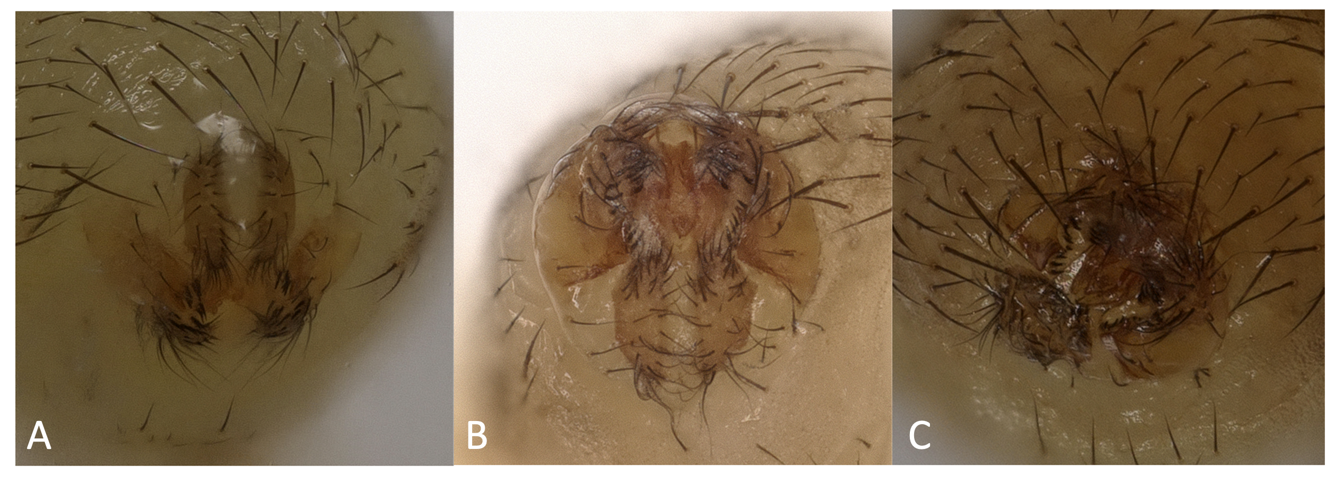
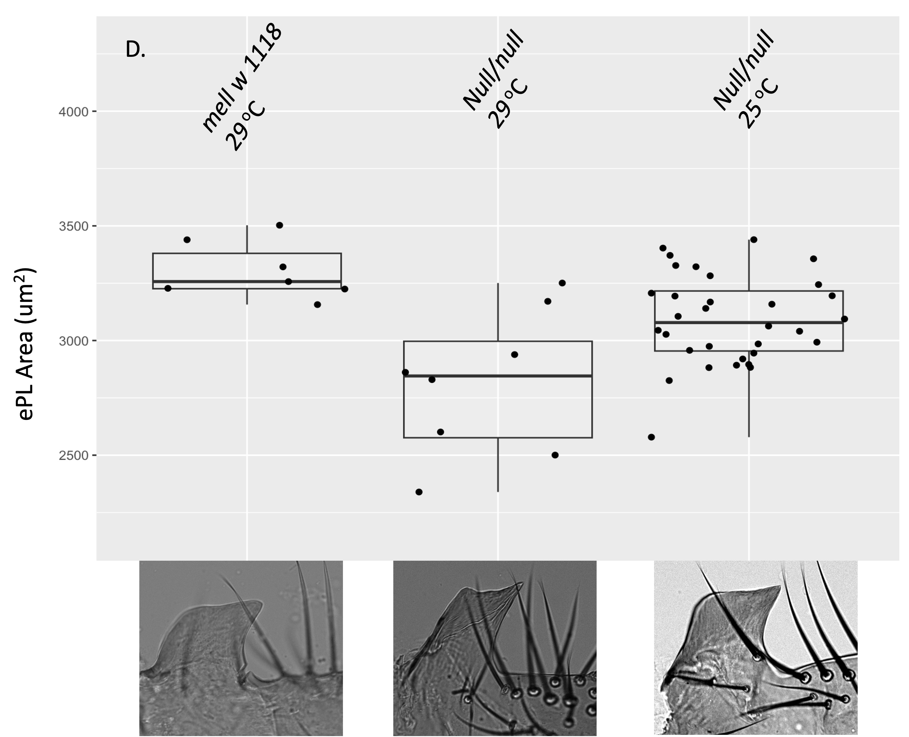
Figure 1.9. Heat stress interferes with the normal development of genitalia in the Aln null Individuals. A. Dmel w 1118 with normal genitalia rotation at 29ºC. B. Aln null with partially rotated genitalia. C. deletion line with partially rotated genitalia. D. Heat stress significantly reduces the size of the ePLs in Aln null compared Dmel w 1118 ePL area (t(12)=-3.8; p-value=0.001027). The figures at the bottom are representative ePL for each treatment.

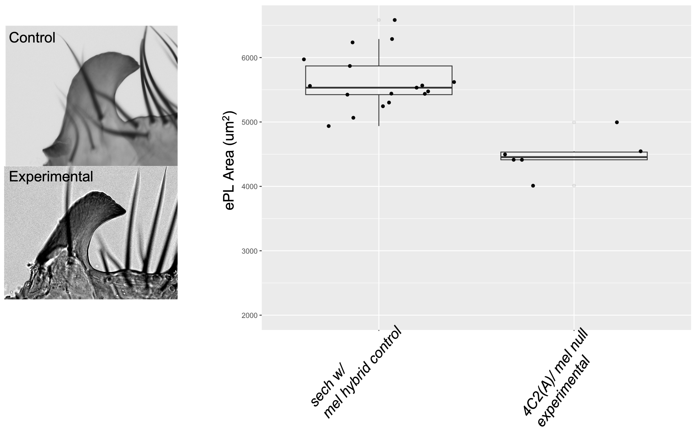
Figure 1.10. F1 hybrids between 4C2(A) introgression line and Aln null flies have significantly smaller ePLs compared to F1 hybrids between D. sech w and D. mel (t(23)=-5.8; p-value<0.00001)

1.8 Supplements:
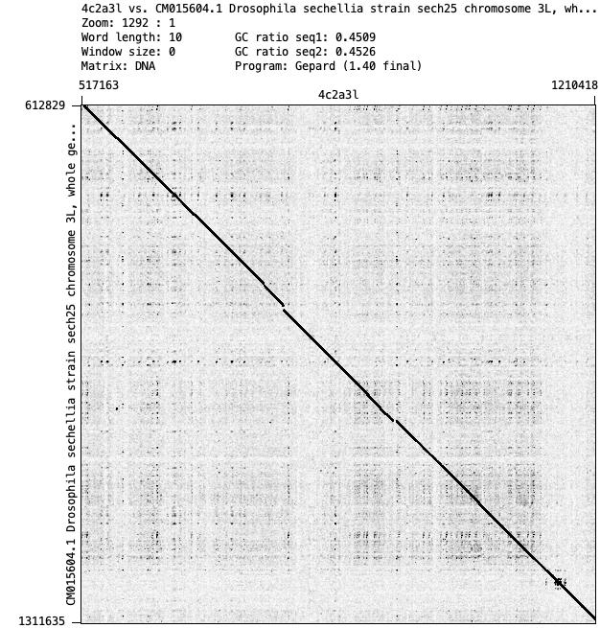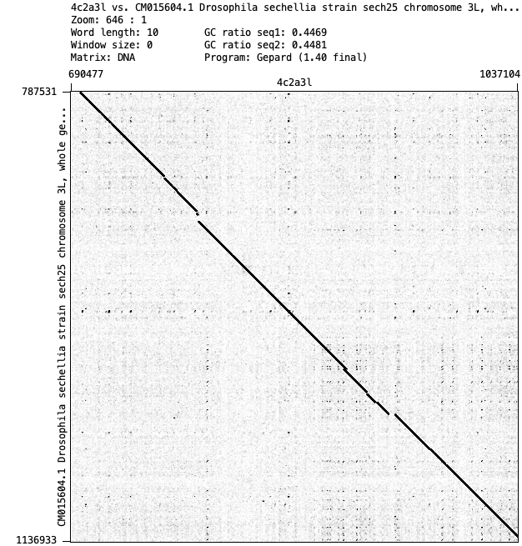
Supplement Figure 1.1. Dot plots around the introgression site showing a frame shift where the genome switches from D. sechellia genomic material to D. mauritiana and back. This region corresponds with the P-element flanking regions at around 881,000 on the 4C2(A) newly created chromosome.

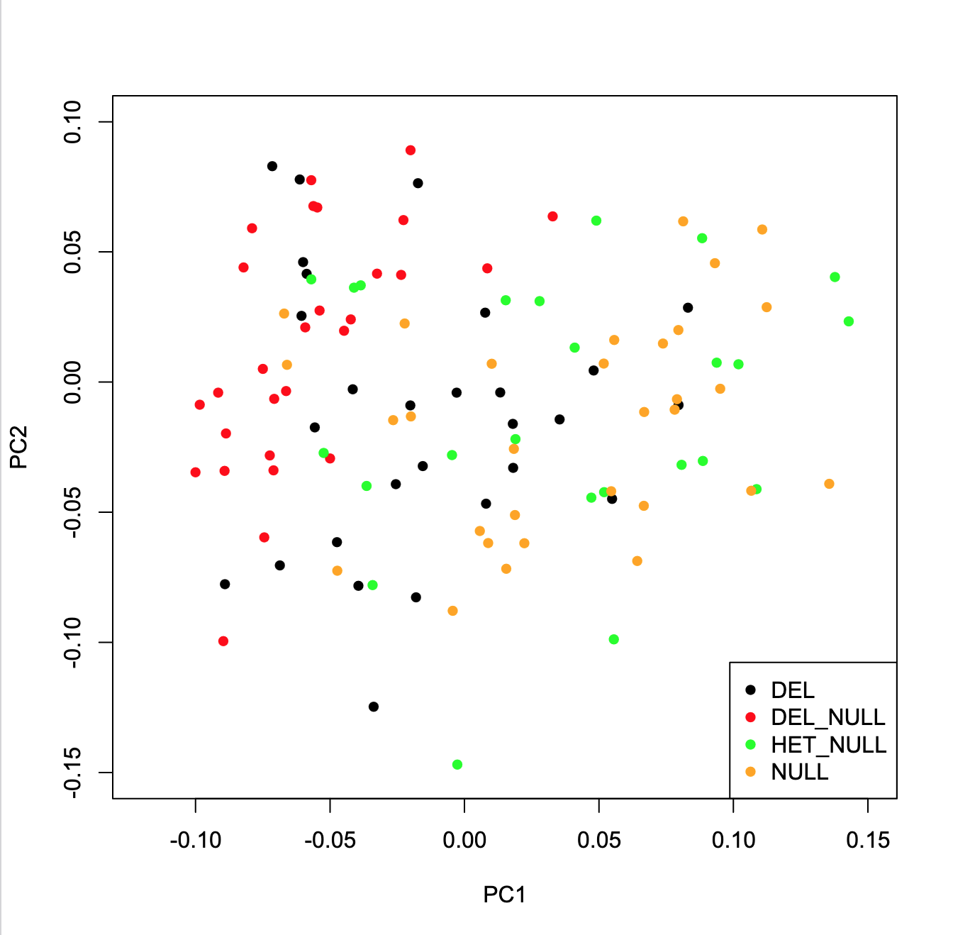
Supplement Figure 1.2. (top) Visual representation of each genotype. We analyzed Fourier coefficients using Principal Components Analysis (PCA). The data were normalized for size. Principal component 1 (PC1, corresponding to 86% of variance) vs principal component 2 (PC2, corresponding to 5% of variance) does not show any separation between genotypes.
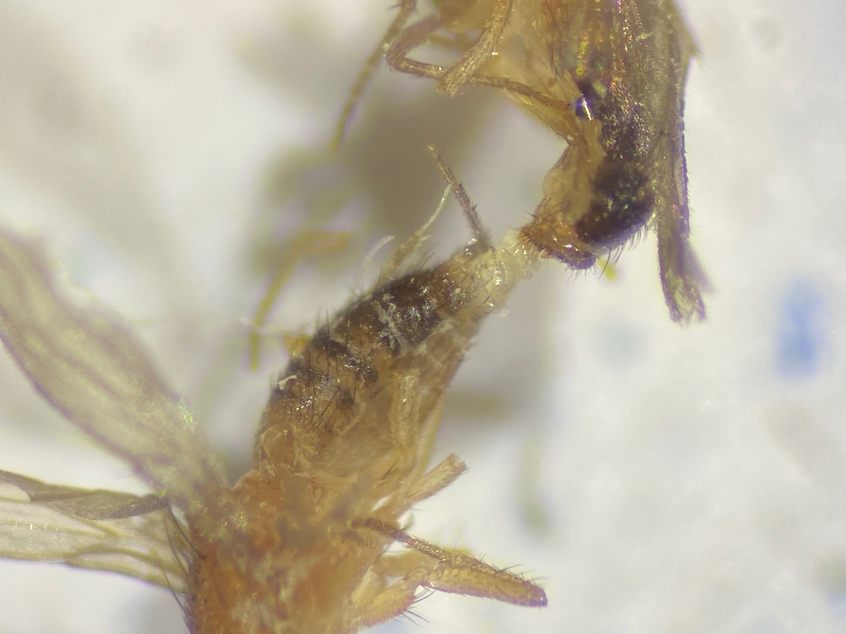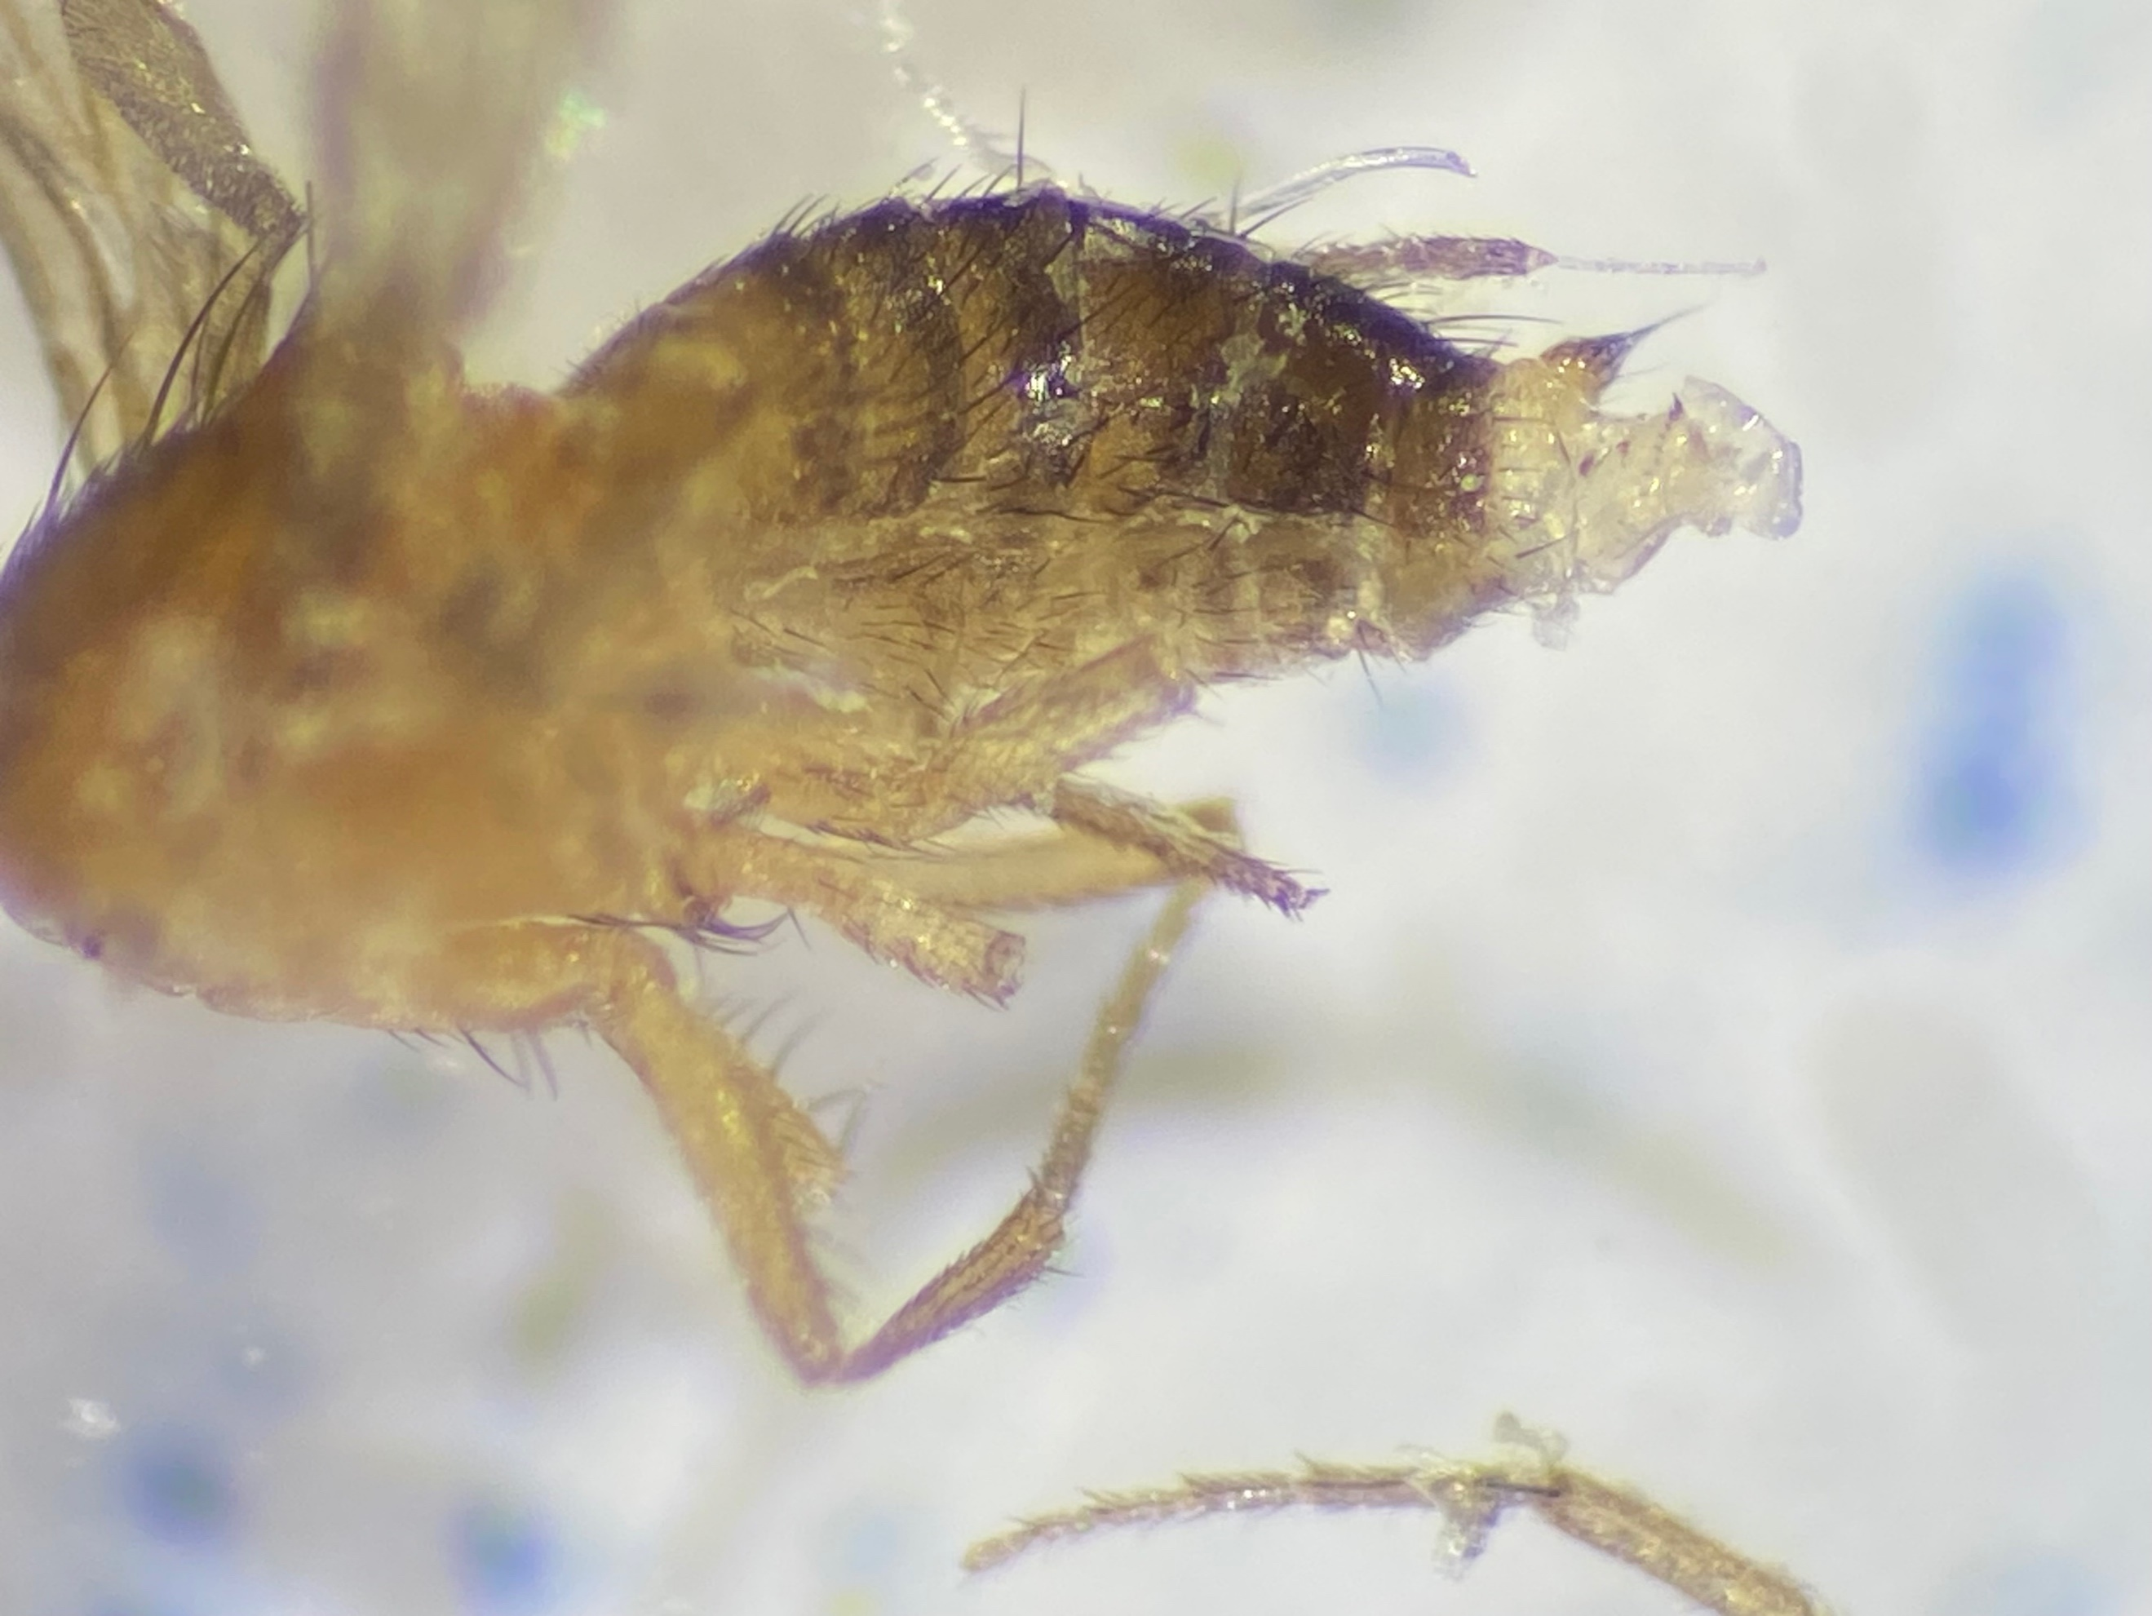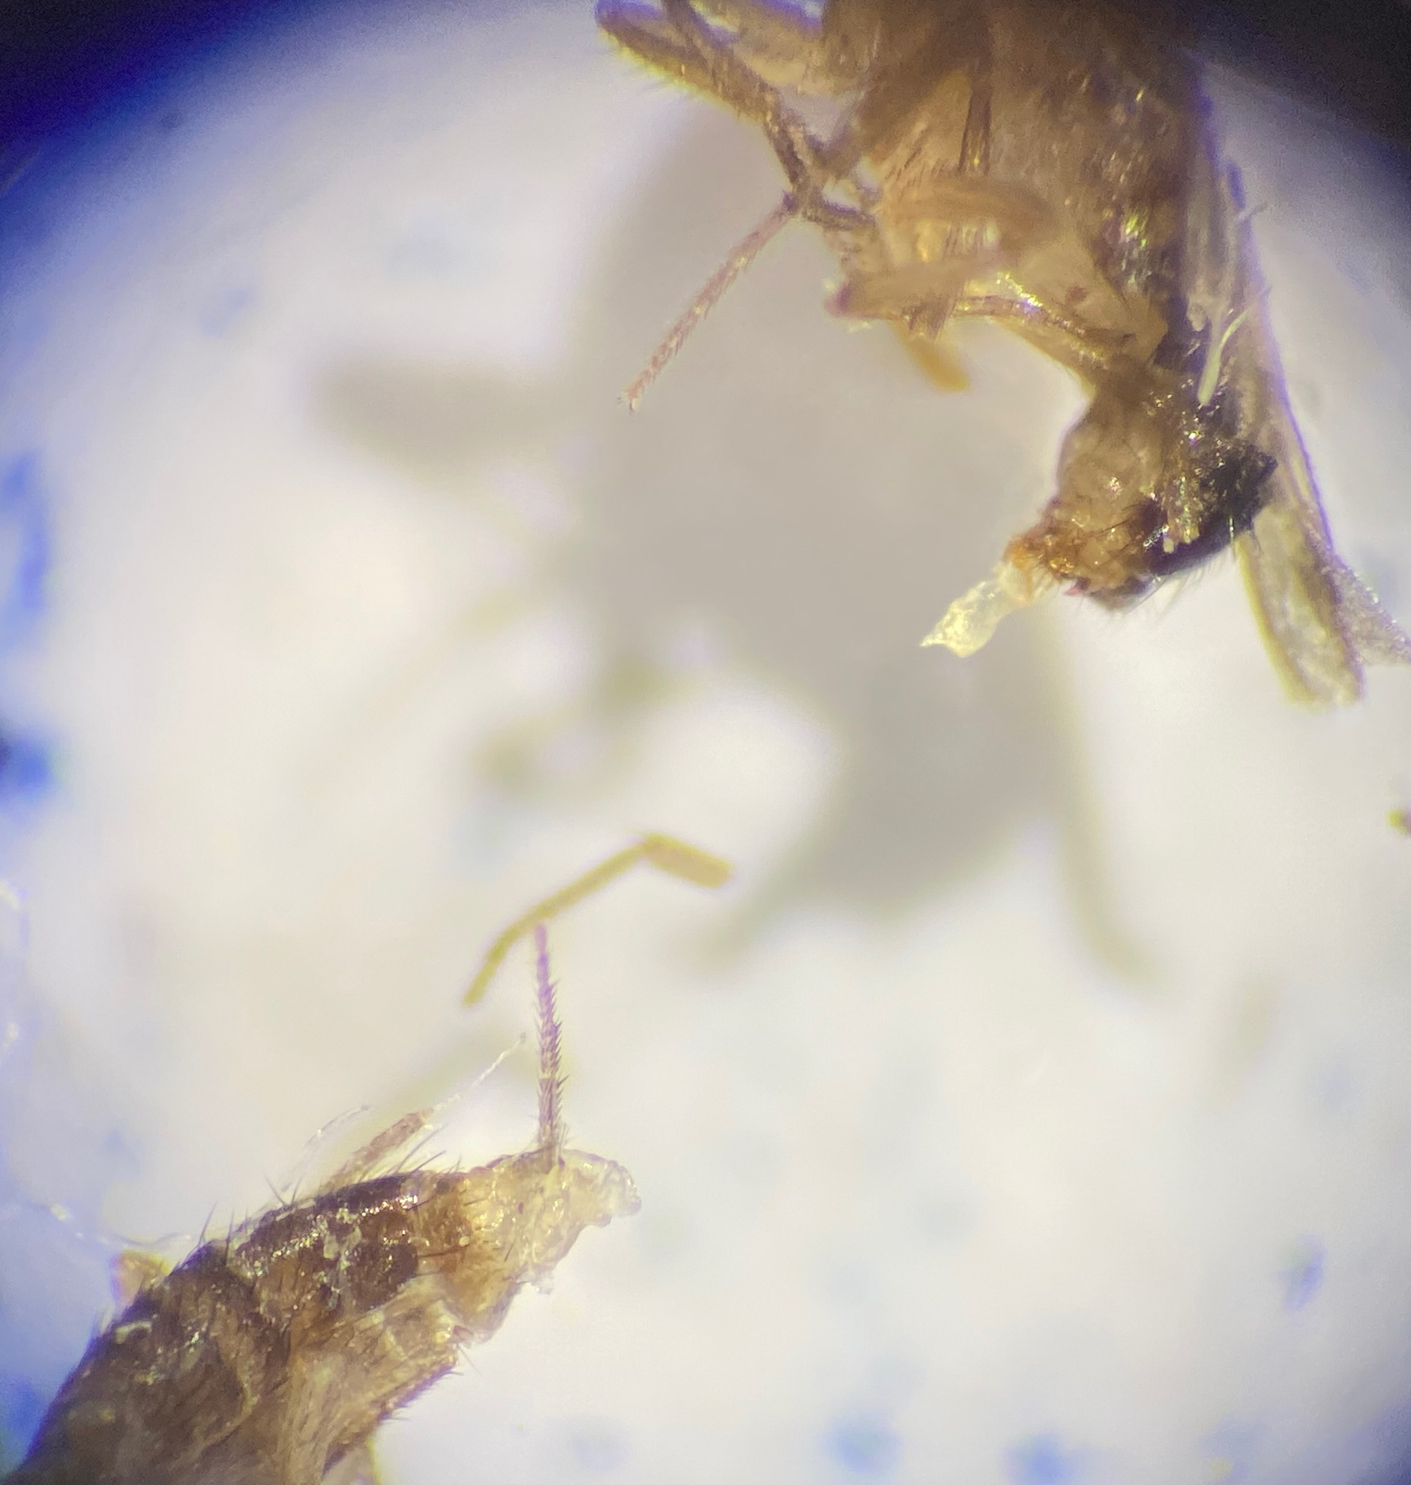
C.
B
A.
Supplement Figure 1.3. Some individuals of the deletion line die during mating due to being unable to separate from copulation. You can find these pairs in the stock vials and bottles. The deletion/null genotype also shows this phenomenon. Further dissection of these pairs showed that this is not due to ePL, and ePL is not stuck to the female (panel A). Our observations show that the phallus is still connected to the female in these dead couples. In many cases, female genitalia show areas with melanization that represent signs of wounds and suggest traumatic mating. However, these wounds are located in the area that we hypothesize is necessary for sensing the size and shape of the ePL (panel B). In addition, we observed solidified secretions connected to the male phallus when separating the couples that were comparable to the mating plug (panel C). Lastly, we have observed the deletion line pairs mating. While the mating duration is normal, in some cases, males have trouble separating from the female and even move from a male-above position of mating to an end-to-end position comparable to mating in mosquitoes.

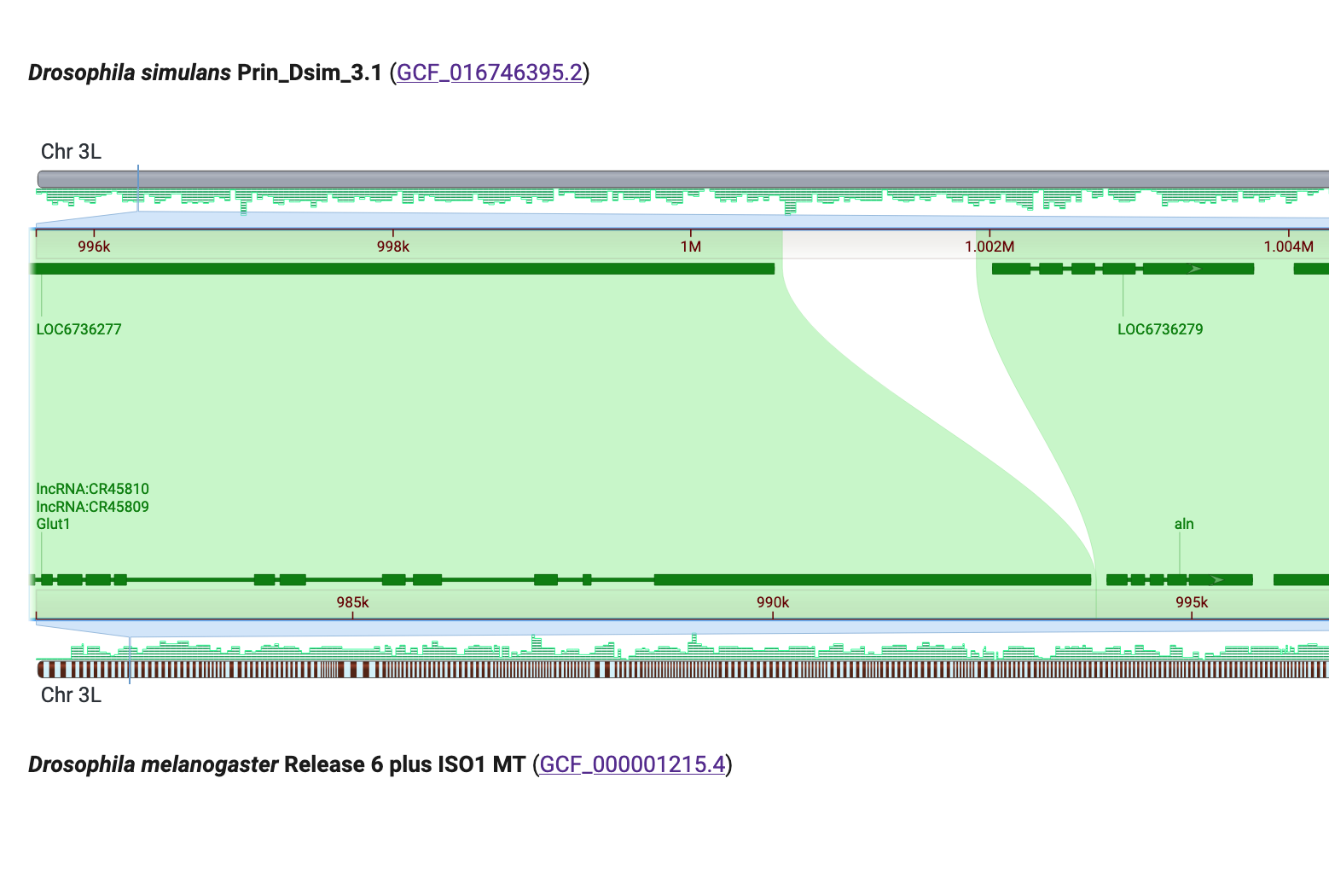
Supplement Figure 1.4. Aln shows an extensive increase in size D. simulans compared to the other species (white area) as a result of an invasion of a hobo transposon. (Figure extracted from NCBI genome comparison tool)

Supplement Table 1.1. List of genes within the 4C2(A) region and their genetic coordinates (in bps) in D. melanogaster genome
Type | Gene region start | Gene region end | Gene name
Protein coding | 1140429 | 1177276 | bric a brac 2
Protein coding | 1036369 | 1101089 | bric a brac 1
Protein coding | 1034697 | 1036298 | CG9205
lncRNA | 1001027 | 1002195 | lncRNA:CR45811
Protein coding | 995982 | 1034875 | trio
Protein coding | 993983 | 995703 | CG12038
lncRNA | 962756 | 963099 | lncRNA:CR45810
lncRNA | 961769 | 962471 | lncRNA:CR45809
Protein coding | 914074 | 993788 | Glucose transporter 1
Protein coding | 909112 | 912319 | nervous fingers 1
Protein coding | 902898 | 903810 | materazzi
lncRNA | 901888 | 902396 | lncRNA:CR46200
Protein coding | 897380 | 898772 | CG34057
Protein coding | 895951 | 897364 | CG34056
snoRNA | 891250 | 891475 | snoRNA:CG32479-a
snoRNA | 890270 | 890490 | snoRNA:CG32479-b
Protein coding | 877291 | 882013 | CG13907
Protein coding | 871899 | 895313 | Ubiquitin specific protease 10
Protein coding | 865396 | 871701 | CG12502
Protein coding | 852720 | 857248 | defective proboscis extension response 20
Protein coding | 851346 | 852673 | Dodecenoyl-CoA delta-isomerase
Protein coding | 843926 | 851080 | Centrosomal protein 290kDa
Protein coding | 841451 | 843701 | Gustatory receptor 61a
Protein coding | 839980 | 841360 | Jumonji domain containing 5
Protein coding | 837861 | 839931 | CG13887
Protein coding | 836667 | 837821 | CG13901
Protein coding | 835683 | 836770 | CG42554
Protein coding | 834093 | 835515 | CG42553
Protein coding | 826720 | 833385 | Splicing factor 3b subunit 3
snoRNA | 833062 | 833209 | snoRNA:18S-1086
snoRNA | 832487 | 832639 | snoRNA:28S-3308
snoRNA | 831870 | 832008 | snoRNA:18S-110
snoRNA | 830437 | 830511 | snoRNA:Me28S-A771
snoRNA | 829922 | 829992 | snoRNA:Me5.8S-G74
snoRNA | 827764 | 827843 | snoRNA:Me28S-G3113a
snoRNA | 827537 | 827620 | snoRNA:Me28S-G3113b
snoRNA | 827312 | 827383 | snoRNA:Me28S-C788a
snoRNA | 827075 | 827144 | snoRNA:Me28S-C788b
lncRNA | 826720 | 830190 | lncRNA:CR45184
lncRNA | 820759 | 821512 | lncRNA:CR43883
lncRNA | 813300 | 814487 | lncRNA:CR44537
Protein coding | 803427 | 804051 | CG13898
tRNA | 770363 | 770462 | tRNA:Ile-TAT-1-2
tRNA | 769503 | 769600 | tRNA:Ile-TAT-1-1
Protein coding | 749400 | 753492 | extra macrochaetae
tRNA | 743723 | 743794 | tRNA:iMet-CAT-1-3
Protein coding | 737680 | 755489 | hinge3
lncRNA | 737052 | 737479 | lncRNA:CR43785

Supplement Table 1.2. Comparison of gene location among the four sister species
Gene Name | Drosophila melanogaster ( Gene beginning…End) | Drosophila simulans  (Gene Beginning…End) | Drosophila mauritiana  (Gene Beginning…End) | Drosophila sechellia  (Gene Beginning…End)
hinge3 | 737680…755489 | 759,580..761,180 | 717,275..718,744 | 807,240..808,910
extra macrochaetae | 749400…753492 | 771,265..774,849 | 728,931..732,568 | 819,012..822,936
CG13898 | 803427…804051 | 825,216..825,830 | 782,265..782,899 | 874,359..874,991
Splicing factor 3b subunit 3 | 826720…833385 | 848,352..856,762 | 805,447..812,059 | 904,308..910,933
CG42553 | 834093…835515 | 857,385..858,882 | 812,606..814,085 | 911,499..912,918
CG42554 | 835683…836770 | 858,944..860,126 | 814,165..815,320 | 913,068..914,246
CG13901 | 836667…837821 | 859,898..860,964 | 815,329..816,182 | 914,117..915,063
CG13887 | 837861…839931 | 861,148..863,139 | 816,408..818,375 | 915,310..916,758
Jumonji domain containing 5… | 839980…841360 | 863,327..864,797 | 818,563..819,991 | 917,444..918,858
Gustatory receptor 61a | 841451…843701 | 864,834..866,943 | 820,098..822,148 | 918,975..921,283
Centrosomal protein 290kDa | 843926…851080 | 867,090..874,540 | 822,953..829,770 | 921,818..928,640
Dodecenoyl-CoA delta-isomerase | 851346…852673 | 874,792..876,137 | 830,055..831,271 | 928,891..930,226
defective proboscis extension response 20 | 852720…857248 | 876,168..880,180 | 831351..835950 | 930,238..934,832
CG12502 | 865396…871701 | 881,472..887,208 | 836774..841979 | 935,613..940,831
Ubiquitin specific protease 10 | 871899…895313 | 888,387..907,043 | 842,148..865,416 | 941,006..964,159
CG13907 | 877291…882013 | 892,243..896,898 | 847,519..852,102 | 946,321..950,900
CG34056 | 895951…897364 | 910,803..912,259 | 866,104..867,437 | 964,629..966,184
CG34057 | 897380…898772 | 912,422..913,715 | 867,568..868,856 | 966,276..967,597
materazzi | 902898…903810 | 917,806..918,742 | 872969..873934 | 971,654..972,595
nervous fingers 1 | 909112…912319 | 923,962..927,178 | 867568..868856 | 977,870..981,040
Glucose transporter 1 | 914074…993788 | 928,886..1,000,549 | 884095..959082 | 1,022,598..1,056,117
CG12038 | 993983…995703 | 1,002,021..1,003,765 | 960366..962199 | 1,056,430..1,058,169
trio | 995982…1034875 | 1,004,040..1,043,052 | 963,792..1,001,565 | 1,058,433..1,097,117
CG9205 | 1034697…1036298 | 1,043,300..1,044,435 | 1000835..1003025 | 1,097,442..1,098,607
bric a brac 1 | 1036369…1101089 | 1,044,502..1,101,768 | 1003082..1058363 | 1,098,669..1,154,637
bric a brac 2 | 1140429…1177276 | 1,139,840..1,167,193 | 1,097,550..1,124,612 | 1,193,418..1,220,595

Chapter 2

One gene can affect both female reproductive output and male genital morphology
2.1 Abstract
Fisher’s runaway selection model suggests that over time, genes affecting male reproductive phenotypes and the female’s preference for them will localize to the same region of the genome. The pleiotropic effect of the same gene has the potential to give rise to associated male and female reproductive phenotypes but no example has been discovered until this study. We tested the possibility that one gene can affect both male and female phenotypes and provide a basis to facilitate co-evolution. We tested the effect of epandarial posterior lobes (ePLs) size, a male phenotype, on female egg-laying using introgression lines between D. sechellia and D. mauritiana. Previous data have shown that when females mate with a male that has smaller ePLs the females reduce the number of eggs they lay. Our results show that in two introgression lines that have smaller ePLs, when introgression females mate with their male counterparts, they do not reduce their egg laying. A gene affecting the ePL size in each region has been identified previously. We used tools available in D. melanogaster to manipulate the genes Allnighter (Aln) and Goldilocks (Glds) and test their effect on egg laying. Our findings show that Aln knock-out females lay significantly fewer eggs. When flies carry both introgression regions, they show a more severe ePL phenotype, suggesting an interaction between these regions. Using qPCR, we quantified the change in one candidate’s expression while manipulating the other. Taken together, our data suggest that Aln affects both male and female reproductive phenotypes, and variation in expression in different tissues can provide a basis for the coevolution of reproductive phenotypes.
2.2 Introduction:
Many reproductive traits evolve rapidly between closely-related species (Swanson and Vacquier 2002). An evolutionary model that can push the fast divergence of reproductive traits is Fisher’s runaway selection model, which states that directed preference for a trait in a sex results in the evolution of new phenotypes (Fisher 1930). Furthermore, the preference and the preferred trait are genetically correlated and passed together to the offspring (Fisher 1930; Henshaw and Jones 2020). On the other hand, evidence shows that a change in a sexually-selected phenotype in one sex can correlate with a change in the corresponding phenotype in the other sex. For instance, artificial selection for longer sperm results in a longer seminal receptacle, a sperm storage organ, in Drosophila melanogaster (Miller and Pitnick 2002). In waterfowl species, vaginal complexity correlates with the length and morphology of the male phallus (Brennan et al. 2007). Hermaphroditic species provide a different perspective, where postcopulatory mechanisms play a stronger role than precopulatory mechanisms (Greeff and Michiels 1999). Studies on different populations of land snails showed variation in spermatophore and spermatheca volume and a positive correlation between spermatheca volume and the number of sperm transferred (Beese et al. 2006).
Colocalization of the sexual signal and preference in the genome has been studied extensively, especially in crickets (Wiley et al. 2012). For example, Shaw and Lesnick (2009) showed that a Quantitative Trait Locus (QTL) that is responsible for the difference in female song preference between two closely-related species, localizes to the same region as a male song QTL. In addition, Xu and Shaw (2019) explored the signal-preference coevolution in crickets and tested whether linkage disequilibrium resulted from tight physical linkage or the pleiotropy of a locus. Later, Xu and Shaw (2021) provided a more defined map of the QTLs and provided several candidate genes that could affect pulse rate and preference divergence. The linkage between signal and preference has also been observed in finches (Pryke 2009) and butterflies (Kronforst et al. 2006).
As mentioned, the pleiotropy of one gene and/or linkage of some genes can result in the colocalization of multiple sexual phenotypes in both males and females in the genomic landscape. An example of a pleiotropic effect is the insertion of a single transposon in the desat-1 gene in D. melanogaster that affects both the production of sex pheromones and the discrimination of male and female flies by the mutant males (Marcillac et al. 2005). Many sexually selected traits show pleiotropy (Fitzpatrick 2004). However, the pleiotropy of one gene has not been explored compared to the linkage of multiple genes that result in coevolved traits in males and females.
The four sister species of D. melanogaster consist of four newly diverged species that include D. melanogaster, D. simulans, D. sechellia, and D. mauritiana. The genetic and developmental basis of morphological differences between the male genitalia of these four sister species has been explored (Masly et al. 2011; Tanaka et al. 2015; Glassford et al. 2015; Vincent et al. 2019; Hagen et al. 2019; Ridgway et al. 2024; Urum et al. 2024). The four sister species show striking genital divergence, especially in epandarial posterior lobes (ePL) (previously called the posterior lobes (Rice et al. 2019) and claspers. The ePLs are cuticular outgrowths on the male genitalia that help the male hold on to the female during mating and insert between the female’s VII and VIII abdominal segments (Eberhard and Ramirez 2004; Jagadeeshan and Singh 2006; Kamimura and Mitsumoto 2011). Complete laser or genetic ablation of the ePLs results in the males falling off the females (LeVasseur-Viens et al. 2015; Frazee and Masly 2015). Studies have shown that changes in male genitalia size and shape result in more wounding in females (Masly and Kamimura 2014). Additionally, Frazee and Masly (2011) showed that when D. melanogaster females mate with males that have smaller ePLs, the females reduce the total number of eggs they lay. It has also been revealed that this decrease is not due to genital wounding (Frazee et al. 2021), which suggests that the decrease in egg-laying could be due to female sensory incompatibility.
QTL analysis between D. simulans and D. sechellia, and D. simulans and D. mauritiana have revealed loci on all major chromosomes that affect ePL morphology (Coyne and Kreitman 1986; Coyne et al. 1991; Macdonald and Goldstein 1999). Mapping experiments between D. sechellia and D. mauritiana have revealed large effect loci on the second and third chromosomes (Coyne et al. 1991). In this study, we focused on introgression lines between D. sechellia and D. mauritiana, created by Masly and Presgraves (2007). Briefly, this stock collection was created by backcrossing individual D. mauritiana stocks marked with single P-element insertions carrying the marker miniwhite⁺ into a white eye D. sechellia (w) genetic background for 15 generations. Furthermore, some of these lines were explored for their effect on the ePL size and shape (Masly et al. 2011) and clasper size (Tanaka et al. 2015). We focused on two regions, Q1(A) and 4C2(A), in the introgressions between D. sechellia and D. mauritiana that have been previously shown to affect the size of the ePL (Masly et al. 2011; Masly and Kamimura 2014; Frazee et al. 2021). Furthermore, due to the location of these regions, 4C2(A) is close to the telomere, and Q1(A) is close to the centromere; they have not been extensively studied in the QTL mappings that identified regions corresponding to ePL morphology, but previous studies have shown that the Goldilocks (Glds) in Q1(A) region (unpublished data from Masly lab) and Allnighter in 4C2(A) (Chapter 1) region affect the ePL size. Here we test whether the regions that affect the ePL in the male, also affect the female egg-laying phenotype. Furthermore, we explore the question of whether the two regions are synergistic. Lastly, we show that one of the two candidate genes affects both the male ePL size and female egg-laying behavior.
2.3 Materials and Methods:
Fly stocks were maintained on cornmeal fly food and kept at room temperature with 12-h light:dark cycle. The D. sechellia w and introgression lines were crossed and maintained in a 23 °C incubator and kept there for behavioral experiments. The blue food was made by adding a concentration of ~0.08 g L⁻¹of bromophenol blue to 1 liter of fly food, making it a dark color that made it easy to distinguish the eggs. The UAS-Glds plasmid and subsecuent fly line was previously created by Masly lab. This fly line when paired with GAL4 results in over-expression of Glds.
Creation and analysis of the double introgression phenotype
The double introgression was generated previously in our lab by crossing the 4C2(A) and Q1(A) introgression and selecting individuals based on eye color. After the crossing-over event occurred flies carrying 4C2(A) and Q1(A) on the same chromosome were collected and the homozygote double introgression line was created. The double introgression’s ePL was dissected and imaged using Zeiss SP2, and the images were measured using ImageJ (Schneider et al. 2012).
Behavioral experiments
For assessment of egg-laying behavior, introgression lines and D. sechellia w virgin males and females were collected (Figure 2.1) and aged for three days. One male and one female were aspirated together in a blue food vial between 09.00 and 11.00 hrs. The matings were not observed for these genotypes. After 24hrs, males were aspirated out. After three days, females were moved to a new vial, and the eggs, egg cases, and larvae were counted for each vial. This procedure was conducted for nine days. For D. melanogaster behavioral experiments, virgin males and females were collected and aged for three days. One male and one female were aspirated together in a blue food vial between 09.00 and 11.00 hrs, and the matings were observed. After mating, males were aspirated out. After two days, females were moved to a new vial, and the eggs, egg cases, and larvae were counted for each vial. The procedure was carried on for 10 days. To ensure that male morphology stayed consistent in each set of behavioral experiments, some male genitalia were dissected and observed for any substantial abnormalities. At the end of the behavioral experiments, the reproductive organs of some females that did not produce larvae were dissected and visually examined for the presence of sperm (five females per line). In the D. melanogaster experiments, at the end of the behavioral trials, five females per line, were dissected to test for abnormalities in the female genitalia and reproductive tract.
In situ hybridization
We used adult D. melanogaster Canton S flies for our in situ experiment. Canton S, in which S stands for special, is a line laboratory-bred wild-type fly that is often used as a control for behavioral experiments or as a genetic background. Canton S was originally collected from Canton, Ohio by C. B. Bridges. We fixed adult D. melanogaster Canton S in 4% PFA in DEPC PBT. We dissected the brain and crop out of the fly’s body, and washed and stored the dissected tissue in 100% ethanol. We followed the protocol of Chapter 1 and the Masly lab protocol (JP Masly, unpublished).
Quantitative PCR assays
We performed a quantitative PCR (qPCR) experiment to test the potential interaction between candidate genes in each introgression region. The qPCR primers were designed using the FlyPrimerBank (Hu et al. 2013). Two primer sets per gene were chosen, and at least one primer expanded over the intron except for Gld, which does not have any introns. Male prepupae were collected and kept in a 25 °C incubator for tissue collection. The pupae were dissected 40 hours after puparium formation (hAPF). Tissues were stored in Trizol ®, and RNA was extracted using chloroform combined with the RNeasy kit (Untergasser 2008). cDNA was created using iScript Reverse transcription SuperMix (Cat #1708840). A BioRad Rt-PCR machine (model CFX96) and SsoAdvanced Universal SYBR Green Supermix (BioRad, Cat #1725270) were used to quantify the expression between the samples.
Statistics
We performed all the statistical analyses for the behavioral experiments in R version 4.0.5 (R Development Core Team, 2010), using the packages tidyverse version 2.0.0 (Wickham et al., 2019) and ggtext vesion 0.1.2 to generate the plots, and rstatix version 0.7.2 (Kassambara, 2023). We tested the normality of our data using the Shapiro-Wilk normality test and Bartlett test for homogeneity of variances (Table 2.1). We compared the total number of eggs laid by females in each behavioral treatment using Kruskal-Wallis or ANOVA (Table 2.1). We used the post-hoc pairwise Wilcox test and Benjamini-Hochberg correction for the Kruskal-Wallis and Tukey for ANOVA. For the analysis of the qPCR results we used BioRad’s CFX Maestro software and Excel.
2.4 Results:
The 4C2(A),Q1(A) double introgression has a smaller ePL than either 4C2(A) or Q1(A)
It has been previously established that the two introgression lines 4C2(A) and Q1(A) significantly reduce the ePL area (Masly et al. 2011). However, the flies containing both 4C2(A) and Q1(A) introgressed regions have an ePL area that is comparable to the F1 hybrid between D. mauritiana and D. sechellia w (Wilcoxon test with Bonferroni correction, p-value=1) (Figure 2.2). The double introgression is significantly different from both 4C2(A) (Wilcoxon test with Bonferroni correction, p-value<0.0001) and Q1(A) (Wilcoxon test with Bonferroni correction, p-value<0.0001) (Figure 2.2). On average, the double introgression is 31.6% smaller, and the F1 hybrid is 34.5% smaller than pure species D. sechellia w, whereas 4C2(A) is 13% smaller and Q1(A) is 15.9% smaller than D. sechellia w. The double introgression is smaller than the sum of the effects of 4C2(A) and Q1(A). Additionally, we studied the morphology of the other organs of double introgression. The double introgression flies show a swollen crop phenotype (personal observation). The swollen crop in older animals affects the space available in the abdomen, and some females with swollen crops show asymmetric ovariole phenotype or smaller ovarioles (personal observation).
Males of the introgression lines 4C2(A) and Q1(A) significantly reduce the egg-laying of pure species females but not their genetic counterparts
We compared the total number of eggs laid by the female over a period of nine days as a result of a single mating. We tested introgression lines, some of which affect the ePL morphology, including 3Q1(A), which results in a smaller ePL, and 4G4C(A), which results in a larger ePL. We also tested additional introgression lines that do not affect the ePL, Yar1(A), and 4G5(A). For the 3Q1(A) treatment, we did not observe any significant difference between the D. sechellia w by D. sechellia w control cross and the 3Q1(A) males by D. sechellia w females cross (Tukey test, p-value=0.99). However, the 3Q1(A) by 3Q1(A) cross produced significantly more eggs than the three other crosses (Figure 2.3 a). The treatments with the 4G4C(A) introgression line showed no significant difference from the D. sechellia w by D. sechellia w cross (Kruskal Wallis, H(3)=4.52, p-value= 0.21) (Figure 2.3 b). These results suggest that a larger ePL does not affect egg-laying in the females the same way a smaller ePL does.
Our data show that in two of the introgression lines with the smallest ePLs when these males with smaller ePLs mate with control D. sechellia w females, the control females significantly reduce their egg-laying amounts compared to other introgression genotypes. In the 4C2(A) behavioral assay, there was a significant difference among the four treatments (Kruskal Wallis, H(3)=12.63, p-value= 0.0055). We observed that when the D. sechellia w females mate with 4C2(A) males, females reduce their egg laying compared to D. sechellia w females by D. sechellia w males control cross. Interestingly, when 4C2(A) females mate with 4C2(A) males, they do not show any decrease in egg-laying (Figure 2.4 A). The Q1(A) behavioral assay follows the same trend. When Q1(A) males mate with D. sechellia w females, the D. sechellia w reduce the number of eggs they lay, while when Q1(A) males mate with Q1(A) females, the egg-laying of the females does not decrease (Figure 2.4 B). This suggests that females from these two introgression lines carry genetic material that affects female egg-laying behavior in a manner that makes the introgression line behaviorally compatible with other individuals carrying the same introgression.
Additionally, we tested the reciprocal cross between 4C2(A) males and Q1(A) females and Q1(A) males and 4C2(A) females and saw no decrease in egg laying (Figure 2.4 C). In fact, Q1(A) females mated with 4C2(A) males lay significantly more eggs than D. sechellia w. Furthermore, we observed that there is higher mortality among the control females mated to the 4C2(A) males (8 out of 30, 26% mortality) than 4C2(A) females mated to 4C2(A) males (3 out of 31, 9% mortality). Q1(A) males resulted in higher mortality in D. sechellia w (11 out of 40, 27% mortality) compared to Q1(A) females (9 out of 48, 18% mortality). The mortality of females immediately after mating correlates with the study conducted by Masly and Kamimura (2014), where they found that 4C2(A) and Q1(A) males injured a significantly larger proportion of females compared to D. sechellia w males.
The Glds gene is expressed in the adult female brain and crop
The expression pattern of Aln has been shown in the developing pupae (Chapter 1) and adults (Shekhar et al. 2023). The expression pattern of the Glds has also been identified in the developing pupae in both male and female developing genitalia (unpublished data from the Masly lab). However, the expression of Glds is unknown in the central nervous system and other body structures. Here, we used in situ hybridization in the brain and crop to identify the pattern of Glds expression. We observed that Glds is expressed in the eye lobe of the brain and the crop in adult D. melanogaster (Figure 2.5). Additionally, many of our samples showed a Dalmatian pattern (Supplemental Figure 2.1) in both the brain and the ventral nerve cord corresponding with the areas where the trachea would enter into these tissues, suggesting an expression of Glds in the tracheal system.
Female egg-laying is not affected by overexpression of Glds in the Poxn+ neurons
The in situ experiment suggested that Glds might be expressed in neurons. We knew that there are some Poxn+ neurons in the female central nervous system; therefore, we used Poxn-GAL4 to over-express Glds in the female to assess its effect on female egg-laying. Our data showed no significant difference between the control and experimental females in the mating duration and the total number of eggs (Figure 2.6).
The homozygote Aln null females lay significantly fewer eggs compared to control females and the heterozygote Aln null females
To test our other candidate gene Aln, we used one of the stocks from the Gene Disruption Project (Bellen et al., 2011) that were available in the Bloomington stock center and had an insertion in the middle of the Aln gene (BL #25327). This stock is homozygous viable and fertile and is marked by EGFP expression driven by 3xP3 (an engineered regulatory driver) which we will call Aln null. We created an Aln null heterozygote by crossing out Aln null to UAS-Glds. We collected data from both Aln null heterozygous and homozygous females crossed to D. melanogaster Canton S. There was no significant difference between the mating duration of the two treatments (W=117, p-value = 0.3385) (Figure 2.7). The Aln null homozygote laid significantly fewer eggs compared to the Aln null heterozygote, thus suggesting a role for Aln in the female egg-laying phenotype (W = 523.5, p-value<0.0001) (Figure 2.7).
The qPCR experiment suggests that there is an expression increase in Aln in Glds overexpression lines
We looked at the expression change between some of the pure species and some introgression lines for both Aln and Glds (Figure 2.8 A and B). Our results show that there is variation in expression between the species in both Aln and Glds. Glds has the highest expression in D. mauritiana which is consistent with whole trascriptome expression data published by Masly et al. (2011) for the male genital disc. Surprisingly, Aln expression was highest in the Q1(A) introgression line followed by D. mauritiana. We used the Poxn-GAL4;UAS-Glds that has previously been shown to affect ePL size (unpublished data from the Masly lab) to study the relationship between Aln and Glds. There was an increase in Aln expression in Glds overexpressed developing genitalia (Figure 2.8 C). We hypothesize that Aln’s expression is increased to combat the effects of Glds. We used the Dcr2;ap-GAL4;UAS-Poxn-RNAi to study the effect of the knockdown of Poxn, a regulator of ePL development, on Aln and Glds. (Figure 2.8 D). Interestingly, we identified that both Aln and Glds expression decreased in the Poxn knockdown background. However, the decrease in Aln is much more severe than Glds. Taken together our qPCR results suggest that the expression of both Aln and Glds is species-specific and Aln expression is affected by increase in Glds expression.
2.5 Discussion:
The co-localization of male morphology and female behavior and/or preference has been studied in many species (Kronforst et al. 2006; Pryke 2009; Xu and Shaw 2019, 2021). However, the exact genes that localize to the same region or the gene that affects both male and phenotype has been unknown until this study. Here, we show that Aln affects both male genital morphology (Chapter 1) and female egg-laying behavior. The reason Aln is an ideal candidate can be summarized by three key features. First, the Aln knockout is not lethal and individuals that do not have a functioning copy of Aln produce viable offspring, though at lower rates. Therefore, this feature, which makes Aln more susceptible to fitness consequences (i.e., reduced fecundity), will not have lethal consequences. However, as shown in Chapter 1, only the last exon of Aln showed a significant change between the four sister species of D. melanogaster, but D. simulans showed a major change in the upstream region to a hobo transposon invasion. Secondly, Aln is involved in the cellular stress response and modulates both autophagy in neurons as a result of stress (Shekhar et al. 2023) and programmed cell death during development (Chapter 1). Thirdly, after mating and due to the effects of seminal fluid proteins, females show synaptic plasticity (Rubinstein and Wolfner 2013). Specifically, the seminal fluid, Ovulin, causes an increased number of boutons in the octopaminergic neurons innervating the oviduct. We hypothesized that due to the nature of Aln modulating the autophagy in neurons, it plays a critical role in female synaptic plasticity after mating and change in Aln results in a change in egg-laying behavior.
Our egg-laying experiment with the over-expression of the Glds did not show any significant change in females’ egg-laying behavior even when mating with males that have been shown to possess a significantly smaller ePL (unpublished data from the Masly lab).
The double introgression shows that two separate regions on the left arm of chromosome 3 (3L), 4C2(A) and Q1(A), have a synergistic effect on the ePL size. Our data show that when a fly with mostly D. sechellia w genomic background carries these two regions from D. mauritina, its ePL area is almost identical to the F1 hybrids (Figure 2.2). This phenomenon suggests that there is a connection between the genes of these two regions. The synergistic effect between genes has been studied in Arabidopsis thaliana, (Wynn et al. 2011; Poulios and Vlachonasios 2018), and Pérez-Pérez et al. (2009) suggest that synergy between two non-homologous genes is due to the shape of the metabolic or regulatory pathways they are involved in. Further, in C. elegans, elt-2 and elt-7 synergistically promote morphological gut differentiation, and while worms with abruption of either of these genes still develop a gut, the disruption of both these genes results in the hindrance of gut differentiation (Sommermann et al. 2010).
Our data show that when 4C2(A) mate with 4C2(A), there is no spike in mortality after mating, and the egg-laying shows no significant difference from the control D. sechellia w by D. sechellia w pairing, or male D. sechellia w by female 4C2(A) pairing. Masly and Kamimura (2014), showed that the three introgression line males, 4C2(A), Q1(A), and 3Q1(A), wounded the females in significantly higher proportions compared to matings of D. sechellia w by D. sechellia w. In the three introgressions mentioned above, 3Q1(A) and Q1(A) had higher proportions of wounding than 4C2(A) (Masly and Kamimura 2014). Surprisingly, our results showed that the mortality after pairing was higher in 4C2(A) and Q1(A) than in 3Q1(A). Frazee et al. (2021) showed that artificial wounding does not have a significant effect on female egg-laying. Additionally, the amount of sex peptide transferred to the females in the introgression was not significantly lower than D. sechellia w; in fact, 4C2(A) individuals transferred significantly more sex peptide to the females than the other introgression lines and D. sechellia w (Frazee et al. 2021). The introgression lines that had smaller ePL regularly transferred less sperm to the females; however, the amount was still enough to fertilize all her eggs (Frazee et al. 2021). Our data show that the ePL morphology can affect the female mortality rate.
Based on our qPCR data, we hypothesize that Aln from 4C2(A) and Glds from Q1(A) belong to two separate pathways, where the action of GLDS affects the expression of Aln. The observation of a swollen crop in the double introgression animals and the expression of Glds in the crop suggest that Glds might be part of the insulin-like growth factor signaling pathways. Many studies have detailed the effect of insulin-like growth factor signaling pathways in organ size and shape development (Hyun 2013; Suzawa et al. 2019; Lin and Smagghe 2019) and also egg production (Drummond-Barbosa and Spradling 2001; Badisco et al. 2013; Mendes and Mirth 2016). For instance, Masly et al. (2011) showed that the insulin-like receptor (InR) gene is one of the candidates that was expressed in D. mauritiana in the Q1(A) introgression line, even though InR is on the right arm of the third chromosome. This finding further strengthens the supposition that a candidate gene in the Q1(A) region affects the insulin-like growth factor pathway. Cellular stress due to the change in the signaling pathway triggers the expression of Aln to combat the effect of ER stress and unfolded protein response (Shekhar et al. 2023). Aln plays a role in the modulation of autophagy in the Drosophila central nervous system (Shekhar et al. 2023). Other studies have shown that disruption of Aln results in incomplete rotation of developing genitalia in male flies, which is closely regulated apoptosis (Chapter 1).
In conclusion, we show for the first time that a gene regulates both female reproductive behavior and male divergent terminalia morphology, suggesting that a single locus can affect male and female phenotypes that are connected to each other. It would be interesting to see the evolutionary force in play on this gene and see whether there is sexual conflict at the gene level in such a locus or it is more of a cooperation story between the sexs. Aln is a gene that is involved in autophagy and programmed cell death and affects the morphology of developing organs. Furthermore, its expression in the central nervous system suggests strongly that Aln plays a role in the female post-copulatory response. The expression of Aln responds to the amount of GLDS protein present and, therefore, gives rise to an avenue for explanation of the double introgression phenotype. Neither Aln nor Glds are transcription factors, and our data presented here, suggest that the morphological diversity seen among the newly evolved species in this complex can be modulated by changes in regulatory or protein-coding regions of genes that are further down the cascade of gene regulatory hierarchy.

2.6 References:
Alboukadel Kassambara (2023). rstatix: Pipe-Friendly Framework for Basic Statistical Tests. R package version 0.7.2. https://CRAN.R-project.org/package=rstatix
Badisco L., P. Van Wielendaele, and J. Vanden Broeck, 2013 Eat to reproduce: a key role for the insulin signaling pathway in adult insects. Frontiers in Physiology 4. https://doi.org/10.3389/fphys.2013.00202
Beese K., K. Beier, and B. Baur, 2006 Coevolution of male and female reproductive traits in a simultaneously hermaphroditic land snail. Journal of Evolutionary Biology 19: 410–418. https://doi.org/10.1111/j.1420-9101.2005.01022.x
Bellen H. J., R. W. Levis, Y. He, J. W. Carlson, M. Evans-Holm, et al., 2011 The Drosophila Gene Disruption Project: Progress Using Transposons With Distinctive Site Specificities. Genetics 188: 731–743. https://doi.org/10.1534/genetics.111.126995
Brennan P. L. R., R. O. Prum, K. G. McCracken, M. D. Sorenson, R. E. Wilson, et al., 2007 Coevolution of Male and Female Genital Morphology in Waterfowl, (T. Pizzari, Ed.). PLoS ONE 2: e418. https://doi.org/10.1371/journal.pone.0000418
Coyne J. A., and M. Kreitman, 1986 Evolutionary genetics of two sibling species, Drosophila simulans and D. sechellia. Evolution 40: 673–691. https://doi.org/10.1111/j.1558-5646.1986.tb00530.x
Coyne J. A., J. Rux, and J. R. David, 1991 Genetics of morphological differences and hybrid sterility between Drosophila sechellia and its relatives. Genetics Research 57: 113–122. https://doi.org/10.1017/S0016672300029177
Drummond-Barbosa D., and A. C. Spradling, 2001 Stem Cells and Their Progeny Respond to Nutritional Changes during Drosophila Oogenesis. Developmental Biology 231: 265–278. https://doi.org/10.1006/dbio.2000.0135
Eberhard W. G., and N. Ramirez, 2004 Functional Morphology of the Male Genitalia of Four Species of <I>Drosophila</I>: Failure to Confirm Both Lock and Key and Male-Female Conflict Predictions. an 97: 1007–1017. https://doi.org/10.1603/0013-8746(2004)097[1007:FMOTMG]2.0.CO;2
Fisher R. A., 1930 The genetical theory of natural selection. Clarendon Press, Oxford.
Fitzpatrick M. J., 2004 Pleiotropy and the Genomic Location of Sexually Selected Genes. The American Naturalist 163: 800–808. https://doi.org/10.1086/386297
Frazee S. R., and J. P. Masly, 2015 Multiple sexual selection pressures drive the rapid evolution of complex morphology in a male secondary genital structure. Ecology and Evolution 5: 4437–4450. https://doi.org/10.1002/ece3.1721
Frazee S. R., A. R. Harper, M. Afkhami, M. L. Wood, J. C. McCrory, et al., 2021 Interspecific introgression reveals a role of male genital morphology during the evolution of reproductive isolation in Drosophila. Evolution 75: 989–1002. https://doi.org/10.1111/evo.14169
Glassford W. J., W. C. Johnson, N. R. Dall, S. J. Smith, Y. Liu, et al., 2015 Co-option of an Ancestral Hox-Regulated Network Underlies a Recently Evolved Morphological Novelty. Developmental Cell 34: 520–531. https://doi.org/10.1016/j.devcel.2015.08.005
Greeff J. M., and N. K. Michiels, 1999 Low potential for sexual selection in simultaneously hermaphroditic animals. Proceedings of the Royal Society B. 266: 1671–1676. https://doi.org/10.1098/rspb.1999.0830
Hagen J. F. D., C. C. Mendes, A. Blogg, A. Payne, K. M. Tanaka, et al., 2019 tartan underlies the evolution of Drosophila male genital morphology. Proceedings of the National Academy of Sciences 116: 19025–19030. https://doi.org/10.1073/pnas.1909829116
Henshaw J. M., and A. G. Jones, 2020 Fisher’s lost model of runaway sexual selection. Evolution 74: 487–494. https://doi.org/10.1111/evo.13910
Hu Y., R. Sopko, M. Foos, C. Kelley, I. Flockhart, et al., 2013 FlyPrimerBank: An Online Database for Drosophila melanogaster Gene Expression Analysis and Knockdown Evaluation of RNAi Reagents. G3: Genes, Genomes, Genetics 3: 1607–1616. https://doi.org/10.1534/g3.113.007021
Hyun S., 2013 Body size regulation and insulin-like growth factor signaling. Cellular and Molecular Life Sciences. 70: 2351–2365. https://doi.org/10.1007/s00018-013-1313-5
Jagadeeshan S., and R. S. Singh, 2006 A time-sequence functional analysis of mating behaviour and genital coupling in Drosophila: role of cryptic female choice and male sex-drive in the evolution of male genitalia. Journal of Evolutionary Biology 19: 1058–1070. https://doi.org/10.1111/j.1420-9101.2006.01099.x
Kamimura Y., and H. Mitsumoto, 2011 Comparative copulation anatomy of the Drosophila melanogaster species complex (Diptera: Drosophilidae): Copulation anatomy of Drosophila. Entomological Science 14: 399–410. https://doi.org/10.1111/j.1479-8298.2011.00467.x
Kronforst M. R., L. G. Young, D. D. Kapan, C. McNeely, R. J. O’Neill, et al., 2006 Linkage of butterfly mate preference and wing color preference cue at the genomic location of wingless. Proceedings of the National Academy of Sciences U.S.A. 103: 6575–6580. https://doi.org/10.1073/pnas.0509685103
LeVasseur-Viens H., M. Polak, and A. J. Moehring, 2015 No evidence for external genital morphology affecting cryptic female choice and reproductive isolation in Drosophila: GENITAL SHAPE AND SEXUAL SELECTION. Evolution 69: 1797–1807. https://doi.org/10.1111/evo.12685
Lin X., and G. Smagghe, 2019 Roles of the insulin signaling pathway in insect development and organ growth. Peptides 122: 169923. https://doi.org/10.1016/j.peptides.2018.02.001
Macdonald S. J., and D. B. Goldstein, 1999 A Quantitative Genetic Analysis of Male Sexual Traits Distinguishing the Sibling Species Drosophila simulans and D. sechellia. Genetics 153: 1683–1699. https://doi.org/10.1093/genetics/153.4.1683
Marcillac F., Y. Grosjean, and J.-F. Ferveur, 2005 A single mutation alters production and discrimination of Drosophila sex pheromones. Proceedings of the Royal Society B. 272: 303–309. https://doi.org/10.1098/rspb.2004.2971
Masly J. P., J. E. Dalton, S. Srivastava, L. Chen, and M. N. Arbeitman, 2011 The Genetic Basis of Rapidly Evolving Male Genital Morphology in Drosophila. Genetics 189: 357–374. https://doi.org/10.1534/genetics.111.130815
Masly J. P., and Y. Kamimura, 2014 Asymmetric mismatch in strain-specific genital morphology causes increased harm to Drosophila females: brief communication. Evolution n/a-n/a. https://doi.org/10.1111/evo.12436
Mendes C. C., and C. K. Mirth, 2016 Stage-Specific Plasticity in Ovary Size Is Regulated by Insulin/Insulin-Like Growth Factor and Ecdysone Signaling in Drosophila. Genetics 202: 703–719. https://doi.org/10.1534/genetics.115.179960
Miller G. T., and S. Pitnick, 2002 Sperm-Female Coevolution in Drosophila. Science 298: 1230–1233. https://doi.org/10.1126/science.1076968
Poulios S., and K. E. Vlachonasios, 2018 Synergistic action of GCN5 and CLAVATA1 in the regulation of gynoecium development in Arabidopsis thaliana. New Phytologist 220: 593–608. https://doi.org/10.1111/nph.15303
Pryke S. R., 2009 Sex chromosome linkage of mate preference and color signal maintains assortative mating between interbreeding finch morphs. Evolution. https://doi.org/10.1111/j.1558-5646.2009.00897.x
Rice G., J. R. David, Y. Kamimura, J. P. Masly, A. P. Mcgregor, et al., 2019 A standardized nomenclature and atlas of the male terminalia of Drosophila melanogaster. Fly 13: 51–64. https://doi.org/10.1080/19336934.2019.1653733
Ridgway A. M., E. J. Hood, J. F. Jimenez, M. D. S. Nunes, and A. P. McGregor, 2024 Sox21b underlies the rapid diversification of a novel male genital structure between Drosophila species. Current Biology S0960982224000228. https://doi.org/10.1016/j.cub.2024.01.022
Rubinstein C. D., and M. F. Wolfner, 2013 Drosophila seminal protein ovulin mediates ovulation through female octopamine neuronal signaling. Proceedings of the National Academy of Sciences 110: 17420–17425. https://doi.org/10.1073/pnas.1220018110
Schneider C. A., W. S. Rasband, and K. W. Eliceiri, 2012 NIH Image to ImageJ: 25 years of image analysis. Nat Methods 9: 671–675. https://doi.org/10.1038/nmeth.2089
Shekhar S., A. T. Moehlman, B. Park, M. Ewnetu, C. Tracy, et al., 2023 Allnighter pseudokinase-mediated feedback links proteostasis and sleep in Drosophila. Nature Communications 14: 2932. https://doi.org/10.1038/s41467-023-38485-7
Sommermann E. M., K. R. Strohmaier, M. F. Maduro, and J. H. Rothman, 2010 Endoderm development in Caenorhabditis elegans: The synergistic action of ELT-2 and -7 mediates the specification→differentiation transition. Developmental Biology 347: 154–166. https://doi.org/10.1016/j.ydbio.2010.08.020
Suzawa M., N. M. Muhammad, B. S. Joseph, and M. L. Bland, 2019 The Toll Signaling Pathway Targets the Insulin-like Peptide Dilp6 to Inhibit Growth in Drosophila. Cell Reports 28: 1439-1446.e5. https://doi.org/10.1016/j.celrep.2019.07.015
Swanson W. J., and V. D. Vacquier, 2002 The rapid evolution of reproductive proteins. Nature Reviews Genetic 3: 137–144. https://doi.org/10.1038/nrg733
Tanaka K. M., C. Hopfen, M. R. Herbert, C. Schlötterer, D. L. Stern, et al., 2015 Genetic Architecture and Functional Characterization of Genes Underlying the Rapid Diversification of Male External Genitalia Between Drosophila simulans and Drosophila mauritiana. Genetics 200: 357–369. https://doi.org/10.1534/genetics.114.174045
Urum A., G. Rice, W. Glassford, Y. Yanku, B. Shklyar, et al., 2024 A developmental atlas of male terminalia across twelve species of Drosophila. Frontiers in Cell and Developmental Biology 12: 1349275. https://doi.org/10.3389/fcell.2024.1349275
Vincent B. J., G. R. Rice, G. M. Wong, W. J. Glassford, K. I. Downs, et al., 2019 An atlas of transcription factors expressed in the Drosophila melanogaster pupal terminalia. Genetics.
Wickham H, Averick M, Bryan J, Chang W, McGowan LD, et al., 2019. Welcome to the tidyverse. Journal of Open Source Software 4(43), https://doi.org/1686. 10.21105/joss.01686
Wiley C., C. K. Ellison, and K. L. Shaw, 2012 Widespread genetic linkage of mating signals and preferences in the Hawaiian cricket Laupala. Proceedings of the Royal Society B. 279: 1203–1209. https://doi.org/10.1098/rspb.2011.1740
Wynn A. N., E. E. Rueschhoff, and R. G. Franks, 2011 Transcriptomic Characterization of a Synergistic Genetic Interaction during Carpel Margin Meristem Development in Arabidopsis thaliana, (C. Schönbach, Ed.). PLoS ONE 6: e26231. https://doi.org/10.1371/journal.pone.0026231

2.7 Figures
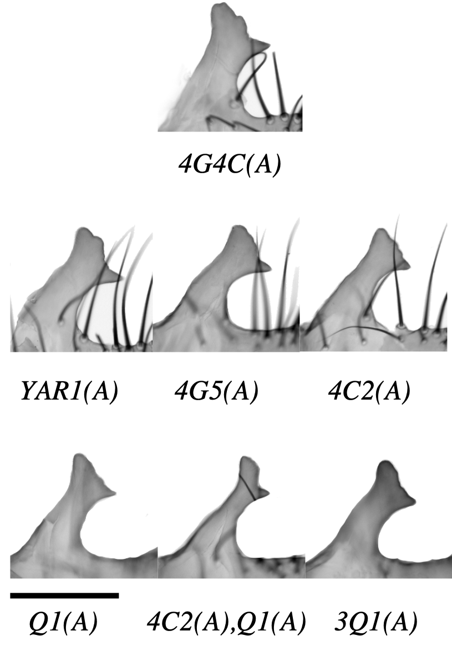
Figure 2.1. The ePLs of the introgression lines between D. sechellia and D. mauritiana. 4G4C(A) is the only introgression line with a bigger ePL compared to D. sechellia. YAR1(A) and 4G5(A) do not show any significant change in ePL size and shape. 4C2(A), Q1(A), 4C2(A),Q1(A), and 3Q1(A) have a smaller ePL compared to D. sechellia.The scale bar indicates 100 um.
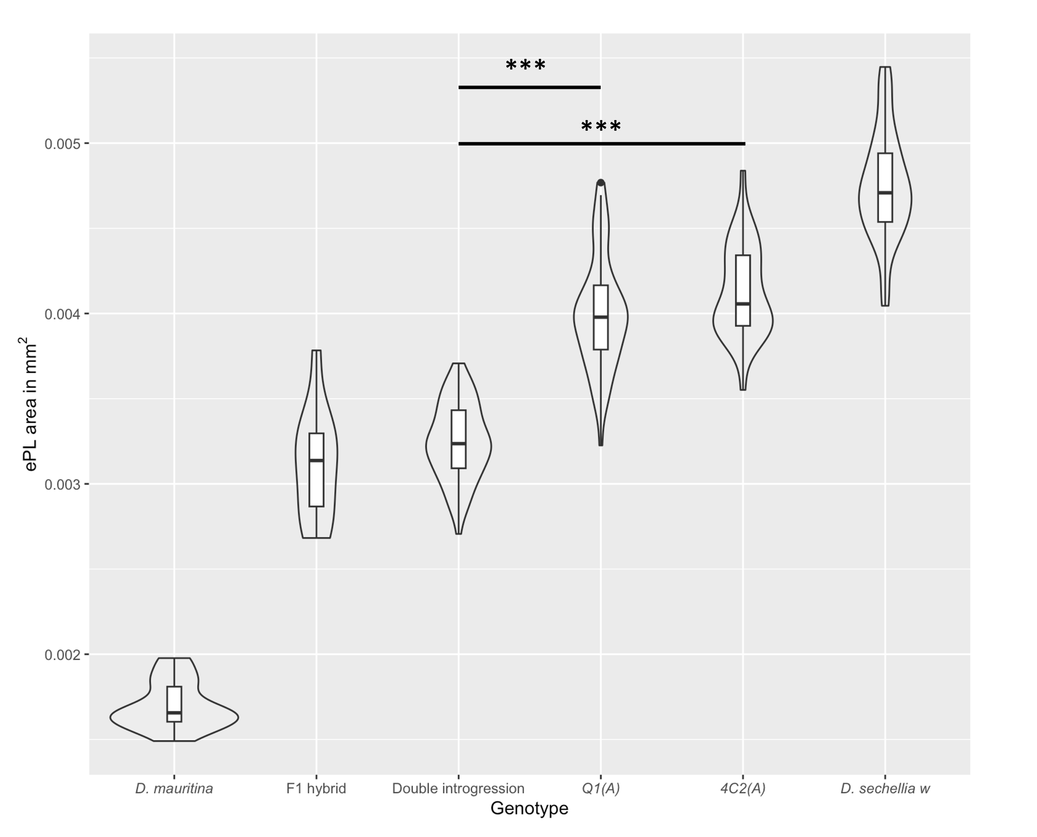
Figure 2.2. The ePL area in mm² for D. mauritiana, the F1 hybrid between D. mauritiana and D. sechellia, double introgression containing both 4C2(A) and Q1(A), the two introgressions Q1(A) and 4C2(A), and D. sechellia. There is a significant difference between the genotypes (Kruskal-Wallis chi-squared = 233.17, p-value < 0.001). Wilcoxon pairwise comparison shows a significant difference between all the genotypes except the F1 hybrid and the double introgression and between 4C2(A) and Q1(A) introgression lines. Only the bars for comparison between 4C2(A) and double introgression, and Q1(A) and double introgression are shown. *** p-value <0.0001.
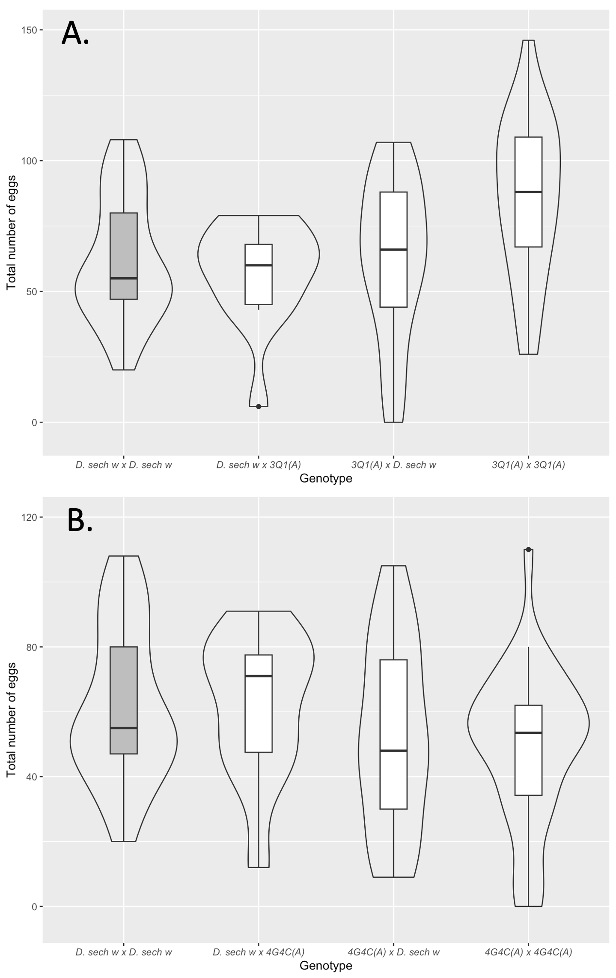
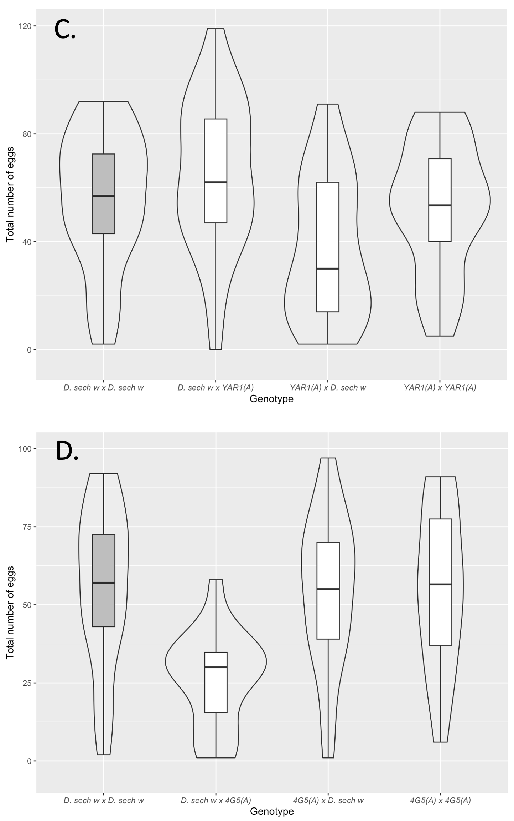
Figure 2.3. The egg-laying comparison between each genotype combination. A. There was no significant difference between D. sechellia w by D. sechellia w control and 3Q1(A) males by D. sechellia w females (Tukey test, p-value=0.99). The 3Q1(A) by 3Q1(A) has a significant increase in egg-laying compared to the other 3 crosses: D. sechellia w by D. sechellia w (Tukey test, p-value=0.009), 3Q1(A) by D. sechellia w (Tukey test, p-value=0.02), and sechellia w by 3Q1(A) (Tukey test, p-value=0.01). B. The treatments with the 4G4C(A) introgression line showed no significant difference from the D. sechellia w by D. sechellia w (Kruskal Wallis, H(3)=4.52, p-value= 0.21) suggesting that a bigger ePL does not affect the egg laying in the females the same way a smaller ePL does. The two control genotypes that don’t affect ePL size show various egg-laying effects. D. sechellia w by YAR1(A) lays significantly more eggs than YAR1(A) by D. sechellia w (Tukey test, p-value=0.002) (C) and D. sechellia w by 4G5(A) females lay significantly fewer eggs compared to the other 3 set of crosses (D). In each treatment, the genotype order is Male x Female. The control D. sechellia w by D. sechellia w crosses are shown in gray. Boxplot whiskers are drawn to show the interquartile range. The horizontal line within each box shows the median value. * p-value <0.05 ** p-value <0.001, *** p-value <0.0001

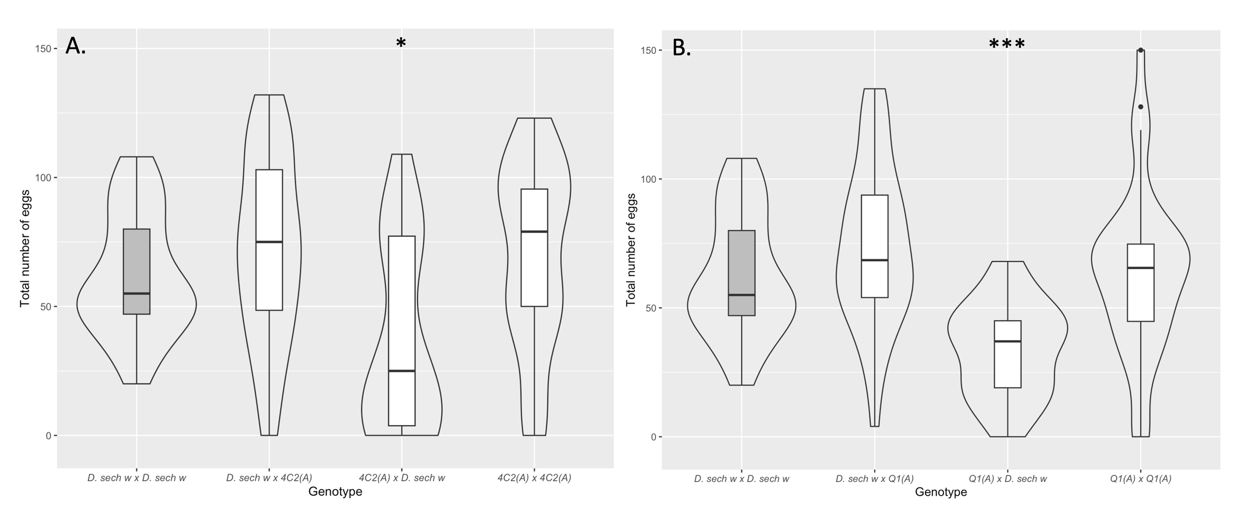
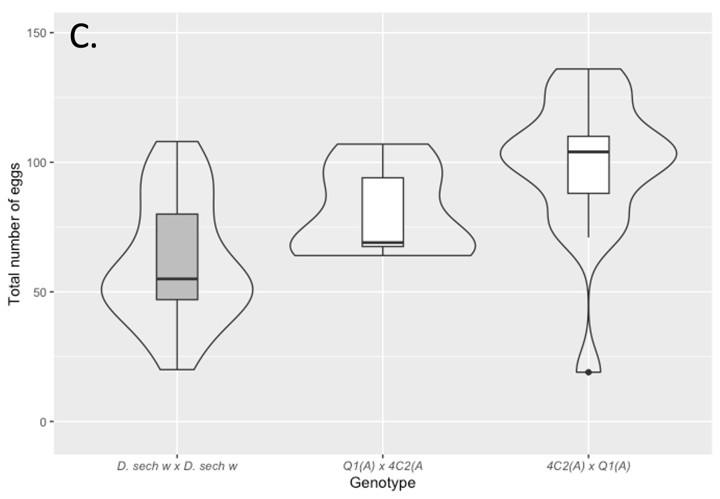
Figure 2.4. The egg-laying comparison between each genotype combination. A. There is a significant difference between the behavioral treatments for 4C2(A) region (Kruskal-Wallis chi-squared = 12.632, p-value =0.005505). When 4C2(A) males mate with D. sechellia w females, the D. sechellia w females reduce their egg-laying compared to 4C2(A) males mate 4C2(A) females (Pairwise Wilcox test with Benjamini–Hochberg correction p-value= 0.012), D. sechellia w by D. sechellia w (p-value= 0.019) and D. sechellia w by 4C2(A) (p-value=0.012). B. There is a significant difference between the behavioral treatments for Q1(A) region (Kruskal-Wallis chi-squared = 32.824, p-value <0.0001). When Q1(A) males mate with D. sechellia w females, the D. sechellia w females reduce their egg-laying compared to Q1(A) males mate 4C2(A) females (Pairwise Wilcox test with Benjamini–Hochberg correction p-value <0.0001), D. sechellia w by D. sechellia w (p-value <0.0001) and D. sechellia w by 4C2(A) (p-value <0.0001). C. When Q1(A) males mate with D. 4C2(A) females, the 4C2(A) females lay normal amounts of egg compared to D. sechellia w by D. sechellia w. When 4C2(A) males mate with Q1(A) females, the Q1(A) females lay significantly more eggs (Pairwise Wilcox test with Benjamini–Hochberg correction p-value <0.0001), D. sechellia w by D. sechellia w (p-value <0.0001) and D. sechellia w by 4C2(A) (p-value <0.0001). In each treatment, the genotype order is Male x Female. The control D. sechellia w by D. sechellia w crosses are shown in gray. Boxplot whiskers are drawn to show the interquartile range. The horizontal line within each box shows the median value. * p-value <0.05 ** p-value <0.001, *** p-value <0.0001

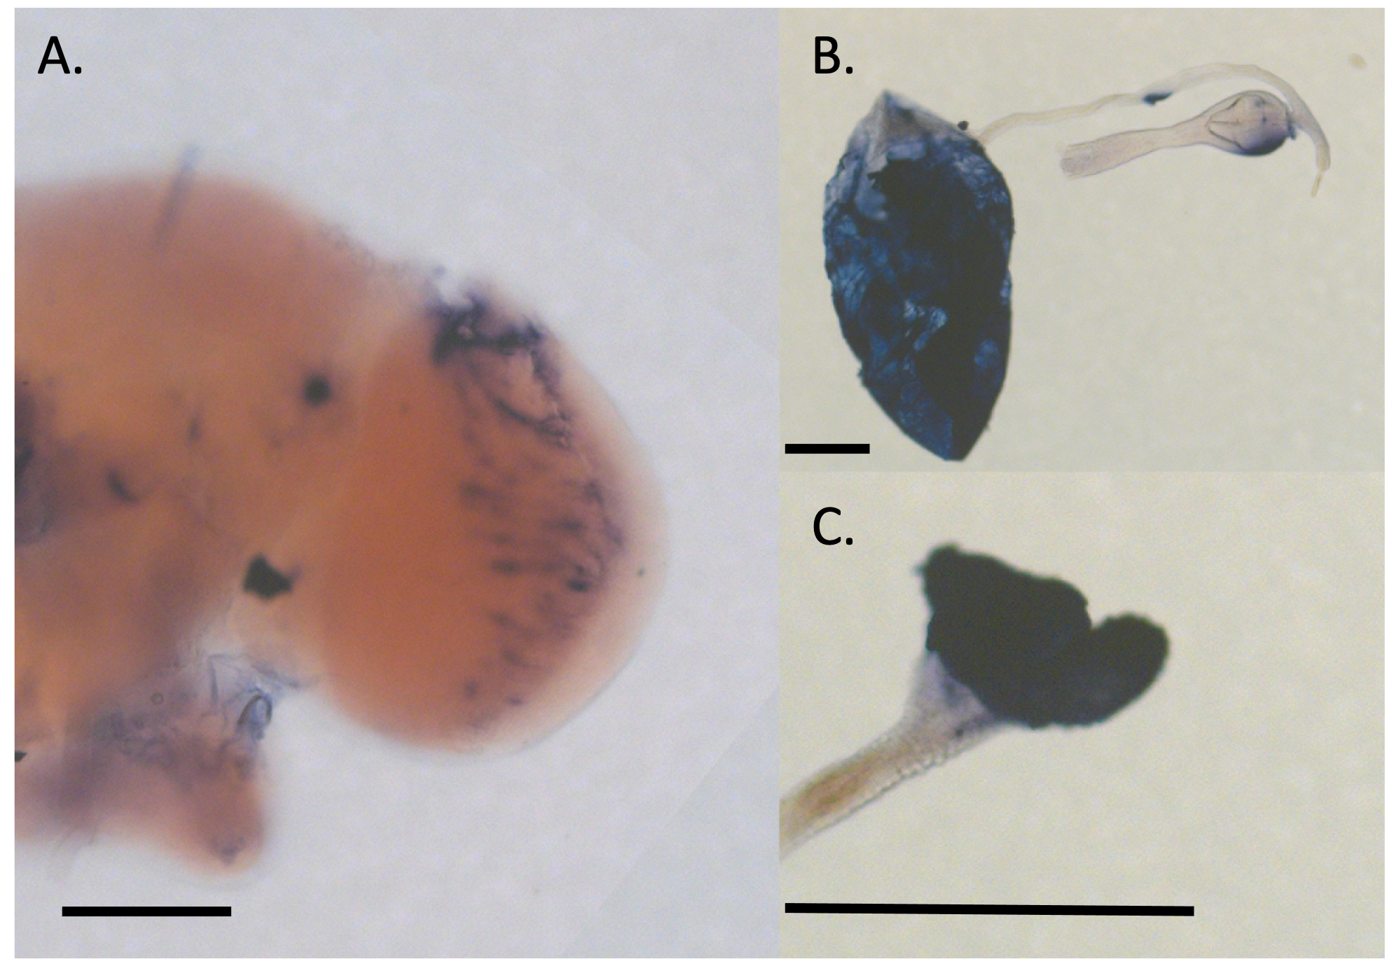
Figure 2.5. The Glds in situ hybridization for adult brain (A) and crop (B, C). Blue color in the tissue indicates the expression of the gene. The in situ hybridization of Glds shows localization to the adult eye lobe (A) and the crop (B,C). The scale bar is 100 um.

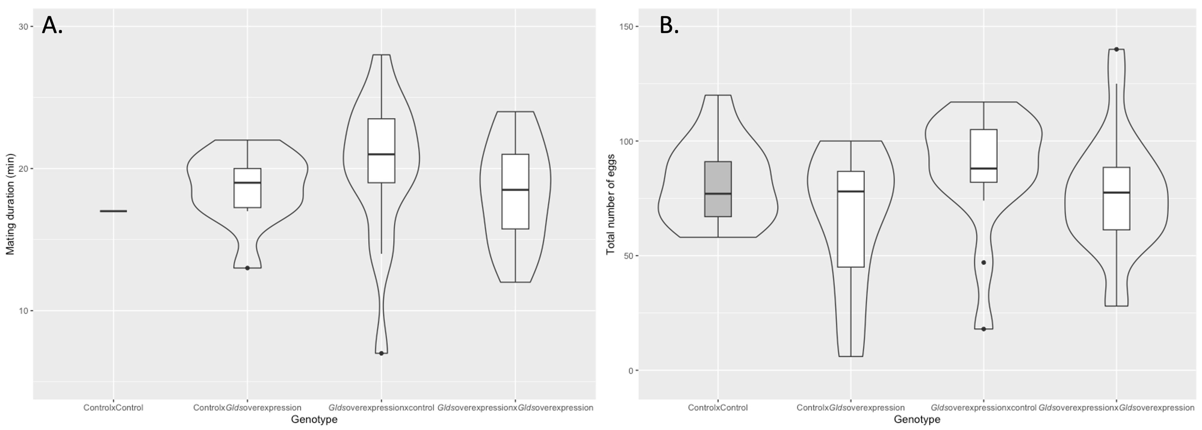
Figure 2.6. Overexpression of Glds using PoxnGAL4 does not affect egg-laying. A. There is no significant difference between the four mating combinations in mating duration. B. There is no significant difference between the four mating combinations in total number of eggs laid. In each treatment, the genotype order is Male x Female. Experimental genotype is Dcr2;UAS-Glds;PoxnGAL4. Control genotype is Dcr2;UAS-Glds;Sb. Boxplot whiskers are drawn to show the interquartile range. The horizontal line within each box shows the median value.

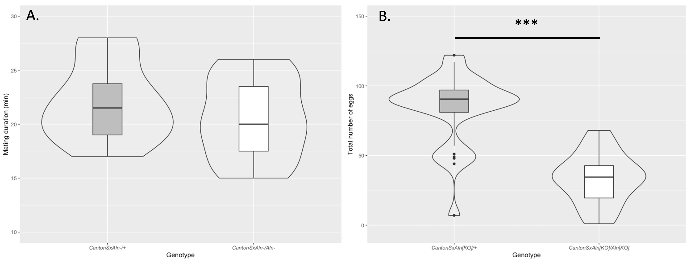
Figure 2.7. Aln null homozygote females mated to D. melanogaster Canton S have a normal mating duration (A)(W=117, p-value = 0.3385) but lay significantly fewer eggs compared to the Aln null heterozygote females (B)(W = 523.5, p-value<0.0001). Boxplot whiskers are drawn to show the interquartile range. The horizontal line within each box shows the median value. *** p-value <0.0001

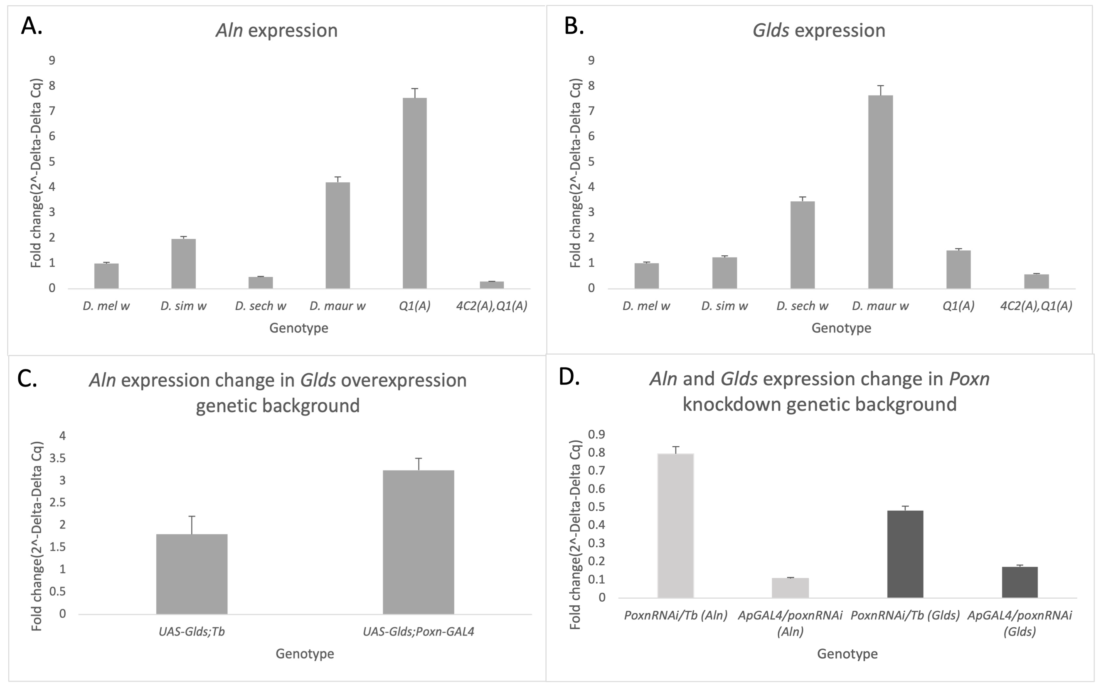
Figure 2.8. qPCR results suggest that over-expression of Glds affects the expression of Aln. A. Aln expression in the pure species and introgression lines (Error bar =5% of data). B. Glds expression in the pure species and introgression lines (Error bar =5% of data). C. The change in expression of Aln between control background and Glds overexpression (Error bar = mean standard error of observations). D. The change in expressions of Aln and Glds between control background and Poxn knockdown (Error bar =5% of data).

2.8 Tables:
Table 2.1: Analysis of introgression lines egg-laying experiment

Introgression line | Treatment  (male by female) | N | Normality test p-value | Homogeneity of variance test p-value | ANOVA/ Kruskal Wallis p-value | Post-hoc  p-value
4C2(A) | D. sechellia w by D. sechellia w | 29 | 0.150 | 0.09819 | 0.005505
 |  |  |  |  |  | 0.266
 |  |  |  |  |  | 0.019
 |  |  |  |  |  | 0.266
4C2(A) | D. sechellia w by 4C2(A) | 27 | 0.537 | 0.09819 | 0.005505
 |  |  |  |  |  | 0.012
 |  |  |  |  |  | 0.860
4C2(A) | 4C2(A) by D. sechellia | 20 | 0.00356 | 0.09819 | 0.005505
 |  |  |  |  |  | 0.012
4C2(A) | 4C2(A) by 4C2(A) | 28 | 0.0585 | 0.09819 | 0.005505
Q1(A) | D. sechellia w by D. sechellia w | 29 | 0.150 | 0.007858 | 3.509e-07
 |  |  |  |  |  | 0.092
 |  |  |  |  |  | 4.7e-05
 |  |  |  |  |  | 0.733
Q1(A) | D. sechellia w by Q1(A) | 34 | 0.724 | 0.007858 | 3.509e-07
 |  |  |  |  |  | 2.5e-06
 |  |  |  |  |  | 0.209
Q1(A) | Q1(A) by D. sechellia | 29 | 0.724 | 0.007858 | 3.509e-07
 |  |  |  |  |  | 4.7e-05
Q1(A) | Q1(A) by Q1(A) | 38 | 0.289 | 0.007858 | 3.509e-07
3Q1(A) | D. sechellia w by D. sechellia w | 29 | 0.150 | 0.2396 | 0.00284
 |  |  |  |  |  | 0.9569410
 |  |  |  |  |  | 0.9998489
 |  |  |  |  |  | 0.0091992
3Q1(A) | D. sechellia w by 3Q1(A) | 13 | 0.0570 | 0.2396 | 0.00284
 |  |  |  |  |  | 0.9486298
 |  |  |  |  |  | 0.0145948
3Q1(A) | 3Q1(A) by D. sechellia | 21 | 0.321 | 0.2396 | 0.00284
 |  |  |  |  |  | 0.0233457
3Q1(A) | 3Q1(A) by 3Q1(A) | 25 | 0.732 | 0.2396 | 0.00284
YAR1(A) | D. sechellia w by D. sechellia w | 19 | 0.449 | 0.8872 | 0.00461
 |  |  |  |  |  | 0.6525176
 |  |  |  |  |  | 0.1284221
 |  |  |  |  |  | 0.9747607
YAR1(A) | D. sechellia w by YAR1(A)) | 27 | 0.866 | 0.8872 | 0.00461 | 0.6525176
 |  |  |  |  |  | 0.0020781
 |  |  |  |  |  | 0.2886150
YAR1(A) | YAR1(A) by D. sechellia | 23 | 0.107 | 0.8872 | 0.00461 | 0.1284221
 |  |  |  |  |  | 0.0020781
 |  |  |  |  |  | 0.1887555
YAR1(A) | YAR1(A) by YAR1(A) | 28 | 0.187 | 0.8872 | 0.00461 | 0.9747607
 |  |  |  |  |  | 0.2886150
 |  |  |  |  |  | 0.1887555
4G4C(A) | D. sechellia w by D. sechellia w | 29 | 0.150 | 0.6591 | 0.21
 |  |  |  |  |  | 0.85
 |  |  |  |  |  | 0.34
 |  |  |  |  |  | 0.34
4G4C(A) | D. sechellia w by 4G4C(A) | 23 | 0.0392 | 0.6591 | 0.21
 |  |  |  |  |  | 0.23
4G4C(A) | 4G4C(A) by D. sechellia | 23 | 0.392 | 0.6591 | 0.21
 |  |  |  |  |  | 0.34
 |  |  |  |  |  | 0.85
4G4C(A) | 4G4C(A) by 4G4C(A) | 30 | 0.171 | 0.6591 | 0.21
4G5(A) | D. sechellia w by D. sechellia w | 18 | 0.449 | 0.1526 | 0.000386
 |  |  |  |  |  | 0.0018580
 |  |  |  |  |  | 0.9975364
 |  |  |  |  |  | 0.9999316
4G5(A) | D. sechellia w by 4G5(A) | 18 | 0.365 | 0.1526 | 0.000386
 |  |  |  |  |  | 0.0021707
 |  |  |  |  |  | 0.0022381
4G5(A) | 4G5(A) by D. sechellia | 21 | 0.845 | 0.1526 | 0.000386
 |  |  |  |  |  | 0.9991947
4G5(A) | 4G5(A) by 4G5(A) | 18 | 0.631 | 0.1526 | 0.000386
2.9 Supplement:
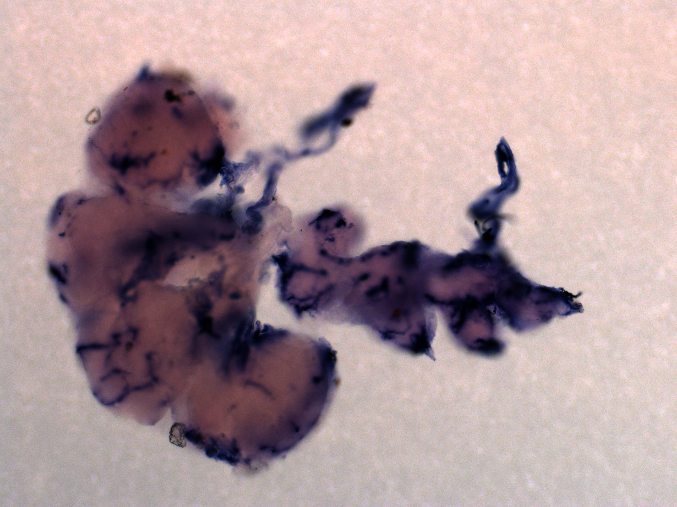
Supplement Figure 2.1 the in situ hybridization of Glds in brain and ventral nerve cord showing a Dalmatian pattern .

Chapter 3

Neurobiology of Egg-laying Behavior in Drosophila: Neural Control of the Female Reproductive System
(in revision for the Journal of Neurogenetics)
3.1 Abstract
Egg-laying is one of the key aspects of female reproductive behavior in insects. Egg-laying has been studied since the dawn of Drosophila melanogaster as a model organism. The female’s internal state, hormones, and external factors, such as nutrition, light, and social environment, affect egg-laying output. However, only recently, neurobiological features of egg-laying behavior have been studied in detail. Fruitless and doublesex, two key players in the sex determination pathway, have become focal points in identifying neurons of reproductive significance in both central and peripheral nervous systems. The reproductive tract and external terminalia house sensory neurons that carry the sensory information of egg maturation, mating and egg-laying. These se include the presence of male accessory gland products and mechanical stimuli. The abdominal neuromere houses neurons that receive information from the reproductive tract, including sex peptide abdominal ganglion neurons (SAGs), and send their information to the brain. In the brain, neuronal groups like aDNs and pC1clusters modulate egg-laying decision-making, and other neurons like oviINs and oviDNs are necessary for egg-laying itself. Lastly, motor neurons involved in egg-laying, which are mostly octopaminergic, reside in the abdominal neuromere and orchestrate the muscle movements required for laying the egg. Egg-laying neuronal control is important in various evolutionary processes like cryptic female choice, and using different Drosophila species can provide intriguing avenues for the future of the field.
3.2 Introduction:
Reproduction is a costly phenomenon that shapes the life history of a species through phenomena like decreased survival and a lower number of future reproductive opportunities (Harshman & Zera, 2007; G. C. Williams, 1966). Animals have limited energy resources, which results in trade-offs between different physiological functions, behavior, and reproduction (Harshman & Zera, 2007). Specifically, the reproductive costs to the female can be grouped into resource-allocation costs, for instance, production of the yolk protein, and non-resource-based costs, which include hormonal changes to the female body (T. D. Williams, 2005). Egg production and oviposition are major contributors to this costly phenomenon in females (Azevedo et al., 1997; Rosenheim et al., 2000). Therefore, egg-laying behavior needs to be closely regulated by the female’s physiology and neuronal systems. Hormones and peptides have a long-term effect and change the physiology of the female animal. For example, insulin-like peptides in Drosophila play a key role in oogenesis by regulating stem cell division in response to nutrition intake (LaFever & Drummond-Barbosa, 2005), resulting in a more long-term effect in the female body. In contrast, neurons provide a more immediate response. For example, recent studies have discovered specific neuronal candidates affecting oviposition in female Drosophila and artificial activation of some of these neurons results in the animal exhibiting oviposition sequence (F. Wang, Wang, Forknall, Patrick, et al., 2020).
Egg-laying behavior needs to provide enough flexibility for the female to produce offspring while encountering variable external environments (Kienzle et al., 2020; Reguera, 2002; Roy et al., 2018; Van Wielendaele et al., 2013) and physiological changes (Roy et al., 2018; J. Xu et al., 2010). For instance, unlike Drosophila melanogaster, D. suzukii prefers healthy unwounded fruit as an egg-laying substrate. Kienzle et al. (2020) showed that D. suzukii will lay its eggs on wounded fruit when the healthy fruit becomes less available. Conversely, change in external environmental factors affects the internal physiology of the female. In mosquitos, the expression of microRNA-309 is dependent on the blood meal, and disruption of microRNA-309 results in failure of ovarian development (Y. Zhang et al., 2016). These regulations on egg-laying, whether promoted by hormones or neurons, correlate directly with the female’s fitness and ensure that the female’s genes reach the next generation.
Since the early days of D. melanogaster as one of the model organisms for genetics, egg-laying behavior has been a phenotype that caught the interest of biologists. Egg-laying has been used as a phenotype to study hybridization (Engels & Preston, 1979; Price et al., 2001; Sturtevant, 1920), as an indicator of fecundity (H. Shapiro, 1932; Tantawy & Vetukhiv, 1960), and for quantitative genetics (McMillan et al., 1970). Egg-laying has been studied in connection with female life-span (Partridge et al., 1986, 1987) later came into light as a proxy for cryptic female choice (Frazee and Masly, 2015; Frazee et al., 2021; LeVasseur-Viens et al., 2015) and decision-making (Yang et al., 2008). Studying the egg-laying of Drosophila using genetic tools has always been a subject of interest for researchers, and many studies have focused on the production of the egg itself (Hall & Greenspan, 1979; Wieschaus, 1980). Early studies on female Drosophila focused on reproductive behavior holistically (Manning, 1967) or used decapitated females to assess the neuronal control of egg-laying between closely related Drosophila species (Grossfield & Sakri, 1972). In recent years, the neurobiology of egg-laying and how females control their reproductive output has received more attention in insects, including oriental tobacco budworm (C. Wang et al., 2020) and bean bug (Hasebe & Shiga, 2021). More in-depth studies have been conducted on specific neurons affecting fruit-fly egg-laying behavior (Rezával et al., 2012, 2014; Shao et al., 2019; F. Wang, Wang, Forknall, Patrick, et al., 2020; K. Wang et al., 2021; Yang et al., 2008).
Egg-laying involves different neuronal components (Figure 3.1) that overlap with other aspects of female reproductive behavior and motivation (Ishimoto & Kamikouchi, 2021). Ovipositor extension can be part of mating, rejection, and egg-laying behavior. During mating, the female extends her ovipositor horizontally, whereas, during egg-laying, the female extends her ovipositor toward the substrate and bends her abdomen (K. Kimura et al., 2015). This stereotypical pattern lasts around six seconds and is called the “ovipositor motor program” (Yang et al., 2008). Internally, ovarioles need to be stimulated to produce more oocytes, the mature egg needs to move from the ovariole to the uterus via the oviduct, and the female needs to decide on a good location to lay her eggs; all of these components involve neuronal control (Rodríguez-Valentín et al., 2006; White et al., 2021; Yang et al., 2008).
Studying reproduction without also considering hormonal control is impossible. There are studies in many groups of dipterans that hormonal control plays a significant role in egg-laying. Hormonal control has been studied extensively in Aedes aegypti since the 1970’s (Gwadz & Spielman, 1973; Wheelock et al., 1988). For instance, blocking the decrease in juvenile hormone (JH) levels after a blood meal results in abnormal egg development and decreased egg hatching (A. B. Shapiro et al., 1986). JH (J. P. Shapiro & Hagedorn, 1982), and ovarian ecdysogenic hormone (OEH) (Matsumoto et al., 1989) are two of the neurosecretory hormones that modulate follicle maturation and vitellogenesis in A. aegypti (Nijhout, 1998). In the case of OEH, D. melanogaster sister species offer a curious case: they lack the gene neuroparsin, which is the homolog of OEH and widely conserved among many insects (Veenstra, 2010). Instead of OEH specifying egg maturation, in D. melanogaster, JH modulates egg maturation (Bilen et al., 2013). After eclosion, the corpus allatum produces JH that stimulates the yolk protein production in the fat body (Jowett & Postlethwait, 1980) (Figure 3.2). The fat body and follicle cells synthesize yolk proteins that are vital for the development of the oocyte (Mirth et al., 2019). With the sexual maturation of the female fruit fly, JH levels fall. Yolk production starts again with the stimulation provided by sex peptide (SP), an accessory gland protein that is transferred from the male to the female reproductive tract during mating (Soller et al., 1997). It has been shown that hormones can change the firing properties and ion currents of neurons in mice (DeFazio & Moenter, 2002). However, the effect of hormones and SP on Drosophila’s neurons is understudied. Experiments with JH suggest that this hormone plays an active role in dimorphic behavior between males and females. For instance, inhibiting JH activity by feeding the flies Fluvastatin, a drug that inhibits JH, results in the feminization of the walking behavior of male flies (Belgacem & Martin, 2002). The intertwined nature of hormonal and neuronal control calls for more in-depth studies of hormone titer’s effect in female Drosophila's neurons.
Some aspects of the environment modulate D. melanogaster’s fecundity. For example, the nutritional environment affects the egg-laying output and site selection. Lifetime egg-laying of female D. melanogaster increases with an increase in the food quality (Tracey Chapman & Linda Partridge, 1996). The egg-laying behavior is also affected by the site-selection decision-making process. Drosophila females lay fewer eggs when no appropriate sites are available (Eisses, 1997). The presence of chemical cues in the food affects the egg-laying output. For instance, Geosmin-sensing neurons express Odorant receptor 56a (Or56a) and target a brain region called DA2 glomerulus to inhibit oviposition and feeding (Stensmyr et al., 2012). The presence of external and internal pathogens modulates egg-laying as well. Flies avoid laying eggs on contaminated food by an olfactory circuit in the brain that represses the egg-laying circuit (Stensmyr et al., 2012). Further, bacterial infection reduces the rate of egg-laying in female Drosophila through the NF-kB signaling pathway (Kurz et al., 2017). For example, Schwenke and Lazzaro (2017) have shown that JH affects both increased egg laying and decreased infection resistance, which results in immunosuppression in mated females (Schwenke & Lazzaro, 2017), and thus illustrates a trade-off between a physiological function (immune response) and reproduction.
The light environment is another factor that affects egg-laying decisions. Markow (1975) showed that genetic variation exists for light dependent behaviors and established that some fly strains lay more eggs in the dark while others lay more eggs in light treatment. Female flies display UV aversion for egg-laying site selection. They sense this specific light environment using their R7 photoreceptors (Zhu et al., 2014). Gr66a-expressing neurons on the leg induce aversion, while Gr66a-expressing neurons in the pharynges induce attraction to the chemical lobeline as an egg-laying site (Joseph & Heberlein, 2012). Gr66a-expressing bitter-tasting neurons that are sensitive to H₂O₂ also promote UV avoidance in the egg-laying site selection (Guntur et al., 2017).
In addition, the social environment affects the fruit fly’s behavior. Mating is known to increase aggression in females (Bath et al., 2017), and field studies of oriental fruit flies have shown that females increase their aggression to defend their egg-laying sites (Shelly, 1999). However, increased aggression in the social environment does not directly affect egg-laying (Bath et al., 2017, 2018). A recent study found that non-egg excrements of other females, combined with the female’s social exposure before the mating, can modulate the number of fertilized eggs by the female (Fowler et al., 2022). The presence of a male-produced pheromone affects female egg-laying site selection by activation of Or7a+ neurons. Additionally, Or7a mutant and Or7a ablated flies lay a higher number of eggs (Lin et al., 2015). Chemical cues by other mated females also guide the female egg-laying site selection (Duménil et al., 2016). Olfactory cues are one of the key players in D. suzukii. Orco-expressing sensory neurons are necessary for the egg-laying site selection of this species (Karageorgi et al., 2017).
Until this point, I covered external factors and hormones that affect egg-laying. From here, I focus on central and peripheral neurons that affect egg-laying. I will explore major sex determination genes that are commonly used in reproductive neurobiology in Drosophila. I will discuss the sensory neurons, with a focus on the abdomen, and explore neurons that detect important signals during and after mating that have been shown to affect egg-laying. Next, I will move to the neurons in the abdominal neuromere (abdominal ganglion) and brain, where a significant part of processing sensory clues and regulating egg-laying behavior occurs, and briefly explore the motor neurons. Lastly, I explore the field’s future and areas that show potential for expansion. Neurobiology of egg laying in Drosophila offers exciting avenues to study evolutionary forces like cryptic female choice using genetic tools already available in this classic model.
3.3 Major sex determination genes as indicators of central neurons involved in female reproduction
Doublesex (dsx) and fruitless (fru) are two major sex determination genes (Billeter et al., 2006) (Figure 3.3). The gene dsx is involved in male and female developmental differentiation and regulates sex-specific behavior in both sexes (Waterbury et al., 1999). The gene fru is a major player in male courtship behavior and is involved in the development of male-specific muscle of Lawrence (Billeter et al., 2006). Neurons expressing either or both of these genes are usually important for specifying reproductive behavior (K. Kimura et al., 2008; Sanders & Arbeitman, 2008; K. Wang et al., 2021; Waterbury et al., 1999; Yamamoto & Koganezawa, 2013). For instance, the elimination of synaptic transmission with tetanus toxin in dsx-expressing neurons results in no egg laying in female D. melanogaster (Rideout et al., 2010). Further dissection of this phenotype shows that sperm were transferred normally to these females, and inseminated females produced mature oocytes. This result suggests that infertility is due to mature oocytes not being moved into the uterus and being fertilized (Rideout et al., 2010), indicating an essential role for dsx neurons in egg laying.
The gene dsx encodes an mRNA that is differentially-spliced to produce sex-specific protein isoforms, one of which is the Dsx^{F} protein in female Drosophila. Dsx^{F} protein is crucial for sexual differentiation, including the production of female pheromones and yolk proteins (Baker & Wolfner, 1988; Waterbury et al., 1999). Dsx-expressing neurons have a wide distribution in the female central nervous system (CNS). In adult females, dsx is expressed in 700 CNS neurons, and there are 30-40 dsx-expressing neurons in each brain hemisphere of female Drosophila, specifically around 16 cells in the pC1 and pC2 regions (Sanders & Arbeitman, 2008). Palavicino-Maggio et al. (2019) suggest that pC1, pC2, and pC3 clusters are the hubs of sex-specific behavioral patterns. For instance, pC2l control the ovipositor (K. Kimura et al., 2015). The pC1 region houses the most studied region between the three that modulate egg-laying (See brain section). Dsx-expressing neurons that affect egg-laying are not limited to the brain. Dsx-expressing neurons in the ventral nerve cord are sufficient to elicit an ovipositor extrusion and egg ejection behavior (K. Kimura et al., 2015). Other genes affecting dsx expression might have an effect on egg-laying as a result. For instance, deletion of mir-iab-4/8 and homothorax (hth) mutants result in increased egg-laying and decreased receptivity, thus showing that mir-iab-4/8 and hth regulate dsx expression levels during development (Garaulet et al., 2021). Other studies have shown that co-expression of the gene dissatisfaction (dsf) and dsx in abdominal neuromere interneurons modulates vaginal plate opening, ovipositor extrusion and movements of uterus walls (Duckhorn et al., 2022). Taken together, these studies suggest a critical role for dsx-expressing neurons in female reproductive behavior, including egg-laying.
The other major sex-determination gene fru has sex-specific splice isoforms as well as common isoforms. Fru is a complex locus that has at least four promoters (P1-4), and only transcripts produced from P1 are sex-specific. Female-specific splice of Fru (Fru^{F}) has no known function (Demir & Dickson, 2005). It has been shown that the neurons with transcription from the P1 promoter play a role in female sexual behaviour (Usui-Aoki et al., 2000). Studies have shown that the non-sex-specific Fru proteins (known as FruCOM) are expressed throughout the developing nervous system (Sato & Yamamoto, 2022). Moreover, Chowdhury et al. (2020) show that FruCOM, especially from P2 transcript, affects female receptivity and heterospecific mating. Other studies have shown that there specifically are five fru-expressing mAL interneurons present in the female brain (Goto et al., 2011; K.-I. Kimura et al., 2005). Many of the recently described neurons in the egg-laying circuit are fru-expressing, including oviDNs (F. Wang, Wang, Forknall, Patrick, et al., 2020). These results suggest that even though there is no known function for Fru^{F} protein in the female Drosophila, fru+ neurons are involved in egg-laying and other reproductive behaviors.
Fru and dsx are not the only genes that regulate sexual differentiation and behavior (Figure 3.3). Other genes that have been shown to affect female behavior include Sex-lethal (Sxl)(Evans & Cline, 2013; Sawala & Gould, 2017), retained (retn)(Shirangi et al., 2006), and transformer (tra) (Castellanos et al., 2013) and may prove valuable in further determining the pathways involved in female egg-laying. Sxl has been shown to have targets other than transformer and through a branch of downs stream genes, collectively called tra-insufficient feminization (TIF) pathway, controls the development of fru+ neurons that regulate the passage of the mature egg to the oviduct (Evans & Cline, 2013).
The interplay between the sex determination genes plays a crucial role in orchestrating the complex behaviors associated with reproduction in Drosophila. The vast body of work available on both dsx and fru is a gem for neurobiology, which in many cases is underappreciated. The results from papers in fields other than neurobiology might hold the key that leads to a better understanding of circuits. For example, Keisman et al. (2001) described the effect of dsx in female genital disc development that will eventually give rise to reproductive tract and external terminalia. As mentioned above, the extensive distribution of dsx-expressing neurons in the female central nervous system indicates their pivotal role in shaping sex-specific behavioral patterns. The fru gene emerges as a player in e reproductive behaviors in Drosophila which include important neurons like oviDNs. Additionally, the involvement of other genes further emphasizes the complexity of the regulatory network governing female reproductive behaviors. As researchers continue to understand the intricacies of these genetic pathways, more resources will become available to study single neurons and their effect on reproductive behavior.

3.4 Peripheral nervous system: Sensory neurons that influence egg-laying
Drosophila possesses numerous sensory neurons throughout its body, including sensory organs located on the head and legs. The relationship between sensory organs on the head or legs and egg-laying has been extensively discussed in a review by Ishimoto and Kamikouchi in 2021. For this review, I will focus specifically on sensory cues received by the sensory organs located in or on the abdomen (Figure 3.4).
3.5 Sensory cues triggered by mating
The process of mating changes female fruit flies’ behavior. It reduces receptivity and increases ovulation, egg-laying (Avila et al., 2011), and food intake (Ribeiro & Dickson, 2010). These changes in female behavior are modulated by components of mating, including pheromonal cues (Billeter & Wolfner, 2018), seminal fluid proteins (SFPs) (Haussmann et al., 2013; Ribeiro & Dickson, 2010), and the physical act of mating itself (Shao et al., 2019). Mating and its components modulate vesicle release at the nerve terminals of the reproductive tract (Heifetz & Wolfner, 2004). The act of mating and some components of the seminal fluid change the status of the lower reproductive tract, while SPFs modulate the vesicles released from neurons, innervating the seminal receptacle, while sperm alters the neurons innervating the upper reproductive tract (Heifetz & Wolfner, 2004). Furthermore, SFPs are responsible for the conformational change of the lower reproductive tract (Adams & Wolfner, 2007). In addition, mating affects gene expression in different tissues. For example, gene expression changes in the female D. melanogaster’s head after mating are strongly correlated with metabolic pathways (Newell et al., 2020).
SP is one of the SFPs secreted by male accessory glands and, in its mature form, is composed of 36 amino acids (Kubli, 2003). SP is sensed by pickpocket (ppk)+ and fru+ neurons in the female reproductive tract, which are called sex peptide sensory neurons (SPSNs)(Yapici et al., 2008). Silencing SPSNs in virgin female flies results in increased egg laying that is comparable to mated females (Häsemeyer et al., 2009; Rezával et al., 2012). SPSNs express a G protein-coupled receptor called the sex peptide receptor (SPR). The binding of SP to SPR results in a cascade that blocks the activity of SPSN neurons. The silencing of SPSNs by SP results in behaviors specific to post-mating response, including increased egg-laying and rejection (Häsemeyer et al., 2009; Rezával et al., 2012). SPR is also expressed by spermatheca secretory cells and aids in sperm release (Avila et al., 2015). Knockdown of the SPR gene with RNA interference reduces egg laying significantly (Yapici et al., 2008). SP is not only detected by neurons and cells in the reproductive tract but also passes through hemolymph and is sensed by neurons in the CNS and VNC (Yapici et al., 2008); specifically, fru+ neurons in the brain (Chow et al., 2010). SP stimulates JH synthesis in the corpus allatum resulting in the development of oocytes (Moshitzky et al., 1996).
SPR expressed in the neurons has a similar structure to myo-inhibitory peptide (MIP) receptors. SP is more stable than MIPs and can survive the harsh environment of the female reproductive tract (Isaac et al., 2014). There are 5 MIPs in Drosophila, and they have been known to act as neuropeptides (Carlsson et al., 2010). One early study showed that pan-neuronal knockdown of MIP does not affect receptivity and remating, but at least in one fly line, there was a significant decrease of the egg-laying (Kim et al., 2010). Furthermore, Poels et al. (2010) show that neither RNAi knockdown of MIPs nor direct injection of MIPs in the fruit fly’s abdomen has an effect on the egg-laying. More recent studies have shown that Mip-expressing neurons in the CNS are essential contributors to female receptivity and copulation effect (Jang et al., 2017; Shao et al., 2019).
Other seminal fluid proteins affect the female egg-laying as well. Acp26Aa, also known as ovulin, has a small increasing effect on egg-laying (Herndon & Wolfner, 1995). Specifically, it helps release the mature oocyte from the ovary after mating (Heifetz et al., 2000) by increasing the activity of octopamine-releasing neurons (Rubinstein & Wolfner, 2013). Studies show that ovulin is a protein that interacts with itself. However, the pathway by which this molecule interacts with octopaminergic neurons, whether as a monomer or dimer, has not yet been identified (A. Wong et al., 2006). In a systematic study of gustatory receptors (Grs), Park and Kwon (2011) found the expression of 21 Grs in the abdomen that send their projections to the ANm. Most of these Grs are expressed in multidendritic neurons on the abdominal wall, while 4 are expressed in the reproductive tract. Gr28b.b, Gr28b.c, Gr32a (involved in pheromone detection), and Gr64c (a sugar receptor) are expressed in the female’s upper reproductive tract (Park & Kwon, 2011) and can be candidates for modulation of ovulation. Other studies have shown that uterine Gr32a-expressing and ppk+ neurons, increase aggressive behavior after mating. Similarly, activation of Gr32a-expressing uterus neurons in virgin females reduced their sexual receptivity (Liu et al., 2020). These results suggest that Gr32a-expressing neurons might be potential candidates that affect egg-laying behavior as well. In males, Gr32a-expressing neurons detect synomones and enforce reproductive isolation (Fan et al., 2013), and affect aggressive behavior (Andrews et al., 2014).
3.6 Sensory cues triggered by ovulation and egg delivery
Ovulation and release of the egg are done by both virgin and mated females. As mentioned above, the release of the oocyte into the uterus and uterine contractions are modulated by octopamine. However, the movement of oocytes into the uterus triggers mechanosensory neurons and provides feedback to the insect (Chiang et al., 1991). The ppk- and dsx+ neurons not only sense sex peptide, but also can act as stretch receptors (Rezával et al., 2012). Silencing of a group of two to three ppk and CG3542 expressing neurons residing on the upper oviduct reduces egg-laying but does not affect the mating receptivity (Lee et al., 2016), thus hinting that these neurons might be involved in stretch sensation in the oviduct. Other studies suggest that fru+ neurons are developmentally controlled by TIF pathway and might also be involved in the release of egg from the ovary (Evans & Cline, 2013). Cury and Axel (2023) have identified a pair of sensory neurons in the posterior uterus, called PU neurons. PU neurons sense the movement of the egg to the vagina and ovipositor and are necessary for transition into egg burrowing behavior (Cury & Axel, 2023). Taken together, studies suggest that defects in the neuronal control of mature egg release from the ovary and its movement through the reproductive tract can reduce the number of eggs significantly.
3.7 Mechanosensory cues from mating direct egg-laying behavior
Mechanosensation provides valuable external information and internal feedback to egg-laying females. The mechanical stimulus on the D. melanogaster body is sensed by two types of devices: ciliated type I neurons, which include mechanosensory bristles, and multidendritic neurons (Hehlert et al., 2021). Female Drosophila genitalia have many mechanosensory bristles arising from the genital disc during development (McQueen et al., 2022). It has been shown that the genes invected and engrailed are necessary for the development of normal bristle phenotype of the female genitalia, and mutants of these two genes lack the bristle phenotype (Figure 3 of Casares et al., 1997). Specification of these genitalia bristles is under the genetic control of Hairless, and a mutation in this gene results in female genitalia with almost no bristles (Figure 3 of Bang et al., 1991). A system that affects the development and innervation of the bristle is the achaete-scute system (García-Bellido & Santamaria, 1978; Simpson, 1990) and its adjacent genes like asense (Domínguez & Campuzano, 1993) Daughterless, Senseless (Jafar-Nejad, 2006) and musashi (Nakamura et al., 1994). However, their effects on the bristles of the female genitalia have not been characterized extensively. The mechanosensation modulated by the Piezo mechanoreceptor affects the reproductive behavior of D. melanogaster and optogenetic activation of Piezo-expressing ppk- neurons in the female abdomen increases neuronally in LSANs, in turn affect egg-laying (Shao et al., 2019). The bristles directly on the ovipositor have also been studied in D. suzukii and resemble mechanosensory neurons in D. melanogaster and express mechanosensory channels, including Piezo (Crava et al., 2020). A recent study shows that the bristles on female D. melanogaster genitalia express the nompC (Cury & Axel, 2023) as well as Piezo. Cury and Axel (2023) show that the mechanosensory bristle on the posterior end of the abdomen are necessary for assessing the firmness of the substrate for egg-laying.
Mechanosensation of the genitalia affects the female’s egg-laying in other insect species and can provide basis for further discovery in D. melanogaster. For example, in female crickets, Gryllus bimaculatus the mechanosensory hairs on the vulva send the signal to the terminal abdominal ganglion and result in a change in the motor pattern of the vulva after the egg is laid (Ogawa et al., 2011). Elimination of sensory feedback from these mechanoreceptors resulted in the cricket staying in the egg-deposition pattern (Ogawa et al., 2011). Similar studies have not been conducted in D. melanogaster and are a puzzle piece of many unknown aspects of the effect of mechanosensation on the egg-laying behavior of Drosophila.
3.8 Central nervous system: The abdominal neuromere in the ventral nerve cord
In adult Drosophila, the neuromeres of the ventral nerve cord (VNC) are merged to form segmental thoracic neuromeres and a smaller fused neuromere for the abdominal sections (Court et al., 2020). The Drosophila VNC has around 20,000 neurons (Bates et al., 2019) and the abdominal neuromere (ANm) or abdominal ganglion (AG) is the most posterior segment of Drosophila’s VNC (Court et al., 2020) (Figure 3.5). Unlike its name, this fusion of abdominal neuromeres resides completely in the thorax and connects to the abdomen through the main nerve called the abdominal nerve trunk (AbNT). There are four other bilaterally-paired nerves coming out of ANm or its adjacent regions (AbN1-4)(Court et al., 2020), but for the purpose of this review, I will focus only on ANm and AbNT. Most of the cell bodies of neurons reside on the outer cortex of ANm and project toward the center (Court et al., 2020). Some subsets of ANm neurons have been studied regarding egg-laying behavior and regulation. There are roughly 300 dsx+ neurons in the ANm (K. Kimura et al., 2015). Studies have shown that the activation of dsx+ neurons in the ventral nerve cord results in ovipositor extension and egg ejection in some, but not all, decapitated female flies (K. Kimura et al., 2015).
SP abdominal ganglion (SAG) neurons (Figure 3.5), as the name suggests, are dsx+ and Fru- female specific cholinergic neurons that reside within ANm and receive information from sex peptide sensory neurons (SPSNs) (Feng et al., 2014) (Figure 3.5). There are two SAG neurons, one on each side of ANm, and they send their projections bilaterally to the dorsal protocerebrum and ipsilaterally to the periesophageal regions in the brain (Feng et al., 2014). SAG neurons have excitatory synapses with neuropeptide allatostatin-C (AstC)-producing neurons in the brain; mating silences the SAG-Ast-C axis and results in the production of JH and vitellogenesis (C. Zhang et al., 2022). Reduction of the activity of SAG neurons reduces female receptivity and increases the number of eggs laid by the female fly (Feng et al., 2014) and increases the appetite for salt and yeast (Walker et al., 2015). The SPSN-SAG axis modulates post-mating decrease in sleep (Garbe et al., 2016). Studies suggest that SAGs are not the only pathway regulating female behavior downstream of SPSNs (Feng et al., 2014). There are four dsx/ETFLP250 neurons in the abdominal neuromere with the opposite effect of SAG neurons that send their axons to SOG as well (K. Kimura et al., 2015; Rezával et al., 2012).
SPSNs come into contact with other neurons in the ANm. The ventral abdominal lateral (vAL) (dsx+) neurons and ventral abdominal medial (vAM neurons) are Mip-expressing interneurons in the abdominal neuromere that relay the signal from SPSNs to neurons that send their signal to the brain (SAG neurons in case of vAM) (Jang et al., 2017) (Figure 3.5). A pair of ascending neurons in ANm, called LSANs, convey the information of the act of copulation sensed by Piezo-expressing neurons in the abdomen to the brain (Shao et al., 2019). Shao et al. (2019) further showed that artificial activation of LSANs suppresses egg-laying (Figure 3.5). While the connection of some neurons in the ANm, for instance, SAG, is well characterized, potential synapses between other neurons involved in the egg-laying circuit and the nature of these connections are waiting to be discovered (Figure 3.7).
3.9 Central nervous system: The Brain
The Drosophila brain is one of the well-studied animal brains in terms of circuits and neuronal connectivity (Dorkenwald et al., 2022; Schlegel et al., 2017; C. S. Xu et al., 2020). The adult fly brain has around 135,000 neurons (Bates et al., 2019) and shows a strong sexual dimorphism both in the number of neurons and the presence and absence of them (Cachero et al., 2010). Anatomically, the Drosophila brain has multiple regions, some of which have a more prominent role in the modulation of reproductive behavior.
The female brain has several distinct groups of neurons that are important in egg-laying (Figure 3.6). For example, pC1 neurons are a group of neurons in the brain that express dsx (Zhou et al., 2014). P1 neurons are a male-specific subset of pC1 neurons that express both fru and dsx genes (K. Kimura et al., 2008). P1 neurons are located near the mushroom body and are composed of 20 interneurons. In females, all P1 neurons die as a result of the female-specific dsx transcript (K. Kimura et al., 2008). It has been suggested that pC1 neurons receive information of the female reproductive state and regulate the output accordingly (F. Wang, Wang, Forknall, Patrick, et al., 2020) (Figure 3.6, Figure 3.7). Sex peptide abdominal ganglion (SAG) neurons are one type of these neurons that send information on the female reproductive state to the brain (Feng et al., 2014). In a recent study, Wang et al. (2020) have shown that out of five morphologically different pC1 neurons (pC1a-e) in each hemisphere, three (pC1a-c) have an amplitude of synapses with SAG neurons and the other two have synapses to a lesser degree. Out of the five pC1 neurons, optogenetic activation of SAG neurons induces the strongest activation in pC1a neurons. The neurons in the pC1 cluster have synapses with each other. Experiments have shown that virgin females with ablated pC1 neurons lay more eggs (F. Wang, Wang, Forknall, Parekh, et al., 2020). These findings, along with the fact that cholinergic pC1 neurons have only a few synapses with oviposition descending neurons, suggest that pC1 neurons suppress egg laying in virgin females by an indirect connection. (F. Wang, Wang, Forknall, Patrick, et al., 2020).
SAG neurons connect directly to pC1 neurons; pC1 neurons, in turn, are connected to oviposition inhibitory neurons (oviINs) (K. Wang et al., 2021) (Figure 3.5). There is one oviIN per hemisphere and silencing their activity results in higher egg-laying in virgins, whereas increasing their activity in mated females reduces their egg-laying (K. Wang et al., 2021). The activity of oviposition descending neurons (oviDNs) induces egg deposition behavior (F. Wang, Wang, Forknall, Patrick, et al., 2020). The cell body of these fru+ dsx- cholinergic neurons resides in the brain, and they innervate the abdominal ganglion in the ventral nerve cord (Figure 3.6, Figure 3.7). The two types of oviDNs, ovDNa and oviDNb, have similar arborization in the brain, but differ in their axonal branching in the abdominal ganglion (F. Wang, Wang, Forknall, Patrick, et al., 2020). Furthermore, Vijayan et al. (2023) show that the cell state of oviDNs is a context-dependent phenomenon and relies on both the quality of the substrate and the stage of ovulation in the reproductive tract (Figure 3.6). The cholinergic oviposition excitatory neurons (oviENs) send excitatory signals to oviDNs playing a key role in the regulation of egg laying in the process (F. Wang, Wang, Forknall, Patrick, et al., 2020) (Figure 3.6).
The dsx-expressing anterior dorsal neuron (aDN) cluster has two glutaminergic (Milyaev et al., 2012) neurons per hemisphere. The aDN has dimorphic dendritic arborizations between the sexes and gives rise to distinct behaviours. Specifically, in the females it is involved in egg-laying site selection using olfactory signals (Nojima et al., 2021). Male aDN receives visual information, whereas the female receives multiple sensory signals, with the main senses being olfactory, thermosensory, and hygrosensory (Nojima et al., 2021). Interestingly, oviposition excitatory neurons (oviENs) have the most synaptic input, including axo-axonic connections to the aDNs. Oviposition inhibitory neurons (oviINs) also form connections with axons of aDNs. Optogenetic activation of olfactory neurons has been shown to increase the calcium signal in the female aDN neurons. Further, this calcium signal is more intense in mated females than in virgin females. Axons of aDN neurons are restricted to the superior medial protocerebrum (SMP) and specifically have a direct output to oviDNa. Another one of the postsynaptic targets is a neuron called SMP156, which suggests that SMP156 might be a neuron joining together different parts of the egg-laying circuit (Nojima et al., 2021). The discovery of aDNs not only provides evidence for the use of sexually divergent sensory input and behavior output by the same neurons in males and females, but also sheds light on another piece of the egg-laying circuit puzzle.
Other noteworthy neurons include pC2l and pMN2 neurons (K. Kimura et al., 2015) (Figure 3.6). pMN2 are female-specific dsx-expressing neurons that are responsible for the extrusion of the ovipositor during oviposition, while pC2l neurons are responsible for the extrusion of the ovipositor during mating (K. Kimura et al., 2015). Kimura et al., (2015) suggest that pMN2 neurons direct egg laying and activate the VNC motor program. Other studies suggest that oviposition command was mis-assigned to pMN2 (Wang et al., 2021 supplement). DNp13 (pMN1) are dsx+ neurons that control the ovipositor extrusion in mated females and form synaptic connections with SAG neurons and pC1 neurons. Silencing the activity of DNp13 neurons does affect the number of eggs laid (Mezzera et al., 2020) (Figure 3.6). The activity of two dorsal paired medial (DPM) neurons is important for maintaining the egg-laying substrate choice, and expression of the gene amnesiac is necessary for the correct function of these two neurons (Wu et al., 2015) (Figure 3.6).
There are Mip-expressing neurons in the brain, as well as VNC, that affect egg-laying. There are an average of 24 Mip-expressing neurons in each hemisphere (Shao et al., 2019). Previously, it has been shown that some MIP neurons affect satiety and affect body weight (Min et al., 2016). There are fru+ MIP neurons in the female brain. However, these neurons show no effect on female receptivity or remating (Jang et al., 2017). Interestingly, Shao et al. (2019) showed that acute photoactivation of brain Mip-expressing neurons can result in complete suppression of egg-laying. Additionally, the act of copulation induces MIP release from some Mip-expressing neurons in the brain (Shao, 2019). These neurons await further characterization of their connection to other key neurons in the circuit. Previously, I discussed that MIPs and SP could activate the same receptor, and that specific Mip-expressing neurons in the brain and VNC modulate egg-laying. But the question remains: Even though MIPs do not induce egg-laying, why are Mip-expressing neurons important in the egg-laying circuit? Could they be remnants of an old circuit that is now highjacked by SP?
3.10 Motor neurons
Octopaminergic neurons regulate female reproduction in many insects (White et al., 2021). In the locust, Locusta migratoria, digging and egg retention are under the control of coordinated central pattern generators (CPGs) in the abdominal ganglion. Octopamine modulates egg laying by inhibiting digging behavior and relaxing the oviducts (R. Wong & Lange, 2014). Ovipositor valve contractions are the result of rhythmic activity of the ovipositor muscle, which in turn is controlled by the initiator and oscillator interneurons in the terminal abdominal ganglion (Ogawa et al., 2011). Even though CPG’s are not commonly studied in terms of female Drosophila reproduction, studies on other species provide insight on how fruit fly’s egg-laying is modulated. In D. melanogaster, oviduct contraction is the product of a set of neurons in the abdominal neuromere that is both glutamate and octopamine-releasing. Octopaminergic neurons are inhibitory, whereas glutaminergic neurons excite the muscles (Rodríguez-Valentín et al., 2006). The ring-like muscles rhythmically contract and relax to push the egg forward in the oviduct (Hudson et al., 2008) and subset of Insulin-like peptide 7 (Ilp7) expressing neurons are glutaminergic motor neurons that innervate the oviduct and are necessary for egg-laying (Castellanos et al., 2013). Studies have shown that female flies that lack octopamine retain their developed eggs (Monastirioti et al., 1996), while additional studies have shown that the octopamine neurons innervate ovaries and oviducts and trigger ovulation (Monastirioti, 2003). A pair of motor neurons innervating the uterus were recently discovered. The pair of circular muscle of the uterus (CMU) neurons residing in ANm are necessary for uterus constriction during egg-laying sequence and egg expulsion and silencing the CMU neurons reduces the egg-laying (Cury & Axel, 2023) (Figure 3.1, Figure 3.7). Whether CMU neurons also incorporate octopamine as a neurotransmitter has yet to be confirmed. Oliveira-Ferreira et al. (2023) identified a broader group of aNM neurons called OvAbg that have sex specific arborizations and modulate egg-laying behaviour in the female. They further clustered the OvAbgs based on the neurotransmitters and show that as a group OvAbgs promote egg deposition and are functionally downstream of oviDNs (Oliveira-Ferreira et al., 2023).
3.11 Why is neuronal control of egg-laying important in light of evolution?
The neuronal basis of female Drosophila reproductive behavior is less explored compared to some male reproductive behaviors such as courtship. The male reproductive phenotype has been studied extensively with regard to evolutionary pressures. Female reproductive phenotype and, by extension, egg-laying behavior is under the control of natural and sexual selection as well and have direct consequences on not only the individual’s fitness, but also its mating partner. However, males and females have different evolutionary interests, and sexual conflict happens when the optimal outcome of male-female interaction is different for one sex compared to the other (Chapman et al., 2003; Parker, 1979). In Drosophila, sexual conflict can occur due to SFPs and their effect on egg-laying. Females can respond to this conflict by controlling the activity and longevity of SFPs (Sirot et al., 2015) or their sensitivity to them. For example, SP can result in increased mating costs in females by increasing egg production (Wigby & Chapman, 2005). Wensing and Fricke (2018) showed that the egg-laying response to SP varies across wild populations of D. melanogaster. Therefore, the response to SP and the subsequent egg-laying phenotype can be used to measure conflict in Drosophila.
Eberhard brought about the study of cryptic female choice, a process that allows the female to alter a male’s chances to father her offspring (Eberhard, 1996). However, experimental evidence for and against cryptic female choice is difficult to obtain due to its complex nature and overlap with other evolutionary processes like sexual conflict. Egg-laying may be used as an indicator of cryptic female choice. Shining light on the neural control of egg-laying can elucidate the neuronal basis of cryptic female choice. The female nervous system plays an important role in sperm storage in D. melanogaster. For example, Arthur et al. (1998) have shown that females with a masculinized nervous system or isolated abdomens store much less sperm, suggesting evidence for female control at the sperm storage level. Other studies have shown that females egg-laying output is affected by the morphology of a novel trait on male genitalia suggesting a sensory component in the females that assesses mate quality and modulates the egg-laying output based on this signal (Frazee et al., 2021; Frazee & Masly, 2015).
D. melanogaster as a species provides an excellent resource for studying female behavior, and the genus Drosophila offers a wide diversity of reproductive traits that are ideal for studying the evolution of reproductive behaviors (Anholt et al., 2020). This field can benefit from more in-depth studies on neuronal control within D. melanogaster sister species and other members of this genus. Two ideal candidates to study comparative female reproductive behavior are D. suzukii and D. sechellia. These two species present two cases of evolutionary adaptations on egg laying. D. suzukii shows a shift of preference in egg-laying substrate compared to D. melanogaster. D. suzukii prefers ripe fruit, which provides a firm egg-laying substrate compared to rotten fruit. This indicates a shift in the mechanosensory and chemosensory preferences (Durkin et al., 2021; Karageorgi et al., 2017), and it is coupled with a change in the ovipositor morphology (Atallah et al., 2014). In contrast, D. sechellia has a specialized food source and habitat, the Morinda citrifolia shrub, which repels other members of the genus Drosophila (Grunwald Kadow & Gompel, 2020). D. sechellia has the largest eggs size amount the among the D. melanogaster sister species. Its number of ovarioles and rate of egg production has also been reduced when compared to its sister species, each with separate genetic mechanisms (R’Kha et al., 1997). In laboratory cultures D. sechellia egg-laying can be stimulated by adding Morinda to their food. The neuronal basis of D. sechellia’s attraction to morinda has been well studied (Auer et al., 2020; Dekker et al., 2006). However, the underlying neuronal control of egg-laying in D. sechellia is unknown. Due to D. sechellia long retention of the fertilized egg in the uterus (Markow et al., 2009), researchers have struggled with incorporating modern genetic tools such as CRISPR-Cas9 in studying this species but recent studies have successfully incorporated these methods in D. sechellia (Auer et al., 2020).
In conclusion, egg-lying behavior in the fruit fly offers new and exciting avenues to study evolution, reproduction, and decision-making. Special attention needs to be paid to sensory neurons residing in and on the female’s abdomen that sense mating and environmental signals and affect egg-laying. With the newer tools developed for this model organism and their decreased cost, the topic of neuronal control of egg-laying behavior promises new discoveries.

Acknowledgements:
I thank J.P. Masly and L. Weider for helpful comments on the manuscript, and M. Markham, C. Siler, C. Bourne, and members of the Masly lab for helpful discussion during the course of this work.

Disclosure statement:
No potential conflict of interest was reported by the author.

Funding:
M.A. was supported in part by funding from NSF IOS 1453642 to J.P. Masly.

ORCID:
Mehrnaz Afkhami: https://orcid.org/0009-0004-0653-4473

3.12 References:
Adams, E. M., & Wolfner, M. F. (2007). Seminal proteins but not sperm induce morphological changes in the Drosophila melanogaster female reproductive tract during sperm storage. Journal of Insect Physiology, 53(4), 319–331. https://doi.org/10.1016/j.jinsphys.2006.12.003
Andrews, J. C., Fernández, M. P., Yu, Q., Leary, G. P., Leung, A. K. W., Kavanaugh, M. P., Kravitz, E. A., & Certel, S. J. (2014). Octopamine Neuromodulation Regulates Gr32a-Linked Aggression and Courtship Pathways in Drosophila Males. PLoS Genetics, 10(5), e1004356. https://doi.org/10.1371/journal.pgen.1004356
Anholt, R. R. H., O’Grady, P., Wolfner, M. F., & Harbison, S. T. (2020). Evolution of Reproductive Behavior. Genetics, 214(1), 49–73. https://doi.org/10.1534/genetics.119.302263
Atallah, J., Teixeira, L., Salazar, R., Zaragoza, G., & Kopp, A. (2014). The making of a pest: The evolution of a fruit-penetrating ovipositor in Drosophila suzukii and related species. Proceedings of the Royal Society B: Biological Sciences, 281(1781), 20132840. https://doi.org/10.1098/rspb.2013.2840
Auer, T. O., Khallaf, M. A., Silbering, A. F., Zappia, G., Ellis, K., Álvarez-Ocaña, R., Arguello, J. R., Hansson, B. S., Jefferis, G. S. X. E., Caron, S. J. C., Knaden, M., & Benton, R. (2020). Olfactory receptor and circuit evolution promote host specialization. Nature, 579(7799), 402–408. https://doi.org/10.1038/s41586-020-2073-7
Avila, F. W., Mattei, A. L., & Wolfner, M. F. (2015). Sex peptide receptor is required for the release of stored sperm by mated Drosophila melanogaster females. Journal of Insect Physiology, 76, 1–6. https://doi.org/10.1016/j.jinsphys.2015.03.006
Avila, F. W., Sirot, L. K., LaFlamme, B. A., Rubinstein, C. D., & Wolfner, M. F. (2011). Insect Seminal Fluid Proteins: Identification and Function. Annual Review of Entomology, 56(1), 21–40. https://doi.org/10.1146/annurev-ento-120709-144823
Azevedo, R. B. R., French, V., & Partridge, L. (1997). Life‐History Consequences of Egg Size in Drosophila Melanogaster. The American Naturalist, 150(2), 250–282. https://doi.org/10.1086/286065
Baker, B. S., & Wolfner, M. F. (1988). A molecular analysis of doublesex, a bifunctional gene that controls both male and female sexual differentiation in Drosophila melanogaster. Genes & Development, 2(4), 477–489. https://doi.org/10.1101/gad.2.4.477
Bang, A. G., Hartenstein, V., & Posakony, J. W. (1991). Hairless is required for the development of adult sensory organ precursor cells in Drosophila. Development, 111(1), 89.
Bates, A. S., Janssens, J., Jefferis, G. S., & Aerts, S. (2019). Neuronal cell types in the fly: Single-cell anatomy meets single-cell genomics. Current Opinion in Neurobiology, 56, 125–134. https://doi.org/10.1016/j.conb.2018.12.012
Bath, E., Bowden, S., Peters, C., Reddy, A., Tobias, J. A., Easton-Calabria, E., Seddon, N., Goodwin, S. F., & Wigby, S. (2017). Sperm and sex peptide stimulate aggression in female Drosophila. Nature Ecology & Evolution, 1(6), 0154. https://doi.org/10.1038/s41559-017-0154
Bath, E., Morimoto, J., & Wigby, S. (2018). The developmental environment modulates mating‐induced aggression and fighting success in adult female Drosophila. Functional Ecology, 32(11), 2542–2552. https://doi.org/10.1111/1365-2435.13214
Belgacem, Y. H., & Martin, J.-R. (2002). Neuroendocrine control of a sexually dimorphic behavior by a few neurons of the pars intercerebralis in Drosophila. Proceedings of the National Academy of Sciences, 99(23), 15154–15158. https://doi.org/10.1073/pnas.232244199
Bilen, J., Atallah, J., Azanchi, R., Levine, J. D., & Riddiford, L. M. (2013). Regulation of onset of female mating and sex pheromone production by juvenile hormone in Drosophila melanogaster. Proceedings of the National Academy of Sciences, 110(45), 18321–18326. https://doi.org/10.1073/pnas.1318119110
Billeter, J.-C., Rideout, E. J., Dornan, A. J., & Goodwin, S. F. (2006). Control of Male Sexual Behavior in Drosophila by the Sex Determination Pathway. Current Biology, 16(17), R766–R776. https://doi.org/10.1016/j.cub.2006.08.025
Billeter, J.-C., & Wolfner, M. F. (2018). Chemical Cues that Guide Female Reproduction in Drosophila melanogaster. Journal of Chemical Ecology, 44(9), 750–769. https://doi.org/10.1007/s10886-018-0947-z
Cachero, S., Ostrovsky, A. D., Yu, J. Y., Dickson, B. J., & Jefferis, G. S. X. E. (2010). Sexual Dimorphism in the Fly Brain. Current Biology, 20(18), 1589–1601. https://doi.org/10.1016/j.cub.2010.07.045
Carlsson, M. A., Diesner, M., Schachtner, J., & Nässel, D. R. (2010). Multiple neuropeptides in the Drosophila antennal lobe suggest complex modulatory circuits. The Journal of Comparative Neurology, 518(16), 3359–3380. https://doi.org/10.1002/cne.22405
Casares, F., Sánchez, L., Guerrero, I., & Sánchez-Herrero, E. (1997). The genital disc of Drosophila melanogaster . Development Genes and Evolution, 207(4), 216–228. https://doi.org/10.1007/s004270050110
Castellanos, M. C., Tang, J. C. Y., & Allan, D. W. (2013). Female-biased dimorphism underlies a female-specific role for post-embryonic Ilp7 neurons in Drosophila fertility. Development, 140(18), 3915–3926. https://doi.org/10.1242/dev.094714
Chapman, T., Arnqvist, G., Bangham, J., & Rowe, L. (2003). Sexual conflict. Trends in Ecology & Evolution, 18(1), 41–47. https://doi.org/10.1016/S0169-5347(02)00004-6
Chiang, A.-S., Burns, E. L., & Schal, C. (1991). Ovarian regulation of cyclic changes in size and activity of corpus allatum cells in Blattella germanica. Journal of Insect Physiology, 37(12), 907–917. https://doi.org/10.1016/0022-1910(91)90006-L
Chow, C. Y., Wolfner, M. F., & Clark, A. G. (2010). The Genetic Basis for Male × Female Interactions Underlying Variation in Reproductive Phenotypes of Drosophila. Genetics, 186(4), Article 4. https://doi.org/10.1534/genetics.110.123174
Court, R., Namiki, S., Armstrong, J. D., Börner, J., Card, G., Costa, M., Dickinson, M., Duch, C., Korff, W., Mann, R., Merritt, D., Murphey, R. K., Seeds, A. M., Shirangi, T., Simpson, J. H., Truman, J. W., Tuthill, J. C., Williams, D. W., & Shepherd, D. (2020). A Systematic Nomenclature for the Drosophila Ventral Nerve Cord. Neuron, 107(6), 1071-1079.e2. https://doi.org/10.1016/j.neuron.2020.08.005
Crava, C. M., Zanini, D., Amati, S., Sollai, G., Crnjar, R., Paoli, M., Rossi-Stacconi, M. V., Rota-Stabelli, O., Tait, G., Haase, A., Romani, R., & Anfora, G. (2020). Structural and transcriptional evidence of mechanotransduction in the Drosophila suzukii ovipositor. Journal of Insect Physiology, 125, 104088. https://doi.org/10.1016/j.jinsphys.2020.104088
Cury, K. M., & Axel, R. (2023). Flexible neural control of transition points within the egg-laying behavioral sequence in Drosophila. Nature Neuroscience, 26(6), 1054–1067. https://doi.org/10.1038/s41593-023-01332-5
DeFazio, R. A., & Moenter, S. M. (2002). Estradiol Feedback Alters Potassium Currents and Firing Properties of Gonadotropin-Releasing Hormone Neurons. Molecular Endocrinology, 16(10), 2255–2265. https://doi.org/10.1210/me.2002-0155
Dekker, T., Ibba, I., Siju, K. P., Stensmyr, M. C., & Hansson, B. S. (2006). Olfactory Shifts Parallel Superspecialism for Toxic Fruit in Drosophila melanogaster Sibling, D. sechellia. Current Biology, 16(1), 101–109. https://doi.org/10.1016/j.cub.2005.11.075
Demir, E., & Dickson, B. J. (2005). Fruitless Splicing Specifies Male Courtship Behavior in Drosophila. Cell, 121(5), 785–794. https://doi.org/10.1016/j.cell.2005.04.027
Deutsch, D., Pacheco, D., Encarnacion-Rivera, L., Pereira, T., Fathy, R., Clemens, J., Girardin, C., Calhoun, A., Ireland, E., Burke, A., Dorkenwald, S., McKellar, C., Macrina, T., Lu, R., Lee, K., Kemnitz, N., Ih, D., Castro, M., Halageri, A., … Murthy, M. (2020). The neural basis for a persistent internal state in Drosophila females. ELife, 9, e59502. https://doi.org/10.7554/eLife.59502
Domínguez, M., & Campuzano, S. (1993). Asense, a member of the Drosophila achaete-scute complex, is a proneural and neural differentiation gene. The EMBO Journal, 12(5), 2049–2060. https://doi.org/10.1002/j.1460-2075.1993.tb05854.x
Dorkenwald, S., McKellar, C. E., Macrina, T., Kemnitz, N., Lee, K., Lu, R., Wu, J., Popovych, S., Mitchell, E., Nehoran, B., Jia, Z., Bae, J. A., Mu, S., Ih, D., Castro, M., Ogedengbe, O., Halageri, A., Kuehner, K., Sterling, A. R., … Seung, H. S. (2022). FlyWire: Online community for whole-brain connectomics. Nature Methods, 19(1), 119–128. https://doi.org/10.1038/s41592-021-01330-0
Duckhorn, J. C., Cande, J., Metkus, M. C., Song, H., Altamirano, S., Stern, D. L., & Shirangi, T. R. (2022). Regulation of Drosophila courtship behavior by the Tlx/tailless-like nuclear receptor, dissatisfaction. Current Biology, 32(8), 1703-1714.e3. https://doi.org/10.1016/j.cub.2022.02.031
Duménil, C., Woud, D., Pinto, F., Alkema, J. T., Jansen, I., Van Der Geest, A. M., Roessingh, S., & Billeter, J.-C. (2016). Pheromonal Cues Deposited by Mated Females Convey Social Information about Egg-Laying Sites in Drosophila Melanogaster. Journal of Chemical Ecology, 42(3), 259–269. https://doi.org/10.1007/s10886-016-0681-3
Durkin, S. M., Chakraborty, M., Abrieux, A., Lewald, K. M., Gadau, A., Svetec, N., Peng, J., Kopyto, M., Langer, C. B., Chiu, J. C., Emerson, J. J., & Zhao, L. (2021). Behavioral and Genomic Sensory Adaptations Underlying the Pest Activity of Drosophila suzukii. Molecular Biology and Evolution, 38(6), 2532–2546. https://doi.org/10.1093/molbev/msab048
Eberhard, W. G. (1996). Female control: Sexual selection by cryptic female choice. Princeton University Press.
Eisses, K. Th. (1997). The influence of 2-propanol and acetone on oviposition rate and oviposition site preference for acetic acid and ethanol of Drosophila melanogaster. Behavior Genetics, 27(3), 171–180. https://doi.org/10.1023/A:1025697627556
Engels, W. R., & Preston, C. R. (1979). HYBRID DYSGENESIS IN DROSOPHILA MELANOGASTER: THE BIOLOGY OF FEMALE AND MALE STERILITY. Genetics, 92(1), 161–174. https://doi.org/10.1093/genetics/92.1.161
Evans, D. S., & Cline, T. W. (2013). Drosophila switch gene Sex-lethal can bypass its switch-gene target transformer to regulate aspects of female behavior. Proceedings of the National Academy of Sciences, 110(47). https://doi.org/10.1073/pnas.1319063110
Fan, P., Manoli, D. S., Ahmed, O. M., Chen, Y., Agarwal, N., Kwong, S., Cai, A. G., Neitz, J., Renslo, A., Baker, B. S., & Shah, N. M. (2013). Genetic and Neural Mechanisms that Inhibit Drosophila from Mating with Other Species. Cell, 154(1), 89–102. https://doi.org/10.1016/j.cell.2013.06.008
Feng, K., Palfreyman, M. T., Häsemeyer, M., Talsma, A., & Dickson, B. J. (2014). Ascending SAG Neurons Control Sexual Receptivity of Drosophila Females. Neuron, 83(1), 135–148. https://doi.org/10.1016/j.neuron.2014.05.017
Fowler, E. K., Leigh, S., Rostant, W. G., Thomas, A., Bretman, A., & Chapman, T. (2022). Memory of social experience affects female fecundity via perception of fly deposits. BMC Biology, 20(1), 244. https://doi.org/10.1186/s12915-022-01438-5
Frazee, S. R., Harper, A. R., Afkhami, M., Wood, M. L., McCrory, J. C., & Masly, J. P. (2021). Interspecific introgression reveals a role of male genital morphology during the evolution of reproductive isolation in Drosophila. Evolution, 75(5), 989–1002. https://doi.org/10.1111/evo.14169
Frazee, S. R., & Masly, J. P. (2015). Multiple sexual selection pressures drive the rapid evolution of complex morphology in a male secondary genital structure. Ecology and Evolution, 5(19), 4437–4450. https://doi.org/10.1002/ece3.1721
Garaulet, D. L., Moro, A., & Lai, E. C. (2021). A double-negative gene regulatory circuit underlies the virgin behavioral state. Cell Reports, 36(1), 109335. https://doi.org/10.1016/j.celrep.2021.109335
Garbe, D. S., Vigderman, A. S., Moscato, E., Dove, A. E., Vecsey, C. G., Kayser, M. S., & Sehgal, A. (2016). Changes in Female Drosophila Sleep following Mating Are Mediated by SPSN-SAG Neurons. Journal of Biological Rhythms, 31(6), 551–567. https://doi.org/10.1177/0748730416668048
García-Bellido, A., & Santamaria, P. (1978). DEVELOPMENTAL ANALYSIS OF THE ACHAETE-SCUTE SYSTEM OF DROSOPHILA MELANOGASTER. Genetics, 88(3), 469–486. https://doi.org/10.1093/genetics/88.3.469
Goto, J., Mikawa, Y., Koganezawa, M., Ito, H., & Yamamoto, D. (2011). Sexually Dimorphic Shaping of Interneuron Dendrites Involves the Hunchback Transcription Factor. Journal of Neuroscience, 31(14), 5454–5459. https://doi.org/10.1523/JNEUROSCI.4861-10.2011
Grossfield, J., & Sakri, B. (1972). Divergence in the neural control of oviposition in Drosophila. Journal of Insect Physiology, 18(2), 237–241. https://doi.org/10.1016/0022-1910(72)90124-2
Grunwald Kadow, I. C., & Gompel, N. (2020). Sensory Evolution: Making Sense of the Noni Scent. Current Biology, 30(12), R712–R715. https://doi.org/10.1016/j.cub.2020.04.059
Guntur, A. R., Gou, B., Gu, P., He, R., Stern, U., Xiang, Y., & Yang, C.-H. (2017). H2O2-Sensitive Isoforms of Drosophila melanogaster TRPA1 Act in Bitter-Sensing Gustatory Neurons to Promote Avoidance of UV During Egg-Laying. Genetics, 205(2), 749–759. https://doi.org/10.1534/genetics.116.195172
Gwadz, R. W., & Spielman, A. (1973). Corpus allatum control of ovarian development in Aedes aegypti. Journal of Insect Physiology, 19(7), 1441–1448. https://doi.org/10.1016/0022-1910(73)90174-1
Hall, J. C., & Greenspan, R. J. (1979). GENETIC ANALYSIS OF DROSOPHILA NEUROBIOLOGY. Annual Review of Genetics, 13(1), 127–195. https://doi.org/10.1146/annurev.ge.13.120179.001015
Harshman, L. G., & Zera, A. J. (2007). The cost of reproduction: The devil in the details. Trends in Ecology & Evolution, 22(2), 80–86. https://doi.org/10.1016/j.tree.2006.10.008
Hasebe, M., & Shiga, S. (2021). Oviposition-promoting pars intercerebralis neurons show period -dependent photoperiodic changes in their firing activity in the bean bug. Proceedings of the National Academy of Sciences, 118(9), e2018823118. https://doi.org/10.1073/pnas.2018823118
Häsemeyer, M., Yapici, N., Heberlein, U., & Dickson, B. J. (2009). Sensory Neurons in the Drosophila Genital Tract Regulate Female Reproductive Behavior. Neuron, 61(4), 511–518. https://doi.org/10.1016/j.neuron.2009.01.009
Haussmann, I. U., Hemani, Y., Wijesekera, T., Dauwalder, B., & Soller, M. (2013). Multiple pathways mediate the sex-peptide-regulated switch in female Drosophila reproductive behaviours. Proceedings of the Royal Society B: Biological Sciences, 280(1771), 20131938. https://doi.org/10.1098/rspb.2013.1938
Hehlert, P., Zhang, W., & Göpfert, M. C. (2021). Drosophila Mechanosensory Transduction. Trends in Neurosciences, 44(4), 323–335. https://doi.org/10.1016/j.tins.2020.11.001
Heifetz, Y., Lung, O., Frongillo, E. A., & Wolfner, M. F. (2000). The Drosophila seminal fluid protein Acp26Aa stimulates release of oocytes by the ovary. Current Biology, 10(2), 99–102. https://doi.org/10.1016/S0960-9822(00)00288-8
Heifetz, Y., & Wolfner, M. F. (2004). Mating, seminal fluid components, and sperm cause changes in vesicle release in the Drosophila female reproductive tract. Proceedings of the National Academy of Sciences, 101(16), 6261–6266. https://doi.org/10.1073/pnas.0401337101
Herndon, L. A., & Wolfner, M. F. (1995). A Drosophila seminal fluid protein, Acp26Aa, stimulates egg laying in females for 1 day after mating. Proceedings of the National Academy of Sciences, 92(22), 10114–10118. https://doi.org/10.1073/pnas.92.22.10114
Hudson, A. M., Petrella, L. N., Tanaka, A. J., & Cooley, L. (2008). Mononuclear muscle cells in Drosophila ovaries revealed by GFP protein traps. Developmental Biology, 314(2), 329–340. https://doi.org/10.1016/j.ydbio.2007.11.029
Isaac, R. E., Kim, Y.-J., & Audsley, N. (2014). The degradome and the evolution of Drosophila sex peptide as a ligand for the MIP receptor. Peptides, 53, 258–264. https://doi.org/10.1016/j.peptides.2013.12.016
Ishimoto, H., & Kamikouchi, A. (2021). Molecular and neural mechanisms regulating sexual motivation of virgin female Drosophila. Cellular and Molecular Life Sciences, 78(10), 4805–4819. https://doi.org/10.1007/s00018-021-03820-y
Jafar-Nejad, H. (2006). Senseless and Daughterless confer neuronal identity to epithelial cells in the Drosophila wing margin. Development, 133(9), 1683–1692. https://doi.org/10.1242/dev.02338
Jang, Y.-H., Chae, H.-S., & Kim, Y.-J. (2017). Female-specific myoinhibitory peptide neurons regulate mating receptivity in Drosophila melanogaster. Nature Communications, 8(1), 1630. https://doi.org/10.1038/s41467-017-01794-9
Joseph, R. M., & Heberlein, U. (2012). Tissue-Specific Activation of a Single Gustatory Receptor Produces Opposing Behavioral Responses in Drosophila. Genetics, 192(2), 521–532. https://doi.org/10.1534/genetics.112.142455
Jowett, T., & Postlethwait, J. H. (1980). The regulation of yolk polypeptide synthesis in Drosophila ovaries and fat body by 20-hydroxyecdysone and a juvenile hormone analog. Developmental Biology, 80(1), 225–234. https://doi.org/10.1016/0012-1606(80)90510-2
Karageorgi, M., Bräcker, L. B., Lebreton, S., Minervino, C., Cavey, M., Siju, K. P., Grunwald Kadow, I. C., Gompel, N., & Prud’homme, B. (2017). Evolution of Multiple Sensory Systems Drives Novel Egg-Laying Behavior in the Fruit Pest Drosophila suzukii. Current Biology, 27(6), 847–853. https://doi.org/10.1016/j.cub.2017.01.055
Keisman E. L., A. E. Christiansen, and B. S. Baker, 2001 The Sex Determination Gene doublesex Regulates the A/P Organizer to Direct Sex-Specific Patterns of Growth in the Drosophila Genital Imaginal Disc. Developmental Cell 1: 215–225. https://doi.org/10.1016/S1534-5807(01)00027-2
Kienzle, R., Groß, L. B., Caughman, S., & Rohlfs, M. (2020). Resource use by individual Drosophila suzukii reveals a flexible preference for oviposition into healthy fruits. Scientific Reports, 10(1), 3132. https://doi.org/10.1038/s41598-020-59595-y
Kim, Y.-J., Bartalska, K., Audsley, N., Yamanaka, N., Yapici, N., Lee, J.-Y., Kim, Y.-C., Markovic, M., Isaac, E., Tanaka, Y., & Dickson, B. J. (2010). MIPs are ancestral ligands for the sex peptide receptor. Proceedings of the National Academy of Sciences, 107(14), 6520–6525. https://doi.org/10.1073/pnas.0914764107
Kimura, K., Hachiya, T., Koganezawa, M., Tazawa, T., & Yamamoto, D. (2008). Fruitless and Doublesex Coordinate to Generate Male-Specific Neurons that Can Initiate Courtship. Neuron, 59(5), 759–769. https://doi.org/10.1016/j.neuron.2008.06.007
Kimura, K., Sato, C., Koganezawa, M., & Yamamoto, D. (2015). Drosophila Ovipositor Extension in Mating Behavior and Egg Deposition Involves Distinct Sets of Brain Interneurons. PLOS ONE, 10(5), e0126445. https://doi.org/10.1371/journal.pone.0126445
Kimura, K.-I., Ote, M., Tazawa, T., & Yamamoto, D. (2005). Fruitless specifies sexually dimorphic neural circuitry in the Drosophila brain. Nature, 438(7065), 229–233. https://doi.org/10.1038/nature04229
Kubli, E. (2003). Sex-peptides: Seminal peptides of the Drosophila male. Cellular and Molecular Life Sciences (CMLS), 60(8), 1689–1704. https://doi.org/10.1007/s00018-003-3052
Kurz, C. L., Charroux, B., Chaduli, D., Viallat-Lieutaud, A., & Royet, J. (2017). Peptidoglycan sensing by octopaminergic neurons modulates Drosophila oviposition. ELife, 6, e21937. https://doi.org/10.7554/eLife.21937
Kvitsiani, D., & Dickson, B. J. (2006). Shared neural circuitry for female and male sexual behaviours in Drosophila. Current Biology, 16(10), R355–R356. https://doi.org/10.1016/j.cub.2006.04.025
LaFever, L., & Drummond-Barbosa, D. (2005). Direct Control of Germline Stem Cell Division and Cyst Growth by Neural Insulin in Drosophila. Science, 309(5737), 1071–1073. https://doi.org/10.1126/science.1111410
Lee, H., Choi, H. W., Zhang, C., Park, Z.-Y., & Kim, Y.-J. (2016). A Pair of Oviduct-Born Pickpocket Neurons Important for Egg-Laying in Drosophila melanogaster. Molecules and Cells, 39(7), 573–579. https://doi.org/10.14348/molcells.2016.0121
LeVasseur-Viens, H., Polak, M., & Moehring, A. J. (2015). No evidence for external genital morphology affecting cryptic female choice and reproductive isolation in Drosophila: Genital shape and sexual selection. Evolution, 69(7), 1797–1807. https://doi.org/10.1111/evo.12685
Lin, C.-C., Prokop-Prigge, K. A., Preti, G., & Potter, C. J. (2015). Food odors trigger Drosophila males to deposit a pheromone that guides aggregation and female oviposition decisions. ELife, 4, e08688. https://doi.org/10.7554/eLife.08688
Liu, C., Zhang, B., Zhang, L., Yang, T., Zhang, Z., Gao, Z., & Zhang, W. (2020). A neural circuit encoding mating states tunes defensive behavior in Drosophila. Nature Communications, 11(1), 3962. https://doi.org/10.1038/s41467-020-17771-8
Manning, A. (1967). The control of sexual receptivity in female Drosophila. Animal Behaviour, 15(2–3), 239–250. https://doi.org/10.1016/0003-3472(67)90006-1
Markow, T. A., Beall, S., & Matzkin, L. M. (2009). Egg size, embryonic development time and ovoviviparity in Drosophila species: Ovoviviparity in Drosophila species. Journal of Evolutionary Biology, 22(2), 430–434. https://doi.org/10.1111/j.1420-9101.2008.01649.x
Matsumoto, S., Brown, M. R., Suzuki, A., & Lea, A. O. (1989). Isolation and characterization of ovarian ecdysteroidogenic hormones from the mosquito, Aedes aegypti. Insect Biochemistry, 19(7), 651–656. https://doi.org/10.1016/0020-1790(89)90100-5
McMillan, I., Fitz-Earle, M., & Robson, D. S. (1970). Quantitative genetics of fertility i. Lifetime egg production of Drosophila melanogaster—theoretical. Genetics, 65(2), 349–353. https://doi.org/10.1093/genetics/65.2.349
McQueen, E. W., Afkhami, M., Atallah, J., Belote, J. M., Gompel, N., Heifetz, Y., Kamimura, Y., Kornhauser, S. C., Masly, J. P., O’Grady, P., Peláez, J., Rebeiz, M., Rice, G., Sánchez-Herrero, E., Santos Nunes, M. D., Santos Rampasso, A., Schnakenberg, S. L., Siegal, M. L., Takahashi, A., … Yassin, A. (2022). A standardized nomenclature and atlas of the female terminalia of Drosophila melanogaster. Fly, 16(1), 128–151. https://doi.org/10.1080/19336934.2022.2058309
Mezzera, C., Brotas, M., Gaspar, M., Pavlou, H. J., Goodwin, S. F., & Vasconcelos, M. L. (2020). Ovipositor Extrusion Promotes the Transition from Courtship to Copulation and Signals Female Acceptance in Drosophila melanogaster. Current Biology, 30(19), 3736-3748.e5. https://doi.org/10.1016/j.cub.2020.06.071
Milyaev, N., Osumi-Sutherland, D., Reeve, S., Burton, N., Baldock, R. A., & Armstrong, J. D. (2012). The Virtual Fly Brain browser and query interface. Bioinformatics, 28(3), 411–415. https://doi.org/10.1093/bioinformatics/btr677
Min, S., Chae, H.-S., Jang, Y.-H., Choi, S., Lee, S., Jeong, Y. T., Jones, W. D., Moon, S. J., Kim, Y.-J., & Chung, J. (2016). Identification of a Peptidergic Pathway Critical to Satiety Responses in Drosophila. Current Biology, 26(6), 814–820. https://doi.org/10.1016/j.cub.2016.01.029
Mirth, C. K., Nogueira Alves, A., & Piper, M. D. (2019). Turning food into eggs: Insights from nutritional biology and developmental physiology of Drosophila. Current Opinion in Insect Science, 31, 49–57. https://doi.org/10.1016/j.cois.2018.08.006
Monastirioti, M. (2003). Distinct octopamine cell population residing in the CNS abdominal ganglion controls ovulation in Drosophila melanogaster. Developmental Biology, 264(1), 38–49. https://doi.org/10.1016/j.ydbio.2003.07.019
Monastirioti, M., Linn, Jr., C. E., & White, K. (1996). Characterization of Drosophila Tyramine β-Hydroxylase Gene and Isolation of Mutant Flies Lacking Octopamine. The Journal of Neuroscience, 16(12), 3900–3911. https://doi.org/10.1523/JNEUROSCI.16-12-03900.1996
Moshitzky, P., Fleischmann, I., Chaimov, N., Saudan, P., Klauser, S., Kubli, E., & Applebaum, S. W. (1996). Sex-peptide activates juvenile hormone biosynthesis in the Drosophila melanogaster corpus allatum. Archives of Insect Biochemistry and Physiology, 32(3–4), 363–374. https://doi.org/10.1002/(SICI)1520-6327(1996)32:3/4<363::AID-ARCH9>3.0.CO;2-T
Nakamura, M., Okano, H., Blendy, J. A., & Montell, C. (1994). Musashi, a neural RNA-binding protein required for Drosophila adult external sensory organ development. Neuron, 13(1), 67–81. https://doi.org/10.1016/0896-6273(94)90460-X
Newell, N. R., Ray, S., Dalton, J. E., Fortier, J. C., Kao, J. Y., Chang, P. L., Nuzhdin, S. V., & Arbeitman, M. N. (2020). The Drosophila Post-mating Response: Gene Expression and Behavioral Changes Reveal Perdurance and Variation in Cross-Tissue Interactions. G3 Genes|Genomes|Genetics, 10(3), 967–983. https://doi.org/10.1534/g3.119.400963
Nijhout, H. F. (2021). Insect Hormones. Princeton University Press. https://doi.org/10.2307/j.ctv19fvz3n
Nojima, T., Rings, A., Allen, A. M., Otto, N., Verschut, T. A., Billeter, J.-C., Neville, M. C., & Goodwin, S. F. (2021). A sex-specific switch between visual and olfactory inputs underlies adaptive sex differences in behavior. Current Biology, 31(6), 1175-1191.e6. https://doi.org/10.1016/j.cub.2020.12.047
Ogawa, H., Kagaya, K., Saito, M., & Yamaguchi, T. (2011). Neural mechanism for generating and switching motor patterns of rhythmic movements of ovipositor valves in the cricket. Journal of Insect Physiology, 57(2), 326–338. https://doi.org/10.1016/j.jinsphys.2010.11.021
Oliveira-Ferreira C., M. Gaspar, and M. L. Vasconcelos, 2023 Neuronal substrates of egg-laying behaviour at the abdominal ganglion of Drosophila melanogaster. Sci Rep 13: 21941. https://doi.org/10.1038/s41598-023-48109-1
Palavicino-Maggio C. B., Y.-B. Chan, C. McKellar, and E. A. Kravitz, 2019 A small number of cholinergic neurons mediate hyperaggression in female Drosophila. Proc Natl Acad Sci USA 116: 17029–17038. https://doi.org/10.1073/pnas.1907042116
Park, J.-H., & Kwon, J. Y. (2011). A systematic analysis of Drosophila gustatory receptor gene expression in abdominal neurons which project to the central nervous system. Molecules and Cells, 32(4), 375–381. https://doi.org/10.1007/s10059-011-0128-1
Parker, G. A. (1979). SEXUAL SELECTION AND SEXUAL CONFLICT. In Sexual Selection and Reproductive Competition in Insects (pp. 123–166). Elsevier. https://doi.org/10.1016/B978-0-12-108750-0.50010-0
Partridge, L., Fowler, K., Trevitt, S., & Sharp, W. (1986). An examination of the effects of males on the survival and egg-production rates of female Drosophila melanogaster. Journal of Insect Physiology, 32(11), 925–929. https://doi.org/10.1016/0022-1910(86)90140-X
Partridge, L., Green, A., & Fowler, K. (1987). Effects of egg-production and of exposure to males on female survival in Drosophila melanogaster. Journal of Insect Physiology, 33(10), 745–749. https://doi.org/10.1016/0022-1910(87)90060-6
Price, C. S. C., Kim, C. H., Gronlund, C. J., & Coyne, J. A. (2001). CRYPTIC REPRODUCTIVE ISOLATION IN THE DROSOPHILA SIMULANS SPECIES COMPLEX. Evolution, 55(1), 81–92. https://doi.org/10.1111/j.0014-3820.2001.tb01274.x
Poels J., T. Van Loy, H. P. Vandersmissen, B. Van Hiel, S. Van Soest, et al., 2010 Myoinhibiting peptides are the ancestral ligands of the promiscuous Drosophila sex peptide receptor. Cell. Mol. Life Sci. 67: 3511–3522. https://doi.org/10.1007/s00018-010-0393-8
Reguera, P. (2002). Flexible oviposition behavior in the golden egg bug (Phyllomorpha laciniata) and its implications for offspring survival. Behavioral Ecology, 13(1), 70–74. https://doi.org/10.1093/beheco/13.1.70
Rezával, C., Nojima, T., Neville, M. C., Lin, A. C., & Goodwin, S. F. (2014). Sexually Dimorphic Octopaminergic Neurons Modulate Female Postmating Behaviors in Drosophila. Current Biology, 24(7), 725–730. https://doi.org/10.1016/j.cub.2013.12.051
Rezával, C., Pavlou, H. J., Dornan, A. J., Chan, Y.-B., Kravitz, E. A., & Goodwin, S. F. (2012). Neural Circuitry Underlying Drosophila Female Postmating Behavioral Responses. Current Biology, 22(13), 1155–1165. https://doi.org/10.1016/j.cub.2012.04.062
Ribeiro, C., & Dickson, B. J. (2010). Sex Peptide Receptor and Neuronal TOR/S6K Signaling Modulate Nutrient Balancing in Drosophila. Current Biology, 20(11), 1000–1005. https://doi.org/10.1016/j.cub.2010.03.061
Rideout, E. J., Dornan, A. J., Neville, M. C., Eadie, S., & Goodwin, S. F. (2010). Control of sexual differentiation and behavior by the doublesex gene in Drosophila melanogaster. Nature Neuroscience, 13(4), 458–466. https://doi.org/10.1038/nn.2515
R’Kha, S., Moreteau, B., Coyne, J. A., & David, J. R. (1997). Evolution of a lesser fitness trait: Egg production in the specialist Drosophila sechellia. Genetical Research, 69(1), 17–23. https://doi.org/10.1017/S0016672396002546
Rodríguez-Valentín, R., López-González, I., Jorquera, R., Labarca, P., Zurita, M., & Reynaud, E. (2006). Oviduct contraction in Drosophila is modulated by a neural network that is both, octopaminergic and glutamatergic. Journal of Cellular Physiology, 209(1), 183–198. https://doi.org/10.1002/jcp.20722
Rosenheim, J. A., Heimpel, G. E., & Mangel, M. (2000). Egg maturation, egg resorption and the costliness of transient egg limitation in insects. Proceedings of the Royal Society of London. Series B: Biological Sciences, 267(1452), 1565–1573. https://doi.org/10.1098/rspb.2000.1179
Roy, S., Saha, T. T., Zou, Z., & Raikhel, A. S. (2018). Regulatory Pathways Controlling Female Insect Reproduction. Annual Review of Entomology, 63(1), 489–511. https://doi.org/10.1146/annurev-ento-020117-043258
Rubinstein, C. D., & Wolfner, M. F. (2013). Drosophila seminal protein ovulin mediates ovulation through female octopamine neuronal signaling. Proceedings of the National Academy of Sciences, 110(43), 17420–17425. https://doi.org/10.1073/pnas.1220018110
Sanders, L. E., & Arbeitman, M. N. (2008). Doublesex establishes sexual dimorphism in the Drosophila central nervous system in an isoform-dependent manner by directing cell number. Developmental Biology, 320(2), 378–390. https://doi.org/10.1016/j.ydbio.2008.05.543
Sato, K., & Yamamoto, D. (2022). Mutually exclusive expression of sex-specific and non-sex-specific fruitless gene products in the Drosophila central nervous system. Gene Expression Patterns, 43, 119232. https://doi.org/10.1016/j.gep.2022.119232
Sawala, A., & Gould, A. P. (2017). The sex of specific neurons controls female body growth in Drosophila. PLOS Biology, 15(10), e2002252. https://doi.org/10.1371/journal.pbio.2002252
Schlegel, P., Costa, M., & Jefferis, G. S. (2017). Learning from connectomics on the fly. Current Opinion in Insect Science, 24, 96–105. https://doi.org/10.1016/j.cois.2017.09.011
Schwenke, R. A., & Lazzaro, B. P. (2017). Juvenile Hormone Suppresses Resistance to Infection in Mated Female Drosophila melanogaster. Current Biology, 27(4), 596–601. https://doi.org/10.1016/j.cub.2017.01.004
Shao, L., Chung, P., Wong, A., Siwanowicz, I., Kent, C. F., Long, X., & Heberlein, U. (2019). A Neural Circuit Encoding the Experience of Copulation in Female Drosophila. Neuron, 102(5), 1025-1036.e6. https://doi.org/10.1016/j.neuron.2019.04.009
Shapiro, A. B., Wheelock, G. D., Hagedorn, H. H., Baker, F. C., Tsai, L. W., & Schooley, D. A. (1986). Juvenile hormone and juvenile hormone esterase in adult females of the mosquito Aedes aegypti. Journal of Insect Physiology, 32(10), 867–877. https://doi.org/10.1016/0022-1910(86)90102-2
Shapiro, H. (1932). The rate of oviposition in the fruit fly, Drosophila. The Biological Bulletin, 63(3), 456–471. https://doi.org/10.2307/1537346
Shapiro, J. P., & Hagedorn, H. H. (1982). Juvenile hormone and the development of ovarian responsiveness to a brain hormone in the mosquito, Aedes aegypti. General and Comparative Endocrinology, 46(2), 176–183. https://doi.org/10.1016/0016-6480(82)90199-X
Shelly, T. E. (1999). Defense of Oviposition Sites by Female Oriental Fruit Flies (Diptera: Tephritidae). The Florida Entomologist, 82(2), 339. https://doi.org/10.2307/3496587
Shirangi, T. R., Taylor, B. J., & McKeown, M. (2006). A double-switch system regulates male courtship behavior in male and female Drosophila melanogaster. Nature Genetics, 38(12), 1435–1439. https://doi.org/10.1038/ng1908
Simpson, P. (1990). Lateral inhibition and the development of the sensory bristles of the adult peripheral nervous system of Drosophila. Development, 109(3), 509.
Sirot, L. K., Wong, A., Chapman, T., & Wolfner, M. F. (2015). Sexual Conflict and Seminal Fluid Proteins: A Dynamic Landscape of Sexual Interactions. Cold Spring Harbor Perspectives in Biology, 7(2), a017533. https://doi.org/10.1101/cshperspect.a017533
Soller, M., Bownes, M., & Kubli, E. (1997). Mating and Sex Peptide Stimulate the Accumulation of Yolk in Oocytes of Drosophila Melanogaster. European Journal of Biochemistry, 243(3), 732–738. https://doi.org/10.1111/j.1432-1033.1997.00732.x
Stensmyr, M. C., Dweck, H. K. M., Farhan, A., Ibba, I., Strutz, A., Mukunda, L., Linz, J., Grabe, V., Steck, K., Lavista-Llanos, S., Wicher, D., Sachse, S., Knaden, M., Becher, P. G., Seki, Y., & Hansson, B. S. (2012). A Conserved Dedicated Olfactory Circuit for Detecting Harmful Microbes in Drosophila. Cell, 151(6), 1345–1357. https://doi.org/10.1016/j.cell.2012.09.046
Sturtevant, A. H. (1920). Genetic studies on Drosophila simulans. I. Introduction. Hybrids with Drosophila melanogaster. Genetics, 5(5), 488–500. https://doi.org/10.1093/genetics/5.5.488
Tantawy, A. O., & Vetukhiv, M. O. (1960). Effects of Size on Fecundity, Longevity and Viability in Populations of Drosophila pseudoobscura. The American Naturalist, 94(879), 395–403. https://doi.org/10.1086/282143
Tracey Chapman & Linda Partridge. (1996). Female fitness in Drosophila melanogaster: An interaction between the effect of nutrition and of encounter rate with males. Proceedings of the Royal Society of London. Series B: Biological Sciences, 263(1371), 755–759. https://doi.org/10.1098/rspb.1996.0113
Usui-Aoki K., H. Ito, K. Ui-Tei, K. Takahashi, T. Lukacsovich, et al., 2000 Formation of the male-specific muscle in female Drosophila by ectopic fruitless expression. Nat Cell Biol 2: 500–506. https://doi.org/10.1038/35019537
Van Wielendaele, P., Badisco, L., & Vanden Broeck, J. (2013). Neuropeptidergic regulation of reproduction in insects. General and Comparative Endocrinology, 188, 23–34. https://doi.org/10.1016/j.ygcen.2013.02.005
Veenstra, J. A. (2010). What the loss of the hormone neuroparsin in the melanogaster subgroup of Drosophila can tell us about its function. Insect Biochemistry and Molecular Biology, 40(4), 354–361. https://doi.org/10.1016/j.ibmb.2010.03.001
Vijayan V., F. Wang, K. Wang, A. Chakravorty, A. Adachi, et al., 2023 A rise-to-threshold process for a relative-value decision. Nature 619: 563–571. https://doi.org/10.1038/s41586-023-06271-6
Walker, S. J., Corrales-Carvajal, V. M., & Ribeiro, C. (2015). Postmating Circuitry Modulates Salt Taste Processing to Increase Reproductive Output in Drosophila. Current Biology, 25(20), 2621–2630. https://doi.org/10.1016/j.cub.2015.08.043
Wang, C., Li, G., Miao, C., Zhao, M., Wang, B., & Guo, X. (2020). Nonanal modulates oviposition preference in female Helicoverpa assulta (Lepidoptera: Noctuidae) via the activation of peripheral neurons. Pest Management Science, 76(9), 3159–3167. https://doi.org/10.1002/ps.5870
Wang, F., Wang, K., Forknall, N., Parekh, R., & Dickson, B. J. (2020). Circuit and Behavioral Mechanisms of Sexual Rejection by Drosophila Females. Current Biology, 30(19), 3749-3760.e3. https://doi.org/10.1016/j.cub.2020.07.083
Wang, F., Wang, K., Forknall, N., Patrick, C., Yang, T., Parekh, R., Bock, D., & Dickson, B. J. (2020). Neural circuitry linking mating and egg laying in Drosophila females. Nature, 579(7797), 101–105. https://doi.org/10.1038/s41586-020-2055-9
Wang, K., Wang, F., Forknall, N., Yang, T., Patrick, C., Parekh, R., & Dickson, B. J. (2021). Neural circuit mechanisms of sexual receptivity in Drosophila females. Nature, 589(7843), 577–581. https://doi.org/10.1038/s41586-020-2972-7
Waterbury, J. A., Jackson, L. L., & Schedl, P. (1999). Analysis of the Doublesex Female Protein in Drosophila melanogaster: Role in Sexual Differentiation and Behavior and Dependence on Intersex. Genetics, 152(4), 1653–1667. https://doi.org/10.1093/genetics/152.4.1653
Wensing K. U., and C. Fricke, 2018 Divergence in sex peptide-mediated female post-mating responses in Drosophila melanogaster. Proc. R. Soc. B. 285: 20181563. https://doi.org/10.1098/rspb.2018.1563
Wheelock, G. D., Petzel, D. H., Gillett, J. D., Beyenbach, K. W., & Hagedorn, H. H. (1988). Evidence for hormonal control of diuresis after a blood meal in the mosquito Aedes aegypti. Archives of Insect Biochemistry and Physiology, 7(2), 75–89. https://doi.org/10.1002/arch.940070202
White, M. A., Chen, D. S., & Wolfner, M. F. (2021). She’s got nerve: Roles of octopamine in insect female reproduction. Journal of Neurogenetics, 35(3), 132–153. https://doi.org/10.1080/01677063.2020.1868457
Wieschaus, E. (1980). A Combined Genetic and Mosaic Approach to the Study of Oogenesis in Drosophila. In O. Siddiqi, P. Babu, L. M. Hall, & J. C. Hall (Eds.), Development and Neurobiology of Drosophila (pp. 85–94). Springer US. https://doi.org/10.1007/978-1-4684-7968-3_7
Wigby, S., & Chapman, T. (2005). Sex Peptide Causes Mating Costs in Female Drosophila melanogaster. Current Biology, 15(4), 316–321. https://doi.org/10.1016/j.cub.2005.01.051
Williams, G. C. (1966). Natural Selection, the Costs of Reproduction, and a Refinement of Lack’s Principle. The American Naturalist, 100(916), 687–690. https://doi.org/10.1086/282461
Williams, T. D. (2005). Mechanisms Underlying the Costs of Egg Production. BioScience, 55(1), 39. https://doi.org/10.1641/0006-3568(2005)055[0039:MUTCOE]2.0.CO;2
Wong, A., Albright, S. N., & Wolfner, M. F. (2006). Evidence for structural constraint on ovulin, a rapidly evolving Drosophila melanogaster seminal protein. Proceedings of the National Academy of Sciences, 103(49), 18644–18649. https://doi.org/10.1073/pnas.0601849103
Wong, R., & Lange, A. B. (2014). Octopamine modulates a central pattern generator associated with egg-laying in the locust, Locusta migratoria. Journal of Insect Physiology, 63, 1–8. https://doi.org/10.1016/j.jinsphys.2014.02.002
Wu, C.-L., Fu, T.-F., Chou, Y.-Y., & Yeh, S.-R. (2015). A Single Pair of Neurons Modulates Egg-Laying Decisions in Drosophila. PLOS ONE, 10(3), e0121335. https://doi.org/10.1371/journal.pone.0121335
Xu, C. S., Januszewski, M., Lu, Z., Takemura, S., Hayworth, K. J., Huang, G., Shinomiya, K., Maitin-Shepard, J., Ackerman, D., Berg, S., Blakely, T., Bogovic, J., Clements, J., Dolafi, T., Hubbard, P., Kainmueller, D., Katz, W., Kawase, T., Khairy, K. A., … Plaza, S. M. (2020). A Connectome of the Adult Drosophila Central Brain [Preprint]. Neuroscience. https://doi.org/10.1101/2020.01.21.911859
Xu, J., Tan, A., & Palli, S. R. (2010). The function of nuclear receptors in regulation of female reproduction and embryogenesis in the red flour beetle, Tribolium castaneum. Journal of Insect Physiology, 56(10), 1471–1480. https://doi.org/10.1016/j.jinsphys.2010.04.004
Yamamoto, D., & Koganezawa, M. (2013). Genes and circuits of courtship behaviour in Drosophila males. Nature Reviews Neuroscience, 14(10), 681–692. https://doi.org/10.1038/nrn3567
Yang, C. -h., Belawat, P., Hafen, E., Jan, L. Y., & Jan, Y.-N. (2008). Drosophila Egg-Laying Site Selection as a System to Study Simple Decision-Making Processes. Science, 319(5870), 1679–1683. https://doi.org/10.1126/science.1151842
Yapici, N., Kim, Y.-J., Ribeiro, C., & Dickson, B. J. (2008). A receptor that mediates the post-mating switch in Drosophila reproductive behaviour. Nature, 451(7174), 33–37. https://doi.org/10.1038/nature06483
Zhang, C., Kim, A. J., Rivera-Perez, C., Noriega, F. G., & Kim, Y.-J. (2022). The insect somatostatin pathway gates vitellogenesis progression during reproductive maturation and the post-mating response. Nature Communications, 13(1), 969. https://doi.org/10.1038/s41467-022-28592-2
Zhang, Y., Zhao, B., Roy, S., Saha, T. T., Kokoza, V. A., Li, M., & Raikhel, A. S. (2016). MicroRNA-309 targets the Homeobox gene SIX4 and controls ovarian development in the mosquito Aedes aegypti. Proceedings of the National Academy of Sciences, 113(33). https://doi.org/10.1073/pnas.1609792113
Zhou, C., Pan, Y., Robinett, C. C., Meissner, G. W., & Baker, B. S. (2014). Central Brain Neurons Expressing doublesex Regulate Female Receptivity in Drosophila. Neuron, 83(1), 149–163. https://doi.org/10.1016/j.neuron.2014.05.038
Zhu, E. Y., Guntur, A. R., He, R., Stern, U., & Yang, C.-H. (2014). Egg-Laying Demand Induces Aversion of UV Light in Drosophila Females. Current Biology, 24(23), 2797–2804. https://doi.org/10.1016/j.cub.2014.09.076

3.13 Figures:

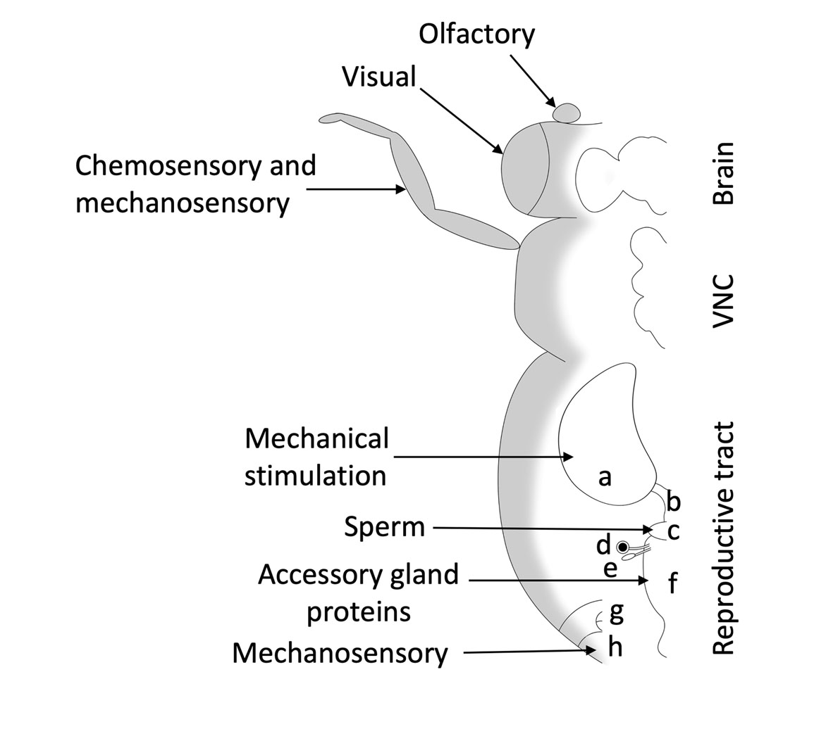
Figure 3.1. The female reproductive structures and sensory input. a. Ovary, b. Oviduct, c. Seminal receptacle d. Spermatheca, e. Female accessory glands, f. Female genital chamber (uterus), g. Analia, h. Female external terminalia (Ovipositor). Arrows indicate locations where females receive sensory inputs that direct egg-laying behavior.
Figure 3.2. The Juvenile hormone (JH) titer throughout the adult female D. melanogaster’s life. After eclosion, the JH spike results in the maturation of the female reproductive tract. After mating, the sex peptide stimulates the corpus allatum to produce JH. This spike in JH results in increased egg production.

Figure 3.3. Sex determination cascade in Drosophila. The genes fruitless (fru) and doublesex (dsx) are critical players in sex determination, and both are expressed in various neurons involved in reproductive behavior. Sex-lethal (Sxl) regulates the expression of transformer (tra) and controls aspects of female neuronal development through the tra-insufficient feminization (TIF) pathway. fru and dsx, in turn, are regulated by tra. Expression of tra in females modulates fru expression and results in a small peptide called FruF with no known function.

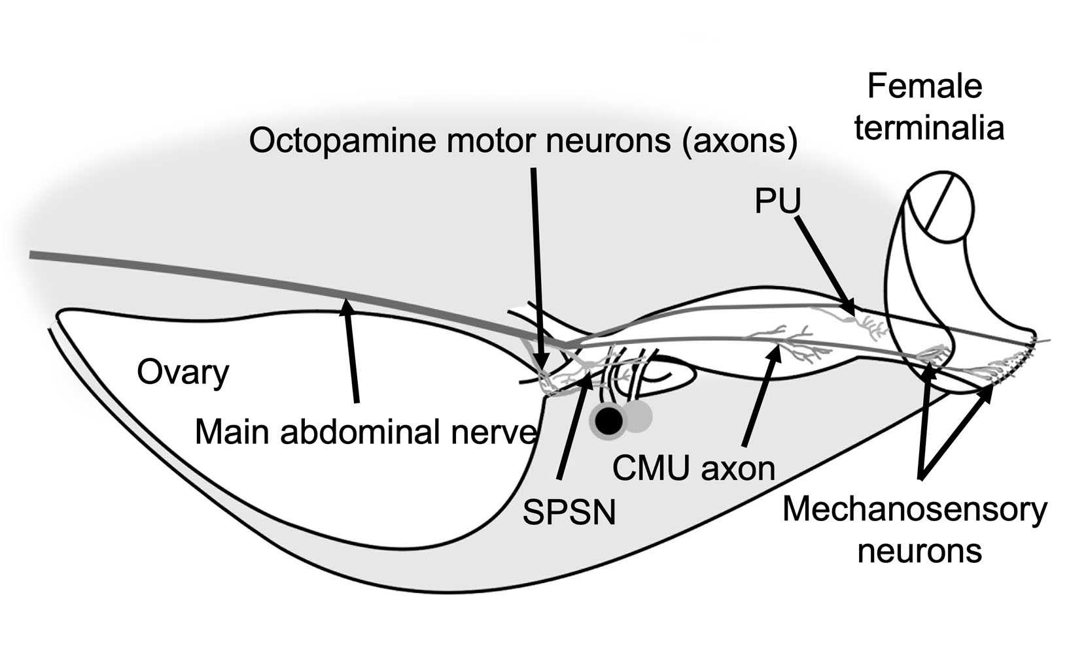
Figure 3.4. Diagram of the major components of the female D. melanogaster female reproductive tract. Motor and sensory neurons in the abdomen affect egg-laying behavior. Sensory neurons are depicted in green, and motor neuron axons are shown in red. SPSN are the primary neurons known to specify the egg-laying behavior through SP pathways. Octopaminergic neurons comprise the majority of motor neurons and modulate egg and sperm release through muscle movement.
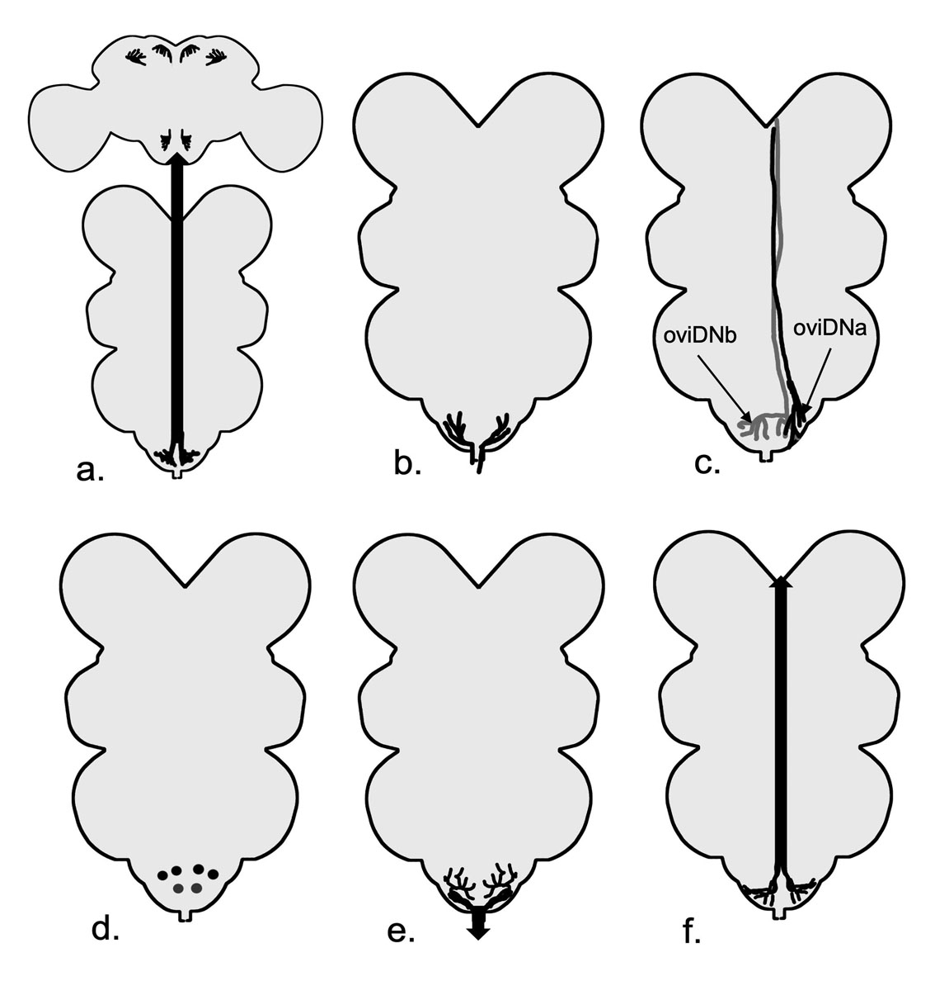

Figure 3.5. The schematic diagram neurons arborizing or residing in the abdominal neuromere (ANm). a. The SAG neuron in the ANm and their arborization in the brain. b. SPSN arborizations in the ANm. c. Right oviDNa (shown in black) and oviDNb (shown in grey) arborizations descending from the right hemisphere of the brain. d. MIP expressing vAL (dsx+) neurons (black) and vAM neurons (grey). e. CMU neurons. f. LSANs.
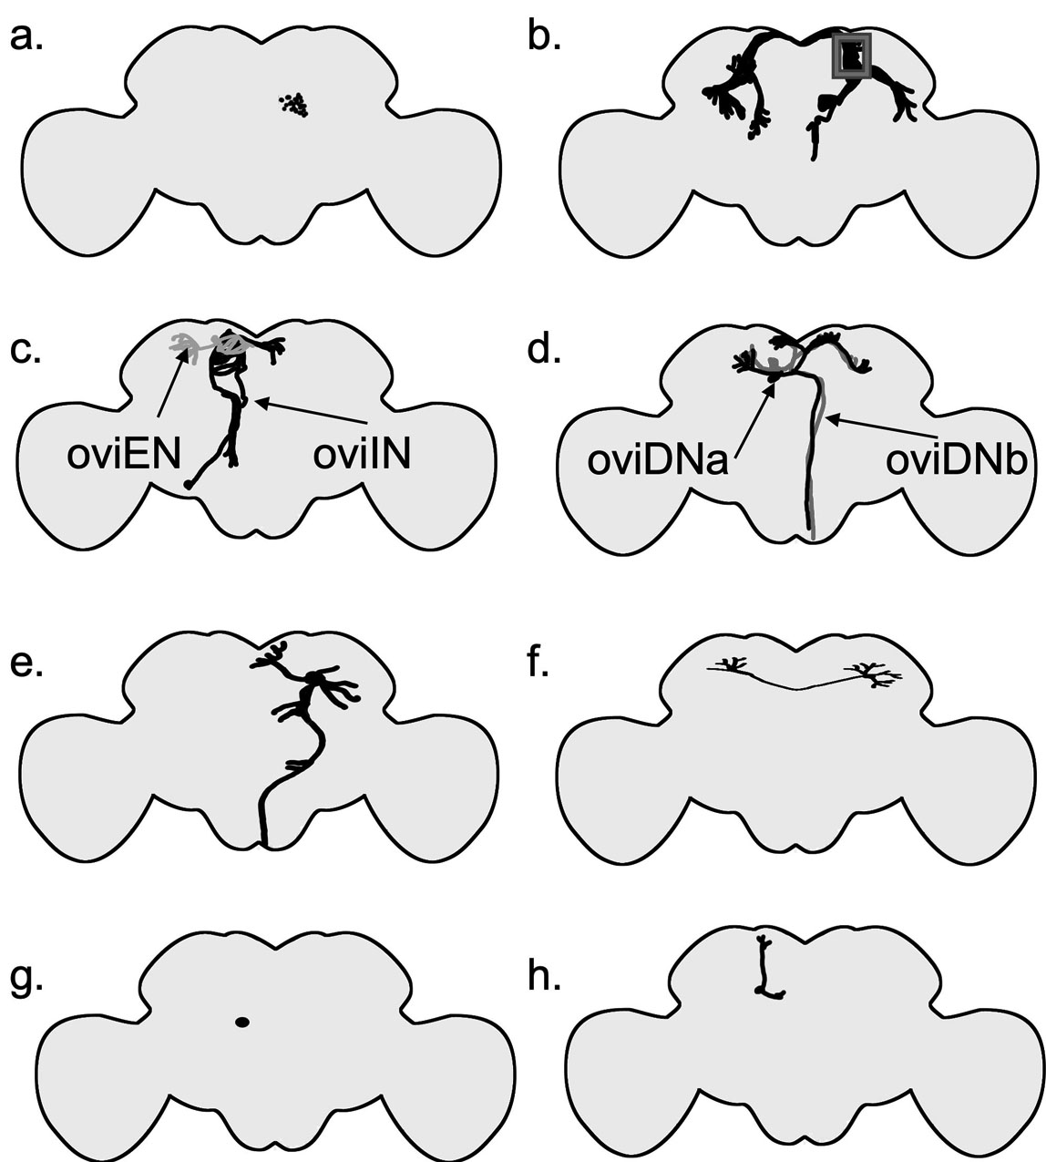
Figure 3.6. Schematic fly brain and location of neurons known to affect egg laying. Only cells from one hemisphere of the brain are depicted. a. pC1 neuron cell bodies. b. pC1 neurons shown with their arborizations; the Lateral Junction, a site of convergence for the majority of dsx+ neuron projections, is highlighted with a grey box. c. oviIN (shown in black) and oviEN (shown in grey) neurons. d. oviDNa (shown in black) and oviDNb (shown in grey) neurons. e. pMN2 neuron. f. pC2l neuron. g. DNp13 (pMN1) neuron cell body. h. dorsal paired medial (DPM) neuron.
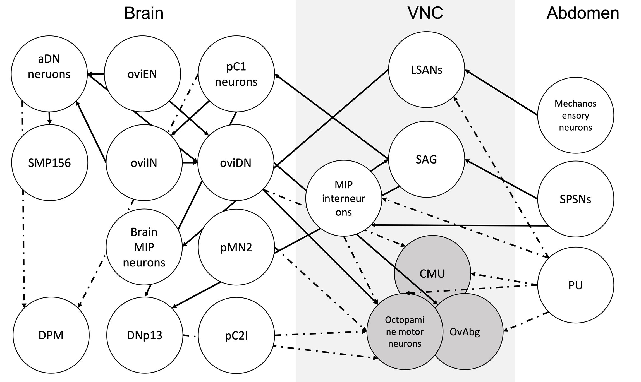

Figure 3.7. Interactions between neurons that affect egg-laying. The black arrows indicate a known connection, and the dashed arrows show a potential connection. Circles with gray color show motor neurons.
Chapter 4
Mechanosensation has wide implications in the egg-laying behavior of female Drosophila
4.1 Abstract:
Sensory modulation is an essential component of female reproduction. Mechanosensation is necessary for three stages that direct egg-laying behavior: (1) Sensing of the act of copulation, (2) ovulation and the feedback of the movement of the mature egg through the reproductive tract, and (3) the probing and selection of the substrate for egg deposition. Here, I identify the sensory sensilla on the female terminalia that mediate sensing copulation and appear to be involved in egg-laying. My focus was on the bilateral regions of the female terminalia that are candidates for sensing the epandarial posterior lobes size and shape. The epandarial posterior lobes are novel male structures that come into contact with the female abdomen. I found that most bristles on the female abdomen, including on the sensilla of female terminalia are cholinergic and express Piezo, a mechanosensory channel gene. I show that Drosophila females that are Piezo null lay significantly fewer eggs than normal females even though their mating duration and sperm storage show no significant differences from wild type controls. Further, I use laser ablation to target a specific group of mechanosensory sensilla on female terminalia and show that ablation of almost all the sensilla significantly reduces the female’s egg-laying. Lastly, I show that female terminalia sensory neurons along with other neurons innervating the female reproductive tract and the Wheeler’s Organ are fru P1+. Taken together, this study provides further evidence that mechanosensory neurons are necessary for proper egg-laying of female Drosophila.
4.2 Introduction
The modulation of where and how many eggs an organism lays can have substantial fitness implications, as egg production is an important milestone in an organism’s life history (Harshman and Zera 2007). Based on their life-history strategy, females can invest significant resources towards oogenesis, embryogenesis, and parental care, which can make female reproduction a costly endeavor (Williams 2005). Therefore, the machinery of egg production should be optimized enough to produce viable and fertile offspring but also flexible enough to take in external and internal cues to avoid wasting the female’s precious resources (Rosenheim et al. 2000; Wang et al. 2001; Williams 2005; Harshman and Zera 2007; Duménil et al. 2016; Mirth et al. 2019). Females can assess external cues, including tactile stimuli, using their sensory neurons. For instance, egg-laying site selection in Drosophila melanogaster can be affected by the chamber size and sugar source available to the female (Schwartz et al. 2012). On the other hand, neurons in D. suzukii’s labellum have lost most of their response to sugars, which can explain this species’ ecological shift to fresh fruit as an oviposition site (Wang et al. 2022).
From an ecological and evolutionary perspective, the choice of environment for oviposition can have major consequences for the survival of offspring (Schwartz et al. 2012). Female D. melanogaster are particular about the oviposition environment and will reduce their egg-laying if a good substrate is not available (Yang et al. 2008; Duménil et al. 2016). Another example is the pest species D. suzukii. This species uses its ovipositor to assess the firmness and penetrate the substrate (Atallah et al. 2014). It has been shown that neurons in D. suzukii female terminalia express the mechanosensory channel Piezo (Crava et al. 2020). Collectively, previous studies have shown that mechanosensory modulation is vital for female reproductive behavior, and more in-depth studies are necessary to decipher the role of mechanosensation in the evolution of female behaviors and structures.
Post-mating responses (PMRs) are a group of behaviors that are manifested after mating in female flies, including an increase in egg-laying (Rubinstein and Wolfner 2013), and a reduction in receptivity to remating (Newell et al. 2020). Various molecules and sensory cues are known to modulate PMRs. On the other hand, the seminal fluid protein Ovulin induces higher ovulation after mating, with a peak of ovulation 24 hours after mating (Herndon and Wolfner 1995). In contrast, the seminal fluid protein Sex peptide reduces female receptivity (Kubli 2003; Yang et al. 2023), and sperm and Sex peptide both stimulate aggression (Bath et al. 2017). Although PMRs have been primarily studied as a function of products transferred from the male to the female, mechanoreceptors also play a crucial role in female PMRs in Drosophila. Sensing of the act of copulation has been shown to be a component of mating in Drosophila that affects PMRs (Shao et al. 2019).
In addition, Eberhart (1994) details the widespread courtship during and after mating in insects and spiders, which mostly involves mechanosensation. Vibrational communication in the form of abdominal quivers is present during courtship and during copulation and has been shown to increase receptivity in females (Eberhard 1994; Fabre et al. 2012). Females also display vibrational communication during mating in the form of the female song; however, disruption of the female song does not seem to affect the number of eggs laid by the female (Kerwin et al. 2020). The available evidence suggests that the mechanosensory aspect of copulation is important and can provide signals to the female that help her assess the quality of the mating and potentially adjust egg-laying accordingly.
The Drosophila abdomen possesses a pair of chordotonal organs within the second abdominal segment called Wheeler’s organs (Miller and Demerec, 1950). Each of the Wheeler’s chordotonal structures consists of 20 scolopidia (Jarman et al. 1993). A scolopidium has a chamber filled with fluid and one to three neurons with their cilia enclosed in the chamber (Kernan 2007); in the case of the Drosophila Wheeler’s organ, there is one neuron per scolopidium (Eberl and Boekhoff-Falk 2007). The Wheeler’s organ sends its projections directly to the second abdominal neuromere through the second abdominal nerve (Court et al. 2020). In other insects, for instance Orthoptera, abdominal chordotonal organs are associated with song reception (Field and Matheson 1998). Yack and Fullard (1993) suggested abdominal chordotonal as hearing organs in Diptera and a few other insect orders. However, this has not been validated by experimental data. Taken together, Yack and Fullard's (1993) suggestion highlights that there are more sensory signals to explore during Drosophila mating that could potentially affect the female reproductive output and the paternity of the offspring.
In D. melanogaster, ovulation is modulated by octopamine motor neurons and wave-like contractions of the oviduct muscle (Monastirioti 2003; Rodríguez-Valentín et al. 2006; Rezával et al. 2014; White et al. 2021). For the egg to pass through the female reproductive tract properly, sensory feedback is required to direct its movement. Cury and Axel (2023) showed that a cluster of sensory neurons on the posterior end of the uterus detects the movement of the egg from the end of the uterus to the ovipositor and the expulsion of the egg. The movement of the egg through the uterus and the expulsion of the egg are directed by a pair of circular muscles surrounding uterine neurons that appear to be glutaminergic (Cury and Axel 2023).
The members of four sister species of D. melanogaster are D. mauritina, D. simulans, D. melanogaster, and D. sechellia (Jagadeeshan and Singh 2006). These species possess a pair of cuticular outgrowths on the male genitalia called epandaril posterior lobes (ePLs) (Rice et al. 2019). Even though these four sister species have newly diverged from each other, the shape and size of the ePLs vary drastically between them (Coyne et al. 1991; Jagadeeshan and Singh 2006; Yassin and Orgogozo 2013), following the trend of the rapid evolution of male genitalia (Eberhard 1985, 2010). The ePLs help the males to hold on to the female during mating, and genetic manipulation (Frazee and Masly 2015) or laser ablation (LeVasseur-Viens et al. 2015) of these structures results in the male falling off the female. Yassin and Orgogozo (2013) suggested that the hypogynial posterodorsal pouch (oviscapt pouches) corresponds to the ePL in the four sister species, with D. simulans having the biggest pouch.
The copulation anatomy of Drosophila species has been well studied (Kamimura 2007; Kamimura and Mitsumoto 2011; Masly and Kamimura 2014; Inatomi et al. 2019). For example, Kamimura and Mitsumoto (2011), have shown that the ePLs inset between the VII and VIII segments of the female abdomen and come into contact with the epigynium. The epigynium is the VIII segment of the female abdomen and is a horse-shoe-shaped segment that surrounds the analia (McQueen et al., 2022). The epigynial ventral lobe has 4 to 5 sensilla in D. melanogaster (McQueen et al. 2022).
In this Chapter, I identified the sensilla on the female terminalia at the ePL insertion sites and quantified the number of epigynial sensilla of the four sister species of D. melanogaster. I used a laser to ablate the epigynial sensilla of female terminalia that I hypothesized are necessary for the assessment of the size of the male genitalia by the female during mating. I explored these sensory bristles more in D. melanogaster using genetic markers, including mechanosensory channels, neurotransmitters, and sex-determination pathway genes. I identified the mechanosensory neurons in the female Drosophila abdomen and terminalia and studied their neurotransmitter identity. In addition, I explored the mechanosensory channel-expressing neurons with a focus on the female terminalia and studied the effect of the knockout of the mechanosensory channel Piezo on female egg-laying. In addition, I tested the effect that Choline acetyltransferase (ChAT) has on female egg-laying.
4.3 Materials and methods:
Fly stocks and maintenance
Flies were reared on cornmeal-molasses-yeast medium at room temperature (23- 25 °C) and maintained on a 12-hour diurnal cycle. For most behavioral experiments, I collected virgin male and virgin female flies and aged them for 3 days prior to mating. For the female bristle laser ablation experiment, virgin flies were allowed to recover for a total of 5 days. The flies for the bristle laser ablation experiment were shipped from Ohio to Oklahoma. The flies were on the way for two days after laser ablation and recovered for 3 days after arriving in Oklahoma. To count the number of eggs accurately, I dyed the food with bromophenol blue (Sigma Aldrich CAT# 34725-61-6) at a concentration of ~0.08 g L⁻¹.
Laser ablation behavioral assays
For the laser ablation experiment, virgin D. melanogaster CantonS females were collected and aged as described above. For the laser ablation, we collaborated with Dr. Michal Polak from University of Cincinnati at Ohio. Dr. Polak used an Olympus (Center Valley, PA, USA) IX71 inverted light microscope with pulsed laser from a Vector 532-1000-20 Q-switched laser (Coherent, Santa Clara, CA, USA) that was focused through an Olympus UplanApo 20× objective to ablate the sensilla on the female epigynium for the experimental flies, and the ablation of other abdominal sensilla or laser treatment of the body for the control flies. Laser-ablated and control females (the five groups mentioned above) were then shipped back to the University of Oklahoma for behavioral assays. I mated the flies to virgin control males, observed their mating, and recorded the mating duration in minutes. I counted their eggs, egg cases, and larvae were counted every two days for a total of 10 days. I received the flies in 5 unknown groups (i.e., single blind experiment). Additionally, I collected virgin flies on the day of laser ablation as a baseline, unshipped control. I scored the egg counts of the laser-ablated flies blindly. I set up all the matings and behavioral experiments on two days consecutive days, consisting of two morning sets and two afternoon sets. After the conclusion of the behavioral experiments, Dr. Polak revealed the identity of each of the five groups to me, which were as follows: group 1 severe laser ablation, group 2 laser ablation, group 3 control shipment, group 4 severe laser control and group 5 laser control. I scored all females for the number of sensilla that had been ablated on the female genitalia. I counted the number of ablated sensilla and grouped them into three groups: (1) Severe ablation, where 8-10 sensilla were ablated; (2) Medium ablation, with 6-7 sensilla ablated; and (3) low ablation, with less than 6 sensilla ablated.
Mechanosensory neuron identification
I used SEM microscopy to explore the morphology of the female terminalia of D. sechellia and D. mauritina. I used GAL4/UAS and LexA/LexAop systems and expressed the green fluorescent protein (GFP) to identify the individual sensory neurons in the female (Table 4.1). Images of the female abdomens were obtained using either using a Leica SP8 confocal or SP2 Zeiss Axioskop. The 3D renderings of the abdomen were generated using Imaris imaging software (version 9.1). To test the effect of Piezo on egg laying, I used the complete loss of function Piezo[ko] (Kim et al. 2012). Kim et al. (2012) created Piezo[ko] by deleting all the exons of this gene using genomic recombination. They also showed that the mechanosensory potential of thoracic bristle to gentle touch remained intact in the Piezo[ko] line (Kim et al. 2012). I used both D. melanogaster CantonS and D. melanogaster Berlin as control lines.
Piezo^{-/-} behavioral assays
I collected the virgin males and females and aged them for three days. I put the male and female together in a blue food vial, observed the mating, and the mating duration was visually observed and timed. I then removed the male and moved the female to a new blue food vial every two days and repeated the process for a total of 10 days. To test the effect of Piezo[ko] on sperm storage, I mated wildtype and Piezo[ko] virgin female flies to dj-GFP male flies, which express GFP in the sperm cell tails. Then, I dissected two sets of females: in one group the female reproductive tract was dissected 30 minutes after mating in cold PBS and in another group the female reproductive tract was dissected in cold PBS 90 minutes after mating. I then recorded the position and presence of the sperm in the reproductive tract using the SP2 Zeiss microscope fluorescent microscope.
Data analysis
Statistical analysis was done using R version 4.0.5 (R Core Team, 2017). I created all the graphs using ggplot2 (Wickham, 2016). I tested the normality of our data using the Shapiro-Wilk normality test and Bartlett test for homogeneity of variances. I used the Student’s t-test or Mann-Whitney U test to compare control and experimental treatments to test the Piezo[ko] behavioral experiments. For the laser ablation study, I used Kruskal-Wallis with Wilcox test post-hoc test to compare mating duration and ANOVA and Tukey as a post-hoc test to compare the total number of eggs. Our explanatory variable was the different groups of laser treatment and their controls, and our response variables were mating duration and the total number of eggs laid.
4.4 Results:
Identification of the female PNS bristles at the ePL insertion site
I used the previously described copulation anatomy by Kamimura and Mitsumoto (2011) between the four sister species to determine the regions of female teminalia that come into contact with the ePLs. I used SEM electron microscopy to explore the sensory bristle morphology on the female terminalia of D. sechellia and D. mauritina (Figure 4.1). Our observations show that the sensilla on the epigynium and the hypogynial teeth are close-ended bristles, suggesting a mechanosensory function for them.
The average number of sensilla on the epigynium varies significantly among the four sister species of D. melanogaster
I quantified the number of bristles on the female epigynium between the four sister species of D. melanogaster (Figure 4.2, supplement figure 4.1). I chose epigynium because these sensilla come into contact with ePLs and because these structures are not directly on the female ovipositor itself. D. melanogaster (n= 30) and D. mauritina (n=31) had an average number of 4 bristles with some individuals having a higher number of sensilla. D. simulans (n=26) also had an average number of 4 bristles but there were more individuals who had an average of 3 bristles. D. sechellia (n=30) had the lowest number of sensilla on the epigynium, with the average being 2 sensilla. There was a significant difference between the number of bristles between D. sechellia (pairwise Wilcox test, Benjamini-Hochberg correction, p-value<0.0001) and the other three species. There were significant differences in bristle numbers between D. simulans and D. melanogaster (pairwise Wilcox test, Benjamini-Hochberg correction, p-value=0.0083) as well as D. mauritina (pairwise Wilcox test, Benjamini-Hochberg correction, p-value=0.0015).
Mechanosensory sensilla on the female terminalia have the potential to modulate egg-laying.
I used laser ablation to test for the effect of mechanosensory cues during copulation on the female’s egg-laying behavior. Our data showed no significant difference between flies that have their sensilla ablated and the various control flies, except for the control females with severe laser treatment and control females who were not shipped (Wilcoxon test, p-value=0.044) (Figure 4.3). However, the two individuals who had all their epigynium sensilla ablated deposited almost no eggs. To understand the relationship between the number of bristles ablated and egg-laying, I binned the terminalia laser-treated flies into groups (Figure 4.4). Our data showed that there was a significant change in egg-laying (ANOVA, df=3, p-value= 0.0006). Additionally, I inspected the anatomical location of each sensilla on the epigynium and its correlation with the decrease in egg-laying. There was no correlation between the anatomical location of the sensilla. However, the last sensilla is hard to access and was only ablated in individuals in the severe ablation group.
Mechanosensory neurons of the female reproductive tract and female terminalia are marked by both sex determination and mechanosensory markers
To uncover the nature of sensory neurons of female terminalia, I used several GAL4/UAS and LexA/LexAop lines. Out of the lines I screened (Table 4.1), three sets of lines caught our interest: fru-P1-GAL4 and fru-P1-LexA, Piezo-GAL4 and Chat-GAL4. The surprising discovery was fru-P1-GAL4 and fru-P1-LexA, which labeled all the mechanosensory neurons on the female terminalia (Figure 4.5 A, B). The product of fru-P1 is a small molecule that gets degraded, while in males, fru-P1 gives rise to FRUM protein that modulates many sex-specific functions (Demir and Dickson 2005 p. 1; Kimura et al. 2005, 2008). Furthermore, fru-P1 lines labeled neurons on the reproductive tract (Figure 4.5 C) and abdominal ganglion. The Piezo-GAL4 transgene was found to be expressed in all female terminalia neurons (Figure 4.5 D) as well as all the other mechanosensory sensilla on the body. There were Piezo-expressing neurons on the reproductive tract as well. ChAT-GAL4 labeled epigynium sensilla and other sensory neurons on the fly’s body (Figure 4.5 E). The localization of Tdc2+ dendrites to the periphery of ANM suggests that they might come into contact with the axons of the sensory neurons from the female terminalia (Supplement Figure 4.5). Other note-worthy lines were the Pox neuro (Poxn) lines, a gene studied with regard to male terminalia development and courtship behavior (Boll and Noll 2002). Although the Poxn lines that I tested did not label any neurons on the female terminalia, Poxn was expressed in the neurons of the female reproductive tract (Figure 4.5 F). While exploring the female sensory neurons, I came across the Wheeler’s organs of D. melanogaster (Figure 4.5 G). These organs are a pair of Poxn+ and fru-P1+ tear-shaped structures on the second abdominal segment.
Piezo^{-/-} females mate for the normal duration but had significantly reduced fecundity compared to wild-type females
Piezo mechanosensory channels are present in sensilla on the female body, including terminalia and sensory neurons innervating the reproductive tract. Female flies that are Piezo[ko] do not show any change in mating duration compared to the controls (Figure 4.6 A, C). However, the Piezo[ko] females lay significantly fewer eggs (Figure 4.6 B, D). The Piezo[ko]do not show any significant difference form the control males (Figure 4.7). To further study this phenomenon, I tested the effect of Piezo mechanosensory channels on sperm storage after mating. I found no difference between the presence of sperm in the Piezo[ko] and wild-type flies, and both showed sperm in spermatheca and seminal receptacles (Table 4.2, Supplement Figure 4.2 and 4.3). Older Piezo[ko] females show a bloated phenotype (Supplement Figure 4.4). Dissection of older females showed that this phenotype was due to swelling of the gastric tract.
ChAT knockdown driven by fru-P1-GAL4 does not affect mating duration but causes a significant decrease in egg-laying amounts.
Because I discovered that the female teminalia sensilla were both fru-P1+ and ChAT+, I tested the effect of ChAT knockdown using the fru-P1-GAL4 driver. It is important to mention that major players in the egg-laying circuit, like oviposition descending neurons, are also fru+ and cholinergic (Wang et al. 2020). Our data showed ChAT knockdown using the fru-P1-GAL4 result in a significant decrease in female egg laying (Wilcox test, W = 8, p-value = 0.0002) but not mating duration (Figure 4.8).
4.4 Discussion:
Control over egg-laying in Drosophila behavior relies on incoming sensory cues, from the Sfp transferred to the female by the male to mechanosensory signals triggered by the act of mating. In species where females mate with multiple males, it is important for the female to modulate the number of offspring based on the assessment of the male quality not only before the mating but during and post-mating as well. Studies in D. melanogaster have shown that females can reduce their egg-laying due to multiple reasons. For instance, traumatic injury results in a non-significant but consistent decrease in egg-laying and a significant increase in mature oocyte retention (Dixon and McCall 2023). Frazee and Masly (2015) showed that females reduce their egg-laying if the males possess abnormal ePLs. All these examples can be modulated by mechanosensory cues. Therefore, it is crucial that we have a deeper understanding of mechanosensory modulation.
Several studies have looked at the effect of abnormal ePL size and shape on female egg-laying (LeVasseur-Viens et al. 2015; Frazee and Masly 2015; Frazee et al. 2021 and Chapter 1) but the question of how the females sense the ePL size still remained unanswered. Even though the female terminalia of the four sister species look similar, there are subtle differences between them. For example, Yassin and Orgogozo (2013) have compared both male and female genitalia and show that the hypogynial posterodorsal pouch (oviscapt pouches) was more prominent in D. simulans and D. sechellia compared to D. melanogaster. In this present study, I showed that the number of epigynium sensilla was different between the four sister species, and the two species with the most prominent ePL (D.sechellia and D. simulans) varied in the number of sensilla when compared to the other two species (D. melanogaster and D. mauritina).
The Piezo knockout can potentially affect egg-laying in a variety of ways. One potential avenue is that the sperm and seminal fluid are ejaculated and taken- up properly. Based on our results, this is unlikely; at least in the case of sperm storage, the young Piezo knockout females did not show any difference from the controls. However, older females showed a more bloated phenotype, which is concordant with the study conducted by Oh et al. (2021). Another potential explanation for the effect on egg laying could be due to females not receiving sufficient sensory information during mating, as Shao et al. (2019) have postulated. The Piezo mechanosensory channel is necessary for the female to completely manifest the post-mating phenotype of reduced receptivity (Shao et al. 2019). This is independent of the effect of Spfs and sperm, and lack of Piezo channels results in females remating faster (lower mating refractory period)(Shao et al. 2019). The copulation effect refers to the importance of the sensory cues modulated by Piezo channels in female reproductive behavior. Piezo knockout males did not show a significant reduction of egg production in their female partners compared to the controls, but the females averaged slightly fewer eggs (Figure 4.7). Jois et al. (2022) showed that the sensory information received by the male sensory neurons is necessary for copulation persistence.
Another potential mechanism for the reduction of egg-laying may be due to reduced insulin signaling as a result of the inactivity of the crop’s stretch receptors in Piezo[ko] females (Badisco et al. 2013; Oh et al. 2021). It is known that mating increases starvation resistance; furthermore, starvation resistance depends on age (Rush et al. 2007), which corresponds to our observation of older females being more bloated. Lastly, eggs might not be able to properly pass through the oviduct and uterus due to a lack of sensory feedback, which awaits further investigation.
The ablation of a single mechanosensory neuron with a laser had no effect on egg-laying, which was concordant with the flexibility of egg-laying behavior. Vijayan et al. (2023) suggested that the egg-laying motor program is dependent on context to initiate, and the lack of signal from a few sensory neurons might not affect the overall outcome of egg-laying. However, as I have shown here, when all sensilla on the epigynium were removed, then egg-laying was reduced. Another factor to consider can be the trauma of laser treatment; however, none of our controls with burn marks on their bodies showed this amount of decreased response, nor did the females that had more than half of their sensilla’s ablated die prematurely. Cury and Axel (2023), showed that silencing the bristles on the tergite and sternite 7 together with the sensilla on the female terminalia affects the total number of eggs laid based on the firmness of the substrate. The neurons on the epigynium are a small subset of neurons marked by the ABT-1 driver (Cury and Axel 2023). Each subset of neurons marked by the ABT-1 driver could be further explored to identify if each group specializes in different mechanosensory modalities and whether the value of sensory information received by each neuron is context-dependent. Additionally, the arborizations of epigynium sensilla and other terminalia sensilla innervate the abdominal neuromere through the main abdominal nerve. Preliminary data show that the dendrites of the Tdc2+ neurons localize to the midline of the abdominal neuromere making a direct connection between sensory and motor neurons probable (Supplement figure 4.5).
The knockdown of ChAT using the fru-P1-GAL4 driver showed a severe decrease in egg laying compared to the controls. As Wang et al. (2020) discovered, one of the main players in female egg-laying behavior is also fru+ and it is cholinergic. They showed that the silencing of OviDNs neurons resulted in the complete arrest of egg-laying. Our method did not silence the neuron and did not reduce the amount of available mRNA of ChAT. The phenotype that I observed, i.e., reduction of egg-laying, can potentially be the result of both OviDNs and terminalia sensory neurons. In order to test this hypothesis a narrower driver is required.
As mentioned previously, it was suggested, but never proved, that abdominal chordotonal structures can act as hearing organs in Diptera (Fullard and Yack 1993). Here, based on our results, I can hypothesize that in D. melanogaster, there is a strong possibility that Wheeler’s organs do more than proprioception. The expression of Poxn is surprising (Figure 3) as, generally, Poxn is used to identify chemoreceptors (Nottebohm et al. 1994). However, other studies have emphasized the importance of Poxn in the development of the nervous system (Dambly-Chaudière et al. 1992) and courtship behavior (Boll and Noll 2002). It is known that female Drosophila exhibit singing behavior during mating (Kerwin et al. 2020) and the vibrational attributes of the male courtship of various species has been extensively studied (Mazzoni et al. 2013). I think that Wheeler’s organs are in an ideal position to receive vibrational sensory cues during mating for both males and females, and the expression sex determinant fru and the courtship gene Poxn suggest that these neurons might have sex-specific tasks and identities. Currently, our preliminary data do not show any significant differences in egg-laying between female flies Poxn knockdown using fru-P1 driver, but egg-laying might not be the ideal phenotype to test. For future research, I suggest testing the rate of female song and male seminal fluid composition in Poxn knockdown in males and females.
In conclusion, both external and internal mechanosensory structures are necessary for proper egg-laying behavior in female fruit flies and changes in these mechanisms can reduce the female’s fecundity. Moreover, mechanosensation is necessary for the female to assess the quality of its mate and the suitability of the environment for oviposition. Our findings suggest that variation in mechanosensory modulation can give rise to new female preferences.
4.5 Reference:
Atallah J., L. Teixeira, R. Salazar, G. Zaragoza, and A. Kopp, 2014 The making of a pest: the evolution of a fruit-penetrating ovipositor in Drosophila suzukii and related species. Proceedings of the Royal Society B. 281: 20132840. https://doi.org/10.1098/rspb.2013.2840
Badisco L., P. Van Wielendaele, and J. Vanden Broeck, 2013 Eat to reproduce: a key role for the insulin signaling pathway in adult insects. Frontiers in Physiology. 4. https://doi.org/10.3389/fphys.2013.00202
Bath E., S. Bowden, C. Peters, A. Reddy, J. A. Tobias, et al., 2017 Sperm and sex peptide stimulate aggression in female Drosophila. Nature Ecology and Evolution 1: 0154. https://doi.org/10.1038/s41559-017-0154
Boll W., and M. Noll, 2002 The Drosophila Pox neuro gene: control of male courtship behavior and fertility as revealed by a complete dissection of all enhancers. Development 129: 5667–5681. https://doi.org/10.1242/dev.00157
Court R., S. Namiki, J. D. Armstrong, J. Börner, G. Card, et al., 2020 A Systematic Nomenclature for the Drosophila Ventral Nerve Cord. Neuron 107: 1071-1079.e2. https://doi.org/10.1016/j.neuron.2020.08.005
Coyne J. A., J. Rux, and J. R. David, 1991 Genetics of morphological differences and hybrid sterility between Drosophila sechellia and its relatives. Genet. Res. 57: 113–122. https://doi.org/10.1017/S0016672300029177
Crava C. M., D. Zanini, S. Amati, G. Sollai, R. Crnjar, et al., 2020 Structural and transcriptional evidence of mechanotransduction in the Drosophila suzukii ovipositor. Journal of Insect Physiology 125: 104088. https://doi.org/10.1016/j.jinsphys.2020.104088
Cury K. M., and R. Axel, 2023 Flexible neural control of transition points within the egg-laying behavioral sequence in Drosophila. Nature Neuroscience 26: 1054–1067. https://doi.org/10.1038/s41593-023-01332-5
Dambly-Chaudière C., E. Jamet, M. Burri, D. Bopp, K. Basler, et al., 1992 The paired box gene pox neuro: A determiant of poly-innervated sense organs in Drosophila. Cell 69: 159–172. https://doi.org/10.1016/0092-8674(92)90127-X
Demir E., and B. J. Dickson, 2005 fruitless Splicing Specifies Male Courtship Behavior in Drosophila. Cell 121: 785–794. https://doi.org/10.1016/j.cell.2005.04.027
Dixon C., and K. McCall, 2023 Characterization of female reproductive disturbances post-traumatic injury in Drosophila melanogaster. MicroPublications in Biology 2023. https://doi.org/10.17912/micropub.biology.000883
Duménil C., D. Woud, F. Pinto, J. T. Alkema, I. Jansen, et al., 2016 Pheromonal Cues Deposited by Mated Females Convey Social Information about Egg-Laying Sites in Drosophila melanogaster. Journal of Chemical Ecology 42: 259–269. https://doi.org/10.1007/s10886-016-0681-3
Eberhard W. G., 1985 Sexual Selection and Animal Genitalia: Harvard University Press.
Eberhard W. G., 1994 Evidence for Widespread Courtship During Copulation in 131 Species of Insects and Spiders, and Implications for Cryptic Female Choice. Evolution 48: 711. https://doi.org/10.2307/2410481
Eberhard W. G., 2010 Evolution of genitalia: theories, evidence, and new directions. Genetica 138: 5–18. https://doi.org/10.1007/s10709-009-9358-y
Eberl D. F., and G. Boekhoff-Falk, 2007 Development of Johnston’s organ in Drosophila. International Journal of Developmental Biology 51: 679–687. https://doi.org/10.1387/ijdb.072364de
Fabre C. C. G., B. Hedwig, G. Conduit, P. A. Lawrence, S. F. Goodwin, et al., 2012 Substrate-Borne Vibratory Communication during Courtship in Drosophila melanogaster. Current Biology 22: 2180–2185. https://doi.org/10.1016/j.cub.2012.09.042
Field L. H., and T. Matheson, 1998 Chordotonal Organs of Insects, pp. 1–228 in Advances in Insect Physiology, Elsevier.
Frazee S. R., and J. P. Masly, 2015 Multiple sexual selection pressures drive the rapid evolution of complex morphology in a male secondary genital structure. Ecology and Evolution 5: 4437–4450. https://doi.org/10.1002/ece3.1721
Frazee S. R., A. R. Harper, M. Afkhami, M. L. Wood, J. C. McCrory, et al., 2021 Interspecific introgression reveals a role of male genital morphology during the evolution of reproductive isolation in Drosophila. Evolution 75: 989–1002. https://doi.org/10.1111/evo.14169
Fullard J. H., and J. E. Yack, 1993 The evolutionary biology of insect hearing. Trends in Ecology & Evolution 8: 248–252. https://doi.org/10.1016/0169-5347(93)90200-9
Harshman L. G., and A. J. Zera, 2007 The cost of reproduction: the devil in the details. Trends in Ecology & Evolution 22: 80–86. https://doi.org/10.1016/j.tree.2006.10.008
Herndon L. A., and M. F. Wolfner, 1995 A Drosophila seminal fluid protein, Acp26Aa, stimulates egg laying in females for 1 day after mating. Proceedings of the National Academy of Sciences 92: 10114–10118. https://doi.org/10.1073/pnas.92.22.10114
Inatomi M., D. Shin, Y.-T. Lai, and K. Matsuno, 2019 Proper direction of male genitalia is prerequisite for copulation in Drosophila, implying cooperative evolution between genitalia rotation and mating behavior. Scientific Reports 9: 210. https://doi.org/10.1038/s41598-018-36301-7
Jagadeeshan S., and R. S. Singh, 2006 A time-sequence functional analysis of mating behaviour and genital coupling in Drosophila: role of cryptic female choice and male sex-drive in the evolution of male genitalia. Journal of Evolutionary Biology 19: 1058–1070. https://doi.org/10.1111/j.1420-9101.2006.01099.x
Jarman A. P., Y. Grau, L. Y. Jan, and Y. N. Jan, 1993 atonal is a proneural gene that directs chordotonal organ formation in the Drosophila peripheral nervous system. Cell 73: 1307–1321. https://doi.org/10.1016/0092-8674(93)90358-W
Kamimura Y., 2007 Twin intromittent organs of Drosophila for traumatic insemination. Biology Letters 3: 401–404. https://doi.org/10.1098/rsbl.2007.0192
Kamimura Y., and H. Mitsumoto, 2011 Comparative copulation anatomy of the Drosophila melanogaster species complex (Diptera: Drosophilidae): Copulation anatomy of Drosophila. Entomological Science 14: 399–410. https://doi.org/10.1111/j.1479-8298.2011.00467.x
Kernan M. J., 2007 Mechanotransduction and auditory transduction in Drosophila. Pflügers Archiv: European Journal of Physiology 454: 703–720. https://doi.org/10.1007/s00424-007-0263-x
Kerwin P., J. Yuan, and A. C. Von Philipsborn, 2020 Female copulation song is modulated by seminal fluid. Nature Communications 11: 1430. https://doi.org/10.1038/s41467-020-15260-6
Kim S. E., B. Coste, A. Chadha, B. Cook, and A. Patapoutian, 2012 The role of Drosophila Piezo in mechanical nociception. Nature 483: 209–212. https://doi.org/10.1038/nature10801
Kimura K.-I., M. Ote, T. Tazawa, and D. Yamamoto, 2005 Fruitless specifies sexually dimorphic neural circuitry in the Drosophila brain. Nature 438: 229–233. https://doi.org/10.1038/nature04229
Kimura K., T. Hachiya, M. Koganezawa, T. Tazawa, and D. Yamamoto, 2008 Fruitless and Doublesex Coordinate to Generate Male-Specific Neurons that Can Initiate Courtship. Neuron 59: 759–769. https://doi.org/10.1016/j.neuron.2008.06.007
Kubli E., 2003 Sex-peptides: seminal peptides of the Drosophila male. Cellular and Molecular Life Sciences (CMLS) 60: 1689–1704. https://doi.org/10.1007/s00018-003-3052
LeVasseur-Viens H., M. Polak, and A. J. Moehring, 2015 No evidence for external genital morphology affecting cryptic female choice and reproductive isolation in Drosophila: Genital shape and sexual selection. Evolution 69: 1797–1807. https://doi.org/10.1111/evo.12685
Masly J. P., and Y. Kamimura, 2014 Asymmetric mismatch in strain-specific genital morphology causes increased harm to Drosophila females: brief communication. Evolution n/a-n/a. https://doi.org/10.1111/evo.12436
Mazzoni V., G. Anfora, and M. Virant-Doberlet, 2013 Substrate Vibrations during Courtship in Three Drosophila species, (T. M. Jones, Ed.). PLoS ONE 8: e80708. https://doi.org/10.1371/journal.pone.0080708
McQueen E. W., M. Afkhami, J. Atallah, J. M. Belote, N. Gompel, et al., 2022 A standardized nomenclature and atlas of the female terminalia of Drosophila melanogaster. Fly 16: 128–151. https://doi.org/10.1080/19336934.2022.2058309
Mirth C. K., A. Nogueira Alves, and M. D. Piper, 2019 Turning food into eggs: insights from nutritional biology and developmental physiology of Drosophila. Current Opinion in Insect Science 31: 49–57. https://doi.org/10.1016/j.cois.2018.08.006
Monastirioti M., 2003 Distinct octopamine cell population residing in the CNS abdominal ganglion controls ovulation in Drosophila melanogaster. Developmental Biology 264: 38–49. https://doi.org/10.1016/j.ydbio.2003.07.019
Newell N. R., S. Ray, J. E. Dalton, J. C. Fortier, J. Y. Kao, et al., 2020 The Drosophila Post-mating Response: Gene Expression and Behavioral Changes Reveal Perdurance and Variation in Cross-Tissue Interactions. G3 Genes|Genomes|Genetics 10: 967–983. https://doi.org/10.1534/g3.119.400963
Nottebohm E., A. Usui, S. Therianos, K. Kimura, C. Dambly-Chaudiére, et al., 1994 The gene poxn controls different steps of the formation of chemosensory organs in Drosophila. Neuron 12: 25–34. https://doi.org/10.1016/0896-6273(94)90149-X
Oh Y., J. S.-Y. Lai, S. Min, H.-W. Huang, S. D. Liberles, et al., 2021 Periphery signals generated by Piezo-mediated stomach stretch and Neuromedin-mediated glucose load regulate the Drosophila brain nutrient sensor. Neuron 109: 1979-1995.e6. https://doi.org/10.1016/j.neuron.2021.04.028
Rezával C., T. Nojima, M. C. Neville, A. C. Lin, and S. F. Goodwin, 2014 Sexually Dimorphic Octopaminergic Neurons Modulate Female Postmating Behaviors in Drosophila. Current Biology 24: 725–730. https://doi.org/10.1016/j.cub.2013.12.051
Rice G., J. R. David, Y. Kamimura, J. P. Masly, A. P. Mcgregor, et al., 2019 A standardized nomenclature and atlas of the male terminalia of Drosophila melanogaster. Fly 13: 51–64. https://doi.org/10.1080/19336934.2019.1653733
Rodríguez-Valentín R., I. López-González, R. Jorquera, P. Labarca, M. Zurita, et al., 2006 Oviduct contraction in Drosophila is modulated by a neural network that is both, octopaminergic and glutamatergic. Journal of Cellular Physiology 209: 183–198. https://doi.org/10.1002/jcp.20722
Rosenheim J. A., G. E. Heimpel, and M. Mangel, 2000 Egg maturation, egg resorption and the costliness of transient egg limitation in insects. Proceedings of the Royal Society B 267: 1565–1573. https://doi.org/10.1098/rspb.2000.1179
Rubinstein C. D., and M. F. Wolfner, 2013 Drosophila seminal protein ovulin mediates ovulation through female octopamine neuronal signaling. Proceedings of the National Academy of Sciences U.S.A. 110: 17420–17425. https://doi.org/10.1073/pnas.1220018110
Rush B., S. Sandver, J. Bruer, R. Roche, M. Wells, et al., 2007 Mating increases starvation resistance and decreases oxidative stress resistance in Drosophila melanogaster females. Aging Cell 6: 723–726. https://doi.org/10.1111/j.1474-9726.2007.00322.x
Schwartz N. U., L. Zhong, A. Bellemer, and W. D. Tracey, 2012 Egg Laying Decisions in Drosophila Are Consistent with Foraging Costs of Larval Progeny, (F. Marion-Poll, Ed.). PLoS ONE 7: e37910. https://doi.org/10.1371/journal.pone.0037910
Shao L., P. Chung, A. Wong, I. Siwanowicz, C. F. Kent, et al., 2019 A Neural Circuit Encoding the Experience of Copulation in Female Drosophila. Neuron 102: 1025-1036.e6. https://doi.org/10.1016/j.neuron.2019.04.009
Wang Y., A. B. Salmon, and L. G. Harshman, 2001 A cost of reproduction: oxidative stress susceptibility is associated with increased egg production in Drosophila melanogaster. Experimental Gerontology 36: 1349–1359. https://doi.org/10.1016/S0531-5565(01)00095-X
Wang F., K. Wang, N. Forknall, C. Patrick, T. Yang, et al., 2020 Neural circuitry linking mating and egg laying in Drosophila females. Nature 579: 101–105. https://doi.org/10.1038/s41586-020-2055-9
Wang W., H. K. Dweck, G. J. Talross, A. Zaidi, J. M. Gendron, et al., 2022 Sugar sensation and mechanosensation in the egg-laying preference shift of Drosophila suzukii. eLife 11: e81703. https://doi.org/10.7554/eLife.81703
White M. A., D. S. Chen, and M. F. Wolfner, 2021 She’s got nerve: roles of octopamine in insect female reproduction. Journal of Neurogenetics 35: 132–153. https://doi.org/10.1080/01677063.2020.1868457
Wickham H (2016). ggplot2: Elegant Graphics for Data Analysis. Springer-Verlag New York. ISBN 978-3-319-24277-4
Williams T. D., 2005 Mechanisms Underlying the Costs of Egg Production. BioScience 55: 39. https://doi.org/10.1641/0006-3568(2005)055[0039:MUTCOE]2.0.CO;2
Yang C. -h., P. Belawat, E. Hafen, L. Y. Jan, and Y.-N. Jan, 2008 Drosophila Egg-Laying Site Selection as a System to Study Simple Decision-Making Processes. Science 319: 1679–1683. https://doi.org/10.1126/science.1151842
Yang Y. T., S. W. Hu, X. Li, Y. Sun, P. He, et al., 2023 Sex peptide regulates female receptivity through serotoninergic neurons in Drosophila. iScience 26: 106123. https://doi.org/10.1016/j.isci.2023.106123
Yassin A., and V. Orgogozo, 2013 Coevolution between Male and Female Genitalia in the Drosophila melanogaster Species Subgroup, (D. J. Colgan, Ed.). PLoS ONE 8: e57158. https://doi.org/10.1371/journal.pone.0057158

4.6 Figures:
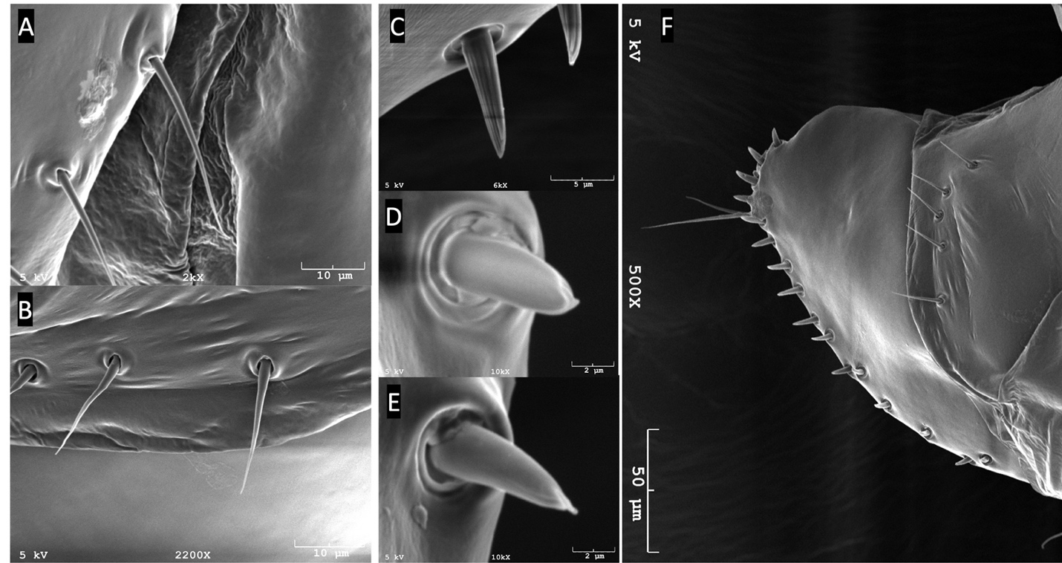
Figure 4.1. The SEM of D. sechellia and D. mauritina. A. The sensilla on the epigynium of D. sechellia. B. The sensilla on the epigynium of D. mauritina. C. Hypogynial tooth of D. mauritina. D. Hypogynial tooth of D. sechellia. E. Hypogynial tooth of D. sechellia. F. Side view of female terminalia in D. mauritina.
Figure 4.2. The number of epigynium sensilla varies significantly between the four sister species. There is a significant difference between the four species (Kruskal-Wallis chi-squared = 74.277, df = 3, p-value<0.0001). D. sechellia is significantly different form the other three species (pairwise Wilcox test, Benjamini-Hochberg correction, p-value<0.0001). D. simulans is different from D. melanogaster (pairwise Wilcox test, Benjamini-Hochberg correction, p-value=0.0083) and D. mauritina (pairwise Wilcox test, Benjamini-Hochberg correction, p-value=0.0015).
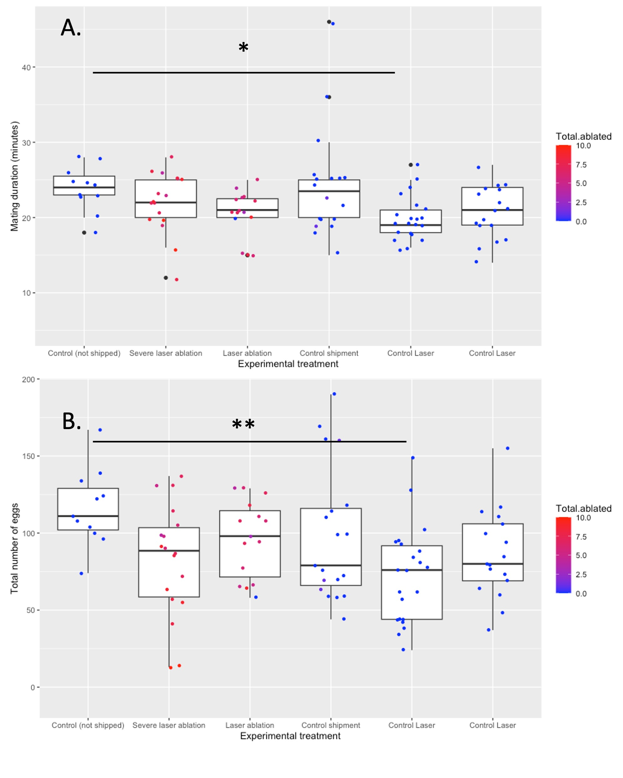
Figure 4.3. The effect of laser ablation on female egg-laying. A. The mating duration did not show any significant difference between the severe laser control and the not shipped control (p-value=0.044). However, there was a significant difference between the control that was not shipped and one of the laser controls where the individuals showed burn marks (p-value=0.044). B. The total number of eggs did not show a significant difference between the controls and the teminalia laser ablation treatments. However, there was a significant difference between the unshipped control and severe laser control (p=0.007). The color gradient indicates the number of total bristles ablated by laser in a sample.

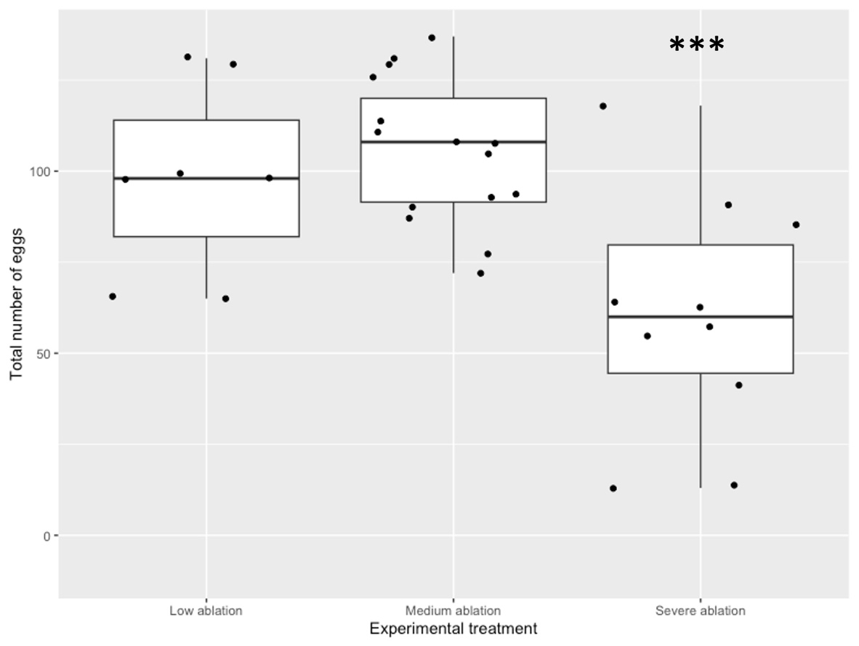
Figure 4.4. There is a significant difference in egg-laying between the females with severe laser ablation of epigynium sensilla (N=9) and females with low (N=7) and medium laser ablation (N=14) (ANOVA, df=2, p-value= 0.000595).

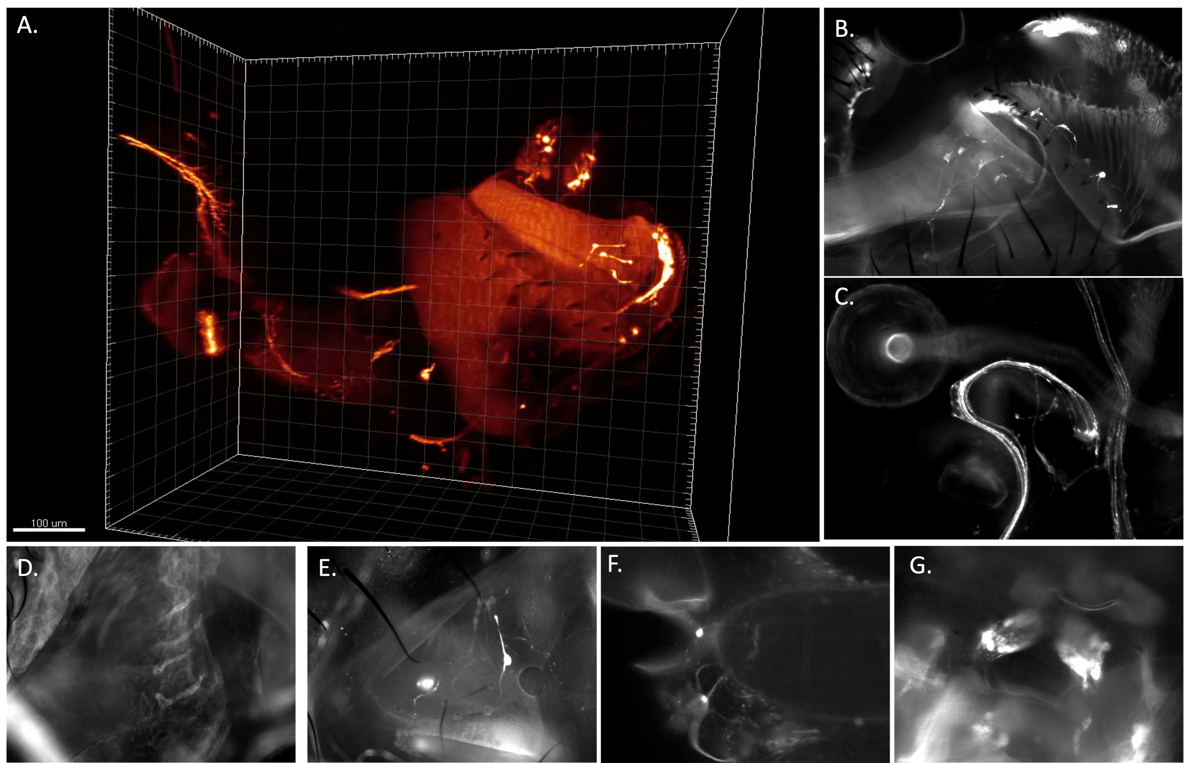
Figure 4.5. The female abdominal sensory neurons. A. The fru-P1-GAL4 transgene is expressed in all the sensilla neurons on the female terminalia, including the sensilla on the ovipositor (hypogynium), analia and eiygynium. B. The fru-P1-GAL4 transgene expression in female genitalia with a focus on epigynium. C. The fru-P1-GAL4 expression in neuronal arborizations next to spermathecae. D. Piezo-GAL4 labels epigynial sensilla. E. ChAT-GAL4 labels epigynial sensilla. F. There are Poxn-GAL4 in the female reproductive tract (note that the dark region is an egg). G. The Wheeler organs are labeled by fru-P1-GAL4. D. The Wheeler organs are labeled Poxn-GAL4 with a broad enhancer (Poxnw280).
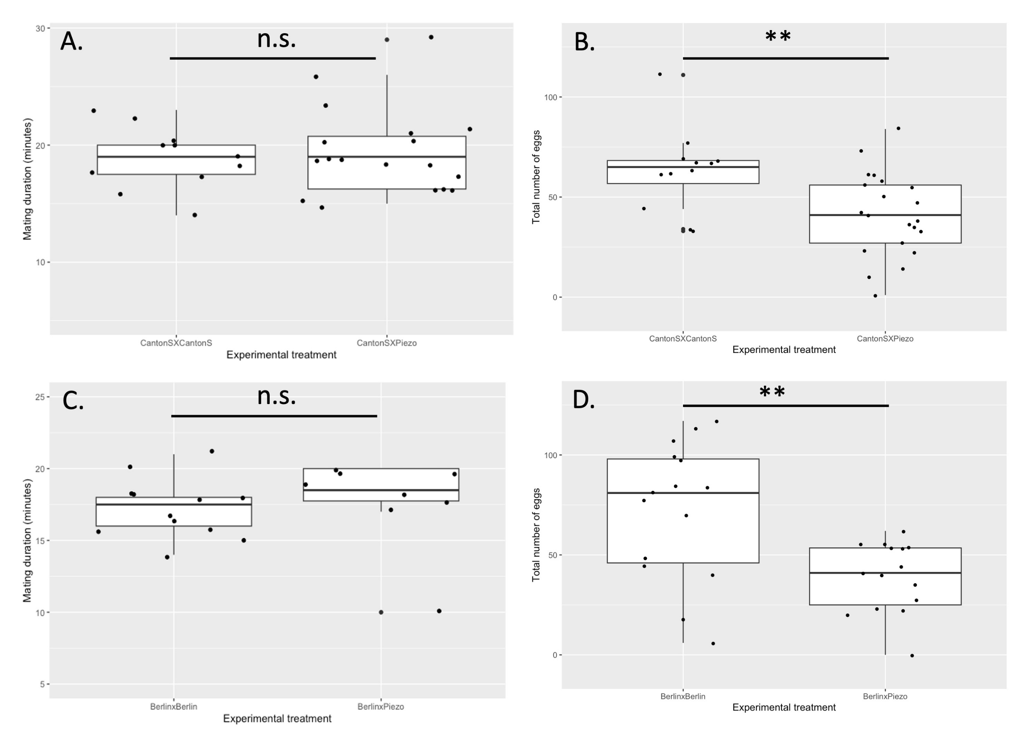
Figure 4.6. The effect of Piezo knockout on female egg-laying behavior. A and B. D. melanogaster CantonS females are used as controls and Piezo knockout females are the experimental animals. Both are mated to D. melanogaster CantonS virgin males. A. There is no significant difference between the mating duration of the two treatments (n.s. p>0.05). B. There is a significant difference between the total number of eggs laid between the treatments (t=2.88; p=0.0082). C and D. D. melanogaster Berlin females are used as controls and Piezo knockout females are the experimental animals; both are mated to D. melanogaster Berlin virgin males. C. There is no significant difference between the mating duration of the two treatments (n.s. p>0.05). D. There is a significant difference between the total number of eggs laid between the treatments (W=176; p=0.0089).

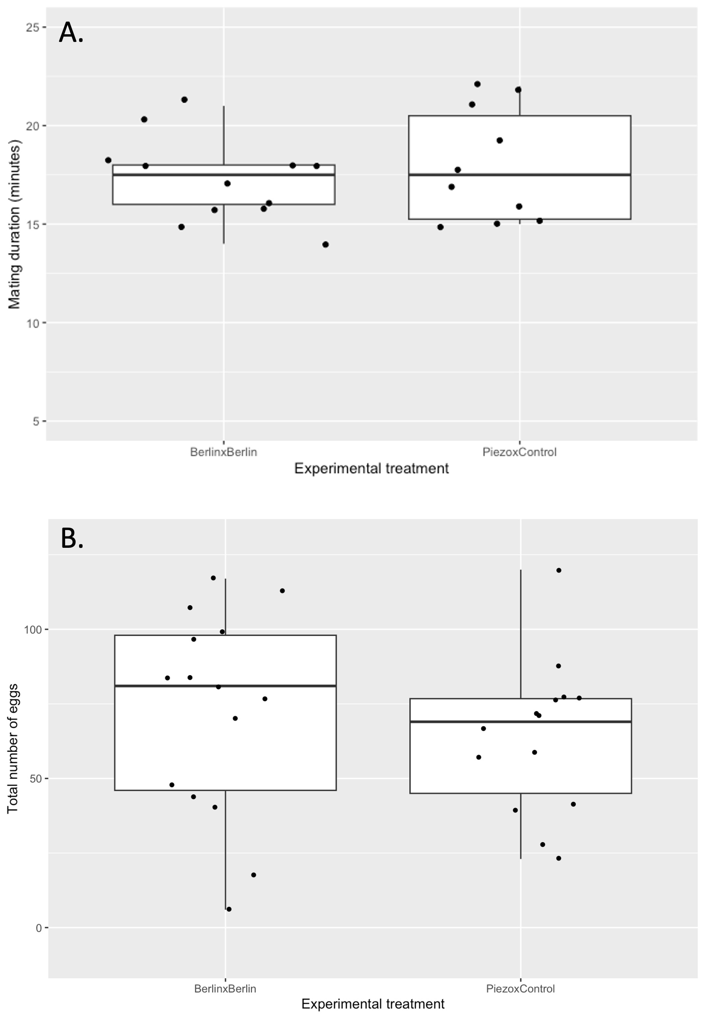
Figure 4.7. The effect of Piezo knockout on male reproductive behavior. A. There is no significant difference between the mating duration of the two treatments (n.s. p>0.05). B. There is no significant difference between the total number of eggs laid between the treatments (n.s. p>0.05).

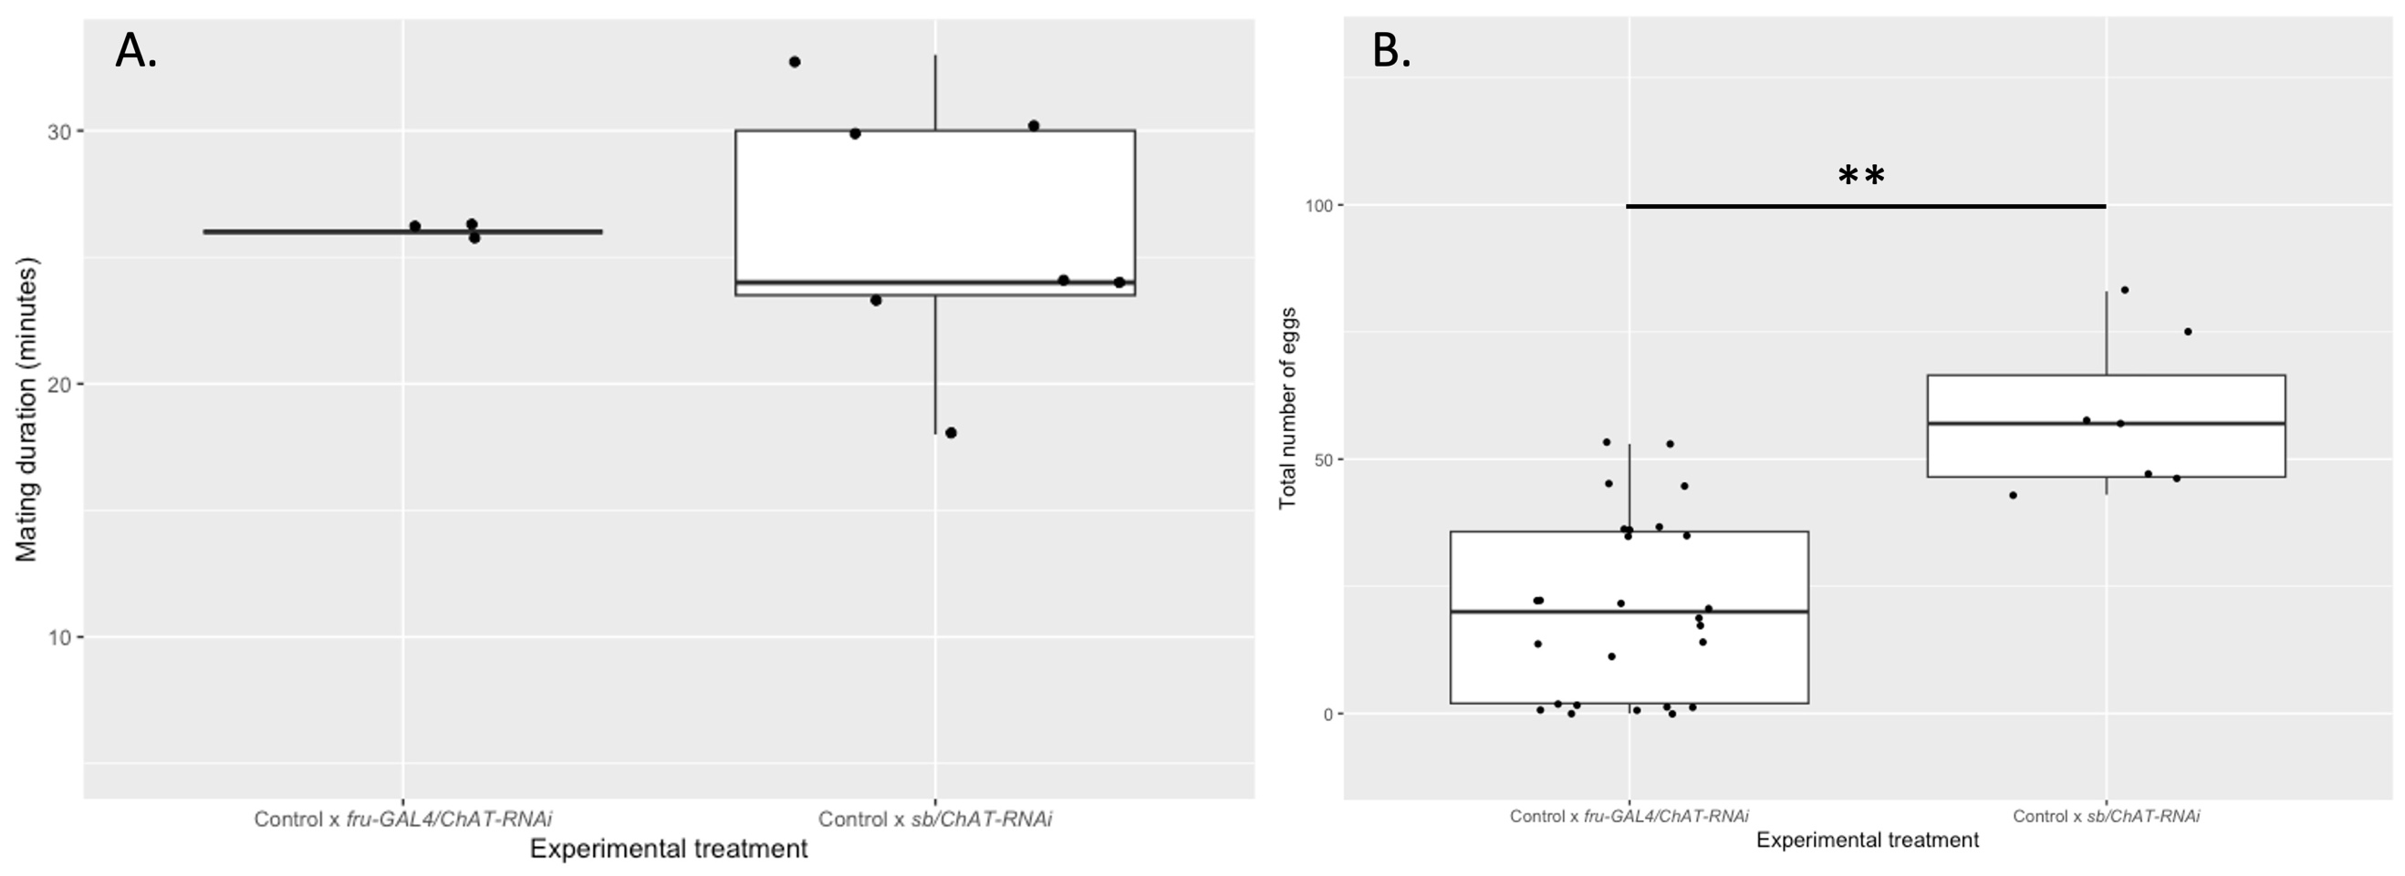
Figure 4.8. The effect of Chat knockdown driven by fru-P1-GAL4 on female egg laying. There is a significant decrease in egg laying when Chat knockdown is knocked down in fru-P1 circuit (Wilcox test, W = 8, p-value = 0.0002732).

4.7 Tables:
Table 4.1. List of fly lines and their expression in the female with a focus on the female terminalia.
Line | Expression pattern
Poxn-GAL4 (Poxnw280,UAS-GFP/tb) | Expression in female abdomen and neuronal arborizations connecting to the gastric and reproductive tract. Wheelers organ and peripheral abdominal neurons.  Expression in Brain and VNC. Some leg bristles and wing margin. halter.
Poxn-GAL4 (Poxnw209,UAS-GFP/tb) | Expression in female abdomen and neuronal arborizations connecting to the gastric and reproductive tract.  Expression in Brain and VNC. Some leg bristles. One bristle on the halter.
fru-P1 (UAS-GFP/CyO;fru-P1-GAL4/Sb and delt-M22/cyo;fru-P1-LexA, LexAop-GFP/Tb) | All female terminalia bristles. The expression in terms of bristles is exclusively limited to the terminala. Neurons on the reproductive tract. Brain and VNC. Wheeler’s organ.
Elav-GAL4; UAS-GFP | All neurons including neurons of the female terminalia sensilla
ChAT-GAL4; UAS-GFP | Many neurons including neurons of the female terminalia sensilla
Piezo-GAL4; UAS-GFP | Many neurons including neurons of the female terminalia sensilla
Neur-GAL4; UAS-GFP | Many neurons including neurons of the female terminalia sensilla. A ring of expression around vagina.
NompC-GAL4; UAS-GFP | No expression in the terminalia or reproductive tract
TrpA1-GAL4; UAS-GFP | No expression in the terminalia or reproductive tract
Gaba-GAL4; UAS-GFP | No expression in the terminalia
Dsx-GAL4; UAS-GFP | No expression in the terminalia. Expression in spermatheca cells
Gaba-B-R1-GAL4; UAS-GFP | No expression in the terminalia
GADI-B-R1-GAL4; UAS-GFP | No expression in the terminalia

Table 4.2: The location of sperm in the reproductive tract between control and Piezo[KO] flies 30 to 40 minutes after mating.
 | Mating duration (min) | Sperm observed in uterus | Sperm observed in seminal receptacle | Sperm observed in spermathecae( The female has two spermathecae)
CantonSxPiezo[KO] | 17 | Yes | No | No, No
CantonSxPiezo[KO] | 17 | Yes | No | Yes, Yes
CantonSxPiezo[KO] | 18 | Yes | No | Yes, Yes
CantonSxPiezo[KO] | 21 | Yes | No | Yes, Yes
CantonSxPiezo[KO] | 16 | Yes | No | Yes, No
CantonSxCantonS | 22 | Yes | No | No, No
CantonSxCantonS | 19 | Yes | No | No, No
CantonSxCantonS | 22 | Yes | No | Yes, Yes
CantonSxCantonS | 21 | Yes | No | No, No
CantonSxCantonS | 18 | Yes | No | No, No

Table 4.3: The location of sperm in the reproductive tract between control and Piezo[KO] flies 90 minutes after mating.
 | Mating duration (min) | Sperm observed in uterus | Sperm observed in seminal receptacle | Sperm observed in spermathecae (The female has two spermathecae)
CantonSxPiezo[KO] | 21 | Very few | Yes | Yes, Yes
CantonSxPiezo[KO] | 15 | Very few | Yes | Yes, Yes
CantonSxPiezo[KO] | 15 | Very few | Yes | Yes, Yes
CantonSxPiezo[KO] | 21 | Very few | Yes | Yes, Yes
CantonSxPiezo[KO] | 22 | Yes | Very few | Yes, Yes
CantonSxPiezo[KO] | 16 | Yes | Very few | Yes, Yes
CantonSxPiezo[KO] | 22 | Very few | Yes | No, No
CantonSxPiezo[KO] | 22 | Yes | Yes | Yes, Yes
CantonSxPiezo[KO] | 15 | Yes | Yes | Yes, No
CantonSxPiezo[KO] | 21 | Very few | Yes | Yes, Yes
CantonSxCantonS | 14 | Yes | No | Yes, No
CantonSxCantonS | 23 | Very few | Yes | In the duct
CantonSxCantonS | 18 | Yes | No | No, No
CantonSxCantonS | 22 | Yes | No | Yes, No
CantonSxCantonS | 22 | Very few | Yes | No, No
CantonSxCantonS | 19 | Very few | Yes | No, No
CantonSxCantonS | 24 | Very few | Yes | No, No
CantonSxCantonS | 21 | Yes | Yes | Yes, No
CantonSxCantonS | 26 | Yes | Yes | Yes, No

4.8 Supplements:
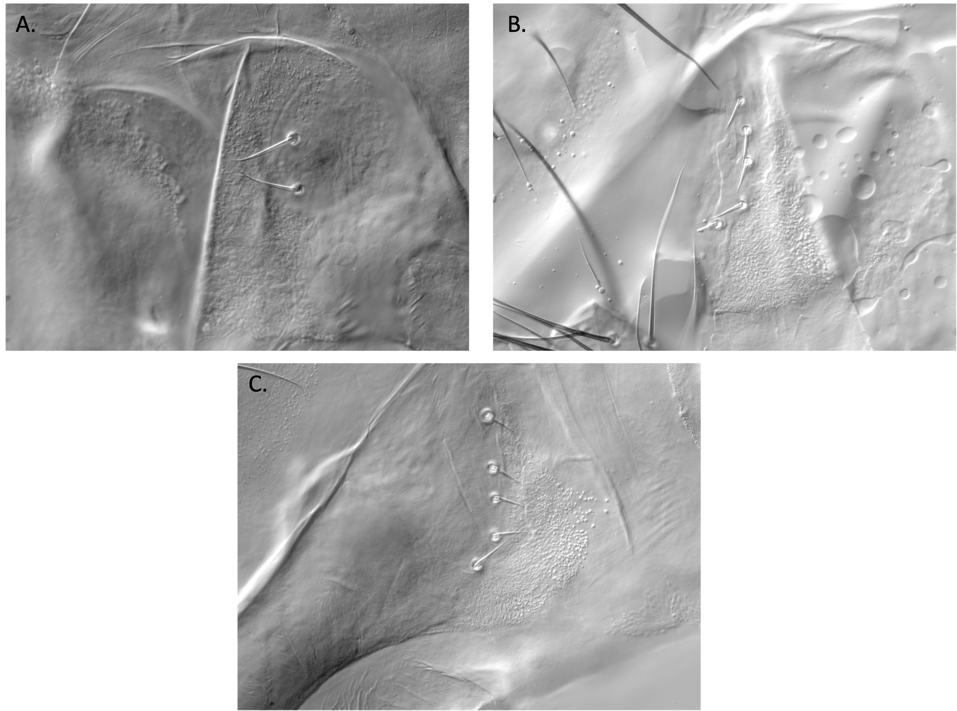

Supplement Figure 4.1. The epigynium sensilla in A. D. sechellia B. D. melanogaster and C. D. mauritina

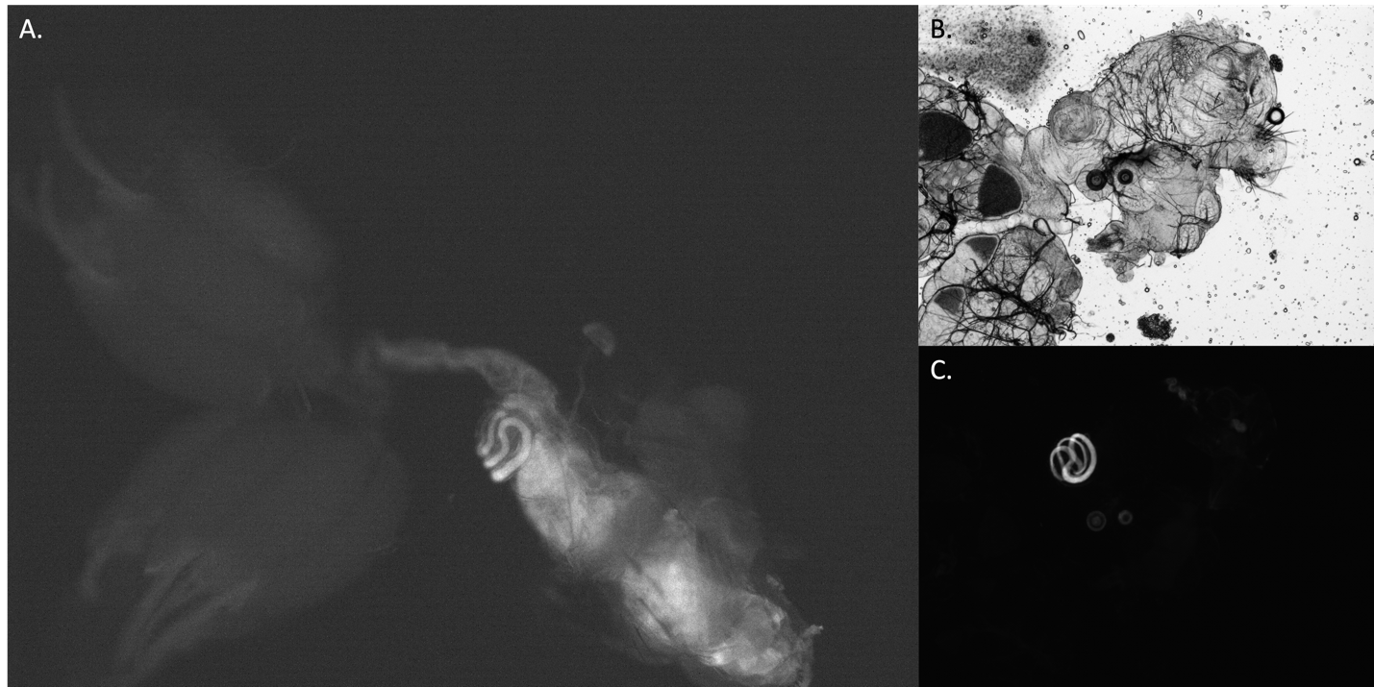
Supplement Figure 4.2. A. The female reproductive tract 30 minutes after mating with djGFP males. B. and C. The female reproductive tract after 24hrs mating with djGFP male.
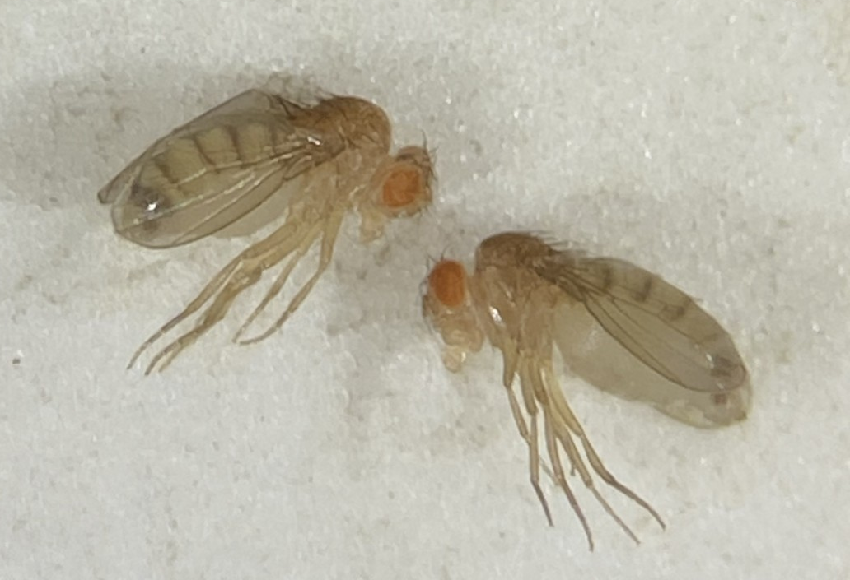
Supplement Figure 4.3. Bloated older females of Piezo[KO] line. This phenotype is not due to eggs in older females.

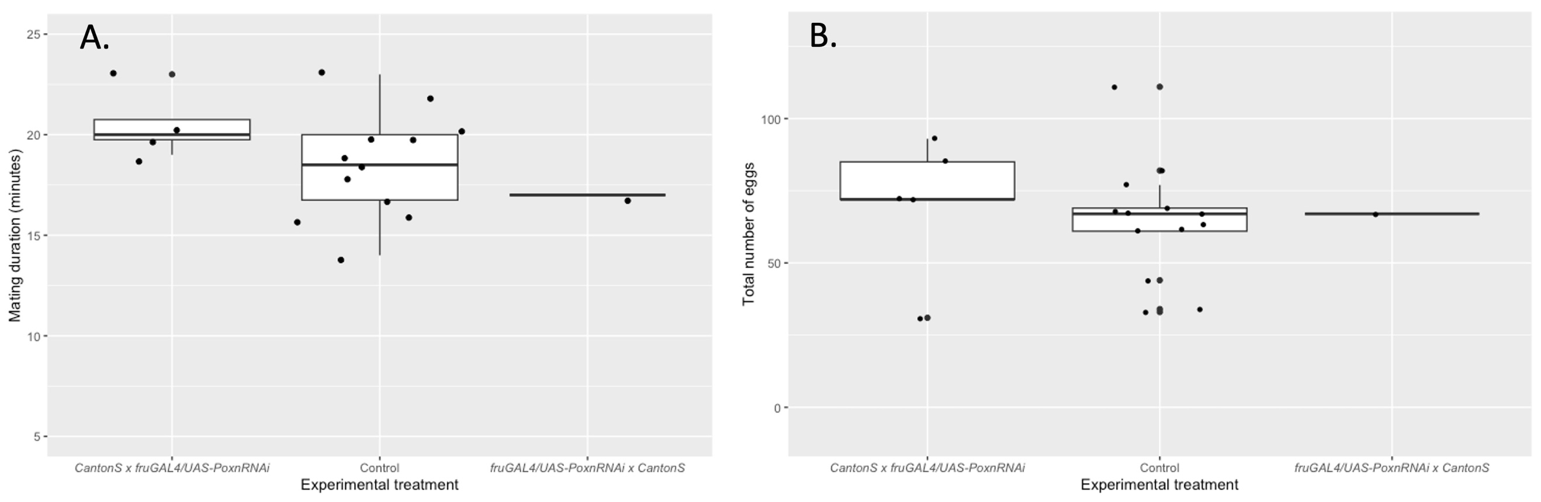
Supplement Figure 4.4. The effect of Poxn knockdown driven by fru-P1-GAL4 on female egg laying. The Poxn knockdown driven by fru-P1-GAL4 does not show any significant effect on female mating duration (A) and egg-laying (B). A much larger sample size is needed to decipher finer differences.

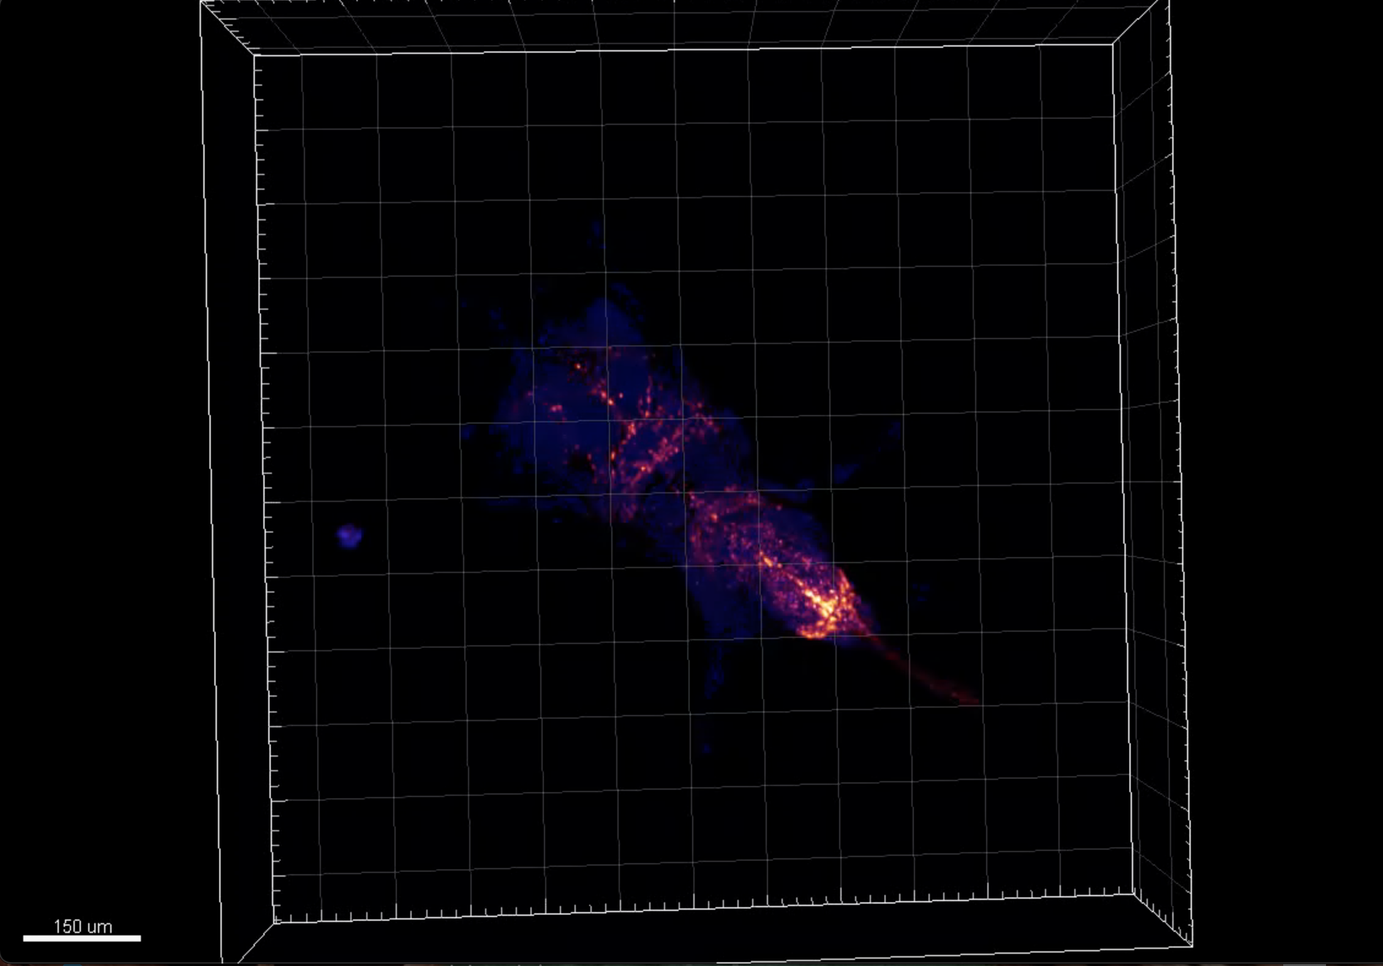
Supplement Figure 4.5. Dendrites of Tdc2+ neurons localize to the region of the abdominal neuromere where the axons of fru P1+ neurons localize (Tdc2+ is a marker for octopamine, and the octopaminergic neurons are necessary important for egg-laying).

