UNIVERSITY OF OKLAHOMA
GRADUATE COLLEGE

MOLECULAR CHARACTERIZATION OF THE ARABIDOPSIS NUCLEAR FACTOR-Y TRANSCRIPTION FACTOR FAMILY

A DISSERTATION
SUBMITTED TO THE GRADUTE FACULTY
in partial fulfillment of the requirements for the
Degree of
DOCTOR OF PHILOSOPHY

By
CHAMINDIKA LAKMALI SIRIWARDANA
Norman, Oklahoma
2014

MOLECULAR CHARACTERIZATION OF THE ARABIDOPSIS NUCLEAR FACTOR-Y TRANSCRIPTION FACTOR FAMILY

A DISSERTATION APPROVED FOR THE
DEPARTMENT OF MICROBIOLOGY AND PLANT BIOLOGY

BY

_______________________
Dr. Ben Holt III, Chair

_______________________
Dr. John P. Masly

_______________________
Dr. Scott Russell

_______________________
Dr. Liz Karr

_______________________
Dr. Anne Dunn

© Copyright by CHAMINDIKA LAKMALI SIRIWARDANA 2014
All Rights Reserved.

This dissertation is dedicated to my father T. Devasiri W. Siriwardana and in the loving memory of my mother Anoma Malkanthi Siriwardana, who are my inspiration in becoming a plant biologist, and to my husband P.G. Prabhath E. Amaradasa whom I couldn’t have done this without.

Acknowledgements
My very special thanks go to my supervisor Dr. Ben Holt for the valuable advice and guidance given throughout the project. His continued support was key to the successful completion of this project. I am also very grateful to Dr. John Masly, Dr. Scott Russell, Dr. Liz Karr, Dr. Anne Dunn, and Dr. Bing Zhang for their support and advice as my committee members. I also thank all the past and present members of the Holt lab for providing a stimulating and fun work environment. Especially I would like to thank Dr. Roderick Kumimoto for teaching me the molecular techniques that were invaluable for this project and for critically evaluating my work. I also thank Dr. Shuanghe Cao for the help and advice he has given about cloning, and Yanz Zhang for teaching me the yeast-2 hybrid technique. I am also grateful for the undergraduate researchers I worked with, Conner Boatright and Zack Meyers. I also thank members of the Russell lab, Zhang lab, Bartley lab, Libault lab, and Kessler lab for their support. Especially Daniel Jones and Taylor Fore for the assistance given with microscopy. Finally my deepest thanks go to my husband Paluwatte Gedara Prabhath Eranda Amaradasa, parents, brother, family and friends for their encouragement.

Table of Contents

Acknowledgements v
Table of Contents vi
List of Tables ix
List of Figures...………...……………………………………………………………………………………. x
Chapter 1: Introduction 1
Introduction 2
Classification of the Arabidopsis NF-Y gene family 4
Regulation of NF-Y in plants 15
Chapter 2: Gene family analysis of the Arabidopsis NF-YA transcription factors reveals opposing abscisic acid responses during seed germination 29
Summary 30
Introduction 31
Results 35
Discussion 43
Materials and methods 49
Chapter 3: Arabidopsis NF-YA subunits are positive regulators of photoperiod dependent flowering 73
Summary 74
Introduction 76
Results 80
Discussion 93
Materials and methods 97
Chapter 4: Mapping protein interaction domains of Arabidopsis NF-YC9 118
Summary 119
Introduction 121
Results 124
Discussion 129
Materials and methods 132
Chapter 5: Arabidopsis NF-YA are transcriptionally, post-transcriptionally and post-translationally regulated by light 144
Summary 145
Introduction 146
Results 148
Discussion 152
Materials and methods 154
Chapter 6: Summary of yeast 2-hybrid analysis done to understand protein-protein interactions of the NF-Y 162
Introduction 163
Results 164
Materials and methods 173
Chapter 7: Conclusion 183
Conclusion and Future Directions 184
References 190

List of Tables
Table 1.1. Number of NF-Y subunits in eukaryotes.. 18
Supplemental Table 2. 1. List of homozygous and hemizygous p35S:NF-YA plant lines. 62
Supplemental Table 3.1. Cloning primers. 110
Supplemental Table 3.2. Mutagenic Primers used for cloning the NF-YB2E65R mutant. 111
Supplemental Table 3.3. qPCR primers used to measure gene expression. 112
Supplemental Table 4.1. The amino acid sequences of NF-YC9 truncations and primers used for amplification. 139
Supplemental Table 4.2. Mutagenic primers used to clone NF-YC9 mutants. 140
Table 5.1. List of genes that belong to the overrepresented GO term “cellular response to light stimulus” 157
Table 6.1. Novel interactors of NF-YA2 identified through an Y2H library screen. 175

List of Figures
Figure 1.1. NF-Y family phylogenies.. 19
Figure 1.2. Multiple sequence alignment (MSA) of full- length NF-YA proteins. 20
Figure 1.3. Multiple sequence alignment of the core domain NF-YA proteins.. 21
Figure 1.4. Identity matrix of the full-length and core domain NF-YA proteins.. 22
Figure 1.5. Identity matrix of the full-length and core domain NF-YB proteins.. 23
Figure 1.6. Identity matrix of the full-length and core domain NF-YC proteins. 24
Figure 1.7. Multiple sequence alignment of full-length NF-YB proteins.. 25
Figure 1.8. Multiple sequence alignment of full-length NF-YC proteins.. 26
Figure 1.9. Multiple sequence alignment of core domain NF-YB proteins.. 27
Figure 1.10. Multiple sequence alignment of core domain NF-YC proteins.. 28
Figure 2.1. Characterization of p35S:NF-YA overexpressing lines.. 55
Figure 2.2. p35S:NF-YA5 seedlings develop cotyledon-like leaves.. 56
Figure 2.3. NF-YA proteins are nuclear localized.. 57
Figure 2.4. Seed germination on Gamborg’s B5 medium for p35S:NF-YA.. 58
Figure 2.5. p35S:NF-YA overexpressors show opposing germination phenotypes on ABA.. 59
Figure 2.6 NF-YA genes are expressed in the endosperm and embryos. 60
Figure 2.7. ABA response genes are misregulated in p35S. 61
Supplemental Figure 2.2. Identity matrix of the full-length NF-YA protein sequence.. 64
Supplemental Figure 2.3. Overexpression of the NF-YA gene family leads to growth defects.. 65
Supplemental Figure 2.4. Quantifications of the cotyledon-like leaves in p35S:NF-YA5.. 66
Supplemental Figure 2.5. Abiotic stress responses of p35S:NF-YA5 seedlings 67
Supplemental Figure 2.6. Confirmation of nuclear localization of NF-YA proteins.. 68
Supplemental Figure 2.7. Overexpression of select NF-YA genes leads to ABA hypersensitivity during root elongation. 69
Supplemental Figure 2.8. Publically available microarray data demonstrate that NF-YA genes are expressed in seeds.. 70
Supplemental Figure 2.9. qPCR analysis of gene expression in p35S:NF-YA8 and p35S:NF-YA9 seeds... 71
Supplemental Figure 2.10. ABA-induction of gene expression in p35S:NF-YA8 and p35S:NF-YA9 seeds.. 72
Figure 3.1. NF-YB2E65R looses interaction with NF-YA subunits. 103
Figure 3.2. p35S:NF-YB2^{E65R} cannot rescue the nf-yb2 nf-yb3 late flowering phenotype.. 104
Figure 3.3. p35SNF-YB2^{E65R} plants cannot express high FT. Expression of A) NF-YB2 B) FT C) AP1. 105
Figure 3.4. A strong activation domain (EDLL) is not able to recue the NF-YB2^{E65R} flowering phenotypes.. 106
Figure 3.5. NF-YA2 maybe a positive regulator of photoperiod dependent flowering.. 107
Figure 3.6. FT is upregulated in pNF-YA2:NF-YA2.. 108
Figure 3.7. pNF-YA2:NF-YA2-EDLL can induce flowering in the absence of CO 109
Supplemental Figure 3.1. Alignment of core domain of NF-YA subunits and CCT domain of CCT proteins.. 113
Supplemental Figure 3.2. p35S:NF-YB2^{E65R} cannot rescue the nf-yb2 nf-yb3 late flowering phenotype.. 114
Supplemental Figure 3.3. p35S:NF-YB2^{E65R} cannot rescue the nf-yb2 nf-yb3 late flowering phenotype.. 115
Supplemental Figure 3.4. Expression of NF-YA2 in pNF-YA2:NF-YA2 plants.. 116
Supplemental Figure 3.5. MFT is upregulated in pNF-YA2:NF-YA2. 117
Figure 4.1. A. Schematic diagram of the full-length Arabidopsis NF-YC protein.. 135
Figure 4.2. The conserved core domain is required for NF-YC9 interactions. 136
Figure 4.3. NF-YC9^{F151R V153K} looses interaction with CO, HY5, NF-YA1, and NF-YA2 but not ABF3 and NF-YB2. 137
Figure 4.4. pNF-YC9:NF-YC9^{F151R V153K} cannot rescue the triple phenotype.. 138
Supplementary Figure 4.1. Multiple sequence alignment of full- length NF-YC proteins.. 141
Supplementary Figure 4.2. Identity matrix of the full-length and core domain NF-YC proteins.. 142
Supplementary Figure 4.3. NF-YC family phylogenies.. 143
Figure 5.1. Percent hypocotyl elongation in red light for p35S:NF-YA plants.. 158
Figure 5.2. NF-YA transcripts are opposingly regulated by light.. 159
Figure 5.3. NF-YA proteins are opposingly regulated by light.. 160
Figure 5.4. NF-YA2 proteins are degraded through the proteasome.. 161
Figure 6.1. Interaction between Brachypodium NF-YC and select Arabidopsis proteins.. 176
Figure 6.2. BdNF-YB3 and BdNF-YB6 can physically interact with Arabidopsis NF-YC3, 4, and 9. DBD, DNA-binding domain; AD, activation domain. 177
Figure 6.3. NF-YC3, NF-YC4, and NF-YC9 protein-protein interaction network.. 178
Figure 6.4. NF-YB and NF-YC subunits interact with bZIP transcription factors.. 179
Figure 6.5. Full length NF-YB2 is required for the ABF3 interaction. 180
Figure 6.6. NF-YB1 - NF-YB10 interact with NF-YC3, NF-YC4, and NF-YC9.. 181

Abstract
NUCLEAR FACTOR-Y (NF-Y) transcription factors, composed of three independent families: NF-YA, NF-YB, and NF-YC, have greatly expanded in plants in comparison to animals. For example, while humans have only one member of each subunit, the modal plant Arabidopsis thaliana (Arabidopsis) has 10 members. However, due to lack of studies, the significance of the expansion in the plant lineage is poorly understood. Plant NF-Ys have primarily been studied on their role regulating flowering, abscisic acid (ABA) responses, embryogenesis, and nodulation in legumes. However, key questions remain on how the NF-Y regulates these processes. Here I answer two fundamental questions about the NF-YA subunit during regulation of ABA responses and flowering.

ABA mediated seed germination is one of the plant developmental responses regulated by the NF-Y. Three NF-YC subunits, NF-YC3, NF-YC4, and NF-YC9 have opposing responses during abscisic acid (ABA) mediated seed germination, demonstrating that members of this closely related gene family have evolved unique regulatory roles. Since the mature NF-Y complex binds DNA as a trimer I hypothesized that the NF-YA and NF-YB family members should also have opposing regulatory functions. However, opposing functions have not been identified for the NF-YA or NF-YB. In Chapter 2, I studied the germination responses of all 10 Arabidopsis NF-YA genes by creating overexpression constructs. Germination responses on ABA containing media showed that the closely related paralogs NF-YA1 and NF-YA9 are insensitive and NF-YA2, NF-YA4, NF-YA7, NF-YA8, and NF-YA10 were hypersensitive to ABA. The result supported my hypothesis and show that the closely related NF-YA family members have evolved opposing roles regulating ABA mediated seed germination.

The NF-Ys have been extensively studied during its regulation of photoperiod dependent flowering. NF-YB and NF-YC subunits are known positive regulators of this pathway, however the role of NF-YA subunits remained a fundamental question that had not been answered. Prior research had proposed a model where NF-YA acts as negative regulators of flowering. However, several recent publications demonstrated that NF-YA should be acting as positive regulators. In Chapter 3, I tried to understand the role played by NF-YA during floral regulation. My hypothesis was that NF-YAs are positive regulators of flowering. Since loss of function NF-YA are lethal or do not have flowering phenotypes, I used two approaches to test if NF-YA are positive regulators. First, to indirectly test if NF-YAs are need for the NF-YB/NF-YC dimer to regulate flowering, I created a mutant version of NF-YB that loses interaction with NF-YA. The mutant was overexpressed in the late flowering nf-yb2 nf-yb3 double mutant and was found not to complement the late flowering phenotype. However, the mutant protein was strongly expressed and was able to localize to the nucleus. This result strongly indicated that NF-YA should be required as positive regulators of flowering. My second approach was to study overexpressors of NF-YA. Here I was able to identify that NF-YA2 overexpressors drove early flowering and led to the upregulation of a key floral gene FT. These results strongly suggested that NF-YA2 might be a positive regulator of flowering. Further, a recent publication had demonstrated that CO provides an activation domain for the NF-Y complex. The NF-Ys were able to induce flowering in the absence of CO (in a co mutant background) when an activation domain called EDLL was attached to NF-YB2. I hypothesized that the NF-YB2 mutant that loses interaction with NF-YA will not be able to induce flowering, however NF-YA2 will be able to induce flowering in the absence of CO when attached to the EDLL domain. The results supported the hypothesis. As a conclusion, my data strongly suggests that NF-YAs are required as positive regulators of flowering.

In addition to studying the roles played during seed germination and flowering, I also studied protein interactions of the NF-Y and how the NF-Ys are regulated. In Chapter 4, I studied the protein-protein interactions of NF-YC9 and its targets. A combination of deletions and point mutations were used to understand how NF-YC9 interacts with its targets. The results demonstrated that while the conserved domain is required for protein function, the non-conserved regions are also necessary for the interaction between NF-YC9 and most of its targets. In Chapter 6, I have presented a collection of yeast 2-hybrid (Y2H) experiments done to better understand the nature of NF-Y protein interactions. This chapter demonstrated the NF-Ys are able to interact with a variety of other plant proteins including transcription factors. It also demonstrated inter-species protein interactions in plants. In Chapter 5, I studied the regulation of NF-YA transcript and protein. Here I was able to show that NF-YA family transcripts and proteins are regulated by light.

In conclusion this dissertation added to the literature on NF-Y in several aspects; 1) opposing role for the NF-Y were identified during seed germination, 2) NF-YA were strongly suggested to be positive regulators of flowering, 3) protein interactions of the NF-Y were dissected through Y2H analysis, 4) NF-YA transcripts and proteins were shown to be regulated by light.

Statement on use of pronouns in dissertation

The research included in this dissertation is a subset of what I did in the lab and is focused on the research I primarily performed or supervised. Therefore, to save confusion, I have used the “I” pronoun. However, at the end of each chapter, I have included a short section called “Contributions” where I acknowledge the efforts of any assistants on these projects.

Chapter 1: Introduction

Introduction

A myriad of biological processes in living organisms are regulated at the molecular level through differential gene expression, controlled to a significant extent by transcription factors. In plants about 45% of transcription factors belong to gene families that are common to eukaryotes; however most of these transcription factor families have a higher expansion rate in plants than in animals (Shiu et al. 2005). One transcription factor family common to eukaryotes that has undergone an extensive expansion in the plant lineage is NUCLEAR FACTOR-Y (NF-Y). The NF-Y gene family is composed of three independent subunits, NF-YA, NF-YB and NF-YC. In animals each subunit has one to three members (Table 1.1). In contrast, a key model plant, Arabidopsis thaliana (Arabidopsis), has ten members of each subunit (Gusmaroli et al. 2001, 2002; Siefers et al. 2009; Petroni et al. 2012; Laloum et al. 2013). A similar trend is seen with other plant species that have been sequenced and annotated (Table 1.1). Although the NF-Y transcription factors have undergone an extensive expansion in plants, key amino acid residues remain highly conserved in all eukaryotes (Mantovani 1999). This conservation of key residues allows the plant biology community to extrapolate data from animal systems, where the NF-Y transcription factors have been extensively studied.

Intact NF-Y function is essential in animals and the loss of NF-YA causes lethality (Bhattacharya et al. 2003). In humans and other animals, the targets of NF-Y divide into in to two major groups: cell cycle related genes and disease related genes, the later which includes an increasing number of examples from cancer (Ly et al. 2013). Target genes of the NF-Y during cell cycle regulation include cyclins and cyclin-dependent kinases (Kao et al. 1999; Manni et al. 2001), and during disease regulation include SRY-related HMG-box (Sox) genes (Wiebe et al. 2000; Huang et al. 2005).

Structural studies done on animal NF-Y have given insights into subunit interaction and activation of target genes. NF-YA is localized to the nucleus, NF-YB can move freely between the nucleus and cytoplasm, and NF-YC is localized to the cytoplasm (Frontini et al. 2004; Kahle et al. 2005). For the mature transcription factor to form, the NF-YB and NF-YC subunits dimerize in the cytoplasm and this dimer moves to the nucleus (Sinha et al. 1996). In the nucleus the NF-YB/NF-YC dimer interacts with the NF-YA subunit to make the mature NF-Y complex. NF-YA cannot bind either NF-YB or NF-YC alone and only interacts with the NF-YB/NF-YC dimer, which offers a complex surface for NF-YA to bind. NF-Y binds DNA only after the trimer has been assembled. The NF-Y target sequence is the pentamer CCAAT box (Mantovani 1999). CCAAT boxes are ubiquitous and present in as much as 30% of eukaryotic promoters (Bucher 1990), mostly positioned between -60 and -100 from the start codon and found in a variety of promoters, including developmentally controlled and housekeeping genes (Mantovani 1999; Dolfini et al. 2012; Fleming et al. 2013). The NF-YA subunit makes physical contact with the CCAAT box. Mutational analysis in yeast have identified amino acids that are essential for the NF-YA to make physical contact with the CCAAT boxes, and mutations of any single amino acid leads to a loss of interaction (Maity and de Crombrugghe 1992). NF-YB and NF-YC interacts with DNA non-specifically in adjacent areas and stabilizes the trimer complex (Nardini et al. 2013). The transcriptional activation sequences are located in the N-terminal of the NF-YA subunit and the C-terminal of the NF-YC subunit.

Plant NF-Y transcription factors have retained functional and structural similarities to animals, but, due to their extensive expansion, have also evolved unique and novel functions. Following is a review on the literature of NF-Y transcription factors in plants, focusing on the model plant Arabidopsis. The review includes classification of NF-Y, roles played during plant development, and regulation. The findings present an emerging picture of the expanded plant NF-Y families evolving novel and unique functions and mechanisms of regulation that allows them to regulate diverse aspects of plant growth and development.

Classification of the Arabidopsis NF-Y gene family
NF-YA genes
Arabidopsis has ten NF-YA genes that cluster into five groups of closely related paralogs: NF-YA1/NF-YA9, NF-YA2/NF-YA10, NF-YA3/NF-YA8, NF-YA4/NF-YA7, and NF-YA5/NF-YA6 (Figure 1.1; (Siefers et al. 2009). An early ancestral sequence gave rise to two monophyletic clades, one that contained NF-YA1/NF-YA9 and the other the rest of the gene family. Accordingly, NF-YA1/NF-YA9 have diverged furthest from the rest of the family. When all ten NF-YA genes were examined concurrently to study the developmental responses regulated by the genes, closely related paralogs NF-YA1/NF-YA9 had a unique role during abscisic acid (ABA) mediated seed germination, and paralogs NF-YA5/NF-YA6 in embryo development (Siriwardana et al. 2014; see Chapter 2 of this dissertation).

Multiple sequence alignments of the Arabidopsis and human NF-YA reveal a single highly conserved core domain flanked by a less conserved N- and C-termini (Figure 1.2 and Figure 1.3). An identity matrix of the full-length NF-YA protein sequences demonstrates that the closely related pairs of paralogs are highly conserved both inside and outside of the core domain (Figure 1.4). The conserved core region contains amino acids known to be essential for NF-YA activity in animals (Kahle et al. 2005; Nardini et al. 2013). Examples include the nuclear localization signal (Figure 1.2), which is highly conserved in animal and plants, suggesting all ten Arabidopsis NF-YA subunits are nuclear localized. This was found to be true; confocal imaging of the cyan fluorescence protein (CFP) tagged NF-YA demonstrated that all ten subunits are nuclear localized (Siriwardana et al. 2014, see Chapter 2 of this dissertation). Further, amino acids that make physical contact with the NF-YB/NF-YC dimer and DNA are highly conserved (Figure 1.3). In humans conserved arginine and histidine residue within amino acids 272-280 and the following GxGGRF motif makes physical contact with the CCAAT box, all of which are absolutely conserved in Arabidopsis. Mutational analyses have demonstrated that each of these amino acids are indispensible for DNA binding (Xing et al. 1993). Outside the core domain, NF-YA are less well-conserved. However all the Arabidopsis NF-YA have a characteristic glutamine and serine/threonine rich N-terminus, which is partly responsible for the transcriptional activation capacity of NF-Y complexes.

NF-YB and NF-YC genes
There are ten members each of the NF-YB and NF-YC gene families in Arabidopsis (Figure 1.1; (Petroni et al. 2012). Identity matrices of the full-length NF-YB and NF-YC proteins reveal that closely related paralogs share high identity (Figure 1.5 and 1.6). Examples for functional conservation among closely related paralogs include NF-YB2/NF-YB3 that are positive regulators of flowering and NF-YC3/NF-YC9 that are negative regulators of ABA responses.

Multiple sequence alignments of Arabidopsis and human NF-YB and NF-YC proteins reveal a highly conserved core domain and less conserved N-termini and C-termini (Figure 1.7 and 1.8). The core domains of NF-YB and NF-YC proteins are related to histone fold motifs, with NF-YB and NF-YC related to H2B and H2A histones, respectively (Mantovani 1999). Amino acids in NF-YB and NF-YC proteins that make physical bonds during dimer formation and are responsible for interaction with the NF-YA are highly conserved in Arabidopsis (Figure 1.9 and Figure 1.10) (Kim et al. 1996; Sinha et al. 1996; Romier et al. 2003; Nardini et al. 2013). I created mutations in Arabidopsis NF-YB2 and NF-YC9 based on amino acids that are essential for NF-YA/NF-YB and NF-YA/NF-YC interactions in animals, and found that the same amino acids are indispensible in plants. The findings of this analysis are further discussed in Chapters 3 and 4.

Roles of NF-Y transcription factors during plant development
Photoperiod dependent flowering
Photoperiod or day length is one of the key environmental factors that determines when plants flower, which is key for reproductive success. Arabidopsis is a long day plant, that is it flowers when the photoperiod is longer than a crucial length (Salisbury 1985). The transcription factor CONSTANS (CO) is key to detecting photoperiod. CO proteins peak during long days through the circadian regulation of its transcript and light regulation of its protein (Hayama and Coupland 2004). Once CO peaks it directly regulates the expression of FLOWERING LOCUS-T (FT). FT is a long sort after mobile signal that travels from the leaves, where flowering is initiated, to the shoot apical meristem, where the floral transition occurs. FT activates floral identity genes responsible for the transition of a vegetative meristem into a floral meristem. Select NF-YB and NF-YC genes are coexpressed and physically interact with CO (Ben-Naim et al. 2006a; Wenkel et al. 2006b; Kumimoto et al. 2010). The temporal and spatial coexpression of CO and NF-Y were used to identify NF-YC subunits, NF-YC3, NF-YC4, and NF-YC9, that regulate flowering (Kumimoto et al. 2010). NF-YB2 and NF-YB3, which have strong vascular expression, are also regulators of photoperiod dependent flowering (Wenkel et al. 2006b; Kumimoto et al. 2008b). Further, the above-mentioned NF-Ys have strong loss of function phenotypes that confirm their role in long-day flowering.

Mutants of NF-YB2 and NF-YB3 flower later than the wild type in long-days. (Cai et al. 2007; Kumimoto et al. 2008b). Individual single mutants are significantly late flowering, where as the nf-yb2 nf-yb3 double mutant is even later than either single mutant, indicating an additive effect. In addition ectopic overexpression of NF-YB2 and NF-YB3 leads to early flowering. These results demonstrate that NF-YB2 and NF-YB3 are positive regulators of flowering. The expression of FT is down regulated in the mutants and up regulated in the overexpressors, demonstrating that NF-YB2 and NF-YB3 regulate flowering by regulating FT activity. A triple mutant of three NF-YC genes NF-YC3, NF-YC4, and NF-YC9 also leads to late flowering in long days, demonstrating that these subunits are positive regulators of flowering (Kumimoto et al. 2010). Further, FT was significantly down regulated in the triple mutants, indicating that NF-YC genes regulate flowering by controlling the activity of FT. The authors also showed that the three NF-YC proteins interacted with NF-YB2, NF-YB3, and CO, thus making a NF-YB/NF-YC/CO complex. Further, genetic studies show that CO requires the NF-Y to activate FT (Kumimoto et al. 2010). When CO was overexpressed in the triple mutant background, it was not able to drive early flowering. Its investigation represents that NF-YB and NF-YC genes are indispensible for CO mediated photoperiod flowering. However the role played by NF-YA subunits remains ambiguous and is a significant element of this dissertation.

Overexpression of two NF-YA genes, NF-YA1 and NF-YA4, in the leaf vasculature resulted in late flowering (Wenkel et al. 2006b). Further, expression of FT was down regulated in these lines. In contrast to the NF-YB and NF-YC results, these data indicate that NF-YA1 and NF-YA4 may be negative regulators of flowering. CO belongs to a larger family of proteins comprising 17 members called CO-LIKE (COL), characterized by tandem B-box zinc finger domains and a conserved CO, CO-LIKE, and TIMING OF CAB1 (TOC1) or CTT domain. The CCT domain shows high homology to the conserved core domain of the NF-YA proteins, specifically to the amino acids required in NF-YA to bind DNA. These two lines of evidence, i.e., that NF-YA can be negative regulators of flowering when overexpressed and NF-YA and CO share a region of homology, led to a hypothesis to explain the role of NF-YA subunits during flowering. Termed the replacement model, this assumes two independent complexes on the FT promoter, CO/NF-YB/NF-YC and NF-YA/NF-YB/NF-YC. In this model, CO/NF-YB/NF-YC would activate the promoter, while NF-YA/NF-YB/NF-YC would suppress FT activation. Thus, competition between NF-YA and CO to bind the NF-YB/NF-YC dimer would regulate FT activity. However the replacement model was not able to answer some key questions. Although NF-YA and CO share a region of homology, key residues that are indispensible for NF-YA to bind DNA at CCAAT boxes are not conserved in CO (Xing et al. 1993). This indicates that the CO/NF-YB/NF-YC complex is unable to bind CCAAT boxes. Further, the NF-Y complexes are highly conserved in eukaryotes and there is no other evidence of the atypical complex proposed by the replacement model. Several recent publications have further demonstrated that the replacement model does not explain the role of NF-YA during flowering.

CO is able to bind DNA in a unique cis-element called the CORE site independent of the NF-Y subunits. (Tiwari et al. 2010). Electrophoretic mobility shift assays (EMSA) demonstrated that CO binds the FT promoter in the absence of NF-Y subunits. Further, CO did not bind CCAAT boxes on the FT promoter. Cao et al. (2014) demonstrated that CCAAT boxes are essential for flowering. When a CCAAT box in the FT promoter is mutated, FT was not able to drive flowering. The CCAAT box required for FT activity is a distal element (-5.3 kb) and the CORE sites are proximal elements (-100 to -150 bp). CO at the CORE site and the NF-Y complex at the CCAAT box physically interact through a chromatin loop that brings these complexes together. These results demonstrate that the CORE and CCAAT sites need to be bound by CO and NF-Y, respectively, for proper flowering. The CCAAT box is bound by the NF-YA subunit (Maity and de Crombrugghe 1998), which would in theory mean NF-YA are positive regulators of flowering. However, there is currently no experimental evidence demonstrating that NF-YA are required for photoperiod dependent flowering. In Chapter 3, I demonstrate that NF-YA subunits are required for the NF-YB/NF-YC dimer to drive flowering by creating a mutant version of NF-YB that looses interactions with the NF-YA. I also identify NF-YA2 as a positive regulator of flowering.

ABA responses

Abscisic acid (ABA) is a plant hormone that regulates stress responses. One of the major roles of ABA is to promote drought tolerance. ABA induces physiological changes in plants, including stomatal closure, that limit water loss and allow plants to survive drought. Ectopic overexpression of two NF-Y genes, NF-YA5 and NF-YB2, are demonstrated to confer drought resistance (Nelson et al. 2007; Li et al. 2008). NF-YA5 is targeted by the microRNA miR169a. Drought and ABA downregulated miR169a, which in turn resulted in an increase in NF-YA transcripts. NF-YA5 is strongly expressed in guard cells and regulates stomata closure, resulting in less water loss. Further, overexpressors of NF-YA5 lost less water than the wild type, indicating that this gene has the potential to be a target for breeding drought tolerant crops. Although NF-YA5 has not been tested in field conditions, the NF-YB subunits have been tested. Arabidopsis NF-YB1 and its ortholog in corn (Zea mays) ZmNF-YB2 confer drought resistance. Further, under field conditions, corn overexpressing ZmNF-YB2 were better able to survive drought and led to increases in yield. These results demonstrate that studying NF-Y genes have potential to be used to engineer drought tolerant crops.

The NF-Y also regulates ABA responses during seed germination. NF-YB and NF-YC proteins physically interact with bZIP transcription factors involved in ABA signaling during germination responses. Briefly, NF-YB6 and NF-YB9 interact with bZIP67, and a larger set of NF-YC and NF-YB interact with ABF1, ABF2, ABF3, ABF4, and HY5 (Yamamoto et al. 2009; Kumimoto et al. 2013). Clear phenotypes are also associated with the NF-YB and NF-YC during seed germination. NF-YB2 and NF-YB3, when overexpressed, are hypersensitive to ABA. Interestingly, nf-yc mutants showed opposing germination phenotypes. nf-yc3 and nf-yc9 were hypersensitive to ABA, whereas nf-yc4 was insensitive. Two recent publications also demonstrated overexpressors of select NF-YA genes: NF-YA1, NF-YA2, NF-YA3, NF-YA7, NF-YA9, and NF-YA10 were hypersensitive to ABA (Leyva-Gonzalez et al. 2012; Mu et al. 2013). The opposing ABA phenotypes seen with NF-YC subunits suggest that a similar phenomenon would be seen with NF-YA and NF-YB subunits. In Chapter 2, I describe my studies of the ABA mediated seed germination responses of all ten NF-YA genes and identify that they do, indeed, have opposing germination responses.

Embryo development

Embryogenesis is the development period in which a single celled fertilized egg develops into a mature embryo (Braybrook and Harada 2008). In plants, embryo development has two phases: morphogenesis and maturation. A group of unrelated transcription factors called LEC - LEC1, LEC2, and FUS3 - regulate both phases. LEC1 is a member of the NF-YB gene family conventionally classified as NF-YB9. Both NF-YB9 and its closest paralog NF-YB6 (LEC1-LIKE) are crucial for embryo development (West et al. 1994; Kwong et al. 2003). The LEC genes, including NF-YB6 and NF-YB9, have characteristic loss-of-function and overexpression phenotypes. Loss-of-function mutants are intolerant to desiccation and have defects in food storage accumulation (Harada 2001), whereas ectopic overexpression leads to vegetative tissues that have characteristics of embryonic tissues (Lotan et al. 1998; Luerssen et al. 1998; Stone et al. 2001; Kwong et al. 2003). The LEC genes regulate embryogenesis by activating genes encoding seed proteins required for embryogenesis (Kagaya et al. 2005a; Kagaya et al. 2005b). They also maintain balance between the two plant hormones that maintain seed dormancy: ABA and Gibberellic acid (GA) (Curaba et al. 2004; Gazzarrini et al. 2004; Casson and Lindsey 2006). The LEC genes repress GA and stimulate ABA levels, which leads to a feedback loop increasing the LEC genes. The increased LEC genes increase the activity of seed proteins.

Because NF-Y function as a trimer, this suggests that a subset of NF-YA and NF-YC genes are also likely involved in embryogenesis. Recently ectopic overexpression of four NF-YA genes, NF-YA1, NF-YA5, NF-YA6, and NF-YA9, was shown to result in vegetative tissue (i.e., adult tissue) with embryonic features, indicating that these genes are regulators of embryo development ((Mu et al. 2013; Siriwardana et al. 2014); see Chapter 2 of this dissertation) NF-YC subunits involved in embryogenesis are yet to be identified.

Nodulation in legumes

Nodules are specialized root organs that develop as a result of symbiotic relationships between legumes and nitrogen-fixing bacteria (rhizobia). Rhizobia convert atmospheric nitrogen to a reduced form that plants readily accumulate and in return the plants provide a protected niche and carbohydrate nutrition for the bacteria. A screen to find transcription factors that regulate nodule development in Medicago truncatula identified MtNF-YA1 (Combier et al. 2006). MtNF-YA1 regulated nodule development by controlling nodule meristem activity. Further, during nodulation the expression of MtNF-YA1 is regulated through miR169 and a small peptide, uORF1p (Combier et al. 2006; Combier et al. 2008). NF-YC subunits that regulate nodulation were identified when NF-YC1 from the common bean (Phaseolus vulgaris) was shown to regulate nodule development (Zanetti et al. 2010). NF-YC1 regulated nodule development by activating cortical cell divisions. It was also shown that NF-YC1 is involved in the mechanism that discriminates between high and low quality symbiotic partners. NF-YB counterparts that regulate nodule development remain to be identified.

Regulation of NF-Y in plants

Plant NF-Y genes have unique temporal and spatial expression patterns (Stephenson et al. 2007; Siefers et al. 2009; Cao et al. 2011a; Liang et al. 2013) which provide functional specialization, where different subunits can regulate unique developmental processes. An example is the expression of NF-YB6 and NF-YB9, which regulate embryogenesis, specifically in the embryonic tissue (Lotan et al. 1998; Kwong et al. 2003). Further, the expression patterns can be used to predict functions of the NF-Y. Kumimoto et al. (2010) used this approach to successfully identify the NF-YC subunits involved in regulating flowering time. Briefly, NF-Y interacts with CO to regulate flowering, and CO is expressed in the leaf vasculature. Three NF-YC subunits expressed in the vasculature were identified, which were later shown with loss-of-function mutants to regulate flowering.

NF-YA transcripts are targeted for degradation by miR169 (Rhoades et al. 2002). Several studies have shown the biological significance of this regulation. Li et al. (2008) demonstrated that NF-YA5 is targeted by miR169 during drought responses. The expression of miR169 was down regulated by ABA and drought, which led to an increase in the NF-YA5 transcript under drought stress conditions. NF-YA5 was then able to promote ABA signaling components, which led to the plants becoming tolerant to drought. A similar phenomenon was seen with a soybean (Glycine max) NF-YA subunit, GmNF-YA3, which is targeted by Gm-miR169, and controls its ability to confer drought tolerance (Ni et al. 2013). Another example of miR169 regulating NF-YA genes comes from aspen (Populus tremulloides), where Ptr-miR169 represses PtrNF-YA during vegetative bud dormancy (Potkar et al. 2013). The regulation of NF-Y in plants, other than the tissue specific expression patterns and miR169 targeting, are not well understood. In animals, NF-Y proteins are regulated through phosphorylation and ubiquitination (Dolfini et al. 2012) and it is likely that this holds true for plants. In Chapter 5 I demonstrate that Arabidopsis NF-YA transcript and proteins are regulated by light.

The study of NF-Y transcription factors in plants is still in the early stages. However, as discussed here, steady progress is being made to better understand the role of these transcription factors and the significance of their expansion in the plant lineage. The following chapters of this dissertation add to the emerging picture by answering key questions about the NF-Y complex. In Chapter 2, a descriptive study is done on the complete NF-YA family. Here I identify that most aspects of the NF-YA are conserved between animals and plants. I also demonstrate that the NF-YA subunits have opposing roles regulating ABA responses. In Chapter 3, I answer a fundamental question regarding the NF-YA during its regulation of flowering, which is, are the NF-YA required for flowering and which NF-YA subunits play a role? I use a mutant version of NF-YB2, which loses interaction with NF-YA, to show that NF-YB2 requires intact NF-YA interaction for its flowering responses. After showing that the NF-YA are required for the NF-YB flowering responses, I identify NF-YA2 as a possible positive regulator of flowering. In Chapter 4, I map the protein interaction domains of NF-YC9 and demonstrate that the conserved core domain is indispensible for interaction with target proteins. I also show that the less conserved domains are required for specific interaction with some targets. Further, through a mutant analysis, I identify specific amino acids required for target interactions. In Chapter 6, I answer a broad spectrum of questions regarding the NF-Y and its specific interactions using Y2H analysis. Briefly, I look at protein-protein interactions between NF-Y and its targets in Arabidopsis, in other plant species, and interaction with bZIP transcription factors that regulate ABA and light responses. Further, through a Y2H library screen I identify novel protein interactors of NF-YA2. In Chapter 5, I present preliminary data that the NF-YA transcript and protein levels are regulated by light. Taken together this dissertation adds to the data known about role played by the NF-Y during plant development and brings us closer to understand the significance of the expansion of NF-Y in plants.

Table 1.1. Number of NF-Y subunits in eukaryotes. Compared to animals and yeast, plants have expanded the number of NF-Y genes. Note that yeast has a fourth “NF-Y” subunit, called HAP4, which is not listed here (Maity and de Crombrugghe 1998; Stephenson et al. 2007; Thirumurugan et al. 2008; Cao et al. 2011a; Petroni et al. 2012; Liang et al. 2013).

Organism | NF-YA | NF-YB | NF-YC | Potential combinatorial diversity
Homo sapiens | 1 | 1 | 1 | 1
Mus musculus | 1 | 1 | 1 | 1
Caenorhabditis elegans | 2 | 2 | 2 | 8
Saccharomyces cerevisiae | 1 | 1 | 2 | 2
Arabidopsis thaliana | 10 | 10 | 10 | 1000
Triticum aestivum | 10 | 11 | 14 | 1540
Brachypodium distachyon | 7 | 17 | 12 | 1428
Oryza sativa | 10 | 11 | 7 | 770
Brassica napus | 14 | 14 | 7 | 1372

Figure 1.1. NF-Y family phylogenies. Full-length protein sequences were used for phylogenetic analysis. Multiple sequence alignments were performed with ClustalW. Evolutionary history was inferred using the Neighbor-Joining method with in MEGA5 (Tamura et al. 2011). Bootstrapping with 5000 replicates was used to test phylogeny. Evolutionary distances were computed using the Poisson correction method. The trees are drawn to scale.

Figure 1.1. Multiple sequence alignment (MSA) of full-length NF-YA proteins. MSA was computed using ClustalW in Genious. The Conserved core domain is underlined in black. The three black boxes correspond to nuclear localization signal in humans. At: Arabidopsis thaliana; Hs: Homo sapiens.

Figure 1.3. Multiple sequence alignment of the core domain NF-YA proteins. MSA was computed using ClustalW in Genious. Amino acids making physical contact with NF-YB, NF-YC, and DNA-bases are annotated (Nardini et al. 2013). At: Arabidopsis thaliana; Hs: Homo sapiens.

Figure 1.4. Identity matrix of the full-length and core domain NF-YA proteins. A) Full-length protein B) core domain. Note that pairs of closely related paralogs demonstrate high identity across both the core domain and full-length protein sequence. At: Arabidopsis thaliana; Hs: Homo sapiens.

Figure 1.5. Identity matrix of the full-length and core domain NF-YB proteins. A) Full-length protein B) core domain. Note that pairs of closely related paralogs demonstrate high identity across the full-length protein sequence. At: Arabidopsis thaliana; Hs: Homo sapiens.

Figure 1.6. Identity matrix of the full-length and core domain NF-YC proteins. A) Full-length protein B) core domain. Note that pairs of closely related paralogs demonstrate high identity across the full-length protein sequence. At: Arabidopsis thaliana; Hs: Homo sapiens.

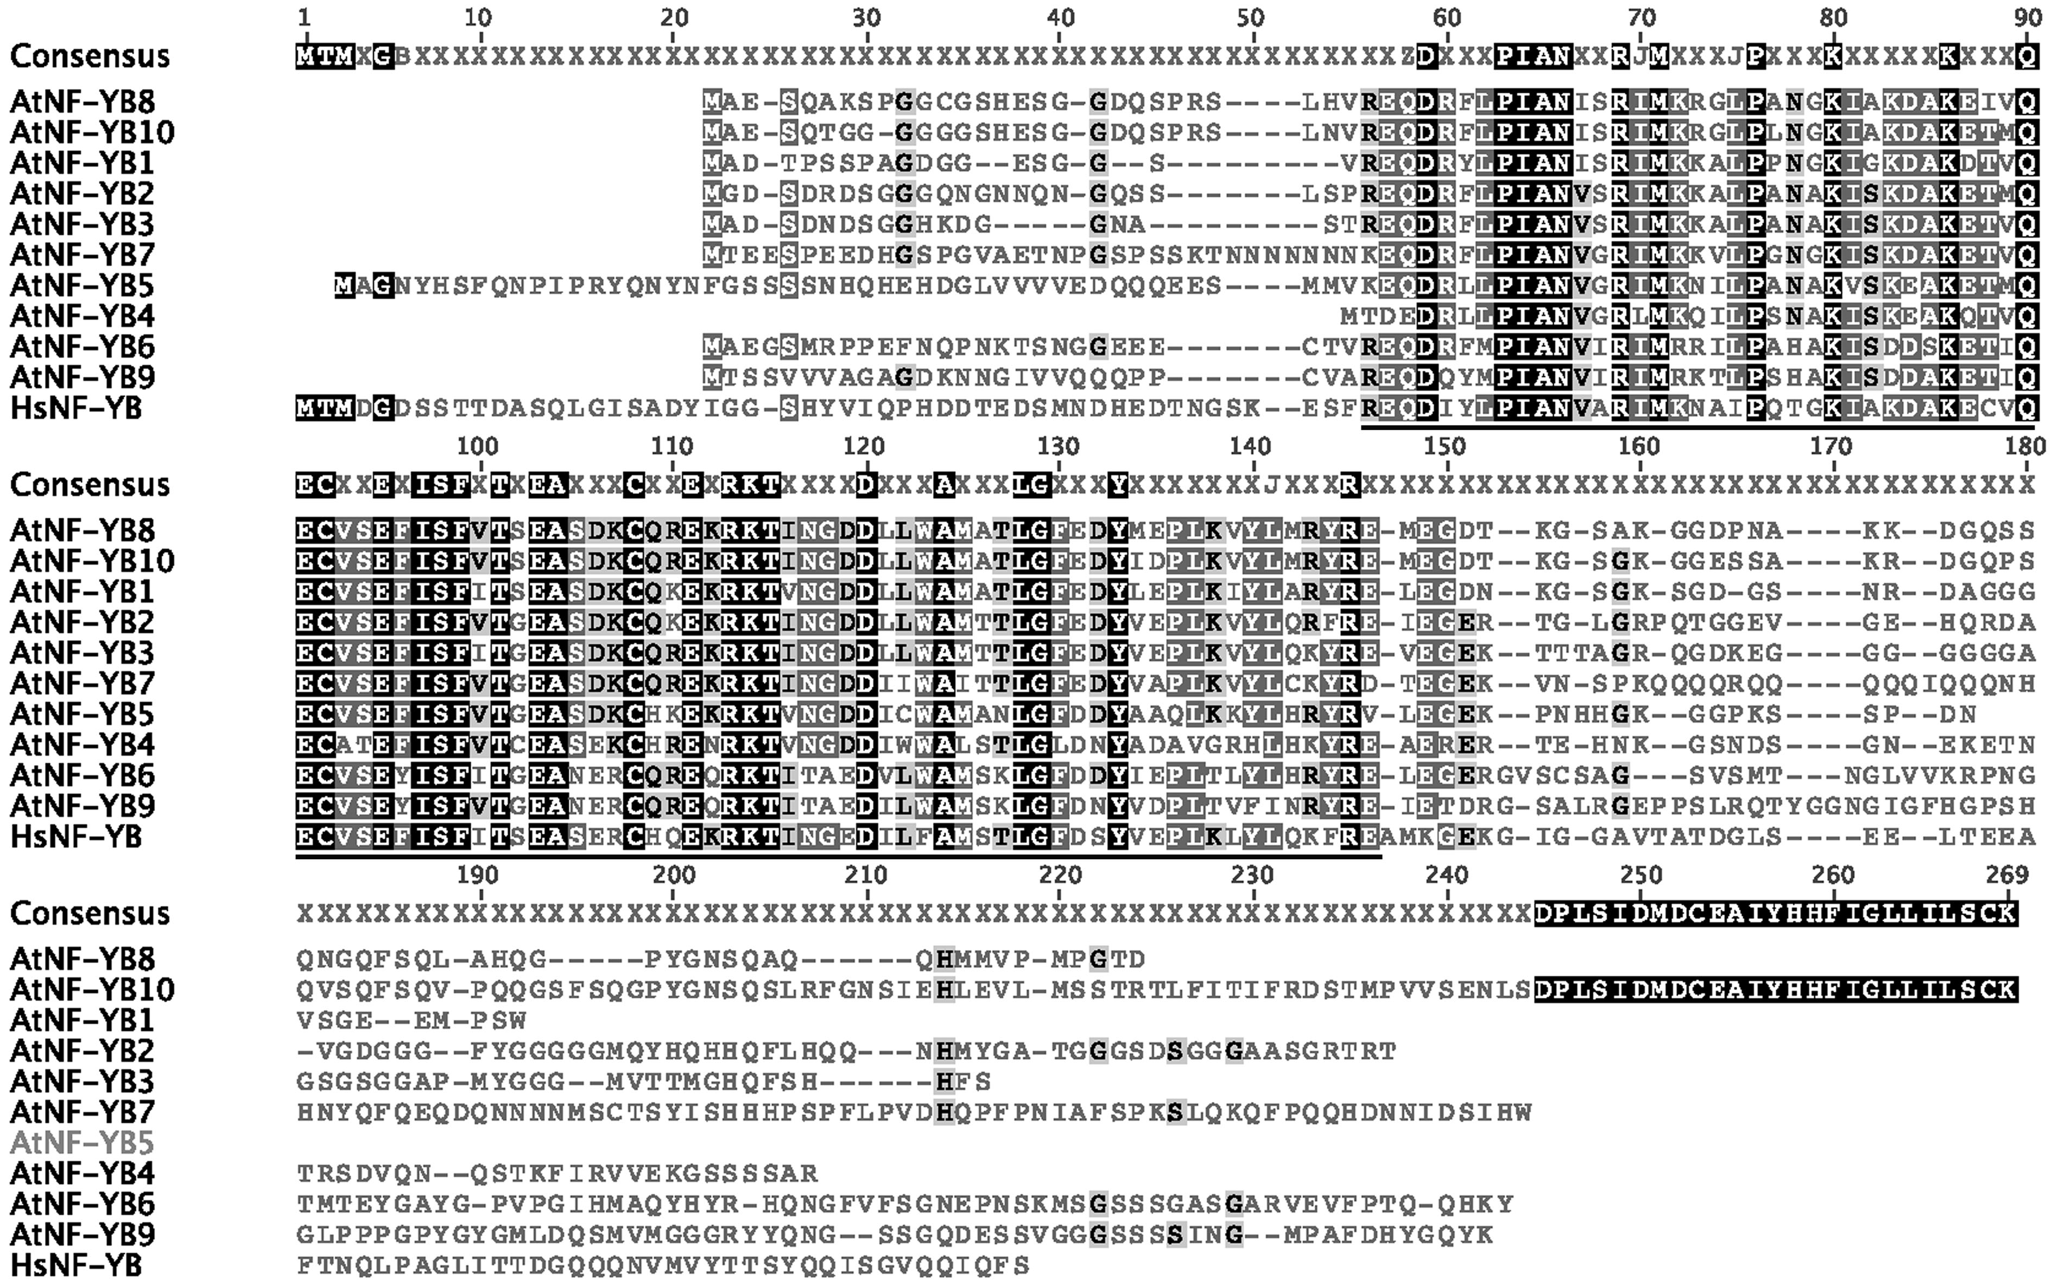

Figure 1.7. Multiple sequence alignment of full-length NF-YB proteins. MSA was computed using ClustalW in Genious. The Conserved core domain is underlined in black. At: Arabidopsis thaliana; Hs: Homo sapiens.

Figure 1.8.. Multiple sequence alignment of full-length NF-YC proteins. MSA was computed using ClustalW with in Genious. The Conserved core domain is underlined in black. At: Arabidopsis thaliana; Hs: Homo sapiens.

Figure 1.9. Multiple sequence alignment of core domain NF-YB proteins. MSA was computed using ClustalW in Genious. Amino acids making physical contact with NF-YA are annotated (Nardini et al. 2013). At: Arabidopsis thaliana; Hs: Homo sapiens.

Figure 1.10. Multiple sequence alignment of core domain NF-YC proteins. MSA was computed using ClustalW with in Genious. Amino acids making physical contact with NF-YA are annotated (Nardini et al. 2013). At: Arabidopsis thaliana; Hs: Homo sapiens.

Chapter 2: Gene family analysis of the Arabidopsis NF-YA transcription factors reveals opposing abscisic acid responses during seed germination

This chapter was published in Plant Molecular Biology Reporter.
Siriwardana C.L., Kumimoto R. W., Jones D. S., and Holt B.F. III. (2014) Gene family analysis of the Arabidopsis NF-YA transcription factors reveals opposing abscisic acid responses during seed germination. Plant Molecular Biology Reporter.

Summary
In the plant kingdom each of the NF-Y transcription factor families, NF-YA, NF-YB and NF-YC, has undergone great expansion compared to the animal kingdom. For example, Arabidopsis thaliana has 10 members of each gene family compared to only one in humans. Progress towards understanding the significance of this expansion is limited due to a lack of studies looking at the complete gene family during plant development. In the current study, transgenic overexpression lines were created for all 10 Arabidopsis NF-YA genes and examined for general development and alterations in abscisic acid (ABA) mediated seed germination. NF-YA overexpression typically led to severe growth retardation and developmental defects, which extended from embryogenesis through to adult plants. Although overexpression of all NF-YA family members consistently led to growth retardation, some transgenic lines were hypersensitive to ABA during germination while others were hyposensitive. The opposing germination phenotypes were associated with the phylogenetic relationships between the NF-YA members. In addition, ABA-marker genes were experimentally misregulated and ABA-induction of gene expression was reduced in the overexpressors. Collectively, this study demonstrates that, although the NF-Y have retained high degrees of similarity, they have evolved unique and sometimes opposing roles during plant development.

Introduction
NUCLEAR FACTOR-Y (NF-Y) transcription factors bind DNA as complexes composed of three unique subunits, called NF-YA, NF-YB and NF-YC. While common throughout the eukaryotic lineage, the three NF-Y families have undergone an expansion in plants, with most species encoding ~10 genes for each family (Gusmaroli et al. 2001, 2002; Stephenson et al. 2007; Thirumurugan et al. 2008; Siefers et al. 2009; Cao et al. 2011a; Petroni et al. 2012; Laloum et al. 2013). Arabidopsis thaliana (Arabidopsis) has 10 NF-YA, 10 NF-YB and 10 NF-YC, and since NF-Y binds DNA as a heterotrimer this leads to the possibility of 1,000 unique NF-Y transcription factor complexes (Petroni et al. 2012). The large number of possible complexes suggests the potential to regulate diverse plant processes. NF-Y have demonstrated roles in: abscisic acid (ABA) responses (Nelson et al. 2007; Warpeha et al. 2007; Li et al. 2008; Yamamoto et al. 2009; Leyva-Gonzalez et al. 2012; Kumimoto et al. 2013; Mu et al. 2013), photoperiod dependent flowering (Ben-Naim et al. 2006b; Wenkel et al. 2006a; Cai et al. 2007; Chen et al. 2007; Kumimoto et al. 2008a; Kumimoto et al. 2010), embryogenesis (West et al. 1994; Lotan et al. 1998; Kwong et al. 2003; Lee et al. 2003), endoplasmic reticulum stress responses (Liu and Howell 2010), salt stress responses (Li et al. 2013), photosynthesis (Kusnetsov et al. 1999; Stephenson et al. 2010), root elongation (Ballif et al. 2011) and nodule development (Combier et al. 2006; Combier et al. 2008; Zanetti et al. 2010).

NF-Y family proteins have retained a high degree of similarity, especially in the residues necessary for complex formation and DNA binding, therefore how NF-Y have diverged to regulate a diverse set of development processes is still in question (Siefers et al. 2009; Laloum et al. 2013). NF-YA proteins are typified by a 53 amino acid conserved domain which makes physical contacts with DNA at CCAAT box cis-elements and mediates interactions with the NF-YB/NF-YC dimer (Olesen and Guarente 1990; Maity et al. 1992; Xing et al. 1993; Xing et al. 1994; Nardini et al. 2013). While the NF-YB and NF-YC subunits are abundant in-vivo, NF-YA is limiting for trimer formation and subsequent DNA binding (Dolfini et al. 2012). An examination of animal and plant literature demonstrates that the expression of NF-YA subunits is highly regulated at the transcriptional, post-transcriptional, and post-translational level. At the transcriptional level, tissue specific expression of the expanded NF-YA gene family in plants has shown spatial and temporal specialization (Stephenson et al. 2007; Siefers et al. 2009; Cao et al. 2011a). In animals, NF-YA protein is targeted for ubiquitination and subsequently degraded by the proteasome (Manni et al. 2008). Due to the high conservation of the residues targeted for ubiquitination, this likely also holds true for plant NF-YAs. In addition, plant NF-YA transcripts are targeted by a family of microRNAs called miR169 (Rhoades et al. 2002). In turn, miR169 abundance is regulated by the important stress hormone ABA.

Several recent publications have demonstrated that NF-YA subunits play an essential role during ABA-mediated responses in plants. ABA signals are perceived via the PYRABACTIN RESISTANCE1 (PYR1) /PYR1-LIKE (PYL) /REGULATORY COMPONENTS OF ABA RECEPTORS (RCAR) family of soluble receptors (Fujii et al. 2009; Ma et al. 2009; Melcher et al. 2009; Miyazono et al. 2009; Nishimura et al. 2009; Park et al. 2009; Santiago et al. 2009). Once ABA is bound to PYR/PYL, a signaling cascade is initiated through PP2C phosphatases and SnRK2 kinases to activate bZIP transcription factors that bind ABA response elements (ABRE) within the promoters of ABA response genes (Gosti et al. 1999; Merlot et al. 2001; Saez et al. 2004; Choi et al. 2005; Finkelstein et al. 2005; Furihata et al. 2006; Fujii and Zhu 2009; Rubio et al. 2009; Umezawa et al. 2009; Vlad et al. 2009; Yoshida et al. 2010). Select NF-YA subunits were shown to regulate the expression of these core ABA signaling components (Leyva-Gonzalez et al. 2012). Microarray analysis of Arabidopsis NF-YA2, NF-YA3, NF-YA7, and NF-YA10 driven by an inducible promoter revealed that transcript levels of several PYR/PYL/RCAR, PP2C, and SnRK2 family members were consistently downregulated.

In addition to regulating ABA signaling components, mutants and overexpressors of NF-YA have ABA-related developmental phenotypes during drought responses and seed germination. NF-YA5 transcripts increase in response to drought in an ABA-dependent manner (Li et al. 2008). The increase in transcript of NF-YA5 is attributed to drought induced down regulation of miR169a, which targets NF-YA5 transcripts for degradation. Further, plants overexpressing NF-YA5 were drought tolerant, whereas mutants were susceptible. Two recent publications further demonstrated that overexpression of selected members of the NF-YA family lead to ABA mediated seed germination phenotypes. Briefly, qualitative analyses demonstrated that overexpression of NF-YA1, NF-YA2, NF-YA3, NF-YA7, NF-YA9, and NF-YA10 led to ABA hypersensitivity (Leyva-Gonzalez et al. 2012; Mu et al. 2013). In addition, nf-ya5 mutants were hypersensitive to ABA during seed germination (Warpeha et al. 2007). NF-YC subunits were also recently shown to be involved in ABA responses. Interestingly, different NF-YC subunits can have unique and opposing functions in ABA mediated seed germination (Kumimoto et al. 2013). Mutants of nf-yc4 were hypersensitive to ABA, whereas mutants of nf-yc3 and nf-yc9 were hyposensitive to ABA during germination. The presence of opposing germination phenotypes in nf-yc mutants indicated that NF-YAs might also be involved in similar phenomena, however this had not been systematically examined for the entire family.

Here I present a complete family analysis of the Arabidopsis NF-YA. All ten Arabidopsis NF-YA genes were systematically overexpressed and the resulting phenotypes characterized relative to morphological development and ABA-mediated germination. Due to the presence of 10 NF-YA genes with high levels of amino acid similarity and extensive overlap in tissue-specific expression patterns (Siefers et al. 2009), I reasoned that overexpression would be a more fruitful first approach. Additionally, loss of function mutants in NF-YA1 and NF-YA2 are lethal (Pagnussat et al. 2005; Meinke et al. 2008). Overexpression of all NF-YA led to severe growth retardation, which was seen from embryo development through the adult plant. Although all overexpressors showed various levels of growth retardation, some transgenic lines were hypersensitive and others hyposensitive to germination on ABA media. ABA-marker genes were misregulated and the ability of exogenously applied ABA to induce transcription of marker genes was attenuated in the overexpressors. The opposing ABA phenotypes were associated with phylogenetic relationships between the NF-YA, indicating that members of this closely related gene family evolved distinct roles during ABA-mediated seed germination.

Results
The Arabidopsis NF-YA family clusters into five groups of paralogs
Phylogenetic analyses showed that the 10 members of the NF-YA gene family cluster into five groups of apparent paralogs, NF-YA1/NF-YA9, NF-YA2/NF-YA10, NF-YA3/NF-YA8, NF-YA4/NF-YA7, and NF-YA5/NF-YA6 (Figure 2.1A). Although the amino acid sequence of the NF-YA core domain is highly conserved, there are a few amino acids that are unique, especially in the early diverging paralogs NF-YA1/NF-YA9 and NF-YA2/NF-YA10 (Supplementary Figure 2.1). The NF-YA subunits diverge outside the core domain, however the pairs of paralogs maintain high identity throughout the amino acid sequence (Supplementary Figure 2.1 and 2.2). The combination of highly conserved core domains and diverging, non-conserved regions suggested that studying overexpressors of the complete NF-YA gene family would potentially reveal both common and unique phenotypes.

Overexpression of NF-YAs Causes Severe Growth Retardation
To characterize developmental phenotypes associated with NF-YA overexpression, qualitative and quantitative analyses were performed on two independent transgenic lines for each gene. Most NF-YA overexpression lines were shorter with smaller rosette diameters and produced fewer, smaller siliques than wild type plants (Figure 2.1B and Supplementary Figure 2.3). The only exceptions were p35S:NF-YA4 and p35S:NF-YA6, where one or both plant lines were similar to the wild type. Although most p35S:NF-YA plants exhibited varying levels of dwarfism, they all went through the same developmental stages as wild type plants with only moderate delays. Plant lines used for analysis had demonstrated accumulation of the transgenic proteins (Figure 2.1C). The level of protein expressed varied with p35S:NF-YA1 and p35S:NF-YA4 having the strongest expression and p35S:NF-YA6 the weakest. The phenotypes seen here are in agreement with previous reports showing that overexpression of a smaller subset, NF-YA2, 4, 7, and 10, also led to dwarf phenotypes (Liu and Howell 2010; Leyva-Gonzalez et al. 2012)

p35S:NF-YA5 and p35S:NF-YA6 produce cotyledon-like leaves
Two NF-YB subunits, LEAFY COTYLEDON 1 (LEC1/NF-YB9) AND LEC1-LIKE (L1L/NF-YB6), are essential for embryo development (West et al. 1994; Lotan et al. 1998; Kwong et al. 2003; Lee et al. 2003; Junker et al. 2012). Mutants of LEC1 and LEC1-L produce cotyledons with leaf like characters (e.g., trichomes), whereas overexpressors can produce cotyledon-like leaves. Although NF-YBs required for embryo development have been identified, the presumed NF-YA and NF-YC remained unidentified. Recently Mu et al. (2013) published that overexpressors of NF-YA1, NF-YA5, NF-YA6, and NF-YA9 produce cotyledon-like leaves. Examining all 10 NF-YA overexpression lines, I found that this phenotype occurs somewhat rarely and inconsistently for most lines. The exceptions were the paralogous p35S:NF-YA5 and p35S:NF-YA6 lines where I consistently observed cotyledon-like leaves in the normal position of the first set of true leaves (Figure 2.2A). This phenotype often persisted for multiple pairs of leaves in p35S:NF-YA5 plants and ultimately precluded seed set and further characterization of p35S:NF-YA6. In addition to gross morphological appearance resembling elongated cotyledons, leaves that should have developmentally corresponded to the first non-embryonic, true leaves were considerably smaller, had less chlorophyll, and typically lacked or had very few trichomes relative to wild type controls (Figure 2.2B and Supplementary Figure 2.4). The cotyledon-like leaves of p35S:NF-YA5 were further observed by differential interference contrast (DIC) microscopy and found to have vascular defects, including vascular tissue that was largely limited to the mid-rib region (Figure 2.2C). Although the p35S:NF-YA5 seedlings had severe growth defects, they were tolerant to salt and osmotic stress (Supplementary Figure 2.5).

NF-YA proteins are localized to the nucleus
Studies in animal systems have shown that the NF-YA subunit is primarily localized to the nucleus (Frontini et al. 2004; Kahle et al. 2005). The high degree of conservation between plant and animal NF-Ys (Siefers et al. 2009) suggested that a similar localization pattern would be seen in plants. Supporting this argument, the positively charged arginine and lysine residues in the core domain of the human NF-YA subunit, which are required for nuclear localization (Kahle et al. 2005), are highly conserved in Arabidopsis (Supplementary Figure 2.1 and Siefers et al. 2009).

Localization of all ten NF-YA-CFP/HA proteins was studied using confocal microscopy. The cyan fluorescence protein (CFP) signal was always strongly associated with the nucleus (Figure 2.3). The strength of the CFP signal corresponded well with the level of protein expression seen on the western blot (Figure 2.1C). The strongest expressing lines, p35S:NF-YA1 and p35S:NF-YA4, had the strongest CFP signal, whereas the weakest expressing line, p35S:NF-YA6, displayed weakest signal. This data supports and extends previously published data showing that Arabidopsis NF-YA1, NF-YA4, and NF-YA5 are nuclear localized (Li et al. 2008; Liu and Howell 2010; Li et al. 2013).

p35S:NF-YA have opposing germination phenotypes on ABA
Mutants of nf-yc subunits can have opposing germination phenotypes on ABA (Kumimoto et al. 2013). Since the NF-Y complex binds DNA as a trimer (Sinha et al. 1996; Romier et al. 2003; Nardini et al. 2013), we reasoned that this was likely to hold true for the NF-YA and tested all 10 subunits concurrently in this study. For ease of comparison, results were graphed based on phylogenetic relationships (Figure 2.1A), with apparent closest paralogs placed on the same graph in each instance.

On non-ABA media (Gamborg’s B5), most p35S:NF-YA lines germinated similarly to parental Col-0, although some lines showed minor delays (Figure 2.4A-E). Nevertheless, all plant lines reached ~50% germination by 18-24h post incubation and ~100% germination by 48h post incubation. On media supplemented with 1μM (+)-ABA, germination of parental Col-0 was delayed by approximately 72h. Conversely, NF-YA overexpression caused highly variable responses to ABA (Figure 2.5A-E). Most interestingly, I found that overexpression of the closely related (Figure 2.1A) NF-YA1 and NF-YA9 genes resulted in early germination; p35S:NF-YA1 lines reached 50% germination ~20h earlier than parental Col-0 while p35S:NF-YA9 lines germinated a full 48-h earlier (Figure 2.5A). In contrast, overexpression of NF-YA2, NF-YA4, NF-YA7, NF-YA8, and NF-YA10 resulted in late germination. To statistically confirm the apparent differences from parental Col-0, I performed Fisher’s Exact Tests at 84h post-incubation (Figure 2.5F-J; 84h was chosen because it is equivalent to ~50% germination for Col-0 in most experiments). Additionally, I examined dose response curves for each transgenic line using the 84h time point (Figure 2.5K-O). Collectively this data demonstrates that NF-YA overexpression consistently alters ABA responses, but that NF-YAs can cause opposing phenotypes in response to ABA. Additionally, I note that the ABA phenotypes are not directly correlated in any obvious way with the gross morphological data reported above (i.e., dwarf plants can give rise to both ABA-susceptible and resistant seeds, depending on the overexpressed NF-YA gene).

To see if the ABA responses of p35S:NF-YA are developmentally stage dependent (i.e., if ABA responses extend beyond germination), the effect of ABA on root elongation was tested. Four-day-old seedlings of selected p35S:NF-YA plant lines were initially grown on non-ABA media and then transferred to non-ABA (control) or ABA media (5 μM (+)-ABA). I selected p35S:NF-YA7, p35S:NF-YA8, and p35S:NF-YA9 because they were relatively healthy (i.e., the dwarf stature was not as severe as other stable lines) and had opposing phenotypes in the germination assays (Figure 2.5). On non-ABA media, primary root lengths were shorter for all p35S:NF-YA lines compared to wild type plants. Because of these differences in primary root elongation, results were graphed as the percent root elongation compared to non-ABA media. The results showed that the primary root growth of all three lines was hypersensitive to ABA (Figure S7). Thus, in contrast to the opposing germination phenotypes, all three p35S:NF-YA lines showed the same negative effect of NF-YA overexpression during root growth on ABA media.

NF-YA genes are expressed in embryos and the endosperm.
Most of the NF-YA genes showed ABA-related germination phenotypes when overexpressed with the p35S promoter. However a disadvantage with using overexpression constructs is that genes that do not have a biological role in a tissue may show a phenotype due to ectopic overexpression. To determine which NF-YA genes are likely to have a native biological role during seed germination, transgenic plants expressing the NF-YAs fused to the beta-glucuronidase reporter gene (GUS) and driven by their native promoter were examined (Siefers et al. 2009). This analysis showed that NF-YA1, NF-YA2, NF-YA3, NF-YA4, NF-YA6, NF-YA7, NF-YA8 and NF-YA9 were expressed in embryos and NF-YA1, NF-YA2, NF-YA3, NF-YA7, and NF-YA9 were expressed in the endosperm (Figure 2.6). The only genes that did not show expression in the embryo or the endosperm were NF-YA5 and NF-YA10. I compared these findings to publicly available expression data (Arabidopsis e-FP browser; http://bar.utoronto.ca/efp/cgi-bin/efpWeb.cgi; Winter et al. 2007) and found similar results (Figure S8). The only significant difference was NF-YA8 where I measured fairly weak expression, but publicly available data suggested moderately strong expression. Collectively, our data supports likely roles for most members of this gene family during seed development.

ABA related genes show altered expression in p35S:NF-YA
To further examine how NF-YA genes regulate ABA responses during seed germination, the expression of various ABA-related markers was examined. This included genes involved in ABA biosynthesis and catabolism, ABA signaling, and various downstream responses. p35S:NF-YA8 and p35S:NF-YA9 were selected for qPCR analyses due to their opposing germination phenotypes (p35S:NF-YA8 is hypersensitive and p35S:NF-YA9 is hyposensitive to ABA; Figure 2.5A and 2.5B). NF-YA8 and NF-YA9 were 100-fold and 40-fold upregulated, respectively (Supplemental Figure 2.9).

Initially the expression of ABA-related markers on seeds incubated on B5 media was examined. Two members of the 9-cis-epoxycarotenoid dioxygenase (NCED) gene family, NCED3 and NCED6, were misregulated in the overexpressors (Figure 2.7A). These genes control the rate-limiting step of ABA biosynthesis during dormancy and seed germination (Ruggiero et al. 2004; Lefebvre et al. 2006; Frey et al. 2012). NCED3 was significantly upregulated in both p35S:NF-YA8 and p35S:NF-YA9 seeds and NCED6 in p35S:NF-YA9 seeds. Following synthesis, ABA 8’-hydroxylation is a key mechanism by which ABA is catabolized. A CYP707A gene family member that encode ABA 8’-hydroxylases during dormancy and seed germination, CYP707A1 (Okamoto et al. 2006), was significantly downregulated in both p35S:NF-YA8 and p35S:NF-YA9 seeds (Figure 2.7B). ABA signaling components were also misregulated in the overexpressors, including the PYL6 ABA receptor, the SnRK2.6/OST1 and SnRK2.8 kinases, and the ABI1 phosphatase (Figure 2.7C, 2.7D, and 2.7E). In addition, RAB18, a well-known ABA response gene (Lang and Palva 1992), was six-fold upregulated in p35S:NF-YA9 seeds (Figure 2.7F).

Expression of these genes after ABA treatment was also evaluated. Strong upregulation (216-fold) of RAB18 in parental Col-0 showed that the ABA treatment was successful (Figure 2.7F). When the seeds where incubated on ABA, NCED3 was 40-fold upregulated in response to ABA in the wild type but only 10-fold upregulated in the overexpressors (Figure 2.7A). ABA-maker genes, ABF3, AIA, and HAB1 showed a similar trend (Supplementary Figure 2.10). In addition CYP707A1 was significantly downregulated in p35S:NF-YA8 seeds compared to the wild type (Figure 2.7B) and SnRK2.8 was two-fold downregulated in wild type and nearly 10-fold downregulated in the overexpressors on ABA (Figure 2.7D).

Discussion
In the presence of ABA, p35S:NF-YA expressing seeds can show opposing germination phenotypes. Overexpressors of NF-YA1 and NF-YA9 were hyposensitive, whereas overexpressors of NF-YA2, NF-YA4, NF-YA5, NF-YA7, NF-YA8, and NF-YA10 were hypersensitive to ABA. Opposing germination phenotypes were previously observed for the NF-YC subunits. An nf-yc3 nf-yc9 double mutant and an nf-yc3 nf-yc4 nf-yc9 triple mutant showed reduced germination inhibition in response to ABA, whereas single and double mutants with nf-yc4 showed hypersensitivity to ABA (Kumimoto et al. 2013). It is important to note that in the case of NF-YC observations, these were based on loss of function/hypomorphic mutations. Thus opposing phenotypes are not necessarily a simple artifact of ectopic overexpression. While opposing germination phenotypes have not been published on the NF-YB subunits, the overexpression of two paralogs in the NF-YB family, NF-YB2 and NF-YB3, led to ABA hypersensitivity (Kumimoto et al. 2013). The presence of opposing ABA phenotypes in NF-YA and NF-YC subunits and the fact that NF-Y complexes bind DNA as a trimer (Sinha et al. 1996; Romier et al. 2003; Nardini et al. 2013), suggests that a similar phenomena would be expected with the NF-YB subunits. Supporting this hypothesis, preliminary data from the Holt lab suggests that overexpression of some NF-YBs also leads to ABA hyposensitivity (BFH unpublished data). These results indicate that while the NF-Y proteins have retained high degrees of similarity, especially in the residues necessary for NF-Y complex formation and DNA binding (Siefers et al. 2009), they may be evolving unique, even antagonistic, regulatory roles for some processes. Similar phenomena from plant transcription factor families include the auxin-response factors (ARFs), which include both activators and repressors of auxin-response elements (Ulmasov et al. 1999) and WRKY family members, which include both positive and negative regulators of disease resistance (Eulgem and Somssich 2007).

NF-YC3 and NF-YC9, the two NF-YC subunits with mutants hyposensitive to ABA are paralogs, whereas NF-YC4 (mutant hypersensitive to ABA) is more distantly related (Siefers et al. 2009). Similarly ABA responses for the NF-YAs appear connected to their phylogenetic relationships. The two NF-YA subunits that are hyposensitive to ABA during seed germination, NF-YA1 and NF-YA9, are closely related paralogs sharing a recent common ancestor (Figure 2.1A). Similarly, NF-YA2 and NF-YA10 also share a recent common ancestor and both are hypersensitive to ABA. While amino acid alignments in the conserved domains of all ten NF-YA are highly similar, NF-YA1 and NF-YA9 do have a few unique amino acids that will provide targets for future mutational analyses towards uncovering the specific changes leading to functional differences.

My findings of reduced ABA sensitivity in seeds overexpressing NF-YA1 and NF-YA9 are in contrast with a recent report by Mu et al. (2013) in which they reported hypersensitivity. However, the authors appear to define germination as emerged plants after five days (i.e., visible cotyledons on a growth plate), which might be more properly defined as the “greening rate” (Kim et al. 2004). Here germination is more narrowly defined as the emergence of the radical from the seed coat (Bewley 1997). This is an important distinction as previous research suggests that these two phenotypes are not always directly correlated (Kim et al. 2004; Kumimoto et al. 2013). In fact, nf-yc9 single mutants did not have a germination phenotype but showed an early greening phenotype. Further, in contrast to an ABA hypersensitive germination phenotype, nf-yc4 nf-yc9 double mutants also had an early greening phenotype (Kumimoto et al. 2013). If the same five-day time point is examined in isolation with the current data, it is in agreement with Mu et al., (2013) for NF-YA1 overexpression. However this hides the fact that most of the NF-YA1 overexpressors germinate significantly faster than parental Col-0 (Fig. 5A). The day five (and later) measurement for NF-YA1 suggests that total germination percentage never reaches 100%, but, nevertheless, those that do germinate do so more quickly than Col-0. Thus, my data and previous data strongly suggest that germination and greening are separable processes that need to be carefully defined and quantified as such. Further, although NF-YA9 overexpression led to reduced ABA sensitivity during germination, the seedlings were hypersensitive to ABA during root elongation. This demonstrates that ABA sensitivity can vary significantly at different developmental time points. The ABRE binding bZIP transcription factor ABF2 also shows a similar phenomena (Kim et al. 2004). While p35S:ABF2 seeds germinate as wild type on ABA, they are hypersensitive to ABA during root growth. In contrast, overexpressing ABF3 and ABF4 (members of the same sub-family) results in hypersensitivity to ABA during both seed germination and root elongation (Kang et al. 2002).

It is possible that NF-Y complexes both physically interact with and regulate the expression of genes that mediate seed germination in response to ABA. In the case of physical interactions, it was shown that NF-YB and NF-YC subunits physically interact with transcription factors that mediate ABA responses, including ABFs, HY5 and bZIP67 (Yamamoto et al. 2009; Kumimoto et al. 2013). In the current study, NCED3 and NCED6 genes that regulate the rate limiting step of ABA biosynthesis during germination (Ruggiero et al. 2004; Lefebvre et al. 2006; Frey et al. 2012), were upregulated and CYP707A1, a gene that regulates ABA catabolism during germination (Okamoto et al. 2006), was downregulated. It is possible that NF-YA regulates the level of ABA during germination and that the overexpression of NF-YA genes led to higher levels of ABA in seeds due to increased production and decreased breakdown. In addition to genes that regulate ABA biosynthesis and catabolism, genes that regulate ABA signaling were down regulated. The down regulation of ABA signaling genes is consistent with a previous publication, which showed similar results with NF-YA2, NF-YA3, NF-YA7, and NF-YA10 overexpressors (Leyva-Gonzalez et al. 2012). This shows that most members of the NF-YA family are able to regulate ABA signaling components during germination and other ABA-mediated developmental responses. In addition to misregulation of ABA-related markers, ABA-induced genes showed attenuated response to ABA application. Similarly, ABA induction of known ABA-induced genes was reduced or eliminated in the pyr1 pyl1 pyl2 pyl4 pyl5 pyl8 sextuple mutant (Gonzalez-Guzman et al. 2012) and the snrk2.2 snrk2.3 snrk2.6 triple mutant (Fujii and Zhu 2009; Fujita et al. 2009; Nakashima et al. 2009). The current study and Leyva-Gonzalez et al. (2012) have shown the down regulation of ABA receptors and kinases in NF-YA overexpressors. It is possible that the reduced induction of ABA-regulated genes in the NF-YA overexpressors is partly due to the down regulation of the receptors and kinases. Although this study identified opposing ABA phenotypes in the NF-YA family during germination, the qPCR analysis did not identify opposingly regulated genes. A high throughput analysis using microarray or RNA-seq techniques that identify global changes in gene expression may be required to identify the genes that lead to the opposing germination phenotypes.

My finding that p35S:NF-YA5 is resistant to abiotic stress is in agreement with Li et al. (2008) who demonstrate that NF-YA5 overexpressors are drought tolerant. The authors found that NF-YA5 transcript was strongly induced by drought conditions. A miRNA, miR169, which targets the NF-YA5 transcript, was down regulated during drought conditions and ABA treatment, and this decrease in miR169 was partially responsible for the increase in NF-YA5 transcript accumulation. Similar examples are seen in plant species such as Medicago truncatula, soybean (Glycine max), and aspen (Populus tremulloides), where miR169 is demonstrated to regulate NF-YA transcripts during diverse development programs such as nodulation, drought responses, and vegetative bud formation (Combier et al. 2006; Ni et al. 2013; Potkar et al. 2013). Because, most NF-YA genes are predicted targets of miR169 (Rhoades et al. 2002), its role in ABA mediated germination and embryo development needs further investigation.

Members of the NF-Y gene family, common to all eukaryotes, have undergone a large expansion in the plant kingdom, however the significance of this expansion is not well understood. The same NF-YC family members that have opposing roles during germination actually work together to regulate flowering time (Kumimoto et al. 2010; Kumimoto et al. 2013), demonstrating both unique and overlapping roles for NF-Y during plant development. The current study adds to the growing evidence for both unique and overlapping roles for the NF-Y in the plant lineage by identifying opposing role for the NF-YA family during germination. It is important to note that studying the complete gene family aided in identifying the opposing roles for this genes family. Future studies of NF-YA family roles during development can potentially identify similar unique and overlapping responses and may eventually help explain the evolutionary advantages for the expansion of the plant NF-Ys.

Materials and methods

Phylogenetic analysis
Full-length cDNA sequences for the coding regions of NF-YA subunits were obtained from TAIR (http://www.arabidopsis.org; Huala et al. 2001). Phylogenetic analyses were conducted using MEGA5 (Tamura et al. 2011). The Maximum Parsimony method was used to infer evolutionary history as described previously (Felsenstein 1985; Nei M. 2000).

Construction of transgenic lines
The full-length coding region of each NF-YA gene (NF-YA1 to NF-YA9) was amplified from cDNA by PCR using Pfu Ultra II (cat#600670; Agilent Technologies) and ligated into the GATEWAYTM entry vector pENTR/D-TOPO (cat#45-0218; Invitrogen). All constructs were sequenced and found to be identical to sequences at The Arabidopsis Information Resource (http://www.arabidopsis.org; Huala et al. 2001). NF-YA10 cDNA in pDONR221 was obtained from ATOME1 ORFEOME library (stock#51B10;CNRGV). All NF-YA cDNA clones were introduced to the plant expression destination vector pEarlyGate102 (stock#CD3-684; ABRC; Early et al., 2006) using the GATEWAYTM LR Clonase II reaction kit (cat#56485; Invitrogen). The 35S cauliflower mosaic virus promoter (p35S) (Kay et al. 1987) was used to drive the expression of each gene. Transgenic plants were generated using Agrobacterium mediated floral dipping described in previous studies (Clough and Bent 1998). At least two independent homozygous or hemizygous transgenic lines were examined for each NF-YA (Supplementary Table 2.1).

Plant cultivation and germination assays
Arabidopsis thaliana ecotype Columbia (Col-0) was used as the wild type for all experiments. For morphological studies and generation of matched seed sets plants were grown in standard long day conditions (16-h light/8-h dark cycle) in a custom walk-in chamber. Plant growth medium contained equal parts Farfard C2 and Metromix 200 (17,620 cm3 total soil mixture) supplemented with 40 g Marathon pesticide and 3,785 cm3 distilled water with Peter’s fertilizer (NPK 20:20:20). Plants were watered with dilute Peter’s fertilizer (at 1/10 recommended feeding levels) throughout the growth cycle. For western blots, germination assays, qPCR and microscopy seed plates were cold stratified in the dark for 48h and placed in a Conviron ATC13 growth chamber at 22°C with continuous light.

Germination assays were always performed on matched seed sets that were after ripened for four months. Seeds were sterilized by treating with 70% ethanol for 5 min and 50% household bleach for 5 min followed by five washes of sterile distilled water. Seeds were germinated on Gamborg’s B5 media or B5 supplemented with (+)-ABA (cat#A4906; Sigma). Germination was scored as the emergence of the radical tip from the seed coat (Bewley 1997). These experiments were done in triplicate (n=3), with a total of at least 80 seeds used per genotype and repeated three times with independent, matched seed sets with the same results. For the statistical analyses, the observed frequencies were compared with expected frequencies with Fisher’s exact tests as previously described within INSTAT (GraphPad Software – La Jolla, CA) (Kumimoto et al. 2013).

Microscopy
p35S:NF-YA5 and pNF-YA:GUS/GFP lines (Siefers et al. 2009) were imaged with a Zeiss Axiolmager.Z1/ ApoTome microscope (Carl Zeiss). Prior to imaging, pNF-YA:GUS/GFP seed coats (including endosperm) and embryos were stained by placing in beta-glucuronidase (GUS) staining solution and incubated overnight at 37oC in the dark (Perry and Wang 2003). Subcellular localization was determined in four-day-old seedlings counterstained by incubating in 50 µg/mL propidium iodide (PI) for 5 min, followed by washing in DI water for 5 min. Seedlings were mounted in DI water and roots were imaged using a Leica TCS SP8 confocal laser-scanning microscope with a 40X water immersion objective. Sequential scanning mode was used for CFP and PI detection where CFP was excited using 458 nm laser with emission detected at 462 – 536 nm and PI was excited using 561 nm laser with emission detected at 582 – 673 nm. Approximately 200 serial optical sections of root tip were imaged with an average cubic voxel size of 190 nm x 190 nm x 190 nm starting with the root epidermis closest to the cover slip imaging through to the stele. For DNA labeling, tissue was fixed in 4% PFA in PBS for 2 min incubated in 5 µg/mL Hoechst 33342 for 50 min, mounted on DI water, and excited with a 405 nm laser. Images were processed using ImageJ (http://rsb.info.nih.gov/ij/; Schneider et al. 2012) where average intensities of both CFP and PI channels through the series were taken and merged.

Western blot
Total protein was extracted from 14-day-old plants by grinding in lysis buffer (20 mM Tris, pH 8.0, 150 mM NaCl, 1 mM EDTA, pH 8.0, 1% Triton X-100, 1% SDS with fresh 5 mM DTT, and 100 µM MG132). NF-YA-CFP/HA was probed with high affinity anti-HA primary antibody (cat#11 867 423 001; Roche) and goat anti-rat secondary antibody (cat#SC-2032; Santa Cruz Biotechnology). The Bio-Rad ChemiDoc XRS imaging system was used for visualizing the protein blot after incubations with ECL plus reagent (cat#RPN2132; GE Healthcare). Equivalent loading and transfer efficiency was determined by staining the protein blot with Ponceau S (cat#P3504; Sigma-Aldrich).

qPCR Analysis
Matched seed sets were germinated on Gamborg’s B5 medium, with or without 1 μM (+)-ABA. Total seed RNA was extracted using the E.Z.N.A. Plant RNA Kit (cat#R6827-01; Omega Biotek) according to the manufacturers instructions for difficult samples. Genomic DNA was digested during RNA extraction by treating the columns with DNase (cat#E1091; Omega Biotek). First-strand cDNA was synthesized using the Superscript III First-Strand Synthesis System (cat#18080-051; Invitrogen). qPCR was performed using a CFX ConnectTM Real-Time PCR Detection System (Bio-Rad) with the SYBR Green qPCR Master Mix (cat#K0222; Fermentas). Gene expression analysis was done using the CFX ManagerTM software (Bio-Rad). Normalized expression, ∆∆Cq, was selected as the analysis mode. Samples were normalized to a constitutively expressed reference gene, At2g32170 (Czechowski et al. 2005). Three biological replicates were used for the qPCR, which was repeated three times with the same results. Statistical analysis was done with two-way ANOVA (P<0.05), in which genotype and seed growth media were used as the two variables, followed by Bonferroni multiple comparisons post-hoc test against Col-0 on B5 media or on B5 + 1 µM ABA (Gutierrez et al. 2008; Rieu and Powers 2009). Primer sequences are available upon request.

Contributions
This project was conceived by Dr. B. Holt, myself and Dr. R. Kumimoto. I made the transgenic NF-YA overexpressors by Agrobacterium mediated transformation and collected the stable lines. I performed the phenotype analysis, western blot, microscopy (other than confocal microscopy), germination assays, GUS staining, RNA extraction and qPCR, and multiple sequence alignments. I also wrote the paper published in PMBJ. Cloning NF-YA1 to NF-YA9 was performed by Dr. R. Kumimoto. The clones were introduced to the plant destination vectors by Dr. R. Kumimoto or myself. D. Jones performed the confocal imaging. Dr. B. Holt constructed the phylogenetic tree.

Figure 2.1. Characterization of p35S:NF-YA overexpressing lines. A) Phylogenetic relationship between the Arabidopsis NF-YA genes. B) Phenotypes for two independent lines of three-week-old p35S:NF-YA plants compared to Col-0. C) Protein blot for the two independent transgenic lines of each p35S:NF-YA.

Figure 2.2. p35S:NF-YA5 seedlings develop cotyledon-like leaves. A) Seedlings of Col-0 and p35S:NF-YA5. B) True leaves of Col-0 in comparison to cotyledon-like leaves of p35S:NF-YA5. C) Differential interference contrast (DIC) microscopy images of leaf venation in Col-0 and p35S:NF-YA5. The scale bar in (A) equals 1 mm (for Col-0) and 0.5 mm (for p35S:NF-YA5) (B) equals 2 mm (C) equals 50 µm.

Figure 2.3. NF-YA proteins are nuclear localized. Protein localization in Col-0 and p35S:NF-YA-CFP/HA overexpression lines. The cyan fluorescence protein (CFP) signal (blue) was always strongly associated with the nucleus (note that localization was confirmed by merged images, combining the CFP localization of NF-YAs with DIC imaging and Hoechst 33342 labeling staining of the nucleus – Figure S6). The cell walls are stained with propidium iodide (red). The scale bar in (A) equals 15 µm.

Figure 2.4. Seed germination on Gamborg’s B5 medium for p35S:NF-YA. A-E) Germination curves for two independent lines each of p35S:NF-YA overexpressors compared to Col-0.

Figure 2.5. p35S:NF-YA overexpressors show opposing germination phenotypes on ABA. A-E) Germination curves for two independent p35S:NF-YA lines. F-J) Germination at 84-h post incubation. K-O) Dose responses on 0.5, 1, 2, and 5 μM ABA at 84-h post incubation. Asterisks for F to J are Fisher’s Exact Test p-values; * p<0.01, ** p<0.001, *** p<0.0001.

Figure 2.6. NF-YA genes are expressed in the endosperm and embryos. The native expression of NF-YA genes in seeds imbibed for 24h are shown for A) embryos B) seed coat/endosperm. The scale bar in Col-0 equals 50 µm.

Figure 2.7. ABA response genes are misregulated in p35S:NF-YA8 and p35S:NF-YA9 seeds. Gene expression analyzed by qPCR for genes involved in ABA A) biosynthesis, B) catabolism, C) receptors, D) kinases, E) phosphatases, and F) responses. Asterisks represent significant differences derived from two-way ANOVA (p<0.05), in which genotype and seed growth media are the two variables, followed by Bonferroni multiple comparisons post hoc test against Col-0 on B5 media or on B5 + 1 µM ABA.

Supplemental Table 2. 1. List of homozygous and hemizygous p35S:NF-YA plant lines.

AGI# | Construct | Plant line# | Homozygous or Hemizygous
At5g12840 | p35S:NF-YA1-CFP/HA | 1 | Homozygous
At5g12840 | p35S:NF-YA1-CFP/HA | 2 | Homozygous
At3g05690 | p35S:NF-YA2-CFP/HA | 1 | Homozygous
At3g05690 | p35S:NF-YA2-CFP/HA | 2 | Homozygous
At1g72830 | p35S:NF-YA3-CFP/HA | 1 | Homozygous
At1g72830 | p35S:NF-YA3-CFP/HA | 2 | Homozygous
At2g34720 | p35S:NF-YA4-CFP/HA | 1 | Homozygous
At2g34720 | p35S:NF-YA4-CFP/HA | 2 | Hemizygous
At1g54160 | p35S:NF-YA5-CFP/HA | 1 | Hemizygous
At1g54160 | p35S:NF-YA5-CFP/HA | 2 | Hemizygous
At3g14020 | p35S:NF-YA6-CFP/HA | 1 | Hemizygous
At3g14020 | p35S:NF-YA6-CFP/HA | 2 | Hemizygous
At1g30500 | p35S:NF-YA7-CFP/HA | 1 | Homozygous
At1g30500 | p35S:NF-YA7-CFP/HA | 2 | Homozygous
At1g17590 | p35S:NF-YA8-CFP/HA | 1 | Homozygous
At1g17590 | p35S:NF-YA8-CFP/HA | 2 | Homozygous
At3g20910 | p35S:NF-YA9-CFP/HA | 1 | Homozygous
At3g20910 | p35S:NF-YA9-CFP/HA | 2 | Homozygous
At5g06510 | p35S:NF-YA10-CFP/HA | 1 | Hemizygous
At5g06510 | p35S:NF-YA10-CFP/HA | 2 | Homozygous

Supplemental Figure 2.1. Multiple sequence alignment of full-length NF-YA protein sequences. At: Arabidopsis thaliana; Hs: Homo sapiens. The Conserved core domain is underlined in black. The three black boxes correspond to nuclear localization signal in humans.

Supplemental Figure 2.2. Identity matrix of the NF-YA protein sequences. A) Full-length protein B) core domain. At: Arabidopsis thaliana; Hs: Homo sapiens. Note that pairs of Arabidopsis NF-YA paralogs demonstrate high identity across the full-length protein sequence.

Supplemental Figure 2.3. Overexpression of the NF-YA gene family leads to growth defects. Quantitative measurements of A) plant height B) rosette width C) number of siliques on primary bolt D) length of siliques.

Supplemental Figure 2.4. Quantifications of the cotyledon-like leaves in p35S:NF-YA5. A) Leaf area B) number of trichomes C) chlorophyll content. Asterisks represent significant differences derived from Student’s t-tests.

Supplemental Figure 2.5. Abiotic stress responses of p35S:NF-YA5 seedlings. Response to A) 6% mannitol B) 150 mM NaCl. Asterisks represent significant differences derived from Student’s t-tests.

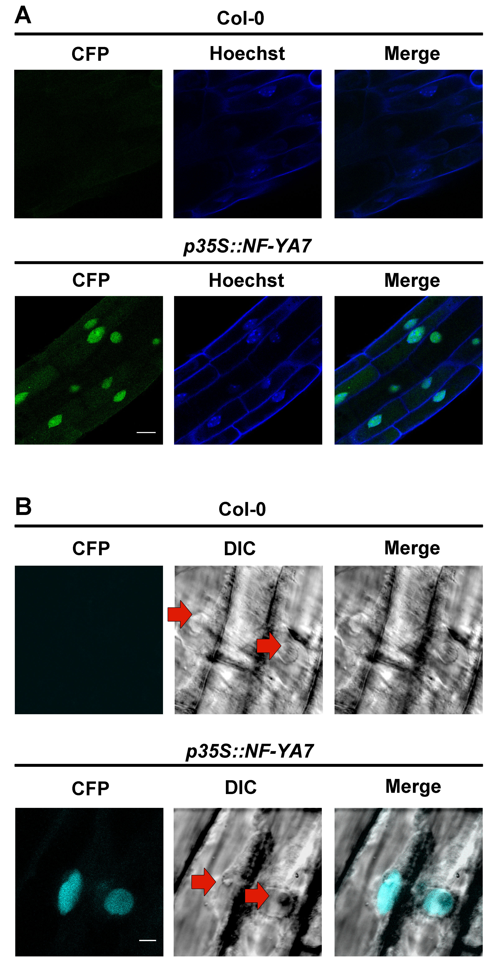

Supplemental Figure 2.6. Confirmation of nuclear localization of NF-YA proteins. A) Hoechst 33342 (blue) labels nuclei and CFP signal (green) shows localization of NF-YA7. Merged images demonstrate co-localization of DNA label and CFP fluorescence. Scale - 15 µm. B) Differential Interference Contrast (DIC) imaging (grey) of root cell nuclei (red arrows point to the nuclei) with CFP signal (cyan) showing localization of NF-YA7. Merged images indicate CFP fluorescence is localized to the root cell nuclei. Scale - 5 µm.
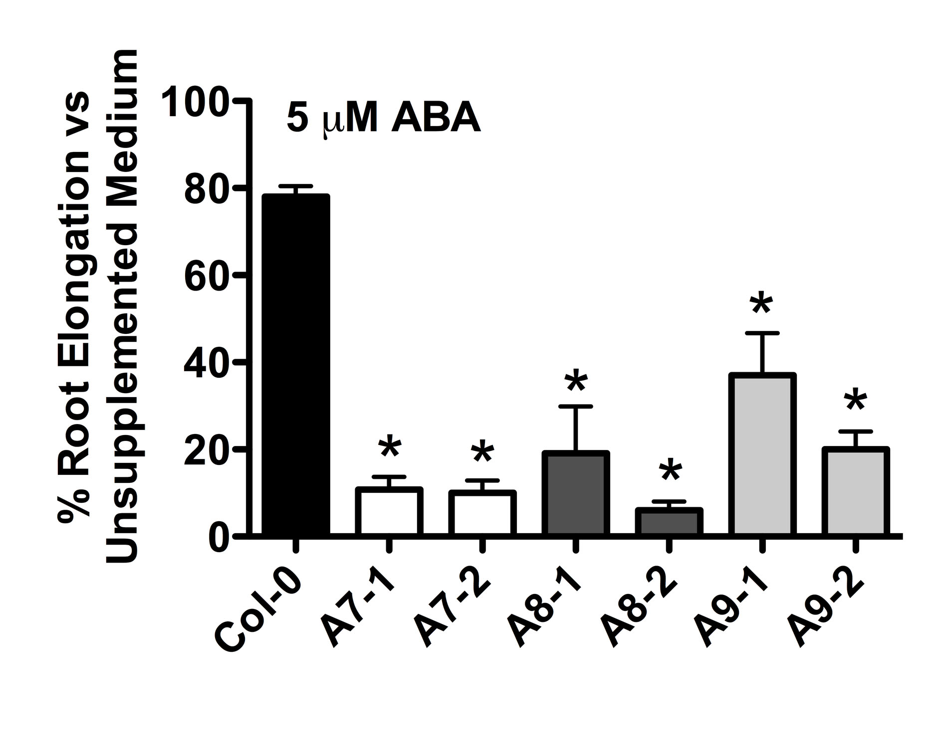

Supplemental Figure 2.7. Overexpression of select NF-YA genes leads to ABA hypersensitivity during root elongation. The percent root elongation in growth medium with ABA was compared to the unsupplemented medium for Col-0, p35S:NF-YA7, p35S:NF-YA8, and p35S:NF-YA9. Asterisks represent significant differences derived from one-way ANOVA (P < 0.05) followed by Dunnett’s multiple comparison post hoc tests against Col-0

Supplemental Figure 2.8. Publically available microarray data demonstrate that NF-YA genes are expressed in seeds. Data was obtained from the Arabidopsis e-FP browser at http://bar.utoronto.ca/efp/cgi-bin/efpWeb.cgi.

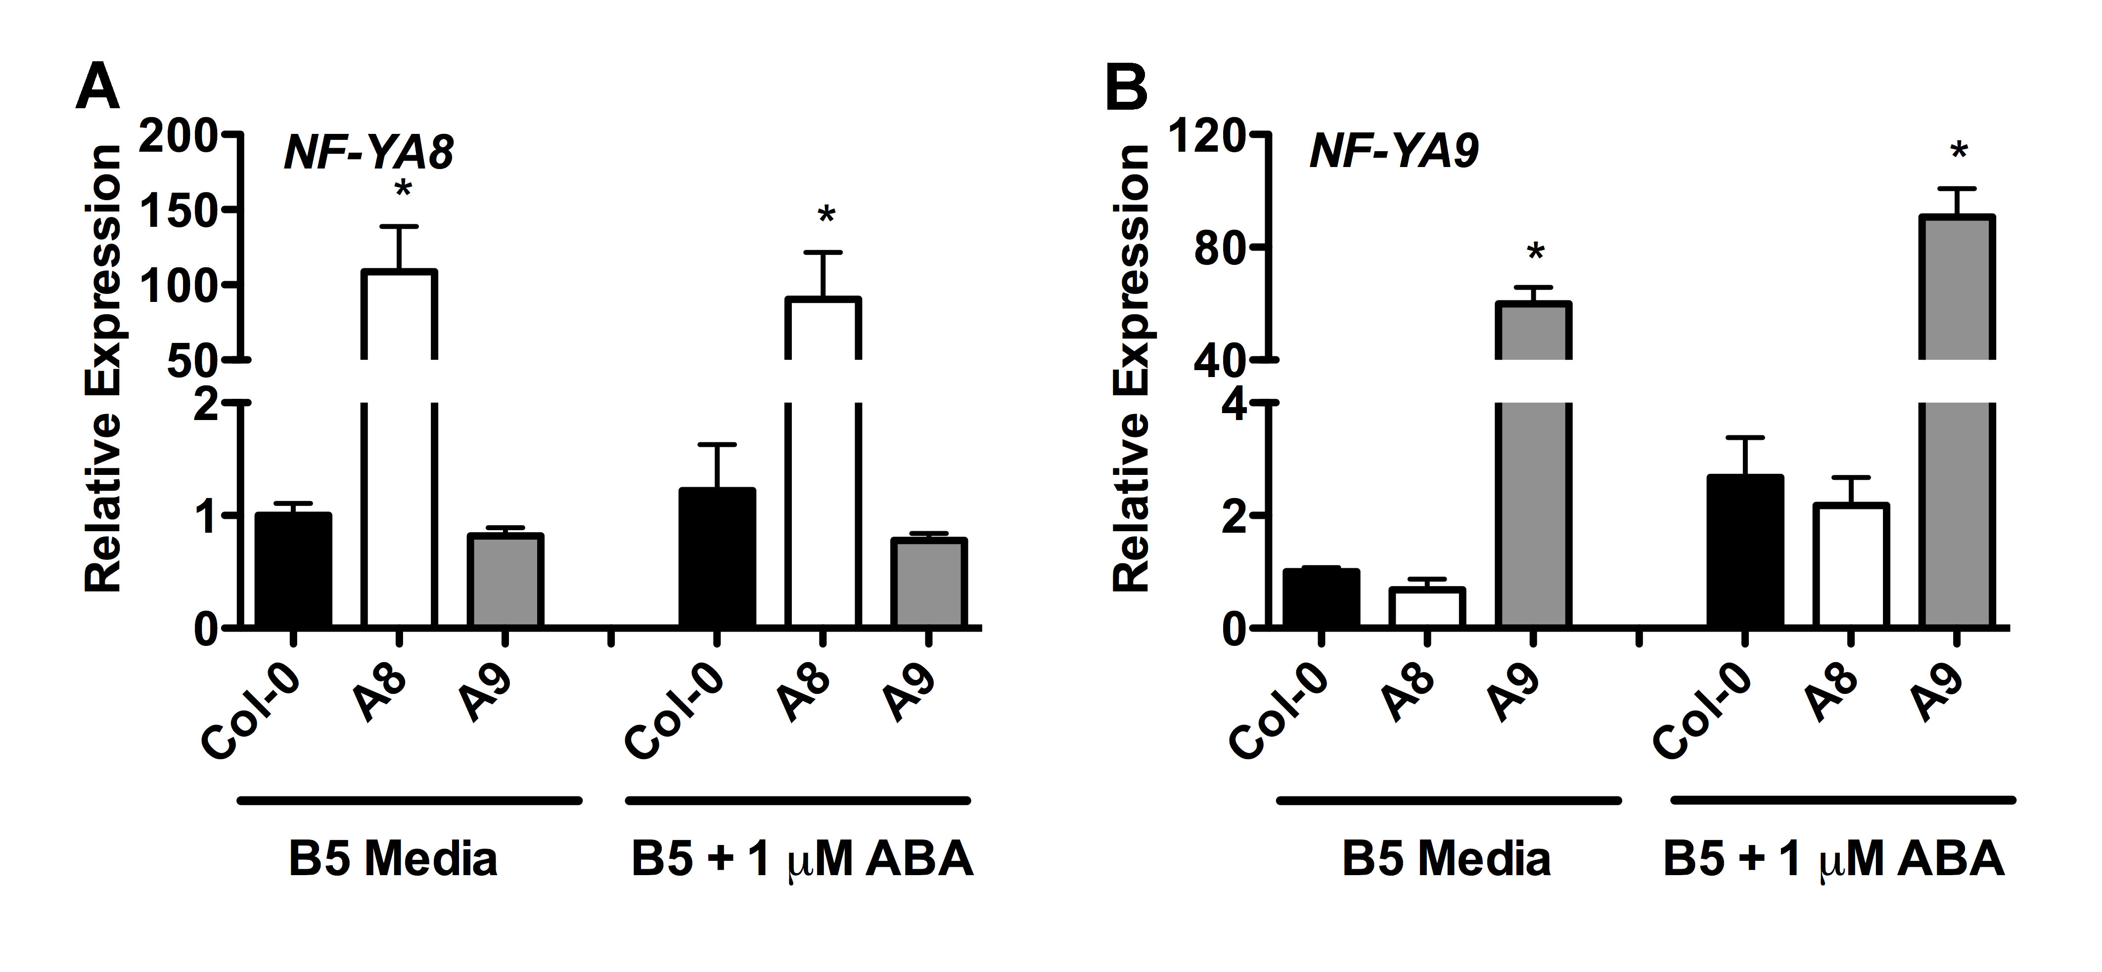

Supplemental Figure 2.9. qPCR analysis of gene expression in p35S:NF-YA8 and p35S:NF-YA9 seeds. (A) NF-YA8 (B) NF-YA9. Asterisks represent significant differences derived from two-way ANOVA (p<0.05), in which genotype and seed growth media are the two variables, followed by Bonferroni multiple comparisons post hoc test against Col-0 on B5 media or on B5 + 1 µM ABA.

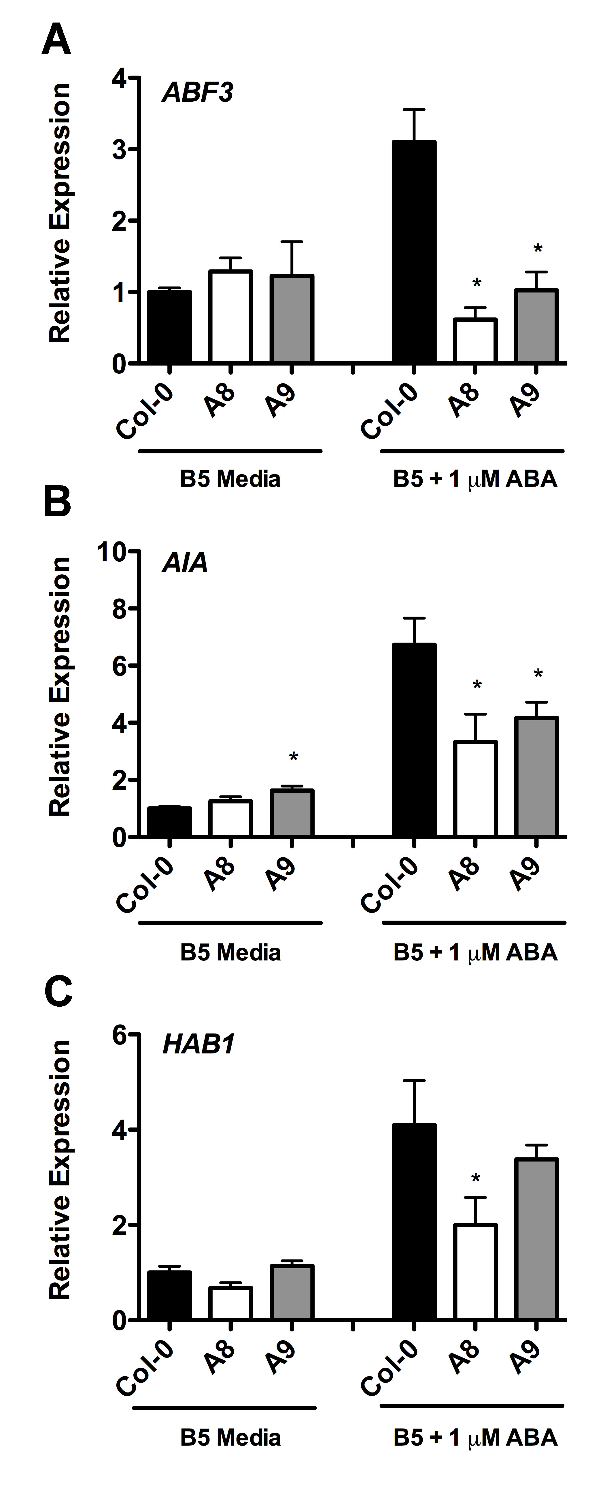

Supplemental Figure 2.10. ABA-induction of gene expression in p35S:NF-YA8 and p35S:NF-YA9 seeds. Expression of A) ABF3 B) AIA C) HAB1. Asterisks represent significant differences derived from two-way ANOVA (p<0.05), in which genotype and seed growth media are the two variables, followed by Bonferroni multiple comparisons post hoc test against Col-0 on B5 media or B5 + 1 µM ABA.

Chapter 3: Arabidopsis NF-YA subunits are positive regulators of photoperiod dependent flowering

This chapter is in preparation as a manuscript to be submitted for review to Plant Journal.
Siriwardana C.L., Kumimoto R.W., Myers Z.A., Jones D. S., Holt0 B.F. III.
Arabidopsis NF-YA subunits are required as positive regulators of photoperiod dependent flowering.

Summary
The heterotrimeric NF-Y transcription factors, composed of the three independent protein families NF-YA, NF-YB, and NF-YC, are required for photoperiod dependent flowering. While it is known that specific NF-YB and NF-YC subunits interact and function together with a key floral regulator, CONSTANS (CO) to regulate flowering, the role and specific NF-YAs remains unknown. NF-YAs were thought to be negative regulators that compete with CO to bind the NF-YB/ NF-YC dimer. However, results from a number of recent publications have suggested that NF-YA subunits may be acting as positive regulators of flowering. In this chapter I tested my hypothesis that NF-YAs are positive regulators of flowering. Since NF-YA loss of function alleles are lethal or do not have flowering phenotypes, I used two approaches to test if NF-YA are positive regulators. First, to indirectly test if NF-YAs are needed for the NF-YB/NF-YC dimer to regulate flowering, I created a mutant version of NF-YB that loses interaction with NF-YA, but not NF-YC. The mutant was overexpressed in the late flowering nf-yb2 nf-yb3 double mutant, and was found not to complement the late flowering phenotype. However, the mutant protein was strongly expressed and was able to localize to the nucleus, as expected for a functioning NF-YB protein. This result shows that mutations that eliminate the ability of NF-Y complexes to recruit NF-YA prevent appropriate flowering and suggest that NF-YA are required as positive regulators of this process. My second approach was to study overexpressors of NF-YA. Here I was able to identify that NF-YA2 overexpressors drove early flowering and led to the upregulation of a key floral integrator FT. This result suggested that NF-YA2 may be a positive regulator of flowering. Further, a recent publication suggested that CO provides an activation domain for the NF-Y complex. In this publication, NF-YB2 was able to induce flowering in the absence of CO (in a co mutant background) when it was translationally fused to an activation domain called EDLL. I hypothesized that, when fused to this same EDLL domain, the NF-YB2 mutant described above would not be able to induce flowering in the absence of CO. Further, I hypothesized that NF-YA2 would be able to induce flowering in the absence of CO when attached to the EDLL domain. The results reported here support both of these hypotheses. Because NF-YA2:EDLL promotes more rapid flowering, this strongly suggests it is part of the NF-Y complex bound at the FT promoter and my data strongly suggests that NF-YAs are required as positive regulators of flowering.

Introduction
In angiosperms the correct timing of floral transition is crucial for reproductive success. Both external and internal cues determine when the floral transition occurs. A key external cue is the duration of day/night cycles or photoperiod (Lang 1952). Photoperiod varies in temperate climates where there are four pronounced seasons. The model plant Arabidopsis thaliana (Arabidopsis) is a long day plant; that is, it flowers when the day becomes longer than a crucial day length (Salisbury 1985). Central to measuring photoperiod is the circadian regulation of CONSTANS (CO) transcript and the light-mediated regulation of CO protein accumulation (Hayama and Coupland 2004). CO protein peaks in long days and is able to bind the promoter and activate FLOWERING LOCUS T (FT) (Tiwari et al. 2010). FT is the key mobile signal that travels from the leaves, where the photoperiod signal is perceived, to the shoot apex, where the floral transition occurs (Corbesier et al. 2007; Mathieu et al. 2007; Tamaki et al. 2007). At the shoot apex, FT binds the bZIP transcription factor FLOWERING LOCUS D (FD) and activates floral transition genes that regulate the transition from a vegetative meristem to a floral meristem (Abe et al. 2005; Wigge et al. 2005). Recent publications have demonstrated that members of the heterotrimeric transcription factor family called NUCLEAR FACTOR-Y (NF-Y) are required for CO activation of the FT promoter and thus regulate the downstream events that lead to the floral transition (Kumimoto et al. 2008b; Kumimoto et al. 2010).

NF-Ys are heterotrimeric transcription factors composed of three independent protein families, NF-YA, NF-YB, and NF-YC. While ubiquitous to eukaryotes, the NF-Y subunits have undergone an extensive expansion in plants. For example, Arabidopsis has ten members of each family (Petroni et al. 2012). To activate target genes, NF-YB and NF-YC dimerize in the cytoplasm and move to the nucleus where the dimer interacts with NF-YA to make a DNA-binding trimer (Sinha et al. 1995; Sinha et al. 1996; Frontini et al. 2004; Kahle et al. 2005). The NF-Y trimer is sequence specific and binds DNA in conserved CCAAT boxes (Mantovani 1999). NF-YA makes direct contacts with the CCAAT boxes and the NF-YB/NF-YC dimer makes non-specific contacts in adjacent regions, helping to stabilize the promoter/protein complex (Nardini et al. 2013).

Several NF-YB and NF-YC subunits have been demonstrated to regulate photoperiod dependent flowering (Ben-Naim et al. 2006a; Wenkel et al. 2006b; Cai et al. 2007; Chen et al. 2007; Kumimoto et al. 2008b; Kumimoto et al. 2010). Briefly, two NF-YB subunits, NF-YB2 and NF-YB3, act as positive regulators of flowering. nf-yb2 and nf-yb3 mutants are late flowering, and the nf-yb2 nf-yb3 double mutant flowers later than the single mutants, indicating an additive effect from overlapping function. Three NF-YC subunits, NF-YC3, NF-YC4, and NF-YC9, are also positive regulators of flowering, with the triple nf-yc3 nf-yc4 nf-yc9 mutant being late flowering. The expression of FT is down regulated in both the nf-yb and nf-yc mutants, suggesting that the NF-Y genes regulate flowering in an FT dependent manner. The NF-YC genes that regulate flowering also physically interact with CO, suggesting that a NF-Y/CO complex may be formed on the FT promoter (Kumimoto et al. 2010). Further, when CO was overexpressed in the nf-yc triple mutant background, its ability to drive early flowering and upregulate FT was suppressed, suggesting that CO requires all three NF-Y subunits for proper function (Kumimoto et al. 2010). These results taken together demonstrate that NF-YB and NF-YC subunits are required as positive regulators of CO mediated photoperiod responses. However, the role played by NF-YAs is not clearly understood.

Overexpression of two NF-YA subunits, NF-YA1 and NF-YA4, using a phloem specific promoter, resulted in late flowering (Wenkel et al. 2006). In addition, the DNA binding domain of NF-YA subunits shares a region of high homology with CO. Based on these two findings, Wenkel et al. (2006) proposed a replacement model where NF-YA and CO compete to bind the NF-YB/NF-YC dimer. In this model there are two possible complexes that can form on the FT promoter, NF-YA/NF-YB/NF-YC and CO/NF-YB/NF-YC. The model suggests that the CO/NF-YB/NF-YC complex acts positively on the FT promoter. The NF-YA/NF-YB/NF-YC complex does not activate the FT promoter and exerts a negative regulatory effect, caused by the competition between NF-YA and CO to bind the NF-YB/NF-YC dimer.

Recent findings have led us to believe that the replacement model may not fully explain the role of NF-YA during flowering. For example, CO was able to directly bind the FT promoter, independent of NF-Y complexes, at unique cis-sequences called CO regulatory elements (CORE) 1 and 2 (Tiwari et al. 2010). CO did not require NF-Y to bind the CORE sites. In addition, CO did not bind CCAAT boxes. This was not surprising in that although the DNA binding domain of NF-YA shares a region of homology with CO, some amino acids that are essential for the NF-YA to bind CCAAT boxes are not conserved (Xing et al. 1993). Therefore it is unlikely that CO competes with NF-YA to bind CCAAT boxes.

It was recently demonstrated that CCAAT boxes are essential for regulating the FT promoter (Cao et al. 2014). When a select CCAAT box in the FT promoter was mutated, flowering was negatively affected, whereas the CCAAT box is in a distal promoter element located -5.3 kb from the FT start codon, the CORE sites are proximal elements located at approximately -150 bp. Thus, this is evidence of a chromatin loop formed with NF-Y at the CCAAT box and CO at the CORE site (Cao et al. 2014). Further it was shown that CO provides an activation domain for the NF-Y complex, and that NF-YB2 fused to a strong activation domain could promote flowering in the absence of CO (Tiwari et al. 2012). The findings summarized above strongly suggested that NF-YAs are needed as positive regulators of flowering.

My hypothesis is that NF-YAs are acting as positive regulators of flowering. To test this hypothesis I identified a mutation in NF-YB2, which abolishes the interaction with NF-YA. The NF-YB2 mutant, which was unable to interact with NF-YA, did not promote flowering, strongly suggesting that NF-YA are required for the NF-YB/NF-YC dimer to promote flowering. Further, NF-YB2 attached to activation domain (EDLL) was recently shown to induce flowering in the absence of CO. However, when fused to this same EDLL domain, the NF-YB2 mutant described above did not induce flowering in the absence of CO. The result of the experiment strongly suggest that while CO provides an essential activation activity to the NF-YB/NF-YC dimer, the NF-YA subunit is required for the dimer to bind DNA and function in the promotion of flowering. I also identified NF-YA2 as a possible positive regulator of flowering. NF-YA2 was vascular expressed and overexpression led to earlier flowering and upregulation of FT. Further, NF-YA2 was able to induce flowering in the absence of CO when attached to the EDLL domain. Taken together, the results strongly suggest that NF-YA are positive regulators of flowering.

Results
NF-YB2^{E65R} loses interaction with NF-YA subunits
In humans, the NF-YB^{E92R} mutant protein was shown to specifically lose interaction with the NF-YA subunit, but not the NF-YC subunit (Sinha et al. 1996). Recent crystal structure analysis of the NF-Y complex demonstrated that this glutamic acid makes physical contact with NF-YA (Nardini et al. 2013). The core domains of NF-Y proteins are highly conserved through the eukaryotic lineage (Siefers et al. 2009) and I found the glutamic acid in humans to be absolutely conserved in Arabidopsis (Figure 3.1A). Further, NF-Y genes have been annotated in wheat, rice, and Brachypodium (Stephenson et al. 2007; Thirumurugan et al. 2008; Cao et al. 2011a), and in NF-YBs of all three genomes, this glutamic acid is conserved. Therefore the glutamic acid is likely essential for function and a mutation in this position has the potential to be a powerful tool to study the loss of NF-YB/NF-YA interactions in presence of an intact NF-YB/NF-YC interaction.

Since I was interested in finding out if the NF-YA subunits are required for the NF-YB/NF-YC dimer to regulate photoperiod dependent flowering, I chose to alter the flowering-promoting NF-YB2 protein (Cai et al. 2007; Kumimoto et al. 2008b) to create the NF-YB2^{E65R} mutation. I tested if NF-YB2^{E65R} can interact with three NF-YC subunits involved in flowering (Kumimoto et al. 2010) and found that both NF-YB2 and NF-YB2^{E65R} were able to physically interact with NF-YC3, NF-YC4, and NF-YC9 (Figure 3.1B). Next I tested the ability of NF-YB2^{E65R} to interact with NF-YA2 (NF-YA2 regulates flowering; Figure 3.5). It has been previously shown that NF-YB proteins do not initially dimerize with NF-YA proteins, but instead first form a dimer with NF-YC and then trimerize with NF-YA (Kim et al. 1996). This was confirmed as NF-YB2 and NF-YB2^{E65R} did not interact with NF-YA2 in Y2H assays. Therefore, I used Y3H assays where NF-YC9 was expressed using a bridge vector. In this system, NF-YB2 was able to interact with NF-YA2, however NF-YB2^{E65R} lost interaction (Figure 3.1C), demonstrating that the conserved glutamic acid is required for NF-YA2 to interact with the NF-YB2/NF-YC9 dimer.

p35S:NF-YB2^{E65R} cannot rescue the late flowering phenotype of nf-yb2 nf-yb3
NF-YB2 and NF-YB3 have additive roles regulating photoperiod dependent flowering and the nf-yb2 nf-yb3 double mutant was extremely late flowering (Kumimoto et al. 2008b). NF-YB2 expressed under the control of the constitutively expressed 35S viral promoter (Kay et al. 1987) was able to rescue the nf-yb2 nf-yb3 late flowering phenotype (p35S:NF-YB2; Holt and Risinger, unpublished data). Based on my hypothesis that NF-YA are positive regulators of flowering, I expected that p35S:NF-YB2^{E65R}, which loses interaction with NF-YA, would be unable to rescue the nf-yb2 nf-yb3 late flowering phenotype. I tested this by overexpressing both p35S:NF-YB2 and p35S:NF-YB2^{E65R} in the nf-yb2 nf-yb3 background. The results showed that first generation plants (T1s) transgenic for p35S:NF-YB2 were able to rescue the late flowering phenotype as previously shown (Figure 3.2A and 3.2B). Some p35S:NF-YB2 plants flowered earlier than wild type. None of the p35S:NF-YB2^{E65R} plants, however, were able to rescue the late flowering phenotype. On average, p35S:NF-YB2^{E65R} plants produced 44 leaves prior to flowering, which was not statistically different from the 43 leaves produced by nf-yb2 nf-yb3 mutants. To rule out the possibility that the flowering phenotypes were due to differences in growth rate, I also scored flowering time by measuring the number of days it took for the first bud to appear (Supplementary Figure 3.2). The results were the same as with the leaf number counts. I also tested flowering time of p35S:NF-YB2^{E65R} in the wild-type background (Figure 3.2C). This T1 flowering time experiment demonstrated that p35S:NF-YB2 was able to drive flowering earlier than the wild type. However, p35S:NF-YB2^{E65R} exerted a dominant negative effect and those plants flowered significantly later than the wild type. With the previous Y2H results, this result suggested that a non-functional NF-YB^{E65R}/NF-YC dimer can form in these transgenic plants (i.e., unable to bind NF-YA and subsequently DNA) and partially interfere with flowering time.

Alternative explanations for the T1 flowering data discussed above were that the mutant NF-YB protein might have been unable to 1) accumulate or 2) move into the nucleus. To rule out these possibilities, I first compared the level of protein expression in 12 individual TI generation p35S:NF-YB2^{E65R} plants to a strongly expressing stable p35S:NF-YB2 plant line (p35S:NF-YB2-1). I found that half of the p35S:NF-YB2^{E65R} plants tested had the same high level of protein expression as p35S:NF-YB2-1 (Figure 3.2D). Interestingly, those with the highest accumulation of NF-YB2^{E65R} were among the latest flowering, typically flowering even later than the nf-yb2 nfy-b3 parental line. This result demonstrates that p35S:NF-YB2^{E65R} plants with protein expression comparable to that of an early flowering p35S:NF-YB2 plant line are still unable to rescue the late flowering phenotype and, as suggested above, NF-YB2^{E65R} can dominantly interfere with flowering. I additionally compared flowering times in two independent, stable, single insertion lines each for p35S:NF-YB2 and p35S:NF-YB2^{E65R} (i.e., stable T3 lines). These lines had similarly strong protein accumulation. p35S:NF-YB2-1 and p35S:NF-YB-2 flowered at on average 11 and 17 leaves respectively and p35S:NF-YB2^{E65R}-1 and p35S:NF-YB2^{E65R}-2 flowered at 43 and 40 leaves respectively (Supplementary Figure 3.3). Confocal imaging was used to test if the mutation affected NF-YB2 protein localization. To test this both NF-YB2 and NF-YB2^{E65R} were fused with yellow fluorescence protein (YFP). NF-YB2-YFP and NF-YB2^{E65R}-YFP were both strongly localized to the nucleus, with a weaker signal in the cytoplasm (Figure 3.2E). These results demonstrate that the E65R mutation does not affect accumulation or localization of NF-YB2, strongly suggesting that differences in function are a result of losing the NF-YA interaction.

p35S:NF-YB2^{E65R} plants cannot drive high FT expression
NF-Y and CO regulate flowering by binding the FT promoter, and FT was upregulated when the NF-YBs that regulate flowering were overexpressed (Cai et al. 2007; Kumimoto et al. 2008b; Kumimoto et al. 2010; Tiwari et al. 2010). p35S:NF-YB2^{E65R} was not able to induce flowering, however, in the nf-yb2 nf-yb3 background; therefore I hypothesized that FT would not be upregulated. Prior to testing the level of FT, I tested if NF-YB2 is overexpressed at similar levels in p35S:NF-YB2 and p35S:NF-YB2^{E65R}. If NF-YB2 was not upregulated in p35S:NF-YB2^{E65R} plants, that would explain its inability to increase the expression of FT. However, when the expression of NF-YB2 in stable p35S:NF-YB2 and p35S:NF-YB2^{E65R} plant lines was tested, I found that NF-YB2 expression was highly upregulated in both lines (Figure 3.3A). Next, I tested the expression of FT and found that FT expression was actually suppressed in p35S:NF-YB2^{E65R} (Figure 3.3B). FT was slightly upregulated in p35S::NF-YB2. FT directly regulates the expression of APETALA1 (AP1) (Corbesier et al. 2007), which also had a similar expression profile as FT in p35S:NF-YB2 and p35S:NF-YB2^{E65R} plants (Figure 3.3C). This suggests that p35S:NF-YB2^{E65R} is not able to recue the flowering phenotype, in fact p35S:NF-YB2^{E65R} can act as a dominant negative, because it is interferes with FT expression. This suggests that the NF-YB/NF-YC dimer needs to interact with NF-YA to drive the expression of FT to regulate flowering.

p35S:NF-YB2^{E65R} fused to a strong activation domain is not able to induce flowering in a CONSTANS-deficient mutant
A recent publication demonstrated that CO provides an activation domain for the NF-Y complex, which can be substituted with a foreign activation domain (Tiwari et al. 2012). Briefly, p35S:NF-YB2 was not able to induce flowering in co mutants, suggesting that CO, not NF-Y complexes, was the rate limiting step in these mutants. However, when p35S:NF-YB2 was fused to a strong activation domain called EDLL, the resulting p35S:NF-YB2/EDLL construct was able to induce flowering co mutants. I hypothesized that the NF-YB2^{E65R} mutation results in a dysfunctional NF-YB/NF-YC complex unable to bind NF-YA and subsequently DNA. Therefore I argued that fusing a strong activation domain (which would act as an activator in the absence of CO) would still be unable to induce flowering. This would suggest that CO and NF-YA provide different activities for the NF-YB/NF-YC dimer.

I used two methods to test flowering in the absence of CO; loss of function mutants and short day (SD) conditions. First, I tested the ability of p35S:NF-YB2, p35S:NF-YB2-EDLL, and p35S:NF-YB2^{E65R}-EDLL to rescue the late flowering phenotype of co-2 which are in the Landsberg erecta (Ler) background. The results showed that while p35S:NF-YB2-EDLL was able to induce flowering in co-9, p35S:NF-YB2, and p35S:NF-YB2^{E65R}-EDLL were not able to induce flowering (Figure 3.4A). Although p35S:NF-YB2-EDLL was able to induce significantly earlier flowering, the response was weak. While Ler flowered at about 10 leaves, the earliest flowering p35S:NF-YB2-EDLL plants flowered at about 20 - 25 leaves. However, both p35S:NF-YB2 and p35S:NF-YB2^{E54R}-EDLL were not able to induce flowering in co-2. I also tested flowering in co-9 mutants, which are in the Col-0 background. Although a few p35S:NF-YB2-EDLL plants flowered even earlier than Col-0, most of the plants were not able to induce flowering in the co-9 background and the differences were not significant (Figure 3.4B). These results show that p35S:NF-YB2-EDLL, can only partially substitute the activity of CO. However, p35S:NF-YB2, and p35S:NF-YB2^{E65R}-EDLL were not able to induce flowering.

CO protein does not accumulate in short days (SD) and is the rate limiting factor for flowering induction under these conditions. Therefore researchers use SD conditions as proxy for a co mutant background. I expected that p35S:NF-YB2-EDLL, which partially induced flowering in co mutants, would be able to induce flowering in Col-0 plants grown in SD. Alternatively, p35S:NF-YB2^{E65R}-EDLL would not induce flowering. As expected in SD conditions, Col-0 flowered after producing about 60 leaves. p35S:NF-YB2-EDLL drove earlier flowering than Col-0 and p35S:NF-YB2,and p35S:NF-YB2^{E65R}-EDLL flowered at the same time as Col-0 (Figure 3.4C). However, p35S:NF-YB2-EDLL produced on average 40 leaves, which was considerably later than the average 14 leaves produced by Col-0 under LDs. This again indicates that p35S:NF-YB2-EDLL can only partially substitute the activity of CO under SDs.

The EDLL domain is a strong activation domain and it is possible that the flowering responses discussed above were a result of direct activation of downstream floral regulators such as AP1 and LEAFY (LFY) – i.e., that it was not due to the expected activation of FT expression. Therefore, to demonstrate that the p35S:NF-YB2-EDLL flowering responses were due to its activity on the FT promoter and not on downstream targets, flowering responses were tested in the ft-10 background. None of the constructs tested was able to rescue the ft-10 late flowering phenotype, indicating that the p35S:NF-YB2-EDLL flowering phenotypes are dependent on functional FT (Figure 3.5D). Further, p35S:NF-YB2-EDLL had severe growth phenotypes when overexpressed in all the genetic backgrounds tested here. However, this phenotype does not appear to be correlated with flowering time as p35S:NF-YB2-EDLL plants in the ft-10 background had the same phenotype as in the other backgrounds, but did not flower earlier.

I also tested the ability of p35S:NF-YB2, p35S:NF-YB2-EDLL, and p35S:NF-YB2^{E65R}-EDLL to drive early flowering in Col-0 and rescue the nf-yb2 nf-yb3 late flowering phenotype. In both these cases active CO was present, however I expected that attaching a strong activation domain should lead to earlier flowering phenotypes. In the Col-0 background, p35S:NF-YB2 and p35S:NF-YB2-EDLL drove early flowering (Figure 3.4E), however the ability of p35S:NF-YB2-EDLL to drive early flowering was significantly stronger than p35S:NF-YB2. A similar response was seen in the nf-yb2 nf-yb3 mutant background, where p35S:NF-YB2 and p35S:NF-YB2-EDLL were both able to rescue the mutant phenotype, but p35S:NF-YB2-EDLL was significantly more effective (Figure 3.5F). In both cases p35S:NF-YB2^{E65R}-EDLL did not drive early flowering or rescue the late flowering phenotype. Alternatively, p35S:NF-YB2 ^{E65R}-EDLL had a dominant negative effect in the Col-0 background, similar to the phenotype seen with p35S:NF-YB2^{E65R} in Col-0 (Figure 3.2C). These results strongly suggest that while CO provides an essential activation activity to the NF-YB/NF-YC dimer, the NF-YA subunit is required for the dimer to bind DNA and function in the promotion of flowering – i.e., the NF-YB/NF-YC dimer is essentially non-active in the absence of the NF-YA subunit.

NF-YA2 can positively regulate photoperiod dependent flowering
To identify NF-YAs involved in flowering, first generation plant lines overexpressing each of the 10 NF-YA genes were analyzed. Two of the lines p35S:NF-YA2 and p35S:NF-YA6 were able to flower earlier than Col-0. All of the p35S:NF-YA plant lines had severe growth defects (Siriwardana et al. 2014) and, as a result, I was not able to collect stable lines for p35S:NF-YA6. However I was able to collect stable lines for p35S:NF-YA2. Two stable p35S:NF-YA2 plant lines produced ~10 leaves prior to flowering while the wild type produced 13 leaves (Figure 3.5A). To test if the early flowering phenotype was a direct result of the severe growth phenotype, I compared flowering responses of p35S:NF-YA2 to stable plant lines of p35S:NF-YA7, p35S:NF-YA8, and p35S:NF-YA9. The results showed that p35S:NF-YA7 and p35S:NF-YA9 flowered later and p35S:NF-YA8 at the same time as Col-0. This suggested that the severe growth phenotypes and flowering time were not directly correlated.

To further investigate the flowering phenotypes associated with NF-YA2, I expressed NF-YA2 under the control of its native promoter. The reasoning for this experiment was to overcome two major disadvantages faced when NF-YA2 was overexpressed under the control of the p35S promoter. As discussed above, when NF-YA genes were overexpressed it led to severe growth phenotypes. In addition, p35S leads to ectopic overexpression, therefore even genes that do not have a native function (due to lack of expression in a tissue, both temporally and spatially) can show a phenotype under the control of p35S promoter. I expected to overcome these two issues by expressing NF-YA2 under the control of its own native promoter. Before analyzing the flowering phenotypes of pNF-YA2:NF-YA2 plant lines, I tested the level of NF-YA2 expression. In the stable pNF-YA2:NF-YA2-1 plant line, NF-YA2 was 60-fold upregulated (Supplementary Figure 3.4). A possible explanation for the strong upregulation under the control of the native promoter is that the pNF-YA2:NF-YA2 construct did not contain the 3’UTR region of the gene, which is targeted by miR169 (Rhoades et al. 2002). However, the pNF-YA2:NF-YA2 plants did not have the severe growth phenotypes seen with p35S:NF-YA2. When flowering time was tested, two independent stable pNF-YA2:NF-YA2 plant lines were significantly early flowering compared to the Col-0 (Figure 3.5B). These data suggested that NF-YA2 could be a possible positive regulator of flowering.

CO, NF-YBs, and NF-YCs promote flowering by inducing FT expression in the phloem of young leaves, and as a result have strong vascular expression (An et al. 2004; Siefers et al. 2009; Kumimoto et al. 2010). When NF-YA2 was studied using a prNF-YA2:GUS-GFP construct (both here and elsewhere (Siefers et al. 2009), expression was largely confined to the vascular tissue in 10 day old leaves (Figure 3.5C). A similar spatial expression pattern was observed, for CO and the NF-YBs and NF-YCs that promote flowering. Strong vascular expression and the ability to drive early flowering when overexpressed, strongly suggested that NF-YA2 may be a positive regulator of flowering.

FT expression is upregulated in pNF-YN2:NF-YA2
CO, NF-YBs and NF-YCs regulate flowering primarily by controlling FT expression (Kobayashi et al. 1999; Cai et al. 2007; Kumimoto et al. 2008b; Kumimoto et al. 2010). I used the stable pNF-YA2:NF-YA2-1 plant line to test if NF-YA2 regulates the same set of genes. I used two time points to test the expression of my target genes, seven and nine days after germination, which co-related with the developmental time period when the flowering signals are initiated (An et al. 2004). NF-YBs and NF-YCs do not affect the expression of CO (Cai et al. 2007; Kumimoto et al. 2008b; Kumimoto et al. 2010), similarly CO was not misregulated in the NF-YA2 overexpressor (Figure 3.6A). However, similar to the NF-YBs and NF-YCs, the expression of FT was significantly upregulated in pNF-YA2:NF-YA2 when tested at day seven (Figure 3.6B). A paralog of FT, MOTHER OF FT (MFT) was also upregulated on both time points tested (Supplementary Figure 3.5). AP1 is a floral meristem identity gene that FT directly activates (Corbesier et al. 2007). I found that AP1 was significantly upregulated in pNF-YA2:NF-YA2 at day nine, two days after I saw the upregulation of FT (Figure 3.6C). These results strongly suggested that NF-YA2, like its NF-YB and NF-YC counterparts, regulates flowering primarily by regulating FT expression.

pNF-YA2:NF-YA2-EDLL induces flowering in a CONSTANS-deficient mutant
I hypothesized that if NF-YA2 is able to interact with the NF-YB/NF-YC dimer on the FT promoter, attaching the EDLL domain to pNF-YA2:NF-YA2 would also result in an induction of flowering in co mutants. If the hypothesis were proven, this would place NF-YA2 at the FT promoter. In co-9 backgrounds, pNF-YA2:NF-YA2-EDLL induced earlier flowering, whereas the control pNF-YA2:NF-YA2 was not able to induce flowering (Figure 3.7A). In the co-2 background, although a few pNF-YA2:NF-YA2-EDLL plants induced earlier flowering the differences were not significant. I also tested if pNF-YA2:NF-YA2-EDLL was able to induce flowering in the ft-10 background and found it did not, indicating that the flowering phenotype is dependent on functional FT.

T1 flowering data showed that pNF-YA2:NF-YA2-EDLL plants also flowered significantly earlier than Col-0 (Figure 3.7A). A portion of the pNF-YA2:NF-YA2-EDLL plants produced three or four sets of cotyledon-like leaves prior to producing true leaves (Supplementary Figure 3.4). This phenotype is consistent with what others and I have published earlier on NF-YA overexpressors (Mu et al. 2013; Siriwardana et al. 2014). Collectively, this data strongly supports the hypothesis that NF-YA subunits are actively involved in the flowering-promoting, functional NF-Y complexes and that the principal function of CO is to provide the transcriptional activation domain.

Discussion

The current study strongly suggests that NF-YA subunits act as positive regulators of photoperiod dependent flowering. I used two approaches to find if NF-YAs are positive regulators of flowering. The first was an indirect approach, where I used the NF-YB^{E65R} mutant. NF-YB2^{E65R} expressed under the control of p35S promoter was not able to rescue the late flowering phenotype of nf-yb2 nf-yb3. This result strongly suggested that NF-YA was needed for the flowering activity the NF-YB/NF-YC dimer. An alternative explanation for the flowering responses would be that NF-YB2^{E65R} is not expressed. However, NF-YB2 was strongly overexpressed in p35S:NF-YB2^{E65R} plants, the mutant protein accumulated as same as the wild type protein, and the mutant protein localized to the nucleus and was able to interact with NF-YC proteins. Further, the mutant had a dominant negative effect during its flowering responses. A similar conclusion on the dominant negative nature of the glutamic acid mutation was made in animal systems (Sinha et al. 1996). However, I cannot rule out the possibility that the mutant protein folded incorrectly or that the mutant lost interaction with regulatory elements other than NF-YA (e.g. a transcription factors that regulate flowering) and this resulted in the lack of rescue of late flowering. This approach also had the limitation that the data could only strongly suggest but not directly demonstrate that the NF-YA are required. The second approach I used was to study overexpressors of NF-YA genes. Using this approach I found that NF-YA2 overexpressors were able to drive early flowering, upregulate FT and that the gene was expressed in the vasculature. These data suggest that NF-YA2 could be a positive regulator of flowering. However, the overexpression constructs were problematic in some aspects. The native promoter construct had a very weak phenotype and the p35S construct had a very severe growth phenotype. Analysis of NF-YA2 loss of function mutant lines would give a better understanding of its role. However, this approach is limited as mutants of NF-YA2 are lethal (Pagnussat et al. 2005; Meinke et al. 2008). An inducible system could be developed to overcome the lethality.

Recently CO was demonstrated to provide an activation domain for the NF-Y complex. p35:NF-YB2-EDLL was able to induce flowering in a co mutant background. However, in this study, p35S:NF-YB2^{E65R}-EDLL was not able to induce flowering. This result strongly indicated that while CO provides an activation domain for the NF-Y complex, the NF-YB/NF-YC dimer is non-functional in the absence of NF-YA. pNF-YA2:NF-YA2-EDLL essentially had the same flowering phenotypes as p35S:NF-YB2-EDLL. Both constructs were able to induce flowering in co mutants, were not able to induce flowering in ft-10 mutants, and drove earlier flowering in Col-0. This genetic data strongly suggest that NF-YA2 is at the FT promoter. Biochemical analysis, such as chromatin immunoprecipitation and electrophoretic mobility assays (EMSA), could be used to show that NF-YA2 can bind the FT promoter, and complement the genetic assays presented here. If the biochemical data showed that both CO and NF-YA are physically present at the FT promoter at the same time and that NF-YA2 can bind the promoter, combined with the genetic data, this would very strongly suggest that NF-YA are acting as positive regulators.

Previously NF-YAs were believed to act as negative regulators of flowering, because overexpression of two NF-YA genes, NF-YA1 and NF-YA4, led to later flowering (Wenkel et al. 2006b). I saw the same response with NF-YA7 and NF-YA9 overexpressors. Further, unpublished data from the Holt lab showed that overexpression of a subset of NF-YB genes led to later flowering. It is possible that NF-Y genes have opposing roles during flowering time regulation. Similar opposing phenotypes for the NF-Y genes were demonstrated in ABA-mediated seed germination (Kumimoto et al. 2013; Siriwardana et al. 2014). A recent publication showed that NF-YA2 acts as a negative regulator of stress mediated flowering responses (Xu et al. 2014). Further miR169 was shown to target and degrade NF-YA2 transcripts, which led to an induction of flowering through the downregulation of FLC and resulting upregulation of FT. However, there were a few question areas that were not clearly addressed. Loss-of-function mutants of FLC do not have an effect on flowering in Col-0 plants under LD conditions (Michaels and Amasino 2001). Therefore how the down regulation of FLC led to the flowering phenotypes under these conditions is not clear. Both my and the Xu et al., (2014) study had the disadvantage that we analyzed overexpression constructs. Loss-of-function mutants are needed to clearly understand the native role played by NF-YA2 in both the photoperiod and stress pathway.

Dissecting the nature of the NF-Y/CO complex on the FT promoter would be a compelling next step, and here I have summarized a few questions that could be answered. One of the questions that could be addressed is do two separate NF-YB/NF-YC dimers form on the FT promoter; a dimer that can interact with NF-YA at CCAAT sites, and a dimer that can interact with CO at the CORE site. Some lower level plants have only NF-YB and NF-YC subunits and data from animal systems strongly suggest that NF-YB/NF-YC dimer can bind DNA in the absence of NF-YA (it is important to note that the dimer has not been shown to bind CCAAT boxes in the absence of NF-YA) (Dolfini et al. 2012). Therefore it is possible that the NF-YB/NF-YC dimer can function independent of the NF-YA at CORE sites and possibly help recruit and stabilize CO. Another question is, do NF-Y needs additional activation domains to regulate gene expression? Yeast has a fourth HAP (NF-Y are termed HAP in yeast) subunit, HAP4, that provides an activation domain (Mantovani 1999). It is possible that plants, where there are only three NF-Y subunits, require a replacement for this fourth subunit for its activity at some promoters. In this scenario, CO would provide the activation potential at the FT promoter. Similarity the NF-Y complex is known to interact with protein families such as bZIP and COL (Wenkel et al. 2006; Kumimoto et al. 2013), and these may provide activation domains. Another area that can be investigated is to find other interactors of the NF-Y/CO complex on the FT promoter. Recently it was shown that CO physically interacts with ASYMMETRIC LEAVES 1 (AS1) on the FT promoter (Song et al. 2012). It is not known if NF-Y interacts with AS1. However this indicates that multisubunit protein complexes can form on the FT promoter involving CO and NF-Y, and further investigations about these complexes are needed to better understand how FT is regulated.

Recently it was shown that NF-Y, bound to the CCAAT box, and CO, bound to CORE sites, physically interact via a chromatin loop (Cao et al. 2014). Since NF-YA makes contact with CCAAT boxes, this data led to the hypothesis that NF-YA should be acting as positive regulators of flowering. In this chapter I tested this hypothesis. The data showed that the NF-YB2^{E65R} mutant, which lost interaction with NF-YA, was not able to drive flowering and NF-YA2 overexpressors were early flowering and upregulated FT. Further, pNF-YA2:NF-YA2-EDLL was able to induce flowering in the absence of CO. Biochemical analysis and loss of function mutants will help better demonstrate the role NF-YA in the future. The mechanism by which NF-Y regulate FT promoter is the most studied in plants, therefore the knowledge we gain here could be used to understand how NF-Y regulate other promoters during developmental response such as embryogenesis, stress responses, and nodule development.

Materials and methods
Multiple sequence alignments
Protein sequences were obtained from TAIR (http://www.arabidopsis.org (Huala et al. 2001) or National Center for Biotechnology Information (http://www.ncbi.nlm.nih.gov/) and manipulated in TextWrangler (http://www.barebones.com) Multiple sequence alignments were made using ClustalX (Thompson et al. 2002) and shaded within Geneious (http://www.geneious.com/).

Generation of overexpression constructs
The p35S:NF-YB2 and the ten p35S:NF-YA constructs were previously described (Cao et al. 2011a) (Siriwardana; in review). NF-YB2^{E65R} was amplified from cDNA using mutagenic PCR. pNF-YA2:NF-YA2 was amplified using genomic DNA with the promoter region starting approximately 1 KB upstream of the start codon. The proof reading enzyme Pfu Ultra II (cat#600670; Agilent Technologies) was used for PCR reactions and the resulting fragments were ligated into GATEWAYTM entry vector pENTR/D-TOPO (cat#45-0218; Invitrogen). The EDLL domain (Tiwari et al. 2012) was amplified from cDNA and contained Acs1 sites, which were used to clone the EDLL domain into the pENTR/D-TOPO backbone of NF-YB2 and NF-YB2^{E65R} entry clones. All entry clones generated were sequenced and other than the point mutation were identical to sequences at TAIR (http://www.arabidopsis.org (Huala et al. 2001). NF-YB2^{E65R} was ligated into the destination vector pEarlyGate101 (Earley et al. 2006), pNF-YA2:NF-YA2 into pEarlyGate301 (Earley et al. 2006), and NF-YB2, NF-YB2-EDLL, and NF-YB2^{E65R}-EDLL into pK7FWG2 (Karimi et al. 2002) using the GATEWAYTM LR Clonease II reaction kit (cat#56485; Invitrogen). Table S1 lists primer sequences used for cloning and mutagenesis.

Plant transformation, cultivation and flowering time experiments
Arabidopsis thaliana ecotype Columbia (Col-0) was the wild type for all experiments. nf-yb2 nf-yb3 (Cao et al. 2011a) and co-9 (Balasubramanian et al. 2006) were previously described. Plants were transformed using Agrobacterium mediated floral dipping (Clough and Bent 1998). Plants were cultivated in a custom-built walk-in chamber under standard long day conditions (16-h light/8-h -dark) using plant growth conditions previously described (Siriwardana-in review). Leaf number at flowering was measured as the total number of rosette and cauline leaves on the primary axis at flowering.

Western Blots
Total protein was extracted by grinding in lysis buffer (20 mM Tris, pH 8.0, 150 mM NaCl, 1 mM EDTA, pH 8.0, 1% Triton X-100, 1% SDS with fresh 5 mM DTT, 10 mM protease inhibitor and 5 mM MG132). NF-YB2-YFP/HA and NF-YA2-CFP/HA were detected using high affinity anti-HA primary antibody (cat#11 867 423 001; Roche) and goat anti-rat secondary antibody (cat#SC-2032; Santa Cruz Biotechnology). Horseradish peroxidase-based ECL plus reagent was used for visualization in a Bio-Rad ChemiDoc XRS imaging system. The membrane was stained with Ponceau S (cat#P3504; Sigma-Aldrich) to determine equivalent loading and transfer efficiency.

Confocal imaging
p35S:NF-YB2-YFP and p35S:NF-YB2^{E65R}:YFP in nf-yb2 nf-yb3 background, and nf-yb2 nf-yb3 seeds were cold stratified in the dark for 48-h then germinated and grown on B5 media under 24hr light. Six to seven-day-old seedlings were counterstained with propidium iodide (PI) (50 µg/mL) for five minutes, washed in DI water for five minutes and whole mounted in fresh DI water on standard slides. Hypocotyls were imaged with an Olympus FluoView 500 using a 60X WLSM objective. XYZ scans were taken with line sequential scanning mode where fluorescent signals were sampled using a filter_based detection system optimized for YFP and PI with chloroplast autofluorescence also detected in the latter. YFP was excited using a 488 nm Argon laser whereas PI was excited using a 543nm Helium Neon laser. Approximately 50 serial sections were imaged with a cubic voxel size of 414 nm x 414 nm x 414 nm. Image processing took place in ImageJ (http://rsb.info.nih.gov/ij/) where average intensity projections where taken from YFP and PI channels and merged.

Yeast two-hybrid (Y2H) and three-hybrid (Y3H) analysis
Entry clones of NF-YA2 and NF-YC9, which were previously described (Kumimoto et al. 2010) Siriwardana-in review), were subcloned into pDESTTM22 (Invitrogen) and pTFT1 (Ciannamea et al. 2006) respectively to obtain an activation domain (AD) and bridge construct. The DNA binding domain (DBD) and AD constructs for NF-YB2 and NF-YC9 were previously described (Kumimoto et al. 2010). The plasmids were transferred to the yeast strains MaV203 (Invitrogen) for Y2H and PJ69-4α (James et al. 1996) for Y3H analysis. Protein interactions were tested according to the ProQuestTM manual (Invitrogen). For the X-Gal assay nitrocellulose membranes were frozen in liquid nitrogen and placed on a filter paper saturated with Z-buffer containing X-Gal (5-bromo-4-chloro-3-indoxyl-beta-D-galactopyranoside, Gold Biotechnology, cat#Z4281L). For the synthetic dropout medium lacking the amino acid Histidine 5 mM 3-amino-1,2,4-triazole (3-AT) was added to eliminate nonspecific activation.

qPCR analysis
Total RNA was collected from seven-day-old or nine-day-old seedlings according to instructions in the E.Z.N.A Plant RNA Kit (cat#R6827-01; Omega Biotek). First-strand cDNA synthesis was performed as previously described (Siriwardana-in review). For qPCR a CFX ConnectTM Real-Time PCR Detection System (Bio-Rad) with the SYBR Green qPCR Master Mix (cat#K0222; Fermentas) was used. Results were analyzed using CFX ManagerTM (Bio-Rad) where samples were normalized to a constitutively expressed reference gene At2G32170 (Czechowski et al. 2005). Table S2 lists primer sequences used for qPCR analysis.

Contributions
This project was conceived by Dr. Ben Holt, myself and Dr. Roderick Kumimoto. I cloned all the genes and mutant constructs, other than NF-YB2-EDLL, which was cloned by Rod Kumimoto. I made the transgenic NF-YA and NF-YB overexpressors by Agrobacterium mediated transformation and collected the stable lines. I performed the flowering time analysis, western blot, qPCR, and multiple sequence alignments. Zachary Myers, an undergraduate at the time under my direct supervision, performed the RNA extractions. Daniel Jones performed the confocal imaging with my assistance.
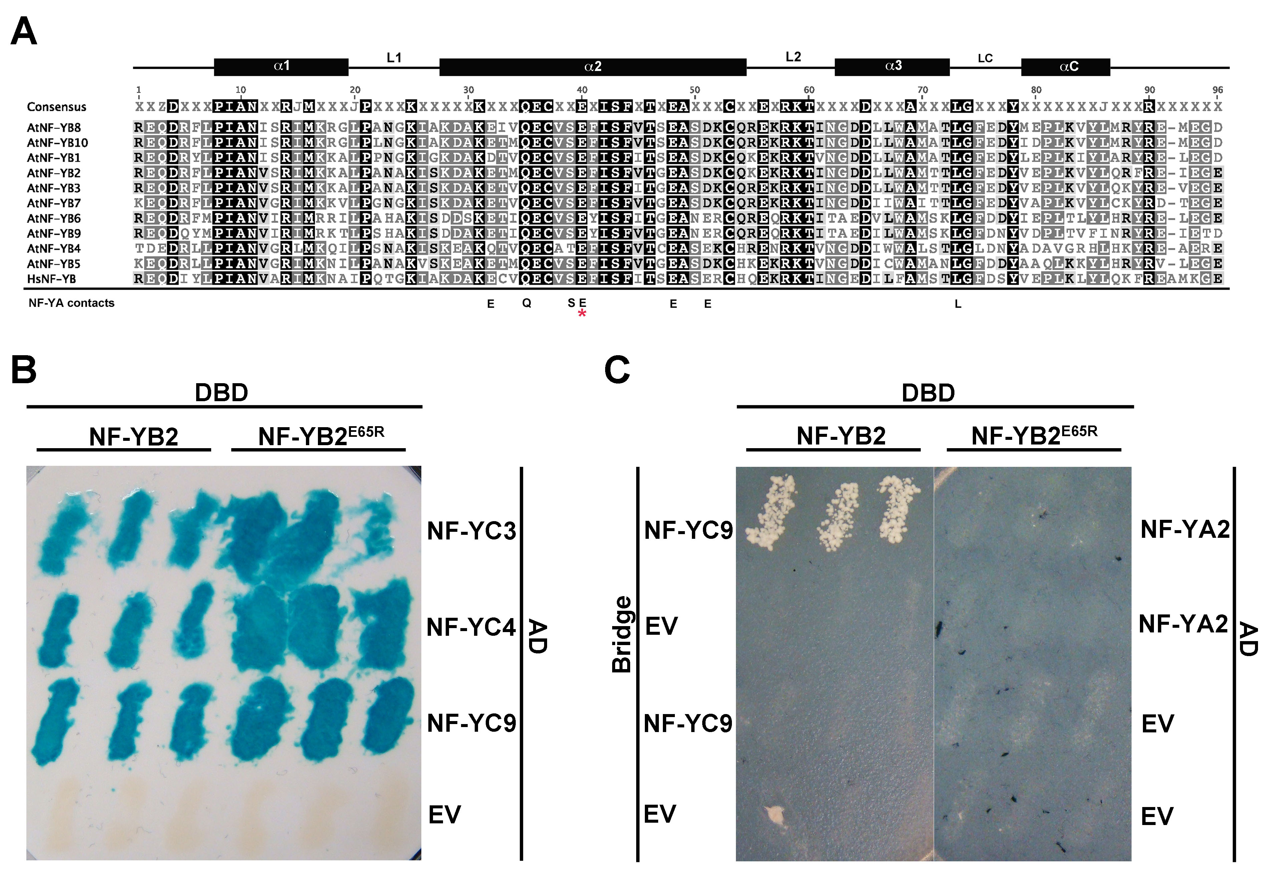

Figure 3.1. NF-YB2^{E65R} loses interaction with NF-YA subunits. A) Alignment of the core domain of human and Arabidopsis NF-YB subunits. * marks the position of the conserved glutamic acid required for interaction with NF-YA in humans (Nardini et al, 2013). B) NF-YB2 and NF-YB2^{E65R} interact with NF-YC3, NF-YC4, and NF-YC9 in Y2H assays. C) NF-YB2 but not NF-YB2^{E65R} interacts with NF-YA2 when NF-YC9 is expressed using a bridge vector in Y3H assays.

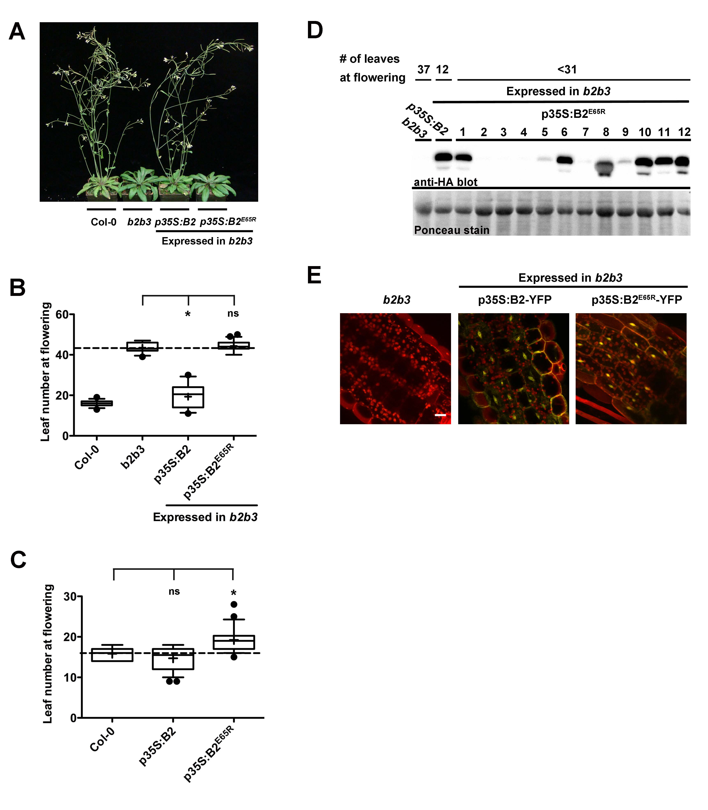
Figure 3.2. p35S:NF-YB2^{E65R} cannot rescue the nf-yb2 nf-yb3 late flowering phenotype. A) Photograph of flowering time in p35S:NF-YB2 and p35S:NF-YB2^{E65R} in nf-yb2 nf-yb3. B) T1 flowering time quantification of p35S:NF-YB2 and p35S:NF-YB2^{E65R} in the nf-yb2 nf-yb3 background. C) T1 flowering time quantification of p35S:NF-YB2 and p35S:NF-YB2^{E65R} in the Col-0 background. D) Protein expression analysis of NF-YB2^{E65R} in the nf-yb2 nf-yb3 background. E) Protein localization of NF-YB2^{E65R} in the nf-yb2 nf-yb3 background. Asterisks represent significant differences derived from one-way ANOVA (P < 0.05) followed by Dunnett’s multiple comparison post hoc tests against nf-yb2 nf-yb3 or Col-0.

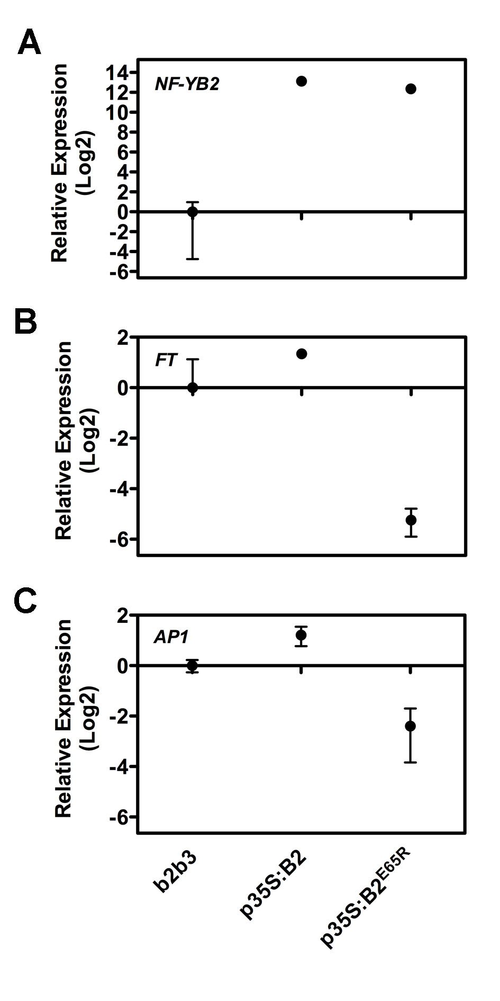
Figure 3.3. p35SNF-YB2^{E65R} plants cannot express high FT. Expression of A) NF-YB2 B) FT C) AP1.

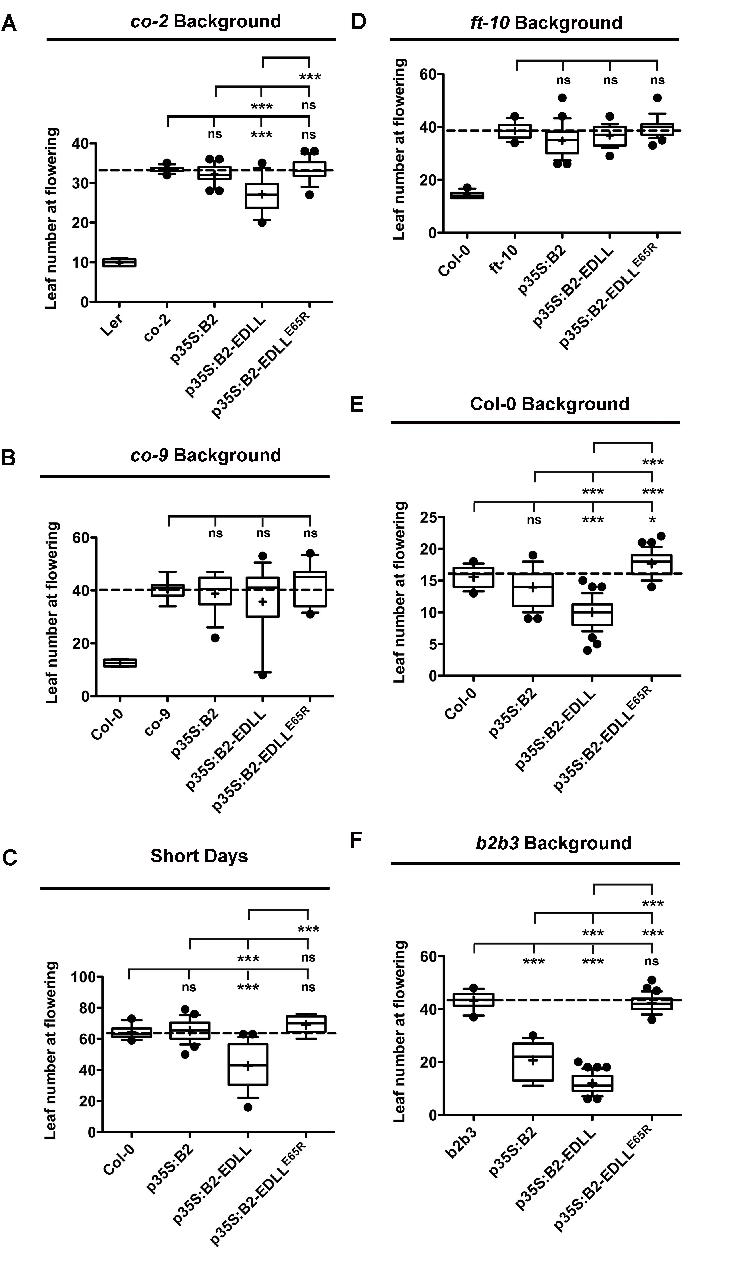

Figure 3.4. A strong activation domain (EDLL) is not able to recue the NF-YB2^{E65R} flowering phenotypes. T1 flowering time quantification of p35S:NF-YB2, p35S:NF-YB2-EDLL, and p35S:NF-YB2^{E65R}-EDLL in A) co-2 B) co-9 C) short days D) ft-10 E) Col-0 F) b2b3. Asterisks represent significant differences derived from one-way ANOVA (P < 0.05) followed by Bonferroni’s multiple comparison tests.

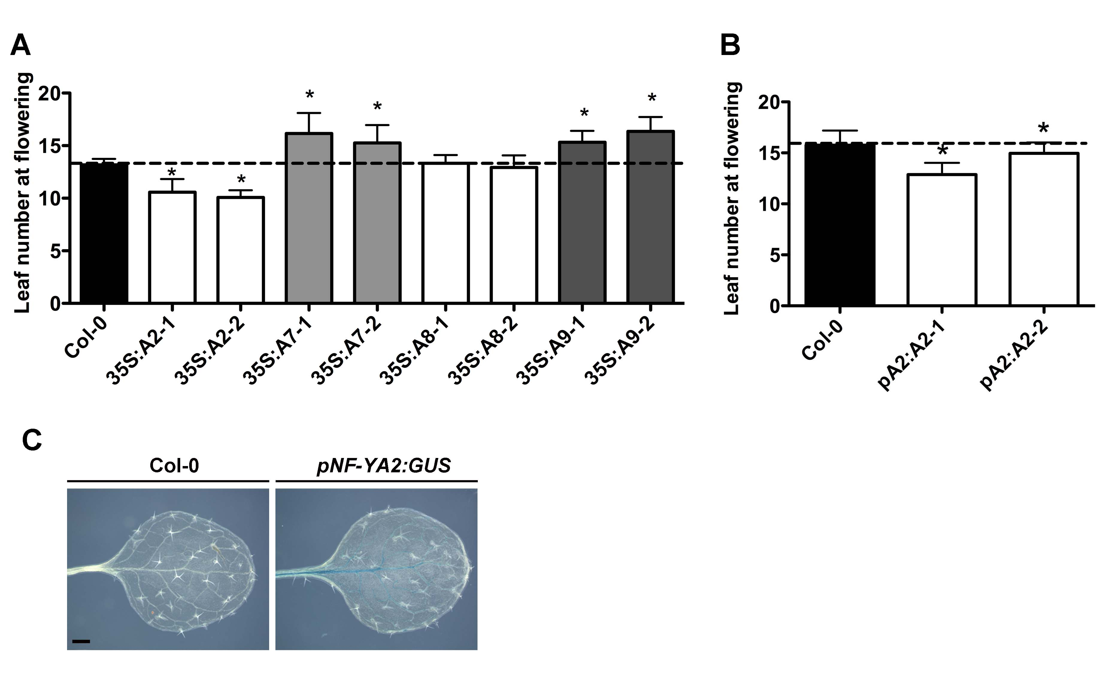

Figure 3.5. NF-YA2 maybe a positive regulator of photoperiod dependent flowering. A) Flowering time quantification of two independent p35S:NF-YA2, p35S:NF-YA7, p35S:NF-YA8, and p35S:NF-YA9 plant lines. B) Flowering time quantification of two independent pNF-YA2:NF-YA2 plant lines. C) The expression pattern of pNF-YA2-GUS in leaves of 10 day old plants. Asterisks represent significant differences derived from one-way ANOVA (P < 0.05) followed by Dunnett’s multiple comparison post hoc tests against Col-0.

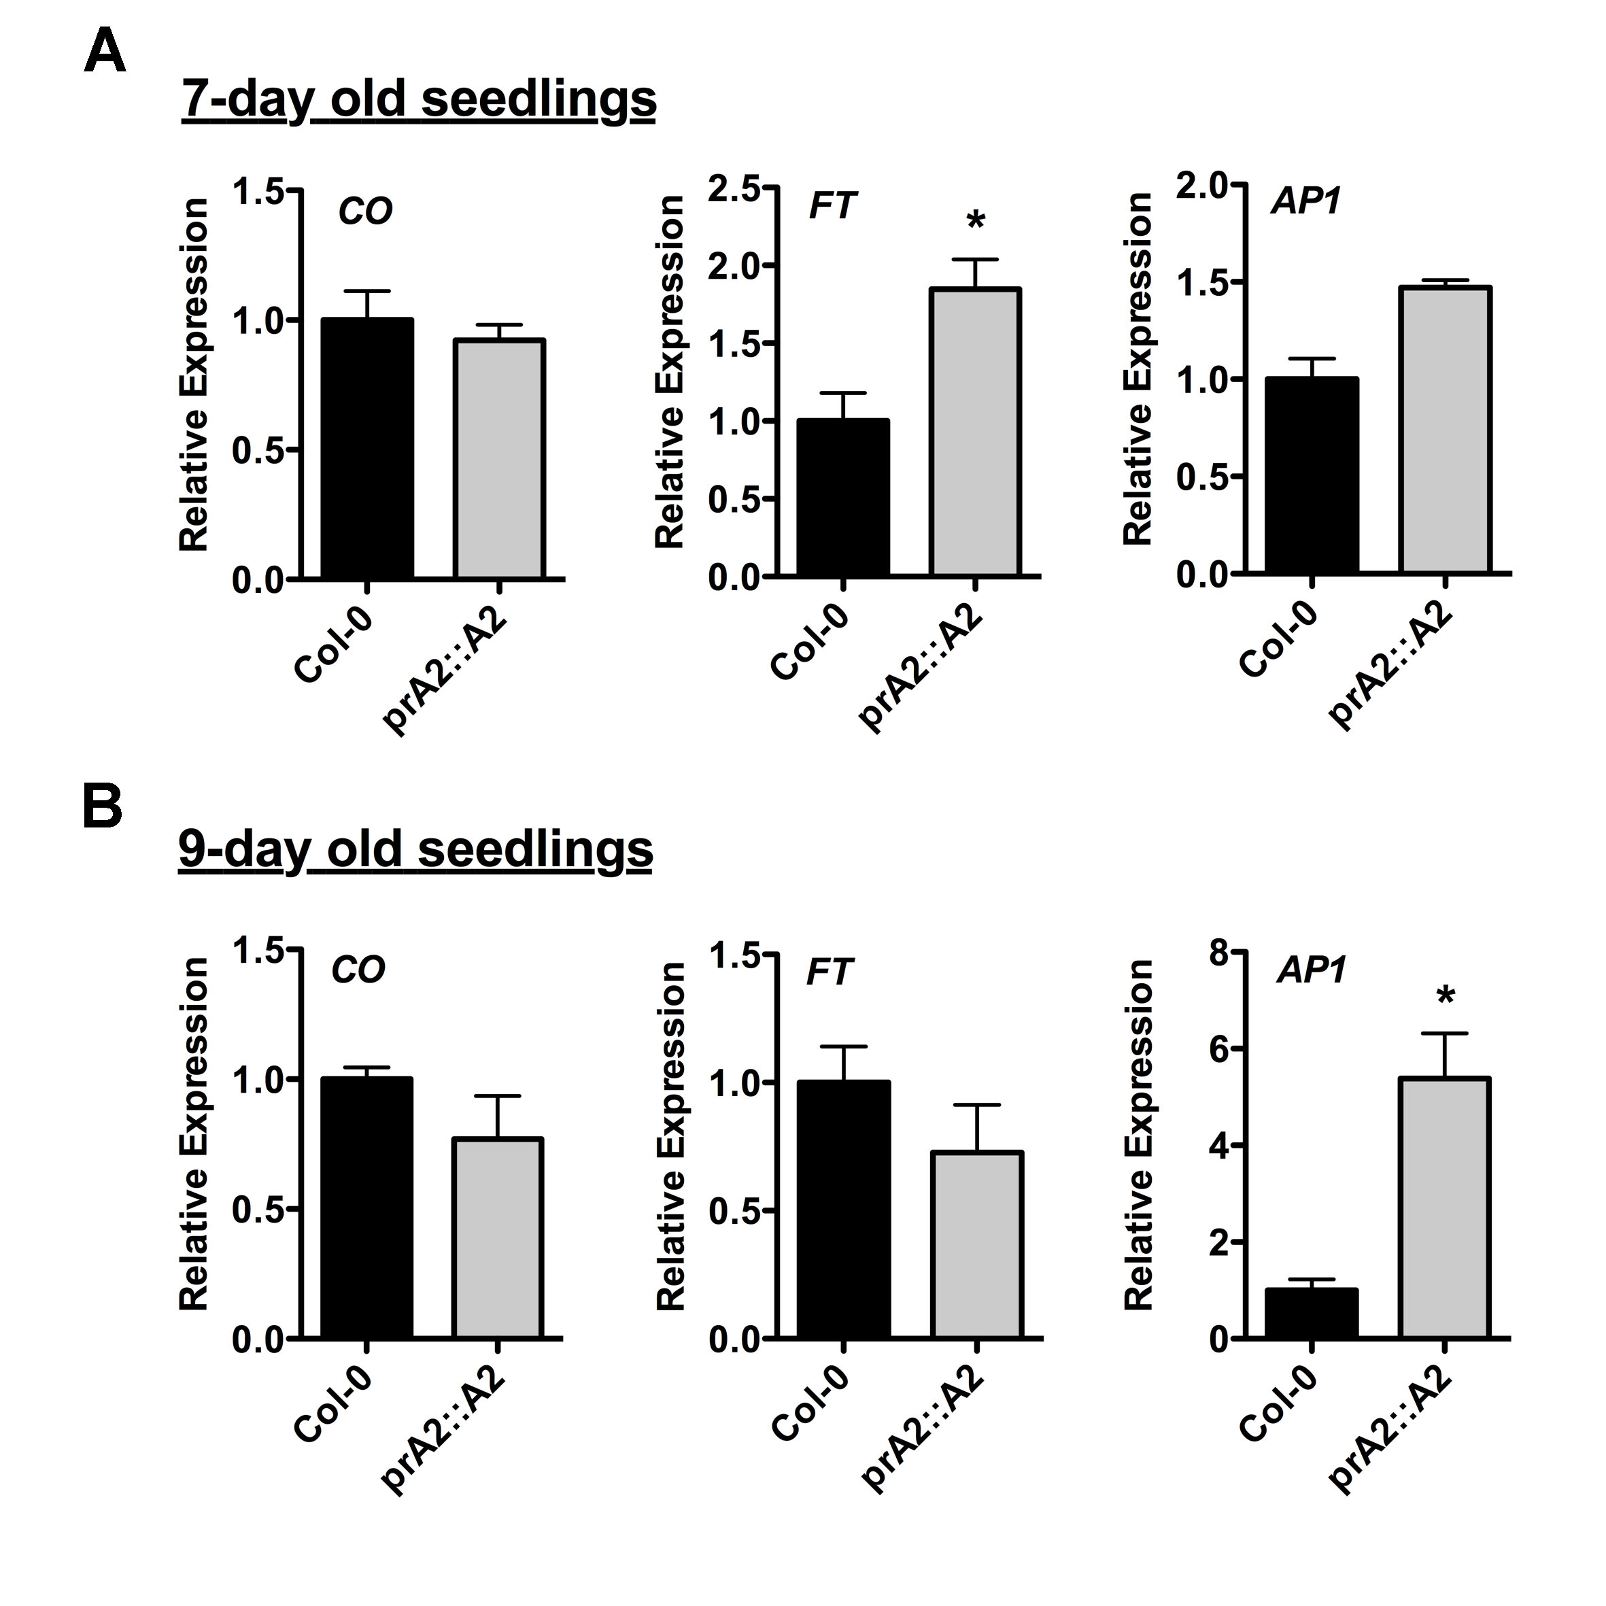
Figure 3.6. FT is upregulated in pNF-YA2:NF-YA2. Expression of A) CO B) FT C) AP1. Asterisks represent significant differences derived from Student’s T-tests (p<0.05).

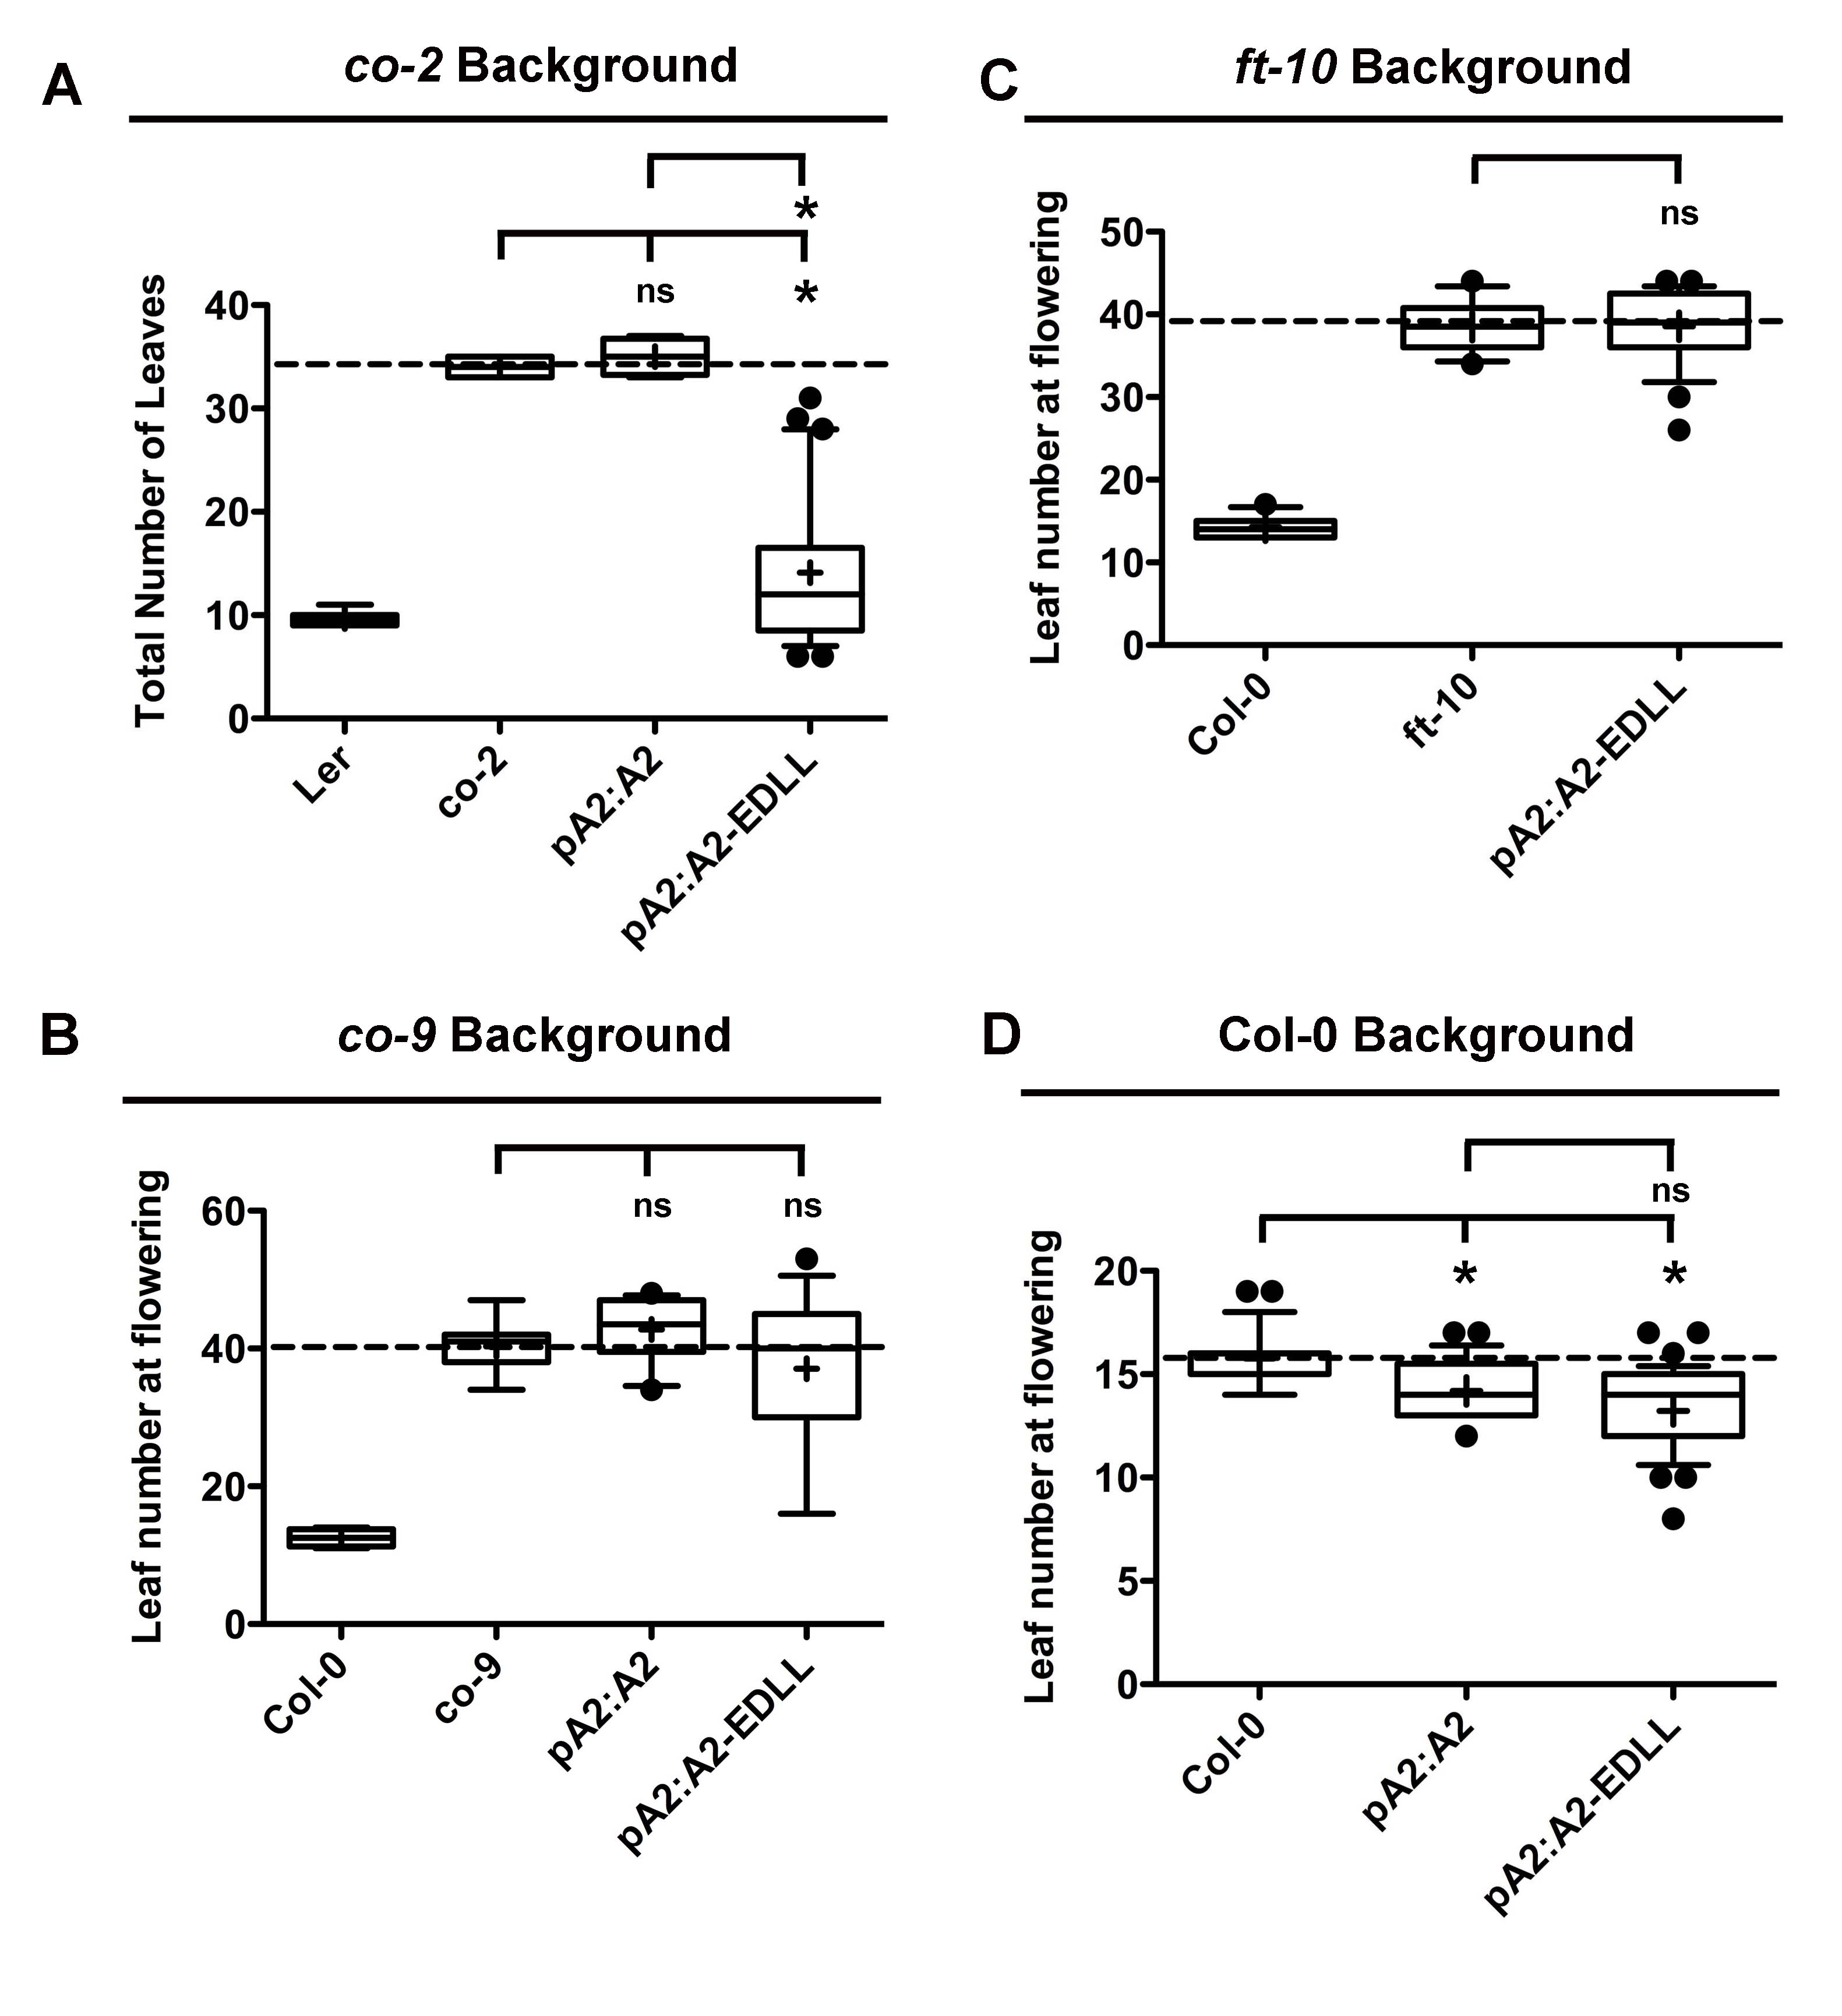
Figure 3.7. pNF-YA2:NF-YA2-EDLL can induce flowering in the absence of CO. Flowering time in A) co-2 B) co-9 C) ft-10 D) Col-0. Asterisks represent significant differences derived from one-way ANOVA (P < 0.05) followed by Bonferroni’s multiple comparison tests.

Supplemental Table 3.1. Cloning primers.

Construct | Cloning Primer
NF-YB2 | F-ATGGGGGATTCCGACAGGGATTCCG
NF-YB2 | R-AGTCCTTGTCCTACCGGAGGCAGGT
pNF-YA2:NF-YA2 | F-CATATGACGTATATGCACATTTTTA
pNF-YA2:NF-YA2 | R-GGTTTTGAAATTGCATTATCCATTGG
EDLL Domain | F- TATAGGCGCGCCGAAGTTTTCGAGTTTGAGTATTTG
EDLL Domain | R- TATAGGCGCGCCTCTCTTCCTTTCTTCTGAATCAAG

Supplemental Table 3.2. Mutagenic Primers used for cloning the NF-YB2E65R mutant. The Mutagenic primers were used with the full-length NF-YB2 cloning primers to make mutations.
Construct | Mutagenic Primer
NF-YB2^{E65R} | F- AGTGTGTCTCCCGGTTCATCAGCT
NF-YB2^{E65R} | R- AGCTGATGAACCGGGAGACACACT

Supplemental Table 3.3. qPCR primers used to measure gene expression.
Gene | qPCR primer
NF-YA2 | F-TAGAGGATCCGGTGGGAGATTCTTGA
NF-YA2 | R-CCAAGAGAATGAACGGGAGAACTTAGG
NF-YB2 | F-CCGGTGGAGGGCAAAACGGGAAC
NF-YB2 | R-GGCGGGCAAGGCCTTCTTCA
FT | F- CAGGCAAACAGTGTATGCACCAGG
FT | R- CCGCAGCCACTCTCCCTCTG
AP1 | F-AGGGAAAAAATTCTTAGGGCTCAACAG
AP1 | R-GCGGCGAAGCAGCCAAGGTTCAGTTG
CO | F-GAGCAACAACCTGACCCTGCAAGCCAGA
CO | R-GAACCGGCCATTGACCCGCGGTCTTATC

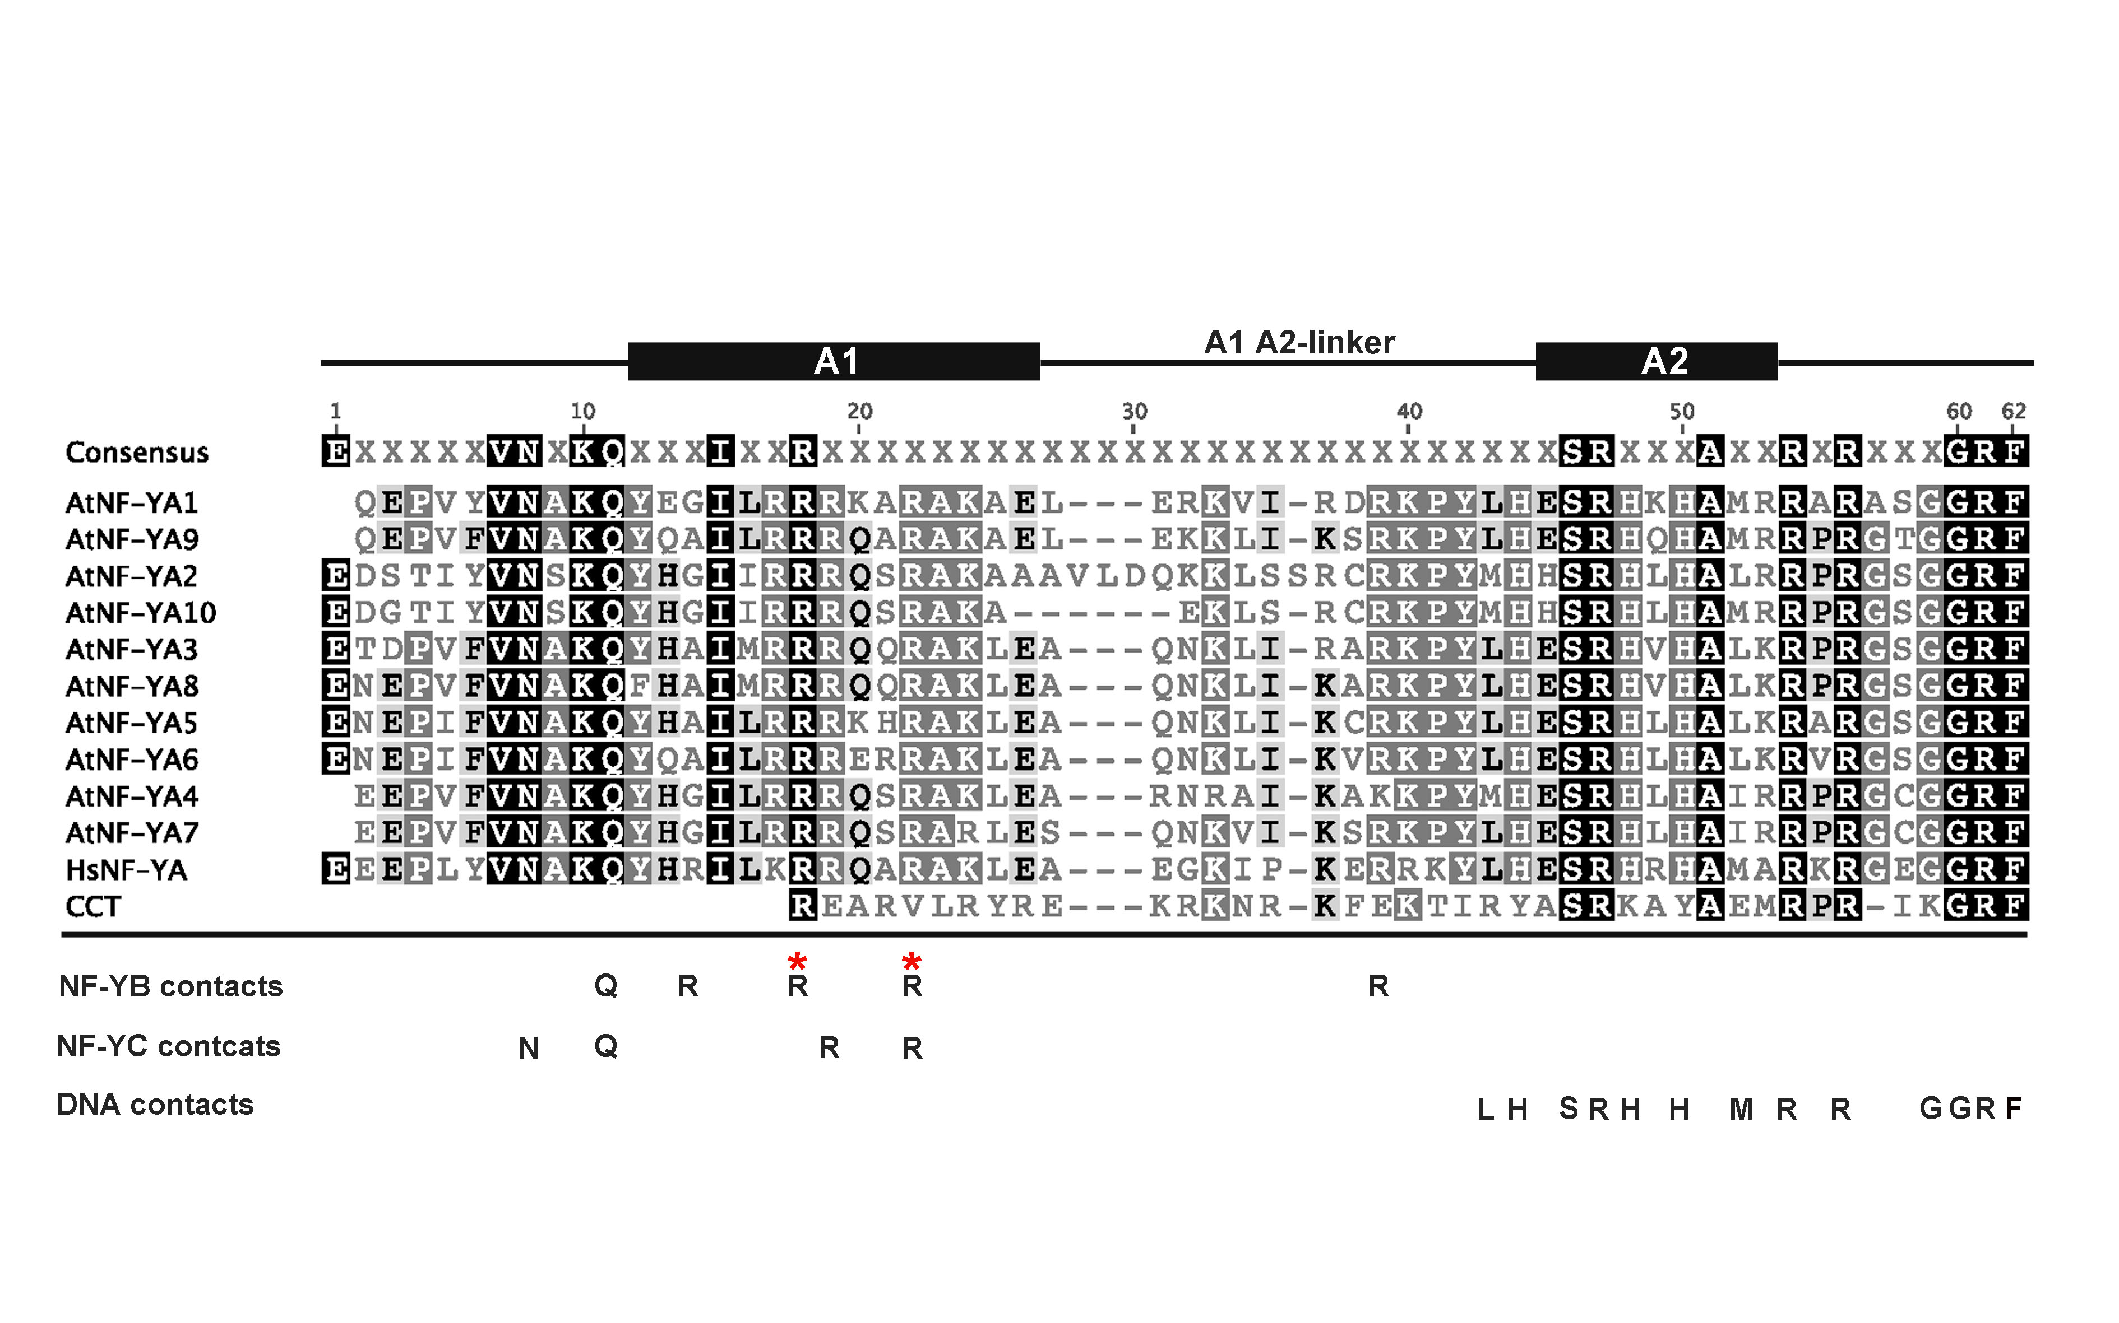
Supplemental Figure 3.1. Alignment of core domain of NF-YA subunits and CCT domain of CCT proteins. * marks the positions where the conserved glutamic acid in NF-YB, discusses in this paper that is required for interaction with NF-YA, makes physical contact (Nardini et al, 2013).

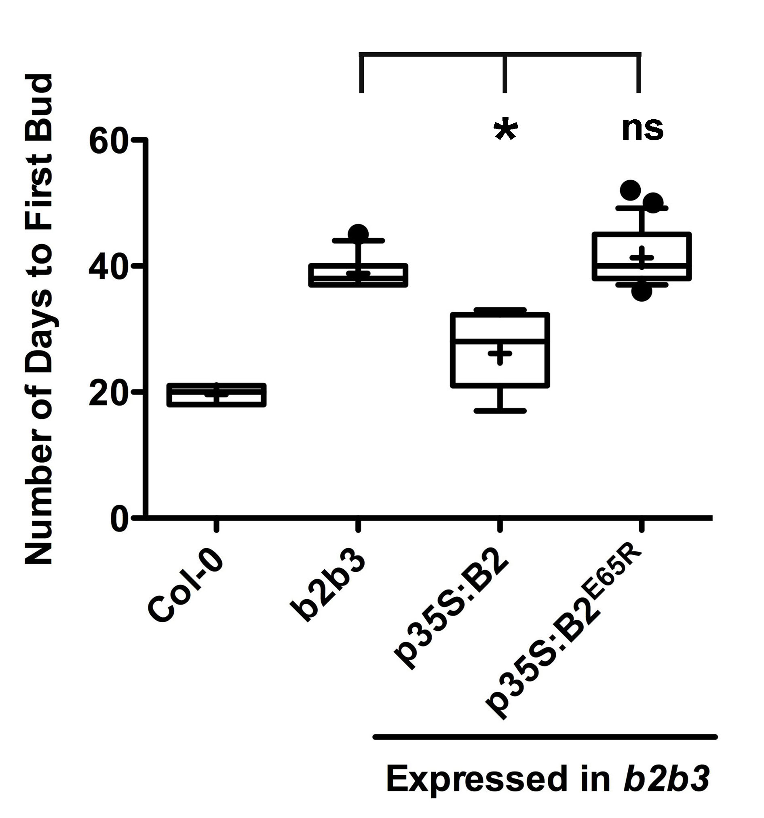
Supplemental Figure 3.2. p35S:NF-YB2^{E65R} cannot rescue the nf-yb2 nf-yb3 late flowering phenotype. T1 flowering time quantification using the date to first bud of p35S:NF-YB2 and p35S:NF-YB2^{E65R} in the nf-yb2 nf-yb3 background.

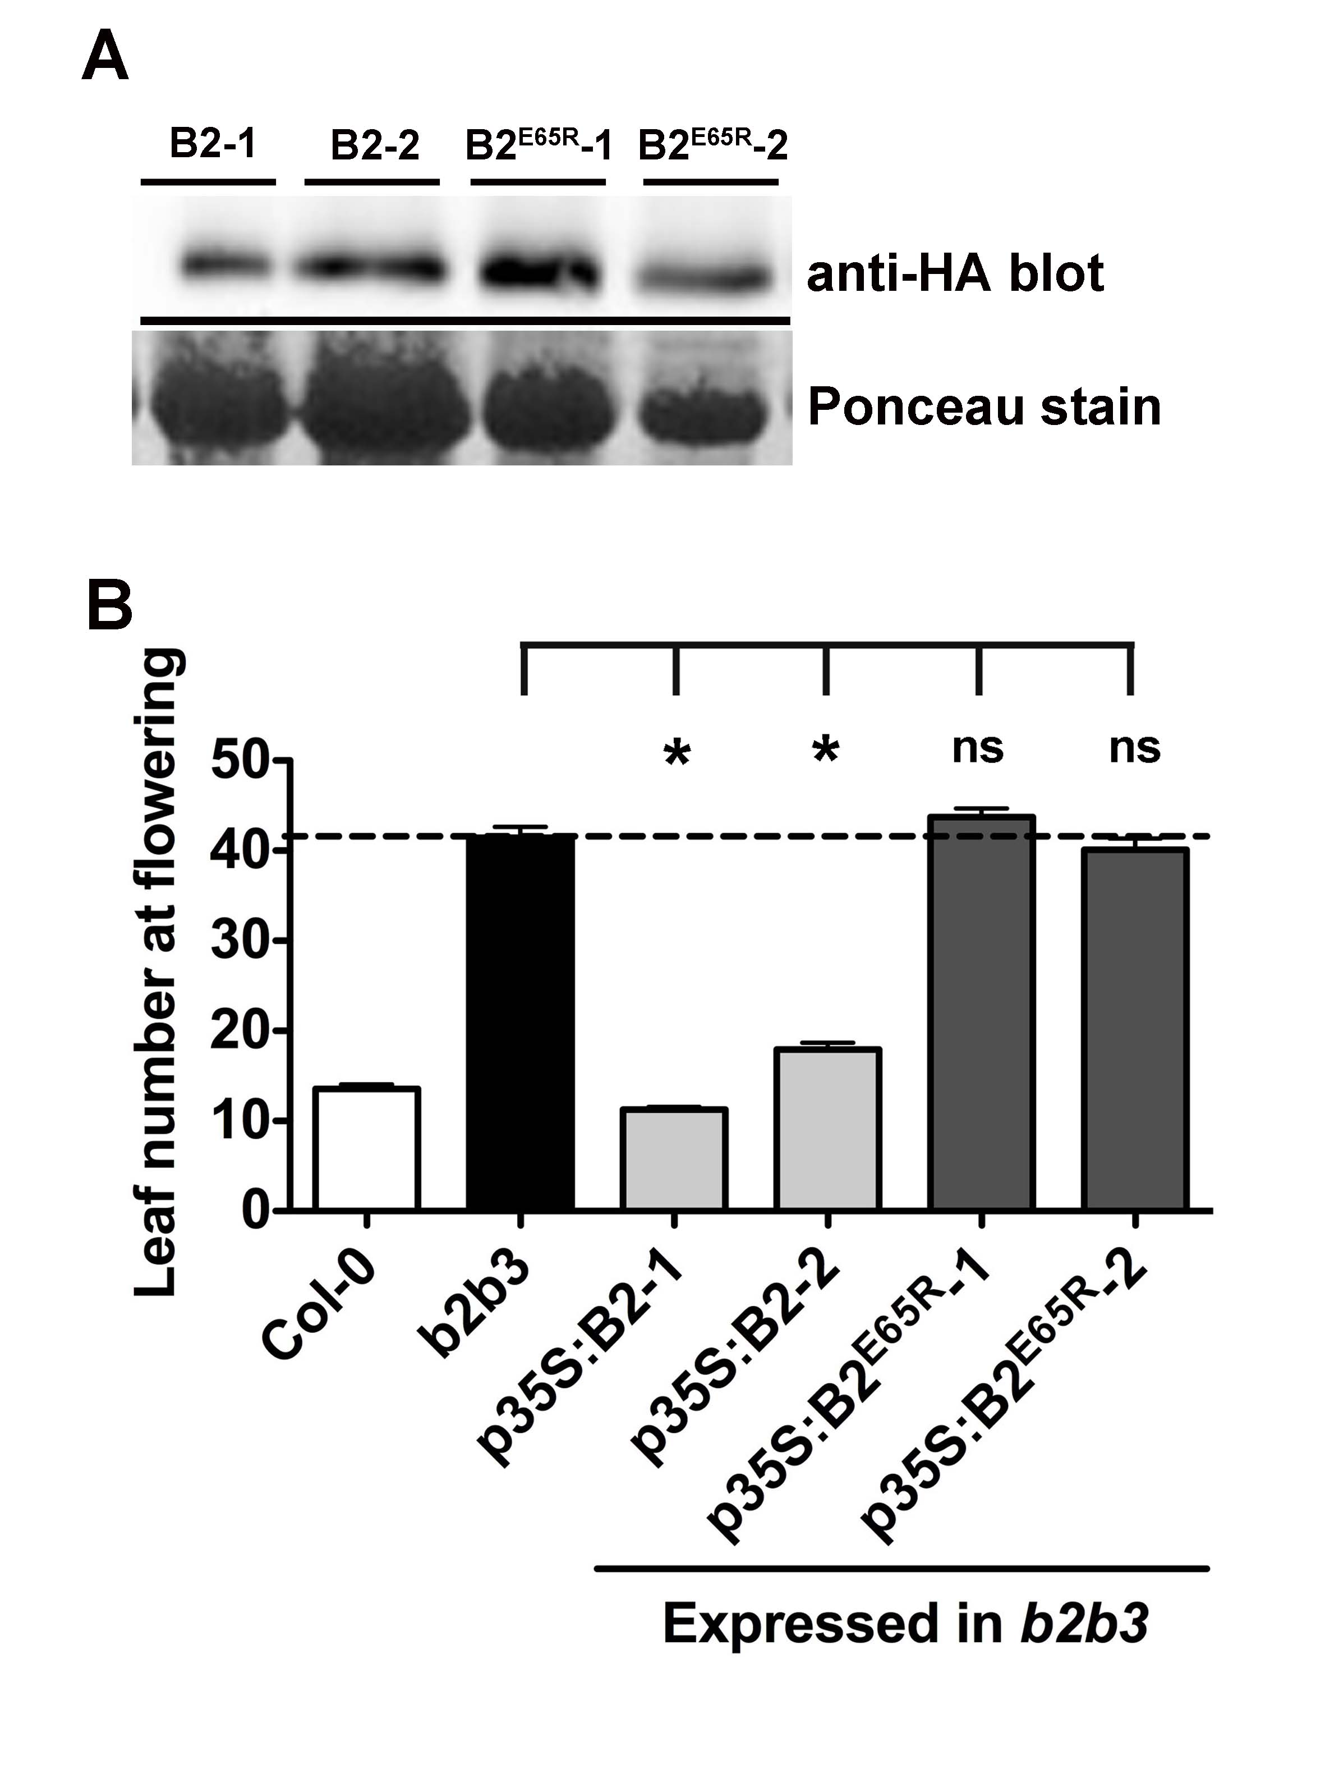

Supplemental Figure 3.3. p35S:NF-YB2^{E65R} cannot rescue the nf-yb2 nf-yb3 late flowering phenotype. A) Protein expression in two stable plant lines for p35S:NF-YB2 and p35S:NF-YB2^{E65R} in the nf-yb2 nf-yb3 background B)T3 stable line flowering time quantification of p35S:NF-YB2 and p35S:NF-YB2^{E65R} plant lines in the nf-yb2 nf-yb3 background. Asterisks represent significant differences derived from one-way ANOVA (P < 0.05) followed by Dunnett’s multiple comparison post hoc tests against nf-yb2 nf-yb3.

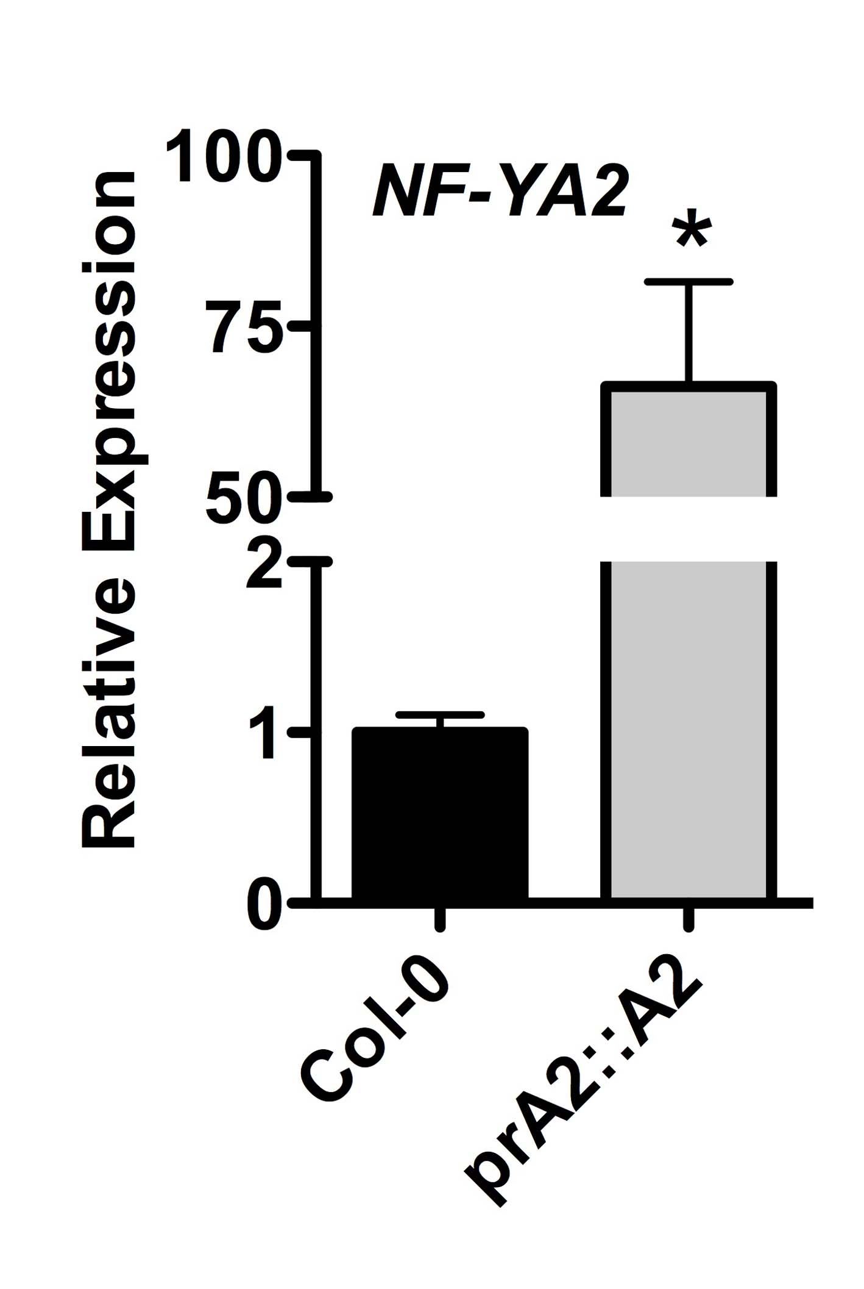

Supplemental Figure 3.4. Expression of NF-YA2 in pNF-YA2:NF-YA2 plants. Asterisk represents significant differences derived from Student’s T-tests (p < 0.05).

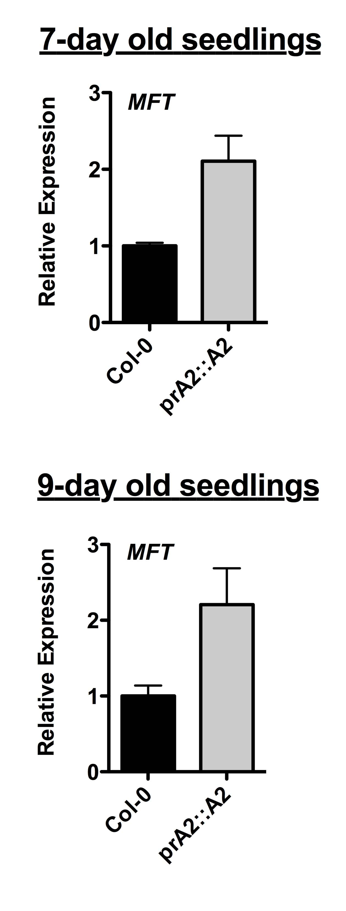

Supplemental Figure 3.5. MFT is upregulated in pNF-YA2:NF-YA2.

Chapter 4: Mapping protein interaction domains of Arabidopsis NF-YC9

Summary

Three unrelated protein families encode NF-Y subunits: NF-YA, NF-YB, and NF-YC, which are ubiquitous to eukaryotes. The protein domains necessary for NF-Y function are well characterized in animal systems; however, similar studies are lacking in plants. Here I analyzed the Arabidopsis NF-YC9 protein, whose function has been extensively studied during plant development programs, including photoperiodic flowering, light perception and plant abscisic acid (ABA) response. I chose to test the protein-protein interactions between NF-YC9 and its known interactors CO (photoperiodic flowering), HY5 (light perception), ABF3 (ABA responses), NF-YA1, NF-YA2, and NF-YB2 to identify the regions of NF-YC9 that interacts with each target. The NF-YC9 protein has a conserved domain flanked by two non-conserved domains. I found that, similar to animal systems, the conserved domain is required for its interaction with target proteins. I also found that the requirement of the non-conserved regions varies with the targets. I identified two mutants in NF-YC9, one that abolishes interaction with all the targets tested and one that is able to interact with the ABF3 and NF-YB2 but loses interaction with CO, HY5, NF-YA1, and NF-YA2. By overexpressing the mutant versions of NF-YC9 in plants, I was able to show that the specific amino acids are important for NF-YC9 biological function. That is, the NF-YC9 mutant that lost interaction with proteins that regulate flowering (CO, NF-YA1, and NF-YA2) was unable to drive the normal flowering responses of NF-YC9. This is the first study in plants that looks at NF-Y protein interactions and added to the studies done in animal systems demonstrating that, while the conserved domain is indispensable for protein function, the non-conserved regions are also necessary for the interaction between NF-YC9 and most of its targets.

Introduction

Protein interactions, especially between transcription factors, are a key mechanism through which plants regulate development. NF-Y transcription factors are composed of three subunits, NF-YA, NF-YB, and NF-YC. In the model plant species Arabidopsis thaliana (Arabidopsis) the NF-Y subunits have demonstrated roles in photoperiod dependent flowering (Ben-Naim et al. 2006b; Wenkel et al. 2006a; Cai et al. 2007; Chen et al. 2007; Kumimoto et al. 2008a; Kumimoto et al. 2010), embryogenesis (West et al. 1994; Lotan et al. 1998; Kwong et al. 2003; Lee et al. 2003), abscisic acid (ABA) responses (Nelson et al. 2007; Warpeha et al. 2007; Li et al. 2008; Yamamoto et al. 2009; Leyva-Gonzalez et al. 2012; Kumimoto et al. 2013; Mu et al. 2013), endoplasmic reticulum stress responses (Liu and Howell 2010), light signaling (Warpeha et al. 2007), salt stress responses (Li et al. 2013), photosynthesis (Kusnetsov et al. 1999; Stephenson et al. 2010), and root elongation (Ballif et al. 2011). The molecular mechanisms on how the NF-Y regulates these processes are not well understood. However, NF-Y proteins are known to interact with other key transcription factors that regulate flowering, light signaling, and ABA responses.

Here I have summarized what is known currently about the nature of NF-Y interactions with other transcription factors. During the initiation of flowering, several NF-YC subunits interact with CONSTANS (CO), a key regulator of photoperiod dependent flowering (Ben-Naim et al. 2006a; Wenkel et al. 2006b; Kumimoto et al. 2010). A series of deletion mutants and substitution mutants in CO have led to the identification of the protein domains in CO necessary for interaction with the NF-YC subunits (Ben-Naim et al. 2006a; Wenkel et al. 2006b). The authors were able to demonstrate that the conserved CCT domain in CO is necessary for the interaction with NF-YC subunits. CCT stands for CO, CO-LIKE (COL), and TIMING OF CAB1 (TOC1) and this domain is shared among the 17 member CO-LIKE family of proteins. Although the domains in CO necessary for the CO/NF-YC interaction has been tested, the reciprocal test identifying the NF-YC protein domain(s) necessary for CO interaction has not been done. Similarly, NF-Ys interact with ABFs and HY5, bZIP transcription factors that regulate ABA responses (Kang et al. 2002). HY5 is also a key transcription factor that regulates light responses and was recently shown to act as a mediator between light signaling and ABA responses (Chen et al. 2008). Three NF-YC members, NF-YC3, NF-YC4, and NF-YC9, interact with ABF1, ABF2, ABF3, ABF4 and HY5 (Kumimoto et al. 2013). In addition NF-YB2 specifically interacts with ABF3. The protein domains of NF-YB2 that interact with ABF3 were studied in detail; however the protein domains of NF-YC that are required for interactions remain unidentified. Therefore, although the current literature has identified NF-YC interactions with other transcription factors, the domain(s) and specific amino acids that mediate these interactions remain unknown. Further, although almost all the combinations of NF-YA/NF-YB/NF-YC proteins can trimerize, the domain(s) and amino acids that are required remain unknown.

Although NF-Y protein interactions have not been well studied in plant systems, NF-Y trimerization has been extensively studied in yeast and animals. A large set of deletion mutants and amino acid substitution mutants are available from these systems that identified protein domains indispensable or necessary for the trimer formation (Sinha et al. 1995; Kim et al. 1996; Sinha et al. 1996). From these studies, we know that the NF-YC conserved domain is sufficient for the formation of a stable NF-YB/NF-YC complex. However, a larger portion is necessary to form a stable complex (Kim et al. 1996). Portions of both the conserved and non-conserved domain were essential for NF-YA to interact with the NF-YB/NF-YC dimer.

Using the literature from animal systems as a guide, I identified the protein interaction domains of one of the NF-YC subunits, NF-YC9. NF-YC9 has a conserved domain flanked by two non-conserved regions. I demonstrated that the conserved domain of NF-YC9 is indispensable for the interaction with CO, HY5, ABF3, NF-YA1, NF-YA2 and NF-YB2. The conserved domain alone was not able to interact with any of the target protein, and required partial protein regions from non-conserved regions. However, the requirement of the non-conserved regions varied with the target, where some proteins only required a small portion of the non-conserved regions and other required the complete region. Further, I was able to identify mutants in NF-YC9, which abolished interactions with specific targets. I show that the biochemical assays have biological relevance by introducing the mutants into plants and testing the effects of the mutations on protein function.

Results

NF-YC9 protein has a conserved core domain and non-conserved N-terminus and C-terminus

Protein alignment of the ten NF-YC subunits from Arabidopsis and the human NF-YC subunit demonstrate that all NF-YC proteins have a highly conserved core domain (Figure 4.1, Supplementary Figure 4.1, and Siefers et al. 2009). The core domain folds into four α-helixes. In animals αC makes contact with the NF-YA subunit and α2 makes contact with the NF-YB subunit (Mantovani 1999; Nardini et al. 2013). All the Arabidopsis NF-YC proteins show a high degree of identity throughout the core domain (Supplementary Figure 4.2). The core domain is flanked on either side by a non-conserved N-terminus and C-terminus. Phylogenic analysis demonstrates that the NF-YC9 core domain is most closely related to NF-YC3 (Supplementary Figure 4.3 and (Siefers et al. 2009). The NF-YC9 full-length protein also shares a high degree of identity with full-length NF-YC3. However, the identity is lower with other full-length NF-YC proteins (Supplementary Figure 4.2).

The conserved core domain is required for NF-YC9 protein interactions

Data from animal systems have shown that the core domain is indispensable for interaction with target proteins. Due to the high conservation between the animal and plant core domains, I expected that the same will be true for plants. I used directed yeast 2-hybrid assays (Y2H) to test interaction between NF-YC9 and known targets. All the target proteins tested - CO, HY5, ABF3, NF-YA1, NF-YA2, and NF-YB2 - required the conserved core domain for interaction (Figure 4.2). Except for NF-YB2, none of the targets interacted with NF-YC9 when truncations were made to the core domain. NF-YB2 still interacted with the core domain when the αC helix was eliminated. In animals, it has been shown that the αC helix is required for NF-YA interaction and the α2 helix is required for the NF-YB interaction (Mantovani 1999; Nardini et al. 2013). However, NF-YB2 did not interact with the core domain alone and required a partial sequence from either the N-terminus or the C-terminus for interaction. The requirement of the N-terminus or C-terminus was not specific as NF-YB2 interacted with the core domain when it was fused to either the N-terminus or C-terminus. Indicating that while part of the core domain was indispensable for the interaction (the αC helix was not required for the NF-YB2/NF-YC9 interaction), the N-terminus or C-terminus were possibly required to stabilize the protein interaction.

The necessity of the N-terminus and C-terminus varies with different proteins

NF-YB2 interacted with the core domain if either the N-terminus or C-terminus was attached (Figure 4.2). However, all the other targets required the N-terminus for interaction. NF-YA2 alone did not interact when the C-terminus was eliminated. Interactions between NF-YC9 and CO, HY5, ABF3 and NF-YA1 did not require the C-terminus.

The first 58 amino acids were eliminated from the N-terminus of NF-YC9 and a truncation was made from AA59 to the end of the core domain. This construct still interacted strongly with CO and NF-YB2; however, the interaction with ABF3 and NF-YA1 was almost eliminated and the interaction with HY5 was lost. This shows that CO and NF-YB2 only require a small portion of the N-terminus for stable interactions, whereas ABF3, NF-YA1, and HY5 required a larger portion. Taken together these results show that the necessity for the N-terminus and C-terminus varies with the target.

NF-YC9^{F151R V153K} loses interaction with CO, HY5, NF-YA1 and NF-YA2

In humans, the two mutants NF-YC^{I51D} and NF-YC^{F113R I115K} were identified to specifically lose interactions with the NF-YA but not the NF-YB. The NF-YC^{I51D} mutation is in the α1 helix and the NF-YC9^{F113R I115K} is in the αC helix. Recent crystal structure analysis demonstrated that the phenylalanine in NF-YC^{F113R I115K} makes physical contacts with NF-YA (Nardini et al. 2013). The core domains of human NF-YC and Arabidopsis NF-YA are highly conserved (Figure 4.1; (Siefers et al. 2009) and, observing the alignment, I found that the isoleucine in human NF-YC^{I51D} and phenylalanine in human NF-YC^{F113R I115K} to be absolutely conserved. The isoleucine in Human NF-YC^{F113R I115K} was less conserved in Arabidopsis and NF-YC9 has a valine in that position. To test the effects of these mutations in Arabidopsis, I created the same mutants in NF-YC9, NF-YC9^{I89D} and NF-YC9^{F151R V153K}.

NF-YC9^{I89D} lost interaction with all the targets tested (Figure 4.3). This indicates that this amino acid is generally required for NF-YC9 protein interactions. The NF-YC9^{F151R V153K} double mutant was able to interact with ABF3 and NF-YB2 (Figure 4.3). The NF-YC9/ABF3 interaction was weaker; however, the NF-YC9/NF-YB2 interaction was not affected at all. This result is consistent with my previous finding that the αC helix was not required for the NF-YB2 interactions (the mutant NF-YC9^{F151R V153K} is in the αC helix). However, all the other targets tested, CO, HY5, NF-YA1, and NF-YA2, lost interaction when tested against the NF-YC9^{F151R V153K} double mutant. This was consistent with my finding that these targets required the αC helix for interactions.

pNF-YC9:NF-YC9^{F151R V153K} cannot rescue the late flowering nf-yc triple mutants

I was interested in testing the biological relevance of the Y2H assays performed. For this I was interested to see if the NF-YC9^{F151R V153K} mutant affects the biological function of the protein. NF-YC9 together with NF-YC3 and NF-YC4 are required for photoperiod flowering (Kumimoto et al. 2010). The nf-yc3 nf-yc4 nf-yc9 triple mutant flowers significantly later than the wild type. However, when any of the three NF-YC genes are overexpressed in the triple mutant background, it is able to rescue the late flowering phenotype (Kumimoto et al. 2010). I wanted to test if NF-YC9^{F151R V153K}, which lost interaction with other transcription factors involved in promoting flowering - CO and NF-YA1 (Wenkel et al. 2006b) and NF-YA2 (Siriwardana C.L. and Holt B.H; unpublished data) - was able to rescue the late flowering phenotype of the triple mutant. My hypothesis was that the double mutant that cannot interact with CO, NF-YA1, and NF-YA2 would not be able to rescue the late flowering phenotype of the triple mutant. I did T1 flowering time analysis on pNF-YC9:NF-YC9 and pNF-YC9:NF-YC9^{F151R V153K} in the triple mutant background to test the ability of the constructs to rescue the late flowering phenotype. The results demonstrate that while pNF-YC9:NF-YC9 was able to rescue the triple mutant phenotype, pNF-YC9:NF-YC9^{F151R V153K} was not able to rescue (Figure 4.4). pNF-YC9: NF-YC9^{F151R V153K} had a dominant negative effect and flowered later than the triple mutant.

To ensure that the flowering responses seen above were not due to the lack of protein accumulation, I tested transgenic protein accumulation in the mutants. As my control, I used a pNF-YC9:NF-YC9 plant line that was able to strongly rescue the late flowering phenotype. Out of the 12 pNF-YC9:NF-YC9^{F151R V153K} plant lines tested, six had a similar level of protein expression. However, none of these plant lines was able to rescue the late flowering phenotype. This demonstrates that transgenic protein accumulated in both constructs, however the pNF-YC9: NF-YC9^{F151R V153K} mutant alone was not able to rescue late flowering.

Discussion

Here I found that the NF-YC9 protein domains and amino acids required for protein-protein interactions were conserved between plants and animals. In animals the α2 helix is indispensable for NF-YB/NF-YC interactions and I found the same true for plants (Sinha et al. 1996; Nardini et al. 2013). Additionally, I was able to show that a portion of the core domain was not required for NF-YB/NF-YC interactions. The interaction took place both when this region was deleted and when a mutation was introduced. The αC region was indispensable for interaction with NF-YA proteins. Interestingly the same region was also indispensable for interaction with the COL and bZIP targets. This indicates that the NF-YB/NF-YC dimer forms using the α2 helix of NF-YC, and the NF-YA subunit interacts with the dimer using the αC helixes of NF-YB (Nardini et al. 2013) and NF-YC. The trimer then may provide a platform for other target proteins to interact and initiate transcription.

The NF-YB2 core domain is sufficient for its interaction with NF-YC9 (Siriwardana C.L. and Holt B.H.; unpublished data), whereas the NF-YC9 core domain alone did not interact with NF-YB2. However, the NF-YC9 core domain was able to interact when fused to either the N-terminus or C-terminus, indicating that the core domain alone is sufficient for the interaction, but it is not able to form a stable complex. Sinha et al., (1996) came to a similar conclusion where they found that although the core domain is sufficient for interactions, a larger portion is required to form a stable complex. The NF-YA proteins required both the core domain and either the N-terminus (NF-YA1) or both the N and C-terminus (NF-YA2). The COL and bZIP targets tested also required the core domain and the N-terminus but not the C-terminus for interactions. CO was able to interact when about half of the N-terminus was deleted; however, HY5 and ABF3 required the complete N-terminus. This shows that while the conserved core domain is indispensable for interactions, the adjacent non-conserved regions also play an important role in the interactions.

The prNF-YC9:NF-YC9 ^{F151R V153K} plants were not able to rescue the triple phenotype. These results were expected because the mutant did not interact with two transcription factors required for flowering, CO (Wenkel et al. 2006b) and NF-YA2 (Siriwardana et al., unpublished data). Current data strongly suggest that NF-YA are positive regulators of flowering (discussed in Chapter 3). However Wenkel et al. (2006) proposed NF-YAs act as negative regulators of flowering. In the model proposed by the authors, CO and NF-YA subunits compete to bind the NF-YB/NF-YC dimer where CO activates transcription and NF-YA subunits exert a negative effect by competing with CO. This hypothesis was partly based on the alignments of COL proteins and NF-YA, which share a region of homology in their DNA binding domain. However, the region of homology does not extend to the subunit interaction domains. In my analysis, CO and NF-YA (as well as HY5 and ABF3) interacted with the same domains of NF-YC9. Further, the same amino acids were required for CO and NF-YA (as well as HY5 and ABF3) to bind NF-YC9. These data suggest the possibility of a replacement model, where CO replaces NF-YA to bind NF-YC9. However, I find it unlikely because the NF-YC interaction domain of NF-YA does not share homology with CO. It is possible that that NF-YA and CO interacts with NF-YC9 using the same amino acids. Similarly, NF-YB and NF-YC interact with NF-YA using the same amino acids (Nardini et al. 2013) and mutations of these amino acids led to the loss of interaction with both NF-YB and NF-YC (Xing et al. 1994). It is likely that NF-YA interactions with the NF-YB/NF-YC dimer makes a platform used by CO and other transcription factors to bind the trimer. Analyzing the crystal structure of the NF-Y trimer in complex with its interacting proteins will allow us to answer this question.

Here I have shown that the conserved core domain is indispensable for the Arabidopsis NF-YC9 to interact with target proteins. The core domain alone was not able to interact with target proteins and required portions of the N-terminus and C-terminus. This research will be extended in the future to study the protein interaction domain in NF-YA, NF-YB and the COL/bZIP targets. A similar approach as used here with a set of truncations and mutations in NF-YA and NF-YB will be used to study protein regions and specific amino acids required for interactions. Further, crystalizing the NF-Y complex with the COL/bZIP targets will be both a confirmation of the Y2H and allow us to model the NF-Y and its target complexes.

Materials and methods

Multiple sequence alignments

Arabidopsis full-length protein sequences were obtained at The Arabidopsis Information Resource (TAIR) (http://www.arabidopsis.org (Huala et al. 2001). The human NF-YC protein sequence was obtained from the National Center for Biotechnology Information (http://www.ncbi.nlm.nih.gov/). Multiple sequence alignments were developed using ClustalX program (Thompson et al. 2002) within the software program Geneious.

Cloning

The clones generated and primer sequences are provided (Supplementary Table 1). The mutations were made using mutagenic PCR and the mutagenic primer sequences are provided (Supplementary Table 2). Each construct was amplified from cDNA by PCR using the proof reading enzyme Pfu Ultra II (cat#600670) and cloned into the GATEWAYTM entry vector pENTR/D-TOPO (cat#45-0218; Invitrogen). All resulting clones were sequenced and other than the intentionally introduced mutations were identical to the sequences at TAIR (http://www.arabidopsis.org (Huala et al. 2001). All the clones were sub cloned into the Y2H expression vectors pDESTTM22 or pDESTTM32 (Invitrogen). The pNF-YC9:NF-YC9 construct was previously described (Kumimoto et al. 2010). The entry clone pNF-YC9:NF-YC9^{F151R V153K} was sub cloned into the plant expression vector pEarlyGate301 (Earley et al. 2006).

Y2H analysis

The respective activation domain (AD) or DNA binding domain (DBD) constructs was introduced into the yeast strain MaV203 (Invitrogen). Y2H assays were performed according to the instructions in the ProQuestTM manual (Invitrogen). For the X-Gal assay nitrocellulose membranes were frozen in liquid nitrogen and placed on a filter paper saturated with Z-buffer containing X-Gal (5-bromo-4-chloro-3-indoxyl-beta-D-galactopyranoside, Gold Biotechnology, cat#Z4281L).

Plant transformation, cultivation and flowering time experiments
Arabidopsis thaliana ecotype Col-0 was the wild type for all experiments. The triple mutant was previously described (Kumimoto et al. 2010). Agrobacterium mediated floral dipping was used to transform the triple mutant with pNF-YC9:NF-YC9 and pNF-YC9:NF-YC9^{F151R V153K} (Clough and Bent 1998). All experiments were carried out on plants grown in a custom-built walk-in chamber under standard long day conditions (16-h light/8-h dark). Plant growth conditions were as previously described (Siriwardana-in review). Leaf number at flowering was measured as the total number of rosette and cauline leaves on the primary axis at flowering.

Western Blot
Total protein was extracted from three-week-old soil grown plants by grinding in lysis buffer (20 mM Tris, pH 8.0, 150 mM NaCl, 1 mM EDTA, pH 8.0, 1% Triton X-100, 1% SDS with fresh 5 mM DTT, 10 mM protease inhibitor and 5 mM MG132). NF-YC9/HA was detected using high affinity anti-HA primary antibody (cat#11 867 423 001; Roche) and goat anti-rat secondary antibody (cat#SC-2032; Santa Cruz Biotechnology). Horseradish peroxidase-based ECL plus reagent was used for visualization in a Bio-Rad ChemiDoc XRS imaging system. The membrane was stained with Ponceau S (cat#P3504; Sigma-Aldrich) to determine equivalent loading and transfer efficiency.

Contributions
This project was conceived by Dr. B. Holt and myself. I cloned all the genes and mutant constructs and introduced them into yeast expression vectors. I performed all the Y2H experiments. I made the transgenic pNF-YC9:NF-YC9^{F151R V153K} overexpressors by Agrobacterium mediated transformation and performed the flowering time experiment and western blot. The undergraduate researchers, C. Boatwright and Z. Myers, assisted me during the experiments.

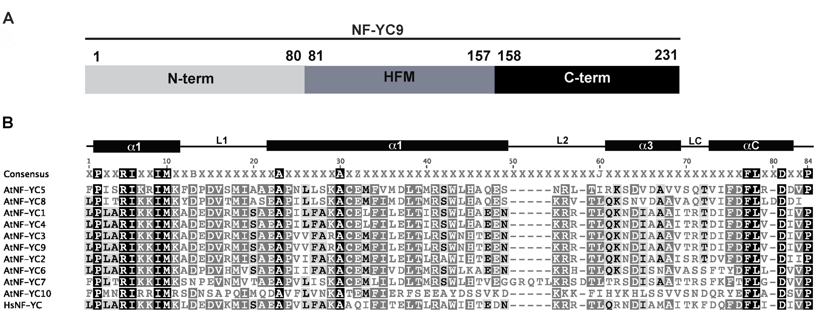

Figure 4.1. The Arabidopsis NF-YC protein. A) Schematic diagram of the full-length Arabidopsis NF-YC9 protein. B) Alignment of the Arabidopsis and human NF-YC core domains. At: Arabidopsis thaliana; Hs: Homo sapience.

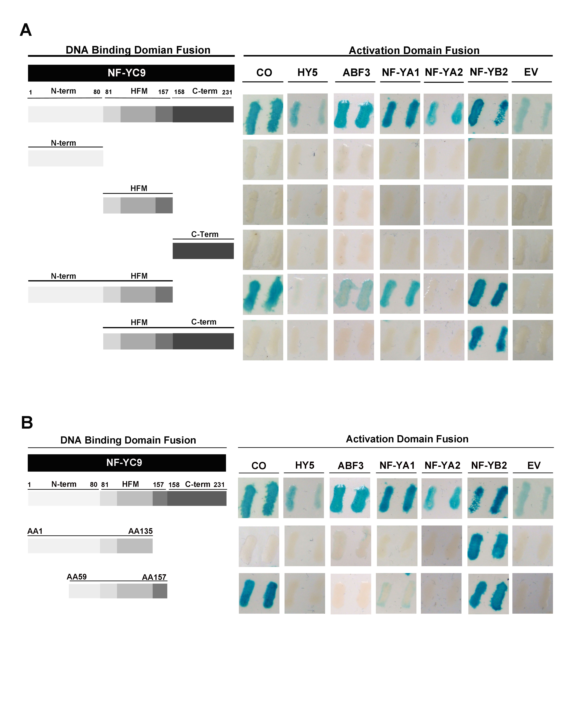Figure 4.2. The conserved core domain is required for NF-YC9 interactions. A) Deletions of NF-YC9 domains. B) NF-YC9 truncations.

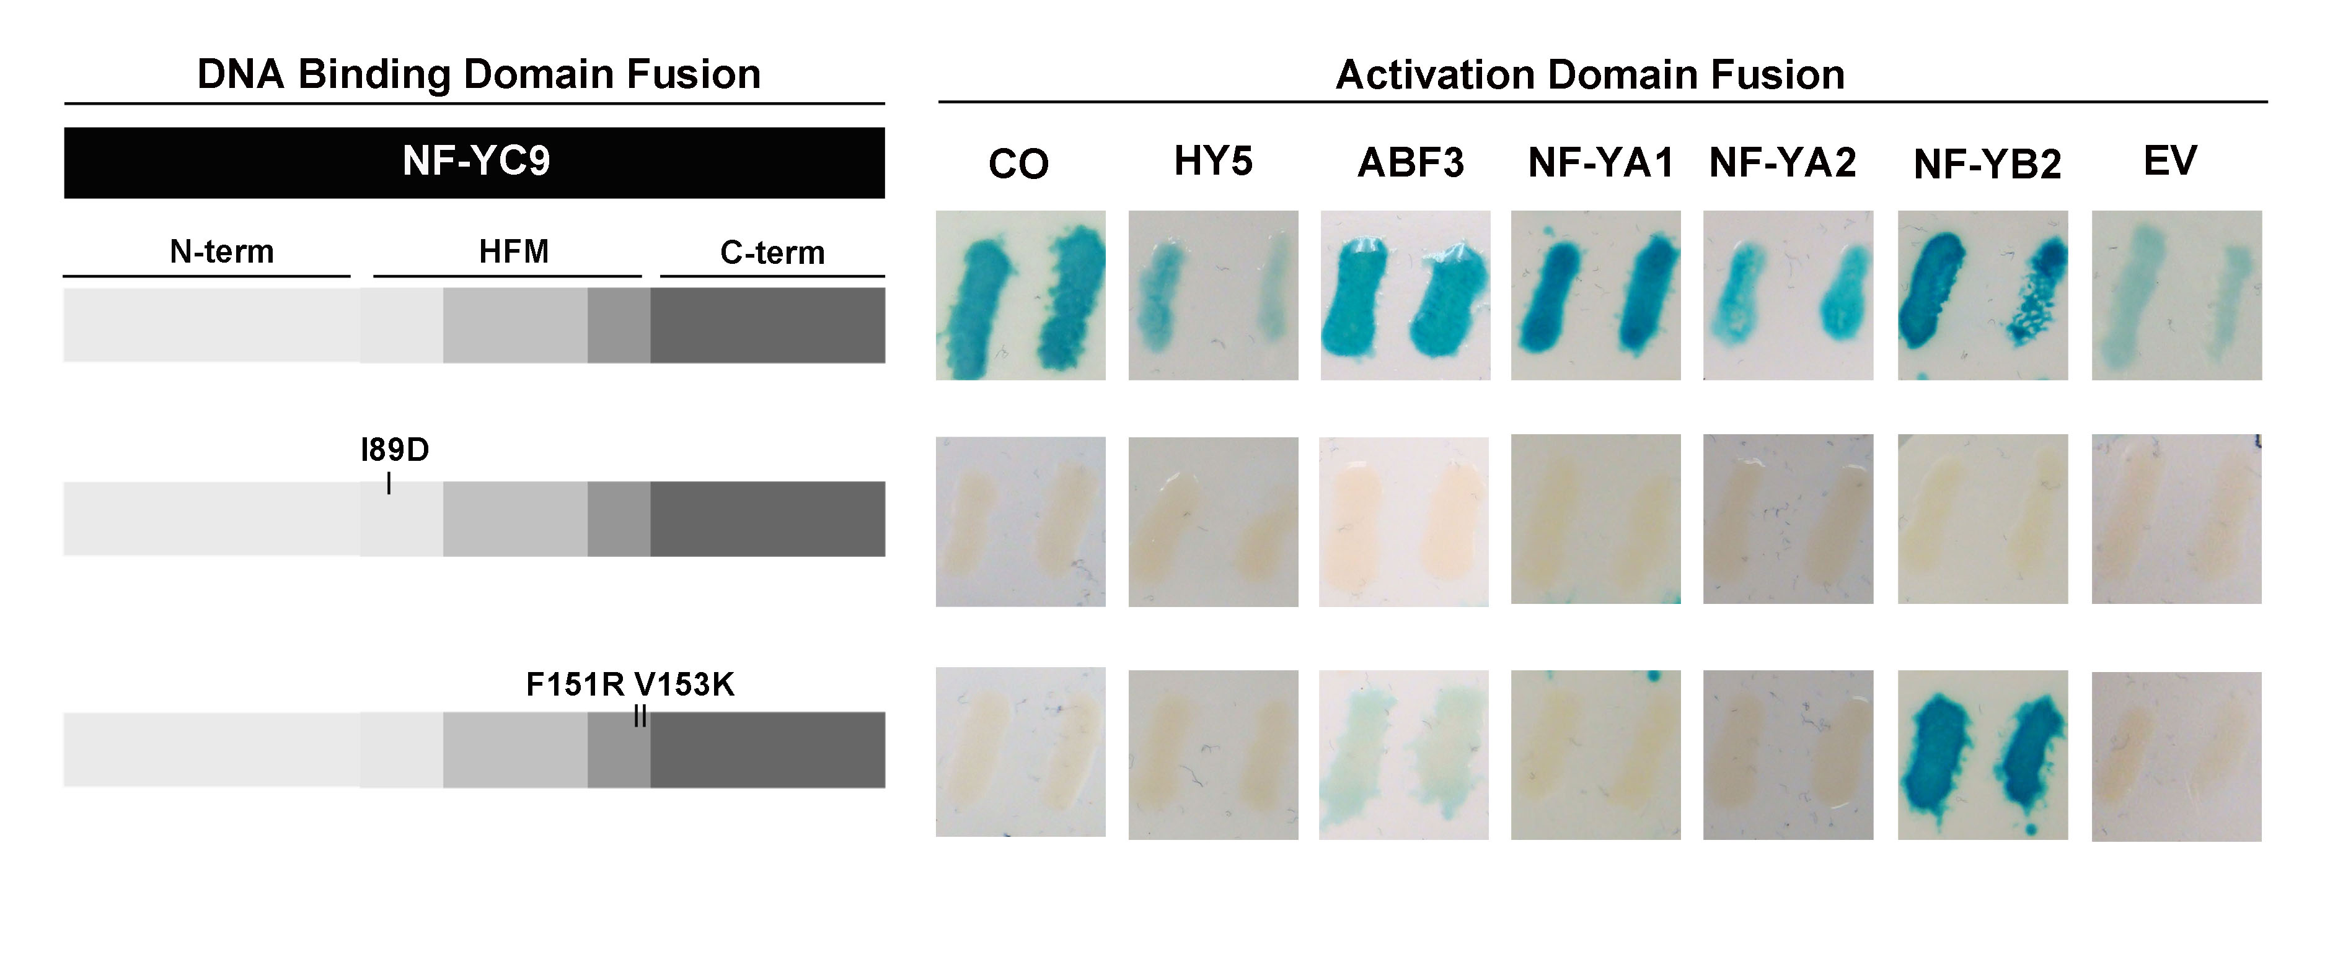

Figure 4.3. NF-YC9^{F151R V153K} loses interaction with CO, HY5, NF-YA1, and NF-YA2 but not ABF3 and NF-YB2.

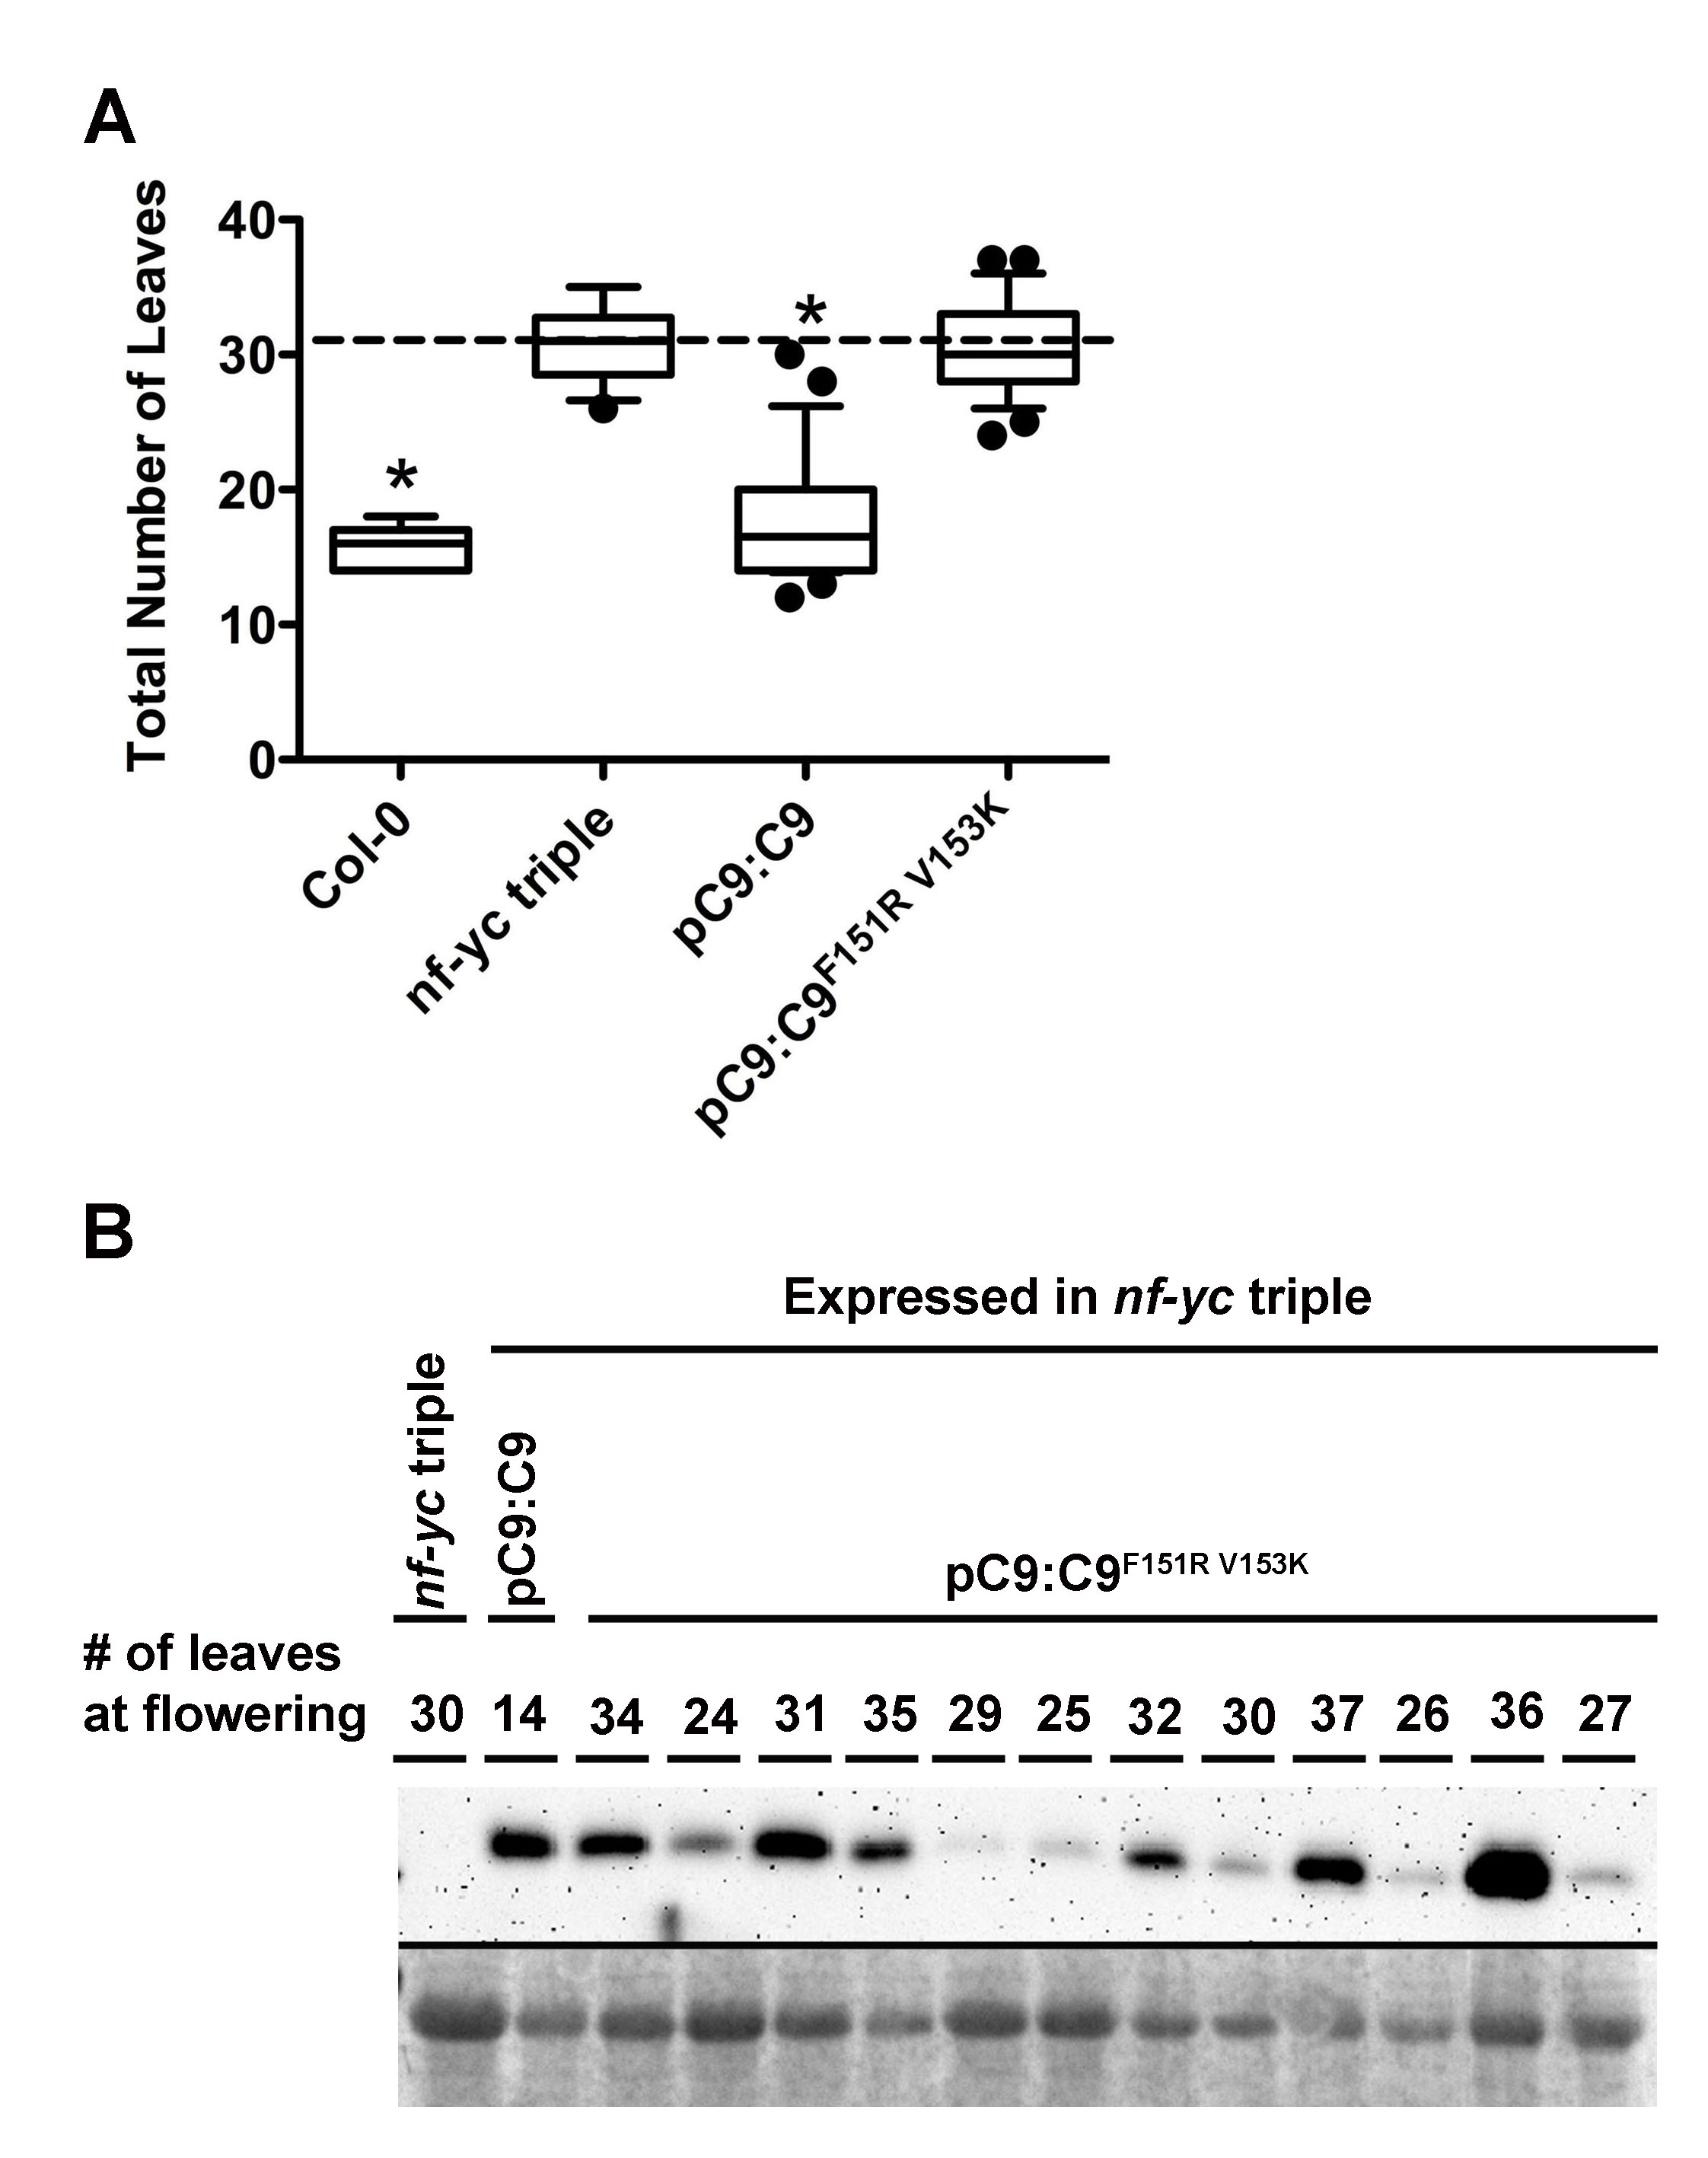

Figure 4.4. pNF-YC9:NF-YC9^{F151R V153K} cannot rescue the triple phenotype. A) T1 generation flowering time analysis. B) Protein expression in the plant lines used for the flowering time analysis. Asterisks represent significant differences derived from one-way ANOVA (P < 0.05) followed by Dunnett’s multiple comparison post hoc tests against the nf-yc triple mutant.
Supplemental Table 4.1. The amino acid sequences of NF-YC9 truncations and primers used for amplification.
Construct | Amino acids | Primers
NF-YC9 | 1 - 231 | F-ATGGCTATGCAAACTGTGAGAGAAG
NF-YC9 | 1 - 231 | R-GGTTTTGAAATTGCATTATCCATTGC
N-term | 1 - 80 | F- ATGGCTATGCAAACTGTGAGAGAAG
N-term | 1 - 80 | R-GCTGTGGTTCTTGAAATCGGTAGTC
C-term | 158 - 231 | F-CGGGGAGGATCCGAGATGAAGTC
C-term | 158 - 231 | R- GGTTTTGAAATTGCATTATCCATTGC
HFM | 81 - 157 | F-CTTCCCCTTGCGAGAATCAAG
HFM | 81 - 157 | R-GGGAACAATATCCACAAGGAAATC
N-term + HFM | 1 - 157 | F- ATGGCTATGCAAACTGTGAGAGAAG
N-term + HFM | 1 - 157 | R- GGGAACAATATCCACAAGGAAATC
HFM + C-term | 81 - 231 | F- CTTCCCCTTGCGAGAATCAAG
HFM + C-term | 81 - 231 | R- GGTTTTGAAATTGCATTATCCATTGC
AA 59 - 157 | 59 - 157 | F-CTTCAAGCATTTTGGGAGAACCAATTC
AA 59 - 157 | 59 - 157 | R- GGGAACAATATCCACAAGGAAATC
AA 1 - 135 | 1-135 | F- ATGGCTATGCAAACTGTGAGAGAAG
AA 1 - 135 | 1-135 | R-ATCGTTCTTCTGCAACGTCCGCCT

Supplemental Table 4.2. Mutagenic primers used to clone NF-YC9 mutants. The Mutagenic primers were used with the full-length NF-YC9 cloning primers (Supplementary Table 4.1) to make point mutations.

Construct | Mutation | Mutagenic Primers
NF-YC9^{I89D} | I89D | F-AGAATCAAGAAAGCATGAAAGCGGAT
NF-YC9^{I89D} | I89D | R-ATCCGCTTTCATGCTTTCTTGATTCT
NF-YC9^{F151RV153K} | F151R V153K | F-GATATTTTTGATCGGATATTGTTCCC
NF-YC9^{F151RV153K} | F151R V153K | R-GGGAACAATATCCGATCAAAAATATC

Supplementary Figure 4.1. Multiple sequence alignment of full- length NF-YC proteins. The Conserved core domain is underlined in black. At: Arabidopsis thaliana; Hs: Homo sapiens.

Supplementary Figure 4.2. Identity matrix of the full-length and core domain NF-YC proteins. A) Full-length B) core domain. At: Arabidopsis thaliana; Hs: Homo sapiens.

Supplementary Figure 4.3. NF-YC family phylogenies. Phylogenetic trees were constructed by neighbor joining using the full-length protein sequences with in MEGA5.2 (Tamura et al. 2011).

Chapter 5: Arabidopsis NF-YA are transcriptionally, post-transcriptionally and post-translationally regulated by light

Summary
NF-Y transcription factors are composed of three independent protein families, NF-YA, NF-YAB, and NF-YC. The three proteins form a trimer and then bind target CCAAT boxes on genes regulated by the NF-Y. Research from animal systems has shown that the NF-YAs are present in limited amounts for trimer formation, whereas the NF-YB and NF-YC are abundant. In animals, NF-YA proteins are regulated through phosphorylation and ubiquitination followed by proteasome-mediated degradation. Similar studies in plants are lacking. In general, plant NF-Y are poorly studied and the mechanisms by which these transcription factors are regulated is not well understood.

Here I have demonstrated that light, the external environmental cue crucial for plants at every developmental stage, plays a vital role regulating the abundance of NF-YA transcript and protein levels. I showed that the stability of NF-YA mRNA was light dependent. The same was true for NF-YA proteins. I was further able to demonstrate that some NF-YA proteins are degraded through the proteasome. Yeast two-hybrid (Y2H) screening identified a kinase, CKB4, as a direct physical interactor of NF-YA2. CBK4 is a kinase that phosphorylates its targets in response to light signals. The current study is the first to look at NF-YA transcript and protein stability in response to light, and strongly suggests tight regulation of accumulation at multiple levels is imposed on this transcription factor family in plants.

Introduction
Light is arguably the most crucial environmental cue regulating plant development. Plants require light for food production through photosynthesis; as a result light signaling regulates every step of plant development including seed germination, seedling establishment, flowering and fruit set. At the molecular level, different wavelengths of light are perceived through specialized photoreceptors called phytochromes and cryptochromes (Estelle 2001; Lau and Deng 2010). The photoreceptors then initiate a signaling mechanism that activates or represses specific targets that lead to differential gene expression. A key player in this pathway is the ubiquitin E3 ligase CONSTITUTIVE PHOTOMORPHOGENIC 1 (COP1), which is directly and differentially regulated by the photoreceptors. COP1 is a negative regulator of photomorphogenesis or light induced growth. In the dark, COP1 degrades key transcription factors necessary for activating genes that respond to light; and one of the most crucial is LONG HYPOCOTYL 5 (HY5). HY5 is also phosphorylated by members of the caseine kinase (CKII) family in the dark, which ensures that the residual HY5 remains in a less active form (Estelle 2001). Recently HY5 was demonstrated to physically interact with the Nuclear Factor-Y (NF-Y) transcription factors (Kumimoto et al. 2013).

NF-Ys are heterotrimeric transcription factors composed of three independent subunits, NF-YA, NF-YB, and NF-YC (Mantovani 1999; Siefers et al. 2009; Fleming et al. 2013). The NF-Ys are sequence specific and bind CCAAT boxes on target promoters. Neither of the subunits can bind DNA alone. All three subunits trimerize, in a stepwise manner prior to making DNA contact with the NF-YA subunit, which contacts with the CCAAT box. Studies in animal systems have shown the NF-YB and NF-YC subunits are abundant and that the NF-YA is limiting for trimer formation (Dolfini et al. 2012). In animals, the NF-YA proteins are regulated via both phosphorylation and proteasome mediated degradation (Manni et al. 2008). The lysine (R) residue responsible for tagging the protein with ubiquitin has been identified and these R residues are conserved in plants (Kumimoto R. W. and Holt B.F. – unpublished data), indicating that plant NF-Y are likely to be regulated through a similar mechanism. However similar studies are lacking in plant systems.

The regulation of plant NF-Y in general is poorly studied. The only aspect that has been studied is the targeting and degradation of plant NF-YA through microRNA. In the model plant Arabidopsis thaliana (Arabidopsis), seven out of the ten NF-YA transcripts are targeted by a microRNA, miR169 (Rhoades et al. 2002). The developmental consequences resulting from the regulation of NF-YA transcript through miR169 is well studied for developmental programs ranging from embryogenesis to flowering responses and during plant stress responses (Combier et al. 2006; Li et al. 2008). This interaction has also been conserved in other plant species where orthologs of miR169 and NF-YA regulate such developmental programs as bud formation and nodulation in legumes (Ni et al. 2013; Potkar et al. 2013). However, how the NF-YA (or the NF-Y in general) are regulated in plants, other than being targeted by miR169, is not known.

Recently studies of the NF-YC subunits have demonstrated that they are able to regulate light responses in plants (Kumimoto R.W. and Holt B.F. – unpublished data). Because the NF-Y bind DNA as a trimer, it is likely that NF-YA and NF-YB subunits show a similar response. Here I show that select NF-YAs have light related growth phenotypes. I also show that NF-YA transcript and protein stability is dependent on light availability. Through a Y2H screen I found that NF-YA2 is able to physically interact with a CKII family member CKB4. This study is the first to look at NF-YA regulation by light, and strongly suggests that the abundance of NF-YA is tightly regulated in plants.

Results
p35S:NF-YA have shorter hypocotyls under red light.
A triple mutant of NF-YC subunits, nf-yc3 nf-yc4 nf-yc9, has significantly longer hypocotyls than the wild type in red light conditions (Kumimoto R.W. and Holt B.F. – unpublished data). Although minor differences were seen in blue light and other light conditions, the most deficient response was seen towards red light, indicating that the NF-Y may primarily regulate responses to red light. To see if the NF-YAs have a similar response to red light, the overexpressors of all 10 NF-YA genes were tested in red light. The results showed that six NF-YA lines tested had significantly shorter hypocotyls in comparison to the wild type (Figure 5.1). The data suggest that these six NF-YA subunits could potentially work with the three NF-YC subunits to regulate light responses.

The light related phenotypes suggested that NF-YA might be able to regulate the expression of genes involved in light signaling. The Holt lab has collected gene expression data on p35S:NF-YA2 plants (p35S:NF-YA2 had a light phenotype above) through a RNA-Seq analysis (Kumimoto R.W. and Holt B.F. – unpublished data). I tested for enrichment of Gene Ontology (GO) terms related to light signaling in this data set. GO analysis of the data demonstrated that the GO term “cellular response to light stimulus” was significantly enriched. Key genes that regulate light responses such as PHYTOCHROME INTERACTING FACTOR 3 (PIF3), PIF4, and SPA1 were misregulated in p35S:NF-YA2 plants (Table 5.1). The child GO terms of “cellular response to light stimulus” - “response to red light”, “response to far red light”, “response to blue light”, “response to UV” were also enriched. The data strongly suggest that NF-YA2 has an important role regulating light responses.

NF-YA genes are differentially regulated in response to light availability
The availability of key regulators in light signaling, for example HY5, is regulated by light (Estelle 2001). Therefore I tested if light can directly regulate the abundance of NF-YA. I first looked at NF-YA transcript levels. I tested the relative expression of NF-YA genes grown on continuous light or grown on continuous light and transferred to dark for 24-h or 48-h. qPCR results show that NF-YAs have differential responses to light availability (Figure 5.2A). Transcript levels of NF-YA2, NF-YA4, NF-YA8, and NF-YA10 were down regulated in the dark treatments. In contrast NF-YA7 transcript was upregulated in the dark.

Transcript levels of some light regulated transcription factors show a clear daily oscillation (Carre and Veflingstad 2013). I tested if this was true for the NF-YA. I selected NF-YA2, which had a strong response to light availability, to test the oscillation under long day cycles (16-h light/8-h dark). The results show that NF-YA2 transcript did not fluctuate during a 24-h time period (Figure 5.2B). As a control, I also tested FT, a gene that is strongly upregulated at the end of long days, and the results show FT was 80-fold upregulated (Figure 5.2C).

NF-YA protein are regulated by light
NF-YA transcript levels were differently regulated by extended periods of darkness. This suggested that the protein levels might also show a similar response. Two NF-YA genes that had differential response to light at the transcriptional level, NF-YA2 and NF-YA7, were selected for the analysis. Total protein was extracted from p35S:NF-YA2 and p35S:NF-YA7 plants grown in continuous light or grown on continuous light and transferred to dark for 24-h or 48-h. The results showed that NF-YA2 protein may have degraded when plants were treated with dark for 24 or 48-h (Figure 5.3). However it is possible that the decrease in protein level was directly a result of the decrease in transcript. NF-YA7 protein levels remained unchanged in the light and dark treatments.

NF-YA proteins are degraded through the proteasome
The results above suggested that NF-YA2 protein may be degraded in the dark, indicating that like animal NF-YA, the protein may be targeted to the proteasome for degradation. To test this, a cell free degradation assay was performed using the proteasome inhibitor MG132. The results showed that NF-YA2 protein rapidly degraded in the absence of MG132, however the protein was stable in the presence of MG132 (Figure 5.4). This result suggests that NF-YA2 is targeted to the proteasome for degradation. Further experiments showing that NF-YA2 is ubiquitinated will help establish proteasome mediated degradation.

CKB4 physically interacts with NF-YA2
I performed an Y2H library screen to identify novel protein interactors of NF-YA2. This screen identified seven novel interactors of NF-YA2, one of which was CKB4, a component of the CKII kinase complex. CKII kinase phosphorylates its targets in response to light signals and the circadian clock (Daniel et al. 2004). The ability NF-YA2 to physically interact with CKB4 suggests that NF-YA2 may be a target that is phosphorylated. The NF-YA2 protein contains putative CK2 phosphorylation sites (S/T XX D/E). However, further experimental validation with kinase assays are required to demonstrate that CKB4 is able to phosphorylate NF-YA2. This data suggests that, like animal NF-YA, plant NF-YA may also be phosphorylated and the kinase involved in likely CKB4.

Discussion
Here I present preliminary data that suggests a mechanism for NF-YA regulation through light. NF-YA transcript showed differential response to light availability. NF-YA2, NF-YA8, NF-YA4, and NF-YA10 were down regulated when at least a 24-h dark treatment was given. In contrast NF-YA7 was upregulated in the dark. Arabidopsis NF-Y transcription factors have been shown to have opposing regulatory role during plant development (Kumimoto et al. 2013; Siriwardana et al. 2014 and Holt lab – unpublished data). It is possible that the differential regulation of transcript is partially responsible for the ability to opposingly regulate plant development. In contrast to animals, which have one of each NF-Y member, plant have multiple NF-Y members/ per family (Petroni et al. 2012). However, the significance of this expansion is not well understood, and how the closely related NF-Y in plants differently regulates plant development is in question. We know that the expanded plant NF-Y have specific spatial and temporal distribution patterns (Siefers et al. 2009), which accounts for its ability to regulate specific development programs. For example NF-YB6 and NF-YB9 are only expressed in the early embryo stage and specifically regulate embryogenesis (Lotan et al. 1998). The differential regulation of NF-YA transcript by light also may provide such specificity, where specific NF-YA regulates plant development according to the availability of light.

Animal NF-Y proteins are regulated through phosphorylation and degradation by the proteasome (Manni et al. 2008). The data presented here strongly suggest a similar mode of regulation for the plant NF-YA proteins. Animal literature suggests that NF-YA are the limiting factor for trimer formation (Dolfini et al. 2012). The NF-YB and NF-YC are abundant in-vivo, however the NF-Y trimer is required for DNA binding (Mantovani 1999), therefore the presence or absence of NF-YA could be controlling the ability of the trimer to bind DNA and regulate gene expression. Because these data suggest that plant NF-YAs are also regulated by similar mechanisms it is possible that NF-YA are also the limiting factor in plants. However, future research looking at the abundance and activity of plant NF-Y are required to answer this question.

The mechanism by which NF-YA are regulated according to the preliminary data given here is strikingly similar to how HY5 is regulated (Estelle 2001). HY5 protein accumulates only when light is available. In the dark HY5 protein is rapidly degraded by the proteasome. The E3 ligase, COP1, attaches ubiquitin to HY5 for it to be targeted to the proteasome. It is possible that NF-YAs are also ubiquitinated through COP1, and this needs to be tested in the future. HY5 is also phosphorylated by members of the caseine kinase (CKII) family in the dark, which ensures that the residual HY5 remains in the less active form. Here I found that NF-YA2 is able to physically interact with a CKII member, CKB4. Future experiments are needed to test if CKIIs can phosphorylate NF-YA2; however the data here suggest that this is a possibility. Further, NF-YC proteins physically interact with HY5 (Kumimoto et al. 2013). Research from animal systems suggests that NF-Y do not require histone modifications to bind DNA, and can help requite or make chromatin assessable to other transcription factors (Fleming et al. 2013). Based on the data, it is possible to hypothesize that NF-Y help requite HY5 to promoters of targets genes. The regulation of NF-YA subunits in a mechanism similar to HY5 may ensure that NF-Y complexes are not formed in the dark and adds an additional layer of insurance that HY5 does not activate these promoters. In addition it is possible that miR169 may also regulate NF-YA in response to light availability and this needs to be investigated.

Preliminary data suggest plant NF-YA are regulated by light. Further experiments with more detailed analysis are required to fully understand the significance of this regulation. However this data adds to current data that demonstrate NF-YA are dynamically regulated in plants trough miR169 by adding mechanisms such as phosphorylation and proteasome mediated degradation. Studying these regulatory mechanisms will bring us closer to understanding why the NF-Y expanded in the plant lineage and how the closely related NF-YA gene family differentially regulates plant development.

Materials and methods

Plant cultivation and hypocotyl measurements

Arabidopsis thaliana ecotype Columbia (Col-0) was used as the wild type for all experiments. For hypocotyl measurements, protein extraction and RNA extraction seedlings were grown on plates under continuous light unless otherwise noted. Seeds were sterilized by treating with 70% ethanol for 5 min and 50% household bleach for 5 min followed by five washes of sterile distilled water and germinated on Gamborg’s B5 media. Hypocotyl length experiments were done in a custom built light chamber, where the 660 nm light wavelength was used as red light. For hypocotyl length measurements plants were photographed and the hypocotyl was measured using Image J1.46r (http://rsb.info.nih.gov/ij/ (Schneider et al. 2012)).

Western blot and cell free degradation assay
Total protein was extracted from 14-day-old plants by grinding in lysis buffer (20 mM Tris, pH 8.0, 150 mM NaCl, 1 mM EDTA, pH 8.0, 1% Triton X-100, 1% SDS with fresh 5 mM DTT, and 100 µM MG132). NF-YA-CFP/HA was probed with high affinity anti-HA primary antibody (cat#11 867 423 001; Roche) and goat anti-rat secondary antibody (cat#SC-2032; Santa Cruz Biotechnology). The Bio-Rad ChemiDoc XRS imaging system was used for visualizing the protein blot after incubations with ECL plus reagent (cat#RPN2132; GE Healthcare). Equivalent loading and transfer efficiency was determined by staining the protein blot with Ponceau S (cat#P3504; Sigma-Aldrich).

qPCR Analysis
Total RNA was extracted using the E.Z.N.A. Plant RNA Kit (cat#R6827-01; Omega Biotek) according to the manufacturers instructions. Genomic DNA was digested during RNA extraction by treating the columns with DNase (cat#E1091; Omega Biotek). First-strand cDNA was synthesized using the Superscript III First-Strand Synthesis System (cat#18080-051; Invitrogen). qPCR was performed using a CFX ConnectTM Real-Time PCR Detection System (Bio-Rad) with the SYBR Green qPCR Master Mix (cat#K0222; Fermentas). Gene expression analysis was done using the CFX ManagerTM software (Bio-Rad). Normalized expression, ∆∆Cq, was selected as the analysis mode. Samples were normalized to a constitutively expressed reference gene, At2g32170 (Czechowski et al. 2005). Three biological replicates were used for the qPCR.

Contributions
This project was conceived by Dr. B. Holt and myself. I performed the hypocotyl length analysis, plant cultivation, RNA extraction and qPCR, western blots, and cell free degradation assays. I also performed the Y2H library screen that identified CKB4 as an interactor of NF-YA2. Z. Myers assisted me during RNA extraction and western blots. I performed the GO analysis on RNA-seq data collected and analyzed by Dr. B. Holt and Dr. K. Kumimoto with the assistance of Bioo-scientific, Austin, TX.

Table 5.1. List of genes that belong to the overrepresented GO term “cellular response to light stimulus”

Gene ID | Fold change | Annotation
AT1G08830 | 197.00 | CSD1|copper/zinc superoxide dismutase 1
AT2G42540 | 10.63 | COR15A|COR15|cold-regulated 15a
AT4G25560 | 3.79 | LAF1|AtMYB18|MYB18|LONG AFTER FAR-RED LIGHT 1|myb domain protein 18
AT1G09530 | 3.74 | PIF3|POC1|PAP3|phytochrome interacting factor 3|PHOTOCURRENT 1|PHYTOCHROME-ASSOCIATED PROTEIN 3
AT2G28190 | 2.34 | CSD2|CZSOD2|copper/zinc superoxide dismutase 2
AT2G43010 | -19.04 | PIF4|SRL2|AtPIF4|phytochrome interacting factor 4
AT5G24120 | -9.2 | SIGE|SIG5|ATSIG5|sigma factor E|SIGMA FACTOR 5
AT5G04190 | -9.94 | PKS4|phytochrome kinase substrate 4
AT2G46790 | -3.12 | APRR9|PRR9|TL1|Arabidopsis pseudo-response regulator 9|pseudo-response regulator 9|TOC1-LIKE PROTEIN 1
AT1G07180 | -3.81 | ATNDI1|NDA1|ARABIDOPSIS THALIANA INTERNAL NON-PHOSPHORYLATING NAD ( P ) H DEHYDROGENASE|alternative NAD(P)H dehydrogenase 1
AT5G02810 | -2.27 | PRR7|APRR7|pseudo-response regulator 7
AT4G34190 | -2.09 | SEP1|stress enhanced protein 1
AT1G54160 | -2.69 | NFYA5|NF-YA5|NUCLEAR FACTOR Y A5|"nuclear factor Y, subunit A5"
AT3G59060 | -2.26 | PIL6|PIF5|phytochrome interacting factor 3-like 6|PHYTOCHROME-INTERACTING FACTOR 5
AT2G46340 | -2.09 | SPA1|SUPPRESSOR OF PHYA-105 1

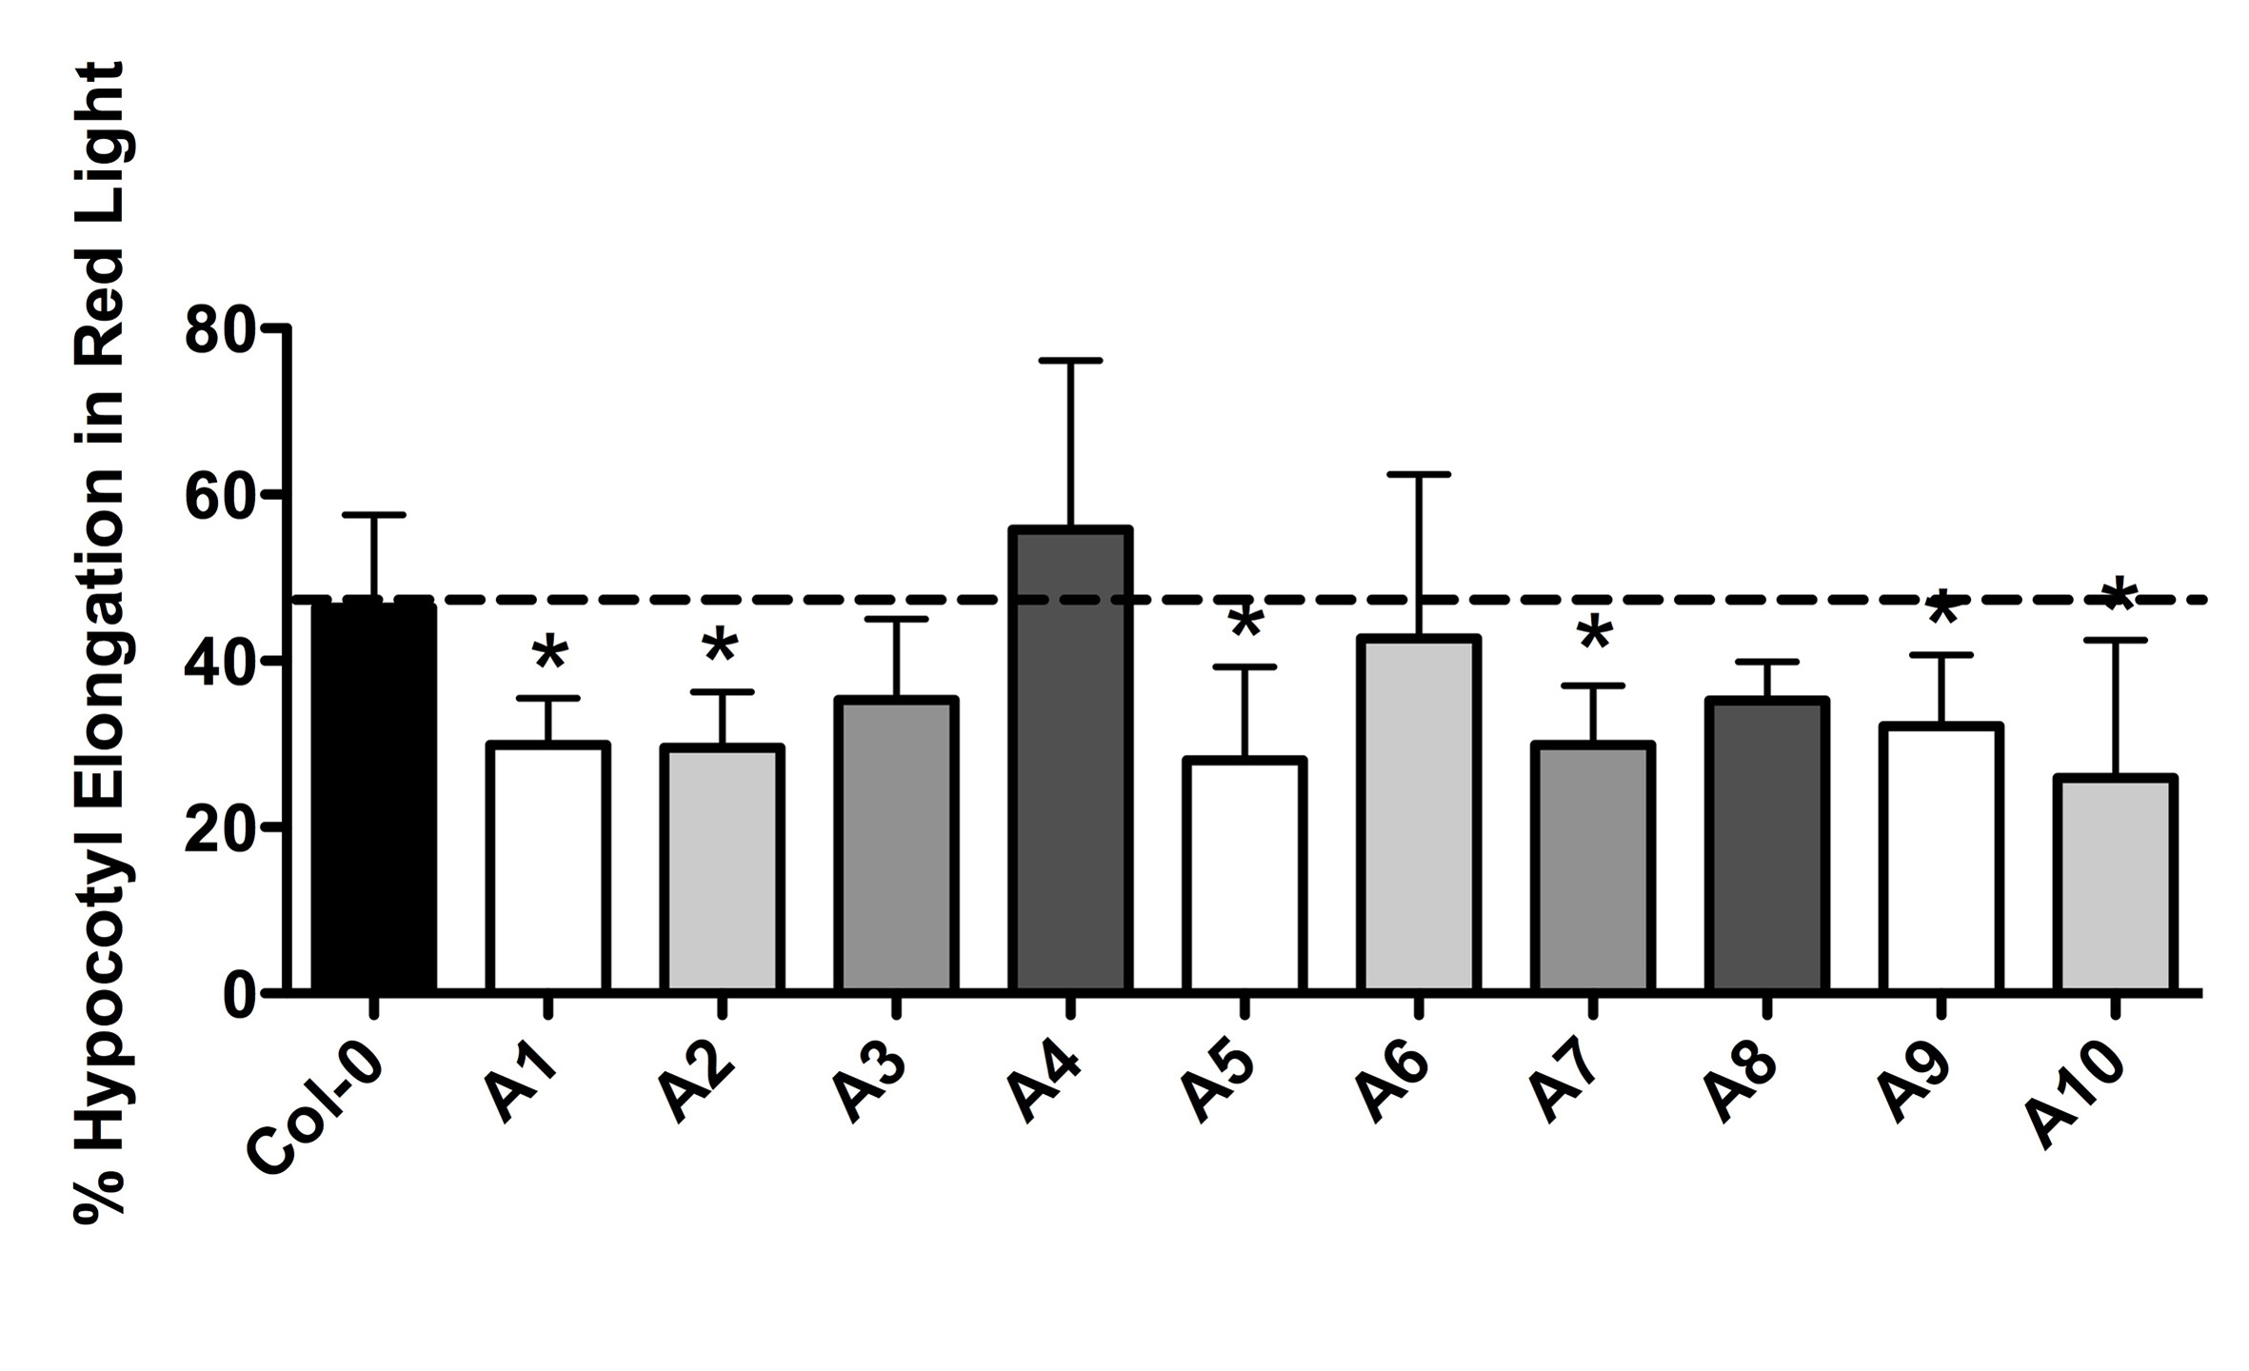
Figure 5.1. Percent hypocotyl elongation in red light for p35S:NF-YA plants. Plants grown in red light was compared to dark to calculate percent hypocotyl elongation. Asterisks represent significant differences derived from one-way ANOVA (P < 0.05) followed by Dunnett’s multiple comparison post hoc test against Col-0.
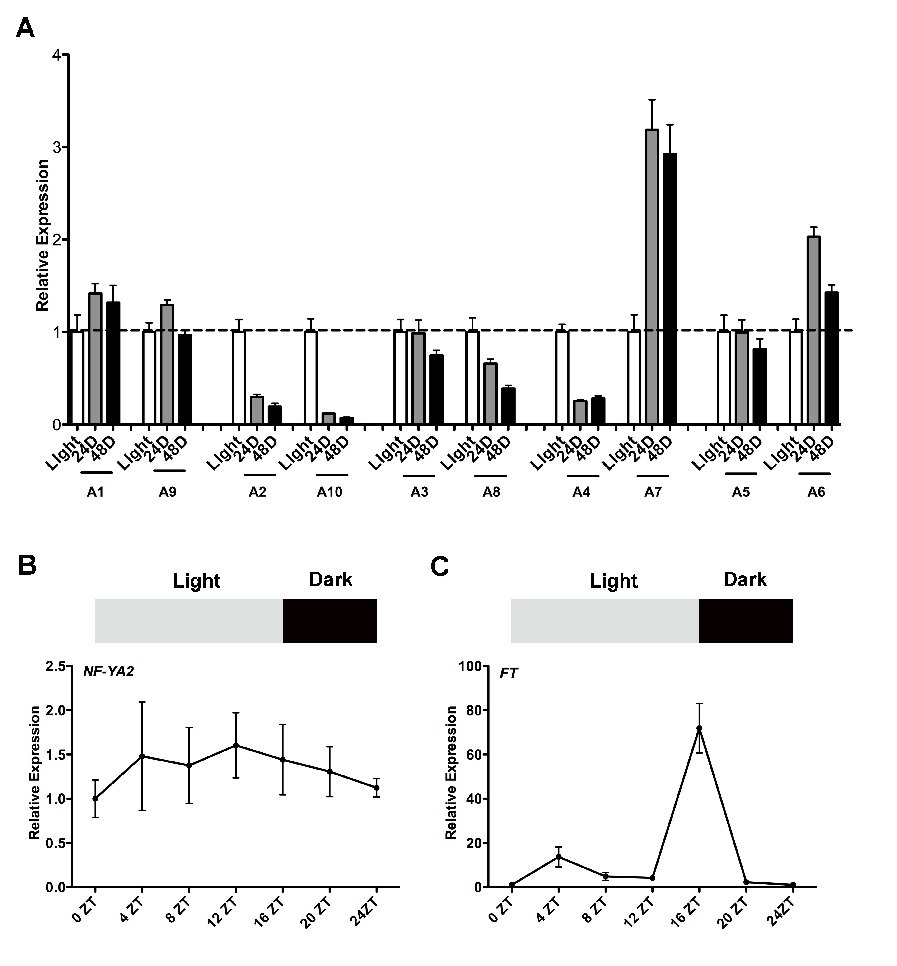
Figure 5.2. NF-YA transcripts are opposingly regulated by light. A) Relative expression of NF-YA transcript in Col-0 plants grown under continuous light or grown under continuous light and transferred to dark for 24 or 48-h. B) Oscillation of NF-YA2 transcript level during a 24-h time period in long days. C) Oscillation of FT transcript level during a 24-h time period in long days.

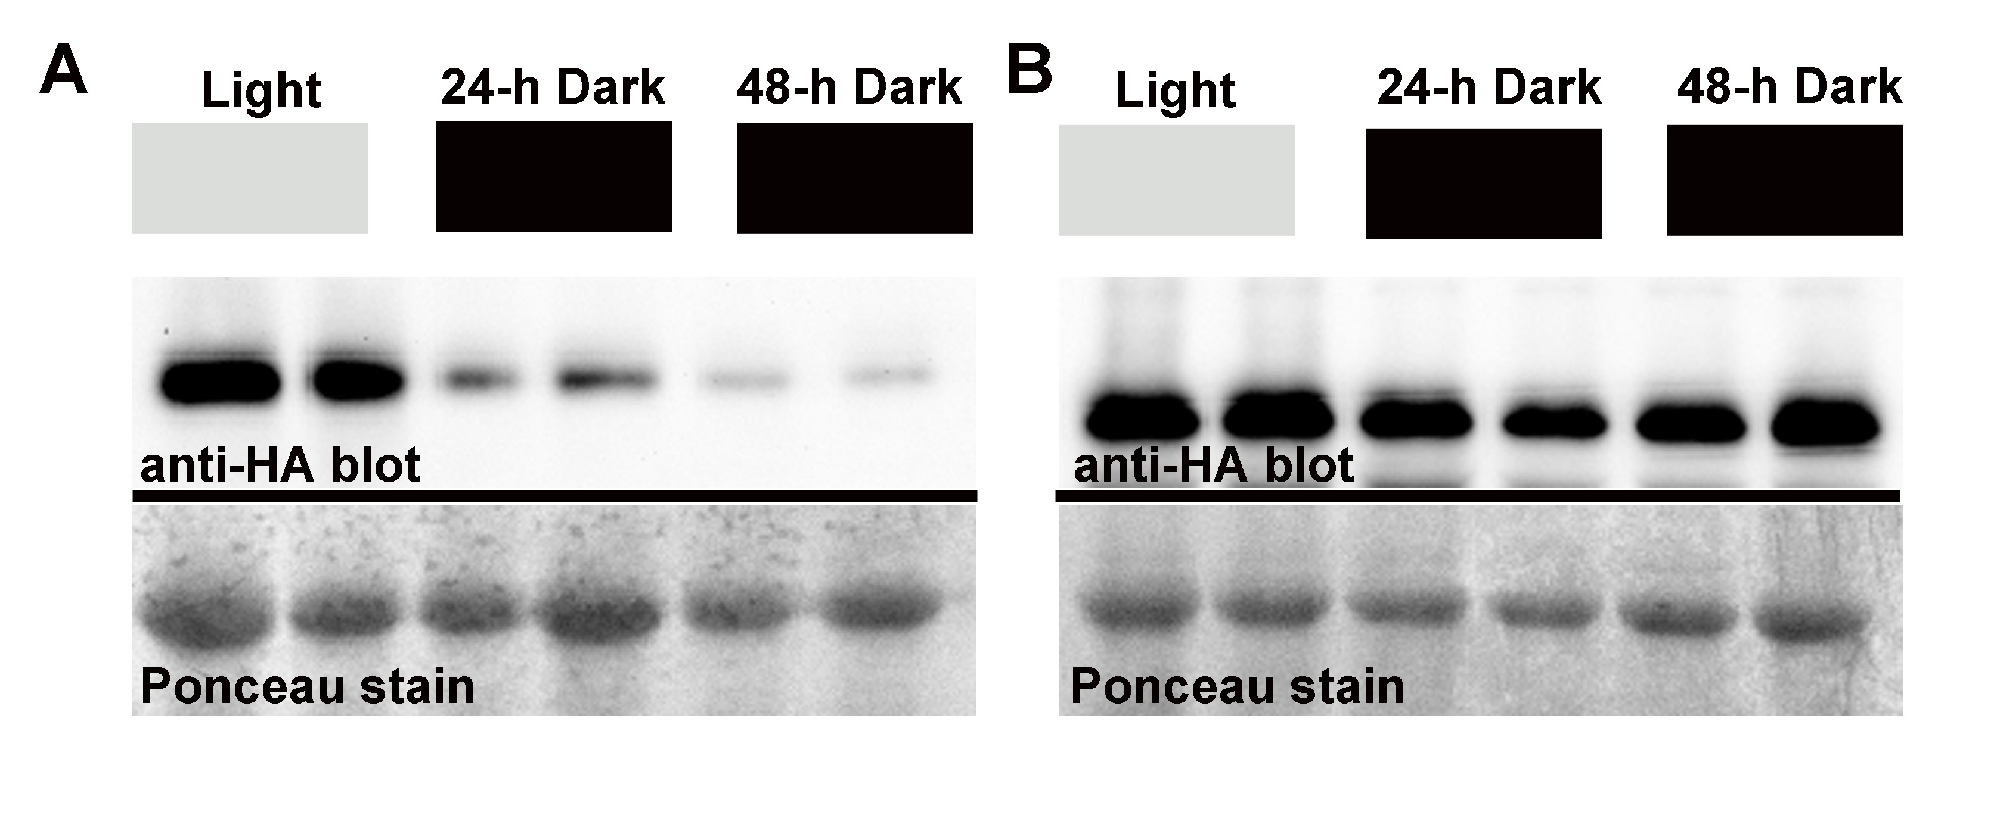

Figure 5.3. NF-YA proteins are regulated by light. Western blot showing total protein extracted from plants grown in continuous light or grown in continuous light and transferred to dark for 24-h or 48-h for A) p35S:NF-YA2 B) p35S:NF-YA7.

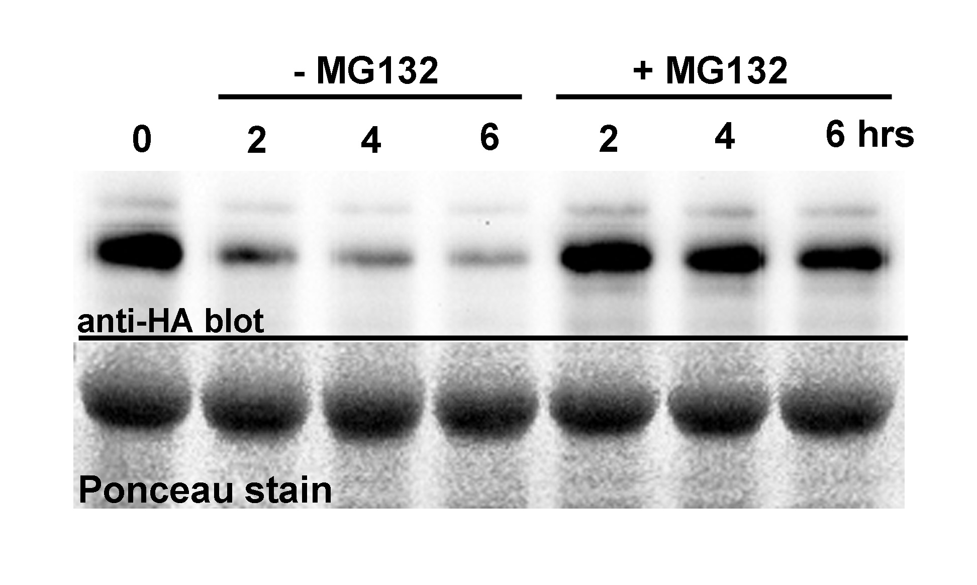

Figure 5.4. NF-YA2 proteins are degraded through the proteasome. Cell free degradation assay in the absence or presence of the proteasome inhibitor MG132.

Chapter 6: Summary of yeast 2-hybrid analysis done to understand protein-protein interactions of the NF-Y

Introduction
Chapter 6 includes a collection of yeast 2-hybrid (Y2H) experiments done to answer a wide variety of questions related to the NF-Y and its protein interactions. Y2H detects protein-protein interactions between two proteins (Fields and Song 1989). This technique utilizes properties of a transcription factor in yeast, GAL4. GAL4 has two separable functionally essential domains: a DNA binding domain (DBD) and an activation domain (AD). The two domains are required to be in close proximity to activate transcriptions, however they are not required to be covalently attached. In Y2H, the two proteins of interest are fused to the DBD or the AD. If the two proteins physically interact it brings the DBD and AD into close proximity and the complex is able to initiate transcription. Both reporter genes, such as lacZ and auxotrophic markers such as HIS3 or URA3 fused to artificial promoters, are used as targets of GAL4. Since the development of Y2H in 1989 by Fields and Song, the Y2H technique has gained immense popularity as a simple yet powerful semi in-vivo tool to detect protein-protein interactions.

I used Y2H to gain insight on the NF-Y protein interactions in plants. A majority of the work presented here has been published elsewhere in collaboration with other lead authors or will be published in the future.

Results
Brachypodium NF-YC proteins physically interact with Arabidopsis NF-YB, CO and TOC1

This work was published in BMC Biotechnology.
Cao S., Siriwardana C.L., Kumimoto R.W., Holt B.F. III. (2011) Construction of high quality GatewayTM entry libraries and their application to yeast two-hybrid for the monocot model plant Brachypodium distachyon. BMC Biotechnology. 11:53.

I did a set of experiments to see if NF-Y from different species are able to physically interact. Available literature demonstrated that the NF-Y proteins are highly conserved in plants (Siefers et al. 2009), suggesting that they may be able to physically interact. Previous studies had demonstrated that the Arabidopsis NF-YC proteins interacted with the Arabidopsis CO, TOC1, NF-YB2, and NF-YB3 (Kumimoto et al. 2010). I tested the ability of three NF-YC subunits in Brachypodium distachyon (Brachypodium), an emerging grass model species, to interact with Arabidopsis CO, TOC1, NF-YB2, and NF-YB3. The results demonstrated that the Arabidopsis and Brachypodium proteins are able to physically interact (Figure 6.1). This showed that the NF-Y in Arabidopsis and Brachypodium are structurally and functionally conserved. Further, Dr. S. Cao developed a high quality yeast two-hybrid library for Brachypodium, and the ability of Arabidopsis and Brachypodium proteins to interact suggested that this library can be utilized for plant species other than Brachypodium.

The Brachypodium orthologs of Arabidopsis NF-YB2 and NF-YB3 physically interact with Arabidopsis NF-YC proteins that regulate flowering.

This work was published in PLoS ONE.
Cao S., Kumimoto R.W., Siriwardana C.L., Risinger J.R., Holt B.F. III. (2011) Identification and characterization of NF-Y transcription factor families in the monocot model plant Brachypodium distachyon. PLoS ONE. 6:6.

I further extended the cross-species protein interaction assays by testing interaction between Arabidopsis NF-YC and Brachypodium NF-YB proteins during flowering. In Arabidopsis two NF-YB proteins, NF-YB2 and NF-YB3, and three NF-YC proteins, NF-YC3, NF-YC4, and NF-YC9, physically interacted and regulated flowering (Kumimoto et al. 2008b; Kumimoto et al. 2010). Loss-of- function nf-yb2 nf-yb3 mutants were extremely late flowering; however the late flowering phenotype was rescued by overexpressing either NF-YB2 or NF-YB3 (Risinger and Holt, unpublished data). J. Risinger tested if two Brachypodium NF-YB genes that are orthologs of Arabidopsis NF-YB2 and NF-YB3 are able to rescue the late flowering phenotype of the Arabidopsis nf-yb2 nf-yb3 mutants. The results showed that the Brachypodium NF-YB were able to rescue the Arabidopsis mutants, demonstrating that they are functionally compatible (Cao et al. 2011a). This result indicated that the Brachypodium NF-YB proteins are able to make a functional protein complex with the Arabidopsis NF-YC proteins, NF-YC3, NF-YC4, and NF-YC9. I tested this possibility using a Y2H assay and found that the Brachypodium NF-YB and Arabidopsis NF-YC were able to physically interact (Figure 6.2). I concluded that the Brachypodium NF-YB proteins physically interacted with Arabidopsis NF-YC subunits and functionally complemented the Arabidopsis NF-YB proteins.

NF-Y proteins interact with the ABRE-binding bZIP transcription factors that regulate ABA signaling.

This work was published in PLoS ONE.
Kumimoto R.W., Siriwardana C.L., Gayler K.K., Risinger J.R., Siefers N., Holt B.F. III. (2013) NUCLEAR FACTOR Y transcription factors have both opposing and additive roles in ABA-mediated seed germination. PLoS ONE. 8:3.

Abscisic acid (ABA) is a plant stress response hormone. The ABA signaling cascade results in the activation of a group of bZIP transcription factors that binds and regulates ABA response genes. Recently a bZIP transcription factor that regulates ABA responses, bZIP67, were shown to interact with NF-Y subunits (Yamamoto et al. 2009). bZIP67 was able to make a complex with the NF-YB/NF-YC dimer and activate the promoter of CRUCIFERIN C (CRC), which encodes a seed storage protein. The NF-Y trimer was also shown to interact with a bZIP transcription factor, bZIP28, during endoplasmic stress responses (Liu and Howell 2010). The two NF-Y/bZIP interactions suggested that NF-Y/bZIP interactions may be ubiquitous during plant stress responses. To investigate this possibility, I used network analysis to study whether bZIP transcription factors associate with the NF-Y. I found that the bZIP/NF-Y interactions are commonly predicted (Figure 6.3). Other than NF-Y/bZIP interactions the network analysis also predicted the NF-Y interactions with CONSTANS-LIKE (COL) proteins. The Holt lab previously showed that the NF-Y/COL interactions are common in plants (Kumimoto et al. 2010; Cao et al. 2011b), demonstrating that the network analysis predictions could be experimentally validated.

To further investigate the NF-Y/bZIP protein interactions I used Y2H analysis. Two NF-YB subunits, NF-YB2, NF-YB3, and three NF-YC subunits, NF-YC3, NF-YC4, and NF-YC9, are involved in ABA mediated seed germination (Kumimoto et al. 2013). Further NF-YB1 was involved drought tolerance (Nelson et al. 2007). I tested if these subunits are able to interact with bZIP transcription factors that regulate ABA responses ABF1, ABF2, ABF3, ABF4, and HY5. The results showed that the three NF-YC subunits interacted with all the bZIP proteins tested and NF-YB2 interacted with ABF3 (Figure 6.4). This showed that NF-YC subunits ubiquitously interacted with the bZIP proteins, whereas the NF-YB proteins conferred specificity.

NF-YB2 and NF-YB3 proteins are highly conserved and share an identical conserved histone fold motif (HFM) (Siefers et al. 2009). Since ABF3 interacted with NF-YB2 and not NF-YB3, it was hypothesized a region outside the conserved HFM is required for the ABF3/NF-YB2 interaction. NF-YB2 HFM is flanked by a less conserved N-terminus and C-terminus. J. Risinger made constructs with the N-terminus, C-terminus, HFM, N-terminus + HFM, and C-terminus + HFM. None of these constructs interacted with ABF3, demonstrating that the full-length protein is required for interactions (Figure 6.5). This result led to the hypothesis that the HFM flanking regions may be providing a stabilizing platform. To test this possibility J. Risinger constructed chimeric proteins of NF-YB2 and NF-YB10. NF-YB10 is distantly related to NF-YB2 and does not interact with ABF3. The N-terminus and HFM of NF-YB2 fused to the C-terminus of NF-YB10 was able to interact with ABF3. The complementary construct (N-terminus and HFM of NF-YB10 fused to C-terminus of NF-YB2) or the N-terminus and HFM of NF-YB10 were not able to interact with ABF3. This result demonstrated that the N-terminus and HFM of NF-YB2 confer specificity and the C-terminus stabilizes the NF-YB2/ABF3 protein complex.

Most Arabidopsis NF-YB proteins are able to physically interact with the NF-YC proteins that regulate flowering.
Plant NF-Y transcription factors have undergone an extensive expansion compared to animals (Siefers et al. 2009), however the significance of this expansion is not well understood. To get insight in to the expansion of the NF-YB family J. Risinger studied the ability of the complete NF-YB gene family to drive flowering. Two NF-YB subunits NF-YB2 and NF-YB3 are known to regulate flowering (Kumimoto et al. 2008b). The nf-yb2 nf-yb3 double mutant is extremely late flowering; however the late flowering phenotype was rescued by overexpressing either NF-YB2 or NF-YB3. When six other NF-YB genes that do not have a known role in flowering were overexpressed some genes were able to rescue the flowering phenotype and others were not (Risinger J.R., and Holt B.H., unpublished data). I used a Y2H assay to test if the NF-YB subunits used in the rescue experiment was able to interact with three NF-YC subunits that regulate flowering, NF-YC3, NF-YC4, and NF-YC9. The results showed that all the NF-YB subunits, other than NF-YB10, were able to interact with the NF-YC subunits (Figure 6.6). These results indicated that the NF-YB/NF-YC interactions are ubiquitous and was not the limiting factor for some NF-YB to rescue and others not to rescue the late flowering phenotype.

The NF-YB proteins have a highly conserved histone fold motif (HFM). The HFM alone, of select NF-YB genes, were able to rescue the nf-yb2 nf-yb3 late flowering phenotype (Risinger J.R., and Holt B.H., unpublished data). This data led to the hypothesis that the HFM is able to form a stable functional protein complex with the NF-YC subunits. I used a Y2H analysis to test if the HFM of NF-YB proteins can interact with NF-YC subunits and found that they were able to interact (Figure 6.7). The results confirmed the hypothesis that the NF-YB HFM alone is able to interact and form a functional protein complex with NF-YC proteins.

A Y2H library screen identified novel interactors of NF-YA2
The developmental process regulated by the NF-Y in plants is not well understood. Currently we know that the NF-Y primarily regulates photoperiod dependent flowering, ABA and other stress responses, embryogenesis, and nodulation in legumes (Petroni et al. 2012). Identifying novel proteins that interacts with NF-Y can potentially lead to the identification of yet unknown development programs regulated by the NF-Y. Y2H library screens are a powerful technique to detect novel protein interactors. I screened an Y2H library to identify novel interactors of a NF-YA subunit, NF-YA2. I was able to identify seven interacting proteins of NF-YA2 (Table 6.1). All of these are novel interactors that have not previously been published as NF-YA2 interacting proteins. Three of the interacting proteins, CKB4, ARC6, and LSU1 have been well studied in literature.

CKB4 encodes a casein kinase II beta chain (CKII) (Perales et al. 2006; Moreno-Romero et al. 2011). CKII are highly conserved serine/threonine kinases composed of two α subunits and two β subunits, with four members of each subunit in Arabidopsis. In plants CKII are primarily known to regulate the circadian clock and light regulated development. Known targets of CKII are transcription factors regulating circadian and light responses and include HY5 (Hardtke et al. 2000), LONG HYPOCOTYL IN FAR-RED LIGHT 1 (HFR1) (Park et al. 2008), LONG AFTER FAR-RED LIGHT 1 (LAF1) (Seo et al. 2003), LATE ELONGATED HYPOCOTYL (LHY) (Sugano et al. 1998), and PHYTOCHROME INTERACTING FACTOR 1 (PIF1) (Bu et al. 2011). The NF-Ys also have a role during circadian and light regulated development and is known to regulate or interact with targets of the CKII (Kumimoto et al. 2013) and Holt B. F., unpublished data), therefore it is likely that NF-YA subunits are also targeted by the CKII during circadian and light regulated development, adding an additional layer of regulation. Recently CKII subunits were also shown to regulate flowering time in Arabidopsis. Multiple order mutants of CKII subunits are late flowering and have reduced FT expression (Mulekar et al. 2012). The target of CKII during regulation of flowering is not known; it is possible that CKII targets NF-YA2, which can be responsible for the phenotype. Further, phosphorylation by CKII demonstrates a novel mechanism by which the NF-YA proteins are regulated in plants.

ACCUMULATION AND REPLICATION OF CHLOROPLASTS 6 (ARC6), is a transmembrane protein localized to the chloroplast that plays a major role in chloroplast division (Glynn et al. 2008). arc6 mutants are characterized by having one to two oversized chloroplasts per mesophyll cell (Pyke et al. 1994). Further research is needed to demonstrate the role played by NF-Y during chloroplast divisions, however in animal systems, NF-Y have been extensively published to be involved in cell division (Ly et al. 2013). Similar studies in plant systems are lacking, and the interaction between NF-YA2 and ARC6 is a possible starting point to investigate the role played by NF-Y during cell division in plants.

Genomic analysis in Arabidopsis identified RESPONSE TO LOW SULFUR 1 (LSU1), as a protein that confered adaptation to low sulfur environments (Maruyama-Nakashita et al. 2005). NF-Y subunits have not been associated with sulfur deficiency to date, however they have been shown to respond to another macromolecule essential for plant growth, nitrogen. NF-YA genes are strongly upregulated and its target miR169 is strongly down-regulated by nitrogen starvation (Zhao et al. 2011). A similar mechanism of regulation may take place during sulfur deficiency and warrants further investigations to the role played by NF-Y during sulfur deficiency and the significance of the interaction with LSU1.

Chapter 6 demonstrated the versatility of the of the Y2H technique in answering a wide variety of questions and as a tool to develop new hypothesis. I was able to demonstrate interaction between the NF-YB/ NF-YC subunits, interspecies interactions among the plant NF-Y subunits, and NF-Y/bZIP interaction during ABA and light responses. I was also able to identify novel interactors of NF-YA2 through a Y2H library screen, which can be used as starting points to develop hypothesis to further the study of NF-Y in plant systems.

Materials and methods

Directed Y2H analysis and Y2H library screen

The respective activation domain (AD) or DNA binding domain (DBD) constructs was introduced into the yeast strain MaV203 (Invitrogen). Directed Y2H assays were performed according to the instructions in the ProQuestTM manual (Invitrogen). For the X-Gal assay nitrocellulose membranes were frozen in liquid nitrogen and placed on a filter paper saturated with Z-buffer containing X-Gal (5-bromo-4-chloro-3-indoxyl-beta-D-galactopyranoside, Gold Biotechnology, cat#Z4281L).

The Y2H library used in the screen was previously described, and was a GatewayTM ready library made from mixing equal parts of hormone treated and untreated seedlings, flowers, developing seeds, and primary leaves (Burkle et al. 2005). The Y2H library screen was performed according to the instructions in the ProQuestTM manual (Invitrogen).

Protein-protein interaction network
Individual protein-protein interaction networks were built for NF-YC3, NF-YC4, and NF-YC9 using GeneMANIA (http://www.genemania.org (Mostafavi et al. 2008; Warde-Farley et al. 2010)). Selection criteria to develop the network map in GeneMANIA were predicted interactions and physical interactions with a 50-gene output. Default settings in GeneMANIA were used for network weighting. The individual network maps built in GeneMANIA for NF-YC3, NF-YC4, and NF-YC9 were downloaded as text files and combined to build a protein interactome in Cytoscape 2.8.0 (http://www.cytoscape.org (Cline et al. 2007)). Data from Y2H library screens and directed Y2H assays done in the Holt lab and published interactions (Kumimoto et al. 2010) of NF-YC3, NF-YC4, NF-YC9 were manually added to the protein interactome in Cytoscape.

Contributions
I was a co-author, but not the lead author, in the publications presented in this chapter. My contribution was to conceive the Y2H experiments with the lead author and Dr. B. Holt. I performed all the directed Y2H experiments discussed in this chapter. Cloning the genes and ligating into Y2H vectors were performed by R. Kumimoto, J. Risinger, A. Robbins, or myself. I performed the Y2H library screen with NF-YA2. I also performed the network analysis.
Table 6.1. Novel interactors of NF-YA2 identified through an Y2H library screen.
AGI Number | Gene Name | Notes
AT2G44680 | CKB4 | Encodes casein kinase II beta chain (CKII)
AT5G42480 | ARC6 | Encodes accumulation and replication of chloroplast 6
AT3G49580 | LSU1 | Encodes response to low sulfur 1
AT1G34380 |  | Encodes 5’-3’ exonuclease family protein
AT2G39280 |  | Encodes gyp1 super family protein
AT5G61200 |  | Unknown protein
AT2G36220 |  | Unknown protein

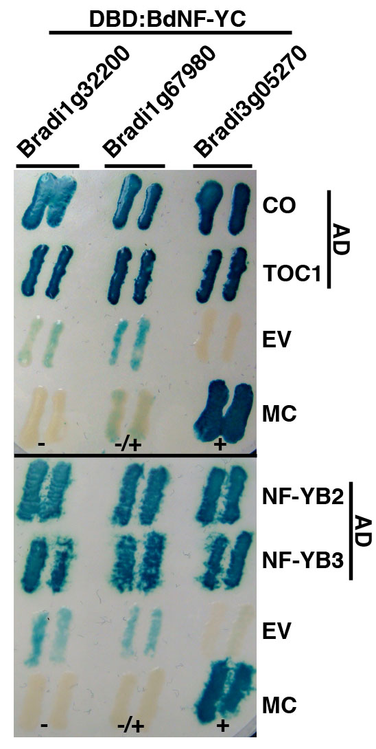
Figure 6.1. Interaction between Brachypodium NF-YC and select Arabidopsis proteins. The Brachypodium NF-YC orthologs Bradi1g32200, Bradi1g67980, and Bradi3g05270 were cloned as Gal4 DNA binding domain (DBD) fusions and directly tested for the ability to physically interact with previously described Gal4 activation domain (AD) fusions to full length Arabidopsis CO, TOC1, NF-YB2, and NF-YB3. EV - empty vector; MC - manufacturer’s (Invitrogen) controls (+ strong interactor, +/- weak interactor, - non-interactor).

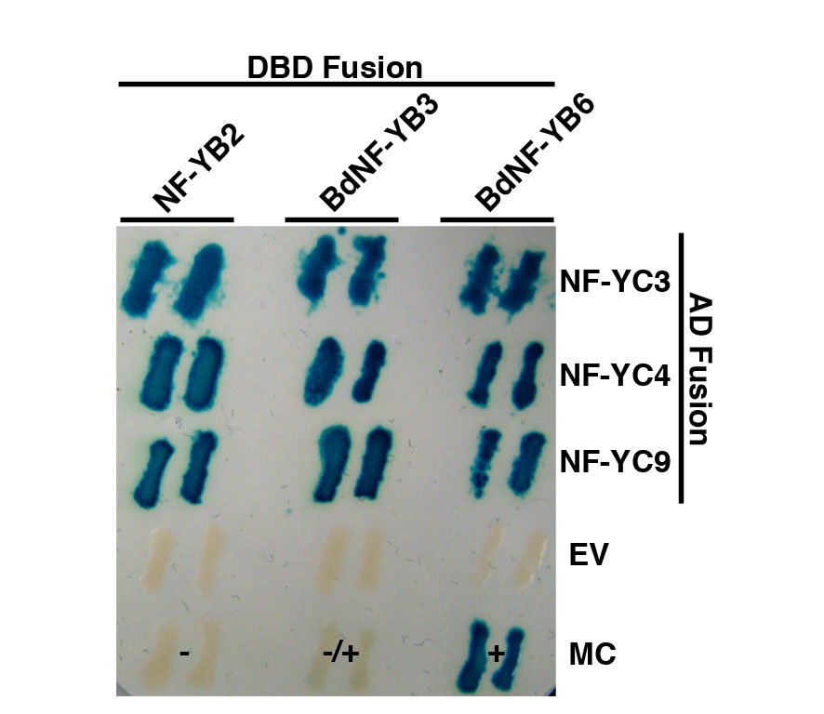
Figure 6.2. BdNF-YB3 and BdNF-YB6 can physically interact with Arabidopsis NF-YC3, 4, and 9. DBD, DNA-binding domain; AD, activation domain. EV - empty vector; MC - manufacturer’s (Invitrogen) controls (+ strong interactor, +/- weak interactor, - non-interactor)

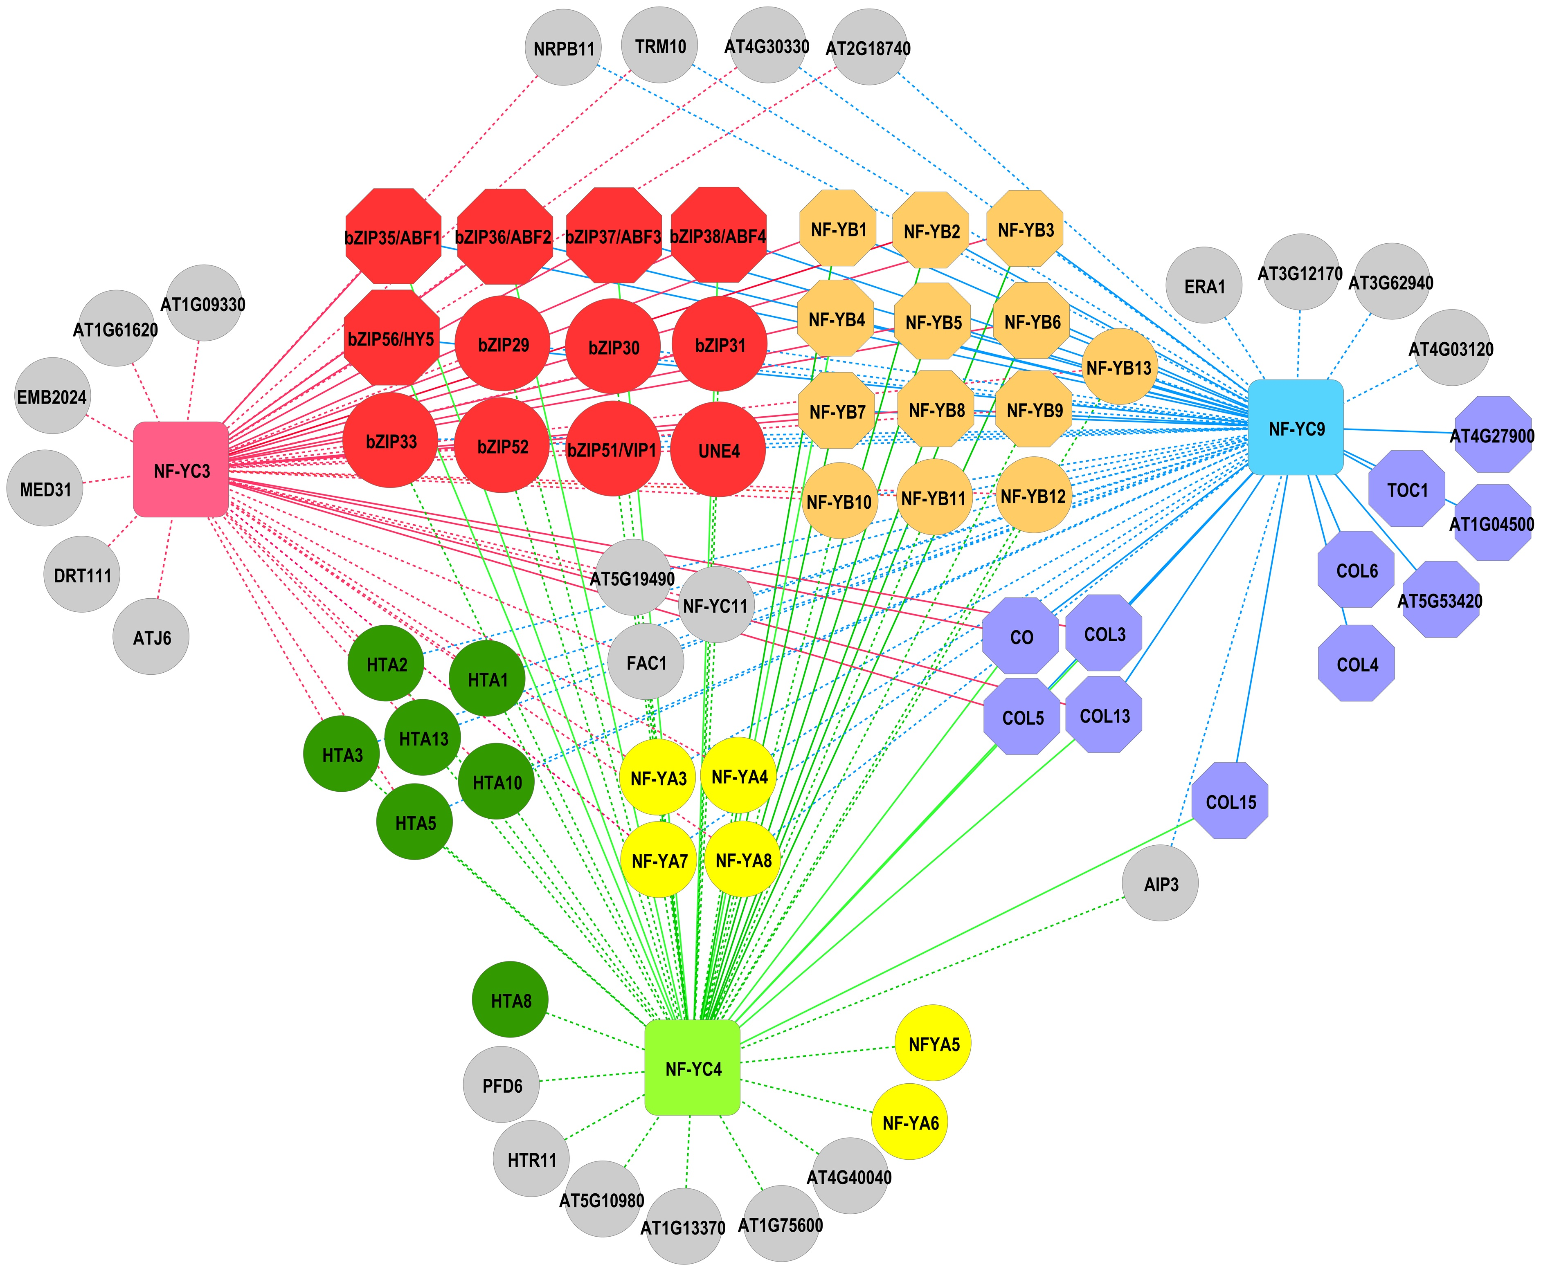

Figure 6.3. NF-YC3, NF-YC4, and NF-YC9 protein-protein interaction network. Both demonstrated and GeneMANIA predicted protein-protein interaction data for NF-YC3, NF-YC4, and NF-YC9 were visualized using Cytoscape. Predicted physical interactions are depicted as dashed lines, while demonstrated interactions are depicted as solid lines. Input nodes NF-YC3, NF-YC4, and NF-YC9 are shown as squares. Circle nodes are those predicted data from GeneMANIA. Octagonal nodes represent demonstrated physical interactions. Related protein nodes are colored as follows: red-bZIP; blue-CCT; green-H2A; orange/tan-NF-YB; yellow-NF-YA; gray-unclassified interacting proteins.

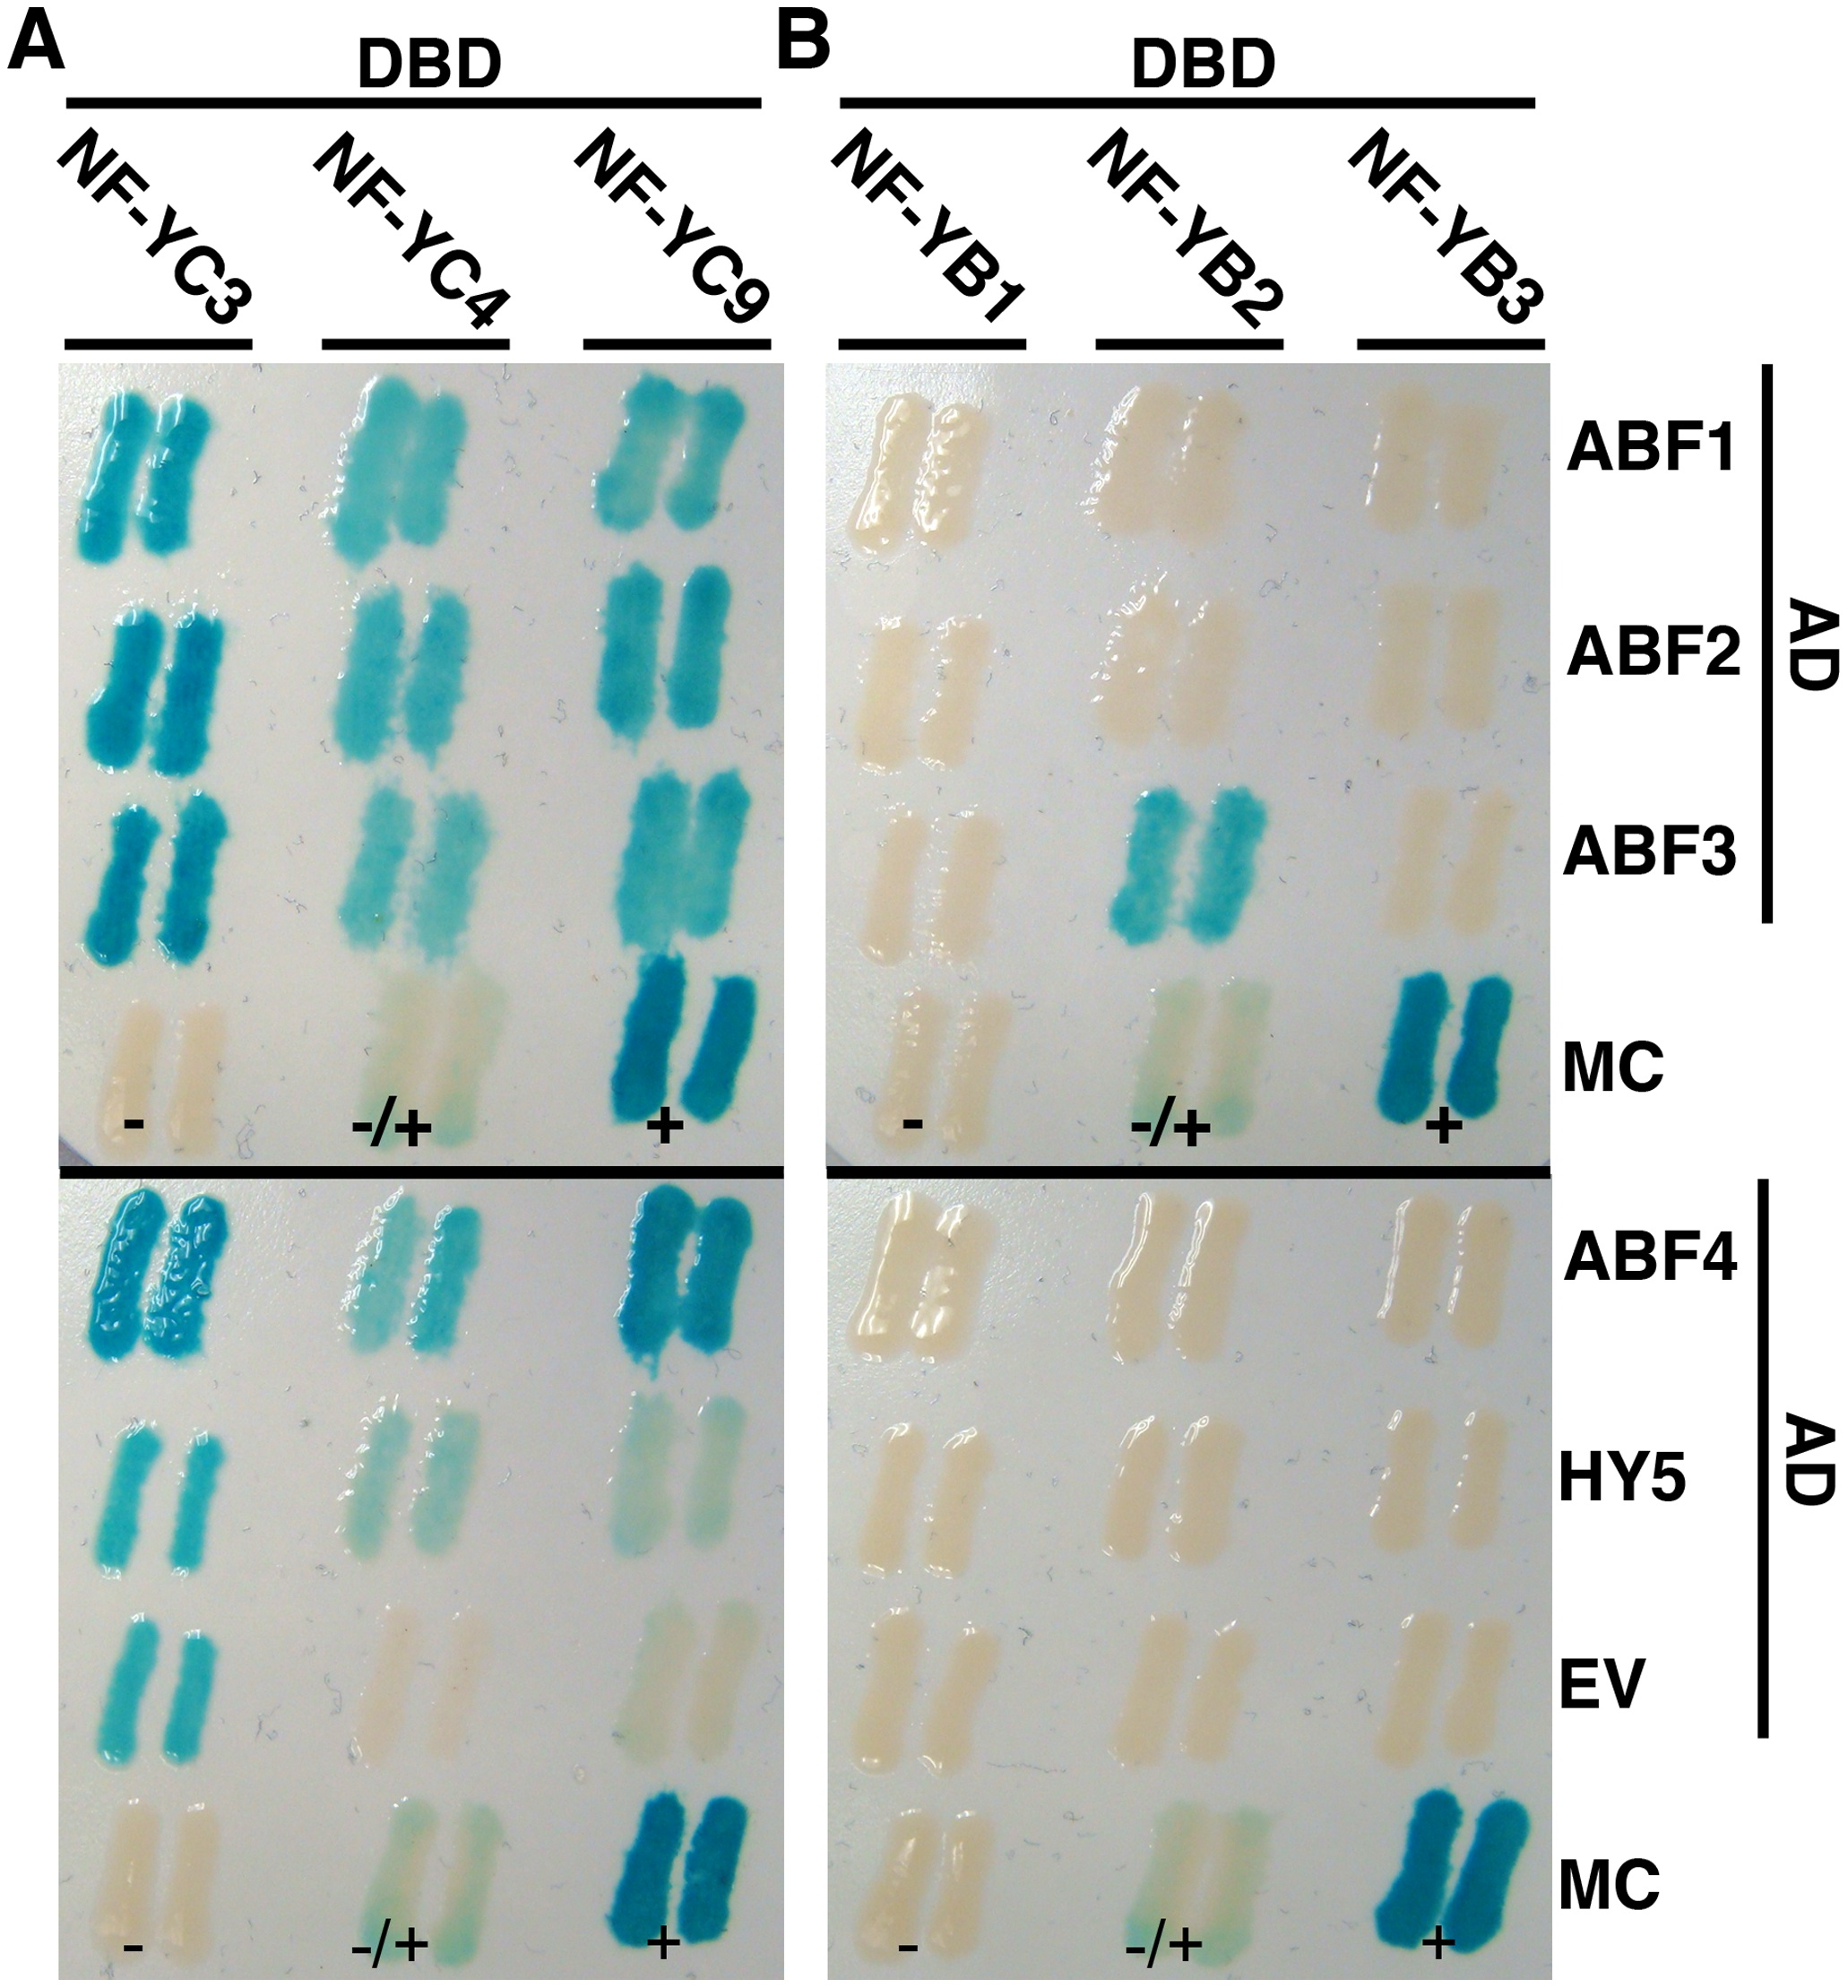

Figure 6.4. NF-YB and NF-YC subunits interact with bZIP transcription factors. Directed Y2H interactions between NF-YB or NF-YC subunits fused to DNA binding domains (DBD) and select bZIP proteins fused to activation domain (AD). Two independent colonies are shown for the activation of a β-galactosidase reporter gene. A) NF-YC3, NF-YC4, and NF-YC9 interactions with ABF1-4 and HY5. B) NF-YB1, NF-YB2, and NF-YB3 interactions with ABF1-4 and HY5. MC = manufacturers controls (+ = strong positive, +/- = intermediate positive, - = negative, EV = empty vector.

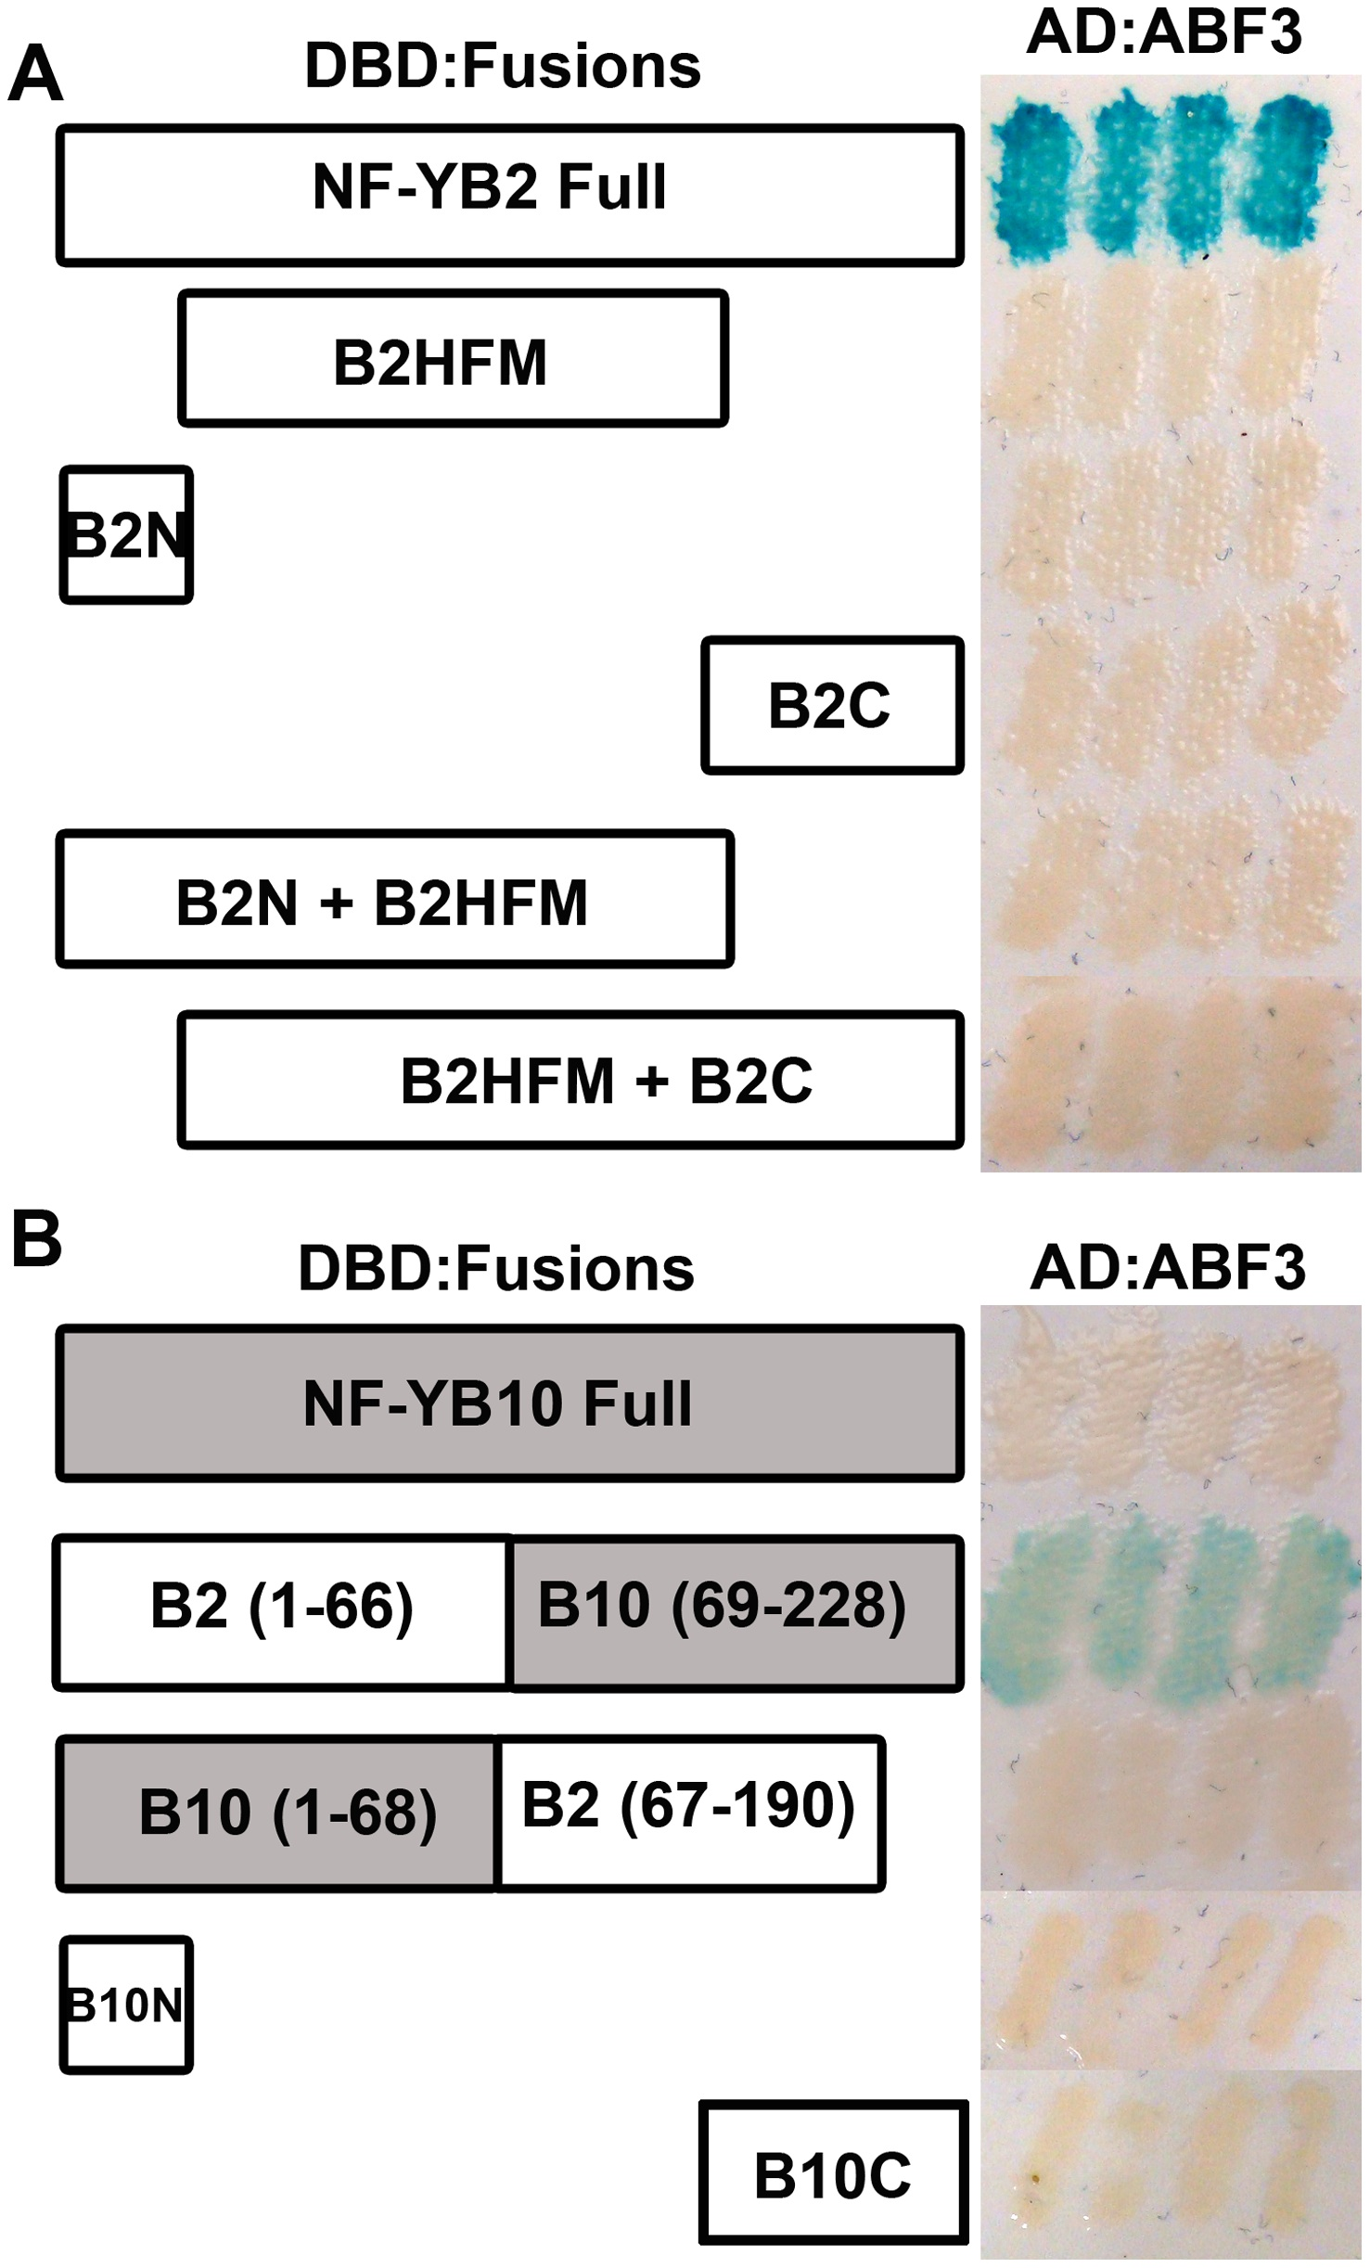

Figure 6.5. Full length NF-YB2 is required for the ABF3 interaction. Y2H assays were performed between AD:ABF3 and DBD fused to A) Full length NF-YB2 (AA 1-90), B2HFM (AA 26-121), B2N (AA 1-25), B2C(AA 122-190), B2N+B2HFM (AA 1-122), and B2HFM+B2C (AA 122-190); B) Chimeric constructs – full length NF-YB10 (AA 1-228), NF-YB2/NF-YB10, NF-YB10/NF-YB2, NF-YB10/NF-YB2, NF-YB10N(AA 1-27), and NF-YB10C (AA 123-228).

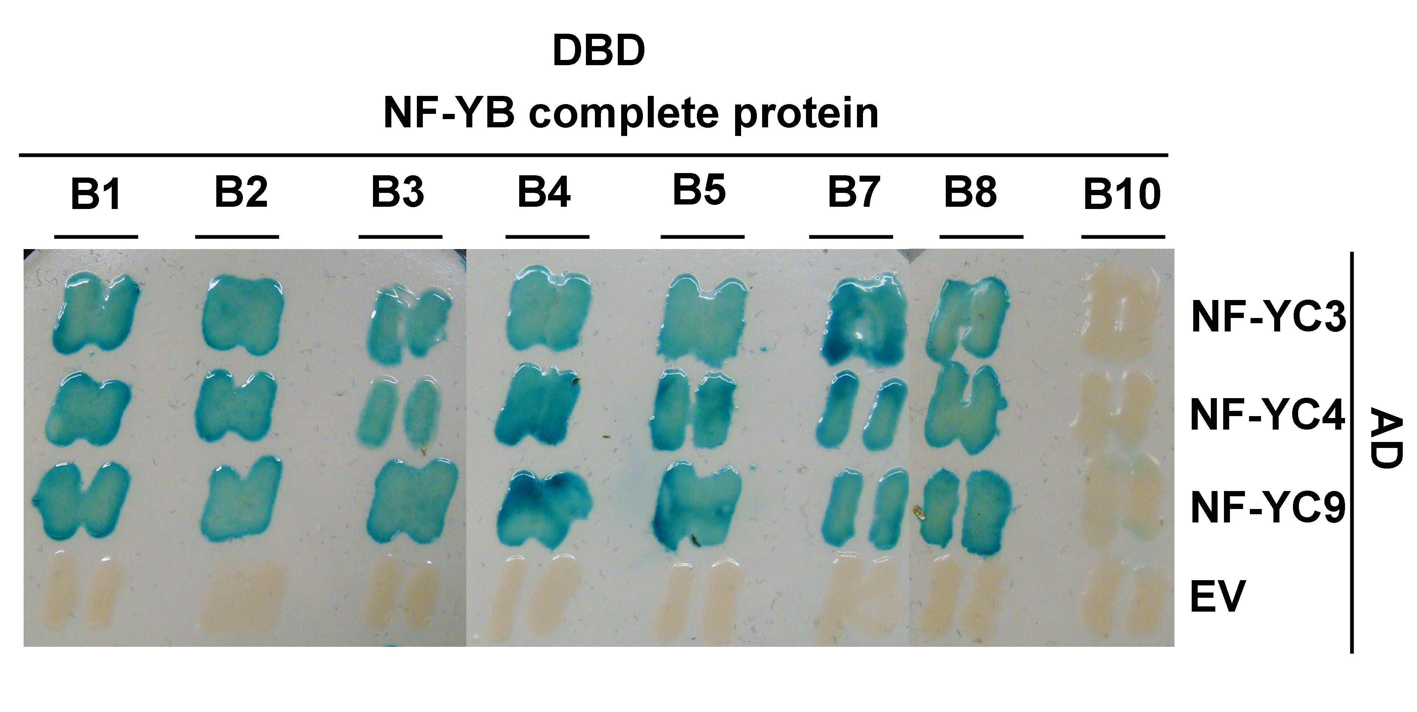
Figure 6.6. NF-YB1 - NF-YB10 interact with NF-YC3, NF-YC4, and NF-YC9. NF-YB subunits were expressed as DNA binding domain (DBD) constructs and NF-YC subunits as activation domain (AD) constructs. EV = empty vector.

Figure 6.7. The conserved core domain of NF-YB1, NF-YB2, and NF-YB10 are sufficient for interaction with NF-YC subunits. NF-YB core domains were expressed as DNA binding domain (DBD) constructs and NF-YC subunits as activation domain (AD) constructs. EV = empty vector.

Chapter 7: Conclusion

Conclusions and Future Directions
The NF-Y, consisting of three independent gene families, NF-YA, NF-YB, and NF-YC, has expanded in plants compared to animals. For example the model plant Arabidopsis thaliana (Arabidopsis) has 10 members per family compared to one member of each family in humans. The significance of this expansion is not well understood, primarily due to lack of studies done on plant NF-Y. Here I studied in detail the role of NF-YA genes during seed germination and flowering. I also studied biochemical properties of the NF-Y by looking at protein stability and protein interaction domains. These studies showed the highly conserved nature of NF-Y in eukaryotes and, at the same time, gave insights into how the expanded NF-Y families in plants have diverged to have unique, and led us to better understand this gene family.

Gene duplications events that led to the expansion of the NF-Y in plants may have been conserved due to the ability of the NF-Y to diverge in the responses it regulates. Specifically the plant NF-Y may have evolved unique and opposing functions. The first insight on the NF-Ys having unique roles in the same developmental response came from the finding that three NF-YC subunits were able to act as either positive or negative regulators of seed germination (Kumimoto et al. 2013). This research added on to this by identifying NF-YA subunits that also have divergent regulatory roles during seed germination. Two closely related paralogs were less sensitive to ABA whereas several other members of the same gene family were hypersensitive. As the NF-Y bind DNA as a trimeric complex it is likely that NF-YB subunits might also regulate seed germination in a divergent manner. Preliminary data from the Holt lab supports this hypothesis, however further careful analysis is required to understand the role of the 10 NF-YB genes during seed germination. The NF-Ys also have opposing roles regulating photoperiod dependent flowering responses, where several NF-YA and NF-YB have been shown to be either positive or negative regulators of flowering responses. The current study done to look at the response of NF-YA during ABA mediated seed germination was the first to look at all 10 members of the gene family simultaneously. Similar studies on the complete set of NF-Y genes during various developmental stages will provide greater insight to the significance of the expansion of this gene family in plants.

This study also answered a key question about the role of NF-YA during flowering time. NF-YAs were shown to be required for the NF-YB/NF-YC dimer to drive flowering and NF-YA2 was identified as a possible positive regulator of flowering. Further questions remain to be answered on the mechanism by which the NF-Y/CO complex activates the FT promoter and how it is fine-tuned to only drive expression at a precise time point during plant development. An attractive hypothesis is that the NF-Y/CO complex can remove a repressor complex bound on the FT promoter. TEMPRANILLO (TEM) proteins are able to bind the FT promoter downstream of the CO binding site and act as negative regulators of FT expression, and possibly can represent a target for testing. Further, TEM is misregulated in CO and NF-Y mutants (Holt lab unpublished data) and this could potentially lead to a feedback loop where the levels of possibly CO, NF-Y and TEM are regulating each other. Recent studies in animal systems have shown that it is likely that both the classical NF-Y trimer and NF-YB/NF-YC dimers can be bound to DNA (Ceribelli et al. 2008). Although these data are preliminary and further studies are ongoing in animals systems, this opens up a similar possibility for plant systems. For example, we cannot rule out the possibility of two separate NF-Y complexes are formed on the FT promoter, for example the classical NF-Y trimer sitting on the CCAAT boxes, and a CO/NF-YB/NF-YC complex bound on the CORE sites. In this case the NF-YB/NF-YC subunits may dimerize and interact with each other and NF-YA or CO.

The nature of protein-protein interaction between plant NF-Y has not been carefully studied. However, similar studies have extensively been done on animal systems. Here I successfully used the studies in animal systems as a guide to understanding protein-protein interaction in plants. I identified a mutant of NF-YB2, which was published to lose interactions with NF-YA but not NF-YC based on animal literature. An extensive study on the protein domains necessary for interactions was done with NF-YC9. The full-length NF-YC9 protein was truncated or mutated based on the available data from animal systems. I found that most aspects of protein-protein interactions were highly conserved between plants and animals. Similar assays with truncations and mutations on the plant NF-YA and NF-YB proteins will further expand our understanding of NF-Y complex formation. Further, crystal structure analysis of a plant NF-Y complex alone and with an interacting protein such as CO or HY5 would enable us to more fully understand how the plant NF-Y interact with each other and their targets.

The NF-Y in plants has only been shown to regulate a limited number of development responses. However the vast distribution of CCAAT boxes on promoters and the large potential NF-Y combinations that can form due to the expansion of the gene family suggests that NF-Y should have the ability to regulate a diverse set of developmental responses (Siefers et al. 2009; Petroni et al. 2012). Further studies such as screens (mutant screens, yeast two-hybrid screens), and whole genome analysis and data mining will give insight on to developmental responses regulated by the NF-Y. A developmental response that animals NF-Y regulate, which has received attention due to its role in cancer, is cell division (Mantovani 1999), a role that has not been investigated in plants. The highly conserved nature of animal and plant NF-Y strongly suggests that plant NF-Y also should have an intrinsic role regulating cell division.

The study of NF-Y in animal systems is well in advanced of similar studies in plant systems. Currently a large focus on animal systems is to understand the nature of the NF-Y in the transcription machinery that regulates gene expression (Dolfini et al. 2012). The emerging picture is that NF-Y can bind DNA irrespective of histone modifications on chromatin, and constitutes one of the early regulatory elements that bind DNA. Once bound, the NF-Y may recruit chromatin remodeling machinery and transcription regulators. It is also thought that NF-Y binding may make DNA accessible for other transcription factors to bind. Similar studies in plants are lacking and it is an area of great interest that a plant biologist can venture into.

Here my studies were primarily done on model plant species. Studying a model species gave the advantage of having a vast array of information and resources. The next step is to use the knowledge gained from the model plant species and apply it to crops. A good example of this comes from the study of NF-YB during drought responses (Nelson et al. 2007). The authors discovered that Arabidopsis NF-YB2 overexpressors are resistant to drought. The next step the authors took was to perform a large-scale field experiment using the NF-YB2 ortholog from Zea mays (corn) ZmNF-YB1. ZmNF-YB1 overexpressors were also drought resistant. I have studied the role of NF-YA during seed germination and flowering time, two processes that are important for crop production. Therefore the knowledge gained from the studies presented here could be used in field conditions to produce crops with improved traits.

The primary goal of this dissertation was to understand the role played by Arabidopsis NF-YA during seed germination and flowering responses. The study identified opposing roles for the NF-YA during seed germination and the NF-YAs were shown to act as positive regulators of flowering. This study also gave insight to the nature of protein-protein interactions and protein biochemistry of the NF-Y. This data added to the current literature by demonstrating the conserved nature of the NF-Y in eukaryotes, while adding insight on the opposing regulatory abilities that some members of the same gene family have evolved. These data strongly suggested that while many aspects of the NF-Y remain conserved between eukaryotes the expansion in plant systems allowed the NF-Y to differentially and specifically regulate plant development.

References
Abe M, Kobayashi Y, Yamamoto S, Daimon Y, Yamaguchi A, Ikeda Y, Ichinoki H, Notaguchi M, Goto K, Araki T (2005) FD, a bZIP protein mediating signals from the floral pathway integrator FT at the shoot apex. Science 309 (5737):1052-1056.
An H, Roussot C, Suarez-Lopez P, Corbesier L, Vincent C, Pineiro M, Hepworth S, Mouradov A, Justin S, Turnbull C, Coupland G (2004) CONSTANS acts in the phloem to regulate a systemic signal that induces photoperiodic flowering of Arabidopsis. Development 131 (15):3615-3626.
Balasubramanian S, Sureshkumar S, Lempe J, Weigel D (2006) Potent induction of Arabidopsis thaliana flowering by elevated growth temperature. PLoS Genet 2 (7):e106.
Ballif J, Endo S, Kotani M, MacAdam J, Wu Y (2011) Over-expression of HAP3b enhances primary root elongation in Arabidopsis. Plant Physiol Biochem 49 (6):579-583.
Ben-Naim O, Eshed R, Parnis A, Teper-Bamnolker P, Shalit A, Coupland G, Samach A, Lifschitz E (2006a) The CCAAT binding factor can mediate interactions between CONSTANS-like proteins and DNA. Plant J 46 (3):462-476.
Ben-Naim O, Eshed R, Parnis A, Teper-Bamnolker P, Shalit A, Coupland G, Samach A, Lifschitz E (2006b) The CCAAT binding factor can mediate interactions between CONSTANS-like proteins and DNA. The Plant Journal 46 (3):462-476.
Bewley D (1997) seed germination and dormancy. Plant Cell 9:1055-1066.
Bhattacharya A, Deng JM, Zhang Z, Behringer R, de Crombrugghe B, Maity SN (2003) The B subunit of the CCAAT box binding transcription factor complex (CBF/NF-Y) is essential for early mouse development and cell proliferation. Cancer Res 63 (23):8167-8172.
Braybrook SA, Harada JJ (2008) LECs go crazy in embryo development. Trends Plant Sci 13 (12):624-630.
Bu Q, Zhu L, Dennis MD, Yu L, Lu SX, Person MD, Tobin EM, Browning KS, Huq E (2011) Phosphorylation by CK2 enhances the rapid light-induced degradation of phytochrome interacting factor 1 in Arabidopsis. J Biol Chem 286 (14):12066-12074.
Bucher P (1990) Weight matrix descriptions of four eukaryotic RNA polymerase II promoter elements derived from 502 unrelated promoter sequences. J Mol Biol 212 (4):563-578.
Burkle L, Meyer S, Dortay H, Lehrach H, Heyl A (2005) In vitro recombination cloning of entire cDNA libraries in Arabidopsis thaliana and its application to the yeast two-hybrid system. Funct Integr Genomics 5 (3):175-183.
Cai X, Ballif J, Endo S, Davis E, Liang M, Chen D, DeWald D, Kreps J, Zhu T, Wu Y (2007) A putative CCAAT-binding transcription factor is a regulator of flowering timing in Arabidopsis. Plant Physiol 145 (1):98-105.
Cao S, Kumimoto RW, Gnesutta N, Calogero AM, Mantovani R, Holt BF, 3rd (2014) A Distal CCAAT/NUCLEAR FACTOR Y Complex Promotes Chromatin Looping at the FLOWERING LOCUS T Promoter and Regulates the Timing of Flowering in Arabidopsis. Plant Cell.
Cao S, Kumimoto RW, Siriwardana CL, Risinger JR, Holt BF, 3rd (2011a) Identification and characterization of NF-Y transcription factor families in the monocot model plant Brachypodium distachyon. PLoS One 6 (6):e21805.
Cao S, Siriwardana CL, Kumimoto RW, Holt BF, 3rd (2011b) Construction of high quality Gateway entry libraries and their application to yeast two-hybrid for the monocot model plant Brachypodium distachyon. BMC Biotechnol 11:53.
Carre I, Veflingstad SR (2013) Emerging design principles in the Arabidopsis circadian clock. Semin Cell Dev Biol 24 (5):393-398.
Casson SA, Lindsey K (2006) The turnip mutant of Arabidopsis reveals that LEAFY COTYLEDON1 expression mediates the effects of auxin and sugars to promote embryonic cell identity. Plant Physiol 142 (2):526-541.
Ceribelli M, Dolfini D, Merico D, Gatta R, Vigano AM, Pavesi G, Mantovani R (2008) The histone-like NF-Y is a bifunctional transcription factor. Mol Cell Biol 28 (6):2047-2058.
Chen H, Zhang J, Neff MM, Hong SW, Zhang H, Deng XW, Xiong L (2008) Integration of light and abscisic acid signaling during seed germination and early seedling development. Proc Natl Acad Sci U S A 105 (11):4495-4500.
Chen NZ, Zhang XQ, Wei PC, Chen QJ, Ren F, Chen J, Wang XC (2007) AtHAP3b plays a crucial role in the regulation of flowering time in Arabidopsis during osmotic stress. J Biochem Mol Biol 40 (6):1083-1089.
Choi HI, Park HJ, Park JH, Kim S, Im MY, Seo HH, Kim YW, Hwang I, Kim SY (2005) Arabidopsis calcium-dependent protein kinase AtCPK32 interacts with ABF4, a transcriptional regulator of abscisic acid-responsive gene expression, and modulates its activity. Plant Physiol 139 (4):1750-1761.
Ciannamea S, Kaufmann K, Frau M, Tonaco IA, Petersen K, Nielsen KK, Angenent GC, Immink RG (2006) Protein interactions of MADS box transcription factors involved in flowering in Lolium perenne. J Exp Bot 57 (13):3419-3431.
Cline MS, Smoot M, Cerami E, Kuchinsky A, Landys N, Workman C, Christmas R, Avila-Campilo I, Creech M, Gross B, Hanspers K, Isserlin R, Kelley R, Killcoyne S, Lotia S, Maere S, Morris J, Ono K, Pavlovic V, Pico AR, Vailaya A, Wang PL, Adler A, Conklin BR, Hood L, Kuiper M, Sander C, Schmulevich I, Schwikowski B, Warner GJ, Ideker T, Bader GD (2007) Integration of biological networks and gene expression data using Cytoscape. Nat Protoc 2 (10):2366-2382.
Clough SJ, Bent AF (1998) Floral dip: a simplified method for Agrobacterium-mediated transformation of Arabidopsis thaliana. Plant J 16 (6):735-743.
Combier JP, de Billy F, Gamas P, Niebel A, Rivas S (2008) Trans-regulation of the expression of the transcription factor MtHAP2-1 by a uORF controls root nodule development. Genes Dev 22 (11):1549-1559.
Combier JP, Frugier F, de Billy F, Boualem A, El-Yahyaoui F, Moreau S, Vernie T, Ott T, Gamas P, Crespi M, Niebel A (2006) MtHAP2-1 is a key transcriptional regulator of symbiotic nodule development regulated by microRNA169 in Medicago truncatula. Genes Dev 20 (22):3084-3088.
Corbesier L, Vincent C, Jang S, Fornara F, Fan Q, Searle I, Giakountis A, Farrona S, Gissot L, Turnbull C, Coupland G (2007) FT protein movement contributes to long-distance signaling in floral induction of Arabidopsis. Science 316 (5827):1030-1033.
Curaba J, Moritz T, Blervaque R, Parcy F, Raz V, Herzog M, Vachon G (2004) AtGA3ox2, a key gene responsible for bioactive gibberellin biosynthesis, is regulated during embryogenesis by LEAFY COTYLEDON2 and FUSCA3 in Arabidopsis. Plant Physiol 136 (3):3660-3669.
Czechowski T, Stitt M, Altmann T, Udvardi MK, Scheible WR (2005) Genome-wide identification and testing of superior reference genes for transcript normalization in Arabidopsis. Plant Physiol 139 (1):5-17.
Daniel X, Sugano S, Tobin EM (2004) CK2 phosphorylation of CCA1 is necessary for its circadian oscillator function in Arabidopsis. Proc Natl Acad Sci U S A 101 (9):3292-3297.
Dolfini D, Gatta R, Mantovani R (2012) NF-Y and the transcriptional activation of CCAAT promoters. Crit Rev Biochem Mol Biol 47 (1):29-49.
Earley KW, Haag JR, Pontes O, Opper K, Juehne T, Song K, Pikaard CS (2006) Gateway-compatible vectors for plant functional genomics and proteomics. Plant J 45 (4):616-629.
Estelle M (2001) Proteases and cellular regulation in plants. Curr Opin Plant Biol 4 (3):254-260.
Eulgem T, Somssich IE (2007) Networks of WRKY transcription factors in defense signaling. Curr Opin Plant Biol 10 (4):366-371.
Felsenstein J (1985) Confidence-Limits on Phylogenies - an Approach Using the Bootstrap. Evolution 39 (4):783-791.
Fields S, Song OK (1989) A Novel Genetic System to Detect Protein Protein Interactions. Nature 340 (6230):245-246.
Finkelstein R, Gampala SS, Lynch TJ, Thomas TL, Rock CD (2005) Redundant and distinct functions of the ABA response loci ABA-INSENSITIVE(ABI)5 and ABRE-BINDING FACTOR (ABF)3. Plant Mol Biol 59 (2):253-267.
Fleming JD, Pavesi G, Benatti P, Imbriano C, Mantovani R, Struhl K (2013) NF-Y coassociates with FOS at promoters, enhancers, repetitive elements, and inactive chromatin regions, and is stereo-positioned with growth-controlling transcription factors. Genome Res 23 (8):1195-1209.
Frey A, Effroy D, Lefebvre V, Seo M, Perreau F, Berger A, Sechet J, To A, North HM, Marion-Poll A (2012) Epoxycarotenoid cleavage by NCED5 fine-tunes ABA accumulation and affects seed dormancy and drought tolerance with other NCED family members. Plant J 70 (3):501-512.
Frontini M, Imbriano C, Manni I, Mantovani R (2004) Cell cycle regulation of NF-YC nuclear localization. Cell Cycle 3 (2):217-222.
Fujii H, Chinnusamy V, Rodrigues A, Rubio S, Antoni R, Park SY, Cutler SR, Sheen J, Rodriguez PL, Zhu JK (2009) In vitro reconstitution of an abscisic acid signalling pathway. Nature 462 (7273):660-664.
Fujii H, Zhu JK (2009) Arabidopsis mutant deficient in 3 abscisic acid-activated protein kinases reveals critical roles in growth, reproduction, and stress. Proc Natl Acad Sci U S A 106 (20):8380-8385.
Fujita Y, Nakashima K, Yoshida T, Katagiri T, Kidokoro S, Kanamori N, Umezawa T, Fujita M, Maruyama K, Ishiyama K, Kobayashi M, Nakasone S, Yamada K, Ito T, Shinozaki K, Yamaguchi-Shinozaki K (2009) Three SnRK2 protein kinases are the main positive regulators of abscisic acid signaling in response to water stress in Arabidopsis. Plant Cell Physiol 50 (12):2123-2132.
Furihata T, Maruyama K, Fujita Y, Umezawa T, Yoshida R, Shinozaki K, Yamaguchi-Shinozaki K (2006) Abscisic acid-dependent multisite phosphorylation regulates the activity of a transcription activator AREB1. Proc Natl Acad Sci U S A 103 (6):1988-1993.
Gazzarrini S, Tsuchiya Y, Lumba S, Okamoto M, McCourt P (2004) The transcription factor FUSCA3 controls developmental timing in Arabidopsis through the hormones gibberellin and abscisic acid. Dev Cell 7 (3):373-385.
Glynn JM, Froehlich JE, Osteryoung KW (2008) Arabidopsis ARC6 coordinates the division machineries of the inner and outer chloroplast membranes through interaction with PDV2 in the intermembrane space. Plant Cell 20 (9):2460-2470.
Gonzalez-Guzman M, Pizzio GA, Antoni R, Vera-Sirera F, Merilo E, Bassel GW, Fernandez MA, Holdsworth MJ, Perez-Amador MA, Kollist H, Rodriguez PL (2012) Arabidopsis PYR/PYL/RCAR receptors play a major role in quantitative regulation of stomatal aperture and transcriptional response to abscisic acid. Plant Cell 24 (6):2483-2496.
Gosti F, Beaudoin N, Serizet C, Webb AA, Vartanian N, Giraudat J (1999) ABI1 protein phosphatase 2C is a negative regulator of abscisic acid signaling. Plant Cell 11 (10):1897-1910.
Gusmaroli G, Tonelli C, Mantovani R (2001) Regulation of the CCAAT-Binding NF-Y subunits in Arabidopsis thaliana. Gene 264 (2):173-185.
Gusmaroli G, Tonelli C, Mantovani R (2002) Regulation of novel members of the Arabidopsis thaliana CCAAT-binding nuclear factor Y subunits. Gene 283 (1-2):41-48.
Gutierrez L, Mauriat M, Pelloux J, Bellini C, Van Wuytswinkel O (2008) Towards a systematic validation of references in real-time rt-PCR. Plant Cell 20 (7):1734-1735.
Harada JJ (2001) Role of Arabidopsis LEAFY COTYLEDON genes in seed development. Journal of Plant Physiology 158 (4):405-409.
Hardtke CS, Gohda K, Osterlund MT, Oyama T, Okada K, Deng XW (2000) HY5 stability and activity in arabidopsis is regulated by phosphorylation in its COP1 binding domain. EMBO J 19 (18):4997-5006.
Hayama R, Coupland G (2004) The molecular basis of diversity in the photoperiodic flowering responses of Arabidopsis and rice. Plant Physiol 135 (2):677-684.
Huala E, Dickerman AW, Garcia-Hernandez M, Weems D, Reiser L, LaFond F, Hanley D, Kiphart D, Zhuang M, Huang W, Mueller LA, Bhattacharyya D, Bhaya D, Sobral BW, Beavis W, Meinke DW, Town CD, Somerville C, Rhee SY (2001) The Arabidopsis Information Resource (TAIR): a comprehensive database and web-based information retrieval, analysis, and visualization system for a model plant. Nucleic Acids Res 29 (1):102-105.
Huang W, Zhao S, Ammanamanchi S, Brattain M, Venkatasubbarao K, Freeman JW (2005) Trichostatin A induces transforming growth factor beta type II receptor promoter activity and acetylation of Sp1 by recruitment of PCAF/p300 to a Sp1.NF-Y complex. J Biol Chem 280 (11):10047-10054.
James P, Halladay J, Craig EA (1996) Genomic libraries and a host strain designed for highly efficient two-hybrid selection in yeast. Genetics 144 (4):1425-1436.
Junker A, Monke G, Rutten T, Keilwagen J, Seifert M, Thi TM, Renou JP, Balzergue S, Viehover P, Hahnel U, Ludwig-Muller J, Altschmied L, Conrad U, Weisshaar B, Baumlein H (2012) Elongation-related functions of LEAFY COTYLEDON1 during the development of Arabidopsis thaliana. Plant J 71 (3):427-442.
Kagaya Y, Okuda R, Ban A, Toyoshima R, Tsutsumida K, Usui H, Yamamoto A, Hattori T (2005a) Indirect ABA-dependent regulation of seed storage protein genes by FUSCA3 transcription factor in Arabidopsis. Plant Cell Physiol 46 (2):300-311.
Kagaya Y, Toyoshima R, Okuda R, Usui H, Yamamoto A, Hattori T (2005b) LEAFY COTYLEDON1 controls seed storage protein genes through its regulation of FUSCA3 and ABSCISIC ACID INSENSITIVE3. Plant Cell Physiol 46 (3):399-406.
Kahle J, Baake M, Doenecke D, Albig W (2005) Subunits of the heterotrimeric transcription factor NF-Y are imported into the nucleus by distinct pathways involving importin beta and importin 13. Mol Cell Biol 25 (13):5339-5354.
Kang JY, Choi HI, Im MY, Kim SY (2002) Arabidopsis basic leucine zipper proteins that mediate stress-responsive abscisic acid signaling. Plant Cell 14 (2):343-357.
Kao CY, Tanimoto A, Arima N, Sasaguri Y, Padmanabhan R (1999) Transactivation of the human cdc2 promoter by adenovirus E1A. E1A induces the expression and assembly of a heteromeric complex consisting of the CCAAT box binding factor, CBF/NF-Y, and a 110-kDa DNA-binding protein. J Biol Chem 274 (33):23043-23051.
Karimi M, Inze D, Depicker A (2002) GATEWAY vectors for Agrobacterium-mediated plant transformation. Trends Plant Sci 7 (5):193-195.
Kay R, Chan A, Daly M, McPherson J (1987) Duplication of CaMV 35S Promoter Sequences Creates a Strong Enhancer for Plant Genes. Science 236 (4806):1299-1302.
Kim IS, Sinha S, de Crombrugghe B, Maity SN (1996) Determination of functional domains in the C subunit of the CCAAT-binding factor (CBF) necessary for formation of a CBF-DNA complex: CBF-B interacts simultaneously with both the CBF-A and CBF-C subunits to form a heterotrimeric CBF molecule. Mol Cell Biol 16 (8):4003-4013.
Kim S, Kang JY, Cho DI, Park JH, Kim SY (2004) ABF2, an ABRE-binding bZIP factor, is an essential component of glucose signaling and its overexpression affects multiple stress tolerance. Plant J 40 (1):75-87.
Kobayashi Y, Kaya H, Goto K, Iwabuchi M, Araki T (1999) A pair of related genes with antagonistic roles in mediating flowering signals. Science 286 (5446):1960-1962.
Kumimoto RW, Adam L, Hymus GJ, Repetti PP, Reuber TL, Marion CM, Hempel FD, Ratcliffe OJ (2008a) The Nuclear Factor Y subunits NF-YB2 and NF-YB3 play additive roles in the promotion of flowering by inductive long-day photoperiods in Arabidopsis. Planta 228 (5):709-723.
Kumimoto RW, Adam L, Hymus GJ, Repetti PP, Reuber TL, Marion CM, Hempel FD, Ratcliffe OJ (2008b) The Nuclear Factor Y subunits NF-YB2 and NF-YB3 play additive roles in the promotion of flowering by inductive long-day photoperiods in Arabidopsis. Planta 228 (5):709-723.
Kumimoto RW, Siriwardana CL, Gayler KK, Risinger JR, Siefers N, Holt BF, 3rd (2013) NUCLEAR FACTOR Y Transcription Factors Have Both Opposing and Additive Roles in ABA-Mediated Seed Germination. PLoS One 8 (3):e59481.
Kumimoto RW, Zhang Y, Siefers N, Holt BF, 3rd (2010) NF-YC3, NF-YC4 and NF-YC9 are required for CONSTANS-mediated, photoperiod-dependent flowering in Arabidopsis thaliana. Plant J.
Kusnetsov V, Landsberger M, Meurer J, Oelmuller R (1999) The assembly of the CAAT-box binding complex at a photosynthesis gene promoter is regulated by light, cytokinin, and the stage of the plastids. J Biol Chem 274 (50):36009-36014.
Kwong RW, Bui AQ, Lee H, Kwong LW, Fischer RL, Goldberg RB, Harada JJ (2003) LEAFY COTYLEDON1-LIKE defines a class of regulators essential for embryo development. Plant Cell 15 (1):5-18.
Laloum T, De Mita S, Gamas P, Baudin M, Niebel A (2013) CCAAT-box binding transcription factors in plants: Y so many? Trends Plant Sci 18 (3):157-166.
Lang A (1952) Physiology of Flowering. Annual Review of Plant Physiology and Plant Molecular Biology 3:265-306.
Lang V, Palva ET (1992) The expression of a rab-related gene, rab18, is induced by abscisic acid during the cold acclimation process of Arabidopsis thaliana (L.) Heynh. Plant Mol Biol 20 (5):951-962.
Lau OS, Deng XW (2010) Plant hormone signaling lightens up: integrators of light and hormones. Curr Opin Plant Biol 13 (5):571-577.
Lee H, Fischer RL, Goldberg RB, Harada JJ (2003) Arabidopsis LEAFY COTYLEDON1 represents a functionally specialized subunit of the CCAAT binding transcription factor. Proc Natl Acad Sci U S A 100 (4):2152-2156.
Lefebvre V, North H, Frey A, Sotta B, Seo M, Okamoto M, Nambara E, Marion-Poll A (2006) Functional analysis of Arabidopsis NCED6 and NCED9 genes indicates that ABA synthesized in the endosperm is involved in the induction of seed dormancy. Plant J 45 (3):309-319.
Leyva-Gonzalez MA, Ibarra-Laclette E, Cruz-Ramirez A, Herrera-Estrella L (2012) Functional and Transcriptome Analysis Reveals an Acclimatization Strategy for Abiotic Stress Tolerance Mediated by Arabidopsis NF-YA Family Members. PLoS One 7 (10):e48138.
Li WX, Oono Y, Zhu J, He XJ, Wu JM, Iida K, Lu XY, Cui X, Jin H, Zhu JK (2008) The Arabidopsis NFYA5 transcription factor is regulated transcriptionally and posttranscriptionally to promote drought resistance. Plant Cell 20 (8):2238-2251.
Li YJ, Fang Y, Fu YR, Huang JG, Wu CA, Zheng CC (2013) NFYA1 Is Involved in Regulation of Postgermination Growth Arrest Under Salt Stress in Arabidopsis. PLoS One 8 (4):e61289.
Liang M, Yin X, Lin Z, Zheng Q, Liu G, Zhao G (2013) Identification and characterization of NF-Y transcription factor families in Canola (Brassica napus L.). Planta.
Liu JX, Howell SH (2010) bZIP28 and NF-Y transcription factors are activated by ER stress and assemble into a transcriptional complex to regulate stress response genes in Arabidopsis. Plant Cell 22 (3):782-796.
Lotan T, Ohto M, Yee KM, West MA, Lo R, Kwong RW, Yamagishi K, Fischer RL, Goldberg RB, Harada JJ (1998) Arabidopsis LEAFY COTYLEDON1 is sufficient to induce embryo development in vegetative cells. Cell 93 (7):1195-1205.
Luerssen H, Kirik V, Herrmann P, Misera S (1998) FUSCA3 encodes a protein with a conserved VP1/AB13-like B3 domain which is of functional importance for the regulation of seed maturation in Arabidopsis thaliana. Plant J 15 (6):755-764.
Ly LL, Yoshida H, Yamaguchi M (2013) Nuclear transcription factor Y and its roles in cellular processes related to human disease. Am J Cancer Res 3 (4):339-346.
Ma Y, Szostkiewicz I, Korte A, Moes D, Yang Y, Christmann A, Grill E (2009) Regulators of PP2C phosphatase activity function as abscisic acid sensors. Science 324 (5930):1064-1068.
Maity SN, de Crombrugghe B (1992) Biochemical analysis of the B subunit of the heteromeric CCAAT-binding factor. A DNA-binding domain and a subunit interaction domain are specified by two separate segments. J Biol Chem 267 (12):8286-8292.
Maity SN, de Crombrugghe B (1998) Role of the CCAAT-binding protein CBF/NF-Y in transcription. Trends Biochem Sci 23 (5):174-178.
Maity SN, Sinha S, Ruteshouser EC, de Crombrugghe B (1992) Three different polypeptides are necessary for DNA binding of the mammalian heteromeric CCAAT binding factor. J Biol Chem 267 (23):16574-16580.
Manni I, Caretti G, Artuso S, Gurtner A, Emiliozzi V, Sacchi A, Mantovani R, Piaggio G (2008) Posttranslational regulation of NF-YA modulates NF-Y transcriptional activity. Mol Biol Cell 19 (12):5203-5213.
Manni I, Mazzaro G, Gurtner A, Mantovani R, Haugwitz U, Krause K, Engeland K, Sacchi A, Soddu S, Piaggio G (2001) NF-Y mediates the transcriptional inhibition of the cyclin B1, cyclin B2, and cdc25C promoters upon induced G2 arrest. J Biol Chem 276 (8):5570-5576.
Mantovani R (1999) The molecular biology of the CCAAT-binding factor NF-Y. Gene 239 (1):15-27.
Maruyama-Nakashita A, Nakamura Y, Watanabe-Takahashi A, Inoue E, Yamaya T, Takahashi H (2005) Identification of a novel cis-acting element conferring sulfur deficiency response in Arabidopsis roots. Plant J 42 (3):305-314.
Mathieu J, Warthmann N, Kuttner F, Schmid M (2007) Export of FT protein from phloem companion cells is sufficient for floral induction in Arabidopsis. Curr Biol 17 (12):1055-1060.
Meinke D, Muralla R, Sweeney C, Dickerman A (2008) Identifying essential genes in Arabidopsis thaliana. Trends Plant Sci 13 (9):483-491.
Melcher K, Ng LM, Zhou XE, Soon FF, Xu Y, Suino-Powell KM, Park SY, Weiner JJ, Fujii H, Chinnusamy V, Kovach A, Li J, Wang Y, Li J, Peterson FC, Jensen DR, Yong EL, Volkman BF, Cutler SR, Zhu JK, Xu HE (2009) A gate-latch-lock mechanism for hormone signalling by abscisic acid receptors. Nature 462 (7273):602-608.
Merlot S, Gosti F, Guerrier D, Vavasseur A, Giraudat J (2001) The ABI1 and ABI2 protein phosphatases 2C act in a negative feedback regulatory loop of the abscisic acid signalling pathway. Plant J 25 (3):295-303.
Michaels SD, Amasino RM (2001) Loss of FLOWERING LOCUS C activity eliminates the late-flowering phenotype of FRIGIDA and autonomous pathway mutations but not responsiveness to vernalization. Plant Cell 13 (4):935-941.
Miyazono K, Miyakawa T, Sawano Y, Kubota K, Kang HJ, Asano A, Miyauchi Y, Takahashi M, Zhi Y, Fujita Y, Yoshida T, Kodaira KS, Yamaguchi-Shinozaki K, Tanokura M (2009) Structural basis of abscisic acid signalling. Nature 462 (7273):609-614.
Moreno-Romero J, Armengot L, Marques-Bueno MM, Cadavid-Ordonez M, Martinez MC (2011) About the role of CK2 in plant signal transduction. Mol Cell Biochem 356 (1-2):233-240.
Mostafavi S, Ray D, Warde-Farley D, Grouios C, Morris Q (2008) GeneMANIA: a real-time multiple association network integration algorithm for predicting gene function. Genome Biol 9 Suppl 1:S4.
Mu J, Tan H, Hong S, Liang Y, Zuo J (2013) Arabidopsis transcription factor genes NF-YA1, 5, 6, and 9 play redundant roles in male gametogenesis, embryogenesis, and seed development. Mol Plant 6 (1):188-201.
Mulekar JJ, Bu Q, Chen F, Huq E (2012) Casein kinase II alpha subunits affect multiple developmental and stress-responsive pathways in Arabidopsis. Plant J 69 (2):343-354.
Nakashima K, Fujita Y, Kanamori N, Katagiri T, Umezawa T, Kidokoro S, Maruyama K, Yoshida T, Ishiyama K, Kobayashi M, Shinozaki K, Yamaguchi-Shinozaki K (2009) Three Arabidopsis SnRK2 protein kinases, SRK2D/SnRK2.2, SRK2E/SnRK2.6/OST1 and SRK2I/SnRK2.3, involved in ABA signaling are essential for the control of seed development and dormancy. Plant Cell Physiol 50 (7):1345-1363.
Nardini M, Gnesutta N, Donati G, Gatta R, Forni C, Fossati A, Vonrhein C, Moras D, Romier C, Bolognesi M, Mantovani R (2013) Sequence-specific transcription factor NF-Y displays histone-like DNA binding and H2B-like ubiquitination. Cell 152 (1-2):132-143.
Nei M. KS (2000) Molecular Evolution and Phylogenetics. Oxford University Press, New York
Nelson DE, Repetti PP, Adams TR, Creelman RA, Wu J, Warner DC, Anstrom DC, Bensen RJ, Castiglioni PP, Donnarummo MG, Hinchey BS, Kumimoto RW, Maszle DR, Canales RD, Krolikowski KA, Dotson SB, Gutterson N, Ratcliffe OJ, Heard JE (2007) Plant nuclear factor Y (NF-Y) B subunits confer drought tolerance and lead to improved corn yields on water-limited acres. Proc Natl Acad Sci U S A 104 (42):16450-16455.
Ni Z, Hu Z, Jiang Q, Zhang H (2013) GmNFYA3, a target gene of miR169, is a positive regulator of plant tolerance to drought stress. Plant Mol Biol 82 (1-2):113-129.
Nishimura N, Hitomi K, Arvai AS, Rambo RP, Hitomi C, Cutler SR, Schroeder JI, Getzoff ED (2009) Structural mechanism of abscisic acid binding and signaling by dimeric PYR1. Science 326 (5958):1373-1379.
Okamoto M, Kuwahara A, Seo M, Kushiro T, Asami T, Hirai N, Kamiya Y, Koshiba T, Nambara E (2006) CYP707A1 and CYP707A2, which encode abscisic acid 8'-hydroxylases, are indispensable for proper control of seed dormancy and germination in Arabidopsis. Plant Physiol 141 (1):97-107.
Olesen JT, Guarente L (1990) The HAP2 subunit of yeast CCAAT transcriptional activator contains adjacent domains for subunit association and DNA recognition: model for the HAP2/3/4 complex. Genes Dev 4 (10):1714-1729.
Pagnussat GC, Yu HJ, Ngo QA, Rajani S, Mayalagu S, Johnson CS, Capron A, Xie LF, Ye D, Sundaresan V (2005) Genetic and molecular identification of genes required for female gametophyte development and function in Arabidopsis. Development 132 (3):603-614.
Park HJ, Ding L, Dai M, Lin R, Wang H (2008) Multisite phosphorylation of Arabidopsis HFR1 by casein kinase II and a plausible role in regulating its degradation rate. J Biol Chem 283 (34):23264-23273.
Park SY, Fung P, Nishimura N, Jensen DR, Fujii H, Zhao Y, Lumba S, Santiago J, Rodrigues A, Chow TF, Alfred SE, Bonetta D, Finkelstein R, Provart NJ, Desveaux D, Rodriguez PL, McCourt P, Zhu JK, Schroeder JI, Volkman BF, Cutler SR (2009) Abscisic acid inhibits type 2C protein phosphatases via the PYR/PYL family of START proteins. Science 324 (5930):1068-1071.
Perales M, Portoles S, Mas P (2006) The proteasome-dependent degradation of CKB4 is regulated by the Arabidopsis biological clock. Plant J 46 (5):849-860.
Perry SE, Wang H (2003) Rapid isolation of Arabidopsis thaliana developing embryos. Biotechniques 35 (2):278-280, 282.
Petroni K, Kumimoto RW, Gnesutta N, Calvenzani V, Fornari M, Tonelli C, Holt BF, 3rd, Mantovani R (2012) The Promiscuous Life of Plant NUCLEAR FACTOR Y Transcription Factors. Plant Cell 24 (12):4777-4792.
Potkar R, Recla J, Busov V (2013) ptr-MIR169 is a posttranscriptional repressor of PtrHAP2 during vegetative bud dormancy period of aspen (Populus tremuloides) trees. Biochem Biophys Res Commun 431 (3):512-518.
Pyke KA, Rutherford SM, Robertson EJ, Leech RM (1994) arc6, A Fertile Arabidopsis Mutant with Only Two Mesophyll Cell Chloroplasts. Plant Physiol 106 (3):1169-1177.
Rhoades MW, Reinhart BJ, Lim LP, Burge CB, Bartel B, Bartel DP (2002) Prediction of plant microRNA targets. Cell 110 (4):513-520.
Rieu I, Powers SJ (2009) Real-time quantitative RT-PCR: design, calculations, and statistics. Plant Cell 21 (4):1031-1033.
Romier C, Cocchiarella F, Mantovani R, Moras D (2003) The NF-YB/NF-YC structure gives insight into DNA binding and transcription regulation by CCAAT factor NF-Y. J Biol Chem 278 (2):1336-1345.
Rubio S, Rodrigues A, Saez A, Dizon MB, Galle A, Kim TH, Santiago J, Flexas J, Schroeder JI, Rodriguez PL (2009) Triple loss of function of protein phosphatases type 2C leads to partial constitutive response to endogenous abscisic acid. Plant Physiol 150 (3):1345-1355.
Ruggiero B, Koiwa H, Manabe Y, Quist TM, Inan G, Saccardo F, Joly RJ, Hasegawa PM, Bressan RA, Maggio A (2004) Uncoupling the effects of abscisic acid on plant growth and water relations. Analysis of sto1/nced3, an abscisic acid-deficient but salt stress-tolerant mutant in Arabidopsis. Plant Physiol 136 (2):3134-3147.
Saez A, Apostolova N, Gonzalez-Guzman M, Gonzalez-Garcia MP, Nicolas C, Lorenzo O, Rodriguez PL (2004) Gain-of-function and loss-of-function phenotypes of the protein phosphatase 2C HAB1 reveal its role as a negative regulator of abscisic acid signalling. Plant J 37 (3):354-369.
Salisbury FB (1985) Photoperiodism. Hortic Rev (Am Soc Hortic Sci) 4:66-105.
Santiago J, Dupeux F, Round A, Antoni R, Park SY, Jamin M, Cutler SR, Rodriguez PL, Marquez JA (2009) The abscisic acid receptor PYR1 in complex with abscisic acid. Nature 462 (7273):665-668.
Schneider CA, Rasband WS, Eliceiri KW (2012) NIH Image to ImageJ: 25 years of image analysis. Nat Methods 9 (7):671-675.
Seo HS, Yang JY, Ishikawa M, Bolle C, Ballesteros ML, Chua NH (2003) LAF1 ubiquitination by COP1 controls photomorphogenesis and is stimulated by SPA1. Nature 423 (6943):995-999.
Shiu SH, Shih MC, Li WH (2005) Transcription factor families have much higher expansion rates in plants than in animals. Plant Physiol 139 (1):18-26.
Siefers N, Dang KK, Kumimoto RW, Bynum WEt, Tayrose G, Holt BF, 3rd (2009) Tissue-specific expression patterns of Arabidopsis NF-Y transcription factors suggest potential for extensive combinatorial complexity. Plant Physiol 149 (2):625-641.
Sinha S, Kim IS, Sohn KY, de Crombrugghe B, Maity SN (1996) Three classes of mutations in the A subunit of the CCAAT-binding factor CBF delineate functional domains involved in the three-step assembly of the CBF-DNA complex. Mol Cell Biol 16 (1):328-337.
Sinha S, Maity SN, Lu J, de Crombrugghe B (1995) Recombinant rat CBF-C, the third subunit of CBF/NFY, allows formation of a protein-DNA complex with CBF-A and CBF-B and with yeast HAP2 and HAP3. Proc Natl Acad Sci U S A 92 (5):1624-1628.
Siriwardana CL, Kumimoto RW, Jones DD, Holt BF (2014) Gene family analysis of the Arabidopsis NF-YA transcription fcators reveals opposing abscisic acid responses during seed germination. Plant Molecular Biology Reporter.
Song YH, Lee I, Lee SY, Imaizumi T, Hong JC (2012) CONSTANS and ASYMMETRIC LEAVES 1 complex is involved in the induction of FLOWERING LOCUS T in photoperiodic flowering in Arabidopsis. Plant J 69 (2):332-342.
Stephenson TJ, McIntyre CL, Collet C, Xue GP (2007) Genome-wide identification and expression analysis of the NF-Y family of transcription factors in Triticum aestivum. Plant Mol Biol 65 (1-2):77-92.
Stephenson TJ, McIntyre CL, Collet C, Xue GP (2010) TaNF-YC11, one of the light-upregulated NF-YC members in Triticum aestivum, is co-regulated with photosynthesis-related genes. Funct Integr Genomics 10 (2):265-276.
Stone SL, Kwong LW, Yee KM, Pelletier J, Lepiniec L, Fischer RL, Goldberg RB, Harada JJ (2001) LEAFY COTYLEDON2 encodes a B3 domain transcription factor that induces embryo development. Proc Natl Acad Sci U S A 98 (20):11806-11811.
Sugano S, Andronis C, Green RM, Wang ZY, Tobin EM (1998) Protein kinase CK2 interacts with and phosphorylates the Arabidopsis circadian clock-associated 1 protein. Proc Natl Acad Sci U S A 95 (18):11020-11025.
Tamaki S, Matsuo S, Wong HL, Yokoi S, Shimamoto K (2007) Hd3a protein is a mobile flowering signal in rice. Science 316 (5827):1033-1036.
Tamura K, Peterson D, Peterson N, Stecher G, Nei M, Kumar S (2011) MEGA5: molecular evolutionary genetics analysis using maximum likelihood, evolutionary distance, and maximum parsimony methods. Mol Biol Evol 28 (10):2731-2739.
Thirumurugan T, Ito Y, Kubo T, Serizawa A, Kurata N (2008) Identification, characterization and interaction of HAP family genes in rice. Mol Genet Genomics 279 (3):279-289.
Thompson JD, Gibson TJ, Higgins DG (2002) Multiple sequence alignment using ClustalW and ClustalX. Curr Protoc Bioinformatics Chapter 2:Unit 2 3.
Tiwari SB, Belachew A, Ma SF, Young M, Ade J, Shen Y, Marion CM, Holtan HE, Bailey A, Stone JK, Edwards L, Wallace AD, Canales RD, Adam L, Ratcliffe OJ, Repetti PP (2012) The EDLL motif: a potent plant transcriptional activation domain from AP2/ERF transcription factors. Plant J 70 (5):855-865.
Tiwari SB, Shen Y, Chang HC, Hou Y, Harris A, Ma SF, McPartland M, Hymus GJ, Adam L, Marion C, Belachew A, Repetti PP, Reuber TL, Ratcliffe OJ (2010) The flowering time regulator CONSTANS is recruited to the FLOWERING LOCUS T promoter via a unique cis-element. New Phytol 187 (1):57-66.
Ulmasov T, Hagen G, Guilfoyle TJ (1999) Activation and repression of transcription by auxin-response factors. Proc Natl Acad Sci U S A 96 (10):5844-5849.
Umezawa T, Sugiyama N, Mizoguchi M, Hayashi S, Myouga F, Yamaguchi-Shinozaki K, Ishihama Y, Hirayama T, Shinozaki K (2009) Type 2C protein phosphatases directly regulate abscisic acid-activated protein kinases in Arabidopsis. Proc Natl Acad Sci U S A 106 (41):17588-17593.
Vlad F, Rubio S, Rodrigues A, Sirichandra C, Belin C, Robert N, Leung J, Rodriguez PL, Lauriere C, Merlot S (2009) Protein phosphatases 2C regulate the activation of the Snf1-related kinase OST1 by abscisic acid in Arabidopsis. Plant Cell 21 (10):3170-3184.
Warde-Farley D, Donaldson SL, Comes O, Zuberi K, Badrawi R, Chao P, Franz M, Grouios C, Kazi F, Lopes CT, Maitland A, Mostafavi S, Montojo J, Shao Q, Wright G, Bader GD, Morris Q (2010) The GeneMANIA prediction server: biological network integration for gene prioritization and predicting gene function. Nucleic Acids Res 38 (Web Server issue):W214-220.
Warpeha KM, Upadhyay S, Yeh J, Adamiak J, Hawkins SI, Lapik YR, Anderson MB, Kaufman LS (2007) The GCR1, GPA1, PRN1, NF-Y signal chain mediates both blue light and abscisic acid responses in Arabidopsis. Plant Physiol 143 (4):1590-1600.
Wenkel S, Turck F, Singer K, Gissot L, Le Gourrierec J, Samach A, Coupland G (2006) CONSTANS and the CCAAT Box Binding Complex Share a Functionally Important Domain and Interact to Regulate Flowering of Arabidopsis. The Plant Cell Online 18 (11):2971-2984.
West M, Yee KM, Danao J, Zimmerman JL, Fischer RL, Goldberg RB, Harada JJ (1994) LEAFY COTYLEDON1 Is an Essential Regulator of Late Embryogenesis and Cotyledon Identity in Arabidopsis. Plant Cell 6 (12):1731-1745.
Wiebe MS, Wilder PJ, Kelly D, Rizzino A (2000) Isolation, characterization, and differential expression of the murine Sox-2 promoter. Gene 246 (1-2):383-393.
Wigge PA, Kim MC, Jaeger KE, Busch W, Schmid M, Lohmann JU, Weigel D (2005) Integration of spatial and temporal information during floral induction in Arabidopsis. Science 309 (5737):1056-1059.
Winter D, Vinegar B, Nahal H, Ammar R, Wilson GV, Provart NJ (2007) An "Electronic Fluorescent Pictograph" browser for exploring and analyzing large-scale biological data sets. PLoS One 2 (8):e718.
Xing Y, Fikes JD, Guarente L (1993) Mutations in yeast HAP2/HAP3 define a hybrid CCAAT box binding domain. EMBO J 12 (12):4647-4655.
Xing Y, Zhang S, Olesen JT, Rich A, Guarente L (1994) Subunit interaction in the CCAAT-binding heteromeric complex is mediated by a very short alpha-helix in HAP2. Proc Natl Acad Sci U S A 91 (8):3009-3013.
Xu MY, Zhang L, Li WW, Hu XL, Wang MB, Fan YL, Zhang CY, Wang L (2014) Stress-induced early flowering is mediated by miR169 in Arabidopsis thaliana. J Exp Bot 65 (1):89-101.
Yamamoto A, Kagaya Y, Toyoshima R, Kagaya M, Takeda S, Hattori T (2009) Arabidopsis NF-YB subunits LEC1 and LEC1-LIKE activate transcription by interacting with seed-specific ABRE-binding factors. Plant J 58 (5):843-856.
Yoshida T, Fujita Y, Sayama H, Kidokoro S, Maruyama K, Mizoi J, Shinozaki K, Yamaguchi-Shinozaki K (2010) AREB1, AREB2, and ABF3 are master transcription factors that cooperatively regulate ABRE-dependent ABA signaling involved in drought stress tolerance and require ABA for full activation. Plant J 61 (4):672-685.
Zanetti ME, Blanco FA, Beker MP, Battaglia M, Aguilar OM (2010) A C subunit of the plant nuclear factor NF-Y required for rhizobial infection and nodule development affects partner selection in the common bean-Rhizobium etli symbiosis. Plant Cell 22 (12):4142-4157.
Zhao M, Ding H, Zhu JK, Zhang F, Li WX (2011) Involvement of miR169 in the nitrogen-starvation responses in Arabidopsis. New Phytol 190 (4):906-915.

