University of Oklahoma

Graduate College

A THEORETICAL AND TOPICAL ANALYSIS OF CÉCILE CHAMINADE’S CONCERTINO, OP. 107 for flute and piano

A Thesis

submitted to the Graduate Faculty

in partial fulfillment of the requirements for the

Degree of

Master of Music

By

Elizabeth Anne Wolfrey
Norman, Oklahoma
2023

A Theoretical and topical analysis of cécile chaminade’s concertino, op. 107 for flute and piano

A THESIS APPROVED BY THE
school of music

BY THE COMMITTEE CONSISTING OF

Dr. Sarah Ellis, Chair

Dr. Valerie Watts

Dr. Marvin Lamb

[Prefix] [First and Last Name]

[Prefix][First and Last Name]

© Copyright by Elizabeth Wolfrey 2023
All Rights Reserved.

Table of Contents
List of Tables v
List of Figures vi
Abstract viii
Chaminade Biography and Compositional Style 1
Formal Analysis 7
Topical Analysis 30
Conclusion: An Alternative Narrative 58
References 61

List of Tables
Table 1 Form of Concertino op. 107……………………………………………….8

List of Figures

Figure 1 Period structure and cadences of the primary theme mm. 1-14 9
Figure 2 mm. 15-21 10
Figure 3 mm. 22-34, end of first A section 11
Figure 4 Missing A-major Antecedent mm. 116-125 12
Figure 5 Inner refrain section, mm. 96-110 14
Figure 6 Primary theme 15
Figure 7 Secondary Theme 16
Figure 8 First seven measures of the C-section, mm. 73-79 17
Figure 9 mm. 15-26 19
Figure 10 mm. 22-26 20
Figure 11 Secondary theme 21
Figure 12 Transition from the A section (mm. 31-32) into the B section (mm. 33-40) 22
Figure 13 Half-step motive used as a means of modulation into the C-section 23
Figure 14 Brief foray into F-major, mm. 79-82 24
Figure 15 C-section transition into the A'-Section, fragment of Primary theme in A-minor, mm. 95-97 24
Figure 16 Affirmation of C-major in the A'-section, mm. 98-109 25
Figure 17 half-step motive transitional device, flute part mm. 108-110 26
Figure 18 m. 111, cadenza 27
Figure 19 Transition from A'-section to the Coda, mm. 132-139 28
Figure 20 ending of the coda, mm. 140-152 29
Figure 21 Opening Declamatory Tetrachord mm. 1-2 34
Figure 22 Declamatory Bass in modulation to A major in the first A section, m. 11 34
Figure 23 Declamatory bass restatement mm. 27-30 35
Figure 24 mm. 112-115 36
Figure 25 37
Figure 26 mm. 33-40 38
Figure 27 Secondary theme transformation, ascending bass line transformation. 39
Figure 28 First seven measures of the C-section. mm. 73-79 40
Figure 29 Ascending/Descending Chromatic Declamatory Bass over Pedal Point in the C-section, mm. 84-86. 41
Figure 30 Relocation of the Declamatory Bass leading in the French +6 42
Figure 31 42
Figure 32 Declamatory bass used to get to a V43/iii 43
Figure 33 Pastoral topic mm. 112-115 46
Figure 34 Undercutting of climaxes via modulations/mode mixture. 47
Figure 35 Transition from the pastoral A section to the B section in a major flat key. 48
Figure 36 mm. 95-101 49
Figure 37 mm. 146-152 50
Figure 38 mm. 31-34 52
Figure 39 mm. 38-40 52
Figure 40 Transition from the B section into the C-section (Vivo) mm. 71-79 54
Figure 41 Transition from the C-section into the A'-section, mm. 95-101. Fragments of the Primary theme are shown in the piano in mm. 96-97 and 100-101 55
Figure 42 Coda section minus the first four measures (mm. 140-152) 57

Abstract
Of her many works, the Concertino, op. 107 for flute and piano has experienced an enduring popularity amongst flutists. This popularity is evident based on its inclusion in Schirmer’s Flute Music by French Composers collection, a volume that has been cemented in the canon for all performing flutists. In the 1990’s, an article was published which attributed a story of unrequited love to the piece. This story, though doubtful to its authenticity, has taken root and morphed the work into a sort of “coming of age” piece for flutists who play it. This unfortunately has become a part of Chaminade’s biography when performed, despite little evidence she intended the work to be perceived in this way.
In my analysis of the Concertino, I examine the ways in which Chaminade manipulates the form of a rondo to create a work that is musically effective and expressively rich. I will argue that a tonal problem created by the juxtaposition of A and A# is played out through the lens of the pastoral genre. I show how Chaminade frames the Concertino in the pastoral expressive genre through her employment of musical topics. In my conclusion, I propose a new narrative that removes Chaminade’s supposed love, restores her agency, and defers the narrative to the artist performing the work instead of the one that wrote it.

Chaminade Biography and Compositional Style
Cécile Louise Stéphanie Chaminade was a French composer and pianist born in Paris on August 8, 1857. Her father ran an insurance firm in Paris thus securing their social status as quite well off. Both of her parents were musical, but her mother, who was a singer and pianist, gave Cécile her first piano lessons.
The precise details of Chaminade’s education are hard to pinpoint, but Marcia Citron’s bio-bibliography of the composer provides a relatively complete picture. Citron states that by the late 1860s Chaminade was already beginning to compose, and her musical talents were observed by Georges Bizet and Felix LeCouppey. LeCouppey was so impressed with her, he requested Chaminade enroll at the renowned Conservatoire where he taught. Unfortunately, such an arrangement was not a possibility for Chaminade— her father would only allow her to take lessons with the professors and would not permit her to enroll in the Conservatoire. In addition to lessons with LeCouppey, Citron reports Chaminade studied with other faculty from the Conservatoire, including, Antoine François Marmontel (piano), Augustin Savard (counterpoint), and eventually with Benjamin Gounod.
Although she wasn’t officially a student at the Conservatoire, Chaminade had plenty of exposure amongst her peers. In fact, both she and her music made frequent appearances at the most famous of Salons and concert halls in Paris during the nineteenth-century. Chaminade made her professional performing debut in 1877 at the Salle Pleyel in Paris to favorable reviews. Over the next year, she continued performing and premiered a number of her own works at the Salle Erard, including the Trio no. 1, op. 11 and various piano works.
The 1880s were productive for Chaminade and are evidence of her continued development as a composer. In 1881, she wrote her first work for orchestra, the Suite D’Orchestre, op. 20 which was premiered at the Société Nationale de Musique. Other large-scale works she composed during this time include the opera, La Sévillane, and a full-length ballet, Callirhoë. By 1888, Chaminade’s two subsequent orchestral works, a concerto and a symphony, were premiered: the Concerstücke, for piano and orchestra, and Les Amazones, for voices, chorus, and orchestra.
The end of the 1880s was significant for Chaminade both personally and professionally. In 1887, Chaminade’s father died which marked a turning point in her musical productivity. The most notable effect this had on Chaminade was that she began writing in smaller scale genres, composing almost exclusively works for solo piano and Mélodies.
Despite limiting herself to the composition of small-scale works, the 1890s proved rather productive for Chaminade in terms of publishing works for voice and piano. Citron posits that Chaminade’s attraction to the genre stemmed from the need to support her household after her father’s death, and the market for Mélodies enabled her to do so. Her compositional productivity during these years was complemented by a rigorous touring and performance schedule that took Chaminade and her music all over France and Europe. Chaminade’s impressive mélodie output during this decade added 64 songs to her oeuvre, and with the success of her publications and performances, Chaminade began to gain a dedicated following of fans, particularly in the United States.
Chaminade’s frequent appearance in performance at the concerts of the Société Nationale de Musique likely proved beneficial to form relationships with composer and flutist, Paul Taffanel, and Conservatoire director, Théodore Dubois— both Société members. In 1902, Chaminade completed a work on commission from the Paris Conservatory for the flute concours. The Concertino op. 107 was the result of the commission and stands out amongst her works due in part to its lasting popularity. The commission by Chaminade was one of the first newly commissioned works by composers other than the flute professor from the Conservatoire.
In 1908, Chaminade’s husband, a music publisher she married in 1901, died and her compositional output suffered as a result. After his death, Chaminade continued to perform to much acclaim though her compositional output slowed. In 1913, she was the first woman composer to be awarded France’s highest award, the Chevalier of the Legion of Honor. Between 1913 and 1914, Chaminade traveled to London to record piano rolls for the Aeolian company, these recordings can still be heard today.
She continued to compose and signed a contract with Enoch in 1917. Terms of the contract guaranteed 12 compositions a year, which she fulfilled until 1928 when her last published work was issued. In 1925, and in declining health, she took up residence full time at her villa near Toulon until 1936 when she moved to Monte Carlo where she lived until her death on April 13, 1944.

Chaminade’s Compositional Style
Chaminade’s compositional style is rooted in the aesthetic traditions of the Romantic era. In her own words, “I am essentially of the romantic school, as all my work shows.” Her music is identifiable by the detailed melodic work that evokes a singing style no matter the instrument or voice for which it is written. Her exquisite melodies are complemented by regular phrase structures and familiar formal schemes. Mostly functional tonality with occasional use of extended harmonies contribute to cohesion of the works when she ventures outside the norms of form.
Chaminade’s music is stylistically diverse, and incorporates various cultural dance styles, and often mixes stylistic elements of the Renaissance, Baroque, and Classical periods. Her mélodies, and incidentally the two pieces for flute and piano, feature accompanimental patterns and styles that complement and act primarily in service of elevating the melody. Melodies are frequently repeated and highly ornamented.
Chaminade’s Exacting Performance Requirements
Known to perform recitals of her own music, Chaminade was precise in her performance instructions. In a December 1908 issue of Etude Magazine, she offers this advice to the performer:
‘Read carefully all that is written.’ The tempo, nuance, accent, phrasing, having all been minutely indicated, the interpreter ought, with reflection, to achieve technical accuracy, and to approach very nearly what the author desires. But besides what is written, there is that which one cannot write, cannot even explain; that is, the ‘soul’ of a piece of music. The composer, in order to be understood, must count on the intelligence and intuitiveness of his interpreter.

Chaminade repeatedly elevates the importance of effective musical expression, communication, and style. She clarifies the differences between affectations like those used in Zingara, in which she says “The song in the second part should be played ‘appassionato’, the tone always full and vibrant…it is not tender, it is passionate; it is therefore necessary to avoid all coquetry." Of the half dozen or so works she includes instructions for in this article, Chaminade remarks on the musical character and the necessary execution for all of them. She also comments on the nature of pauses, in which she says “I wish to make a remark on pauses generally. Pupils seem to treat them as a negligible quantity, [sic] and consider them as a waste of time. The pause, on the contrary, plays a very important part in the musical phrasing, and so much are the big things affected by small ones, the phrasing will be entirely spoiled if the player does not hold it out for its full value.”
Chaminade emphasizes this message again when she reviews Pierrette, saying, “the piece demands strict observance of its import, the silences, accents, and in a word, demands ‘poise.’ Beware of a lack of firmness, as that destroys the peculiar character is desired to suggest, which is expressed by the word ‘chic,’ a banal word, but nevertheless one well adapted to music, that cannot be replaced by any equivalent.” These exacting instructions and encouragement from the composer only confirm that her works were written with an intentionality that was in service of the music. For Chaminade, artistry was essential, she tells us so herself.

Chaminade’s Concertino
Of her many works, the Concertino, op. 107 for flute and piano has experienced an enduring popularity amongst flutists. This popularity is evident based on its inclusion in Schirmer’s Flute Music by French Composers collection, a volume that has been cemented in the canon for all performing flutists. In the 1989, an article was published which attributed a story of unrequited love to the piece. This story, though doubtful to its authenticity, has taken root and morphed the work into a sort of “coming of age” piece for flutists who play it. This unfortunately has become a part of Chaminade’s biography when performed, despite little evidence she intended the work to be perceived in this way.
In my analysis of the Concertino, I examine the ways in which Chaminade manipulates the form of a rondo to create a work that is musically effective and expressively rich. I will argue that a tonal problem created by the juxtaposition of A and A# is played out through the lens of the pastoral genre. And I’ll show how Chaminade frames the Concertino in the pastoral expressive genre through her employment of musical topics. In my conclusion, I propose a new narrative that removes Chaminade’s supposed love, restores her agency, and defers the narrative to the artist performing the work instead of the one that wrote it.

Formal Analysis
Taken at face-value, it can be easy to dismiss the Concertino as just a short and sweet little rondo that accomplishes the musical and technical goals of the commission. But just below the surface, Chaminade’s unusual treatment of conventional form, in combination with a tonal problem makes the work much more complex and dramatically satisfying. Chaminade’s Concertino loosely follows the Rondo principle by utilizing primary thematic material from the A theme in alternation with contrasting sections aurally the work comes across as a rondo. While creating the semblance of rondo form, Chaminade counters expectations by making two of the refrain sections the most harmonically unstable sections of the work. In addition to harmonic instability, the phrase structure of the outer refrain sections is more loose-knit than expected and accompanied by a weakening of the cadential structures.
Chaminade’s version of the modified rondo form clearly delineates each section and enhances the dramatic effect of the work overall. As one can see in Table 1, Chaminade’s adjustments to the overall rondo structure are evident. Structurally, what would be the last B section is instead replaced by a flute cadenza primarily based on the primary theme but also features elements of the secondary theme before transitioning to the final A section. Directly countering the conventions of the rondo form, outermost A sections are the most unstable, modulating between multiple keys before ultimately returning to D major; the inner sections are comparatively stable, working within a tonal area before transitioning to a new key for a new section.

Section | Measures | Tempo | Primary key area | Secondary key area
Intro | mm. 1-2 | Moderato | D major
A (Refrain 1) | mm. 3-32 |  | D major | A maj., B-flat maj., B min.
B | mm. 33-72 | Piu animato | B-flat major
C | mm. 73-95 | A tempo | A minor
A’ (Refrain 2) | mm. 96-110 |  | C major
Cadenza | mm. 111 |  | F-sharp | F-sharp major and minor
A’ (Refrain 3) | mm. 112-135 | Tempo 1 | D major | A maj., B-flat maj., B min.
Coda | mm. 136-152 | Presto | D-major | D aug.
Table 1 Form of Concertino op. 107

The instability of the two outer refrains is one of the primary ways in which Chaminade alters the form. As shown in Figure 1, the primary theme’s harmonic instability forces it to lose its tight-knit organization while its continual, fragmented repetition prevents establishing symmetry. The period structure of the primary theme enables Chaminade to repeat the antecedent while continually adjusting the consequent until she deviates from the theme entirely in measure 23. Rather than acting as a transition into the B section, it’s used as a transition to get back to the home-key D-major.
The cadences in the first and third refrains, and how Chaminade modulates to new key areas, is somewhat unusual and affects the trajectory of the form. The primary theme’s period structure bear the typical cadential hallmarks—weak cadence at the end of the antecedent and strong cadence at the end of the consequent, as shown in Figure 1. At the end of the first statement of the theme, instead of cadencing in the home-key, Chaminade cadences into the dominant where she repeats the primary theme.
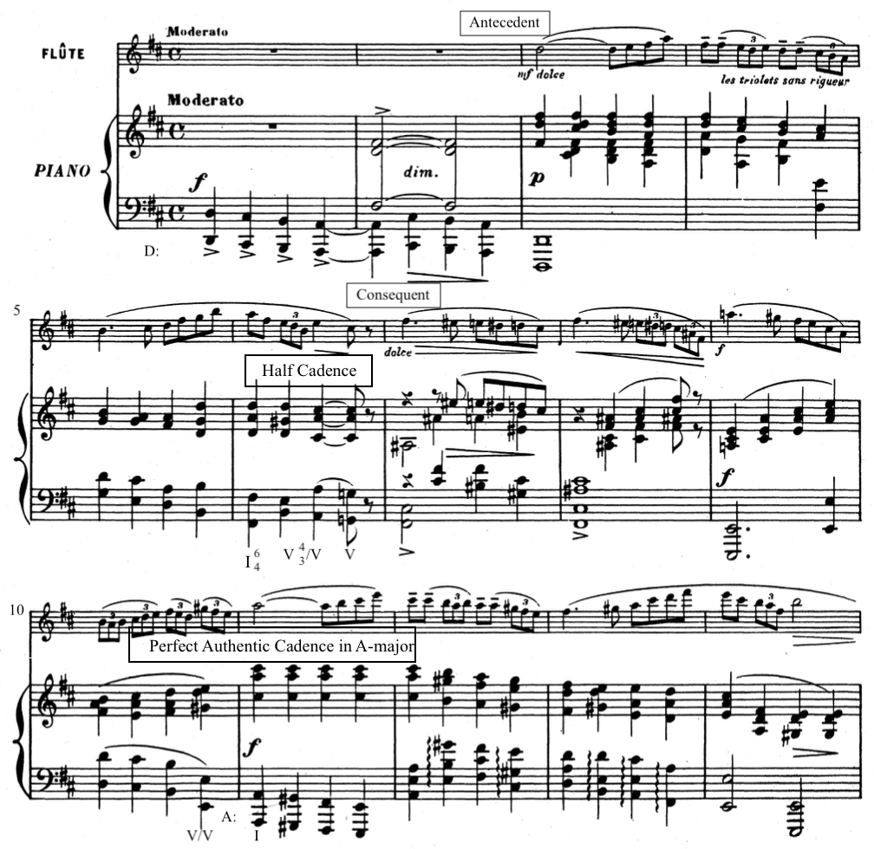
Figure 1 Period structure and cadences of the primary theme mm. 1-14

As she repeats the primary theme, the cadences get more and more obfuscated despite the melodic material generally maintaining their period structure. There’s a clear half cadence at the end of the antecedent in A-major, but the strong cadence that follows subverts expectations. As shown in Figure 2, the tonic, A-major, morphs into a dominant seventh chord setting up the modulation back to the home key. Instead of modulating back to D-major however, Chaminade instead uses the remnants of the declamatory bass to step down into a second inversion chord and modulates up a half-step to B-flat-major.
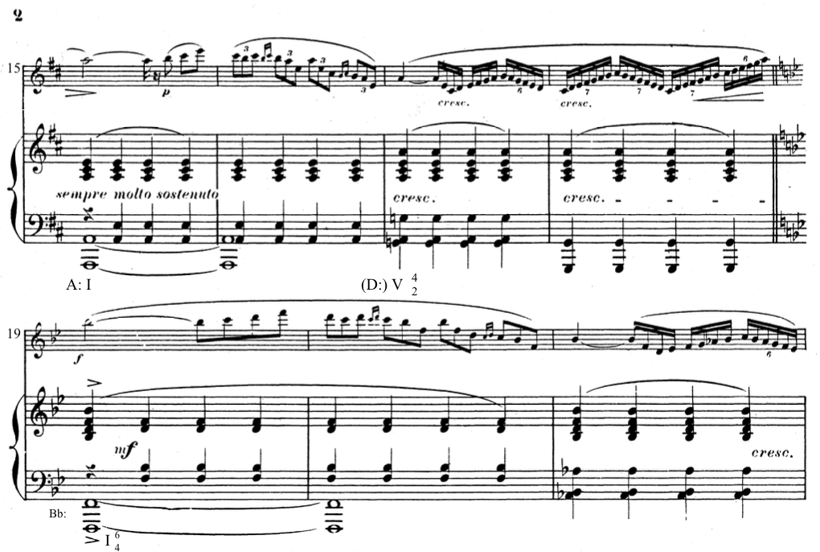
Figure 2 mm. 15-21

The penultimate modulation in the outer A sections moves to B-minor, the relative minor of the home key (D-major). B-minor isn’t really tonicized however, and pedal point interruptions on low A ensure that this new key won’t last very long. The arpeggiation of an E-minor triad in the piano delivers a dominant A chord just in time to act as a perfect authentic cadence into the home key to complete the A section, as shown in Figure 3. Though technically in B-minor, these four measures of transition material effectively function as a prolonged ii-V-I progression in the key of D-major, thus rendering them even more effective when the primary theme reenters in measure 27.
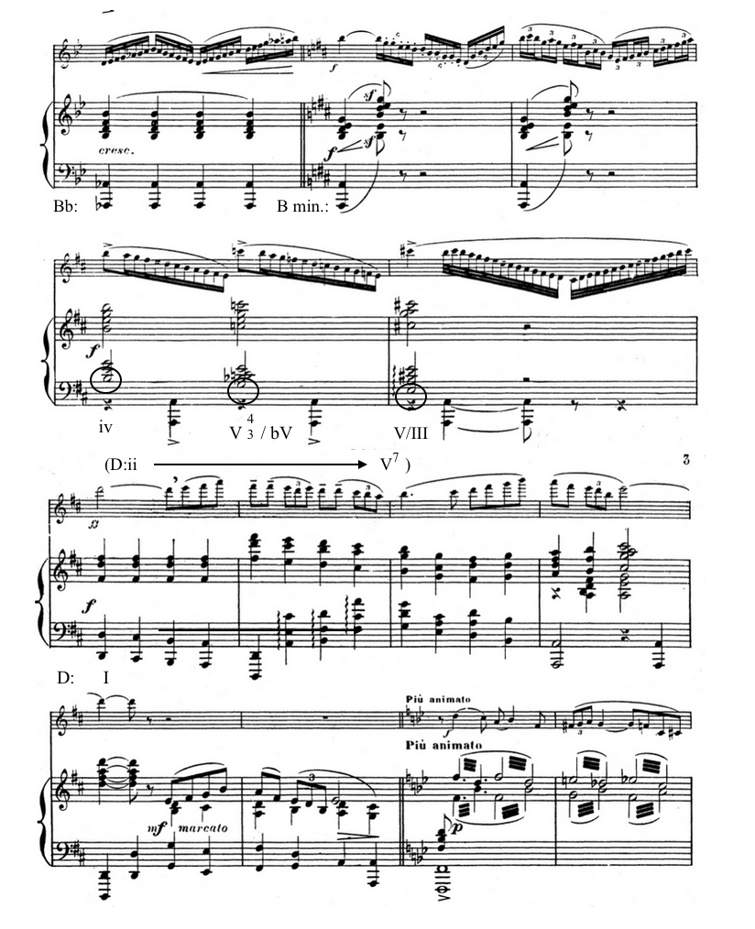
Figure 3 mm. 22-34, end of first A section

The third A section is almost the same as the first one. The only difference between them, is that the third A section eliminates the antecedent phrase so that the modulation to A-major jumps right into the consequent phrase that transitions the theme into a new key, as shown in Figure 4.
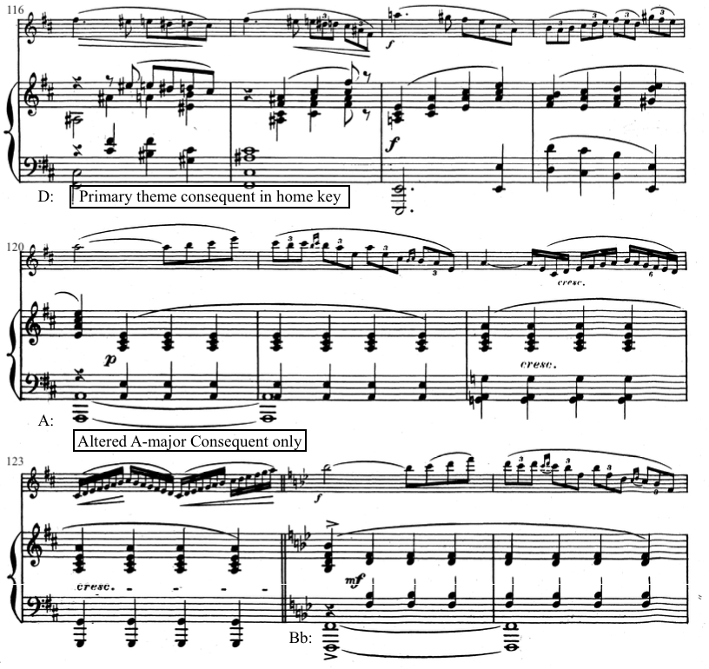
Figure 4 Missing A-major Antecedent mm. 116-125

The inner A section that separates the C section and Cadenza is the most unique of the three refrains in the piece. It fails to restate the primary theme in its entirety, and though it does have cadential closure, it’s an incomplete refrain. Figure 5 highlights its unique features, its key—C-major (bVII), the fragmented mixture of primary and secondary themes, and the chain of secondary seventh chords that transition into the cadenza. The cadenza that follows serves to affirm this as a refrain section as it develops the primary theme. The return of the refrain at the close of the cadenza is not at all unexpected, in fact, it’s the most anticipated rondo convention that is actualized in the piece.
Overall, the refrain sections serve as a return to comfort and stability rather than dramatic intensity. The fervor in which the primary theme is declared is somewhat lost in the final return of the refrain, and only in the coda is it finally fully reestablished, reaching its peak.
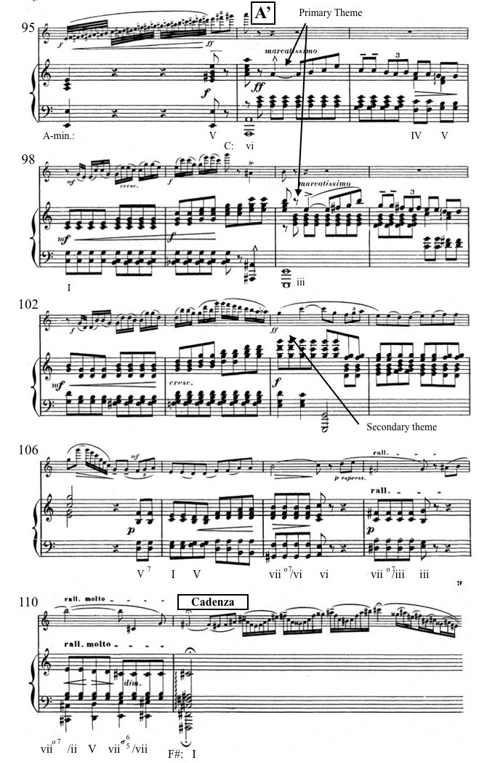
Figure 5 Inner refrain section, mm. 96-110

The order and content of the inner sections of the rondo form are where Chaminade makes the most adjustments to the structure of the work itself. Though it’s a seven-part rondo, the B section is only stated once and the C-section immediately follows it, replacing an opportunity to revisit the refrain. These two sections are comparatively stable harmonically though their key areas are found through mode mixture: the B section modulates to B-flat-major (bVI) while the C-section modulates to A-minor (v). Thematically, they adhere to convention, developing their themes extensively, though these sections lack the degree of repetition established in the refrains. Unlike conventional rondos, the episodes serve to dramatically intensify the work, rather than the repeated refrains.
The B section modulates to B-flat-major (bVI), eschewing the typical shift to the dominant or relative minor. The secondary theme’s syncopation, register, contour, and phrase structure provides contrast from the primary theme, as seen in Figures 6 and 7. After the initial statement of the secondary theme, the B section also brings about more interaction between the flute and the piano, in which both voices share fragments of the secondary theme in turn. The melodic half-step becomes motivic in the last four measures of the secondary theme and fragments of it prevent any attempts of restating the secondary theme in full until the end of the B section.
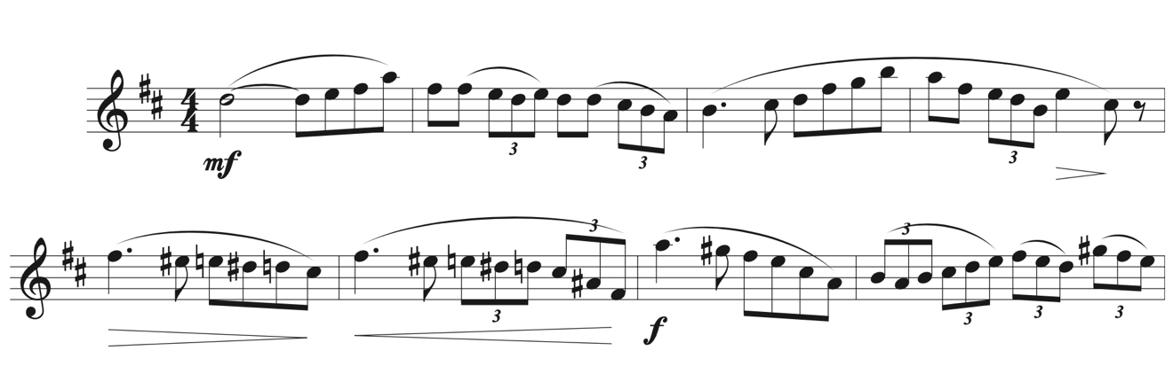
Figure 6 Primary theme

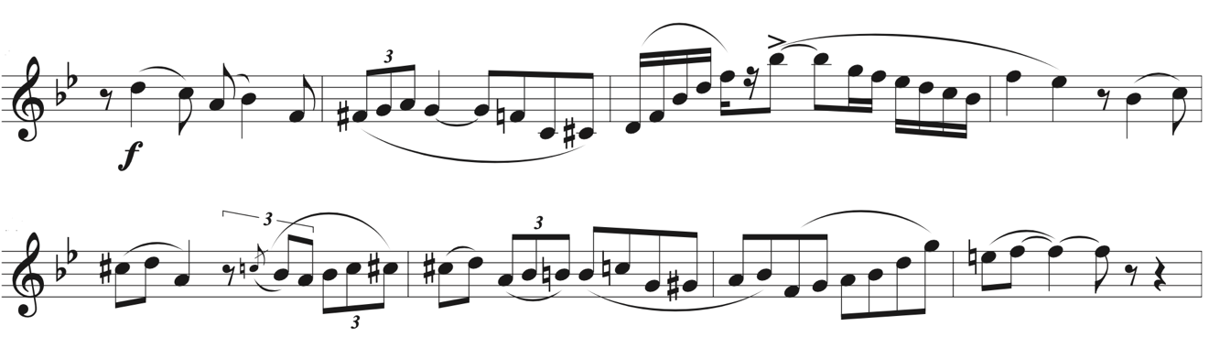
Figure 7 Secondary Theme

The C-section is organized like a development instead of an interior theme. It’s made up of two parts that are almost equal in length and very similar in content, with some notable deviations in the second part. As a development, elements of the primary and secondary themes are elaborated on through virtuosic treatment. Figure 8 shows the intense virtuosity in the flute part as it develops rhythmic ideas laid out in the primary and secondary themes. The chromatic line in the piano is the only easily identifiable unifying feature that links the episodes together.
The rondo form, and Chaminade’s alterations to it, would be less remarkable if not for the way the form enables the work to function within the pastoral expressive genre. The form also provides the ideal structure for the tonal problem to play out.

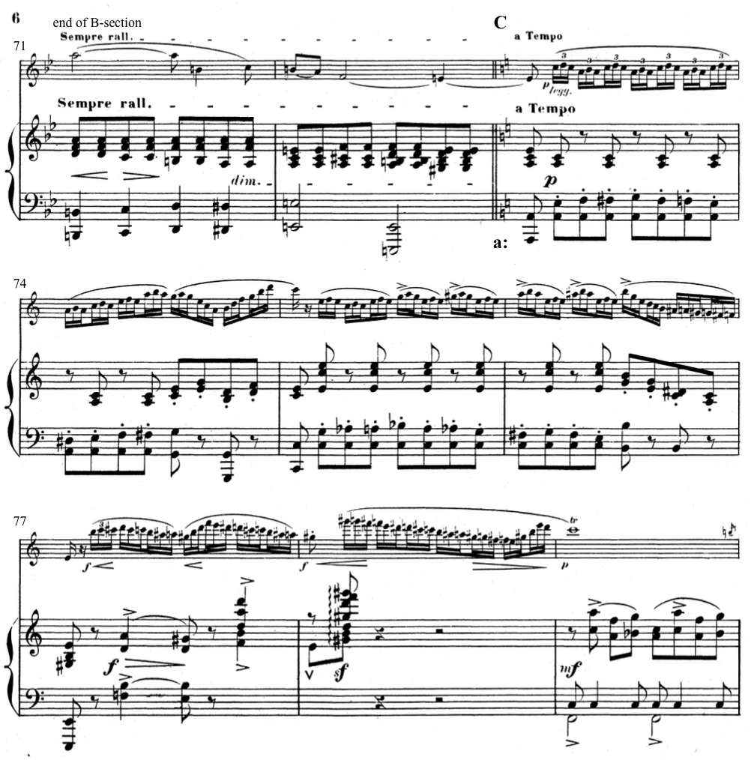
Figure 8 First seven measures of the C-section, mm. 73-79

A Musical Problem
A musical problem is when a feature of a work cannot immediately be accounted for as part of the whole. According to Murray Dineen, “the problem is solved by explaining it in light of the whole work, as a logically related and thus a coherent part thereof.” There are myriad ways a musical problem can be expressed (e.g., rhythmic, timbral, tonal), in the case of the Concertino, the problem is a tonal problem, and it is single pitch: A-sharp.
The tonal problem that arises in Chaminade’s Concertino is through the opposition of the pitches A and A#. This opposition comes to the forefront in the coda, which fully exposes the problem just before its resolution. The arrival at the coda fully illuminates the extent of the melodic half-step’s disruption of the musical texture. The tonal problem is made thematic itself via the melodic half-step motive that arises in the secondary theme.
The opening A-section gives a brief glimpse of the role of A-sharp via an incomplete statement of the primary theme in B-flat-major, as shown in Figure 9. Initially, it seems as though this can be explained away simply by the merit of modal mixture, in mm. 19-22. This modulation, shown in Figure 9, is more significant comes just after a modulation to and restatement of the Primary theme in A-major.
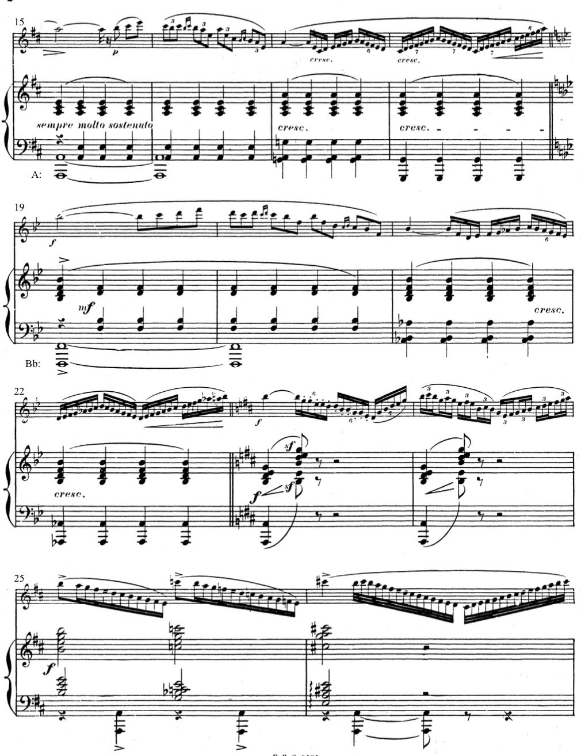
Figure 9 mm. 15-26

This modulation is only 4 measures long, but attempts to state the primary theme in the new key in the flute part provides the necessary way station to modulate by another half-step to return to a key signature with two sharps. The first three statements of the primary theme in this section are generally unproblematic and reinforce their key area and mirror each other in melodic and harmonic content. This modulation, in mm. 23-26, however, uses extended harmonies by way of octave A’s as pedal points in the bass, the melodic content in the flute changes, as does the harmonic rhythm, as shown in figure 10.
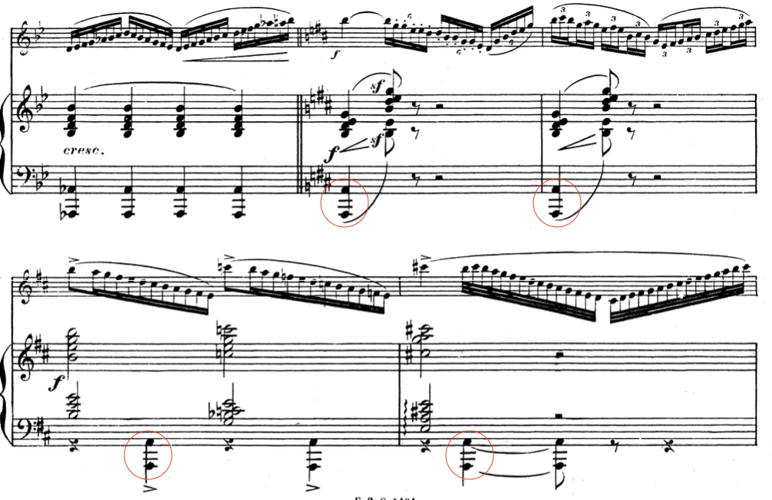
Figure 10 mm. 22-26

Unlike the other modulatory phrases, in which the bass note in the piano steps down a half-step to facilitate the key-change, this modulation is facilitated by the half-step upward in both the flute and piano parts, as shown in figure 10. It turns out the key of B-flat was more disruptive to the development of the melody. This is the first time in which both voices work together to complete the harmonic shift, and in which the flute deviates from restatements of the primary theme.
In the B section, the tonal problem is confronted head-on in a modulation to B-flat-major — the flatted sixth of home-key D-major. Instead of a stable melodic idea taking a tour through different key areas, Chaminade embeds the instability of the melodic half-step directly into the melody in the flute. She does so by using the period phrase structure to reframe the consequent phrase in the flute’s melody, as seen in figure 11. This coincides effectively with the chromatic declamatory bass’s appearance in the piano, further destabilizing the section which can be seen in figure 12.

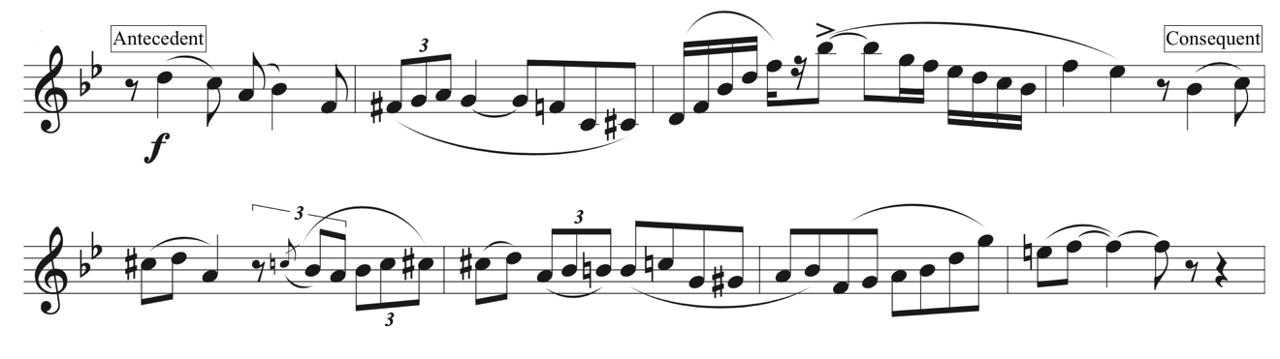
Figure 11 Secondary theme

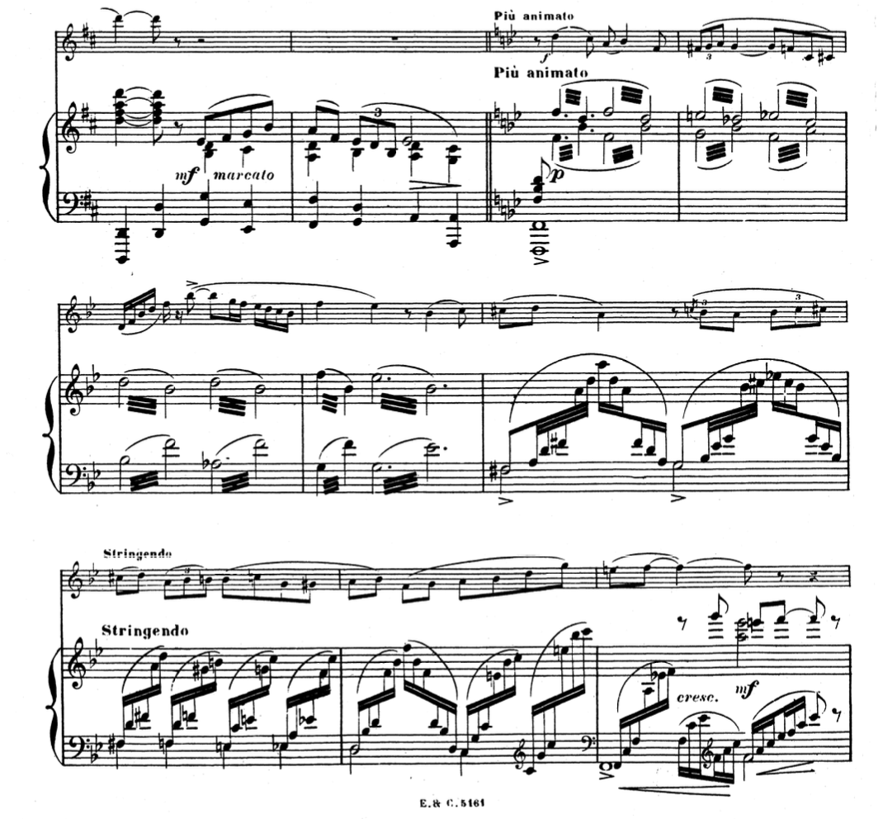
Figure 12 Transition from the A section (mm. 31-32) into the B section (mm. 33-40)

The Secondary theme is only ever completely stated in the key of B-flat major which lends stability to the section, but chromatic interruptions or fragments are never far away. Like the A-section, the B-section also has a final statement of its primary theme up an octave. Unlike the A-section however, here, the melodic half-step is repeatedly emphasized in the flute as a means of modulating for a transition in the next section, in mm. 69-72. Figure 13 shows the extended continuation and emphasis of the half-step motive.
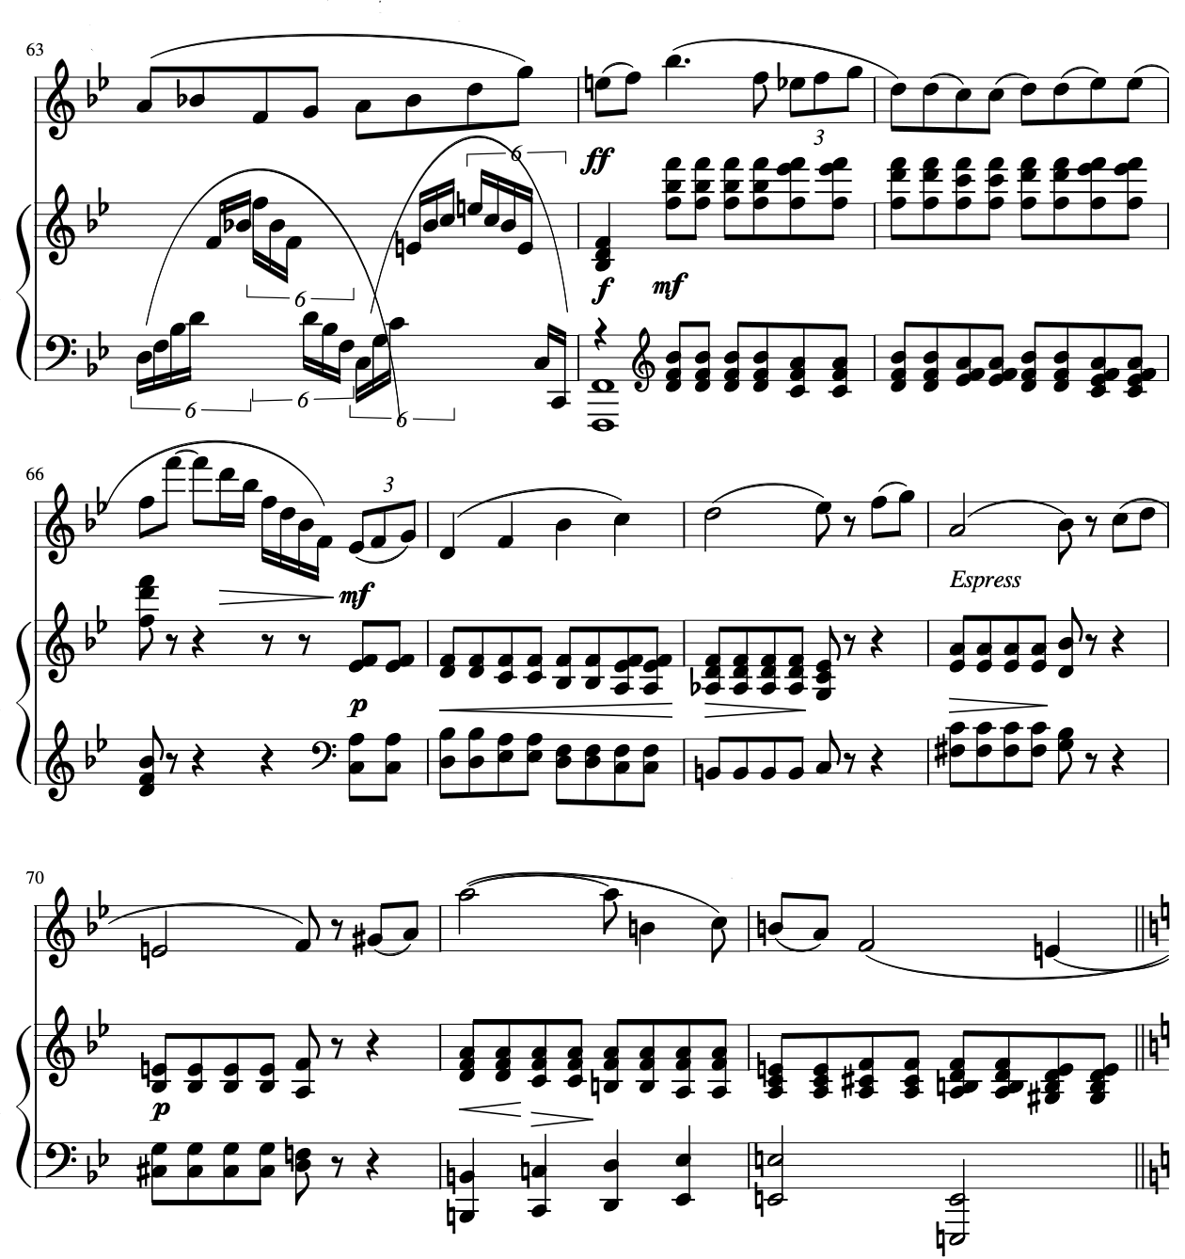
Figure 13 Half-step motive used as a means of modulation into the C-section

The C-section that begins in measure 73 casts the problematic B-flat in even sharper relief by modulating to A-minor. Brief forays into F-major taunt the possibility of the B-flat reappearing but the flute’s determinacy to arpeggiate F-major triads eschews that possibility as shown in figure 14.
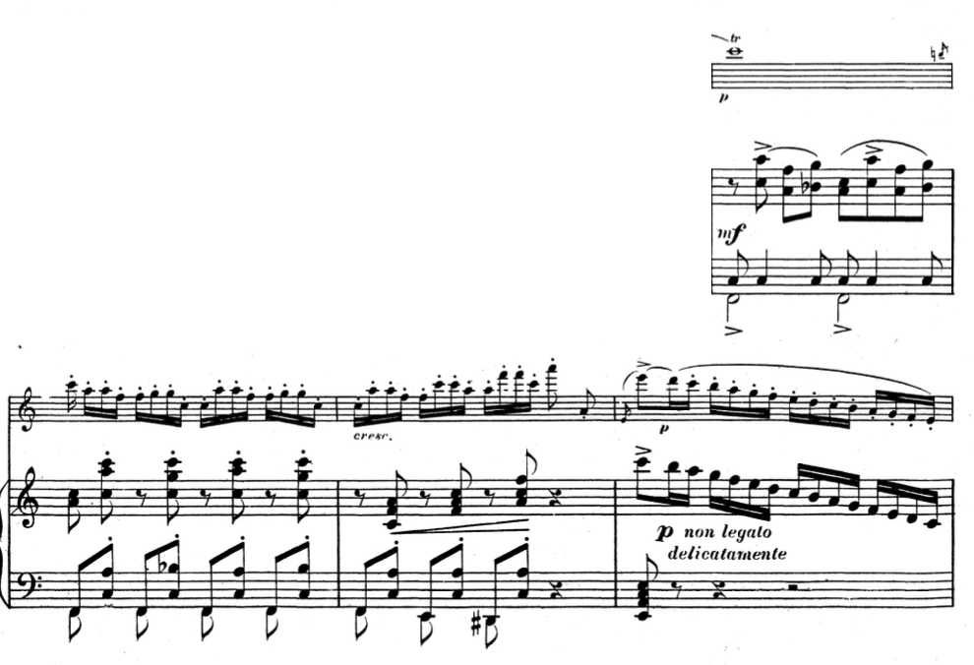
Figure 14 Brief foray into F-major, mm. 79-82

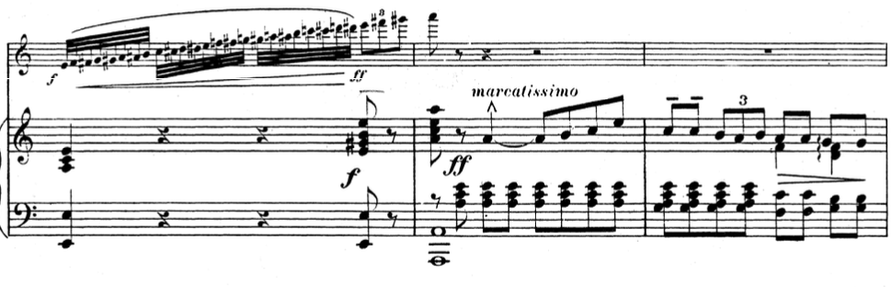
Figure 15 C-section transition into the A'-Section, fragment of Primary theme in A-minor, mm. 95-97

By the time the C-section transitions into the first return of A section material, it seems as though the A-natural is cemented as the dominant pitch. Rather than A-minor, the A’-section transitions into its relative major—C-major. This is evident in retrospect based on the subsequent melodic and harmonic content that immediately follows the fragment of the primary theme that appears in measures 96 and 97. As shown in figure 16, secondary theme material also comes back which supports the key of C-major.
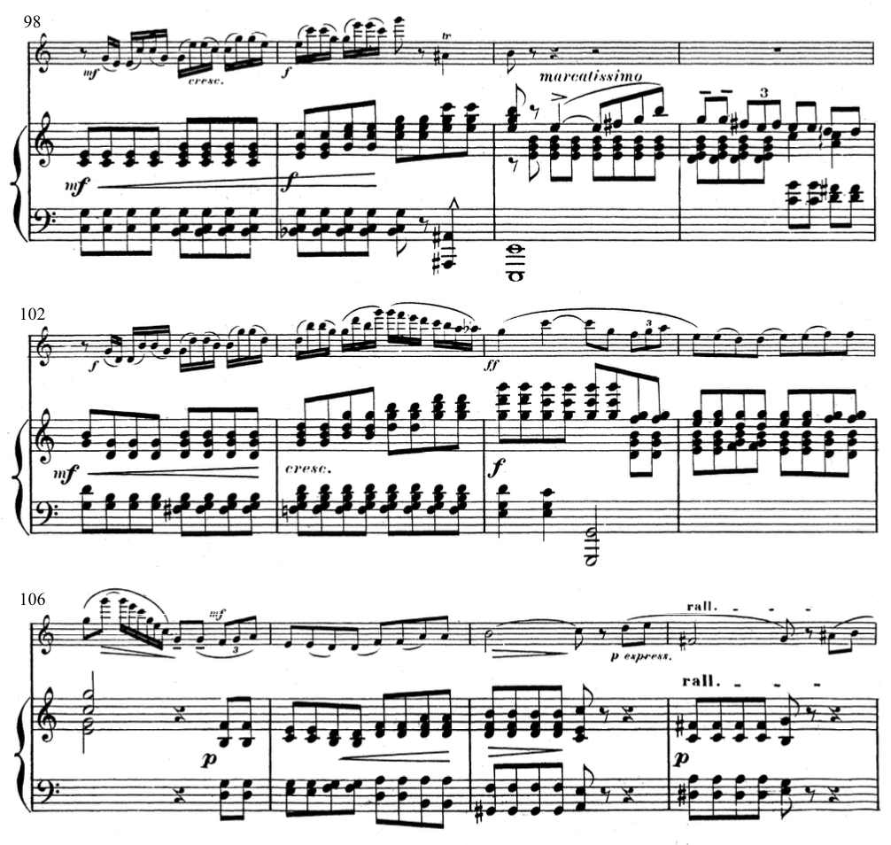
Figure 16 Affirmation of C-major in the A'-section, mm. 98-109

The return to A in measure 96 seems to ameliorate the problematic pitch. There are fewer chromatic alterations in the section and the half-step motive only appears at the end of the section as a transitional device into the cadenza. As shown in in figure 17, the reappearance of the melodic half-step motive is appropriate because it is heavily featured in the cadenza.
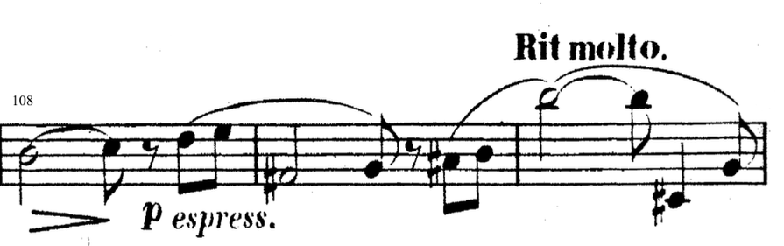
Figure 17 half-step motive transitional device, flute part mm. 108-110

The cadenza, which occupies m. 111, relies on the opposition between A and A# that arises as the tonal problem. The flute solo starkly highlights the contrast between the two pitches, as seen in figure 18. Here, the Primary theme is cast in juxtaposition with the melodic half-step motive. Extended arpeggiations and chromatic neighbors emphasize the instability of the section. And the tonal regions traversed by the flutist only serve to draw out the tonal problem through juxtaposition of A and A-sharp.
The way Chaminade links the Cadenza into the final return of A and gets back to D-major is quite brilliant. She uses the mediant, F-sharp, of the home key we’re trying to get back to as the tonic pitch for the cadenza. This then positions the problematic pitch, A-sharp, as the third scale degree, rather than resolving it, she draws out the conflict here in the cadenza. After F-sharp-major gives way to F-sharp-minor, Chaminade then uses that third scale degree as an access point back to D-major. She doesn’t immediately acquiesce to the A-natural however. A series of seventh chord arpeggiations on A-natural give the appearance of that, but the melodic half-step reappears just in time to reintroduce the A-sharp, as shown in figure 18.

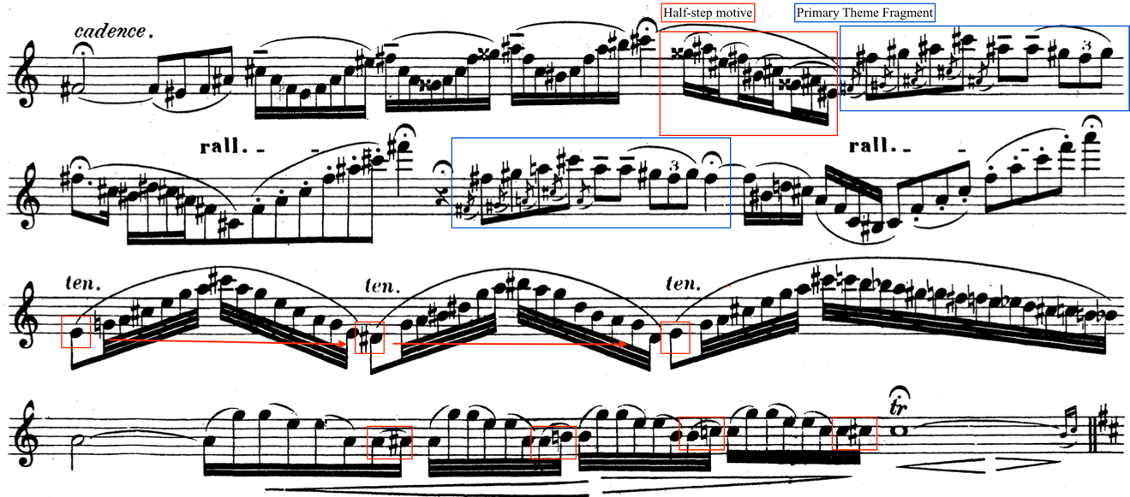
Figure 18 m. 111, cadenza

The A’-section that returns at the close of the cadenza treats the tonal problem in the same ways as it does in the A-section that opens the piece.
The coda clarifies the function of the B-flat/A-sharp as an antagonist to the idealized pastoral soundscape. Wherever B-flat (or its enharmonic, A-sharp) appeared, it brought with it harmonic and melodic instability. In the beginning it may have seemed innocuous, but by the Coda it’s glaringly obvious that that pitch has become a problem.
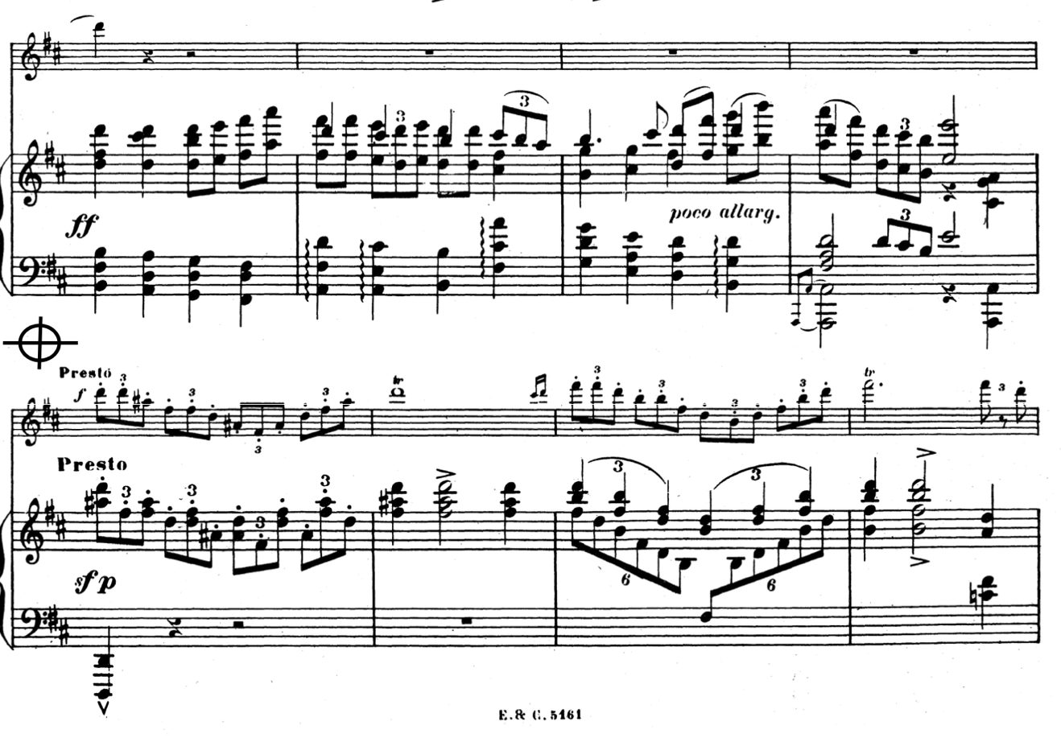
Figure 19 Transition from A'-section to the Coda, mm. 132-139

In the Coda, the tonal problem comes to a head by infiltrating the home-key of D-major. The abrupt delivery from the Primary theme into a D-augmented chord by the piano comes across as a shock. Not only does the augmented chord subvert expectations, but the abrupt tonal shift coincides with an abrupt tempo-change to Presto. The D+ chord here functions as a dominant chord instead of a tonic chord.
As bits of the declamatory bass attempt to guide the section, Chaminade offers the half-step motive its final chance in an ossia option, as shown in figure 20. The rapid scale work gives way to a series of secondary dominant chords in the piano while the flute’s trills from G#/A dispel the problematic note. That is, until the French augmented sixth chord appear in m. 145, planting octave B-flats in the bass voice of the piano.
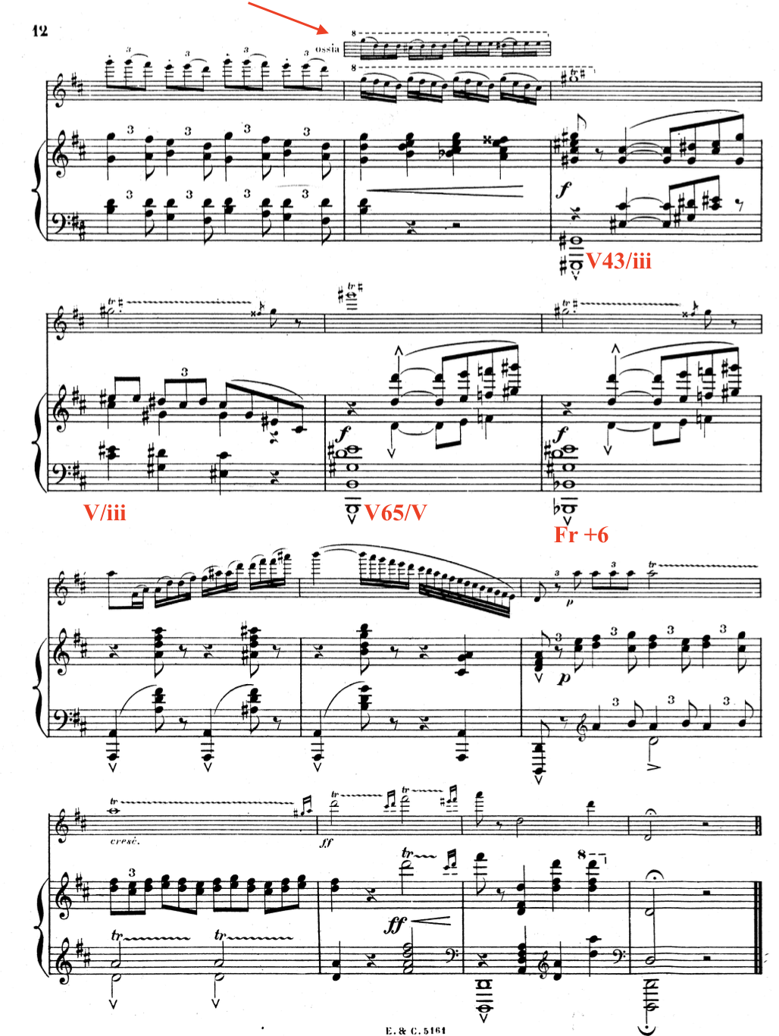
Figure 20 ending of the coda, mm. 140-152

The augmented 6th chord, rather than affirming Bb, provides exactly the vehicle needed to dispense with the problem. As she had already done several times before, Chaminade uses the bass voice of the piano to step down another half-step to change the tonal trajectory of the work. A final arpeggiation in measure 146—akin to those in the B section, sheds the final appearance of A# and delivers the dominant of the home-key of D-major.
That A-natural was the winning pitch is emphasized repeatedly in the flute’s remaining trills. The piano reaffirms the key of D-major by reiterating the triplet scale figures. After extended trilling and a final arpeggiation of D-major, the piece comes to a bombastic close.
Topical Analysis
Pastoral as Expressive Genre
The Concertino uses the pastoral expressive genre as the expressive framework of the piece. Robert Hatten defines the pastoral expressive genre in his book, Musical Meaning in Beethoven. As an expressive genre, the setting of the pastoral acts as a frame for the dramatic structure, while also serving as the fundamental topic that coordinates features of the work. The expressive trajectory is broadly pastoral (i.e., serene, idyllic, etc.) but defined by tragic interruptions that create moments of crisis. Hatten states that, “the mixing of tragic elements endows the pastoral with greater seriousness and the elevation of style in turn supports the interpretation of the pastoral as a poetic conceit for a spiritual state of innocence (or serenity) subject to the disturbances of tragic experience (or remembrance).” This is the expressive landscape which governs the Concertino.
The expressive states of the Concertino are clearly delineated by the sections of the rondo form. The piece is governed broadly by the pastoral and declamatory bass topics in the refrain sections, while the episodes are characterized by the shift to the ombra and lament bass topics. The pastoral exerts its control over these irruptions and constantly attempts to restore the serene mood set forth in the A sections.
These expressive states can be understood as contributing to the narrative of the piece based on their function as lyric or narrative time. In The Sense of Music, Raymond Monelle characterized the lyric time temporal state as one signified in presentational sections in which the melody comes to the fore and in which harmonic and phrase structures are relatively stable. Narrative time, in contrast, is signified in sections in which harmonic and phrase structures become more complex and in which there is generally an increase in rhythmic activity. Put simply, lyric time is generally associated with themes, while narrative time is associated with passage work. The narrative and dramatic path can be understood through the shifting of the temporal state in conjunction with changes in topical signifiers.
Throughout the Concertino, topical elements contribute to its narrative and formal development. Topics such as the melodic half-step sigh motive (seufzer), lament bass, ombra, brilliant and singing styles, and pastoral appear so frequently they become significant through their use, juxtaposition, and manipulation. The interactions of these topics within the form create distinct periods of lyric time contrasting with periods of narrative time. These expressive states are evident by the use of disparate topical elements which contribute to the emergence of meaning via narrative. Thus the dramatic and narrative structure of the Concertino is built within a pastoral framework as an expressive genre, not just a musical topic.
Declamatory Bass
The lament, as characterized by William Caplin in the Oxford Handbook of Topic Theory, is both a musical topic and schema. As both topic and scheme, it is not only a subject of musical discourse that carries expressive meaning but also a compositional lexicon from which composers could draw from and present in various guises.
Caplin defines the lament schema as a tetrachord bass line that descends stepwise, diatonically or chromatically, from the tonic scale degree to the dominant. For Caplin, the lament bass has both formal relation to form and temporal framing qualities i.e., the lament not only plays an expressive role topically, but a functional role in regards to form. As a topic, Caplin refers to the expressive qualities and affect it often invokes: mourning and loss. Caplin’s discussion regarding the lament’s formal function centers around the lament being capable of expressing the range of beginning, middle, or ending framing temporalities. These framing temporalities become relevant for the discussion as to how Chaminade applies the lament bass in the Concertino.
The lament bass topic is used differently in the Concertino than convention would ordinarily dictate. Chaminade uses two versions of a descending tetrachord in the Concertino: a chromatic minor mode tetrachord and a diatonic, major-mode descending tetrachord. The chromatic minor mode tetrachord functions in a way similar to the chromatic lament bass that Caplin describes. This tetrachord, which I will refer to as the lament bass, appears in the episode sections, functioning in the conventional way. I argue the major mode tetrachord, on the other hand, acts more like a declamatory bass than a lament. The declamatory bass maintains the formal functions of the typical lament bass but turns its expressive content on its head. I will label this version of the descending tetrachord the declamatory bass because of its unusual appearance and thematization in the diatonic major mode, its initiating function, and its refreshed and joyous character. The declamatory bass permeates the A section and is rendered even more effective in juxtaposition with the chromatic lament bass in the B and C sections.
The declamatory bass permeates the A sections and is rendered even more effective in juxtaposition with the chromatic lament bass in the B and C sections. As a topic in the A section, the declamatory tetrachord functions as a signifier of initiation. Its efficacy conveys an initiating or beginning function which drives the Concertino forward and signals the return of the rondo’s refrain and moves to lyric time.
The first appearance of the declamatory bass has an initiating function and is in the two-bar introduction (fig. 21). The descending tetrachord establishes the key of D-major and, unbeknownst to the listener at the time, establishes one of the primary harmonic motives of the piece. In its diatonic major form, the declamatory bass signals the initiation of the A section, and each of its subsequent returns. It is almost always in quarter notes, embedded into the very pulse of the music. When it has completed its initiating function at the beginning of a new section or modulation, it then moves to an inner voice in the piano where it lies in wait until it regains control of the harmonic rhythm.
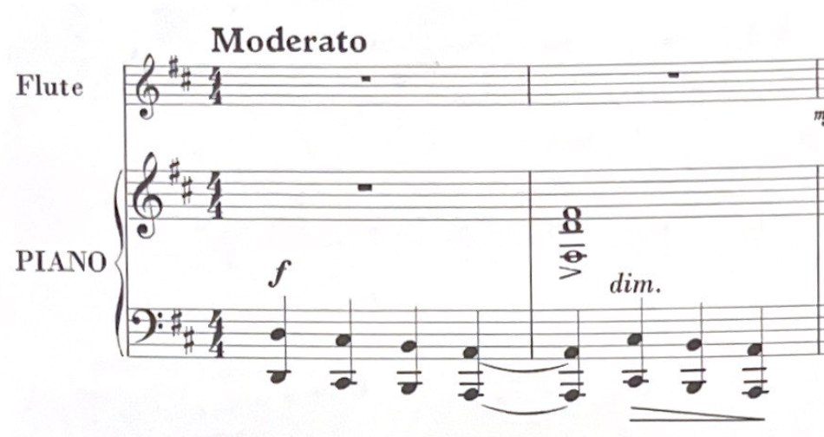
Figure 21 Opening Declamatory Tetrachord mm. 1-2

Despite the harmonic instability of the A section, the declamatory tetrachord is generally preserved through each modulation. This beginning-temporality is signified not only by the presence of the declamatory bass, but by the modulations it accompanies or the change in melodic content from the flutist. When the first A section modulates to A-major, the true declamatory bass is utilized in the same way it is at the introduction (fig. 22).
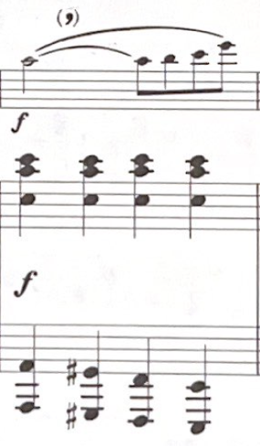
Figure 22 Declamatory Bass in modulation to A major in the first A section, m. 11

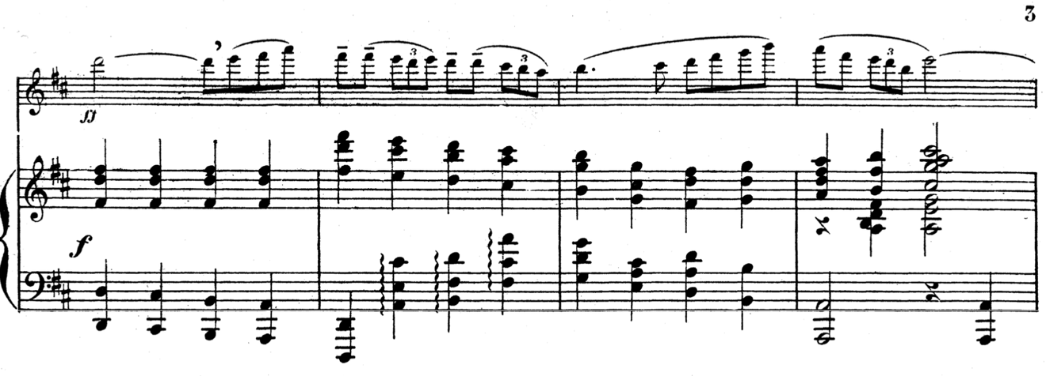
Figure 23 Declamatory bass restatement mm. 27-30

Although most of the appearances of the tetrachord in the A section appear in the bass voice of the piano, there are instances of it temporarily relocating to an inner voice. As an inner voice, the declamatory tetrachord has a being-in-the-middle function and facilitates transitions into contrasting sections (fig. 23). As one can see in Figure 23, the descending tetrachord in the inner voice signals the beginning of transition to the B section through a modulation to D-major. After which, it moves to the lowest voice of the right hand of the piano as transition material begins.

The declamatory bass in the first return of the A section is more subtle. The lack of a full statement of the Primary theme, and interruptions of Secondary theme material, obfuscate the descending tetrachord that is buried in blocked chords in the piano. Figure 43 shows the last appearance of the declamatory bass in the A’ section before it disappears giving way to a Secondary theme interruption. Its subtly in this section contribute to its “being-in-the-middle” relation to the form at this point.
After the cadenza, the return of the A section in measure 112 restores the declamatory bass and is marked by the pastoral topic. The character here is less declamatory than the beginning of Concertino, rather, it’s comparatively mollified in its reappearance. The reappearance’s initiating function is rendered less effective by its placement in the same register in which the flute resumes the Primary theme as shown in Figure 24.
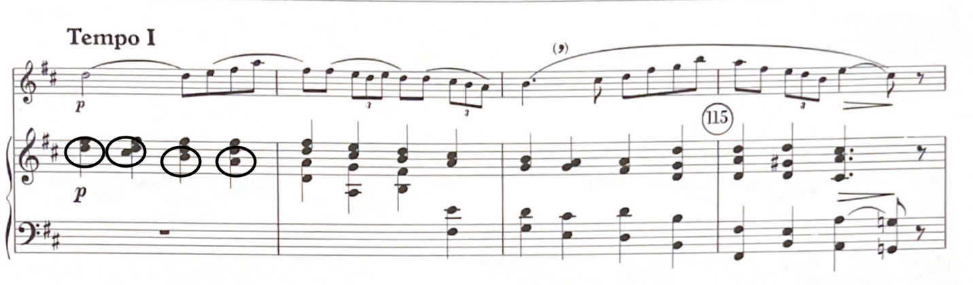
Figure 24 mm. 112-115

The A section’s return is slightly altered in comparison to how it first appeared. The Primary theme is only played once in A-major and the piano takes the theme over when the section returns to D-major. The declamatory bass is pervasive. Initially, in a faster harmonic rhythm changing each beat and then later at a slower harmonic rhythm as part of a pedal point. Figure 24 shows the faster versus the slower version that appears in figure 25.
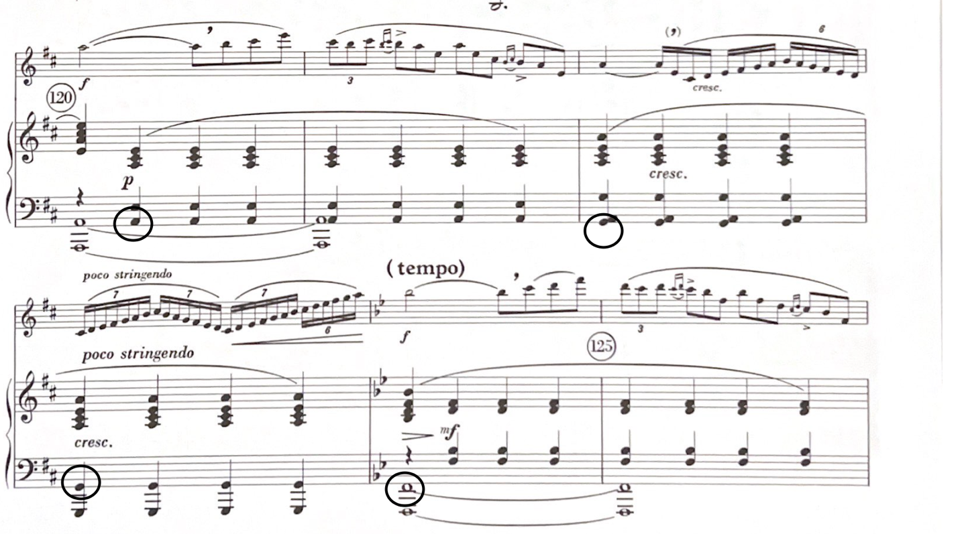
Figure 25

At the B sections, the chromatic tetrachord’s first appearance is obfuscated by its placement in the inner voice and the prevalence of the flute melody (fig. 26). As shown in Figure 26, Chaminade avoids re-applying its initiating function to the new section until she moves it back to the bass of the piano in the consequent phrase of the Secondary theme. This relocation is significant, not only because of the initiating function of the lament bass, but because of the stringendo indication and proximity to the melodic half-step motive that creates the tonal problem of the work.

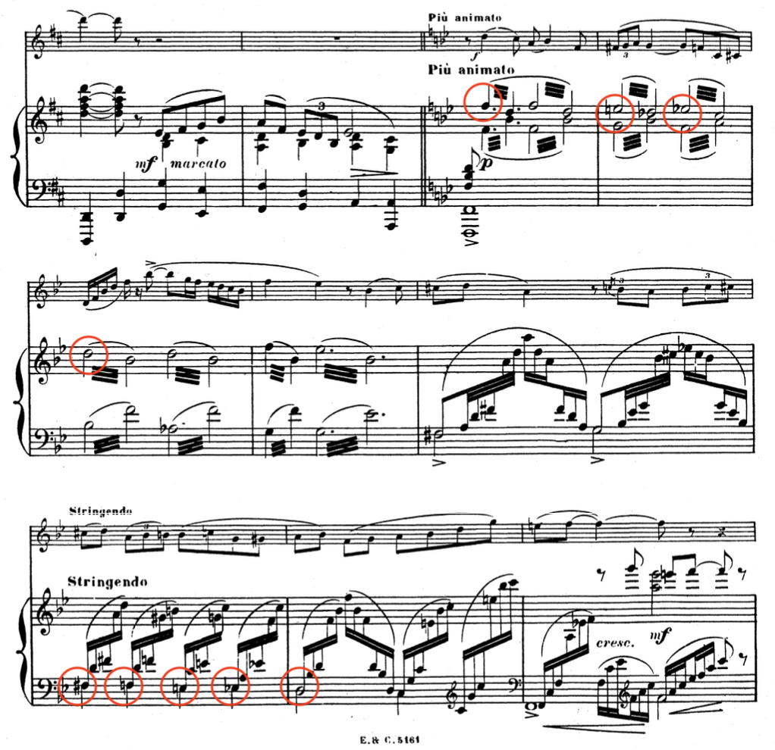
Figure 26 mm. 33-40

The B section stability arises from the secondary theme which is only fully stated in the key of B-flat major. As the Secondary theme develops, the declamatory bass transforms into a chromatic lament bass realizing the being-in-the-middle function. As the flute develops the theme, transforming it through chromatic scales and arpeggios, the bass line reverses itself to become an ascending tetrachord (fig. 27).
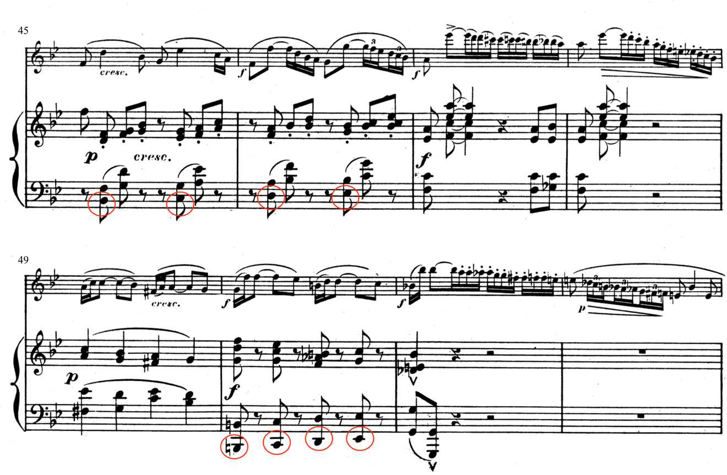
Figure 27 Secondary theme transformation, ascending bass line transformation.

The C-section subverts expectations by replacing what would’ve been a return to A in a typical rondo. This effect is enhanced by the loss of the declamatory bass which all but disappears. As shown in Figure 27, the ascending bass that was interspersed in the B section becomes the dominant presentation in the C-section (see mm. 73-79). This alteration moves the chromatic bass as it ascends and descends to an inner-voice over a pedal point that contributes to the “being-in-the-middle” temporality. Figure 28 shows this movement to the inner voice and demonstrates how the flute maintains the key of A-minor throughout the chromaticism.

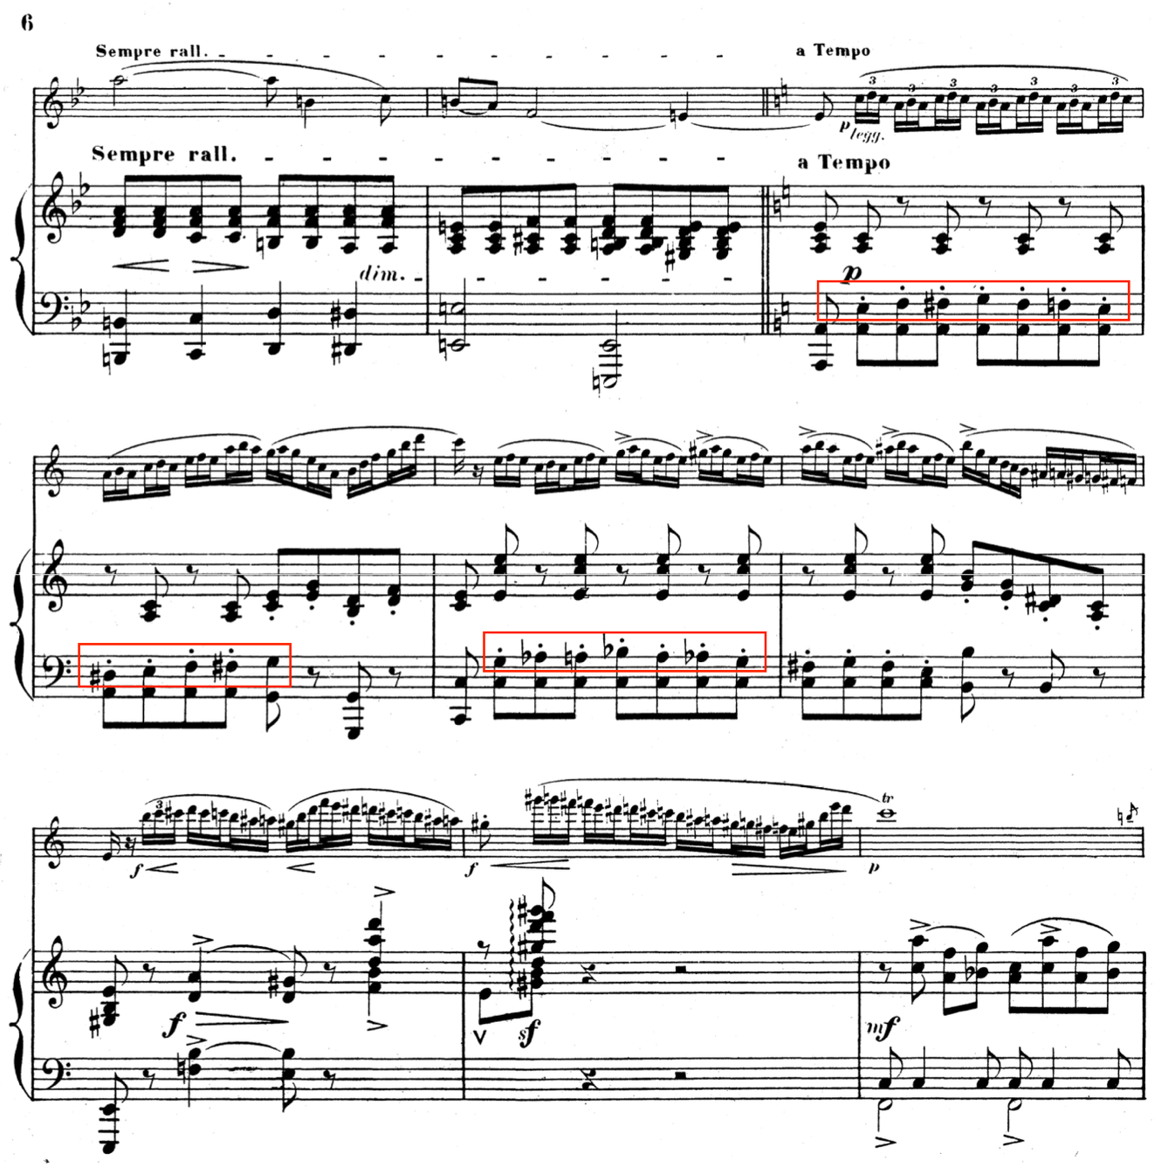
Figure 28 First seven measures of the C-section. mm. 73-79

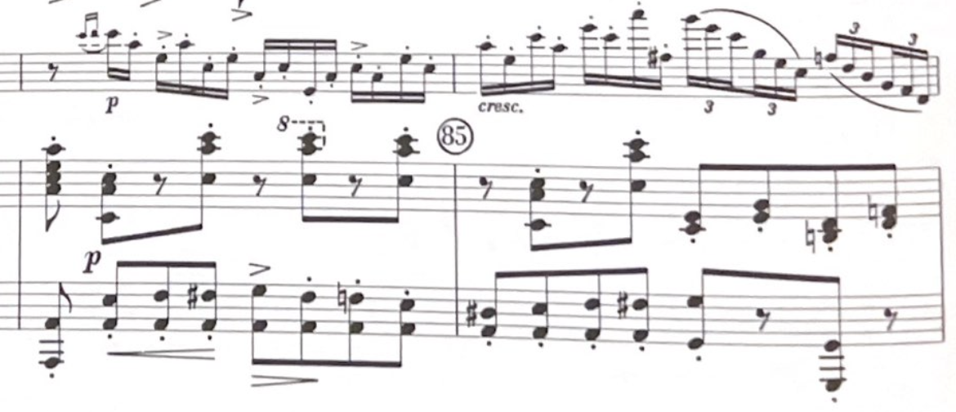
Figure 29 Ascending/Descending Chromatic Declamatory Bass over Pedal Point in the C-section, mm. 84-86.

The C-section is neatly contained in two sections, each about eleven measures long, both closing with the same French augmented sixth chord. The augmented sixth chord is preceded by the declamatory bass returning to the bass/lowest voice in the piano. In both cases, the augmented sixth chord resolves first to a second inversion A-minor chord that then moves to the dominant, E-major. Figure 30 shows the second instance of this which transitions into the return of the A section and a near complete restoration of the declamatory bass.
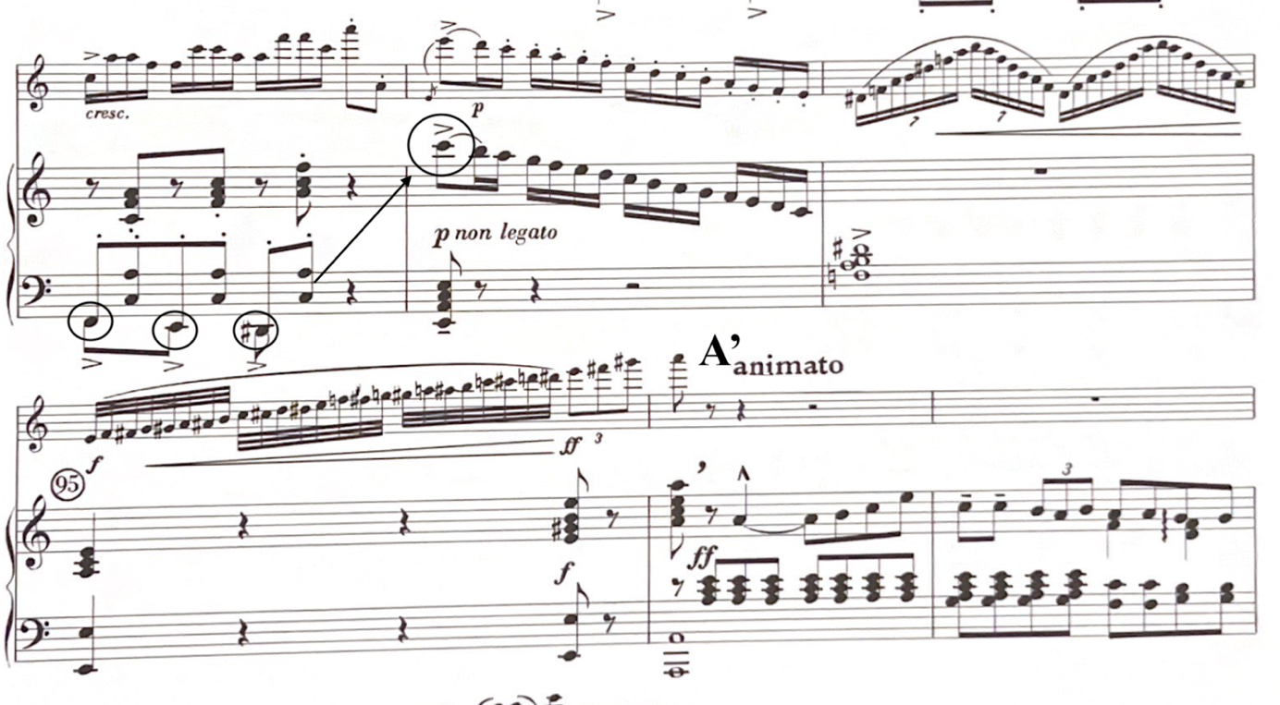
Figure 30 Relocation of the Declamatory Bass leading in the French +6

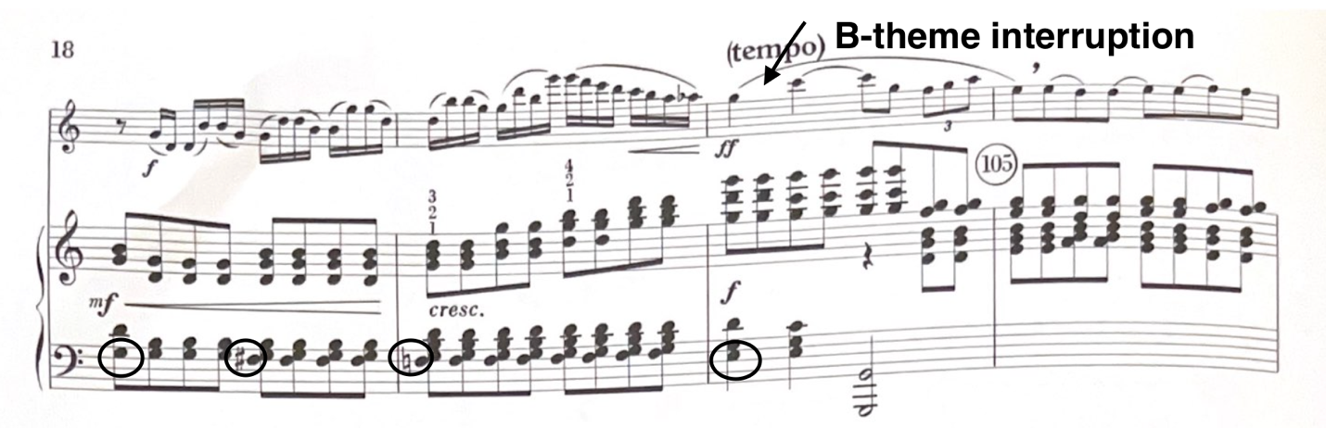
Figure 31

There are only ever glimpses of the declamatory bass in the Coda. When it does appear, it is either foiled before it can be completed or it serves as a vehicle to a secondary chord. Figure 31 illustrates the last of these instances, this particular occurrence is first diatonic using scale degrees 6-5-4-3 then chromatic using scale degrees 6-b6-5-#4. In this instance, the direct juxtaposition of the diatonic then chromatic form provides the only instance of an ending function.
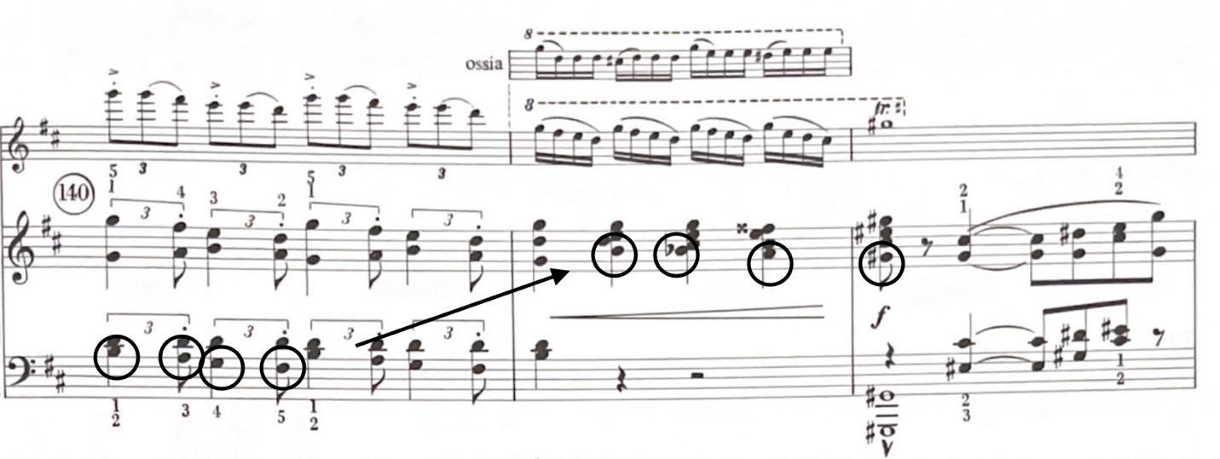
Figure 32 Declamatory bass used to get to a V43/iii

Overall, the declamatory bass in Concertino functions as a harmonic motive whose various guises create cohesion in the modified rondo form of the work. The juxtaposition of the diatonic version in the A sections and the chromatic version in the B and C-sections contributes to the narrative and expressive trajectory. The flexibility of temporal qualities that the bass portrays makes for the ideal unifying feature of the work.

Pastoral
In The Musical Topic, Raymond Monelle traces the roots of pastoralism and its mixed critical reception stating, “[t]he prejudice against pastoral has made it harder for modern writers to understand the prevalence of the genre throughout Western literature, and above all to see that the pastoral was an allegory of music; to understand that music was for Europeans simply the pastoral without its shepherds.” Using literature as a spring-board, Monelle illustrates how particular ideals and themes became codified as signs of the pastoral and how those aspects took root and eventually found their way into music.
Monelle characterizes pastoralism as “an allegory of the imagination, and the unmeaning lyricism of pastoral verse is an allegory of music. In pastoralism, as in music, there is no concept of ‘real’. Emotion and desire are utterly free; the imagination is responsible only to the text, not to the world; time is suspended in a lyric present.” In his book Interpreting Musical Gestures, Topics, and Tropes, Robert Hatten elaborates on the development of the Pastoral topic in the early Romantic era:
“I am presupposing the cultural availability of a pastoral mode that may include
various aspects of the following scenario: (1) an individual retreating from a
complex and less euphoric reality (2) in an attempt to regain lost simplicity,
innocence, happiness, or the sublime—or to imagine a similarly euphoric present
or future idealized state (3) by inhabiting an idealized space of reflection or serenity that emulates those envisioned qualities, (4) and that may also evoke the
monumentality of a landscape with its poignant juxtapositions of geological time,
historical time, and individual memory.”

Hatten’s work on the pastoral also addresses the temporal shifts that arise from what he considers “sharp musical oppositions.” These oppositions are applied to the pastoral topic in the Romantic era via “emphasis of subdominant harmony, modulation to the flat side, undercutting expressive climaxes, employment of consonant appoggiaturas and other less dissonant irruptions or other disruptions that may occur;” characteristics Hatten deems additional to the principal of the topic evoking what he terms “mollified tension and intensity.”
Generally, the pastoral topic may signify an idealized space or time, retreat to nature or more natural world, pure or modest love, pleasant simplicity, naïveté, goodheartedness or innocence. As signifier, the pastoral topic may be identified through compositional elements on the surface of the music by use of pedal point or drone, slow harmonic rhythm, simple melodic contour with gentle climaxes, compound meter, major mode, parallel thirds, and/or subdominant inflection. The additional signifiers from pastorale genres like that of the musette and siliciano, in combination with earlier listed elements, may also invoke the pastoral topic via meters and dance rhythms that fulfill the typical pastoral character. Indexical signs of the pastoral may relate to instruments that evoke the topic, like the flute or bagpipes for instance.

The Pastoral in Concertino op. 107
The pastoral is employed in two ways in the Concertino, as both topic and overarching genre. As a genre, the pastoral permeates the nature of the work and positions tragic and folk elements of the music in opposition. As a topic, elements that signify the pastoral appear many times over the course of the Concertino and dramatically guide the expressive states.
The pastoral topic as it appears in op. 107 is most obvious at the final return of the primary theme that begins at the termination of the cadenza in m. 112. This moment has a markedly different rhetorical effect than any other time the primary theme appears, much of which points to the pastoral topic. The soft dynamic marking, the voicing of parallel thirds and sixths in the piano, and diatonic major tonality all work to signify the pastoral topic. These signifiers of the pastoral topic evoke the sweet innocence and nostalgia the topic has come to signify historically. Rather than celebrating the realization of the voice breaking free into a large form, the tone is soft and tender, reflective of an almost resigned acceptance that the moment was there and now it’s over.
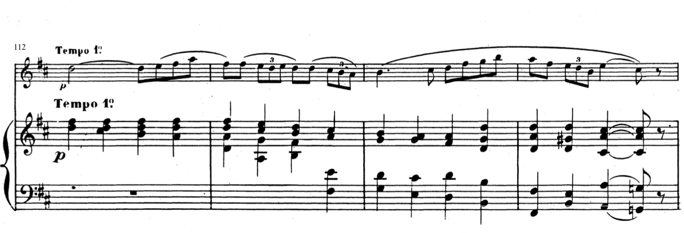
Figure 33 Pastoral topic mm. 112-115

The pastoral topic isn’t limited to the final refrain in op. 107 however, as allusions to it appear all over the Concertino from the very outset. Chaminade’s consistent use of striking musical oppositions within a rondo form maintain the dramatic trajectory of the piece and uphold Hatten’s idea of “mollified tension and intensity” consistent with the Romantic evolution of the pastoral. In op. 107, a climax proffered by a modulation is undercut when Chaminade modulates again within a few measures in a section that generally offers tonal stability. This happens multiple times in the outer most A-sections, as shown in figure 33.
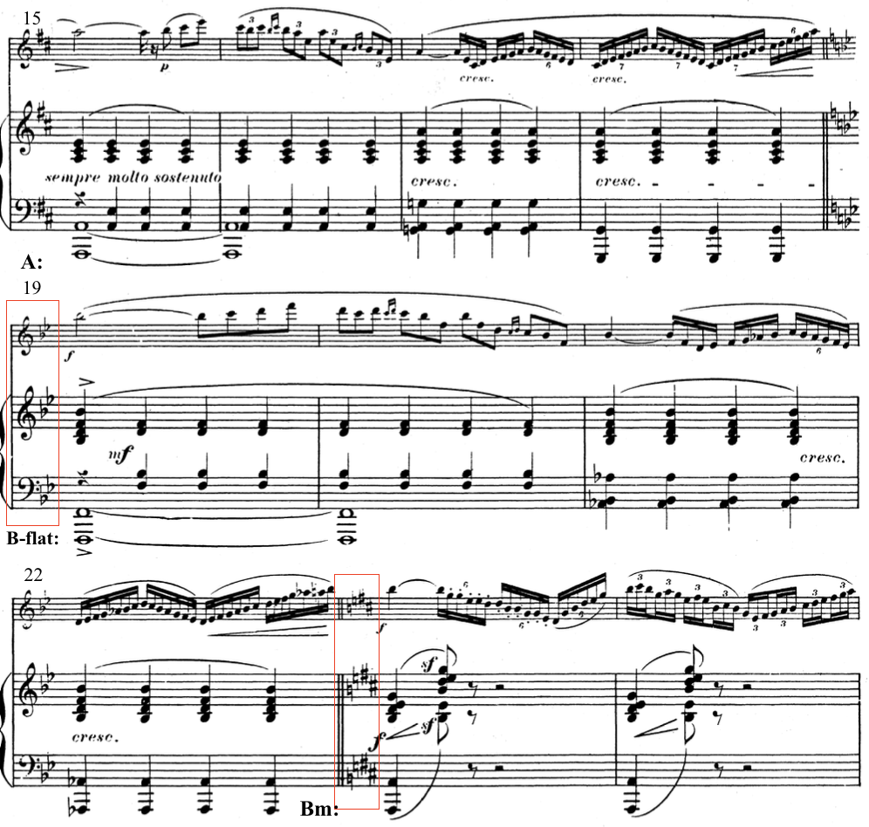
Figure 34 Undercutting of climaxes via modulations/mode mixture.

Chaminade upholds Hatten’s pastoral characteristics by modulating to the flat sixth in the first episode, even as ombra and lament bass topics begin invading the musical texture, as shown in figure 35. The topical changes are consistent with the use of the pastoral as expressive genre, in which the calm serenity of the pastoral is interrupted by tragic elements.
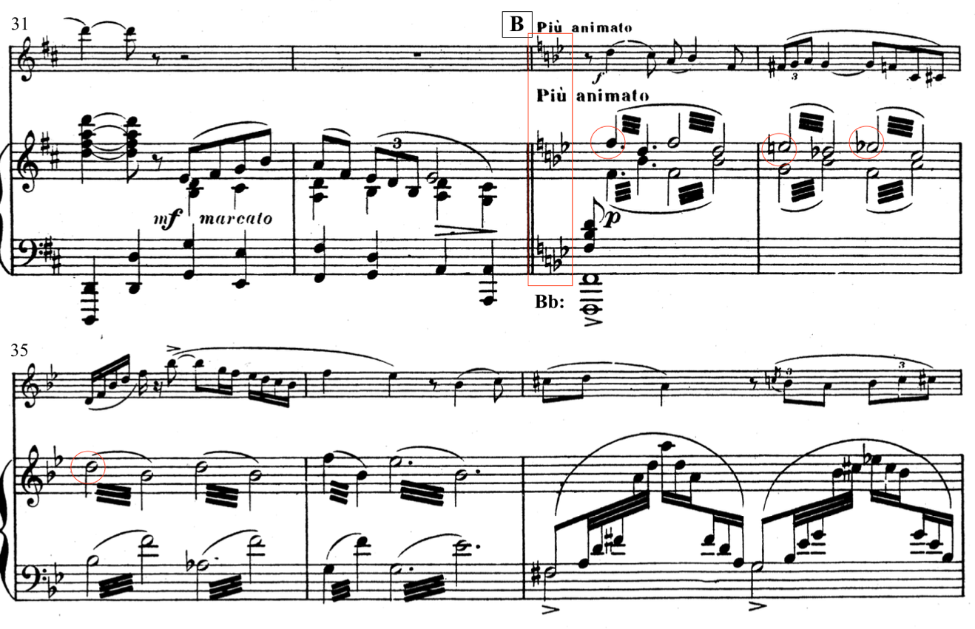
Figure 35 Transition from the pastoral A section to the B section in a major flat key.

Even in the inner A section, in which the primary theme fights for prevalence, the parallel thirds of the pastoral topic remain. The joyful and declamatory nature of the descending tetrachord fades slightly through repeated blocked chords in the piano, the initial presentation in minor-mode, and the failure to ever reach the final pitch of the tetrachord, shown in figure 36.

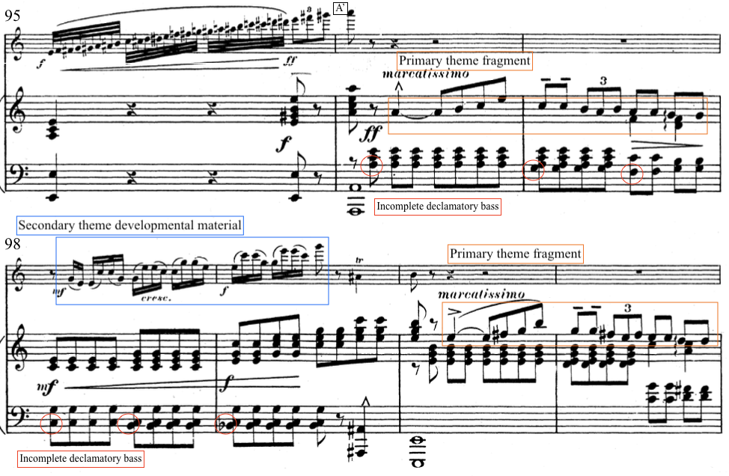
Figure 36 mm. 95-101

The pastoral topic hangs on until the very end of the piece. Subdominant inflections, parallel thirds, and fragments of the primary theme abound through the coda, mm. 136-152. Figure 37 shows the final seven measures in which the jump bass and parallel thirds in the piano lend additional support to the pastoral.
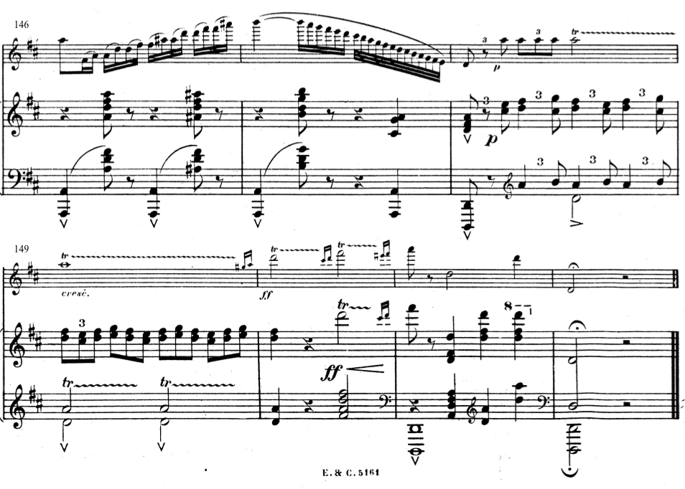
Figure 37 mm. 146-152

Ombra Topic
The ombra topic, first introduced by Leonard Ratner and expounded upon by Clive McClelland in the Oxford Handbook of Topic Theory, generally signals a change in mood to terror, a sense of shadowiness, or approaching fear, and in dramatic contexts may signify the supernatural. Although referencing music from the second half of the eighteenth-century, McClelland argues “by introducing discontinuous elements into the music composers were aiming not only to depict horror but actually to convey an unsettling feeling to the audience, and the use of ombra was therefore highly effective as a rhetorical gesture in symphonies.”
The significance of the ombra topic in Chaminade’s Concertino is that it provides a topical contrast in the episode sections of the modified rondo form. Consistent with the pastoral as an expressive genre, the presence of the ombra topic serves as an indicator of crisis in the otherwise idyllic pastoral landscape. In these sections, the ombra topic also signifies a shift from lyric time sections (i.e. pastoral sections) to narrative time sections. These narrative time sections are significant because of the ways in which they contribute to the narrative of, as well as, the formal progress of the piece. The use of the ombra topic is an essential element of the Pastoral expressive genre’s dramatic structure and contributes to the field of topics that organize the expressive states in the Concertino.
In the Concertino, the ombra topic is signified in several key ways. Its appearance signifies a move to narrative time in which harmonic and phrase structures become more complex. The topic is first marked by the deceptive and unusual modulation to a flat key, in this case, the flatted sixth scale degree of the home-key of the piece (e.g. D-major modulates to B-flat-major). Additional structural elements, including slower harmonic motion, and increased use of diminished seventh chords also evoke the ombra topic. Musical effects, including tremolos, chromatic lament bass, and chromatic step-wise melodies also signify the ombra topic in these contrasting sections.
The B section’s change in character, melody, and harmony all imply a shift in the musical discourse which is affirmed by the application of ombra elements. As shown in figure 38, this shift occurs when the secondary theme enters and the pastoral topic gives way to the ombra topic. Although McClelland indicates that tonal instability is a hallmark feature of the ombra topic, the B section (mm. 33-72) of the Concertino generally commits to the key of B-flat major on a global level. However, local instability within the bass line and the thematized melodic minor second contribute to the ombra affect that permeates the section. Harmonic dissonances arise from the harmonization of the chromatic declamatory bass topic in the piano with a chromatically oscillating flute solo above as seen in Figure 39.
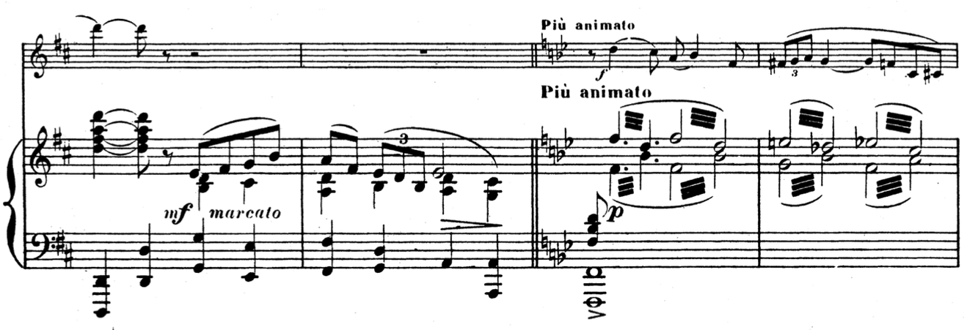
Figure 38 mm. 31-34

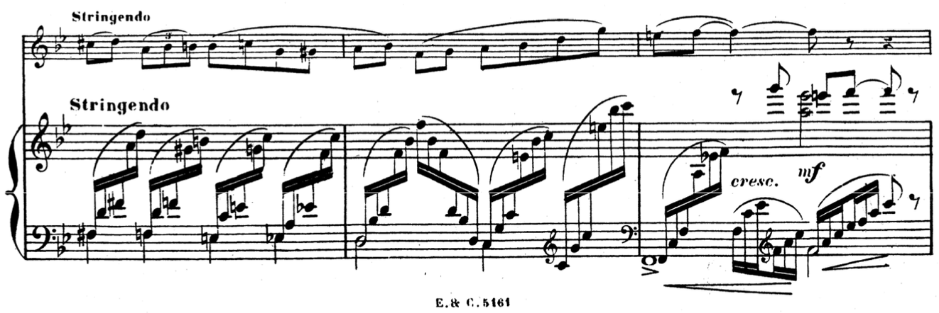
Figure 39 mm. 38-40

Ombra characteristics invade the secondary theme melody that is played by the flute as well. This melody not only descends but is written in the middle and low register of the flute’s range. In addition to the low register, the syncopation and mixture of duple and triple subdivisons contribute to the rhythmic unease of the section created by these ombra charactersitics.
In the C-section, the ombra topic continues to contribute to a general disturbance of the musical texture. Other more general ombra characteristics, like minor mode and dramatic dynamic changes permeate the section and create more tension. These moments are intensified by the troping of the brilliant style in the flute part. Figure 40 shows the transition from the B section into the C-section where the ombra topic’s signifiers change and are troped with the brilliant style.
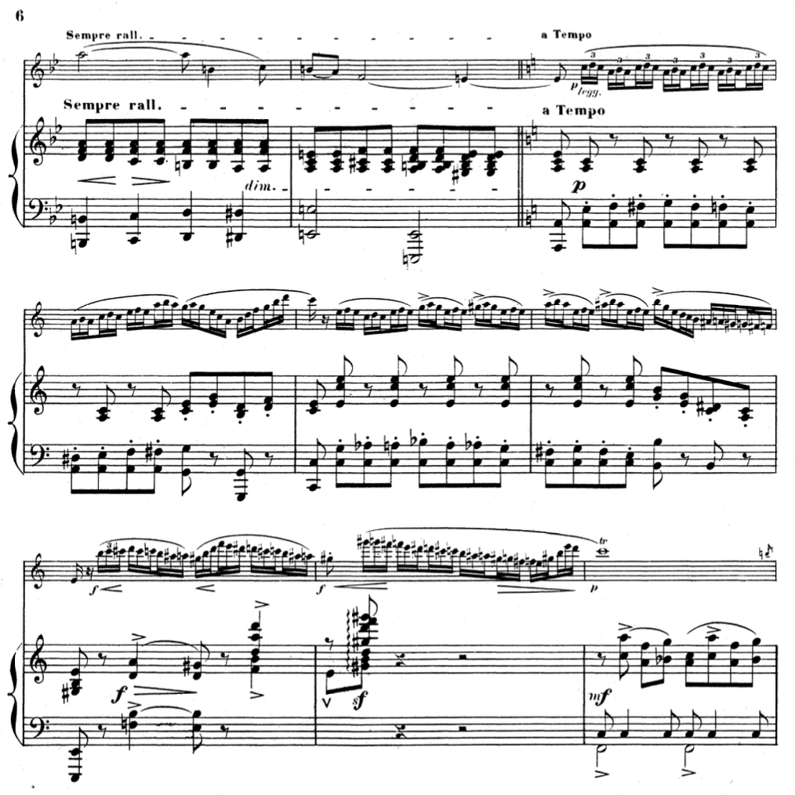
Figure 40 Transition from the B section into the C-section (Vivo) mm. 71-79

A few interesting things happen that are directly related to the use of the ombra topic when the A section returns in measure 96. The diatonic declamatory bass reappears but the major mode does not. This A section is first overcome by the pull of the minor mode that dominated the C-section before it. The primary theme material we do get are all just fragments of it in various minor keys. Meanwhile, these attempts at stating the Primary theme are interrupted by fragments of the Secondary theme in major mode as shown in figure 41. 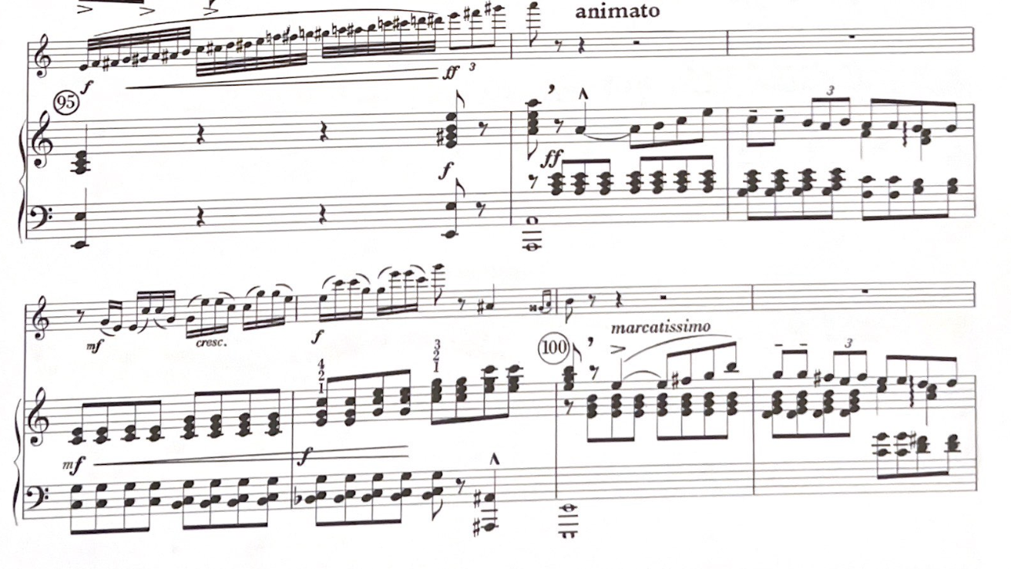
Figure 41 Transition from the C-section into the A'-section, mm. 95-101. Fragments of the Primary theme are shown in the piano in mm. 96-97 and 100-101

By the end of the flute’s cadenza and re-entry into an A section in m. 112, the ombra topic is dispensed with until the coda that begins in measure 136. The shift in discourse first seen in the B section (refer to Figure 41) is ultimately played out here in the Coda in which many different elements undergo a radical shift. In the coda, the distinction between ombra and tempesta characteristics becomes more blurred as they are troped together to create a dramatic ending. The use of augmented chords, bold chromaticism, rapid scale passages, at an agitated, fast tempo signify the ombra topics and their use is quite effective. More fragments of the primary theme in the piano undercut the flute’s attempt at ending the work with a trill and termination. Figure 42 illustrates this dramatic showdown, in which ultimately D-major wins out.
Although the ombra topic is usually signified by a slower, somber tempo, Chaminade uses a faster tempo so that the dramatic effect of the composition continues to build. Despite the lack of explicit supernatural reference in the Concertino, in some cases ombra topic may refer to a more celestial temporality which draws on more of the pastoral allusions Chaminade incorporates into the work. Either way, the effect the ombra topic has on the first episode of op. 107 is jarring, emotionally evocative, and musically dramatic all fulfilled and executed through the topic’s unsettling characteristics.

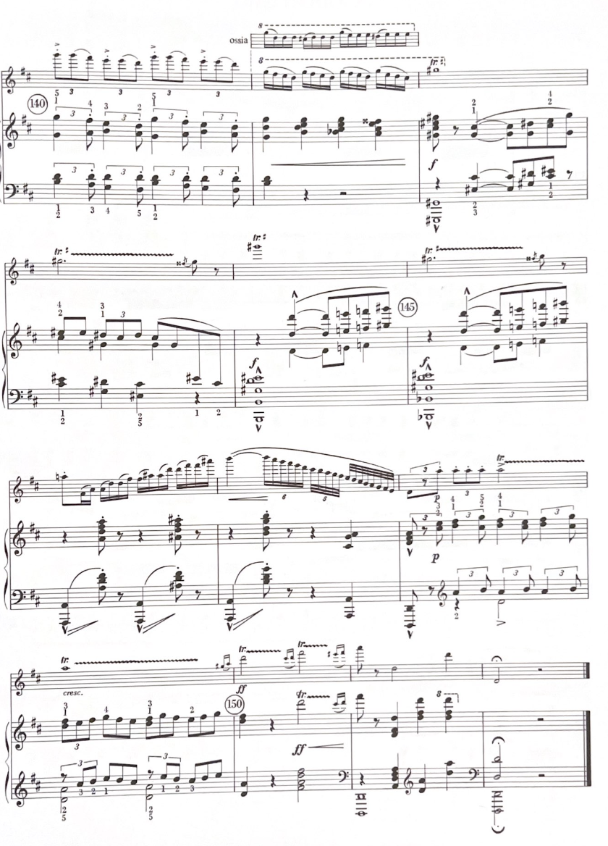
Figure 42 Coda section minus the first four measures (mm. 140-152)

Conclusion: An Alternative Narrative
In 1989, an article was published in the Flutist Quarterly that referenced a story in regard to Chaminade’s Concertino op. 107. In the article, the author wrote the following:
“An interesting story, which may or may not be based in fact, is one concerning Cecile Chaminade’s interest in Gaubert. Chaminade, a woman twenty-two years older than Gaubert, became infatuated with the young debonair flute virtuoso. In a [sic] effort to gain his interest and possible affections, she wrote the now famous Concertino, op. 107 for flute and orchestra or flute with piano accompaniment. It was
selected as the concours piece at the Conservatoire in 1902 and has remained one of
the most popular flute solos to this day.”

The article and story were referenced again the following year in an article by Cécile Tardif that was also published in the Flutist Quarterly. Tardif clears up some of the details surrounding the Concertino, including details on the commission requested by Dubois, as well as the marriage that Chaminade had entered into in 1901, the year before the commission took place. Additionally, Philippe Gaubert graduated from the Conservatoire in 1894 and would not have participated in the concours in 1902.
Nevertheless, the story has taken root amongst flutists and is so often repeated that it has taken on a new role that creates a narrative of unrequited love that is supposedly expressed by Chaminade through the music. As a result, Chaminade’s most famous work and reputation rests on a false narrative that only serves to diminish her beautiful and clever composition to a love story. And after all, how many young flutists can relate to a story of unrequited love?
The Concertino, op. 107 by Chaminade is not going anywhere anytime soon for flutists because it is so well established in the standard repertoire, however, agency can be given back to Chaminade if there is perhaps another story to go along with the work. Rather than basing the story off of rumors, a narrative can be supported and signified by particular musical elements that trigger clear associations with styles, genres, and expressive meanings.
The narrative I propose ties into the way teachers use this piece to help a flutist find their own voice. Instead of using Chaminade as the subject of the narrative, I propose the flutist centers themself as the subject, or the narrator of their own story. The pastoral is so often used to signify a retreat to an idealized state, this retreat turned inward in the Romantic era in ways that it makes more sense to center oneself in the story. Tragic irruptions that disturb the pastoral evoke troubles that all musicians encounter in their development. For the students that can’t yet relate to a story of unrequited love, I offer a narrative that fits their own personal artistic journey.
In the Concertino, the pastoral as a genre governs the expressive states of the rondo form which I use to affirm this narrative. The pastoral A sections signify the idyllic state we return to when we are at peace with our instrument and ourselves. We relax, even luxuriate, in the singing, diatonic melody that shows off all of the best features of the instrument’s voice. We find comfort in the ease of the scale patterns and subtle ornaments of the melody. The B and C sections bring out conflict through sudden changes to ombra and brilliant style topics. For an artist developing their voice, these sections signify the outside forces that negatively affect our performance. When we leave the safety of our practice rooms and put ourselves into the world.
The declamatory bass that introduces the piece and begins the first A section signals to the flutist that everything is well. They can sing their song and nothing is in their way. Through key changes, they are secure and confident with their voice. In the second A section, there’s a loss of confidence. Bits of the primary theme are there but become obfuscated by piano interjections repeating the same thing, or even the flutist deviating into secondary theme fragments. In the cadenza, they begin to reassert themself more readily. The return of the primary theme in the final refrain seems subdued but in reality, any doubt has been shed and peace has returned.
The crises signified by the ombra and brilliant topics, combines with a shift to narrative time in the B and C sections. The technique required to execute these sections could trip up even the most seasoned player and the sparse piano does nothing to cover up technical deficiencies. The inner sections are where the flutist must fight or take flight. Undulating tremolos and lament bass topics abound so that any hint of weakness could lead to disaster. This is the moment: the audition, the competition, the recital, etc. it all leads up to this.
As the piece develops, so too does the flutist. Each return of the refrain reaffirms their journey is the right one. Eventually, the technical demand subsides, the primary theme returns, and all is well. By the time they reach the coda, the flutist is so sure of themselves that even an A-sharp won’t throw them off.

References
Caplin, William. “Topics and Formal Functions: The Case of the Lament,” in The Oxford
Handbook of Topic Theory, edited by Danuta Mirka, 415-452. Oxford: Oxford
University Press, 2014.

Chaminade, Cécile. “How to Play My Best Known Pieces,” The Etude, 26 no. 12,
December 1908, 759.

Citron, Marcia. Cécile Chaminade: A Bio-Bibliography. New York: Greenwood Press,
1988.

Dineen, Murray. “The Tonal Problem as a Method of Analysis.” Theory and Practice 30
(2005): 69-96.

Fischer, Penelope. “Philippe Gaubert: French Musician Extraordinaire.” The Flutist
Quarterly 14, no. 3 (Summer 1989), 17-24.

Hatten, Robert. Musical Meaning in Beethoven: Markedness, Correlation, and
Interpretation. Indiana: Indiana University Press, 2004.

Hatten, Robert. Interpreting Musical Gestures, Topics, and Tropes: Mozart, Beethoven,
and Schubert. Bloomington: Indiana University Press, 2004.

McClelland, Clive. “Ombra and Tempesta in The Oxford Handbook of Topic Theory,
edited by Danuta Mirka, 279-300. Oxford: Oxford University Press, 2014.

Monelle, Raymond. The Sense of Music: Semiotic Essays. New Jersey: Princeton
University Press, 2001.

Monelle, Raymond. The Musical Topic: Hunt, Military and Pastoral. Bloomington:
Indiana University Press, 2006.

Tardif, Cécile. “Cécile Chaminade and the Concertino, op. 107” Flutist Quarterly vol. 15,
2 (Spring 1990), 20.

Marcia J. Citron, Cécile Chaminade: A Bio-Bibliography (New York: Greenwood Press, 1988), 3.
Ibid., 4.
Ibid.
Ibid., 5.
Ibid.
Ibid., 8.
Citron, Bio-Bibliography, 9.
Ibid., 11.
Prior to Paul Taffanel’s tenure as professor of flute from 1893-1908, concours pieces were usually composed by the professor of the instrument. During Taffanel’s tenure as professor, he began to commission concours pieces from other composers.
Citron, 14.
Ibid., 18.
Ibid., 19.
Citron, 21.
The Concertino, op. 107 and Sérénade aux Étoiles, op. 142 are Chaminade’s only compositions for flute and piano.
Cécile Chaminade, “How to Play My Best Known Pieces,” The Etude, 26 no. 12, December 1908, 759.
The Etude, 758.
Ibid. 759
Ibid., 759.
Murray Dineen, “The tonal Problem as a Method of Analysis,” Theory and Practice 30 (2005): 70.
Robert Hatten, Musical Meaning in Beethoven: Markedness, Correlation, and Interpretation (Indiana: Indiana University Press, 2004), 92.
Ibid., 96.
See pg. 53 for definition of the ombra topic.
Raymond Monelle, The Sense of Music: Semiotic Essays (New Jersey: Princeton University Press, 2001), 256.
Caplin, William E., “Topics and Formal Functions: The Case of the Lament,” in The Oxford Handbook of Topic Theory, ed. Danuta Mirka (Oxford: Oxford University Press, 2014), 415.
Ibid., 417.
Monelle, Raymond. The Musical Topic: Hunt, Military and Pastoral. (Bloomington: Indiana University Press, 2006), 185.
Ibid., 186.
Ibid., 189.
Hatten, Robert. Interpreting Musical Gestures, Topics, and Tropes: Mozart, Beethoven, and Schubert. (Bloomington: Indiana University Press, 2004), 56.
Hatten, Interpreting, 56. Sharp musical oppositions include parameters of: mode, key, theme, topic, texture, meter, tempo, and style.
Hatten, Interpreting, 56.
McClelland, Clive. “Ombra and Tempesta,” in The Oxford Handbook of Topic Theory, ed. Danuta, Mirka (Oxford: Oxford University Press, 2014): 279.
Ibid., 280.
The brilliant style is characterized by rapid passages for virtuosic display. It’s often invoked in contrast with the singing style. As it is here in the Concertino, the singing style applies to the Primary theme, which is then cast into contrast with the Secondary theme, or the virtuosic developmental passage in the C-section.
Penelope Fischer, “Philippe Gaubert: French Musician Extraordinaire.” The Flutist Quarterly vol. 14, 3 (Summer 1989), 18.
Cécile Tardif, “Cécile Chaminade and the Concertino, op. 107” Flutist Quarterly vol. 15, 2 (Spring 1990), 20.

