University of Oklahoma

Graduate College

Assessment of Learning Through Reflecting on Doing

A thesis

submitted to the Graduate Faculty

in partial fulfillment of the requirements for the

Degree of

Master of Science

By

Jackson lyall autrey
Norman, Oklahoma
2019

Assessment of learning through reflecting on doing

A thesis approved for the
School of Aerospace and Mechanical Engineering

By

Dr. Farrokh Mistree, Co-Chair

Dr. Zahed Siddique, Co-Chair

Dr. Thomas L. Landers

© Copyright by Jackson lyall autrey 2019
All Rights Reserved.

This thesis is dedicated to my parents, Allen and Crystal Autrey, whose support has been unfaltering and enthusiastic, even when it was not easy to give it.

Acknowledgements
I acknowledge the support of my wife, Jennifer M. Sieber, who has supported me both throughout my research as both a partner and a colleague. Without her, none of this would be possible.
I am grateful for the support of Professors Farrokh Mistree and Zahed Siddique. Their mentorship and support continue to both guide and inspire me.
Additionally, I appreciate Dean Thomas Landers for serving as a member of my thesis committee and providing significant direction.
Finally, I am grateful to the University of Oklahoma’s School of Aerospace and Mechanical Engineering and the Dolese Teaching Fellowship for their longstanding and gracious financial support.

Table of Contents
Acknowledgements v
Table of Contents vi
List of Tables x
List of Figures xi
Abstract xiii
Chapter 1. Gaps in Design, Build, and Test 1
1.1 Problem Statement 2
1.2 Research Questions 3
1.2.1 Primary Question 3
1.2.2 Research Questions 3
1.3 Structure of AME4163 5
1.3.1 Assessment in AME4163 8
1.3.2 Course Features 12
1.3.3 AME4163 During Fall 2015 and 2016 14
1.4 Research and Analysis Methods 15
1.4.1 Assessment strategies and Tools 16
1.4.2 Proposed Assessment Instruments 17
1.4.3 Methods to Address the Research Questions 18
1.5 Thesis Outline 18
Chapter 2. Critical Literature Review 22
2.1 Foundations of AME4163 22
2.2 Pedagogical Approach 26
2.3 Literature Gaps Regarding Assessment in Engineering Design Education 28
2.4 Need for Improved Forms of Self-Assessment 31
2.5 Methodological Literature 34
2.6 Implications for Research 37
Chapter 3. Gaps in Assessment of DBT Students: AME4163 in Context 39
3.1 Problems with Traditional Assessment in DBT 39
3.2 Verification of Problems in AME4163 42
3.2.1 LS Data from Fall 2015 42
3.2.2 Fall 2015 LS Data Versus Course Performance 46
3.3 Summary of Assessment Gaps 50
Chapter 4. Exploration of Domains of Learning in AME4163 53
4.1 Modifications to Self-Assessment Between 2015 and 2016 54
4.2 Domains of Learning in AME4163 55
4.2.1 Individual LS Data 55
4.2.2 Team LS Data 59
4.2.3 Overview of Learning Areas 61
4.3 Student Confidence in AME4163 62
4.3.1 MII ‘Current Status’ 62
4.3.2 MII ‘Moving Forward’ 65
4.3.3 Relationship Between Student Course Performance and Confidence 67
Chapter 5. Team Versus Individual Learning 80
5.1 DBT Course Project in AME4163 80
5.2 Analysis of LSs by Assignment in AME4163 – Standard Approach 81
5.2.1 Areas of Student Learning 82
5.2.2 Patterns in Student Versus Team Learning Over Time 85
5.3 Analysis of LSs by Assignment in AME4163 – Text Mining Approach 88
5.3.1 Patterns in Areas of Student Learning by Keyword 89
5.3.2 Word Frequency Comparison Over Time 90
Chapter 6. Development of Student Insight 94
6.1 Development of Student ‘Insight’ Over Time 96
6.2 Word Frequency Patterns Across Insightfulness 100
Chapter 7. Closure 105
7.1 Findings Regarding the Research Questions 106
7.1.1 RQ1: Discrepancies in Conventional Assessment 106
7.1.2 RQ2: Evaluating Novel Assessment Forms 109
7.1.3 RQ3: Individual versus Team Learning 112
7.1.4 RQ4: Student Learning Changes over Time 114
7.1.5 RQ5: Features of Student Insight 116
7.2 Principal Findings 118
7.3 Limitations in the Proposed Framework 120
7.4 Assessing Research Limitations and New Questions 121
7.5 Doctoral Dissertation Proposal 123
7.5.1 Doctoral Dissertation Proposal Summary 123
7.5.2 Proposed Research Questions, Hypotheses and Tasks for PhD Dissertation 127
7.5.3 Rationale for Admittance to the Interdisciplinary Doctoral Program of the Graduate College 129
7.5.4 Proposed Course Plan 131
7.5.5 Proposed Doctoral Dissertation Reading Committee 132
Chapter 8. Statement of personal growth 134
8.1 Research Takeaways 134
8.2 Personal Takeaways 137
References 141
Appendix A: Fall 2018 AME4163 Course Booklet 148

List of Tables
Table 1.1. Map of Target POED to Course Assignments 6
Table 1.2. Diagram of Learning Statement Structure 9
Table 1.3. 'Current Status' Section Questions of the MII 11
Table 1.4. 'Moving Forward' Section Questions of MII 12
Table 4.1. Number of Observations Per Treatment Level for MII: I and V 72
Table 4.2. ANOVA Results for Confidence Level on Grades 74
Table 4.3. ANOVA Results for Start and End Confidence Levels on Grades 74
Table 4.4. Tukey HSD test for Start/End Confidence Effect on Device Grade 75
Table 4.5. Kruskal-Wallis Results for All Questions on MII: I-V 77
Table 7.1. Doctoral Dissertation Questions, Hypotheses, and Tasks 128
Table 7.2. Doctoral Dissertation Course Plan 131

List of Figures
Figure 1.1. Course Schedule for Lectures and Assignments 7
Figure 1.2. Entity-Relationship Diagram for Individual LS Database 14
Figure 1.3. Connections Between Research Questions, Chapters, and Data Analysis 18
Figure 3.1: Learning Domain Breakdown for Individual LS in Assignments 1-5 44
Figure 3.2: Learning Domain Breakdown for Team LS in Assignments 1-5 44
Figure 3.3(a)-(e). Regression of Number of Total Team LSs v. Team Assignment Grade for Assignments 1-5 47
Figure 3.4. Regression Analysis for Individual SLE Grades v. Course Grade 49
Figure 4.1.(a) Histogram of Terms from Individual LS in 2016 with Frequency > 150; (b) Cluster Diagram of Individual LS Terms 56
Figure 4.2. Bar Plot of 2016 Individual LS from A1-5 Sorted by POED 57
Figure 4.3(a)-(e). Word Clouds of Frequent Terms in 2016 LS 58
Figure 4.4. (a) Histogram of Team LS with Frequency > 20; (b) Cluster Diagram of A1-5 Team LS; (c) Bar Plot of 2016 Team LS Sorted by POED 60
Figure 4.5(a)-(e). Word Clouds of Frequent Terms in 2016 Team LS 61
Figure 4.6. (a) MII 'Current Status' Questions 1 and 2; (b) MII 'Current Status' Questions for POED 1a, 1b, 1c, and 1d 63
Figure 4.7. (a) Radar Plot of Median Student Response, Question to Question; (b) Radar Plot of Median Student Response, Survey to Survey 66
Figure 4.8. Histograms of (a) Device Performance Grade and (b) Overall Course Grade 69
Figure 4.9(a)-(e). Correlation Matrices for MII 'Moving Forward': I-V 70
Figure 4.10. Interaction Plot of Start and End Confidence Level on Device Grade 76
Figure 5.1. Bar Plots of 2016 LSs Broken Down by POED and Sub-POED 83
Figure 5.2. Pie Charts of Team and Individual LS POED by Assignment 88
Figure 5.3. (a) Histogram of Terms from Individual LS from A1-5 with Frequency > 150; (b) Cluster Diagram of Terms from Individual A1-5 LS 89
Figure 5.4. Histogram of Terms from Team LS from A1-5 with Frequency > 20; (b) Cluster Diagram of Terms from Team A1-5 LS 90
Figure 5.5(a)-(e). Word Clouds of Frequent Terms in 2016 Individual LS 91
Figure 5.6(a)-(e). Word Clouds of Frequent Terms in 2016 Team LS 93
Figure 6.1. Stacked Bar Chart of Individual LSs by Rating and Assignment 97
Figure 6.2. Stacked Bar Chart of Team LSs by Rating and Assignment 98
Figure 6.3(a)-(c). Histograms of Most Frequent Terms from A1-5 Team LSs by Insight Level 101
Figure 6.4(a)-(c). Histograms of Most Frequent Terms from A1-5 Individual LSs by Insight Level 103
Figure 8.1. Personal Message from the Author 140

Abstract
Over the past two decades, an emerging educational framework called ‘experiential learning’ has come to prominence in numerous fields, including medical and instructional education. Experiential learning, in contrast to rote or didactic learning, requires that the learner grapple with the various aspects of an authentic problem, engaging with the interconnected facets of the problem context, constraints, needs, and other components. This approach to learning is heavily anchored in the work of David Kolb, who posits that learning is a cyclical process in which the subject takes part in some experience, reflects on that experience, abstracts lessons identified in that reflection, and integrates the new knowledge in such a way that they may then experiment with the new framework. It is contended in this thesis that an opportunity exists to better incorporate this framework in engineering design education to enable engineering students to be more conscious, deliberative learners.
In two sections of the course AME4163: Principles of Engineering Design, given in Fall 2015 and 2016 at the University of Oklahoma, the learning paradigm of “learning through reflection on doing” is embraced as the method by which students, referred to in the course as junior engineers, internalize five principles of engineering design (POED). As the students engage with the design project for the semester, they complete a series of assignments with two integrated assessment instruments, the learning statement (LS) and the material internalization inventory (MII), designed to stimulate the reflection and abstraction stages of learning identified in Kolb’s learning cycle. In this thesis, the focus is on this approach to experiential learning, in conjunction with the aforementioned assessment instruments, will enable engineering design instructors to produce graduates capable of meeting the challenges of a changing engineering landscape.
Farrokh Mistree points out in his editorial for the Journal of Mechanical Design titled “Strategic Design Engineering: A Contemporary Paradigm for Engineering Design Education for the 21st Century?” that increasing complexity in engineered systems and the environments in which they are designed is prompting a need for graduates who are prepared to adapt to changing circumstances. Competence in this area requires that engineers have the ability to reflect on new information to abstract value. It is in this domain of learning that the experiential learning construct may be of most value to current and future students. Unfortunately, though experiential learning has taken root in some engineering design programs, instructors teaching such courses tend to focus on output rather than student learning. It is common practice in engineering design education for instructors of DBT courses to implement assessment strategies in which they focus on the end products of student designs: devices designed and built, programs written, results obtained, and more. In this thesis, the case is made that student learning outcomes are improved when instructors de-emphasize the importance of product “success” and instead focus on the learning acquired through the process of design itself. Furthermore, of central importance is the contention that requiring students in engineering design courses to focus on their learning process produces engineering graduates more likely to succeed in today’s engineering environment.
Consequently, the following research question guiding the described research efforts in AME4163 is offered:
In the context of an experiential learning engineering design, build, and test course, what are the curriculum, strategies for assessment, and tools that instructors can employ to motivate students working in team settings to learn by reflecting on doing and how can instructors characterize and assess that learning?
Implicit in this question is the notion that engineering students, in practicing design, learn as a byproduct of reflection on their lived experiences. This is what is implied by the phrase “learn by reflecting on doing.” From the instructor’s need to assess this learning through reflection on doing is where this document obtains its title. Consequently, addressing this question is valuable in at least two areas: scholarly efforts to facilitate student learning in experiential settings and efforts within mechanical engineering capstone programs to produce graduates capable of meeting new industry challenges. Essential to the latter notion is the idea that graduating engineers must be capable of adapting and speculating on new competencies for themselves. It is also hoped that addressing the proposed research question and developing the necessary tools and assessment strategies will provide others with potential strategies that they might employ in similar types of design courses. Specifically, outcomes of this thesis include:
- Practical alternative assessment methods used by the instructors in the Fall 2015 and 2016 iterations of the course AME4163: Principles of Engineering Design
- A detailed framework for organizing and implementing novel self-assessment to enable engineering students to develop critical competencies
- A comprehensive course rubric, in the form of a booklet for students, mapping the pedagogical goals to the course activities to enable connectivity
It is hoped that the research outlined in this thesis will serve both engineering design educators and researchers as a roadmap for scaffolding their courses to enable students to develop the ability to adapt through learning by reflecting on doing. As this thesis contains both a framework for such courses and a thorough guide for the use of particular assessment strategies and tools, it thus may serve in a practical capacity. Further, remaining and newly-identified questions are leveraged into a proposal for a doctoral dissertation in which they will be pursued in greater detail so as to broaden the scope of this work.

Chapter 1. Gaps in Design, Build, and Test
The principal motivation for this work arises from the question “in the context of an experiential learning engineering design, build, and test course, what are the curriculum, strategies for assessment, and tools that instructors can employ to motivate students working in team settings to learn by reflecting on doing and how can instructors characterize and assess that learning?” In service to addressing that question, research is undertaken wherein data, collected from students undergoing a scaffolded design process grounded in existing pedagogy, is analyzed. Further, motivation arises from the rising need for engineers capable of working on diverse teams, to design and build complex systems, using rapidly-changing technology, and often working in conjunction with geographically-distributed peers. In short, the need to provide opportunities to junior engineers to develop the ability to adapt through critical self-reflection drives this work. In Chapter 1, this motivation is established alongside presentation and discussion of the specific curriculum, assessment strategies, and tools used in the underlying research so as to better frame the problem explored in the current work. Further, the course in which the current work is anchored, AME4163: Principles of Engineering Design, a senior-level engineering design, build, and test (DBT) course offered in the School of Aerospace and Mechanical Engineering at the University of Oklahoma, is described and outlined. Finally, the assessment instruments, including the learning statement (LS) and the Material Internalization Inventory (MII), that are utilized in this work and their role as both a tool of assessment and a tool to enable student learning are outlined and described.

1.1 Problem Statement
In this thesis, the problem for consideration is how instructors can better assess student learning in engineering DBT courses in which student learning through reflection on doing is the focus. In particular, the problem is addressed in the context of the identified need for engineering graduates able to adapt to rapidly-changing situations, complex systems, and emerging technologies. Principally, the concern is with the problem of how instructors can enable students to develop this competency as part of their university engineering education. This problem is divided into four components:
- Problems regarding the utility of traditional measures of student evaluation at assessing student learning.
- Challenges in using conventional assessment tools to assess specific areas of student learning in design courses.
- Issues regarding the tools available to assess individual student learning in team-based project contexts.
- Challenges instructors face in tracking student internalization of course principles over the length of the design project.
These identified problems are more formally justified in Chapter 2, through evaluation of the relevant literature and in Chapter 3, where the existence of several of these problems is verified using data collected from the Fall 2015 semester of AME4163. Using these problems as a starting point, the particular research questions to be addressed in this work are outlined in the following section.

1.2 Research Questions
In this section, the research questions addressed in this work are formally outlined. These research questions are posed in such a way that the primary issue (how instructors can enable students to learn how to adapt to changing circumstances in modern engineering practice) is related to the educational framework of particular portions of their design education. Consequently, in this thesis, the goal is that, through outlining and addressing the specific research questions in relation to the primary question, the primary question may be fully addressed and a framework for mechanical engineering DBT courses is proposed.

1.2.1 Primary Question
The primary research question for this study is posed as follows:
In the context of an experiential learning engineering design, build, and test course, what are the curriculum, assessment strategies, and tools that instructors can employ to motivate students working in team settings to learn by reflecting on doing and how can instructors characterize and assess that learning?
In the context of this question, particular research questions whose answers will enable the overarching question to be addressed are outlined in the following section.

1.2.2 Research Questions
In Section 1.1, the primary problem addressed in this work is outlined and divided into four components. From these four sub-problems are derived the research questions that, when answered, enable the primary research question to be answered. Given this, five associated research questions are posed as follows:
- RQ1: What discrepancies in student internalization of course material due to outcome-focused methods of student assessment such as device performance, technical analysis, and quality of written assignments does learning statement data from Fall 2015 reveal?
- RQ2: What differences can be inferred from the relative changes in student internalization of engineering design principles from the LS and competency survey data from two sections of AME4163 and what do those differences say about the utility of the two assessment instruments as measures of student learning?
- RQ3: How can the introduction of reflective exercises such as the learning statement be used to discern between individual and team-level internalization of the POED in the context of group activities such as assignments?
- RQ4: For students on teams working on a design, build, and test project, how can the learning statement and individual surveys be used to gauge how student learning changes over the course of a design experience and how does this process impact student internalization of material?
- RQ5: How can LS data be used to derive knowledge regarding student development of strong insight and what are the features of that insight when it takes place?
With the problem stated and research questions outlined, it is now time to move on to the discussion of the course that serves as the testbed for this work. As this work fundamentally relies on understanding the process of student learning taking place in the context of an engineering DBT course and as using that understanding to create tools with both research applications and educational benefits is the goal, it is critical that properly outlining the environment in which data are collected is done.

1.3 Structure of AME4163
At the University of Oklahoma, senior-level mechanical engineering students are exposed to the process of design through an engineering design course in the semester preceding their Capstone design project. In the course, AME4163: Principles of Engineering Design, experiential learning is leveraged to enable students to internalize the Principles of Engineering Design (POED) and to transition from students to Junior Engineers, who are distinguished from students by their ability to identify new principles to suit their needs.
In AME4163, students form their own teams of four or five to complete a design challenge issued by the instructors: two professors and a teaching assistant. Over the course of the design project, the teams are required to complete a series of assignments, each tied to one or more of the five POED, embodying the steps of a structured design process. To ensure exposure to all POED and their subcategories, students are provided with Table 1.1, in which the POED are mapped to the assignments. This map represents a significant overarching organizational structure in the course and is used as both a tool for students and researchers. Instruction is provided through lectures that are tied to the assignments to enable further internalization of the POED. Moreover, context and additional tools are provided through the lectures that the students can leverage in their projects and beyond. Progression of the course through assignments, lectures, and major course milestones is mapped in the timeline presented in Figure 1.1.
Table 1.1. Map of Target POED to Course Assignments
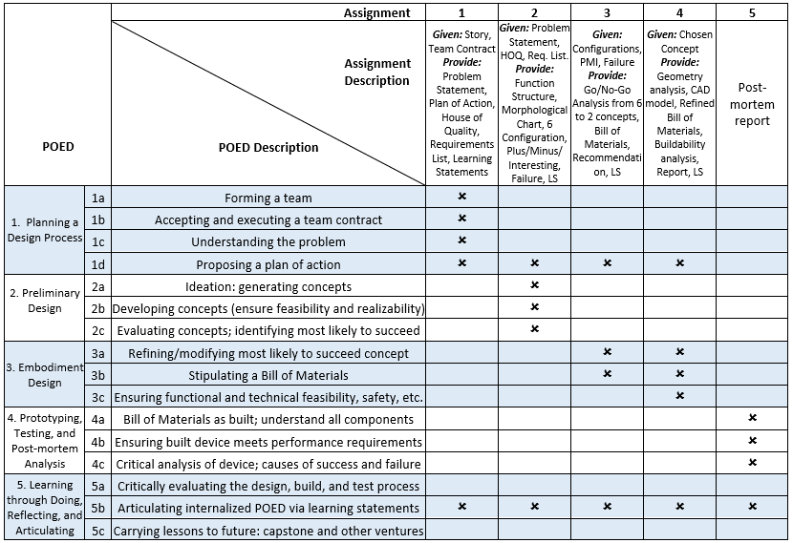

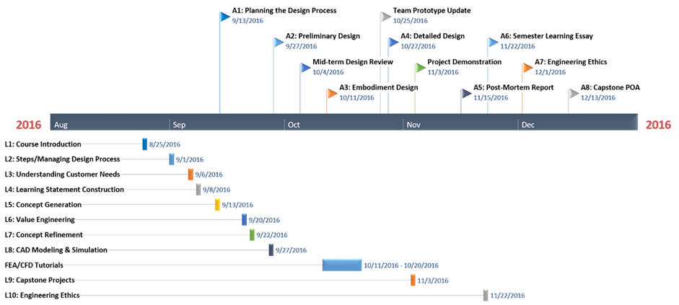
Figure 1.1. Course Schedule for Lectures and Assignments

Teams use the assignments to complete the design problem titled “Project POP: Prospect or Perish,” a project and context borrowed from Mistree et al. [1]. In the vignette, the fictional inhabitants of the planet Vayu need an autonomous mobile device capable of navigating rough terrain to prospect and drill for subterranean natural resources. Given the problem context, students are required to form teams, frame the problem requirements, design and test a device capable of traversing a course of our own construction, and finally perform a post-mortem reflection on their design experience.
In AME4163, David Kolb’s experiential learning cycle [2] is foundational to the design, build, and test course. It is held as true in this work that the structure of an open design problem provides unique opportunities to enable students to reflect and articulate their own learning. To enable this reflection, students engage with two self-assessment instruments. First, students are required, in lectures and in each assignment, to write learning statements (LSs), in which they describe the utility of lessons acquired through experience. Second, the students must complete five surveys, titled the Material Internalization Inventory (MII), in which they reflect on their confidence in their ability to apply knowledge in the short- and long-term. In keeping with the focus on assessing learning through reflection on doing, the importance of project output is deemphasized to the students. Instead, it is made clear in the course lectures and grading rubrics that the instructors’ interest is in seeing the students demonstrate learning and growth. These self-assessment instruments are elaborated upon in the following sections.

1.3.1 Assessment in AME4163
Given that the stated goal in AME4163 is to motivate students to become active learners, it is imperative that they are enabled to become conscious of their learning through reflection on doing. Pedagogically, this is derived from Kolb’s experiential learning cycle [1]. Practically, this approach takes the form of two instruments called the Learning Statement (LS) and the Material Internalization Inventory (MII).

The Learning Statement
In AME4163, a student self-assessment instrument called the learning statement (LS) is employed to enable students to engage with the steps embodied in Kolb’s experiential learning cycle: have an experience, reflect on it, abstract learning, and integrate the new knowledge. Over the course of the design project, in both assignments and lectures, students and teams are required to write LSs to express their learning in the context of particular experiences. The LS structure, outlined in Table 1.2, is strictly required and its purpose is explained in early course lectures.
Table 1.2. Diagram of Learning Statement Structure
Experience x | Learning y | Value/Utility z
Through x (From x, By doing x, …) | I learned y
I did not consider x initially | I realized y | Value/Utility z in future of learning y
I thought (expected) x before/initially | I found out y | Value/Utility z in future of learning y
 | I discovered y
 | I became conscious of y
Value (Lectures) = Help you transition from a student to a junior engineer and gain insight into how to do the assignments
Value (Assignments) = Principles of Engineering Design

During lectures, students are encouraged to tie their learning to value related to their later work as Junior Engineers. For LSs submitted with assignments, students are encouraged to explore the value of their learning in terms of their internalization of the POED. Further, a particular number of LSs in each assignment for each individual, is not specified; what is required is only that each team member write at least one and that the team as a whole write at least one.
Over the course of a semester, the approximately 150 students and their teams generate between eight and ten thousand LSs. During the course, LSs are evaluated in order to provide feedback to the students so as to encourage deeper reflection and wider exploration of the utility of their learning. For analytical research purposes, a two-pronged evaluation method for the LSs has also been developed. The first portion of the evaluation of each LS involves identifying the primary associated POED of the learning expressed in each statement, labelling each LS with a POED sub-category such as ‘1a’ or ‘4c’ (see Table 1.1). In the second portion of the evaluation, each LS is categorized by ‘insightfulness,’ a metric describing the degree to which future value has been outlined and the rubric for which is provided to each student. In reading each LS, rating it using the two-pronged method, and providing individual feedback to students, instructors find that a grader can spend between five and ten hours grading the LSs from a single assignment from one course section. The time-consuming nature of this evaluation is part of the impetus for the text mining approach to analyzing the learning statement that is discussed in Section 1.3.2 and cited extensively in Chapters 4-6.

The Material Internalization Inventory
The second self-assessment instrument that is employed in AME4163 takes a very different form from the LS. A series of five surveys, titled the ‘Material Internalization Inventory’ (MII), has been developed that are comprised of two sections designed to assess student confidence in their abilities to leverage knowledge in the short and long-term. In the first section, titled ‘Current Status,’ students assess their confidence in their ability to utilize certain design skills in the next phase of the project. A preamble prompts the students to think of the applicability of their knowledge in the short term and ask them to rate a series of statements using a five-point interval scale, where ‘1’ represents strongly disagree with the statement and ‘5’ represents strongly agree with the statement for the student. As the ‘Current Status’ section is tied to short-term applicability of their knowledge, the assessed statements change from survey to survey. The statements in this section of the MII are listed in Table 1.3 with the bold phrase following each serving as the question shorthand for used in later figures.
In the second section of the survey, students are asked to assess their agreement with ten statements tied to particular knowledge of design using the same five-point Likert scale as the first section. As in the first section of the survey, a preamble prompts the students completing this section to consider how their knowledge may be applied in the long-term (capstone, their careers, etcetera). Unlike in the first section, however, these ten statements do not change from survey to survey. The ten statements that we employ in this section of the survey are listed in Table 1.4 with the bold phrase following each serving as the question shorthand for use in charts.
Table 1.3. 'Current Status' Section Questions of the MII
Survey | ‘Current Status’ MII Questions
(All) | - I understand what is being asked of me in the most recent assignment and how that material is connected to the previous work in the course (connectivity)  - I know why previous feedback has been provided to me and/or my team regarding the work that we have completed and how that feedback fits into the overall intention of the assignment (feedback)
1 | - I understand the importance of forming a team in order to complete Assignment 1 (POED 1a) (team)  - I understand the utility to team management of the team contract in order to complete Assignment 1 (POED 1b) (management)  - I recognize the role of forming a team understanding of the problem in order to complete Assignment 1 (POED 1c) (problem)
2 | - I understand the importance of forming a team in order to complete Assignment 1 (POED 1a) (team)  - I understand the utility to team management of the team contract in order to complete Assignment 1 (POED 1b) (management)  - I recognize the role of forming a team understanding of the problem in order to complete Assignment 1 (POED 1c) (problem)  - I understand the utility of proposing a plan of action in the design process (POED 1d) (plan)  - I understand the importance of the morphological chart in the process of concept generation as seen in Assignment 2 (POED 2a) (morph.chart)  - I understand the importance of ensuring concept functional feasibility via Plus, Minus, Interesting in Assignment 2 (POED 2b) (plus-minus-interesting)  - I understand the importance of evaluating concepts to determine the most likely to succeed concept in the design process (POED 2c) (concept-eval.)
3 | - I understand the utility of proposing a plan of action for the design process (POED 1d) (plan)  - I understand the importance of technical evaluation of concepts (analysis, experimentation, thought exercises) in order to refine them such as through the Go/No-Go matrix in Assignment 3 (POED 3a) (go/no-no)  - I understand the need to stipulate a Bill of Materials during the concept refinement phase of the design process (POED 3b) (bill-of-materials)  - I understand the need to ensure functional feasibility, safety, and buildability in the design process (POED 3c) (concept-feas.)
4 | - I understand the importance of technical evaluation of concepts (analysis, experimentation, thought exercises) in order to refine them in the design process (POED 3a) (concept-refine)  - I understand the importance of having a Bill of Materials (as built) and knowledge of the limitation of chosen components in the design process (POED 4a) (component-choice)  - I understand the importance of ensuring that the device (as built) meets target requirements for the design process (POED 4b) (requirements-met)  - I understand the importance of critically evaluating the performance of the prototype in the design process (POED 4c) (perform.-eval.)
5 | - I understand the importance of critically evaluating the entire design process (POED 5a) (process-eval.)  - I understand the importance of learning statements and articulating my learning to others in the design process (POED 5b) (learning-statement)  - I understand the importance of carrying lessons from the design process forward into other ventures (POED 5c) (carry-forward)
Table 1.4. 'Moving Forward' Section Questions of MII
Question | ‘Moving Forward’ MII Questions
1 | Based on what I have learned so far, I feel that I am prepared to move from a student to a junior engineer working in a design-related field (industry, graduate school, academia, etc.) (JrEngineer)
2 | I understand how to effectively form and manage a team in the context of designing a system (ManageTeam)
3 | I know how to diagram engineering design problems and write a problem statement (StateProb)
4 | I understand how to develop system concepts that are consistent with the project requirements as I understand them (ConceptDev)
5 | I am able to effectively evaluate concepts by leveraging engineering principles to analyze technical function, manufacturing feasibility, and functional feasibility of concept sub-systems (ConceptEval)
6 | I am capable of refining and modifying concepts using analytical techniques until I find a solution to the problem (ConceptRef)
7 | I know how to identify which aspects of selected concepts are likely to succeed from a functional and technical feasibility and buildability standpoint (ConceptFeas)
8 | I am capable of constructing models and prototypes of my concepts in order to communicate my design concepts to other team members and customers (BldPrttype)
9 | I know how to analyze my own work critically and plan a way forward as needed (SelfAnalyze)
10 | I understand how to communicate to others my ideas and learning in the design process (Communicate)

The five MII are administered at key points throughout the course: MII: I before completion of Assignment 1, MII: II following completion of Assignments 1 and 2, MII: III following completion of assignment 3, MII: IV following completion of Assignment 4, and MII: V following completion of the student device demonstrations and Assignment 5, which is a post-mortem exercise. By tying the survey dates to milestones in the course, survey responses may then be seen in the context of particular student course experiences.

1.3.2 Course Features
In addition to the course structure outlined earlier in Section 1.3 and the assessment instruments described in the previous two sections, several additional course features are implemented in AME4163 to facilitate learning. Principally, a booklet, included in this work as Appendix A, has been drafted which serves as a reference point for students in the course. Included in the booklet are all assignments, grading rubrics, submission and form templates, and supplementary information required for the course. In this regard, the booklet serves as the master document for the course curriculum and scaffolds the course according to the instructors’ learning objectives. Material in the booklet is also tied closely to the pedagogical goals and approach. Students are provided with the POED map in Table 1.1 as well as descriptions of the target competencies for the course and expected learning outcomes. Students are also provided with some supplementary reading material discussing the foundational pedagogy, including discussions of Kolb’s work, Bloom’s Taxonomy of Learning Domains [2], and readings on effective communication.
From the instructor side of the course, a database has also been developed to aid in the collection, storage, and organization of LS data. The architecture of the LS database enables one to query subsets of LS data on such characteristics as student name, assignment submitted, associated POED, and several other traits. This database and the analyses it facilitates will be further explored in Section 1.4.2. Constructed using Python and SQLite, the database organizes LSs in various tables organized around attributes associated with each statement such as a random student identification number, date submitted, assignment or lecture in which the statement was submitted, associated POED sub-category, and insight rating, as we show in entity-relationship diagram in Figure 1.2.
Data are collected from student assignments and lectures, stored in tab-separated variable (TSV) files, and uploaded to the database. Hosting the database offline and utilizing randomly generated identification numbers allows researchers to preserve student privacy and avoid potential violations of FERPA [3]. Upon uploading of the TSV files, the database determines whether the LS was written by a team or an individual, and then creates corresponding tables to store the LS based on the attributes associated with each statement. A user interface written in HTML allows one to interact with the database and query particular subsets of the data. The interface has been designed to allow one to obtain subsets of the data as general as all LSs with a particular POED tag or as specific as all LS from a particular date range from a single student or with a specific rating. In Figure 1.3, this process is diagrammed using a Unified Modeling Language (UML) activity diagram. As seen in the figure, LS text from the queried data subset are output (as a .txt file) for text mining analysis in R. For convenience, the generated data file is stripped of formatting that inhibits the analysis and is stored in a pre-specified directory, enabling one to easily locate and access said information to begin the text mining step.

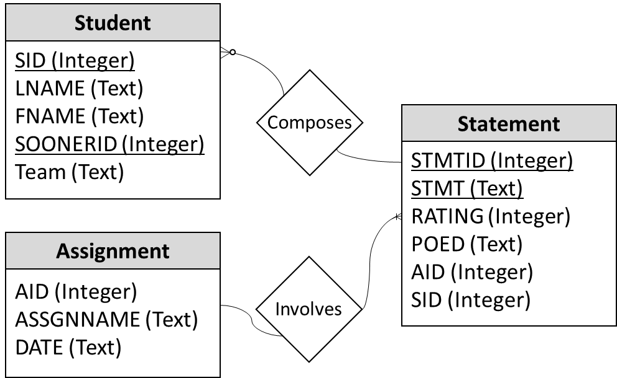
Figure 1.2. Entity-Relationship Diagram for Individual LS Database

1.3.3 AME4163 During Fall 2015 and 2016
The data used in the current work are collected from four sections of AME4163: two taking place in Fall 2015 and two taking place in Fall 2016. In most respects, the core elements of the course were very similar. Project POP is the design challenge in both years, borrowed from Mistree et al. [4], a course booklet containing the information described in Section 1.3.2 was present, Assignments 1-6 were the virtually identical in terms of content (though standards and the grading rubric were modified between sections), and the emphasis on learning over project outcome was made clear in both. In this thesis, the course in general is the focus and, as such, it should be understood that what is being said is applicable to both years, unless specifically noted otherwise. In later chapters, there will be some effort to look at potential differences in the collected data from both years and attempt to frame those changes.
Some differences, however, are noted between the Fall 2015 and 2016 sections. Notably, total enrollment in Fall 2015 was 90 students while in Fall 2016 there were 157 students enrolled. In addition, while target POED were identified for each course activity in both years, only in Fall 2016 were POED tied to particular elements of the grading rubric, intended to improve student understanding of how the POED related to their coursework. Furthermore, in Fall 2016, in order to provide students greater opportunity to internalize POED 4, which largely deals with prototyping, the ‘Mid-Semester Design Review’ process was modified to include a ‘Frankenstein Prototype.’ Students in Fall 2016 were thus in better position to learn in the area of POED 4.

1.4 Research and Analysis Methods
In the course, AME4163: Principles of Engineering Design, data from two groups of students (Fall 2015 and Fall 2016) undergoing an authentic and immersive design experience are collected. The methods used in this thesis are broken into to two categories, ‘strategies and tools’ and ‘proposed assessment instruments.’

1.4.1 Assessment strategies and Tools
In addition to the developed and tested assessment instruments, the implementation of various assessment strategies and tools used to guide student internalization of the POED is also addressed. These strategies include the following:
  - Scaffolded assignments built around “target” POED: For each student assignment, students are informed of the fact that the activities and learning goals of the assignments are tied to several (usually 3-5) POED. Students are then encouraged to frame their learning on a given assignment in terms of those POED.
  - Course Booklet: Each student is required to purchase a course booklet that contains all the course information (syllabus, style guides, schedule, etc.), assignment instructions and rubrics, tips for success, and information about the learning goals of the course. In this way, the goals of the course (internalization of the POED) are made explicitly clear to each student and further tie those goals to all components of the course. See Appendix A for the 2018 booklet.
  - Learning statement database: Given the large number of learning statements, as well as the “metadata” for each statement (authorship, date written, subject area, insight rating, etc.), The researcher has, in collaboration with another master’s student, developed an SQL/Python-based database that enables both the easy storage of the approximately 10,000 learning statements and simplified queries of the stored data. Data is then analyzed using both conventional statistical analyses and an implementation of the bisecting k-means text mining algorithm.

1.4.2 Proposed Assessment Instruments
Subjected to a scaffolded set of assignments that track with the steps of a structured design process, the steps of which are encapsulated in the Principles of Engineering Design (POED), the students are required by the instructors to reflect on their experiences and articulate their learning via several outlets.
- The learning statement (LS): Anchored in the work of David Kolb, the learning statement is a structured sentence through which students express specific lessons learned (and the value of those lessons) in the context of particular experiences. Students must reflect on specific experiences, abstract learning from said experience, and then articulate it to the instructors. The instructors require students to submit both individual and team statements during lectures, assignments, and a “post-mortem” assignment called the Semester Learning Essay, which follows the conclusion of the design project.
- The material internalization inventory (MII): This item refers to a survey through which student confidence in the internalization of the POED in both the near and long-term is assessed. Students complete surveys by answering particular questions throughout the course of the semester following specific course milestones. Students respond to questions using Likert-style responses on a scale of one to five. Non-parametric statistical methods are used to sort the response data and identify response patterns.

1.4.3 Methods to Address the Research Questions
Analysis of the large amount of data collected principally takes on one of two forms: analysis of survey data or of LS data. In terms of the survey data, the focus is largely on identifying relationships/patterns using non-parametric statistical approaches to identify correlations between responses to survey questions. Owing to the fact that there are multiple question sets in the survey, those different sets are analyzed separately to address specific research questions. Similarly, using both conventional statistical approaches and a bisecting k-means text mining algorithm, different sets of analyses are performed on the LS data to address particular questions. The connections between the research questions to be addressed, the chapter in which they are addressed, and the data sets utilized in those chapters is mapped in Figure 1.3.
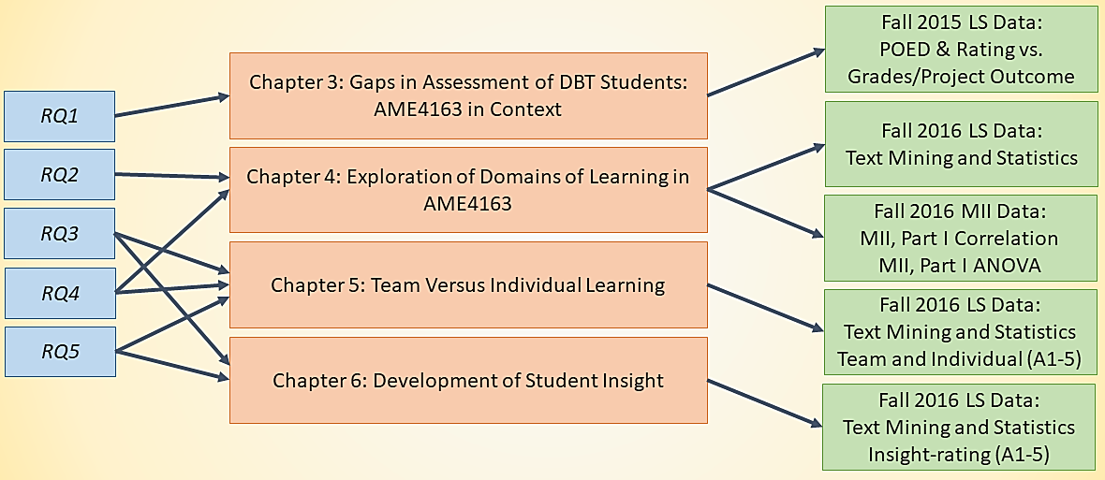
Figure 1.3. Connections Between Research Questions, Chapters, and Data Analysis

1.5 Thesis Outline
In Chapter 1, motivation in pursuing this work is established as being to improve assessment in engineering design education. This is accomplished by framing the problem, the course used as the research testbed, the research questions, and the methods that are employed in this thesis. In Chapter 2, additional context for the material presented in Chapter 1 is provided through a critical review of the relevant literature. This literature is divided into five main sections: Section 2.1: Foundations of AME4163, Section 2.2: Pedagogical Approach, Section 2.3: Gaps in the Literature Regarding Assessment in Engineering Design Education, Section 2.4: Need for Improved Forms of Self-Assessment, and Section 2.5: Methodological Literature.
In Chapter 3, the main analytical work begins by using data from AME4163 in Fall 2015 to validate the assertion that conventional forms of student assessment are insufficient for both understanding and shaping learning in engineering DBT courses. This is accomplished by comparing student confidence in their design abilities to their performance in the design project and by exploring the areas of design in which students preferentially exhibit learning. Particular gaps that exist using these conventional forms of assessment are then highlighted and elaborated upon in the following chapters.
In Chapter 4, overall domains of learning of students in AME4163 holistically is looked at. This is accomplished using both LS and MII data from Fall 2016 to explore student understanding of their design abilities in general, as well as the main subject-areas in which students exhibit learning. Student self-reported learning is also compared with performance in the broader design project of the course.
In Chapter 5, comparisons between individual and team learning in the context of AME4163 are examined. This involves analysis of the differences exhibited by individuals when writing LSs and those written by teams. Using text analysis, word frequency differences between individual and team LS are examined as well as differences in proportion of each group’s LSs as rated by insight. From these data, conclusions are drawn about how individual learning is shaped by working on teams and thus, how the ‘team’ experience affects the learning process.
In Chapter 6, the features of student self-assessment that may lead to strong insight towards design are explored. In particular, whether and to what degree students become more conscious learners over the course of the semester is identified. Comparisons of LSs across assignments in Fall 2016, including to the final post-mortem report and learning essay, are examined. Specifically, a focus on data organized based on the ‘insight’ ratings assigned by instructors to each learning set is presented. By examining these subsets, the features of LSs at different insight levels are identified.
In Chapter 7, the analysis from Chapters 3-6 is distilled into key insights as they relate to the stated research questions. Specifically, student learning in AME4163 is modelled, how successful the LS and MII are at encouraging and assessing self-reflection, how student learning is shaped by team settings, how student learning changes over the course of a design project, how well students in AME4163 are able to transition to junior engineers, capable of solving novel industry problems are all examined. Furthermore, how insights into these research questions will enable the instructors of AME4163 to make changes that improve learning outcomes is addressed. Finally, the suitability of this framework for use in engineering DBT courses in general is explored and a model for the implementation of such a framework is proposed.
It is hoped that the research outlined in this thesis may serve both engineering design educators and researchers as a roadmap for scaffolding their courses so as to enable students develop the ability to adapt through learning by reflecting on doing. As this thesis contains both a framework for such courses and a thorough guide for the use of particular assessment strategies and tools, it thus may serve in a practical capacity.
In service to this aim, included in this work also is Appendix A, which contains the current course booklet for the Fall 2018 session of AME4163. Further, in Section 7.5, a doctoral proposal is outlined that builds upon the work contained in this document in order to identify future research avenues and questions for investigation.

Chapter 2. Critical Literature Review
In this chapter, the relevant literature underpinning the current work is explored. Specifically, a survey of the literature that explores the pedagogy employed in AME4163, the theory on which my research assessment instruments are based, the existing research work on assessment in engineering design education, and the theory that justifies the analytical methods employed in this paper including text mining analysis, Spearman correlation analysis, and others, is provided.

2.1 Foundations of AME4163
Principally, this research is built on the work of Balmer [5] who explores the development of a framework for iterative improvement in AME4163, a project-based senior-level design course for mechanical engineers. The course framework is thereby anchored around a central project and largely in the experiential learning cycle explored in the work of Kolb [1], whose construct presents a model by which individuals use experiences to iteratively improve their mental model of the world. This cycle is also the foundation on which learning statements, explored in detail in Section 1.3.1, are based. The learning statement (LS) instrument has also been explored in prior work [6] [7] and much of that analysis has been incorporated into this thesis. In terms of using the LSs as a means of better understanding student learning, researchers such as Turns [8], and Allen et al. [9] are also utilized as a reference point.
Both Balmer and the author, in investigating means of improving AME4163, build on the work of Mistree et al. [4], whose contributions to project-based design education include the development and description of open-ended design projects that are composed of a technical problem and problem context, which together are used to create an authentic, immersive experience. In the Fall 2015 and 2016 iterations of the course, the semester design project, Project POP, was borrowed from this work.
In agreement with the work of Dym et al. [10], it is asserted in this work that preparing engineers for existing challenges faced by professional working engineers necessarily requires exposure to open problems that force students to confront unknown variables, complex and often conflicting requirements, and situational context. Further, Dym et al. establish not only the important role that project-based learning (PBL) frameworks have in enabling students to acquire necessary engineering design competencies but also conclude that such courses may serve as an opportunity for education researchers to perform pedagogical studies to improve engineering design education more broadly.
Though much about the course has been changed since the work done by Balmer, many of the learning objectives and technical challenges still present in the course are a legacy of Balmer’s efforts to frame AME4163 in terms of the development of competencies. Though, in this thesis, analyzing learning in terms of proficiency in specific competencies is not the focus, the influence on the course structure of those who have outlined such competencies more rigorously is clear. In particular, ABET [11], Eggert [12], Lahidji [13], and others [14] [15] [16] [17] have thoroughly explored the set of competencies required of modern engineering graduates in professional practice. In AME4163, those identified competencies have, over time, come to shape the course learning objectives outlined in Section 1.3. In this work, the focus is largely on whether those learning objectives, rather than the competencies that constitute them, are being met. Like Balmer, the author means to rigorously iterate the course to better meet these learning objectives and thus must scaffold the course accordingly.
In the context of the course foundation thus established, this work builds on the questions posed by others facing similar challenges. Todd et al. [18] and Etlinger [19] explore the challenges in attaining the outlined competencies faced by students in project-based design courses and how that particular course model is best suited for development of these competencies in students due to the fact that it forces students to make difficult design choices and compromises in the face of practical concerns. In AME4163, that knowledge is leveraged to prepare students to deal with complex problems in the belief that such challenges enable the development practical design skills. In addition, Smith et al. [20] demonstrate that students in project-based design courses report increased confidence in their own competencies when they are provided opportunities for self-assessment. Further, the authors highlight a general trend between the overall confidence expressed by students and grade received when using their self-assessment instrument (surveys). While they do not conclude an explicit model for predicting grades with student self-assessment, their results demonstrate the potential utility of self-assessment instruments as a possible predictor of student success. Furthermore, using surveys can allow instructors to highlight particular areas of learning for the students.
One aspect of project-based courses and the learning of students in them that is not a focus of this thesis is the relative importance of the team formation process. Though understanding how teams contribute to individual learning is of interest, this research is less concerned with how different methods for team formation affect ‘success’ in a conventional sense. Specifically, in AME4163, student teams are not chosen nor are students forced them to form them based on personality criteria or methods outside their own best judgement. As a result, results here do not control for interpersonal issues within teams of for individual student abilities within their teams. It is important, however, to be mindful of the literature regarding these factors. From the work of Reilly et al. [21], it is clear that models can be used by organizers to form teams tasked with the development of new products and systems that attempt to manage interpersonal issues to increase team effectiveness. From Barrick’s work [22], one may gain insight into the particular qualities of individuals in workplace teams that tend to be most effective at handling tasks. In addition, Pournaghshband [23] explains that one of the most common problems faced by students in design teams is managing team decisions. As he explains, many of these students have not, before the projects outlined in the paper, been members of a design team, and thus struggle with collective decision making. Pournaghshband also outlines strategies to manage these issues and notes their effectiveness in a classroom setting. Some issues, such as students having difficulty in managing the scope of a problem early on, are common to AME4163 and the advice is leveraged to have students identify the key requirements of the system early on, modifying the document as their problem understanding grows.
Largely, the body of work explored in this section describes the support in the literature that justifies the current structure of AME4163 and that which constitutes the pedagogical foundations of the course described in the course booklet. Having done so, how more general theories of learning have shaped these choices and the analysis performed in this thesis are explored.

2.2 Pedagogical Approach
From a philosophical standpoint, significant influence in both personal philosophy and resultant work is drawn from the pedagogical school of constructivism. Generally, in this work it is believed, as embodied in the work of social constructivists like Vygotsky [24], that meaning is created for learners, via cognition, when they engage socially with others. In an educational context, this has a direct connection with learning activities such as the team-based design projects we engage in in AME4163. Additionally, the way learners interact with that design project through the lens of what Jean Piaget described as ‘disequilibration’ [25], wherein learners, upon encountering novel problems for which no existing ‘schema’ to organize them exists, construct new schema to make sense of the phenomenon, is of primary concern. In this work, it is not sought to analyze or operationalize this theory, but simply to acknowledge its influence on the way in which student learning in the course is understood.
One of the more important theoretical constructs underpinning modern engineering education and engineering design education, in particular, is the experiential learning framework established by David Kolb [1]. Developed first during the 1970s and worked upon by Kolb and numerous others since, the experiential learning framework is a model for individual learning that posits the value of authentic, immersive experiences as a bedrock for a learner’s iterative model of knowledge acquisition. In his eponymous learning cycle, Kolb describes how learners first engage in an authentic, immersive experience, then engage in reflective observation about the events of that experience, then attempt to abstract lessons from those reflections, and finally endeavor to actualize those lessons moving forward in a period of ‘active experimentation.’ From here, the learner then proceeds back to the first step and the cycle repeats. Modern engineering design courses rely, to varying degrees of explicitness, on the framework as a theoretical basis for their supposed value. In contemporary engineering design courses, students (in teams or as individuals) engage with realistic design challenges, develop solutions, and then attempt to implement those solutions. Here Kolb’s cycle, which is itself iterative, dovetails nicely with real-world engineering design practice, which is likewise iterative.
In the work of Jonassen and Hung [26], the authors describe an instructional model that may be integrated nicely with Kolb’s cycle, the Problem-Based Learning (PBL) model. PBL represents a recent instructional design innovation that has risen to prominence in many educational disciplines, notably many technical disciplines. Emerging from medical education, which as recently as the 1990s suffered from issues wherein graduating physicians possessed significant technical knowledge but struggled to apply it in clinical practice, PBL works by replacing traditional methods of rote instruction with near-constant practical problem-solving sessions. As the authors describe, due to the centrality of problem-solving in professional practice, PBL is well situated for attuning students mentally to the realities of working in their chosen discipline. Of particular value for the purposes outlined here, the authors state that PBL is beneficial to learners by challenging them to “collaboratively assum[e] responsibility for generating learning issues and processes through self-assessment” (p. 7).
In addition to the PBL model of instruction, additional theoretical knowledge from social constructivism as an epistemological framework is drawn. As engineering design work is almost exclusively collaborative in nature – the age of the lone inventor has, perhaps sadly, passed – learners must be conscious of the process of “continual sense-making,” as described in the work of Jackson & Klobas [27]. In their paper, Jackson & Klobas describe a practical means by which engineering designers might deliberatively engage with product design as a process of continual socialized knowledge construction, rather than the ‘conventional view’ of design as the application of set technical facts to novel use cases. What the authors found is that the deliberative training of project managers in social constructivism as a method of organizing knowledge enabled these same managers to more effectively order information and research produced by team members who came from diverse technical backgrounds. In relation to instructional design, this work raises important questions about how engineering design students are conditioned to understand the relation between individual designers and their collaborative partners, be that a design team or an enterprise. In this work, this perspective informs the instructors’ philosophies of design with regard to the value of the team-oriented design project.

2.3 Literature Gaps Regarding Assessment in Engineering Design Education
Though distinct in many respects, the framework of AME4163 is similar to a popular method of instruction called ‘Problem Based Learning’ (PBL). Its prominence in educational research literature and its potential utility in engineering design make it worthwhile to address its shortcomings. For example, researchers such as Perrenet, Bouhuijs, and Smits [28] have raised some issues with the framework, particularly its suitability in higher-levels of engineering education and certain issues related to assessment in such courses. In particular, the researchers find that, in advanced design instruction, the short-form projects characteristic of conventional PBL are less analogous to the large-scale, complex problems associated with realistic engineering practice. Of particular interest here is also their finding that assessment schema in PBL-based engineering courses are often inconsistent, with metrics sometimes in conflict with identified learning objectives, though they do not offer remedies.
Segers and Dochy [29] offer a potential solution to this issue in the form of innovative assessment strategies. The authors first highlight that, while PBL represents an innovation in engineering education by more accurately mapping the instructional strategy to the desired learning outcomes of the discipline, conventional measures of assessment (exams and design artifact performance, to name two) do not adequately meet the needs of the course structure. Instead, the authors investigated two novel forms: peer evaluation and a PBL-specific form of testing called the OverAll Test. The developed OverAll Test was found to have high validity but did not match with instructor assessment. In contrast, the peer evaluations were found to have high generalizability and mapped well to conventional measures of assessment, but the researchers note that the students’ effective evaluations of their peers did not extend to themselves. From this study, two conjectures are offered. First, one might suggest that the mismatch between the results of the OverAll Test and the instructor evaluations do not represent a failure of the exam’s suitability as an assessment tool in engineering instruction, but a problem with instructor expectations of success and performance. Second, there is reason to believe that students’ difficulties with self-evaluation lie not in any inherent inability to do so, but a lack of training in the skill. These conjectures later will be returned to later.
In the work of Olds, Moskal, and Miller [30], the authors differ from others here in that they focus on assessment methods used in engineering education research. They highlight a growing need for novel research methods in engineering education owing in large part to an evolving understanding of the characteristics of successful practitioners. Of particular interest here is the call for greater utilization of research methods that collect language data and examine student perceptions of their own learning. This represents a significant gap in existing engineering design education research and opens the door for this research project in which a novel research method is utilized to examine student understanding of their own learning using a text-based tool.
Though it is becoming a bit dated, one of the seminal calls for improved assessment strategies in engineering design curricula comes from Besterfield-Sacre, Atman, and Shuman [31]. In their oft-cited work, the researchers investigate several novel assessment strategies in actual engineering classrooms. Their principal findings are that collecting information about their attitudes toward their curricula and learning experiences directly from students represents a significant value opportunity for the improvement of individual courses and engineering curricula as a whole. In this manner, the authors demonstrate a means by which student opinions can be used to improve aggregate educational outcomes.
Taken as a whole, the body of engineering design education literature contains frequent calls for improved assessment strategies and tools for research and educational purposes. Recalling the primary research question outlined in Section 1.2.1, this speaks directly to the purpose of this thesis: to investigate and provide such strategies and tools. Further, findings from this body of literature go a long way in addressing research question one, which is related to gaps in existing forms of assessment in engineering design. This will be further investigated in Chapter 3. In the following section, more specific research gaps are highlighted that are used to outline the format of these efforts.

2.4 Need for Improved Forms of Self-Assessment
From the review of literature so far, one of the common items mentioned in several papers was the identified need for improved assessment instruments in engineering PBL courses, with engineering design in particular noted. In disciplines other than engineering education, an often discussed and sometimes controversial method of assessment is that of self-assessment. Many researchers have explored the theoretical value (or lack thereof) in one context or another and disagreement on the matter is common. One common complaint, such as that noted by Kaslow et al. [32] is that self-assessment inherently suffers from a bias on the part of the respondent. However, these researchers make an important caveat: that bias appears to derive from a lack of understanding on the part of the learners as to the role of that self-assessment.
This finding suggests that self-assessment, if properly leveraged in an appropriate setting wherein learners understand both the instrument and its instructional purpose, may serve an important function. Ward, Gruppen, and Regehr [33] seem to backup this assertion. In their work, the authors survey the research on self-assessment in an effort to understand why, despite a large body of theoretical work supporting the value of self-assessment, so much of the practical and experimental research has determined it to be of little value. They find that large-scale methodological issues plagued studies that investigated self-assessment and thereafter characterize the predominant problems. One of the key issues they identify is that learners in these studies are not properly ‘calibrated’ when asked to perform self-assessment. That is, in many studies, no (or little) effort was made to explain to subjects how to be critical when self-assessing. In practice, this seems clear, as studies like that performed by Verano-Tacoronte, Bolívar-Cruz, and González-Betancor [34] attest. In their study, they find statistically significant evidence that engineering design students are proficient at evaluating the work of peers but suffer from marked-overconfidence in their own abilities. Notably, they also find that this effect is significantly gendered, with male engineering students more likely to over-evaluate their own performance than their female counterparts.
Another pedagogical influence is Mistree [35] who, in an editorial for the Journal of Mechanical Design, identifies the need for improved methods of assessment in engineering design courses, which are becoming increasingly integral to educating engineering graduates capable of meeting modern industry challenges. In particular, he argues that educators must train engineers to be critical of their experiences to commit to continuous learning.
Current literature on the need for better metrics of self-assessment in engineering design education is plentiful and varied amongst disciplines and course types. For project-based design in particular, it has already been highlighted how both Besterfield-Sacre et al. [31] and Segers and Dochy [29] explore the need for better instruments to understand and explore student attitudes about their learning. In particular, they point out that, in the context of a rapidly changing and globalizing world with increased competition between nations, we need to prepare engineers who are not only capable technically but who also respond well to change. To assess the degree to which peer-evaluations, a non-typical form of student evaluation, are useful as a metric of student progress in desired learning outcomes, the authors compare the results of peer evaluations given by students in a project-based course with those of a written examination. They find that peer evaluations are not good predictors of student achievement of learning objectives. In their case, the peer evaluations are substantially more positive than their evaluated outcomes. Furthermore, in the work of Old et al. in [30], the authors discuss the challenges facing engineering educators today and explore the utility of a variety of atypical assessment techniques. In particular, they inventory common approaches to assessment in engineering education and note the need for improved communication between education researchers and educators to improve engineering curricula. Additionally, they note the that surveys can provide instructors valuable information about student attitudes to their learning, provided the surveys are constructed carefully.
Returning to Kaslow [32], whose identifies another short-coming of self-assessment instruments, that they are prone to bias and misuse when students do not properly understand their purpose, he recommends that self-assessment tools to assess student learning should be paired with secondary tools to corroborate results. In contrast to many findings that self-assessment is often uncorrelated with conventional measures of student success in engineering design courses (report grading, design artifact performance), Smith et al. [20] associate self-assessment with improved design student outcomes and also demonstrate how such instruments can be used to better understand the process of student learning in design courses. Segers and Dochy [29] demonstrate that some self-assessment instruments in PBL-based courses succeed at prompting students to critically evaluate their own learning, though they note that this outcome requires that educators align the course goals with the purpose of self-assessment.
In short, in the literature substantial gaps regarding the utility of self-assessment in engineering design courses are apparent, including a lack of understanding of the proper role of self-assessment in engineering courses and proper implementation details. It seems clear that, despite significant substantial theoretical value, little is well understood regarding appropriate implementation of such tools or how data collected from them should be interpreted. In Chapter 1, the approach to doing just that that is taken in this thesis is outlined. In the following section, technical literature to validate the data analysis in this thesis is discussed.

2.5 Methodological Literature
Various forms of textual analysis exist in many disciplines; in this thesis, text of discrete sentences with a pre-determined structure (learning statements) is analyzed. As discussed in Section 1.1, assessment of the student self-assessment exercises is based on a desire to categorize subject matter and determine the insight expressed with the purpose of understanding self-reported learning. While textual analysis to assess learning is used both outside of engineering pedagogy [36] [37] and within [38], the creators of these analytical frameworks largely deal in relatively lengthier writing samples such as essays or paragraphs. In addition, while the authors reveal certain insights about patterns among student writings that can be useful for efforts to teach successful ‘patterns’ of writing to other students, they also focus their analysis on the more mechanical, quantifiable aspects of student writing: word choice, sentence length, and number of references to certain key phrases and words. Though a similar approach with the text mining analysis is employed here and discussed more in Chapters 4 and 5, the instructors of AME4163 also assess insight expressed and subject matter explored. Corroborating the approach to analyzing the learning statements is the work of Reidsema and Mort [39], who tentatively suggest that certain “linguistic features” such as connectivity and appraisal are linked to higher levels of learning insight in design students.
Following the LSs, it is now necessary to identify in the literature techniques for analyzing the survey data that are more readily analyzed quantitatively than the LSs. In particular, abundant justification for the correlation matrix method discussed in Section 4.3 can be found. In contrast to conventional correlation matrices, which typically utilize Pearson’s r, Spearman’s rank coefficient is employed here. This is a necessary consequence of using Likert-style response data in the surveys, which may not be treated as continuous. Mendenhall and Sincich [40] outline the calculation method of Spearman’s coefficient, r_{s}. Ramachandran and Siddique [41] further provide a framework for interpreting survey response data using bivariate correlational analysis. Excepting the use of the Spearman correlation coefficient in place of the Pearson coefficient, this work also largely follows the method for using correlation matrices to establish inter-correlations between surveys using Likert style responses outlined by Sterzinger [42]. Further utilized, primarily as reference, are the methods employed by education researchers such as Kim et al. [43] and social science researcher Wahn [44].
Following initial efforts to explore the LSs by categorizing them based on subject matter and level of insight followed by conventional analysis of the patterns among such categories, additional means of analysis were sought out. In partnership with Jennifer Sieber, the researcher here implemented a text mining approach that is utilized in the work of this thesis. Development of that tool and discussion of its utility was published in the International Journal of Engineering Education [45]. Within engineering education, Frasciello [38] outlines a model for text mining of student writing samples in engineering courses. Outside the field of engineering Wu and Chen [36] and Kokensparger [37] highlight the growing suitability of text mining algorithms for exploring the subject matter of a set of student writing samples.
Text mining is a subset of Data Mining and requires several standard preprocessing techniques to be implemented before analysis can occur. To begin, each statement needs to have the punctuation removed and all characters must be converted to lowercase. Then, so-called ‘stop words’ must be removed to eliminate the occurrence of words that are not useful to the analysis of the subject but are frequently occurring connector words (such as “a”, “the” and “and”) in the English language. The choice of which stop words to remove has been widely studied and it is reported, to determine the key factors contributing to variance in the documents, base stop words must be removed together with subject matter words that occur frequently. Researchers have found sets of stop words that are widely used for specific text mining tasks, such as Choy who has determined which stop words are removable for Twitter analysis [46]. In this study, the English language stop word package ‘tm’ is used in the initial analysis and later a set of key words provided to the students that are specific to the learning statements are also removed to provide a more focused analysis on the factors contributing to student learning.
K-means clustering has been used to determine the words that are most similar to each other in terms of frequency based on comparative studies that have assessed K-means algorithm to outperform standard hierarchical clustering in determining the similarity of text. As explored by Savaresi and Boley [47], the bisecting K-means clustering algorithm is an efficient method for hierarchically clustering data based on specified criteria with a guaranteed solution convergence. In particular, Steinbach et al. [48] show that a specific type of K-means, bisecting K-means, outperforms other clustering methods for text cluster analysis. Further, principal component analysis (PCA) is used to explore variance in the data, permitting identification of variance in the individual data subsets. In this study eigenvalue decomposition is the chosen PCA method [49].

2.6 Implications for Research
From the available literature, the theory at work in AME4163 is established to further create a basis for the assertion that improvements in assessing learning in project-based design courses is vital to student outcomes. Further, in the literature support for the hypothesis that the methods instructors use to evaluate students in project-based design courses are not adequate for understanding student learning is abundant. Specifically, instructors typically assess student success based on project outcomes and technical analysis while often ignoring student progress in team formation and decision-making, two areas of learning that appear frequently in design projects. This common finding implies two things. First, that conventional measures of assessment are insufficient for understanding student learning in design courses. Second, student learning in design courses, as a consequence of improper assessment methods, must not be as thoroughly understood as many believe. These gaps inform research questions one and two (Section 1.2.2) directly, which address specific questions regarding assessment in engineering design.
Furthermore, in the literature is found ample support for both the theoretical validity of self-assessment as well as an understanding of the gaps in understanding regarding its use in an engineering design context. Addressing this gap seems particularly useful in terms of the potential added value to engineering design courses for both students and instructors that would be provided by a suitable self-assessment framework. Research questions three through five incorporate specific elements of this gap and answering them will aid in forming a better understanding of the practical utility of self-assessment in engineering design.
In what follows, the implementation of one possible framework and report on the data obtained from that implementation during two semesters of the course AME4163: Principles of Engineering Design is explored and documented.

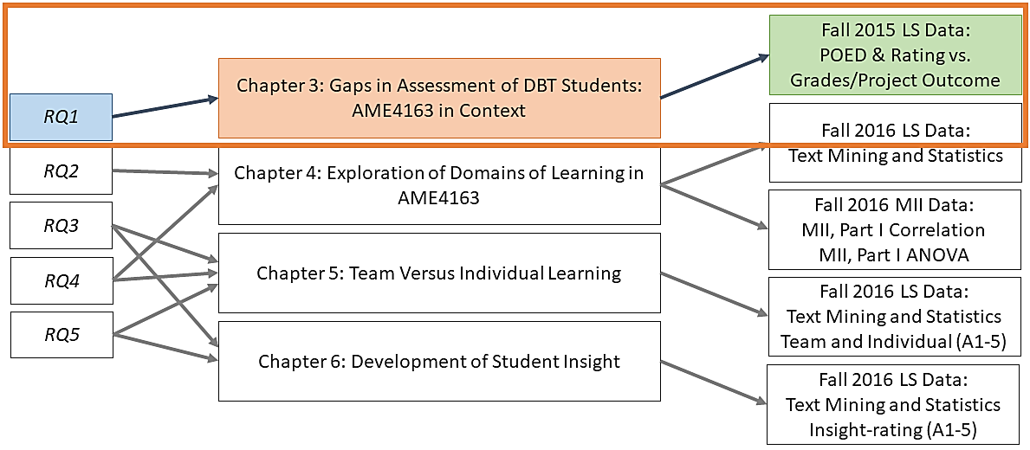

Chapter 3. Gaps in Assessment of DBT Students: AME4163 in Context
As explored in Section 2.3, conventional methods of assessment in engineering DBT courses most often involve focusing on the output of the projects in such courses. As much of the literature suggests, this may be ill-suited to understanding and assessing learning in design courses. In this chapter, some cited causes of this deficiency are outlined, and those assertions are validated with data collected from AME4163. In general, virtually no correlation between student learning and their performance in either the course nor in important course assignments is found. Despite, however, little correlation between these two measures of performance, learning statement (LS) data imply that learning across many domains of engineering design are evident.

3.1 Problems with Traditional Assessment in DBT
In conventional engineering DBT courses, students are presented with an open-ended design problem and given all (or a large majority) of the course to plan, design, construct, and test some specific design artifact. In this thesis, the phrase ‘design artifact’ may be taken to include any complex system ranging from a computer program (such as might be developed in a computer science course) to a thermal-fluid system (chemical engineering) to a model airplane (aerospace engineering). In AME4163, the design artifact that students are challenged to build is an autonomous vehicle capable of navigating an obstacle course and popping a protected balloon. In general, most engineering DBT courses add further ‘realism’ to the problem by placing students in groups of various sizes. From an educational standpoint, the benefits of this model are varied and well justified [21]. Students benefit from the social construction of knowledge by working with peers [24], they develop skills related to time and complexity management from the open-ended structure of project [23], and the hands-on nature of the construction/building element provides a rare opportunity to apply learned technical skills under realistic circumstances.
Despite these many benefits, evaluation and assessment in such courses is lacking in many areas. First, though students do benefit from learning constructed together with peers, the nature of grading work submitted by teams may under- or over-value the contributions of individuals artificially. The goal of educators is to produce educated individuals, and the effectiveness of instructional methods may obscure this goal at the level of specific students. Consequently, what is observed from this course model is that students are improving on average or in aggregate but looking at team performance may not reveal problems (or breakthroughs) with the learning taking place in individual students.
Second, in a typical engineering DBT course, a substantial portion of grades and evaluation are often based on the performance of the design artifact against some set of criteria. Though this makes some intuitive sense, it disproportionately places the emphasis of the course on ‘winning’ rather than learning. What is key here is that design, as practiced in the real world, is a process of exploration, tradeoffs, testing, and reworking until a possible solution is realized rather than some Platonic ideal. Though students are expected to meet some threshold for competency in order to graduate, iterative improvement must also be a focus. By only (or primarily) focusing on the performance of the final artifact, the message is sent that it is not acceptable to fail, learn, and improve but that students must do everything correct the first time. And unlike in courses like thermodynamics where one either knows how to apply something like the equations governing heat transfer or they do not, in design there is never a singular correct answer, only iterative improvement. In this sense, by evaluating students based on design artifact performance, instructors fail to recognize students learning to think as designers simply because they did not get it right on the first go.
Third, directly following from point two is that students in such classes are also assessed based on written reports and submissions in various forms. This model of assessment derives directly from those used in more conventional courses: lecture, assignment, quiz, and test-based courses. While such course structures and assessment strategies may be effective for building broad bodies of knowledge in areas of education that emphasize the acquisition of factual knowledge, some have suggested that the ‘soft-skills’ frequently associated with design are not measurable in a conventional sense [31]. How, for example, can a written test demonstrate how well a student is able to communicate their ideas to team members? How the degree to which teams of individuals have planned for uncertainty later in the project be graded? Conventional measures are inadequate for this task, and yet, they must still be cultivated and evaluated by instructors.
Clearly, due to these and other issues, there are apparent problems in the assessment methods used in engineering DBT courses. However, before more rigorous exploration of alternative methods can be performed, these critiques must be validated using the available course, AME4163.

3.2 Verification of Problems in AME4163
Using data collected from AME4163 students in Fall 2015, the claims described in Section 3.1 and highlighted by numerous authors cited earlier must be validated. To do so, several findings are presented: individual LSs grouped by assignment over the course of the design project, team LSs grouped by assignment over the course of the design project, regression models comparing number of LSs submitted by each team for each assignment versus the team grades for those assignments, and regression analysis of the grades of individual student Semester Learning Essays versus each individuals’ overall course grades. The results are instructive, as they demonstrate clearly that learning in many domains is taking place but that that learning does not translate to course success as judged using conventional measures of assessment.

3.2.1 LS Data from Fall 2015
In the first stage of the analysis, the proportions of team and individual LSs pertaining to particular POEDs are tabulated. As an example: if, on Assignment 1, a team provides twenty statements, five for the team as a whole and fifteen from the individual team members, and of the individual LSs five fall into the domain of the first POED (labelled POED 1 on the following charts), then 25% (5/20) of the total team statements on Assignment 1 are individual learning statements falling into the domain of POED 1. The same analysis using the complete pool of all team LSs provided on Assignments 1 through 5 is performed. The results of the individual and team LS percentages are shown in Figures 3.1 and 3.2. As a reminder, the five POEDs correspond to the five principles of design as follows:
- POED 1: Planning the design
- POED 2: Preliminary design
- POED 3: Embodiment design
- POED 4: Prototyping, testing, and post-mortem analysis
- POED 5: Learning through doing, reflecting, and articulating
One important aspect to consider in interpreting the analysis is that, though LSs are required for Assignments 1 through 5, it is not required explicitly that the statements provided pertain directly to the assignment in which they are submitted. Students are free to explore learning regarding class lectures as well as design-related activities not expressly related to a particular assignment. For early assignments, however, it is found that student LSs largely track with the assignment subject matter.
As expected, for both team and individual learning statements in Assignment 1, POED 1 is the exclusive focus of learning on both the team and individual level. In Assignment 1, teams are tasked with organizing their team and planning their design approach as well as developing an understanding of the design problem and formulating a requirements list.
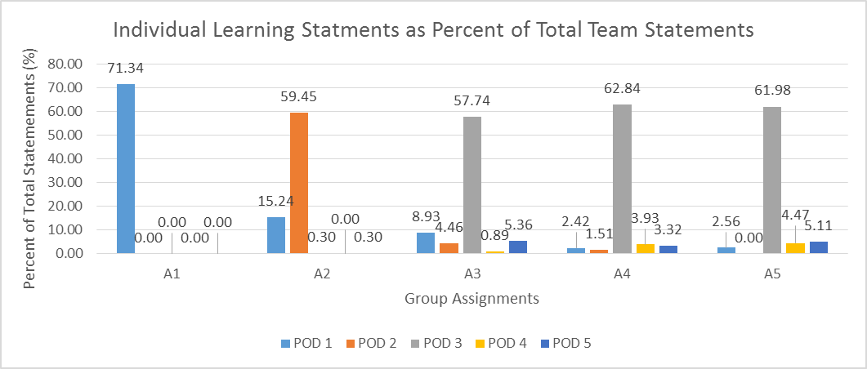
Figure 3.1. Learning Domain Breakdown for Individual LS in Assignments 1-5
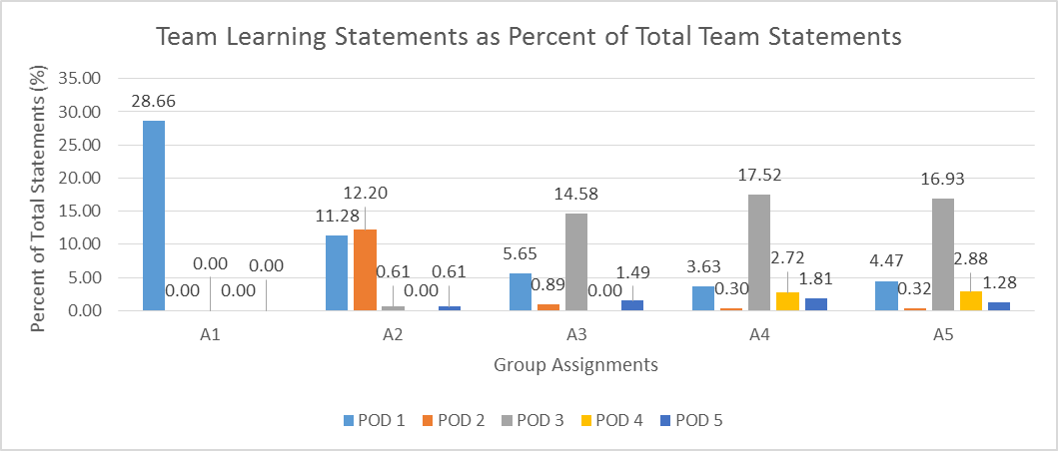
Figure 3.2. Learning Domain Breakdown for Team LS in Assignments 1-5
Similarly, in Assignment 2, in which the teams’ focus is on developing early concepts and exploring ideas for potential solutions to the problem, POED 2 is the major focus of the learning on both the team and individual level, accounting for 12 and 59 percent of total statements, respectively. In addition, POED 1 is still well represented in Assignment 2. This makes sense as Assignment 2 is early enough in both the semester and the design process that teams are still working through issues related to planning, team communication, and refining their requirements.
In Assignment 3, in which students focus on critically evaluating the concepts generated in Assignment 2 and narrowing the design to a primary and secondary concept, the focus of LSs turn towards POED 3, which involves refining and modifying through analysis concepts that are “the most likely to succeed.” Unlike in Assignments 1 and 2, however, it is in Assignment 3 that the LS breakdown begins to broaden out and form a distribution between the five POEDs. Additionally, it is here that the trend of spikes in successive POEDs on each assignment ends.
Between Assignments 3, 4 and 5, POED 3 remains the most common area in which both individuals and teams express learning. This is surprising, and so a possible explanation is offered. In completing Assignments 4 and 5, the students further refine their concept first through developing a rigorous CAD model (Assignment 4) and then by performing finite element analysis on critical design components (Assignment 5). Both Assignments 4 and 5 are structured to pertain to refinement of the primary team concept and thus learning is expected to stay primarily within the domain of POED 3. However, what makes the breakdown interesting is that many (if not most) teams have begun the prototyping phase by Assignment 4. Even as they refine the detailed CAD models and perform analyses of their critical components the teams have begun testing physical models and experimenting with prototyping. Though the relative proportions of LSs pertaining to POED 4, which deals with prototype testing, rise around Assignments 4 and 5, one might expect that process to have been more impactful on the students as they prepared their Assignment 4 and 5 reports and thus should have represented a greater proportion of student learning during that time period.
One possible explanation is that fewer teams than expected have actually started constructing and testing the device in a meaningful way by this point in the project. This explains why fewer individuals and teams would report learning statements categorized in the domain of POED 4, which deals with prototyping and testing of the device, in Assignments 4 and 5. From an instructor standpoint, this is worrisome. The device demonstration date is only one week after the Assignment 5 due date. If the teams are not reporting learning in POED 4 in Assignment 5, it can be inferred that they have not begun serious prototyping and testing the device as recently as one week before the device must be completed. If the above explanation is correct, then teams were waiting until the final week to begin constructing and testing their prototypes, putting them in a difficult position with regards to the device demonstration.
An alternate explanation is anchored in the particular focus of the teams while formulating their assignment reports. Specifically, though they are free to explore individual and team learning as it pertains to the course and design process in general, it can be seen in the results that students tend to submit LSs that are more directly related to the immediate assignment being worked on, rather than what they might be working on in general. For example, though a team may be constructing and testing a prototype as early as Assignment 4, in their LSs they provide on Assignments 4 and 5 they might tend to focus on the work required by those assignments, which suggests that the students at times compartmentalize aspects of the project (such as assignments and device construction) separately.

3.2.2 Fall 2015 LS Data Versus Course Performance
In the next stage of the analysis, the relationship (if any) between the number of learning statements provided by a team (individual and team LSs) and the grade received is explored. One might think that a team providing a greater number of learning statements on a given assignment might tend to have performed better on that assignment, indicating that learning objectives are being achieved. However, as is seen in Figures 6(a)-(e), there is no statistically significant correlation between the number of LSs provided by a team on a particular assignment and their grade on the assignment.
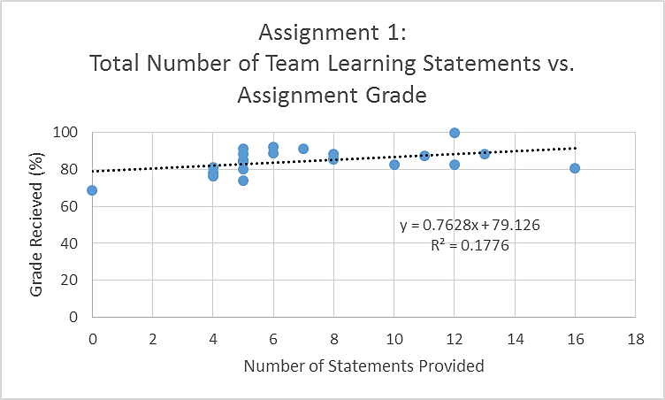 | 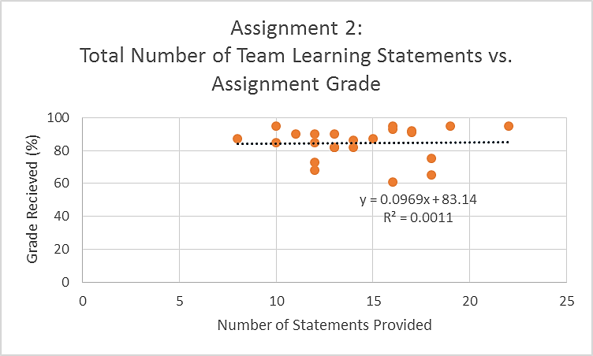
(a) Assignment 1 | (b) Assignment 2
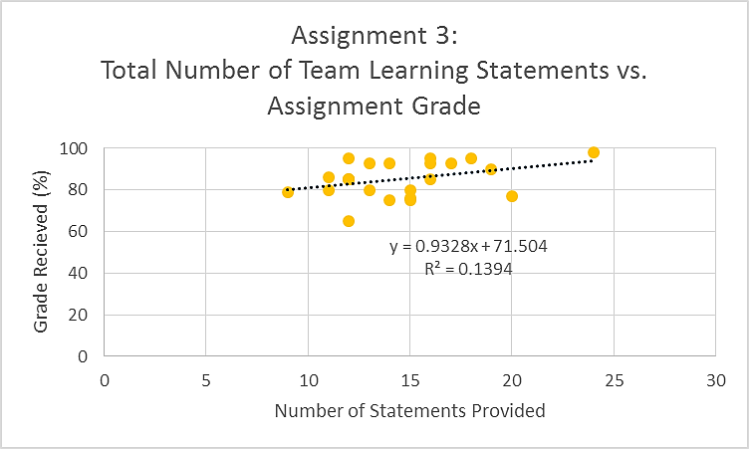 | 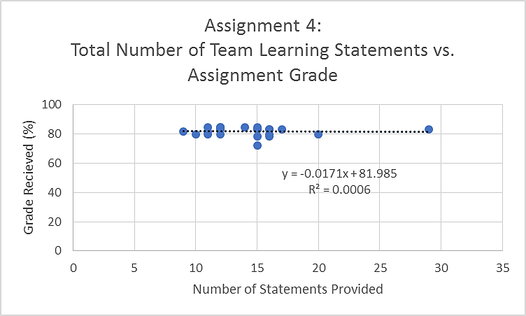
(c) Assignment 3 | (d) Assignment 4
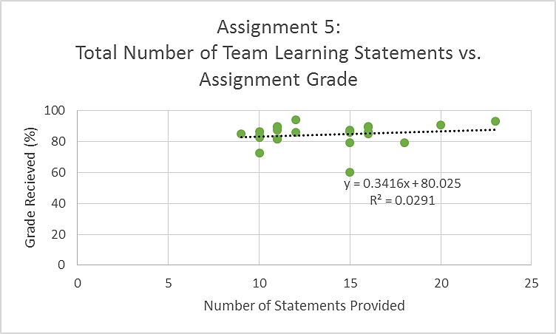
(e) Assingment 5
Figure 3.3(a)-(e). Regression of Number of Total Team LSs v. Team Assignment Grade for Assignments 1-5
Using simple linear regression, a line of best fit for each assignment is generated and it is seen that none possess a linear model with a multiple R² value greater than .2, which is interpreted as a low probability of a correlation between the number of statements provided and the assignment grade received by each team. From the results of the linear regression one can surmise that, in general, the number of LSs provided by a team does not correlate statistically with the assignment grades received. However, despite an absence of a relationship between the LSs and the student grades, there is evidence that a significant amount of learning is reported by the students. In fact, this seems to be strong evidence of the assertion that current grading techniques in project-based design courses are insufficient to assess student learning. What is shown in Figures 3.1 and 3.2 is evidence of student learning in specific areas and what is shown in Figures 3.3(a)-(e) is that that same learning is not reflected in the course grading. It therefore is seen that learning is taking place independent of the grade received. Students are thereby learning through doing, precisely as outlined by Kolb in his model for experiential learning.
Moving into the final stage of the analysis, identifying whether a link exists between performance on the SLE and overall course performance is sought. As mentioned earlier, the grading for the SLE involves counting the number of statements provided and adding the point values of the individual learning statements (based on the rating criteria specified). However, since 30 statements in at least 10 domains are requested without specifying the penalty for too few or the possible benefit of additional statements, there is little variation in the number of statements submitted. Consequently, the primary factor in the grading is the insight rating of the individual learning statements. Further, this means that the relative proportion of highly rated statements (ratings of three) correspond directly to the SLE grade. Therefore, comparing the grades on the SLE with the final course grades of the individuals who submit them, in effect, assesses the possible correlation between level of learning (by proxy) and student course performance. However, when plotting the two series, as is done in Figure 3.4, and fitting a linear regression to the data it is seen that once again there is something else significant at play.
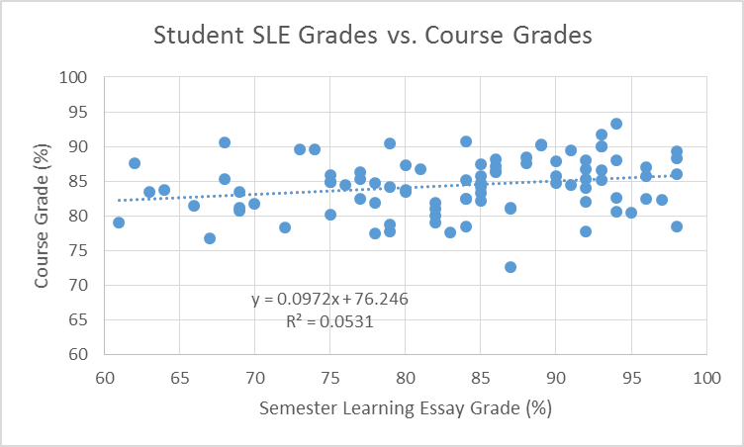
Figure 3.4: Regression Analysis for Individual SLE Grades v. Course Grade
Though from the data and trend line a slight positive correlation is observed between learning statement ratings and overall course performance, the trend is not rigorous enough to account for all the variation in the course grading. From the multiple R² value of .0531, only 5.3% of the variability in overall course performance is explained by the ratings of the student LSs. This is likely due to the fact that the majority of the grading that goes into the calculation of a student’s overall course grade is based on evaluations of that student’s teams as a whole, thus somewhat reducing an individual’s ability to independently impact his or her grade. However, this further demonstrates that though many students are demonstrating both learning and a substantial degree of insight with that learning, that learning is not substantially impacting the way the students are assessed in the course.

3.3 Summary of Assessment Gaps
LSs and the SLE are tied to “Abstract Conceptualization” and “Reflective Observation” from Kolb’s Experiential Learning Construct [1]. From the analysis of the LSs submitted by the students over the course of Fall 2015, several facets about the learning of the students in the class are observed. First, in the attempts to compare the learning statements of both individuals and teams to the assignment grades, no significant correlation is found (a conclusion that maps well with recognized inconsistencies in the literature between other forms of student self-assessment and instructor evaluation [30]), implying that the conjecture offered in Section 3.1 is true (RQ1).
Second, the categorization of the learning statements into groups based on the domain of learning that encompassed each statement that is shown in Figure 3.1 and Figure 3.2 tracks nicely with the intended domains built into the assignments. Specifically, Assignment 1, in which the assignment is scaffolded to focus on team organization, planning the design, and understanding the design problem, is the assignment in which both group and individual learning statements pertaining exclusively to the first POED are the focus, which addresses those same principles. Similarly, in Assignment 3, in which ideation and concept generation are emphasized, the vast majority of both individual and group learning statements fall into the “Preliminary Design” domain of POED 2. Third, learning statements in the “Embodiment Design” domain (POED 3) constitute the majority of submitted LSs for Assignments 3 through 5.
Over the course of the five team assignments, students largely focus their LSs in the area of POED 3 (“embodiment design”). From this it can be gathered that students, during the course of the project itself, are most challenged by the portions of the project that deal with translating general ideas into feasible concepts. This is an understandable difficulty they face; at this stage, the students are essentially asked to abstract from the hypothetical to the concrete and then refine that effort into something practical. This reflects an important moment of growth for the students into junior engineers.
Furthermore, from what is observed in Figure 3.1 and Figure 3.2, it is concluded that student and team learning in the “Prototyping, testing and post-mortem analysis” domain of POED 4 is weaker during what should be a period where that domain is explored thoroughly (the weeks leading up to the device demonstration).
Finally, from the presented data no strong, positive correlations between the quality of learning statements and course performance (via grading) are found, despite the fact that notable aspects of the learning that students achieved are clearly identified and understandable. From this it is inferred that the methods by which design students are currently evaluated (ability to follow design steps, artifact performance, and quality of written work) are not a complete picture of the learning actually taking place, a position consistent with other investigations [29]. From this, the following is posited: either design students are not learning what the instructors seek to teach and thus the way the material is taught must change, or, students are not being assessed on criteria relevant to what they need to learn in a design experience and thus the way students are assessed must be revisited. There is some additional reason to suspect the latter conclusion over the former.
In an editorial submitted to the Journal of Mechanical Design, Mistree suggests that as the global engineering landscape changes and people begin to focus on more collaborative, interdisciplinary projects attempting to solve complex problems with unclear customer needs and wants, the competency most needed by students deals with an ability to adapt and learn rather than any particular technical skill or analytical technique [35]. With that in mind, what instructors should be looking for in engineering design students is evidence that they are learning from mistakes and progressing in a relative sense, rather than simply meeting some fixed technical standard.
Having now validated the assumption, instigated initially by other reported findings in the literature, with data from the present course in question, it is now acceptable to move forward to exploring and validating two alternate forms of assessment: The Learning Statement and a survey titled the Material Internalization Inventory.

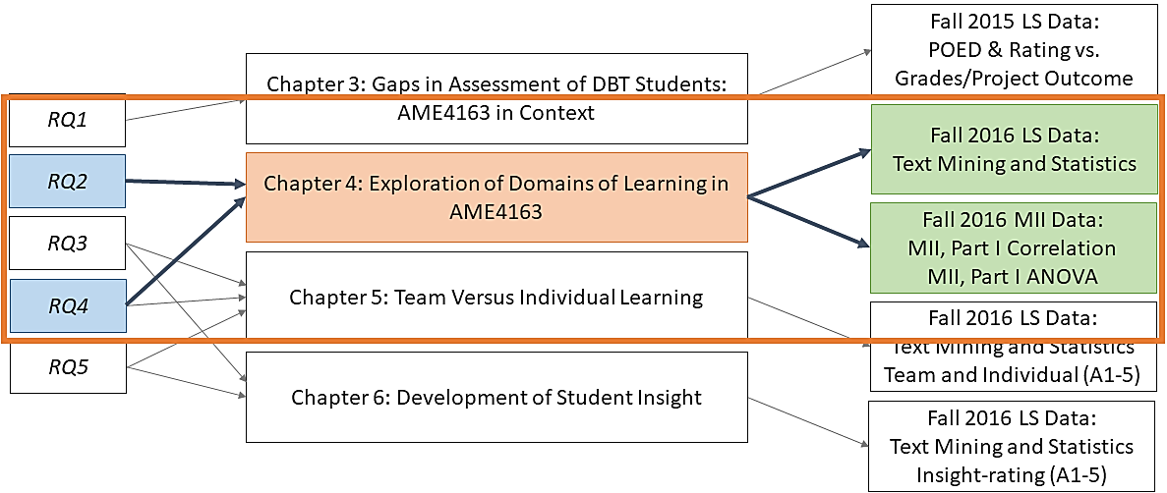

Chapter 4. Exploration of Domains of Learning in AME4163
In Chapter 3, data collected from the Fall 2015 iteration of AME4163 are used to validate assertions collected from literature in the field of engineering design. Specifically, the data reveal two important issues with contemporary engineering DBT assessment. First, that students in such courses demonstrate learning in competency areas that are highlighted by various bodies [11] as important to engineering practice but this learning does not impact course performance. Second, there is evidence that students are meeting learning objectives for the course in some areas and less so in other areas. The latter finding is expanded on here. Accepting that conventional measures of assessment (design artifact performance, quality of written reports, etcetera) are not wholly sufficient for assessing learning in design courses, alternatives must now be explored for use in AME4163. Accordingly, in this chapter, the implementation of two forms of self-assessment: The Learning Statement (already discussed) and the Material Internalization Inventory (MII) are discussed.

4.1 Modifications to Self-Assessment Between 2015 and 2016
Based on preliminary data gathered in Fall 2015, which are outlined in Chapter 3, the instructors for AME4163 made changes to the structure of AME4163 in Fall 2016 in order to better facilitate critical self-reflection in the course. These changes are broken into three categories: organizational and structural changes, developments in assessment sophistication, and improved learning objective emphasis. Organizational and structural changes largely related to the course materials and web platform. For Fall 2016, for example, the course material booklet was completely revamped from what was essentially a detailed course syllabus into a cohesive synthesis of all vital course materials and supplementary readings for additional context. The revised booklet included information about pedagogy, improved details and explanations of course events, and a full item-by-item description of strategies and objectives. Further, the web platform was developed such that it echoed the booklet structure and became a more cohesive element of the course infrastructure, effectively streamlining course assignments while providing teams an online private area to work on their project.
With these changes to the organizational materials in AME4163, the sophistication of the self-assessment instruments was also improved. For the learning statements (LS), a more rigorous evaluation and categorization system was developed in order to facilitate both research with the statements as a data source and to enhance their utility as an instrument of feedback to the students. In Fall 2015, the LSs were categorized by their major POED; in Fall 2016, the statements were categorized by their POED sub-category. What would have been classified as ‘POED 1’ in Fall 2015, was now able to be labeled as ‘POED 1c,’ for example. Further, the survey instrument was completely redone for Fall 2016 and became what is now called the Material Internalization Inventory (MII). After surveying the literature on survey design and exploring previous issues with the instrument, it was decided to build a survey with two sections: one that focused on the continuing AME4163 project and one that focused on Capstone (AME4553) and the students’ future careers in industry. The survey questions are detailed in Tables 3 and 4.
Finally, in Fall 2016 the thematic consistency and continuity throughout the semester in all supplementary course materials such as the booklet, lecture slides, and assignment documents and templates were greatly improved.

4.2 Domains of Learning in AME4163

4.2.1 Individual LS Data
Figure 4.1(a) shows the most frequently used words (at least 150 uses) across all assignments for LS written by individuals. The word ‘design’ is the most common word used in reflection throughout the course, followed by ‘learned’ and ‘team.’ The strong representation of ‘design’ and ‘learned’ are unsurprising given that ‘design’ is the focal point of all subjects in the course and ‘learned’ is one of the main words built into the LS structure. The high frequency of ‘team’ suggests students are cognizant of the importance of teaming to design. Additionally, Figure 4.1(b) shows the cluster analysis of those same terms. It is observed that ‘design’ is not only the most frequently used term, but its representation among the statements is high enough to make it the centroid term for its cluster, pulling in only the next nearest term ‘learned’ and diagramming that those two terms are closer in frequency to each other than the next nearest cluster’s terms. In Figure 4.2, all individual LS submitted in Assignments 1-5, organized by POED, are plotted. Observe that POED 1 (planning a design process) and POED 4 (prototyping, testing, and post-mortem analysis) represent the two largest areas of student focus, but with POED 2a (concept generation) the second largest sub-POED.
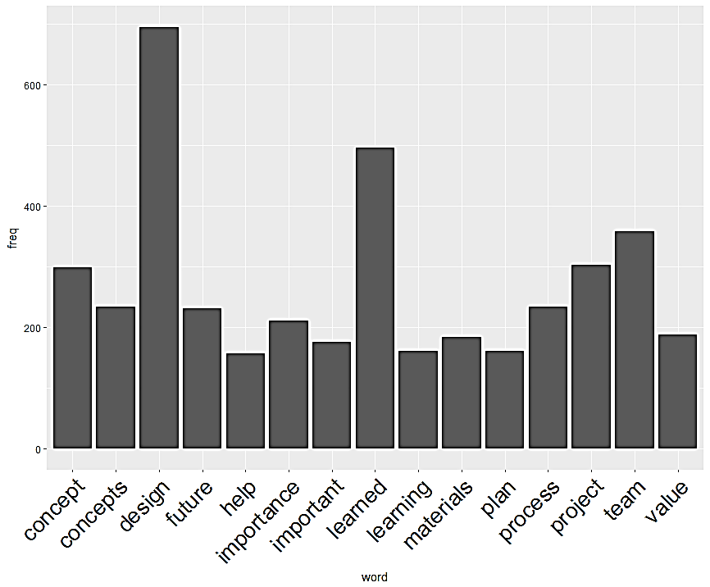
(a)
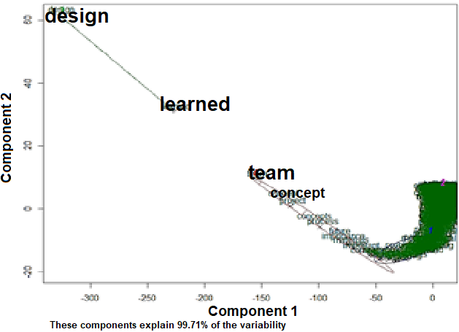
(b)
Figure 4.1. (a) Histogram of Terms from Individual LS in 2016 with Frequency > 150; (b) Cluster Diagram of Individual LS Terms
Figure 4.2. Bar Plot of 2016 Individual LS from A1-5 Sorted by POED
By comparing Figure 4.2 and the terms highlighted in Figure 4.1(a), observe that the words most frequently cited overall seem to approximately map to the POED most frequently written about by individuals. Note also the frequent use of the word ‘team,’ and the fact that POED 1, which deals with several issues pertinent to team formation, organization, and management, both represent areas frequently explored by individuals in the LS. Similarly, ‘concept(s)’ were extremely well represented in the writing samples. Those words could refer to several POED but given what is observed in Figure 4.2 regarding the prominence of POED 2a, which deals with concept generation, and POED 3a, which deals with concept modification, the frequency of ‘concept(s)’ is unsurprising. These connections between the frequently used words and the LS POED breakdown lend credence to the text mining approach moving forward with analysis of the LS broken down by assignment.
Where in Figure 4.1(a) an analysis of the individual LSs from all five assignments together is presented, those LS are now analyzed by individual assignment. These results are plotted in Figure 4.3, showing the corresponding word clouds visually illustrating the relative frequencies of words occurring more than 50 times. From Figure 4.3, it is observed that ‘team’ is the most frequently used word in Assignment 1 and ‘design’ is the most frequently occurring word in Assignments 2-5. As a progression throughout the semester, the focus for the individual students shifts away from their initial decisions of how they will work together as a team to complete their projects and towards the design of their project.
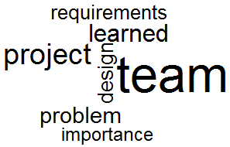 | 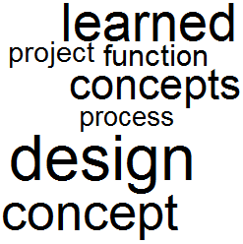 |  | 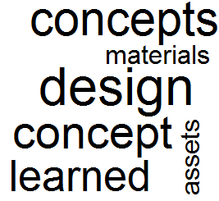
(a) A1 | (b) A2 |  | (c) A3
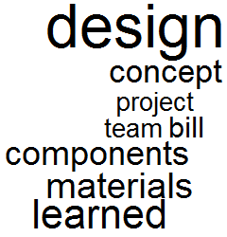 |  | 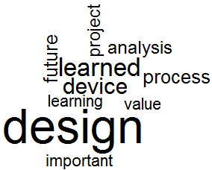
(d) A4 |  | (e) A5
Figure 4.3(a)-(e). Word Clouds of Frequent Terms in 2016 LS
Throughout Assignments 2-5, it is observed that design becomes more and more of a focus for the students. The key factors for Assignments 2-4, in which the students are focusing on their design, were the concepts that they are considering implementing, the ability for the student to identify what they are learning, the design process, and the materials they choose. Recalling the assignment-POED map in Table 1.1 (See Section 1.3), observe that the text mining results appear to validate the assignment target POED. Though the text mining method does not enable one to identify word combinations particular to POED subcategories, patterns in the word frequency can be observed that suggest that students are largely focusing on the main POED targets. In Assignment 5, the design is still a key factor, but observe also that individual students begin reflecting on what is important, the analysis of their project, what they realize throughout, and the value of these experiences toward their future work.

4.2.2 Team LS Data
For the team learning statements, terms across all assignments occurring with a minimum frequency of 50 are analyzed and highlighted them in Figures 11 and 12.
The relatively low number of LSs written by teams presents some obvious challenges. For the given frequency cutoff, only two terms meet the threshold, as shown in Figure 4.4(a). One of these terms, ‘plan’, makes sense, as many of the LSs written by teams deal with their collective organization and planning process. The frequency of the word ‘project’ unsurprising and does not seem specific to any one subject area. From the K-means clustering in Figure 4.4(b), observe that the key factors across all assignments for the teams are the design process and the teams (POED 3 and 1, respectively). All other factors for team learning are not as significant, as can be noted from the fact that only those two terms are in the first cluster.
From Figure 4.5(a), it can be observed that the term ‘team’ is the most frequently occurring in Assignment 1 and that it remains a more prominent word as the semester progresses for the teams than for the individuals, as discussed before. During Assignments 2 and 3, the key factors for team learning are the team as a learning tool and the concepts that the teams used in the design process. In Assignment 5, the design process becomes the most important factor for team learning.
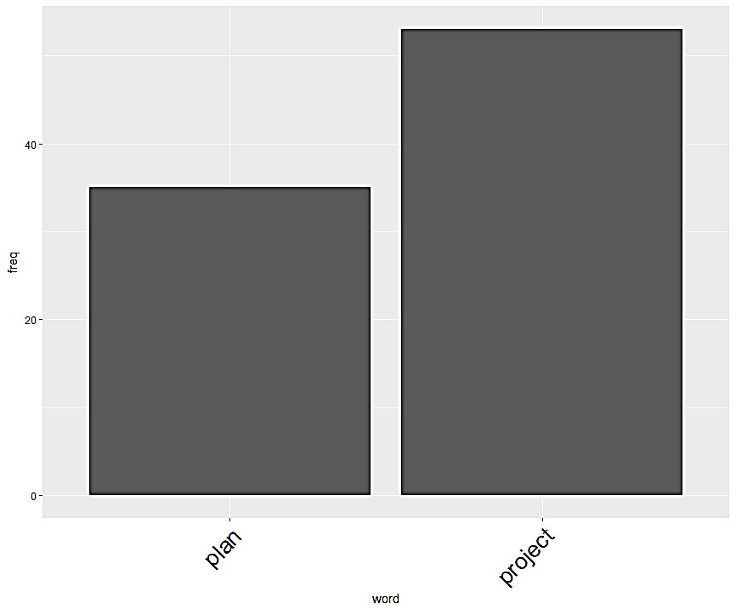 | 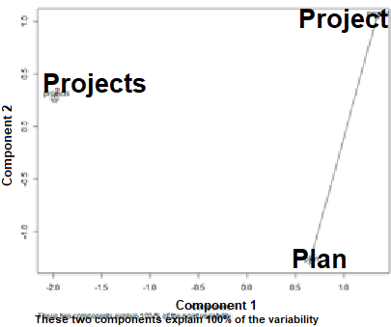
(a) | (b)
(c)
Figure 4.4. (a) Histogram of Team LS with Frequency > 20; (b) Cluster Diagram of A1-5 Team LS; (c) Bar Plot of 2016 Team LS Sorted by POED

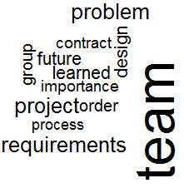 | 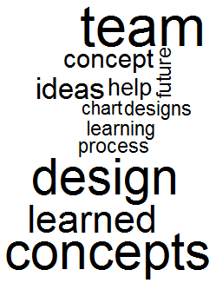 |  | 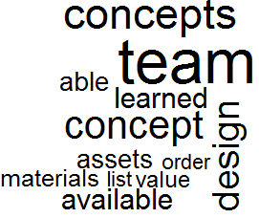
(a) A1 | (b) A2 |  | (c) A3
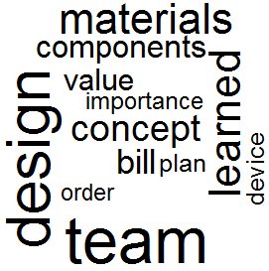 |  | 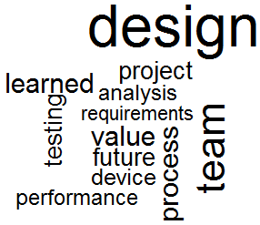
(d) A4 |  | (e) A5
Figure 4.5(a)-(e). Word Clouds of Frequent Terms in 2016 Team LS

4.2.3 Overview of Learning Areas
In Figure 4.3(a), it is noted that individual LS in Assignment 1 largely focus on team formation and management, which are tied to POED 1. It is observed here that ‘team’ is the most frequently word used, a notable exception to Assignments 2-5, in which ‘design’ is instead the word most frequently used. This is consistent with the goals for students completing Assignment 1, which focus on two areas: forming and organizing the team and understanding the design problem. Interestingly, it is observed from Figures 10(b)-(e) that ‘concept’ and ‘concepts’ in Assignment 2, ‘device’ and ‘process’ in Assignment 3, ‘concept/concepts’ and ‘materials’ in Assignment 4, and ‘materials,’ ‘concepts,’ and ‘components’ in Assignment 5 are all the most frequently used words after ‘design.’ Given that, in Assignment 2, students generate concepts, in Assignment 3 they refine them into a primary design concept, in Assignment 4 they develop CAD models and plan the prototype construction, and in Assignment 5 they perform a post-mortem on the device as-built, in the results there is evidence that students are internalizing the POED as intended. This, given the fact that students around Assignment 3 begin to more readily discuss their learning in the context of a design process, indicates that by the stage of concept refinement the value of the structured approach is becoming evident to the students.

4.3 Student Confidence in AME4163
It now becomes necessary to examine student confidence in their own abilities. As stated in Section 1.3, the MII is principally divided into two sections. It is necessary to separately gauge how confident students are in applying their learning in the short-term (‘Current Status’) and the long-term (‘Moving Forward’). Questions in ‘Current Status’ (see Table 1.3) differ from survey to survey (with some overlap), whereas the questions in ‘Moving Forward’ (see Table 4) are constant between surveys.

4.3.1 MII ‘Current Status’
The median response to questions in ‘Current Status’ that appear in multiple surveys are presented in Figure 4.6. The first two questions of ‘Current Status’ appear in all five surveys. The first question asks students to rate their confidence in understanding what is required in the most recent assignment and how that work connects to the rest of the course. The second question asks students to rate their confidence in how well they understand why recent feedback on their work was provided. In addition to these two questions, five other questions appear on two surveys. In each, students are asked to express how confidently they feel that they understand one of the items associated with POED 1a, 1b, 1c, 1d, or 3a, which deal with team formation, implementation of a team contract, forming an understanding of the problem, developing a plan of action, and refining generated concepts, respectively. The questions pertaining to POED 1a, 1b, 1c, and 1d appear on MII: I and MII: II, which take place before and after Assignment 1, respectively. The question pertaining to POED 1d appears on MII: II and MII: III, which occur before and after Assignment 2, respectively. The question pertaining to POED 3a appears on MII: III and MII: IV, taking place before and after Assignments 3 and 4, respectively. The shaded areas surrounding the plots represent variation about the median response for that survey.
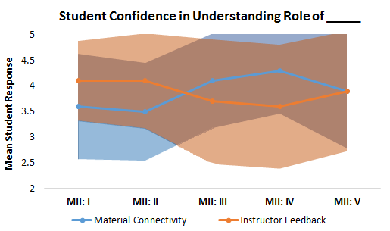 | 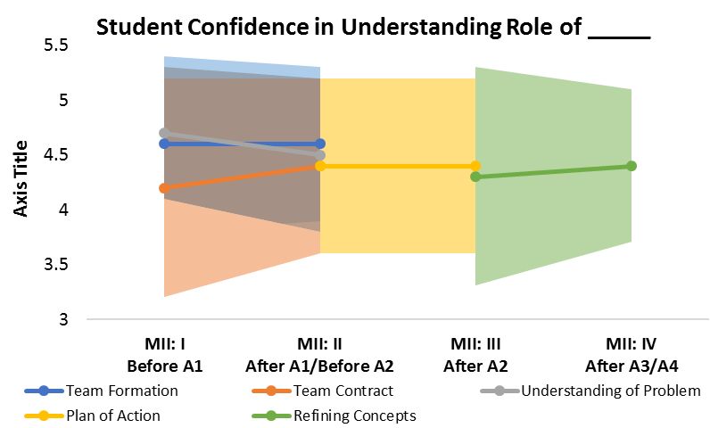
(a) | (b)
Figure 4.6. (a) MII 'Current Status' Questions 1 and 2; (b) MII 'Current Status' Questions for POED 1a, 1b, 1c, and 1d
It is observed in Figure 4.6(a) that the trends in mean student response to Question 1 and Question 2 are almost perfect mirrors to one another, converging at almost the same level of confidence. Between MII: I and MII: II, students do not significantly change in how confident they report they feel about what is being asked of them in the most recent assignment. However, between MII: II, III, and IV, students are substantially more confident in what is being asked of them and how the material connects to previous work, before dropping in confidence again in MII: V. This suggests that the students are quite comfortable with the assignments that call heavily on their technical skills; in Assignment 3 they narrow generated concepts down to two through technical analysis and in Assignment 4 they develop their chosen concept through technical analysis such as Computer-Aided Design. Assignment 5 however, turned in shortly before MII: V, is a post-mortem exercise, encouraging students to critically reflect on the design process and the team’s successes and failures. This must be relatively more challenging to the student, as their confidence in understanding the purpose of Assignment 5 declines. In contrast, student confidence in their understanding of instructor feedback drops from MII: II to III and from MII: III to IV, before rising again after MII: V. Once again, the effect highlighted seems to be prompted by the assignments in which students favorably leverage their technical skills. This suggests that students may value feedback less in technical domains which are areas that, as seniors, they likely feel more confident in. Of note also the relatively high mean confidence expressed in general; in fact, in all five surveys, students expressed confidence of three or less only slightly more than twenty percent of the time. Overall, it is observed that senior-level design students are, on balance, firmly confident in their short-term ability to apply knowledge acquired.
In Figure 4.6(b), note that most students do not significantly change their responses to questions that appear on successive surveys. Questions in which students assess their confidence in the importance of team formation and forming a plan of action did not change at all across two assignments dealing heavily with those topics. Questions in which students assess their confidence in the importance of implementing the team contract and evaluating concepts only rose by .2 and .1 points, respectively, across the assignments dealing with those topics while the question in which they assess their confidence in the importance of understanding the problem actually fell by .2. Given these small shifts, it appears that student confidence in the importance of various POED to the design process are not significantly affected by single assignments. However, recalling the LS POED breakdown in Figures 10, student focus is shifting over time. Further, from Figure 4.6(a), it can be seen that students on average increasingly see the connections between each step of the design process as that process moves forward. From this seeming contradiction it could be postulated that, as students move forward in the design process, though they may identify the value in distinct steps, they might be coming to see each step as relatively less important in the grand scheme of the project.

4.3.2 MII ‘Moving Forward’
In this section, the focus now shifts to the section of the survey in which students assess their confidence in applying their knowledge to future endeavors (capstone, industry). In this section of the survey, titled ‘Moving Forward,’ the ten questions outlined in Table 4 (see Section 1.3) are posed. The data from this portion of the survey are plotted in Figure 4.7(a) and (b). Both versions of the resultant radar plot of the median student responses to Questions 1-10 of the ‘Moving Forward’ section on all five surveys are presented to illustrate different points.
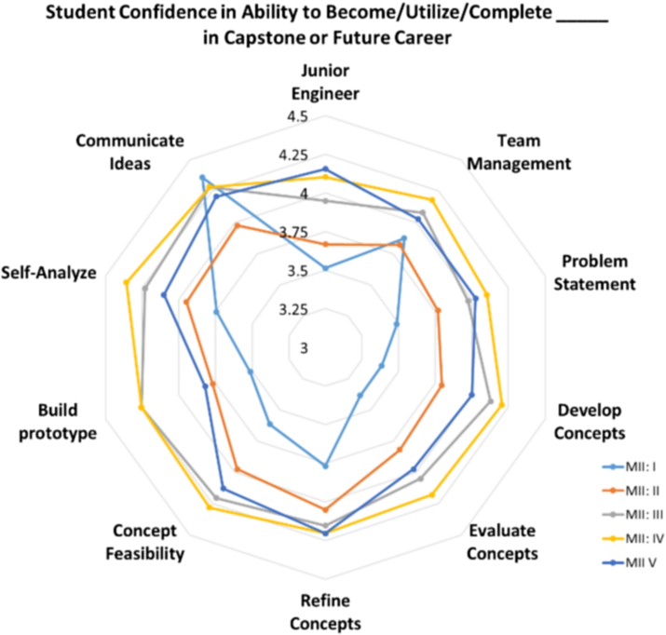 | 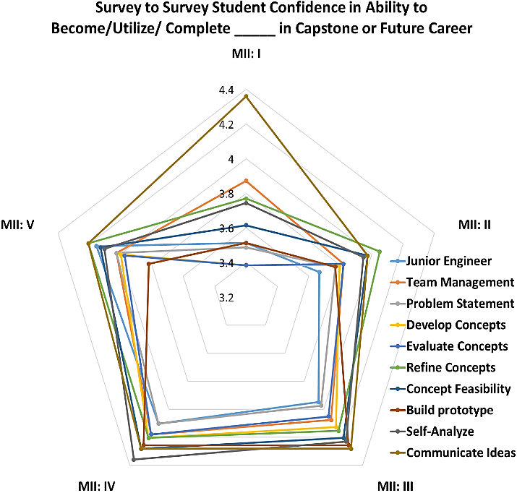
(a) | (b)
Figure 4.7. (a) Radar Plot of Median Student Response, Question to Question; (b) Radar Plot of Median Student Response, Survey to Survey
Immediately, from both plots, it is observed that median student confidence never falls below 3 nor above 4.5 across all surveys, with response variance ranging from .85 to 1.0. Note also that the average student taking AME4163 appears confident in their ability to apply the identified skill or knowledge to capstone or their career.
From Figure 4.7(a), it is observed first that, overall, between MII: I and MII: V, mean student confidence in each question rose for all but Q10. In Q10, students are asked to assess confidence in their ability to communicate their ideas and learning. At first, students start off fairly confident in this area (MII: I), but later their confidence then drops (MII: II), and then rises and converges at around 4.25 (MII: III-V). Given that students complete MII: I before submitting their first assignment, it could be postulated that their initial experience with the assignments reveals shortfalls to the students in their communication skills that they had not anticipated but that the exercise of writing and submitting assignments grows their confidence over time. In Figure 4.7(b), another interesting phenomenon in the responses to the surveys over times is evident. Excepting Q10, not only do students become more confident in their ability to apply the skills embodied in Q1-9 over time, but their response variation between questions converges over time until MII: IV, before becoming slightly more varied in MII: V. This phenomenon might be attributable to the fact that MII: V takes place after the completion of the post-mortem exercise in Assignment 5. The post-mortem exercise is a reflective one; the students are now looking back at their project through the lens of the success or failure of their device. Going into the prototyping phase (MII: IV), most teams have gained confidence in most design areas, but many are disappointed by the performance of their device during the demonstration. Therefore, the slight downward trend in confidence from MII: IV to MII: V implies evidence that students are critically examining their abilities after Assignment 5.

4.3.3 Relationship Between Student Course Performance and Confidence
Following the prior analysis of confidence, it is now time to answer two questions related to student confidence in their design abilities. First, does there exist a relationship between the confidence that students express regarding their long-term ability to apply their design skills and their actual performance in the course, as judged by conventional evaluations of their design artifacts and written reports? Second, how does that same student confidence change over the course of the design project, in response to the novel challenges that they face and the feedback from instructors that they receive? Addressing these questions will provide important insight regarding the value of such self-assessment instruments in DBT courses.
Before beginning the analysis, a note on the data set. This information will provide some later context that will aid in the interpretation of the results. First, data were collected from 160 students who took AME4163 in Fall 2016. However, because in this chapter changes in student responses across all five surveys are the focus, this data set has been narrowed to eighty-nine students who completed all five surveys that semester. Survey responses themselves are not graded per se, but a participation grade is given simply for completing each survey. Survey results are not broken down by gender in this analysis, but, for completeness, note that of eighty-nine complete observations, ten are women and seventy-nine are men.
Since the students are not being sampled randomly (the MII response data and grades are from the eighty-nine students who completed all five surveys), the normality of the grades for the students that are used in this analysis are examined. Since student confidence is compared to ‘traditional’ evaluation metrics, the students’ grades on their design artifact performance and in the course overall are examined. In this case, because the sample size is greater than ~30, parametric tests (like ANOVA) are acceptable even if the underlying population is non-normal [40]. In Figure 4.8 are presented histograms of the two grade distributions. Note that in the figure that the distribution for device performance grade appears distinctly non-normal whereas overall course grade is closer to normal, though with some obvious outliers.
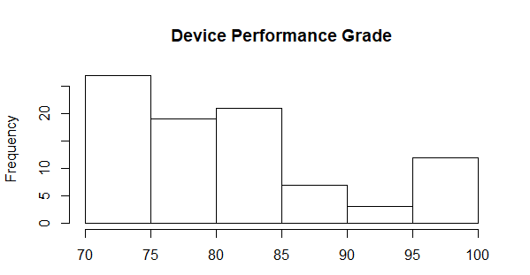 | 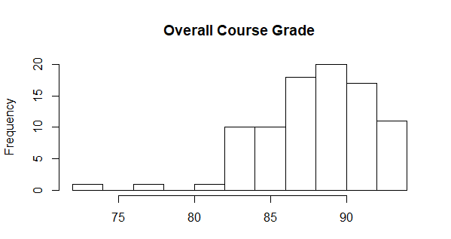
(a) | (b)
Figure 4.8. Histograms of (a) Device Performance Grade and (b) Overall Course Grade
Next, correlations between the survey responses themselves for all five surveys are examined. As mentioned previously, responses to the surveys use Likert-style response scales, so the typical Pearson’s coefficient is insufficient. Instead, the Spearman rank correlation coefficient, suitable for ordinal data, is used. In Figure16, correlation matrices are produced for all ten survey questions across all five surveys. Survey questions are coded by the bolded key-words outlined in Table 4, Section 1.3.1.
In Figure 4.9, each cell displays the Spearman rank correlation coefficient for the pair of survey questions with the darkness of the color corresponding to the strength of the correlation where darker colors imply stronger correlations. In addition, color is removed from a cell if the p-value for the coefficient of the pair of questions is higher than .01, meaning that the generated coefficient is insignificant for a ninety-nine percent confidence level. In general, fairly strong correlations between most all question pairs across all five surveys are observed, though most appear to strengthen over time, meaning that between MII: I and MII: V, the correlations grow stronger.
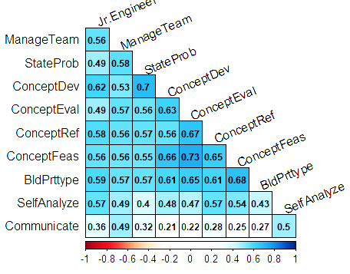 | 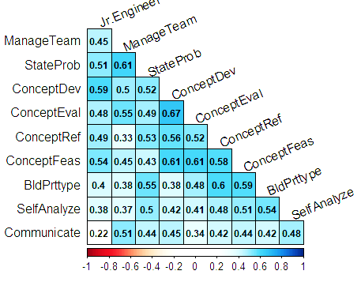
(a) MII: I | (b) MII: II
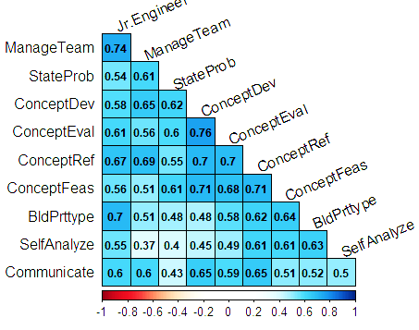 | 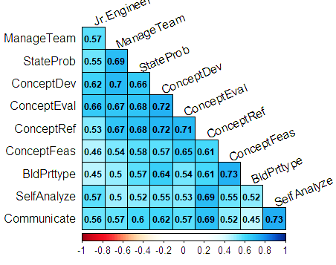
(c) MII: III | (d) MII: IV
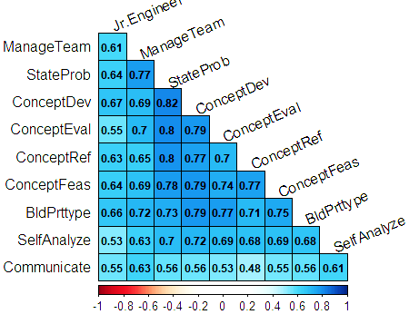
(e) MII: V
Figure 4.9(a)-(e). Correlation Matrices for MII 'Moving Forward': I-V
Interestingly, the three strongest correlations (greater than or equal to .8) in MII:V all involve student confidence in their ability to formulate an understanding of the design problem (StateProb). This question has a correlation coefficient of .82 with student confidence in their ability to develop design concepts, .8 with student confidence in their ability to evaluate concepts, and .8 with student confidence in their ability to refine concepts. This finding implies that students at the end of the semester who are confident in their ability to formulate an understanding of the design problem are also confident in their ability to generate, evaluate, and refine concepts during the design process.
Now that some understanding of the data is formed, the analysis plan is diagramed. To begin, recall that the data set contains eighty-nine complete cases of observations of student responses to ten questions from five course surveys. Included in the data set are each students’ grades for their team’s device performance and for the individual’s overall performance in the course. Moving forward to the first phases of the analysis, the data set is scrubbed of any individual student’s name or student ID to preserve anonymity and limit my own potential bias in any analysis.
In phase one, one-way ANOVA analysis is performed with each of the students two grades as the response variable. Because the changes in effect over time of the students’ confidence on their course performance are of interest, each student is classified one of two ways: in the first using their results from MII: I (beginning of the design project) and in the second using their results from MII: V (end of the design project). Students are put into one of three groups for both time periods. If a student’s responses in one survey summed to a cumulative forty points or greater (for example, by answering all ten questions with a rating of ‘four’), they were labeled ‘high’ confidence for that survey time period. If a student’s responses in one survey summed to between thirty and thirty-nine points (inclusive), they were labeled ‘medium’ confidence. If a student’s responses in one survey summed to equal or less than twenty-nine, they were labeled ‘low’ confidence. Using this formula, each student was grouped for each time period with three levels with varying numbers of observations. Summaries for the total number of students falling into each level for MII: I and V are outline in Table 4.1.
Table 4.1. Number of Observations Per Treatment Level for MII: I and V
MII: I | MII: V
High Low Med  41 17 31 | High Low Med  52 8 29

Having classified the data into the stated categories for each time period, four one-way ANOVA tests are performed: one for the effect of the confidence level at the start of the semester on the demonstration grade, one for the effect of the confidence level at the start of the semester on the overall grade, one for the effect of the confidence level at the end of the semester on the demonstration grade, and one for the effect of the confidence level at the end of the semester on the overall grade. For all tests, there are three treatment levels with varying numbers of observations, which requires that both different formulas for the sum of squares calculations and weighted mean instead of the treatment means for calculations are used. This turns out not to be a difficult issue, as R’s built-in ANOVA function ‘aov’ detects unbalanced designs and makes these changes in formulae automatically.
Following the set of one-way ANOVA tests, two two-way ANOVA tests are performed looking for possible interaction effects between starting and ending-confidence levels on each of the two grade items. As in the one-way tests, the null hypothesis is that neither treatment (start or end confidence level) nor their interactions, has an effect on the response variable (demonstration grade in the first and overall course grade in the second). For this analysis, residuals are analyzed to ensure that the model is appropriate for the data examined given assumptions of residual normality.
In the final portion of the analysis, the survey responses themselves are examined. Specifically, do the responses to given questions change significantly over the course of the semester? To accomplish this, all ten questions across all five MII are collected into ten separate data frames and ANOVA is performed on each one. In this case, each ANOVA test will have five treatment levels (each survey) but will be a balanced design with eighty-nine total observations for each. However, unlike in previous tests, as the response variable is the student Likert-response to each question, an ordinal variable, the non-parametric Kruskal-Wallis test of variance must be used. This will permit appropriate identification of whether the null hypothesis that the responses do not change between the surveys must be accepted or rejected.
As previously outlined, the first task is to perform one-way ANOVA on the effects of the starting and ending confidence levels on the device demonstration grade and on the overall course grade. The results of those four tests are summarized in Table 4.2. From this table, of the four ANOVA tables, none produce p-values small enough to provide support to reject the null hypotheses that either the start or ending confidence level has an effect on the students’ device performance grades or overall course grades. Given this fact, and in keeping with the aforementioned analysis plan, it is now necessary to move on to examination of the possible interaction effects between both the starting and ending confidence treatments on either the device demonstration or overall course grades. These findings are summarized in Table 4.3.
Table 4.2. ANOVA Results for Confidence Level on Grades
Effect of Starting Confidence Level on Device Grade
StartConfLev  Residuals | Df  2  86 | Sum Sq  75  7078 | Mean Sq  37.68  82.30 | F value  .458 | Pr(>F)  .634
Effect of Starting Confidence Level on Overall Grade
StartConfLev  Residuals | Df  2  86 | Sum Sq  43.3  1147.3 | Mean Sq  21.66  13.34 | F value  1.624 | Pr(>F)  .203

Effect of Ending Confidence Level on Device Grade
StartConfLev  Residuals | Df  2  86 | Sum Sq  2  7151 | Mean Sq  .93  83.15 | F value  .011 | Pr(>F)  .989

Effect of Ending Confidence Level on Overall Grade
StartConfLev  Residuals | Df  2  86 | Sum Sq  .9  1189.8 | Mean Sq  .452  13.834 | F value  .033 | Pr(>F)  .968

Table 4.3. ANOVA Results for Start and End Confidence Levels on Grades
Two Way ANOVA Start/End Confidence Effect on Device Performance
StartConfLev  EndConfLev  StartConfLev:EndConfLev  Residuals | Df  2  2  4  80 | Sum Sq  75  11  713  6354 | Mean Sq  37.68  5.41  178.17  79.43 | F value  .474  .068  2.243 | Pr(>F)  .6240  .9343  .0716

Two Way ANOVA Start/End Confidence Effect on Overall Grade
StartConfLev  EndConfLev  StartConfLev:EndConfLev  Residuals | Df  2  2  4  80 | Sum Sq  43.3  6.9  40.3  1100.1 | Mean Sq  21.660  3.426  10.087  13.752 | F value  1.575  .249  .734 | Pr(>F)  .213  .780  .572

In Table 4.3, it can be seen that, in a two-way ANOVA of the start and end confidence-level effects on the two graded items, no effect of either confidence level on either grade is detected. However, note that there appears to be some slight interaction effect from between the two treatments on the device performance grade. Note that this is fairly weak significance; the effect is only significant for a confidence level of 90%. Nevertheless, this result must be followed up on by performing a Tukey Honest Significant Difference (HSD) Test on the model to identify how the effect might be manifesting itself. The results of this test are summarized in Table 4.4.
Table 4.4. Tukey HSD test for Start/End Confidence Effect on Device Grade
Tukey HSD Results
$StartConfLev
Low-High  Med-High  Med-Low | diff  -2.5027039  -0.6655268  1.8371771 |  |  | lwr  -8.642249  -5.731140  -4.586059 |  |  | upr  3.636841  4.400087  8.260413 |  |  | p adj  0.5956764  0.9472192  0.7740295
$EndConfLev
Low-High  Med-High  Med-Low | diff  1.1687339 -0.2940403  -0.8746936 |  |  | lwr  -6.914172  -4.638611  -9.374234 |  |  | upr  9.251640 5.226692  7.624847 |  |  | p adj  0.9364430  0.9888912  0.9672664
$`StartConfLev:EndConfLev`

Low:High-High:High  Med:High-High:High  High:Low-High:High  Low:Low-High:High  Med:Low-High:High  High:Med-High:High  Low:Med-High:High  Med:Med-High:High  Med:High-Low:High  High:Low-Low:High  Low:Low-Low:High  Med:Low-Low:High  High:Med-Low:High  Low:Med-Low:High  Med:Med-Low:High  High:Low-Med:High  Low:Low-Med:High  Med:Low-Med:High  High:Med-Med:High  Low:Med-Med:High  Med:Med-Med:High  Low:Low-High:Low |  |  | diff  -3.8120994  -4.5822459  -1.4787660  -5.8473558  16.8545673  -6.1262019  -1.9091690  -0.2800481  -0.7701465  2.3333333  -2.0352564  20.6666667  -2.3141026  1.9029304  3.5320513  3.1034799  -1.2651099  21.4368132  -1.5439560  2.6730769  4.3021978  -4.3685897 |  |  | lwr  -16.453180  -13.687309  -18.635769  -20.916524  -12.000694  -18.767283  -13.765527  -8.980237  -14.635099  -17.758892  -20.376864  -10.024714  -18.719336  -13.905548  -10.070449  -14.974206  -17.374729  -7.975192  -15.408908  -10.480372  -6.096517  -26.070673 |  |  | upr  8.828982  4.522817  15.678237  9.221813  45.709828  6.514879  9.947190  8.420141  13.094806  22.425558  16.306352  51.358047  14.091130  17.711408  17.134552  21.181166  14.844509  50.848819  12.320996  15.826526  14.700912  17.333494 |  |  | p adj  0.9882376  0.7995397  0.9999989  0.9455929  0.6410097  0.8305500  0.9998638  1.0000000  1.0000000  0.9999889  0.9999922  0.4498749  0.9999502  0.9999853  0.9956639  0.9997797  0.9999995  0.3407786  0.9999920  0.9992347  0.9226912  0.9992860
Tukey HSD Results
$`StartConfLev:EndConfLev`
Med:Low-High:Low  High:Med-High:Low  Low:Med-High:Low  Med:Med-High:Low  Med:Low-Low:Low  High:Med-Low:Low  Low:Med-Low:Low  Med:Med-Low:Low  High:Med-Med:Low  Low:Med-Med:Low  Med:Med-Med:Low  Low:Med-High:Med  Med:Med-High:Med  Med:Med-Low:Med |  | diff  18.3333333  -4.6474359  -0.4304029  1.1987179  22.7019231  -0.2788462  3.9381868  5.5673077  -22.9807692  -18.7637363  -17.1346154  4.2170330  5.8461538  1.6291209 |  |  | lwr  -14.477133  -24.739661  -20.038407  -16.678470  -9.066674  -18.620454  -13.871667  -10.316991  -53.672150  -49.140325  -46.423815  -11.591445  -7.756347  -11.247382 |  |  | upr  51.143799  15.444789  19.177601  19.075906  54.470520  18.062762  21.748041  21.451606  7.710611  11.612853  12.154584  20.025511  19.448654  14.505624 |  |  | p adj  0.6939322  0.9980620  1.0000000  0.9999999  0.3674733  1.0000000  0.9985929  0.9698930  0.3052323  0.5687400  0.6390803  0.9947890  0.9055656  0.9999784
Interestingly, the Tukey HSD results indicate no significant pairwise differences between any of the levels of the interaction effects between start and end confidence levels on the device demonstration grade. One possibility for this is that ANOVA is more sensitive to variation about the mean than in the pairwise tests of the Tukey HSD. The interaction effects are therefore plotted for completeness in Figure 4.10.
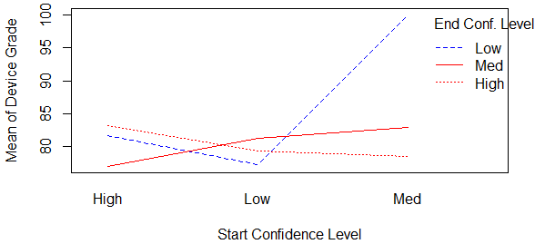
Figure 4.10. Interaction Plot of Start and End Confidence Level on Device Grade

It can be observed that, for students who start at medium confidence and end the project at the low confidence level, device grade is much higher. For all students at the medium and high confidence levels at the end of the project, the device grade is mostly the same regardless of the starting confidence level. Notably, students who started with low confidence and ended with low confidence also had the lowest device performance.
Moving on to the final phase of the analysis, in which it is examined whether any questions exhibit changes in response between any of the five surveys. That is, are student responses to any survey question significantly different, in aggregate, at different points in the design project? As previously mentioned, the Kruskal-Wallis rank sum test of variance is used due to the ordinal nature of the variable, which are the responses to the survey questions. Results for each question are outlined in Table 9.
From Table 9, significant differences at some level of the response variable in four questions can be seen for a ninety-nine percent level of confidence. A higher level of confidence is used for this test in particular than is typical because the non-parametric test is less sensitive then its parametric alternatives. For those five questions (Questions 3, 4, 7, and 8), there is some indication that significant changes may be occurring over the course of the project.
Table 4.5. Kruskal-Wallis Results for All Questions on MII: I-V
Number | Descriptor | Chi-Squared | DoF | p-value
1 | JrEngineer | 12.46 | 4 | .0143
2 | ManageTeam | 2.02 | 4 | .733
3 | StateProb | 18.09 | 4 | .00119
4 | ConceptDev | 25.46 | 4 | 4.07e-05
5 | ConceptEval | 12.89 | 4 | .0118
6 | ConceptRef | 8.08 | 4 | .0888
7 | ConceptFeas | 14.45 | 4 | .00600
8 | BldPrttype | 14.46 | 4 | .00600
9 | SelfAnalyze | 7.34 | 4 | .119
10 | Communicate | 2.34 | 4 | .673

From the one-way ANOVA results, neither student confidence at the beginning or the end of the semester has any significant bearing on the students’ performance in either the device demonstration or the course as a whole. This indicates a strong inability to properly assess confidence (and consequently, competence) in their design-related abilities. This finding is consistent with what other engineering researchers, particularly in STEM fields, find regarding student assessment of their own competency. Researchers such as Hamlin et al. [50] have found that students largely over-estimate their own abilities, though they note that this effect is predominantly true for men while the reverse is true for women. It is stated earlier that the sample was overwhelmingly male, to a ratio of about eight to one. Further analysis will have to be done to verify whether this effect is gendered in nature.
This is also corroborated by the correlation matrices presented in Figure 4.9. Given that the confidence across all surveys skews higher, it is unsurprising that the correlations largely strengthen over time; students coming to the end of the course are more confident in their design abilities, seemingly without regard for their performance. Note, however, that a slight interaction effect between starting and ending confidence levels on how well the students’ design devices performed is present. Students who started the course off with ‘medium’ levels of confidence and ended with ‘low’ levels of confidence actually were more likely to perform well in the device demonstration, though it is possible that the low number of observations for that combination of factors played some role in the starkness of the effect, which was only detected by ANOVA with a ninety percent confidence level.
It is also found that, in analyzing the results of the survey responses themselves, student responses to the MII ‘Moving Forward’ questions three, four, seven, and eight reveal effects significant enough to reject the null hypotheses that confidence levels for each question were the same throughout the semester for a confidence level of ninety-nine percent. Those four questions dealt with student confidence in their ability to formulate problem statements, develop concepts, determine the feasibility of design concepts, and build effective prototypes, respectively. Though further analysis will be required to examine the particular trends at play, these highly significant differences in response suggest that, at least on some level, for some areas of design related competency, students are being self-critical of their own learning experience. In Chapter 5, the analysis is broadened to examine how groups of students understand and interpret their aggregated learning.
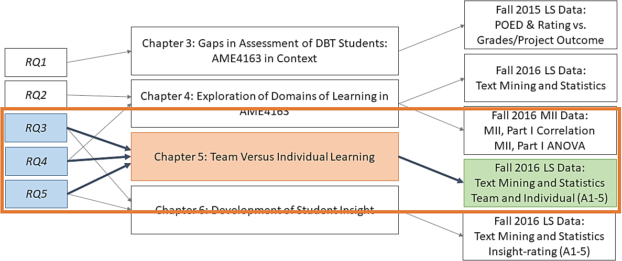

Chapter 5. Team Versus Individual Learning
In this chapter, learning statement (LS) data from students in Fall 2016 is leveraged in order to identify differences in the learning expressed by students, as individuals, and that expressed by groups of students in their course teams. The chapter begins with a brief discussion of the course project and the team structure in the course.

5.1 DBT Course Project in AME4163
In AME4163, as has already been outlined in Section 1.3, students are organized into teams in order to complete a structured, semester-long design project. This project is characterized by the scaffolded design process, the opportunity to build and test a prototype system, and the team structure. In AME4163, the teams are organized by the students, though the instructors may facilitate team formation. The instructors provide students with a lecture that includes best practices for forming successful teams. In particular, the instructors caution against forming teams comprised simply of groups of friends. Instead, they are advised to form teams based on an alignment of team member goals and each member’s availability.
Throughout the design project, teams are free to complete the written assignments as they please; beyond providing the instructions, rubric, and lectures, the instructors do not prescribe a means of dividing work amongst the members of any team. As is common in group projects, outside of extenuating or unusual circumstances, the instructors assign grades for the assignments to the teams as a whole in order to facilitate team accountability. Through this the instructors hope to encourage members to cooperate, compromise, and navigate disagreement effectively.
Importantly, at the conclusion of each assignment, teams are required to complete learning statements, both as individuals and as a team. By working to identify a collective lesson, insightful individuals have the opportunity to share with students who have greater trouble. Further, those sharing their insight for the benefit of others, by working in a social context, are generally forced to be more careful, selective, and incisive with their thinking. Through the team LS exercise, knowledge is therefore generated collectively and is dependent on the social context of the group created over the course of the semester.
Given this slight distinction between the cognitive effort involved in individual and team LSs, it is asserted that it is likely that differences between the aggregated groups of either LSs can be revealing about the ways students in such courses learn.

5.2 Analysis of LSs by Assignment in AME4163 – Standard Approach
In both this section and in Section 5.3, LS collected from students in Fall 2016 over the course of the five assignments comprising the course design project are utilized. In this section, however, the breakdown of both team and individual LS by domain of learning is explored. That is, as each LS falls into one of the POED categories, a breakdown of the LSs for each category is provided in order to explore emergent patterns, particularly as they relate to differences between the learning expressed by individuals versus teams.

5.2.1 Areas of Student Learning
In Figure 5.1(a), the total breakdown of all individual student LSs submitted in Assignments 1-5, broken down in terms of the POED explored in each statement is highlighted. Each POED bar is further sub-divided into the POED sub-categories, coordinated by color. For example, POED 1a is light green and 1d is dark green. Within each section of each bar, a POED sub-category label is included with the number of LSs pertaining to that label. The boxed number at the far right of each bar is the sum of all LSs in each POED. The same approach for the team LSs is employed and illustrated in Figure 5.1(b).
For the individual LS in Figure 5.1(a), note that POED 1 and POED 4 are largely the focus of individual LSs. POED 1, which deals with team formation, planning the design process, and understanding the problem, are a continuing focus for students throughout the semester. Many students report throughout the design process that only at later stages do they see how valuable ensuring teams are responsibly formed and organized from the beginning can be to later success. Similarly, throughout the project many individuals identify how key forming a proper “plan of action” is to manage the uncertainty of time and effort. Student writing LSs tied to POED 4, which deals with prototyping and post-mortem analysis, largely focus on POED 4a, which refers to the role of the Bill of Materials and the criticality of understanding each component of the prototype. Students writing these statements often explore how components that were purchased at the last minute or without full understanding of the limitations of the component performance contribute to struggles during the device testing and demonstration.
- Individual LSs
- Team LSs
Figure 5.1. Bar Plots of 2016 LSs Broken Down by POED and Sub-POED
Interestingly, though POED 2 is only the third most explored POED overall, POED 2a is the second largest sub-category written about by individuals. Students writing LS tied to POED 2a, which deals with concept generation, largely write about how the systematization of ideation (through tools like the Function Structure and Morphological Chart in Assignment 2) is useful in generating a variety of useful concepts, as opposed to a more intuitive, unstructured approach.
Figure 5.1(b) shows the same breakdown but instead for team LSs. For the team LSs presented in Figure 5.1(b), there appears to be similar patterns of subject matter explored but with several notable differences. First, as in Figure 5.1(a), it can be seen that teams are largely concerned with both team formation (POED 3a) and proposing the plan of action (POED 3d). Relatively speaking, however, it is seen that, unsurprisingly, teams write a higher percentage of their LS about POED 3a than 3d, indicating that teams continually revisit the process by which they had organized and collaborated in their team formation. Another similarity notable between the two figures is that POED 2a is well represented among the team LSs, once again being the second largest category written about (though tied for that position in this case). Student teams throughout the design process revisit the role of the concept generation phase on their current progress or difficulties. Perhaps the largest difference between teams and individuals, and rather surprisingly so, is that seen in Figure 5.1(b) that statements exploring POED 3 are by far the largest block of LSs written by teams. Perhaps POED 3, which deals with concept refinement and elimination, forming a preliminary Bill of Materials, and ensuring concept feasibility, is so well represented among team LSs due to the fact that the process of narrowing down concepts to two (primary and a backup concept) and refining the primary concept until it meets all identified requirements is anchored in several, labor-intensive tools. That is, the instructors require teams at this stage to perform a series of structured analyses that they likely perform as a team (rather than delegating to individuals) due to the fact that said analyses cannot be easily broken up into discrete tasks and necessitate the input of all team members. Therefore, it is logical that students drafting the team LSs find the design work embodied by POED 3 to be an area well understood by all team members. This may also account for the representation of POED 1 and 2 (work more easily done as a team) and the relatively weak representation of POED 4 and 5 (work can be more easily divided among individuals).

5.2.2 Patterns in Student Versus Team Learning Over Time
Having broken down the POED explored in the LSs for teams and individuals in Assignments 1 through 5, data are now further broken down by assignment. In figure 5.2 is demonstrated the POED breakdown of both team and individual LSs for each assignment in order to better understand how the chosen subject matter of student and team LSs changes over time. One of the more interesting patterns from the data present in Figure 5.2 is how consistent the POED breakdown is between teams and individuals for Assignments 1-3. This may be due to the fact that, until Assignment 4, all of the design work is included in the assignments but around the time of Assignment 4, students begin to construct their devices. There is no assignment that addresses this phase of the design process; it is the only unstructured part of the course. As a result, individuals, around the time of Assignment 4, may be working on tasks separate from Assignment 4 itself and therefore may find these experiences more relevant to write about. The fact that individuals and teams are much more similar in their LS breakdowns in Assignment 5 lends credibility to that theory. There are slight differences, however, in Assignments 1-3; for example, in Figure 5.2(a) and Figure 5.2(b) (Assignment 1), teams, unsurprisingly, devote relatively more LSs than do individuals toward POED 1a, dealing with team formation. However, despite slight variation in the breakdown of POED sub-categories in Assignments 1-3, the differences between team and individual LS are relatively slight. As anticipated, both teams and individuals focus on POED 1 in Assignment 1, POED 2 in Assignment 2, and POED 3 in Assignment 3, mapping extremely well to the target assignment POED table presented here as Table 1.1 in Section 1.3.1.
Despite how well the POED breakdown in Figure 5.2(a-e) maps to that presented in Table 1.1, in Figure 5.2(f-i), these trends no longer hold true. In particular, note that in Assignment 4, individuals largely write about POED 4 (particularly POED 4a), as the instructors intend from the assignment targets, whereas teams focus almost exclusively on the areas of concept evaluation and refinement embodied by POED 3. It was suggested earlier in this section that teams may be focusing on ‘Embodiment Design’ (POED 3) as the work associated with this POED is more team-driven (or at least, less able to be distributed as individual tasks) than that of other POED. Another confounding factor may be that at the time that Assignment 4 is being drafted, many teams are beginning to purchase real components for the device. As the instructors do not require LSs to be written about any particular experience (though they provide suggested targets), it may be the case that individuals are beginning to focus more on prototyping and testing (POED 4) than the team as a whole.

 | Individual | Team
Assignment 1 | 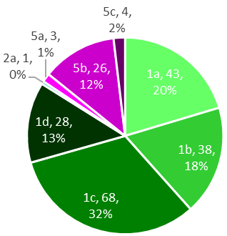 | 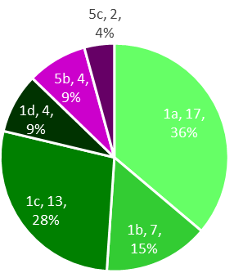
 | (a) | (b)
Assignment 2 | 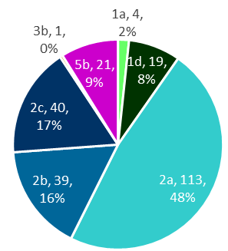 | 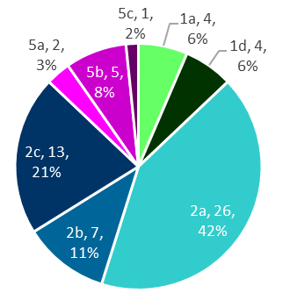
 | (c) | (d)
Assignment 3 | 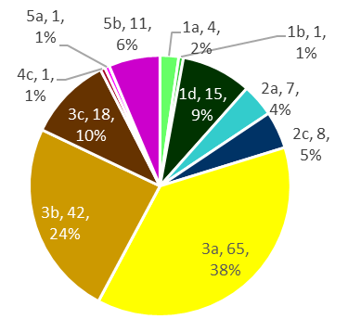 | 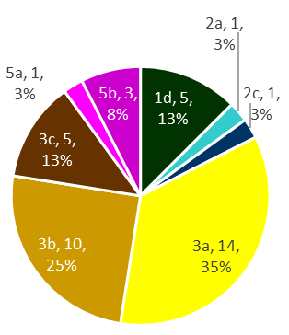
 | (d) | (e)
 | Individual | Team
Assignment 4 | 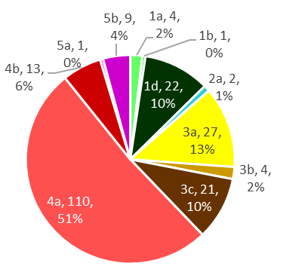 | 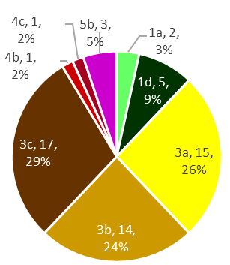
 | (f) | (g)
Assignment 5 | 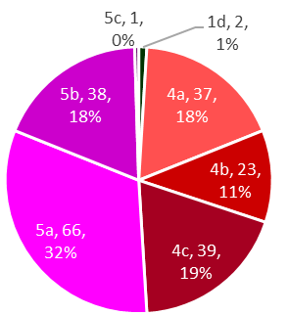 | 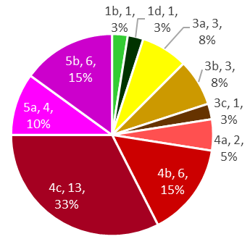
 | (h) | (i)
Figure 5.2. Pie Charts of Team and Individual LS POED by Assignment

5.3 Analysis of LSs by Assignment in AME4163 – Text Mining Approach
Having broken down the data using the conventional approach in Section 5.2, a clustering and word frequency analysis is used in lieu of simple descriptive statistics. The individual statements and the team statements have been mined for each assignment and tables produced of the most frequent words that students determined were meaningful for reflection. This allows one to track which words are important throughout the course and which words are correlated with specific assignments.

5.3.1 Patterns in Areas of Student Learning by Keyword
In Figure 5.3(a) are plotted the most frequently used words (at least 150 uses) across all assignments for LSs written by individuals. The word ‘design’ is the most common word used in reflection throughout the course, followed by ‘learned’ and ‘team.’ From this, it can be taken that students overall are cognizant of the process-oriented nature of design, that they are focused on their own learning, and that they understand the importance of teaming to design. Additionally, in Figure 5.3(b) is shown the cluster analysis of those same terms.
(a) |  | (b)
Figure 5.3. (a) Histogram of Terms from Individual LS from A1-5 with Frequency > 150; (b) Cluster Diagram of Terms from Individual A1-5 LS

Note that ‘design’ is not only the most frequently used term, but its representation among the statements is high enough to make it the centroid term for its cluster, pulling in only the next nearest term ‘learned’ and diagramming that those two terms are closer in frequency to each other than the next nearest cluster’s terms. The majority of their variability also spans across the second principal component.
For the team learning statements, terms are analyzed across all assignments occurring with a minimum frequency of 50. These findings are illustrated in Figure 5.4. As shown in Figure 5.4(a), only two words meet this threshold. From the K-means clustering in Figure 5.4(b), note that the key factors across all assignments for the teams are the design process and the teams (POED 3 and 1, respectively). All other factors for team learning are not as significant, as noted from the fact that only those two terms are in the first cluster.
(a) | (b)
Figure 5.4. Histogram of Terms from Team LS from A1-5 with Frequency > 20; (b) Cluster Diagram of Terms from Team A1-5 LS

5.3.2 Word Frequency Comparison Over Time
In addition to the analysis of all submitted statements presented in the previous section, Assignments 1 through 5 are now analyzed individually for both individuals and teams. These results are plotted in Figure 5.5 and Figure 5.6, respectively, with Figure 5.5 showing word clouds visually illustrating the relative frequencies of words occurring more than 50 times in individual statements.
(a) Assignment 1 | (b) Assignment 2 |  | (c) Assignment 3
(d) Assignment 4 |  | (e) Assignment 5
Figure 5.5(a)-(e): Word Clouds of Frequent Terms in 2016 Individual LS

From Figure 5.5, note that ‘team’ is the most frequently used word in Assignment 1 and ‘design’ is the most frequently occurring word in Assignments 2-5. As a progression throughout the semester, the focus for the individual students shifts away from their initial decisions of how they will work together as a team to complete their projects and towards the design of their project. Throughout Assignments 2-5, it is seen that design becomes more and more of a focus for the students. The key factors for Assignments 2-4, in which the students are focusing on their design, were the concepts that they are considering implementing, the ability for the student to identify what they are learning, the design process, and the materials they choose. In Assignment 5, the design is still a key factor, but individual students can be seen to begin reflecting on what is important, the analysis of their project, what they realize throughout, and the value of these experiences toward their future work.
These findings are consistent with the goals for students completing Assignment 1, which focus on two areas: forming and organizing the team and understanding the design problem. Given that, in Assignment 2, students generate concepts, in Assignment 3 they refine them into a primary design concept, in Assignment 4 they develop CAD models and plan the prototype construction, and in Assignment 5 they perform a post-mortem on the device as-built, in the results there is evidence that students are internalizing the POED as intended. It is also notable the fact that students around Assignment 3 begin to more readily discuss their learning in the context of a design process, indicating that by the stage of concept refinement the value of the structured approach is becoming evident to the students.
Team findings are illustrated in Figure 5.6 using the same approach. From Figure 5.6(a), note that the term ‘team’ is the most frequently occurring in Assignment 1 and that it remains a more prominent word as the semester progresses for the teams than for the individuals, as discussed before. During Assignments 2 and 3, the key factors for team learning are the team as a learning tool and also the concepts that the teams used in the design process. In Assignment 5, the word ‘design’ becomes the most frequently-used word, indicating that discussions of the process as a whole become a larger subject of discussion. This seems further corroborated by the fact that, though the word ‘process’ is among the most frequently-used words in Assignments 1 and 2, Figures 23(a) and (b), it falls, relatively, in use in Assignments 3 and 4 before reappearing in Assignment 5. This seems to indicate that, in assessing the project after the fact during the Assignment 5 post-mortem, teams are particularly focused on their learning related to the process of design itself rather than more specific lessons.
(a) Assignment 1 | (b) Assignment 2 |  | (c) Assignment 3
(d) Assignment 4 |  | (e) Assignment 5
Figure 5.6(a)-(e): Word Clouds of Frequent Terms in 2016 Team LS
In their totality, the results shown here can be leveraged to reveal differences between the areas of focus for students as individuals and as part of groups. Instructors of engineering design courses such as AME4163 stand to gain from better understanding how individuals process new insight as part of learning communities. However, to better characterize how strong that insight is, learning statement data must be re-analyzed using the insight scale discussed in Section 1.4. This analysis is outlined in Chapter 6.

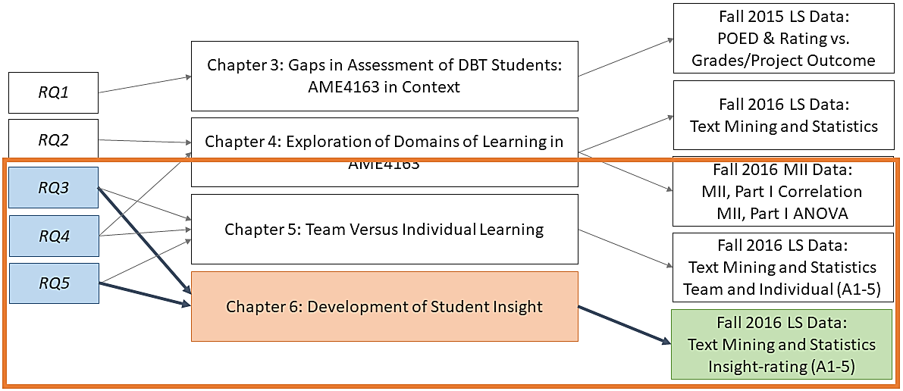

Chapter 6. Development of Student Insight
In this chapter, the focus is principally on how students come to generate insight into the design process over time. Specifically, the evolution of patterns of insight, as understood in terms of the learning statements (LSs), in the self-assessment of students is examined over the course of a design project. These patterns emerge both as a by-product of successive stages of the design project, in which students must focus on unique and particular elements of the process, as well as how students become acclimated to the process of critical self-reflection. In Section 5.2, it is demonstrated that the subject matter of student self-assessment changes in predictable ways as they move through the steps of a structured design process. Here, in Chapter 6, this is built upon by examining data in which it is shown that students’ ability to generate strong insight grows throughout the semester as well.
In Section 1.3.1, it is briefly discussed how the instructors in AME4163 evaluate the LSs. The first prong of the approach involves categorizing the LSs’ subject matter by POED and data from this categorization is demonstrated in Chapters 3-6. The second method of evaluation, however, involves a more value-oriented approach. Specifically, the instructors categorize each statement by degree of insight using a rubric discussed extensively with the students. The purpose of this rubric (and the insight-rating more generally) is to communicate to students the purpose of the LS. The instructors want students to internalize the self-reflection and resultant articulation of applicable future schema outlined in Kolb’s experiential learning cycle. Therefore, the rubric emphasizes a sliding scale involving how specific the articulated learning is and the degree to which the student(s) has articulated the potential future utility of that statement. LSs are thereby rated on a zero to three-point scale where:
- Zero points represents no insight owing to the student’s failure to adhere to the prescribe LS structure
  - Example: “I learned how to design a vehicle which has been very useful this semester.”
- One point represents trivial insight due the ‘obviousness’ or implicit nature of the learning
  - Example: “By working on building the device, I learned how to wire DC electric motors to a circuit, which will be useful if I need to do so again.”
- Two points represents decent insight into a lesson but either does not strongly connect that learning to future utility or that future utility is too vaguely articulated
  - Example: “By developing the team Gantt Chart, I learned the importance of staggering tasks and structuring time in a team-based project and I believe this will be useful to me in the future.”
- Three point represents strong insight in which a specific, non-obvious lesson is strongly tied to some anticipated future scenario
  - Example: “Through troubleshooting our team’s microcontroller issues during the device construction stage, I realized how necessary it can be in a design to prepare alternative/backup plans to alleviate risks to success and I think this will prove useful in my career when I will have to produce working solutions to design problems under strict time constraints.”
Using this scale, each LS from Fall 2016 was evaluated for degree of insight by the instructors. Using similar methods to the subject-area breakdowns discussed in Chapters 3-6, both team and individual LS are now explored for patterns in the development of student insight during a design project.

6.1 Development of Student ‘Insight’ Over Time
To begin the analysis, first it is examined how the degree of insight for both individuals and teams change, in the aggregate, over the course of the design project. By the time students submit Assignment 1 (planning the design project and outlining customer requirements), they have some practice with self-reflection, having written LSs as part of each lecture. As a consequence, they are familiar enough with the structure that very few (n < 5) of the total number of LSs fail to adhere to the prescribed structure of the exercise. Therefore, in Figures 24 and 25, in which the LSs by insight rating and assignment number are outlined, the category for insight rating zero is not present. What is left are the three categories of LSs that range from ‘obvious’ to ‘moderate’ to ‘strong’ insight for each assignment.
What is immediately noticeable in Figure 6.1 is a relatively large percentage of the individual LSs that are rated as insight level one and two. Indeed, for each assignment, LSs with these two ratings make up no less than 80% of the total LSs submitted. Overall, this suggests something that is not terribly surprising: that strong insight, requiring more careful and deliberative self-reflection, is harder to obtain. What is promising from this figure though is an overall trend in improvement from assignment to assignment. Specifically, LSs with a rating of one decrease from nearly half of LSs in Assignment 1 to less than 10% in Assignment 5. Similarly, while less than 5% of LSs in Assignment were rated as three, almost 20% of the Assignment 5 LSs received the same rating. Additionally, though the trend is less pronounced, LSs with a rating of two do increase on average between Assignment 1 and 5. Overall, this finding seems to represent some evidence that students, over the course of the semester, are developing stronger insights.
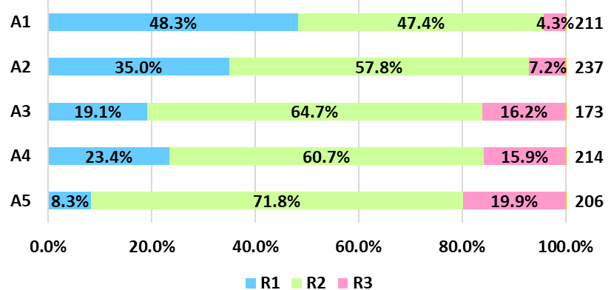
Figure 6.1. Stacked Bar Chart of Individual LSs by Rating and Assignment

In contrast, the team LSs, which are displayed in Figure 6.2, are substantially less clear in terms of observed patterns. In particular, team LSs rated as insight level two show little meaningful growth or decline. With a standard deviation only a little above 5% across all five assignments, the proportion of LSs rated as two did not substantially change over the course of the five assignments. LSs rated as one did show a slight upward trend from Assignment 1 to 5, with a corresponding slight drop in LSs rated as three over the same period, but relatively high standard deviations for each (8.0% and 7.3%, respectively) indicate that the actual proportions in either category were more chaotic than on any definite upward or downward pattern.
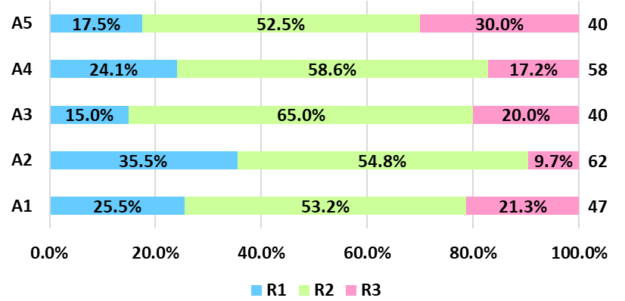
Figure 6.2. Stacked Bar Chart of Team LSs by Rating and Assignment

When taking these findings together, there appears to be an inconsistency. How could it be that, despite individuals demonstrating growth in their ability to make strong insights over the course of the semester, the teams comprised of those individuals are not showing similar levels of improvement? Two possibilities may be at play. In the first scenario, it may be the case that, while many individuals are indeed making improvements in their ability to self-assess for insight, improving the aggregate set of individual LSs over time, they may disproportionately represent a narrow set of teams. In this scenario, those who start off weak may benefit over time from their team-members who are better at it early on. In those teams, the instructors might reasonably expect to see growth in the individual team members’ LSs, but not their LSs written together as a team, because they would already be leveraging that team member’s insights early on until individuals pick it up. As a consequence, it should then be expected to see relatively static quality in team LSs, where some teams do it well and others less so, all while individual members improve. Alternatively, in the second scenario, perhaps what is being observed is a sort of ceiling or upper-bound on the ability for teams to generate strong insight in this setting. In this scenario, the limit may be a result of many factors: the social environment of the team, the number of students on the team capable at any given moment of strong insight, or the limits of self-assessment in a group context. Whatever the reason, in this model it is not likely that the relative number of LSs rated as one category or another would change much over time, due to the limits described.
The former scenario is more likely and more strongly supported by the evidence for several reasons. First, from a social constructivist standpoint on the theory of knowledge creation, it should be expected that individuals in close social proximity to those more skilled in the skill of critical self-reflection would be more likely to also develop that skill than another, similar individual without the benefit of that social proximity to a knowledgeable other. In this context, it should not be surprising when those less skilled in this area learn and grow in response to a collective knowledge construction process. And from the evidence, it should be expected that the number of individuals expressing strong insight would grow while the number of teams doing the same would be relatively constant. The latter model, involving the possible upper-bound scenario, also seems easier to reject due to the level of variance in the number of statements rated at insight level three. If such a phenomenon were at play, the boundary should be a bit clearer.

6.2 Word Frequency Patterns Across Insightfulness
In Section 6.1, the focus is on how student abilities to express strong insight change over the course of a semester for both individuals and the teams they comprise. Returning to the text mining tool utilized in several previous chapters is now necessary to examine a slightly different question: what are the unique features or aspects of LSs in each of the three principal LS insight-rating categories? To address this, team and individual LSs for all five assignments by rating are separated and the word-frequency analysis tool is thereby employed. The results for team and individual LSs are displayed in Figures 26 and 27, respectively.
From Figure 6.3, observe that for team statements rated as one, the words ‘team,’ ‘design,’ and ‘learned’ still occur more frequently than other terms, but now with the addition of the word ‘concept.’ Interestingly, it is also observed that for statements rated as two, ‘team’ becomes an even more prominent word used in the LSs while ‘learned’ has decreased substantially. In addition, for LSs rated both two and three, a greater number of words are represented at the same cutoff threshold. This indicates that students who write about fewer subjects tend to be rated lower for LS insight. For statements rated as three, the term ‘future’ occurs frequently, and this term is not seen in other team statements at lower ratings.
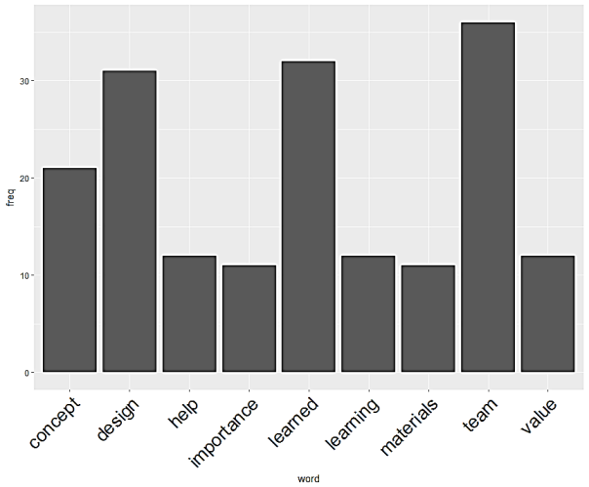 | 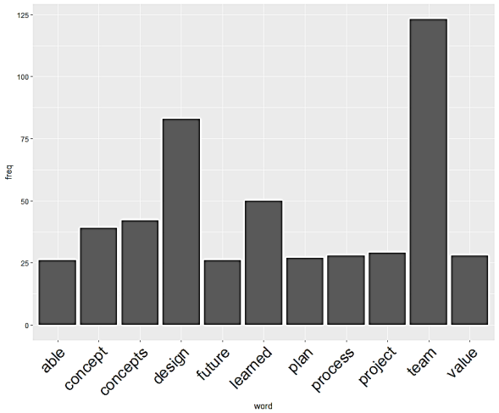
(a) Insight Rating – 1 | (b) Insight Rating – 2
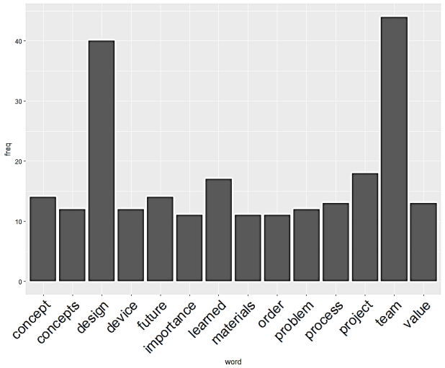
(c) Insight Rating – 3
Figure 6.3(a)-(c): Histograms of Most Frequent Terms from A1-5 Team LSs by Insight Level

From Figure 6.4, for individual statements at all ratings, the terms ‘design,’ ‘learned,’ and ‘team’ do occur frequently, but not always the most frequently. For statements rated as one and two, those three terms are the most frequent, but for statements rated as three, the terms ‘team’ and ‘learned’ are overshadowed by ‘future’ and ‘project.’ The key factors for student success are tied to design, but the ability of the students to consider the future implications of their work and to focus on the project are also factors contributing to student success.
Interestingly, team LSs rated at an insight level of three constitute an overall larger proportion of the total Assignment 1-5 LSs than is the case for individuals. While it is pointed out, in Section 6.1, that individuals, in the aggregate, do become more insightful over time, three-point individual LSs are still relatively rarer across all five assignments. When compared to the one- and two-point data sets for both team and individuals, this results in a situation where the three-point individual LSs do not contain as many words that meet the frequency cutoff threshold. This could suggest that individual student LSs that are highly rated cover a broader range of subjects.
This seems counterintuitive but consider the model: by relying on word frequency, one is looking for words that many individuals used in their statements. If the collective pool contains more diverse content, then the individual words are less likely to appear frequently, and the resultant set of frequently-appearing words meeting the threshold cutoff is small in comparison to the other insight categories. This suggests that a feature of individual LSs is that students are less likely to home in on a few topics of interest. Instead, they are drawing insight from multiple subject areas of their learning experiences.
In contrast, teams writing insightful statements appear to be doing the opposite. They are writing about a relatively narrow set of topics and thus the pool of frequently-occurring words is relatively large. This result appears to be confirmed when examining random statements from the data set manually. Even though the students often describe, in their team statements, learning resulting from diverse experiences across all areas of the project, the most common sentiment expressed in the learning relates to how they are working as a team, planning the project, or something otherwise related to the more group-oriented aspects of the design project. This result should not be surprising, though the instructors do not require that teams write their team LSs about insights related to working as or on a team, that would seem logical as the subject they would be thinking about when drafting them.
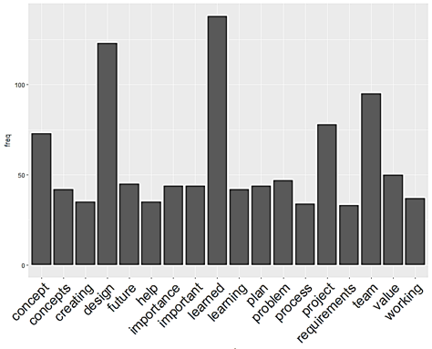 | 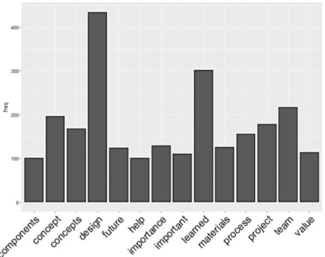
(a) Insight Level – 1 | (b) Insight Level – 2
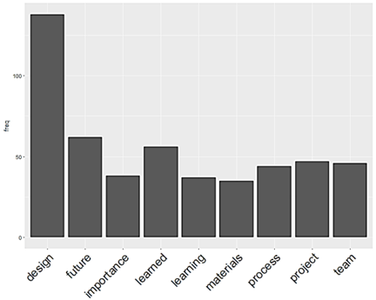
(c) Insight Level – 3
Figure 6.4(a)-(c). Histograms of Most Frequent Terms from A1-5 Individual LSs by Insight Level
In summary, when controlling for the ratings, it is observed in Figure 6.3 that, for team LSs rated one, topics covered largely focus on ‘concept/concepts’ and ‘device.’ In contrast, it is observed that students with statements in the three-point category largely focused on ‘team,’ ‘process,’ and ‘plan.’ From this it can be gathered that students most fully internalize, by the standards, the non-technical aspects of the POED. Meanwhile, it is observed that student LS in the two-point category also heavily focused on ‘concept/concepts’ as well as ‘materials’ and ‘process.’ Additionally, there were too few ‘zero-point’ statements to perform meaningful analysis, which itself seems to indicate that the students have adequately internalized the ‘reflection on doing’ approach embodied in the LS format. Lastly, it appears that one of the more interesting features of highly-rated individual LSs is that they cover a wider variety of subjects than their lower-rated counterparts, suggesting that students who develop strong insight are not doing so only in narrow areas of the design project (such as team formation or device construction).
Characterizing student learning through reflection on doing by degree of insight represents a useful framework for instructors seeking to better understand the impact of student learning experiences and can be used to demonstrate the degree to which students in a course are engaging with the stated material and learning objectives. This, combined with the work outlined in Chapters 2-5, is now addressed in terms of the research questions posed in Chapter 1 to more formally outline the contribution of this work. Based on the outcome of this work, new questions are raised that will form the foundation for a doctoral dissertation proposal, outlined here in Section 7.5.

Chapter 7. Closure
In Chapter 1, the following research question is posed as the overarching concern:
In the context of an experiential learning engineering design, build, and test course, what are the tools and strategies that instructors can employ to motivate students working in team settings to learn by reflecting on doing and how can instructors characterize and assess that learning?
This question is further elaborated on by asking the following six research questions:
- RQ1: What discrepancies in student internalization of course material do outcome-focused methods of student assessment such as device performance, technical analysis, and quality of written assignments do learning statement data from Fall 2015 reveal?
- RQ2: What differences can be inferred from the relative changes in student internalization of engineering design principles from the learning statement (LS) and competency survey data from two sections of AME4163 and what do those differences say about the utility of the two assessment instruments as measures of student learning?
- RQ3: How do the introduction of reflective exercises such as the learning statement and instructor feedback affect individual-level internalization of the POED in the context of team activities such as the assignments?
- RQ4: For students on teams working on a design, build, and test project, how can the learning statement and individual surveys be used to gauge how student learning changes over the course of a design experience and how does this process impact student internalization of material?
- RQ5: What features or patterns do we see in the results of text mining of student LS data and how do those results validate or invalidate the previous LS evaluation methods such as POED categorization and insight categorization?
Taken together, these five questions underscore the primary analytic component of this thesis and must therefore be addressed in order to be used to provide validity to the provided curriculum, assessment strategies, and tools as well as identify the new questions that will be addressed in the proposed doctoral dissertation in Section 7.5.

7.1 Findings Regarding the Research Questions
Having restated the research questions and having performed a thorough analysis of the LS and MII data in Chapters 3-6, a summary of the primary findings in terms of their implications regarding the posed questions for investigation is offered. For details on student assignments, please see, in Appendix A: Fall 2018 AME4163 Course Booklet, page 167 for Assignment 1, page 177 for Assignment 2, page 181 for Assignment 3, page 186 for Assignment 4, page 190 for Assignment 5, page 194 for Assignment 6, and page 197 for Assignment 7.

7.1.1 RQ1: Discrepancies in Conventional Assessment
Based primarily on an analysis of the existing literature on assessment in engineering DBT courses, the hypothesis is offered that conventional assessment methods are fundamentally lacking in several ways. In particular, as discussed in Section 3.3, conventional methods of assessment, such as evaluation of research reports and design artifact performance, fail to account for learning as a response to failure in the design process. Design in professional practice is iterative but classroom design projects rarely have the time required to incorporate this feature. As a consequence, poor designs, uncertainty, and simple misfortune can result in discrepancies between the proficiency obtained in design in such courses and the measured performance of such students.
In order to investigate this, in Chapter 3, the implementation of the LS in Fall 2015 is explored and the data collected from that course compared to student performance using the discussed conventional measures of assessment. The findings provide some support for the tentative conclusion that such measures are insufficient measures of student learning in engineering DBT courses.
First, in Figures 3.1 and 3.2 the portion of LSs for each assignment that fell into each POED category are diagrammed. As expected, for Assignments 1-3, student LSs, both those written by individuals and those written by each team, tracked closely with the targeted learning objectives for these assignments. However, a discrepancy that appears in Assignments 4 and 5 is evident. In these assignments, one might expect more students to focus on POED 4, which deals with prototyping, but instead both teams and individuals still focus heavily on POED 3, dealing with concept refinement. This discrepancy may be a result of teams delaying their prototyping later than might be expected or may be more a result of students focusing in their LSs on the material necessary to complete the assignment rather than all activities they are working on at the time. Regardless, due to the dominance of the trend amongst the whole class, this evidence implies that students are making progress to toward the learning objectives in a manner not suggested by evaluation of the reports or design artifact.
In addition, in Figures 3.3 and 3.4, two means of comparing the LSs written by the students with their course grades, which represent a conventional measure of assessment, are explored. In Figure 6, I attempt to determine, for each assignment, the relationship between the number of LSs submitted by a given team with their performance on the course assignment. Though the number of LSs submitted is merely a weak proxy for learning, the degree of effort implies that students writing more are at least trying to engage with the material more seriously than others. From Figure 6, for no assignment is there any evidence of a strong correlation between the number of LSs and the grades received. Though most correlations are weakly positive, in no assignment is there present a strength of correlation greater than an R² of .2. In Figure 3.4, the proxy for learning via the LSs is the grade for the SLE. As the SLE is an assignment at the end of the semester designed purely to demonstrate learning, it is a more direct proxy for the phenomenon. From the comparison between SLE grades and overall course performance, again no significant correlation between the two is found. In fact, the correlation (R² < .06) is so weak as to be surprising, considering that the overall course grade is at least in part determined by the SLE grade. The high degree of variance and lack of correlation in fact suggests that, despite doing poorly in other areas of the course (conventional assessment schema), many demonstrate compelling learning in their essay.
Ultimately, though not conclusively, it is found that learning is clearly being demonstrated by students in AME4163 even when conventional measures of assessment do not reflect that fact in the students’ grades. This suggests both that students are being improperly assessed in such courses and that the LS can serve some function as an assessment tool for the instructors.

7.1.2 RQ2: Evaluating Novel Assessment Forms
For research question 2, the principal concern regards what is found generally from the two self-assessment instruments and whether or not data collected from them is useful in an engineering DBT course. As already established in Section 7.1.1, the answer to the latter concern for LSs is tentatively ‘yes.’ Given this, this section begins by exploring data collected from the survey instrument discussed in Chapter 4.
Recall that the MII instrument consisted of two sections: ‘Current Status’ (Table 1.3, p. 10) and ‘Moving Forward’ (Table 1.4, p. 11). In the former section, questions changed week-to-week across the five surveys and generally dealt with student confidence in their design abilities in the immediate next stage of the project. In the latter section, questions remained constant across all five surveys and questioned the students on their degree of confidence in specific abilities as they might be applied in their careers. This section is begun by describing results in the ‘Current Status’ section.
In Figure 4.6 (Section 4.3.1), the changes across the five surveys in the ‘Current Status’ questions that appear on two consecutive surveys are highlighted. Though some trends are noted that seem tied to students’ reactions to specific assignments, overall, median confidence remains both surprisingly high and highly consistent throughout the semester. Though it appears that students are particularly confident in applying overtly technical design skills in the near future and their confidence does dip slightly in response to a particularly non-technical (post-mortem reflection), the median confidence expressed by students appears relatively insensitive to major events in the course. This is particularly notable in light of what is observed in the next section of the survey, ‘Moving Forward’, which deals with student confidence in applying design skills in the long-term.
From the two radar plots portrayed in Figure 4.7, a similar phenomenon in the ‘Moving Forward’ section to that described in the ‘Current Status’ section is observed. Specifically, across all five surveys, median responses regarding the degree of confidence students express about applying specific skills in Capstone and their later careers stays both quite high and fairly consistent. To be clear, for questions 1-9, median responses between the first and final survey do rise, though the upward trend is very slight. Only in question 10, that dealing with student confidence in their ability to communicate their design ideas, is there any decrease overall. Further corroboration of this finding can be found in both the correlation analysis and the ANOVA tests performed on the data set. The intercorrelations between each question for each survey, which are shown in Figure 4.9. What is observed is that the responses to each question on each survey are all or mostly correlated with one another. Due to the prior finding that student confidence is disproportionately high, this effect seems related to the fact that students were similarly overconfident at all phases of the project. In Tables 5-8, various applications of ANOVA testing explore whether confidence had any effect on student overall course grades. Unsurprisingly at this point, there is essentially no direct link between expressed level of confidence in design abilities and the students’ actual ability to realize a design.
In terms of the LSs from the same semester, there are several notable takeaways regarding student internalization of course material as well as the utility of the LS in general. First, from Figure 4.2 in Section 4.2.1, it is noted that, in a breakdown of overall learning expressed throughout the semester, all five POEDs are fairly well represented as a proportion of total statements. However, if one looks at the specific sub-POEDs involved, students clearly focused on some more than others. POEDs 2a, dealing with the generation of concepts, and 4a, dealing with the Bill of Materials and the prototype component selection, are greatly overrepresented. This suggests that, to some degree, students are engaging with some elements of the design process much more readily than others. In contrast, team LSs, which are highlighted in Figure 4.4 of Section 4.2.2, were much more heavily dominated by POED 3 than any other POED, suggesting that, as groups, students much more heavily focused on concept refinement. A tentative implication here is that the concepts embodied in POED 3 give individual students more difficulty and the presence of the team social structure enables them to grapple with it more effectively.
Considering the analysis of the LSs presented in Chapter 3, from which it is established that the LS instrument provides some value in terms of describing the areas of student learning that is not readily explained by the course’s conventional assessment measures, it seems evident that the utility of the LS as a tool for instructors to understand learning in their courses as a result of the LS data from Chapter 4. The high degree of granularity that is enabled by the sorting of the learning statements into relevant POED sub-categories seems to be explainable by the circumstances and progression of the course. In contrast, data from the survey instrument seems to be lacking in some key ways. First and foremost, the high degree of confidence that students express in their design abilities, both technical and non-technical, is not well represented in other areas of the course, suggesting that this confidence is often misplaced. Though some variance is apparent here, the overall trend is troublesome. Second, students do not vary significantly in their responses across the semester, suggesting that that overly-confident self-assessment is relatively insensitive to the events that they experience. This implies that, at least in its current incarnation, student self-assessment via a survey seems to lack significant utility in this context.

7.1.3 RQ3: Individual versus Team Learning
For research question 3, the principal concern deals with assessing the degree to which self-assessment, via the LS, is useful for distinguishing between team and individual learning. To examine this question, analysis of LS data from Chapter 5 and Chapter 6 is used. In Chapter 5, the older method of LS analysis is utilized, which involves categorization of the LSs by POED to highlight aggregate differences in the learning expressed by teams and individuals. In Chapter 6, differences are highlighted between the degree of insight expressed by individuals versus teams using the text mining approach of word frequency analysis.
In Figure 5.1 in Section 5.2.1, aggregated LSs across Assignments 1-5 for both teams and individuals are outlined and further sub-divided by POED domain. Though the variance in subject matter is less pronounced for individual than team LSs, individuals predominately explore themes in POED 1 (planning the design) and POED 4 (prototype testing and evaluation) whereas teams by a much greater relative margin explore POED 3 (refinement in the design). The prevalence of POED 3 on a team level suggests that, due to the largely labor-intensive practices scaffolded into the project that are related to POED 3, students are spending a great deal of their work time together involved in portions of the process related to this domain. In contrast to other portions of the project, where many teams report dividing up the work and completing their assigned tasks individually, much of the concept refinement tasks require communal judgement and decision making.
However, while POED 1 and 3 are the most explored subjects by individuals, POED 2a is the single largest sub-category. The same sub-category is fairly large in the team LS figure as well. Taken together, this suggests that POED 2a, dealing with concept generation, was a subject of substantial importance both on an individual level and to the teams as a whole. Partly, this is by necessity. Though concepts are generated first in Assignment 2, many students report revisiting these concepts through the stage in which they narrow their generated concepts to a primary choice. What is important here is likely that students and the groups in which they work, are collectively preoccupied by this step, even after it is completed.
Shifting focus to Section 6.1, in which some important differences between teams and individuals regarding the degree of insight that each express in their respective LSs are highlighted, recall that insight in each LS is assessed on a four point scale ranging from improper format/”Not a LS” (zero points) to strong insight (three points) by the instructors. In Figures 24 and 25 breakdowns of the team and individual LSs by assignment and by degree of insight are prepared. The primary difference between teams and individuals that are highlighted in these figures is the notable trend in improvement that individuals make over the course of the semester. For individuals, fewer than 5% express strong insight in Assignment 1 whereas nearly 20% do in Assignment 5. Similarly, as a proportion of total statements, those rated one (low insight) shrank over the course of the project. In contrast, no significant trends, positive or negative, are apparent in the team LSs over the course of the semester. For each assignment, LSs rated two were the largest category, ranging from 53 to 65% of all team statements for that assignment.
This discrepancy between the improvements made by individuals and the stagnant level of insight expressed by teams is curious. In Section 6.1, two possibilities are suggested. The first is that the students who were responsible for the improvement were disproportionately consolidated on relatively few teams. Unsurprisingly, in such a scenario, those who ‘got it’ early were able to help teammates improve their individual LSs while they largely motivated the writing of each team LSs. If that is true, it would explain why the portion of highly-rated individual statements increased while the team statements stayed more or less constant. In the second possibility, some form of ceiling is involved in the drafting of team LSs. Whether that ceiling is the result of inherent problems in making collective insights in such a setting (one is reminded of the anecdote about the camel being a horse designed by committee) or by a limit on the number of students likely to progress to the ‘strong insight’ category over time remains a question for further analysis.

7.1.4 RQ4: Student Learning Changes over Time
For research question 4, what is asked is, essentially, how student internalization of targeted course material changes over the course of the semester. In planning to address this research question, it was initially intended to leverage the survey data to partly address this question. However, as explained in the response to research question 2 (Section 7.1.2), the survey instrument, at least in its present form, seems far too flawed to use to assess student internalization of material owing to the high degree of overconfidence expressed in the students. As a consequence, this section, will only focus on discussion of LS data that are explored in Sections 5.2.2 and 5.3.1.
In Section 5.2.2, a very granular look is taken at the LS data by separating it first between team and individual LSs, then by assignment, then further by POED sub-category. The result is the set of pie charts that constitute Figure 5.2. One of the key findings from the analysis of this figure is that, in terms of the subject matter explored, both teams and individuals discuss roughly the same subject matter at similar rates from Assignments 1-3. This may be largely due to the fact that, only by Assignment 4 do students begin working on design activities outside of the context of the design reports when they begin prototyping. This seems further evidenced by the fact that, in Assignment 5, the post-mortem design reflection, both teams and individuals return to writing LSs that have roughly similar POED ratios. At that point in the process, it is evident that individuals begin to focus more heavily on the process overall.
However, despite the relative consistency in Assignments 1-3, there are some slight differences regarding differing focuses on specific sub-POED. Without revisiting in fine detail every minute difference, it is particularly interesting that teams tend to focus on POED 1a (dealing with team formation) at higher rates than do individuals. Perhaps most important from a learning objective standpoint is the consistency in overall mapping of the LS subject areas to the target POED for each assignment that are described in Table 1.1 in Section 1.3.1.

7.1.5 RQ5: Features of Student Insight
With research question 5, what is now of concern is the utility of the text mining tool as a supplement to LS analysis. To do so, findings from Section 5.3.2 are summarized, in which the individual LSs are broken down by assignment and text mining analysis performed on each subset. Following this, word frequency analysis of the sub-sets of LS for each category of degree of insight is performed, which is outlined in Section 6.2.
For ease of visualization, the word frequency analysis for each assignment for individual and team LSs is represented as word clouds in Figures 22 and 23, respectively. Perhaps unsurprisingly, both the words ‘team’ and ‘design’ are highly represented for both teams and individuals across all five assignments. However, for individuals, the relative frequency of the word ‘team’ shrinks over the course of the semester significantly, suggesting that individuals are becoming more focused on other subject areas. Further, for individuals, it is noted that in Assignments 2-4 ‘concept’ becomes much more prominent than many other words. Importantly, one also sees in Assignment 5 that individuals begin to focus on words like ‘process’ and ‘future’ to a greater degree than before, suggesting a shift in perspective when reflecting on the design project. Overall, these figures imply that, with some uncertainty involved, students are roughly discussing topics in their LSs in a manner consistent both with the target POED for each assignment and with the manual categorization method results. Relative to individuals, it is also important to note that the teams use the word ‘team’ more frequently (relatively) throughout the project than do individuals. This is also unsurprising given the collective nature of the team LS exercise. Like individuals, teams as a whole show greater representation of the word ‘process’ during Assignment 5 than at any other point following Assignment 1, suggesting a re-orienting of focus is taking place there.
In Section 6.2, the text mining tool is used to query sub-sets of the LSs where each sub-set is comprised of only individual or team LSs and only one insight-rating category. These data sets are highlighted in Figures 26 and 27. Interestingly, for team LSs rated as one, the word ‘concept’ is substantially over-represented compared to the other insight ratings. Similarly, for LSs rated two, ‘team’ is relatively more represented than in the previous category. Perhaps most importantly, for team statements rated two and three, a much larger set of words has met the minimum frequency cutoff. Interestingly, for individuals, whose LSs constitute a much larger data set, higher representation of the words ‘design’, ‘learned’, and ‘team’ were more related to insight ratings one and two. For highly rated individual LSs, words such as ‘future’ and ‘project’ were relatively more frequent. The implication here is that students who tend to have a clearer eye on the future are more likely to develop strong insight. Additionally, it is notable that LSs rated three represented a larger overall fraction for team LSs than for individuals, though that proportion was roughly static across all five assignments. Perhaps most interesting though is the fact that, unlike for team statements, individual statements rated three had far fewer words meeting the frequency cutoff, suggesting that, for individuals, it is more likely that LSs rated highly involve a broader range of subject material.

7.2 Principal Findings
From these findings important progress has been made in addressing all proposed research questions first laid out in Section 1.2 and addressed more thoroughly in Section 7.1. Specifically, evidence has been presented that confirms suggestions in the literature that conventional measures of assessment in design courses are insufficient for fully understand the learning experiences of students. Furthermore, it is found that self-assessment, particularly in the form of the learning statement, represents an opportunity for both students, educators, and researchers. For students, this value comes from the importance of an exercise that engages the student to critically reflect on their experiences to enable them to meet future challenges. For instructors, LSs can be used to provide a broad range of insight regarding the nature of learning in their courses. This insight is exemplified by the degree to which aggregate internalization of course material can be explored, differences between individuals and teams can be understood, and how learning changes over time. For researchers, this thesis offers both a model for an engineering DBT course that is practical and a novel assessment instrument that may have applications in a broader variety of scenarios than the setting explored here.
Furthermore, further evidence has been added to the findings of other researchers that surveys that task students with assessing their degree of confidence in their abilities are marred by the relative over-confidence of engineering students in their capabilities and the difficulty in ‘calibrating’ those expectations appropriately. Since Fall 2016, the AME4163 instructors have not implemented the survey due to these issues, though potential remedies for the issues outlined here continue to be explored.
In addition, the work explored in this thesis reflects an important step in building a framework for iterative improvement of engineering design courses. The course booklet, described in Chapter 1 and referenced throughout this thesis, can be useful in both outlining the goals of instructors in a manner that is usable for students and connects the series of activities performed with higher-level learning objectives. Further, the curriculum laid out in the course booklet dovetails nicely with the learning statement self-assessment data gathered and analyzed here. As has been stated, self-assessment functions best in situations where students have a thorough understanding of its role in their learning and the course booklet defines those connections clearly.
A separate contribution of this work is the construction of a research framework and associated tools that may better enable monitoring of student learning via self-assessment in design courses. Between the learning statement, the course booklet, and the data mining and analysis tools, researchers can more feasibly implement a system for gauging aggregate learning in their courses, which should enable them to iteratively refine them towards improved experiences.
In Section 7.5 of this thesis, a doctoral dissertation building on this work is laid out that outlines the specific research questions arising from this work. It is hoped that with this doctoral research work results can be extended and generalized beyond their current limitations, particularly with regard to fidelity and specificity of results and the narrowness of their applicability (here, that remains mechanical engineering design courses). In particular, these questions arise from drawbacks and limitations in the current work, which will be discussed in greater detail in Section 7.3.

7.3 Limitations in the Proposed Framework
One of the primary drawbacks of the framework for analyzing LSs that are examined in this thesis is the difficulty in using aggregate data to draw conclusions about individual students. Though high-level patterns may emerge, instructors and researchers utilizing this tool should be wary of using that understanding of the class as a whole to address issues for individual students. Furthermore, the text analysis tool, which has been tentatively validated with the findings here, shares the same flaw. Analysis of an individual’s body of LSs using this analytical framework is not advised at this time, which presents several challenges for educators wishing to use it to offer feedback.
In addition to the problems already stated, one must be mindful of the limitations of word frequency analysis in drawing conclusions about student cognition. While word frequency analysis and cluster analysis can be useful in exploring certain concepts, they are still relatively new tools and the precise ‘meaning’ of their output is still an area of active experimentation and research. As a result, though the tentative results of the text mining analysis are notable and represent potentially useful findings, exploring improvements and alternative methods is a necessary and ongoing activity.
Another major limitation to this study is the fairly narrow context in which this research takes place. Though a large amount of data has been collected for this work, across two semesters of the AME4163 course, one must be cautious about extending the conclusions beyond the context of a senior-level, mechanical engineering design, build, and test course. Without further research, one cannot be sure that the patterns noted would hold up in, for example, a computer science design course, or a freshman-level design course, or a more conceptual design course. Therefore, it is important to state that the conclusions drawn here should not be interpreted as extending beyond that particular frame of reference.
Other miscellaneous drawbacks to this work are surely plentiful. Of particular note, however, is one which many other researchers in this field often discuss more thoroughly in work in educational settings. No effort has been made in this body of work to explore how the presented phenomena interact with constructs such as gender, race, or other demographic effects. Though understanding how these concepts affect educational practice and pedagogy is important, they were left outside the scope of this work.

7.4 Assessing Research Limitations and New Questions
In this thesis some questions have been addressed and still others have been raised. In particular, it is important to follow-up on the possibly-gendered effects hinted at here. Much about the culture of higher education, particularly in STEM fields, can be problematic for women and other minority populations. Researchers such as Beasley and Fischer have highlighted the way certain sociological phenomena can affect attrition rates of women and minorities in the STEM fields [51].
Additionally, exploring new domains of data and text analytics to build more comprehensive tools for the analysis of student learning is of particular interest. Aside from the obvious fact that the text mining demonstrated here is only a small part of a much larger puzzle of approaches, methods, and technologies, the field of data analytics continues to grow both in scope and validity even as this document is typed. In order to develop tools that are more readily implemented by other educators in alternative settings, it is imperative that this project continues to explore and experiment with other methods of analysis.
The prospect of introducing other research forms into future, continued work is also quite exciting. Specifically of interest is the possibility of pursuing opportunities for qualitative research that may supplement and enhance the sort of work described in this thesis. Qualitative researchers understand that individual learning is a complex process and cannot simply be distilled to a relatively small set of figures and numbers. Though quantitative research is still a crucial aspect of the work likely to be performed as this project continues, one is mindful of the opportunity to flesh out the phenomena of study with the rich context and detail inherent to qualitative research.
In closing out this section, the reader should be left with some of the questions intended for exploration in future research. These questions derive in part from the analysis in this thesis as well as the wider context of the author’s educational experience. The following questions, which have been used foundationally to generate the doctoral dissertation proposal in Section 7.5, are listed thusly:
- What factors affect the degree to which teams become social environments conducive to the collective generation of knowledge and how can engineering educators assist in creating such environments?
- What data analytics tools are suitable for use in the analysis of student writing from the perspective of instructors and what are the elements that comprise utility from that standpoint?
- How can we, as instructional designers, shape courses to incorporate novel assessment instruments (such as self-assessment) in such a way that students engage with them as steadfastly as they engage in more conventional measures of assessment?
- What features of a design project are responsible for the fostering of non-technical engineering design competencies and how can these features be generalized to apply to more than one particular project?
It is hoped that addressing these questions will serve as the foundational motivation for additional research, particularly in the form of a doctoral dissertation. In building out a framework to accomplish this, in the following section is outlined a proposal for a doctoral dissertation.

7.5 Doctoral Dissertation Proposal
Following from the work contained in this thesis, including the conclusions, prescriptions, takeaways, and questions for future analysis throughout Section 7.1, it is now appropriate to describe a plan for a proposed Doctoral Dissertation. In consultation with the author’s advisors, Professors Farrokh Mistree and Zahed Siddique, the following doctoral dissertation plan of action and proposed topic is proposed. The presumptive title of this work will be Intelligent Assessment of Learning through Reflection on Doing in Engineering Design, Build, and Test Courses.

7.5.1 Doctoral Dissertation Proposal Summary
In the Master’s thesis, Assessment of Learning Through Reflection on Doing, preliminary data is offered to support the assertion that reflective self-assessment instruments can be utilized by instructors of engineering design, build, and test (DBT) courses to both reinforce student learning while providing instructors with insight into the learning process. Using self-assessment data collected from mechanical engineering students in two senior-level engineering design courses, several research goals are realized: in what areas students are able to internalize target course material, the degree to which that information leads to strong or weak student insight into their own knowledge, and a model for how instructors can use information acquired from that data to both provide targeted feedback to students and modify weaker aspects of their courses.
In that previous work, Kolb’s experiential learning construct is leveraged. Developed in the early 1970s, Kolb’s construct outlines a model for experiential learning in which student learning arises from having an experience, reflecting on that experience, abstracting meaning from those reflections, and integrating those abstractions in future experiences [6]. In this doctoral dissertation, this framework is used to offer a more generalized comment on the utility of integrating David Kolb’s experiential learning construct into engineering DBT courses toward understanding and shaping student learning. Specifically, it is asserted that targeted self-assessment in courses leveraging the experiential learning model provide instructors with a means to both interpret and enable student learning, particularly in areas of student competence that have been identified as necessary for modern engineering practice but are not well assessed. To validate this assertion, various forms of self-assessment, such as student articulation of lessons via the Learning Statement (LS), which may facilitate the integration of experiential learning into engineering design courses are explored. Primarily, the goal is to validate self-assessment as an approach for instructors to both shape and interpret student learning in such courses. As a secondary goal, data analytics tools, such as text mining, which can improve the collection and analysis of the collected self-assessment data while enabling instructors to provide sophisticated feedback to students, will be explored.
The experiential learning construct, as outlined by educational theorist David A. Kolb, provides instructors with a framework for understanding student learning in educational environments [6]. It is contended that, in particular, this framework may be valuable to engineering design programs, particularly DBT courses, in part because the cyclical nature of the experiential learning framework and the iterative design approach favored in many programs are analogous and in part because the framework applies well to so-called “open-ended” problems such as those encountered in engineering design. However, despite the potential utility of the experiential learning construct in engineering design education and its empirical value as a learning framework, there is a lack of strong evidence that the methods of assessment used in DBT courses utilizing the construct suitably enable instructors to accurately understand student learning.
Consequently, there is a need for more sophisticated instruments of assessment in engineering design courses and other courses that are anchored in the experiential learning construct. Such instruments must enable instructors to understand how learning is taking shape over time, how it changes in response to novel challenges, and in what targeted domains of learning students are and are not developing. In order to identify these instruments, the following assertions are addressed:
- That self-assessment instruments, such as the Learning Statement, used in concert with intelligent data analytics tools, can be used to fill the identified need in engineering DBT courses.
- A course framework that embeds self-assessment into all course features (assignments, lectures, exercises, and so forth) and a data-driven approach to interpret student data collected from that self-assessment provides practical utility.
- Techniques such as text mining and machine learning can be used to analyze data from self-assessment instruments to produce a sophisticated model of student learning in engineering DBT courses that empowers educators to actively shape student learning even in courses where students are challenged to solve open-ended engineering design problems.

Preliminary Questions for Literature Review
In order to test these assertions, the following preliminary questions, which will be more firmly established by thoroughly reviewing the relevant literature, are posed:
- Is Kolb’s experiential learning cycle treated as a consequence of or a driving mechanism for student learning in engineering design courses? In other words, are instructors in engineering design courses anchoring their courses in the construct or simply using it to explain learning in such courses?
- Following up on question one, what are some proposed alternative learning models to Kolb’s construct and why or why not are they appropriate for use in DBT courses?
- In what ways do traditional assessment methods, self-assessment or otherwise, fail to characterize student learning in environments that leverage the experiential learning construct, particularly engineering design courses?
- In what ways have data-driven approaches been used to model student learning in engineering design courses? In engineering courses as a whole? In education in general?
- What data exists to support the validity of self-assessment in DBT courses and what, specifically, are the most common forms of student self-assessment?

7.5.2 Proposed Research Questions, Hypotheses and Tasks for PhD Dissertation
Primary Research Question
How can self-assessment instruments, such as the Learning Statement, be utilized to both facilitate the integration of Kolb’s experiential learning construct in engineering design, build, and test courses while providing instructors with the requisite abilities to rigorously evaluate student learning in such courses? Furthermore, what course frameworks, strategies, and data analytics techniques can support an instructor’s ability to interpret acquired self-assessment data?
To address these primary questions, a set of secondary research questions, associated hypotheses, and research tasks are outlined in Table 7.1.

Table 7.1. Doctoral Dissertation Questions, Hypotheses, and Tasks
 | Secondary Research Questions | Hypotheses | Research Tasks
1. | What techniques and frameworks are most suitable for integrating self-assessment into engineering DBT courses to both foster student learning through reflection on doing and to enable rigorous assessment of that learning? | By integrating the LS instrument into both lectures and design assignments used in an engineering DBT course, written by both teams and individuals, I will demonstrate the efficacy of self-assessment as a tool for both student learning and instructor assessment of that learning | - Develop a plan for implementation of the LS in AME4163 for Fall 2017 and Fall 2018  - Construct tools for data analysis  - Text mining  - Online LS collection
2. | What data analytics techniques are most suited for analysis of student self-reported learning, such as that collected from the Learning Statement? | Having already used clustering text mining techniques in my Master’s work to analyze LS data to understand the areas and degree of internalization of student learning, I will continue to build on that model. Further, I propose that semantic analysis may also be of benefit. | - Modify existing text mining algorithm to control for  - Word frequency  - “Stop Words”  - Incorporate semantic analysis techniques into text mining tool
3. | How can instructors leverage self-assessment data to understand how learning is taking shape in their courses in terms of degree of course material internalization, acquisition of target competencies, and the degree to which “teaming” impacts the individual learner? | By comparing LS data collected from multiple sections of AME4163 and analyzing that data using the proposed data analytics tools, I propose that we can develop a picture, both in aggregate and for individuals, of the way learning is taking shape in the DBT course, AME4163. Comparisons between sections will provide additional support for the identification of factors most impactful to learning. | - Within the proposed AME4163 course framework, outline a procedure for the delineating data collected from individuals versus teams, and between the different course features (lectures, assignments, semester learning essay)  - Formulate a procedure for comparing different sections of AME4163
4. | How can we leverage text mining techniques such as word frequency, cluster, and semantic analysis along with machine learning analysis to identify key linguistic features of student LS such as subject matter, insight, and connectivity? | Using the LS data collected to support my MS thesis, a training data set can be used to develop a supervised machine learning algorithm (possibly k-Nearest Neighbor) to classify student LS by subject matter and insight | - Inventory supervised and semi-supervised machine learning algorithms for use in LS analysis  - Develop chosen algorithm to work in concert with established LS collection procedure
5. | How can we use data analytics techniques to develop a method for iterative course improvement, wherein aggregate student self-assessment is used to identify elements of the course that do not meet our educational targets? | Using the established text mining framework to understand the aggregate picture of learning in AME4163, I can then identify specific course features that contribute to or detract from student learning. I will then show how this information can be used to modify the existing course framework to improve student learning outcomes | - Propose a procedure for connecting the learning expressed by students through LS to particular course features  - Develop a method to validate the proposed connections  - Establish a procedural framework for making iterative course changes

7.5.3 Rationale for Admittance to the Interdisciplinary Doctoral Program of the Graduate College
As is shown in the MS thesis, there is evidence to suggest that by leveraging self-assessment instruments such as the Learning Statement in engineering DBT courses, instructors are able to both enable student learning and improve their understanding of that learning in their courses. The doctoral research proposal, including research questions and relevant tasks to be completed, is thereby outlined and builds on preliminary findings and will address a more general need in engineering education. Since the proposal, as outlined, draws from the fields of engineering design, data science, educational theory, educational assessment, and writing analysis, it is contended that the interests of this research are best served if organized as an interdisciplinary PhD at the graduate college level.
It has been suggested that the author pursue a PhD program within the College of Engineering, specifically in the established Engineering Education concentration. Having reviewed the study program for the Engineering Education PhD, there appears not to be a fit because the proposed program of study and research will be beyond engineering and needs to involve faculty members with expertise in education, assessment, technology assisted education, linguistics, data analytics and engineering. Furthermore, the author’s own background education in these identified areas is substantially lacking, and therefore will require mentorship from a committee with more varied expertise than what is allowable in the existing multidisciplinary program. Hence, this petition to obtain a PhD through the Interdisciplinary Doctoral Program of the Graduate College. In contrast, the General Engineering PhD is a program that has been designed to prepare students for careers in advanced engineering or related science areas. However, the author’s interest is in pursuing a career in engineering education and not advanced engineering or related science areas. In summary, both the General Engineering PhD and its Engineering Education concentration are unsuitable for the proposed dissertation and hence this petition to be admitted to the interdisciplinary doctoral program of the Graduate College.
In an era of hyper-specialized and niche research, it is contended that new knowledge creation in the manner proposed necessitates taking a multidisciplinary approach. Since a course plan that covers disciplines anchored in the Colleges of Arts and Science, Education, and Engineering is sought, existing programs solely within the College of Engineering do not meet this need. Further, it will be critical to be advised by a diverse panel of faculty uniquely qualified to mentor and assess the completed work. Consequently, it is believed that the author will be empowered to make a significant contribution with the dissertation in engineering education if permitted to do so through the Interdisciplinary Doctoral Program in the Graduate College.

7.5.4 Proposed Course Plan
In Table 7.2, a tentative plan of courses that will provide both the necessary background knowledge to accomplish the research goals laid out in this proposal as well as the foundational experience needed to pursue a career in engineering education is outlined. One of the ways in which the existing Engineering Education concentration fails to meet the stated needs is in the inflexibility of the course requirements. Permission to design my doctoral work as an interdisciplinary degree will provide this flexibility, as it will enable taking many of the required courses as personalized reading courses, offered by members of the doctoral committee.

Table 7.2. Doctoral Dissertation Course Plan
Course Code(s) | Course Title (Description) | Hours
Engineering Design and Practice
- ISE 5553 | Data-Driven Decision Making I | 3
- ISE 5853 | Data-Driven Decision Making II | 3
Data Science and Analytics
- DSA 5013 | Fundamentals of Engineering Statistical Analysis | 3
- DSA 4513 | Database Management Systems | 3
- DSA 5103 | Intelligent Data Analytics | 3
- DSA 5113 | Advanced Analytics and Metaheuristics | 3
Computer Science
- CS 5033 | Machine Learning | 3
- CS 5043 | Advanced Machine Learning | 3
- CS 5083 | Knowledge Discovery and Data Mining | 3
- NA | Directed study/reading course in computer-aided text analytics. Course should address techniques and limitations to analyzing text using software. | 3
Educational Psychology
- EIPT 5033 | Introduction to Research and Evaluation in Education | 3
- EIPT 5203 | Measurement and Evaluation in Education | 3
- EIPT 6043 | Qualitative Research Methods I | 3
Assessment
- NA | Directed reading course covering assessment tools and strategies from an institutional/educational perspective. Will delve into educational theory and practice. | 6
Linguistics/Text Analysis
- NA | Directed reading course covering linguistic analysis and features of writing with an emphasis on word choice and style. Course will involve a technical understanding of natural language construction. | 6
Dissertation Research
- ENGR6980 | Research for Doctoral Dissertation | 39
 | Total | 90

7.5.5 Proposed Doctoral Dissertation Reading Committee
In cooperation with the prospective dissertation committee chair and co-chair, Professors Farrokh Mistree and Zahed Siddique, six additional University of Oklahoma faculty members have been solicited to participate on the committee. These faculty members have all agreed to participate and each brings substantial research experience and domain-specific expertise, which will empower the author to outline a fundamentally multidisciplinary course of research. The committee will be organized as follows:
- Committee Chair: Farrokh Mistree, Professor of Aerospace and Mechanical Engineering, Gallogly College of Engineering
- Committee Co-Chair: Zahed Siddique, Professor and incoming Director of the School of Aerospace and Mechanical Engineering, Gallogly College of Engineering
- Committee Member: Christan Grant, Assistant Professor of Computer Science, Gallogly College of Engineering
- Committee Member: Theresa Cullen, Associate Professor, John and Jane Kenney Endowed Faculty Fellow, Jeannine Rainbolt College of Education
- Committee Member: Xun Ge, Professor of Educational Psychology, Jeannine Rainbolt College of Education
- Committee Member: Dr. V. Nicholas LoLordo, Lecturer of Expository Writing, University College
- Committee Member: Dr. Felix Wao, Director of Academic Assessment, Office of Academic Assessment

As this thesis and the resultant doctoral proposal represent substantial milestones in my life and growth, I now wish to outline, in Chapter 8, my personal statement of growth and learning.

Chapter 8. Statement of personal growth
The work described in this thesis represents a substantial portion of my adult life and has been foundational in shaping who I am today. As a result, in this chapter, I focus on my primary takeaways and insights from my time working as a Master’s, and future doctoral, student at the University of Oklahoma’s School of Aerospace and Mechanical Engineering (AME) in Norman, Oklahoma. I divide this chapter into two sub-sections: research and personal takeaways. In the research takeaways section, I outline what I believe to be my principal contributions to this field and the foundational gaps that I believe they address. In the personal takeaways section, I describe what I have learned in my pursuit of a career in academia.

8.1 Research Takeaways
My work in AME, as outlined in this thesis and several conference [6] and journal publications [45], has been motivated by my desire to improve the educational experiences of my students. I believe that engineers are uniquely suited to address many of the world’s major challenges and, foundational to that, is a quality education in which students learn to think critically. In the context of engineering practice, engineering design education represents an opportunity to instill in students this particular competency. Through this thesis, I hope to outline a model that others may leverage to provide value to the experiences of three principal stakeholders: engineering students, professors, and design education researchers.
In the early phases of this project and under the guidance of my advisors, I first identified a gap in the manner in which engineering design students are assessed. In an educational context, assessment is both a tool of quality control of the educational experience and a tool for establishing and rewarding proficiency in the relevant subject matter.
When an assessment instrument is not suited to a particular setting or education experience, it fails in both respects.

In the engineering design education context, this gap is grounded in several factors. First, traditional measures of assessment in design courses place unnecessary and disproportionate weight on the ‘success’ of the design artifact. Whether that artifact is a program, a robot, or a mechanical system, student proficiency in the field of design is typically measured in terms of the success of such products. This is antithetical to the practice of engineering design, which is grounded in iterative improvement. My first major realization was that students who are overly-penalized for an underwhelming first attempt at a solution are not being assessed on the merits of their design abilities but more often on a narrow set of technical competencies. Second, while the prevalence of team-based projects in engineering design courses are a laudable feature of such programs, traditional measures of assessment are not well suited for assessing individuals in such settings.
By focusing on the collective materials produced by a team, instructors often fail to see development in individuals.

What I have come to understand is that, in order to improve the learning experiences for individuals, we need assessment tools in engineering design courses that provide insight into how they are learning in a team context.
Through this research, I also highlight the importance of expectations and understanding of the purpose of assessment for students engaging in critical self-reflection. As I demonstrate through my analysis of the survey data dealing with student confidence in their abilities, mechanical engineering seniors express relatively high levels of confidence at all stages of a design project, seemingly without regard for the performance and insights they are actually developing. As I mention in Section 4.3, this finding confirms a more general trend described by other researchers: that STEM students in general have difficulty with accurate assessment of their own abilities. My tentative findings highlight a need for improved understanding of the root causes of this phenomenon. I postulate that this over-confidence and general difficulty with accurate self-reflection is a by-product of students’ general lack of understanding as to the purpose and value of self-reflection as an assessment form. Consequently, I anticipate that my future work will involve exploring methods to communicate this purpose earlier in the design course.
Finally, I suggest that the work I outline in this thesis provides an opportunity for both engineering design educators and researchers. For engineering design educators, I feel this value takes the form of an improved understanding of the process of knowledge acquisition and competency in their courses while also providing tools and strategies for improving assessment in their design courses. Our iterative improvement of AME4163 may serve as a valuable framework for improving the meta-cognitive capabilities of our junior engineers. For researchers, I have demonstrated several methods by which the implementation of the Learning Statement, data collection, and analysis of that data may be useful in analyzing learning in design courses. I have addressed research questions pertaining to individual learning in team contexts, what material students internalize over the course of a design project, and features associated with the development of student insight. Furthermore, I am eager to see other researchers implement more data-intensive instruments, like my proposed text mining tool, to assist them in the aggregate analysis of their students.

8.2 Personal Takeaways
I have been fortunate to have the opportunity, by taking part in this research, to develop as an educator, researcher, and member of academia. As my future goal is to become a professor of engineering design, following the completion of my proposed doctoral program, I am cognizant of the lessons I have picked up as a Teaching and Research Assistant as well as a member of the Graduate Student Community at AME.
Specifically, as a graduate teaching assistant (GTA) for AME4163 and AME4553 (the Capstone design course), I have learned how to work with and mentor students in pursuit of their educational goals. I have, during this time, helped teams with significant interpersonal and professional issues manage difficulties with the project, I have helped struggling students understand material by connecting them with the learning objectives for the course, and I have provided useful advice for dealing with everything from managing workloads, to solving technical problems, to communicating their ideas to teammates and instructors. What I have taken from these collective experiences is the importance of seeing students as individuals and connecting course material with their own desires and goals. Not all students want to work in design and that is fine, but I have come to recognize that lessons learned in this field can apply to many areas of engineering practice and I take great pride in helping them to see that.
Further, I have been especially lucky with the degree of influence and responsibility that I have been entrusted with as a GTA in this course. Most GTA’s are little more than graders or glorified administrative assistants for the professors for which they work. In contrast, Professors Mistree and Siddique have empowered me to design and manage the course design project, prepare and deliver lectures, take a direct role in the technical advising of teams, and take a role in the organization and management of the course objectives. What I have taken from these experiences is an understanding of how instructors must be much more than simple content-delivery systems. A lecturer stands at the front of a classroom twice or three times a week, speaks for an hour or so, and then leaves. An educator, in contrast, must engage in a cooperative effort to elevate the thinking of their pupils by challenging them to do and be better than they are. I have observed how they provide a guiding hand for students, never spoon-feeding them but instead counseling them to see what is in front of them. From this comprehensive ‘course’ on university instruction, I believe that I will be able to hit the road running as a professor when that time comes with far less anxiety than many of my peers.
I have also, during my time with AME, had the great pleasure of serving as both a member and chair of the AME Graduate Student Community, a student organization devoted to improving graduate student life at OU in the Gallogly College of Engineering. I have watched the organization grow from a handful of AME students to near twenty from programs all over the college. I have participated in and organized countless social and professional development events that have created a community of academics in our school. I have made great friends and been inspired by the work that they have done as well as the qualities they have displayed: their giving attitudes, their willingness to help, and their willingness to put in the hours to do good. Running the organization alongside my co-chair, Anand Balu Nellippallil, I have learned how to delegate tasks and push through institutional resistance to change in the face of challenges. Further, our advisor, Professor Farrokh Mistree, has pushed me (and the organization as a whole) to never stop wanting and pushing for more. My takeaway is that creating a community is, like engineering design, a matter of iterative improvement. We are never ‘finished’. There is only the next thing.
From all these and many more experiences I lack the space to describe adequately, I have come to find joy in the struggle to continuously improve my learning community. I recognize that, as the world changes, as people change, as technology and culture and so many other things change, what is constant is the need for people who are willing to step forward and take responsibility for making their organization, their community, their world, better. My feeling is that the knowledge required to do so exists and is merely waiting for someone to put the pieces together.
Further, aside from taming knowledge for useful purposes, I have learned to find inspiration in the pursuit of knowledge for knowledge’s sake. Our perspectives can often be so limited by the immediate and our short-term needs that I feel it is important to take a step back and appreciate the opportunity to learn something new for the simple joy of sharing that with others. I therefore wish to leave the reader with a quote from Carl Sagan (see Figure 8.1) that succinctly captures my feeling of wonderment at the wonder of learning.

Figure 8.1. Personal Message from the Author

References

[1] | D. A. Kolb, Experiential Learning: Experience as the Source of Learning and Development, Second Edition, Indianapolis, IN: Pearson FT Press, Indianapolis, 2014.
[2] | L. W. Anderson, R. K. David and S. B. Benjamin, A Taxonomy for Learning, Teaching, and Assessing: A Revision of Bloom's Taxonomy of Educational Objectives. Complete ed., New York: Longman, 2001.
[3] | U.S. Department of Education, "Ed.gov," 1 March 2018. [Online]. Available: https://www2.ed.gov/policy/gen/guid/fpco/ferpa/index.html. [Accessed 24 August 2018].
[4] | F. Mistree, J. Allen, H. M. Karandikar, J. A. Shupe and E. Bascaran, Learning How to Design: A Minds-On, Hands-On, Decision-Based Approach, 1995.
[5] | L. Balmer, Development of a Framework for Designing and Improving Courses that Embody Design-Specific Cognitive Activities, Norman, Oklahoma: University of Oklahoma, 2015.
[6] | J. Autrey, J. Sieber, Z. Sidique and F. Mistree, "Paper #16102: Fostering Learning Principles of Engineering Design," in 2016 ASEE Annual Conference and Exposition: Research on Design Learning, New Orleans, LA, 2016.
[7] | J. L. Autrey, J. Sieber, Z. Siddique and F. Mistree, "Leveraging self-assessment to encourage learning through reflection on doing," International Journal of Engineering Education, vol. 34, no. 2(B), pp. 708-722, 2018.
[8] | J. Turns, "Learning Essays and the Reflective Learner: Supporting Assessment in Engineering Design Education," in Frontiers in Education: 27th Annual Conference. Teaching and Learning in an Era of Change, Pittsburgh, PA, 1997. DOI: 10.1109/FIE.1997.635893.
[9] | J. Allen, F. Mistree, W. Newstetter and J. Turns, "Learning Essays and the Reflective Learner: Supporting Reflection in Engineering Design Education," in Proceedings Frontiers in Education 1997 27th Annual Conference. Teaching and Learning in an Era of Change, Milwaukee, WI, Vol.2, pp.681-688, 1997.
[10] | C. L. Dym, A. M. Agogino, O. Eris, D. D. Frey and L. J. Leifer, "Engineering Design Thinking, Teaching, and Learning," Journal of Engineering Education, vol. 94, no. 1, pp. 103-120, 2005.
[11] | A. E. A. Commissions, "Criteria for Accrediting Engineering Programs," ABET, Baltimore, MD, 2010.
[12] | R. J. Eggert, "Engineering design education: Surveys of demand and supply," in Proceedings of the 2003 ASEE Annual Conference and Exposition: Staying in Tune with Engineering Education, Nashville, TN, 2003.
[13] | B. Lahidji, "Competencies In Manufacturing Engineering Technology Programs From Employer’s Point Of View Paper," in ASEE 2000 Annual Conference, St. Louis, Missouri, 2000.
[14] | T. J. Brumm, L. F. Hanneman and S. K. Mickelson, "Assessing and developing program outcomes through workplace competencies," International Journal of Engineering Education, vol. 22, no. 1, p. 123, 2006.
[15] | M. A. Laingen, Assessing engineering students' demonstration of workplace competencies in experiential learning environments through internships and cooperative work experiences, Iowa State University Digital Repository, 2014.
[16] | S. A. Male, M. B. Bush and E. S. Chapman, "An Australian study of generic competencies required by engineers," European Journal of Engineering Education, vol. 36, no. 2, pp. 151-163, 2011.
[17] | E. De Graaff and W. Ravesteijn, "Training complete engineers: Global enterprise and engineering education," European Journal of Engineering Education, vol. 26, no. 4, pp. 419-427, 2001.
[18] | R. H. Todd, C. D. Sorensen and S. P. Magleby, "Designing a Senior Capstone Course to Satisfy Industrial Customers," Journal of Engineering Education, vol. 82, no. 2, pp. 92-100, 1993.
[19] | H. A. Etlinger, "A retrospective on an early software projects course," in ACM SIGCSE Bulletin (SIGCSE '90), vol. 22(1), pp. 72-77, New York, NY, 1990.
[20] | W. F. Smith, Z. Siddique and F. Mistree, "Paper #9046: The Development of Competencies in a Design Course from a Student Perspective," in 121st ASEE Annual Conference & Exposition, Indianopolis, IN, 2014.
[21] | R. R. Reilly, G. S. Lynn and Z. H. Aronson, "The role of personality in new product development team performance," Journal of Engineering and Technology Management, vol. 19, no. 1, pp. 39-58, 2002.
[22] | M. R. Barrick, G. L. Stewar, M. J. Neubert and M. K. Mount, "Relating member ability and personality to work-team processes and team effectiveness," Journal of Applied Psychology, vol. 83, no. 3, pp. 377-391, 1998.
[23] | H. Pournaghshband, "The students' problems in courses with team projects," ACM SIGCSE Bulletin, vol. 22, no. 1, pp. 44-47, 1990.
[24] | L. S. Vygotsky, Mind in society: The development of higher psychological processes, Cambridge, MA: Harvard University Press, 1978.
[25] | J. Piaget, "The Role of Action in the Development of Thinking," in Knowledge and Development, W. F. Overton and J. M. Gallagher, Eds., Boston, MA, Springer, 1978, pp. 17-42.
[26] | D. H. Jonassen and W. Hung, "All Problems are not Equal: Implications for Problem-Based Learning," The Interdisciplinary Journal of Problem-based Learning, vol. 2, no. 2, pp. 6-28, 2008.
[27] | P. Jackson and J. Klobas, "Building knowledge in projects: A practical application of social constructivism to information systems development," International Journal of Project Management, vol. 26, no. 4, pp. 329-337, 2008.
[28] | J. C. Perrenet, P. A. Bouhuijs and J. G. M. M. Smits, "The Suitability of Problem-Based Learning for Engineering Education: Theory and Practice," Teaching in Higher Education, vol. 5, no. 3, pp. 345-358, 2000.
[29] | M. Segers and F. Dochy, "New Assessment Forms in Problem-based Learning: the value-added of the students' perspective," Studies in Higher Education, vol. 26, no. 3, pp. 327-343, 2001.
[30] | B. Olds, B. Moskal and R. Miller, "Assessment in Engineering Education: Evolution, Approaches and Future Collaborations," Journal of Engineering Education, vol. 94, no. 1, pp. 13-25, 2005.
[31] | M. Besterfield-Sacre, C. J. Atman and L. J. Shuman, "Engineering Student Attitudes Assessment," Journal of Engineering Education, vol. 87, no. 2, pp. 133-141, 1998.
[32] | N. J. Kaslow, C. L. Grus, L. F. Campbell, N. A. Fouad, R. L. Hatcher and E. R. Rodolfa, "Competency Assessment Toolkit for professional psychology," Training and Education in Professional Psychology, vol. 3, no. 4S, p. S27, 2009.
[33] | M. Ward and L. Gruppen, "Measuring Self-assessment: Current State of the Art," Advances in Health Sciences Education, vol. 7, no. 1, pp. 63-80, 2002.
[34] | D. Verano-Tacoronte, A. Bolívar-Cruz and S. González-Betancor, "Autoevaluación: Una competencia crítica para la Ingeniería Industrial [Self-assessment: A critical competency for Industrial Engineering]," Dyna, vol. 82, no. 194, pp. 130-138, 2015.
[35] | F. Mistree, "Strategic Design Engineering: A Contemporary Paradigm for Engineering Design Education for the 21st Century," Journal of Mechanical Design, vol. 135, no. 9, p. 090301, 2013.
[36] | Y. Wu, F. B. and X. Chen, "eLearning assessment through textual analysis of class discussions," in Fifth IEEE Conference on Advanced Learning Technologies, Kaohsiung, Taiwan, 2005. DOI: 10.1109/ICALT.2005.132.
[37] | B. J. Kokensparger, Using Compositional Writing Samples To Explore Student Usage Patterns In A Learning Management System, Lincoln, NE: University of Nebraska, 2013.
[38] | M. J. Frasciello, Embedded Technical Communication Instruction: Understanding High-Context Writing in a Pre-Professional Engineering Program, New-York, NY: Syracuse University, 2015.
[39] | C. Reidsema and P. Mort, "Assessing reflective writing: Analysis of reflective writing in an engineering design course," Journal of Academic Language & Learning, vol. 3, no. 2, pp. A117-A119, 2009.
[40] | W. M. Mendenhall and T. L. Sincich, in Statistics for Engineering and the Sciences, Sixth Edition, Boca Raton, FL, CRC Press, 2016, pp. 869-873.
[41] | M. Ramachandran and Z. Siddique, "Paper #DETC2016-59694: Development of Competencies and Their Inter-Relationships in an Engineering Design Course," in ASME 2016 International Design Engineering Technical Conferences and Computers and Information in Engineering Conference, 2016.
[42] | D. R. Sterzinger, Achievement Motivation in the Secondary Mathematics Classroom, Marshall, MN: Southwest State University, 2001, pp. 42-51.
[43] | E. Kim, F. B. Newton, R. G. Downey and S. L. Benton, "Personal Factors Impacting College Student Success: Constructing College Learning Effectiveness Inventory (CLEI)," College Student Journal, vol. 44, no. 1, pp. 112-126, 2010.
[44] | J. Wahn, "Organizational Dependence and the Likelihood of Complying with Organizational Pressures to Behave Unethically," Journal of Business Ethics, vol. 23, no. 3, pp. 245-251, 1993.
[45] | J. Autrey, J. Sieber, Z. Siddique and F. Mistree, "Leveraging Self-Assessment to Encourage Learning Through Reflection on Doing," International Journal of Engineering Education, vol. 34, no. 2B, 2018.
[46] | M. Choy, "Effective Listings of Function Stop words for Twitter," International Journal of Advanced Computer Science and Applications, vol. 3, no. 6, pp. 8-11, 2012.
[47] | S. M. Savaresi and D. Boley, "On the performance of bisecting K-means and PDDP," in First SIAM International Conference on Data Mining (ICDM-2001), Chicago, IL, 2001. DOI: 10.1137/1.9781611972719.5.
[48] | M. Steinbach, G. Karypis and V. Kumar, "A Comparison of Document Clustering Techniques," in KDD-2000 Workshop on Text Mining, Boston, MA, 2000.
[49] | I. T. Jolliffe, "Principal Component Analysis, Second Edition," Springer- Verlag, New York, NY, 2002.
[50] | B. Hamlin, J. Riehl, A. J. Hamlin and A. Monte, "Work in progress — What are you thinking? Over confidence in first year students," in IEEE Frontiers in Education Conference (FIE), Washington, DC, USA, 2010. DOI: .
[51] | M. Beasley and A. Fischer, "Why they leave: The impact of stereotype threat on the attrition of women and minorities from science, math and engineering majors," Social Psychology of Education, vol. 15, no. 4, pp. 427-448, 2012.

Appendix A: Fall 2018 AME4163 Course Booklet
One of primary ways in which I wish to contribute in this project is the iterative improvement of AME4163: Principles of Engineering Design. Like design itself, I believe that course improvements are incremental and iterative. We must continue to look for new ways to improve the educational experiences of our students. One of the tools that I developed as a result of the research described in this thesis is the AME4163 course booklet. Originally, I set out to craft the course booklet for this class as an organizational tool for students. In envisioned as, essentially, an expanded syllabus. Over time, however, I came to see it as another way to reinforce the messages of the course by creating connective tissue between the various elements of the course. In the booklet for the 2018 AME4163 class comprising this appendix, I attempt to outline to students the connections between the course goals, our pedagogical approach, and our professional and scholastic expectations while also contextualizing them with the POED we expect them to internalize. Like all iterative projects, it is still a work in progress, and will be modified for 2019 and each year following.
Fall 2018
AME4163: Principles of Engineering Design
Course Booklet
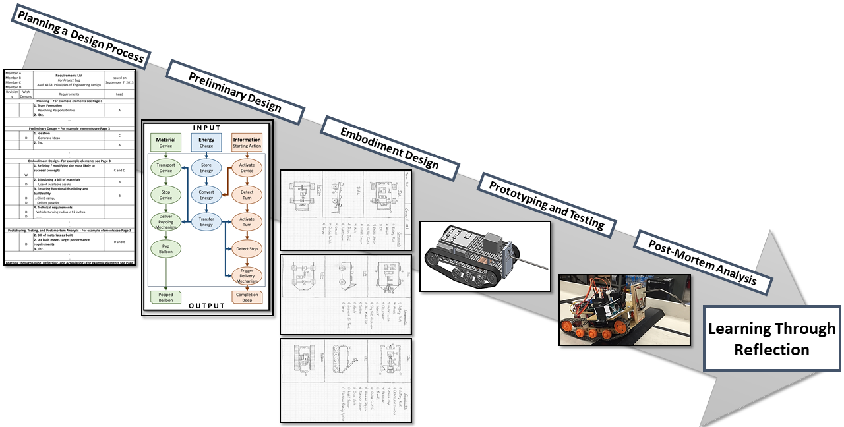

Instructors:
Farrokh Mistree, Zahed Siddique
Teaching Assistants:
Jackson Autrey, Bhagyashree Waghule

Disclaimer: This booklet has been developed primarily for the convenience of AME4163 students. The documents contained in this booklet are subject to possible changes throughout the semester that may be necessitated by circumstance. Students are responsible for keeping track of these changes as they are announced.

Contents
I. Course Summary 152
What the Course is About 152
Principles of Engineering Design 152
Targeted Competencies 152
II. Course Information 153
Contact Information 153
Email and File Naming Protocols 153
Assignment Templates 154
Policy Information 154
Principal Goal 155
Assignment List and Grade Breakdown 156
Assignments and Principles of Engineering Design 158
Class Schedule 159
Participation and Attendance 161
Resubmission Policy 161
Machine Shop 161
III. Project WindBAG 162
Problem Introduction 162
Problem Description 162
Details and Evaluation 164
IV. Course Assignments 166
General Tips 166
Assignment 1: Planning a Design Process (POED 1a, 1b, 1c, 1d, and 5b) 167
Assignment 1 Tips 171
Assignment 1 Page Breakdown 171
AME4163 Sample Team Contract 171
Assignment 2: Preliminary Design (POED 1d, 2a, 2b, 2c, and 5b) 177
Assignment 2 Tips 180
Assignment 2 Page Breakdown 180
Assignment 3: Embodiment Design (POED 1d, 3a, 3b, and 5b) 181
Assignment 3 Tips 184
Assignment 3 Page Breakdown 184
Assignment 4: Detailed Design (POED 1d, 3a, 3b, 3c, and 5b) 186
Assignment 4 Tips 189
Assignment 4 Page Breakdown 189
Assignment 5: Post-Mortem Analysis (POED 4a, 4b, 4c, 5b, and 5c) 190
Assignment 5 Tips 193
Assignment 5 Page Breakdown 193
Assignment 6: Semester Learning Essay (POED 5a, 5b, and 5c) 194
Assignment 6 Tips 195
Assignment 6 Page Breakdown 195
Assignment 7: Capstone Plan of Action (POED 1a, 1b, 1c, 1d, 5b, and 5c) 197
Assignment 7 Tips 200
Assignment 7 Page Breakdown 200
V. Additional Information 202
CAD/FEA CFD Resources and Materials 202
Frankenstein Prototype 202
Document Templatles 203
Project Progress Report Format 203
Meeting Notes Memo Format 205
Mid-Semester Design Review Format 208
Prototype Review Format 211
VI. Readings 212
David Kolb and Experiential Learning 212
Communication Styles 213
Bloom’s Taxonomy of Learning Domains 214
Learning Statements 215
Competencies 216
VII. Diversity and Inclusion Workshop 217
Attendance and Learning Statement Sheet 224

I. COURSE SUMMARY
WHAT THE COURSE IS ABOUT
- Internalizing the principles of engineering design and learning how to identify and develop career sustaining competencies
- Learning through doing (reading, designing, building, testing, and post-project analysis), reflecting, and internalizing the principles of engineering design
- Learning to frame, postulate a plan of action, and then implement that plan of action for the capstone project in AME4553 in Spring 2018
- Transitioning from being a student to a junior engineer in a company
PRINCIPLES OF ENGINEERING DESIGN
- Planning a design process
  - Forming a team
  - Accepting and executing a team contract to stipulate ethical guidelines to decision making and problem resolution
  - Understanding the problem and framing the problem statement
  - Proposing a plan of action
- Preliminary design
  - Ideating and generating concepts
  - Developing concepts to ensure functional feasibility, ensure realizability (technical feasibility)
  - Evaluating the concepts (functional feasibility, technical feasibility) and identifying that system concept which is most likely to succeed
- Embodiment design
  - Refining / modifying the most likely to succeed concept through technical analysis, experimentation and thought exercises
  - Stipulating available assets
  - Ensuring functional feasibility, technical feasibility, realizability (buildable within budget and with available skills), and safety
- Prototyping, testing and post-mortem analysis
  - Creating a bill of materials as built, including an understanding of the limitations and capabilities of the chosen components
  - Ensuring that the design as built meets target performance requirements
  - Performing a critical analysis after device prototyping of causes of success and failure
- Learning through doing, reflecting and articulating
  - Critically evaluating the processes of designing, building, and testing
  - Articulating, using learning statements, the Principles of Engineering Design that you have internalized
  - Identifying new POED and carrying that knowledge into future projects and experiences
TARGETED COMPETENCIES
Consider how these may be applied in Capstone (AME4553) and beyond:
- The ability to learn by reflecting on doing
- The ability to speculate on future trends and pose useful questions for future investigation
- The ability to make engineering design decisions in the face of limited information
- The ability to adapt to new circumstances such as a new design team or problem
- The ability to introspectively self-assess to improve as a designer

II. COURSE INFORMATION
CONTACT INFORMATION
Instructors
Farrokh Mistree (Section 001)  Felgar Hall 306  (405)306-7309 (cell)  farrokh.mistree@ou.edu  Office Hours: Seven days a week until midnight. | Zahed Siddique (Section 002)  Felgar Hall 202  (405)325-2692 (office)  zsiddique@ou.edu  Office Hours: Tuesday and Thursday 12:00 – 1:00 PM

Teaching Assistants
Jackson Autrey (Both sections)  Felgar Hall 147  (918)813-1269 (cell)  jackson.autrey@ou.edu  Office Hours: Thursdays 1:00-3:00 PM or by appointment | Bhagyashree Waghule (Both sections)  Felgar Hall 143 (Capstone Café)  Bhagyashree.waghule@ou.edu  Office Hours: Monday 12:00-2:00 PM or by appointment

EMAIL AND FILE NAMING PROTOCOLS
We expect you to follow the submission protocols listed in each assignment. The salient features are summarized below.
Emails: We expect you to use the following convention for all emails
Email on behalf of team
SUBJECT: AME4163 – Assignment # – Team Number
OR
SUBJECT: AME4163 – Nature of Query – Team Number

Email on behalf of individual
SUBJECT: AME4163 – Assignment # – Family Name
OR
SUBJECT: AME4163 – Nature of Query – Family Name

Assignment Submissions: We expect you to use the following file naming convention on all submissions
AME4163_xx_yy
Where ‘xx’ represents the assignment number or submission title and ‘yy’ your Team Number (for team submission) or Family Name (for individual submission).
Notes on communication protocols
- Be sure that there is no space between the ‘AME’ and ‘4163’ portions of the subject line.
- In the body of the email, please remember to include a phone number that the junior engineer can be reached at.
- We expect you to combine all elements of an assignment into one Word/PDF file.
- We plan to respond to every email. If you do not get a response in a timely manner, please resend the email with “Gentle Reminder” at the start of the subject header.
- Please ensure that the Assignment number, Team number or Family name of individual and page numbers appear in the footer of each Word and pdf document.

ASSIGNMENT TEMPLATES
In this course, assignment templates will be provided for your use. In general, they are structured as follows: Cover Page/Self-Grading Rubric, Assignment body, and Appendix. After your team has completed the assignment, but not yet submitted the document, you will be required to complete the self-grading rubric form which serves as the assignment cover page. This should serve as a reflective exercise and potential final check before submission. In some instances, we will request that you put certain information in the appendix and, at other times, your team may see fit to do so. In any case, appendices should be given some sort of descriptive title such as “Appendix A: Extended Gantt Chart” rather than simply “Appendix A”.
Importantly, we require that your team, though it may personalize the document in many ways, NOT alter the document headings provided in the template. We use an automated tool to collect certain information from assignment submissions and altering the heading format frustrates this effort. In some cases, heading text only may be altered. These can be identified by the use of brackets in the template. For example, a header titled “[TEAM MEMBER A]” may be changed to “Jane Q. Student.”

POLICY INFORMATION
As this is a design course, we encourage you to collaborate and discuss assignments and projects with your fellow classmates. However, we will not tolerate copying of assignments, projects, or reports. For assignments and projects, the deadlines are rigid (with some exceptions for emergencies).
AME4163 will make use of the Canvas platform. Tutorial information on using the site will be uploaded to the main page of the course on Canvas, with further support available at ou.edu/ouit.
Reading materials are made available online (through Canvas) and are offered to add context to the assignments and project goals. This material is provided for teams and individuals to leverage in their completion of assignments. Citations are required for all material used in assignments.
For all assignments, a standard of professionalism is expected and required. This includes submission of all assignments in both Word and PDF formats, utilization of all outlined communication protocols (this includes obeying file naming conventions outlined in this booklet), and the following submission requirements: page numbers, section headers, diagrams and figures (where appropriate) correctly labelled, and any references cited. These professionalism requirements will account for a percentage of the submission grade.
If you require accommodation on the basis of disability, please contact one of the instructors or teaching assistants. More information on OU’s disability accommodation policy may be found at: http://www.ou.edu/eoo/policies-procedures/disabilities.html

PRINCIPAL GOAL
Our goal, in this course, is to provide an opportunity for you as a junior engineer to internalize the Principles of Engineering Design and to develop competencies that you need to hit the road running as a junior engineer in AME4553 and in industry in nine months’ time. Note the phrase “junior engineer.” In your courses up to this point, you have largely identified and been identified as “students.” We make the conscious choice instead to use the phrase “junior engineer” to highlight the fact that you are now at a stage of technical competency and maturity that merits treatment more akin to that you will likely experience in your careers. Further, we intend to act largely as mentors or coaches to you throughout the design project. Internalizing this perspective, we believe, will aid in you in two ways. First, we aim to provide you the tools and guidance which will enable you to meet the challenge presented in this course and are therefore available as resources. Second, we intend to prepare you in this course for your Capstone design experience (AME4553) in the Spring semester. In that course, you will be solving engineering challenges (primarily for corporate sponsors) for which you will be responsible for professional work. Accordingly, you will be expected to act like practicing engineers in professional settings. We therefore put it to you in AME4163, in preparation for your work in Capstone and your careers, that you should endeavor to visualize yourselves as “junior engineers” as you work with your teams this semester.
In AME4163, you must complete a semester-long design project with a team of your colleagues. In this course, we focus on learning and not just on how well your project device performs on the day of the competition. By the time you begin your Capstone design projects in Spring, you should be able to:
- Plan a design process by understanding requirements, implement that process, evaluate the outcome, and identify improvements to that process.
- Generate, evaluate, and develop design concepts by applying knowledge of science, engineering techniques, and manufacturing principles.
- Use analysis and simulation tools to understand design performance and then improve the design.
- Generate solid models and engineering drawings of the design using 3D modelling software.
- Prototype the design.
- Learn through doing (for example, design, build, test, read, write, etc.) and experiencing (for example, working in a team, getting feedback from mentors).

As we intend to treat each of you like a junior engineer in a company, we expect you to act like one. Consider how you frame your questions to your mentors. We encourage frequent questions to improve your understanding, but your questions should be commensurate with your new status. A student asks questions like “how can I get an A?” or “what do you want me to do in this assignment?” A junior engineer thinks deeper and instead asks questions which will help them learn and grow as engineers. So, while we encourage frequent questions, we ask that you stop and think before asking questions which could instead be more readily answered by reading through your booklet.
ASSIGNMENT LIST AND GRADE BREAKDOWN
A1: Planning a Design Process (See Page 16)
- Team Skill Inventory and Team Prospectus
- Team Contract Understanding
- Problem Statement
- Project Schedule
- House of Quality
- Requirements List
- Learning Statements
Grade: See Assignment 1 Grade Breakdown 10% of total
Target POEDs: 1a, 1b, 1c, 1d, and 5b

A2: Preliminary Design (See Page 25)
- Function Structure
- Reality Check
- Morphological Chart
- Concept Generation
- Plus, Minus, Interesting
- Learning Statements
Grade: See Assignment 2 Grade Breakdown 10% of total
Target POEDs: 1d, 2a, 2b, 2c, and 5b

A3: Embodiment Design, Pt. I (See Page 29)
- Available Assets
- Critical Evaluation of Concepts
- Establish Evaluation Criteria
- Go/No-Go Analysis
- Reduce the Number of Concepts
- Learning Statements
Grade: See Assignment 3 Grade Breakdown 10% of total
Target POEDs: 1d, 3a, 3b, and 5b

A4: Detailed Design (See Page 33)
- Refined Concept Description
- CAD Models
- Bill of Materials
- FEA of Critical Components
- Learning statements
Grade: See Assignment 4 Grade Breakdown 15% of total
Target POEDs: 1d, 3a, 3b, 3c, and 5b
Project Demonstration and Reviews
- Mid-term Design Review
- Prototype Update
- Prototype Demonstration/Competition
Grade: See Project Grading Scoresheet 15% of total
Target POEDs: 4a, 4b, and 4c

A5: Post-Mortem Analysis (See Page 37)
- Preamble
- Design Process
- Changes to the Design Process
- Design Artifact
- Changes to the Design Artifact
- Learning Statements
Grade: See Assignment 5 Grade Breakdown 10% of total
Target POEDs: 4a, 4b, 4c, 5b, and 5c
A6: Semester Learning Essay (See Page 41)
- Learning Statements
Grade: See Assignment 6 Grade Breakdown 10% of total
Target POEDs: 5a, 5b, and 5c
A7: Capstone Plan of Action (New Teams) (See Page 43)
- Document Format and Problem Statement
- Background Information
- Team Understanding
- Requirements List
- Question for Sponsor
- Plan of Action
- Important Milestones
- Critical Evaluation
Grade: See Assignment 8 Grade Breakdown 10% of total
Target POEDs: 1a, 1b, 1c, 1d, 5b, and 5c

Short Assignments and Miscellaneous 10% of total
- Attendance and participation
- Ethics exercise
- CFD/FEA/CAD short assignments

Note: All assignments outlined above also include a required level of professionalism, outlined specifically in each assignment breakdown and more generally in the “Policy Information” section on Page 3 of this booklet.

ASSIGNMENTS AND PRINCIPLES OF ENGINEERING DESIGN
To structure your learning over the course of this project and to further aid in your internalization of the Principles of Engineering Design (POED), the following table is provided which maps the POED to the specific assignments in which they appear. Leverage this information as you go through assignments and prepare learning statements. Note that these are the instructor learning targets for each assignment; you are encouraged to reflect on connections between POED and assignments not made explicit by this chart.
Assignment | 1 | 2 | 3 | 4 | 5 | 6 | 7
Description  Target  POED | Given: Story, Team Contract  Provide: Problem Statement, POA, HOQ, Req. List, LS | Given: Prob. Statement, HOQ, Req. List.  Provide: Function Structure, Morph. Chart, 6 Concepts, PMI, Failure, LS | Given: Concepts, PMI, Failure  Provide: Go/No-Go from 6 to 2, Bill of Materials, Select Concept, LS | Given: Selected Concept  Provide: Geometry analysis, CAD model, refined Bill of Materials, Buildability, Report, LS | Post-Mortem Report | Semester Learning Essay | Capstone Plan of Action
1a
1b
1c
1d
2a
2b
2c
3a
3b
3c
4a
4b
4c
5a
5b
5c

See Page 1 of this booklet for details on the specific Principles of Engineering Design (POEDs)

CLASS SCHEDULE
Week | Date | Section 001 | Section 002 | Item Due | Notes
1 | 8/21 | Course Introduction  Discussion of Booklet | Course Introduction  Discussion of Booklet |  | 001: SEC N0202  002: FH 300
1 | 8/23 | Steps in Design Processes  Designing and Managing the Design Process | Steps in Design Processes  Designing and Managing the Design Process | Reading: David Kolb, Competencies | 001: SEC N0202  002: FH 300
2 | 8/28 | Understanding Customer Needs -  Creating House of Quality and List of Requirements | Learning Statement Construction  Semester Learning Essay | DUE 8/28 by 11:59 PM: Team Formation Submissions | 001: SEC N0202  002: FH 300
2 | 8/30 | Learning Statement Construction  Semester Learning Essay | Understanding Customer Needs -  Creating House of Quality and List of Requirements | Reading: Bloom’s Taxonomy, Learning Statements | 001: SEC N0202  002: FH 300
3 | 9/4 | Diversity and Professionalism Workshop, Part I |  |  | 001 and 002: EPF 200
3 | 9/6 | Diversity and Professionalism Workshop, Part II |  |  | 001 and 002: EPF 200
4 | 9/11 | Function Structure  Morphological Chart  Assignment 2 Discussion | Function Structure  Morphological Chart  Assignment 2 Discussion |  | 001: SEC N0202  002: FH 300
4 | 9/13 | No Class – Engineering Career Fair |  | DUE 9/13 by 11:59 PM: Assignment 1 | Register early to avoid waiting in line!
5 | 9/18 | Value Engineering  Attention Directing Tools | Value Engineering  Attention Directing Tools |  | 001: SEC N0202  002: FH 300
5 | 9/20 | Go/No-Go  Concept Selection  Assignment 3 Discussion | Computer-Aided Design Methods and Approaches |  | 001: SEC N0202  002: FH 300
6 | 9/25 | Computer-Aided Design Methods and Approaches | Go/No-Go  Concept Selection  Assignment 3 Discussion |  | 001: SEC N0202  002: FH 300
6 | 9/27 | Machine Shop Tour |  | Due 9/27 by 11:59 PM: Assignment 2 | See Posted Schedule
7 | 10/2 | Feedback: Mid-Term Design Review |  | Review Form | See Posted Schedule
7 | 10/4 | Feedback: Mid-Term Design Review |  | Review Form | See Posted Schedule
8 | 10/9 | No Class – Work Day
8 | 10/11 | No Class – Work Day |  | Due 10/11 by 11:59 PM: Assignment 3
9 | 10/16 | No Class – Work Day
9 | 10/18 | No Class – Work Day
10 | 10/23 | Feedback  Team Prototype Update |  | During Review: Prototype or Frankenstein Prototype  Due 10/25 by 11:59 PM: Assignment 4 | See Posted Schedule
10 | 10/25 | Feedback  Team Prototype Update |  |  | See Posted Schedule
11 | 10/30 | No Class – Work Day
11 | 11/1 | Capstone Project Announcements |  |  | 001: SEC N0202  002: FH 300
12 | 11/6 | Project Demonstrations |  |  | See Posted Schedule
12 | 11/8 | Project Demonstrations |  |  | See Posted Schedule
13 | 11/13 | Engineering Ethics | Engineering Ethics |  | 001: SEC N0202  002: FH 300
13 | 11/15 | No Class – Work Day |  | Due 11/15 by 11:59 PM: Assignment 5
14 | 11/20 | No Class – Work Day
14 | 11/22 | No Class – Thanksgiving Break
15 | 11/27 | No Class – Work Day |  | Due 11/27 by 11:59 PM: Assignment 6
15 | 11/29 | No Class – Work Day
16 | 12/4 | Dead Week  No Class – Work Day
16 | 12/6 | Dead Week  No Class – Work Day |  | Due 12/14 (AME4553 advisor discretion): Assignment 7 | All extension-granted work due by 12/7
17 | 12/11 | Finals Week  No Class – Work Day
17 | 12/13 | Finals Week  No Class – Work Day

PARTICIPATION AND ATTENDANCE
Attendance and participation in this course are both required and will be taken during every lecture. Specifically, at the end of all lectures, there will be a short, reflective written exercise which will serve simultaneously as a tool for collecting attendance, a form of class participation, and an opportunity for you to grow as learners. Other opportunities for course participation will include moments of call and response during lectures, in-class group discussions, and other short activities.
Keep in mind that, in addition to the research suggesting that student attendance contributes to both performance and knowledge acquisition, the instructors will also use course time to disclose necessary changes or information about the course. DO NOT RELY ON THAT INFORMATION BEING CIRCULATED BY OTHER MEANS.

RESUBMISSION POLICY
In AME4163, teams and individuals will have the opportunity to resubmit graded work, at their discretion. In general, the proper protocol and rules for resubmitting work will be as follows:
- Notify the instructor (and CC Jackson and Bhagyashree) of you or your team’s intent to resubmit a particular assignment.
- From the date that graded work is returned to individuals or teams, you will have one week to resubmit. For example, if graded work is handed back on Tuesday during class, you will have until the following Tuesday at midnight to resubmit the assignment.
- Structure of resubmission:
  - New self-grading sheets appropriately filled in
  - Include the old self-grading sheets (and identify them as such)
  - Include a sheet in which you identify what you changed, where these changes are located, and why your grade should be modified. The ‘why’ is important. In the context of the rubric and the feedback, indicate clearly how the additional information warrants a higher grade.
  - The revised submission with changes highlighted. Changes can be highlighted either using Word’s built-in highlight function or by including document notes/comments.

MACHINE SHOP
As a key component of the course project is the construction of a working prototype capable of addressing the challenges posed, many of you will likely be in unfamiliar territory. An excellent resource available to you are the people who run the AME machine shop, which includes the machine shop supervisor Billy Mays and machinist Greg Williams, along with several undergraduate assistant staff.
While we encourage each team to take advantage of this resources where needed, we also expect you to be respectful of the time and expectations of the staff. With upwards of forty groups in this course, the machine shop runs the risk of being overrun by students requesting help. Consequently, you are expected to plan your requests for assistance/resources in advance and with careful mindfulness of what your actual needs are. Additionally, please do your best to avoid waiting until the last possible weeks before the project demonstrations; in the past this has caused resources to become unnecessarily tied up.
Both Mr. Mays and Mr. Williams are excellent sources of wisdom regarding the machining and buildability aspects of your prospective concepts. Leverage their advice early in the process and do not wait until the final few weeks to begin building your devices.
III. PROJECT WINDBAG
PROBLEM INTRODUCTION
As was outlined on Page 4 of this booklet, AME4163 revolves around a central semester-long, team-based project. This project is designed to provide students with the opportunity to act as junior engineers exploring solutions to a complex, multi-level, and competency-building problem. One component of that experience is that the problem revolves around a central narrative. This narrative provides the opportunity to diagram the problem within its complete context, just as problems in the real world exist within particular contexts. Further, due to the fact that narratives contain a large amount of information of varying degrees of usefulness to the problem, the junior engineers are expected to determine which of that information is most important, of some importance, and irrelevant. This experiential learning provides the basis on which competencies will be further developed.
PROBLEM DESCRIPTION
Professor Joachin Witherspear is moderately displeased. Although he had originally been excited about being invited to teach at the University of Vayu, (he had been awarded the coveted Bosh nef Storey Fellowship, named after the founder of the University, a man responsible for many innovations on the planet of Vayu) he is rather upset with the arrangements. He has been given a nice office and a brand new compu-station, but the keys for the office and the building will take a week and a half. The Galactic Express people have been very nice in extending him credit, but he is not sure that it will be enough. And then there are all the numbers and forms and who knows what else that he had to apply for just to get the power and tele-vid turned on at his rental house. Still the house is clean, and the people are friendly enough. He is determined, as would be anyone from his planet of Gleesong, to do the best job he can while at the University of Vayu.
“It is a good thing that I am still single, or this move to Vayu would have been extremely difficult,” Joachin thinks to himself as he walks to the conference room for his appointment with a Mr. Vindebagg. “I wonder why the chair-person wants me to meet with this gentleman - my neighbor says he is a crackpot!”
As he enters the conference room, Joachin gets his first look at Thaddeus P. Vindebagg - the new professor. He knows that it is this worthy gentleman because of the outsize badge Vindebagg wears, announcing to all and sundry his moniker. In addition, it proclaims his profession to be that of “Professional Concept Generator and Expeditor”. The badge is only the beginning. Vindebagg is wearing a tunic made of patchwork, silvery corduroy trousers and shoes that have mates but not in this room. Joachin suspects that the socks, if Vindebagg wears socks, match about as well as his shoes. His hair is beyond the ability of any mortal barber to bring under control. But the man's face draws attention away from the scenic tour that is his attire. His eyes are alert and penetrating, and it is almost as if one can see a computer screen behind these eyes, constantly scrolling past new ideas being generated.
“Don’t be put off by the clothes, friend, even though they do make me look a bit crack-potish,” says Vindebagg, echoing Joachin’s first thought.
“Thaddeus P. Vindebagg, at your service. As you can see from my badge, my business is conceptualizing and idea generation, and helping other people do the same. The clothes are to jar people out of complacency and to demonstrate the principle of synthesizing a new artifact from an unlikely set of concepts. But enough of that. I’ve come to discuss developing a concept of my own.”
“My name is Joachin Witherspear, but I am unsure why you would want to speak to me. There are many professors here, senior to me, and with better contacts in industry. I am very much the new kid on the block,” returns Joachin.
“Well, in truth I asked to speak to your chairman. I thought you were a bit young. Now I see what your chairman thinks of me.”
“Wait a minute, I am not without talent or competency. I do hold the Bosh nef Storey Fellowship.”
“Ah, Bosh nef Storey ...”, muses Vindebagg, “there was an engineer with imagination and vision. Not like some of these around today. Well, perhaps you are the best bet after all. Would you like to hear my concept?”
“I am here, so I might as well listen. Please, go ahead.”
His face becoming ever more animated, Vindebagg pulls out diagrams, sketches and scribbled paragraphs from his overstuffed satchel. Spreading them on the conference table, he begins, “You see, it has to do with harnessing the wind...”
“I see why you are having so much trouble with this concept,” interrupts Joachin, “From what I have seen so far, there is very little wind on Vayu, just a pleasant breeze. Besides the sun shines all the time, except for the hour of rain every day, so you can harness the sun for energy. This idea will never sell on Vayu.”
“It is true there is little usable wind on Vayu. This is why it is such a good world for growing food. Very little wind erosion occurs and the weather is mild,” lectures Vindebagg, adding testily, “But I never said that I wanted to ‘sell’ the idea on Vayu. There are other worlds...”
“I’m sorry, please continue.”
“Quite all right. The concept got its start when I was reading some books of history about wind power. Sailing ships and windmills, that sort of thing. But what I thought would be interesting, would be if we were able to able to harness the wind and store it as energy...”
“And then use it later at a site remote from where the wind source is. Of course, I was blocking thoughts before, but now I see what you are getting at,” says Joachin excitedly. “We could use such a device to power vehicles and such on my home planet, Gleesong. (They call it that because the wind blows all the time so that it sounds as if someone is constantly singing. We are a resource poor planet and the weather is mostly cloudy so that solar energy is right out. Presently, we are importing nuclear fuels to provide energy, and even though there is no danger of melt-down in our power plants, we still have a waste disposal problem. The government has begun building windmills to provide power, but no one has thought of using it to power vehicles. We are still using fossil fuels at present!”
“Then we agree, this is a concept that must be pursued, Joachin, but we must have some energetic young people, without preconceptions, to help us.”
“We can get the Design class to take this on as a project, Thaddeus,” says Joachin, adding, “But we need a name, or phrase, to rally around ... hmm ... How about, Wind Blown Applications Group - WindBAG!”
“Perfect, just perfect,” beams Vindebagg. “This is what I call concept generation indeed.”
DETAILS AND EVALUATION
Task
Design, build and test a system capable of converting wind energy into some more useful form of energy and then store this energy in some compact, transportable module. The wind source will be represented by a household electric fan, and the energy modules must be used to propel a vehicle, carrying as large a payload through as many loops around a track (see image below) as possible, subject to the restrictions and conditions.
Restrictions
- No minimum or maximum number of dimensions is specified, though teams are reminded to be aware of the track dimensions
- No maximum weight limit is specified
- A maximum budget of $100.00 is required with a bill of materials for the finished devices to be used to validate the amount spent
Conditions
- The vehicle will be required to move around the following track:
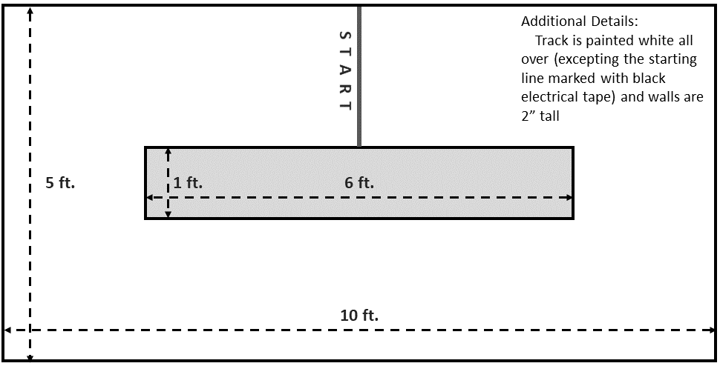
- No guide wires of any kind will be allowed. Once the system is placed on the track, any additional touches from a group member will receive a penalty. The vehicle may utilize the walls for navigation but may NOT hang over the top of the walls (‘grabbing the edge’)
- From the time the vehicle begins moving until it runs out of usable energy, the number of loops of the track will be counted. Partial loops will be noted and used in the event of a tie.
Performance Tests
The mechanism that is to be tested shall consist of a conversion/storage device, energy modules and a vehicle. In the first part of the test, each group will be given 5 minutes to convert and store as much energy as their design allows. The energy modules shall then be integrated with the group's vehicle, the payload added, and two runs shall be made.
The performance run will be scored by two measurements. These are:
- The useful load carried by the vehicle (payload)
  - This measurement demonstrates the useful work down by the vehicle and energy module
- The number of laps traveled by the vehicle
  - The number of laps traveled by the vehicle will be used in the calculation of points for this portion of the performance test.
  - Once the vehicle has crossed the start line it shall not be aided in any way to complete traversing the course.
Each system will be required to go through the performance test twice. Teams will be allowed two minutes to set up their system before each run on the course, which includes installation of modules and payload. The system must be removed from the competition area within one minute after completion of the test. Penalties will be levied if the set up and removal times are exceeded.
The points for each part of the performance test will be calculated as follows:
- Points for payload
  - $P_{1}= \left[\frac{Weight- {Weight}_{min}}{{Weight}_{max}-{Weight}_{min}} x 50\right]$
  - Where
    - Weight is the payload
    - Weight_{max} is the maximum payload any group’s vehicle carries
    - Weight_{min} is the minimum payload any group’s vehicle carries (or a suitable minimum selected later)
- Points for number of laps travelled
- $P_{2}= \left[\frac{Laps - {Laps}_{min}}{{Laps}_{max}- {Laps}_{min}}x 50\right]$
- Where
  - Laps is the number of laps travelled by the groups device
  - Laps_{max} is the maximum number of laps travelled by any group’s vehicle
  - Laps_{min} is the minimum number of laps travelled by any group’s vehicle (or a suitable minimum selected later)
- Original points
  - OP = P₁ + P₂ – Penalties
  - The sum of the original points from both runs of the performance test will be the group points. The group with the most points will be judged to be the winners of the competition.

IV. COURSE ASSIGNMENTS
AME4163 is divided into several course assignments which comprise the steps of a design process as described on Page 1 in the Principles of Engineering Design. These assignments are supplemented by lecture materials, in-class and out-of-class exercises, and readings. Here we provide detailed instructions for each assignment and general tips for their completion. Use this document to track your progress and leverage the materials presented here to complete the assignments.
GENERAL TIPS
- Professionalism:
Never ignore the importance of formatting and professional appearance in a document. They are easy points and serve to make documents more readable and, thus, more engaging. Many miss these or gloss over this formatting and thus lose the points that can very often be the difference between an ‘A’ and a ‘B’ or a passing and a failing grade.
- Understand the Rubric
Leverage the grading scheme provided for each assignment to complete the task. The grading schemes are not arbitrary and reflect the interests of the instructors. A great deal of time and effort has been put into deciding what to value in each assignment and what categories of evaluation to include; each team should thus prepare each assignment to that articulated standard.
- Demonstrate Learning
The most important thing students can do to curry the favor of the instructors is to demonstrate real learning. Note: THIS DOES NOT REFER TO THE ACQUISITION OF TECHNICAL PROFICIENCY. The instructors do not have any interest beyond baseline acknowledgement for acquired skills in SolidWorks or wiring electrical circuits. They are interested in how you are learning to solve problems and creatively approach potential solutions. They want to see that you understand the principles of a systematic design process and how that understanding can be leveraged to solve complex, open-ended, ill-structured problems like those faced by practicing engineers.
- Manage Time Effectively
In every class, every year, inevitably, some groups wait until the last few days to complete not just the assignments but the actual design and construction of their project device. This simply is not doable in a course as immersive and complex as AME4163. To avoid this pitfall, plan accordingly with all team members well in advance. Utilize texting, communication apps, email, cloud-based collaboration software, and anything else one can imagine in order to beat deadlines.
- Ask Questions
Both the instructors and the TA are an excellent resource for course information. Do not hesitate to email or visit them in person at their office hours. The goal is not to deceive or hide evaluation methods from you; they will explicitly tell you what they want to see from each member of the course and each team. In addition, your course TA has taken this course and helped design this year’s version. Your instructors are a resource: utilize them.

ASSIGNMENT 1: PLANNING A DESIGN PROCESS (POED 1A, 1B, 1C, 1D, AND 5B)

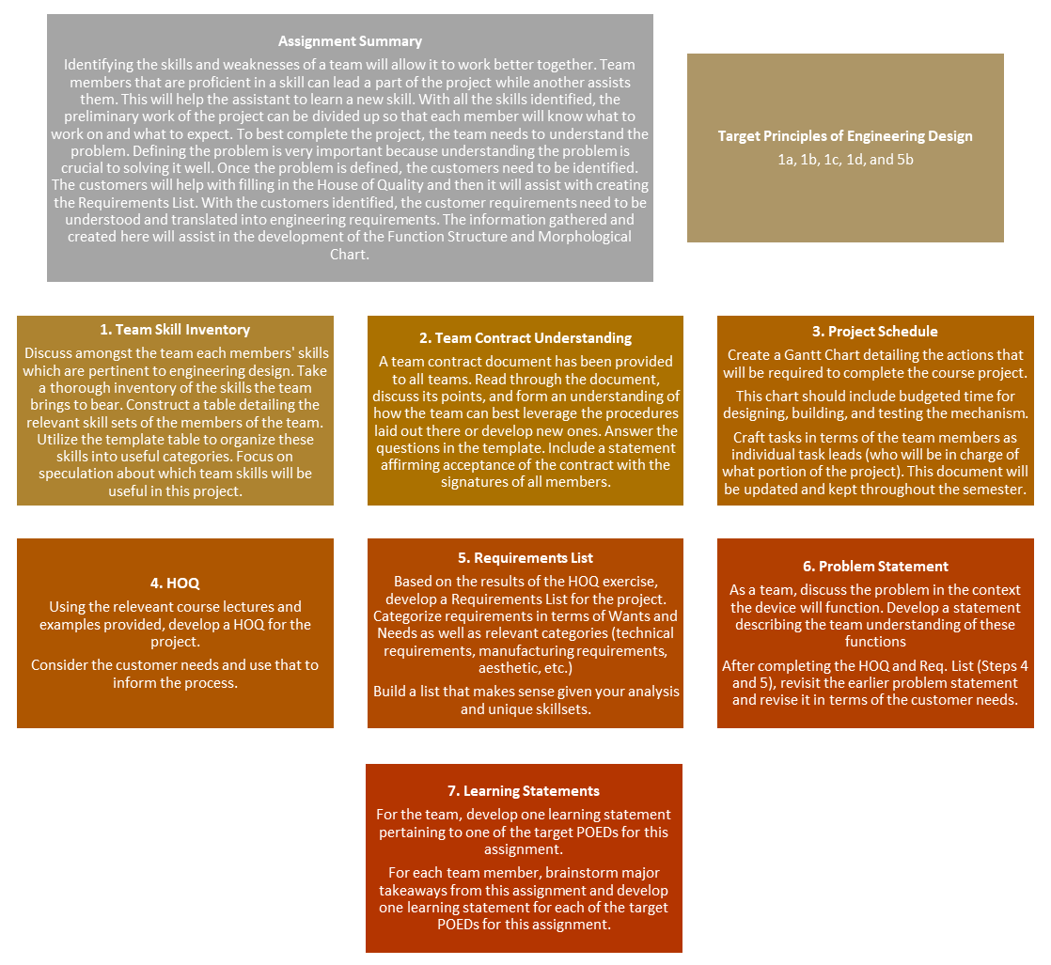

Note: PLEASE USE THE PROVIDED ASSIGNMENT TEMPLATE, AVAILABLE ON CANVAS
assignment Step Checklist
Suggested Assignment Length: 17 Pages. Grading rubrics are included in the assignment templates.

- Team Skill Inventory and Team Prospectus
Skills, Experience, and Strength of Team
Categorization of the experiences are believable, and they relate to competencies and meta-competencies
- Teams should use this as an opportunity to analyze their unique experiences and qualifications which may lead to success in the project.
- One useful way to begin this list may be to leverage the resumes of each member of the team.
NOTE: This may also be a useful opportunity to update your resume for the upcoming career fair!
- Brainstorm a large list of skills and assets and then break this list down in to relevant categories.
- Think critically about the demands of the project to identify relevant skills.
- Distill the relevant skills into the provided table with useful categories.
- Be meticulous with this table as it will be recalled in Assignment 3.

- Team Contract Understanding
Executing the Team Contract
Exploring how the team intends to use the Team Contract provided to ensure team success.
- Write out a statement explaining that each member of the team has read and understood the contract and intends to adhere to it in the upcoming project. Further, the statement should indicate that all members have signed a printed copy of the contract.
- Designate a single person as the team communicator, responsible for submitting assignments and sending out necessary regular emails, text messages, etcetera. In addition, explain what roles all other members of the team will serve.
- EACH team member (identified by name) must write a brief paragraph explaining their take away from the team contract (their responsibilities, understanding, etc.).

*Note: It is advised to begin item 6 at this stage, then complete Items 3, 4, and 5 before finalizing Item 6.
- Project Schedule
Team Gantt Chart
All steps in process shown with critical path, important dates from class, description of steps, and extra time accounted for. Gantt chart readable and formatted well for printing.
- Use available examples to ensure that the chart is readable and clear.
- Create the Gantt Chart in a form that will be able to be edited throughout the semester.
- Develop a system or schedule for regularly updating this document.
- Format to display in the main body. Do NOT include this as an Appendix.

- House of Quality
HoQ is complete and correct
- Include all categories laid out in the examples.
- Use the template provide to ensure completion.

‘Whats’ and ‘Hows’ of HoQ are extensive
‘Whats’ cover multiple customers; Be sure to have ‘Hows’ for each ‘What’
- Use the text of the project description to inform the ‘Hows’ and the ‘Whats’.
- Brainstorm for a thorough listing of these aspects.
- After they have been formed, perform a Reality Check to ensure completeness.
Customer requirements are explained
- Use an additional section of text to succinctly explain the customer requirements.
- Justify their inclusion and their relative importance.
- Write in terms of the customers as real people with real needs.

Engineering requirements and all numbers are justified
Created from customer requirements
- Use text to justify team choices regarding thresholds for meeting criteria.
- All criteria should have some numerical target (if applicable) or some tangible metric for success.

Justification and process for determining relative weights for ‘Whats’ are provided
- Explain the methods used to choose weights. Examples can include team votes, several HOQ iterations run with random weights, or reasoned deliberate choices.
- Justify why the results of those choices will enable team success.

Results from HoQ are explained
- Explain the consequences of the HOQ results.
- Describe how the HOQ results will affect your design process and choices moving forward.
- Explore the relation between the HOQ results and the plan of action moving forward.

- Requirements List
The Requirements List is extensive and detailed for the project
Covers demands and wishes with appropriate information for each and who is responsible
- The Requirements list, in addition to having each requirement labelled a want or a demand, should also be broken up into various categories. Choose relevant categories. Examples include: technical requirements, safety requirements, manufacturing requirements, device performance requirements, etc.
- This list should be thorough, and each requirement should have some target or measurable objective for success. Numerical objectives are most common (e.g. “Our device must weigh less than X lbs.”) but qualitative objectives can be used for relevant requirements (e.g. “Aesthetic Requirements – Device must be painted red and blue”).

The Requirements List has correspondence with the HoQ
- The results of the HOQ can be added directly to the Requirements list but should not be the only items listed.
- Other requirements must serve as expansions on the HOQ results.

- Problem Statement
Problem Statement before HOQ and Requirements List
Create initial problem statement from a purely technical standpoint
- Think about the problem overall as a device to be built. This version of the problem statement should be heavily focused on the technical.
- Think about the specific functionality required of the device. Think in terms of technical feasibility.

Revised Problem Statement
Create with new knowledge and insight
- Given the results of the HOQ and Requirements List, think about new information that is relevant to the team understanding of the problem.
- Leverage the priorities created in the HOQ to define the problem around the most important customer requirements. Create a team understanding of what the primary problem needing to be addressed is, followed by secondary objectives, tertiary objectives, and so forth.
- Define the problem around the specific, measurable, achievable objectives defined in the Requirements list.
- Modify the initial problem statement with your updated understanding of the problem.

- Learning Statements
Draft team and individual learning statements
Competencies, insight, etc.
- Learning statements must have the structure that has been covered in class.
- Develop learning statements focusing on the following Principles of Engineering Design: 1a, 1b, 1c, 1d, and 5b (See Page 1).
- Individual: each team member should brainstorm their chief takeaways for the assignment and then write a LS rooted in those takeaways for each target POED (five for each individual).
- Team: choose a single target POED for the team overall and write a LS for it
- For both individual and team learning statements remember this course is about getting you to internalize the principles of engineering design. Think and write so that you have generated sufficiently insightful lessons learned that can be leveraged in the Semester Learning Essay.
- Include full names for each student in the spaces provided in the provided assignment template.

- Professionalism
Professionalism – Bonus
- Team name, names of members, page number
- Question written out then answered
- Reality checks
- Clarity, connectivity, utility
- Spark, insight, extra effort

Comments
Though professionalism is, for this assignment, left as a bonus, in future assignments it will be a requirement. Be sure to get into the habit of preparing formal reports in well-established and easily-readable formats.

ASSIGNMENT 1 TIPS
- Do not build your preconceived ideas of how to achieve the final results into the specifications.
- Make sure that each subsystem requirement is covered.
- Make sure that the customer’s interests are protected.
- Make sure that your interests are protected. This includes planning for your schedule(s), accounting for your wants and needs, etc.

ASSIGNMENT 1 PAGE BREAKDOWN
Item | Section | Suggested Pages
1 | Team Skill Inventory and Team Prospectus | 5
2 | Team Contract Understanding | 1
3 | Problem Statement | 1
4 | Project Schedule | 2
5 | House of Quality | 5
6 | Requirements List | 2
7 | Learning Statements | 1
8 | Professionalism | NA
 | TOTAL | 17

AME4163 SAMPLE TEAM CONTRACT
Preamble
The following is a draft team contract for your team’s consideration. A copy will be made available as a downloadable document on Canvas. This document is designed to be a tool for all teams. All members should read thoroughly, discuss, make needed changes, and sign it before implementing. Use this as a tool to help resolve conflict, promote organization within the team, and improve efficiency of labor within the team. Make an effort within the context of the overall project to utilize the various aspects of the team contract to improve your work. It is highly encouraged that all team members read through the team contract and sign in the appointed space at the end of the contract.
Team XXXX – Team Contract
Date: MM/DD/YY
- Team Coordinator
  - YYYY will serve as the Team Coordinator. He/she has agreed to fulfill the following responsibilities:
    - Task delegation for the entire team taking input from the team members into account and ensuring an equitable distribution of workload.
    - Communicating all essential information to the team in an orderly, prompt fashion via emails or text messages/group messages.
    - Calling meetings and deciding on meeting times.
    - All work will be submitted by the Team Coordinator unless otherwise defined by the assignment parameters including:
      - Completed assignment submissions in Word/PDF format
      - Team Learning Statements (Individual statements will be submitted by each member of the team)
    - Team Coordinator may delegate responsibilities for coordinating the team when appropriate.
  - ZZZZ has agreed to serve as the back-up Team Coordinator and will fulfill the role of the Team Coordinator when appropriate.
  - The Team Coordinator (and back-up) can be removed upon the request of the majority of team members, subject to the approval of the OU mentors for this project, from that position if and only if the Team Coordinator exhibits poor leadership, breaches the team contract, or is otherwise deemed unfit to coordinate
- Code of Conduct
  - As a team, we will:
    - Not tolerate disrespect towards other team members on the basis of religion, ethnicity, gender, or sexual orientation. Such disrespect is grounds for OU mentor involvement and/or removal from the group.
    - Hold each other to high standards and be aware that anything less than 100 percent effort on assignments affects the entire team’s performance.
    - Set/agree to standards of quality.
    - Respect the time of our peers. We understand that our individual time is not worth more than anyone else’s.
    - Appear on time for meetings.
The decisions of the Team Coordinator should be made with the entire team in mind with the main goal being team success.
- Conflict Resolution
  - As a team, we will:
    - First attempt to deal with all issues that may arise internally. OU mentors will only become involved if no resolution can be reached amongst ourselves.
    - Seek to understand the interests and desires to each party involved before arriving at answers or solutions.
    - Choose an appropriate time and place to discuss and explore the conflict.
    - Listen openly to other points of view.
    - Acknowledge valid points that the other person has made.
    - State our points of view and our interests in a non-judgmental and non-attacking manner.
    - Seek to find some common ground for agreement.
    - Acknowledge that because of the team-oriented nature of this project, potential situations may arise where the thoughts and ideas of one team member may be passed over (even after deliberation) for the benefit of the group as a whole.
    - Proceed to implement the team decision upon resolution of the conflict.
- Accommodation Standards
  - As a team, we acknowledge:
    - That there may be more than one correct/acceptable approach to arrive at an answer to a problem. Accordingly, we will be open to accommodating all reasonable / practical points of view.
    - That we are all individuals and we all think about things differently.
    - That in order to excel, it would be prudent to allow the learning/engineering styles of each member to work together in a positive way instead of letting them interfere with one another.
    - The importance of proceeding through consensus. In the event that there is no consensus the majority vote will prevail and all will get behind the decision made by the majority.
- Communication Standards
  - In Meetings:
    - All ideas will be listed to and taken into consideration.
    - The goals of the meeting will be discussed and displayed at the beginning of the meeting, and will be checked off as completed. To eliminate misunderstandings action items (who is to do what) will be covered at the end of the meeting.
    - Productivity and efficiency are essential.
    - Meetings will only be held when necessary.
    - The cancellation of regularly scheduled meetings is solely at the discretion of the Team Coordinator.
    - Additional meetings may be called as deemed necessary by the Team Coordinator in consultation with the team members.
  - Outside of Meetings:
    - We recognize the importance of reading and responding to all text messages and emails.
    - Responses to emails/text messages must be sent in a reasonable amount of time.
    - “Reasonable amount of time” is defined as 6 hours for text messages and 12 hours for emails.
    - If a team member is unable to attend a meeting, the Team Coordinator must be notified at least 24 hours in advance. This clause can be ignored in extreme or emergency situations (examples include issues of health or family need).
    - Restrict SMS communication between team members between 10:00PM and 8:00AM excluding dire emergencies.
  - Peer Reviews
    - We will participate in a biweekly “peer review” process, separate from the coursework required, to ensure accountability and quality standards are being met by every member of the group.
    - These peer reviews will NOT be anonymous and will be shared amongst the team members.
    - The Peer Review Form (for Peer Review Form, see Appendix A) will be completed and turned in at the end of that week’s meeting.
    - It is expected that these peer reviews should be taken seriously. Each member will reflect on the feedback and take appropriate action to ensure the success of Team XXXX.
- Team Meeting Standards
  - Meeting Frequency
    - Meetings will be scheduled twice a week. Assuming the tasks are completed in the first weekly meeting, the second weekly meeting (for that week) will be canceled.
    - Agendas will be discussed at the beginning of every meeting and will be prepared by the Team Coordinator with input from team members.
    - The expectations for future meetings will be discussed at the end of each meeting to allow for transparency for all group members about what is expected.
  - Meeting Leadership
    - Meetings will be called by the Team Coordinator, or her/his designate as situations apply.
  - Meeting Organization
    - The team will be incorporating a SCRUM Board for organization purposes.

- Quality of Work
  - As a team:
    - We expect all work done by every member to be quality work as agreed to by the team.
    - We expect all work done by every member to be done on time.
    - We acknowledge some weeks will be busier than others; this is NOT an excuse to provide work that is not up to the quality standard OR pass work onto other team members.
    - Any time a team member knows that he or she would be unable to complete an assignment either on time or up to the quality standard, the Team Coordinator must be notified at least 48 hours in advance in order to allow for the assignment to be completed. (This provision is for health-related emergencies only.)
    - We acknowledge that if a member(s) of the group consistently produces sub-par work that is either late or does not fit the quality standard, the OU mentors will be notified and this is grounds for removal from the group.
  - All assignments are due to the Team Coordinator at LEAST 24 hours before the official due date in order to accommodate revisions if necessary.
  - Work that is not up to the quality standards (i.e., did not follow instructions, was poorly done, was unfinished etc.) will be returned to the original author for revision.
  - The revisions mentioned above will be delegated by the Team Coordinator and any or all of the other members of the team (assuming all involved with the revisions has read and understands the submission).
- Consequences of Contract Breach
  - As a team:
    - We will always first address the issue internally. If no resolution is reached, then OU mentors may be involved.
    - We acknowledge that a breach of the contract can result in OU mentor involvement and potentially the removal of that group member from the group
    - We acknowledge all grade penalties/repercussions associated with removal from the group.
    - We acknowledge the importance of peer reviews in this course. We are aware that we will receive honest and fair reviews from all members of the group that accurately reflect our performance.

- Member Names and Signatures
I understand the contents of this document and agree to abide by it.
Signed (with date) 1

Signed (with date) 2

Signed (with date) 3

Signed (with date) 4

Appendix A
Peer Review
Review each team member on his or her performance during the past two-week period. Please be honest and fair, as these reviews will be referenced during end-of-semester peer review. Please turn into the team leader when completed.
-1 Said person is contributing one or more letter grades below the team average.
-1/2 Said person is contributing one-half letter grade below the team average.
0 Said person is contributing at the same level as the other team members.
+1/2 Said person is contributing one-half letter grade above the team average.
+1 Said person is contributing one or more letter grades above the team average.

 | Contributes to workload, Carries their fair share. | Actively participates in & contributes to meetings and activities | Delivers on commitments, does what they say they will do | Exhibits professional and ethical behavior on all aspects of assignments
Name 1
Name 2
Name 3
Name 4
Name 5

Peer Review:
Review each team member on his or her performance during the past two-week period. Please be honest and fair, as these reviews will be referenced during end-of-semester peer review. Please turn into the team leader when completed.
-1 Said person is contributing one or more letter grades below the team average.
-1/2 Said person is contributing one-half letter grade below the team average.
0 Said person is contributing at the same level as the other team members.
+1/2 Said person is contributing one-half letter grade above the team average.
+1 Said person is contributing one or more letter grades above the team average.

 | Contributes to workload, Carries their fair share. | Actively participates in & contributes to meetings and activities | Delivers on commitments, does what they say they will do | Exhibits professional and ethical behavior on all aspects of assignments
Name 1
Name 2
Name 3
Name 4
Name 5

ASSIGNMENT 2: PRELIMINARY DESIGN (POED 1D, 2A, 2B, 2C, AND 5B)

Note: PLEASE USE THE PROVIDED ASSIGNMENT TEMPLATE, AVAILABLE ON CANVAS

assignment sTEP cHECKLIST
Suggested Assignment Length: 25 Pages. Grading rubrics are included in the assignment templates.

- Function Structure

Appropriate flow of materials, energy, and signal (information)
Completes task in a logical manner
- Do a reality check. Explain why this particular Function Structure, if implemented, is feasible.
- For all sub-functions, use noun-verb tuples to describe the sub-function.
- Matter, energy, and information INTERACT with each other for WindBAG to be functional.
- Be sure that someone tracing the flow of matter, information, and energy throughout the system could understand every step needed to accomplish the required task.

Explanations for Function Structure are provided
- Explain the role of matter, energy, and information in the function structure and how they interact.
- For connectivity, refer to the function structure figure and then do the writing.
- For connectivity indicate what question you are answering AND provide a figure number and title for the figure.
- Need to use verb-noun tuples.

- Reality Check
Appropriate level of details for Function Structure
Inputs shown with appropriate connections to complete the task
- Boundary of the Function Structure needs to be defined.
- Materials, energy, and information is input to the boundary. There MUST be something that comes OUT of the boundary at the other end.
- The function structure is foundational to ensuring functional feasibility of the device. If the Function Structure is not right, then an appropriate reality check has not been performed.

- Morphological Chart
Morphological Chart is present and has the proper details Indicate the question that is being answered.
- Introduce the Morphological Chart – tie it to the Function Structure diagram.
- Provide a figure number with a title for the chart.
- For each sub-function possibility outlined in the chart, provide a short description.

- Concept Generation
Morphological Chart is used properly to generate six feasible system concepts which are viable and well-thought-out.
- Refer to the Morphological Chart. Indicate how the Morphological Chart has been used to generate concepts.
- Give a unique identifying name to each of the six system concepts.
- Indicate which elements from the Morphological Chart are embodied in each concept. Either provide a table or include this information together with the sketch.
- Perform a reality check.

Description of each concept’s sub-functions and how they work
- For each verb-noun tuple explain input, function, and output.
- Do not write an essay in this section; keep it succinct.
- For connectivity refer to the Function Structure figure.
- Please augment the descriptions for Assignment 3.

Description for system concepts are provided
Including sketches and how it works
Sketches should be clear and presentable
- Draw sketches BY HAND and label the key features/components. These must be readable.
- Relate labels to both verb-noun tuple and morphological chart.
- Reality check. Explain why each concept will or will not work. Lay the groundwork for the PMI.

- Plus, Minus, Interesting
PMI – Advantages, disadvantages, and interesting features for system concepts are provided
- Include EACH PMI with the concept description provided in the previous section. Include the PMI at the end of each individual concept description. In other words, keep each PMI with the concept it applies to, rather than grouping them all together.
- Build on the reality check done during the concept description section with the PMI.
- PMI should be in bullet form. Should cover both functional feasibility AND technical feasibility (including availability of components). Identify what additional information will be needed for the GO/NO-GO decision in A3.
- Reality check: Give an assessment of the ease with which the device could be assembled.

- Learning Statements
Draft team and individual learning statements
Competencies, insight, etc.
- Learning statements must have the structure that has been covered in class.
- Focus on lessons internalized which deal with the following Principles of Engineering Design: 1d, 2a, 2b, 2c, and 5b (See Page 1).
- Individual: each team member should brainstorm their chief takeaways for the assignment and then write a LS rooted in those takeaways for each target POED (five for each individual).
- Team: choose a single target POED for the team overall and write a LS for it
- For both individual and team learning statements remember this course is about getting you to internalize the principles of engineering design. Think and write so that you have generated sufficiently insightful lessons learned that can be leveraged in the Semester Learning Essay.
- Include full names for each student in the spaces provided in the provided assignment template.

- Professionalism
- Team name, names of members, page number
- Question written out then answered
- Reality checks
- Clarity, Connectivity, Utility
- Spark, Insight, Extra Effort

ASSIGNMENT 2 TIPS
- Read the assignment very carefully and take note of what is required.
- Take a careful look at the Grading Scheme to figure out what is required of you.
- Provide context for what you write by reproducing the task or question that you have been asked to address. Follow this up with your answer.
- Check that you have indeed provided the information that you have been requested to provide.
- Before uploading the assignment check that you have put together against the grading scheme. Fix if necessary.

ASSIGNMENT 2 PAGE BREAKDOWN
Item | Section | Suggested Pages
1 | Function Structure | 2
2 | Reality Check | 1
3 | Morphological Chart | 8
4 | Concept Generation | 12
5 | Plus, Minus, Interesting | NA
6 | Learning Statements | 1
8 | Professionalism | NA
 | TOTAL | 25

ASSIGNMENT 3: EMBODIMENT DESIGN (POED 1D, 3A, 3B, AND 5B)

Note: PLEASE USE THE PROVIDED ASSIGNMENT TEMPLATE, AVAILABLE ON CANVAS
assignment sTEP cHECKLIST
Suggested assignment length: 35 pages. Grading rubrics are included in the assignment templates.

- Competencies and Available Resources
List and justify the available assets of the team. This includes not only the tools and materials available but the skills, knowledge, and workspaces the team possesses or has access to. Refer to Item 1 from Assignment 1. However, when creating your table, whittle your list down to those assets and skills which are likely to be useful during construction of your prototype. Do not include an asset or skill which is not likely to be helpful for this project.
- Assets are categorized in useful terms such as their relation to sub-systems of the device, budget, or as materials versus tools. Further, use a tabular format and provide sources where required.
- Where appropriate, note possible limitations or obstacles to utilization of particular assets. For example, “I have a soldering gun, but no one on our team knows how to use it properly.”
- Summary of the available assets tied to the Morphological Chart. Keep this in mind, this list of available assets will be used to generate the evaluation criteria in Step 3.

- Establish Evaluation Criteria
All Criteria for Go/No Go is described Includes available assets
- Use the list of available assets to inform the evaluation criteria. At this stage, teams are not just evaluating concepts based on the technical or functional feasibility of the concept but also on whether or not the concept is realizable given the team skills and assets. Individual evaluation criteria should take into account whether the team, given its available assets, has the time, knowledge, or ready-access to materials needed to actualize the concept.
- Remember to think about buildability, reliability, and maintainability (your ability to make repairs should something go wrong)
- Use the provide table in the template to outline and describe each individual criterion.
- Keep your justification of each evaluation criterion limited to a succinct description.
- Each GO/NO-GO criterion should have a threshold that enables it to be given a Yes/No decision.

The list of criteria is between ten and fifteen items long
- List includes wants and demands that are developed from customer requirements and covers all aspects of the device.
- Make sure your evaluation criteria are tied to your available assets, your technical requirements, concept feasibility and buildability.
- List of evaluation criteria are separated into Demands and Wishes, if relevant.

- Critical Evaluation of Concepts
Sketch of concept with all components identified
- Use arrows and lines and typed text to label the hand drawn sketches.
- Keep sketches simple; do not get overly bogged down in the detailed minutia of every concept. Stick to the main functional elements and the overall design idea.
- To ensure readability, sketch with pencil and then use a dark pen over the finished sketch to make the drawn lines clearer.

Briefly describe each concept and critically evaluate it
- In one to two sentences, explain the main idea of the concept and the approach it will utilize
- In a few sentences, explain its likely advantages or relative strengths
- In a few sentences, explain its likely weak-points or probable modes of failure

- Go/No Go Matrix
The Go/No Go Matrix has been properly created
Labeled correctly with colors used to easily show Go or No Go
- In the created matrix, the evaluation criteria make up the left-hand column and the individual concepts make up the top-row.
- Use colors to highlight cells based on “Go” or “No Go” decisions (Convention is that “Go” is green and “No Go” is red).
- Evaluation criteria labels in the actual table cells should be succinct enough to fit in one or two lines of a cell. Do not cram large amounts of text into the table; you can provide additional information in text after the fact.
- Give your table a table number and title.

Explanations for all decisions for Go/No Go have been provided
- Succinctly justify all decisions made in the Go/No-Go matrix. One way to do this in an organized fashion is to create a new table for each concept with the evaluation criteria in the left-hand column, the concept name at the top of the second column with the Go/No-Go decisions below (in the same column), and then use a third column to list justifications.
- Alternatively, bulleted/numbered lists can be used. The choice is yours, but the justifications should not be a large paragraph of text.

- Reduce the Number of Concepts
Six concepts are narrowed to two. PMI and Probable Failures modes for reduced number of concepts listed.
- Introduce the PMI and probable failure modes section with a brief section of text describing how this is integrated into the overall reduction of concepts. This section can be used to rank concepts or eliminate them. Explain the utility of the exercise in the process.
- Think critically about the weak points of the concept; even if a concept is a “Go” in all evaluation criteria, attempt to intuit what could go wrong. In particular, given the available assets and skills of the team, consider how feasible a concept would be to construct. Think about more than just technical feasibility; consider buildability.
- Use the PMI to determine ways to improve or modify concepts. Note, this should not require a totally new concept. It should simply allow you to make intelligent and selective changes.

Reduced number of concepts and explanations have been provided
Show evidence that the available assets have been used to make decisions
- Recommendations for the reduced concepts should be anchored in the Go/No GO matrix decisions and the Morphological Chart.
- Justify the team’s decision to elevate one concept to the primary concept and relegate another to backup status. This decision should be predicated on things such as how long each might take to build, the potential cost of each, how likely the concept is to meet all project objectives given team assets and skillsets.
- Explore how the selection of a primary concept will be utilized moving forward based on inventoried assets and known skills. How can these be leveraged?
- Learning Statements
Draft team and individual learning statements
Competencies, insight, etc.
- Learning statements must have the structure that has been covered in class.
- Develop learning statements focusing on the following Principles of Engineering Design: 1d, 3a, 3b, and 5b (See Page 1).
- Individual: each team member should brainstorm their chief takeaways for the assignment and then write a LS rooted in those takeaways for each target POED (four for each individual).
- Team: choose a single target POED for the team overall and write a LS for it
- For both individual and team learning statements remember this course is about getting you to internalize the principles of engineering design. Think and write so that you have generated sufficiently insightful lessons learned that can be leveraged in the Semester Learning Essay.
- Include full names for each student in the spaces provided in the provided assignment template.

- Professionalism
- Team name, names of members, page number
- Question written out then answered
- Reality checks
- Clarity, Connectivity, Utility
- Spark, Insight, Extra Effort

ASSIGNMENT 3 TIPS
- Read the assignment very carefully and take note of what is required.
- Take a careful look at the Grading Scheme to figure out what is required of you.
- Provide context for what you write by reproducing the task or question that you have been asked to address. Follow this up with your answer.
- Check that you have indeed provided the information that you have been requested to provide.
- Before uploading the assignment check that you have put together against the grading scheme. Fix if necessary.

ASSIGNMENT 3 PAGE BREAKDOWN
Item | Section | Suggested Pages
1 | Available Assets | 8
2 | Critical Evaluation of Concepts | 10
3 | Establish Evaluation Criteria | 2
4 | Go/No-Go Analysis | 12
5 | Reduce the Number of Concepts | 2
6 | Learning Statements | 1
8 | Professionalism | NA
 | TOTAL | 35

ASSIGNMENT 4: DETAILED DESIGN (POED 1D, 3A, 3B, 3C, AND 5B)

Note: PLEASE USE THE PROVIDED ASSIGNMENT TEMPLATE, AVAILABLE ON CANVAS

ASSIGNMENT STEP CHECKLIST
Suggested Assignment Length: 25 pages. Grading rubrics are included in the assignment templates.
If the team is comfortable with the primary concept selected from Assignment 4 then use it for this assignment. If the team isn’t comfortable with the main concept look at the backup and proceed with that one instead. Alternatively, teams may elect to merge concepts, provided they elaborate on their justification for doing so.

- Refined Concept Description
Refined description of concept
Update description and information of the concept from Morphological Chart assignment to include analysis, knowledge, or insight obtained between Assignments 3 and 4.
- Consider modifications made to the concept since Assignment 3, even slight ones. Explain the reasoning for those changes. It is fine if these modifications did not flow directly from the design process steps of the assignments, but the reason for the changes must be justified.
- Consider the results of the Go/No-Go which led to the selection of this concept; think about how those results can be used not just to select the most-likely to succeed concept but also to further refine it.

- CAD Models
Screen dump of CAD models
Assembled, exploded, and others as appropriate also identify the components and provide explanations as needed.
- Use the mindset that another engineer will try to understand your concept in depth from looking at these screen dumps and descriptions.
- Use clear views of the CAD models (isometric, profile, etc.) to demonstrate key aspects of the design.
- If the device involves some mechanism, consider using two or more pictures side-by-side to show the deployed and un-deployed mechanism.

- Bill of Materials
Bill of Materials is tied to the Available Assets list produced in Assignment 3. This includes (but is not limited to): space to build, tools, competencies/skills of team members, and available materials.
- Develop a Bill of Materials for the planned construction of the device in terms of each specific component, number of each component (for components which repeat), and category of item.
- At this phase, focus on leveraging as much as possible from the list of available team assets developed in Assignment 3.
- Focus on buildability and pragmatism; many groups at this stage want to go buy expensive components or fabricate relatively simple components when plenty of existing parts are available to them already. Keep it simple and practical.
- Briefly outline the team’s plan for assembling the device.

- FEA of Critical Components
Analysis and explanation of refinements for component
Justify necessary changes
- Provide a list of the four most critical components of the device. Explain their role in the overall design and their likely modes of failure.
- Explain how the team will attempt to mitigate these failure risks. Consider what can be done during construction as well as what the team can do to prepare for failure during the competition. Explain changes (if any) made to the components as a result of this analysis.
- If major revisions have been called for at this stage, provide updated solid models.
- For each critical component, perform Finite Element Analysis on the component. Briefly describe the boundary conditions chosen, justify the analysis choices, and describe input parameters in terms of previous coursework (Statics, Dynamics, DMC, Fluid Mechanics, etc.)
- Interpret the results of your analysis. Determine if the component (as designed) is likely to fail under the circumstances you will likely encounter on the day of the demonstration. If the component will not fail under those circumstances, use FEA to identify under what circumstances the component would likely fail.

- Learning Statements
Draft team and individual learning statements
Competencies, insight, etc.
- Learning statements must have the structure that has been covered in class.
- Focus on lessons internalized which deal with the following Principles of Engineering Design: 1d, 3a, 3b, 3c, and 5b (See Page 1).
- Individual: each team member should brainstorm their chief takeaways for the assignment and then write a LS rooted in those takeaways for each target POED (five for each individual).
- Team: choose a single target POED for the team overall and write a LS for it
- For both individual and team learning statements remember this course is about getting you to internalize the principles of engineering design. Think and write so that you have generated sufficiently insightful lessons learned that can be leveraged in the Semester Learning Essay.
- Include full names for each student in the spaces provided in the provided assignment template.

- Appendix
Relate the detailed drawings to the bill of materials. Stipulate which materials will be used for what components/sub-systems.
- Include a set of appropriately-detailed engineering drawings (with dimensions and units specified) of all solid model components and assemblies.
- Label all drawings and use a formatted title block to include information such as team name, component name, scale being used, what units are in use, etc.
- Drawings should all include multiple views, labelled in appropriate detail.

- Professionalism
- Team name, names of members, page number
- Question written out then answered
- Reality checks
- Clarity, Connectivity, Utility
- Spark, Insight, Extra Effort

ASSIGNMENT 4 TIPS
- Read the assignment very carefully and take note of what is required.
- Reflect on the synthesized concept from Assignment 3.
- Make a detailed component list for the overall design.
- Model components individually, giving attention to details like material and physical dimensions. You will be well served for the analysis in A5 to make the component models as accurate as possible.
- Assemble components into assembly drawing. Note overall design issues and go back to make changes where necessary.

ASSIGNMENT 4 PAGE BREAKDOWN
Item | Section | Suggested Pages
1 | Refined Concept Description | 4
2 | CAD Models | 5
3 | Bill of Materials | 2
4 | FEA of Critical Components | 2
5 | Learning Statements | 1
6 | Appendix | 11
8 | Professionalism | NA
 | TOTAL | 25

Note: for additional material and resources pertaining to finite element analysis, computational fluid dynamics, and computer-aided design, please see ‘CAD/FEA CFD Resources and Materials’ in Section V: Additional Information of this booklet on page 47.

ASSIGNMENT 5: POST-MORTEM ANALYSIS (POED 4A, 4B, 4C, 5B, AND 5C)

Note: PLEASE USE THE PROVIDED ASSIGNMENT TEMPLATE, AVAILABLE ON CANVAS
ASSIGNMENT STEP CHECKLIST
Suggested Assignment Length: 10 pages. Grading rubrics are included in the assignment templates.

- Preamble
- Briefly outline the problem as it was understood by the team. Reflect on how the team formulated customer requirements and what they were.
- This section should be used by the team to reflect upon the design by considering the basis on which it was formed. Tie this into the team’s overall design philosophy for the device and briefly describe its characteristics.
- Do not use this section to describe team successes or failures, only what was done.
- Consider including both CAD renderings and photos of the finished design. Make sure that they are captioned or are described somehow.

- Design Process
- What Went Right?
  - In this section, reflect on what went correctly with the design the team implemented. In what ways was the design (not the finished product, necessarily) successful? Be sure to tie the team understanding of the success of the design to specific assignments and lectures over the course of the semester.
- What Went Wrong?
  - Similarly, in this section, explore how the design failed to either meet the team or the instructor standards for the project. What portions of the design process did the team fail to complete or complete adequately? Again, be sure to tie this understanding to the course assignments and lectures.

- Changes to the Design Process
Tie the proposed changes to relevant PODs, explaining at what stage in the design process changes would be made and why.
- What You Would Change?
  - Given the responses to the previous two sections, expand on what specific changes the team would make to the design in order to either make it better or to correct a failure. In other words, show that the team could modify the design process to produce your desired change.
- How Would These Changes Help?
  - Reflect on the changes suggested in the previous section and explain how what was identified to improve the design process would have affected the overall design.

- Design Artifact
- What Went Right?
  - In this section, reflect on what went correctly with the device the team implemented. In what ways was the device successful? Be sure to tie the understanding of the success of the device to specific assignments and lectures over the course of the semester.
- What Went Wrong?
  - Similarly, in this section, explore how the device failed to either meet the team or the instructor standards for the project. What portions of the assembly/construction process did the team fail to complete or complete adequately? Again, be sure to tie this understanding to the course assignments and lectures.

- Changes to the Design Artifact
  - What You Would Change?
    - Given the responses to the previous two sections, expand on what specific changes the team would make to the device in order to either make it better or to correct a failure. In other words, show that the team could modify the device to perform better.
    - If what the team would change is simply a mechanical fix (use a bigger motor, make the arm stronger, etc.) then explain how the team would modify the design process to be able to generate those mechanical fixes. For example, earlier testing after the CAD phase might have shown that [blank] was needed earlier.
  - How Would These Changes Help?
    - Reflect on the changes suggested in the previous section and explain how what was identified would have affected the overall device performance.

- Learning Statements
Draft team and individual learning statements
- Learning statements must have the structure that has been covered in class.
- Focus on lessons internalized which deal with the following Principles of Engineering Design: 4a, 4b, 4c, and 5b (Page 1).
- Individual: each team member should brainstorm their chief takeaways for the assignment and then write a LS rooted in those takeaways for each target POED (four for each individual).
- Team: choose a single target POED for the team overall and write a LS for it
- For both individual and team learning statements remember this course is about getting you to internalize the principles of engineering design. Think and write so that you have generated sufficiently insightful lessons learned that can be leveraged in the Semester Learning Essay.
- Include full names for each student in the spaces provided in the provided assignment template.

- Professionalism
- Team name, names of members, page number
- Question written out then answered
- Reality checks
- Clarity, Connectivity, Utility
- Spark, Insight, Extra Effort

ASSIGNMENT 5 TIPS
- Take a moment to reflect on the performance of your team/device during the competition.
- Take a moment to reflect on the design process itself and determine where it was successful/unsuccessful.
- Determine the key points of success/failure in both the design process and the device construction.
- Consider what changes could have been made to make either component more successful.
- Explore these successes, failures, and changes in terms of the design process steps and the semester assignments.

ASSIGNMENT 5 PAGE BREAKDOWN
Item | Section | Suggested Pages
1 | Preamble | 2
2 | Design Process | 2
3 | Changes to the Design Process | 1
4 | Design Artifact | 2
5 | Changes to the Design Artifact | 1
6 | Learning Statements | 2
8 | Professionalism | NA
 | TOTAL | 10

ASSIGNMENT 6: SEMESTER LEARNING ESSAY (POED 5A, 5B, AND 5C)

Note: PLEASE USE THE PROVIDED ASSIGNMENT TEMPLATE, AVAILABLE ON CANVAS
ASSIGNMENT STEP CHECKLIST
Maximum Assignment Length: 2 Pages. Grading rubrics are included in the assignment templates.

- Learning Statements
Competencies, insight, etc.
  - Number of Learning Statements
    - You may include a maximum of 30 statements. Additional statements will earn no more than the maximum number of points.
    - There is no minimum number of statements required, but each statement will be worth 2 points. For example, 25 statements will yield: 2 x (25/30 points) = 50 points.
  - Number of Categories
    - You must organize your learning statements into categories. Do not simply list all learning statements without organizing them into categories
    - You will be assessed based on the number of categories/subjects explored as well as range of POED covered in your learning. See Page 1 of booklet regarding the POED
  - Value/Utility Present
    - All learning statements must use the triple format (See Page 60 of booklet). You will be judged based both on how closely your statements abide by the format and the depth of insight which is expressed.
      - Insight will be assessed using the scale discussed in class and in the booklet.

- Professionalism
- Unique to this assignment: two pages MAXIMUM and NO cover page
- 1-inch margins, Times New Roman 11-point font.
- Submit as a Microsoft Word document
- Individual name
- Properly headed sections
- Page numbers
- Clarity, connectivity, and utility

ASSIGNMENT 6 TIPS
- Carefully read to understand what is expected from you for the Semester Learning Essay.
- Organize lecture material, your notes, and assignments (individual and group).
- Carefully review, as a team, the material and do a mind dump of what you individually and collectively believe you have learned from the lectures, the assignments, the feedback, from the design, build and test experiences.
- Use the affinity diagram to organize the lessons learned with headers being the principles.
- Prioritize to ensure that you maximize the points you receive

ASSIGNMENT 6 PAGE BREAKDOWN
Item | Section | Pages
1a | Learning Statements – Number of Statements | 2
1b | Learning Statements – Number of Categories | 2
1c | Learning Statements – Value/Utility Present | 2
2 | Professionalism (Bonus) | NA
 | TOTAL POSSIBLE | 2

ASSIGNMENT 7: CAPSTONE PLAN OF ACTION (POED 1A, 1B, 1C, 1D, 5B, AND 5C)

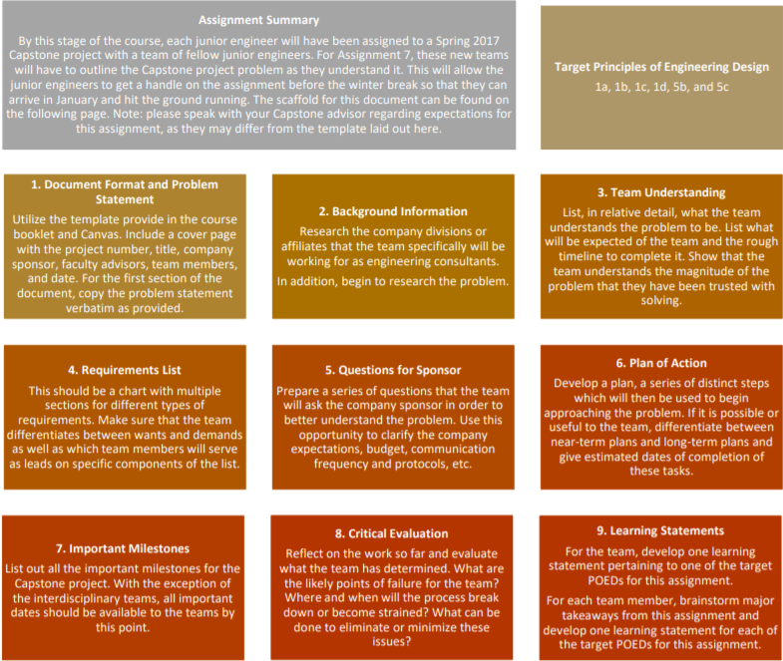

Note: PLEASE USE THE PROVIDED ASSIGNMENT TEMPLATE, AVAILABLE ON CANVAS

ASSIGNMENT STEP CHECKLIST
Suggested Assignment Length: 15 Slides/Pages (ask for clarification from faculty mentor). Grading rubrics are included in the assignment templates.

Use the template provided (available on Canvas) to complete the steps of the assignment.
- Document Format and Problem Statement
- Include a cover page with project number, project name, company sponsor, company advisors, faculty advisors, team member names, and the date
- Reproduce, verbatim, the problem statement as provided in AME4163.
Problem Statement:

- Background Information
  - Do some research into the company, including who they are, where they’re located, what size of business they are, who they market to, etc.
  - Research the problem. Is it a costly problem for the company? What are the safety and/or ethical concerns associated with the problem and/or its possible solution? What prior work has already been done?
  - Use this as an opportunity to learn as much as possible about the company before meeting them in person.
Company Research:

Problem Research:

- Team Understanding
- Based on the team understanding of the problem statement as provided and the background information so far explored, explain what the team understands the problem for the company to be.
- More specifically, think in terms of what value the team can provide the company. Think about whether or not they would benefit from a prototype or more involved analysis, for example.
Team Understanding of Problem:

Value Opportunity:

- Requirements List
- Leverage the team understanding of the problem as well as the background research performed to establish a Requirements List. This list should be as comprehensive as possible.
- Use the Demands/Wants distinction used in the AME4163 project. Further, categorize requirements in useful ways.
- Establish target objectives for the achievement of the requirements present on the list.
Member A  Member B  Member C |  | Requirements List  Capstone Project Name | Date
Revisions | W/D | Requirements | Lead Team Member
Category (Example: Planning Requirements)
12/3/16 | W | Requirement Description – Target | Member A
12/3/16 | D | Requirement Description – Target | Member B
… | … | … | …
Category (Example: Technical Requirements)
12/3/16 | D | Requirement Description – Target | Member C
12/3/16 | D | Requirement Description – Target | Member D
… | … | … | …

- Questions for Sponsor
  - Use this opportunity to establish an early relationship with the company sponsors; these are professionals using their time and experience to assist students in becoming junior engineers.
  - Questions for the sponsor should be as specific as is feasible while focusing on issues not easily researched or answerable through analysis. In other words, ask only questions that the sponsor can provide answers for.
  - Do not make the list for this assignment too exhaustive, focus on the important questions needed to start making progress as quickly as possible.
Questions:
- Category 1
  - Question 1A
  - Question 1B
- Category 2
  - Question 2A
  - Question 2b

- Plan of Action
  - Consider the remaining Fall 2015 schedule as well as the Spring 2016 schedule.
  - Discuss here the elements of the team contract and how they will be implemented.
  - Develop a Gantt chart and an expected hours breakdown for the project. This will change as you go along, but start it here.
Project Gantt Chart:

- Important Milestones
  - You can find the majority of these dates in the Capstone Handbook, which will be available on Canvas.
  - Highlight dates of project deliverables.
Project Milestones:
- Academic Calendar Events (Semester start/end dates, etc.)
- Deliverable Deadlines (AME4553/Company Deliverables)
- Critical Evaluation
  - Recall the various reality checks performed during the design of the AME4163 project device. Think about how the team considered ways the device could fail long before it was built.
  - Categorize the different ways the project could fail. Some examples include planning issues, scope creep, and poor communication. Think through the various possibilities and anticipate them.
Critical Evaluation of Plan of Action:

Probable Failure Modes:

- Learning Statements
  - Team: Prepare a single team LS based on one of the target POED for the assignment
  - Individual: each team member should brainstorm their chief takeaways for the assignment and then write a LS rooted in those takeaways for each target POED (five for each individual).
Team Learning Statement:

Individual Learning Statement
- Professionalism
  - Team name, names of members, page number
  - Question written out then answered
  - Reality checks
  - Clarity, Connectivity, Utility
  - Spark, Insight, Extra Effort

ASSIGNMENT 7 TIPS
- Begin approaching the Capstone problem using the tools acquired in AME4163.
- Consider the customer requirements and your own requirements as junior engineers.
- Reflect on the problem statement as delivered and develop a full understanding of the problem.
- Work with your teammates to develop an understanding of the problem.
- Plan the next stages for your team in terms of both the time you will have to devote to the project as well as your current understanding.
ASSIGNMENT 7 PAGE BREAKDOWN
The page breakdown for this assignment will be left to the best judgement and discretion of the team’s capstone faculty mentor. Please inquire with him or her for further details.

V. ADDITIONAL INFORMATION
CAD/FEA CFD RESOURCES AND MATERIALS
Owing to the fact that portions of the AME4163 and AME4553 courses are likely to involve computer-aided design (CAD) modeling, finite element analysis (FEA), and, potentially, computational fluid dynamics (CFD), it has been determined supplemental materials for this course should be provided which will assist the students in completion of their CAD, FEA, and CFD related tasks. In addition to the lecture slides (available on Canvas) on CAD, FEA, and CFD, several in-class examples and tutorials will be utilized this semester which will refresh student memory into the programs available on the OU College of Engineering computers. Further, the following links should provide students with further resources to explore these domains.
COMPUTER-AIDED DESIGN
- SolidWorks
  - Text: http://www.solidworkstutorials.com/solidworks-user-interface/
  - Videos: http://www.solidworks.com/sw/resources/solidworks-tutorials.htm
FINITE ELEMENT ANALYSIS
- ANSYS
  - Videos and Text: http://www.ansys.com/Industries/Academic/Tools/Curriculum+Resources/Tutorials,+Examples+&+Curriculum
- SolidWorks Simulation
  - Videos and Text: http://www.solidworks.com/sw/resources/getting-started-simulation-and-analysis-tools.htm
COMPUTATIONAL FLUID DYNAMICS
- ANSYS CFX
  - http://www.ansys.com
- FLUENT
  - (GAMBIT by Fluent Inc. is used for meshing): http://www.fluent.com

FRANKENSTEIN PROTOTYPE
During the planned prototype update in late October, teams will be expected to demonstrate their progress in the construction of their prototype. Teams who have few or no components for their actual device will be expected to provide a ‘Frankenstein’ prototype. A Frankenstein prototype is simply a cheap and simple physical model of your selected concept. It should not take more than an hour or two to complete and may be constructed from cheap and/or disposable materials (paper, cardboard, string, etc.). The purpose of this prototype is both to help you outline your proposed design to the instructor and give your team the chance to explore the physical geometry of your system and its constituent components. Use this as an opportunity to flesh out your selected concept. Note: a Frankenstein Prototype need not be fully functional but attempting to do so can be helpful in exploring component feasibility. For more information on Frankenstein Prototypes, see: http://blog.inventhelp.com/prototypes/ and http://www.precisiontype.com/producing-a-prototype-for-your-invention/

Completed Frankenstein Prototypes will resemble something like these:
Frankenstein Prototype for a portable windmill for power generation | Frankenstein Prototype for a stackable washer-dryer
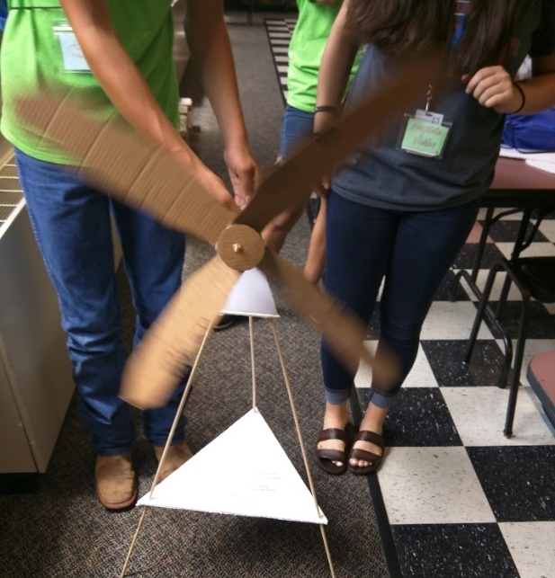 | 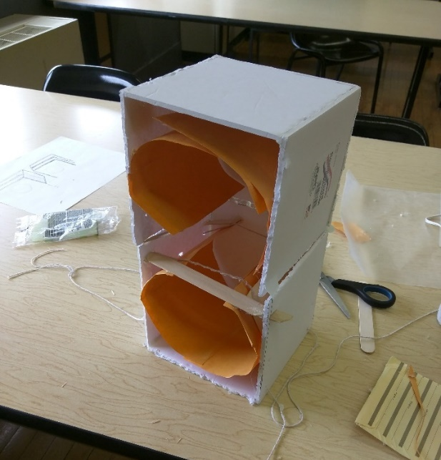

DOCUMENT TEMPLATLES
In this section, we have included suggested templates for various organizational purposes. Teams are encouraged to familiarize themselves with the project progress report and meeting notes memo documents in particular, as they may come in handy in AME4553 when briefing Capstone project sponsors.
PROJECT PROGRESS REPORT FORMAT
The formatted document contained on the following page may be used by teams to keep mentors and advisors abreast of team progress and activities. Like the meeting notes template (contained in the following section), the project progress report can be used by the team to track their own progress through the semester. While not required in AME4163, they will be required in the AME4553: Design Practicum the following semester, so it is suggested that teams familiarize themselves with the document and get into the habit of preparing them.
This document can be found on Canvas under the name: AME4163_ProjectProgressReportFormat_082316.
To: Recipients
CC: Relevant mentors (Professors, TA, etc.)
From: List senders
Subject: Meaningful yet short summary of subject with date included
Planned activities for current week (from previous report and Gantt chart):
- List planned activities listed for the current week,
  - With sub-bullets used to elaborate on project tasks
- Make sure the list is readable
- Make sure the numbers meaningfully reflect either the intended chronological order of completion of the tasks or their relative importance.
Activities completed in the past week
- Make sure to list only those activities that have been completed since the last progress report.
  - Again, elaborate with sub-bullets
Activities not completed and actions taken to rectify
- List what your team was not able to accomplish that it had originally intended to. Explain why if possible and the actions taken to complete the action in a timely fashion, if necessary.
Planned activities for the next week
- In this section, develop a way to stay ahead and/or on top of current activities by thinking about the next stages.
Problems/assistance needed from mentors
- List questions, concerns, requests for advice, etc. for your mentors in this section. This will facilitate their advice in a more immediate fashion.
Major Milestones to work towards
- If there are any relevant major events/assignments/reports/presentations/etc. coming up, then list them here.
Appendix
In this section, be sure to include an updated Gantt chart of team activities as well as any additional material too large or not suitable for the main body of the progress report.

MEETING NOTES MEMO FORMAT
The formatted document contained here may be used by teams to document the events of weekly, bi-weekly, or randomly scheduled meetings. It encourages team organization and can be used to track team progress throughout the design process. In addition, the use of some sort of meeting record can simplify the process of completing assignments by creating a record of all events and work completed in an organized and chronological fashion. It should be noted that, unlike the project progress report document, the meeting notes memo is for internal team use only and should not usually be submitted to mentors or advisors.
This document can be found on Canvas under the name: AME4163_MeetingNotesMemoFormat_082316.
The University of Oklahoma
The School of Aerospace and Mechanical Engineering
AME 4163: Principles of Engineering Design
Form: MEETING RECORD
Group Number: Meeting Number: Date: Location:
Members Present: 1. 2. 3.
4. 5.
Time Start_________________________Time End____________________________________________
Project Name:
Project Brief:

_____________________________________________________________________________________
Agenda
Key Words:
Check off completed Items:
( ) 1. Warmup
( ) 2. Review Agenda
( ) 3. Record of Previous Meeting
( ) 4. Action item reports
( ) –
( ) –
( ) –
( ) –
( ) –
( ) –
( ) 5.
( ) 6.
( ) 7.
( ) 8.
( ) 9. Action items
( ) 10. Next meeting date, etc.
( ) 11. Meeting Summary
_______________________________________
NOTES
Decision Roster (See next page)

Items to be considered in the future (not next meeting)

Meeting Review
+ -

Next meeting
Date Time Location
Scribe
Signature _______________________________________

Topic 5 (Brief Discussion) Main Points

Decisions / Conclusions

Action Items

Topic 5 (Brief Discussion) Main Points

Decisions / Conclusions

Action Items

Topic 5 (Brief Discussion) Main Points

Decisions / Conclusions

Action Items

Topic 5 (Brief Discussion) Main Points

Decisions / Conclusions

Action Items

MID-SEMESTER DESIGN REVIEW FORMAT
As can be seen in the schedule, in early October teams will have to present the design of their device for the project at that stage to both instructors and the TA. The students will present their selected concept and the steps they have taken to realize that concept. There will then be an opportunity for the instructors and TA to ask questions and provide advice to the student groups. In addition, each team will submit a document outlining several important components of their design. These components are outlined in the following document
This document can be found on Canvas under the name: AME4163_MidSemesterDesignReviewFormat_082316.

AME4163: Principles of Design
Mid-Semester Design Review
Project Update
[Date of presentation]
[Group number and/or nickname]
[Names of group members]

Section A: Current Pictures/Models of the Project
- CAD Models
- Be sure to label all components of the device in the CAD model in accordance with their function and/or importance to the overall design.
- Bill of Materials
- Students should provide a list of materials that they have bought or are preparing to purchase. This list should be specific. I.e. do not say “1 motor,” say “1 Leeson Motors 24 V, 1 HP DC motor.” It should also include cost, quantity, and a total cost estimate for the entire list.
- Photographs of the device
- It is fine if at this stage all your team has are assembled materials; in such cases, photograph the materials and label the photos. If construction/assembly has begun, all the better.
Section B: What has been completed so far?
In this section, explain what has been done to realize the design. Explore how the synthesized design has come from applying the previous work done in class to this point. Explain why decisions have been made to alter or change aspects of the design and why they came about (results of testing, circumstances, cost, feasibility, etc.).
Section C: What remains to be completed?
In this section, explain to the instructors what remains to be done. This can include assembling the device, fabricating or purchasing parts, testing said device in both controlled and “field” conditions, programming (if necessary), and anything else that may be needed to complete the design. Briefly outline a schedule for the remaining activities.
Notes:
[Leave this section blank. Give room for the instructors to leave their feedback and make sure several copies of this document are printed out for both the instructors and the TA]
PROTOTYPE REVIEW FORMAT
The purpose of the prototype review, which will take place in late October, is to give the instructors a chance to provide advice regarding the prototyping and construction phase of the project. You may note that there is no assignment which specifically address the physical prototyping process. In Assignment 4, your team generates CAD models and addresses planned component selections. Following that assignment, the team then demonstrates the constructed device in front of their peers and instructors. Given this gap, we provide you this opportunity to get feedback regarding your prototyping and testing phase. At this review, we will expect to see the following:
  - Some or all components of the planned system
    - Teams should bring any components which have been purchased and be prepared to address components which have not yet been obtained
    - Discuss which components remain to be purchased or acquired
  - A plan for device construction and testing
    - Be prepared to discuss how components will be utilized in the system, assembled into the finished design, and how they meet some requirement or provide some functionality to the overall system
    - Be able to discuss a schedule for finalizing (or beginning) construction of the prototype as well as how the components will be tested
          - Think about how components will be tested individually, as part of sub-assemblies, and as a part of the entire system
          - Discuss how team will account for uncertainty in the testing process (component failures, poor performance, etc.). We expect to see each team develop contingencies for likely scenarios faced.
  - Discuss a plan for performance of the system on the day of performance
    - What components, spare parts, and/or tools does the team plan to have on hand?
    - How is the team planning to handle problems…
          - …On the eve of the competition?
          - …On the day of the competition?
          - …Between trials?
  - Address the roles and responsibilities of each team member as they pertain to the aforementioned items

Though no written documentation is required for this update, we encourage you to prepare some documentation of the above items both to keep your team on track and also as a reference for Assignment 5: Post-Mortem Report. In Assignment 5, we ask you to look back, after the device demonstration, to address your successes and failures and diagnose the source of both. Preparing some documentation for this review will help to plan your prototype construction and testing phase while serving as a useful source of insight in Assignment 5. Note that many of the critical points of failure for teams in previous years arose during this phase of the project; prepare accordingly.
VI. READINGS
In order to assist in your learning, we also include in this booklet supplemental reading. Assigned readings for particular lectures can be found in the class schedule on Page 8. Supplemental reading is provided in order to provide additional context regarding the theoretical basis on which much of the course material is founded. Several of the following readings also provide links to additional material which may assist you in the completion of the learning exercises required in this course. Additional readings can be found on the course Canvas page in the section entitled ‘Additional Readings.’
DAVID KOLB AND EXPERIENTIAL LEARNING
Source: http://cei.ust.hk/files/public/simplypsychology_kolb_learning_styles.pdf
In this course, we strive to enable junior engineers to internalize the Principles of Engineering Design by learning through reflection on doing in the context of an authentic, immersive engineering design, build, and test experience. The pedagogical basis for this approach is largely grounded in the work of an educational theorist and social psychologist named David Kolb. In 1984, he published a book on his theory of learning styles in which he detailed a model for learning in which a person learns by reflecting on experience, in contrast to other learning models such as didactic learning or rote memorization. Kolb posits that novel experiences prompt people in such a way as to challenge their preexisting knowledge. It then follows that resolution of that challenge (through reflection) results in a new model for dealing with related experiences. Kolb further asserts that the benefit of learning in this manner is that the learner is empowered to utilize the knowledge they have obtained in a wider variety of circumstances than if they had learned the same information through alternative circumstances. He called the process by which experience is transformed into learning the ‘Experiential Learning Cycle,’ a process which takes place in four steps. In the figure below, we demonstrate how we have modeled AME4163 on this cycle to encourage junior engineers to be cognizant and reflective participants in their own learning.
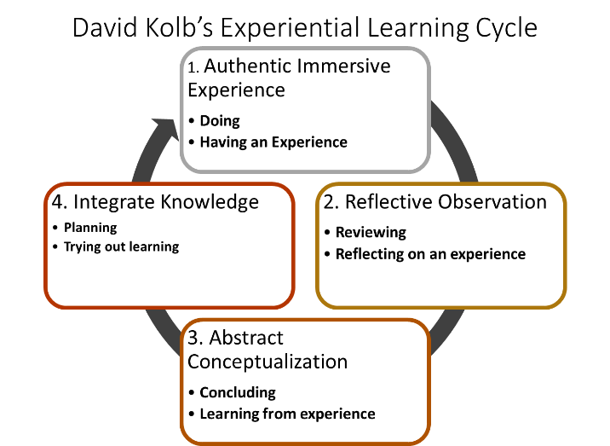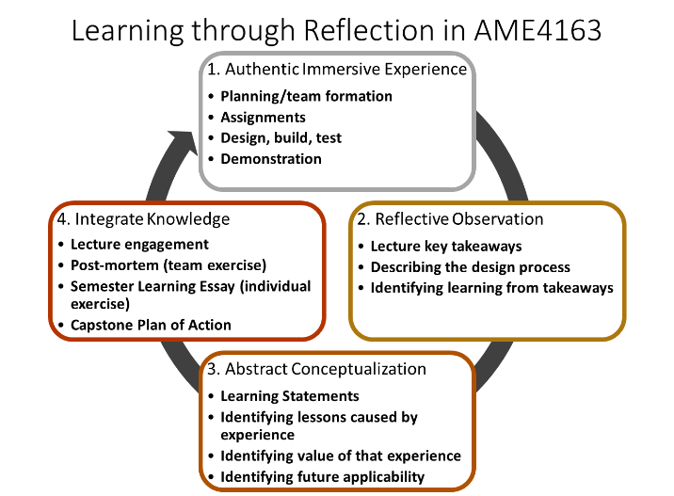
For additional context please see our papers published in the proceedings of the 2017 American Society of Engineering Education Annual Conference and Exposition.

COMMUNICATION STYLES
Source: https://www.opm.gov/policy-data-oversight/performance-management/performance-management-cycle/monitoring/communicate/

One thing we stress in AME4163 is the importance of communication in engineering design practice. Communication, in this instance, covers a wide spectrum of activities ranging from the professional presentation of work (as may be found in the assignment submissions) to the everyday discussions taking place between team members. Clear and respectful communication is essential to engineering practice and is thus another important competency we expect you to develop in this course. Given this fact, we urge you to consider reading and reflecting on the following model for communication. In particular, this model may be of use to teams consisting of members with differing communication styles, especially where those differences seem to be a source of conflict.
One nonintuitive method by which we can improve communication with others is by being an “active listener.” Active listening refers to a set of practices by which a person makes an active effort to engage with material being presented to them. In a lecture context, taking notes is a form of active listening. In conversation with a team member, making a deliberate effort to think about material as it is presented to you is a form of active listening. When we communicate with others, particularly team members, it is vital that we recognize the importance of being active listeners. Communication, in a team context, necessarily exists as a back-and-forth between multiple people. This requires that we each be able to not just hear others, but to do so in such a way that we give them the space to express themselves fully while also thinking consciously about how we might respond. The United States office of Personnel Management (OPM) recommends striving to meet the following criteria to practice effective active listening:
- Take notes and plan to report on those notes.
- Concentrate on content rather than the speaker's delivery style.
- Never be afraid of silence; give speakers time to think.
- Be adept at asking encouraging questions in a positive tone.
- Summarize what the speaker has told you.

Framed this way, we consider effective communication to be the efficient transfer of information between two or more individuals. Consequently, it is not simply enough to be able to express ourselves clearly; we must do so in such a way that considers the needs of our intended recipients. To that end, the OPM also recommends thinking about the preferred communication style or styles of ourselves and others. They identify four such styles and their associated qualities thusly:
Style | Content (They talk about: . . . ) | Process (They are: . . . )
Action | results, objectives, performance | down to earth, direct, impatient
Process | facts, procedures, planning | factual, systemic, logical
People | people, communication, feeling | spontaneous, warm, empathetic
Idea | concepts, possibilities, issues | imaginative, unrealistic, full of ideas
When attempting to communicate with your team members, particularly during occasions where conflict appears to be present, consider their preferred communication style as well as your own. Where are they likely to conflict? How can that conflict be bridged by modifying your own approach? Thinking about these things more consciously may provide an effective means for establishing solid communication even in the midst of difficult circumstances. In addition, consider addressing this at an early phase of the team formation process, when effective communication may be in the process of being established. In fact, consider, as an exercise, identifying each team members’ preferred communication style using a quick online quiz such as this: http://www.mit.edu/~mbarker/pmi96/commp796.txt
BLOOM’S TAXONOMY OF LEARNING DOMAINS
Source: https://cft.vanderbilt.edu/guides-sub-pages/blooms-taxonomy/
Bloom’s Taxonomy of Learning Domains is the name given for a construct developed by education psychologist Dr. Benjamin Bloom which outlines the steps that need to occur in order for learning beyond “rote memorization” to take place. These domains have been expanded on since the original work in the 1950’s and the nomenclature contained therein serve partly as the basis for the learning statements used frequently throughout the semester. While the implications of this construct on educational science have been far-reaching and may be of interest to some students, for the purposes of the reflective exercises utilized in this course, students interested in becoming more cognizant of their learning should consider the construct on Page 60, reproduced from Vanderbilt’s Center for Teaching.
Note that each domain of learning in Bloom’s Taxonomy is associated with words which help to define it in greater detail. Further, in his 1956 work, Bloom identified each stage of the pyramid as being in ascending order of cognitive difficulty. Knowledge, located at the bottom of the figure, is considered the starting point for more complex cognitive activities. Essentially, we start with some basic amount of knowledge known simply to us as a set of facts or observations. Moving up the pyramid, we move into comprehension by understanding the knowledge well enough to communicate it to others. Following that, we then begin to identify how that knowledge can be used to address some issue. In the Analysis domain, we expand on the Application domain by generating new information. Stepping into the Evaluation domain, we then begin to evaluate the knowledge that we have generated. Finally, in the Synthesis domain, we can use our conclusions to take actionable steps to put our newfound conclusions into practice. Each stage of Bloom’s Taxonomy corresponds to some level of evolution in how we grow in our learning. We can see that this model can be used to interpret our learning both in the short-term (our learning in a particular course) as well as the long-term, such as how you are expected to grow as an engineer from a freshman studying simple physics and calculus to a senior solving open-ended, contextual design, build, and test problems.

Bloom’s Taxonomy
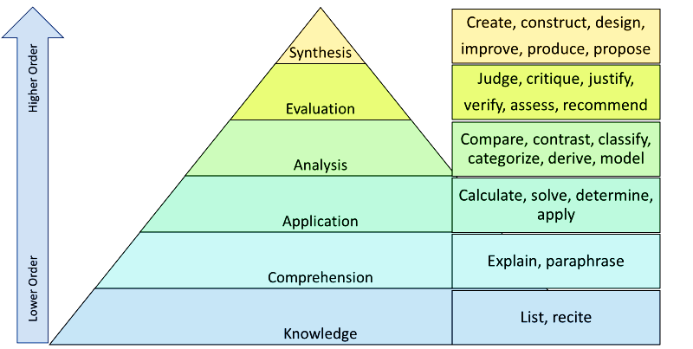
LEARNING STATEMENTS
In each assignment and at the conclusion of all course lectures, each junior engineer is tasked with writing learning statements. Learning statements are a way for you to reflect on your experiences and identify key lessons learned. In particular, we are asking you to demonstrate that you are both internalizing the target POED and formulating an understanding of how you can apply this knowledge moving forward (both in your education and your later careers). We insist on the following format for learning statements: 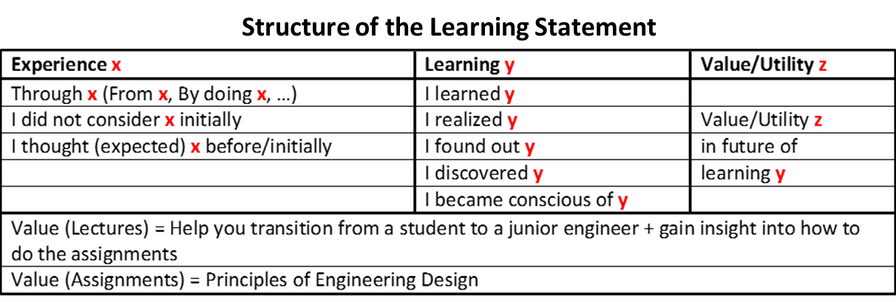
Learning statements take the form of statements which begin with a clause describing the event or activity in which learning took place and end with a description of the learning using action words taken from Bloom’s taxonomy (see the Bloom’s Taxonomy figure). These action words help to assist you in being deliberate in your analysis of your learning. When constructing learning statements, endeavor to demonstrate learning of more than mere technical skills. So-called “low-hanging fruit” is NOT of interest to the instructors and will be graded more harshly. Instead, try to analyze your learning in more abstract or complex domains. Consider the following example learning statement, in which a student from Fall 2016 describes a student’s experience with team formation.
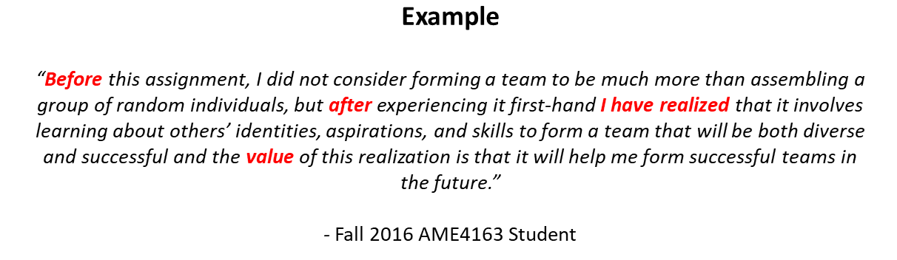
The format is strong and the insight is decent but the ‘value’ portion of the statement is lacking in specificity. Do not simply say that a particular lesson will be valuable in the future, describe in what way it will be valuable in the future. Throughout the course, we will generally evaluate learning statements on a scale from zero to three points. Zero points will be given to statements in which the format is not correct. One point will be given to statements in which the learning described is trivial (low-hanging fruit) or obvious to the experience (see relevant lectures for examples). Two points will be awarded to statements which demonstrate some connection to POEDs or future practice but where that connection is tenuous or vague. Three points will be given to statements in which the junior engineer has developed insight (demonstrate internalization of POEDs or wider application of learning to future endeavors).

If you are interested in a more thorough exploration of the role of learning statements as an educational and research tool, the instructors of AME4163 have produced some papers which can be found in the proceedings of both the 2016 and 2017 American Society of Engineering Education Annual Conference and Exposition (See the citations in the readings section on David Kolb on Page 57).
COMPETENCIES
Competencies are defined as the skills or critical attributes required to be successful in a given field or subject. Competencies can be technical skills or more ‘meta’ skills (such as the ability to manage new information) which together are important for engineering development. The targeted competencies for this course are based in large part on those recommended by Lucas Balmer in his 2015 Master’s Thesis. In turn, the competencies outlined in his work are in large part based on the recommendations of the ABET accreditation board as well as those competencies which surveys of industries have revealed are the competencies that companies most desire in their straight-out-of-school engineering hires. Recall from Page 1 of the course booklet that the target competencies for AME4163 are as follows:
- The ability to learn by reflecting on doing
- The ability to speculate on future trends and pose useful questions for future investigation
- The ability to make engineering design decisions in the face of limited information
- The ability to adapt to new circumstances such as a new design team or problem
- The ability to introspectively self-assess to improve as a designer
Acquisition of these target competencies will enable you to transition into and succeed in your Capstone projects (AME4553) and later into your first engineering positions. They will become extremely relevant as you begin work on Assignment 8, your Capstone plan of action.
VII. DIVERSITY AND INCLUSION WORKSHOP

Mechanical Engineering Diversity and Inclusion Training

DEVELOPED AND HOSTED BY LAVONYA BENNETT
SEPTEMBER 4 AND 6 OF 2018

Brief References
- Steele, C. M. (1997). A threat in the air: How stereotypes shape intellectual identity and performance. American Psychologist, 52(6), 613-629. doi:10.1037/0003-066x.52.6.613
- Gaertner, S. L., & Dovidio, J. F. (1986). The aversive form of racism. Academic Press.
- Roberson, Q. M. (2006). Disentangling the meanings of diversity and inclusion in organizations. Group & Organization Management, 31(2), 212-236.

Contact LaVonya Bennett
I would love to partner with you or your organization to facilitate, develop, or host a diversity and inclusion training, seminar, conference, or webinar. For further details on availability and pricing please contact me directly via phone or email.

Email: lavonyabennett@ou.edu or lavonyabennett@gmail.com

Table of Contents

Overview of Training 219
Need for Diversity and Inclusion 220
Understanding Terms 220
Benefits in Practice 220
Theory to Practice 221
Terms of Conflict 222
Stereotype Threat 222
Aversive Racism 222
Notes Page 223

Overview of Training

Day 1
- Opening
- Workforce Dialogue
- Engaging Behaviors
- Stereotype Threat
- Aversive Racism
- Terms of Conflict

Day 2
- Recap
- Managing Conflict
- Social Identity
- Case Studies
- Closing

Need for Diversity and Inclusion in ME

Understanding Terms
Diversity can be conceptualized as a numerical trait. Inclusion can be conceptualized as an action of appreciation, learning, and welcoming environments for diversity.
__________________________________________________________________________________
“Diversity is having a seat at the executive table. Inclusion is having the opportunity to be an equitable, contributing, and appreciated member while at the table” _______________________________________________________________________________________________________

Results of Diverse in Inclusive Practices:
Diversity/Cultural Competency are one factor for obtaining and maintaining accreditation in Mechanical Engineering programs.
Increased innovation
Quality customer service
Cohesive collaboration

Theory to Practice

Engaging Behaviors
 | When we meet or work with another person, we get a small glimpse of their beliefs, values, attitudes, experiences, and social identities. People are similar to icebergs, there are much more complex attributes beyond the surface. Some people are comfortable sharing openly and some people are reserved. Some people may vary depending on the environment they are in.  Appropriate verbal and not verbal behaviors vary across culture. Below you can outline appropriate verbal and non-verbal ways to engage with others. Remember, your engagement style should be fluid and malleable to your audience.
  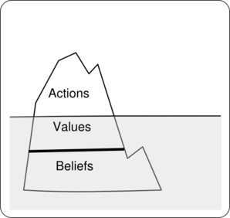
  

Terms of Conflict

Several factors, including lack of cultural awareness and empathy, stereotype threat, and aversive racism can inflate the likelihood of experiencing conflict when working with others.
You should always make it a priority to become culturally competent. Not only with this aid in the reduction conflict, but it will increase productivity and innovation.
Stereotype Threat
Stereotype threat is the phenomenon in which a person believes they may be at risk of conforming to a stereotype about their social group.
Stereotype threat can negatively impact the cognitions of an individual and have profound effects on their behavior.
Aversive Racism
Aversive racism is when people regard themselves as non- prejudice and often have consuming thoughts about being labeled as racist.
Aversive racism can negatively impact positive interactions, self-reflection, and celebration of differences.

NOTES PAGE
____________________________________________________________________________________________________________________________________________________________________________________________________________________________________________________________________________________________________________________________________________________________________________________________________________________________________

ATTENDANCE AND LEARNING STATEMENT SHEET
The form on the following page is the attendance and learning statement sheet which will be handed out after each lecture. The instructors will use this sheet to collect attendance and provide feedback to you regarding your learning statements. Please familiarize yourself with the elements of the sheet.

First name LAST NAME CAPS Date
ID number Section
Lecture Number and Title
Circle if you do NOT wish your submission to be considered for inclusion in Best Practice feedback.
A Learning Statement must be structured as a triple Experience followed by Learning followed by Utility in ONE SENTENCE. Key words MUST be underlined.

Relate Value / Utility of LS anchored in Lectures to your doing the assignments. Relate Value / Utility of LS anchored in reflecting on doing in assignments to hitting the road running as a Junior Engineer. Examples of Learning Statements

Through X I learned Y which will help me do xx in Assignment yy.
From Lecture N, I found out Y which is valuable because ????

Take Away 1:

Learning Statement 1

Take Away 2:

Learning Statement 2

At present, I will prepare a more detailed research plan and propose a timeline for implementation of this plan to be presented to my doctoral committee. Furthermore, this plan will form the basis for a National Science Foundation grant proposal.
Quotation found at the following URL: http://www.ou.edu/content/coe/academics/graduate/academics/Engineering.html

