UNIVERSITY OF OKLAHOMA
GRADUATE COLLEGE

PER ASPERA AD ASTRA:
LATVIAN NATIONAL IDENTITY REFLECTED IN
SELECTED ORGAN WORKS BY AIVARS KALĒJS

A DOCUMENT
SUBMITTED TO THE GRADUATE FACULTY
in partial fulfillment of the requirements for the
Degree of
DOCTOR OF MUSICAL ARTS

By
CRISTIANO RIZZOTTO
Norman, Oklahoma
2019

PER ASPERA AD ASTRA:
LATVIAN NATIONAL IDENTITY REFLECTED IN
SELECTED ORGAN WORKS BY AIVARS KALĒJS

A DOCUMENT APPROVED FOR THE
SCHOOL OF MUSIC

BY

Dr. John Schwandt, Chair
Dr. Damin Spritzer
Dr. Frank Riddick
Dr. Eugene Enrico
Dr. Janet Ward

© Copyright by CRISTIANO RIZZOTTO, 2019
All Rights Reserved
This dissertation is dedicated to my dear wife Clara and to our beloved son Kristian Walter, who has been with us since I started writing it.

Acknowledgements
I wish to express my most sincere thanks to the following people:
My grandmother, Mrs. Antinea Doloresa Cukurs Rizzotto, the person who first instigated in my heart the love for music, for her homeland, and for the Latvian language; my first piano teacher, whose knowledge, advice, and help have been priceless for me throughout my entire life. Most especially during the process of writing this dissertation, thank you for hosting me on multiple research visits to Rīga, for being present in all my concerts in Latvia, and for being with me during the many hours spent at the National Library of Latvia and the library at the Jāzeps Vītols Latvian Academy of Music.
Dr. John Schwandt, for guiding, advising, and inspiring me to strive ever higher during the work on this project and throughout my years at the American Organ Institute. I shall remember your lessons for life.
My committee members, whose feedback and suggestions greatly enhanced the quality of this work.
Mr. Aivars Kalējs, for granting me access to the manuscripts and published scores of all his organ compositions, for the time conceded, and for reviewing the historical portion of this document.
The librarians at the National Library of Latvia and the Jāzeps Vītols Latvian Academy of Music, who patiently helped me navigate their vast collection and who even gifted me with a copy of Grauzdiņa’s book of organ history in Latvia, the most important source on the subject and which has been out of print for decades.
My parents, Mr. and Mrs. André Vidal Pessôa and Desirée Doraine Rizzotto Vidal Pessôa, for the constant encouragement, support, and advice throughout the years.
My dear wife, Dr. Clara Miranda Rizzotto, for being the strongest force encouraging me to pursue a doctoral degree in the first place, and for all the assistance, support, and love on every step of the way. None of this would have been possible without you.
Table of contents
Acknowledgements iv
List of Tables ix
List of Figures x
List of Examples xi
Abstract xiii
Chapter 1: Introduction 1
Study purpose 1
Music and national identity in Latvia 2
Chapter 2: History of the pipe organ in Latvia 27
Chapter 3: Aivars Kalējs: Biography 44
Chapter 4: Meaning in music 55
Chapter 5: Analysis of selected pieces by Aivars Kalējs 60
Per aspera ad astra 63
Via dolorosa 92
Solitudinem faciunt 101
Chapter 6: Conclusion 128
Bibliography 131
Appendix A: Organ works by Aivars Kalējs 141
Appendix B: Review of Latvian organ literature 144
Appendix C: Organ specifications 148
Appendix D: Interview with Aivars Kalējs: Transcript 151

List of Tables

Table 1. Per aspera ad astra: section outline 65
Table 2. Solitudinem faciunt: section outline 104
Table 3. Ugāle organ specifications. Cornelius Rhaneus, 1701 (28/II/P). 148
Table 4. Rīga Dom organ specifications. Walcker & Co., 1882-1883 (IV/P/124) 148

List of Figures
Figure 1. Per aspera ad astra: dynamic outline 66
Figure 2. Solitudinem faciunt: dynamic outline 105

List of Examples

Example 1. Per aspera ad astra, mm. 1-6 68
Example 2. Per aspera ad astra, mm. 12-17 69
Example 3. Per aspera ad astra, mm. 9-11 70
Example 4. Per aspera ad astra, mm. 27-30 71
Example 5. Čakona, mm. 64-66 72
Example 6. Tokāta par Mediņa koraļdziesmu Tev mūžam dzīvot, Latvija! mm. 48-50 72
Example 7. Per aspera ad astra, mm. 40-46 73
Example 8. Per aspera ad astra, mm. 53-54 74
Example 9. Per aspera ad astra, mm. 58-61 75
Example 10. Per aspera ad astra, mm. 64-68 75
Example 11. Per aspera ad astra, mm. 80-83 77
Example 12. Per aspera ad astra, mm. 101-106 80
Example 13. Per aspera ad astra, mm. 122-131 82
Example 14. Per aspera ad astra, mm. 149-151 84
Example 15. Per aspera ad astra, mm. 169-171 85
Example 16. Per aspera ad astra, mm. 185-187 86
Example 17. Per aspera ad astra, mm. 199-200 87
Example 18. Per aspera ad astra, mm. 227-229 88
Example 19. Via dolorosa, mm. 1-4 93
Example 20. In Paradisum, mm. 6-10 94
Example 21. Via dolorosa, mm. 45-48 94
Example 22. Via dolorosa, mm. 61-68 95
Example 23. Via dolorosa, mm. 109-112 96
Example 24. Via dolorosa, mm. 125-128 97
Example 25. Solitudinem faciunt, mm. 1-4 106
Example 26. Solitudinem faciunt, mm. 13-21 107
Example 27. Solitudinem faciunt, mm. 31-37 109
Example 28. Solitudinem faciunt, mm. 45-48 110
Example 29. Solitudinem faciunt, mm. 57-61 111
Example 30. Doriskās variācijas, mm. 359-367 114
Example 31. Solitudinem faciunt, mm. 74-81 115
Example 32. Solitudinem faciunt, mm. 127-130 116
Example 33. Solitudinem faciunt, mm. 140-143 117
Example 34. Solitudinem faciunt, mm. 186-192 120
Example 35. Solitudinem faciunt, mm. 227-234 122
Example 36. Solitudinem faciunt, mm. 244-252 123
Example 37. Solitudinem faciunt, mm. 269-273 124

Abstract
The scope of this dissertation is to provide an overview of the fundamental importance of music in the formation of the national identity of the Latvian people and how music has helped them remain and overcome extreme adversities as a nonviolent gentle nation in the Herderian sense, and how the peaceful and resilient spirit it helped create was fundamental to the restoration of independence after decades of Soviet occupation; to provide a summary of the history and literature of the pipe organ in Latvia within the wider cultural and historical context of that country; and to present the organist and composer Aivars Kalējs as a worthy representative of the values and spirit of the Latvian heritage. The analysis of three of his most significant organ compositions demonstrates how the composer’s creative process relates back to the Latvian archetypal worldview and cultural heritage: Per aspera ad astra (1989), Via dolorosa (1992), and Solitudinem faciunt (2016).

Chapter 1: Introduction

Study purpose
Aivars Kalējs is a composer and performer of international recognition. He wrote over 100 opus numbers and the organ occupies a central place among his compositions. He has performed in almost all the countries of Europe, the United States, Canada, and Japan. For over forty years he has been a concert organist at the Rīga Dom Cathedral, the largest medieval cathedral in the Baltic countries and home of the famous 144-rank E. F. Walcker organ which once was the largest organ in the world. He has recorded extensively and written articles and entries about the history of Latvian organs in periodicals and lexicons. Between 1980 and 1985 he added 250 organs to the Latvian Ministry of Culture’s index of protected cultural monuments, out of an estimated three hundred currently existing instruments in the entire country.
No academic works have been written about Aivars Kalējs or his music to this date. The purposes of the present study are 1) to analyze some of the organ compositions by Aivars Kalējs, which reflect the characteristics of his cultural heritage; and 2) to introduce the power that music had to influence the history of Latvia and engrain its population with a nonviolent identity. Hopefully this examination will incentivize further research into the treasures of Latvian music. Kalējs is still actively composing, therefore is not the scope of this study to analyze his entire compositional output. Instead, this research will focus on three pieces that are significant representatives of Kalējs’ œuvre and that perhaps capture the national spirit of Latvia: Per aspera ad astra, Via dolorosa, and Solitudinem faciunt.

Music and national identity in Latvia
Latvia built its identity in close relation to music. The popular notion of cultural identity is so closely related to cultural heritage that many Latvians identify themselves as a dziedātājtauta (nation of singers).
The 1991 Baltica Folklore Festival identifies one important point in history that helped originate this correlation between music and national identity in Estonia, Latvia, and Lithuania. According to Dainis Stalts, who spoke on the opening ceremony on July 11, this was the publishing of two volumes of folk songs of different nations, epochs, and languages, Volkslieder, in 1778-79, by the German philosopher Johann Gottfried Herder (1744 – 1803).
Herder arrived in Rīga in November of 1764 and lived there for four and a half years. During that time, he taught at the Dom Cathedral’s school, worked as a city librarian, and was pastor at two Lutheran churches. According to Kurt Stavenhagen, this is when he became “Herderian” in his ideas: he became enthusiastic about living song traditions, seeing in them fundamental and universal expressions of human love and decided to compile and publish some of these songs (in Latvian, dainas). Herder would pursue this folk song project throughout his life. His philosophy of history saw humanity as a group of nations moving toward the fixed end of God’s plan.
In 1803, while he was working on a third volume, which was never finished, Herder described the goals of his project as to represent “a living voice of the nations and of humankind itself.” He quoted songs of the past to construct a future in which “humans would be friends of humans, and no nation on earth sharpens its sword anymore.”
The first volume of Volkslieder contained love songs, and the second, the opposite of love: songs about war. The poems presented by Herder identify an important and contrasting different nations’ “natural way of thinking.” As he himself wrote on an unpublished manuscript of 1774, “The warlike nation sings the feats of its ancestors, inciting itself to perform similar feats,” while “The gentle nation sings love songs full of nature and naïveté.” The Latvian and Lithuanian songs in Herder’s project were central examples of the gentle nations, as their songs about war talked not about conquests, heroism and bravery, but about the soldier’s and his family’s suffering, tragedy, death, life and love destroyed. The stories they told were about a maiden whose groom dies in combat, a soldier whose own family doesn’t recognize him after the war, a soldier who misses his beloved while he is away, etc. This attitude towards the fight against evil and how a person should proceed in the face of danger permeated the imagination of that people. The core of the national song repertoire is about peace and unity, avoiding martial themes. The Baltic fairytale heroes were not the strong conquerors, but the small, patient and noble-hearted characters that won their victory by acting wisely rather than violently, and at the right time, like in the stories of Sprīdītis or Maija and Paija.
In the years after the publication of Volkslieder, professors, literary critics, and translators such as August Schlegel would say that the fidelity of portraying this natural poetry in its own manner was unprecedented, and claimed that this work had a prominent place in German and European cultural history.
Herder is remembered to this day in the Baltic countries as one of their first true foreign friends at a time in which they were still submitted to serfdom. His work was a long-lasting stimulus to the waking up of self-awareness and consciousness of the Latvians as gentle people who expressed their identity and union through music, especially by singing together. For them the act of singing together would eventually become more important even than the words being sung. Volkslieder and his other essays shaped the work of the nation builders of the next generations.
Herder was a Lutheran pastor. According to Guntis Šmidchens, Professor of Baltic Studies at the University of Washington, the Protestant Reformation itself provided ideological foundations to establish a choir singer’s identity, enabling for all the singers an active participation in the liturgy. This was first done in German, then in Latvian. The printing of hymnals and Christian literature helped standardize the language across the dialects and regions. Hymn-singing, first Protestant and later Catholic as well, originated a new kind of public singing alongside the tradition of folk music that could be practiced by any group of people anywhere.
In the nineteenth century, Latvians could be described by what the historical sociologist Anthony Smith called an ethnie: “a named, self-defined human population with myths of culture origins, shared historical memories, elements of common culture, and a measure of ethnic solidarity.” National self-identification had gradually come into being since the time of Herder. It coincided with the awareness of a national choir culture, “of a song repertoire held in common with others who spoke, read, and sang the languages.”
According to Šmidchens, the composition of the national anthems of England and France, in 1745 and 1792, respectively, inspired a transnational movement throughout Europe. This movement would produce at least one national anthem for every nation in the world. England’s anthem, “God Save the King,” resulted from the tradition of Protestant chorales that united the people in prayer for the king, for God to defeat and scatter enemies. France’s “La Marseillese” calls to arms to defend the country from foreign invaders.
Throughout the eighteenth and into the nineteenth century, when other warlike nations faced danger by the enemies, their songs would contrast pride and shame, bravery and cowardice. They did so by calling men who avoided military service not masculine, summoning them to overcome their fear by destroying the enemy, and highlighting the honor brought by soldiers fallen in combat to their families and to themselves.
Latvia’s emancipation from serfdom happened in parts: first Lifland (southern Estonia and northern Latvia) and Kurland (western and southern Latvia), in 1816-1819, and eastern Latvia two generations later, in 1861. After this, its singing “ethnies” could finally transform themselves in one singing nation through the national song festivals, the first of which took place in 1873. Latvians would come from different parts of the country to sing together in these events organized by individual cultural leaders. Benedict Anderson called these festivals, which would build foundations of new literary and musical traditions, a “unisonance,” a “physical realization of the imagined community.”
The historic première of the song that would later become the national anthem, “God bless Latvia,” took place during this 1873 Latvian Singing Festival. Kārlis Baumanis wrote the music and the words:
God bless Latvia,
Our precious fatherland,
God bless Baltija,
Give it our blessing!

Where Latvian daughters bloom,
Where Latvian sons sing,
Let us rejoice in happiness,
In our Baltija!

This song gave a unified name to the territory in the southern half of the Baltic Provinces (“Baltija”), Kurland and Lifland, inhabited by the ethnic Latvians: Latvia. It made no claim to political independence because Baltija was then a province of the Russian Empire. This text is different from the other hymns of monarchies in the sense that it requested a prayer for the country, and not for a monarch. It also did not mention enemies. The national objective for which it prayed was the happiness of the land in which Latvians blossomed and sang. Moreover, it used the first-person plural instead of recognizing the individual, thus defining the nation and its egalitarian nature.
In the struggle against cultural Russification, Latvians realized that they could use music as a nonviolent way to express resistance. One example of this happened at the song festival of 1895. The anthem of Imperial Russia was to be sung at the opening concert before the speech of the metropolitan of the Russian Orthodox Church in Rīga, a firm supporter of the cultural Russification. As was the official custom, the dignitaries and the audience applauded the anthem to request an encore. After the second rendition, conspirators in the audience kept applauding so that the repetitions would keep succeeding each other. Despite having tried to stop the choir and the conductor Ernests Vīgners, the metropolitan was unable to do the speech and left. This instance in which the anthem of Imperial Russia was paradoxically used to denote resistance to Russian cultural domination, demonstrates how the power of singing can transform the meaning of a song’s text. The act of singing, of making music together, had become a “means of expressing an independent Latvian identity.”
In the eighteenth century the Latvian serfs had sung casual songs connected to their own lives, unaware that after Herder their songs and singing would become national symbols. During the nineteenth century, the nationalistic movements departed from Herders’ ideal of deducing differences between nations through collecting songs and poetry in oral culture; now, patriotic scholars looked for or created poetry that enhanced the valor and perceived value of their nation. At the turn of the twentieth century, Latvians were conscious of the strong connection between music and their own identity, and were aware of themselves as a “nation of singers.”
The twentieth century brought trends of socialism and militant songs into Latvia. “The Internationale” was translated and adapted to Latvian during the 1905 Revolution to instigate a violent battle against the tsar. This movement for full autonomy began in 1903, claiming that the conditions in the Baltic Provinces were intolerable. Fomenting vengeance was fundamental for the Latvian Bolsheviks’ ideology and tactics. However, according to Peter Ackerman, the currents of non-violent politics remained strong even during that period.
After the revolution of July 5, 1917, the Russian Provisional Government granted Latvians restricted local self-governments, but the Latvian Political Conference decided that national unification was necessary. Even though independence was declared on November 18, 1918, Latvians had to fight against Germans and Bolsheviks until 1920, when “peace treatises were signed with Germany and Russia, with the latter ‘forever.’”
Many important authors and composers kept renouncing violence, such as Emīls Dārziņš’ adaptation of Kārlis Skalbe’s poem in Mūžam zili (Blue Forever). This song premièred after Latvia won its independence war, at the Latvian Song Festival of 1926. It calls the living to weep for the shattered lives of the fallen heroes (upurus, “victims”), which remain eternally. Despite the depiction of Latvia’s long suffering after centuries under foreign rule (Mūžam nav miera zem Latvijas bērziem, “There is never peace beneath Latvia’s birches”), the song does not call for revenge. His music is still performed to this day.
Freedom in Latvia, however, only lasted for “twenty-two years, five months and twenty-seven days.” On August 23, 1939, Germany and the Soviet Union signed the Molotov-Ribbentrop Pact, also known as the German-Soviet Non-aggression Pact. This agreement contained a secret protocol that divided the territories of Poland, Lithuania, Latvia, Estonia, Finland, and Romania, into German or Soviet “spheres of influence.” Shortly after, in June 1940, the Red Army occupied Latvia. The major Western nations did not recognize de jure this illegal occupation. Immediately after their establishment, the Soviets began deporting elites (soldiers, government officials, and prominent members of society) to the Soviet Union, culminating in the mass deportation of approximately 15,500 people in a single night, between June 13 and 14, 1941 (jūnija deportācijas). Among the victims, 2,400 were children younger than ten.
According to Valters Nollendorfs, Chairman of the Board at the Occupation Museum of Latvia, the Soviet deportations are classified as crimes against humanity because they deprived people of their civil and human rights and were carried out in an inhumane manner. “The Communist regime in the Soviet Union engaged in mass relocations to enforce its political, social and nationalities policies and to persecute and silence its critics and opponents.” Prisoners were sent to death camps “forever,” with no passports, only identification cards. This system of slave labor camps was designed and used by Lenin since 1918, after tsarist antecedents, and was later perfected by Stalin. This government agency was called Gulag (an acronym for Glavnoe Upravlenie Lagerei or “Main Camp Administration”). Since the Soviet authorities often failed to provide appropriate housing and clothing, and because conditions of forced work were so hard, the death rate among deportees was very high.
However, Germany suddenly terminated the Molotov-Ribbentrop Pact on June 22, 1941, by invading the Western Soviet border. The Nazi code name for this invasion was Unternehmen Barbarossa (“Operation Barbarossa”). Between June and August 1941, the Germans had advanced into the Baltic countries, Poland, Ukraine, Moldavia, and Belarus.
According to Prit Buttar, all three Baltic States saw the arrival of the Germans as an opportunity of reestablishing their lost independence and self-government. The Germans, however, were not interested in allowing any form of nationalism in the Baltic countries. As soon as the Baltic States realized that the arrival of the Wehrmacht brought the Germans as occupiers and not as liberators, the initial euphoria evaporated in a matter of weeks. People soon began to consider how to resist the German occupation, fearful of a return of Soviet control. They had to “watch helplessly while their destiny was decided by their powerful neighbors.” After a pause in the fights during the siege of Leningrad, which ended in January of 1944, the Soviets were able to invade Latvia again in July and capture Rīga on October 13, 1944. They would remain in Latvia for almost fifty years after that.
A new image of war had emerged in the Baltic music of the interregnum period: that death was unavoidable because victory was almost impossible. But death was still preferable than betraying truth and justice. The best known songs of that period were not printed in the books for lack of paper and ink. Besides, that was hardly necessary, since they passed orally between the people – which also caused them to have many variations. These were still songs about love destroyed by war. In songs like the anonymous but much copied Lithuanian Palinko liepa šalia kelio (“Linden trees bowed low”), a mother wept tears not of gratitude for the heroic acts of her son, but because his death could not be avoided.
Even in the Singing Revolution of the late 1980s, a confrontation between civilians and the armed soldiers of the occupying forces, the songs sung were still mostly Herderian, not embracing personal glory or the heroic defeat of the enemy, but the human and personal emotions of love and death in the context of national struggle. Thus the idea of a gentle nation based on love could be reaffirmed even during war.
The Soviets took control over Latvia with violence, executing or deporting all potential leaders of resistance since 1940. Stalin used political terror as a tactic to implement his policies of social and biological engineering, which aimed to create soviet humans with no sense of individual ownership, but simply a collective identity instead. More mass deportations followed. On the night between March 24 and 25, 1949, Operation Priboi (“Surf” in Russian) took place. People were arrested at home or in their places of employment. Between March 25 and 28, it sent 42,133 Latvians to inhospitable regions of Siberia (more than 2 percent of the pre-war population of Latvia). Among them were 10,990 children under sixteen. 73 percent of the deportees were women and children under 16. In that week, 30,620 families consisting of 94,799 people were deported from the three Baltic States, Latvians being almost 50 percent of them. This operation aimed to forcefully collectivize rural households, and to eliminate all support to those who were against the communist occupation.
Latvians were sent to Yuhnov, Vyatka, Norilsk, North Uralian labor camp Sevurrallag, Usolye, and to Astrakhan prison. The working and living conditions in the camps were extremely hard. Often there were no light or heating, no possibility to wash themselves or wash and dry clothes in the barracks. People were forced to work to complete exhaustion often 16 hours a day without any proper tools, just hands only. Because of the lack of proper clothes in the bitter cold and extremely small food portions 3,400 prisoners died at their places of imprisonment. Because of that Soviet prison camp could also be called death camps. Unlike the Nazi camps where people were killed systematically, the Soviet camps took their prisoners to slow painful death by imposing hard work and life conditions. Mostly the male prisoners died, families lost their fathers. A large number of children spent their childhoods in Siberia.

According to Andres Kasekamp, Professor of Baltic Politics at the University of Tartu, Estonia, the threat of violence kept public culture under control because nobody who remained after the deportations could feel safe from arrest, given that even people who seemed the most loyal were publicly ostracized.
The culture and art in the Soviet Union had been regulated since 1932 by the principles of “socialist realism.” Maxim Gorky had created this method, originally literary. It soon became the predominant approved art, though the NKVD allegedly shot its founder in 1936. Social realism classified any form of art as a political act and determined that its purpose should be that of constructing a communist society. Art should identify with submit itself to the Communist Party’s ideology and policies (partiinost’), represent socialist content and the leader’s ideas (ideinost’), aim to unite people in group action (klassovost’, later kollektivnost’), and be accessible and appealing to the masses (narodnost’) – which included the use of folk and nationalistic music. The faithfulness to the regime’s goals determined the cultural correctness of the works.
Being apolitical or passive was considered a crime, and accusations of “formalism” (focus on form instead of content) or of having “Western influence” could lead an artist from public humiliation to deportation and death on the Gulag. Paul Johnson wrote that “Stalin hated ‘Westerners’ in the same way Hitler hated Jews, using the same term: ‘cosmopolitanism.’” This is why especially after 1945 anyone who had been in contact with non-Soviet ideas or foreigners was destroyed or isolated in camps. As Šmidchens put it, “Fear of punishment was the most powerful reason why poets wrote, composers composed, and singers sang loyal songs in the Stalinist era.” Socialist realism would continue to be an obstacle to free artistic expression until the collapse of the censorship in the 1980s.
The idea was to create the new Soviet man through active intervention not just in the folklore process, but also on other forms of national expression of identity and transform them, through “idea-ness” and “party-ness.” According to Leon Trotsky, this “Communist man of the future” would:
“… make it his purpose to master his own feelings, to raise his instincts to the heights of consciousness, to make them transparent, to extend the wires of his will into hidden recesses, and thereby to raise himself to a new plane, to create a higher social biologic type, or, if you please, a superman.”

Stalin himself said that “The development of cultures national in form and socialist in content is necessary for the purpose of their ultimate fusion into one General Culture, socialist as to form and content, and expressed in one general language.” This new musical nationalism could not be exclusively Russian because even the Russian Federation itself was a multinational entity. Imperial Russia, the “prison of the peoples,” was over, and according to the new doctrine, “every Soviet nation now had the right to express itself on an equal footing with Russia.” A new anthem of the Soviet Union replaced “The Internationale” in 1944. As a symbol of the Union’s character, it clearly demonstrates that, in Herderian terms, a gentle nation it was not.
In 1946, the secretary of the Central Committee, Andrei Zhdanov, proposed another cultural doctrine that soon became policy, classifying the world either as “imperialistic” (lead by America) or “democratic” (lead by the USSR). All artistic and literary output had to be in conformity with the Communist Party line, and had to express this explicitly. Those who failed to satisfy this requirement were punished. He constantly pressured composer unions and literary journals in Russia and the Baltic States for insufficient political activity. In the view of Moshe Lewin, Zhdanov was aware of the ideological weakness of the regime and made an effort to offer a different ideological “coagulator” and mobilizer.
In Russia, a Resolution of the Communist Party Central Committee of February 10, 1948, entitled “On V. Muradeli's opera The Great Friendship” extended its criticism to six other composers, branding them formalists: Shostakovich, Prokofiev, Khachaturian, Shebalin, Popov, and Myaskovsky. 1948 was a year of musical purges in which nearly all the leading Soviet composers were declared formalists, even their names becoming taboos. Consequently, the music being written in the other republics came to the foreground. On that year, the Stalin Prize was given to an Estonian composer for a cantata loyally dedicated to Stalin, a paradigmatic example, in the view of the authorities, of Soviet art “national in form, socialist in content.”
Soviet control over Latvian composers began in 1944 when Nilss Grinfēlds returned to Latvia from Russia to lead the Soviet Latvian Composers Union. In 1946, Vladimir Muzalevskii was sent from Moscow to reorganize the music history faculty at the Latvian Conservatory. Among those punished for insufficient loyalty to the Party were professors Jēkabs Graubiņš, Mirdza Paleviča, Jēkabs Kārkliņš, and Emilis Melngailis, concertmasters Irēna Bergmane and Tija Goba, and students Jānis Līcītis, Krišs Deķis, Jāzeps Lindbergs, and Vija Muške. The Mass deportation of March 1949 would happen shortly before the 1950 Second Song Festival of Soviet Latvia. In it, Latvians would sing praises to glorious Russia, to the Great Leader, and by extension to his policies, which were inflicting great damage in Latvia – in a program carefully selected by Party officials.
After Stalin’s death in 1953 came the Khrushchev Thaw, a period which has been described as being of comparative relaxation of repression and censorship. The power over the people no longer derived from direct violence, but, as Václav Havel put it, everyone kept “living within a lie.” For this well-established system to persist, it was no longer necessary for the population to believe in the government propaganda, however:
They must behave as though they did, or they must at least tolerate them in silence, or get along well with those who work with them. For this reason, however, they must live within a lie. They need not accept the lie. It is enough for them to have accepted their life with it and in it. For by this very fact, individuals confirm the system, fulfill the system, are the system.

Kevin Mulcahy observed that even though the stringency with which the official culture was enforced in the Soviet Union varied, the demands for conformity to the dominant ideology remained very high. Professional unions were an extension of the party’s arm. The vigilance, cultural repression, directives for form and content, pressure for constant productivity and ideological loyalty and praise, and the constant possibility of harassment and accusations had an impact on the career and output of many composers during the Soviet era. It is possible that this observation that Maurice Friedberg made in 1960 may also apply to composers of the period:
True, ours is an age of science and statistics. Nonetheless, one cannot escape a feeling of discomfort when reading in one of the reports at the Third Writers’ Congress in May of 1959 that Soviet literature presently boasts 4,801 writers, and that this represents a growth of 30 per cent over 1954; that of this number 47.9 per cent produce prose, 37.4 per cent bring forth poetry, 6.9 per cent create tragedies and comedies, while 7.8 per cent study and criticize the output of the remaining 92.2 per cent. One could also learn from the report the delegates’ length of membership in the Union of Soviet Writers, their formal education, the number of nationalities they represent and how many of them are members of the Communist Party.

The most that a musician could do was not to participate, such as conductors or soloists alleging that their absences on a concert or other event were for a reason like poor health. Omission was the way of remaining outside of the official and explicit Soviet lie, simply by not repeating it.
After the death of Stalin, trying to step out of the ideological façade was no longer life threatening, but a person would risk their career and livelihood for every action outside of the public lie. However, as Havel observed, if individual after individual refused to comply with the Soviet ideological façade, however small the act, the system would eventually melt away.
On his essay titled “Marxism and the National Question,” Stalin had defined a nation as “a historically constituted, stable community of people formed on the basis of a common language, territory, economic life, and psychological character, manifested in a common culture.” Marina Frolova-Walker pointed out that the word “territory” was the controversial addition that the expansionist author made to an otherwise neutral description. The Soviet Union took brutal measures to wipe out the Latvian language, to absorb its territory, and to turn its citizens into Soviet humans through social engineering, cultural hegemony, and historical fabrication.
Still, even after decades, the gentle spirit and identity of this Singing Nation continued to exist. The terror and propaganda had not been capable of changing its core values. The expressive genre that Latvians would employ to defy the Soviet oppression was nonviolent: it was through music, through singing. The nonviolence seeds that Herder planted in the eighteenth century grew under the guidance of culture builders and resulted on a non-violent national identity that was stronger than all the destructive power of the socialist period.
In 1985 Mikhail Gorbachev became the General Secretary of the Central Committee of the Communist Party of the Soviet Union. By that time, the regime was decadent, economically weakened, and morally impaired, because of high corruption in the Communist Party. In his attempt of taking measures to resolve tensions and slow down the decay of the regime, he announced two new policies: Glasnost (гла́сность, publicity) and Perestroika (перестро́йка, restructuring). Changes began to appear in Latvia, at first slowly. While the situation developed in Russia, censorship was gradually lifted. Political, economical, historical, and social problems started to be more openly discussed by the people and even the media. The USSR was hesitant and careful to react, not wanting to lose its stability because of growing tensions and dissatisfactions. A nationwide drive for liberation gained force as many of the people who had once been debilitated by the Soviet terror and propaganda started to notice that they could express their aspirations without fearing severe punishment.
That is how the Baltic Revolution started, and Šmidchens traced its origin back to the Stalinist song festivals of the 1940s, in which Soviet anthems were contrasted with Latvian songs. This striking difference was displayed in hundreds of occasions throughout the decades, and this is where people could rehabilitate trust, solidarity, responsibility, and relationships with other individuals. When Latvians sang about love, they were able to simultaneously express their Latvian identity and non-Soviet identity. Unarmed, they used nonviolent mechanisms to handle conflict. For the first time they were able to talk without fear of governmental retaliation. It was precisely in these musical gatherings that the forbidden national flags of pre-Soviet Latvia, Estonia, and Lithuania reemerged in 1988, after almost fifty years of occupation.
One of the better-known symbols of their united call for independence was the “Baltic Way,” “a human chain that joined approximately 2 million Estonians, Latvians, and Lithuanians hand-in-hand from Tallinn in Estonia to Vilnius in Lithuania on August 23, 1989, the 50-year anniversary of the signing of the Molotov-Ribbentrop Pact.” One out of every four inhabitants of the Baltic countries joined their hands in this 420-mile-long demonstration, one of the longest unbroken human chains in history.
The 1990 song festival in Rīga was the first instance of what could be termed an officially sanctioned return. Several hundred exiles accepted the invitation to attend: “For the first time after the long nightmare years, Latvian choirs from outside also dared to participate in this song festival.” Exiles converged on Riga in early July to add their numbers and voices to a festival they anticipated as an event of reconciliation and nationalism. In it, “Latvians would have an opportunity to be Latvian again,” one man said, by performing Latvian music and displaying national feelings.

While new music was being written, pieces that had not been heard for years started to reappear. One song that had been banned by the Soviets but was revived at the Latvian song festival of 1990 was Jāzeps Vītols’ Beverīnas dziedonis (“The Bard of Beverīna”). Composed in 1895, it had been sung in the song festivals of 1895, 1910, 1926, 1933, and 1938, but only once during the Soviet period (1960). The text by Auseklis has a poetic line that was inspired by a medieval tale about a man who stopped a war by singing: “Tautu izglāba dziesmu gars!” (“The nation was saved by song!”). Music indeed saved the Latvian nation. Even though the armed enemy would confront the Latvian demonstrators, there was never violent reaction or bloodshed from their part. Independence was declared on May 4, 1990, and officially restored on August 21, 1991. The Baltic countries were the first three of fifteen to leave the Soviet Union. Their move inspired the others to secede, resulting on the fast dismantling of the USSR.
Even though mass euphoria and feelings played a role, nonviolence takes time. Persistence, patience, faith, and hope – the same qualities exhibited by the characters in the folk songs and tales – were also essential ingredients for the success of the Singing Revolution. But the most important factor was knowing what they were fighting for. The moving force was the individuality and identity of people, against a system that worked against individuality, freedom, nationalism, and ultimately against peace itself, by promoting fear, distrust, and conflict. This motivation was rooted in something deeper and more permanent than all the propaganda and social and cultural engineering that aimed to crush and restructure the mentality of an entire population. The authentic and better features of the Latvian character were able to remain, to resist underneath the surface – and to rise again through the representation of music and poetry.
Hugo von Hofmannsthal once said that nothing is in the political reality of a country that is not first in its literature. Reflecting on this thought, philosopher Olavo de Carvalho said, “this statement is so profound and true that it can be applied to the analysis of political situations from several different angles, always resulting in some knowledge.” He went on to explain that the future of a nation starts in its literature and culture, because if something is not on the imagination, it cannot be done – meaning that all human action has roots in the imaginary and fantasy. As people hear stories, dream, hear other stories, they gather information to decide what qualities they wish to incorporate to their own lives, and ultimately who they want to be. Literature and art may help one better understand the surrounding circumstance and the world. Carvalho affirmed that this is all constructed in the imaginary, and that a political agent simply opens channels to realize his fantasies, adapting them to the existent means.
In this sense, the Latvian culture can be a timeless example to people anywhere in the world. The natural expressions of culture in the form of music, poetry, and art mixed themselves with the national identity for centuries, laying deep-rooted foundations for a nonviolent identity and attitude among Latvians. These were results of the spontaneous creativity of the free human spirit. This is why the roots it created were much deeper and long lasting than the artificial and internationalist Soviet substitute that was brutally imposed, even if some of the methods employed could be subtle. The cultural battle against the intruders was fought and won. The artistic expressions of the Latvian identity ennobled their characters and strengthened the people’s will to resist for half a century against much more powerful and bellicose enemy, who aimed precisely at their eradication. Music played a central role.
In a world in which violence is a growing concern, Latvia’s history teaches a lesson that can be beneficial to the nations that wish to learn from it. Having in mind the observation by Hofmannsthal, perhaps a first important point in this direction is to study its music, art, literature, and consider what it can teach us about human nature and the secrets to the path for solid nonviolent and peaceful character – directly or indirectly. As Goethe once formulated, “it is urgent to be patient.” Some cultural processes are constructive, others destructive. They also take time. Socialist ideals, concepts, and worldview, for instance, took over a century since their development to dominate not only the political scenery, with visible and explicit results, but also the subconscious of millions of people throughout several countries.
As the history of the Soviet Union’s illustrates, forceful reculturing may not work. For it to have permanent results, two conditions may have been necessary. Firstly, that more generations have passed since the start of its implementation – at least enough for all the people who lived before the regime to have died, so that the collective memory of what came before could be erased. Secondly, that it would have taken slower and smoother steps, given that this foreign ideology was radically different than the reality previously experienced by the Latvian population. It might be arguable that this ideology did not succeed for being incompatible with civilization or human nature itself, by denying in principle rights as basic as private property or accumulation of wealth and weakening family ties.
The Oxford Dictionary defines culture as “The arts and other manifestations of human intellectual achievement regarded collectively,” and “The ideas, customs, and social behavior of a particular people or society.” This is where the answer may be found, and where the battle may be fought. The key word is “ideas.” Stalin saw the importance of culture in this sense of long-term change. He had history books rewritten, photographs edited, concepts reformulated. He controlled the behavior expressions of the populations he subjugated. However, he may have not penetrated on their ideas deeply enough to create the new soviet humans
The founder of the Italian Communist Party Antonio Gramsci was a contemporary of Stalin who had a much more subtle approach. He created a theory called cultural hegemony, according to which the “political society or State” could manipulate the culture of the “civil society” through the works of intellectuals, the “commissars” of the State’s ability to exercise social hegemony and political government. The intellectuals should find occupations and positions of historical prestige like educational institutions and media vehicles. These structures would be the mediators for these intellectuals to have contact with the masses. They should also occupy positions that would “legally” assure State discipline upon groups who did not “consent,” either actively or passively – that is, when the spontaneous consensus failed. By occupying these spaces, they would obtain the necessary “spontaneous” consensus from the masses thanks to the prestige associated with these professions, and consequently their trust. Thus, the State would mold the values, beliefs, concepts, and mores of the population, so that the political society’s worldview would become the accepted cultural norm.
Though it was conceived to only benefit the ruling class, this strategy of occupying the spaces can have positive results to the society if employed by members of this same society towards good purposes. These spaces can be diverse, including the literature and ultimately the popular imaginary. As the original Latin word cultura denotes, this guiding force is something that must be cultivated. Employing cultural means to reverse long-term actions that institutionalize conflict or violence may take years, however the history of Latvia has demonstrated that it is perhaps the most effective solution, and that of the longest lasting result.

Chapter 2: History of the pipe organ in Latvia
The first documented reference to organs in the Baltics is from 1329, when the organs in the northern Livonian towns of Paistu and Helme were destroyed by enemy action. According to Ilma Grauzdiņa, surviving historical evidence about organs and organbuilders from that time and region were sparse, most consisting of accounts of instrument installations or destruction. The earliest record of a pipe organ in Rīga is from Saint Catherine’s Church (Svētās Katrīnas baznīca) in 1392. Another account mentions the existence of an organ at Saint Peter’s Church (Svētā Pētera baznīca) in 1456. The existence of instruments in these churches suggests that there was already an organ at the Rīga Dom Cathedral (Rīgas Doms), the seat of the archbishop.
Protestant liturgy was established in the Baltic territories in 1522, with the conversion of Saint James Church (Svētā Jēkaba baznīca) and Saint Peter’s Church. The latter had received a new organ in 1520 by the first organbuilder in Latvia known by name, Balthasar Zcineken, as a replacement for the older instrument.
After a fire in the Rīga Dom destroyed its organ in 1547, a new one with three manuals and 42 stops was built between 1598 and 1601 by Jacob Rab(e) (Raab, d. 1609), an organ builder from Lübeck. The price was 5,685 Thalers and 3 Marks. This instrument was rebuilt several times and enlarged in the following 280 years, but part of the original casework is still visible today.
The first hymnbooks in Latvian appeared in 1587 and 1615. The congregation sang in unison, accompanied by the organ. Collections of sacred music appeared in Rīga in 1686. Most churches in Kurzeme (Duchy of Courland, in western Latvia) were built as a result of an order by Duke Gotthard to build 70 new churches, issued in 1568. Since every landlord was responsible for building a church on his estate, the resulting buildings also became manifestations of wealth and pride. Most castles and manors were burnt during the Revolution of 1905 and both world wars, but these churches survived as almost the only witnesses to the high achievements in art in Kurzeme during the seventeenth and eighteenth centuries. The existence of organs in this region before 1600 can also be traced in Holy Trinity in Jelgava (Jelgavas Sv. Trīsvienības baznīca, 1586), Saint Catherine in Kuldīga (Kuldīgas Sv. Katrīnas baznīca, 1593), and the Church of the Holy Spirit in Bauska (Bauskas Svētā Gara baznīca, 1595).
Though most organs outside of Rīga were portatives during the seventeenth century, there were larger instruments in cities such as Durbe, Grobiņa, Valmiera, Cēsis, Ventspils, Ēdole, Piltene, and others. Organbuilders working in Latvia in the seventeenth century were Master Moritz (Mauritius) Wendt, who worked in Rīga in 1608-1633, his son Jakob Wendt, Johannes Pauli (Paulus), Christopher Meinecke (Christoff Mencke), Martin Siewert (Sievert), Gabriel Branditius (Brenditius), and Bartholomäus Schumann.
The region of Kurzeme had strong links with Germany, Prussia, Holland and Poland. In the eighteenth century a new style in art appeared in Latvia, called Kurzeme Baroque. The Sēfrenss family played an important role in the establishment of this new style. Many ornate organ cases in this style were built in the carpentry shop of Nikolass Sefrēnss “the younger” (1662 – 1710), located in Ventspils, the main port of the Duchy, including the famous organ in Ugāle (II/28/P).
Built between 1697 and 1701, this instrument is the oldest organ in the Baltics preserved in its original form and can be heard regularly in church services and recitals. It is also the only surviving playable baroque organ in Latvia, which makes it an invaluable resource for musicians and historians. The case was built by Mihael Markvart (Michael Marquardt), Nikolass’ future son-in-law. The organ was built by Kornēliuss Rāneuss (Cornelius Rhaneus) from Kuldīga, one of the most famous Latvian organbuilders of the time. It featured a Rückpositiv, a mechanical action slider chest, and four bellows. The metal pipes are made of lead and tin in equal proportions and the wooden pipes are made of pine, as well as the bellows and case. The windchests and supports are made of wood and the trackers, of limewood. A single windtrunk supplies air to the Pedal, Hauptwerk and Rückpositiv, in this order. The a¹ pitch is 460 Hz and the temperament is currently equal, though it was originally meantone. According to Jānis Kalniņš, this is a rare example of East Prussian Baroque organbuilding and it contains one of only two extant historical examples of a manual Zincke 8’. Table 1 (Appendix E) contains the Ugāle organ specifications with the original stop names.
Rhaneus also built organs for the castle chapel of Jelgava (Jelgavas Pils, the residence of the Duke of Kurzeme, 1695-1697), a church in Lestene (Lestenes baznīca, 1707-1708), and the church of Saint Catherine in Kuldīga (Kuldīgas Svētās Katrīnas baznīca, 1712-1715).
The Swedish and Polish-Lithuanian rule over the Baltic territories ended in the beginning of the eighteenth century. Tsar Peter the Great brought that region under Russian jurisdiction in the Great Northern War (1700 – 1721). The last region of Latvia to be incorporated into the Russian Empire was the Duchy of Kurzeme, which was purchased in 1795 by Catherine the Great.
At that time, the town of Kuldīga, in Kurzeme, was the second largest organ producer in Latvia, after Rīga. Several organ builders worked there, including Mal. H. Erasmus, Albrecht Jordan, Paul Frölich, and Gabriel Julius Mosengel (Moosengel). Settled in Jelgava, Johann Heinrich Joachim was well-known in the first half of the century, renovating the organ in Sabile (Sabiles baznīca, 1752), and building new instruments for St. Gertrude Church in Rīga (Rīgas Vecā Svētās Ģertrūdes baznīca, 1753), St. Anna’s Church in Jelgava (Jelgavas Svētās Annas baznīca, 1755), and Saints Peter and Paul Cathedral in Saint Petersburg, Russia (1737). His most important organ was for the church of the Holy Trinity Cathedral in Liepāja (Liepājas Svētās Trīsvienības katedrāle, 1758, thirty-six stops), left unfinished due to the builder’s progressive deafness.
The most influential Latvian organ builder of the eighteenth century was Heinrich Andreas Contius (Heinrihs Andreass Konciuss, 1710 – 1795), praised once by Johann Sebastian Bach in 1748. He built the organ at St. Jakobi Church in Rīga (1760-1761, II/P/25, case still preserved); constructed a new instrument within the existing case at Holy Trinity Cathedral in Liepāja (1773-1779, II/P/38); added pedal towers and expanded the Rīga Dom organ (1773-1776); and, in partnership with his son-in-law Johann Andreas Stein (Šteins, 1752 – 1821), the instrument at the Reformed Church in Rīga (Rīgas Reformātu draudze, 1783, II/P/14). Contius’ instruments didn’t use a Rückpositiv and were usually not much decorated.
Domestic organbuilders started to appear around the turn of the nineteenth century, among which Theodor Tiedemann and his son Johann Theodor Tiedemann. The most important church musicians in Latvia of the years around 1800 were Georg Michael Telemann (1748 – 1831), who was a grandson of Georg Philipp Telemann, Julius August Fehre (1745 – 1812), and August Jenisch (1766 – 1811).
The nineteenth century was marked by events that intensified musical life in Latvia. After Alexander I’s instigations of 1816-1819, Latvians were freed from serfdom. Between 1860 and 1890, many took possession of the lands were their families worked for generations. Those without lands moved to the cities, pressuring the German elites to give up their Baltic control. The idea of independence started to circulate around 1905, but only the fall of the Russian Empire created the favorable conditions for the proclamation of independence on November 18, 1918. Against this background, many world-renowned musicians came to play concerts in Latvia, including Anton and Nikolai Rubinstein and Clara Schumann. The visits of Franz Liszt (1842), Hector Berlioz (1847) and Richard Wagner (from August 1837 to July 1839) had the greatest impact in the process of establishing a national school of Latvian music. Another important facet of this process was the raising of the art of choral singing by Heinrich Dorn (1800 or 1804 – 1892), who arrived in Rīga in 1832, and the development of music education in Latvia by Jānis Cimze (Zimse, 1814 – 1881), Jānis Bētiņš (Behting, 1830 – 1912), and Kārlis Baumanis (1835 – 1905), whose 1873 composition Dievs, svētī Latviju became the National Anthem after the independence in 1918.
Sacred music also played a role in the musical education of the population. The developments in church music in Latvia during the nineteenth century can be evidenced by the demand for and publication of hymn books. In 1839, Johann Leberecht Ehregott Punschel (Punšelis, 1778 – 1849) published a book containing 363 chorales in Leipzig under the title Evangelical Chorale Book appropriate to German, Latvian and Estonian Hymnbooks in the Russian Baltic Provinces. This book was reprinted in fifteen editions in the following seventy-five years. Other chorale collections followed: by Wilhelm Bergner the younger (1837 – 1907) in Rīga (1883), with 171 chorales, and by Rudolf Postel (Rūdolfs Postelis, 1820 – 1889) in Jelgava (1884), with 235 chorales.
A golden age of the art of organbuilding in Latvia occurred between the middle of the nineteenth century and the First World War, both in terms of quality and quantity. The greatest demand was for positive organs, many of which were built by self-taught peasants. Many new church organs were produced during those years and several are still in working condition. These instruments with typical German Romantic traits contained several string stops, usually at 8’, expressive boxes, crescendo pedals, and free combinations. Some of them had pneumatic action.
The most famous organbuilder in Rīga was August Martin (1808 – 1892). He built sixty-seven organs for churches and nineteen for schools in the Baltics, Russia, and Poland between 1840 and 1855. His largest instrument was for the Saint Gertrude Old Church in Rīga (Rīgas Vecā Svētās Ģertrūdes baznīca) (1867-76, III/P/31), relocated in 1906 to Saint Gertrude New Church (Jaunā Svētās Ģertrūdes baznīca). His son Emil Martin (1848 – 1922), who had worked for Friedrich Ladegast for four years, built an organ for St. Jacob Catholic Cathedral in Rīga (Svētā Jēkaba katedrāle, also known as St. James Church) (1913, II/P/35, Opus 322). Another prolific organbuilder who lived in Rīga, Krustpils, and Jēkabpils was Friedrich Weißenborn. He built eighty-five organs in Latvia and Lithuania between 1865 and 1898.
Liepāja also developed as a center for organbuilding in the 1840s. The most famous builder there was Karl Herrmann (Kārlis Hermanis, 1807 – 1868), who built eighty church organs and fifty positive organs in Kandava (1830 – 1835), Dobele (1836 – 1843), and Liepāja (1844 – 1868). He and his son Karl Alexander (Kārlis Aleksandrs Hermanis, 1847 – 1928) enlarged the instrument at Holy Trinity Cathedral in Liepāja to seventy-seven stops on four manuals between 1844 and 1874.
Large German firms had prominence in Latvia during the second half of the nineteenth century, among which Friedrich Ladegast (five organs), Georg Friedrich Steinmeyer & Co., and Wilhelm Sauer. The latter built ten organs in Latvia between 1882 and 1906, including Saint Gertrude Old Church (1906, III/P/45). Barnim Grüneberg from Stettin expanded the instrument at Holy Trinity Cathedral in Liepāja, which is still the largest tracker organ in the world (1884-85, IV/P/130), from 77 to 130 ranks. Ebenhard Friedrich Walcker & Co. built twenty-five organs between 1882 and 1913, and in 1937, including the famous instrument at the Rīga Dom Cathedral (Rīgas Doms, 1882-1883, IV/P/124, Opus 413). The inaugural concert on January 31, 1884, attracted 3,400 people and was the best-attended concert in Rīga ever. The Rīga Dom hosted many organ recitals and most performers were German. German organists were also active performers and organizers of cultural events, primarily Wilhelm Bergner the elder (1802 – 1883) and Wilhelm Bergner the younger (1837 – 1907).
According to musicologist Ilma Grauzdiņa, the second most important center for the organ word in Latvia during the nineteenth century was Jelgava, where there were both German and Latvian churches. The German Holy Trinity Church (Jelgavas Sv. Trīsvienības baznīca) had an organ by Johann Friedrich Schulze (1793 – 1858) (1850, II/P/26), where Rudolf Postel was organist. Ludvigs Bētiņš (1856 – 1930) and Jāzeps Vītols (1863 – 1948) were two of his famous students. Atis Kauliņš (1867 – 1944) was the organist at the Latvian Church of St. Anna (Jelgavas Svētās Annas baznīca).
Mārtiņš Krēsliņš (Martin Kresling, 1851 – 1911), from Jēkabpils, was the most famous Latvian organbuilder at the turn of the twentieth century. He built nearly 140 organs and harmoniums, some of which still exist today.
A few Latvian organists became internationally recognized performers, among whom Oskars Šepskis (1850 – 1914), organist for twenty years at Saint Gertrude Old Church; Ādams Ore (1855 – 1927); Ludvigs Bētiņš, Head of the Organ Class at the Moscow Conservatory (1890-1900 and 1910-1913); and Jānis Sērmūkslis (1855 – 1913). After the 1880s, they concertized regularly in the Baltics and the Russian Empire. The Lutheran churches of the Empire had started to host concerts in the second half of the nineteenth century. In the 1890s, Atis Kauliņš, Pauls Jozuus (1873 – 1937), and Alfrēds Kalniņš (1879 – 1951) also started performing internationally.
Prominent Latvian organ students at the Moscow Conservatory included Ernests Vīgners (1850 – 1933), Marija Gubene (1872 – 1947), and Elizabete Olga Francmane (1882 – 1967). The latter was Head of the Organ Class at that institution in 1918 and after 1920 taught music theory at the Latvian Conservatory. The first surviving Latvian organ composition was written by Kārlis Baumanis: Mūsu Tēvs debesīs (the Lord’s Prayer, 1875) for choir and organ.
The first pieces for organ solo were written at the turn of the century by composers such as Ādams Ore, Nikolajs Alunāns (1859 – 1919), Jazeps Vītols, and Alfrēds Kalniņš. Grauzdiņa describes a great general enthusiasm on writing new organ compositions and having them performed; the instrument was also incorporated in ensembles as accompaniment. According to Andrei Streliaev, truly Latvian organ music had not been written until Alfrēds Kalniņš’ Fantasia in G Minor of 1902, because it was only around that time that composers started using a rhetorical musical language that is considered recognizably Latvian.
Cultural life in Latvia flourished during its first period of independence (1918-1940). The Latvian Conservatory was established in Rīga in 1920. Pauls Jozuus was Head of the Organ Class there from 1920 until his death in 1937. The People’s Conservatories were established in Jelgava (1921), Daugavpils (1924), and Rīga (1929). The most famous concert organists were Ādams Ore, Ādolfs Ābele (1889 – 1967), Alfrēds Kalniņš, and Harald Creutzburg (Haralds Kreicburgs, 1875 – 1946). The latter succeeded Wilhelm Bergner at the Rīga Dom (until 1933) and conducted the choir of the Rīga Bach Society. In Liepāja, the most prominent organist was Konstantīns Veinbergs, organist at Holy Trinity Cathedral from 1924 to 1939.
During that period, besides Latvian organbuilders, Herbert Kolbe (b. 1887) from Germany, August Terkmann (1885 – 1940) from Estonia, and Wacław Biernacki (1878 – 1954) from Poland built organs in Latvia. Biernacki’s instrument was built in Līksna (1931, II/P/27+1 borrowed stop) and may be considered one of the best instruments in Latgale. The last instrument Walcker & Co. built in Latvia was installed at the Latvian University (1937, III/P/59+11 borrowed stops, Opus 2544). However, these foreign builders were the exception; the majority of instruments was produced locally. The State Electrotechnical Factory (Valsts elektrotehniskā fabrika, VEF) acquired the Hammond organ patent but those electronic instruments were not popular for long, mostly because of their “unsatisfying sound quality.”
According to Grauzdiņa, some of the most significant organ compositions of the first period of independence were Alfrēds Kalniņš’ Introduktcija un Allegro (1928), Klostera idillē [Monastery Idyll] (1928), Skerco [Scherzo] (1928), Procesijā (1937), and Agitato (1938); Fantāzijā par latviešu tautas dziesmu ‘Arājiņi ecētāji [Fantasy on the Latvian folk song ‘Arājiņi ecētāji’] (1932) by Jēkabs Graubiņš; Prelūdija E-dur (1939) by Arvīds Žilinskis; Lūgšana [Prayer] (1938) by Pēteris Barisons; Pastorāle As-dur (from the First Suite in E Major, 1937) by Pēteris Zolts; Trīs prelūdijas ērģelēm (1939) by Jāzeps Mediņš; and Meditācija (1934) by Lūcija Garūta.
During World War II Latvia was occupied by Germany (1941-1944) and the Soviet Union (1940-1941 and 1944-1991). Several musicians emigrated from the country then, including Jāzeps Vītols, Jānis Mediņš, Jānis Kalniņš, and Volfgangs Dārziņš. Practically no more organs were built after the Soviet occupation and the local organbuilding tradition was extinct. The only instrument installed was a neo-baroque Sauer organ at the Latvian Conservatory (1973, II/P/17). Furthermore, over eighty pipe organs were destroyed between 1940 and 1991. In a country of just under 25,000 square miles, this number can be significant. For perspective, it is estimated that only about 300 organs exist in Latvia today. Sacred music was written either before 1940 or after 1990, since state atheism was enforced upon the nations occupied by the USSR. Churches were turned into concert halls or administrative buildings. Latvian composers in exile, however, wrote sacred music evenly throughout the years.
Joachim Braun cites Alfrēds Kalniņš’ organ composition Variations on a Theme by Jāzeps Vītols (first performed in 1951), based on one of Vītols’ most popular chorales, as “the first post-World War II attempt at a concealed work of art of protest and despair.” This artwork of dissent was a liturgical chorale. At that time, performing sacred music in the Soviet Union was considered an act of non-conformism.
The Rīga Dom Cathedral organ was an exceptional case. It was considered the flagship of the organ world in the Soviet Union. It was restored twice, by Hermann Eule Orgelbau Bautzen (1961-1962) from Germany and by Flentrop Orgelblouw B. V. (1982-1984) from the Netherlands. In 1962 the Cathedral was turned into a concert hall. The 1882-1883 Walcker organ was the second largest instrument in the USSR and played a central role in the Soviet organ world. It was featured in three to five concerts per week. Audiences flocked from the entire country and tickets were often sold out. For perspective, in the year 1980, a total of 283,000 people attended 187 concerts there. According to Streliaev, many Latvians write for the organ because of the Rīga Dom organ, and manual and registration indications on these composers’ scores frequently correspond to Dom specifications. He asserts that “it is important to keep in mind the Rīga Dom organ specifications when planning to study and perform Latvian organ works.” Table 3 (Appendix E) contains the Rīga Dom Cathedral organ specifications.
Jēkabs Mediņš (1885 – 1971), Indulis Kalniņš (1918 – 1986), Romualds Jermaks (b. 1931), Pauls Dambis (b. 1936), Aivars Kalējs (b. 1951), Imants Zemzaris (b. 1951), and Ligita Sneibe (Arāja, b. 1962), among others, wrote for the organ during the Soviet occupation period.
Nikolajs Vanadziņš (1892 – 1978) headed the Organ Class of the Latvian Conservatory from 1938 to 1978 and many of his students became concert organists. Among those were Pēteris Sīpolnieks (1913 – 1984), Oļģerts Cintiņš (1935 – 1992), Jevgenija Lisicina (b. 1942), Tālivaldis Deksnis (1946 – 2018), Larisa Bulava (b. 1950), Aivars Kalējs, Atis Stepiņš (1958 – 2013), and Vita Kalnciema (b. 1959). Tālivaldis Deksnis later became Head of the Organ Class from 1986 to 2008. Vita Kalnciema succeeded him in 2008 and currently holds the post.
After the restoration of independence in 1991, many instruments have been installed and others, restored. In her essay titled Situācija Latvijas Ērģeļkultūrā 20.un 21. Gadsimta Mijā (The situation in Latvian Organ Culture on the Border of the 20th and 21st Centuries), Inese Paiča observed that in addition to installations and restorations, some churches follow the negative trend of replacing their pipe organs with digital imitations or even synthesizers. On December 19, 1991, Jānis Kalniņš arrived in Ugāle and opened an organ shop, where he restores and builds new instruments, thus restoring the national organbuilding tradition. According to a report from 2012, by the time of the company’s twentieth anniversary it had restored many organs in Latvia and abroad, and also built twenty-eight new organs for Sweden, Italy, Norway, Lithuania, Finland, and France. A 2018 post by Kalniņš on the Facebook page Mūzikas instrumentu būve Latvijā (Building of musical instruments in Latvia) provided a more updated figure of forty instruments built, as well as the addition of Belgium to the list of countries. The largest Kalniņš organ is located at the Sigulda Church. His team restored the largest organ in Latvia, located at the Holy Trinity Cathedral in Liepāja. The most challenging and high profile project was the restoration of the historic organ of the Ugāle Church, completed in 2005. Since then Ugāle has become a destination for many organ lovers. Many Latvian and foreign organists have performed in Ugāle and several recordings have been made.
In the assessment of Ilma Grauzdiņa, a typical pipe organ found in present-day Latvia features Romantic traits such as the prevalence of 8’ stops over higher pitched ranges, a variety of string voices and vibrating effects, and expressive devices like the crescendo pedal and enclosed divisions. The stops most commonly found on these instruments are: Aeoline, manual 8’ (16’, 4’); Bifra, Bifara or Pfiffaro, manual 8’+4’ (4’+4’, 4’+2’); Bordun, Bourdon or Burdon, manual 16’, 8’ (32’, 4’) and pedal 32’, 16’, 8’ (4’); Cello or Violoncello, pedal 8’ (16’) and manual 8’; Dolce, manual 8’; Doppelflöte, manual 8’; Dulcian, manual 16’; Fagott, Fagotto or Fagoth, manual 16’, 8’ and pedal 32’, 16’, 8’; Flauto dolce, manual 8’ (4’); Flöte, Flauto, Flûte or Flute (a broad group which may include, for example, Fernflöte, Blockflöte, Waldflöte, and Bachflöte); Flûte harmonique, manual 8’ (4’); Fugara, manual and pedal 8’, 4’ (16’, 2’); Gamba or Viola di Gamba, manual 8’, 16’ (4’) and pedal 16’; Gedackt or Gedeckt, manual and pedal 16’, 8’, 4’ (pedal also 32’); Geigenprincipal, manual 8’, 4’ (16’); Gemshorn, manual 8’, 4’ (2’); Harmonia aetheria, manual (three to four ranks); Hohlflöte or Holzflöte, manual 8’ (4’); Kornett, Cornett, Cornettino or Kornett-Mixtur, manual (starting at 2 $2/3$’, 4’ or 8’); Klarinette, manual 8’ (16’) and pedal 8’, 16’ (4’); Kontrabass, pedal 16’, 32’; Mixtur, 3 ranks starting on 4’ or 4 ranks starting on 5 $1/3$’; Nachthorn, manual 8’; Nasat or Nasard, manual and pedal 2 $2/3$’ (5 $1/3$’, 1 $1/3$’); Oboe, manual and pedal 8’ and 16’; Oktave, Octave or Octav, manual and pedal 8’, 4’, 2’; Physharmonika, manual 8’; Posaune, manual 16’, 8’ and pedal 16’, 8’ (32’); Principal, Prinzipal or Principale, manual 16’, 8’, 4’ and pedal 32’, 16’, 8’, Quintatön or Quintadena, manual 16’, 8, 4’; Quinte, manual 5 $2/3$’, 2 $2/3$’, 1 $1/3$’ (pedal also 10$2/3$’); Rauschpfeife, manual (Quinte 2 $2/3$’ + Oktave 2’); Rohrflöte, manual 8’, 4’; Salicional, manual and pedal 8’ (16’, 4’); Schalmey, manual 8’ (4’, 2’); Scharp or Scharff (3 to 5 ranks); Sesquialtera, manual (Quinte 2 $2/3$’ + Terz 1 $3/5$’); Subbass, pedal 16’; Terz or Terzflöte, manual 3 $1/5$’, 1 $3/5$’ ($4/5$’); Trompete, manual and pedal 8’ (16’, 4’); Unda maris, manual 8’; Violino, manual 8’, 4’; Violon, pedal 16’, 8’; Viola coelestis, Voix celeste or Vox caelestis, manual 8’; Vox humana, manual 8’; Zartflöte, manual 8’.
Over 350 organ compositions have been written in Latvia since Alfrēds Kalniņš’ Fantasia in G Minor – 200 miniatures and 150 works of larger scale. Streliaev defined miniatures as pieces with duration shorter than ten minutes. According to this parameter, the three compositions analyzed on this study are on the category of large-scale works.

Chapter 3: Aivars Kalējs: Biography
As previously mentioned, this research was conceived with the following purposes: 1) presenting the contributions of the Latvian composer Aivars Kalējs to the organ repertoire which reflect the outlined characteristics of his cultural heritage; 2) introducing the power that music had to change the history of a nation and engrain its population with a nonviolent identity.
Born on April 22, 1951, to a family of artists, Aivars Kalējs can be considered one of the most prominent Latvian composers and performers of his generation. In his survey to Latvian organ music, Andrei Streliaev recognized Kalējs and Rihards Dubra as the nation’s most prolific composers of pieces with sacred content. He wrote over one hundred opus numbers of symphonic, organ, piano, voice, choir, and chamber works. The organ occupies a central place among his compositions.
Aivars’ paternal grandfather, Jānis Kalējs, was an amateur organist who built a wooden organ in his house, where he would host small religious services. His son Oto Kalējs wished to be a musician when he was a child, but his family had no means to pay for piano lessons. Jānis died shortly after World War II and Oto ended up becoming a sculptor. He also started learning piano during his studies at the Academy of Arts, playing the music of Jānis Līcītis. However, when Līcītis was deported to Siberia in 1950, Oto was shocked and abandoned his own musical education. Aivars’ maternal grandfather, Kārlis, was a countryside musician who taught himself violin without any formal musical education. He was known to play that instrument with a pure sound and even two voices in a folk manner, despite having very thick fingers.
In addition to the influence of the musical inclinations of his predecessors, two events in young Aivars’ life pointed towards pursuing music. First, when he was five years old, his father Oto took him to see an Argentinian musical movie called “The Age of Love,” and upon returning home, and despite never having had piano lessons, Aivars was able to play the main theme of the movie with one finger on the old piano of their communal apartment. His father arranged for him to start having piano lessons shortly after. The second event was a recurring one around the age of seven: on Sunday mornings, since it was not possible to attend church regularly, the family used to listen to a long wave radio station from the German Democratic Republic that was able to reach Rīga. It was a music broadcast that played Bach cantatas and organ music. This music caused a great impression on the young Kalējs.
Kalējs’ formal music education began in 1958 at the Emīls Dārziņš College of Music. There he studied composition under Ģederts Ramans (1927 – 1999). He sang in the college’s boy’s choir from ages seven to thirteen. In 1967, at the age of 16, Kalējs wrote his first composition: Prelude, Opus 1, for piano. His organ studies began at the Latvian Conservatory in Rīga when he was 18-years-old. Between 1969 and 1977, Kalējs attended the Conservatory. He studied composition with Ādolfs Skulte (1909 – 2000), organ with Nikolajs Vanadziņš (1892 – 1978), and counterpoint and theory with Lūcija Garūta (1902 – 1977).
Kalējs’ composition teacher Ādolfs Skulte was born in Kiev, Ukraine, to a Latvian father and an Italian mother. His family moved back to Latvia in 1921. He started his studies in engineering at the University of Latvia in 1928, but later changed his career path to music. Skulte attended the Latvian Conservatory since 1930, studying composition under Jāzeps Vītols. He joined the faculty at the same institution after graduating in 1936. Skulte taught there until the end of his life. His musical style was described as having a “classically romantic expression,” “characterized by a refined impressionism, a lyrical warmth and a maximally balanced musical dramaturgical solutions.” During the Soviet occupation, when several intellectuals fled from Latvia during the purges of the 1940s, he decided to retain his academic position in Rīga and continue living as normally as it would be possible. According to Jānis Kudiņš, Skulte believed that continuing his daily work for the Latvian cultural tradition would be a way to resist the colonization and Russification policies implemented by the Soviets.
Kudiņš added that, as a professor, Skulte never doubted or discouraged the ideas of his contemporaries and students, even if they were foreign to his own artistic conceptions. Consequently, his most renowned pupils mastered compositional styles as varied as Ģederts Ramans’ music language formulations; the post-romantic symphonic conceptions of Artūrs Grīnups and Vilnis Šmīdbergs; the bright symphonic colors of Romualds Kalsons; the avant-garde aesthetics developed by Romualds Grīnblats (one of the very few to have done so in Latvia or Russia); the synthesizing of classical and popular genres by Imants Kalniņš; the cinema, theatre, and rock genres developed by Mārtiņš Brauns; and the miniaturist and aesthete Imants Zemzaris.
Kalējs’ organ teacher Nikolajs Vanadziņš was born in Trikāta, Vidzeme, and studied organ with Jacques Handschin at the Petrograd Conservatory between 1913 and 1917. After a period teaching in Petrograd, Jāzeps Vītols invited him back to Latvia in 1923 to be the director at the new Latgale National Conservatory. In 1929 Vanadziņš moved to Rīga to direct the People’s Conservatory. In 1938 he was named organ professor at the Latvian Conservatory, where he would remain until his retirement. He had an active performing career and many students who would later become renowned organists, such as Aivars Kalējs, Pēteris Sīpolnieks, Oļģerts Cintiņš, Jevģēnija Ļisicina, and Larisa Bulava. Kalējs was his penultimate organ student.
Kalējs’ counterpoint and theory teacher Lūcija Garūta was born in Rīga and attended the Latvian Conservatory, where she studied piano with Marija Žilinska, Hans Schmidt, and Lidija Gomane-Dombrovska, and composition with Jāzeps Vītols. She continued her studies in Paris under Alfred Cortot and Isidor Philipp (piano) and Paul Dukas (composition). Besides being a professor at the Conservatory, she was also an active performer as both soloist and accompanist, playing the piano and the organ. She was forced to interrupt her performing career in 1940 due to health problems. Her teaching career started in 1926 at the People’s Conservatory, where she remained until 1947. She also taught at the Latvian Conservatory from 1940 until 1972. Almost all the musicology and composition students at the Conservatory during that time were under her tutelage. Garūta wrote approximately thirty pieces for piano and a few pieces of larger scale. Her creative progress was “overshadowed by the oppression of the ideology of the ruling system.” For instance, the première of her opera was cancelled twice (1938/39 and 1960); the Latvian Composer’s Union harshly criticized her piano concerto; and performing her cantata Dievs, Tava zeme deg! (“Lord, Your Land is Burning!”) was forbidden for several years. Years later, when asked about what lessons from these professors marked him the most, Kalējs replied that:
It was not only the knowledge of composition, piano or organ. They taught me a lot, but I value the most the greatness of their personalities. They were excellent personalities in their own ways. Not only as musicians, but also as human beings in general. There is a tendency to think that what we had before was better but what we have now is worse. However, today I really have not seen these kinds of personalities in the Academy of Music. I do not see them! Skulte was a spiritual aristocrat. Garūta was a soul of sincerity and kindness. Vanadziņš represented the school of Petersburg’s intelligentsia of that time, meeting with personalities like Alexander Glazunov (1865 – 1936) and Rachmaninoff (1873 – 1943), among others.
During his first year at the Conservatory, Aivars Kalējs used to play services at the Church of the Cross in Rīga. He did not publicize this information because playing for church was not allowed, even though there was a supposed freedom of religion. In reality, this freedom only existed formally “on paper,” while there was an intense effort to promote atheism through propaganda and to keep the youth away from church. The local authorities were soon informed of Kalējs’ activities and contacted his mother, telling her that if her son wished to graduate from the Conservatory, he would have to stop playing for religious services. Children of priests had trouble even being admitted in the Conservatory. Students who graduated were only allowed to play at a handful of churches that were used exclusively as concert halls, without having any religious services. Kalējs would still secretly play “here and there” for major church holidays like Christmas.
Kalējs played his graduation concert at the Rīga Dom Cathedral in 1977, on the second largest instrument in Latvia, and its foremost pipe organ, the 144-rank (124 stops) 1882-1883 E. F. Walcker organ. The Dom Cathedral is the principal Evangelical Lutheran church in Latvia and the largest worship space in the Baltic countries. Its construction started in 1215 and continued for centuries, resulting in a combination of architectural styles. In Kalējs’ own words, “The word Dome itself – Domus in Latin – means place of home. (…) It’s a sacred place.”
Soon after his graduation, the administration was once again informed that he had been playing in churches, so he was not allowed to play concerts anymore. Two years went by in which he was not allowed to perform, but one day a concert organist fell ill and was unable to play at the Dom Cathedral. Kalējs was contacted about the possibility of substituting for him on those events. According to Kalējs, he could not afford to play badly in any of the recitals; otherwise he might never have a chance to play future concerts.
Besides his activities as a composer, organist, and pianist, Kalējs also worked on the monument board of the Latvian Ministry of Culture between 1980 and 1985, focusing on research of church organs throughout the country. He wrote articles and entries about the history of Latvian organs in periodicals and lexicons, and he still does so to this date. In the early 1980s he wrote an article for a booklet of the Creative Youth in which he mentioned the fact that more organs were destroyed in Latvia in times of peace after the Second World War than during the war period. He listed all the churches whose organs had been devastated during the post-war Soviet era. Kalējs proceeded to request the addition of 250 other pipe organs to the index of protected cultural monuments. According to him, that number comprised practically all the playable instruments in Latvia at the time. There had never been a prospect for the preservation of more than half a dozen organs.
The authorities became dissatisfied with the repercussion of that article. Consequently, in 1984 Kalējs was once again forbidden by the authorities to play concerts anywhere, including at the Dom Cathedral. After some time and, in his own words, having nothing to lose, Kalējs went to the Minister of Culture Vladimirs Kaupužs not to apologize but to ask a question: if in Latvia there was such as thing as existed in West Germany, the Berufsverbot. Kaupužs was surprised by the question and unable to justify the ban. In Kalējs’ words:
The effect was the following: I didn’t have anything to lose, and with such a categorical question, it was in their interest to not get such a desperate person to start collaborating with the other side. Soon I was offered to play a solo concert in the Dom Cathedral. This is a very important point that shows the situation of those times and the fact that we didn’t always need to be afraid. Talking about the organs, yes, we made a list of organs that needed to be protected and they were. The fact is that the last organ was destroyed in 1980. I don’t think this was my merit; maybe it was also a coincidence.

Churches were allowed to function again during the final years of the Soviet occupation. In 1989 Aivars Kalējs became the titular organist at the New Church of St. Gertrude in Rīga, a position he holds to this date. He has also been a concert organist at the Rīga Dom Cathedral for over forty years.
Kalējs is an organist and pianist with an extensive international concert career, having performed solo recitals and toured with ensembles throughout Europe, North America, and Asia. He collaborated, among others, with conductors Andris Nelsons, Māris Sirmais, Andres Mustonen, Pierre Cao, and Imants Kokars. He is frequently invited to perform in prestigious venues such as the Notre Dame Cathedral in Paris and international organ festivals in the US, Belgium, Italy, Germany, Denmark, and Estonia. His performances comprise classical repertoire, his own compositions, and also improvisations. He has established duos with the soprano Inese Galante and the French horn player Arvīds Klišāns.
Aivars Kalējs is featured on sixteen LPs, forty CDs, and seven MCs as a composer and/or performer, produced by several labels. His works won awards at the Sibīrijas bērni competition (Siberia’s children, 2002), the Kremerata Baltica’s new work competition (2003), and the song contest Es dziedu par Latvijas mežiem (I sing for Latvia’s forests, 2004). He was also honored with the AKKA/LAA Copyright Award (2004).
The greatest musical influences over the young Kalējs’ compositional style were first the French impressionists like Claude Debussy (1862 – 1918) and Maurice Ravel (1875 – 1937). Later he became passionate towards the music of Francis Poulenc (1899 – 1963), and then Olivier Messiaen (1908 – 1992). He was able to acquire a recording of Messiaen’s nine Meditations on the Mystery of the Holy Trinity, which was difficult to obtain during the Soviet time. The harmonies fascinated him. Kalējs would be the first Latvian organist to ever play Messian’s L’Ascension in the Rīga Dom Cathedral. He also greatly admired the compositions of Jehan Alain (1911 – 1940). In 1986, Kalējs played a concert of Alain’s compositions in the Rīga Dom Cathedral devoted to the commemoration of the composer’s 75th anniversary. Kalējs would end up writing two pieces dedicated to Messiaen, one dedicated to Alain, and another using Alain’s surname’s musical transcript. Those were the composers who inspired and influenced Kalējs own style throughout most of his life, but now he says that “my head is full of music and I haven’t needed such influences for the last twenty years.”
Even though folk music and the singing tradition are very prevalent in the Latvian culture and music world, Kalējs has never been keen on arranging and harmonizing folk music. At least not to the degree with which other compatriot composers have done it. He claims that, for the most part, the instances in which this happened were more intuitive than conscious. For example, the Dorian variations (Doriskās variācijas), for organ, contain a folk melody in a middle voice, “Go, little sun, soon to God” (“Ej, saulīte, drīz pie Dieva”), whose presence was only noticed by the composer years later, while listening to a recording of it. Another intuitive and unplanned combination of themes happened on his Tokāta par Jāņa Mediņa kora dziesmu Tev mūžam dzīvot, Latvija! (Toccata on the Jānis Mediņš choir song “May you live forever, Latvia!”), for organ, in which the bass line at some point also made an impression of the Latvian national anthem by Baumanis.
Kalējs’ work as composer and performer is acknowledged in encyclopedias, history books, periodicals, and reference books printed in several countries, such as: Latvijas Enciklopēdia, Latvijas Padomju Enciklopēdija, Latvijas Mūzikas Informācijas Centrs, Latviešu Komponisti un Muzikologi 1989, Latviešu Komponistu Instrumentālā Kamermūzika 1975-1985, Mūzikas Saule, Repertorium Orgelmusik (Germany), Handbuch Orgelmusik (Germany), A Directory of Composers for Organ (UK), and Latvian Organ Music: A Performer’s Guide and Bibliography (Canada).

Chapter 4: Meaning in music
It is possible that Per aspera ad astra, Via dolorosa, and Solitudinem faciunt belong at least in part to, or carry on characteristics of, a group of pieces of the Baltic repertoire that Joachim Braun describes as bearing anti-establishment connotations and an Aesopian language of dissidence, even resistance. Calling works in this group deeply humanitarian in their content, Braun says that they communicate their intrinsic meaning and symbolic values to the audience with means such as “Renaissance, Baroque, or Oriental stylizations; by indicative, mostly Latin headings; by a symbiosis of ancient folklore elements and modern musical idiom; by avant-garde, for Soviet conditions, composition techniques.”
Hallgjerd Aksnes writes that:
Music simply does not exist independent of experience. Meaning is not something in the music itself, as many musicologists and music philosophers seem to believe, but something that arises through individual subjects’ encounters with musical works.

According to Leonard B. Meyer, intrinsic meaning is not a property of things (musical compositions), since it is not found on the musical stimulus alone and even the same stimulus could have different meanings to different listeners. To him, the pure physical existence of tones is meaningless unless they point to something beyond themselves. However, the meaning is also not located exclusively on the experiences or events to which the stimulus points, but on the “triadic” relationship between the stimulus, the thing it points to, and the listener.
On the viewpoint of absolutists, musical stimuli don’t point to extramusical concepts, but only to other musical events that are about to happen. Thus, for them “one musical event (be it a tone, a phrase or a whole section) has meaning because it points to and makes us expect another musical event.” This product of expectation is called embodied meaning. It is dependent of stylistic experience in the sense that the listener needs to be at least somewhat familiar with the style to find expectation in the stimuli.
However, in human communication there is another type of meaning, called designative, in which a stimulus may indicate an event or consequence different from itself in kind. For example, a word may point to (describe) something that is not itself a word. This may not be exclusively the case, thus the same stimuli might be able to simultaneously point to embodied and designative meanings. A piece of music might therefore also carry extramusical meanings.
Depending on the listener’s training and disposition, the music may cause an affective or intellectual experience. For Meyer, “belief also probably plays an important role in determining the character of the response.” In that sense, those who were taught that music is primarily emotional may respond affectively, and those who were taught to understand music in technical terms will likely favor the formalist position. While musicians and trained critics consciously expect something as simple as a dominant seventh chord to resolve in a cadence, the untrained listener may perceive the delay in resolution as affect.
Questions may arise with regards to the composer’s intentional meaning or audience. Does the same gesture (stimulus) have the same meaning to different listeners than it does to the composer? Perhaps a meaning may arise to the listener without communication taking place. George Herbert Mead once wrote that communication only takes place when the gesture has the same meaning to both composer and listener. The composer, being a listener himself, may be able to control his inspiration with reference to the listener. Some of these questions may be challenging to answer without sufficient context. On the other hand, the listener doesn’t need to take the composer’s attitude to create his own experience while participating in the musical process. According to Meyer, there may be obligation neither for the composer to ask if the listener will follow all the stimuli in accordance with his intentions, nor for the listener to objectify his responses to the stimuli – and the latter does frequently “lose himself in the music.” Sometimes the composer’s intent might just be to stir the listener towards a particular affect.
According to Simon Frith, the direct emotional intensity of music is connected to its abstract character, which gives music a looseness of reference that makes it immediately accessible. Arthur Schopenhauer also considers the abstract character of music to be the basis for its emotional impact on the listener’s imagination:
It does not … express this or that particular or definite joy, this or that sorrow, or pain, or horror, or delight, or merriment, or peace of mind; but joy, sorrow, pain, horror, delight, merriment, peace of mind themselves, to a certain extent in the abstract, their essential nature, without accessories and therefore without their motives. Yet we completely understand them in this extracted quintessence.

J. Peter Burkholder writes that much of meaning depends on interpretation, and might therefore be variable, even though common threads do exist – otherwise film composers, for instance, would not be able to achieve what they do. Composers trust that the listeners interpret the music within a range of possible meanings. According to him, “As we learn more about music from any time and place, and become more familiar with the music those who lived at that time and place would have known, we increase our capacity to understand what the music meant to them, and thus might mean to us.” For Peter Kivy, music can express particular emotions because some musical phrases mimic human gestures that are associated with certain human feelings, and other musical features can express particular feelings through some conventional association.
In the case of Aivars Kalējs, to shed some light on this matter, it may be helpful to read this description of his own compositional process:
Sometimes I begin to play in one sitting, something improvised, it just happens – even during a service, and then the music comes. I just hear it. I don’t overthink, and passionately start writing even before the end of the piece. However, if there is no clear continuation in the middle of the composition, I do not try to get the music violently from myself on the field; to cultivate and develop something, I calmly set aside. Sometimes it can be “sedated” for years. Then comes a moment when I return to it with a fresh view and hear the continuation. It doesn’t happen with all the pieces. However, there are a lot of musical ideas of which I could write down more. I fix it only vertically, like any improvisation, because the material must be sufficiently lively and musical. The theme sketches accumulate, I don’t know how different they are, I should just write and write. But then it happens that there is not really time, because of duties, concerts, rides... I think that I am a bit of a funny composer, because I am not in a hurry to get the job done as soon as possible. It is important to be pleased when the opus is finished.

… and his personal understanding of the purpose of music and sense of mission:
I think that nowadays composing music has lost its main reason, why music is created at all. For instance, during the Baroque, later also during the Classical period, it was another path to God. Music was intended only for human spiritual growth. Nowadays in academic music we often see a desire for new discoveries– new stories, new textures – and reviews only talk about technology and soundtracks, not about the essence of music. For example, many contemporary musical works … are destructive and depressing. If people are already depressed in daily routine and in a hurry, should music encourage and strengthen those feelings in some way? Music has long been no longer for human spiritual development. The world is moving as if life was based only on the pursuit of pleasure: to accomplish one’s work and make as much money as possible to enjoy as much pleasure as possible. The predominance of lightweight music is also steadily rising. If we look anywhere in the radio sphere: there might be one “Classical” radio but everything else is filled just with the popular music, and it is so depressing.
… I would say that we should look our way for genuine spiritual growth, which can be provided by worship and common prayers. … Musicians are not always happy when playing contemporary music. Sometimes it seems to me, while performing concerts with orchestras, that the musicians have faces like graves, lifeless. Nowadays there are so many concerns that at least music should make people’s life brighter. That may be my main goal.

Chapter 5: Analysis of selected pieces by Aivars Kalējs
Aivars Kalējs’ music can be described as extended tonality and neo-romantic. His compositions reflects the ethos of the Latvian national identity described in the previous pages. The use of the word ethos here refers to “the distinguishing character, sentiment, moral nature, or guiding beliefs of a person, group, or institution; also: ethic [a guiding philosophy].” National identity is understood as “a sense of a nation as a cohesive whole, as represented by distinctive traditions, culture, and language.” This research will focus on three pieces that are significant representatives of Kalējs’ œuvre and that perhaps best illustrate this proposition: Per aspera ad astra, Via dolorosa, and Solitudinem faciunt.
The term neo-romantic refers to “the return to emotional expression associated with 19th century Romanticism;” or, since the mid-1970s, also “synonymous with neo-conservative post-modernism, especially in Germany, Austria and the USA.”
Extended tonality departs from traditional tonality by enhancing the significance of various pitches as alternate points of reference while decreasing the emphasis on the tonic or its anticipation. The harmony is more linear and with less defined root movements instead of traditionally predetermined structures of prominent chords and diatonic pitches. The melodic line generates the harmony rather than the other way around and motivic patterns generate form. Kalējs’ music also makes use of clusters, polyvalent and parallel chords, quartal harmonies, and extended tertian chords. These factors combined cause the functionality of chords in his compositions to seem nebulous or irrelevant at times.
The analysis of these pieces will focus on identifying salient features that establish them as worthy representatives of the Latvian musical language. It will seek to determine their musical style in senses such as…
… the set of elements which on one hand gives a piece of music its identity and on the other hand allows it to be related to something outside itself: to a particular period of time, to a particular country of origin, to a type, to a function, to a composer, or to another piece of music.

On the other hand, taking into account the characteristics of extended tonality with respect to harmony, rhythm and form, this analysis will touch upon these issues, but will not be a detailed examination of them with use of tables or matrixes.
Besides the titles in Latin, Per aspera ad astra, Via dolorosa, and Solitudinem faciunt have in common the fact that they are meditations on tragic events. Yet these meditations may be seen through the optic of a Herderian gentle nation. Though the subject matters are sad, they are not presented in a way meant to depress or anger the listener, but to elevate him or her through contemplation.
In the compositions of Aivars Kalējs, including the ones selected, the addition or subtraction of stops and the subsequent variation in dynamics is generally not sudden. It is gradual, although some sections demand frequent additions of two or more stops at a time for every consecutive measure, for instance, as happens at mm. 90-93 of Per aspera ad astra. This is due to the fact that his compositions, as many in the Latvian organ repertoire, were conceived with the Walcker organ at Rīga Dom Cathedral in mind. There all stop changes must be done manually by the organist or a registrant, with the exception of a few preset combinations. This can be observed by, among other things, the frequent calls to alternate between four manuals, which are numbered using Roman Numerals. Some publishers may choose to write a (III) when IV is called for, as Eros did with Via dolorosa. The four manuals can be understood as: I Hauptwerk, II Brustwerk, III Oberwerk, and IV Schwellwerk.
Kalējs frequently notates stop changes in his compositions, but in more general terms than by the constant use of specific stop names, though these do occur about half the time. This can be understood as a practical way to write music to be adapted to various instruments, as no two organs are alike and the composer himself frequently performs his own compositions on concert tours across Europe and beyond.

Per aspera ad astra
Kalējs finished writing Per aspera ad astra, Opus 47, shortly before Christmas 1989. According to him, that coincided with the time in which he was finally able play at church from Sunday to Sunday instead of longing for it “thirstily.” That was the cusp of the collapse of the Soviet Union. The heavy hand of communism, which oppressed organized religion, was beginning to lift its weight – public religious worship was gradually being released from strict prohibition. As Kalējs put it, at that watershed moment he discovered that his compositional language had changed, as if help had come from on high. 1989 marked the fiftieth anniversary of the Molotov-Ribbentrop Pact, which had cast the Baltic States under the influence of the Soviet Union. In that year Latvians were showing the world their Baltic Way of resisting the enemy via the Singing Revolution and other nonviolent expressions that asked for liberation.
Per aspera ad astra was a powerful piece that would become one of Kalējs’ best-known organ works. In the composer’s words, written under the title, it was “dedicated to the memory of the children of Latvia who died during the Soviet deportations.” The reference is to the 1941 and 1949 deportations described on pages 9-15, whose majority of victims were children and women that had their lives shattered. Kalējs was one of the first composers in Latvia to address the theme of deportations.
With its Latin title meaning “from hardships to the stars,” this disquieting piece is filled with broken lines, thorny rhythms, and sharp dissonances that eventually lead to a fortissimo climax of smoothly waving ascending phrases. It ends in pianississimo while reaching the highest notes of the keyboard with a 1’ solo. While the tonic changes several times and is sometimes unclear, the final measures (mm. 205-247) have a clearly more traditional harmonic language and alternates between G Minor and D Minor natural scales. As it is characteristic of Kalējs’ music, there are practically no authentic or inauthentic cadences throughout the piece or an emphasis on the dominant chord, and the natural minor mode is used more frequently than any other forms of the minor scale. Kalējs alters other degrees of the scale more frequently than the flat seventh. This avoidance of dominants and major sevenths causes his music to sound less traditional, however it is still neoromantic.
Kalējs’ manuscript contains twelve tempo or character markings: Agitato (Tempo rubato) e affetuoso, Allegro vivo, vivo e pastoral, scherzando e sereno, Allegro furioso, Andante cantabile e doloroso, misterioso e espressivo, espressivo (rubato) e parlando vivo, Moderato pesante e serioso, Allegro con fuoco, stretto, Vivace. Bärenreiter’s edition marked seven of those indications with more emphasis and added suggested metronome markings to six of them: Agitato e affetuoso: Tempo rubato, Allegro vivo (♩. = 114), Allegro furioso (♪ = 160), Andante cantabile e doloroso (♪ = 108), Moderato pesante e serioso (♪ = 112), Allegro con fuoco (♩ = 128), and Vivace (♩ = 124). Bärenreiter also added a metronome marking to m. 72 (♪ = 176), where there were previously no distinctive indications. Table 1 contains the structure of the piece and its pitch centers.

Table 1. Per aspera ad astra: section outline
Section | Measure numbers | Segment indication | Description | Pitch center/  key area
A | 1-12 | Agitato (Tempo rubato) e affetuoso | Three-note parallel chords in sixths over pedal A | D minor
 | 12-39 | Allegro vivo | Melody over ostinato and pedal A, then in chords | D minor
 | 40-61 |  | Alternation between elements presented on the two previous segments | B♭ minor to  D major
B | 62-65 | vivo e pastoral | Two voices with parallel motions in sixths, pedal D | D mixolydian
 | 66-104 | scherzando e sereno | Melody over trills (birdsong) and tremolo chords, bitonality, pedal D | D mixolydian to E octatonic (Oct 1,2)
 | 105-116 | Allegro furioso | Tremolo chords over a parallel pedal melody | E octatonic (Oct 1,2)
C | 117-126 | Andante cantabile e doloroso | Melody over chords; manuals only | E octatonic to D♭octatonic (Oct 1,2)
 | 127-139 | misterioso e espressivo | Melody over enharmonic pedal chord | D♭ octatonic (Oct 1,2)
 | 140-148 | espressivo (rubato) e parlando vivo | Broken melody in various patterns over the same pedal chord | C#/ D♭ octatonic  (Oct 1,2)
D | 149-165 | Moderato pesante e serioso | Melody over chords, at first also with pedal chord | Modulating using same octatonic pitches
 | 166-184 | Allegro con fuoco | Chords, melody of section B on the pedals | Alternating between B♭ octatonic and B minor
 | 185-198 | stretto | Block chords | B minor
E | 199-226 | Vivace | Sixteenth note melody over half note chords | D octatonic (Oct 1,2)  to G Dorian
 | 227-247 |  | Two-part sixteenth note canon ending on trills | G Dorian to  D Dorian
Per aspera ad astra can be divided in five sections based on the shape of its dynamic arches, which also denote mood changes – from (A) agitated and restless to (B) placid but building tension until (C) another soft and mysterious place that (D) becomes heavier and once again restless up to a pungent climax that leads the piece to (E) a long last burst of energy which moves ever upward and ultimately disappears in the highest realms. In terms of overall dynamic shape, sections A through D each become overall louder from a quieter starting place. Section E is the only one that starts louder and becomes softer. Figure 1 shows the dynamic outline of Per aspera ad astra.
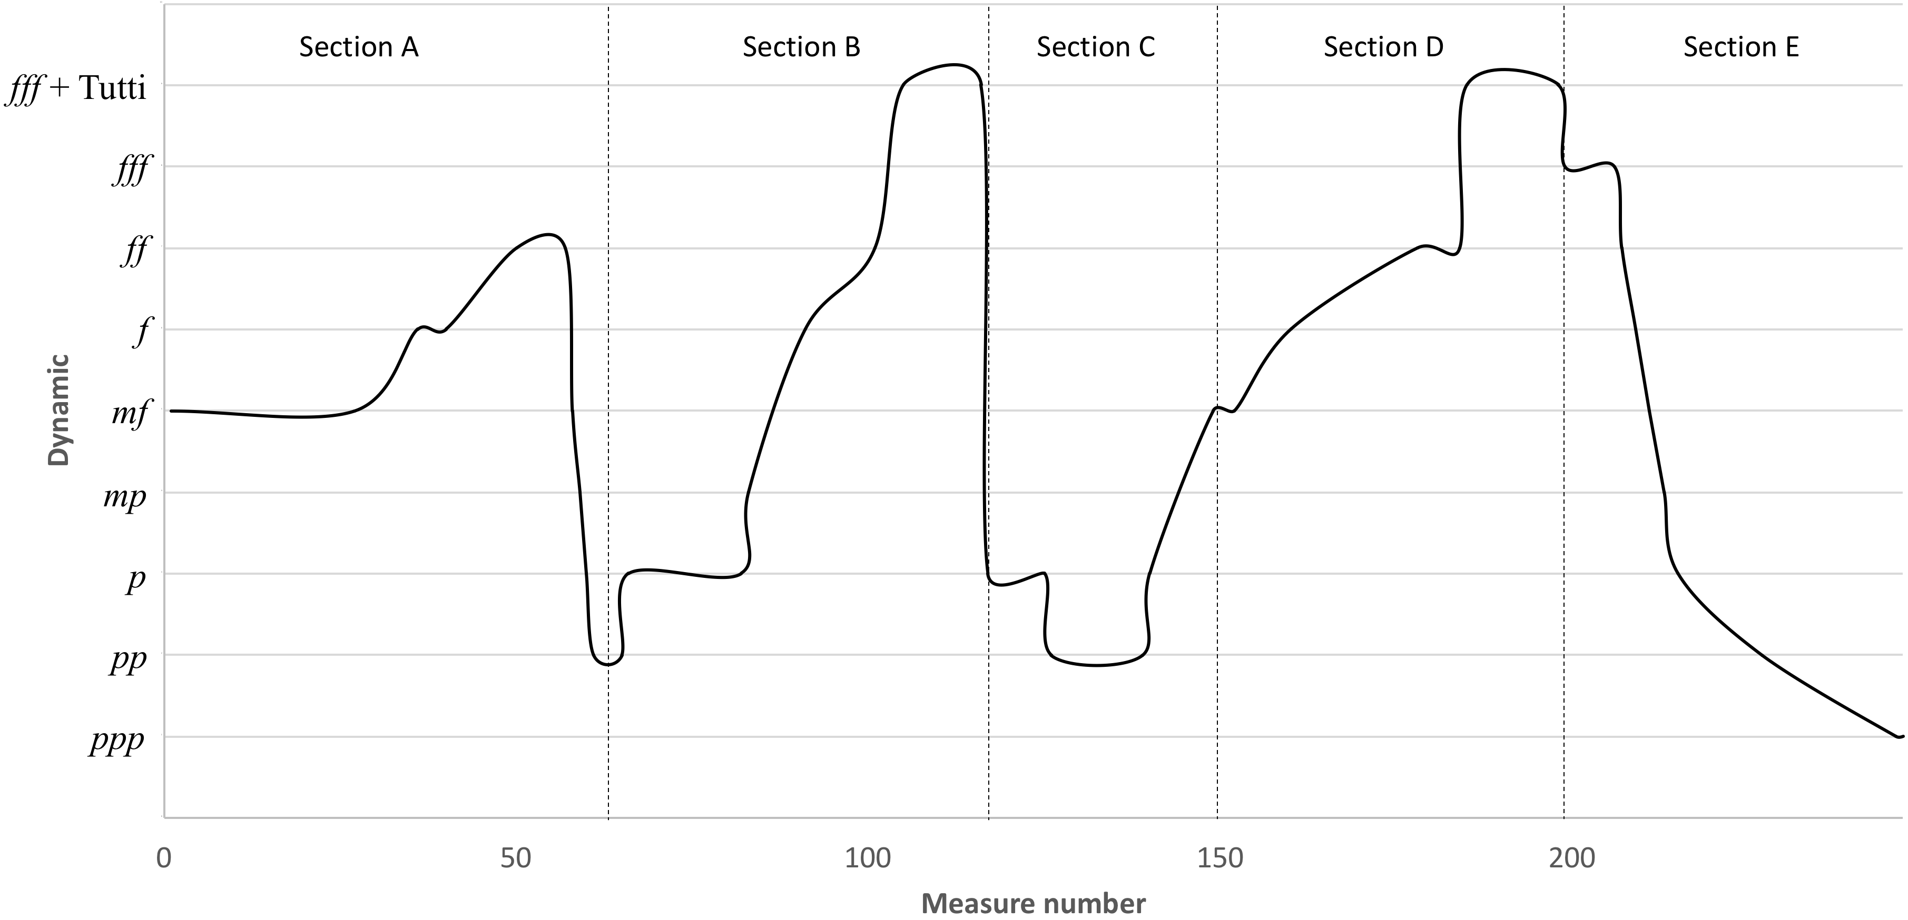
Figure 1. Per aspera ad astra: dynamic outline
Even though the different sections are contrasting in dynamic and speed, the addition or subtraction of stops is generally not sudden. It is gradual, although in a few occasions there is a demand for the frequent subtraction or addition of two or more stops at a time for every consecutive measure, as happens at mm. 90-93. This is perhaps due to the fact that this piece, as many in the Latvian organ repertoire, was conceived with the Walcker organ at Rīga Dom Cathedral in mind. This can be observed by the detailed calls for specific stops and the use of four manuals, identified by Roman Numerals. There the organist or registrant must do all stop changes manually, with the exception of a few preset combinations. The only place where a subito piano happens is on the downbeat of m. 117, but that can be accomplished by reducing the registration on manual IV while the organist plays on manuals I and II in the egment leading up to it, so a softer layout will be prepared for then the hands move up the manuals.
The piece begins with an introduction from m. 1 to the downbeat of 12. This first segment of section A (mm. 1-61) is characterized by the strong rhythm of a broken line of parallel chords as seen in Ex. 1. These chords foreshadow a melody that will be clearly stated starting at m. 14, a case of fore-imitation. All of them encompass the harmonic intervals of major or minor sixths. This parallel and mostly downward movement in sixths (or thirds) is a recurring feature in Per aspera ad astra. Some chords are accented to emphasize the thorny (aspera) rhythm. This is grounded on a pedal A which is struck six times, preceded by octave accaciaturas. Each of the twelve measures has a slight variation in meter and hence a different time signature. The tempo directions are Agitato (tempo rubato) e affetuoso and the articulation is indicated to be non legato. The resulting effect of these factors combined is the restlessness asked for by the composer. The total number of phrases on this introduction is three (4+4+4). The registration asked for is all foundation stops (principals, flutes, and strings) from manuals I and II, the manual coupling II/I, and a 32’ Untersatz (principal) plus a Subbass 16’ on the pedal.

Example 1. Per aspera ad astra, mm. 1-6
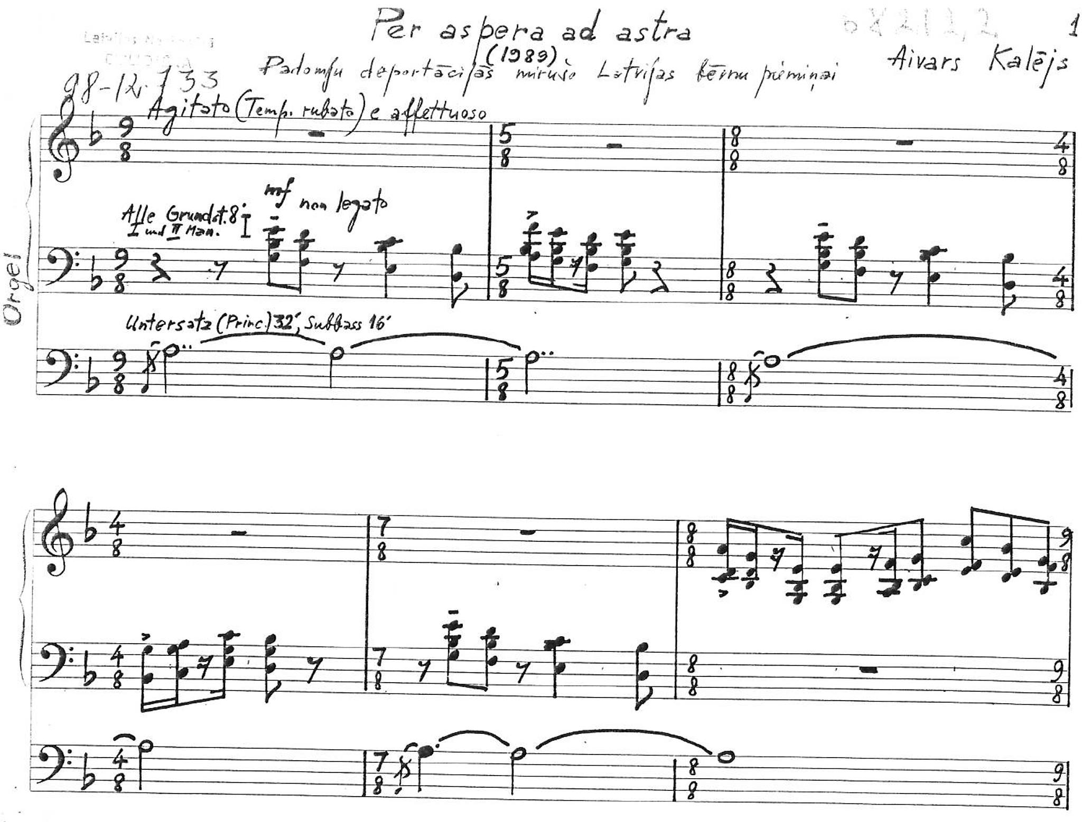

Copyright © 2002 by Bärenreiter-Verlag. All rights reserved.

While the key signature of the piece is one flat and D minor is implied, a key is never firmly established. The pedal A (V) is superimposed by a moving line that revolves around the E diminished chord (ii). All the chords on the first two segments of section A can be diatonically related to D minor. The tension created by the diminished and dissonant chords, along with the long pedal note, are however not solved on the tonic, but finish instead on an Am7 chord (V⁷). This tonally ambiguous section sometimes behaves as if the key was A Phrygian, especially at mm. 9-12.
The introduction of Per aspera ad astra demonstrates some typical features of Aivars Kalējs’ organ music such as the use of the natural minor scale, pedal notes or chords for several measures at a time, the parallel movement of chords with the same interval range (in this case, sixths) and which often carry the melody on their higher notes, untraditional harmonic progressions, and a tenuously established pitch center that sometimes leaves room for ambiguity.
The second part of section A begins at m. 12 and continues through m. 39. The downbeat of m. 12 feels like a point of arrival even though it was not preceded by a cadence. The music jumps straight into a measure-long ostinato melody on the left hand (Ex. 2) for thirteen measures (mm. 12-24). The mood is still the same from the introduction: restless. For the first seventeen measures, the pedal point remains on the note A.
Example 2. Per aspera ad astra, mm. 12-17
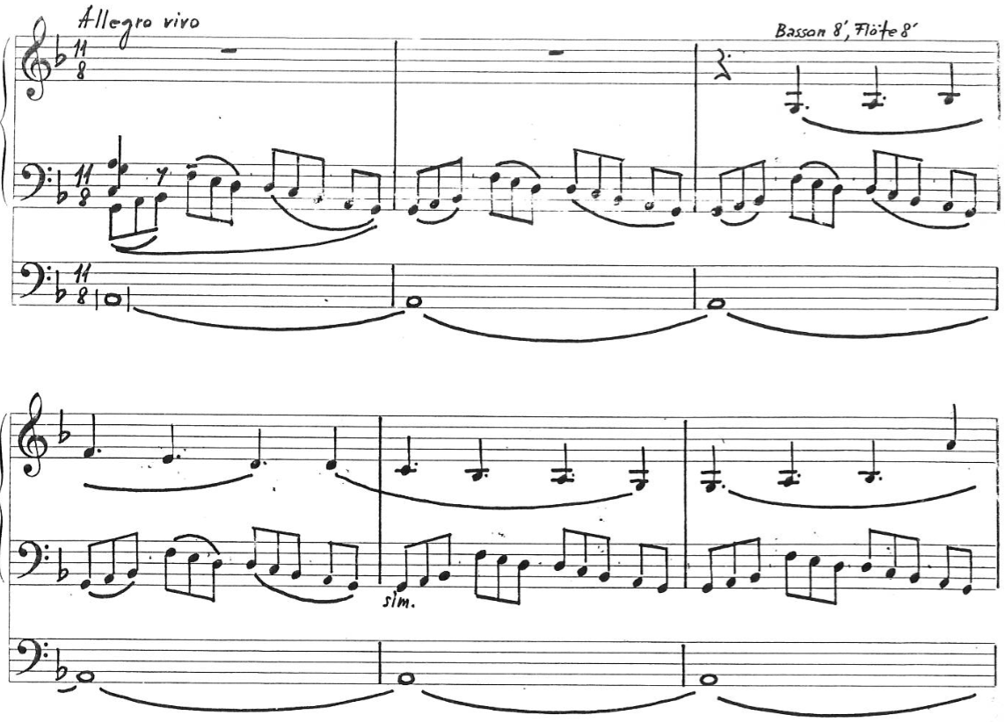

These repeated eleven-note units are based on a segment that had appeared on the introduction, here highlighted on Ex. 3.
Example 3. Per aspera ad astra, mm. 9-11
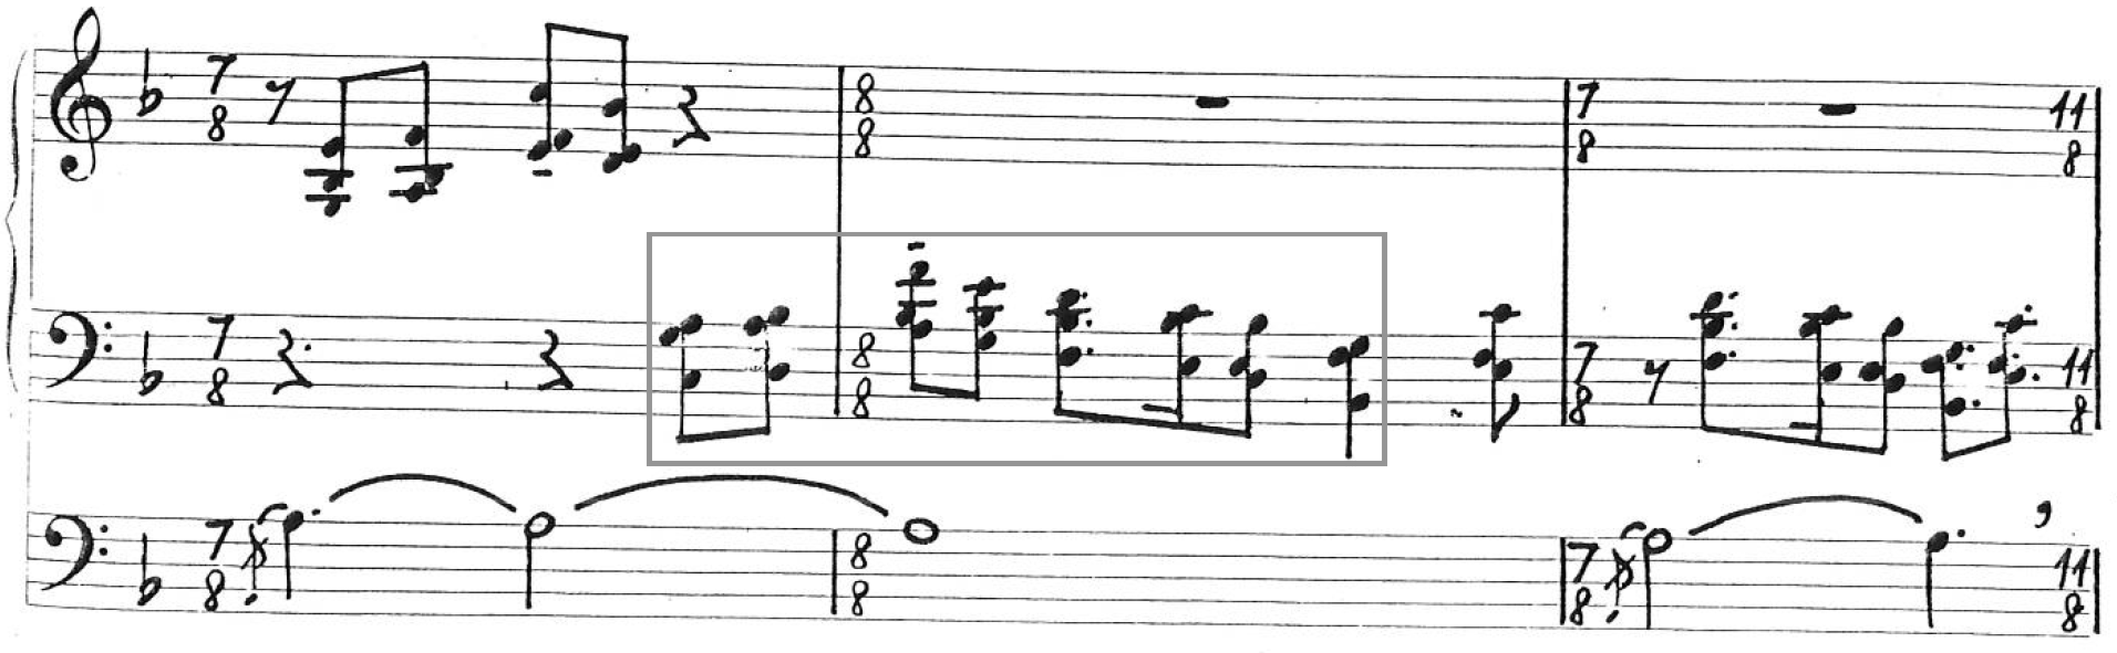

The fast and continuous flow of the ostinato on the left hand may invoke the image of a moving train, which could remind the informed listener of the cattle trains used to transport the thousands of victims of the deportations to Siberia, to whom this piece is dedicated. This was remarked by concertgoers a number of times in occasions when the author of this document performed this piece. Such a train might indeed have been in the mind of the composer when writing Per aspera ad astra. In Kalējs’ words:
It has intensity changes but not a concrete storyline. It is the same as in one’s life; there is no absolute evil or a paradise on the earth. This music involves different souls and spiritual states of the people deported to Siberia. In some dramatic parts of the composition, you can notice the reflection on compassion and indignation for when innocent people needed to suffer. But there is no program or storyline, so in this case it is an absolute music. Just that while composing this music in my imagination I was together with those people in the train or already gone away. Without presence, without compassion, it is not possible to even touch such a topic.

The subsequent phrases are the expansion of this melody. When the third repetition of this ostinato theme begins, the right hand plays a solo melody on another manual, like the cantus firmus of a chorale (mm. 14-21, seen on Ex. 2). The registration for this tune is a combination of Basson 8’ and Flöte 8’. It starts as a prolation canon of dotted quarter notes against eight notes (mm. 14-17) and further develops the melody foreshadowed at mm. 6-7.
The pedal point is interrupted by a two-measure pedal line that follows the manual movement in parallel sixths and thirds, as seen in Ex. 4, and then it returns for another five measures.
Example 4. Per aspera ad astra, mm. 27-30
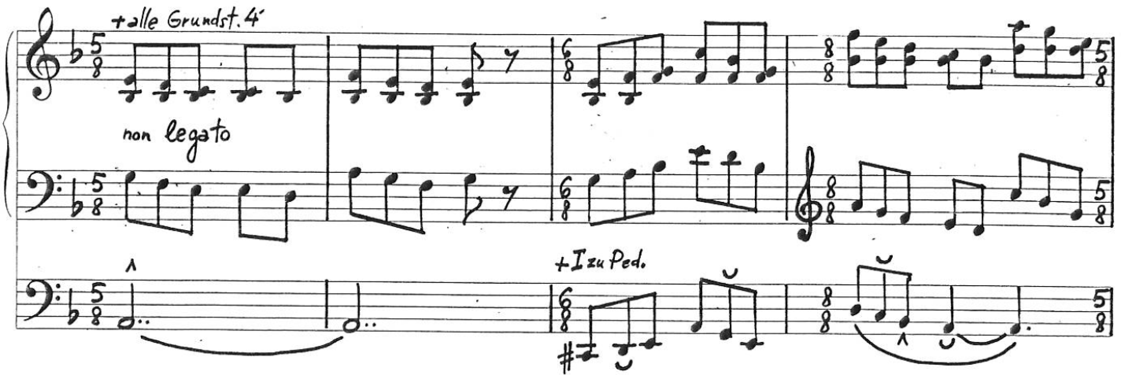

The key is D minor, using the natural minor scale, despite the absence of pure D minor chords other than in weak beats as passing notes. The E diminished (ii) chord is prominent since the beginning of the piece. Without exception, all the resulting harmonies of the parts combined in this section are diatonic to D Minor.
At mm. 22-39 both hands move in the same speed and in parallel sixths, first as single notes (mm. 22-26) and later in chords (mm. 27-29). This constraint to the interval of sixths means that when a melody returns in the same range and key, the harmonies used may be the same. For instance, the chords of mm. 27-28 are exactly the same as those of the two opening measures (Ex. 1), however with equal note values. After 11 measures on 11/8, the meter changes often, practically from measure to measure at mm. 24-36. Kalējs also makes extensive use of sixths in several of his other organ compositions, for instance, on the Čakona (Ex. 5) and on second movement of the Tokāta par Jāņa Mediņa koraļdziesmu Tev mūžam dzīvot, Latvija! (Ex. 6).
Example 5. Čakona, mm. 64-66
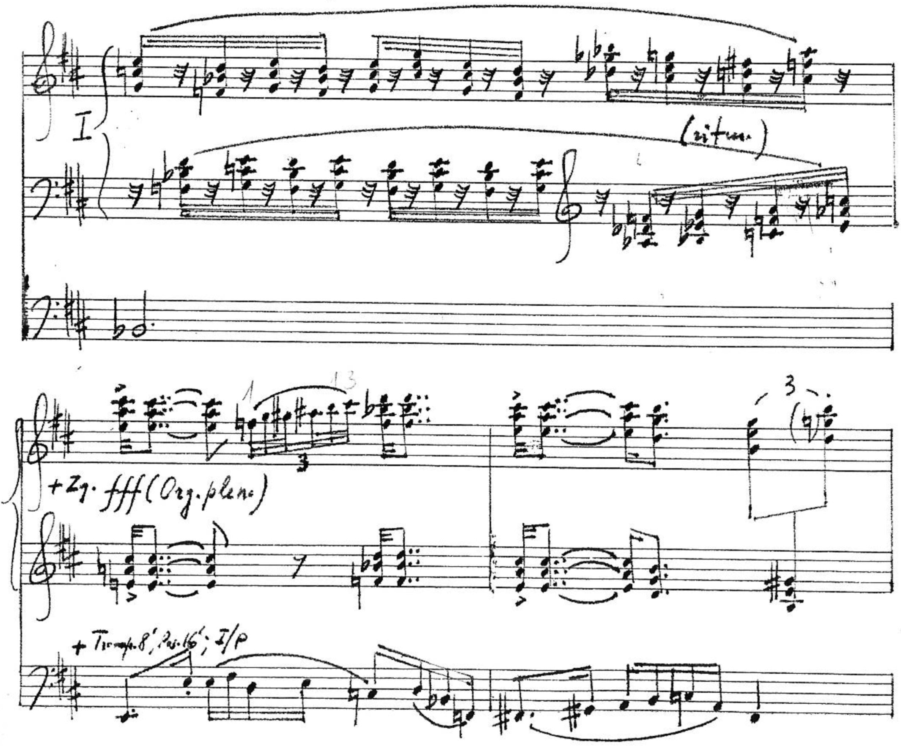
Example 6. Tokāta par Jāņa Mediņa koraļdziesmu Tev mūžam dzīvot, Latvija!, mm. 48-50
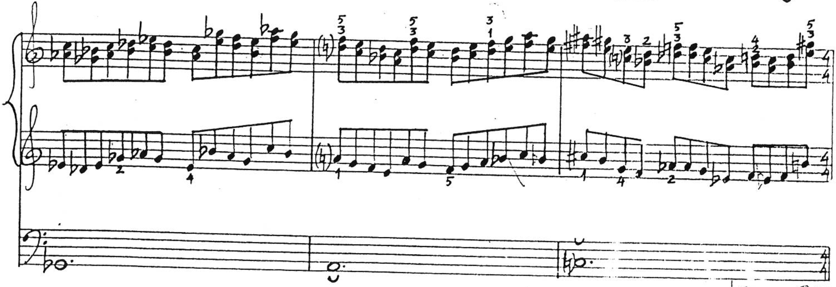
Unpublished scores. Used by permission from Aivars Kalējs.
In Per aspera ad astra there is a gradual increase in dynamic from mf to f by playing both hands on Manual I (m. 22), adding all foundation stops 4’ (m. 27), coupling Manual I to the pedal (m. 29), and adding 2’ (m. 31), Aliquote or Cornet (m. 33), and 16’ (m. 36).
The third part of section A is comprised by mm. 40-61. It begins with a striking G♭^{#4-3} chord on the first inversion (Ex. 4), unexpected after the E dim (ii6) over pedal A that had finished section 2 in the key area of D minor. The first part of this section (mm. 40-47) revolves around the key of B♭ minor, although there is not a single instance of a clearly stated chord in that key and the key signature remains the same as before.
Example 7. Per aspera ad astra, mm. 40-46
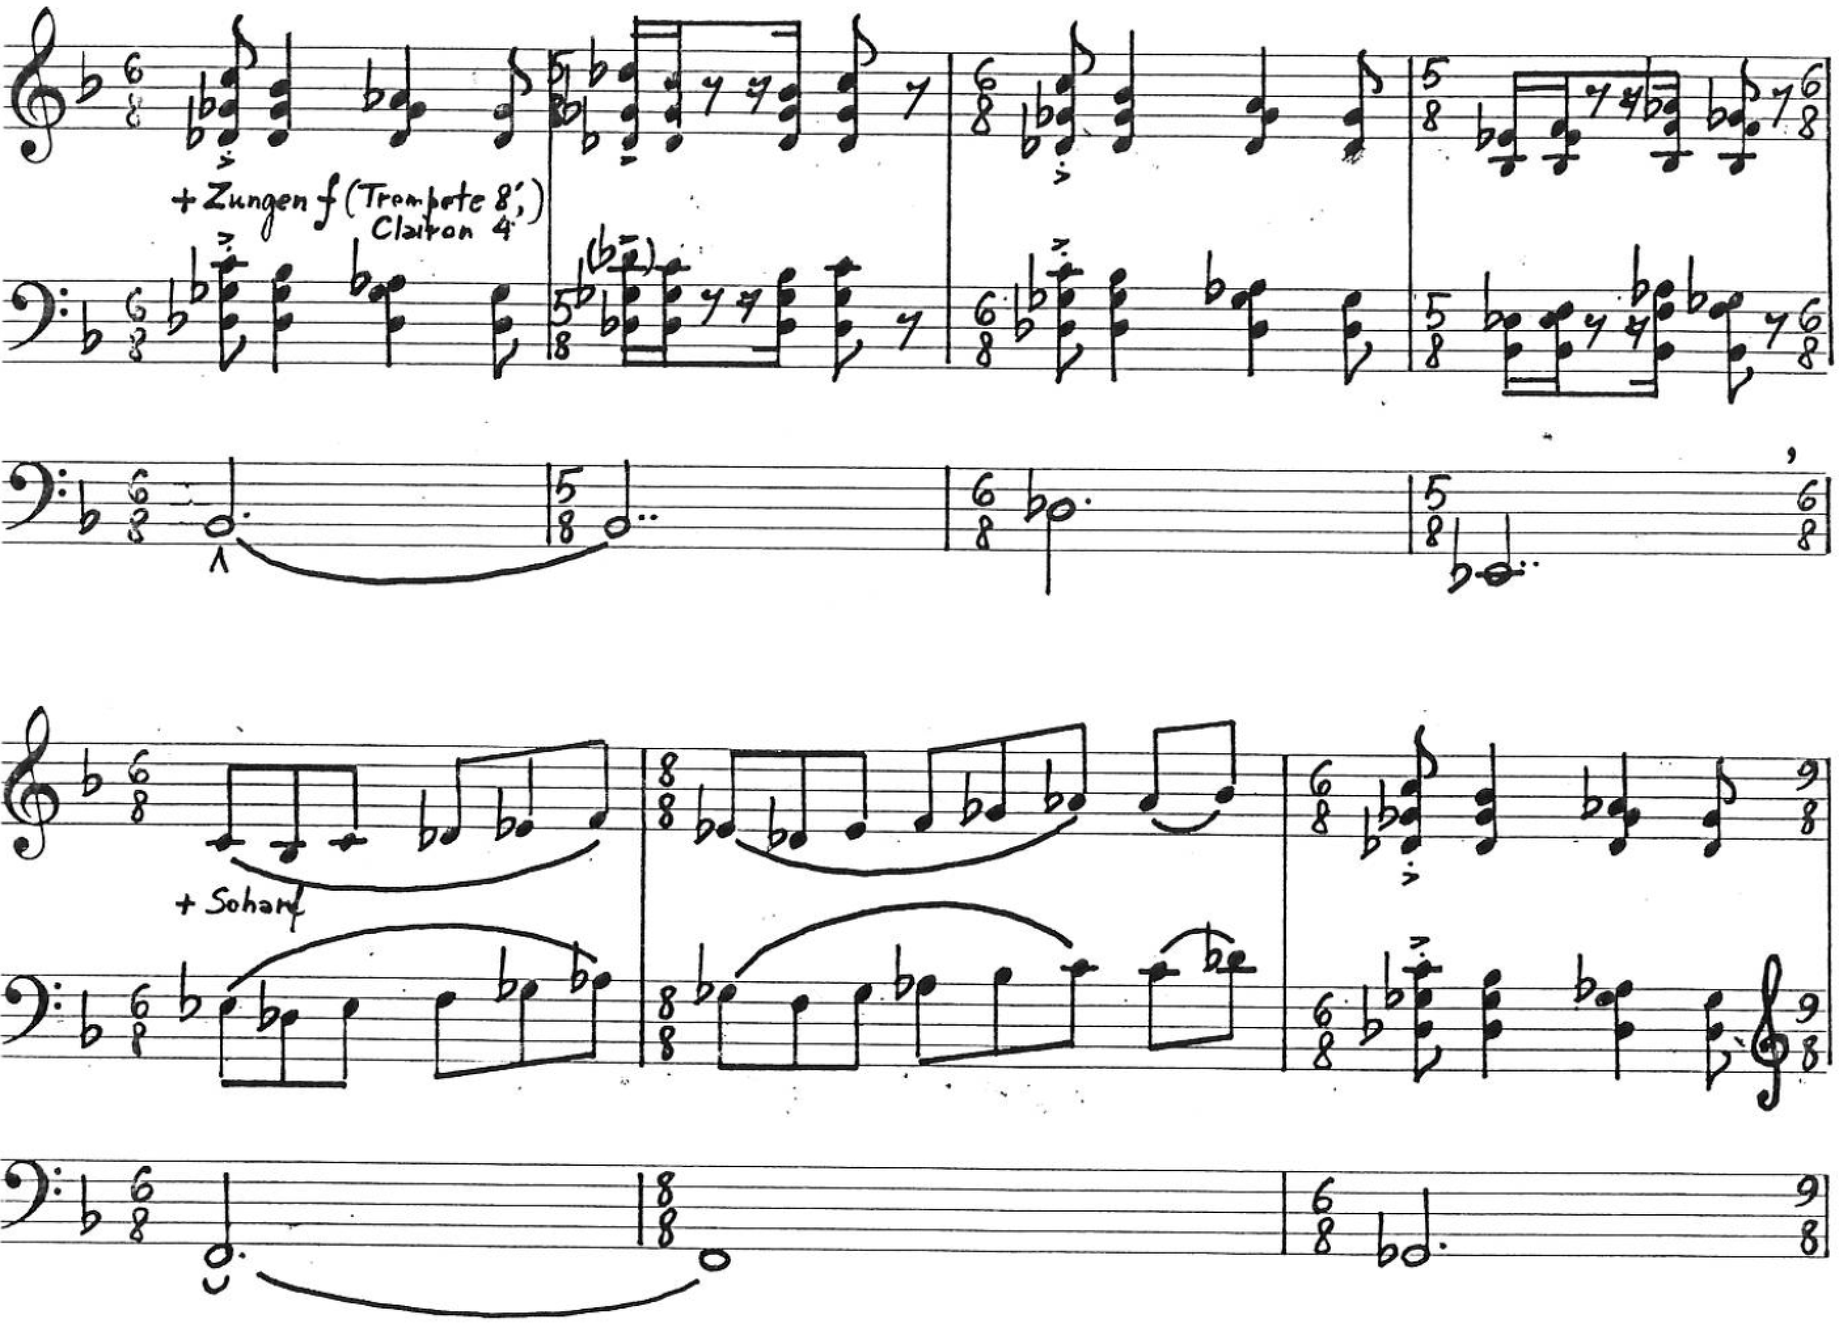
This segment consists of an alternation between rhythmic and melodic elements introduced at mm. 1-39, as can be observed respectively at mm. 40-43 and 44-45 on Ex. 7. Time signatures change every one or two measures, as in the previous section, alternating irregularly between compound and complex. The dynamics reach a peak with Tutti (Organ pleno) at mm. 50-54, where tonality seems ambiguous between G minor and G diminished with a downward pedal arpeggio outlining an A7 chord: G-E-A-E-C#. That leads immediately to a D, and through a sequence of apparently disconnected tertian chords in root position and contrary motion (Ex. 8), which is commong in this piece and throughout Kalējs’ œuvre, to a first inversion F chord.
Example 8. Per aspera ad astra, mm. 53-54
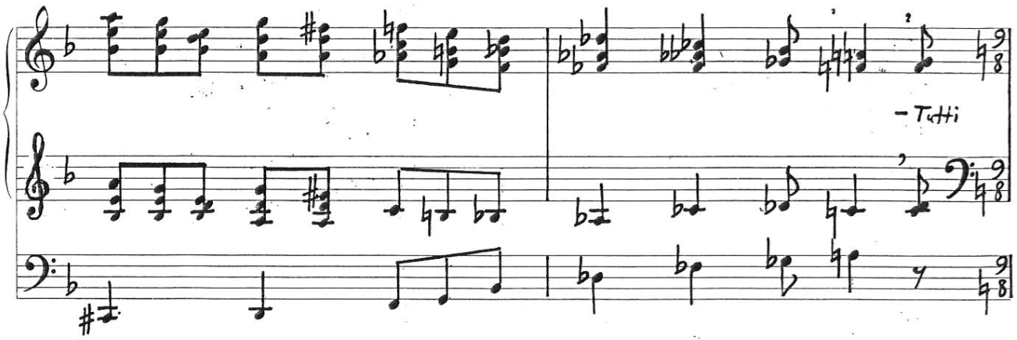

After that the dynamic diminishes through the removal of stops from the Tutti (or the Tutti preset button, as in the case of the Dom Cathedral organ) and manual changes up to IV at m. 60, marked dolce and to be played with the Unda maris 8’. The short phrases leading to each manual change land respectively on A, G♭ and D (Ex. 9). The cadence leading to the D major chord on the downbeat of m. 61 is the first and one of the only authentic cadences in the entire piece. D is the pitch center of the upcoming section, first mixolydian and then octatonic. The pedal D is held until m. 95, with the brief exception of mm. 68-70.
Example 9. Per aspera ad astra, mm. 58-61
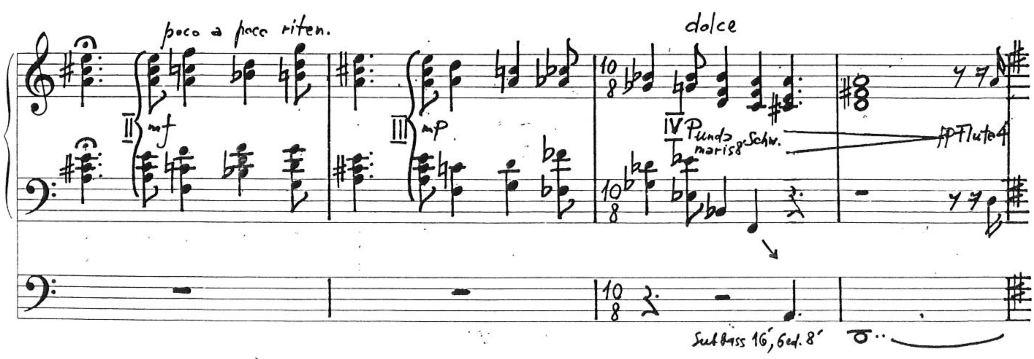
Marked vivo e pastoral, section B (mm. 62-116) starts with the pickup to m. 62. The tonal center of D mixolydian brings the fist change of mood since the piece began: from agitated and restless to static, soft, and mysterious. For the first four measures, the two hands play brief phrases in two voices and parallel sixths.
Example 10. Per aspera ad astra, mm. 64-68
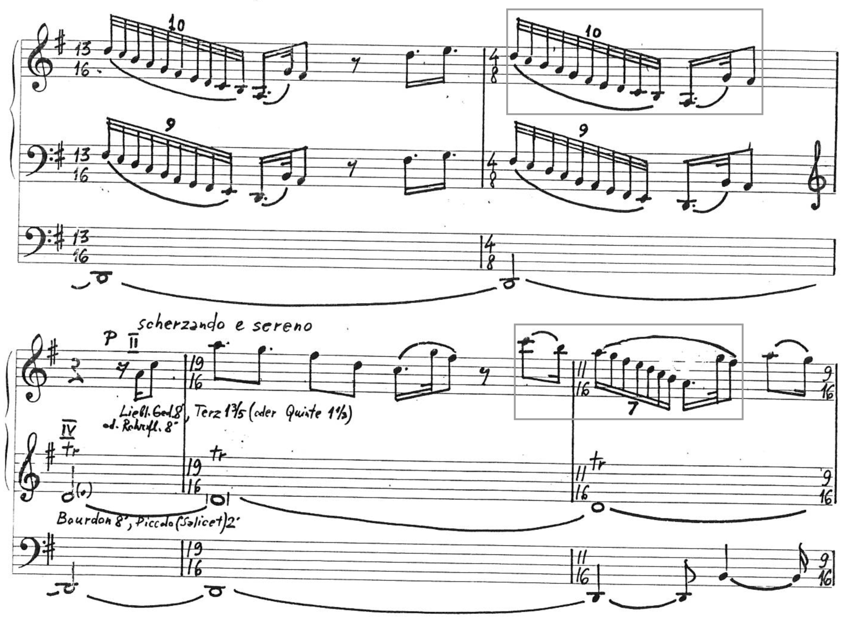
These four measures contain rhythmic and melodic material that will be developed throughout section B, such as that highlighted on Ex. 10. The florid melodic line on the right hand that starts at m. 66 becomes permeated with rests on its way upward, giving it an air of hesitation, while the following descending scales move much more rapidly and uninterrupted. An image that could perhaps come to the mind of the listener would be that of the innocence of children playing, oblivious to an inhospitable environment. In the words of the composer:
[Per aspera ad astra] is simply a much deeper music than what I wrote before. There is nothing superfluous or simple, as a pure play of the sounds. There is also a fragment that includes birdsong, the fantasy world of children, and nature. Because it is not only an idea about the deportations; there is also a step inside of the pure world of children.

The other element that appears in section B is tremolo chords such as those seen on Ex. 11. The rhythmic figure of the left hand at m. 80 repeats itself unaltered from m. 72 to 87, and with very little variation at mm. 88-89. This is the most static section of the piece up to this point, with no change in time signature between mm. 72-87.
Bitonality is introduced at mm. 72-74. There the tremolo that begins on the right hand is briefly tonicized in C major while the left hand repeats a measure-long fragment with in A minor in the same rhythmic pattern observed on the later measures displayed on Ex. 11 (A-B-C under a D-E tremolo). The bitonality continues as the right hand tremolo ends and the melodic idea from mm. 66-71 is further developed in D mixolydian while the left hand repeats the same fragment continuously.

Example 11. Per aspera ad astra, mm. 80-83
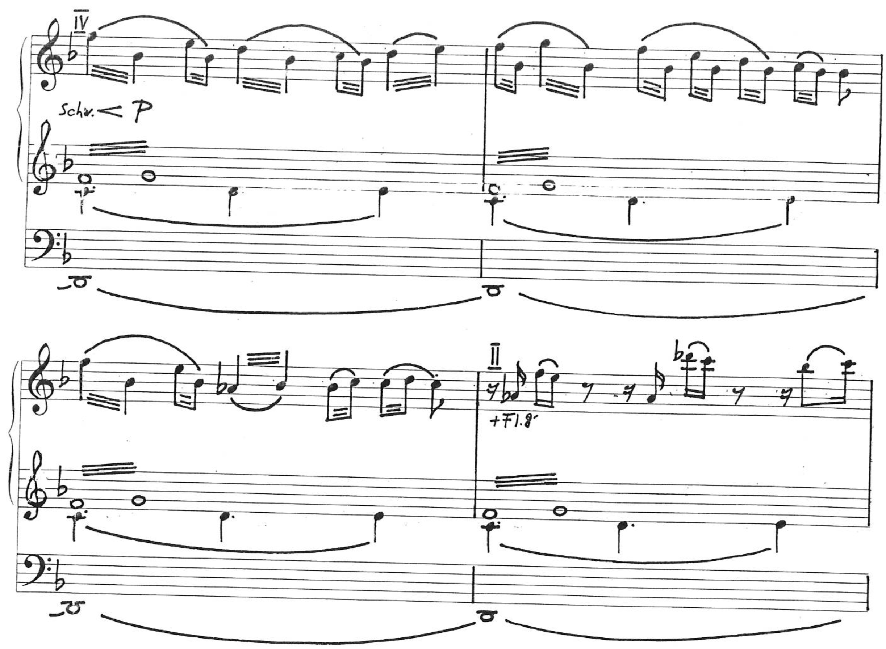
At mm. 80-82 (Ex. 11) the same pattern of mm. 72-74 repeats itself, however this time the right hand tonicizes F major while the left hand tonicizes C major (C-D-E under an F-G- tremolo). Because of the way these structures are built, both instances emphasize the subdominant of each of the simultaneous keys: G and D at mm. 72-74 and B♭ and F at mm. 80-82.
Stops are gradually added throughout section B, with many mutations, ensuring a continuous crescendo from the original pianissimo. This, alongside the use of bitonality, will help build up tension as the keys begin to change. For instance, at m. 77 Kalējs asks for a Terz 3 ⅗’ or Quinte 5 ⅓’ (or 2 ⅔’), both of which support the 16’ harmonic series sounding as a third or a fifth respectively. Measure 85 asks for a Kornett (8’ + 4’ + 2 ⅔’ + 2’ + 1 ⅗’) and m. 90 for another 2 ⅔’. Many of the stop additions on section B ask for two or more stops at a time, including some of the examples just mentioned. Many of Kalējs’ organ compositions feature solo melodies with mutations during their softer sections, as well as a step on the process of adding stops to increase volume and tension during a crescendo, demonstrating a preference of this composer for this type of sound.
While the left hand and the pedal point remain the same, on the right hand D mixolydian modulates to an E eight-tone scale at m. 82. With the changes in tonality, tension increases. The tonal center of the melody at mm. 83-89 is difficult to point out with precision because there are no clear arrivals. The ambiguity of this particular fragment is between E and B♭. What is clear since the beginning of the piece and throughout the entire section A is the emphasis on the tritone E-B♭ and the diminished triad E-G-B♭, which in fact constitutes the very first chord of the piece (Ex. 1). The tritone and extensive use of diminished chords are one of the fundamental elements contributing to the overall feeling of restlessness throughout Per aspera ad astra. At m. 89 the tremolo figure on the left hand and the bitonality end. At m. 90 both hands play the same melodic material from the right hand in previous measures, but in parallel sixths. The meter and time signature once again change on almost every measure. The E octatonic scale (Oct 1,2) is used starting on the downbeat of that measure.
The use of octatonic scales by Aivars Kalējs might be partly due to the musical influences of his youth, mostly French composers who made extensive use of the octatonic scale: Olivier Messiaen, Jehan Alain, Claude Debussy, Maurice Ravel, and Francis Poulenc. Messiaen used it particularly often and included it in his seven modes of limited transpositions. The three pieces in this study make use of octatonic scales.
Another possible inspiration for the use of octatonic scales might have come from the influence of Russian music. In the words of Richard Taruskin, the coronation bells from the opening scene of Modest Mussorgsky’s opera Boris Godunov form “two dominant seventh chords with roots a tritone apart” derived from an octatonic scale, and “Thanks to the reinforcement the lesson has received in some equally famous pieces like [Rimsky-Korsakov’s] Scheherazade, the progression is often thought of as being peculiarly Russian.” In the beginning of the twentieth century the octatonic scale was so familiar in the circle of composers surrounding Nikolai Rimsky-Korsakov that it was called the Korsakovian scale (Корсаковская гамма), and to this day it is still referred in Russian theory by the historical name of Rimsky-Korsakov scale or mode.
The octatonic scale can also be found in the music of Igor Stravinsky (Petrushka, The Rite of Spring, Symphonies of Wind Instruments, Scherzo fantastique, Fireworks, The Firebird, the Symphony of Psalms, the Symphony in Three Movements, and many others), Alexander Scriabin, Sergei Prokofiev, and Dmitri Shostakovich, to name some of the most influential Russian composers of the twentieth century. As Streliaev points out, since historically “many Latvian composers studied abroad in places like Russia, France and Germany, the knowledge and cultural influences they obtained were assimilated with nationalist influences to create an authentic Latvian style.”
Example 12. Per aspera ad astra, mm. 101-106
In Per aspera ad astra the movement in parallel sixths ends on the downbeat of m. 98. From mm. 98-104 the figuration becomes block chords of two notes per hand progressing for the most part in contrary motion. The overall rhythmic and melodic shape of this segment is similar to that from the previous measures. One marking feature of mm. 98-104 is that practically all these chords contain the interval of a major seventh, as seen on Ex. 12, making this segment particularly pungent in contrast with its precedents. The dynamic at m. 101 is marked fortissimo with the addition of a Mixtur.
The tempo marking of mm. 105-116 is Allegro furioso (Ex. 12), its dynamic is fortississimo, and the registration asked for is Tutti (full organ). This segment and mm. 185-198 are the two loudest instances of the piece, where fff + Tutti is asked for. The scale used is still E octatonic (Oct 1,2), despite the absence of B and D from these measures, with a strong emphasis on the diminished triad E-G-B♭ on the manuals and D♭-E-G on the pedal line. The rhythmic formula of m. 105 is repeated every measure until m. 115.
A sudden interruption occurs on the second beat of m. 116 with a dotted quarter rest with a fermata. This is the first moment of silence since the piece started. It happens abruptly at the climax of the hitherto loudest and most anxious point, where minor seconds and sevenths clashed with a long E diminished seventh chord (vii^{o7}) sustained in a restless tremolo. Something, a violent action, has been cut off unexpectedly. At this point and considering what is to follow, several possible images could come to the mind of the listener: the sudden interruption of a terrible nightmare, or of a particularly tortuous moment, or finally being able to walk into a warmer shelter after battling the Siberian winter outdoors, or even being released from an exceptionally harsh punishment of a torturer. Nevertheless, one does not awake to a new reality changed for the better as one would from a bad dream.
The somber mood is prolonged into the start of section C (mm. 117-148) by the continuation of the use of the same E octatonic scale. Marked Andante cantabile e doloroso, the dynamic contrast between the fortissimo + Tutti of m. 116 and the subito piano of m. 117 is the most abrupt change in dynamic in the entire piece.
Example 13. Per aspera ad astra, mm. 122-131
Given that mm. 117-124 are played on Manual IV with no pedals and only a brief jump to Manual III at m. 125 (Ex. 13), there is enough time for the registrant to change stops on the other divisions of the organ, establishing mellow registrations as the starting point of section C. If an image could describe mm.117-126, it would perhaps be that of waking up: three short phrases starting with the same melody (mm. 117-118, 119-120, and 121-126, pictured on Ex. 13) and almost exact same harmony, as if hesitant to rise and step outside to start the day on a new but still dark key: D♭ octatonic (Oct 1,2). This scale uses the same pitch class from the previous octatonic scales. The key change is marked by the entrance of the D♭ in the pedal and left hand, to be sustained from m. 126 to 135.
The dynamic is back to pianissimo. The right hand plays a languid melody, asi n the previous section, however the background of a sustained chord instead of moving notes and tremolo gives this segment a much more uncanny character. A brief change of harmonies occurs at mm. 136-138, and then the D♭ drone returns in the form of a pedal chord D♭-F-A♭ that will be sustained from m. 139 to 155, which will already be section D. The segment encompassing mm. 140-148 is marked espressivo (rubato) e parlando vivo. It brings back the movement of two voices in the manuals, this time in thirds (mm. 140-144) and fourths (mm. 145-147), which is still a variation of the material introduced at m. 66 (Ex. 10). The melodies are constantly interrupted by rests that give it an angular nature, as has often been the case since m. 78. This is the birdsong expanded and made progressively harsher.
These sharp “angles” or thorns are conceivably an illustration of the aspera in the title of the piece: hardships, sometimes interpreted or even translated as thorns, something that stings. The word aspera is the plural accusative case of the Latin word asperum, meaning an uneven, rough, harsh place or landscape, or adversity, difficulties.
More restlessness is added with the marking poco più mosso just before the downbeat of m. 142, the addition of flute stops and a change of manuals to III at m. 147, though the dynamic is still not louder than piano. The melodies on the manuals seem to tonicize around E octatonic (Oct 1,2) before reaffirming the D♭ chord at mm. 147-148. The fermata over the rest at the end of m. 148 is the second instance of silence in Per aspera ad astra, but unlike m. 116, it is not complete silence, as the pedal D♭ chord is still sustained as before. This concludes the quietest section of the piece.
Section D (mm. 149-198) can be described as an ever ascending gesture towards a dynamic climax that will reach its peak at mm. 192-198. The tempo indication of its first segment, seen on Ex. 14, is Moderato pesante e serioso, to be played on Manual I using all 8’ foundation stops. Stops are gradually added starting at m. 152, which also contains the indication poco a poco accelerando.
Example 14. Per aspera ad astra, mm. 149-151
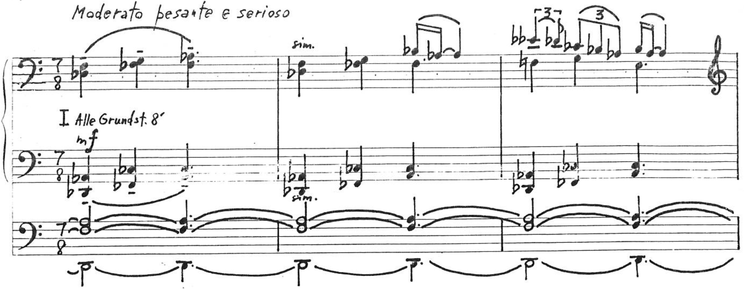
On the segment of mm. 149-165 the pitch center changes in consecutive phrases equivalent in shape and length to the one shown on Ex. 14. It starts in D♭ with a tonicization on A♭ (m. 151), modulating to F minor (m. 152) and tonicizing in B♭ (m. 155). At m. 156 the pedal chord is lifted while the hands play an interpolation of D minor and D octatonic (Oct 1,2), and from m. 162 it modulates to a series of progressively more dissonant chords using initially an eight-tone F scale containing the gap of a minor third but later also including a C natural at mm. 164-165 when modulating to the next segment.
Marked Allegro con fuoco and più forte, the segment starting at m. 166 brings back the use of parallel but disconnected tertian chords, tonicizing from G to B♭ at m. 169 (Ex. 15) using the notes of the G octatonic scale (Oct 1,2) until finally landing on B minor at m. 171. Here, as seen on Ex. 15, the pedal starts playing the same melody that the left hand played as an ostinato starting at m. 12 (Ex. 2). This is a return to the train motif, possibly indicating once again the idea of movement, perhaps displacement.
Example 15. Per aspera ad astra, mm. 169-171
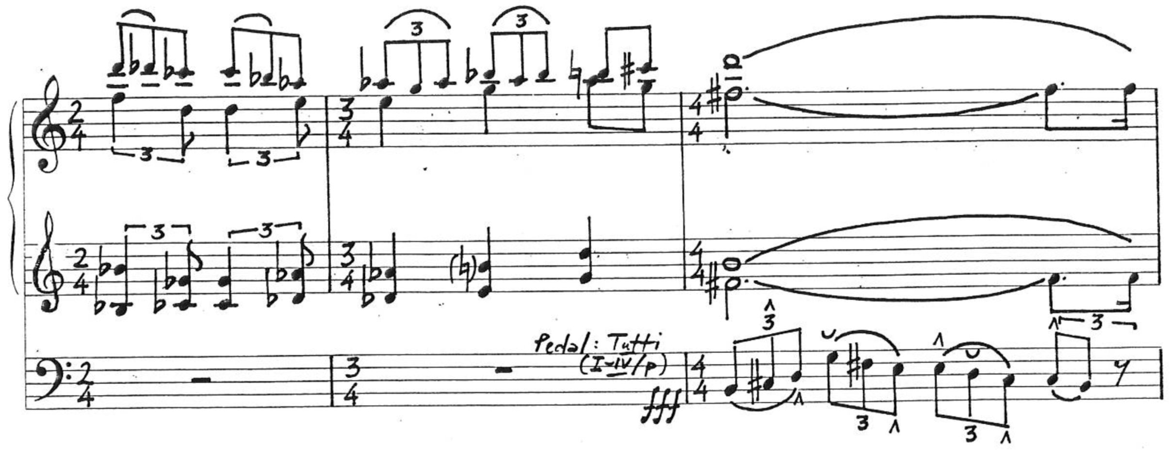
All manuals are coupled to the pedal and all its stops used. The formula of m. 171 repeats itself in the pedals three more times at mm.172-174. From the initial range of B-G in B minor it goes up to B-A in G major, then D-B♭ in B♭, then D-C in C7. Between mm. 175-178 the pedal line has a melody culminating in the high D but then going down to the low F, while going through the harmonies of Fm6+, Bm, Dm, Edim, and Fm6+. From m. 178 to 184 the harmonic rhythm increases back to chord changes at every quarter note duration and the key becomes unclear but using for the most part the set of notes of an F octatonic scale (Oct 1,2). This second segment of section D ends at m. 184 with longer chords that interrupt the harmonic and rhythmic movement of the previous measures, namely F^{ø}7 on the first inversion, F minor and B minor. The dynamic is up to fortissimo with the use of mixtures and all 8’, 4’, and 2’ reeds. A suspenseful silence follows, marked by a brief rest with a fermata, the only other moment of true silence in the piece after m. 116. However, this time instead of a quiet and mysterious section such as that starting at m. 117, the dynamic climax of the piece ensues.
Example 16. Per aspera ad astra, mm. 185-187
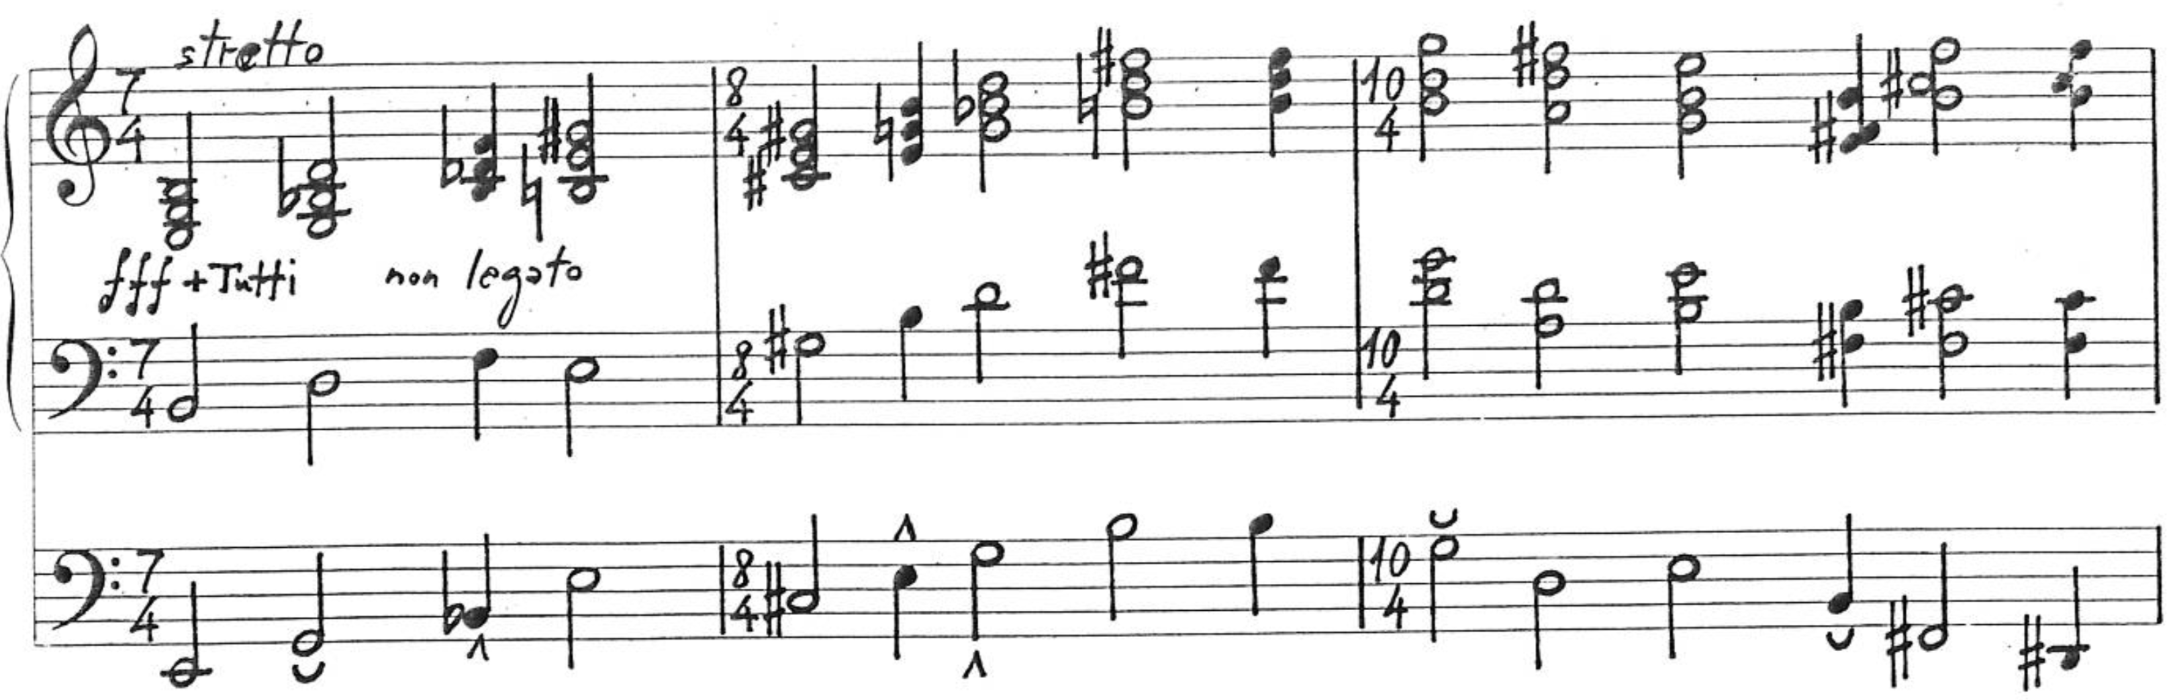
The stretto begins at m. 185 (Ex. 16). It consists of non legato tertian block chords on fortississimo + Tutti moving at harmonic intervals of thirds or fifths. As in other parts of this piece and also in other of Kalējs works, the melody guides the harmony. The melodic and harmonic formula of m. 187 is repeated with variations in both those aspects, but keeping the same rhythm. The key area is unclear but seems to gravitate towards B minor.
The greatest tension in the piece is achieved at mm. 192-194 through the use of quartal harmony, with a sustained G#-C#-D-F chord on the higher octave; moving fourths on the left hand, perfect at mm. 193-193 and augmented at m. 194, and a double pedal line emphasizing the minor second B#-C#. The overall effect is approximately a sustained C#dim chord, permeated by moving dissonances. At mm. 195-198 the short sequence of the four consonant block chords Dm-G-Fm-B♭ is repeated twice in half notes, with the right hand jumping down an octave on the second time and the double pedal line approaching the middle of the pedalboard in contrary motion starting from D and d¹.
Example 17. Per aspera ad astra, mm. 199-200
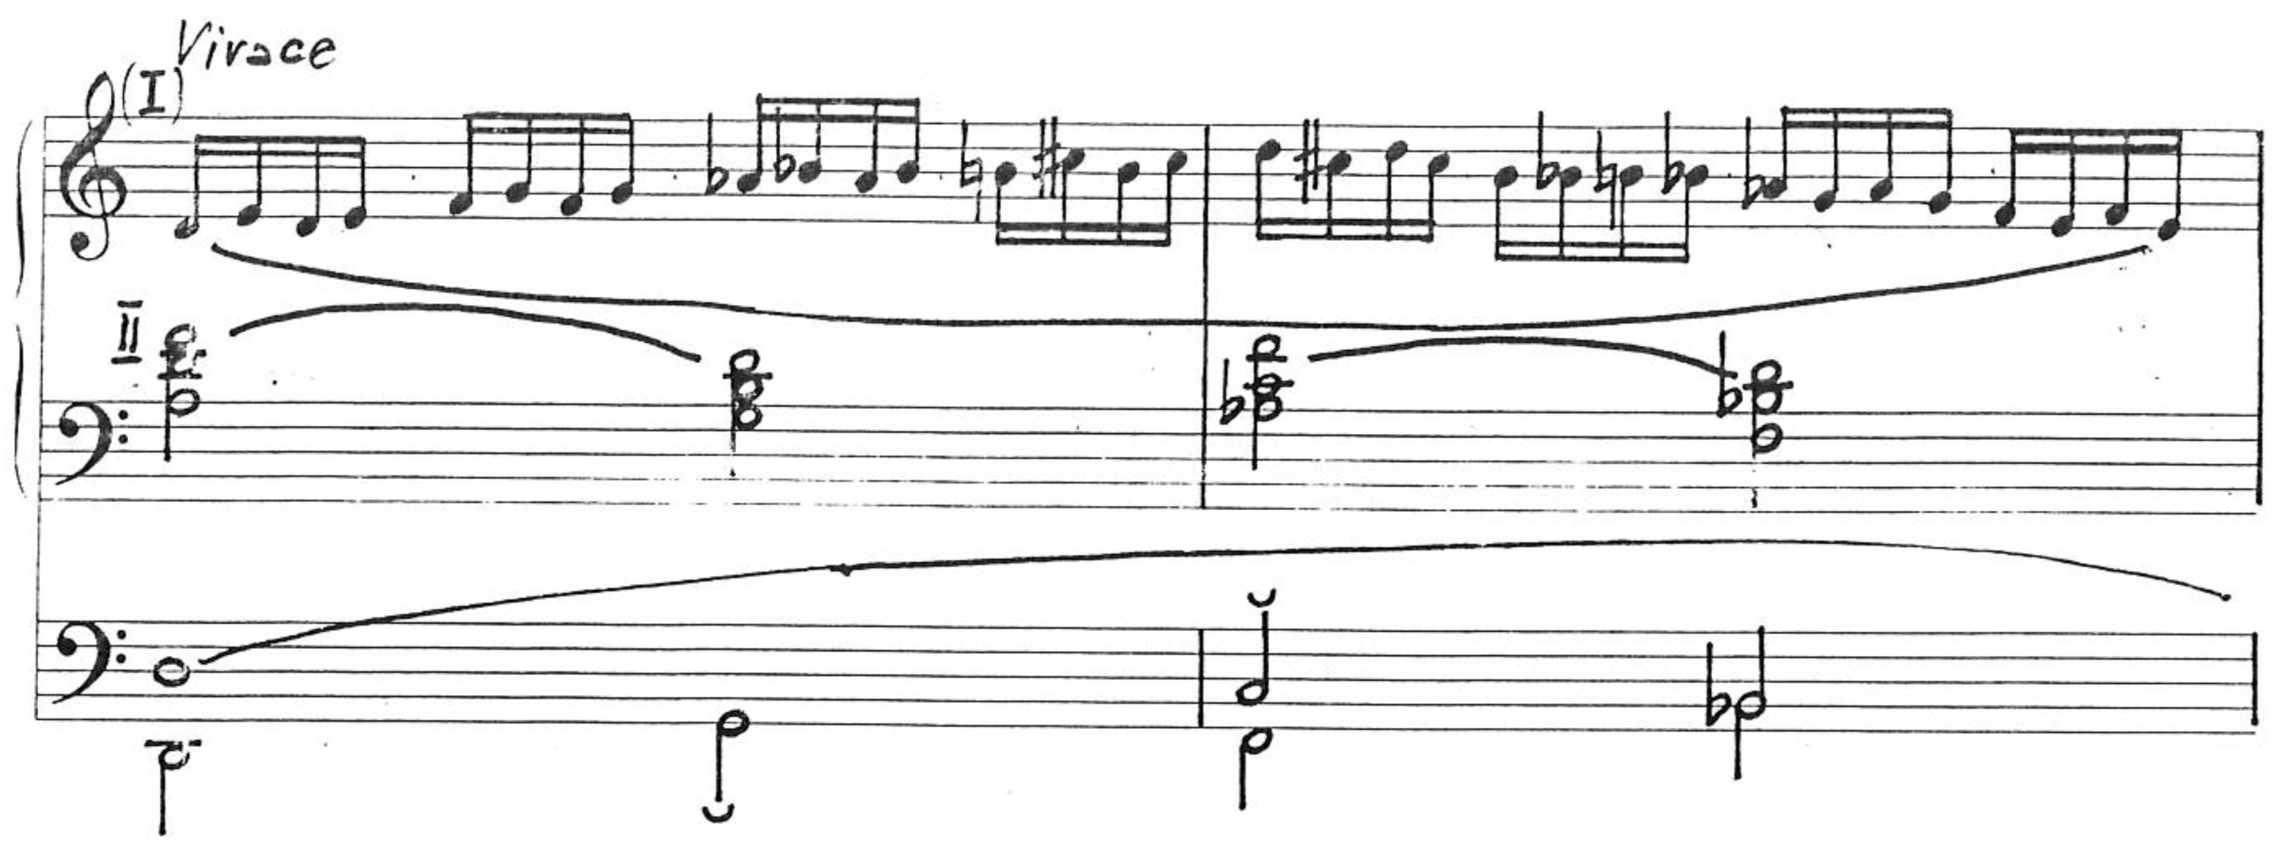
Marked Vivace, the final section, E, starts at the downbeat of m. 199 and can be described as a single uninterrupted gesture divided in equal cells of two measures, coming from a burst of energy until its gradual disappearance. The section begins with the left hand and pedal playing the same chord sequence of the previous four measures, seen on Ex. 16 (Dm-G-Fm-B♭), for another six measures. This combination of consonant chords can be viewed as diatonic when considering that it only uses the notes forming an eight-tone D scale, or else this may simply be D minor with borrowed chords. In one last display of bitonality, the right hand uses notes that comprise the D octatonic scale (Oct 1,2) highlighting the contour of a D diminished chord (mm. 199-200), F diminished (mm. 201-202, and A♭ diminished (mm. 203-204).
At m. 205 the new key of G Dorian is established. The harmonic rhythm of the right hand as running sixteenth notes remains the same as seen on Exs. 15 and 16 while the left hand and pedal also move in two-measure units of whole note, half note, and half note. The exact same melodic line seen below on the right hand of mm. 227-228 (Ex. 18) repeats itself every two measures from m. 205 to m. 215, with the same underlying harmony. The figuration will remain the same on the right hand until the end of the piece, and the harmonic movement until the downbeat of m. 227.
Example 18. Per aspera ad astra, mm. 227-229
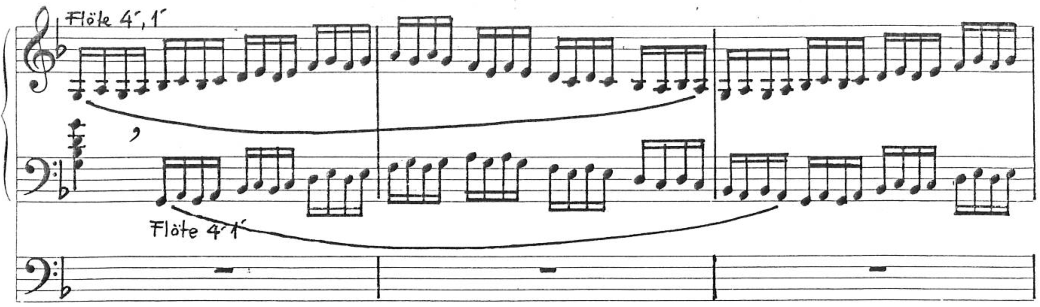
Stops are gradually removed and the dynamic has a continuous decrescendo. Measure 215 is marked pianissimo on the left hand using Unda maris or Schwebung 8’ of Manual IV, and piano on the right hand, with the double gap registration of Bourdon 16’, Flöte 4’, and Sifflöte 1’. The pedals are no longer used starting at m. 215. No dissonance has occurred since the landing on G Dorian at m. 205. This release from the tension created by heavy dissonances within the octatonic modes comes as a liberation from the chains of all earthly suffering. From m. 217 the melody rises ever higher. On the downbeat of m. 227 the Bourdon 16’ is removed and both hands play the same melody in canon at the temporal distance of one quarter note on flutes 4’ and 1’ (Ex. 18). At m. 231 the key smoothly transitions to D minor using the natural scale. Throughout this piece, and indeed on many if not most of his organ works, Kalējs uses the natural scale of a minor mode, with a minor seventh degree on every instance instead of major. At m. 238 the right hand reaches a F-E trill on the highest octave of the organ. At m. 239 only the 1’ flute remains, poco a poco accelerando. The left hand quickly joins the right hand trill as the scale turns into the trills A-B♭, B♭-C (lasting for a half note duration each), C-D (dotted half note duration), and at last D-E adjacent to the F-E of the right hand – and indeed sharing the same E – for a whole note duration on pianississimo, being released after the last sixteenth-note third D-F is played on the downbeat of m. 247. A soul has been released from injustice and suffering to the presence of God in heights of Heaven.
Per aspera ad astra tells a story about a sensitive subject about which Kalējs wanted to write for a long time. He wrote it when Latvia was still occupied. Speaking of its genesis and reception, the composer said:
It could have happened that I composed this piece earlier, not just at the tail end of the Gorbachov era, when it was less risky, but I was not ready as a composer back then. I performed it only in the end of 1989, if I remember correctly. I did not let it sleep, I played it immediately. I also started receiving audience reactions when I began traveling abroad in 1991 – I received gratitude for this piece after concerts in Scandinavia and Germany. Nevertheless, the most precious memory and listener feedback for me was a postcard with flowers on a Christmas Eve with a note starting that the deported ones who returned thank me for this music. The flowers withered but the postcard has remained. I keep it as a very dear memory.

After a concert at the Rīga Dom in 1997 in which the composer himself played this piece, Imants Mežaraups wrote:
The composition is free, rhapsodically outlined, offering a variety of virtuoso organ textures and registration contrasts. The work is beautiful, in my opinion, too beautiful for such a topic. That tragedy calls for sharpness, for anger, for desperation, for at least some part of harsh, dissonant expressionism. But the dissonances here for the most part sounded only as flowing passages where the major or minor ruled triumphantly. This kind of Latvian romanticism may be indicative of a tendency to stand up and endure, moreover without much disappointment. The flowing shapes of the initial stage and the end, where the sounds of the highest ranges disappear, were touching, while confirming Kalējs’ mastery in organ playing and use of the instrument. And yet this composition lacked a really frantic scream.

However, no frantic scream was needed. Per aspera ad astra paints a picture of a painful chapter in the history of Latvia, but without sentiments of anger or a lust for revenge. It tells a story in accordance with the perspective inherited from the Latvian quintessential attitude when speaking of love destroyed by war. Meditating on the message of Per aspera ad astra, Kalējs said:
If we try to put feelings into words, the final part of the composition tells us everything – despite all the cruelty and sufferings experienced by the people, in this case also by children, in the end the music rises up to the heights. It is the their released spirit being rewarded in Heaven. This is the moment when you can feel how the music is raising up. In other words, a normal life on this earth was denied to them, even to the ones that survived the deportation to Siberia. But I believe they will end up with the Creator in Paradise. And if we look deeper, if we received an unexpected freedom, it was largely due to the on the suffering and prayers of those children and adults sent to Siberia.

Via dolorosa
Aivars Kalējs wrote Via dolorosa (“The way of grief”) in 1992, the year after the restoration of independence. The piece is “dedicated to the memory of the victims of the Soviet occupation in Latvia, in particular to the families that were deported and perished in Siberia.” According to Kalējs, “Via dolorosa is a logical continuation of Per aspera ad astra. It does not have the contrasts but it involves a single character and its development.” After Via dolorosa Kalējs wrote other organ pieces with a similar continuous development in one section over a single character, especially In Paradisum, but also Perpetuum mobile, and the miniature Postludium.
Via dolorosa is a slow perpetuum mobile. The piece draws a single dynamic arch from pianissmo to fortissimo to pianissimo, though the descent is sudden while the ascent is very gradual. Unlike Per aspera ad astra or Solitudinem faciunt, Via dolorosa is constructed in two very long sections with as single point of interruption, instead of several smaller and contrasting segments. The meter remains the same throughout the entire piece and the time signature is Andante sostenuto. The key signature has four flats and the piece revolves around the F natural minor scale, with the first E natural appearing only at m. 112, close to the climax of the piece. There is not a traditional authentic or inauthentic cadence on that key except for one instance of a V⁶₅ – i at m. 116, though the continuous nature of the harmonic movement makes seem like an unremarkable passing harmony.
Following an eighth rest on the downbeat of m. 1 (Ex. 19), the rhythm of the pedal line is divided in fourth notes in syncopation against half note movement of the manual part from the beginning of the piece until its conclusion. This rhythmic formula is kept unchanged throughout the whole piece, only becoming slightly irregular on the final slowdown of the four closing measures (mm. 160-163). The manual part starts with two measures of whole notes and later remains regularly divided in half notes from mm. 3 to 160. There are no rests in the entire piece other than in the pedal line at m. 1 and mm. 160-163. This absolute regularity in rhythm and note durations produces an effect that confluences a steady feeling with the impression of painfully slow steps.
Example 19. Via dolorosa, mm. 1-4
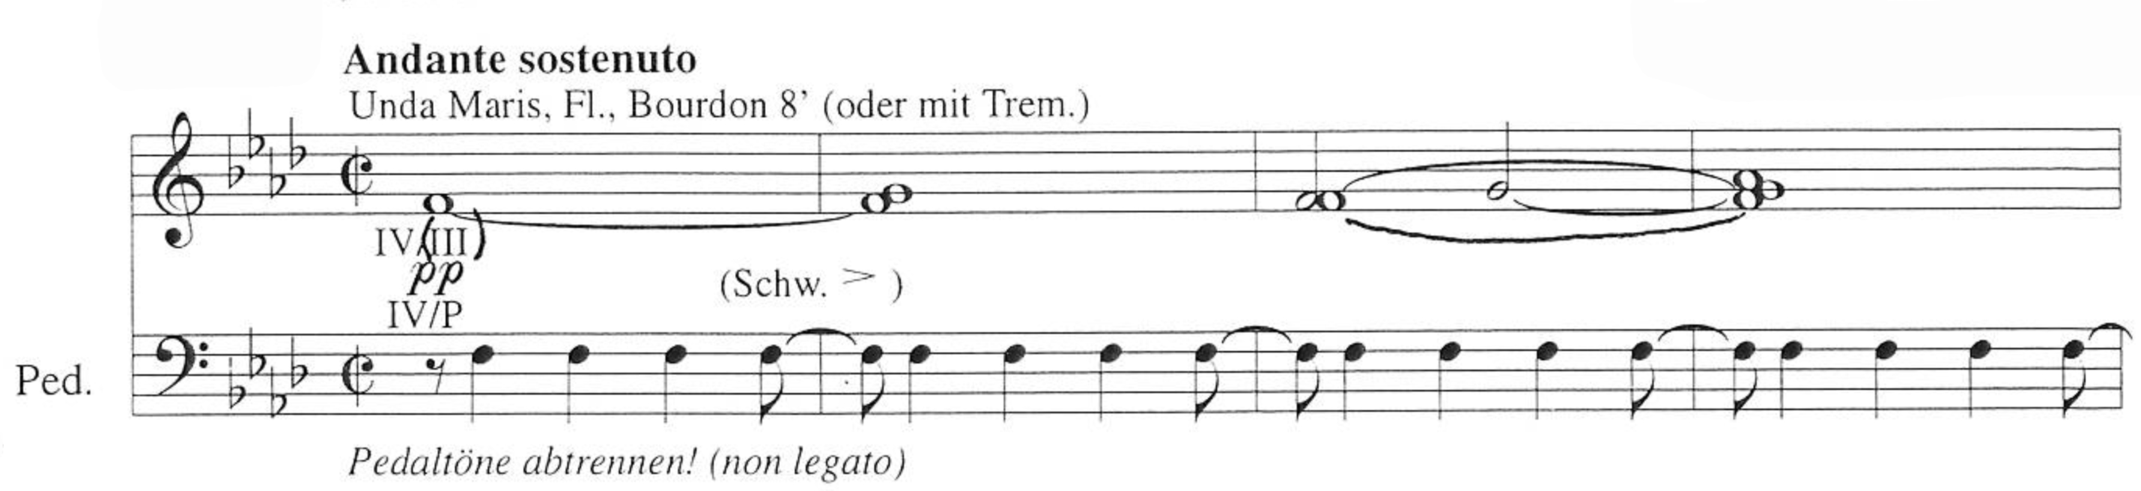
Copyright © 1995 by Eres Edition. All rights reserved.
Via dolorosa begins with manual and pedal F notes alone in the interval of an octave. The gradual addition of stops and cluster notes, either up or down in a wedge and one by one in the order of the scales results in a seamless crescendo. After m. 41 more stops are added approximately every four measures. Practically all clusters in this piece are composed by the consecutive diatonic notes of the F minor natural scale. This particular use of clusters is unique to Via dolorosa in Kalējs’ organ works. Until m. 62 every single cluster originates from the f¹ (middle F) on the manuals, meaning that this note is constantly present in the first half of the piece. Manual changes, couplings, and stop additions are called for at the beginning of the formation of new clusters, right when their first note is played. This slow and progressive crescendo by almost imperceptible degrees gives the piece a growing sense of despair. Range and dynamic expand, ascend, and increase in search for light, a theme often explored by Kalējs in his compositions.
Kalējs would use a similar perpetuum mobile pattern of rhythmic and harmonic motion seven years later through the entirety of his composition In Paradisum (Ex. 20). That piece also wedges dynamically from piano to forte and then pianississimo, but not with the same, development, magnitude, and intensity as Via dolorosa.
Example 20. In Paradisum, mm. 6-10
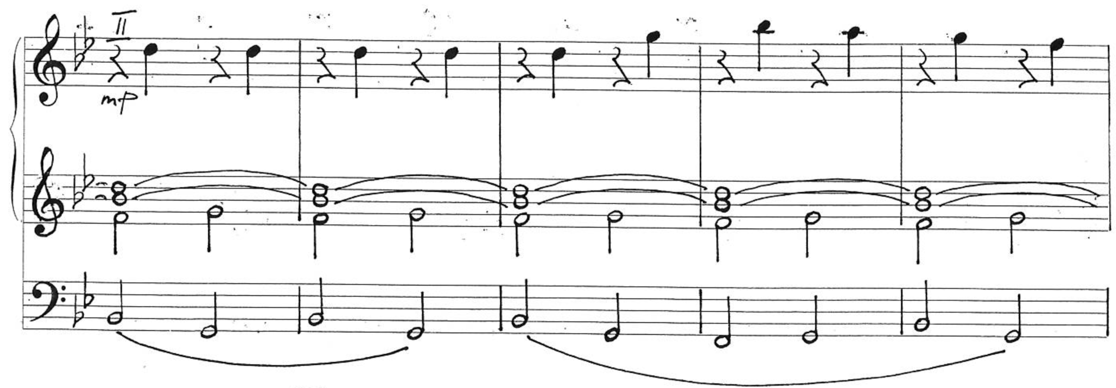
Unpublished score. Used by permission from Aivars Kalējs.
In Via dolorosa the lines expand from a single initial note in parallel or, more often, contrary motion between manuals and pedals, building clusters which follow the scale of F minor natural. Ex. 21 presents an instance where contrary motion happens not only between the manual part and the pedal, but also within the manual part.
Example 21. Via dolorosa, mm. 45-48
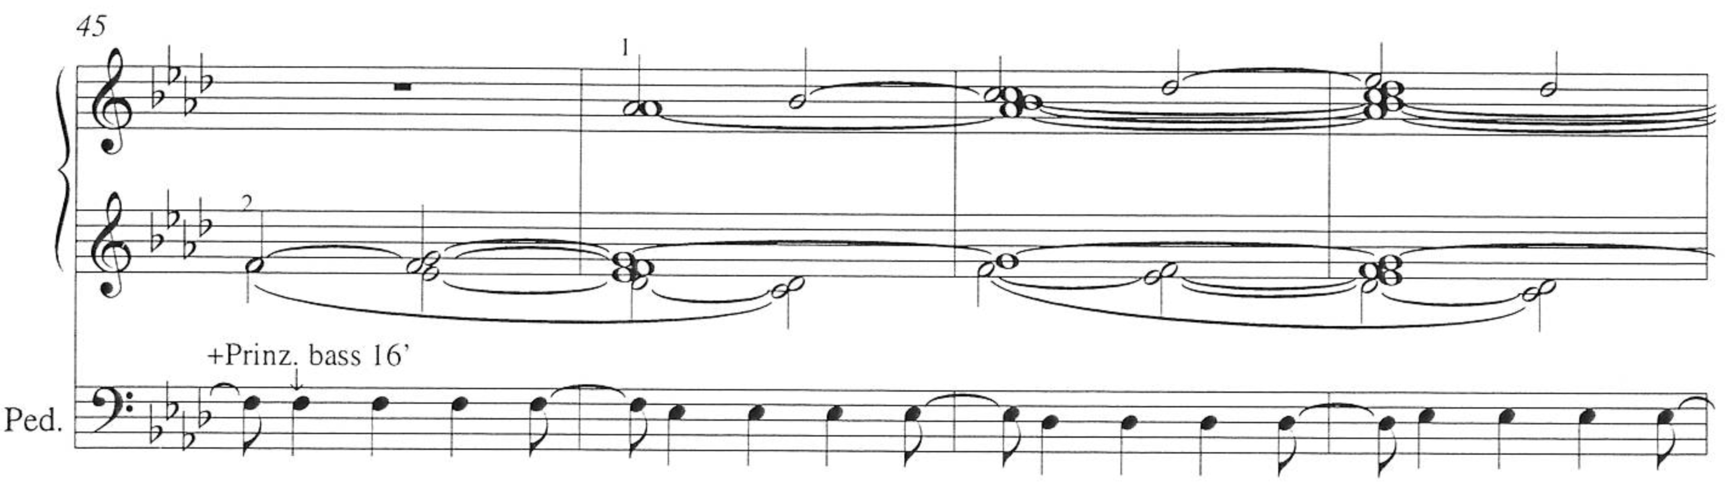
The pedal ostinato outlines complete descending F minor scales where each degree pulses for the duration of four quarter notes at mm. 15-22, mm. 31-38, and mm. 49-56. After that it continues to outline the same descending scale but starting from the E♭ instead of F seven consecutive times, at mm. 57-63, mm. 64-70, mm. 71-77, mm. 79-86, mm. 87-93, mm. 94-100, and mm. 101-106.
Example 22. Via dolorosa, mm. 61-68
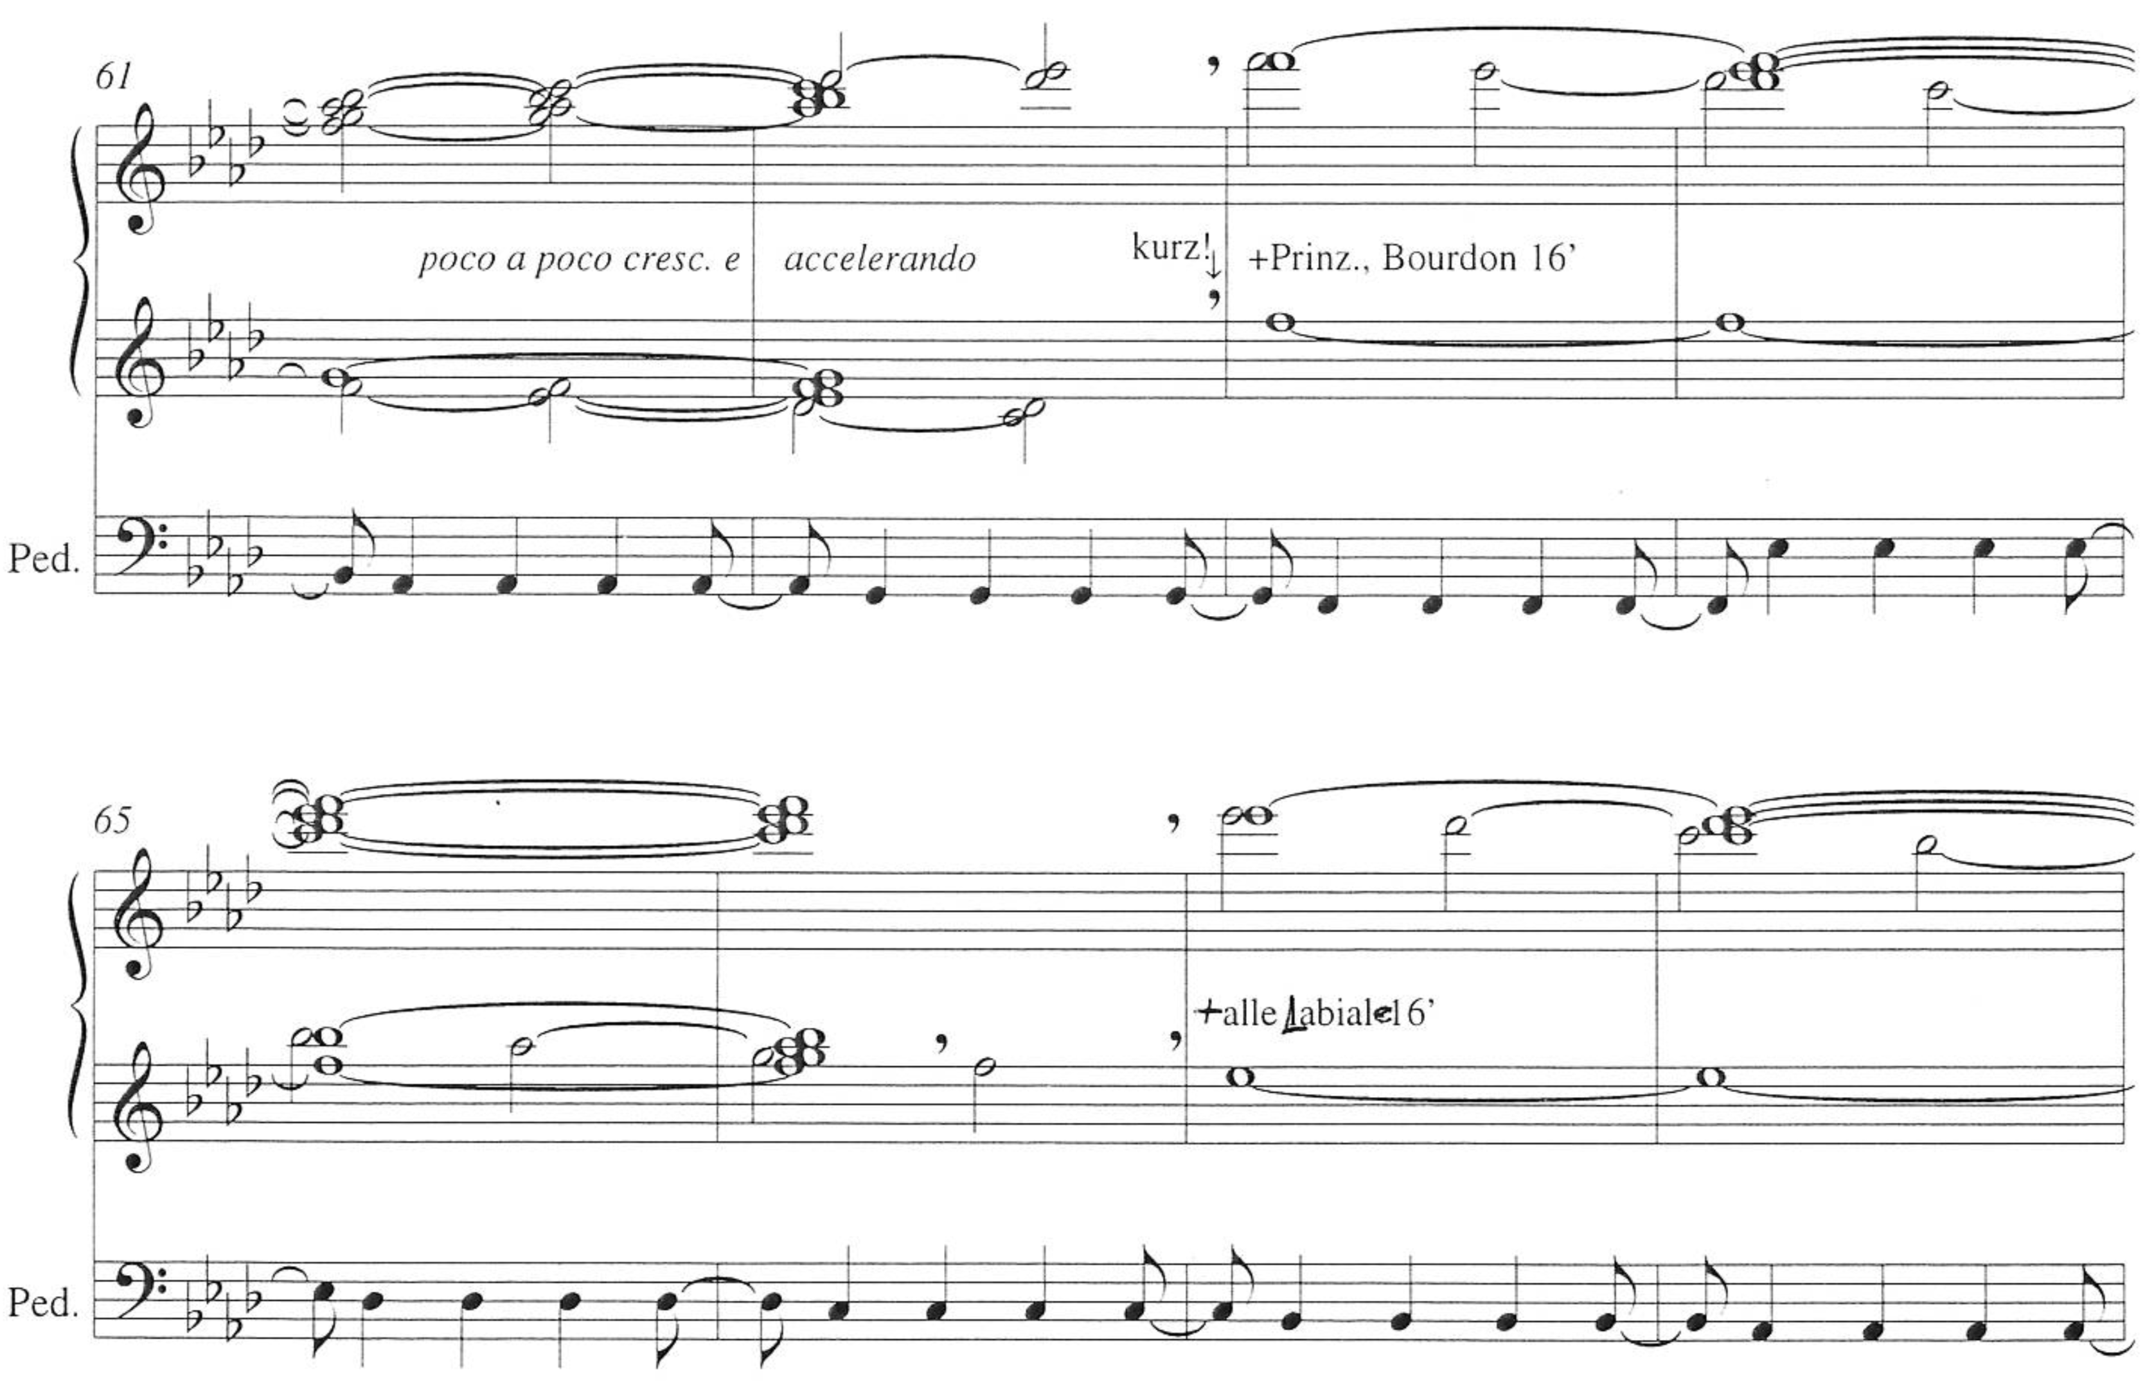
At m. 63 the clusters start forming from the upper octave (Ex. 22) and descending within them from the starting octaves of F (m. 63), E♭ (m. 67), D♭ (m. 71), and skipping to B♭ (m. 75), always within the diatonic notes of the F minor natural scale. The indication of poco a poco crescendo e accelerando from m. 61 is in effect until m. 107.
An almost identical sequence of clusters from mm. 63-78 starting on the same F-E♭-D♭-B♭ octaves takes place at mm. 79-94. The difference is that the left hand does not take part on the formation of the clusters, but rather moves up from the lower manual octave in parallel octaves with the added fifth in contrary motion, respecting the diatonic intervals of the F minor natural scale, against the pedals and the right hand. The pedal line still plays the repeated descending octaves described above. The increase in density caused by the use of more notes and the lower range serves to escalate the overall tension. Stops are added at the beginning of every new cluster formation at m. 63-107. Since m. 63 all cluster formations happen from the top down. In addition to the rhythmic regularity of the hands and especially feet, the effect can remind the listener of heavy footsteps of someone carrying a burden.
This linear crescendo reaches the maximum dynamic of Organo pleno at m. 107, indicated Maestoso, which lasts until m. 126. The difference between these measures and what preceded them is that the movement is not between clusters, but chords, and the pedal line moves in octaves rather than in single notes, as seen on Ex. 23.
Example 23. Via dolorosa, mm. 109-112
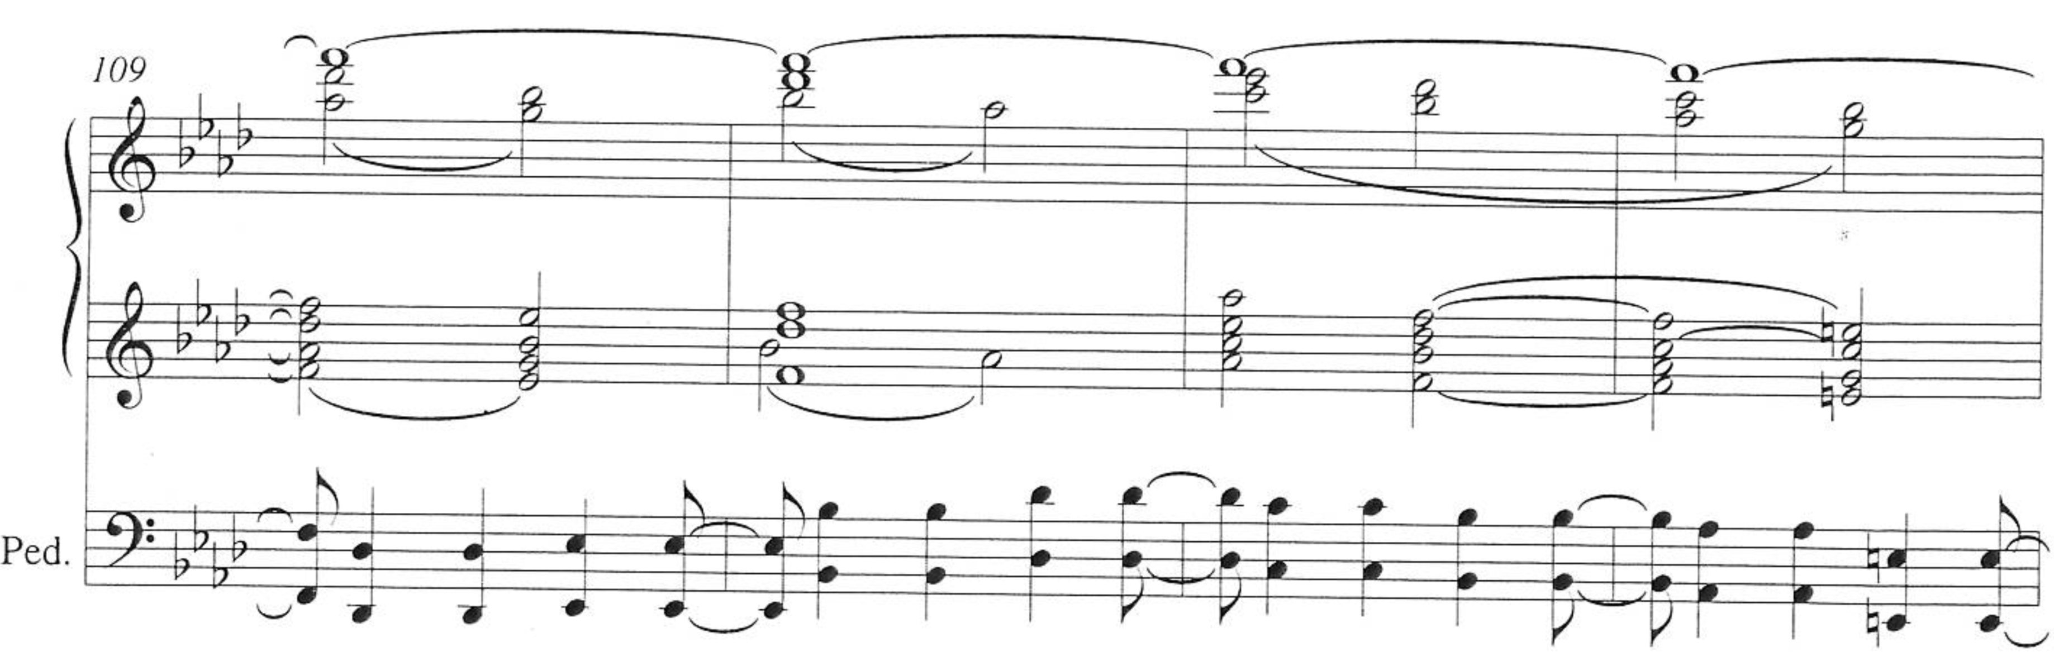
Measure 112 is the first instance of a note not diatonic to the F minor natural scale, E natural, though that note still belongs to the tonality of F minor within the harmonic scale. The measures where the movement is driven by consonant chords (mm. 107-120) contain some resemblance of harmonic functionality, though the chords are still formed based on the diatonically descending notes of the higher register.
At mm. 122-126 the tension is increased to is climax with the adoption of the D octatonic scale (Oct 1,2) after a B minor chord at m. 121 leads to a D minor chord on the downbeat of the next measure. At mm. 122-126 the pedal octaves outline the complete scale moving upwards from D. The ascending gesture that has built up uninterrupted for 126 measures is suddenly discontinued at m. 127 (Ex. 24).
Example 24. Via dolorosa, mm. 125-128
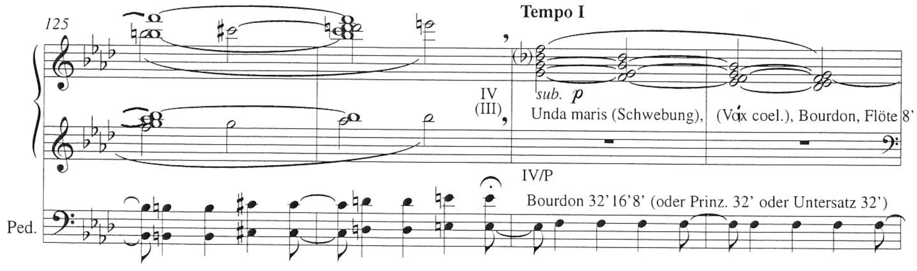
Kalējs described the reasoning behind this development:
It reflects the feeling of maximum, when there is nowhere else to go – when the heart is full, atonement and enlightenment come. At the same time there are limits that a human can resist but if we talk about prisoners of those camps, it can be said that they go far beyond the normal limits of suffering that a human being can tolerate. This was probably possible because they relied in the faith of God, the love of the closest ones, as well as the hope that some day despite everything they would return to Latvia.

The placement of a fermata over the last pedal octave of m. 126 allows for couplers and stops to be quickly withdrawn. The rhythm keeps its pace otherwise uninterrupted, in subito piano, picking up right at the downbeat of m. 127. The key returns to the usual F minor natural scale. The range of the chords is lowered by the extent of an octave. The extreme dissonance of the previous clusters becomes more consonant with the use of tertian chords with sevenths that melt downwards in the shape of diatonic clusters like those in the beginning of the piece. The initial seventh chords are rooted on the notes G (m. 127), F (m. 119), E♭ (m. 131), and D♭ (m. 133), while the pedal pulsates on the note F.
From there, the dynamic and range slowly descend to the lowest and softest sounds of the organ, as seamlessly and smoothly as the crescendo was on the first three-fourths of the piece. Chord notes are lifted one by one, toward lower pitches. The E natural is used in three instances in conjunction with notes from the C major chord (V) or E diminished chord (vii). Those are the last growling dissonances as the piece is dying down. The pulsing notes stop as life succumbs in the end when the heart stops beating. The last measures consist of the diatonic cluster C-D♭-E♭-F with the low pedal C pulsating gradually slower until it disappears, using the softest 16’ and 32’ pipes only. The last four measures are pianissimo and diminuendo through the use of the swell pedal and removal of stops. The fermate in the last measure are placed on the manual cluster and the pedal’s final half rest.
Despite the constancy of its ostinato, Via dolorosa is not a static piece without movement or message. Notwithstanding its depiction of a situation where constraint and suffering were imposed upon others, it also shows how a person suffering displacement and injustice can have elevated thoughts, hope for the future, perhaps forgiveness, strive for spiritual growth, and keep the mind free. As the composer himself said, “you can put borders for your body, physically, to stay somewhere, to not be able to go to the West. There is a border. However, you cannot put borders to your spirit and soul.”
For Kalējs it is important to remember and meditate on the things that have happened, not only the good ones, but also the unfortunate events. This helps put things in perspective, being careful to never allow pride to blind one to the reality of the facts, and most especially to stagnate the potential spiritual development he wishes everyone would strive for. In this light that is very consonant with the Latvian way of reflecting on these events through music and poetry, the listener is also invited to remember the texts of the many dainas that contemplate the sadness resulting from acts against human life but without a thirst for revenge. For Kalējs it is also essential for a composer not to let himself be blinded by fame or success, so that he doesn’t run the risk of halting his own spiritual development by feeling “like a coryphaeus.” Reflecting on current events at the time of the interview, Kalējs added:
If we don’t want to stop our spiritual growth we have to learn humility, which is trait of the spiritual strength. But what we constantly hear in the world and also in Latvia regarding the Centennial Celebration is “be proud!” Well, if we think about those 100 years, for a precise half of them people lived without freedom. Occupation is a strange word, but we have another name for this: “unfree.”

In the end, a musical composition may be a source of inspiration, inner development, or merely something to ponder about for those who seek it. The listener might perhaps be enriched by the experience finding meaning in ways that even the composer had not considered:
…as I mentioned before, the deportees even heard the sound of a train in the bass. I never imagined it myself but that sound is present during all the composition. It was not my intention but I wrote this music with all my heart, and every person can hear something different in it. I myself cannot always predict what is inside the music until the moment when someone tells me their feelings or when I intuitively connect it with memories or ongoing situations. It lies within the music.

Solitudinem faciunt
Aivars Kalējs finished writing Solitudinem faciunt in the spring of 2016 and it has not yet been published. The Latin word solitudinis means “loneliness, solitariness; desert, waste, emptiness, solitude.” Solitudinem faciunt could be translated as “Causing solitude.” In the manuscript Kalējs wrote a Latvian translation of this expression as a subtitle: viņi atstāj aiz sevis tuksnesi (“they leave behind the desert”).
The expression originated from a passage in the book Agricola by the Roman historian Tacitus. At the end of chapter thirty, Tacitus quoted a speech in which the Caledonian chieftain Calgacus described his enemies, the Romans, in the following manner:
These plunderers of the world, after exhausting the land by their devastations, are rifling the ocean: stimulated by avarice, if their enemy be rich; by ambition, if poor; unsatiated by the East and by the West: the only people who behold wealth and indigence with equal avidity. To ravage, to slaughter, to usurp under false titles, they call empire; and where they make a desert, they call it peace.

On May 18, 2016, Vita Kalnciema premièred the piece at the Rīga Dom Cathedral and also recorded it that same summer in CD format for internal distribution at the Jāzeps Vītols Music Academy in Rīga. Throughout the following year, the composer also performed this piece himself in Rīga, Paris, Helsinki, and in his tour of Russia. This composition has equal magnitude to the other two and it is a good example of the composer’s current mindset. It was dedicated to the fifty-four fatal victims of the Zolitūde shopping center roof collapse in Rīga on November 21, 2013. That was the worst disaster in Latvian history since the sinking of the ship Mayakovsky in 1950.
However, the story behind Solitudinem faciunt goes further back than just this tragedy. It also results from thoughts that had been present in the mind of the composer beforehand. Kalējs also “dedicated it to the terrorist attacks in Brussels and Paris.” His own daughter and grandson lived near one of the attack sites, which explains why they would inspire many thoughts on the part of the composer, as well as the creation of other compositions:
If we don’t talk about organ, but [music] with the organ, for me the Songs of Innocence are also very touching. One of my colleagues, a composer, kindly and without any envy asked me how I was able to write something like that, with such a question: ‘Well, how? Something so pure.’ Well, yes, it is not a typical contemporary music. I wrote it with a special catharsis because my oldest daughter and grandson were living there and could possibly die. When I wrote this composition there were two terror attacks – in Bataclan, Paris, and in the airport of Brussels – which came into the music. There is another recent piece regarding the terror attack in Manchester that truly touched me. Only eight years old Saffie Rose passed away among others and I devoted this music to her – Sičiljāna, for alto saxophone and organ.

When asked about the “solitude” in question in Solitudinem faciunt and who “leaves behind the desert,” Kalējs answered:
These are people, not only terrorists, who do not have the idea of bringing joy, supporting, and doing good for others. Terrorists seek revenge, to destroy and not to give anything good to humanity. In the wider sense, we can find whole groups of people who only run after money; they are egoistic people who live only for their own comfort and sometimes even at the expense of others. It is the contrary of my life motto, which encourages doing as much as possible for the people and my neighborhood. The end of this composition talks about the only solution: we don’t have to be influenced by these ideas and actions of those people and we don’t have to scathe others. My answer in the last part of this music is the unconditional love. Love is the only answer. Hiding and not doing anything is not the answer. I don’t have any idea about guns as my only gun is the sound of music and brotherly love.

Of the three pieces studied, Solitudinem faciunt is the closest to the harmonic language of the common practice period, though it still makes use of dissonant or tertian chords of ambiguous functional classification. It revolves for the most part around G minor. Because it develops itself over the same melody, this piece may be described as a fantasia over that theme. Like Per aspera ad astra, Solitudinem faciunt is made up of several sections with frequent changes in key, stops, and manuals. Some variations make use of hemiolas, fugal treatment (trio texture), and dense chords, especially from m. 214 to the end of the piece (m. 273), including the use of double pedal in the last three measures.
Table 2. Solitudinem faciunt: section outline
Section | Measure numbers | Segment indication | Description | Pitch center/  key area
A | 1-8 | Sostenuto ♩. = 60 | Block chords under g¹ and melody on the inner voice | G minor
 | 8-20 | Allegro ♩. = 108 | Melody over chords | G minor
 | 21-28 | ♩ = 180 | Melody with implied pedal point over chords | G minor
 | 29-41 | ♩ = 60 | Block chords | G minor
 | 42-54 | ♩ = 136 | Melody over pulsing pedal point with hemiola | G minor
 | 55-58 | ♩ = 72 | Block chords | G minor
 | 59-65 | Sostenuto ♩ = 60 | Melody under chords | G minor to  D minor
 | 66-74 | ♩ = 136 | Melody and chords over pulsing pedal point with hemiola | D minor to  G minor
B | 75-97 | Vivace ♩. = 112 | Fugal material | G minor to  D minor
 | 97-111 |  | Trio texture | D minor to  D♭ major
 | 112-131 | Meno mosso | Melody over cords | Modulating
 | 131-133 |  | Recitative | A minor
C | 134-182 |  | Melody over pulsing (left hand) and sustained (pedal) pedal points | A minor to  C minor to  G minor
D | 183-204 |  | Two-part melodies over pulsing pedal point | G minor and modulating
 | 205-213 | Meno mosso | Melody over pulsing (man.) and sustained pedal points | C# minor to  D# minor
 | 214-220 | Sostenuto pesante | Block chords | D# minor to  F# major
E | 221-241 |  | Melody over chords, then block chords | F# major to  D minor
 | 242-273 |  | Block chords on manuals only, then over pedal point, melody or double pedal | D Aeolian major scale (024578T)
Of the three pieces studied, this is the only one that ends not in pianississimo and in a minor key or cluster, but in a triumphant Organo pleno fortissimo. Figure 2 shows the dynamic outline of Solitudinem faciunt. The changes in dynamic happen faster than those in Per aspera ad astra. Throughout this piece, it is usually clear what the tonal center is, though the modes may vary.
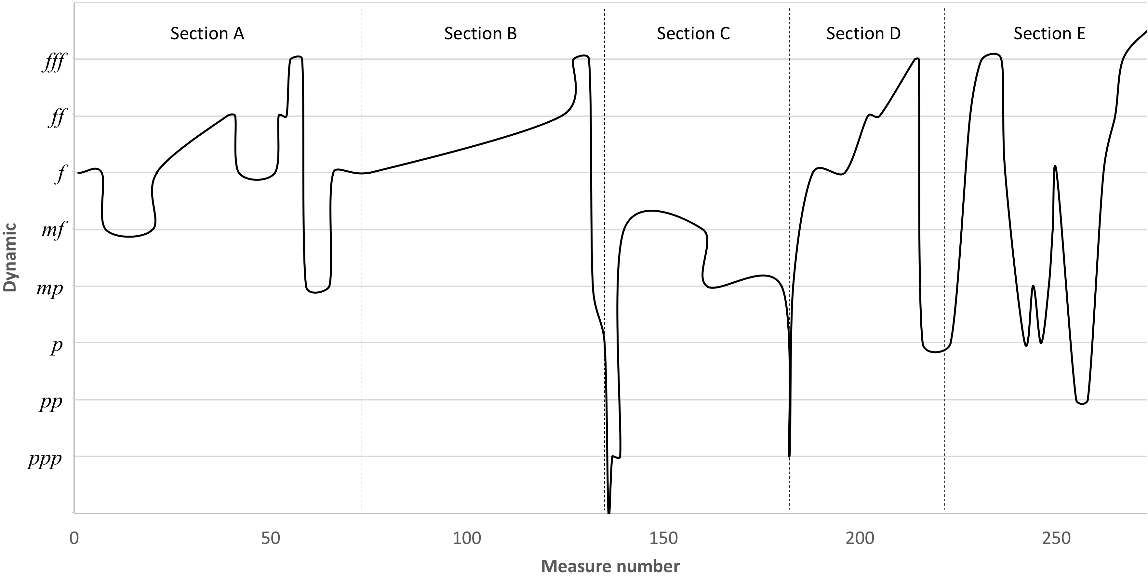
Figure 2. Solitudinem faciunt: dynamic outline
Solitudinem faciunt begins with eight introductory measures that preambulate the theme to be developed throughout the piece. One of the key features of the initial phase of its development is the fixation on g¹, as seen on Ex. 25. This note is struck and held thirteen times in a row at mm. 1-8, sounding continuously over the chords underneath, which are interrupted by rests three times after brief apparitions before the phrase can reach a longer and conclusive statement on the pickup to m. 5. The harmony on the downbeat of m. 5 is a C major chord (IV). This chord appears multiple times during the piece, and in conjunction with the tonality of G minor (i), it gives it a modal flair by hinting at a mix of the Dorian mode with the melodic minor scale.
Example 25. Solitudinem faciunt, mm. 1-4
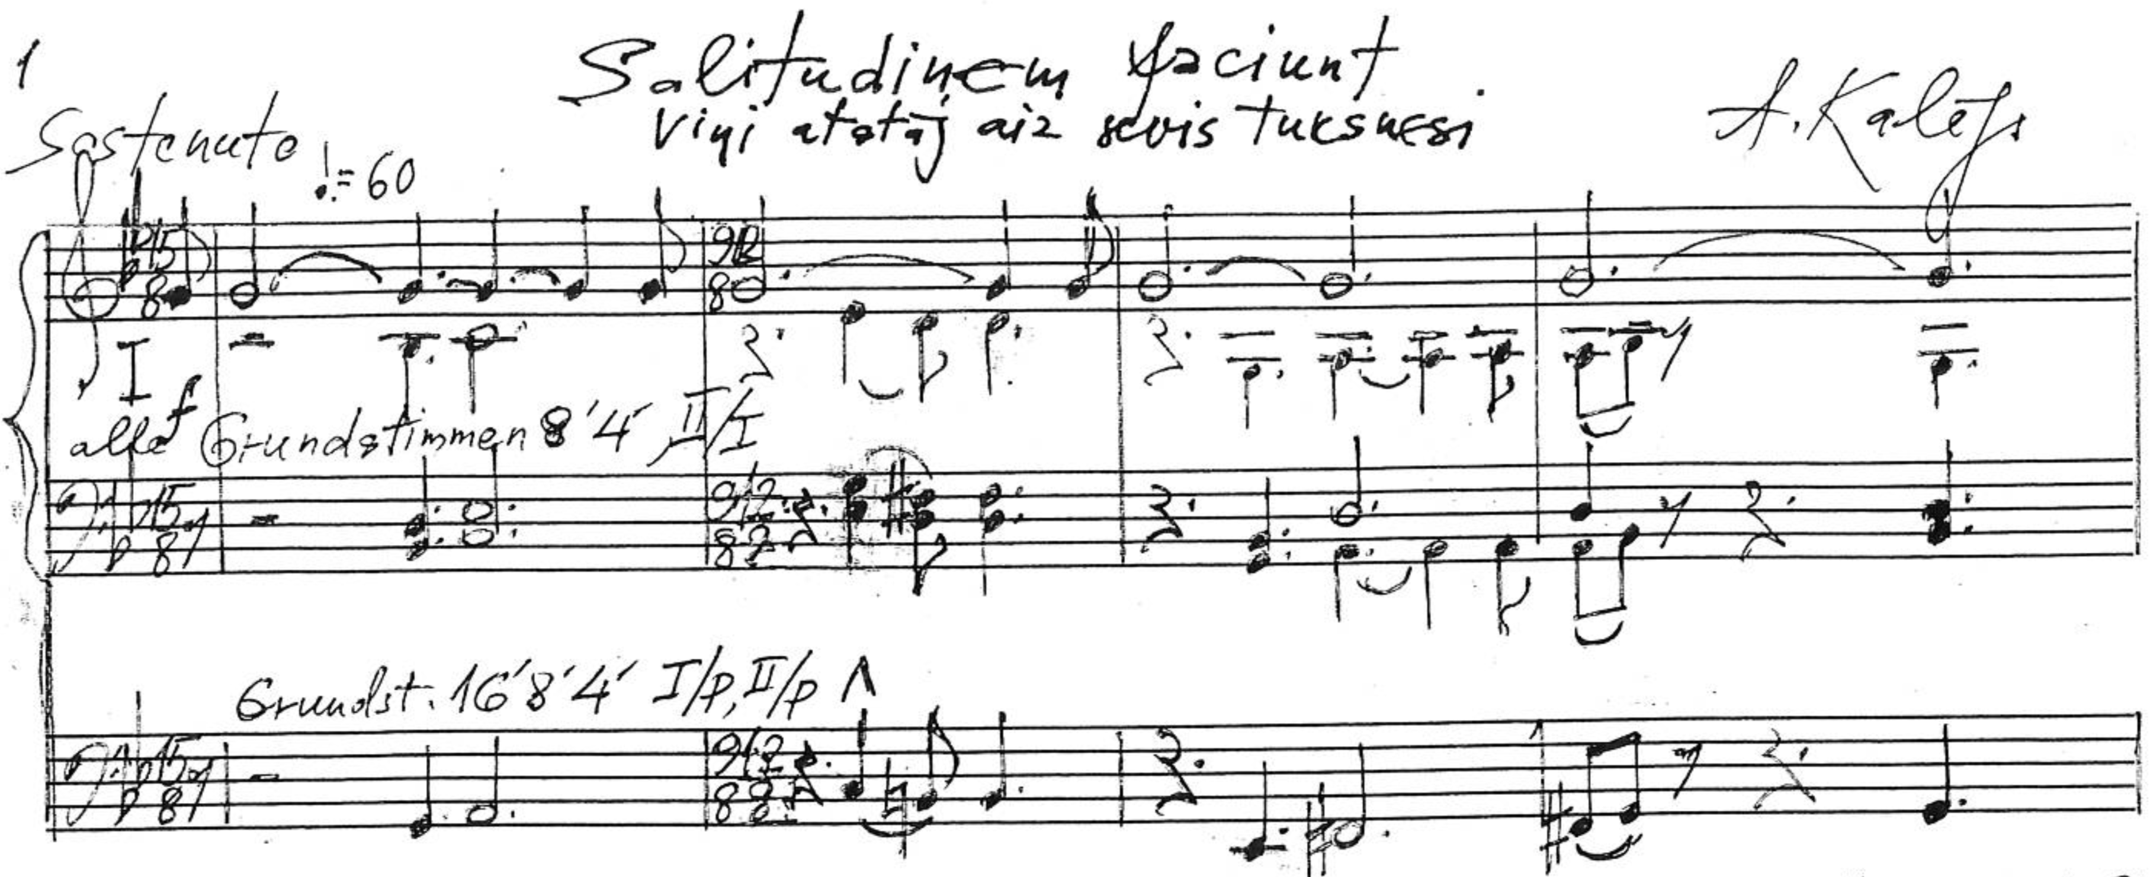
Unpublished score. Used by permission from Aivars Kalējs.
The tempo indication is Sostenuto and the registration is all foundation stops 8’ and 4’ of manuals I and II, all pedal foundations 16’, 8’, and 4’, and manual and pedal couplings. As in Per aspera ad astra and indeed in many of Kalējs’ other organ compositions, the meter in Solitudinem faciunt changes frequently between m. 1-68, at almost every measure, the longest stretch without a meter change being mm. 21-28.
The frequent use of the leading tone in lieu of the subtonic contrasts with its absence from Per aspera ad astra or Via dolorosa, but it is in line with the harmonic language of the aforementioned pieces that Kalējs has worked on more recently, namely the Sičiljāna in 2017 and the Songs of Innocence for publication in 2016 – the latter of which might be one of the most traditional pieces he has written to this day in harmonic terms.
Example 26. Solitudinem faciunt, mm. 13-21
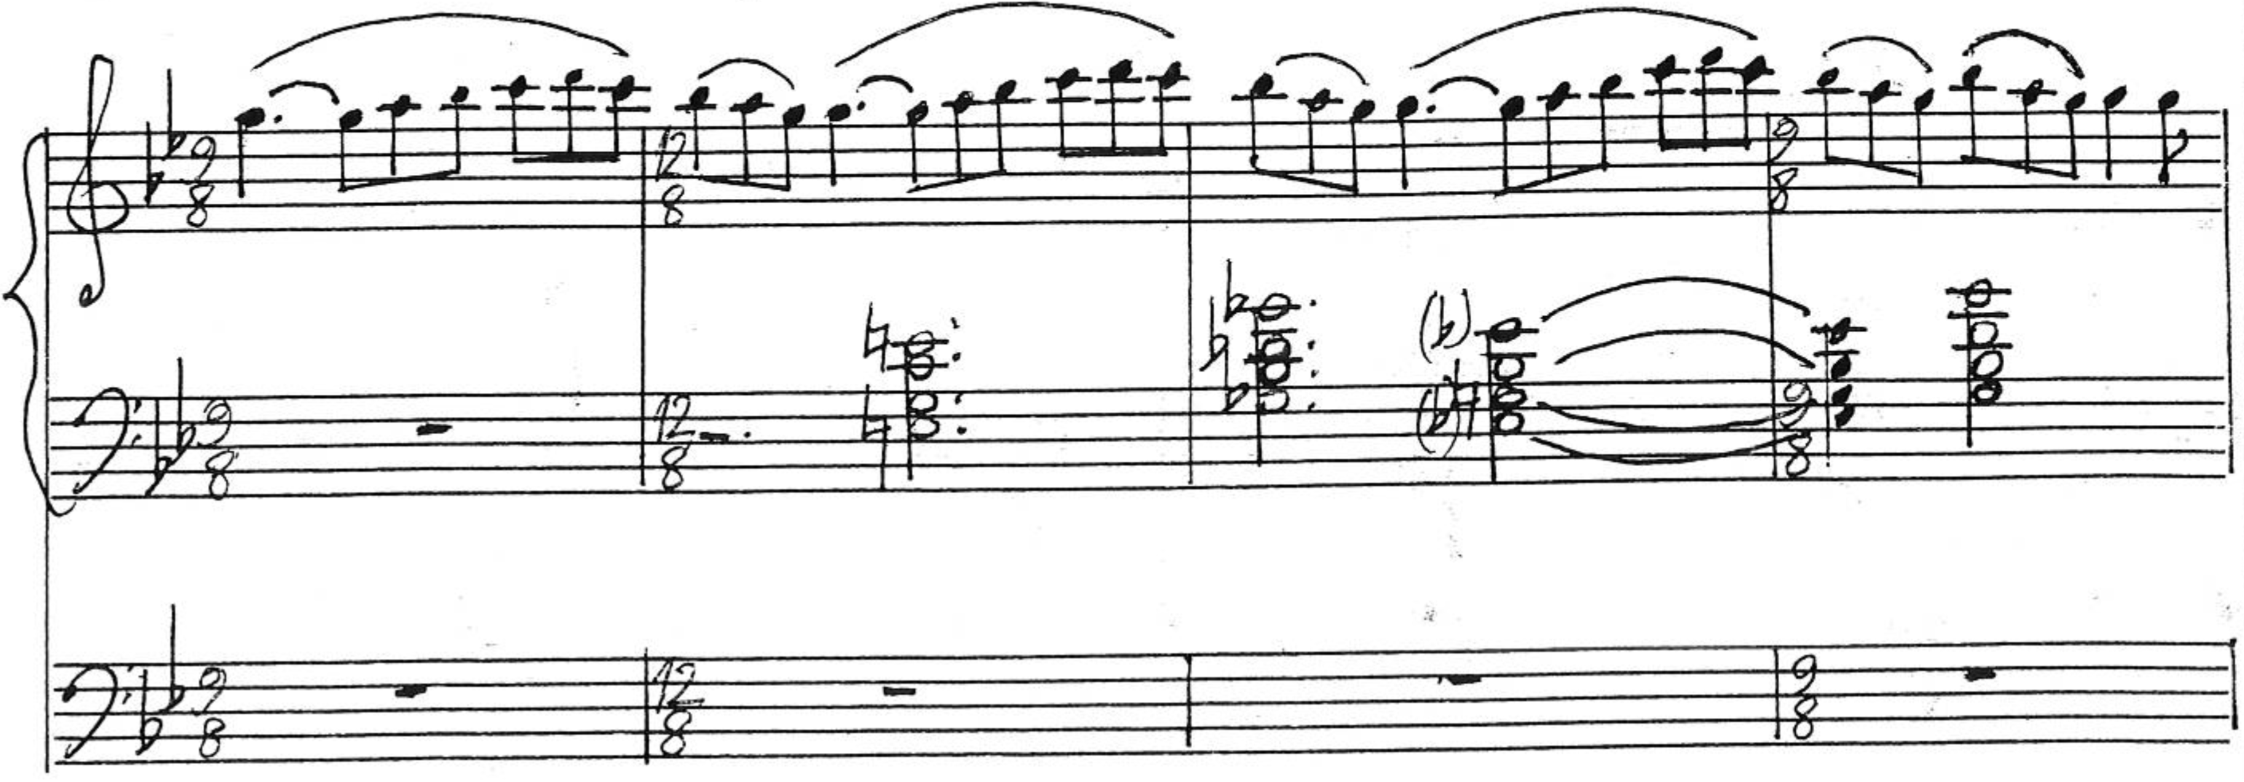
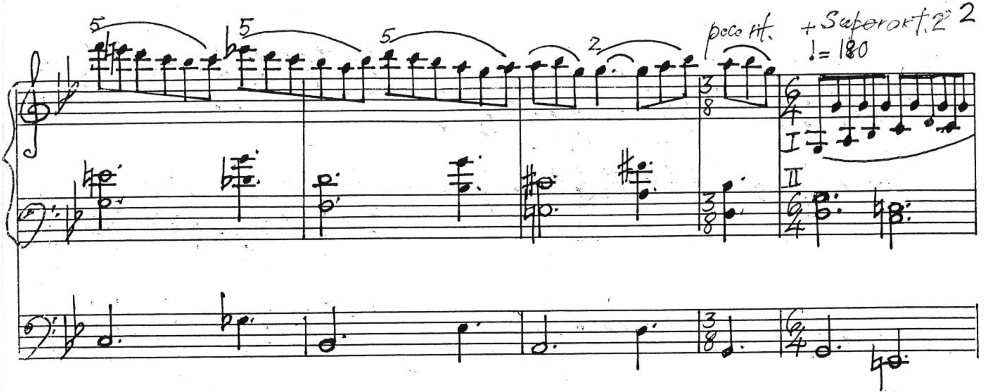
Marked Allegro, the following segment (mm. 8-20) features the melodic fragment G-A-B♭-C-D seen at m. 13 (Ex. 26) five times prior to that, at the start of every measure at mm. 8-12 however interrupted by rests. Having in mind the thoughts that might have inspired the composer, especially considering the aforementioned events he had in mind when writing most of this composition, the apparent hesitations at the beginning of the piece could perhaps be interpreted as symbolizing the anticipation before something sinister occurs. The chords underneath, Gm-C-G♭-E♭-B♭-D-Gm, show that some functionality can be observed in this piece as in the authentic cadence of mm. 11-12 (V/V – V – i). However they also demonstrate that other tertian chords unrelated to the the key or to each other might be used in parallel motion, even clashing with the melody played above.
The theme played by the right hand at mm. 13-22 (Ex. 26), though never stated in a fully decisive manner and never in the same way twice, is the backbone from which most melodic and rhythmic ideas in Solitudinem faciunt are developed. Its high points are on the notes F, E, E♭, and D at mm. 17-18, which will also be apparent at mm. 25-26, 37-38, 40-41, 44-45, 49, 54, 57-58, etc., most explicitly on the fugue subject of mm. 75-79. One of the fundamental features of the melodic line throughout the piece is its generally conjunct motion. Another key characteristic of Solitudinem faciunt is that, unlike Per aspera ad astra or Via dolorosa, silence interrupts the musical activity several times, especially at the beginning but notably including an entire silent measure on section C (m. 136). These interruptions are a reference to the sudden termination of life which mark the events for which Solitudinem faciunt was dedicated.
The same Gm-C-G♭-E♭-B♭-D-Gm sequence of mm. 8-12 occurs again at mm. 13-20. On the next segment (mm. 21-28) the metronome marker increases from ♩. = 108 to ♩ = 180 and the underlying harmonies are expanded to Gm-C-G♭-E♭-A-Adim-G-Gm-C-F-B♭-E♭-A-D-Gm, or i – IV – I♭ – III – V/V – iiº – I – i – V/VII – V/III – III – VI – V/V – V – i. Those chords often dissonate with the melody on the right hand, this time consisting of the same melody from mm. 15-20, but with an implied pedal point on g¹ (middle G), as can be glimpsed above at m. 21 of Ex. 26.
The segment of mm. 29-41 returns to the initial tempo indication, Sostenuto, and the same block chord style of the opening measures (Ex. 27). The melodic aspect of the chords is doubled or nearly so between the right and left hand, as was also the case at mm. 1-4, as these chords move parallelly underneath (mm. 29-34) or encompassing (mm. 35-38) the once again briefly omnipresent middle G. In a similar way that the same F was ubiquitous on the first 62 measures of Via dolorosa, Solitudinem faciunt revolves around the note G, though in various ranges and not so contiguously, for the better part of its first sixty measures.
Example 27. Solitudinem faciunt, mm. 31-37
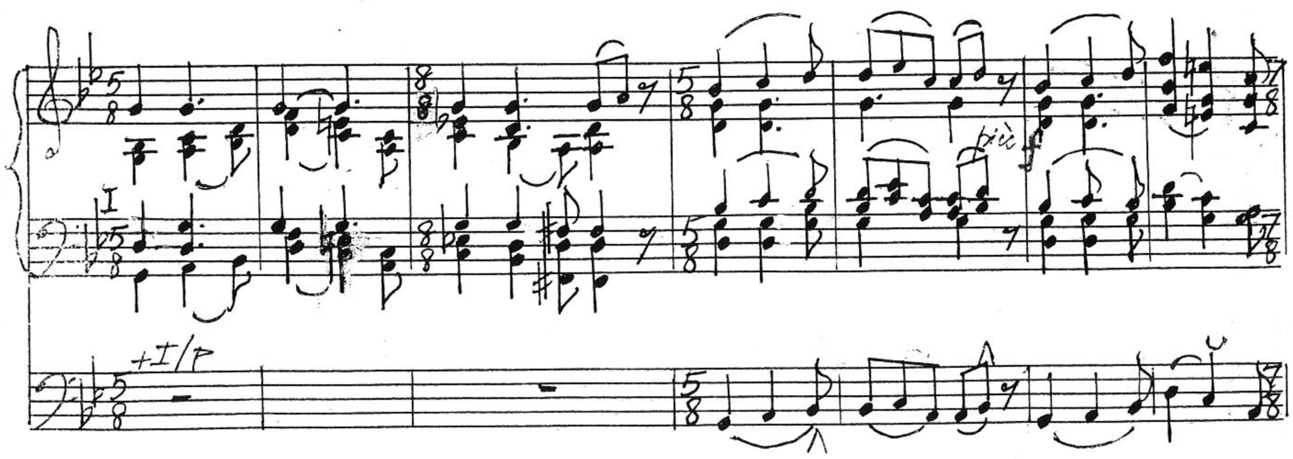
The pedal line at mm. 34-41 is consistently locked with the highest note of every chord at the interval of a third and all parts of every chord are in perfect parallel motion. This may remind the reader of the frequent use of parallel thirds and sixths in Per aspera ad astra (Exs. 1, 3, 4). The use of such intervals will be prominent in the coming measures of this piece. While all segments prior to mm. 29-41 ended with a G minor chord, m. 41 leaves off with a hybrid of the D major on the first inversion (V) and F# diminished (viiº) chords. Stops and couplers are gradually added until a fortissimo is reached at m. 38, diminishing slightly to a forte on the downbeat of m. 42. A new idea begins on that measure which will again return at m. 183: a pulsing pedal point superimposed by a transformed version of the theme. The tempo more than doubles, from the previous ♩ = 60 to ♩ = 136.
Example 28. Solitudinem faciunt, mm. 45-48
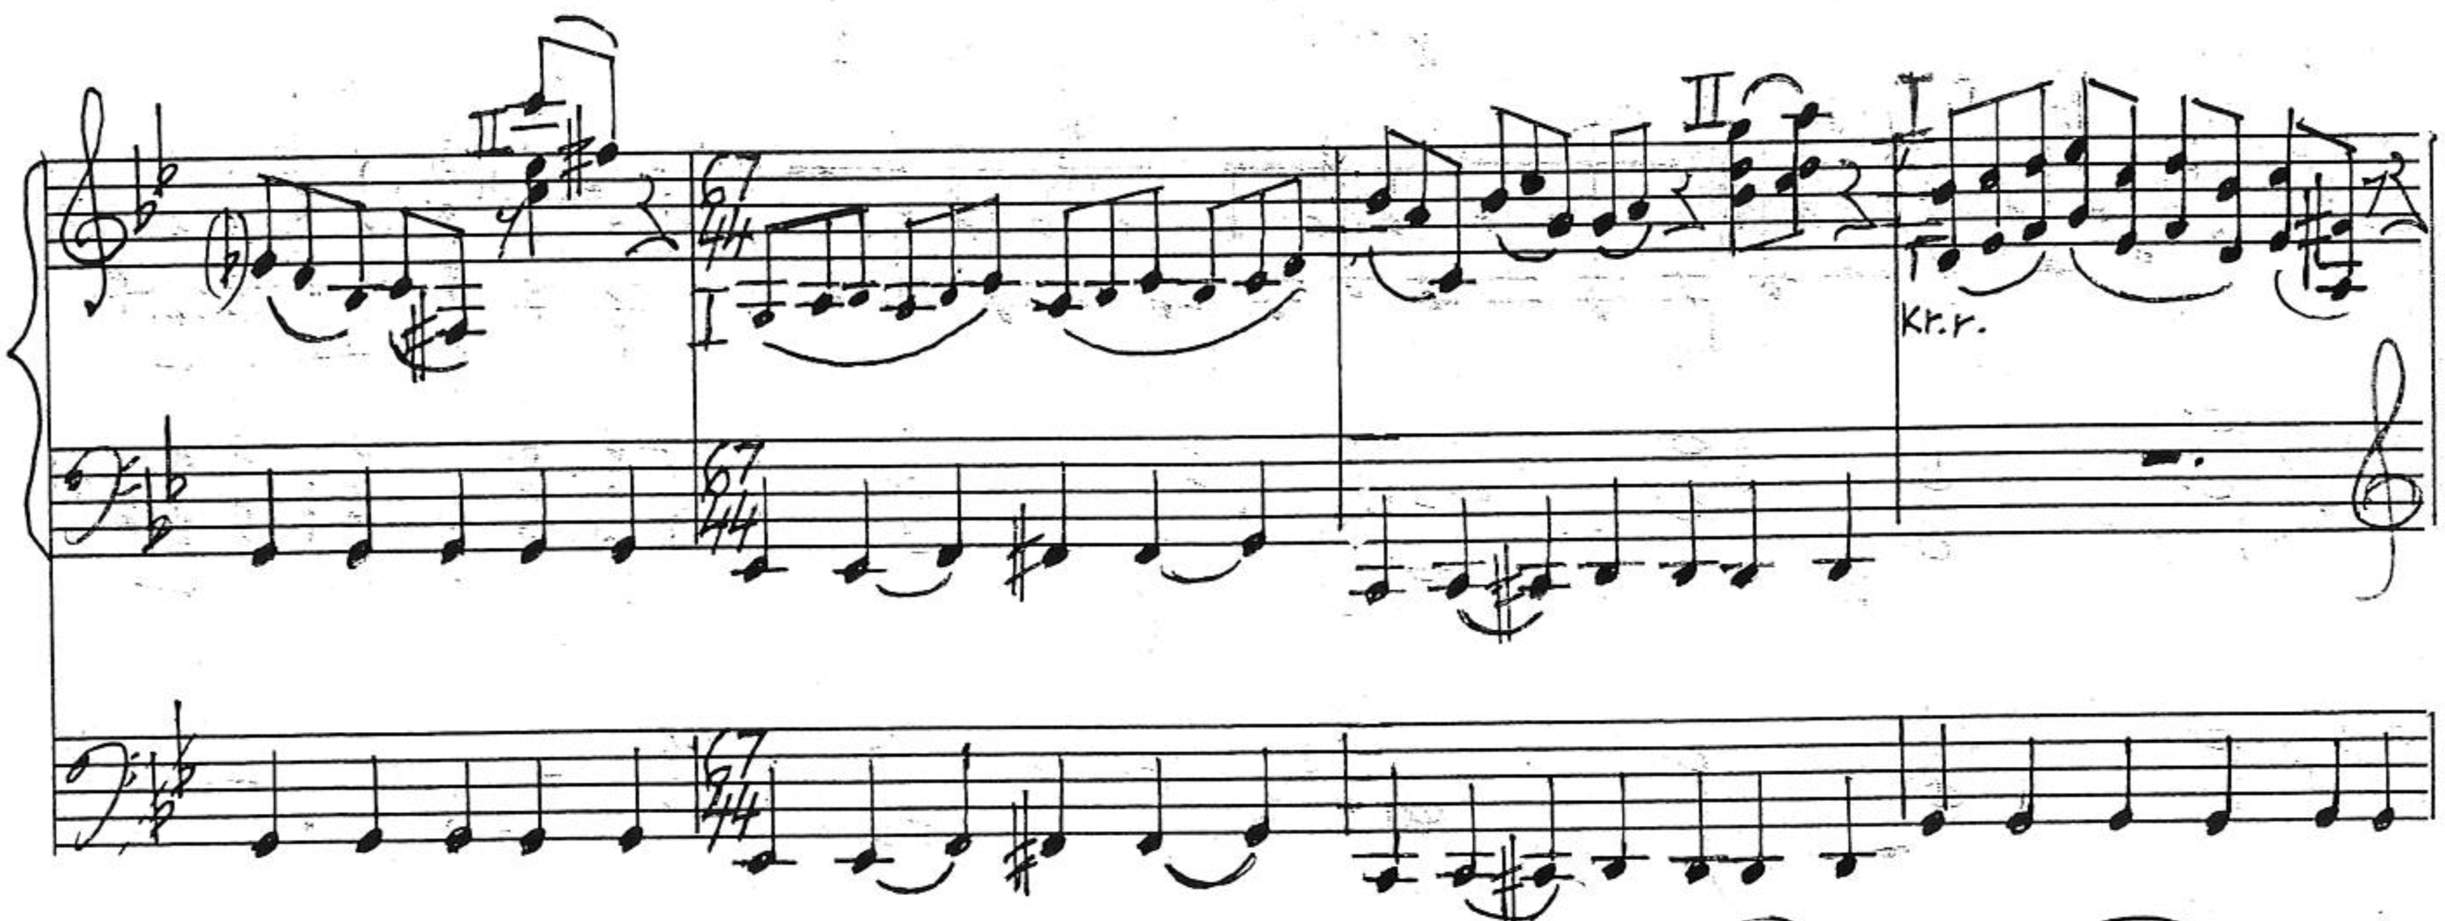
The melody appears with hemiolas initially as snippets on Manual I that alternate quickly with echoes on Manual II, as seen above at m. 45 (Ex. 28). At m. 46 it becomes more sinuous, but still interrupted by rests and echo chords at intervals of one to three measures. The hemiola between the part varies between the actual 6/4, 7/4 or 5/4 on the pedal against subdivisions that behave like 12/8 or more complex subdivisions usually in groups of three eighth-notes on the manuals. The left hand drops the pedal point and joins the right hand on playing the melody at m. 48 (kr. r. on Ex. 28 stands for kreisā roka, left hand). At mm. 48-54 the melody progresses with the interval of a sixth, with the added parallel interval of a lower third on the left hand at mm. 52-54.
The segment of mm. 42-54 ends with an eighth-note D major chord with the pedal line striking another quarter-note D alone, followed by a quarter note rest. This is yet another interruption of the melodic flow. At mm. 55-58 the tempo halts again to ♩ = 72, the dynamic has increased to Organo pleno fortississimo, and the denser texture of the block chord format of mm. 29-41 returns. At mm. 55-56 the G that is commonly struck during this type of segment is played by both hands as the middle voice of their three-note octave chords as well as by the pedal.
At m. 58 (Ex. 29) it seems as if two chord progressions happen simultaneously, but to the same effect: Cm-Gm-D (iv – I – V) if focusing mostly on the right hand or F7-B♭-F#dim (V/III – III – viiº) if also taking into consideration the pedals and left hand. A quarter note rest with a fermata follows this ambiguous chord progression, which gives the registrant or performer enough time to realize the great number of stop changes required before the next segment.
Example 29. Solitudinem faciunt, mm. 57-61
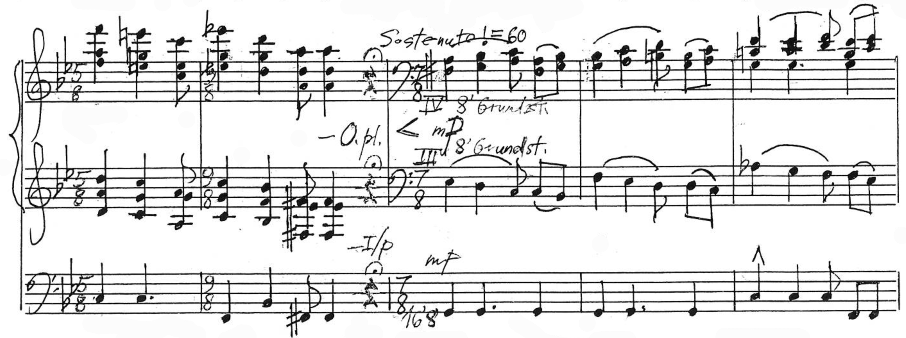
The dynamic diminishes considerably into m. 59, back down to foundations 8’ on the manuals and 16’ and 8’ on the pedals. The tempo is once again Sostenuto. The left hand plays a solo on the tenor range at mm. 59-63 and then both hands go up to Manual IV. This segment, mm. 59-65, is another return of the block chord style of mm. 1-8, 29-41, and 55-58, in its quietest form so far, as this is the first time in the piece that the dynamic diminishes to a mezzo-piano. However, despite the diminuendo and apparent lull, there is no quietude in this segment. At the end of every measure, after dissonances and harmonic ambiguity, there seems to be a longing for a change or resolution, none of which really come until the authentic cadence into the downbeat of m. 66 in the new key of D. This is the first departure from the key of G minor.
Tempo has changed drastically throughout various short and contrasting segments thus far, but after the return to ♩ = 136 at m. 66, it will remain consistently lively for at least the same number of measures, until the gradual deceleration of mm. 112-131. From m.75 onwards the segments become longer and the sections more unified, meaning that the piece develops in greater gestures. Part of the reason for this could be that the first 65 measures of Solitudinem faciunt were written between November 20 and 30, 2013, while from m. 66 onwards, the writing took place from March 7, 2016 until the end of April. This information is available at two places in the manuscript: the list of dates and pages written on them below the last measure (m. 273, p. 17), and the pencil marking “7.III.16” at m. 66.
When talking about his compositional process, Kalējs revealed that for years it has not been uncommon for him to sketch ideas or start compositions, and if a clear continuation is not obvious, to leave them to rest while ideas mature until the time is right:
From the very beginning, I always wrote the music the way I heard it without too much effort, even though catharsis was always necessary. Nothing should be composed or performed unenthusiastically. It has to be done keenly, with a spark; then there is a hope that the music will reach the audience. Sometimes I am lazy and end up with more drafts and themes than I can possibly finish; in the end, there is a solid stack of them. Regarding some small music pieces, I sometimes write the theme in order to not forget the melody and somehow finish it all at the end. It might happen with some small music works. But if the music comes in bigger form and if I do not see a clear continuation, I leave the piece for some time. Sometimes even for years. This also applies for performing the pieces I have already written. Some are not important for me to play with hot feet. My record is the piece Via Crucis (Krusta ceļš), which stayed without playing for 15 years until the year when my birthday coincided with Good Friday and that seemed as a good day to play it. Of course it is different with the commissioned works, which I have more lately from musicians, so I cannot afford them to lay them to rest quietly; what was promised must be fulfilled.

Kalējs found inspiration and a reason to revisit the ideas that would become Solitudinem faciunt after the tragic events in Rīga, Paris, and Brussels – a tune that resonated with the spirit of the time in Europe. Besides the length of segments, another difference between the 2013 portion of section A and the rest of the piece is that instead of maintaining the confinement to the key of G minor, from that point onwards there is modulation to other keys, including the eventual use of octatonic modes.
The segment of mm. 66-74 is a return of the pulsating pedal point under hemiolas seen at mm. 42-54. It starts on D minor and moves across tonicizations in F minor, C# minor, C major, E♭ major, and returns to G minor. That happens mostly through diminished chords with a few added notes and passing chords, but the summary of mm. 66-74 is: Edim-Fm-Edim-G#m-C#m-F#dim-Fdim-C-A♭dim-E♭-Gm-D/F#dim-G-C-Fm-G♭dim-G. The changes in tonality add new flavors to the development of the piece and are a precursor for what is to come.
Section B (mm. 75-133) starts with a three-voice fugue. Other organ works of large scale by Kalējs also contain fugal sections, such as the Doriskās variācijas, where the eighteenth variation is a four-voice fugue. Excluding the pickup note of the subject, the opening measures of this variation are shown on Ex. 30. Several other of his compositions contain polyphonic imitations such as canons, as was the case in Per aspera ad astra’s mm. 227-237 (Ex. 18).
Example 30. Doriskās variācijas, mm. 359-367 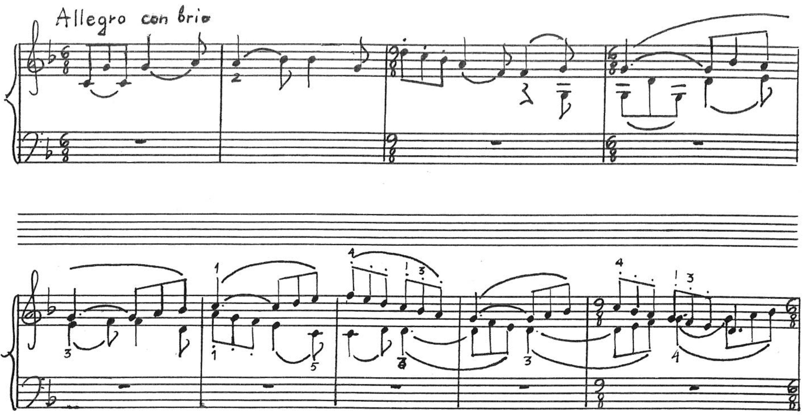
Unpublished score. Used by permission from Aivars Kalējs.
If Solitudinem faciunt narrates a story or paints an image for the listener, the tension increase with the segments of pulsing pedal points, heavy use of diminished chords, and finally the arrival of a fugal section, could be conceived as a representation of chaos. It is easy to associate a fugue with the act of trying to escape, as even the etymology of the name of this form implies. The word fuga in the original Latin means flight, escape, avoidance, and exile. The intertwined melodies of this kind of polyphony could very well represent the disorientation of people in face of a tragedy as it happens, like the collapse of the supermarket’s roof or an ongoing terrorist attack. Those are manifestations of evil and destruction caused either by the negligence of engineers or by cold blooded attackers inspired by a destructive ideology. They create the metaphorical desert, ultimately leaving behind nothing but desolation. Tension would arise from the perspective of the victims expecting the unknown, a potential other collapse, blast, or bullet, while struggling in panic to evacuate the danger zone.
Example 31. Solitudinem faciunt, mm. 74-81
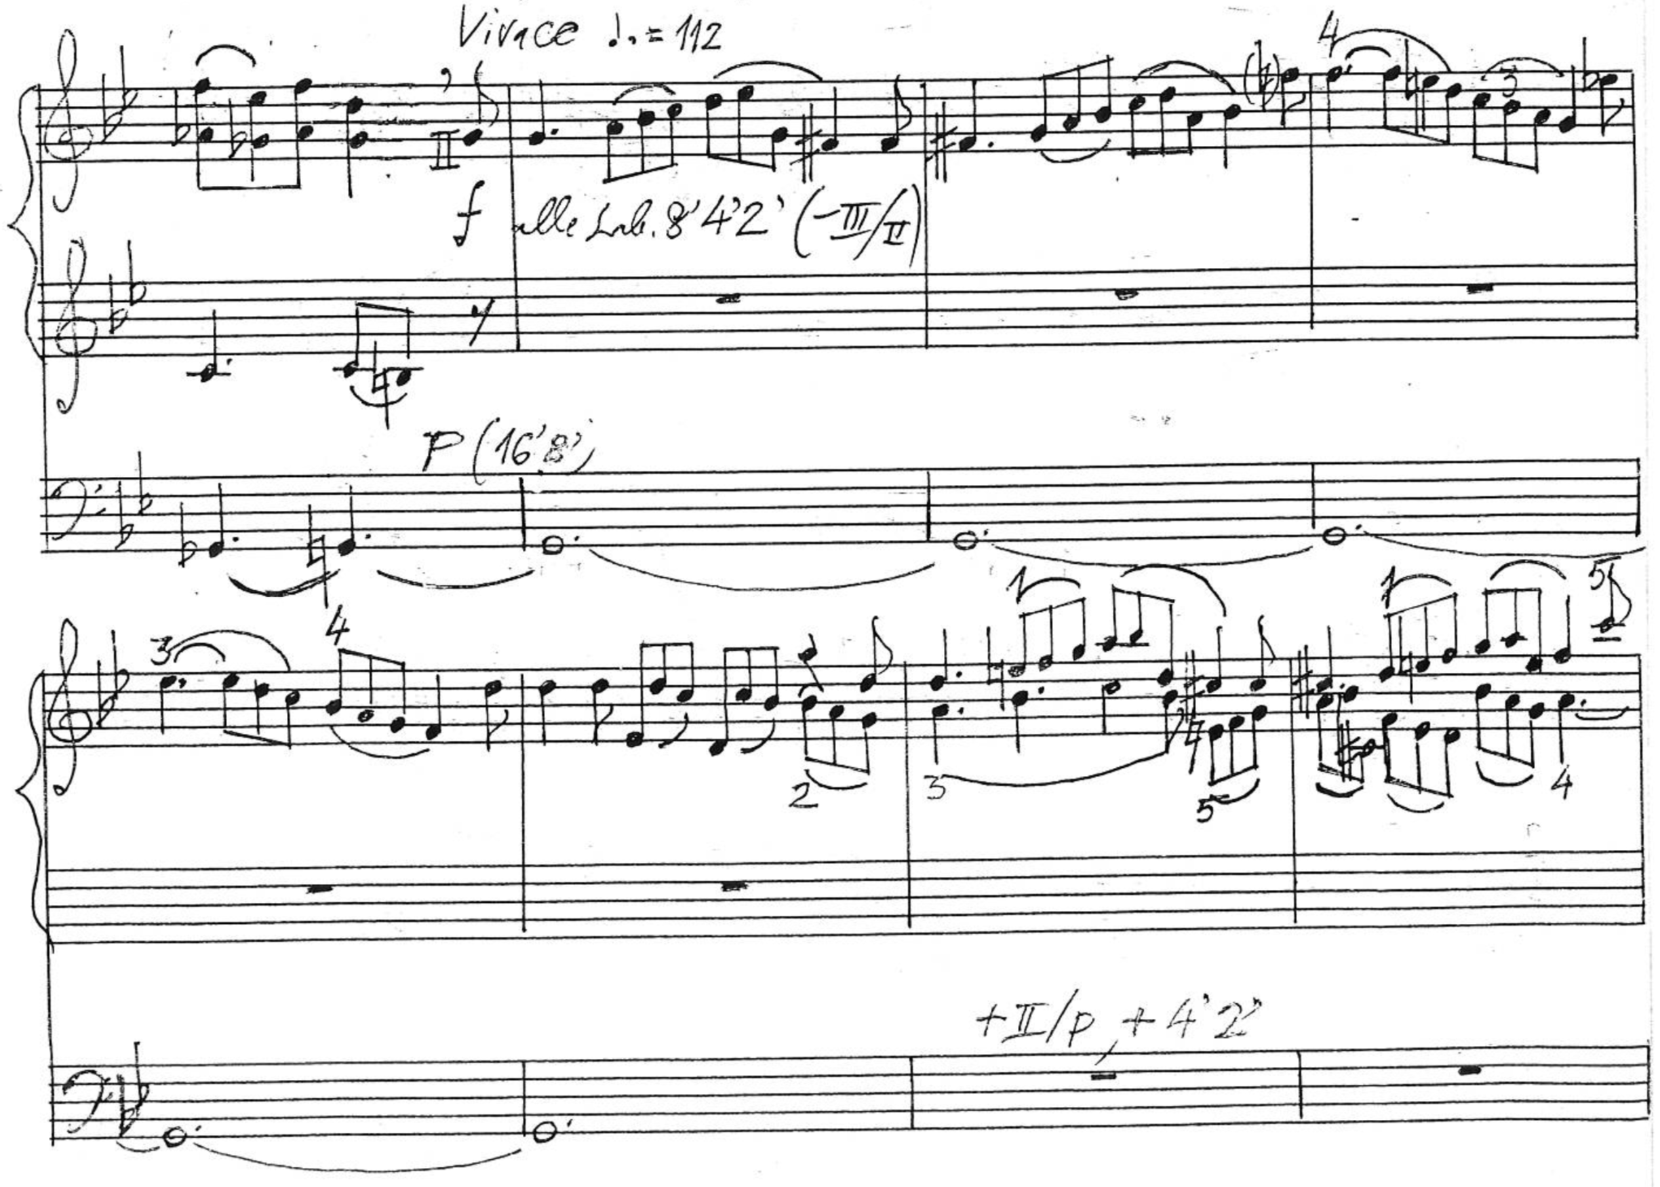
The tempo in this section of Solitudinem faciunt is Vivace (♩. = 112), the dynamic forte with all manual foundations 8’, 4’, and 2’ with pedal 16’ and 8’, and the key is still G minor. The time signature is 12/8, a dance-like meter that could suggest the idea of a dance of death (Totentanz). The subject begins in the alto voice on the pickup to m. 75 and it has a length of five measures (mm. 75-79), as seen on Ex. 31. The melody is derived from the theme that has been constantly utilized on this piece.
The subject statement occurs over a pedal point that is released when the soprano line begins a real answer up a fifth on the pickup to m. 80. The third subject entrance happens in the pedal line on the pickup to m. 85.An episode follows at m. 90 and modulations begin to occur, reaching D minor at m. 97. At that point it starts to become clear that the music is departing from the strict fugue form and behaving more like a trio texture. The manual parts become imitative, with several false entries to the subject as the pedal line is less active, sometimes pulsating, otherwise serving as a foundation to the harmonies constructed by the melodies above.
After a brief solo melody on the left hand over a D♭ pedal point at mm. 108-111, the texture thickens at m. 112 to two parts per hand, all on Manual I, the more active two lines being played by the right hand in C minor over a C pedal point. The dynamic keeps increasing with manual changes and the addition of stops and manual couplers in the previous measure. Measure 112 is più forte and the tempo, Meno mosso, is more solemn. The modulations have been happening constantly since m. 90. This is a part of the piece where tension increases. At mm. 124-131, which goes from fortissimo + reeds to Organo pleno fortississimo (Ex. 32), the emphasis on diminished chords is so intense that it becomes difficult to know what the key center is.
Example 32. Solitudinem faciunt, mm. 127-130
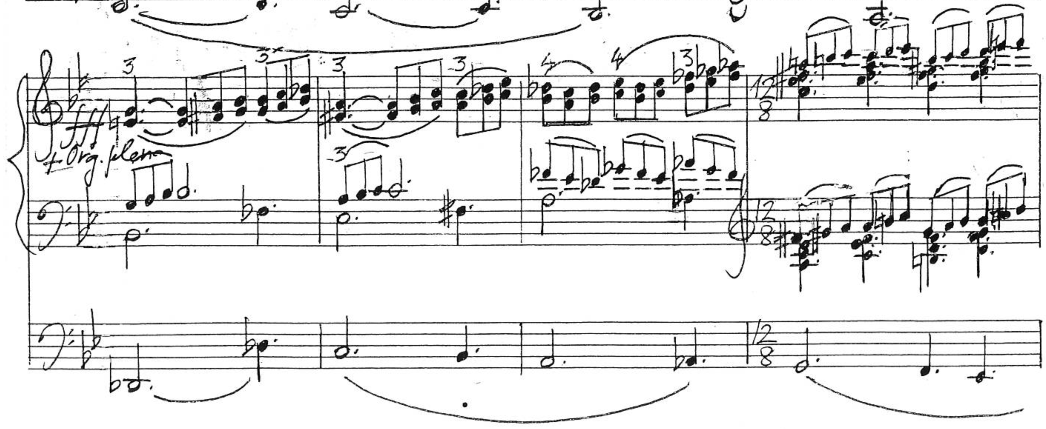
The final chord reached on the downbeat of m. 131 is dissonant mixture of possibilities, consisting of a pedal D octave and the notes D-F#-G-B-D-F♮. After its length of a dotted half note, all the notes are suddenly lifted but one, the highest, and the only F♮, causing this moment to be an impactful cutoff. The final blow, the strongest and most dramatic, is lifted except for one very soft remaining note. The high F of the previous chord is held (transferred to Manual IV) for another dotted half note and into the next measure with the withdrawing of most stops, diminishing the dynamic to mezzo-piano using 8’ stops only. This melancholic reverberation decays into a short sinuous line that fades away. Starting on that sustained F a brief recitative follows at mm. 131-133. It uses the A minor harmonic scale, though it is centered around the note D. The last three notes of this single line melody in the highest octave of the organ are F-E-B, followed by a dotted quarter rest with a fermata.
If the listener is willing to imagine a picture of what is to come, section C (mm. 134-182) may be a depiction of the figurative desert. At mm. 134-135 a faint idea begins in mezzo-piano with a piano accompaniment, a melody over chords with the same texture as seen on Ex. 33. It travels from A minor to a combination of F major and D minor.
Example 33. Solitudinem faciunt, mm. 140-143 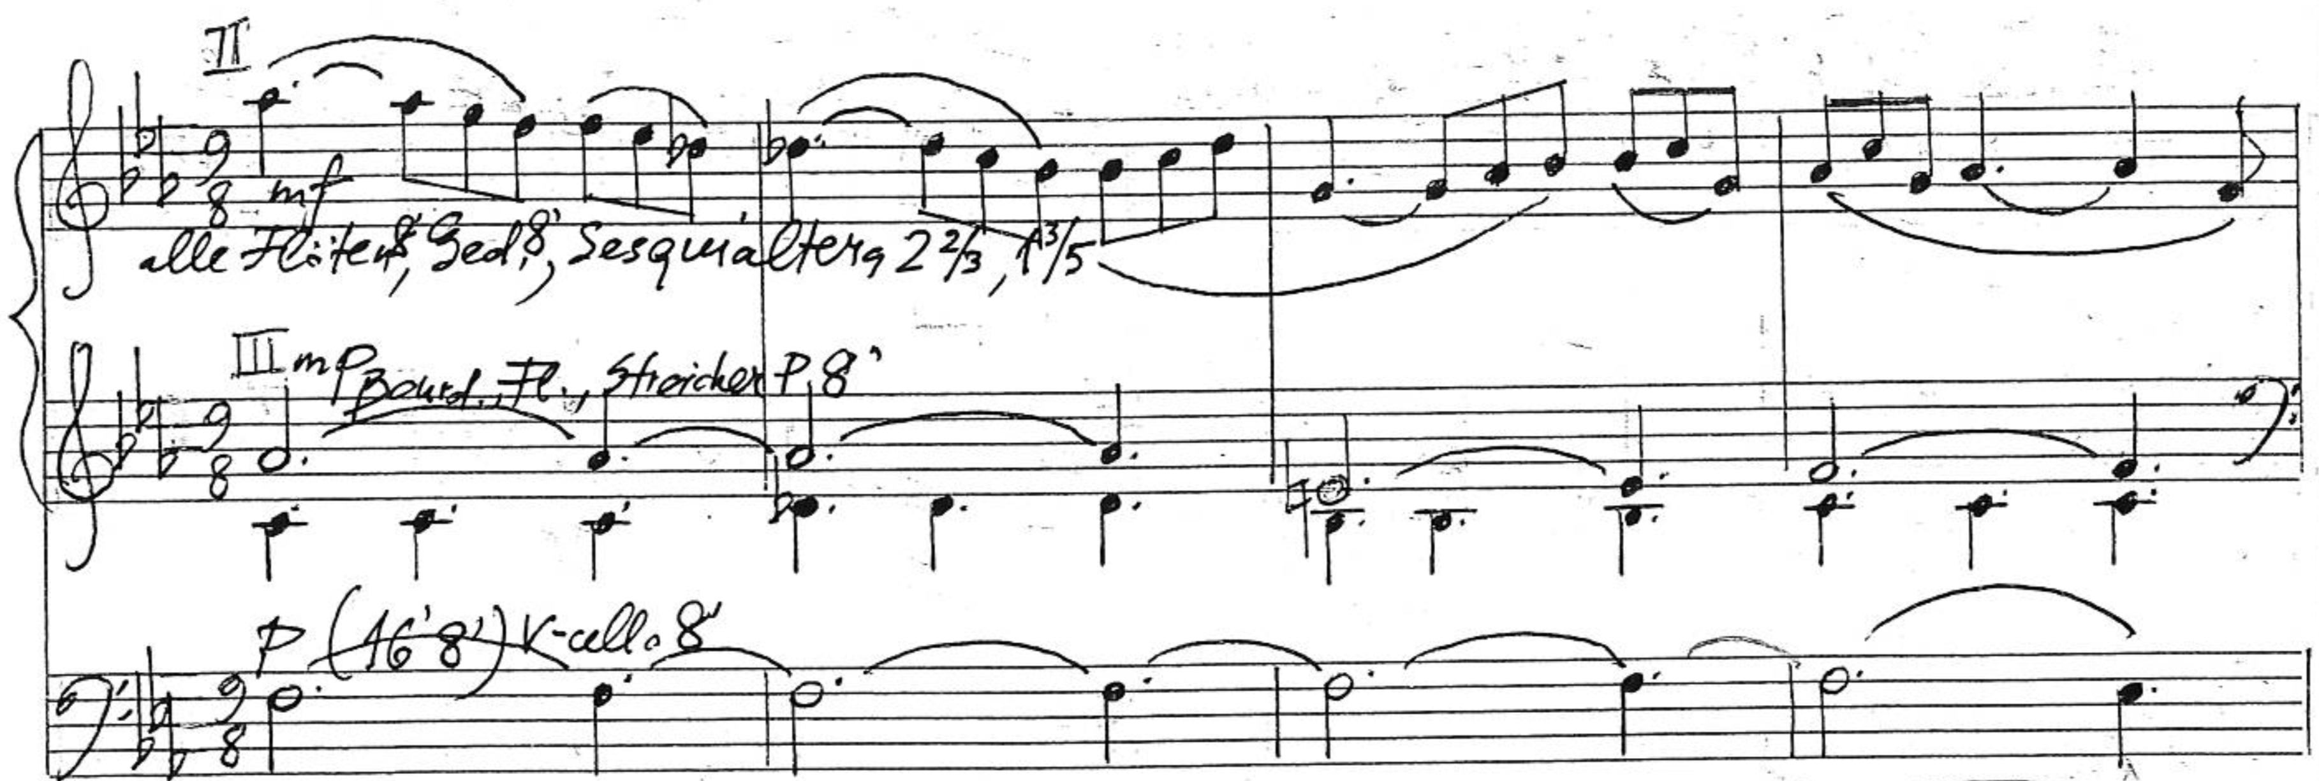
Measure 136 is entirely silent and mm. 137-139 bring a second attempt at beginning the melody of descending lines with an even softer dynamic than previously, piano on Manual IV using only a suggested unda maris 8’ and gedackt 8’ with the box closed. The harmony moves from G minor to E♭ major and F# diminished over a pedal G before fading again into a dotted quarter rest art the third beat of m. 139. It is like waking up from a dream: the eyes open for a moment after the blackout, then close again, open for a second time, and have one last long blink before becoming fully conscious again on the downbeat of m. 140 (Ex. 33).
On that measure the registration changes to a solo with mutations: all flutes, 2 $2/3$’ and 1 $3/5$’. The key is now C minor, though the first tonic chord only appears at the downbeat of m. 146. This section remains uneventful, with long phrases of a mostly stepwise melody floating above harmonies that change at a regular and unhurried pace. At a constant 9/8 mm.140-179 are the second longest streak of measures in Solitudinem faciunt without a changing meter, after the segment of mm. 68-123, which precedes and encompasses the fugal section. This factor contributes to the placidity of section C. Dissonances are barely present anymore to the piercing degree of the previous section. Starting on the C minor of m. 146, the next measures move through the following chords: A♭-Fm-Ddim7-Cm-A♭-Cm7-F#dim-B♭m7-E♭m-Adim-B♭7. With that, at m. 161, the quinte 2 $2/3$’ is removed and the solo remains on the gap registration of 8’ and 1 $3/5$’: G-Cm-F#m-G-Cm-A♭-Bdim-Cm. Then at the downbeat of m. 173 the pedal line holds a D for four measures under the chords D7-Bdim-Cm-D, indicating an impending modulation from C minor to the key of G minor, and then a four-measure long pedal G (mm. 177-180) under G-Cm-D-G. This long phrase ends with the two Picardy cadences.
Section C is very placid overall. The pulsating notes on the left hand alongside in combination with the slow and ever descending pedal lines give mm. 134-182 a cavernous atmosphere: a deep and distant rumble in the depths of the earth with the overlaying regular repetitions of water drops from the draperies and stalactites vast, the sinuous melody gently cutting through the darkness as air drafts between interminable cave chambers. The same combination of sounds may be just as well the sound painting of the desolation of a battlefield or attack site after the harm is done, or the rubbles of a fallen construction. A short sequence of chords diminuendo from piano to pianissimo ensues at mm. 180-182 anticipating the next section: Edim-F-Ddim-E♭-C#dim, or viiº/VII♭ – VII♭ – viiº/VI – VI – viiº/V.
Section D (mm. 183-220) brings back the movement after almost fifty measures of apparent numbness and isolation. This could perhaps be interpreted as a moment of awakening for the survivors, the families of all victims, and the general population. It might be the starting point of the realization that something significant has happened, to estimate the losses, to process the fact that things after this might never be the same. The increase in tension throughout this section might reflect people’s first response to the shock of a tragedy or attack, though these may still be the first stages of grief: denial or even some anger while trying to understand and cope with the pain. It is also possible that Solitudinem faciunt may not be telling a story per se, but it can be instead a musical description of certain emotions or a state of mind.
At m. 183 another pulse begins on the pedal line on the low D, in mezzo-forte, as has occurred many a time in previous segments. It continues until the downbeat of m. 205, at which point it becomes a sustained pedal point. Four ascending melodies in the dominant utilizing the notes of the G minor melodic scale are initially spaced away from each other by rests where only the pedal line remains pulsating (mm. 184-188, Ex. 34). While that happens, stops are added and manuals changed towards a bigger sound. By m. 189 forte is reached and a second melody joins in going up and down the scale. This trio texture will remain until m. 202.
Example 34. Solitudinem faciunt, mm. 186-192 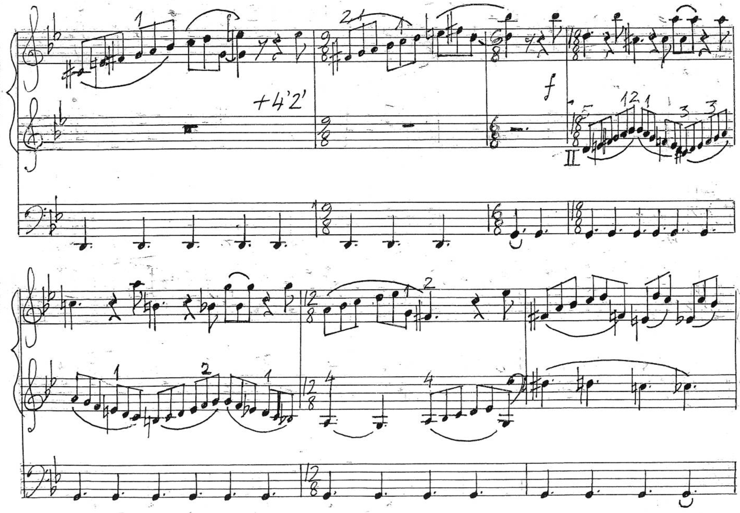
The figure seen on the last two beats of the right hand at m. 192 is one of the formulas utilized throughout the following measures interchangeably between the hands and often against a scale on the other part. Measure 197 has the words più forte written over the pedal line, suggesting that stops keep being added as tension escalates. At m. 199 the left hand plays a melody that starts in the key of D♭ over a pedal D♭. A poco ritenuto at m. 201 gives way to the thicker texture in fortissimo of m. 202, where the pedal pulsates the low D, the left hand pulsates a B augmented chord, and the right hand plays a descending figure in the G minor scale from E♭ to F#. Another poco ritenuto on the last beat of m. 204 lands on a full C# minor chord in both hands, più fortissimo and Meno mosso. The segment encompassing mm. 205-213 is another moment of maximum tension. The key signature, which had just changed to the four sharps of C# minor at m. 205 changes again at m. 209 to the five sharps of G# minor. At mm. 209-213 the chord progression F#dim-Gm-D dim results in a modulation to D# minor at the downbeat of m. 214. The dynamic is Organo pleno fortississimo, the tempo indication Sostenuto pesante, and the format back to block chords over a D# pedal. However, this is the last moment of such weight and tension of section D. The two-measure cell leaves at an E diminished chords, followed by a quarter note rest. Measures 217-218 are a perfect echo to mm. 214-215, however at a lower octave, on Manual IV instead of I, and at the dynamic piano with the 8’ flue stops. Instead of the interrupted release on the E diminished chord, however, the line continues towards a hybrid conclusion of this segment simultaneously in D# minor to F# major, then just F# major after a quiet plagal cadence landing on the downbeat of m. 221. The first shock after the impact has passed and the emotions quiet down momentarily.
Section, E (mm. 221-273) consists of two parts that bring about the conclusion of the piece with a message of what is to be done when faced with such adversity and grief. They are both about coping with it. The first segment (mm. 221-241) could be interpreted as the difficulty of accepting the seeming injustice of fate, death, and destruction.
The apparent quietude brought about by the plagal cadence to the downbeat of m. 221 is short lived, as one stage of the grief cycle proceeds to the next. The F# major chord of the first beat is rapidly departed from with the third turned minor on beat two, and afterwards a melodic line over a pedal E that moves parallelly in sixths on the left hand and with the added third above that chord which completes the octave with the tenor line.
Example 35. Solitudinem faciunt, mm. 227-234
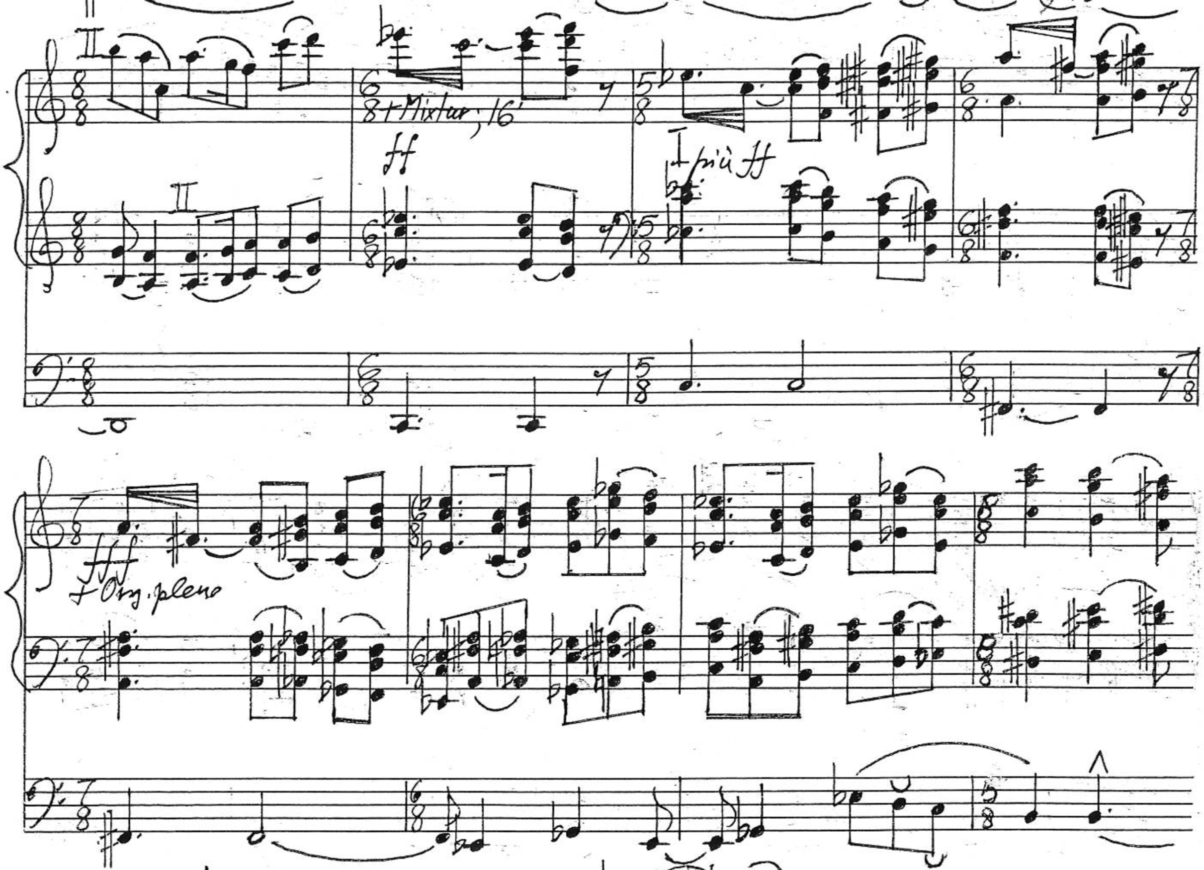
Measure 227 is the culmination of that gesture (Ex. 35), where the right hand gains again some independence from the left hand. At m. 228 the texture thickens to block chords for the remainder of the piece. On 228-235 their motion is perfectly contrary. A furious sequence of minor and diminished chords begins with four instances of unmeasured tremolo at mm. 228-231 from the dynamics of fortissimo to Organo pleno fortississimo. At mm. 236-241 there are no more such clashing dissonances and as the chords descend in parallel motion from higher to lower registers, the dynamic diminishes from forte to piano. A minor plagal cadence towards D minor lands on the half note D chord with a Picardy third at the downbeat of m. 241. This is the point where the tonal center changes from G to D. The manuals have an eighth note rest while the pedal holds the low D into the next measure and final transformation of the piece.
The first measures of this last segment (m. 242-273) begin softly. They consist of two almost identical questions (mm. 242-243, 246-247) and answers (mm. 244-246, 248-249). As seen on Ex. 36, these measures revolve around the harmonies of D major, G minor, and A♭ minor and major. A harmonic transformation begins to occur as this idea is expanded and the dynamic changes with stop additions and manual changes.
Example 36. Solitudinem faciunt, mm. 244-252
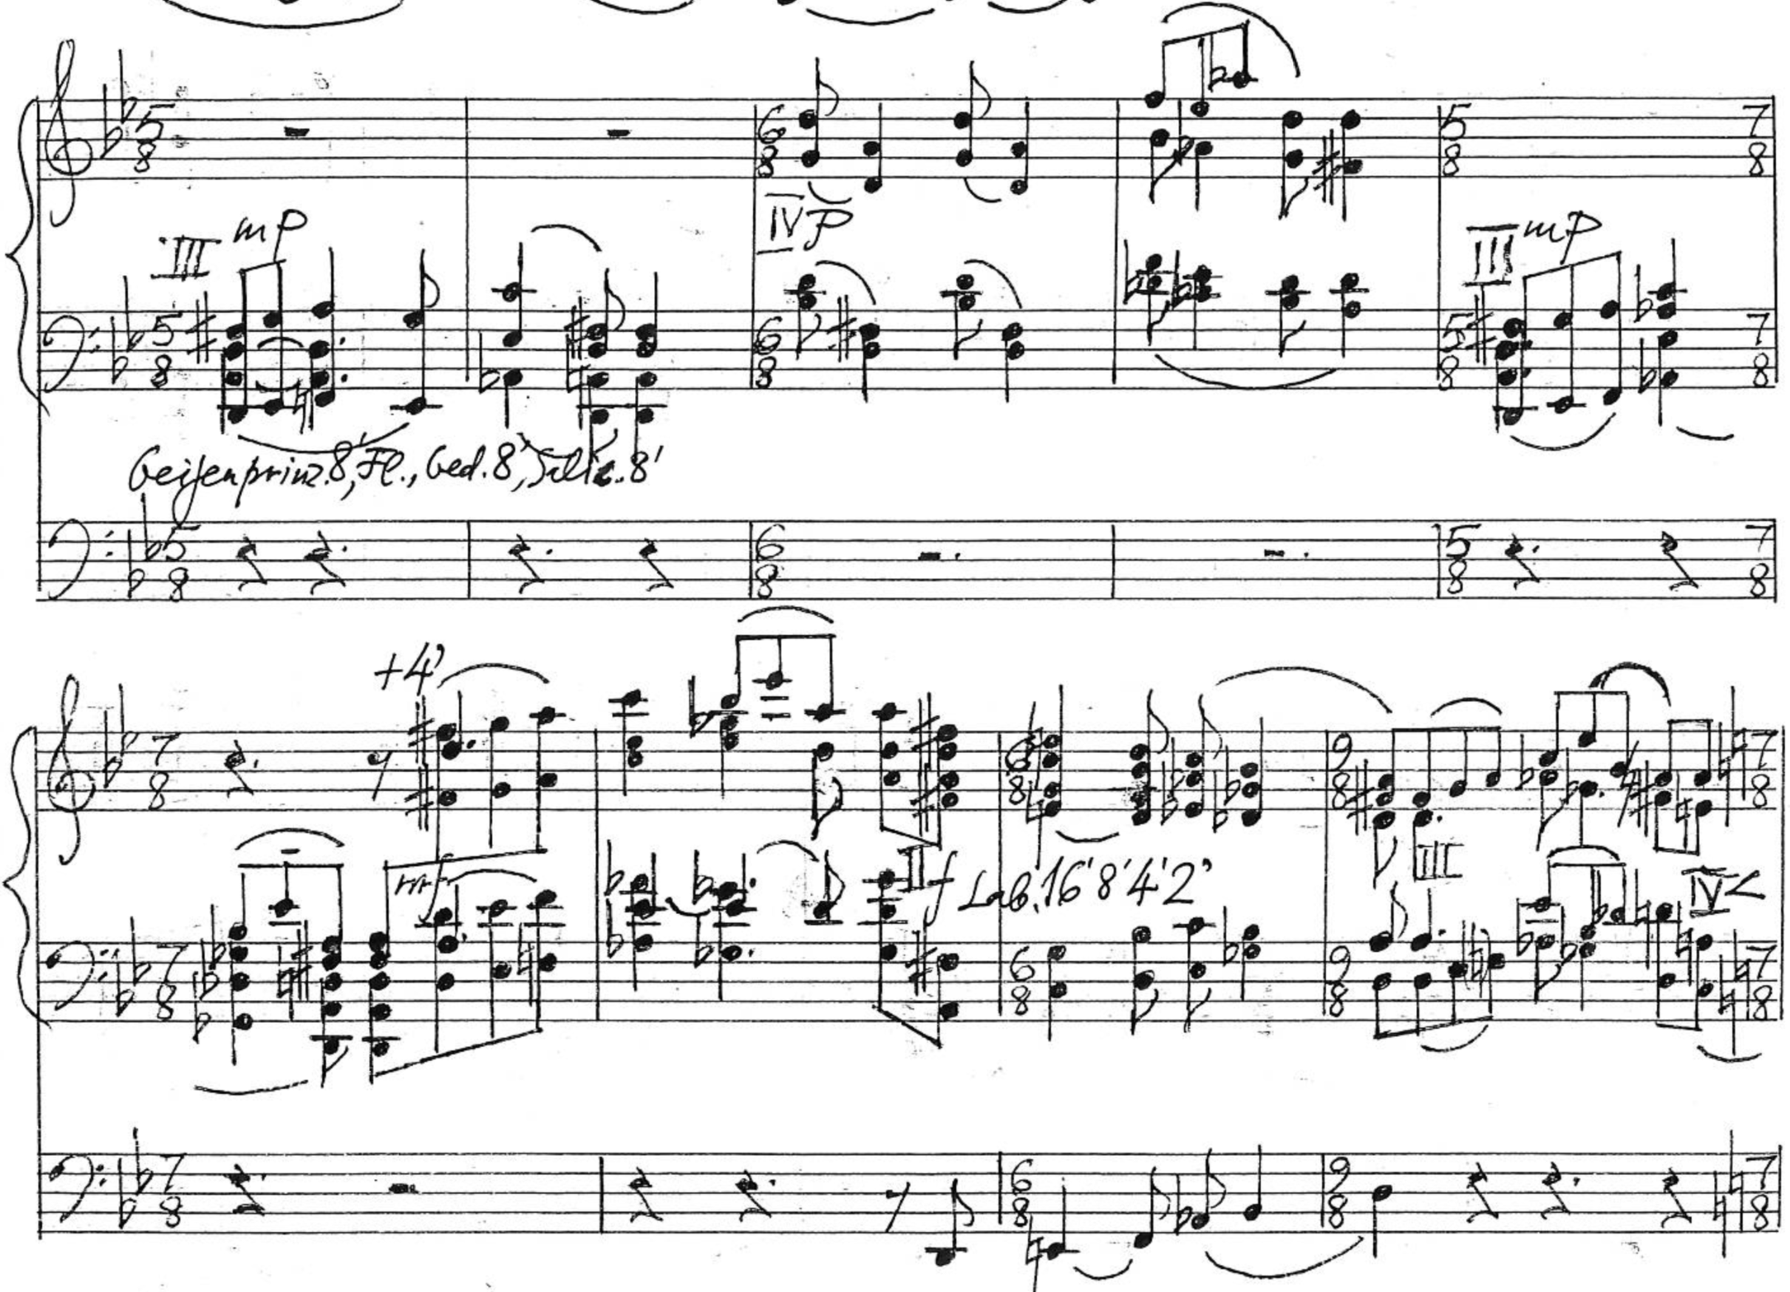
According to Kalējs, what determines the form and harmony in his compositional process is the melody or main character. He described this last section of Solitudinem faciunt as a hymn that rises up to heaven. With this in mind, it is clear that the harmonies are almost entirely guided by the melody above them, with little in the sense of harmonic functionality. The chords leading to the tonic D major chord at mm. 242-273 are, by frequency, G minor (iv, 11 times), E♭ minor (ii♭, 9 times), G♭ major (iv♭, 5 times), C major (VII♭, 1 time), A minor (v, 1 time).
Example 37. Solitudinem faciunt, mm. 269-273
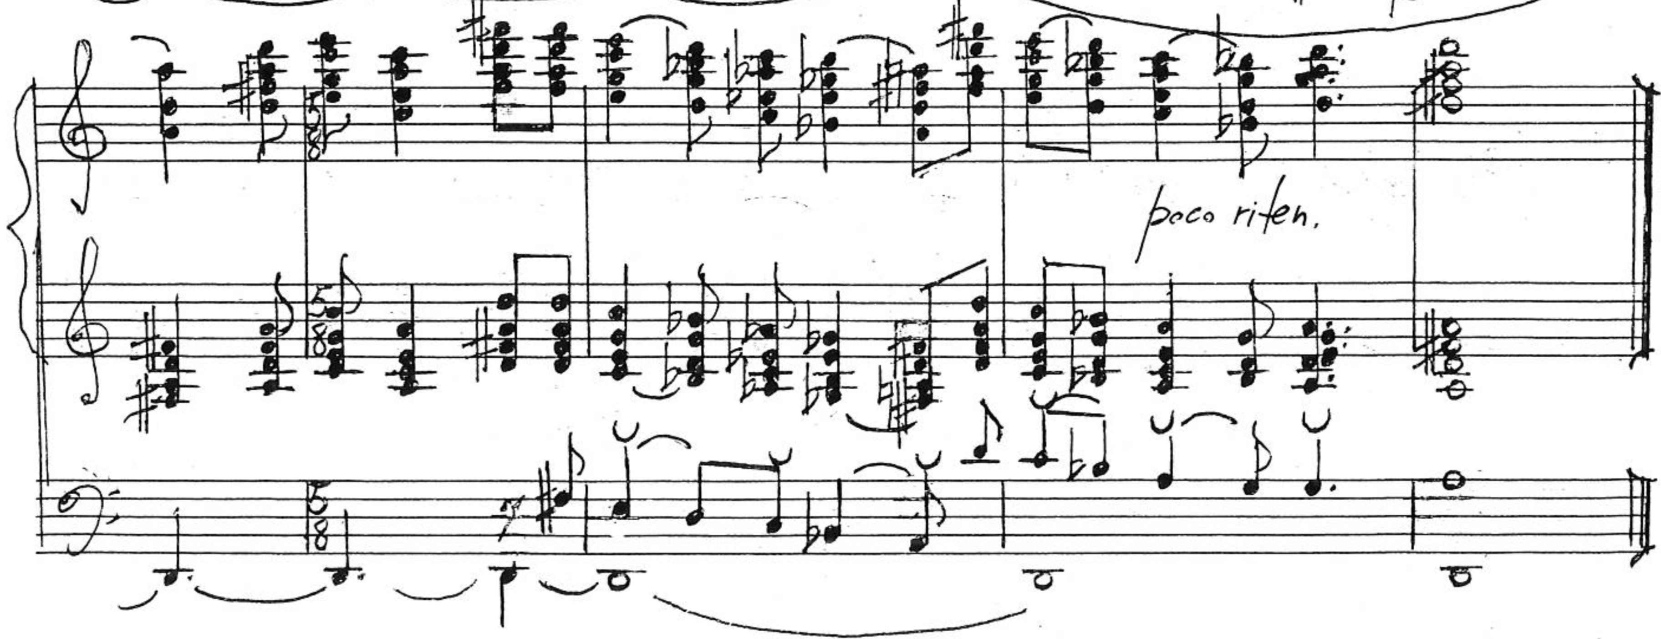
The modal transformation from the key of G to D still utilizes the notes of the ascending G minor melodic scale: G-A-B♭-C-D-E-F#. When the center is shifted to D, the scale looks like this: D-E-F#-G-A-B♭-C. This mode is known as the Aeolian major scale or Hindu scale and it is essentially the D natural minor scale with a raised third degree. The harmonies underneath, however, contain chords beyond those commonly found on that scale.
The dynamic increases from pianissimo at m. 254 to Organo pleno fortississimo at mm. 267-273. The thick chord texture remains constant throughout the entire segment and is thickened even more at mm. 270-273 with the double pedal line of the descending scale in D over the pedal point (Ex. 37).
Grief, anger, frustration, denial, solitude, and emptiness are sentiments and ideas that shall not be cultivated or preserved for long. If tragedies and injustices that may happen can teach anything after they have passed and can no longer be prevented or undone, it might not be that one should forever feed negative sentiments, regrets, or anger. Instead it is possible to see the light even in times of greatest darkness, to reach healing through the elevation of the spirit to higher realms. Of the three pieces analyzed in this study, Solitudinem faciut is the only one to have such a triumphant ending. The fact that the tonality of the apotheosis of mm. 242-273 utilizes the same notes as the previous G minor key but in a major mode and with such exultation may be a representation of the mystery of how the same suffering and injustice can have the effect of leading to spiritual vigor, forgiveness, and hope. Utilizing the same building blocks, the G melodic minor scale has become a D Aeolian major scale; granted, with an expanded harmonic palette to enrich the beauty of this victory. Beyond the idea of just a tonal transformation, one could almost speak of a transfiguration in the sense of a “complete change of form or appearance into a more beautiful or spiritual state.”
This conversion is comparable to the Christian symbolism of the cross as the suffering and death that lead to happiness and life. The concept of adding meaning and elevating adversities as a sacrifice towards the redemption and salvation of the soul, and even being thankful for these personal crosses, has been present in Christianity for centuries. Saint Josemaría Escrivá summarized this idea:
Do everything for the love of God and embrace your daily cross joyfully. This is something I have repeated thousands of times because I believe that these ideas should be engraved on every Christian heart. When we advance beyond the stage of simply tolerating difficulties or sufferings (whether physical or moral) and, instead, love them and offer them to God in reparation for our sins and the sins of all mankind, then, I assure you, they do not distress us. It is no longer just any cross we are carrying. We discover that it is the Cross of Christ, and with it the consolation of knowing that our Redeemer has taken it upon himself to bear its weight. We cooperate as Simon of Cyrene did, who, when he was returning from work on his farm intending to take a well-earned rest, was forced to lend his shoulders to help Jesus. For a soul in love it is no misfortune to become voluntarily Christ’s Simon of Cyrene and, in this way, to give such close company to his suffering Humanity, reduced to a state of rags and tatters. For if we do this we can be certain of our closeness to God, who blesses us by choosing us for this task.

Kalējs’ own viewpoint resonates with this concept. Furthermore, it once again embodies the natural reaction that could be expected from a person embedded in the mentality of a Herderian gentle nation: resilience, faith, and love in face of adversity. Pondering upon the combined message of the three pieces of this study, he concluded:
There is no message of peaceful contemplation of destruction. Per aspera is a spirit, the faith of the released spirit of people that go towards Heaven. In Via Dolorosa there are sorrows that, I hope, are not hopeless, but enlighten people. Suffering is also a way to God. If we live in constant joy, there is usually no space for God. I talk about pleasure. And I hope Solitudinem gives listeners, in the end, spiritual vigor and strength. Everything that came before was given to not become desperate, but in spite of everything, to resist and remain united by love. This is not about the love of passion, but brotherly love. We still ask the main question of humanity – why are we here and what is our purpose? When we live here on the earth, protected in our bodies and vulnerable, the purpose is completely clear, there is no doubt. We are here not to stand each other or perceive others as troublesome and needless. Each of us has a task and challenge to live in friendship and fellowship. Even better – in love, in a true spiritual love. We have to support and please each other, finding our way to God. Everyone has a different way. Within this unique life we are given lies the power of Creator. Our lives are not a cliché and everyone has a free will. Even though our paths are different, we all have the same goal to go towards the Creator. It does not mean to go our way without feeling the people around us. On the contrary, we have to go our way with the idea of giving to our society, our neighborhood.

Chapter 6: Conclusion
This study presented the importance of music in the formation of the idea of a Latvian people and nation, and how it has remained a central element of their national identity and the formation of cultural and ethical values. One result of the creation of such a culture was “one of the most extensive collections of folk songs (dainas) of all peoples of Europe, more than 1.2 million texts and 30,000 melodies,” many of which paint the picture of the quintessentially nonviolent and resilient character of this Herderian gentle nation. This character has been tested under utmost conditions. In the twentieth century alone Latvia experienced a War of Independence, two World Wars, was occupied by and suffered under foreign invaders for more than half of the century, and experienced genocide and other extreme adversities. Yet, Latvians remained a peaceful people with a strong spirit and were able to survive all hardships and restore their freedom. Music played an important role in the survival of Latvia.
The preceding chapters related the history of the pipe organ in that country and the parts that the instrument, organists, and composers for the organ, had in the wider context of a nation that has music as one of its founding pillars. Aivars Kalējs was presented as a notable representative of the pipe organ in Latvia in the capacities of composer, performer, and scholar. His choice was particularly relevant because his work has been an exemplary embodiment of the Latvian spirit described in the previous chapters.
Per aspera ad astra, Via dolorosa, and Solitudinem faciunt are the most representative large scale organ compositions of Aivars Kalējs to this date, alongside the two-page miniature Postlude hommage a Jehan Alain, according to his own admission. The analyses of these works reveal how they share similar features to one another as well as with other of his compositions, but also how distinct compositions with different structures can produce an overarching message of resilience, hope, spiritual vigor, and love. More importantly, these are some of the most significant values in the cultural and historical context of Latvia.
The three compositions by Aivars Kalējs selected for this research, as well as the reasoning behind them provided by the composer himself, are resonant with the Latvian culture and identity. These pieces help consolidate a place for him as the worthy representative of these values. For these and other works, as well as for his other contributions to the field, including his successful initiative towards the preservation of hundreds of instruments as cultural patrimony, Kalējs has achieved national and international recognition as an authority on the subject of Latvian organ music and the history of the pipe organ in that country. As a currently very active composer and performer, Aivars Kalējs carries the flag of this tradition into the twenty-first century.
This study has endeavored to contribute towards the dissemination of the organ repertoire of a nation that deserves more exposure in concert halls, academic curriculums, and even churches throughout the world; particularly that of Aivars Kalējs, not only for its sheer beauty, but also for its meaning. Hopefully the understanding of the role music played in the history of Latvia will also occupy a space in the readers’ imagination with some of the seeds that have made Latvia a gentle nation with a strong spirit and a resilient attitude – and inspire the readers to consider how some of the concepts introduced in these pages can help them strive for a path of never ending improvement and spiritual growth, onwards and upwards.
Kalējs’ music and philosophy are perhaps best summed up in his own words:
There is something, if I could call it my credo regarding creative work – if there is so much wonderful music already written I could ask myself why I am even writing more, what I have to offer. But yet, there is a capital principle: you have to see, like in the Baroque or in the time of the great classics, if the things you do are serving for the spiritual development of a person. I mean, if a person leaves the concert with a feeling of being enlightened, then it is something worth doing. Otherwise, it is not. During my life I have received enough testimonies from the audience – not phrases of courtesy but sincere thoughts – that prove that what I do is obviously worth it; that my music has influenced them in a positive way. But the main principle is – if it serves for the spiritual development of a person. By spiritual development, I do not mean gathering information or following some speculative theories that do not develop a person. What I mean by spiritual development is the path towards God. One example of this path, of course, the highest and most inaccessible, is music itself. It gives strength to the person and cleans the soul…

Bibliography

Books
Ackerman, Peter, and Jack DuVall. A Force More Powerful: A Century of Nonviolent Conflict. New York: St. Martin’s Press, 2000.

Almén, Byron, and Edward Pearsall, eds. Approaches to Meaning in Music. Bloomington: Indiana University Press, 2006.

Anderson, Benedict. Imagined Communities: Reflections on the Origin and Spread of Nationalism. Rev. ed. London: Verso, 2006.

Applebaum, Anne. Gulag: A History. New York: Anchor Books, 2003.

Beckmann, Klaus. Repertorium Orgelmusik: Komponisten – Werke – Editionen, 1150-2000. Mainz: Schott Musik International, 2001.

Bērzkalns, Valentīns. Latviešu Dziesmu svētku vēsture, 1864-1940. New York: Grāmatu Draugs, 1965.

Biezaitis, Ēriks, and Margarita Biezaitis. Mūzikas Krātuves Skaņdarbu Katalogs. Rīga: Mūsikas Krātuves Izdevums, 1992.

Bleiere, Daina, Ilgvars Butulis, Inesis Feldmanis, Aivars Stranga, and Antonijs Zunda. History of Latvia – 100 Years. Adelaidē: Society “Domas spēks,” 2014.

Braun, Joachim. Raksti – Mūzika Latvijā. Rīga: Musica Baltica, 2002.

Buttar, Prit. Between Giants: The Battle for the Baltics in World War II. Long Island City, NY: Osprey Publishing, 2013.

Conquest, Robert. Stalin: Breaker of Nations. New York: Penguin, 1991.

Damon, Cynthia. Tacitus: Agricola. Carlisle, Pennsylvania: Dickinson College Commentaries, 2016. ISBN: 978-1-947822-09-2. Accessed May 29, 2018. http://dcc.dick
inson.edu/tacitus-agricola/30.

Darwin, Charles. The Descent of Man, and Selection in Relation to Sex. Princeton: Princeton University Press, 1981.

Eglītis, Oļģerts. Nonviolent Action in the Liberation of Latvia. Cambridge, MA: The Albert Einstein Institution, 1993.

Escrivá, Josemaría. Friends of God. Madrid: Studium Foundation, n.d. (first published in 1977). Accessed March 3, 2019. http://www.escrivaworks.org/book/friends_of_god.
Faber, Rudolf, and Philip Hartmann, eds. Handbuch Orgelmusik: Komponisten, Werke, Interpretation. Kassel: Bärenreiter, 2010.

Fiseisky, Alexander, ed. Organ Music from the Baltic States – Volume 1: Latvia. New York: Bärenreiter, 2002.

Frisk, Anna, Sverker Jullander, and Andrew McCrea, eds. The Nordic-Baltic Organ Book: History and culture. Göteborg: Göteborg Organ Art Center, 2003.

Fūrmane, Lolita. Latviešu Komponisti un Muzikologi, 1989 – Sakarā ar Latvijas Komponistu savienības X kongresu. Rīga: Latvijas Komponistu Savienības, 1989.

Gramsci, Antonio. Os Intelectuais e a Organização da Cultura, trans. Carlos Nelson Coutinho, Rio de Janeiro: Civilização Brasileira, 1982.

Grauzdiņa, Ilma. Tūkstoš mēlēm ērģeles spēlē. Rīga: Liesma, 1987.

Havel, Václav, and John Keane. Power of the Powerless: Citizens against the State in Central-Eastern Europe. Armonk, NY: M. E. Sharpe, 1985.

Henderson, John. A Directory of Composers for Organ. 2nd ed. Swindon (Wiltshire, UK): John Henderson (Publishing) Ltd., 1999.

Herder, Johann Gottfried. Martin Bollacher, ed. Werke in zehn Bänden. 10 vols. Frankfurt am Main: Deutscher Klassiker Verlag, 1985-2000.

Jērans, Pēteris, ed. Latvijas Padomju Enciklopēdija. Rīga: Galvenā Enciklopēdiju Redaktcija. 10 vols. 1981-1988.

Johnson, Paul. Modern Times: The World from the Twenties to the Nineties. New York: Perennial Classics, 1991.

Karnes, Kevin C., and Joachim Braun, eds. Baltic Musics/Baltic Musicologies: The Landscape Since 1991. New York: Routledge, 2009.

Kasekamp, Andres. A History of the Baltic States. New York: Palgrave Macmillan, 2010.

Krebs, Stanley Dale. Soviet Composers and the Development of Soviet Music. New York: W. W. Norton & Company, Inc., 1970.

Larson, Steve. Musical Forces: Motion, Metaphor, and Meaning in Music. Bloomington: Indiana University Press, 2012.

Latvian Institute. From Tribe to Nation: A Brief History of Latvia. Rīga: The Latvian Institute, 2013.

Meyer, Leonard B. Emotion and Meaning in Music. Chicago: The University of Chicago Press, 1956.

Misiunas, Romuald J., and Rein Taagepera. The Baltic States: Years of Dependence, 1940-1990. London: Hurst & Company, 1993.

Pople, Anthony, ed. Theory, Analysis & Meaning in Music. New York: Cambridge University Press, 1994.

Robinson, Jenefer, ed. Music and Meaning. Ithaca: Cornell University Press, 1997.

Sējāne, Solvita, ed. Latviešu Mūzikas Kods – Versijas par mūziku gadsimtu mijā. Rīga: Musica Baltica, 2014.

Simon, Gerhard. Church, State and Opposition in the USSR. Translated by C. Hurst & Co. Ltd. Berkley and Los Angeles: University of California Press, 1974.

Smith, Anthony D. The Cultural Foundations of Nations: Hierarchy, Covenant, and Republic. Malden, MA: Blackwell Publishing, 2008.

Smith, Graham, ed. The Baltic States: The National Self-Determination of Estonia, Latvia and Lithuania. New York: St. Martin’s Press, 1996.

Sproge, Gunta. Latviešu Komponistu Instrumentālā Kamermūzika, 1975 – 1985. Rīga: Republikaniskais mākslas mācību iestāžu metodiskais kabinets, 1989.

Strods, Heinrihs. “The Nonviolent Resistance Movement in Latvia (1944–1958).” The Anti-Soviet Resistance in the Baltic States. Edited by Arvydas Anušauksas. Vilnius: Genocide and Resistance Research Centre of Lithuania, 1999, 161-173.

Šmidchens, Guntis. The Power of Song: Nonviolent National Culture in the Baltic Singing Revolution. Seattle: University of Washington Press, 2014.

Šmite, Gundega. Latvjias Jaunās Mūsikas Dienas: 2011 programma. Rīga: Latvijas Komponistu Savienības, 2011.

Tacitus. The Germany and the Agricola of Tacitus: The Oxford Translation Revised, with Notes. Project Gutenberg: 2013. ISO-8859-1. Accessed May 29, 2018. https://www.
gutenberg.org/files/7524/7524-h/7524-h.htm.

Taruskin, Richard. Stravinsky and the Russian Traditions. Oxford and New York: Oxford University Press, 1996.

Tastevena, Irina, and Heinrihs Jubels, eds. Latvijas Enciklopēdia. Rīga: Valērija Belokoņa izdevniecība, 2005.

Trotsky, Leon. Literature and Revolution. Edited by William Keach. Translated by Rose Strunsky. Chicago: Haymarket Books, 2005. (Orig. pub. 1925).

Vesilind, Priit, James Tusty, and Maureen Tusty. The Singing Revolution. Tallinn: Varrak Publishers Ltd., 2008.

Ulrich, Homer, and Paul A. Pisk. A History of Music and Musical Style. New York: Harcourt, Brace & World, Inc., 1963.

White, James F. A Brief History of Christian Worship. Nashville: Abingdon Press, 1993.

Zivitere, Aija, and Ligita Ašme. Padomju Latvijas Mūzikas Festivāls – Rīga, 1986. gada 19.–24. novembrī. Ziņas par komponistiem, atskaņotājmākslas kolektīviem un skaņdarbu anotācijas. Rīga: Avots, 1986.

Journal articles
Abdy Williams, C. F. “Evolution of the Organ.” Music & Letters 5, nº 3 (1924): 253-63. Accessed May 11, 2018. http://www.jstor.org/stable/726785.

Ashworth, Alec Hargreaves. “Twentieth-Century Painting: The Approach Through Music.” Music & Letters 20, nº 2 (1939): 115-29. Accessed April 23, 2018. http://www.
jstor.org/stable/728052.

Bilmanis, Alfred. “Free Latvia in Free Europe.” The Annals of the American Academy of Political and Social Science 232 (1944): 43-48. Accessed December 12, 2016. http://www.jstor.org/stable/1023333.

Braun, Joachim. “One or Two Baltic Musics?” Journal of Baltic Studies 14, nº 1 (1983): 67-75. Accessed December 9, 2016. http://www.jstor.org/stable/43211195.
Braun, Joachim. “Some Preliminary Considerations on the Present State of Baltic Musicology.” Journal of Baltic Studies 13, nº 1 (1982): 40-52. Accessed December 9, 2016. http://www.jstor.org/stable/43211132.

Carpenter, Inta Gale. “Festival as Reconciliation: Latvian Exile Homecoming in 1990.” Journal of Folklore Research 33, nº 2 (1996): 93-124. Accessed January 11, 2017. http://
www.jstor.org/stable/3814771.

Friedberg, Maurice. “Socialist Realism: Twenty-Five Years Later.” American Slavic and East European Review 19, nº 2 (1960): 276-87. Accessed January 10, 2017. http://www.jstor.org/stable/3004196.

Frolova-Walker, Marina. “‘National in Form, Socialist in Content’: Musical Nation-Building in the Soviet Republics.” Journal of the American Musicological Society 51, nº 2 (1998): 331-71. Accessed January 10, 2017. http://www.jstor.org/stable/831980.

Garrard, John. “The Original Manuscript of Forever Flowing: Grossman's Autopsy of the New Soviet Man.” The Slavic and East European Journal 38, nº 2 (1994): 271-89. Accessed September 18, 2017. http://www.jstor.org/stable/308806.

Goeckel, Robert F. “Soviet Policy toward the Baltic Lutheran Churches and Their Role in the Liberalization Process.” Kirchliche Zeitgeschichte 6, nº 1 (1993): 120-38. Accessed September 18, 2017. http://www.jstor.org/stable/43099845.

Kalējs, Aivars. “Īsa Latvijas ērģeļu vesture.” Vox Humana 1 (August 1999): 3-5.

Karnes, Kevin C. “A Garland of Songs for a Nation of Singers: An Episode in the History of Russia, the Herderian Tradition and the Rise of Baltic Nationalism.” Journal of the Royal Musical Association 130, nº 2 (2005): 197-235. Accessed December 9, 2016. http://www.jstor.org/stable/3557472.

Ketola, Mikko. “The Baltic Churches in the Process of Transformation and Consolidation of Democracy since 1985.” Kirchliche Zeitgeschichte 20, nº 1 (2007): 66-80. Accessed December 9, 2016. http://www.jstor.org/stable/43751061.

Klugman, Jeffry. “The Psychology of Soviet Corruption, Indiscipline, and Resistance to Reform.” Political Psychology, Vol. 7, Nº1 (March 1986), pp. 67-82. International Society of Political Psychology. Accessed September 16, 2017. http://www.jstor.org/
stable/3791157.

Kreindler, Isabelle T. “Baltic Area Languages in the Soviet Union: A Sociolinguistic Perspective.” Journal of Baltic Studies 19, nº 1 (1988): 5-20. Accessed December 13, 2016. http://www.jstor.org/stable/43211456.

Lazda, Mara. “Reconsidering Nationalism: The Baltic Case of Latvia in 1989.” International Journal of Politics, Culture, and Society 22, nº 4 (2009): 517-36. Accessed December 12, 2016. http://www.jstor.org/stable/25621945.

Lazda, Mara. “Women, Nation, and Survival: Latvian Women in Siberia, 1941-1957.” Journal of Baltic Studies 36, nº 1 (2005): 1-12. Accessed December 13, 2016. http://www.jstor.org/stable/43212601.

Lewin, Moshe. “Rebuilding the Soviet Nomenklatura, 1945-1948.” Cahiers Du Monde Russe 44, nº 2/3 (2003): 219-51. Accessed January 10 2017. http://www.jstor.org/stable/
20174773.

Linker, Damon. “The Reluctant Pluralism of J. G. Herder.” Review of Politics 62, nº 2 (2000): 267-293. Accessed December 2, 2016. http://www.jstor.org/stable/1408038.

Long, Delbert H. “Soviet Education and the Development of Communist Ethics.” The Phi Delta Kappan 65, nº 7 (1984): 469-72. Accessed September 18, 2017. http://www. jstor.org/stable/203870 87, 470.

Mežaraups, Imants. “Koncerts Doma Baznīcā.” Jaunā Gaita, nº 209 (June 1997). Accessed June 4, 2018. http://jaunagaita.net/jg209/JG209_Mezaraups.htm.

Muktupāvels, Valdis. “Musical Instruments in the Baltic Region: Historiography and Traditions.” The World of Music 44, nº 3 (2002): 21-54. Accessed December 9, 2016. http://www.jstor.org/stable/41699450.

Mulcahy, Kevin V. “Official Culture and Cultural Repression: The Case of Dmitri Shostakovich.” Journal of Aesthetic Education 18, nº 3 (1984): 69-83. Accessed January 13, 2017. http://www.jstor.org/stable/3332676.

Metuzāle-Kangere, Baiba, and Uldis Ozolins. “The Language Situation in Latvia 1850-2004.” Journal of Baltic Studies 36, nº 3 (2005): 317-44. Accessed December 13, 2016. http://www.jstor.org/stable/43212650.

Plaat, Jaanus. “Religious Change in Estonia and the Baltic States during the Soviet Period in Comparative Perspective.” Journal of Baltic Studies 34, nº 1 (2003): 52-73. Accessed December 13, 2016. http://www.jstor.org/stable/43212514.

Reid, Susan E. “Destalinization and Taste, 1953-1963.” Journal of Design History 10, nº 2, Design, Stalin and the Thaw (1997): 177-201. Accessed September 18, 2017. http://
www.jstor.org/stable/13 16131.

Senn, Alfred Erich. “The Sovietization of the Baltic States.” The Annals of the American Academy of Political and Social Science 317 (1958): 123-29. Accessed December 13, 2016. http://www.jstor.org/stable/1031085.

Skultans, Vieda. “Remembering Time and Place: A Case Study in Latvian Narrative.” Oral History 26, nº 1 (1998): 55-63. Accessed December 13, 2016. http://www.jstor.org/
stable/40179472.

Skultans, Vieda. “The Expropriated Harvest: Narratives of Deportation and Collectivization in North-East Latvia.” History Workshop Journal, nº 44 (1997): 170-88. Accessed December 13, 2016. http://www.jstor.org/stable/4289523.

Skultans, Vieda. “Theorizing Latvian Lives: The Quest for Identity.” The Journal of the Royal Anthropological Institute 3, nº 4 (1997): 761-80. Accessed December 13, 2016. doi:10.2307/3034038.

Stola, Dariusz. “Forced Migrations in Central European History.” The International Migration Review 26, nº 2 (1992): 324-41. Accessed December 13, 2016. doi:10.2307/25
47060.

Strods, Heinrihs, and Matthew Kott. “The File on Operation ‘Priboi’: A Re-Assessment of the Mass Deportations of 1949.” Journal of Baltic Studies 33, nº 1 (2002): 1-36. Accessed December 13, 2016. http://www.jstor.org/stable/43212456.

Strods, Heinrihs. “The USSR MGB's Top Secret Operation ‘Priboi’ (‘Surf’) for the Deportation of Population from the Baltic Countries, 25 February; 23 August 1949,” Latvijas Vēsture 30, nº 2 (1998), pp. 39-47. Accessed January 2, 2017, http://lpra.vip.lv/
priboi.htm.

Šulca, Ārija. “Ērģeļu dienu 15 un Latviešu Ērģelnieku Ģildes Amerikā 10 Gadu Atcere.” Jaunā Gaita, nº 207 (1996): 48-51. Accessed December 2, 2016. http://jaunagaita.net/
jg207/JG207_Sulca.htm.

Taruskin, Richard. “Chernomor to Kashchei: Harmonic Sorcery; or, Stravinsky’s ‘Angle.’” Journal of the American Musicological Society 38, nº 1 (Spring 1985): 72–142.

Urdze, Andrejs. “Nationalism and Internationalism: Ideological Background and Concrete Forms of expression in the Latvian SSR.” Journal of Baltic Studies 19, nº 3 (1988): 185-96. Accessed December 13, 2016. http://www.jstor.org/stable/43211477.

Newspaper articles
Carvalho, Olavo de. “Da fantasia deprimente à realidade temível,” Diário do Comércio, September 11, 2006. Accessed December 9, 2016. http://www.olavodecarvalho.org/
semana/060911dc.html.

Cook, Anda Sūna. “Ērģēļnieks Aivars Kalējs Klīvlandē.” Laiks, December 16-29, 2006.

Eferte, Māra. “Ērģeļnieks Aivars Kalējs Bostonā.” Laiks, September 30, 1989.

Kalējs, Aivars. “Aivara Kalēja skaņukalve.” Interview by Ilze Medne. Mūzikas Saule 63, nº 3, 2011, 20.

Kalējs, Aivars. “LMML: Mišelam Legrānam.” Mūzikas Saule 3, 2012.

Zemzare, Astra. “Aivars Kalējs Amerikā.” Laiks, September 16-22, 2006.

Zemzaris, Imants. “Klases albums par EDMS absolventiem Aivaru Kalēju, Uldi Urbānu, Andri Riekstiņu, Regīnu Razumu.” Mūzikas Saule 6, September 2001.

Theses and Dissertations
Blizzard, Joshua. Expanded tonality: The treatment of upper and lower leading tones as evidenced in Sonata “Undine,” IV by Carl Reinecke. Master’s thesis. Tampa: University of South Florida: 2007.

Streliaev, Andrei. Latvian Organ Music: A Performer’s Guide and Bibliography. Doctoral thesis. Toronto: University of Toronto, 2012.

Vikmane, Blāzma. Latviešu tautasdziesmas kā pirmsskolas vecuma bērnu muzikālās dzirdes un balss attīstīšanas līdzeklis. Doctoral thesis. Rīga: Latvijas Universitāte, 1995.

Websites
Ašme, Ligita, and Marīte Dombrovska. “Zemzaris, Imants (1951), komponists, mūzikas kritiķis.” Latvijas Mūzikas Informācijas Centrs. Accessed May 10, 2018. http://lmic.lv/co
re.php?pageId=722&id=324&profile=1.

Bērziņa, Vizbulīte. “Graubiņš, Jēkabs (1886 – 1961), komponists, mūzikas kritiķis.” Latvijas Mūzikas Informācijas Centrs. Accessed May 7, 2018. http://lmic.lv/core.php?pa
geId=722&id=274&profile=1.

Delfi. “Mūžībā devies ērģelnieks Tālivaldis Deksnis.” March 17, 2018. Accessed April 11, 2018. http://www.delfi.lv/kultura/news/in-memoriam/muziba-devies-ergelnieks-taliva
ldis-deksnis.d?id=49850439.

Dombrovska, Mārīte. “Aivars Kalējs, 1951.” Musica Baltica. Accessed January 16, 2017. https://www.musicabaltica.com/en/composers-and-authors/kalejs-aivars/.
Dombrovska, Mārīte. “Jurjāns, Andrejs (1856 – 1922), komponists.” Latvijas Mūzikas Informācijas Centrs. Accessed May 10, 2018. http://lmic.lv/core.php?pageId=722&id=30
5&profile=1.

Dombrovska, Mārīte. “Kalējs, Aivars (1951), komponists, ērģelnieks.” Latvijas Mūzikas Informācijas Centrs. Accessed May 10, 2018. http://lmic.lv/core.php?pageId=722&id=38
1&profile=1.
Fūrmane, Lolita, and Mārīte Dombrovska. “Dubra, Rihards (1964), komponists.” Latvijas Mūzikas Informācijas Centrs. Accessed May 10, 2018. http://lmic.lv/core.php?pageId=72
2&id=234&profile=1.

Grauzdiņa, Ilma. “Jermaks, Romualds (1931), komponists.” Latvijas Mūzikas Informācijas Centrs. Accessed May 9, 2018. http://lmic.lv/core.php?pageId=722&id=290
&profile=1.

Ģēģere, Valda. “Skaista profesija.” Katedrāle. August 12, 2005. Accessed November 1, 2016. http://www.katedrale.lv/index.php?id=4250.

Jākobsone, Ruta. “Oskars Šepskis (1850 – 1914).” Music in Latvia, February 2, 1998. Accessed May 5, 2018. http://www.music.lv/Composers/O_Sepskis.htm.

Jāzepa Vītola Latvijas Mūzikas akadēmija. “Profesore Vita Kalnciema.” Accessed April 12, 2018. http://www.jvlma.lv/latvian/docetaji/4030.html.

Kalējs, Aivars. “Aivars Kalējs, Organist and Composer.” Accessed December 2, 2016. http://aivarskalejs.webs.com.

Kudiņš, Jānis. “Skulte, Ādolfs (1909 – 2000), komponists: Daiļrade, Curriculum Vitae.” Latvijas Mūzikas Informācijas Centrs. Accessed January 17, 2017. http://www.lmic.lv/
core.php?pageId=722&id=325&profile=1.

Latgales Centrālā Bibliotēka. “Nikolajs Vanadziņš: Ērģelnieks, mūzikas pedagogs, 1882-1978.” Accessed January 17, 2016. http://www.lcb.lv/?lang=lv&nod=Daugavpils_novad
nieki&title=Muziki&cid=30&name=NIKOLAJS_VANADZINS_&aid=194.

Latvian Central Statistics Bureau. http://www.csb.gov.lv/.

Latvijas Mūzikas Informācijas Centrs. “Ābele, Ādolfs (1889 – 1967), diriģents, komponists, ērģelnieks.” Accessed May 9, 2018. http://lmic.lv/core.php?pageId=722&id
=287&profile=1.

Latvijas Mūzikas Informācijas Centrs. “Baumanis, Kārlis (1835 – 1905), komponists.” Accessed May 5, 2018. http://www.lmic.lv/core.php?pageId=722&id=2422&profile=1.

Latvijas Mūzikas Informācijas Centrs. “Gubene, Marija (1872 – 1947), komponiste.” accessed May 7 2018. http://lmic.lv/core.php?pageId=722&id=2308&profile=1.

Latvijas Mūzikas Informācijas Centrs. “Kalniņš, Jānis (1904 – 2000), diriģents, komponists, mūzikas pedagogs, ērģelnieks.” Accessed May 9, 2018. http://lmic.lv/core.p
hp?pageId=722&id=1557&profile=1.

Latvijas Mūzikas Informācijas Centrs. “Katalogi: Aivars Kalējs.” Accessed December 2, 2016. http://www.lmic.lv/core.php?afftor=381&name=&pageId=731.

Music in Latvia. “Latvijas ērģeļu katalogs.” Accessed April 10, 2018. http://www.music.
lv/lek/.
Mūzikas instrumentu būve Latvijā’s Facebook page. November 9, 2018. Accessed April 12, 2019. https://bit.ly/2VG44an.

Nollendorfs, Valters and Uldis Neiburgs. “Briefing papers of the Museum of the Occupation of Latvia: Soviet Mass Deportations from Latvia.” Ministry of Foreign Affairs of the Republic of Latvia, August 16, 2004. Accessed January 2, 2017. http://www.mfa.gov.lv/en/policy/information-on-the-history-of-latvia/briefing-papers-of-the-museum-of-the-occupation-of-latvia/soviet-mass-deportations-from-latvia.

Pasler, Jann. “Neo-Romantic.” Grove Music Online, 2001. Accessed May 14, 2018. https://doi-org.ezproxy.lib.ou.edu/10.1093/gmo/9781561592630.article.40720.

Paula, Rūta. “Ērģelnieks un komponists Aivars Kalējs.” Latvijas Sabiedrisko mediju, April 22, 2014. Accessed December 2, 2016. http://klasika.lsm.lv/lv/raksts/benefice/
ergjelnieks-un-komponists-aivars-kalejs.a36639/.

Pelkauss, Elmārs. “Soviet Mass Deportations of June 14 1941.” Latvian History, June 14, 2012. Accessed December 12, 2016. https://latvianhistory.com/2012/06/14/.

Portāls nra.lv. “Latvijā pieminēs 25.marta deportācijās cietušos.” Neatkarīgā Rīta Avīze, March 25, 2011. Accessed December 2, 2016. http://nra.lv/latvija/riga/68784-latvija-piemines-25-marta-deportacijas-cietusos.htm.

Pormale, Daina, Baiba Jaunslaviete, and Mārīte Dombrovska. “Garūta, Lūcija (1902 – 1977), komponiste: Daiļrade, Curriculum Vitae.” Latvijas Mūzikas Informācijas Centrs. Accessed January 2, 2017. http://www.lmic.lv/core.php?pageId=722&id=285&profile=1.

Rīgas Doms. “Ērģelnieki.” Accessed December 2, 2016. http://www.doms.lv/persons.

Rīgas Jaunā Svētās Ģertrūdes draudze. “Vecākās skanošās ērģeles Rīgā.” Accessed April 16, 2018. http://www.jaunagertrudesdraudze.lv/?ct=ergeles.

Tempo Giusto. “Aivars Kalejs (Lettonie): Orgue, Compositeur.” Accessed December 2, 2016. http://www.tempogiusto.org/artistes/concerts_tempo_giusto_Aivars_Kalejs.html.

Ventas Balss. “Ugāles ērģeļbūves darbnīcai.” July 7, 2012. Accessed April 12, 2019. https://www.ventasbalss.lv/zinas/novada/11421-ugales-ergelbuves-darbnicai-20.

Žune, Inese. “Dambis, Pauls (1936), komponists, zinātniskais vadītājs.” Latvijas Mūzikas Informācijas Centrs. Accessed May 10, 2018. http://lmic.lv/core.php?pageId=722&id=27
7&profile=1.

Films
Carvalho, Olavo de. “Política e Literatura com Olavo de Carvalho” (video of lecture, Terça Livre live broadcast). Posted February 10, 2015. Accessed November 15, 2016. https://www.youtube.com/watch?v=S_a8GM86opo.

The Baltic Tragedy. Directed by Petras Bernotas. International Historic Films, 1985. Accessed January 2, 2017. https://www.youtube.com/watch?v=x440cUS4uTU&t=970s.

The Singing Revolution. Directed by James Tusty and Maureen Castle Tusty. Mountain View Productions, 2006. DVD. Mountain View Productions, 2008.

Appendix A: Organ works by Aivars Kalējs

Organ Solo or Organ Duo
Variācijas (Variations), Op. 8. Score, 1970/1971.
Melodija (Melody), Op. 16 (1975). In: Proizvedenija sovetskih kompozitorov dlja organa. Leningrad: Sovetskij Kompozitor, 1982.
Fantāzija ditirambs (Phantasie – Dithyramb), Op. 17 (1972/1976). In: Proizvedenija sovetskih kompozitorov dlja organa. Leningrad: Sovetskij Kompozitor, 1982.
Fanfaras (Fanfares), Op. 21. Score, 1975/1977.
Čakona (Ciaccona, Chaconne), Op. 24. Score, 1978.
Improvizācija par vārdu ALAIN (Improvisation on the name ALAIN), Op. 27 (1979). In: Latvian Soviet Music for Organ (Latvijskaja sovetskaja organnaja muzyka), Book 2. Leningrad: Muzyka, 1982.

Uzliesmojumi (Flares/Fireworks), symphonic poem, Op. 32 (1981). In: Latvian Soviet Organ Music (Latvijskaja sovetskaja organnaja muzyka), Book 3. Leningrad: Muzyka, 1988.
Doriskās variācijas (Dorian variations), Op. 44. Score, 1984-1986.
Variazioni antichi, Op. 46. Score, 1989.
Per aspera ad astra (Caur ērkšķiem uz zvaigznēm), Op. 47, 1989. In: Organ Music from the Baltic States, Volume 1: Latvia, 57–71. New York: Bärenreiter-Verlag, 2002.
Tokāta par Jāņa Mediņa kora dziesmu “Tev mūžam dzīvot, Latvija!” (Toccata on the Jānis Mediņš choir song “May you live forever, Latvia!”), Op. 48. Score, 1990.
Via dolorosa, Op. 50 (1992), Bremen, Germany: Eres Edition, 1995.
Lux aeterna (hommage a Olivier Messiaen), Op. 51. Score, 1995.
Prelūdija par G. F. Hendeļa tēmu Prieks pasaulei (Prelude on the G. F. Handel’s theme Joy to the World!), Op. 54. Score, 1997.
Tokata par Korali “Gods Dievam augstiba” – Toccata über den Choral Allein Gott in der Höh’ sei Ehr’ (All Glory be to God on High; Gloria in excelsis Deo), Op. 57, Berlin: Formblitz, 1998.
Lamento, Op. 58. Score, 1998.
In Paradisum, Op. 59. Score, 1999.
Postlude hommage a Jehan Alain, Op. 60. Score, 1999.
Lūgšāna (Prayer), Op. 62, 2001. Rīga: Musica Baltica, 2003.
Cantus “Memento 1941!,” Op. 63. Score, 2002.
Ārija mīļotā ērģelnieka aizbraukšanai (Aria for the departure of a beloved organist), Op. 65a. Score, 2002.
Musica dolente, Op. 66a. Score, 2001/2006. First version for symphonic orchestra.
Lux aeterna II (hommage a Olivier Messiaen), Op. 73. Score, 2005.
Offertoire de St. Thomas d’Aquin, Op. 74. Score, 2005.
Korāļsonāte (Chorale Sonata), Op. 77. Score, 2004/2006.
Laika rits ir neapturams (Time’s flow is unstoppable), Op. 91a. Score, 2013.
Tokāta Do mažorā (Toccata in C Major), Op. 94a, for organ duo. Score, 2013/2014.
Variācijas par M. Mažvida XVI gs. psalmu (Variations on a 16th century psalm by Martynas Mažvydas), Op. 96. Score, 2014.
Himna dzimtenei (Kāzu maršs) (Hymn to the motherland: Wedding march), Op. 97. Score, 2015.
Perpetuum Mobile (Mūžīgā kustība), Op. 98. Score, 2006/2016.
Solitudinem faciunt: viņi atstāj aiz sevis tuksnesi (Causing Solitude: they leave behind the desert), Op. 100. Score, 2013/2016.
Postludium (mātes piemiņai) (in memory of my mother). Score, n.d.

Organ with Other Instruments
Bezvainības dziesmas, cikls ar Viljama Bleika dzeju (Songs of Innocence, cycle with poetry by William Blake), Op. 38a, for chamber choir, flute and organ or piano. Score, 1984.
Bezvainības dziesmas, cikls ar Viljama Bleika dzeju (Songs of Innocence, cycle with poetry by William Blake) in the English language, Op. 38b, for chamber choir, flute and organ or piano. Score, 1985.
Via crucis, Op. 52, for organ, bells, and timpani. Score, 1994/1996.
Elevation (Cildenums), Op. 52, for violin or flute and organ. Score, 1997. Dedicated to the 9 organ days in Toronto (Veltījums 9. Ērģeļu dienām Toronto).
Ave Maria, Op. 64/1 for soprano or tenor and piano or organ. Score, 2002.
Ave Maria, Op. 64/2, for mezzo-soprano (alto) or baritone and piano or organ. Score, 2002.
Viator Dei for French horn or viola or cello and organ. Score, 2005.
Svešo ierašanās rondo formā (Arrivée des Exotes en forme d’un Rondo) for soprano and organ. Score, 2010. Text: Martina Dēringa.
Tokāta par korāli Ļauj mums tagad sirsnīgi priecāties! (Toccata on the chorale Allow Us to Heartily Rejoice!), Op. 89, for organ, bells and timpani. Score, 2011.

Tokāta Do mažorā (Toccata in C Major), Op. 94b, version with percussions. Score, 2015.
Trīs garigas vakara dziesmas (Three spiritual evening songs), for tenor or soprano, alto saxophone, and organ. Score, 2016.
Sičiljāna (Siciliana), Op. 104, for alto saxophone and organ. Score, 2017.

Appendix B: Review of Latvian organ literature
After extensive research, Andrei Streliaev observed that only around 80 out of approximately 350 pieces for solo organ by Latvian composers, or about 17 percent, were published to the date of his writing. Many of the unpublished pieces are not easily accessible, which suggests that the actual number of existing pieces may be greater.
When it comes to accessibility to most of the specialized literature about the organ in Latvia, most of it is in Latvian and in the experience of this author, some of the published material is not available to the public and it can only be accessed in Latvia.
The most comprehensive sources of information about the pipe organ in Latvia are Ilma Grauzdiņa’s book Tūkstoš mēlēm ērģeles spēlē [The Organ Sounds in a Thousand Reeds] (Rīga: Liesma, 1987) and Andrei Streliaev’s dissertation Latvian Organ Music: A Performer’s Guide and Bibliography (Toronto: University of Toronto, 2012). Combined, these sources paint the most complete picture of organ history and music in Latvia from the beginning to the present day available in any language.
According to Martin Boiko, Grauzdiņa’s book is one of a few publications from the 1980s that was able to bypass Soviet ideology and the usually obligatory Marxist-Leninist citations altogether. It focuses on the history of the instrument in the territory of present-day Latvia in chronological order from the 1300s to 1986. She wrote the history of various instruments, gave their specifications, and provided information about the past and present organists and builders. The book also contains information about music education in Latvia, the foundation of the Latvian Conservatory (renamed the Jāzeps Vītols Latvian Academy of Music in 1991) and the central role of this institution in the formation of the generations of organists since 1919. The three appendices at the end are a description of the specifications most typical of the average Latvian organs, a list of recordings of a series dedicated to the historical organs of Latvia, and a list of works for the organ divided by composer, with information about premières and recordings.
Streliaev’s dissertation focuses on the organ repertoire of Latvia from a performer’s viewpoint. In the first chapter he conducts a review of the most important literature dedicated to the issues of organ music in Latvia, a review of the music literature and provides other sources of information. Streliaev’s is the most comprehensive compilation of related books and studies on the subject available in any language. Chapter two consists of a Latvian organ music overview, a section about the history of the organ in Latvia, and a list of recordings of Latvian organs. On chapter three Streliaev analyzes three pieces with which he tries to establish a distinctive voice of Latvian organ music and its stylistic features. His appendices contain comprehensive lists of works for solo organ and organ with other instruments (up to 2010 and divided by composer), and a list of Internet resources.
Nora Lūse’s book Домский концертный зал и органное искусство Советской Латвии [The Dom Cathedral Concert Hall and the Organ Art of Soviet Latvia] (Rīga: Liesma, 1985) focuses on the history of the Rīga Dom Cathedral and the 144-rank 1882-1883 E. F. Walcker organ, and their role in the history of the city. The appendix consists of the specifications of the Walcker and other important instruments in Latvia.
Two anthologies of Latvian organ music in bilingual editions (German and English) feature pieces from different periods. One is called Organ Music from the Baltic States – Volume 1: Latvia (New York: Bärenreiter, 2002). The other two volumes from this collection are about the other two Baltic countries. Edited by Alexander Fiseisky, the book contains a chapter summarizing the history of the organ in Latvia from the very beginning to the present day, the specifications of the organs at Rīgas Doms and Ugāle, the biographies of the featured composers and some notes for performance. Most pieces in this volume were never published before. The other anthology, Baltische Orgelmusik aus zwei Jahrhunderten (1785-1950) [Two centuries of Baltic organ music (1785-1950)] (Lilienthal: Eres, 2000), encompasses music from the three Baltic countries in a single volume. It also contains an introductory chapter about the history of Latvian organ music up to 1950.
Other sources that may be visualized when visiting the library at Jāzeps Vītols Latvian Academy of Music (JVLMA) in Rīga include Master of Music papers such as Ērģeļkultūra Latvijā 20.gs. 80.-90. gados [The organ culture in Latvia in 80-90s of the 20th century] by Ilze Reine (1999), Jaunākā Latviešu Ērģeļmūzika 1985-2000 [The newest Latvian Organ Music 1985-2000] by Aigars Reinis (2001), Rīgas Doma Koncertdarbības Divdesmit Gadi: 1984-2004 [Twenty Years of Concert Activity in Rīga Dom Cathedral: 1984-2004] by Diāna Jaunzeme (2005), Latviešu Trimdas Ērģeļliteratūra [Latvian Exile Organ literature] by Jānis Pelše (2005), Komponistes Latviešu Ērģeļmūzikā: Skices un Portretējumi [Women composers in Latvian Organ Music: sketches and portraits] by Gundega Vilcāne (2005), and Situācija Latvijas Ērģeļkultūrā 20.un 21. gadsimta mijā [The Situation in Latvian Organ culture on the border of 20th and 21st centuries] by Inese Paiča (2006).
Arianna Goldin-Loumbrozo’s doctoral dissertation Latvian Composers in the United States and Canada: an Analytical Study with Suggestions for Performance of Their Instrumental Music (New York University: New York, 1996) is about Latvian composers in exile in North America. Of her analysis of five selected pieces, one of them is for organ. The appendix includes a list of compositions including works for organ by Latvian composers living in the United States and Canada.
The Nordic-Baltic Organ Book (Göteborg: Göteborg Organ Art Center, 2003), edited by Anna Frisk, Sverker Jullander, and Andrew McCrea, consists of a chronological overview and stoplist of the most notorious instruments in the Baltic and Nordic countries from the 1550s to the late twentieth century. Each section dedicated to an individual instrument is written in two languages: that of the country in which the organ is located and English. Seven out of the fifty-five instruments described in the book (built between 1700 and 1884) are located in Latvia.
Joachim Braun’s Raksti: Mūzika Latvijā [Studies: Music in Latvia] (Rīga: Musica Baltica, 2002) is written in Latvian, German, and English, and contains some information about the organ in Latvia.

Appendix C: Organ specifications
Table 3. Ugāle organ specifications. Cornelius Rhaneus, 1701 (28/II/P).
Hauptwerk (II), CDE-c³  Principal 8’ (façade)  Bordun 16’  Hollflöt 8’  Quintade 8’  Octava 4’  Rohrflöt 4’  Raußquint 3’  Superoctava 2’  Waldflöt 2’  Sexta (Terz 1 $3/5$’)  Mixtur III  Zincke 8’ | Rückpositiv (I), CDE-c³  Principal 4’ (façade)  Flötte 8’  Blockflött 4’  Scandinal und Querfloit 4’ (Salicional 4’)  Gemshorn 2’  Offenflött 2’  Sedecima 1’  Schalmeij 8’ | Pedal, CDE-e¹  Subbass 16’  Gedactbass 8’  Viola di Gamba 8’  Octava 4’  Quinte 3’  Octava 2’  Posaune 16’  Trompete 8’  Zimbelstern  Calcantenglocke  Evacuant

Table 4. Rīga Dom organ specifications. Walcker & Co., 1882-1883 (IV/P/124)
Hauptwerk (I), C-f³  41 Principal 16’  40 Flauto major 16’  39 Viola di Gamba 16’  51 Octav 8’  50 Hohlflöte 8’  49 Viola di Gambe 8’  48 Doppelflöte 8’  47 Gemshorn 8’  46 Quintatön 8’  45 Bourdon 8’  44 Dulcian 8’  56 Quinte 5 $1/3$’  31 Octav 4’  30 Gemshorn 4’  29 Gamba 4’  Hauptwerk (cont’d)  28 Hohlflöte 4’  27 Rohrflöte 4’  55 Terz 3 1/5’  54 Quinte 2 $2/3$’  53 Octav 2’  26 Superoctav 1’  57 Sexquialtera 5 $1/3$’ & 3 $1/5$’ (55+56)  59 Cornett V 8’ (c⁰-f³)  60 Mixtur VI 4’  58 Scharff 1 $1/3$’ IV  38 Contrafagott 16’  37 Tuba mirabilis 8’  36 Trompete Harmonique 8’  35 Cor anglais 8’  34 Euphon 8’  33 Clairon 4’  32 Cornettino 2’  Schwellwerk (IV), C-f³  Enclosed  10 Quintatön 16’  9 Flötenprincipal 8’  6 Melodica 8’  5 Flûte d'amour traversière 8’  4 Bourdon doux 8’  3 Aeoline 8’  20 Voix céleste 8’  8 Unda maris 8’ (5+6)  21 Viola Tremolo (3+20)  7 Piffaro 8’ & 2’ (4 +16)  19 Flötenprincipal 4’  18 Gedecktflöte 4’  17 Vox angelica 4’  16 Salicet 2’  15 Harmonia aetherea III  2 Trompete 8’  1 Physharmonika 8’ | Brustwerk (II), C-f³  84 Geigenprincipal 16’  85 Bourdon 16’  86 Principal 8’  87 Fugara 8’  88 Spitzflöte 8’  89 Rohrflöte 8’  90 Concertflöte 8’  91 Lieblich Gedackt 8’  92 Viola di Alta 8’  93 Dolce 8’  100 Fugara 4’  101 Salicet 4’  102 Flauto dolce 4’  80 Quinte 2 $2/3$’  103 Superoctav 2’  Brustwerk (cont’d)  104 Waldflöte 2’  81 Terz 1 $1/3$’  94 Sexquialtera 2 $2/3$’ & 1 $3/5$’ (80+81)  82 Mixtur IV  83 Cornett V (g⁰-f³)  95 Aeolodicon 16’  96 Ophycleide 8’  97 Fagott & Oboe 8’  98 Oboe 4’  43 Tremolo Oboe 8’  (43 = 97 + Tremolo)  Hauptpedal, C-d¹  116 Principalbaß 32’  117 Octavbaß 16’  118 Violonbaß 16’  119 Kontraviolonbaß 16’  120 Subbaß 16’  121 Flötenbaß 16’  122 Gedecktbaß 16’  123 Quintbaß 10 $2/3$’  105 Octavbaß 8’  106 Hohlflötenbaß 8’  107 Gedecktbaß 8’  108 Violoncello 8’  124 Terzbaß 6 2/5’  113 Octavbaß 4’  114 Hohlflöte 4’  115 Octave 2’  125 Sexquialtera 10 $2/3$’ (123+124)  126 Mixtur V  61 Grand bourdon V 32’ (116+105+113+123+124)  109 Bombardon 32’  110 Posaunenbaß 16’  111 Trompete 8’  112 Cornobaßo 4’ | Oberwerk (III), C-f³  62 Salicional 16’  63 Lieblich Gedeckt 16’  64 Geigenprincipal 8’  65 Viola d’amour 8’  66 Wienerflöte 8’  67 Gedeckt 8’  68 Salicional 8’  70 Harmonika 8’  52 Bourdon d’echo 8’  69 Bifra 8’ & 4’ (67+72)  76 Geigenprincipal 4’  77 Spitzflöte 4’  71 Traversflöte 4’  72 Dolce 4’  78 Piccolo 2’  Oberwerk (cont’d)  79 Mixtur IV  74 Basson 8’  75 Clarinette 8’  73 Vox humana 8’  42 Tremolo for Vox humana and Bourdon d’echo  Schwellpedal  Enclosed with IV manual  25 Violon 16’  24 Bourdon 16’  13 Violon 8’  14 Dolceflöte 8’  12 Viola 4’  11 Flautino 2’  23 Serpent 16’  22 Bassethorn 8’  Couplers:  II/I, III/I, IV/I, II-III-IV/I, III/II, IV/II, I/P, II/P, III/P, IV/P, I-IV/P, P/I (“Noli me tangere”)

Fixed (Preset) combinations:

A. Omnia Copula
B. f Pedalgruppe I (117-122, 125, 105-108, 113, 114)
C. mf Pedalgruppe II (118-122, 106-108, 24, 25, 13)
D. mp Pedalgruppe III (119, 120, 107, 108, 24, 25, 13, 14)
E. p Pedalgruppe IV (24, 25, 13, 14)
F. Forte IV .Manual (3-10, 16-19)
G. Organo Pleno
H. ff I., II., III. Manual (all flue stops)
I. f I., II., III. Manual (all 16’, 8’ ,4’ flue stops without compound stops)
K. p I., II., III. Manual (39, 40, 44, 48-50, 27-39, 34, 35, 38/88-90, 92, 93, 101, 102, 104, 95, 97, 98/62, 65, 66, 68, 70-72, 78, 75)
L. mf I. Manual (44, 45, 47, 49, 50, 27-30)
M. mf I. Manual (44, 45, 47, 49, 29)
N. mf II. Manual (87-93, 100-102)
O. mf II. Manual (87, 91-93, 101, 102)
P. mf III. Manual (64-68, 70-72, 77)
Q. mf III. Manual (66-68, 70-72)
R. Kombinations-Prolongement (preparation)
S. Walze (coupling on and off the crescendo pedal)
T. Trompetenchor I., II., III., IV Manual and Pedal (37, 36, 33, 32, 96, 74, 73, 2, 110-
-112)
U. Expression Pedal for reed stops of Manual II (43, 95, 97, 98)
V. Expressive Pedal for Manual IV and Schwellpedal
W. mf IV. Manual (3, 8-10)
X. Tutti IV. Manual (without 20, 21)

Seven Abstoßer (registration cancel buttons) for: Manual I, Manual II, Manual III, Manual IV, Hauptpedal, Schwellpedal, Manuals I-III, all couplers.
Crescendo/diminuendo with speed control.
Separate console for Manual IV and Schwellpedal.

Appendix D: Interview with Aivars Kalējs: Transcript
Translated from Latvian by the author. Interview date: August 15, 2018.
Rizzotto: Cristiano Rizzotto, interviewer
Kalējs: Aivars Kalējs, interviewee
(Start of Interview)
Rizzotto: What attracted you to being a musician, and more specifically, to the pipe organ?
Kalējs: Well, it was my dream to become a musician, even though my father was a sculptor. However, my father always wanted to study music himself but they were not rich enough to afford it. His father did not have lats to pay for the piano lessons. One single lats. But before the war four lats was like one dollar and my grandfather did not have it for my father, his son, to pay for the music studies.
Rizzotto: So your father was a sculptor, but you…
Kalējs: Yes, he was a sculptor but he was always attracted to music. While studying in the Academy of Arts he started playing music of the composer Jānis Līcītis. In 1950, the composer was sent to Siberia and for my dad it was a big shock so he left the music studies. My dad back then… not that there was nothing from the Western films to see, there was a cinema in Rīga. You could see Argentinian musical films with Lolita Torres. You know Lolita Torres, right? … So my dad brought me to a musical film “The Age of Love,” and after watching it I had the melody stuck in my head. When I came home I tried to play it on the piano with one finger. That was the moment for my father. If I could play a melody without knowing how to play, I had to start learning music.
Rizzotto: How old were you back then?
Kalējs: I was five. We had piano in our [communal] apartment, an old German piano, and I tried to play on it with one finger, as I did not know how to play it properly. My piano classes started when I was five and a half years old. I also listened to the radio, to the long radio waves that could be caught in Rīga. It was the music from the Democratic Germany, Berlin, where every Sunday morning they broadcasted a cantata by Bach and organ music. I listened to it when I was a child. I did not go regularly to the church to listen to the organ, it all started with this half an hour of radio. It was from 9:00 until 9:30 a.m. This was my second moment of realizing music in my life.
Rizzotto: And how old where you back then?
Kalējs: It was before school time and during it. From being seven years old.
Rizzotto: Were there musicians in your family before you?
Kalējs: Yes, both grandfathers. They were not professional musicians, but they were very talented and gifted with musical abilities. From my father’s side – I never met him as my dad was the youngest son and my grandfather died right after the war – he played by listening. He built an organ at home together with an organ builder, using only wooden pipes, and he hosted small ceremonies (services) at home. He played tunes by listening to the music, not even knowing how to read the notes.
The grandfather from my mother’s side, he played a violin without learning too. He was a countryside musician who played without any musical education. He played even two [simultaneous] voices in a folk manner with fingers twice bigger than mine. He played purely and with two voices on his violin. When I was eight to ten years old I also learned to play the violin. I don’t know how he did it without learning… But I saw it myself! He was much more talented than I am! Kārlis was his name and it was his purest happiness moment when I played piano from the music scores in the Kolkhoz club’s New Year’s party being only ten years old. For him it was something! He never punished me when I spent my summers in the countryside when I was not behaving that well, he always defended me. Even when grandma wanted to punish me, he never let her. His attitude towards me was very special. Maybe because of another reason: he had a nice son, my mother’s younger brother, who passed away in an accident while fishing. It happened when he wanted to throw an old grenade from the year 1946 in the water and it exploded. It meant that there was only my mother left for the parents and probably it played a role in his attitude towards me. The fact that if there is no son anymore – there is a grandson.
Rizzotto: What where their names?
Kalējs: The father’s name was Oto; the grandfather from the mother’s side, Kārlis; and from father’s side, Jānis.
Rizzotto: When did you start composing and who were your early influences as a composer and performer?
Kalējs: I composed my first piece of music when I was already in the music school. I was sixteen back then. Yes, I would say it was late because today kids start to play organ, for example, already when they are ten or twelve. To be honest, it was very hard for me at the beginning; I had problems with composition and it took me a lot of time to find the right way. The first piece I wrote was for the piano and, yes, it was very difficult to begin. What influenced me as a composer? Firstly, I really liked French impressionists. Of course, also the classics, but the biggest passion I felt was towards Francis Poulenc, and later I discovered Olivier Messiaen. I remember buying his record of nine meditations, which was difficult to find in those times. His music and harmonies in those nine meditations fascinated me; I remember having goosebumps listening to it. The feeling was like listening to something from another world. In those times I was the first Latvian organist who played L’Ascension in the Dom Cathedral. One version for orchestra and one for solo organ.
Rizzotto: Once you mentioned that your most influential composition teachers, Ādolfs Skulte, Lūcija Garūta, Leonīds Vīgners, and Nikolajs Vanadziņš, were all connected to the organ in their own way. What were those connections?
Kalējs: Yes, they all were connected to the organ. My only composition teacher was Skulte. Garūta taught harmony and polyphony. Vīgners was a very good conductor of choirs and symphonic music, I worked together with him for three years. Vanadziņš was my organ teacher. Three years after graduating from the Conservatory Skulte was playing organ in two churches. Garūta wrote an important cantata during the war, in 1943. Alfreds Kalniņš was going to première it at Saint Gertrude’s Old Church but in the end, Garūta performed it herself. Choir and organ. After the war, she also played in many church concerts in Kurzeme (Courland) in 1944 and 1945. Vīgners learned to play the organ in the Conservatory too but Vanadziņš was the organ teacher. I was his penultimate student of organ.
Rizzotto: What lessons from them marked you the most?
Kalējs: It was not only the knowledge of composition, piano or organ. They taught me a lot, but I value the most the greatness of their personalities. They were excellent personalities in their own ways. Not only as musicians, but also as human beings in general. There is a tendency to think that what we had before was better but what we have now is worse. However, today I really have not seen these kinds of personalities in the Academy of Music. I do not see them! Skulte was a spiritual aristocrat. Garūta was a soul of sincerity and kindness. Vanadziņš represented the school of Petersburg [Russian] intelligentsia of that time, meeting with personalities like [Alexander] Glazunov and Rachmaninoff, among others.
Rizzotto: What characteristics, in your opinion, make a piece of music distinctly Latvian?
Kalējs: We could discuss for hours in order to answer this question. Let’s take 4 music pieces: first, the Melancholic Valse (Melanholiskais valsis) by Emīls Dārziņš for orchestra. Second, the symphonic poem My motherland (Mana dzimtene, simfoniska idille) by Alfrēds Kalniņš; it is the Latvian nature, the woodlands, the fields, where you can feel the nature and loveliness of both music and lyrics, as many words are used in their diminutive forms, with much love, which is very typical for the Latvian. Next, the Adagio from the Cello Concerto (Koncerts Čellam) by Jānis Ivanovs. And from the symphonies, the Fifth Symphony (Piektā simfonija) by Ādolfs Skulte, with all its movements. All the aspects from those four compositions can capture the full soul of a Latvian.
Rizzotto: What about those pieces?
Kalējs: Well, I chose those pieces even though there are lots of folk songs. From the professional point of view, those pieces reflect our sense of music. The Latvian feeling of life is very diverse. It is not something concrete and settled. Words in this sense are powerless and here comes the old saying – what cannot be expressed by words is expressed by music. Those four pieces are the answer. They complement each other. If I had to add something from my music, I would choose De Profundis for symphonic orchestra. Also Lūcija Garūta has a very nice Meditation (Meditācija) in this sense, for orchestra and organ.
Rizzotto: Latvians also have a lot of mythology in their music.
Kalējs: Yes, but that was in the time of Awakening in the nineteenth century, but not anymore. You cannot tell much with mythology anymore. Of course, folk songs are also an important genre to understand Latvian music. There are around 35,000 melodies collected.
Rizzotto: Some of your compositions (not just for organ) have titles in French, and two pieces pay a tribute to Jehan Alain. Many more compositions have titles in Latin. You also wrote pieces based on Latvian, French, and Nordic folklore. Are your musical language and style inspired by a national school of composition or a specific composer?
Kalējs: Yes, I like this kind of music. In 1986, I played a special concert devoted to the commemoration of Jehan Alain’s seventy-fifth anniversary in the Dom Cathedral. Only his music. There were dances, litanies, different variations, an Ave Maria with soprano. I thought it was so tragic how he left this world during the Second World War being just 29 years old. The fate of Messiaen was luckier, while imprisoned he wrote the Quartet for the End of Time. It is my way to show respect to them, by devoting two pieces to Messiaen and using Alain’s surname’s musical transcript.
I do not see anything strange about the titles; I am very free in terms of using Latin for my compositions. De Profundis means – how I call from the depth for God… The title explains it very clearly and shortly. I do not try to use Latin in order to be more recognized abroad. Those titles simply come to me in the process of creating. Usually my titles come with time, just in time – in the moment when everything seems suddenly clear. For example, once I started to compose a piano music with a very strange title, “Seasons” (Gadalaiki), but the full title was “Why the princess goes to sleep without being kissed” (Kāpēc princese neskūpstīta gulēt iet). The princess goes to sleep in spring, winter, autumn but she always feels happy and never sad about the fact that no one kissed her. The title is very special; it came during the process [of composing].
There is one more thing – you can put borders for your body, physically, to stay somewhere, to not be able to go to the West. There is a border. However, you cannot put borders to your spirit and soul. When I performed in my first composer evening in the House of the Blackheads, I played my French album for piano. The comments (program notes) said that when Latvia regained its independence, we came back to Europe. I did not have to go back: I was in Europe already! I mentioned in that comment that I had problems going back to Europe since I was already there.
Am I inspired of any composers or composition schools? Yes, in the beginning I liked French impressionists. Always. Such as Debussy, Ravel, Poulenc, Messiaen, Alain. Now it is not necessary [for me] to listen to their music anymore. That time has passed. Now my head is full of music and I haven’t needed such influences for the last twenty years.
Rizzotto: Latvia has a very important tradition of singing. Do you believe that this tradition influences the other musical arts beyond the vocal and choral realms?
Kalējs: Yes, for Latvia the singing tradition is very important. Especially folk songs. I have myself a piece for piano, “Painting” (Glezna), where a part of it unexpectedly got an impression of a folk song melody, “The evening sun sits in a golden boat” (“Saulīt vēlu vakarā sēstas zelta laiviņā”). While composing the music I was feeling that it lead to something familiar. Only when I got to the middle of it did I suddenly realized that this harmony was about the painting I saw in a Rūdolfs Peders exhibition and this folk song. Therefore, it can possibly happen that folk melodies influence and appear, even in an unexpected way. At least it happened to me, and I have never been keen on arranging and harmonizing folk music. I have just a few of them.
Rizzotto: You have written several pieces for choir, as well as performed many concerts with various vocal ensembles. Have Latvian folk or choral music inspired or influenced your compositional style? Do you see any connection between your work, particularly for the organ, and the Latvian folk or choral traditions?
Kalējs: Yes, I do, but I mostly create instrumental music. In this case, I do not worry that in Latvia I could be more famous by writing choir music. It does not matter for me. I write music that I feel and hear at the moment. Music that I receive with gratitude. I do not say that I receive it from the God or creator, that would be very arrogant, but I do feel the music. There is even a paradox that sometimes I am better known abroad, in the West, than here in Latvia.
Rizzotto: Folk music has influenced people. What connection does it have with the organ?
Kalējs: Well, for example, one summer I went to collect folk songs with my classmates. I collected one song that a 90-year-old woman living in Talsi sang for a Midsummer celebration. Later on, I wrote a variation for a choir from this melody. It is interesting that some time ago I was reading a newspaper where they mention birthdays and I found myself there. I was mentioned there as an organist, not as a composer. It is very typical to still perceive me as an organist, not as a composer. Composer? Oh, yes, he is also writing something. This is how it is, and one of the reasons why is because I do not have much music for choirs; I write instrumental music. If you want to be famous for choirs, which never seemed to be very relevant to me, then you have to write for the choirs. Another paradox was a situation in the central newspaper Diena (Day) where the editor of the music section was very surprised hearing that I am also a composer. The success and awards in several composition contests did not play a big role either. We forget very fast. Of course, I am smiling about all of this.
Today it is highly important to be visible in the crowds, to go to the concerts in order to be famous and regularly remind others about yourself. I do not think it is very necessary. I don’t go to many concerts because I think that most of them, if we talk about contemporary music, are a waste of time. I would even say – it is like hitting the time with a stick until it loses its value. This is another paradox. Of course, there are concerts worth hearing but it does not happen that often. There are pianists who play with spirit, passion. When, for example, some particular conductors such as Nelsons or Jansons are conducting or in some excellent performances abroad, when Yuri Trifonov, a young Russian pianist was performing in Hamburg. That was fantastic. Often we hear a technically good performance but very rare is what I call a spiritual performance. For just listening for the correctly played music – it is not enough.
To conclude, I don’t personally think that folk music influences the music that I write. Of course, it can happen accidently like it this with the folk song and my recent composition “Painting”. However, it is mostly not wittingly. Another example of a typical thought of musicologists is in one of my organ pieces, Tokāta par Jāņa Mediņa kora dziesmu Tev mūžam dzīvot, Latvija! (Toccata on the Jānis Mediņš choir song “May you live forever, Latvia!”), where the bass line made an impression of the Latvian national anthem by Baumanis. A musicologist would think that the composer decided to combine two themes, which is not true. It was a surprise for myself! It was intuitive. It happened the same way as it happened with that folk song.
If we talk about my pieces dedicated to the deported ones, in the times of Occupation, we face the same situation. The Occupation time reflects the Dorian variations (Doriskās variācijas); I listened to it after many years and realized that its middle section contains a folk melody in a middle voice, “Go, little sun, soon to God” (“Ej, saulīte, drīz pie Dieva”). I only saw it after years. That was the year 1985; with the political situation then, this might be my biggest music for that time. After all the years lived in those times people are so desperate – asking ‘for how long?,’ ‘when are we going to be free?’ Maybe this is why the element of “Go, little sun, soon to God” suddenly came into my music. It was not done on purpose to reflect this music. It was just somehow present in that time. Moreover, if we come back to those dedications, it did not happen that I decided to write about Deportations; the music just came. Only by starting to compose the music, the enlightenment of its meaning arose. As if someone whispered to me the right words. Not me but someone from the side. The sun rose, a light came – this is how it happened.
Rizzotto: Many Latvian organists were actively connected to the choral and folkloric activities in Latvia during the 19th and early 20th century, as composers for choir, conductors, and pedagogues. In like manner, several conductors of the period also learned how to play organ and wrote organ compositions. Do you believe this link still exists in the current generation of contemporary composers in Latvia? If so, what is the outlook of this connection into the twenty-first century?
Kalējs: I think there is no link anymore. In some cases, for example, composer Pēteris Vasks learned how to play organ and wrote music for it. In the 19th century, especially on its second half, there were no people who were just church organists or congregation organists separately, because one could not live from just that. You had to also work as a teacher, sacristan, or a choir leader. Sometimes the sacristan would hold the funeral instead of the priest. So partly, this connection was present before and after the First World War. For example, Ādams Ore was a concert organist, which was rarely the case. Those were more like exceptions. Nikolajs Vanadziņš was an organ teacher and Pauls Jozuus was an organist, a choir conductor and at some time even a rector of the Conservatory. Alfrēds Kalniņš was a composer and organist. Many composers played organ until the Second World War. After the war, the organ was perceived as a church instrument and chances to play it or to be a composer for it were practically gone.
I personally experienced that during my first year at the Conservatory, when I played in the Krusta church services. There was no information and publicity about it but someone still noticed the activity and my mother was told that I should stop playing there if I want to graduate. In those times freedom of religion existed only formally “on papers” while in reality there was a huge propaganda promoting atheism and keeping the youth away from the church. Those whose parents were priests had problems to even enter the Conservatory. There were many things happening. If you were a student, as I was then, even after graduating you were only allowed to play in a handful of churches like Katrīnas Church in Kuldīga, Sīmaņa Church in Valmiera, and in Straupe, where they used the churches as concert halls without having any religious ceremonies. I played on Christmas celebrations here and there.
When I graduated from the Conservatory’s organ class, after my graduation concert in the Dom Cathedral in 1977, the administration received the information that I had been playing in churches, so I was not allowed to play any more concerts. I had to wait for two long years in order to be able to play again, substituting for an ill organist. Even then, if I would play badly in any of those concerts, of course, I would play no more concerts at all. One failure would be enough. I could not afford to play badly.
To conclude, there is no such a big connection between composers and organists anymore. There are just a few of them, like Rihards Dubra, who plays organ regularly, Ēriks Ešenvalds, a well-known composer, also him. The important fact is that the best composers are those who play the organ – Ešenvalds, Dubra, Pēteris Vasks. If I could also count myself in… because I don’t have such a feeling of putting myself higher than others. I don’t feel myself to be above or closer to God than a cleaning lady in the church... Maybe she will get a better life than me there in the kingdom of heaven. That is important, it is my belief. And, for example, I don’t waste my time in the contemporary music concerts but I do think that we should always find time to the people who need it. Even if it is the same cleaner in the church, who has something to tell you – offer her something, listen to her, tell her something back. Listen to people and try to help them, and also children, don’t be sorry for the time spent with them. Instead of sitting in a café or a bar for long hours, being in presentations like those to which people invite me from time to time, it is important to look around. Like it is written in the Sacred Scriptures – love your neighbor. And the closest one besides your family can be anyone. These are the principles of living.
There is something, if I could call it my credo regarding creative work – if there is so much wonderful music already written I could ask myself why I am even writing more, what I have to offer. But yet, there is a capital principle: you have to see, like in the Baroque or in the time of the great classics, if the things you do are serving for the spiritual development of a person. I mean, if a person leaves the concert with a feeling of being enlightened, then it is something worth doing. Otherwise, it is not.
During my life I have received enough testimonies from the audience – not phrases of courtesy but sincere thoughts – that prove that what I do is obviously worth it; that my music has influenced them in a positive way. But the main principle is – if it serves for the spiritual development of a person. By spiritual development, I do not mean gathering information or following some speculative theories that do not develop a person. What I mean by spiritual development is the path towards God. One example of this path, of course, the highest and most inaccessible, is music itself. It gives strength to the person and cleans the soul, for example, the great classics as Beethoven or Mozart.
I have not written a lot but I feel that I have done something. It can happen that as a performing organist I will get to the point when I will play only Bach and some of my own work, but only thanks to my listeners, as I would never put my music even close to Bach. But listeners receive it well, so I play it. I have a feeling that contemporary composers do not think about the spiritual influence of their music on a human being. It feels more like an ostentatious tendency of finding some new kind of harmonies and solving purely technical issues. And the most important thing that contemporary music lacks is this spiritual strength. Even if there is the strength, there is no light. This music, instead of lifting up to the heavens, presses down to the ground. I do not judge anyone as I am not a judge but I honestly tell you my own sense of the world, that which I see. There are many talented composers like John Adams, whose music is energetic, rhythmically interesting, with a very brilliant instrumentation but there is one misfortune: that this energy feels empty; it does not enlighten but only excites the listener. We can see this excitement even more in today’s pop music, in all its expressions. It gives excitement and energy, so people listen to it, but unfortunately without any spiritual presence.
Rizzotto: How much do you feel you have learned from other contemporary composers, particularly from Latvia?
Kalējs: When I was young, as I already mentioned, my inspirations were undoubtedly Poulenc, Messiaen, and Alain. But I since long ago do not really learn from the music of our time. My positive influences are, I dare say, Bach and the great classics. This is not a very direct answer but my attitude towards contemporary music is very cautious. I try to be very selective when looking through a great number of contemporary compositions. There are some pearls but it takes a long time to find them.
Rizzotto: How would you describe your compositional style and approach?
Kalējs: This is a question for musicologists. For them I have a special word in Latvian – muzurķi. It means music experts that like to seek and find everything they want to find in music. This is a question for the muzurķi.
Rizzotto: When composing, how is your process? Do you sketch melodies and ideas or write entire sections?
Kalējs: As I mentioned before – the beginning was very slow and difficult. I was finding my way in the mist. But later in the Conservatory, when I brought my pieces, they were usually accepted without any complaints. From the very beginning, I always wrote the music the way I heard it without too much effort, even though catharsis was always necessary. Nothing should be composed or performed unenthusiastically. It has to be done keenly, with a spark; then there is a hope that the music will reach the audience. Sometimes I am lazy and end up with more drafts and themes than I can possibly finish; in the end, there is a solid stack of them. Regarding some small music pieces, I sometimes write the theme in order to not forget the melody and somehow finish it all at the end. It might happen with some small music works. But if the music comes in bigger form and if I do not see a clear continuation, I leave the piece for some time. Sometimes even for years. This also applies for performing the pieces I have already written. Some are not important for me to play with hot feet. My record is the piece Via Crucis (Krusta ceļš), which stayed without playing for fifteen years until the year when my birthday coincided with Good Friday and that seemed as a good day to play it. Of course it is different with the commissioned works, which I have more lately from musicians, so I cannot afford them to lay them to rest quietly; what was promised must be fulfilled.
Rizzotto: Do you favor any particular harmonic structures or compositional techniques?
Kalējs: As I said, I am far from passionate for solving technical problems, that is, structures or special techniques. A vivid melodic material, a strong theme are needed. If the beginning of the music is strong enough, then it is music. It is the same as a stone when the sculptor takes it to create his work; if he can feel this stone right, the image will come perfect to him. It is the same with music. All further development hides in the melody. It needs to be guessed. I do not mean to say that I write without knowing what will follow. It can happen that by improvising some individual fragments they may come into the work. Fragments that are already written down before and feel necessary at that moment. It is not in a blind way, but when I write I often look forward to what is about to come. The process of improvisation can bring unexpected developments. On contrary, if everything had been planned before and put on little shelves, that would have excluded the possibility of the unexpected. It is very characteristic to the contemporary music to be structured before, to be planned at the desk. In many cases this invented, structured music is not alive and does not await any other playback after the première. It turns out to be pretty unnecessary even to the listeners. In some cases it satisfies a small group of apologists of contemporary music and that is the end of it. The music cannot be composed with the idea of ‘what I will get for it?’ I mean the material benefits. In art it is necessary to be an idealist. That is why it is complicated for me when a cultural foundation asks, it is like a toothache to write how much do I want to receive for it.
Rizzotto: Do you think about form when you compose or does the organization of ideas come to you naturally?
Kalējs: It comes naturally. Luckily, for this reason I am not able to repeat myself. I see how a part of my colleagues repeat themselves. The form is also determined by what is concealed: the theme, the melody or even by several themes. The main character or material determines the form.
Rizzotto: You are known for being a spiritual and religious composer. Considering that you grew up during the occupation of Latvia by a regime that was hostile to religion, where does this spirituality and inspiration come from?
Kalējs: That was a very elevated thing to say – spiritual. We all want to be spiritual. I do not really consider myself very religious either. I mean, I started playing organ in church regularly only in 1989, and not on separate hidden occasions. In 1989, it was as if a curtain was open; I had a series of curtains that were continually opening and leading me towards clarity and freedom. I was starting to feel truly free. That was precisely the year when, towards the end of the year, I finished Per aspera, which was already a deeper experience. For example, Flashes had a splendid style and musical language, but with time I learned to get rid of what was not necessary. Like a sculptor that takes the stone and gets rid of all the unnecessary parts. So where do the spirituality and inspiration came from? Since childhood, I always enjoyed to be alone. A human develops and grows being alone. I liked to wander around the fields by my grandmother’s house or just spend my time alone by the sea. I went my own way and it was always very different than the one designed by the Soviet regime in order to create a mass society. For this reason this Soviet regime, with all its ideas to limit any spiritual expressions, for me was like water for the ducks – it just flowed down from the feathers. It did not really make me wet, let us say.
Rizzotto: Did you play for church during the Soviet occupation?
Kalējs: Yes. I could say that I started to play regularly just in 1989, at the very end of the Soviet regime. I played at Ģertrūde’s new church and then we regained the independence in 1991. Therefore, I played for two years earlier.
Rizzotto: How would you describe your trajectory and development as a composer?
Kalējs: It is again a question for the muzurķi. I think and hope that we can talk about the development because I believe I have not repeated myself in any moment. That is, being stuck on a place. In any case, I don’t feel empty, quite the contrary – there is a lot of music I still want to carry out to the end.
Rizzotto: What do you consider to be incisive moments in your career?
Kalējs: First of all, two words that are not in my lexicon: outstanding and, even less, career. I have never had any thought or idea, or even interest in a career. Thinking about prominence, it can rapidly stick to you, when receiving appreciation from the audience. It is better to keep away from this word like from fire, because to feel it means putting an end on self-development. At the same time, there is no reason to feel ashamed about any of my compositions or the reasons why I wrote them. We have to be as truthful as possible and never overrate our own accomplishments.
I understand that nowadays, especially in America, life is unimaginable without the word “career.” However, I really cannot think anything regarding this word. I think it means to think about things that often depend on other people’s accounts. That is not a true self-development. To be able to please other people with what you do, this egoistic tendency and thoughts on your career can only disturb your spiritual development. To develop yourself spiritually, it is possible to do it peacefully without any external incentives.
Rizzotto: What organ pieces do you consider to be most representative of your work?
Kalējs: You have already found those three works, Cristiano. At the same time, the 2-page long miniature postlude dedicated to Alain is also not something small. It has a lot inside. I remember myself preparing for the Nuremberg festival when I got very bored of everything I had to play and I suddenly created this music. It is very precious to me. If we don’t talk about organ, but [music] with the organ, for me the Songs of Innocence are also very touching. One of my colleagues, a composer, kindly and without any envy asked me how I was able to write something like that, with such a question: ‘Well, how? Something so pure.’ Well, yes, it is not a typical contemporary music. I wrote it with a special catharsis because my oldest daughter and grandson were living there and could possibly die. When I wrote this composition there were two terror attacks – in Bataclan, Paris, and in the airport of Brussels – which came into the music. There is another recent piece regarding the terror attack in Manchester that truly touched me. Only eight years old Saffie Rose passed away among others and I devoted this music to her – Sičiljāna, for alto saxophone and organ.
Rizzotto: What challenges have you faced as a composer?
Kalējs: A great challenge is to write for the orchestra. It is a big responsibility as there are 100 people participating and you should be sure that they all do it with a satisfaction. For this reason my favorite prize, if I ever talk about prizes, is a coffee cup I received as a thankfulness from the National orchestra. I value it a lot.
Rizzotto: When playing the organ or piano, do you also improvise? Does improvisation influence your compositional process?
Kalējs: Yes, frequently; and sometimes also in jazz style, not only classical. I have also improvised during the concerts, in the Dom Cathedral, in the New Year’s concert. But not regularly. Does improvisation affect my compositional process? Definitely! By improvising, I find a clue to the further development [of the composition].
Rizzotto: Do you find it important to convey a message to the audience through your compositions?
Kalējs: Reports are now up-to-date on the Cheka’s bag files. (Laughs.) There you can find the reports. But I just write absolute music without any special programs. The basic idea is simple: my main objective is that no matter what kind of music I write, it needs to delight people, in the highest sense, in order to brighten them up and release them from the prosaic quotidian concerns.
Rizzotto: Some of your pieces have descriptive titles. Do you think of your music as programmatic or absolute?
Kalējs: As I mentioned before, the titles usually come together with the music. I do not think if I will write a waltz or tango, or anything else. No, I just compose. Sometimes the titles come very clearly, but figuratively enough, leaving space for the listener’s imagination.
Rizzotto: You wrote Per aspera ad astra before the restoration of independence. What is the story behind this piece? What message did you try to convey?
Kalējs: If we try to put feelings into words, the final part of the composition tells us everything – despite all the cruelty and sufferings experienced by the people, in this case also by children, in the end the music rises up to the heights. It is the their released spirit being rewarded in Heaven. This is the moment when you can feel how the music is raising up. In other words, a normal life on this earth was denied to them, even to the ones that survived the deportation to Siberia. But I believe they will end up with the Creator in Paradise. And if we look deeper, if we received an unexpected freedom, it was largely due to the on the suffering and prayers of those children and adults sent to Siberia.
Rizzotto: Per aspera ad astra changes its mood and intensity several times. Is this related to its dedication? Does this piece have a storyline? Is it programmatic or absolute music?
Kalējs: Yes, of course. It has intensity changes but not a concrete storyline. It is the same as in one’s life; there is no absolute evil or a paradise on the earth. This music involves different souls and spiritual states of the people deported to Siberia. In some dramatic parts of the composition, you can notice the reflection on compassion and indignation for when innocent people needed to suffer. But there is no program or storyline, so in this case it is an absolute music. Just that while composing this music in my imagination I was together with those people in the train or already gone away. Without presence, without compassion, it is not possible to even touch such a topic.
Rizzotto: Was it not risky to openly dedicate a piece to the mass deportations during the Soviet occupation? When and where was the première? How was Per aspera ad astra received by the public?
Kalējs: Yes, it could have happened that I composed this piece earlier, not just at the tail end of the Gorbachov era, when it was less risky, but I was not ready as a composer back then. I performed it only in the end of 1989, if I remember correctly. I did not let it sleep, I played it immediately. I also started receiving audience reactions when I began traveling abroad in 1991 – I received gratitude for this piece after concerts in Scandinavia and Germany. Nevertheless, the most precious memory and listener feedback for me was a postcard with flowers on a Christmas Eve with a note starting that the deported ones who returned thank me for this music. The flowers withered but the postcard has remained. I keep it as a very dear memory.
Rizzotto: You called Per aspera ad astra a watershed in your compositional style. Please describe why and what has changed.
Kalējs: It is simply a much deeper music than what I wrote before. There is nothing superfluous or simple, as a pure play of the sounds. There is also a fragment that includes birdsong, the fantasy world of children, and nature. Because it is not only an idea about the deportations; there is also a step inside of the pure world of children.
Rizzotto: What is the story behind Via dolorosa? What message did you try to convey with this piece?
Kalējs: Via dolorosa is a logical continuation of Per aspera ad astra. It does not have the contrasts but it involves a single character and its development. We could get back to my skepticism towards the contemporary music that we receive today. It is very often static and does not have a development. Unfortunately, my beloved Messiaen has an opera, Saint François d'Assise, that is an absolutely static music. In other words, it is the result of a composer that has received so much fame that he is starting to feel like a coryphaeus. If we don’t want to stop our spiritual growth we have to learn humility, which is trait of the spiritual strength. But what we constantly hear in the world and also in Latvia regarding the Centennial Celebration is “be proud!” Well, if we think about those 100 years, for a precise half of them people lived without freedom. Occupation is a strange word, but we have another name for this: “unfree.”
Rizzotto: In Via dolorosa, the ascending gesture that builds up uninterrupted for 126 measures is suddenly discontinued at m. 127. Does this piece have a storyline? Is it programmatic or absolute music?
Kalējs: Well, it reflects the feeling of maximum, when there is nowhere else to go – when the heart is full, atonement and enlightenment come. At the same time there are limits that a human can resist but if we talk about prisoners of those camps, it can be said that they go far beyond the normal limits of suffering that a human being can tolerate. This was probably possible because they relied in the faith of God, the love of the closest ones, as well as the hope that some day despite everything they would return to Latvia. For this reason, thinking of today’s situation when many people go away from Latvia protesting that there is not enough material wealth is absurd. I am not talking about the exceptions when it is necessary to go for some medical or other serious issues, but in general. When so many people leave because of material reasons, it is a miserable situation. I myself was offered several opportunities to move abroad. During my first and second visits to America, near Boston they offered me to play in churches with historical organs from the nineteenth century. I could stay there and live in clover writing music. I also received an offer in Germany in 1989. No! I cannot do without the Latvian nature, Rīga, and the Dom Cathedral. I can go for the concerts, which is wonderful, but I always need to come back.
Yes, it is an absolute music without a program. However, as I mentioned before, the deportees even heard the sound of a train in the bass. I never imagined it myself but that sound is present during all the composition. It was not my intention but I wrote this music with all my heart, and every person can hear something different in it. I myself cannot always predict what is inside the music until the moment when someone tells me their feelings or when I intuitively connect it with memories or ongoing situations. It lies within the music.
Rizzotto: What is the story behind Solitudinem faciunt and its main theme? What message did you try to convey with this piece? Something beyond the tragedy in Zolitūde?
Kalējs: It is not only about the tragedy of Zolitūde. I also dedicated it to the terrorist attacks in Brussels and Paris.
Rizzotto: What is the “solitude” in question in Solitudinem faciunt? Who “leaves behind the desert?”
Kalējs: These are people, not only terrorists, who do not have the idea of bringing joy, supporting, and doing good for others. Terrorists seek revenge, to destroy and not to give anything good to humanity. In the wider sense, we can find whole groups of people who only run after money; they are egoistic people who live only for their own comfort and sometimes even at the expense of others. It is the contrary of my life motto, which encourages doing as much as possible for the people and my neighborhood. The end of this composition talks about the only solution: we don’t have to be influenced by these ideas and actions of those people and we don’t have to scathe others. My answer in the last part of this music is the unconditional love. Love is the only answer. Hiding and not doing anything is not the answer. I don’t have any idea about guns as my only gun is the sound of music and brotherly love.
Rizzotto: Once you said that among your main goals as a composer, “music should make people’s lives brighter” and “we should look our way for spiritual growth.” How do these three pieces based on tragedies and in the memory of the victims who suffered or perished help the listener be elevated? Is there a message of hope or peaceful contemplation of destruction?
Kalējs: No, there is no message of peaceful contemplation of destruction. Per aspera is a spirit, the faith of the released spirit of people that go towards Heaven. In Via Dolorosa there are sorrows that, I hope, are not hopeless, but enlighten people. Suffering is also a way to God. If we live in constant joy, there is usually no space for God. I talk about pleasure. And I hope Solitudinem gives listeners, in the end, spiritual vigor and strength. Everything that came before was given to not become desperate, but in spite of everything, to resist and remain united by love. This is not about the love of passion, but brotherly love. We still ask the main question of humanity – why are we here and what is our purpose? When we live here on the earth, protected in our bodies and vulnerable, the purpose is completely clear, there is no doubt. We are here not to stand each other or perceive others as troublesome and needless. Each of us has a task and challenge to live in friendship and fellowship. Even better – in love, in a true spiritual love. We have to support and please each other, finding our way to God. Everyone has a different way. Within this unique life we are given lies the power of Creator. Our lives are not a cliché and everyone has a free will. Even though our paths are different, we all have the same goal to go towards the Creator. It does not mean to go our way without feeling the people around us. On the contrary, we have to go our way with the idea of giving to our society, our neighborhood.
Rizzotto: You worked at the monument board of the Latvian Ministry of Culture between 1980 and 1985, adding 250 organs to the Latvian Ministry of Culture’s index of protected cultural monuments. Was that your initiative? How was that work and how can one have access to that index?
Kalējs: Yes, it was my initiative. The law did not protect most organs. There were only a few prospects for the protection of historical monuments. They talked about organs among other cultural monuments and this was my initiative for there to be initiatives for not just five organ prospects, but a chain of them: practically all the playable organs at that time. This was so that the law would protect them. I remember writing an article for a booklet of the Creative Youth at that time. In it I mentioned the fact that after the war there are more organs destroyed in Lutheran churches than during the war period. Nevertheless, I mentioned and specifically listed the churches whose organs were devastated after the war, during the Soviet era. Of course, the government was not very happy about it, that the ruin was even bigger than during the war, and when they were fed up, in 1984, they decided to exclude me again from playing concerts. Even in the Dom Cathedral.
After some time I went to the Minister of Culture. Not to ask for forgiveness but to simply ask one question. Back then, in West Germany, there was such thing as prohibition for a profession, when some groups of people were not allowed to work in their field. At that time, the minister of Culture was Vladimirs Kaupužs and he was very surprised with my question of whether we also had a ban on a profession in Latvia. He was completely confused and started to justify himself. It depended on him whether I would play again or not.
The effect was the following: I didn’t have anything to lose, and with such a categorical question, it was in their interest to not get such a desperate person to start collaborating with the other side. Soon I was offered to play a solo concert in the Dom Cathedral. This is a very important point that shows the situation of those times and the fact that we didn’t always need to be afraid. Talking about the organs, yes, we made a list of organs that needed to be protected and they were. The fact is that the last organ was destroyed in 1980. I don’t think this was my merit; maybe it was also a coincidence.
Rizzotto: You have written several articles and entries about the history of the organ in Latvia. What are your thoughts on the future of the pipe organ and its repertoire in Latvia?
Kalējs: There are more and more talented organists, especially female organists in Latvia, which is an interesting fact. There are more composers too and, as I said before, the main principle is the love they put into the work. The most important is not determined only by education, theory, musical education, but by who we are as humans. If someone in the future will search what is the essence of my music, they can find it in this work – the work of Cristiano. You will be as my messenger now.

Mārīte Dombrovska, “Kalējs, Aivars (1951), komponists, ērģelnieks,” Latvijas Mūzikas Informācijas Centrs, accessed May 10, 2018, http://lmic.lv/core.php?pageId=722&id=381&profile=1.
This number was estimated by the researchers currently working on completing the Latvian Organ Catalog, sponsored by the State Culture Capital Foundation. Music in Latvia, “Latvijas ērģeļu katalogs,” accessed April 10, 2018, http://www.music.lv/lek/about_cat.htm.
Kevin C. Karnes, “Soviet musicology and the ‘nationalities question’: the case of Latvia” in Baltic Musics/Baltic Musicologies: The Landscape Since 1991, eds. Kevin C. Karnes and Joachim Braun, (New York: Routledge, 2009), 56.
Guntis Šmidchens, The Power of Song: Nonviolent National Culture in the Baltic Singing Revolution (Seattle: University of Washington Press, 2014), 24-25.
Ibid. 26-28.
Damon Linker, “The Reluctant Pluralism of J. G. Herder,” Review of Politics 62, nº 2 (2000): 283-285, accessed December 2, 2016, http://www.jstor.org/stable/1408038.
Johann Gottfried Herder, Werke in zehn Bänden (Frankfurt am Main: Deutscher Klassiker Verlag, 1985-2000), vol. 10: 804, lines 1-8, quoted in Šmidchens, 44.
Ibid. vol. 10: 107, lines 20-21, quoted in Šmidchens, 45.
Ibid. vol. 3: 60, lines 27-30, quoted in Šmidchens, 35. Emphasis in original.
Šmidchens, 30-36.
Ibid. 44.
Ibid. 46.
Ibid. 53.
Anthony D. Smith, The Cultural Foundations of Nations: Hierarchy, Covenant, and Republic (Malden, MA: Blackwell Publishing, 2008), 30-31.
Šmidchens, 53.
Ibid. 63.
Benedict Anderson, Imagined Communities: Reflections on the Origin and Spread of Nationalism, rev. ed. (London: Verso, 2006), 145.
Latviešu kordziesmas adntoloģija, 12 volumes (Rīga: Zvaigzne ABC, 1994), vol. 1: 25-26, quoted in Šmidchens, 87-88. The word “Baltija” was replaced by “Latvia” in the twentieth century.
Šmidchens, 87.
Valentīns Bērzkalns, Latviešu Dziesmu svētku vēsture, 1864-1940 (New York: Grāmatu Draugs, 1965), 169-170.
Šmidchens, 101.
Ibid. 103.
Pēteris Jērans, ed., Latvijas Padomju Enciklopēdija, 10 volumes (Rīga: Galvenā Enciklopēdiju Redaktcija, 1981), vol. 4, 303.
Alfred Bilmanis, “Free Latvia in Free Europe,” The Annals of the American Academy of Political and Social Science 232 (1944): 45, accessed December 12, 2016, http://www.jstor.org/stable/1023333.
Šmidchens, 118.
Peter Ackerman and Jack DuVall, A Force More Powerful: A Century of Nonviolent Conflict (New York: St. Martin’s Press, 2000), 13-39.
Bilmanis, 45.
Emīls Dārziņš and Kārlis Skalbe, Mūžam zili, 1909, accessed December 16, 2016, http://www. dziesmas.lv/d/Muzam_zili_-_Emils_Darzins_-_Karlis_Skalbe/17264.
Rīta Panorāma, “Dārziņa visas kora dziesmas komponista 140. jubilejas koncertā,” LTV un Latvijas Radio Portāls, November 25, 2015, accessed January 2, 2017, https://www.youtube.com/watch?v= 8Y9_rc1K-JE.
The Baltic Tragedy, directed by Petras Bernotas, International Historic Films, 1985, accessed January 2, 2017, https://www.youtube.com/watch?v=x440cUS4uTU&t=970s.
Valters Nollendorfs and Uldis Neiburgs, “Briefing papers of the Museum of the Occupation of Latvia: Soviet Mass Deporta tions from Latvia,” Ministry of Foreign Affairs of the Republic of Latvia, August 16, 2004, accessed January 2, 2017, http://www.mfa.gov.lv/en/policy/information-on-the-history-of-latvia/briefing-papers-of-the-museum-of-the-occupation-of-latvia/soviet-mass-deportations-from-latvia.
Anne Applebaum, Gulag: A History (New York: Anchor Books, 2003), xv-xvi.
Prit Buttar, Between Giants: The Battle for the Baltics in World War II (Long Island City, NY: Osprey Publishing, 2013), 133-137.
Ibid. 150-154.
Šmidchens, 130-133.
Korporacija “Vytis” ir Akademinė skaučių draugovė, Palinko liepa šalia kelio, accessed January 2, 2017, http://senas.akademikai.lt/Dainos/p.html.
Šmidchens, 134.
Robert Conquest, Stalin: Breaker of Nations (New York: Penguin, 1991), 299.
Nollendorfs.
Heinrihs Strods, “The USSR MGB's Top Secret Operation ‘Priboi’ (‘Surf’) for the Deportation of Population from the Baltic Countries, 25 February; 23 August 1949,” Latvijas Vēsture 30, nº 2 (1998), pp. 39-47, accessed January 2, 2017, http://lpra.vip.lv/priboi.htm.
Elmārs Pelkauss, “Soviet Mass Deportations of June 14 1941,” Latvian History, June 14, 2012, accessed January 2, 2017, https://latvianhistory.com/2012/06/14/.
Andres Kasekamp, A History of the Baltic States (New York: Palgrave Macmillan, 2010), 141-146.
Kevin V. Mulcahy, “Official Culture and Cultural Repression: The Case of Dmitri Shostakovich,” Journal of Aesthetic Education 18, nº 3 (1984): 69-83, accessed January 13, 2017, http://www.jstor. org/stable/3332676, 70.
Paul Johnson, Modern Times: The World from the Twenties to the Nineties (New York: Perennial Classics), 1991, 453.
Šmidchens, 145.
John Garrard, “The Original Manuscript of Forever Flowing: Grossman's Autopsy of the New Soviet Man,” The Slavic and East European Journal 38, nº 2 (1994): 271-89, accessed September 18, 2017, http://www.jstor.org/stable/308806, 282.
Jeffry Klugman, “The Psychology of Soviet Corruption, Indiscipline, and Resistance to Reform,” Political Psychology, vol. 7, nº1 (March 1986), pp. 67-82, International Society of Political Psychology, accessed September 16, 2017, http://www.jstor.org/stable/3791157, 74, 77.
Delbert H. Long, “Soviet Education and the Development of Communist Ethics,” The Phi Delta Kappan 65, nº 7 (1984): 469-72, accessed September 18, 2017, http://www.jstor.org/stable/203870 87, 470.
Leon Trotsky, Literature and Revolution, ed. William Keach, trans. Rose Strunsky (Chicago: Haymarket Books, 2005), 249.
Josef Stalin, Marksizm i natsional'no-kolonial'nïy vopros (Marxism and the National and Colonial Question), Moscow, 1934, quoted in Marina Frolova-Walker, “‘National in Form, Socialist in Content’: Musical Nation-Building in the Soviet Republics,” Journal of the American Musicological Society 51, nº 2 (1998): 331-71, accessed January 10, 2017, http://www.jstor.org/stable/831980, 331.
Ibid. 332.
Moshe Lewin, “Rebuilding the Soviet Nomenklatura, 1945-1948,” Cahiers Du Monde Russe 44, nº 2/3 (2003): 219-51, accessed January 10 2017, http://www.jstor.org/stable/20174773: 237-238.
Frolova-Walker, 363-364.
Ibid. 368-369. The Stalin Prize (Государственная Сталинская премия) was the most important state award in the Soviet Union. It was given annually to artists and scientists from 1940 to 1952, reappearing with the name State Prize of the USSR (Госуда́рственная пре́мия СССР) between 1960 and the Union’s dissolution in 1991.
Šmidchens, 151.
Susan E. Reid, “Destalinization and Taste, 1953-1963,” Journal of Design History 10, nº 2, Design, Stalin and the Thaw (1997): 177-201, accessed September 18, 2017, http://www.jstor.org/stable/13 16131, 178-182.
Heinrihs Strods, “The Nonviolent Resistance Movement in Latvia (1944–1958)” in The Anti-Soviet Resistance in the Baltic States, ed. Arvydas Anušauksas (Vilnius: Genocide and Resistance Research Centre of Lithuania, 1999), 161-173, 172.
Václav Havel and John Keane, Power of the Powerless: Citizens against the State in Central-Eastern Europe (Armonk, NY: M. E. Sharpe, 1985), 31.
Mulcahy, 70.
Maurice Friedberg, “Socialist Realism: Twenty-Five Years Later,” American Slavic and East European Review 19, nº 2 (1960): 276-87, accessed January 10, 2017, http://www.jstor.org/stable/ 3004196, 276.
Havel, 78-81.
J. V. Stalin, Works, 13 vols., (Moscow: Foreign Languages Publishing House, 1952- 55), 2, 307, quoted in Frolova-Walker, 334.
Frolova-Walker, 334.
Oļģerts Eglītis, Nonviolent Action in the Liberation of Latvia (Cambridge, MA: The Albert Einstein Institution, 1993), 8.
Šmidchens, 158.
Havel, 92-93.
Mara Lazda, “Reconsidering Nationalism: The Baltic Case of Latvia in 1989,” International Journal of Politics, Culture, and Society 22, nº 4 (2009): 517-36, accessed December 12, 2016, http://www. jstor.org/stable/25621945, 518.
There were 7,907,029 people living in the Baltic countries in 1989: 1,565,662 in Estonia, 2,666,567 in Latvia and 3,674,800 in Lithuania. Sources: Department of Statistics, Republic of Lithuania, accessed September 15, 2008, http://www.stat.gov.lt/en/pages/view/?id=2468; Latvian Central Statistics Bureau, accessed September 14, 2008, http://www.csb.gov.lv/; Statistical Office of Estonia (1997), retrieved September 15, 2008, http://www.stat.ee/26332. Ibid, 519.
Inta Gale Carpenter, “Festival as Reconciliation: Latvian Exile Homecoming in 1990,” Journal of Folklore Research 33, nº 2 (1996): 93-124, accessed January 11, 2017, http://www.jstor.org/stable/ 3814771, 105.
Šmidchens, 309, 403.
Jāzeps Vītols and Auseklis, Beverīnas Dziedonis, 1895, accessed January 10, 2017, http://www. dziesmas.lv/d/Beverinas_Dziedonis_-_J-Vitols_-_Ausekla_vardi/5054.
Olavo de Carvalho, “Da fantasia deprimente à realidade temível,” Diário do Comércio, September 11, 2006, accessed December 9, 2016, http://www.olavodecarvalho.org/semana/060911dc.html.
Olavo de Carvalho, “Política e Literatura com Olavo de Carvalho” (video of lecture, Terça Livre live broadcast), posted February 10, 2015, accessed November 15, 2016, https://www.youtube.com/ watch?v=S_a8GM86opo.
Olavo de Carvalho, “Pela restauração intelectual do Brasil,” Diário do Comércio, September 4, 2006, accessed January 11, 2017, http://www.olavodecarvalho.org/semana/060904dc.html.
Charles Darwin, The Descent of Man, and Selection in Relation to Sex (Princeton: Princeton University Press, 1981), 169-174.
Oxford Dictionaries, s.v. “Culture,” accessed January 11, 2017, https://en.oxforddictionaries.com/ definition/culture.
Antonio Gramsci, Os Intelectuais e a Organização da Cultura, trans. Carlos Nelson Coutinho (Rio de Janeiro: Civilização Brasileira, 1982), 10-11. The quote marks on the terms are Gramsci’s.
Alexander Fiseisky, ed., Organ Music from the Baltic States – Volume 1: Latvia (New York: Bärenreiter, 2002), XXIV. Andrei Streliaev, Latvian Organ Music: A Performer’s Guide and Bibliography, doctoral thesis (Toronto: University of Toronto, 2012), 26.
Ilma Grauzdiņa, Tūkstoš mēlēm ērģeles spēlē (Rīga: Liesma, 1987), 24.
Ibid. 24-25.
After four centuries of going back and forth between Catholicism and Lutheranism, however, this church was given to the Catholics in 1923 and is now the Catholic Cathedral in Rīga.
Fiseisky, XXV; Streliaev, 26.
Grauzdiņa, 25; Fiseisky XXV.
Anna Frisk, Sverker Jullander, and Andrew McCrea, eds., The Nordic-Baltic Organ Book: History and culture (Göteborg: Göteborg Organ Art Center, 2003), 53.
In Latvia from 1611 to 1614, from 1630 to 1633, and in 1642.
From Lübeck; in Latvia from 1674 to 1675.
From Danzig; in Latvia from 1676 to 1687.
From Köslin in Pommern; in Latvia from 1674 to 1698.
From Königsberg; in Latvia from 1695 to 1705.
Grauzdiņa, 26-27; Fiseisky, XXV.
Grauzdiņa, 27-30; Fiseisky, XXVI; Streliaev, 26-27.
Anna Frisk et al., 49-50.
In Kuldīga from 1694 to 1744.
Born in 1689; in Kuldīga from 1746 to 1772.
1720 – 1775, from Frauenburg, East Prussia; in Kuldīga from 1758 to 1775.
From Königsberg; in Kuldīga from 1719 to 1730. Nephew of the renowned organ builder Johann Josua Mosengel (1663 – 1730).
1696 – 1762, from Schafstädt, Thuringia.
Grauzdiņa, 34; Fiseisky, XXVI.
1708 – 1792, from Haale/Saale. Streliaev, 28.
Frisk et al., 209.
Grauzdiņa, 37.
Grauzdiņa 34; Fiseisky, XXVII.
Born in 1743, worked in Rīga from 1778 to 1806.
Active from 1807 to 1835 in Kurzeme and later in Lithuania.
Grauzdiņa 34-37; Fiseisky, XXVII; Streliaev 28.
Lyrics on p. 6.
Grauzdiņa, 45-51; Fiseisky, XXVII-XVIII.
Evangelisches Choralbuch zunächst in Bezug auf die deutschen, lettischen un estnischen Gesangbücher der russischen Ostsee-Provinzen. Grauzdiņa, 60.
Šmidchens, 56.
Grauzdiņa, 61; Fiseisky, XXVIII.
Grauzdiņa, 68-70; Fiseisky, XXVIII; Streliaev 28-29.
Grauzdiņa, 69; Streliaev, 29.
Born in Dachwig, Thuringia; in Rīga from 1837.
Grauzdiņa, 52-55.
From Germany; in Jacobstadt (Jēkabpils), Kurzeme, between 1840 and 1902.
Fiseisky, XXVIII.
Grauzdiņa, 56-58.
Ibid. 82.
Grauzdiņa, 66-68; Fiseisky, XXVIII; Streliaev, 29-33
Frisk et al., 209.
Grauzdiņa, 104; Fiseisky, XXVIII-XXIX.
Grauzdiņa, 105; Fiseisky, XXIX.
Grauzdiņa, 81; Fiseisky, XXIX.
Grauzdiņa, 97-104.
Ibid. 114-115.
Grauzdiņa, 114-121; Fiseisky, XXX.
Grauzdiņa, 121.
Streliaev, 14.
Jāzeps Vītols founded the Conservatory in 1919 with the name Latvijas Konservatorija and directed it until 1944, except between 1935 and 1937. After the restoration of independence in 1991, the institution was renamed Jāzepa Vītola Latvijas Mūzikas akadēmija, or Jāzeps Vītols Latvian Academy of Music.
Grauzdiņa, 122-125.
Jelgavas Tautas konservatorija, now Jelgavas mūzikas vidusskola. Ibid. 128-130.
Latgales Tautas konservatorija, now Daugavpils mūzikas vidusskola. Ibid. 130-132.
Rīgas Tautas konservatorija, now Jāzepa Mediņa mūzikas vidusskola. Ibid. 132.
Ābele was also a composer (primarily choral music and folk song arrangements for choir), conductor, and pedagogue. Aivars Kalējs transcribed two of Ābele’s short songs for solo organ (see Appendix C). He fled Latvia in 1944 for Germany and in 1949 moved to the United States. After 1951 Ābele lived in Kalamazoo, Michigan, where he continued to compose.
Grauzdiņa, 134-140.
Ibid. 149.
Grauzdiņa, 126; Fiseisky, XXX.
Streliaev, 36.
Grauzdiņa, 171-175.
Grauzdiņa, 194-195; Streliaev, 36.
Fiseisky, XXX.
Music in Latvia, “Latvijas ērģeļu katalogs.”
Streliaev, 15.
Braun, Joachim. “Reconsidering Musicology in the Baltic States of Lithuania, Latvia, and Estonia: 1990-2007” in Karnes and Braun, 7.
Grauzdiņa, 229.
Ibid. 204-212.
Streliaev, 30.
Ibid. 30
Grauzdiņa, 192-195.
Delfi, “Mūžībā devies ērģelnieks Tālivaldis Deksnis,” March 17, 2018, accessed April 11, 2018, http://www.delfi.lv/kultura/news/in-memoriam/muziba-devies-ergelnieks-talivaldis-deksnis.d?id= 49850439.
Jāzepa Vītola Latvijas Mūzikas akadēmija, “Profesore Vita Kalnciema,” accessed April 12, 2018, http://www.jvlma.lv/latvian/docetaji/4030.html.
Organ specifications on Table 3.
Not to be confounded with the composer, organist, and conductor Jānis Kalniņš (1904 – 2000).
Firmas.lv, “Ugāles Ērģeļbūves Darbnīca, SIA,” accessed April 11, 2018, https://www.firmas.lv/pro file/ugales-ergelbuves-darbnica-sia/41202004456.
Ventas Balss, “Ugāles ērģeļbūves darbnīcai,” July 7, 2012, accessed April 12, 2019, https://www. ventasbalss.lv/zinas/novada/11421-ugales-ergelbuves-darbnicai-20.
Mūzikas instrumentu būve Latvijā’s Facebook page, November 9, 2018, accessed April 12, 2019, https://bit.ly/2VG44an.
Mention in Streliaev, 36-37.
Ventas Balss, “Ugāles ērģeļbūves darbnīcai.”
Grauzdiņa, 235-236.
Streliaev, 14-15. His compilation’s cut-off date was December 31, 2015 (ibid. 115).
Streliaev, 19.
Aivars Kalējs, interview by author, Rīga, August 15, 2018, transcript, Appendix D.
During a great part of the Soviet era it was illegal to listen to many Western radios. The regime tried to keep the population sheltered from information (press, radio, films, television, etc.) coming from the outside world. However, many people used the radios in their homes to capture long wave broadcasts coming from abroad.
Ibid.
Mārīte Dombrovska, “Aivars Kalējs, 1951,” Musica Baltica, accessed January 16, 2017, https:// www.musicabaltica.com/en/composers-and-authors/kalejs-aivars/.
Musica Baltica, “Skulte, Ādolfs (1909 – 2000),” accessed January 2, 2017, https://www.musica baltica.com/en/composers-and-authors/dolfs-skulte/biography.
Jānis Kudiņš, “Skulte, Ādolfs (1909 – 2000), komponists: Daiļrade, Curriculum Vitae,” Latvijas Mūzikas Informācijas Centrs, accessed January 17, 2017, http://www.lmic.lv/core.php?pageId=722& id=325&profile=1.
Ibid.
Latgales Tautas konservatorija, now Daugavpils mūzikas vidusskola.
Latvijas Tautas konservatorija, now Jāzepa Mediņa mūzikas vidusskola.
Oļģerts Cintiņš taught harmony and polyphony to Aivars Kalējs.
Latgales Centrālā Bibliotēka, “Nikolajs Vanadziņš: Ērģelnieks, mūzikas pedagogs, 1882-1978,” accessed January 17, 2016, http://www.lcb.lv/?lang=lv&nod=Daugavpils_novadnieki&title=Muziki &cid=30&name=NIKOLAJS_VANADZINS_&aid=194.
Appendix D.
Musica Baltica, “Garūta, Lūcija (1902 – 1977),” accessed January 2, 2017, https://www.musica baltica.com/en/composers-and-authors/garuta-lucija/.
Daina Pormale, Baiba Jaunslaviete, and Mārīte Dombrovska, “Garūta, Lūcija (1902 – 1977), komponiste: Daiļrade, Curriculum Vitae,” Latvijas Mūzikas Informācijas Centrs, accessed January 2, 2017, http://www.lmic.lv/core.php?pageId=722&id=285&profile=1.
Meaning someone with a noble soul.
Sirsinība.
Appendix D.
Rīgas Krusta baznīca.
Ibid.
Elizabeth Celms, “Riga's most precious symbol in Jeopardy,” The Baltic Times, July 28, 2004, accessed January 17, 2017, http://www.baltictimes.com/news/articles/10575/.
Latvijas nacionālā kultūras mantojuma pārvalde.
Dombrovska, “Kalējs, Aivars (1951), komponists, ērģelnieks.”
Radošās Jaunatnes.
Kultūras pieminekļu saraksta.
Appendix D.
Born in 1925; Latvian SSR Minister of Culture between 1962 and 1986.
Under German law, the Berufsverbot (professional ban) is a prohibition to practice a profession. A recipient of this “professional disqualification” is not allowed to work in his or her field or engage in certain activities. This ban may be implemented due to the individual’s criminal record, political persuasion, or membership in certain groups.
Ibid.
Jaunā Svētās Ģertrūdes Evaņģēliski luteriskā baznīca.
Aivars Kalējs, “Aivars Kalējs, Organist and Composer,” accessed December 2, 2016, http://aivars kalejs.webs.com/bio.
Microcassetes.
Mārīte Dombrovska, “Kalējs, Aivars.”
Méditations sur le Mystère de la Sainte Trinité, for organ, 1969.
Quatre méditations symphoniques pour orchestre, 1932-1933.
Lux aeterna, Op. 50, 1995, and Lux aeterna II, 2005.
Postlude hommage a Jehan Alain, Opus 60, 1999.
Improvizācija par vārdu ALAIN (Improvisation on the name ALAIN), Opus 27, 1979.
Appendix D.
Opus 44, 1984/1986.
Ibid.
Opus 48, 1990.
Joachim Braun, “One or Two Baltic Musics?” Journal of Baltic Studies 14, nº 1 (1983): 67-75, accessed December 9, 2016, http://www.jstor.org/stable/43211195, 73.
Hallgjerd Aksnes, Perspectives of Musical Meaning: A Study Based on Selected works by Geirr Tveitt (PhD thesis, University of Oslo, 2002), 28, quoted in Steve Larson, Musical Forces: Motion, Metaphor, and Meaning in Music (Bloomington: Indiana University Press, 2012), 33.
Leonard B. Meyer, Emotion and Meaning in Music (Chicago: The University of Chicago Press, 1956), 34.
Ibid. 35.
Ibid. 34-35.
Ibid. 40.
Ibid.
George Herbert Mead, Mind, Self, and Society (Chicago: University of Chicago Press, 1934), 42-75, quoted in Meyer, 40.
Meyer, 40.
Simon Frith, “Towards and Aesthetic of Popular Music,” in Music and Society: The Politics of Composition, Performance and Reception, eds. Richard Leppert and Susan McClary (Cambridge: Cambridge University Press, 1987), 139, quoted in Kathleen Marie Higgins, “Musical Idiosyncrasy and Perspectival Listening,” in Music and Meaning, ed. Jenefer Robinson (Ithaca: Cornell University Press, 1997), 97-98.
Arthur Schopenhauer, The World as Will and Idea, trans. R. B. Haldane and J. Kemp, vol. 1 (London: Trübner, 1883), 338, quoted in Robinson, 98.
J. Peter Burkholder, “A Simple Model for Associative Musical Meaning,” in Approaches to Meaning in Music, eds. Byron Almén and Edward Pearsall, Bloomington: Indiana University Press, 2006, 103.
Gregory Karl and Jenefer Robinson, “Shostakovich’s Tenth Symphony and the Musical Expression of Cognitively Complex Emotions,” in Robinson, 154-155.
Aivars Kalējs,“Aivara Kalēja skaņukalve,” interview by Ilze Medne, Mūzikas Saule 63, nº 3, 2011, 20. (Translated by the author.)
Ibid.
Merriam-Webster Dictionary, “Ethic,” accessed May 11, 2018, https://www.merriam-webster. com/dictionary/ethic.
Oxford Dictionaries, s.v. “National identity,” accessed May 14, 2018, https://en.oxforddictionaries. com/definition/national_identity.
This selection of representative works was endorsed by the composer himself during an interview with the author, with the suggested addition of the miniature Postlude hommage a Jehan Alain (Opus 60, 1999). Appendix D.
Jann Pasler, “Neo-Romantic,” Grove Music Online, 2001, accessed May 14, 2018, https://doi-org.ez proxy.lib.ou.edu/10.1093/gmo/9781561592630.article.40720.
Joshua Blizzard, Expanded tonality: The treatment of upper and lower leading tones as evidenced in Sonata “Undine,” IV by Carl Reinecke, Master’s thesis (Tampa: University of South Florida: 2007), 1-2.
Homer Ulrich and Paul A. Pisk, A History of Music and Musical Style, (New York: Harcourt, Brace & World, Inc., 1963), 4.
See Table 3.
Valda Ģēģere, “Skaista profesija,” Katedrāle, August 12, 2005, accessed November 1, 2016, http:// www.katedrale.lv/index.php?id=4250.
Ibid.
In Latvian, “Padomju deportācijās mirušo Latvijas bērnu piemiņai.”
At least in the Rīga Dom Cathedral’s Walcker organ, where the keyboards end on f³.
See Table 3.
From the Italian verb acciaccare, “to crush,” also called short appoggiaturas. Bärenreiter doubled these appoggiatura notes alone by adding them also to Manual I.
Appendix D.
At the Rīga Dom Cathedral, Kalējs plays it on Manual IV. Barenrëiter calls for the Swell.
Translated as Ciaccona (on manuscript) or Chaconne, Op. 24, score, 1978.
Toccata on the Jānis Mediņš choir song “May you live forever, Latvia!,” Op. 48, score, 1990.
Appendix D.
Stops that produce a pitch other than unison or octaves.
E-F-G-A♭-B♭-C-D♭-E♭ (0134689E).
E-F-G-A♭-A#/B♭-B/C♭-C#/D♭-D.
Appendix D.
Richard Taruskin, Stravinsky and the Russian Traditions (Oxford and New York: Oxford University Press, 1996), 283.
Richard Taruskin, “Chernomor to Kashchei: Harmonic Sorcery; or, Stravinsky’s ‘Angle,’” Journal of the American Musicological Society 38, nº 1 (Spring 1985): 72–142, 132.
Streliaev, 106.
C#/D♭-D-E-F-G-A♭-A#/B♭-B/C♭.
Samples of the development of this birdsong melody are observable here at m. 83 (Ex. 9) and mm. 101-104 (Ex. 10).
D-E-F-G-A♭-B♭-C♭-D♭, interpolated by D minor chords containing the pitch of A natural.
F-G-A♭-B♭-B/C♭-D♭-D/E♭♭-E (023569TE).
G-A♭-B♭-B/C♭-C#/D♭-D/E♭♭-E-F.
F-G-A♭-B♭-B/C♭-D♭-D-E.
D-F-G-A♭-A-B♭-B-C (0356789T).
D-E-F-G-A♭-B♭-B-C#/D♭.
That f³ is the highest note on the manuals at the Rīga Dom organ.
Appendix D.
The theme for this concert with the Latvian Radio Choir was “spiritual, sacred music.” It was broadcasted live by the European Broadcast Union on March 17, 1997, to almost all of Europe and Canada as a part of the Euroradio concert series.
Imants Mežaraups, “Koncerts Doma Baznīcā,” Jaunā Gaita, nº 209 (June 1997), accessed June 4, 2018, http://jaunagaita.net/jg209/JG209_Mezaraups.htm. (Translated by the author.)
Reference to the restoration of independence of Latvia in 1991.
Appendix D.
Aivars Kalējs, Via dolorosa, Op. 49, Bremen, Germany: Eres Edition, 1995.
Tēls: image, character, personage.
Appendix D.
Opus 59, 1999.
Mužīgā kustība, Opus 98, 2006/2016.
n.d., in memory of his mother.
The highest note on the manuals of the Walcker organ at Rīga Dom Cathedral is that same f³ played by the right hand at m. 63.
D-E-F-G-A♭-B♭-B-C#.
The Gulag.
Appendix D.
Ibid.
“Dainas – this is a traditional form of music or poetry, usually consoisting of four lines in quatrain form. Dainas are specifically Latvian in their structure, thematic sentiments, and worldview. Dating back well over a thousand years, more than 1.2 million texts and 30,000 melodies have been identified and collected; they were first published between 1894 and 1915.” The Latvian Institute, From Tribe to Nation: A Brief History of Latvia (Rīga: The Latvian Institute, 2013), 3.
Ibid.
Reference to the nationwide commemoration of the 100 years of the Latvian Declaration of Independence (November 18, 1918).
Latvian: nebrīvē.
Ibid.
Ibid.
Oxford Latin Desk Dictionary, s.v. “Sōlitūdō, sōlitūdinis,” ed. James Morwood, revised edition (New York: Oxford University Press, 2005), 176.
De vita et moribus Iulii Agricolae. Literal translation: On the life and character of Julius Agricola. In this book from 98 AD, Tacitus recounted the life of his father-in-law, the Roman general and Governor of Britain Gnaeus Julius Agricola.
Tacitus, The Germany and the Agricola of Tacitus: The Oxford Translation Revised, with Notes, (Project Gutenberg: 2013), accessed May 29, 2018, https://www.gutenberg.org/files/7524/7524-h/ 7524-h.htm, 30.5. Original text: Raptōrēs orbis, postquam cūncta vastantibus dēfuēre terrae, mare scrūtantur: sī locuplēs hostis est, avārī, sī pauper, ambitiōsī, quōs nōn Oriēns, nōn Occidēns satiāverit: sōlī omnium opēs atque inopiam parī adfectū concupīscunt. Auferre trucīdāre rapere falsīs nōminibus imperium, atque ubi sōlitūdinem faciunt, pācem appellant. Cynthia Damon, Tacitus: Agricola (Carlisle, Pennsylvania: Dickinson College Commentaries, 2016), ISBN: 978-1-947822-09-2, accessed May 29, 2018, http://dcc.dickinson.edu/tacitus-agricola/30.
Appendix D. The first reference is to the Brussels bombings of March 22, 2016, at the Brussels Airport in Zaventemand the Maalbeek metro station in central Brussels. The Islamic State of Iraq and the Levant (ISIL) claimed responsibility for this attack, which left 35 fatal victims and more than 300 injured. The second reference is to the November 2015 Paris attacks carried on November 13, 2015, at the Stade de France in Saint-Denis and the Bataclan theatre. The ISIL also claimed responsibility for this attack, which caused 137 deaths and 413 injuries.
Bezvainības dziesmas, cikls ar Viljama Bleika dzeju (Songs of Innocence, cycle with poetry by William Blake), Opus 38, for chamber choir, flute and organ or piano, 1984. Revisited and published in 2016.
Sičiljāna (Siciliana), Opus 104, 2017.
Appendix D. The reference is to the Manchester Arena bombing of May 22, 2017, carried by an Islamic extremist with a shrapnel-laden homemade bomb, leading to 23 deaths and 139 injuries. More than half of the victims were children and Saffie Rose was the youngest fatal victim of this attack.
Ibid.
Uz karstām pēdām: a Latvian humorous expression meaning urgently, with impatience.
Ibid.
Dorian variations, Op. 44, score, 1984-1986.
Not for the first time, the highest note available on the manuals of the Rīga Dom Cathedral organ.
Ibid.
This statement took place in the conversation moments after the end of the interview transcribed on Appendix D, but unfortunately it was not recorded as part of the official interview.
Other names for it are Aeolian dominant scale, Mixolydian ♭6 scale, and melodic major scale.
Oxford Dictionaries, s.v. “Transfiguration,” accessed March 3, 2019, https://en.oxforddictionaries. com/definition/transfiguration.
Josemaría Escrivá, Friends of God (Madrid: Studium Foundation, n.d., first published in 1977), point nº 132, accessed March 3, 2019, http://www.escrivaworks.org/book/friends_of_god-point-132.htm.
Ar gariem zobiem panestu: expression meaning literally “to tolerate with long teenth.”
Appendix D.
The Latvian Institute, From Tribe to Nation: A Brief History of Latvia, 3.
Opus 60, 1999.
Appendix D.
Ibid.
Streliaev, 8.
His cut-off date was December 31, 2010. Ibid. 115.
Martin Boiko, “Muzikoloģija/Mūzikas Zināte: A Critical History of Latvian Musicology,” in Karnes and Braun, 105.
Streliaev describes these shorter studies in greater detail. Ibid. 6-7.
Grauzdiņa, 40; Fiseisky, XXII; Streliaev, 27; Frisk et al., 50.
Wind signal or pedal for bird call. In German, Pedal für Vogelstimme.
From the Latin evacuare, “to empty,” this is a stop with which the organist, after having finished playing, can relieve the bellows of all wind pressure.
Grauzdiņa, 72-74; Fiseisky, XVII-XX; Streliaev, 31-33; Frisk et al., 210; Rīgas Doms, “Ērģeļu dispozīcija,” accessed April 14, 2018, http://www.doms.lv/info/?mnu_id=70.
Latvian currency used between 1922 and 1941, and reintruduced between 1993 and 2013.
Every time Kalējs mentions “the war” he is referring to World War II.
La edad del amor (Latvian: Mīlas plaukums), a 1954 Argentine musical comedy film starring Lolita Torres. This actress was so popular in the Soviet Union that many newborn girls were named Lolita after her tour there in 1963.
During a great part of the Soviet era it was illegal to listen to many Western radios. The regime tried to keep the population sheltered from information (press, radio, films, television, etc.) coming from the free world. However, many people used the radios in their homes to capture long wave broadcasts coming from abroad.
Tauta stila.
Russian: from kol[lektivnoe] (collective) + khoz[yaĭstvo] (farm). A collective farm in the USSR.
In Latvian there are two words meaning “performer,” one of which approaches better the sense of a musical instrument player. Aivars Kalējs prefers this word (atskaņotājs) instead of the other (izpildītājs).
Méditations sur le Mystère de la Sainte Trinité (Meditations on the Mystery of the Holy Trinity), for organ, 1969.
Quatre méditations symphoniques pour orchestre, 1932-1933.
Ģēģere.
Dievs, Tava zeme deg!, “Lord, Your Land is Burning!”
Rīgas Vecā Svētās Ģertrūdes baznīca.
It is said that Garūta’s creative progress was consistently “overshadowed by the oppression of the ideology of the ruling system.” Performing her cantata Dievs, Tava zeme deg!, as well as some of her other works, was forbidden for several years. Perhaps Kalniņš was pressed to cancel his participation as a performer on the première of this piece. Daina Pormale, Baiba Jaunslaviete, and Mārīte Dombrovska, “Garūta, Lūcija (1902 – 1977), komponiste: Daiļrade, Curriculum Vitae.”
Meaning someone with a noble soul.
Sirsinība.
Tautas dziesmas.
Opus 56, 1997/2000.
Here Kalējs refers to the First Latvian National Awakening (latviešu/latvju tautas atmoda). There were three different but ideologically related national revival movements in the history of Latvia: the First Awakening (from the 1850s to the 1880s), the Second Awakening (starting in the late 1880s and leading to the proclamation of independence in 1918), and the Third Awakening (from 1987 to 1991, which led to the restoration of independence in the Singing Revolution).
Ethnologists discovered that Latvians have one of the most extensive collections of folk songs (dainas) of all peoples of Europe, more than 1.2 million texts and 30,000 melodies, many of which date back more than a thousand years. They were first published between 1894 and 1915. The Latvian Institute, From Tribe to Nation: A Brief History of Latvia, 3.
Lux aeterna, Op. 50, 1995, and Lux aeterna II, 2005.
Improvizācija par vārdu ALAIN (Improvisation on the name ALAIN), Opus 27, 1979.
Piano Cycle Le stagioni per sotto voce (Seasons in an Undertone), Opus 61, 2000.
Melngalvju nams, a building located in Vecrīga (old town Rīga), first erected during the early fourteenth century for the Brotherhood of Blackheads, a guild of unmarried merchants, ship owners, and foreigners in Rīga. It was bombed by the Germans in 1941 and demolished by Soviets in 1948, but later rebuilt between 1995 and 1999. Between 2012 and 2016 it was used as the Chancellery of the President of the Republic.
Piano cycle French album, Opus 55, 11 works, 1997.
Opus 48, 1990.
Opus 44, 1984/1986.
Ķesteris (zakristijonas): a servent of the church, an assistant to the pastor.
Izkrata sirdi: “pour the heart.”
Tuvāko: the one closest to you.
This neologism comes from the combination of two words in Latvian: mūzika + urķis (hacker).
Uz karstām pēdām: a Latvian humorous expression meaning urgently, with impatience.
Uzliesmojumi, symphonic poem, Opus 32, 1981.
Esmu sava ceļa gājējs: a Latvian expression meaning “I am the walker of my own path.”
In the sense of having an influence.
Jaunā Svētās Ģertrūdes Evaņģēliski luteriskā baznīca.
Musicologists.
Izcils (prominent, eminent, outstanding, distinguished) and karjera (career). The original question in Latvian used the word izcils, which has various English translations that vary depending on context: Kādus brīžus jūs uzskatāt par izciliem un svarīgiem savā karjerā? Hence the alternate use, in the response, of “outstanding” and “prominence.”
Postlude hommage a Jehan Alain, Opus 60, 1999.
Bezvainības dziesmas, cikls ar Viljama Bleika dzeju (Songs of Innocence, cycle with poetry by William Blake), Opus 38, for chamber choir, flute and organ or piano, 1984.
Sičiljāna (Siciliana), Opus 104, 2017.
Nickname given to the files from the former Soviet secret service, known as Cheka between 1917 and 1922, which predecessed Soviet State security organs such as the GPU, NKVD, and KGB. The term chekist referred to members of the Soviet secret police during the entire Soviet period, despite official name changes. Kalējs’ joke was a reference to a word used by the interviewer – ziņojums (message, report, information, dispatch). This expression was commonly used by those who enforced Soviet ideology, which for years demanded all forms of art to display socialist content. By the time of this interview, the Latvian government was in the process of deciding whether or not to release several secret files from the Cheka’s bags to the public.
Reference to the restoration of independence of Latvia in 1991.
Ģēģere.
Tēls: image, character, personage.
Reference to the nationwide commemoration of the 100 years of the Latvian Declaration of Independence (November 18, 1918).
Latvian: nebrīvē.
The Gulag.
Cepuri kuldams: with a golden hat. Idiom meaning to live in a good situation, particularly financially.
Aivars Kalējs,“Aivara Kalēja skaņukalve,” interview by Ilze Medne.
Ar gariem zobiem panestu: expression meaning literally “to tolerate with long teenth.”
Dombrovska, “Kalējs, Aivars (1951), komponists, ērģelnieks.”
Radošās Jaunatnes.
Born in 1925; Latvian SSR Minister of Culture between 1962 and 1986.

