FINDING THE
BALANCE

CREATING AN OPEN, SUSTAINABLE FUTURE FOR OU

A REPORT FROM
THE UNIVERSITY LIBRARIES COMMITTEE
SCHOLARLY COMMUNICATION TASKFORCE
TABLE OF
CONTENTS

EXECUTIVE SUMMARY 3
Challenges 3
Recommendations 4
Communication Framework 4
Taskforce members 5
Additional Information 5
FULL REPORT 6
Introduction 6
Considerations Undertaken by the Taskforce 6
Economics of Publishing 6
An Open Access Solution 8
Open access publishing (gold and hybrid) 9
Institutional or Disciplinary Repositories 10
Author Rights 11
Open Access Policies 11
Scholarly Communication Practices/OA Among Different Disciplines 12
Impact on Scholarly Societies/Strategies Enacted by Scholarly Societies 13
Promotion and Tenure Considerations 14
Sharing of Items Other Than Scholarly Articles 14
Recommendations of the Scholarly Communication Taskforce 15
Communication and Outreach Framework 16
Additional Information 17
Appendix A: List of U.S. institutions with open access policies 18

Note to Readers: References in this report have been provided as links to the cited material followed by superscript numerals. Readers can find the full, corresponding reference list/bibliography, along with other resources, on the Taskforce website at: https://bit.ly/SCTFReport.
Unless otherwise specified, this report is licensed CC BY 4.0 (Attribution 4.0 International. 

EXECUTIVE SUMMARY
The Scholarly Communication Taskforce, a sub-group of the University Libraries Committee, met regularly from September 2019 through December 2020. The taskforce was charged with:

- Conducting a review of the scholarly communication environment, identifying and summarizing the relevant literature.
- Identifying actions and best practices from peer institutions that OU faculty members and graduate students can take — as authors, readers, reviewers, editors, society associates, and advisory board members — to have the most positive impact upon the creation of an open and sustainable system of scholarly communication at OU.
- Considering and recommending how open access publication should be regarded in tenure, promotion, merit and post-tenure review for those who are dependent upon appropriate avenues of scholarly publication for professional advancement.
- Identifying relevant practices, initiatives, and/or policies that can most effectively contribute to increased awareness of scholarly communication issues on campus.
- Communicating these findings to University of Oklahoma faculty and graduate students along with recommendations for pursuing opportunities for future developments, while simultaneously incorporating mechanisms for effective feedback.

CHALLENGES
Full findings are provided in the following report. In brief, challenges to creating an open and sustainable system of scholarly communication at the University of Oklahoma at present are:

- Lack of institutional commitment to making scholarly outputs – including data and software – publicly available for reading, reuse, or replication
- Lack of a university-wide open access policy
- Spiraling costs of academic journal subscriptions for libraries
- Authors’ transfer of copyright/ownership of content published in journals
- Over-emphasis on venue, specifically high impact factor journals, as a proxy for quality
- Tenure and promotion evaluation practices
- Insufficient institutional support for scholarly, particularly university, presses

RECOMMENDATIONS
After reviewing, considering, and discussing the relevant literature and associated best practices the Taskforce recommends the following actions:
- OU Faculty Senate begins the preparatory steps necessary to pass a university Open Access Policy based on the Harvard model policy¹ language.
- Scholars at OU seek to retain their rights as authors² when possible. Strategies to address this can be provided through websites, workshops and presentations, videos, individual consultations with liaison librarians, and other means.
- The University, through the University Libraries, promotes and supports mediated deposit of scholarly and research materials into OU’s institutional repository, SHAREOK³.
- University Libraries provides tools and resources to assist scholars in identifying quality outlets for publishing their work and serving in editorial capacities; tools to provide this information are available at OU Libraries Evaluating Publishers web page⁴.
- OU Faculty Senate considers a resolution⁵ promoting principles for advancing openness, and open access rights to University personnel-authored works, through University Libraries journal negotiations.
- Scholars choose outlets for their publications with an awareness of fair pricing and open access; tools to provide this information are available at web pages for the OU Libraries Serial Projects⁶ and Open Access⁷.
- The Provost’s Office and the OVPRP develop guidelines for preparing and reviewing promotion and tenure documents that affirm a commitment to disseminating research and scholarly activity outputs as widely as possible by supporting faculty participation in open access distribution of their scholarship.
- Academic departments apply consistent criteria for assessing the quality of published work, including traditional (fee-based) and open access publications, in the tenure and promotion process.
- The University implements procedures to support the ability of university research and operational units to license software they develop under open licenses and contribute to open-source projects when possible.
- The University standardizes and streamlines administrative procedures related to scholarly communication issues to minimize individual researcher time: permissions, available licenses, and Article Processing Charges (APC) payments or Open Access Fees.

COMMUNICATION FRAMEWORK
Framework for communicating findings to the OU community of scholars include the following recommendations:

- The ULC Scholarly Communication Taskforce, in partnership with the University Libraries, create online guides, workshops and presentations, videos, news items, and other means to communicate this report and facilitate campus discussion among faculty and graduate students.
- The ULC Scholarly Communication Taskforce utilizes established campus communication channels, such as (but not limited to) the Provost’s Bulletin, the CFE website, and the Libraries’ monthly newsletter, to share this report.
- Members of the ULC Scholarly Communication Taskforce share and present this report to, at a minimum, the following:
  - University Libraries Committee
  - Faculty and Graduate Student Senate Executive Committees
  - Faculty and Graduate Student Senates
  - Office of the Vice President for Research and Partnerships
  - Provost’s Office
  - Research Council
  - Deans’ Council
  - President’s Office
  - Center for Faculty Excellence
  - Associate Deans for Research
  - College-based meetings of Chairs and Directors
  - Departmental faculty meetings
  - University Libraries’ liaison librarians

TASKFORCE MEMBERS
- Michael Bemben (Health & Exercise Science)
- Lee Fithian (Architecture)
- Raphael Folsom (History)
- J.P. Masly (Biology)
- Claude Miller (Communication)
- Katherine Pandora (History of Science)

- Darren Purcell (Geography & Environmental Sustainability)
- Caroline T. Schroeder (Classics & Letters)
- Karen Rupp-Serrano (University Libraries, ex officio)
- Jen Waller (University Libraries, ex officio)

ADDITIONAL INFORMATION
In addition to the full report that follows, additional information about the University Libraries Committee Scholarly Communication Taskforce is on the Taskforce website⁸.

FULL REPORT

INTRODUCTION
Today’s scholars have more publishing options available than ever before. In addition to traditional venues, open publishing has become a viable and practicable option for communicating research to ever broadening audiences. This breadth of options focuses increased attention – and, in some cases, new attention – on the way business models, accessibility, copyright and intellectual property, and research dissemination are envisioned and enacted. Moreover, these considerations have important and pressing implications for University of Oklahoma (OU) faculty members and graduate students who are authors, readers, reviewers, editors, society associates, and advisory board members dependent upon effective scholarly communication for professional development and advancement. Each of these institutional stakeholders are at the forefront of a transformative shift toward a more sustainable system of scholarly communication. Understanding this landscape and actively working to address current and emerging opportunities is essential for the health and vitality of the scholarly enterprise at OU.

A number of peer institutions have undertaken similar efforts to those conducted by the University Libraries Committee’s Scholarly Communication Taskforce (see Taskforce charge⁹). Documents crafted by the University of Arizona¹⁰ and Oregon State University,¹¹ as well as a discussion with Ada Emmett, Director, Shulenburger Office of Scholarly Communication & Copyright, University of Kansas Libraries have been particularly helpful to the taskforce.

Additionally, the taskforce found extremely valuable the open access policies enacted by the faculties at Harvard University,¹² Florida State University,¹³ Rutgers University,¹⁴ Georgia Tech University,¹⁵ University of Colorado,¹⁶ and over 110 other academic institutions. Because it provides a clear framework around which institutions have built and tailored their own open access policies to fit the needs of their faculty, graduate students, and staff, the language used in Harvard University’s Model Open Access Policy¹⁷ was found to be particularly helpful. The language in the Model Open Access Policy represents the accumulated experience of multiple institutions that have drafted and implemented open access policies.

CONSIDERATIONS UNDERTAKEN BY THE TASKFORCE

ECONOMICS OF PUBLISHING
The Association of Research Libraries provides data on North American research libraries’ expenditure trends. The most recent data¹⁸ indicate ongoing resource expenditures (journals, databases) have risen 166% from 1998-2018; while during the same period, the consumer price index has risen less than 55% (Figure 1).
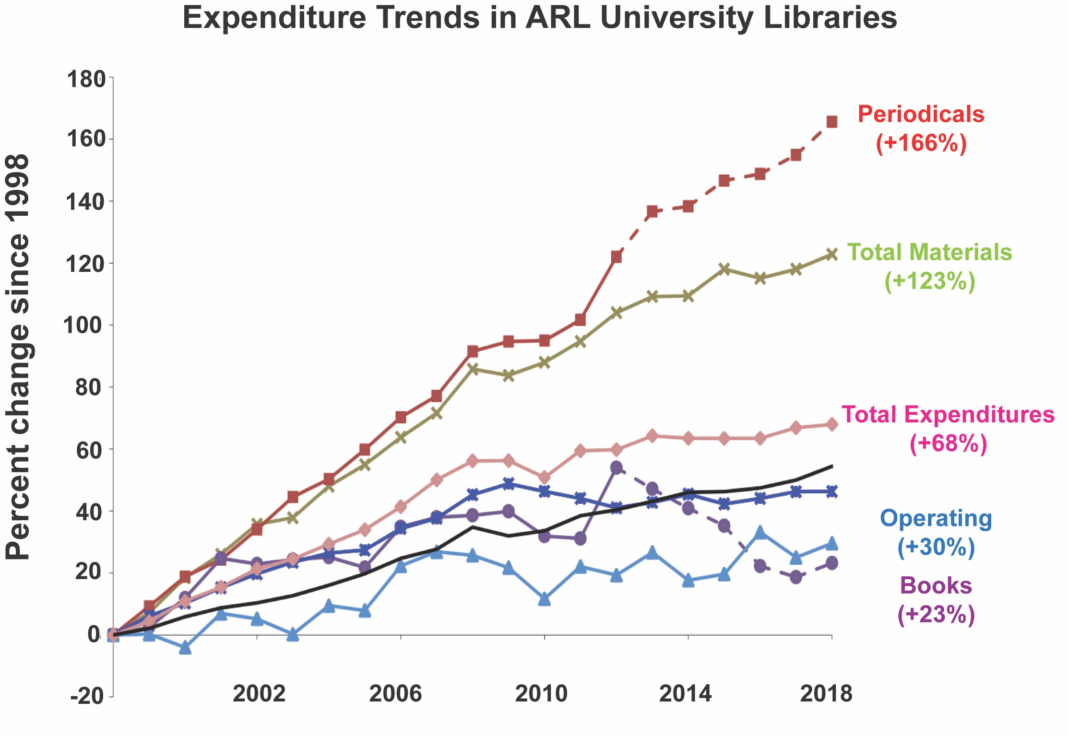
Figure 1. University Libraries expenditure trends. Data from ARL Libraries, not adjusted for inflation. Image © Association of Research Libraries

At OU, ongoing resource expenditures¹⁹ have gone from 76% of spending by format in FY10 to 93% in FY19. Although costs have risen across all disciplines, those within science, technology, engineering, and mathematics (STEM) have risen most steeply (Figure 2).

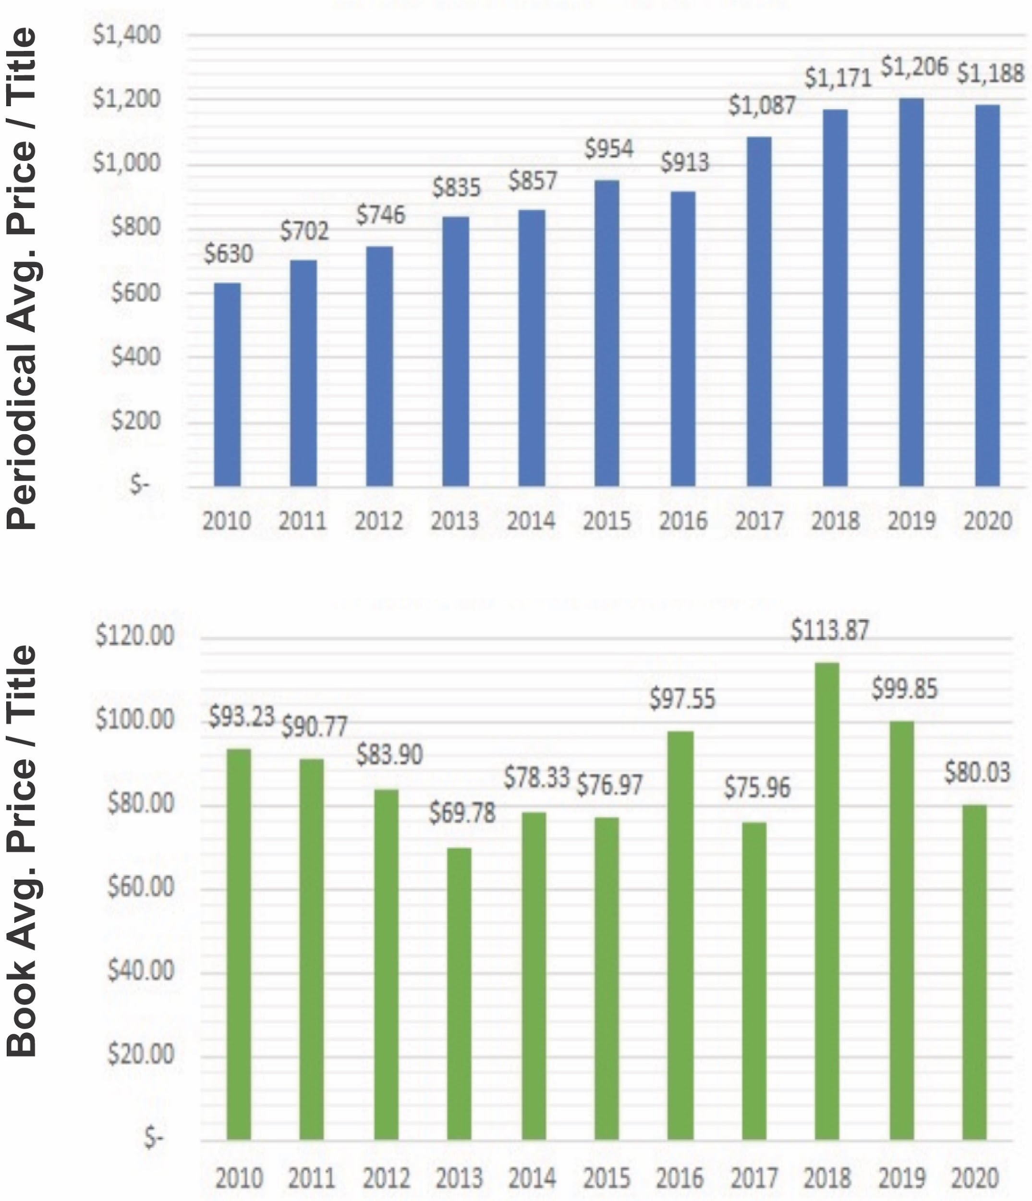

Figure 2. OU Libraries expenditures. Data were compiled from the ongoing OU Serials Project.
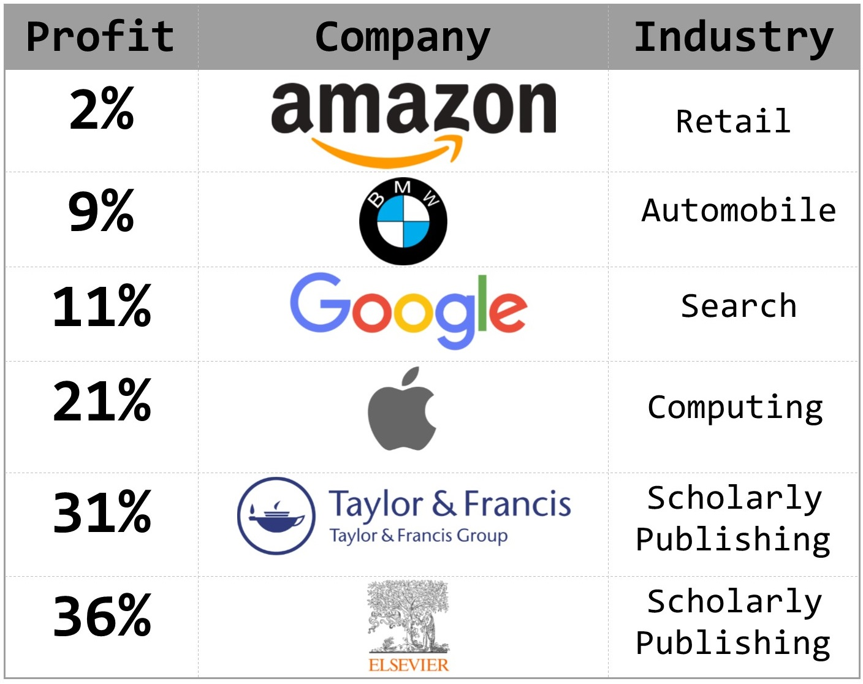
Universities, libraries, faculty, and graduate students are all engaged in a unique publishing ecosystem. Faculty members and graduate students write, edit, and assess the content published in scholarly journals, for the most part with no direct financial benefit; publishers assemble, publish, and distribute that content. Universities employing the authors and editors of this content then buy it back through their own libraries at a considerable markup so that faculty and graduate students may have access to their own work. The publishers, some of which are among the most profitable companies in the world, have monetized scholarly output to their benefit and to the benefit of their shareholders with little regard for those providing the content. Essentially, the university pays for both generating publishable content and accessing this same content in what is rapidly becoming an unsustainable publication system.

Commercial publishers, who control a substantial portion of STEM publishing, and a growing portion of social sciences and humanities publishing, either directly or in partnership with scholarly societies, enjoy growing and substantial profit margins under this inequitable system (Figure 3)²⁰. A 2018 presentation from the University of Virginia Library²¹ put commercial publisher profits in line with those of tech companies, banks, and pharmaceutical firms.
Figure 3. Example profit margins for large businesses.

By way of contrast, according to the NYU Stern database²² of more than 7,000 US companies, the average profit margin across all firms in 2019 was 7.9%.

Using Elsevier as an example, even after withdrawing from a comprehensive access agreement with the publisher in 2019, Elsevier accounts for 25% of OU Libraries’ ongoing resource expenditures. This ongoing resource cost escalation is exacerbated by the fact that the University Libraries has, over the past decade, experienced flat or declining budgets, including a university-mandated permanent budget reduction in FY19 and FY20 of over one million dollars. Although additional monies could address this deficit in the short term, over the long term these increases, as demonstrated by ARL research libraries expenditure trends, cannot be managed or sustained with current funding trajectories alone.

Given that libraries cannot continue to endure such escalating costs, one obvious solution would be to cancel ongoing resource commitments, both journals and databases. However, this would fail to address the underlying problem: The scholarly content created and assessed by scholars is being provided to publishers who then place it behind a paywall, which, by its very nature, limits access to only a subset of potential users.

An Open Access Solution
Open Access is the free, immediate, online availability of research articles²³ coupled with the rights to use those articles fully in a digital environment. Communicating the results of scholarly research and creative activity is essential to the research process; research can only be advanced by the sharing of its results, and the greatest value will be found through the widest sharing of those results. Over the past decade, open access has become central to advancing the interests of researchers, scholars, students, businesses, and the public. Increasingly, faculty members at institutions that support research are implementing policies that require researchers to make articles openly accessible to and fully usable by the public. Numerous studies have shown how making scholarly work openly available has many significant advantages, including:

- Open access journals garner more citations^{24,25,26,27,28} relative to those held behind a paywall.
- Open access articles serve more readers: Full text downloads are 89% higher; pdf downloads are 42% higher; and unique visitors are 23% greater for open access relative to subscription access articles.^{29,30,31,32}
- Open access articles receive more academic social media³³ attention than those in subscription journals behind a paywall.
- Openly available works provide more access for those who need it – scholars from smaller institutions or low and middle-income countries, patients and patient advocates, policy makers, and businesses relying on the latest findings to remain competitive.
- Open access also enables greater public engagement, faster impact, wider collaboration, and increased interdisciplinary conversation³⁴.

Four primary mechanisms can be used to enable open access: 1) open access publishing, 2) institutional or disciplinary repositories, 3) effectively managed author rights, and 4) open access policies. Each mechanism is covered below.

Open access publishing (gold and hybrid)
In “gold” (complete) open access publishing, authors publish their articles in journals that meet the full definition of open access – all articles are free to read, and the publisher places no financial or copyright barriers between the readers and the articles. In some cases, gold open access journals charge authors an open access fee, which is often paid from grant funding, a library fund, or funding from other university offices. However, 70% of open access journals do not charge authors a fee³⁵ to
publish. Open access publishing now firmly co-exists alongside traditional journal publishing, and it is the fastest growing segment of the scholarly publishing market (Figure 5³⁶). Open access journal options are now available across virtually every area of research, and these journals span the spectrum from lower impact research to high impact research.

In “hybrid” publishing, authors publish their articles in journals that charge a subscription fee and charge an additional article processing charge (APC) to authors who wish to make their individual article open access. In this model, some articles in a given issue are free for readers to access, and some remain behind a subscription paywall. Hybrid journal APCs are not a sustainable method of open access. For one, publishers have begun raising the price of APCs at three times the rate of inflation³⁷. Furthermore, libraries or other offices within the institution find themselves paying twice for the same content – once for the journal subscription and again for the APC to individual authors at their institution.

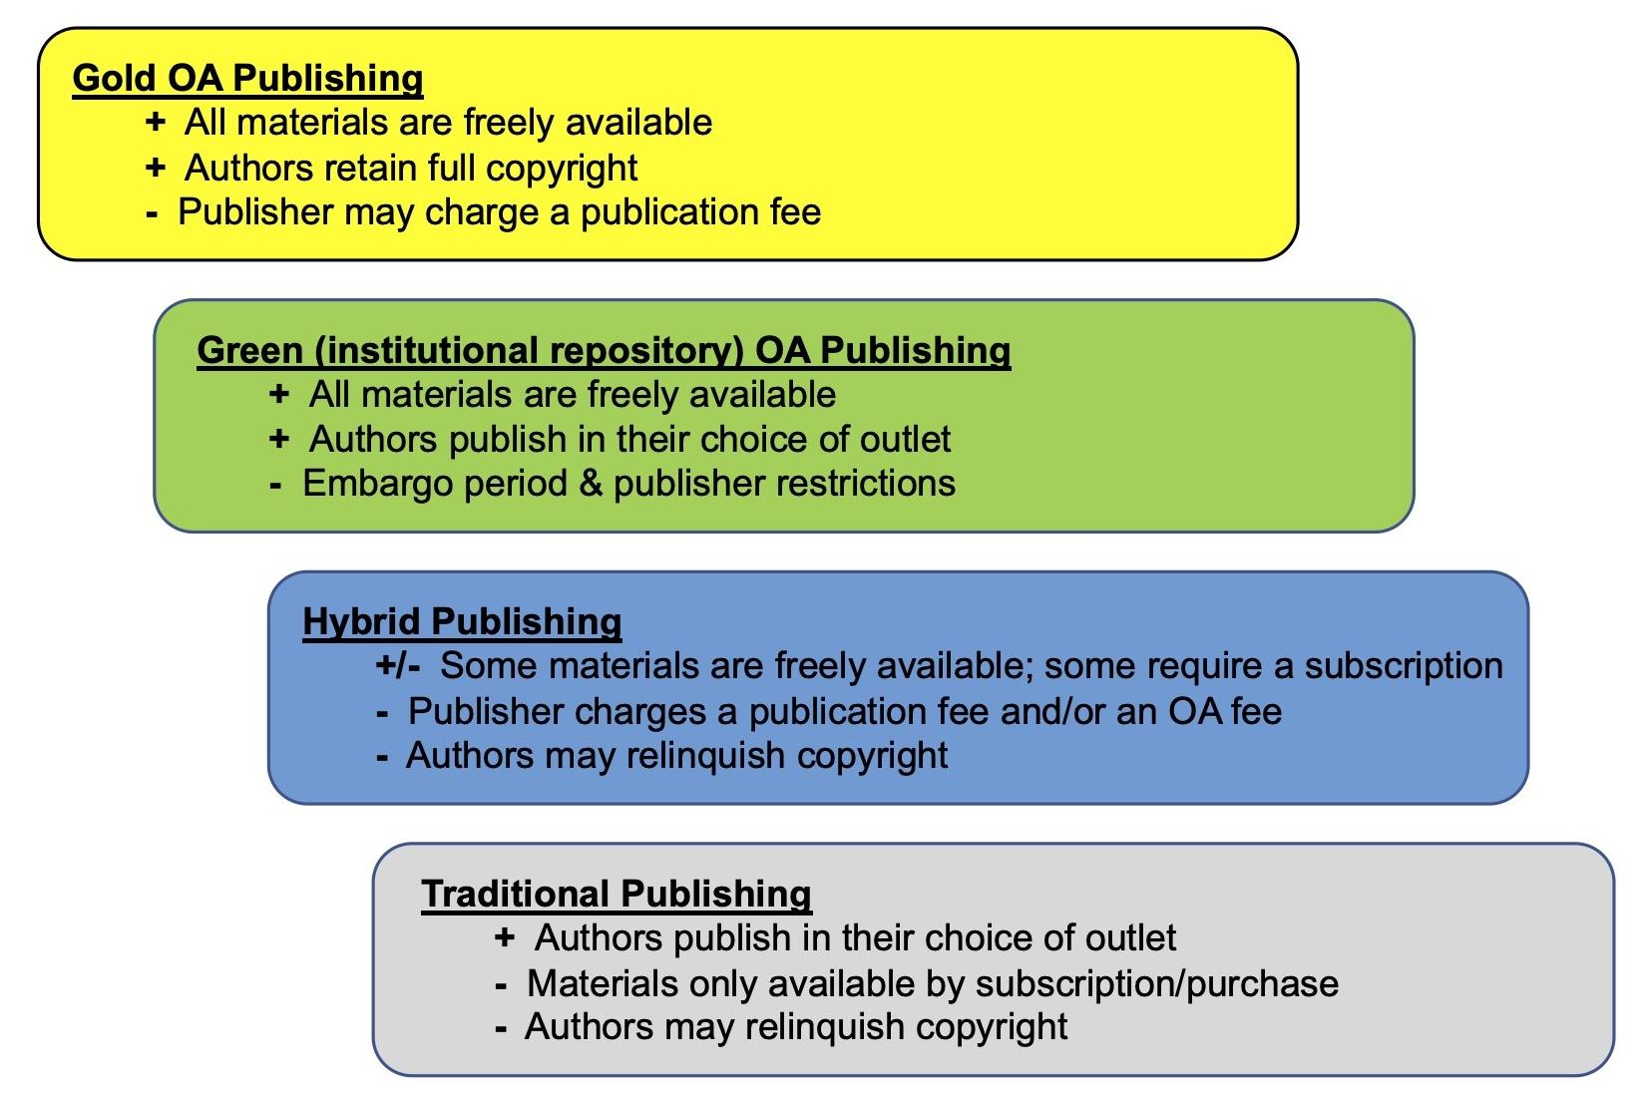
Figure 4. Scholarly publishing options.

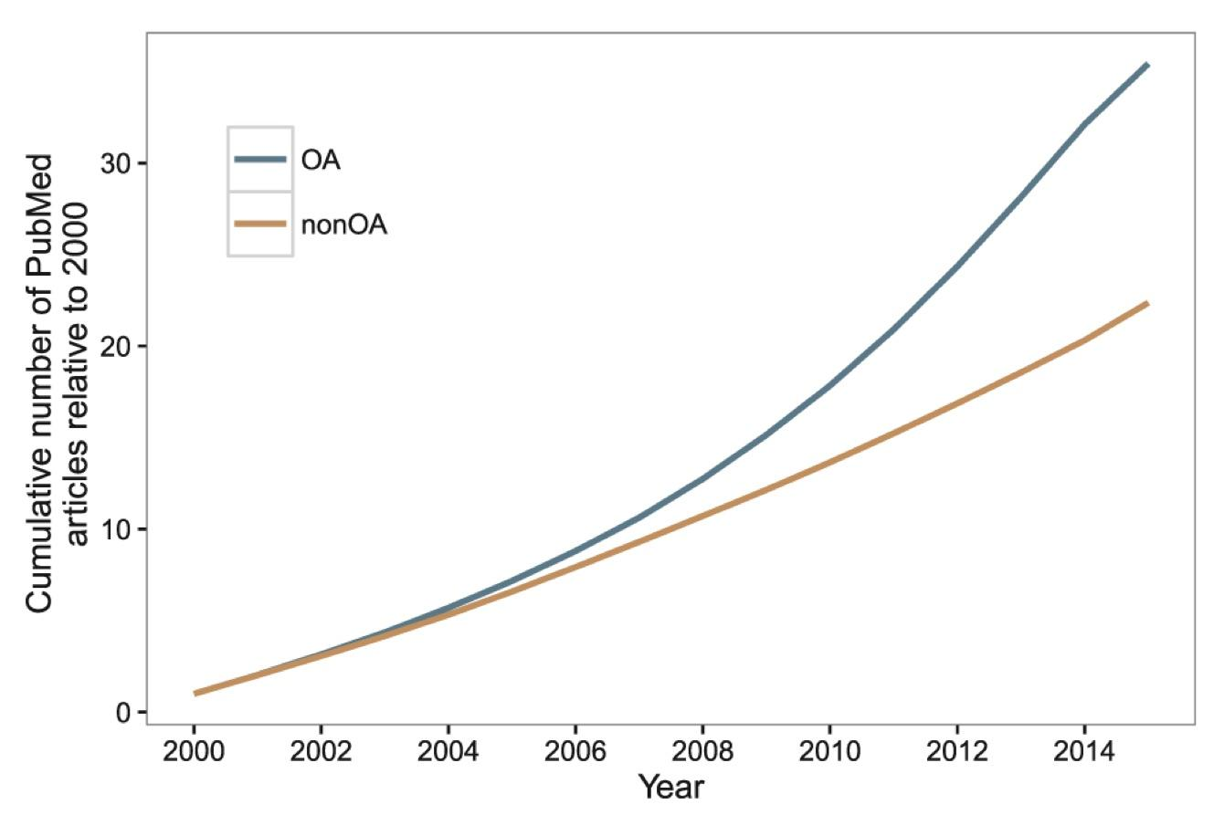
Figure 5. Rise in Open Access publications. Source: DOI: 10.12688/f1000research.8460.3.

Institutional or Disciplinary Repositories
Authors can choose to deposit their articles in institutional repositories, which enable readers to freely access the article text. This practice allows any author to make their work openly available regardless of the journal in which the article was published. OU’s institutional repository, SHAREOK,³⁸ serves as the home for the intellectual output of its faculty, students, and staff, holding and making available digital theses, dissertations, faculty publications, datasets, and much more. Institutional repositories are indexed by major search engines and other aggregators so that works deposited in a repository are findable across the internet. Because libraries’ missions include the preservation and dissemination of information, institutional repositories are most often maintained by academic libraries. Disciplinary repositories, covered in more detail later in this report, serve a similar function.

Depositing work in an institutional repository such as SHAREOK has two major caveats: embargo periods, and the inability to upload the publisher’s pdf of an article. Often publishers’ restrictions
mean authors must wait one to three (1 – 3) years to make their work available via an institutional repository, leading to delays in the dissemination of their work. Additionally, most publishers do not allow authors to upload the publisher’s pdf. Instead they allow uploading the postprint (author’s final, submitted manuscript after all peer review and revisions, but before copy editing and layout) or a preprint (authors final draft before peer review). Still, uploading a postprint to an institutional repository allows readers without a journal subscription to access and read the content.

Author Rights
Authors at OU who write manuscripts for peer-reviewed, scholarly journals generally own the full copyrights to their works. When authors publish in an open access journal, they retain their full copyrights even after the article has been published. However, when authors choose to publish in a traditional, subscription access journal, they are almost always required to sign a form transferring some or all of their copyrights to the publisher. These forms go by different names – publishing agreements, copyright transfer agreements, publication agreements, journal publishing agreements, etc. – and these legally binding contracts outline exactly what authors can and cannot do with the articles they have written. Moreover, after transferring copyright to a publisher, authors generally have very little say in how their work may be used later and often have to request permission from the publisher to reproduce or otherwise use aspects of their own scholarly work. Ultimately, these publishing agreements can restrict dissemination of scholarship, thereby lessening its impact.

Authors of research papers have the ability to ensure their articles can be accessed and used by the widest possible audience by managing their rights prior to signing a copyright transfer agreement. One effective tool for this purpose is an open access policy, covered in more detail in the next section. Besides an open access policy, other means for creating addenda to traditional copyright transfer forms are readily available, including proven resources to help authors maintain the rights³⁹ important to them – such as the ability to upload their work to an institutional repository or another openly available option. More specifically, OU Libraries Office of Open Initiatives and Scholarly Communication⁴⁰ provides services to assist authors in understanding their contracts and publishing under the most favorable conditions.

Open Access Policies
Academic institutions have implemented effective policies that support making open access to scholarly research articles (however, not books and monographs, which are addressed later in this document) the default mode for their faculty. Open access policies provide for open dissemination of scholarly activity by faculty and define guidelines for that dissemination, typically through the campus institutional repository.

There are at least 111 academic institutions (Appendix A) in the United States that have implemented an open access policy, which is typically enacted by a faculty governing body, such as the faculty senate. These policies allow authors to grant a license to the university to upload their scholarly articles to the university’s institutional repository prior to the rights being given to a publisher in an author agreement. Open access policies facilitate the widest dissemination of scholarly output, while still allowing authors to publish in the journals of their choice. Most academic open access policies allow authors an opt-out mechanism for specific papers under various circumstances.

SCHOLARLY COMMUNICATION PRACTICES / OA AMONG DIFFERENT DISCIPLINES
The rise of open access in scholarly communication benefits scholars in all disciplines, so scholars across all fields should acquaint themselves with the advantages available to them. However, bibliometric studies indicate the uptake, attitude, and practice of open access tends to vary across disciplines due to a number of factors, some of which may include:

- Disciplinary heritage/history
- Disciplinary culture and norms, including publishing channels
- Disciplinary barriers to open access, including publisher policies
- Funding mechanisms available to different disciplines and those funders’ requirements
- Influence of promotion and tenure among different disciplines (covered below)
- Scholars’ perceptions of the above

Furthermore, among individual scholars there are a variety of attitudes and practices based on additional variables beyond the scope of this report, such as: position; rank; tenure; personal attitudes, interests, and comfort with technology.

Several fields are considered to have had a pioneering role in implementing open access, most notably mathematics, physics, and astronomy. In fact, the foundation for open access was laid with the creation of arXiv,⁴¹ the open repository for physics established in 1991. Medical, natural, and technical sciences have also taken leading roles in embracing open access. The exceptions to this are the fields of engineering and chemistry, which have open access prevalence rates lower than most other disciplines,⁴² including those in the social sciences and humanities. Open access uptake in the social sciences is close behind the natural sciences; however, law, arts, and the humanities show the lowest uptake across all disciplines.

As noted above, the spectrum of open access practice is due to a number of factors, although it can generally be encapsulated by the following:

- U.S. governmental funding policies, such as the public access policies⁴³ implemented by the NSF, NIH, and other funding agencies require scholars to make the results of their funded research openly available. Most of these agencies are critical for STEM and social science funding.
- The high costs of producing monographs⁴⁴ are a key structural factor currently limiting open access in the humanities⁴⁵. Moreover, most research work in the humanities does not receive project-specific funding, making it difficult to integrate APCs or open access funds into a grant. However, many university presses are creating and evolving innovative options for open access monograph publishing.
- Many humanities, social science, and professional fields use an informal hierarchy to evaluate publications rather than quantitative methods often used by STEM disciplines.

IMPACT ON SCHOLARLY SOCIETIES / STRATEGIES ENACTED BY SCHOLARLY SOCIETIES
Scholarly and professional societies vary enormously in culture and scale, yet they play an important role in the scholarly communication landscape. Most scholarly societies work to advance research and connect scholars within a specific discipline or field, and the ways in which they do so are varied: publications, conferences, meetings, discipline-specific resources, professional services, awareness programs, advocacy, etc. Frequently, scholarly societies invest their profits back into the academic community, although when they outsource journal publishing to a publicly-held, commercial publisher a large portion of the profits flow to the publishing company.

Many scholarly societies are facing challenging times. Maintaining a membership in one’s disciplinary organization was once thought of as vital, but the changing funding environment, the increasing “adjunctification” of the academic workforce, and the ease of creating direct ties among individual colleagues in online social networking systems have contributed to the ambivalence many scholars feel toward these societies today. Scholarly societies thus face rising costs and declining memberships, causing them to rely increasingly on income from publications — at precisely the same time they face increasing expectations among scholars that information and communication will exist in open spaces online. Increasing calls for open access to scholarship are posing serious challenges⁴⁶ to the financial models that have allowed scholarly societies to fund the non revenue generating projects they have established on behalf of their members.

Some scholarly societies have responded by establishing open access journals to generate revenue by charging open access fees paid by the author(s). However, due to differing imperatives and realities among various disciplines, an author-pays publishing model may not always be feasible. Academic libraries, including OU Libraries, are increasingly partnering with scholarly societies to provide open access journal publishing services and platforms at no cost. Additionally, organizations such as TSPOA⁴⁷ (Transitioning Society Publications to Open Access) and OASPA⁴⁸ (Open Access Scholarly Publishing Association) are actively supporting society journal publications in their shift to open access. Indeed, a recent report identified seven different approaches and models,⁴⁹ for use alone or in combination, effective in transitioning scholarly society publications to open access.
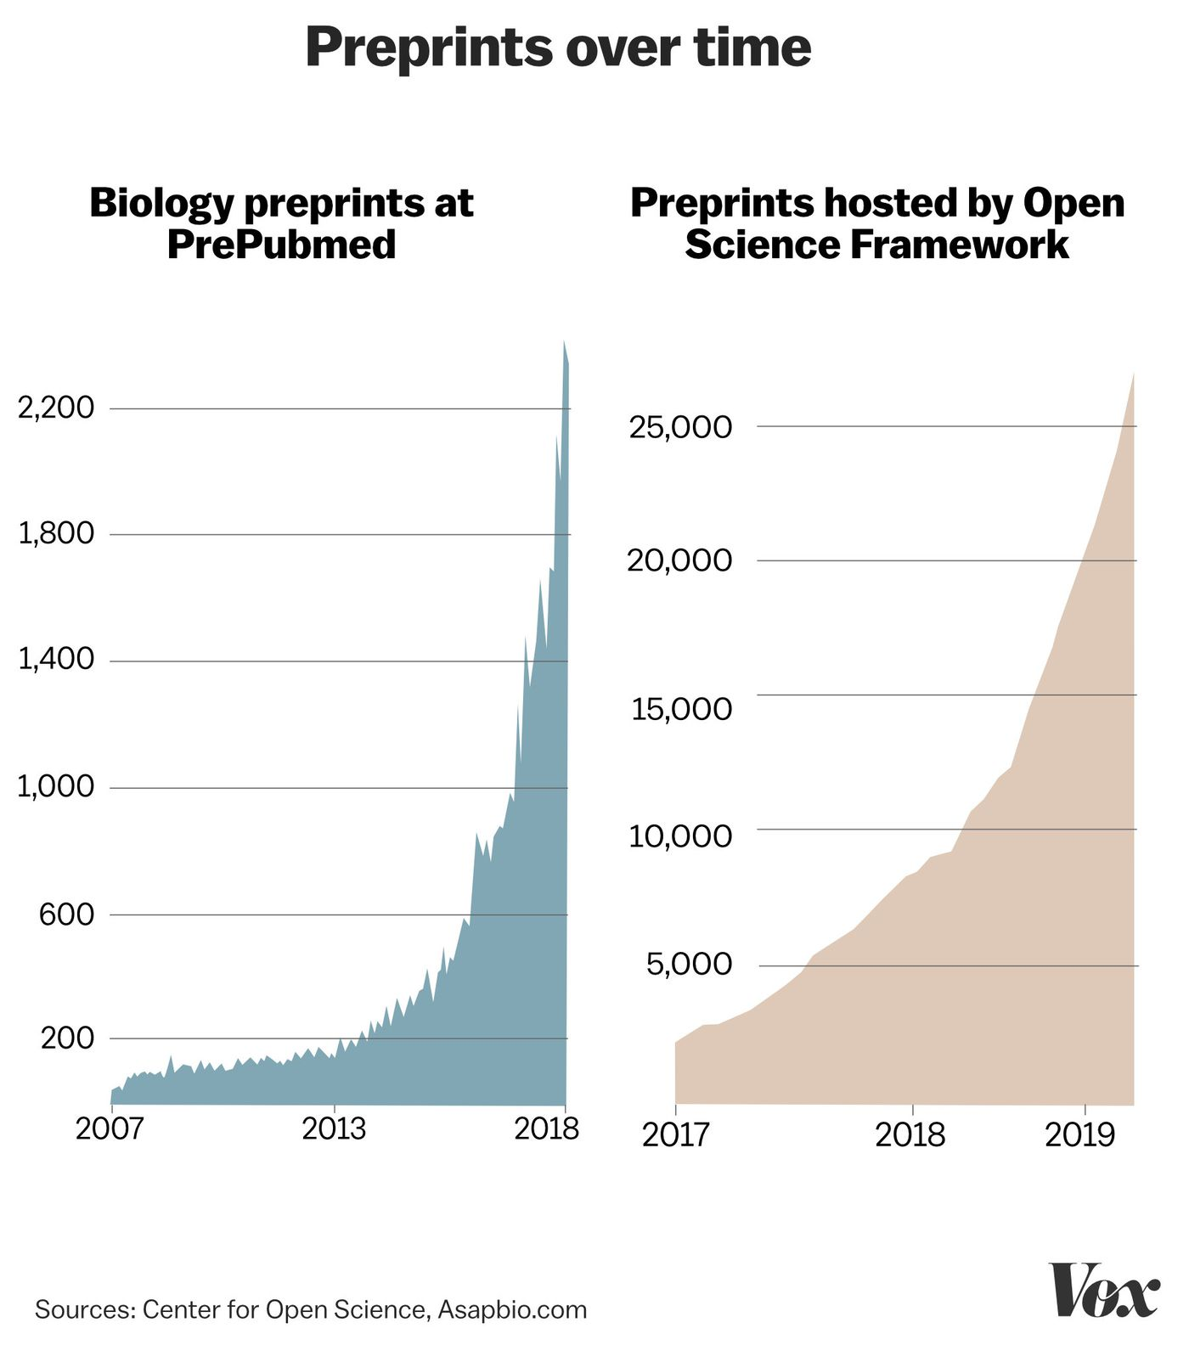
Yet journal publication represents only one mode for increasing public access to scholarship. For example, some societies have worked to make their publication agreements more open-friendly so their authors may retain their rights to deposit articles in institutional and disciplinary repositories. Many societies have gone a step further and created disciplinary repositories where authors can deposit preprints, postprints, data sets, gray literature, and other scholarly outputs (Figure 6⁵⁰). There are many others, but a few of these include:

- arXiv (physics, mathematics, astronomy, computational science)
- bioRxiv (life sciences)
- engrXiv (engineering)
- Humanities Commons
Figure 6. The rise in OA biomedical preprints over time (50). Image © Vox

- MLA Commons
- SocArXiv (social sciences)
- PsyArXiv (psychology)
- RePEc (economics)

PROMOTION AND TENURE CONSIDERATIONS
Promotion, tenure, and review processes play a significant role in scholarly communication. Faculty seek to publish in venues which are valued by their professional peers. One recent research study⁵¹ indicated scholars most value journal readership, while believing their peers most value prestige and related metrics such as impact factor. The impact factor, in turn, is also under the microscope; in 2012 the San Francisco Declaration on Research Assessment (DORA⁵²) called into question the Journal Impact Factor (JIF) for “a number of well-documented deficiencies as a tool for research assessment” and urged the elimination “of journal-based metrics in funding, appointment, and promotion considerations” and “the need to assess research on its own merits rather than on the basis of the journal in which the research is published.” Echoing this last point, another recent study⁵³ indicated most scholars agree that high-quality peer reviewed works should be encouraged via promotion and tenure processes, whereas in practice the publication venue is frequently used as a proxy for quality and rigorous peer review. Findings such as these highlight the academy’s need to respond more agilely to new publication venues, some of which offer the ability to support more open and diverse ways to make research public while addressing the economics of scholarly publishing.

SHARING OF ITEMS OTHER THAN SCHOLARLY ARTICLES
The scholarly landscape has evolved in recent years to include not just formal publications such as books and articles, but a wide range of other valuable research achievements, such as digital scholarship projects, datasets, and software. In a networked scholarly communication environment, these research outputs merit serious attention. Digital scholarship projects combine the power of technologies such as GIS, linked open data, data and text analysis with traditional and rigorous research materials and techniques to create new ways to explore and understand the past, present, and future. Datasets of all varieties (images, audio, topological, numerical, etc.) hold value for current and future users; a dataset used by a climatologist may also be of value to a public policy analyst, political scientist, or a historian. Software to interact with information, facilitate queries, or create visualizations has clear applications in the scholarly landscape and beyond. The availability of data and code allows for the important work of examining research for validity and rigor. Although it is essential to have access to basic data to verify and reproduce the results of articles in peer-reviewed journals, it is frequently unavailable. Determining how to assess, provide credit for, utilize, maintain and preserve these research outputs holds both challenge and promise.

RECOMMENDATIONS OF THE SCHOLARLY COMMUNICATION TASKFORCE
After reviewing, considering, and discussing the relevant literature⁵⁴ and associated best practices the University Libraries Committee Scholarly Communication Taskforce recommends the stakeholders identified below take the following actions to have the most positive impact upon the creation of an open and sustainable system of scholarly communication at OU:

- OU Faculty Senate begins the preparatory steps necessary to pass a university Open Access Policy based on the Harvard model policy¹ language. An open access policy encourages and facilitates the wider circulation of scholarship created at OU. Many peer and aspirational-peer institutions have already developed such policies (Appendix A).
- Scholars at OU seek to retain their rights as authors² when possible. Strategies to address this can be provided through websites, workshops and presentations, videos, individual consultations with liaison librarians, and other means.
- The University, through the University Libraries, promotes and supports mediated deposit of scholarly and research materials into OU’s institutional repository, SHAREOK³. SHAREOK provides the necessary infrastructure for OU stakeholders to share scholarship on a stable, open platform that facilitates interoperability with major search engines and harvesting initiatives.
- University Libraries provides tools and resources to assist scholars in identifying quality outlets for publishing their work and serving in editorial capacities; tools to provide this information are available at OU Libraries Evaluating Publishers web page⁴. Quality of publication venues is important for tenure and promotion as well as for ensuring the quality and reliability of open access scholarship; these tools and resources will help scholars choose the most advantageous outlets for their work and avoid questionable publishers and journals.
- OU Faculty Senate considers a resolution⁵ promoting principles for advancing openness, and open access rights to University personnel-authored works, through University Libraries journal negotiations. As the representative body where issues of critical importance for the University of Oklahoma’s community of scholars are deliberated, resolutions adopted by the Faculty Senate serve as authoritative statements of the will of the faculty. The resolution process provides an essential forum in which to give due deliberation to the principles for advancing openness.
- Scholars choose outlets for their publications with an awareness of fair pricing and open access; tools to provide this information are available at web pages for the OU Libraries Serial Projects⁶ and Open Access⁷. Many factors contribute to a scholar’s decisions on which publication venues are consistent with their professional development. To support consideration of open access options as part of this determinative process, scholars must be provided with accessible and reliable information.
- The Provost’s Office and the OVPRP develop guidelines for preparing and reviewing promotion and tenure documents that affirm a commitment to disseminating research and scholarly activity outputs as widely as possible by supporting faculty participation in open access distribution of their scholarship. Such guidelines will confirm the centrality of open access principles to the research mission of the University and provide structural support for how evaluative bodies should best proceed within a framework that respects both university-wide principles and departmental-level disciplinary considerations.
- Academic departments apply consistent criteria for assessing the quality of published work, including traditional (fee-based) and open access publications, in the tenure and promotion process. Establishing consistent criteria in the tenure and promotion process that apply to open access options will resolve ambiguities about the status of these new scholarly venues for candidates and evaluators and will eliminate approaching these instances in an ad hoc manner.
- The University implements procedures to support the ability of university research and operational units to license software they develop under open licenses and contribute to open-source projects when possible. The scholarly and research lifecycle includes important outputs in addition to scholarly articles, and the principles of openness extend to these outputs as well.
- The University standardizes and streamlines administrative procedures related to scholarly communication issues to minimize individual researcher time: permissions, available licenses, and Article Processing Charges (APC) payments or Open Access Fees.

COMMUNICATION AND OUTREACH FRAMEWORK
The ULC Scholarly Communication Taskforce developed a framework for communicating findings to the OU community of scholars, which includes the following recommendations:

- The ULC Scholarly Communication Taskforce, in partnership with the University Libraries, create online guides, workshops and presentations, videos, news items, and other means to communicate this report and facilitate campus discussion among faculty and graduate students.
- The ULC Scholarly Communication Taskforce utilizes established campus communication channels, such as (but not limited to) the Provost’s Bulletin, the CFE website, and the Libraries’ monthly newsletter, to share this report.
- Members of the ULC Scholarly Communication Taskforce share and present this report to, at a minimum, the following:

  - University Libraries Committee
  - Faculty Senate Executive Committee
  - Graduate Student Senate Executive Committee
  - Faculty Senate
  - Graduate Student Senate
  - Office of the Vice President for Research and Partnerships
  - Provost’s Office
  - Research Council
  - Dean’s Council
  - President’s Office
  - Center for Faculty Excellence
  - Associate Deans for Research
  - College-based meetings of Chairs and Directors
  - Departmental faculty meetings
  - University Libraries’ liaison librarians

ADDITIONAL INFORMATION
Additional information about the University Libraries Committee Scholarly Communication Taskforce, including this report’s full bibliography is available on the Taskforce website⁵⁵.

Unless otherwise specified, this report is licensed CC BY 4.0 (Attribution 4.0 International.

APPENDIX A: LIST OF U.S. INSTITUTIONS WITH OPEN ACCESS POLICIES
Institutions identified by querying⁵⁶ the Registry of Open Access Repository Mandates and Policies (ROARMAP⁵⁷)

Abilene Christian University
Allegheny College
Amherst College
Arizona State University Libraries
Bennington College
Boston University
Brandeis University
Brigham Young University Library
Bryn Mawr College
Bucknell University
California Institute of Technology
California Polytechnic State University
California State University
Case Western Reserve University
Columbia University Lamont-Doherty Earth Observatory
Columbia University Libraries
Columbia University Mailman School of Public Health
Columbia University School of Social Work
Connecticut College
Cornell University
Drake University
Duke University
Duke University Graduate School
Emory University
Florida Gulf Coast University
Florida State University
Georgia Institute of Technology
Gustavus Adolphus College Library
Harvard Business School
Harvard Divinity School
Harvard Law School
Harvard School of Public Health
Harvard University Faculty of Arts & Sciences
Harvard University Graduate School of Design
Harvard University Graduate School of Education
Harvard University John F. Kennedy School
of Government
Harvard University Medical School
Harvard University Shorenstein Center on Media
IUPUI
Indiana University-Purdue University Fort Wayne
Indiana University-Purdue University Indianapolis Library
Johns Hopkins University
Kansas State University
Lafayette College
Luther Seminar
Massachusetts Institute of Technology
Miami University (Ohio) Libraries
Montana State University
Muhlenberg College
Northeastern Illinois University
Northern Illinois University
Oberlin College
Oregon State University
Oregon State University College of Oceanic and Atmospheric Sciences
Oregon State University Library Faculty
Pacific University
Penn State University
Penn State University Libraries
Princeton University
Rice University
Rollins College
Rutgers
San Jose State University
Smith College
Smithsonian Institution
Snell Library
Stanford University School of Education
Temple University Graduate School
Texas A&M University
The College of Wooster
Toulouse Graduate School
Trinity University
University of California System
University of California San Francisco
University of Central Florida
University of Illinois Urbana-Champaign
University of Colorado Boulder
University of Delaware
University of Florida
University of Hawaii-Manoa
University of Illinois Chicago Circle
University of Kansas
University of Kentucky
University of Maryland College Park
University of Massachusetts Amherst
University of Nevada
University of North Carolina Greensboro
University of North Florida
University of North Texas
University of Northern Colorado Library Faculty
University of Oregon
University of Oregon Department of Romance Languages
University of Pennsylvania
University of Puerto Rico School of Law
University of Rhode Island
University of Tennessee
University of Texas Libraries
University of Virginia
University of Wisconsin Eau Claire: ED McIntyre Library
Ursula C. Schwerin Library
Utah State University
Valparaiso University
Virginia Tech
Virginia Tech Library Faculty Association
Wake Forest University Z. Smith Reynolds Library Faculty
Wellesley College
West Virginia University
Wichita State University
Woods Hole Oceanographic Institution

