UNIVERSITY OF OKLAHOMA
GRADUATE COLLEGE

ORDERING WONDER:
COLLECTIONS, CURATORS, AND SHOWMEN IN ANTEBELLUM AMERICA

A DISSERTATION
SUBMITTED TO THE GRADUATE FACULTY
in partial fulfillment of the requirements for the
Degree of
DOCTOR OF PHILOSOPHY

By
James Marcus Burnes
Norman, Oklahoma
2023

ORDERING WONDER:
COLLECTIONS, CURATORS, AND SHOWMEN IN ANTEBELLUM AMERICA

A DISSERTATION APPROVED FOR THE
DEPARTMENT OF THE HISTORY OF SCIENCE, TECHNOLOGY, AND MEDICINE

BY THE COMMITTEE CONSISTING OF

Dr. Katherine Pandora, Chair

Dr. Alison Fields

Dr. Piers Hale

Dr. Kerry Magruder

© Copyright by JAMES MARCUS BURNES 2023
All Rights Reserved.

ABSTRACT

This dissertation explores the development and execution of five museum collections established between the 1793 opening of Charles Willson Peale’s museum in Philadelphia and the opening of the Smithsonian Institution as America’s National Museum in 1855. The Smithsonian Institution and, later, the American Museum of Natural History and the Metropolitan Museum of Art seem to many like the beginning of "real" museums in America, but what this research demonstrates is that they are the result of decades of trial and error by many previous, equally real, museums. Through generations of changes not only of the nation but of the people and culture of that nation, museums’ content and displays reflected changes in government, cultural shifts, and new populations with leisure time and extra money to spend. They at once reveal something uniquely American in content while tying themselves to existing European models, providing excellent avenues to study the early exercise of American science with international comparisons to older, more established institutions, professionals, and audiences.

In memory of James W. Westgate
mentor, friend, colleague

Acknowledgements
As soon as one begins trying to list the profuse number of individuals who have helped or supported any project someone will immediately be forgotten. Be that as it may, there are some who deserve to be mentioned here in case this ends up being my only lasting contribution cast out into the world which people can find. Without the encouragement and guidance of my mentor professor back at Lamar University closer to the beginning of this century, I would have never pursued any graduate degree, much less a doctorate. Jim Westgate taught me not only the ins and outs of the Eocene and vertebrate paleontology, but how to navigate the Academic system with which I was vastly unfamiliar. He was the first to encourage my interests in the history of science as it related to paleontology; how moments and discoveries which were no longer scientifically important were still major milestones in the development of the discipline. He helped me develop my path of science outreach, sending me out to share our fossil casts with local schools and making me part of Texas Energy Museum’s Dinosaur Days. He was my biggest supporter when I began crowdfunding my own mini mobile museum of fossil casts when I was no longer close enough to use the ones from the lab. Without my time with him, the miles we travelled together, and the continued working relationship we maintained until his unexpected passing in 2022, none of what follows would have occurred. It is to his memory that I dedicate this work.
My advisor, Katherine Pandora, has been indispensable in helping me make sense of my own ideas and questions about the history of science and popular culture. She has always provided me with the sources I have needed to verify the connections I was seeing, always showing, but never telling me what to see. She helped me realize more of my own potential chairing me through my second M.A. and this dissertation. She was also the first one to show me that I could take the questions and interest I had about Victorian exploration and science and turn them onto American shores where fewer historians of science were combing the beaches. Possibly most importantly, she understood my need for work life balance as my work moved from Graduate Assistant to fill time exhibitions coordinator for the University Libraries, and my wife and I welcomed our son into the world. For that, I am truly thankful.
Piers Hale has been my longest contact at the University of Oklahoma, having been the Victorian Science scholar I initially contacted to visit the department. A constant source of inspiration both inside and outside the classroom, our chats, special readings, and music discussions provided needed recharges throughout this whole process. Working between Drs. Hale and Pandora gave me a stronger framework on which to build the comparison between American and British Science. This work could not have been as robust without his help. And he did not hold a grudge when I declared independence from the British line of inquiry and entrenched myself firmly into American Cultural History.
One of the most important contributing factors to being able to complete this project was securing full time employment. This was an event made possibly by Kerry Magruder. Our lunch chats during my earliest years in the program helped center me within a new discipline, university, and city. Not only has he been a source or moral and academic support through this process, but his willingness to take me on as a contributor to the Galileo’s World exhibition allowed me to slowly carve out a place for my talents within the library. I first worked as a graduate assistant and later became a full-time staff member in charge of the library’s exhibitions, a position graciously created by Dean Rick Luce.
Following the completion of my Master’s Degree I spent semesters steeping in the Art History department. Alison Fields and Byron Price both welcomed me into the fold as I spent several seminars fine tuning my media and image analysis skills. Working and studying with artists such as Lucas Simmons and Bryan Rapp and art historians in (then) training Denise Neil and Ashlea Guernsey provided not only a new network of colleagues and friends, but yet another toolkit and ideas useful in approaching such an interdisciplinary project as this. They suggested readings and exhibits while listening to my lamentations over the lack of biographical context of many artists lives were separated from the works they produced. My time with them provided me with a fuller view of nineteenth century America.
Enormous thanks to Lukas Rieppel who generously shared his scans and photos of Koch material from the Missouri Historical Society when the pandemic prevented me from visiting. I am thankful for the friends I made while managing the project. Leila McNeil and I toiled through early coursework together and have remained in touch after our paths diverge. I am grateful for the opportunity to have written something for her and Anna Reser’s early installments of Lady Science. Brent Purkaple and I shared an office and a passion for science education and outreach even though our respective subject timelines were separated by centuries.
As I mentioned before, a great deal of this began back in Texas at Lamar University and I had to get here from there. I was accepted into the OU program without funding and was only able to begin my career here thanks to Clay Wesley and Don Rodgers. They helped me secure a Graduate Assistant position in the Graduate College working on a project with Dean Lee Williams and Tim Davidson. I never would have met Clay and Don had it not been for the McNair Scholars Program at Lamar University and its director Daniella Medley. I would also like to mention Steven Zani, who taught the Intro to Philosophy course my first year of college. Included on the syllabus (which I still have) was Galileo, Newton, and Einstein. I had no idea at the time that those weeks would set me up with at least a basic background in my eventual chosen field. When I returned to college after a four-year hiatus working on industrial labor projects, I saw him at the university bookstore. Not only did he remember me, but he was incredibly encouraging about me coming back, something that had a profoundly positive effect on my mental state as I was adjusting to a lot of then recent changes.
Carolyn Shelton Clanahan guided my headlong dive into anthropology when I went back to Lamar and oversaw the process of obtaining a minor in the field (Lamar has no major in Anthropology). Working with her also opened doors into student engagement and involvement in ways I had not known possible the first time I was enrolled. Michael Clanahan taught me how to be a student; not just a college student, but a lifelong student of the world and how to learn from the people around me. He also taught me how to not just go to class and go home, but to get involved. He also showed me how to constantly reposition the big picture a bit to get a different perspective than everybody else. Each and every one of these people are counted amongst my closest and dearest friends to this day and I can only hope that the equity that they put into me can be paid forward.
My wife Jami has been one of the few constants along this everchanging path. She has remained steadfastly supportive and positive over the years even as our timelines, addresses, and other plans changed. My son Nathaniel was born in 2018. The bulk of this dissertation was written while he was asleep, either during his nap times or after bedtime. This is a fact I am disproportionally proud of and one of the reasons that my time to completion is on the upper average. Through him I know that my contribution to the future is something that goes beyond the pages in this dissertation.
The greatest gift that came from my son growing up as I worked on this has been his completely new way of looking at the world. His insatiable curiosity bolsters my own, and his ability to find wonder in the seemingly mundane recapitulates some of the earliest records of experiencing nature’s wonders in many of the sources I have used. I began to keep a notebook with me as we watched children’s programming or read children’s books because I began noticing aspects of what I was working on peppered and flaked throughout all the media we consumed. From the very first—and subsequently numerous others—episode of Scooby-Doo taking place in a museum to the fact that the Gotham City Museum may just be the most robbed museum in the world, museums in popular culture still abound. I would also be remiss if I did not mention our three dachshunds Madame Curie, Lady Chloe, and Dame Freya. They have been constant writing and editing companions. In the evenings when everyone else is asleep in their rooms, some combination of these girls is asleep next to me on the couch, in the chair, or on the floor.
Lastly, thanks to Steven Eardley for proofreading and copyediting. His notes have made this work better than it would have been otherwise. Any remaining errors are solely my own.

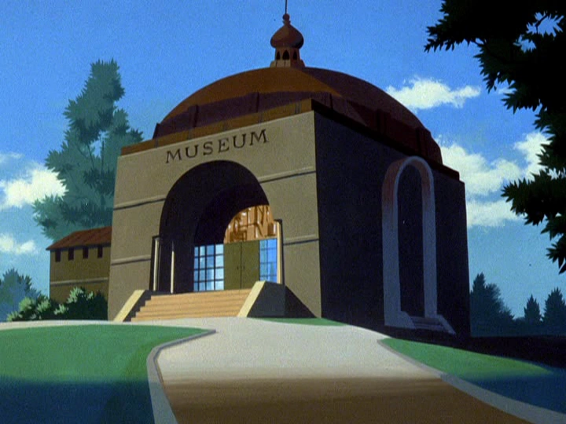

Figure 1. County Museum, Scooby-Doo Where are You. Episode 1, "What a Night for a Knight." Image still by author.

Table of Contents

Abstract iv

Acknowledgements vi

List of images xii

Museums Discussed xiv

Prologue: Lucy in the Sky (with Fossils) xx

Introduction 1

1 — Forging a Dynasty: The Peale Family Museum(s) 31

2 — Ten Thousand Chinese Things: Nathan Dunn’s Chinese Collection 82

3 — Meet Me in St. Louis: Clark, Catlin, Koch 111

4 — A Congress of Wonders: Dime Museums and Penny Presses 168

5 — From National Museum to Nation’s Attic: The Smithsonian Institution
and the Return to Order 218

6— Conclusion 250

Epilogue: The Splitsonian Institute 261

Bibliography 262

LIST OF IMAGES

Figure 1. County Museum x

Figure 2. Independence Hall xiv

Figure 3. Dunn’s Chinese Museum xiv

Figure 4. Rembrandt Peale’s Baltimore Museum xv

Figure 5. Bullock’s Egyptian Hall xv

Figure 6. Barnum’s American Museum xvi

Figure 7. Barnum’s New Museum xvii

Figure 8. United States Patent Office xviii

Figure 9. The Smithsonian Castle xviii

Figure 10. Inside Peale’s Museum xix

Figure 11. Inside Barnum’s Museum xix

Figure 12. Lucy’s Legacy xx

Figure 13. Museum as Popular Culture 30

Figure 14. 1794 Admission Ticket to Peale’s Museum 35

Figure 15. Copper engraving plate for Peale’s Museum tickets 35

Figure 16. 1814 printed ticket to Peale’s Museum 35

Figure 17. 1820s ticket to Peale’s Museum 36

Figure 18. Rational Amusements Poster 39

Figure 19. The Artist in His Museum 43

Figure 20. Self Portrait with Mastodon Bone 50

Figure 21. The Exhumation of the Mastodon 52

Figure 22. An Experiment on a Bird in an Air Pump 52

Figure 23. Peale’s Carnivorous Mammoth 54

Figure 24. Skeleton of the Mastodon at the Baltimore Museum 69

Figure 25. The Peale’s Mummy 73

Figure 26. Examination of a Mummy – The Priestess of Ammon 76

Figure 27. Dunn’s Chinese Museum 83

Figure 28. Bullock’s Museum 133

Figure 29. An Iowa Addressing a London Audience 137

Figure 30. Catlin’s Living Gallery performing for the French King 144

Figure 31. Missourium or Missouri Leviathan 158

Figure 32. The Hydrarchos 160

Figure 33. Panorama of the Monumental Grandeur of the Mississippi Valley 163

Figure 34. Extinct Sloth Detail of the Mississippi Valley Panorama 163

Figure 35. Koch and Dickenson detail of the Mississippi Valley Panorama 164

Figure 36. Joice Heth: The Greatest Natural and National Curiosity in the World 185

Figure 37. Lunar Man Bats 192

Figure 38. Barnum’s American Museum 206

Figure 39. Interior of Barnum’s American Museum 209

Figure 40. Barnum’s New Museum 215

Figure 41. The Smithsonian Castle 227

Figure 42. United States Patent Office 240

Figure 43. Gallery of the U.S. Patent Office Museum 243

Figure 44. The Splitsonian Institute 260
Museums Discussed

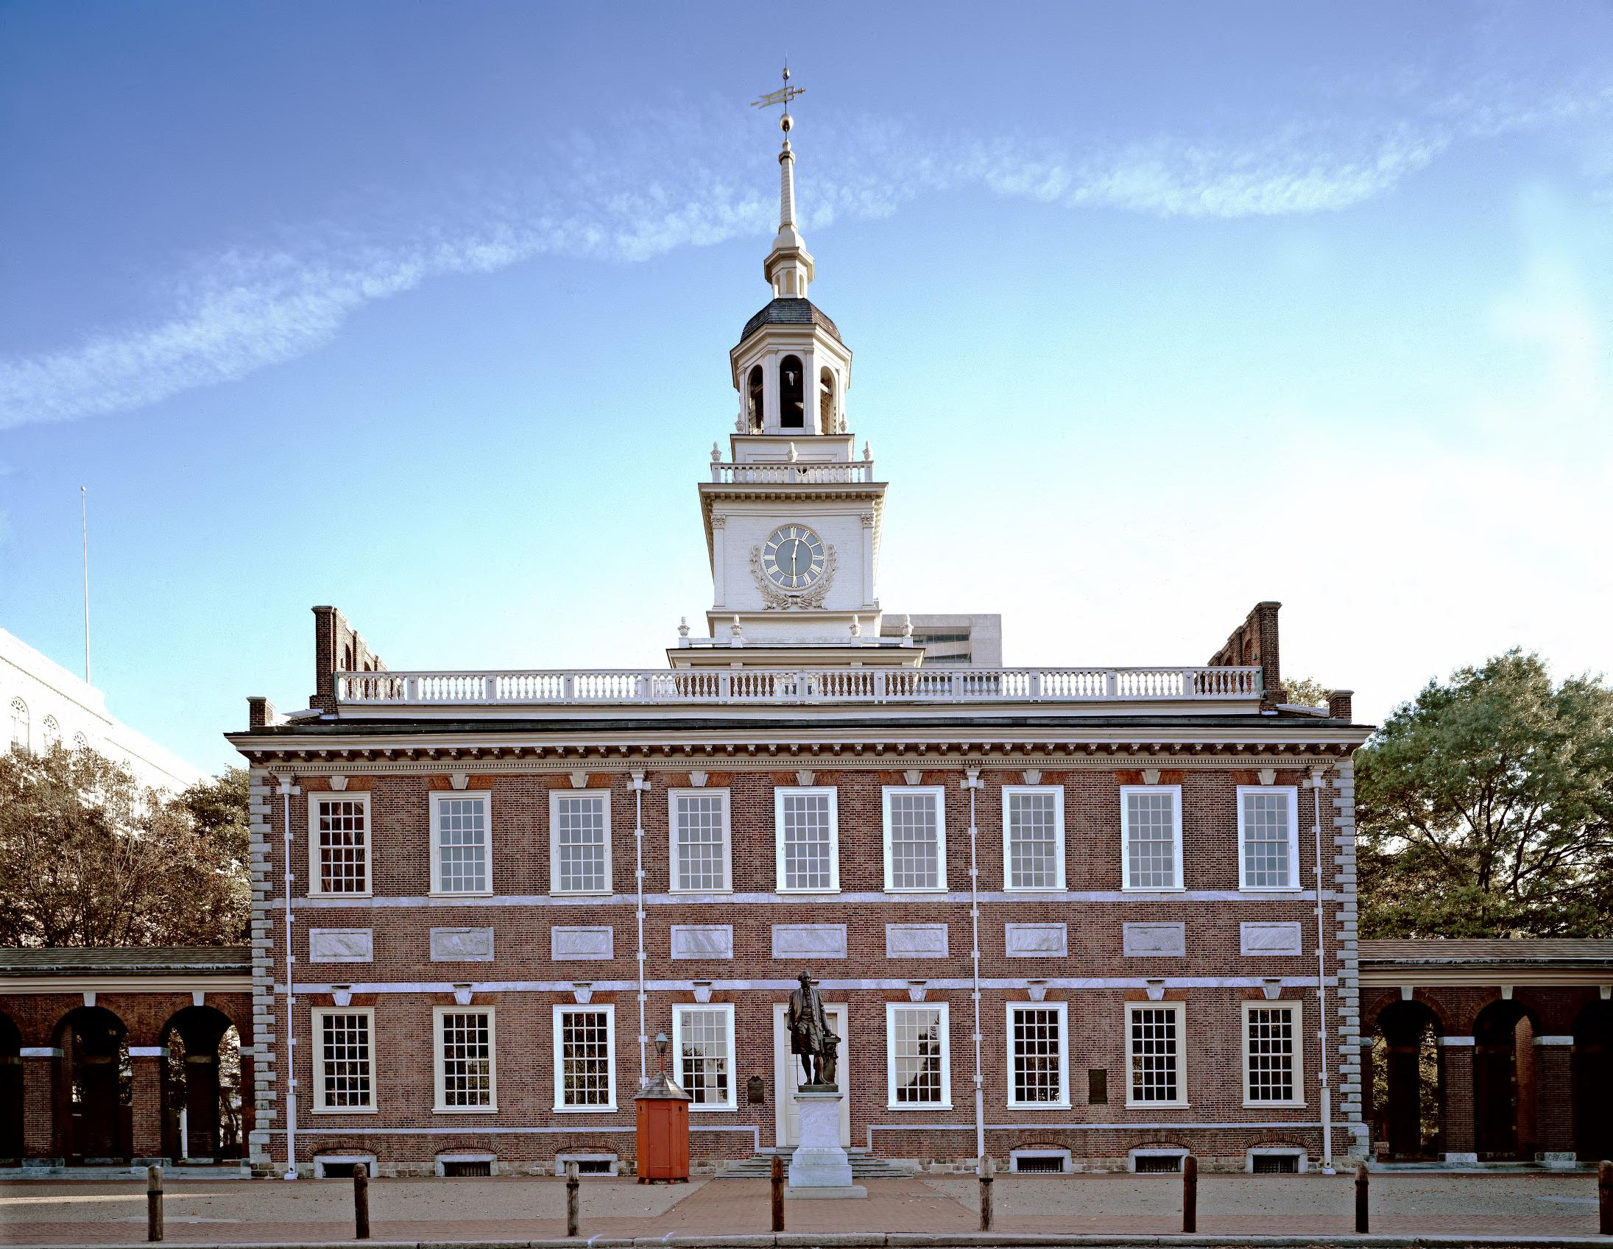
Figure 2. Independence Hall, Philadelphia. Home of Peale's second museum. Image Courtesy of the Library of Congress (http://hdl.loc.gov/loc.pnp/pp.print)
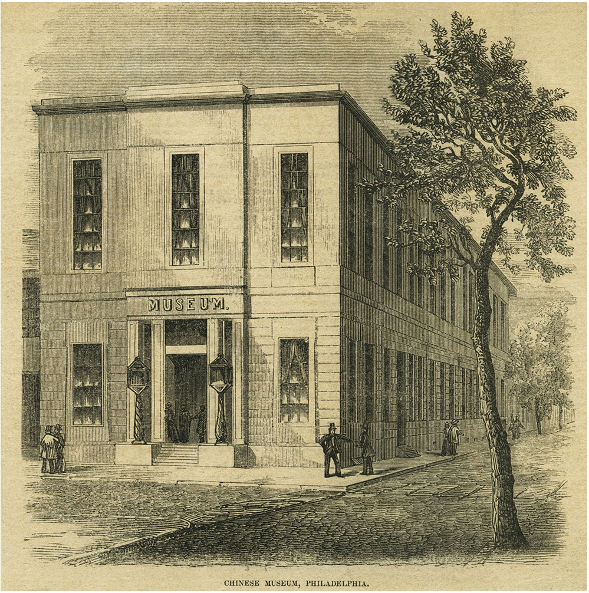
Figure 3. Dunn’s Chinese Museum in Philadelphia. Locating this original source has been difficult. The image is shared online through Wikimedia commons, not for anything associated with Nathan Dunn, but because the building was the site of the 1848 Whig convention.
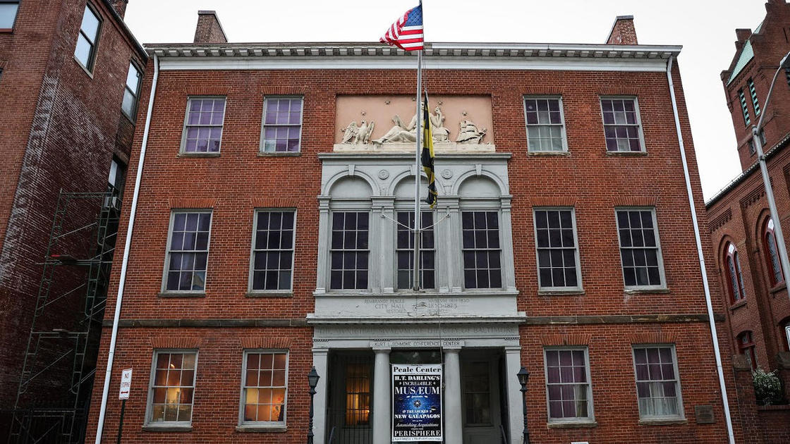
Figure 4. Rembrandt Peale's Baltimore museum. The first building designed and built for the purpose of being a museum. Now The Peale Center in Baltimore. Courtesy of the National Trust for Historic Preservation.

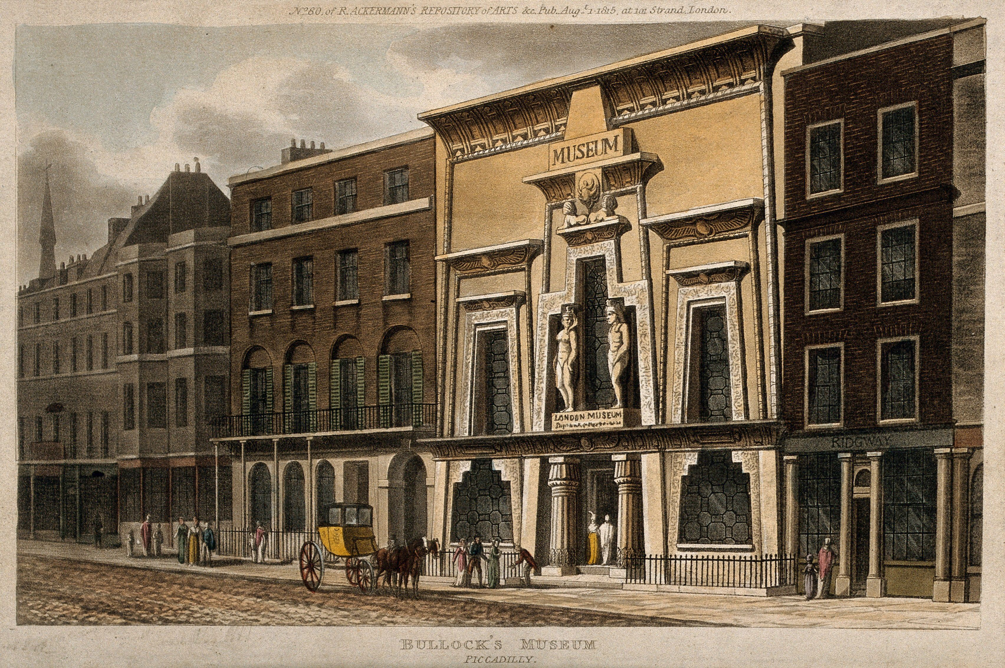
Figure 5. Bullock's Museum, Egyptian Hall in Piccadilly, London. From The Complex History of Bullock's Museum is set out in The survey of London, XXIX, pp.266-270. Image Courtesy Wellcome Collection, reference 40283i.
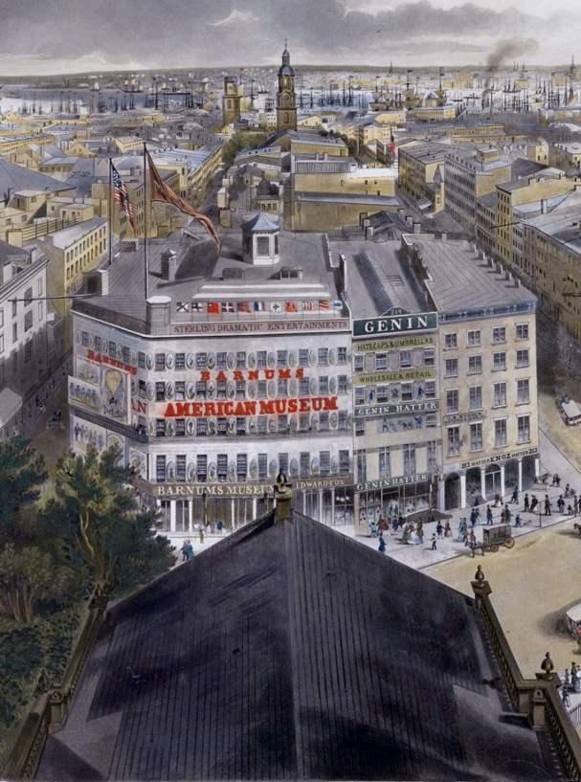
Figure 6. Barnum's American Museum. 1855. New York, looking east, south and west from the steeple of St. Paul’s Church, 1855. Drawn by John William Hill (1812-1879) and engraved by Henry Papprill in New York. Entered according to Act of Congress in the year 1855. (https://www.geographicguide.com/united-states/nyc/antique/19th-century/broadway-ny.htm))
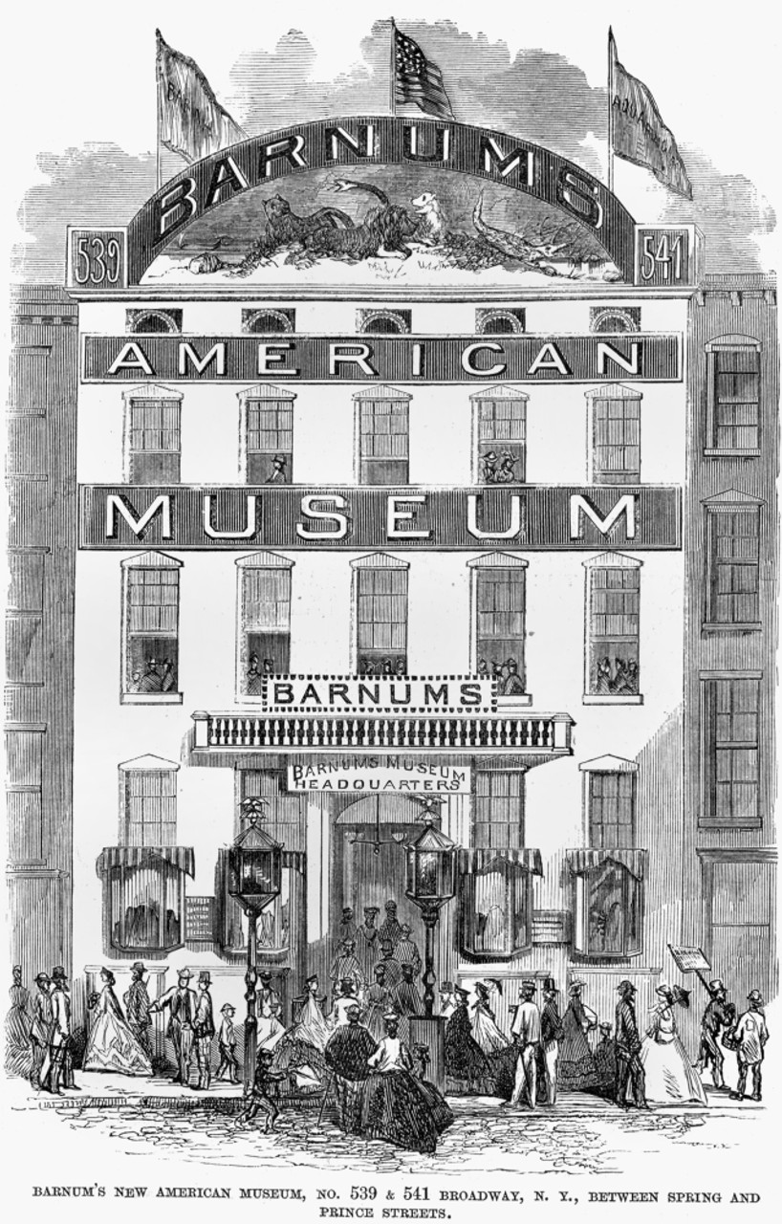
Figure 7. Barnum’s New Museum, 1865. View of P.T. Barnum's American Museum, on Broadway between Spring and Prince Streets, New York City. Wood engraving, 1865. Courtesy Granger Historical Picture Archive.
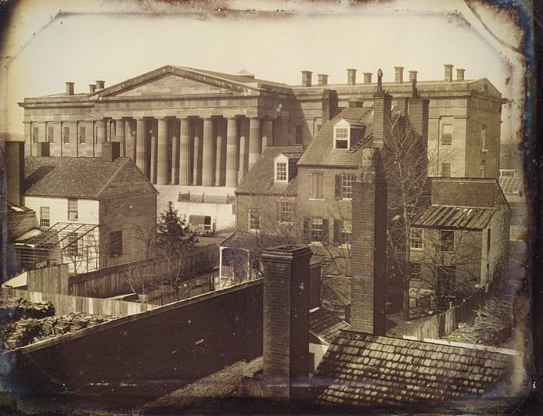
Figure 8. Daguerreotype of the United States Patent Office, Washington, DC c. 1846. Photographed by John Plumbe (1809-57). From the Library of Congress Prints and Photographs Division. DAG 1229
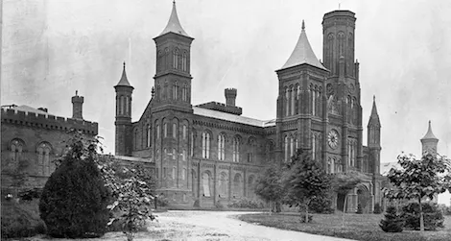
Figure 9. The Smithsonian Castle as seen from the north, c 1860. Courtesy of the Smithsonian Archives, Record Unit 95, Box 30, Folder: 8.

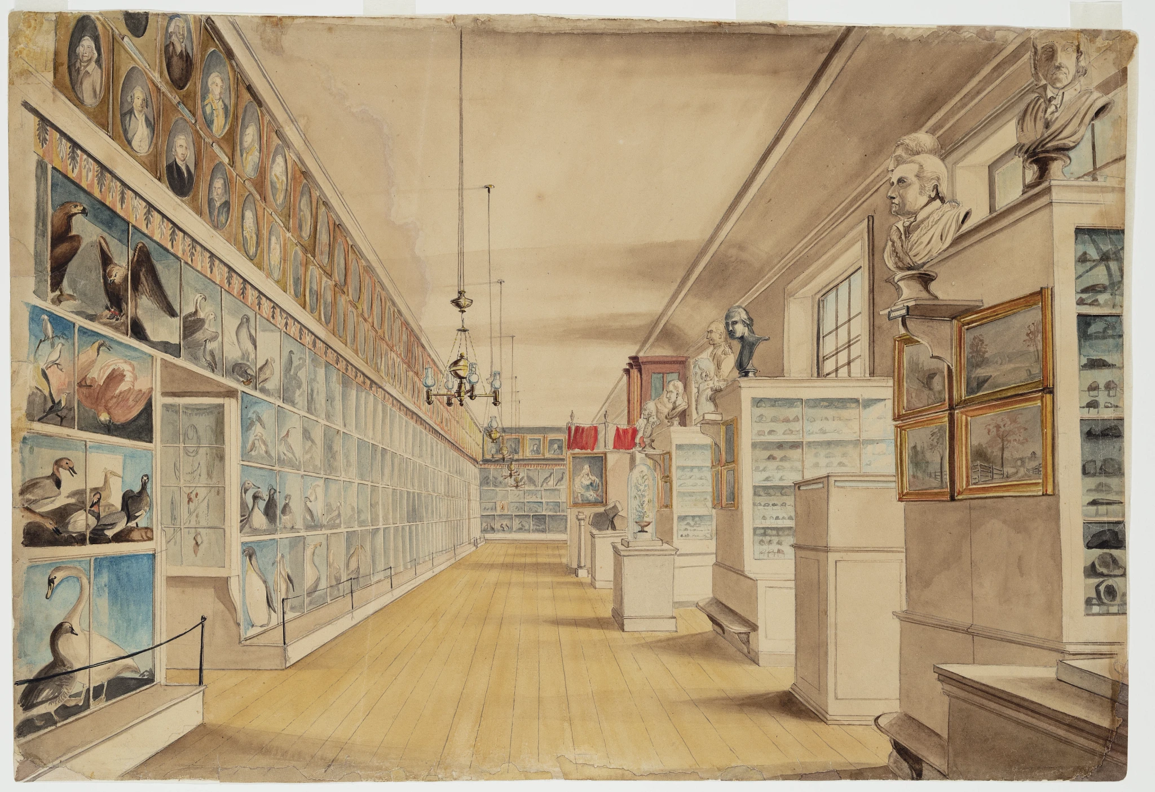
Figure 10. Inside Peale’s Museum. “The Long Room, Interior of Front Room in Peale's Museum, 1822.” Titian Ramsay Peale. Courtesy of Detroit Institute of Arts, Founders Society Purchase, Director’s Discretionary Fund, 57.261.
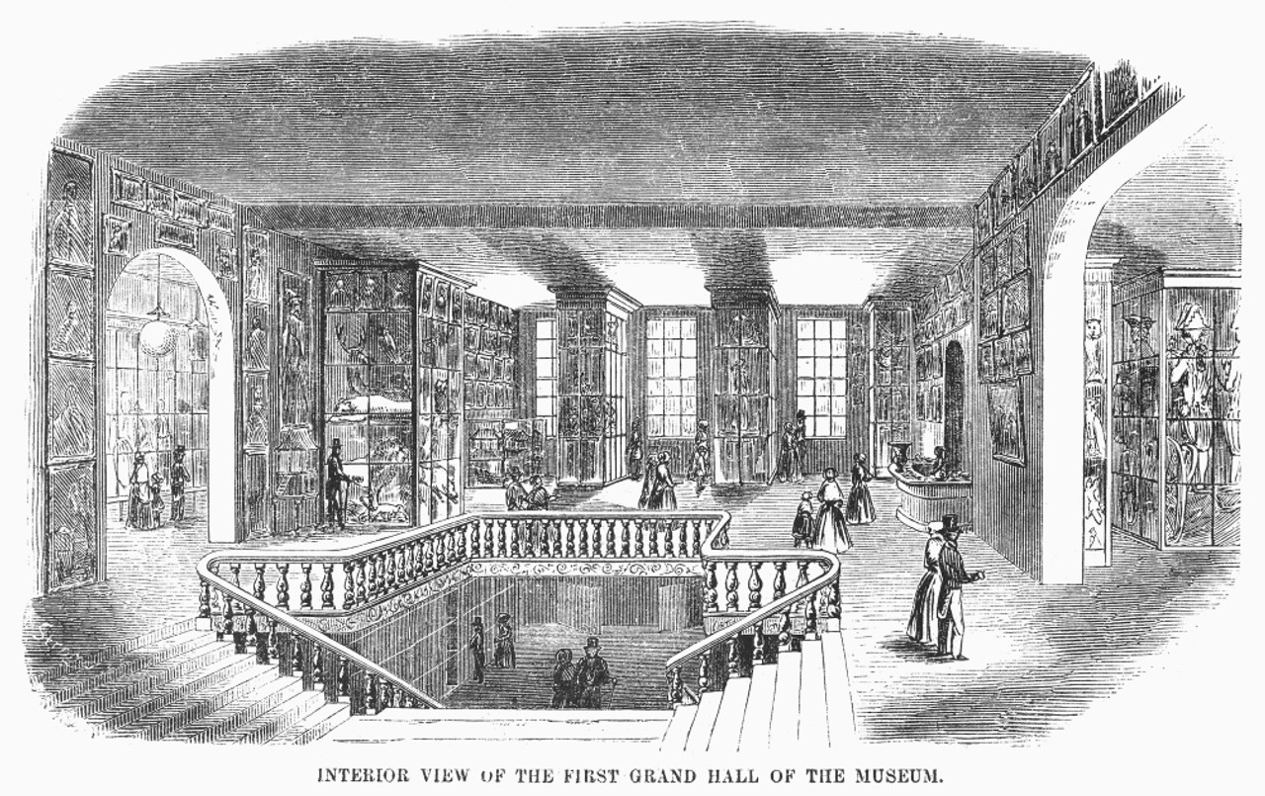
Figure 11. Inside Barnum's American Museum. Barnum’s American Museum. Interior view of the first Grand Hall of P.T. Barnum's American Museum in New York City. Wood engraving, 19th century. Courtesy of the Granger Historical Picture Archive

Prologue: Lucy in the Sky (with Fossils)
I met Lucy in 2007. The fossilized remains of the world’s most famous hominid were on public display for the first-time outside of Ethiopia at the Houston Museum of Natural Science. Even in her home country the remains had only been on public exhibition twice since her discovery in 1974. I visited Lucy’s special gallery—Lucy’s Legacy: The Hidden Treasures of Ethiopia—twice: once with my vertebrate paleontology class and again with my physical anthropology class. The two trips focused on different parts of the remains, different parts of the one-hundred-plus artifact exhibition, and even different parts of the controversy surrounding the exhibit coming to America. The confluence of all these things has stayed with me throughout the hundreds of exhibits and museums I have visited since.
What was fascinating about this exhibition was that no matter what the intent of the curators, almost everyone I was with or overheard during both visits came away from the exhibition with something different. Some of their comments and questions were informed by specific disciplines, like biomechanics, environmental pressures on evolution, or preservation bias and fossil preparation. Others were more basic: creationism versus evolution, for example. Still others had little or no interest in the physicality or the theology; they were there to see the exhibit because they heard, knew, or understood that it was important, and thought that they would at least get to say they had seen it.
These museum visits got me to start thinking about museums and their histories. Lucy’s Legacy was quickly replaced with the informal title “The Lucy Exhibit,” as the public press covered the controversy of the fossil’s travels. Associated Press articles appeared across several prominent outlets detailing the disapproval of many prominent paleontologists and many more Ethiopians over the fossils leaving the country, as well as the secrecy surrounding the planning of this excursion.
NBC News noted that paleoanthropologist Richard Leakey “reproached the Houston museum for using Lucy as a ‘prostitute’ to spur ticked sales, extraordinarily high at $20.”
Ethiopian immigrants in Houston called for a boycott of the exhibition and the Smithsonian Institution in Washington D.C., the Field Museum in Chicago, and the American Museum of Natural History in New York City refused to exhibit the collection. Smaller museums were not so scrupulous. Over the course of her six-year sojourn, Lucy’s Legacy was exhibited at Pacific Science Center in Seattle, Washington (2008), Discovery Times Square in New York City (2009), and, following storage back in Houston for four years, the Bowers Museum in Santa Ana, California (2013). It was then returned to the Ethiopian National Museum for the 50th anniversary of the African Union.
Why was such an important exhibit shadowed in controversy? Would a traveling exhibition of the treasures of Ethiopia have been met with the same refusals? How important was it that the authentic fossil go on display? As the deals were made in private it is hard to say, but Ann Gibbons gave the most concise answer for both sides in Science. “Ethiopian officials have high hopes that Lucy will do for Ethiopia what King Tut’s riches did for Egypt,” while “Houston Museum officials hope that Lucy’s box office appeal will attract millions of Americans.” It seems that everyone had a different reason for, and interpretation of, Lucy’s Legacy. When the exhibition opened and began travelling, public perceptions were again modified through the lens of personal experience. Lucy, herself was tied to popular culture from the moment of her discovery, for she was named after the psychedelic Beatles’ song, “Lucy in the Sky with Diamonds.” It is this intersection of popular, or “low,” culture and so-called “high” culture (in this case, science) that we will be looking at in this history of American museums.

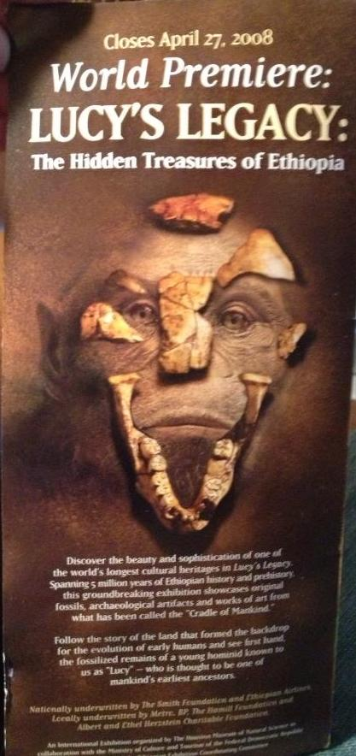

Figure 12. Lucy's Legacy informational brochure for the exhibition at the Houston Museum of Natural Science. Author's own.
Introduction
This dissertation focuses on six museum collections that were developed in the United States during the middle decades of the nineteenth century. These include the collection of the Charles Willson Peale family, called “Peale’s Museum” and later on the Philadelphia Museum; Nathan Dunn’s “Chinese Museum” (also in Philadelphia); George Catlin’s mobile “Indian Gallery;” Albert Koch’s “Saint Louis Museum;” P.T. Barnum’s “American Museum” in New York City, and the Smithsonian Museum in Washington D.C.
The antebellum period in the United States, which spans the years between the War of 1812 (1812-1815) and the Civil War (1861-1865), neatly encompasses the active time period for the bulk of the museum collections within this study. Understanding the impetus for collecting these various and sundry materials from around the world, the careful curation of these artifacts, and their eventual public display, provides a unique lens through which to view the development of the cultural life of the United States, as it settled into itself after winning independence from Great Britain. This was a time when “the very idea of generations resonated with new meaning,” as historian Joyce Appleby says in her 2000 book, Inheriting the Revolution: The First Generation of Americans. She observes that this was a time period when an important shift occurred: “As families exerted less influence in the lives of those born after Independence, the young people looked more to their peers for models of behavior.”
The decades in which these collections were being conceived also coincides with the Second Great Awakening (1800 through the 1830s), which saw, in addition to religious revivals, the development of movements for societal and educational reform. The rise of literacy in the working and middle classes, and the lack of an established inherited aristocracy, provided opportunities for a variety of individuals to take up careers that were distinct from their European counterparts. This weakening of familial control and expectations inspired early-born Americans with the “promise of a fresh political will” to exercise within the post-colonial landscape they inhabited. This dissertation explores the growing literate populace, and their experiences with the various collections, as well as and the cultural context in which the information and values being imparted through these ventures occurred. This audience can also be defined by their exposure to contemporary books, pamphlets, newspapers, and other forms of “rational entertainments,” such as the lectures that were part of the lyceum movement. These experiences would help the new nation’s first generation “fix [their] ideas about ambition, success, effort, discipline, and responsibility,” as they worked to shape and improve the United States according to their developing beliefs about liberty, democracy, and free enterprise.”
Broadly defined, the “creation and display” of the collections I study in this dissertation gained meaning in this era through the dynamics surrounding material culture. That is to say these collections, seen not only as single units in themselves, but also as a mass of smaller individual artifacts, were initially formed and established by the specific collectors and proprietors for their own purposes, but were very quickly reinterpreted, repurposed, and reused by the antebellum American audiences. Often, their responses led the owners of the establishments to reinterpret the collections and how they should be displayed. Thus, the audience participated in a cultural exchange with the hosts, and while few left written accounts of their experiences of these entertainments, positive or negative, the continued popularity of museums shows how engaged the American public was with the museum experience.
Nearly all of the museum-men I will discuss were part of a generational cohort who were born and came of age during the early national period. Thus, even in their museum work, they were engaged in early debates about what it meant to be an American. Each of these collections sheds light on questions that were being asked during this period, and about what was at stake in the various answers that were put forward. The diversity of their circumstances—in terms of the content of their collections, their locations, and their intended purposes—helps demonstrate the heterogeneity that was a paramount feature of the new nation. How free was the American citizenry? Was the public allowed to make up its own mind about their places within, and their duties to the Republic? How the United States fit within a world of global trade, transnational politics, and international warfare, were all relevant to the consciousness of the museum-going public during this time, for it was this world these museums reflected in their content, their arrangements, and the circumstances under which they were seen.
Bringing these six specific collections together into this study provides further advantages, because they share dynamics that are crucial to understanding the information ecology of this time period: the importance of natural history; the ways in which knowledge was generated and circulated amongst a wide public; and the transatlantic reach of these various ventures. These museums recreated a world in miniature, displaying what was “exotic” and “bizarre” next to what was mundane, and offering a view of other cultures and other times. Even if most of these enterprises were designed with profit in mind, it will be necessary to draw upon the fields of history of science, museum studies, art history, and American Studies to make sense of them.
Historiographic Background on Museums
Joel Orosz’s 1990 work, Curators and Culture: The Museum Movement in America 1740-1870, tracks the earliest “museums” that were not private or sequestered collections. He notes there was no formal museum movement before 1870, since there were no journals, no professional organizations, nor even a single spokesman. Still Orosz maintains that “while a small proportion of these museums [before 1870] did degenerate into sideshows or elitist enclaves, the great majority had serious and egalitarian aspirations,” with these proprietors forming a “network …who communicated among themselves, who were simultaneously influenced by the same cultural factors, and were doing the same things at the same time for the same reasons.” Toward the end of the same decade, Edward P. Alexander’s The Museum in America provides thirteen mini-biographies of well-known figures in public display, among them Henry Fairfield Osborn, Carl Akeley, and William Temple Hornaday who were, save two, all born after the Smithsonian was established.
Museum Studies and Museology are essential components for analyzing the collections in this project. As I have learned during the course of my research, the bulk of museum studies—both modern and historical—are focused on art museums, their histories, and their professional staffs. Although such studies provide some historical guidance, what is true for art museums does not simply transfer to all museums. As recently as 2005, Sally Gregory Kohlstedt noted that “historians of science had spent little time on museums, taking for granted their commonplace functions and using them as backdrop for biographical or intellectual history studies.” That is to say that natural history collections, and later natural history museums, tend to be relegated to research environments for particular field scientists and natural history societies.
To situate work relating to “display,” and “exhibitions” within a larger national context, I will use scholarly writings on material culture. To understand the day-to-day life of things in the United States, I will be using, as basic reference works, Material Culture in America: Understanding Everyday Life, edited by Shirley Wajda and Helen Sheumaker, and Karen Harvey’s “Object Biographies: from Production to Consumption,” which is a chapter in History and Material Culture. I will also be looking at landmark tourist sites in the United States, such as Niagara Falls in New York and Mammoth Cave in Kentucky, since how visitors reacted to them and what they wrote about their experiences, can be used to postulate something about the museum experience. Regardless of size, all these experiences have much in common with the museum experience. I will be drawing on John Sears’ Sacred Places: American Tourist Attractions in the Nineteenth Century to develop this idea. The form which the museums I will study eventually take, follow, generationally, the evolution (or devolution) of early American republicanism. The earliest—Peale’s Museum—was dedicated to his belief that the growing population should be educated in proper ideas about order—natural order—and their place within it. The heart of this republican ethos was, as historian Jean Baker notes, an insistence that the success of the republic depended upon education about the “public responsibilities of private citizens.” By the end of Peale’s dynasty in the 1830s, there were “expanding tensions between community ideals of res publica and the expanding economic world inhabited by shopkeepers, small proprietors, and craftsman who anxiously sought,” as Robert Kelley has argued, “to be liberated from the restraints of a system that all too often placed government on the side of the gentry.” That “gentry” can be seen in the elder Peale’s appeal to order. As those born after the Revolutionary War and on into the first decade of the new century came of age, they were “engaging with their desires, callings, decisions, and reflections” in a way that was not tied to the norms of the colonial era. In the decades of the antebellum period, it was less order that captured the public imagination, but a fascination with excess, the distant and unfamiliar, wonder, novelty, and the sheer profusion of curiosities across the continent and across the world—in other words, the experiences that P.T. Barnum promoted in his American Museum.
To clarify the cultural tension between those two museum models, I have found two works particularly insightful: Lawrence Levine’s Highbrow/Lowbrow: The Emergence of Cultural Hierarchy in America and Les Harrison’s The Temple and the Forum: The American Museum and Cultural Authority in Hawthorne, Melville, Stowe, and Whitman. Both of these works identify and describe the differentiation of cultural groups with conflicting values, and in the process help to explain the factors involved in the shaping of audience relationships with museums. The chief delineation, following Levine, was between high and low culture, and what experiences were included in each category. Struggles over cultural authority, detailed in Harrison’s work, illuminate who got to make these distinctions and how they sought to establish them as normative. Harrison not only examines where that authority comes from, but also how the American public developed along with, and responded to, these designations.

Historiographic Background on History of Science
While this dissertation is largely informed by topics within the history of science, it is a history of science that can only be of use if one recognizes its convergences with the history of art and literature, as treated in works of American Studies. While, professionally speaking, histories of science, art, and literature belong to separate disciplines, all of these areas were braided together as experienced by antebellum audiences. At any given time, a visitor to Peale’s or Barnum’s museum may also have been reading romantic poetry and fiction from American authors such as Washington Irving, Edgar Allan Poe, or Nathaniel Hawthorne. Visitors of means at Peale’s Philadelphia Museum or Barnum’s American Museum in New York City likely would have been equally familiar with the works of the members of the Hudson River School, which was very famous at the time. I will discuss this historiography in the next section.
The works in the history of science at the heart of this dissertation concern natural history: particularly in the areas of geology, paleontology, anthropology, archaeology, ethnography, and biology. Robert Bruce’s The Launching of American Science, 1846-1876, published in 1987, provides a broad historiography that relates relevant trends. It is interesting to note that, in the more than thirty years since its publication, nothing has appeared to challenge, expand, or narrow Bruce’s historical analysis. Christoph Irmchser’s The Poetics of Natural History, by contrast, is more directly concerned with natural history. Irmchser’s work is particularly useful, since his chapter on Barnum defines “some of the crucial similarities and differences between Peale’s museum-keeping and Barnum’s reinvention of the museum as a ‘show-shop.’” Margaret Welch’s The Book of Nature: Natural History of the United States 1825-1875 is excellent, but other books, which are focused on a slightly earlier period, provide a better understanding of how someone who wanted to fashion a museum would have been thinking about their materials, and how receptive the European populace was to shows and exhibits from the United States. These sources include Richard Drayton’s Nature’s Government: Science, Imperial Britain, and the ‘Improvement’ of the World; Emma Spary’s Utopia’s Garden: French Natural History from the Old Regime to the Revolution; Susan Scott Parrish’s, American Curiosity: Cultures of Natural History in the Colonial Atlantic World; and Laura Dassow Walls’ The Passage to Cosmos: Alexander von Humboldt and the Shaping of America. For example, Spary’s Utopia’s Garden provides a comparison between transatlantic and American museums, including parallels of cultural change, as both France and America overthrew their respective monarchies. Parrish’s American Curiosity explores the natural history of the entire British Atlantic world, providing another point of contrast for early American museums like Peale’s, and their distinctive American contents.
As the new nation’s population shifted their identities from colonial British subjects to citizens of the United States, what they considered appropriate representations of themselves and their new nation was changing. When Parrish’s conclusions in American Curiosity are paired with the material cultural analysis within Kariann Akemi Yokota’s Unbecoming British: How Revolutionary America Became a Postcolonial Nation, it reveals the changing view of museum things during post-colonial development. This evolution follows a similar trajectory followed by colonialists-turned-Americans. At the very least, these works unveil some of the earliest germinations of how the “who” and the “what” became distinctly American, not least in their distinctly American diversity of styles, languages, and conceptions of entertainment.

Historiographic Background on American Studies
There are numerous intersections between the history of American science and antebellum American literature. Christoph Irmscher’s The Poetics of Natural History, mentioned in the previous section, gives the most holistic analysis of audiences for science, natural history, and museum collections. Within the American Studies field, Robert Scholnick’s edited collection of essays, American Literature and Science, and Sam Halliday’s Science and Technology in the Age of Hawthorne, Melville, Twain and James: Thinking and Writing Electricity, provide points of note about American experiences during the period. Lynda Walsh’s Sins Against Science: The Scientific Media Hoaxes of Poe, Twain, and Others and Matthew Goodman’s The Sun and the Moon: The Remarkable True Account of Hoaxers, Showmen, Dueling Journalists and Lunar Man-Bats examine pseudo-scientific hoaxes that gained popular traction, and how scientific knowledge could be valued as entertainment. These developments in the early decades of the nineteenth century made it difficult for professionals to buttress and maintain their scientific authority.
In order to contextualize early collections, I must first contextualize the wider culture in which these collections were obtained, organized, displayed, and marketed. The essays by Catherine R. Kelly on “Early America” and James Cook on “The Nineteenth Century” in A Companion to American Cultural History under Karen Halttunen’s editorship are excellent cornerstones for the analysis of cultural history. Kelly specifically notes that, since the 1976 publication of Kenneth Silverman's A Cultural History of the American Revolution, “preoccupations that once seemed idiosyncratic have moved to the center of scholarly inquiry and debate…Literary culture, performances of all kinds, and the visual arts are no longer charming distractions from the serious minded investigations …[and] have become far more significant to those [cultural] investigations.” Likewise, Cook reflects on the shifting focus of scholarly work, stating that: “The antebellum period itself has been reconceptualized as a wellspring of the modern rather than its opposite or antipode…[and] the range of cultural forms generating scholarly attention has expanded to include a far more diverse mix of vernacular, commercial, and transnational sources.” Combined with Janice Radway’s American Studies: An Anthology, these three historiographic sources support this dissertation’s commitment to keeping the audiences and users of these collections in view, and not simply as ancillary content within biographical sketches of those associated with each collection. The following books treat, more specifically, the development of an audience for reading and a market for textual material: Ronald Zboray’s A Fictive People: Antebellum Economic Development and the American Reading Public and Isabelle Lehuu’s Carnival on the Page: Popular Print Media in Antebellum America. In A Fictive People, Zboray explores the antebellum reading public and books written by Americans. This same reading public were the ticket holders for the exhibitions and the galleries promoted in early American museums. In this case, highlighting the various subversions of cultural cohesion within the population of readers is applicable to museum visitors, as “[readers] themselves seemed at times reluctant to join the great national culture crusade and instead struck off on their own peculiar quests for self-construction.” Though not as easily transportable as books, magazines, or newspapers, museum collections of the time were as popular as American print material. Carnival on the Page provides an account of what audiences read, examining the context of that reading, and attempts to control that context, including attempts at content control. It is not hard to see those “reformers from all walks of life who recommended propriety, discipline, and asceticism” as those who liked Peale’s museum, with its stress on the “order of nature,” while Barnum favored “new publications characterized not only by their abundance but also their taste for the eccentric and off-balanced.”
As various cultural forms such as theater and opera began to become popular, it was not long before all aspects of culture began to stratify. Lawrence Levine’s Highbrow/Lowbrow: The Emergence of Cultural Hierarchy in America outlines the Whig consciousness that commenced to control American culture, after losing control of American politics to the Democrats in the 1830s. Levine makes clear that the pattern of cultural changes that occurred in the first half of the nineteenth century, following the rise of “high art” along with the elevation of social elites, was an initiative that encouraged the active “denigration of popular audiences.” As it pertains to this dissertation, Levine’s explanation of the early bifurcation between what was “serious” (high) and what was “popular” (low) helps explain the spatially separated spheres of entertainment in the forms of opera and museums, on the one hand, and minstrelsy and sideshows on the other. It also helps explain why “serious” museums like Peale’s were eventually forced to use “popular” attractions to maintain ticket sales.
Stephen Mihm’s A Nation of Counterfeiters: Capitalists, Con Men, and the Making of the United States and James Cook’s The Arts of Deception: Playing with Fraud in the Age of Barnum provide a solid foundation for understanding the flux and fluidity of trust, authority, and order in the years before the Civil War. While Mihm’s book deals specifically with the counterfeiting of money, it provides another view of the United States. It explains why systems (in this case banking) rise, prosper, and then disappear, for any number of reasons, some of which, such as geography and/or proprietary decisions, also affected American museums. It also helps explain why Barnum was to become the very embodiment of a confidence man.
Discerning real from fake and fact from fiction became a daily occurrence for most people during the antebellum period. Cook’s Art of Deception is a direct analysis of how Barnum’s work as a showman illustrates these cultural trends but also had great influence beyond his own activities. Beginning with his exhibition of Joice Heth, an African-American woman he claimed had been George Washington’s nursemaid, and through his display and promotion of his Fiji mermaids, Cook posits that these fakes, and others like them, weren’t just devised to deceive for deception’s sake, but were a way to help familiarize spectators and audiences with the “brave new world in which the very boundaries of truth were becoming more puzzling.” In the same sense that Peale and early museums were reflecting the order that they claimed were to be found in attending to expertly-attested facts of nature, Barnum’s materials were reflective of cultural chaos. They play with anxieties and fears in the cultural marketplace, and the transformation of scary uncertainties about the facts of nature into a new form of urban entertainment. The art of tricking the viewer has a long and distinguished past, even in the serious halls of high art. Peale’s museum featured both a painted trompe l’oeil (The Staircase Group) and a three-dimensional one as well. The wax model of Peale within his own museum was described as so strikingly lifelike that it fooled several of his own closest friends. What, then, are we to make of deception in the art of show? What are the key differences, if any, between Peale’s wax statue and Barnum’s Fiji mermaid?
In attempting to grasp what exhibits resonated with contemporary audiences, David Reynolds’ discussion of the production and consumption of American literature has been especially helpful. My own view has been much influenced by works such as his Waking Giant: America in the Age of Jackson; Beneath the American Renaissance: The Subversive Imagination in the Age of Emerson and Melville, and Walt Whitman’s America: A Cultural Biography. Reynolds’ works are important aspects of not only literary history but American cultural history, for they take a very expansive approach to the concept of the American Renaissance. Reynolds includes discussions of Edgar Allan Poe and Emily Dickinson, whose writing contain references to collections, museums, and natural history, but he also treats forgotten figures who were widely read in their day, such as George Lippard and his mystery novel Quaker City, of the Monks of Monk Hall. While these details are important to literary history, they also alert us to the fact that there were things that were furiously popular in the 1830s, 40s and 50s that we have no record of, or have only passing mention of in the notes of a diarist, or in a letter. His work also challenges the notion that what is popular is synonymous with what is mainstream. He argues that, while Whitman and other now-canonical authors may have been popular, they were outside of the mainstream of authors who were of most importance to the public. It was only the later anointment that solidified them as the mastheads of the American literary canon, obliterating awareness of the cultural significance of those deemed to have little literary merit. It is therefore clear that it is the audience that decides what is important and what it means, independently of the author or promoter’s intended goal.

Historiographic Background on Art History
In my research I have found it nearly impossible to understand nineteenth century American culture without paying attention to forms of artistic expression. The centrality of artistic expression in its myriad of forms include painting—in particular in its most familiar forms on canvas—but also in little-remembered formats such as the enormous painted panoramas that often backdropped the exhibits in early museums. The very establishment of nineteenth-century art as American culture is deeply intertwined with the politics of the emerging republican ideals within society. To understand American art is to understand the American experience: an experience that ranged from city slums to westward expansion, from wild nature to the “vanishing” Native Americans, and from idyllic nature to heavy industrialization. The history of art in this period is important to this dissertation, not only as a way of studying the visual culture of the antebellum period, but to compare American art and American museums to their counterparts in Europe—especially in London and Paris.
The emergence of a distinctly American style of art mirrored other political, social, intellectual, and cultural developments in the new nation. Two figures whose work has been seen as such are Charles Willson Peale (1741-1827) and George Catlin (1796-1872). Both were accomplished artists and have had much of their work analyzed by art historians. However, few have put their art within the context of their other, non-artistic activities. Thomas Gaehtgens’ American Icons: Transatlantic Perspectives on Eighteenth and Nineteenth Century Art does just that, while Marianna Doezema and Elizabeth Milroy’s Reading American Art and Barbara Croseclose’s Nineteenth-century American Art provide the analytical foundations for investigating the American cultural context. More specifically, Roger Stein’s essay on Charles Willson Peale, “The Artist in His Museum” delves into the artist’s take on the museum in ways that other art historians have not. Stein notes that the museum absorbed “Peale’s energies to the point where he abandoned painting almost completely during the years 1798-1804… [and there were] strains and tensions between the museum’s scientific and didactic purposes or between the Peales’ roles as curators and cataloguers and their roles as artists and promoter-showmen.” Even in a family as close and patriarchal as the Peales, the generational divides mirrored the country’s newfound independence from Great Britain, as the sons embraced the role of showmen and promoters more than had their father.
Barbara Bloemink’s Frederic Church, Winslow Homer and Thomas Moran: Tourism and the American Landscape; Linda S. Ferber’s The Hudson River School: Nature and the American West; and Stephan Oetterman’s The Panorama: History of a Mass Medium, each provide insight into the American art world of this period, its members, and their relationships to the developing republic. Bloemink’s work is especially useful in its cross-sectional content analysis, as it overlaps expeditions, explorations, and marketing of the American West. These artists and schools also paved the way for the post-war expansion boom in not only travel to the majestic Rocky Mountains, but, as in the particular cases of Church, Homer, and especially Moran, the proliferation of copies of their art in contemporary magazines. These later decades would see the natural world competing for the attention of the American audience with the old shows and exhibits of the changing museum world.
Three distinct American subjects in artworks were: the American landscape; Native Americans; and uniquely American wildlife species, such as the turkey and the pronghorn antelope. American landscape paintings became celebratory images of collective identity, for their cheaply-produced lithographic copies were often used as home decor. Such art could also be put to use as diorama backgrounds for various species of preserved animals within a museum’s collection. The depictions of Native Americans by artists such as George Catlin and Alfred Jacob Miller were immensely interesting to British and French audiences, many of whom would have likely grown up hearing or reading about the French and Indian Wars, and the relation of immigrants from their own country with the Native American population. Catlin’s Indian Gallery, which incorporated live people, as an extension of his work as an artist, provides an excellent comparison with Barnum’s showmanship—which was notorious for its human “exhibits.” Both proprietors arrived at the same ends of featuring living dioramas, despite their beginnings in vastly different areas of the United States, their different backgrounds, and their highly different aims.
The American landscape was widely recognized for having features that were distinct from Great Britain and continental Europe. During the period spanning my research, some of the most frequent subjects were the Catskill Mountains and surrounding area, as painted by members of the Hudson River School, and the Mississippi and Missouri Rivers, most notably captured by artist George Caleb Bingham (1811-1879). Rebecca Bedell’s The Anatomy of Nature: Geology and American Landscape Painting, 1825-1875, explores this topic in greater detail and is also an example that demonstrates the close natural relationship between art history and the history of science.
Many species of American wildlife would also have been novel to Europeans. In fact, western species may have been novel to East-coast Americans. One artist in particular stands out as the one who captured the most diverse species, both on canvas and physically: John James Audubon (1785-1851). Audubon is best known for his Birds of America series featuring as many species of American birds as he could find. These were all painted life-sized and were available to collectors by subscription. Many of his images would later be bound together in eight volumes offering a vivid ornithology collection which, even at its double elephant folio size, was still quite compact compared to a taxidermied collection.

The Six Collections and the Individuals who Created Them
The first museum I will discuss is Peale’s Museum, created by Charles Willson Peale (1741-1827). A well-known artist and veteran of the Revolutionary War, Peale’s collection consisted of his art, the artwork produced by his many artistic children, and numerous natural history specimens, many of which were preserved for the museum by his son Raphaelle Peale (1774-1825). The bulk of this natural history collection was a donation from Merriweather Lewis and consisted of artifacts gathered during Lewis and Clark’s Corps of Discovery expedition. Two of Peale’s other sons, Rembrandt (1778-1860) and Rubens (1784-1865), opened their own second-generation Peale museums in Baltimore (in operation from 1814-1829) and New York City (in operation from 1825 until the Panic of 1837). The youngest—Titian (II) (1799-1885)— served as a naturalist on two separate United States Government expeditions. The first—the Stephen H. Long Expedition of 1820—explored America’s Great Plains region to the foothills of the Rocky Mountains. An analysis of his experiences is detailed in art historian Kenneth Haltman’s 2007 book Looking Close and Seeing Far: Samuel Seymour, Titian Ramsay Peale, and the Art of the Long Expedition. Since Lewis and Clark’s 1803 Corps of Discovery expedition and Zebulon Pike’s 1805 expeditions were both considered military operations, Long’s expedition was the first scientific exploration party hired by the United States Government. The material collected during this expedition followed the precedent set by Lewis, and also ended up in the Peale Museum in Philadelphia.
Following two more inland expeditions to collect for his father’s museum, Titian served as chief naturalist aboard the USS Peacock during the United States Exploring Expedition from 1838 to 1842. The expedition circumnavigated the globe while mapping nearly 300 islands, mostly in the Pacific Ocean. It also traveled along the coast of the Oregon Territory and part of Antarctica. Historical nonfiction author Nathaniel Philbrick’s 2001 Sea of Glory: America’s Voyage of Discovery: The U.S. Exploring Expedition, 1838-1842, covers the expedition, its various difficulties, and its almost forgotten legacy. Titian’s adventures provide an excellent opportunity to analyze how collecting and other scientific portions of government-led expeditions were conducted and supported (or tolerated) by the U.S. Army on land, and the U.S. Navy at sea.
The second collection I focus on is the work of Philadelphian Nathan Dunn (1782-1844), a Quaker who collected and curated over ten thousand objects from China, ranging from small porcelain bowls and furniture to textiles, tools, and enormous statues of Buddha. While working as a merchant in Canton, China from 1818 to 1831, Dunn’s business network extended to and included many native Chinese merchants who, unlike foreign traders, had unfettered access to the inner areas of mainland China. It was these objects collected from the interior that set Dunn’s Chinese collection apart from competing exhibitions of Chinese artifacts. Following his time in Canton, Dunn returned to Philadelphia, and in 1838 constructed his “Museum of Ten Thousand Chinese Things.” His museum remained open until 1842, when he moved the entire collection to London. He surmised that the British population, given the recent acquisition of Hong Kong, would be very interested in his “Chinese things.” Much less studied than Peale’s Museum, Dunn’s enterprise provides important evidence that Peale’s Museum was not an anomaly of the period—that is, that Peale was not the only museum-minded entrepreneur, and that the American public had great interest in such things. According to art historian Nancy B. Wilkinson, 100,000 visitors saw Dunn’s collection in Philadelphia, and at least that many more visited it in London.
The third collection I treat is that of American artist George Catlin (1798-1872). Catlin began collecting artifacts while traveling and painting Native American portraits along the Mississippi River. Catlin’s five expeditions to the West were aided William Clark, of Lewis and Clark, who had since become the Governor of the Missouri Territory. Unlike his expedition partner Lewis, Clark kept his collection of expedition materials and set them up as a private display at his office and residence in St. Louis, where Catlin surely saw them. Catlin’s first foray into Native American territories came when he accompanied Clark on a diplomatic expedition. Later on, Clark provided introductions for the artist, as well as permissions and opportunities to travel west of the Mississippi River. Catlin combined his paintings and Native American artifacts to establish what he called his Indian Gallery, which he took on tour across Europe. Brian Dippie’s George Catlin and his Contemporaries provides the most complete Catlin expedition and production analysis, but journalist Benita Eisler’s Red Man’s Bones: George Catlin, Artist and Showman leans in a bit more into Catlin as a performer.
The eastern United States was not the only area of antebellum America that had permanent museum collections open to the public. In 1836, the Saint Louis Museum opened along the waterfront of the Mississippi River. The proprietor of this museum was Albert C. Koch (1804-1867), a German immigrant who arrived in the city in 1827. He is my fourth subject. In addition to exhibiting art and some living animal attractions, Koch managed to display a sizable portion of Clark’s personal collection through a series of loans which outlasted Clark himself. Along with exhibits featuring live alligators were fossils that Koch himself had collected in the region. He is mostly known for his fanciful, rather imaginatively reconstructed specimens of Missourium and Hyrdrachos which were displayed locally and later toured through Europe and eventually sold there. The Missourium was a mastodon-like creature, and Hydrachos a giant “sea serpent.” Broadsides and lecture advertisements depict these enormous creatures on display, which Koch describes in his Description of the Missourium or Missouri Leviathan Together with Its Supposed Habits, and Indian Traditions. The most detailed collection of his life comes from his own hand—Journey Through a Part of the United States of North America in the Years 1844-1846. This was published in limited numbers in 1848, in German, and for Germans. In 1972, Ernst A. Stadler, a Bavarian-born immigrant living in St. Louis translated Koch’s travelogue into English with a foreword by historian John McDermott. While this work focuses on Koch’s paleontological expeditions, which his museum helped fund, little is dedicated to his time at the museum. In 1980, Bruce McMillan gathered much of what is known about Koch’s museum in his “Objects of Curiosity: Albert Koch’s 1840 St. Louis Museum,” an article in The Living Museum. What little is there was gleaned from John McDermott’s Missouri Historical Society publication from thirty-two years earlier.
I then treat Phineas Taylor Barnum (1810-1891), proprietor of the American Museum. A New Englander by birth, Barnum made his earliest career with traveling entertainments before opening his American Museum in New York City in 1841. Eventually his name would become associated with everything “circus.” After years of traveling shows featuring jugglers, singers, and an enslaved woman who claimed to have been George Washington’s nursemaid, Barnum stopped taking his show to the audience and let the audiences come to him. His absorption of several existing museums, which will be covered in more detail in chapter 4, should have created a curatorial and organizational nightmare if Barnum had ever taken the time to curate it. Robert Wilson’s 2019 Barnum: An American Life is quite useful, but the most complete look at Barnum’s showmanship is found in Benjamin Reiss’s 2001 The Showman and the Slave: Race, Death, and Memory in Barnum’s America.
The dissertation ends with the establishment of the Smithsonian Institution as the national museum of the United States in 1855. Far less straightforward than it seems, the emergence of the Smithsonian as “America’s museum” was not a foregone conclusion. Its final form only arose after many months of political infighting, when the American government settled on Joel Poinsett’s idea for a National Institute. Poinsett (1779-1851) was an American diplomat and was at the time the Secretary of War. Far from a simple cabinet of curiosity, Poinsett’s National Institute would eventually become the cutting-edge of American scientific research, a house of publishing, and the thing that would most cement America’s “cultural equality” with the museums of Europe. The first decade after the opening of the Smithsonian “Castle” saw many of the same debates about the use and display of material collections for public enjoyment and professional education. The truly “modern” Smithsonian, in form as well as function, came as the halls were rebuilt after a devastating fire in 1865. America’s national museum would rebuild itself as an avatar for a nation rebuilding itself after an equally devastating Civil War. Part of the materials that would go into producing what would become the nation’s museum standard-bearer are contained within the histories I discuss in this dissertation’s chapters.

Chapters and Organization
The organization of chapters in this dissertation follows a more or less chronological order for the creation and development of the six museums. This will make it easy to track the changing notions about museums, and the changing expectations of the audience, as the American museum slowly professionalized and took on its modern form.
Chapter One begins with the opening of Peale’s museum in 1786. Peale’s museum opened before the Louvre in France but was not a “national” museum in the same manner. The Louvre opened in 1793 as the Muséum central des arts de la République. The imprisonment of Louis XVI, during the French Revolution, made this art collection a public property, a veritable national museum. Peale’s Museum was more akin to the earlier European cabinets of curiosities, that is until the Peale heirs began opening other museums in Baltimore and New York City. Much work has been done to outline Charles Willson Peale’s contributions to American museums, but my focus will be on the subsequent and second generation of Peale museums opened and managed by his sons, from 1814 until the collections were purchased by Barnum in the 1840s. This early chapter addresses the earliest designs, goals, and target audiences for museums in the nineteenth century and the trajectory of static collections moving toward showmanship venues.
The second chapter follows another museum-minded Philadelphian as he travels to China in 1818 and trades internationally with Cantonese locals to create his own collection of “Ten Thousand Wonderful Things.'' These artifacts were displayed when he opened as his “Chinese Museum” in Philadelphia in 1838, shortly after being appointed to the Philadelphia Museum’s board of Directors. Dunn’s collection, and his method of collecting, offers a glimpse into how American audiences interacted with the “exotic” as well as how business acumen can aid in the development of museums. Following Dunn’s death in 1844 the collection was sold at auction through a London firm.
Chapter Three moves events west. The first part follows George Catlin’s journey to St. Louis, Missouri in order to create what he dubbed his “Indian Gallery,” which consisted of numerous collected Native American artifacts and hundreds of portraits of the indigenous peoples who lived along the Mississippi River, painted from life during his five sojourns to native tribes. Catlin believed his work was capturing a race of people who were vanishing before the expansion of modern civilization. He wanted his collection to preserve their cultures and likenesses. Catlin’s museum allows us to compare how American and European audiences engaged with the material. After years of unsuccessful attempts at selling his collection, it was eventually taken as collateral against his debts.
Catlin’s time in St. Louis is shared by museum proprietor Albert Koch, a German immigrant who opened his St. Louis Museum in 1836, and who is the subject of part two of this chapter. Koch collected a lot of important fossils, which he often erroneously identified. The popularity of these displays shows a change in the preferences of American audiences for the odd and bizarre. The scientific reactions to Koch’s touring monsters also help us understand the professionalization of science during the nineteenth century. Koch’s museum fell into disrepair while he was touring Europe with his creations. He eventually sold the materials to the national museum in London and to the King of Prussia. The contents of his exhibitions make him a proto-Barnum, in that he blurred the lines between display, show, and education.
Chapter Four examines the meteoric rise of P.T. Barnum, whose name is synonymous with showmanship, entertainment, and humbug. Following Barnum’s successes and failures in the early 1830s, through his successful travelling shows beginning in 1835, Barnum amassed an enormous collection of artifacts. He would eventually purchase entire museum collections, including those from the Peale sons in New York and Baltimore. These collections were displayed in his American Museum, which opened in New York in 1841, and burned to the ground in 1865. Barnum enjoyed nearly twenty-five years of success as an American showman, with a museum in New York City and a host of travelling shows and partnerships in Europe. Barnum’s museum is a counterweight to the lofty, noble ideas of museums as places of erudition and quiet reflection. It is also an oft-overlooked aspect of Barnum’s life, as his popularity rose again in the latter half of the nineteenth century, in his association with the most famous travelling circus in the United States—Barnum and Bailey’s.
While each chapter has a focus on one of the six collections, there will also be themes that recur amongst them—for example, networks and international travel. Although each collection here is linked to a single individual, none of them created their collections alone; the fact is that none of these collections would have been possible without a network of other people who either supplied the artifacts or supplied contacts for individuals selling collections. Often these networks overlapped and influenced one another. For instance, artist George Catlin entered the Philadelphia art scene and was influenced by a visit to Peale’s Museum. While in England, he also engaged in a very short partnership with Barnum.
Each major figure within this dissertation left the United States in order to exhibit their materials in Europe. Rembrandt and Rubens Peale took their family’s second mammoth skeleton to London in 1803, and while there published An Historical Disquisition on the Mammoth. They canceled plans to take the exhibit to France, returning to the United States in July citing poor receipts and growing tensions between England and Napoleon. Catlin’s time in Paris in the 1840s tempered his expectations of remuneration as he attempted to navigate the long-standing continental practices of patronage and prestige. Koch toured his sensational fossil creations throughout Europe in the 1840s, before selling the material to different heads of state, where they were reexamined and reassembled for the national museum in Great Britain and the private collection of the King of Prussia. Dunn transported his “Ten Thousand Chinese Things” to London in 1842, while Barnum toured Europe in 1844-45 with his diminutive star, General Tom Thumb.
The final chapter concludes with the foundation of the Smithsonian Institution. Just as the nation remained united following the Civil War, the Smithsonian became the uniting factor among the growing number of professional scientists working in the numerous American universities, and in the field in the newly acquired territories. Finally, the United States had its own official national museum. A repository for government-led scientific and exploring expeditions, as well as storehouse for a nation’s artifacts, the Smithsonian became what Peale had hoped to create in Philadelphia—an orderly reflection of the country, its natural history, and its culture(s) and arts. Along the way the Smithsonian became the beginning of official museums in America. Peale’s Museum served as an early prototype, while Barnum’s Museum became an exemplar of what not to do. That is part what this research addresses. It is fitting that the national museum can be described in the same manner as the nation itself, with the very motto we cast on our currency: E pluribus unum. For out or many philosophies and collections the United States formed one national museum.

Popular Science and Popular Culture
It has been nearly thirty years since historians of science Roger Cooter and Stephen Pumpfrey noted that “little has been written on science generally in popular culture.” Now, here we are almost a quarter of the way into the twenty-first century, and we can only add that little more has been written, particularly with regards to museums. This is not to say that there has not been work done in the area. Samuel Alberti, Sally Gregory Kohlstedt, Katherine Pandora, and Karen Rader have all tackled science in museums, material culture(s) of artifacts, publics and their reactions, as well as where museums fit into the history of science. What complicates matters is that not all museums are science museums, and not all non-science museums are devoid of science.
By instituting disciplinary divisions across collections, we have made it more difficult to analyze what museums mean, and where they fit into popular science and popular culture. The same reservations that Cooter and Pumfrey had about the umbrella term of “popularization” covering all of “popularized science” can be applied to the study of museums and where they fit within the history of science. That is to say, the meanings and executions of these processes vary over time. With the varying meanings of “popular” in each aspect of collecting, displaying, and presenting, it is hard to ascertain if museums are the generation or the result of the popularization of science. There are as many answers to what a museum is as there are questions about what science is.
I would argue that museums, as we know them as a general, sometimes themed collection of materials for public view, began as popular culture before they functioned to popularize science. The earliest recorded cabinets of curiosities were created as a way of showing off the wealth, power, and prestige of an individual to people in the court or other elites. These “cabinets” were popular destinations for wealthy aristocrats touring the area. They at least made the collectors popular, as we know from the famous sixteenth and seventeenth century collections of Ferrante Imperato and Old Worm. What, then, of the unrecorded collections of “things of interest” by the more general populace? Where did they go?
The act of popularizing science had lasting and continued benefits for the museum-minded individual. These individuals populate an odd place within the bounds of the discipline, both by contemporary scientists and historians of science. They are part of what James Secord calls “a commercial culture of exhibition.” In this he included not only museums but panoramas, demonstrative lectures, and journalism. “Money could be made,” Secord attests “through authorship, editing, reviewing, specimen dealing, industrial consulting, instrument making, museum curating, lecturing and showmanship.” Each of the men in the following chapters undertook one or more of these avenues of expression—all for varying reasons and with vastly different results.
What do we call these early American museums, then? Secord rightfully advises against calling it “low science,” as “it creates a misleading dichotomy with ‘High Science’ and is too easily elided with the dismissive catch-all ‘popular science.’” Are museums architects of popularization or vessels of it? Lecturing and the Lyceum circuit had long been “a mainstay for those who pursued science for pay,” but what of the people who staked out a sedentary location for a vast collection of material that did not travel out but invited the public in? Who were the popularizers? Were they the ones who created and curated, or the ones who lectured? Some were both. Others were neither; they purchased collections and buildings in tandem. Are they merely the “commercial middlemen of science” or are they something more concrete, that our current epistemological vocabulary cannot quite define? It is time that popular culture takes its place within the history of science with the autonomy that Cooter and Pumfrey called for three decades ago. It needs to become a major subdiscipline within social and cultural history.
The following pages recount the history of early American museums in this way. Biographical sketches of the collectors-turned-curators and of the collections themselves provide both a national and an international context. The biographies give us an understanding of the character, aims, and differing philosophies of these individuals. Their collections were established during a period when the general public gained greater access to scientific knowledge—particularly natural history. This “explosion of natural knowledge… intersected with cultural patterns still very much in flux, and this fluidity possessed interesting implications for the organization of knowledge.” The museums, and subsequently their organizational stylings, followed the changing cultural norms that were becoming more rigidly defined by the mid-nineteenth century. This is also true of those collections that were exhibited in Europe. These offer us an opportunity to compare American with transatlantic audiences, in terms of their expectations and reactions. Science and culture are not separate; it therefore stands to reason that popular science and popular culture are also intertwined. By studying them together we can create a much fuller picture of knowledge transfer and its participants in antebellum America. Interdisciplinary analysis following references to the collections, museums, people, and shows across contemporary literature and art allows us to see a more holistic representation of the antebellum public’s experience with the materials. This is beneficial to establishing trends in early American popular culture. Museums are one of the cornerstones, and lasting facades, to the antebellum period’s’ “proliferation of sites for scientific education and entertainment.” These and other institutions like them, deserve continued analysis and study; for nowhere is the link between science and popular culture stronger than in a museum.

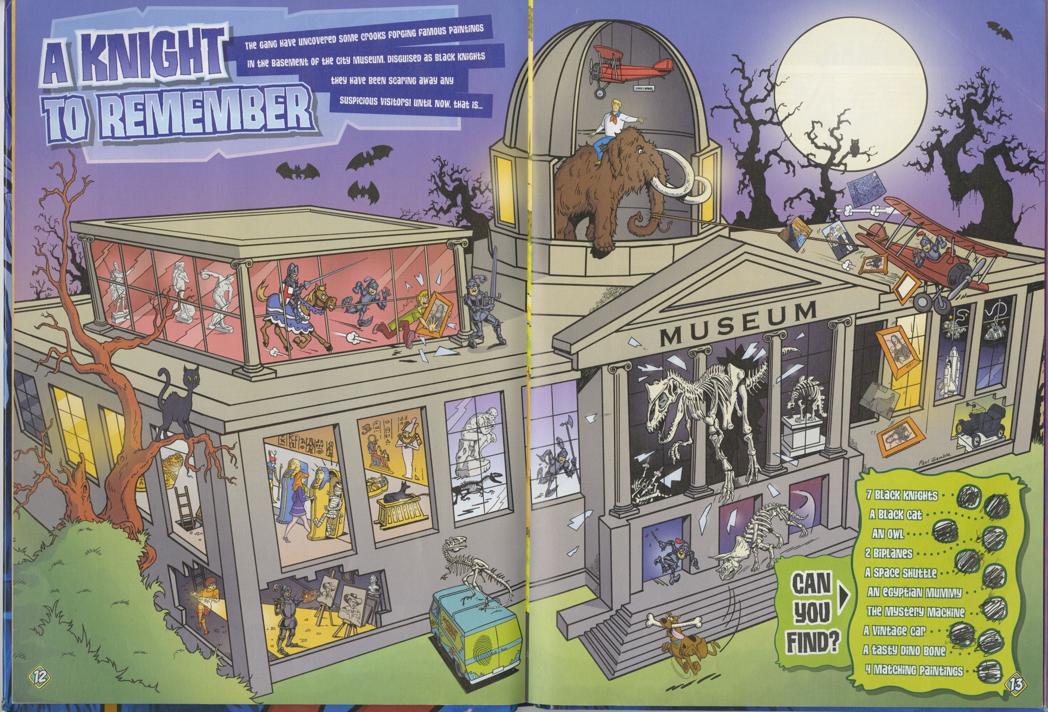
Figure 13. Museum themed activity in a children’s book.. Scooby Doo Annual 2011. Image by author.

Forging a Dynasty:
The Peale Family Museum(s)

Following the American Revolution, Philadelphia was the new nation's cultural center. During the war, the first and second Continental Congress had met at the Pennsylvania Statehouse to sign the Declaration of Independence. Philadelphia was at the heart of the war effort, and central to its success. After the war, it was both the country’s financial center and its cultural center. Between 1790 and 1800, the city even served as the temporary capital of the United States.
During this period, Philadelphia artist Charles Willson Peale (1741-1827) began to put together his natural history museum. Peale's career as an artist and his elite class-status served his museum in ways reminiscent of European aristocrats' cabinets of curiosities. All manner of objects—from frogs to Arctic seabirds—were displayed for the enjoyment of the Peale family, and for the education of Peale's contemporaries outside of the household. The collection, which was advertised as a teaching tool, served as both a status symbol and a means of mapping order onto the newly formed country. The more exotic the objects within the collection, the more caché Peale would gain within his social circle. It also allowed the showman to demonstrate his expertise about the natural world. Visitors to the Peale Museum participated in this structure of knowledge-transfer in much the same way that visitors experienced galleries of trompe l’oeil ("fool the eye") paintings. Such paintings produced three-dimensional space and objects on a two-dimensional surface to trick the viewer into believing that they were seeing physical objects. Each guest, when they presented their personalized invitation at the door, was agreeing to play along. Peale had no qualms about controlling and directing individuals inside his museum, or in encouraging them to make needed social changes in the outside world. Historian David C. Ward posits that Peale’s depiction of the order of nature within his museum would be a mirror for those who visited to reflect on the order of their new country, and that “institutionalizing nature created Americans who built the institutions, cultural as well as political, of the United States." That is to say that natural order inside the museum projected political order outside the museum. Peale’s natural history would imitate life so that the civic life could imitate his order.
Why would Peale structure his museum to emphasize the order of nature rather than its wildness and its romanticism? The answer to this lies in the creation of the American Republic following the Revolutionary War, and its achievement of independence from England. The new nation's government aimed to create order out of chaos, and Peale's Columbianum was duplicating this process in the ordering of his natural history specimens. This society was designed to support the arts and artists of Philadelphia. It was founded in 1794, the same year that Peale retired from portrait painting to pursue work as a naturalist. Ward notes that the Columbianum shared many of the same goals of Peale’s museum, which was established later, especially the desire to “forge citizens of character” and the belief that “nature’s harmony would teach humans a lesson in greater harmony between individuals.” Peale considered high character necessary to the viability of the Republic, and through his displays and exhibitions hoped to have a positive influence on the inhabitants of the Republic. Historian Catherine E. Kelly notes that though museums like Peale's were popular, even with statesmen and lawmakers, these same elites "also flocked to Daniel Bowen's Columbian Museum, where arrangements of wax presidents, Chinese "mandarins," Barbary pirates, and eight-legged calves owed more to cultures of curiosity and spectacle than to hierarchies of natural science." "Scholars," she continues, "are only just beginning to recover he parameters of this visual culture, to say nothing of its full significance. And they have yet to consider the relationship between visual and print cultures. But, if their research does not yet allow for broad generalizations, it clearly indicates the significance of the visual in the early republic." This significance is what I explore in the following pages, as it ebbs and flows through cities old and new, across oceans, and back to the pedestals of display within the United States' burgeoning museums.
Learning is not a passive task, and Peale knew that it would require effort on the part of his visitors to understand the lessons his museum sought to teach. Peale confessed, "I neglect any little contrivances which might serve to catch the Eye of the gaping multitude; (and give me some quarter dollars) but rather prefer: a steady perseverance to gain experience to execute such improvements as may tend to give a Scientific cast, as being most effectual to make deep and lasting impressions on those who come to study the subjects of the Museum." This letter contains the essence of Peale's museum philosophy: to avoid sensational or aberrant exhibitions that would only draw the "gaping multitude," and to focus instead on order, structure, and ideals which would cultivate and improve the sentiment—as a product of reason—of those visitors who "come to study the subjects." This letter also reveals that Peale's (at least) written desire was visitors with "steady perseverance," and not merely hordes with quarter dollars. Without studious labor, how would visitors learn the lessons of order and harmony that Peale’s museum was promoting for the new nation?
Those quarter dollars were essential to Peale's plan for his museum and his fellow citizens. By charging an admission fee, Peale created a type of republican museum open to anyone with the means to pay. David Ward argues that this precursor to the modern publicly accessible museum is Peale's greatest achievement, which "broke decisively with the European tradition of the private exhibition, open only to the politically and economically privileged." While this model for admittance still fell beyond the reach of the poor and those held in slavery, it was open to a broader swathe of classes than similar institutions elsewhere. The price of admission was still a limiting factor, as a quarter dollar in 1786 was equal to about $6.77 today.

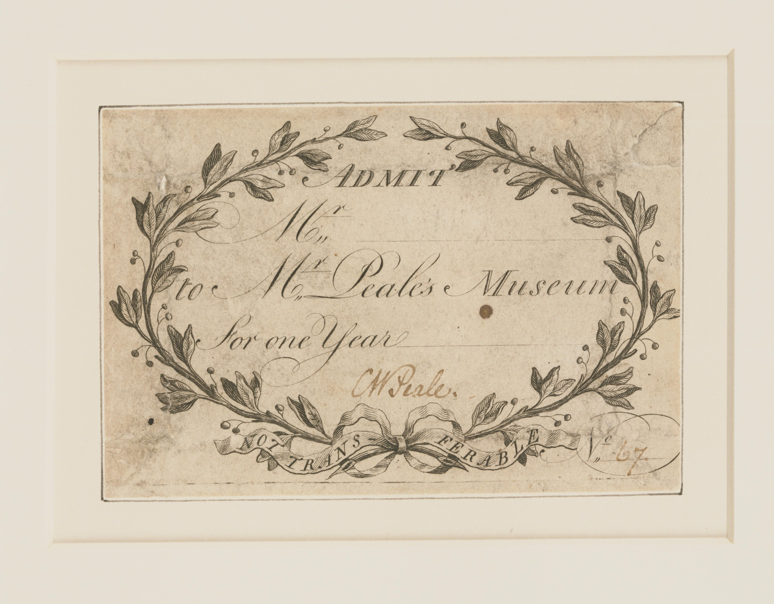
Figure 14. A 1794 admission Ticket to Peale's Museum. Courtesy of the Philadelphia Museum of Art.
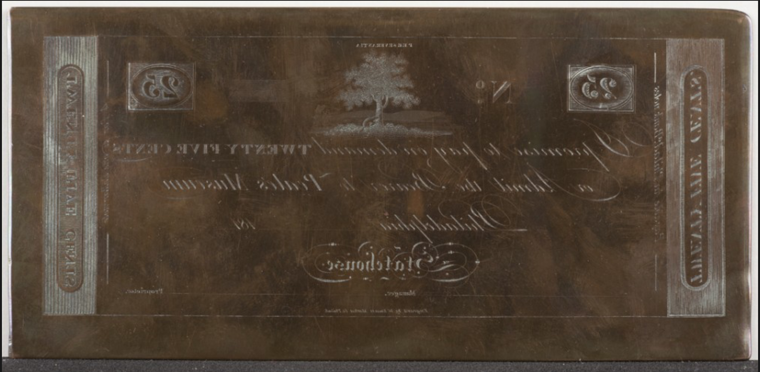
Figure 15. By 1810, Peale had copper plates for printing tickets. Courtesy of the American Philosophical Society.
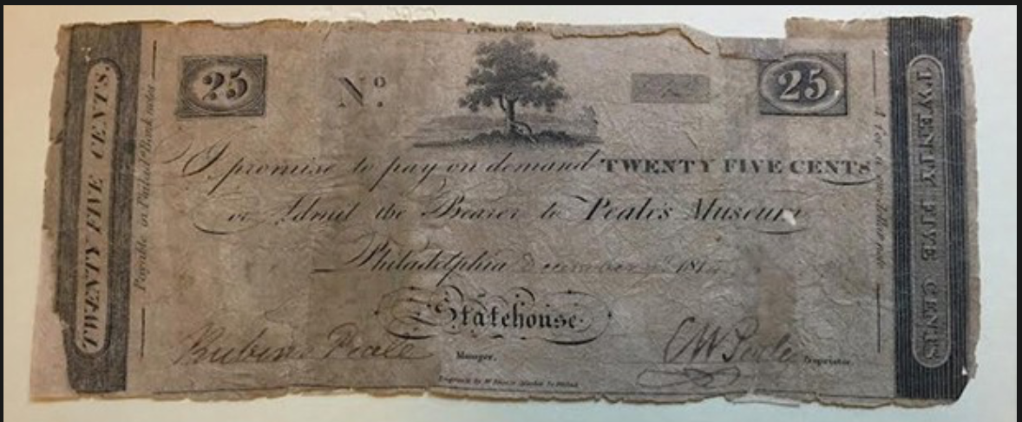
Figure 16. The same printing plates were still in use as late as 1814 as this one, signed by both Rubens and his father can attest. Courtesy of the American Philosophical Society.
Historian David Alexander contends that Peale’s combination of natural representation and detailed exhibits and activities could make the “institution a popular, even an exciting place, in great contrast with the silent, gloomy European museums of the day.” The Ashmolean at Oxford, the British Museum in London, the Muséum National d’Histoire Naturelle, the Conservatoire National des Arts et Métiers in Paris, and the Swedish Royal Academy of Sciences at Stockholm held significant collections, but were elitist in outlook, and tended to emphasize their country’s political reach. For this reason, according to Alexander, they “did not attract large, popular audiences.” Peale’s museum was more engaging.
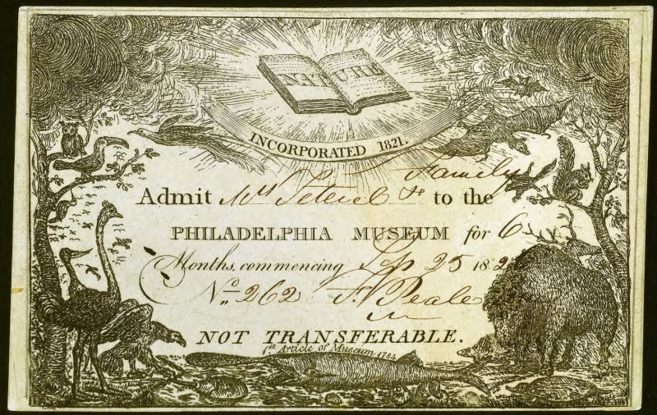
Figure 17. By the 1820s Peale had redesigned his admission tickets. Courtesty of The Library Company of Philadelphia. Original in private collection of the Peale-Sellers family.
Peale's appeal to a broader audience set him apart from his European contemporaries, but his most original contribution was his approach to specimen display. Painted backgrounds are now ubiquitous in museums across the world. However, during his time, Peale's contemporaries provided their animal displays with the "neat and clean appearance" that came from lining their cases with white paper. Peale, ever the artist, modeled his birds and smaller animals "in natural poses in glass-fronted cases two to four feet high, with realistic, modeled foregrounds and curved, brightly painted watercolor backgrounds, many …were lifelike and brought out the habits and environments of the creature shown." Visitors to Peale's would be treated to an animal as it had existed in life, complete with depictions of its original habitat. Alligators and the like would not hang from the ceiling as they had in earlier European cabinets of curiosities. Peale’s museum was organized to represent the wonder in nature, not just the wonders of nature.
In July 1786, the Pennsylvania Packet ran an ad inviting people to visit a new collection of curiosities:
“MR. Peale, ever desirous to please and entertain the Public, will make a part of his House a Repository for Natural curiosities—The Public he hopes will thereby be gratified in the sight of the Wonderful Works of Nature which are now closeted and but seldom seen.”

With this announcement, Peale invited the general public to visit the Philadelphia Museum, ushering in a new direction for museums and public display. Far from the academic temple-like collections of Europe, Peale's Museum, as it soon became known, was open to anyone with the twenty-five-cent admission price--anyone who was looking for "rational amusements" and "useful knowledge to socialize and improve the population." Peale had suddenly ushered in what Charles Coleman Sellers called "new science for a new era." From the very beginning, back to his earliest inclinations of creating a public space, Peale "understood that to succeed in the market, he had to present his Enlightenment-bred worldview so that it would appeal to a wide segment of the public." In an 1808 letter to President Thomas Jefferson, Peale described how American nature had created a "new American man," and it was precisely these new Americans that Peale sought as customers. The reputation of Peale's Philadelphia Museum quickly spread throughout the early United States, aided by the museum's 1794 move to the new Philosophical Hall, which was built as an addition to the American Philosophical Society. Peale's Museum was now less a publicly displayed private collection and more of a full-fledged monument to the American Enlightenment and the country’s natural history.
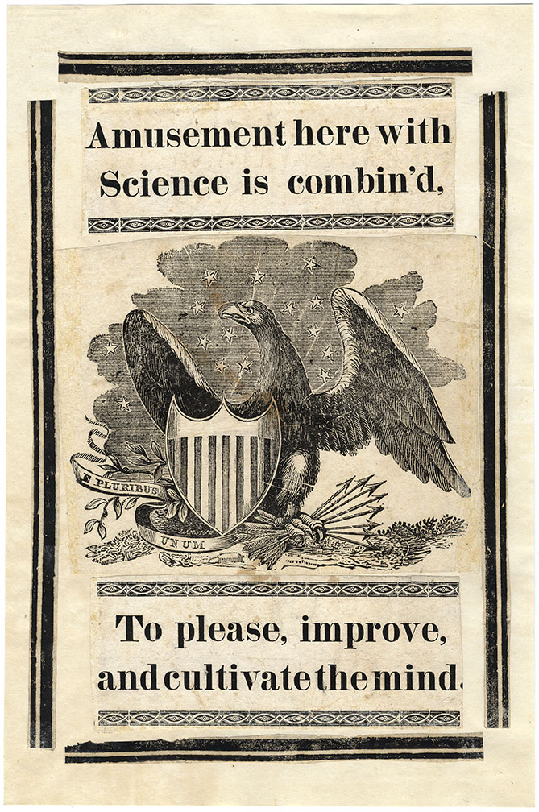
Figure 18. Undated Print advertising Peale's rational amusements. Courtesy of the American Philosophical Society.

Peale's Museum was not the first to display artifacts, art, stuffed animal specimens, or fossils. It was never alone in the world of exhibitions, even in the late eighteenth century. Peale's museum benefited from political and scientific networks, which many other early American museums, such as Scudder's, lacked. From the early collections of art and artifacts belonging to George Washington, Thomas Jefferson, and Lewis and Clark, the museum continued to be tied to American institutional history and development and, in some cases, the de facto repository for the country's historical artifacts. Peale cataloged American Culture as it developed and asserted itself, especially as regards its relationship with the natural world. Peale's world in miniature and philosophy of social control may have shaped his educational ideals for what a museum could become. However, the success of these ideals was never a forgone conclusion. In fact, his sons had to move into more "popular" exhibits to maintain public interest and attendance in their museums.
The earliest displays in Peale's museum echoed that of his European predecessors. This arrangement was only natural, as Charlotte M. Porter notes, "Despite his [Peale's] own nationalism, there were few authoritative American publications for him to use. The major authority Peale recognized was Carl Von Linné [and] although Peale preferred native names for American species, he did adopt the Linnaean convention of Greek or Latin binomial nomenclature." American naturalist William Bartram used the same naming system in his 1791 book Travels through North and South Carolina, Georgia, East and West Florida, the Cherokee Country, etc. However, it was “Peale’s displays [that] exposed the American public to Linnaean nomenclature in an easily understood fashion for the first time.”
One of the marks of Peale's success is that his work inspired others, particularly the work of members of the Academy of Natural Sciences of Philadelphia and those within the Pennsylvania Academy of Fine Arts. Peale greatly influenced the direction and the holdings of the Academy of Natural Sciences and inspired them to use the physical catalog to extend and expand American scientific endeavor and inquiry. The Pennsylvania Academy of Fine Arts, which I will examine in the next chapter, brought a lawyer-turned-artist to Philadelphia, who would, in his own time, follow the model of the Peale family to become an artist/impresario. However, it is not enough to have a museum philosophy; one must have a collection with which to express that philosophy, and filling a museum is not a simple task. Peale's collection grew in part from his contacts (and relatives) in the United States military, as well as merchant sailors, and fellow natural philosophers and historians. The museum would eventually contain material from around the world. The initial non-art collection came from expeditions, most of them governmentally funded. However, to fill his museum, Charles Willson Peale would also organize the first scientific expedition in the United States--an expedition to unearth the skeleton of a mastodon. Peale immortalized this venture in his 1806 painting, The Exhumation of the Mastodon.

Filling the Museums
When Charles Willson Peale opened his American museum, the bulk of the collection was art, and most of that collection was produced by the Peale family itself. Even the prolific Peales could not paint enough canvases to keep the museum exhibits fresh and lucrative, much less expand its holdings, building footprint, and cultural influence. Here, Peale relied on his vast network of powerful and influential individuals to spread the good word about his museum, and to broker donations to fill any missing areas in his natural history collections. His relationship with Thomas Jefferson proved to be an enormous asset in this regard. While he was president, Jefferson made Peale's museum the official repository for natural history specimens collected by the Corps of Discovery (1804-1809) led by Captain Merriweather Lewis and Lieutenant William Clark.
When it came to gathering specimens, Peale did not just sit and wait for them to arrive at his doorstep. “In general,” writes historian of science John C. Greene, “Peale was his own collector. Every year, especially in the spring when the birds were in their finest plumage, he sallied forth to collect specimens, some to be added to his own exhibits, others to be used in foreign exchange.” Peale would also take opportunities to collect during travel and was known to have selected some of his Philadelphia museum specimens among the fish markets of New York City while visiting extended family.

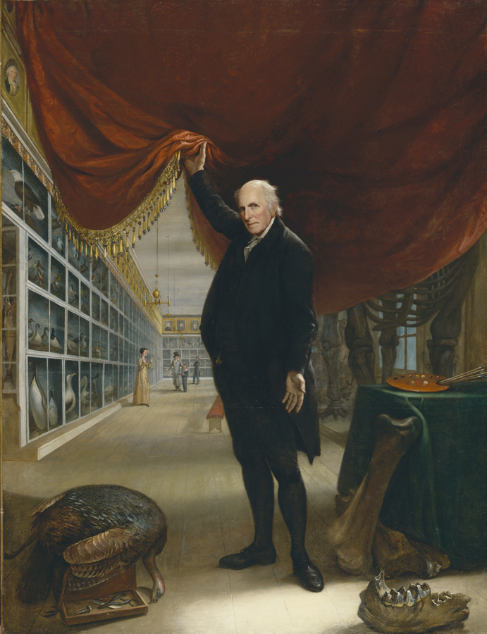
Figure 19. Peale providing a peek behind the curtain. Note the mounted mammoth on the right and the paddlefish on the far left. The Artist in His Museum. Charles Willson Peale. Oil on canvas framed: 116 x 92 x 5 in. (294.64 x 233.68 x 12.7 cm.); 103 3/4 x 79 7/8 in. (263.525 x 202.8825 cm.) Gift of Mrs. Sarah Harrison (the Joseph Harrison, Jr. Collection. Courtesy the Pennsylvania Academy of Fine Arts.
Peale's first natural history specimen was a paddlefish from the Allegheny River donated by Robert Patterson, a professor of mathematics at the University of Pennsylvania. This paddlefish was prominently featured in Peale's 1822 self-portrait The Artist in his Museum, and was also featured on early admission tickets to the museum, which bore the legend “1st Article of the Museum, 1784” above the specimen. Patterson, a fellow member of the American Philosophical Society, also proved invaluable in helping Peale gain access to the University of Pennsylvania libraries, where they both "looked through the great Histoire Naturelle, by then at its thirty-eighth volume, by the Comte de Buffon, the leading French Naturalist." While Peale adopted and followed Buffon's classification system of mammals, he scoffed at the naturalist's idea that American wildlife had degenerated to sizes smaller than anything in Europe. Peale remarked in a lecture that Buffon had "either a great Antipathy to America or to Truth.”
Indigenous American species arrived in Philadelphia through all manner of sources, some from sea captains and sailors enjoying time in port, others by cart or wagon from members of the Philosophical Society or friends of the museum. Lewis and Clark shipped the bulk of new American species straight from the West. More exotic specimens were obtained by trade or purchase. When he obtained duplicate specimens, he sent them to the Royal Academy in Stockholm or the Paris Museum of Natural History. When the Napoleonic Wars interrupted trade routes through the European continent, Peale turned to commercial dealers for supplies. Peale "complained of the high exchange rate" demanded by London dealer John Hall. However, he "could not resist the opportunity to obtain a specimen of Menua superba, one of the Australian lyrebirds, and of the platypus, ‘a Quadruped with a ducklike bill from New Holland.’”
Zoological specimens from the Lewis and Clark expedition alone were numbered in the hundreds. They were preserved and displayed in Peale's museum, where American naturalists could inspect and study them. To illustrate the vitality of American naturalism in the early 1800s, Scholar John Greene has this to say:
Alexander Wilson named, described, and illustrated three of the birds—the western tanager (Piragana ludoviciana), Lewis’ woodpecker (Asyndesmus lewis), and Clark’s ‘crow’ or nutcracker (Nucifraga Columbiana)—in his American Ornithology. George Ord described and gave scientific names to the Columbian ground squirrel, the black-tailed prairie dog, the bushy-tailed wood rat, the grizzly bear, the mountain goat, the Oregon ruffed grouse, the Columbian sharp-tailed grouse, and the pronghorn antelope in an anonymous contribution to the second American edition of William Guthrie’s A New Geographical, Historical, and Commercial Grammar (1815) and did likewise for the western gray squirrel and the eastern wood rat in subsequent memoirs. Constantine Rafinesque described and named the mountain beaver, the mule deer, the Oregon bobcat, and the prairie rattler. In 1823 Thomas Say added the short-tailed shrew, the coyote, the plains gray wolf, and the swift fox to the list of animals discovered for science by Lewis and Clark. The sage grouse was described by Charles L. Bonaparte in 1827, the mountain quail by David Douglas in 1837, the white-tailed jackrabbit by John Bachman in 1837, the poor-will by Audubon in 1839, and the Piñon jay by Prince Maximillian of Wied-Neuwied in 1841.
Philadelphia naturalists with access to Peale's museum collection were instrumental in publishing early American works of zoology, including Wilson's American Ornithology, Richard Harlan’s Fauna Americana(1825), John Godman’s American Natural History (1826-1828), and J. and T. Doughty’s The Cabinet of Natural History and American Rural Sports (1830-1832). Such works inspired a number of perhaps better-known American naturalists a generation later, including John Bradbury, Thomas Nuttall, Titian Peale, Thomas Say, and John J. Audubon."

During the museum's early years, specimens arrived ready for taxidermy. Even local gifts, like Benjamin Franklin's angora cat, arrived deceased. George Washington kept Chinese pheasants given to him by Lafayette from the Royal Aviary in Paris, and upon their death sent them to Philadelphia. Two of these, a male and a female, are some of the only surviving original Peale specimens. They are now housed in the Museum of Comparative Zoology at Harvard University, and maintain the original Peale labels. In his letter to Washington, dated February 27, 1787, Peale thanked him for the first specimen. The letter also reveals that Peale had already learned much about the taxidermy of birds. Peale wrote, "'When you have the misfortune of losing the others [pheasants] if the weather should be warm be pleased to order the Bowels to be taken out and some pepper put into the Body. But no salt, which would spoil the feathers."
Not all of Peale's museum inhabitants were dead on arrival. When Peale moved his collection via public parade from the building adjoining his home on Third and Lombard to the Philosophical Hall in 1794, he requested permission from the Pennsylvania governor to fence off a portion of the state grounds so that living specimens could mature "until [the specimens were] full grown and ready to be stuffed and mounted on display." The most prominent fixture in the Peale zoo was a bald eagle kept in a large cage at the top of Philosophical Hall. The cage was emblazoned with the gilded words "Feed Me Daily 100 years." Peale had obtained the eagle as a chick in 1788 and boasted in his autobiography that "This Eagle had been so long domesticated that Peale could without fear stroke him with his hand, nay it knew him so well that when [he] was walking in the state House Garden, it would utter cries expressive of its pleasure on Seeing him." The bird lived for fifteen years in captivity before its death made him a permanent part of Peale's collection. Peale may have considered himself lucky that the eagle had not lived to 100, as the fifteen years alone cost him $300 in food.
Large animals also populated the fenced grounds of the new museum. On one occasion, a female elk broke her staked lead, and when Peale tried to catch her by slipping a rope and rein over her head, she bolted. His lead "jammed in [his] pocket, and he was thrown to the ground and dragged 30 or 40 feet before his pocket tore" and "thus saved his life, for had it held fast, she would have dragged him against the Threes [trees], and would innivetably [sic] have killed him."Managing living animals was more immediately life-threatening than the arsenic and mercury poisoning that could be caused by years of taxidermy. The Peale menagerie was a great draw for the people of Philadelphia, and these animals, having lived their lives on view or as the pets and wards of Rubens Peale, would after their death move indoors to become part of Peale's American Museum.
The display of taxidermied animals that had once lived on the grounds had the benefit of lending authority to the rest of the collection. If people had visited Peale's menagerie enough times, they could see how an animal interacted with the local, if not natural, environment. Once the animal was dead and Raphealle had completed the taxidermy, guests could judge for themselves the skill of the work. If the animals, once seen living on site, were adequately lifelike, this brought the feeling of correctness to the rest of the displays. Logistically, animals living on site would suffer much less decomposition before they arrived on Raphaelle's workbench. They could also provide references for musculature and movement for related or at least physically similar animals that were to be turned into exhibits.

Indian Artifacts
Peale's collection was not limited to animal, mineral, and vegetable. Excepting Thomas Jefferson's personal collection at Monticello, Peale's museum "was the first repository for the Indian artifacts collected on the [Lewis and Clark] expedition." Jefferson sent some artifacts directly to Peale, and Lewis donated nearly all his personal collection from the expedition. This included a peace pipe and a mantle made from 140 ermine skins, presented to the captain by Shoshone Chief Cameahwait, in what is present-day Idaho. That particular meeting is one of the most romantically remembered, since it was the site of the reunion of Chief Cameahwait and his sister Sacajawea, who had aided the exploration from the beginning. Since Sacajawea had grown up with the Minitari people after being captured as a child, she translated the parties’ exchanges from the Shoshoni into Minitari. Her husband translated the Minitari into French, and yet another unnamed expedition member translated the French into English. Peale created a diorama of wax figures representing Lewis and Cameahwait at this 1805 meeting.
Peale's museum took possession of material from the Lewis and Clark expedition, and in 1809, from Lewis’s personal collection. Sellers notes that while incomplete, the published accession account in Poulson’s American Daily Advertiser dated March 1, 1810, reveals "that a good collection of weapons, utensils, and costumes illustrating the life of the tribesmen had come to the museum." Following Jefferson's death in 1826, Peale received more Indian artifacts from the former President's Bedford County estate, Poplar Forest. In addition to the wax figures of Lewis and Cameahwait wearing their respective costumes and accoutrements, Peale's artifact gallery contained "a handsome buffalo robe, an Omaha tobacco pouch, Cree Indian cradle, a Chinook woman's skirt of cedarbark fiber, and an Indian Hunting shirt made of buffalo skin and worn on the expedition by Clark."

The Exhumation of the Mastodon
Fossil bones had been housed in Peale’s study as early as 1766, where they had been brought from Big Bone Lick (in what would later become Kentucky). Peale could then sketch them before giving them to Hessian army surgeon Christian Friedrich Michaelis to "take back for study by the savants of Göttingen." These bones were among the first objects in Peale’s museum. In a visit of 1784, Peale’s brother-in-law, Colonel Nathaniel Ramsay, had suggested that that a museum displaying such curiosities was a sure solution to the financial struggle brought on by Peale’s ever-growing family, since such curiosities would be far more popular than paintings.
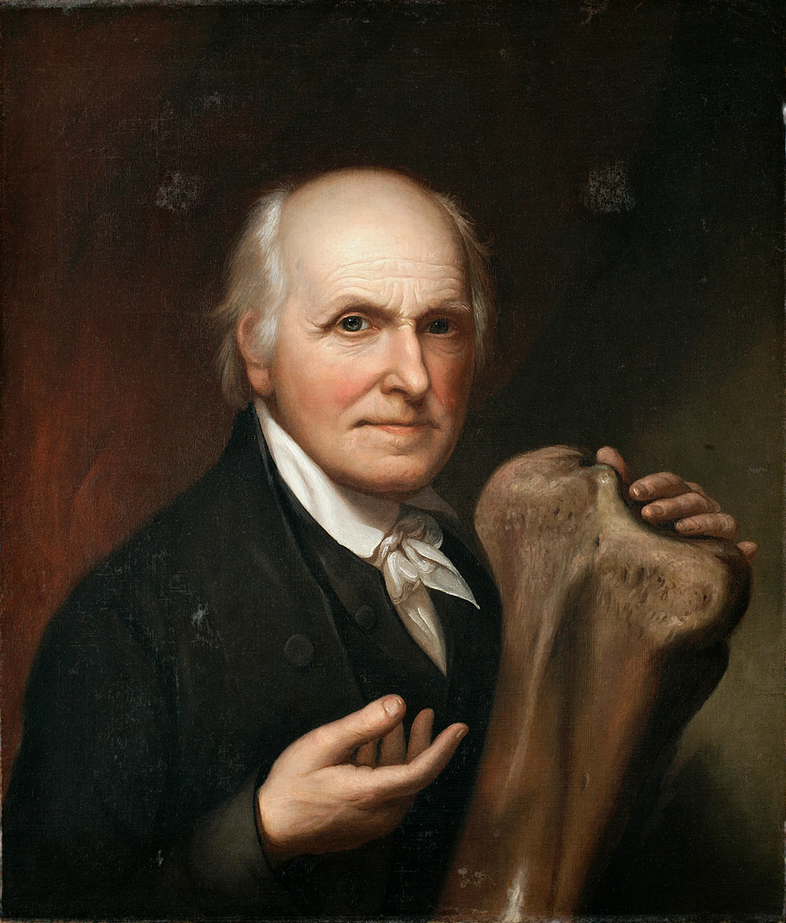
Figure 20. Charles Willson Peale, Self-Portrait with Mastodon Bone, 1824, oil on canvas, 26 1/4 x 22 in., New-York Historical Society, Purchase, James B. Wilbur Fund, Photography. Courtesy New-York Historical Society, negative #8736c.
In 1801, Peale received a newspaper clipping with an explanatory letter from a friend in New York State. The clipping spoke of numerous giant bones discovered in a marshy field near Newburgh, New York. When Peale arrived in Newburgh in 1801, he found that the farmer who had discovered the bones, John Masten, had been displaying them for a fee for three years. The mammoth skeleton was the most complete that Peale had seen, with "enough to reproduce on one side what had been on the other." Deals were struck for purchasing the existing bones and for exhuming any bones that remained. This “dig” constituted the first organized scientific expedition in the United States. The specific goal was to uncover and collect the rest of the mastodon bones for Peale's museum. The process was anything but simple.
After the expedition, Peale painted The Exhumation of the Mastodon to capture the importance of the event. The painting was displayed in what was eventually christened the "mammoth room" of the museum. Basically, the painting is a family portrait, featuring Peale and his children (who were never actually at the site). The gathering thunderstorm in the Catskills evokes an urgency and energy to the painting and to the reconstructed bones. In the painting, Peale stands before unrolled sketch papers that reveal the reconstruction of collected bones. One also sees a giant wheel mechanism, used to drain the site. The painting is both portrait and landscape, classical and modern, technological, and pastoral. It is also a science painting, a natural history painting, on par with Joseph Wright of Derby's 1768 painting, An Experiment on a Bird in the Air Pump.
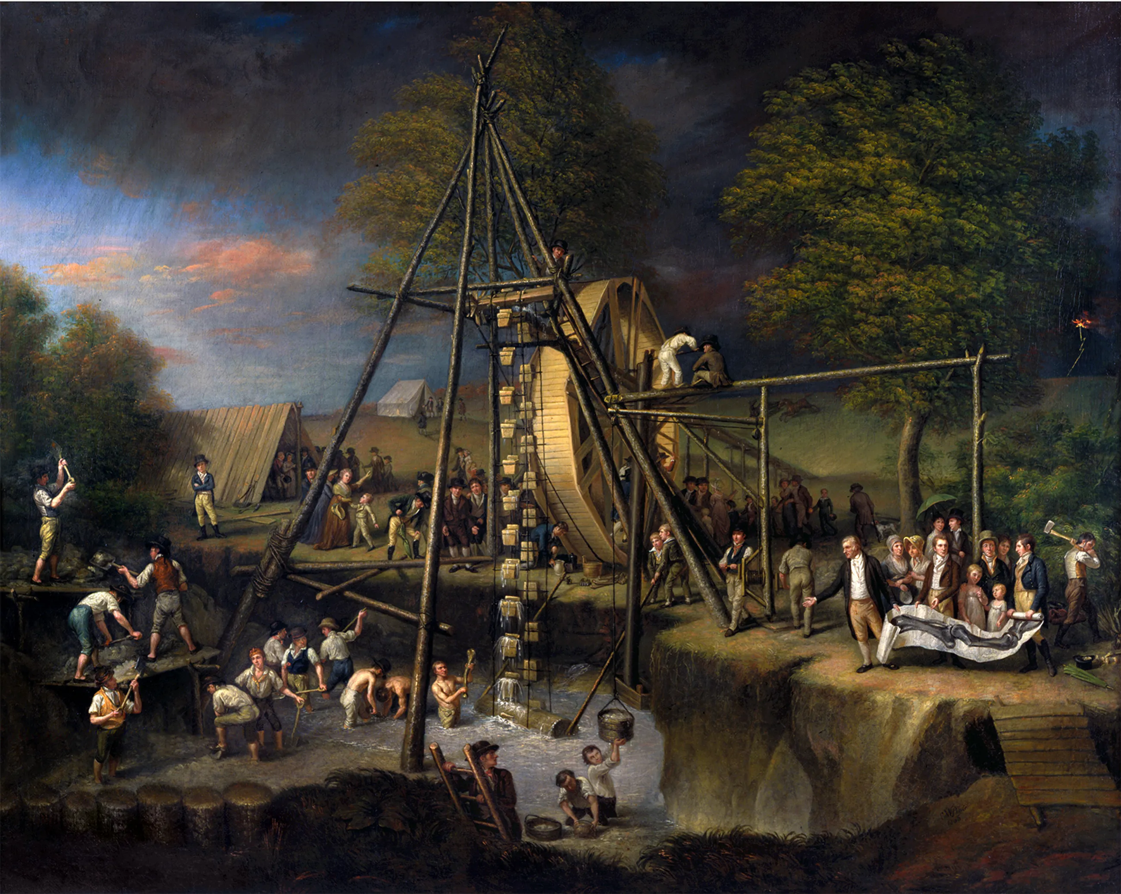
Figure 21.Charles Willson Peale, Exhumation of the Mastodon, ca. 1806–08, oil on canvas, 49 x 61 1/2 in., Maryland Historical Society, Baltimore City Life Museum Collection, Gift of Bertha White in memory of her husband, Harry White, BCLM-MA.5911. Courtesy of the
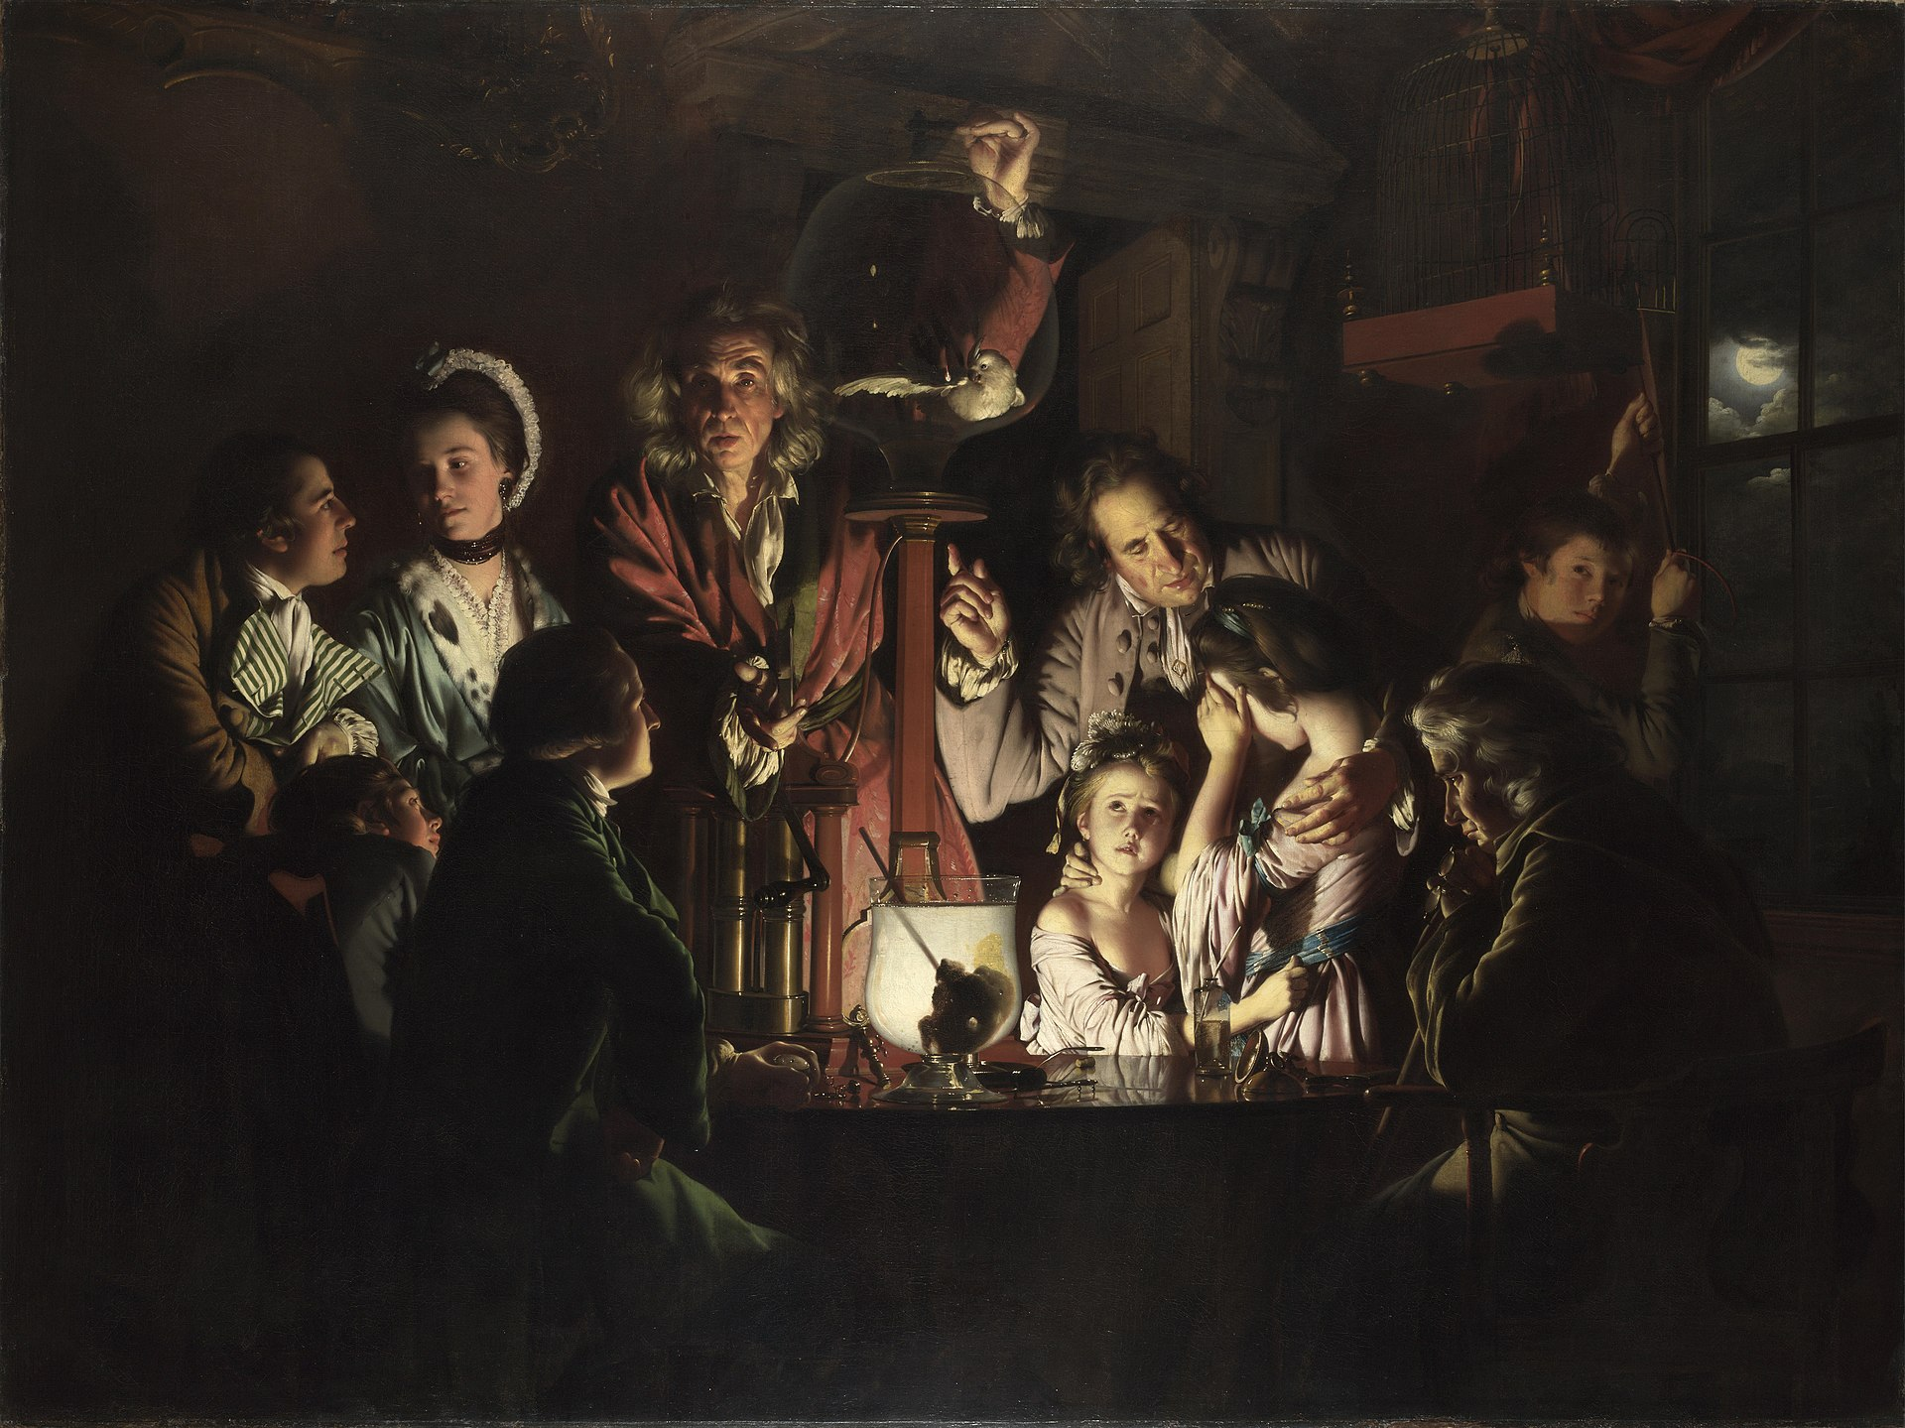
Figure 22. An Experiment on a Bird in an Air Pump by Joseph Wright of Derby, 1768. National Gallery London.
Before Peale left New York, he excavated at least three other morasses in hopes of securing more mammoth bones. All together, enough bones were collected to successfully reconstruct two full-size American mammoths with the addition of some carved pieces. One would make its home in the mammoth room at the museum, while his sons Rembrandt and Raphaelle took the other on tour to England, using the income from the exhibitions to finance their trip. On the 1803 trip, Rembrandt published Historical Disquisition on the Mammoth, or Great American Incognitum, in London. Having been on the expedition that collected the bones, Rembrandt toured as the authority on the subject, publishing that the teeth were that of a carnivore and, as such, the large tusks should face downward "like those of a walrus, and probably for a similar purpose." Whether this was a genuine belief or done as a bit of embellishment has never been fully established. Taken at his word, Rembrandt believed that the mammoth was like a walrus; however, given all the notes from the elder Peale's colleague Dr. Joseph Wistar, discussing the similarities between mammoths and elephants, I believe it is more likely Rembrandt Peale was touring England with his carnivorous mammoth as an American showman. Further evidence for this fact is Rembrandt's earliest representation of the mammoth of New York, which shows the tusks pointing upward before the specimen was toured around Europe. This chronology raises interesting questions to which I have found no answers: Why would Rembrandt choose to switch the tusks and publish a pamphlet supporting the reorganization? Were not the bones as exciting to Londoners as they were to New Yorkers? Moreover, when, exactly, did he turn the tusks around? Was it before the first show or after a few with lackluster attendance? When Rembrandt Peale opened his museum in Baltimore, he took a different approach to museums than had his father, and this tour may be the earliest sign of his exhibition philosophy.
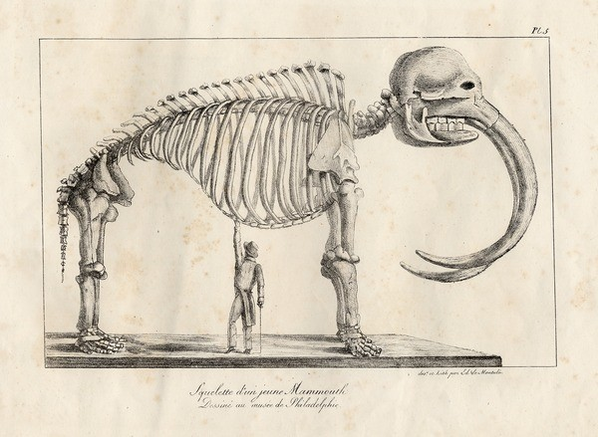
Figure 23. Peale's carnivorous mammoth. Squelette d'un jeune Mammouth dessiné au musée de Philadelphie. Courtesy of the American Philosophical Society.

Titian (II) Explores with the Long Expedition
Titian Ramsey Peale II was elected as a member of the Philadelphia Academy of Natural Sciences at the age of 18. The following year, in 1818, he set off with Major Stephen Harriman Long on his expedition to map some of the unexplored southern portions of the Louisiana Purchase. Titian was employed as an assistant naturalist working closely with expedition zoologist, fellow Academy member, and family friend Thomas Say. Some of Titian's earliest published natural-history artwork appeared in Say's American Entomology. He had accompanied Say on an expedition to Florida and Georgia the year before.
Following the unofficial and then official procedures of depositing government expedition specimens with the Peales, a shipment of nearly one hundred drawings arrived in Philadelphia on March 20, 1821. Zoological specimens deposited that day included "a half-dozen squirrels" and the head and cape of a mule deer that had been killed by expedition members the previous August. Reports from the American Philosophical Society record that "by the time the specimen reached Peale's Museum on March 20, 1821, the skin, according to James [Peale], “was so much injured by the depredating insects that it has not been judged proper to mount it entire. The head has therefore been separated from the remaining portion of the skin and may be seen in the Philadelphia Museum, placed under the foot of a prairie wolf."
Most of Titian's drawings, sketches, and watercolors show the animals within their habitats. The family of Pronghorn, or American, antelope is shown among the beardtongue and prickly pear cactus with mountains in the distant background. These images portrayed nature not just as illustrations but as three-dimensional worlds. Every detail was chosen and executed with great care to reproduce wild nature in the still museum. Another of Titian's collected specimens became prominent in the world of Peale's museum. In Peale's The Artist and His Museum, a turkey lies at the artist's feet, awaiting the taxidermist's art. This turkey is likely one that Titian had collected on the Long Expedition.
Titian returned to Philadelphia in 1821 and began working on the backlog of his own returned specimens. Titian's work amounted to "nearly a hundred mounted exhibits, as well as botanical specimens and over a hundred drawings." In addition to the physical specimens and natural history drawings, Titian supplied the gallery with portraits of Long's scientific corps: commander Major Stephen H. Long, geologist Lieutenant Augustus Edward Jessup, physician and botanist Dr. William Baldwin, zoologist Thomas Say, and Titian's self-portrait.
While his brothers Rembrandt and Rubens worked on their own branches of Peale's museum(s) in Baltimore and New York City, respectively, Titian worked to fill them. He was collecting and maintaining specimens across two extensive American expeditions. Between the Long Expedition (1818-1823) and the United States Exploring Expedition (1838-1842), Titian was stayed in his home in Philadelphia. There he managed the original Museum, since his father had entered semi-retirement. This was the arrangement until the elder Peale's death in 1827. Titian then operated as a curator at the museum under his brother Franklin until the call of expeditionary science once again reached him. In 1838, he set off on an American exploring expedition, this time by sea. Art historian Kenneth Haltman says that Titian's work with Long represented “expeditionary science in 1820 as a confident assertion of civilized control and linear advance."
Eighteen years later, Titian Peale was serving as chief naturalist aboard the Peacock for the United States Exploring Expedition. In this post, he could see just how far attempts to “civilize” would extend. He also discovered how different his overland expedition with Army Captain Stephen Long was from a sea voyage under the direction of Navy Lieutenant Charles Wilkes. Titian had assumed all the collected material from the naval expedition. would go to the Peale Museum in the same manner as had the Lewis and Clark material. When material began returning from the voyage, it fed into growing political tensions in Washington concerning the ownership of material, as well as a larger argument about the desirability of a national museum. The US Exploring Expedition., its scientists, naturalists, and its eventual mass of collected specimens forced the government to take official action on the question of a national museum. This development is addressed in Chapter 5.
Once a specimen or artifact arrived at Peale’s museum, it had to be made ready for display. Many cultural artifacts could be displayed as received, but for Peale to accurately recreate nature in miniature, the animals would have to be treated and taxidermied. Skins, pelts, and specimens had to be cleaned, preserved, stuffed, and mounted in lifelike arrangements to populate their painted dioramas. The work that went into getting animals taxidermied and displayed was possibly more dangerous dangerous than it had been to collect the specimen in the first place. Peale's oldest son Raphaelle came to know the ravages of the process too well.

Raphaelle Peale: Prodigal Son and Taxidermist
Museum work for the Peales was a family affair. The entire family worked at entertaining guests and patrons, but most of them were also artists in some fashion. Each had an important part to play in the elder Peale's grand scheme, even if they were not always aware of what their particular responsibilities may be. True to the times, Peale's sons were responsible for the physical requirements that kept the museum operating. Peale's oldest son, Raphaelle, bore the brunt of these responsibilities, involved as he had been from the very beginning of his father's post-war fixations.
Born in 1774, Raphaelle was 21 at the time of his father’s—and America’s—first art exhibition--the Columbianum, in 1795. This exhibition featured his father’s famous trompe l’oeil painting, titled The Staircase Group, which features Raphaelle as one of the children standing on the stairs. The exhibition also had thirteen of Raphaelle’s own paintings, five of them portraits and eight of them still lifes. None of Raphaelle’s Columbianum paintings survive, but according to art historian Phoebe Lloyd, "one in particular, A Deception, suggests that at the very beginning, Raphaelle pattern[ed] himself on his father's example." Lloyd contends that Peale’s relationship to Raffaelle is revealed when George Washington came to sit for a painting in 1795. If the elder Peale didn’t have the time to do the painting, the natural choice for that responsibility would have been Raphaelle, as the eldest son. However, the honor of painting the President of the United States was given to Raphaelle's younger brother, Rembrandt. This action, Lloyd argues, "is a pattern in the relationship of Raphaelle and his father which would be played out until Raphaelle's death at age 51." All his life, he was treated as an extension of his father who never allowed him to design a course for himself; Raphaelle consistently "bent to his father's stronger will."
A particularly revealing example of Peale’s view of Raphaelle as an extension of himself occurred in 1793, when he sent his nineteen-year-old son on a collecting trip to South America. As Raffaelle traveled east from French Guiana through the interior and then north to Mexico, he collected specimens for the family museum, including a spotted margay cat and a toucan. Raphaelle returned with these, and presumably other, rare specimens "so that his father could fulfill his pledge to represent all New World species in his museum."
The great irony of Raphaelle's expedition is that it brought him into contact with a style of European painting completely unlike that of his father or siblings. Raphaelle's surviving paintings show us that his time in Mexico--then a major Spanish colonial outpost--introduced him to the Spanish Baroque bodegón style of still life paintings. This influence may also explain why he entered so many still-life paintings in his father's Columbianum and maintained his work with still lifes, even though it was not particularly lucrative, and was seen as a sub-tier of professional artistry. His exposure to the elaborate Spanish gardens in Mexico might also explain his attachment to the burgeoning horticultural movement back in the United States, as Philadelphia became the horticultural center of the new republic. Unable to become a "free agent," divorced from his father's will, it was while acting as his father's hands that Raphaelle found what would distinguish him from the other Peales. These paintings offered some respite from his life of toil to fulfill his father’s vision.
Life was never just about painting for Raphaelle. In 1797, Raphaelle and his brother Rembrandt traveled to Charleston, South Carolina, where they attempted to establish the first branch of the Peale Museum. Although the venture was unsuccessful, and they both returned to working at their father's museum, it provides ample evidence of the elder Peale's ambition for his museum. Raphaelle toured briefly, creating profile silhouettes with a “physiognotrace" device. This brought him some money, and a respite from his father's brooding. The timing is suspect, and it is possible that the elder Peale’s desire to have a museum in Charleston might have been twofold, for he may have sent Rembrandt and Raphaelle to Charleston in order to separate Raphaelle and his soon-to-be bride.
Raphaelle married Martha "Patty" McGlathery in 1797. The elder Peale was against Raphaelle's union with a woman of Irish heritage from the start, since this might hurt his social standing. However, his antipathy may have also been due to Peale not wanting to lose his most devoted museum worker. For their entire marriage, Patty was treated as a deleterious influence on her husband and blamed for his illness and fits of delusion . It is now beyond argument that Raphaelle Peale began suffering from mercury and arsenic poisoning in 1806, when he began doing more taxidermy work for his father's museum Raphaelle's drinking also increased, to balance the poisons' effects. Of all the Peales, Raphaelle paid the highest price for his father's museum and for his father's approval. Whatever self-destructive tendencies (alcoholism) Raphaelle may have had, his father allowed them. Furthermore, the elder Peale knew full well, by 1810, of the dangers of arsenic and mercury poisoning in taxidermy work, but allowed that too, since the work benefited the museum.
Far from being a prodigal son or an undisciplined man given to bouts of drunkenness, Raphaelle was a dedicated artist and museum worker with a chronic illness, who during periods of wellness, displayed the harmony, order, and light of his Spanish-style still lifes, which he continued to produce until his death in 1825. Charles Willson Peale outlived his son by two years. When he wrote his Autobiography, it included "a fabricated fiction" of Raphaelle's final hours, a fiction “that Charles Willson Peale needed to believe." Peale literally worked his eldest son to death in the cause of his museum, for his son created the hundreds of taxidermied displays for the museum. The essence of Peale's museum, unique among its contemporaries, was the scale and context this preservation provided. Raphaelle’s short, tragic life reveals that Charles Willson Peale was willing to spare nothing in making his museum a reality.

Rembrandt Builds in Baltimore
Rembrandt Peale was born in 1778, four years after Raphaelle. Rembrandt managed to navigate his father's moods, and plans for the museum with greater alacrity than his elder brother. In 1798, he married Eleanor May Short and began building a family totaling eleven—Rembrandt and Eleanor included. By the time Rembrandt had painted George Washington's portrait, he had devoted himself entirely to art. With his father’s money, he traveled to London and Paris to study with the masters, including some of the most prominent men of science. Peale financed his son's trip(s) with an eye to getting portraits of the great French scientists, writers, and artists for the museum. "This aim," notes American art historian Lois Marie Fink, "also provided additional rationale for Paris as Rembrandt's destination, for at this time most American artists going abroad went to London to study with Benjamin West."
Rembrandt had already spent time with the the historical painter Benjamin West during his 1802-3 stay in England, when he was exhibiting one of Peale's mastodon skeletons. For the Peales, time with West was not only an artist's tradition but a familial one. The elder Peale had studied art under a much younger West forty years earlier, not long after West had settled in England.Benjamin West (1738-1820) was born in Pennsylvania and was contemporaries with Peale and Benjamin Franklin (1705-1790). Both men painted the latter. Peale's Franklin portrait, completed in 1785, was much earlier than West's famous science painting of 1816: Benjamin Franklin Drawing Electricity from the Sky.
Rembrandt spent nearly a year and a half in Paris during two visits. His first visit, which ranged from June to September 1808, was cut short due to homesickness, and because of his fear that "the war in Europe would flare up and isolate him on the continent." He returned to Paris in October 1809, this time with his wife and five children. Surrounded by family, for one year they adopted a full Parisian lifestyle, until he left for England in 1810. Rembrandt's tours across the Atlantic allowed him to compare his father's museum with those in England and Paris. Peale had letters of introduction for his son's time in England addressed to West and scientist Sir Joseph Banks. In England, Rembrandt attended Royal Academy classes until his expulsion for playing a prank on West. Younger brother Rubens attended anatomical lectures by the likes of Dr. John Heaviside and Sir Everard Home. Heaviside owned and operated an anatomical museum, and Home's famous brother-in-law, Dr. John Hunter, had just transferred his collection from government ownership to the Royal College of Surgeons.
At the invitation of Banks, the brothers attended library breakfasts at his Soho mansion, where he entertained people of various professions. Banks also arranged passes for Rembrandt and Rubens to visit the then "closely restricted" British Museum. In gratitude, Rembrandt dedicated the updated pamphlet on the mammoth to Sir Joseph Banks.
Rembrandt had invaluable experiences in Paris. Through letters of introduction from his father, from Thomas Jefferson, and from his patrons, his social circle included men like "George Cuvier, a pioneer in the study of fossils…writers like Bernardin de Saint-Pierre, a naturalist and author...and men from the world of art…Jacques-Louis David, revolutionary in art and politics and still leader of the French school of painting the sculptor Jean Antoine Houdon…and Dominique Vivant Denon, museum man extraordinaire." Rembrandt's connections include many well-known individuals both abroad and back home. It is likely that his decision to forsake another stay in England and visit Paris instead had been influenced by a meeting with the American artist and inventor Robert Fulton (1765-1815) in 1807.
Fulton--the man who developed the first commercially successful steamboat--may have swayed Rembrandt to travel to the continent. After all, he had “firsthand acquaintance with the advantages of Paris for a young artist.” Fulton had also studied under West (their fathers had been friends), briefly living with him during the 1780s. In 1797, Fulton went to Paris, where, in 1800, he exhibited a painting of the panorama of the city. Pierre Prévost’s Vue de Paris depuis les Tuileries (View of Paris from the Tuileries Gardens) was exhibited on a site still called Rue des Panoramas (Panorama Street). It is likely that Fulton’s recent experiences in France influenced Rembrandt.
Rembrandt returned to Philadelphia after a year in Paris. There he had a very bad experience with the local art circles. In Paris he had seen the government award artists with money as well as fame. His painting--The Roman Daughter--which had been highly praised in Paris, was scorned in Philadelphia. It was even accused of being a copy, painted by Paul Svinin, the Russian Vice-Consul in the United States. The accusation was later publicly withdrawn, but Rembrandt had had enough of Philadelphia and took the "scorned work" to Baltimore, where he and his brother Rubens established another Peale's Museum in August of 1814.
Peale's Museum in Baltimore began as a showcase for Rembrandt and Rubens' artworks, including private portraits of Baltimore patrons and for the city itself. Rembrandt detailed his plans in a letter to Jefferson, stating:

"I mean to form a handsome establishment in (Baltimore), the general plan of which will differ from my father's Museum, it being my intention to render it more properly a Museum of Arts and Sciences: and without neglecting any branch of Natural History, to bestow my chief attention to the formation of a Picture Gallery & Depository of the course and productions of manufacture…"

The son who was the most devoted to the arts was dedicating part of his museum to "productions of manufacture" (engineering). While the museum was mainly an artists' gallery, Rembrandt's Baltimore museum's main attraction was the mammoth skeleton he and Rubens exhibited in England.
The museum opened in August of 1814. It was the first building in Baltimore to be built specifically as a museum. Unfortunately, the War of 1812 was going on, and Baltimore came under the attack of British forces just a month after the museum was opened. Baltimore was the "culmination of the British's Chesapeake campaign," in which the United States Capitol and the White House had both been burned. According to the Peale Center for Baltimore History and Architecture, Rembrandt feared that his museum would meet the same fiery fate: "Rembrandt, his pregnant wife, and their seven children spent the night in the building during the Fort McHenry bombardment, hoping that the British would think it was their residence and spare it." The museum survived the Battle of Baltimore and the War of 1812. In 1816, in an effort to modernize the gallery, Rembrandt installed a "magic ring” of pearls to illuminate one of his galleries. These "magic pearls" were carbureted hydrogen gas lamps.
In 1820, Rembrandt conceived and began work on his grandest painting, in both scale and scope: The Court of Death. The reception and monetary success of this 13-foot high and 24-foot-long canvas totaled $9,000 in admissions across the "Eastern cities" and convinced Rembrandt that "art was after all his strong point." He used the opportunity to divest himself of the museum business. In 1822, Rembrandt turned over the entire operation of the Baltimore Museum to his brother Rubens.

Rubens
Rubens Peale was born in 1784, the same year his father opened his museum. Rubens, the fourth child and third son, grew up alongside and in step with his father's museum. He also had the good fortune to be the constant companion of his brothers as they traveled across the American and European continents on jobs for their father. As a child, Rubens had not taken to the artist's ways as had his siblings. His elder brother Titian (the first one) had worked with him on the naturalist side of the museum. Rubens had cared for many of the live animals gifted to his father's museum. He also oversaw a garden on the corner of Lombard and Third streets, where he raised plants and seeds that had been donated to the museum. In fact, his garden produced the first tomatoes seen in Philadelphia."
When Rubens turned to science, he literally gained a clearer perspective on the world, for his first use of a hand microscope revealed that he needed corrective lenses. Soon afterwards, he was fitted with spectacles, and began to show a growing interest in art. However, throughout his life, he remained more closely attuned to animals and plants, dutifully assisting his father in running his museum and his brothers in creating theirs. Rubens Peale took charge of the family museum business in 1810 following his father's retirement. Sellers describes him as a businessman who saw "science as entertainment" and a man who knew that the "world in miniature" would never show a profit. For the next two decades, Rubens "seasoned" the original Peale's Museum in Philadelphia with special, money-making exhibits such as a "Santorian Chair" weighing machine and "suffered the appearance of Signor Hellene, a one-man band who played viola, cymbals, and tenor drum, accompanied by pipes strapped to his head."
Rubens directed the Peale Museum in Philadelphia for nine years. Titian (II) returned in 1819 from a government-sponsored expedition with Major Stephen Harriman Long, bringing with him hundreds of prints and new museum specimens. At that time, he took the helm of the Philadelphia museum. In 1821, Rubens left Philadelphia and soon became the sole Peale operator of Peale's Baltimore Museum. While working through the debts his brother had left behind, Rubens began to eye a more strategic location for his own museum endeavor: New York City. Even though the Baltimore museum had its own mammoth, Rubens restructured the Baltimore Museum to bring in more travelling shows and ticket income and opened yet another branch of Peale’s Museum in New York City. This museum was located on Broadway, facing both the New York City Park and City Hall.
Peale's New York Museum opened on October 26, 1825. Rubens had planned the opening to coincide with the opening of the Erie Canal, which was the first navigable waterway connecting the Atlantic Ocean to the Great Lakes. The 363-mile-long canal expanded trade routes west and gave the city of New York a significant advantage over other United States ports. It also bestowed prosperity on other New York cities along the canal, including Albany, Syracuse, and Buffalo.

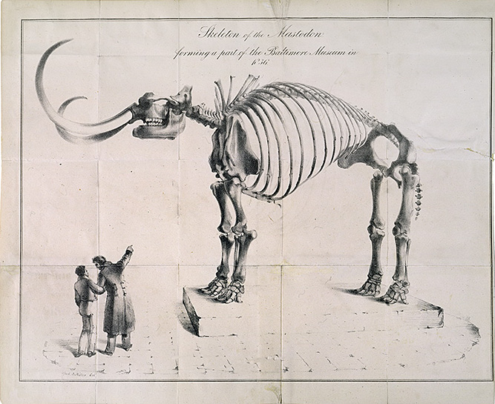
Figure 24. Skeleton of the Mastodon Forming a Part of the Baltimore Museum in 1836. This sketch was done by Baltimore artist Alfred Jacob Miller., Medium Print Collection, courtesy of the Maryland Historical Society.

By February 1826, Rubens’ museum had two Egyptian mummies displayed in the main exhibition hall courtesy of George Barclay of New York. Rubens soon purchased the mummies outright from Barclay "much to the dismay of his father…who worried that the revenue gained from their exhibition would be very slight and not worth the amount paid for [them]." On March 2, 1826, Rubens advertised a public unwrapping of the two mummies, including the statement, "On this occasion, children cannot be admitted." Once the unwrapping was completed, the mummified remains were reinstalled in the display space, complete with updated advertisements describing the newly unwrapped exhibits. Throughout the nineteenth century, mummies became the staple of all major exhibitions. Whether held in a public museum or private collection, Rubens' unwrappings were very early events in America’s first “mummymania."

Mummymania: a Museum Windfall
Mummies, the desiccated mortal remains of Egyptian embalming practices, had been in Western collections as early as 1722, when one was brought to England. The British Museum exhibited their first mummy around 1803. The first mummified Egyptian remains arrived in the American Colonies in 1767, when artist Benjamin West presented a hand and forearm to the Library Company of Philadelphia. Napoleon's 1798 and 1799 Egyptian campaigns led to the publication of the ten-volume La Description de l’Egypte in 1809. The collections of two atlases and 873 copper engravings "whetted international curiosity about the history and artifacts of the land along the Nile." Reportedly, an unknown number of mummies were imported into Philadelphia in 1800 by the silversmith John Germon. These were neither exhibited nor sold and stayed in storage at the docks until renovations in 1832 when workers destroyed all but one, which remained in a private family collection until "at least August 1848." The University of Pennsylvania received an "infant mummy 'stated to be in high perfection'" and a "hand of a delicate female" from Reverend Thomas Hall of Leghorn, a former student. Peale's museum advertised one in March 1817, and another arrived in summer 1818. This was reported in both the Boston Columbian Centinel (May 16, 1818) and the Niles National Register (June 6, 1818). In 1821, the former commander of the USS Constitution, Commodore Charles Stewart, presented "an Egyptian mummy head and a small animal mummy" as gifts to the Peale Museum. The head and the dog mummy had been given to Reverend Hall in 1819 "by an Armenian who had just come from Alexandria." Reverend Hall erroneously identified it as belonging to Pompey the Great. Both had been exhibited in New York before Stewart brought them to Peale. By 1823, mummies were reasonably common in wealthy private collections and in museums like the Peale’s. However, these were static collections, and it took the arrival of a traveling mummy to "ignite such an interest [in mummies] that it would become known as 'mummymania.'".
The Boston mummy is one of the most documented mummies in nineteenth-century America, thanks to the proliferation of advertisements and engravings created for its exhibition; it was also one that Rubens exhibited in the early 1820s. The expressed purpose of the exhibition in Boston was to raise money for the Boston Dispensary and the Massachusetts General Hospital, and in this it was successful. In late 1823, the hospital's board of trustees voted to send "The Mummy" on a tour of the southern cities. Mid-October 1823 saw the mummy installed in the Academy of Arts in New York City, and by mid-December, it was in Richmond, Virginia. Always traveling by sea, since the trustees did not trust their precious cargo in the rough overland route, the mummy was exhibited in Charleston in January 1824 and arrived in Augusta, Georgia, in March. April saw the mummy installed in Philadelphia. It was in Baltimore by May, where Rubens Peale had exclusive rights to the exhibition. Rubens paid Doggett and Co., the trustees' overseers for the exhibition, $650 for this privilege, and it netted $746 profit for the six weeks it was there. The grand total of receipts for the time was $1,842. The mummy was exhibited briefly during August 1824 in Albany in the state senate chamber, then arrived in Rhode Island on the final day of that month. The mummy left Rhode Island and the traveling exhibition circuit on September 11, 1824. The success Rubens saw with the leased mummy exhibit led him to purchase his own mummies as soon as the opportunity presented itself.
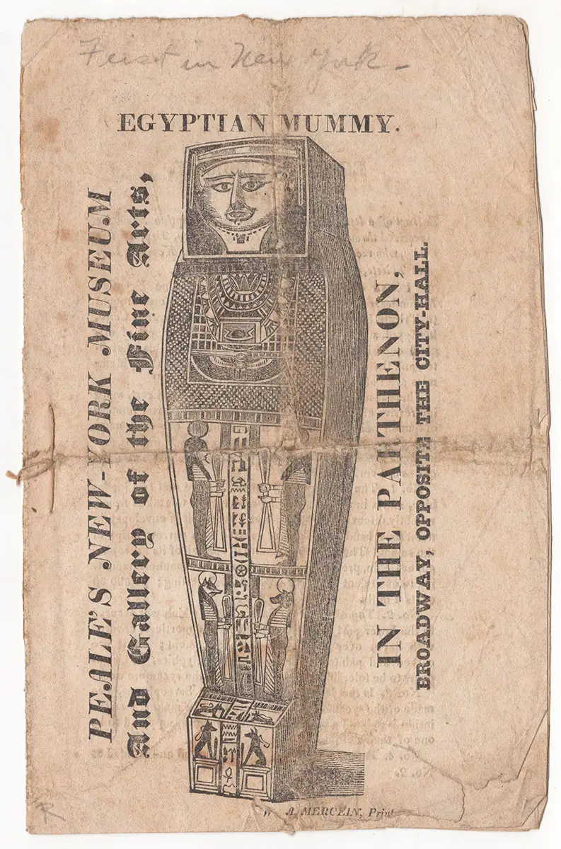
Figure 25. The Peale's had a mummy on display in their New York location as detailed in this undated (likely 1827) print. The note at the top reads "First in New York." Courtesy of James E. Arsenault and Company.
Mummies from exhibitions and private collections inspired others to write about them. The audience for these writings were the same people who were paying to see mummies unwrapped at Rubens' museum. Through exhibits like these, a new literary genre was born. At least two of the mummy's exhibitions, first in Boston and again in Baltimore, inspired visitors to publish verse poems in their local newspapers. In Charleston, the mummy was displayed with a copy of Horace Smith's sonnet "Address to the Mummy at Belzoni's Expedition." The poem had been written in 1817 as part of the sonnet competition with Percy Blythe Shelley. Shelley's entry was "Ozymandias." The first novel to feature a revived mummy was the aptly titled The Mummy! A Tale of the Twenty-Second Century, published in the United Kingdom in 1827 by Jane Webb. In Webb's tale, the mummy Cheops is revived in the year 2126 by electrical shock, not magic. Galvanism over incantation, science over superstition. The future, still even a hundred years hence, is filled with technological wonders that provide a backdrop for a reanimated being from the ancient past. Webb's mummy is not vengeful, even if his appearance recalls Victor Frankenstein's description of his monster: "A mummy again endued with animation could not be so hideous as that wretch." Before Webb's father's insolvency and death, the family was quite wealthy. As such, Webb would have likely been exposed to higher class experiences such as mummy unwrappings like those at the theaters around Piccadilly in the early 1820s. After her mother's death in 1819, she embarked on a yearlong European tour, which would have undoubtedly exposed her to the stirrings of early Egyptomania in France.
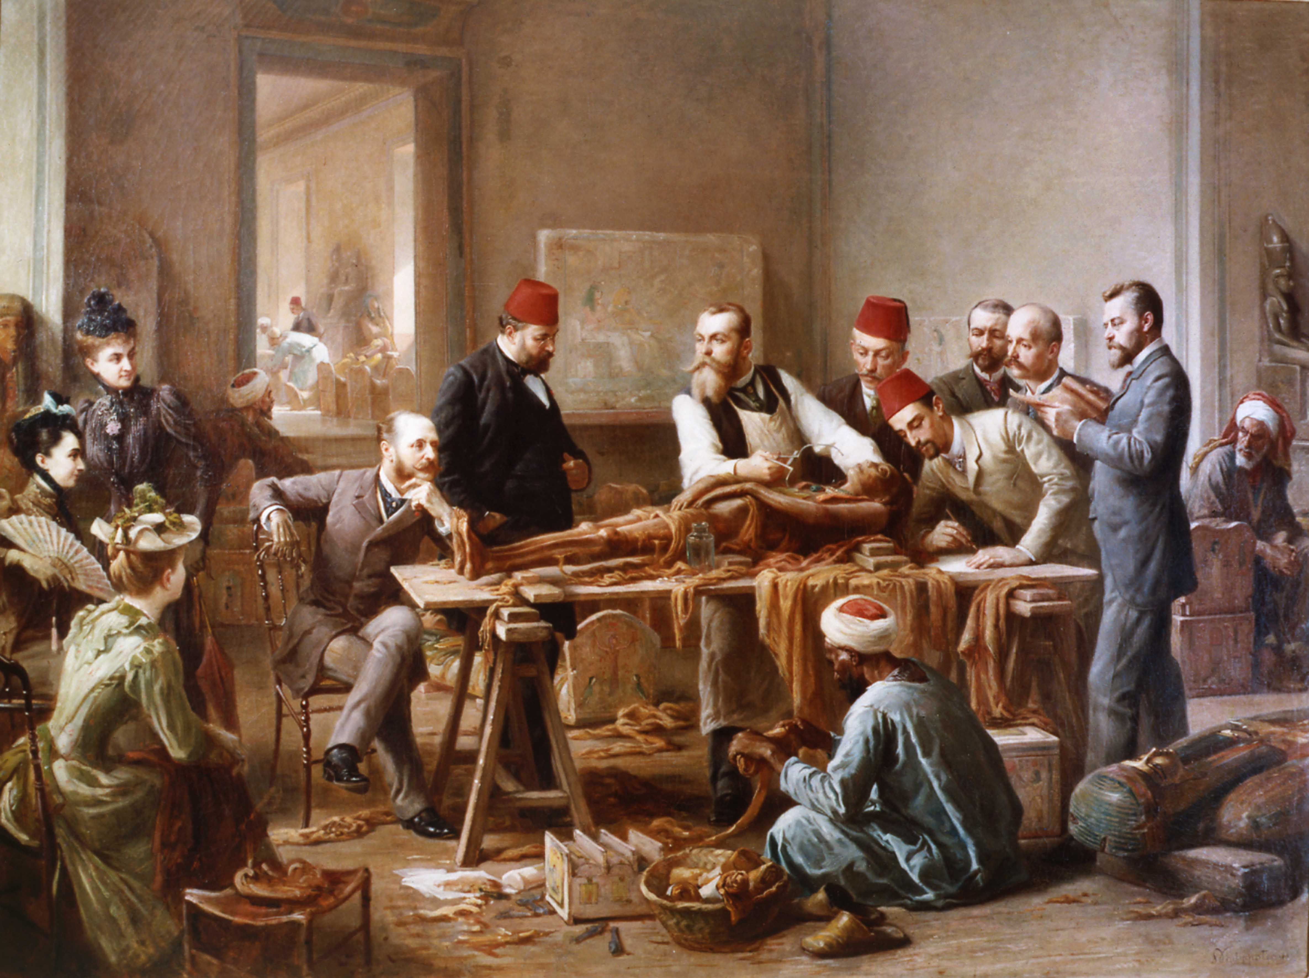
Figure 26. A standard view of an unwrapping party. "Examination of a Mummy - The Priestess of Ammon" (1891) by Paul Dominique Philippoteaux 1891. Courtesy of The Leicester Galleries

S. J. Wolfe notes in Mummies of Nineteenth-Century America that while the Padihershef mummy (the same one that Rubens exhibited at Baltimore) was in Richmond around Christmas 1823, it might have been visited by Edgar Allan Poe, inspiring him to write the short story "Some Words with a Mummy." It is hard to say whether it was the Richmond mummy or another similar exhibition. Poe would have ample opportunity to see other mummies on exhibition, both traveling and at Peale's Museum in Baltimore, but his "Some Words with a Mummy" was not published until 1845. By this time, "mummymania" had moved from the traveling show and museum into a more firmly scientific endeavor, though it was still offered to customers who paid to see unwrappings within the residences of the wealthier American citizenry. Rubens Peale staged an unwrapping of his two imported mummies in 1826, and the practice drew paying guests to the event and repeat visits to the museum after the unwrapped mummies were put back on display. This was a practice that would be replicated in other museums in New York and elsewhere.
Poe’s “Some Words with a Mummy,” published first in The American Review: A Whig Journal of Politics, Literature, Art and Science in April 1845, is a multilayered satire. On the surface, he is lampooning not just "mummymania" but Egyptomania itself, with a setup of the then widespread practice of public and private unwrapping parties. The mummy is brought back to life through an electric shock, echoing Webb's revivification in The Mummy! and incorporating scientific elements with which his readers would have been familiar. His sarcaphagus reveals the mummy's name as Allamistakeo. Once he is returned to the living, he presents himself as an erudite and sensible man, first chastising the men for the abuse he has suffered under electrical shock. He indicates that he was embalmed alive to achieve his present appearance and sustainability. Premature burial and a blurred line between life and death were also themes in Poe's The Fall of the House of Usher, published in 1839. In conversation with the mummy, the Doctor and his friend attempt to convince the mummy that modernity had led to inevitable progress and that the technology of the present is superior to that of the past.
Allamistakeo is also unimpressed by modern forms of government, recounting the fall of the Federation of Egyptian states to a tyrant known as Mob. As Katrina E. Bachinger observes, such political themes are as much a part of Poe's style as the macabre. Losing the individual for the mass(es) was, in Poe’s eyes, an increasing threat to American politics. The power of the mob was a part of democracy. Thus in "Some Words with a Mummy" the mummy describes democracy as "a most odious and insupportable despotism that ever was heard upon the face of the Earth." It is of little wonder that the story was published in a Whig magazine and that the ancient Egyptian corpse was easily bested by a cough suppressant. The story's editor, Thomas Ollive Mabbott, noted at the end of "Some Words with a Mummy" that there was no "city museum," in which the Directors held the mummy to be examined, in New York in 1845. While there may not have been a city museum, P.T. Barnum opened his American Museum there in 1842. Now, people were seeing exhibits in museums and reading about materials they may have seen. Conversely, reading about mummies may have enticed some of the public to search out the nearest one on exhibit.

The Last Peale Standing
Rubens managed the museum's brisk and ever-changing operations for nearly two decades. At one point, he was running his New York Museum, overseeing the Baltimore Museum, and using his position as a member of Peale's board of trustees to create a circuit for exhibits traveling between Philadelphia, Baltimore, and New York City. Following the death of the elder Peale in 1827, the board elected Franklin Peale as manager of the Philadelphia museum, with Titian as the curator. The Baltimore branch closed in 1839, and the collections were absorbed back into Philadelphia. The Panic of 1837 dropped wages, raised unemployment, and threw banking and trade into disarray. The recession lasted until the mid-1840s, and major areas of commercial trade, such as New York City, were significantly impacted. The Panic plunged Rubens' museum into debt from which it could not recover. In 1843, Rubens Peale's New York Museum of Natural History and Science (he had renamed it in 1840) was sold to an upstart New York showman named Phineas Taylor Barnum. Barnum had just two years prior purchased a smaller New York museum—Scudder's American Museum—which had been in operation since 1810; Barnum was also developing a collection of his own.
The 1840s saw significant changes in American culture, and as focuses and amusements shifted, so did the Peale family legacies. Rubens was forced to sell the New York stake of the Peale museum dynasty in 1843, and the original Philadelphia Peale's Museum became all that remained of a family museum circuit that had once stretched across three states. By 1842, the museum had moved for a final time to a location which proved to be too expensive to maintain. The massive collection of Peale's artifacts brought in by a network of professionals, faced its final restructuring. P.T. Barnum, whose own brand of entertainment was oriented more to amusement than rational contemplation, ended up with the bulk of all the Peale collections, even keeping Rubens' New York Museum open for a time as a faux competitor.
The first generation of America's rational amusements ended with a shift in focus to the audience rather than the patron. Peale's brother-in-law Nathaniel Ramsey's observation that displaying artifacts (chiefly the mammoth bones) would make far more money than art alone proved to be truer than either may have imagined. The slow rise of the American middle class, the growth of newspaper distribution, and increased leisure time and literacy would shape the American public's relationship with science as it was collected, displayed, and diffused in ways that were foreign to European museums. These collections and exhibitions are key to interpreting the earliest stages of the development of the American middle class. As James Cook notes, "It was during the decades before the Civil War that the very first commercial entertainment industries began to emerge." Thus "Antebellum historians…are particularly well positioned to trace the changes in meanings, production, and circulation of US popular culture." These changes came not only with the opening of Peale's museum but, at times, could be seen within the contemporary exhibitions of fellow Philadelphian Nathan Dunn. Peale's mold was broken before it had even hardened.
Through all the Peale family's successes and failures, they laid the foundation for both private and public American museums. In the face the many problems of running a museum, Peale realized that to keep the museum, his national museum, as he saw it, things would have to change when it came to funding. Peale "correctly identified… the need for reinterpretation of the Constitution so that federal funds could be appropriated to support national collections." For a generation, Peale's museum was the repository–in some instances, little more than a storehouse–for the United States Government's expeditions in the American West. Federal funding, however, never arrived with the materials. The cost of stewardship of such collections would not get congressional attention until after the return of The United States Exploring Expedition in 1842. As I outline in the final chapter, it would take another decade of infighting before anything resembling a national museum would get federal funding. Furthermore, everything that happened within the world of rational amusements and exhibitions would eventually influence the way in which the Smithsonian would be arranged, funded, organized, and overseen.

Ten Thousand Chinese Things:
Nathan Dunn’s Chinese Collection

While Peale’s museum collected and displayed artifacts mostly from the North American continent, a contemporary Philadelphian had his sights on something more international, specifically China. As historians Paul Can Dyke and John Wills Jr. noted, China, specifically Canton, was very important in the shipping trade: “All the tea thrown into Boston Harbor or sipped from fine porcelain at Parisian soirées...had been shipped from Canton.” Before Americans became a nation of coffee drinkers, colonial merchants would have all been familiar with products imported from China, but perhaps less familiar with the tea and other materials’ country of origin. One American would use the fortune he amassed by trading in China to curate an unparalleled collection of Chinese material. With this collection, he hoped to educate his fellow countrymen and women about Chinese culture, politics, and natural history.
On December 22, 1838, Nathan Dunn opened his Chinese exhibit in the Philadelphia Museum. Ten Thousand Chinese Things may have initially seemed like hyperbole, but what greeted the invited reception guests that night and ticket holders the following days was anything but. The reception alone consisted of "well over one hundred invited guests composed of 'artists, merchants, mechanics, editors, literati, military, and naval officers, and a goodly representation from all the learned professions.'" The guests "sipped a beverage made by adding sugar and cream to a juice extracted from a Chinese plant" and a "variety of tea that was so rare and of such high quality that the Chinese refused to export it." Dunn's advertising acumen was revealed by a journalist who was granted early access to the exhibit. He predicted that “the wonders of China” would “absorb the conversation of all, even of the busy politician and the solitary bookworm.” Up to now a “sealed book," China was revealed by the museum to be “the most extraordinary nation on the earth."

Figure 27. Dunn’s Chinese Museum in Philadelphia. Locating this original source has been difficult. The image is shared online first through Wikimedia commons, notably not for anything associated with Nathan Dunn, but because the building was the site of the 1848 Whig convention, and was then still known as the “Chinese Museum Building.”

How could anyone fail to be impressed? The exhibition salon was 163 feet long, 70 feet wide, and 35 feet from floor to ceiling. Over 11,000 square feet of exhibit space was filled with spectacular representations of all things Chinese. Ten-foot-tall multicolored Chinese lanterns hung from the ceiling, and two fifty-foot-long painted screens faced each other from opposite ends of the great hall. These screens were "divided into compartments that offered detailed depictions of Chinese flowers as well as panoramic views of landscapes, seascapes, and river scenes." Three enormous, gilded statues of the Buddha representing his past, present, and future manifestations were "recreations of the originals that had caught Dunn's attention during a visit to a Buddhist shrine on Honam island, across the Pearl River from the foreign factories." A young Chinese man aided Dunn in explaining portions of the exhibition to visitors.
At least fifty clay statues were part of Dunn’s exhibition, each one representing “a different strata of Chinese society: mandarins, priests, mourners dressed in white, tragedians, itinerant barbers, shoemakers, smiths, shopkeepers and their customers, boatmen, beggars, merchants, soldiers, and many others.” Dunn positioned his statues inside dioramas--which was a technique created by Peale. Through props and colorful backgrounds, Dunn was able to “show the characteristic actions of the Chinese as well as the environments in which they lived and worked.” The statues were not only there to display the clothing or adornments of China’s fashion, but each “bore the exact likeness of some actual Chinese personage.” Dunn had chosen fifty “living subjects” to be made into clay figure likenesses for his museum. The effect was so precise, notes Haddad, that “visitors to the museum who had previously sojourned to Canton could actually recognize specific people who had lived there.”
There are no records indicating how large each of the dioramas was or what their footprint within the building may have been. However, the scale of the exhibition can be imagined by the fact that there was a recreated silk shop and a "full-scale reproduction of a Cantonese street," which included a Chinese gentleman carried aloft by two sedan-chair bearers. In addition to these exhibits, there were "fifty-three glass cases, each covered by a facsimile of a Chinese roof." Their sizes are not recorded, but the sights must have been astonishing to people who may have only experienced Chinese culture through tea advertisements or patterns on crockery. Given some of the items displayed, these cases must have been substantial. It is worth listing them here to appreciate Dunn's collection's scale and diversity, remembering that these were just a portion of the whole collection. "In these cases were furniture; models of bridges, canals, pagoda, and boats; an actual boat; musical instruments; weapons; jewelry; varieties of porcelain and porcelain vases, some being six feet tall; lacquer work; agricultural tools; a coffin; bamboo pillows; seventeen concentric ivory balls carved from a single block of ivory; spectacles with frames made of tortoise shells and lenses composed of rock; coins; a stuffed Chinese buffalo sent by William Wood; a thirteen-foot boa constrictor coiled around a wild cat of China...; and more than three hundred prints and paintings depicting almost every aspect of Chinese life."

Beneficial Transformation
Dunn's aim was not to just stimulate and astonish his guests. He had a specific purpose behind his museum that was not unlike Peale’s. While Peale called his exhibitions "rational amusements," Haddad labels Dunn's as "beneficial transformation," which is an excellent way to frame Dunn's approach to using his collection for education. Painstakingly recreating the context of a vase, a robe, or an abacus ensured that the viewer would understand the object as part of a larger cultural environment. Contemporary museums, even those focusing on the same geographic location as Dunn's--like the East India Marine Society of Salem--exhibited items in much the same way as classic cabinets of curiosity. Their eclectic collections, which originated all over Oceania, contained a veritable "flood of objects, good bad and indifferent'' from areas as diverse as "China, India, Zanzibar, the East Indies, and the Oceanic Islands." Instead of arranging them by geographical provenance, the curators "placed all cooking utensils together and did the same for hats and weapons," rendering them "devoid of didactic value."
Just four months after Dunn’s museum opened, minister and social reformer Enoch C. Wines published A Peep at China, in Mr. Dunn's Chinese Collection; with Miscellaneous Notices Relating to the Institutions and Customs of the Chinese. The colophon indicates that it was printed "for Nathan Dunn." The work is both a history of Dunn's collection and a valuable contemporary source outlining the involvement and use of the collection. The Museum opened on December 22, 1838. Wines described the night thus: "rarely have we passed a pleasanter hour, or formed one of happier company." This happy company consisted of "over a hundred gentlemen…among them were many of our most eminent citizens. Artists, merchants, mechanics, editors, literati, military and naval officers, and a good representation from all the learned professions." Wines also noted that only three other Chinese collections existed: one in the Hague, one in London in the care of the East India Company, and one in Salem, Massachusetts. Each of these, he declares, came short of the splendor, extent, and accuracy of Mr. Dunn's, excluding perhaps the clothing collection in the Hague. He adds that the "multitude of miniature men and women, not likenesses as are those of Mr. D., have been dressed in illustrative attire. In this one particular, viz: the exhibition of the distinctive dresses of the Chinese, there may be a difference in favour of the European over the American collection, but the advantage goes no farther."
Wines' work and Dunn's later catalogs both methodically describe the materials and exhibits within Dunn's exhibition. However, they also paid a great deal of attention to trade. The final chapter in Wine's book, "Our Trade with China '' encompasses all of the then-known histories of the country. Wine's Chinese timeline stretches from "when Rome was but an infant, and the Grecian philosophy among the things to be, China had produced a sage, second only in the long catalog of heathen philosophers, to the illustrious and the pure-minded Socrates." At the end of a long exhibition catalog, Wines outlines the first Chinese trade with Arabia, the first Catholic missionaries in 1246 and 1253, "the two Polos, Nicholas and Matthew…[who] in 1274, went back, taking young Marco with them." Here, Wines makes an aside, noting that the Travels of Marco Polo "was long considered little more than a pleasant romance, but has since proven to be remarkably faithful and accurate."
Wines adds that "the pen of the noble Venetian" would inspire and "nurse the lofty enthusiasm and indomitable perseverance" of a young Christopher Columbus, who later "revealed to Europe, not indeed a new passage to the rich empire of Cathay, but a NEW WORLD, the destined refuge of the oppressed of every clime, designed by Providence to become the theatre of new and sublime experiments in government, where human nature, relieved from its pressure imposed upon it by the abuses of ancient dynasties might start afresh, with unimpeded and elastic step, on the race of improvement.”
Coming down from the apex of the sermon, Wines goes on to list missionaries and the eventual founding of European trade with China. This included the development of Russia's overland trade route, which was at first limited to "the frontier station at Kiackta, in Tartart." He also mentions English successes and failures in the sixteenth century, and the first American trading vessel sailing from New York in 1784. Wines is insistent that the blocked and limited contemporary trade with China was never the historical norm, but arose from constant abuses against the Chinese government by Westerners–especially missionaries, who meddled in government affairs. “Christian merchants” continued to import opium. They worked to line their packets with the one commodity that was traded into China–aggressively against their government's wishes. "If European and American traders may fairly blame illiberality of the Chinese, these have certainly just ground of complaint against the former, in the illegal practices to which their cupidity prompts them. Fifteen to twenty millions [of dollars] worth of opium is, in defiance of the laws and known wishes of the government, every year empty upon the shores of China by Christian merchants!" This admonishment echoed Dunn's own feelings about the opium trade and the West's egregious involvement in it. Furthermore, Dunn was appalled that the same ships that emptied their opium cargo also delivered Bibles and, on some accounts, missionaries.
With its voluminous physical footprint and numerous artifacts, Dunn's collection had a powerful impact on the audiences of the 1830s and 40s. The collection had lasting, if incalculable effects. Thus the literature of the day came to be populated with Chinese characters and themes. Eventually, the collection was broken up and sold to art dealers and shops in London.
Nathan Dunn was not the first foreigner to attempt to create a "Chinese Museum," but he was unequivocally the most successful. His private collection surpassed established industries and large corporations operating in Canton. According to Haddad, "Even the East India Company—with its army of agents, the backing of the British government, and deep monetary reserves—tried to build a grand collection but failed. According to one report, its entire Chinese holdings amounted to about one-tenth of what Dunn would ultimately acquire." These were the same agents who had once called Tingqua into their offices to convince him to stop servicing Dunn's merchant ships into Canton. Their first offer was extra pay to forgo Dunn's shipments. When Tingqua refused, they threatened to pull their supply lines and the salary he received from them. However, Tingqua refused to end his work with Dunn. The other contenders for Chinese collecting, including the Dutch East India Company, and the East India Marine Society, failed to reach anything that compares with Dunn's collections. The East India Marine Society, which had hoped that Chinese artifacts would boost their Salem, Massachusetts museum collection, "blamed their failure on ‘wealthy mandarins' who, themselves connoisseurs of Chinese things, disdained to part with anything of unique value," leaving the Society with "only objects of 'souvenir' nature."
Nathan Dunn was born into a New Jersey Quaker family in 1782. His father died that same year, and his mother later remarried a prominent Quaker minister. At the age of twenty, Dunn moved to Philadelphia and, against the wishes his father , "entered the business community, becoming an apprentice to a merchant." The elder Dunn had stipulated that his son learn a trade, but in 1805, Nathan Dunn and a partner "launched their own business, and that same year, the Monthly Meeting of Friends in Philadelphia received him as a member." By 1816, Dunn's finances were a disaster and the Monthly Meeting "disowned Dunn...on the grounds that he had become 'an embarrassed in his affairs and unable to meet his engagements' and, more specifically, that he had 'assigned his effects so as to secure some of his creditors in preference to others.'" Dunn, aged 34, heavily in debt and expelled from Quaker society, decided to make a fresh start, and enter the "risky yet potentially lucrative world of the China trade."
Dunn had no means of his own for getting to China and so turned to his friend and one of his largest creditors, John Field. Field and Dunn became partners with the agreement that any commissions Dunn made in China would go toward paying off his substantial debt to Field. Field, who "had some past experience in the China trade," provided the capital with which Dunn secured a ship, captain, crew, and cargo and sailed to China in 1818. Historian John Rogers Haddad described Dunn as "the ship's supercargo, which meant that he was responsible for keeping the books and handling all transactions—both the sale of American goods to Chinese merchants and the subsequent purchase of Chinese commodities intended for the American market." Field remained in Philadelphia "to oversee the domestic side of the business." Dunn joined the throngs of Americans who were plying their trade with the Chinese and, with the possibility of a "400 to 500 percent" return on their investment, hoped to pay off his creditors in a short time.

Collecting from Canton
Dunn’s short time amounted to twelve years in Canton, during which time he grew wealthy and became one of the most trusted foreigners in China. John Rogers Haddad opens his chapter on Dunn with the tale of the warehouse district fire that destroyed most of the waterfront. Dunn's entire holdings, estimated at $150,000, would have been lost had his friend Tingqua not taken it upon himself to direct his own workers to load Dunn's crates onto boats and save them from the flames. Haddad described Tingqua's operation on the wharf as “dwarfing that of Nathan Dunn...and he [Tingqua] knew that, whereas his deep monetary reserves allowed him to absorb the occasional pecuniary setback, the fire would have proved devastating to his friend… [he] had simply selected the only course that would permit both men to continue to seek prosperity." At this same time, Tingqua's own factory was severely damaged in the fire.
What made Dunn a successful collector of Chinese artifacts despite so many failed attempts? In a word: opium. Most specifically, Dunn's rejection of any trade of the drug. Collecting the accounts of Dunn's position at the time, Haddad explains, "'Opium is a poison' he [Dunn] wrote, 'destructive alike to the health and morals of those who use it habitually, and, therefore, the traffic in it... is nothing less than making merchandise of the bodies and souls of men.'" Contemporary sources attest to this "positive effect of Dunn's stance in the Chinese community." Haddad recounts Brantz Mayer's notes: "'Instead of dealing in OPIUM...and this aiding (as too many Americans have done) in fixing on the Chinese all the curses which flow from the habitual use of that intoxicating drug, ... Dunn received 'presents…of valuable curiosities...from the natives' who sought to show their 'thankfulness for the virtue which induced him to abstain from assisting in the ruin of thousands of their countrymen.' Dunn, in short, cared about the health and well-being of the Chinese people, whereas many other traders did not." When Yale professor and founder of the American Journal of Science, Benjamin Silliman asked Dunn about his success while on a tour of Dunn's museum, Dunn attributed the achievement of his collection "in part because he had those 'wealthy mandarins [Houqua and Tingqua]' working for him. They appreciated how he, unlike most agents of the East India Company, had learned to respect the 'ingenuity' and the 'intelligence' of the Chinese and to treat 'all classes' well." With the help and connections of Hougua and Tingqua and Dunn's aversion to the opium trade, his reputation soon reached the notice of the Emperor. "As a result," writes Haddad, "Dunn was able to ingratiate himself with China's elite. According to Silliman, he frequently entertained 'the most distinguished officials of the Government' at his 'house and table.' After winning their 'esteem and confidence,' he 'soon discovered that it was in his power to obtain favors not usually granted to strangers.'" In addition to the gifts provided to Dunn, Houqua and Tingqua helped Dunn "hire Chinese agents willing to travel to other regions purely for collection purposes."
Tingqua was one of the two Hong merchants that Dunn paid to service his ships. The other, Houqua, served many American interests in Canton and had the "lofty reputation among foreigners as the most trustworthy and reliable of all the Hong merchants." Houqua's services came at a significant cost but with seemingly equal benefits to his American partners. Haddad notes that "by 1834, Houqua had amassed such a vast fortune that his net worth was estimated at $52 million—making him perhaps the wealthiest commoner alive in the world." Houqua's "limitless wealth and connections" provided Dunn with "invaluable assistance both in commerce and in his later attempt to collect artifacts."
When it came to collecting artifacts in China, the connections were more important than the finances, but the finances were essential. The Chinese government did not allow foreigners to roam into the country's interior, so any collecting would have to be done by Chinese agents. Dunn began collecting "at some undetermined point in 1822" to create "'a cabinet sufficient to fill a small apartment...for his own pleasure and that of his friends." Each year, his collection grew, and so did his desire to see a complete Chinese collection so that by the time he returned to Philadelphia, he was in possession of his advertised 'ten thousand Chinese things.’"
Dunn's Hong Merchants and Chinese agents could access areas of China that were strictly off-limits to any foreigner during this time. That meant Dunn had access (once removed) to collecting areas that others didn’t. Moreover, this placed the collecting decisions firmly within the native eye. Chinese agents were the ones who were getting to choose what "curiosity" should represent an area in Dunn's collection. In this sense, what can be considered the ethnographic section of Dunn's collection was undertaken with a host of Chinese agents exercising their own judgment concerning cultural representation.
Nonetheless, the Chinese collectors needed some training when it came to selecting Chinese flora and fauna, since these had to fit into pre-existent Western ideas about the "Great Chain of Being." They needed some education in Western Enlightenment values, if they were to match the order and structure of nature that Dunn had experienced during his formative years in Philadelphia, that is to say, Peale's Museum. Plant and animal specimens would have to be filed under the western Linnaean system, and any existing relatives would have to be researched. For this task, he turned to William W. Wood, "whom Dunn befriended in Canton probably because the two shared the same contempt for the opium trade and the British East India Company." Wood had come to China to make it rich, but had ended up as a clerk for an American firm in Canton named Russell and Company.
William Wood was described as a "penniless adventurer" "having no fit purpose," who eventually found his way to helping Dunn manage the network of Chinese collectors. To this end, he “employed a scheme that depended heavily on the Chinese to supply the bulk of the natural-history section [of Dunn's collection].” Wood’s industry, kindness, flattery, and not an insignificant amount of money and subterfuge, helped convinced a team of Chinese agents to undertake fieldwork. He was concerned that the agents might not be up to the task of collecting under the modern Linnaean System, for he "judged the field of natural history in China to be both flawed and lacking in scientific rigor." "'The ideas entertained by Chinese writers on the subject of animals are vague and imperfect, fable and absurdity being mingled in the strangest manner with truth and good sense,” he wrote. “They possess no systematic arrangement of animated beings, and commit the most glaring errors in classification.” Wood spent a great deal of time and effort teaching the Chinese agents how to handle natural history specimens to meet the classification requirements of Dunn's museum. Wood's educational efforts were successful. Thus, after learning exactly what information and practices made specimens valuable, the Chinese natural history collectors were as competent as the ones Dunn entrusted with art and ethnography. "After acquiring these skills, they fanned out, traveling ‘by land and water,’ in search of birds, fish, reptiles, insects, shells, animals, plants, and rocks. On returning to Canton, many could present 'new and interesting animals' to a pleased William Wood."
Like Dunn, Wood was confined to Canton. However, he was allowed to ply the coastal waters for various fish species, which he collected and used to create accurate natural history drawings. Another interesting source of specimens came from Chinese traveling exhibitions such as traveling zoos: "Chinese exhibitioners would capture wild animals for their portable zoos, Wood would attend their shows, and, at the conclusion, offer to buy the animals from the owner. In this fashion, he acquired both a boa constrictor and a wildcat." Wood continued to supply Dunn with specimens even after the latter had returned full time to Philadelphia. Specimens were shipped from Canton to Philadelphia "at a tremendous cost." Haddad concluded that "only the moths and butterflies, it was said, suffered over the course of these transcontinental passages...[and]...in the end, the natural history collection earned the approval of some of America's top scientists," including Benjamin Silliman.

Returning to Philadelphia
Dunn completed his business in Canton in 1831. Several contemporary accounts note that he was less than enthused about his return to Philadelphia. His time in Canton had changed him. Returning to Philadelphia as “one of the city’s wealthiest citizens,” he was now in a new social circle. However, he complained of the cold, and wrote to his botanist friend John H. Reeves that "the help is no help at all." Dunn created his "'Chinese Cottage'" at the corner of High Street and Bartram Avenue in Mount Holly. Moreover, he was able to liquidate his debts in short order. Reportedly this was accomplished by inviting his patrons to a lavish dinner party, and placing checks plus interest under the guests’ dinner plates. Dunn joined the American Philosophical Society and the Academy of Natural Sciences. He also became manager of the Philadelphia House of Refuge and gifted the Quaker Haverford College $20,000, which helped keep the college operating.
In 1836, Dunn was appointed to the Philadelphia Museum Company, which had formerly been the museum of Charles Willson Peale. It had been twenty-five years since Rubens Peale had taken the reins of the Peale Museum. He had slowly added more curiosities, and had also added entertainments to compete with traveling shows. Peale's grandson and fellow board member, George Escol Sellers, pitched a reinvigorated Philadelphia Museum to Dunn, which would include a new building in a new location, and would house Peale's original collections as well as Dunn's new Chinese collection. Building began on Peale’s “new” museum on the corner of Ninth and George Streets on January 20, 1836. Construction took roughly two years to complete (opening on independence day 1838) and was paid for by a $20,000 personal loan from Nathan Dunn and a $32,000 loan from the Bank of the United States.
Peale's collection was decades old and already catalogued before building began. Once more, Neither Peale himself, not any of his sons were overseeing the construction and cataloguing his collection for display. Dunn hoped he could have the Chinese Collection ready for its public debut by the end of the year. Dunn "along with Titian Peale and a team of artists were working furiously in hope that they could complete the installation of the Chinese exhibit before the end of the year." The gigantic size of Dunn's collection greatly surpassed the square footage of the exhibition space. In fact, the entire building would have been too small had Dunn had it at his disposal. Thus, Dunn had to resign himself to the fact that he would have to store many of his artifacts and "introduce them on a rotating basis." Dunn lost one of his major helpers shortly after the opening, when Titian left Philadelphia to join the United States Exploring Expedition, which set sail on August 18, 1838.
What shape was Dunn's exhibition in when visitors first began interacting with it? Like Peale, Dunn's curation was based on order, and that order had to both explain Chinese culture and entice curious Philadelphians to pay their twenty-five cents to visit. "Many people who might have had no previous interest in China," wrote Aaron Caplan in 1986, "ventured in because they had come to expect a certain level of entertainment from anything calling itself a museum." Dunn continued the amalgamation of public museums and private collections that Peale's museum had started. Dunn intended to awe and educate, to provide a space for patrons to appreciate the art, craftsmanship, and industriousness of China and its peoples with the "extra element of excitement and showmanship." In other words, he provided “rational amusements.”

Displaying with Dioramas
Among Dunn's ten thousand Chinese things were numerous articles of daily life--things like desks, clothing, and tools. Many of these were tied to the middle or upper-middle classes with which Dunn would have had the most contact during his time in Canton. This emphasis caused some distortion in his representation of China . Still, where museums like the one at the Hague focused on the miniature, Dunn's collection was full-sized; it was on a true human scale. Peale had used dioramas in his museum as ways of presenting natural history specimens within their own habitats. But when it comes to human statues, some find this kind of display problematical. Ian Shin describes dioramas with human subjects as "passive voyeurism," which detaches the viewer from the reality of the spectacle, and "acquits viewers of any responsibility for the subjugation of the object and excuses them from any challenges to their worldviews." Calling on Curtis Ainsley's remarks about the living villages of the 1893 Chicago World's Fair, Shin compares displays fifty years apart and with vastly different motives. Overall, Shin's criticism of the racialization of dioramas and their "imperialist mindset," are valid. However, they would be better aimed at the displays of P.T. Barnum and Catlin’s Native American shows than at Nathan Dunn's clay figures.
How were the Chinese represented in Dunn's collection? Dunn's dioramas consisted of eleven large cases lining three of the museum's four walls. Along this perimeter, visitors could find Chinese mandarins, literati, women, actors, priests, a street scene, a silk merchant’s shop, a sedan chair with bearers, a wealthy Chinaman's palace, and a rural farming scene complete with a stuffed buffalo at the plow. "Dunn's decision to include these figures was a crucial one for the museum's success," posits Caplan. "The figures lent to the exhibit a human scale. These Chinese, who lived so far away in a society so different that had existed for so long, could finally be encountered face to face. The empathy that resulted would not have developed if Dunn had displayed the articles he had collected in a setting devoid of human figures.
Another key feature of Dunn's diorama characters is that each figure represents a person that Dunn or his associates actually knew. These were not generic Chinese figures that could be easily substituted for one another. Such representations raise Dunn's dioramas above the "passive voyeurism" modern scholars may attribute to the display style. Dunn's clay models were so life-like, and each so unique, that if they managed to escape modern criticisms of imperialist projections, they were nevertheless racialized in their subjection to detailed phrenological study, which was a contemporary practice mentioned in the Catalog.

Cataloging the Collection
Dunn’s displays placed “the authentic objects themselves before the interested party, creating a sense of immediacy and therefore the feeling that one had been transported to China.” Dunn sought to increase the didactic value of these exhibits with his Descriptive Catalog. Dunn’s Catalog “attempted to explicate Chinese culture as a whole while also offering background information on many of the specific items on display.” It also attempted to steer the “aimless guest” on a structured path through the collection. The Catalog itself was very specific in the directions from the outset and "direct[ed] the visitor's movements through the entire exhibit: 'The visitor is requested to commence with the screen at the entrance, and then, turning to the left, to take the cases in the order in which they are numbered.' Labeling cases with Roman numerals and individual items with Arabic numerals, Dunn established a specific sequence that visitors were encouraged to follow." His catalog translated Chinese texts and characters, provided names of people and places associated with the display and, Dunn hoped, would avoid the empty descriptions that commonly plagued exhibitions of foreign culture, where objects were simply described as bizarre or curious.
Dunn’s Descriptive Catalog served as the intellectual and cultural map of his Chinese exhibit and, by extension, Chinese culture. It also served as another lens through which to view Enlightenment science. Haddad describes Thomas Jefferson's Notes on the State of Virginia as “perhaps the quintessential document that describes a region from the perspective of the American Enlightenment” and that Dunn’s Catalog resembled it in form. The catalog, broken down into categories and with specific instructions for moving through the exhibit, allows historians to at least attempt to reconstruct the physical exhibition. The cases would have reflected the categories as well. In looking through the Catalog, we can imagine the museum’s contents, which included “government, the arts, religion, education, natural history, the military women, marriage, funerals, costumes, festivals, sports and pastimes, vocations, diet, agriculture, manufactures, inventions, transportation, architecture, trade, justice, and the penal system.
In addition to the case descriptions of the scenes represented in the dioramas, Dunn’s Catalog presents each case with an accompanying narrative. In case eight, for instance, Dunn related the experience of one Captain Laplace of the French Navy and his early embarrassment at not being able to use chopsticks. A rather humorous tale, it reveals early misunderstandings about Chinese culture, such as food. "'It seemed rather doubtful whether I should be able to eat my rice, grain by grain, according to the belief of Europeans regarding the Chinese custom." When the host had taken up his own utensils to begin eating, Laplace was astonished as he "cleverly joining the two ends of their chopsticks, plunged them into the bowls of rice held up to the mouth, which was opened to the full extent, and thus easily shovelled in the rice, not by grains, but by handsfull." By providing these first-person accounts of scenes displayed in his museum, Dunn added another layer of realism to his representation. He was further humanizing the Chinese other and adding more authenticity to the whole of the collection.
Dunn meant for his collection to instruct and inform. The Catalog was there to help that process along. Even then, within the introduction, the author reiterates the material artifacts' importance. "A single article," he wrote, "will illustrate whole pages of written description… It teaches by things rather than words. The images are visible and tangible, and therefore, cannot be easily misunderstood." Dunn's dioramas were in place so museum visitors could easily imagine the scene and perhaps imagine themselves within it. The Catalog served as a "mute guide" through each of the scenes, and as an identification book for the thousands of smaller pieces displayed in smaller cases. These smaller exhibits ranged from brass statues, to lead shot, carved ivory models, stuffed birds, and seashells.
The Catalog also tried to educate Dunn's visitors about the ruinous outcome of the opium trade. Dunn used the platform to lay out his case that trading in opium was morally outrageous. He pointed out that while the lion's share of culpability belonged to England, "most of our own merchants in Canton are guilty in the same way and to an equal extent." He added notes on the relationship between the opium trade and the growing work of Protestant missionaries in China. "Dunn was raised a Quaker," Haddad writes, "and Quakers usually did not proselytize and certainly did not have any presences in China. Yet he knew that America was in the throes of an evangelical movement (now called the Second Great Awakening) and that the majority of the visitors to his museum were Protestants who supported foreign missions." With an eye to his audience, Dunn wrote of "The 'grasping avarice' of opium traders...[that] undermines the moral and spiritual message of the missionaries and 'sets at naught every Christian obligation before the very eyes of the people it sought to convert!' The Chinese would never choose to convert to Christianity as long as the most visible emissaries from a Christian nation, the merchants, continued to inflict a blight on their society." After visiting the exhibit and working through the Descriptive Catalog “outrage [at the opium trade] was the only suitable reaction to this dark side of the Chinese economy.”
While methodological and inclusive in collecting, Dunn could not escape the pseudoscience of the day. Phrenology, which was enjoying growing acceptance and popularity in the late 1830s, was contemporaneous with Dunn's exhibit. He mentions it in one of his "rare negative assessments of the Chinese included in the Catalog—a bizarre blanket statement regarding the impact of a despotic government on the anatomies of its citizens." Haddad notes that Dunn "undoubtedly knew several phrenologists personally,” and that when the museum opened, "Orson Fowler, who would become America's greatest popularizer of phrenology, was giving lectures and head examinations a few blocks away." As Philadelphia was then the "intellectual capital of America," it attracted many scientific thinkers including phrenologists. In fact "George Combe, of Scotland, the world's foremost phrenologist following the death of Joseph Spurzheim, was delivering a system of lectures in Peale's museum and drawing audiences of five hundred people. Dunn's exhibits occupied the same building, and Combe enjoyed a pleasurable tour of the museum." Samuel George Morton was another famous Philadelphia phrenologist, whose Crania America was published in 1839. He was a professor of anatomy, and "the owner of the country's largest collection of skulls.” Morton had received Chinese skulls from missionaries in China, "including the skull of a pirate, and that of a criminal who had been hanged." Given the contemporary prominence of phrenology, it is no wonder that Dunn took the time to "revisit the subject of Chinese racial characteristics by inspecting the clay heads of his own statues."

Showing in England
Dunn realized how exhibits could be tools of political persuasion and would use the power of his collection to try and change the minds of the British when his Chinese collection settled in London in 1842. Prior to leaving for England, Dunn's dealings with the Philadelphia Museum Company came to a head. An investigation into the company's finances "revealed that the company and the bank had never finalized the purchase of the land on which the museum stood. In addition, the new building had cost nearly $60,000 more than the contracted figure of $80,000." Charles Coleman Sellers notes that when Dunn announced he was taking the Chinese collection to England, he concluded there would be no objections as "some directors had complained of the length of lease and the amount of rental." Dunn also provided a "letter from Herman Cope, superintendent of the Suspended Debt and Real Estate Department of the United States Bank, demanding immediate settlement of the museum's obligations. Dunn had been a member of the company since 1836, and as President, "offered the Museum building and land for $37,250 and, swift and persuasive, was able to close the deal on August 5, 1841. Dunn had everything packed and loaded before the end of the year and "had all four tons ...loaded onto the packet ship Hendrick Hudson, and, in December 1841, he set sail for London.”
Dunn's timing could not have been better. By the time he had settled in London in 1842, the English had recently acquired the island of Hong Kong in perpetuity as part of the Treaty of Nanking. This treaty also established five treaty ports at Shanghai, Canton, Ningpo, Foochow, and Amoy. The English "hungered for information on China, as no public exhibitions were available to satiate their curiosity." In 1838, Londoners could attend a Chinese Panorama, with a copy of a Chinese artist’s painting. This copy, painted by Robert Burford, shows only foreign factories. "With almost no competition," Haddad writes, "Dunn could capitalize on the new popular interest in China and educate the public about the nation over which England now exerted a greater influence. He moved his collection into a building at Hyde Park Corner that was specially constructed for its use. For a public that had only recently (1839) expressed tremendous enthusiasm for George Catlin's Indian Gallery in the Egyptian Hall, Dunn's Chinese Museum promised a similar pleasure."
Before opening to the public Dunn was obliged to provide private tours of the collection for "important personages" in order of their status: first, the Queen, then the nobility, and finally "'men of literature and science.'" Haddad notes that the Queen had "in fact, contacted Dunn and 'expressed her gracious intention of honoring the exhibition with her presence.'" Queen Victoria and Prince Albert arrived at 3:45 PM and did not finish their tour for nearly two hours; Dunn's exposition ended at 5:30. Dunn's careful arrangement of materials was hardly needed as "the Queen had apparently studied up on China prior to the visit, for she was often able to describe a given article's function without the aid of Dunn's explanation." Dunn himself "felt honored by the Queen's patronage and even saved the glove he had worn that day."
The London Exhibition Hall, located inside a two-story pagoda had a "green roof edged with vermillion." It was 240 feet long and 50 feet wide. Beyond the "grand sign written in gilded Chinese characters that read “Ten Thousand Chinese Things,” this enormous hall was dominated by three statues of Buddha representing the past, present, and future visages of the religious teacher. During its time in London, Dunn's collection was augmented by living Chinese participants with whom visitors could converse. Following the death of their English sponsor, "two children, A. Sheng and A. Yow, made a living at the exhibition."
Dunn’s hope that his exhibition would alter, or at least soften, British policy towards China and the Chinese people never saw fruition. While it may have failed at the parliamentary level, there was at least a marked, if modest, success in changing the British public’s general opinion of the Chinese people. “The British,” notes Haddad, “had once and for all removed the veil that once obscured Chinese civilization and the latter could never be the same again.” It followed that once the West became more familiar with China, the Chinese would inevitably become more open to Western influence, and would begin accommodating themselves to Western culture.

The Collection Dispersed
Dunn died in Switzerland in 1844. His Chinese Collection still had two years of its nearly half-decade run remaining in London. Under the curatorship of Dunn's colleague William B. Langdon, the collection began to tour the English provinces. Dunn's collection netted a profit of $50,000 a year while in London, and figures like this did not escape the notice of America's greatest showman, P.T. Barnum. Barnum was in London at the same time as Dunn, promoting a show starring General Tom Thumb. At least one contemporary account erroneously announced that Barnum had agreed to purchase Dunn's collection. Barnum eventually purchased a Chinese collection of his own and displayed it in New York, but it was not Dunn's, and it came on the ending cusp of the public's enchantment with China. In November 1844, just two months after Dunn's death, it became known that a second Chinese museum, one larger than Dunn’s was about to be built by John Peters, an attaché on Caleb Cushing's diplomatic mission to China. Peters had already begun assembling his own mammoth Chinese collection.
Barnum's own Chinese collection was likely the one that Peters organized. However, neither the size of the collection nor the experience of the showman could keep the public interested in a country that was no longer considered “hidden.” Barnum leaned into the idea of "virtual travel" by employing various Chinese characters to populate his elaborate Chinese settings. In the decade following Dunn's success, both in China and with China, the perception of China changed. It no longer had the mystique of a hidden country. It was also being colonized faster than it was industrializing. Barnum displayed his Chinese exhibit “for only one year at 539 Broadway; he then moved it down to Ann Street and later into storage." In this, Dunn was prescient: "In Dunn's opinion," Haddad concludes, "[British merchants and missionaries] hope for finding China more open to British manufactures and evangelism was ill-founded. In a chilling prophecy, he argued failure for merchants and missionaries alike." Merchants wanted to reap a "golden harvest" from a less than golden economy and on the salvation front, "Dunn predicted that they [missionaries] would confront a populace that associated their efforts to proselytize with the sins of the avaricious merchants. Missionaries would ultimately face the hard truth he predicted: "Opium and the Bible cannot enter China together."
The Chinese Collection, at least in part, was back on display in London in 1851 at the Great International Exhibition, located at the Crystal Palace. Art historian Nancy B. Wilkinson notes that this exhibition consisted of about half of Dunn's original collection. She agrees with Haddad that whatever the entire fate of the collection, it was not purchased by Barnum. There is at least one unconfirmed report that a portion of the collection "was lost in a fire while being transported to Edinburgh." The 1851 show "enjoyed none of its former success and, by the end of the year, the remaining articles were sold at auction by Christie's." Dunn's collection may very well have been the largest singularly-themed, personal collection in modern museum history. At the very least, its afterlife in print and artifact had an outsized impact on the audiences of his day. Wilkinson records that "fully a third of the objects were bought by one London dealer, formerly a tea importer, and through his shop the remnants of the Chinese Collection were disseminated to young British artists and designers ready to transfer global discoveries into modern design." The Chinese furniture from the collection had a strong influence on avant-garde furniture-makers, such as the Herter Brothers of New York, Josey Hoffmann of Austria, and Charles Rennie Mackintosh of Scotland. Edwin William Godwin's own furniture designs, influenced by Chinese sources he saw in the Chinese Collection of William Hewett and Company’s store, pass into the Twentieth Century and back into America.
Dunn's success stemmed from his honesty and his refusal to partake in the opium trade. His collection is arguably one of the most significant ethnographic collections ever assembled. Moreover, it was assembled, in large part, by the people who were being represented. Dunn recognized the power behind such collections, and rarely had such vision and wealth combined with such strong goodwill. Dunn is rarely mentioned in the pantheon of early American collectors, and his Chinese Collection is not nearly as famous as Peale's early American Museum. Perhaps this is due to the fact that it does not follow the established track of authors like Steven Conn, who argue that early American museum collections and exhibitions were private cabinets of curiosities, whose main value was to impress existing social circles.
Ultimately, the characteristic of Dunn's museum that sets it apart from the others was that Dunn's work was done in concert with native Chinese people. They were the ones who could choose what came back to Dunn from the interior or China. They were therefore an important part of the curation process. This agency may seem like a small thing regarding the overall arc of the collection. However, as Caplan notes, "Dunn was often complimented for building this museum in cooperation with famous Hong merchants, whose names were also mentioned with respect. The Museum, then, was seen by most as a joint venture between the people of China and Nathan Dunn." This level of detail and respect was not seen and not often repeated during Dunn's time, and it has rarely been seen in the centuries that followed.

Meet Me in St. Louis:
Clark, Catlin, Koch

While the Peale family attempted to extend their particular brand of museum to other areas of the East, the country was expanding rapidly westward. Charles Willson Peale’s attempts to steer the new Republic's populace towards methodical reasoning through his museums was overshadowed by an explosion of new cities. Rising virtually overnight out of frontier lands, river towns like St. Louis, Missouri, and Cincinnati, Ohio, became important cultural destinations, as the population of the United States continued to increase in number and to expand its geographic footprint.

Lewis and Clark: The Corps of Discovery
St. Louis, in particular, became the "Gateway to the West,'' metaphorically and physically. Situated along the Mississippi River, St. Louis was both the beginning and end of Lewis and Clark’s expedition—the famous Corps of Discovery. The city quickly became a staging area for travelers moving east to west and north and south. St. Louis was a hub of international and intertribal culture. Landon Jones described it as a "global village," recounting that "The Americans were nominally in charge, but Spanish officials had lingered a full seven months after the Three Flags Ceremony in 1804. The language of choice for most of the 3500 residents…was French [and] church records would be kept in French until the 1830s.”
The "Slave Code" of 1804 established the rights of slave owners just months after Lewis and Clark had disembarked. However, the question of dealing with the surrounding indigenous population was still unanswered upon their return. Lewis had plans to publish an authoritative narrative of the expedition from his notes and journals. This practice was in its infancy but would prove lucrative for many in coming years. For Lewis' compatriot, William Clark, the ebb and flow of the city became the tempo of his life.
As late as 1977, historian Jerome Steffen lamented that the Lewis and Clark expedition had been historicized in “episodic aspects" such as "the perils of hostile Indians and uncharted wilderness." In the last forty years, studies have slowly begun to examine the scientific objectives of the expedition. Following Steffen’s challenge, and through the 1980s, the historiography of the expedition continued to “reflect an attitude that the scientific and diplomatic goals were inconsistent with one another and that, therefore, one or the other must have predominated .”
Historian Donald Jackson wrote that it was "no longer useful to think of the Lewis and Clark Expedition as the personal story of two men" but instead "an enterprise of many aims and a product of many minds." According to James P. Ronda, those many minds included “Philadelphia scientists and artisans, St. Louis merchants and rivermen, and native people throughout the continent." Much has been written about such personages and the westward expansion, but little has been written about the St. Louis Museum that was a prominent cultural landmark along the river.
The Expedition of Lewis and Clark is still a rich and fertile field for historians of science to research. Here, I will focus on a background episode in Clark's life, which would affect American cultural consciousness as much has his earlier military career. As noted in previous chapters, the Lewis and Clark’s expedition provided a portion of the natural history specimens displayed in Peale's museum, since Lewis deposited his personal collection there. Clark, on the other hand, took his specimens to St. Louis. The Lewis and Clark expedition returned with crates of plant and animal specimens, native tribal goods and clothing, and a wealth of cartographic and economic information regarding the northern portion of Thomas Jefferson's Louisiana Purchase. Even before Lewis and Clark had returned, Jefferson launched another expedition to explore the southern portion of the Purchase. The Freeman-Custis, or Red River expedition, set out from Fort Adams near Natchez, Mississippi, to map and explore the Red River. Freeman and Custis left on April 19, 1806, and traveled 615 miles to arrive near present-day New Boston, Texas. There, they encountered Spanish troops who brought the expedition to a halt on July 28th. Any political embarrassment regarding this international incident was eclipsed by Lewis and Clark’s triumphant return that September.
After his return from the expedition, Clark settled in St. Louis. There he created a sort of unofficial private museum of the artifacts he had collected. Henry Rowe Schoolcraft visited Clark’s Museum in 1818 and described it as "the only collection of specimens of art and nature west of Cincinnati, which partakes the character of a museum, or cabinet of natural history," and that the collection was “arranged with great taste and effect, but to reinforce Clark’s experience and knowledge of the subject matter.” Clark’s collections served different purposes for different guests. To the white inhabitants of the surrounding area, Clark's mementos likely served as a silent testimonial to Clark's prowess in dealing with the native peoples, for as Castle McLaughlin writes, "it graphically recorded the process of Anglo-American expansion and the consequent removal of Indian peoples from their ancestral lands." The Indian artifacts would probably have also reinforced their feelings of Manifest Destiny, for the collection underlined American expansion and the removal of the Indians. For Clark’s Native visitors, who were there to discuss treaties, trade agreements, or land issues, they may have seen the Native artifacts, especially those that were diplomatic or chiefly gifts, as well as the paintings of Indian leaders, as a testimony to Clark’s ability to work effectively and in a trustworthy manner with the tribes under his jurisdiction, as the federal government’s Indian Diplomat in the region.
For Clark himself, the artifacts may have been simply mementos from his expeditions and trade deals, or reminders of friends or trading partners he met as an Indian Diplomat for the United States government. During his career, he would have seen them turn from mementos to relics, as Indian tribes were relocated, assimilated, or exterminated. While he utilized his curiosities for what McLaughlin calls "social capital," that is to say they were things “to be shared and discussed with members of his class and social circle," it seems that they were a potent weapon in his arsenal to keep the peace between settlers and Indians. To the settlers, Clark's collection represented progress and the control their government (if not race) exerted over the native peoples. To the Indigenous, they were records of diplomatic successes, consummation of treaties, and a reminder that someone was listening to their problems and working for them within a foreign and unfamiliar political force.
This irony of dissonance is not lost on historians. Buckley notes that the time, energy, and money Clark spent assessing his Indian collection "indicates a genuine interest on his part, even though the assimilation policies he implemented destroyed some of the cultures that he then preserved in his museum." "Clark," Buckley continues, "maintained one of the best Indian museums in the country and painstakingly collected and documented Indian artifacts, relics, and mementos of a way of life that he viewed as threatened with imminent extinction." This "vanishing race" theory would continue to influence generations of collectors, museum men, and artists, as Clark became the American authority on the Indigenous populations of the United States and its ever-increasing territory.
Clark's position as an expert, both in Native American affairs and the natural history of the American West, combined with his amiable manner, made him a more significant influence on the course of artifact collecting and collection display than many historians have realized. Guests through Clark's offices and home in Saint Louis included some of the most influential artists, explorers, and writers who shaped the American public's perception of Indians. Clark's most profound influence may have been on the artist George Catlin, but other notable artists such as Alfred Jacob Miller and Karl Bodmer were also affected . American writers Washington Irving and Henry Rowe Schoolcraft called on Clark for access to and information about traveling through the western territories. Scottish nobleman Sir William Drummond Stewart, the German Prince Maximilian of Neuweied and Prince Friedrich Paul Wilhelm von Württemberg, Swiss Count de Pourtales, and the French Marquis de Lafayette were all international travelers recording their adventures through the American West. Clark was the man they all had to see, partially to honor ceremony and etiquette, but also to find out which areas were safe for travel, and to obtain a passport to let tribes know they were not hostile travelers, Each presumably would have made time to see Clark's museum of Indian curiosities.
What was left of Clark’s cabinet of curiosities was dispersed after his death in 1838. Clark gifted pieces of his collection to family and friends throughout his life, sometimes sending artifacts along with the live animals he sent East. Clark’s animal collecting included an elk sent to Washington at the behest of Superintendent of Indian Affairs Thomas McKenney, bison and beaver to Europe and a live grizzly bear to General Lafayette in France. In the early 1830s, an enterprising German immigrant began work on opening an official museum in Saint Louis at the intersection of Second and Market Streets. Albert Koch, a fine American showman and bit of a confidence man, approached Clark about including some of his Indian curiosities to augment his own paleontological wonders. Koch, who I will discuss later in this chapter, never returned Clark’s loaned specimens. In 1841, Koch left St. Louis with his fossil wonders and most of Clark’s Indian artifacts and sold everything he could while on tour in Europe. Some of that collection may have been sold to another aspiring St. Louis showman, William McPherson. However, this is unlikely as Koch almost assuredly knew they would fetch higher prices if sold in Europe.
Clark was an important man to both visiting countrymen and foreign adventurers. "Clark," writes Jay H. Buckley, "supplied these artists with passports, wrote letters of introduction for them to notable St. Louisans, invited them to sit in during treaty proceedings at St. Louis, and even invited them to accompany him to various Indian councils such as the one that Catlin attended at Prairie du Chien in 1830.” George Catlin had come straight from Peale’s Museum to visit William Clark in order to obtain access to native tribes in order to record their culture(s) on canvas. There, he not only met America's chief Indian diplomat, but also another American showman. Catlin would take what he learned from Peale and Clark and make it part of his own show: Catlin's Indian Gallery.

Catlin’s Spark
The essence of an Indian Gallery in the 1830s rests firmly within the "vanishing race" trope. During this period, the US government were instituting Indian Removal, and the American public was reading books like James Fenimore Cooper’s The Last of the Mohicans. Published in 1826, “Cooper’s image of a distraught Chingachgook standing alone at the story’s end,” writes Brian Dippie, “lamenting his lost people, made an indelible impression on the reader and helped launch a literary vogue that thrived in America until mid-century, when changing tastes and boredom rendered it obsolete." The story would be familiar to Catlin's patrons, and his paintings of the people, their villages, their everyday lives, and their special ceremonies would hold great appeal. This growing collection of Native American portraits, physical artifacts, and works documenting the Indians’ behaviors and culture took shape as a proper "Indian Gallery.”
Catlin believed his venue would be on par with Peale’s or Clark's. Catlin's subjects were west of the Mississippi, where President Andrew Jackson was sending the Eastern tribes. The same year Catlin began capturing native likenesses on canvas, the United States government began moving eastern tribes across the Mississippi River. Andrew Jackson called for Indian Removal in his 1829 inauguration speech, and by the end of May 1830, he had signed it into law. The Senate had passed Indian Removal Act S.102 on April 24, 1930, 28 to 19, with only one abstention. The law provided for an exchange of lands with the Indians residing in any of the states or territories, and for their removal west of the Mississippi river. The question moved to Congress, where it narrowly passed along party lines 101 to 97, with eleven abstentions, ten of which were Jacksonian Democrats.
American historian and Jackson biographer H.W. Brands contends that “the policy of that [Jackson] administration was nothing but an extension of the process that had been underway for two centuries." Jackson's total Indian removal in the 1830s was more successful than previous attempts, partly due to the increased population of the areas east of the Mississippi. The logic of the Jacksonian mind was that national progress for the white citizen would not tolerate the “old ways'' of aboriginal life. For a society intent on confiscating native land in pursuit of imperialist aims, the self-interested rationale was put forth that there was no room for hunting and gathering or wandering and migrating in a land of farming and manufacturing. If the Indians insisted on remaining, living in their traditional way, they faced annihilation by the United States government. Perhaps Catlin's Indian portraits supported the idea that removal to the West—where an Indian could be an Indian—was the best recourse. Regardless of whether anyone believed this, one thing is for sure: most white settlers were more comfortable seeing Indians on canvas than living with them as neighbors.

George Catlin
George Catlin was born on July 26, 1796, in the Wyoming Valley area of Wilkes-Barre, Pennsylvania, about 120 miles from Philadelphia. He was part of the first generation of Americans born after Independence. The fifth of fourteen children, his father, Putnam, and his grandfather, Eli, had enlisted in 1777. By his vague accounts, "the early part of my life was whiled away, apparently somewhat in vain, with books reluctantly held in one hand, and a rifle or fishing-pole firmly and affectionately grasped in the other.” Nature would be his teacher throughout his life.
Catlin’s father was a professional lawyer and amateur land speculator, and Catlin followed in his footsteps. He was admitted to the bar in Connecticut in 1818 after only one year of law school. He was later admitted to the bar in Wilkes-Barre. Catlin practiced only "two or three years" before selling his law library and converting the proceeds into painting materials. As noted in chapter one, Philadelphia was an important place for American artists. The Peales were there and had recently established the Pennsylvania Academy of Fine Arts. Catlin exhibited his miniatures there between 1821 and 1823 before he was elected to membership in 1824.
Catlin began painting portraits at West Point, charging $40 for a single portrait and $60 for a group. Here he was copying the early career of his friend Thomas Sully, who had also painted at West Point. Sully, it is true, charged $300 to $600 for West Point portraits. Still, Catlin saw painting as a road to financial stability, if not success. He married Clara Gregory in May 1828, and while his family—and hers—assumed the artist would settle down and make his living as a local portrait artist, neither his family, nor any, “anthropologist, art historian, Catlin biography, or ethno-historian has satisfactorily explained why this great artist devoted his entire life, at a terrible cost to himself and his family, to painting Native Americans.”

“Why Indians?”
The mythical beginnings of Catlin’s gallery involve a touring delegation of western Indians traveling through Philadelphia. The real story is less romantic. Many American artists wanted to do historical paintings. When, however, Samuel F.B. Morse said he would try his hand at it, in 1814, his mother, like Catlin’s father, replied that the only way to make a living as an American artist was in portrait painting.
Catlin moved west in the last half of the 1820s. His brother Julius had resigned his commission as an infantryman in Arkansas Territory in 1826 to take up miniature painting. The two discussed traveling west together, but in 1828 George drowned under "mysterious circumstances, with a hint of foul play." In 1826 Catlin was "admitted to the newly formed National Academy of Design in New York, though his inclusion was enveloped in controversy.” He was elected by a unanimous vote, but after a heated exchange with William Dunlap at the May 7, 1828 meeting, Catlin resigned from the New York Academy and began exhibiting his work at the American Academy of Fine Arts.
William Dunlap was an art historian. In fact, he was one of the major forces in the development of American art history. Dunlap never held a high opinion of Catlin's art. In addition to art history, Dunlap was a successful playwright and actor who produced over sixty plays before Catlin finished law school. He was also an artist. Dunlap claimed that Catlin as an artist was utterly incompetent. His work was not on the same level as others within the National Academy of Design, whose members included Samuel F.B. Morse, Henry Inman, Rembrandt Peale, Thomas Cole, and Asher B. Durand.
Regarding Catlin's move to paint western Indians, Dippie quotes Dunlap from the New York Academy's archives: "I doubt not that he has improved both as a colorist and a draughtsman. He has no competitor among the Black Hawks and the White Eagles and nothing to ruffle his mind in the shape of criticism." "Such waspishness," Dippie comments, “supports William Truettner’s contention that Catlin’s mixed reception in New York played a part in his decision to paint Indians, placing him beyond academic criticism, literally a nonpareil.” Nothing in Catlin’s work before 1828 indicated a natural move toward Indian portraits, and the first ones he produced that year are described by modern Smithsonian American Art Curator William Truettner as “gruesome.” Regardless of their merit, the paintings he produced in 1828—full-length portraits of a nine-member touring delegation of Winnebago Indians—signaled the beginning of Catlin’s legacy as an artist and a showman.

Catlin in St. Louis
George Catlin's arrival in St. Louis in 1830 was hardly inevitable. Between 1828 and 1830, Catlin attempted several avenues for gaining patronage among the notable inhabitants of New York and Washington. When these failed, he turned to portraiture and prints by subscription. In 1829, his subscription book for a portrait print of the famous lawyer, Tapping Reeve, showed only nine entries. Despite the meager subscriptions, Catlin continued with plans to have his own multi-figure painting duplicated as an aquatint. Catlin’s The Virginia Constitutional Convention of 1829-30 may have been more timely than his 1892 Reeve portrait. However, it was not any better executed, and it certainly was not going to get more subscribers than the more famous and talented John Trumbull's Declaration of Independence. In order to stack the deck, Catlin embarked on a move that Dippie describes as “pure Catlin and is instructive to his lifelong modus operandi;" he reached out to someone influential and famous for an endorsement. In 1829, his patron of choice was Gilbert du Motier, Marquis of Lafayette. He never heard back from Lafayette, and as he moved on from the aquatint, like a true showman, he continued down his line of potential endorsements. “At home,” Dippie explains, "rich men and congressmen, senators and cabinet officers were alike handmaidens to his ambition; abroad, lords and ladies, kings, and queens were never beyond his Yankee calculation. He would try anything to make a dollar from his art.”
Catlin arrived in St. Louis in the spring of 1830. From all accounts, he went straight to William Clark's office with a letter of introduction, presumably by the Secretary of War Peter Buell Porter. Catlin had asked Porter for a letter of introduction when Porter served on the Erie Canal Commission with DeWitt Clinton, whom Catlin had painted. In St. Louis, Catlin saw "Clark's Indian Museum." He had seen other collections before, most notably The Peale Museum, but this was the most direct single-focused Indian collection he had ever seen. Dippie notes, "Clark's cabinet of curios may have planted in Catlin's mind the idea of forming a similar collection." The number of guests that Catlin would have seen visiting the collection may have helped steer his future course.
Throughout the spring, Catlin studied in Clark's Indian gallery. He also painted a full-length portrait of Clark standing at a desk. In the painting, a paper is unfurled next to Clark, bearing the words “Prairie du Chien." This refers to a trip Catlin took with Clark to attend an Indian council. From there he moved to Fort Leavenworth, where he painted members of the eight different tribes inhabiting the area. By the winter of 1830/31, Catlin was back in Washington, where he painted the Indian delegations of the Seneca and the Menominee. Many delegations traveled to Washington during the 1830s to make their cases against the Indian Removal Act.
After nearly a full year of painting portraits to fund another excursion west Clark arrived back in St. Louis in December 1831. Here, he painted Pigeon’s Egg Head or The Light, as well as a Plains Cree Indian, and a Assiniboine Indian who was a member of a delegation headed to Washington. On his return, he once again painted Pigeon's Egg Head, who had by this time adopted the dress of a white man. His own tribe later murdered him for succumbing to white influences. This particular story came to dominate Catlin's narrative on the vanishing race and their contact with "civilized society." It became a cornerstone of the show in his Indian Gallery."
Catlin completed five trips west between 1830 and 1836, visiting at least 50 tribes, staying at government posts and traveling on American Fur Trading Company routes. His relationship with Clark and other government post members aided his access, as did the growing interest in "the Indian" among those serving in Washington and abroad. Through their mutual friend, Major J.K. Hook, Catlin secured letters of introduction from the then Secretary of War, Lewis Cass. Luckily for Catlin, Cass served as Secretary of War from 1831 through 1836. Thus his letters of introduction were in force for the duration of Catlin’s time out west.

Catlin’s Gallery
Catlin began promoting his Indian Gallery before he had actually completed it. In 1831, Catlin held a week-long exhibition in Pittsburgh. "The local paper," Dippie records "noted that the hundred or so on display were 'yet in an unfinished state.'" The paintings tried only to secure correct likenesses and were to be be completed later. Catlin and his wife stayed in Cincinnati, Ohio, for a considerable time in the early 1830s. Catlin's reminiscing and "an utterly unreliable synopsis of his ‘roamings' compiled later in life" have led to scholars' confusion about what precisely the Catlins were doing while in Ohio.
In April of 1833, Catlin exhibited finished paintings in Pittsburgh. In the fall of that same year, he “showed his work, touched up and properly framed, in Cincinnati, then in Louisville till year’s end.” These early exhibitions were the beginning of a series of shows Catlin would undertake over the next six years, beginning in the United States and eventually taken abroad. Catlin possessed 140 finished paintings in Cincinnati and claimed to have as many more in various states of production. Throughout this early circuit, Catlin worked with what Dippie describes as “a flair for showmanship," advertising as far as newspapers would reach and charging "a modest fee at the door."
When Catlin returned upriver in 1835, his wife Clara accompanied him on a steamboat up the Mississippi River. Generally, he came back down the river unaccompanied. He would paddle a canoe ahead of the steamer in order to explore bays, marshes, and other populations before landing at the steamer’s destination. Catlin's interest "was in the land itself, the minerals and the scenery, rather than in any Indians who might be found so close to civilized centers." When, in 1835, Clara became pregnant with their their first child, Catlin began plans to settle down as an artist and a family man.
Catlin’s resolve to stay in one place did not last an entire year. ​​In July 1836, just before his big exhibition in Buffalo, Catlin caught a steamboat to the Great Lakes region in order to see the Coteau des Prairies—the area where the Indian pipestone quarries were located. These quarries were a place that Catlin "had longed to visit since examining the calumets in Clark's museum.” He “simply had to see the quarry for himself,” says Dippie, "to round out his western travels, his Indian Gallery, his notes, and his collection of curiosities. That done, he promised (and this time meant it), his wanderlust would be satisfied, and he would concentrate on readying his paintings for a New York Exhibition.” This particular event reveals much about how important Catlin considered his Indian Gallery. He left so quickly that all his paintings were still hanging in the Buffalo church they had rented for the exhibition, along with their descriptive labels, advertising broadsides, and unpaid printing bills. It fell to his brothers and father to settle all accounts and store the paintings until he returned. Clara was left with his sister in Delta, New York. They had lost their baby just weeks before.

A Hard Sell
George Catlin did not just want to show his paintings. He wanted to sell them. He had no large estate to convert into an art museum, nor did he have the network of important friends and confidants boasted by the Peales or by Clark. His intended to survive through patronage. He began establishing his collection with dreams of a government contract. Scores of his letters to prominent, but often loosely acquainted friends ask about potential appointments, commissions, or interest in the gallery. By the time Catlin had completed or at least substantially filled his Indian Gallery, he was not the only exhibitor of Indian paintings and thanks to technological advances in lithography, other natural history “galleries” of were coming to subscribers in the form of books.
By the mid-1830s, John James Audubon’s The Birds of America was nearly completed for its subscribers. Each plate of this enormous book depicted a species of American bird rendered at full size in the portfolios. Such works offered subscribers a chance to own a museum in miniature or, at least, a more portable version of their favorite ornithological collection. Finding space for a book of prints was much easier than housing an equal number of stuffed specimens. The lavish work was printed in Europe; the first ten plates were completed in Scotland in 1826, and the rest were finished in London in 1828. It was not long before the idea of a similar undertaking, this one involving Native Americans, was underway.
In 1836 America, former Superintendent of Indian Affairs Thomas McKenney (1785-1859) and judge and author James Hall (1793-1868) began planning for a collection of biographies of the Native American tribes of North America. That spring, Hall and McKenney both approached Catlin on separate occasions to gauge his interest in adding his artwork to their collection. Had Catlin been providing all the art for McKenney and Hall, he would likely have been more amicable. However, many of the portraits from the Indian Department at Washington ended up being duplicated by Charles Bird King. King had the federal patronage that Catlin had long strived to obtain. Catlin had tried cutting in on King’s arrangement a few months after he returned from the Upper Missouri in 1832.
Catlin often wrote to the newspapers with letters “intend[ing] to put the pretenders in their place,” discounting the uniqueness, if not the quality, of the “’Lewises and Kings, and, for that matter, the McKenneys and Halls with their portfolio of Indian pictures.” The very newspaper that published his letters—the Evening Star­—had, in 1835, likened James O. Lewis’ Aboriginal Port-folio to Catlin’s Indian Gallery. Catlin was no longer the only Indian painter. He now had competition in the one field he had set out to make his own. Nevertheless, he was also a shrewder (or more stubborn) businessman than Lewis, who had received initial payment for his paintings ($609), which were “repainted, added to the War Department Gallery, and reproduced in McKenney and Hall’s work without additional compensation.” Catlin intended to go his own way, and in 1836 the McKenney and Hall project moved ahead without him. For his part, Catlin would need to shift his exhibitions again, and in 1838, he was presenting his Indian Gallery in Boston. Kathryn Hight notes that the Boston playbill advertised to “entertain and instruct” and also promised adventures of buffalo hunting and performances of religious ceremonies. Portraits of both Black Hawk and Osceola were also to be presented, though neither had been painted west of the Mississippi. Blackhawk and Osceola “had become national celebrities for their respective roles in confrontation between whites and Indians. They were individually the best-known Indians in the United States at the time Catlin was developing his Gallery.” Since they had both fallen to the superior forces of the United States military, they "could now be featured as praiseworthy adversaries, men of honor and bravery, gallant losers in the inexorable march of the new American society to its destiny of conquest of the continent.”

Letters, Notes, and Traveling Shows:
Government interest in Native Americans as “human artifacts” grew in response to the public interest in Native Americans as curiosities. Moving the “Indian” off the land and onto the page was an attempt at enacting the self-fulfilling prophecy of the vanishing race. It can be viewed as a type of propaganda. Catlin’s contemporaries were less likely to be concerned with memorializing the vanishing race than they were with helping to document that disappearance. Catlin needed to re-invent himself by taking up a project no one else was willing or able to do. He would take his gallery to Europe, where things might play out differently. “Catlin,” explains Dippie, “was confident the British Museum or some other well-endowed institution would want his collection; certainly, the English public would pay to see it.”
Catlin sailed for London in 1839. His Indian Gallery was installed and opened to the English public at the Egyptian Hall, Piccadilly, in February 1840. Catlin’s portion of the gallery contained his paintings and paraphernalia from his time in the American West. The Egyptian Hall itself was filled with an eclectic collection of wonders. “The hall,” writes historian David Wrobel, “functioned as a repository for the ‘exotic’ from all over the world.” Catlin’s American Indian artifacts were as equally at home in the Egyptian-style museum building as any of the various artifacts from the South Seas collected by Captain James Cook seventy years earlier.

Figure 28. Bullock's Museum, Egyptian Hall in Piccadilly, London. From The Complex History of Bullock's Museum is set out in The survey of London, XXIX, pp.266-270. Image Courtesy Wellcome Collection, reference 40283i.

The Egyptian Hall was the place in London to set up traveling exhibits. It had been designed and commissioned by William Bullock to house his own vast collection of curiosities. From its completion in 1812 until its destruction in 1905, it was a prominent fixture filled with displays of almost everything imaginable. Bullock’s original collection featured natural history specimens—including large taxidermy mounts—along with art and relics from the Napoleonic wars, the Belzoni expeditions of Seti’s tomb in Egypt, artifacts from Mexico, and a living diorama of Laplanders and their reindeer. The latter of which consisted of living individuals in their traditional dress performing tasks from their daily lives. This is a form of display that Catlin would later adopt. Bullock sold the Egyptian Hall to George Lackington in 1825 and continued to be known for great spectacles, including panoramas, traveling entertainments, and watercolor art exhibitions, some commissioned by imminent English Romantic painter J.M.W. Turner.
London may not have provided Catlin with all the money he needed, but it provided him with something else he lacked in the United States: time. By August 1840, Catlin had found that summer and early fall in Piccadilly were the dull season. “The fashionable were out of town,” explains Dippie, and “exhibitions simply died.” With the Indian Gallery set in the Egyptian Gallery, Catlin used this lull in promoting and showing to finally produce the book he had been promising for over three years. Catlin's foray into self-publishing followed the same arc as most other projects in his life. The work was arduous; the book went over budget and schedule, nothing that needed to be done came close to Catlin's initial estimates. To pay for the book’s ballooning costs, he realized that as the book hit the markets, he would have to bring the Indian Gallery along with it to help promote sales. He was helped along with the subscription services after Charles Murray, a “master of the Queen’s household, who had met Catlin on a boat from Des Moines to St. Louis in 1835, obtained the names of Queen Victoria, Prince Albert, and the Queen Dowager to head the subscription list.”
When Catlin’s Letters and Notes on the Manners, Customs, and Conditions of the North American Indians was finally finished in 1841, it was met with many "exceptional" reviews, and because "the cost of the whole was nearly all paid off my March 1842…substantial profits seemed likely." But such was not the case. The same government that would not sponsor Catlin on an art commission or purchase his completed gallery, also sullied his plans for that "substantial profit" in the American book market. Catlin had published his book in London. The engravings and the printing were all done in England, which meant that even though the book's content was unmistakably American, the book's letterpress and engravings were all technically English and, therefore, subject to a substantial import tax. "On April 12, 1842," notes Dippie, “the Committee on Ways and Means reported adversely on Catlin’s petition for an exemption from the heavy import duties on letterpress, which he had argued would deprive him ‘of all his contemplated profits’ on the American edition.”
During Catlin's first year in Piccadilly, his gallery boasted 32,500 paying visitors. At a shilling admittance, he earned $9,433. As for Catlin’s bottom line: on January 31, 1841, “his nephew scrawled on the back of a letter, ‘Spent, all.'" What, then, of Catlin's successes? Here is where historians draw the line between artist and showman, mainly along the financial boundary. Describing a list of the most popular questions and his answers Catlin had printed up to present to his host at dinner parties, Dippie notes, "The list was meant to be amusing. But it was also a rebuke to his hosts and patrons—the English public who paid his bills—and it suggested the weariness of a man who had aspired to be a great American artist and ended up a harried showman.”
Catlin's lease at Piccadilly lasted for three years. His pictorial history contained painted representatives from forty-eight tribes, a conical Crow wigwam at the center, and, on various occasions, long tables covered with what literary historian Nilak Datta calls “mundane objects.” These everyday effects of the natives portrayed in his paintings were usually arranged by type (what they were) rather than by kind (what their purpose was). This type of curation, according to Datta, "evokes touristic interest…[and]...justifies to the audience the broad difference between the modern and the premodern en masse.” This was also true of many other general exhibitions in Piccadilly and inside the Egyptian Hall.
London, by all accounts, was a city filled to capacity with exhibitions of every sort. The city "drew every conceivable exhibition into its boundaries, and Catlin was right there with the carnival hawkers, freak shows, scientific charlatans, magicians, ethnological curiosities from Africa and the South Sea Islands, strange animal acts, fire-eaters, panorama painters, and the rest—all clamoring for the same shillings he sought. Like them, he stood or fell on his novelty.” Nevertheless, Catlin was set apart from some of these acts in one crucial aspect. In January 1842, he visited Windsor Castle for a private exhibition with Queen Victoria and Prince Albert. The center of his visit was not a single one of his Indian paintings or artifacts, but instead, the sizeable three-dimensional model of Niagara Falls that he had created for his Niagara Falls painting in 1827. This lesson was the same one Nathanial Ramsey taught Charles Willson Peale all those years ago. Paintings and art were ubiquitous, even if their content was foreign to the viewer. Artists display art in exhibitions, such as miniature models, artifacts, and material culture; that is what made a show.

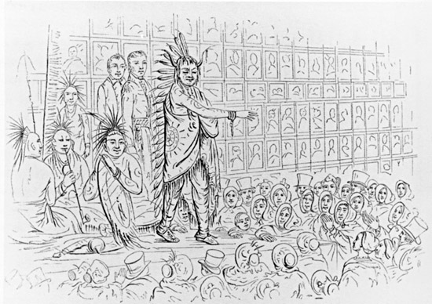
Figure 29. An Iowa Addressing a London Audience in Catlin's Indian Gallery. Catlin's Notes of Eight Years' Travels and Residence in Europe with His North American Indian Collection, 1848.

Catlin was, in fact, a showman from the very beginning. His greatest show of all was his continued contemplation and estimation of his successes in the face of continued adversity. He had a showman's knack for reinvention and novelty. These traits led to what Dippie describes as the ability, or strategy, "to put the best public face on any situation," which is what he did as he started traveling his show across Europe. The rented rooms in the Egyptian Hall cost Catlin £550 per year. In May 1842, when his second lease expired, the "harried showman" moved his gallery to Liverpool, where he began a series of lectures touring the provinces promoting his gallery and his book.
Performing Live: The Living Tableau
If showcasing his gallery in London taught George Catlin anything, it was the need for novelty. The competition for the public's money in Piccadilly was fierce, and static art shows could easily be passed over for some other form of entertainment—some other "rational amusement," as Charles Willson Peale called it. As time passed, Catlin needed to transform his show into something more competitive. He also needed to promote his book. The best way to do both was with a cast of living Indians to supplement the cultural artifacts and likenesses already displayed in his gallery. He needed to find a way to get his pictures moving. Catlin's first foray into live exhibitions came with a gallery installation in 1842, when he supplemented his lectures with English men and boys (and his own nephew Theodore Burr Catlin) in costume, performing ceremonial Indian dances. He later realized that he needed real Indians, as the London populace had already experienced shows of Hottentots, Laplanders, and Inuit people. Having real Indians would draw more of a crowd.
In 1843, Catlin partnered with an American showman named Arthur Rankin. Rankin had "accompanied nine Ojibwas to England, and in December [1842] he escorted the troupe to Windsor Castle where they performed authentic dances ‘to the apparent surprise as well as amazement of the Queen.’" The Ojibwa cast managed to keep Londoners interested—and paying—until late Spring, when the partnership ended. With the Ojibwas gone, Catlin partnered with another American showman, P.T. Barnum. Barnum and Catlin exhibited "fourteen Iowas 'from their hunting grounds, 500 miles west of the Mississippi,' the land of unspoiled noble savages described in Letters and Notes.” Unlike the Ojibwas, or the English actors playing the parts, the Iowas did not perform in the gallery. They would, likely through Barnum's original arrangements, set up a full camp “in some open space” where they could lead their lives as they would at home—or as close as one could come in the wilds of London. The Iowas would be Catlin's living, breathing diorama.
The Iowas erected their camp on Lord's Cricket ground on St. John's Wood Road. Guests could watch the Indians "shoot arrows, pray to their spirits, erect tipis, play ball, dance, sing, and orate—all 'under the Superintendence of Mr. George Catlin.'" This scene, seemingly far from the halls of art or the artifact collection in William Clark's meeting house, was an extension of both. For his part, Catlin was participating in the show as an interpreter of the customs of the Indians, assumed to be doomed to extinction. On the part of the audience, it was a taste of things to come, as the nineteenth century marched toward the twentieth. These early open-air shows foreshadowed and perhaps inspired representations of the American West that would come a generation later. "Though the Indians proved disappointing archers and their dances and ceremonies were performed on a stage," Dippie concludes, " the outdoor setting was inspired show business, anticipating by forty years a key element in the magic of Buffalo Bill's Wild West that captivated England in 1887." It also revealed just how much the scales had tipped in favor of Barnum's style of showmanship.
By May 1844, Catlin's gallery was languishing, and he had to sublet his Great Hall to one of Barnum's most remarkable exhibits, Tom Thumb. The Indian Gallery still hung on the wall, and the Iowas still danced and prayed on the cricket field, but neither were effective attractions. To make matters worse, Catlin's relationship with Barnum, which was good to begin with, began to deteriorate. Barnum mentions passing off the Iowas to Catlin after they showed up "on our joint account," but Catlin never mentions Barnum in any published accounts of his tours in England or the continent. Historian Richard Altick writes that this is due to Catlin's "reluctance to be publicly associated with a showman." At this point in Catlin's career, he struggled to keep the air of education in his lectures and his gallery. It is likely Catlin saw in Barnum precisely what he did not want to become. However, he was also aware that the life he was living was setting him firmly on that path. In an effort to break away again, Catlin took his gallery and the Iowas back on the road. By late spring of 1845, Catlin, his wife Clara, and his show were in France.

Catlin on the Continent
Catlin's reluctance to exhibit in Paris was due in part to the hefty taxes levied on his type of show. He would have to pay back one-tenth of his receipts to the French government, which meant that a profitable show in Paris was as unlikely as one in London, albeit for different reasons. Catlin took nearly two years of planning and letter writing to secure an exhibition space on the Champs Elysées. Catlin had started planning for Paris in the fall of 1843, but a series of what can be described as "Catlinian" events pushed the family's arrival on the French shore to April 1845. First, he had to replace his Ojibwas with the Iowas for the French trip. He had to secure permission from the French prefect for exhibition space, and he spent several weeks working out the financial prospects of bringing the paintings and the Indians or just the Indians. Amid that planning, Clara gave birth to a "stout boy" to add to the growing Catlin family, which until that time had been Catlin, Clara, and three daughters.
The harsh realities of a touring life soon overshadowed Catlin’s hopes for Paris offered. Brian Dippie perfectly sums up Catlin's time in Paris: "Never would Catlin experience such prestige, such heady praise. And never would he experience such desolation, such loss." The Catlins had only been in Paris three months when Clara died. Catlin's Paris exhibition had only been open a month and a half, the success of which, Catlin had assured Clara as he had every other time, would greatly benefit the family. The band of Iowas that made the heart of the Paris troupe left Catlin in mid-June after the passing of the wife of Little Wolf, one of the prominent members of the band. Though Catlin's wife died just weeks later, he still secured another group for his exhibition. This time, a group of eleven Ojibwas from Canada was brought to France by an English manager named George Henry. This group proved a disaster for Catlin. They were with him only five months, before he sent them off, at great personal expense, to Antwerp.
At this point in his career, Catlin had to admit what he had become. He was a showman. The thing he despised most about Barnum was becoming a necessity, as he forged alliances and partnerships that he would have staunchly refused under earlier circumstances. He came to Europe as the champion of the Indians' plight. He displayed his collection of artifacts and portraits in such ways as to posit that he was a friend to the Indian and sympathetic to their trials and tribulations under the American government. Nevertheless, as costs mounted, these sympathies and lectures had to take a back seat to "the show," for it was a show that sold tickets. George Henry's troupe had more than modest success in London's Egyptian Hall in Piccadilly, where they "offered English audiences twice-daily demonstrations of the 'Operation of Scalping!'" and played up the wildness (and otherness) of the Indian. Henry, who travelled under the adopted Ojibwa name Maugwuduas, had sought Catlin out in France specifically because Catlin now held the reputation of being a "showman specializing in Indians." During a seasonal break, Catlin took the troupe to Brussels, where two of the party died of smallpox, and another died in London. Because Henry left the arrangement, owing the Indians and Catlin back pay, Catlin was forced to pay to send the Ojibwas home, and had to run shows in Brussels, Ghent, and Antwerp to raise these funds. "No one," Catlin warned, "should consider bringing Indians over to Europe in the expectation of turning a profit, 'at least for many years to come.'"
Through it all, Catlin was concerned with profits. As much as he had toured on the idea of preserving the Indian as an entity, a separate population, or as a model of a lost culture, in the end, it was all about profit. In Paris, the “wildness” of his trained troupe from Canada brought Catlin into high society. However, he had yet to find a steady patron. The shows had taken their toll, and in light of losing his wife, he sat with his now motherless daughters and son, taking stock of his situation. Catlin decided to leave the arena of spectacle and return to a life dedicated to art.
Catlin's tour of the European continent may not have provided the riches he had envisioned. However, it allowed him to enter a high social circle. When Catlin first landed in France, he managed to secure an audience with King Louis-Philippe with the help of the American minister. Viewing the Indian troupe as a nostalgic reminder of his own tour in North America, the King ordered a room in the Louvre Museum for Catlin's paintings "for private viewing by the royal family and guests.” Louis-Philippe “came twice himself to inspect it with Catlin and reminisce about his own experiences in the wilds of America." Royal patronage allowed Catlin to gain access to prominent citizens and guests, including the likes of Charles Baudelaire, George Sand, Eugene Delacroix, and Baron Alexander von Humboldt. Catlin was even elected as a member of the Société Ethnologique de Paris. Catlin's ego was boosted by this recognition—one that he had failed to receive in his native country. However, there was no money in it. Even when he successfully procured a commission of sorts from the King, it was to treat events such as the explorations of La Salle and other achievements of the French in North America and did not concern his Indian Gallery. Although “the king did select fifteen of Catlin’s paintings to be copied for the palace at Versailles…it brought no income.”
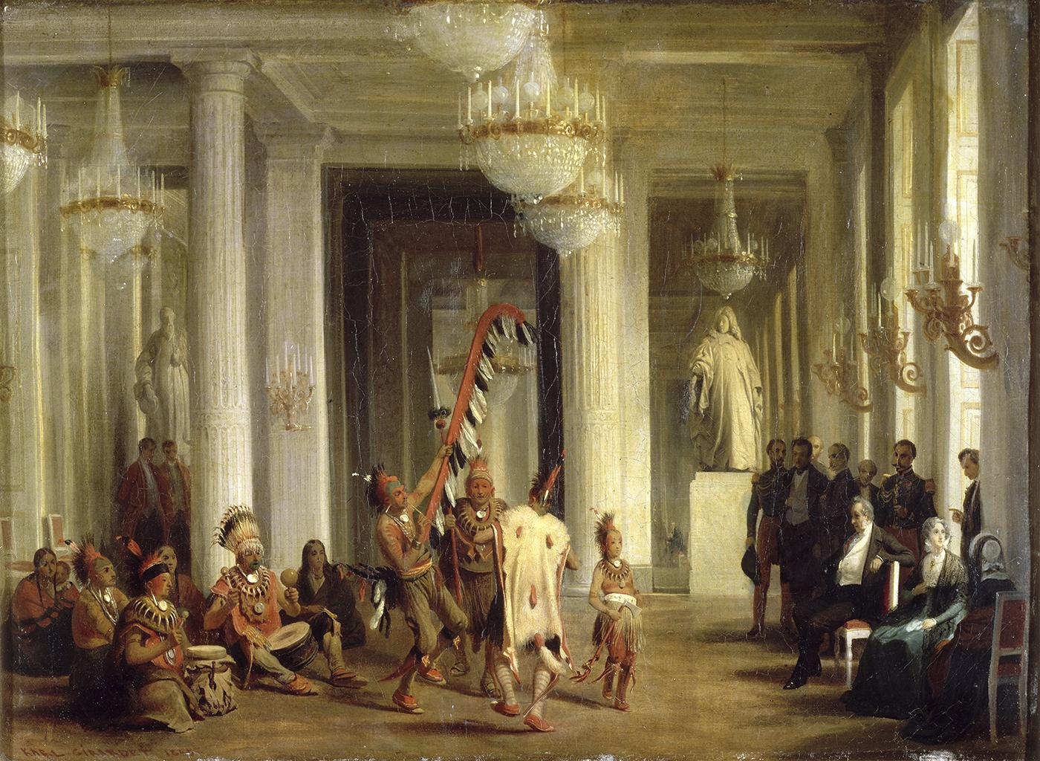
Figure 30. Karl Girardet capturs Catlin’s living gallery performing for the King in 1845. Karl Girardet. Le roi Louis-Philippe assistant dans un salon des Tuileries a la danse d'Indiens Iowa, 21 avril 1845. (King Louis-Phillippe watches dance by Iowa Indians in a salon of the Tuileries, 21 April 1845). Départemente des Peintures, La Louvre, INV 4928; LP 6646; MV 61388.

In 1847, Catlin held exhibitions of his Indian Gallery paintings at the Gallery des Beaux-Arts, "but he found expenses exceeding revenues and so crated his works and put them in storage." When revolution again swept France in 1848, the monarchy of King Louis-Phillipe was deposed, and with it, Catlin's hopes for royal patronage. Catlin fled France at least a week earlier than the king and queen, although he recounts it was just days before the revolution that he was to show the finished La Salle series to the king. "Throughout his career," muses Brian Dippie, "Catlin was always missing the express train to prosperity by a second or two: wars routinely broke out, and national economies crumbled as he was about to board. Certainly, his tale about delivering the finished paintings to the Louvre just three days before Louis-Philippe was deposed can be discounted." When Catlin returned to France, his Indian Gallery (and the La Salle paintings) were still in storage, unharmed by the revolutionaries. The full gallery comprised nine tons of paintings and artifacts. Catlin had to get all of this out of the country by horse and coach, since the railroad lines were either destroyed or barricaded.
Catlin and his gallery returned to England, leaving behind the thrill of social acclamation. The cost had been much more than monetary. His family now consisted of three daughters, as his son died on June 1, 1847. The shattered Catlin had to see the body across the Atlantic to be buried next to Clara. His conscience, if not his reputation, was marred by the association of showmen. His ledger books showed no more upon his return than had been there when he left. He remained ever hopeful, as there was still a chance that the American government would come through and purchase his gallery. This sale would be the only avenue left for vindicating his life in Europe. He was looking for "success so spectacular," writes Dippie, "it would justify the mounting toll of sacrifices to his personal ambition." Before he left England for France, Catlin "had been offered £7,000 ($35,000) for his collection, but still clinging to the hope that it would be bought and displayed by the American nation, he refused to part with it." It is unclear whether he wanted to make sure the gallery's permanent home was the United States or whether he was hoping to sell it for more. In 1846, a bill to purchase Catlin's Indian Gallery for $65,000 was presented before Congress but died for lack of action. The following year, a proposed bill that spread a purchase price of $50,000 over ten years passed the House but was killed in the Senate. Richard Altick sums up Catlin's post-France life: "Forced to return to London in the aftermath of the 1848 revolution," Catlin "lived an increasingly poverty-stricken life for the next few years holding an unsuccessful exhibition of his paintings during the Crystal Palace summer."

The Debt (and Death) of a Showman
While Catlin was still exhibiting in England, the United States House and Senate were busy with a still expanding American West. They had resolved the boundary dispute with Britain over the Oregon Territory, while the annexation of Texas brought another sizable piece of land under federal jurisdiction. Among the bills addressing slavery in the new territories and what those territorial relationships were to the established state and federal governments, an amendment for installment purchase of Catlin's Indian Gallery made the floor on February 27, 1849. Unfortunately for Catlin, the House defeated the joint purchase resolution on March 3.
Without the steadier income from exhibiting living tableaus, Catlin had begun using his Indian Gallery as collateral for small loans. Their purpose was twofold: one, he needed the money, but more shrewdly, these loans were spun as conditional to the sale of the gallery. Catlin used all his efforts to convince the American government that foreign powers were showing interest. However, he was stalwartly holding on because, being the patriot he was, he knew the gallery of American Indians belonged in the United States. This posturing had little effect other than to drive Catlin further into insolvency. He could cash out a collateral loan to Sir Thomas Phillips, not by repaying the cash, but by creating fifty oil copies of Indian scenes of Phillips' choosing. It took this and five years for Catlin to regain the twenty paintings he had provided Phillips for a £100 loan.
A break of sorts came in 1849 when gold was discovered in California. "In the face of personal adversity," Dippie notes, "the showman in Catlin had come out fighting." The gold in California quickly became international news, and with each retelling, the riches grew in value, and the work involved in reaping the rewards lessened. Catlin, who had never been west of the Rocky Mountains, began a series of lectures about the American West and eventually became "actively engaged in an emigration scheme to attract Britons to Texas and, as a paid agent, was duping ordinary people for personal gain." By 1850, Catlin had been named as superintendent of the United States Land Company's Texas Department, which would have meant that he not only sold the notion of Texas to the people but was to physically lead the first group of emigrants to the lands he had described to them. He resigned his post shortly before the group sailed from Liverpool. An Austin, Texas newspaper described the settlement as a colony sixty miles north and "the project of Mr. George Catlin." It did not last a year.
Failure followed failure for Catlin. Congress failed to purchase his Indian Gallery, as did any other foreign government. Many of his paintings were held to guarantee loans that could only be resolved by a complete sale. He needed a way to induce a bidding war among heads of state for his collection, and he concocted an audacious scheme in the form of a traveling museum, the "Museum of Mankind." The venture, which would be "illustrative of primitive lifeways worldwide, a traveling exhibition that would bring the plight of natives in an age of colonization to the attention of people everywhere," would move around by steamship.
In March 1851, Catlin laid out his vision for his museum before the Ethnological Society of London. The grand design was like nothing proposed before or since. Dippie describes the scheme as "harebrained, to put it kindly." A two-hundred-foot-steamer whose captain had stock in the endeavor, propped up by hundreds of stockholders, would sail its shallow drafted hull continuously around the world, docking in every port as Catlin described "stopping no longer in any than a lucrative excitement could be kept up."
Catlin's plans for his floating museum made his Indian Gallery the centerpiece. His success was assured if Catlin could just get started. An entire ethnographic congress, filled with paintings and artifacts of every culture of the world, would be the outcome of a continuous fleet of floating museums constantly on the move. Dippie sums up Catlin's midcentury actions as a man desperate for any chance to succeed: "It was as though each setback were to be overcome by mounting a new project twice as implausible…He fooled no one as frequently as he fooled himself." The Ethnological Society applauded his zeal and enthusiasm but failed to act toward instituting any limited-liability companies needed for investment purposes.
The floating museum wasn't just another fly-by-night plan that Catlin had dreamt up. It combined several plans he had tried and failed to implement over the preceding decade. It was also a way to have someone else pay for moving his gallery out of England. The Lords of the Treasury of England had voted to end his exemption of duties on the collection following the end of the next exhibition season. Catlin had to get his Gallery out of the country by the end of 1851, or he would risk debtor’s prison for taxes and duties he could not pay.
By 1852, Catlin's friends in Congress had mostly retired from politics. Henry Clay died midyear, and Daniel Webster had not held a seat in the Senate since 1850. Catlin's most powerful appeal was sent to Webster in April 1852, addressed from "Queen's Bench prison!" Later on, he sent an advertisement posted from a London Auction house for pieces of Catlin's Indian Gallery. This missive spurred a general discussion of Catlin’s fate in Congress. Many members had dismissed Catlin's previous pleas as hyperbolic attempts to get government patronage. This time, several committees discussed the question proposed by William Seward with all sincerity. However, the motion was squarely defeated along the new party lines in Congress. It seemed like the end for Catlin. For the Catlin the European promoter and showman, it was. That Catlin the artist survived 1852 is nothing short of miraculous. He would eventually make his way back to the United States in 1871. His second career was as an Indian painter. He amassed another Indian Gallery, based mainly on his own earlier sketches and notes, somewhat smaller in content and scope than the first.
His original Indian Gallery was saved intact when an American mechanical engineer named Joseph Harrison bought out the three English claims on the collection. Harrison, a fellow Pennsylvanian, had loaned Catlin money at some point in his European sojourn, and was also interested in Catlin’s estate. Harrison's wealth came from a building a railway system from St. Petersburg to Moscow, for which he was "richly rewarded by a grateful Emperor Nicholas." Harrison packed up Catlin’s entire gallery and shipped it to Philadelphia for storage. Catlin still owed his debts, and Harrison would release them upon repayment and not before. This agreement did not seem to bother Catlin at all. While he was abroad, he seemed to worry less about the Gallery because Harrison had it. In truth, Catlin's Indian Gallery was safer in Harrison's possession than it would have been in Catlin's.
Catlin remained abroad until 1871. Between 1854 and 1860, he virtually disappeared. Divorced from that side of himself that had posted advertisements and followed show reviews in the newspapers, he was conspicuously silent. Catlin himself maintains that he made two trips to South America during this time, but little evidence supports this claim. What does exist are paintings depicting South American tribes and their customs. These were similar to Catlin's works of western American Indians. During the declining years of his life, Catlin remained steadfast in his decision to pursue art, and never again attempted anything on a par of the shows he had put together in the 1840s.
If sheer force of will could have caused the United States government to purchase Catlin’s Indian Gallery, he would have never had the chance to take it to Europe. Even in the face of poverty in London, and with his family ruined, Catlin knew his gallery was a national treasure. True to his convictions, Catlin never again toured with a living tableau, even though he knew such shows provided some monetary respite. He had already flown too close to the showman's sun, and any mention of his partnership with Barnum made him feel a bit of a fraud.
At the invitation of Joseph Henry, secretary of the newly created Smithsonian Institution, Catlin lived within the very museum in which he had wished to hang his gallery. Neither Catlin nor Henry could afford to pay the debt owed to Joseph Harrison for the release of the original gallery. In the 1865 fire, Henry lost his notes, records, and the Smithsonian's own Indian Gallery, painted by John Mix Stanley. Stanley's paintings had been on display since 1852, when post-Catlin discussions in Congress began to favor Stanley's art over Catlin's. Catlin died in 1872, with some of his Indian Cartoon gallery and South American art on display in the Smithsonian. Samuel Colt had commissioned a series of twelve paintings from Catlin's South American trip that would serve as advertising for his firearms; this was as close as Catlin got to the mass media presence, he maintained in the late 1830s and early 1840s. The greatest irony of Catlin's life came in 1874, after his creditor, Joseph Harrison, died. Harrison’s widow, Sarah, presented the Smithsonian with the entire Catlin Indian Gallery as a gift, as a replacement for the Stanley Indian Gallery, which had burned in 1865. Had Catlin been successful in selling his collection at any time, his paintings would surely have been lost to the flames.

Albert Koch: The Saint Louis Showman
German immigrant Albert Koch (1804-1867) is known to an even smaller circle of scholars than either William Clark or George Catlin. Koch’s shows, broadsides, and lectures mark a change in trends from the practices of his earlier museum counterparts. Instead of showing nature as it was, which Koch did in St. Louis through the 1830s, he began to show what nature could be– with some embellishment. Koch's success and showmanship could only be matched by his contemporary P.T. Barnum. Both men were early experimenters in the rapidly evolving museum and show world of the 1840s. In fact, Koch was selling tickets to a hoax a year before Barnum, since his Missourium was touring in 1841 before Barnum’s infamous Fiji mermaid, which appeared in 1842.
Koch’s Museum in St. Louis opened in 1836. The first two years were promising. For twenty-five cents museum patrons could see "an Egyptian mummy with sarcophagus, an Indian mummy from a cave in Kentucky, cosmoramic views of the Battle of Austerlitz [in the Napoleonic Wars], the tunnel under the Thames, the French Revolution of 1830, and other such pictorial news, wax figures of Siamese Twins...other personages, a large collection of stuffed birds, and other intriguing and educational phenomena." His profits were ample enough that by 1838 Koch spent less time at the museum and more excavating giant bones along the banks of the Missouri River. Koch collected the bones from three locations along the river to reconstruct his Missourium, a construction of bones from various mastodons to form a startling creature so giant that a living elephant could walk under it. His Missouri "leviathan" and the Hydrarchos from fossils collected in Alabama were considerable draws in the 1840s.
Paleontologists are familiar with these early works of fanciful fossil reconstructions as spectacles of popular exhibits. Historians of American geology may also come across Koch’s name used disparagingly, by 19th century geologist James Dwight Dana. Some modern accounts do the same. Keith Thomson described Koch as "a rather shameless showman," while Daniel Loxton and Donald Prothero call him "a shameless self-promoter, and (most of all) a hustler of the first order." Still, they do begin their chapter on Koch by describing him as a "commercial fossil collector" and "a successful and important fossil hunter." Historian Lukas Rieppel labels Koch a "specimen dealer and dime museum operator." He looks specifically at Koch's assumed moniker of "Dr." as a means of claiming "scientific and medical expertise aimed to police the boundaries between truth and untruth." These ill feelings towards Koch stem from his two major attractions of creatively and deceptively reconstructed fossils.
Koch dealt in more than fossils and hoaxes. The accepted narrative for those American historians familiar with “Dr.” Koch is that his St. Louis Museum displayed many Indian artifacts on loan from William Clark himself. He eventually sold this material in Europe, while he was exhibiting fossil specimens. Over the course of twelve years, historian John McDermott researched the Clark-Koch connection and found that Koch had not stolen the artifacts, as some thought, but had borrowed them, and had explicitly advertised them as belonging to Clark. They remained in Koch’s possession after Clark’s death in 1838.
Koch was born in Roitzsch in the Duchy of Saxony on May 19, 1804. His father was a “magistrate and administrator of the royal domain,” which allowed the elder Koch enough social status and wealth to have his own cabinet of curiosities. Ernst Stadler, the translator of Koch’s Journey Through a Part of the United States, says that nothing more is known about his childhood, but suggests that given the family's position, the boy would have had at least a secondary education. Koch's obituary (1867) stated that he had sailed to the United States at the age of 22, and nothing more is known of his whereabouts with any certainty until the establishment of his St. Louis Museum. The city's first German newspaper, the Anzeigar des Westens, noted in its June 29, 1839, issue that Koch had been a citizen of St. Louis for a dozen years.
The Missouri Saturday News carried several favorable reviews for Koch's collection of exotic stuffed birds and impressive live animals. These included a living bear and five alligators. In June 1838, one of the alligators fell from a third-story window of the museum. According to one newspaper, it was a "suicide." Earlier that year, the same newspaper printed a letter from an artist named George Catlin outlining his plans to paint the portrait of the never-before painted Seminole Chief Osceola and the others in his party. These people were in St. Louis presumably to see Indian Agent William Clark. An editorial reply reveals that not only had Osceola's portrait already been painted, but the portrait had been on display in Koch's museum for some time. The editorial took the time to note that an eastern artist may have misjudged the St. Louisans, for "'In St. Louis,' Stadler quotes the editor, 'we have been for a long period accustomed to looking at the portrait of Osceola.'"
An incident in the Fall of 1838 provides excellent insight into the presentation abilities of AlbertKoch. One of the reporters for the Missouri Saturday News, reporting from "rural Missouri," had appended a note to his column on Koch concerning an animal oddity he was sending back. "What was apparently intended as a practical joke played on Koch," writes Stadler, "was turned by him into an eye-catching addition to the museum…" An advertisement for the elusive and rare Prock appeared in the Daily Commercial Bulletin, foreshadowing Koch’s exhibitions of the Missourium and Hydrarchos in the coming decade. Thus, Koch was not only a talented amateur fossil hunter, but also a very clever showman:

DID YOU EVER SEE A PROCK?
This beautiful animal, which has long been considered fabulous, is now to be seen at the St. Louis Museum.
Not in a painting, but stuffed and preserved as natural as life, situated on a rock surrounded with flowers—The Animal is the size of a mule and has much the resemblance of a Zebra, except that the legs are much shorter and thicker and the tail more bush at its extremity. The head has much the resemblance of a Rhinoceros, and has a horn on the nose of an ivory substance. The public are requested to call and examine the animal for themselves, as the limits of an advertisement are insufficient for a full description. Call and behold an animal that has never before been exhibited in the old or new world.

Missourium and Hyrdrachos
Koch sold part of his St. Louis Museum collection in January 1841, and the good doctor took the Missouri leviathan on a grand tour. Koch toured the larger cities on his way east while managing to leave for London's Egyptian Hall just before geologist Charles Lyell began his tour of the American West. Historian Paul Semonin notes, "Crowds flocked to see the American Monster, and the exhibition was so successful it remained on display in London for nearly eighteen months." When the Missourium came under fire from Richard Owen, a biologist and the first director of London’s Natural History Museum, Koch defended his reconstruction at the Geological Society in April 1844. He quietly closed his exhibit and began a tour of Ireland and Germany. Koch returned to London in May 1844, where “he ensured the financial success of his early tour by selling his entire collection of fossils to the British Museum for a down payment of $2,000 plus $1,000 a year for the rest of his life.”
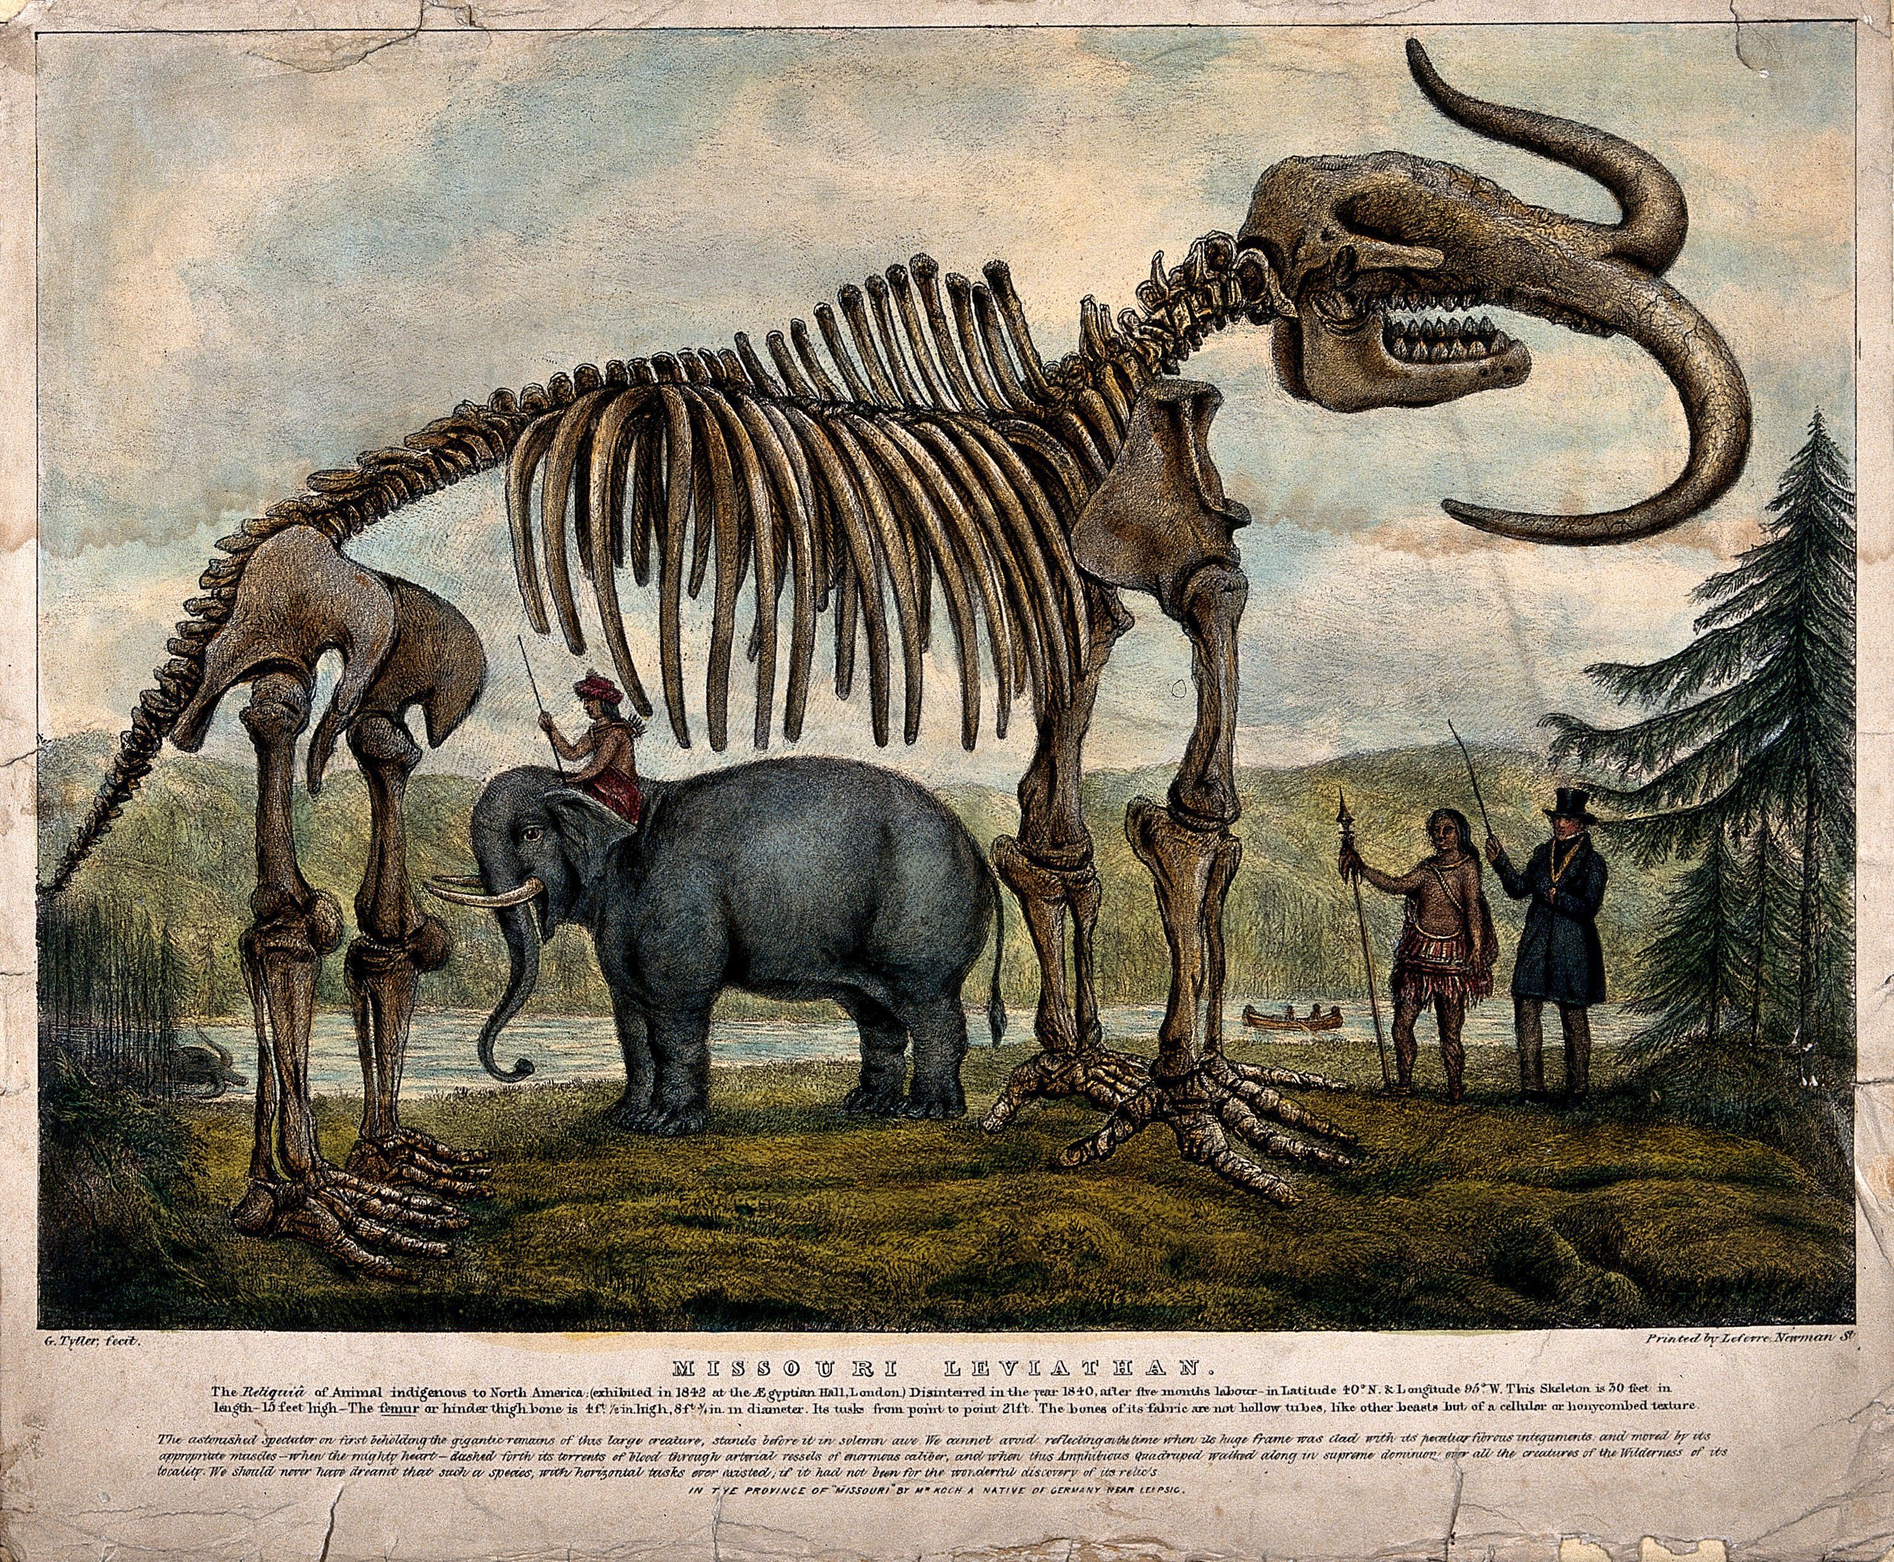
Figure 31. Coloured lithograph by G. Tytler, ca. 1845. Wellcome Collection. Public Domain Mark. Source: Wellcome Collection. Reference: 581088i

When Koch returned to the United States in late 1844, he immediately began assembling another showstopper. He also began keeping a detailed journal of his travels across the American West to be published when he returned to Germany. This publication indicates the growing popularity of travelogues among European audiences, especially of journeys through the American West. Koch's second show was a sea monster composed of multiple whale fossil vertebrae stretching 114 feet long. In 1845, Koch's sea monster went on exhibit in the Apollo Rooms on Broadway in New York City, just down the way from P.T. Barnum's newly opened American Museum.
In 1845 Koch’s reputation as a hoaxer at best and a fraud at worst regarding his Missourium specimen meant his show could only stay in one place for a short time. Owen and others were quick to alert the public to the fact that he had a history of mistruths on display. Luckily for Koch, by 1845, there were plenty of places to hold an exhibition in New York. His translated journal records installations at Niblo's Gardens and another New York locale, called by Koch "The New York Museum,” where his collection was moved from the second floor to the basement. Koch then traveled to Baltimore and Utica before sailing with his collection to Europe. Koch and his Hydrarchos could not repeat his success with the Missourium. He left London and took his show to Dresden where the king of Prussia, Frederick Wilhelm IV, purchased the fossils for the Royal Museum in Berlin.

Figure 32. The Hydrarchos or Leviathan! of the Antediluvian world, in an 1845 Broadside for Koch's sea monster. Courtesy of the Library of Congress. Portfolio 119, Folder 33. Digital ID http://hdl.loc.gov/loc.rbc/rbpe.11903300.
After selling King Frederick his Hydrarchos, and publishing his travel journal in Dresden, Koch returned to the United States where, in January 1848, he began excavating more whale fossils in Alabama. In just a month, Koch had uncovered a nearly complete skeleton of the toothed-whale Zeuglodon, the same species that comprised most of his Hydrarchos reconstruction. Now living comfortably with a pension from the King of Prussia, Koch spent months removing the fossils from their rocky matrix, sending the more difficult specimens back to Dresden. After nearly a year and a half of work, the whale fossil was freed and went on exhibit on May 6, 1849, "in a large and beautiful saloon furnished by the Royal Academy of Dresden, where the Royal family of Saxony viewed it." From there, Koch and his Zeuglodon traveled to Breslau, Vienna (for a year), and then Prague. There was a canceled exhibition in Munich due to the fact that the Zeuglodon measured ninety-six feet, and "no rooms large enough for his collection could be found, and because some urgent business required his presence in the United States." There is no record of what that urgent business was, but in 1853, Koch and the whale fossils were in New Orleans for a time. Upon returning to St. Louis, Koch sold the exhibit collection to Edward Wyman, who was the current owner of Koch's old St. Louis Museum.
Koch’s fossils would prove to be of vast importance outside of the world of the show. In 1944 M. F. Ashley Montagu and C. Bernard Peterson argued that Koch’s Missourium locality, and his notes that there were human artifacts found in situ with those of the mammoth (mastodon) were correct. Koch had discovered the first evidence of human and mastodon interaction, which was overshadowed and dismissed as he toured the U.S. and Europe with his conflated Missourium. They also provide a fitting descriptor to remember Koch as a skilled amateur paleontologist as much as a brilliant, if shameless, self-promoter: “Koch’s account of his find and his description of the skeleton were very well written,” they wrote, “and show him to have been a collector of some ability and keen intelligence.”
With Missourium and Hydrarchos, it can be argued that Koch was Barnum before Barnum. Kochs’s insistence on selling the show for fact. whereas Barnum would always imbue his exhibitions with an air of ambiguity was his hallmark of failure. As long as Koch's finds were reconstructed by "proper" scientists, he remained a trusted collector and what was then known as a "practical man." Barnum's tact, learned or not from Koch's interactions with the scientific establishment, was to entertain, to remain ambivalent and ambiguous to the facts of the matter. Whatever the case, Koch was still well-known enough in fossil circles that he was included in the enormous Panorama of the Monumental Grandeur of the Mississippi Valley in 1851. This 348-feet-long panorama commissioned by Dr. Montroville Dickenson for his own lecture and show, features a scene of fossil excavations from the stream beds near Kimmswick, Missouri.
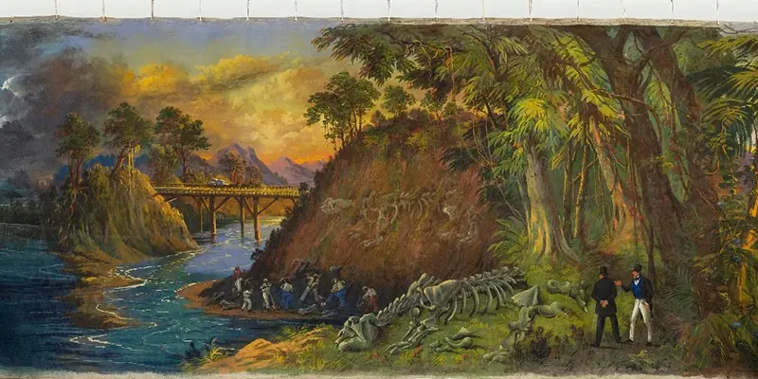
Figure 33. John Egan’s The Panorama of the Monumental Grandeur of the Mississippi Valley, 1850, Courtesy Saint Louis Art Museum. Object Number 34:1953. Digital scans and details www.slam.ord/collectio/objects/841/
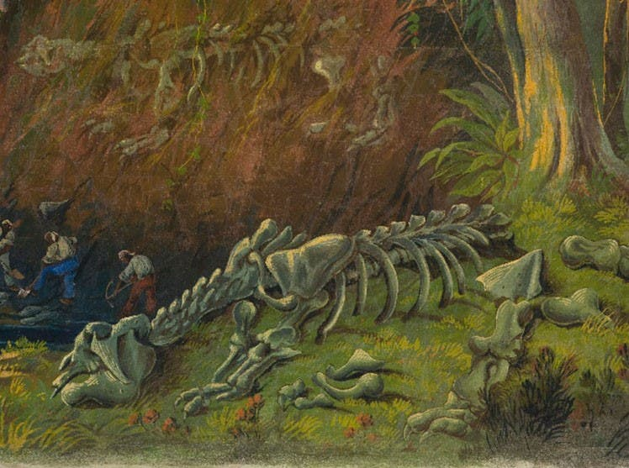
Figure 34. Detail. John Egan’s The Panorama of the Monumental Grandeur of the Mississippi Valley, 1850, Courtesy Saint Louis Art Museum. Object Number 34:1953. Digital scans and details www.slam.ord/collectio/objects/841/

The enormous fossil remains are sometimes described as mammoths, possibly to fit in with Koch’s finds. However, they are, quite obviously, giant ground sloths, which Koch had also uncovered and toured as evidenced by their inclusion in the ad for the hydrarchos (Figure 13). The artist, John J. Egan, depicted the fossils in the manner of Cuvier's anatomy books. Both Koch and Dickenson are in the front right foreground, where Koch, distinguished by his high hat and flashy white trousers, explains the excavation process and fossil reconstruction to Dickerson. It is fitting that such a successful showman is captured on this particular kind of canvas and that Dickenson included Koch as the expert who provided the "authentic" narrative for this portion of his panorama show, just as Koch's fossils had provided him the "authentic" reputation as a trusted collector.
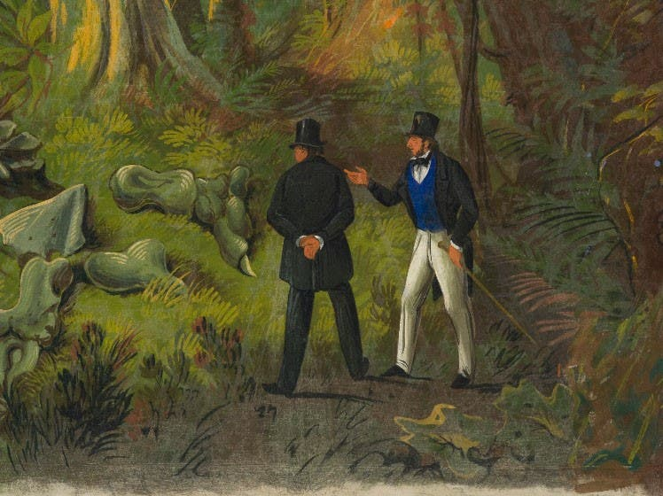
Figure 35. Detail. John Egan’s The Panorama of the Monumental Grandeur of the Mississippi Valley, 1850, Courtesy Saint Louis Art Museum. Object Number 34:1953. Digital scans and details www.slam.ord/collectio/objects/841/
Albert Koch's objects were less for display than for money. It is true that the money came from the objects being displayed in the form of a show, but the nature of collecting and scientific networks of the antebellum period dictated that this be the case. Amateurs could provide the material to the professionals, but they were outside the scientific establishment. Koch's fossil material was more important to early paleontologists than his spurious reconstructions. Still, Koch's collection provided authenticity and authority for those around him. That he was not an anatomist meant that he was expected to make mistakes in reconstructing his finds. Lukas Rieppel describes this as "vouchsafing." He argues that "the authenticity of Koch's fossil depended crucially upon the judgments one made about his identity” and “even though he [Koch] could not be trusted to place his findings with a larger, philosophical framework…his value to the community derived from the material objects he made available for expert interpretation, regardless of whether he stored his fossils individually in wood boxes or strung them together in the manner of a colossal sea serpent.”
That Koch’s Missourium and Hydrarchos were not authentic led Koch into a life of showmanship—which he maintained in order to finance his own fossil excavations—overshadowing his early contributions to the infant science of paleontology. If anything, his extensive showmanship and international ties built a much larger stage for discussing the ancient worlds that fossil hunters would uncover in the coming decades. Koch also primed the public to expect wondrous things, and by the time the so-called “bone rushes” were underway in the latter part of the nineteenth century, both the public and the media were following every expedition.
There are lasting ripples of Koch’s work. Thus, his deconstructed Missourium still stands in the Natural History Museum in London. That model, reconstructed for the museum by Richard Owen, was used to illustrate the Mastodon gigantus in the American geologist James D. Dana’s Manual of Geology. Koch’s Hydrarchos provides yet another layer of authenticity and authority regarding amateur collectors and their objects serving professional science.
During Koch's career as a showman and paleontologist and Catlin's time as an artist and showman, the lines blurred between exhibitions, museums, and shows. The environment and culture of exhibitions was shifting. Koch and others put on a show, in order to provide funding for his other, more serious projects, including his desire to educate the public in the manner of Peale’s museum. Museums in this period would often divest their rational roots in favor of amusement and showmanhip. McDermott sums up Koch and many other showmen of the Antebellum (or ante-Barnum) period thus: “This showman by necessity and scientist by choice has been almost forgotten, but…his St. Louis museum, and most of all his fossil discoveries, places Koch among America’s significant scientific pioneers.”
The showmanship that had once supplied the financing for artists and scientists to collect, exhibit, and educate in their more noble or "professional" pursuits, ended up as the main show. The evolution of museums from places of education and quiet reflection into a bawdy, circus-like environment began almost as soon as Peale opened his museum in Philadelphia. For as the “leisure class” grew, so did their appetite for the unique, exotic, and spectacular. The sacred and profane were part of the same show, and entertainment trumped the stoic lyceum-like lectures. Peale's rational amusements were no longer equal parts rational and amusing. However, they were still incredibly popular. New York City saw collections, exhibitions, theater, and spectacle collide, shaping the rest of the nineteenth century's museum culture, if only for what some officials decided not to do.
A Congress of Wonders:
Dime Museums and Penny Presses
(or Barnum, the Sun, and the American Museum)

The legacy of P.T. Barnum (1810-1891) in the museum world is vast. Even as some choose to characterize Barnum's American Museum as too commercial or simply too crass, it was the standard of the day, which other museums attempted to emulate. It also became something that modern museums tried to avoid. Barnum's American Museum marked a shift from the temple-like, reverence-filled museums of the Peales. However, even Peale had to eventually turn to Barnumesque exhibits to stay in operation as a forum of public knowledge. Where the Peales, Dunn, and Catlin, and to a lesser extent Koch, presented the evidence of nature and the world in miniature, the authority was unidirectional, from the curator to the patron. Barnum left everything up to the visitor, sometimes even asking his audience to decide. This was one way he could avoid being called a humbug, when he exhibited scams like the “Fejee Mermaid.”
This tactic was also convenient for managing the amalgamation and conglomeration that filled Barnum's museum walls. Anything that could be displayed was, with little or no overarching theme. Nevertheless, far from being slapdash and cluttered, Barnum's museum reflected the growing nineteenth-century philosophy of miscellany. The editors of Science Museums in Transition note that "miscellany, rather than being an analyst's catch-all category for the ill-defined, was instead an early nineteenth-century genre, and one that characterized museums, exhibitions, and literature." It was a genre which Barnum would stretch to its limits, as he promoted singers, freak shows, hoaxes, and humbugs. The genre included sensational stories like the lunar man-bat, which exploded on the newspaper scene, driving subscriptions and circulation numbers to their highest levels. Though Barnum was not involved in the Moon Hoax, it tied in with his museum displays in New York, and the resulting newspaper feuds would keep Barnum's name in circulation years after the story was exposed as fiction. For Barnum, readers became museumgoers.
One of Barnum's most famous and derided exhibits was “What Is It?" which featured a black “freak” named William Henry Johnson, whose mental condition and appearance was decidedly "other." "Because of the ambiguous exhibit title, 'What Is It?'," notes Andrea Dennett, "Barnum was able to set the spectator up, placing all alleged 'misrepresentations' squarely in the lap of the viewer, who was forced to form his own opinion as to whether the exhibit was a man, an animal, or a combination.” There were no such ambiguities in other early museums. Catlin’s characters were represented as “real Indians,” in his carefully arranged landscapes. Dunn specifically wanted to teach people about Chinese culture, and thanks to his deep ties with Chinese collectors, he was able to do so. Barnum was more extreme. His sensationalism, coupled with the popularity of his museum, would drive the development of the United States National Museum in the mid-1840s, albeit in the opposite direction. It also led to a new separation of art museums and natural history museums, that to this day are still distinct in their audiences and their advertising. By making Barnum's American Museum the example they did not want to follow, the Smithsonian Institution wished to put museums back on their pedestal. As we will see in the final chapter, having a museum controlled by the government has some Barnum-sized problems of its own, not least of which was the "miscellaneity" of artifacts that would inundate the collections, and force museums to rethink their actual purpose.
The museum careers of the Peales and George Catlin ended with P.T. Barnum. After his time in London, as impresario of his exhibition, Catlin wanted to lead a less showman-like life, and began to retire from the exhibitioner’s scene. For the Peales, the end came in the form of a check. Barnum began purchasing whole museum collections as early as 1841, and over the course of a decade eventually acquired all of the Peales' collections. The purchases began with Ruben's Baltimore Museum in 1843. They culminated in a joint auction acquisition, in 1850, with Moses Kimbell, for the bulk of the original Peale material, which they divided between Barnum's American Museum in New York City and Kimball's Boston Museum.
There was always something of a divide between the early museum, with their openly educational tone (and their upper crust clienteles), and the cheaper traveling shows. “Well before the Revolution,” wrote theatre historian Brooks McNamara, strolling exhibitors of curiosities already operated in the colonies, along with a host of mountebanks and other popular showmen and entertainers." Traveling entertainments were in practice throughout the eighteenth century and were often dubious in nature. As collections and cities became more extensive in the early nineteenth century, showmen began "to house their freaks and curiosities more or less permanently in 'museums' of 'cabinets of curiosities.’” Their only competition was a handful of more serious collections gathered by trained artists, scientists or naturalists, or by knowledgeable amateurs. By mid-century, when Barnum was creating and expanding his American Museum, even the "respected collections" of people like the Peales "were forced to introduce more and more sensational novelties."
This new environment of science and spectacle, reverence and revel, was the ecosystem in which Barnum opened his museum. He had led traveling shows through New England, the South, and the West. He had been one of the "strolling exhibitors" for a time and had experienced what worked and what did not. And he knew what worked in what cities. Andre Stulman Dennett claims that "the rise of dime museum in the middle of the nineteenth century was a by-product of the enormous expansion of the American urban landscape," which meant wandering showmen like Barnum could stay in one place and have a steady stream of paying customers. Barnum’s flair as a showman was complemented by the sensibilities of a Yankee merchant. Barnum traded in diversions, curiosities, and humbugs, and his American Museum was always fully stocked.

Becoming Barnum
How did Barnum, a merchant's son from Connecticut, manage to eclipse and then consume the Peale museum dynasty and become the most recognizable name in show business to date? It started with tiny Ivy Island in Connecticut and a drive to succeed financially. The first twenty years of his life honed Barnum’s business acumen to the point that when he unleashed his enterprise in New York City in the mid-1830s, there was no force comparable.
Barnum was born on July 5, 1810, in the small village of Bethel, Connecticut, into what historian of science Katherine Pandora describes as "the first generation of citizens who inherited the Revolution." Barnum doesn’t say much about his siblings in his own writings. In his autobiography, he recounts a single story of his younger brother Eder attempting to catch him sneaking back into his bedroom late at night. However, for the most part, P.T. Barnum's construction of his life was that of an only child. Barnum was the first and seemingly favorite grandchild of Phineas Taylor, who deeded five acres of land to Barnum, just outside the village of Bethel; the deed noted it was the whole of Ivy Island. "I was not four years of age," wrote Barnum, before my grandfather informed me, with much seriousness, that I was a landowner...and I am certain that not a week elapsed from that period till I was twelve years of age, that I did not hear of this precious patrimony." In 1822, when Barnum finally visited his precious island, he found that it had not lived up to eight years of imagination. The entire area was a swamp filled with snakes and hornets, and completely unfit for farming. Barnum had been on the receiving end of one of his grandfather's practical jokes.
Grandfather Phin's joke can almost assuredly be seen as an attempt to temper a young man's spirit for high adventure and riches and settle him into the working life of a Connecticut village. In retrospect, it probably had the opposite effect. Barnum recalled in his autobiography, "I can the more heartily laugh at this practical joke because that inheritance was long afterwards of service to me. 'Ivy Island' was a part of the weight that made the wheel of fortune begin to turn in my favor at a time when my head was downward." Barnum had learned that the most successful part of this trick was that the land actually existed. Had Ivy Island simply not been there, the joke would have only been half as powerful. He also learned that, even if the result disappointed, the imagination that went into expectation was a powerful thing. This notion was something that Barnum would employ most heartily for almost his entire life.
By the mid-1820s, Barnum was organizing local lottery competitions in Glassy Plain, Connecticut. Customers bought tickets for "OVER 550 PRIZES" in a "MAGNIFICENT LOTTERY," all of which was organized and advertised by young Barnum himself. Even if the non-cash prizes were green-tinted bottles and blackened tinware, the winners went away happy at having won prizes. Barnum worked in the Grassy Plain store until it closed in 1827. Historian Robert Wilson notes that Barnum recalled that the town and the trade were "'dog eat dog— 'tit for tat.' Because 'each party was expected to be cheated, if it was possible.'" Woolen rags were sold in bags with cotton and linen, vegetable deliveries were short bushels, all with the sellers claiming innocence because a helper or a neighbor had counted or bagged up the dry goods. On the merchant’s side, their "ground coffee was as good as burned peas, beans, and corn could make, and our ginger was tolerable, considering the price of corn meal." That Barnum's "conscience, morals and integrity" were not utterly destroyed, he said, could be attributed only to his not working there longer than he did. However, it educated him to how far people would be willing to accept a stretched truth.
Barnum moved to New York City in 1827. He lived with a relative and operated the wholesale purchases for their grocery store and surrounding auctions. He returned to Bethel to recuperate from smallpox but returned a few months later where, in short order, he purchased his own porterhouse (a bar and steakhouse) near the grocery. Barnum sold the establishment for a profit in just a few months and moved across the river to work at another porterhouse "near what is today the Manhattan side of the Brooklyn Bridge and was then the terminus for the Fulton Ferry." The Fulton Ferry was a landing for travelers from Danbury and Bethel. Barnum's employer, David Thorpe, allowed Barnum time off to see friends in town, where he treated them to the theater. "Here," notes Robert Wilson, "he began to develop his eye for theater and showmanship, and in time, he would combine it with his already sound entrepreneurial instincts." He was to sharpen these entrepreneurial instincts back in Connecticut.
In 1828, Barnum returned to Bethel to open his own business at the behest of his grandfather. The promise of free rent was as likely as an enticement as the prospect of opening his own store. These business years brought in more than just steady income. During his time in Bethel, he married, began and ended several other business ventures, and expanded his lottery business. He also met his first traveling showman. Hachaliah Bailey had been exhibiting elephants across the northeast for over twenty years. Barnum had been to the theatre in New York, but only as a spectator, and not a producer, as was Bailey. This chance meeting might have remained just that if the state government had not ended lotteries. The seed of a traveling show was planted, though it would take some time to germinate.
Lotteries and Libel: Barnum goes to Press
By 1830, Barnum was operating lottery offices across much of the state. He would buy tickets in bulk and send his agents to the regional offices in Bethel, Danville, Norwalk, Stamford, and Middletown to sell them. He also began publicizing his lotteries in newspapers, handbills, and circulars. His handbills and circular, of which there were tens of thousands, were printed with “striking prefixes, affixes, staring capitals, marks of wonder, pictures, etc." His main base of operation, an office "he called the Temple of Fortune," was "plastered with gold signs and color placards" which would not only draw attention to his tickets but "also emphasize that his customers were luckier than those who bought from other agents." At its highest point, Barnum's agents were "bringing in as much as $2,000 a day in sales." This work taught Barnum the "efficacy of advertising," and also "develop[ed] his insight into the complicated nature of his customers, a realization that outwardly respectable people might have interests that were not entirely respectable." The church frowned upon gambling, which, of course, included lotteries. As Barnum sold tickets to husbands and wives "secretly on the condition he not tell the other spouse," he was also learning the wiles of human nature.
It was not long before the church began frowning on Barnum himself as much as his lotteries. Barnum's grandfather was a Universalist Democrat, as was Barnum. A staunch believer in the Jeffersonian ideals of separation of church and state, Barnum attempted to promote himself through local newspapers. When the Danbury paper refused to print Barnum's letters, he "became exceedingly indignant” and took his rejections as evidence that religion had already become “so powerful as to muzzle the press." He now thought that he would require his own newspaper to publicize his enterprises. Barnum purchased a printing press the summer of his twenty-first birthday. On October 19, 1831, Barnum published the first issue of his weekly broadsheet, the Herald of Freedom.
It took Barnum only eight months to be slapped with his first libel suit. The case was brought by his own Uncle Alansan, whom Barnum claimed favored a state-church merger. The case never went to trial. The second suit did. A butcher in Danbury whom Barnum called a "zealous politician" and accused of being "a spy in the Democratic Caucus" brought the suit, and Barnum was fined "several hundred dollars in damages." When Barnum accused Congregationalist Seth Seelye of "taking usury of an orphan boy," the case went up before that "lump of superstition" Judge David Daggett. Barnum lost the suit; he was not even permitted to testify because of his Universalist beliefs. He was convicted and fined $100 and court costs, or jail time. He chose jail.
While serving his sentence in a wallpapered and carpeted cell, which Robert Wilson describes as "surely a rarity in the annals of imprisonment," Barnum continued to edit his newspaper and correspond with other newspaper editors throughout the region. He invoked Gideon Welles, the editor of the Hartford Times, to "make such remarks as justice demands." "His ability to marshal not just his own paper," notes Wilson, "but also the goodwill of others was a harbinger of things to come. It was the first clear example of his flair for drawing attention to his beliefs, his enterprise, and himself." These continued correspondences also allowed Barnum to arrange a celebratory spectacle for the day of his release. A "Committee of Arrangements" made sure that on the day of Barnum's release (December 5, 1832), there was a large crowd to accompany him from his cell, across the village green, and into the courthouse where he was sentenced. Bands played hymns, and speakers defended the freedom of the press. The night was spent at a nearby hotel, where a feast was held, punctuated by toasts and speeches. The day ended with a parade of carriages taking Barnum home to Bethel. All these events were obviously orchestrated well in advance. The appearance of spontaneity, however, made the performance more powerful. The show far outweighed the seriousness of the conviction or the imprisonment. Robert Wilson sums up the event: "Of the various tactics that Barnum would master as he became a successful showman, one was to know when to stand in the wings and when to step to the footlights to take a bow. It seems likely that, in this case, he was in both places at once." He continues, "Others might have thought to sponsor an ode or an oration, engage a chorus or a band, plan a banquet or a parade, envision three cheers rather than three cheers twice, and might have forgotten the cannon salute altogether. But not Barnum...more would always be more...This day had all the earmarks of a Barnum production. It was the day when his career as a showman began." He was twenty-two at this time.
Barnum's time organizing his lotteries gave him experience in advertising. His time publishing his own newspaper revealed the power of the press. The spectacle of his release parade revealed just how powerful a performance can be, and just how much planning might go into making something appear spontaneous. When the Connecticut state legislature outlawed lotteries in May 1835, Barnum had to reinvent himself. Without the steady influx of cash, Barnum “decided he could not afford to keep publishing the paper, and in November, having brought out 160 issues in three years, he stepped away” from the Herald of Freedom and Gospel Witness. He added the religious allusion in 1833 when his "enemies decried...his newspaper's homilies by calling him 'reverend' and 'self-made priest.’" This episode is yet another foreshadowing of Barnum's ability to take insults and turn them into self-promotion.

Barnum in New York
P.T. Barnum, his wife Charity and their daughter Caroline settled in New York in 1833. Barnum scoured the want ads looking for jobs and other opportunities. One of the first he saw called for investors for an "IMMENSE SPECULATION" that proved beyond his then meager finances. Instead, Barnum invested in the "'hydro-oxygen microscope" at Scudder's American Museum. Barnum managed to sustain the family until May of 1835 when, through the work of a debt collector, several hundred dollars owed to him arrived. Barnum took the capital and opened a boarding house on Frankfurt Street. The bulk of his guests were people he knew from Connecticut who called on Barnum while they were visiting the city. He had soon saved enough to purchase stock in a nearby grocery store, where he partnered with John Moody on South Street, not far from the porterhouse where he had worked as a young man.
A series of events in the summer of 1835 cemented Barnum's name as a showman. First, in July 1835, a man named Coley Bartram, a fellow Connecticut Yankee who knew both Barnum and Moody, called on their store. Bartram told Barnum of his recently sold interest in a traveling exhibit of a supposedly 161-year-old enslaved black woman who was reportedly owned by George Washington's father, and who had supposedly attended to the birth and infancy of "young George." Bartram handed Barnum an advertisement for Joice Heth, who was described in the Pennsylvania Inquirer (July 15, 1835) as "one of the greatest natural curiosities ever witnessed." Just as when Charles Willson Peale received the slip of newspaper advertising giant bones on display in a barn, this tiny scrap of paper set Barnum off on the track that would make him famous.
Barnum met Bartram’s former exhibition partner in Philadelphia. R. W. Lindsay produced an aged document reporting that Heth had been sold by Augustine Washington in 1727 to a neighbor in order to reunite “Aunt Joice" with her husband. No one seems to question how Heth had "raised...dear little "George" who was born in 1732 after she was sold to a neighbor. However, her nearly paralyzed body, shock of grey mangled hair, and lack of teeth seemed to remove any doubt that she was much older than most old people. Lindsay asked $3000 to transfer the rights of exhibition to Barnum, and said he would cut that price by two-thirds if Barnum could produce the $1000 within ten days. Barnum had $500 on hand and convinced "a friend" to loan him the rest. He "sold his share in the grocery to his partner, presumably to acquire the means to begin promoting his exhibit."
Transferring the rights of exhibition has led some to believe that Barnum now owned Joice Heth outright and that, in addition to promoting the show, he was a full-fledged slave owner. In New York, this was illegal by 1835. The "rights of exhibition" had first been signed on June 10, 1835, by Lindsay and Heth's owner, John S. Bowling, to take "Heth from city to city for a year, sharing in the profits and losses from exhibiting her." On June 15, 1835, the ailing Bowling sold his share of the exhibition to Coley Bartram, “who only a few days before he approached Barnum, sold them to Lindsay." Did Barnum own Heth, or was he just "renting" her? Wilson sums up the agreement as "a tangled and morally specious engagement; in his eagerness, Barnum was embarking on one of the most objectionable money-making schemes of his career, one that he would never quite live down."
The murkiness of the deal was at least part of the appeal. English professor Benjamin Reiss, who specialized in American Cultural History, notes that there were many unanswered questions regarding the circuitous route that brought Heth to Barnum. "Who exactly was Bowling?" he wrote in 2001. Why hadn't Heth set the record straight on her own background? "It seems likely," Reiss continues, “that Lindsay gave this story to Barnum with an assortment of nods and winks." Another option is that Lindsay thought he was getting the better of Barnum in the deal. Either way, it is obvious Barnum knew the truth, and believed, quite shrewdly, "that the questions left unanswered could themselves turn out to be profitable." At turns, Barnum bragged about concocting the whole story. At the same time, one of his biographers (A.H. Saxon) attested that Barnum believed the documents presented and never suspected otherwise until the show was touring.
Was Barnum traveling with a slave through free states, and if so, why, as Reiss again questions, did no Abolitionist society or paper take up the question? As with many things in Barnum's life, his explanations, too, are contradictory. This slipperiness was a Barnum talent that would continue to drive his successes, whether he was showcasing living beings, authentic artifacts, or grand hoaxes. All shows were equal to Barnum, regardless of context or content. He could at once credit himself with creating the story of George Washington's nursemaid and being duped by the person who had leased (or sold) her to him; he could be both the fooled and the trickster.
Barnum's career can be summarized in the old phrase "same song; different verse." His system of show and exhibition was all but patented. "The frequency with which Barnum repeated this pattern of planted objection, denials, and countercharges raises some questions concerning his audience," Barnum biographer Neil Harris wrote in 1973. Harris explores the Moon Hoax among a set of hoaxes perpetrated on the New York citizenry, which "Barnum had no hand in" (the other being a Balloon Hoax story of air travel from England to America in seventy-five hours). Harris defines the two leading questions: "Why were Americans apparently so credulous?" and "Why did Americans enjoy watching shows and visiting exhibits that they suspected might be contrived? Why did they flock to witness impostures which they knew about?" Harris is quick to charge the city of New York, if not the entire nation, as having earned their moniker "Gotham, the legendary town of fools." Washington Irving and James K. Paulding's 1807-1808 social commentary, Salmagundi; or, The Whim-Whams and Opinions of Lancelot Langstaff, "appeared to have some basis in fact." What Harris does not take into consideration is the importance of audience participation and collusion that was present even in higher establishments like Peale's museum, with its trompe l’oeil. Patrons were visiting, knowing they were supposed to be fooled, and reveled in the fooling. Compared to Peale's earliest art gallery shows, two new factors entered the scene in the 1830s and 40s: larger audiences and a broader class of visitors. They may not have been imbued with the same social cues, functions, and societal etiquette. However, the people who were partaking in the hoaxing were engaging in much the same way: some were indeed fooled, some were impressed with the execution of the trick, and others simply enjoyed that others were fooled.
The base for Barnum’s success was advertising. Newspapers were the start. Without advertising, the show and the showman were nothing. Barnum understood this from two sides, the first from his time promoting his lotteries, the other from his time as a newspaper editor. The day after he had signed the contract with Lindsay to exhibit Heth, an announcement appeared in the August 7, 1835, edition of the New York Evening Star heralding the show that was soon to grace the halls of Niblo's Garden in New York. Poised between Prince and Houston streets, Niblo's Garden on Broadway was where "Well-off New Yorkers went ...to eat ice cream, drink coffee, lemonade or something stronger, and listen to music or watch traveling entertainments amid the greenery, escaping the noise and squalor of the more densely urban streets to the south." Barnum and his promotional assistant Levi Lyman capitalized on this effective form of advertising. They also capitalized on the new critical developments in transportation, as moving Heth via rail was much more efficient than by coach. They arranged for a "private press showing at Niblo's once Heth arrived from Philadelphia" and, according to Lyman, "paid [the New York Herald’s] competitors to become ‘firm believers’ in the claims they were making for [Heth], the payments inducing ‘sudden conversions’ in the editors.”
Barnum, Lyman, and Joice Heth toured New England for months, moving on to the next town as the ticket sales decreased. Promotional material flooded every town before their arrival. In Boston, attendance was so high that it crowded out another exhibition in the Concert Hall. Johann Nepomuk Maelzel and his amazing automaton—the Turk—were pushed out by Barnum and Heth. Maelzel had had nearly twenty years of fame exhibiting his chess-playing automaton
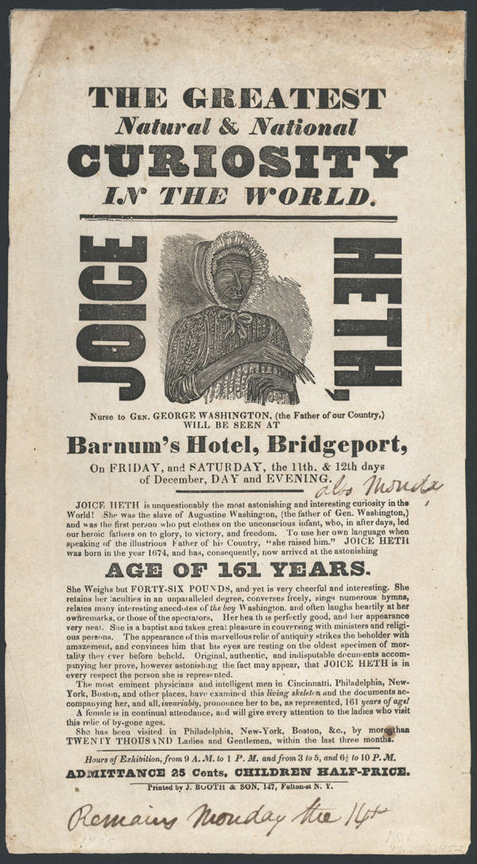
Figure 36. Handbill for the 1835 Joice Heth exhibition. Courtesy of Somers Historical Society and the New York Heritage Digital Collections.
across Europe before coming to the United States. Barnum would draw inspiration from Maelzel and the Turk in more ways than one. When the audience began to shrink, Barnum, or someone in his employ, alerted the Boston newspapers that Joice Heth was not only a hoax in regards to her advanced age but that she was not even a human. Attendance increased immediately. Some were new patrons; others were paying for a repeat visit in order to see how they had been so easily duped.
Barnum remained with Lyman through Albany but left the show entirely to Lyman in late 1835. Barnum hired a nurse to oversee Heth as she had been unable to "get over a cold and after an exhibition in New Haven in late January [1836]. Barnum had her moved, along with her nurse, to his half-brother Philo's house in Bethel to try to recuperate." Joice Heth died on February 19, 1836, but she had one last exhibition. "Over the course of Barnum's promotion of Heth," notes Wilson, "he had courted demand for an autopsy upon her death to answer the question of her age (and humanity) once and for all." Physician and Barnum associate David L. Rogers agreed to perform a public autopsy on Heth on February 25, 1836, and "Rogers, who has undertaken some high-profile jobs of this sort in the past, had no objection to Barnum's selling tickets to those who would like to watch him work." The amphitheater in New York's City Saloon on Broadway could hold fifteen hundred people. Each one paid Barnum fifty cents to attend. Dr. Rogers' autopsy concluded that Heth could be no more than eighty. Richard Locke of the New York Sun called Heth “the most precious hoax of our time” as the Sun provided its readers with a full account of the previous day's procedures, eye-witnessed by Locke himself as a special guest of both Barnum and Rogers. What followed was a microcosm of dueling journalism, which reached its zenith in the summer of 1835. Lyman visited James Gordon Bennet at the New York Herald to inform the paper that it was Heth's autopsy that was the hoax and that she was still alive and on show in Connecticut. Wilson concludes, "Sales of both newspapers undoubtedly benefited from the dispute, as the public continued to wonder where the truth rested." For James Gordon Bennett, the truth had not yet been arrived at. He crossed paths with Lyman again in September 1836 and, while accosting Lyman for lying about the Heth autopsy, proceeded to take down notes from Lyman's new true story, which laid out that "Barnum has found Heth on a Kentucky plantation, pulled her teeth taught her the George Washington stories and increased her purported aging as he moved from city to city." "Many members of the public," writes Robert Wilson, "embraced this version of the affair, false though it was, which would have repercussions for Barnum throughout his career and even up to the present day."

Barnum Rise on (man)bat Wings
In order to understand the public who visited Barnum's Joice Heth exhibition, sometimes repeatedly, it is essential to understand the cultural context of the mid-1830s. One of the keys to Barnum’s successes stemmed from his knowledge of newspapers, advertising, and public promotion. By the time Barnum brought Joice Heth to New York, New Yorkers knew where to turn for the news of the day. The summer of their arrival saw the city in the grip of the most spectacular hoax in newspaper history. Though the story ran for only six installments, The Sun’s August 1835 account of the “Great Astronomical Discoveries” created a sensation, which was kept up through a continued argument between the Sun and the Herald.
At the beginning of the 1830s, most newspapers were large broadside affairs that cost around six cents an issue and were filled with merchant news such as ship arrivals and the prices of wholesale goods. Benjamin Day began his penny paper, The Sun, in 1833, hoping that the reduced price would be affordable to readers and profitable to himself. Over the next several years, many others would follow Day in marketing news to the growing group of middle-class citizens with a spare penny to drop on a paper. This lucrative enterprise was aided by the advent of steam-powered presses, which reduced the time and labor involved in producing a newspaper.
The hydro-oxygen microscope that Barnum had read about in the Sun actually existed. While Barnum had to pass on the opportunity to invest in it at Scudder's American Museum, it would inspire another money-making scheme. Richard Locke, the editor of The Sun, wrote the advertisement for the microscope that Barnum read when he arrived with his family in 1833. The two would meet in person and talk at length at the 1836 autopsy of Joice Heth and the days after. In the intervening years, Barnum would take to the road with Joice Heth, and Locke would pen one of the earliest science fiction stories the world had read.
On August 21, 1835, the Sun advertised "Celestial Discoveries" with more details to be printed in the coming installments. "Science," according to Matthew Goodman, was Locke's "true intellectual love, even more than literature or politics, and astronomy in particular had long held a special interest for him." Locke pulled the details for his moon series from a variety of places, including his personal copies of the Edinburgh New Philosophical Journal, which in its premier 1826 issue featured “The Moon and its Inhabitants.” He also used reports from the astronomer John Herschel’s observatory in South Africa, and a report on the invention of the hydro-oxygen microscope—an operational version of which “was one of the featured attractions at Scudder’s American Museum on Broadway.” Such an attraction would have likely been familiar to those living within the circulation distance of The Sun, either because they had visited Scudder's museum or had read about the exhibition there. This microscope served as the crux of a tale that would eventually take the city by storm. By pointing to an existing material object, Locke was giving the readers a solid foundation on which to build his fanciful story; in this case, it was a case of art imitating life. It’s just that this life happened to be on the moon.
The story began in earnest on August 25, 1835, with Locke writing from the accounts of "a scientific gentleman," one fictional, “Dr. Andrew Grant—a character of Richard Locke's own creation—who served as amanuensis to Sir John Herschel at his observatory at the Cape of Good Hope." The first installment detailed the instrument's creation, which allowed one to observe the moon's inhabitants. Herschel had combined the telescope with the hydro-oxygen microscope into a contrivance where the objects seen through the telescope were then enlarged and projected by the microscope in the same manner in which small objects were lit and rendered large at the museum, which many of the Sun's readers would have no doubt seen for themselves. The reports featured lunar poppies, forests, animals, and humanoid man-bat inhabitants. Some of the installments included "engravings of lunar animals and other objects” produced by Herbert Home, Esq. The inclusion of lithographs to accompany news stories was unprecedented. Goodman notes that "immediately the Sun began receiving requests for those engravings from readers, ideally engravings produced in lithograph form so they might display them at home, alongside their looking glasses and mourning pictures...[and] just twenty-four hours after the first appearance of the man-bats—the Sun was able to offer, for twenty-five cents, a lithography entitled Lunar Animals and other Objects, Discovered by Sir John Herschel in His Observatory at the Cape of Good Hope and Copied from Sketches in the Edinburgh Journal of Science.”
Perhaps Edgar Allan Poe described the Moon Hoax best in his essay on Richard Locke: "As these discoveries were gradually spread before the public, the astonishment of that public grew out of all bounds." Those bounds were enormous and had a far-reaching effect. Matthew Goodman states, "The Sun’s total circulation...had risen to 19,360, with 17,440 of those papers sold in New York and the remainder in Brooklyn and surrounding cities. It was, as [Benjamin] Day surely knew, a cataclysmic number, one that must have sent shockwaves through the city’s newspaper districts, where none of the Sun’s six-penny competitors had a circulation of more than a few thousand. The readership numbers being generated by the Sun had never before been seen in New York or anywhere else. Even the mighty Times of London, Great Britain's paper of record…could claim a daily circulation no greater than 17,000." This readership and demand for the story swelled to include numerous other city newspapers that began reprinting Locke's story, some citing the Sun, others citing Locke’s semi-fictional Edinburgh Journal of Science.
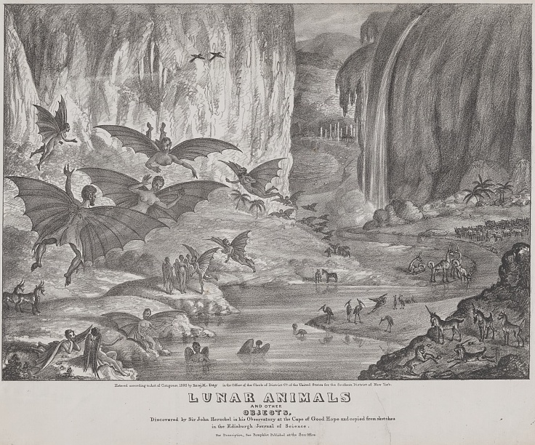
Figure 37. Lithograph,1835. Lunar animals and other objects Discovered by Sir John Herschel in his observatory at the Cape of Good Hope and copied from sketches in the Edinburgh Journal of Science Courtesy the Library of Congress.

This lunar frenzy was the cultural environment in which P.T. Barnum began to promote Joice Heth. The newspapers were circulating at an all-time high, due to a fictional account peppered with enough facts and first-hand experience to be plausible, if not believable. Newspaper editors hurled accusations back and forth at hoaxers and humbugs, and the journalists who had sparred over the Joice Heth autopsy—Richard Locke and James Bennett—were back again. All of this led to a perfect storm for Barnum, who, as Robert Wilson points out, was more or less indebted, if not indentured, to the press. All of the Sun's readers, some of whom were following Bennett's Herald, were aware of this young twenty-four-year-old showman. In his 1855 autobiography, Barnum concludes his chapter on Heth with a revealing glimpse into his relationship with the press: "…social controversy served my purpose as 'a showman' by keeping my name before the public." Barnum would certainly recall the phenomenal impact of the lunar man-bat, seven years later, when he purchased and displayed his Fiji Mermaid.

Barnum on the Road: 1836-1840
The years following the Joice Heth tour were tumultuous ones for Barnum. For the next five years, he was an on-again, off-again traveling showman. "During this period," Wilson notes, Barnum "would sometimes be away from home for a year or more, and each time he returned, he would say that his life on the road was over, that he wished to stay at home with his family. Nevertheless, then off he would go again." While he was off, Barnum began promoting a traveling juggler named Signor Antonio, whom he rechristened "Vivalla," to make the act more exotic. Barnum met Vivalla in Albany while exhibiting Heth. The plate-spinning Vivalla was a hit until a rival juggler named Roberts in Philadelphia led the heckling of the show. Barnum seized the opportunity to have the two perform a type of jugglers' duel in a contest to prove who was best. The contests were orchestrated shams, for Barnum had hired Roberts for the engagements. This episode reveals Barnum's growing confidence in his own style of showmanship. "These details," wrote Barnum in 1855, "may possess little interest to the general reader. They, however, serve to show (though it may be revealing some of the 'tricks of the trade') how such matters are frequently managed in theatres and other places of amusement...The entertainment of the time may be an offset to the ‘humbug’ of the transaction...for the public appears disposed to be amused even when they are conscious of being deceived.”
Barnum subsequently teamed up with a small traveling circus owned by Aaron Turner. The Turner circus, which was based in Danbury, Connecticut consisted of his two trick-riding sons and "a clown who did magic tricks." Barnum's contribution was Signor Vivalla. The troupe toured the South, including Alabama, Kentucky, and Tennessee, until May 1837 when they disbanded, and Barnum returned to "'home sweet home,' to spend a few weeks with my dear family." That same month, New York banks stopped redeeming commercial paper money at full face value. It was the beginning of the Panic of 1837, which led to a recession that eventually impacted the entire United States. New England bore the early brunt of the panic, so when Barnum hit the road again with "Barnum's Grand Scientific and Musical Theater," he went as far west as Cincinnati, Ohio, and as far south as New Orleans, with stops in Nashville, Tuscaloosa, and Vicksburg, as well as intermediate stops. ”
The troupe did remarkably well. Thus, by the time they reached Vicksburg, Barnum was able to buy the steamboat Ceres for $6000. He then went down-river, stopping at various places to put on shows. In his 1855 autobiography, Barnum regales the reader with tales of a shooting, of being run out of town in Francisville, Louisiana, and of a wedding that took place aboard the Ceres. Barnum reached New Orleans on March 19, 1838, where they performed for a week. Barnum's Grand Scientific and Musical Theatre disbanded in Opelousas, Louisiana, and Barnum “started for home, arriving in New-York, June 4, 1838." Barnum returned to New England "thoroughly disgusted with the life of an itinerant showman." He records in his autobiography, "though I felt that I could succeed in that line, I always regarded it, not as an end, but as a means to something better in due time." In the summer of 1838, Barnum aimed to settle down.
There was a short respite in travel as Barnum attempted to settle down in a more stable business. He advertised for a partner in a "permanent, respectable business." The replies ranged from humbugs to outright frauds. Of the ninety-three respondents, Barnum chose, on the recommendation of a city alderman, a German named Proler. Their Bowery Street factory produced an "unlikely assortment of products, from paste blacking and Cologne water to bear's grease." Barnum lasted six months in this business before selling his share to his partner on credit. Proler promptly left New York for Europe and left "Barnum with nothing but his unpaid note and the recipes for the products."
Still unwilling to live the traveling life, Barnum rented a stage space in Vauxhall Gardens "at the top of the Bowery in Astor Place" and started a series of variety shows that were "inexpensive to produce and featured a changing mix of performers who were hired only by the night." With the city still feeling the effects of the Panic, Barnum hoped the cheaper attractions could help the audience "beat the bad times" and keep him solvent. His star attraction was a young boy named John Diamond, who, in blackface,"' became justly celebrated as the best negro-dancer and representative of Ethiopian 'break-downs' in the land." “Such was the racism of the day," writes Wilson, "'that 'Negro-dancing' was all the rage among white audiences, but only if it was not performed by an actual black person." So prominent was this practice that, when Barnum had to find a suitable replacement for Master Diamond for a night's performance, he had to black-face the black dancer he had found in the Five Points. Barnum knew that the replacement "was a genuine negro, and not a counterfeit one, and [that] there was not an audience in American that would not have resented, in a very energetic fashion, the insult of being asked to look at the dancing of a real negro." With his black dancer suitably blackened and with a wooly wig, Barnum's "Vauxhall audience, assuming that the blackface disguised a whiteface, was roundly satisfied with the performance."
”Barnum scraped by with his Vauxhall variety shows for a few months, but even he could not pull the city out of the post-panic recession and relinquished the establishment in August." He knew, or at least thought he knew, that he could make money on the road, but he did not want to do it. His second daughter, Helen, was born in April 1840, and now he would leave Charity with two children. "No one but myself," he wrote, "can know how earnestly I struggled against the thought of resuming the life of an itinerant showman, but I had a dependent family, my funds were low, and as nothing better appeared, I determined once more to endure the privations, vexations, and uncertainties of a tour in the West and South."
Almost immediately after ending his show at the Bowery, in 1840, Barnum began another tour that included Master Diamond, Mr. C.D. Jenkins, singer and "delineator of Yankee and other eccentric characters," and John Hallett, Barnum's brother-in-law, who served as his agent and advertiser. They traveled through Buffalo, Toronto, Detroit, Chicago, Ottawa, Springfield, St. Louis, and other places for seven months. It is almost a certainty, the same certainty that Edgar Allan Poe must have visited Peale's Baltimore museum, that Barnum would have called on Dr. Albert Koch’s St. Louis Museum in 1840. Though there is no written record of such a visit, the striking similarities between Barnum's future American Museum and Koch's St. Louis Museum reveal either direct influence or the co-evolution of ideas.
Barnum arrived in New Orleans on January 2, 1841. He had $100 in his coffers, which he claimed was the same amount that he had started with. He was nearly evicted from his boardinghouse before payments from the shows began to change the tide, with a total of more than $1000 coming in over the course of a few nights, the last $479 being "profits of a grand dancing match, very much on the plan of the match in Philadelphia between Vivalla and Roberts." They exhibited in Vicksburg and Jackson without much success, but returned to New Orleans and then Mobile, where they "succeeded admirably." During this last leg of the tour, Barnum's star, Master Diamond, left the troupe after "extorting large sums of money" from his promoter. Finally, on March 12, Barnum "turned his face homeward," and by way of the Mississippi and the Ohio Rivers, arrived in New York on April 28, 1841. He found his family well and resolved to never return to the life of an itinerant showman.

The American Museum
Being resolute and being successful are two vastly different things. What Barnum began in earnest in the late Spring of 1841 would soon lead to his immeasurable success. However, it did not come overnight. At first, Barnum attempted to sell Sears Pictorial Illustrations of the Bible, contracting 500 copies for $500. "I advertised largely," he wrote, "appointed agents and sub-agents and managed in the course of six months to sell thousands of books, and at the same time to place a sufficient number in the hands of irresponsible agents to use up all my profits and all my capital." He opened another show lease at Vauxhall Halls on June 14, 1841, but noted that managing a show at the "Vauxhall saloon" might have been compromising to his "dignity as a 'Bible-Man'.” Thus he had his brother-in-law John Hallett manage the lease, under Barnum's direction, of course. The 1841 season ended on September 25, 1841, and they "cleared about two hundred dollars above expenses." He wrote advertisements for the Bowery Amphitheatre for $4 a week and articles for the Sunday press. The latter appeared in the New York Atlas under the title The Adventures of an Adventurer, Being Some Passages in the Life of Barnaby Diddledum. Robert Wilson points out that “the first four letters and final two letters of his [Barnum’s] antihero’s name suggest that the sketches were autobiographical, but the name was also meant to be comical and uncomplimentary.
Wilson’s analysis of Barnum’s novella asserts that the adventures “are the same ones Barnum himself had on his travels and are based on the journal that he would consult for his autobiography.” Diddledum is a “hard-bitten, cynical fellow who would do anything for a buck—an approximation of what his reputation has become today.” Diddledum is also the culprit in Lyman’s version of the Joice Heth autopsy that he told James Gordon Bennet. He was, as Barnum labeled him, "the King of Humbugs." Barnum was the prince to Diddledum's king. Barnum would put on events and exhibitions to "arouse public curiosity," whereas Diddledum's "Humbugs'' were "bald-face frauds[s]." The stories, mentioned in his autobiography as a way of "keeping the pot boiling at home" are "an odd effort, clearly true in some places and fictional in others, an attempt, perhaps, to expel the demons of actions he regretted and to remind himself of what he must never become." By the fall of 1841, Barnum was at a low point in his career.
Through his work at the Bowery Amphitheatre, Barnum learned that Scudder's American Museum (including the hydro-oxygen microscope) was now up for sale. Located across Broadway from St. Paul's Church, the museum initially opened in 1791 "in a museum room in City Hall created by the New York Tammany Society 'to protect and preserve whatever related to our county in art of nature.'" Wilson surmises this early installment's low point came early in the Tammany Museum's history "when, in a grotesque display of republican solidarity during the Reign of Terror in France, it exhibited a guillotine complete with a beheaded wax-figure counterrevolutionary."

Funding and Filling a Museum in New York
John Scudder became the manager of the Tammany Museum in 1802 and owned it outright by 1810. In the eighteen years that Scudder, an amateur taxidermist, managed the museum, until his death in 1820, the collections focused on natural history specimens. Scudder renamed the collection the New American Museum and rented space in a City Hall park for “the cost of one peppercorn in annual rent, an arrangement that lasted for nearly ten years.” After his death, neighbors complained because of the noise associated with the museum, which had begun to rely upon “vaudeville shows of magicians, freaks, ventriloquists, and tame Indians.” John Scudder, Jr. operated the museum intermittently for a board of directors after his father’s death, briefly making the museum profitable by “forsaking any remaining educational value it had.” The younger Scudder had, after all, attempted to open a competing entertainment venue called Scudder’s New York Spectaculum on Chatham Street, in an unsuccessful attempt to “draw away the American Museum’s customers.”
The younger Scudder was not the only competition. In the mid-1820s, Rubens Peale moved to a building on Broadway across from City Hall and opened Peale's New York Museum. They would remain in constant competition through the New York fires of 1835 until the Panic of 1837 bankrupted Peale. While Peale's collection went to his speculators in the New York Museum company "more interested in selling stock in it than in improving its displays," the American Museum remained solvent and, more importantly, extant. John Scudder, Jr. lost his last bit of show business following a drunken brawl. Scudder’s sisters wanted to opt out of the responsibility of what was once "the largest [collection] in the world." In 1840, the youngest Scudder daughter was now an adult, and it was "time to terminate all testamentary arrangements." In July 1841, the City Surrogate appointed John Heath to settle the Scudder estate. It was with Heath whom Barnum contracted with that November. By 2:00 p.m. on December 27, 1841, P.T. Barnum became the owner (on credit) of the American Museum on Broadway, in New York City.
By the time Barnum discovered that Scudder's American Museum was for sale, he and his family were living hand to mouth. The museum had been valued at $25,000 in 1831, and Barnum calculated that Scudder himself may have put twice that much into the endeavor. In 1841, the asking price was $15,000, still far above anything Barnum could scrape together. At this point, Barnum had resolved to "concentrate [his] energies upon providing for the future,” and "was seriously determined to make the purchase, if possible." That possibility only existed if Barnum could find a financial backer for the museum. He reached out to Francis L. Olmsted, who owned the building that housed the collection. Through letters and meetings, Barnum convinced Olmsted to purchase Scudder's entire collection and then sell the building and contents to Barnum on credit. Olmsted agreed, but only if Barnum could present collateral in the form of unencumbered real estate. Barnum's five-acre Ivy Island in Connecticut, though worthless, was indeed unencumbered and free of any lien, and Grandfather Phineas' practical joke on young Taylor Barnum proved to be his greatest inheritance after all, for Olmsted took the island as security against the museum and its contents.
With the payment secure, Barnum began negotiations with John Heath for the museum. He first offered $10,000 for the collection but was turned down. After a week of haggling, meeting with Heath again, and talking with the Scudder daughters, Barnum secured the lot for $12,000 and was to take possession on November 15, 1841. On the morning they were to sign the agreement, Heath regretfully informed Barnum that a "rival museum (the Peale's Museum Company) swooped in and offered the original price, putting up $1,000 in earnest money." Barnum was "thunderstruck" at the news and began to inform himself "as to the character of this Peale's Museum Company." Peale's Museum Company, actually called the New-York Museum Company had purchased Rubens Peale’s New York Museum. The company consisted of a group of “speculators, headed by an unsuccessful ex-president of a bank, who had bought Peale's collection for a few thousand dollars [and] were now to join the American Museum with it, issue and sell stock to the amount of $50,000, pocket $30,000 profits, and permit the stockholders to look out for themselves."
Aware of the power of the press, Barnum again took to the newspapers. He approached Moses Yale Beach at the Sun, as well as his "good friends West, Herrick, and Ropes of the Atlas, and others" in order to "blow the [museum] speculation sky high." Through these outlets, Barnum "wrote a large number of squibs, cautioning the public against buying the Museum stock, ridiculed the idea of a board of broken-down bank directors engaging in the exhibition of stuff money and gander skins..." The warnings worked, or at least seemed to work, which was just as good for Barnum. Around the first of December, the Museum Company contacted Barnum with an offer to manage the museum under their ownership in an effort to buy his silence in the press for a salary of $3,000 a year. "They thought they had caught me securely," he wrote. However, after seeing how the "newspaper medicine was doing in its office," Barnum "knew he had caught them.” After the meeting with the Museum Company, Barnum called on Heath again to agree to a backup set of terms for the museum. Should the company not pay the remaining balance by December 26, 1841, would Heath sell the museum collection for the agreed terms settled the month before? Heath answered in the affirmative but was confident the company would not choose to forfeit the $ 1,000 earnest money. They wrote the new deal securing Olmsted's continued agreement, and the parties waited. Barnum was sure the company did not have the capital on hand and, through his use of the press, could not raise the funds before the allotted time. The deal reached with Heath was kept secret to lull the competition into thinking they had won. When the prescribed date arrived to conclude their business with Heath, they neither produced the remaining balance, nor did they even appear, or “send the slightest apology for not doing so!" Barnum signed a contract the following morning, and his first order of business was to dispatch the below note to the Museum Company:

American Museum, New-York, December 27, 1841.
To the President and Directors of the New-York Museum:
Gentlemen: –It gives me great pleasure to inform you that you are placed upon the Free List of this establishment until further notice.
P.T. Barnum, Proprietor.

Barnum had won the day and the museum. However, there was much work to be done to make the museum profitable, so he could pay off his debt to Olmsted. During the summer of 1842, Olmsted visited Barnum, who, when asked about his corn beef sandwich lunch, replied: "I have not eaten a warm dinner since I bought the Museum, except on the Sabbath, and I intend never to eat another on a week-day until I am out of debt." Barnum described Olmsted as "clapping him familiarly on the shoulder," saying, "Ah! You are safe and will pay for the Museum before the year is out!" In less than a year from their conversation, Barnum owned the property outright, having paid for it from the profits of the museum. Barnum had made his museum profitable, and he could run it however he wished, without board oversight or stockholders' interests.
Barnum’s unfettered freedom to execute his vision for the museum was a luxury that none of his competitors had. Barnum's American Museum may also be the last museum of its size to have been governed in this way. Charles Willson Peale had similar freedom when he began displaying natural history specimens with his artwork in Philadelphia over fifty years prior. However, it did not take long before the Philadelphia Museum Company, of which Nathan Dunn was a board member, controlled the stewardship of the material from Peale's Philadelphia Museum and its direction and display of that material. Barnum was free to experiment, market, advertise, and promote as he saw fit. His background in business, lotteries, newspapers, and traveling shows made him the perfect steward for the vast, eclectic collections housed under one roof. From taxidermy, mummies, and unclassified exotica to living curiosities, live performances, and hoaxes, Barnum was not just in the business of displaying exhibits. He was selling an experience.
Figure 38. Barnum's American Museum. 1855. New York, looking east, south and west from the steeple of St. Paul’s Church, 1855. Drawn by John William Hill (1812-1879) and engraved by Henry Papprill in New York. Entered according to Act of Congress in the year 1855. (https://www.geographicguide.com/united-states/nyc/antique/19th-century/broadway-ny.htm)

A Museum Revolution: Barnum’s Museum for All
The establishment of Scudder's American Museum neatly parallels the rise of Peale's Museum, discussed in the first chapter. Their differences illustrate the regional and personal differences that shaped the early collections of things for display in America. Peale's was a family enterprise meant to educate the citizens of the Republic. The Tammany Society likewise wished to preserve art and nature as it related to the country. While Peale's Philadelphia Museum was longer lasting, as it passed down through the family before being handed over to a board of directors, Scudder's museum changed hands rapidly through the early 19th century and began with a board of directors. Ultimately, both succumbed to the need to make money to stay afloat. The most significant difference in the 1840s is that New York had a faster-growing and more diverse audience than Peale had seen in Philadelphia. Another difference is that while Peale's collection was visited by invitation or subscription, museums like Koch's in St. Louis and Scudder's in New York were ticketed, and the tickets were cheap.
That is not to say that Barnum's American Museum was devoid of educational value. Viewed from today's pedestal of what counts as education and what counts as entertainment, the American Museum was chiefly out to entertain. Dennett claims that " Barnum conceived his extraordinary museum for the purpose of entertainment—not education—and with profit as his central concern." She and many others point to Barnum's confession in his autobiography pertaining to the merits of the Museum for "rapidly making money." It seems Barnum was only being honest in his autobiographies when he was admitting his faults. There are, of course, other ways to look at Barnum's collections as a public good. Borrowing today's term, Barnum's American Museum would undoubtedly be classified as "edutainment." In this case, the spectacle adds to and does not detract from the rational. Thus, historian Katherine Pandora argues "That miscellaneity could be something more than a matter of (lowbrow) style and could, in fact, represent a legitimate way of knowing nature seemed unlikely according to the norms set by those who produced expert knowledge. When placed within the context of the 'heteroglot exuberance' of antebellum norms of knowledge exchange, however, the ubiquity of miscellaneity as an aid to encountering the world—particularly for new learners—suggests that it helps add value in enabling thinking." Just as Albert Koch was allowed to produce specimens and not knowledge, Barnum was obliged to be a producer of wonders and spectacles. Regardless of the feelings about Barnum's operation, one thing that even Dennett agrees with is that Barnum's museum "was the prototype—all later museums followed his pattern."
“Barnum's pattern was to fill his five-story museum with as many things as it could possibly hold. His was a department store, of sorts, for the various and sundry examples of natural history or natural curiosities that had been collected under one roof. It was a combination of everything Barnum had done before. The museum was a chimera of menagerie, cabinet of curiosity, circus, and theatre. It was his traveling show without the travel. A location for such shows to perform and a constant source of ‘entertainments...to promote education.’"

Figure 39. Barnum’s American Museum. Interior view of the first Grand Hall of P.T. Barnum's American Museum in New York City. Wood engraving, 19th century. Courtesy of the Granger Historical Picture Archive.
The first order of business for Barnum was a renovation of the museum's exterior, a facelift that would be worthy of the building’s contents. Barnum installed a Drummond light on the roof, added colorful international flags along the edge of the roof to join the giant American flag that was already there, and had enormous oil paintings of animals created to adorn the façade between each of the eighty windows. "He waited to have them installed until all of the oils were completed," Wilson writes, "creating the maximum dramatic effect by hanging them all on a single night. He attributed an immediate hundred-dollar increase in his daily draw to the paintings' impact." The labor paid off, and as Andrea Dennett recounts with Barnum's "business ability, his talent for collecting a dazzling array of attractions, and his 'devotion to...gigantic posters and colored inks,' Barnum was able to pay back Olmsted's loan in fifteen months." Part of that success, argues Wilson, relied upon Charity Barnum's ability to keep their family's yearly expenses below $600. It also did not hurt that the $27,912.62 in receipts Barnum took in the first year at the museum was nearly three times the $10,862 the museum had taken in during its final year as Scudder's.
The success of Barnum's American Museum through the 1840s and 1850s led to a growing collection and a growing audience. In 1843, Barnum had forced Peale's New York Museum out of business and purchased the collection for $7,000. However, he continued to operate it under Peale's name as a faux competitor before finally absorbing the collection entirely. Barnum's successes came more from promoting and advertising the things in his museum than from the things themselves. In contrast to Peale’s museum, Barnum's was democratic, open to anyone with a twenty-five-cent ticket, at least if they were white. An ad for Barnum's American Museum from the New York Tribune, dated February 27, 1849, announced a special date and time for admission to the museum to "Persons of Color." "In order to afford respectable colored persons an opportunity to witness the extraordinary attractions at present exhibited at the Museum, the Management has determined to admit this class of people on Thursday morning next, March 1, from 8 am till 1 pm Special perormancs [sic] in the Lecture room at 11 o’clock.” For women, Barnum created the matinee. The museum “represented a new concept in chaste entertainment, and it provided women with a safe and easily accessible meeting place for lunch, conversation, and amusement, free of the rowdy or drunken men.” “The American Museum,” Dennett continues, “was both affordable and fashionable, and women of all classes were attracted to the wholesome atmosphere stressed by the pedagogical rhetoric of Barnum’s museum.”
Barnum tempered his pedagogical rhetoric with unique flights of fancy. The popularity of the Moon Hoax in 1835 proved that readers–all potential museum visitors–were interested in the bizarre, unknown, and fantastic. Barnum would provide ample opportunities to enjoy these. His first commercial and marketing success as proprietor of the American Museum was something as unbelievable as lunar manbats. However, this time, Barnum presented a preserved specimen instead of just images and reports. In June 1842, with some help from Moses Kimball, owner of the Boston Museum, Barnum procured an article that has become the lasting symbol of shameless hoaxes and fakes. The diminutive three-foot-long specimen was of a "mermaid, from a distant part of the ocean, embalmed and miraculously preserved." It has become forever tied to Barnum's name. The "FeJee Mermaid" was, of course, a ruse, a fake with a dubious, if believable, back story. Barnum set to work in the papers, advertising the mermaid and the coming expert Dr. J. Griffin's lectures, first at the Concert Hall on Broadway, not Barnum's museum, so the artifact would be believed to be a legitimate discovery and not a plot. The shows were a success, and the relationship between Barnum and Kimball paid off dividends long after the mermaid stopped selling tickets.
Barnum's first living "star,” one of his many freaks, was the diminutive General Tom Thumb. Thumb, whose real name was Charley Stratton, was from Bridgeport, Connecticut, and at the time he and Barnum met, was only five years old. The great potential shown by the child led Barnum to take up travel once more. Barnum coached the child in skits and revelry, including drinking wine and smoking cigars, and announced his age at the first shows as eleven. Barnum reasoned that an audience would fail to believe the General more than a child if they knew his actual age, and thus Stratton became another Barnum humbug. In 1844, Barnum was in England exhibiting Tom Thumb to a receptive English audience. During this tour, Barnum met with artist-showman George Catlin and arranged to show some living Native Americans—an event that soured Catlin on exhibitions and on Barnum. Unlike Catlin, Barnum found his sojourns to Europe immensely profitable, which provided him funds with which to promote his museum. It is hard to separate Barnum's traveling exhibitions from his stationary ones in terms of showmanship, but focusing on the physicality of place and the stationary aspect of the building of the American museum provides an early comparison with museums that came later. The idea worked partly because the money made on traveling shows sustained Barnum's "home base" of the American Museum, and his American museum provided the fame and name recognition for his traveling shows. This was not unlike prominent modern museums developing and renting out small traveling exhibits to smaller, regional museums. It was a win-win situation.

Out in a Blaze
In 1850, Barnum and Moses Kimball purchased the remaining collection of the Peale's dynastic museum collections. They split the Philadelphia Museum's contents between New York and Boston. Barnum's immensely profitable U.S. tour of the "Swedish Nightingale," Jenny Lind, netted Barnum $500,000 between 1850 and 1852. Five years later, Barnum sold the contents of his museum to John J. Greenwald, his assistant manager, and his partner Henry D. Butler "for $24,000 plus an annual rental fee of $29,000." Barnum was planning for an early retirement. However, a series of ruinous investments led him back to the showman's life, this time as an author and lecturer. He published the first edition of his autobiography in 1855, and went on a series of speaking tours detailing the art of making money, and "after a highly successful European tour of Tom Thumb, he was back on his feet again." Greenwald and Butler were no Barnum. "It was no coincidence," wrote Dennett, "that the American Museum did not prosper during Barnum's absence." In March 1860, Barnum bought his American Museum back.
On July 13, 1865, disaster struck the American Museum. A fire began in the engine room, and the entire building burned to the ground. No person was killed, but many of Barnum's animals perished in the blaze. Visitors were able to escape, and with some dramatic moments, so were the performers. What animals did escape "created havoc in the nearby streets" as they fled the conflagration. In a letter to his friend Bayard Taylor, Barnum outlined a new museum, a free museum: “Barnum’s Free National (something)." Even Barnum did not have the right word for it. He knew it would have to be subsidized, and to that end, next to it, or nearby, he would have to have a paying museum, in the old Barnum style, "with its giants, dwarfs, fat women, [etc..]" During Barnum’s lifetime, the very conception of what a museum is had changed. The commercial and the philanthropic could not exist simultaneously in the same space. Senator Benjamin Tappan was already speaking of the “degraded” nature of the word “museum.” In fact, in 1853, the New York Times stated that “We have no museums.” In other words, Barnum’s American Museum was no museum at all. Would they have made the same declaration had Peale’s or Scudder’s museums survived?
Barnum’s Free National (something) never came to fruition. He purchased The Great Chinese Museum and opened Barnum's New Museum. He was still on Broadway and, in 1866, partnered with a lion trainer named Isaac van Amburgh to form the Barnum and Van Amburgh Museum and Menagerie. It was more menagerie than museum. The animals were the chief draw, and Barnum was not promoting with his old vigor. On March 3, 1868, another fire destroyed Barnum and Amburgh's museum. This time, Barnum was out of the museum business for good. Though he came up with a grand plan for a new museum in the 1880s, nothing would come of it. In Struggles and Triumphs, he spared a thought for the business but also for the performers. Again, no humans perished, but "The loss was a large one, and the complete frustration of our plans for the future was a serious consideration. But worse than all were the sufferings of the poor wild animals which were burned to death in their cages.”

Figure 40. Barnum’s New Museum, 1865. View of P.T. Barnum's American Museum, on Broadway between Spring and Prince Streets, New York City. Wood engraving, 1865. Courtesy Granger Historical Picture Archive.
Barnum’s Ghost
After the second museum fire, Barnum left the museum business in all but name. His American Museum had been "the people's favorite," and while no one would be able to match his success, many scrambled to "partner" with Barnum just for the draw of his name. George Wood was one such friend, and by the end of summer 1868, Barnum was on hand to provide the opening remarks for Wood's Museum and Metropolitan Theatre, which was located on the corner of Broadway and Thirtieth Street and housed the surviving pieces of Barnum's New Museum, among other things. His job as promoter and figurehead allowed Barnum the freedom of retirement while still being able to dip his hand in the showman's life. He would eventually go on to partner with a series of traveling circus owners, taking the menagerie and freak shows that were such a draw in New York back across the United States, this time by rail. The traveling shows that Barnum had once sought to avoid were back in vogue, and with improved transportation technology. Barnum was 70 years old when he began his latest career, and with greater rail transportation across the United States, a whole new audience awaited. Then, in 1888, Barnum teamed up again with James Bailey, and they toured the world.
During Barnum's eighty-one years, he gained and lost several fortunes and made a name for himself that has lasted through the ages, becoming deeply rooted in the American psyche for both Yankee ingenuity and humbuggery. Barnum's American Museum stands as a prominent backdrop for many changes in American culture. It either highlighted those changes, such as the growing leisure and middle-class hungry for entertainment, diversions, and social interactions, or, in the case of the professionalization of museums, provided the impetus for those changes. Barnum knew that for a museum the size and scope of his American Museum, it would have to be externally subsidized and maintained, likely by the nation's government. If it were genuinely going to be democratic, it would have to maintain free admission for anyone. Even as his museum career came to an end, Barnum, with his fingers squarely on the pulse of the country's cultural landscape, had described what would become the Smithsonian Institution, America's National museum.
If there was any one thing the founders of the Smithsonian Institution could agree on, while fighting things out in Congress, is that whatever the Smithsonian would be, it would not be Barnumesque. As American museums slipped out of the hands of individuals and family lineages, they began to be shaped by the professional standards. This reflected the change going on within science, which was moving from the realm of gentleman adventurers and amateur collectors toward trained, degreed, credentialed collectors and curators. The new museums would employ their own networks of trained collectors. What our new national museum would end up looking like would take time, money, and Congress to ascertain.

From National Museum to Nation’s Attic:
The Smithsonian Institution and the Return to Order

The development of the Smithsonian differs from the institutions examined in previous chapters in that it was not the product of a single individual. Because James Smithson left a legacy but no concrete instructions, the planning of the museum was left to others. This is why the Smithsonian Institution is not the Smithson Museum in the style of Peale's, Koch's, Scudder's, or Barnum's.
The Smithsonian Institution's official history begins on August 10, 1846 when President James Polk signed the Act of Congress establishing a museum. However, the real origin of the Smithsonian was the Columbian Institute for the Promotion of Arts and Sciences. Founded on June 28, 1816, by Dr. Edward Cutbush and Thomas Law, the Columbian Institute was successful in establishing what became the botanical gardens in 1821 along with a small mineral cabinet "which soon developed into a general though small museum, containing specimens of zoology, botany, ethnology, archaeology, fossils, etc." Besides the botanical garden and the museum, the Institute wanted to study the sciences of botany, farming, mining, and cartography. There were a few meetings, often devoted to astronomy or mathematics, but the only projects to get off the ground were the botanical garden and the natural history museum. This museum housed quite a lot of artifacts, some of which would end up in the Smithsonian. However, it was not the national museum that the members wanted.
The earliest members of the Columbian Institution included “about ninety representative men of Washington, among them members of Congress, scientific men, clergymen, and prominent citizens, and an equal number of corresponding members, including all the leading men in the country. Among its officers were ex-President Adams, the Secretary of War (Poinsett), Secretary of the Navy (James K. Paulding), the Chief of Engineers of the Army (Alexander Macomb), and other prominent officials. It seemed quite a few important people had their own ideas about what useful arts and science would need promoting.”
From the onset, Joel Poinsett (1779-1851) was the "controlling mind in this movement" to establish a National Museum. He served as General Director of the organization until 1845, when he declined the candidacy, and "from this period the decline in the prosperity of the society was marked." Poinsett was nearly 62 when he delivered the inaugural address of the National Institute on January 4, 1841. Poinsett's career spanned the globe. His earliest journeys through Europe began in 1800. When his father and sister both died in 1803, he was left with a sizable inheritance of his own. He traveled to Russia in 1806, and soon after his return, President James Madison appointed him Consul in General. In this role, he served as a special agent in Chile and Argentina. He toured the American West until 1816 and was elected to Congress in 1820. He then served as the First Minister to Mexico from 1825-1830 and Secretary of War from 1837-1841. His travels provided him with the "opportunities of observing the institutions of Europe, Asia, and South America. His culture was broad and sympathetic, and he was better fitted, perhaps, than any of the public men of his time to appreciate the necessity of organizing ...institutions in accordance with a liberal and comprehensive plan." Within a month of Poinsett's delivery of "Objects and Aims of the National Institution for the Promotion of Science," "Senators Linn from Missouri and Preston South Carolina, both members of the National Institution, proposed new bills for the organization of the Smithsonian Institution, at the same time reporting a bill to incorporate the National Institution for the Promotion of Science."
These bills put the management of the Smithsonian Institution entirely under the purview of the National Institution. They called for "joint occupancy of the two institutions of buildings, and finally, it was required that all collections of works of art and of natural history owned by the United States, not otherwise assigned (of all works of art, and all books relating thereto, and all collections and curiosities belonged to the United States in the possession of any of the Executive Departments and not necessarily connected with the duties thereof) shall be deposited in said buildings (or shall be transferred to said institution, to be there preserved and arranged).” The earliest stirrings of a National Museum had begun.
The money for the Smithsonian came from the legacy of a rich British scientist—James Smithson. In 1826, this septuagenarian Englishman, of inherited wealth, wrote his will, leaving his estate to his nephew. An interesting stipulation to the bequest was that should the nephew die without heirs, the entire estate would be bequeathed "to the United States of America, to found at Washington, under the name of the Smithsonian Institution, an Establishment for the increase & diffusion of knowledge among men." Smithson had never even visited the United States; why would he leave his estate to a country that had been a colony when he was born? The illegitimate son of Hugh Percy, the 1st Duke of Northumberland, and Elizabeth Keate Macie, "a great grandniece of Charles, Duke of Somerset," Smithson was keenly aware of where he should have been placed among the English citizenry and, more so, how he was kept from those rights and privileges. In his history of the first fifty years of the Smithsonian, Samuel Pierpont Langley, the third Secretary of the museum, recounted one of Smithson's notes: "' The best blood of England flows in my veins on my father's side I am a Northumberland, on my mother's I am related to Kings, but this avails me not. My name shall live in the memory of man when the titles of the Northumberlands and the Percys are extinct and forgotten.” “It has been wondered,” continued Langley, “that Smithson should have left his fortune for the purpose he did, but not by those who have considered the sentence placed here in italics, where we surely scarcely need to read between the lines to see the genesis of the institution which perpetuates the name he bore, in place of the titled one he was denied.”
Smithson saw a museum as a way to preserve his name, if not his legacy, for centuries to come, but why in the United States and not his home country? Perhaps it was a choice that would deny the country that had denied him titles, of his wealth. Perhaps it was the fact that England already had national museums, and he did not want the Smithsonian to be overshadowed by the British Museum. His decision may have also been influenced by his friends in the Royal Society, who may have wanted him to establish a sort of satellite collection elsewhere in the world. The English botanist Sir Joseph Banks (1743-1820) was an enormous supporter of the internationalism of science. Banks, while President of the Royal Society (1778-1820), had helped arrange a transfer release of Smithson in 1807 while the latter was held as a prisoner of war, first in Tönning and later Hamburg, Germany, during the Napoleonic Wars. Banks was friends with Alexander von Humboldt, who was also a great proponent of science transcending political and geographic conflict. A repository of knowledge (and specimens) on the North American continent would aid such endeavors and open up a continent's worth of natural history.
Smithson died in June 1829 in Genoa, Italy. His nephew acquired his estate but died without heirs in 1835. It would take over three years for the estate to arrive in America. "After much debate," Congress passed a bill which authorized and enabled the president to assert and prosecuted the claim of the United States to the legacy bequeathed by James Smithson." President Andrew Jackson appointed Richard Rush, "a lawyer of high standing, who had been Attorney-General of the United States, Secretary of the Treasury, and a candidate for the office of Vice-President...[and] also Minister to France and to England." The amount due to the U.S. was converted to gold sovereigns "for convenience of transportation," and the £104,960, 8s, 6d. "were packed at the Bank of England in one hundred and five bags, each containing 1000 sovereigns, except one which contained 960 sovereigns, and certain change." The bags were loaded into eleven crates "found to be the equivalent of $508,218.46," a sum equal to $16,494,476.03 in 2023. The gold was reminted and invested, per the Act of July 7, 1838, into the stocks of States, "chiefly in 500 bonds of the state of Arkansas for $1000 each, bearing six percent interest." The goal was to increase the principal of the initial funds while also helping establish and settle the state of Arkansas, which had only recently joined the Union. When Arkansas failed to pay any interest by 1846, Congress, with an unrelenting push from former president and then member of Congress John Quincy Adams, "made good the deficiency from the public funds" while they continued to discern what it was that a national museum needed to be.”
The intervening years were filled with debate on what precisely an institution for the "increase and diffusion of knowledge" should be. Though President Van Buren urged "prompt action" at each Congressional session, the details continued to create delays. Through the urging of many university officials, the Senate believed it should be an educational endeavor. In 1838 alone, "five [suggestions] favored a school corresponding to what would now be called a postgraduate university." Richard Rush, Minister to France and England, and the one appointed by President Andrew Jackson to secure and return with bequest, proposed "a system of scientific correspondence, of lectureships, of general cooperation with the scientific work of government, a liberal system of publication, and collections—geological, zoological, botanical, ethnological, and technological." John Quincy Adams "urged the establishment of a great astronomical observatory, 'equal to any in the world.'" Pleadings and proposals continued; an agricultural school, a school of astronomy, and a meteorological bureau were all considered. As the debates continued, "the interest of the public became much greater; earnest discussions were printed in the newspapers and reviews; letters urging speedy action were written to Congress by all persons in all parts of the country."
At this time, gentlemanly science was slowly giving way to a professional science. The change happened more rapidly in some areas than others. The Smithsonian would both follow and influence this trend. By providing specialized spaces for natural history to divide into botany, mammalogy, zoology, and the like, they acted to separate and reclassify the hodge-podge “miscellaneity” of the Barnum-type museum. With Barnum and, to a lesser extent, Peale, you could see everything at once: the familiar beside the exotic, the bizarre and wonderful next to the prosaic. All you needed was the money to buy a ticket or, in the case of Peale's earliest collection, an invitation. The Smithsonian, which was conceived from the beginning as a scientific institution would keep “low-culture” out of its hallowed halls. Barnum's museum had offered plays, acrobats, human curiosities, and animals. Barnum gave his audience things to look at and possibly to think about. In the Smithsonian, all the exhibits would be curated by specialists, in a way that provided the correct answer to the viewer, before asking them to think. Knowledge creation, whether it was factual or not, was not multidirectional, but came from the top down. In this way the Smithsonian harkened back to the old idea of a museum as a reverent temple of elite knowledge. In the Smithsonian, the curation of the exhibits would be granted only to those who were official, credentialed, and initiated, and something would be lost in that process.
A decade would pass between the announcement of Smithson's bequest to the final decision, approved by Congress and signed by the President, which brought the Smithsonian Institution into being in a form that "did not represent the views of any one party, except in some degree that which favored the library and incidentally the museum." Eight of those ten years were caught up in congressional hearings and decisions on what form that Institution would take. President Andrew Jackson sent Rush to claim the inheritance, but President James Polk signed the final bill on August 10, 1846. The plans for the institution passed through four other presidencies and numerous other state questions. The Board of Regents "Was appointed without delay" and held their first meeting on September 7 "in a room in the General Post-Office Building set apart for their use by the President of the United States." In many ways, it was both the Columbian and the National Institute rolled into one with various other responsibilities, though neither had made it to the founding. The National Institute "ceased to be the center of public interest...after nearly five years of activity," but its influence "upon the history of science in the United States, and particularly in educating public opinion and the judgment of Congress to the application of the proper means of disposing of the Smithsonian legacy, cannot well be overestimated. If the Smithsonian Institute had been organized before the National Institute had exerted its influences, it would have been a school, an observatory, or an agricultural experiment station." A similar outcome would have occurred had the Smithsonian been fully organized and established before the United States Exploring Expedition collection started returning to Washington D.C. The sheer volume of materials and the handling of the collections (and of the collectors on board the expedition) had as much a part in shaping the Smithsonian and early American science as anything done in D.C. The amount of physical material returned from the voyage seemed to quantify the daunting ephemeral philosophy of establishing a national museum in three-dimensional space.
A small clause in the planning would enormously influence what kind of museum the Smithsonian would be. Collections brought back from government-sponsored expeditions now became the property of the American Government, and by law, those collections were to be deposited in the National Museum. What would become the National Museum soon had to deal with hundreds of tons of artifacts brought back from The South Pacific and the American West. Some of these expeditions will be discussed later on.
There were eight years of Congressional debate before President Polk, on August 10, 1846, signed the bill that founded the Smithsonian Institution. In 1849, work began on the construction of the original building—a large and impressive red-brick “castle,” that stands on the mall to this day.
Figure 41. The Smithsonian Castle as seen from the north, c 1860. Courtesy of the Smithsonian Archives, Record Unit 95, Box 30, Folder: 8.

National Institute, National Museum, National Attic
By the time the Smithsonian Castle was completed in 1855, the idea of what a museum had changed. When Joseph Henry was appointed as the first secretary of the Smithsonian in 1846, the Patent Office had not yet been completely filled to capacity. Henry, who had been Secretary of the National Institute, believed, like Pickering, that the artifacts were useful in what science could learn from them. They were to be a research-based collection and not a collection for public perusal. He hated the design of the Smithsonian building but was forced to work in it, and he continued to fight for a separation between the Smithsonian Institution and a National Museum. When the initial push to have the Patent Office and old National Institute Collections folded into and under Henry's charge, he refused. "One scan of the catalog," wrote Nina Burleigh, “shows why a serious scientist might be leery of making space in his institution for such a motley collection." A partial list of the collection included "pieces of rock upon which Captain Cook was killed in Hawaii; a Liberian lemon; a 'hair brush neatly made by a blind boy in the Illinois Institute for the Education of the Blind'; Ben Franklin's cane; a double headed snake from Maryland; a massive marble Syrian sarcophagus; and gifts to the United States from the imam of Muscat, including cashmere shawls and a case of attar of roses." These items were more in line with Barnum's American Museum than the Smithsonian Institution.
As late as 1876, in his next to last annual report as Secretary, Joseph Henry was still pushing "the propriety of a separation of the Institution from the National Museum...the functions of the Museum and the Institution are entirely different." The Museum, he thought, should "exhibit the national resources and industry of our country" while the Institution did "not offer the results of its operations to the physical eye, but presents them to the mind..." For Henry, this was not mere semantics, but addressed a violation of the Smithson contract. In the same report, he argued that the Smithson bequest said that the institution was to be separate from the government and not beholden to it for patronage. By making it a national museum, its expenditures would quickly outpace its appropriations. From the outset, Henry believed Museums were for seeing; the Smithsonian was for thinking. This notion split the miscellaneity of Barnum's American Museum, which invited people to see and think. Even Peale’s museum was constructed so that it could inform and educate, sometimes subtly, sometimes subversively, while pleasing the senses.
Ironically, it was Joseph Henry’s interpretation of Smithson’s words that helped “museumize” the Smithsonian. To increase knowledge, Henry and the Smithsonian trained people "for at least twenty expeditions before 1858." In addition to the expeditions mentioned above, Smithsonian representatives traveled to South America, Greenland, Australia, China, and Japan, and more. Assistant Secretary Spencer Baird collected a team of young naturalists who lived and worked at the Smithsonian during the winter and traveled and collected during the summer. The institution also began to attract a lot of young scientists, who, from 1857 to 1866, created a scientific group called the Megatherium Club. The Club was founded by biologist William Stimpson. The members did a lot of close study of various species, describing and classifying them.
In style, the lecture halls and exhibits of the Smithsonian were more like the early Peale Museum than the Barnum museum. "Henry didn't like them," recounts Burleigh, "but the Smithsonian's lectures and museum attracted growing popular support. The museum was more easily understood by recalcitrant congressmen than were the scientific papers." Popular support would prove to be the secret to the success of the Smithsonian Institution. In the face of detractors in the Senate, who still wondered what the institute was for, appropriations continued to come in, and expeditions continued to go out.
Joseph Henry also oversaw one of the greatest tragedies the Smithsonian had yet to face. On January 24, 1865, the Smithsonian burst into flames. Workers repairing areas around the "Picture Gallery," where John Mix Stanley's American Indian paintings were displayed, had installed a heater to keep warm and had inadvertently vented it not through a flue to the outside but to a furring space between the finished wall and the brick façade. The Henry family lived in the Castle and rescued what they could, which was relatively little. Smithson's collections of papers and minerals were all lost—everything except his library, which was located in a different part of the building. Henry, however, "deemed their loss inferior to the twenty years of institutional business and history that had perished in the flames. ‘The most irreparable loss was that of the records, consisting of the official, scientific and miscellaneous correspondence.’” He wrote, “These included thirty-five thousand pages of copies of letters, fifty thousand pages of letters received by the institution, receipts of publications and specimens, records of experiments, and miscellaneous diaries, memorandums, and account books.”
Following the end of the Civil War, Henry oversaw the rebuilding the Castle and its collections. He decided against rebuilding the lecture hall, as he never liked it, and his refusal to allow Frederick Douglas to lecture in the rooms of the Smithsonian because he was black "caused much consternation." The area was redesigned as an exhibit space, which in 1865 was apparently less offensive to Henry than a lecture hall. The post-Civil War period was a boom period for American exploration and Science, especially as it pertained to the American West. Dynasties of Smithsonian-trained scientists explored the ever-expanding country, with expeditions handed down from person to person, like inheritances.
Despite Henry's objections, the Smithsonian Museum would continue to develop as a National Museum. The Smithsonian expeditions' show-and-tell aspect, especially under future expedition leaders, like John Wesley Powell and Ferdinand V. Hayden, became a sure way to secure and even increase government appropriations. However, the question of what the Smithsonian was, and who it was for, was not dead, and would come up again in the late nineteenth century.

The United States Exploring Expedition (1838-1842) Fills the Museum
In 1838, less than two weeks before Smithson's legacy arrived in the United States, an expedition to circumnavigate the globe and explore uncharted territories in the South Pacific weighed anchor. Six ships carrying 346 men "including a team of nine scientists and artists" took part in the United States Exploring Expedition (U.S. Ex. Ex.). The USS Vincennes, Peacock, Relief, Porpoise, Sea Gull, Flying Fish, and Oregon would have all but passed the Mediator, which docked Richard Rush and the eleven crates of Smithson's gold on August 29. The primary purpose of the expedition was hydrographic surveys around ports of call, to produce or update nautical charts for the Navy and for trade. However, there were naturalists as well as cartographers aboard. In addition to stretching its sea legs, the United States was joining the ranks of older countries in oceanic exploration of the world. The second voyage of the HMS Beagle had ended only two years prior, and Charles Darwin had not yet published his famous Voyage of the Beagle.
The impetus for the expedition that became the U.S. Ex. Ex. came in 1818 with the hollow earth theory. Twenty years before the U.S. Ex. Ex. set sail, John Cleves Symmes, Jr., a former Captain in the army during the War of 1812, printed and distributed a circular claiming that "the earth is hollow and habitable within." According to Symmes' version of the Hollow Earth Theory, there were two entrances at the earth's poles which led to the habitable spheres within. Historian Herman Viola argues that this "Holes in the Poles Theory" "was not widely accepted even then" and that it was "New England merchants eager to find new sealing and whaling grounds'' who promoted support for Symmes and encouraged Congress to approve an exploring expedition of the South Seas. From his home in St. Louis, Symmes began lecturing on his theory. "Some prominent men of science," wrote popular American historian Nathaniel Philbrick, "gave Symmes their cautious approval. Dr. Samuel Mitchell, an astronomer in Cincinnati, spoke in support of the theory. A globe patterned on Symme's idea became part of Philadelphia's prestigious Academy of Natural Science collection...[and] John J. Audubon sketched Symmes's portrait in 1820, helping to establish his reputation as the “Newton of the West."
Symmes first petitioned Congress for two ships in 1822. The motion was tabled, and Symmes continued his lecture series to gain support for his expedition. In 1824, Symmes was lecturing in his native Ohio when he "gained the support of an energetic acolyte named Jeremiah N. Reynolds," who had "attended Ohio University before becoming the editor of the Wilmington Spectator.” Though just twenty-four years old, Reynolds' brief newspaper career had generated a network of influential friends who aided Symmes and Reynolds during their joint lecture tours. Reynolds was "an articulate and charismatic speaker," whereas Symmes was not. Their lectures sold out halls "all across the United States," but when Reynolds began developing his own version of Symmes' theory, the relationship began to sour. Symmes' called for an expedition to the north, and when Reynolds started to entertain ideas that a voyage south could have the same results, the two men went their separate ways. With reports, in 1823, that James Weddell, an English sealer, had sailed "farther south than even Cook" and found not ice but open water, Reynolds broadened his idea of a Southern Expedition to include the charting and surveying of the islands of the South Pacific.
Reynolds' South Pacific expedition was the one that captivated the interests of American merchants and scientists. For four years, Reynolds worked to build his support base "until it had become a force that Washington could no longer ignore." With suitable backing, Reynolds orchestrated a series of memorials sent to Congress from America's scientific and marine societies. In May 1828, the House passed a resolution that called for President John Quincy Adams to send a Naval excursion to the Pacific. The resolution called for a scientific corps of the variety that had accompanied expeditions by European powers. Reynolds was designated as a special agent to the Navy in charge of outfitting his Southern expedition with the appropriate scientists and naval officers. One of the applicants was a lieutenant named Charles Wilkes.
John Cleves Symmes died in 1829, and so did Reynold's South Pacific Expedition. Since the expedition had failed to sail before John Quincy Adams left office, it fell victim to incoming president Andrew Jackson's wholesale scrapping of policies and projects from the previous administration. Reynolds, however, remained connected to the Navy and served as secretary to Captain John Downes aboard the Potomac on his fateful voyage to Sumatra in 1831, where the captain, in retribution for a Malay pirate attack, "destroyed the fort, burned the town, and killed more than 100 natives." Reynolds published his account of the incident when the Potomac returned to the United States. It was entitled Voyage of the United States Frigate Potomac. Once back in Washington, Reynolds saw an opportunity to reestablish interest in exploring the South Seas.
The second attempt to create a Pacific exploration fared better than the first, if not precisely the way Reynolds had intended. In 1836, Reynolds again called on the scientific and maritime organizations to beseech Congress for a fully exploratory expedition. In March 1836, the Senate produced a bill calling for a Pacific survey, and on April 3, Reynolds was speaking to Congress. "In keeping with the giant size and boundless ambition of the young nation it represented, the U.S. expedition would 'collect, preserve, and arrange everything valuable in the whole range of natural history, from the minute madrapore to the huge spermaceti, and accurately described that which cannot be preserved,' In addition the expeditions' scientists would study the languages and customs of the many peoples they encountered while collecting data concerning weather, navigation, the earth's magnetism, and other fields of interest." Congress and the Senate were convinced and dedicated $150,000 to the cause. President Andrew Jackson, the same president who killed the 1829 expedition, would now see to it that this larger, more publicly supported expedition would be put together as soon as possible.
With Jackson's approval and congressional funding, Reynolds and others made ready to sail. The Secretary of the Navy, Mahlon Dickerson, was doing everything in his power to sabotage or at least delay the expedition. Dickerson's reasons were twofold: first and foremost, he believed in a conservative Navy that was easy to oversee, but secondly, and more personally, Dickerson refused to have Reynolds included on the expedition, despite the fact that even President Jackson said that the public expected it. Reynolds was still close friends with the former navy secretary Samuel Southard, who was Dickerson's "primary political foe" in New Jersey. Dickerson's final stalling maneuver was to send Wilkes to Europe to procure the scientific instruments needed for the expedition. Wilkes returned in January 1837 after five months abroad. The Panic of 1837 threatened to once more sink the expedition. As for Reynolds, he took to The New York Times to publicly air his grievances with Secretary Dickerson. To add insult to injury, "political infighting made it impossible for the friends of American author Nathaniel Hawthorne to secure him a position as the voyage's historiographer."
The same political infighting and clashes of personalities, frequently spilling over into the press thanks to Reynolds, delayed the expedition's launch even further. When Martin Van Buren took office after Jackson, Poinsett was placed in charge of finding a commanding officer to lead the expedition. Poinsett appointed Captain Joseph Smith, who agreed, but only if he could bring Charles Wilkes along as a surveyor. Whether or not Wilkes orchestrated or even planned what happened next is debatable. The fact that it happened changed the very nature of the expedition. Wilkes declined to serve with Smith, given the latter's poor health and the other senior officers objecting to his commanding his own ship. When Smith learned of Wilke's objections, he refused to head the expedition. At the end of the line of suitable officers, Poinsett offered the position to Wilkes. Now, instead of running a single ship under Smith, Wilkes would have the entire expedition under his command. The news was not received well, and letters poured in from nearly everyone who had previously refused the position. Smith wrote to wish Wilkes the best, and Wilkes set out to rein in Reynolds' floating university. He cut the number of civilian scientists from twenty-seven to seven, but kept naturalists Jacob Bailey, Charles Pickering, and Titian Peale, botanist and assistant botanist William Rich and William Brackenridge, conchologist Joseph Couthouy, philologist Horatio Hale, and geologist and mineralogist James Dana. The eminent American botanist Asa Gray had been selected to participate, but ultimately declined. The official artist for the voyage was Alfred Agate, but many on board were excellent draftsmen and artists, including Titian Peale. With Wilkes in total control, the balance tipped towards naval surveying rather than natural history. Meanwhile, little thought was given to the need for a specimen repository, an oversight that would directly lead to the establishment of the Smithsonian Institution.
Jeremiah Reynolds was not on board when the expedition finally sailed in August 1838. The strongest proponent for the development and execution of a survey of the South Pacific had lost his chance to go, through the public attacks of Dickerson. Reynolds was right, of course. Dickerson was sabotaging, or at the very least indefinitely delaying, the expedition; even Van Buren realized that. By early August, even letters of support from Edgar Allan Poe could not persuade Wilkes to bring Reynolds on board. Perhaps there is more in that first meeting between Reynolds and Wilkes than anything either of them recorded.

Filling the Patent Office
With the U.S. Ex. Ex. officially launched, Poinsett returned to his work creating the National Institute, since such a repository would soon be required as the collections from the expedition were soon to start arriving. Collecting on the expedition was nothing that Peale or any of the other scientists had anticipated. Wilkes made it challenging to do much that was not navy surveying. Nevertheless, they did manage to collect and return tons of artifacts. Crates of collections would be transferred to ships that were returning to the United States. Where those crates went once in port is another story. Antony Alder notes that Peale especially had his own notions of how the collections should be handled back on land. Titian "sought, in accordance with past precedent, to conduct private in conjunction with 'public' collecting and at every available opportunity, he sent boxes of collections to the museum in Philadelphia marked 'private.' Titian had no reason to think otherwise; his father's museum had been the de facto depository for the Corps of Discovery materials, and Philadelphia was still the seat of culture and science in America. There was still nothing comparable to Peale's Museum, so why would the expedition collections go elsewhere?"
As Secretary of War, Poinsett had been instrumental in finally seeing the US Ex. Ex. sail. As the president of the National Institute, he was diverting all of the incoming U.S. Ex. Ex. collections through their doors, and in 1841, John James Abert reported to Poinsett that "20 tons more of the collections from the Exploring expedition have arrived...nearly one-fourth of the whole is marked as private." Abert's letter laments that breaking up the collection would be destructive. Tellingly, for the development of a national museum, he ends with "that clause in our Smithson bill will settle the power in such case"—meaning that the National Institute would have the governing authority over the collections and could deny any attempts to break them up. He also recommended that all such markings of “private," should be disregarded. "Abert was not opposed to the collection being distributed," writes Adler, merely urging that “some authority should be obtained,' the suggestion, of course, being that the National Institute, under Poinsett's guidance, was best suited to preside over any distributions." Who wielded the power to control the collections was one of the questions to be settled with clauses in the Smithson Bill. The artifacts from the expedition were a unified, single, national collection.
Figure 42. Daguerreotype of the United States Patent Office, Washington, DC c. 1846. Photographed by John Plumbe (1809-57). From the Library of Congress Prints and Photographs Division. DAG 1229

Abert was undoubtedly one of the people Poinsett had hired to prepare the expedition specimens for display in the Patent Office. And he was at least partially to blame for the chaos that greeted the scientists when they returned in 1842. Before shipping their crates back to the United States, they were color-coded and catalogued with a number and lettering system, with arguably the idea that they would not be opened until the shipping party returned with the catalog and keys to the number-letter system. In Peale's case, however, they would go where he sent them. Philbrick recorded the mismanagement for the official Smithsonian history: "Titian Peale was horrified to find that a taxidermist had combined the skins of a male and female bird of the same species into a single bird. James Dana discovered that some of the more delicate marine organisms he had collected had been taken out of their bottles of preservative, dried, and then stuck with pins." "The conchologist Couthouy," Adler adds, "was so discouraged by the destruction of his collected materials (all the labels having been removed from his specimens when they were found to discolor the alcohol) that he abandoned the work of writing up his report." Peale's horror was exacerbated by the fact that the ship he had sailed on, The Peacock, sank at the mouth of the Columbia River in July 1841, taking with it any of his collections he had not yet sent back. The incident had no loss of life, but one can only imagine what Peale felt watching the ship sink. Back in Washington, looking at the remnants of artifacts carefully collected, prepared, and shipped only to have them destroyed for display, he must have felt the same way.
The expedition returned to port on June 10, 1842, and the National Institute's curator was fired and replaced by Charles Pickering, the expedition's naturalist. He complained about the lack of room in the Patent Office, even before many of the boxes had been opened. These crates themselves became "a great source of friction between the two institutions [The National Institute and the members of the Exploring Expedition] . . . [another being] the explorers' dissatisfaction with the quality of care bestowed upon the collections before the squadron's return. They made no secret of it, and the Institutes' depredations became legendary among Washington's next generation of scientists. After ten months of arranging, curating, and damage control, Pickering resigned and "set off to Egypt" to "research a book he was planning to write about the races of man." Senator Benjamin Tappan convinced the Library Committee to replace him with Wilkes. In less than a year since his return, Wilkes was now curator of the Exploring Expedition's collection. "The collections," wrote historian William Stanton, "were so crowded that the Expedition specimens could not be viewed to best advantage, the Institute's china teapots really ought not to be displayed cheek by jowl with shells, corals, and birds, and the ‘good taste and propriety’ of some of the Institute's exhibits were questionable—this perhaps in reference to a bit of half-naked nubility in one of the Indian portraits." But the strongest offense that the National Institute presented Wilkes was "the public's impression, which he was sure the Institute's officers were at pains to encourage, [was] that this was the Hall of the National Institute." To remedy this, Wilkes had a large sign with gold lettering installed. It read "Collections of the United States Exploring Expedition." Abert wrote Wilkes, and asked what his plans for the National Institute were. He assured Abert that "no doubt it would become necessary to remove the Institute's collections sometime in the future. Due notice would be given." Abert's reply, described by Stanton as "long and eloquent," fell on deaf ears, and after failing to receive any government appropriations in 1842, the National Institute as an entity slowly disappeared, as the idea of a National Museum grew.
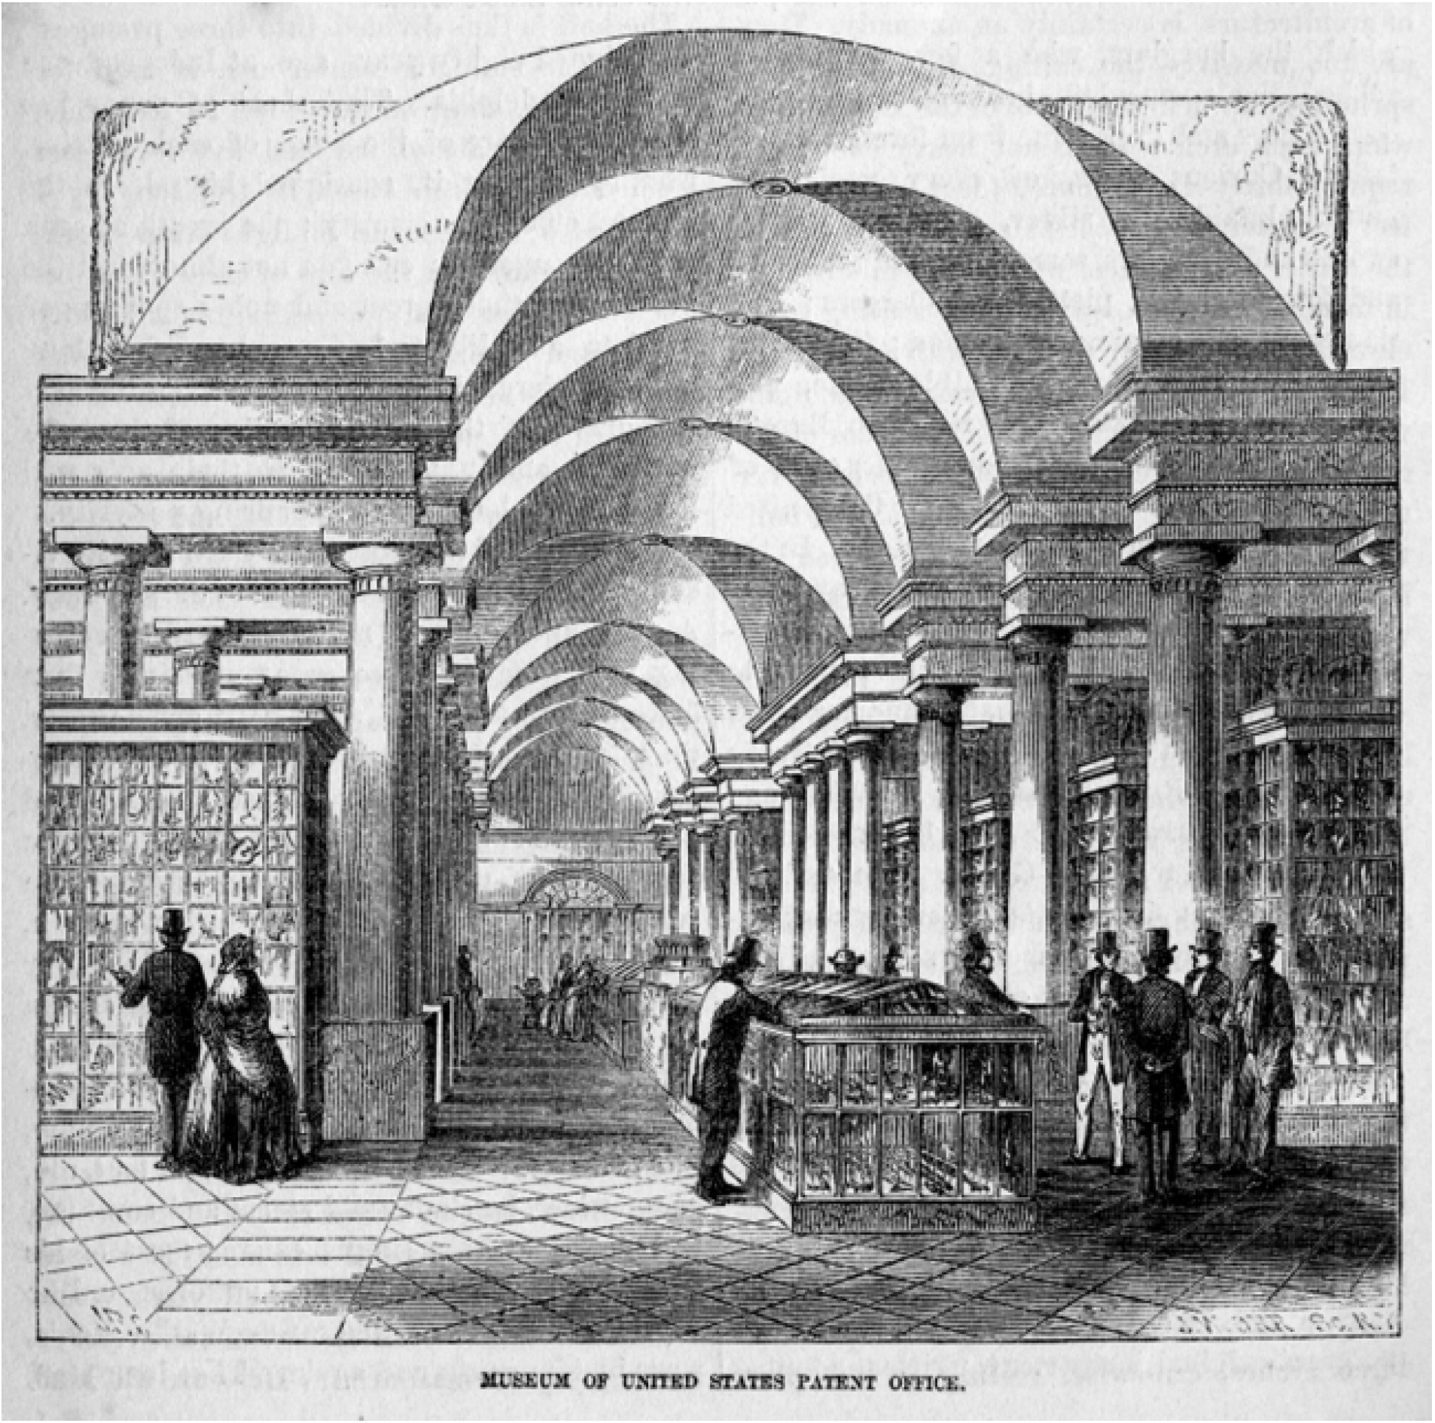
Figure 43. Visitors in the second-floor gallery of the Patent Office Museum, c. 1856. From ‘The City of Washington: United States Patent Office’, United States Magazine 3 no. 4 (1856), p. 294. Used in Anthony Adler’s “From Pacific to the Patent Office.”

Wilkes' "collection of the United States Exploring Expeditions'' remained in the Patent Office until 1858. The Smithsonian Institution had been established in 1846, and the building, a Norman-style castle on the mall, originally designed by Wilkes' nephew James Renwick, Jr., had been completed by 1855. By the time the Smithsonian took possession of the Ex. Ex. artifacts the collection made up only one-fifth of its total natural history material. Two more government surveys in the late 1840s and early 1850s contributed to the growing number of artifacts in the Smithsonian. Both were undertaken after the incorporation of the Smithsonian, and there was no question as to where the artifacts would be sent, and who would have authority over the collections.
Two notable land surveys produced more than the Patent Office could handle, and between the U.S. Ex. Ex., the United States and Mexican Boundary Survey and the Pacific Railroad Surveys, the fate of the Smithsonian Institution as the depository for American artifacts was sealed. The United States and Mexican Boundary survey began in 1848, shortly after the signing of the Treaty of Guadalupe, when Hidalgo ended the Mexican-American War. The survey lasted seven years, and in addition to determining national borders, the survey provided a wealth of natural history, ecological, and ethnographic material. The three-volume Report on the United States and Mexican Boundary Survey, made under the direction of the Secretary of the Interior by William H. Emory contained entries and artistic renderings of everything from paleontology and botany to herpetology and mammalogy. By the time this expedition was organized, the idea of a single collection was moot. As the material collected was deposited in the various sections of the Smithsonian, it was up to each one to catalog and maintain them.
Currently, the only Smithsonian department with accessible information on products from the survey is the botany department. The material was collected and returned, and it became part of the early Smithsonian collection. However, there exists no accessible catalog of just what all those artifacts were. The Pacific Railroad Surveys were likewise equipped with naturalists and scientists. Instead of one nearly 2,000-mile-long survey like the one at the border, the Pacific Railroad Surveys consisted of five separate surveys, all attempting to ascertain the most economical route for a railway to the Pacific Ocean. Each survey deposited artifacts of natural history into the growing Smithsonian collection.

Establishing a Legacy and a Reputation
The establishment of the Smithsonian Institution did not end the practice of private collections or even privately owned and operated museums. However, it did change the playing field in two fundamental ways. The first was scale. With its federally funded scientific expeditions and the scientists accompanying federal surveying expeditions, the limit for physical material–animal, vegetable, mineral, fungus, cultural, foreign, or domestic did not seem to exist. In base numbers of things, it surpassed Barnum’s American Museum many times over. Not all of these things were as interesting to look at as, say, a mummy, a purported holy relic, or a mermaid might have been, but there was enough to sift through to find something.
The second major shift in American museum culture that the Smithsonian brought about was that of reputation and expertise, not just for the material curated within the buildings, but by extension, those working for the Institution. It was a professional organization that very quickly became synonymous with truth and knowledge. Perhaps no better example of this can be found than in Daniel Goldstein's "Yours for Science '' article, which examines the Smithsonian's correspondents’ network in the last half of the nineteenth century. As early as 1863, a man was able to claim affiliation with the Smithsonian as well as being the son of an eminent geologist and receive not only high societal welcome at the Dubuque, Iowa state agricultural fair, but as Goldstein recounts, "eventually leave town with more than $1500, several valuable scientific books and natural history specimens, and an overcoat that did not belong to him." The confidence man in question, James Dale Owen, claimed to be sent by the Smithsonian to attend state fairs and shows to purchase material of scientific interest. He “found people willing to extend hospitality in the name of science and to give him money in exchange for his promise to send them expensive scientific works after he returned to Washington…[the scoundrel] took advantage of the Midwesterner’s intellectual ambitions, their support for natural science and their high regard for the Smithsonian Institution.”
Goldstein quickly points out that it was not simply the naivete of the country bumpkin that allowed cities like Dubuque and many others to be taken in by men like Owen and others, just as it was not simple-mindedness or stupidity that led to the popularity of the big city and traveling hoaxes examined in previous chapters. Far more was at play. Just as the desire (or agreement) to be fooled, figure out the con, or marvel at its execution in the cases of trompe l'oeil paintings in Peale's Gallery, there was also a desire to be associated with an institutional icon of truth and Much of the populace was primed–and willing–to take a chance on anyone affiliated with the Smithsonian. By contrast, no one was representing Barnum's American museum except Barnum. Moreover, almost certainly, no one was approaching Barnum with potential collection material except with the offer to sell it to the proprietor.
The Smithsonian was on the up and up and not to be blamed for men like Owen, who took advantage of the populace at the institution's expense. Little was left of Barnum's collection to compete with the Smithsonian. He still had fame. The rebuilt Smithsonian began operations along with the beginning of Reconstruction, and as the United States pulled itself from the Civil War, it became the model for museums that wished to hold themselves in professional esteem. In the case of Peale's rational amusements, Barnum had played the amusements out to their last. The Smithsonian Institution would lean into this trend towards rationalism. With the rise of a millionaire class, museums and collections followed this rational, professional, and studious model. Subsequent museums would often be tied to universities or state governments, sometimes both. Before the development of the American Association of Museums (AAM), claiming that one was a Smithsonian affiliate was the mark of a good museum.
A significant (and lasting) change in American museums during this period involved their tone and content. Barnum's style of theater and display never went away. It was just relegated further from the realm of what a "museum" was. Roadside attractions, freak shows, tourist traps, and carnivals would keep the bizarre otherness of the world on display. By contrast, many new and serious museums were built, from the multi-site Smithsonian Institution, currently boasting 21 museums, and the National Zoo, to historic home museums in the historic districts of small cities that worked hard to earn and maintain their AAM accreditations.
Content changed to monitor and organize prominent college collections and categorize future museums. Gone was Barnum's miscellaneity of bird's nests on top of Egyptian sarcophagi and human oddities. Order, reminiscent of Peale’s great hall, was the establishing factor. Before Barnum’s last fire, naturalist Albert S. Bickmore called on New York City officials to establish a natural history museum in the city. By the time that board was organized, and the building completed as the American Museum of Natural History, a Metropolitan Museum of Art was also in the works.
The Smithsonian Institution and, later, the American Museum of Natural History and the Metropolitan Museum of Art seem to many like the beginning of "real" museums in America, but what my research has demonstrated is that they are the result of decades of trial and error among many previous, equally real museums. Through generations of change, not only of the nation but of the people and culture of that nation, their content and displays reflected changes in government, cultural shifts, and a population with leisure time and extra money to spend. They at once reveal something uniquely American in content while steadfastly tying themselves to older European models, if only by the architectural style of their buildings. Through all of these changes, one thing has remained intact: nearly all modern museums strive to inform and educate while being pleasing to the senses. Sometimes, the sense of pleasure and wonder may have tipped the balance of rational and amusing, but there was always the desire to show. Modern museums of all kinds and sizes maintain excellence in teaching or education in some manner, with many hiring permanent directors of education to bridge the gap between the institution and the public. Undoubtedly, Charles Willson Peale would recognize his idea of rational amusements in what today is termed "edutainment," though likely he would have thought it below the mission of the museum as he did when his sons instituted the traveling shows and plate spinning in their own museums. Regardless, the bulwark of museums today is education, as evidenced my innumerable mission statements, impact reports, and grant applications.

Conclusion

Two years into working on the arrangement and scope of this dissertation my son began carrying around his books and actively choosing which ones we read to him. Given his age, board books were usually the standard faire until he found two very specific books which he effectively did not put down for over a year. Always coming back to me with them when we sat in the chair or at bedtime. These “step into reading” books were much more advanced reading than his toddler level, but he was content to listen and look through the few illustrations that were there. One book was on the discovery of King Tut’s tomb by Howard Carter and the other recounted Barnum Brown’s uncovering of the first Tyrannosaurus rex fossils. Both of them featured museums prominently. In the case of Carter’s early influence private collections of arts and artifacts played a major role as well.
As someone who has studied and worked in the fields of archaeology and paleontology and living with the constant confounding of the two disciplines, I have worked with school-aged kids who are completely obsessed with one or the other of these topics, but I cannot recall anyone being that interested in both. I had certainly not looked at the two discoveries as contemporaries before. At least not until we started reading these books at the same time. Brown, who incidentally was named after P.T. Barnum, discovered the first T. rex fossils in 1902, with the bones later going on public display at the American Museum of Natural History in New York City in 1906.
Howard Carter was just a year younger than Brown, and uncovered many Egyptian artifacts before discovering the tomb of Tutankhamen in 1922. Though the finds were separated by twenty years and occurred on two different continents, for a generation of people they would have experienced the media sensations of both spectacular finds as they made their way into the public spaces via museum exhibits. If the public were experiencing such events at the same time, and across various media why would historians look at only one or the other regarding public reaction? The “Bone Wars” had occupied most of the United States’ newspaper columns in the late nineteenth century, and Egyptomania would later influence the development of Art Deco. Here were two glaringly obvious examples of science and the public engagement. If there were these, there were bound to be others. What were the antecedents of these types of cultural interchanges, and where they the result of earlier developments within museum and public display? What we have seen here is that what happened during the Antebellum period primed the next one hundred years for the various cultural “manias” that resulted from public display of science. We see their shadows and hear their echoes now within the continued successes and importance of museums across the world.
Today the name "Smithsonian" is synonymous with "museum." For the general public, the image that it conjures up is a vast storehouse of materials with only part of the collections on display behind glass or in acrylic cases. For the scientist or the researcher, it may bring to mind the vast archives and collected data both existing and yet to be gleaned from the collections. The Smithsonian, with its string of pearls organization of multiple sites and facilities, is both of these things, both popular and intellectual. In some manner, its continued operations have managed to fulfill the two competing images that Congressional representatives had for the bequest of James Smithson. What I have explained here is how the history of early American museums, whether private or public, whether somber or sensational influenced both of those visions. The outcome and outline for America's national museum were never a forgone conclusion. Even Peale's earliest collections, arranged and staged with all appropriate Enlightenment sensibilities could not maintain enough of a civic audience to sustain the establishment and soon moved to displaying freaks of nature and more macabre pieces. Far from being the beginning of the history of “professional” museums in the United States, the Smithsonian is the outcome of decades of successes and failures conducted by private American citizens, who, for want to educate, entertain, or grow wealthy, procured and managed large collections of physical materials which they worked to curate and arrange for the benefit of their audience.
When Charles Willson Peale organized and opened his museum in 1784 it consisted mostly of portraits of famous Americans. On the advice of his brother-in-law, Peale began to add natural history specimens to his collection, and within a decade he, his family, and his museum to the American Philosophical Society building. Peale had intended his museum to be the national museum of the new nation. The work and the nation quickly outpaced Peale's ability, collection, and space. This was a pattern that was repeated variously by each of the men discussed here. Peale’s network of influential Americans grew from his respect as an artist with many early statesmen sitting with Peale, or one of his sons, for their portrait, later to be included in Peale’s famous gallery. In turn, sailors, adventurers, early scientists, and his sons all provided specimens for his growing museum. Peale himself also collected for his museum. His expedition in New York to recover fossil mammoth bones became a cornerstone of his museum and his legacy. By including the painting, The Exhumation of the Mastodon within the museum along with the mastodon exhumed and reborn, Peale was not only providing a marvelous glimpse into the past but also establishing a subliminal form or authority within his museum. Peale had been there. Patrons could see the painting, and then see the reconstructed skeleton. This reinforced the authenticity of the rest of the museum. Rembrandt and Rubens Peale had toured Europe with another mastodon skeleton, separating the “show” aspect of the Peale Museum, but maintaining it nonetheless. Others would use the same tactic, with varying degrees of success.
Peale’s Philadelphia neighbor Nathan Dunn, managed a large collection of Chinese material which he procured from his days of trading in Canton. Like Peale exhuming the mastodon, Dunn had been present in China where he lived for several years. Like Peale, Dunn relied on networks of traders and Chinese citizens to amass his collection. Chinese law barred any foreigner from traveling into the interior of the country, so Dunn's collection was only possible through his relationship with Chinese tradesmen and the local population. Singular in its focus Dunn's collection has the distinction of being one which is most reflective of its subject. His exhibition guide boasted "ten thousand Chinese things," which were obtained from their source. Chinese traders and craftsmen were the ones who were choosing the materials to bring to Dunn. They were the curators of their own representation. That Dunn was able to amass such a collection, safely transport it back to Philadelphia, organize, and maintain it is staggering. Dunn used the popularity of the "exotic" to not only educate his patrons about China and Chinese culture but to draw attention to the sinister aspects of the opium trade, which he abhorred and publicly denounced in his museum guidebooks. Dunn also took his enormous collection abroad, exhibiting in London. It was here that the collection was disbursed by Dunn’s trustees after his death.
Early American museums were not relegated to the East. As the nation expanded opportunities for other types of cultural collection presented themselves. Artist George Catlin was an early exhibitor of art in Peale's gallery in Pennsylvania, who later traveled up the Mississippi River documenting what he feared were disappearing cultures of the Native American people. While he traveled and painted, Catlin also collected Native American artifacts which he would use later in his studio to complete works based on his sketches, but also as part of the gallery itself to, in the same manner as Peale, establish himself as an authority on his subject matter. Ostensibly, Catlin's collection was similar to Dunn's, that is, a cultural one. But, where Dunn was exhibiting the culture and stylings of a vibrant, active people, Catlin felt more like he was preserving snapshots of a way of life that would soon be as extinct as Peale's mastodon. Throughout his life Catlin attempted to sell his Indian Gallery to the United States government, hoping for it to have a permanent home in a national collection. With no such sale forthcoming, he spent a considerable amount of time touring Europe where he saw modest success on a lecture and gallery circuit; fame in French royal circles, which brought him society but little money; and an eventual short-lived, though more monetarily successful, pairing with another American showman P.T. Barnum, which he loathed.
Catlin did not bring museums to St. Louis, they were already established when he arrived. William Clark maintained his Corps of Discovery artifacts within his offices as Indian Diplomat where they served to strengthen his reputation as knowledgeable of the Native American condition. Albert Koch's museum predated Dunn's Chinese collection and opened the same year as Catlin's last sojourn west. A hodgepodge of topics and artifacts Koch exhibited everything from live alligators and some of Clark’s personal collection to locally retrieved real fossils some of which made it into his more fantastical displays such as his enormous mammoth-type monster Missourium and his Hydrarchos sea serpent. A German immigrant, Koch toured his two fictitious creatures along the same circuit Rembrandt and Rubens Peale had taken their true mammoth. He also published (in German) an account of his time in the American West to circulate while he was touring his homeland. Peale's influence can easily be seen in Catlin's projects as he moved from Pennsylvania to St. Louis, to Europe. However, these stylings of the show were not something that could keep making money in the same locations and Catlin found himself promoting staged living dioramas of the Native American people in partnership with showman P.T. Barnum.
Barnum is a summation of all previously mentioned forms of show, exhibition, display, and marketing. His life and works embody the changes that the United States was going through between the Revolution and the Civil War. For each change in public interests, Barnum tacked his sails and embraced them as if they had been part of his fabric of being. From traveling shows with jugglers, singers, and a leased enslaved woman claiming (and promoted) to be George Washington's nursemaid, Barnum collected experiences, and when he opened his American Museum in 1841 he presented those to anyone who would purchase tickets. Unlike his predecessor, Barnum did not rely on a network of connected sorts to fill his museum. He quite simply purchased his predecessor's including the remains of Rembrandt and Ruben Peale's museums and Scudder's American Museum in New York. With his museum full to the brim of every imaginable trinket, bauble, artifact, human oddity, sideshow, oyster bar, and ice cream Barnum's museum seemed to be the antithesis of Peale's stoic Enlightenment hall. Barnum utilized the penny press newspapers to promote his museum and shows, and his penchant for half-truths, near facts, and downright hoaxes such as the Fiji mermaid kept his name in the papers, and on reader's minds. He toured Europe with Jinny Lind and Tom Thumb, as well as a living tableau of Native American performers with whom he partnered with George Catlin for a time.
A series of devastating fires ended Barnum's museum career, but his fame allowed him to reinvent himself; again, following a change in the United States after the Civil War. He became a partner, if only in name only, for some of the most popular and enduring circus shows in the world. Barnum knew a museum like his American Museum could never come again. The mix of content, the "miscellaneity," could never be matched on the scale or frankly desire. On size alone, Barnum noted that a similar museum would have to be subsidized by a government, and any government would not subsidize something as cacophonous as what Barnum had created. If a museum was going to represent the nation, it was going to have to have order, purpose, and authority. By this time the question of what form a United States national museum would take was already decided, and when both the Smithsonian and Barnum’s museum both burned in 1865 (Smithsonian in January and Barnum’s in July), only one rose from the ashes.
It is a paradox that what did develop into the national museum of the United States, the Smithsonian Institution, was global and continental artifacts and “miscellaneous collections” that were more similar to the things that Barnum had displayed in his American Museum than what Peale had displayed in Philadelphia. Joseph Henry, and later Secretaries of the Smithsonian, were charged with providing Pealian (Pealite) order onto Barnumesque chaos. That, I think, is the wonder of the Smithsonian and how it represents not only the material culture of the United States, but its development, history, and success follows the ebb and flow of American culture through the same period. In a sense, it was yet another generation of "born American" following the Revolution, and the War of 1812, that was able to glean bits from its predecessors to create something greater than the sum of its parts. The Smithsonian Institution in the 1850s was the perfect blend of Peale's order of nature and Barnum’s wonder of nature. Henry's Smithsonian was facing the same "strains and tensions" that Peale's had over half a century earlier, only instead of being "between the museum's scientific and didactic purposes or between the Peales' roles as curators and cataloguers and their roles as artists and promoter-showmen" it was between the roles of curators and cataloguers and their roles as scientists and researchers.
As late as 2021, curator emeritus of the Smithsonian, David K. Allison, aided by intern Hanna Peterson, published Exhibiting America: The Smithsonian’s National History Museums, 1881-2018 firmly marking the beginning of the national history museum in 1881 to demarcate between its earliest existence as natural history museum Fewer than ten small paragraphs outline the earliest debates and struggles of the museum, but it at least provides an early account from their archives from Joseph Henry, the first Smithsonian secretary’s, notes on the “‘national collections’” which consisted of a not insignificant number of artifacts when transferred to the new building in 1858 when the National Institute ceased to exist.

“First those of the naval expeditions; second, those of the United States Geological Surveys; third, those of the boundary surveys; fourth, those of surveys for railroad routes to the Pacific, fifth, or miscellaneous expeditions under the War and Navy Departments; sixth those of miscellaneous collections presented or deposited by societies and individuals; and, lastly, of an extensive series of the results of explorations prosecuted by the Institution itself.”

These were the very same collections that Henry fought to keep out of the Smithsonian. Henry served as the steward of the Institution for more than thirty years, during which time he saw a lot of changes for the Institution and the country. Historian William S. Walker noted in 2013 that “despite Congress’s charting of the Smithsonian, Henry insisted that it was a private institution.” A view far more aligned with other antebellum museums of the time rather than, say the British Museum or the Louvre. Some of Henry’s reluctance to make the Smithsonian a governmental repository was founded partly in his desire to keep the Institution above political influence should the museum be funded at the whim of congressional appropriations. Henry saw the museum collection and building itself as millstones around the neck of the advancement of American science. He went so far as trying to sell the building to the federal government and relocate to a more modest, and less costly building. Henry only acquiesced after Congress ensured the institution would receive an annual appropriation to maintain and care for the voluminous materials that were finally absorbed into the Smithsonian collection in 1858. Such an agreement was exactly what Barnum had prophesied for museums of the size when his American Museum was destroyed.
The Smithsonian Institution is not the beginning of museum history in the United States. The foundation of what became the Smithsonian came in the preceding decades as private citizens took opportunities to collect, exhibit, and educate a growing American public as a new nation developed its sense of self on a world stage. To even consider these examples as “pre” history of museums in America is to do them a disservice in the establishment of the collections, show, and culture in which the Smithsonian and later museums inhabit. Only by examining these instances together, as they would have been experienced by an Antebellum public, can we reconstruct a clearer understanding of what all went into creating that public. We cannot praise Peale's trompe l’oeil displays and disparage Barnum's Fiji Mermaid for they are both artifacts meant to fool. What we can do is use these instances to understand what it means to be fooled, who has the means and motive to fool, and what, of course, is the outcome of being fooled on the audience.
There is no question that museums continue to offer the "rational amusements" that Peale worked hard to establish. The main concern for all museum professionals ever since has been establishing the appropriate ratio between the two, and perhaps more importantly, who has the authority to make that decision. Such decisions, neither modern nor historical, should not be taken lightly, or for granted. One may wonder, though, as the modern Smithsonian has expanded into an organization string of pearls with different buildings dedicated to themed collections, if the museum has ordered the wonder out of the collections. When materials are dispersed according to the topical or cultural disciplines, content, or relationship it is easier for visitors to divide up their time and only engage with material they are interested in. This decreases the likelihood of serendipity or experiencing something new while visiting familiar collections. Eventually the collections suffer the same fate as our academic disciplines, professionalized and narrowed to points so finite that we sometimes quite literally miss the forest for the trees.
It is important to make sure we do not order ourselves out of usefulness whether that is museum collections, academic research, or life in general. For all the faults of Barnum’s museum there is something to be said about the draw of the lights, the show, and the presentation of it all. As we work to reconstruct science in popular culture in the past, we also must not fail to keep showing the benefit—and need—of it in the present. Understanding science as popular culture is just as important as understanding science in popular culture. As Pandora and Rader warned in 2008, “what is at stake is nothing less than a truly democratic conception of our contemporary era in which the scientific imagination plays an ever-increasing role in our individual lives, our collective lives, and the lives of nations.” Museums are the physical intermediaries between the morphing populations of scientists and the public. They are important nodes in the transfer of knowledge and have an immeasurable impact on the development of the scientific thoughts, literacy, and engagement of future generations.
Epilogue: The Splitsonian Institute
On December 18, 1976, an episode of The Scooby Doo Show, “The Spirits of 76” featured Scooby and the gang visiting in Washington, D.C. for the Bicentennial celebrations. The unrelenting rainstorms inspire a visit to the “Splitsonian Institute.” The obvious homage to the Smithsonian includes an establishing shot of the famous Castle and its exhibits feature such relics as the largest steam locomotive, the Wright Brothers’ plane, Eli Whitney’s Cotton Gin, and various Dinosaur reconstructions. There is no better image to tie the ends of this research together than the Mystery Machine in front of a caricature of the Smithsonian during the Bicentennial. It brings American museums full circle from Peale’s earliest museums in the post-colonial United States to the establishment of the nation’s national museum. It is also serves as a testament to the continued impact that museums have on our shared cultural consciousness, both popular and scholarly.
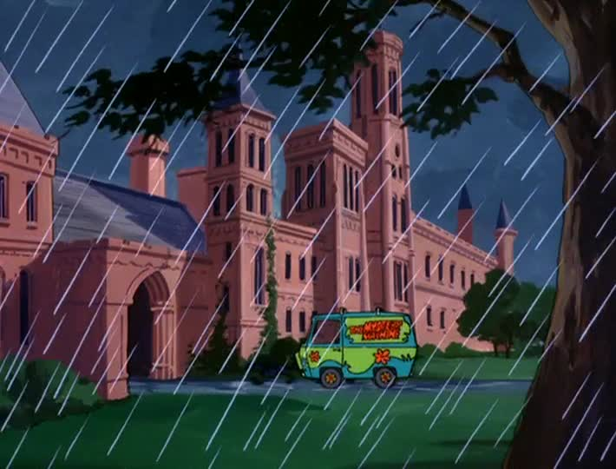
Figure 44. The Splitsonian Institute. The Scooby Doo Show, "Spirits of '76." Image captured by author.
Bibliography

Abbas, Ackbar, “Walter Benjamin's Collector: The Fate of Modern Experience.” New Literary History 20, no. 1 (Autumn, 1988): 217-23.

Adams, Bluford. E Pluribus Barnum: The Greatest Showman and the Making of U.S. Popular Culture. Minneapolis: University of Minnesota Press, 1997.

Adler, Antony. “From the Pacific to the Patent Office: The US Exploring Expedition and the Origins of America’s First National Museum.” Journal of the History of Collections 23, no. 1 (2011): 40-74.

Alberti, Samuel. Nature and Culture: Objects, Disciplines, and the Manchester Museum. Manchester: Manchester University Press, 2012.

Alderson William T. ed., Mermaids, Mummies, and Mastodons: The Emergence of the American Museum. Washington, D.C.: American Associations of Museums, 1992.

Alexander, Edward P. Museum Masters: Their Museums and Their Influence. Walnut Creek, CA: AltaMira Press, 1996.

Allison, David K. and Hannah Peterson. Exhibiting America: The Smithsonian’s National History Museum, 1881-2018. Washington, D.C.: Smithsonian Scholarly Press, 2021.

Altick, Richard D. The Shows of London. Cambridge, MA; London: Belknap Press of Harvard University, 1978.

Appleby, Joyce. Inheriting the Revolution: The First Generation of Americans. Cambridge, MA: Harvard University Press, 2000.

Arendt, Hannah ed. Walter Benjamin: Illuminations. New York: Schoken Books, 1969.

Baker, Jean. “From Belief into Culture: Republicanism in the Antebellum North. American Quarterly 37, no. 4 (Autumn 1985): 532-550.

Barnum, P.T.. Struggles and Triumphs or, Forty Years Recollections of P.T. Barnum. Buffalo, NY: Warren, Johnson and Co., 1872. Fully digitized copy available on the Internet Archive: https://archive.org/details/strugglestriumph00barnrich/page/n8. Accessed December 20, 2019.

____. Struggles and Triumphs: of, the Life of P.T. Barnum, Written by Himself. Edited by George Bryan. New York: Alfred A. Knopf, 1927.
Barrow, Mark V. Jr. Nature’s Ghosts; Confronting Extinction from the Age of Jefferson to the Age of Ecology. Chicago; University of Chicago Press, 2009.

Bedell, Rebecca. The Anatomy of Nature: Geology and American Landscape Painting, 1825-1875. Princeton: Princeton University Press, 2001.

Benjamin, Walter, and Knut Tarnowski. "Eduard Fuchs: Collector and Historian." New German Critique no. 5 (Spring 1975): 27-58.

Berkowitz, Carin, and Bernard Lightman, eds. Science Museums in Transition: Cultures or Display in Nineteenth-Century Britain and America. Pittsburgh: University of Pittsburgh Press, 2017.

Bloemink, Barbara. Frederic Church, Winslow Homer and Thomas Moran: Tourism and the American Landscape. New York: Bulfinch Press, 2006.

Blum, Ann Shelby. Picturing Nature: American Nineteenth-Century Zoological Illustration. Princeton, NJ: Princeton University Press, 1993.

Bradford, Phillips and Harvey Bloom. Ota Benga: The Pygmy in the Zoo. New York: St. Martin’s Press, 1992.

Brands, H.W. Andrew Jackson: His Life and Times. New York; London: Doubleday, 2005.

Bruce, Robert. The Launching of American Science, 1846-1876. Ithaca: Cornell University Press, 1987.

Buckley, Jay H. William Clark: Indian Diplomat. Norman, OK: University of Oklahoma Press, 2008.

Burleigh, Nina. The Stranger and the Statesman: James Smithson, John Quincy Adams, and the Making of America’s Greatest Museum. New York: HarperCollins, 2003.

Caplan, Aaron. “Nathan Dunn’s Chinese Museum.” Unpublished PhD dissertation, University of Pennsylvania Libraries, 1986.

Carter, Edward, ed. Surveying the Record: North American Scientific Explorations to 1930. Philadelphia: American Philosophical Society, 1999.

Catlin, George. Letters and Notes on the Manners, Customs, and Conditions of the North American Indians. London: published for the author, 1842.

Colton, Harold Sellers. “Peale’s Museum,” Popular Science Monthly 75 (September 1909): 221-238. A full digital version can be found at The Internet Archive: https://archive.org/details/popularsciencemo7509newy/page/238.

Conn, Steven. Museums and American Intellectual Life. Chicago: University of Chicago Press, 1998.

Cooter, Roger and Stephen Pumfrey. “Separate Spheres and Public Places: Reflections on the History of Science Popularization and Science in Popular Culture.” History of Science 31 (1994): 237-267.

Costeloe, Michael P. William Bullock Connoisseur and Virtuoso of the Egyptian Hall: Piccadilly to Mexico (1773-1849). Bristol, England: HiPLAM, University of Bristol, 2008.

Cook, James W. “Antebellum Cultural History.” In A Companion to American Cultural History, edited by Karen Halttunen. St. Malden: Blackwell Publishing, 2008.

____. The Arts of Deception: Playing with Fraud in the Age of Barnum. Cambridge, MA: Harvard University Press, 2001.

Covington, James. W. The Seminoles of Florida. Gainesville: University Press of Florida, 1993.

Cutright, Paul Russell. Lewis and Clark: Pioneering Naturalists. Lincoln, NE: University of Nebraska Press, 1969.

Datta, Nilak. “The Museum as West and West as Museum.” Western American Literature 53, no. 3 (Fall 2018): 311-338.

Dennett, Andrea Stulman. Weird and Wonderful: The Dime Museum in America. New York; London: New York University Press, 1997.

Dippie, Brian. Catlin and His Contemporaries: The Politics of Patronage. Lincoln, NE; London: University of Nebraska Press, 1990.

Doezema, Marianna and Elizabeth Milroy, eds. Reading American Art. Hartford, CT: Yale University Press, 1998.

Eisler, Benita, Red Man’s Bones. New York; London: Norton and Company, 2013.

Ewing, Heather. The Lost World of James Smithson: Science, Revolution, and the Birth of the Smithsonian. New York: Bloomsbury, 2007.

Fabian, Ann. The Skull Collectors Race: Science, and America's Unburied Dead. Chicago: University of Chicago Press, 2010.

“Famous fossil Lucy leaves Ethiopia for controversial U.S. tour.” The Denver Post 6 August 2007. https://www.denverpost.com/2007/08/06/famous-fossil-lucy-leaves-ethiopia-for-controversial-u-s-tour/.

Feber, Linda S. The Hudson River School: Nature and the American Vision. New York: Skira Rozzoli, 2009.

Fink, Lois Marie. American Art at the Nineteenth-Century Paris Salons. Cambridge, UK: Cambridge University Press, 1990.

____. “Rembrandt Peale in Paris.” The Pennsylvania Magazine of History and Biography 110, no. 1 (Jan 1986): 71-90.

Fitzsimons, Raymund. Barnum in London. New York: St. Martin’s Press, 1970.

Fleming, Candace. The Great and Only Barnum: The Tremendous, Stupendous Life of Showman P.T. Barnum. New York: Schwartz Wade Books, 2009.

Flores, Dan L. ed. Jefferson and Southwestern Exploration: The Freeman and Custis Accounts of the Red River Expedition of 1806. Norman: University of Oklahoma Press, 1984.

____. ed. Southern Counterpart of Lewis and Clark: The Freeman and Custis Expedition of 1806. Norman: University of Oklahoma Press, 2002.

____. “The Ecology of the Red River in 1806: Peter Custis and Early Southwestern Natural History.” The Southwestern Quarterly 88, no. 1 (July 1984): 1-42.

Fritze, Ronald H. Egyptomania: A History of Fascination, Obsession and Fantasy. Chicago: University of Chicago Press, 2016.

Gibbons Ann. “Lucy’s Tour Abroad Sparks Protests.” Science 314 issue 5799 (October 2006): 574-575.

Gochberg, Reed. Useful Objects: Museums, Science, and Literature in Nineteenth Century America. Oxford: Oxford University Press, 2021.

Goetzmann, William H. Army Exploration in the American West 1803-1863. Austin: Texas State Historical Association, 1991.

____. Exploration and Empire: The Explorer and the Scientist in the Winning of the American West. New York: Alfred A. Knopf, 1966.

Goldstein, Daniel. “‘Yours for Science’ The Smithsonian Institution's Correspondents and the Shape of Scientific Community in Nineteenth-Century America.” Isis 85, no. 4 (December 1994): 573-599.

Goode, George Brown, ed. The Smithsonian Institution 1846-1896: The History of Its First Half Century. Washington D.C.: Smithsonian Institution, 1897

Goodman, Matthew. The Sun and the Moon: The Remarkable True Account of Hoaxers, Showmen, Dueling Journalists, and Lunar Man-Bats in Nineteenth Century New York. Philadelphia: Basic Books, Perseus Book Group, 2008.

Greene, John C. American Science in the Age of Jefferson. Ames: Iowa State University Press, 1984.

Guice, John, Jay Buckley, James Holmberg. By His Own Hand: The Mysterious Death of Meriwether Lewis. Norman: University of Oklahoma Press, 2006.

Haberly, Lloyd. “The American Museum from Baker to Barnum.” The New-York Historical Quarterly 43, no. 3 (Autumn 2012): 273-287.

Haddad, John Rogers. The Romance of China: Excursions to China in U.S. Culture 1776-1876. New York: Columbia University Press, 2008.

Haltman, Kenneth. Looking Close and Seeing Far: Samuel Seymour, Titian Ramsay Peale, and the Art of the Long Expedition, 1818-1823. Pittsburgh: Pennsylvania State University Press, 2008.

Halttunen, Karen, ed. A Companion to American Cultural History. St. Malden: Wiley-Blackwell, 2008.

Harris, Neil. Humbug: The Art of P.T. Barnum. Boston; Toronto: Little, Brown, and Company, 1973.

Harrison, Les. The Temple and the Forum: The American Museum and Cultural Authority in Hawthorne, Melville, Stowe, and Whitman. Tuscaloosa: University of Alabama Press, 2007.

Harvey, Karen. ed. History and Material Culture. London: Routledge, 2009.

Hauptman, Laurence M. and George Hamell. “George Catlin: The Iroquois Origins of His Indian Portrait Gallery.” New York History 84, no. 2 (Spring 2003): 125-152.

“History of the Peale Center.” https://www.thepealecenter.org/history. Accessed November 2018.

Henry, Joseph. Annual Report of the Board of Regents of the Smithsonian Institution,1876. Washington D.C.: Government Printing Office, 1877.

Hight, Kathryn S. “‘Doomed to Perish’ George Catlin’s Depictions of the Mandan.” Art Journal 49, no 2. Depictions of the Dispossessed (Summer 1990): 119-124.

The Historical Society of Somers. Beasts and Ballyhoo, the Menagerie Men of Somers. http://www.somershistoricalsoc.org/menageries2.html.

Hunter, Jr., Wilbur H. "Peale's Baltimore Museum." College Art Journal 12, no. 1 (Autumn 1952): 31–36.

Irmscher, Christoph. The Poetics of Natural History. New Brunswick, NJ; Rutgers University Press, 2019.

Jackson, Donald, ed., The Letters of the Lewis and Clark Expedition with Related Documents, 1783-1854. Two volumes. Urbana: University of Illinois Press, 1970-1984.

Jones, Landon Y. William Clark and the Shaping of the West. New York: Hill and Wang, 2004.

Joyce, Barry Alan. The Shaping of American Ethnography: The Wilkes Exploring Expedition, 1838-1842. Lincoln, NE: University of Nebraska Press, 2001.

Kelly, Catherine E. “The Revolution and the Early Republic.” In A Companion to American Cultural History, edited by Karen Halttunen. St. Malden; Blackwell Publishing, 2008.

Koch, Albert C. Koch. Journey through a Part of the United States of North American in the Years 1844-1846. Translated and edited by Ernst A. Stadler. Carbondale and Edwardsville: Southern Illinois University Press, 1972.

Kohlstedt, Sally Gregory. “‘Thoughts in Things:’ Modernity, History, and North American Museums.” Isis 96, no. 4 (December 2005): 586-601.

Kovarik, Bill. Revolutions in Communication: Media History from Gutenberg to the Digital Age. New York: Bloomsbury, 1997.

Krebs, Edgardo Carlos. “George Catlin and South America: A Look at His ‘Lost’ Years and His Paintings of Northeastern Argentina.” The American Art Journal 22, no. 4 (Winter 1990): 4-39.

Kurin, Richard. “The Devastating Fire that Nearly Consumed the Smithsonian Castle in 1865.” In Smithsonian Magazine (January 22, 2015). https://www.smithsonianmag.com/smithsonian-institution/devastating-fire-nearly-consumed-smithsonian-castle-1865-180954002/. Accessed December 28, 2019.

Langdon, William B. “Ten Thousand Chinese Things.” A Descriptive Catalog of the Chinese Collection Now Exhibiting at St. George’s Place, Hyde Park Corner: With Condensed Accounts of the Genius, Government, History, Literature, Agriculture, Arts, Trade, Manners, Customs, and Social Life of the People of the Celestial Empire. London: Printed for the proprietor, 1844.

Lepler, Jessica M. 2013 The Many Panics of 1837: People, Politics, and the Creation of a Transatlantic Financial Crisis. Cambridge, UK; New York: Cambridge University Press, 2013.

Levine, Lawrence W. Highbrow Lowbrow: The Emergence of Cultural Hierarchy in America. Cambridge, MA: Harvard University Press, 1988.

Lehuu, Isabelle. Carnival on the Page: Popular Print Media in Antebellum America. Chapel Hill: University of North Carolina Press, 2000.
Lepler, Jessica. The Many Panics of 1837: People, Politics, and the Creation of a Transatlantic Financial Crisis. Cambridge, UK: Cambridge University Press, 2013.

Lloyd, Phoebe. “Philadelphia Story.” Art in America 76, no. 2 (November 1988): 154-177.

Loxton, Daniel and Donald R. Prothero. Abominable Science: Origins of the Yeti, Nessie, and Other Famous Cryptids. New York: Columbia University Press, 2013.

Mahar, William. Beyond the Burnt Cork Mask: Early Blackface Minstrelsy in Antebellum American Culture. Champaign, IL: University of Illinois Press, 1999.

McDermott, James Francis. “Museums in Early Saint Louis.” Missouri Historical Society Bulletin 4 (1948): 129-138.

____. “William Clark: Pioneer Museum Man.” Journal of the Washington Academy of Sciences 44, no. 11 (November 1954): 370-373.

____. “William Clark’s Museum Once More.” The Bulletin 16, no. 2 (1960): 130-133.

McLaughlin, Castle ed. Arts of Diplomacy: Lewis and Clark’s Indian Collection. Cambridge, MA: Peabody Museum of Archaeology and Ethnology, Harvard University; and Seattle: University of Washington Press, 2003.

McMillan, R. Bruce, “Objects of Curiosity: Albert Koch’s 1840 St. Louis Museum.” The Living Museum 2, nos. 2, 3 (1980): 35-38.

McNamara, Brooks. “’A Congress of Wonders’: The Rise and Fall of the Dime Museum.” Emerson Society Quarterly 20, no. 3 (1974): 216-232.

Miller, Lillian B., ed. The Selected Papers of Charles Willson Peale and His Family, Volume I: Charles Willson Peale: Artist in Revolutionary American 1735-1791. New Haven; London: Yale University Press, 1983.

____. ed. The Selected Papers of Charles Willson Peale and His Family, Volume 5: The Autobiography of Charles Willson Peale. New Haven; London: Yale University Press, 1983.

Montagu, M.F. Ashley and C. Bernard Peterson. “The Earliest Account of the Association of Human Artifacts with Fossil Mammals in North America.” Proceedings of the American Philosophical Society 87, no. 5 (May 5, 1955): 407-419.

Murray, Lisa Rochelle. P.T. Barnum Presents: The Greatest Classroom on Earth! Historical Inquiry into the Role of Education in Barnum’s American Museum. Unpublished Master’s Thesis, University of Texas at Austin, 2009.

Newkirk, Pamela. Spectacle: The Astonishing Life of Ota Benga. New York: HarperCollins, 2015.

New York City Historic Buildings. https://www.geographicguide.com/united-states/nyc/antique/19th-century/broadway-ny.htm Accessed December 1, 2023.
Nichols, Thomas Low. Forty Years of American Life in Two Volumes. London: John Maxwell and Company,1864. Full digital version available at the Internet Archive: https://archive.org/details/fortyyearsameri02nichgoog/page/n8. Accessed December 15, 2019.

Oetterman, Stephan. The Panorama: History of a Mass Medium. New York: Zone Books, 1997.

Orosz, Joel. Curators and Culture: The Museum Movement in America 1740-1870. Tuscaloosa: University of Alabama Press, 1990.

The Pacific Railroad Surveys: Central Pacific Railroad Photographic History Museum. http://www.cprr.org/Museum/Pacific_RR_Surveys/. Accessed December 31, 2019.

Pandora, Katherine.“Popular Science in National and Transnational Perspective: Suggestions from the American Context.” Isis 100, no. 2 (2009): 346-358.

____. “The Children’s Republic of Science in Antebellum Literature of Samuel Griswold Woodrich and Jacob Abbott.” Osiris, Vol. 24, no. 1, Science and National Identity (2009): 75-98.

Pandora, Katherine and Karen Rader. “Science in the Everyday World: Why Perspectives from the History of Science Matter.” Isis, 99, no. 2 (June 2008): 350-364.

Parton, Dorothy M. The Diplomatic Career of Joel Roberts Poinsett. PhD diss., published by the Catholic University of America, 1934.

Pennsylvania Academy of Fine Arts online collections notes. https://www.pafa.org/collection/artist-his-museum. Accessed October 2, 2019.

Philbrick, Nathaniel. “Learn More About the U.S. Exploring Expedition.” The United States Exploring Expedition, 1838-1842, Smithsonian Libraries Digital Collection. https://www.sil.si.edu/DigitalCollections/usexex/learn/Philbrick.htm. Accessed December 30, 2019.

____. Sea of Glory: America’s Voyage of Discovery The U.S. Exploring Expedition 1832-1842. New York: Viking, 2003.

Poe, Edgar Allan. “Richard Adams Locke.” Literary America, 1848 (manuscript). https://www.eapoe.org/works/misc/litamlra.htm. Accessed December 12, 2019.

Rathbun, Richard. The Columbian Institute for the Promotion of Arts and Sciences: A Washington Society of 1816-1838, which established a Museum and Botanic Garden under Government Patronage. Washington, D.C.: Government Printing Office, 1917. A full digital copy can be found here: https://books.google.com/books?id=3GRHAAAAYAAJ&printsec=frontcover&source=gbs_ge_summary_r&cad=0#v=onepage&q&f=false. Accessed December 27, 2019.

Rebert, Paula. “A Civilian Surveyor on the United States-Mexico Boundary: The Case of Arthur Scott.” In Proceedings of the American Philosophical Society 155, no. 4 (December 2011): 433-462.

Redman, Samuel J., Prophets and Ghoses: The Story of Salvage Anthropology. Cambridge, MA: Harvard University Press, 2021.

Reiss, Benjamin. The Showman and the Slave: Race, Death, and Memory in Barnum’s America. Cambridge, MA: Harvard University Press, 2010.

Reynolds, David. Beneath the American Renaissance: The Subversive Imagination in the Age of Emerson and Melville. New York: A.A. Knopf, 1988.

____. Waking Giant: America in the Age of Jackson. New York: Harper, 2008.

____. Walt Whitman’s America; A Cultural Biography. New York: Vintage Books, 1996.

Rhor, Monica. “’Lucy’ exhibit worries some scientists.” NBC News. 24 August 2007. https://www.nbcnews.com/id/wbna20429225.

Richardson, Edgar P., Brooke Hindle, and Lillian B. Miller. Charles Willson Peale and His World. New York: Harry N. Abrams, Inc., 1983.

Rieppel, Lukas, “Hoaxes, Humbugs, and Frauds: Distinguishing Truth from Untruth in Early America.” Journal of the Early Republic 3, no. 3 (Fall 2017): 501-529.

Riggs, Christina. Treasured: How Tutankhamun Shaped a Century. London: Atlantic Books, 2021.

Rippy, Fred J. Joel R. Poinsett: Versatile American. Durham, NC: Duke University Press, 1935.

Ronda, James P. “Passion and Imagination in the Exploration of the American West.” In A Companion to the American West, ed. William Deverell. Oxford: Blackwell Publishing, 2004.

Sachsman, David B. and David W. Bulla, eds. Sensationalism: Murder, Mayhem, Mudslinging, Scandals, and Disasters in 19th-Century Reporting. New Brunswick, NJ: Transaction Publishers, 2013.

Sampson, Henry. Blacks in Blackface: A Sourcebook of Early Black Musical Shows. Two volumes. Lanham, MD; Scarecrow Press, 2013.

Sarton, George. “George Catlin ‘Indian-Loving Catlin’ (1796-1872).” Isis 22, no. 1 (Dec. 1934): 77-94.

Saxon, A.H. P.T. Barnum: The Legend and the Man. New York: Columbia University Press, 1989.

Sears, John. Sacred Places: American Tourist Attractions in Nineteenth-Century America. Oxford: Oxford University Press, 1989.

Secord, James A. Victorian Sensation. Chicago: University of Chicago Press, 2000.

Sellers, Charles Coleman. Mr. Peale’s Museum. New York: W.W. Norton & Company, 1980.

____. “Unearthing the Mastodon: Peale’s Greatest Triumph.” American Heritage Magazine 30, no 5 (August/September 1979): p. 16. Online digital archive
http://www.americanheritage.com/content/unearthing-mastodon. Accessed October 3, 2018.

Semonin, Paul, American Monster: How the Nation’s First Prehistoric Creature Became a Symbol of National Identity. New York; London: New York University Press, 2000.

Sheppard, Kathleen. The Life of Margaret Alice Murray: A Woman’s Work in Archaeology. Landam, MD: Lexington Books, 2013.

Shin, Ian. “Encounters of a New Kind: Nathan Dunn's Chinese Collection and the Construction of Race in Nineteenth-Century America.” Unpublished PhD dissertation, Amherst College, 2006.

"Smithson Held as a Prisoner of War.” James Smithson Collection, 1796–1951. Smithsonian Institution Archives. Accessed December 23, 2019.

Spary, E.C. Utopia’s Garden: French Natural History from Old Regime to Revolution. Chicago: University of Chicago Press, 2000.

Stanton, William. The Great United States Exploring Expedition. Berkeley: University of California Press, 1975.

Stein, Roger B. “Charles Willson Peale’s Expressive Design: The Artist in His Museum.” In Reading American Art, edited by Marianna Doezema and Elizabeth Milroy. Hartford: Yale University Press, 1998.

Steffen, Jerome O. William Clark: Jeffersonian Man on the Frontier. Norman: University of Oklahoma Press, 1977.

Symmes, John Cleves. Circular No. 1. St. Louis, MO: self-published, 1818.

Taft, Robert. Artists and Illustrators of the Old West 1850-1900. New York: Scribner, 1953.

Thomson, Keith. Legacy of the Mastodon: The Golden Age of Fossils in America. New Haven: Yale University Press, 2009.

Tucher, Andie. Froth and Scum: Truth, Beauty, Goodness, and the A Murder in America’s First Mass Medium. Chapel Hill: University of North Carolina Press, 1994.

Tynan, Daniel J., “J. N. Reynold’s Voyage of the Potomac: Another Source for The Narrative of Arthur Gordon Pym.” Poe Studies 4, no. 2 (December 1971): 435-37. Online access can be found at The Edgar Allan Poe society of Baltimore: https://www.eapoe.org/pstudies/ps1970/p1971207.htm. Accessed December 29, 2019.

The U.S. Mexican Boundary Survey: A full digital collection of the survey report can be found at the Biodiversity Heritage Library. https://www.biodiversitylibrary.org/bibliography/213#/summary. Accessed Dec 31, 2019.

Van Dyke, Paul A. and John E. Wills Jr. eds. The Private Side of the Canton Trade, 1700-1840: Beyond the Companies. Hong Kong: Hong Kong University Press, 2018.

Vasile, Ronald Scott. “The Hard-Drinking Early Smithsonian Naturalists of the Megatherium Club.” Smithsonian Magazine (September 4, 2019). https://www.smithsonianmag.com/smithsonian-institution/hard-drinking-early-smithsonian-naturalists-who-aspired-find-and-classify-everything-earth-180973037/. Accessed September 5, 2019.

____. William Stimpson and the Golden Age of American Natural History. Dekalb, IL: Northern Illinois University Press, 2018.

Viola, Herman J., and Carolyn Margolis, eds. Magnificent Voyagers: The U.S. Exploring Expedition, 1838-1842. Washington D.C.: Smithsonian Institution, 1985.

____. Exploring the West. Washington D.C.: Smithsonian Books, 1987.

Vote results: S. 102 in the Senate: https://www.govtrack.us/congress/votes/21-1/s104 and in the House: https. Accessed August 24, 2019.

Wadja, Shirley, and Helen Cheumaker. Material Culture in America: Understanding Everyday Life. London; New York: ABC-CLIO, Bloomsbury Press, 2011.

Walker, William S. A Living Exhibition: The Smithsonian and the Transformation of the University Museum. Boston: University of Massachusetts Press, 2013.

Wallace, David Rains. The Bonehunters’ Revenge: Dinosaurs, Greed, and the Greatest Scientific Feud of the Gilded Age. Boston: Houghton Mifflin, 1999.

Wallace, Irving. The Fabulous Showman: The Life and Times of P.T. Barnum. New York: Alfred A. Knopf, 1959.

Ward, David C. Charles Willson Peale: Art and Selfhood in the Early Republic. Berkeley: University of California Press, 2004.

Washington, Harriet A. Medical Apartheid: The Dark History of Medical Experimentation on Black Americans from Colonial Times to the Present. New York: Doubleday, 2006.

Weigley, Russell F. ed. Philadelphia A 300-Year History. New York: W.W. Norton and Company, 1982.

Werner, M.R. Barnum. New York: Harcourt, Brace and Company, 1923.

Wilkinson, Nancy B. “The Chinese Collection of Nathan Dunn: It’s Origin, Travels, and Influence on the Arts in Britain.” The International Journal of Arts in Society 3, no. 4 (2009): 61-69.

Wilson, Robert. Barnum: An American Life. New York; London: Simon and Schuster, 2019.

Wines, E.C. A Peep at China, in Mr. Dunn’s Chinese Collection; with Miscellaneous Notices Relating to the Institutions and Customs of the Chinese. Philadelphia: printed for Nathan Dunn, 1839.

Wolfe, S.J. Mummies in Nineteenth Century America: Ancient Egyptians as Artifacts. Jefferson, NC; London: MacFarland and Company, Inc., 2009.

Wood, Raymond and R. Bruce McMillan eds. Prehistoric Man and His Environments. New York: Academic Press, 1976.

Worm, Ole. Museum Wormianum seu Historia Rerum Rariorum. Lugdun: Elsivirium,1655.

Wrobel, David. Global West, American Frontier. Albuquerque: University of New Mexico Press, 2014.

Yanni, Carla. Nature’s Museums: Victorian Science and the Architecture of Display. New York: Princeton’s Architectural Press, 2005.

Yokota, Kariann Akemi. Unbecoming British: How Revolutionary American Became an Postcolonial Nation. Oxford: Oxford University Press, 2011.

Zboray, Ronald. A Fictive People: Antebellum Economic Development and the American Reading Public. Oxford: Oxford University Press, 1993.

Zoehfeld, Kathleen Weidner. Finding the First T. Rex. New York: Random House, 2008.

____. The Curse of King Tut’s Mummy. New York: Random House, 2007.

Associated Press, “Famous Fossil Lucy Leaves Ethiopia for Controversial U.S. Tour,” The Denver Post (August 6, 2007). https://www.denverpost.com/2007/08/06/famous-fossil-lucy-leaves-ethiopia-for-controversial-u-s-tour/. Accessed 2 November 2023.
Monica Rhor. “’Lucy’ Exhibit Worries Some Scientists,” NBC News (August 24, 2007). https://www.nbcnews.com/id/wbna20429225. Accessed 2 November 2023.
Ann Gibbons, “Lucy’s Tour Abroad Sparks Protests,” Science 314, issue 5799 (October 2006): 575.
Joyce Appleby, Inheriting the Revolution: The First Generation of Americans (Cambridge, MA: Harvard University Press, 2000), 3.
Joyce Appleby, Inheriting the Revolution, 3, 256-257.
Joel J. Orosz, Curators and Culture: The Museum Movement in America, 1740-1870 (Tuscaloosa: University of Alabama Press, 1990), 1-3.
If formality and professionalization are the keystones for what constitutes museums, then even as Orosz refutes the democratic criticisms of museums turned sideshows he still participates within the standardization regarding what is said to be a museum and what is not. It is the same argument within the history of science as to what constitutes “science” and what denotes a “scientist.”
Sally Gregory Kohlstedt, “‘Thoughts in Things’: Modernity, History, and North American Museums,” Isis, 96, no. 4 (December 2005): 586-601, 587. Joyce Appleby. Inheriting the Revolution 3, 256-257.
Shirley Wajda and Helen Sheumaker, eds., Material Culture in America: Understanding (Santa Barbara, CA: ABC-CLIO, 2011), is a nearly 600-page encyclopedic collection of physical American culture spanning four hundred years. History and Material Culture, edited by Karen Harvey (London: Routledge, 2009), provides a more global perspective, in addition to a guiding methodology for studying materials that survive and materials that are missing from the historical record.
John Sears, Sacred Places: American Tourist Attractions in Nineteenth-Century America (Oxford: Oxford University Press, 1989).
Jean Baker, “From Belief into Culture: Republicanism in the Antebellum North,” American Quarterly 37, no. 4 (Autumn, 1985), 532-550, 537.
Robert Bruce, The Launching of American Science, 1846-1876 (Ithaca, NY: Cornell University Press, 1987).
Christoph Irmscher, The Poetics of Natural History (New Brunswick, NJ: Rutgers University Press, 2019), 114.
Catherine E. Kelly, “The Revolution and the Early Republic,” in A Companion to American Cultural History, edited by Karen Halttunen (Hoboken, NJ: Blackwell Publishing, 2008), 46-62, 47.
James W. Cook, “Antebellum Cultural History,” in A Companion to American Cultural History, edited by Karen Halttunen (Hoboken, NJ: Blackwell Publishing, 2008), 65-78, 66.
Ronald Zboray, A Fictive People: Antebellum Economic Development and the American Reading Public (Oxford: Oxford University Press,1993), xvi.
Isabelle Lehuu, Carnival on the Page: Popular Print Media in Antebellum America (Chapel Hill, NC: The University of North Carolina Press, 2000), 3.
James W. Cook, The Arts of Deception: Playing with Fraud in the Age of Barnum (Cambridge, MA: Harvard University Press, 2001), 26.
This episode is described in detail in the introduction of Christoph Irmscher’s The Poetics of Natural History.
Roger B. Stein, “Charles Willson Peale’s Expressive Design: The Artist in His Museum,” in Reading American Art, edited by Marianna Doezema and Elizabeth Milroy (New Haven, CT: Yale University Press, 1998), 38-78, 52.
Bruce McMillan, “Objects of Curiosity: Albert Koch’s 1840 St. Louis Museum,” The Living Museum 42, no. 2 (1980): 35-38. John F. McDermott, “Museums in Early St. Louis,” in The Bulletin 4, no. 3 (1948): 129-138.
Detailed histories of the early Smithsonian debates can be found in the Smithsonian’s annual reports as well as the Congressional record. The best scholarly history of the early Smithsonian is William S. Walker’s 2013 A Living Exhibition: The Smithsonian and the Transformation of the Universal Museum. Two popular histories, Nina Burleigh’s 2003 Stranger and the Statesman: James Smithson, John Quincy Adams, and the Making of America’s Greatest Museum, the Smithsonian and Heather Ewing’s 2007 The Lost World of James Smithson: Science, Revolution, and the Birth of the Smithsonian, also provide a reasonably detailed and readable overview of Smithson, his bequest, and the early Washington, D.C. landscape. The most succinct history of the Smithsonian/National Institute debate can be found on the Smithsonian Archives webpage, archived itself at https://web.archive.org/web/20090803084613/http://siarchives.si.edu//history/exhibits/baird/bairdb.htm.
Mostly these shows were booked in London’s Piccadilly Circus, which allows comparisons to be made about British audiences and their expectations with those of Americans. Others were more continental in scope. Catlin, for example, toured London, Brussels, and Paris in 1839.
For an even broader context than the museums and collections mentioned here with later comparisons and contrasts see Reed Gochberg’s Useful Objects: Museums, Science, and Literature in Nineteenth-Century America (Oxford: Oxford University Press, 2021).
Roger Cooter and Stephen Pumfrey, “Separate Spheres and Public Places: Reflections on the History of Science Popularization and Science in Popular Culture,” History of Science 31 (1994): 237.
Ferrante Imperato, Dell’ Historia Naturale (Naples: Stamparia à Porta Reale, 1599); Ole Worm, Museum Wormianum seu Historia Rerum Rariorum (Lugdun: Elsivirium, 1655).
James A. Secord. Victorian Sensation (Chicago; University of Chicago Press, 2000), 437.
Katherine Pandora, “The Children’s Republic of Science in Antebellum Literature of Samuel Griswold Woodrich and Jacob Abbott,” Osiris 24, no. 1 (2009): 97.
Katherine Pandora, “Popular Science in National and Transnational Perspective: Suggestions from the American Context,” Isis 100, no. 2, (2009): 349.
Russell F. Weigly, ed., Philadelphia: A 300-Year History (New York: W.W. Norton and Company, 1982), 134.
David C. Ward, Charles Willson Peale: Art and Selfhood in the Early Republic (Berkeley: University of California Press, 2004), 105. Art and Selfhood analyzes Charles Wilson Peale's journey through self-identity within his writings to reveal influences on his art. These same lines of thinking can be applied to the influences on and purposes of his museum. Chapter 5 of Ward’s book, pages 97-110, pays particular attention to the Peale’s reformist ideals and his ideas about the museum as an institution.
Ward, Charles Willson Peale, 102.
Catherine E. Kelly, “The Revolution and the Early Republic,” in A Companion to American Cultural History, ed. Karen Halttunen (Oxford: Blackwell Publishing, 2008), 59.
Ward, Charles Willson Peale, 103. See also Peale Papers, vol. 4, 411.
Ward, Charles Willson Peale, 103. See also Peale Papers, volume 4, 411.
Ward, Charles Willson Peale, 103. Currency conversion provided by https://www.officialdata.org/us/inflation/1786?amount=0.25 (Accessed January 9, 2020).
The most concise collection of Peale’s early life, military service, and political associations can be found in Edward P. Alexander’s 1996 Museum Masters: Their Museums and Their Influence. Alexander claims that the bulk of his Peale history stems from personal interviews with Charles Coleman Sellers shortly before his death in 1980. Edward P. Alexander, Museum Masters: Their Museums and Their Influence (Walnut Creek, CA: AltaMira, 1996), 54.
Alexander, Museum Masters, 61.
Charles Coleman Sellers, Mr. Peale’s Museum (New York: W.W. Norton & Company, 1980), 23. Sellers’ 1980 Mr. Peale’s Museum is one of the most complete works on Peale’s life, work, and legacy. It greatly expands on Horace Wells Sellers' 1914 biography "Charles Willson Peale, Artist-Soldier," which appeared in The Pennsylvania Magazine of History and Biography. Unfortunately, both Sellers are direct descendants of Charles Willson Peale, and the general theme of both biographies is hagiographic. They do, however, offer a collection of facts that can be checked, leaving the more subjective conclusions aside.
Ward, 104-105.
Charlotte M. Porter. The Eagle’s Nest Natural History and American Ideas 1812-1842 (Tuscaloosa: University of Alabama Press, 1986), 30.
John C. Greene, American Science in the Age of Jefferson, 53.
Edgar P. Richardson, Brooke Hindle, and Lillian B. Miller, Charles Willson Peale and His World (New York: Harry N. Abrams, Inc., 1983) , 113-116.
John C. Greene, Science in the Age of Jefferson, 54.
John C. Greene, American Science in the Age of Jefferson, 207.
Lillian B. Miller, ed. The Selected Papers of Charles Willson Peale and His Family, Volume I Charles Willson Peale: Artist in Revolutionary American 1735-1791 (New Haven, London: Yale University Press, 1983), 473.
Lillian B. Miller, ed. The Selected Papers of Charles Willson Peale and His Family, Volume 5, The Autobiography of Charles Willson Peale (New Haven; London: Yale University Press, 1983), 473.
John C. Greene, American Science in the Age of Jefferson, 54; Lillian B. Miller, ed. The Selected Papers of Charles Willson Peale and His Family, Volume 5, The Autobiography of Charles Willson Peale (New Haven; London: Yale University Press, 1983), 227.
This is still a common practice, as many museums have agreements with zoos to take possession of specimens after they have died. The Sam Noble Museum of Natural History in Norman, Oklahoma, has this agreement with the Oklahoma City Zoo. Sellers, Mr. Peale’s Museum, 84.
John C. Greene, American Science in the Age of Jefferson, 207-208; Sellers, Mr. Peale’s Museum, 187.
William Clark placed his personal collection of expedition materials on display in his private museum in St. Louis, Missouri, which he founded in 1816. This subject will be explored further in Chapter Two. Sellers, Mr. Peale’s Museum, 187; John C. Greene, American Science in the Age of Jefferson, 209.
Charles Coleman Sellers, Mr. Peale’s Museum, 10. Sellers’ 1980 Mr. Peale’s Museum is one of the most complete works on Peale’s life, work, and legacy. It greatly expands on Horace Wells Sellers' 1914 biography "Charles Willson Peale, Artist-Soldier" in The Pennsylvania Magazine of History and Biography. Unfortunately, both Sellers are direct descendants of Charles Willson Peale, and the general theme of both biographies is hagiographic. They offer a collection of facts that can be checked, leaving the more subjective conclusions aside.
Sellers, 123-130. Peale initially advertised the find and display as a mammoth. Mammoths and mastodons are very similar outside of their teeth and their size. After the French anatomists officially renamed the specimen, Peale adjusted his scripts—including the painting's title—accordingly.
Sellers, 144.
Paul Semonin, American Monster: How the Nation's First Prehistoric Creature Became a Symbol of National Identity (New York; London: New York University Press, 2000), 332-333. American Monster is the most comprehensive study of the earliest excavations and explanations of prehistoric elephant remains in the United States. The earliest accounts are compared with reports from Siberia and follow the debate about the nature of the beasts from the American Colonial Period, the Revolutionary War, and through the mid-nineteenth century, as they incorporated the new theories of nature posited by Charles Darwin and Alfred Russell Wallace.
Keith Thomson’s Legacy of the Mastodon: The Golden Age of Fossils in America refers to the entire Peale Family as "artists and showmen." It devotes an entire chapter to "Fossils and Show Business," with specific reference to Peale's mastodons. The Legacy of the Mastodon is a 2008 generalist history of vertebrate paleontology dedicated to the leading paleontologist of the 20th century, Alfred Romer. Thomson's "golden age" spans over a century, from the Jeffersonian period to the last decade of the nineteenth century. It is valuable as a nearly complete single-source reference for the important individuals in American vertebrate paleontology and the areas where they worked and published.
The art of the Long Expedition, including Titian's, is addressed in detail in Kenneth Haltman's Looking Close and Seeing Far: Samuel Seymour, Titian Ramsay Peale, and the Art of the Long Expedition, 1818-1823, published by The Pennsylvania State University Press in 2008. While the art history research is thorough, little attention is paid to the specimens collected and made part of Peale's museum.
Edgar P. Richardson, Brooke Hindle, and Lillian B. Miller, Charles Willson Peale and His World (New York: Harry N. Abrams, Inc., 1982), 168-169.
Sellers, Mr. Peale’s Museum, 187; John C. Greene, American Science in the Age of Jefferson, 241.
Haltman, Kenneth. Looking Close and Seeing Far: Samuel Seymour, Titian Ramsay Peale, and the Art of the Long Expedition, 1818-1823 (University Park, PA: The Pennsylvania State University Press, 2008), 14.
Phoebe Lloyd spent her entire professional life piecing together Raphaelle Peale's life. In an attempt to clean up his reputation as a "drunken-wastrel," she explained that his drinking was used to offset the effects of the mercury poisoning he had contracted through his work as a taxidermist. Her 1988 article "The Philadelphia Story," published in Art in America, is the most comprehensive work on Raphaelle Peale’s life. She wrote a number of books on Raphaelle Peale and heavy metal poisoning.
Phoebe Lloyd. “Philadelphia Story,” Art in America 76, no. 2 (November 1988), 158.
Phoebe Lloyd. “Philadelphia Story,” Art in America 76, no. 2 (November 1988), 199.
Lois Marie Fink, “Rembrandt Peale in Paris,” The Pennsylvania Magazine of History and Biography 110, no. 1 (Jan 1986): 71-90. Fink’s 1990 American Art at the Nineteenth-Century Paris Salons is one of the most comprehensive collections of exhibition lists of American art and artists in Paris.
Charles Coleman Sellers, Mr. Peale’s Museum, 84.
Charles Coleman Sellers, Mr. Peale’s Museum, 156.
Lois Marie Fink, “Rembrandt Peale in Paris.” The Pennsylvania Magazine of History and Biography 110, no. 1 (Jan 1986), 71-90, especially 71-72. Rembrandt's time in England and Paris mirrors Fulton's more than his father's, only without as much of the fame Fulton carried from his works on canals and other patented inventions. An excellent source for Fulton's time in Europe is Alice Curry Sutcliffe’s 1909 biography Robert Fulton and the “Claremont.” In 2019, Prêvost's Panorama was prepared for auction at Sotheby's; the information can be found at https://www.sothebys.com/en/articles/the-grandeur-of-pierre-prevosts-panorama-of-paris [Accessed September 23, 2020].
Hunter, Jr., Wilbur H. "Peale's Baltimore Museum." College Art Journal 12, No. 1. (Autumn, 1952): 31–36.
“History of the Peale Center; https://www.thepealecenter.org/history (Accessed November 2018). The Battle of Baltimore and the bombardment of Fort McHenry is the battle witnessed by Francis Scott Key and the inspiration for his poem “The Star-Spangled Banner.”
That same year, Rembrandt, with like-minded investors, created the first commercial gas light company in America: The Gas Light Company of Baltimore. Wilbur Hunter, Jr. notes that Rembrandt was "no businessman," and “Peale was soon eased out of the company poorer than when he had formed it.” Hunter, Jr., Wilbur H. "Peale's Baltimore Museum," College Art Journal No. 1. (Autumn, 1952), 31–36.
Hunter, Jr., Wilbur H. "Peale's Baltimore Museum." College Art Journal, Vol. 12, No. 1.
Sellers, Mr. Peale’s Museum, 84.
Charles Coleman Sellers. “Unearthing the Mastodon: Peale’s Greatest Triumph,” American Heritage Magazine 30, no 5 (August/September 1979), 16. Online digital archive http://www.americanheritage.com/content/unearthing-mastodon, accessed October 3, 2018.
Many books and New York Historical Society articles cover the importance of the Erie Canal. Two very accessible books are Peter Bernstein's 2005 Wedding of the Waters: The Erie Canal and the Making of a Great Nation, and Carol Schiff’s 1996 The Artificial River: The Erie Canal and the Paradox of Progress, 1817-1862.
S.J. Wolfe, Mummies in Nineteenth Century America: Ancient Egyptians as Artifacts, (Jefferson, NC; London: MacFarland and Company, 2009), 55, 137.
S. J. Wolfe. Mummies in Nineteenth-Century America, (Jefferson, NC: McFarland and Company, Inc., 2009), 7-12.
The mummy's name, Padihershef, would not be known until 1960 when the hieroglyphs on the mummy and inner coffin were translated, revealing the name and occupation of the deceased (he was a stonecutter). Nearly all the visitors to the museum referred to the mummy as female.
“The entire first chapter of S.J. Wolfe’s Mummies in Nineteenth-Century America follows the travels of the mummy Padihershef as well as provides earlier context for mummies—and parts of mummies—in Colonial America and then the United States. At the time of writing, the Massachusetts General Hospital still maintains Padihershef on display in the Ether Dome, and he can be visited from 8:00 a.m. to 9:00 p.m. daily. S. J. Wolfe. Mummies in Nineteenth-Century America, (Jefferson, NC: McFarland and Company, 2009), 7-34. The mummy continues to be displayed at the hospital, and varying parts of the coffins are on loan to the Museum of Fine Arts in Boston. The outer case is on loan to the Art Museum in Springfield, and Padihershef stands in the "Ether Dome" of the Massachusetts General Hospital, where he has overseen many lectures, including the famous first public display of the use of surgical anesthesia on October 16, 1848, which gave the operating theatre its name.
Both poems were published in Leigh Hunt’s The Examiner in 1818. Hunt, like Smith, was part of Shelley's literary circle, and he and John Keats also wrote sonnets about the Nile for the 1817 competition. Shelley and Smith wrote the poems in the winter of 1817-1818, the same time as Mary Shelley's Frankenstein; or The Modern Prometheus was published (anonymously) in January 1818. That novel had been the outcome of another literary competition between Percy Shelley, Mary Wollstonecraft (soon to be Mary Shelley), and Lord Byron in the summer of 1816. Elements of Frankenstein and "mummymania" would appear in an American short story a generation later. Notes on the dates of the writing of these poems can be found at https://www.sas.upenn.edu/~mgamer/Etexts/shelleysmith (Accessed December 18, 2020).
Mary Shelly, Frankenstein, ed. J. Paul Hunter (New York: London: Norton and Co., 2012), 36. It is interesting to note that the comparison to a mummy, which was a relatively new product in people's lives, draws no notes from either the Second Norton Critical edition or the heavily annotated version edited by Susan J. Wolson and Ronald L. Levao from the Harvard University Press. Webb's foray into science fiction was a singular but important work. While her benefits may not have been directly monetary, the editor of The Gardener’s Magazine reviewed the work favorably, in view of the many useful inventions the book proposed, like the steam-powered digging machine. That editor, John Claudius Loudon, the famous Scottish botanist, sought out the author, and the two married in 1830. Jane, now Loudon, worked with her husband and created popular gardening manuals, including Young Ladies Book of Botany (1838), Gardening for Ladies (1840), The First Book of Botany (1841), and Botany for Ladies (1822) among others. An excellent Jane Loudon profile and more on her popularization of botany can be found in the Oxford Dictionary of National Biography here: https://www.oxforddnb.com/view/10.1093/ref:odnb/9780198614128.001.0001/odnb-9780198614128-e-17030 (Accessed December 15, 2020). A literary exploration of The Mummy! story can be found in Lisa Hopkins' Jane C. Loudon's The Mummy!: Mary Shelley Meets George Orwell, and They Go in a Balloon to Egypt' author's print: http://shura.shu.ac.uk/8710/3/Hopkins_Loudon_Mummy.pdf (Accessed December 15, 2020). The piece was originally published as Hopkins, Lisa (2003). 'Jane C. Loudon's The Mummy!: Mary Shelley Meets George Orwell, and They Go in a Balloon to Egypt'. Cardiff Corvey, number 10 in the Cardiff Corvey online journal that no longer seems to exist.
An excellent analysis of how mummies moved from popular show to scientific circles and the benefits and detriments to the study of Egyptology can be found in Kathleen L. Sheppard’s The Life of Margate Alice Murray: A Woman’s Work in Archaeology. (Chapter 6, pp. 121-160.) An outline for the earliest Egyptian relics in America can be found in William B. Dinsmor, “Early American Studies of Mediterranean Archaeology,” Proceedings American Philosophical Society 87 (1944), 70-104.
Katrina E. Bachinger. “Peacock’s Melincourt and the Politics of Poe’s “The Sphinx,” Nineteenth-Century Literature 42, No. 2 (Sept. 1987), 217-225. "Some Words with a Mummy," in Collected Works of Edgar Allan Poe, ed. Thomas Ollive Mabbott, 3 vols. (Cambridge, MA; London: Belknap Press of Harvard Univ. Press, 1969-78), III, 1194- 1195.
James W. Cook. “Antebellum Cultural History,” in A Companion to American Cultural History, ed. Karen Haltutunen (Oxford: Blackwell Publishing, 2009), 71.
Charlotte M. Porter. The Eagle’s Nest: Natural History and American Ideas 1812-1842, (Tuscaloosa: University of Alabama Press, 1986), 32.
Paul A. Van Dyke and John E Wills, Jr. eds. The Private Side of the Canton Trade, 1700-1840: Beyond the Companies (Hong Kong: Hong Kong University Press, 2018), 2.
John Rogers Haddad, The Romance of China: Excursions to China in U.S. Culture 1776-1876 (New York: Columbia University Press, 2008), 102-103.
John Rogers Haddad, The Romance of China, 104-105.
Haddad notes that while none of Dunn's statues survive, "the Rhode Island Historical Society possesses a statue brought from Canton at around the same time and might be of the same variety." J. Haddad, The Romance of China, 104-105.
The boa constrictor and the wild cat were likely the ones that William Wood had purchased from the traveling zoo in Canton. There is no mention of who provided the taxidermy for the exhibit, but it is likely that it was Raphaelle Peale since he was one of the most practiced, if not the best, taxidermist in Philadelphia. Haddad, The Romance of China, 105.
John Rogers Haddad, The Romance of China, 106-107.
E.C. Wines, A Peep at China, in Mr. Dunn’s Chinese Collection; with Miscellaneous Notices Relating to the Institutions and Customs of the Chinese (Philadelphia: printed for Nathan Dunn, 1839), 11.
E.C. Wines, A Peep at China, 97.
E.C. Wines, A Peep at China, 98.
E.C. Wines, A Peep at China, 102-103.
John Rogers Haddad, The Romance of China, 95.
John Rogers Haddad, The Romance of China, 88-89.
John Rogers Haddad, The Romance of China, 89.
John Rogers Haddad, The Romance of China, 87.
John Rogers Haddad, The Romance of China, 95-96.
John Rogers Haddad, The Romance of China, 92
John Rogers Haddad, The Romance of China, 94. John Rogers Haddad, "The Romantic Collector in China: Nathan Dunn's Ten Thousand Chinese Things," Journal of American Culture 21, no. 1 (1998): 7-26 .
John Rogers Haddad, The Romance of China, 97-99.
John Rogers Haddad, The Romance of China, 99-100.
John Rogers Haddad, The Romance of China, 101.
John Rogers Haddad, The Romance of China, 102.
Aaron Caplan, “Nathan Dunn’s Chinese Museum,” (unpublished thesis, University of Pennsylvania Libraries, 1986), 75. This monograph contains the most comprehensive analysis of the layout and flow of the exhibition with small maps recreated by the author of the spaces described within Dunn’s catalog.
Ian Shin, “Encounters of a New Kind: Nathan Dunn's Chinese Collection and the Construction of Race in Nineteenth-Century America,” (Unpublished PhD dissertation , Amherst College, 2006), 47-50.
Aaron Caplan, “Nathan Dunn’s Chinese Museum,” 84-85.
Here, Haddad frames Dunn's educational pursuits through Steven Conn's "object-based epistemology" outlined in. the latter's 1998 Museums and American Intellectual Life, 1876-1926. Conn's approach to museum history in the United States during the Antebellum period is patronizing: "Peale's Museum...made an admirable first effort to present the world in orderly fashion," and holds that museums of the time "degenerated” into Barnumesque sideshows. While decades removed from Conn's focus years, there is no mention of Dunn or the exacting educational order of his museum. He conflates Barnum's later shows with Barnum's earliest museums and believes that nothing good comes from collections filled with miscellaneous specimens, and that these purveyors "used objects to present a world of spectacle, disorder, and carnival.” Conn uses David Murray's early history of museums (1904) as proof that "the museums of 1897" were "far in advance of the museum of 1847." In fact, the only advancement made during the half-century was in the bureaucracy of the museum and the structures in place to be unidirectional pontificated with "educational resources" (i.e. objects). Nothing in the 1890s had improved upon Dunn's collection in scope, in display, or in educational efforts. Steven Conn. Museums and American Intellectual Life, 1876-1926 (Chicago: University of Chicago Press, 1998), 8-10. See also Less Harrison’s The Temple and the Forum: American Museum and Cultural Authority in Hawthorn, Melville, Stowe, and Whitman. John Rogers Haddad, The Romance of China , 107-109.
John Rogers Haddad, The Romance of China, 108.
William B. Langdon, "Ten Thousand Chinese Things." A Descriptive Catalog of the Chinese Collection Now Exhibiting at St. George's Place, Hyde Park Corner: With Condensed Accounts of the Genius, Government, History, Literature, Agriculture, Arts, Trade, Manners, Customs, and Social Life of the People of the Celestial Empire (London: Printed for the proprietor, 1844), 54. Langdon is listed as the "curator of the Chinese Collection."
William B. Langdon, "Ten Thousand Chinese Things," 14.
John Rogers Haddad, The Romance of China, 112.
Morton's skull collection is worthy of its own study for many reasons, not the least being ethical. More can be found in Ann Fabian's 2010 book The Skull Collectors: Race, Science, and America's Unburied Dead (Chicago: University of Chicago Press, 2010 ). John Rogers Haddad, The Romance of China, 109-110.
In November 1841, Dunn was involved in a bizarre legal matter that saw a warrant for his arrest "on charges that he had committed “assault and battery, with an intent to commit an unnatural crime." His accuser, Lewis V. Curry, testified that "the 'alleged transaction between the parties' took place in the pit of the Walnut Street Theatre." Dunn, "apparently fearful of prison and the embarrassment of a public trial, agreed to pay his accused $1,000 if the latter would drop all charges." The matter seemed closed, but a city magistrate reopened it. Upon "further examination," the magistrate declared that the accuser could not produce a single other witness and that originally had described the assailant as "Nathan Dunn, 'not the proprietor of the Chinese Museum, but some other Nathan Dunn,' before ultimately accusing the owner of the Chinese collection." Dunn was discharged, and Curry was indicted on extortion charges. John Rogers Haddad, The Romance of China, 116-117. Peter Coleman Sellers, Mr. Peale’s Museum: Charles Wilson Peale and the First Popular Museum of Natural Science and Art (New York: W.W. Norton & Co., 1980), 294-295.
John Rogers Haddad, The Romance of China, 117.
John Haddad, “The Romantic Collector in China: Nathan Dunn’s Ten Thousand Chinese Things,” in Journal of American Culture 21, no. 1 (March 1998), 7-26, 22.
Haddad includes an intriguing account of “pure speculation” in his notes on the Buddha statues. “Interestingly, Charles Dickens was living in London and writing A Christmas Carol while Nathan Dunn's museum was open to the public. Though purely a matter of speculation, the three idols representing the past, present, and future could have inspired the ghosts that famously visited Ebeneezer Scrooge on Christmas Eve." The Romantic Collector, 127, note 142. There are no records of Dickens visiting Dunn's collection, but as with Poe and Peale's Baltimore museum, it is almost a certainty that he. John Haddad, "The Romantic Collector in China,” 7-26.
John Rogers Haddad, The Romance of China, 119-120.
John Haddad outlines John Peters' collecting and Caleb Cushing's Chinese diplomatic expedition in Chapter 7 of The Romance of China, entitled "The Cultural Fruits of Diplomacy: A Chinese Museum and Panorama." While this collection is initially contemporaneous with Dunn's, it offers little new material, either culturally or empirically. The end of the Peters Collection and Barnum's involvement offer further examples of the cases examined here. Of note, though, is the inclusion of the Chinese Panorama painted by George West, which should be of particular interest to both art Historians and scholars of American studies, who are focused on material culture and entertainment. John Haddad, "The Romantic Collector in China,” 7-26, 22-23; John Rogers Haddad, The Romance of China: Excursions to China in U.S. Culture 1776-1876, 119-120.
Nancy B. Wilkinson, The Chinese Collection of Nathan Dunn: It’s Origin, Travels, and Influence on the Arts in Britain.” The International Journal of Arts in Society, vol. 3, no. 4 (2009):66. There is little evidence that Barnum purchased Dunn’s collection. The thorough Nathan Dunn scholarship undertaken by John Haddad has been presented here, and it points to the eventual sale and dispersion of the collection. Nancy Wilkinson's work on the Chinese influence on modern furniture design follows Haddad's conclusions. It is beyond the scope of this dissertation and would require much more research to confirm. However, as a matter of conjecture following along Wilkinson's furniture study, we can see that the increase in Asian, specifically Chinese motifs began to increase in the same avant-garde art circles in the late nineteenth century, leading several prominent crockery manufacturers to begin using patterns and designs likely first seen in Dunn's Collection. Mid-twentieth-century manufacturers that led a revival in this trend were being distantly influenced by Dunn's "Then Thousand Chinese Things." It is in fact likely that the New Jersey Quaker is responsible for so many families in the United States owning china featuring the "Chinese Willow" motif.
Aaron Caplan, “Nathan Dunn’s Chinese Museum,” (Unpublished PhD dissertation, University of Pennsylvania Libraries, 1986), 114.
Landon Y. Jones, William Clark and the Shaping of the West (New York: Hill and Wang, 2004), 149.
Jerome O. Steffen, William Clark: Jeffersonian Man on the Frontier (Norman: University of Oklahoma Press, 1977), 31-32.
Donald Jackson, The Letters of the Lewis and Clark Expedition with Related Documents, 1783-1854, 2nd ed. 2 Vols (Urbana: University of Illinois Press, 1970-1984), vol. 2, 3-4.
Donald Jackson, The Letters of the Lewis and Clark Expedition with Related Documents, 1783-1854, 2nd ed. 2 volss (Urbana: University of Illinois Press, 1970-1984), vol. 2, 5. Also quoted in James P. Ronda, “Passion and the Imagination of the American West,” in A Companion to The American West, edited by William Deverell (Oxford: Blackwell Publishing Company, 2004), 54.
Historian Dan Flores provides the most comprehensive sources on the Red River Expeditions in his 1984 edited collection Jefferson and Southwestern Exploration: The Freeman & Custis Accounts of the Red River Expedition of 1806 and its 2002 updated companion Southern Counterpart of Lewis and Clark: The Freeman and Custis Expedition of 1806. Flores records that, scientifically speaking, Peter Custis was the first academically trained naturalist to accompany any American expedition and hailed from the same city where The Peale family was establishing a museum of art and natural history. Custis was a medical student in Philadelphia when he joined surveyor and astronomer Thomas Freeman for the expedition. The Red River Expedition may have been a failure politically. However, from the standpoint of exploration and reconnoitering, its four-month duration provided significant insight into the use of the area for settlement and trade. Interestingly, none of the artifacts Freeman and Custis collected were sent to the Peale Museum in Philadelphia. This decision may be one of the reasons that the expedition’s successes failed to find their way into the public's consciousness. This lack of Freeman-Custis material, or the lack of research surrounding its existence if it was indeed part of the Peale collection, is more striking since Freeman stayed in Philadelphia for nearly two months, working with Charles Willson Peale and Benjamin Smith Barton “in an effort to find a naturalist who was both scientifically trained and physically able to undertake a hazardous journey and taxing wilderness exploration.”Dan Flores, ed. Jefferson and Southwestern Exploration: The Freeman and Custis Accounts of the Red River Expedition of 1806. (Norman: University of Oklahoma Press, 1984), 53. For background on Custis’ scientific contributions and a critique of the Freeman-Custis historiography, see Dan. L. Flores, "The Ecology of the Red River in 1806: Peter Custis and Early Southwestern Natural History,” The Southwestern Quarterly 88, no. 1 (July, 1984), 1-42.
The most comprehensive study of the Lewis and Clark artifacts can be found in the 2003 Arts of Diplomacy: Lewis and Clark’s Indian Collection, published by The Peabody Museum of Archaeology and Ethnology and the University of Washington Press. The collected works attempt to provide context and provenance to many of the remaining artifacts that have passed through several early American museums (including Peale's) and arrived in institutional museums connected with universities. It also attempts to separate the things collected by Lewis and Clark from those collected by other men on the expedition, as well as those who continued to collect under the inspiration of the expedition. The notes of John Frances McDermott's work in the late 1940s cite Schoolcraft's notes on Clark's Collection. Castle McLaughlin, ed. Arts of Diplomacy: Lewis and Clark’s Indian Collection (Cambridge, MA: Peabody Museum of Archaeology and Ethnology, Harvard University; and Seattle: University of Washington Press, 2003), 130-131.
Castle McLaughlin, ed. Arts of Diplomacy, 130-131.
Jay H. Buckley, William Clark: Indian Diplomat (Norman: University of Oklahoma Press, 2008), 214.
Jay H. Buckley. William Clark: Indian Diplomat, 213-214. In a series of articles from 1948-1960, Historian John Francis McDermott moved from saying that Koch never had Clark's collection to saying that he did. He changed his mind upon finding an ad by Koch, in the St. Louis Commnercial Bulletin, which made clear that he had Clark’s artifacts on loan. The familial legacy that Koch “took” the artifacts proved true, but they were on loan, and with Clark dead, there was no particular need to return them. It is also likely that Clark's children were so overwhelmed with the remaining artifacts that it was worth neither their time nor effort to find Koch before he left for Europe, or to attempt restitution when he returned. See James Francis McDermott. "Museums in Early Saint Louis," Missouri Historical Society Bulletin 4 (1948), 129-138; John Francis McDermott, “William Clark: Pioneer Museum Man,” Journal of the Washington Academy of Sciences 44, no. 11 (November 1954): 370-373.
Jay H. Buckley, William Clark: Indian Diplomat, 215.
Brian Dippie, Catlin and His Contemporaries: The Politics of Patronage (Lincoln, NE; London: University of Nebraska Press, 1990), 17.
Historic vote details can now be explored through govtrack.us, with the voting data broken down by party, ideology, and detail. The results for S.102 for the Senate can be found at https://www.govtrack.us/congress/votes/21-1/s104 and that of the House here: https://www.govtrack.us/congress/votes/21-1/h149. Data was accessed on August 24, 2019.
Even then, Jackson failed to move all of the eastern tribes. The Seminole tribes of southern Florida resisted and fought removal with such ferocity that they were finally left alone in the lower Florida swamplands. However, their numbers were few, with over 3,000 captured and relocated during the Second Seminole War (1835-1842). They first clashed with the U.S. government a generation before (1816-1819) and again a generation following removal (1855-1858). At this time, all but 500 Seminoles finally agreed to resettlement in what is now Oklahoma. A concise history of these episodes can be found in James. W. Covington’s work The Seminoles of Florida (Gaineville: University Press of Florida, 1993). See also H.W. Brands, Andrew Jackson: His Life and Times (New York; London: Doubleday, 2005), 489.
George Catlin. Letters and Notes on the Manners, Customs, and Conditions of the North American Indians XXXX reprints (text same in first and tenth editions). As late as 1934, Historian of Science George Sarton lamented in his Isis article “George Catlin “Indian-Loving Catlin” (1796-1872) that “we have not had a satisfactory biography” of Catlin. It took over 50 years for one to be published. In fact, Brian Dippie’s 1990 Catlin and His Contemporaries: The Politics of Patronage is dedicated: “for my brother Bruce T. Dippie because he said it was about time." This work focuses on his paintings and artifacts as they were presented as part of his Indian Gallery. Less discussed here, but equally important for study, is George Sarton’s claim, in 1934, that George Catlin was “one of the pioneers of American anthropology, and the value of his written and graphical testimonies concerning as they do conditions which have long ceased to exist, cannot be over-estimated.” See George Sarton, “George Catlin ‘Indian-Loving Catlin’ (1796-1872),” Isis 22, no. 1 (Dec. 1934), 77-94.
George Catlin, Letters and Notes on the Manners, Customs, and Conditions of the North American Indians (London: published by the author, 1842). Brian Dippie, Catlin and His Contemporaries, 7-8.
Brian Dippie, Catlin and His Contemporaries, 9. Laurence M. Hauptman and George Hamell, “George Catlin: The Iroquois Origins of His Indian Portrait Gallery,” New York History 84, no. 2 (Spring 2003), 125-152.
Brian Dippie, Catlin and His Contemporaries, 9.
Brian Dippie, Catlin and His Contemporaries, 10-11.
Other, more talented portraitists also had their problems. When the great historical painter John Trumbull, decided to sell engravings of his Declaration of Independence, he only persuaded seven senators and twenty-seven representatives to buy it, at $20 apiece. This was hardly the success he expected Brian Dippie, Catlin and His Contemporaries, 20.
Brian Dippie, Catlin and His Contemporaries, 21.
Brian Dippie, Catlin and His Contemporaries, 22. The notion of the “vanishing” Indigenous people of North America is far more complex than can be explained here. Catlin was part of a larger societal philosophy that this disappearance was well under way and could not be reversed. For more on this topic and the myriad of influences and actors see Samuel J. Redman’s Prophets and Ghosts: The Story of Salvage Anthropology (Cambridge, MA: Harvard University Press, 2021).
Brian Dippie, Catlin and His Contemporaries, 32-33.
Brian Dippie, Catlin and His Contemporaries, 28-29.
Brian Dippie, Catlin and His Contemporaries, 29.
Brian Dippie, Catlin and His Contemporaries, 39.
The Pipestone Quarry would be one of the gems in Catlin’s Indian Gallery. His amateur mineralogy expeditions led him to surmise that the pipestone was a then unknown or unnamed type of steatite, commonly known today as soapstone. Later analysis proved Catlin correct. This explained why the soft stone could be easily carved into pipes and not affected by the heat. Following analysis and report in the American Journal of Science and Arts, the mineral was named catlinite in his honor. Brian Dippie. Catlin and His Contemporaries: The Politics of Patronage, 39-41.
Brian Dippie, Catlin and His Contemporaries, 86-89. Kathryn S. Hight, “‘Doomed to Perish’: George Catlin’s Depictions of the Mandan,” Art Journal 49, No 2 (Summer 1990): 119-124.
Brian Dippie, Catlin and His Contemporaries, 68
David Wrobel, Global West, American Frontier (Albuquerque: University of New Mexico Press, 2014), 33.
By the time Catlin arrived at Piccadilly, William Bullock had sold his Egyptian Hall and had been in the United States for over a decade dealing in real estate investments. What little is known about the life of William Bullock and his creation of the Egyptian Hall is collected in Michael P. Costeloe’s 2008 book William Bullock Connoisseur and Virtuoso of the Egyptian Hall, published by the University of Bristol. Bullock earned much of his vast wealth from mining operations in Latin America, and as such, the book is part of the university's Hispanic, Portuguese, and Latin American Monographs collection. This work serves as an excellent history of the early decades of the Egyptian Hall and a contemporary example of a British collector-turned-museum director to contrast with the American Charles Willson Peale.
Brian Dippie, Catlin and His Contemporaries, 68-69.
Brian Dippie, Catlin and His Contemporaries, 70.
Brian Dippie, Catlin and His Contemporaries, 98-99.
Nilak Datta, “The Museum as West and West as Museum,” Western American Literature 53 no. 3 (Fall 2018): 311-338, 318.
Brian Dippie, Catlin and His Contemporaries, 98-99.
Brian Dippie, Catlin and His Contemporaries, 98-99.
Brian Dippie, Catlin and His Contemporaries, 101.
Brian Dippie, Catlin and His Contemporaries, 101-102.
Richard D. Altick, The Shows of London (Cambridge, MA: Belknap Press of Harvard University, 1978), 278. Brian Dippie, Catlin and His Contemporaries, 104-105.
Brian Dippie, Catlin and his Contemporaries, 106-108.
Brian Dippie. Catlin and His Contemporaries, 109.
Brian Dippie. Catlin and His Contemporaries, 109.
Brian Dippie, Catlin and His Contemporaries: The Politics of Patronage, 120-122.
Brian Dippie, Catlin and His Contemporaries: The Politics of Patronage, 126-127
Brian Dippie, Catlin and His Contemporaries, 119. Richard D. Altick, The Shows of London,, 278. Brian Dippie, Catlin and His Contemporaries, 279.
The complete account of the debates regarding Catlin's Indian Gallery and the greater questions of 1848/1849 can be found in Brian Dippie, Catlin and His Contemporaries, 127-135.
Brian Dippie, Catlin and His Contemporaries, 137-138.
Brian Dippie, Catlin and His Contemporaries, 139.
Brian Dippie, Catlin and His Contemporaries, 140.
Brian Dippie, Catlin and His Contemporaries, 140-142.
Edgardo Carlos Krebs, “George Catlin and South America: A Look at His ‘Lost’ Years and His Paintings of Northeastern Argentina,” The American Art Journal 22, no. 4 (Winter, 1990): 4-39.
The Harrison family collection goes further into this examination of collecting, collectors, and artists/showmen. In 1874 Sarah Harrison donated Charles Willson Peale's self-portrait The Artist in His Museum to the Pennsylvania Academy of Fine Arts. Benita Eisler, Red Man’s Bones, (New York and London: Norton and Company, 2013), 382, 404. See the Pennsylvania Academy of Fine Arts online collections at https://www.pafa.org/collection/artist-his-museum. Accessed October 2, 2019.
Very little is recorded of Koch's life except his published and translated journal. Like Koch's subjects, the original German version is rare, though an academic translation was completed and published in 1972. Still, this translation is fragmentary as it only covers the years 1844-1846. While containing significant information about his later travels and his Hydrarchos exhibition, it contains nothing in Koch's hand about his museum in St. Louis. Editor and translator Ernst Stadler, combined with the work of Koch scholar John McDermott, provides context and commentary regarding genealogical and contextual newspaper accounts where they have found them. The work also mentions the then-contemporary work of archaeologist R. Bruce McMillan, who was investigating Koch's original localities, and the 1944 article by M.F. Ashley Montagu and C. Bernard Peterson, which asserts that for all of Koch's shows, his field notes were complete, detailed, and accurate. This publication, by and large, is the most complete picture of Koch as a showman and scientist to date. More work is needed on this period in American museum history. As more Antebellum newspapers are made available through microfilm and digital collections, more interesting stories about Albert C. Koch will appear. Until then, this research relies on the sparse accounts of Stadler, McDermott, et al.
The cave from Kentucky is most likely Mammoth Cave. Albert C. Koch, Journey through a Part of the United States of North America in the Years 1844-1846, translated and edited by Ernst A. Stadler (Carbondale and Edwardsville: Southern Illinois University Press, 1972), xi. Bruce McMillan asserts that these three localities are Kimmswick, The Bourbeuse River, and the Pomme de Terre River. R. Bruce McMillan, “Objects of Curiosity: Albert Koch’s 1840 St. Louis Museum,” The Living Museum 2, nos. 2, 3 (1980), 35-38.
Keith Thomson, Legacy of the Mastodon: The Golden Age of Fossils (New Haven and London: Yale University Press, 2008), 84.
Daniel Loxton and Donald R. Prothero, Abominable Science: Origins of the Yeti, Nessie, and other Famous Cryptids (New York: Columbia University Press, 2013), 228.
Lukas Rieppel, “Hoaxes, Humbugs, and Frauds,501-529, 504.
See James Francis McDermott. “Museums in Early Saint Louis,” 129-138; John Francis McDermott, “William Clark: Pioneer Museum Man,” Journal of the Washington Academy of Sciences 44, no 11 (November 1954): 370-373; and John Francis McDermott, “William Clark’s Museum Once More,” The Bulletin 16, no. 2 (1960): 130-133.
According to Stadler, Koch’s obituary mentions a forthcoming posthumous autobiography. But “no trace of any such biography has been found.” Albert C. Koch. Journey through a Part of the United States xviii.
Albert C. Koch. Journey through a Part of the United States xx.
This advertisement reportedly comes from the Daily Commercial News of St. Louis, but I have not been able to obtain a copy. It is quoted, along with many advertisements describing wonders and collections in Dr. Koch's St. Louis Museum in the introduction to the translated travel journal, which Koch initially published in limited numbers in Dresden. Albert C. Koch. Journey through a Part of the United States, xx-xxii.
Koch's Missourium is currently on display at the Natural History Museum in London. The extra bones and wooden blocks were removed, and the fossils went on display as one of the best specimens of the American Mastodon to be seen anywhere. Paul Semonin, American Monster: How the Nation’s First Prehistoric Creature Became a Symbol of National Identity (New York and London: New York University Press, 2000), 382-385.
Albert C. Koch. Journey through a Part of the United States, 119; 139. Paul Semonin, American Monster, 386.
The whale fossils were sold again in 1863, this time to The Wood's Museum in Chicago, which was later lost in a tragic fire in 1871. Albert C. Koch. Journey through a Part of the United States, xxxi.
M.F. Ashley Montagu and C. Bernard Peterson, “The Earliest Account of the Association of Human Artifacts with Fossil Mammals in North America,” Proceedings of the American Philosophical Society 87, no. 5, Papers on Archaeology, Ecology, Ethnology, History, Paleontology, Physics, and Physiology (May 5, 1955): 407-419, 408. Improvements in archaeological dating methods revealed that the mastodon fossils and the human artifacts were of vastly differing ages, but the fact remains that from the site Albert Koch had indeed found what he claimed he found. For the archaeological report revisiting Koch's sites in and around St. Louis, see Prehistoric Man and His Environments, edited by W. Raymond Wood and R. Bruce McMillan (Cambridge, MA: Elsevier, Academic Press, 1976).
In his article “Hoaxes, Humbugs, and Frauds,”501-529, Lukas Rieppel argues that the practice of naturalists maintaining that Koch was not a professional scientist provided the necessary buffer between Koch's anatomical claims, which were constructed, and his individual fossil finds, which were valuable to the "official" scientific community.
Berkowitz, Carin, and Bernard Lightman, eds., Science Museums in Transition: Cultures or Display in Nineteenth-Century Britain and America (Pittsburgh: University of Pittsburgh Press, 2017), 160-161.
John Francis McDermott, “Dr. Koch’s Wonderful Fossils,” The Bulletin of the Missouri Historical Society 4, no. 3 (1948): 233-256, 233. There are references to many newspaper articles advertising Koch's museum and exhibitions, but these are notoriously difficult to find. More research is needed to collect and further substantiate claims and provide a more holistic view of Koch's life outside of the articles by McDermott and the journal translated by Stadler. However, these are both invaluable sources; I hope more can be done with these materials. Other instances cannot be replicated. For example, Stadler notes that through correspondence with the attending funeral home which relocated Koch's body, the son of the then director claimed that Koch's body had petrified, which leads Stadler to ponder, "To how many men is granted the privilege of being so consistent, even after death?" Albert C. Koch. Journey through a Part of the United States, xxxi.
Carin Berkowitz and Bernard Lightman, eds. Science in Transition: Cultures of Display in Nineteenth-Century Britain and America (Pittsburgh; University of Pittsburgh Press, 2017), 7-8.
Harold Sellers Colton, “Peale’s Museum,” Popular Science Monthly 75 (September 1909), 221-238. A complete digital version can be found at The Internet Archive: https://archive.org/details/popularsciencemo7509newy/page/238.
Brooks McNamara, “’A Congress of Wonders’: The Rise and Fall of the Dime Museum,” ESQ 20, 3rd quarter (1974), 216-232. Written in 1974, McNamara states plainly that "popular entertainment has always offered the ordinary man a vital and appealing alternative theatre that ought to be studied on its own terms as folk or naïve art and as an aspect of popular culture not merely derided as a quaint corruption of the so-called legitimate stage.”
Andrea Stulman Dennett, Weird and Wonderful: The Dime Museum in America (New York; London: New York University Press, 1997), 2. Dennett follows the Dime Museum and entertainment culture throughout the long nineteenth century and is an excellent source on this aspect of American popular culture.
Scores of books attempting to capture the “true” P.T. Barnum have been published, several by Barnum's own hand. Entrepreneurs, inventors, and even CEOs claim him as a sort of patron saint. Barnum's autobiography, first published in 1855, has been edited and reprinted at various times, the most recent being in 2011. Robert Wilson’s Barnum: An American Life was released in August 2019. Like other biographies, it has one major shortcoming: little is said about Barnum's life before the circus. My goal here is to consolidate all the asides and notes from the Barnum scholars to provide a cohesive picture of Barnum as a museum man. Thus, this chapter will close with the museum fires in the 1860s, well before the sixty-year-old Barnum established his Grand Traveling Museum, Menagerie, Caravan, and Hippodrome in 1870.
A list of Barnum children and what little is known about Barnum’s mother and father can be found in Candace Fleming’s The Great and Only Barnum: The Tremendous, Stupendous Life of Showman P.T. Barnum (pp. 7-10). Barnum's early work with educational attractions, if not "rational amusements" and attracting a family audience, can be found in Katherine Pandora's chapter "The Permissive Precincts of Barnum's and Goodrich's Museums of Miscellaneity," in Science Museums in Transition: Cultures of Display in Nineteenth-Century Britain and America, edited by Carin Berkowitz and Bernard Lightman (Pittsburgh: University of Pittsburgh Press, 2017).
P.T. Barnum, Struggles and Triumphs: of the Life of P.T. Barnum, written by Himself, ed. George S. Bryan, Vol. 1 (New York; London: Alfred A Knopf, 1927), 13-19.
Robert Wilson, Barnum: An American Life, (New York: London: Simon and Schuster, 2019), 17-19. P.T. Barnum, Struggles and Triumphs: of the Life of P.T. Barnum, 20-21.
Robert Wilson, Barnum: An American Life, 19-20.
Bailey reportedly purchased his first elephant from a sea captain in 1804. There is much debate on whether or not this was the first elephant in the United States. By the time Barnum met Bailey and his elephant, they had been touring for over twenty years. Bailey had made enough money from his menagerie that he built and opened The Elephant Hotel in Somers, New York (finished in 1825). Bailey is considered the pioneer of the American Circus, and so many of his neighbors in Somers, New York, had attempted to capitalize on the popularity of exotic animals that there was a booming trade in auctions and imports during the first half of the nineteenth century. Barnum again crossed paths with another of Bailey's elephants in the 1840s, when he purchased Scudder's American Museum, where the skeleton and hide of an earlier member of Bailey's menagerie were on display. Frederic Harrison Bailey, a nephew of "Hack" Bailey, enlisted a young orphan named James Anthony McGinnis as an assistant advertising advance man for their circus in the 1860s. McGinnis later adopted Frederic's Bailey surname and, in 1880, established the Barnum and Bailey Circus with P.T. Barnum. Bailey's elephant shows up in many works on Barnum, including the 1923 Barnum by M.R. Werner, the 1959 The Fabulous Showman: The Life and Times of P.T. Barnum by Irving Wallace (pp. 33-35), the 1989 P.T. Barnum: The Legend and the Man by A.H. Saxon (p. 90) and Candace Fleming’s 2009 The Great and Only Barnum: The Tremendous, Stupendous Life of Showman P.T. Barnum (p. 15). There is, however, great confusion as to which “Bet” it could have been that visited Bethel in 1828. The Historical Society of Somers has an essay from the Circus Historical Society Annual Meeting in Nyack, New York, dated July 15, 2004, entitled Beasts and Ballyhoo, the Menagerie Men of Somers, which attempts to provide historical context for the series of Bailey’s touring pachyderms. In http://www.somershistoricalsoc.org/menageries2.html a letter to the editor of American Heritage Magazine from the president of the Somers Historical Society in 1973 tried to set the record straight on “Old Bet” , including her shooting death in 1817 at the hand of a farmer. As convoluted as the stories have gotten, they shed light on an important influence in Barnum's life shortly before leaving Bethel for New York and beginning his career as a showman.
Robert Wilson, Barnum: An American Life, 22.
Robert Wilson, Barnum: An American Life, 22.
Robert Wilson, Barnum: An American Life, 23-25.
Robert Wilson, Barnum: An American Life, 25-27.
Robert Wilson, Barnum: An American Life, 28-29.
Human curiosities on exhibition were a common experience in the nineteenth century. Robert Wilson covers this in a chapter titled "The Nursemaid,” Barnum: An American Life, 32-34. The more bizarre the performer, the more lucrative the show. There are several good books regarding this practice; one on the Joice Heth hoax is Benjamin Reiss' The Showman and the Slave: Race, Death, and Memory in Barnum’s America (Cambridge, MA: Harvard University Press, 2010).
Robert Wilson, Barnum: An American Life, 32-33.
Robert Wilson, Barnum: An American Life, 33.
Reiss dedicates the entire first chapter of his book to tracing out the remaining extent sources to illuminate the curious case of Joice Heth. Benjamin Reiss, The Showman and the Slave, 21.
Neil Harris, Humbug: The Art of P.T. Barnum (Boston: Little, Brown and Company, 1973), 67-68.
Robert Wilson, Barnum: An American Life, 33-34. Benjamin Reiss, The Showman and the Slave, 29-30.
An excellent primer on hoaxing and its audience during this period is James W. Cook’s The Art of Deception: Playing with Fraud in the Age of Barnum. The critical point here is that Barnum was operating within established mores, which he used to fund his American Museum. Robert Wilson, Barnum: An American Life, 37-38; Matthew Goodman, The Sun and the Moon: The Remarkable True Account of Hoaxers, Showmen, Dueling Journalists, and Lunar Man-Bats in Nineteenth-Century New York (Philadelphia: Basic Books, Perseus Book Group, 2008), 250.
Robert Wilson, Barnum: An American Life, 238-39.
At the end of his chapter on the Joice Heth incident, Robert Wilson examines both editions of Barnum's autobiography. He reveals how they approached Barnum's time with Heth, and the lessons learned from the exhibition, albeit under less than admirable pretext. See Robert Wilson, Barnum: An American Life, 38-40. For a more detailed account of the autopsy of Joice Heth, see Matthew Goodman, The Sun and the Moon, 254-259. For how the Heth autopsy fits in a broader history of medical experiments on people of color, see Harriet A. Washington's 2008 Medical Apartheid: The Dark History of Medical Experimentation on Black Americans from Colonial Times to the Present (New York: Doubleday, 2006).
Several histories of American Media provide an excellent account of the development of penny presses. For the technical aspects, see Bill Kovarik's Revolutions in Communication: Media History from Gutenberg to the Digital Age (New York: Bloomsbury, 1997). For content and context, see Andie Tucher's Froth and Scum: Truth, Beauty, Goodness, and the A Murder in America’s First Mass Medium (Chapel Hill: University of North Carolina, 1994) and David Sachsman and David Bulla, eds., Sensationalism: Murder, Mayhem, Mudslinging, Scandals, and Disasters in 19th-Century Reporting (New Brunswick, NJ: Transaction Publishers, 2013). Matthew Goodman’s The Sun and the Moon: The Remarkable True Account of Hoaxers, Showmen, Dueling Journalists, and Lunar Man-Bats in Nineteenth-Century New York, outlines the intertwining of the Sun and Herald newspapers, their editors Richard Locke and James Gordon Bennett, and P.T. Barnum.
Matthew Goodman, The Sun and the Moon, 139.
Matthew Goodman, The Sun and the Moon, 136-137; 175-176.
Edgar Allan Poe, “Richard Adams Locke,” Literary America, 1848 (manuscript) online access: https://www.eapoe.org/works/misc/litamlra.htm Accessed December 12, 2019.
P.T. Barnum, The Life of P.T. Barnum, 176.
Robert Wilson, Barnum: An American Life, 44-45. P.T. Barnum, The Life of P.T. Barnum, 171.
An excellent source for understanding the broader impact and timeline of the Panic of 1837 is Jessica M. Leper’s The Many Panics of 1837: People, Politics, and the Creation of a Transatlantic Financial Crisis (Cambridge, UK: Cam bridge University Press, 2013). P.T. Barnum, The Life of P.T. Barnum, 203-206.
P.T. Barnum, The Life of P.T. Barnum, 206-207.
Robert Wilson, Barnum: An American Life, 48.
Blackface Minstrelsy has a long tradition in Antebellum America and post-war America. Two recent works that contain details beyond the depth and scope of this project are William J. Mahar's Beyond the Burnt Cork Mask: Early Blackface Minstrelsy in Antebellum American Culture (Champaign, IL; University of Illinois Press, 1999) and Henry T. Sampson's two-volume Blacks in Blackface: A Sourcebook of Early Black Musical Shows (Lanham, MD; Scarecrow Press, 2013). Robert Wilson. Barnum: An American Life, 48-49; Thomas Low Nichols. Forty Years of American Life in Two Volumes. Vol. II (London: John Maxwell and Company, 1864), 232-233. Full digital version available at the Internet Archive: https://archive.org/details/fortyyearsameri02nichgoog/page/n8. (Accessed December 15, 2019).
P.T. Barnum, The Life of P.T. Barnum, 211.
P.T. Barnum, The Life of P.T. Barnum Written by Himself. (Redfield: New York), 1855, p. 212-213.
P.T. Barnum, The Life of P.T. Barnum, 49-50.
Robert Wilson, Barnum: An American Life, 50.; P.T. Barnum. The Life of P.T. Barnum, 215.
Robert Wilson, Barnum: An American Life, 51.
Robert Wilson, Barnum: An American Life, 51. Lloyd Haberl, “The American Museum from Baker to Barnum,” The New-York Historical Quarterly 43, no. 3 (Autumn, 2012): 283.
A nearly complete history of the American Museum in New York can be found in Lloyd Haberl, “The American Museum from Baker to Barnum,” 273-287. The demise of both the museums are highlighted in pages 283-286.
P.T. Barnum, The Life of P.T. Barnum, 218-20.
P.T. Barnum, The Life of P.T. Barnum, 219-20.
P.T. Barnum, The Life of P.T. Barnum, 220-222.
P.T. Barnum, The Life of P.T. Barnum, 223.
Andrea Stulman Dennett, Weird and Wonderful, xi, 40; Katherine Pandora, "The Permissive Precincts of Barnum's and Goodrich's Museums of Miscellaneity,” 55. The unpublished 2009 master’s Thesis “P.T. Barnum Presents: The Greatest Classroom on Earth! Historical Inquiry into the Role of Education in Barnum’s American Museum” by Lisa Rochelle Murray provides an excellent overview of early American Museum history as it pertains to education while purposefully unpacking education specifically in Barnum’s American Museum.
Robert Wilson, Barnum: An American Life, 56.
Robert Wilson, Barnum: An American Life, 54, 57; Andrea Stulman Dennett, Weird and Wonderful, 26.
Candace Fleming’s The Great and Only Barnum, 39; Andrea Stulman Dennett, Weird and Wonderful, 36.
Robert Wilson devotes an entire chapter to the FeJee Mermaid and the importance of the event on Barnum and the museum. Robert Wilson, Barnum: An American Life, 58-70.
It is beyond the scope of this work to outline Barnum's period after his museums. However, Robert Wilson's 2019 Barnum: An American Life is the most recent biography that includes all of Barnum's shows and travels. Raymund Fitzsimons' Barnum in London (1970) details England's and, more broadly, Europe's reception of Barnum and his exhibitions, such as Tom Thumb. Fitzsimons also wrote an earlier biography of English showman Albert Smith entitled The Baron of Piccadilly: The Travels and Entertainments of Albert Smith 1816-1860 for an interesting comparative study.
Andrea Stulman Dennett, Weird and Wonderful, 37.
Les Harrison, The Temple and the Forum, 33.
Andrea Stulman Dennett, Weird and Wonderful, 38; P.T. Barnum, Struggles and Triumphs, 701.
Les Harrison, The Temple and the Forum, x; Andrea Stulman Dennett. Weird and Wonderful, 38; Robert Wilson, Barnum: An American Life, 224.
For a complete history of this early society, see Richard Rathbun. The Columbian Institute for the Promotion of Arts and Sciences: A Washington Society of 1816-1838 which Established a Museum and Botanic Garden under Government Patronage (Washington, D.C.: Government Printing Office, 1917). The above quote is from page 5. A complete digital copy can be found here: https://books.google.com/books?id=3GRHAAAAYAAJ&printsec=frontcover&source=gbs_ge_summary_r&cad=0#v=onepage&q&f=false. (Accessed December 27, 2019).
George Brown Goode, ed. The Smithsonian Institution 1846-1896: The History of its First Half Century (Washington D.C.: De Vinne Press, 1897), 37.
George Brown Goode, ed. The Smithsonian Institution 1846-1896, 40-41. Only one book-length full biography of Joel Poinsett exists. Joel R. Poinsett: Versatile American was written by J. Fred Rippy in 1935, and while it provides biographical information on Poinsett's life, it is in need of a modern update. For those interested in the political career of Poinsett, a bound dissertation from The Catholic University of America entitled The Diplomatic Career of Joel Roberts Poinsett was written by Dorothy M. Parton in 1935. Released the year before Rippy's book, Parton notes, "No definitive life of Joel R. Poinsett has been written. The best-known short biography, The Life and Services of Joel R. Poinsett (Philadelphia, 1888), was written by Charles J. Stillé, and for a brief biography, it is quite satisfactory.
"Smithson Held as a Prisoner of War,"James Smithson Collection, 1796–1951 (Smithsonian Institution Archives). (Accessed December 23, 2019).
George Brown Goode, ed. The Smithsonian Institution 1846-1896, 1-3. In his first chapter of this history, Langley provides extensive genealogical notes for Smithson's maternal and paternal lines.
For more regarding Banks' and Humboldt's interactions, including Humboldt's request for British passports before his own journey of discovery, see Andrea Wulf. The Invention of Nature: Alexander von Humboldt's New World (New York: Alfred A. Knopf, 2015).
George Brown Goode, ed., The Smithsonian Institution 1846-1896, 28-30. Conversion calculated at https://www.officialdata.org/us/inflation/1836?amount=508218.46.
George Brown Goode, ed. The Smithsonian Institution 1846-1896, 36.
George Brown Goode, ed. The Smithsonian Institution 1846-1896 , 51, 49. A full account of the votes and amendments of the bill(s) through Congress until the approval of the Smithsonian institution can be found in George Brown Goode, ed. The Smithsonian Institution 1846-1896, 47-53.
Nina Burleigh. The Stranger and the Statesman: James Smithson, John Quincy Adams, and the Making of America’s Greatest Museum. (New York: HarperCollins, 2003), 256.
Joseph Henry. Annual Report Of the Board of Regents of the Smithsonian Institution, 1876 (Washington, D.C.: Government Printing Office, 1877), 11-12.
Nina Burleigh. The Stranger and the Statesman: James Smithson, John Quincy Adams, and the Making of America’s Greatest Museum. (New York: HarperCollins, 2003), 256. For more about Stimpson, his expedition, and the Megatherium Club, see Ronald Scott Vasile's William Stimpson and the Golden Age of American Natural History (DeKalb, IL: Northern Illinois University Press, 2018) and his popular article "The Hard Drinking Early Smithsonian Naturalist of the Megatherium Club" in Smithsonian Magazine September 4, 2019. https://www.smithsonianmag.com/smithsonian-institution/hard-drinking-early-smithsonian-naturalists-who-aspired-find-and-classify-everything-earth-180973037/. (Accessed September 5, 2019).
The best summary of the fire can be found in the Smithsonian Undersecretary for History, Art and Culture Richard Kurin’s reflective article “The Devastating Fire that Nearly Consumed the Smithsonian Castle in 1865,” in Smithsonian Magazine of January 22, 2015. https://www.smithsonianmag.com/smithsonian-institution/devastating-fire-nearly-consumed-smithsonian-castle-1865-180954002/. (Accessed December 28, 2019).
Three works have been written which expressly examine the United States Exploring Expedition: The Great United States Exploring Expedition (1975) by William Stanton, Magnificent Voyagers: The U.S. Exploring Expedition, 1838-1842 (1985). by Herman Viola and Carolyn Margolis, which tied into an exhibit with the same title at the Smithsonian’s National Museum of Natural History, and Sea of Glory: America’s Voyage of Discovery The U.S. Exploring Expedition 1832-1848 (2003) by Nathaniel Philbrick. Viola was the Director of the Smithsonian's Anthropological Archives during the period in which the US. Ex. Ex. exhibitions were planned and presented. There are also the published "Wilkes Journals" of the account, which are problematic and deserve their own biographies. Each of these works provides an intimate look at the expedition, which I will only briefly describe here as its history relates to the philosophies of the politicians who shaped the early development of the Smithsonian and how the naturalists on board collected and cataloged what would eventually be that museum's artifacts.
John Cleves Symme’s, Circular No. 1, 1818. Herman J. Viola and Carolyn Margolis, Magnificent Voyagers: The U.S. Exploring Expedition, 1838-1842 (Washington D.C.: Smithsonian Institution, 1985), 9; Nathaniel Philbrick, Sea of Glory, 18-19.
Nathaniel Philbrick, Sea of Glory, 20.
Nathaniel Philbrick, Sea of Glory, 29.
Nathaniel Philbrick, Sea of Glory, 31. For the expedition's impact on American Ethnography, see Barry Alan Joyce's The Shaping of American Ethnography: The Wilkes Exploring Expedition, 1838-1842 (2001) in the Critical Studies in the History of Anthropology series. Reynolds' remarks before Congress were reviewed in the January 1837 issue of the Southern Literary Messenger by Edgar Allan Poe, who "used some seven hundred words of Reynolds' Address in the fifteen hundred words of Chapter XVI of The Narrative of Arthur Gordon Pym." A comparative analysis of the review and the chapter can be found in Daniel J. Tynan, “J. N. Reynold’s Voyage of the Potomac: Another Source for The Narrative of Arthur Gordon Pym,” Poe Studies 4 no. 2 (December, 1971), 35-37. Online access can be found at The Edgar Allan Poe Society of Baltimore: https://www.eapoe.org/pstudies/ps1970/p1971207.htm(Accessed December 29, 2019).
Nathaniel Philbrick, Sea of Glory, 32, 35.
Jeremiah Reynolds, his efforts to launch an early naval exploration of the South Pacific, and subsequent work as correspondent is a topic worthy of discussion in its own book-length study. His career is involved in the early American Hollow Earth theory with Symmes and, through publishing in 1838, accounts of the albino whale Moche Dick, he helped to inspire Herman Melville's 1851 Moby Dick. Melville also provides another angle to study American Antebellum culture Barnum, though unnamed, appears in his 1857 satirical novel The Confidence Man. See Andrew Delbanco's Melville, His World and Work, and John Evelev's Tolerable Entertainment: Herman Melville and Professionalism in Antebellum New York. Nathaniel Philbrick, Sea of Glory, ), 46-50.
Antony Adler, "From the Pacific to the Patent Office,” 40-74, 55.
Antony Adler, "From the Pacific to the Patent Office,” 40-74, 55.
Nathaniel Philbrick, “Learn More About the U.S. Exploring Expedition,” The United States Exploring Expedition, 1838-1842, Smithsonian Libraries Digital Collection. https://www.sil.si.edu/DigitalCollections/usexex/learn/Philbrick.htm. (Accessed December 30, 2019); Antony Adler, "From the Pacific to the Patent Office,” 40-74, 65-66.
William Stanton. The Great United States Exploring Expedition (Berkeley: University of California Press, 1975), 303.
What few works have been published concerning the United States and Mexican Boundary Survey focus on the artistic works produced for the reports, such as Ann Shelby Blum’s 1993 Picturing Nature: American Nineteenth-Century Zoological Illustration, and Robert Taft’s 1953 Artists and Illustrators of the Old West 1850-1900. For the Mexican Boundary Survey specifically, see Ron Tyler's chapter "Illustrated Government Publications related to the American West 1843-1863" in Edward Carter's Surveying the Record: North American Scientific Explorations to 1930. Paul Rebert’s “A Civilian Surveyor on the United State-Mexico Boundary: The Case of Arthur Scott” in Proceedings of the American Philosophical Society, 1,55, no 4 (December 2011) provides a case study for a participant of the survey and mentions some collecting. Broader histories of these antebellum period surveys can be found in Herman J. Viola's Exploring the West (1987) and William Goetzmann’s Army Exploration in the American West 1803-1863 (1959 reprinted in 1991) and Exploration and Empire: The Explorer and the Scientist in the Winning of the American West (1966). A complete digital collection of the survey report can be found at the Biodiversity Heritage Library: https://www.biodiversitylibrary.org/bibliography/213#/summary. (Accessed December 31, 2019). The Smithsonian's botany department history outline can be found here: https://naturalhistory.si.edu/research/botany/about/historical-expeditions/mexican-boundary-survey. (Accessed December 31, 2019). Digital collections for the Railroad Surveys can be found at the Central Pacific Railroad Photographic History Museum: http://www.cprr.org/Museum/Pacific_RR_Surveys/. (Accessed December 31, 2019).
Daniel Goldstein, "'Yours for Science': The Smithsonian Institution's Correspondents and the Shape of Scientific Community in Nineteenth-Century America." Isis. 85, no. 4 (December, 1994): 573-599, 573-574.
This is not to say that this practice had ended completely. Such was not the case. Human beings were still displayed in public spaces. For more on this practice, its lasting duration, and its popularity. See Phillips Verner Bradford and Harvey Bloom's 1992 Ota Benga: The Pygmy in the Zoo (New York: St. Martin’s Press, 1992), and more recently, Pamela Newkirk's Spectacle: The Astonishing Life of Ota Benga (New York: HarperCollins, 2015).
These books were part of the “Stepping Stones True Stories” series, alternately titled “Totally True Adventures” The Curse of King Tut’s Mummy (2007) and Finding the First T.Rex (2008), both by Kathleen Weidner Zoehfeld.
See David Rains Wallace’s The Bonehunters’ Revenge: Dinosaurs, Greed, and the Greatest Scientific Feud of the Gilded Age, Houghton Mifflin, 1999.
General analysis of Egyptomania can be found in Ronald H. Fritze’s 2016 Egyptomania: A History of Fascination, Obsession and Fantasy. More recent, and Tutankhamen specific is Christina Riggs’ Treasured: How Tutankhamun Shaped a Century (2021).
Roger B. Stein, “Charles Willson Peale’s Expressive Design: The Artist in His Museum, in Reading American Art, ed. Marianna Doezema and Elizabeth Milroy, Yale University Press, 1998), pp. 38-78, p. 52
David K. Allison and Hannah Peterson. Exhibiting America: The Smithsonian’s National History Museums, 1881-2018. Smithsonian Scholarly Press, Washington, D.C., 2021, pp. 10-12.
William S. Walker. A Living Exhibition: The Smithsonian and the Transformation of the University Museum. University of Massachusetts Press: Boston, pp. 14-17.
Katherine Pandora and Karen Rader, “Science in the Everyday World: Why Perspectives from the History of Science Matter.” Isis, 99, no. 2 (June 2008), 364.

