UNIVERSITY OF OKLAHOMA

GRADUATE COLLEGE

SELECTED SONGS OF NADIA BOULANGER: FORMAL ANALYSIS AND ADAPTATION FOR BRASS CHAMBER MUSIC

A DOCUMENT

SUBMITTED TO THE GRADUATE FACULTY

in partial fulfillment of the requirements for the

Degree of

DOCTOR OF MUSICAL ARTS

By

DAVID WILLIAM MARVEL

Norman, Oklahoma

2021

SELECTED SONGS OF NADIA BOULANGER: FORMAL ANALYSIS AND ADAPTATION FOR BRASS CHAMBER MUSIC

A DOCUMENT APPROVED FOR THE

SCHOOL OF MUSIC

BY THE COMMITTEE CONSISTING OF

Dr. Karl Sievers, Chair

Dr. Irvin Wagner

Dr. Michael Lee

Dr. Marvin Lamb

Dr. Joseph Havlicek

© Copyright by DAVID WILLIAM MARVEL 2021

All Rights Reserved

Acknowledgments
I would first like to thank my committee members: Karl Sievers, Irvin Wagner, Marvin Lamb, Michael Lee, and Joseph Havlicek. They have been thoughtful mentors, rigorous scholars, and just all-around wonderful to work with throughout the degree. This document would not have happened without their guidance and support.
I need to thank my colleague, roommate, and friend, Caleb Westby. I appreciate his feedback throughout the process, particularly on the arrangements and helping with the final engraving. I am incredibly grateful for Caleb’s friendship and that he has tolerated my practicing at home for years without complaint.
I would like to thank Dr. Sievers again, this time, for his role as my trumpet teacher and advisor. I first got the chance to hear Dr. Sievers perform and teach during the annual Bill Adam Trumpet Festival he hosts on the OU campus; I immediately knew I needed to come to Oklahoma to study. I am eternally thankful to Dr. Sievers for welcoming me into his studio, connecting me to gigs, and patiently guiding me on my trumpet journey.
I also need to thank Dr. Sarah Ellis for offering me a position as a graduate teaching assistant and being a patient and gracious boss. Without Dr. Ellis’ support, this journey would not have been possible.
Finally, I would like to thank my students. I didn’t stay in school because I love to write papers; I am incredibly grateful for each student I had the opportunity to work with at OU. My students continue to inspire me through their thoughtfulness, perseverance, and kindness.

Table of Contents

Acknowledgments iv
Table of Contents v
List of Tables vii
List of Figures viii
Abstract x
Chapter 1: Exposition 1
STATEMENT OF PURPOSE 1
NEED FOR THE STUDY 1
SCOPE AND LIMITATIONS OF STUDY 2
REVIEW OF RELATED LITERATURE 3
Chapter 2: Development – The Songs of Nadia Boulanger 7
METHODOLOGY 7
Chanson (Delaquys) 8
ANALYSIS 8
ARRANGEMENT 11
Au Bord de la Route 16
ANALYSIS 16
ARRANGEMENT 19
Chanson (Mauclair) 25
ANALYSIS 25
ARRANGEMENT 28
Élégie 35
ANALYSIS 35
ARRANGEMENT 40
Cantique 47
ANALYSIS 47
ARRANGEMENT 49
Chapter 3: Recapitulation 53
SUMMARY 53
CONCLUSIONS 53
CONSIDERATIONS FOR FURTHER STUDY 54
Bibliography 56
Appendix A: Annotated Vocal Scores 58
Appendix B: Lecture Recital Program 76
Appendix C: Links to Lecture Recital Recordings 78

List of Tables
Table 1 Form and Text in Chanson (Delaquys) 9
Table 2 Form and Text in Au Bord de la Route 16
Table 3 Form and Text in Chanson (Mauclair) 26
Table 4 Form and Text in Élégie 35
Table 5 Form and Text in Cantique 47
Table 6 Typical Features in Nadia Boulanger's Compositions 54

List of Figures

Figure 1 Chanson (Delaquys) mm. 0-3 10
Figure 2 Chanson (Delaquys) mm. 12-15 10
Figure 3 Chanson (Delaquys) mm. 50-56 11
Figure 4 Author's Arrangement of Chanson (Delaquys), Page 1 12
Figure 5 Author's Arrangement of Chanson (Delaquys), Page 2 13
Figure 6 Author's Arrangement of Chanson (Delaquys), Page 3 14
Figure 7 Author's Arrangement of Chanson (Delaquys), Page 4 15
Figure 8 Au Bord de la Route mm. 1-4 17
Figure 9 Au Bord de la Route mm. 5-8 18
Figure 10 Au Bord de la Route mm. 22-24 19
Figure 11 Au Bord de la Route mm. 43-47 19
Figure 12 Author's Arrangement of Au Bord de la Route, Page 1 21
Figure 13 Author's Arrangement of Au Bord de la Route, Page 2 22
Figure 14 Author's Arrangement of Au Bord de la Route, Page 3 23
Figure 15 Author's Arrangement of Au Bord de la Route, Page 4 24
Figure 16 Ostinato in Chanson 26
Figure 17 Chanson mm. 23-25 27
Figure 18 Chanson mm. 29-35 28
Figure 19 Author's Arrangement of Chanson (Mauclair), Page 1 29
Figure 20 Author's Arrangement of Chanson (Mauclair), Page 2 30
Figure 21 Author's Arrangement of Chanson (Mauclair), Page 3 31
Figure 22 Author's Arrangement of Chanson (Mauclair), Page 4 32
Figure 23 Author's Arrangement of Chanson (Mauclair), Page 5 33
Figure 24 Author's Arrangement of Chanson (Mauclair), Page 6 34
Figure 25 Élégie mm. 1-10 37
Figure 26 Élégie mm. 21-30 38
Figure 27 Élégie mm 34-39 39
Figure 28 Élégie mm. 47-50 40
Figure 29 Author's Arrangement of Élégie, Page 1 41
Figure 30 Author's Arrangement of Élégie, Page 2 42
Figure 31 Author's Arrangement of Élégie, Page 3 43
Figure 32 Author's Arrangement of Élégie, Page 4 44
Figure 33 Author's Arrangement of Élégie, Page 5 45
Figure 34 Author's Arrangement of Élégie, Page 6 46
Figure 35 Cantique mm. 1-3 48
Figure 36 Cantique mm. 11-13 49
Figure 37 Author's Arrangement of Cantique, Page 1 50
Figure 38 Author's Arrangement of Cantique, Page 2 51
Figure 39 Author's Arrangement of Cantique, Page 3 52

Abstract
Worth can be a difficult thing to understand and define, even under the best of circumstances. Nadia Boulanger is known to have told her teacher, Gabriel Fauré, that “if there is one thing of which I am certain, it is that my music is worthless.” As a teacher, Boulanger empowered her students to listen for the internal logic present in the pieces of art that she considered valuable. This document will apply Nadia Boulanger’s teachings to her compositions to demonstrate that her music does have worth. To that end, these analyses will compile data to discern the internal logic in her pieces.
As a performer, Nadia Boulanger coupled her analytical beliefs to her performance practice; her concerts were shaped by and carefully crafted to present her analyses. Her formal classes included an informal ticket to hear her commentaries in action. Therefore, in addition to analytical validation, the author intends to demonstrate the value of Nadia Boulanger’s music through the arrangement and performance of her compositions as brass chamber music. as brass chamber music.

Chapter 1: Exposition

STATEMENT OF PURPOSE
Despite Nadia Boulanger’s legendary reputation as a teacher, her compositions themselves have rarely been the subject of analysis or performance. Boulanger herself did not see any value in her compositions, and scholars have generally taken her cue, focusing on other aspects of her life. The purpose of this document is to demonstrate that the music of Nadia Boulanger does have worth.
The author will argue for the value of her music in two ways: formal analysis and a reimagination of each song as brass chamber music. The formal analysis will provide insights into Boulanger’s compositional style, highlighting the text-music relationship in each song. In addition, the arrangement of each piece for brass quintet will make the songs accessible to musicians who would not typically be able to perform them, which will, in turn, increase opportunities for audiences to hear the works of Nadia Boulanger. These two perspectives demonstrate the worth of Nadia Boulanger’s music as interesting tonal compositions and as living pieces of art that merit reaching a wider audience.

NEED FOR THE STUDY
This study is needed to fill a void in the scholarship on Nadia Boulanger and expand the repertoire available to brass musicians. Scholars have neglected research on Nadia Boulanger’s compositions, despite her reputation as a composition teacher. As a result, there have been few performances of her music, many of her works have only been recorded once (if at all), and many of her scores are not accessible for study or performance. The analyses provided here will provide data useful for the continued discovery of Nadia Boulanger’s music. The arrangements of these songs will create opportunities for brass players to perform this music, which they could not typically access.

SCOPE AND LIMITATIONS OF STUDY
Grove Music lists 48 compositions by Nadia Boulanger. Thirty-eight of those compositions are vocal, and 29 of those are for solo voice and piano. This study will focus on just five of the songs for voice and piano: Chanson (Delaquys), Au Bord de la Route, Chanson (Mauclair), Élégie, and Cantique. The author has chosen these songs for two reasons.
First, they are among Boulanger’s vocal scores readily available online; much of Nadia Boulanger’s music remains unpublished, unfinished, or scattered about in private collections. However, it is not enough to “arbitrarily bring them together;” Nadia Boulanger considered the organization of concerts to be as much an art as the performance or composition. The author hypothesizes that the five songs listed above, in their given order, will favorably display the wide variety of Nadia Boulanger’s music.
The analysis of these songs shall be limited to formal elements of harmony, meter, melody, and the relationship between text and music. The arrangement of each piece will also include a brief description of any changes made in the translation from voice and piano to brass quintet.

REVIEW OF RELATED LITERATURE
Nadia Boulanger was a well-known figure in her own time. Her life and impact have continued to be an area of interest to her former students and researchers. A 2002 call for papers “on the subject of Nadia Boulanger, her life and influence, her contribution to musical pedagogy, and the work of her American students” by the American Research Center neatly summarizes what is available, as well as what is missing from the research on Boulanger. This literature review will demonstrate the need for a detailed study of Nadia Boulanger’s compositions.
Nadia Boulanger had a remarkable influence on her students, and they have worked to preserve her legacy through publishing interviews, stories, and accounts of her teaching. Bruno Monsaingeon, a Nadia Boulanger student late in her life, authored a book of curated conversations with Boulanger based on his own experiences and the stories from other Boulanger students. This collection of discussions, Mademoiselle: Conversations with Nadia Boulanger, explores Nadia’s upbringing in and love of France, the importance of her Catholic faith, her beliefs about the construction of music, her students, the famous musicians she worked with, and the art of interpretation. This book also contains nine tributes to Boulanger (including one from Leonard Bernstein), a chronology of her life, and a discography of her performances. Elliott Carter praises this book for its “impression of her teaching and her contacts with us [her students], unlike any of the biographies I have read.” However, Boulanger’s compositions never come up throughout these conversations, just as contemporary researchers have primarily ignored her music.
Beyond biography and attempts to catalog her teaching approaches, most of the research on Boulanger details her influence on her students’ compositions. Two representative examples of this are Pedagogical style and influence of Nadia Boulanger on music for wind symphony, an analysis of three works by her students: Copland, Bassett, and Grantham by Wendy McCallum, and The pedagogical influence of Nadia Boulanger on the works of her female students: An analysis of selected compositions by Diane deVries. This research body has expanded beyond Boulanger’s students; Kimberly Francis has published several articles detailing the various ways Nadia Boulanger influenced Stravinsky’s music. This research affirms the emphasis on structure in music presented in Monsaingeon’s conversations. That none of this growing area of research is concerned with Boulanger’s compositions is further evidence of the need to study her music. Even Jeanice Brooks, one of the most active modern Boulanger scholars, has focused her research on Boulanger’s musical life without looking at her compositions. Her book with the most promising title, The Musical Work of Nadia Boulanger, does not offer any observations regarding Boulanger’s compositions. Instead, she focuses on Boulanger’s “musical work” as a conductor and lecturer.
Recently, there have been a few attempts made to look at some of Nadia Boulanger’s music. Rosemary Yeoland, in her article “Nadia Boulanger et Camille Mauclair,” discusses the five songs Boulanger wrote with texts by Mauclair “in detail;” yet, her musical observations of the songs are a few sentences limited to their “tonality, rhythm and expression.” Caroline Potter, one of the leading scholars on Boulanger, came closer to Boulanger’s music in her article, “Nadia Boulanger’s and Raoul Pugno’s La Ville Morte.” This Potter article contains a single paragraph describing the work as “rooted in tonality, though often highly chromatic and with modal inflections…” Most of the article is spent discussing the challenges Boulanger faced trying to have the opera performed, as well as the complications that arose from her collaboration with Pugno.
In her book, Nadia and Lili Boulanger, Potter does include some analysis of the elder Boulanger sister’s compositions. In the chapter “Towards the Prix de Rome,” Potter describes several of Nadia’s and Lili’s early compositions. Potter uses her analysis to highlight, what she considers to be, the “typical” features of Nadia’s music; that it is tonal music with some chromaticism, dissonance, use of pedal points, and “restless modulations.” Most of Potter’s analysis does not go beyond these observations, and, at times, she writes as though she is also convinced that Nadia Boulanger’s music is “worthless.” Potter’s three-sentence portrayal of Boulanger’s Élégie as “harmonically and texturally straightforward” and “old-fashioned” can be seen as dismissive. She continually takes jabs at the elder Boulanger sister’s music, her “questionable” choice of poetry to set to music, and even goes so far as to suggest that “perhaps she considered literary merit to be unimportant when selecting poems to set.” Finally, Caroline Potter claims that the purpose of the chapter “The Music of Nadia Boulanger” is to “focus on the public reception” to Boulanger’s works and “to explore the reasons behind the ultimate failure... of her compositional career.”
Of particular interest to this author are Caroline Potter’s comments about the songs included in this study. In addition to her brief criticism of Élégie, Potter offers some description of Cantique, Chanson, and Au bord de la route. Potter’s comments about Cantique are like her criticisms of Élégie; she is critical of the “conventional,” “pious sentiments” expressed “in traditional fashion.” She compares the opening of the song to the beginning of Fauré’s Lydia. She describes the opening chords as ‘virtually identical’ so she can declare that “Boulanger decided not to emulate the paradoxical quality of Fauré’s music.” All Potter offers about Chanson is that the subtitle of “Populaire” explains “the uncomplicated character” of that song. Concerning Au bord de la route, Potter comments that the song “features a pedal F throughout,” is “in F minor, [and] has a piano accompaniment marked ‘tortueux.’” That these observations are all that has been said about these songs demonstrates the need for further study of Nadia Boulanger’s music.

Chapter 2: Development – The Songs of Nadia Boulanger

METHODOLOGY
The importance of form is a recurring theme amongst scholarly analyses and first-hand accounts of Nadia Boulanger’s teaching. Caroline Potter asserts that Boulanger’s teaching “would always aim to project the structure of a piece.” Jeanice Brooks summarizes Boulanger’s approach to “structural listening” as highlighting the “coherent, integrated, and self-unfolding structures that can be objectively determined and whose presence acts as an implicit guarantee of value.” Given its focal role in Nadia Boulanger’s teaching and analysis, the form of each song shall be the principal feature of the comments that follow. The author believes that revealing the unifying structures in Boulanger’s music that she taught her students to listen for will prove the value of her music.
To illuminate those structures, the analysis of each song will highlight how the text is expressed through the form of the music. The analyses will reveal that tonality is the “self-unfolding structure” that unifies each song. In addition to the form of the music, the comments will highlight what Potter calls the “typical features” of Nadia Boulanger’s music for future meta-analysis, particularly the harmonic, melodic, and rhythmic vocabulary present and the developmental techniques Boulanger employs.
The author has chosen to use a typical brass quintet for the arrangements – two trumpets, horn, trombone, and tuba. For the sake of preserving the continuity of the vocal melodies, the first trumpet will play the part of the soloist, and the remaining four members shall play the role of the piano. This traditional arrangement of soloist and accompanist is also appropriate for the lecture-recital where the author first presented these arrangements. The lecture-recital program has been included in Appendix B: Lecture Recital Program.
Given Nadia Boulanger’s extensive revisions of her works, it would be foolish to suggest that these arrangements are “perfect.” The notes on each arrangement describe the unique challenges each song presents and describes the author’s approach to a solution. The author hypothesizes that Boulanger’s songs are adaptable to many different settings and that these arrangements shall serve as one kind of proof.

Chanson (Delaquys)

ANALYSIS
Nadia Boulanger organizes the six stanzas of this energetic love poem, by a family friend, Georges Delaquys, into a strophic song based on the tonal center of G.
The lilacs are in plenty,
Hide and seek
And the roses are pretty,
Hide!
Draw the curtains, draw the curtains!
And under the green leaves
Hide! Ah ah! Ah ah! Ah ah!
Lilacs and rosebushes Ah ah!
Beautiful one, Ah, ah! Ah ah!
The most beautiful, it is you!
Fine lords and beautiful ladies,
Love, love,
In your lace attire,
Love.
Draw the curtains, draw the curtains!
Who will want my soul?
Love! Ah ah! Ah ah! Ah ah!
Loves and kisses, ah beautiful one!
Ah ah! Ah the most beautiful, it is you!
The first three stanzas form the first strophe. Within the strophe, the stanzas are organized to support the tonal center of G. Table 1 shows that each of the first three stanzas has distinct music and that together, they outline the three pitches of the tonal center.
Table 1 Form and Text in Chanson (Delaquys)
Section |  | Measures | Notes
Introduction |  | 1 | Subdominant
Stanza 1 | Strophe 1 | 2-9 | Tonic prolongation
Stanza 2 | Strophe 1 | 10-18 | Harmonically active, tonicization of subdominant, use of mediant at end
Stanza 3 | Strophe 1 | 19-28 | Dominant pedal, quasi-authentic cadence
Stanzas 4-6 | Strophe 2 | 29-55 | Repetition of music from stanzas 1-3
Closing Section |  | 56 | Ascending flourish, plagal cadence

The germinal idea of this song is the relationship of the subdominant to the tonic. The importance of the subdominant is foreshadowed in the introduction by beginning with the subdominant; although the tonic pitch, G, is contained within the C major triad, it is unusual to start a piece with subdominant harmony. Figure 1 shows this atypical introduction, and the tonic drone in the first stanza, which grounds the tonality in G. This relationship unfolds in the second stanza.
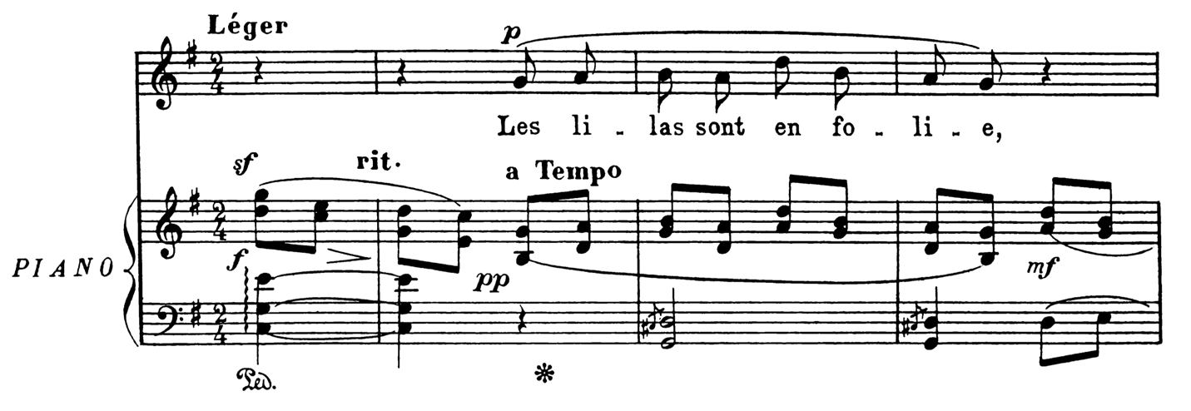
Figure 1 Chanson (Delaquys) mm. 0-3
The second stanza emphasizes the importance of the subdominant and reaffirms the tonality of G. Applied dominants lead to the subdominant in m. 12 and again in m. 14. Figure 2 shows how the subdominant resolves down to the mediant at the end of the stanza to subordinate the phrase within the overall tonal center.
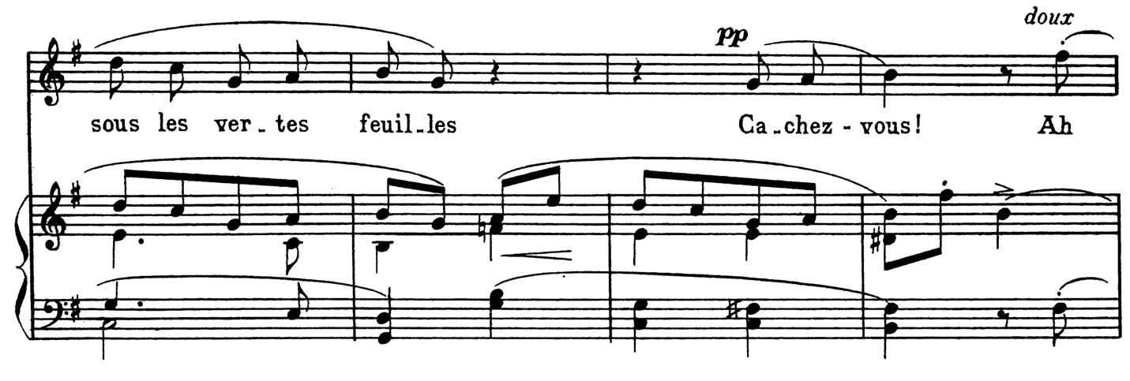
Figure 2 Chanson (Delaquys) mm. 12-15
The third and final stanzas of Chanson reiterate the germinal idea expressed in the opening. The dominant pedal (mm. 46-49) is a typical trait of tonal music that prepares listeners for the return of tonic. Figure 3 shows that Boulanger uses V7/IV to lead away from the dominant pedal towards a cadence, as well as the plagal flourish at the end of the song. The reappearance of V7/IV and the use of a plagal cadence at the conclusion reflect the introduction and affirm the germinal idea in this song.
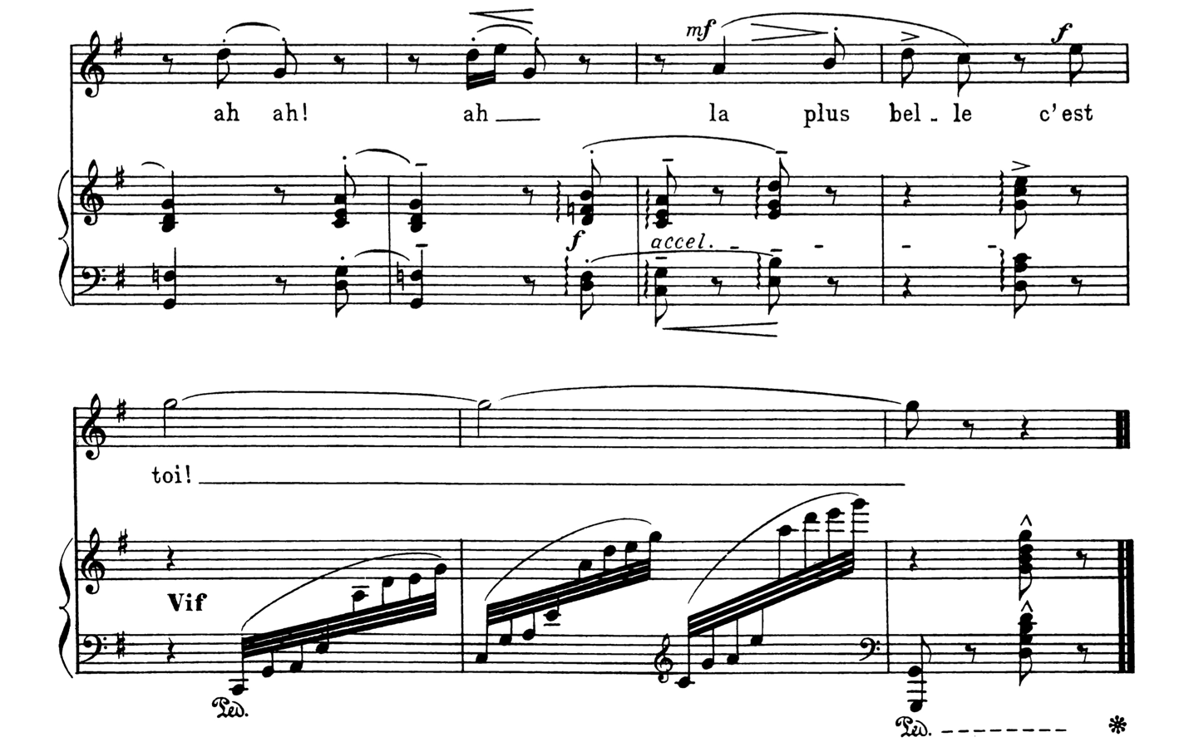
Figure 3 Chanson (Delaquys) mm. 50-56

ARRANGEMENT
The clear homophonic texture of this song lends itself well to a traditional brass quintet; in particular, the piano generally maintains four voices throughout, one for each of the remaining instruments while the first trumpet plays the vocal solo. This piano part does, however, present a few challenges for translation to a brass chamber group.
In this Chanson, there are several rolled chords, use of pedal, and a few instances where the range, rhythm, and harmonic density are not suited to brass chamber music. The last three measures of Figure 7 demonstrate how the author has handled one such passage presenting many of the issues described above.
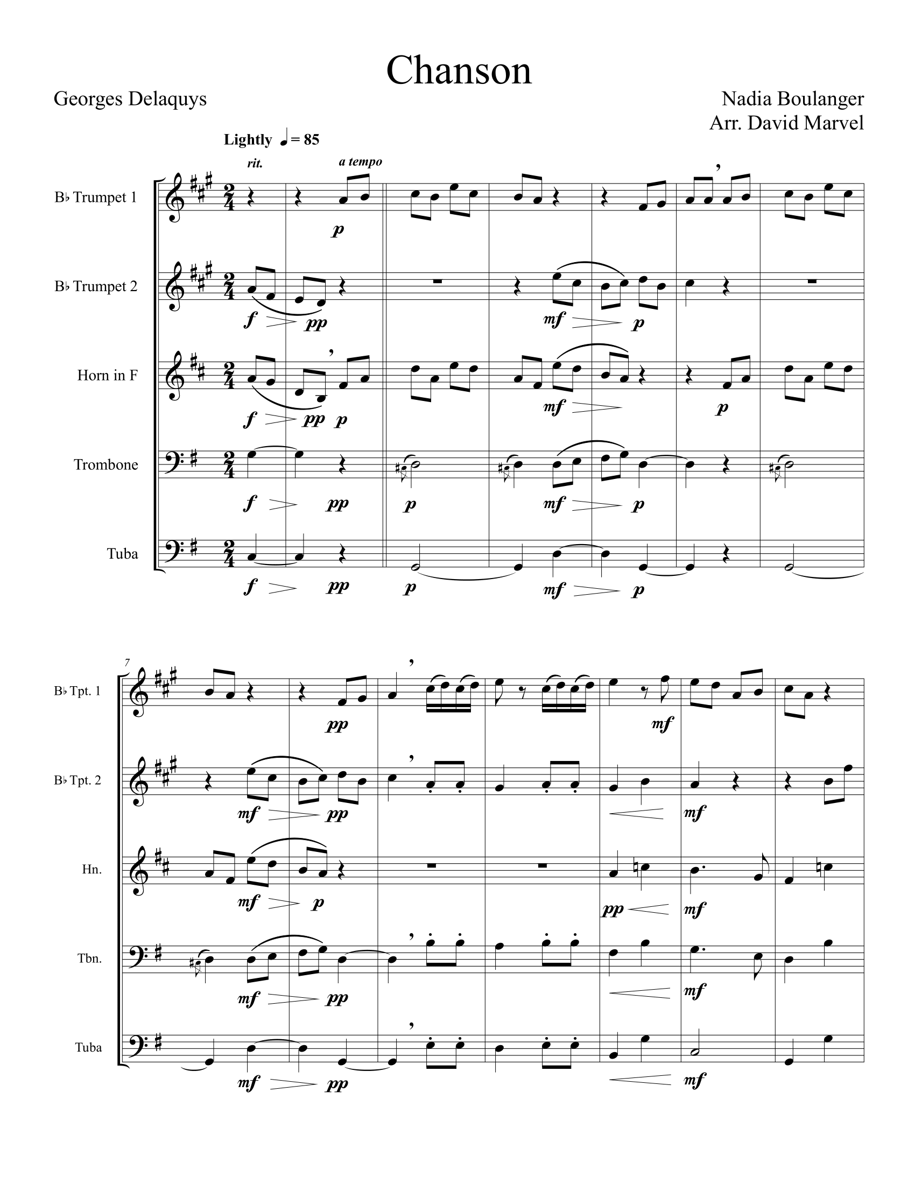
Figure 4 Author's Arrangement of Chanson (Delaquys), Page 1
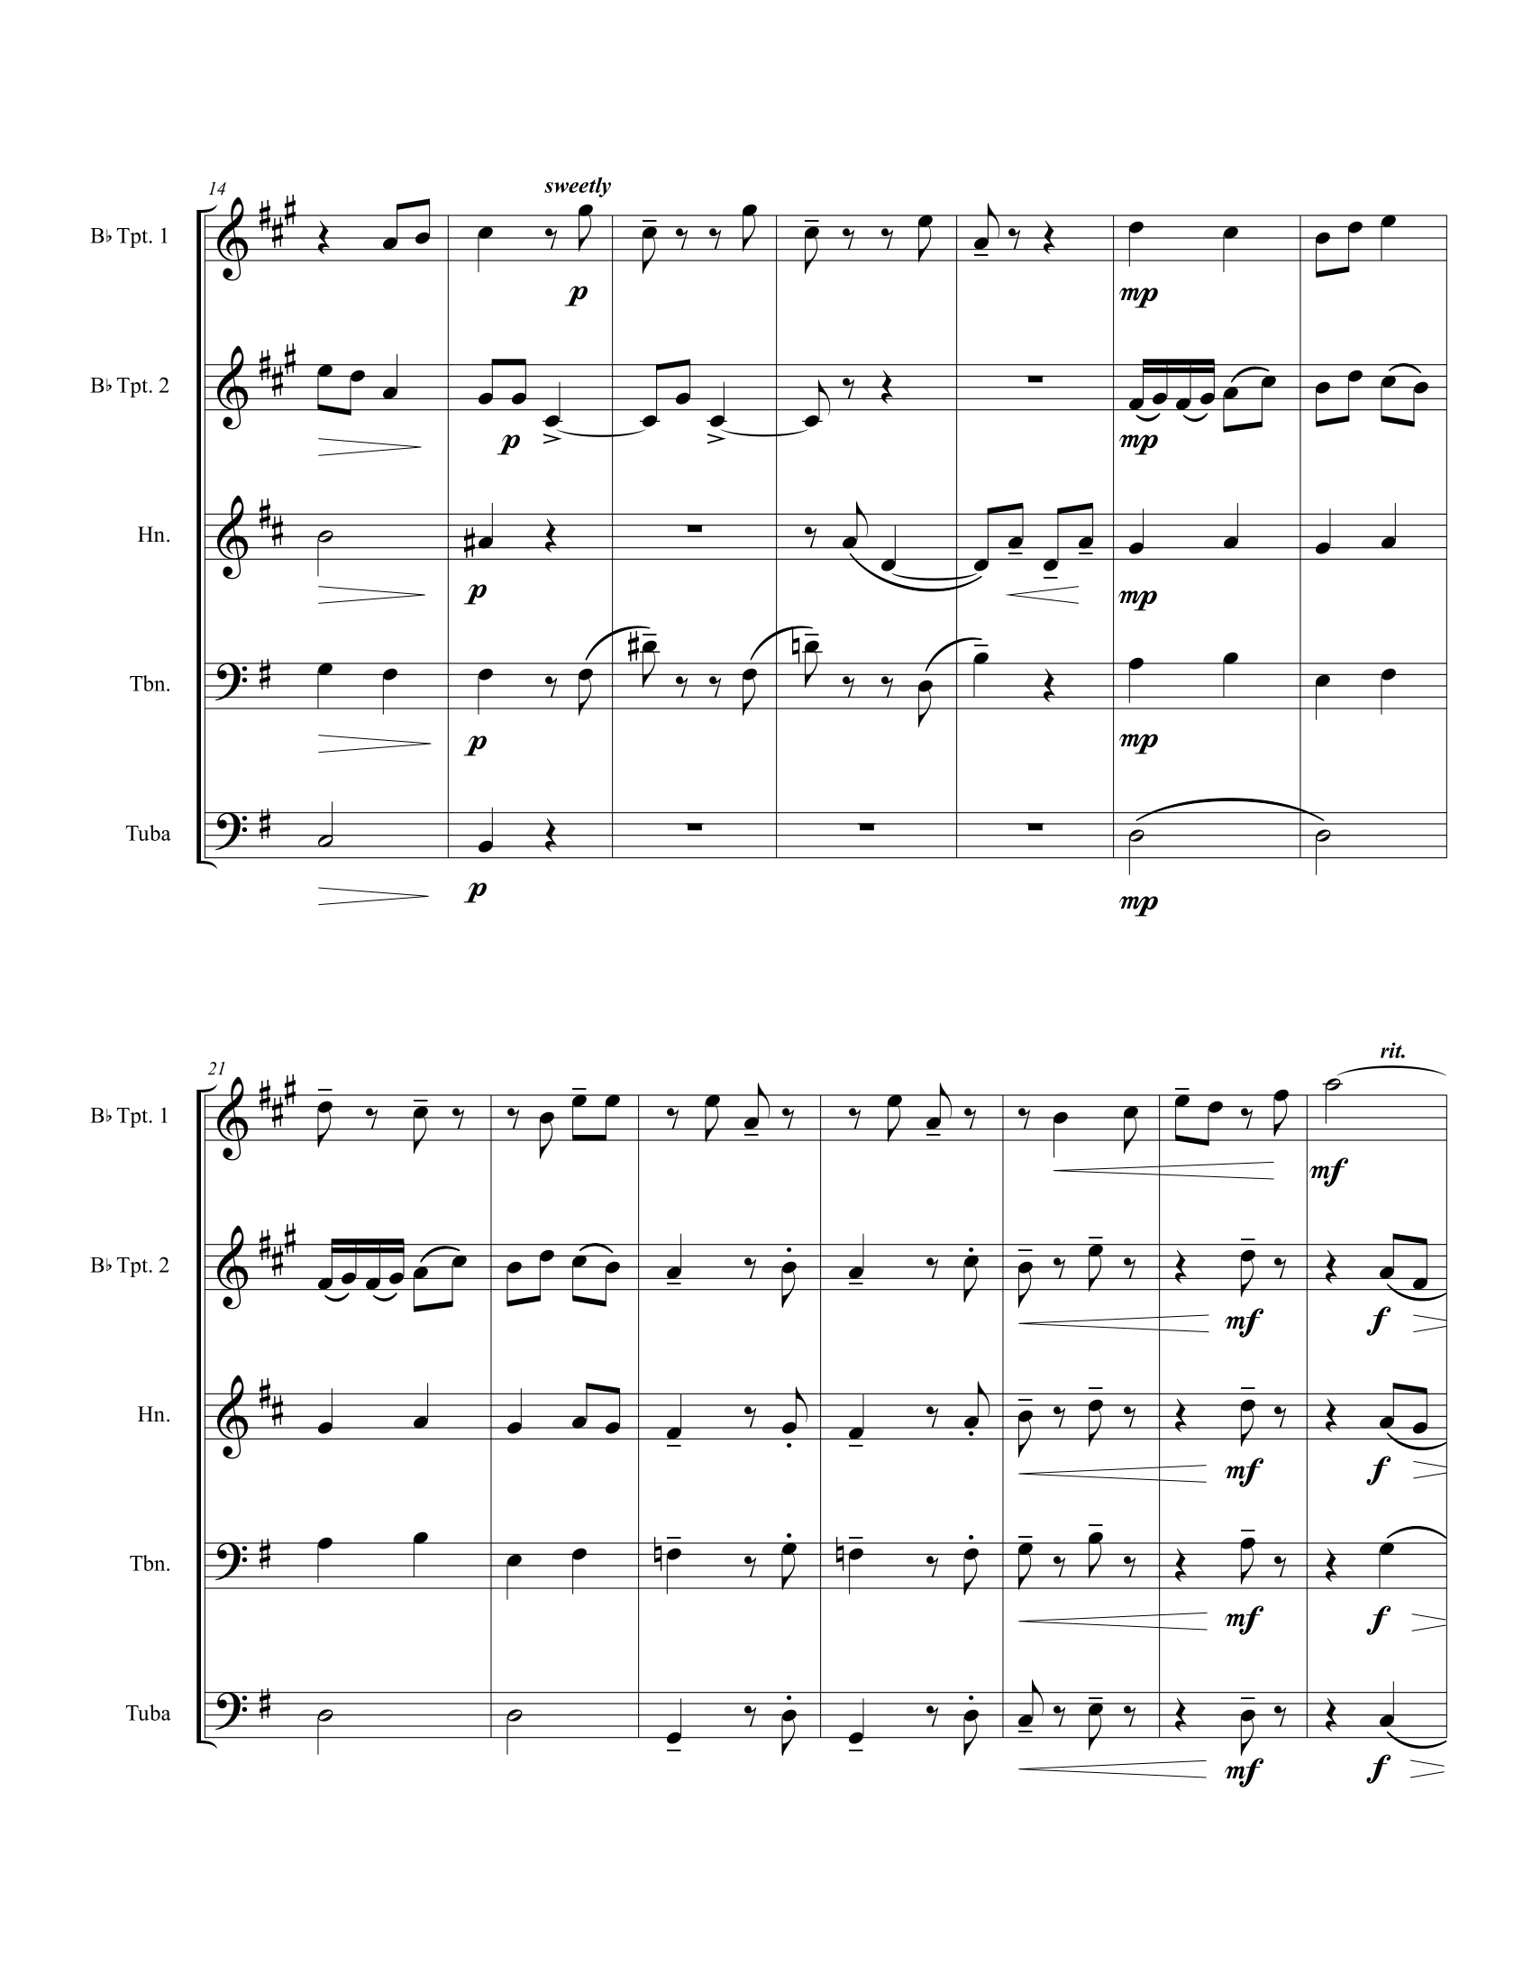
Figure 5 Author's Arrangement of Chanson (Delaquys), Page 2
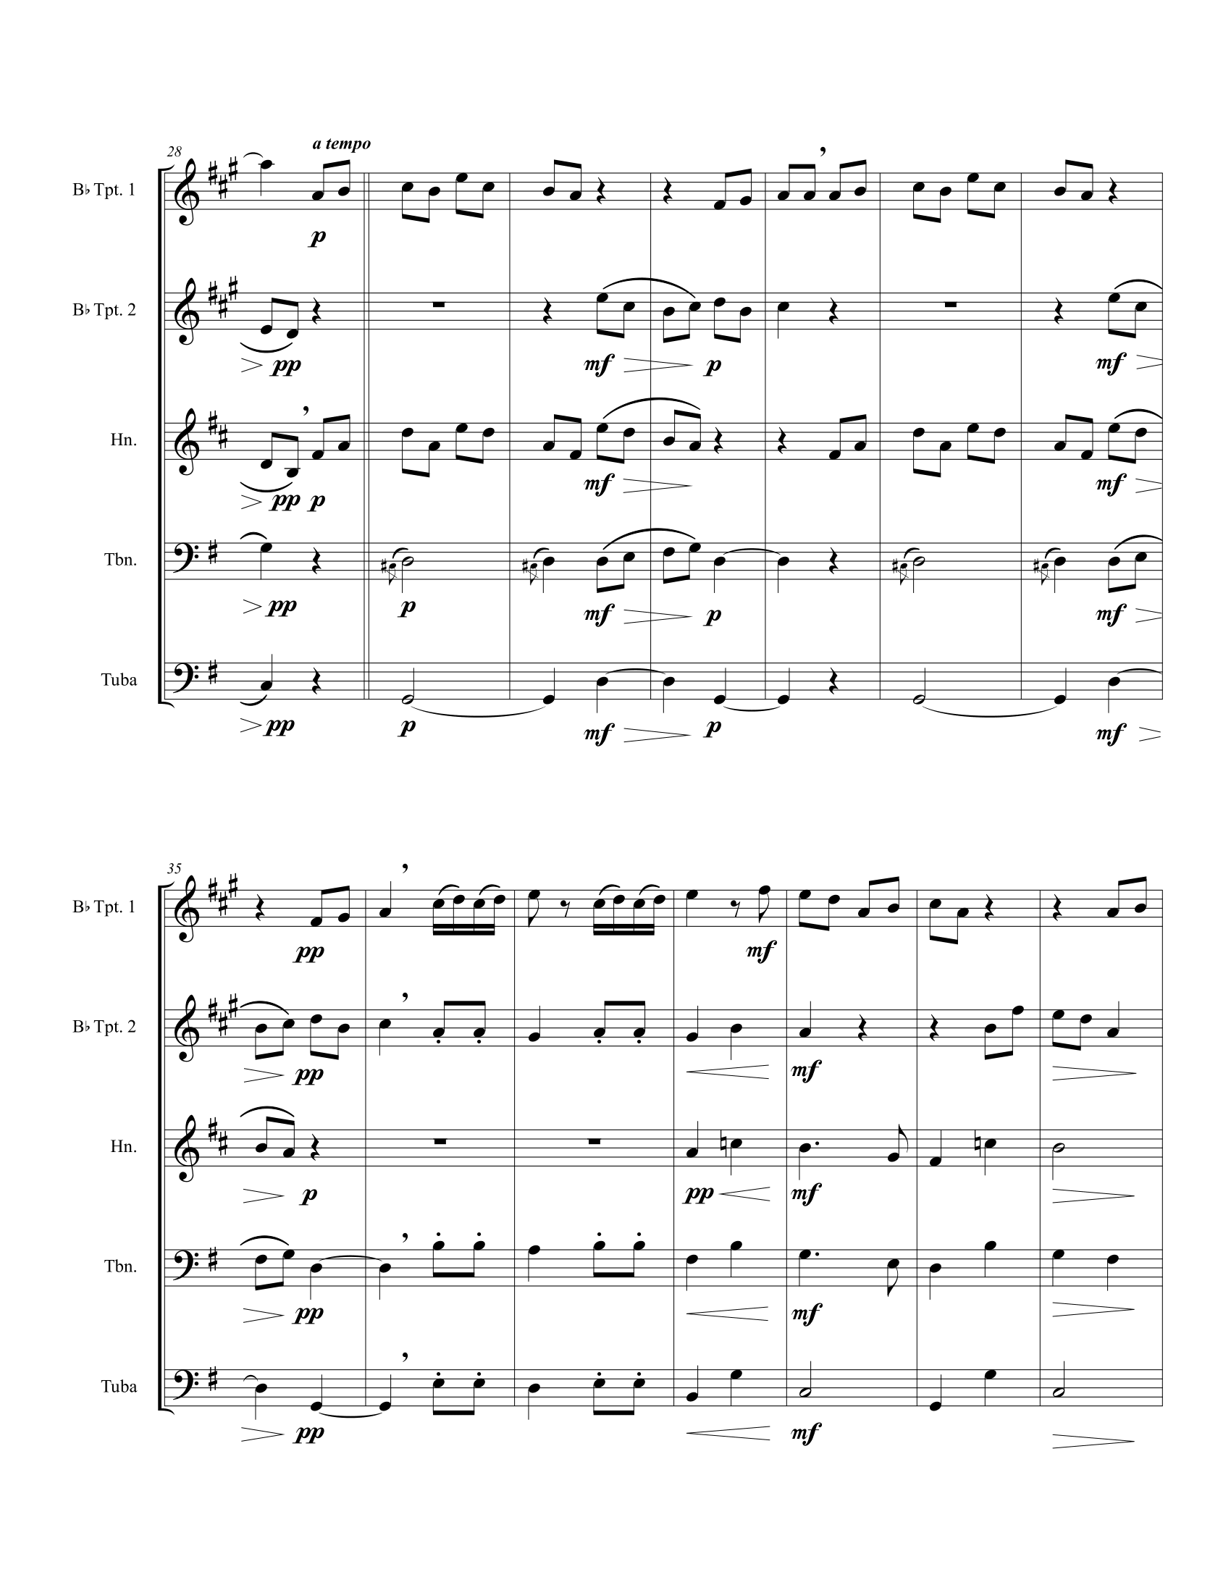
Figure 6 Author's Arrangement of Chanson (Delaquys), Page 3
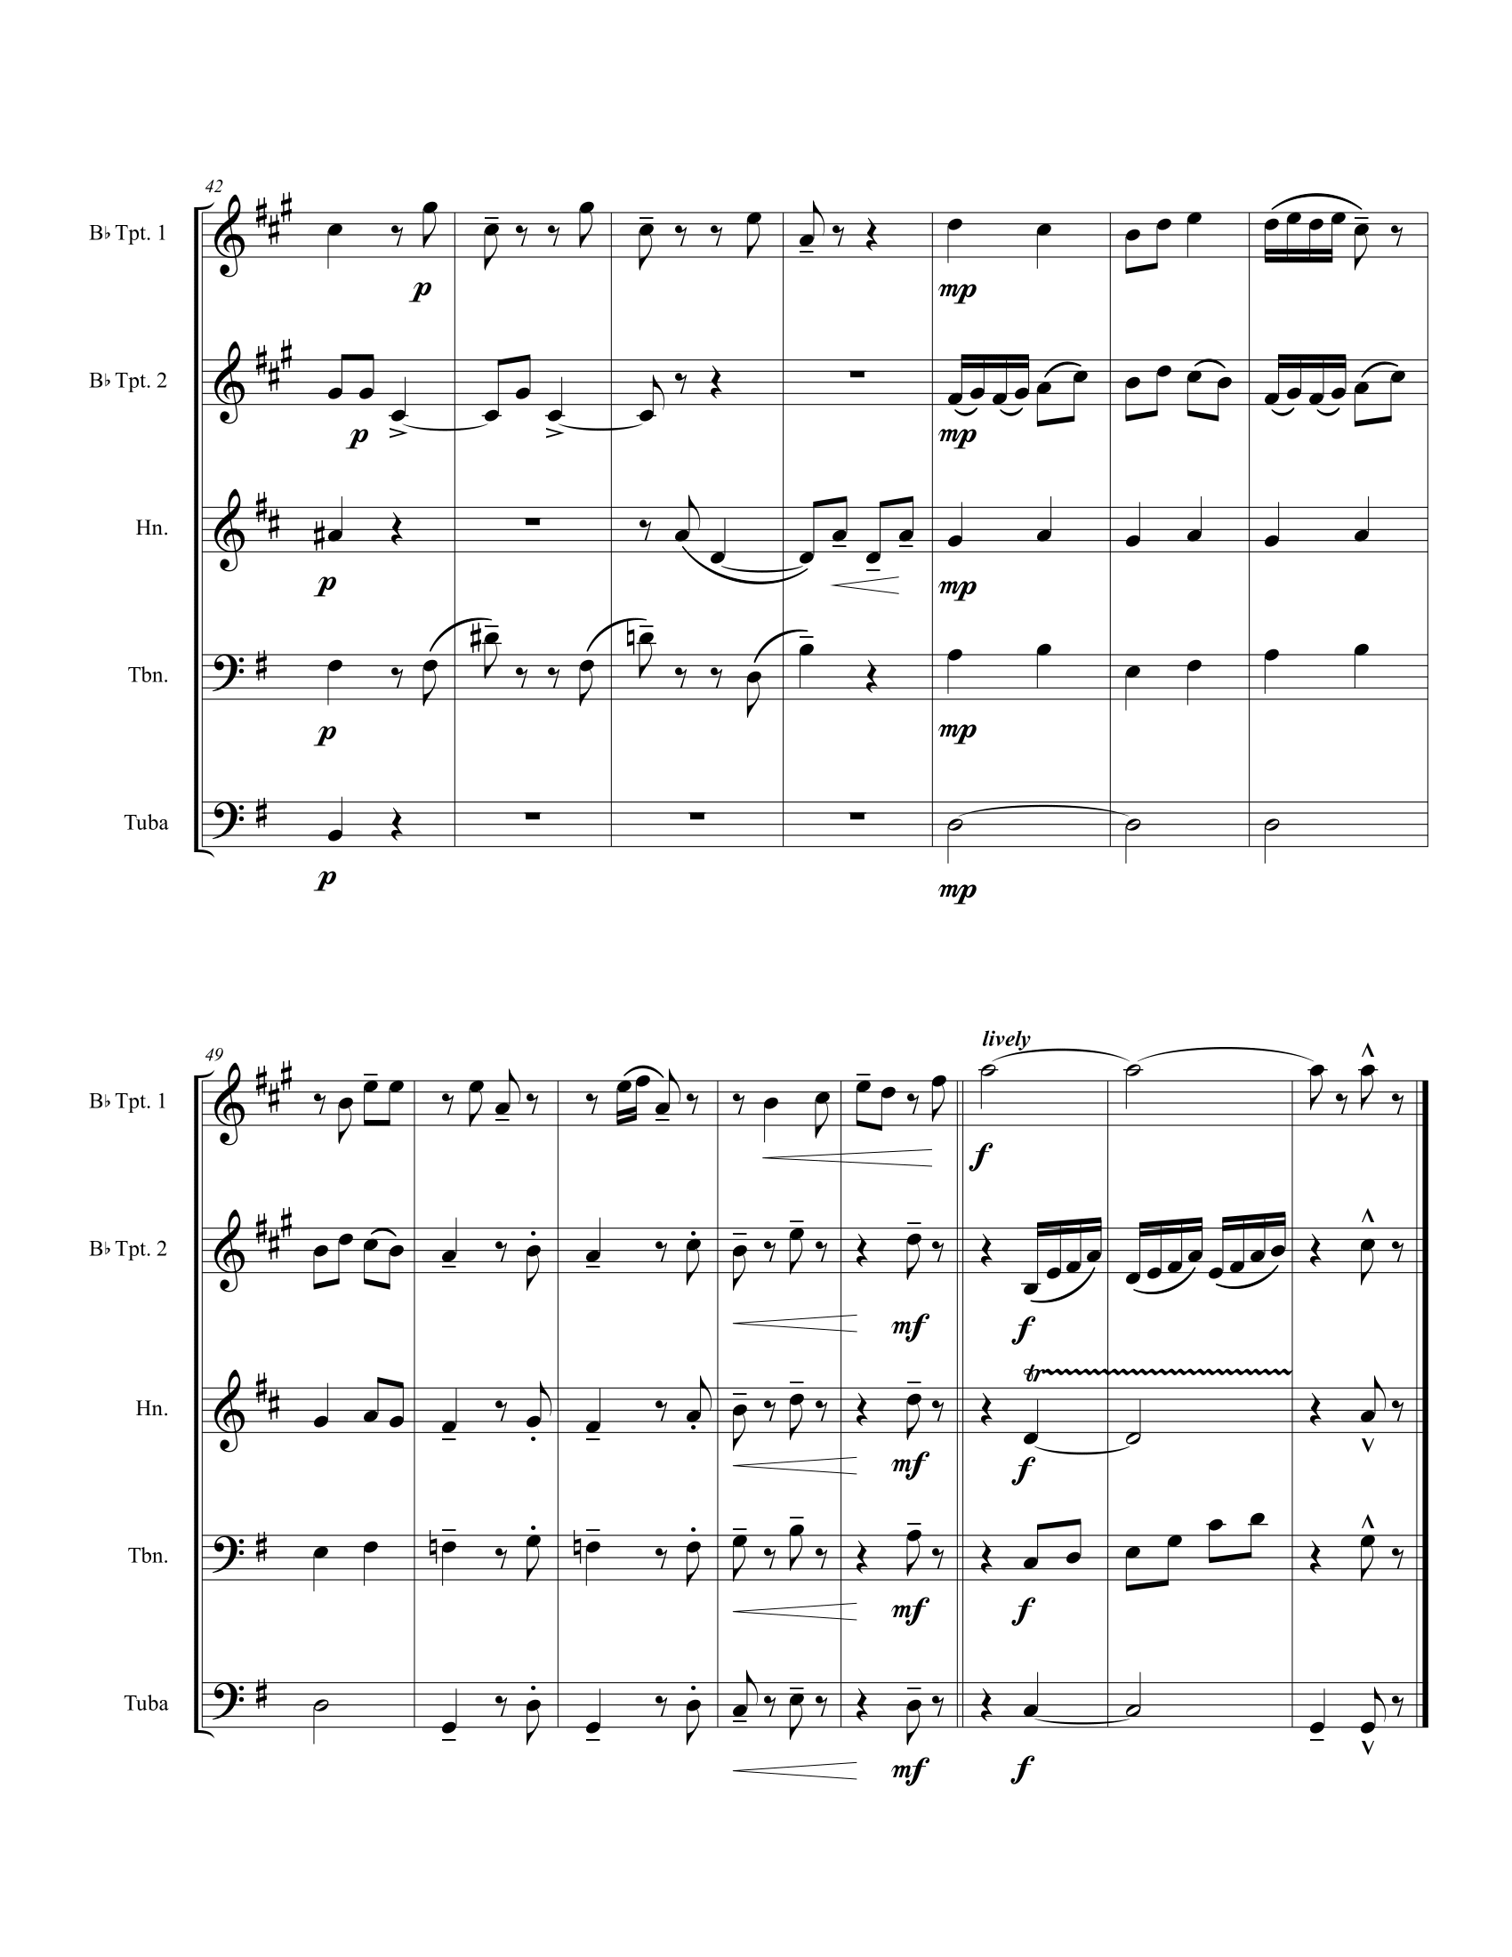
Figure 7 Author's Arrangement of Chanson (Delaquys), Page 4

Au Bord de la Route

ANALYSIS
For this sad song about a man’s life lived without love, Nadia Boulanger organizes the music around each of Camille Mauclair’s four stanzas.
This man did not want to live anymore
Come along, what are you getting involved in?
Sir, Madam, truly,
This man had had enough.
His heart was like a stone
But if someone had opened it
Perhaps in this heart of a lover
Would he have seen the diamond.
But the stone was so heavy
That he lay down on the road
Squeezing his hands on it
And he died in his waiting.
This man had had enough
With him the jewel will die
Sir, Madam, it is getting late,
A sign of the cross and go.
Nadia Boulanger organizes each stanza into a period. Table 2 shows the structure of phrases in Au Bord de la Route.
Table 2 Form and Text in Au Bord de la Route
Section |  | Measures | Notes
Introduction |  | 1-4 | Phrygian descent
Stanza 1 | Antecedent | 5-8 | Asymmetrical parallel period, accompaniment based on the introduction
Stanza 1 | Consequent | 9-15
Stanza 2 | Antecedent | 16-19 | Modulating symmetrical parallel period, accompaniment more harmonically active
Stanza 2 | Consequent | 20-24
Stanza 3 | Antecedent | 25-28 | Descending parallel 5ths
Stanza 3 | Consequent | 29-34 | Descending parallel 5ths
Stanza 4 | Antecedent | 35-38 | Return to music from Stanza 1
Stanza 4 | Consequent | 39-47 | Return to music from Stanza 1

The introduction, shown in Figure 8, establishes the tonal center as F and the song’s dissonant, minor harmonic soundscape. The bottom pitch of each dyad outlines a typical song progression in the phrygian mode; the dissonance added to this standard harmonic formula expresses the pain conveyed by the text and foreshadows the heavy use of dissonance throughout the song.
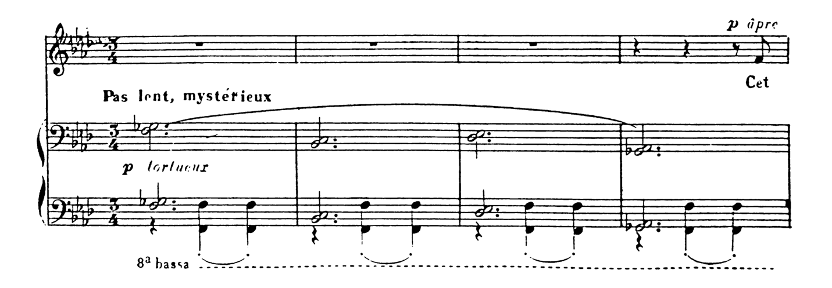
Figure 8 Au Bord de la Route mm. 1-4
The vocal melody used for the first stanza is another important unifying idea in this song; the declamatory ascending fifth entrance in the solo is an inversion of the descending fifth presented at the beginning of the introduction. The rhythm of the melody carries over into the accompaniment in measure 21. The first two lines of each stanza form an antecedent phrase using the same theme shown in Figure 9 (does not show anacrusis).
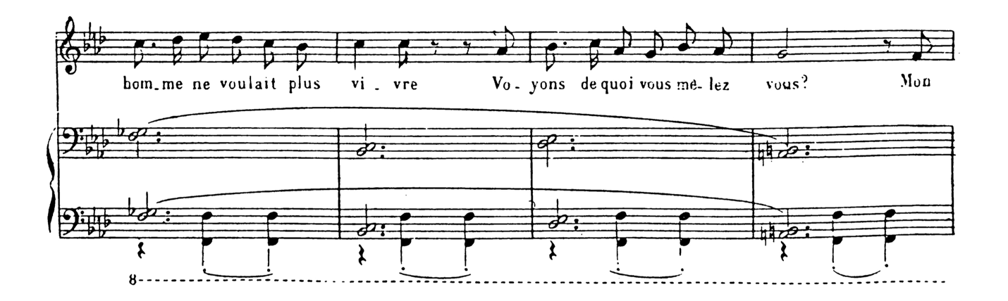
Figure 9 Au Bord de la Route mm. 5-8
Although the harmony is not typical, the periodic phrasing throughout is quite clear. The antecedent is the prototypical four measures; this is made clear by the phrase marking and supported by the agogic accent on the supertonic in m. 8. The consequent phrase is parallel, and interpolation in the second half of the phrase drags out the journey back to the tonic. In this way, Nadia Boulanger uses the form to convey the feeling expressed in the text of not wanting to go on anymore.
The insistent weak-beat Fs in the piano’s left hand persist throughout Au Bord de la Route, grounding the tonal center. Figure 10 shows the dramatic moment the tonic pedal disappears at the end of the second stanza, supporting harmonic text painting on the word “diamond” with the subdominant, Bb. The consequent phrase in the second stanza begins parallel then changes at the cadence to support this shift to Bb.

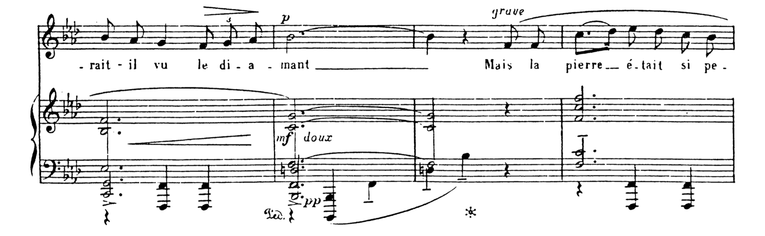
Figure 10 Au Bord de la Route mm. 22-24
The consequent phrase in the third stanza uses a new melody that shifts back and forth between Ab and G, an idea rooted in the use of Ab and Gb to lead to F in the introduction. Figure 11 shows Ab and Gb returning at the end of the final stanza to lead back to the tonic.
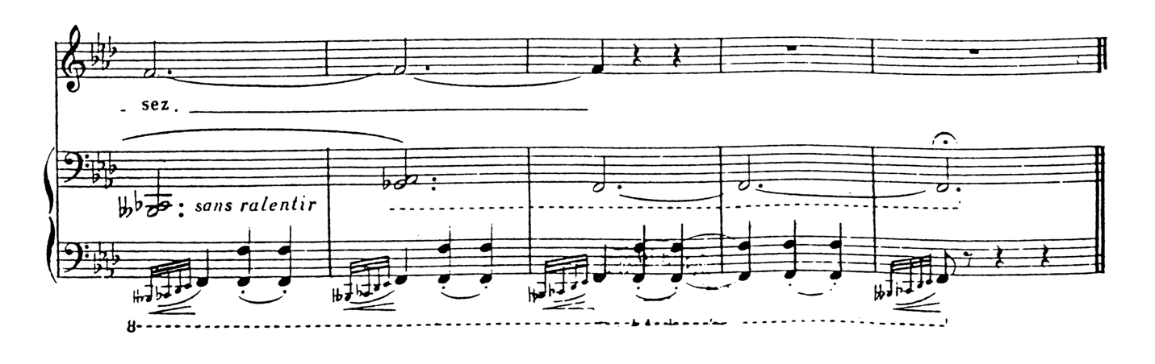
Figure 11 Au Bord de la Route mm. 43-47

ARRANGEMENT
While the vocal line in this song is well suited to the middle register of the trumpet, the piano presents several unique challenges in translation to brass chamber music. The use of extreme low register, pedal, and dense chords containing more notes than players in a brass quintet are the most obvious and quickly resolved; for instance, in this arrangement, many octave doublings, particularly in the extreme lower register, were sacrificed. One challenge of this song is the prevalence of long notes, particularly at such a slow tempo. With the pedal, the piano can sustain indefinitely; brass musicians need to breathe.
A unique artistic hurdle that this arrangement presents is the conflict of timbre and function. In the original, the distinction between timbres is apparent and coincides with two separate musical roles. As brass chamber music, a homogenized sound does not lend itself well to that distinction. In response to these problems, the author has chosen to rework some passages to include more melodic passages for most ensemble members. For instance, Figure 13 shows the second trumpet harmonizing the melody in the second stanza, with the horn providing some rhythmic contrast through material derived from the germinal motive.

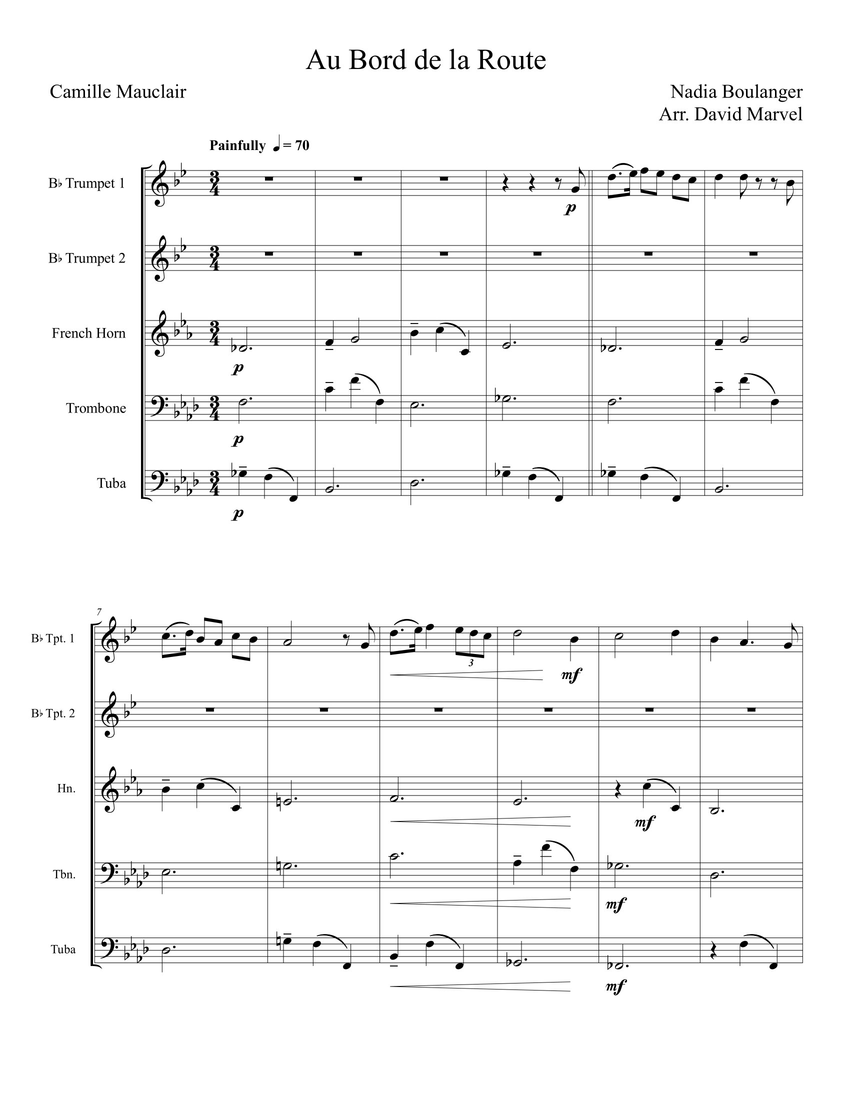
Figure 12 Author's Arrangement of Au Bord de la Route, Page 1
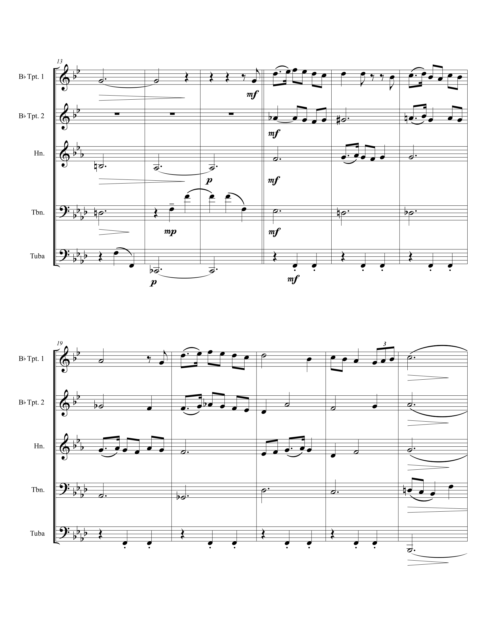
Figure 13 Author's Arrangement of Au Bord de la Route, Page 2
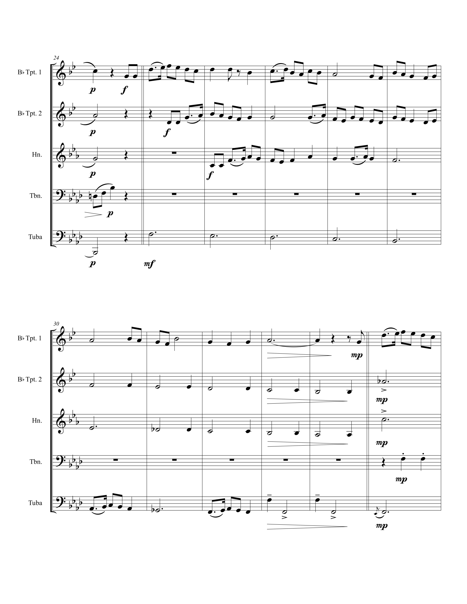
Figure 14 Author's Arrangement of Au Bord de la Route, Page 3
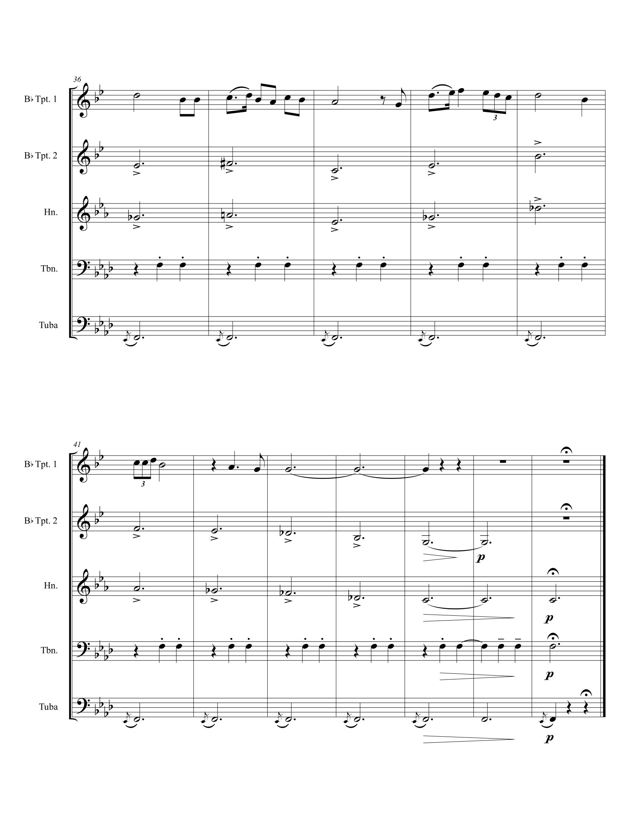
Figure 15 Author's Arrangement of Au Bord de la Route, Page 4

Chanson (Mauclair)

ANALYSIS
This poem by Camille Mauclair expresses the harsh ambivalent nature of love turning into scorn. Nadia Boulanger organizes this song around each of Mauclair’s stanzas.
She sold my heart
For a song:
Sell my heart instead,
Oh peddler
Instead of the song.
Your songs were white
Mine is the color of blood;
She sold my heart,
Oh peddler
She sold my heart
While having fun.
And now sing my heart
In the squares,
At the crossroads,
You will cause crying, peddler
While telling of my great love.
While she will cause to laugh
The people who had come to her wedding,
While singing the song for fun,
For which she had sold my heart.
The introduction establishes A as the tonal center and presents the germinal idea of using Bb to lead back to A using the ostinato shown in Figure 16. The most prominent pitches within this ostinato, A, occurs four times, and Bb, three. In addition to their frequency, both pitches appear in metrically strong positions, both hands of the piano, and they both lead directly into each other as pickups. In all of the sections which use the ostinato, the vocal melody primarily remains on scale degree five, hinting at the traditional relationship between tonic and dominant while enhancing the leading function of Bb through their tritone relationship.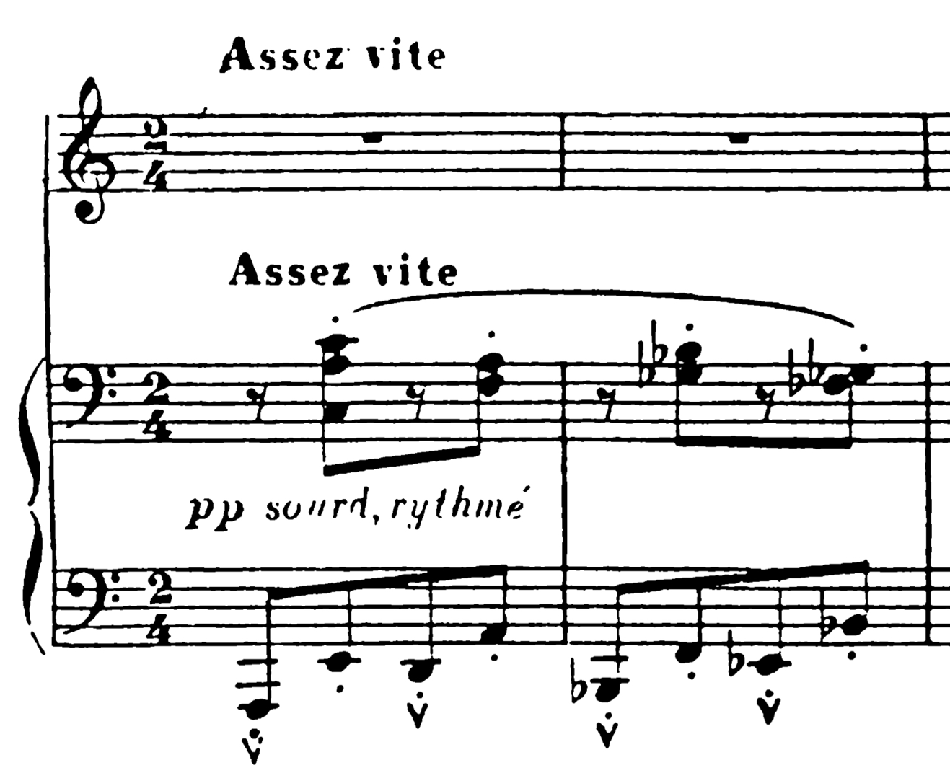
Figure 16 Ostinato in Chanson
Table 3 shows that the ostinato is prominent throughout much of this song.
Table 3 Form and Text in Chanson (Mauclair)
Section | Measures | Notes
Introduction | 1-4 | Ostinato
Stanza 1 | 5-22 | Ostinato
Stanza 2 | 23-38 | Simple triple, harmonically dense opening, Bb leads return to ostinato
Stanza 3 | 39-51 | Climax, similar to Stanza 2, returns to ostinato
Stanza 4 | 52-71 | Ostinato

In stanzas two and three, when the ostinato is not present, the germinal idea still rules. Figure 17 demonstrates that Bb still functions as the dominant, leading back to A. As in the first stanza, A and Bb both appear in metrically strong positions, both hands of the piano, and both pitches lead directly into each other. Furthermore, the tritone formed by E in the soprano against the Bb in the bass (m. 24) reinforces the dominant function Bb carries in this song.
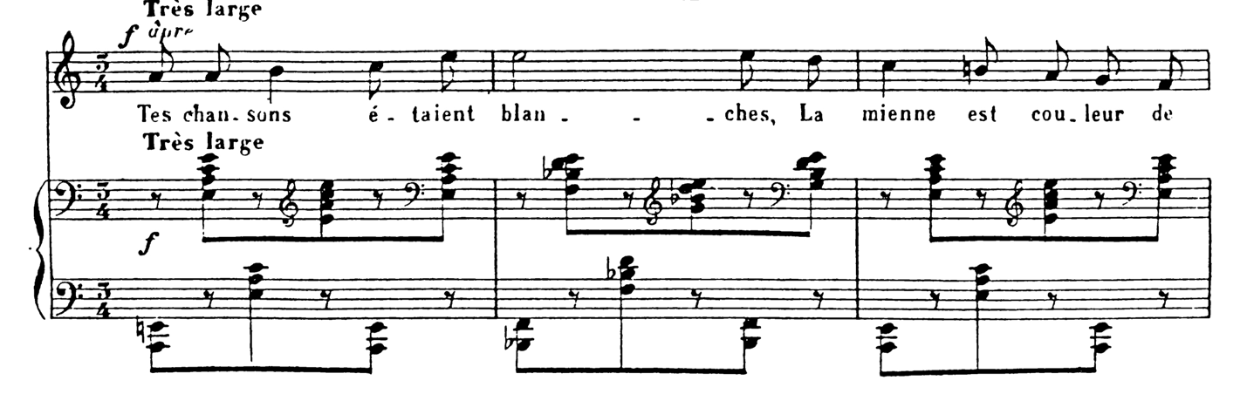
Figure 17 Chanson mm. 23-25
Figure 18 shows the retransition from the new music of stanza two back to the ostinato. The bass reveals what is happening; after getting locked into outlining an A augmented triad in the left hand in mm. 27-30, a brief hemiola in mm. 31-32 destabilizes the music. It is the Bb in m. 33 that leads back to the ostinato.

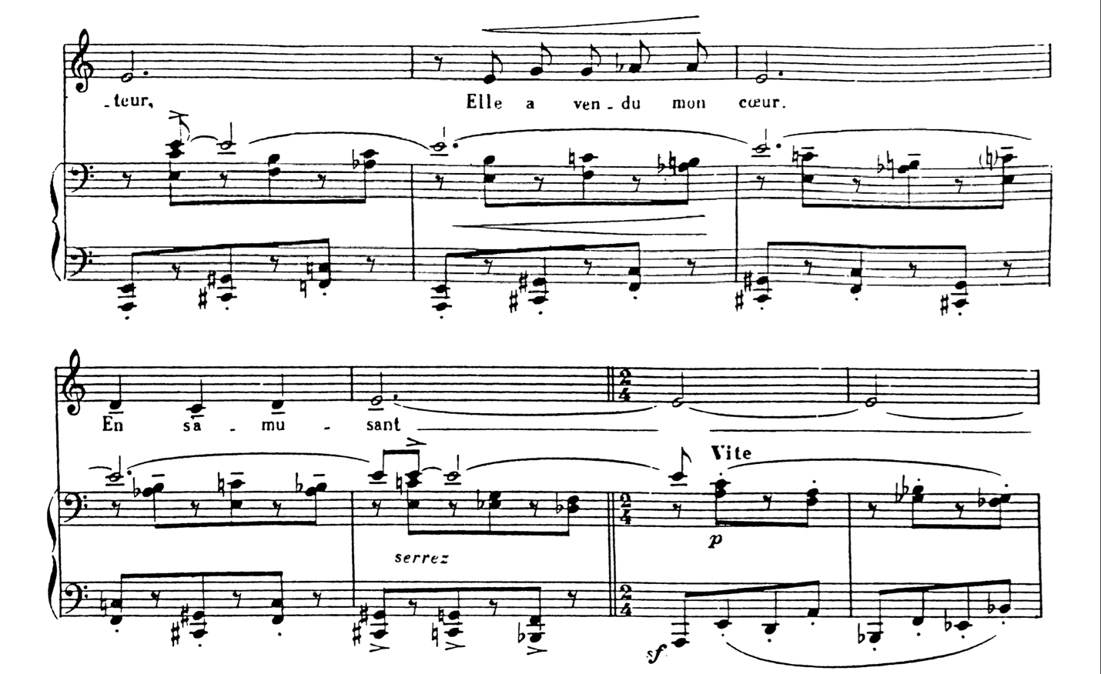
Figure 18 Chanson mm. 29-35
In the climactic third stanza, dense harmonies predicted by the seconds in the introduction ornament the germinal idea. At the end of the third stanza, the pain expressed by Bb in the piano part infects the vocal melody. For the remainder of the piece, the vocalist sings Bb instead of B.

ARRANGEMENT
For this song, solving the translation of the ostinato accounts for most of the arrangement. The author’s solution, shown in Figure 19, preserves the original strong beat bass and weak beat soprano pitches in the horn and tuba. The new inner voice in the trombone outlines the original harmonies and helps connect the horn and tuba.
The new music in the second stanza has too many simultaneous pitches and too wide of a range to translate directly to a brass quintet. The composite rhythm remains the same in this arrangement, but the added long notes help tie the bass, syncopation, and melody together.
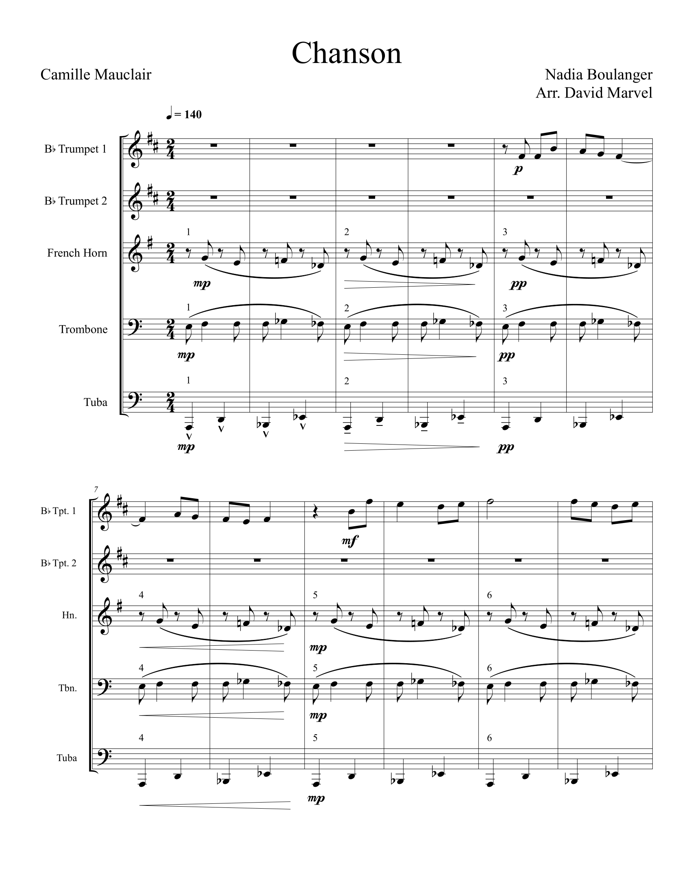
Figure 19 Author's Arrangement of Chanson (Mauclair), Page 1
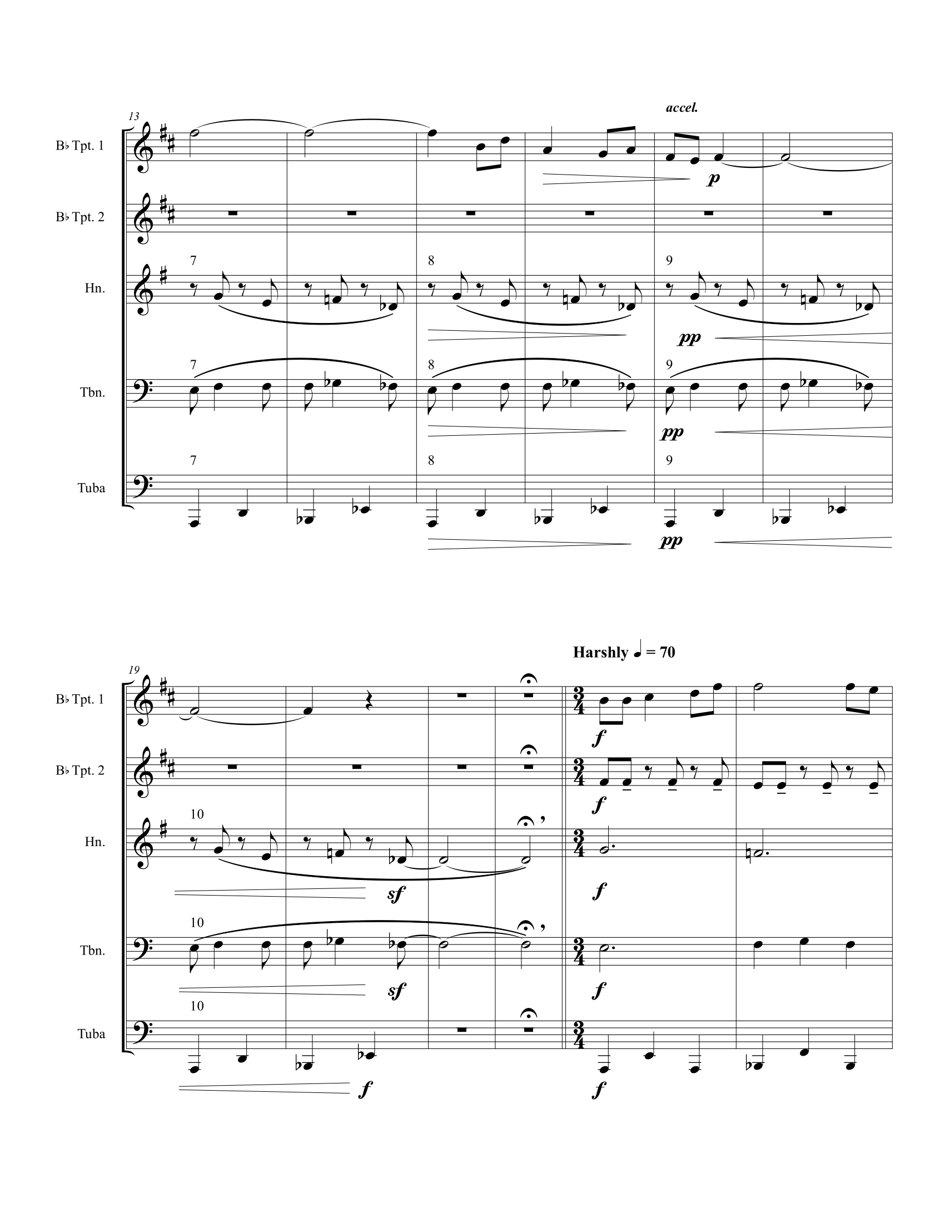
Figure 20 Author's Arrangement of Chanson (Mauclair), Page 2
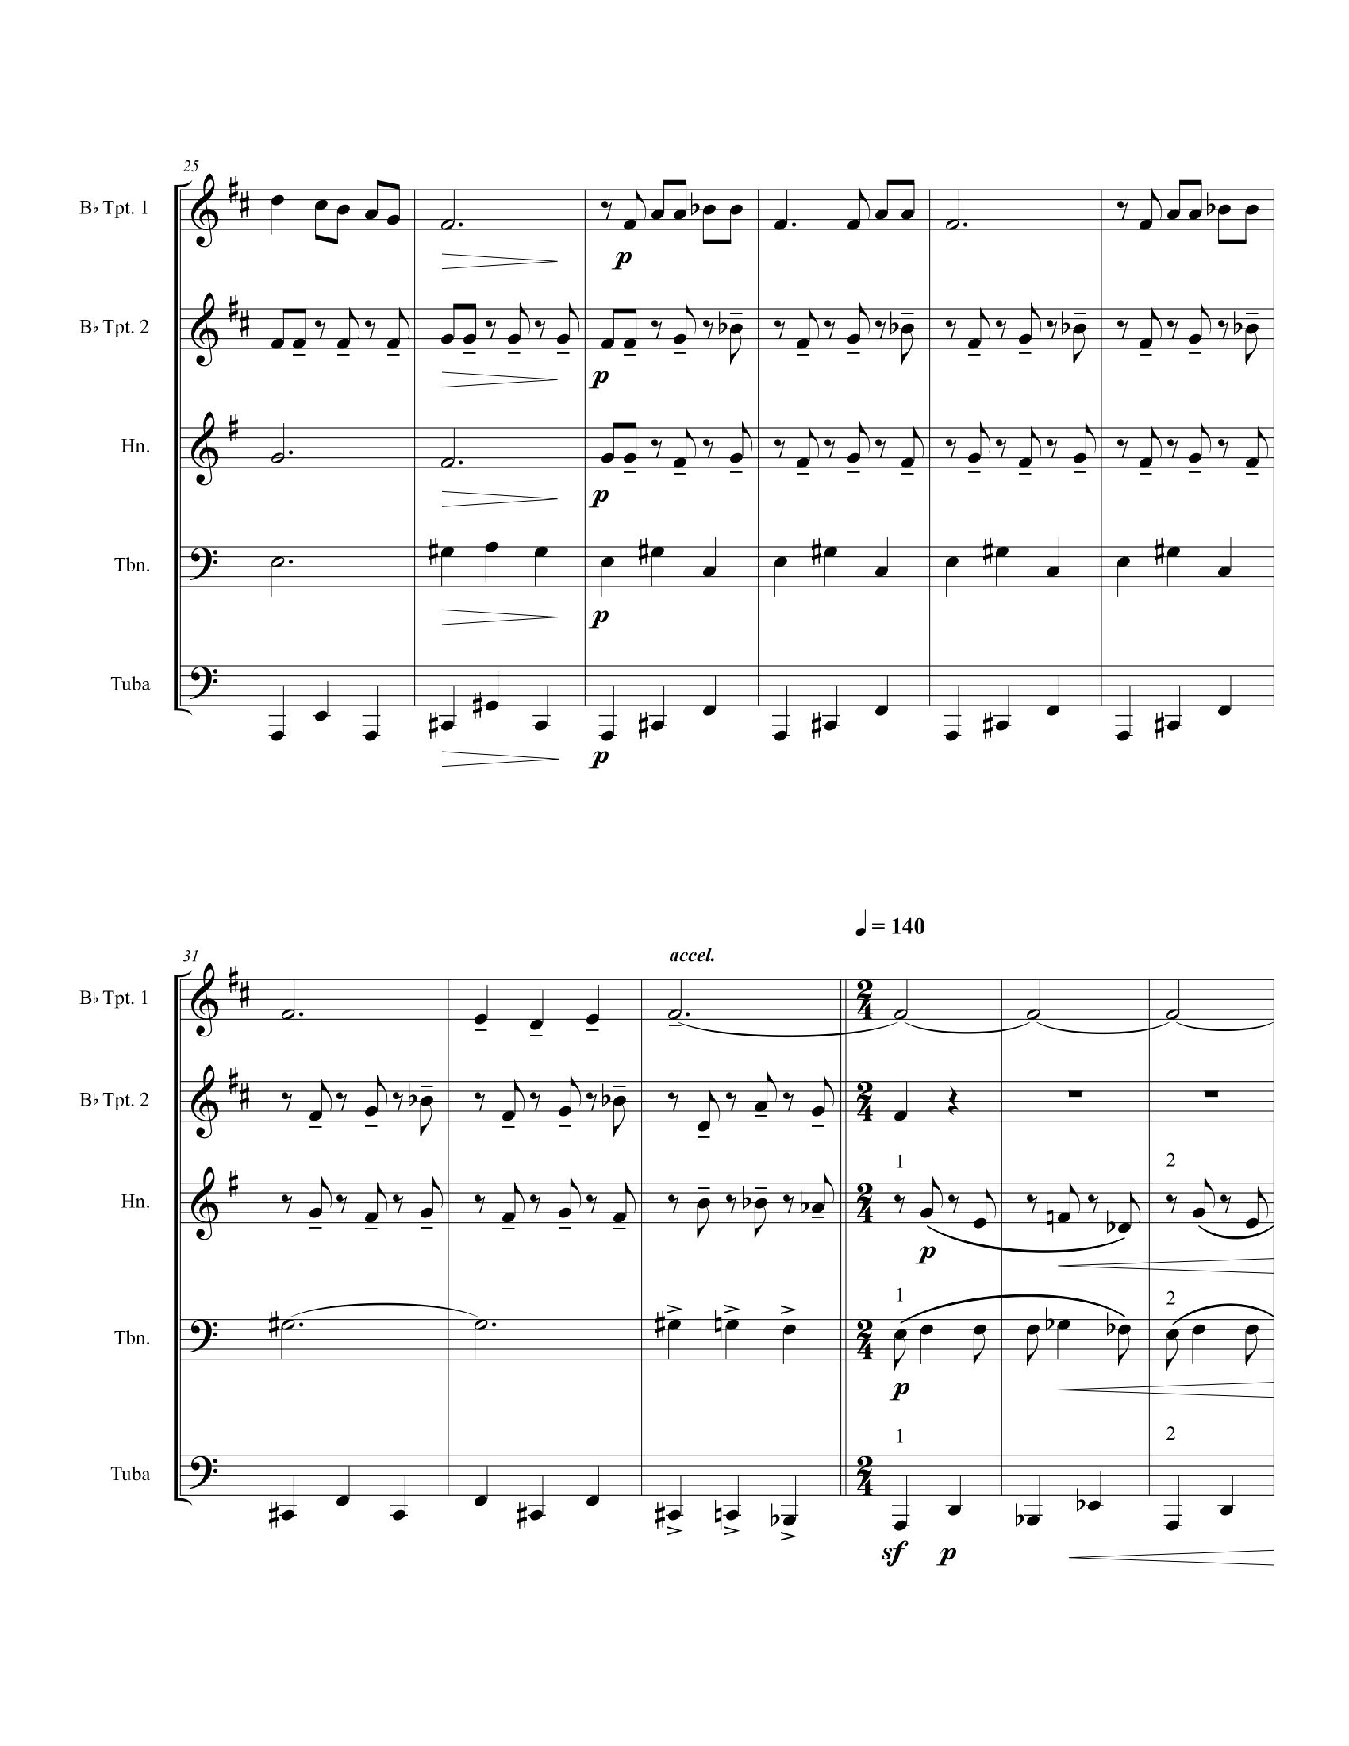
Figure 21 Author's Arrangement of Chanson (Mauclair), Page 3
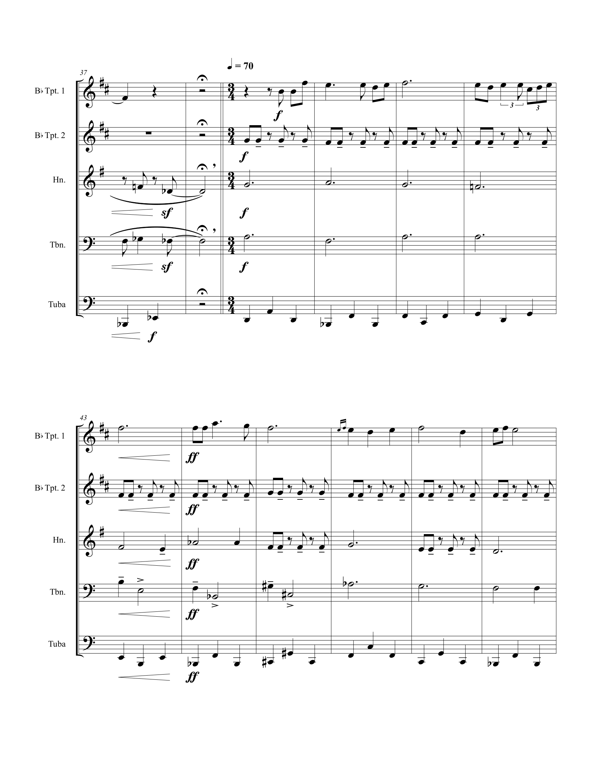
Figure 22 Author's Arrangement of Chanson (Mauclair), Page 4
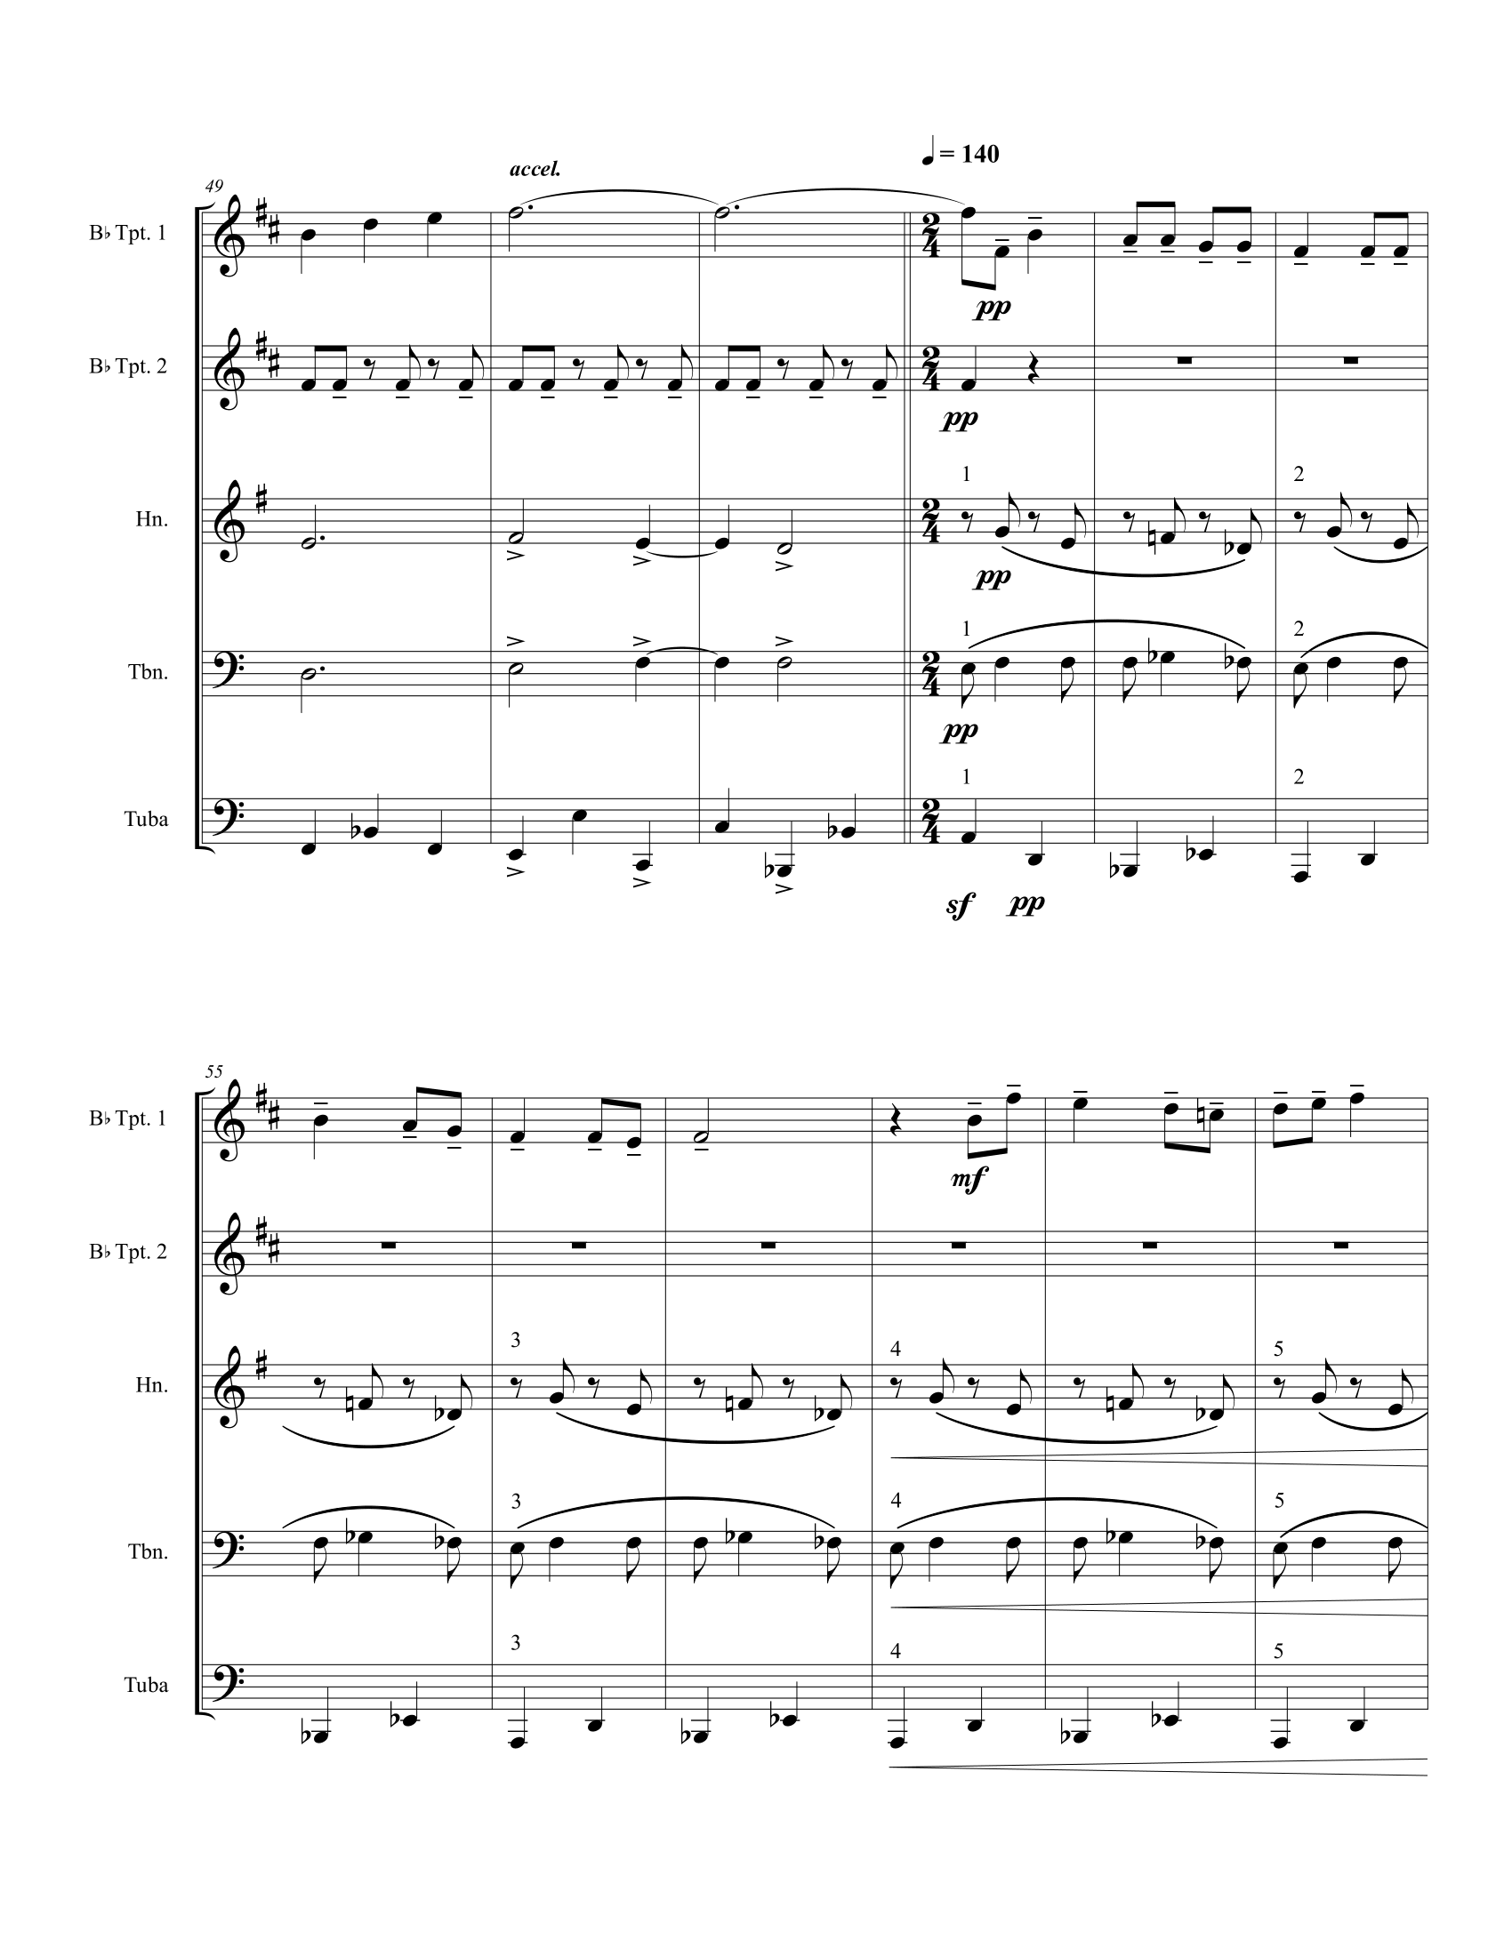
Figure 23 Author's Arrangement of Chanson (Mauclair), Page 5
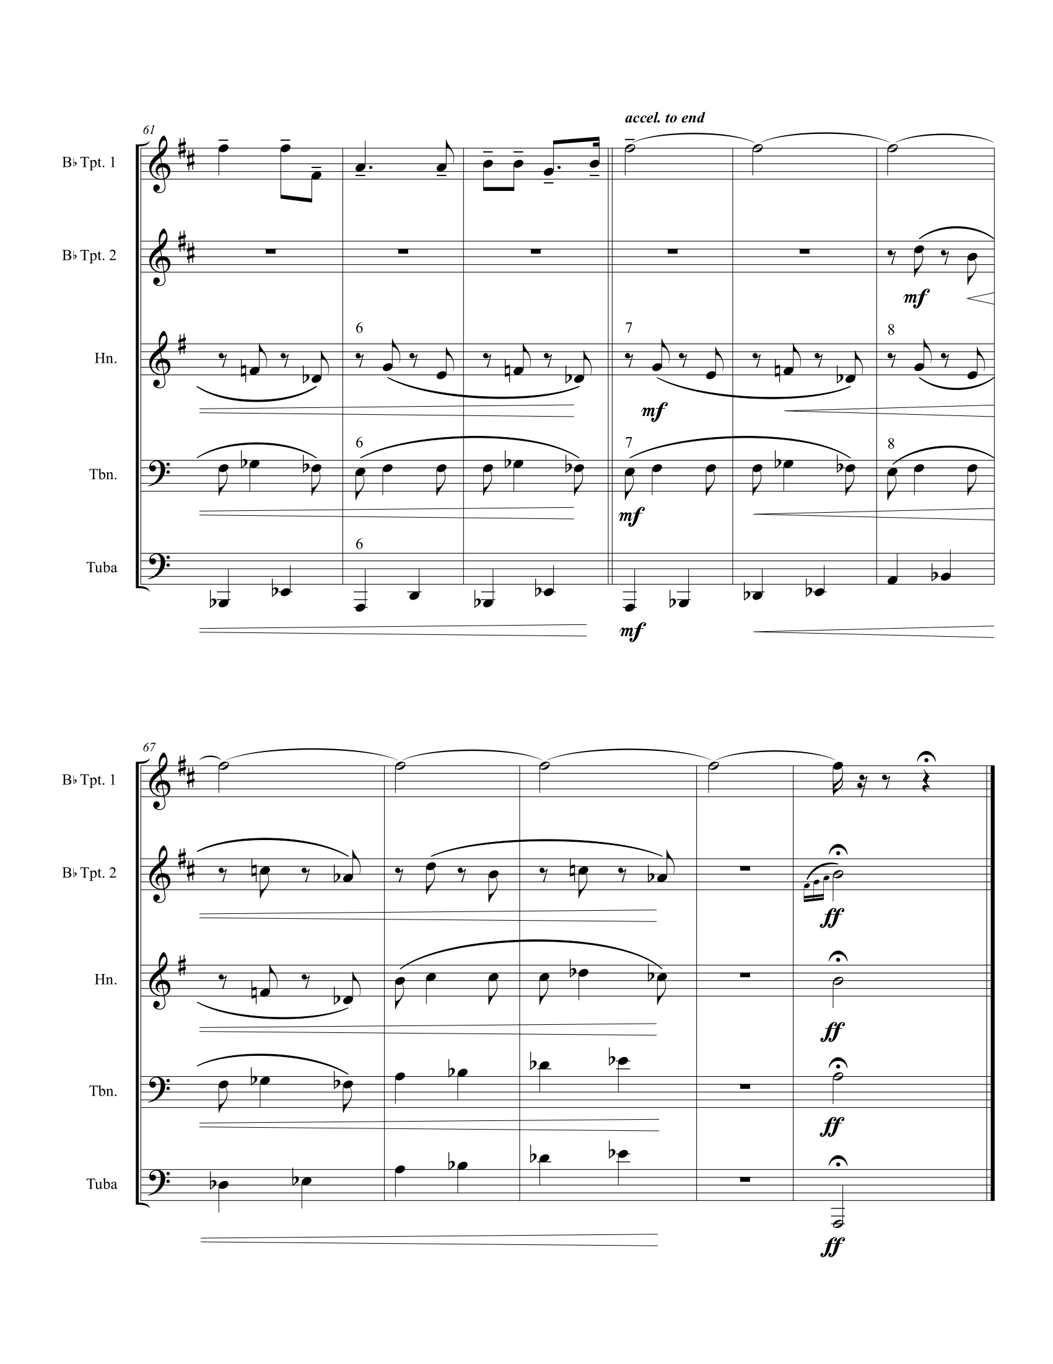
Figure 24 Author's Arrangement of Chanson (Mauclair), Page 6

Élégie

ANALYSIS
Published in 1906, Nadia Boulanger sets this poem by Albert Samian in a well-organized manner, revealing some of the competing influences in her musical world of lingering romanticism and the new impressionism particular to the French.
A sweetness splendid and somber
Floats under the starry sky.
It looks as if above in the shadow
A paradise has collapsed.
And it is like the ardent fragrance,
The feverish fragrance in the black air
Of a lover’s hair
Unraveled through the night.
All space languishes in fevers.
From the depths of the mysterious hearts
Coming to die on the lips
Words which closed the eyes.
And from my mouth, where evaporates
The scent of the past pleasures
And from my still vibrant heart
Arises vague pities.
For all of those, who, on earth
By such an evening arms outstretched
Have not in their lonely heart
A name to sob quietly.
For the first three stanzas, Boulanger organizes the music around the text, making it more dramatic when she musically blurs the lines between the final two. The organization of text and key areas shown in Table 4 reveal a Romantic harmonic language.
Table 4 Form and Text in Élégie
Section | Measures | Notes
Introduction | 1-4 | Descending melody establishes Db
Stanza 1 | 5-19 | Db, modal mixture
Stanza 2 | 20-30 | D, highly chromatic
Stanza 3 | 31-39 | E, change to compound triple
Stanza 4 | 40-48 | Climax, Eb Ab A Db
Stanza 5 | 48-57 | Climax, Eb Ab A Db
Closing Section | 58-65 | Db

The germinal idea in this song unfolds a bit more slowly than Nadia Boulanger’s other songs included in this study. The first three notes from the piano form a melodic motive, which is vital in the first stanza and closing section. The introduction establishes the tonic as Db and presents an important motive; however, the vocal entry better represents the germinal idea in this song.
At the solo entrance in m. 5, the piano ornaments the tonic triad with the opening motive. The first chromatic pitch introduced in m. 6 is an accented chromatic lower neighbor tone D in the second measure of the vocal melody, which alludes to the key and a motive explored in the second stanza. The opening vocal statement also foreshadows the importance of traditional tonic-dominant relationships in the song. Figure 25 shows that the solo entrance is supported by a typical tonic prolongation using the dominant: I - V4/3 - I.
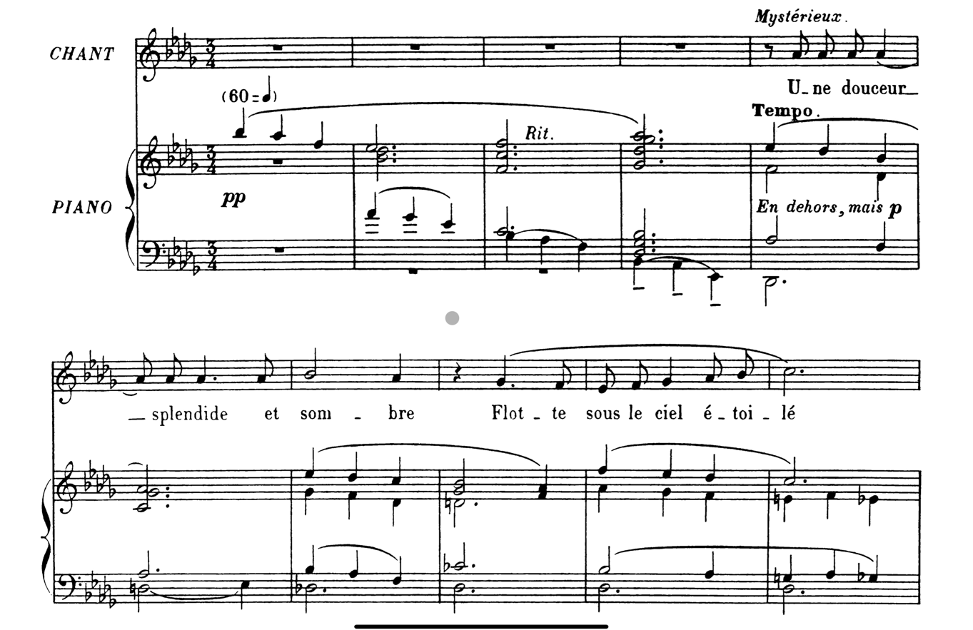
Figure 25 Élégie mm. 1-10
Figure 26 shows the development of the germinal idea in the second stanza. The accented chromatic lower neighbor idea from the opening is used eight times in this small passage. It is always an ornament of dominant function harmonies, just as it appeared in the beginning. In the first half of the phrase, the motive resolves to tonic. In mm. 26-30, the motive is used as a sequence to transition to the dominant of the key of E in preparation for the third stanza.
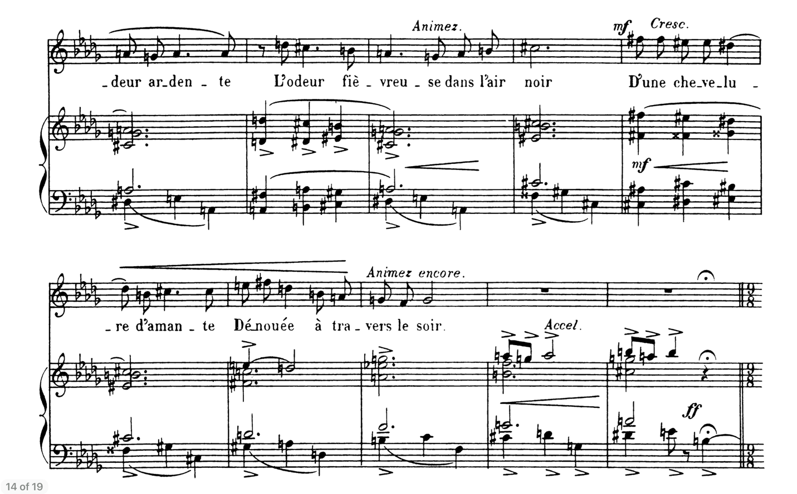
Figure 26 Élégie mm. 21-30
Despite the shift to compound meter, a new accompaniment pattern, and a new tonal center of E, the vocal melody in the third stanza is derivative of the second stanza. The tail end of the third stanza is particularly impressionistic; Figure 27 shows where, in mm. 36-38, the melody descends a whole tone scale while the piano planes through a series of descending nonfunctional dominant chords.
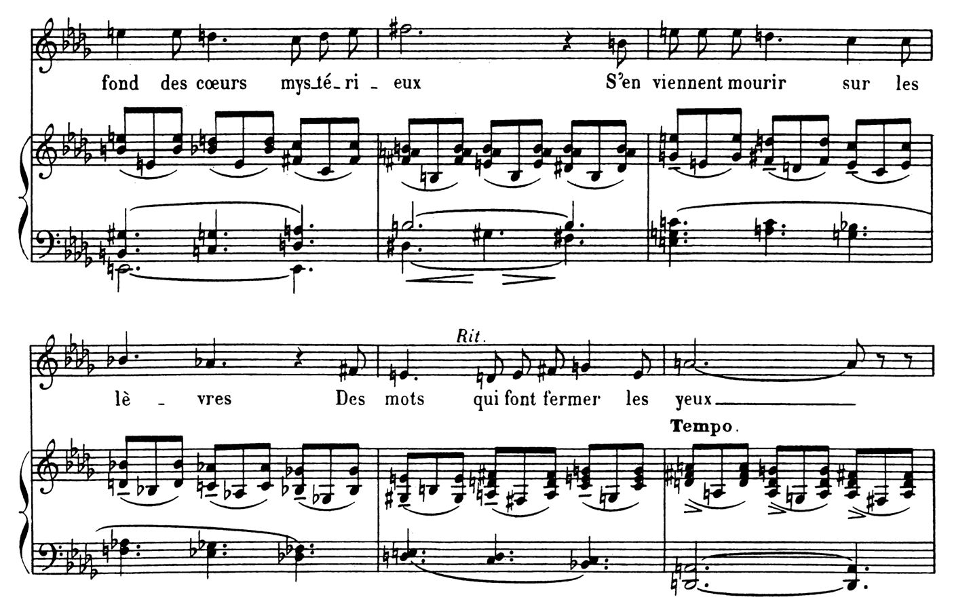
Figure 27 Élégie mm 34-39
Figure 28 presents the blurred boundary between the fourth and fifth stanzas. At this dramatic moment, the strong rhythmic pulse collapses and a dominant pedal is pointing back towards the original key of Db. The motive from the opening returns as the basis for the closing section; the slow descent towards tonic, ornamented by numerous gorgeous suspensions, is typically Romantic and is a natural inevitability brought on by the introduction.
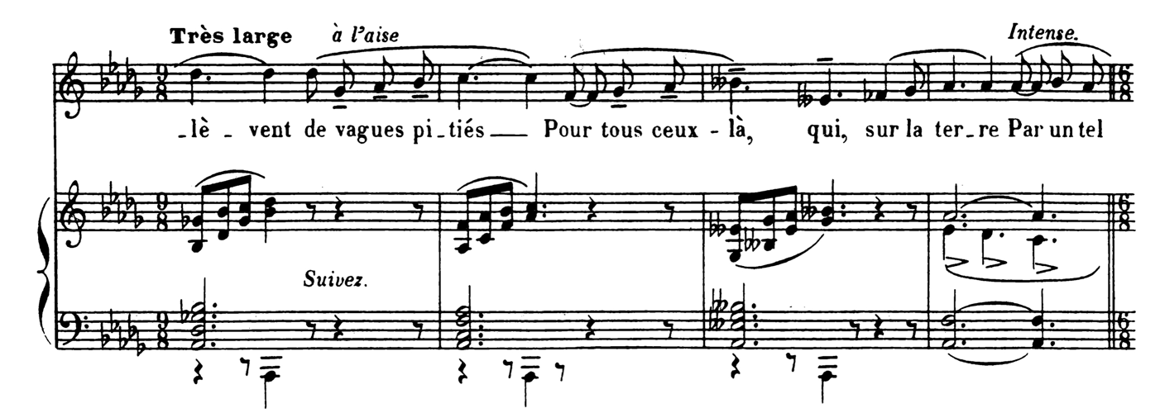
Figure 28 Élégie mm. 47-50

ARRANGEMENT
The introduction's four descending statements of the germinal motive and the homophonic texture of the first stanza are well suited for a brass quintet; in addition to the soloist, the piano primarily contains four independent voices, one for each of the other members of the group.
While several passages in Élégie are well suited for direct translation, many require some adaptation to work. In particular, the typical pianistic accompaniment patterns used throughout the lively compound sections are too busy to carry over literally. Figure 32 demonstrates two different solutions to this problem in the third and fourth stanzas. The author chose to lengthen the structural tones and divide the composite rhythm among several players in this arrangement.
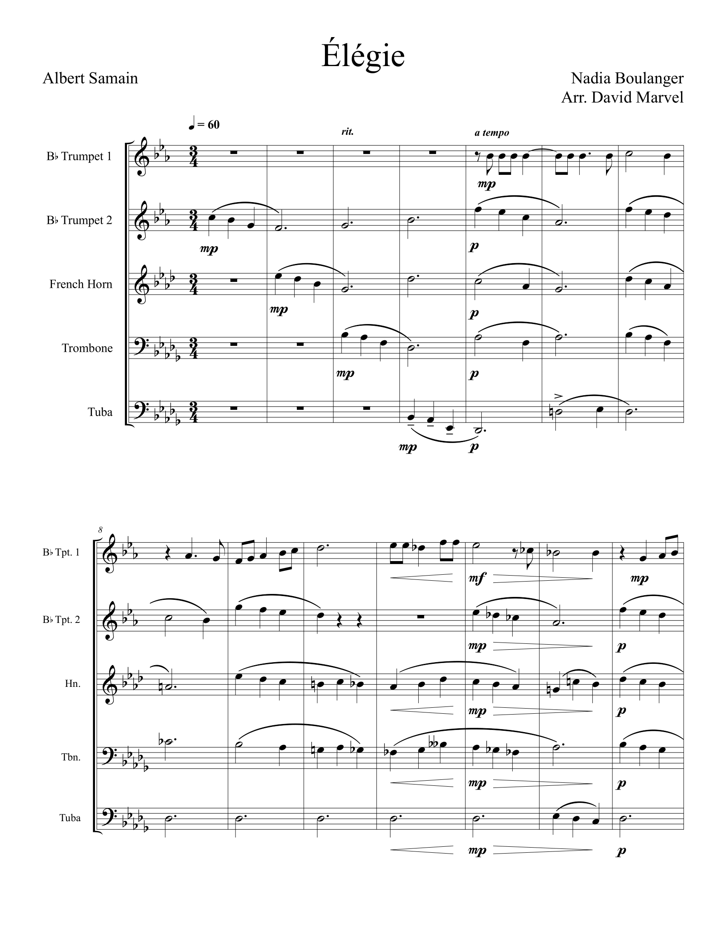
Figure 29 Author's Arrangement of Élégie, Page 1
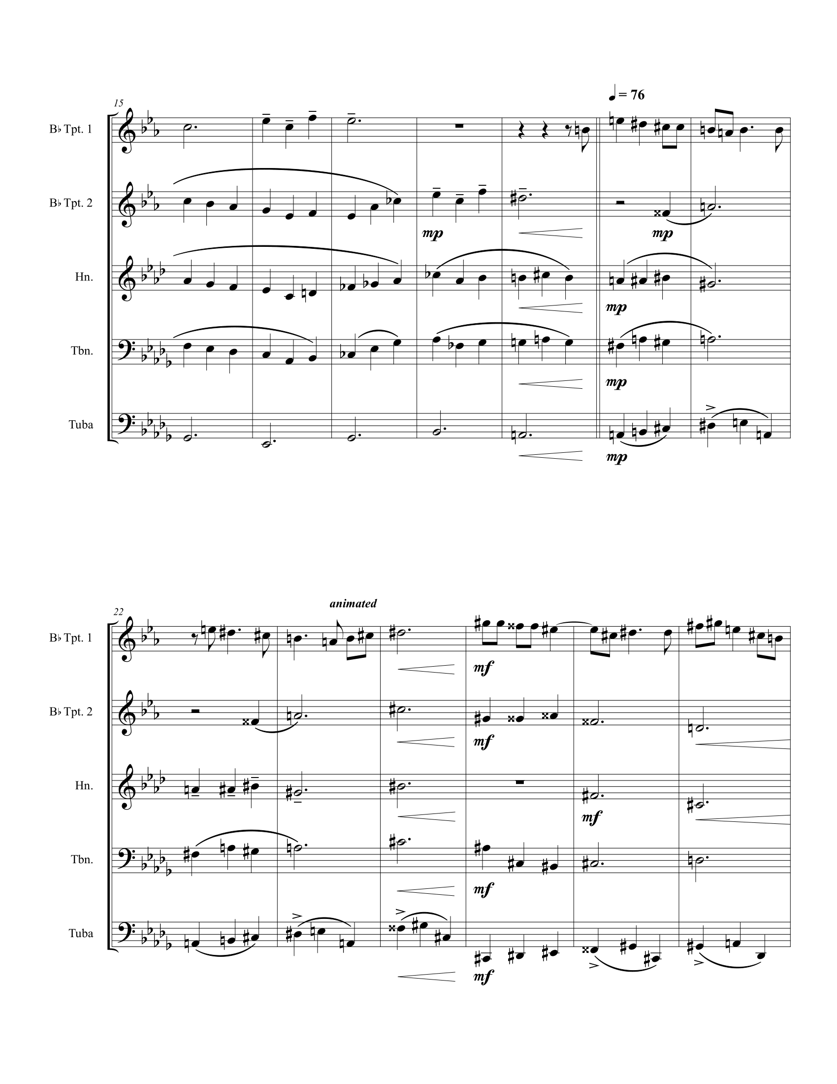
Figure 30 Author's Arrangement of Élégie, Page 2
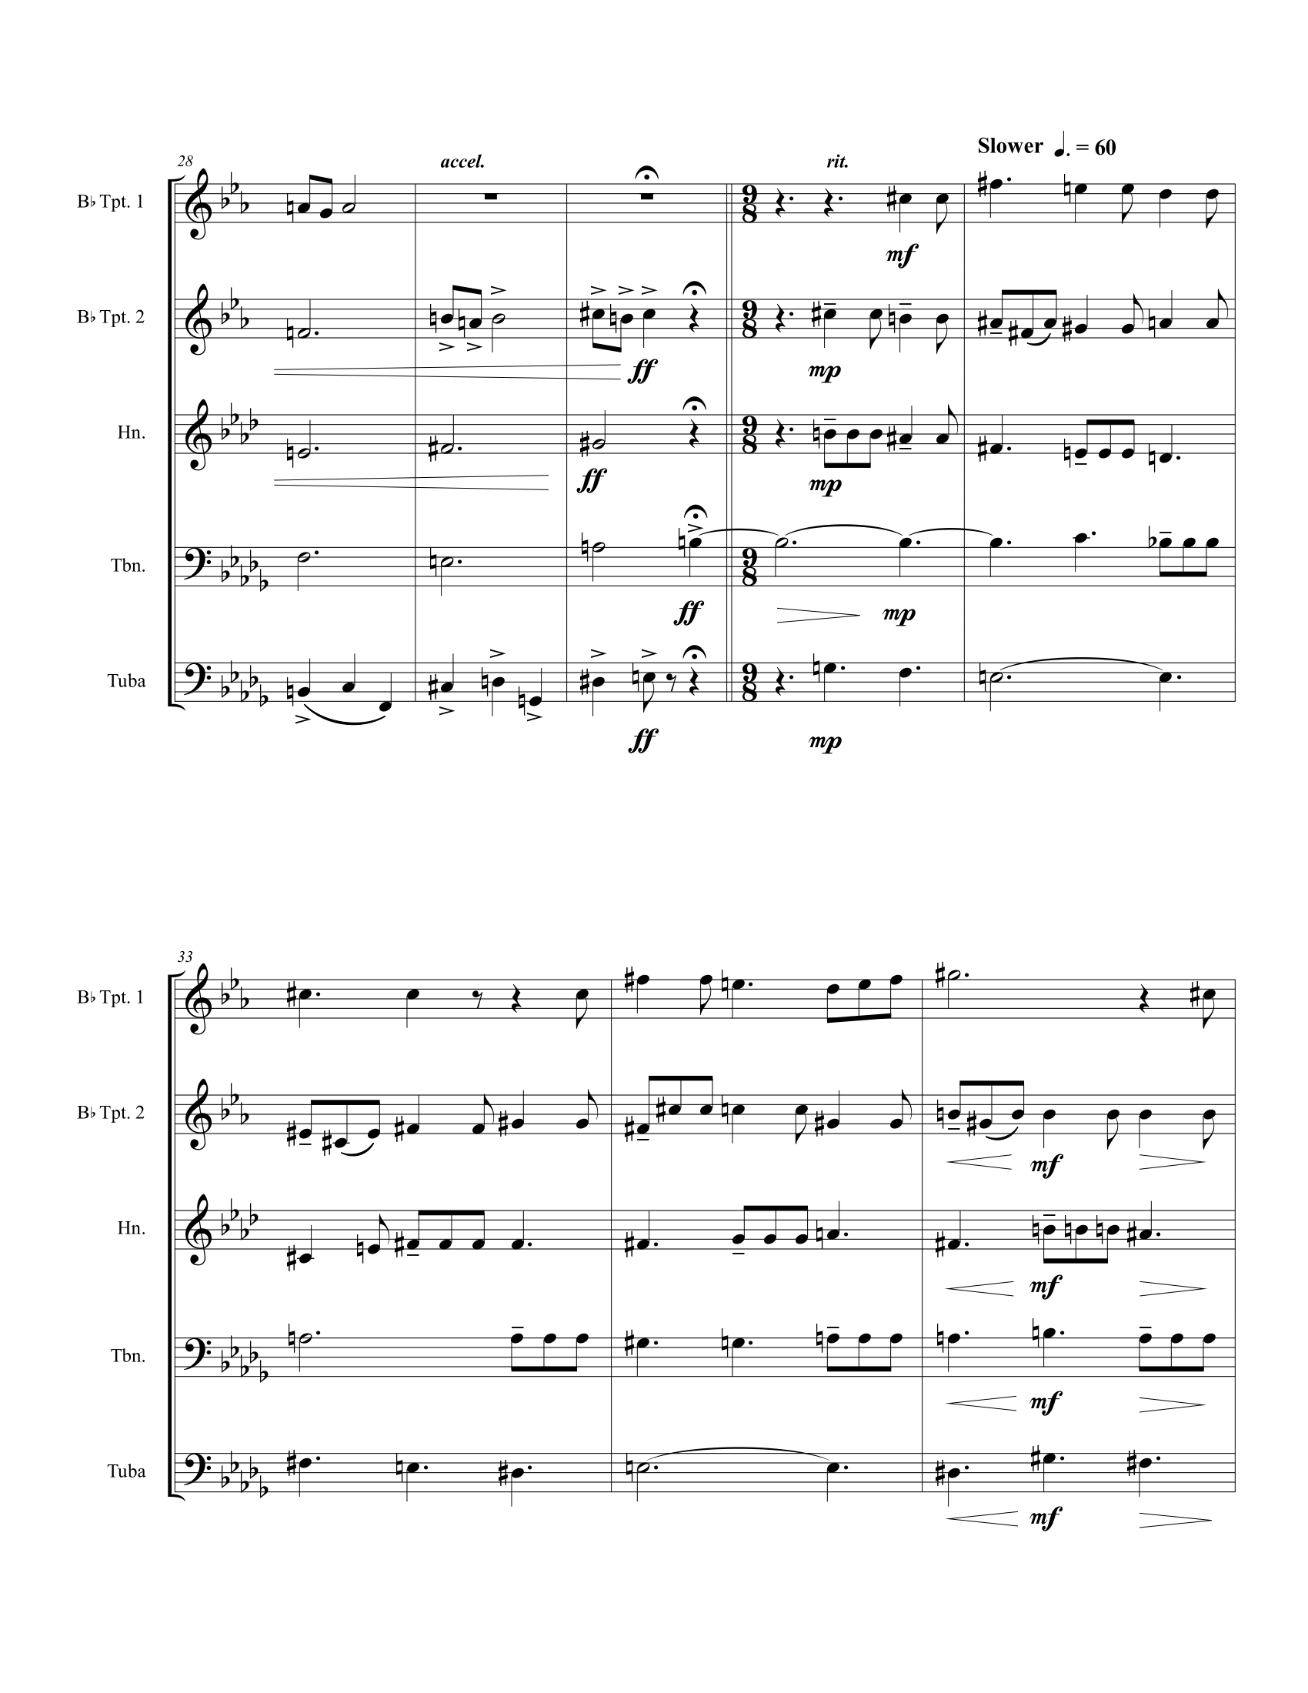
Figure 31 Author's Arrangement of Élégie, Page 3
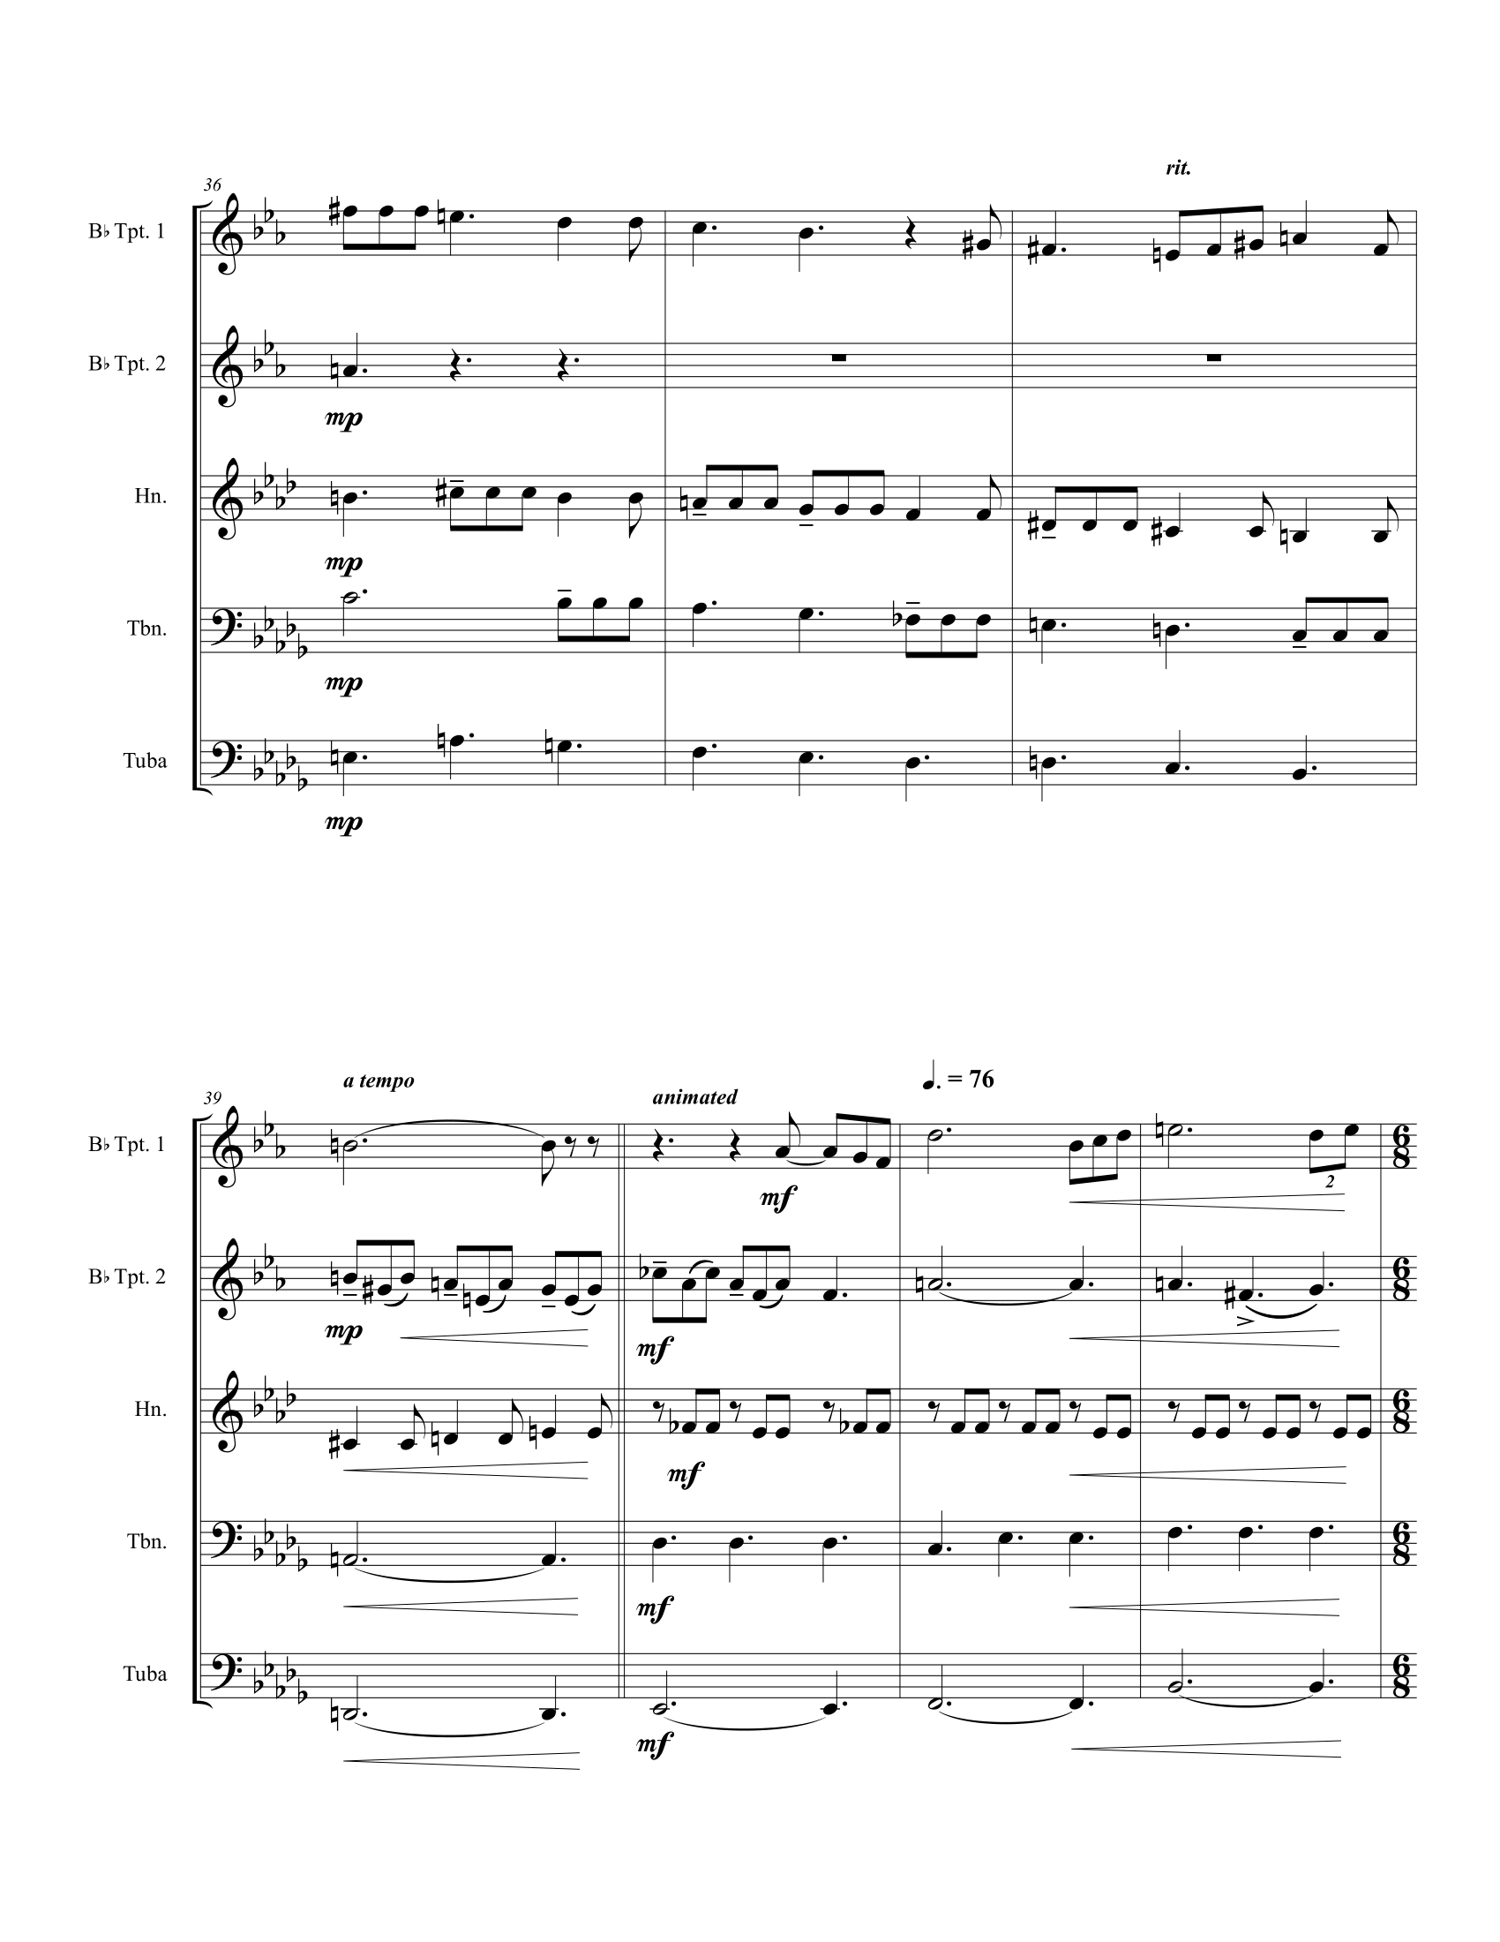
Figure 32 Author's Arrangement of Élégie, Page 4
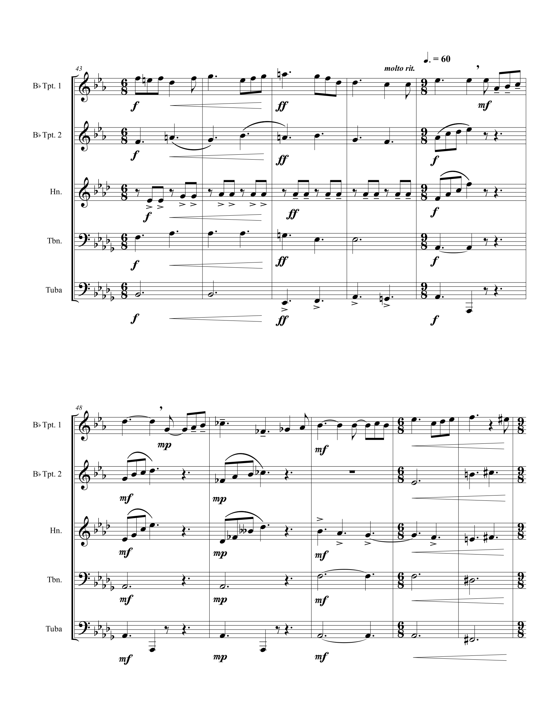
Figure 33 Author's Arrangement of Élégie, Page 5
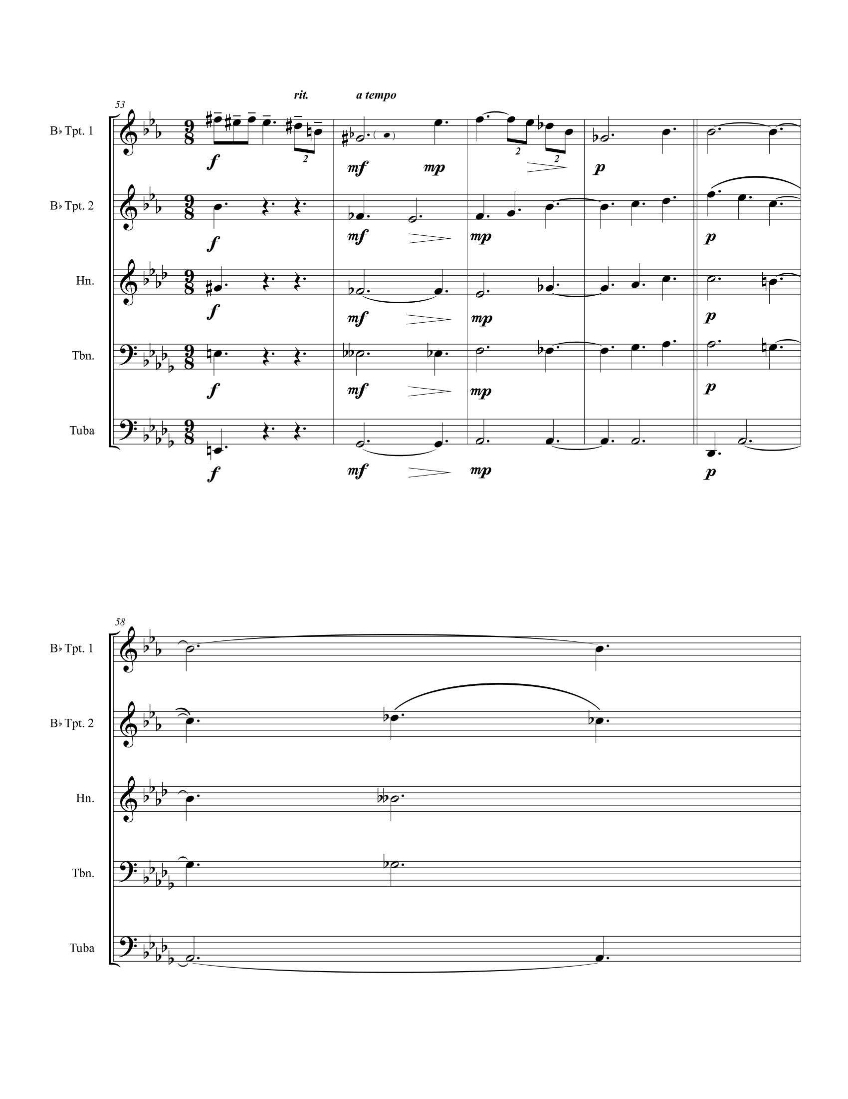
Figure 34 Author's Arrangement of Élégie, Page 6

Cantique

ANALYSIS
Published in 1909, Nadia Boulanger organizes Cantique around Maurice Maeterlinck’s three stanzas in this short poem expressing the power of love. Table 5 shows how the form unfolds in this song and the principal features of each section.
For every soul that cries,
For every sin that passes,
I open within the stars
My hands full of graces.
There is no sin which lasts
When love has spoken;
There is no soul that dies
When love has cried.
And if love goes astray
On paths here below,
Her tears find me
And do not get lost.
Table 5 Form and Text in Cantique
Section | Measures | Notes
Introduction | 1 | Tonic, static
Stanza 1 | 2-10 | Tonic prolongation followed by increased harmonic rhythm driving towards cadence, open-ended
Stanza 2 | 11-18 | Expanded range, begins the same as stanza one and quickly diverges, climax, circle of fifths harmonic sequence
Stanza 3 | 19-26 | Rhythmic anticipation in melody, restatement of melody from stanza 1, dominant pedal, closed ending
Closing Section | 27-29 | Flourish, authentic cadence

The germinal idea of this song is achieving maximum resonance in the key of F. Figure 35 shows the presentation of the germinal idea. The static, hollow tonic heard at the beginning is an essential stabilizing feature that remains present throughout most of the song. The high C remains through the first stanza and the beginning of the second. A circle of fifths sequence in the second stanza forces the C to resolve down in m. 15; however, the C reappears in the third stanza in the bass as a dominant pedal point. The vocal melody in this opening also returns in both subsequent stanzas.
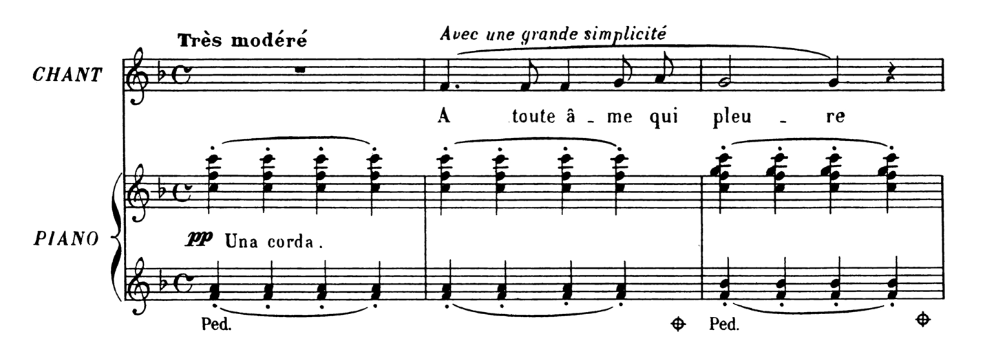
Figure 35 Cantique mm. 1-3
The neighboring motion in the third measure, resulting in stacked fourths and seconds, foreshadows the kinds of harmonic dissonances Nadia Boulanger will use throughout Cantique. For instance, at the end of the first stanza, the half cadence uses a fourth above the bass, rather than the prototypical leading tone a third above. Figure 36 shows a nonfunctional minor dominant chord in the second stanza; the fourth and second are alluded to in the beginning figure prominently in this dissonant harmony.
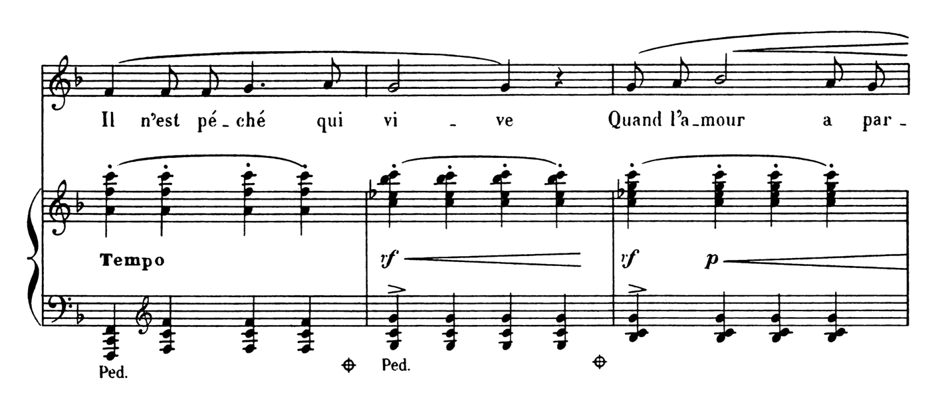
Figure 36 Cantique mm. 11-13

ARRANGEMENT
Although the vocal melody sits in a beautiful tessitura for the solo trumpet, the piano part presents several challenges for a brass quintet. The wide range, especially the repetitive high C, the pedal, the few rolled chords, and the many chords with more notes than a brass quintet has players all requiring some adjustment to work. Figure 39 shows the author’s solution to many of these problems.
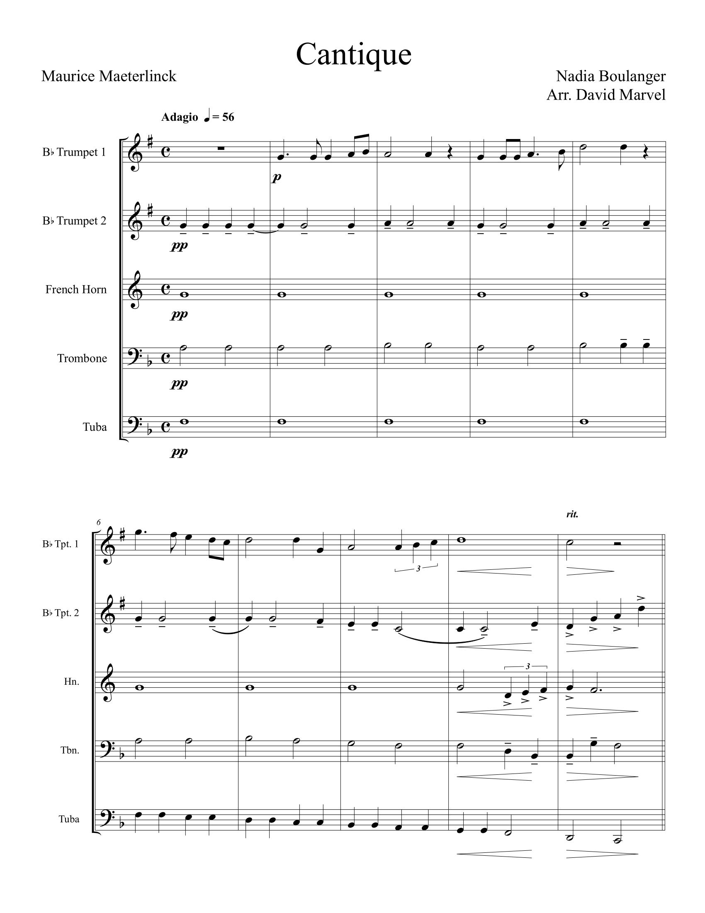
Figure 37 Author's Arrangement of Cantique, Page 1
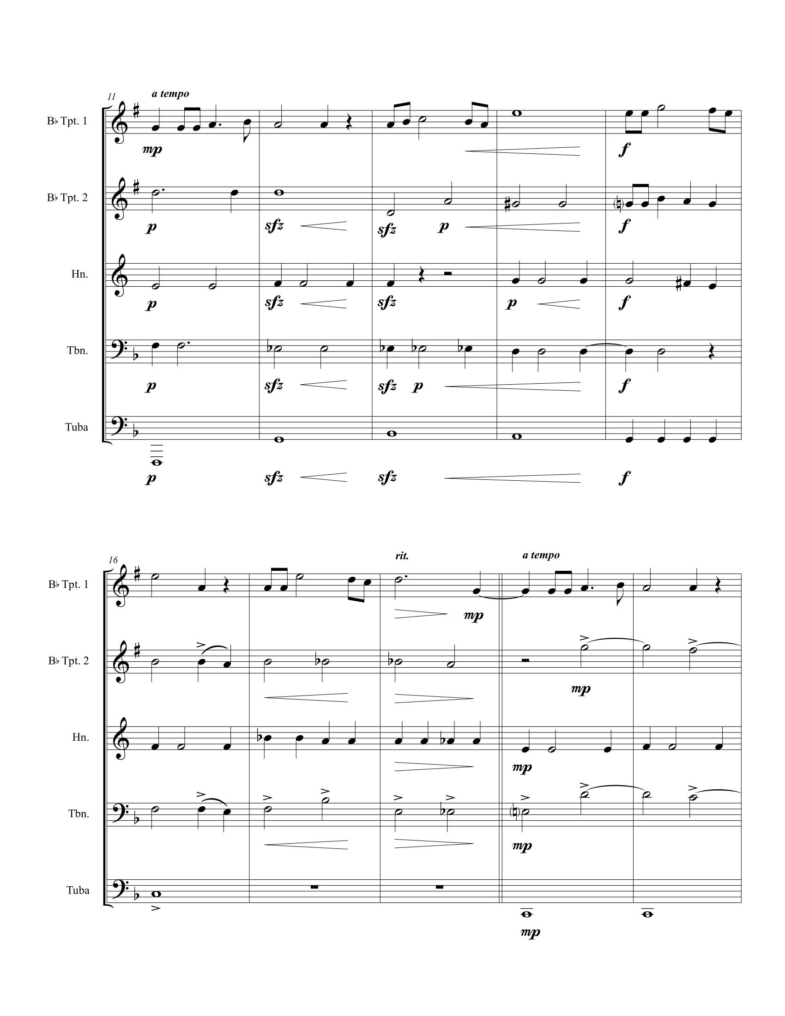
Figure 38 Author's Arrangement of Cantique, Page 2
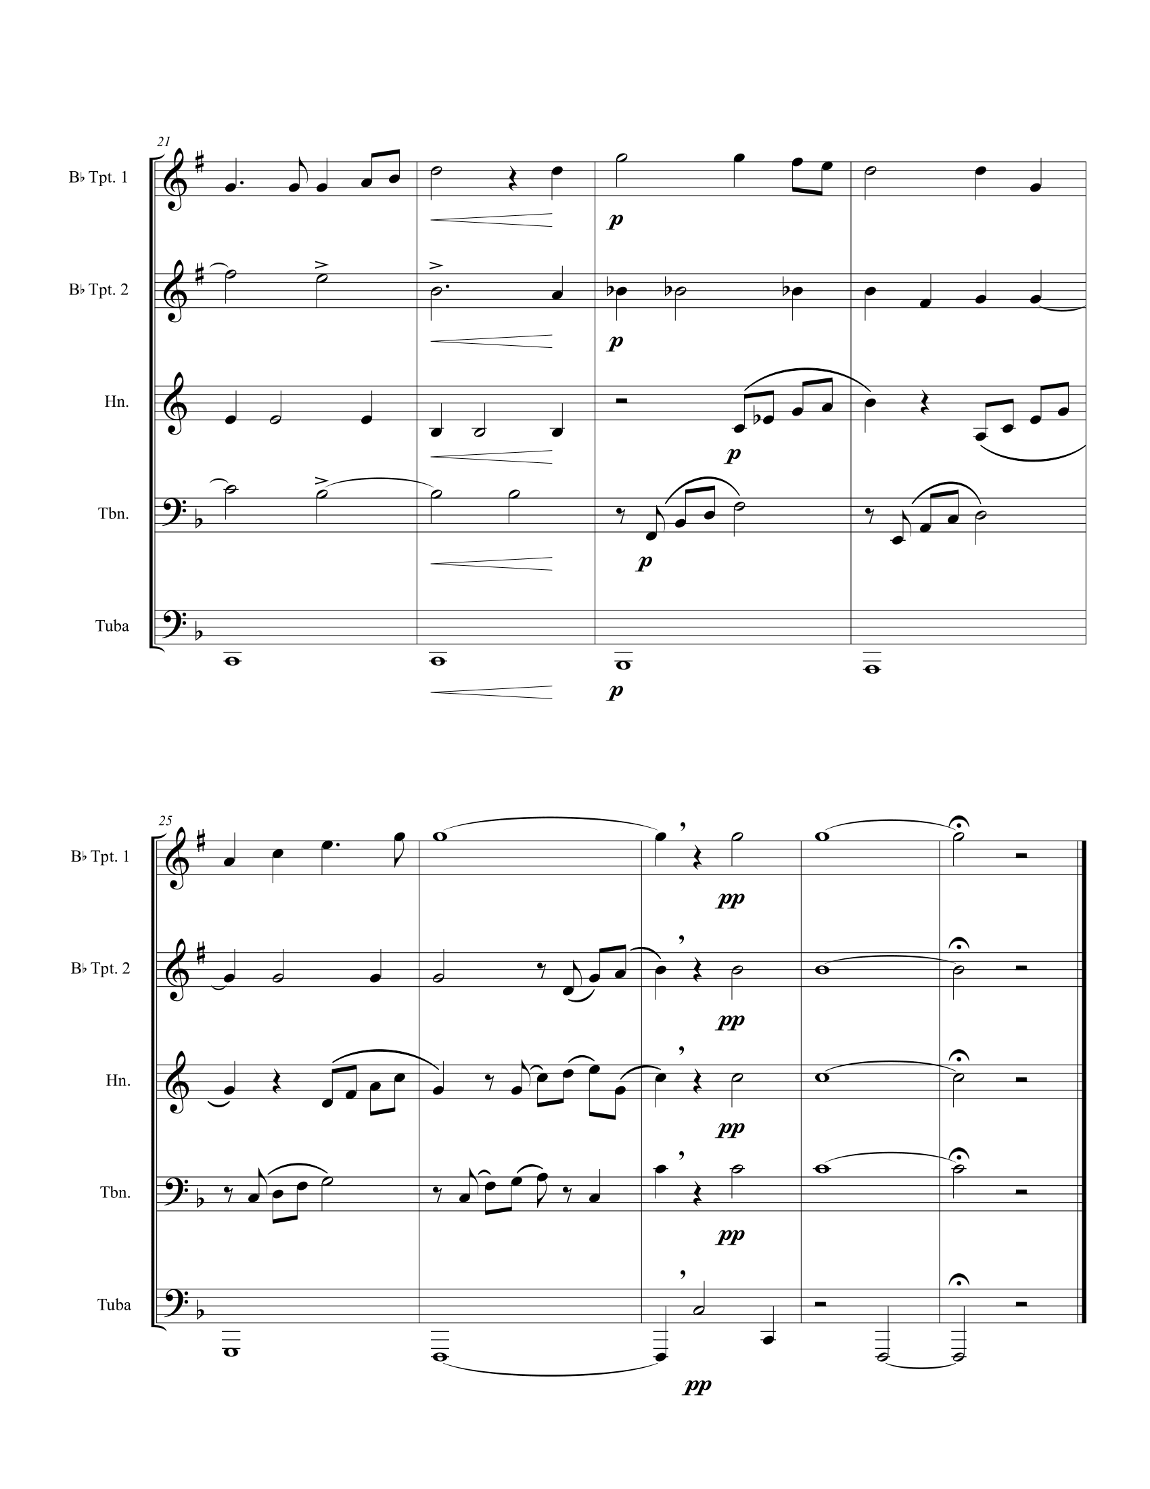
Figure 39 Author's Arrangement of Cantique, Page 3

Chapter 3: Recapitulation

SUMMARY
Nadia Boulanger’s compositions have received relatively little scholarly attention. It is not within the scope of this document to discuss the reasons for this in detail; however, it is likely that her own belief that her music is “worthless” has not encouraged many to seek it out. Despite her views about her compositions and the perceived failure of her composing career, this study proceeded under the hypothesis that Nadia Boulanger’s music does have worth.
The author uses research on Nadia Boulanger’s teaching and performance as the basis for evaluating the worth of her music. The results of this study are brass chamber arrangements accompanied by formal analysis of five of Nadia Boulanger’s songs: Chanson (Delaquys), Au Bord de la Route, Chanson (Mauclair), Élégie, and Cantique. These results demonstrate that Nadia Boulanger’s compositions have worth as coherent works of art.
The author has included their annotated scores in Appendix A: Annotated Vocal Scores, a copy of the lecture-recital program where these arrangements and analyses were presented in Appendix B: Lecture Recital Program, and links to video recordings of the performances of the arrangements in Appendix C: Links to Lecture Recital Recordings to support this document.

CONCLUSIONS
It would be inappropriate to make sweeping judgments about Nadia Boulanger’s compositional style based on five songs alone. However, these songs do contain what scholars have described as typical features of Nadia Boulanger’s compositions, mainly that they are tonal works with some chromaticism, dissonance, use of pedal points, and “restless modulations.” Table 6 confirms the presence of these features in all five songs included in this study. The analyses of the songs show that they each contain a consistent internal logic.
Table 6 Typical Features in Nadia Boulanger's Compositions
Song | Tonality | Chromaticism | Dissonance | Pedal Points | Modulations
Chanson (Delaquys) | G Major | Applied dominants | Functional | Tonic and dominant pedals | Strongly tonicizes subdominant
Au Bord de la Route | F Minor | Borrowing from phyrgian | Harmonic 2nds | Tonic pedal throughout | Brief shift to subdominant
Chanson (Mauclair) | A Minor | Within ostinato | Within ostinato | Tonic pedal mm. 27-30 | N/A
Élégie | Db Major | Modal mixture | Functional | Dominant pedal mm. 47-51 | Several distantly related keys
Cantique | F Major | mm. 12-18 | Harmonic 2nds and 4ths | Tonic and dominant pedals | Circle of fifths sequence

CONSIDERATIONS FOR FURTHER STUDY
For the author, this study has posed far more questions than provided answers. Why have Nadia Boulanger’s compositions been overlooked for so long? Is it possible to discern a particular style to Boulanger’s music? Are there defining boundaries in the style of her compositions? Are there patterns in the way she set texts by certain poets?
While this document provides valuable data for the study of Boulanger’s music, much more study is needed to uncover the compositional secrets of one of the most influential music teachers of the 20th century. The author hopes that this document will encourage others to explore Nadia Boulanger’s music for themselves and find new ways of sharing it with the world.

Bibliography

Boulanger, Nadi, and Camille Mauclair. 1922. "Elle à vendu mon cœur." IMSLP. https://imslp.org/wiki/Elle_%C3%A0_vendu_mon_c%C5%93ur_(Boulanger%2C_Nadia).
Boulanger, Nadia, and Albert Samain. 1906. "Élégie." IMSLP. https://imslp.org/wiki/%C3%89l%C3%A9gie_(Boulanger%2C_Nadia).
Boulanger, Nadia, and Camille Mauclair. 1922. "Au Bord de la Route." IMSLP. https://imslp.org/wiki/Au_bord_de_la_route_(Boulanger%2C_Nadia).
Boulanger, Nadia, and Georges Delaquys. 1909. "Chanson." IMSLP. https://imslp.org/wiki/Chanson_(Boulanger%2C_Nadia).
Boulanger, Nadia, and Maurice Maeterlinck. 1909. "Cantique." IMSLP. https://imslp.org/wiki/Cantique_(Boulanger%2C_Nadia).
Brooks, Jeanice. 2013. The Musical Work of Nadia Boulanger: Performing Past and Future Between the Wars. Cambridge: Cambridge University Press.
2002. "Call for Papers: Nadia Boulanger and American Music." Music Theory Online (Chicago: Society for Music Theory) 8.
DeVries, Diane. 1998. The Pedagogical Influence of Nadia Boulanger on the Works of Her Female Students: An Analysis of Selected Compositions. Ann Arbor: ProQuest Dissertations.
Francis, Kimberly. 2010. "A Dialogue Begins: Nadia Boulanger, Igor Stravinsky, and the Symphonie De Psaumes." Women & Music 14 (1): 22-44.
Francis, Kimberly. 2011. "A Most Unsuccessful Project: Nadia Boulanger, Igor Stravinsky, and the Symphony in C, 1939-45." The Musical Quarterly 94 (1): 234-270.
—. 2015. Teaching Stravinsky: Nadia Boulanger and the Consecration of a Modernist Icon. New York: Oxford University Press.
Francis, Kimberly, and Jeanice Brooks. 2020. Nadia Boulanger: Thoughts on Music / Edited and Translated by Jeanice Brooks and Kimberly Francis. Eastman Studies in Music.
Laederich, Alexandra. 2017. Unknown Music of Nadia Boulanger. Sonoma, CA: Delos Productions, Liner notes.
McCallum, Wendy. 2004. Pedagogical Style and Influence of Nadia Boulanger on Music for Wind Symphony, an Analysis of Three Works by Her Students: Copland, Bassett, and Grantham. Denton: University of North Texas.
Monsaingeon, Bruno, and Robyn translation by Marsack. 1985. Mademoiselle: Conversations with Nadia Boulanger. Manchester: Carcanet Press Limited.
Potter, Caroline. 2006. Nadia and Lili Boulanger. Ashgate.
—. 2001. Nadia Boulanger. January 20. Accessed April 2021. https://doi-org.ezproxy.lib.ou.edu/10.1093/gmo/9781561592630.article.03705.
Potter, Caroline. 2000. "Nadia Boulanger’s and Raoul Pugno’s La Ville Morte." Opera Quarterly 16 (3): 397-406.
Potter, Caroline. 1999. "Reviews of Books: "Nadia Boulanger: A Life in Music" by Léonie Rosenstiel." Music & Letters 80 (2): 315-317.
Yeoland, Rosemary. 2014. "Nadia Boulanger et Camille Mauclair." International Review of the Aesthetics and Sociology of Music (Croatian Musicological Society) 45 (1): 63-76.

Appendix A: Annotated Vocal Scores
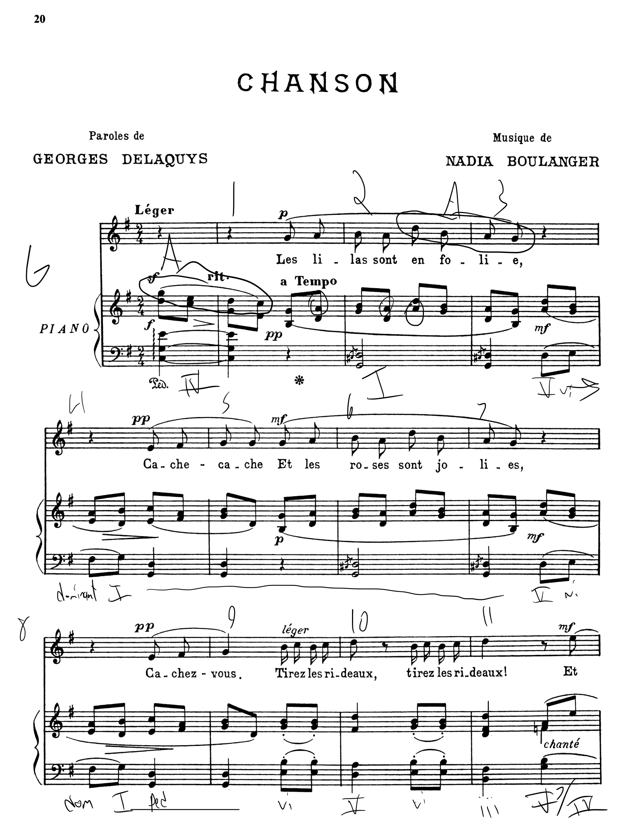
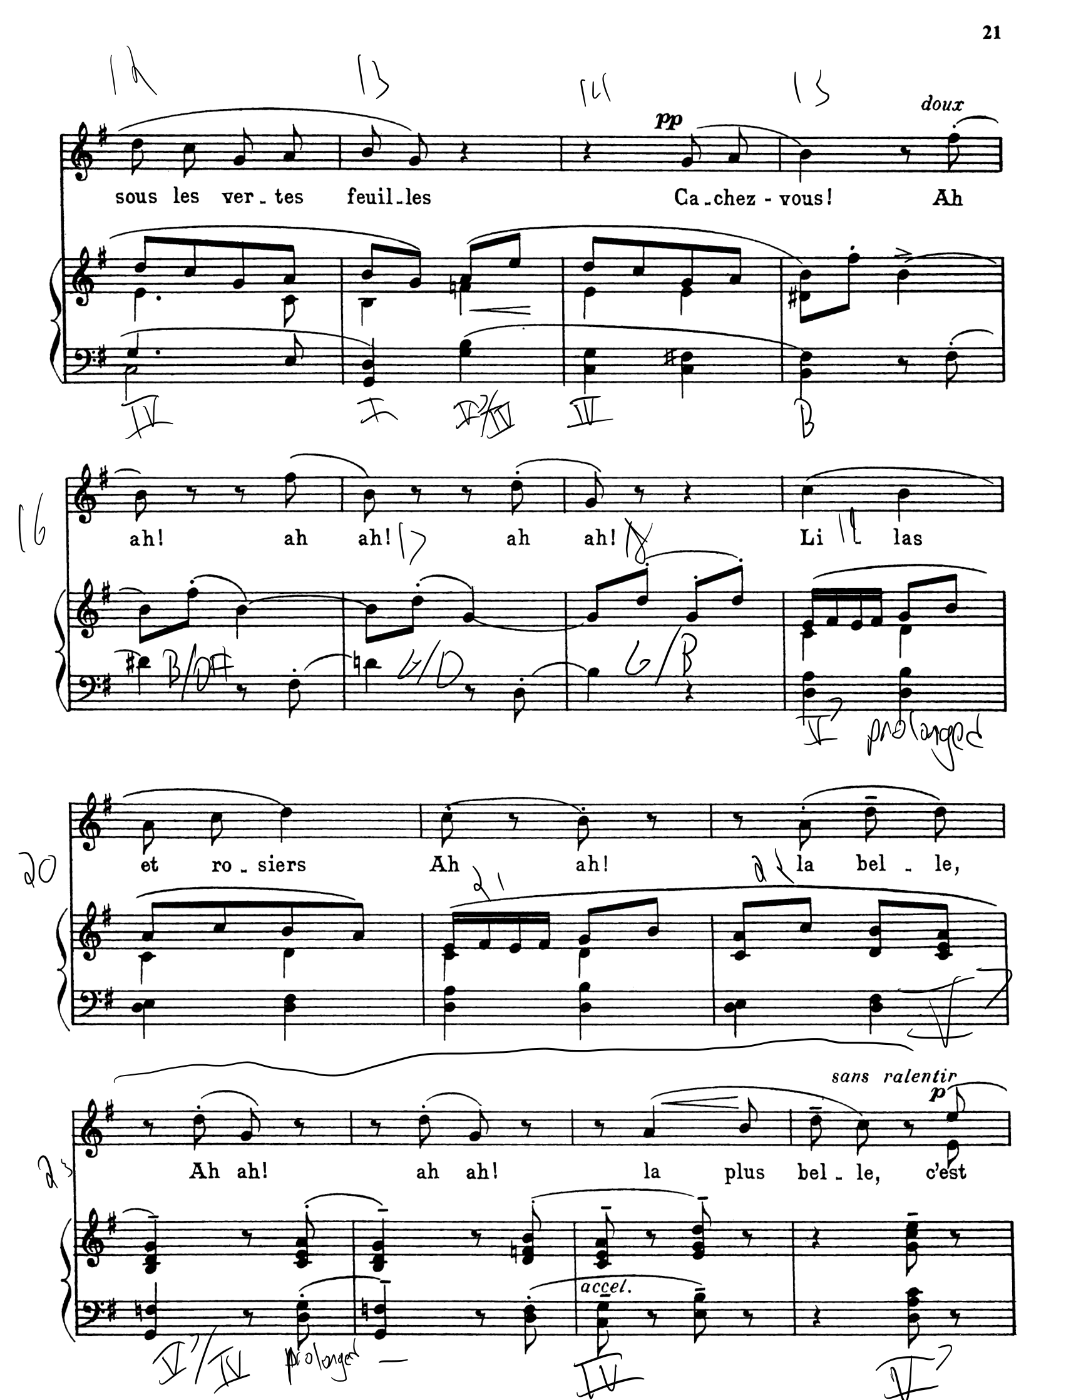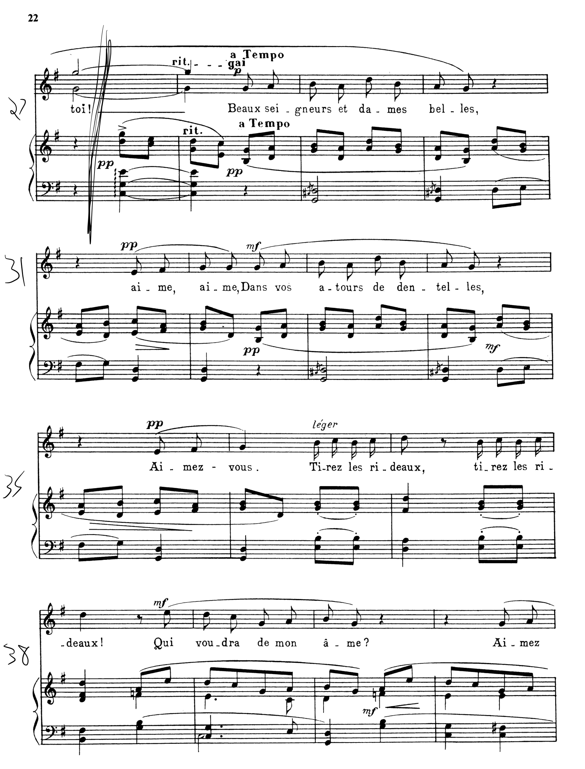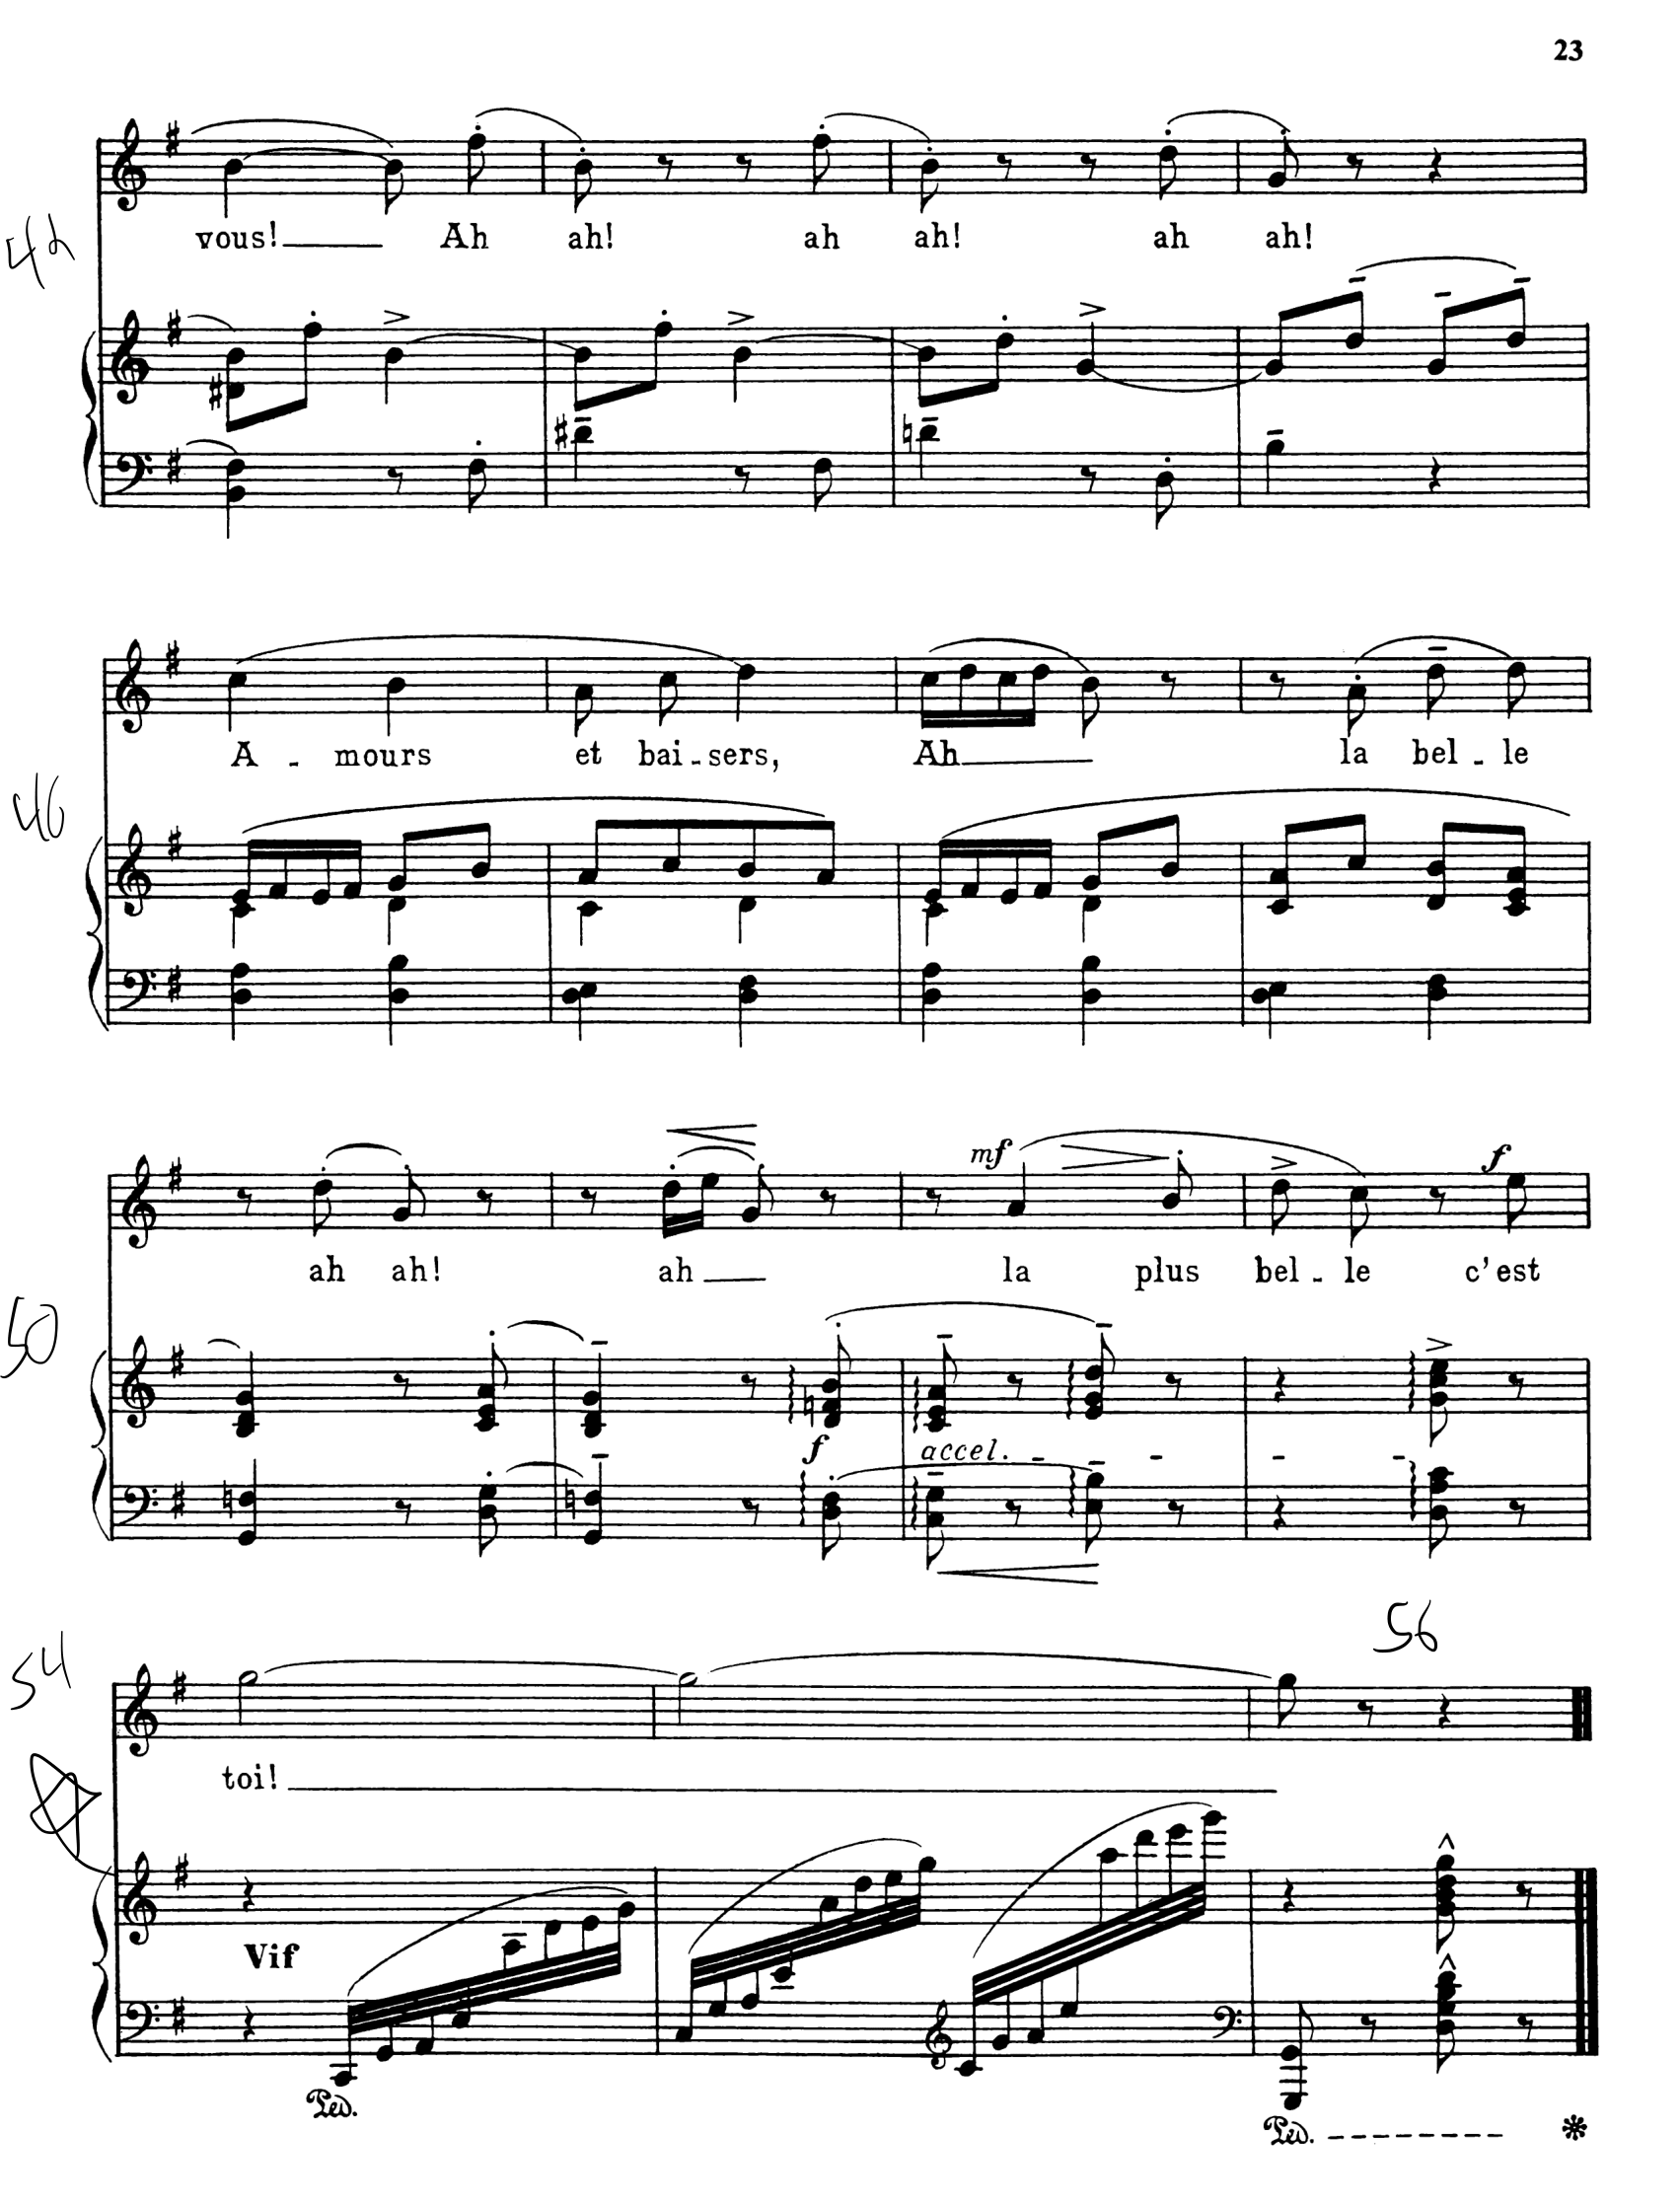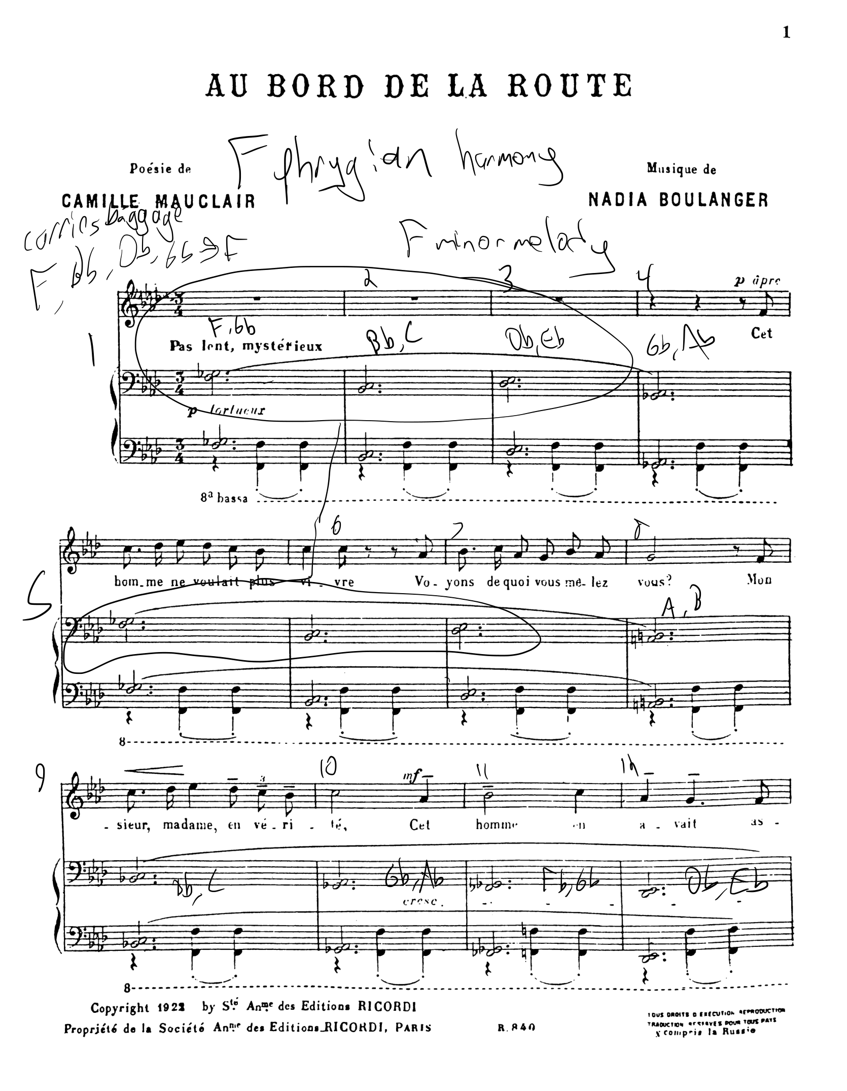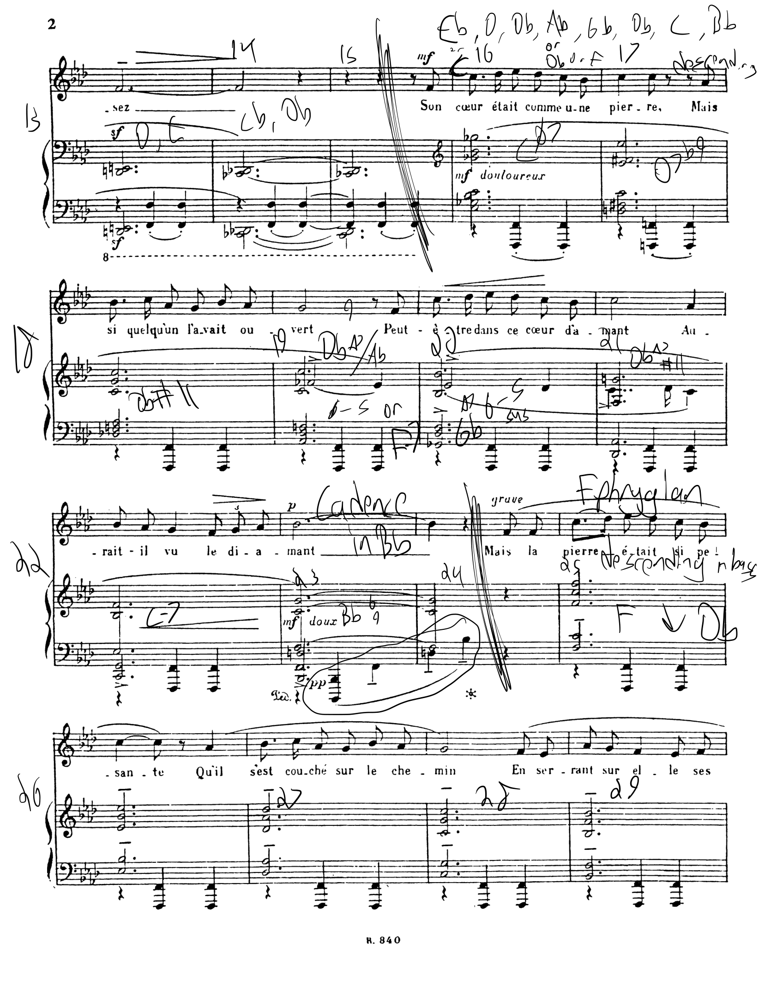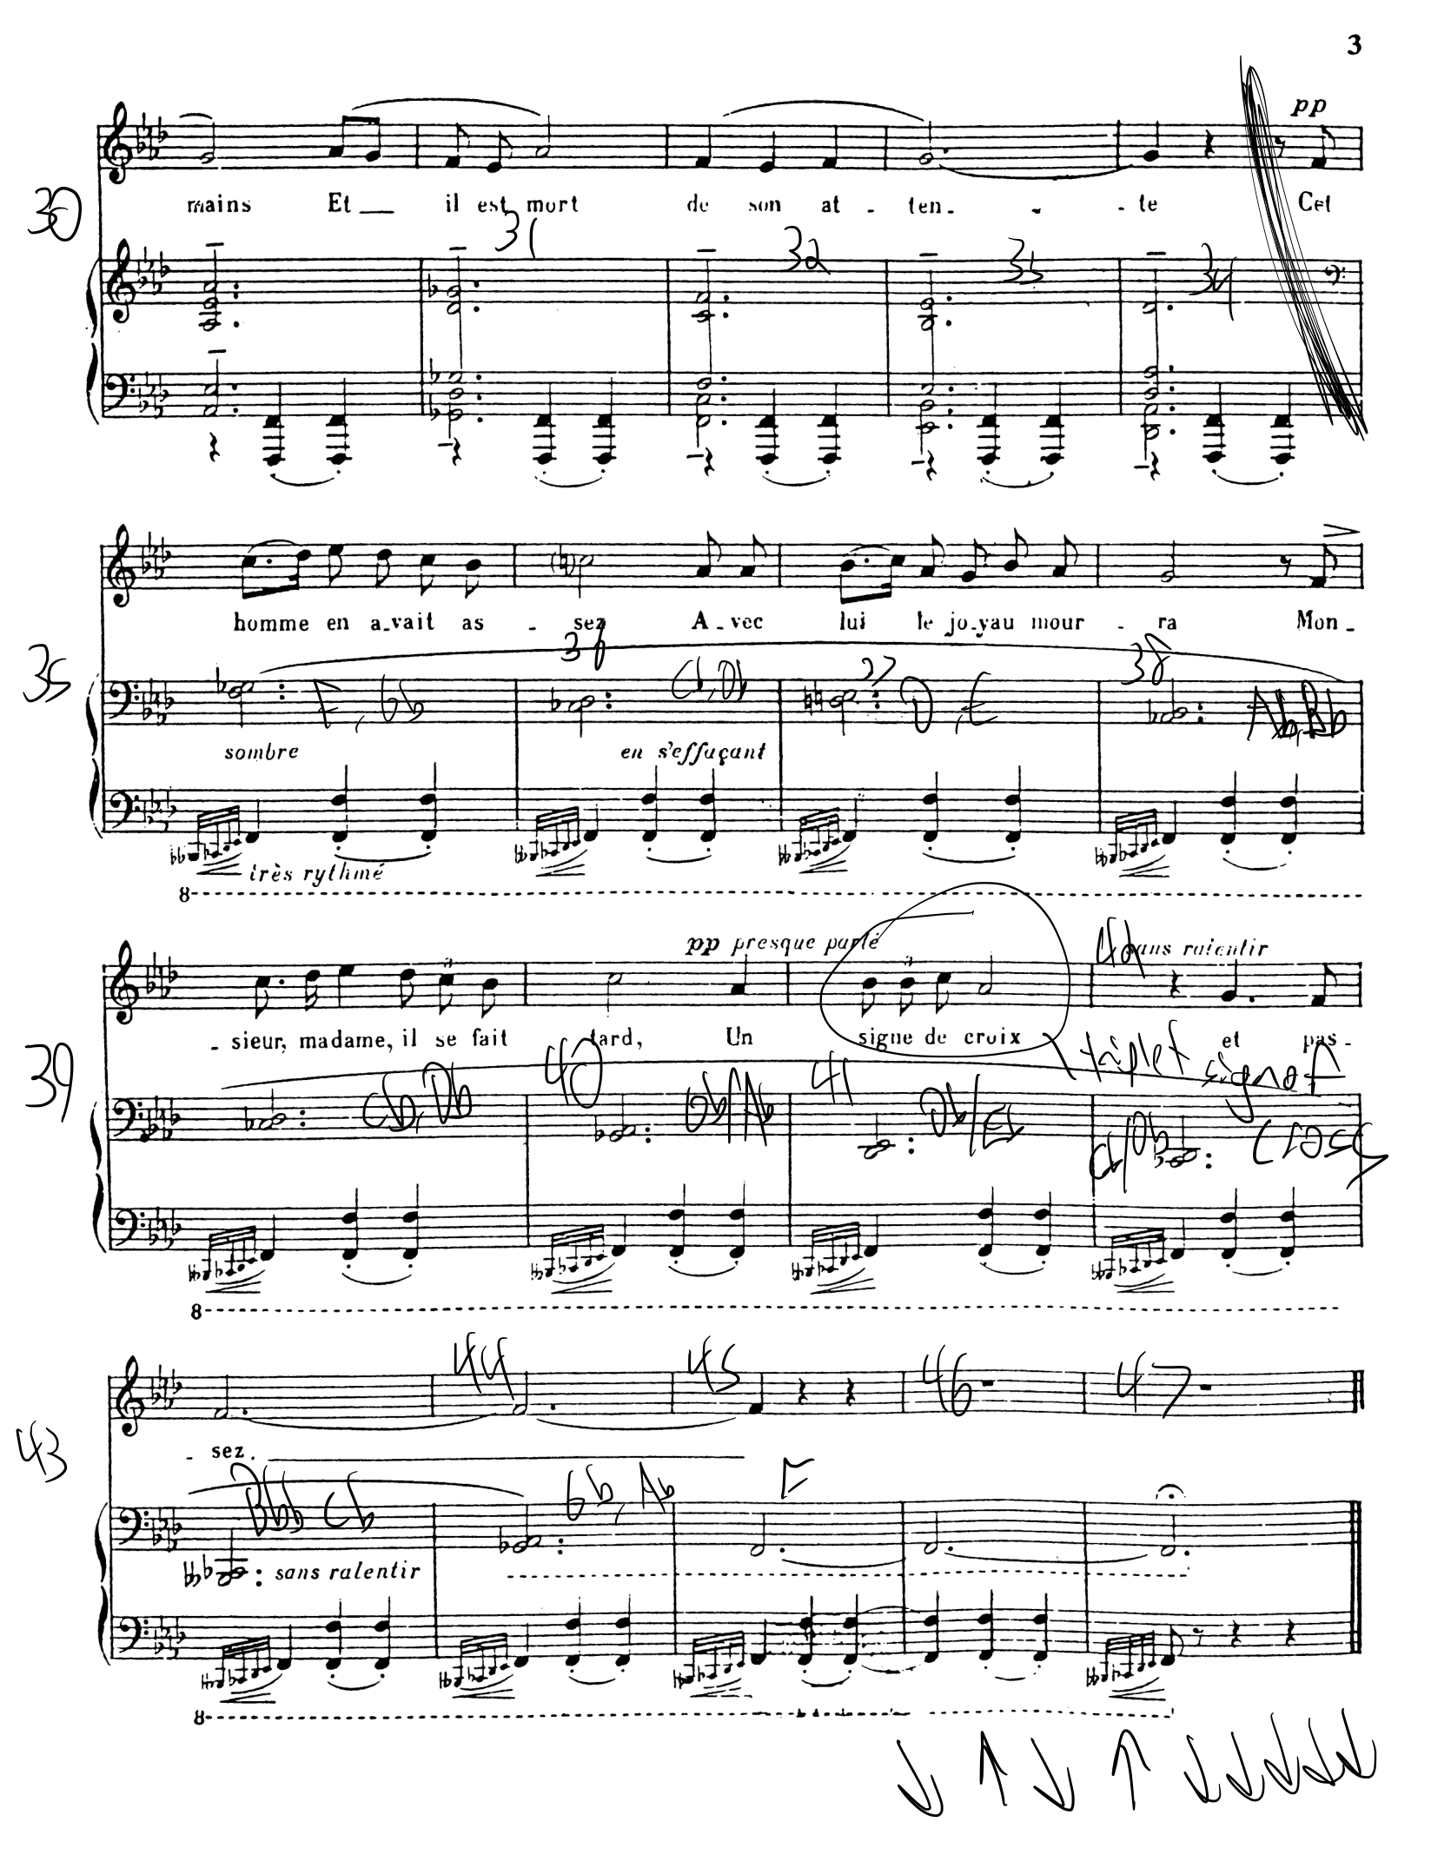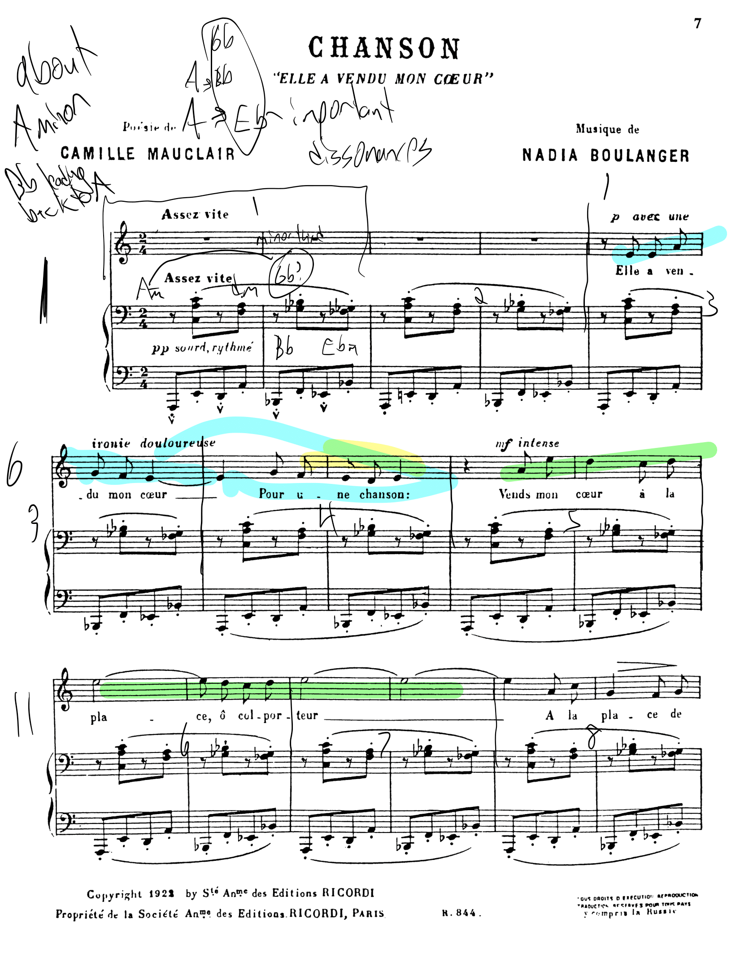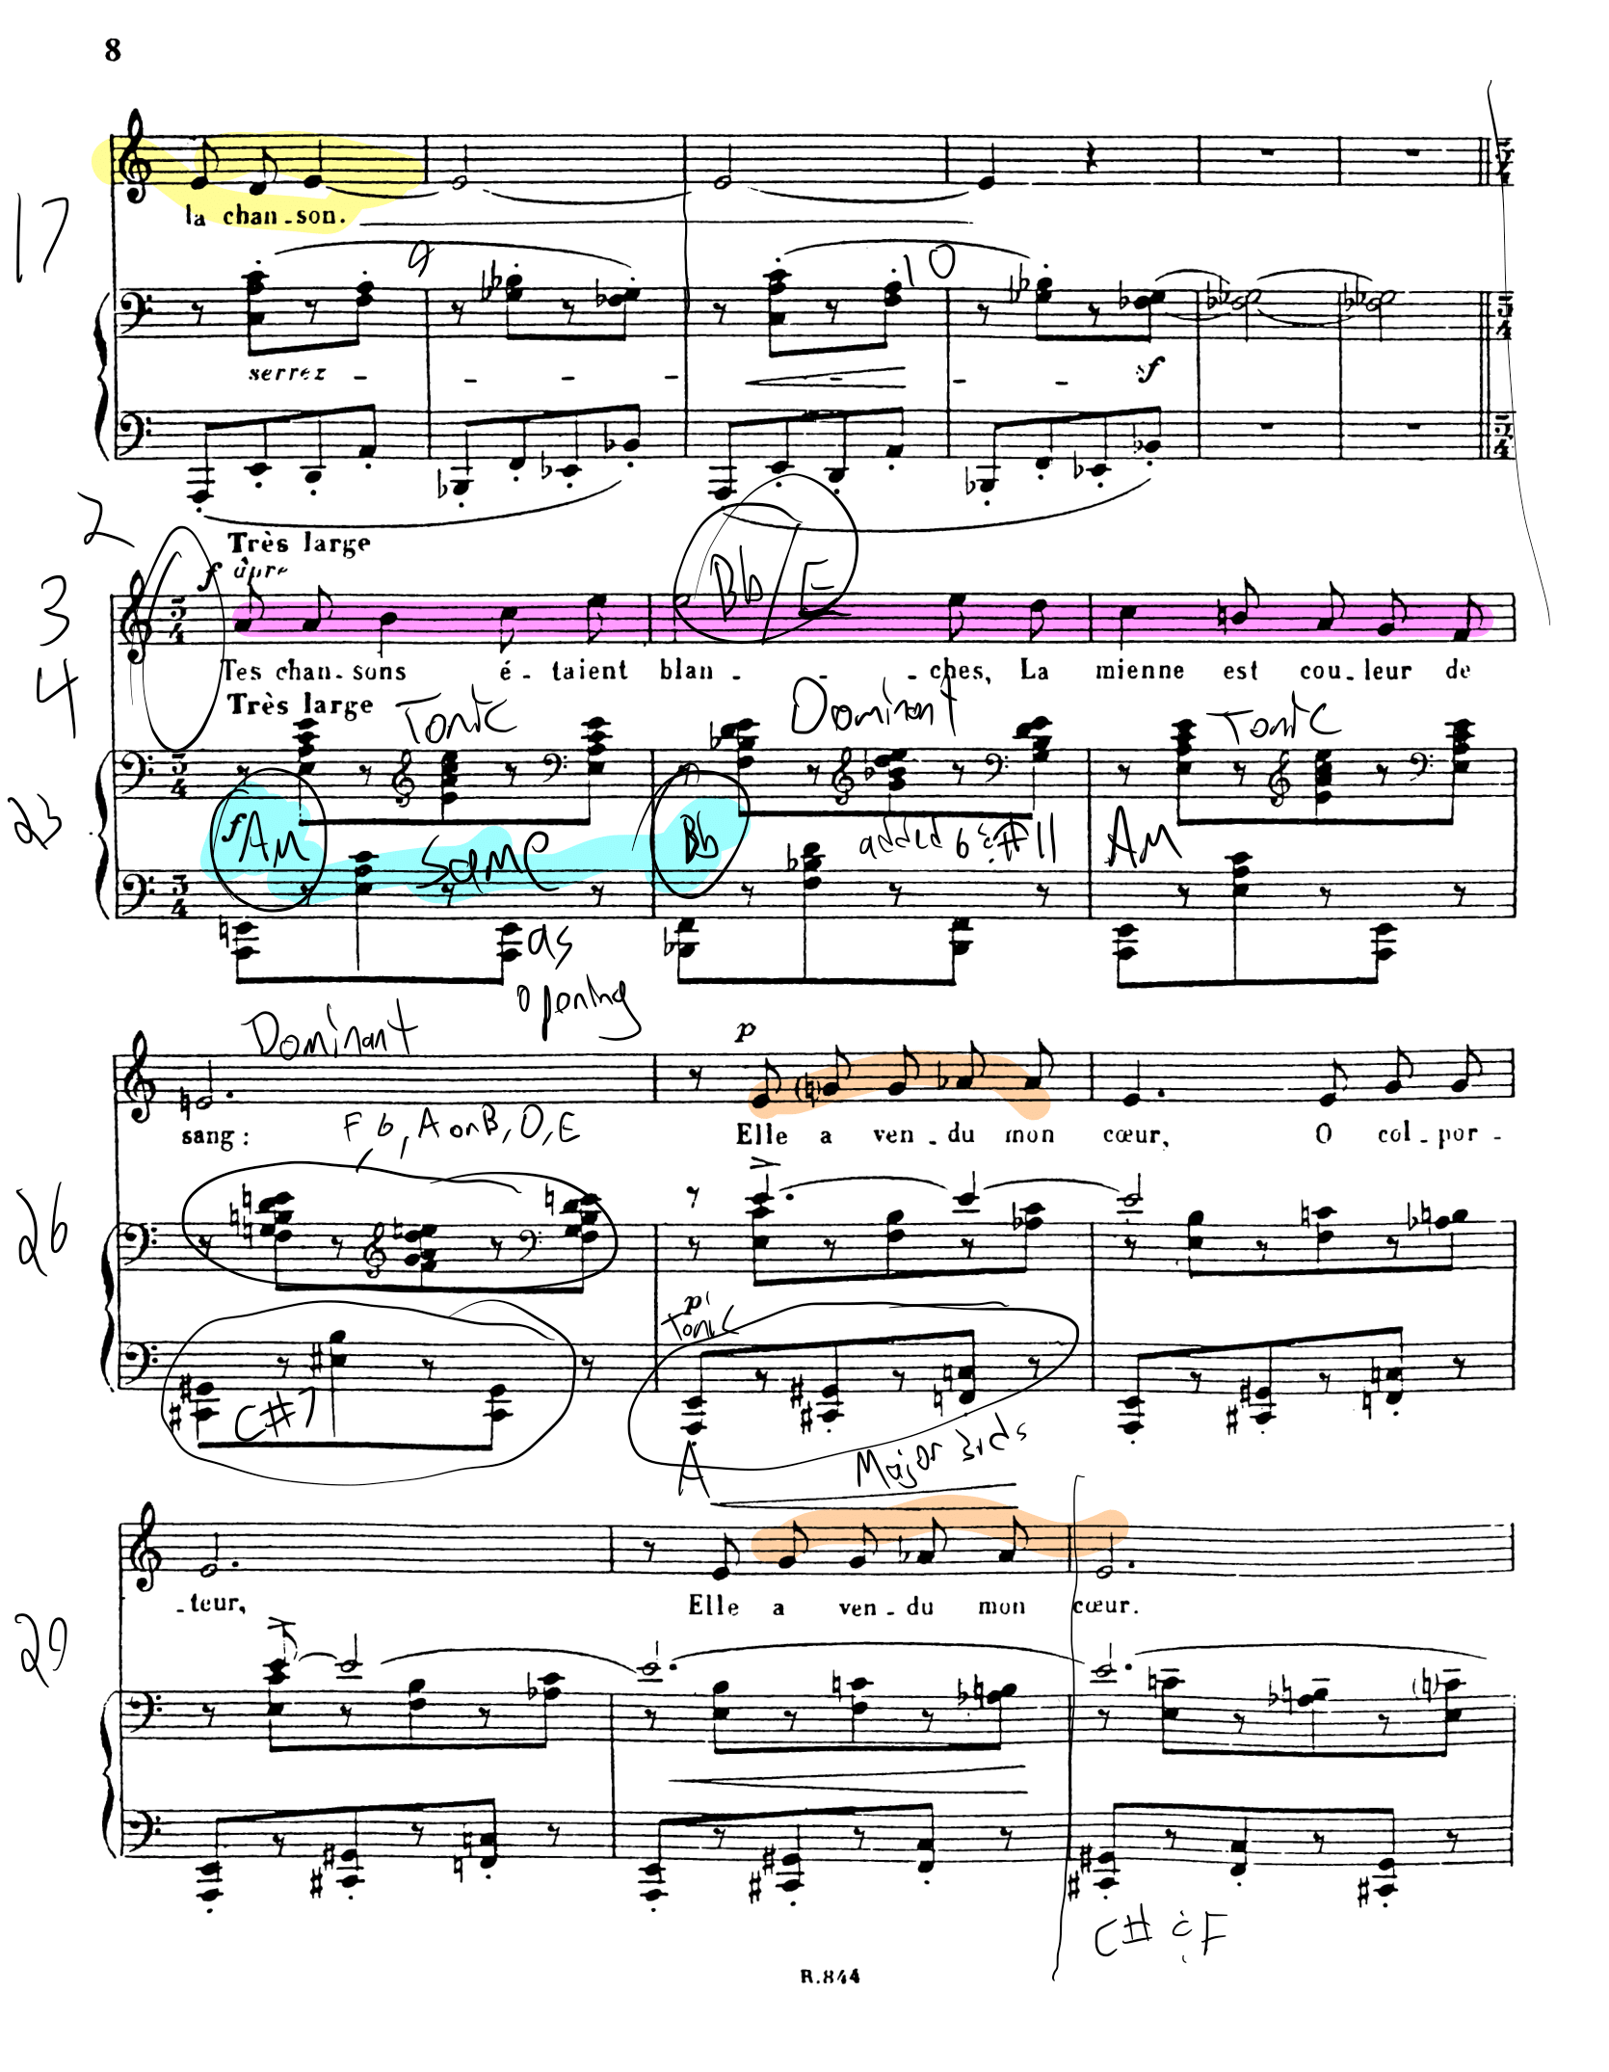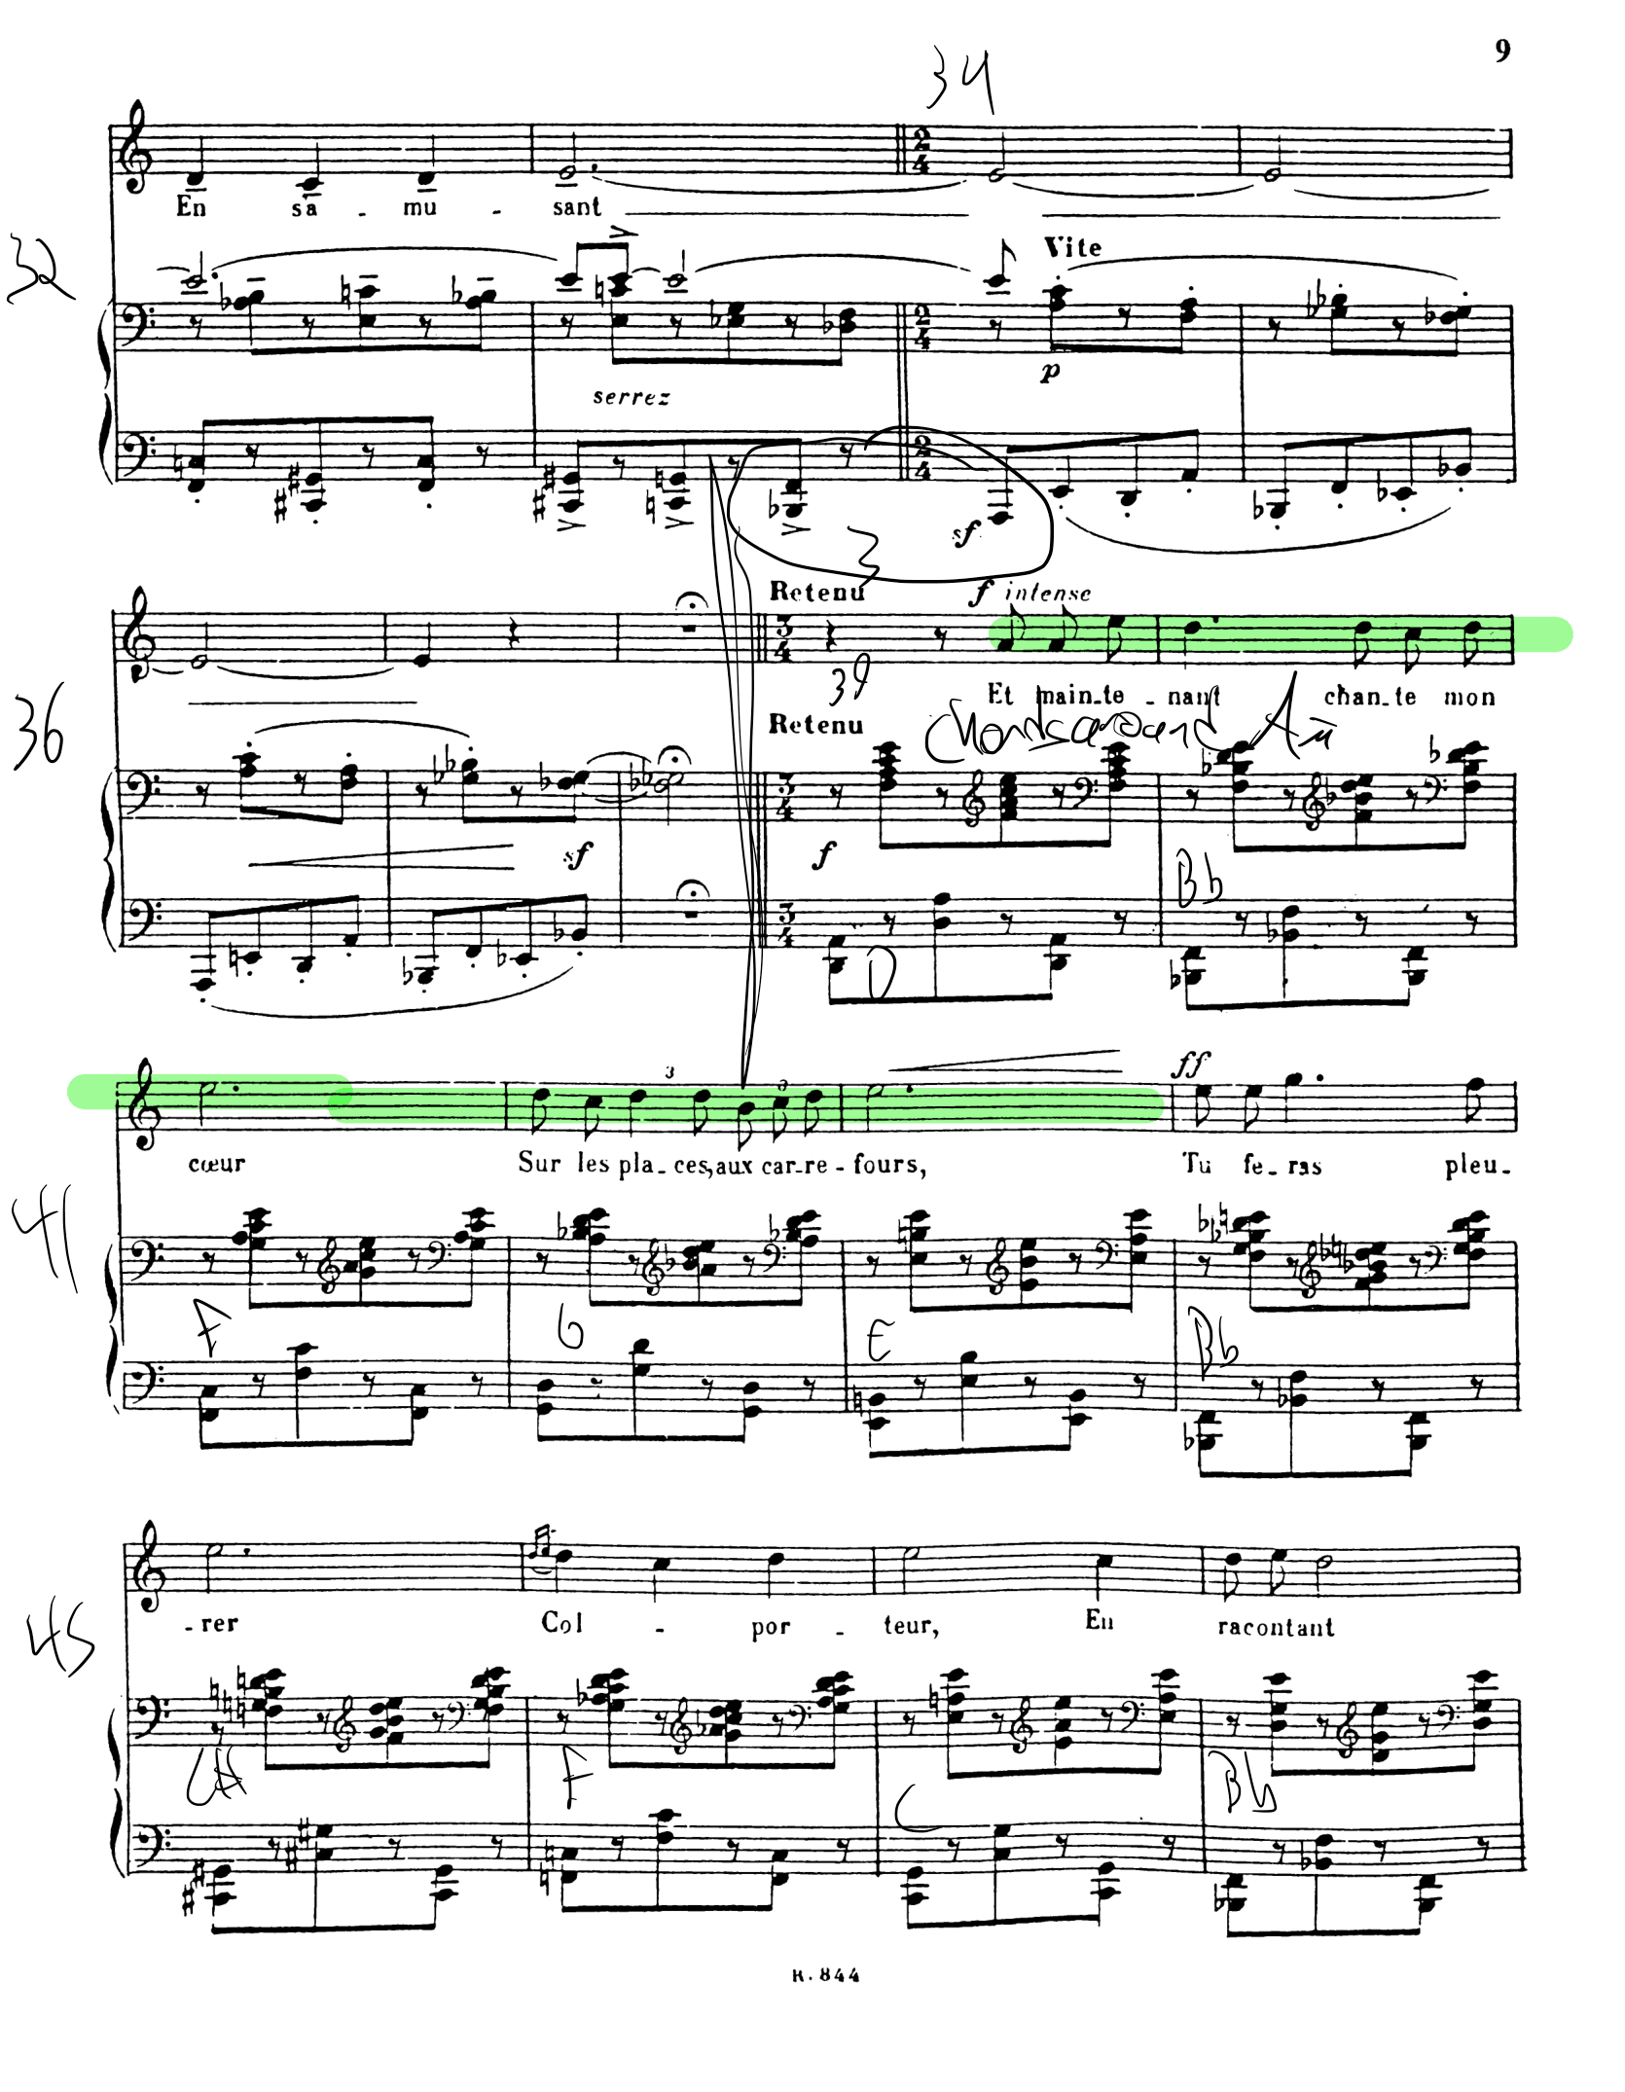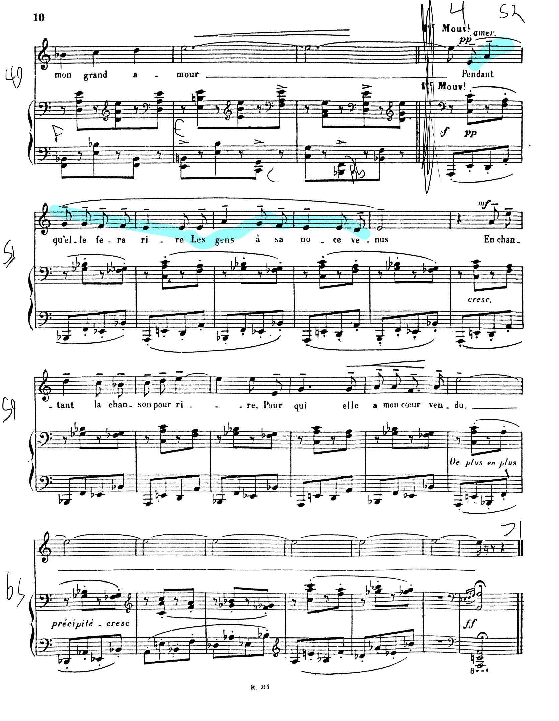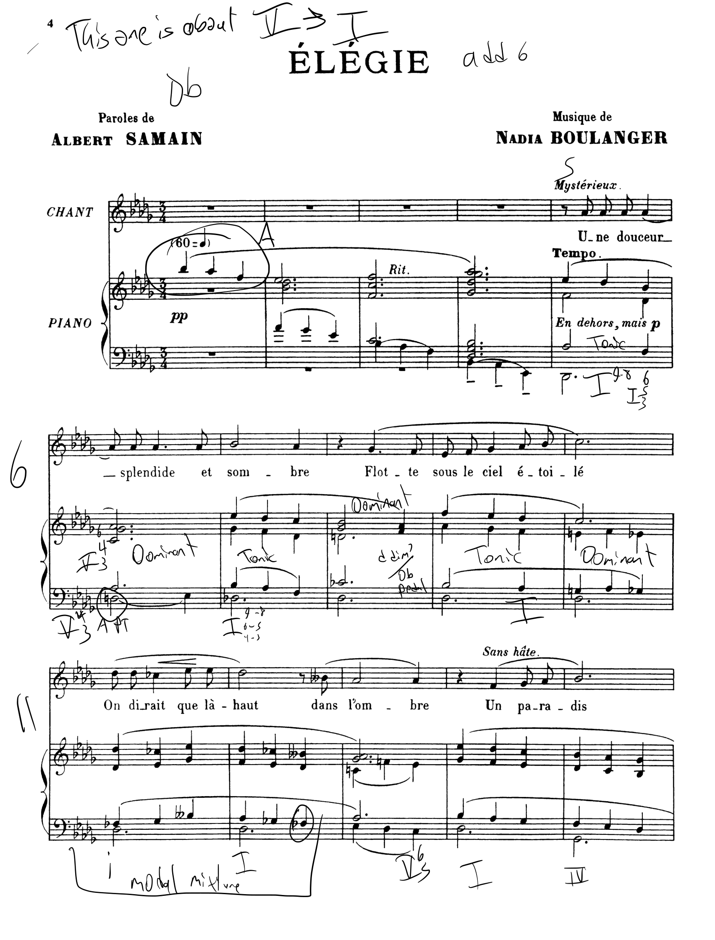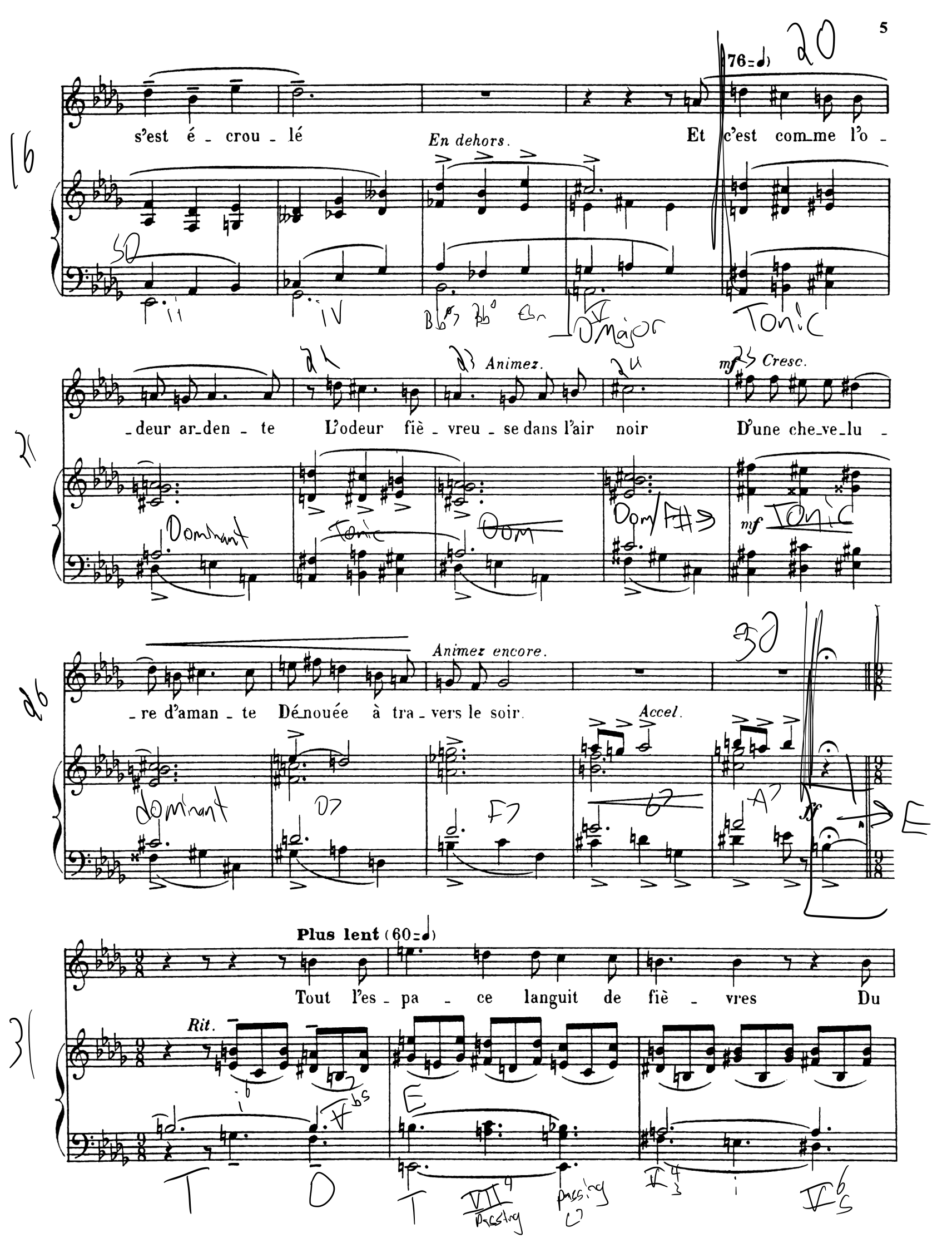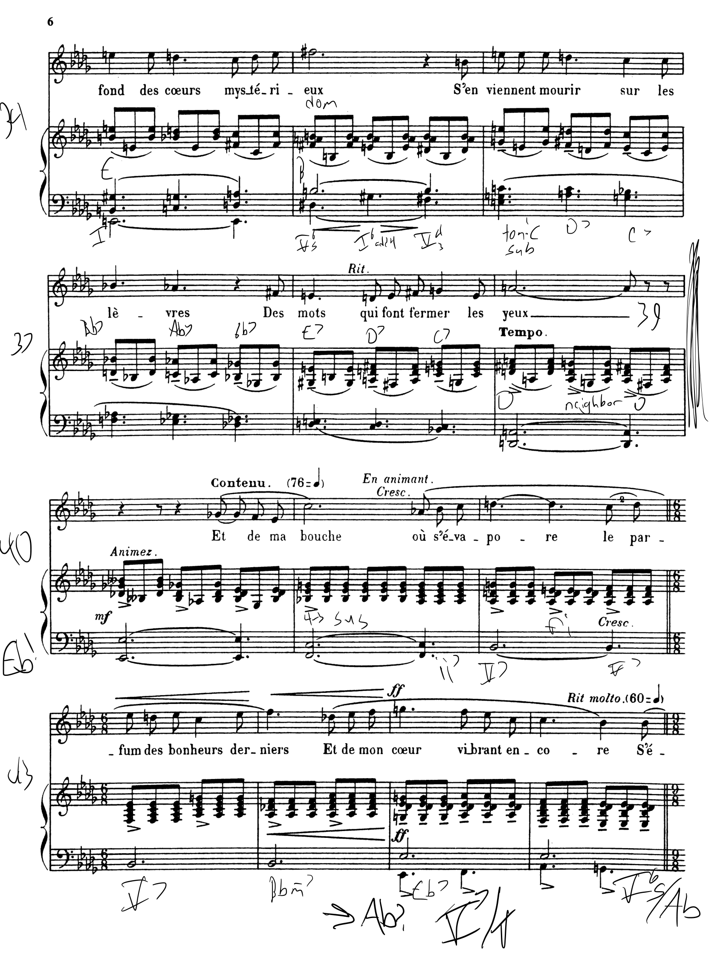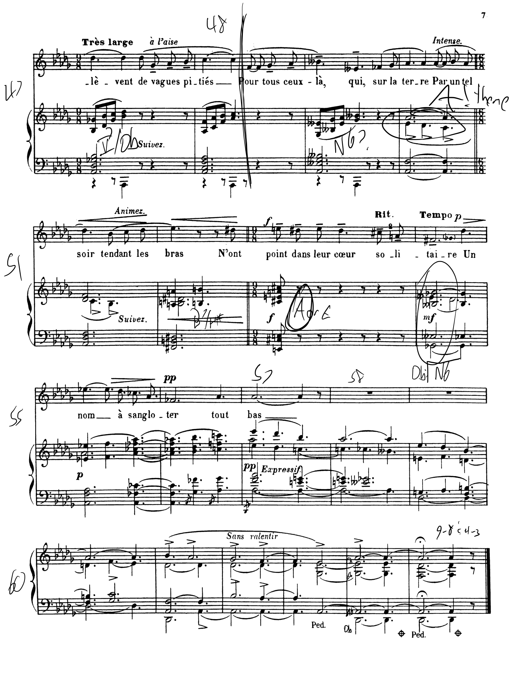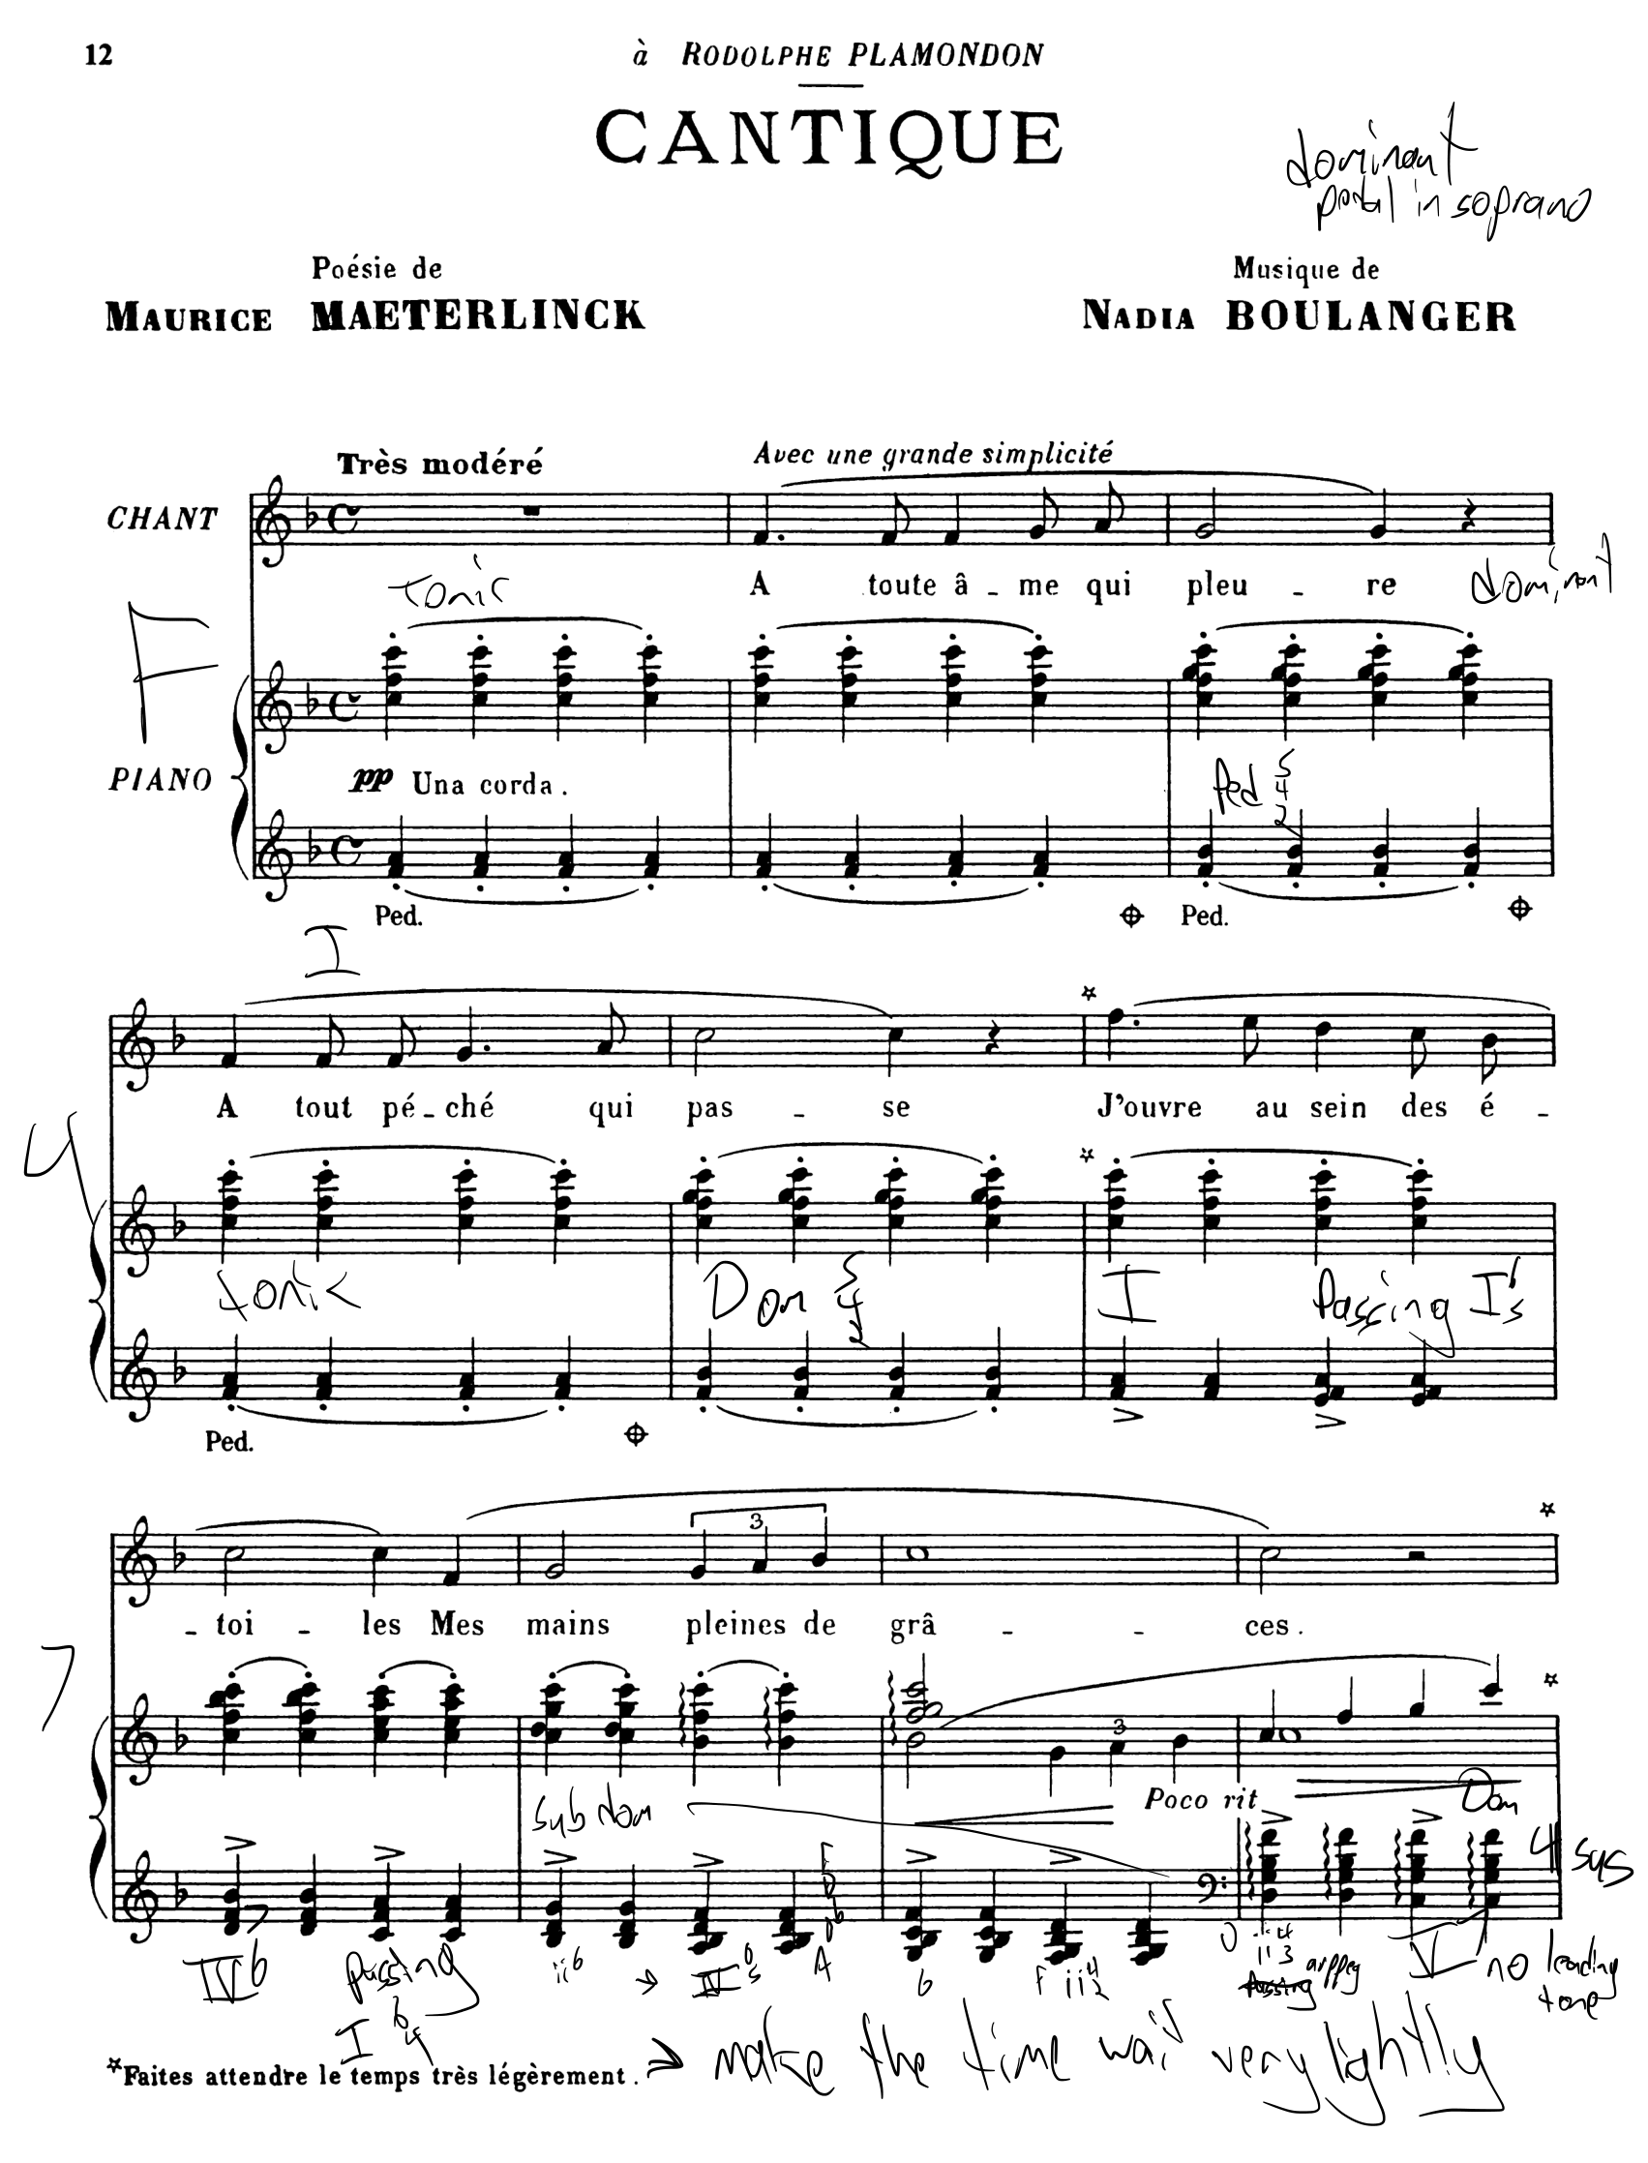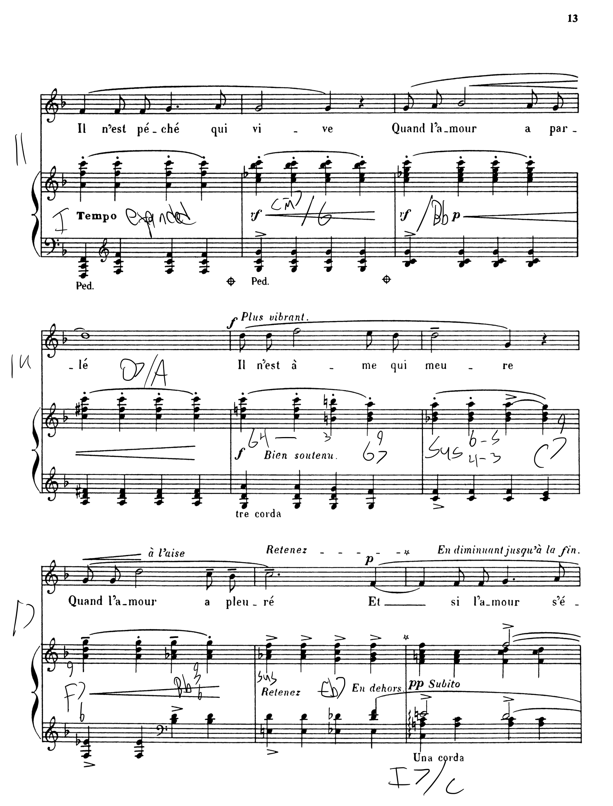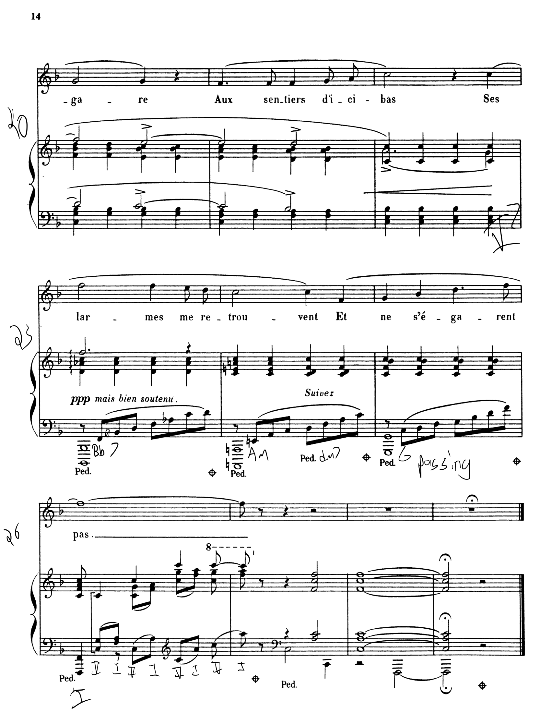

Appendix B: Lecture Recital Program
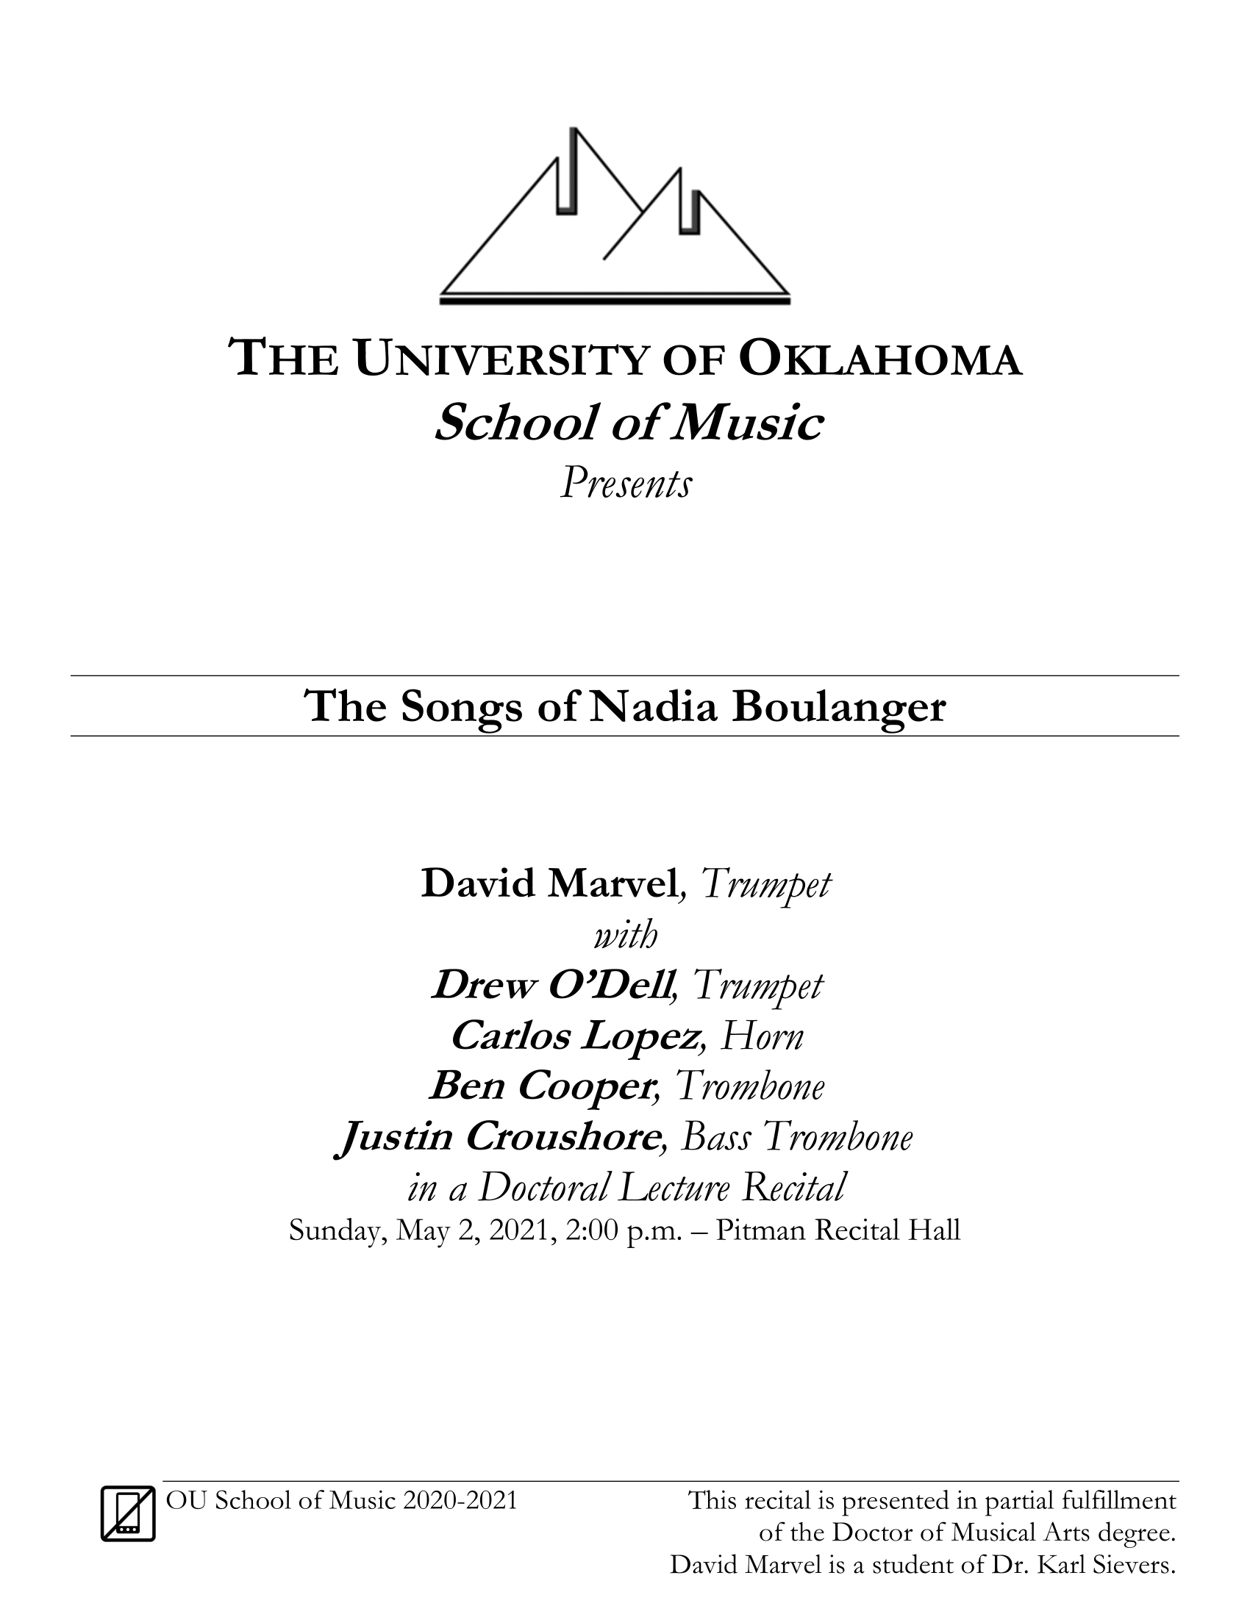
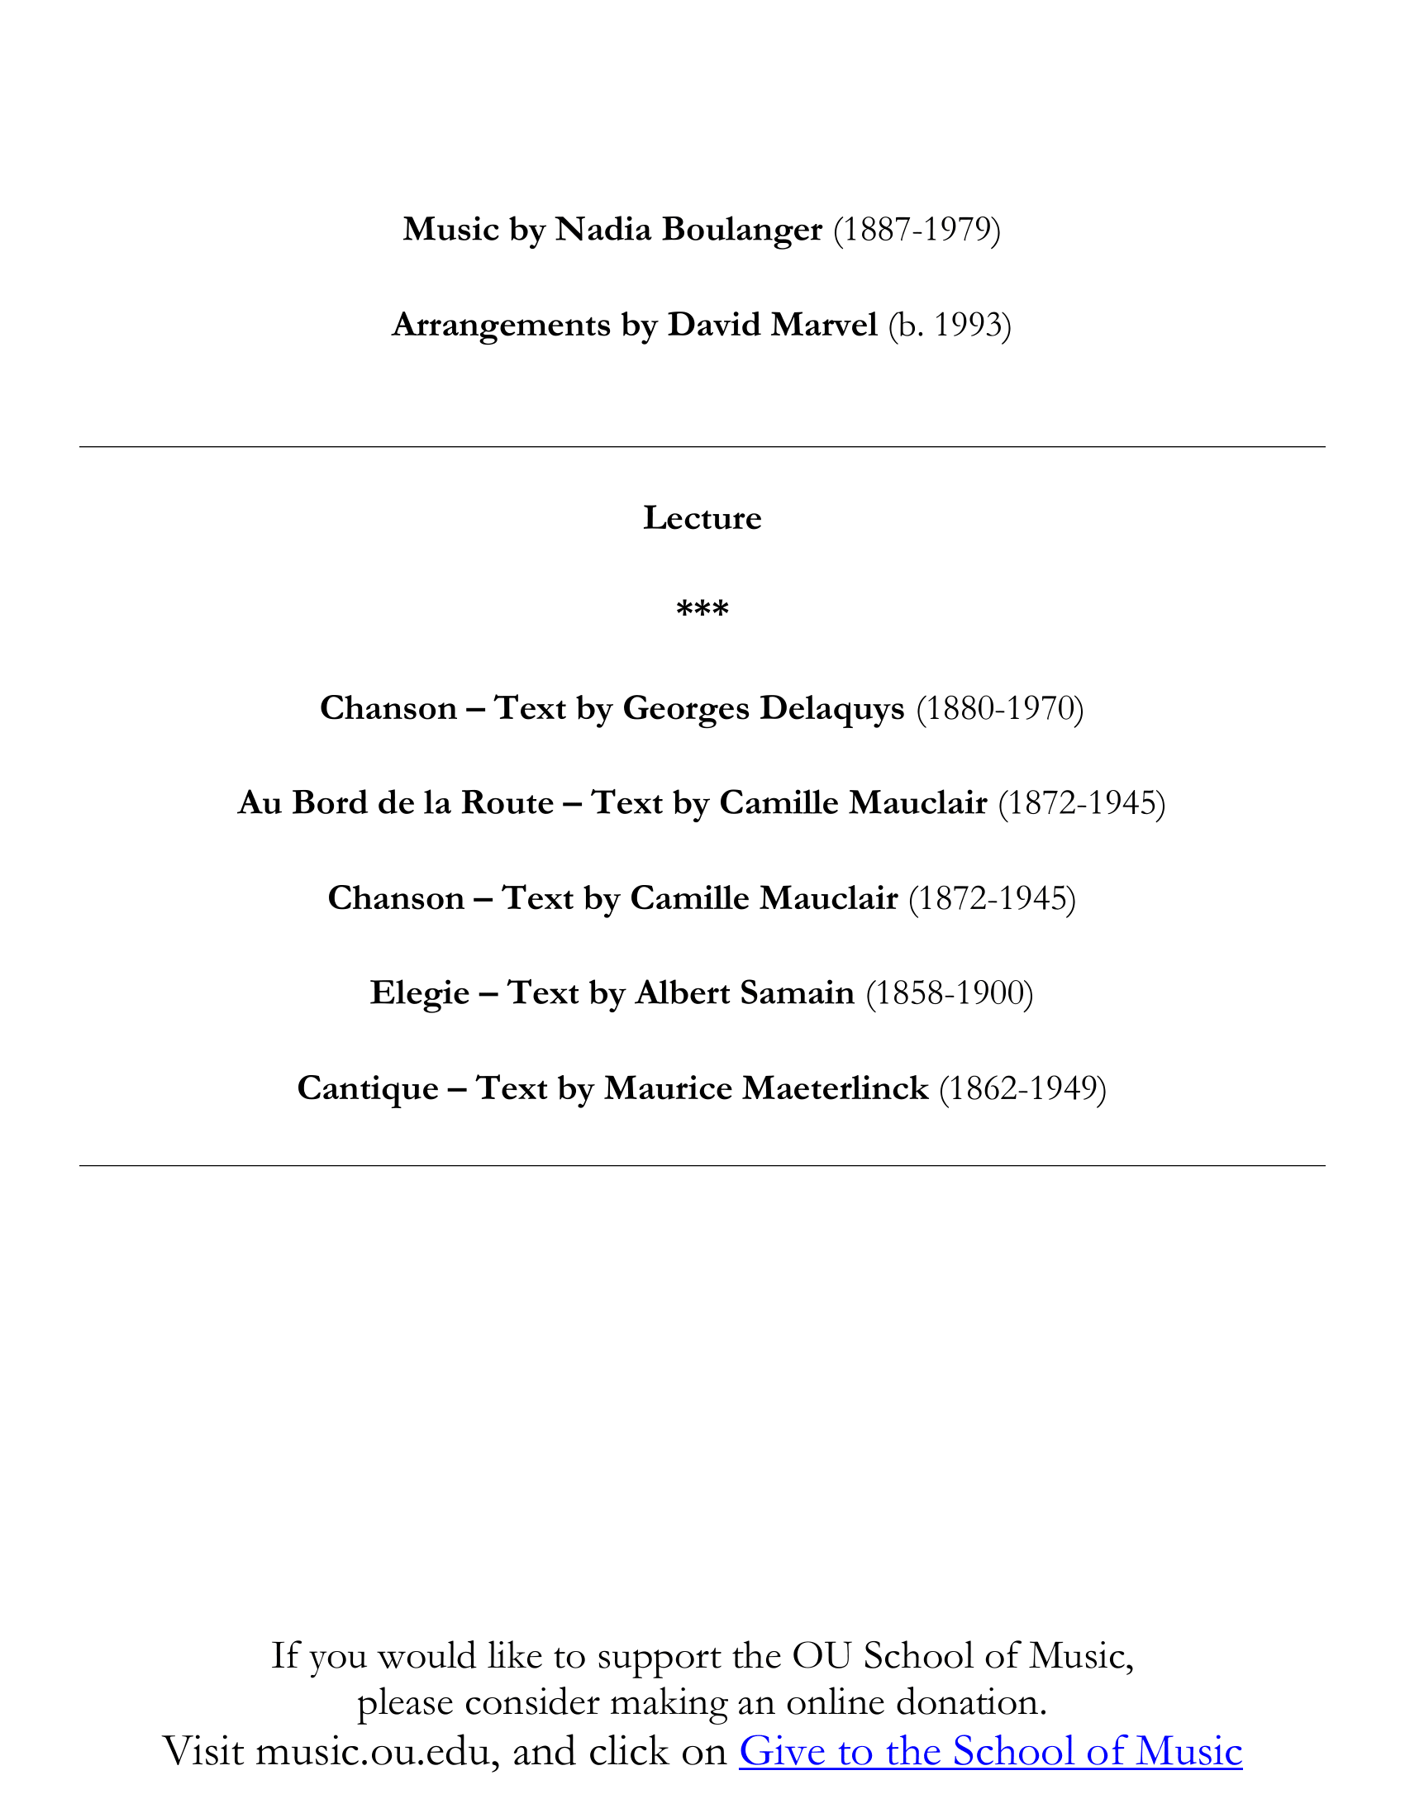

Appendix C: Links to Lecture Recital Recordings
Chanson (Delaquys) – https://youtu.be/OLheqEdWeY4
Au Bord de la route – https://youtu.be/fQ6pFZkCKK0
Chanson (Mauclair) – https://youtu.be/eeOZ_xX-g8k
Élégie – https://youtu.be/nr9SzrxPaug
Cantique – https://youtu.be/n0r1lpiwNZI

Caroline Potter, “Reviews of Books: ‘Nadia Boulanger: A Life in Music’ by Léonie Rosenstiel,” Music & Letters 80, 2 (1999): 315
Jeanice Brooks, The Musical Work of Nadia Boulanger: Performing Past and Future Between the Wars, (Cambridge: Cambridge University Press, 2013), 59
Bruno Monsaingeon, Mademoiselle: Conversations with Nadia Boulanger. (Manchester: Carcanet Press Limited, 1985), 66
Caroline Potter, “Reviews of Books: ‘Nadia Boulanger: A Life in Music’ by Léonie Rosenstiel,” Music & Letters 80, 2 (1999): 315
Potter, “Reviews of Books,” 316
Caroline Potter, Nadia and Lili Boulanger (Ashgate, 2006), 66
Caroliner Potter, “Nadia Boulanger,” Grove Music Online, 2001, https://doi-org.ezproxy.lib.ou.edu/10.1093/gmo/9781561592630.article.03705
Potter, Nadia and Lili Boulanger, 66
Jeanice Brooks, The Musical Work of Nadia Boulanger: Performing Past and Future Between the Wars, (Cambridge: Cambridge University Press, 2013), 217-218
Chicago Society for Music Theory, “Call for Papers: Nadia Boulanger and American Music,” Music Theory Online, 8 (2002)
Bruno Monsaingeon, Mademoiselle: Conversations with Nadia Boulanger. (Manchester: Carcanet Press Limited, 1985), 13
Wendy McCallum, Pedagogical style and influence of Nadia Boulanger on music for wind symphony, an analysis of three works by her students: Copland, Bassett, and Grantham. (Denton: University of North Texas, 2004)
Diane DeVries, The pedagogical influence of Nadia Boulanger on the works of her female students: An analysis of selected compositions. (Ann Arbor: ProQuest Dissertations Publishing, 1998)
Jeanice Brooks, The Musical Work of Nadia Boulanger: Performing Past and Future Between the Wars, (Cambridge: Cambridge University Press, 2013), 8-9
Rosemary Yeoland, "Nadia Boulanger et Camille Mauclair." International Review of the Aesthetics and Sociology of Music 45, (2014): 75
Caroline Potter, "Nadia Boulanger’s and Raoul Pugno’s La Ville Morte." Opera Quarterly, 16, (2000): 400
Potter, Nadia and Lili Boulanger, 28
Potter, Nadia and Lili Boulanger, 29
Potter, Nadia and Lili Boulanger, 26
Potter, Nadia and Lili Boulanger, 65
Potter, Nadia and Lili Boulanger, 72-73
Potter, Nadia and Lili Boulanger, 88
Potter, Nadia and Lili Boulanger, 88
Potter, Nadia and Lili Boulanger, 136
Brooks, The Musical Work of Nadia Boulanger: Performing Past and Future Between the Wars, 59
Alexandra Laederich. Unknown Music of Nadia Boulanger (Sonoma, CA: Delos Productions, 2017), 10
Laederich, Unknown Music of Nadia Boulanger, 21
Laederich, Unknown Music of Nadia Boulanger, 11
Laederich, Unknown Music of Nadia Boulanger, 23-24
Laederich, Unknown Music of Nadia Boulanger, 18
Caroline Potter, Nadia and Lili Boulanger (Ashgate, 2006), 28-29

