UNIVERSITY OF OKLAHOMA
GRADUATE COLLEGE

THE ROLE OF DISASTER SUBCULTURES IN SPANISH SPEAKING HISPANIC/LATINO IMMIGRANTS IN THE UNITED STATES

A THESIS
SUBMITTED TO GRADUATE FACULTY
in partial fulfillment of the requirements for the
Degree of
MASTER OF SCIENCE
IN GEOGRAPHY AND ENVIRONMENTAL SUSTAINABILITY

By
AMERICA R. GAVIRIA PABON
Norman, Oklahoma
2022
THE ROLE OF DISASTER SUBCULTURES IN SPANISH SPEAKING HISPANIC/LATINO IMMIGRANTS IN THE UNITED STATES

A THESIS APPROVED FOR
THE DEPARTMENT OF GEOGRAPHY AND ENVIRONMENTAL SUSTAINABILITY

BY THE COMMITTEE CONSISTING OF

Dr. Mark Shafer, Chair
Dr. Renee McPherson
Dr. Joseph Ripberger

© Copyright by AMERICA R. GAVIRIA PABON 2022
All Rights Reserved.

Acknowledgments
This thesis would not have been able to possible without the help and support of so many people.
First, I want to thank my advisor Dr. Mark Shafer for all his support throughout this journey. Thank you for always encouraging and believing in me and all my crazy ideas. You helped me achieve all of my goals. You have been a great advisor and mentor to me.
I also want to thank my committee members, Dr. Renee McPherson and Dr. Joe Ripberger. Thank you for always supporting me and guiding me through this process. Special thanks to Joe Ripberger for helping me with analyzing data and always being there whenever I had any questions or concerns.

Third, I want to thank my colleagues at IPPRA. Thank you for always supporting me in my research and even helping out whenever I need it, you guys are awesome! Special thanks to Kenzie Krocak for being so supportive and helpful in times when I needed it.

Special thanks to Joseph Trujillo Falcón for his guidance and amazing advice. This work would not have been possible without your help.

I also want to thank my friends Ivan, Kevin, Luis Daniel, Zaibeth, Javier, Cesar, and Kelby. Even though we are all far apart you have always been there for me since the very beginning. Thank you for always listening to me and cheering me up when I was feeling down. You guys are the best support system I could ever ask for.

My family has also been a great support to me. Thank you for always encouraging me to pursue my dreams, career, and goals no matter how far away I went. I love you all unconditionally.
I want to thank my amazing life partner Diego for always being there for me. You have supported me from the very beginning. There are no words to describe how thankful and grateful I am with everything you have done for me. Thank you for staying with me through the phone and help me study, practice for my presentations and just listening to me whenever I needed to talk and decompress. I love you with all my heart.

Finally, I want to dedicate this work to my community, the Hispanic/Latino community specially my Boricua community. I could not be prouder to be part of such an amazing, loving, kind, and diverse group of people. You are what inspires me to keep doing this type of research.

Table of Contents
Acknowledgments iv
List of Figures vii
List of Tables viii
Abstract ix
Chapter 1: Introduction 1
Section 1.1: Literature Review 3
Section 1.1.1: Disaster Subcultures 4
Section 1.1.2: Language Barriers 6
Section 1.2: Quantitative Analysis 6
Section 1.3: Qualitative Analysis 8
Section 1.4: Journals 9
Chapter 2: Disaster Subcultures: How Hispanic/Latino Spanish Speaking Immigrants Perceive, Interpret, and Understand Severe Weather Risks in the United States 10
Section 2.1: Introduction 10
Section 2.2: Disaster Subcultures 12
Section 2.2.1: Defining Disaster Subcultures 12
Section 2.2.2: Hispanic and Latinos Disaster Subcultures and Vulnerability 13
Section 2.3: Data & Methodology 14
Section 2.3.1: Survey Data 14
Section 2.3.2: Survey Design 16
Section 2.4: Results 19
Section 2.5: Discussion 28
Section 2.6: Conclusion 32
Section 2.7: Acknowledgments 33
Chapter 3: The Role of Disaster Subcultures in the Guatemalan Community During the December 10th, 2021, Quad-State Tornado Outbreak 34
Section 3.1: Introduction 34
Section 3.1.1 Tornado Event 34
Section 3.1.2: Disaster Subcultures of Hispanic/Latinos in the United States 35
Section 3.1.3: The Guatemalan Community 36
Section 3.2: Methodology 38
Section 3.2.1: Data Collection 38
Section 3.2.2: Transcripts 40
Section 3.2.3: Inductive Analysis 41
Section 3.3: Results 42
Section 3.3.1: Experience 42
Section 3.3.2: Language Limitations 43
Section 3.3.3: Awareness 44
Section 3.3.4: Protective Action 47
Section 3.3.5: Knowledge 49
Section 3.3.6: Advice 51
Section 3.4: Discussion 53
Section 3.5: Conclusion 56
Section 3.6: Acknowledgements 56
Chapter 4: Conclusions 58
Section 4.1: Key Findings 58
Section 4.2: Limitations 59
Section 4.3: Future Work 61
References 62

List of Figures
Figure 1. Shows the frequency of tornadoes around the world (from Wikipedia n.d.) 1
Figure 2. Shows the climatology of tornado days per year in the United States from 1986-2015 (from Storm Prediction Center n.d.) 2
Figure 3. Distribution of Hispanic and Latino population in the U.S. in 2020 according to the U.S. Census Bureau. 3
Figure 4. Response of WXS22 participants when asked if they were familiar with tornadoes based if they lived in the United States before or not. 20
Figure 5. Response of WXS22 when asked if they were familiar with tornadoes based in their previous country of residence. 21
Figure 6. Response of WXS22 participants of previous experience with tornadoes in their country of residence before coming to the United States. 22
Figure 7. Response of WXS22 participants on their risk perception level regarding tornadoes based on whether they live in the United States before or not. 23
Figure 8. Mean tornado risk perception of WXS22 participants based on their previous country of residence. 24
Figure 9. Participants from WXS22 respond to their understanding of what causes severe weather events based on their U.S. residency. 25
Figure 10. Mean rating of severe weather events understanding for participants who had previous residency in Latin American countries. 26
Figure 11. Response of WXS22 participants of their understanding of the difference between severe thunderstorms and tornadoes based on the U.S. residency. 27
Figure 12. Mean level of understanding between severe thunderstorms and tornadoes of respondents from Latin American countries. 28

List of Tables
Table 1. Demographic representation of WXS22 participants. Population estimates were obtained from the American Community Survey microdata records, made available by IPUMS USA (http://www.ipums.org) from (Ruggles et al. 2021) 16
Table 2: WXS22 participants country of residency. 18
Table 3: WXS22 questions that were analyzed for this research. 19
Table 4: Interview questions conducted in the communities affected by the tornado event. 39
Table 5: Codes developed from the inductive analysis. 41

Abstract
Having a diversity of climatic zones, the United States experiences different weather hazards and risks such as winter storms, tornados, droughts, hurricanes, among others depending on the geographic location. With Americans having a culture geared towards becoming a weather-ready nation, they may be more familiar with their emergency system than other communities living in the United States. According to the U.S. 2020 Census, Hispanics in the U.S. account for 18.9% of the total population, making them the second largest ethnic group. Coming from different places and having a diverse cultural background, the Hispanic/Latino community may be more vulnerable towards these hazards and disasters due to their lack of experience with such events in their country of origin and other factors such as language barriers. Hispanic/Latino Spanish speaking communities in the U.S. come from different places and depending from where one comes, some people may have different cultures of disaster response, or disaster subcultures. When it comes to understanding, interpreting, and acting on different information regarding weather and climate threats these factors can play a significant role. Additionally, inequities in weather risk communication such as translations from English to Spanish may also increase the vulnerability and challenges that this community faces when it comes to weather hazards. This research analyzes how cultural background and experiences or disaster subcultures from Hispanic/Latino immigrants in the United States affects the way they perceive, understand and act on severe weather risks. Using data from the Severe Weather and Society Survey 2022 Spanish version we analyze the differences between people who lived outside the U.S. versus people who did not and their perceptions, behaviors, and reporting understanding of severe weather risks. When doing the analysis, language barriers will also be taken into consideration. In addition, we also perform a qualitative analysis using data from interviews held after the December 10th, 2021, tornado outbreak within the Guatemalan community of Mayfield, KY. These results are presented and discussed using a disaster subcultures frame. When communicating different weather risks and threats, the weather enterprise needs to consider factors such as culture and experience to effectively communicate and transmit their weather risk information to diverse communities such as Spanish speaking Hispanic/Latinos.

Chapter 1: Introduction
The United States is divided into nine climatic regions which are the Northeast, Upper Midwest, Ohio Valley, Southeast, Northern Rockies and Plains, South, Southwest, Northwest and West (NWS n.d.a). Having different climates results in having diverse weather hazards all around the country. For example, the Northeast can be expected to have weather hazards such as snowstorms and blizzards, meanwhile the South can experience more severe thunderstorms and tornadoes. As a result of experiencing all types of hazards across the United States, Americans have been geared to and encouraged to have a weather ready nation. Resources such as the National Weather Service (NWS) have created educational campaigns and webinars such as Weather 101, Severe Weather 101, NWS Seasonal Safety Campaigns, among others, that encourage readiness, responsiveness and resilience to weather and climate threats (NWS n.d.b; NWS 2017).
Topographical and meteorological characteristics favor the development of severe thunderstorms and tornadoes in the United States (Lu et al. 2015). As a result, the United States is one of the places with the highest frequency of tornadoes in the world (Guo et al. 2016).
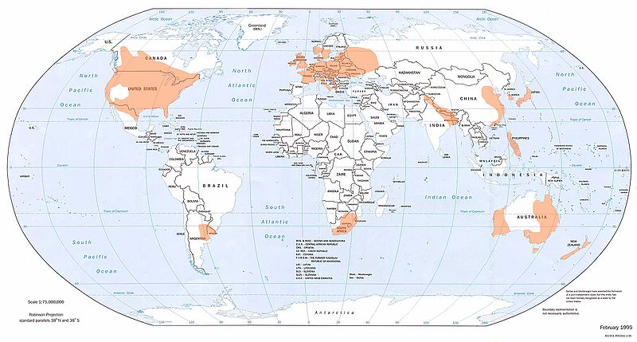
Figure 1. Shows the frequency of tornadoes around the world (from Wikipedia n.d.)
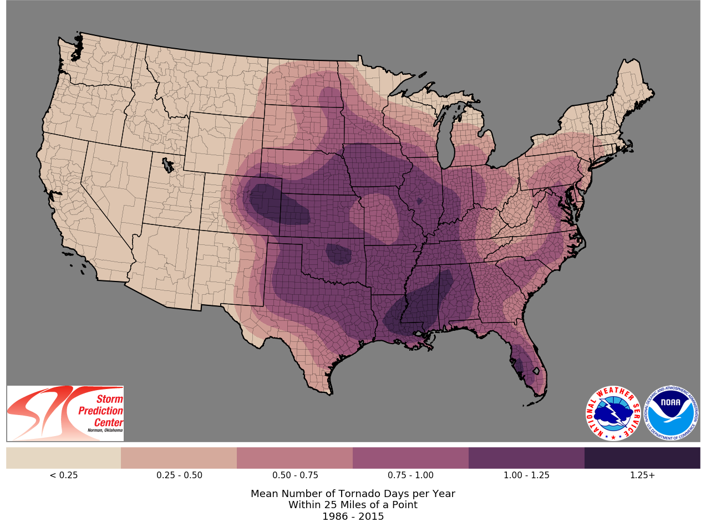
Figure 2. Shows the climatology of tornado days per year in the United States from 1986-2015 (from Storm Prediction Center n.d.)
Being used to weather hazards, Americans may develop disaster subcultures towards specific hazards that will influence the way they perceive, understand, and respond to them. However, the population in the United States is diverse, and for recent immigrants who establish themselves in this country, it may be more difficult to adapt due to differences in their culture, experience, and perceptions of hazards.
Currently, the largest minority group in the United States are Hispanic/Latinos accounting for 18.9% of the population (U.S. Census Bureau 2020). A Hispanic or Latino is defined by the U.S. Census as a person of Cuban, Mexican, Puerto Rican, South or Central American, or other Spanish culture or origin regardless of their race. The largest representation from Hispanic/Latinos in the United States come from Mexico (60%), Puerto Rico (9%), and El Salvador (4%). This group has grown by 23% since 2010 and in states like California and New Mexico, Hispanics/Latinos are the largest ethnic group comprising 39.4% and 47.7% of their total population, respectively. Projections show that by 2050 Hispanic/Latinos will account for 30% of the United States population (U.S. Census Bureau 2020b). Being such a large and significant group in the United States it is important to understand their vulnerabilities, inequities and disadvantages when it comes to weather risks and hazards.
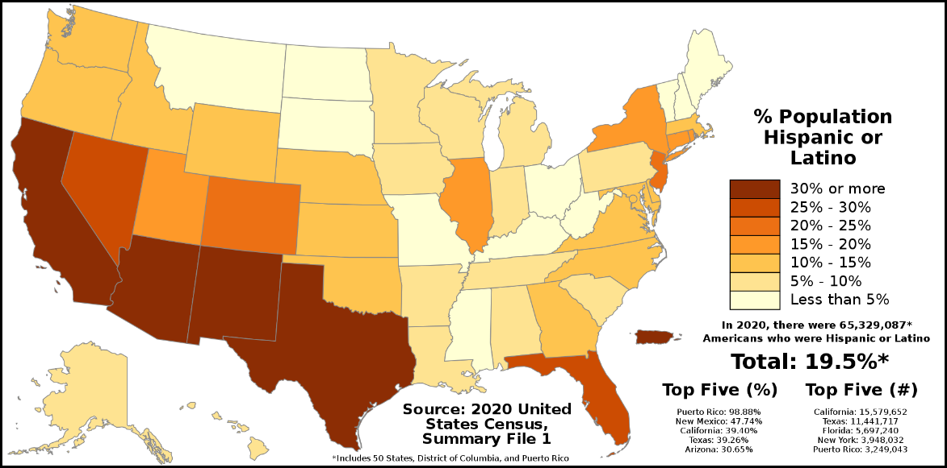
Figure 3. Distribution of Hispanic and Latino population in the U.S. in 2020 according to the U.S. Census Bureau.

Section 1.1: Literature Review
Hispanic/Latinos immigrate to the United States from all across Latin America and Spain, which results in a group that has different characteristics regarding culture and experience with weather hazards. Not all countries experience the same weather hazards. For example, a person from Puerto Rico may be more familiar with hurricanes, while a person from Chile may be more familiar with earthquakes. Coming from different backgrounds, Hispanic/Latinos should not be grouped together as one single group. There are significant differences between their cultural background, language, and experiences that set them apart from one another. In addition, Hispanic immigrants are also different from the U.S.-born Hispanics and disregarding these differences can leave a significant gap in hazard research (Maldonado et al. 2016).
Research has shown that Hispanic/Latinos are more vulnerable to weather risks (Maldonado et al. 2016; Trujillo-Falcón et al. 2021; Méndez et al., 2020). In addition, information lacking these group’s risk perceptions and language barriers places them at a disadvantage and increases their vulnerabilities when it comes to weather hazards (Benavides and Arlikatti, 2010). Not having previous experience with a hazard can increase their vulnerability to future risks. Research shows that individuals who have experienced a specific disaster may find it easier to imagine such disaster will happen again in the future, and therefore, indicate a higher perceived risk than individuals without this experience (Botzen and Van Der Bergh 2009).
Coming from different backgrounds and based on their previous experiences in their home countries, Hispanic/Latino immigrants have already developed their own risk perceptions about disasters that may differ from the ones they may experience in the United States. For example, people that have not experienced an event such as a tornado, could perceive their personal risk to be lower than those who have experienced one (Klockow et al. 2014). In addition to being unfamiliar with weather hazards in the United States, Hispanic/Latinos also face other challenges such as finding work or housing, among others, that can outweigh those less common events like earthquakes, floods and tornadoes (Donner and Rodriguez 2008).

Section 1.1.1: Disaster Subcultures
Cultures are generated and regenerated by social innovation and learning processes that are triggered by people experiencing challenges as they interact with their physical, social and cultural environments (Warner and Engel, 2014). There are different definitions of culture. In 1995, Lederach defined culture as the shared knowledge and schemes created by a set of people perceiving, interpreting, expressing, and responding to the social realities around them. For Matusomoto et al. (1996) culture is the set of attitudes, values, beliefs, and behaviors, shared by a group of people, but different for each individual, communicated from one generation to the next. An element that can be considered part of a culture is language. Language is one of the most important parts of a culture because it is the way people communicate within their community. Language simultaneously reflects culture and is influenced and shaped by it. It is also the symbolic representation of a people since it comprises their historical and cultural backgrounds as well as their approach to life and ways of thinking (Jiang 2000). It is not possible to understand or appreciate culture and language without the knowledge of one another (Elmes 2013; Wardhaugh 2002).
In 1965, Anderson defined subcultures as people who share distinctive cultural characteristics which differentiates them from other groups. An element that represents subcultures is language dialects. It can be said that dialects are equally adequate for the needs of the subculture of which they are a part of (Goodman 1965).
Communities can develop a subculture for responding to a unique problem or emergency such as a weather hazard which can result in a disaster subculture (Anderson 1965). Therefore, Anderson (1965) defined disaster subcultures as subcultural patterns operative in a given area which are geared towards the solutions of problems, both social and non-social, arising from the awareness of a periodic disaster threat.
There has been research on how disaster subculture influences European, American and Asian communities' response to a weather threat (Engel et al. 2014; Wenger and Weller 1972; and Hagen et al. 2021). However, disaster subcultures are yet to be analyzed within Hispanic/Latino communities. Using the framework of disaster subcultures, we will perform a quantitative and qualitative analysis to understand how disaster subcultures play a role on how Hispanic/Latinos in the United States understand, perceive and respond to severe weather risks.

Section 1.1.2: Language Barriers
Language barriers also exacerbate the level of vulnerability for Hispanic/Latino immigrant communities. The majority of weather warning information in the United States is in English, and the one that is available in Spanish does not incorporate factors such as cultural background and language dialects into their translations (Trujillo-Falcón et al. 2022; Aguirre 1988). Having these inequities in bilingual weather risk communication can transfer to ineffective preparedness when it comes to a weather threat (Aguirre 1988).
Hispanic/Latino immigrants have a wide range of Spanish dialects depending on their country of origin or cultural background which can change the way they perceive or respond to a weather hazard. During an interview with AccuWeather in 2021, Ph.D. student and researcher at the University of Oklahoma Joseph Trujillo Falcón, explained how this comes into play in meteorology. For example, in the Colombian dialect of Spanish, the word “tornado” does not refer to a twister but rather to a strong wind gust. As a result, risk perceptions of a tornado may be different for this community in comparison to their native counterparts. Hispanic/Latino communities are not a monolithic group; they need to be analyzed as groups of cultures and dialects. Therefore, researchers and government agencies can develop best practices that resonate with underserved communities in the United States (Trujillo-Falcón et al. 2022).

Section 1.2: Quantitative Analysis
Hispanic/Latinos in the United States immigrate from different places in Latin America and Spain which means they enter the country with disaster subcultures developed in their country of origin that may be different from their new native counterparts. For a disaster subculture to occur there needs to be a recurring hazard. If a person has not experienced that, then a disaster subculture cannot be developed. For a person who comes from a country like Peru where tornadoes are not common, it is very unlikely that this person will develop a disaster subculture towards tornadoes. When people from these communities move to the U.S. they are being exposed to severe weather, winter weather, and tropical cyclones that they may never have experienced in their home country. It is harder for them to adapt to a weather ready nation culture because their disaster subculture has not prepared them for that. Keul et al. (2018) stated that cultural differences can result in large variations in the perception of and response to the risk posed by severe weather phenomena, and that there has been little consideration of how multiple hazards are perceived.
For the purpose of this research, we decided to develop both a quantitative and qualitative analysis on disaster subcultures in the Hispanic/Latino community to analyze how this affects the way the perceive, understand and respond to weather risks in the United States.
In our first paper, we perform a quantitative analysis using data from the Severe Weather and Society Survey 2022 Spanish version (WXS22) to analyze and address how disaster subcultures influence the way Hispanic/Latino immigrants perceive and understand severe weather threats in the United States in comparison to those who have lived in the United States for a prolonged period of time. For the purpose of this research, we focus on questions regarding familiarity, risk perceptions, severe weather understanding, and previous experience with tornadoes in their home country.

Section 1.3: Qualitative Analysis
On December 10th, 2021, there was a tornado outbreak that significantly affected the Midwest, Ohio Valley, and Tennessee Valley throughout the evening hours into the early morning of December 11th. One of the communities that was highly impacted by this tornado outbreak was the community of Mayfield, Kentucky. The EF-4 tornado resulted in catastrophic damage and a toll of 57 deaths throughout the community.
The population in Mayfield, Kentucky is 9,971 and 13.5% of this population is from Hispanic or Latino origin (U.S. Census Bureau 2020c). All of the information that was provided to the community during the tornado outbreak was in English, leaving the Hispanic population unable to understand what was going on and putting them at a higher risk. Having information available in Spanish is critical and crucial, especially to first generation Latino immigrants since they can also encounter additional problems such as lack of disaster information and unfamiliarity with the risks (Arlikatti et al., 2010). After the event, this community was hit very hard due to these inequities that occurred.
Three months after the event a research team from the University of Oklahoma traveled to the communities affected by the tornadoes that occurred in December 2021, which included the states of Arkansas and Kentucky. Our research team was split into three different groups. One group would interview emergency managers and state officials, the second group would interview forecasters from the NWS and the third group would interview people from the Hispanic/Latino community. In this paper, we analyze data collected from Hispanic/Latino communities in Mayfield, Kentucky throughout March 1st, and March 2nd, 2022.
We conducted 16 interviews in Mayfield, Kentucky and 12 out of them were people from the Guatemalan community. As of 2019, Guatemalan immigrants account for 2.5% of the U.S. population (MPI, 2022). In Mayfield, KY there is a growing community of Guatemalans. The majority of these people are first generation Latino immigrants and coming to a new country like the United States can be hard and challenging to adapt especially to a climate that poses different hazards they may have never experienced before in their home country.
In this paper we use an inductive analysis approach to develop a codebook from the interview data. We use the codebook to assess the following research questions:
- What values, norms, beliefs, knowledge, and technology did Guatemalan immigrants rely on to respond to disasters from their home country?
- And how does the disaster subculture of Guatemalan Immigrants affect how they responded to tornado hazards in the Quad-State tornado outbreak?

Section 1.4: Journals
These papers are aimed to be submitted to scientific journals. Paper 1 (Disaster Subcultures: How Hispanic/Latino Spanish Speaking Immigrants Perceive, Interpret, and Understand Severe Weather Risks in the United States) will be submitted to the Bulletin of the American Meteorological Society. Meanwhile, paper 2 (The Role of Disaster Subcultures in the Guatemalan Community During the December 10th, 2021, Quad-State Tornado Outbreak) is planned to be submitted to the Journal of Disaster Risk Reduction.

Chapter 2: Disaster Subcultures: How Hispanic/Latino Spanish Speaking Immigrants Perceive, Interpret, and Understand Severe Weather Risks in the United States

Section 2.1: Introduction
The United States has a diversity of climatic zones throughout its territory which range from tropical climates, dry climates, moist subtropical mid-latitude climates, moist continental mid-latitude climates, and highlands. Consequently, the United States experiences a wide range of weather hazards, such as winter storms, tornados, droughts, hurricanes, among others depending on the location. In many places, multiple hazards are possible, requiring preparedness and warning information that can quickly allow the population to discern what problem they face and then carry out the appropriate steps needed for safety (Sullivan and Häkkinen 2011). As a result of these different hazards that occur, Americans born and raised in the United States are encouraged to be weather ready, and the National Weather Service (NWS) has undergone several educational campaigns to encourage readiness, responsiveness and resilience to weather and climate threats (NWS 2017). However, for a person living in the United States that was not born or raised in that country, they may have a different cultural background, experiences and perceptions regarding the different weather hazards and their risks.
According to the (U.S.Census Bureau 2020a) Hispanic/Latinos in the United States account for 18.9% of the total population. The U.S Census defines a Hispanic or Latino as a person of Cuban, Mexican, Puerto Rican, South or Central American, or other Spanish culture or origin regardless of race. The largest representation from Hispanic/Latinos in the U.S. come from Mexico (60%), Puerto Rico (9%), and El Salvador (4%). This group has grown by 23% since 2010 and in states like California and New Mexico, Hispanics/Latinos are the largest ethnic group comprising 39.4% and 47.7% of their total population, respectively. Across the continental United States, this group is the second-most prevalent with majority of Hispanic/Latinos in every region. Projections show that by 2050, Hispanics/Latinos will account for 30% of the U.S. population (U.S. Census Bureau 2020b). Even though Hispanics/Latinos are the second largest group in the United States they are considered a minority group; therefore, they may be at higher risk or vulnerability towards weather hazards and risks (Lindell and Perry 2003; Mendez et al., 2020; Trujillo-Falcón et al., 2021). Research indicates that immigrants are more likely to experience inequities within the disaster cycle compared with the native-born population in the United States (Donner and Rodriguez 2008; Lemyre et al. 2009; Scurfield 2008). For example, immigrants may experience communication barriers and lack of knowledge about community resources that prevents them from taking preventive measures (Yong et al. 2017).
When Hispanics/Latinos immigrate to the United States, they come from all across Latin America and Spain; they all have different cultures, experiences, and perceptions regarding weather risks. Not all Hispanic/Latino immigrants experience the same weather hazards. For example, Puerto Ricans have more experience with hurricanes, while Peruvians are more familiar with El Niño due to their geographic locations. Research shows that individuals who have experienced a specific disaster may find it easier to imagine such disaster will happen again in the future, and therefore, indicate a higher perceived risk than individuals without this experience (Botzen et al. 2009). For example, a study showed that Mexican immigrants who experienced the Loma Prieta earthquake in 1989 responded very differently during the 1994 Los Angeles earthquakes as compared to Mexicans who did not go through that experience (Bolin and Stanford 1998; Tierney 1994).
Having less information about their perceptions and risks places Hispanic/Latinos at a higher disadvantage from non-Hispanic whites (Carter-Pokras et al. 2007). Coming from different backgrounds and based on their previous experiences in their home countries, Hispanic/Latino immigrants have already developed their own risk perceptions about disaster that may differ from the ones they may experience in the United States. For people that have not experienced an event such as a tornado, they could perceive their personal risk to be lower than those who have experienced one (Klockow et al. 2014). This chapter will focus on disaster subcultures and how it relates to vulnerabilities within the Hispanic/Latino community.

Section 2.2: Disaster Subcultures

Section 2.2.1: Defining Disaster Subcultures
Defined by Lederach (1995), culture is the shared knowledge and schemes created by a set of people perceiving, interpreting, expressing, and responding to the social realities around them. An element or example that can be considered part of a culture is language. Language is one of the most important parts of a culture because it is the way people communicate within their community. Language simultaneously reflects culture and is influenced and shaped by it. It is also the symbolic representation of a people since it comprises their historical and cultural backgrounds as well as their approach to life and ways of thinking (Jiang 2000).
An element that follows culture is subculture. When we refer to subculture, we are talking about people who share distinctive cultural characteristics which differentiates them from other groups (Anderson 1965). An example of a subculture would be language dialects. Dialects represent subcultures. Therefore, it can be said that dialects are equally adequate for the needs of the subculture of which they are a part (Goodman 1965).
Disaster subculture is defined by Anderson (1965) as sub-cultural patterns in a given area which are geared towards the solutions of problems, both social and nonsocial, arising from the awareness of some form of almost periodic disaster threat. Newcomers in the community are usually taught this behavior from other residents or public officials who are the ones in charge to disseminate that information. In other words, we can say that having a disaster subculture means how people within a community perceive weather threats and disasters, and how they react and respond to them before, during or after the event.

Section 2.2.2: Hispanic and Latinos Disaster Subcultures and Vulnerability
Based on this concept of disaster subcultures we can explore how Hispanic/Latino communities that immigrated to the United States from Latin America experienced different weather threats in their home country and how these experiences shape the way they will react to possible weather hazards in the U.S. Using the example again of someone from Puerto Rico, it is likely that they will know how to act when they are under a hurricane threat in the U.S. However, if that person moves to a place like Oklahoma where severe weather is the most common threat, it is probable that they will not know how to react because they have never experienced any tornadoes or severe weather in their home country of Puerto Rico. When people from these communities move to the U.S. they are being exposed to severe weather, winter weather and tropical cyclones that they may never have experienced in their home country. It is harder for them to adapt to a weather ready nation culture because their disaster subculture has not prepared them for that. Keul et al. 2018 stated that cultural differences can result in large variations in the perception of and response to the risk posed by severe weather phenomena, and that there has been little consideration of how multiple hazards are perceived.
Language barriers also exacerbate the level of vulnerability for Hispanic/Latino immigrant communities. The majority of weather warning information in the United States is in English, and the one that is available in Spanish does not incorporate factors such as cultural background and language dialects into their translations (Trujillo-Falcón et al. 2022; Aguirre 1988). Having these inequities in bilingual weather risk communication can transfer to ineffective preparedness when it comes to a weather threat (Aguirre 1988).
Hispanic/Latino immigrants have a wide range of Spanish dialects depending on their country of origin or cultural background which can change the way they perceive or respond to a weather hazard. During an interview with AccuWeather in 2021, Ph.D. student and researcher at the University of Oklahoma Joseph Trujillo Falcón, explained how this comes into play in meteorology. For example, in the Colombian dialect of Spanish, the word “tornado” does not refer to a twister but rather to a strong wind gust. As a result, risk perceptions of a tornado may be different for this community in comparison to their native counterparts. Hispanic/Latino communities are not a monolithic group; they need to be analyzed as groups of cultures and dialects. Therefore, researchers and government agencies can develop best practices that resonate with underserved communities in the U.S. (Trujillo-Falcón et al. 2022). In this paper we will analyze and address how disaster subcultures influence the way Hispanic/Latino immigrants perceive and understand severe weather threats in the U.S. in comparison to people who have lived in the U.S. for a prolonged period of time.

Section 2.3: Data & Methodology

Section 2.3.1: Survey Data
The survey data for this research comes from the 2022 iteration of the WxSurvey. The 2022 Severe Weather and Society Spanish (WXS22) survey was designed and administered by the Institute for Public Policy Research & Analysis (IPPRA) at the University of Oklahoma. This is an annual nationwide survey that measures tornado forecast, warning receptions, comprehension, and response. The WXS22 is the sixth survey in an annual series (Ripberger et al., 2020a, 2020b, 2020c, 2020d and 2021; Bitterman et al. 2022) and it is the second one to be conducted in Spanish (Krocak et al. 2022). Just like the previous WxSurveys, WXS22 measured extreme weather and climate risk perceptions, risk literacy, interpretations of probabilistic language and measured trust in governmental agencies. WXS22 included questions regarding people’s cultural background and risk perceptions in their previous country of residence. This version of the Spanish survey was fielded from 15 July – 5 August 2022 using an online questionnaire that was completed by 641 Spanish-speaking adults in the United States. IPPRA was responsible for implementing the survey and managing the data; Qualtrics oversaw recruiting participants to complete the survey via advertisements on web pages, social media, and contact with various online communities. To assure a diverse and representative sample of the U.S. population, Qualtrics also affiliates with programs and partnerships to recruit their participants. This company maintains a diverse pool of participants who have agreed to participate in surveys. The survey was approved by the Institutional Review Board of the University of Oklahoma (OU IRB# 9418) and the participation was completely voluntary.
For the respondents to be able to participate in the survey they needed to answer the first question which asked: “Do you speak Spanish?” as “Yes, well” or “Yes very well” to be able to continue with the survey. Participants were broadly representative of the U.S. Spanish-speaking population regarding age, sex, and Hispanic heritage (Table 1).

 | U.S. Spanish Speakers  (Census 2020) | Survey Participants WXS22
Age
18-34 | 35% | 45%
35-64 | 52% | 47%
65 + | 13% | 8%
Sex
Female | 50% | 55%
Male | 50% | 45%
Hispanic Heritage
No, not of Hispanic, Latino or Spanish origin | 6% | 2%
Yes, Mexican, Mexican American, Chicano | 60% | 44%
Yes, Puerto Rican | 9% | 12%
Yes, Cuban | 4% | 7%
Yes, another Hispanic, Latino or Spanish origin | 27% | 34%
Table 1. Demographic representation of WXS22 participants. Population estimates were obtained from the American Community Survey microdata records, made available by IPUMS USA (http://www.ipums.org) from (Ruggles et al. 2021)

Section 2.3.2: Survey Design
The WXS22 survey consisted of 179 questions that took around 18-20 minutes to respond. For the purpose of this paper, we analyzed questions regarding familiarity and risk perceptions with severe weather in the U.S. based on 1) whether they lived in the U.S. before or not and 2) if they did not live in the U.S., then the questions were based in their country of origin (Table 2). A person who lived in the U.S. before is defined as a person who has been in the country and did not have any previous residency in a Latin American country. For Q1, Q2, and Q3 we focused only on tornadoes. (Table 3)
Participants had to respond if they were familiar or not with the previous hazards (Q1). For respondents who did not live in the U.S. before, they had to answer if they had experienced these hazards in their previous country of residency (Q2). For our third research question (Q3), participants were asked to rate the level of risk of the mentioned hazards in their area from no risk to extreme risk in a 1-to-5 Likert scale. For Q4 and Q5 survey participants were asked if they understand what causes severe weather events, and their understanding of differences between severe thunderstorms and tornadoes respectively from strongly disagree to strongly agree in a 1-to-5 Likert scale.

 | Survey Participants WSX22
Did you live in the U.S. before?
Yes | 51%
No | 49%
What country did you live in before?
México | 22%
Puerto Rico | 16%
Cuba | 7%
Colombia | 10%
Perú | 2%
Venezuela | 18%
Guatemala | 6%
Other | 18%
Table 2: WXS22 participants country of residency.

Questions | WXS22
Familiarity (Q1) | Different parts of the U.S. experience different types of extreme weather events. Are you familiar with the following types of extreme weather? [list hazards]  Diferentes lugares de los Estados Unidos experimentan diferentes tipos de condiciones de tiempo extremo. ¿Estás familiarizado con las siguientes condiciones de tiempo extremo?
Country of Residency (Q2) | Did you experience these types of weather when you lived in your previous country of residency? [list hazards]  ¿Experimentó estos eventos extremos cuando vivía en su anterior país de residencia?
Risk Level (Q3) | Thinking about all four seasons (winter, summer, spring, and fall), how do you rate the risk of the following extreme weather events to you and the people in your area? [list hazards]  Tenga en cuenta las cuatro estaciones del año (invierno, verano, primavera y otoño) ¿Cómo categoriza el riesgo de los siguientes eventos de condiciones del tiempo extremas para usted y las personas en su área?
Severe Weather Understanding (Q4) | I do not understand what causes severe weather events like thunderstorms, tornadoes, and hurricanes.  No entiendo cuáles son las causas que ocasionan los eventos de tiempo extremo tales cómo tormentas, tornados y huracanes.
Severe Thunderstorms vs Tornadoes (Q5) | Do you understand the difference between severe thunderstorms and tornadoes?  ¿Entiende usted la diferencia entre tormentas severas y tornados?
Table 3: WXS22 questions that were analyzed for this research.

Section 2.4: Results
For our first research question (Q1) we found that there is relatively little difference in tornado familiarity between people who lived in the U.S. before when compared to people who did not (Figure 4). Forty six percent of the people who did not live in the U.S. before indicated that they were not familiar with tornadoes in comparison with the 38% of people who had already been living in the U.S.

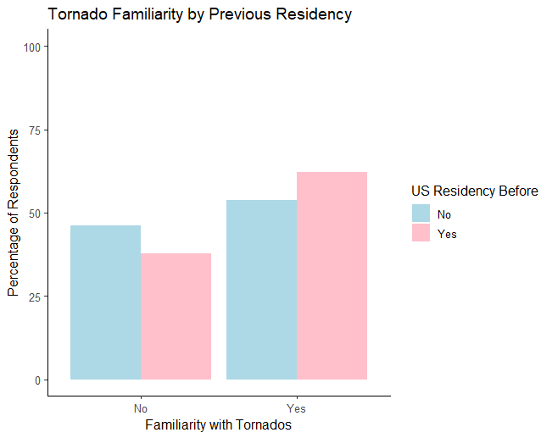
Figure 4. Response of WXS22 participants when asked if they were familiar with tornadoes based if they lived in the United States before or not.
Our first research question (Q1) was also broken down by previous country of residence (Figure 5). Results showed that participants who lived in Colombia before they moved into the U.S. were least familiar with tornadoes (70%), followed by Mexico (59%), Venezuela and Guatemala (50%) each respectively. Respondents from Cuba indicated that they had a higher level of familiarity with tornadoes even though they had not lived in the contiguous U.S. before (80%) followed by Puerto Rico (57%).
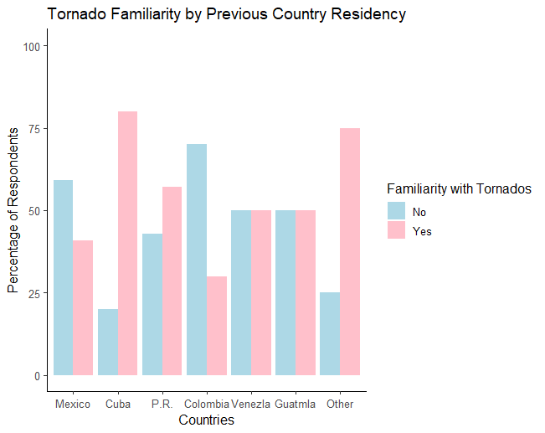
Figure 5. Response of WXS22 when asked if they were familiar with tornadoes based in their previous country of residence.
Continuing with our second research question (Q2) participants were asked if they had experienced tornadoes in their previous country of residence (Figure 6). Results showed that a higher percentage of respondents from Venezuela (100%), Guatemala (83%), Mexico (82%), and Cuba (71%) did not have any previous exposure to tornadoes in their home country. As for having experience with tornadoes, results showed that respondents from Puerto Rico (33%), and Cuba (29%) were most likely to have experience tornadoes.

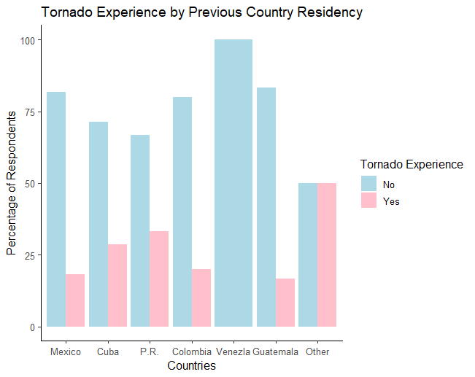
Figure 6. Response of WXS22 participants of previous experience with tornadoes in their country of residence before coming to the United States.
We also asked participants to rate their level of perceived risk of tornadoes on a scale from No Risk to Extreme Risk (Q3) based whether they lived in the U.S. before or not (Figure 7). Results show that of the people who indicated a no risk (60%) did not live in the U.S. before. Meanwhile, higher percentages of people who indicated a High (54%) and Extreme (52%) did not also live in the U.S. before. Results also show that or people who indicated Low and Moderate risk (60%) and (61%) respectively lived U.S. before.
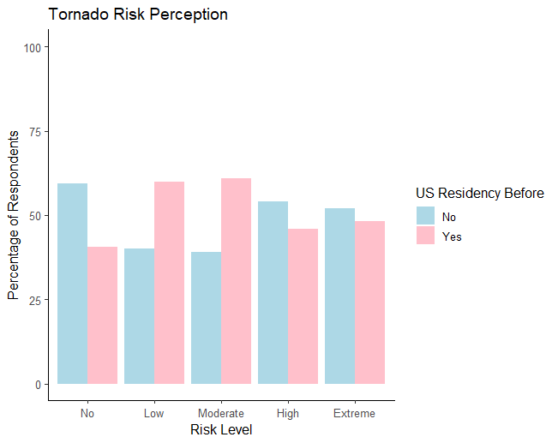
Figure 7. Response of WXS22 participants on their risk perception level regarding tornadoes based on whether they live in the United States before or not.
Following up with this research question (Q3) we also analyzed risk tornado perception of the participants who did not live in the U.S. before (Figure 8). Results show that the lowest risk perception of tornadoes were from people who lived in Mexico (2.1), Puerto Rico (2.9), Colombia (3.2) and Guatemala (3.3). As for Venezuela and Cuba they had the highest risk perceptions of tornadoes with 4.2 and 4.3 respectively. Also, a wider spread on Puerto Rico and Colombia compared to others, indicates a broader diversity of risk perception in these countries.
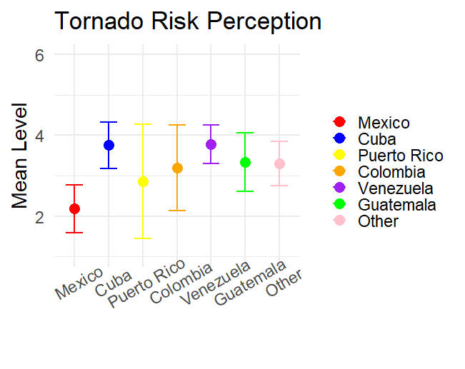
Figure 8. Mean tornado risk perception of WXS22 participants based on their previous country of residence.
For our fourth research question (Q4) we asked participants if they did not know the cause of severe weather events such as tornadoes, hurricanes, and thunderstorms rated from Strongly Agree to Strongly Disagree (Figure 9). Results show that of the people who Strongly Agree with the statement (67%) did not live in the U.S. followed by those in that same group who selected Neither (55%). As for people who Agree with the statement (60%) did live in the U.S. before. Results also show that for people who did live in the U.S. before (55%) and (54%) answered “Strongly Disagree” and “Disagree” with the statement respectively.
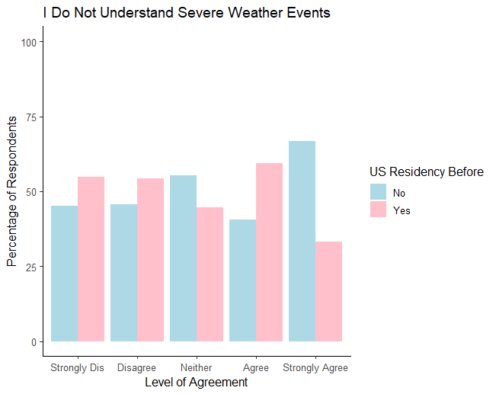
Figure 9. Participants from WXS22 respond to their understanding of what causes severe weather events based on their U.S. residency.
Similarly, to research question 4 (Q4) we analyzed the understanding of extreme weather for participants who had previous residence in other Latin American countries (Figure 10). Results show that consistency among participants where the mean of their severe weather events understanding ranged from 2.5 to 3.0, with the exception of Venezuela which had a higher mean score of 3.4.
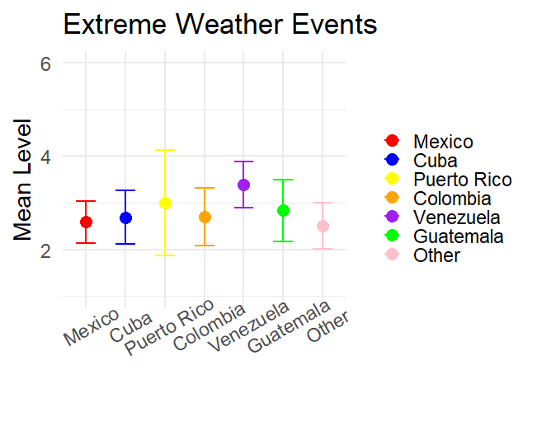
Figure 10. Mean rating of severe weather events understanding for participants who had previous residency in Latin American countries.
Continuing with research question 5 (Q5), participants were asked to rate their understanding of severe thunderstorms versus tornadoes based on whether they lived in the U.S. before or not (Figure 11). As we can see, results show that of the people who indicated “Definitely no” (67%) did not live in the U.S. before in comparison with those that were U.S. residents (33%). In addition, for participants that answered, “Probably Yes” (60%) or “Definitely Yes” (54%) were participants. who had lived in the U.S. before.

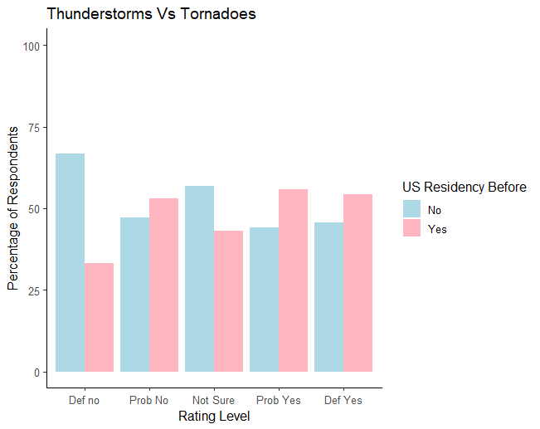
Figure 11. Response of WXS22 participants of their understanding of the difference between severe thunderstorms and tornadoes based on the U.S. residency.
Following up with this question we also analyzed how people who lived in Latin American countries understand the difference between severe thunderstorms and tornadoes (Figure 12). Results show that there is consistency regarding this statement. Most respondents indicated that they do understand the difference between severe thunderstorms and tornadoes with a mean level of response between 3.9 and 4.0.
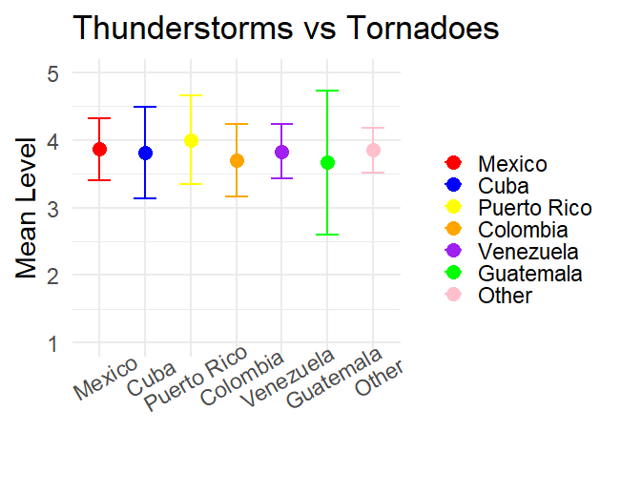
Figure 12. Mean level of understanding between severe thunderstorms and tornadoes of respondents from Latin American countries.

Section 2.5: Discussion
Not all individuals respond and perceive risks and hazards the same way. Carter-Pokras et al. (2007) stated that cultural groups respond to risk and crisis communication on the basis of their perceptions, and ways of thinking which can differ from group to group. Cultural differences can result in large variations in the perception of and response to the risk posed by severe weather phenomena (Keul et al 2018). Coming from different places and backgrounds, this is what makes the Hispanic/Latino community in the United States diverse and unique. The purpose of this research was to highlight and explore the differences of severe weather risk perceptions between Hispanic/Latino communities who have lived in the U.S. versus those who had previous residency in Latin American countries.
Not every country provides the same quality of weather information to their population. In research by Keul et al. 2018 on transcultural severe weather risk perceptions, results showed that there were important differences in the quality of severe weather information among the country samples for laypeople that influenced weather knowledge and their potential fears and protective actions. Our results showed significant differences of tornado risk perceptions between people who lived in the U.S. before in comparison to respondents who had previously lived in Latin America.
To better understand their risk perceptions, participants were asked if they had any previous tornado experience in their country of residency. Results show that all of our respondents indicated to have less experience with tornadoes in their respective countries. Puerto Rico, Cuba, and Colombia were among the countries that indicated previously to have more experience with tornadoes in comparison to the rest of the countries. Even though tornadoes are not that common in Puerto Rico, the island does experience watersprouts which can be sometimes mistaken by tornadoes. In addition, tornadoes can be associated with hurricanes which are very common in the island. As for Colombia, the translation and terminology of tornadoes could be an important factor due to that in the Colombian dialect of Spanish, ‘tornado” does not refer to a twister but rather to a strong wind gust Trujillo-Falcon et al. 2021 It is important to add that if these communities have experienced a disaster before and survived it, they become more familiar with the risk which can result in them becoming less concerned about the severity of the threat when a warning is issued Sellnow et al. 2017.
In our questions about tornado familiarity results showed that people who had previous U.S. residency had higher familiarity with tornadoes than those who did not live in the U.S. before. As for these participants, results showed that Colombia, Mexico, Venezuela, and Guatemala were the least familiar with tornadoes. These results highly correlated with our previous question about tornado experience. Tornadoes are more common in the United States than in most Latin American countries. As a result, U.S. residents are more likely to experience a tornado than a person in Latin America is. Therefore, U.S. residents can become more familiar with tornadoes versus those who had previous residency in Latin America.
A past experience with a hazard can shape the way people recognize and develop judgments about a future risk (Weinstein 1989; Renn 2009; Wachinger et al. 2013). We asked participants to rate their perceived level of tornado risk based on their previous residency. Results showed that most respondents with previous residency in Latin American countries tended to indicate a higher risk perception for tornados in comparison to their native counterparts who tended to indicate a lower tornado risk perception. When we broke down these results by country, we found that participants from Mexico were the ones that indicated a lower risk perception for tornadoes followed by Puerto Rico and Colombia. As for Cuba, Venezuela, and Guatemala they indicated a higher risk level for tornadoes. Klockow et al. 2014 found that these perceptions that are driven by social forces or place attachments are the ones that motivate people to attenuate or amplify their risk. Consequently, an understanding of those values would improve the ability of risk communicators to influence tornado risk perceptions.
The understatement of what causes an event can also shape the way people perceive a hazard. We wanted to analyze how participants rated their understanding of what causes severe weather events. Our most significant result for this question was that a higher percentage of people who did not live in the U.S. before indicated that they “Strongly Agree” with the statement that they do not understand what causes severe weather. When broken down by countries, results show consistency in their answers for most countries with Venezuela just going a little bit over the mean. Many of these countries represented in our survey do not experience tornadoes. If an event never occurred in their country before it is unlikely that they will know what causes such an event.
Similarly, to our previous question we wanted to analyze participants' understanding of the difference between severe thunderstorms and tornadoes. Results showed an increasing tendency towards knowing the difference between these two hazards for people who lived in the U.S. but a decreasing one for people who had previous residency in Latin American countries. In terms of countries there is consistency in the results. Even though tornadoes are not common in these countries, thunderstorms are. With the exception of Mexico, the rest of the countries represented in the survey are near or close to the Intertropical Convergence Zone which means that they receive rain and thunderstorms on a daily basis. Storms may not necessarily be severe, but it may be easier to differentiate between a storm and a tornado.
It is important to recognize and acknowledge the needs of a population when communicating weather risk information since that will translate into preparedness actions. In their paper, Sullivan and Hakkinen (2011) worked with including disabled populations into disaster planning. They recommended that by including people with disabilities, disaster preparedness research will contribute insight and experience for effective communication and action.
With increasing immigration of people from Latin American countries to the United States, the country is becoming more diverse. Research by Tierney (1994) found that in the Loma Prieta earthquake, the communities in the U.S. are becoming more culturally diverse; therefore, organized efforts that provide assistance to disaster victims from these communities also need to change to accommodate that diversity. Results from Carter-Pokras et al. (2007) found that people responsible for issuing emergency warning communications for the Latino community should recognize that prior experiences with emergencies in their country of origin may affect emergency preparedness and responses of Latino immigrants.
Previous research has linked disaster subcultures to different levels of understanding in European and Asian communities (Engel et al., 2014; Hagen et al., 2021) however, nothing has explored Hispanic/Latino communities quite yet. This research aims to showcase the role that disaster subculture plays when it comes to understanding and perceiving severe weather risks. Our results showed differences in severe weather risk perceptions between participants who lived in the United States before versus those who had previously lived in Latin American countries. In addition, we also found differences in tornado experience and risk perceptions among the countries represented in our study. Acknowledging that Hispanic/Latino communities come from different backgrounds and experiences can be very beneficial and helpful to authorities and local disaster managers that want to build on existing capabilities and reduce enduring vulnerabilities (Engel et al. 2014).

Section 2.6: Conclusion
The Hispanic/Latino population in the United States is projected to increase, meaning that we will constantly have people from Latin America immigrating to the country with different perspectives, backgrounds, experiences, and disaster subcultures. In our research we found differences of severe weather and tornado risk perceptions between people who live in the U.S. before versus those who had previous residency in Latin American countries. The majority of countries represented in the survey had lower experience, familiarity and risk perceptions regarding tornadoes and severe weather. Therefore, it is important that when weather risk communication is provided to the public it also includes and considers factors such as weather experience, cultural background and differences between these communities. Comprehending their culture, and weather patterns, the weather enterprise can develop better practices when communicating weather risk information.

Section 2.7: Acknowledgments
Special thanks to Dr. John Lipski and Estilita Cassiani Obeso from Penn State University for helping with the translations of the survey. Data collection for this project was funded by the Office of the Vice President for Research and Partnerships at the University of Oklahoma. Data analysis and research support was funded by the NOAA Weather Program Office (Accelerating Development of the US Extreme Weather and Society Survey Series, NA16OAR4320115).

Chapter 3: The Role of Disaster Subcultures in the Guatemalan Community During the December 10th, 2021, Quad-State Tornado Outbreak

Section 3.1: Introduction

Section 3.1.1 Tornado Event
On December 10th, 2021, a tornado outbreak struck the Midwest, Ohio Valley and Tennessee Valley throughout evening hours into December 11th early morning hours. A total of 16 tornadoes touched ground making it one of the most dangerous and worst tornado outbreaks recorded in the United States, especially among wintertime events. As a result, tornadoes that developed from this outbreak affected the areas of Missouri, Illinois, Indiana, Ohio, Arkansas, Kentucky, Tennessee, Mississippi and Alabama. This event resulted in 87 fatalities and catastrophic damage to the communities affected. At 9:26 pm on December 10th, the National Weather Service in Paducah, Kentucky issued a Tornado Emergency for Mayfield, Kentucky. This EF-4 tornado was one of the most significant tornadoes, which developed in northwest Tennessee and moved across Western Kentucky accounting for 165.7 miles and resulting in catastrophic damage and a death toll of 57 victims.
The population in Mayfield, Kentucky is 9,971 and 13.5% of this population is from Hispanic or Latino origin (U.S. Census Bureau 2020c). All of the information that was provided to the community during the tornado outbreak was in English, leaving the Hispanic population unable to understand what was going on and putting them at a higher risk. Having information available in Spanish is critical and crucial, especially to first generation Latino immigrants since they can also encounter additional problems such as lack of disaster information and unfamiliarity with the risks (Arlikatti et al., 2010). This community was hit very hard during this event due to these inequities that occurred. The district had to seek translators to be able to communicate and provide services and resources to the Hispanic community.

Section 3.1.2: Disaster Subcultures of Hispanic/Latinos in the United States
In the United States the Hispanic/Latino community is the largest minority group with high rates of people from Central and South America and their growth is only projected to increase. Information lacking these group’s risk perceptions and language barriers places them at a disadvantage and increases their vulnerabilities when it comes to weather hazards (Benavides and Arlikatti 2010). Coming from all across Latin America with different cultures and experiences, adapting to a new living environment in the United States can be challenging. These challenges such as finding work or housing, among others, can outweigh those less common events like earthquakes, floods and tornadoes (Donner and Rodriguez 2008).
Cultures are generated and regenerated by social innovation and learning processes that are triggered by people experiencing challenges as they interact with their physical, social, and cultural environments (Warner and Engel 2014). Communities can develop a subculture for responding to a unique problem or emergency such as a weather hazard which can result in a disaster subculture Anderson (1965). Therefore, Anderson (1965) defined disaster subcultures as subcultural patterns operative in a given area which are geared towards the solutions of problems, both social and non-social, arising from the awareness of a periodic disaster threat.
There has been research on how disaster subculture influences European, American, and Asian communities' response to a weather threat (Engel et al., 2014; Wenger and Weller 1972; and Hagen et al., 2021). However, disaster subcultures are yet to be analyzed within Hispanic/Latino communities.
The U.S. Census Bureau (n.d.) defines Hispanic/Latino as a person of Cuban, Mexican, Puerto Rican, South or Central American, or other Spanish culture or origin regardless of race. Currently this group accounts for 18.9% of the United States population and projections show that by 2050, Hispanics/Latinos will account for 30% of the United States population (U.S. Census Bureau 2020a). When arriving in the United States, Hispanic/Latino immigrants bring with themselves their culture and experiences. It is important to note that coming from different countries they may have encountered and experienced different weather conditions as the ones they might come across in the United States. In addition, they may also have a lack of experience with a specific hazard. For example, a person from Peru may be more familiar with earthquakes rather than tornadoes. Therefore, Hispanic/Latino’s disaster subcultures may differ from disaster subcultures that have been developed across time in their new location. Anderson (1965) states that newcomers should learn this knowledge from older residents or from public officials whose function is to disseminate such information.

Section 3.1.3: The Guatemalan Community
As of 2019, Guatemalan immigrants account for 2.5% of the U.S. population (MPI, 2022). In Mayfield, KY there is a growing community of Guatemalans. Many of these people are first generation Latino immigrants and coming to a new country like the United States can be hard and challenging to adapt especially to a climate that poses different hazards they may have never experienced before in their home country.
Guatemala is a country located in Central America and it is bounded by Mexico, Belize, El Salvador, and Honduras. Due to its location, Guatemala has a tropical climate all year round. However, during the months of December-February they can experience lower temperatures due to cold air masses that come from the United States. Guatemala is also located in the path of hurricanes; therefore, during hurricane season if a tropical cyclone hits the country that can result in heavy rainfall, landslides, and flooding. The responsibilities of communicating weather risk information Is the Institute of Seismology, Vulcanology, Meteorology and Hydrology of Guatemala. The majority of their weather risk information is distributed through their official webpage and social media such as Facebook, Twitter, and Instagram. Even though this information exists in Guatemala it does not necessarily reach the entire population. According to their last census (INE 2018) only 21.3% of the Guatemalan population has a computer and 29% of them have access to the internet.
As of the 2018 Census (INE 2018), in Guatemala 43% of the population identifies themselves as indigenous. Forty-one-point seven percent of this group is Mayan. The official language of Guatemala is Spanish; however, they also have a wide variety of indigenous spoken languages. Around 11.3% of the population speaks K’iche’ followed by Q’eqchi’ (7.7%), Kaqchikel (7.4%), and Mam (5.5%) (INE 2018).
Guatemalans not only have a diverse population and culture, but they also experience different weather hazards from the ones to which they may be exposed in the United States. Therefore, Guatemalans may have developed their own values, norms, beliefs, knowledge, and technology to deal with hazards in their home country. These factors developed into their disaster subcultures which differ from disaster subcultures in the United States.
In this paper we will analyze the following research questions:
- What values, norms, beliefs, knowledge, and technology did Guatemalan immigrants rely on to respond to disasters from their home country?
- How does the disaster subculture of Guatemalan immigrants affect how they responded to tornado hazards in the Quad-State tornado outbreak?

Section 3.2: Methodology

Section 3.2.1: Data Collection
We developed an English questionnaire that would contain the interview questions we would ask participants. For the purpose of this paper, we will only be focusing on the questions shown in Table 4. After the English version was completed, then this questionnaire was translated into Spanish. The questionnaire consisted of 5 main topics: Weather Awareness and Protective Action, The Quad-State Tornado, Trust in Government and Media, Immigration Status and Limitations to Safety, and Language Barriers.

Interview Questions
Q1: What types of weather disasters did you experience in your home country?
¿Qué tipos de catástrofes meteorológicas experimentó en su país de origen?

Q2: What was the most memorable disaster you experienced growing up?
¿Cuál fue la catástrofe más memorable que experimentó mientras crecía?

Q3: In your home country, how did you become aware of weather disasters? Were there resources, like sirens, radio, and/or television, that you relied on for information?
En su país de origen, ¿cómo tomó conciencia de las catástrofes meteorológicas? ¿Existían recursos, como las sirenas de tornado, la radio y/o la televisión, en los que confiaba para informarse?
Q4: Let’s talk about your life here in ______. What kind of weather disasters do you experience here? Are they different from the ones from your home country?
Hablemos de su vida aquí en ______. ¿Qué tipo de catástrofes meteorológicas experimenta aquí? ¿Son diferentes de las de su país de origen?

Q:5 In general, how prepared do you feel to the threats here in the U.S. when compared to the ones you experienced in your home country? Why is that?
En general, ¿cuán preparado se siente ante las amenazas aquí en EE.UU. en comparación con las que experimentó en su país de origen? ¿A qué se debe esto?
Q:6 Was last December’s tornado the first tornado you ever experienced?
¿El tornado del pasado diciembre fue el primer tornado que experimentó?

Q:7 As the tornado approached your area, what emergency preparedness plan did you and your family take, if any?
¿A medida que el tornado se acercó a su área, cual fue el plan de emergencia que usted y su familia ejecutó si alguno?

Q:8 Now that you experienced the tornado, what kind of advice would you give to someone that has not experienced one before?
Ahora que ha experimentado el tornado, ¿qué tipo de consejo le daría a una persona que nunca ha experimentado un tornado antes?
Q:9 Do you primarily speak English? If not, what language are you most familiar with?
- If other languages: Are you able to get weather hazard information in [Insert Language Here] here? If so, from where or from who?
- To what degree do you trust that source?
¿Habla principalmente inglés? Si no es así, ¿con qué idioma está más familiarizado?
- Si son otros idiomas: ¿Puede obtener información sobre los riesgos meteorológicos en [Inserte el idioma aquí]? En caso afirmativo, ¿de dónde o de quién?
- ¿En qué medida confía en esa fuente?

Table 4: Interview questions conducted in the communities affected by the tornado event.
After developing the questionnaire, we reached out to community leaders in Mayfield, Kentucky such as teachers, pastors, and other non-profit organizations via email and telephone. These individuals then pointed us out to community members who were directly affected by the tornado and were interested in sharing their experiences.
Finally, a research team from the University of Oklahoma traveled to the communities affected by the tornadoes that occurred in December 2021, which included the states of Arkansas and Kentucky. Our research team was split into three different groups. One group would interview emergency managers and state officials, the second group would interview forecasters from the NWS and the third group would interview people from the Hispanic/Latino community. For the purpose of this paper, we will analyze data collected from Hispanic/Latino communities in Mayfield, Kentucky throughout March 1st and March 2nd, 2022. Our team arrived in Mayfield, Kentucky on March 1st and was there until March 2nd conducting interviews with the Hispanic/Latino community. Before starting the interviews, participants were read an oral consent which stated that the interviews would be recorded, were completely voluntary, and ensured their anonymity. Interviews lasted from 20-45 minutes. A total of 16 interviews were conducted in Spanish during these two days. For the purpose of this research, we will only analyze data from 12 of the interviews which corresponded to participants from the Guatemalan community in Mayfield, Kentucky.

Section 3.2.2: Transcripts
Once we completed our data collection, interviews were transcribed using NVivo which is a software for qualitative data analysis. Since the interviews were conducted in Spanish, we needed to make sure that the software translated them correctly. Therefore, once we transcribed the interviews using the software, we also checked them manually and made the necessary corrections.

Section 3.2.3: Inductive Analysis
For this paper we used an inductive analysis approach to develop a codebook from the interview data collection. Codes that are constructed from an inductive analysis are constructed as researchers review data (SAGE, 2019). For the inductive analysis we went through all the transcribed interviews and started reading, highlighting quotes and then grouping them together by having similar themes. Then, by going through this data again we finally developed the codes that we were going to use for this research. The codebook developed for this research can be found in Table 5.
Code | Definition
Experience | Any kind of experience with weather hazards in participants' country of origin.
Language Limitations | The language that participants spoke and any limitations.
Awareness | This code pertains to how participants became aware of weather hazards in their home country.
Protective Action | This code addresses what kinds of protective action participants took after they learned about the tornado threat.
Knowledge | Any kind of knowledge participants had of the tornado threat.
Advice | Any type of advice you would give to a person from Guatemala that recently arrived in the United States.
Table 5: Codes developed from the inductive analysis.

Section 3.3: Results

Section 3.3.1: Experience
Participants were asked about previous experience with weather hazards in their home country. Most of them indicated that they do not get many weather hazards in Guatemala except for rainfall or some minor thunderstorms.
Rosa:
“En Guatemala hay tormentas, pero son un poco menos, pero no son muy fuertes. Si se hacen escuchar son del temblor terremoto, ese es el único grave de allá de nuestro país.”
“There are thunderstorms in Guatemala, but they are weaker and not that frequent. We do hear and get earthquakes. That is the only one that is bad over there”.

Sofia:
“Nunca experimenté un tornado. Si experimenté muchas lluvias. Había lluvia durante tres días”.
“I never experienced a tornado. I did experience a lot of rain, it would rain up to three days”

Karla:
“Bueno no tanto como acá, sí de que hay como un huracán sí, pero no es como lo que pasó aquí, fue tan fuerte.”
“Well not as much as here, we do get hurricanes, but it is not as bad as what happened here [the tornado]”.

Javier:
“No había nada de desastres en mi país”.
“There were not any disasters in my country”.

Julio:
“Allá sólo lluvia cuando era tiempo de lluvia y sol cuando era tiempo de sol”
“Over there [Guatemala], only rained when it was rain season, and there was sun where it was dry season”

Participants noted that severe weather events were rare and seasonal. Hurricanes and floods were the predominant threats which occurred only in the rainy season. Consequently, even if they were prepared for tornadoes, the one occurring in December would be highly unexpected from their experience.

Section 3.3.2: Language Limitations
Participants were asked what language they spoke. The majority of them did not speak or understand English very well. Six out of the 12 participants indicated that K’iché was their first language followed by Spanish. For the rest of the participants, they preferred to speak Spanish and had a limited English proficiency
Rosa:
“Yo tengo un idioma, K ́iché, entonces no es fácil dejarlo porque yo nací allí. La mayoría de mi familia no hablan en español, hablan más en K ́iché. No es fácil olvidar nuestro idioma, muchas personas de nuestro país de Guatemala no saben hablar otro idioma, entonces necesitan ayuda”.
“I have a language which is K’iche and it is not easy to leave it because I was born in over there [Guatemala]. Most of my family do not speak Spanish, they speak K’iche. It is not easy to forget our language, a lot of people from my country of Guatemala do not speak other languages, therefore, they need help”.

Sofia:
“Algunos hablan mucho español acá algunos no hablan nada. He visto que muchos necesitan traducir al español”.
“Some of them speak a lot of Spanish and others do not speak Spanish at all. I’ve seen that a lot of them [Guatemalan immigrants] need to translate into Spanish”.

Julio:
“Yo hablo dos lenguajes, K’iché y el español. Mi primer idioma es K’iche porque siempre hablo K’iché con mi papá. Ni yo ni mis padres hablamos mucho inglés”.
“I speak two languages, K’iche and Spanish. My first language is K’iche because I always speak K’iche with my dad. Neither me of my parents speak much English”.

Section 3.3.3: Awareness
Participants were asked how they kept aware of the weather if they did in their home country of Guatemala. Some of them answered by just looking at the sky or from what they saw in the news.
Sandra:
“Si a veces es eso (ver las nubes) por que las personas mayores, que más tienen experiencia de cosas así no dependían mucho de recursos como pronósticos. Yo no sintonizaba información del tiempo en radio o televisión”.
“Yes, sometimes that [see the clouds]. because old people have more experience and they do not depend on resources such as weather forecasts. I did not watch any weather information on the radio or television”.

Fernanda:
“Nada más sólo lo que veíamos por las noticias”.
“Only from what we saw in the news”

Josue:
“Solamente veía las nubes. Creo que hay personas en radio o televisión pero no escuchaba nada allá”.
“I only looked at the clouds. I think there are people on the radio or television, but I did not listen to any of it while I was there [in Guatemala]”.

Others indicated that there is no information available to them regarding weather or technology that will keep them updated.
Karla:
“Solamente nos esperábamos porque comience a llover, no teníamos meteorólogos”.
“We just waited for the rain to start; we did not have any meteorologists”.

Olivia:
“Viera de que allí no existían los teléfonos inteligentes, o tal vez sí pero la mayoría de las personas no teníamos acceso a un teléfono o una computadora. Inclusive algunos teníamos tele, pero de ver videos con cassette. Entonces nunca que las noticias que esto, nunca nos interesamos en eso. En la familia nunca nos inculcaron la cultura de estar viendo el pronóstico del tiempo sino solamente decían “Oh está nublado, mañana va a estar lloviendo” o cosas así. Entonces, las personas mayores, ellos seguían mucho las fases de la luna. No había una fuente como la radio o televisión donde mencionan mucho en el tiempo, al menos estando en las aldeas”.
“You see, over there [Guatemala] smartphones did not exist, or maybe yes but the majority of us did not have access to a phone or a computer. Some of us had television but we could only watch cassette videos. So we never listened to or watched the news, we never got interested in that. In our family they never taught us a culture of being aware of the weather forecast, they only said “Oh it is cloudy, tomorrow it is going to rain or things like that”. Old people would follow the phases of the moon. There was not a source of information such as the radio or television where they talked about the weather, at least in rural areas”.

Julio:
“No hay personas como meteorólogos encargados pero siempre creo que alguien me va a decir cuando algo nos va a pasar”.
“There are not any people such as meteorologists that are in charge of the weather but if something is going to happen someone is going to tell me about it”.

Rosa:
“Anteriormente no, no había nada, no sabían lo que iba a pasar, pero así como nosotros ahora que hay redes, Facebook, hay tantas y tantas redes ahora, tienen unos pocos años como cinco años que ahora ya existe más eso de teléfono”.
“Long time ago, no, there was not anything, you did not know what was going to happen. But now there are a lot of social media such as Facebook. Now that phones exist, they have been around for the last five years or so”.

This suggest a culture of visual interpretation of weather conditions and that media communication, particularly weather reports, was rarely received.

Section 3.3.4: Protective Action
Participants were asked if they took any kind of protective action after they learned about the tornado event. Some of them looked at the news and followed the directions that friends or relatives indicated to them.
Fernanda
“Las recomendaciones que una maestra me mandó era que pueden meterse al closet, pueden meterse al baño. Le dije a mi esposo y se metió al closet con los niños “.
“The recommendations that a teacher sent me was to get into the closet or the bathroom. I told my husband and he got into the closet with the kids”.

Olivia:
“Miré todo lo que es noticias de aquí en EE.UU Lamentablemente, no hay un canal que nos diga en español de noticias de acá de Mayfield. No hay nada”.
“I watched U.S. news. Unfortunately, there is not a Spanish channel here in Mayfield. There is nothing.”

Karla
“Le dije a mis hermanos tal vez nos iremos allá abajo, nos fuimos allí al shelter, estuvimos allí como media hora y mi hermano dijo “ah no no pasa nada”. Nos salimos otra vez y escuchamos las ventanas y escuchamos el árbol caer encima del coche y ahí me asusté. Se fue la luz, se puso todo oscuro, nos corrimos otra vez al shelter”.
“I told my sibling maybe we should go down there [to the shelter]. We went to the shelter and were there for like half hour and my brother said “nothing is happening” so we went out again. Then we heard the windows and the tree fall down on top of the car and I got scared. The power went out, everything went dark and we ran to the shelter again”.

Others decided not to take action because they thought nothing was going to happen.
Esteban:
“No, no le puse atención porque muchas veces dicen que va a pasar algo, va a pasar y nunca pasa. Pues dijeron esa vez y si, si pasó”.
“No, I did not pay attention to it because a lot of times they say something is going to happen and it never does. But that time they said it and it did happen”.

Rosa:
“Nos quedamos ahí en la casa. Pero si no pensamos nada, nunca íbamos a imaginar que sí iba a suceder”.
“We stayed there in the house. But we did not think of anything, we never imagined that it was going to happen”.

Some did take protective action, such as going to a shelter or close. Fernanda mentioned the recommendation of a teacher suggesting efficacy of tornado preparedness drills in schools. Other did not react to the storm, perhaps based on lack of experience with such devastating weather conditions.

Section 3.3.5: Knowledge
Participants were asked when they learned that a tornado was coming their way and how they received that information. The majority of them indicated that they got alerts through their phones, but they were in English.
Esteban:
“Me enteré media hora antes. Es que los teléfonos avisan, pero en nuestro pueblo en Guatemala, el teléfono no hace nada”.
“I learned about half an hour before. Cell phones warn you, but in our town in Guatemala, a phone does not do anything”.

Sofia:
“Si a veces llega alerta en inglés tengo un hermano que no entiende nada de inglés no habla inglés y le llegan las alertas de cuando hay tornado, tormenta eléctrica y no entiende qué dice eso”.
“Yes, sometimes the warning is in English. I have a brother that does not understand English and when he gets the warnings of tornadoes or thunderstorms he does not know what it says”.

Karla:
“Si nos enteramos, pero como que siempre llegan alarmas de que viene un tornado, como que no le puse tanta atención y pensé que no iba a pasar nada. Y luego llegó el día, me llegó la alarma una hora antes y como que no le puse más atención. Si creo que no nos va a pasar, dije”.
“Yes we found out about the tornado but since we always get tornado warnings I did not pay any attention to it because I thought that nothing was going to happen. I received the warning an hour before the tornado but I did not pay any more attention to it. I said that it was not going to happen”

Olivia:
“En esta del tornado que hubo pues nos dieron tres alertas, pero a nosotros como la verdad es que las alertas vienen en inglés a veces nos cuesta traducirlo. Entonces y así como llegaban allá en Florence donde vivíamos antes, nosotros veníamos con esa idea de que no iba a pasar, que no era así, tan tan fuerte. Entonces no le hacíamos caso porque habían pasado como en dos ocasiones eso de las alertas y gracias a Dios no había pasado nada”.
“On this tornado there were three warnings but because they are always in English it is hard for us to translate. So just as we got them when we lived in Florence, we came here [to Mayfield] with that idea that it was not going to happen, at least not too bad. Therefore, we ignored them because there were two times where we have gotten warnings before and thanks to God nothing had happened”

Javier:
“Mis hijos llegaron y me dijeron papá, mañana va a haber un tornado. Y si no miraban el teléfono no sabían que iba a haber un tornado. Pero no le puse atención porque no pensábamos, pensábamos que era normal y ya. Y yo les dije a ellos que no se preocupen que confiamos en Dios que todo va a estar bien”.
“My children came in and said “dad there is going to be a tornado tomorrow”. If they had not looked at their phone, they would not know there was going to be a tornado. But I did not pay attention to it because we thought that was normal. I told them not to worry that we trusted God that everything is going to be okay”.

Fernanda:
“Yo estaba en el hospital cuando la maestra me mandó un mensaje y yo no le ponía importancia porque jamás en mi vida había escuchado un tornado así y ni he visto nada de eso”.
“I was in the hospital when the teacher sent me a message and I did not give it any importance because never in my life I had heard or seen a tornado like that”.

It appears that most received a warning, but either ignored it, did not understand it due to language barriers, or did not take action due to low risk perception. Again, notice comments related to learn of threats from teachers or school-age children.

Section 3.3.6: Advice
Participants were asked what type of advice they would give to anyone who comes from Guatemala to the United States and have never experienced a tornado before. Most of them indicated that they should be aware of alerts and pay attention to them.
Rosa:
“Por mi parte es bueno hablarles sobre eso porque muchas familias no saben cómo se vive en este lugar y es bueno hablarles para que la familia ya esté al pendiente de cualquier cosa y así estén comunicados. Muchas personas necesitan saberlo porque a veces hay personas que vienen acá y no saben nada porque nuestro país es muy diferente”.
“As for me, it is good to talk to them about that because a lot of families do not know how life here [in the U.S.] is so it is good to talk to them so they are aware of what is happening and are informed. A lot people need to know because they come here [to the U.S.] and do now know anything because our country is so different”.

Sofia:
“Sé que cuando lleguen aquí todos van a tener un teléfono y sé que a los teléfonos les llegan las notificaciones un día antes como la aplicación del clima. Cuando se levanten deben checar sus teléfonos”.
“I know that when they get here, they will have a cell phone where they can get weather notifications in the weather app. When they get up in the morning, they should check they phones”.

Josue:
“Que esté preparado y se aliste porque aquí no es igual como Guatemala”
“To be ready and to prepare because here [in the U.S.] it is not the same as in Guatemala”.

Sandra:
“Yo creo que es muy muy importante que nos informemos. Yo creo que tener en cuenta acerca de las alarmas del teléfono. Porque en mi experiencia fue que a veces los teléfonos sonaban cuando viene una lluvia y cosas. Entonces para mi en ese momento yo pensaba que era un niño, sonó la alarma y pensé que era un viento y es normal. Pero esa vez no fue poquito. Eso fue muy alto, Entonces yo creo que las personas que no tienen una experiencia como esta es muy importante tomar en cuenta los avisos”.
“I think it is very important that we are informed. I believe that we need to take into account cell phone alarms. In my experience, phones would go off when there was rain and other stuff. But at that moment I thought it was a little kid [amber alert]. The alarm went off and I thought it was a small wind and that it was normal. But that time it was not small, it was very strong. So I think people that not have had an experience like this it is very important to take the warnings in to account”

Olivia:
“Que si le haga caso a las alarmas, que no los ignore. Rentar una casa preferiblemente con sótano, porque eso es muy importante”.
“To listen to the alerts and not to ignore them. Rent a house that has a shelter because that is very important”.

Fernanda:
“Primero poner atención a lo que mandé a hacer el teléfono y a lo que digan las personas que ya lo han vivido”
“First, to pay attention to what the phone tells you to do and to what people who have had experience with it tell you”.

All participants indicated a desire to pay more attention to alerts in the future and inform others of the risks. Responses also indicate the importance of phone alerts related to other parts of the warning system.

Section 3.4: Discussion
In their paper Wenger and Weller (1972) provides us a disaster subculture framework by identifying three key factors that a community needs to develop a disaster subculture. The first one is that the community must have experienced repetitive disaster impacts and the possibility of future impacts from the same agent must be viewed as a recurrent threat to the community. In our results we saw that none of our participants had experienced a tornado in their home country before. In addition, participants indicated that the most recurring threat in their home country was rainfall. Therefore, it would have not been possible for them to develop a disaster subculture towards tornados because of their lack of experience with them.
Next, the development of a disaster subculture appears to be facilitated if the local agent allows for some period of forewarning. This will allow the community to prepare and come up with measures to lessen the consequences of the impact. Our results showed that the majority of Guatemalans do not get any weather warning information due to various reasons: information is not available, if available this information does not reach everyone in the country due to the lack of technology access, and lastly participants indicated that their culture is not geared towards being aware of weather and forecasts.
The third factor is the existence of consequential damage that is salient to various segments of the community. In the case of the Guatemalans that we interviewed after the tornado outbreak in Kentucky, since they had no previous experience with tornados and had little experience with weather events, there was not any consequential damage to the community when they were in their home country of Guatemala.
Wenger and Weller (1967), and Engel et al. (2014) also described key elements that are part of the disaster subculture framework. These elements are valuative and normative elements that define what is important and worthwhile when hazard strikes and outline desirable behavior in relation to the hazard in hand respectively. Beliefs, knowledge, and technology are also an important part of the disaster subculture framework. Beliefs encompasses tenents concerning the hazard and its possible consequences. For example, a community's belief can be that they believe they will be safe from the hazard because God will keep them safe. These beliefs can prevent them from taking protective action prior to the hazard. In our results we found various reasons that prevented the majority of our participants from taking protective action during the December 10th tornado outbreak which were: the belief that nothing was going to happen because they received warnings in the past and nothing had happened before, and because God will prevent the event to happen and if it did occur, He will protect them from any harm.
Knowledge is related to a community’s awareness, level of information, and the active application of available information or resources. Having previous experience with the disaster can help communities better prepare and take protective action since they are already familiar and have knowledge about the threats the hazard may pose. In our case study our results showed that none of our participants had previous experience with tornadoes in their home country therefore, they did not know how to react to such a threat. In addition, most of the warning information that was available was in English. All our participants spoke either Spanish or K’iché as their first language and some of them spoke or understood a little bit of English. Not being able to understand the information, a significant number of these participants decided to ignore the warnings and not take any protective action.
Finally, technology is also an important part of this framework. Technology can help to develop methods for detection and warning. Our results showed that some of our participants did not have access to technology back in Guatemala and in addition, they did not have a culture geared towards being weather aware. These two factors played a significant role during their actions in the December 10th tornado outbreak. Since they do not use technology in their home country to keep themselves safe and weather aware they did not see that as a necessary action to take during this event.
In general, for a disaster subculture to develop within a community they must have experienced repetitive impacts from a disaster agent that allows a period of forewarning, results in diffuse damage that cuts across class and status lines in the community, produces damage to life and property, and is perceived as posing a continuing threat. This research aims to showcase how previous experience with hazards in their home country in Guatemala and other cultural factors such as norms, language, beliefs, and technology affected participants’ response during the December 10th, 2021, tornado outbreak. Our findings show that the lack of experience with tornadoes of our participants and their beliefs, knowledge, language barriers, and access to technology that they had already developed while being in Guatemala affected their decision making during the tornado outbreak.

Section 3.5: Conclusion
Weather and climate in the United States can be very diverse depending on the location and these events may not be experienced in other parts of the world. Projections show that Hispanic/Latino population in the United States will keep increasing. Coming from all parts of Latin America, these communities will have different experiences with weather and may have or not developed disaster subcultures geared towards these weather hazards, which may not be the same as the ones experienced in the United States. One of our most significant findings is that the lack of experience with tornadoes in their home country of Guatemala and language barriers severely affected and influenced participants' decision making towards taking protective actions during the December 10th, 2021, tornado outbreak. Culture and experience with disasters plays a significant role when it comes to understanding and perceiving new weather hazards, therefore it is important for the weather enterprise to consider such factors when issuing weather risk information to the communities.

Section 3.6: Acknowledgements
Special thanks and recognition to Mayfield Independent School District and Primera Iglesia Bautista Hispana in Mayfield, KY. Funding was provided by NOAA/Office of Oceanic and Atmospheric Research under NOAA-University of Oklahoma Cooperative Agreement #NA21OAR4320204, U.S. Department of Commerce.

Chapter 4: Conclusions

Section 4.1: Key Findings
Immigration from Hispanic/Latinos will continue to keep increasing in the United States. Depending on the country from which these newcomers originate, it means that they will have different disaster subcultures towards hazards in their home country that may be different from the ones that they will experience in the United States. The findings from our quantitative analysis showed that there are significant differences of severe weather and tornado risk perceptions between those who had lived in the United States than those who had previously resided in other countries in Latin America. Our most significant finding is that most participants from the countries represented in our data analysis had lower experience, familiarity, and risk perceptions regarding tornadoes and severe weather. There were also significant differences in tornado experience and risk perceptions among the countries represented in our study. The variation in responses can be attributed to participants’ different cultural backgrounds and experiences with previous hazards in their home country. These cultural differences can result in large variations on how people respond to risks and weather hazards (Keul et al. 2018). In addition, experience with hazards can have a significant impact on the way they will recognize and develop judgment about future risks (Weinstein 1989; Renn 2009; Wachinger et al. 2013).
In our second paper we aimed to showcase how beliefs, norms, experience and language played a significant role in the decision-making process and response to the December 10th, 2021, tornado in Mayfield, Kentucky among the Guatemalan community. One of our most significant findings for this research was that the lack of experience with tornadoes and other weather hazards in their home country of Guatemala alongside language barriers affected and influenced their decision towards taking protective action during the tornado event. Not being able to understand the risk warning information provided and not knowing how dangerous the situation could be due to their lack of experience led most participants to not take any protective measures during this event.
For a disaster subculture to develop within a community they must have experienced repetitive impacts from a disaster agent that allows a period of forewarning, results in diffuse damage that cuts across class and status lines in the community, produces damage to life a property, and is perceived as posing a continuing threat. In both of our analyses, results indicated that a lack of experience led to lower risk perceptions with the hazard and consequently, a poor decision making regarding protective actions. In his paper on disaster subcultures Anderson (1965) indicated that people who are new to a community learn disaster subculture patterns from older residents or public officials. Therefore, it is important the weather enterprise takes into consideration factors such as experience and culture when educating and providing weather risk information for these communities.

Section 4.2: Limitations
A mixed method approach can be very beneficial in research. Qualitative research can answer research questions such as “how” and “why” meanwhile; quantitative research addresses “how often” and “how many” (Malina et al. 2011). Using this mixed methods approach helped us to understand in a quantitative way using survey data how Spanish speaking Hispanic/Latinos understood and interpreted severe weather based on their disaster subcultures. Performing a qualitative analysis in this research that included analyzing interview data gave us the tools to expand and ask more questions to participants that were not able to be included in the survey. Conducting research using this mix method approach can be fruitful for obtaining profoundly empirical insights (Malina et al. 2011).
The quantitative research helped confirm my hypothesis that disaster subcultures do play a role on how Spanish speaking Hispanic/Latinos understand and perceive severe weather risk in the United States. However, by doing just the quantitative analysis by itself I would not have been able to determine how interpretation of questions affect their responses. Also, the quantitative analysis provided us with a greater sample of respondents in comparison to the qualitative work. By including a qualitative analysis, we were able to explain in more detail our questions to participants. In addition, interviews gave us a better understanding on how participants process disaster subcultures.
Using survey data can sometimes be limiting to the kind or number of questions you can ask to the participants. This is primarily one of the limitations of our quantitative analysis. Participants interpretation of the questions can also be a limiting factor. The survey was tested to a group before distribution to make sure translations were accurate. In our question regarding tornado familiarity, we do not have control over how participants interpret the meaning of familiarity which can affect our results. Another limiting factor we encounter is that even though we have a survey that is a representative sample of the U.S. population, we have a small sample. In addition, Qualtrics is a software that is designed to distribute surveys online therefore, people who do not have access to internet are not represented in this sample.
As a result of these limitations in our quantitative analysis we decided to also include a qualitative analysis that will allow us to more questions and get more into depth regarding experience with weather hazards. However, one of the limitations with this approach is that we only focused on the role of disaster subcultures in the Guatemalan community. Therefore, we cannot make assumptions that this will be the same case for other Hispanic/Latino communities.

Section 4.3: Future Work
For future work and research going forward we will be collaborating with the Severe Weather and Society Dashboard project alongside Dr. Justin Reedy, Joseph Trujillo Falcón, Dr. Kimberly Klockow McClain, and Dr. Joe Ripberger. This will provide NWS Weather Forecast Officers with data that pertains to the specific regions they serve. Through annual, nationwide surveys and supplemental qualitative interviews of Spanish speakers in the U.S., we would address disparities that most hinder the weather enterprise from developing effective, inclusive, and culturally responsive disaster preparedness plans for the U.S. Spanish speakers by asking the following questions: How do Hispanic and Latinx heritage, culture, nation of origin, length of stay and/or family history in the U.S., region of residence in the U.S., and other social variables (e.g., language preference, age, gender, income) affect the way these groups receive information about weather hazards, including current NWS products? How do these factors in turn affect their perceptions of weather risks, interpretations of weather warning products, and planned protective actions from weather hazards? What differences exist between different Spanish-speaking communities (e.g., nation of origin, region of residence in the U.S.) in perceptions of the risks of various weather hazards and their plans for taking protective action?

References
Aguirre, B. E., 1988: Feedback from the field: The lack of warnings before the Saragosa tornado. Int. J. of Mass Emerg. and Disasters, 6, 65-74.,
http://www.ijmed.org/articles/133/download/

Anderson W., 1965: Some observations on a disaster subculture: the organizational response of Cincinnati, Ohio to the 1964 flood. The Disaster Research Center. https://udspace.udel.edu/bitstream/handle/19716/1242/RN6.pdf

Arlikatti, S., Pulido, A.M., Slater, H., and Kwarteng, A., 2010: Perceived role of the spanish-language media in promoting disaster
resiliency: Public service announcements and 2-1-1 program. J. of Spanish Language Media, 3, 78-91,
https://www.researchgate.net/publication/262637834_Arlikatti_S_Pulido_AM_Slater_H_Kwarteng_A_2010_Role_of_Spanish_Language_Media_in_Promoting_Disaster_Resiliency_Public_Service_Announcements_and_2-1-1_Program_The_Journal_of_Spanish_Language_Media_3_78
Benavides, A., and Arlikatti s., 2010: The role of the Spanish-language media in disaster warning dissemination: An examination of the Emergency Alert System. J. of Spanish Language Media., 3, 41-58,
https://www.researchgate.net/publication/309043369_The_role_of_the_Spanish-language_media_in_disaster_warning_dissemination_An_examination_of_the_emergency_alert_system

Bitterman, A.; Krocak, Makenzie; Ripberger, Joseph; Silva, Carol; Jenkins-Smith, Hank; Ernst, Sean; Stormer, Sam, 2022, "WX22", Harvard Dataverse, V1,
https://doi.org/10.7910/DVN/TD5DGD

Bolin, R. and Stanford, L., 1998: The Northridge Earthquake: Community-based Approaches to Unmet Recovery Needs. Disasters, 22, 21-38,
https://doi.org/10.1111/1467-7717.00073

Botzen W.J.W. and Van Der Bergh J.C.J.M., 2009: Managing natural disaster risks in a changing climate. Environmental Hazards,3,209-225.
https://doi.org/10.3763/ehaz.2009.0023
Carter-Pokras O., Zambrana R., Mora, S., and Aaby, K., 2007: Emergency Preparedness: knowledge and perceptions of Latin American Immigrants. Health Care for the Poor and Underserved.,18,465-481,
https://doi.org/10.1353/hpu.2007.0026

INE (Censo: Población y Vivienda) 2018: Resultados del censo 2018. https://www.censopoblacion.gt/explorador (Accessed September 8th, 2022).

Donner W., and Rodriguez H., 2008: Population composition, migration, and inequality: the influence of demographic changes on disaster risk and vulnerability. Social Forces,87, 1089-1114,
https://doi.org/10.1353/sof.0.0141

Elmes, D., 2013: The relationship between language and culture. http://dspace.fudutsinma.edu.ng/xmlui/bitstream/handle/123456789/2725/46-11.pdf?sequence=1

Engel, K., Frerks G., Velotti, L., Warner, J., and Wejis, B., 2014: Flood disaster subcultures in The Netherlands: the parishes of Borgharen and Itteren. Nat. Hazards.,73,859-882,
https://doi.org/10.1007/s11069-014-1116-5

Goodman, K. S., 1965: Dialect Barriers to Reading Comprehension. Elementary English,42, 853–860,
http://www.jstor.org/stable/41385909

Guo, L., Wang, K., and Bluestein, H. B., 2016: Variability of tornado occurrence over the continental United States since 1950, J. Geophys. Res. Atmos., 121, 6943– 6953, doi:10.1002/2015JD024465.

Hagen, K., Petterson M., Humphreys, D., and Clark, N., 2021: Why disaster subcultures matter: a tale of two communities: how and why the 2007 Western Solomon Islands tsunami disaster led to different outcomes for two Ghizo communities. Geosciences.,9,387,
https://doi.org/10.3390/geosciences11090387

Instituto nacional de sismología, vulcanología, meteorología e hidrología. Quienes somos. https://insivumeh.gob.gt/?p=130 (Accessed September 9th, 2022).

Jiang, W., 2000: The relationship between culture and language. ELT Journal, 54, 328–334,
doi:10.1093/elt/54.4.328

Keul, A., Brunner, B., Allen, J., Wilson, K. A., Taszarek, M., Price, C., Soleiman, G., Sharma, S., Roy, P., Aini, M. S., Elistina, A. B., Abidin Ab Kadir, M. Z., & Gomes, C., 2018: Multihazard weather risk perception preparedness in eight countries. WCAS.,10,501-520,
https://doi.org/10.1175/WCAS-D-16-0064.1
Klockow K., Peppler, R., and McPherson, R., 2014: Tornado folk science in Alabama and Mississippi in the 27th 2011 tornado outbreak. GeoJournal., 79, 791-804,
https://doi.org/10.1007/s10708-013-9518-6.

Krocak, M.; Ripberger, Joseph; Bitterman, Abby; Silva, Carol; Jenkins-Smith, Hank; Trujillo-Falcón, Joseph; Gaviria Pabón, América, 2022, "WXS21", Harvard Dataverse, V1
https://doi.org/10.7910/DVN/IZNQVA

Lederach, J.P., 1995: Preparing for peace conflict transformations across cultures. Syracuse University Press,9.

Lemyre, L., Gibson, S., Zlepnig, J., Meyer-Marcelod, R., and Boutette, P., 2009: Emergency preparedness for higher risk populations: psychosocial considerations, Radiation Protection Dosimetry, 134, 207–214,
https://doi.org/10.1093/rpd/ncp084

Lindell, M., and Perry, R., 2003: Communicating environmental risk in multiethnic communities. 7,
https://us.sagepub.com/en-us/nam/communicating-environmental-risk-in-multiethnic-communities/book9348

Lu, M., Tippett, M., and Lall, U., 2015: Changes in the seasonality of tornado and favorable genesis conditions in the Central United States. Geophysical Research Letters., 42, 4224-4231,
https://doi.org/10.1002/2015GL063968

Maldonado A., Collins, T., Grineski, S., and Chakraborty, J.,2016: Exposure to flood hazards in Miami and Houston: are Hispanic immigrants at greater risk than other social groups? Environmental Research and Public Health., 8, 775,
https://doi.org/10.3390/ijerph13080775

Malina, M.A., Nørreklit, H.S.O. and Selto, F.H. 2011: Lessons learned: advantages and disadvantages of mixed method research, Qualitative Research in Accounting & Management, 8, 59-71.
https://doi.org/10.1108/11766091111124702

Matsumoto, D., Kudoh, T., & Takeuchi, S., 1996: Changing Patterns of Individualism and Collectivism in the United States and Japan. Culture & Psychology, 2, 77–107,
https://doi.org/10.1177/1354067X9621005

Méndez, M., G. Flores-Haro, L. Zucker, 2020: The (in)visible victims of disaster: Understanding the vulnerability of undocumented Latino/a and indigenous immigrants,
Geoforum, 116,50-62,
https://doi.org/10.1016/j.geoforum.2020.07.007

Migration Policy Institute, 2022: Frequently requested statistics on immigrants and immigration in the United States,
https://www.migrationpolicy.org/article/frequently-requested-statistics-immigrants-and-immigration-united-states?gclid=CjwKCAjwhNWZBhB_EiwAPzlhNgDR0NsB55kDxSn4ZrP0HOtrPFZlweilTIVwLjJ1Qce2zZFNADtgdxoCsgwQAvD_BwE (Accessed September 8th, 2022).

National Weather Service, n.d.a, Climatic Zones,
https://www.weather.gov/jetstream/climates (Accessed August 30th, 2022)
National Weather Service, n.d.b: Educational Resources. https://www.weather.gov/learning (Accessed October 17th, 2022).
National Weather Service, 2017: Your National Weather Service: Evolving to Build a Weather Ready Nation.
https://www.weather.gov/about/wrn (Accessed August 28th, 2022).
Renn, O., 2009: Handbook of risk and crisis communication: Risk Communication: Insights and Requirements for Designing Successful Communication Programs on Health and Environmental Hazards. Taylor & Francis.
Ripberger, J. Silva, Carol; Jenkins-Smith, Hank; Krocak, Makenzie, 2020a: "WX17 Instrument.pdf", WX17, Harvard Dataverse, V1,
https://doi.org/10.7910/DVN/GSTYK4/KVUSRA
Ripberger, J.; Silva, Carol; Jenkins-Smith, Hank; Krocak, Makenzie, 2020b: "WX18 Instrument.pdf", WX18, Harvard Dataverse, V1,
https://doi.org/10.7910/DVN/RHT4ON/VBCEWA
Ripberger, J.; Silva, Carol; Jenkins-Smith, Hank; Krocak, Makenzie, 2020c: "WX19 Instrument.pdf", WX19, Harvard Dataverse, V1,
https://doi.org/10.7910/DVN/MLCJEW/A7CGBK
Ripberger, Joseph; Krocak, Makenzie; Silva, Carol; Jenkins-Smith, Hank, 2020d: "WX20 Instrument.pdf", WX20, Harvard Dataverse, V2,
https://doi.org/10.7910/DVN/EWOCUA/SIZBQM
Ripberger, Joseph; Krocak, Makenzie; Silva, Carol; Jenkins-Smith, Hank, 2021, "WX21", Harvard Dataverse, V2,
https://doi.org/10.7910/DVN/QYZLSO
SAGE Research Methods Dataset, 2019: Learn to build a codebook for a generic qualitative study. https://dx.doi.org/10.4135/9781526496058
Scurfield, R., 2008: Post-Katrina Storm Disorder and Recovery in Mississippi More Than 2 Years Later. Traumatology, 14, 88–106,
https://doi.org/10.1177/1534765608319086
Sellnow, D.D., Lane D., Sellnow T., and Littlefield L., 2017l The IDEA Model as a Best Practice for Effective Instructional Risk and Crisis Communication. Communication Studies, 5, 552-567,
DOI: 10.1080/10510974.2017.1375535
Sullivan and Häkkinen, 2011: Preparedness and warning systems for populations with special needs: ensuring everyone gets the message (and knows what to do). Geotechnical and Geological Engineering., 29, 225-236,
https://doi.org/10.1007/s10706-010-9363-z.
Tierney, K.,1994: Practical lessons from the Loma Prieta earthquake. National Academy Press.,Chapter 4: 105-274,
https://nap.nationalacademies.org/read/2269/chapter/6
Trujillo-Falcón, J. E., Bermúdez, O., Negrón-Hernández, K., Lipski, J., Leitman, E., & Berry, K. (2021). Hazardous Weather Communication En Español: Challenges, Current Resources, and Future Practices. Bulletin of the American Meteorological Society, 102, 765-773,https://journals.ametsoc.org/view/journals/bams/102/4/BAMS-D-20-0249.1.xml
Trujillo-Falcón, J. E., A. R. Gaviria Pabón, J. T. Ripberger, A. Bitterman, J. B. Thornton, M. J. Krocak, S. R. Ernst, E. Cassiani Obeso, and J. Lipski, 2022: ¿Aviso o alerta? Developing effective, inclusive, and consistent watch and warning translations for U.S. Spanish speakers. Bull. Amer Meteor. Soc.,
https://doi.org/10.1175/BAMS-D-22-0050.1

U.S. Census Bureau, 2020a: P2: Hispanic or Latino, and not Hispanic or Latino by race. 2020 Decennial Census,
https://data.census.gov/cedsci/. (Accessed August 22nd, 2022).

U.S. Census Bureau, 2020b: Prevalence rankings and diffusion score. https://www.census.gov/library/stories/2021/08/2020-united-states-population-more-racially-ethnically-diverse-than-2010.html (Accessed August 15, 2022)

U.S Census Bureau, 2020c: QuickFacts Mayfield city, Kentucky. https://www.census.gov/quickfacts/fact/table/mayfieldcitykentucky/PST045221
(Accessed September 8th, 2022)

U.S. Census Bureau, 2020d: Population projections. https://www.census.gov/programs-surveys/popproj.html (Accessed August 15, 2022)
Wachinger, G., Renn, O., Begg, C. and Kuhlicke, C. 2013: The Risk Perception Paradox—Implications for Governance and Communication of Natural Hazards. Risk Analysis, 33,1049-1065,
https://doi.org/10.1111/j.1539-6924.2012.01942.x

Wardhaugh, R. 2002: An introduction to sociolinguistics (Fourth Ed.). Oxford: Blackwell Publishers.

Warner, J., and Engel, Karen.2014: Disaster culture matters. Environment & Society 1-8.,
https://doi.org/10.1590/1809-4422ASOCEx002V1742014.

Weinstein N., 1989: Optimistic biases about personal risks. Science,246,1232-1233,
https://doi.org/ 10.1126/science.2686031

Wenger, D. and Weller J., 1972: Some Observations on The Concept of Disaster Subculture. The Disaster Research Center. pp.48,
https:// udspace.udel.edu / bitstream/ handle/19716/399/PP9?sequence=3

Yong, A.G., Lemyre, L., Pinsent, C. and Krewski, D., 2017: Risk Perception and Disaster Preparedness in Immigrants and Canadian-Born Adults: Analysis of a National Survey on Similarities and Differences. Risk Analysis, 37,2321-2333,
https://doi.org/10.1111/risa.12797

