University of Oklahoma

Graduate College

effect of an acute high fat meal in healthy individuals: the exercise pressor response

A thesis

submitted to the Graduate Faculty

in partial fulfillment of the requirements for the

Degree of

Master of Science

By

Patrece AnToinette Branch
Norman, Oklahoma
2016

effect of an acute high fat meal in healthy individuals: the exercise pressor response

A thesis approved for the
Department of Health and Exercise Science

By

______________________________
Dr. Christopher Black, Chair

______________________________
Dr. Rebecca Larson

______________________________
Dr. Jay Campbell

© Copyright by Patrece Antoinette Branch 2016
All Rights Reserved.

Acknowledgements
Dr. Ade: Thank you so much for always being accepting and reassuring despite the fact that I was constantly in your office emotionally charged. Thank you for allowing me to enter into your lab and helping me transform from a Microbiologist to an Exercise Physiologist. Thank you for developing me as a scientist and for teaching me professionalism, acceptance of results and things that were out of my control, for enhancing my writing capabilities, as well as teaching me in general to be a better research scientist. Thank you for exposing me and sharing with me your knowledge in the field.
Dr. Black: I appreciate all that you have done for me including helping me transition into a different field of study. I am so thankful for you becoming my chair and still taking the time out to assist me in defending and completing my thesis project even though I was not originally assigned to your lab. Thank you for the talks in your office that help to boost my confidence as a scientist.
Dr. Campbell: Thank you for always being there to help me better understand my studies via giving me biological examples that I could relate to exercise physiology which was extremely vital and key to my success in earning my Master’s. Thank you for allowing me to think independently yet being there to fill in the gaps as well.
Dr. Larson: Thank you for being so flexible and accepting to be a part of my committee. Thank you for helping me find the documents and all the required materials I needed for my thesis to be complete.
To my amazing lab mates, thank you for all the extra time you put in to help me collect data and to help keep me sane. Thank you for always talking me off the edge and working with me to push me and make me the best that I can be. Thank you for sharing your knowledge with me and always being there to lend a listening ear.
Thank you to my friends, family, and the faculty that have consistently showed me support and for never giving up on me. Thank you for pushing me to strive for greatness and to be the best that I can possibly be.
Thank you to all of my participants who without, this thesis would not be possible. Thank you for your patience, promptness, and for your participation.
Lastly thank you to my late mother who taught me that even the sky would not limit anything that I set my mind to. Thank you for raising a strong, independent woman and for always being my rock.
Table of Contents

Acknowledgements iv
List of Tables ix
List of Figures x
Abstract xi
Chapter 1: Introduction 1
Research Aims 3
Hypothesis 3
Significance of the Study 4
Assumptions 4
Delimitations 4
Limitations 5
Operational Definitions 5
Chapter 2: Literature Review 7
Adverse Health Outcomes Associated with Dietary Habits 7
Chapter 3: Material and Methods 17
Ethical Approval 17
Subjects 17
Inclusion Factors 17
Exclusion Factors 17
Experimental Protocol 18
Experimental Measurements 20
Anthropometric Measurements 20
Blood Pressure 20
Inactive Limb Vascular Resistance 21
Dynamic Handgrip Exercise 22
Static Handgrip Exercise 23
Post Exercise Circulatory Arrest 23
Blood Analysis 23
Statistical Analysis 24
Chapter 4: Results 25
Subject characteristics 25
Exercise pressor responses 25
Dynamic handgrip exercise 25
Static handgrip exercise 31
Chapter 5: Discussion 38
Summary 38
Effects of High Fat Meals on Cardiovascular Health 38
Myocardial Oxygen Uptake 40
Dynamic Vs. Static Vs. PECA Protocols 41
Implications of the Present Study 42
Experimental Considerations 43
Future Studies 43
Chapter 6: Conclusions 45
References 47
Appendix A: IRB Outcome Letter 50
Appendix B: Informed Consent 52
Appendix C: Subject Identification And Health History 58

List of Tables
Table 1: Subject Characteristics 25
Table 2: Hemodynamic Response to Dynamic Handgrip Exercise. 27
Table 3: Hemodynamic Response to Dynamic Handgrip Exercise. 31
Table 4: Hemodynamic Response to Static Handgrip Exercise. 33
Table 5: Hemodynamic Response to Static Handgrip Exercise. 37

List of Figures
Figure 1: Schematic diagram of the experimental protocol. Exercise consisted of either DHGX for 3 min or SHGX/PECA for 5 min. Arrows represents venous blood sampling. 20
Figure 2: Rate Pressure Product (RPP) during Dynamic Handgrip Exercise. 28
Figure 3: Systolic Blood Pressure (SBP) During Dynamic Handgrip Exercise. 29
Figure 4: Systolic Blood Pressure Response (SBP) During Static Handgrip Exercise (30% MVC) and Post-Exercise Circulatory Arrest (PECA). 34
Figure 5: Rate Pressure Product (RPP) During Static Handgrip Exercise (30% MVC) and Post-Exercise Circulatory Arrest (PECA). 35

Abstract
Background: Cardiovascular disease is the number one cause of mortality in the United States which has arose from numerous contributing factors including the westernized diet and its shift toward more fatty and carbohydrate heavy meals. To date, studies have focused on the effects of single high-fat meals on peripheral endothelial function, but have not investigated the effects on the cardiovascular control of blood flow during exercise. Primary Aim: The primary aim of this study was to evaluate the interaction between a single high-fat meal and the exercise pressor reflex. METHODS: Since the exercise pressor reflex is dependent on the activation of both mechanically sensitive and metabolite sensitive receptors we chose a study design that allowed each to be studied in detail. In order to investigate the effects of the meal on the mechanically sensitive receptors, a dynamic handgrip exercise test was conducted at 10, 15, and 20% of each participant’s maximal voluntary contraction with a minute per intensity and a 30-minute rest period before continuing through the protocol. Given the very low exercise intensity the accumulation of metabolites would have been minimal during this type of exercise. Following the rest period, both mechanical and metabolite sensitive receptors were investigated during a static handgrip exercise test at 30% MVC followed by a period of post exercise circulatory arrest in which only the metabolite sensitive receptors would be active. During each exercise test measurements arterial blood pressure, heart rate, the rate-pressure product, and inactive limb vascular resistance were obtained. RESULTS: The high-fat meal had no significant effect on the cardiovascular responses during the dynamic handgrip exercise in comparison to the placebo meal. Conversely, following a single-high fat meal there was a significant increase in the rate pressure product, an index of myocardial work, during the static handgrip exercise test. (p value < .05). There was no other significant response in the other variables measured when comparing the placebo and the high-fat meals during static handgrip exercise. The results found in this study provide insight on how a single high-fat meal can increase the amount of work that must be done by the heart during exercise that stimulates both mechanical and metabolite sensitive receptors within the periphery. This is valuable because it helps to explain how the normal population is effected directly by eating an unbalanced diet which increases the risk of cardiovascular disease.

Chapter 1: Introduction
In 2005 it was estimated that nearly sixty four million people in the United States were diagnosed with cardiovascular disease (CVD). Additionally, CVD accounts for approximately 610,000 deaths in the United States annually making it the leading cause of mortality (Prevention 2015). CVD is an umbrella broad term that encompasses diseases of the heart and blood vessels which are often the result of a blockage or narrowing of the blood vessels, referred to atherosclerosis, which may lead to a myocardial infarction, peripheral artery disease, and stroke v. Atherosclerosis is a multifactorial disease that is impacted by a number of known risk factors such as age, sex, obesity, physical inactivity, smoking, high levels of low-density lipoprotein cholesterol, and high levels of high-density lipoprotein cholesterol (3 Ade Ref).
The traditional western diet contains a variety of foodstuffs that have high concentrations of saturated fatty acids (SFA). The most abundant source of SFAs in the western diet include baked goods, fatty meats, margarine, and dairy products (Cordain, Eaton et al. 2005). From the year 1909 to the 2004 there was a 33% increase in the amount of fat per capita per day consumed with 31% of the total diet consisting of SFAs (Hiza 2007). The risk with the increasing amounts of high fat content substances in the western diet is the associated increase in serum triglyceride levels, which is the result of increased free fatty acids circulating in the blood stream following consumption of a high fat meal. Acutely, an increase in serum triglycerides levels via a single high-fat meal results in endothelial dysfunction as measured by brachial artery flow-mediated dilation. This impaired endothelium dependent vasodilation is greatest in individuals who consistently eat high-fat or high-caloric meals compared to those who consume low-fat or low caloric meals (Vogel, Corretti et al. 1997, Anderson, Evans et al. 2001, Bae, Bassenge et al. 2001, Gokce, Duffy et al. 2001, Ceriello, Taboga et al. 2002, Bae, Schwemmer et al. 2003, Tsai, Li et al. 2004, Tushuizen, Nieuwland et al. 2006, Shimabukuro, Chinen et al. 2007). Many studies to date have been done attempting to explain the underlying mechanisms that elicit this decline in endothelial function. Albrink and Man (year) utilized a case-control study to determine that fasting triglycerides levels are elevated in people with coronary heart disease, a condition classified as CVD, in comparison to a control group (Albrink and Man 1959). Other studies suggest that elevated plasma triglyceride levels increases the risk of CVD by 32% (Austin, Hokanson et al. 1998).
The exercise pressor reflex is a cardiovascular response that is induced at the onset of exercise resulting in an increase in mean arterial pressure (MAP) (Mitchell, Kaufman et al. 1983). MAP is determined physiologically by changes in cardiac output (i.e. changes in stroke volume and/or heart rate) and systemic vascular resistance. The pressor response is triggered by a cascade of events that begins with the contraction of the muscle. The contraction deforms mechanoreceptors which are also called ergoreceptors, which send an afferent signal via type III and IV afferent nerve fibers to the central cardiovascular control centers in the central nervous system. After a few seconds the late onset metaboreceptors detect the change in different metabolites produced by muscular contraction (Mitchell, Kaufman et al. 1983). The afferent signal from these metaboreceptors also travel to the central nervous system via type III and IV afferent nerves. The afferent signal from both mechano- and metaborecptors is integrated within the central command which, along with afferent information from the arterial baroreceptors results in a coordinated increase in MAP via changes in parasympathetic and sympathetic nervous system outflow. During mild to moderate intensity exercise the parasympathetic withdrawal accounts for the overall increase heart rate and the sympathetic nervous system elicits an increase in systemic vascular resistance.
Studies have been conducted studying the effects of a high fat meal on the human body and the complex workings of the exercise pressor; however these have been studied separately having no research to date has been done on how the two interact. Therefore, the primary aim of this study is to determine the effect a single high-fat meal on the exercise pressor reflex and the underlying mechanism mediating the (Ade, Broxterman et al. 2015) MAP response. It has hypothesized that a single high fat meal will augment the exercise pressor reflex compared to a double-blinded placebo meal. In addition this difference in the exercise pressor reflex between the high fat and the placebo meals will be related to a variation in both the cardiac and vascular response.

Research Aims
- To evaluate the effects of postprandial hypertriglyceridemia, via a single high-fat meal, on the exercise pressor reflex in elevations of mean arterial pressure during dynamic exercise

Hypothesis
- A singe high fat meal will augment the exercise pressor reflex in comparison to a placebo meal.
- Differences in the exercise pressor reflex between the high-fat and placebo meals will be related to variation in both cardiac and vascular response.appwF

Significance of the Study
As explained above the western diet has become more concentrated with saturated fats over a series of years. This study examines the response of a single meal on the arterial blood pressure response to exercise (i.e., exercise pressor reflex) which will provide insight into the possible ramifications a person who consumes a traditional high-fat meal daily may have. It also provides a possible mechanism illustrating how triglycerides affect important bodily functions such as those that act on the heart and peripheral vasculature. Since CVD is currently the leading cause of mortality in the United States, this study can provide information that may assist in helping create a shift in the traditional westernized diet that could potentially increase the life expectancy and quality of life for many Americans.

Assumptions
- Subjects were accurate about cardiovascular condition
- Subjects were accurate in the assessment of recreational activity
- Subjects participating in the study have a similar westernized diet
- Subjects arrived fasted

Delimitations
- Subjects were men and women that were recreationally active according the guidelines presented and between the ages of 18 – 45 years of age
- Subjects were free from cardiovascular diseases and did not have diabetes
- Subjects were not on statin therapy, antioxidant supplements, or inflammatory drugs
- Subjects were not current smokers, nor did the subjects smoke 6 months prior to the study

Limitations
- The source of fat that was consumed was from a dairy product, therefore subjects who were lactose intolerant could not participate
- Not every source of fat is the same and the source for this study was a dairy product as opposed to eating for example, margarine
- The study concentrated on the effects of high fat only in comparison to high fat plus carbohydrates which is a more accurate depiction of the normal everyday diet

Operational Definitions
Saturated Fatty Acids (SFA) – a fat that has a chemical structure in which there are no double bonds between carbon atoms and all carbons are bonded to hydrogens (McLaughlin 2003 - 2016)
Cardiovascular Disease (CVD) - an umbrella term which encompasses essentially any condition dealing with a blockage or narrowing of the blood vessels which may lead to things such as angina, heart attacks, and strokes (Clinic 2014)
Atherosclerosis – a condition in which fatty deposits, or plaques, attach to the inner lining of arterial walls and block blood flow. It is a form of arteriosclerosis. (No Date
Coronary Heart Disease – a disease in which plaque builds up on the coronary arteries causing a blockage (Laible, Wei et al. 2015)
Mean Arterial Pressure (MAP) – is the average pressure exerted on the arteries in a given cardiac cycle (Zheng, Sun et al. 2008)
Cardiac Output – the volume of blood that the ventricles push out into systemic circulation per minute and is equivalent to the product of stroke volume and heart (No Date)
Systemic Vascular Resistance – the total resistance exerted by the vasculature of the body as a whole excluding the pulmonary resistance. It is also called total periphery resistance (Klabunde 2014).

Chapter 2: Literature Review

Adverse Health Outcomes Associated with Dietary Habits
The traditional western diet contains a variety of foodstuffs that have high concentrations of saturated fatty acids (SFA). The most abundant source of SFAs in the western diet includes baked goods, fatty meats, margarine, and dairy products (Cordain, Eaton et al. 2005). From the year 1909 to the 2004 there was a 33% increase in the amount of fat per capita per day consumed with 31% of the total diet consisting of SFAs (Hiza 2007). The risk with the increasing amounts of high fat content substances in the western diet is the associated increase in serum triglyceride levels, which is the result of increased free fatty acids circulating in the blood stream following consumption of a high fat meal.
Acutely, an increase in serum triglycerides levels results in endothelial dysfunction, which is defined as an endothelial cells inability to elicit arterial vasodilation in response to a vasodilator signal (e.g., shear stress, acetylcholine, and nitric oxide) and often proceeds overt cardiovascular disease. A study conducted by Shimabukuro et al. (2007) determined that endothelial function decreases after the consumption of a high-fat meal but was unaltered after the intake of a high-carbohydrate or standard meal. Both serum triglycerides and free fatty acids were increased upon consuming the high-fat meal which was accompanied with a decrease in forearm blood flow and total reactive hyperemic flow. In comparison, the other two types of meals exhibited a decline in free fatty acid concentrations before a return to baseline and no change in the serum triglyceride levels. In addition, there was no significant change reported in neither forearm blood flow nor total reactive hyperemic flow(Shimabukuro, Chinen et al. 2007). These findings are parallel to those found by Gokce et al. (2001) and Vogel et al. (1997) as well who also studied the differences among a high versus low fat meal in healthy subjects(Vogel, Corretti et al. 1997, Gokce, Duffy et al. 2001). In a similar study, Bae et al. (2002) implemented either a high-fat, low-fat, or high fat with the supplementation of vitamin E meal in healthy subjects. In both the high-fat and high-fat plus vitamin E there was an incline in serum triglyceride concentrations following consumption of the meal but there was no change after the low fat meal. This study concluded transient postprandial endothelial dysfunction did not develop after the low-fat or high-fat plus vitamin E subjects. However, transient postprandial dysfunction did occur after the high-fat meal but there was no relation in regards to the observed increase in lipid oxidation(Bae, Schwemmer et al. 2003). While these previous study observed adverse consequences of a single high fat meal Giannattasio et al. (2005) concluded that nitric oxide bioavailability, which is a key component of endothelial-dependent arterial function, was not impaired in healthy subjects after a single oral fat load but was significantly impaired in subjects with a chronic increase in their serum triglyceride levels. This suggests that the consequences of increased serum triglycerides are greatest over a period of time compared to acute increases with a single meal(Giannattasio, Zoppo et al. 2005).
Unlike the previous studies that attribute the observed endothelial dysfunction to a higher level of triglycerides, Gokce et al. (2001) observed a different relationship. The researchers did not find a cause and effect correlation between the acute state of hypertriglyceridemia and endothelial function. This suggests acute hypertriglyceridemia does not produce an acute impairment in endothelial vasodilator function(Gokce, Duffy et al. 2001). Others speculate from a different perspective hypothesizing that it may not be triglycerides that directly affect the endothelium but oxidative stress or other triglyceride related molecules that are the underlying cause.
Wilmink et al. (2001) hypothesized that remnant-like particles (RLP) may adversely affect the endothelium in the postprandial stage. To test this hypothesis, they composed three different study groups, one with cerivastatin treatment, one with gemfibrozil, and one placebo group. The overall increase blood triglyceride levels were lower in the group with the treatment of gemfibrozil compared to the placebo group. However both groups had a similar increase in the level of measured total cholesterol and RLP-C. The cerivastatin treated subjects saw comparable increase in total cholesterol and triglyceride concentrations as examined in the placebo group however, there was not a significant increase RLP-C levels. Nitroglycerine levels were unchanged for all group types, but the impairment of flow-mediated dilation was induced after an oral fat meal in the placebo and gemfibrozil groups but was not impaired at all in the group treated with cerivastatin. This shows that lowering the RLP-C instead of the lowering of triglycerides diminishes endothelial dysfunction. This could be due to the pleiotropic effects that statins possess including the attenuation of certain inflammatory pathways and increasing nitric oxide synthase expression(Wilmink, Twickler et al. 2001). These findings provided support for researchers who conclude that endothelial dysfunction following consumption of a high-fat meal is caused by inflammatory responses which may lead to increased oxidative stress and vascular impairments.

Individuals diagnosed with type II diabetes mellitus are at an increased risk for cardiovascular disease compared to their non-diabetic comparisons. Therefore regulating the type of meals consumed by such patients is vital to not only maintaining the correct blood glucose levels, but also to minimizing their risk of cardiovascular disease and dysfunction. In a study by Anderson et al. (2001) it was hypothesized that triglyceride rich lipoproteins produced during postprandial lipaemia would elicit endothelial dysfunction and increase levels of oxidative stress in both healthy and type II diabetic subjects. Very Low Density Lipoprotein (VLDL) in diabetic patients remained higher than healthy subjects while the High-Density Lipoprotein was consistently higher in healthy subjects compared to diabetic individuals. The plasma triglyceride levels significantly increased from baseline peaking at four hours in healthy subjects and decreasing near baseline afterwards spanning over the next four hours. In diabetic subjects there was also a sharp inclination peaking at four hours and decreasing slightly but the triglyceride concentration remained elevated from baseline even eight hours after the high-fat meal. Lipid derived radicals increased post the high fat meal in both groups but was more drastic with the diabetic patients.
The authors also report a significantly decreased endothelium-dependent flow-mediated dilation, which was associated with increases in free radicals, in both groups(Anderson, Evans et al. 2001). Sexena et al. (2005) also carried out an experiment concentrating on patients with type II diabetes with and without macrovascular complications in addition to healthy subjects. The aim was to evaluate the relationship between postprandial triglyceride levels and oxidative stress in all three groups. After the consumption of the meal plasma thiobarbituric acid reactive substances, TBARS, increased in both groups but was greatest in diabetics with known macrovascular complications. It was assumed that this was an effect of a rapid increase in triglyceride levels which all in turn increased oxidative stress levels. Although all groups experienced oxidative stress in the study, the oxidative stress persisted for a greater amount of time and was higher in magnitude in both types of diabetic patients compared to healthy controls(Saxena, Madhu et al. 2005).
Leukocytes are white blood cells that the body implements when it is encountered with an infection or inflammatory response. These cells also tend to increase the amount of superoxides produced in smooth muscle as well as the endothelium. Bae et al. (2000) conducted a study measuring oxidative stress and its effects following both a high and low fat meal in clinically healthy subjects, with particular focus on the leukocyte responses. PMA-activated leukocyte superoxide production was significantly increased following consumption of a single high fat meal but remained unchanged following a low fat meal. This was accompanied with an increase in the serum triglyceride concentration measured among both groups. Another interesting finding was the strong inverse relationship amongst the PMA-activated leukocytes superoxide production which escalated as endothelium-dependent flow mediated brachial artery dilation declined. In summary the authors also concluded that a single high-fat meal elicits an increase in triglyceride levels which are accompanied with an increase in PMA-activated leukocyte superoxide produced and a decrease in endothelial function. The explanation for the series of steps leading to oxidative stress were as follows: first, an increase in vascular superoxide anion production which increases free radical production and increase low density lipoprotein oxidation. This leads to Low Density Lipoprotein (LDL) being entrapped by the vascular endothelium where the LDL is oxidized by oxygen free radicals produced by the endothelium itself or monocytes which lead to the oxidized LDL inactivation nitric oxide. The problem in this is that nitric oxide is the primary vasodilator used by the endothelium therefore if this substance is inactivated one could expect to see a decline in endothelial function(Bae, Bassenge et al. 2001). Ceriello et al. (2002) explains a possible pathway in which the inactivation of nitric oxide occurs. The research group supports that oxidative stress may be the result of an excessive generation of the superoxide anion commonly denoted as O₂⁻. This anion then inactivates nitric oxide, or NO, reacting with it creating peroxynitrite which is a very potent long lasting oxidant. The group set out to evaluate if postprandial hypertriglyceridemia and hyperglycemia have an impact on endothelial dysfunction and if this occurrence is accompanied with nitrotyrosine (NT) production. The study involved both healthy and diabetic subjects and three test meals which were high fat, high-fat plus glucose, and a glucose load. In both groups the high fat load resulted in an increase in NT production and a decrease in endothelial function with larger differences occurring in the diabetic group. When a high fat meal was combined with an added glucose load there was an even larger increase in NT generation maxing at one hour in healthy subjects and 2 hours for diabetics and a greater decrease in endothelial function in both groups. With just a glucose load both groups experienced an unaltered triglyceride concentration with a decrease in endothelial function and an increase in NT production.

Ceriello et al. (2002) also investigated the effects of short term and long-term treatment of simvastatin on endothelial function and NT following the high fat, high-fat plus glucose, and glucose loads. Short term simvastatin increased resting endothelial function and NT but not triglyceride levels. Following the meals, endothelial function was significantly decreased. However, following long term treatment of the same drug there was improvement in baseline endothelial function and NT levels accompanied with a smaller increase of post meal triglyceride concentrations having a value of incline below the placebo group. Hence there was supporting information that simvastatin acts as an intracellular antioxidant since there was a decrease in lipid concentration and oxidative stress measured by the decline of NT. The study showed that postprandial hypertriglyceridemia and hyperglycemia have a cumulative yet independent contribution on endothelial dysfunction having oxidative stress as a common phenomenon occurring with increased levels of NT. With that being said, there was a greater impact on endothelial function when both hypertriglyceridemia and hyperglycemia occurred together than the effects of either condition examined on its own. It also showed the presence of oxidative stress which was displayed by the increase in peroxynitrite production post a high fat meal(Ceriello, Taboga et al. 2002).
Glutathione peroxidase, GSH-Px is an antioxidant enzyme that catalyzes the reduction of hydrogen peroxide (H₂O₂) in the presence of the antioxidant glutathione. Tsai et al. (2004) investigated the relationship between the impairment of endothelial function post a high fat and increases in systemic inflammation via markers for oxidative stress (GSH-Px and 8-epi-prostaglandin F_{2α} (8-PGF_{2α})). After the high-fat meal there was a significant increase in triglycerol levels 2 h post meal and remained elevated for up to 6 h. GSH-Px levels decreased at two hours but returned near baseline around four hours. 8-PGF_{2α} levels increased and peaked at four hours post meal and returned to baseline around six hours. Endothelial-dependent flow-mediated dilation was significantly decreased at all time points following the meal. The observed decrease in antioxidant status supports the hypothesis that an increase in oxidative stress induced after a meal during hypertriglycerdaemia may be the leading cause of endothelial dysfunction(Tsai, Li et al. 2004). Taking this idea a step further Tushuizen et al. (2006) conducted a study in which similar measurements were performed after the consumption of two fat rich meals. Markers of oxidative stress and inflammation were measured in addition to cellular microparticles (MP) and metabolic and endothelial responses. The meals were given one at a time; one at breakfast around 8:30 in the morning and the other was consumed for lunch at 12:30 in the afternoon. The measurements were recorder before, two, four, six, and eight hours post the initial breakfast meal consumption. During the meal visits plasma triglycerol, glucose, and insulin concentrations significantly increased following the breakfast meal, but further increased following the second meal. NEFA, or non-esterified fatty acids, act as a signal and a metabolic substrate which may regulate glucose utilization in the muscle was low in concentration following a meal suggesting that there was insulin-mediated suppression of NEFA. Also, there was an increase in plasma melodialdehyde following the meals as endothelial-dependent flow-mediated dilation decreased suggesting there was an increased oxidative stress. The decrease in endothelial-dependent flow-mediated dilation following the second meal was not dependent on the plasma triacylglycerol elevations, but more so associated with the increase of oxidative stress. Overall there was a correlation between hypertriglyceridemia and the negative effects on endothelial function including adverse effects on adhesion molecules and nitric oxide- mediated vasodilation by the means of oxidative stress(Tushuizen, Nieuwland et al. 2006).
There has been supporting information that exercise may decrease the risk cardiovascular disease by reduction of postprandial lipemia, PPL. An irregular PPL occurs when there is an excessive and drawn out increase in triglyceride concentrations after a meal. Silvestre et al. aimed to analyze the effects of whole-body exercise at varying times before the consumption of a high fat meal on postprandial lipemia and endothelial function. Subjects for this study were active as well as recreationally trained. Serum triglyceride levels were significantly lower in subjects that exercised the night before consumption of the meal than they were for those who either exercised the same day before the meal or did not exercise at all. The highest triglyceride concentration was observed in those that did no exercise prior to the meal. Even though there was no significant effects on serum insulin levels, there was a notable difference in the insulin area under the curve between no exercise and exercise the night before the meal. Therefore exercise decreased the postprandial insulin concentrations. The glucose levels for those who did no exercise were the highest followed by same day exercise and lastly with the lowest glucose concentration, exercise the day before. Intense exercise such as those preformed during this study has been associated with an increase in gluconeogenesis which could have that impact for up to four hours after exercise is completed. This aids the body in compensating for the decrease seen in glycogen stores explaining the increase in glucose levels from those that exercised the night before versus the same day. There was less of a change in dilation from baseline to each time measurement in both exercise conditions than there was in those that did not exercise. However, this could be due to the higher baseline values of both exercise groups causing a less diameter change of the arterial artery post the high fat meal. Or because the study did not control nor measure the actual sheer stress of the artery. Both exercise treatments decreased total and peak PPL in comparison to the no exercise results. To add on to that, the decreases was very comparable with no significant difference between the two times of exercise(Silvestre, Kraemer et al. 2008).
Based on the information gained from all of the listed papers, it can be suggested that endothelial dysfunction may occur due to numerous events occurring following a high fat meal. In all subject types hypertriglyceridemia occurs which subsequently increases the chance of having oxidative stress through free radial production. In diabetics the impact may be more profound simply because these patients already have a decreased amount of antioxidants in the body than a healthy individual would. The increased oxygen reactive species or other oxidants such as peroxynitrite all contribute to a decline in endothelial function. The papers collectively exhibit different factors that cause endothelial complications however, it may be a cascade effect of all of these things happening as a series of misfortunate events instead of concentrating and attempting to pinpoint just one main thing that creates dysfunction of the endothelium after a high fat meal.

Chapter 3: Material and Methods

Ethical Approval
All procedures were approved by the Institutional Review Board for Research Involving Human Subjects at the University of Oklahoma Health Sciences Center, which conformed to the Declaration of Helsinki. Each eligible participant provided verbal and written consent prior to experimental testing.

Subjects
A paired t-Test power analysis using an alpha error rate of 0.05 and a beta error rate of 0.20, which corresponds to a power of 80 percent, resulted in the calculation that a total sample size of at least 10 to 15 participants was requires to detect physiologically and clinically relevant 10 mmHg difference in blood pressure between testing time periods. Therefore the study consisted of 10 to 15 recreationally active men and women between the ages of 18 – 45 years. Current level of physical activity was assessed with the International Physical Activity Questionnaire as previously described by Craig et al. (2003)(Craig, Marshall et al. 2003). The subjects were recruited via campus wide emails, flyers, and newspapers ads placed within the surrounding communities.

Inclusion Factors
- Men and women
- 18 to 45 years old
- Recreationally active (i.e., less than 10 hours of physical activity per week)

Exclusion Factors
- Known atherosclerosis cardiovascular disease (ASCVD) defined by history of acute coronary syndromes, myocardial infarction, stable or unstable angina, coronary or other arterial revascularization, stroke, transient ischemic attack (TIA), or peripheral artery disease.
- Diabetic
- Known significant ventricular arrhythmias
- Current use of statin therapy
- > 140 mmHg resting systolic blood pressure
- Current use of antioxidant supplements (e.g., fish oil)
- Current and chronic use of anti-inflammatory drugs (e.g., NSAIDS)
- Current smoker or within last six months
- Lactose intolerant

Experimental Protocol
The study utilized a randomized balanced double-blind placebo-controlled crossover protocol with two treatments (placebo and high-fat meal). Participants completed the two experimental conditions on separate days with at least one week washout period. All experimental procedures were performed prior to and two hours after ingesting either the placebo or the high-fat beverage to coincide with peak plasma triglycerides (Figure 1). All female participants were tested in the early follicular phase of their menstrual cycle.
Following an overnight fast (~12 hours), venous blood samples were obtained for the measurement of plasma triglyceride and serum lipid hydroperoxide concentration followed by anthropometric measurements and determination of forearm maximal voluntary concentration (MVC). Initially each participant rested in a darkened, temperature-controlled room for fifteen minutes before baseline blood pressure, heart rate, and inactive limb vascular resistance measurements were obtained. Baseline was followed by two exercise maneuvers in random order: 1) dynamic handgrip exercise (DHGX) for three minutes and 2) static handgrip exercise (SHGX) for three minutes followed by post exercise circulatory arrest (PECA) for two minutes. Each exercise test was performed in the right arm. Arm dominance was not controlled for due to the laboratory set-up which precluded exercise tests in the left arm. Given that participants served as their own controls (see statistical analysis section) comparisons were always performed in the same arm. Resting and exercising measurements of blood pressure, heart rate, and inactive limb vascular resistance were recorded continuously. Thirty minutes of recovery was given between exercise tests to allow for the return of resting blood pressure, heart rate, and inactive limb vascular resistance. Following the static and dynamic exercise tests, the participants consumed either the placebo or high-fat beverage. All measurements were repeated two hours after the beverage to coincide with peak plasma triglyceride concentrations.
The high-fat beverage used in the present study consisted of a fat dose equivalent to 1.5 grams of fat per kg bodyweight in accordance with other postprandial investigation(Bae, Bassenge et al. 2001, Ade, Rosenkranz et al. 2014, Bond, Gates et al. 2015). The high-fat beverage was composed of heavy whipping cream (Kroger Ultra-pasteurized Heavy Whipped Cream). Serving size was measured as milliliters (mL) of whipping cream = body weight in kg x 5.625. The nutritional makeup of the high fat beverage was four grams of saturated fat per serving, twenty-five milligrams cholesterol per serving, and zero carbohydrate per serving. The placebo was composed of water of equal volume to the high-fat beverage. Each beverage was ingested within twenty minutes.
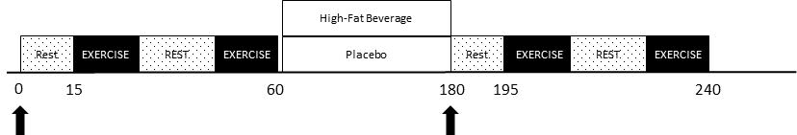
Figure 1: Schematic diagram of the experimental protocol. Exercise consisted of either DHGX for 3 min or SHGX/PECA for 5 min. Arrows represents venous blood sampling.

Experimental Measurements

Anthropometric Measurements
Participant’s height was measured in centimeters (cm) with a digital stadiometer (ProDoc Dectecto stadiometer). This was done by instructing the participant to take off height adding materials such as shoes and hats followed by having the subject stand vertically straight against the wall where the digital scale was located. Once the subject was situated in place the lever arm of the scale was ascended until reaching the top of the subject’s head. Body mass was measured in kilograms (kg) with a digital scale (HealthOMeter 349KLX).

Blood Pressure
Beat-by-beat systolic (SBP), diastolic (DBP), and mean arterial pressure (MAP) were acquired via an automated non-invasive beat-by-beat finger photoplesmography on the left hand (Finometer Pro; Finapress Medical Systems, Amsterdam, The Netherlands). This blood pressure measurement was calibrated to branchial arterial blood pressure via an automated sphygmomanometer via a “return-to-flow” procedure according to the manufacture’s recommended procedures to verify absolute Finometer arterial blood pressure measurements. The calibration procedure was performed prior to each exercise test. Heart rate was measured via three-lead electrocardiogram (Finometer Pro; Finapress Medical Systems, Amsterdam, The Netherlands). Each pressure measurement had the arm or finger slightly outstretched and supported at heart level. The rate pressure product was calculated as systolic blood pressure × heart rate and used as an index of myocardial work and myocardial oxygen uptake.

Inactive Limb Vascular Resistance
Vascular resistance was determined in the left, inactive, arm by a two-dimensional Doppler ultrasound system (Logiq S8, GE Medical Systems, Milwaukee, WI) which allowed for the simultaneous measurements of the brachial artery diameter and blood velocities. The ultrasound had a linear array transducer operating in duplex mode and insonation angle of <60 degrees. Measurements of the brachial artery were recorded by placing the transducer approximately 5 to 10 cm above the antecubital fossa. A computer was used to store the recorded and digitized continual measurements of the brachial artery lumen-arterial wall interface. To order to conduct an off-line analysis of vessel diameter, an automated edge-detection software was utilized (Medical Imaging Applications, Coralville, IA). The ultrasound videos had known distances which were used for the scaling of measurements. The video was allowed to play on the system after setting a region of interest on the brachial artery image. Brachial artery blood velocity was assessed as the time-averaged mean velocity (V_{Mean} = cm/s) which was measured with the Doppler system in pulse wave mode at a frequency of four megahertz (MHz). To make sure complete insonation was achieved, the Doppler gate was set to the full width of the vessel. At rest and during each exercise test inactive forearm blood flow (FBF, mL/min) was calculated utilizing the product of brachial artery diameter and mean blood velocity (Vmean).
$$FBF \left(\frac{mL}{min}\right)= Vmean x π x {vessel radius}^{2} x 60$$
Forearm vascular resistance (FVR, [mmHg x min] /mL) was calculated as the quotient of MAP to FBF.
$$FVR \left(\frac{mmHg x min}{mL}\right)= \frac{MAP}{FBF}$$

Dynamic Handgrip Exercise
Maximal voluntary contraction was determined by having the participant isometrically contract their right hand against a handgrip dynamometer for approximately three seconds. This protocol was replicated in triplicate with a minimum of sixty seconds between each trial. The highest force attained from the three trials was considered the MVC. The right hand was used to conduct the dynamic handgrip exercise on a custom built handgrip ergometer with weight being pulled four cm over a pulley. The right arm was abducted to approximately eighty degrees and kept at heart level while doing the exercise in the supine position. Low intensity dynamic exercise engages both central command and mechano-sensitive afferents, with minimal activation of metabo-sensitive afferents. Therefore, after a one minute baseline, the participant performed three one minute exercise cycles at 10%, 15%, and 20% of the MVC. A metronome with a setting of a one second contraction immediately followed by a two second relaxation period was used in order to have the participant squeeze in a rhythmic pattern.

Static Handgrip Exercise
Static handgrip exercise (SHGX) has previously been shown to activate mechanical and metabolite sensitive afferents and therefore provides unique information compared to the dynamic exercise. Moderate static handgrip exercise was performed by having the participant squeeze a handgrip dynamometer at 30% of the participant’s MVC for three minutes. During this time participants were visually monitored to ensure normal breathing patterns were maintained and to prevent inadvertent Valsalva.

Post Exercise Circulatory Arrest
The post exercise circulatory arrest (PECA) maneuver was performed immediately following SHGX. Briefly, when there was only about three seconds remaining for the SHGX a rapidly inflating blood pressure cuff proximal to the contracting muscle and the elbow was inflated to 250 mmHg for two minutes. This period of circulatory arrest trapped the associated exercise metabolites within the muscle. These metabolites stimulate the afferent metaboreceptors independently from the central command and the mechanoreceptors. Participants were instructed to remain completely relaxed during this period.

Blood Analysis
To detect the plasma triglyceride and plasma interleukin-6 (IL-6), a venous blood sample was taken from the antecubital vein via venipuncture by trained personnel. After the blood sample was received, it was spun and pipetted into 500 μl aliquots and immediately frozen at -80 C. A commercial vendor (LabCorp) performed the triglyceride (#001172) and IL-6 (#140816) analysis.

Statistical Analysis
Based on previous investigations on the exercise pressor reflex, the sample size was determined to be 10 to 15 participants in order to illustrate a physiologically and clinically significant ten mmHg difference in blood pressure. This corresponds to a power of eighty percent, and effect size of .75, and a beta error rate of .20. A Two way repeated measure ANOVA (time × treatment) was conducted to compare the difference in SBP, DBP, MAP, FBF, and FVR before and after the ingestion (i.e., time effect) of either the high fat meal or the placebo (i.e., treatment effect).

Chapter 4: Results

Subject characteristics
There was a total of 10 subjects that participated in this study comprised of 8 men and 2 women. The average height and weight was 176.8 ± 5.4 cm and 82.2 ± 8.0 kg respectively. The eldest subject was 39 yrs. and the youngest was 18 yrs. giving a range of 21 yrs. among the subjects, however, on average the age of the subject was 23.3 ± 5.7 yrs. The mean body mass index was 46.5 ± 4.0 kg/m².
Table 1: Subject Characteristics
Variable | Value
n | 10
Sex (men/women) | 8/2
Age (years) | 23.3 ± 5.7
Height (cm) | 176.8 ± 5.4
Weight (kg) | 82.2 ± 8.0
Body mass index (kg m⁻²) | 46.5 ± 4.0
Values are mean ± SD

Exercise pressor responses

Dynamic handgrip exercise
The average mean systolic blood pressure following the placebo meal was 133.6 ± 10.5 mmHg at 10% MVC. After the high-fat meal the average SBP was 136.9 ± 6.1 mmHg at the same MVC (p = .94). This value at 15% of the subjects MVC following the placebo and the high-fat meal was 136.5 ± 11.1 mmHg and 138.4 ± 6.9 mmHg respectively (p = 0.95). Lastly at 20% MVC the SBP average values following the placebo and the high-fat meal were 138.1 ± 11.7 mmHg and 141.5 ± 7.0 mmHg respectively (p = 0.96) (Figure 3). The mean values of the diastolic blood pressure (DBP) at 10, 15, and 20% MVC following the placebo meal were 76.9 ± 8.0 mmHg, 78.9 ± 8.6 mmHg, and 80.5 ± 9.2 mmHg respectively. Following the high-fat meal the average DBP values were 77.4 ± 6.3 mmHg at 10% MVC (p = 0.91), 79.4 ± 6.3 mmHg at 15% MVC (p = 0.93), and 81.5 ± 6.2 mmHg at 20% MVC (p = 0.93). The mean arterial pressure (MAP) average values at 10, 15, and 20% MVC were 96.9 ± 9.4 mmHg, 99.5 ± 10.0 mmHg, and 101.7 ± 10.9 mmHg following the placebo meal. The mean MAP values post the high-fat meal were 97.7 ± 6.0 mmHg at 10% MVC (p = 0.74), 100.1 ± 6.2 mmHg at 15% MVC (p = 0.95), and 102.9 ± 6.6 mmHg at 20% MVC (p = 0.91). Additionally, 64.9 ± 10.4 beats per minute (bpm), 66.2 ± 10.2 bpm, 68.5 ± 9.5 bpm were the average values for the HR at 10, 15, and 20% MVC. The mean values of HR following the high-fat meal at 10, 15, and 20% were 70.5 ± 7.4 bpm (p = 0.03), 66.2 ± 10.2 bpm (p = 0.04), and 72.2 ± 6.1 bpm (p = 0.85) respectively. Lastly the average rate pressure product (RPP) for 10, 15, and 20% MVC were 8719.9 ± 1338.8 mmHg x bpm, 8719.9 ± 1838.8 mmHg x bpm, and 9503.8 ± 1927.0 mmHg x bpm respectively. These values following the high-fat meal was 9644.5 ± 972.2 mmHg x bpm (p = 0.37), 9795.7 ± 971.6 mmHg x bpm (p = 0.25), and 10212 ± 998.8 mmHg x bpm (p = 0.32). Figure 2 illustrates these results showing no significance at any intensity of exercise. Significance was evaluated based on the p value of < .05.

Table 2: Hemodynamic Response to Dynamic Handgrip Exercise.
 | Pre-Meal |  |  | Post-Meal
 | Placebo | HFM |  | Placebo | HFM
Baseline Rest
SBP, mmHg | 125.5 ± 8.1 | 130.6 ± 13.3 |  | 130.6 ± 10.4 | 133.9 ± 6.4
DBP, mmHg | 73.3 ± 5.2 | 78.5 ± 7.7 |  | 75.6 ± 8.6 | 76.6 ± 6.2
MAP, mmHg | 92.3 ± 5.5 | 97.8 ± 10.6 |  | 95.1 ± 9.9 | 96.3 ± 6.1
HR, bpm | 62.2 ± 5.8 | 62.9 ± 6.6 |  | 62.2 ± 7.2 | 66.4 ± 5.7
RPP, mmHg × bpm | 7799.0 ± 886.9 | 8225.9 ± 1282.6 |  | 8136.0 ± 1220.3 | 8874.6 ± 693.9
10% MVC (60)
SBP, mmHg | 133.9 ± 12.8 | 136.5 ± 14.6 |  | 133.6 ± 10.5 | 136.9 ± 6.1
DBP, mmHg | 78.4 ± 74 | 81.7 ± 8.5 |  | 76.9 ± 8.1 | 77.5 ± 6.3
MAP, mmHg | 98.8 ± 8.6 | 102.1 ±11.2 |  | 96.9 ± 9.40 | 97.7 ± 6.0
HR, bpm | 67.4 ± 10.3 | 67.7 ± 9.1 |  | 64.9 ± 10.4 | 70.5 ± 7.4*
RPP, mmHg × bpm | 9086.4 ± 2041.2 | 9293.9 ± 1927.1 |  | 8719.9 ± 1338.8 | 9644.5 ± 972.2
15% MVC (120)
SBP, mmHg | 134.4 ± 14.2 | 136.9 ± 12.6 |  | 136.5 ± 11.1 | 138.4 ± 6.9
DBP, mmHg | 78.9 ± 7.5 | 82.4 ± 7.2 |  | 78.93 ± 8.6 | 79.4 ± 6.3
MAP, mmHg | 99.5 ± 8.9 | 102.7 ± 9.9 |  | 99.5 ± 10.0 | 100.1 ± 6.2
HR, bpm | 66.6 ± 10.4 | 67.8 ± 7.4 |  | 66.2 ± 10.2 | 70.8 ± 6.6†*
RPP, mmHg × bpm | 9030.9 ± 2261.8 | 9305.8 ± 1539.2 |  | 8719.9 ± 1838.8 | 9795.7 ± 971.6
20% MVC (180)
SBP, mmHg | 136.9 ± 13.1 | 139.2 ± 13.7 |  | 138.1 ± 11.75 | 141.5 ± 7.0
DBP, mmHg | 80.3 ± 7.5 | 83.6 ± 7.8 |  | 80.5 ± 9.2 | 81.5 ± 6.2
MAP, mmHg | 101.4 ± 8.8 | 104.4 ± 10.6 |  | 101.7 ± 10.9 | 102.9 ± 6.6
HR, bpm | 68.7 ± 10.2 | 68.8 ± 5.7 |  | 68.5 ± 9.5 | 72.2 ± 6.0
RPP, mmHg × bpm | 9503.0 ± 2295.4 | 9602.8 ± 1492.7 |  | 9503.8 ± 1927.0 | 10212 ± 998.8
Values are mean ± SD, SBP, systolic blood pressure; DBP, diastolic blood pressure; MAP, mean arterial pressure; HR, heart rate; RPP, rate pressure product.
† Significantly different compared to Baseline p < 0.05
* Significantly different compared to Placebo at Timepoint p < 0.05

Figure 2: Rate Pressure Product (RPP) during Dynamic Handgrip Exercise.

Figure 3: Systolic Blood Pressure (SBP) During Dynamic Handgrip Exercise.

Table 3 describes the forearm blood flow (FBF) and forearm vascular resistance (FVR) responses. At 10% of the subjects’ MVC the average forearm blood flow and vascular resistance was 69.6 ± 30.3 ml × min⁻¹ and 1.6 ± .7 mmHg × (ml × min⁻¹)⁻¹ respectively following the placebo meal. After the high-fat meal, mean values forearm blood flow was 88.2 ± 21.1 ml × min⁻¹ (p = 0.24) and forearm vascular resistance 1.1 ± 0.3 mmHg × (ml × min⁻¹)⁻¹ (p = 0.04). Post placebo meal at 15% MVC, the average forearm blood flow was 64.9 ± 25.1 ml × min⁻¹ and forearm vascular resistance was 1.8 ± .7 mmHg × (ml × min⁻¹)⁻¹. Sequential to the high fat meal, the average was 93.5 ± 25.8 ml × min⁻¹ (p = 0.07) and 1.2 ± .3 mmHg × (ml × min⁻¹)⁻¹ (p = 0.01) for forearm blood flow and forearm vascular resistance respectively. Lastly following the largest weight load at 20% MVC, the mean value for forearm blood flow and forearm vascular resistance respectively was 74.9 ± 36.2 ml × min⁻¹ and 1.7 ± .8 mmHg × (ml × min⁻¹)⁻¹ when the subjects consumed the placebo meal. After the high-fat meal the average forearm blood flow was 96.8 ± 29.7 ml × min⁻¹ (p = 0.17) and forearm vascular resistance was 1.2 ± .5 mmHg × (ml × min⁻¹)⁻¹ (p = 0.02). There were no differences for between placebo and high fat meal at any exercise time point during the dynamic handgrip exercise test. Significance was defined with a p value of < .05.

Table 3: Hemodynamic Response to Dynamic Handgrip Exercise.
 | Pre-Meal |  |  | Post-Meal
 | Placebo | HFM |  | Placebo | HFM
Baseline Rest
FBF, ml × min⁻¹ | 119.7 ± 45.3 | 115.9 ± 73.2 |  | 69.4 ± 27.0 | 91.7 ± 21.4
FVR, mmHg × (ml × min⁻¹)⁻¹ | 0.9 ± 0.4 | 1.1 ± 0.5 |  | 1.5 ± 0.6 | 1.1 ± 0.3
10% MVC (60)
FBF, ml × min⁻¹ | 108.9 ± 44.7 | 101.5 ± 56.0 |  | 69.6 ± 30.3 | 88. 2 ± 21.1
FVR, mmHg × (ml × min⁻¹)⁻¹ | 1.1 ± 0.6 | 1.3 ± 0.7 |  | 1.6 ± .7 | 1.1 ± .3
15% MVC (120)
FBF, ml × min⁻¹ | 110.4 ± 49.4 | 104.7 ± 50.2 |  | 64.9 ± 25.1 | 93.5 ± 25.8
FVR, mmHg × (ml × min⁻¹)⁻¹ | 1.2 ± 0.9 | 1.3 ± 0.8 |  | 1.8 ± .7 | 1.2 ± .3
20% MVC (180)
FBF, ml × min⁻¹ | 114.0 ± 53.3 | 119.7 ± 45.3 |  | 74.9 ± 36.2 | 96.8 ± 29.7
FVR, mmHg × (ml × min⁻¹)⁻¹ | 1.2 ± 1.0 | 0.9 ± 0.4 |  | 1.7 ± .8 | 1.2 ± .5
Values are mean ± SD, SBP, systolic blood pressure; DBP, diastolic blood pressure; MAP, mean arterial pressure; HR, heart rate; RPP, rate pressure product.
† Significantly different compared to Baseline p < 0.05
* Significantly different compared to Placebo at Timepoint p < 0.05

Static handgrip exercise
The average values for all subject’s systolic blood pressure during 30% MVC following the placebo meal was 160.7 ± 19.6 mmHg, 95.1 ± 9.7 mmHg for the mean diastolic blood pressure, 122.8 ± 14.0 mmHg for the average mean arterial pressure, and 76.5 ± 14.7 bpm for the mean heart rate. The mean values during 30% MVC post the high-fat meal were 165.8 ± 12.2 mmHg (p = 0.6), 96.1 ± 6.8 mmHg (p = 0.99), 124.2 ± 9.6 mmHg (p = 0.89), and 82.7 ± 11.1 bpm respectively (p = 0.09). There were no significant changes in these values when as seen in Figure 4. Following the high fat meal at 30% MVC the rate pressure product was 13724.5 ± 2226.1 mmHg × bpm which was significantly higher than that achieved following 12346.2 ± 3021.3 mmHg × bpm value obtained following the placebo meal (p = 0.04). During the PECA period the systolic blood pressure after the placebo meal the mean value was 152.3 ± 15.6 mmHg, the diastolic blood pressure was 88.3 ± 7.5 mmHg, the mean arterial pressure was 113.6 ± 10.4 mmHg, and heart rate was 66.1 ± 15.7 bpm. The mean values during PECA post high-fat meal were 152.2 ± 12.1 mmHg for systolic blood pressure (p = 0.76), 86.3 ± 6.5 mmHg for diastolic blood pressure (p = 0.99), 112.3 ± 9.6 mmHg for mean arterial pressure (p = 0.34), and 66.9 ± 6.7 bpm for heart rate (p = 0.88). There were no differences with a p value of < .05 for any of these variable between placebo and high fat meal at any time point during the PECA period of the static handgrip exercise test. Lastly the averages RPP for the static handgrip exercise at 30% MVC were 12346.2 ± 3021.3 mmHg x bpm, and 10130.7 ± 3064.0 mmHg x bpm during PECA. These values following the high-fat meal were 13724.5 ± 2226.1 mmHg x bpm (p = 0.25), 10169.9 ± 1154.8 mmHg x bpm (p = 0.9) respectively. Figure 5 illustrates these results showing significance during the static handgrip exercise.

Table 4: Hemodynamic Response to Static Handgrip Exercise.
 | Pre-Meal |  |  | Post-Meal
 | Placebo | HFM |  | Placebo | HFM
Baseline Rest
SBP, mmHg | 128.0 ± 7.0 | 129.4 ± 10.2 |  | 134.8 ± 12.4 | 139.7 ± 7.0
DBP, mmHg | 73.2 ± 2.9 | 76.4 ± 4.9 |  | 76.8 ± 8.4 | 78.1 ± 3.5
MAP, mmHg | 93.0 ± 4.0 | 95.8 ± 7.2 |  | 98.0 ± 9.6 | 99.6 ± 5.7
HR, bpm | 61.9 ± 8.2 | 62.5 ± 5.2 |  | 62.0 ± 7.5 | 68.6 ± 5.4
RPP, mmHg × bpm | 7926.4 ± 1172.4 | 8069.8 ± 758.6 |  | 8367.2 ± 1403.8 | 9576.6 ± 882.5
30% MVC
SBP, mmHg | 156.2 ± 18.3 | 158.3 ± 22.6 |  | 160.7 ± 19.6 | 165.8 ± 12.2
DBP, mmHg | 93.0 ± 9.3 | 96.6 ± 11.0 |  | 95.1 ± 9.7 | 96.1 ± 6.8
MAP, mmHg | 119.5 ± 11.9 | 124.0 ±16.2 |  | 122.8 ± 14.0 | 124.2 ± 9.6
HR, bpm | 76.8 ± 14.0 | 78.6 ± 11.0 |  | 76.5 ± 14.7 | 82.7 ± 11.1
RPP, mmHg × bpm | 12080.9 ± 3008.1 | 12484.7 ± 2677.6 |  | 12346.2 ± 3021.3 | 13724.5 ± 2226.1*†
PECA
SBP, mmHg | 147.4 ± 16.5 | 152.0 ± 17.4 |  | 152.3 ± 15.6 | 152.2 ± 12.1
DBP, mmHg | 86.1 ± 7.8 | 90.6 ± 7.9 |  | 88.3 ± 7.5 | 86.3 ± 6.5
MAP, mmHg | 110.2 ± 11.4 | 115.3 ± 12.2 |  | 113.6 ± 10.4 | 112.3 ± 9.6
HR, bpm | 65.1 ± 13.3 | 68.2 ± 12.3 |  | 66.1 ± 15.7 | 66.9 ± 6.7
RPP, mmHg × bpm | 9692.7 ± 2874.8 | 10381.9 ± 2350.6 |  | 10130.7 ± 3064.0 | 10169.9 ± 1154.8
Values are mean ± SD, SBP, systolic blood pressure; DBP, diastolic blood pressure; MAP, mean arterial pressure; HR, heart rate; RPP, rate pressure product.
† Significantly different compared to Pre-Meal p < 0.05
* Significantly different compared to Placebo at Timepoint p < 0.05

Figure 4: Systolic Blood Pressure Response (SBP) During Static Handgrip Exercise (30% MVC) and Post-Exercise Circulatory Arrest (PECA).

Figure 5: Rate Pressure Product (RPP) During Static Handgrip Exercise (30% MVC) and Post-Exercise Circulatory Arrest (PECA).

In the table 5 the average values for forearm blood flow and forearm vascular resistance are described. Following the placebo meal, the mean values obtained during 30% MVC for forearm blood flow and forearm vascular resistance were 78.5 ± 33.6 ml × min⁻¹ and 1.9 ± .9 respectively. After the high fat meal at 30% MVC the average value for forearm blood flow was 85.7 ± 25.3 ml × min⁻¹ (p = 0.91) and forearm vascular resistance was 1.6 ± .6 mmHg × (ml × min⁻¹)⁻¹ (p = 0.09). The average value for forearm blood flow and forearm vascular resistance during PECA after the placebo was 67.8 ± 34.4 ml × min⁻¹ and 2.1 ± 1.1 mmHg × (ml × min⁻¹)⁻¹ respectively. Following the high-fat meal, the mean value was 96.8 ± 42.3 ml × min⁻¹ for FBF (p = 0.06) and 1.3 ± .5 mmHg × (ml × min⁻¹)⁻¹ for FVR during PECA (p = 0.09). The p value was < .05 when observing for significance.

Table 5: Hemodynamic Response to Static Handgrip Exercise.
 | Pre-Meal |  |  | Post-Meal
 | Placebo | HFM |  | Placebo | HFM
Baseline Rest
FBF, ml × min⁻¹ | 87.9 ± 37.8 | 92.5 ± 57.3 |  | 69.2 ± 31.9 | 75.4 ± 13.0
FVR, mmHg × (ml × min⁻¹)⁻¹ | 1.3 ± 0.8 | 1.4 ± 0.7 |  | 1.7 ± 0.8 | 1.4 ± 0.3
30% MVC
FBF, ml × min⁻¹ | 97.1 ± 43.0 | 83.2 ± 41.8 |  | 82.2 ± 33.5 | 87.4 ± 26.1
FVR, mmHg × (ml × min⁻¹)⁻¹ | 1.8 ± 1.7 | 1.9 ± 1.0 |  | 1.8 ± 1.0 | 1.6 ± 0.6
PECA
FBF, ml × min⁻¹ | 86.1 ± 38.5 | 69.4 ± 29.1 |  | 70.2 ± 35.5 | 99.8 ± 43.8
FVR, mmHg × (ml × min⁻¹)⁻¹ | 1.9 ± 1.9 | 2.0 ± 1.0 |  | 2.1 ± 1.2 | 1.3 ± 0.5
Values are mean ± SD, SBP, systolic blood pressure; DBP, diastolic blood pressure; MAP, mean arterial pressure; HR, heart rate; RPP, rate pressure product.
† Significantly different compared to Baseline p < 0.05
* Significantly different compared to Placebo at Timepoint p < 0.05

Chapter 5: Discussion

Summary
The primary finding in this current study was illustrated via static handgrip exercise following the high-fat meal which significantly increased the rate pressure product. This value is a measurement of the overall oxygen consumption and myocardial work of the heart during exercise. This data supports, in part, the hypothesis that cardiac responses would alter post a single high-fat meal when the exercise pressor was activated via exercise. In contract the systolic, diastolic, and mean arterial pressure responses did not significantly deviate after the high-fat meal in comparison to the placebo meal which contradicts the first hypothesis. Collectively these observations increase our understanding of the effects dietary fat intake has on the work the heart must perform during exercise.

Effects of High Fat Meals on Cardiovascular Health
The typical western diet consist of foodstuffs high in the concentration of saturated fatty acids, with an omega-6/omega-3 fatty acid ratio greater than 15/1 ((Simopoulos 2002, 2008). Van Oostrom et al. (2004) demonstrated that a single fresh cream beverage high in saturated fat, like that used in the present investigation, elicited a significant inflammatory response. While inflammatory markers were not measured in the present study, an increase in numerous inflammatory markers are reported following consumption of a single high-fat meal or beverage (REFS).
As illustrated throughout the literature review, many studies have been conducted showing the detrimental effects that high-fat meals have on the cardiovascular system. These complications are vast in nature and can, in some cases, have cumulative effects which cause a cascade of events to occur. There is a positive correlation seen when observing triglyceride levels and oxidative stress which both have a negative correlation with flow mediated dilation which could be combated via the use of antioxidants such as simvastatin (Anderson, Evans et al. 2001, Bae, Bassenge et al. 2001, Wilmink, Twickler et al. 2001, Tsai, Li et al. 2004, Saxena, Madhu et al. 2005, Tushuizen, Nieuwland et al. 2006). Other studies provide support showing that vasodilation and overall endothelial function decrease following a high-fat meal(Vogel, Corretti et al. 1997, Gokce, Duffy et al. 2001, Giannattasio, Zoppo et al. 2005, Shimabukuro, Chinen et al. 2007). The impact of exercise and the possible benefits of physical activity in lowering the effects of increased lipemia on endothelial function has been researched as well. This showed that exercise helped to truncate the negative effects of increase triglyceride levels in comparison to those who had not participated in physical activity (Bae, Schwemmer et al. 2003).
During exercise, the muscle contraction-induced neural feedback, termed the exercise pressor reflex, significantly contributes to the autonomic regulation of heart rate, cardiac output, vascular resistance and subsequent arterial blood pressure. While this coordinated blood pressure response to exercise is essential for maintaining blood flow an augmented exercise blood pressure response is not without adverse consequences. Normotensive individuals who demonstrate an increased exercise pressor reflex (i.e., greater increase in blood pressure during exercise) are significantly more likely to develop clinical hypertension (Dlin, Hanne et al. 1983, Singh, Larson et al. 1999). Furthermore, those with an exaggerated blood pressure response to exercise are at a higher risk of cardiovascular morbidity and mortality compared to those with a normal blood pressure response (Kannel, Gordon et al. 1971, Kurl, Laukkanen et al. 2001, Vasan, Larson et al. 2001, de, Hoeks et al. 2008, Weiss, Blumenthal et al. 2010). Therefore, the blood pressure responses to exercise provide additional insight into cardiovascular health and function beyond that observed at rest.
Mechanistically, numerous factors contribute to the exercise pressor reflex. Interestingly, Chang et al. (2004) demonstrated a link between endothelial function and an increased blood pressure response to exercise. In individuals with a normal resting blood pressure it was determined that endothelium-dependent vasodilation was significantly decreased in the individuals with high exercise induced blood pressure. These data suggest that changes in endothelial function may contribute to changes in the exercise pressor reflex. Given the previous studies that demonstrate a decreased endothelial function following a single high meal, we hypothesized that it would elicit an increase in the exercise pressor reflex. Contrary to this hypothesis, the high-fat meal in the present study did not significantly alter the exercise blood pressure response. This finding suggests that the observations of Chang et al. (2004) were more correlative not causative. However, future studies will be required to determine if this holds true in other populations, like those with a higher risk of cardiovascular disease (see Future Studies)

Myocardial Oxygen Uptake
Direct measurements of myocardial oxygen uptake require catheterization of the coronary sinus and the use of an indicator dye that are unpractical in most patients. However, estimation of myocardial oxygen uptake during clinical exercise tests is often achieved by the product of heart rate and systolic blood pressure, which is referred to as the rate-pressure product or double product (Gobel et al; Kitamura et al). As such myocardial ischemia often occurs in patients at the same rate-pressure product versus the same exercise intensity or workload (Robinson et al). In addition to patient populations, the rate pressure product provides an index of myocardial oxygen uptake in health young subjects during cycling (Kitamura et al). This relationship has also been shown to hold true during moderate intensity isometric handgrip exercise (Nelson et al), which is similar to that used in the present investigation.
The importance of an acute high-fat meal and subsequent increase in free fatty acid content on myocardial function has previously been evaluated (Mjos et al). In a previous study plasma free fatty acid levels were acutely increased in dogs via continuous intravenous infusion of a fat emulsion. This resulted in an increased myocardial uptake of free fatty acids and resulted in an increased myocardial oxygen uptake. The findings of the present investigation extend this earlier work by demonstrating that a single high-fat meal significantly increases the rate pressure product, and index of myocardial oxygen uptake, in healthy young subjects during isometric handgrip exercise. As previously mentioned, given that many daily activities include components of isometric exercise these findings have key implications in many populations, particularly those with underlying cardiovascular disease.

Dynamic Vs. Static Vs. PECA Protocols
The dynamic handgrip exercise was conducted in order to isolate and activate the mechanoreceptors dominantly. The metaboreceptors were not activated to the same extent since during dynamic exercise the muscle is allowed to bring in new blood cleaning out any metabolites that may have formed. In contrast, the static handgrip exercise enabled the activation of both the mechano- and the metaboreceptors. The mechanoreceptors were activated upon the initial contraction and the metaboreceptors were activated while the contraction was held. Lastly, The PECA exercise was conducted which allowed for the participant to release the contraction essentially eliminating the mechanoreceptors and continuing the metaboreceptors. The different receptor combinations activation made it possible to examine if one receptor as more responsible for the feedback to the command system thus influencing the exercise pressor response or if both worked together to produce the optimal pressor reflex.

Implications of the Present Study
This study provides further evidence of the impact of a high-fat meal on different components of the cardiovascular system. Although the population was recreationally active healthy individuals, it may be said that the effects seen may be exaggerated in older populations. An increase in blood triglyceride levels may not have had a profound impact on these particular participants, unfortunately the same cannot be said for older people. It is known that changes in the body occur as one ages, including increases in the exercise pressor reflex and overall decreased vascular health (i.e., increased vascular stiffness and decreased endothelial function). As demonstrated by Robinson et al. (REF) the rate pressure product, more so than blood pressure or exercise work load alone, is related to the onset of angina. With this being said the findings of the present investigation demonstrate that there is an increase in myocardial oxygen uptake, via increases in the rate pressure product) in individuals following consumption of a single high-fat beverage. These results in combination with knowledge about how age effects the cardiovascular system provides key information on the additional cardiovascular event risk that could occur following this type of meal. Since CVD is the most common cause of mortality in the United States, research such as this can be very beneficial to the health community extending life expectancy and the overall quality of life.

Experimental Considerations
Although the project was designed to account for outside contributing factors that could possibly construe the data, there were still limitations in regard to the research problem. One limitation that may have impacted the results was the source of fat. The fat load was consumed via heavy cream therefore, participants that were lactose intolerant were excluded from the project. However, this is a common method used in the literature as it provides the investigator with a controlled meal, but in a form that is applicable to real world situations. Another characteristic of the fat coming from dairy is that it may not truly reflect the fat eaten every day in the westernized diet since not all fat has the same source. For instance, fat from the dairy drink is different from the fat that is derived from food stuffs such as margarine. In addition, the study focused on strictly high-fat consumption as compared to other studies that examined the effects of a high-fat meal with the addition of carbohydrates which more accurately reflects the daily westernized diet consumed. Lastly the participants were college aged students from a single university, therefore the sample was not as randomized nor representing a large population but rather a selected subgroup.

Future Studies
Because cardiovascular disease and myocardial events are more commonly seen in the older population, further studies should focus on an older at risk population rather than testing college aged individuals. There is benefit to seeing what happens in these individuals however, the impact of consistent build-up and increased triglyceride levels may be more dramatic in the older sample and other unforeseen implications may be happening as well. Adding to this knowledge, cardiovascular disease is usually caused due to a series of events not just by having one high-fat meal, therefore testing an older population will better reflect the long-term effects of eating a predominantly high in fat diet. In addition, participants should be asked for a broad summary of the type of diet consumed on the daily. The reason being is because a healthier person who eats foodstuff that can prevent the detrimental effect of a single high-fat meal may provide invalid results in comparison to people who have consistently consumed foodstuff high in fat. Further research should also try and mimic a meal that would be consumed in everyday life, for example most people do not consume heavy whipped cream as a meal. A study that may be beneficial as well is studying the same variables within different physical active levels such as those who have little to no physical activity, those with moderate physical levels, and those who are athletes or highly physically active. Doing so would allow researchers to see how physical inactivity interacts with diet giving the negative impacts on the cardiovascular system.

Chapter 6: Conclusions
This study was designed to investigate the impact of consuming a single high-fat meal on the exercise pressor in clinically healthy college-aged individuals. The exercise pressor reflex was quantified by measuring beat-by-beat blood pressure via photoplesmography during moderate intensity dynamic and static handgrip exercise prior to and 2 hours following ingestion of a single high-fat beverage or placebo beverage. In addition, measurements of inactive limb blood flow and vascular resistance were used as an index of regional vascular control. The single high-fat beverage consisted of a fat dose of 1.5 grams per kg body weight. This and similar dosages have been well documented as sufficient stimulus capable of increasing blood and plasma triglycerides several folds above resting or placebo levels. Separate studies researching the cardiovascular and pulmonary effects of a single high-fat meal and the complex mechanisms driving the exercise pressor reflex have been conducted separately; however, to the best of our knowledge, studies observing the interaction between the two have not been studied to date. In consistent with our first hypothesis the single high-fat meal resulted in no significant differences in systolic, diastolic, or mean arterial pressure during either exercise test compared to placebo. This was mirrored by no differences in inactive limb blood flow or vascular resistance between high-fat and placebo beverages. However, the rate pressure product increased significantly following the high-fat meal versus the placebo during the 30% MVC static exercise test. This is a very clinically relevant finding given that the rate pressure product is a clinical measure of myocardial work and oxygen consumption (REFS). This has significant clinical importance given that the rate pressure product is a key factor determining the onset of angina during exercise (Robinson et al.).

References
(No Date). "Cardiac Output." from http://dictionary.reference.com/browse/cardiac-output.
Ade, C. J., R. M. Broxterman, J. C. Craig, S. J. Schlup, S. L. Wilcox, S. Warren, P. Kuehl, D. Gude, C. Jia and T. J. Barstow (2015). "Predicting performance on simulated Lunar and Mart Chapter 6: Conclusionsian-based exploration tasks." Aerosp Med Hum Perform 86(10): 1-8.
Ade, C. J., S. K. Rosenkranz and C. A. Harms (2014). "The effects of short-term fish oil supplementation on pulmonary function and airway inflammation following a high-fat meal." Eur J Appl Physiol 114(4): 675-682.
Albrink, M. J. and E. B. Man (1959). "Serum triglycerides in coronary artery disease." AMA Arch Intern Med 103(1): 4-8.
Anderson, R. A., M. L. Evans, G. R. Ellis, J. Graham, K. Morris, S. K. Jackson, M. J. Lewis, A. Rees and M. P. Frenneaux (2001). "The relationships between post-prandial lipaemia, endothelial function and oxidative stress in healthy individuals and patients with type 2 diabetes." Atherosclerosis 154(2): 475-483.
Austin, M. A., J. E. Hokanson and K. L. Edwards (1998). "Hypertriglyceridemia as a cardiovascular risk factor." Am J Cardiol 81(4A): 7B-12B.
Bae, J. H., E. Bassenge, K. B. Kim, Y. N. Kim, K. S. Kim, H. J. Lee, K. C. Moon, M. S. Lee, K. Y. Park and M. Schwemmer (2001). "Postprandial hypertriglyceridemia impairs endothelial function by enhanced oxidant stress." Atherosclerosis 155(2): 517-523.
Bae, J. H., M. Schwemmer, I. K. Lee, H. J. Lee, K. R. Park, K. Y. Kim and E. Bassenge (2003). "Postprandial hypertriglyceridemia-induced endothelial dysfunction in healthy subjects is independent of lipid oxidation." Int J Cardiol 87(2-3): 259-267.
Bond, B., P. E. Gates, S. R. Jackman, L. M. Corless, C. A. Williams and A. R. Barker (2015). "Exercise intensity and the protection from postprandial vascular dysfunction in adolescents." Am J Physiol Heart Circ Physiol 308(11): H1443-1450.
Ceriello, A., C. Taboga, L. Tonutti, L. Quagliaro, L. Piconi, B. Bais, R. Da Ros and E. Motz (2002). "Evidence for an independent and cumulative effect of postprandial hypertriglyceridemia and hyperglycemia on endothelial dysfunction and oxidative stress generation: effects of short- and long-term simvastatin treatment." Circulation 106(10): 1211-1218.
Clinic, M. (2014). "Disease and Conditions: Heart Disease." 1998 - 2016, from http://www.mayoclinic.org/diseases-conditions/heart-disease/basics/definition/con-20034056.
Cordain, L., S. B. Eaton, A. Sebastian, N. Mann, S. Lindeberg, B. A. Watkins, J. H. O'Keefe and J. Brand-Miller (2005). "Origins and evolution of the Western diet: health implications for the 21st century." Am J Clin Nutr 81(2): 341-354.
Craig, C. L., A. L. Marshall, M. Sjostrom, A. E. Bauman, M. L. Booth, B. E. Ainsworth, M. Pratt, U. Ekelund, A. Yngve, J. F. Sallis and P. Oja (2003). "International physical activity questionnaire: 12-country reliability and validity." Medicine and Science in Sports and Exercise 35(8): 1381-1395.
de, L., II, S. E. Hoeks, Y. R. van Gestel, J. J. Bax, J. Klein, R. T. van Domburg and D. Poldermans (2008). "Usefulness of hypertensive blood pressure response during a single-stage exercise test to predict long-term outcome in patients with peripheral arterial disease." Am J Cardiol 102(7): 921-926.
Dlin, R. A., N. Hanne, D. S. Silverberg and O. Bar-Or (1983). "Follow-up of normotensive men with exaggerated blood pressure response to exercise." Am Heart J 106(2): 316-320.
Giannattasio, C., A. Zoppo, G. Gentile, M. Failla, A. Capra, F. M. Maggi, A. Catapano and G. Mancia (2005). "Acute effect of high-fat meal on endothelial function in moderately dyslipidemic subjects." Arterioscler Thromb Vasc Biol 25(2): 406-410.
Gokce, N., S. J. Duffy, L. M. Hunter, J. F. Keaney and J. A. Vita (2001). "Acute hypertriglyceridemia is associated with peripheral vasodilation and increased basal flow in healthy young adults." Am J Cardiol 88(2): 153-159.
Hiza, H. A. B. a. B., L. (2007). Nutrient Content of the U.S. Food Supply, 1909 – 2004: A Summary Report. U. S. D. o. Agriculture, United States Department of Agriculture, Center for Nutrition Policy and Promotion: 18.
Kannel, W. B., T. Gordon and M. J. Schwartz (1971). "Systolic versus diastolic blood pressure and risk of coronary heart disease. The Framingham study." Am J Cardiol 27(4): 335-346.
Klabunde, R. E. (2014, November 30, 2014). "Cardiovascular Physiology Concepts." Systemic Vascular Resistance, from http://www.cvphysiology.com/Blood%20Pressure/BP021.htm.
Kurl, S., J. A. Laukkanen, R. Rauramaa, T. A. Lakka, J. Sivenius and J. T. Salonen (2001). "Systolic blood pressure response to exercise stress test and risk of stroke." Stroke 32(9): 2036-2041.
Laible, G., J. Wei and S. Wagner (2015). "Improving livestock for agriculture - technological progress from random transgenesis to precision genome editing heralds a new era." Biotechnol J 10(1): 109-120.
McLaughlin, E. (2003 - 2016). "What are Saturated Fats? – Definition, Types, Functions, and Examples." 2033 - 2016, from http://study.com/academy/lesson/what-are-saturated-fats-definition-types-function-examples.html.
Mitchell, J. H., M. P. Kaufman and G. A. Iwamoto (1983). "The exercise pressor reflex: its cardiovascular effects, afferent mechanisms, and central pathways." Annu Rev Physiol 45: 229-242.
Prevention, C. f. D. C. a. (2015, August 10, 2015). "Heart Disease Facts." from http://www.cdc.gov/heartdisease/facts.htm.
Saxena, R., S. V. Madhu, R. Shukla, K. M. Prabhu and J. K. Gambhir (2005). "Postprandial hypertriglyceridemia and oxidative stress in patients of type 2 diabetes mellitus with macrovascular complications." Clin Chim Acta 359(1-2): 101-108.
Shimabukuro, M., I. Chinen, N. Higa, N. Takasu, K. Yamakawa and S. Ueda (2007). "Effects of dietary composition on postprandial endothelial function and adiponectin concentrations in healthy humans: a crossover controlled study." Am J Clin Nutr 86(4): 923-928.
Silvestre, R., W. J. Kraemer, E. E. Quann, R. L. Seip, C. M. Maresh, J. L. Vingren, D. L. Hatfield and J. S. Volek (2008). "Effects of exercise at different times on postprandial lipemia and endothelial function." Med Sci Sports Exerc 40(2): 264-274.
Singh, J. P., M. G. Larson, T. A. Manolio, C. J. O'Donnell, M. Lauer, J. C. Evans and D. Levy (1999). "Blood pressure response during treadmill testing as a risk factor for new-onset hypertension. The Framingham heart study." Circulation 99(14): 1831-1836.
Tsai, W. C., Y. H. Li, C. C. Lin, T. H. Chao and J. H. Chen (2004). "Effects of oxidative stress on endothelial function after a high-fat meal." Clin Sci (Lond) 106(3): 315-319.
Tushuizen, M. E., R. Nieuwland, P. G. Scheffer, A. Sturk, R. J. Heine and M. Diamant (2006). "Two consecutive high-fat meals affect endothelial-dependent vasodilation, oxidative stress and cellular microparticles in healthy men." J Thromb Haemost 4(5): 1003-1010.
Vasan, R. S., M. G. Larson, E. P. Leip, J. C. Evans, C. J. O'Donnell, W. B. Kannel and D. Levy (2001). "Impact of high-normal blood pressure on the risk of cardiovascular disease." N Engl J Med 345(18): 1291-1297.
Vogel, R. A., M. C. Corretti and G. D. Plotnick (1997). "Effect of a single high-fat meal on endothelial function in healthy subjects." Am J Cardiol 79(3): 350-354.
Weiss, S. A., R. S. Blumenthal, A. R. Sharrett, R. F. Redberg and S. Mora (2010). "Exercise blood pressure and future cardiovascular death in asymptomatic individuals." Circulation 121(19): 2109-2116.
Wilmink, H. W., M. B. Twickler, J. D. Banga, G. M. Dallinga-Thie, H. Eeltink, D. W. Erkelens, T. J. Rabelink and E. S. Stroes (2001). "Effect of statin versus fibrate on postprandial endothelial dysfunction: role of remnant-like particles." Cardiovasc Res 50(3): 577-582.
Zheng, L., Z. Sun, J. Li, R. Zhang, X. Zhang, S. Liu, J. Li, C. Xu, D. Hu and Y. Sun (2008). "Pulse pressure and mean arterial pressure in relation to ischemic stroke among patients with uncontrolled hypertension in rural areas of China." Stroke 39(7): 1932-1937.

Appendix A: IRB Outcome Letter
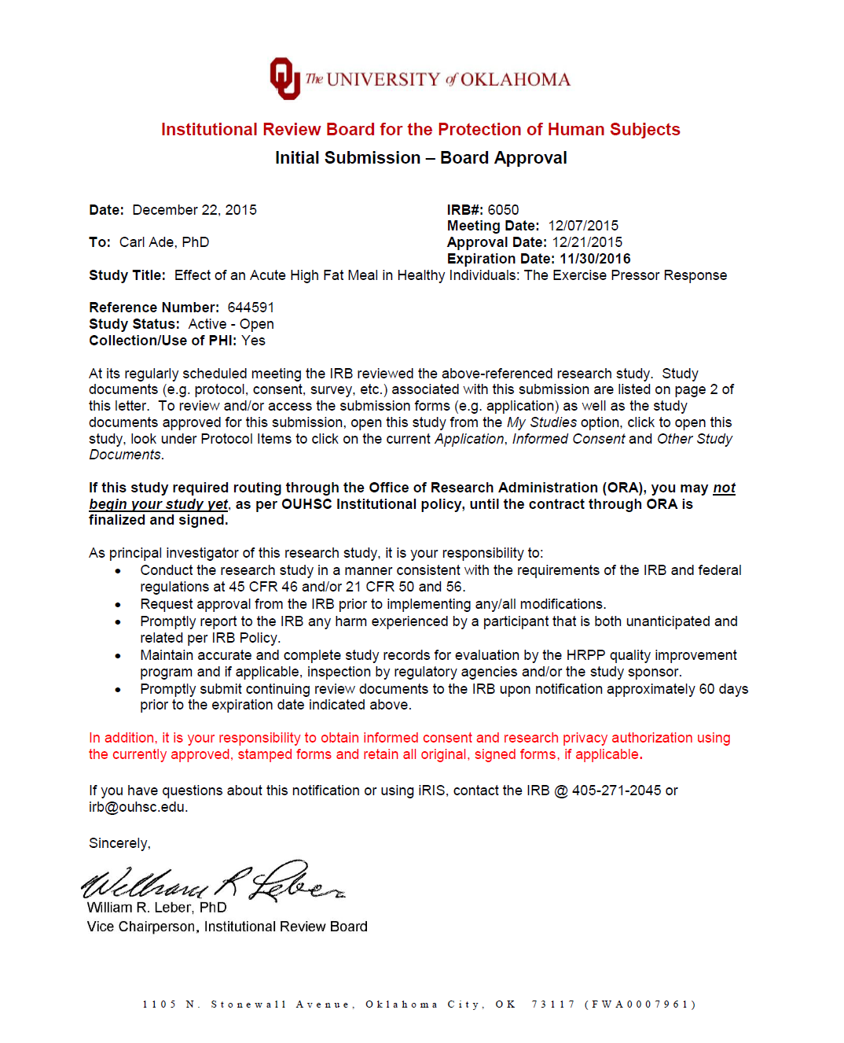
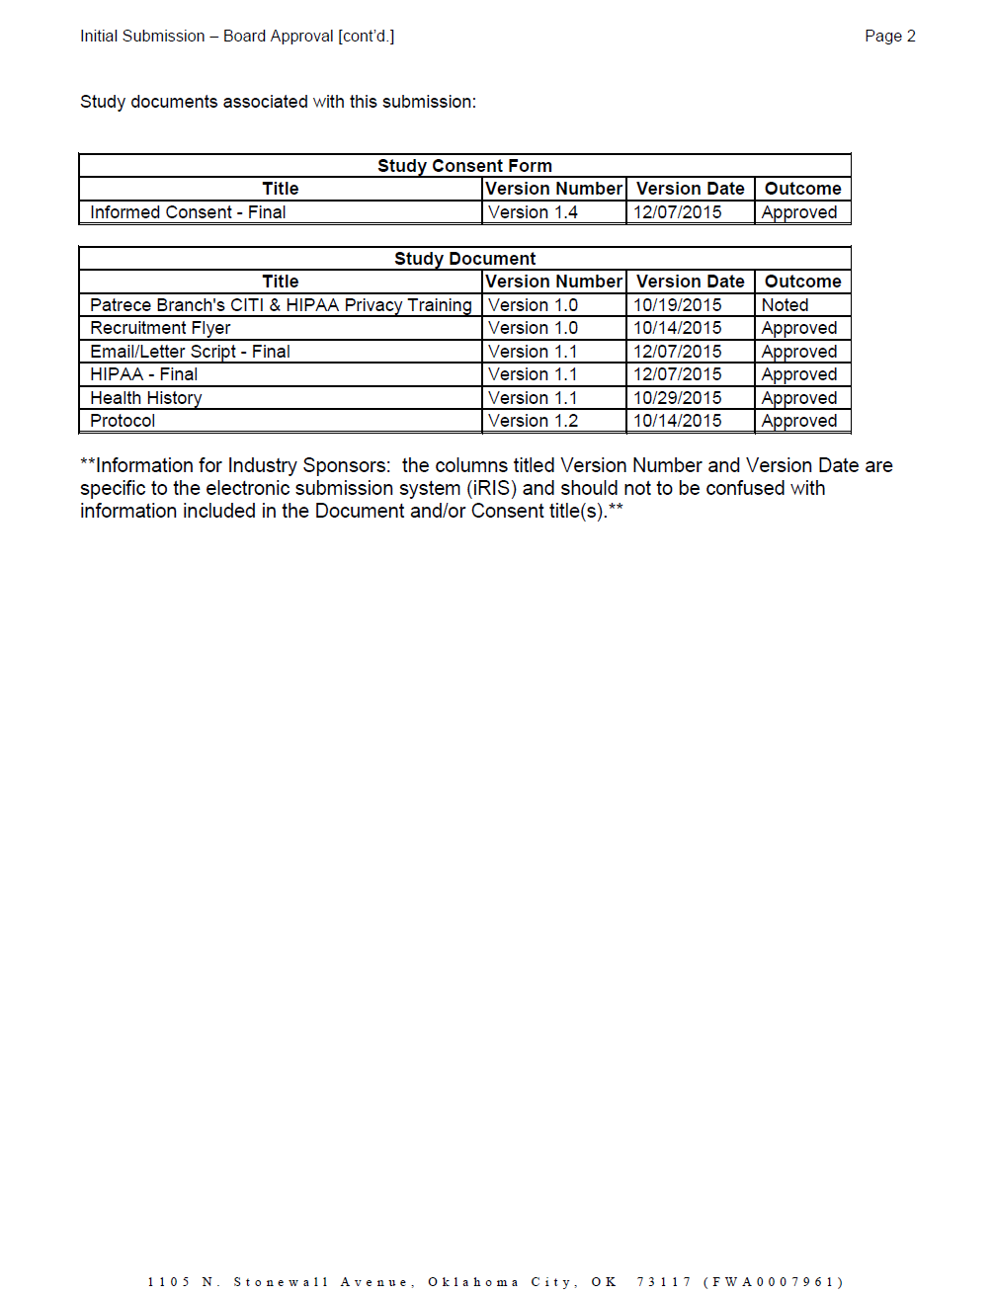
Appendix B: Informed Consent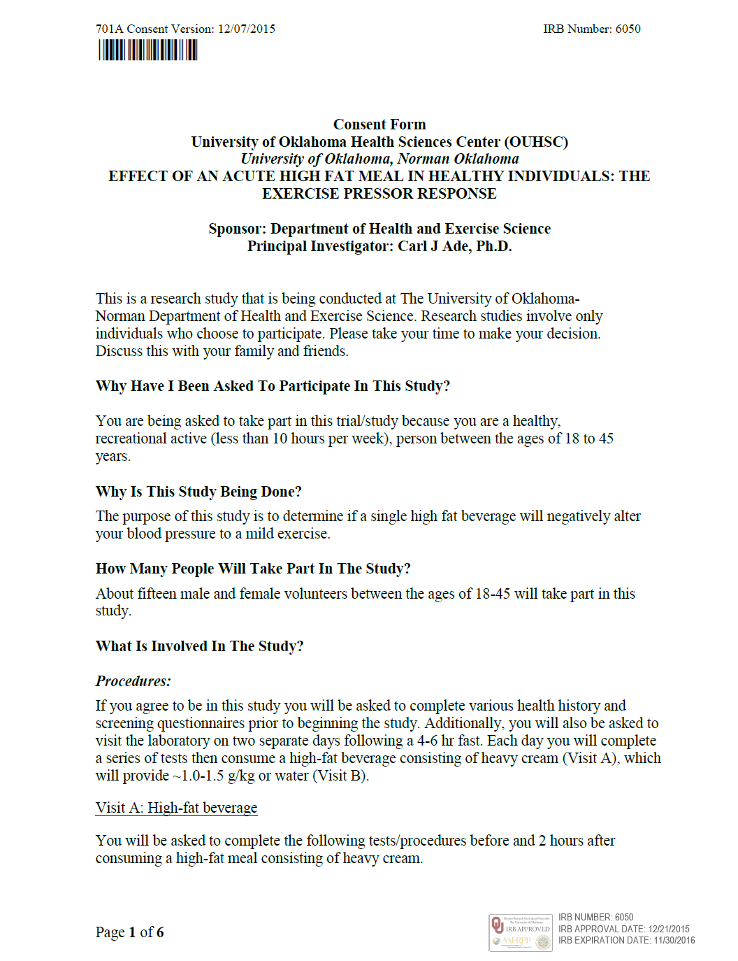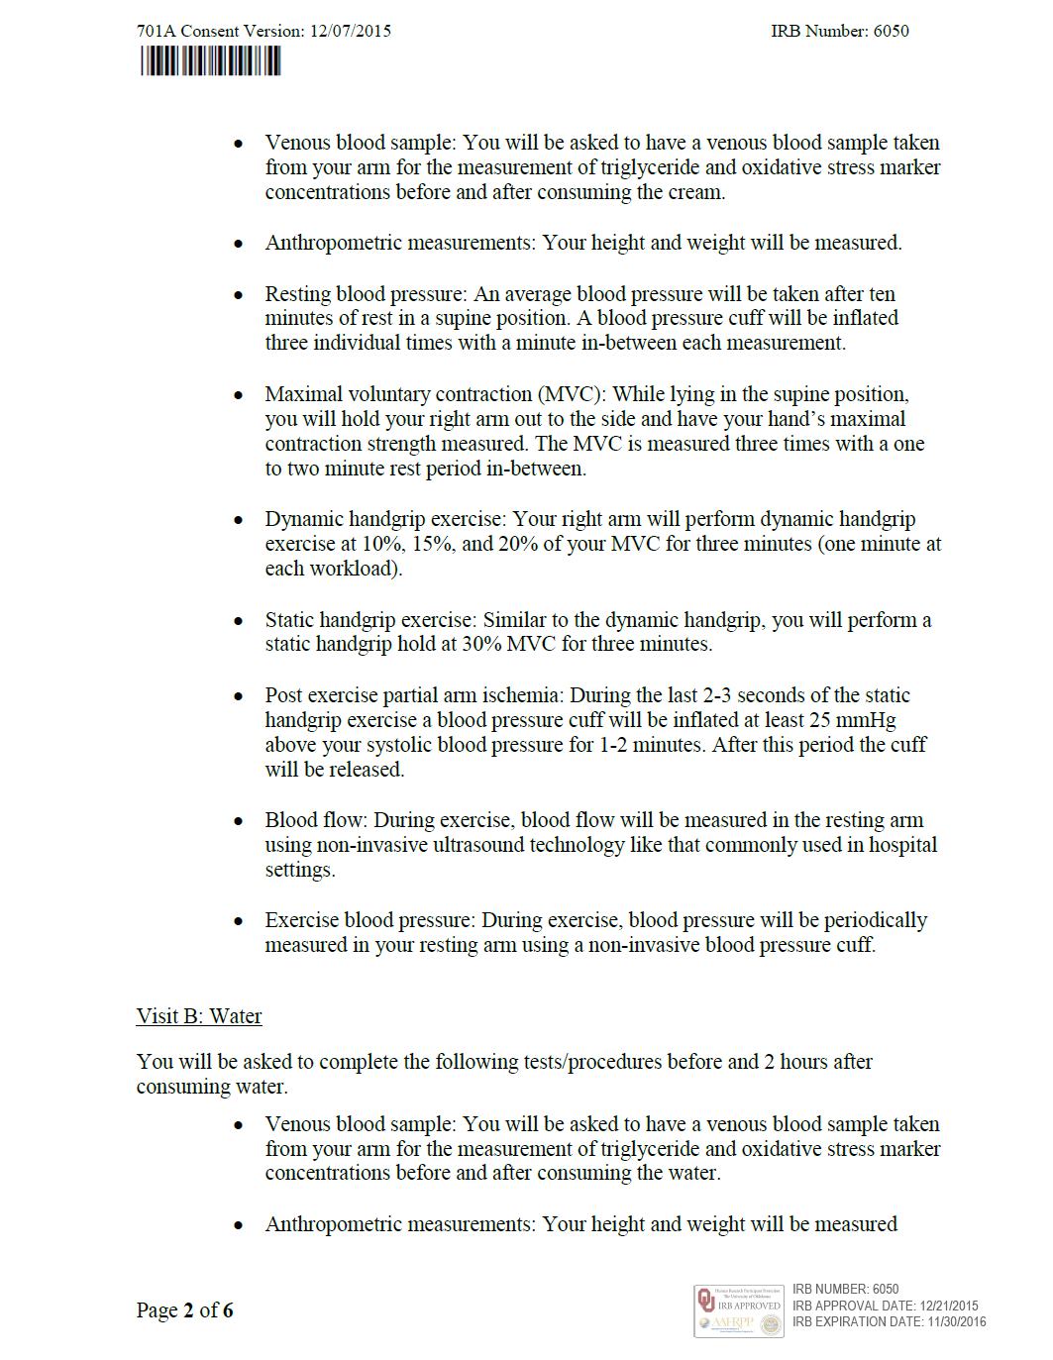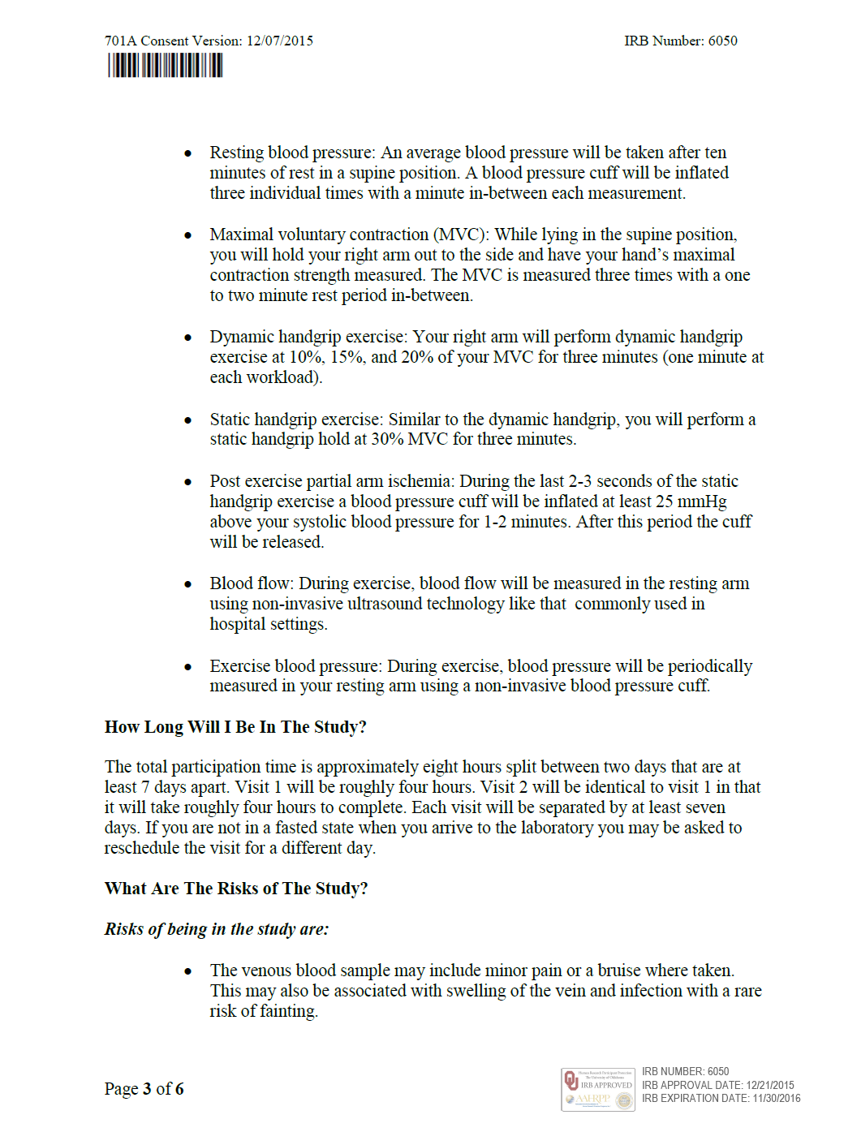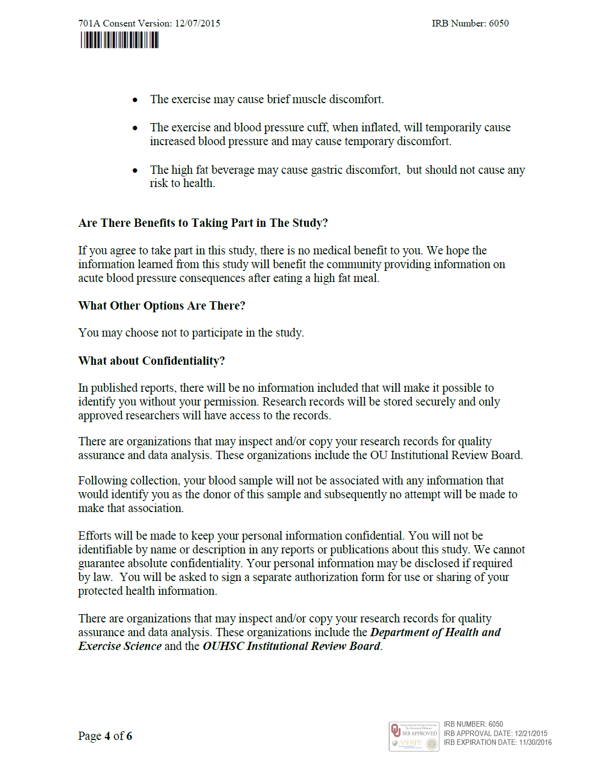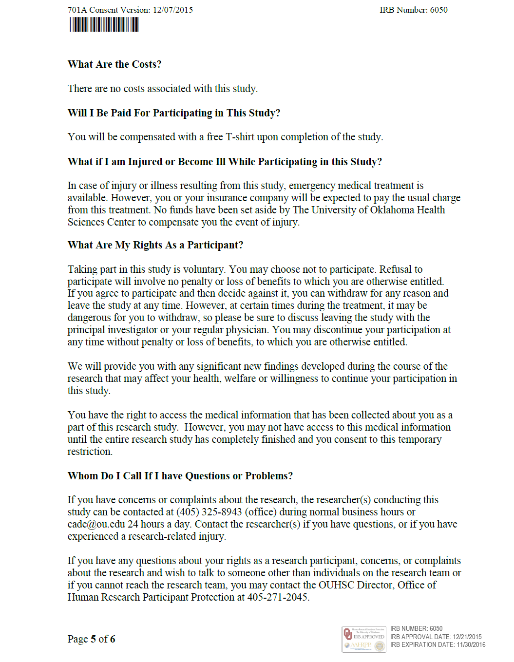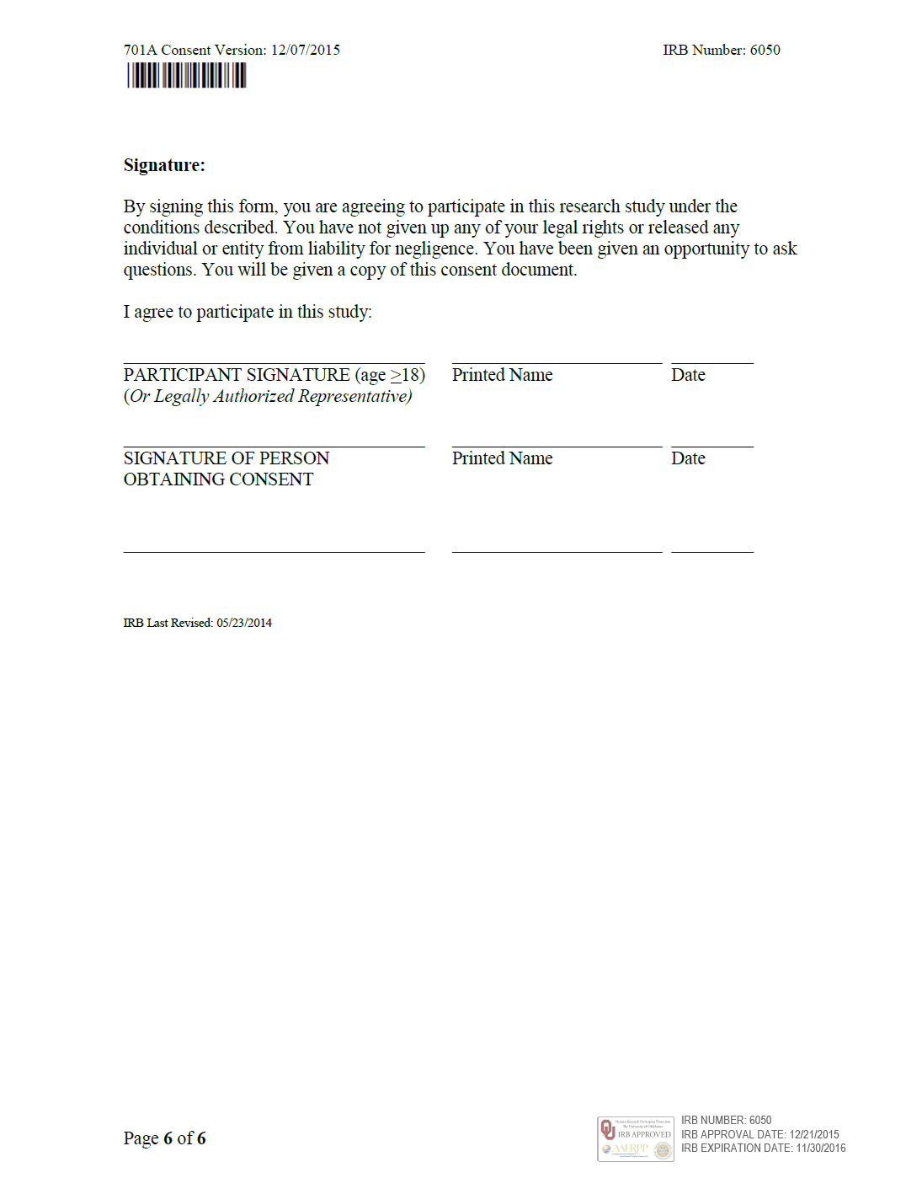
Appendix C: Subject Identification And Health History