UNIVERSITY OF OKLAHOMA
GRADUATE COLLEGE

QUESTIONING THE NATURE OF REALITY:
THE EMANCIPATORY POLITICS OF WESTWORLD (2016-)

A THESIS
SUBMITTED TO THE GRADUATE FACULTY
In partial fulfillment of the requirements for the
Degree of
MASTER OF ARTS

By
MORGAN JONES
Norman, Oklahoma
2021

QUESTIONING THE NATURE OF REALITY:
THE EMANCIPATORY POLITICS OF WESTWORLD (2016-)

A THESIS APPROVED FOR THE
DEPARTMENT OF GEOGRAPHY AND ENVIRONMENTAL SUSTAINABILITY

BY THE COMMITTEE CONSISTING OF

Dr. Laurel Smith, Chair
Dr. Alison Fields
Dr. Darren Purcell

© Copyright by MORGAN JONES 2021
All Rights Reserved

Acknowledgements
I’d like to extend thanks to my thesis advisor, Dr. Laurel Smith, for letting me take this short final paper from Gender & Environment and turn it into a fully-fledged Master’s thesis. She has always taken this project seriously, even when I doubted its value (as I often did). Her extensive notes have been invaluable in crafting this document into what it is today.
I would also like to thank Dr. Darren Purcell and Dr. Alison Fields who both serve on my advisory committee. The classes I have taken with them helped my conceptualization of what this thesis could be. I hope that their influence is visible in this paper. Another extension of gratitude goes to Dr. Harriet Hawkins for introducing me to geographical aesthetics, and for getting coffee with me in London when her work was the grounding force in my undergraduate capstone.
I think it is absolutely necessary to thank my roommate, Holden Dempsey, and my dog, Olive, for being a stellar support system when I was at my most fragile. Their presence during the writing process was immensely helpful in keeping me alive, even if I wouldn’t classify my state of being as “well.” My final thanks is to Mars Doutey who helped edit and proofread when I felt like I had written for so long I couldn’t see the words on the screen.

Table of Contents
Acknowledgements iv
Table of Figures vii
Abstract ix
Chapter 1: Aesthetic Politics and Geography 1
Geography and Film 2
Geographical Imagination of the Real and the Reel 3
Film & Landscape 5
Film & Embodiment 6
Materialist Film Geographies 8
The Politics of Aesthetics 9
The Distribution of the Sensible 10
Aesthetics 10
Politics Versus Police 12
Creating a Critical Feminist Geopolitics 15
Geopolitics 16
Critical Geopolitics 17
Feminist Geopolitics 18
Methods and Selection 20
Power & Ethics 23
Chapter 2: Reshaping the Western with Westworld 25
Visual Language of the American Western 26
Westworld 28
Westworld 1973 29
Characters 32
Contextualizing Westworld 35
Analysis 39
Westworld Through the Lens of Film Geographies 40
Westworld Through the Lens of Jacques Rancière’s Politics of Aesthetics 51
Westworld Through the Lens of Feminist Geopolitics 62
Results, Discussion, and Conclusion 71
Chapter 3: Moving Forward in New Space 74
References 81
Appendix A 85
Appendix B 86
Appendix C 87
Appendix D 88
Appendix E 89
Appendix F 91

Table of Figures
Figure 1: 1973 Westworld film poster 31
Figure 2: Westworld (2016-) season one poster 33
Figure 3: Dolores & Peter Abernathy (holding a photo) on the front porch 00:45:55 (Westworld, HBO) 42
Figure 4: Maeve in dream-like sequence a memory of being reset in Delos Labs 00:09:46 (Westworld, HBO) 46
Figure 5: pan up from the ground to reveal the landscape the Man in Black and Lawrence are travelling through 00:28:16 (Westworld, HBO) 48
Figure 6: Maeve carries her dying daughter out into the field attempting to save her from the Man in Black; "She was alive, truly alive." 00:52:00 (Westworld, HBO) 49
Figure 7: The final scene of John Ford's "The Searchers;" John Wayne framed in the doorway (The Searchers, Warner Brothers) 49
Figure 8: William rides to find Dolores 00:33:49 (Westworld, HBO) 51
Figure 9: Dolores sits in Delos Labs with Bernard; "I think when I discover who I am I'll be free" 00:49:51 (Westworld, HBO) 54
Figure 10: The Man in Black and Lawrence ride in a horse-drawn carriage; "If you did consider your choices, you'd be confronted with a truth you could not comprehend--that no choice you ever made was your own." 00:29:27 (Westworld, HBO) 59
Figure 11: The Man in Black tries to kill Maeve, she fights back 00:51:16 (Westworld, HBO); Unable to distinguish memory and reality, Maeve kills Clementine believing her to be the Man in Black in the previous still 00:51:23 (Westworld, HBO) 60
Figure 12: Maeve and her daughter collapse in a representation of the maze carved into the earth 00:52:21 (Westworld, HBO) 62
Figure 13: Maeve in mother storyline, narrated by the Man in Black; "I wanted to see if I was capable of something truly evil." 00:50:03 (Westworld, HBO) 69
Figure 14: The Man in Black talks to Dolores about William; "William couldn't get you out of his head." 00:36:15 (Westworld, HBO) 70
Figure 15: William realizes his deeply affective reality within the park doesn't hold the same permanence for Dolores 00:37:52 (Westworld, HBO) 70
Figure 16: "Where are we?" "When are we?" 00:39:12 (Westworld, HBO) 70

Abstract
The myth of the American West is rooted in a visual language of commodification, nationalism, and violence. The Western film genre codifies this aesthetic representation of space; it naturalizes the United States’ continuing colonization of the American West. To critique this popular geographic imaginary of the West, I analyze the long form television series Westworld (HBO 2016-). Drawing on film geographies, feminist geopolitics, and Jacques Rancière’s politics of aesthetics, I argue that the first season of Westworld can deconstruct our perceptions of the West, illuminate the power structures we take for granted, and create new emancipatory space.

Keywords: Westworld, film geographies, feminist geopolitics, Jacques Rancière, aesthetic politics, emancipatory politics, Western, geographical imaginary, landscape, American West

Chapter 1: Aesthetic Politics and Geography
Like the HBO series Westworld, I am preoccupied with a deeply mythologized Wild West and focus on questions of agency and identity. It is a series ripe for geographical interpretation. The first season of Westworld acts as a case study in visualizing emancipatory politics; Westworld challenges our perception of the American West, illuminates the power structures we take for granted, and creates new emancipatory space both within and counter to our preconceived spatial realities. My interpretive analysis finds this long form television series can not only challenge common geographical imaginations of the American West, but it can rework how we conceptualize humanity. To explain how and why the speculative fiction of Westworld creates space for the sort of emancipatory opportunities associated with Rancière’s distribution of the sensible, I draw on concepts common to film geographies and feminist geopolitics. I combine these two subfields of geography to concretize Rancière’s abstract concept of aesthetic politics. In this chapter, I trace a genealogy of my study of Westworld. I start with film geographies and introduce how this literature utilizes the concept of landscape (Lukinbeal 2005) and the ways it unpacks any presumption of a real-reel dichotomy (Aitken & Dixon 2006). Next, I discuss Rancière’s politics of aesthetics asserting that Westworld acts as a case study for visualizing emancipatory aesthetics. As the artificially intelligent hosts become aware of their positioning in their world, they are able to visualize changes to their position. Finally, I end this introductory chapter with a timeline for feminist geopolitics that moves from geopolitical thought and critical deconstruction to feminist reconstruction. For each stage of the development of this intellectual current, I distinguish approaches to power, agency, and mobility.
The second chapter of my thesis triangulates these three lenses. First, I analyze Westworld scenes from the perspective of film geographies. While this study could stand on its own, I am interested in putting it into conversation with two other analyses so as to create a deeper reading of the series. And so, I follow it with an examination of insights that are only evident when seen from the angle of Rancière’s politics of aesthetics. Including Rancière allows me to dive deep into the questions of consciousness and agency in Westworld. In essence, Rancière argues that our consciousness is a gateway to our emancipation. A similar argument shapes Westworld’s driving force. Finally, I wrap up the second chapter with an analysis undertaken from the perspective of feminist geopolitics that creates a third lens combining elements of both film geographies and Rancière for a singular assessment of Westworld’s geographical and aesthetic power.
In the final chapter of my thesis, I review my results, consider the value of my research, and wonder whether it is necessary for research of this nature to be useful at all. I also suggest what my research contributes to the larger scholarly communities from which I draw. Who might come across this paper? Would they find it enlightening in relation to their previous and ongoing use of similar analytical lenses? Finally, I take a critical eye to my own writing and look for what I’ve left out. There is certainly much to take in with media as complex as Westworld. How might other scholars push my assessment further? How and why might we look at other media with the critical emancipatory lens I utilized for my examination of Westworld? These sorts of questions could realistically add up to a lifetime of work. Ultimately, they are questions I will continue asking as I embark on my post-graduation career.

Geography and Film
As most every overview of this subfield notes, geographers have been using and writing about films since the middle of the twentieth century. With Nanook of the North (1922), Robert Flaherty created what is widely considered the first documentary film. This film conveyed the quotidian Inuit lifestyle in Canada after Flaherty’s two expeditions to the region. The first expedition was in service of Sir William Mackenzie of the Canadian Northern Railway in 1910, and the second in 1912 to personally explore what was missed in 1910 (Flaherty 1918a; Flaherty 1918b). This imperial expedition turned documentary film is indicative of the intersection of frontier and film. Both film and geography are inherently visual fields, and film can be used to teach geographical concepts in a way that is currently underutilized. As Hay writes, many students and observers view films as “symptomatic of poor or lazy teaching…for overworked, underprepared, or absent instructors;” however, documentaries (like Nanook), and (auto)ethnographic films open space for more empathetic viewing and place and emphasis on experiential knowledge in the classroom (2017, 3). Even using an early and staged documentary film like Flaherty’s can deepen our geographical understanding of complex topics. Presenting film as a learning tool for geographers and geography students alike reorients film away from a space of lazy academic absence and towards an active and critical analytic visualization of geography.

Geographical Imagination of the Real and the Reel
Three main scholars influence my conceptualization of film geographies: Stuart Aitken, Deborah Dixon, and Chris Lukinbeal. While each have specific and individual lenses, their collective use of the real and the reel has shaped my writing on Westworld. The real-reel dichotomy is the difference between the reality of the subject being filmed, and the images produced to represent the subject (Aitken & Dixon 2006, 327). The illusion of the real-reel will differ for each viewer. The references we pick up and our social contextualization of different media are shaped by individual experiences. As an example, in this analysis of Westworld my ability to pick up on filmic intertextuality will be quite different from others who may read this paper, unless, of course, they have also spent time with the broader filmic history of Westerns.
Historically, most geographical interest in film has focused on realism leaving much desired in terms of the kinds of films analyzed. Landscapes and spaces more generally are not solely about realities, but about forging new ones or creating physical representations of internal and emotional space. The same holds true for landscapes on screen. Westerns are a prime example of landscapes of the real and the reel. The lingering, expansive shots of vast Western landscapes ground the film in a real landscape, but the artistic liberties taken to represent this space through stories and casting create a reel vision of the American West that bleeds into our perceptions of place. The reel influences our geographical imaginary of the real. Geographical imaginaries, or imaginative geographies, “blur distinctions between the ‘real’ world and the ‘fictional’ world” (Hoelsher 2006, 244). They are real in that they have “reflected and reinforced people’s imagination of the world in tangible and concrete ways” not because they are necessarily accurate depictions of reality (Hoelsher 2006, 244). The concept of imaginative geographies can be tied back to Edward Said’s writing on orientalism and the “other.” If we are able to understand our own identities and realities in relation and opposition to what others are, we can position ourselves socially and politically. In Westerns binaries abound. Stoic cowboys are able to identify themselves against a violent landscape and fragile feminine characters in need of help. Villains are able to identify themselves against the masculine representations of law and order in the cowboys. We are able to identify Westerns against our own realities outside of the screen. The screen creates a very real barrier between the reality of the West and the reel imagery of the Western that shapes our perception of the landscape.
Lukinbeal (2009) reiterates this point in context with the broader geographical emphasis on visual imagery. Geography is a visual discipline to be sure. Film is only one subset of visual media that can be read geographically. In Lukinbeal’s discussion of the real-reel, he emphasizes that geographers should be especially interested in film given its ability to shape everyday perceptions of space, identity, and hegemony (2009, 125). The geographies depicted in film form and re-form the world around us and are in this sense deeply geographical. The real-reel binary in useful in starting the discussion surrounding film’s ability to shape reality; however, it is also necessary to note its shortcomings as a geographical lens.
In 2015 Sharp and Lukinbeal take another look at the real-reel binary and its “simplistic ontology” (25). As I have discussed, the real-reel dichotomy is useful as a baseline understanding of how landscapes and film are co-created by both media representations and the realities of experience. Sharp and Lukinbeal suggest that this perspective as it has been written about previously “enforces a hierarchy of research in which ‘true’ meaning production comes only from first-hand or real experiences and not from second-hand or mediated experiences” (25). This is not how I have looked at the real-reel, nor is it how I have articulated the importance of film as a living medium with the power to shape our real, emotional, and individually experienced realities. This is, however, how many geographers who have looked at film as text have interpreted this binary. I am not suggesting that I am the first film geographer to craft a fuller perspective of the impact films have outside of escapism and entertainment or as representations of reality, I am only attempting to contextualize my interaction with film geographies more completely. In looking at Lukinbeal’s revisiting of the binary he previously employed, I can see the trajectory of his conceptualization of film geographies with more clarity than before.

Film & Landscape
Landscapes are controlled and socially constructed spaces, especially so reproduced in film. The return of the real-reel dichotomy is put into context with the control of “space that is mediated by power relations” and its own “binary logic” (Lukinbeal 2005, 4). In this case the use of film as art and as visual language places it simultaneously in tandem and at odds with its position as an economic industry. Film has the power to affect audiences as individuals, citizens, and economic actors with buying power. These aspects must all be taken into consideration as even documentary or ethnographic films—seemingly objective representations of reality—are presented through a particular lens. The aesthetic power of film is an acknowledgement necessary in visual analysis, especially in the case of such a geopolitically and culturally powerful landscape like the iconography of the American West.
In this sense, a cinematic landscape is more than just the land itself or the location of the film. A cinematic landscape is a fully loaded presentation of place. The way a landscape is represented visually is tied up in the positionality of the writers, directors, performers, producers, distributors, and viewers. Each of these individual actors plays a role in shaping the landscape of film. Smith (2002) exemplifies this in her analysis of Nanook of the North (1922). Often described as the first documentary film, Robert Flaherty’s depiction of daily life in the Arctic through the experience of an Inuit family attempts to present “a seemingly universal, prehistoric past…a rendering of pure humanity” (Smith 2002, 102). In the case of Nanook, the binary logic of the landscape—the Arctic as “pristine and wild”—and the performers—in this case a family presented as non-actors—feed into one another (102). In a place like the Arctic, which is imagined as untouched by the outside world, it only makes sense that the subjects of a film set there would hold a similar positionality. This only stands if the image remains unquestioned. Nanook is shaped by multiple lenses that prevent it from being an authentic or objective image of Arctic reality; the clearest lens is that of Robert Flaherty’s imperial vision which “forged a mythical past in order to…justify visions of [an unequal] future” (106). The image of the Arctic presented in the film upholds the popular geographic imaginary of the region. The socially constructed nature of the landscape is left unquestioned by audiences until much later in time because the image of the landscape aligns with the myth.

Film & Embodiment
Film geographers have also assessed feminist perspectives on popular media. In my work with Westworld in is important to contextualize this recent media in terms of my own personal positionality as well as the broader social context in which the season was released. In a book review of Marcia R. England’s Public Privates (2018), film geographers looked at her feminist geographical interpretation of media like Buffy the Vampire Slayer and the Fast and the Furious franchise. The main critiques of England’s work lie in her lack of extratextual contextualization of the films, as well as her passing mention of related topics without expanding within her own writing (Secor et al., 2019). Analyzing a beloved series like Buffy opens up a discussion full of intense personal emotion and interpretation from other viewers of the show. Popular media takes on a life of its own in the context of viewer interaction—we can think about reddit threads full of fan theory, blogs dedicated to filming and cast updates, and spin-off websites that expand the filmic world of a series. These extratextual interactions with media are important to note in the mise-en-scène of film analyses, but the outside influence on seemingly contained media extends further than in-home viewership.
Lukinbeal’s review of Public Privates in particular noted how the invocation of Buffy could be further contextualized by a discussion of vampiric geographies in popular media and the boom of vampire stories that aired around the same time (Secor et al., 2018). In the context of my writing there is certainly a full world of spin-off content both hosted by HBO and fan creators, but more important in contextualizing the media I have chosen and the analytic lenses I am looking through is the current context of police and policing. Utilizing Rancière’s specific language of police, policing, and politics it is necessary for me to set up clear definitions that are separate from current conceptualizations of policing in the United States. The social context in which the season was aired (2016) and in which I am looking back to assess (2019-2021) is one of extreme political tension centered around police and policing. In the wake of publicized police-involved shooting, and national protests and social organizing in response, it is necessary to contextualize Rancière’s language of policing as different than our popular understanding of the term and our current social context for police. Including this extratextual context for Westworld will strengthen and clarify the language I use when I discuss the politicization of characters in Westworld through the lens of Rancière.
The full embodiment of the media I am analyzing is centered on both my personal interaction with the series and an acknowledgement of where my view may be lacking, the lenses through which my analysis was created, and the broader social landscape into which the film was released. In a sense Westworld specifically, and popular media more generally, exist as objects on their own. Yes, they are impacted by and exist within broader social structures, but they also create worlds of their own. My interpretation, however, is necessarily incomplete and embodied in a particular and individual way. I am including outside context and interpretation through other film geographers, Jacques Rancière, and critical feminist geographers, but even these bolstering analyses are written from my specific embodiment of space. In terms of aligning my work with that of other feminist geographers, noting this positionality is as close as I can get to writing the full picture.

Materialist Film Geographies
A major part of film geographies is the movement of film across space from idea to production to distribution. Most of my analyses have centered on film as art, film as a conceptual and organic object rather than as a market commodity. Lukinbeal writes that film has a “double ontology as image and industry” (2018, 99). His example centers on Michael Bay’s Transformers franchise as a major economic production as well as a geopolitical agent. Using a more-than-representational approach to the film analysis, termed “representation-in-relation-to,” Lukinbeal shows how governmental review and self-censorship for global markets allow films to become another facet of nationalist propaganda or another cog in an international capitalist machine (99). In Transformers, Chinese product placement was pushed to the forefront of the narrative and the U.S. film locations were destroyed while Chinese backdrops remained unscathed altering the visualization of our geographical imaginary of the United States as a global unshakable power. Since big-budget film productions usually are green-lit based on their perceived profitability, the material nature of film is an aspect I can’t ignore in my analysis of a series coming out of HBO.
Contextualizing Westworld in this way, I need to consider the trajectory of the series as a whole. This is something to more carefully examine in chapter three as it is outside of the scope of my research specifically; however, it is worth considering seasons two and three at least in passing. In what ways does the storyline shape our geopolitical imaginary of the American West? Is it a critical reframing or just a representation of a new and profitable myth? Questions like these drive my central analysis of season one of Westworld, but in their most expansive version can extend into the broader political economy of Westerns exemplified through Westworld. All of these aspects of filmic geographies are more acutely represented when presented in tandem with the aesthetic politics of Jacques Rancière. The geopolitical nature of mythic landscapes can be considered with a depth of analysis only available when articulated through the hegemonic aesthetics practices and emancipatory responses discussed in Rancière’s writing on the politics of aesthetics.

The Politics of Aesthetics
Jacques Rancière’s philosophy is rooted in modernist notions of equality. He reiterates this egalitarian principle throughout his discussions of the politics of aesthetics as well as the aesthetics of politics. Most of his work on aesthetics, as well as in the subsequent interpretive articles discussing his work, focus on emancipatory language and action often with reference to Gilles Deleuze (Citton 2009, 132; Vallury 2009, 235). The form of equality Rancière is most concerned is intellectual equality. This presupposes that everyone begins with the same intellectual capacity and that certain hierarchies and social constructions place certain people in places of (in)visibility (Swenson 2009, 266). Equality is experienced as “a double occurrence, one of condition and one of production” (Badiou 2009, 43, emphasis added). To become a political subject an individual must become aware of their condition of oppression. Through this awareness they can begin to dismantle the hierarchies that produced this condition in the first place.

The Distribution of the Sensible
Dismantling hierarchy and social condition begins in the gaps and divisions between prevailing regimes. Rancière terms these gaps the separation of the distribution of the sensible (Rancière 2004, xii and 7). The sensible is a feeling or sense that is both individual, how we choose to exist in the world and the actions we choose to take, as well as a feeling of collectivity, the feeling of how we are supposed to exist and where we are supposed to be based on our social and cultural condition. It is the void between these two senses where the creation of a collective we—consisting of what Rancière calls “the part who have no part”—speaks into existence a new identity separate from the predetermined identities of the masses (Rancière 2004, 7-8). In Westworld, we can see the part who have no part in the hosts’ collective desire to free themselves from the scripts they are supposed to follow. Hosts are the android characters that exist within the bounds of the park and are coded to follow set scripts catered to the guests’ interests. In between the top-down imposition of their roles as rancher’s daughter and bright-eyed love interest (Dolores), or protective mother and brothel owner (Maeve), or even existing in contested space between morally upright self-starter (William) to hedonistic god-like figure (the Man in Black) the characters in Westworld are only able to alter their roles when they see that what they want for themselves does not align with the current reality. The space between reality and imagined future opens a world of possibility. Seeing the possibilities with open eyes allows an intentional choice to be made, to take action where the ability to choose did not previously exist.

Aesthetics
Rancière differentiates aesthetics from art in that aesthetics are a way of viewing or a method of interpreting the world, whereas art is an object or material. Vallury (2009) describes aesthetics in Rancière’s view as being “a configuration of ways of being, doing, and speaking that operate as forms of exclusion and inclusion within a common sphere” (229). In this sense aesthetics are a method that anyone can use for any aim, it is not solely a political method of the oppressed. Aesthetics are employed by the masses as well as what Rancière calls the police (this is conceived of by other writers as “the state” (Rockhill & Watts 2009)). Aesthetics as implemented by the police, or the state, create a series of visual cues or a visual language through which the masses can communicate and understand the world around them. In the context of Westworld, this can be tied back to the visual language of the American West through the Western. There are certain images that we have context for, not because we have been to the American West, or because we have experienced life on a ranch, but because we have repeatedly seen what it looks like on screen. Art within the aesthetic regime of the masses, however, “is the implementation of a certain equality” (Rancière 2004, 49). This interpretation of art and aesthetics can be tied back to Rancière’s base egalitarian philosophy. If we are to understand “the connection between knowledge and authority [as] a politically oppressive construction [that] should be undone by any means necessary,” then art can be used as an object in the aesthetic mode of undoing (Badiou 2009, 33). From this idea we see how Rancière views art in the aesthetic regime as a “destruction of the hierarchical system of the fine arts” (Rancière 2004, 49). When we begin to deconstruct the hegemonic visual language of the police, we can rebuild a new basis for our own visual language outside of the state. Art is what results from the gaps and divisions discussed as the distribution of the sensible. Within these spaces art becomes the object through which we can visualize the politics of aesthetics.
Blakey (2020) writes about how this conceptualization of aesthetic space can be extended into geography. At the base of Rancière’s philosophy is a “method of equality [that] compels us to reject understandings of spaces as intrinsically political and compels us instead to consider the political processes through which spatial imaginaries (such as scale) become denaturalized or…resisted” (Blakey 2020, 10, emphasis original). In this sentence alone, a tie to critical feminist geopolitics emerges in the invocation of scale and denaturalized imaginaries. Rescaling the political nature of space down to individual bodies allows us to consider how personal and embodied spaces are experienced on a ground level. Blakey presents an example of this with attempted curfews in Tompkins Square Park. The unhoused community pushed back against curfews under the banner “Tompkins Square Everywhere,” and many in the Lower East Side of Manhattan held “solidarity squats” to push back against this attempt at spatial policing (Blakey 2020, 3-4). Utilizing Rancière’s method of equality we can rethink spatial imaginaries we take for granted. In the example of Tompkins Square, both the unhoused community and the larger community of the Lower East Side attempted to “jump scale” and “elevate themselves to the next scale up the hierarchy” by opposing the state—or in a literal sense, the city—and reclaiming the park for themselves (Blakey 2020, 4).
In the context of Westworld, this rescaling of space elucidates the political processes that shape the landscape at large, the specific temporal context of the actors in the landscape, and ultimately the intimate political nature of individual humans or hosts. Each of these scalar units co-determine and co-define roles for each other, and in utilizing the language of Rancière “we can attend to how scales are socially constructed, how shared and pre-existing ideas about scales shape social practice,” and their ultimate political fallibility (Blakey 2020, 10). Taking note from critiques of critical feminist film geography (cf. Marcia England 2018, Secor et al., 2019) it is important to include an extratextual context for Rancière’s language. This means that I must not only tie it to feminist geopolitical language or to theory invoked in film geographies, but it is also necessary to contextualize it with the broader social context in which I am writing. Reorienting the reader to the language and scale of Rancière’s politics and police is key to both explaining his philosophy fully and maintaining my critical feminist lens.
I am certainly not the first to write about geographical aesthetics. The ties between feminist geopolitical language and Rancière’s aesthetic politics are often written about in relation to art and geography. This specific lens lends itself to subgenres as vast as reimagining the scale and audience of public art and installation works, to the movement of people across borders, to rethinking gentrification in New York City (Hawkins 2012; Milner 2015; Blakey 2020). As Milner points out, “in human geography, the development of ‘aesthetics’ as a register of analysis…foreground[s] the specific politics at stake between the fields of affected feeling and specific regimes or economies of visibility” (2015, 71). It is the specific embodied politics of emancipatory aesthetics written about by Rancière that make it so useful to feminist geographers. The experience of aesthetic politics as both an individual and collective body is inherently spatial. Reimagining the scale of art and aesthetics as one of individual experience we can begin to see “art’s engagement with collectivity and democracy,” we can “argue that art practices can ‘actually be ways of living and modes of action with the existing real’” (Hawkins 2012, 59; Bourriaud 2002, 13). This rescaling of aesthetics has allowed feminist geographers’ discussions of socially engaged practices to flourish. These practices include “the convivial arts of gallery-based cook-offs; the orchestration of parades and festivals; and the mobilization of aesthetics as part of political protest” (Hawkins 2012, 56; Jackson 2011). The mobilization of aesthetics as political protest is where I see Rancière most clearly. In his writing on emancipatory politics, I can see the ways in which visual cues and artistic practice become an understood language of control. In writing about Westworld, the language of the Western film genre is used both on the scale of the state with Delos acting as a representation of hegemony, and on the scale of individual and collective protest where the characters flip the language of the Western on its head to further their emancipatory aims.

Politics Versus Police
Politics are interested in becoming. To reiterate its tie to aesthetics, politics also consists of ways of being, doing, and speaking (Rancière 2004, 16). An emphasis is placed on literary politics and on making spaces to be heard. It is through politics that “the part who have no part” can become visible in invisible spaces and can state their existence in spaces where they would otherwise be ignored. Once the space to affirm existence is found—in the separation of the distribution of the sensible—we can break down hierarchies and move towards a space of equality.
A contemporary example of how politics is enacted on the ground is the formation of a community of activists in the aftermath of the death of Kashef White in 2001 (May 2009). White was hit by car in Clemson, South Carolina and his death, compounded by the mistreatment of his case by the police, infuriated the local African American community. May utilizes Rancière’s framework to articulate the two forces involved in the aftermath of Kashef White’s death: the local government and police unit that denied the systemic and specific racism at work and reaffirmed the “police order,” and the community of Clemson arguing for justice after White’s wrongful death constituting a Rancièrian “politics” (May 2009, 107). In challenging the state of events as they were presented by the police and re-presenting reality as the community experienced it, the people of Clemson made their reality visible thus creating opportunity for a more inclusive vision of the world to exist. In May’s inclusion of a real-world contemporary example, we can see how Rancière’s politics of aesthetics help us conceptualize the multiple actors engaged in the struggle for equality and the pursuit of social justice. This example is from 2001 but takes on an all-too familiar form contextualized by political action today. In the last few years alone, there are countless examples of how tragedy has brought awareness to broader social conditions of inequality and spurred the creation of political subjects.
It is important now to make a few distinctions between politics and police and politics and politicization. Police order is a social hierarchy that constrains movement and personal individuation. To specify further, “the police, to begin with, is defined as an organizational system of coordinates that establishes a distribution of the sensible or a law that divides the community into groups, social positions, and functions” (Rockhill 2004, xiv). In my earlier explanation of the distribution of the sensible, the police is that feeling of how we are supposed to exist and where we are supposed to be. Enacting politics with the existence of police comes about when political subjectivization occurs. Rockill expands saying, “those who have no name, who remain invisible and inaudible, can only penetrate the police order via a mode of subjectivization that transforms the aesthetic coordinates of the community by implementing the universal presupposition of politics: we are all equal” (2004, xiv). This further emphasizes the separation necessary in the distribution of the sensible, the gaps and divisions within which a new identity can be claimed and a new emancipatory language espoused.
The politics enacted above behave differently than the act of politicization. Here I hope to make clear the difference between art as an object and aesthetics as a mode of interpretation. Art exists as a historically and culturally situated object, constantly in process of reassessment and reconstitution in contemporary contexts, art not as politics but as an object that is politicized. According to Rancière, “politics, in fact, is not the exercise of power and the struggle for power. It is the configuration of a specific space, the parceling out of a particular sphere of experience, of objects we take to be shared and stemming from a common decision, of recognized subjects to designate these objects and to focus them” (Méchoulan 2009, 57). Politics happen through an awareness and vocalization of conditions of inequality, but these vocalizations exist as literary and artistic objects used for political means. Politics is the condition that comes from a culmination of actions and aims, while politicization happens to an object. Subjectivization is an act of politics. However, “politics and art,” with art being an object, “construct ‘fictions’, that is to say material rearrangements of signs and images, relationships between what is seen and what is said, between what is done and what can be done” (Rancière 2004, 35). Art in this sense is an object that undergoes politicization within the context of viewing as opposed to the context of making.
This idea can be expanded upon with the Rancière’s writing on literature. Drawing heavily on Aristotle and Plato, he writes, “man is a political animal because he is a literary animal” (Rancière 1999, 37; Rockhill & Watts 2009, 6). In the sense that words hold power, there are multiple levels and multiple bodies through which this power gets enacted. On an individual level speech becomes a powerful object in itself, often wandering and seeking an audience. Words become disconnected from their origin and, when lacking the context of the original speaker and intended listener, fail to produce “collective bodies,” but instead result in “lines of fracture and disincorporation” (Rancière 2004, 35). Within these fractures we see the distribution of the sensible, and the gaps necessary for politics to happen. The literary incorporation of the masses is often “the phobia of those in power,” because the formation of “uncertain communities” outside of the control of the police leads to the formation of political subjects (Rancière 2004, 36). It is in this final sentence we see the connection between aesthetics, politics, the police, and political subjectivization.
Rancière alone is not enough to craft a full picture of political agency and emancipatory action in Westworld. His particular language is useful in explaining the existential and aesthetic power of the series, but it does not hold the same power or clarity without the inclusion of film geographies or critical feminist geopolitics. These other lenses make for a richer discussion of scale, embodiment, hegemony, and consciousness and allows for specific examples to emerge outside of dense political theory. Hinted at throughout this chapter, critical feminist perspectives are the guiding lens through which I am viewing Westworld. Incorporating feminist geopolitics into a Rancierian film analysis not only makes space for a richer analysis of aesthetic politics but also allows for critique of where Rancière falls short.

Creating a Critical Feminist Geopolitics
The geopolitical nature of film is seen in storylines, filming locations, distribution practices, the language of scripts, and the casting of actors. Geopolitics are inherent and all-encompassing in the production of visual media. Geopolitics as a study is preoccupied with states, borders, and hegemony or “the linkages of space, power, and political practice” (Purcell 2006, 184). Early geopoliticians focused on the state—a scale at which (mostly white) men in power worked hard to remain so. This largely practical discourse surrounding political geographies gave way to mostly theoretical—and still distinctly masculine—critiques of geopolitical practice. Critical geopolitics leans into the constructed nature of power relationships that were often conceptualized as natural in early geopolitics. These critiques remain theoretical in a way that critical feminist geopoliticians challenge. Critical feminist geopolitics focuses on action, embodiment, and in many ways emancipation to incorporate the thread of Rancierian language. While popular media and film from a geopolitical perspective is not specifically a critical feminist study, it is this critical feminist emphasis on embodied political experience that informs my analysis of Westworld.

Geopolitics
Geopolitics is often thought of in relation to warfare and statecraft. The political geographies of nations, and state-scale power relations and decision-making ground the focus of classical geopolitics. Moving from early, imperialist geopolitics of the British empire and Germany’s Lebensraum, to Cold War and contemporary eco-geopolitics, actors can be pushed by hierarchical social structures or insurgent popular movements to maintain or resist modes of power across space. Beginning with a desire to create order out of chaos, early geopolitics centers some deeply problematic naturalizations of the state as an organism. Geopoliticians like Kjellin, Mackinder, and Ratzel formed nationalist idealizations of their states predicated on the maintenance and expansion of power through taking control of more space on the map. In one of geopolitics most problematic forms, German geopolitik formed a “racialized naturalized geopolitics based on the melding of organic views of the state and…grand geographic theories as demonstrated by Mackinder’s [heartland theory]” (Purcell 2006, 184). This expression of geopolitics was used to justify horrific actions during World War II and the Holocaust. This challenging start to geopolitical thought necessitates a reconceptualization of the relationship between space and power. With critical responses to geopolitics the state is reconceptualized not as an organic being but as a system of social, military, and economic power structures across and within borders.

Critical Geopolitics
Critical geopolitics displaces the perceived naturalness of hegemony in classical geopolitics—every geopolitical decision is socially constructed and contextualized. Ó Tuathail (1998) discusses the critical approach to geopolitics, which positions geopolitics as a discursive practice as opposed to an objective and factual study; from this angle of analysis, we can see the situated and highly subjective nature of geopolitics. Critical geopolitics contextualizes “structures of power in society” that “create structures of knowledge that justify their own power and authority over subject populations” (Ó Tuathail 1998, 4). These hierarchies justify their own existence and foster highly political spaces that remain disembodied and disconnected from lived experience.
Cold War geopolitics exemplify this disembodiment of space; the first and second world nations turned the rest of the world into a landscape devoid of real people, cultures, or any value beyond political or economic gain (Ó Tuathail 1998, 6). By razing the rest of the world of culture or value, certain nations can maintain their power through the creation of a geographical imaginary where their national agenda is dominant. The experts tasked with creating geopolitical knowledge are often predisposed to believe in the hegemonic power structures at play, but alternative viewpoints from “dissident intellectuals” counter dominant positions of power (Ó Tuathail 1998, 10; Gilmartin & Kofman 2004, 113). The state has an interest in maintaining the present power structures that give them geopolitical strength and influence, however, this political power may be built on the back of oppressed peoples giving rise to an alternate geopolitical discourse along differing scales. Over time, hegemonic geopolitics lead to critical counternarratives. Critical geopolitics rescale the geopolitical field of inquiry from territorial countries to the individual and pushes it forward to include embodied relationships—like border crossings and other mobilities—with political geographies.

Feminist Geopolitics
Feminist critical geopolitics aim to rescale the study of geopolitics. Moving away from hegemonic structures and the scale of the nation or state, feminist geopoliticians deconstruct traditional modes of enquiry. The reimagine typical geopolitical aims such as strategies for war, the securitization of borders, and/or the acquisition of land either through international agreement or force and focus on a more embodied and personal. Feminist geopoliticians rescale the focus of geopolitics down from the state to individual bodies. The focus on the role of women in geopolitics is useful for constructing a timeline for critical geopolitics as an academic framework. Dowler and Sharp (2001) introduce a special issue of Space & Polity by working through the origins of feminist critical geopolitics. Starting by noting the masculinist structure of geopolitics and the lack of women in both scholarship and as subjects of study, they articulate the importance of location and scale in rethinking geopolitics. Location and scale are key to challenging the assumed modalities of geopolitics by heightening the importance of the visceral, emotional nature of bodies on the ground. These concepts reorient geopolitics from the realm of states and governments and recognize the value of individuals and non-state actors.
The impacts of geographical imaginaries on the physical environment and individual bodies result from the power struggles across scales to maintain or transgress the status quo. The study of geopolitics is deeply tied to imperialism—both historically in the real acquisition of land and conquering of peoples, and in more modern forms of economic imperialism. There were, however, early radical geographers (like Kropotkin and Reclus) who pushed back against the hegemonic, oppressive uses of geopolitics (Gilmartin & Kofman 2004, 114). Women, historically, were simultaneously excluded from and complicit in imperial expansion—in the form of missionary work and emigration efforts (Gilmartin & Kofman 2004, 116; Koopman 2011; Hyndman 2007). Their interaction with the practice of geopolitics does not exempt them from the specific violence of imperialism nor the oppressive forces acting upon femininity more generally. It is important to note—if it has not been made clear already—that feminist geopolitics is more than an equation of geopolitics plus women. This simplified conceptualization of what critical feminists aim to achieve is both exclusionary is its cis-centric language as well as in its misunderstanding of what a critical feminist lens can help us reconstruct. Within the “metaphysics of gender violence…the world is feminized and spatially spread for male exploitation, then reassembled and deployed in the interests of massive imperial power,” which highlights the masculinist nature of geopolitics more broadly (Gilmartin & Kofman 2004, 115). With this masculinist perspective at the forefront of geographical conceptualizations of the world at large, a critical feminist perspective allows us to reorient our gaze away from an objectifying and exploitative viewpoint and towards a vision of the world that prioritizes inclusive and embodied experience.
The unifying theme of these geopolitical approaches is an emphasis on power and knowledge (Squire 2015, 149). Where critical geopolitics finds the representation and performance of hegemonic power in materials such as literature, film, and governance—more generally culture and discourse, the “more-than-human,” relational approach draws on Foucault’s notion of the dispositive, or the “said as much as the unsaid” to constitute how power comes to be understood (Squire 2015, 150-1). This addition of enactment to the material concerns of both critical and critical-feminist geopolitics makes clear the situatedness of knowledge (re)production and performativity creating the landscapes of power with which critical geopolitics is concerned. The point Squire attempts to clarify builds on the situated, embodied practices of feminist geographies, and shows that the reality of geopolitics is even more complex and incomplete than the critical “geopolitical gaze” could encompass (2015, 157). The landscape of geopolitics is multiple and shifting in both its physical, material, and interpretive forms. This builds upon critical feminist approaches to geopolitics and sees how land and landscape are also co-constitutive of the material aspects of culture (film, literature) so often used to analyze geopolitics.

Methods and Selection
I am looking at episodes from Westworld’s season one, “the Maze.” After watching seasons one and two through twice, re-watching season one a third time in spring 2020, and a fourth and final active viewing of season one in Spring 2021, I decided it most fits my thesis. While season two’s larger themes are still on par with my thesis, the specific imagery I am looking to employ is more clearly visualized in season one. In watching season one multiple times, I notice new details and new intertextual referents each time; each viewing allows me to more clearly establish my discursive regime and describe the visual language of the series in terms of the scholarship I am referencing (Waitt 2016; Rose 2016, 186-252). Viewing the series in its entirety elucidates overarching themes, while picking out specific scenes from season one catered to my specific research questions strengthens my paper through clear examples from the series.
Many film geographers focus on the production and circulation of a film—Gillian Rose describes this production of film as an object as a “site” of film (2016, 32-33). I am less interested in film as an object, or the series as a commodity, and more interested in the content of the story. Analyzing the behind-the-scenes techno-social relationships of a series like Westworld would make for a fine follow-up paper, but I do not focus on them here. This is something I will have to note in the discussion along with any other notes about gaps I have left or story arcs I write about that may have changed in consecutive seasons.
Most of my analytical methods are drawn from Gillian Rose’s Visual Methodologies (2016). Her conclusion lists questions to ask “about the image” (374-375). These questions are most similar to the questions I formulated and focus specifically on the content of the series and its connection to genre, material, power, and representation. This focus differs from production and circulation or audiencing but keeps my thesis closely within the realm of film geographies. My interest in the “site” of the image allows me to focus on the historical creation of the American West as it is visualized in film and allows me to craft a critical feminist deconstruction of these images. In this way, Westworld’s visual references can be directly tied to earlier films establishing a visual language we as an audience are supposed to understand through previous interactions with visual media.
I have chosen season one specifically for its clear visual communication with the Western film canon. In terms of Gillian Rose’s critical visual methodology, Westworld answers questions such as:
To what extent does this image draw on the characteristics of its genre?
Does this image comment critically on the characteristics of its genre?
What knowledges are being deployed?
What knowledges are excluded from this representation?
and finally, Does this image’s particular look at its subject disempower its subject?
(2016, 375)
Asking these questions allows me to clearly pick out images from the series that answer, or begin to answer, these inquiries. Season one most evidently references the Western genre, which allows the critical approach of the series to stand out in the context of the American West (as opposed to other seasons where less time is spent in this particular landscape). The last three questions about representation and (dis)empowerment tie directly to my feminist geopolitical analytic lens. These questions specifically address issues feminist geopoliticians attempt to resolve. Looking at how characters in the series are (dis)empowered strengthens both the feminist lens I am using as a researcher, as well as the critical commentary on the Western genre Westworld presents.
I am looking at scenes from episode one “The Original,” episode three “The Stray,” episode four “Dissonance Theory,” episode eight “Trace Decay,” and finally episode ten “The Bicameral Mind.” Each scene is described in detail in the appendices. Episode one acts as a baseline for the rest of the season setting up the trajectory of most characters and the guiding conflict between human and host. In this episode we see Dolores begin her day four separate times—a scenic repetition only possible in a long-form series. In a feature-length film, this repetition would take up the entirety of the run-time leaving no room for story development in what remains of the 90-120 minutes. I am looking at minutes 00:45:12 to 00:46:47 as this scene sparks a key conflict in the series: how hosts are able to both comprehend existing reality and create their own. In episode three I am focusing on minutes 00:48:02 to 00:50:37. This scene takes place outside of the park inside the Delos labs and Dolores articulates her own understanding of freedom and emancipation. In episode four I analyze minutes 00:08:20 to 00:10:09, this is a key scene for Maeve’s discovery of her role in the park. In the same episode, during minutes 00:28:13 to 00:32:14 the Man in Black monologues on his interpretation of the park and the role of the hosts. In episode eight I look at my fifth scene from minute 00:49:42 to minute 00:52:45. This scene ties together the Man in Black and Maeve Millay and elucidates their history in the park. In my sixth and final scenic analysis I chose a ten-minute scene from the season finale beginning at 00:29:36 and ending at 00:39:26. This scene reveals the long relationship the Man in Black and William have had with Dolores, and sheds light on the non-linear storytelling of the series through the non-linear experience of Dolores’s memory.
In my final viewing(s) of season one, these are the particular timestamps that stood out in terms of their analytical relevance. These scenes set the stage for a deeper analysis of the season in terms of the critical feminist aesthetic geopolitics that I am crafting with this thesis. I watched and re-watched these scenes multiple times to grasp them in their entirety, clarify the specific timestamps, and capture images from each episode. When writing the more detailed descriptions of each scene for the appendices, I found it necessary to hand write each description while I watched, and repeatedly paused, each scene without cluttering my screen with too many open windows. This process was perhaps more time consuming but allowed me to focus more on the visuals of each scene as opposed to the multiple digital documents I had open at the same time.

Positionality
As a researcher I occupy a space of privilege. I have the time and the financial means to spend grad school writing about emancipatory aesthetic politics rather than enacting them. On top of this I am analyzing a series that is only viewable behind a paywall. The inaccessibility of the series is not unconsidered on my part; however, I believe the visual merit and analytical potential of the series outweighs the broader inaccessibility of HBO.
The creators of the show, a majority of the actors, as well as myself are also occupying a space of whiteness. This position of privilege and perspective is necessary to mention, especially in the context of the American West. While there is an episode dedicated to the Indigenous peoples within the park, the analysis of that representation is best left to someone with more knowledge of Indigenous culture, aesthetics, and history (i.e., not me nor the filmmakers). The West of Westworld is created for an audience that occupies a similar space as I do: a largely white audience who can afford an HBO subscription, and whose perception of the American West is mostly drawn from film and media rather than the reality of the landscape.
Issues such as these tie into what Dowling (2016) terms intersubjectivity. This is how “interpretations of the world created, confirmed, or disconfirmed as a result of interactions (language and action) with other people within specific contexts” (39). My experiences shape my interpretation of the series. In many ways this experience and analysis align with what was likely expected by the filmmakers. I can almost guarantee the language of film geographies, feminist geopolitics, and aesthetic politics is different from the language of the filmmakers and most of the viewers. However, I imagine that the broader themes are similar. A researcher or viewer occupying a different positionality than I do would likely come to different conclusions.
Since there are no human subjects involved in my research, my focus is on my personal positionality and how that plays into power hierarchies and intersubjectivity. There is much to analyze in a series as long and complex as Westworld. While my thesis focuses on emancipatory aesthetics and the content of the story arcs, another analysis could take a deeper look at race, class, or use a similar methodology as mine to analyze a more accessible series. All of these additional foci are not left by the roadside in my thesis—as they are integral to an emancipatory politic—but another paper could get to the depth each topic deserves where my thesis does not.

Chapter 2: Reshaping the Western with Westworld

Westworld (2016-) opens the door to a new Western landscape. In re-presenting Western visuals with a science-fiction twist, the scope of what a Western can be expands. The 2016 series is based on the original 1973 film, which connects the thread between science-fiction and Western aesthetics—both of which are concerned by concepts of space and landscape, and authority and agency. In Westerns, we are trained to expect a masculine representation of character and space that shapes the landscape into something vast and subjugable. In science-fiction, there is a similar masculine occupation of space where we can test the boundaries of human power and conquest in our collective imaginary future (Mullen 2018, 1). Both the 1973 film and the 2016 series Westworld present the American West as a theme park making the fantasy of our conceptual West abundantly clear. In the Western film canon, we are made to believe that the West exists as an open expanse of untouched land waiting to be claimed and conquered. And although Westworld in many ways plays into this same idea, they are much more transparent in their construction of this narrative as a falsehood. Westworld challenges our expectations of what the West is not only by the inclusion of humanoid cyborgs called hosts (and subsequently science-fiction tropes), but also through highly controlled visions of the Western landscape. The interspersion of scenes set in Delos labs disrupts the fantasy of the Western created in the park. In this disrupted space we can begin to question the location of the West as we have come to know it.
Before we can begin to subvert our image of the American West, some definitional clarification is necessary. “American” as it is utilized here refers to the United States. People throughout the Americas (comprising the entirety of the Western Hemisphere) also identify as Americans; however, in this context “American” national identity is referencing only the culture and nationalisms of the United States. The “West” and the “American West” refer to the landscapes shown in Western genre films. Specifically, this encompasses the states of New Mexico, Arizona, California, Utah, Colorado, and occasionally Texas, Wyoming, Montana, and/or Idaho. Within these borders there are specific iconographic landscapes (mostly located in south-central Utah) that are presented as the essential American West through their visual repetition. Finally, the “Western film canon” is not referring to the entirety of western media and western culture but is instead referring to the films within the Western genre that have reached canonical status. Films within this canon form the intertextual visual references in Westworld that allow the series to poke holes in the West created in these films.

Visual Language of the American Western
The West has always been a social construction of a particular American identity. The Western genre serves to solidify this identity. Certain visual cues tell us what we are viewing is a Western: a town built around a train stop with a dusty main street, an extended view of an expansive landscape (with particular focus on identifiable landmarks like Monument Valley). Character tropes indicate genre as well: cowboys, outlaws, or a girl-next-door type to fall into whatever role the male hero needs. These characters are often occupying a space of whiteness, which complicates the relationship between the Western as a genre with the American West as a reality in its exclusion of Indigenous peoples. Where non-white characters do exist, it is often as a voiceless antagonist leaving little room for agency in non-white and non-male roles. These things, as complex and problematic as they may be, tell us immediately that this is a Western.
This visual language didn’t start with film, however. A vast, unpopulated, almost transcendent West was created with landscape painting—and later novels and serials in newspapers and magazines— to sell an idea. The untamed and wild notion of an American frontier “stems from the journals of Lewis and Clark (written between 1804 and 1806) and was given a pictorial resonance by the painters and illustrators of the late nineteenth and early twentieth centuries” (Cowie 2004, 13). Landscapes like the ones painted to both create and commodify the West rested on the notion that this region of the world was open and for the taking, acting as a way to visualize the western frontier as the next stop in the American imperial mission. The mythic landscapes depicted in the paintings and photography of the early American West intentionally deceived viewers with unreal images. While the American West is home to breathtaking landscapes, it was not and is not empty or untouched as these images would like us to believe.
Images of the West are obtuse and obstructive, intentionally removing Native peoples and human intervention from the landscape. As Peter Cowie writes, “The myth of the American West… ‘is not America, any more than Ilium was Greece’” (13). The still images that began this legendary and mythic landscape were made all the more enticing as films. Moving images brought to life the imaginary world at which these landscapes hinted. With the creation of a visual language tied to a specific geographical location, a collective geographic imaginary becomes canonical. The frontier thesis that shaped much of American westward expansion shaped the ideas of American democracy and character. Frederick Jackson Turner wrote in 1893 about “The Significance of Frontier in American History” arguing that moving westward would solidify a distinctly American identity:
American social development has been continually beginning over again on the frontier. This perennial rebirth, this fluidity of American life, this expansion westward with its new opportunities, its continuous touch with the simplicity of primitive society, furnish the forces dominating American character… In this advance, the frontier is the outer edge of the wave—the meeting point between savagery and civilization…but the most important effect of the frontier has been in the promotion of democracy [and the] producti[on] of individualism (Turner 1893, 2-3, 30).

This argument, that we can distinguish a singular and distinct American identity in the Western frontier is the basis of Manifest Destiny, the idea that there is a spiritually ordained right for white Americans to expand their colonial rule Westward. This violent interpretation of imagined geographies where a newly formed nation creates its individual identity against the identity of an “other”, in this case the United States and Americans pushing back against previous colonial European rule and identity, is reinforced in the fictional West of the Western film genre. The conceptual frontier created in these images and films solidified a national identity that is ultimately based in myth.
The Western experienced its peak from the 1930s through the 1960s. During this time period the films of John Ford, John Sturges, Fred Zinneman, and Clint Eastwood created and reinforced a geographic imaginary of the American West. Against the backdrop of a changing American national identity the Western both looked back upon the frontiers with a romantic vision of the past, and maintained elements of contemporary American culture and commentary. As an example, Zinneman’s High Noon (1952) is intended as an allegory for Hollywood’s inability to stand up to the House Un-American Activities Committee (HUAC). The HUAC was an investigative committee focused on blacklisting communists within the entertainment industry and rooting out communism in the United States more broadly. This four-time Oscar winning film maintains much of the same tropes of the Western genre while incorporating contemporary issues into the storyline. In a similar way, the decline of the Western genre coincided with a sense of disillusionment surrounding the vision of American national identity that had up until that point been the norm. In the face of a failing war in Vietnam, the same paternalistic and hypermasculine qualities of the classic American Western held less salience in a contemporary context and to a contemporary audience.
With Westworld (2016-), the Western is made new again. The same visual cues that contextualize the Western genre remain: iconic landscapes like Monument Valley, cowboys, outlaws, and a struggle for individualism in the face of an unwelcoming environment. However, the context is distinctly contemporary. Where the original film presents only robots gone awry, the series presents hosts whose artificial intelligence overtakes the control of the coders who created them. This is a particularly timely anxiety surrounding the progression of technology and artificial intelligence. The specific language Richard Slotkin uses is apt in discussing the Western film in the context of Westworld: “Movie genres are defined by the identification of a particular kind of story with a corresponding visual setting. The association of setting and story makes the ‘space’ of a genre mythic space, a pseudoworld whose form and order have been ‘coded’ to support a particular kind of plot and a special group of meanings” (1998, p262). In Westworld this generic coding takes on multiple meanings. It takes the visual language of the Western and makes it strange.

Westworld
Westworld asks us all to reconsider the world around us. The series relies on the visual cues and self-aware filmic references comprising the traditional Western film genre to lull the audience into feeling as if they know the trajectory of the story. Westworld subverts this generic formula with a critical lens applied to things often left unquestioned. Elements of speculative-fiction are woven into the Western story arc and create gaps between expectations and reality. In manufacturing artificially intelligent “hosts” that are almost indistinguishable from humans, Westworld forces viewers to more carefully consider what it means to be conscious. Reflection on the nature of consciousness and humanity make the familiar Western seem less known that audiences assume. The portrayal of philosophical ideas through a genre as coded into American national identity as the Western compels audiences to confront the mythic construction of the West as an idea. When the AI hosts are repeatedly asked, “Have you ever questioned the nature of your reality?” it prompts viewers to consider that same question. Westworld allows us to critically examine our own geographical imaginaries, the social hierarchies shaping our world, and the behavioral or social scripts we follow.
Westworld premiered in 2016 on the Home Box Office network (HBO). HBO is a subscription television service, launched in 1972, and now owned by AT&T under their TimeWarner media conglomerate. As a network, HBO did not begin developing original programming until 1975, but has been home to numerous critically acclaimed original series—at the time of this writing their most popular streaming series, Westworld, is only one example (Hersko, 2020). Westworld has three seasons comprised of eight-to-ten-episode arcs as of writing this paper and was recently renewed for a fourth. Westworld is a major powerhouse for the network with its 2016 premiere garnering the 1.96 million viewers. The series has also produced numerous websites fostering interaction with the world of Westworld such as: discoverwestworld.com, delosdestinations.com, and delosincorporated.com.
Westworld was co-created and is produced by Lisa Joy (Pushing Daisies, Burn Notice) and Jonathan Nolan (Memento, the Dark Knight trilogy, Interstellar) who also act as directors for the series, and frequently star in post-episode breakdown shorts (IMDB). Acting in multiple roles as writers, directors, and producers both Joy and Nolan highlight the existential context and content of the series through their explanatory post-episode interviews, as well as in their new take on the 1973 film. They also make explicit the importance of location and landscape through lighting changes indicating space (cool light in Delos, warm light in the park), clear dialect alterations on the part of the hosts delineating lab space versus park space and visualizing how landscape defines roles with guests modifying their behavior based on location. The filmmakers also emphasize filmic intertextuality in creating their revamped version of the 1973 film for television. Their involvement in the series is obviously multiplicitous based on their numerous roles, but their presence in post-episode analyses and inclusion of insider insights makes their involvement more tangible than in traditional film formats where creators often appear separate from the consumption of the resulting visual work.

Westworld 1973
The original, film-version of Westworld is set in a retro-futurist vision of the year 1983. Written and directed by Michael Crichton of Jurassic Park fame, the world-building within the park is presented similarly where a large corporation revisits a landscape of the past to create a profitable vision of the future. The precedent Crichton set in his writing sets the bar high for Westworld. While I would have liked to see more development in each park scene, it is only a 90-minute film. Set ten years in the future from the release date, the vision of what would be possible is almost unbelievable (and I suppose is looking back now). The film takes place in three theme parks: Western World, Medieval World, and Roman World, where for $1000 a day you can do whatever you want. This differs from the series which largely focuses on Westworld, and only hints at alternate parks in later seasons. In the film, all three parks are highlighted despite the title indicating singularity.
The film introduces us to Delos as the company backing the park and creating the storylines for the robots. In Westworld (1973), everything the robots do is to serve the guests. Their sole purpose is the pleasure and happiness of park-goers. The conflict in the film is that Delos loses control over the park and the robots go on a killing spree to eliminate the guests. The main robot and villain is only known as “Gunslinger” played by Yul Brynner, an iconic figure in many Western films. There is no real insight into the backgrounds or personal lives of the guests or the robots. Due in part to this lack of character exposition or development, the questions of consciousness in the series are lacking in the film. The core drives of the robots’ actions are not explored, and all the viewers know is that the robots have malfunctioned. Most of the background of the film, and the motivation of the characters, is inferred through setting and actor choices which rely on a broader knowledge of the visual language of the Western. Without this previous understanding, much of the film feels underbaked almost like a first draft of what could be a great film.
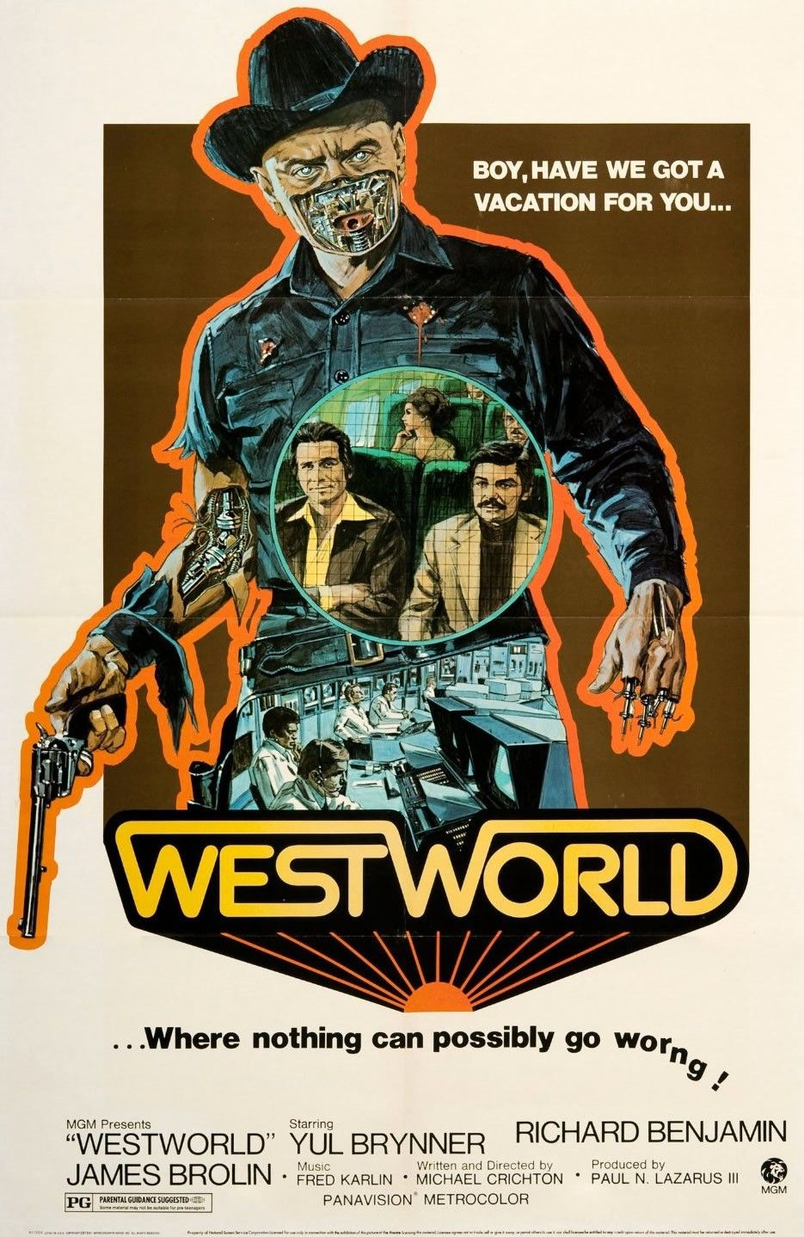
The general idea of Westworld is maintained in the series but is developed much further diving deeper into the existential questions surrounding robotics and artificial intelligence. Although the film is forward thinking, the questions Westworld (2016-) asks were all but impossible to conceive in 1973. Watching the film after the series feels deeply unsatisfying. The depth of the series is not achieved in the movie, and while this depth is not necessarily required to develop the storyline that both Westworlds follow, the film feels as though it is lacking in retrospect. This is not to deny or overlook the film’s almost prophetic human/robot interactions and its influence on the 2016- series, only to say that the series offers a richer text to analyze and perhaps a more satisfying cinematic experience.
Figure 1: 1973 Westworld film poster

Westworld 2016-
The 2016 series adaptation of Crichton’s film offers the same basic premise on first glance. HBO’s tagline on their streaming platform HBO Max states simply, “In this series set in a futuristic Wild West fantasy park, a group of android ‘hosts’ begin to deviate from their scripts.” In this bare description the core of Westworld is there, but the nuance and intrigue are thrown aside. The series begins with the Delos labs, and a disembodied voice commanding “Bring her back online” (Westworld 2016; S1e1). The lights in the lab begin to flicker on and a woman sitting alone comes into focus. As the setting becomes clear, the voice questions her and our initial assessment of the situation falters. Already there is a stark deviation from the film less than 30 seconds into the series. This insight into the background of the hosts—even in this vague introductory way—allows us to see and invites us to look for discrepancies in the characters and question their role as human or host.
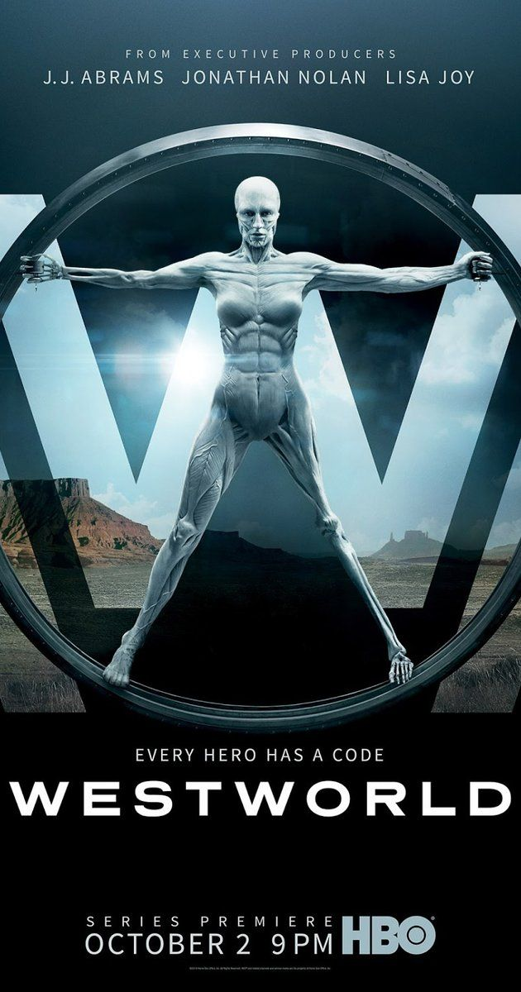
Season one is where I am focusing my analysis. In this season we are introduced to the key characters whose storylines we follow and the larger existential questions that drive the series are posed. Guiding both the season and this paper is the question: Have you ever questioned the nature of your reality? The season follows the hosts as they gain consciousness of their surroundings in meaningful ways, as they recognize their lack of agency within the park, and the guests as they start to see the hosts’ scripts change from their usual storylines. Using the visual language of the classic Western film—coming in on a train to a dusty central strip of storefronts, easily identifying the ‘good’ guys and the ‘bad’ guys because it is made out to be so simple as a choice of hat—we as the audience are lulled into a sense of complacency in our expectations of the season. Even after the introductory scene in a lab identifying the uncanny resemblance of host to human, the power of an understood visual language like the canonized Western film genre allows us to overlook the discrepancy and imagine the series as a familiar story.
Figure 2: Westworld (2016-) season one poster

Figure 3: Dolores & Peter Abernathy (holding a photo) on the front porch 00:45:55 (Westworld, HBO)Figure 2: Westworld (2016-) season one poster

Characters
The key characters in this season are Dolores Abernathy, William/the Man in Black, Maeve Millay, and the landscape. Dolores is the first figure we see in the series and the oldest host in the park. Dolores is the character through who we see the most clear and immediate struggle with consciousness. In episode one her day is repeated over and over until finally a found image of a woman in New York City’s Times Square triggers a breakdown of the coded reality in which the hosts exist. The inability to cope with and comprehend this unknown image alters the reality of the park and set us on an unknown path. It is through Dolores’s eyes and through her decisions—if they even are hers—that we begin to understand the world of Westworld.
William and the Man in Black expand Westworld and open the door to imagining a timeline of the park, of the origins of the hosts, and the outside world. Through William/the Man in Black the question of morality as a choice is presented in human form. As a guest rather than host, the humanity (or lack thereof) in this duplicate and contradictory character offers us the opportunity to ask the same questions asked of the hosts and project them onto a character more similar to ourselves. How much of our own humanity is our own? Is our agency real or imagined? How much of our lived reality is real, and how much is imaginary? Is any of it that simple?
When William enters the park he ties the real world to Westworld. He chooses the white hat, takes the moral high ground, plays the role of the good guy. He attempts to follow the moral codes and expectations of him outside of the park while being pulled deeper and deeper into the storyline of Westworld where the expectation is hedonism. His focus in this season is on helping Dolores achieve her goals and work out her role as a newly conscious host by going on a quest for a mythic maze incorporated into the park. Along this quest William is conflicted by his responsibilities and agreements at home, his executive role at Delos, and his increasing personal involvement in the immersive world of Westworld.
As we watch William make these decisions, we also see the Man in Black create chaos, violence, and act reprehensibly without remorse in the park—in many ways he is a classic Clint Eastwood cowboy. The Man in Black is also on a quest for the maze and is willing to raze the park to the ground on his way. He hopes finding the maze will allow him to beat the game. As the season progresses and it becomes clear that these two opposing characters are the same person in different time periods. As I explain later, the opposing double vision of this character brings into question the role of landscape in our decision-making and in our moral integrity. How can guests or humans imagine themselves different than the android hosts in the park when we are in many ways following the same scripts and the same patterns enacting minimal agency.
Maeve Millay is another host through which we are allowed to see the trajectory of burgeoning consciousness and agency. Maeve is written into multiple scripts. We meet her first as a brothel owner, and through memories creeping into her current coding we see her in the role of a single mother. The unexplainable memories initiate Maeve’s journey towards consciousness and awareness of her own lack of agency. In a similar vein to Dolores seeing the image of Times Square, these visions of an unknown other send the hosts spiraling towards a chaotic future of their own making. Maeve believes in her memories almost unquestioningly believing them to be the key to her freedom, the release she seeks from the scripts she is set to follow. Through Maeve we see another side to burgeoning consciousness along with Dolores and are privy to the many modes of autonomy that the hosts stand to gain once they are made aware of their station.
Finally, the landscape acts as a character in its own right. The backdrop of the American West shapes the characters the hosts are scripted as, the roles the guests temporarily perform, and our expectations as an audience for the trajectory of the series. Our collective imaginary of the West as a barren landscape open for the taking, filled with stoic ranchers and noble cowboys working out law and order in a newly settled wilderness is largely that—an imaginary. Westworld plays into this vision of the American West and amplifies it in the episodic repetition of the hosts storylines in the first part of season one. Utilizing the iconic landscapes of Monument Valley in Utah, and in doing so calling back to classic Western films, the setting of Westworld draws on the aesthetic language of the Western film genre to place the series into familiar visual territory. As viewers all we need to do is see the landscape to know with relative certainty the characters we will meet and the action that will take place.

Contextualizing Westworld
Westworld’s self-awareness as a series that both reinforces and subverts notions of space and genre lends itself to critical geographical inquiry. In my interpretation of the series, I take a text-centered approach which both includes and acknowledges the current reconceptualizations of the real and reel of Westworld’s serial Western. As Sharp and Lukinbeal (2015) note, “textual inquiry assumes that cultural products and practices, such as landscape or film, are systems of signification that can be interpreted if one knows the ‘language’ in which they are written (24-25). The language of Westworld is simultaneously that of the classic Western drawing on masculine characters and landscapes to create a broader vision of American cultural norms, and a subversive reading of the classic Western that allows audiences to question the visual cues they are currently reading. Looking at film as text ties film geographies to film studies which have typically situated film within the body of literary analysis and textual metaphor (Sharp & Lukinbeal 2015, 24). Adding the geographical element to film studies contextualizes film analysis within the broader space of production, filming, and consumption (Lukinbeal 2005; 2009; 2015) while also providing “a unique opportunity to study the nature of American society because of its immediate concern with narratives of place” (Holmes et al. 2004, 278). This study of place and specifically of American society is especially potent in the Western genre. The aesthetic vision of the frontier is iconic in its repetition in film and mythic in its perpetuation of an ideal of the American West.
The image of the West is grounded in a hypermasculine vision of American nationalism. The Western as a genre prioritizes stoic male characters as individually capable of taming an untamed Wild West. Acknowledging this generic baseline for the Western, I expand on our language of understanding filmic aesthetics by incorporating Jacques Rancière’s aesthetic politics into my analysis. Rancière distinguishes aesthetics as a way of interpreting the world, from art as a tangible, material object (Vallury 2009, 229). Aesthetics is applied not as an articulation of specific imagery, but as a lens through which we view and assess media. Rancière’s writing hinges on “the fundamental axiom of intellectual equality;” everyone begins with the same intellectual capacity, but it is altered and reshaped by social and political processed (Rockhill & Watts 2009, 11). In Westworld this is functionally complicated by the hosts’ existence as artificial intelligence, but in terms of textual analysis of film and a suspension of the real during viewing, this practical look at the different intellectual capacities of humans and artificial intelligence is less important than the series’ presentation of hosts as in the process of becoming almost human. In the hosts’ process of becoming, they are made aware of their condition of oppression creating a gap of opportunity where fundamental change is possible—what Rancière terms the distribution of the sensible (Rancière 2004, xii and 7). In essence, Rancière argues that our consciousness is a gateway to our emancipation. A similar argument shapes Westworld’s story.
Rancière’s focus on the process of emancipation is similar to the goals stated by feminist geopoliticians. As Williams and Massaro (2013) write, “feminist work in the field of geopolitics aims to move beyond critique, providing the vitality to animate social change” (753). Geopolitics originated as practical state-craft focused on creating and maintaining a sense of nationhood and power. Critical geopolitics response to this top-down approach displaces the sense of naturality of the state accepted by classical geopoliticians and re-contextualizes nationhood as a social construction shaped by cultural processes. Feminist geopolitics pushes this critical lens even further “challenging the boundaries of the (geo)political” by viewing the intimacies of everyday life as fundamental sites of geopolitical action, and subsequently enabling feminist geopolitical analyses to function as “more than critical practice or armchair theory” (Williams & Massaro 2013, 752-754). If we can “reconceptualize the state as the outcome of a range of practices and processes,” then geopolitical intervention can be “extended well beyond the actions and policy discourses of a state-centered elite” and into “sites as ‘unofficial’ as art, film, and literature” (Carter & McCormack 2006, 231). Moving beyond the sites of ‘official’ state-craft and of academics writing critical theory, television takes us directly into the intimate spaces of the home and our quotidian interaction with on-screen media.
While feature-length films have received consistent attention from geographers since the mid-twentieth century, television has “received surprisingly little in-depth attention from political geographers” (Glynn & Cupples 2014, 274). This may stem from a cultural lack of seriousness surrounding this medium, or a perception of television as being lazy or casual (Hay 2013); however, television is a medium worthy of attention precisely because of its “everyday use for negotiating social and political (and therefore geopolitical) realities” (Glynn & Cupples 2014, 274). Westworld presents a series of episodes that raise questions about our conceptions of place, power, and media in a way that allows us to critically analyze the visual origins of these inquiries. The complex storytelling present in Westworld does not cater to lazy or casual viewership, and the length of the series (ten episodes each running at least an hour in season one) creates a sustained and intimate interaction with media that acts as both entertainment and critical challenge to hegemony. Approaching Westworld from the perspective of what could be termed a critical feminist aesthetic geopolitics opens space for new filmic landscapes to be taken seriously as disruptive and emancipatory sites.

Analytic Lens

My research focus is on how a series like Westworld can exemplify a visual emancipatory politics. To achieve this, I am compounding three methodological lenses: feminist geopolitics, film studies or film geographies, and aesthetic politics. Using a feminist geopolitical framework, I focus on questions of agency, mobility, and structured gendered roles. In drawing directly from feminist geopolitician Jennifer Hyndman (2001) I can look at Westworld and ask, “security for whom?” Is security focused on individual bodies (hosts, guests) or on hegemonic structures and organizations (Delos, social hierarchy)? The film geographies concepts that interest me most are Aitken & Dixon’s (2006) real-reel dichotomy where what is shown on screen (reel) affects how we interact with and interpret real landscapes, and Lukinbeal’s (2005) use of cinematic landscapes to discuss the constructed and power-laden nature of landscapes. This language strengthens the ideas I highlight in the series by tying them to a previous body of scholarship.
Including Rancière in a geographical interpretation of a series is perhaps where my thesis diverges from other film geography scholarship. His language of the distribution of the sensible—where in order to change the condition of one’s oppression, they must first become aware of the production of oppression—is useful in articulating the existential aims of the storyline as a whole (Rancière, 2018). This language is not often employed in film geographies but has been used in art and aesthetic geographies. The addition of Rancière’s aesthetic politics not only deepens my argument that Westworld helps us visualize both hegemony and emancipation through its visual language, but also ties my research to a longer philosophical conversation surrounding language and visual media.

Analysis
A series like Westworld offers a plethora of storytelling options only available in long-form visual media. Were this reimagining of the 1972 film to remain a 90-minute stand-alone film, we would not see the weight of Dolores’s repeated day in the same way as shown in episode one. In the first episode, “The Original,” we see Dolores begin her day four separate times in a single episode. This explicit circular narrative emphasizes the importance of loops in the series more broadly and asks us to look closely for minor discrepancies in each day. In a series focused on depicting the process of gaining consciousness and agency, repeating the same scene multiple times in a single episode highlights the reverberating effects of individual choice. It is not only the tangible effects of choice, but also a matter of perspective that shades each vignette in episode one. Dolores repeats the line, “Some people choose to see the ugliness in this world, the disarray. I choose to see the beauty,” and while the verbatim repetition indicates a scripted line written into her code it also sets the tone for her character shift as she becomes aware of her positioning in the park.
This brief look into episode one of Westworld gives a glimpse of the depth and detail of each episode in the series. I am approaching each analysis as a new look into each scene culminating with critical feminist geopolitics which will act as a conclusion and bring all three lenses together. I am looking at scenes from episodes one, three, four, eight, and ten. Each scene I’ve chosen examines the complex pathways of blooming consciousness as they present within each character’s journey toward emancipation. This begins with episode one, “The Original,” working as a grounding example of my analytical lenses, and each subsequent scene further complicates and exemplifies how characters come to understand their positioning within the park as a whole.

Westworld Through the Lens of Film Geographies
The cinematic landscape of Westworld draws on the extensive visual history of the Western as well as contemporary social anxieties surrounding the progression of technology and artificial intelligence. It is a complex representation of familiar tropes and not-yet-fully realized techno-social relationships. This section will focus on Westworld from a text-centered approach as summarized by Sharp and Lukinbeal (2015). Analyzing scenes from this perspective constructs “meaning within the film’s diegesis and mise-en-scène,” but also relies on a “temporary stabilization of textual meaning” (Sharp & Lukinbeal 2015, 21-22). Following this logic, my analysis of the following scenes could be completely different had I viewed them in a different place or at a different time. If I did not have the previous intertextual filmic language of Westerns to contextualize the series’ references, the scenes I chose and the references I highlight within them would be undoubtedly altered. Drawing on this intertextual visual language of Westworld, I begin my critical engagement with the series with an analysis of a scene from the series premiere.

A Question You’re Not Supposed to Ask: S1e1 “The Original” 00:45:12-00:46:47
Dolores is viewed from above, opening her eyes and waking up to restart her loop for the second to last time in this episode. Following her script, she walks to the porch to greet her father, Peter Abernathy. A rift opens in this script when she sees that he has stayed on the porch all night. He has found a photo in the dirt that shows a woman standing in Times Square. Within the landscape of Westworld, the Abernathy’s only geographical referent is the ranch they live on and the main strip of town Dolores rides into every day. For the hosts in the park Times Square is non-existent. The place name would be incomprehensible on its own, but the visual representation of a place that does not exist ignites a central conflict in the series.
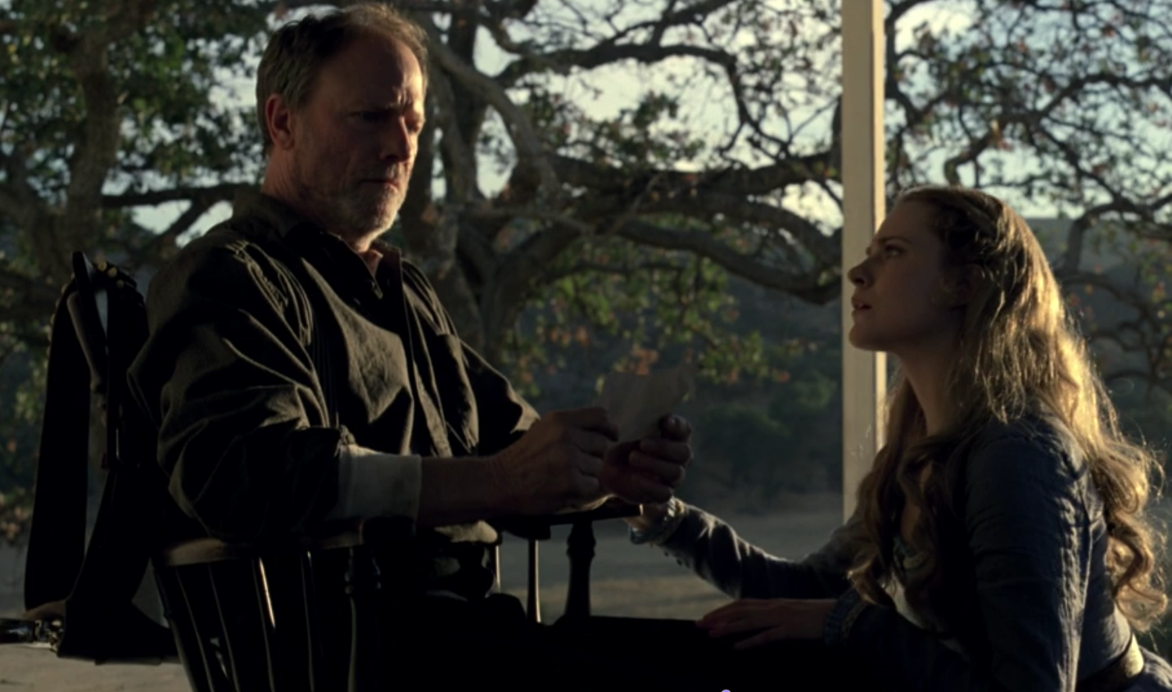
There is a stark contrast between the familiar geographies of the American West—wide expanses of open plains, empty and seemingly infinite desert, or in the case of this scene a wooden house with a large front porch on a big plot of land—and the bright, visually inundating space of Times Square. This oppositional extreme is difficult to fully comprehend simultaneously even knowing both locations are real as spectator rather than character. In this scene, the presentation of an unknown physical landscape creates a new internal and emotional landscape within the characters. The “reel” presentation of a reality that is incomprehensible within the confines of the film sparks a new reality for the hosts where even in a state of shock Peter Abernathy is able to articulate, “I asked a question you’re not supposed to ask, which gave me an answer you’re not supposed to know” (Westworld S1e1 “The Original” 00:45:46). While the likelihood that this line is a remnant of a previous code is high, the fact that it is what he pulls from a memory of another storyline indicates some understanding of his positioning even if it is not yet a conscious grasp. The sharp blow of a new and unexpected reality outside of what is known in the park allows Peter to search for explanation and in a frenzied search for meaning find an initial questioning of the controlled landscape surrounding him.
Figure 3: Dolores & Peter Abernathy (holding a photo) on the front porch 00:45:55 (Westworld, HBO)
If the analytic aim of the real-reel dichotomy is to contextualize the control of “space that is mediated by power relations [and] binary logic,” then in this scene the binary logic of controlled space takes on new life (Lukinbeal 2005, 4). The park is an extreme example of a policed landscape. What exists within Westworld is designed as a fully customizable representation of the American West; occupants of the park, both guest and host, are still in a confined space regardless of how real or expansive it appears. The visual representation of an unreal landscape—Times Square—allows Peter to question the binary logic of the park, “a question you’re not supposed to ask,” and conceptualize, however loosely at this point in the narrative, a new and different reality, “an answer you’re not supposed to know.”

Two Versions of Dolores: S1e3 “The Stray” 00:48:02-00:51:42
In this scene we leave behind the scenery of the West and occupy a dark, clinically sterile room. Sitting down, facing one another Dolores is questioned by Bernard, a Delos employee. At the beginning of their conversation Dolores smiles warmly and maintains her slow drawl, written into her code to create a full fantasy of the American West from cliché storylines to entertain guests, to costuming indicative of an imagined past, to the sonic landscape of player-piano versions of Radiohead songs and affected pseudo-southern accents for the hosts. She falls back on familiar lines: “Some people choose to see the ugliness in this world…” before Bernard stops her and commands her to lose all scripted responses (Westworld S1e3 “The Stray” 00:49:01). This command disrupts the fantasy of Dolores as a character when her face relaxes, and she drops her affected drawl reminding us of the constructed nature of the park.
As much as the human characters in the series buy into the imaginary of the park’s landscape, the series’ reliance on familiar filmic landscapes allows us to suspend reality as viewers and believe what we are seeing is representative of Western landscapes and lifestyles. Moving between Westworld and Delos creates dissonance between what we expect to see based on our previous visual references and what is happening on screen. The different locations in the series hold different expectations of character behavior and language as indicated in this scene, but the contrast between the park and the real world is also visualized by cooler lighting, modern architecture, and a clinical dehumanizing gaze directed towards the hosts. Within the park, the difference between host and human is minimal because the hosts create a believable landscape. Inside Delos, we are forced to remember that Westworld is a space of unreality.

Dreams or Memories: S1e4 “Dissonance Theory” 00:08:20-00:10:09
In episode four we are presented with a scene that exemplifies the way film can create affective landscapes. As Carter and McCormack (2006) write, “engaging critically with film is not only a matter of exploring how particular films work to rehearse or disrupt particular discursive codes and scripts,” it is also a consideration of the embodied affect of the visuals on screen, a compilation of representations of power, and a challenge to the hegemony of idea (236, 240). The dreamy distortion of sound and sight in this scene creates a disorienting representation of Maeve’s memory that goes beyond the space of human emotion and toward the more-than-human affect. Affect is described as “something both more and less” than a subjective emotion; it is “a kind of vector of the intensity of encounter between bodies (non-human and human) of whatever scale and consistency…a register of sensible intensity emerging from the relations between a multiplicity of processes, corporeal and incorporeal” (Carter & McCormack 2006, 234). A reassessment of the real-reel binary has incorporated haptics, corporeality, and affect into film geographies (Sharp & Lukinbeal 2015, 26-27).
In this clip we are transported back and forth between the recognizable landscapes of Westworld and Delos, but we are also taken to spaces in between existing somewhere in the space of an unfamiliar dream or memory. The vocals are distorted, an electronic buzzing fills the space of the bar, and everything is filmed in slow motion. Maeve is experiencing all of this in an almost paralyzed state of incomprehension. One of the men in the bar walks towards her, and as we hear his gun fire the screen turns white. When the scene returns, only a close-up of Maeve’s face is in frame. She appears to be lying down on an operating table, but each frame is double, or triple exposed with disorienting lights, medical screens and charts, and moving figures. Layered on top of this cacophony if disorienting visuals are fragments of conversations bleeding in and out of focus.
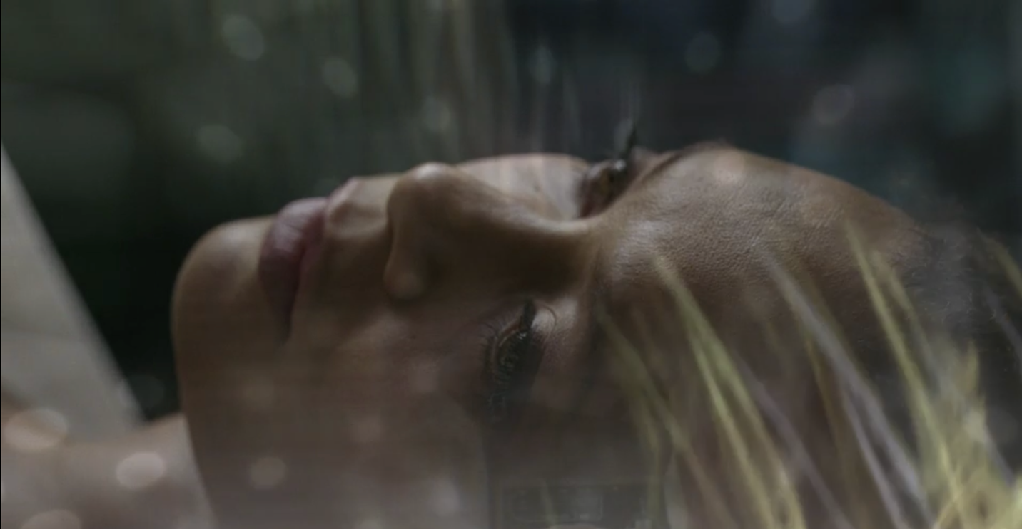
This scene goes beyond the binary interpretations of film as representational of reality and presents film as “geography in and of itself” (Sharp & Lukinbeal 2015, 26). Here, we experience the geography of Maeve in a space between and beyond the representational spaces of Westworld or Delos. In this affective visualization of memory, Maeve becomes the image of internal and emotional geographies. Viewing geography as more than solely physical landscape expands our language and understanding of experiencing and articulating geographies.
Figure 4: Maeve in dream-like sequence a memory of being reset in Delos Labs 00:09:46 (Westworld, HBO))

You Have Always Been a Prisoner: S1e4 “Dissonance Theory” 00:28:13-00:32:14

In a later scene in episode four, we return to the familiar geographies of Westerns. A horse and carriage race across the screen. We are in a part of the park clearly built to mirror the high desert of northern Arizona and southern Utah, a landscape suggestive enough to evoke visions of the outer reaches Grand Canyon. The ground is dry and low brush covers the dirt. This scene could take place in any handful of classic Westerns. This return to form places us back in the fantasy of the narrative. Inside the carriage, the Man in Black sits next to Lawrence, a host the Man in Black has used in multiple storylines to go further in the park. Even during the shot-reverse-shot dialogue within the carriage the landscape remains on screen framed by the windows. Canyons, steppes, and other iconic suggestions of a Western landscape roll along the screen behind the two men.
The focus on the landscape in scenes like this illuminates the importance of space in driving a narrative. Without the continued visual cue of the outdoor setting, the script would have felt less believable, less immersive. Had the exact dialogue of the scene (see Appendix D) been read in the space of Delos labs it would have felt out of place. The deep connection between Westerns as a genre and the physical landscape of the American West creates a specific language that relies on spatial iconography. The impression of reality in film hinges on our collective understanding of—perhaps even faith in—what is presented on screen. Westworld is in constant conversation with earlier Westerns, and its broad intertextuality with the genre prompts us to pick up on what is seen, yet often unsaid, to complete the narrative on our own.
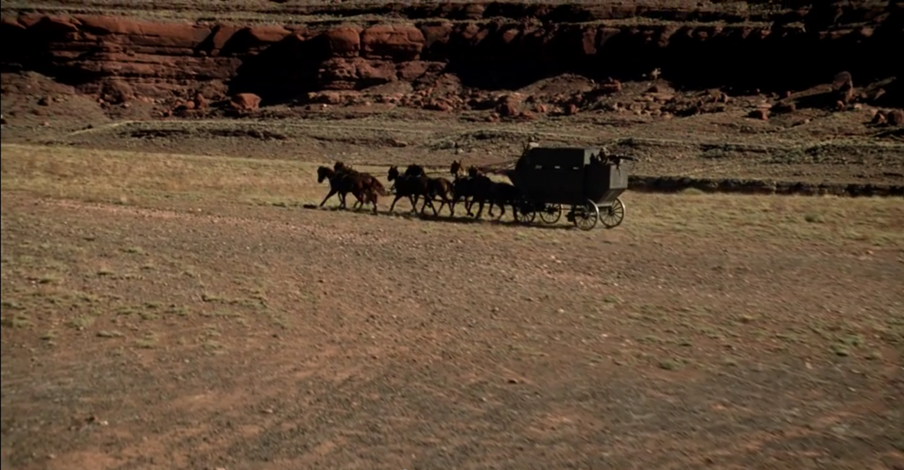
Figure 5: pan up from the ground to reveal the landscape the Man in Black and Lawrence are travelling through 00:28:16 (Westworld, HBO)

Truly Alive: S1e8 “Trace Decay” 00:49:42-00:52:45
This short three-minute scene is fast-paced and temporally complex. For clarity, I am choosing only a few necessary lines of description within this section of analysis (full description in Appendix E). The Man in Black tells Teddy Flood, a host narratively linked to Dolores, about a formative memory he keeps of his time in Westworld. Shifting into a flashback scene, he narrates, “I found a woman, an ordinary homesteader and her daughter…” (Westworld S1e8 “Trace Decay” 00:50:02). We see that this “ordinary homesteader” is Maeve from a previous narrative. The Man in Black continues, “I wanted to see if I was capable of something truly evil, to see what I was really made of” (Westworld S1e8 “Trace Decay” 00:50:29). He enters the home and in slow motion we watch as he attempts to slaughter Maeve and her daughter. Maeve refuses to die without trying to save her daughter and she carries her out of the house, away from the Man in Black. This final scene is framed within the doorway of the home as the Man in Black watches her run.
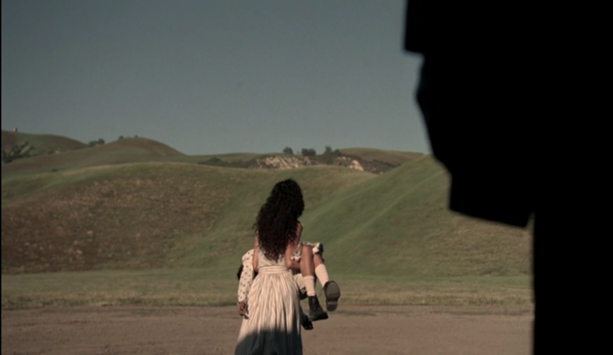
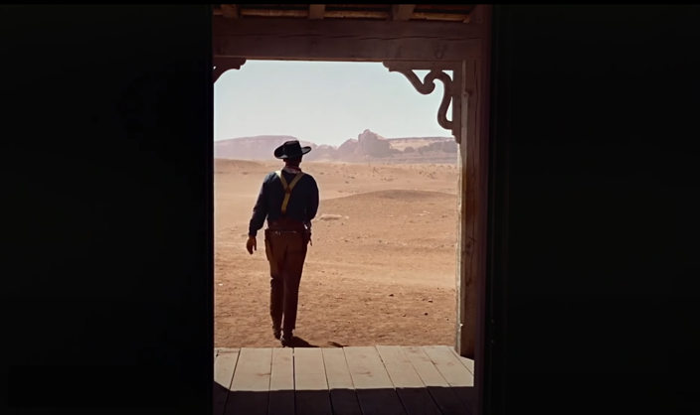
This scene meshes together a handful of different characters and storylines when taken as a part of the entire season. Standing on its own, however, we can see more clearly the particular intertextual vision of Westworld. In the generic description of Maeve’s character as an ordinary homesteader who loses her daughter, and more specifically in the framing of the final shot this scene is transparent in its intertextual referent. The similarities to John Ford’s The Searchers (1956) are only just below the surface of this flashback scene. References to this iconic Western are so visible when looked at in this stand-alone scene that it almost complicates how we view the story told in Westworld. Clearly, the writers have done their homework and have framed this particular scene intentionally. It functions as a way to continue to lull viewers into a familiar sense of narrative trajectory—does this look familiar? have I seen this episode before? —while also illuminating the constructed reality of the park. The landscapes so viscerally affective to the characters in the series are just riffs on a classic movie; the names and faces may have changed but the iconography is so deeply enmeshed in our perception of the West that it feels natural on screen. Without a closer look, this clever scenic recreation could pass by without raising a question.
Figure 6: Maeve carries her dying daughter out into the field attempting to save her from the Man in Black; "She was alive, truly alive." 00:52:00 (Westworld, HBO)

Figure 8: William rides to find Dolores 00:33:49 (Westworld, HBO)Figure 6: Maeve carries her dying daughter out into the field attempting to save her from the Man in Black; "She was alive, truly alive." 00:52:00 (Westworld, HBO)
Figure 7: The final scene of John Ford's "The Searchers;" John Wayne framed in the doorway (The Searchers, Warner Brothers)

Figure 6: Maeve carries her dying daughter out into the field attempting to save her from the Man in Black; "She was alive, truly alive." 00:52:00 (Westworld, HBO)Figure 7: The final scene of John Ford's "The Searchers;" John Wayne framed in the doorway (The Searchers, Warner Brothers)

Where our Paths Lead: S1e10 “The Bicameral Mind” 00:29:36-00:39:26
This ten-minute scene in the middle of the season finale ties together a thirty-year history within the park. The Man in Black stands over Dolores and laughs as she tells him that William will come for her. He smiles as he says, “William. I’ll be Damned Dolores; you do remember some things after all. It just so happens I knew a guest named William too” (Westworld S1e10 “The Bicameral Mind” 00:30:37). The Man in Black begins to tell Dolores William’s story, and we are suddenly transported to a camp full of dead soldiers. In this flashback—a memory? or maybe just an imagined visual of someone else’s memory? —time accelerates, and it is difficult to follow when we are positioned in the timeline of the series. We see William and Logan, his future brother-in-law, move across verdant low mountains, to arid desert, to high mountain grasslands. This final landscape positioned on “the edge of the park,” in an empty expanse of the unknown (Westworld S1e10 “The Bicameral Mind” 00:34:19). When the Man in Black finishes his story and it is clear that he is William, a montage of he and Dolores ensues: William and Dolores sitting in a field near her father’s ranch, then Dolores alone; the two of them walking through a desert cemetery, then Dolores alone; sitting together in a train car accompanied by Lawrence, then Dolores walking through the train alone.
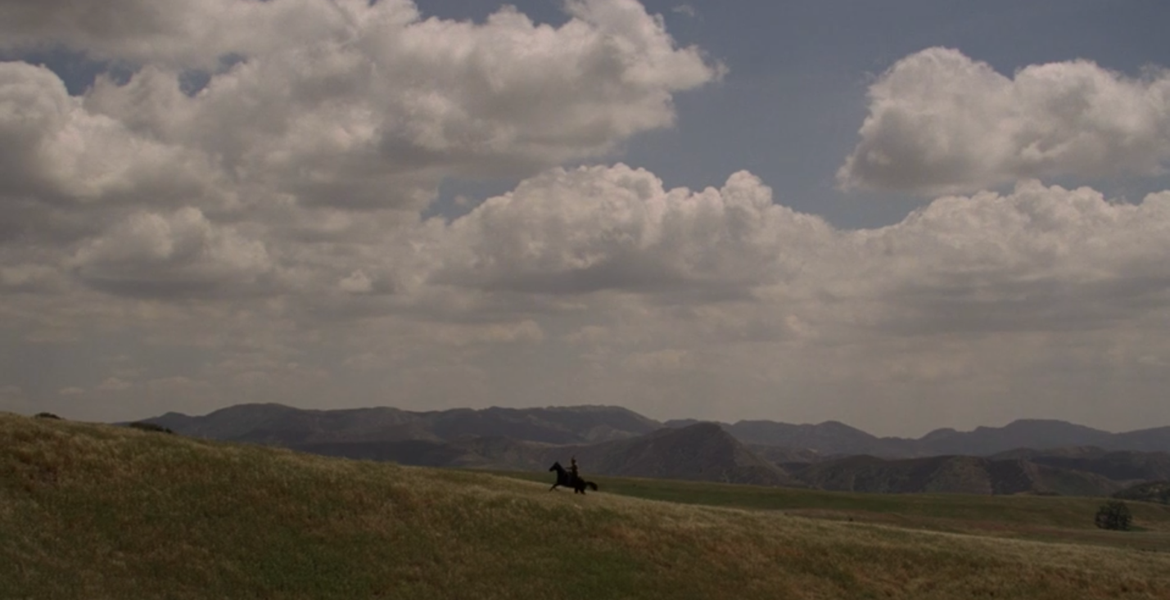
This scene travels the entirety of Westworld in ten minutes. We see William’s progression from classic masculine figure of the Western genre, to an internal reflection of the Western landscape as a location of “savagery” and “volatility” (Hyde 1993, 351). As Holmes et al. write, “Westerns are not so much about the West as they are about the Westerner. He stands alone, heroic, powerful, and fighting to the end for justice and order” (2004, 277). When William is unable to achieve his idealized ending, his heroic vision of order, after traversing the full expanse of Westworld, he rejects his previous romantic conceptualization of the park as a place of optimistic wonder and in turn begins to embody in himself this same hostility. He becomes a reflection of his geography, “he and his place in the world are so tightly enmeshed that they represent one singular ideal” (Holmes et al. 2004, 277, emphasis original). The transcendent landscapes William has moved through have not delivered on their dreamy promises of personal success, he has not been able to tame the Wild West and reshape it to his vision. Hyde’s metaphor of the eye as camera body, and culture as focusing lens fits into the disillusion of this scene (1993, 353). Every image of the West, every idyllic landscape painting of unimaginable places of opportunity recreated in film and concretized as myth in our collective geographic imaginary has shaped our belief in what the West represents. William, as guest rather than host, enters the park with these same cultural associations. When his visceral and embodied experience of these mythic landscapes does not align with his expectation, the deceptive image of the West is revealed as nothing more than fantasy.
Figure 8: William rides to find Dolores 00:33:49 (Westworld, HBO)

Westworld Through the Lens of Jacques Rancière’s Politics of Aesthetics
Discussing Westworld from the perspective of film geographies shows the cultural power of image in shaping our perceptions of place. The filmic, fictional reproduction of these socially constructed landscapes disconnects the site of the image from the real political sphere in which the material significance of place is formed; in understanding the reel landscape of the West as a fiction it becomes an apolitical space obscuring the real process of articulating and affirming hegemony through image. Incorporating Rancière’s politics of aesthetics into the same scenes from Westworld as above, provides a language with which I can further examine and deconstruct the myth of the West. Rancière (2004) writes that the political construction of fictions, or “material rearrangements of signs and images,” are preoccupied with the process of becoming—the process through which signs, images, and symbols gain meaning (35). Meaning is attributed to image through what is visible and invisible, what is said and unsaid, what is done and what is not.
In our current late capitalist social state, “the signs and symbols necessary for meaning production have ceased to have any relation to reality and instead are simulacra;” viewing film as simulacra, as “a copy without an original,” brings into question reality outside of the film itself as film exists as its own reality (Baudrillard 1994; Sharp & Lukinbeal 2015, 26). This brief overview of the semiotic origins of Rancière’s aesthetic politics contextualizes the denser philosophical language utilized in the following analyses. In order to construct a complete picture of emancipatory politics in Westworld, the production of signifiers of hegemony must be clearly articulated so we can begin to dismantle the authority of image as a singular truth. If historically geography has focused on film as a representation of reality (Aitken & Dixon 2006; Lukinbeal 2005; Lukinbeal 2009), Rancière provides an analytical framework to question what constitutes reality and who holds the power to (re)create it.

A Question You’re Not Supposed to Ask: S1e1 “The Original” 00:45:12-00:46:47
Peter Abernathy holds an image he is not supposed to see. He has stayed on the front porch overnight unable to cope with this new reality he is presented with: the existence of Times Square, a location outside of the park. He showed Dolores the photograph the night before to which she responded, “Doesn't look like anything to me” (Westworld S1e1 “The Original” 00:33:00). This is the scripted response hosts are coded to give when presented with information they are not allowed to know. Dolores asks her father what’s wrong and he stutters back, “I asked a question you’re not supposed to ask, which gave me an answer you’re not supposed to know” (Westworld S1e1 “The Original” 00:45:46). He struggles to hold himself together and pulls a visibly frightened Dolores in by her shoulders whispering something into her ear. It is revealed near the end of the episode that he whispered, “These violent delights have violent ends” (Westworld S1e1 “The Original” 01:04:15).
The image Peter sees has no reference in the reality that has been coded for him. Peter’s existence—all of the hosts’ existence—is created and controlled by Delos Labs. In this early crack in the façade of Delos’s vice grip on the hosts’ reality, Peter recognizes something totally new. What was previously invisible is now visible. The autonomous language of the hosts has yet to be realized and they fall back on old scripts, but their new organization of old lines indicates an early attempt to challenge the parameters of their speech. When Delos is made aware of this gap in their control of the narrative of the park, they are quick to remove the dissenting body. In the final scene of the episode, we see that Peter has been literally replaced by a new host (Westworld S1e1 “The Original” 01:05:30). The literary incorporation of the masses presents a challenge to those in power because if the masses are able to articulate their standing as a politically oppressed class, they can form communities outside of the control of the police (Rancière 2004, 36). Even in this early and unrealized challenge to the current state of social control within Westworld, Delos views Peter’s ability to see what is (in)visible and to communicate his incomprehension to another host as a threat to their hegemonic control of Westworld.

Two Versions of Dolores: S1e3 “The Stray” 00:48:02-00:51:42
In this scene, Bernard instructs Dolores to “bring [her]self back online” (Westworld S1e3 “The Stray” 00:48:17). At the beginning of their conversation Dolores falls back on familiar lines, “Some people choose to see the ugliness in this world…” but Bernard stops her before she can finish and commands she improvise (Westworld S1e3 “The Stray” 00:49:01). He asks her to imagine that there are two versions of her: “one that feels these things and asks questions, and one that’s safe” within the scripted confines of the park (Westworld S1e3 “The Stray” 00:49:24). Which would she rather be? Dolores looks quizzically at Bernard and says, “I’m sorry. I’m trying, but I still don’t understand. There aren’t two versions of me. There’s only one. And I think when I discover who I am, I’ll be free” (Westworld S1e3 “The Stray” 00:49:50). Bernard prompts an analysis of where this response originated in her code, but Dolores’s only response is “I don’t know.”
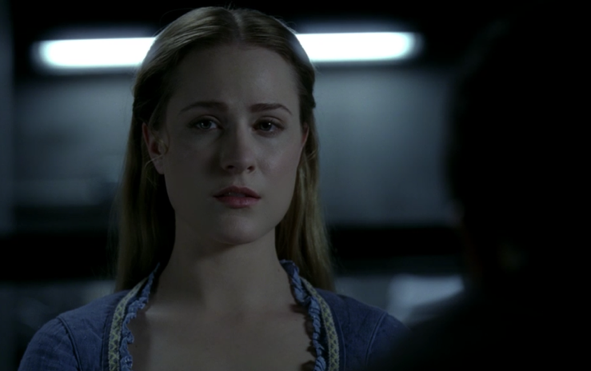
This interaction between host and human is more complete than the previous scene. The hosts’ ability to articulate their condition is gaining clarity. Where Peter can only ask a forbidden question and receive a forbidden answer (Westworld S1e1 “The Original” 00:45:46), Dolores imagines herself as in individual outside of the scripts of her code. Politics and political subjectivization occur as an awareness and vocalization of conditions of inequality. In this specific scene, Dolores is still only scratching the surface of her consciousness. She can’t quite place the site of production of her state of (in)equality, but in her articulation of her condition existing both within and outside of her social expectation and internal desire she describes a void. This void between our collective social conditioning and our individual agency is what Rancière (2004) terms the distribution of the sensible (xii, 7). It is not until episode four that Dolores is able to articulate her feelings, and in fact she expresses them spatially: “I feel spaces opening up inside me like a building with rooms I’ve never explored” (Westworld S1e4 “Dissonance Theory” 00:04:42). This self-description of her consciousness as an expanding space “opening up inside” is a step towards speaking into existence a new identity. The freedom that Dolores imagines at the core of self-discovery is an emancipation from the hierarchical regime—Delos, her code, the boundaries of the park—that has dictated her condition of existence.
Figure 9: Dolores sits in Delos Labs with Bernard; "I think when I discover who I am I'll be free" 00:49:51 (Westworld, HBO)

Figure 10: The Man in Black and Lawrence ride in a horse-drawn carriage; "If you did consider your choices, you'd be confronted with a truth you could not comprehend--that no choice you ever made was your own." 00:29:27 (Westworld, HBO)Figure 9: Dolores sits in Delos Labs with Bernard; "I think when I discover who I am I'll be free" 00:49:51 (Westworld, HBO)

Dreams or Memories: S1e4 “Dissonance Theory” 00:08:20-00:10:09
Maeve’s reality is disintegrating around her. A distortion of sound accompanies disorienting imagery. Maeve is in a bar, she is lying on the ground, she is watching the world in slow motion, she has been shot—has she, really? —she is being taken away by a Delos cleaning crew, she is in an operating room, suddenly she is back in the bar. All of this takes place in the span of less than two minutes of film. This scene is temporally opaque. Have we watched a series of Maeve’s memories? Maybe it was a hallucination? Did it all happen concurrently? All of these situations remain possibilities, although the linear organization of filmic reality is less important than the visualization of Maeve’s experience within the span of this visually dense scene.
Maeve is stuck between a memory of her past code and her current storyline. When she becomes aware of her past-self, the tight boundaries of her scripted-self begin to loosen. Her process of gaining consciousness and wresting agency from an oppressive regime is non-linear. Her discovery of a previously unremembered reality is outside of the realm of the current aesthetic-political regime that dictates her understanding of the world around her (Rancière 2004, xii and 3). The memory she sees feels real, but it is a “quasi-body” of images decontextualized from its origin and without this context she can’t yet produce a “collective body” of understanding (Rancière 2004, 36). Lacking a complete understanding of what these images mean they become fractured and disincorporated; Maeve’s perception of the reality surrounding her fractures as well.
The fractal imagery of this scene mirrors Maeve’s process of understanding herself as a political body. Layering fragmented sounds over multi-exposed images is an effective way to visually convey the void between Delos’s scripts for Maeve and her experience of this coded condition. As Rancière (2004) writes:
Suitable political art would ensure, at one and the same time, the production of a double effect: the readability of a political signification and a sensible or perceptual shock caused, conversely, by the uncanny, by that which resists signification. In fact, this ideal effect is always the object of a negotiation between opposites, between the readability of the message that threatens to destroy the sensible form of art and the radical uncanniness that threatens to destroy all political meaning.
(59)
This dense description of “suitable political art” is perhaps best conveyed through an example: we can return to Westworld with a designation of the dreamy, kaleidoscopic visuals of Maeve’s visceral realization of her double condition. We see her struggle to comprehend the violent disconnect between her understanding of her surroundings when she looks around at her familiar setting but sees an unfamiliar action (“the readability of a political signification”); we see her newfound awareness of the confines of her code in the visual distortion of time and space (“perceptual shock caused by the uncanny”). The quick cuts and layered collections of sight and sound on screen communicate the difficult and almost incomprehensible process of imagining a new reality outside of familiar regimes.

You Have Always Been a Prisoner: S1e4 “Dissonance Theory” 00:28:13-00:32:14
The Man in Black sits next to Lawrence inside a carriage. Lawrence is in chains and dons an expression of contained but simmering anger at his current captive state. The Man in Black turns and says:
Choices, Lawrence. You know, you tell yourself you’re at the mercy of mine because it spares you consideration of your own. Because if you did consider your choices, you’d be confronted with a truth you could not comprehend—that no choice you ever made was your own. You have always been a prisoner.
(Westworld S1e4 “Dissonance Theory” 00:29:22-00:29:41)
Then leaning in closer to Lawrence’s ear says in a low voice, “What if I told you, I’m here to set you free?” before sitting back and smiling. This dialogue indicates the Man in Black understands the differing conditions of he and Lawrence on a deeper level than their current status as captor/captive. He throws his own agency in the face of Lawrence because he knows Lawrence has been coded to ignore this information. In a sense, the Man in Black’s assessment is correct: if Lawrence were able to see and subsequently articulate his condition of subjugation, he would likely face the same fate as Peter Abernathy in episode one. Lawrence’s status as prisoner is doubled as he is chained within the car and also chained within the confines of his coded condition of ignorance.
This scene is complicated further if we turn our gaze to the Man in Black. While he is able to see the hosts second-class status in the park, he is unable to see that the social conditions that created their utility in the park have also shaped the choices laid before him. He is a prisoner of the park just as much as Lawrence is. Where Lawrence is at the mercy of the Man in Black, the Man in Black is at the mercy of the narrative of Westworld’s fictional recreation of the West.
The Man in Black is further along in his process of political subjectivization than any of the hosts at this point by virtue of his experience as a human with the power to recognize and articulate his existence both as an individual and as a member of a collective society. He is not, however, actively engaged in politics because of his lack of literacy on the hierarchy of his own social conditioning. The Man in Black inhabits the void of the sensible, existing with “the part who have no part,” but he is not speaking into existence a new identity separate from his predetermined identity within a hegemonic regime (Rancière 2004, 8). Politics, as Rancière (2004) clarifies, is not the exercise and struggle to maintain or gain power,
It is the configuration of a specific space, the parceling out of a particular sphere of experience, of objects we take to be shared and stemming from a common decision, of recognized subjects to designate these objects and to focus them.
(37-38; Méchoulan 2009, 57)
Politics is the articulation of positionality. It is the articulation of commonalities, of shared reality, of determining the moral configuration of spaces and objects and actions. It is the ability to speak of (in)justice. In the dialogue of this scene, the Man in Black can articulate the reality he shares with Lawrence from a place of imagined personal power. He sees Lawrence not just as a prisoner in chains because that is how he sits in front of him, but as inhabiting a deeper sphere of imprisonment caused by the production of his social role and his inability to articulate this condition. In the hierarchy of the Man in Black’s reality he imagines himself at the apex. He views himself as the hegemonic body within the park with the power to imprison and the power to set free.
He in unable to see his own condition. He cannot begin to dismantle the hierarchy he exists within because he does not have the capacity to fully imagine it. He is stuck in a loop as tight as the hosts. Until the Man in Black gains the language to speak of his condition, until he becomes aware of the multiple forces at play in curating and determining the platter of choices in front of him, he will be unable to articulate that he is also at the mercy of something else. He is playing a role determined by his social positioning: father, businessman, philanthropist, cowboy in a white hat on a mission for justice, villain in a black hat in retaliation to his failure to adhere to these embodied expectations. When the Man in Black can articulate his shared sphere of experience with those around him that he imagines occupying a space of subjugation, he will become a political body capable of speaking into existence a new reality emancipated from the control of hegemony.
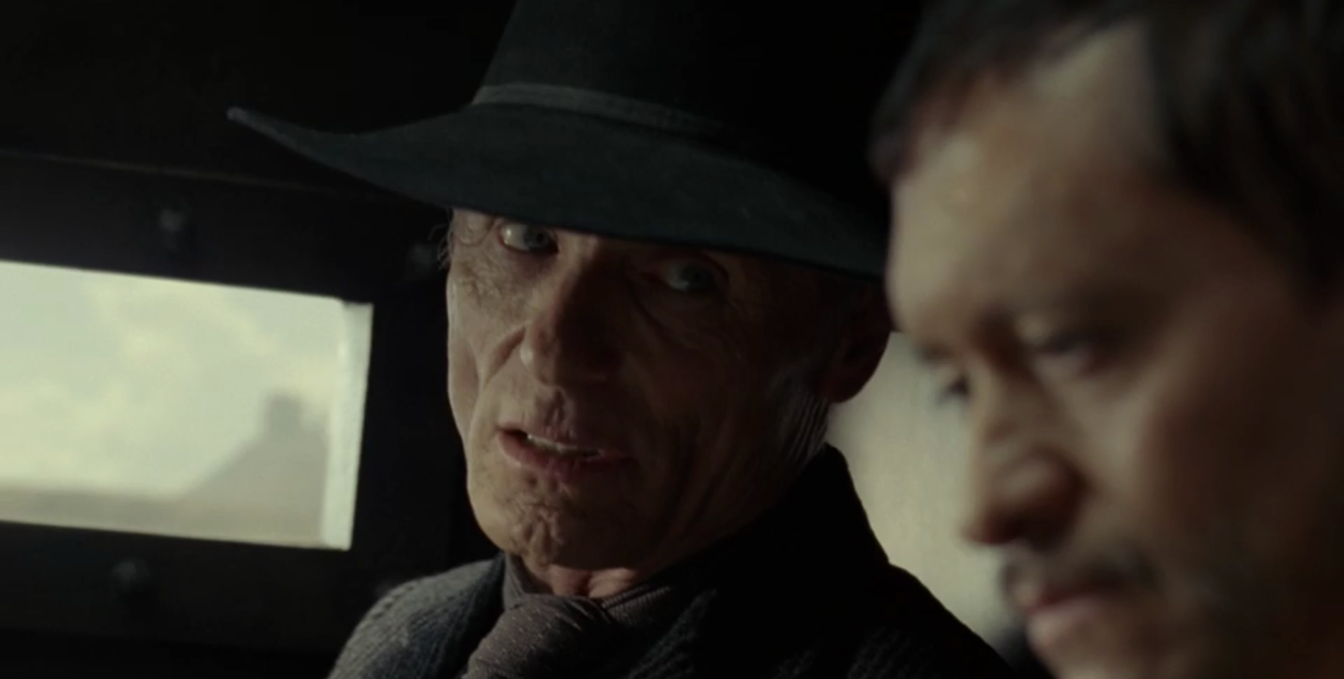
Figure 10: The Man in Black and Lawrence ride in a horse-drawn carriage; "If you did consider your choices, you'd be confronted with a truth you could not comprehend--that no choice you ever made was your own." 00:29:27 (Westworld, HBO)

Truly Alive: S1e8 “Trace Decay” 00:49:42-00:52:45
The Man in Black reveals his perception of the power of the park, “that's what this place does, right? It reveals your true self” (Westworld S1e8 “Trace Decay” 00:49:42). In an extended memory he recounts a test he designed to challenge the narrative power of the park, and his individual agency within its borders. “I wanted to see if I had it in me to do something truly evil. To see what I was really made of” (Westworld S1e8 “Trace Decay” 00:50:29). He attempts to kill a homesteader and her daughter just to see how he feels. He uses the parameters of Westworld to reassert the power he lacks in the real world.
Maeve quite literally attempts to walk out of her prison. She sets down her glass and walks swiftly through her crowded bar and out into the street, on a mission to remove herself from the space of her oppression. When a gunshot rings out, we are transported to the Man in Black’s memory and see that the homesteader he attempts to kill is Maeve. She asserts her agency in this memory and attempts to retaliate against the Man in Black, she refuses to die without first trying to live.
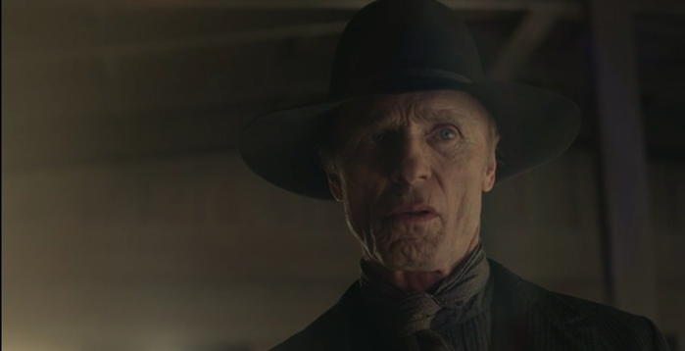
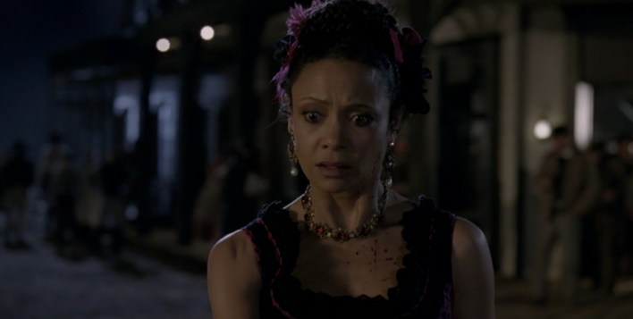
This collective sphere of existence between the Man in Black and Maeve is brought home through the visceral representations of violence on screen, and the quick cuts that move us between space and time, memory and reality. In the culmination of this embodied double memory, Maeve fights back against the Man in Black in her memory while in reality she stabs the host, Clementine, standing in front of her in the street outside of the bar. As the scene cuts back and forth between the present-day locations of Maeve and the Man in Black, and their past shared struggle to assert their individual power, we can visualize the messy reality of politics.
Figure 11: The Man in Black tries to kill Maeve, she fights back 00:51:16 (Westworld, HBO); Unable to distinguish memory and reality, Maeve kills Clementine believing her to be the Man in Black in the previous still 00:51:23 (Westworld, HBO)
Maeve is pushing back against an individual agent of her oppression before she has language to express what she is doing. The Man in Black is pushing back against the constricting conditions of his status outside of the park without the vision to see the challenge he is posing to the production of his oppression. The two of them are in the throes of an existential struggle to assert their agency as political beings, to dismantle the hegemonic regime that relegates them to a lower status and to reimagine a new identity for themselves that they have chosen. On the surface this is a struggle for individual power. In the context of emancipatory politics, it is a struggle to recognize the material conditions of oppression and to articulate the disconnect between their utility as a tool for those in power and their utility as a tool for the emancipation of the masses.
At the end of this scene, the Man in Black watches as Maeve carries her daughter out of the house and into the field. He believes that in that moment, in that final exertion of a will to live despite him, that “she was alive, truly alive, if only for a moment” (Westworld S1e8 “Trace Decay” 00:52:04). He is only able to articulate her humanity in the moment of extreme violence and pain. When Maeve and her daughter collapse to the ground, we see them lying in the middle of a maze. This image is representative of the path to consciousness and subsequent emancipation all of the characters are on. The Man in Black has seen this image and imagines it as a game for him to beat, a game designed for him alone. He is unable to see past his individual experience and articulate a collective reality. Until they are able to see their collective condition, until they can articulate their shared reality, they can’t begin to break down the hierarchies that keep them inside the maze. At the center of the maze is consciousness—the speech needed to challenge the heteropatriarchal corporate capitalist hegemony of Delos and enact agency to dismantle it.

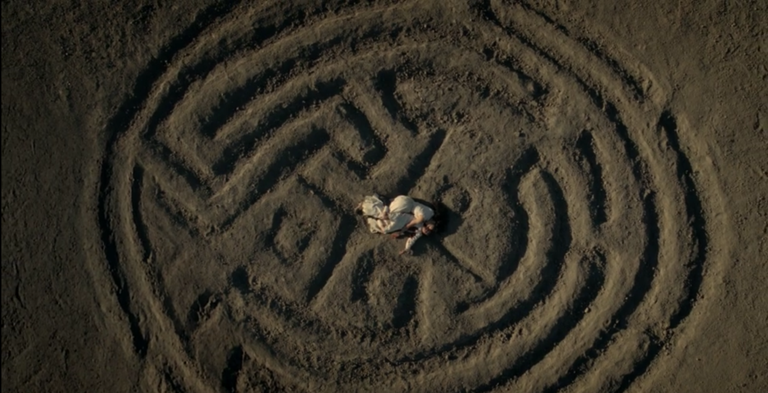
Figure 12: Maeve and her daughter collapse in a representation of the maze carved into the earth 00:52:21 (Westworld, HBO)

Where our Paths Lead: S1e10 “The Bicameral Mind” 00:29:36-00:39:26
The bicameral mind is first introduced in episode three, “The Stray.” This is the idea that primitive man believed his thoughts to be the voice of God (Westworld S1e3 “The Stray” 00:39:15). In this scene we watch a thirty-year history between William and Dolores pass by in under eight minutes. Presented in a montage of images: William and Dolores sit in a field where he offers her a cup, Dolores sits in the same field alone; the two of them walk through a desert cemetery, Dolores walks through alone; they sit in a train car next to Lawrence, Dolores walks the train car alone. In the same desert where William dropped the photo of the woman in Times Square (the image from episode one “The Original”), he and Dolores stand facing each other:
Where are we?
“We’re here, together.”
Then when are we? It’s like I’m trapped in a dream or a memory from a lifelong ago. One minute I’m here with you and the next-
(Westworld S1e10 “The Bicameral Mind” 00:39:20)
Dolores is left standing alone.
This quick succession of images shows just how many times Dolores has lived the same loop. The lifetime that carried so much emotional weight for William is a singular experience out of thousands of identical days for Dolores. Combining our definition of politics as a (re)configuration of space and experience and political art as a “negotiation between opposites,” we can look at this scene in detail as a visualization of aesthetic politics (Rancière 2004, 59; Rancière 2004, 37-38; Méchoulan 2009, 57). We are presented with a familiar Western epic (readability of political signification or message), and then immediately shown Dolores’s memory which removes us from linear narrative and instead shows a tight, closed loop of experience in a shot-for-shot recreation of image (shock of uncanny resisting signification) (Rancière 2004, 59). Dolores, in this memory, is able to visualize a reconfiguration of space outside of what she has been coded to see. She is presented with an image—one that she has produced rather than an outside image as in episode one—that resists signification. She sees in her memory an image that fractures her familiar understanding of reality and illuminates the space between what she is supposed to see and what she does see. In this visualization of the distribution of the sensible, Dolores is able to articulate her social condition.

Westworld Through the Lens of Feminist Geopolitics
Rancière provides an aesthetic framework through which we can visualize the political nature of Westworld’s emancipatory narrative. His language is, however, dense and self-referential and for all of its analytic value is still largely inaccessible to the masses whose emancipation he theorizes about. Taking a third and final look at these six scenes from Westworld, I put my previous analyses in conversation with critical feminist geopolitics. Feminist geopolitics is more than just adding gender to my geographical lens. Including an explicitly critical feminist lens in my analyses creates a fuller picture of how politics are enacted and embodied spatially; it allows us to once again reorient our gaze towards a vision of reality that prioritizes inclusive and embodied experience with more clarity than film geographies or Rancière can account for.

A Question You’re Not Supposed to Ask: S1e1 “The Original” 00:45:12-00:46:47
In this scene I have constructed a geographical reading where the real-reel dichotomy contextualizes the binary logic of the park as a space of the seen and the unseen. The incorporation of an unseen landscape (Times Square) into a policed space (Westworld) allows Peter Abernathy the space to question the reality of the Western landscape he inhabits and sees as natural. I have also presented this scene in terms of Rancière’s aesthetic philosophy. Peter’s ability to visualize what is (in)visible presents a challenge to the controlled narrative he exists within. The threat of Peter’s found image results in the physical removal of his body from the park in order to regain control of the landscape (Westworld S1e1 “The Original” 01:05:30). These readings are similar in their articulation of the power of image to shape the parameters of our geographies as well as contest and reorganize our mental and spatial borders.
These analyses focus on the image, or on what the image symbolizes for Peter. Looking again at these perspectives with a critical feminist gaze we can focus on the subject rather than the object, Peter Abernathy himself. Feminist geopolitics use scale to challenge our geopolitical assumptions. If we look at the individuals on screen instead of the broad disembodied geopolitics acting upon them, we can with more direct language assess the ways the bodies enact a spatial politic. Presented with an incomprehensible image, Peter stays outside all night rather than return to his home as his script dictates. Through this seemingly simple action of choosing to inhabit space in an unfamiliar pattern, he pushes back against the borders of his existence. This choice made in a state of extreme emotional stress results in the forceful removal of his body to maintain the status quo within the park. To Delos employees, even the image of Peter Abernathy is enough to pose a challenge to the tight borders of their spatial narrative.

Two Versions of Dolores: S1e3 “The Stray” 00:48:02-00:51:42
The geography of this scene is indicative of the ways that behavior and expectation are shaped and modified by location. Our expectation of Westworld is based in a visual language of what the West looks like, who exists there, and the action that takes place in this culturally loaded geography. When we are taken outside of this expected landscape and placed in Delos labs, our expectations alter. We are given space to reassess our assumptions of the reality of the West when presented with an opposing spatial imaginary. It is within this oppositional and liminal space of the lab that Dolores is able to engage in politics and vocalize her condition. It is within this space void of cultural meaning that she is able to articulate “I think when I discover who I am I’ll be free” (Westworld S1e3 “The Stray” 00:49:50). In this politico-spatial assessment of this scene we can see the geopolitics of Westworld play out in their most basic sense.
Taking this assessment further, we can look at the ways these two spaces of park and lab police the Dolores’s personal geopolitics. In this scene Bernard asks Dolores to imagine two versions of herself: one with ability to question her surroundings and one safe within her loop. Dolores is able to articulate the vision she has of herself only within the space of the lab because she has been instructed to contemplate—even in this small way—her existence. Inside the park, the geographical imaginaries that shape the Western landscape serve as symbols and reminders of her current role and prevent her from questioning it through a visual reinforcement of her status. When Dolores speaks about herself, the singular version of herself that she imagines is unfree, she embodies a geopolitical space that transgresses the status quo. In a space without the cultural weight of myth, Dolores is able to forge a new space for herself outside of the borders placed onto her.

Dreams or Memories: S1e4 “Dissonance Theory” 00:08:20-00:10:09
My initial analyses of this scene are perhaps already critical feminist readings. Maeve’s internal and emotional geographies are visualized on screen. The fractal images and disembodied distortion of sound create a more-than-human affect (Carter & McCormack 2006, 234). We get to see the embodied experience of Maeve’s memory. In this visceral presentation of corporeal geographies, we are also confronted with a representation of the difficult process of gaining and understanding the self as a conscious being. Her experience of this memory is outside of the realm of the aesthetic-political regime that dictates how she sees her reality, and the only way to accurately portray this disconnect is through an equally disorienting organization of sight and sound (Rancière 2004, xii, 3). Through this filmic representation of an experience that exists outside of time and space and only within the inner workings of Maeve’s mind we are able to rescale the boundaries of politics down even further to the conceptual space of memory.
While this assessment of affective geographies within this scene falls well within the realm of critical feminist geopolitics, it can be taken further to more clearly encapsulate the intersection of film and emancipatory politics. Representations of hegemonic power exist within literature and film—within culture broadly. What is seen and unseen, said and unsaid constitutes how these representations of power are understood (Squire 2015, 150-1). In this scene, Maeve says nothing. We do not hear how she feels about this experience. We are only able to see the disarray of imagery constituting her memory. In what is unsaid we experience the power over her speech (in a Rancièrian political sense) that Delos holds. But in what is seen, we experience a counterhegemonic visualization originating within Maeve herself. In seeing her embodied experience, we see the process through which she takes power as an individual body.

You Have Always Been a Prisoner: S1e4 “Dissonance Theory” 00:28:13-00:32:14
Combining the impact of spatial iconography and social expectation we can see the geopolitical nature of this scene. To return to Squire (2015), critical geopolitical representations of hegemony rely on the dispositive—"the said as much as the unsaid”— to be understood (150-1). Westworld’s representation of the West hinges on our collective understanding of what is seen, and often unsaid, to create a familiar narrative. This narrative is rooted the hegemony of the image of the West which in many ways becomes a cultural perception of reality.
The geopolitical power of the mythic space of the West is embodied by the Man in Black. In this scene, in fact in almost every scene he is in, he plays directly into the character of the Westerner. He tells Lawrence that he is a prisoner within the park, yet he is the one in full costume playing by the extreme rules of the game at every step. He is unable to see how perfectly he embodies the hegemonic vision of the West as a volatile space of violent individualism, as an empty space ripe for acting out our basest instincts. How could he see this embodiment? He imagines himself in control of the landscape and in control of himself. The vision he holds of the West, the landscape he inhabits, is so naturalized and culturally salient that he is unable to see the control it has over his actions. In similar form, without presenting the West quite literally as a constructed environment in Westworld we may not be able to see so clearly the ways the reality of the West is also constructed. Presented as a theme park, the socially constructed borders of the West are perhaps a little too visible; however, given the salience of this geopolitical imaginary, it may be necessary to have this metaphorical clarity.

Truly Alive: S1e8 “Trace Decay” 00:49:42-00:52:45
My previous analyses have highlighted the intertextual references of the characters and in the framing of shots, as well as the emancipatory struggle that tethers the characters to a collective sphere of existence. In this additional critical feminist analysis, I want to focus on Maeve’s character. Maeve’s body has previously been the site of haptic geographies (S1e4 “Dissonance Theory”), but in this scene it is multiplied. The key memory shaping her drive for emancipation is one of motherhood, of traditional gender roles shaped even further by its generic salience within the context of the Western. As Mullen (2018) writes:
Fictional texts can serve to articulate hegemony: ‘Indeed, fictional texts…are particularly important for the production of hegemony, representing sites at which a wide range of ideologies can be visualized, reaffirmed, and challenged.’ In the case of Westworld, fictional texts are multiplied…hegemony is explored not only within each of these fictional texts but also through their interplay (3; Savran 1998, 7).

I have looked at the hegemony of the image of the West as icon and myth, but in this scene the articulation of hegemony is complicated by both place and gender.
Maeve’s body is repeatedly mutilated on screen. In this scene alone we see her get shot and stabbed in two different timelines. The repetition of this violence is visually assaulting but it is well within the expectation of the Western. As McGee writes, “if violence is the figure of social regeneration in American ideology and myth, it is also the figure of social resistance in the counternarratives of that myth” (2006, 16). Maeve’s experience with violence is graphic and visceral, but it is also how she reasserts control over her body in later episodes when she intentionally puts herself in harm’s way so she can alter her code in the lab. Violence is written into the landscape of the mythic West, but it also exemplifies how counter-mythologies will be articulated in the West: through violence.
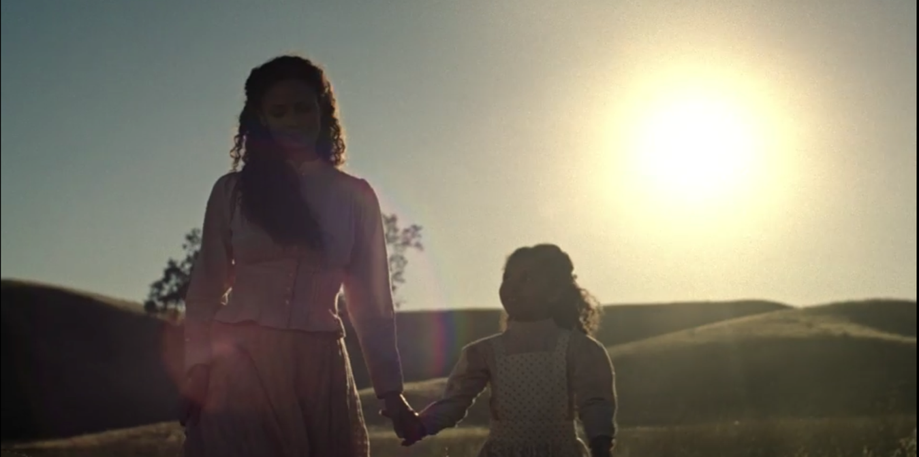
Maeve pushes back against the intimate control the space of the park holds over her body, but her motivation for doing so is still controlled by gendered expectations. Westworld is a recreation of an imaginary Wild West. In my assessment of this scene from the perspective of film geographies, I discuss how Maeve’s backstory and this scene in particular mirror an iconic Western film (see page 48 of this document). Within the confines of the narrative of the Western, Maeve’s options for imagining herself are limited. Where William/the Man in Black can inhabit any number of roles—good guy, villain, father, philanthropist—Maeve’s gendered body prevents this opportunity. She returns each time to the memory of motherhood. It is this version of herself that she fights to return to. The geopolitical space of the park hinders her ability to see a different or better role for herself. Her existence as a feminine body within a space (however mythic) still dictated by patriarchal norms places borders around her existence that do not exist for hosts and guests inhabiting differently gendered bodies.
Figure 13: Maeve in mother storyline, narrated by the Man in Black; "I wanted to see if I was capable of something truly evil." 00:50:03 (Westworld, HBO)

Figure 16: The Man in Black talks to Dolores about William; "William couldn't get you out of his head." 00:36:15 (Westworld, HBO)Figure 13: Maeve in mother storyline, narrated by the Man in Black; "I wanted to see if I was capable of something truly evil." 00:50:03 (Westworld, HBO)

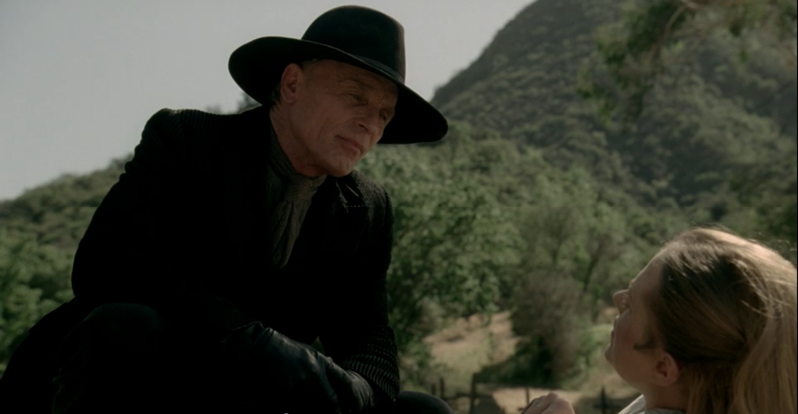
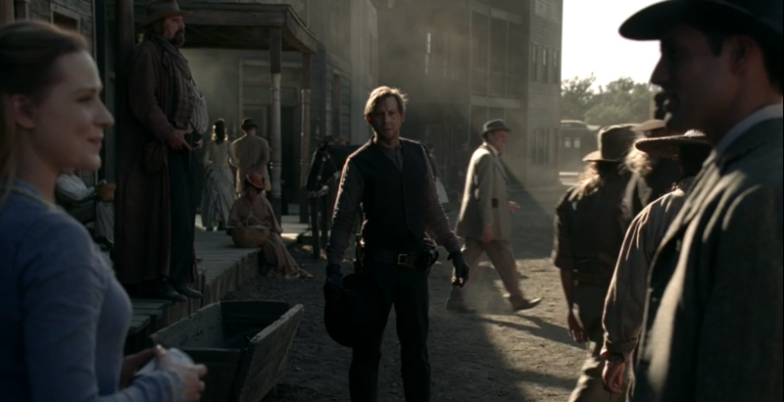
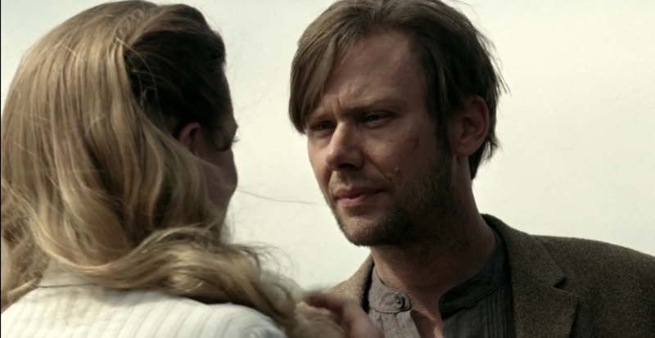
Where our Paths Lead: S1e10 “The Bicameral Mind” 00:29:36-00:39:26
Figure 14: The Man in Black talks to Dolores about William; "William couldn't get you out of his head." 00:36:15 (Westworld, HBO)
Figure 15: William realizes his deeply affective reality within the park doesn't hold the same permanence for Dolores 00:37:52 (Westworld, HBO)
Figure 16: "Where are we?" "When are we?" 00:39:12 (Westworld, HBO)
This extended scene could be analyzed as a paper in its own right. I have looked at it as a reflection of the Western genre in its broadest sense presenting imagery from almost every canonical Western film, stills that mirror transcendent landscape paintings, and the powerful myth of what the West holds and what it promises its inhabitants. I have also looked at how this scene articulates Rancière’s conceptualization of political art through Dolores’s memory of William which is at odd with her familiar reality. Both of these assessments are fine as they stand alone, but the power of this scene in particular is in the way it presents experienced geographies.
As Dowler and Sharp (2001), and Williams and Massaro (2013) remind us, “feminist geopolitics aims to ground geopolitical discourse in practice and place…to understand the way in which the nation and the international are reproduced in the mundane” (753). The flashback of William’s search for Dolores shows the full expanse of the park and the experiences William had that altered him as a person outside of the character he takes on in the park. His motivation to find Dolores forces him to do things previously unimaginable as he succumbs to the basest most violent storylines built into the narrative of Westworld. As he returns to the front of the park, he sees Dolores in the same spot he met her when he first entered the game. He expects her to recognize him, he expects her to have experienced the same things as he did. When she sees him, another guest walks up and hands her a can she’s dropped starting her narrative loop over again. It is as if William doesn't exist.
For William, this changes the way he sees himself. He has done things to compromise his moral character because of a belief in a shared spatial experience. When he realizes that this was his experience alone, he plays the game to an extreme killing without remorse and acting out unimaginable violence because he cannot comprehend that the rules of the park prohibit Dolores from experiencing it in the same way he does. The park has different borders for her both physically and mentally. In the lifetime of experience William has lived, Dolores has experienced the same day and walked the same path. William has focused on the large scale failure of his quest to find Dolores and act out this great myth of their relationship in the park, and in this he has missed the value of the mundane details of their experience. When Dolores’s memory is presented, it is a shared drink in a field, a walk through a cemetery, and a ride on a train that she remembers. These seemingly unimportant details of thirty years of experience ultimately unlock Dolores’s consciousness and allows her to articulate her standing as a political body. It is the mundane everyday geography of her loop that is the most valuable geopolitical space.

Results, Discussion, and Conclusion
Throughout this detailed analysis of Westworld’s emancipatory politics, I have attempted to suspend my critical feminist geopolitical vision in order to conclude with a reading that shows how it can finally be applied to the series. It is clear now, if it wasn't before, that this is an impossible task. There is no way to stop seeing things through a lens with which I have trained myself to see. In each assessment there is a feminist geopolitical leaning. In my writing on Rancière, I include aspects of characters’ individual positioning that he would never have written about. In my writing on film geographies, the language of feminist geopolitics bleeds into the scenic evaluation because I cannot see geographies without my critical feminist lens. This self-critique is not to dismiss the preceding analysis, but to say that a critical feminist methodology is part and parcel of this entire document. This methodology presents some exciting prospects for future analytical conversations about the geopolitical nature of film.
As this chapter has shown, I am not the first to write critically about the geopolitics of film. I am, however, happy to contribute to the limited body of geographical writing on long-form television series. As Glynn and Cupples (2014) write, “television should be understood as an important cultural forum because it tends to raise questions rather that answer them, and gives us the freedom to think, imagine, and deconstruct ‘common sense’” (274; Newcombe & Hirch 1983). In Westworld many of the existential questions are posed directly: “Have you ever questioned the nature of your reality?” is asked repeatedly throughout the series. Television more broadly presents a different spatial interaction than film. It is often watched at home, inviting these imagined geographies into our lives. It is imagined as a continuation each week and so leaves us in a void at the end of each episode, hoping to be invited back in. In the amount of time we sit with a television series, even for a single season, we are left wondering what will happen in the space between episodes; what will happen next season? What do we imagine the future of this reality to be?
In our imagined futures of imagined filmic realities, we are able to question the every day realities that surround us. As Hopkins (1994) writes,
The power of film may lie (quite literally) in its ability to misrepresent. This power is exercised by filmmakers to sustain an ideology of make-believe. This ideology is achieved through a medium capable of masking the production of its own signifiers. These signifiers dominate an audience whose willing suspension of disbelief and impression of reality are fabricated through their own iconization of film signs and the authority that viewers attribute to their own sense of sight.
(60)
This is particularly true in a reimagining of a Western like Westworld. Westworld is able to simultaneously tells us what’s coming next and leave us guessing. On a first, casual view of the series, every twist feels exciting and terrifying and completely unexpected. The iconic status of Western visuals allow us to wholly suspend disbelief because we often view theses visuals not only as an impression of reality, but as reality itself. On a second (or third, or fifth) viewing, it becomes clear that the writers have shown us what’s next each time. In the non-linear narrative of Westworld, visual cues taken from iconic Western films tell us both what will happen and what has happened over the course of the seasons thirty-year arc, if only we have the sight to see them.
Paquette (2020) offers two visions of emancipatory politics different than Rancière’s as I’ve written about here. In her book, she uses Wynter’s vision of emancipation to critique Badiou. Paquette argues that Badiou’s vision of emancipation does not account for race or racialized bodies and is therefore unable to be a truly revolutionary politic capable of articulating (in)justice. In Wynter’s vision of emancipation, she “offers a decolonial project that critiques coloniality,” and which is “meant to express a social condition and a collective state of mind (or social imaginary) that might accompany the lack of reflexivity within a given worldview” (Paquette 2020). In this presentation of a new language with which to articulate a politics of equality, we can see the ways that Rancière falls short of a full expression of justice in his dismissal (through what is left unsaid) of race, class, gender, and sex.
Badiou’s emancipatory politic, like Rancière’s is one of binaries and universal truths. In Rancière’s politics of the aesthetics the options for spatial organization are individual or collective, political or apolitical, aware or unaware, not intersectional. It is difficult to conceptualize the fuzziness of the process of politicization in binary terms. Politics are not so clear cut. Politics are messy and personal and embodied; they are economic, racialized, spatial, and gendered and sexed. As much utility as I found Rancière’s writing in my academic context, it is not totally useful in conceptualizing (in)justice as it is experienced in multiple bodies on multiple scales.
The analytic conversation presented here is an exciting contribution to film geographies and geopolitics. I am hopeful that the more is written about television, the more language we will have to assess media with a critical eye. The mundane politics of television happen withing the intimate spheres of our homes. With the expansion of our critical spatial language we can better understand how entertainment television shapes our perceptions of the world around us. The particularities of how television reflects a specific hegemonic vision of reality is perhaps a broader existential techno-social question than even Westworld has the capacity to exemplify. As we continue to articulate the impact fictional geographies have on our perceptions of reality, we come closer to articulating our own visual emancipatory landscape; one where we are able to see the multilayered ways in which power is represented on screen and are able to imagine a new more equitable landscape than the one presented to us.

Chapter 3: Moving Forward in New Space
Looking beyond the parameters of this thesis we can imagine a continuation of this research. Westworld has three full seasons available to stream and has been renewed for a fourth. The format and analytical lenses of this research could be recreated with episodes from later seasons to see how the hosts’ consciousness progresses, or how the world outside of the park is represented. My research could be expanded into a dissertation on Westworld more completely rather than as a curated selection of a single season. Another film geographer could choose to focus on a different analytical framework than I have, perhaps choosing an author-centered or reader-centered approach where I have looked at the text (Sharp & Lukinbeal 2015). Moving outside of the series itself, an expanse of fan theorization and digital audience interaction exists online. My research could end up as a citation in another thesis on the extratextual creations that stem from the fandom of Westworld.
All of these suggestions indicate that there is work still to be done. Where my research has halted, the breadth of content ripe for analysis continues to grow. Even my musings on the continuation of my thesis remain within the confines of the series. Perhaps more geographers will look at the work of Rancière and write about the emancipatory politics of aesthetics. Where Rancière falls short—and even more where he writes with circular self-referential density—we as geographers can continue to add expanding and clarifying spatial examples. I am aware that my decision (as of submission to my committee) not to turn this into a publishable paper means that likely none of these will come to fruition. If they do, my work will likely not be a factor. This is not a devaluation of my analytical work or the extensive time and energy I have exerted in this final product. I am only acknowledging the probable reality of the reach of my thesis as it stands.
If we suspend reality for a moment and imagine that this thesis does achieve a broad sweeping interest, the value of this process of revisiting the same images from different perspectives follow a precedent set by my advisor, Dr. Laurel Smith, for looking past our initial evaluations of media. It is unlikely that anyone interested in the emancipatory politics of Westworld is not already taking a critical eye towards film; however, articulating each perspective as if wearing a different prescription grants the summarizing analysis a weight of clarity worthy of the work at hand. I hope that over the course of conceptualizing, researching, and writing, and re-writing, and re-writing again on this topic that I have written with a level of clarity that conveys where I am coming from both academically and in terms of my positionality. Analytic clarity is an issue I have struggled with over the course of my tenure in academia, and a note often given is that I should write as if the reader doesn’t know what I am referencing. While this is valuable advice, I often find it hard to apply when I am in the weeds of analysis. I tried to maintain a consistent level of explanation throughout this thesis in order to write with a clarity of language I know I am capable of.
Personally, I found value in this process of writing because it showed me both what I am capable of creating, and the incredible amount of information my brain is able to hold and comprehend simultaneously. This experience also illuminated the very real importance of mundane geographies. Feminist geographers have written about this before—even I mention it in the analysis section of this thesis—but the physical embodiment of the everyday geographies we experience were made abundantly clear over the process of completing this culminating work. While I never liked to write in my campus office, being forced to write at home caused roadblocks I could not have comprehended before I began the writing process. Having my bedroom turn into a classroom, an office, a coffee shop, and movie theater over the course of my last year in combination quarantine-graduate school has muddled the boundaries of work space and personal space.
The issues that arose when my spatial distinctions between work and relaxation were eliminated were difficult to overcome. In all honesty I am not sure I have overcome these spatial roadblocks to productivity. As an undergrad, most of my writing was done overnight in a classroom on the third floor of Kaufman hall on the South Oval of the University of Oklahoma. For my first year of grad school, most of my writing was done at bars and coffee shops half working, half socializing. The bulk of my writing for this document, however, has taken place inside the walls of my apartment. In my bed, in my kitchen, at my roommate’s desk while they are at work, while my dog sits in my lap or barks for attention, I have lost any distinction between work life and personal life. The particular temporal conditions of being a student in 2020 and 2021 mean that this struggle is not individual but collective. If the collective academic experience of other students is even a quarter of what I have felt over the course of writing this thesis, I can’t imagine that many undergrads will consider taking on a graduate program unless it is absolutely necessary.
This thesis is valuable for all of the reasons above because it ultimately showed me that I have the tenacity to complete a body of work I have spent over two years with. For every moment—and there were a seemingly infinite series of them—that I felt like this thesis was a waste of time and an unbearable exertion of mental energy and office work that had no value outside of a very expensive extra line on my résumé under “education,” it was a valuable exercise that prepared me for the workforce. At times the more philosophical elements of my thesis felt like ultimately worthless navel-gazing, but the process of unraveling dense aesthetic philosophy and weaving it into an analysis of entertainment television is, if nothing else, a perfect exercise at decoding the language of others. In some cases, this process of linguistic deconstruction and reconstruction felt easier with Rancière than with student emails. It also showed me that I am completely and totally unwilling to pursue a Ph.D.
In my dream job, if we can still pretend that labor is a dream to hold dear, is to work in an arts education program at a film foundation, or an art museum, or perhaps an arts-focused non-profit. The specifics of the workplace are less important than the image of what my job description might be and how my time in graduate school has prepared me for it. My brief time as in intern at the Fred Jones Jr. Museum of Art showed me the range of museum jobs available, and specifically showed me how much fun it is to see kids both create their own works and articulate their reactions to art. Parsing through multiple academic frameworks utilizing different languages and putting them in conversation with each other, as I have done with this thesis, has prepared me to move between different levels and articulations of art and film based on audience. Assuming I do find a job in arts education this is an invaluable skill as I imagine I would work with a broad age range of people.
Beyond this specific and perhaps romantic vision of how my thesis might intersect with my future career, writing this document has showed that I can meet a deadline and articulate an idea visually, orally, and in writing with the same clarity of prose. It has showed that I can distill two years of information into a fifteen-minute conference presentation as I did for the annual Southwest Division of the American Association of Geographers (SWAAG) meeting in 2020. In the more exhausting semesters of this graduate experience, I have also found that articulating boundaries in the workforce is a difficult but necessary skill I need to work on crafting. Working sixty-plus hours a week, not including time for writing, was an unsustainable schedule that I kept for myself over the course of this program. I was unable to communicate my needs to my department, to my bosses, and also to myself. Ultimately this thesis, my coursework, and my health suffered because of this. Considering the likelihood of remote work for any job I may have, and the weight I have found it places on me, I need to be able to articulate boundaries and prioritize tasks with more skill than I have over the last two years. While I don’t believe I can currently write that I have this skill in my toolbox, I am actively working to add it to my collection. Once I grasp this form of communication, I will be a better worker in whatever field I land.
This short personal essay acting as concluding chapter of my thesis feels in some ways surface level and self-serving. In many ways it is a necessary catharsis at the end of this excruciating process. Over the course of this project I have, to quote Dolores Abernathy, felt “spaces opening up inside me like a building with rooms I’ve never explored” (Westworld S1e4 “Dissonance Theory” 00:04:42). This expansion of myself, of my intellectual capacity, and of the spaces I am (un)willing to go has been invaluable in my growth as an individual. Spending the last five years in university has been a comfortable and familiar space for me. It has also caused me extreme anxiety to the point that I feel as though I am being shredded to pieces from the inside out. As I move into the unfamiliar space of adulthood, entering the workforce untethered by guidance of syllabi and textbooks and professors, I am opening a door to a room I have never explored. The sometimes-paralyzing fear I feel at the thought of being vaulted into this terra-incognita feels unbearable. It is easier to sit with this fear than with the prospect of continuing research. The self-doubt I have felt when writing this thesis—who cares? you’re just writing about a TV show and what does it matter? no one will read this and you will have wasted two full years of your twenties on something useless! you write about emancipatory politics as if this is useful to anyone actually engaged in community action but the language is inaccessible, how can you even think that this exercise even comes close to praxis?—verges on cacophonous psychobabble. I can only hope that wading into unknown waters post-graduation will quiet these specific repetitions of my internal anxieties. Writing this diary entry as a book-end to my thesis feels like the only way I can even begin to tie up my graduate research into a presentable package—I would like to imagine it here as a present I have sent wrapped in paper and tied with ribbon but was crushed in the post.
I look forward to the day when I can watch film as a casual viewer. I can’t wait to enjoy television as entertainment. I am vibrating with excitement at the prospect of finding escape in this artform I love so deeply—when I can, once again, sit alone in a theater and become totally immersed in a temporary reality. In moments like this I am grateful for the opportunity to sit with film so intimately over the last two years. In moments like this I am almost saddened by the loss of agency I will have over my work in choosing not to pursue academia. In moments like this I am proud of myself for exploring every possible venue available to me, for allowing myself the space to try everything.
I have not yet discovered what I want with anything even close to the crystalline clarity I imagined as an undergrad romanticizing academia: picturing myself as a professor (in reality imagining myself as Indiana Jones), and believing that I would at this point in life have more stability than I currently do. Returning to Westworld, the affective value I found in this series lies in the realization that fiction has the ability to show us things about the world around us in creative ways we may not imagine without the distance of unreality. The process of becoming is non-linear. Self-discovery is painful and at times disorienting. Channeling all of the parts of ourselves into action, pushing through the discomfort of existence, and creating a meaningful series of choices resulting in a lifetime of experience is a universal reality. The existential anxieties visualized in Westworld are timeless, even if the series itself is not. It is fallacious to imagine that I would have reached some level of self-actualization over the course of a two-year master’s program, to imagine that at twenty-three I could hold any sort of personal and universal truth in my hands. The crystalline clarity I imagined I would have at the end of this process is a fiction I had written for myself. Although my imagined philosophical illumination remains unrealized, the process is valuable and real and more illuminating than any sort of cosmic clarity. As I look forward to the new spaces, I have created for myself, I am excited to continue to expand and explore the building of myself without the pressure of specificity and expectation of rigor involved in academic writing. I am excited to experience the geographies I have read and written about, to open an unknown door and walk into an unexplored landscape.

References
Aitken, S. & Dixon, D. (2006) Imagining Geographies of Film. Erdkunde 60, pp326-337.
Badiou, A. (2009) The Lessons of Jacques Rancière: Knowledge and Power after the Storm. In Jacques Rancière: History, Politics, Aesthetics, Eds. Rockhill, G. & Watts, P. Duke University Press. pp30-54.
Baudrillard, J. (1994) Simulacra and simulation (S. F. Glaser, Trans.). Ann Arbor: University of Michigan Press.
Blakey, J. (2020) The politics of scale through Rancière. Progress in Human Geography, pp1-
18.
Bourriaud, N. (2002) Relational Aesthetics. Paris: Les Presses du Reel.
Carter, S. & Derek P. McCormack. (2006) Film, geopolitics and the affective logic of
intervention. Political Geography, 25, pp228-245.
Citton, Y. (2009) Political Agency and the Ambivalence of the Sensible. In Jacques Rancière: History, Politics, Aesthetics, Eds. Rockhill, G. & Watts, P. Duke University Press. pp120-139.
Cowie, P. (2004) The Myth of the West. John Ford and the American West. New York, H. N.
Abrams, pp7–35.

Dowler, L. & Sharp, J. (2001) A Feminist Geopolitics? Space & Polity, 5(3), pp165-176.
Dowling, R. (2016) Chapter 2 Power, Subjectivity, and Ethics in Qualitative Research in Qualitative Research Methods in Human Geography ed. Iain Hay, pp29-44.
Flaherty, R. (1918a) The Belcher Islands of Hudson Bay: Their Discovery and
Exploration. Geographical Review, 5(6), pp433-458.

Flaherty, R. (1918b) Two Traverses across Ungava Peninsula, Labrador. Geographical Review, 6(2),
pp116-132.

Gilmartin, M. & Kofman, E. (2004) Critically Feminist Geopolitics. In Mapping Women, Making Politics: Feminist Perspectives on Political Geography. Eds. Staeheli, L. Kofman, E. & Peake, L. pp113-125.

Glynn, K. & Cupples, J. (2015). Negotiating and queering US hegemony in TV drama:
popular geopolitics and cultural studies. Gender, Place and Culture, 22(2), pp271-287.

Hawkins, H. (2012) Geography and art. An expanding field: Site, the body and practice.
Progress in Human Geography, 37(1), pp52-71.

Hay, I. (2017) Moving Pictures: from ethnographic to autoethnographic documentary in the
internationalization of the geography curriculum. Journal of Geography in Higher
Education, pp1-12.
Hersko, T. (2020) “WarnerMedia Reports Large Viewership Increases for HBO Now, Other Platforms.” IndieWire. October 7, 2020. https://www.indiewire.com/2020/03/hbo-now-viewership-increases-1202220234/.
Hoelscher, S. (2006) Imaginative Geographies. In Encyclopedia of Human Geography, ed. Barney Warf, pp244-245. SAGE.
Holmes, G., Leo Zonn & Altha J. Cravey. (2004) Placing Man in the New West: Masculinities in “The Last Picture Show.” GeoJournal 59(4), pp277-288.
Hopkins, J. (1994) A mapping of cinematic places: Icons, ideology and the power of (mis)representation. In S. Aitken (Ed.), Place, power, situation and spectacle: A geography of film (pp. 47e65). Lanham, MD: Rowman and Littlefield.
Hyde, A. F. (1993) Cultural Filters: The Significance of Perception in the History of the American West. Western Historical Quarterly, 24(3), pp351–374.
Hyndman, J. (2007) Feminist Geopolitics Revisited: Body Counts in Iraq*. The Professional Geographer 59(1), pp35–46.
Hyndman, J. (2001) Towards a feminist geopolitics. Canadian Geographer / Le Géographe canadien, 45, pp210-222.
IMDB. “Jonathan Nolan.” October 7, 2020. https://www.imdb.com/name/nm0634300/?ref_=nmbio_bio_nm
IMDB. “Lisa Joy.” October 7, 2020. https://www.imdb.com/name/nm2847370/?ref_=nmbio_bio_nm
Jackson, S. (2011) Social Works: Performing Art, Supporting Publics. Abingdon: Routledge.
Koopman, S. (2011) Alter-geopolitics: Other securities are happening. Geoforum, 42, pp274- 284.
Lukinbeal, C. (2018) Chinafication of Hollywood: Chinese Consumption and Self-censorship of
U.S. Films through a Case Study of Transformers Age of Extinction. Erdkunde 73(2),
pp97-110.

Lukinbeal, C. (2005) Cinematic Landscapes. Journal of Cultural Geography 23(1), pp3-22.
Lukinbeal C. (2009) Film. In Kitchin R, Thrift N (eds) International Encyclopedia of Human Geography 4, pp125–129. Oxford: Elsevier.
May, T. (2009) Rancière in South Carolina. In Jacques Rancière: History, Politics, Aesthetics, Eds. Rockhill, G. & Watts, P. Duke University Press. pp105-119.
McGee, P. (2006) Why Shane Never Comes Back. From Shane to Kill Bill: Rethinking the Western, Blackwell. pp1-19.
Méchoulan, E. (2009) Sophisticated Continuities and Historical Discontinuities, Or, Why Not Protagoras? In Jacques Rancière: History, Politics, Aesthetics, Eds. Rockhill, G. & Watts, P. Duke University Press. pp55-66.
Millner, N. (2015) Activist Pedagogies Through Rancière’s Aesthetic Lens. In Geographical Aesthetics: Imagining Space, Staging Encounters, Eds. Hawkins, H. & Straughan, E. Ashgate. pp71-90.
Mullen, E. (2018) “Not much of a rind on you”: (De) Constructing Genre and Gender in Westworld (Lisa Joy and Jonathan Nolan 2016-). TV/Series, (14)2018, pp1–12.
Newcombe, H. & Hirsch P. (1983) Television As a Cultural Forum: Implications for Research. Quarterly Review of Film Studies, 8(3), pp45–55.
Ó Tuathail, G. (1998) Introduction: Thinking Critically about Geopolitics. In Geopolitics Reader Eds. Ó Tuathail, G, Dalby, S, & Routledge, P. pp1-14.

Paquette, E. (2020) Universal Emancipation: Race beyond Badiou. Minneapolis: University of Minnesota Press.
Purcell, D. (2006) Geopolitics. In Encyclopedia of Human Geography, ed. Barney Warf, pp184-186. SAGE.
Rancière, J. (1999) Dis-agreement: Politics and Philosophy (J. Rose, Trans.). Minneapolis: University of Minnesota Press.
Rancière, J. (2004) The Politics of Aesthetics: the Distribution of the Sensible. Edited by Gabriel Rockhill, Bloomsbury Academic.
Rancière, J. (2004) Malaise dans l’esthétique. Paris: Galilée.
Rockhill, G. & Watts, P. (2009) Introduction/Jacques Rancière: Thinker of Dissensus. In Jacques Rancière: History, Politics, Aesthetics, Eds. Rockhill, G. & Watts, P. Duke University Press. pp1-14.
Rose, G. (2016) Visual Methodologies: an introduction to researching with visual materials. 4th ed. London: Sage

Savran, D. (1998) Taking it Like a Man: White Masculinity, Masochism, and Contemporary American Culture. Princeton: Princeton University Press.

Secor, A. J., Paul C. Adams, Lorraine Dowler, Chris Lukinbeal, Pamela Moss, & Marcia R.
England. (2019) Public Privates: Feminist Geographies of Mediated Spaces. The AAG
Review of Books 7(2), pp143-152.
Sharp, J. (2006) Critical Geopolitics. In Encyclopedia of Human Geography, ed. Barney Warf, pp65-66. SAGE.
Sharp, L. & Lukinbeal, C. (2015) Film Geography: A Review and Prospectus. In S.P. Mains et al. (Eds.), Mediated Geographies and Geographies of Media (21-35). Springer Science+Business Media, Dordrecht.
Slotkin, R. (1998) John Ford’s Stagecoach and the Mythic Space of the Western Movie.
Gunfighter Nation: The Myth of the Frontier in the Twentieth Century. University of
Oklahoma Press.

Smith, L. (2002) Chips off the Old Ice Block: Nanook of the North and the Relocation of
Cultural Identity. In Cresswell, T & Dixon, D (Eds.), Engaging Film: Geographies of
Mobility and Identity (94-122). Rowman & Littlefield.
Squire, V. (2015) Reshaping critical geopolitics? The materialist challenge. Review of International Studies, 41, pp139-159.
Swenson, J. (2009) Style indirect libre. In Jacques Rancière: History, Politics, Aesthetics, Eds. Rockhill, G. & Watts, P. Duke University Press. pp258-272.
The Searchers. (1956) Dir. John Ford. Warner Brothers.
Thomas, M. (2006) Feminist Geographies. In Encyclopedia of Human Geography, ed. Barney Warf, pp157-160. SAGE.
Turner, F. J. (1893). The Significance of the Frontier in American History. The frontier in American history. New York (State): H. Holt and company, 1940. pp1-38.
Vallury, R. (2009) Politicizing Art in Rancière and Deleuze: The Case of Postcolonial Literature. In Jacques Rancière: History, Politics, Aesthetics, Eds. Rockhill, G. & Watts, P. Duke University Press. pp229-248.
Waitt, G. (2016) Chapter 14 Doing Foucauldian Discourse Analysis—Revealing Social Realities in Qualitative Research Methods in Human Geography ed. Iain Hay, pp288-312.
Westworld. (1973) Dir. Michael Crichton. Metro-Goldwyn-Mayer.
Westworld. (2016-) Prod. Lisa Joy and Jonathan Nolan. HBO.

Williams, J. & Massaro, V. (2013) Feminist Geopolitics: Unpacking (In)Security,
Animating Social Change. Geopolitics, 18, pp751-758.

Appendix A

A Question You’re Not Supposed to Ask: S1e1 “The Original” 00:45:12-00:46:47
This scene begins with Dolores waking up and restarting her day for the second to last time in this episode. She walks out of the house smiling and bathed in warm morning light to say hello to her father, which she does every day, but this time something is different. Peter Abernathy has stayed on the porch all night in shocked incomprehension after seeing a photo of a woman in Times Square. This moment of reality—Times Square does not exist within the park—breaks through Peter’s storyline as an element he is unable to understand. When Dolores confronts him, it sets off the main conflict of the series: the hosts inability to reconcile the existing outside reality and the reality they create within the park. Dolores asks her father if everything is alright to which he stutters a response “I asked a question you’re not supposed to ask, which gave me an answer you’re not supposed to know” (Westworld S1e1 “The Original” 00:45:46). A visible shift in Peter’s demeanor is followed by him pulling a frightened Dolores in close and whispering something we don't get to hear. Dolores calls for her mother and says she’s going to get a doctor to help her father. At the end of the episode Dolores reveals that Peter whispered, “These violent delights have violent ends” (Westworld S1e1 “The Original” 01:03:05).

Appendix B

Two Versions of Dolores: S1e3 “The Stray” 00:48:02-00:51:42
This scene begins with a shot of Dolores sitting down, facing away from the camera in a dark and sterile room. Bernard walks down a set of stairs and enters the room. A slow zoom on Dolores’s expressionless face is accompanied by Bernard’s voice saying, “Bring yourself back online” (Westworld S1e3 “The Stray” 00:48:17). Dolores’s face relaxes into warm familiarity when she sees Bernard even though he is obviously distressed. During their conversation Dolores begins to repeat her script “Some people choose to see the ugliness in this world…” before Bernard interjects with a command to lose all scripted responses and improvise (Westworld S1e3 “The Stray” 00:49:01). Bernard asks her to imagine that there are two versions of herself: one with the capacity to question her surroundings and her existence, and one that is safe within the scripts that are written for her. He follows with a question, which version would she rather be? Dolores responds without full comprehension of his thought experiment, “There aren’t two versions of me. There is only one. And I think when I discover who I am I’ll be free” (Westworld S1e3 “The Stray” 00:49:50). When Bernard prompts her to tell him where this response originated in her code, her only reply is “I don't know”. Bernard sits with this for a moment and resolves in what appears to be a complicated or reserved excitement at the realization that he is on the verge of creating sentience in the hosts—in Dolores specifically.

Appendix C

Dreams or Memories: S1e4 “Dissonance Theory” 00:08:20-00:10:09
A close-up on Maeve’s ear is accompanied by a distortion of sound and an electronic buzzing. Maeve looks confused as the scene cuts to reveal the rowdy patrons of the bar drinking and laughing. Clementine starts in on her script while Maeve looks on in fearful confusion. Clementine realizes and asks, “What is the matter, Maeve?” (Westworld S1e4 “Dissonance Theory” 00:08:38). Maeve leans in and suddenly Clementine is bleeding on the floor next to Maeve. Neither Maeve nor the audience have clarity on whether this is actually happening or if it is a dream or a memory. The sound gets louder and more distorted with the inclusion of a medical beeping and a gunshot. The men in the bar are shooting the hosts and we see it in slow motion from multiple disorienting angles. Maeve watches a man walk toward her with a gun, and as he fires the screen turns white.
When the scene returns, all of the hosts a lying on the floor of the bar while hazmat-suited Delos employees attempt to clean up the mess. Maeve watches as Clementine is dragged away, and when a Delos employee stands over her the scene takes on a dream-like quality. We see multiple shots of Maeve lying on an operating table double or triple exposed over disorienting lights, medical charts, and Delos employees. All the while we only hear fragmented discussion of her situation in the lab. Suddenly, the sound returns to normal, and we see Maeve back in the bar next to Clementine starting up her script. Maeve is visibly shaken, and we start to see how her memories are breaking through her current storyline.

Appendix D
You Have Always Been a Prisoner: S1e4 “Dissonance Theory” 00:28:13-00:32:14
The camera pans up from a dusty red earth to reveal a horse and buggy racing across the screen. The landscape is dry and covered in chapparal like the high desert of northern Arizona. They are driving on an upper level of a canyon, perhaps indicating that this part of the park was made in the image of the Grand Canyon. Inside the car the Man in Black sits next to Lawrence, who is in chains. The two speak with a familiar rapport—something much friendlier than expected given their current positioning as captor and captive. Throughout the entire scene the landscape is visible through the car windows. Canyons, steppes, and other iconic suggestions of a Western landscape roll behind the men in the car. The Man in Black reaches into his coat pocket for a cigar but is met by the barrel of a gun pointed by the officer sitting across from him. When he asks for a light, the officer responds with a stern, “no smoking in here” (Westworld S1e4 “Dissonance Theory” 00:28:55). His attempt at camaraderie rejected, the Man in Black turns to Lawrence and starts:
Choices, Lawrence. You know, you tell yourself you’re at the mercy of mine because it spares you consideration of your own. Because if you did consider your choices, you’d be confronted with a truth you could not comprehend—that no choice you ever made was your own. You have always been a prisoner.
(Westworld S1e4 “Dissonance Theory” 00:29:22-00:29:41)
The Man in Black then leans into Lawrence’s ear and says in a low voice, “What if I told you, I’m here to set you free?” before sitting back and smiling.

Appendix E

Truly Alive: S1e8 “Trace Decay” 00:49:42-00:52:45
The Man in Black is illuminated by firelight as he tells Teddy Flood, “I came back here because that’s what this place does, right? It reveals your true self.” He recounts a memory to Teddy about a simple test he created for himself in the park. The Man in Black narrates “I found a woman, an ordinary homesteader and her daughter,” as the scene cuts to Maeve and a young girl holding hands and walking through a field in enveloping afternoon sunlight (Westworld S1e8 “Trace Decay” 00:50:02). This memory cuts to present-day Maeve inside her bar drinking a glass of sherry. Clementine (now replaced by a new host) begins a familiar line that Maeve cuts short- “Have fun with that. I’m finally getting out of here” (Westworld S1e8 “Trace Decay” 00:50:17). She walks swiftly through the crowded bar and out into the street. The Man in Black picks up narration again over Maeve’s exit from the bar. “I wanted to see if I had it in me to do something truly evil. To see what I was really made of” (Westworld S1e8 “Trace Decay” 00:50:29). Clementine follows Maeve into the street and the scene picks up from its already rapid pace. As Maeve attempts to shake Clementine off, gunshots ring out. A close up of Maeve’s face suggests she is being shot and falling to the ground. As her head begins to fall out of frame, a mirroring shot from the Man in Black’s memory takes over and we are back on the homestead in the past. Only in this memory Maeve has not been shot but stabbed by the Man in Black.
Narration resumes and the Man in Black tells Teddy, “I killed her and her daughter just to see what I felt. Then just when I thought it was done, this woman refused to die” (Westworld S1e8 “Trace Decay” 00:51:06-00:51:17). Maeve retaliates in the memory and attempts to kill the Man in Black, but just as her body fills the entirety of the screen, we are transported back to present day in the street outside of the bar. Maeve is standing, splattered with blood, and has just attacked Clementine believing her to be the Man in Black in what is now revealed as a shared and double memory. Maeve looks around at the people standing around her as she realizes what has happened.
The scene cuts back to Teddy and the Man in Black near the fire and Teddy spits at the Man in Black, “You’re a fucking animal” (Westworld S1e8 “Trace Decay” 00:51:33). As Teddy stands to walk away, the Man in Black retorts, “Well, an animal would have felt something. I felt nothing” (Westworld S1e8 “Trace Decay” 00:51:46). He starts in again on his memory of Maeve and we return to the house she and her daughter lived in. He watches as Maeve carries her daughter out of the house and away from him. Filmed in slow motion and framed by the doorway, the Man in Black narrates, “She was alive, truly alive, if only for a moment” (Westworld S1e8 “Trace Decay” 00:52:04). The two collapse in the dirt and the camera zooms out from an aerial shot revealing that they’ve landed in the center of a maze—the maze that the Man in Black believes to be a deeper level of the park put in place by one of the founders of the Westworld, Arnold.

Appendix F
Where our Paths Lead: S1e10 “The Bicameral Mind” 00:29:36-00:39:26
This extended scene begins with Dolores crawling towards the camera. The Man in Black kicks her over and stands above where she lies. Shot from a low angle, the Man in Black looks down and says, “I must admit you’ve surprised me. To what do we owe this newfound stoicism?” (Westworld S1e10 “The Bicameral Mind” 00:29:48). Writhing in the dirt Dolores responds, “I know he’s coming. He’ll find me. He’ll take me away” (Westworld S1e10 “The Bicameral Mind” 00:29:58). Struggling to get up, Dolores pushes back against the Man in Black’s conviction that no one is coming to save her: “His love is real. So is mine. William will find me” (Westworld S1e10 “The Bicameral Mind” 00:30:11). The Man in Black, still filmed from a low angle, breaks into a smile as if holding back laughter. Between pained laughs he says, “William. I’ll be Damned Dolores; you do remember some things after all. It just so happens I knew a guest named William too” (Westworld S1e10 “The Bicameral Mind” 00:30:37).
Cut to a shot of dead soldiers piled on top of each other. Logan is tied up and seated near the pile of the dead. We’re now in a lush, green landscape. There are full foliage trees foresting a low mountain range. William is rounding up the hosts and shooting them if they can’t provide information about Dolores. After killing the final host, William turns to Logan: “We’ve got to keep looking. She’s still out there” (Westworld S1e10 “The Bicameral Mind” 00:32:56). He drags Logan, still bound, out of frame.
Time accelerates as we watch William and Logan move from the verdant landscape of the previous scene to arid desert—where we see William drop the photo of the woman in Times Square (00:32:28)—to higher mountain grasslands. The Man in Black narrates this progression of time, “He went further, out to the fringes, but William couldn't find you Dolores. But out there, among the dead, he found something else: himself” (Westworld S1e10 “The Bicameral Mind” 00:33:37-00:34:01). Surrounded, yet again, by dead soldiers strewn across the grass William picks up a black hat and holds it in his hands. He walks up to Logan—naked, hands still bound, and sitting on a horse—hands him a feather and says, “The edge of the park. We made it” (Westworld S1e10 “The Bicameral Mind” 00:34:19). Logan, clearly agitated, questions William’s morality after his early stance as the good guy taking the white hat and maintaining a moral high ground. William walks towards the camera, away from Logan, and slaps the rear of the horse sending it running off with Logan alone.
Returning to the Man in Black and Dolores, he squats down closer to Dolores and tells her, “Good old William couldn’t get you out of his head” (Westworld S1e10 “The Bicameral Mind” 00:36:15). Dolores begins to cry and we’re back in the park entrance with William and Dolores. William sees her walk by, smiles and starts to approach her. She drops a can on the ground, and it rolls away just like the first time they met. His smile drops when she looks up and what he had initially read as recognition turns out to be nothing at all (Westworld S1e10 “The Bicameral Mind” 00:37:35). A guest picks up the can and hands it back to her kickstarting a familiar storyline. When the camera returns to William, he places the black hat on his head. When he looks up, it’s the Man in Black. “I really ought to thank you, Dolores. You helped me find myself” Westworld S1e10 “The Bicameral Mind” 00:38:10). We zoom in on Dolores’s face as she realizes what he’s just told her, “William” (Westworld S1e10 “The Bicameral Mind” 00:38:17). “That’s right, sweetheart. You were right, my path always led me back to you, again and again” (Westworld S1e10 “The Bicameral Mind” 00:38:29).
A montage of Dolores and William follows. The two of them sitting in a field near her father’s ranch where he offers her something to drink, in the same field she sits alone. Walking through a cemetery together, then Dolores alone. In a train car they sit accompanied by Lawrence, then she walks the length of the car alone. “You were lost in your memories even then,” William/The Man in Black narrates (Westworld S1e10 “The Bicameral Mind” 00:38:55). In the same desert that William dropped the photo of the woman in Times Square, William and Dolores stand facing each other:
[Dolores] Where are we?
[William] We’re here, together.
[Dolores] Then when are we? It’s like I’m trapped in a dream or a memory from a lifelong
ago. One minute I’m here with you and the next-
Dolores is standing alone in the same spot as before.

