UNIVERSITY OF OKLAHOMA
GRADUATE COLLEGE

LONG-RANGE WATER MUNICIPALITY PLANNING IN THE FACE OF CLIMATE CHANGE IN OKLAHOMA AND TEXAS

A THESIS
SUBMITTED TO THE GRADUATE FACULTY
in partial fulfillment of the requirements for the
Degree of
MASTER OF SCIENCE

BY
Jenna Grace Warner
Norman, Oklahoma
2023
LONG-RANGE WATER MUNICIPALITY PLANNING IN THE FACE OF CLIMATE CHANGE IN OKLAHOMA AND TEXAS

A THESIS APPROVED FOR THE
DEPARTMENT OF GEOGRAPHY AND ENVIRONMENTAL SUSTAINABILITY

BY THE COMMITTEE CONSISTING OF

Dr. Travis Gliedt, Chair
Dr. Tom Mueller
Dr. Mark Shafer

© Copyright by Jenna Warner 2023
All Rights Reserved.
Table of Contents
Acknowledgements v
List of Figures vi
Abstract vii
Chapter 1: Introduction 1
Section 1.1: Geography and Climate 2
Section 1.2: Introduction to Water Systems 5
Section 1.3: History of Water Systems in Oklahoma and Texas 9
Chapter 2: Today and Planning Ahead 15
Section 2.1: Climate Change 15
Section 2.2: Climate Change and Water Systems 20
Section 2.3: Oklahoma’s Modern-Day Water System 22
Section 2.4: Texas’s Modern-Day Water Systems 25
Section 2.5: Obstacles in Water Management and Infrastructure 29
Section 2.6: Adaptation and Long-Range Modeling 32
Chapter 3: Perceptions of Water Managers in Oklahoma and Texas 36
Section 3.1: Methods and Procedures 36
Section 3.2: Results 41
Section 3.3: Discussion 87
Chapter 4: Tying it All Together 95
Section 4.1: Major Findings of Research 95
Section 4.2: Limitations 96
Section 4.3: The Future of Water in Oklahoma and Texas 100
Section 4.4: Future Research Targets 104
Section 4.5: Conclusion of All 105
References 110
Appendix 120

Acknowledgements

Firstly, I would like to thank Dr. Travis Gliedt, my advisor, for all his patience and coaching throughout this thesis. I am grateful for all the guidance he provided in every step of this journey. I had not had any formal water education prior to beginning this project. However, Dr. Gliedt made sure I was well-equipped to conduct the research regardless. Beyond this, if it was not for Dr. Gliedt, I would not have applied to graduate school in the first place!
Secondly, I would like to thank my committee members, Dr. Tom Mueller, and Dr. Mark Shafer. Dr. Shafer always made sure I was on track and feeling positive. He was the first professor to walk me around campus before my first semester of graduate school, and his support never ceased.
Dr. Mueller was a great teacher in the literature of the water world. Without his Water and Society course, my thesis would not be in the form it is today. Further, I am grateful for the advocacy he provided throughout the process of writing and analyzing my thesis. Dr. Mueller always bolstered my work with spirit.
Thirdly, I would like to thank my family back home, and my loving partner. I am beyond lucky to have the support network that I do, as none of this would be possible without my parents, Jayn and Todd, my brother, Jack, and my partner, Mason. The unwavering belief in my abilities and encouragement to persevere provided plenty of confidence and grit.
Finally, I want to thank my friends in the department for the constant affirmations and joy. Our weekly, or sometimes daily, runs to Pho Winner and beyond supplied so much comfort in the stress of this process. I am appreciative that my thesis led me to develop such deep friendships.

List of Figures
Figure 1: Map of Texas and Oklahoma Responding Utilities 43
Figure 2: Annual Water Usage in Gallons per 1 Year 44
Figure 3: Water Pricing Opinions of Respondents 45
Figure 4: Map of Long-Range Planning Start 47
Figure 5: Map of Vulnerability of State of Current Infrastructure 48
Figure 6: Map of Vulnerability to Increased Water Demand from Population and Economics 49
Figure 7: Emergency Management Consultation 50
Figure 8: The Incorporation of Climate Information and Forecasting into Current Plans 51
Figure 9: The Incorporation of Climate Information and Forecasting into Future Plans 52
Figure 10: Number of Years in Current Position 57
Figure 11: Map of Vulnerability to Lack of Departmental Resources 58
Figure 12: Educational Background of Respondents Bar Chart 59
Figure 13: Pipeline Quality in Public and Private Utilities 62
Figure 14: Water Treatment Facility Quality in Public and Private Utilities 63
Figure 15: Water Storage Facility Quality in Public and Private Utilities 64
Figure 16: Stormwater Infrastructure Quality in Public and Private Utilities 65
Figure 17: Pumping Station Quality in Public and Private Utilities 66
Figure 18: Meter System Quality in Public and Private Utilities 67
Figure 19: Valve Quality in Public and Private Utilities 68
Figure 20: Well and Pump Quality in Public and Private Utilities 69
Figure 21: Water Supply Line Upgrade Timeframe in Private and Public Utilities 70
Figure 22: Water Treatment Facility Upgrade Timeframe in Private and Public Utilities 71
Figure 23: Water Storage Facility Upgrade Timeframe in Private and Public Utilities 72
Figure 24: Stormwater Infrastructure Upgrade Timeframe in Private and Public Utilities 73
Figure 25: Pumping Station Upgrade Timeframe in Private and Public Utilities 74
Figure 26: Cooling System Upgrade Timeframe in Private and Public Utilities 75
Figure 27: Meter System Upgrade Timeframe in Private and Public Utilities 76
Figure 28: Valve Upgrade Timeframe in Private and Public Utilities 77
Figure 29: Well and Pump Upgrade Timeframe in Private and Public Utilities 78
Figure 30: Invasive Species Interference with Utility Duties 80
Figure 31: Map of Vulnerability to Ground Water Availability 81
Figure 32: Map of Vulnerability to Decreased Precipitation 82
Figure 33: Map of Vulnerability to Increased Evaporation from Increased Temperatures 83
Figure 34: Map of Vulnerability to Increased Extreme Heat Events 84
Figure 35: Map of Vulnerability to Increased Natural Hazards 85

Abstract

The climate is warming as anthropogenic climate change continues to alter the planet and its atmosphere. Water infrastructure is a part of the human-built environment, and this system deals with disasters due to its construction. These disasters are inevitable, especially as the planet changes. The only way to deal with this chaos is through adaptation and mitigation strategies. In the water industry, these adaptations often fall on individual municipalities, as larger-scale change only happens through repeated and consistent large-scale actions. Due to the stressed environment of water workforces in the United States, specifically at the single-municipality level, adaptation efforts can be troublesome. Research efforts to promote adaptation at a more efficient level, meaning the water industry is using and providing water to its fullest extent with minimal losses, can lend assistance in the water realm in the U.S. This research project does so through a survey of water managers in Oklahoma and Texas, a region generally known as the Southern Plains, to analyze how climate change, infrastructure, and department obstacles are felt modernly. By uncovering what water managers go through on a day-to-day basis, this will help better shape policy and adaptation efforts to prepare future generations for a water-scarce environment. Major findings of this project show that most of the surveyed managers believe water is an underpriced resource, many utilities experience a myriad of vulnerabilities as the climate changes, and the majority of respondents do not incorporate climate data in their current long-range plans. Further findings illustrate that water sector workforce and pressure add hindrances to adaptation. In general, this project solidifies that many water systems in the U.S. need investment and organization to adapt. Future research should highlight the need for climatic data information in water municipality risk planning and continue to assess the water manager’s perspective, but also the point of view of the consumer.

Chapter 1: Introduction

Oklahoma and Texas, within the U.S. Southern Plains, have a tumultuous path forward regarding water and climate. Water management and the comprehension of long-range impacts will be helpful for adaptations to a changing climate in the water sector to continue the coverage of public water systems. By understanding what water managers and workers at utilities across Oklahoma and Texas are undergoing, researchers can gain a better perspective on adaptation and mitigation efforts for water infrastructure and policy. This study’s goal is to address the importance of adaptation to a changing climate in the water sector in Oklahoma and Texas by surveying water managers in each state. The main research questions of this project are:
- How do the history and current events of Oklahoma and Texas’s water landscape shape the industry?
- How have utilities invested and researched their long-range plans, and did they consult science experts?
- To what extent are job responsibilities and overwork impacting utility operations?
- What aspects of the water infrastructure in each state are the most vulnerable compared to their current condition and their timeframe for updates?
- Is climate change being explicitly felt by water managers through temperature, precipitation, and natural hazards differences annually?
Through the results, future research can portray the water manager’s perspective on long-range planning for municipalities, the infrastructure quality, stressors of the industry, and additional information for the impending water crisis due to anthropogenic climate change.
This research will be broken down into four chapters, which will all work together to illustrate the water landscape of the Southern Plains. At both the public system level and the natural level, the water realm in Oklahoma and Texas will be entirely defined by the end of Chapter 2. Chapters 1 and 2 will provide the necessary background information as well as assess the first research question. Chapter 3 will break down the methods and research of the survey and analyze the remaining research questions. Finally, Chapter 4 will discuss an analysis, introduce literature on the future of the water industry in each state, address more limitations and draw final conclusions.
To begin Chapter 1, the geography of the Southern Plains will be introduced to the reader. By comprehending the geographies that shaped Oklahoma and Texas, as well as the present-day geographic influences, a fuller idea of the water sector in each state can be formed, thus, it paves the way for Chapter 2 to elucidate climate change’s impacts on the water realm.

Section 1.1: Geography and Climate

Oklahoma and Texas are two states with entirely dissimilar land and population sizes. The state of Oklahoma is 69,898 square miles (Nations.org, 2022). As of July 2021, Oklahoma’s population was recorded at 3,986,639 people (U.S. Census Bureau, 2021). Conversely, Texas is 261,231.7 square miles and is classified as the second-largest state in America (U.S. Census Bureau, 2021). Further, Texas was recorded to have 29,527,941 people as of July 2021 (U.S. Census Bureau, 2021). Therefore, the demographics of both states are starkly disparate. Next, understanding the climate of both Oklahoma and Texas will lend a hand at portraying what water managers and utilities must endure.
The Köppen climate classification designates Oklahoma as two climates, where western Oklahoma is defined as semi-arid and eastern Oklahoma is humid subtropical (Oklahoma Climatological Survey, 2022). Because of this, rainfall patterns favor eastern Oklahoma over western Oklahoma. Due to the Oklahoma panhandle’s proximity to the Rocky Mountains, the panhandle receives approximately 20-30 inches of snowfall annually (Oklahoma Climatological Survey, 2022). This portrait leaves central Oklahoma as a middle ground between climates, often experiencing a mix of both. Additionally, average temperatures range in spatiality. Part of Oklahoma could be experiencing a completely different meteorological occurrence than another section, such as the panhandle receiving snow while severe weather takes place in southeastern Oklahoma. Oklahoma can undergo a plethora of disasters on this note, as the state has endured floods, droughts, ice and snowstorms, tornadoes, and even tropical systems from the Gulf of Mexico.
Oklahoma’s surface and groundwater are crucial components to the makeup of the water infrastructure of the state. Per the Oklahoma Water Resources Board (OWRB), 1,401 square miles of the state are made up of surface water in the form of a lake, reservoir, or pond (OWRB, 2020). Lake Eufaula in eastern Oklahoma is the largest lake by surface area measured at 105,000 acres (OWRB, 2020). Streams and rivers make up 167,600 miles across the state, with the North Canadian River as the longest Oklahoma river at 752 miles in length (OWRB, 2020). Groundwater is also crucial, as western Oklahoma heavily relies on aquifers like the Ogallala (the largest aquifer in America). With 22 aquifers in all, totaling 390,000,000 acre-feet of water underground, the Ogallala makes up 90,000,000 acre-feet of water alone (OWRB, 2020). Thus, surface water and groundwater are utilized heavily, especially when noting the western climate of the state.
Texas’s climate is more complex due to the size of the state. Per the Texas Water Development Board (TWDB), Western Texas is an arid climate, with much of north-central and northwest-central Texas classifying as near semi-arid (TWDB, 2012). Eastern Texas is defined as subtropical humid, and southeastern Texas is closer to a tropical climate where temperature and rainfall patterns are dominated by the Gulf of Mexico (TWDB, 2012). Much like Oklahoma, eastern Texas experiences greater annual averages of rainfall than the western half of the state (TWDB, 2012). When snowfall occurs, it is classically in portions of western Texas, however, the whole state has experienced snow at one point in time, with ice storms and other hazardous weather impacting the state throughout various points of history.
Texas’s surface and groundwater are also vital to Texas’s water infrastructure. The state encompasses 196 reservoirs and one natural lake, Caddo Lake, in eastern Texas (TWDB, 2012). As far as streams and rivers, Texas has 191,000 miles of channels across the state, consisting of 15 major river basins and eight coastal basins (TWDB, n.d.). In the state’s groundwater illustration, there are around 30 major and minor aquifers in Texas (TWDB, n.d.). The Ogallala touches 49 counties of Texas and is the most used aquifer in the state (TWDB, n.d.). Another aquifer of importance in Texas is the Carrizo-Wilcox aquifer, which spans from the Gulf of Mexico into central and southern Texas, reaching east Texas as well (Coeckelenbergh et al., 2021). However, the density of this aquifer is not uniform over the area, so some portions of Texas have access to a more significant amount of this aquifer compared to other areas (Coeckelenbergh et al., 2021). Overall, portions of Texas are more water-rich than others. However, surface and ground are both significant for various uses, with drinking water for Texas’s large population at the forefront of concern.

Section 1.2: Introduction to Water Systems

The water system of the U.S. is a vastly complex landscape that changes from region to region and state to state. This includes Texas and Oklahoma, as even though the region experiences similar conditions, the two have wildly varying water infrastructure. Policy, infrastructure, and management are the most substantial sections, and each has its history, set of objectives, and problems. However, above all else, the water systems are crucial for supplying drinking water to most residents across the country. This requires intricate and extensive connectivity, a multitude of facilities, and an enormous scope of people to carry out each operation.
Water infrastructure can be defined as a combination of man-made and natural systems established to transport and treat water supplies for a given area (EPA, 2016). Containing a large interconnected system, water infrastructure is classically understood to have three subsections associated with municipalities: stormwater, wastewater, and drinking water (EPA, 2016). These three big-ticket infrastructure items form a nexus, to illustrate how each operates in a water utility (EPA, 2016). Breaking each down is integral, as these subsections of water infrastructure are the mechanisms that allow communities to thrive in the past, present, and future.
Drinking water within the water infrastructure system can be a mammoth ordeal, as this is the supply of a necessity of living to an area’s residents and those a municipality serves through their piping. While spatiality and scale of supply scale differs with each municipality (EPA, 2016), a few big takeaways remain. Thus, the water source’s health plays a huge role in ensuring safe and clean drinking water prior to treatment (EPA, 2016). This can originate from a natural or a man-made body of water on the surface or underground (EPA, 2016). Next, structures must be in place to transport the water from these basins to a treatment plant to ensure the quality of water for the water utility’s recipients (EPA, 2016). Finally, further appliances are required to distribute the treated water to the residents (EPA, 2016). Therefore, any hitches in one of these routes can cause issues and need consistent management and upkeep for future success in use.
Wastewater treatment within water infrastructure is another critical component of the water system. More structures are required to collect used water, whether from industry or individuals, and carry this water to be treated at a plant (EPA, 2016). Pumping stations provide the transportation and main hubs of direction before, finally, the water is sent to the plant to be treated appropriately (EPA, 2016). This is the end of the line for many wastewater protocols as most areas are appalled by the idea of using gray water, even if post-treatment levels are safe for human use (Eck et al., 2020). Suppose a residence or business is more rural. In that case, a septic tank is used for wastewater, as the rurality aspect creates a hardship in getting this wastewater to a general plant to be treated. Therefore, this falls on the average individual to install water infrastructure in their home or business to confirm the proper handling of their used water (South Carolina Department of Health and Environmental Control (SCDHEC), 2019). This scenario puts stress regarding water on the individual instead of the U.S. water system, as it points to areas for needed infrastructure improvements for the future of the industry.
Stormwater treatment and management is the final piece of the water infrastructure framework. Collection and retention basins stockpile rainfall runoff in the system (Saint Johns River Management District (SJRMD), 2022). Modeled after natural stormwater management landscapes such as wetlands and other retention habitats, rainfall is halted from flowing into bodies of water and acts as filtration to the various nutrient loads the rainfall endures (SJRMD, 2022). Also, this subsection of the water industry aims to direct stormwater runoff from harming surface and groundwater resources susceptible to nonpoint source pollution from the runoff of this type of water (EPA, 2016). This is where green infrastructure comes into play in the water management system, otherwise denoted as a more environmentally sustainable approach to water management tactics (EPA, 2016). From the basins, a structure is needed to transport the stormwater to a treatment facility for further water system usage (EPA, 2016). Every municipality deals with stormwater management differently, and some are working to improve their stormwater management practices and infrastructure for the future.
The final puzzle piece to the water infrastructure is the individuals that work within the field. The workforce behind water systems conducts cumbersome tasks daily to keep municipalities running and supplying water for their people. In addition, the workforce of water is the backbone that keeps public water systems operating and supplying a resource required for biological life on Earth to the American public.
Overall benefits of a society with a working water infrastructure system are plentiful, as water is required to thrive as a human on Earth. These benefits can be broken down into two main categories; economic, and quality of life, while environmental drawbacks are often associated (EPA, 2016). Economically speaking, communities gain water security from a working water system, with the peace of mind of knowing the region is responsible for keeping the quality of a resident’s water at an acceptable standard under the Clean Water Act of 1972 (CWA) and the Safe Drinking Water Act of 1974 (SDWA). Furthermore, the wastewater and stormwater management practices promote economic stability and success through conservation of the environment, thus protecting recreational activities in the bodies of water around a municipality (EPA, 2016). This also drives tourism, commercial fishing, and urban development, adding to the economic prosperity made possible with efficient wastewater and stormwater capture and treatment frameworks (EPA, 2016). Quality of life is the second benefit of a water system, chiefly for residents that live in an area connected to water infrastructure and piping (EPA, 2016). This ensures public safety from waterborne illnesses is protected and provides a necessary aspect of living to the public without the worry of finding the resource themselves (EPA, 2016). The ease of turning on a faucet and receiving safe water for use is a quality-of-life indicator that only positively benefits the public around municipalities.
However, environmental issues can ensue from water infrastructure and public use. Water infrastructure can negatively impact ecosystems due to construction additions differing from the natural environment’s landscape. Dam construction alone can lead to environmental detriments such as landslides, forest damage, and landscape impacts that can hurt agriculture to name a few (Sayektiningsih & Hayati, 2021). Aquatic ecosystem connectivity is another environmental aspect that can be hurt by water infrastructure (Neeson et al., 2018). Water infrastructure means more than just its individual infrastructure too. Road connectivity to operate the municipality is necessary, and as a result these impermeable surfaces required for such connectivity can pollute water sources (Zhang et al., 2021). This is a common side-effect of an urban environment (Zhang et al., 2021). Overuse of the resource can also impact the environment through the depletion of water resources also relied upon for ecosystem and habitat health. Additionally, if a water utility is mismanaged, or stormwater and wastewater control are not properly conducted, nonpoint source pollution from the water system can directly impact ecosystems and natural cycles (EPA, 2016). Therefore, looking to the future of the water industry will include sustainable tactics to promote positive growth for communities using water infrastructure in future decades.
Combining these operations into one, the overall nexus of the water system is portrayed. The water system is an intricate field that varies regionally. With many responsibilities and practices, water infrastructure is necessary to pilot water systems from the cradle to the grave. Understanding the beginning of the water infrastructure and management plans within Oklahoma and Texas will delineate the intricacies of the water systems of each state today.

Section 1.3: History of Water Systems in Oklahoma and Texas

Comprehending the history that both states went through will lend a hand in interpreting where each is today. This is a focus of the first research question of this thesis. Chronologically, Texas reached statehood before Oklahoma, thus Texas will be discussed firstly. However, each state has a tumultuous past that cannot be fully covered in this document. For the sake of this study, the focus will be the water history of each state. From here, a working understanding of water system age and history of implementation will illustrate backgrounds from which water infrastructure and systems originate in Oklahoma and Texas respectively. Both states have not always seen eye to eye too, adding to a complex portrayal.
The original settlers of Texas were the Caddo, Karankawa, and Coahuiltecans as they called Texas home long before European settlers claimed the area (Hernandez, 2021). Later, the Apache, Jumanos, and Comanches migrated to the area (Hernandez, 2021). The Spanish invaded Texas in the 1600s and would later settle the San Antonio area while also establishing the first formal water policies of the area (Texas State Library & Archives Commission (TSLAC) (TSLAC, 2016). Riparian rights were used, identifying the landowner as holding water rights to the sources on or touching their land (Smolen et al., 2017). Thus, the owners of this land could decide how and when their water was utilized. This doctrine spread through the rest of the state’s system and remained intact, especially in rural communities, through Texas’s statehood and independence (TSLAC, 2016). Due to the climate, the U.S. Supreme Court ruled riparian rights as unfit for the area in 1872, especially noting western Texas and the panhandle (TSLAC, 2016). In 1890, the prior appropriation would start its implementation (TSLAC, 2016). Prior appropriation means to have access to a water source, one must have been the first to lay claim to continue use, which can be simplified as a ‘first-come, first-serve basis’ of water usage (Smolen et al., 2017). However, prior appropriation also delegates surface rights priority in cases of low water quantity, stating that domestic and municipal uses come before agriculture, mining, energy, recreation, and navigation (Smolen et al., 2017). However, overall, allocation amounts are broadly based on an honor system (Smolen et al., 2017), meaning in the case of over-withdrawal, if one has a permit, the TCEQ and other state agencies likely will not check this allowance.
Groundwater, alternately, by the rule of capture has no limitations on withdrawal (Smolen et al., 2017). As one can imagine, this can create a challenge for water conservation, thus, Groundwater Management Areas (GMAs) and Groundwater Conservation Districts (GCDs) were created (Smolen et al., 2017). If an area is forecasted to or currently experiencing a drop in groundwater levels that is concerning to the state, it can be designated as a GMA by the TCEQ (Smolen et al., 2017). The idea would be to allow groundwater recharge to return to the area and assist those living in the GMA to another water source (Smolen et al., 2017). Thus, this paper’s background in Texas portrays how different groundwater and surface water uses are. Further, Oklahoma’s allocations are even more dissimilar, creating hairy situations when the two states share a water source along their borders, like the Red River.
From the beginning of water management in each state to the present, both have faced their share of obstacles in water system installation, continuation, the policies associated, and beyond. Oklahoma and Texas are a part of the United States often referred to as the American ‘West’ where the water is scarce in some parts and abundant in others. Due to this, since the onslaught of white colonization, water infrastructure has always been a challenge and will continue to be under the operation of current societal practices. Also understanding that much of the infrastructure is as old as this history recounts in some segments of Oklahoma and Texas adds to the matter.
Some of the original first people of the area now called Oklahoma were the Wichita, Caddo, Apache, and Quapaw tribes (Yellowfish et al., n.d.). Oklahoma was ‘opened’ when America bought the Louisiana Purchase from France in 1803, and thus, used the land to push out indigenous peoples from the eastern United States per the Indian Removal Act of 1830 (Oklahoma Historical Society, n.d.). The Cherokee, Seminole, Muscogee, Chickasaw, Choctaw, Quapaw, and Seneca tribes were forced to move, against their will, in what is known as the Trail of Tears (Oklahoma Historical Society, n.d.). In 1866, the U.S. wrote new treaties for the tribes to sign, requiring the tribes to give away large swaths of the land in 1830 (Oklahoma Historical Society, n.d.). These treaties paved the way for white settlers to participate in the Land Run of 1889.
Two months after the first Land Run, white society in the newly sectioned-off land began their search for water (The City of OKC, n.d.). The original system was one well in what is now Oklahoma City (OKC) where the settlers were prompted to bring a bucket to fill when water was required (The City of OKC, n.d.). In 1908, OKC sprung for 14 wells that tended to dry completely in the summers (The City of OKC, n.d.). Therefore, it was clear to authorities in OKC that more was needed, and Lake Overholser was built and completed ten years later (The City of OKC, n.d.). Central Oklahoma would go on to complete multiple other water supply lakes, such as Hefner after World War II, Stanley Draper, and Atoka (The City of OKC, n.d.). The next biggest city, Tulsa, started a pumping system in 1904 for their drinking water apparatus, pulling water from the Arkansas River (The City of Tulsa, 2022). However, the river water was soon discovered to be low-quality, so in the 1920s the city invested in a damming project of the Spavinaw Creek to construct a reservoir where they pumped in better-quality water to Tulsa via a pipeline (The City of Tulsa, 2022). Later, Tulsa bought Lake Oologah to boost drinking supply amounts in the 1970s, building another treatment plant to match (The City of Tulsa, 2022). Oklahoma City and Tulsa thus have a more recent history with water infrastructure and quickly discovered the need for reservoir usage in the drier climate.
Rural water was slightly different in Oklahoma. Those that lived in rural communities had what was available on their land for water, and needed to install private wells, and beyond (Smolen et al., 2017). This changed in 1963, when the Oklahoma Water Resources Board (OWRB) started governing the state’s water entirely, setting prior appropriation as the primary means to have water access rurally (Smolen et al., 2017). Before 1963, rural landowners operated on a hybrid between riparian and prior appropriation (Smolen et al., 2017). Thus, following 1963, anyone seeking access to surface water must obtain a permit for use from the OWRB, with an exception for those ‘vested’ with riparian rights after the 1963 prior appropriation passage (Smolen et al., 2017). Specifying further for groundwater access, in 1972, Oklahoma passed a law that “allows landowners or lessees to obtain a permit from the OWRB to use groundwater based on the number of acres of the applicant’s land that overlies a groundwater basin” (Smolen et al., 2017). However, prior to this law’s passage, those with rights would still be granted their previous groundwater allocations (Smolen et al., 2017). Rural water will always be a quandary, as populations are exceedingly spread out, and implementing water infrastructure to reach rural communities can be costly and difficult anywhere.
When dealing with two different states and water, disagreements are common, and policies often differ. Each state has remarkably different water rules and policies. This complicates bodies of water that the two states share, like the Red River which runs between the two. Defined are a few ways Oklahoma and Texas butt heads in terms of water.
When deciding the boundary between Oklahoma and Texas in the early 1920s, the Red River was the center of concern. In 1923, The U.S. Supreme Court ruled that the border began at the south bank of the Red River (Bowman, 1923), meaning the river itself was in Oklahoma and not Texas. It was additionally defined that land ownership of the riverbed was decided by prior ownership under Oklahoma riparian rights, however, this would only extend to the middle of the riverbed (Bowman, 1923). There is a sliver of middle riverbed that is owned by America, and then from the southern bank and onward, the river is Texas land (Bowman, 1923). The article by Bowman from the time portrays the disdain for the situation that many in Texas had towards the boundary decision.
Texas felt like it was losing land in the deal, however, this boundary has remained since 1923. In 1955, the Red River Compact Commission was established, and the Red River Basin was split equally between Oklahoma, Texas, Louisiana, and Arkansas (OWRB, n.d.). The Compact was meant to enhance collaboration between the two states to conserve the river and allow for a means of open communication for disaster recovery (OWRB, n.d.). It was amended again in 1978, however, all four states have signed and agreed to the Compact to be members (OWRB, n.d.). The Compact extends not only to the Red River, but its tributaries, and thus the surrounding land, meaning there is a more significant swath that this Compact reaches than just the river itself (DeBelius et al., 2013). This Compact displays that Oklahoma and Texas can agree in the water field.
From the time of the Compact signing into the 2000s, minimal issues occurred. In 2013, however, the Tarrant Regional Water District, a utility in Fort Worth, was experiencing a population boom and requested Oklahoma provide water for their municipality from Oklahoma’s water resources (Wolf, 2013). The utility asked for a percent of Oklahoma’s share of the Red River Compact, meaning Texas would receive more than the other three states (Wolf, 2013). The Tarrant Regional Water District requested, specifically, to use water from the Kiamichi River, a tributary of the Red, which was declined by the OWRB (DeBelius et al., 2013). In a Contentious Clause, the Red River Compact states that the equal water rights of the four states also include runoff from the subbasin downstream of the Kiamichi (DeBelius et al., 2013). Oklahoma and Texas did not see eye to eye on how the runoff of this sub-basin was established, which is why the Tarrant Regional Water District requested and claimed the right to this ‘extra’ water (DeBelius et al., 2013). However, the Supreme Court ruled in favor of Oklahoma, and the fight was squashed (Wolf, 2013).
2013 is not the last time Oklahoma and Texas disagreed over water policy. Both states were created under different events, and as such different policies and politics are at play respectively. As water becomes a more powerful resource, states have every right to protect its availability. This is especially true under a changing climate. Additionally, this intricate interaction throughout history to the present only adds pressure and unrest to the water systems of each state.

Chapter 2: Today and Planning Ahead

Section 2.1: Climate Change
According to the Intergovernmental Panel on Climate Change (IPCC), climate change is defined as “a change in the state of the climate that can be identified by changes in the mean and/or the variability of its properties and that persists for an extended period, typically decades or longer” (IPCC, 2018). Climate change can occur due to natural earth processes, or human influence, which is denoted as anthropogenic climate change (IPCC, 2018). Anthropogenic climate change is directly related to emissions released into the environment by society, such as greenhouse gases (GHGs), aerosols, and other harmful chemicals that mix with the planet’s atmosphere (IPCC, 2018). GHGs and chemical toxins are expelled due to activities that have become the norm in modern society, such as burning fossil fuels, deforestation, urbanization and land use, and industrial systems (IPCC, 2018). As the planet’s overall climate changes due to anthropogenic impact, individual climates are altered as well, creating a butterfly effect on other natural systems (IPCC, 2018). The climate of Earth is sensitive, and as carbon dioxide and other GHGs increases in percentage in the atmosphere, the overall global temperature is affected and begins warming (IPCC, 2018). Thus, climate change is sometimes referred to as ‘global warming’ due to this effect. Additionally, climate extremes denoted as “the occurrence of a value of a weather or climate variable above (or below) a threshold value near the upper (or lower) ends of the range of observed values of the variable” (IPCC, 2018), also unfold at a higher level under anthropogenic climate change.
Climate change can be predicted through climate modeling. This model is a mathematical output of the planet’s climate based on historical data, atmospheric chemistry, meteorological data, planetary physics, and more to depict potential climate forecasts for future scenarios (IPCC, 2018). Climate models can illustrate possible climatic evolutions anywhere from weeks, months, years, and decades ahead of the present day (IPCC, 2018). Many professions benefit from climate modeling to understand what impacts a field may experience due to anthropogenic climate change’s continuation. For the sake of this study, water management’s role in climate modeling will be highlighted.
Water vapor, a GHG, is a large factor in the changing climate due to anthropogenic effects (Al-Ghussain, 2019). As the atmosphere perpetuates a balance in water vapor and temperature to maintain equilibrium, this is only possible due to the water cycle and the short life water vapor normally holds in atmospheric concentrations (Al-Ghussain, 2019). Without the balance between the two, caused by an increase in temperature due to global warming patterns, more water vapor is present in the atmosphere and there is not a balance between the two (Al-Ghussain, 2019). This also increases cloud presence at varying atmospheric heights, which impacts the energy budget between longwave and shortwave radiation exchanged between the sun and the Earth (Al-Ghussain, 2019). But water vapor is not the only GHG causing an equilibrium shift. Methane, nitrous oxides, and carbon dioxide concentration levels in the atmosphere have all risen considerably since 1950 due to anthropogenic actions such as the burning of fossil fuel products (Al-Ghussain, 2019). Naturally, the atmosphere requires carbon dioxide and other GHGs to maintain a suitable atmosphere for life. However, the carbon cycle takes a long time to reset, which does not fit with the rate that carbon dioxide emissions are spewed into the atmosphere anthropogenically (Al-Ghussain, 2019). This increase in carbon dioxide will cause an increased in temperatures, which returning to water vapor, also increases water vapor concentrations (Al-Ghussain, 2019). Therefore, everything is interconnected and one change in the cycle of the atmosphere will have a large fallout in the equilibrium that is required to maintain a steady state.
The temperatures in the atmosphere and rise in GHGs have other impacts as well such as in the oceans and meteorological patterns. The planet’s oceans absorb carbon dioxide from the atmosphere, causing a pH shift in marine waters, and the ocean also absorbs warmer temperatures, warming waters too (Al-Ghussain, 2019). With the warming of water comes the expansion of water as well as the melting of snow and ice, meaning water levels in coastal communities are rising (Al-Ghussain, 2019). Further, oxygen concentrations in the oceans will continue to decrease, harming aquatic ecosystems greatly (Al-Ghussain, 2019). In weather, it is no secret climate change will alter weather patterns as the only difference between climate and weather is time. As such, the strength of storms will increase, wet regions will receive more precipitations leading to more flooding events, drier regions will receive less precipitation leading to more drought conditions and a lack of water resources, and heat waves will have a larger impact on more of the Earth (Al-Ghussain, 2019). Therefore, climate change will be felt at many magnitudes, and there will not be one natural system that goes unchanged due to these climatic events.
Climate change is felt in Oklahoma and Texas today. Using climate modeling, the South Central Climate Adaptation Science Center (SCCASC) has created a projected scenario for the middle of this century’s temporal average high for the years 2036 to 2065 (Dixon et al., 2020). Depicting the lowest-end event possible, an average high-temperature increase of around 2.6 degrees Fahrenheit is forecasted for the Southern Plains area (Dixon et al., 2020). The high-end scenario forecasts an increase in 5.2 degrees Fahrenheit for the region (Dixon et al., 2020). In fact, by this mid-century dateline, “there will be about 13 to 28 more very hot days on average per year for Oklahoma City” (Dixon et al., 2020), with ‘very hot days’ defined to mean 100 degrees Fahrenheit and beyond highs (Dixon et al., 2020). This dangerous forecast illustrates the increase of potential extreme heat waves in the Southern Plains (Dixon et al., 2020). Based on the SCCASC data, Oklahoma and Texas are forecasted to temporally experience a hotter climate with longer stretches of very hot days, leading to warmer overall average temperature measurements. Thus, the climate is warming in the region due to anthropogenic effects.
In terms of precipitation, Oklahoma and Texas will also experience climate change’s impacts in this realm, spelling trouble for the region’s water resources. Per the SCCASC, climate modeling was used to create another mid-century forecast (2036-2065) for annual average rainfall or snowfall in the Southern Plains (Dixon et al., 2020). The low-end impact for the time range is a 0.1% increase in Oklahoma, with a 2-5% decrease in overall measurements in Central and West Texas (Dixon et al., 2020). Otherwise, the low-end scenario is relatively consistent with current rainfall totals or barely below the modern norm in 2020 (Dixon et al., 2020). However, the high-end event forecast shows much more drying in the region, with Western Texas and Western Oklahoma experiencing an 8-12% drop in rainfall or snowfall measurements and Central Texas and Central Oklahoma also seeing a decrease in precipitation between 2-5% (Dixon et al., 2020). Drying is expected in the region, and less annual rainfall will likely occur due to climate change. For the water industry of the Southern Plains, this means less reliance on precipitation totals recharging surface water and groundwater resources should be applied for Western and Central municipalities in Oklahoma and Texas. Eastern utilities in Oklahoma and Texas will also experience less of this drying pattern. Nonetheless, “even with relatively little change in average annual total precipitation, shifts may occur in when and how much precipitation falls at any given time” (Dixon et al., 2020). Thus, while this climate forecast may not elicit immediate fear for future precipitation totals, spatial variation will still unfold and impact the Southern Plains.
It should be noted that both outlooks for temperature and precipitation by the SCCASC are climate modeling projections. Therefore, they are not set-in-stone future outlooks and should not be relied on to unfold as forecasted. Furthermore, variation in future occurrences is extremely likely, as modeling for both the climate and meteorology is not a perfect science and modeling changes over time as the projection grows closer. Therefore, 2036 through 2065 could look different from this outlook, as more temperature and precipitation variance could materialize.
With a base understanding of climate change in Oklahoma and Texas, potential evapotranspiration associated with climate change has a large impact. Evapotranspiration can be defined as all involved systems in the transportation of water from Earth’s surface to Earth’s atmosphere by way of evaporation and transpiration (Water Science School, 2018). Chiefly by the movement of the divide between the arid Western United States and the humid Eastern United States, known as the 100th meridian line is the biggest proponent to potential evapotranspiration in Oklahoma and Texas (Seager et al., 2018). In geographical terms related to Oklahoma and Texas, this line falls in the panhandles of each state. Scientists note that this arid-humid separation line has already shifted East, to near the 98th meridian (Seager et al., 2018). Using climate modeling, it is predicted that this shift will continue as the line moves farther East through this century his is due to the rise of potential evapotranspiration (Seager et al., 2018). This movement is impacting agricultural communities near the 100th meridian and 98th meridian, causing a decrease in crop production and rangeland space (Seager et al., 2018) due to a decrease in water resources. This aridity moving farther East will continue to effect communities in agriculture as well as water management.
In general, the region’s climatic future on the current path is troublesome for water systems both because of precipitation and temperature patterns. Impacts on water municipalities will be felt in the future, especially as climate extremes such as drought, severe weather, tropical weather, flooding, and beyond affect the region. Oklahoma and Texas will require adaptation and mitigation in their water sectors.

Section 2.2: Climate Change and Water Systems

Per the United Nations (UN) Water Development Report in 2020, “climate change will affect the availability, quality and quantity of water for basic human needs, threatening the effective enjoyment of the human rights to water and sanitation for potentially billions of people” (UN Water Development Report, 2020). As anthropogenic climate change damages the hydrologic cycle of Earth, this also brings concern to the food-energy-water nexus, as with a decrease in water resources, energy and food sectors will be impacted as a result (UN Water Development Report, 2020). Ultimately, a lack of appropriate water resources for society will lead to economic pain, poor human health, and further terrible societal alterations with a focus on impoverished and unequal populations experiencing these fallouts first (UN Water Development Report, 2020). The SCCASC gave a glimpse at how water quantity will be partly impacted by climate change, however, there is still more to the water quantity story, like why water quality will be affected and what this means for water availability.
Water quality will continue to be damaged as pollution, and societal practices in the modern world carry onward. Stormwater runoff, erosion, sedimentation, and harmful algae blooms due to eutrophication or extreme climate events are all polluting instances that degrade water quality over time (EPA, 2022). According to the Center for Watershed Protection (CWP), precipitation moves across impermeable surfaces such as concrete and asphalt in the built, urban environment, and picks up harmful toxins as the water flows (CWP, 2022). Polluting objects and chemicals that the stormwater swallows include lawn fertilizers, pesticides, sediment, oil, and grease, trash, pet waste, metals, bacteria, nitrogen, phosphorus, agricultural pesticides and herbicides, and anything lying in street gutters, rooftops, parking lots, and further (CWP, 2020). This precipitable water eventually reaches a flowing body of water, like a creek, and the pollutants from this runoff process are released into the body of water (CWP, 2022). For the built environment, as this water reaches a municipality, water treatment processes become more intensive. Meanwhile, the natural environment experiences ecosystem impacts as organisms that rely on these bodies of water encounter pollutants and chemicals that pose a hazard to habitat health.
Erosion and sedimentation impact water quality similarly to stormwater runoff. The main influencer in driving worsening fallouts is urbanization and deforestation (CWP, 2022). Urbanization and deforestation are the main influencers driving worsening fallouts. This also means erosion has a harder time carving paths for flowing bodies of water. Thus, the natural flow of bodies of water is altered as the built environment envelopes the natural environment.
Harmful algae blooms also diminish water quality and is a problem in all 50 U.S. states (Government Accountability Office [GAO], 2022). These blooms, defined as a burst of algae at a higher rate than normal for a body of water, are amplified by pollution such as agricultural runoff and beyond (GAO, 2022). This runoff cycle, also called eutrophication, leads to higher phosphorus and other chemical levels that enhances the amplified growth of harmful algae, and thus, creates a harmful bloom. Hypoxia is a common result from blooms, which means the amount of oxygen in waterways is depleted, leading to wildlife harm and ecosystem problems (GOA, 2022). Economic problems can be felt in a harsh way through toxic blooms, as food industries like fishing cannot catch contaminated wildlife, which leads to capital losses (GOA, 2022). Therefore, worsening water quality is a worry for more than just water municipalities, but the food-energy-water nexus and society.
Water quantity, while affected through a decrease in rainfall and snowfall rates, is further impacted by anthropogenic climate change. As temperatures continue to warm (reference back to Figure 3), surface water evaporates at a quicker rate, depleting the amount of water available (American Public Health Association, 2022). Limited precipitation amounts also leads to groundwater recharge worries. Before agriculture took hold on the Southern Plains, groundwater basins and aquifers recharged through precipitation and released excess groundwater in the form of springs and creeks (Woods, 1999). However, with groundwater resources as a reliance for irrigation of agriculture, the springs and creeks that once flowed no longer exist (Woods, 1999). In fact, groundwater and aquifer resources are used at a rate that is higher than natural recharge can compensate for, leading to lower water quantities for the region (Woods, 1999). Further recharge comes from lake basins, which also gains much of its water from precipitation, and is exposed to evaporation rates (Woods, 1999). Therefore, both surface water and groundwater quantities will decrease over time due to climate change and human water use.

Section 2.3: Oklahoma’s Modern-Day Water System

In the present day, Oklahoma has nearly 800 water supply systems (Corn & Soybean Digest, 2021). Current contaminant concerns swirl around pesticides and herbicides, industrial pollution, pharmaceuticals, and personal care products entering the water (Corn & Soybean Digest, 2021). Not only are the OWRB and the Oklahoma Department of Environmental Quality responsible for water infrastructure in Oklahoma, the U.S. Department of Agriculture (USDA) is a large proponent for rural water infrastructure integration (Janeski & Whitacre, 2014). The USDA has a variety of organizations set up to develop rural settings, which includes the construction and implementation of sewer and water systems (Janeski & Whitacre, 2014). However, there are still hindrances for rural communities and water system accessibility.
Per the Corn and Soybean Digest issue of December 2021, Oklahoma’s water landscape rurally will see improvements pending funding (Corn & Soybean Digest, 2021). Nearly 800 million U.S. dollars are needed to revamp wastewater treatment and ensure drinking water supplies last in the future (Corn & Soybean Digest, 2021). The article interviewed the director of the Oklahoma Water Resources Center, Kevin Wagner, who denoted that part of this issue is exacerbated by over half of the water supply systems in the state providing water to less than five percent of Oklahoma’s total population (Corn & Soybean Digest, 2021). This speaks to the rurality of the water problem in Oklahoma, as rural populations are often diffuse. Yielding water to a scattered population is a water infrastructure obstacle in many cases, and Oklahoma qualms this by having as many water municipalities and rural water districts as it does.
Positive news does come from this development, however. “The American Rescue Plan Act (ARPA) of 2021 signed into law in March [2021] authorized $1.87 billion for Oklahoma to build a stronger, more innovative and diverse economy” (Corn & Soybean Digest, 2021). The current governor of Oklahoma, Kevin Stitt, then created task forces to ensure this money is used adequately, and as a result some communities have already received their ARPA allotment to update their public works (Corn & Soybean Digest, 2021). Beyond the ARPA, federal funding for water infrastructure investments in Oklahoma also exists through a federal infrastructure bill that passed Congress in November of 2021 (Corn & Soybean Digest, 2021). The OWRB will earmark where funds will go alongside the Oklahoma Department of Environmental Quality (Corn & Soybean Digest, 2021). This also includes the processes that the Clean Water State Revolving Fund and the Sewer Overflow and Stormwater Reuse Municipal Grant Program, which respectively provide an additional forty-three-billion USD and one billion USD, will be implemented across Oklahoma (Corn & Soybean Digest, 2021). Therefore, with this influx of federal capital, Oklahoma’s water infrastructure, with an emphasis on rural Oklahoma, will see positive alterations in the coming years.
From a public perception, Eck et al. in 2020 surveyed four hundred Oklahoma individuals to assess their thoughts on current state water infrastructure (Eck et al., 2020). From this,
“Respondents across groups consistently identified groundwater quality as higher than surface water quality. Few (<16%) identified groundwater quality as poor/unacceptable; however, a quarter to a third of respondents identified surface water quality as poor-unacceptable” (Eck et al., 2020).
Additionally, water quantity was only pinpointed as a future issue by water professionals, of which there were one hundred and four water career individuals to take their survey (Eck et al., 2020). Meaning, nearly three hundred respondents consisting of the Oklahoma public, and students did not know if water quantity issues would increase over time in the state or responded that it would not be a problem (Eck et al., 2020). A majority of this same demographic did not know what a ‘watershed’ is, however, twenty to thirty percent of their sample size stated they were using water conservation methods and had begun using fewer toxic pesticides and herbicides (Eck et al., 2020). The conclusion of this study overall is that water quality and quantity are and will continue to be hot button topics for decades to come in Oklahoma.
Per the EPA in 2016, Oklahoma soils have less moisture, heavy precipitation events have become more prevalent, and annual rainfall patterns have mostly increased (EPA, 2016). In the future, the Summer in Oklahoma will become hotter and drier, which speaks to the overall projection for the state (EPA, 2016). Through the future decades in general, Oklahoma will become hotter, and droughts and floods have the potential to rise in severity and occurrence (EPA, 2016). Under a changing climate, Oklahoma’s water sector will deal with longer periods of drought, flooding events, severe weather events, fire weather, heat waves, and more, as each incident has the potential to stress the water industry.

Section 2.4: Texas’s Modern-Day Water Systems

Water infrastructure in Texas is harder to synthesize due to the size and variance of the state. While surface water is the most readily used water type in Eastern Texas, Western Texas is groundwater reliant (Chaudhri & Ale, 2014). This difference, along with the size of the state, creates a stark change in issues facing both sides of the state, as each water source comes with a different set of potential problems.
Coeckelenbergh et al., a published article in the Texas Water Journal, notes that as industry and population grow in Texas, water is going to be in even higher demand in the future (Coeckelenbergh et al., 2021). Per the Natural Resources Defense Council, as highlighted by Coeckelenbergh et al., “Texas is at “extreme risk” and will require implementation of sustainable water management practices, particularly since groundwater supplies much of the state’s freshwater demands.” (Coeckelenbergh et al., 2021). In 2014, aquifers provided sixty-two percent of all used water in Texas (Coeckelenbergh et al., 2021). Thus, groundwater demand is at the highest in the modern day, especially as the climate of the region continues to get hotter and drier, leading to less surface water availability (Coeckelenbergh et al., 2021). Statistically, “in Texas, total water demand is projected to increase by 12.3% between 2000 and 2050” (Coeckelenbergh et al., 2021). Therefore, the demand for water has been increasing over a half-century period.
Adding to the water demand issue, groundwater is being pumped from aquifers at a faster rate than natural recharge can refill, as unsustainable water management practices are the norm in the present-day Texas water realm (Coeckelenbergh et al., 2021). By 2070, it is estimated that a water deficit of nearly nine million acres of water will occur due to the duality of impacts from a population boom and climate change (Coeckelenbergh et al., 2021). On top of the population increase and a changing climate, the unsustainable industry of water use does not lend any helping hands (Coeckelenbergh et al., 2021). Industry specifically uses a large portion of Texas water supplies, as noted by Texas Water Journal Editor, Charles Perry (Perry, 2020). In 2017, of the 34,000 disposal wells for wastewater hydraulic fracturing for oil enterprises in the state, large portions of available water were used to enhance oil recovery and injected into the ground for disposal (Perry, 2020). Thus, large fragments of a dwindling water collection are going to oil and other industry uses currently.
The decline in the amount of available groundwater has negatively marked aquifers in Texas, beginning more than eight years ago per Chaudhri and Ale (Chaudhri & Ale, 2014). Specifically, the Ogallala aquifer has undergone salinization as highly mineralized groundwater starts seeping into main aquifer areas (Chaudhri & Ale, 2014). Beyond this, nitrates and fluorides are also found to be higher due to agricultural runoff (Chaudhri & Ale, 2014). This means the extraction and use of aquifer water will require more time and effort as the quality is declining. Chaudhri and Ale also found evidence denoting urban impacts on groundwater quality, meaning urban runoff increases as impervious surfaces become more prevalent (Chaudhri & Ale, 2014). Additionally, Chaudhri and Ale found evidence displaying low groundwater levels in the Texas panhandle as early as 1950, likely due to agricultural use of the groundwater and increased population movement (Chaudhri & Ale, 2014). Therefore, the study by Chaudhri and Ale found that not only is agriculture and oil impacting water, but so is the land cover present. An increase in urbanization, as is being seen in the present-day, impacts water quality, and this is an ongoing problem in Texas.
Surface water use in Texas is primarily from the eastern portion of the state, closer to the coastal area on the Gulf of Mexico (Chaudhri & Ale, 2014). Due to the high amounts of groundwater reliance, plans were created by coastal water districts to reduce groundwater usage starting in 1999 (Chaudhri & Ale, 2014). Aquifers are still present on the eastern side of the state, and withdrawal rates have hit very high usage levels at times, concerning water managers for future totals (Chaudhri & Ale, 2014). To address this, the Harris-Galveston Coastal Subsidence District has been seeking to fix this issue since 1975 to preserve aquifer levels for future water use (Chaudhri & Ale, 2014). The district set goals to reduce groundwater usage by eighty percent by 2030, and increased prices for groundwater extraction in 2001 (Chaudhri & Ale, 2014). This is just one example of a district working to shift groundwater reliance to surface water usage for areas of the state with this option. Not every region of Texas can rely on surface water without shipment of water, and therefore why this example of Harris-Galveston is crucial. They are a district that can change overall state groundwater withdrawal rates and began to alleviate this worry more than decades from today.
Further, an important vulnerable population in Texas is specifically impacted by the water sector, as the most vulnerable populations to water scarcity and accessibility are impoverished or minority populations. The Rio Grande serves as the main water source for those in South Texas, one of the poorest regions of the United States (Jepson & Brown, 2014). To those living in these circumstances, water and sanitation are rarely safe, requiring people to have water delivered or retrieve water over long distances to keep on hand in large jugs (Jepson & Brown, 2014). Water vending machines were utilized to provide safe and affordable drinking water to the population (Jepson & Brown, 2014). Unfortunately, this brought on a new set of problems to the underserved population, continuing the water insecurities as a result. Jepson and Brown’s study relate this to power and subjectivity in action, as many consumers seeking water experience hardships at the expense of the water industry’s disorganization. This is also worsened as climate change creates more of an arid environment in South Texas and elsewhere in the two states of this study’s focus.
As freshwater scarcity grows, many in Texas are turning to the market to solve resource paucity (McColly et al., 2021). Per the TWDB, in the next fifty years municipalities will be dealing with major water loss issues compared to demand rates of their consumer base (TWDB, 2017). Thus, the planning to mitigate for such a future is required for the future of Texas as its population continues to grow. For example, if a municipality’s water levels get to ‘x’ measurement, then the water manager would decide to purchase more water to fit the needs of the utility’s consumers (McColly et al., 2021). Hence, plans would circumvent the stress of water scarcity on the consumer and alleviate stressors of the municipality under the proper funding (McColly et al., 2021). The study done by McColly et al. analyzes multiple approaches for Texas to achieve such freshwater access goals. By dividing Texas in half, with the West side being arid and the East side being wet, each side could help each other on a market basis, or elsewhere that could supply extra drinking water when necessary (McColly et al., 2021). McColly et al. suggests the use of contacts so that anyone can exchange water for monetary gain and demand reasoning to a utility (McColly et al., 2021). This is just one proposed solution from the literature to Texas’s apparent climate problem in the water sector.
Under a changing climate, Texas is experiencing drier soils, an annual rainfall increase, sea-level rise on the coast, increased periods of drought, and warmer overall temperatures (EPA, 2016). The warmer temperatures are particularly worrisome for Texas’s water sector, as evaporation and biological uses of water will stress water resources across the state (EPA, 2016). Like Oklahoma, Texas will undergo more extreme weather events such as severe weather, tropical weather, flooding, droughts, wildfire, and more as the climate changes (EPA, 2016). However, the coastal parameter of Texas’s geography adds ocean acidification, sea-level rise, tropical weather, and rainfall spikes to the list of effects (EPA, 2016). Thus, Texas’s water sector has a multitude of plights to prepare for in the coming years.

Section 2.5: Obstacles in Water Management and Infrastructure

Water infrastructure today not only has climate change to prepare for, but a shifting workforce. “Approximately one-third of drinking water and wastewater operators in the U.S. will be eligible to retire in the next 10 years and the water sector has been facing challenges with recruitment and retention of the skilled workers required for jobs in today’s high-tech environment” (EPA, 2020). Therefore, the Environmental Protection Agency released a workforce initiative to try and drive people to apply to work in the water industry (EPA, 2020). Beyond the EPA, Congress also noted a need for a larger water system workforce, as defined in the American Water Infrastructure Act of 2018 (AWIA) (EPA, 2020). In the AWIA, benefits of the jobs associated were discussed and the sector was defined as more glamorous than the issues an employee of the water industry faces in day-to-day operations. The burdens of the job, and the mammoth responsibilities associated with supplying safe and clean drinking water for mass populations, only adds to the hardship of new faces entering the water field (EPA, 2020). However, combining the efforts of the EPA and Congress is necessary as the water infrastructure workforce dwindles (EPA, 2020). Water workers are the backbone of the water system of the U.S. “Without a sufficient water workforce, water utilities will not be able to meet national drinking water and water quality standards” (EPA, 2020). The water industry is hurting in multiple ways, as a result, and mammoth amounts of pressure are applied on current water managers and workers.
The main categories that are plaguing the water industry modernly are social challenges such as population growth, technological challenges such as locating and implementing environmentally sustainable infrastructure, economic challenges, environmental hazards, and political challenges (Wehn & Montalvo, 2018). The water sector requires large upgrades and innovations to work to its full potential currently and for the future. In 2010, it was estimated that the entire U.S. public water system will require nearly $1 trillion in funding just to replace underground aging water infrastructure by 2035 (American Water Works Association, 2010). Therefore, funding is a shortcoming that adds plenty of pressure on utilities in this sense, as this number does not account for water treatment facilities, water storage facilities, stormwater infrastructure, and more. This means the $1 trillion estimate is even higher to account for all aspects of aging infrastructure throughout every operational aspect of the public water system. Unfortunately, “financial investment into the water sector is still far behind that of other sectors, such as the energy sector” (When & Montalvo, 2018). This makes the water sector one of the least innovative of industries in the United States (Wehn & Montalvo, 2018). Even so, it is estimated that increased research and development of innovation in the water industry is likely the most lucrative and therefore should receive the critical thinking and the funding to achieve a more innovative future (Wehn & Montalvo, 2018). Wehn and Montalvo suggest that a lack in innovative research could be the crux of the issue, stating that from 2014 to 2016, there were less than 55 articles pertaining to water industry innovation in all (Wehn & Montalvo, 2018). As this was almost a decade ago, the general takeaway is that as recently as the mid 2010s, water innovation was not heavily studied.
Another challenge is water transfer from place to place. Water importation requires a lot of infrastructure, such as dams, pumping plants, reservoirs, which also needs energy to operate, adding further cost to the infrastructural demands (Lyons et al., 2009). Implementation of water transfer projects often surround water shortage issues as water is transported to fill a scarcity (Roy, 2018). The only problem is water transfer projects are largely unsustainable as they have social, economic, and environmental impacts (Roy, 2018). A separate but similar obstacle that plagues water management is water supply lines, also in the line of water transportation. They can span a long way, and with aging infrastructure, cracks in the pipes can lead to water loss resulting in financial deprivation (Richardson, 2023). With all these challenges in mind, it is clear that water management has many areas that are difficult to control.
Rurality, economics, and race also play an important role in water access, adding to further obstacles in the industry. Mueller and Gasteyer illustrate this in an article published in 2023, stating that “increased spending on water infrastructure was associated with positive rural economic development outcomes” (Mueller & Gasteyer, 2023). The authors also found that a funding swell in the rural water industry, both wholly and operationally, led to a drop in poverty as it raises per capita income and employment numbers improve (Mueller & Gasteyer, 2023). However, racial inequality is apparent, as per the study’s findings, the return on investment in the water sector of counties with a majority of Latino/a or indigenous populations is minimal in a rural setting (Mueller & Gasteyer, 2018). Rural communities with the majority of Black residents more steadily align with majority white rural communities’ findings, as a boost in water sector funding translates to greater income per capita and lower poverty rates (Mueller & Gasteyer, 2023). The only caveat is water sector funding does not equate to lower unemployment percentages in rural Black communities (Mueller & Gasteyer, 2023). Additionally, rural communities are also faced with financial challenges in receiving water. From 2013-2017, a study conducted by the U.S. Census illustrated that poverty rates in rural communities are higher than urban communities (Guzman et al., 2018). Median household income is also $10,000-$13,000 less in rural communities than in urban areas (Guzman et al., 2018). With those in rural communities experiencing higher rates of poverty and lower average income, water could be an unaffordable resource if monthly bills are high. These disproportional effects do not only touch rural communities, but impoverished people across the country too.
Overall, these findings are important to note for rural investments in the water sector because it details the temporal differences across space. Rurality is not equal, and the water sector is an unfortunate way that systemic racism continues in America today. This adds to the challenges that the water sector faces in becoming more innovative, sustainable, and accessible for all at a safe and healthy level.

Section 2.6: Adaptation and Long-Range Modeling

Climate change adaptation is defined by the IPCC multiple ways, with the adaptive community in mind. Adaptation in reference to the built environment and society means “the process of adjustment to actual or expected climate and its effects, in order to moderate harm or exploit beneficial opportunities” (IPCC, 2018). In terms of the natural environment, adaptation is described as natural adjustments to a new climate and its attributes and resulting impacts (IPCC, 2018). Both adaptation in the sense of the natural and built environments will need human intervention to occur swiftly and responsibly, with stewardship of the earth in mind in both scenarios as well as equity.
As climate change spurs up a higher chance for disaster with the potential to impact water systems, preparation is everything. While a water utility may not be able to plan for every single possible scenario that could pose hazards to the municipality and its systems, it can prepare in ways identified as threatening. According to the Federal Safe Drinking Water Act (FSDWA), under emergency circumstances, a state maintains responsibility to enact primary enforcement for its public water systems to ensure safe drinking water access continues through emergency (American Water Works Association, 2001). Thus, the water utility does not have to be told by state emergency management when to begin emergency preparations and holds every right to do so when emergency is imminent (American Water Works Association, 2001). Therefore, if a utility creates an emergency management plan for all hazards the utility deems as possible, then a utility could be adequately prepared for the future (American Water Works Association, 2001). To adapt to the future, as risk is always present, “Utilities must eliminate or minimize the adverse impacts of all emergencies” (American Water Works Association, 2001). And “perhaps the best way to accomplish this is through sound emergency planning” (American Water Works Association, 2001). Hence, the American Water Works Association solidifies the importance of emergency planning in a water utility. It is better to have a plan and never use it, then have no plan at all.
Vulnerability assessments are a suggested way for water utilities to comprehend potential hazard situations due to climate change (Brown et al., 2013). These assessments are key because during a crisis many different water actors may be committing connected actions without the other’s knowledge or impacting another organization through emergency action (Brown et al., 2013). This means multiple water organizations in each region are interdependent, and that success in this sector requires thorough information from political, environmental, and societal angles (Brown et al., 2013). Therefore, planning on the fly may not include the intricacies of an interdependent organizational relationship. Additionally, broader community action is necessary in the face of climate change, and long-range vulnerabilities must be viewed from a bigger scale (Brown et al., 2013). This community action may be attainable with cross-sector communication, which as water managers become better at voicing a municipality’s needs, will improve over time (Brown et al., 2013). Therefore, from a water planning perspective from almost a decade prior to this research, it is noted that municipalities have a variety of hazards to plan for.
Through planning and adaptation, water systems can prepare for a future altered by anthropogenic climate change. By putting together plans for all possible hazards a municipality could face in the foreseeable future, that municipality is saving themselves time if/when disaster strikes as the municipality will know how to combat such emergencies and overcome them. From this point, a utility would outwardly rely on outside actors to continue the preparations, as Brown et al., notes, the problem is larger than a municipality can plan for. Thus, proper adaptation occurs with thorough preparations and communication.
Th first two chapters of this paper synthesized literature information to provide crucial background information before interpretation of the survey results. In the next chapter, the literature will be used to display this research. With a general understanding of the geographies of Oklahoma and Texas, the history of each state, climate change, each modern state, climate change, adaptation, and the water sector, the resulting research will illustrate the perceptions of water management in the Southern Plains.

Chapter 3: Perceptions of Water Managers in Oklahoma and Texas

Section 3.1: Methods and Procedures

This project began in June of 2021, when the survey draft was created. Jenna Warner and Dr. Travis Gliedt worked through the questions on the survey, applying background knowledge on the water industry, emergency planning, and climate change. Careful consideration and attention were applied to the accessibility of the questions, the potential bias wording could cause, and the general information asked. Both quantitative and qualitative methodologies were applied to the questions of the survey to vary the resulting data. This is also in accordance with an interdisciplinary approach which mixes qualitative and quantitative scientific work. The survey was left long to address a multitude of issues current in the water sector of the Southern Plains. The length also seeks to collect data on curiosities of the sector by the researchers. Further, the authors kept this survey as lengthy as it is in hopes to collect the most pertinent information on the perceptions of water managers on a variety of topics. Each topic has a differing impact on the understanding of Oklahoma and Texas water, such as invasive species affects, water pricing, funding, planning updates, and more. Each question directly focuses on an aspect of the greater water sector. The survey can be fully viewed in the Appendix of this paper.
In the survey, the topics of the questions were created to add multiple angles to the adaptation, long-range planning, climate change, and industry aspects of this research. There are so many specific topics that relate to understanding every characteristic of long-range planning as anthropogenic climate change alters the future. Further, water as a depleting resource has just as many strands to analyze. Therefore, in the survey creation phase, it was a hardship to choose any topic to delete from the survey. Instead of applying simplicity, the survey was left long and complex in this sense. The generalized targets of concept are: background information on each water manager, water source and use, quality of infrastructure now, timeframe to update infrastructure, assistance in improving aspects, vulnerabilities to various risks, invasive species interference, plans of the utility from date of creation to obstacles, points preferred in long-range plans, the most important areas in water system improvements, critical assets, strategies for resiliency, water legislation key ideas, the price of water, estimations of climate data in region, and the incorporation of climate data in future and current plans. There were additionally two open-ended questions at the end asking water managers to share with the researchers’ resources that they sought out when creating their plans, as well as an opportunity to delve into any topic they felt went uncovered in the survey. Therefore, the researchers felt that the survey touched almost every topic of importance when consulting water managers on long-range planning in the face of a changing climate.
Before the survey was finalized, it was tested by friends and family members. This was done to ensure there were no errors missed, and to verify that the questions made sense outside of the academic realm. Once five family members and friends looked over the survey and confirmed that they did not see any errors and that the questions made sense to them, the 36-question survey was sent to the University of Oklahoma’s Internal Review Board for official review. On July 6, 2021, the Internal Review Board approved the research and gave the project the IRB number of 12626. Following approval, Jenna began the process of collecting contact information with the intent to reach out to water managers in the Southern Plains. The fast turn-over rate of water managers meant that many of the contacts provided were outdated and of no use to this project. This means emails and phone numbers change rapidly in the industry. All prior contact sheets from previous projects were deemed outdated and were not utilized.
For Oklahoma, the OWRB website was a great tool. However, there were still issues in the contact data listed due to water management turn-over rates. One number, when called, led to a resident's home phone, in which the resident (upon being asked if they would take a survey as a water manager) claimed that people were always calling their home asking for a water district. Otherwise, every contact with a phone number was called. Contacts without a number listed were emailed. The Oklahoma contact process lasted roughly 6 months.
Valid Texas contacts were even more difficult to attain. Jenna employed the TWDB’s website for contact information, however the access of this information was not as readily available as the OWRB’s spreadsheet. For Texas, further contacts were acquired through search engine investigations. When a contact was found, Jenna would reach out to a phone number or email address listed on an official water district’s website. This was not as successful and took the remainder of the participant collection time. Thus, the sample size for Oklahoma is larger than Texas’s responding population due to this contact snafu.
Beyond difficulty in locating contact data, some respondents were abrasive in phone interactions. At one point, Jenna called a number listed as a utility’s water manager for one of the states. After introducing the project through the phone script, the person on the other end of the phone responded in a rage and suggested they not be contacted again, as they specified that they did not want the government involved. Even after it was made clear that this project is not related to the federal government, this contact stood by their firm opinion and hung up the phone. This incident was not isolated during the research process. Those contacted were angry with the research for reasons such as government intervention, the university, and climate change. Other contacts responded with more poise but noted that their utility was too busy to take the time to fill out the survey. With this perspective in mind, multiple urban-centered utilities said they did not have anyone in charge to take the survey and could not contact their manager to do so. They suggested a call-back at another time, and the manager may be present. However, after a string of contacts in a row with these utilities, no manager appeared.
The survey was open and actively distributed from July 2021 until October 2022. The most successful period of sampling was July through September of 2021. For the fifteen months the survey was available, hundreds of contacts were called or emailed. Phone calls that went unanswered were reached out to an additional time. Whether each of these approaches went to a true contact cannot be confirmed. Overall, the methods portion of this project was the longest part. Jenna wanted to improve the sample size and worked to do so for over a year. Roughly 400 phone calls and 250 emails were sent out for this project. This produced a response rate of 4.1% with 27 responses in all. Of the 27 that responded, 5 did not proceed past the survey participation acknowledgement, making the response rate even smaller. In some questions, only 6 respondents answered. This nonrepresentative response rate will be further addressed in the discussion of this chapter, as well as Chapter 4, as it is a major setback of the dataset’s analysis.
The results were broken down using SPSS and ArcGIS. Because this survey did not receive a sample size representative of the population of water managers in Oklahoma and Texas, statistical analysis was not plausible. Therefore, the only output used in SPSS is a form of bar chart (both simple and clustered). Further, ArcGIS was used to create maps of the respondents, however, spatial correlation is not possible as the sample size is not congruent enough to assume regionality from responses. The qualitative responses added to the results reside from the open-ended questions formatted in the survey. These questions allowed water managers to respond with any information they chose to provide, which did produce interesting findings. Therefore, these three analysis formats were utilized in the results of this study.
In using ArcGIS, two shapefiles from the United States Census Bureau were utilized for Oklahoma and Texas. Both were TIGER/Line shapefiles with boundaries published in 2016 with metadata updated in 2021 (U.S. Census Bureau, 2021). The shapefiles encapsulated state, county, and county subdivision districts. This format was chosen because of the nature of the answers in the survey. Water managers were asked to share the name of their water utility and township with the researchers. Because this is narrower than a county, the subdivisions allowed for each utility to be shown as a polygon. A majority of the towns given by water managers fit the subdivision names as determined in the attribute table of the shapefiles. However, three townships’ names were changed to match the shapefile attribute names for county districts. Bowlegs, Oklahoma was changed to Seminole North because it is in northern Seminole County, Davis, Oklahoma was altered to West Murray as it is in western Murray County, and Goodwell, Oklahoma was named West Texas as Goodwell sits in western Texas County. This allowed the data to join properly from the survey dataset.
It is important to note that more data will be sought after before this project pursues publication. The recruitment of potential participants will be collected in a different format in hopes to circumvent the recruitment hardships the email and telephone processes instilled. The new recruitment style is through the United States Postal Services and is undergoing an IRB modification. The researchers will send a letter containing a QR code and a URL link to the survey to utilities in Texas and Oklahoma. The envelopes will have handwritten addresses on them to promote personable research and to portray to the water managers that these researchers are real people trying to reach them for academic purposes. There will be roughly 400 letters distributed.

Section 3.2: Results

The survey received a total of 27 responses. However, each respondent did not answer every question, and some respondents that agreed to take the survey did not fill out any responses. For certain questions the sample size does range, however, only around 22 responses contain data. Further, only 15 utilities specified where they are located geographically. This is a very small sample size for the target population, which does harm this data’s ability to be interpreted spatially and statistically. It is important to note before diving into the results that water managers are going through a great deal and are overworked in most environments. Each water official’s responses in this research are appreciated and will display the perceptions of each respondent.
The results of this section will be broken down based on the research question they pertain to. These are questions 2-5 of this thesis. Before the research questions’ results are presented, introductory information gathered from this survey will be illustrated. Then, based on the second research question, long-range plans will be discussed. Next to be broken down is the third research question, which covers job responsibilities and stressors. Based on the fourth research question, the current state of water infrastructure compared to the timeframe of infrastructural updates will be defined in terms of the survey results. And finally, the fifth research question on climate change will wrap up the results section.
The introductory information gathered illustrates important background details on the respondents of this survey. This sheds light on aspects such as utilities that responded to the survey. Thus, it is important to portray the limited responses of this survey and their spatial distribution prior to analyzing the results of this study. As illustrated in Figure 1, 13 utilities responded to the survey in Oklahoma and 2 responded in Texas. Therefore, the results of this project do not reflect a sample population healthy enough to generalize findings for each state. Rather, they serve as microscale insight to the various challenges that water utilities face modernly.
Introduction Results
Figure 1, below, shows all responding utilities that answered the survey with their town. The ranking of each rutility in terms of highest to lowest population is Lubbock, Bastrop, Ardmore, Elk City, Guymon, Clinton, Purcell, West Murray, Wilburton, Antlers, Boise City, Okarche-Cashion, West Texas, Taloga-Leedey, and Seminole North (U.S. Census Bureau, 2020; U.S. Census Bureau, 2021). While the survey does include responses from more than 15 utilities, 4 utilities did not wish to reveal their township.

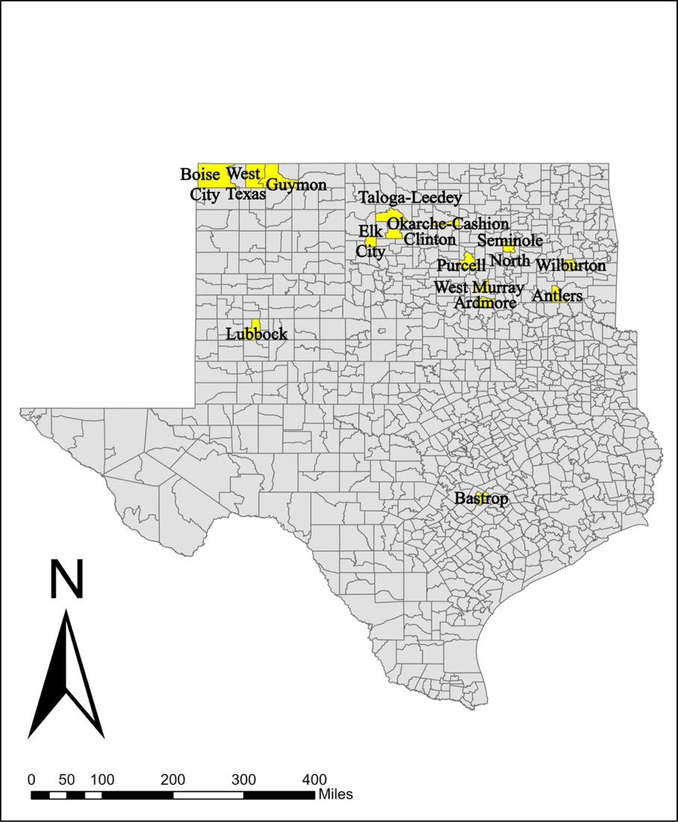
Figure 1: Map of Texas and Oklahoma Responding Utilities
The survey asked the water managers to estimate their annual water usage in gallons, which is what led to Figure 2. Guymon responded that they use 900,000,000 gallons of water in 1 year, and Lubbock noted 13,000,000,000 gallons per 1 year. However, public water use is not the only indicator of water usage from the municipalities. Agriculture and oil production are large industries in each area and use a lot of water. Lubbock uses the most water of any responding utility. Ardmore and Purcell use the next most water in a year. The utilities that use the least amount of water in a year are West Texas, Okarche-Cashion, Seminole North, and Bastrop. Bastrop, Texas is the lowest user, as they responded that they use 3,285,000 gallons per year.
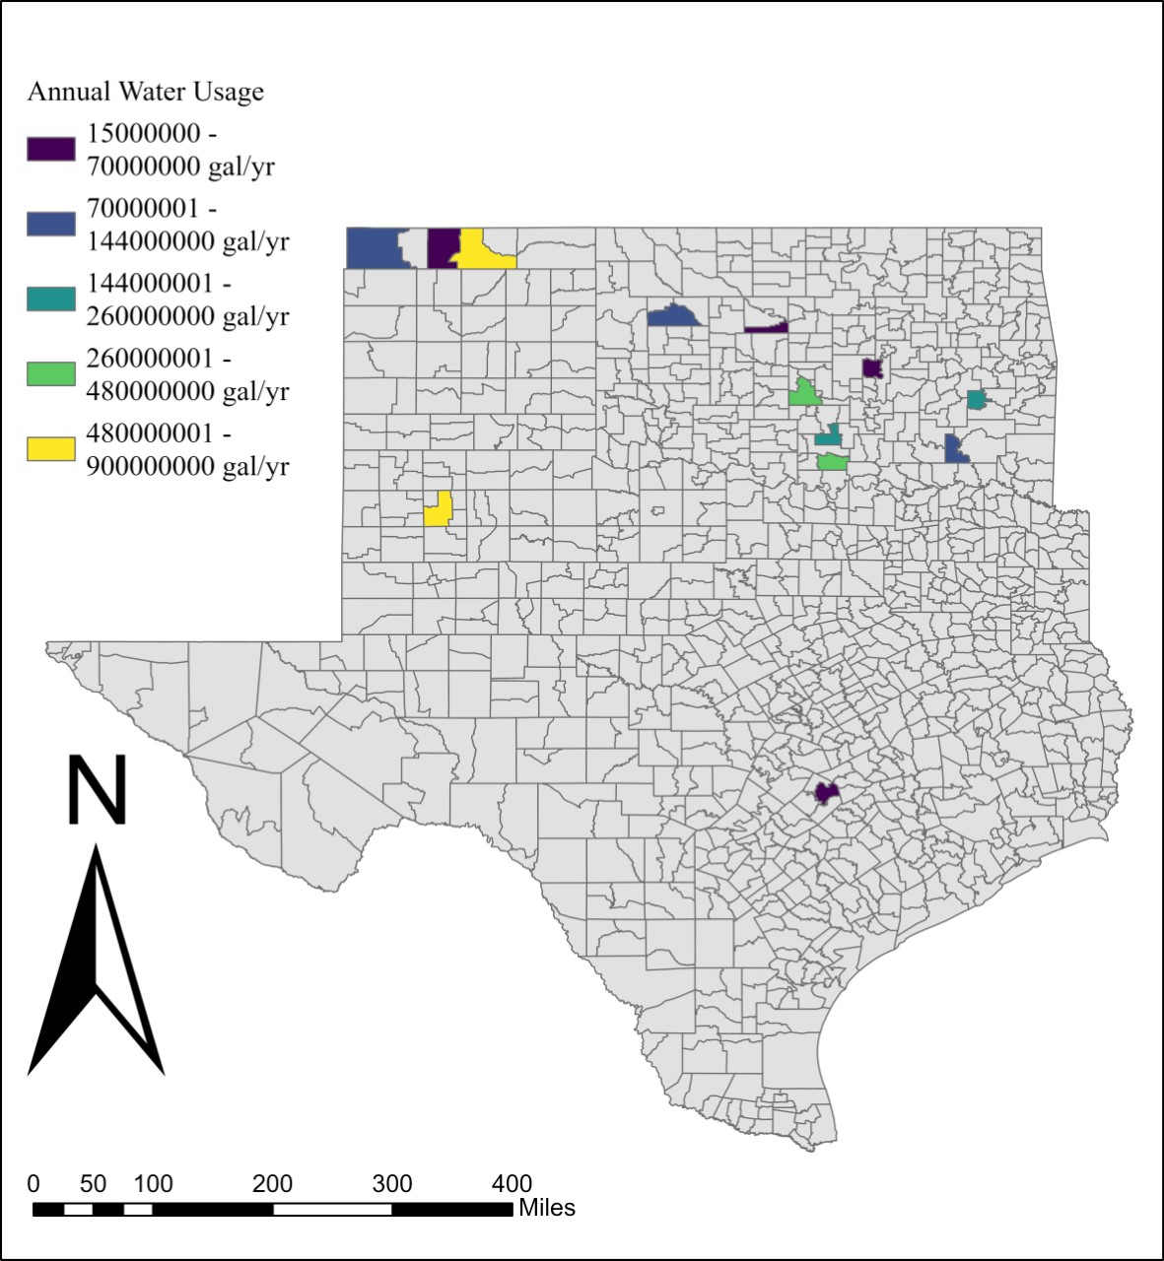
Figure 2: Annual Water Usage in Gallons per 1 Year
The respondents were asked to share their thoughts on water pricing for their residents’ use. These results are visible in Figure 3 as a map product. The consensus between those responding was that water is an underpriced resource, as illustrated in green blue. Only one utility felt that water is an overpriced resource, which was expressed by Wilburton. Further, two utilities felt that water is neither overpriced nor underpriced, as depicted in the yellow shaded districts.
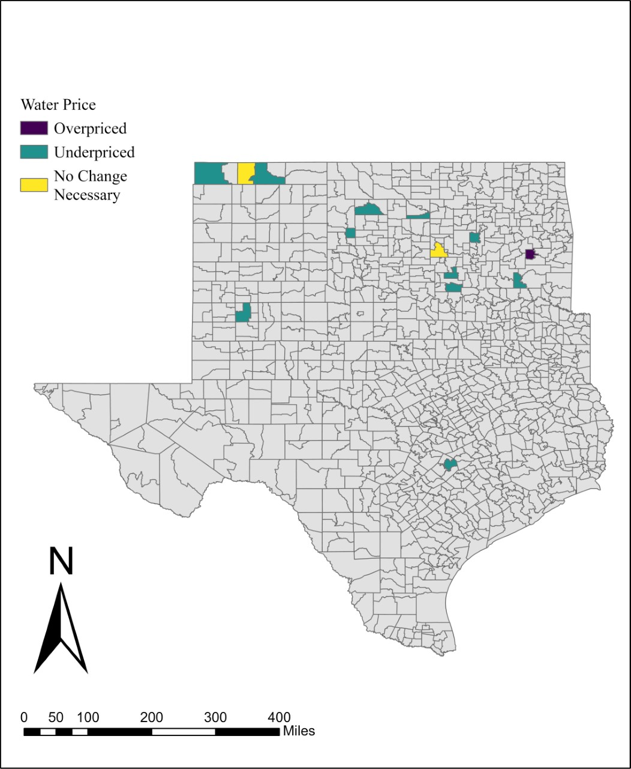
Figure 3: Water Pricing Opinions of Respondents
Figures 1 through 3 add introductory details that provide helpful insights when analyzing the data based on this project’s research questions. From this assessment, a comprehension of geography of the responding utilities was acquired. Additionally, a gauge for annual water usage by each participant was broken down geographically as well. Finally, an opinion question from the survey, asking water managers if water is overpriced, underpriced, or neither, was mapped out. This knowledge will assist in the comprehension of the results presented from this point.

Research Question 2 Results
The second research question highlights long-range planning. Topics discussed will include years since plan creation, emergency management consultation, types of plans the utility have currently, motivations and barriers in creating plans, how utilities overcame obstacles, and the benefits and failures of already enacted plans. These results are shown as maps, bar charts, and qualitative responses.
In Figure 4, below, a map of utilities is depicted to illustrate when long-range planning began at each responding utility. There are 3 utilities that created plans 2020 and later, 3 utilities that created their plans between 2010 and 2019, and 4 utilities that created their plans between 2000 and 2009. The utilities with the longest time-period since plan creation are Guymon, Wilburton, and Bastrop, as all three utilities created their long-range plans in 2000. The utilities with the most recent plan creation time are West Texas, Okarche-Cashion, and West Murray, as these three utilities created their plans in 2020.
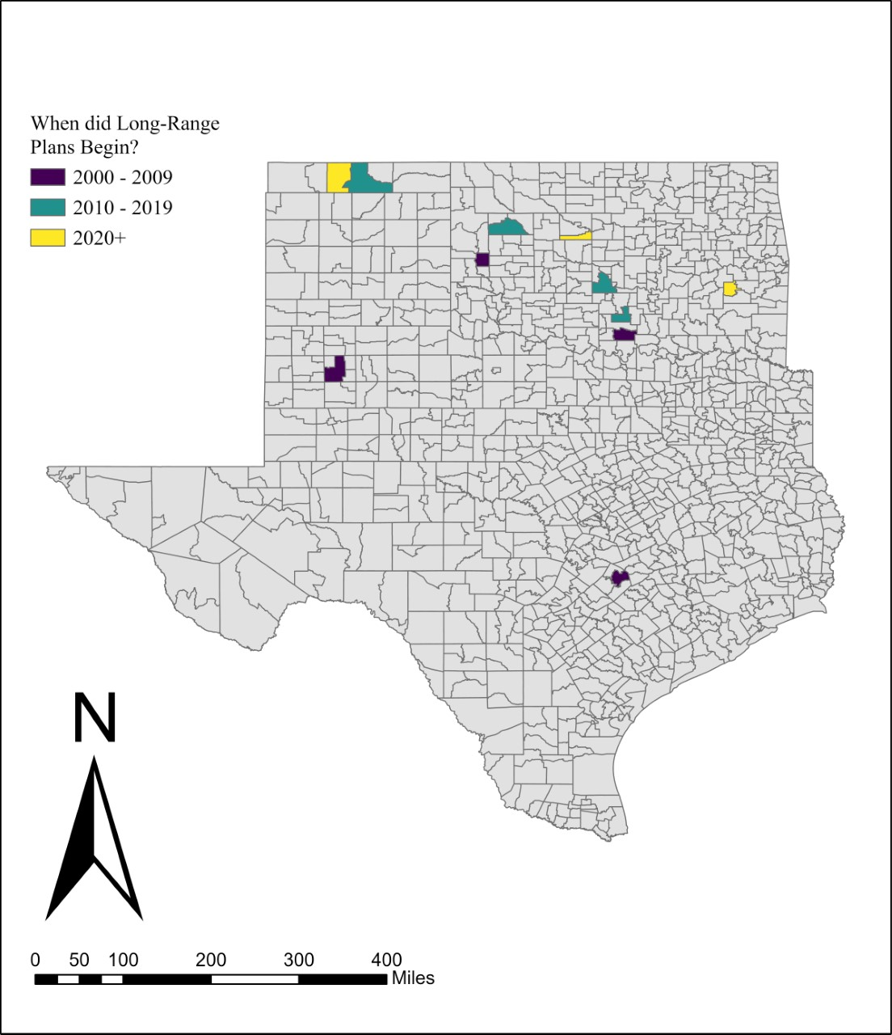
Figure 4: Map of Long-Range Planning Start
Figure 5 examines the vulnerability of the current infrastructure’s quality in each utility to risks associated. Each utility in the Oklahoma panhandle answered that they are vulnerable at some level to their infrastructure’s current state. The other utilities that responded that they are vulnerable to risks from the current state of their water infrastructure, classified in yellow on Figure 5, are: Taloga-Leedey, Lubbock, and Bastrop. Other utilities that are somewhat vulnerable due to their infrastructure, as highlighted in green blue, are: Purcell, Ardmore, Antlers, Wilburton, and Seminole North. The only utilities to answer that they are not vulnerable to risk associated with their current infrastructure are West Murray and Okarche-Cashion.
​​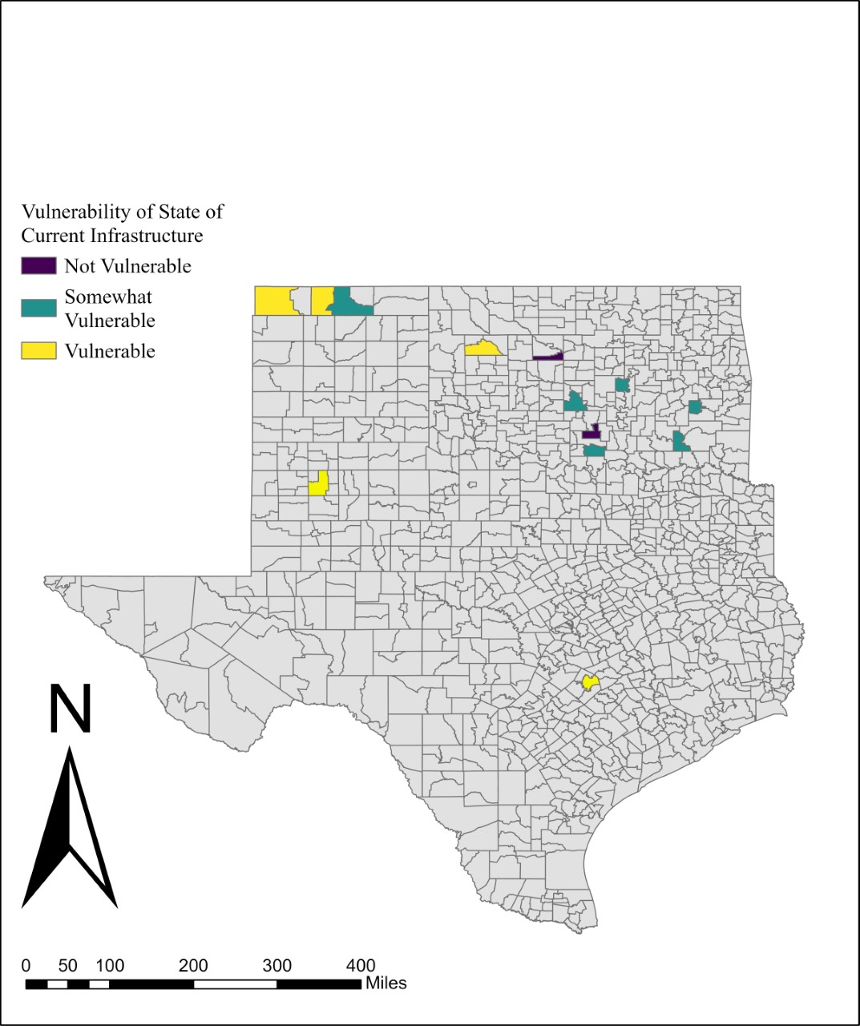
Figure 5: Map of Vulnerability of State of Current Infrastructure
The respondents were asked how vulnerable their utility is to increased water demands due to population growth and economics, mapped in Figure 6 below. Almost every utility designated their systems as vulnerable to somewhat vulnerable, with West Murray as the only utility to respond not vulnerable once more. In Figure 6, 5 utilities answered that they are vulnerable to this risk, and they are: West Texas, Guymon, Okarche-Cashion, Seminole North, and Wilburton. Boise City, Lubbock, Bastrop, Taloga-Leedey, Purcell, Ardmore, and Antlers all classified their water systems as somewhat vulnerable to increased water demands over time.
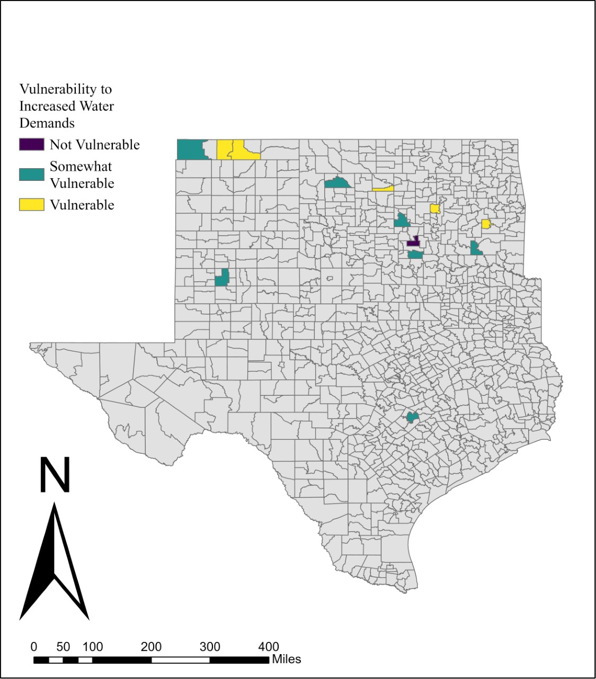
Figure 6: Map of Vulnerability to Increased Water Demand from Population and Economics
When asked if the water managers consulted an emergency manager in their plan consultation, Figure 7 depicts these results. The responses are equal between yes and no of this question, and 6 utilities each responded yes and no to having asked emergency managers how their plans are for the long-term. However, 2 utilities responses are not applicable to this question, meaning only 12 utilities are of relevance to this data. Overall, this figure has an n=14.
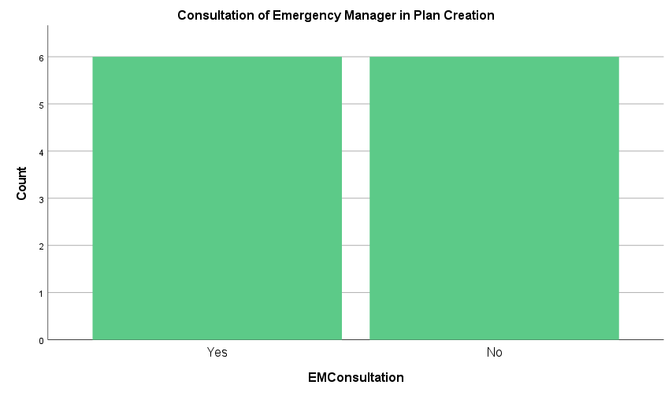
Figure 7: Emergency Management Consultation
Figures 8 and 9 ask the respondents how each utility has incorporated climate information and forecasts into their current and future preparedness and adaptation plans. Figure 8 depicts the current plan usage, which has an n=13. There are 3 utilities that answered that climatic data is fully incorporated in their planning, and 4 utilities answered that it is somewhat incorporated. However, 6 utilities in total said that there is no climatic information incorporated in their long-range plans. As for Figure 9 also with an n=13, 3 utilities responded that they would use climatic data in their future long-range plans. There are 5 utilities that designated they might use this information and forecasting in the future. However, 5 utilities conversely selected that they do not plan to use climatic data in their future planning.
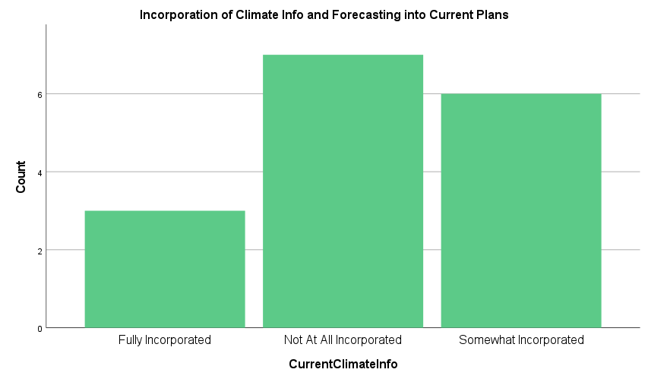
Figure 8: The Incorporation of Climate Information and Forecasting into Current Plans
Comparing the results from Figure 8 to Figure 9 is important in the analysis of this data. Of the 3 respondents that said they have fully incorporated climate information and forecasting into their plans, two responded that they will definitely use climate information and forecasting in future planning. Therefore, 2 of the 3 that responded they will definitely use climate information in the future is already using it, meaning only one utility specified they will definitely use climate information in the future that had not used it much in the past. This utility responded to Figure 8 as somewhat incorporated. There are 2 utilities that responded to Figure 8 that their utility has not at all incorporated climate information into their plans, but they might use climate information in future plans in Figure 9. Of the 4 utilities that responded somewhat incorporated to Figure 8, all that they might use climate information in future plans in Figure 9. Finally, 4 of the utilities that responded to Figure 8 stating that they have not at all incorporated climate information into their plans, in Figure 9 they did not change their answer and responded that they do not plan to use climate information in the future.
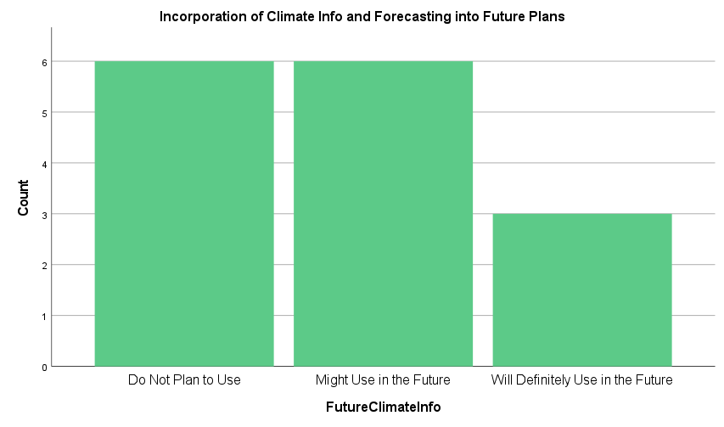
Figure 9: The Incorporation of Climate Information and Forecasting into Future Plans
The qualitative aspects of the second research question also add to the knowledge of long-range plan creation. Question 12 of the survey asked the respondents what kinds of plans each utility has, and as a result, an n=12 gave this research its results. There were 7 utilities that had capital improvement plans, and 4 had asset management plans. There were also 7 utilities with rate structure plans, and 3 utilities with training and capacity planning. Finally, there are 3 utilities that have drought contingency plans.
Question 13 of the survey is a multi-part section relating to plans for the water system of each utility. Part 1 of question 13 has qualitative responses, which denote the driving motivations of plan creation. As such, one answer worth breaking down is:
“decreased well production, drought, increased water demand from public and Industry. low wages & lack of laborers. Municipal departments relies on limited revenues.”
This response is worth analyzing as the Southern Plains are a region regularly experiencing drought. If well production, drought, and increased water demand from the public are all impacting the water utility in this response, there is a dire need for change in this system. Further, a lack of people to work in the industry and low pay are attributing to this loss, most stressors are placed on the utility and the people relying on the utility. As such, relying on limited revenues leads to further worries and obstacles of the utility in question. This is especially true if well production is declining at the utility, per the qualitative response. Another motivation as emphasized by respondents is “failing systems” and “water loss”.
Next, the barriers in creating these plans are:
“Lack of uniformity between government agencies” and “Money, Lack of trained laborers, cost to comply with rules & regulations”.
These obstacles only add to the stress of water managers, as navigating the intricacies of changing influences between governmental agencies as well as monetary issues, trained laborers per job-required tasks, and the expenses required to keep up with state and federal regulations add another layer to each utility. Another response gives a similar atmosphere to the last two, stating:
“Ongoing changes in state and federal bureaucracy with resulting changes in regulations”.
As such, this changing landscape means water managers have quite the script to keep up to date with to comply. Additionally, if water managers have utility-specific issues to worry about, there is even more added to their already very full task bar. For example, one respondent writes that their obstacle is:
“High nitrate levels.”
This means not only does this utility’s water manager have their own responsibilities to keep up with, as well as state and federal changing rulings, but they must comply with lowering the nitrate levels for their residents to meet safe driving levels. To have all these variables fall on the water manager itself is a lot of responsibility for one or a few persons to carry for a utility supplying water to hundreds or more people.
Otherwise, some water managers experience no barriers in their long-range planning creation. One water manager responded to this question that:
“None. City Council supportive.”
This means that their utility experiences no obstacles in creating their long-range planning. This adds to how each utility is unique in the experiences they go through, as not every utility will undergo an easy train-of-thought in their plan creation.
The barriers in creating long-range plans are large. However, there is always an answer to the barrier. Some responses from water managers answered that they overcame barriers due to:
“Grants.” and “Got help from outside source ORWA.”
Thus, in receiving help from other sources, utilities were able to overcome this obstacle. Otherwise, respondents to this question made it clear that they have not been able to overcome any obstacles yet.
Next, respondents were asked if their planning was beneficial. If it was not, the respondents were asked to clarify what could be done better, and the reasons for the failure of planning. One respondent noted that:
“Somewhat, there could be better communication between government agencies, more streamlined/user friendly applications with training options for utility billing software, mapping, and locating lines.”
As such, easier software and friendly application processes are the focal point for this respondent. They feel that if this process was streamlined, better results would occur. Otherwise, the responses in planning are positive. One answered:
“The planning is great, not having the financial ability to go through with them is the problem.”
Therefore, financial ability is a large aspect of positive planning. And further, population growth adds another dimension to the hardships of planning for the future of utilities. This is expressed in the response:
“Very beneficial in coping with explosion in population growth”
Thus, this responding utility denoted that planning for long-range situations was positive for their population growth in the future.
When asked how they prepared their long-range plans, water managers responded:
“Typically plans prepared in conjunction with external consultants.” or “with help from the ORWA.”
Therefore, external consultants and the OWRB are the most useful resources to utilities when creating their long-range plans. Further, another response states:
“Systematic process with internal and external input.”
As such, internal partners within the utility and external partners helped influence the last respondent’s long-range planning ideas.
The most important foci in water utility legislation to the water managers of this survey are water security, water quality, more federal and state funding, rural district assistance, water conservation, education requirements in the industry, and infrastructure updates. Other topics that utilities responded with are less government intervention, wastewater uses, and land use. Thus, the topics of most importance to the water managers of this survey are not agreed upon.
Overall, the main takeaways from research question 2 are: long-range planning in terms of years created are spread across the respondents, there are an equal number of water managers that have sought out emergency manager’s views in plan creation as compared to those who have not, a majority of respondents have not incorporated climate information into planning, that plan creation assists in booming population, a lack of uniformity between federal and state agencies creates stress for water managers, 8 water managers might or will definitely use climate information in future plans, and external and internal input is sought after in planning is crucial. Thus, the preparation stage of long-range planning has an equal percentage of being consulted by emergency managers (included in external), external personnel, and internal personnel to create the whole plan for the future. Therefore, plans that ensure consultation with some aspect of external personnel from the utility seem to have the most positive responses per water managers.
Research Question 3 Results
Next, the results based on the third research question of this thesis encapsulates job responsibilities and stressors. With the results of this section, a framework of workforce tensions can be acknowledged from the point-of-view of the respondents. This point-of-view will lend a hand to comprehend aspects of water infrastructure that may have gone overlooked or years without update.
To gauge each water manager’s understanding of the utility they work at in relation to this survey, each water manager was asked how many years they have served at their utility. Figure 10 spatially depicts this, with the longest-standing water manager in West Murray for 42 years. Most water managers have been in their positions for 10 years or less. Both utilities in Texas have been in their position for the same interval of time, between 11 and 20 years.
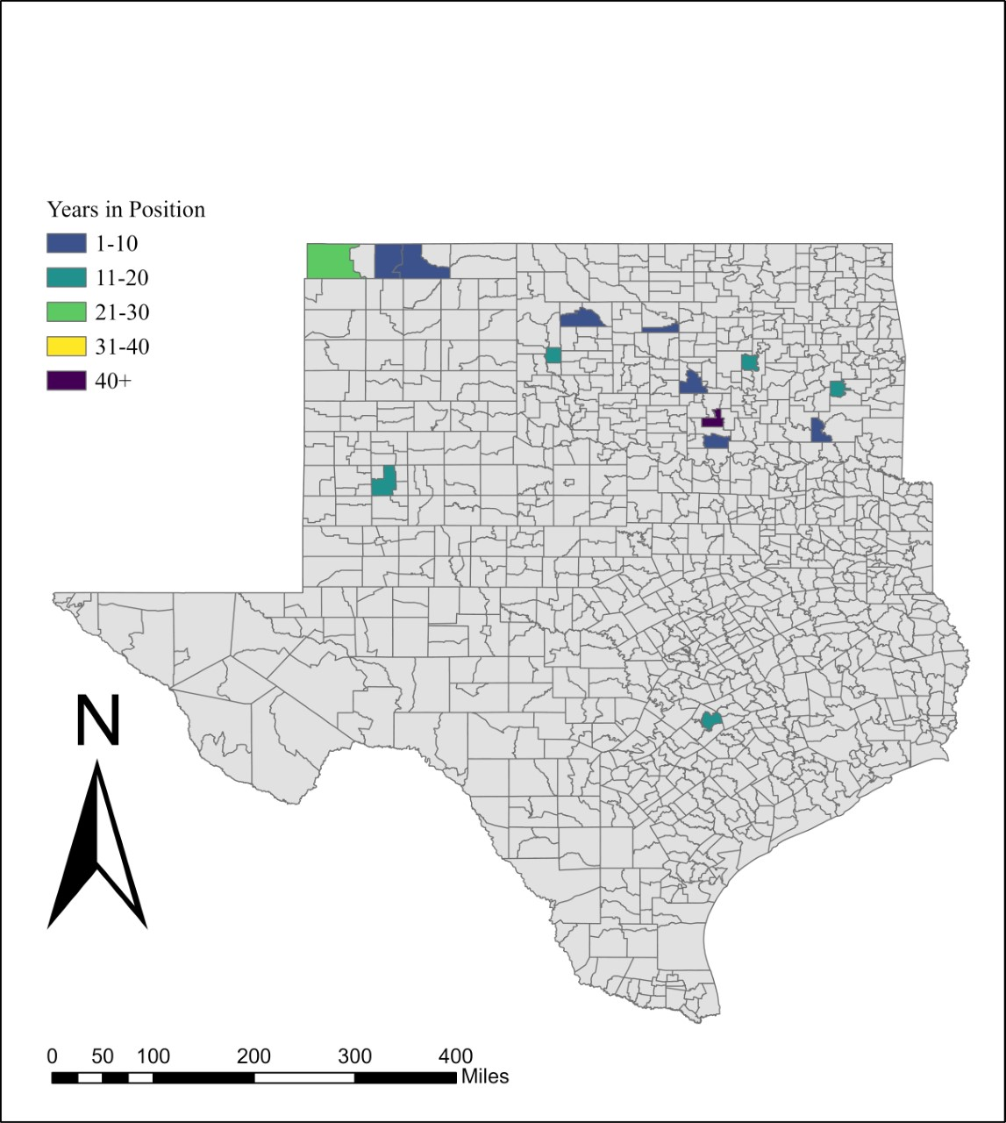
Figure 10: Number of Years in Current Position
Figure 11 maps out the responding utilities’ vulnerability to risks associated with a lack of departmental resources. In this factor, the Oklahoma panhandle is much less spatially coherent, as each utility in that region responded with a different categorical answer. The districts most vulnerable to a lack of departmental resources in terms of risk, in yellow, are Guymon, Okarche-Cashion, Ardmore, and Antlers. Next, the somewhat vulnerable category, as illustrated in green blue, are: West Texas, Taloga-Leedey, Purcell, Seminole North, Wilburton, and Texas. The three utilities said that they are not vulnerable to this risk, as shown in purple, are: Boise City, Lubbock, and West Murray.
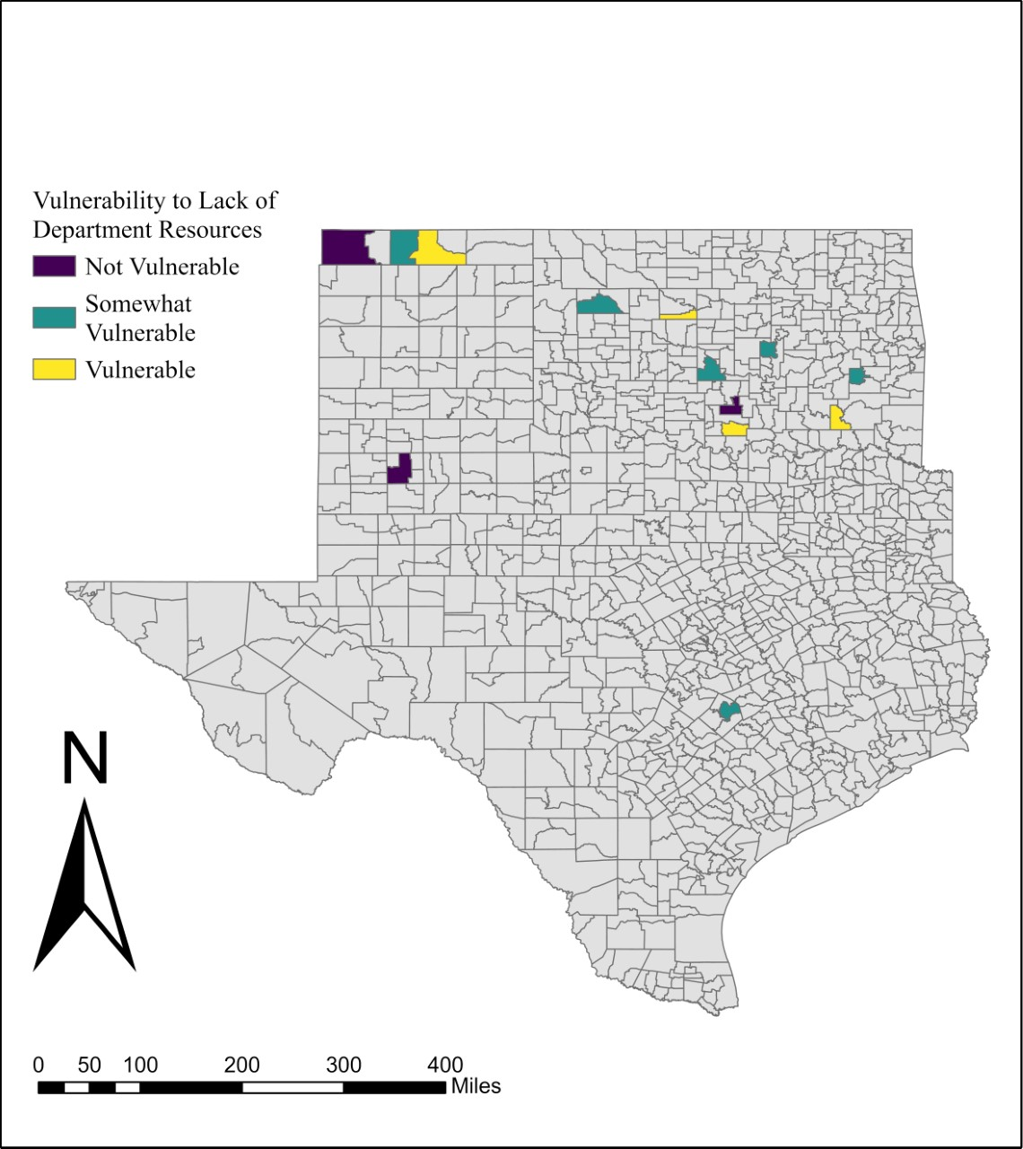
Figure 11: Map of Vulnerability to Lack of Departmental Resources
Survey respondents were asked to reveal the level of education they have completed prior to beginning their water management position. Figure 12 displays this in a simple bar chart with n=17 for the survey question. Most respondents have a bachelor’s degree as 5 water managers have graduated undergraduate college courses, directly followed by 4 water managers with the highest education of completing high school.
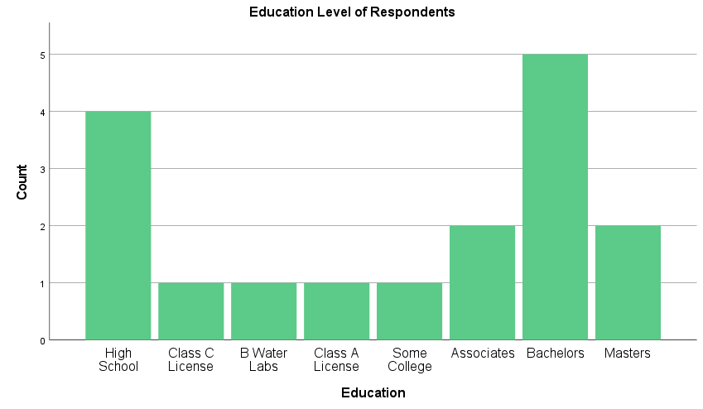
Figure 12: Educational Background of Respondents Bar Chart
There were a multitude of positive findings within the third research question’s bounds through the qualitative answers of the survey. The water managers were asked to list their job responsibilities in the survey to understand how much a water manager has on their plates. One respondent answered:
“Everything dealing with the city side of water and sewer including testing and sampling, Code enforcement, animal control and emergency management services.”
This response speaks to the overworked fractions of this industry. Not only does this water manager conduct responsibilities within the water manager’s job description, but they also run their town’s emergency management services, their animal control department, and conducts code enforcement. Many of the responses are similar, and portray the stress many water managers feel, as one respondent answered:
“Everything.”
However, there is always a spectrum of tasks from utility to utility. Another respondent wrote:
“Pretty much I do anything and everything needing to be done. I over see 3 other employees and make decisions on day to day running of the water district.”
Thus, the above respondent’s rendition of their responsibilities is starkly different from the first response broken down in this category.
At the end of the survey, the water managers were asked to delve into any topics they did not feel were covered in the survey itself. This response fits very well in category 2, as it continues to paint the picture of the workforce’s stress:
“Every small town or small rural water department is unique and comes with its own challenges, its on the job training everyday that no state mandated test or class can prepare you for. Education is great but water operators need to be prepared to handle problems no one ever told them about on an almost daily basis.”
This response has multiple parts worth noting and analyzing. Firstly, this water manager notes that their responsibilities are not fully covered or taught by any form of education to prepare for this position. Without proper setup for the job experience, this could lead to high levels of stress and confusion for water managers. Secondly, this line of work comes with many challenges that will be easier to tackle with on-the-job experience, and thus, those that have been in the industry for longer periods of time will be better suited to handle these almost daily hurdles. Finally, it is important to highlight that each utility is unique, and challenges range extremely in some cases. Therefore, education for uniquely different utility challenges could be hard to achieve.
In general, results from research question 3 portray the stress and pressure the workforce of the water industry is under. From Figures 10, 11, and 12, it can be concluded that most respondents have been in their position for less than a decade, only 3 utilities are not vulnerable to a lack of departmental resources, and a bachelor’s degree is the largest grouping of education of water managers, followed closely by a high school diploma. Qualitative aspects of this category give the most insight into job stressors, however. Many of the participants note that their responsibilities include everything, with a few detailing responsibilities outside the means of a water manger alone. As each utility is different, formal training is cited as not helpful enough to prepare for the job’s authority. Findings found that on-the-job experience means more than education to learn how to work in the water industry.
Research Question 4 Results
The results pertaining to the fourth research question will follow. Infrastructural quality is thus assessed. These findings are compared to the results from a timeline of infrastructural aspects’ updates. This research question’s responses are largely quantitative through clustered bar charts. The bar charts are broken apart to display public versus private utilities. This hypothesis falls under the funding of each, as it may be beneficial to note the update disparities between private and public utilities.
Figures 13 through 20 depict the answers for one multi-pronged question in the survey, with an overarching question asking water managers to rate the current quality of pieces of their infrastructure. The answers were displayed as a clustered bar chart, with public and private utilities as the dependent variable. This dependent variable is held for most clustered bar charts in this analysis. The independent variable in Figures 31 through Figure 20 is one of the infrastructural categories in question 5 of the survey, and those categories are: pipelines, water treatment facilities, water storage facilities, stormwater infrastructure, pumping stations, meter systems, valves, and wells and pumps. The private utilities are denoted with blue bars, and the public utilities are represented with green bars. This data is for current infrastructure, as current means 2021-2022, the time of survey data collection.
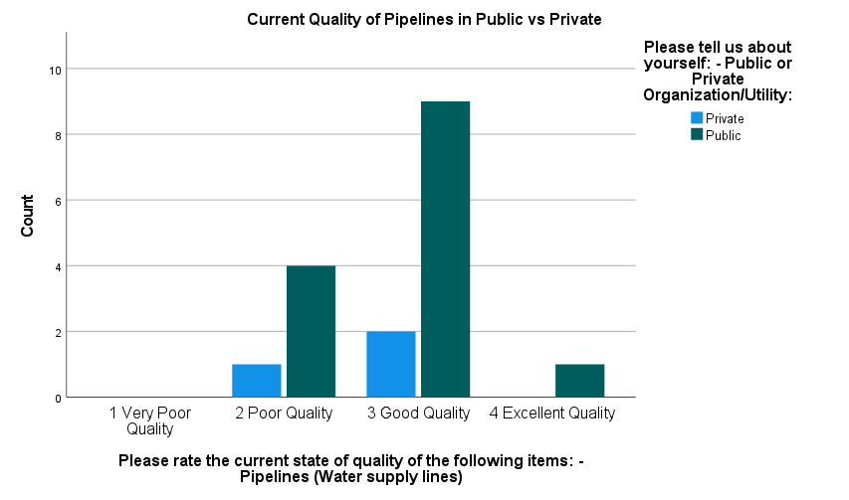
Figure 13: Pipeline Quality in Public and Private Utilities
Figure 13 displays the current quality of pipelines between public and private utilities within the respondents. This figure has an n=17. There are 9 public utilities and 2 private utilities that answered that their pipelines are of good quality, which is a 3 out of 4 on the scale of possible answers. Only 1 public utility responded that their pipelines are of excellent quality. However, no respondents classified their pipelines to be of very poor quality.
Water treatment facilities are the infrastructure in question in Figure 14 with an n=12. Most responses were higher for this infrastructure piece, as 5 public utilities and 2 private utilities gave their water treatment facilities a 3 out of 4, and 3 public utilities and 1 private utility ranked their facilities as 4 out of 4. One public utility did denote their water treatment facility to be of poor quality, however.
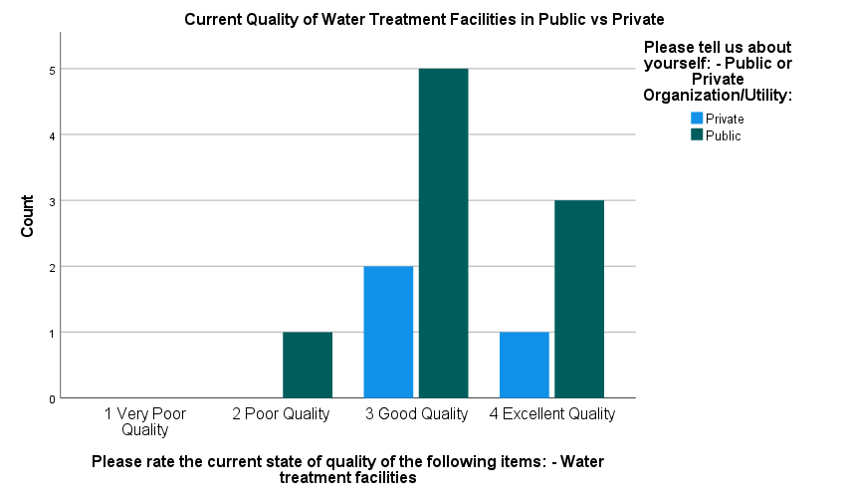
Figure 14: Water Treatment Facility Quality in Public and Private Utilities
Figure 15 gauges the state of water storage facilities of the respondents with an n=17. Similarly, to Figure 14, most responses were a 3 out of 4 and above. There were 7 public utilities and 2 private utilities that gave their water storage facilities a 3 out of 4 rating, and 5 public utilities and 1 private utility answered that their facilities are a full 4 out of 4 per the rankings. There were, however, 2 public utilities that responded with a poor-quality ranking.

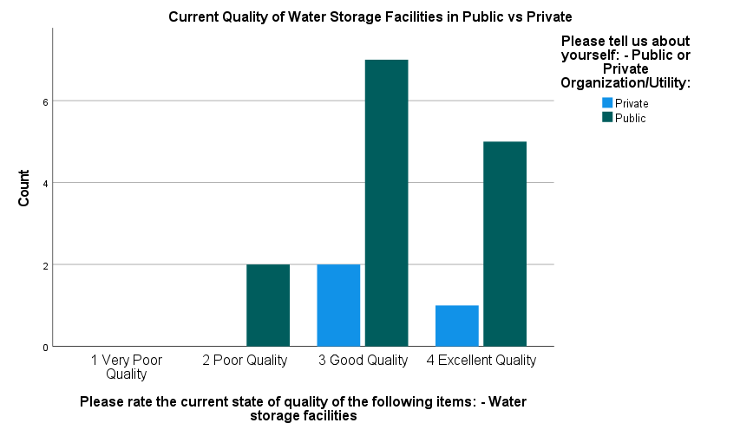
Figure 15: Water Storage Facility Quality in Public and Private Utilities
The current quality of stormwater infrastructure is analyzed in Figure 16, which is starkly different from Figures 13 through 15. Figure 16 shows that many utilities are not as confident in the current state of their stormwater infrastructure, as 5 public utilities rate their infrastructure as poor quality, or a 2 out of 4. Further, 2 public utilities state that their stormwater infrastructure is very poor quality, the lowest rating possible. Only one private utility elected to answer this part of question 5, in which the response was in the highest marks received of these answers. The highest marks, a 3 out of 4, also received answers from 4 public utilities.

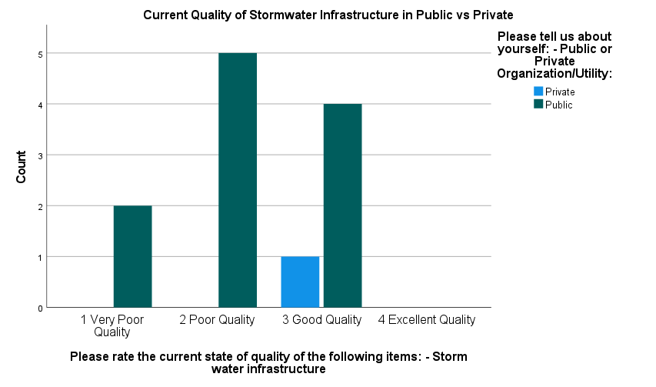
Figure 16: Stormwater Infrastructure Quality in Public and Private Utilities
In Figure 17, n=15 which is a higher response than Figure 16’s response rate as well. In Figure 17, 9 public utilities and 2 private utilities denoted the current quality of their pumping stations to be of good quality. Meanwhile, 3 public utilities responded that their pumping stations are of excellent quality. The most interesting finding of Figure 17 is that the only poor rating of the bar chart was from a private utility, with 1 utility responding with a 2 out of 4 ranking.

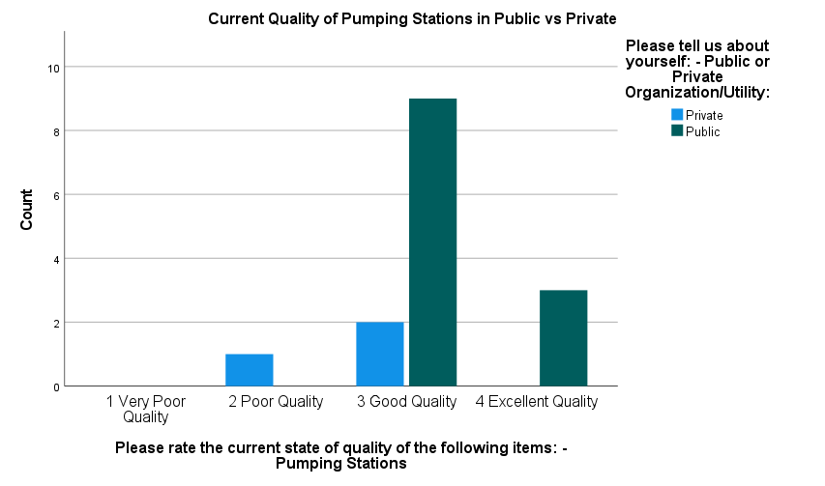
Figure 17: Pumping Station Quality in Public and Private Utilities
The current quality of meter systems in utilities is the next infrastructure piece covered in question 5. Figure 18, below, shows the results, and these responses are far more varied than the previous figures in category 2. A public utility responded that their meter system is very poor, a 1 out of 4 rating, and 1 public and 1 private utility gave their meter system a 2 out of 4. However, 12 public utilities responded that their meter systems are a 3 or better in the rankings, and 2 private utilities. Overall, n=17 in Figure 18.

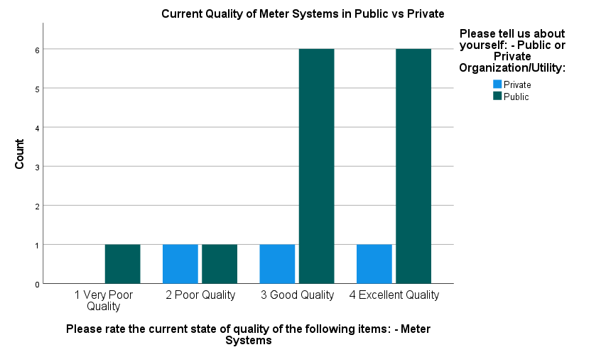
Figure 18: Meter System Quality in Public and Private Utilities
Figure 19, below, broke down the current state of valves in public and private utilities. Not one utility answered that their valves are in excellent condition, conversely, 3 public utilities responded that their valves are a 1 out of 4. There were 2 private utilities and 6 public utilities that answered their valves are a 2 out of 4, or poor quality, and 1 private utility and 5 public utilities responded with a 3 out of 4, or good quality. With an n=17, the response rate for this question stayed like the other sectors of question 5’s bounds.

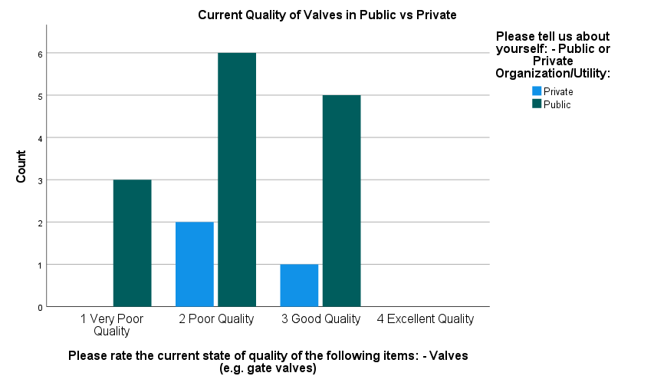
Figure 19: Valve Quality in Public and Private Utilities
The final figure from question 5 is Figure 20, in which the current quality of wells and pumps was inquired upon. This bar chart was skewed to the left, showing 0 utilities with wells and pumps in very poor quality. The ranking receiving the highest responses is 3 out of 4, or good quality, as 7 public and 2 private utilities gave their wells and pumps this rating. There were 4 public utilities and 1 private utility that answered that their wells and pumps are in excellent condition, a 4 out of 4. However, one public utility did respond that their wells and pumps were of poor quality currently. Figure 20 received an n=15, losing 2 responses from the previous figure.

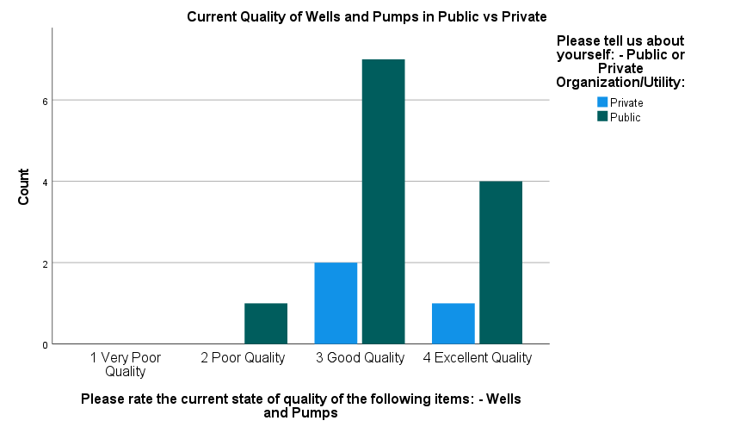
Figure 20: Well and Pump Quality in Public and Private Utilities
Timeframes for infrastructure updates on various parameters are analyzed in Figures 21 through 29. The timeframe rankings are 1-5 years, 6-10 years, 11+ years, and no plan. As Figures 13 through 20, the public utilities are represented in green, and the private utilities are denoted in blue. These figures are created from question 7 in the survey, which asks for the utility’s timeframe in updating pieces of infrastructure.
In Figure 21, the respondents are asked to denote when their utility will upgrade water supply lines to an updated format. There were 5 public utilities and 2 private utilities that answered they do not have a plan for this upgrade. Meanwhile, 4 public utilities and 1 private answered they will update their water supply lines in 1-5 years, and 4 public utilities responded they will update in 6-10 years. Only one public utility will update their water supply lines in 11 and over years. In all, this figure received n=17.
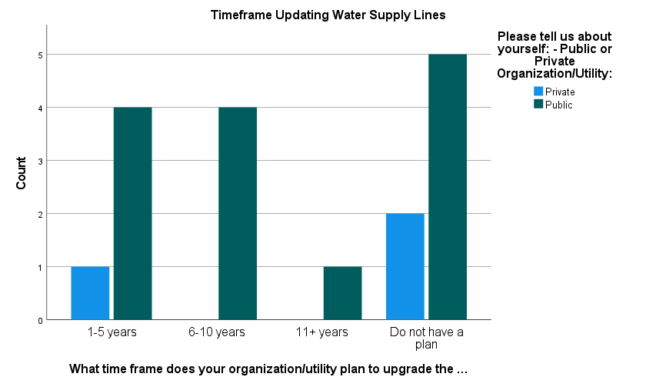
Figure 21: Water Supply Line Upgrade Timeframe in Private and Public Utilities
Figure 22 covers water treatment facility upgrade timelines, and had less utilities respond without a plan than the previous figure. There were 2 public and 1 private utility that answered they do not have plans to update their water treatment facilities. The highest category of Figure 22 is the 1–5-year response, as 2 private and 4 public utilities chose this response. There were 3 public utilities that gave this update timeline a 6–10-year frame. Only one public utility noted they will update their water treatment facility in the next 11 plus years.
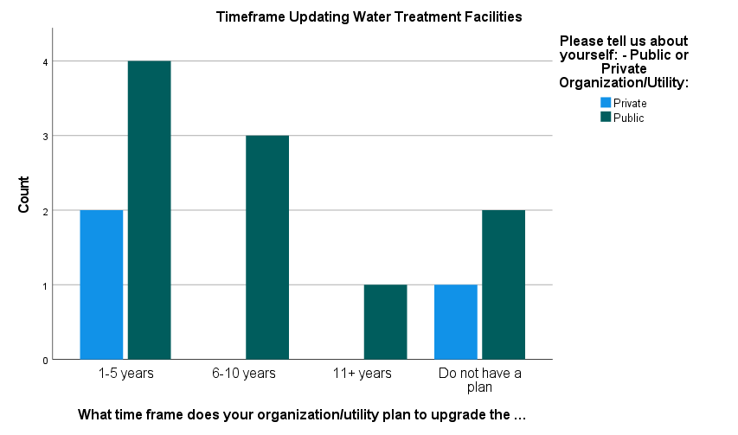
Figure 22: Water Treatment Facility Upgrade Timeframe in Private and Public Utilities
Figure 23, with an n=17, has varied responses towards a timeline of water storage facility upgrades. There were 4 public utilities and 1 private utility that denoted they will update their water storage facilities between 1-5 years from the response time. Another 4 public utilities that answered they will update their water storage facilities in a 6–10-year period. There were 3 public utilities that will update their water storage facilities in 11+ years. Meanwhile, 3 public and 2 private utilities do not have a plan to update their water storage facilities.
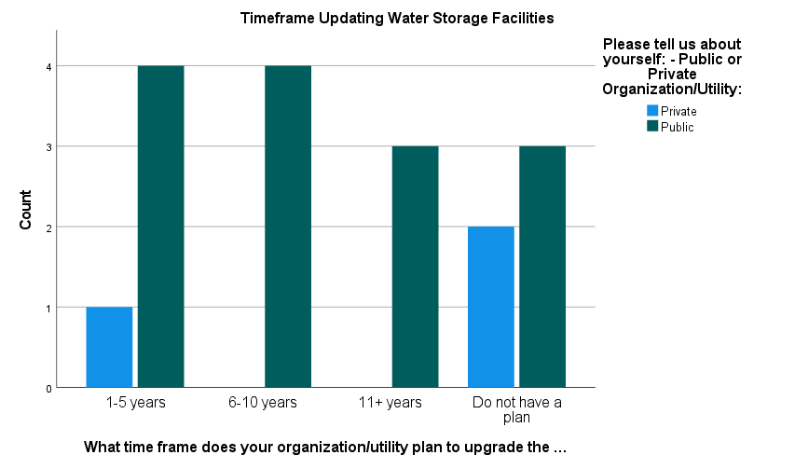
Figure 23: Water Storage Facility Upgrade Timeframe in Private and Public Utilities
Stormwater infrastructure is the next infrastructure in question 7, and Figure 24 has an n=12. This is slightly less than the last two parts of question 7 (Figure 22 and 23). There are 3 public and 1 private utility have no plans for updating their utility’s stormwater infrastructure in the future. Meanwhile, 3 public utilities each have plans to update their stormwater infrastructure in the next 6-10 years, and another 3 in the next 11+ years. However, one public and one private utility have denoted that they will be updating their stormwater infrastructure in the next 1-5 years.

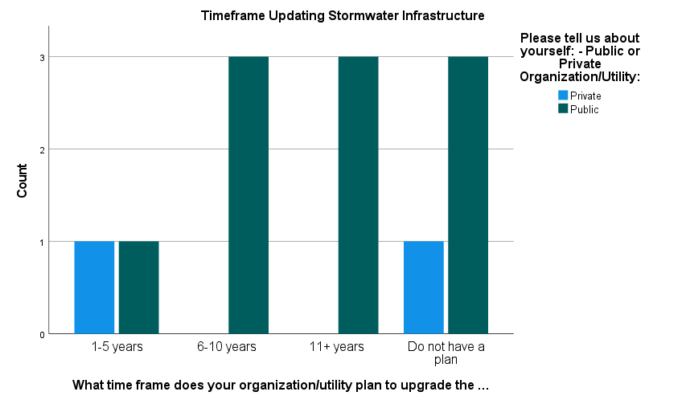
Figure 24: Stormwater Infrastructure Upgrade Timeframe in Private and Public Utilities
Figure 25 covers the pumping stations, with an n=15. There are 1 private and 6 public utilities that will be updating their pumping stations in the next 1-5 years.​​ Three public utilities will update their pumping stations in the next 11+ years. Finally, 3 public and 3 private utilities do not have any plans in the future to update their pumping stations.
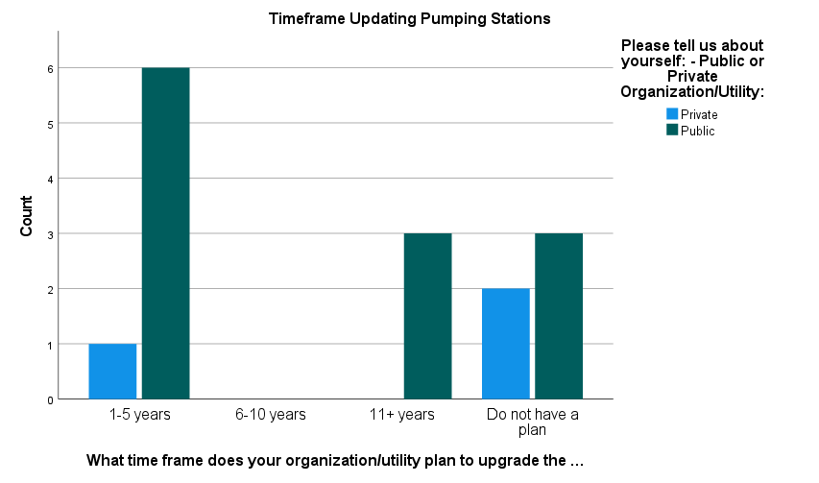
Figure 25: Pumping Station Upgrade Timeframe in Private and Public Utilities
The timeframe for cooling updates has less private utility response, as only one private utility answered this part of the question. This is depicted in Figure 26, as shown below. That private utility and 3 public utilities do not have plans to update the cooling systems of their utilities. Only one utility is planning to update in the next 1-5 years, and one utility is planning to update in the next 11+ years. Thus, this figure has an n=6, making it one of the lowest of the survey.
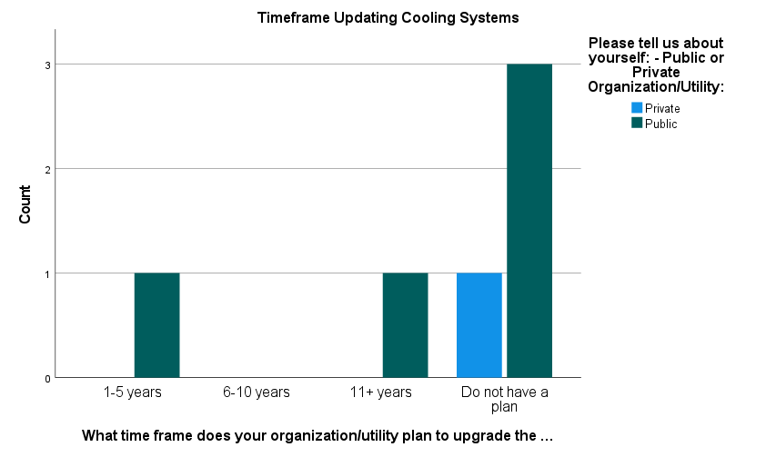
Figure 26: Cooling System Upgrade Timeframe in Private and Public Utilities
Figure 27 defines the timeframe of meter system updates by the responding utilities. There are 6 utilities that will be updating their meter systems in the next 1-5 years, as well as 2 private utilities. There are 2 public utilities that will be updating their meter systems in the next 6-10 years. Three utilities will be updating theirs in 11+ years. Otherwise, 1 private and 2 public utilities do not have a plan to update their meter systems. Figure 27 has an n=16.
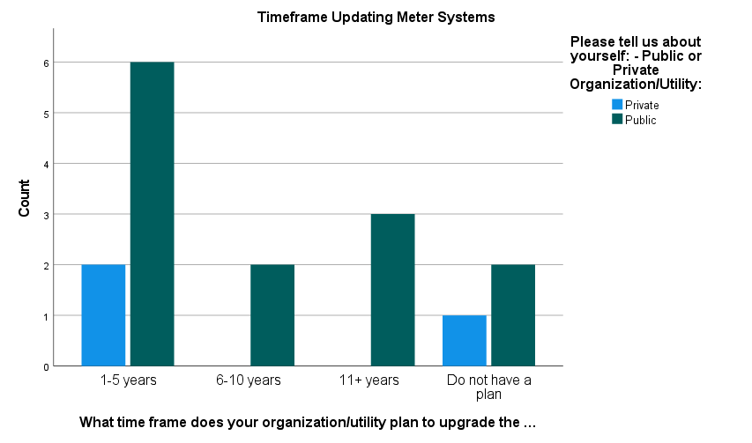
Figure 27: Meter System Upgrade Timeframe in Private and Public Utilities
The valves are the next piece of infrastructure to be updated by utilities, in Figure 28. Only 3 public and 1 private utility do not have a plan to update. Meanwhile, 7 public utilities will update their valves in the next 1-5 years. Further, 4 public utilities will update their valves in the next 6-10 years. The n for this section of question 7 is 17.

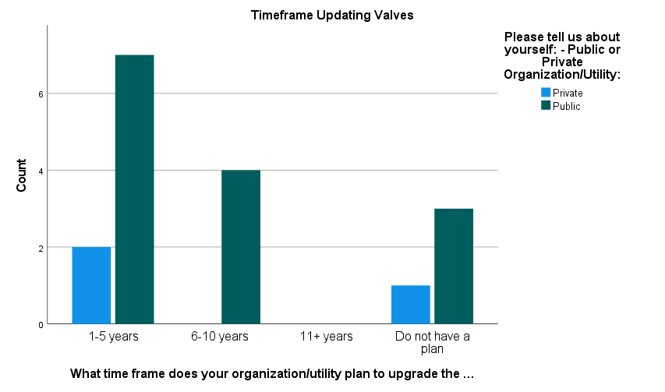
Figure 28: Valve Upgrade Timeframe in Private and Public Utilities
Finally, Figure 29 depicts the last sector of question 7 as wells and pumps. There are 6 public and 2 private utilities that will be updating their wells and pumps in the next 1-5 years. Only 1 public utility has designated their wells and pumps to be updated in the next 6-10 years. Otherwise, 2 public utilities will update their wells and pumps in the next 11+ years. However, 3 public and 1 private utility do not have well and pump update plans.

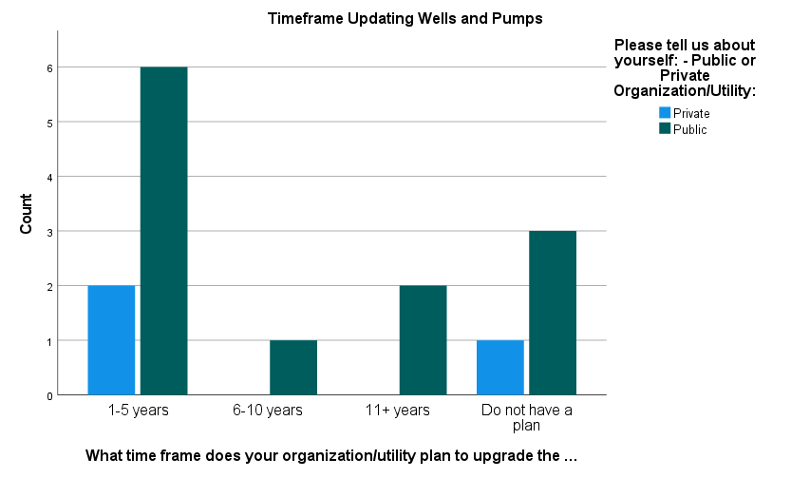
Figure 29: Well and Pump Upgrade Timeframe in Private and Public Utilities
Comparing the current infrastructure to the timeframe of infrastructural upgrades shows interesting findings under research question 4. Infrastructure with the highest totals of poorly rated quality currently are stormwater infrastructure and valves. Conversely, infrastructure with the highest totals of good or excellent quality currently are water treatment facilities, water storage facilities, pumping stations, meter systems, and wells and pumps. It should be noted that the currently tag constitutes when the respondents filled out the survey, which occurred between 2021 and 2022. The aspects of infrastructure with the most indicators by respondents to be updated in the next 1-5 years are water treatment facilities, pumping stations, meter systems, wells and pumps, and valves. The valve update fits with the findings of the quality of current infrastructure. Respondents were split in updating stormwater infrastructure between a 6–10-year period and an 11+ year period. Most participants also responded that they have no plans to update water supply lines or cooling systems. Therefore, a comparison of current infrastructure and the timeframe of updates churns key results.
Research Question 5 Results
Lastly, climate change in each utility’s area is analyzed as the fifth research question. As climate change is actively impacting the globe, various climatic indicators are presented in this part of the chapter. The results in this subsection are presented qualitatively and through maps.
Figure 30, below, determines the role of invasive species in water management tasks. Most respondents, depicted in a spatially formatted setting, show that there is no interference between invasive species. However, Taloga-Leedey, Antlers, and Ardmore specify some level of impact from invasives. Ardmore denotes that they are only impacted by invasive animal species, further clarifying that they are impacted by the zebra mussel. Taloga-Leedey answered that only plant invasives have an impact, as eastern red cedar, Chinese elm, and Johnson grass all affect their utility’s operations. The third utility to specify impact from invasives denotes it to be from tree roots in the sewer lines in Antlers. It is interesting in these findings that more utilities do not experience hardships from the zebra mussels expressed from Ardmore, especially utilities that pull their water from lakes and reservoirs.
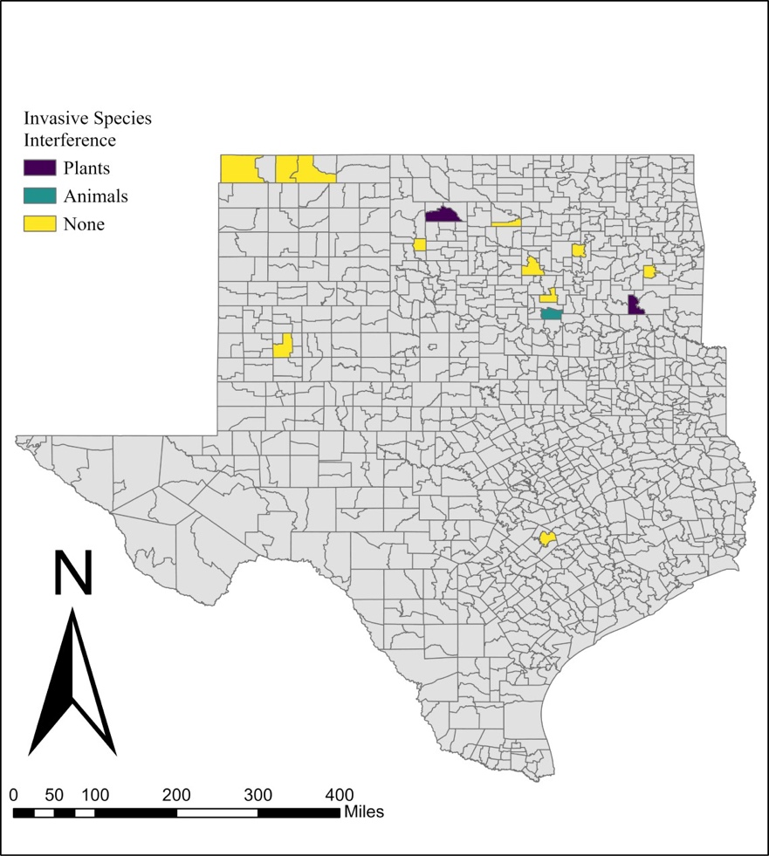
Figure 30: Invasive Species Interference with Utility Duties
Figures 31 through 36 map out responses from question 9 of the survey, in which respondents are asked to rate the vulnerability of their water system to certain risks specified in parts. This question’s findings were also presented in the first and second category of this section, which related to departmental resources, water demand from economics and population, and current infrastructure. Figures 31 through 36 cover water-related risks and natural hazards that pertain to a changing climate.
Figure 31 depicts each utility’s vulnerability to available ground water resources, specifically if their availability could deplete. All 3 responding utilities in the Oklahoma panhandle show that they are vulnerable to this, in yellow on the map in Figure 31, which matches the aquifer usage of the area. There were 4 other utilities in Oklahoma that specified they are also vulnerable to ground water availability, which are Taloga-Leedey, Okarche-Cashion, Seminole North, and West Murray. Elk City in Western Oklahoma responded that they are not vulnerable at all to ground water availability. The other utility not vulnerable is Bastrop, Texas.
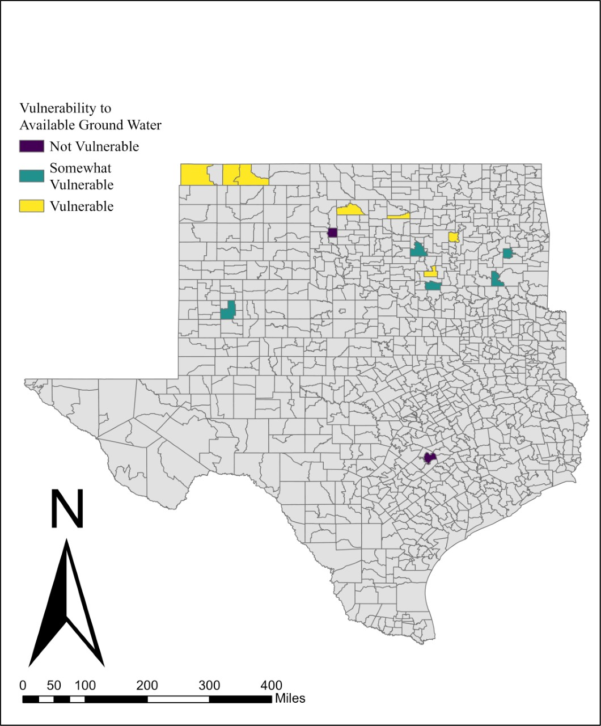
Figure 31: Map of Vulnerability to Ground Water Availability
A vulnerability to decreased annual precipitation is plotted in Figure 32, below, spatially as well. There were only 3 utilities that answered they are vulnerable to decreased annual precipitation totals, with all 3 residing in Oklahoma. Okarche-Cashion, West Texas, and Guymon all responded that they are vulnerable to this risk. A majority of respondents classified their utilities as somewhat vulnerable to a decrease in annual precipitation totals, which is represented in the green-blue highlighted districts in Figure 32. However, 4 utilities declared they are not vulnerable to this risk, which is shown in the purple. There is 1 utility in Texas (Bastrop) and 3 utilities in Oklahoma (Boise City, Seminole North, and Ardmore) that responded that they are not vulnerable in Figure 32.
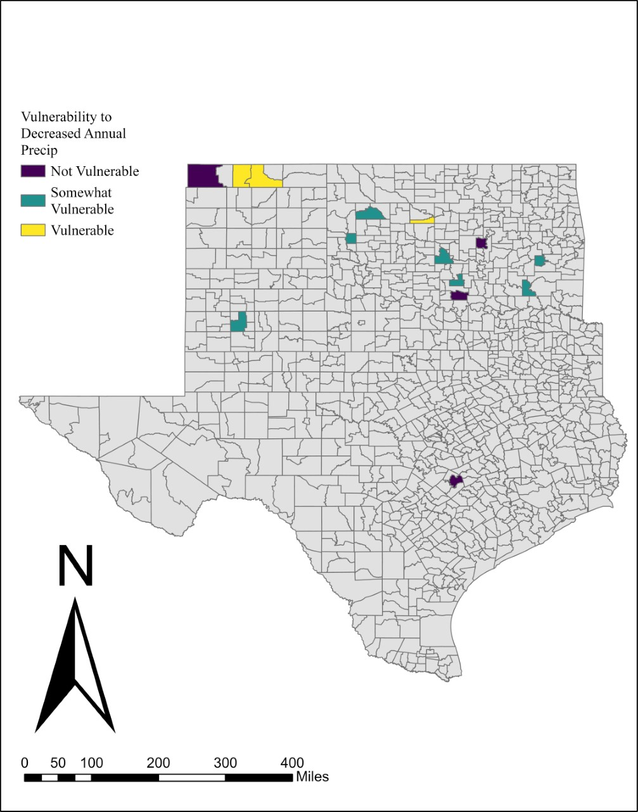
Figure 32: Map of Vulnerability to Decreased Precipitation
Figure 33, below, maps out the responses when water managers were asked if their utilities are vulnerable to increased evaporation of water resources due to increased temperatures. Most water managers answered that they are not vulnerable to this risk, as shown in the purple highlighted districts in Figure 33. It was shocking that only 2 utilities classified their systems as vulnerable, and these 2 are Okarche-Cashion and Guymon, both in Oklahoma. There were 3 utilities that responded that they are somewhat vulnerable to increased evaporation rates, and they are Lubbock, West Texas, and Wilburton. These findings lead the researchers to wonder if most utilities have found a way around this risk in their region, as with a changing climate the temperature in both states will rise and thus, more water resources at the surface will evaporate at quicker rates.
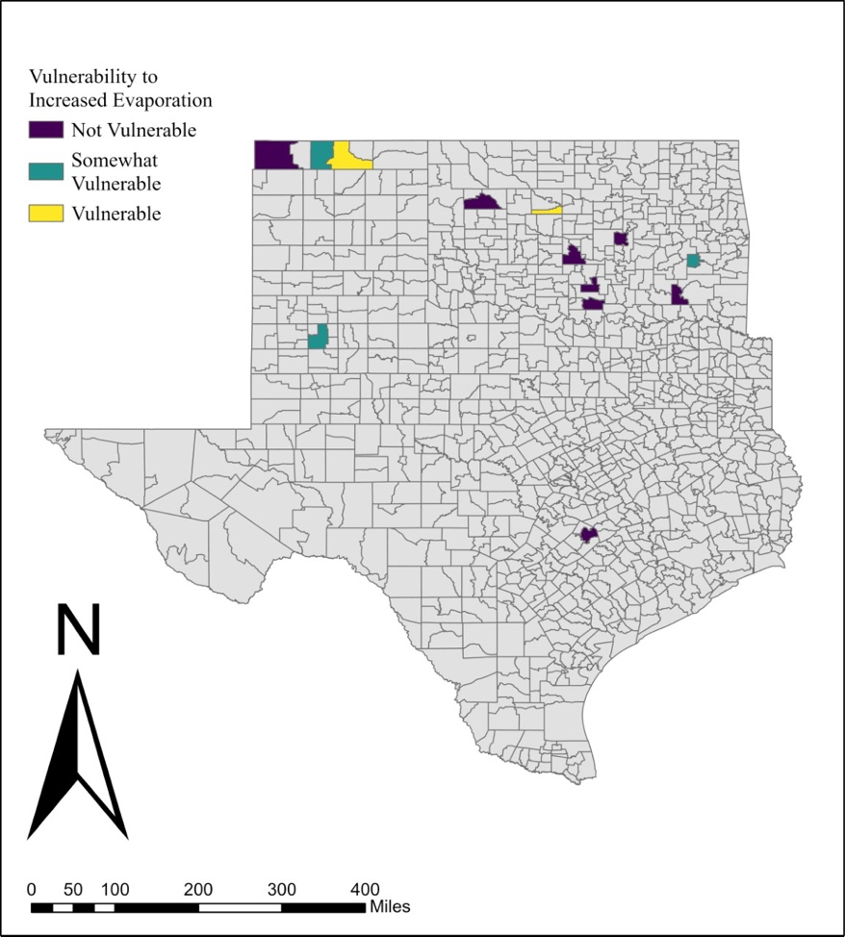
Figure 33: Map of Vulnerability to Increased Evaporation from Increased Temperatures
Speaking of rising temperatures due to climate change, extreme heat events are another risk indicator included in question 9. The results of this are mapped in Figure 34 below. Comparing Figure 33 to Figure 34, many utilities that answered they are not vulnerable to increased evaporation due to increased temperatures did respond that they are somewhat vulnerable to vulnerable to extreme heat events occurring. There are 4 utilities that classified their systems as vulnerable, in the yellow in Figure 34, and they are: Boise City, Guymon, Wilburton, and Antlers. Only 1 utility responded that they are not vulnerable to extreme heat events, and that is West Murray in Southern Oklahoma. There are 8 utilities that otherwise answered that they are somewhat vulnerable to extreme heat events increasing over time.
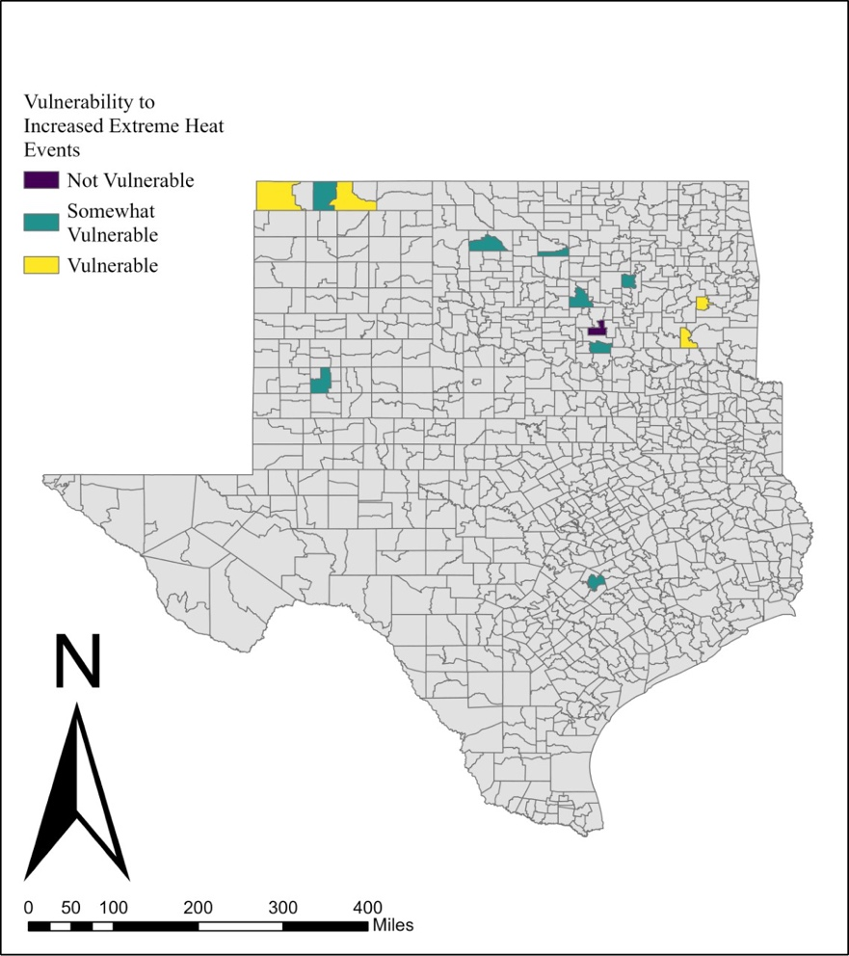
Figure 34: Map of Vulnerability to Increased Extreme Heat Events
Increased natural hazards, such as severe weather events, drought, floods, and any disaster that could naturally occur at an increased rate due to a changing climate is inquired and mapped in Figure 35 below. Similarly to Figure 35, West Murray is the only utility to denote their system as not vulnerable to this risk. There are also only 2 utilities that classified their systems as vulnerable, in yellow, and they are Wilburton in Oklahoma and Bastrop in Texas. Otherwise, 10 utilities responded that they are somewhat vulnerable to increased natural hazard events at their water system.
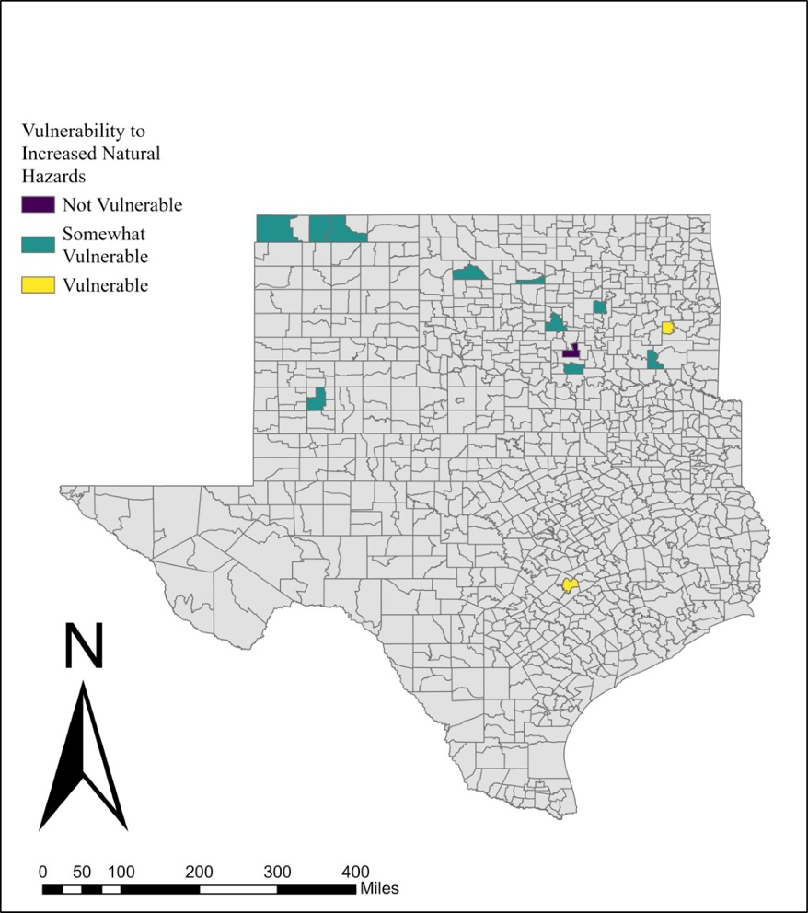
Figure 35: Map of Vulnerability to Increased Natural Hazards
Qualitatively, the results of this survey also produced interesting data towards the fifth research question. When the water managers were asked to include anything that they had not mentioned in the survey, one respondent said:
“We are total groundwater dependent, arid climate, lack of available, willing & capable workforce. My concerns will not reflect completely the concerns of other parts of the regions that have surface water & abundant rainfall.”
Again, speaking to the uniqueness of each utility, this water manager relies only on ground water resources. These resources are depleting quickly due to overuse of aquifers in the area for other industrial reasons (i.e., agriculture, energy, etc.). This spells trouble for this utility in the future, especially as they specify, they are in an arid climate. This response will differ against utilities in the Eastern portions of each state surveyed, as stated in this water manager’s response, parts of Oklahoma and Texas that have surface water resources and receive higher precipitation totals will not have the same risks and worries that this utility has and will continue to have in the future. Further, this respondent says they cannot find available, willing, and capable workers for their utility, likely adding to the strain that this manager is experiencing at their water system. Without proficient help, this water manager plausibly has many responsibilities day-to-day beyond what one or two people can conduct efficiently. Thus, the level of pressure and stress from various risk indicators is mammoth in this case.
The survey also asked if the water manager recommended resources to assist the researchers in plan and adaptation analysis of their water system. One answer was intriguing, and thus, worth analyzing in terms of a changing climate. This water manager said:
“no more than already studied, water resource is one of the most looked after resources.”
Contrasting with the climatic outlook that water scarcity could impact the area as a changing climate leaves more of a mark on the region annually, this response is positive regarding water resource research. They convey that water resources, from their point-of-view, is one of the most looked after resources and thus studied a lot.
In conclusion of all results, thought-provoking findings were curated and analyzed both spatially, numerically, and qualitatively. The lack of statistical analysis in all results is due to the low sample size of this survey, and therefore the data was rendered in map format, bar charts (both clustered and simple), and qualitatively through the responses of the open-ended questions of the survey. These limitations ultimately mean that while these results are conclusive for a few utilities (ranging from n=22 in some questions to an n=6 in others), they cannot be understood as a whole or generalized any further. This is because a small sample size is not representative of a whole population, as not enough responses were collected to achieve a representative sample size of the population of water managers in both states. However, the microscale analysis of each response is still important to research. Further, this lesson will allow the researcher to grow in future projects.

Section 3.3: Discussion

After analyzing this study’s findings, it is critical to discuss what these results mean. The most surprising results will be broken down, and comparisons will be drawn. There were also multiple areas where the project fell short, which will give not only future projects insight, but ideas for change in the next phase of data collection of this study.
Integral findings were how underfunded each municipality is in terms of current quality of system aspects, upgrade status, and planning. While these outputs are not a surprise, they do confirm that the water sector cannot adapt to climate change properly without change. Several water managers reported that their utility had not received any grants or loans in over 5 years, with others reporting smaller numbers of loans than others. It was also inferred that the data would show how overworked water managers are in the present-day. Job security and daily responsibilities are large stressors for water managers and other employees in the water sector, and a lack of funding does not assist these hardships. Another crucial but somewhat anticipated finding is how fractured organizations at the federal, state, and local levels impact the microscale of the water sector. This was noted as one of the biggest impediments to planning and risk management being applied.
Most water managers believe water, as a modernly capital resource, is underpriced. Per an article by Hukka and Katko, underpriced water is a global issue that is hindering the updates needed in many water industries (Hukka & Katko, 2015). While this does not help the process of enhancing aging water infrastructure or uplifting the workforce, the biggest reason for water’s underpricing is ensuring water, as a human right, is affordable to everyone (Hukka & Katko, 2015). One water manager surveyed stated that water is not underpriced, and 4 water managers said it is priced appropriately in the current era.
Surprising results revolve around planning and climate information. It was found that most water managers have not consulted climate information when creating their future plans. Beyond the current plans, it was found that many will not consult climate information in future planning either. This was an alarming discovery.
Another surprising result was demonstrated in Figure 33, which specified vulnerability to evaporation rates due to an increase in temperatures as the climate changes. There are 8 utilities that responded that they are not vulnerable to this risk. However, when asked if they are vulnerable to increased extreme heat events in Figure 34, only one of those utilities responded that they are not vulnerable. This begs the question as to whether the water managers understood the questioning which produced Figure 33. When this question was created (referenced as question 9) the word ‘evapotranspiration’ was excluded in case water managers were not familiar with the terminology. However, this change does not seem to have assisted the comprehension of this concept. Per the OWRB, evaporation rates in Oklahoma are nearly 80% from streams, and 48 inches in Eastern Oklahoma evaporating from water bodies annually to 65 inches in Southwestern Oklahoma (OWRB, 2020). In Texas, the average gross evaporation rates of the state’s major reservoirs are 6.88 million acre-feet, with net evaporation loss peaking in 2011 (Zhu et al., 2021). Therefore, evaporation is clearly a loss-generating factor and a vulnerability to water resources on the surface in each state. Thus, the results from Figure 33 are likely from a level of misunderstanding or bias.
One utility had a not vulnerable answer for six figures (Figures 5, 6, 11, 33, 34, and 35). Per Figure 10, this water manager has been in their position for 40 or more years, labeling their experience as adept in understanding the multifaceted roles of a manager. However, it is puzzling that their utility, in West Murray, Oklahoma, is not vulnerable to the state of its current infrastructure, increased water demands from economics and populations, lack of departmental resources, increased evaporation from increased temperatures, increased extreme heat events, and increased natural hazards. Meanwhile, many utilities around West Murray are vulnerable to many of these vulnerabilities. In Figures 6, 34, and 35, West Murray was the only utility out of all respondents to specify no vulnerability to increased water demand, increased extreme heat events, and increased natural hazards. This leads to the curiosity, has this utility figured out how to overcome this vulnerability or were other biases at hand in the results?
In Figure 31, the respondents were asked their utility’s vulnerability to available groundwater in their area. All three utilities in the Oklahoma panhandle responded that they are vulnerable to this risk as well as two utilities in Western Oklahoma (Taloga-Leedey and Okarche-Cashion). However, a utility in Western Oklahoma noted that their utility is not vulnerable to groundwater availability, and another utility in West Texas only classified themselves as somewhat vulnerable. Elk City, Oklahoma is not vulnerable to this risk based on the response of their water manager, and Lubbock, Texas is only somewhat vulnerable. Lubbock utility’s website highlights a resource plan from four different water bodies (City of Lubbock, n.d.). Two of their water resources are groundwater based, and the other two are surface water based, therefore Lubbock’s response of somewhat vulnerable to available groundwater does match their planning (City of Lubbock, n.d.). Elk City’s utility website conversely has no description of groundwater use in their operations (City of Elk City, 2023). The city designates their only water resource to a reservoir East of Elk City, which is described as small on their website (City of Elk City, 2023). Therefore, the responses in Figure 31, while interesting, do match the resources of the utilities in the Western portion of each state.
Figure 3, a map of water pricing opinions of respondents, shows most of the water managers that took the survey believe water is an underpriced resource. Two utilities in Oklahoma, West Texas and Purcell, responded that no change in pricing was needed. The utility in West Texas’s main resource is the Ogallala aquifer, and this water is used mostly for irrigation and public use (OWRB, 2023). The United States Geological Survey (USGS) accounts that overuse of the aquifer in the Oklahoma panhandle has resulted in a 40-foot drop in aquifer levels from 1966 to 1972 alone due to well usage (Hart et al., 1976). The recharge rate in 1976 was 1 inch annually, depending on precipitation totals and percolation (Hart et al., 1976). Further, the panhandle is commonly riddled with drought meaning that surface water is not reliable (Taghvaeian et al., 2017). The water from the Ogallala is 98% of used water resources in the area (Taghvaeian et al., 2017). Therefore, water is a valuable resource in Texas county, which is why it is curious that the water manager at the West Texas utility classified water to be priced correctly. Especially in comparison to the other two Oklahoma panhandle utilities that responded that water is an underpriced resource. Conversely, Purcell’s utility website offers a software to their water utility users called ‘AquaHawk’ (City of Purcell, 2023). AquaHawk allows users to track their water usage and even receive alerts based on their usage totals to lower their water bills (City of Purcell, 2023). Because Purcell offers this software, those attached to this public utility can keep track of their water consumption and therefore keep their bills low (City of Purcell, 2023). This would explain why the water manager noted no change necessary when asked water pricing opinion.
One utility also in Oklahoma, Wilburton, conversely noted that water is overpriced for their district. This begs the question, are those living in this district facing impoverished conditions that would make water a privileged resource at the current price? A monthly bill example on their website suggests a monthly price could be as high as $55, with a 10% penalty if the bill is unpaid by the 10th of the next month, and water cut off by the 20th (City of Wilburton, 2023). Based on the most recent Census survey in 2021, the median household income is $37,831 with an unemployment rate of nearly 50% and 22% without healthcare (United States Census Bureau, 2020). In nonfamily households, the median income is $25,000 in Wilburton (United States Census Bureau, 2020). Therefore, water would be an overpriced resource for their community.
The sample size of this project has a huge impact on the resulting findings, as discussed previously. Oklahoma and Texas both have hundreds of water municipalities, nonetheless the population reached for this project was 27. Of those 27, 5 did not agree to participate in the study. Additionally, many answers in the survey were left blank, or a respondent would agree to participate only to leave almost every question blank. Therefore, the resulting sample size analyzed was around 17 respondents. Each question has a slightly different sample size due to this, which adds to the error in results of this project. This problem will be targeted to seek solutions in May of 2023 to try to boost the sample size to reach a representative population size for publication and future research from this project.
Another hindrance of this study is the length of the survey was too long. While the goal of this project was to develop as many results as possible for the South-Central Plains region, the length of the survey was not thought to be an issue when the survey was published. This relates to errors from early-career research. Further, many questions within the survey were multi-part questions. Thus, water managers were not just asked to take a 36-question survey, as many of the questions were not simple one-part questions. Many answers were left blank or filled in as not applicable likely due to this length, which could also play into the small sample size. This is not to illustrate that long surveys do not gain results, however, as the population of water managers are over-worked, many may not have time to dedicate to the length of the survey. Many of the entries where a manager stopped responding to questions could be due to operational responsibilities. If something in their utility arose while they were filling out the survey, they likely went to address it and could have either forgotten about the survey upon returning or not found time again to complete their response.
The wording of questions exhibited a level of bias upon further evaluation. Specifically, question 15 asked the respondents to “Please rate the importance of the following items to encourage water system improvements”. One of the rated categories was worded “adequate water supply for your kids' generation”, in which the wording promotes a biased answer. This set was not used in this paper’s results for this reason.
Although the wording of some questions created bias in the survey, the sample population is not biased based on the methodology of this research. Water managers were contacted in Oklahoma from the OWRB database of water managers and called and emailed one by one. Texas water managers were contacted from the TWDB database and by their own municipality websites. Therefore, the contact method ensured that a large quantity of water managers in both states were polled. There could be some error in data collection attributed to the quick turn-over of water managers across the industry, which made contacting each of them difficult as contact information was often incorrect.
The data collected illustrated how unprepared many Oklahoma and Texas water managers may be for a changing climate. Many of their perceptions differed, as there were not many categories that received full marks towards one topic over another, except finances. Further bias was presented through the methods of this research; thus, the findings of this project require further confirmation in water literature and research. However, in general, a lot needs to be altered and updated in the water sector. This is not possible until funding and organization of programs materialize.
Water research has many gaps, some of which are addressed in this paper. Multiple articles assist in the analysis process of the results, and further points that were not touched on in the survey. Therefore, a brief literature review continuing to portray the struggles of the current water sector nationwide will be broken down.
Hukka and Katko sum up the water sector’s struggles in the U.S. best. They highlight that the whole water system of the country is based on a loosely connected system of thousands of small to large municipalities that often neglect to fulfill financial and technical capabilities (Hukka & Katko, 2015). This is connected to the workforce crisis of water jobs, as Hukka and Katko point to the looming retirement of many crucial heads of the U.S. water sector, microscale, and macroscale (Hukka & Katko, 2015). Mehan and Kline noted ten years ago that “the United States has some of the lowest water and wastewater rates in the developed world, resulting in what is often described as an investment "gap"” (Mehan & Kline, 2012). In the ten years since this quote, little has changed if not exacerbated. Pricing water much lower than it could be sold for to uplift a struggling industry also means that the water sector is going through an aging infrastructure and a growing and moving population while dealing with the fallouts of the climate crisis (Mehan & Kline, 2012). Research portrays that if the true, higher price of water is applied then a deeper appreciation for the resource can be achieved by society (Mehan & Kline, 2021). This would generate an understanding of the responsibilities and requirements that must go into the water and wastewater treatment processes, transportation, and beyond that, the workforce of the water sector endures (Mehan & Kline, 2012). However, what this fails to address is with soaring prices on every other good and service in the present-day that many would not be able to afford safe drinking water. Water would be more and more inaccessible to impoverished and vulnerable populations in the United States, or anywhere that enacts higher than sustainable water pricing on the public.
An interesting point was addressed by Chini and Stillwell regarding water demand. Their study showed that temporal aspects of seasonality impact water demand (Chini & Stillwell, 2018). In the summer, many locations consume more water than they do at other points of the year (Chini & Stillwell, 2018). In doing so, stress is added to the water sector as systems are working harder, and requiring more resources (Chini & Stillwell, 2018). Further, the amount of water sent through the system but lost in transit to its end goal has risen across the United States (Chini & Stillwell, 2018). This also equates to major capital losses as that is water that would otherwise be paid for by a consumer. The country loses 9.1 billion cubic meters of water annually, which would otherwise provide water to nearly 44.5 million consumers for a year (Chini & Stillwell, 2018). While this study does not expand on the issues outlined by Chini and Stillwell, these topics are still integral to understanding the current water industry. This clashes with the responses from the water managers of this study, which denoted the quality of pipelines as Figure 13 shows 10 water managers state their pipelines are in good quality, 1 manager notes excellent quality, and 5 managers respond that their pipelines are in poor quality. This is another point of discussion worth delving into in a later study on this research.

Chapter 4: Tying it All Together

Section 4.1: Major Findings of Research

Key takeaways from this study are the mammoth stresses on the workforce of the water industry, as well as the water infrastructure itself. The infrastructure is aging, and thus requires costly updates to serve the population within Oklahoma and Texas today and in the future. The data confirmed that a lack of funding is negatively impacting the water sector and preventing many municipalities from updating as well as planning adequately for a future entailing climate change and water scarcity. Government fractures only create bigger problems, as there is not enough organization in the water sector across federal, state, and local authorities and regulations. Water education and knowledge are another limitation found in the research. However, the largest finding this study can firmly confirm is how overworked the employees of the water industry are daily. There are on the job problems that only seasoned water managers would know how to address, which is a major issue when many key figureheads in water sectors across the country are reaching retirement. As the workforce crisis expands in the water sector, rural municipalities and utilities that lack funding and grants will be impacted most.
This research presents a multitude of climatic events that could impact different parts of Oklahoma and Texas, however, without a proper sample size the true perceptions of water managers regarding these impacts cannot be measured accurately. As the water managers above put it, their concerns are different from water managers in a different climatic zone; they are facing contrasting water crises. Therefore, a survey encompassing the duality of events of climate change in wet versus arid climates with a sample size of 11 to 16 cannot assess true findings. Future research should either pick a climatic zone or use a different mode of survey distribution in hopes to reach a more representative sample population.
Finally, this project shows a potential area of concern to the water sector of the future. It was discovered that half of the respondents polled do not consult an emergency manager when creating their municipality’s emergency plans. Additionally, only one respondent sought out a meteorologist to look over their utility’s plan. Combine these findings with the data showing that most water managers have not and will not turn to climate information and modeling when creating risk management plans for future resiliency needs of their utility, and a dire situation could be afoot. Proper climate planning and adaptation means including climate information and modeling into scenarios that are planned for by each utility in case of emergency or disaster. This protects their consumers from facing water shortages or other issues in the face of a climatic crisis. For future research, this topic should be expanded on in the water sector.

Section 4.2: Limitations

Spotting limitations that weighed on this project is an easier task in hindsight. Limitations experienced include sample size, data collection, the death of phone-based surveys, lack of recruitment personnel beyond one researcher, length of survey, survey setup, statistical analysis, and early-career researching. The author learned a lot throughout the process of conducting this study and would carry out Chapter 3 in a different manner on a second attempt.
According to Raudys and Jain, the larger the sample size the smaller the error in data collected (Raudys & Jain, 1991). If a sample size is too small, like in this project, the data is not accurately assessing true estimates congruent with a larger population and displaying true statistical patterns (Raudys & Jain, 1991). The resulting data is not as trustworthy, and therefore does not contribute concrete empirical research to the field of study (Raudys & Jain, 1991). It should be therefore noted that this study’s sample size was too small compared to the potential target population. Thus, a massive limitation to the research in this paper is the number of water managers that participated. In a future project carried out with similar methodologies, it could be useful to distribute the survey to a broader scale of water managers and increase the study scope. It may also be beneficial for research purposes to interview a handful of municipalities in different climatic regions of Oklahoma and Texas and analyze the realities of the industry physically. Either way, this project’s data has a considerable amount of error attached to the findings.
What was experienced in this survey was the reluctance of water managers to answer a call and respond to an email, let alone say yes to a study of which they have gained knowledge of in this communication format. Many times, a respondent on the other end of the line would comment that they figured the call about the survey was a spam call. Contact via email was not any easier, as external servers bumped the principal investigator’s email from sending. From Jenna’s perspective, after over a year of data collection, if a respondent is to take a survey, they will likely have to stumble upon it on their own. Social media surveys may very well be the most optimal method to conduct unbiased results with a representative sample size. Convincing each respondent in this study that this research was tangible did also impact the sample size of this study. Because of this, statistical analysis of the data was not viable.
The death of the phone-based survey also added limitations to this thesis. As discussed in Keeter et al., phone-based survey recruitment as a data collection method has declined tremendously since 1997 (Keeter et al., 2017). The authors do note that landline and cell phone survey methodologies can have higher response rates if the survey “adjust[s] to match the demographic profile of the U.S.” (Keeter et al., 2017). This begs the question, if the calls to the potential participants of this study were from a recognized area code, instead of Jenna’s area code residing from Columbus, Ohio, would more potential respondents have answered the phone? Overall, the understanding that phone responses in surveys has declined steadily since 1997 does impact this study, as another recruitment method could instead of the phone may have surfaced a larger sample size.
Another limitation to this thesis was the lack of personnel to recruit potential respondents. The recruitment for this data was done exclusively by Jenna, which is why the collection period lasted over a year. As discussed in the previous paragraph, a relation to the demographic of survey participants can lend a hand to connecting with respondents. Jenna does not have an Oklahoma or Texas accent and has an area code outside the region. Further, this project’s recruitment messaging mentions climate change, a highly political topic in recent American politics. In the combination of these recruitment aspects, potential respondents receiving a phone call could have been discouraged to answer or listen to the survey messaging beyond a political stance. If this project had the funding to add more recruiters for data collection, it may be worth it to hire someone with a regional accent known to Oklahoma and Texas and allow this hired researcher to use a university phone number with a 405-area code.
The length of the survey was too much, adding to the problems of this dataset. With 36 questions, with a multitude of questions cradling embedded questions, this survey likely took each respondent a great deal of time. This likely adds to the ‘why’ aspect of the low response rate experienced too. Further, the water industry is going through such workforce hardships, and often rural utilities are run by one or two water managers. The water managers may not have enough time to get everything completed every day with how short-staffed the field is currently, thus finding time to take this long survey might pose a further difficulty. Future research should focus on a shorter, or more concise survey.
A few respondents reported issues in the wording of the questions. The principal investigator was contacted by at least three respondents post survey-link-release to ask what questions meant. One respondent shared that they were leaving a decent number of blank questions due to a failure to comprehend what was being asked. This problem could be why response rate varies considerably between questions. In future projects, survey questions should be written in clear and communicable wording.
The statistical analysis was a limitation due to the low sample size. Tests like t-tests and cross-tabulations require a healthy sample size to be fully accurate and could not be run as the n was 27 for a two-state area. They also require specific data types, of which were not generated by the questions asked. If this research had the ability to be tweaked in the future, the author would alter the geographical scope to include mostly rural Oklahoma, as 18 out of 26 respondents were employees of rural municipalities and districts in the state. Only 4 respondents provided input from Texas, making it the lowest data point of the research project (the remaining entries did not fill out any question, despite agreeing to participate). Hence, this is a major limitation on the project’s main conclusions regarding Oklahoma and Texas. Texas is not enough of a voice in the results to be included in this dataset respectfully. It is not representative of the second largest state in the nation’s water sector.
As an early-career researcher, Jenna did not have enough project insight when this thesis was created. Many of the limitations of this project could be remedied by research experience, as some limitations could have been avoided with the knowledge that comes from time. If this project was redone with Jenna’s new sense of research understanding from the two years of graduation school completed, the recruitment of this survey would be different.
In all, there are a multitude of limitations impacting the results of this research. Sample size, data collection, the death of phone-based surveys, lack of recruitment personnel beyond one researcher, length of survey, survey setup, statistical analysis, and early-career researching all played a role in the final product of this project. As a result, this thesis could have been stronger had these limitations not surfaced.

Section 4.3: The Future of Water in Oklahoma and Texas

Comprehending how the water industry is changing currently and will continue to alter in the future is pertinent to pinpointing future areas of research, as well as relating the findings of this study to real, modern problems. Challenges for the water sectors in Oklahoma and Texas look different and thus, require a divergent approach. This section will break down current news in Oklahoma and Texas related to water, adding further strength to the first research inquiry.
The impacts of climate change on Oklahoma’s water landscape have already begun. In 2022, Oklahoma experienced a deep drought that impacted a multitude of industries that rely on water. A flash drought in June of 2022 was experienced (Daniels, 2022), which did not improve throughout the summer as minimal rainfall totals troubled Oklahoma. September of 2022 was recorded to be the driest month in state records since 1956, and this magnitude of drought has not been seen for almost ten years in Oklahoma (Daniels, 2022). As such, the drought Oklahoma felt from 2010-2015 (Daniels, 2022) was worse than the current drought due to the longer duration of the mid 2010s drought. Currently, the drought of 2022 is in its earlier stages, and therefore has the potential to reach similar levels to the 2010-2015 drought if climatic patterns do not change in the next few years.
In August of 2022, Lake Hefner in Oklahoma City (a lake that supplies drinking water to much of the city), had reached low levels due to drought and record-smashing prolonged summer heat (Hayes, 2022). The lake was replenished with 2.6 billion gallons of water from Canton Lake in Northwestern Oklahoma, which while this benefits those in Oklahoma City, this action has been a controversial one in years past (Hayes, 2022). While Oklahoma City has drawn from Canton Lake 67 times before, in 2013 9.8 billion gallons of water were transported from Canton Lake to Lake Hefner (Hayes, 2022). This strained Canton Lake and some in Northwestern Oklahoma that also rely on this lake for water, as Canton Lake would not recoup until 2015 (Hayes, 2022). The positive side of the recent 2022 water capture project is that the project worked with the OWRB to ensure minimal impacts would affect Canton Lake as well as the United States Army Corps of Engineers, Oklahoma State Department of Wildlife Conservation, and representatives of Canton Lake itself (Hayes, 2022). This water-related climate change impact comes at the hands of population disparities between space in Oklahoma and is only one example of current water events in the state adding to the chaos.
A study conducted by Heather Lazrus in 2016 broke down how water shortages and droughts impact the water management sector of central-southern Oklahoma from a qualitative worldview perspective (Lazrus, 2016). In her results, Lazrus found that maintaining drinking water supplies are pertinent for local living and upkeep and that the respondents were worried about water availability in the region due to drought (Lazrus, 2016). Cultural ideas and worldviews had a clear effect on what the respondents thought was applicable in terms of resource management in the face of drought (Lazrus, 2016). This is broken down to show that individualistic ideologies “will discount drought risks, believing that individual initiative, technology, and market strategies will resolve them” (Lazrus, 2016). Meanwhile, the egalitarian view on resource management favors a community-based solution while also understanding the role of individual actions on a shared water body (Lazrus, 2016). Lazrus’s results bring up an interesting thought in this study, as the worldviews of each water manager surveyed was not collected. The dichotomy of individualistic versus egalitarian would be intriguing to ask water managers in their planning and management processes in future studies. However, the overall messaging from Lazrus’s study is clear: regardless of worldview, people in Oklahoma are concerned about water availability during drought, which is a parameter that will only worsen with time under society’s current practices.
Per an article published in October of 2022, the OWRB will receive $100 million in Oklahoma state funding for rural and small water utility improvements and for dam restoration (Wheeler, 2022). This increase in funding is also occurring at the tribal level, as tribal governments in Oklahoma have pledged $57 million for water upgrades on tribal lands (Wheeler, 2022). Further, Oklahoma has set aside nearly $130 million for its future water projects (Wheeler, 2022). This news is beneficial for the state, as the results of this study found a need for funding in the water sector. As many of the respondents were rural water utilities, it is apparent that the funding set for small and rural utilities is a necessity for water infrastructure in Oklahoma. This could go a long way to assist future drought resiliency planning as well.
This drought is tormenting Texas as well. In August of 2022, 97% of the state was under a category of drought, a drought that began almost a year prior to this date (Méndez, 2022). Due to this, a multitude of public water systems issued types of water restrictions or were forced to ask the public to conserve water resources (Méndez, 2022). Water districts in Uvalde County, Denton County, and Kerr County all declared states of emergency in August of 2022, meaning each public system possessed the unfortunate possibility of running out of water in a 45-day period (Méndez, 2022). A reservoir, Lake Falcon in South Texas, reached a low of 9% capacity in the summer of 2022 due to the drought and the record-breaking heat that 2022 brought (Baddour, 2022). For those in this region of South Texas, Amistad Reservoir is the alternative water resource which also approached record-breaking low numbers amid the summer of 2022 (Baddour, 2022). Thus, the residents were forced to have water trucked in from other areas of Texas (Baddour, 2022). These low reservoir totals grow more worrisome over time, as each could fully dry up by March of 2023 if the area does not receive a deluge (Baddour, 2022). Like the Oklahoma examples explored above, this is only one example of the ongoing climate crisis impacting the society of Texas in terms of water.
Kerry Halladay with the Texas Water Resources Institute describes the dire future of not just Texas’s water infrastructure, but the United States’ future in water. The need to update infrastructure is vital in the modern day. There are pipelines that have gone more than three decades without the proper updating that was intended upon their creation and implementation more than 50 years ago (Halladay, 2023). A lack of funding is again the main reason as to why updates have not yet occurred, and this is the reality that most public Texas municipalities face (Halladay, 2023). Thankfully, “the Infrastructure Investment and Jobs Act, H.R. 3684, signed into law on Nov. 15, 2021, allocated $55 billion to water infrastructure and an additional $6.6 billion to western water storage” (Halladay, 2023). However, the process of sorting the funds to specific areas has yet to be ironed out (Halladay, 2023). Adding further issue to the law, this funding comes at a loan-basis for municipalities, meaning each utility offered funding must pay it back to the federal government in due time (Halladay, 2023). This puts further stress on the management team of public municipalities for the future.
Another key point expressed by Halladay is that the infrastructure that exists now in the water industry was created and placed under a previous set of ideas regarding planning and environmental factors (Halladay, 2023). Climate change and the natural hazards attached to today’s issues were not foreseen in much of the creation of infrastructure, thus, adaptation is required on top of the upgrades required (Halladay, 2023). Examples of situations that current water infrastructure was not built to withstand are coastal flooding in Texas and wildfires in California, which are both outside the realm of the previous planning strategies in infrastructure at their impact levels (Halladay, 2023). The positive spin for the future is that researchers are focusing on the future of water management and finding solutions for region-specific problems (Halladay, 2023). Further, the U.S. Department of Agriculture is also creating a program focused on rural water infrastructure across the country (Halladay, 2023). Therefore, there is hope that the country, and more specifically Texas, can overcome the obstacles laid out by climate change and other societal elements. The big question that remains is the time that this occurs.

Section 4.4: Future Research Targets

​​ This project is still evolving. Due to the low response rate of this current section of the research, another round of survey collection will be conducted. The recruitment method of the survey was altered in an attempt to overcome the limitations experienced in this dataset. The new recruitment will be done through mailed letters sent to approximately 400 water utilities in Oklahoma and Texas. These letters have a QR code that will automatically route water managers to the online survey, the same survey as in the Appendix of this thesis. The wording of this letter and new recruitment method were approved by the IRB on March 3, 2023. These letters will be enclosed in envelopes with hand-written addresses. The hand-written nature of these envelopes aims to catch the eye of water municipality employees sorting through their mail as it draws a personal connection that cannot be mistaken with automated mail. These letters will be sent out in 2023, and the data will be analyzed in accordance with the data recovered in this thesis. The goal is to paint a larger picture of water manager and utility future planning situations representative of the population size. With an enhancement of the response rate, the results of this project will have less sampling bias.

Section 4.5: Conclusion of All

This study’s goal was to address the importance of climatic adaptation in the water sector in Oklahoma and Texas by surveying water managers in each state. Oklahoma and Texas, within the U.S. Southern Plains, have gone through many water issues already, yet still each state has a burdening path forward regarding water and climate. Water management and the comprehension of long-range impacts will be helpful for improvements of infrastructure and planning to continue the coverage of public water systems. By understanding what water managers and workers at utilities across Oklahoma and Texas are undergoing, researchers can gain a better perspective on adaptation and mitigation efforts necessary to achieve a prepared water sector.
The research questions of this project were ultimately answered, however, in the next portion of this research’s outreach to potential participants, more clarity could be provided.
Main research questions of this project are:
- How do the history and current events of Oklahoma and Texas’s water landscape shape the industry?
- How have utilities invested and researched their long-range plans, and did they consult science experts?
- To what extent are job responsibilities and overwork impacting utility operations?
- What aspects of the water infrastructure in each state are the most vulnerable compared to their current condition and their timeframe for updates?
- Is climate change being explicitly felt by water managers through temperature, precipitation, and natural hazards differences annually?
Firstly, the history of Oklahoma and Texas’s water infrastructure as well as their current happenings were delved into in Chapter 1 as a literature review. Oklahoma and Texas each had a separate dark past that ultimately laid the foundation for the start of each state’s water sector. In Oklahoma, the water industry began in Oklahoma with the implementation of several wells. In Texas, the water sector began in San Antonio after the arrival of the Spanish. The lack of water at certain points of the year for both states was a reoccurring problem in the early stages of water development (more so Oklahoma and arid regions of Texas). Meanwhile, greener portions of each state, namely eastern Oklahoma, and eastern Texas, had more naturally occurring water sources to provide for their systems. These systems eventually grew into the operations they are today, which cover much of Oklahoma and Texas. However, being bordering states, Oklahoma and Texas have a history of fighting over water rights. This was analyzed to be chaotic as each state has different water laws. In Chapter 2, modern events in each water system were discussed, as the fighting has not fully ceased. As recently as 2013, the two states fought over water rights to a portion of the Red River. Further assessment was added in Chapter 4 Section 3 to illustrate that even as this research was conducted, water issues have continued within Oklahoma and Texas borders. As unrest appears to be prevalent in the history and current events of Oklahoma and Texas, it is only logical that this tangled web advances stressors in the water industry.
The second question was answered from the results, as it was assessed that the earliest long-range plans were established in 2000 and the latest of the participating utilities were implemented in 2020. Further outputs to the first research question through the results illustrate that an equal number of utilities consulted with emergency managers in their long-range plan creation as compared to utilities that did not. Adding another layer, most of the respondents did not incorporate climate information into their plans, however, a majority of managers selected that they might use or will definitely use climate data in future planning.
Thirdly, it was uncovered that job stressors are weighing on the water managers of Oklahoma and Texas. A manager wrote out that every utility is unique and comes with obstacles that are not covered in water education courses or training. Three managers stated that they are responsible for everything at their utility. On top of this, one of these managers shared that they also conduct the responsibilities of their town’s code enforcement, animal control, and emergency management services. Therefore, stress was deemed to be a real issue in operations. Six water managers denoted that they are vulnerable to issues rooted from their lack of departmental resources, which adds to the pressure.
Fourthly, some of the most vulnerable pieces of infrastructure currently are stormwater infrastructure and valves. Only two managers responded that they are not vulnerable due to the state of their current infrastructure, while other responding utilities designated their facilities as somewhat vulnerable and vulnerable. Aspects of infrastructure that will be updated by the majority in the next ten years from response time are water treatment facilities, water storage facilities, pumping stations, and valves. As compared to the quality of current infrastructure, valves were indicated to be an infrastructural piece of poorer quality by most participants. However, so was stormwater infrastructure was also designated as poorer quality, but their timeframe for majority updates will not occur by the majority in the next decade.
Lastly, the final research question also produced an area of results. A majority of respondents, especially in the Oklahoma panhandle, stated they are vulnerable to available ground water resources. However, when asked if these utilities have vulnerability due to decreased annual precipitation, fewer responded with vulnerability, but the majority response was somewhat vulnerable. One utility in the Oklahoma panhandle designated that they are not vulnerable to this risk. Further, most managers noted that they are not vulnerable to increased evaporation rates of water due to increased temperatures. When asked if these managers were vulnerable to risks involved with increased extreme heat events, only one utility responded that they are not vulnerable. Natural hazards received similar vulnerability results, as only one utility said they are not vulnerable to increased natural hazard events. However, every other respondent declared somewhat or fully vulnerable to this risk.
The water industry is an intricate mechanism working within a complex water system linked together by infrastructure and policy to serve people safe drinking water and water to be used in everyday tasks. The importance of the supply of water and the structures required to reach a large-scale population is only growing in importance as anthropogenic climate change causes increased problems in Oklahoma and Texas. Problems ranging from extending drought, dwindling groundwater supplies, flooding, and beyond add more obstacles to an already elaborate interworking network facing economic and industry stresses. From the outcomes of this research, the perception of water managers regarding these problems is that finances to complete planning is most important to ensure positive long-range planning for municipalities. With funding acting as a concern, the majority note that water is an underpriced resource, however, only about 4 water managers reported receiving substantial funding from state and federal programs to enhance their aging infrastructures. To implement long-range planning, time and money are required as well as governmental organization, and thus, in the absence of both, planning will suffer.
The main thesis question of this research was to gauge how prepared for a changing climate the water utilities and their managers are around Oklahoma and Texas. Minor questions entailed the conditions of the utilities, current struggles a municipality may face in its preparations, and if water managers have noticed a change in climate recently. Comprehending the multifaceted ways challenges in each of these respective categories builds a deeper understanding of how the water sector needs to adapt and mitigate their facilities appropriately. The research found that preparations are not where they should be for the two states in most utilities, at no fault of the water managers. The respondents are overworked and stressed with the number of responsibilities entailed to keep water flowing to their residents. The level of preparation and planning will likely not shift to a more positive light until more funding is applied to the U.S. water system. Further, climate data should be utilized, as well as perspectives from emergency managers, meteorologists, and any disaster scientist to plan appropriately.
In conclusion, from the perception of several water managers and career water individuals, long-range planning for climate change is a growing topic in the water community and will require more attention, capital, and research to fully grasp the necessary pathways to achieve optimal preparations. Overall, the states of Oklahoma and Texas will require close monitoring as the planet warms due to anthropogenic climate change. Research, like this project, are and will be key to mitigating for a successful, water-safe future for the built society.

References
Al‐Ghussain, L. (2019). “Global warming: Review on Driving Forces and Mitigation”. Environmental Progress & Sustainable Energy, 38(1), 13-21. https://aiche-onlinelibrary-wiley-com.ezproxy.lib.ou.edu/doi/full/10.1002/ep.13041

American Public Health Association. (2022). “Climate Changes Health: Water Quality and Accessibility”. The American Public Health Association. https://www.apha.org/topics-and-issues/climate-change/water-quality

American Water Works Association. (2001). “Emergency Planning for Water Utilities”. Manual of Water Supply Practices, 19(4). https://app-knovel-com.ezproxy.lib.ou.edu/web/view/khtml/show.v/rcid:kpEPWUMWS6/cid:kt009WX0D2/viewerType:khtml//root_slug:emergency-planning-water/url_slug:overview?cid=kt009WX056&b-toc-cid=kpEPWUMWS6&b-toc-root-slug=emergency-planning-water&b-toc-title=Emergency%20Planning%20for%20Water%20Utilities%20-%20Manual%20of%20Water%20Supply%20Practices%2C%20M19%20%284th%20Edition%29&b-toc-url-slug=overview&kpromoter=marc&page=4&view=collapsed&zoom=1

American Water Works Association. (2010). “Buried No Longer: Confronting America’s Water Infrastructure Challenge”. Water Industry Technical Action. https://www.awwa.org/Portals/0/AWWA/Government/BuriedNoLonger.pdf?ver=2013-03-29-125906-653

Baddour, D. (2022). “Drought and Record-Breaking Heat Spur a South Texas Water Crisis”. The Texas Tribune. https://www.texastribune.org/2022/08/16/south-texas-water-drought/

Bowman, I. (1923). “An American Boundary Dispute: Decision of the Supreme Court of the United States with Respect to the Texas-Oklahoma Boundary”. Geographical Review, 13(2), 161-189. https://www-jstor-org.ezproxy.lib.ou.edu/stable/208446?sid=primo&origin=crossref#metadata_info_tab_contents

Brown, E., Ternieden, C., Metchis, K., Beller-Simms, N., Fillmore, L., & Ozekin, K. (2013). “Emergency Response or Long-Term Resilience? Extreme Events Challenge Water Utilities and their Communities”. American Water Works Association, 105(8), 38-40. https://www-jstor-org.ezproxy.lib.ou.edu/stable/jamewatworass.105.8.38?sid=primo&seq=2#metadata_info_tab_contents

Center for Watershed Protection. (2022). “Trees and Stormwater Runoff”. The Center for Watershed Protection. https://cwp.org/reducing-stormwater-runoff/

Chaudhuri, S., & Ale, S. (2014). “Long-Term (1930–2010) Trends in Groundwater Levels in Texas: Influences of Soils, Landcover and Water use”. The Science of the Total Environment, 490, 379-390. https://www-sciencedirect-com.ezproxy.lib.ou.edu/science/article/pii/S0048969714006718

Chini, C., & Stillwell, A. (2018). “The State of U.S. Urban Water: Data and the Energy‐Water Nexus”. Water Resources Research, 54(3), 1796-1811. https://agupubs-onlinelibrary-wiley-com.ezproxy.lib.ou.edu/doi/full/10.1002/2017WR022265

City of Lubbock. (n.d.). “Water Utilities Department: Home”. City of Lubbock, Texas. https://ci.lubbock.tx.us/departments/water-utilities-department

The City of Oklahoma City. (n.d.). “OKC Water History”. The City of Oklahoma City. https://www.okc.gov/departments/utilities/about-us/okc-water-history

City of Purcell. (2023). “Utility Information”. City of Purcell, Oklahoma. https://www.purcellok.gov/226/Utility-Information

The City of Tulsa. (2022). “Water Treatment- History”. The City of Tulsa. https://www.cityoftulsa.org/government/departments/water-and-sewer/water-supply/treatment-history/

City of Wilburton. (2023). “Public Works Authority”. City of Wilburton. https://www.cityofwilburton.com/Government/OtherDepartments/PublicWorksAuthority.aspx

Coeckelenbergh, K., Murgulet, D., Uhlman, K., & Vickers, C. (2021). “Groundwater Withdrawals Associated with Oil and Gas Production from Water Supply Aquifers in Texas:
Implications for Water Management Practices”. Texas Water Journal, 12: 151-201. https://twj-ojs-tdl.tdl.org/twj/article/view/7118/6491

Corn and Soybean Digest. (2021). “Oklahoma Rural Water System Improvements on Horizon”. Corn and Soybean Digest, 2021. https://www.proquest.com/docview/2612416945?accountid=12964&pq-origsite=primo&parentSessionId=Z%2BdqEyJD0SDnuJh%2BHPSuwkn2F%2Bs42nJmrO1vgZgJGNU%3D

Cosgrove, W. J., and Loucks, D. P. (2015). “Water Management: Current and Future Challenges and Research Directions”. Water Resoures. Research, 51: 4823- 4839. https://agupubs.onlinelibrary.wiley.com/doi/full/10.1002/2014WR016869

Daniels, N. (2022). “Deteriorating Drought Conditions Have Some Oklahoma Farmers Feeling Déjà Vu”. KGOU NPR. https://www.kgou.org/weather-and-climate/2022-10-04/deteriorating-drought-conditions-have-some-oklahoma-farmers-feeling-deja-vu

DeBelius, D., Lu, Y., Swope, C., & Wertz, J. (2013). “Water Fight”. State Impact National Public Radio. https://stateimpact.npr.org/oklahoma/tarrant-regional-water-district-v-herrmann/

Dixon K.W., A.M. Wootten, M.J. Nath, J. Lanzante, D.J. Adams-Smith, C.E. Whitlock, C.F. Gaitán, & R.A. McPherson. (2020) “South Central Climate Projections Evaluation Project (C-PrEP)”. South Central Climate Adaptation Science Center. DOI: https://doi.org/10.21429/12gk-dh47

Eck, C.J., Wagner, K.L., Chapagain, B. and Joshi, O. (2019). “A Survey of Perceptions and Attitudes about Water Issues in Oklahoma: A Comparative Study”. Journal of Contemporary Water Research & Education, 168: 66-77. https://onlinelibrary.wiley.com/doi/full/10.1111/j.1936-704X.2019.03321.x

Environmental Protection Agency. (2016). “Things Local Officials Should Know about Sustainable Water Infrastructure”. United States Environmental Protection Agency. https://www.epa.gov/sustainable-water-infrastructure/things-local-officials-should-know-about-sustainable-water

Environmental Protection Agency. (2016). “What Climate Change Means for Oklahoma”. United States Environmental Protection Agency. https://19january2017snapshot.epa.gov/sites/production/files/2016-09/documents/climate-change-ok.pdf

Environmental Protection Agency. (2016). “What Climate Change Means for Texas”. United States Environmental Protection Agency. https://www.epa.gov/sites/default/files/2016-09/documents/climate-change-tx.pdf

Environmental Protection Agency. (2020). “America’s Water Sector Workforce Initiative: A Call to Action”. United States Environmental Protection Agency. https://www.epa.gov/sites/default/files/2020-11/documents/americas_water_sector_workforce_initative_final.pdf

Environmental Protection Agency. (2022). “Climate Impacts on Water Quality”. United States Environmental Protection Agency. https://www.epa.gov/arc-x/climate-impacts-water-quality

Guzman, G., Posey, K. G., Bishaw, A., & Benson, C. (2018). “Poverty Rates Higher, Median Income Lower in Rural Counties than in Urban Areas”. United States Census Bureau. https://www.census.gov/library/stories/2018/12/differences-in-income-growth-across-united-states-counties.html

Halladay, K. (2023). “The Future of Water Infrastructure in the U.S. and Texas”. Texas Water Resources Institute. https://twri.tamu.edu/publications/txh2o/2022/winter-2022/the-future-of-water-infrastructure-in-the-us-and-texas/

Hart, D. L., Hoffman, G. L., & Goemaat, R. L. “Geohydrology of the Oklahoma Panhandle, Beaver, Cimarron, and Texas Counties”. United States Geological Survey, Department of the Interior. https://doi.org/10.3133/wri7525

Hayes, J. (2022). “Drought Leads Oklahoma City to Draw Water from Canton Lake for First Time Since 2013”. The Oklahoman. https://www.oklahoman.com/story/news/2022/08/13/okc-lake-hefner-receive-water-canton-lake-heat-wave-drought/65401802007/

Hernandez, E. (2021). “Our History Begins with Them: Native Texan Tribes a Big Part of Tejano History”. Graham Media Group. https://www.ksat.com/news/local/2021/01/21/our-history-begins-with-them-native-texan-tribes-a-big-part-of-tejano-history/

Hukka, J., & Katko, T. (2015). “Appropriate Pricing Policy Needed Worldwide for Improving Water Services Infrastructure”. Journal - American Water Works Association, 107(1), E37-E46. https://www-jstor-org.ezproxy.lib.ou.edu/stable/jamewatworass.107.1.e37?sid=primo#metadata_info_tab_contents

IPCC, 2018: Annex I: Glossary [Matthews, J.B.R. (ed.)]. In: Global Warming of 1.5°C. An IPCC Special Report on the impacts of global warming of 1.5°C above pre-industrial levels and related global greenhouse gas emission pathways, in the context of strengthening the global response to the threat of climate change, sustainable development, and efforts to eradicate poverty [Masson-Delmotte, V., P. Zhai, H.-O. Pörtner, D. Roberts, J. Skea, P.R. Shukla, A. Pirani, W. Moufouma-Okia, C. Péan, R. Pidcock, S. Connors, J.B.R. Matthews, Y. Chen, X. Zhou, M.I. Gomis, E. Lonnoy, T. Maycock, M. Tignor, and T. Waterfield (eds.)]. Cambridge University Press, Cambridge, UK and New York, NY, USA, pp. 541-562, doi:10.1017/9781009157940.008.

Janeski, I., & Whitacre, B. (2014). “Long-Term Economic Impacts of USDA Water and Sewer Infrastructure Investments in Oklahoma”. Journal of Agricultural and Applied Economics, 46(1): 21-39. https://www.proquest.com/docview/1535076033?pq-origsite=primo

Jepson, W., & Brown, H. (2014). “‘If No Gasoline, No Water’: Privatizing Drinking Water Quality in South Texas Colonias”. Environment and Planning. A, 46(5), 1032-1048. https://journals-sagepub-com.ezproxy.lib.ou.edu/doi/epdf/10.1068/a46170

Keeter, S., Hatley, N., Kennedey, C., & Lau, A. (2017). “What Low Response Rates Mean for Telephone Surveys”. Pew Research Center. https://assets.pewresearch.org/wp-content/uploads/sites/12/2017/05/12154630/RDD-Non-response-Full-Report.pdf

Lazrus, H. (2016). “Drought is a Relative Term: Drought Risk Perceptions and Water Management Preferences among Diverse Community Members in Oklahoma, U.S.A.”. Human Ecology: An Interdisciplinary Journal, 44(5), 595-605. doi:10.1007/s10745-016-9840-y

Lyons, E., Zhang, P., Benn, T., Sharif, F., Li, K., Crittenden, J., Costanza, M., & Chen, Y. (2009). “Life Cycle Assessment of Three Water Supply Systems: Importation, Reclamation and Desalination”. Water Science & Technology. Water Supply,9(4), 439-448. https://www.proquest.com/docview/1943129473?accountid=12964&parentSessionId=IqCRHKOPfvK1JEbfBtTdR0r2ZEDx9sZXnqWyYbhW6fQ%3D&pq-origsite=primo

McColly, Q., Mace, R., Tissot, P, & Yoskowitz, D. (2021). “Pricing Options on Water in Texas”. Texas Water Journal, 12(1), Texas water journal, 2021, Vol.12 (1). https://twj-ojs-tdl.tdl.org/twj/index.php/twj/article/view/7121

Mehan, G., & Kline, I. (2012). “Pricing as a Demand‐Side Management Tool: Implications for Water Policy and Governance”. Journal - American Water Works Association,104(2), 61-66. https://www.proquest.com/docview/923778070?parentSessionId=n3RYyOpRsj5sxe6Kcyazk213ZehbHF927Y4Xo0w293I%3D&pq-origsite=primo&accountid=12964

Méndez, M. (2022). “Texas is Facing its Worst Drought Since 2011. Here’s What You Need to Know”. The Texas Tribune. https://www.texastribune.org/2022/08/19/texas-drought-water-conservation/

Mueller, J.T., & Gasteyer, S. (2023). “The Ethnically and Racially Uneven Role of Water Infrastructure Spending in Rural Economic Development”. Nature Water, 1, 74–82. https://doi.org/10.1038/s44221-022-00007-y

NationsOnline. (2022). “Map of the State of Oklahoma”. NationsOnline.org. https://www.nationsonline.org/oneworld/map/USA/oklahoma_map.htm

National Environmental Satellite Data and Information Science. (2018). “Midlatitude Cyclone on the First Day of Summer”. National Oceanic and Atmospheric Administration. https://www.nesdis.noaa.gov/news/mid-latitude-cyclone-the-first-day-of-summer

Neeson, T., Moody, A., O’Hanley, J., Diebel, M., Doran, P., Ferris, M., McIntyre, P. (2018). “Aging Infrastructure Creates Opportunities for Cost-Efficient Restoration of Aquatic Ecosystem Connectivity”. Ecological Applications,28(6), 1494-1502. https://www-jstor-org.ezproxy.lib.ou.edu/stable/26623248?sid=primo&seq=2

Oklahoma Climatological Survey. (2022). “Climate of Oklahoma”. University of Oklahoma Board of Regents. https://climate.ok.gov/index.php/site/page/climate_of_oklahoma

The Oklahoma Historical Society. (n.d.). “Before the Land Runs”. The Oklahoma Historical Society. https://www.okhistory.org/learn/opening1

Oklahoma Water Resources Board. (2023). “Groundwater Studies”. Oklahoma Water Resources Board. https://www.owrb.ok.gov/studies/groundwater/groundwater.php#ogallalap

Oklahoma Water Resources Board. (n.d.). “Red River Compact Commission”. Oklahoma Water Resources Board. https://www.owrb.ok.gov/rrccommission/rrccommission.html

Oklahoma Water Resources Board. (2020). “Water Facts”. Oklahoma Water Resources Board. https://www.owrb.ok.gov/util/waterfact.php

Perry, C. (2020). “Commentary: Water: A Preventable Disaster”. Texas Water Journal, 11(1): 172-173. https://twj-ojs-tdl.tdl.org/twj/article/view/7129

Raudys, S., & Jain, A. (1991). “Small Sample Size Effects in Statistical Pattern Recognition: Recommendations for Practitioners”. IEEE Transactions on Pattern Analysis and Machine Intelligence, 13(3), 252-264. https://ieeexplore-ieee-org.ezproxy.lib.ou.edu/stamp/stamp.jsp?tp=&arnumber=75512

Richardson, S. (2023). “10 Challenges of Water Utilities”. Texas Water Resources Institute. https://twri.tamu.edu/publications/txh2o/2019/summer-2019/10-challenges-of-water-utilities/

Roy, D. (2018). “Water Transfers: What They Are and Why They Need to be Better Managed”. International Institute for Sustainable Development. https://www.iisd.org/articles/insight/water-transfers-what-they-are-and-why-they-need-be-better-managed

Saint Johns River Water Management District. (2022). “Stormwater Systems and How They Work”. State of Florida. https://www.sjrwmd.com/education/stormwater-systems/

Sayektiningsih, T., & Hayati, N. (2021). “Potential Impacts of Dam Construction on Environment, Society and Economy Based on Community Perceptions”. IOP Conference Series. Earth and Environmental Science, 874(1), 12013. https://iopscience-iop-org.ezproxy.lib.ou.edu/article/10.1088/1755-1315/874/1/012013/pdf

Seager, R., Feldman, J., Lis, N., Ting, M., Williams, P., Nakamura, J., Liu, H., & Henderson, N. (2018). “Whither the 100th Meridian? The Once and Future Physical and Human Geography of America’s Arid-Humid Divide. Part II: The Meridian Moves East”. Earth Interactions, 22(5), 1-24. https://doi-org.ezproxy.lib.ou.edu/10.1175/EI-D-17-0012.1

Sekar, S., Daghighi, A., Chen, V., Clingenpool, G., Zhang, Y., Rosenberger, J. M., & Boskabadi, A. (2022). “Optimizing Water Supply through Reservoir Conversion and Storage of Flow Return: A Case Study at Joe Pool Lake”. Texas Water Journal, 13(1): 1-12. https://twj-ojs-tdl.tdl.org/twj/article/view/7124/6494

Smolen, M.D., Mittelstet, A, & Harjo, B. (2017). “Whose Water Is It Anyway? Comparing the Water Rights Frameworks of Arkansas, Oklahoma, Texas, New Mexico, Georgia, Alabama, and Florida”. Oklahoma State University Extension. https://extension.okstate.edu/fact-sheets/whose-water-is-it-anyway.html
‌South Carolina Department of Health and Environmental Control. (2019). “How a Septic Tank System Works”. ‌South Carolina Department of Health and Environmental Control. https://scdhec.gov/environment/your-home/septic-tanks/how-septic-tank-system-works
Taghvaeian, S., Frazier, R. S., Livingston, D., & Fox, G. (2017). “The Ogallala Aquifer”. Oklahoma State University. https://extension.okstate.edu/fact-sheets/the-ogallala-aquifer.html
Texas State Library and Archives Commission. (2016). “Texas Water Issues: Water in Texas”. Texas State Library and Archives Commission. https://www.tsl.texas.gov/lobbyexhibits/water
Texas Water Development Board. (2012). “Chapter 4: Climate of Texas”. Texas Water Development Board. https://www.twdb.texas.gov/publications/state_water_plan/2012/04.pdf

Texas Water Development Board. (n.d.). “Groundwater Data”. Texas Water Development Board. https://www.twdb.texas.gov/groundwater/data/index.asp

Texas Water Development Board. (n.d.). “Ogallala Aquifer”. Texas Water Development Board. https://www.twdb.texas.gov/groundwater/aquifer/majors/ogallala.asp

Texas Water Development Board. (2017). “Water for Texas: 2017 State Water Plan”. Texas Water Development Board. https://www.twdb.texas.gov/waterplanning/swp/2017/index.asp

United Nations World Water Development Report. (2020). “United Nations World Water Development Report 2020”. United Nations Water. https://www.unwater.org/publications/un-world-water-development-report-2020

United States Census Bureau. (2020). “Antlers city, Oklahoma”. U.S. Department of Commerce. https://www.census.gov/search-results.html?q=population+of+antlers+oklahoma&page=1&stateGeo=none&searchtype=web&cssp=SERP&_charset_=UTF-8

United States Census Bureau. (2020). “Ardmore city, Oklahoma”. U.S. Department of Commerce. https://www.census.gov/search-results.html?q=population+of+purcell+oklahoma&page=1&stateGeo=none&searchtype=web&cssp=SERP&_charset_=UTF-8

United States Census Bureau. (2020). “Bastrop County, Texas”. U.S. Department of Commerce. https://www.census.gov/search-results.html?q=population+of+bastrop+texas&page=1&stateGeo=none&searchtype=web&cssp=SERP&_charset_=UTF-8

United States Census Bureau. (2020). “Boise City CCD, Cimarron County, Oklahoma”. U.S. Department of Commerce. https://www.census.gov/search-results.html?q=population+of+boise+city+oklahoma&page=1&stateGeo=none&searchtype=web&cssp=SERP&_charset_=UTF-8

United States Census Bureau. (2020). “Bowlegs town, Oklahoma”. U.S. Department of Commerce. https://www.census.gov/search-results.html?q=population+of+bowlegs+oklahoma&page=1&stateGeo=none&searchtype=web&cssp=SERP&_charset_=UTF-8

United States Census Bureau. (2020). “Clinton city, Oklahoma”. U.S. Department of Commerce. https://www.census.gov/search-results.html?q=population+of+clinton+oklahoma&page=1&stateGeo=none&searchtype=web&cssp=SERP&_charset_=UTF-8

United States Census Bureau. (2020). “Davis city, Oklahoma”. U.S. Department of Commerce. https://www.census.gov/search-results.html?q=population+of+davis+oklahoma&page=1&stateGeo=none&searchtype=web&cssp=SERP&_charset_=UTF-8

United States Census Bureau. (2020). “Elk City CCD, Beckham County, Oklahoma”. U.S. Department of Commerce. https://www.census.gov/search-results.html?q=population+of+elk+city+oklahoma&page=1&stateGeo=none&searchtype=web&cssp=SERP&_charset_=UTF-8

United States Census Bureau. (2020). “Goodwell town, Oklahoma”. U.S. Department of Commerce. https://www.census.gov/search-results.html?q=population+of+goodwell+oklahoma&page=1&stateGeo=none&searchtype=web&cssp=SERP&_charset_=UTF-8

United States Census Bureau. (2020). “Guymon city, Oklahoma”. U.S. Department of Commerce. https://www.census.gov/search-results.html?q=population+of+guymonoklahoma&page=1&stateGeo=none&searchtype=web&cssp=SERP&_charset_=UTF-8

United States Census Bureau. (2020). “Leedey town, Oklahoma”. U.S. Department of Commerce. https://www.census.gov/search-results.html?q=population+of+leedey+oklahoma&page=1&stateGeo=none&searchtype=web&cssp=SERP&_charset_=UTF-8

United States Census Bureau. (2020). “Lubbock county, Texas”. U.S. Department of Commerce. https://www.census.gov/search-results.html?q=population+of+Lubbock+texas&page=1&stateGeo=none&searchtype=web&cssp=SERP&_charset_=UTF-8

United States Census Bureau. (2020). “Okarche town, Oklahoma”. U.S. Department of Commerce. https://www.census.gov/search-results.html?q=population+of+okarche+oklahoma&page=1&stateGeo=none&searchtype=web&cssp=SERP&_charset_=UTF-8

United States Census Bureau. (2020). “Purcell city, Oklahoma”. U.S. Department of Commerce. https://www.census.gov/search-results.html?q=population+of+purcell+oklahoma&page=1&stateGeo=none&searchtype=web&cssp=SERP&_charset_=UTF-8

United States Census Bureau. (2020). “Wilburton city, Oklahoma”. U.S. Department of Commerce. https://www.census.gov/search-results.html?q=population+of+wilburton+oklahoma&page=1&stateGeo=none&searchtype=web&cssp=SERP&_charset_=UTF-8

United States Census Bureau. (2021). “Quick Facts: Oklahoma”. U.S. Department of Commerce. https://www.census.gov/quickfacts/OK

United States Census Bureau. (2021). “Quick Facts: Texas”. U.S. Department of Commerce. https://www.census.gov/quickfacts/TX

United States Census Bureau. (2021). “Texas”. U.S. Department of Commerce. https://www.census.gov/geographies/reference-files/2010/geo/state-local-geo-guides-2010/texas.html

United States Census Bureau. (2021). “TIGER/Line Shapefile, 2016, state, Oklahoma, Current County Subdivision State-based”. U.S. Department of Commerce. https://catalog.data.gov/dataset/tiger-line-shapefile-2016-state-oklahoma-current-county-subdivision-state-based

United States Census Bureau. (2021). “TIGER/Line Shapefile, 2016, state, Texas, Current Census Tract State-based”. U.S. Department of Commerce. https://catalog.data.gov/dataset/tiger-line-shapefile-2016-state-texas-current-census-tract-state-based
United States Government Accountability Office. (2022). “Water Quality: Agencies Should Take More Actions to Manage Risks from Harmful Algae Blooms and Hypoxia”. United States Government Accountability Office. https://www.gao.gov/products/gao-22-104449
Water Science School. (2018). “Evapotranspiration and the Water Cycle”. United States Geological Survey. https://www.usgs.gov/special-topics/water-science-school/science/evapotranspiration-and-water-cycle
Wehn, U., & Montalvo, C. (2018). “Exploring the Dynamics of Water Innovation: Foundations for Water Innovation Studies”. Journal of Cleaner Production, 171, S1-S19. https://www-sciencedirect-com.ezproxy.lib.ou.edu/science/article/pii/S0959652617324174?via%3Dihub

Wheeler, G. (2022). “More Than $440 Million Allocated to Water Infrastructure Projects in Oklahoma”. KOSU NPR. https://www.kosu.org/local-news/2022-10-03/oklahoma-legislature-allocates-more-than-440-million-to-water-infrastructure-projects-with-clear-focus-on-economic-development

Wiley University Services. (2022). “What is a Water Management Planner?” EnvironmentalScience.org. https://www.environmentalscience.org/career/water-management-planner

Wolf, R. (2013). “Supreme Court Sides with Oklahoma in Water Fight”. USA Today. https://www.usatoday.com/story/news/nation/2013/06/13/supreme-court-water-texas-oklahoma-compacts/2382849/

Wood, W. (1999). “Ground-Water Recharge in the Southern High Plains of Texas and New Mexico”. United States Geological Survey. https://pubs.usgs.gov/fs/1999/0127/report.pdf
Yellowfish, S., Werito, R., Werito, C., Hawkins, Y., Yellowfish, S., Harjo, J. R., Underwood, A., & Underwood, A. (n.d.). “From Trails to Truths: Oklahoma History from a Native American Perspective”. Oklahoma City Public Schools and OKCPSNASS. https://www.lcps.org/cms/lib/VA01000195/Centricity/Domain/10601/An%20Indigenous%20Peoples%20History%20of%20the%20United%20States%20Ortiz.pdf
Zhang, T., Xiao, Y., Liang, D., Tang, H., Xu, J., Yuan, S., Luan, B. (2021). “A Two‐Layer Model for Studying 2D Dissolved Pollutant Runoff Over Impermeable Surfaces”. Hydrological Processes, 35(5). https://onlinelibrary-wiley-com.ezproxy.lib.ou.edu/doi/full/10.1002/hyp.14152
Zhu, J., Fernando, N., Guthrie, C. (2021). “Evaporation Losses from Major Reservoirs in Texas”. Texas Water Development Board. https://www.twdb.texas.gov/publications/reports/technical_notes/doc/TechnicalNote21-01.pdf

Appendix

Q1 Online Consent to Participate in Research: Would you like to be involved in research at the University of Oklahoma?
My name is Jenna Warner and I am a graduate student at the University of Oklahoma within the Department of Geography and Environmental Sustainability. I would like to formally invite you to participate in my research regarding necessary climate adaptations in the water management sector in Oklahoma and Texas. You have been identified through the Oklahoma Water Resources Board as a water manager, director, or operator, making you eligible to partake in my research if you so decide. You must be at least 18 years of age to participate in this study. You will receive a copy of the final report upon your request.
Please read this document and contact me to ask any questions that you may have BEFORE agreeing to take part in my research.
What is the purpose of this research? The purpose of this research is to examine the factors that contribute to and hinder adaptation in the water sector in order to better plan for a transition to a sustainable water system.
How many participants will be in this research? About 400 people will take part in this research.
What will I be asked to do? If you agree to be in this research, you will complete an electronic survey.
How long will this take? Your participation will take 15-20 minutes.
What are the risks and/or benefits if I participate? There are no risks or benefits if you participate.
Will I be compensated for participating? You will not be reimbursed for your time and participation in this research.
Who will see my information? In research reports, there will be no information that will make it possible to identify you. You will not enter your name or contact information. Research records will be stored securely and only approved researchers and the OU Institutional Review Board will have access to the records. Data are collected via an online survey system that has its own privacy and security policies for keeping your information confidential. Please note no assurance can be made as to the use of the data you provide for purposes other than this research.
What will happen to my data in the future? We will not share your data or use it in future research projects.
Do I have to participate? No. If you do not participate, you will not be penalized or lose benefits or services unrelated to the research. If you decide to participate, you don’t have to answer any question and can stop participating at any time.
Who do I contact with questions, concerns or complaints? If you have questions, concerns or complaints about the research or have experienced a research-related injury, contact me at (614) 372-9005 or jennastormwarner@ou.edu. You can also contact my advisor, Dr. Travis Gliedt, with any questions at tgliedt@ou.edu.
You can also contact the University of Oklahoma – Norman Campus Institutional Review Board (OU-NC IRB) at 405-325-8110 or irb@ou.edu if you have questions about your rights as a research participant, concerns, or complaints about the research and wish to talk to someone other than the researcher(s) or if you cannot reach the researcher(s).
Please print this document for your records. By providing information to the researcher(s), I am agreeing to participate in this research. This research has been approved by the University of Oklahoma, Norman Campus IRB. IRB Number: _12626_______ Approval date: __July 6, 2021_____
o I agree to participate
o I do not agree to participate

Q1 Please tell us about yourself:
o Town/City/Tribe: __________________________________________________
o Public or Private Organization/Utility: __________________________________________________
o State: __________________________________________________

Q2 Please provide information on all relevant items listed below:
o What is your educational background (institutions, degrees, training, etc.)? __________________________________________________
o What is your job title? __________________________________________________
o What are your job responsibilities? __________________________________________________
o How many years have you worked at your current position? __________________________________________________

Q3 What is the annual water usage for your organization/utility? (in gallons) If unknown, please provide an estimate to the best of your knowledge.
________________________________________________________________

Q4 Is your resource water from a man-made body of water or a naturally occurring body of water?
o Naturally occurring
o Man-made
o I am unsure

Q5 Please rate the current state of quality of the following items:
 | 1 Very Poor Quality (1) | 2 Poor Quality (2) | 3 Good Quality (3) | 4 Excellent Quality (4) | N/A (5)
Pipelines (Water supply lines) | o | o | o | o | o
Pipelines (Treatment plant to households; well to tank to households) | o | o | o | o | o
Water treatment facilities | o | o | o | o | o
Water storage facilities | o | o | o | o | o
Stormwater infrastructure | o | o | o | o | o
Pumping Stations | o | o | o | o | o
Meter Systems | o | o | o | o | o
Valves (e.g. gate valves) | o | o | o | o | o
Wells and Pumps | o | o | o | o | o
Other (Please Specify) | o | o | o | o | o
Q6 Estimate the number of loans and/or grants your water utility plant has received in the last 5 years:
________________________________________________________________

Q7 What time frame does your organization/utility plan to upgrade the following items?
 | 1-5 years | 6-10 years | 11+ years | Do not have a plan | NA
Pipelines (Water supply lines) | o | o | o | o | o
Pipelines (Treatment plant to households; well to tank to households) | o | o | o | o | o
Water treatment facilities | o | o | o | o | o
Water storage facilities | o | o | o | o | o
Stormwater infrastructure | o | o | o | o | o
Pumping Stations | o | o | o | o | o
Cooling Systems | o | o | o | o | o
Meter Systems | o | o | o | o | o
Valves (e.g. gate valves) | o | o | o | o | o
Wells and Pumps | o | o | o | o | o
Other (Please Specify) | o | o | o | o | o

Q8 Which of the following items would your utility need the most help with improving? (Please rank them with 1 being in need of the most help and 10 being the least in need of help)
______ Pipelines (Water supply lines)
______ Pipelines (Treatment plant to households; well to tank to households)
______ Water treatment facilities
______ Water storage facilities
______ Stormwater infrastructure
______ Pumping stations
______ Meter systems
______ Valves (e.g. gate valves)
______ Wells and Pumps
______ Other (Please Specify)

Q9 Please rate the vulnerability of your water system to the following risks:
 | 1 Not Vulnerable | 2 Somewhat Vulnerable | 3 Very Vulnerable | N/A
Decreased annual precipitation levels | o | o | o | o
Increased annual precipitation levels | o | o | o | o
Increased evaporation (from increased temperature) | o | o | o | o
Availability of groundwater | o | o | o | o
Increased water demand (from population and economic growth) | o | o | o | o
Increased natural disaster events | o | o | o | o
Increased extreme heat events | o | o | o | o
State of current infrastructure | o | o | o | o
Increasing regulations | o | o | o | o
Decreasing regulations | o | o | o | o
Lack of departmental resources (e.g. limited employees for water management) | o | o | o | o
Other (Please Specify) | o | o | o | o
Q10 Do invasive plant or animal species interfere with the functions at your facility?
o Yes, just invasive plant species interfere
o Yes, just invasive animal species interfere
o Yes, both invasive plant and animal species interfere
o No, they do not interfere
o I am unsure

Q11 If you responded yes, some form of invasive species do interfere with your facility, which species specifically? (If you responded no, or that you are unsure, write "None".)
________________________________________________________________

Q12 What kinds of plans does your organization/utility have? Please check each box that applies to your water utility.
▢ Asset management plan
▢ Capital improvement plan
▢ Rate structure plan
▢ Drought contingency plan
▢ Training and capacity-building plan
▢ Other (please list) __________________________________________________
▢ None of the above

Q13 Let's discuss the process that your organization/utility uses to create plans for your water system.
o When did you start creating these plans? __________________________________________________
o What were the driving motivations for creating the plans? __________________________________________________
o What were barriers encountered when creating these plans? __________________________________________________
o How did your organization/utility overcome these barriers? __________________________________________________
o Has such planning been beneficial? If not, what could be done to create better planning practices? What are the reasons behind the failure? __________________________________________________
o How did you prepare the plan? __________________________________________________
o Did you receive input from water users and other stakeholders? __________________________________________________
o Do you consult with an emergency manager when creating these plans? __________________________________________________
o Do you consult with a meteorologist or climatologist when creating these plans? __________________________________________________

Q14 Please tell us which options you prefer to see in a long-range water plan. (The lowest preference is 1, and 3 is highest preference. Answer N/A if the option does not apply to your organization)
 | 1 | 2 | 3 | N/A
A Database and Information System of Customer Use Patterns | o | o | o | o
Coordination with Tribal / State / Federal Agencies and Governments | o | o | o | o
Water Rights Issues | o | o | o | o
Water Conservation Goals and Guidelines | o | o | o | o
Water Demand Management Plans | o | o | o | o
Drought Mitigation and Response Strategy | o | o | o | o
Emergency Water Supply Options | o | o | o | o
Supply Restrictions Priorities in Times of Need | o | o | o | o
Climate Science Reports (e.g., climate variability assessment) | o | o | o | o
Storms and Flooding the Community Should Prepare for (Frequency and Intensity) | o | o | o | o
Population and Economic Development Projections as Related to Future Water Demand Levels | o | o | o | o
Climate Vulnerability Assessment of the Current Water Infrastructure | o | o | o | o
Aquifer Recharge Options | o | o | o | o
Engineering Vulnerability Studies of the Water Infrastructure | o | o | o | o
Building Code/ Plumbing Requirements | o | o | o | o
Guidelines for Efficient Irrigation Systems | o | o | o | o
Stormwater Management Plan | o | o | o | o
Sources of Funding for Water System Adaptation | o | o | o | o
Other (Please Specify) | o | o | o | o

Q15 Please rate the importance of the following items to encouraging water system improvements. (Answer N/A if the item does not apply to your organization or if you are unsure what the item means).
 | 1 Not Important | 2 Somewhat Important | 3 Very Important | N/A
Knowledge of government laws/acts | o | o | o | o
Compliance with tribal / federal / state / municipal regulations | o | o | o | o
Compliance with inter-state water treaties | o | o | o | o
Promoting environmental sustainability | o | o | o | o
Organization/utility reputation | o | o | o | o
Risk Management | o | o | o | o
Success of other water utilities' programs | o | o | o | o
Stakeholder pressure | o | o | o | o
Political-driven pressures | o | o | o | o
Collaborations with non-governmental organizations (e.g., universities, non-profits) | o | o | o | o
Personal networks with utilities/professionals | o | o | o | o
Economic reasons (cost savings, organizational growth) | o | o | o | o
Future changes to the climate | o | o | o | o
Availability of tribal / federal / state / local funding | o | o | o | o
Adequate water supply for your community | o | o | o | o
Adequate water supply for your kids' generation | o | o | o | o
Spurring local economic growth | o | o | o | o
Experience with previous drought events | o | o | o | o
Experience with wildfires | o | o | o | o
Experience with previous flooding events | o | o | o | o
Experience with previous hurricanes | o | o | o | o
Experience with previous ice or winter storms | o | o | o | o
Experience with previous hail storms, tornadoes, or wind storms | o | o | o | o
Other (Please Specify) | o | o | o | o

Q16 Please rate the following items based on their significance to impede water system improvements. (Select N/A on an item that you do not understand or that does not apply to your organization).
 | 1 Not Significant | 2 Somewhat Significant | 3 Very Significant | N/A
Fragmented organizational structures (overlapping responsibilities) | o | o | o | o
Stakeholder concerns | o | o | o | o
Regulatory actions | o | o | o | o
Alternative municipal priorities | o | o | o | o
Financial resources | o | o | o | o
Lack of water utility expertise/knowledge | o | o | o | o
Natural Disaster Occurrences | o | o | o | o
Risk averse organizational culture | o | o | o | o
Lack of planning or risk management | o | o | o | o
Personal fear of failure (job security) | o | o | o | o
Organization reputation | o | o | o | o
Lack of available resources | o | o | o | o
Other (Please Specify) | o | o | o | o

Q17 Please tell us how critical the following assets are to the water system. (The least critical is 1, and 3 is most critical. Answer N/A if the assets do not impact your utility, or if you do not understand the asset).
 | 1 | 2 | 3 | N/A
Aquifers | o | o | o | o
Flood Protection | o | o | o | o
Forested Lands | o | o | o | o
Lakes and Reservoirs | o | o | o | o
Streams and Rivers | o | o | o | o
Managed Species | o | o | o | o
Watershed / Snowpack | o | o | o | o
Buildings and Offices | o | o | o | o
Distribution System | o | o | o | o
Raw and Purchased Water Pipes | o | o | o | o
Drinking Water Treatment Plant | o | o | o | o
Wells and Pumps | o | o | o | o
Power Supply | o | o | o | o
Distributed Control Systems | o | o | o | o
Computer Automated Monitoring Systems | o | o | o | o
Telecommunications / Data Network | o | o | o | o
Other (Please Specify) | o | o | o | o

Q18 Please rank the following categories of strategies based on the perceived value of each for improving the utility's effectiveness and enhancing resilience (Rank with 1 being the highest value, and 8 being the lowest value).
______ Water Quantity
______ Water Quality
______ Stormwater and Flood Management
______ Water System Infrastructure
______ Operations
______ Water Demand and Conservation
______ Disaster Preparedness
______ Land Use Planning

Q19 Please rank the following water quantity strategies based on the perceived value of each for improving the utility's effectiveness and enhancing resilience (Rank with 1 being the highest value, and 9 being the lowest value).
______ Reservoir improvements (raising dams, removing sediment)
______ Infiltration and recharge for groundwater supply
______ Aquifer storage and recovery (study, assess/plan, design, construct, fund)
______ Improved sources: increased water treatment
______ New sources: conjunctive use
______ New sources: desalination
______ New sources: rainwater harvesting by industrial and commercial customers, incentives and equipment for all customer
______ New sources: grey water systems
______ New sources: wastewater reuse (large water customers)

Q20 If water utility legislation / regulation were in your hands, which would be of the utmost importance to focus on in the current era in your opinion? (Multiple answers can be selected)
▢ Wastewater uses
▢ Land use
▢ Water security
▢ Water quality
▢ Facility Inspections
▢ Flood / drought mitigation
▢ Education requirements in the industry
▢ More federal / state funding
▢ Climate adaptation
▢ Agricultural water uses
▢ Rural district assistance
▢ Infrastructure updates
▢ Natural disaster plans
▢ Stakeholder limitations
▢ Water conservation
▢ Less government intervention
▢ More government intervention

Q21 In your opinion with your water expertise in mind, is water an underpriced resource?
o Yes, it is underpriced (1)
o No, it is overpriced (2)
o Water is priced properly (3)

Q22 Please rank the following water quality strategies based on the perceived value of each for improving the utility's effectiveness and enhancing resilience (Rank with 1 being the highest value, and 10 being the lowest value).
______ Monitor water quality, surface and ground
______ Hydrologic modeling, water quality, surface and ground
______ Reduce pollutant runoff
______ Restore or improve vegetated cover in water source ecosystems; monitor conditions
______ Fire management plans and risk reduction
______ Improve soil stability and permeability in water source ecosystems
______ Reservoir aeration
______ Low head dams to prevent upstream movement of salt water
______ Saltwater intrusion barriers
______ Purchase land/ecosystems for water source management

Q23 Please rank the following stormwater and flood management strategies based on the perceived value of each for improving the utility's effectiveness and enhancing resilience (Rank with 1 being the highest value, and 6 being the lowest value).
______ Model flood events, sea level rise, and storm surge
______ Coastal restoration plans
______ Green infrastructure, addressing stormwater and runoff, including retention and infiltration (study, assess/plan, design, construct, fund, partner/collaborate/coordinate, develop or revise policies, train, monitor, evaluate), permeable pavement
______ Infrastructure for storm and flood control, such as levees, dikes, and flood walls
______ Floodproof buildings and infrastructure by elevating them or placing within floodproof containers
______ Purchase land/ecosystems for storm and flood management

Q24 Please rank the following water system infrastructure strategies based on the perceived value of each for improving the utility's effectiveness and enhancing resilience (Rank with 1 being the highest value, and 3 being the lowest value).
______ Infrastructure inspections
______ Vulnerable facility identification and protection
______ Relocation of facilities to higher elevations

Q25 Please rank the following operations strategies based on the perceived value of each for improving the utility's effectiveness and enhancing resilience (Rank with 1 being the highest value, and 3 being the lowest value).
______ Universal metering, meter replacement and upgrades
______ Supervisory Control and Data Acquisition (SCADA) for monitoring operations
______ Monitor weather conditions

Q26 Please rank the following water demand and conservation strategies based on the perceived value of each for improving the utility's effectiveness and enhancing resilience (Rank with 1 being the highest value, and 16 being the lowest value).
______ Water demand forecasting, with and without conservation, including agricultural and irrigation demand
______ Monitor water system losses, conduct water loss audits, manage water loss
______ Customer water use audits
______ Set goals for water use and strategies for reducing use, by customer class
______ Utility rate structures for conservation
______ Fund or finance water efficiency
______ Regulations to prohibit water waste
______ Incentives to replace with water-efficient fixtures and appliances
______ Retrofit kit distribution
______ Local/tribal government water conservation retrofits
______ Water utility demonstrating best practices, e.g., limiting on-site irrigation and choosing native plants
______ Shut off cooling units, using water, when not needed
______ Secure fire hydrants from unauthorized water consumption
______ Water reuse at power plants
______ Education and encouragement programs
______ Training staff on water conservation

Q27 Please rank the following land use planning strategies based on the perceived value of each for improving the utility's effectiveness and enhancing resilience (Rank with 1 being the highest value, and 2 being the lowest value).
______ Community and regional planning collaborations
______ Plan and build infrastructure outside of high risk flood areas

Q28 Give a rough estimated number for the following questions to the best of your knowledge:
o On average, how much of an increase in rainfall have you noticed in the last 5 years in your area? __________________________________________________
o On average, how much of a decrease in rainfall have you noticed in the last 5 years in your area? __________________________________________________
o On average, how many colder-than-normal days have you experienced yearly in the past 5 years? __________________________________________________
o On average, how many warmer-than-usual days have you experienced yearly in the past 5 years? __________________________________________________

Q29 Please rank the following disaster preparedness strategies based on the perceived value of each for improving the utility's effectiveness and enhancing resilience (Rank with 1 being the highest value, and 4 being the lowest value).
______ Drought contingency plans
______ Emergency response plans, including mutual aid agreements
______ Post-disaster recovery procedures
______ Insurance, to protect from financial losses

Q30 Are there any resources you would recommend to help us analyze recent plans/adaptation of your utility/organization? (e.g. reports, websites)
________________________________________________________________
________________________________________________________________
________________________________________________________________
________________________________________________________________
________________________________________________________________

Q31 Please estimate the amount of various challenges faced by your water utility to each of the of following components of the water system. (If you are unsure, give a rough estimate to the best of your knowledge)
Water supply : _______
Water source : _______
Water distribution : _______
Total : ________

Q32 Please estimate the amount of necessary actions taken by your water utility that occurred in each of the following periods. (If you are unsure, give a rough estimate to the best of your knowledge)
Prior to the last drought : _______
During the last drought : _______
Between the end of the last drought and today : _______
Total : ________

Q33 Please estimate the amount of water intake problems for each of the following issues in the options below. (If you are unsure, give a rough estimate to the best of your knowledge)
Too low a level : _______
Sediment : _______
Total : ________

Q34 How has your water facility incorporated climate information and climate forecasts into preparedness and adaptation plans?
o Fully Incorporated (1)
o Somewhat Incorporated (2)
o Not at all Incorporated (3)

Q35 How does your water facility plan to use climate forecasts and modeling information in the future to benefit management systems?
o Will Definitely Use in the Future (1)
o Might Use in the Future (2)
o Do Not Plan to Use in the Future (3)

Q36 Is there anything we did not ask in this survey that you feel should be mentioned?
________________________________________________________________

