University of Oklahoma

Graduate College

sports Online tickEting: the effects of NAVIGABILITY AND interactivity on consumers’ experiences, attitudes, and behavioral intentions

A Dissertation

submitted to the Graduate Faculty

in partial fulfillment of the requirements for the

Degree of

Doctor of Philosophy

By

FUWEI SUN
Norman, Oklahoma
2019

sports Online ticekting: the effects of NAVIGABILITY AND interactivity on consumers’ experiences, attitudes, and behavioral intentions

A Dissertation approved for the
Gaylord College of Journalism and Mass Communication

By

Dr. Doyle Yoon, Chair

Dr. Howard Michael Crowson

Dr. Fred Beard

Dr. Glenn Leshner

Dr. Jensen Moore

© Copyright by fUWEI SUN 2019
All Rights Reserved.

To my parents:
Yicheng Sun
And
Huichen Chen

Acknowledgements
I sincerely thank every person who had instructed, supported, and helped me. Without you, it would have been impossible to complete the program.
First, I would like to thank Dr. Doyle Yoon, my chair, who inspired my dissertation direction, guided me in this process, and kept me on track. With his instruction, I was able to successfully complete each stage on time. In addition, I would like to express my sincere thanks to all my committee members, Dr. Fred Beard, Dr. Glenn Leshner, Dr. Jensen Moore, and Dr. Howard Michael Crowson, for their insightful comments and suggestions. My special appreciation also goes to Dr. Leshner for providing laboratory training and instruction for experimental research.
I would also like to express my gratitude to two graduate directors, Dr. Katerina Tsetsura and Dr. Peter Gade, for their consultations and support. I appreciate all my friends, colleagues, faculty members, and staff at the Gaylord for their care and help during these four years.
My daughter, Layla Sun, was born while I was taking the general examination. Since then, everything went so fast and tight. I thank my wife, Yunchen Liu, for everything she did and for being by my side. While I was preparing for the exam, my proposal, and the dissertation, she always took good care of Layla, allowing me to have no worries while I focused on completing my PhD.

Table of Contents
Acknowledgements iv
Table of Contents v
List of Tables ix
List of Figures x
Abstract xi
Chapter 1: Introduction 1
Chapter 2: Historical Background and Literature Review 12
Historical Background—the NBA and Sport Marketing 12
Definition of Sport Marketing 13
Sport Marketing and Online Ticketing 13
Online Ticketing and the NBA 16
Navigability 18
Interactivity 20
MAIN Model and TIME Model 23
Modality-Agency-Interactivity-Navigability (MAIN) Model 23
Theory of Interactive Media Effect (TIME) 30
User Experience 34
Attitude toward the Website and Behavioral Intention 36
Attitude toward the ad/stimulus 36
Behavioral Intention 37
Attitude and Behavioral Intention in the Online Environment 37
Chapter 3: Hypotheses and Research Question 40
Main Effects of Navigability and Interactivity 40
Navigability 40
Interactivity 41
Interaction 43
Mediating Effect of User Experience 44
Serial Mediating Effects of User Experience and Attitude Toward the Website 44
Chapter 4: Method 46
Research Design 46
Independent Variables 47
Navigability manipulation 47
Interactivity manipulation 48
Pre-test for Independent Variables 49
First Pre-test 50
Second Pre-test 51
Third Pre-test 52
Dependent Measurements 53
Attitude toward the site 53
Behavioral intention 53
Mediating Factor—User Experience 54
Control Variables 58
Sample Size 60
Participants 61
Study Procedure 63
Statistical Procedures for Data Analysis 64
Chapter 5: Results 66
Data Preparation 66
Manipulation Check 66
Hypotheses Testing 67
Main Effects of Navigability 67
Main Effects of Interactivity 72
Interaction between Navigability and Interactivity 74
Mediation of User Experience 74
Mediation of User Experience and Attitude Toward the Website 82
Chapter 6: Discussion 87
Summary of Findings 88
Effect of Navigability 88
Effect of Interactivity 89
Interaction Effect of Navigability and Interactivity 91
Mediating Effects of User Experience 93
Mediating Effects of User Experiences and Attitudes toward the Website 95
Theoretical and Practical Implications 97
Theoretical Implication 97
Practical Implication 99
Limitations and Future Research 101
Conclusion 103
References 105
Appendix A: Study Stimuli (for the Pre-test) 118
Appendix B: Pretest Questionnaire 122
Appendix C: Study Stimuli (for the Main Study) 129
Appendix D: Main Study Questionnaire 134
Appendix E: Amazon Mechanical Turk Recruitment Message 146
Appendix F: Unsigned Online Consent Form 147

List of Tables
Table 1. Ticketing Platforms for NBA Teams in the 2018-19 Season 18
Table 2. User Experience Questionnaire 55
Table 3. Exploratory Factor Analysis with Varimax Rotation of UX Scales 57
Table 4. Measurement Items, Reliability, Mean, and Standard Deviation 59
Table 5. MNCOVA Summary for Pragmatic UX and Hedonic UX 69
Table 6. ANCOVA Summary for Attitude Toward the Website 70
Table 7. ANCOVA Summary for Ticket Purchasing Intention 71
Table 8. Mean Scores for PUX, HUX, A_{site}, and PI for Each Experimental Condition 72
Table 9. Mediating Role of UX on the Direct and Indirect Relationship between Navigability and Attitude toward the Website 76
Table 10. Mediating Role of UX on the Direct and Indirect Relationship between Navigability and Ticket Purchasing Intention 78
Table 11. Mediating Role of UX on the Direct and Indirect Relationship between Interactivity and Attitude toward the Website 80
Table 12. Mediating Role of UX on the Direct and Indirect Relationship between Interactivity and Ticket Purchasing Intention 82
Table 13. Mediating Role of UX and Attitude toward the Website on the Indirect Relationship between Navigability and Ticket Purchasing Intention 84
Table 14. Mediating Role of UX and Attitude toward the Website on the Indirect Relationship between Interactivity and Ticket Purchasing Intention 86

List of Figures
Figure 1. Ticket sales website examples. 6
Figure 2. The MAIN model 24
Figure 3. The MAIN model for online advertising and marketing. 29
Figure 4. The theory of interactive media effects (TIME) 32
Figure 5. The proposed study model 43
Figure 6. The effects of navigability on attitude toward the website (A_{site}) mediated by pragmatic UX (PUX) and hedonic UX (HUX). 74
Figure 7. The effects of navigability on purchasing intention (PI) mediated by pragmatic UX (PUX) and hedonic UX (HUX). 77
Figure 8. The effects of interactivity on attitude toward the website (A_{site}) mediated by pragmatic UX (PUX) and hedonic UX (HUX). 78
Figure 9. The effects of interactivity on purchasing intention (PI) mediated by pragmatic UX (PUX) and hedonic UX (HUX). 79
Figure 10. The indirect effect of navigability on purchasing intention (PI) mediated by pragmatic UX (PUX) and attitude toward the website (A_{site}) in serial. 80
Figure 11. The indirect effect of navigability on purchasing intention (PI) mediated by hedonic UX (PUX) and attitude toward the website (A_{site}) in serial. 81
Figure 12. The indirect effect of interactivity on purchasing intention (PI) mediated by pragmatic UX (PUX) and attitude toward the website (A_{site}) in serial. 82
Figure 13. The indirect effect of interactivity on purchasing intention (PI) mediated by hedonic UX (PUX) and attitude toward the website (A_{site}) in serial. 83

Abstract
Web-based ticketing has become a prominent source of revenue for sports organizations. Sports fans today are increasingly searching for and purchasing tickets through the Internet. To increase the potential online ticket sales, sports organizations should take the ticketing website as an effective sales tool seriously and provide customers clear ticket information as well as simple and interactive ticket purchasing processes to fulfill their demands. However, little is known about the underlying extent of the ticketing website navigational structure and interactive features.
To fill the gap, at least in part, this dissertation employed the proposition of the modality-agency-interactivity-navigability (MAIN) model and the theory of interactive media effects (TIME) as the theoretical basis in a setting of the sports online ticketing. The MAIN model and the TIME model explore the influence of technological affordances (e.g., modality, agency, navigability, and interactivity) of digital media on individuals’ evaluations and perceptions. In the current study, a 2 (navigability: complex vs. simple) × 2 (interactivity: high interactivity vs. no interactivity) between-subjects factorial designed online experiment was conducted to investigate the influence of website navigability and interactivity on customers’ experiences, attitudes toward the website, and ticket purchasing intentions. Moreover, the mediating effect of user experience (UX) and attitude toward the website was also examined.
The results first indicated that navigability and interactivity of the ticketing website had significant main effects on participants’ UX and attitudes toward the website respectively. When a ticketing website provided necessary ticket information and links directly with fewer clicks (i.e., simple navigability design), participants generated more positive UX and attitudes toward it than those who browsed the website with complex navigability structure. Similarly, if a ticketing website utilized some interactive functions such as 360° relative seat section viewing, users would perceived more active control over the website and therefore expressed more positive UX and attitudes toward it than those who used the website with no interactive feature.
Next, the results suggested that UX is not only a measurement tool, but also an important mediator between the technological affordances (i.e., navigability and interactivity) of the interactive digital media and users. Overall, two main UX constructs, pragmatic UX and hedonic UX, were identified. Under the premise that navigability had a direct effect on both UX and interactivity had a direct effect on hedonic UX, both UX were recognized to have direct and/or indirect (via attitude toward the website) influence on participants’ ticket purchasing intentions.
The findings revealed some insights into the fields of sport marketing, user experience, interactive digital media effect, and consumer research theoretically and practically. This dissertation, as one of the pilot studies, advances the current understanding of UX, the MAIN model, and the TIME model by applying them to the sports online ticketing setting and supporting their feasibilities. In addition, this dissertation provides a practical suggestion regarding online ticketing design and attribute. It is expected that the findings from this dissertation can supplement some knowledge of the academia and the sports industry.

Chapter 1: Introduction
The sports business is a global industry and is growing rapidly (Plunkett, 2014). In the 1980s, the Gross National Sports Product totaled around 50 billion dollars, but a logical estimate of the total U.S. sports market currently could be more than two trillion dollars annually (Plunkett, 2014; Pitts & Stotlar, 2013). Today, hundreds of millions of fans around the world follow sports daily via radio, television, printed publications, online, or in person as spectators or participants. Because the growth of the sports business has been phenomenal and shows no signs of stopping, sport marketing has become the most important focus of the sports industry (Pitts & Stotlar, 2013).
Sport marketing focuses on all activities designed to satisfy the needs and wants of sports consumers or people who use sport-related goods/services through exchange process (Hoye, Smith, Nicholson, & Stewart, 2015; Mullin, Hardy, & Sutton, 2014). Generally, sport marketing can reflect various types of involvement with sports such as playing sport, watching (listening to) sport, buying tickets (merchandise), and so forth. In sport marketing, “sales are the lifeblood of any sport organization” (Mullin et al., 2014, p. 180). According to Irwin, Sutton, and McCarthy (2008), “sales refer to the revenue-producing element of the marketing process” (p. 89). For the sports organizations, it is essential to develop effective communication activities to entice and increase customers’ awareness and interest as well as induce them to purchase products or services at a level of price, quality, and performance acceptable to them (Brown, 2003; Irwin et al., 2008; Mullin et al., 2014). Besides, sports organizations may resort to every possible marketing mix in order to reach target audiences, increase sales, and produce potential revenues (Brown, 2003; Mullin et al., 2014).
Among the sales strategies and methods, online sales can be seen as a standalone tool which provides a unique interactive sales process to the customers and enables users to reach the teams at any place and at any time by seeing all available team-related information, comparing their shopping options and price, and making purchasing decisions more conveniently (Hur, Ko, & Valacich, 2007; Mullin et al., 2014). By employing the Internet and online sales, sports organizations are able to access a desirable target market efficiently, enhance marketing communication to better connect teams to both local and global fans with the object of providing them with team-related information and a pleasurable online experience, advancing the fandom, promoting business, and further reaching the sales goals (Brown, 2003; Filo, Funk, & Hornby, 2009; Funk, 2017; Scholl & Carlson, 2012). The prevalence of the Internet and online sales provides sports organizations new economic opportunities and benefits; that is, they are not just important channels for direct communication and promotion, but prominent instruments of revenue generation as well (Scholl & Carlson, 2012).
Take ticket sales as an example; it is one of the most important sources of revenue for sports organizations (Hoye et al., 2015). In the United State, ticket sales accounts for approximately 25% of the total revenue of spots teams (Heitner, 2015; Bondarenko; 2019). For the Major League Baseball (MLB), the revenue generated from ticket sales has been nearly 30% for the past decade (Gough, 2018). In the past, sports audiences may have needed to go to a traditional box office to buy tickets in a physical form, but now the advanced technological efficiencies afforded via the Internet have led to the acceptance of online ticket marketing websites (Morehead, Shapiro, Madden, Reams, & McEvoy, 2017). As a result, web-based ticketing has become a prominent component of ticket operations, and sports fans are increasingly looking for information about purchasing tickets online as well (Howard & Crompton, 2004; Irwin et al., 2008). For instance, Mills, Salaga, and Tainsky's (2016) study revealed that more than 95% of the National Basketball Association (NBA) primary market ticket sales took place over the Internet.
When customers purchase tickets for a sporting event online, they are not only buying tickets, but also looking for convenient, fast, interactive, and friendly experience (Hoye et al., 2015). Through online sport ticket sale platforms (e.g., Ticketmaster, StubHub, FlashSeats, and so forth), a sports spectator can access interactive web pages, view all the event information easily, and then select the match that s/he wishes to attend. By simply clicking the game, a map of the arena would pop up and the customer is able to search for preferable seats, compare prices, and place the order.
Thus, sports organizations should find every potential way to increase ticket sales to new consumers and to retain existing audiences; on the other hand, they must value the trend in developing websites as an effective sales tool and pay more attention on providing precise and instant ticket information online as well as accessible and interactive ticket purchasing processes (Brown, 2003; Carlson, Rosenberger, & Muthaly, 2003; Howard & Crompton, 2004; Irwin et al., 2008; Mullin et al., 2014). In detail, the information presented on the sports ticket selling websites should be abundant, clear, concise, and easy to follow and navigate (Filo et al., 2009; Irwin et al., 2008); the web designer should use more interactions to enhance the tangibility of products (i.e., tickets) as more customers search related information online visually (Lee, Kim, & Parrish, 2012); and the processes of online sales ought to be as simple as possible by employing such navigational technologies and interactive implements as mentioned above (Morehead et al., 2017; Mullin et al., 2014). Briefly, sports organizations should ensure that their ticket selling websites provide sufficient and accurate ticket information and are designed to utilize some interactive features to satisfy consumers’ demands.
Although scholars have pointed out the importance of online ticket sales in generating revenues for the sports organizations and provided several suggestions for the online ticketing design, little is known about the underlying extent of the aforementioned elements used on the sports ticket selling platforms and little attention has been paid to interactive features of the ticketing websites. In fact, most of the literature regarding sports teams’ manifestation on the web has mainly centered on general marketing side (e.g., Brown, 2003; Carlson et al., 2003; Filo & Funk, 2005; Lee et al., 2012), users’ overall evaluations of team websites contents (e.g., Filo et al., 2009; Kang, 2015; O’Cass & Carlson, 2010), consumers’ motivation and concerns for the usage of sport-related websites (e.g., Hur et al., 2007), or comparison between team sites (e.g., Scholl & Carlson, 2012).Only few studies have assessed sports ticketing contexts from a standpoint of ticket pricing structures (e.g., Morehead et al., 2017) and how trust and perceived risk influence consumers’ online ticketing purchase intentions (Suh, Ahn, Lee, & Pedersen, 2015). Limited, if any, studies exist that attempt to specifically examine and evaluate the elements and features of sports ticketing websites and customers’ assessments of them.
Therefore, it seems that some important questions, such as “what kind of sports ticketing web design would the customers prefer?,” “to what extent the navigability structure (e.g., ticket, schedule, news, team-related information, number of clicks, etc.) on a sports ticketing website should be and how the customers experience it?,” and “would interactive feature lead users to more positive experiences and responses?,” are still unclear. For example, the NBA has partnered with Ticketmaster for online ticketing since 2012, and the league has created a consolidated online portal (i.e., nbaticket.nba.com) for customers that has been designed to serve as a one-stop shop for tickets for all 30 NBA teams (Jessop, 2012; Mullin et al., 2014). Ideally, the NBA fans who seek to purchase tickets online should experience a standard and consistent sales process. However, when customers visit the official NBA ticket platform, they may notice that by clicking the “buy tickets” option on the page, most of the teams (e.g., Atlanta Hawks, Charlotte Hornets, Oklahoma City Thunder, etc.) are connected directly to Ticketmaster’s ordinary sales web page while some links (e.g., Denver Nuggets, Cleveland Cavalier, etc.) are to the team-specific portals with more navigational links, pictures, and different interactive features such as 360° relative seat viewing which may result in varied ticketing processes and user experiences (see Figure 1). In line with the concerns, more explicit questions arose: Since the main purpose of sports online ticketing is to sell tickets and customers who use the website may look for ticket information directly, will it be better to provide consumers extra navigational structure and team-related information rather than showing them ticket information and necessary sales link directly, or vice versa? Will customers have different perceptions and experiences toward different navigability structures and interactive features?

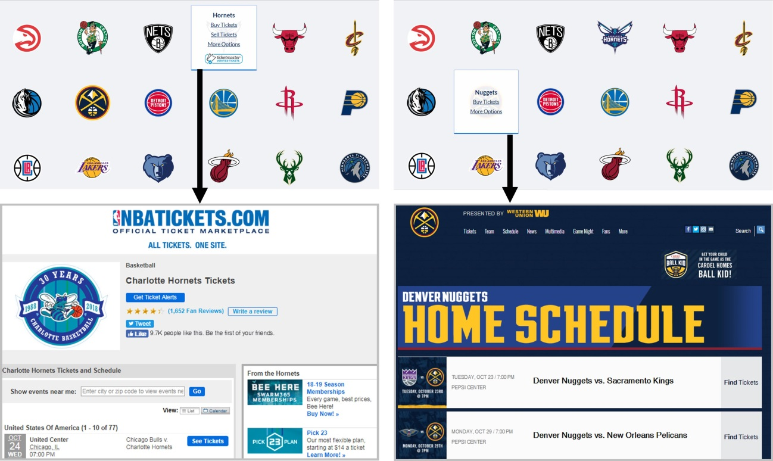
Figure 1. Ticket sales website examples.
The Charlotte Hornets (general platform) and the Denver Nuggets (team-specific portal). Retrieved from: http://nbatickets.nba.com/. Copyright by the NBA Media Ventures, LLC. And Ticketmaster.

Considering the prominence of the online environment, it is important to understand more clearly how the above-mentioned dimensions (i.e., the navigational complexity and interactive attributes) of sports ticketing web pages influence consumers’ perceptions, evaluations and subsequent behavioral decisions. By identifying these consumer-based preferable features in the online marketing communication, sports organizations could increase consumers’ awareness and enhance perceptual associations with them (Filo & Funk, 2005).
For example, Funk (2017) and Randle and Nyland (2008) have proposed that technology-driven changes such as interactivity could improve sports customers’ experiences that meet the goal-directed needs of sports consumers which in turn are able to create a competitive advantage for sales. They also advocated that greater attention to the online design elements and features are necessary in order to respond to the technological changes. Funk (2017) also spotlighted the importance of investigating how the impact of technology can influence sports customer experiences, how design elements increase users’ perceptions and evaluations of the sites, and how a user experience meets individuals’ wants and desires. Accordingly, researchers may need to assess the extent of navigability and interactive features on the page, and measure customers’ responses and evaluations generated from these different online sports ticketing contexts with the purpose of having an insight into the online sports ticketing practices.
Following this line of thought, the current dissertation serves as an exploratory study which aims to answer the aforementioned questions. To do so, this dissertation addressed online sports ticketing practices from web navigability, interactivity, and user experience perspectives. As Scholl and Carlson (2012) have pointed out, web-based interaction and communication share similar online characteristics and design principles even though there are market differences. This dissertation attempted to investigate the impact of sports online ticketing navigational complexity and interactivity on customers’ user experiences and psychological responses (i.e., attitude toward the website and ticket purchasing intention) in the sports online ticketing scenario.
To explore the issues, the present dissertation conducted a between-subjects online experimental study with the aim of following the actual sports ticketing settings and procedures and exploring customers’ experiences and responses. The experiment addressed the effect of navigational complexity and interactive feature of the sports ticketing platform on consumers’ dependent responses.
In detail, the current study explored the influences of navigability and interactivity of the sports ticketing website from the modality-agency-interactivity- navigability (MAIN) model perspective developed by Sundar (2008) and the theory of interactive media effects (TIME) initially proposed by Sundar, Jia, Waddell, and Huang (2015), and put the focus on navigability and interactivity categories. As Sundar, Xu, and Dou (2012) have suggested, the models can be applied to the advertising and marketing context by employing consumers’ attitudes and behavioral outcomes as the dependent variables.
Based on the MAIN model and the TIME model, people’s evaluations and perceptions toward a website would be influenced by technological affordances such as modality, agency, navigability, and interactivity visible on the interface (Sundar et al, 2015). Navigability affordances are the “interface features that suggest transportation from one location to another” (Sundar, 2008, p. 88). These affordances provided by an interface have the dual ability to trigger their own heuristics (e.g., easy navigable sites are more credible) directly and/or transmit the cues through the content that they generate (e.g., the words on the hyperlinks). The navigability affordances could serve as cues which are able to trigger individuals’ heuristics and assessments. In general, a website with abundant navigational links provides users with shortcuts to online content and may cue the browsing heuristic (i.e., encouraging users to browse the site); however, if a platform has too many navigational links, it may indicate the elaboration heuristic, meaning that users would need to think through the relationship between given links and the site’s main content (Sundar, 2008; Sundar et al., 2015). By reducing the navigational complexity, a site could enhance its usability, user-friendliness, and users’ assessments and perceptions of it (Sundar et al., 2015).
Interactivity, on the other hand, is “the degree to which two or more communication parties can act on each other, on the communication medium, and on the messages, and the degree to which such influences are synchronized” (Liu & Shrum, 2002, p. 54). It is one of the crucial media features differentiating digital media and other (traditional) media (Sundar, Kim, & Gambino, 2017). Interactivity enables users to voluntarily and instrumentally control their online actions, to communicate with one another reciprocally, and to send and receive messages simultaneously or asynchronously, which could directly influence browsers’ online experiences (Liu & Shrum, 2002; McMillan & Hwang, 2002).
In addition to the manipulated factors, this dissertation also seeks to examine the mediating effect of user experience in the proposed designs. User experience (UX) is “a person’s perceptions and responses that result from the use and/or anticipated use of a product, system, or service” (International Organization for Standardization [ISO], 2010, p. 1). In the era full of interactive media products, scholars (e.g., Chou, 2016; Hassenzahl & Tractinsky, 2006) have stated that UX serves as an effective implement to assess the nature of interactivities experienced by users. In the sports context, UX could range from users’ subjective experience of the sporting action to the interactions between users and digital media (Sun, May, & Wang, 2016). In this dissertation, two constructs of UX (pragmatic UX and hedonic UX) derived from the six-dimension scales developed by Laugwitz, Held, and Schrepp (2008) were examined as mediators between the designed stimuli and participants’ responses.
In terms of sports category selection, the current study selects the NBA as the primary object for the following reasons: first, the NBA is not only one of the four major professional sports leagues in the United States and Canada (i.e., the MLB, the NBA, the National Football League (NFL), and the National Hockey League (NHL)), but also a global empire and the top paying sports league in the world (Gaines, 2015; Mullin et al., 2014). Second, unlike other three major sports leagues selling online tickets through a single platform with mostly the same interface and features, the NBA, as stated earlier, partners with different channels in addition to Ticketmaster and may lead to different consumers’ responses. On the basis of these two characteristics, the current study chose the NBA online ticketing system as the main research target.
Furthermore, researchers have indicated that team (Wann, Bayens, & Driver, 2004) and fan passion to the team (Wakefield, 2016) would significantly influence consumers’ related behavioral intentions such as ticketing purchasing and event attendance. In Wann et al.’s study, team identification referred to fans’ feeling about their connections to a team and investments in the team. Fan passion, from another perspective, was defined as individuals’ efforts and emotions in supporting the team (Wakefield). To control the potential bias due to these factors, this dissertation measured participants’ team identification and fan passion toward the teams (i.e., Oklahoma City Thunder and Dallas Mavericks) included on the designed ticketing websites as the covariates.
In sum, this dissertation utilized the notions of navigability and interactivity, and investigated their influences on consumers’ perceptions, attitudes, and behavioral intentions toward the sports online ticketing platform. The mediating role of user experience in the field of sports online ticketing was also examined. The results from the current research may contribute to both academic and practical applications of sports online ticketing by extending the theoretical implications on such platforms, helping identify the ideal sports online ticketing model, providing some practical references for sports teams and system designers, and more importantly, better understanding sport consumers’ needs and wants related to online ticketing. The following chapters illustrate the theoretical background and rationale for each study.

Chapter 2: Historical Background and Literature Review
Sports online ticket sales has become a principal component of ticket operations (Irwin et al., 2008). Through the ticketing website, consumers are able to search ticket information, compare preferable seats and prices, interact with provided features, and make purchasing decisions. Although online ticketing plays an important role for revenue generation for spots teams (Hoye et al., 2015), little is known about its adapted design and how customers experience and value the design. In an attempt to fill the gap, at least in part, this dissertation aims to investigate how online features and designed elements of the sports ticketing website affect consumers’ experience, affective perceptions, evaluations, and subsequent behavioral intentions. To further examine the issue, this chapter first includes historical background of the NBA and sport marking, and then the literature review of navigability, interactivity, the MAIN model, and the TIME model are introduced. Next, the mediating effect of user experience is presented. Lastly, customers’ psychological responses (i.e., attitude toward the site and purchase intentions for tickets) toward the current dissertation outline are discussed.

Historical Background—the NBA and Sport Marketing
The NBA was officially formed in New York City in 1949 after merging the rival Basketball Association of America (BAA) and National Basketball League (NBL) (History.com, 2009). In 1984, the NBA’s merchandise sales were roughly $15 million and network TV coverage was limited. Nonetheless, after it adopted a marketing strategy in its global expansion, the NBA turned into a global empire and its players are among the highest-paid athletes in the world with an average salary of more than $7 million in the 2018-19 season (Mullin et al., 2014; Sporting Intelligence, 2018). This growth also indicates the importance of sport marketing and advocates the necessity of employing sport marketing strategies for sports organizations (Carlson et al., 2003; Pitts & Stotlar, 2013).

Definition of Sport Marketing
Sport marketing was coined by Advertising Age in 1978 to describe the activities of consumers and sports marketers who were increasingly using sport as a promotional vehicle (Alonso-Dos-Santos, 2014). Based on Pitts and Stotlar’s (2013) definition, sport marketing is “the process of designing and implementing activities for the production, pricing, promotion, and distribution of a sport product to satisfy the needs or desires of consumers and to achieve the company’s objectives” (p. 82). Similarly, Mullin et al. (2014) also illustrated that “sport marketing consists of activities designed to meet the needs and wants of sport consumers through exchange processes” (p. 13). In short, sport marketing is executing activities to meet sport consumers’ needs/desires/wants and sport teams’ objectives.

Sport Marketing and Online Ticketing
In sport marketing, ticket sales play a significant role for all other revenue streams such as sponsorships, food and beverage, merchandise, and so on (Mullin et al., 2014). Therefore, it is required for sports corporations to emphasize an effective ticket marketing, sales, and service plan. When recreating sport marketing strategy, it is also necessary to consider the mix strategy which is typically called the four Ps: product, price, place, and promotion (Pitts & Stotlar, 2013).
Product. Product should be understood as a concept with tangible (e.g., a baseball bat) or intangible (e.g., a basketball game) attributes and not simply as a singular item. It involves goods, services, people, places, and/or ideas, and has functions or benefits that would satisfy consumers need or wants (Pitts & Stotlar, 2013). To reach the sales goal, a sport marketer should understand what the consumer wants and desires first and then offer that product or service. In terms of sports ticket sales, tickets (tangible hard copy or intangible electronic version) are sold for the event/game (intangible item).
Price. Price refers to the exchange value (i.e., money, services, or other forms of product exchange from seller to buyer) of one product or service for another (Pitts & Stotlar, 2013). It affects the product’s success and the consumer’s perception of the product. This element is crucial because consumers’ decisions are also based on what they will pay in addition to knowledge about the product. For example, Diehl, Drayer, and Maxcy (2016) examined the secondary ticket market (i.e., resale ticket market) for NFL and the results showed that different seating location and relative quality are associated with diverse ticket prices. Moreover, Drayer, Shapiro, and Lee (2012) indicated that quality of the opposing team and time (e.g., weekday vs. weekend, regular game vs. playoff, and so on) would also lead to price differences. However, considering the main research purpose of this dissertation, the price element was controlled for the proposed experiments and therefore was excluded from the following discussion.
Placement. Placement (or product distribution) refers to where and how an organization sources products or services and transports it from the point of origin to the places where consumers can access them (Pitts & Stotlar, 2013). To do so, it requires efficient and effective distribution channels and/or intermediaries. For sports ticket sales, placement can be a fixed box office or electronic online ticketing. Since the early 2000s, sport organizations have increasingly used web-based ticketing to increase ticket sales (Howard & Crompton, 2004). Advanced electronic technologies allow consumers to purchase tickets through virtual box office online. Today, online ticketing has become a prominent part of ticket operations since it provides customers faster and more convenient transaction channel (Morehead et al., 2017; Mullin et al., 2014). Thus, the current study employed the online ticketing setting as the main scenario and investigated the effects of the ticketing website attributes on consumers’ evaluations and responses.
Promotion. Promotion is “the development of a fully integrated set of communication activities intended to persuade consumers toward a favorable belief or action as a tactical component of the overall marketing campaign” (Irwin et al., 2008, p. 3). On the one hand, it is designed to build and shape a favorable image for an organization; on the other hand, it helps increase potential consumers’ attention, attract interest, arouse desire, and ultimately encourage their consumption of the products or services (Hoye et al., 2015; Mullin et al., 2014). In other words, promotion is not just for positioning a product/brand and building its image in consumers’ mind, but for raising their attention, interest and consumption of the products/services as well. Following this, online ticketing promotion was the main focus of this study.
Generally, the four Ps are interrelated, meaning that a change of one element would have an influence on the other elements. Thus, it is crucial for sports organizations to consider the optimal and overall marketing mix (i.e., the strategic combination of four Ps) for both the target market and the business (Pitts & Stotlar, 2013). In the sports online ticketing scenario, the ticket to the game itself is the only product. Price and promotion elements have been examined in previous literature (e.g., Drayer et al., 2012; Howard & Crompton, 2004; Morehead et al., 2017; Shapiro, Drayer, & Dwyer, 2016). However, relatively limited research investigating the “placement” with other marketing mix elements exists and thus requires more examination on this dimension. For instance, Brown (2003) has advocated that more research should be conducted to explore the web as an effective marketing tool from the users’ perspective (e.g., why a customer prefers one website versus others). This dissertation, therefore, sought to explore the effect of promotion element of the marketing mix in the online environment (placement) in an attempt to fill the gap.

Online Ticketing and the NBA
In 2012, the NBA and Ticketmaster announced a deal in which they created a centralized online ticketing destination, and NBA fans would be able to purchase all teams’ primary and secondary tickets in one portal (Jessop, 2012; Mullin et al., 2014). The idea is that this one-stop shop would increase the convenience and easiness for fans by directing them to the page containing all available ticket options for each team and allowing them to compare selling options (e.g., price, seat location, and so on) and for tickets sold by teams, as well as tickets being re-sold by others on the secondary market in one place. In 2018, the NBA agreed to extend its ticketing partnership with Ticketmaster for two more years (Fisher & Lombardo, 2018). Ticketmaster not only became the official ticketing provider of the NBA, but also initiated a new way for sports fans to purchase event tickets.
However, unlike the other three professional sports leagues using a single online ticketing portal (i.e., TicketsNow for 30 of 31 NHL teams, Ticketmaster for NFL teams, and StubHub for MLB teams), audiences who seek to purchase NBA tickets through its one-stop online platform (i.e., nbatickets.nba.com) may notice that not all teams link to Ticketmaster (i.e., the official ticketing partner of the NBA). In detail, after clicking “buy tickets” on the NBA ticketing online portal, 22 of 30 teams indeed link straight to Ticketmaster while others direct consumers to different ticketing platforms, such as AXS, StubHub, and SeatGeek, with different layouts, navigational structure (e.g., news, schedule, video, shop, and so on), and interactive features. Additionally, these teams also use alternative systems (e.g., Flash Seats, VividSeats, and ticketexchange) for ticket resale (see Table 1).
Since the ultimate goal of online ticket sales are alike for all teams (i.e., selling tickets) and customers who mainly use these ticketing websites to look for ticket information, why do these ticketing platforms have such vast differences when it comes to navigability and interactivity? Also, would these differences result in dissimilar consumers’ perceptions and responses? To respond, the following literature review seeks to understand customers’ potential responses and evaluations toward the web differences from the theoretical perspectives of navigability, interactivity, the MAIN model, and the TIME model.

Table 1. Ticketing Platforms for NBA Teams in the 2018-19 Season
Ticketing Platforms for NBA Teams in the 2018-19 Season
Platform | Team | Total
Ticketmaster | Atlanta Hawks, Boston Celtics, Brooklyn Nets, Charlotte Hornets, Chicago Bulls,  Dallas Mavericks, Detroit Pistons,  Golden State Warriors, Indiana Pacers,  Memphis Grizzlies, Miami Heat,  Milwaukee Bucks, New York Knicks,  Oklahoma City Thunder,  Orlando Magic, Phoenix Suns,  Portland Trail Blazers, Sacramento Kings,  San Antonio Spurs, Toronto Raptors, Utah Jazz, Washington Wizards (Ticketmaster) | 22
Team-specific portals using AXS | Cleveland Cavalier, Denver Nuggets,  Minnesota Timberwolves (Flash Seats)  Houston Rockets (AXS)  Los Angeles Clippers (Vivid Seats)  Los Angeles Lakers (Ticketexchange) | 6
StubHub | Philadelphia 76ers (StubHub) | 1
SeatGeek | New Orleans Pelicans (SeatGeek) | 1
Note. Resale tickets portal for each team is given in parentheses.

Navigability
Navigability is a crucial element of website design and it is widely recognized as a pivot for the success of a site (Cachero, Meliá, Genero, Poels, & Calero, 2007; Zhang, Zhu, & Greenwood, 2004). Website navigability refers to the efficiency, effectiveness, ease, and satisfaction with which a user can follow the site’s hyperlink structure, find the required piece of information, and satisfy specific goals by moving through a website (Cachero et al., 2007; Fang et al., 2012; Zhang et al., 2004).
In general, a good navigability design often includes navigational attributes such as links, clear description, few clicks, and so forth (Mateos, Mera, Miranda González, & González López, 2001; Zhang et al., 2004). It could attract users and help them locate information more effectively, easily, and quickly because a well-designed navigability structure provides a clear model for information location which could facilitate the path selection through the interconnected page (Fang et al., 2012; Mateos et al., 2001; Webster & Ahuja, 2006). For example, the presence of an appropriate site menu could help users navigate the site, avoid getting lost, and more importantly, indicate where users might find the information that they seek (Mateos et al., 2001). Also, Mateos et al. have stated that the number of clicks which are necessary to access information in the site could be an important determinant of its navigational degree. That is, a website with a fewer number of clicks to access needed content could increase users’ evaluation of it, and vice versa.
In contrast, a poor navigability web design would result in a loss of repeated visits and negative assessment because users may have had difficulty in finding the needed information from the site which in turn would influence their perception and willingness to visit it again (Miranda González & Bañegil Palacios, 2004). In the e-commerce setting, Miranda González and Bañegil Palacios further specified that a website with poor navigability designs may even cause a potential loss to sales.
Empirical studies (e.g., Cyr, 2008; Szymanski & Hise, 2000; Tung, Xu, & Tan, 2009) have supported that the navigability of an interface connecting pages about various resources, products, and/or services would affect user experience and assessment of it. In a cross-cultural context, Cry (2008) found that navigability efficiency of a B2C (i.e., business to consumer) web page is positively related to users’ trust and satisfaction toward the site, meaning that the website with effective navigability design through valid and relevant links would lead to more positive evaluations and responses toward the site. Similarly, Szymanski and Hise (2000) and Tung et al.’s (2009) studies showed that easy-to-navigate e-commerce websites were perceived as user-friendly and therefore led to more positive satisfaction and assessments of it.
Nonetheless, even though a well-designed interface usually comes with a variety of navigation attributes, it is not always beneficial. Scholars such as Zhang et al. (2004) and Fang et al. (2012) have pointed out that if the navigability of a web design is too complicated, it would increase the difficulty in navigating, and users may become confused and lost in such online environment instead of facilitating information seeking on the site. To avoid such a dilemma, the “three-click rule” is proposed and widely employed which suggests a general principle that users should be able to access the required information within three clicks of the mouse (Zeldman, 2001; Zhang et al., 2004). Clearly, it is essential for web designer and practitioner to find the optimal balance between website efficiency and web navigability complex.

Interactivity
Interactivity is another focal area of this study. It is one of the media features that differentiate digital media and other media (Sundar et al., 2017). Based on the definition, interactivity is “the degree to which two or more communication parties can act on each other, on the communication medium, and on the messages and the degree to which such influences are synchronized” (Liu & Shrum, 2002, p. 54). Similarly, Liu (2003) proposed that interactivity “offers individuals active control and allows them to communicate both reciprocally and synchronously” (p. 208). In general, three dimensions of interactivity are widely discussed: user control, two-way communication, and a/synchronicity (Liu & Shrum, 2002; McMillan & Hwang, 2002).
User control. The digital media often provides users with more navigational and interactive tools than do traditional media. By surfing the website with high level of user control, for example, users can voluntarily and instrumentally control their online actions that influence their experiences directly. That is, web surfers are able to control their experience on the basis of their volition when the website has sufficient user control functions. Among different categories of websites, online shopping websites often offer the most active control because customers need to pay closer attention and compare the choices all the time (Liu & Shrum, 2002; McMillan & Hwang, 2002).
Two-way communication. Two-way communication through the web makes communication with one another reciprocal, which means people can now give and collect instant feedback easily. The formats of two-way communication include chat rooms, discussion group, feedback tools such as a customer satisfaction survey and a company’s contact information, and web tracking techniques (Liu & Shrum, 2002; McMillan & Hwang, 2002).
A/synchronous communication. A/synchronous communication feature allows users to join a communication and receive responses simultaneously (e.g., communication through chat room) or asynchronously (e.g., communication through e-mail). Normally, a well-designed and maintained website is able to offer seamless communication with its users (Liu & Shrum, 2002; McMillan & Hwang, 2002).
Previous studies have supported the importance of interactivity in the web-based environment (e.g., Liu & Shrum, 2002; Sundar & Kim, 2005; Yoon, Choi, & Sohn, 2008). For instance, Liu and Shrum (2002) widely reviewed the literature regarding online interactivity and proposed several integrated findings. That is, active control may be more useful for goal-directed online searching (i.e., obtaining needed/required information) than pleasure surfing (e.g., looking for hedonic benefits and experiential experiences); synchronicity can be an important determinant of enhancing users’ general online experiences when users are downloading files; and users’ perception of general increased interactivity could positively affect their attitudes and behavior. Sundar and Kim’s (2005) study also indicated that interactivity is a strong feature aiding the persuasive function of online advertising. Expressly, an interactive ad (i.e., the ad with multiple hyperlinked layers) not only provides more product information to the audiences, but also increases users’ involvement with the product and leads to more positive evaluation of the ad. From a user standpoint, Yoon et al.’s (2008) findings confirmed that consumer perceived interactivity of the web (i.e., perceived degree of synchronicity and two-way communication) is positively correlated with online retail brands’ customer relationship building and satisfaction enhancement.
Though numerous studies have been conducted to examine interactivity, most of them focus on either attribute-based interactivity or user-perceived interactivity. The former argument holds the position that interactivity is an inherent feature or interface of mediated digital communication which may affect user experience unalterably (Sundar et al., 2015). The later proposition, on the other hand, states how the users perceive the interactive attributes of the system during the communication process (Liu & Shrum, 2002; Sundar et al., 2015).) The attribute-based interactivity focuses more on objected-centered exploration rather than user-centered approach. Conversely, user perceived interactivity often stresses too much on an attribute of the user (e.g., usage and user experience of the system) instead of the system itself (Sundar et al., 2015). As a result, these inconsistencies between the operationalization from previous studies make it difficult to conclude the role of interactivity in the online environment (Liu & Shrum, 2002). Additionally, both approaches may fail to explore the nature and operation of interactivity (Sundar et al., 2015).
To deal with this limitation, Sundar (2008) and Sundar et al. (2015) turned to the media-effects approach and proposed the MAIN model and the TIME model, which provided an integrated solution by categorizing digital media attributes into specific variables such as modality, agency, interactivity, and navigability, and allows researchers to examine the effects of these variables on user responses.

MAIN Model and TIME Model

Modality-Agency-Interactivity-Navigability (MAIN) Model
From a technological affordance perspective, Sundar (2008) has proposed the MAIN model (see Figure 2) focusing on the technological aspects of digital media and identified four broad technological affordances (i.e., modality, agency, interactivity, and navigability) that have revealed significant effects on users’ evaluations and psychological reactions. In the model, affordances are offered by the technology and have particular capabilities to facilitate certain actions (Sundar, 2008). Each of the affordances could cue a range of heuristics implying the judgment rules and affect users’ perceptions of media (Sundar, 2008; Sundar et al., 2015).
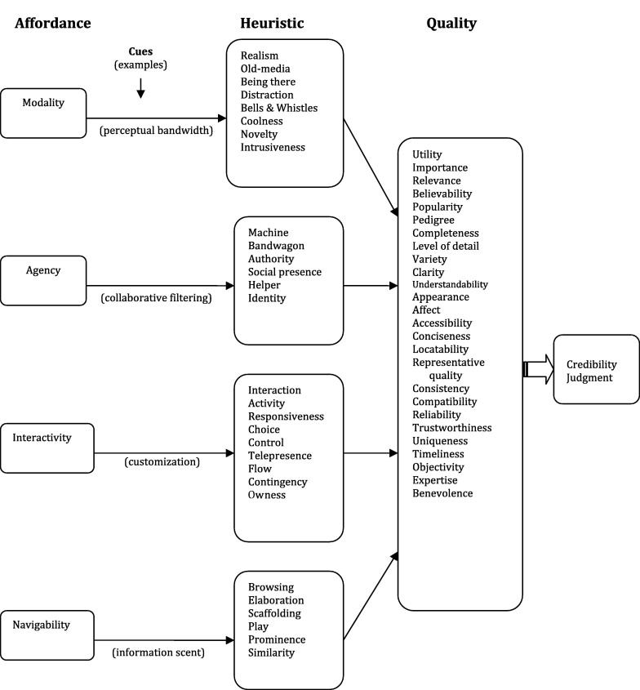
. From “The MAIN Model: A Heuristic Approach to Understanding Technology Effects on Credibility,” by S. S. Sundar, in M. J. Metzger and A. J. Flanagin (Eds.), Digital, Media, Youth, and Credibility (p. 91), 2008, Cambridge, MA: MIT Press. Copyright 2008 by the MIT Press.

Figure 2. The MAIN model

Modality affordance. Modality affordance is the most structural affordance and the most apparent on an interface. It is the means (e.g., text, aural, and audiovisual) through which information is conveyed. Different modalities can influence individuals’ perceived quality and credibility of content (Sundar, 2008; Sundar et al., 2015). For example, if the interface affords an audiovisual presentation of information, users may be more likely to trust image context which is assumed as a direct representation of reality over textual information. In an early advertising study, Mitchell and Olson (1981) had pointed out that visual components of an advertisement help consumers transfer visual information into meaningful semantic messages, form attitudes toward the ad and the brand, and shape their behavioral intentions. In this dissertation, modality remained the same across the experimental conditions in order to exclude its influence.
Agency affordance. Agency affordance is a source of cues/heuristics that could be utilized to evaluate the credibility of message senders (Sundar, 2008; Sundar et al., 2015). In the model, individuals’ perceptions of information source in digital media can influence their evaluation of it. For instance, a message may be evaluated as more credible when it comes from a named expert instead of a layperson (Hu & Sundar, 2010). Similarly, if an online information source or a website has abundant endorsements from others, it can help overcome consumers’ (or users’) initial skepticism about the source or website (Metzger, Flanagin, & Medders, 2010). In the current study, agency was not an included affordance, and thus, only one ticketing source (i.e., Ticketmaster) was utilized on the designed websites in order to eliminate the potential influence of the affordance.
Navigability affordance. Navigability affordance is the interface features that could transit users from one site to another (Sundar, 2008; Sundar et al., 2015). Navigability affordance is a primary focus in this dissertation. According to the model, navigability affordances of digital media serve as cues that could trigger heuristics with different navigational aids on an interface and shape user’s experience and assessments. For instance, navigability affordances that allow users to browse a website and locate relevant information easily could affect users’ judgment by triggering the helper heuristic. Besides, heuristics can also be cued based on the ease of navigating throughout a system. Overall, all the heuristics generated by navigability affordances potentially suggest the designer’s goodwill and thus predisposing users to be positive toward the site. However, similar to the proposition discussed earlier (Zhang et al., 2004; Fang et al., 2012), a well-organized hierarchical layout of navigational links could evoke an effortless visual search and encourage users to browse the site thoroughly and positively, but too complicated navigability design may in contrast result in more elaborative processing in an effortful manner and therefore may lower its usability and users’ perceptions of it.
Interactivity affordance. Interactivity affordance, another important determinant in this dissertation, implies both interaction and activity (Sundar, 2008; Sundar et al., 2015). Normally, the presence of digital media attributes on the interface that facilitates user interactions and activities can result in a positive user experience and evaluation of the content. For example, if an interface affords user control, a key concomitant of interactivity, it can trigger the control heuristics, score high on its quality, and thus enhance users’ experience and assessment of it (Sundar, 2008).
To briefly sum up, though the concepts of navigability and interactivity are widely discussed in the academic fields, their essential roles in the sports online ticketing is not fully investigated. Logically, the ultimate goal of online ticketing websites is to sell tickets and customers who browse these sites may look for ticket information mainly. Following this, a good navigability design in the sports ticketing context ought to ease users to locate required ticketing information quickly and effectively, then what navigability structure should a well-designed ticketing platform have? Also, will different interactivity attributes of the ticketing website result in different users’ responses? Considering the different navigability and interactivity affordances provided by the actual NBA online ticketing websites (i.e., portal locating ticket information with simple navigability structure vs. system with complex hierarchical navigability; website with interactive (360°) relative seat viewing feature vs. no interactive (fixed) relative seat viewing), it is crucial to better understand how these differences influence user experiences and perceptions of the sites.
The MAIN model provides an overall framework explaining the influences of the technological affordances on users’ perceptual and psychological responses to digital media. In a study review article, Metzger and Flanagin (2013) employed the proposition of the MAIN model and pointed out the importance of cognitive heuristics (e.g., reputation heuristic, endorsement heuristic, consistency heuristic, etc.) to the credibility evaluation in the online environment. For instance, when an online information source is considered primary, or official, people are more likely to follow the reputation heuristic elicited by the source and believe it compared to an unfamiliar source (Hilligoss & Rieh, 2008). Likewise, if online information is consistent or similar across different sources, it is likely to elicit consistency heuristic and then help establish credibility of the info (Metzger et al, 2010).
In addition to the credibility evaluation, Sundar and Limperos (2013) applied the MAIN model to the uses and gratifications perspective and proposed four new types of online gratification (i.e., modality-based gratification, agency-based gratification, navigability-based gratification, and interactivity-based gratification) generated from interacting with the technological affordances. Furthermore, Sundar et al. (2012) also indicates that the assumption of the MAIN model can be applied to the field of online advertising and marketing by simply replacing the outcome variable from credibility to customers’ attitudes and behavior (see Figure 3). In the chapter entitled “Role of technology in online persuasion,” they explain the roles of technological affordances (i.e., online action possibilities) and how these affordances trigger cognitive heuristics positively/negatively, and then influence consumers’ attitudes, evaluations, and behavioral intentions. For example, consumers who view a banner advertisement with pull down menu (interactivity) may pay more attention, generate more positive attitudes toward the ad, and be more likely to click it than an ad without pull down menu (Brown, 2002). A website with or without navigational menu (navigability) can also affect users’ perceptions and evaluations of it (Spyridakis, Mobrand, Cuddihy, & Wei, 2007).

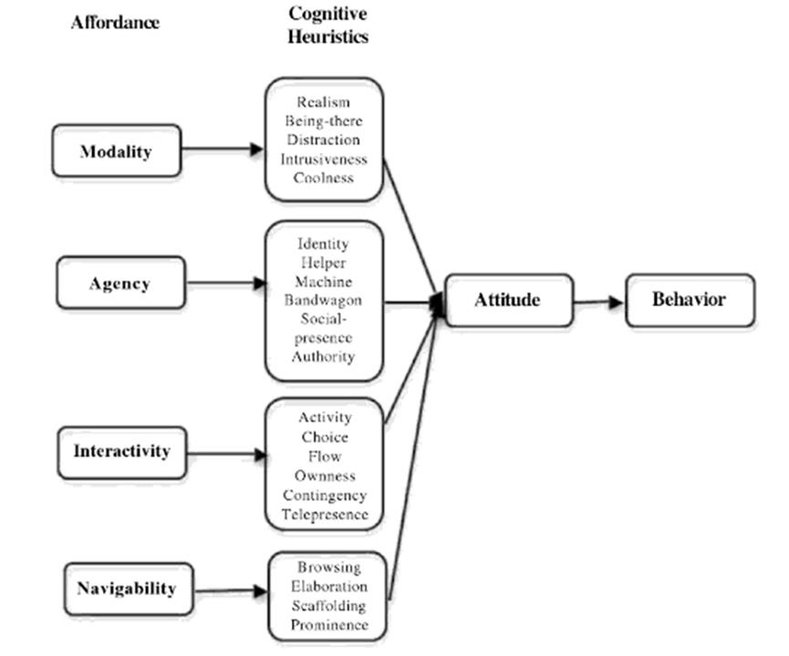
From “Role of Technology in Online Persuasion,” by S. S. Sundar, Q. Xu, and X. Dou, in S. Rodgers and E. Thorson (Eds.), Advertising Theory (p. 361), 2012, New York, NY: Routledge, Taylor & Francis Group. Copyright 2012 by the Routledge.

Figure 3. The MAIN model for online advertising and marketing.

Nonetheless, as Sundar (2008) has pointed out that “not all cues trigger all the listed heuristics and not all heuristics result in quality evaluations along all the listed criteria” (p. 92), the MAIN model does not fully and clearly clarify the listed heuristics and related qualities. To fill the gap, Sundar and the colleagues (2015; 2017) combined the MAIN model and proposed the TIME model to thoroughly explain the effects of interactive media.

Theory of Interactive Media Effect (TIME)
Combining with the MAIN model, the TIME model emphasizes a variable-centered approach to examine the psychological effects of media and provides a comprehensive framework of interactive media effects (Sundar et al., 2017). Similar to the MAIN model, the theory advocates categorizing a given technology or medium into its elemental variables and exploring their distinct effects and/or common combinations (Sundar et al, 2017).
To begin with, the theory conceptualizes technological features of interactive media as “affordances,” which refer to the interface features that are attributable to the technology of the medium instead of the content or source of communication (Sundar et al, 2015). The theory also argues that the affordances are the possibilities for action suggested by environment stimuli (Sundar et al., 2015; Sundar et al., 2017). Here, the concept of possibilities is important because media users may take the interactive tools as visual cues for website evaluations, but they may not always actively engage with all of them. That is, a digital media user’s perceptual and psychological response would be elicited not only by the use of it, but also by the simply presence on an interface (Sundar, 2008). Further, the theory proposes two main routes, cue-route and action-route, to predict users’ perceptual and psychological responses (Sundar et al., 2015; Sundar et al., 2017).
Cue-route.The cue-route originating from the MAIN model, specifies that the presence of affordances of interactive media (e.g., presence of features, tools on the interface, and/or auto-generated metrics) allows specific user action and serves as a psychologically salient cue for the users that triggers perceptual shortcuts or cognitive heuristics about the nature of the site, its source, and its content. Consequently, the presence of affordances can shape user evaluation of the quality and credibility of the media and induce psychological responses even if individuals do not actually engage those affordances (top pathway of Figure 4). As Sundar et al. (2017) have noted, when users are sufficiently persuaded by the salient cues without feeling the actual need to explore further (e.g., actively clicking the interactive tool such as live chat), the cue-route may be enough to aid understanding of the interactive media effects. However, if users prefer going further and attending to the interactive features, then they may turn to the action-route.
Action-route. The action-route proposes that actions generated by affordances of interactive media (i.e., the use of interface features to perform communication actions such as browsing content and sending message) would initiate users’ engagement with media content. In addition, the action-route stresses on four sets of mediators (i.e., perceptual bandwidth, contingency, sense of agency, and self-determination) between actions afforded by the interface and user engagement with the content offered by the interface (bottom pathway of Figure 4).

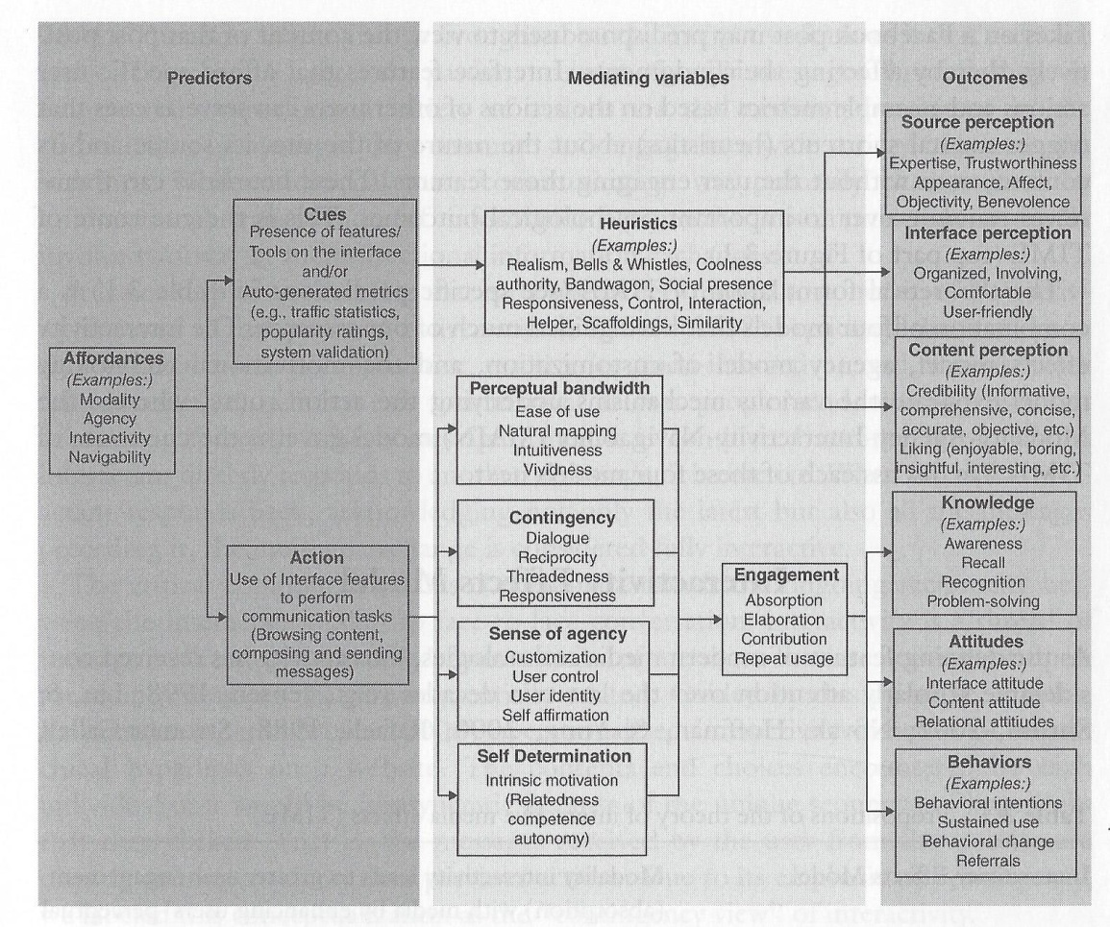
. From “Toward a Theory of Interactive Media Effects (TIME): Four Models for Explaining How Interface Feature Affect User Psychology,” by S. S. Sundar, H. Jia, T. F.Waddell, and Y. Huang, in S. S. Sundar (Eds.), The Handbook of the Psychology of Communication Technology (p. 51), 2015, Malden, MA: John Wiley & Sons. Copyright 2015 by the John Wiley & Sons, Inc.

Figure 4. The theory of interactive media effects (TIME)

Perceptual bandwidth. Perceptual bandwidth refers to breadth and depth of users’ sensory experience of the interface caused by the modality-interactivity affordances (i.e., the interaction techniques available for users to control the interface) such as clicking and dragging on the screen.
Perception of contingency. It is the relatedness in message exchange. It is predicted by the message-interactivity affordance (i.e., interactive tools which permit back-and-forth interdependent message exchanges or offer tailored content according to prior user behavior) such as a live chat.
Sense of agency. Sense of agency focuses on the source-interactivity affordance which allows users to serve as source agents or sources of communication, such that users can customize and create their preferable content.
Self-determination. It is primarily driven by individuals’ intrinsic motivations such as competence and autonomy which are influenced by navigability and customization affordances respectively (Sundar et al., 2017).
Typically, the engagement engendered by user action in interactive media environments can range from simply elaborating the existing content to making new content contributions by self-expression (Sundar et al., 2015; Sundar et al., 2017). As a result, this affordance-driven engagement may dictate the cognitive, attitudinal, and behavioral outcomes of using interactive media.
To sum up, though, there is a lack of empirical examination of TIME thus far, the theory still provides a clear framework regarding how the technological affordances of the interactive media influence users’ perceptions, knowledge, attitudes, and behavior. In the actual setting of the NBA online ticketing context, navigability and interactivity of the ticketing website are two main elements that differentiate the portals. Thus, the terms navigability and interactivity were used as technological affordances of the online ticketing platform in this dissertation and were manipulated to assess their impact on users’ responses.
Nevertheless, it is also important to note that not every action provided by an interface results in all four mediating effects (Sundar et al., 2017). As a result, it is difficult to predict which mediating effect would be elicited by the digital media affordances and action. Besides, the measurements for the mediating factors in the model are not fully examined. Therefore, this dissertation turned to the UX perspective instead of employing the mediators in the model since UX is recognized as a comprehensive and effective implement to assess the nature of interactive media experienced by users (Chou, 2016; Hassenzahl & Tractinsky, 2006). Moreover, this dissertation included consumers’ attitudes toward the NBA ticketing website and behavioral intentions as two main outcome variables because they are central to advertising, marketing, and consumer research (McMillan & Hwang, 2002).

User Experience
Interactive digital media nowadays have become a useful and popular trend. For example, the number of smartphone users across the globe is forecast to be over 3.8 billion by 2021, meaning that more than one third of the world’s population uses mobile phones (Takahashi, 2018). To have a more in-depth understanding of its nature experienced by consumers, user experience (UX) may provide an applicable implement to investigate the environment of interactive products on today’s rival mass markets (Chou, 2016).
According to the International Organization for Standardization (ISO) 9241-210 report’s (2010) definition, UX is “a person’s perceptions and responses that result from the use and/or anticipated use of a product, system, or service” (p. 1). Also, scholars have defined the concept of UX in general. Hassenzahl and Tractinsky (2006) argued that UX is not only about instrumental needs, but also about subjective, situated, complex, and dynamic encounters. They also outlined that UX is a consequence of a users’ internal states, the characteristics of the designed system, and the context (or the environment) within which the interaction occurs. Overall, UX can happen before, during, and after use. By interacting with brand image, functionality, system performance, interactive behavior, and assistive capabilities, UX incorporates with users’ emotions, preferences, perceptions, physical, and psychological responses. From a sports scenario perspective, user experience can be referred to as the subjective experience and interactions between the user and the sporting action, the user and other audiences, the user and information sources, and the user and digital media (Sun et al., 2016).
UX has been examined in different fields. Chou’s (2016) study revealed that users would have different UX perception while using different types of touch mouse (i.e., a type of computer mouse which provides users a touch-based environment to interact with computer). Specifically, consumers would generate dissimilar experiences in the perspectives of general impression, perceptions, and performance when they deal with different interactive products even if they are the same type of items. In an attempt to develop an UX scale for the setting of a video game, Phan, Keebler, and Chaparro (2016) identified nine subscales including usability, narratives, play engrossment, enjoyment, creative freedom, audio aesthetics, personal gratification, social connectivity, and visual aesthetics. McCornack and Johnson (2016) investigated the influence of positive UX of an extension training event for a web-based sampling plan on crop school members’ willingness to share relevant data with others through digital application. The results suggested that such positive experiences of digital media (i.e., inputting the information and retrieving treatment recommendations) would indeed increase participants’ willingness to share wheat pest data online. Santoso, Schrepp, Isal, Utomo, and Priyogi (2016) sought to develop an adapted version of UX questionnaire to evaluate the interactive e-learning management system and the findings supported that UX can be used to examine the effectiveness of the interactive e-learning environment including web-based applications.
Even though a diversity of UX studies have been conducted, most of the scholars agree that there is still a lack of systematic resources available to measure UX of every product (Chou, 2016; Santoso et al., 2016; Vermeeren et al., 2010). Among the studies, Laugwitz et al.’s (2008) UX questionnaire may be the one that has been widely applied for UX measurement (Chou, 2016). Thoroughly, the questionnaire consists of three main constructs and each construct has one to three dimensions for a total of six dimensions: general impression toward the websites (dimension: attractiveness), pragmatic quality (dimensions: perspicuity, efficiency, and dependability), and hedonic quality (dimensions: stimulation and novelty), which shows a satisfactory level of reliability and construct validity. Thus, this dissertation utilized Laugwitz et al.’s questionnaire to evaluate consumers’ experiences regarding the sports (NBA) online ticketing context.

Attitude toward the Website and Behavioral Intention

Attitude toward the ad/stimulus
Attitude is commonly defined as “general evaluation of objects, issues, or people” (Haugtvedt & Kasmer, 2008, p. 419). In the field of advertising and marketing research, it is an individual’s internal evaluation of an object such as an advertisement, a brand, a branded product, and so forth (Mitchell & Olson, 1981).
Attitude toward the ad/stimulus and attitude toward the brand are two main constructs in the field and should be thought of separately (Mitchell, 1986). Studies have showed that attitude toward the advertisement (or external stimulus) would mediate the advertising effects on brand attitude, whereas attitudes are able to mediate behavioral intentions substantially (Mitchell & Olson, 1981). Similar results were found in MacKenzie, Lutz, and Belch’s (1986) research that attitude toward the ad/stimulus exerts significant and positive effect on attitude toward the brand. Generally, individuals’ liking for the advertising/external stimulus or the visual components presented in the ad/stimulus would form brand attitudes in addition to the attribute beliefs about the brand (MacKenzie et al., 1986; Mitchell & Olson, 1981). In short, consumers’ attitudes toward the ad/stimulus have an impact on their brand attitudes and subsequent behavioral intentions.

Behavioral Intention
Behavioral intention, the immediate predictor of actual behavior, represents an individual’s plan to act in response to desired goals (Crano & Prislin, 2006). It is the motivational indicator of how hard an individual is willing to try, or how much effort s/he is planning to exert, to execute the actual behavior (Ajzen, 1991). Scholars (e.g., Crano & Prislin, 2006; Sheeran & Abraham, 2003) have posited that strong intentions triggered by high certainty, attitudinal reaction, and great experience are closely related to actual behavior.

Attitude and Behavioral Intention in the Online Environment
Empirical studies have stated the relationship between attitude toward the ad/stimulus and subsequent behavioral intention in the online environment. Korgaonkar and Wolin’s (2002) study revealed that when individuals had more positive attitudes toward the online advertisement, they would be more likely to shop online and spend more money on these purchases. In a cross-culture (USA vs. Romania) comparison study, Wang and Sun (2010) found consumers’ beliefs about the online advertising (e.g., bringing entertainment, providing information, believable or not, and so forth) significantly influenced their attitudes toward the online ad, which strongly predicted their subsequent behavior such as clicking the ad and shopping online regardless of the nationalities. Zhang and Mao (2016) explored consumers’ responses to social media advertising and indicated that consumers’ attitudes toward the ad on social network sites positively predicted their ad clicks; following, it influenced their product evaluations and behavioral intentions.
Similar results were found in the field of online consumer research. Khalifa and Limayem’s (2003) study focused on Internet consumer behavior and the results showed that individuals’ attitudes toward online shopping were significant determinants of their intentions to shop online. Likewise, Yang, Lester, and James (2007) compared British and American consumers’ attitudes toward online shopping and their Internet purchases. The findings indicated that attitudes indeed significantly predicted customers’ online purchases even though there were nationality differences. Javadi, Dolatabadi, Nourbakhsh, Poursaeedi, and Asadollahi (2012) explored the influences of online shopping attributes (e.g., perceived risk and return policy) on consumers’ attitudes and behavior and found out that financial risk (i.e., the safety of personal consumption record) and non-delivery risk negatively affected consumers’ attitudes toward the e-commerce, which in turn reduced their online shopping willingness. More recently, Hasbullah et al.’s (2016) study examined Malaysian youths’ online shopping behavior and the outcomes supported that attitudes toward online purchases had significant and positive influences on customers’ intentions to shop online. Similarly, Hsu, Chen, Yang, and Lin’s (2017) assessed the effect of attitude toward a gamification website on users’ behavioral intentions and the findings also showed that users’ attitudes toward the website was a strong predictor of behavioral intentions such as website usage intention and word-of-mouth intention.
Overall, attitude has crucial influences not only on consumers’ perceptions and thoughts, but also on their behavior predictions (Crano & Prislin, 2006; Haugtvedt & Kasmer, 2008). Therefore, this dissertation defined attitude toward the sport (NBA) ticketing website (i.e., external stimulus) as customers’ evaluations, in a favorable (or unfavorable) manner, of the particular ticketing portal during an exposure occasion, and employed them as the predictors of subsequent behavioral (ticket purchase) intentions. On the other hand, attitude toward the brand was not discussed in this dissertation because each ticketing website is designed uniquely and represents the brand itself substantively. Measuring individuals’ liking for the website is technically the same to their liking for the brand. Further, behavioral intention was defined as consumers’ willingness to purchase the tickets via the online portal which would be positively related to the actual purchase behavior.

Chapter 3: Hypotheses and Research Question
The current dissertation aims to test the effects of navigability and interactivity affordances of the sports online ticketing platform on customers’ experiences, attitudes toward the site, and intentions to purchase the tickets. The mediating effect of user experience is also examined. According to the literature, the main effect of each factor and the interaction between two manipulated variables are discussed in the following sections. Hypotheses and research questions are presented as well.

Main Effects of Navigability and Interactivity

Navigability
Based on the MAIN model and the TIME model, navigability affordances are the interface features that allow transportation from one site to another (Sundar, 2008). These affordances could trigger users’ heuristics and shape their experience and evaluations of digital media (Sundar, 2008; Sundar et al., 2015). Generally, a website with good navigational structure should include sufficient navigation attributes and it would result in more positive experience and responses than a poorly-designed website. However, if there are too many navigability links on the website or the navigability structure of the system is too complicated, users may need to systematically elaborate the affordances provided on an interface and in doing so would influence their perceptions and assessments of it.
In the sports ticketing scenario, customers are those who have specific purchasing goals (i.e., purchasing the tickets) before using the platform. Thus, it is rational to predict that the navigability of the ticketing platform (e.g., portal locating ticket information simply or platform with complex navigability structure) would have significant impact on users’ perception and responses. That is, participants, with the purpose of purchasing tickets, should be more likely to primarily search ticketing information. Therefore, when the subjects browse the website with simple navigational design, they should generate more positive experience and perception of the site than those who surf the portal with complex navigability stages. The current study proposed the following hypotheses (see Figure 5):
H1: Participants who browse a ticketing platform with simple navigational design have more positive user experiences than those who surf a website with complex navigability structure after controlling for team identification and fan passion.
H2: Participants who browse a ticketing platform with simple navigational design have more positive attitudes toward the portal than those who surf a website with complex navigability structure after controlling for team identification and fan passion.
H3: Participants who browse a ticketing platform with simple navigational design have higher intentions to purchase tickets than those who surf a website with complex navigability structure after controlling for team identification and fan passion.

Interactivity
Empirical research has supported that interactivity could have positive influences on users’ product evaluation (e.g., Sundar & Kim, 2005). More specifically, Liu and Shrum (2002) indicated that active control, one of three dimensions of interactivity, is the essential element in the shopping environment because customers need to pay more attention and compare the options. In addition, according to the TIME model, engaging in the interactive action (i.e., using the interface feature to perform communication tasks) would affect users’ perceptions, knowledge, attitudes, and behavior.
From the NBA online ticketing perspective, active control is a crucial dissimilarity among different platforms. That is, some platforms employ 360° relative seat viewing function that allows users to see the whole view of the arena by dragging the mouse while some simply use fixed relative seat viewing with only one secured direction. Thus, it is likely that users who experience 360° relative seat viewing function would generate more positive perception and responses than those who involve in fixed relative seat viewing condition. According, this study proposes the following hypotheses (see Figure 5):
H4: Participants who browse a ticketing platform with high interactivity function (360° relative seat section viewing) have more positive user experiences than those who use a portal with no interactivity feature (fixed relative seat section viewing) after controlling for team identification and fan passion.
H5: Participants who browse a ticketing platform with high interactivity function (360° relative seat section viewing) have more positive attitudes toward the website than those who use a portal with no interactivity feature (fixed relative seat section viewing) after controlling for team identification and fan passion.
H6: Participants who browse a ticketing platform with high interactivity function (360° relative seat section viewing) have higher intentions to purchase tickets than those who use a portal with no interactivity feature (fixed relative seat section viewing) after controlling for team identification and fan passion.

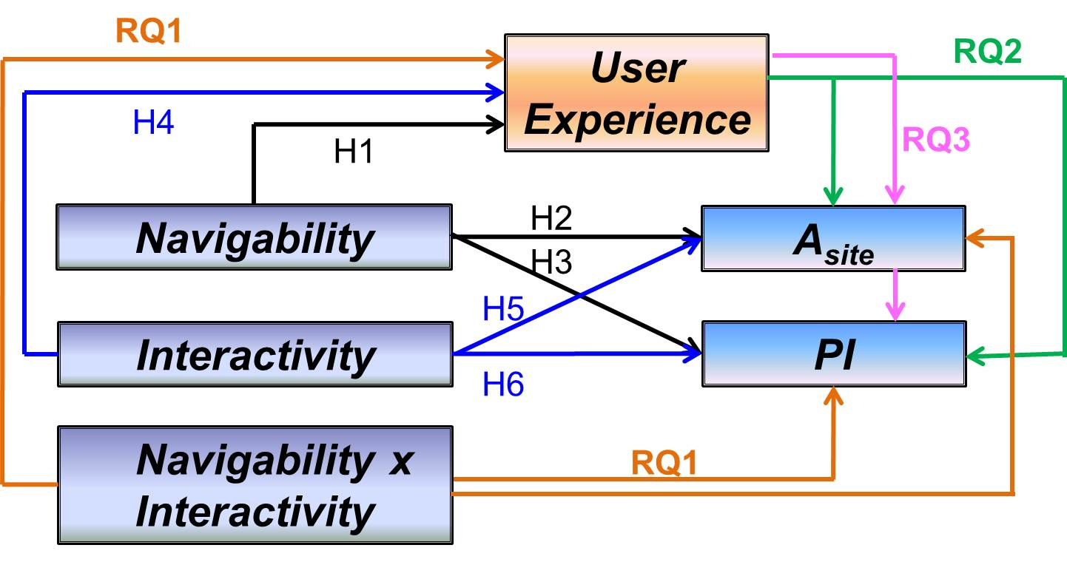
. A_{site} = attitude toward he website; PI = purchase intention.
Figure 5. The proposed study model

Interaction
Briefly, studies supported that both navigability and interactivity would have main effects on consumers’ perception, evaluation, and affective reactions respectively. Following this line of thought, it is reasonable to assume that the ticketing platform presented with simple navigability and a 360° relative seat viewing feature would lead users to more positive outcomes. Nonetheless, limited literature has sought to assess the potential interaction effect between these two factors. This study therefore proposes the following research question in an attempt to, at least in part, fill out the gap (see Figure 5):
RQ1: Will there be an interaction between navigability and interactivity on participants’ (a) user experiences, (b) attitudes toward the site, and (c) the intentions to purchase tickets?

Mediating Effect of User Experience
Moreover, this study was also interested in understanding the mediating effect of user experience in the relationship between proposed design and participants’ responses. User experience, in this study, served as an implement used to assess consumers’ perceptions and responses that result from browsing the ticketing website. Due to the reason that no research has examined the mediating role of user experience in the online sports ticketing context, especially with the focus on navigability and interactivity, the following research question is proposed (see Figure 5):
RQ2: Will user experience mediate the influence of navigability and interactivity on participants’ (a) attitudes toward the site and (b) intentions to purchase tickets?

Serial Mediating Effects of User Experience and Attitude Toward the Website
As mentioned above, attitudes toward the ad/stimulus have crucial influences on customers’ behavior prediction (Crano & Prislin, 2006; Haugtvedt & Kasmer, 2008). Therefore, the current study also wondered if user experience has a mediating effect on customers’ attitudes toward the site and intentions to purchase tickets, will there be a serial mediating effects of user experience and attitude toward the website on their subsequent ticket purchasing intentions? This study, therefore, poses the following research question (see Figure 5):
RQ3: Will user experience and attitude toward the website mediate the influence of navigability and interactivity on participants’ intentions to purchase tickets?

Chapter 4: Method
The purpose of the current study is to assess the impacts of navigability and interactivity features on users’ experience, attitudes toward the website, and intentions to purchase tickets in sports ticketing websites. Moreover, the study also seeks to investigate the mediating influence of user experience on consumers’ responses. This chapter explains the framework of research design that was employed to test the hypotheses and answer the research questions developed in chapter 3. Also, independent variables, pre-test, dependent measurements, mediating variable, control variables, participants, study procedure, and statistical procedures for data analysis are discussed.

Research Design
A 2 (navigability: complex vs. simple) × 2 (interactivity: high interactivity vs. no interactivity) between-subjects factorial design was employed. An online experiment was conducted to test the proposed hypotheses and answer the research questions. According to Wimmer and Dominick (2011) and Leshner (2014), using the experimental method allows researcher to control the variables and examine causality. By conducting an online experiment, researcher can access to demographically diverse sample, reduce cost, and provide more convenience for participants (Reips, 2000). In addition, by employing a between-subjects design, participants may not figure out the manipulations easily and researcher can compare the values of each dependent variable across conditions (Leshner, 2014).
In the current study, participants recruited from the Amazon Mechanical Turk (MTurk) online panel were randomly assigned to each condition. In each condition, participants were instructed that their task was to find one specific game they are assumed to attend and then they need to search for the seat section with the relative view they prefer based on the arena map provided on the ticketing website. After browsing the website and selecting the section, participants were asked to answer a self-report questionnaire to evaluate their perceived experiences and responses.
In terms of the NBA team selection, the current study utilized one of the mid-western teams—Oklahoma City Thunder—as the example. The scenario of the ticketing website was based on the actual NBA online ticket sales setting and process in order to examine the differences between design elements and features of real online ticketing circumstance. One available game (October 8, 2019, Oklahoma City Thunder vs. Dallas Mavericks) was listed on the ticketing website. The minimum age for participating in this study was 18, and there was no maximum age requirement.

Independent Variables

Navigability manipulation
As Zhang et al. (2004) have indicated, a simple navigability system consists of fewer out-going links, which represents options for next step in navigation and serve as an important indicator assessing website navigability complexity. Also, the number of clicks to reach the required information in a system could be a determinant of its navigability degree (Mateos et al., 2001). Thus, the navigability stimuli in this study was designed by its degree to which the navigability links were utilized on the interface and the number of clicks to reach the needed ticketing information based on the “three-click rule” (Zeldman, 2001).
Specifically, the simple navigability condition was the ticketing platform with available game/ticket information and link only. In this condition, participants just needed to click on the “see tickets” button on the first page and click on the seat section on the second page showing the arena map; then participants could experience the relative seat section viewing on the third page, for a total of two clicks. In contrast, the complex navigability condition was the website with more navigability links (e.g., tickets, team, schedule, video, community, and so forth), previous game results, and the same available game/ticket link at the bottom of the page. In the complex navigability condition, if subjects click on the “tickets” option in the menu bar on top of the site, they would be directed to the general ticket page containing “season ticket member central,” “single-game tickets,” “buy tickets from other fans,” etc. links, in which they need to click on the “single-game tickets” option to access to the third page with the available game/ticket link. After clicking on the “see tickets” button on the third page, participants could select the seat section on the fourth page and experience the relative seat section viewing on the fifth page. This condition included a total of four clicks. Except the levels of navigability and the following interactivity feature, all other portions of the platforms were the same.

Interactivity manipulation
Active control, one of the main interactive features, is an essential element especially in the online shopping environment. Considering the actual differences among the NBA ticketing platforms, the interactivity stimuli in the current study was decided by using 360° relative section viewing or fixed picture. The high interactivity website had 360° function which allowed users to view the relative vision of the selected seat section and even the whole arena scene by simply clicking the preferable section and dragging the mouse after the 360° scene popped up. On the other hand, the no interactivity website would use the fixed picture which showed the secured relative view of the seat section.

Pre-test for Independent Variables
The current study employed two manipulations—navigability and interactivity—in a total of four conditions (the initial study design is shown in Appendix A). To ensure the successful manipulation for both factors, three pre-tests were conducted. The participants for each pre-test were recruited from the MTurk online panel at 95% HIT approval rate (i.e., the percentage of surveys completion approved by requester) and the number of HITs (i.e., the number of tasks that the subjects have been completed) was greater than 1,000 to enhance the quality of responses. Each subject was compensated 50 cents for participation. The initial pre-test questionnaire is presented in Appendix B.
Four items adapted from previous studies (Fang et al., 2012; Szymanski & Hise, 2000; Tung et al., 2009) were used to assess the navigability manipulation using a 7-point Likert scale (1 = strongly disagree, 7 = strongly agree): “this website provides the fewest number of clicks necessary to access the ticket information,” “overall, this website has a simple navigational structure,” “this website is well organized to locate ticket information,” and “this website provides an easy process to find the ticket information” (α = .86). The reliability statistics further showed that the Cronbach’s alpha would improve to .89, if the first question was deleted. Therefore, the first question was excluded from the manipulation check scale.
Regarding the interactivity manipulation, three items adapted from Liu (2003) were employed to check the interactivity manipulation using a 7-point Likert scale (1 = strongly disagree, 7 = strongly agree): “this website provides me a 360° relative seat section viewing function,” “while I was viewing the relative seat section, I could move freely to view what I wanted to see,” and “while viewing the relative seat section, I had control over what I could do on the website” (α = .84).

First Pre-test
The first pre-test recruited 128 participants (77 males, 51 females). The Mahalanobis distance was employed to identify potential outliers. According to Cousineau and Chartier (2010), the Mahalanobis distance can be used as outlier identification if the data under study are simple (e.g., analysis using dummy coding variables as predictors such as the multivariate analysis of variance (MANOVA)). The procedure works effectively in recognizing multiple univariate and multivariate outliers, as well as regression outliers (Meloun & Militký, 2001). Also, as Tabachnick and Fidell (2001) suggest, the Chi-Square critical values table should be utilized as a means of detecting if a variable is a multivariate outlier.
Based on these standards, 13 potential outliers were identified and excluded from the analysis. The working data included 115 participants (69 males, 46 females). After browsing the ticketing website in one of the four navigability × interactivity condition, participants were asked to complete the questionnaire to evaluate the website.
An independent samples t-test revealed a statistically significant difference between the manipulated interactivity conditions (t(94) = -2.56, p < .05), such that participants in the high interactivity condition reported higher mean score on the interactivity manipulation check scale (M = 5.81, SD = 0.90) than those in the no interactivity condition (M = 5.26, SD = 1.32). The results supported the effectiveness of interactivity manipulation. However, there was no statistically significant difference between the manipulated navigability conditions (t(113) = 0.84, p = .41) even though participants in the simple navigability condition reported higher agreement with the navigability manipulation check scale than those in the complex navigability condition. As a result, the manipulation of the navigability was not successful.
In order to enhance the quality of the navigability manipulation, two steps were added to the complex navigability condition based on the actual NBA online ticketing process. In detail, one page showing the general ticket central image was added between the first page (including menu links, game results, and available game/ticket link) and the original second page (with multiple ticketing options such as season ticket member central, single-game tickets, etc.). In addition, one filtering page containing “I’m not a robot” message was added between the available game/ticket link page and the arena map page. After adding two steps, the complex navigability condition included a total of six clicks.

Second Pre-test
The second pre-test recruited 129 participants (62 males, 67 females). After filtering out the 27 potential outliers using Mahalanobis distance, the working data consisted of 102 participants (48 males, 54 females). Both navigability manipulation check scale (three items, α = .93) and interactivity manipulation check scale (three items, α = .88) revealed satisfactory level of reliability. An independent sample t-test results showed a statistically significant difference between the manipulated navigability conditions (t(87) = 2.19, p < .05), such that participants in the simple navigability condition reported higher mean score on the its manipulation check scale (M = 5.80, SD = 0.89) than those in the complex navigability condition (M = 5.33, SD = 1.22). The second pre-test supported the success of interactivity manipulation.

Third Pre-test
To further ensure the effectiveness of the manipulated factors, this study conducted the third pre-test to assess the designs. In the third pre-test, two more screening questions for the interactivity conditions (i.e., “did you see the relative seat section view through the arena map” and “what was the t-shirt color that most people wore in the relative seat section view picture”) and one more screening question for the navigability conditions (i.e., “how many clicks did it take to reach the final seat section page”) were added. Besides, manipulation check questions for each factor were shown in the separate survey page to eliminate the potential bias due to the questions order arrangement.
The third pre-test recruited 74 participants (48 males, 26 females). Twenty-eight participants who did not see the relative seat section view through the arena map and did not answer the t-shirt color question correctly (i.e., they did not follow the survey instruction to browse through the online ticketing process) were excluded from the analysis. Moreover, one potential outlier was filtered out using the Mahalanobis distance. Overall, the working data involved 45 participants (30 males, 15 females). Both navigability manipulation check scale (three items, α = .93) and interactivity manipulation check scale (three items, α = .83) showed satisfactory level of reliability.
An independent sample t-test results showed a statistically significant difference between the manipulated navigability conditions (t(43) = 2.37, p < .05), such that participants in the simple navigability condition reported a higher mean score on its manipulation check scale (M = 6.08, SD = 0.16) than those in the complex navigability condition (M = 5.38, SD = 1.18). There was also a statistically significant difference between the manipulated interactivity conditions (t(30) = -3.63, p < .01), such that participants in the high interactivity condition reported a higher mean score on its manipulation check scale (M = 6.12, SD = 0.65) than those in the no interactivity condition (M = 4.90, SD = 1.48). These results again supported the effectiveness of the manipulated navigability and interactivity. Therefore, the modified study designs (Appendix C) and added attention checking questions (Appendix D) were both employed in the main study.

Dependent Measurements

Attitude toward the website
Attitude toward the site was measured using a revised 7-point Likert scale (1 = strongly disagree, 7 = strongly agree) containing three items (Yi, 1990): “I found the website to be good,” “the website is interesting,” and “I liked the website” (Yi reported an α = .85).

Behavioral intention
Ticket purchasing intention was assessed using a revised 7-point Likert scale (1 = strongly disagree, 7 = strongly agree) including three items (MacKenzie, Lutz, & Belch, 1986): “it is likely that I will purchase the ticket(s),” “it is probable that I will purchase the ticket(s),” and “it is possible that I will purchase the ticket(s)” (MacKenzie et al. reported an α = .90).

Mediating Factor—User Experience
User experience was measured using the UX scale developed by Laugwitz et al. (2008). Overall, the scale shows satisfactory levels of reliability and validity and has been widely employed for UX measurement (Chou, 2016; Laugwitz et al.). The questionnaire consists of three main constructs (i.e., general impression toward the websites, pragmatic quality, and hedonic quality); each construct has one to three dimensions for a total of six dimensions (i.e., attractiveness is under general impression; perspicuity, efficiency, and dependability are under the pragmatic quality; stimulation and novelty are under the hedonic quality), and each dimension involves three 7-point semantic differential items adapted from the original questionnaire for a total of 18 questions (see Table 2). More precisely, the general impression construct asks whether users like or dislike the website (attractiveness dimension). Pragmatic quality examines whether it is easy to understand how to use the website (perspicuity), whether customers can use the website efficiently (efficiency), and whether users feel in control of the interaction (dependability). Lastly, hedonic quality assesses whether it’s interesting to use the website (stimulation) and whether the website design innovative and creative (novelty).

Table 2. User Experience Questionnaire
User Experience Questionnaire
Construct | Dimension | Bipolar Item
General Impression | Attractiveness | annoying—enjoyable  unattractive—attractive  unfriendly—friendly
Pragmatic Quality | Perspicuity | confusing—clear  complicated—easy  not understandable—understandable
Pragmatic Quality | Efficiency | inefficient—efficient  slow—fast  cluttered—organized
Pragmatic Quality | Dependability | obstructive—supportive  does not meet expectations—meets expectations  unpredictable—predictable
Hedonic Quality | Stimulation | demotivating—motivating  inferior—valuable  not interesting—interesting
Hedonic Quality | Novelty | antiquated—leading edge  dull—creative  old-fashioned—innovative
Note. The questionnaire items were adapted from “Construction and Evaluation of a User Experience Questionnaire,” by B. Laugwitz, T. Held, and M. Schrepp, in A. Holzinger (Eds.), HCI and Usability for Education and Work (p. 63-76), 2008, Berlin, Germany: Springer. Copyright 2008 by the Springer.

The initial questionnaire developed by Laugwitz et al. (2008) consists of three constructs, and each construct has one to three dimensions for a total of six dimensions. To better examine the role of UX in the proposed designs, all items were reanalyzed by running an exploratory factor analysis (principal components based on eigenvalue, varimax rotation). Two factors were extracted with eigenvalues greater than 1.00, explaining about 71.57% of the overall variance (see Table 3). Both factors were similar to the UX constructs (pragmatic and hedonic UX). Factor one was therefore named as the pragmatic UX and factor two was named as the hedonic UX. The former UX had an eigenvalue of 6.84 and explained 37.99% of the variance and the latter UX had an eigenvalue of 6.05 and explained 33.59% of the variance.
To further filter the items, if the loading value of an item on the primary factor was not above .60 or the items contributed significant variance with a value above .40 on two or more factors, those items were excluded from the scale based on pragmatic reasoning (McCroskey & Young, 1979; Yong & Pearce, 2013). As a result, the pragmatic UX included six items (i.e., not understandable/understandable, complicated/easy, confusing/clear, inefficient/efficient, slow/fast, and cluttered/organized) and showed satisfactory level of reliability (α = .94); the hedonic UX consisted of four items (i.e., dull/creative, old-fashioned/innovative, antiquated/leading edge, and demotivating/motivating) and had satisfactory level of reliability as well (α = .93). All remaining items were loaded heavily on each factor respectively.

Table 3. Exploratory Factor Analysis with Varimax Rotation of UX Scales
Exploratory Factor Analysis with Varimax Rotation of UX Scales
Item | UX
Item | Pragmatic | Hedonic
not understandable—understandable | .85
complicated—easy | .83
confusing—clear | .82
inefficient—efficient | .79
slow—fast | .73
cluttered—organized | .70
does not meet expectations—meets expectations | .72 | .48 | (Excluded)
annoying—enjoyable | .69 | .50 | (Excluded)
obstructive—supportive | .64 | .55 | (Excluded)
unfriendly—friendly | .62 | .57 | (Excluded)
unpredictable—predictable | .59 |  | (Excluded)
dull—creative |  | .88
old-fashioned—innovative |  | .87
antiquated—leading edge |  | .84
demotivating—motivating |  | .74
not interesting—interesting | .44 | .74 | (Excluded)
unattractive—attractive | .41 | .68 | (Excluded)
inferior—valuable | .54 | .65 | (Excluded)
Eigenvalues | 6.84 | 6.05
% of variance | 33.59 | 37.99
Note. Only factor loadings > .40 are shown in the table. The items had < .60 loading value or contributed significant variance with a value > .40 on two factors were highlighted in grey and excluded from the scales.

Control Variables
Literature has shown that team identification (Wann et al., 2004) and fan passion toward the team (Wakefield, 2016) would significantly influence consumers ticket consumption and attendance. In an attempt to eliminate the potential bias, team identification using the Sport Spectator Identification Scale (SSIS) developed by Wann and Branscombe (1993) and fan passion (Wakefield, 2016) were measured as the control variables in the current study. The SSIS consists of three modified items using a 7-point Likert scale (1 = strongly disagree, 7 = strongly agree): “I am a fan of the Oklahoma City Thunder (or the Dallas Mavericks),” “it is important to be a fan of the Oklahoma City Thunder (or the Dallas Mavericks),” and “it is important to me that the Oklahoma City Thunder (or the Dallas Mavericks) wins” (Wann and Branscombe reported an α = .91). Fan passion scale comprises of three revised items using a 7-point Likert scale (1 = strongly disagree, 7 = strongly agree): “I am passionate about the Oklahoma City Thunder (or the Dallas Mavericks),” “I prioritize my time to follow the Oklahoma City Thunder (or the Dallas Mavericks),” and “the Oklahoma City Thunder (or the Dallas Mavericks) is on my mind.” (Wakefield reported an α = .90).
All the measurement items, reliability scores, mean, and standard deviation of the variables included in the current study are reported in Table 4.

Table 4. Measurement Items, Reliability, Mean, and Standard Deviation
Measurement Items, Reliability, Mean, and Standard Deviation
Scale | Item | α | M | SD
Attitude Toward the Site | 1. I found the website to be good. | .93 | 5.57 | 1.18
Attitude Toward the Site | 2. The website is interesting. | .93 | 5.57 | 1.18
Attitude Toward the Site | 3. I liked the website. | .93 | 5.57 | 1.18
Behavioral Intention | 1. It is likely that I will purchase the ticket(s). | .95 | 5.35 | 1.32
Behavioral Intention | 2. It is probable that I will purchase the ticket(s). | .95 | 5.35 | 1.32
Behavioral Intention | 3. It is possible that I will purchase the ticket(s). | .95 | 5.35 | 1.32
Pragmatic UX | not understandable—understandable | .94 | 5.71 | 1.17
Pragmatic UX | complicated—easy | .94 | 5.71 | 1.17
Pragmatic UX | confusing—clear | .94 | 5.71 | 1.17
Pragmatic UX | inefficient—efficient | .94 | 5.71 | 1.17
Pragmatic UX | slow—fast | .94 | 5.71 | 1.17
Pragmatic UX | cluttered—organized | .94 | 5.71 | 1.17
Hedonic  UX | dull—creative | .93 | 5.23 | 1.27
Hedonic  UX | old-fashioned—innovative | .93 | 5.23 | 1.27
Hedonic  UX | antiquated—leading edge | .93 | 5.23 | 1.27
Hedonic  UX | demotivating—motivating | .93 | 5.23 | 1.27
(Continued)
Scale | Item | α | M | SD
Team Identification | 1. I am a fan of the Oklahoma City Thunder (or the Dallas Mavericks). | OKC  .93  Dallas  .97 | OKC  2.94  Dallas  2.68 | OKC  1.47  Dallas  1.59
Team Identification | 2. It is important to be a fan of the Oklahoma City Thunder (or the Dallas Mavericks). | OKC  .93  Dallas  .97 | OKC  2.94  Dallas  2.68 | OKC  1.47  Dallas  1.59
Team Identification | 3. It is important to me that the Oklahoma City Thunder (or the Dallas Mavericks) wins. | OKC  .93  Dallas  .97 | OKC  2.94  Dallas  2.68 | OKC  1.47  Dallas  1.59
Fan Passion | 1. I am passionate about the Oklahoma City Thunder (or the Dallas Mavericks). | OKC  .92  Dallas  .96 | OKC  2.59  Dallas  2.51 | OKC  1.45  Dallas  1.57
Fan Passion | 2. I prioritize my time to follow the Oklahoma City Thunder (or the Dallas Mavericks). | OKC  .92  Dallas  .96 | OKC  2.59  Dallas  2.51 | OKC  1.45  Dallas  1.57
Fan Passion | 3. The Oklahoma City Thunder (or the Dallas Mavericks)is on my mind. | OKC  .92  Dallas  .96 | OKC  2.59  Dallas  2.51 | OKC  1.45  Dallas  1.57
Note. N = 201.

Sample Size
To assure the quality of study analysis, the minimum sample size was calculated by employing the G*Power software (Faul, Erdfelder, Lang, & Buchner, 2007). In general, the calculation includes the anticipated effect size, the probability level, statistical power levels, the numerator degrees of freedom, and number of covariate (Erdfelder, Faul, & Buchner, 1996). The current study expects a medium effect size (i.e., 0.25 for the F-test) based on Cohen’s (1992) conventional standard. Additionally, considering the alpha probability level of 0.05, statistical power of 0.80, numerator degrees of freedom of 1 (i.e., two levels for each manipulated group), two covariates (i.e., team identification and fan passion), and four between-subjects treatment groups, the required sample size is 128 according to the G*Power result. However, taking the potential outliers and poor quality responses into account, this study recruited more participants than the required number.

Participants
Participants for the main study were recruited from the MTurk online panel at the age above 18. The recruitment message is presented in Appendix E.Generally, MTurk participants can self-select into a HIT based upon initial attractions (e.g., compensation and the perceived nature of the task) of that HIT (Keith, Tay, & Harms, 2017). Regarding the MTurk data quality, research has showed that it can be an appropriate substitution for other samples such as student sample and even professional online data panels (Kees, Berry, Burton, & Sheehan, 2017). It provides not only low cost and convenience, but more important, good response quality.
The main study recruited in a total of 597 participants. The screening procedure for the poor quality responses was similar to the pre-test 3. Participants who did not see the relative seat section view through the arena map were first deleted from the data set (n = 35). Next, those who did not answer the attention checking question, “for this question, please select somewhat disagree directly,” during the survey correctly were excluded (n = 66). Lastly, participants who did not answer the “click number” question corresponded to the assigned condition (n = 237) and “t-shirt color” question correctly (n = 51) were all removed from the final data set. Furthermore, the Mahalanobis distance was employed to identify the potential outliers. Seven participants were detected and excluded from the study. As a result, the working data included 201 participants (quantities in each condition: simple navigability/no interactivity, n = 51; simple navigability/high interactivity, n = 57; complex navigability/no interactivity, n = 50; complex navigability/high interactivity, n = 43).
Among the participants, 100 were males (49.8%), 100 were females (49.8%) and one specified non-binary (0.5%). The mean age was 36.89 years (SD = 10.07) range from 19 to 71. Ninety-five participants stated their marital status as married (47.5%), 80 stated their marital status as single and have never been married (40.0%), 19 stated their marital status as divorced (9.5%), and 5 stated their marital status as widowed (2.5%). A total of 83 participants had completed a 4-year college degree (41.5%), 39 had completed a master’s degree (19.5%), 31 had completed some college (15.5%), and 27 had completed a 2-year college degree (13.5%). Regarding the race, 143 participants declared their race as white/Caucasian (71.5%), 18 declared their race as African American (9.0%), 17 declared their race as Asian (8.5%), and 14 declared their race as Hispanic (7.0%). Thirty-eight participants reported their total yearly household income were more than 100,000 (19.0%), 30 reported their total yearly household income were within the range of $40,000-49,999 (15.0%), 21 reported their total yearly household income were within the range of $30,000-39,999 (10.5%), 21 reported their total yearly household income were within the range of $20,000-29,999 (10.5%), 20 reported their total yearly household income were within the range of $60,000-69,999 (10.0%), and 17 reported their total yearly household income were within the range of $70,000-79,999 (8.5%).
Regarding the participants’ NBA online ticketing experiences, 154 reported that they had previous ticket purchasing experience (76.6%) and 47 reported that they had never purchased NBA game ticket(s) online (23.4%). Among the NBA ticketing websites (multiple choice), Ticketmaster was the most commonly used website (n = 123, 79.9%), followed by StubHub (n = 88, 57.1%), SeatGeek (n = 22, 8.3%), Vivid Seats (n = 13, 4.9%), and FlashSeat (n = 10, 3.8%). Ninety participants indicated that they attended 1-3 NBA games during the 2018-19 season (55.2%), 51 indicated that they did not attend any game during the 2018-19 season (31.3%), and 17 indicated that they attended 4-6 games during the 2018-19 season (10.4%). The Los Angeles Lakers were the most favored team in the league selected by the participants (n = 38, 19.0%), followed by the Golden State Warriors (n = 20, 10.0%), the Boston Celtics (n = 16, 8.0%), the Chicago Bulls (n = 11, 5.5%), and the New York Knicks (n = 11, 5.5%). Five (2.5%) participants selected the Oklahoma City Thunder as their favorite NBA team and six (3.0%) participants selected the Dallas Mavericks as their favorite team.

Study Procedure
The Qualtrics online survey portal linked to the MTurk online panel was employed for conducting the study. Participants first viewed the informed consent (Appendix F) approved by an Institutional Review Board (IRB) on the screen and had to decide whether to continue the experiment or not before beginning the study. After the participants agreed to participate in the study, they were randomly assigned to one of the four navigability × interactivity condition.
Participants were first asked to answer some general questions regarding their online ticketing usage experience, NBA game attendance, favorite team, and so forth. Then, the participants were instructed that they are looking for ticket(s) for a specific game (October 8, 2019, Oklahoma City Thunder vs. Dallas Mavericks) regardless of price and they were also asked to find the section with the preferable relative view through the arena map. To complete the task, participants needed to browse the designed ticketing website for ticket information in either the complex or simple navigability conditions. Once they found the “see tickets” button for the game, they needed to click on the link and move to the page with an overall arena map in which they could select the preferable section and view the relative seat section view in either 360° relative seat section viewing or fixed seat section viewing condition.
After browsing the website and selecting the section, participants were asked to complete a self-report questionnaire (Appendix D) regarding their evaluations and responses toward the site. Lastly, they were asked to answer the demographic questions. At the end of the survey, each participant was asked to enter the unique code generated automatically from the portal to show the survey completion. Participants were compensated 50 cents for their participation. The average duration to complete the survey was 10 minutes 35 seconds.

Statistical Procedures for Data Analysis
After data collection, the Statistical Package for the Social Sciences (SPSS) software was used to analyze the data. In detail, hypotheses 1, 4, and research question 1(a) were examined using the multivariate analysis of covariance (MANCOVA). The rest of the hypotheses, research question 1(b), and 1(c) were examined using the analysis of covariance (ANCOVA). The mean differences between the manipulated conditions and participants’ user experiences, attitudes toward the site, and behavioral intentions were compared after controlling for team identification and fan passion. The interaction between navigability and interactivity on participants’ responses was then assessed. PROCESS macro 2.16.3 for SPSS using 10,000 bootstrap samples and bias-corrected confidence intervals (CIs) (Hayes, 2013) were employed to answer the research question 2 and research question 3 regarding the mediating effects of user experience and attitude toward the website between the manipulated factors and the participants’ responses.

Chapter 5: Results
The aim of this study was to explore the effects of website navigability and interactivity on users’ experiences, attitudes toward the site, and intentions to purchase tickets in the sport online ticketing setting. The mediating effect of user experience on consumers’ responses was also examined. This chapter first reports the data preparation. Then, the hypotheses and research questions proposed in chapter 3 were tested and answered using MANCOVA, ANCOVA, and PROCESS macro 2.16.3 for SPSS. Participants’ team identification and fan passion toward the teams were used as covariates.

Data Preparation
All the data were collected through the Qualtrics online survey portal linked to the MTurk panel. After downloading the data, the identifying information such as participants’ responses ID and IP address were all deleted from the data file. Next, if the participants did not answer the screening questions (e.g., “what was the color of the t-shirts laid out on the seats in the relative seat section view?,” “for this question, please select somewhat disagree directly,” etc.) correctly, their responses were excluded from the analysis. The cleaned data were then imported into SPSS software for analysis. Lastly, before analysis, the potential outliers were identified and removed from the remaining data set using the Mahalanobis distance.

Manipulation Check
An independent sample t-test result showed a statistically significant difference between the manipulated navigability conditions (t(175) = 3.94, p < .001), such that participants in the simple navigability condition reported higher mean score on navigability scale (M = 5.87, SD = 1.05) than that in the complex navigability condition (M = 5.20, SD = 1.31). There was also a statistically significant difference between the manipulated interactivity conditions (t(192) = -6.24, p < .001), such that participants in the high interactivity condition reported higher mean score on interactivity scale (M = 5.92, SD = 1.13) than that in the no interactivity condition (M = 4.81, SD = 1.39). The results supported the successful manipulation of navigability and interactivity.

Hypotheses Testing
Before the hypotheses testing, the four experimental conditions were first examined for differences in their previous online NBA ticket(s) purchasing experience (yes vs. no). The differences were not statistically significant (χ²(3) = 3.32, p = .35). The conditions were also assessed for differences in participants’ self-identification as an NBA fan. The difference was not statistically significant (F(3,196) = 1.53, p = .21). The mean NBA fan identification in each condition was above 5.00 (median = 4.00). Also, the differences in the demographic variables such as gender (χ²(6) = 5.21, p = .52) and age (F(3,196) = 1.98, p = .12) were not statistically significant. Overall, the outcomes supported the equivalency of the conditions and the participants in this study considered themselves NBA fans.

Main Effects of Navigability
Hypothesis 1 predicted that participants who browsed the ticketing platform with simple navigational design would have more positive user experiences than those who surf the site with complex navigability structure after controlling for team identification and fan passion. A MANCOVA result showed that there was a significant main effect of navigability (Wilks’s λ = .93, p < .01) on both pragmatic UX (F(1,193) = 13.95, p < .001, η²_{part} = .067) and hedonic UX (F(1,193) = 8.58, p < .01, η²_{part} = .043) after controlling for the effects of team identification and fan passion. In details, the participants in the simple navigability condition had higher pragmatic UX (M = 5.99, SD = 1.10) and higher hedonic UX (M = 5.46, SD = 1.22) than those in the complex navigability condition (pragmatic UX: M = 5.38, SD = 1.18; hedonic UX: M = 4.95, SD = 1.29). H1 was supported (see Table 5). The mean scores are presented in Table 8.
Hypothesis 2 predicted that participants who browsed the ticketing platform with simple navigational design would have more positive attitudes toward the portal than those who surf the site with complex navigability structure after controlling for team identification and fan passion. By running an ANCOVA, the Levene’s test first supported the assumption of homogeneity of variances on the dependent variable across groups (p = .09). Next, the result revealed that the main effect of navigability on participants’ attitudes toward the website was statistically significant (F(1,193) = 9.55, p < .01, η²_{part} = .047) after controlling for the effects of team identification and fan passion, such that the participants in the simple navigability condition revealed more positive attitudes toward the website (M = 5.80, SD = 1.04) than those in the complex navigability condition (M = 5.29, SD = 1.27). H2 was supported (see Table 6). The mean scores are summarized in Table 8.

Table 5. MNCOVA Summary for Pragmatic UX and Hedonic UX
MNCOVA Summary for Pragmatic UX and Hedonic UX
 | DV | df | MS |  | F | p | η²_{part}
Covariance
Team Identification - OKC Thunder  (Wilks’s λ = .99, p = .91) | PUX | 1 | 0.04 |  | 0.03 | .87 | .000
 | HUX | 1 | 0.24 |  | 0.16 | .69 | .001
Team Identification - Dallas Mavericks  (Wilks’s λ = .99, p = .72) | PUX | 1 | 0.25 |  | 0.20 | .66 | .001
 | HUX | 1 | 0.07 |  | 0.05 | .83 | .000
Fan Passion - OKC Thunder  (Wilks’s λ = .98, p = .18) | PUX | 1 | 3.05 |  | 2.40 | .12 | .012
Fan Passion - OKC Thunder  (Wilks’s λ = .98, p = .18) | HUX | 1 | 4.66 |  | 3.23 | .07 | .016
Fan Passion - Dallas Mavericks  (Wilks’s λ = .99, p = .81) | PUX | 1 | 0.06 |  | 0.05 | .83 | .000
Fan Passion - Dallas Mavericks  (Wilks’s λ = .99, p = .81) | HUX | 1 | 0.14 |  | 0.10 | .76 | .001
Main Effects
Navigability  (Wilks’s λ = .93, p < .01) | PUX | 1 | 17.74 |  | 13.95 | *** | .067
Navigability  (Wilks’s λ = .93, p < .01) | HUX | 1 | 12.41 |  | 8.58 | ** | .043
Interactivity  (Wilks’s λ = .98, p = .12) | PUX | 1 | 3.12 |  | 2.46 | .12 | .013
Interactivity  (Wilks’s λ = .98, p = .12) | HUX | 1 | 6.26 |  | 4.33 | * | .022
Interaction
Navigability × Interactivity  (Wilks’s λ = .98, p = .15) | PUX | 1 | 0.31 |  | 0.24 | .62 | .001
Navigability × Interactivity  (Wilks’s λ = .98, p = .15) | HUX | 1 | 4.45 |  | 3.08 | .08 | .016
Error | PUX | 193 |  | 1.27
Error | HUX | 193 |  | 1.45
Total | PUX | 201
Total | HUX | 201
Corrected Total | PUX | 200
Corrected Total | HUX | 200
Note. PUX = pragmatic UX; HUX = hedonic UX.
* p < .05. ** p < .01. *** p < .001.

Table 6. ANCOVA Summary for Attitude Toward the Website
ANCOVA Summary for Attitude Toward the Website
 | df | MS | F | p | η²_{part}
Covariance
Team Identification - OKC Thunder | 1 | 0.25 | 0.19 | .66 | .001
Team Identification - Dallas Mavericks | 1 | 0.26 | 0.20 | .65 | .001
Fan Passion - OKC Thunder | 1 | 1.52 | 1.17 | .28 | .006
Fan Passion - Dallas Mavericks | 1 | 0.89 | 0.68 | .41 | .004
Main Effects
Navigability | 1 | 12.42 | 9.55 | ** | .047
Interactivity | 1 | 6.54 | 5.03 | * | .025
Interaction
Navigability × Interactivity | 1 | 1.07 | 0.82 | .37 | .004
Error | 193 | 1.30
Total | 201
Corrected Total | 200
Note. * p < .05. ** p < .01. *** p < .001.

Hypothesis 3 predicted that participants who browsed the ticketing platform with simple navigational design would have higher intentions to purchase tickets than those who surf the site with complex navigability structure after controlling for team identification and fan passion. By running an ANCOVA, the Levene’s test supported the assumption of homogeneity of variances on the dependent variable across groups (p = .06). However, the main effect of navigability on participants’ intentions to purchase tickets was not statistically significant (F(1,193) = 0.13, p = .91, η²_{part} = .000). The mean intention to purchase tickets in simple navigability condition was 5.35 (SD = 1.44) and the mean intention to purchase tickets in complex navigability condition was 5.37 (SD = 1.17). H3 was not supported (see Table 7). The mean scores are presented in Table 8.

Table 7. ANCOVA Summary for Ticket Purchasing Intention
ANCOVA Summary for Ticket Purchasing Intention
 | df | MS | F | p | η²_{part}
Covariance
Team Identification - OKC Thunder | 1 | 4.53 | 2.60 | .11 | .013
Team Identification - Dallas Mavericks | 1 | 1.85 | 1.06 | .31 | .005
Fan Passion - OKC Thunder | 1 | 1.99 | 1.14 | .29 | .006
Fan Passion - Dallas Mavericks | 1 | 0.73 | 0.42 | .52 | .002
Main Effects
Navigability | 1 | 0.02 | 0.01 | .91 | .000
Interactivity | 1 | 1.84 | 1.06 | .31 | .005
Interaction
Navigability × Interactivity | 1 | 0.22 | 0.12 | .73 | .001
Error | 193 | 1.74
Total | 201
Corrected Total | 200
Note. * p < .05. ** p < .01. *** p < .001.

Table 8. Mean Scores for PUX, HUX, A_{site}, and PI for Each Experimental Condition
Mean Scores for PUX, HUX, A_{site}, and PI for Each Experimental Condition
 | PUX |  | HUX |  | A_{site} |  | PI
Condition
Navigability
Simple | 5.99 (1.10) | *** | 5.46 (1.22) | ** | 5.80 (1.04) | ** | 5.35 (1.44) | ns
Complex | 5.38 (1.18) | *** | 4.95 (1.29) | ** | 5.29 (1.27) | ** | 5.37 (1.17) | ns
Interactivity
No (fixed) | 5.56 (1.21) | ns | 5.02 (1.28) | * | 5.36 (1.27) | * | 5.26 (1.27) | ns
High (360°) | 5.81 (1.11) | ns | 5.38 (1.24) | * | 5.73 (1.05) | * | 5.46 (1.38) | ns
Note. PUX = pragmatic UX; HUX = hedonic UX; A_{site} = attitude toward the website;
PI = purchase intention. Standard deviations were given in parentheses.
* p < .05. ** p < .01. *** p < .001.

Main Effects of Interactivity
Hypothesis 4 predicted that participants who browse the ticketing platform with high interactivity function (360° relative seat section viewing) would have more positive user experiences than those browsing the portal with no interactivity feature (fixed relative seat section viewing) after controlling for team identification and fan passion. A MANCOVA result indicated that there was no significant effect of interactivity on UX (Wilks’s λ = .98, p = .12). However, the main effect of interactivity on participants’ hedonic UX was statistically significant (F(1,193) = 4.33, p < .05, η²_{part} = .022) after controlling for the effects of team identification and fan passion, such that the participants in the high interactivity condition stated higher hedonic UX (M = 5.38, SD = 1.24) than those in the no interactivity condition (M = 5.02, SD = 1.28). On the other hand, the main effect of interactivity on participants’ pragmatic UX was not significant (F(1,193) = 2.46, p = .12, η²_{part} = .013). H4 was partially supported (see Table 5). The mean scores are presented in Table 8.
Hypothesis 5 predicted that participants who browse the ticketing platform with high interactivity function (360° relative seat section viewing) would have more positive attitudes toward the site than those use the portal with no interactivity feature (fixed relative seat section viewing) after controlling for team identification and fan passion. By running an ANCOVA, the Levene’s test supported the assumption of homogeneity of variances on the dependent variable across groups (p = .09). Next, the results showed that the main effect of interactivity on participants’ attitudes toward the website was statistically significant (F(1,193) = 9.55, p < .01, , η²_{part} = .025) after controlling for the effects of team identification and fan passion, such that the participant in the high interactivity condition showed more positive attitudes toward the website (M = 5.73, SD = 1.05) than those in the no interactivity condition (M = 5.36, SD = 1.27). H4 was supported (see Table 6). The mean scores are summarized in Table 8.
Hypothesis 6 predicted that participants who browse the ticketing platform with high interactivity function (360° relative seat section viewing) would have higher intentions to purchase tickets than those use the portal with no interactivity feature (fixed relative seat section viewing) after controlling for team identification and fan passion. Similar to H3, the Levene’s test supported the assumption of homogeneity of variances on the dependent variable across groups (p = .06), but the main effect of interactivity on participants’ intentions to purchase tickets was not statistically significant (F(1,193) = 1.06, p = .31, η²_{part} = .005). The mean intention to purchase tickets in high interactivity condition was 5.46 (SD = 1.38) and the mean intention to purchase tickets in no interactivity condition was 5.26 (SD = 1.26). H6 was not supported (see Table 7). The mean scores are presented in Table 8

Interaction between Navigability and Interactivity
Research question 1 asked whether there would be an interaction between navigability and interactivity on user experience, participants’ attitudes toward the website, and their intentions to purchase tickets. The MANCOVA result showed that there was no statistically significant interaction effect of two factors on participants’ pragmatic UX (F(1,193) = 0.24, p = .62, , η²_{part} = .001) and there was no significant interaction effect on the hedonic UX (F(1,193) = 3.08, p = .08, η²_{part} = .016). Similarly, there was no statistically significant interaction effect on participants’ attitudes toward the site (F(1,193) = 0.82, p = .37, η²_{part} = .004) and ticket purchasing intentions (F(1,193) = 0.12, p = .73, η²_{part} = .001) (see Table 5-7).

Mediation of User Experience
Research question 2 asked whether user experience (pragmatic UX and hedonic UX) would mediate the influence of navigability and interactivity on participants’ attitudes toward the website and their intentions to purchase tickets. In the current study, simple navigability and no interactivity conditions were coded as zero; complex navigability and high interactivity conditions were coded as one.
By running a mediation model 4 of PROCESS macro 2.16.3 for SPSS using 10,000 bootstrap samples and bias-corrected confidence intervals (CIs) (Hayes, 2013), the results first revealed that there was a statistically significant effect of navigability on participants’ pragmatic UX (b = -.63, SE = .16, p < .001), which in turn positively influenced their attitudes toward the website (b = .49, SE = .06, p < .001). Next, the model also showed that there was a statistically significant effect of navigability on participants’ hedonic UX (b = -.54, SE = .18, p < .01), which in turn positively affected their attitudes toward the website (b = .39, SE = .05, p < .001). Overall, the model was statistically significant (F(5, 195) = 2.76, p < .05, R² = .07).
Though the direct effect of navigability on participants’ attitudes toward the website was not statistically significant (b = -.02, SE = .10, p = .86), the indirect effect of navigability on attitudes toward the website mediated by pragmatic UX and hedonic UX was statistically significant (PUX: b = -.31, SE = .09, 95% CI = [-.51, -.15]); HUX: b = -.21, SE = .08, 95% CI = [-.38, -.08]). In other words, participants in the simple navigability condition showed more positive pragmatic UX and hedonic UX, which in turn would result in more positive attitudes toward the website than those in the complex navigability condition (see Figure 6). Results are summarized in Table 9.

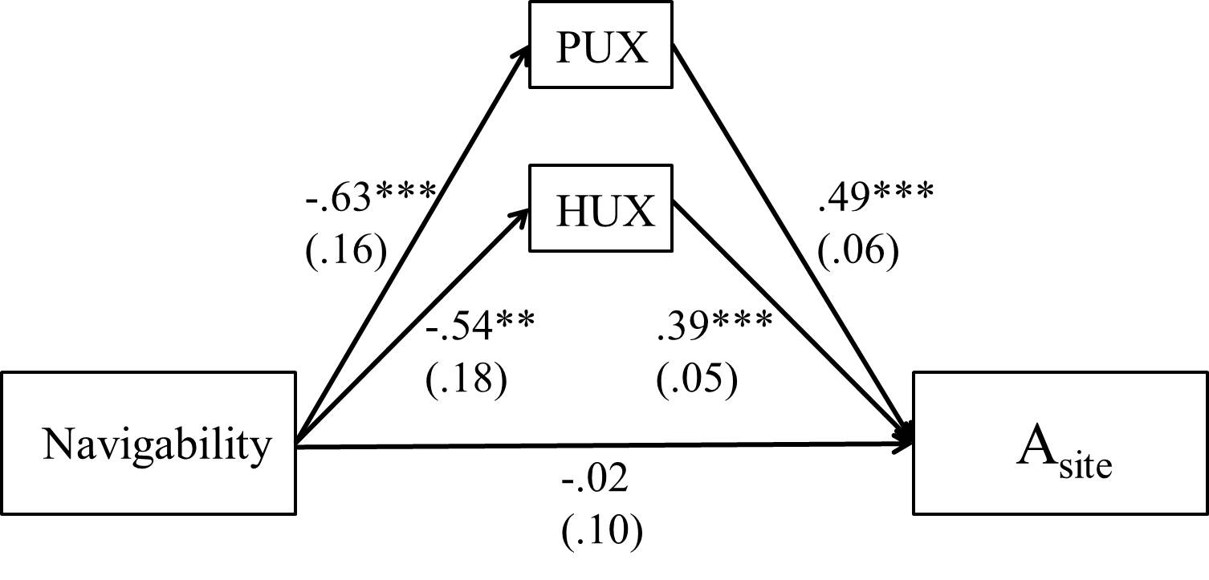
Figure 6. The effects of navigability on attitude toward the website (A_{site}) mediated by pragmatic UX (PUX) and hedonic UX (HUX).
Standard errors were given in parentheses. Navigability was coded as “simple” = 0, “complex” = 1.
** p < .01. *** p < .001.

Table 9. Mediating Role of UX on the Direct and Indirect Relationship between Navigability and Attitude toward the Website
Mediating Role of UX on the Direct and Indirect Relationship between Navigability and Attitude toward the Website
Specific Effect | Point Estimate | Boot SE | 95% Bootstrap CI
Specific Effect | Point Estimate | Boot SE | LL | UL
Navigability → A_{site} | -.02 | .10 | -.21 | .18
Navigability → PUX → A_{site} | -.31 | .09 | -.51 | -.15
Navigability → HUX → A_{site} | -.21 | .08 | -.38 | -.08
Note. PUX = pragmatic UX; HUX = hedonic UX; A_{site} = attitude toward the website.

Then, the mediating role of user experience between navigability and participants’ intentions to purchase tickets was assessed. Although the overall model was not statistically significant (F(5, 195) = 1.13, p = .34, R² = .03), the findings still revealed that there was a statistically significant effect of navigability on participants’ pragmatic UX (b = -.63, SE = .16, p < .001), which in turn influenced their intentions to purchase tickets positively (b = .28, SE = .11, p < .01). Nonetheless, the mediating effect of hedonic UX on purchasing intention was not statistically significant (b = .16, SE = .10, p = .11) even though navigability had a direct and statistically significant effect on hedonic UX (b = -.54, SE = .18, p < .01).
The model further showed that the direct effect of navigability on participants’ intentions to purchase tickets was not statistically significant (b = .27, SE = .19, p = .15), but the indirect effect of navigability on purchasing intention mediated by pragmatic UX was statistically significant (b = -.17, SE = .07, 95% CI = [-.35, -.06]). More specifically, participants in the simple navigability condition reported more positive pragmatic UX and hedonic UX than those in the complex navigability condition, but only pragmatic UX had positive influences on their ticket purchasing intentions (see Figure 7). Results are presented in Table 10.

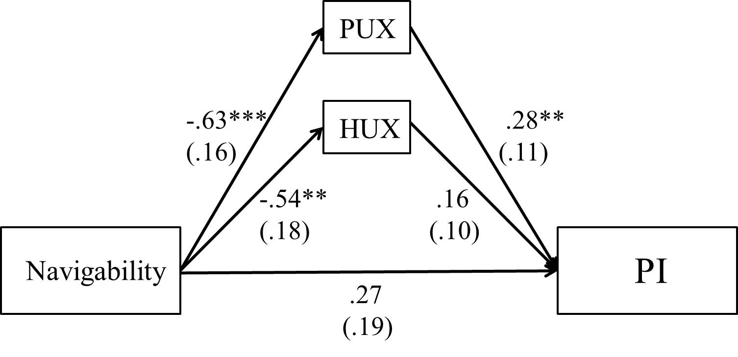
Figure 7. The effects of navigability on purchasing intention (PI) mediated by pragmatic UX (PUX) and hedonic UX (HUX).
Standard errors were given in parentheses. Navigability was coded as “simple” = 0, “complex” = 1.
** p < .01. *** p < .001.

Table 10. Mediating Role of UX on the Direct and Indirect Relationship between Navigability and Ticket Purchasing Intention
Mediating Role of UX on the Direct and Indirect Relationship between Navigability and Ticket Purchasing Intention
Specific Effect | Point Estimate | Boot SE | 95% Bootstrap CI
Specific Effect | Point Estimate | Boot SE | LL | UL
Navigability → PI | .27 | .19 | -.10 | .64
Navigability → PUX → PI | -.17 | .07 | -.35 | -.06
Navigability → HUX → PI | -.08 | .05 | -.24 | -.01
Note. PUX = pragmatic UX; HUX = hedonic UX; PI = ticket purchasing intention.

Finally, the mediating effect of user experience between interactivity and participants’ attitudes toward the website was analyzed. Though the overall model was not statistically significant (F(5, 195) = 1.92, p = .09, R² = .05), the findings still stated that there was a statistically significant effect of interactivity on participants’ hedonic UX (b = .42, SE = .18, p < .05), which in turn positively influenced their attitudes toward the website (b = .38, SE = .05, p < .001). On the other hand, while pragmatic UX had positive and statistically significant effect on participants’ attitudes toward the site (b = .49, SE = .06, p < .001), the direct effect of interactivity on pragmatic UX was not significant (b = .30, SE = .17, p = .07).
Moreover, the model suggested that the direct effect of interactivity on participants’ attitudes toward the website was not statistically significant (b = .10, SE = .10, p = .28). In contrast, the indirect effect of interactivity on attitudes toward the site mediated by hedonic UX was positive and statistically significant (b = .16, SE = .07, 95% CI = [.03, .32]), meaning that participants in the high interactivity condition reported more positive hedonic UX, which in turn led to more positive attitudes toward the website than those in the no interactivity condition (see Figure 8). Results are presented in Table 11.

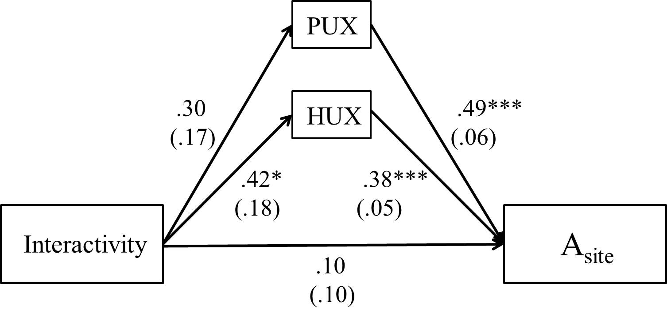
Figure 8. The effects of interactivity on attitude toward the website (A_{site}) mediated by pragmatic UX (PUX) and hedonic UX (HUX).
Standard errors were given in parentheses. Interactivity was coded as “no interactivity” = 0, “high interactivity” = 1.
* p < .05. *** p < .001.

Table 11. Mediating Role of UX on the Direct and Indirect Relationship between Interactivity and Attitude toward the Website
Mediating Role of UX on the Direct and Indirect Relationship between Interactivity and Attitude toward the Website
Specific Effect | Point Estimate | Boot SE | 95% Bootstrap CI
Specific Effect | Point Estimate | Boot SE | LL | UL
Interactivity → A_{site} | .10 | .10 | -.09 | .29
Interactivity → PUX → A_{site} | .15 | .09 | -.02 | .34
Interactivity → HUX → A_{site} | .16 | .07 | .03 | .32
Note. PUX = pragmatic UX; HUX = hedonic UX; A_{site} = attitude toward the website.

The mediating role of user experience between interactivity and participants’ intentions to purchase tickets was also examined. The results specified that there was a positive and statistically significant effect of interactivity on participants’ hedonic UX (b = .42, SE = .18, p < .05), but the effect of hedonic UX on purchasing intention was not statistically significant (b = .15, SE = .10, p = .13). Likewise, although pragmatic UX had positive and statistically significant effect on participants’ ticket purchasing intentions (b = .25, SE = .48, p < .001), the direct effect of interactivity on pragmatic UX was not significant (b = .30, SE = .17, p = .07). The overall model was not statistically significant (F(5, 195) = 1.34, p = .25, R² = .03) and suggested that neither direct nor indirect effect of interactivity on participants’ intentions to purchase tickets was found (see Figure 9). Results are summarized in Table 12.

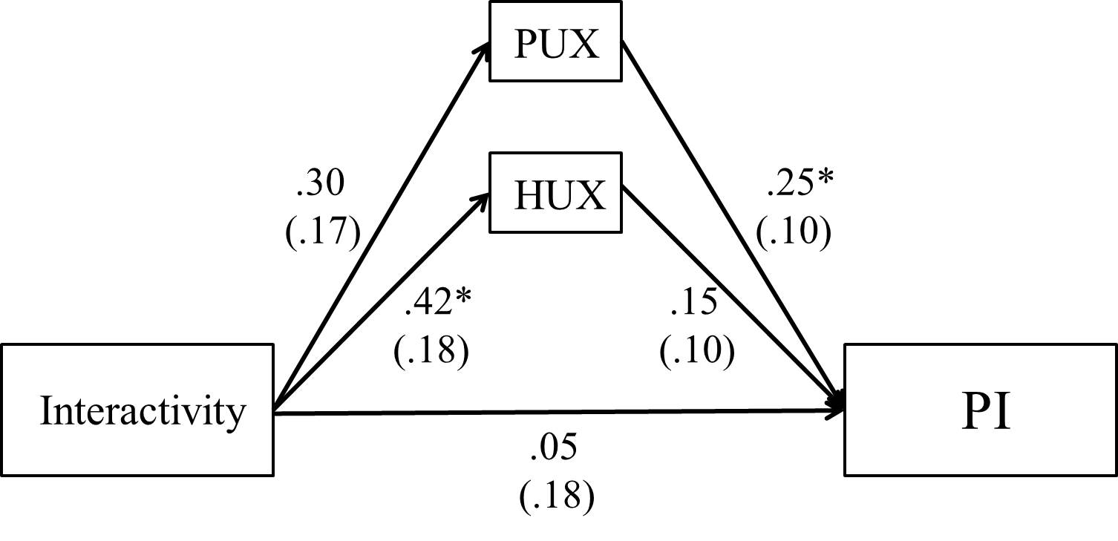
Figure 9. The effects of interactivity on purchasing intention (PI) mediated by pragmatic UX (PUX) and hedonic UX (HUX).
Standard errors were given in parentheses. Interactivity was coded as “no interactivity” = 0, “high interactivity” = 1.
* p < .05.

Table 12. Mediating Role of UX on the Direct and Indirect Relationship between Interactivity and Ticket Purchasing Intention
Mediating Role of UX on the Direct and Indirect Relationship between Interactivity and Ticket Purchasing Intention
Specific Effect | Point Estimate | Boot SE | 95% Bootstrap CI
Specific Effect | Point Estimate | Boot SE | LL | UL
Interactivity → PI | .05 | .18 | -.31 | .40
Interactivity → PUX → PI | .08 | .05 | .00 | .21
Interactivity → HUX → PI | .06 | .05 | -.004 | .21
Note. PUX = pragmatic UX; HUX = hedonic UX; PI = ticket purchasing intention.

Mediation of User Experience and Attitude Toward the Website
Research question 3 asked whether user experience (pragmatic UX and hedonic UX) and participants’ attitudes toward the website would mediate the influence of navigability and interactivity on their intentions to purchase tickets in serial. By running a mediation model 6 of PROCESS macro 2.16.3 for SPSS using 10,000 bootstrap samples and bias-corrected confidence intervals (CIs) (Hayes, 2013), the current study found there was a statistically significant indirect effect of navigability on participants’ ticket purchasing intentions via pragmatic UX and attitudes toward the website in serial (b = -.17, SE = .08, 95% CI = [-.37, -.05]) even though the overall model was not statistically significant (F(5, 195) = 1.13, p = .34, R² = .03). That is, participants in the simple navigability condition showed more positive pragmatic UX, which in turn would lead to more positive attitudes toward the website, and attitudes toward the website would then positively influence their ticket purchasing intentions (see Figure 10 and Table 13).

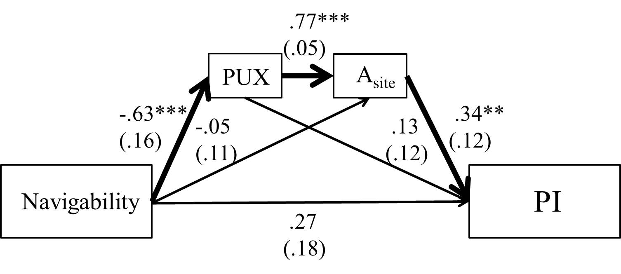
Figure 10. The indirect effect of navigability on purchasing intention (PI) mediated by pragmatic UX (PUX) and attitude toward the website (A_{site}) in serial.
The arrows were outlined in bold. Standard errors were given in parentheses.
Navigability was coded as “simple” = 0, “complex” = 1.
** p < .01. *** p < .001.

Similarly, although the overall model was not statistically significant (F(5, 195) = 1.13, p = .34, R² = .03), there was a statistically significant indirect effect of navigability on participants’ ticket purchasing intentions via hedonic UX and attitude toward the website in serial (b = -.15, SE = .07, 95% CI = [-.32, -.05]). In detail, participants in the simple navigability condition reported more positive hedonic UX, which in turn resulted in more positive attitudes toward the website, and then attitudes toward the site would positively affect their ticket purchasing intentions (see Figure 11 and Table 13).
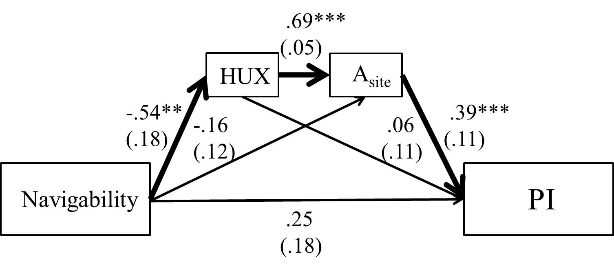
Figure 11. The indirect effect of navigability on purchasing intention (PI) mediated by hedonic UX (PUX) and attitude toward the website (A_{site}) in serial.
The arrows were outlined in bold. Standard errors were given in parentheses.
Navigability was coded as “simple” = 0, “complex” = 1.
** p < .01. *** p < .001.

Table 13. Mediating Role of UX and Attitude toward the Website on the Indirect Relationship between Navigability and Ticket Purchasing Intention
Mediating Role of UX and Attitude toward the Website on the Indirect Relationship between Navigability and Ticket Purchasing Intention
Specific Effect | Point Estimate | Boot SE | 95% Bootstrap CI
Specific Effect | Point Estimate | Boot SE | LL | UL
Navigability → PUX → A_{site} → PI | -.17 | .08 | -.37 | -.05
Navigability → HUX → A_{site} → PI | -.15 | .07 | -.32 | -.05
Note. PUX = pragmatic UX; HUX = hedonic UX; A_{site} = attitude toward the website;
PI = ticket purchasing intention.

Regarding the perspective of interactivity, the results first revealed that the overall model was not statistically significant (F(5, 195) = 1.34, p = .25, R² = .03). Also, there was no statistically significant indirect effect of interactivity on participants’ ticket purchasing intentions via pragmatic UX and attitudes toward the website in serial (b = .08, SE = .06, 95% CI = [.00, .24]), meaning that no matter whether participants were in the high or no interactivity condition, it would not influence their pragmatic UX even though pragmatic UX would positively affect customers’ attitudes toward the website; following, it would positively influence the subsequent behavioral intentions (see Figure 12 and Table 14).

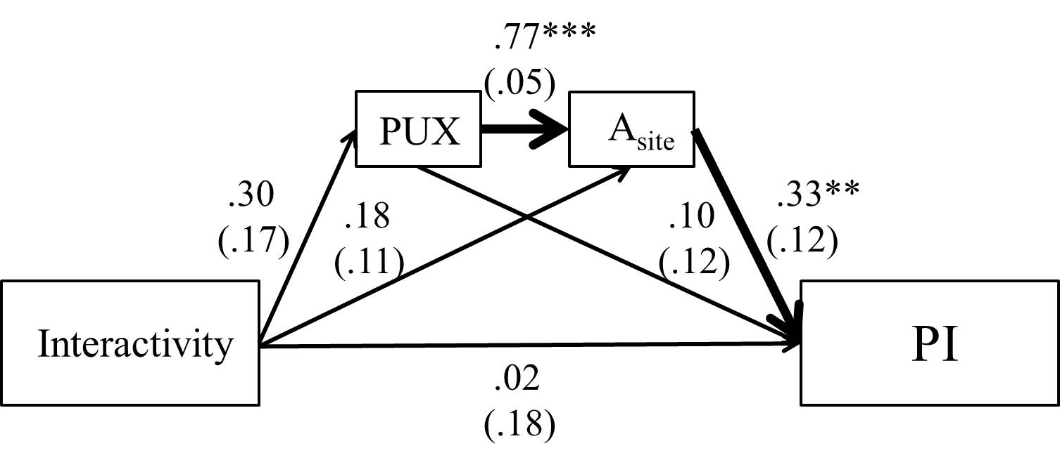
Figure 12. The indirect effect of interactivity on purchasing intention (PI) mediated by pragmatic UX (PUX) and attitude toward the website (A_{site}) in serial.
The arrows were outlined in bold. Standard errors were given in parentheses.
Interactivity was coded as “no interactivity” = 0, “high interactivity” = 1.
** p < .01. *** p < .001.

Lastly, there was a statistically significant indirect effect of interactivity on participants’ ticket purchasing intentions via hedonic UX and attitudes toward the website in serial (b = .11, SE = .06, 95% CI = [.02, .26]) even though the overall model was not statistically significant (F(5, 195) = 1.34, p = .25, R² = .03). That is, participants in the high interactivity condition expressed more positive hedonic UX, which in turn resulted in more positive attitudes toward the website, and attitudes toward the site would then positively affect their ticket purchasing intentions (see Figure 13 and Table 14).
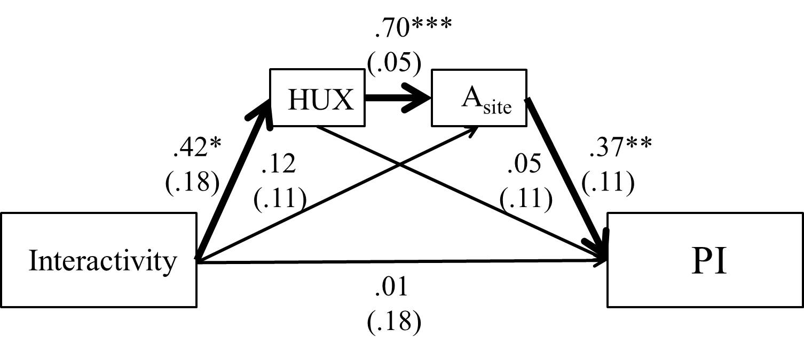
Figure 13. The indirect effect of interactivity on purchasing intention (PI) mediated by hedonic UX (PUX) and attitude toward the website (A_{site}) in serial.
The arrows were outlined in bold. Standard errors were given in parentheses.
Interactivity was coded as “no interactivity” = 0, “high interactivity” = 1
* p < .05. ** p < .01. *** p < .001.

Table 14. Mediating Role of UX and Attitude toward the Website on the Indirect Relationship between Interactivity and Ticket Purchasing Intention
Mediating Role of UX and Attitude toward the Website on the Indirect Relationship between Interactivity and Ticket Purchasing Intention
Specific Effect | Point Estimate | Boot SE | 95% Bootstrap CI
Specific Effect | Point Estimate | Boot SE | LL | UL
Interactivity → PUX → A_{site} → PI | .08 | .06 | .00 | .24
Interactivity → HUX → A_{site} → PI | .11 | .06 | .02 | .26
Note. PUX = pragmatic UX; HUX = hedonic UX; A_{site} = attitude toward the website;
PI = ticket purchasing intention.

Chapter 6: Discussion
The purpose of this dissertation was to explore the effects of website navigability and interactivity on users’ experiences, attitudes toward the website, and intentions to purchase tickets in the sport (NBA) online ticketing scenario. The mediating role of user experience on customers’ attitudes and behavioral intentions was also examined. In addition, this dissertation further assessed the mediating effects of user experiences and attitude toward the designed ticketing website in serial on customers’ intentions to purchase tickets.
A 2 (navigability: complex vs. simple) × 2 (interactivity: high interactivity vs. no interactivity) between-subjects factorial designed online experiment was conducted to test the hypotheses and answer the research questions. All the stimuli (i.e., the simulated ticketing web designs) used in the current study were based on the actual NBA online ticketing setting.
The results revealed some important insights about sport (NBA) online ticketing practices and theoretical implications. To begin with, this dissertation identified two main constructs of UX, pragmatic UX and hedonic UX, instead of six-dimension scales (i.e., attractiveness, perspicuity, efficiency, dependability, stimulation, and novelty) developed by Laugwitz et al. (2008). It may suggest that when customers browse the ticketing website, they would take perspicuous and efficient experiences they perceived as a whole of pragmatic UX and take stimulative and novel experiences they sensed as a whole of hedonic UX. Even so, this finding was still consistent with Laugwitz et al.’s proposition because all the reliable bipolar items categorized in this dissertation were under the range of those two constructs (i.e., pragmatic and hedonic UX) initially. The outcome also advocated the findings from the earlier studies (Hassenzahl, 2001; Hassenzahl, Burmester, & Koller, 2003). Accordingly, this finding may indicate that when users browsed the ticketing website, they would perceive more generalized experiences (e.g., two main UX constructs) than sub-dimensional experiences (e.g., six-dimension UX).

Summary of Findings

Effect of Navigability
It was predicted that navigability design of a sport (NBA) ticketing website would influence participants’ user experiences, attitudes toward the site, and intentions to purchase tickets. The findings suggested that navigability had a significant effect on participants’ pragmatic UX, hedonic UX, and attitudes toward the website. That is, participants who browsed the ticketing website with simple navigational design was more likely to have clear, efficient (pragmatic), stimulative, and novel (hedonic) experiences, and generate more positive attitudes toward the site than those who were in the complex navigability condition.
As scholars have theoretically stated that the information presented on the sports ticketing websites should be clear and the online sales processes should be simple and easy to follow (Filo et al., 2009; Irwin et al., 2008; Morehead et al., 2017; Mullin et al., 2014), this study provides a clearer underlying extent of an online ticketing design contents and elements. First, even though a good navigability design often includes navigational links (Mateos et al., 2001; Zhang et al., 2004), the sport (NBA) ticketing website should only offer available ticket information directly and necessary ticketing links (e.g., “see tickets” button), rather than providing extra team-related information and links unrelated to ticket sales. A possible explanation may be that since the only product of a ticketing website is tickets themselves, specifically, and customers who browse the ticketing website may have a certain goal to look for ticket information merely, it may not be necessary to include too much team-related information and unrelated links such as a menu bar with many navigational options (e.g., video, community, store, etc.) on the website.
Second, a ticketing website ought to utilize fewer steps to reach the final arena map page in which customers could select preferable seat section and make the final purchase. That is, a website should skip extra steps such as showing customers a page with more ticket options because most of customers who browse ticketing website may look for single game ticket directly instead of seeking information regarding season tickets, premium seating, group experiences, and so forth. Also, skipping the “I am not a robot” page may enhance user experience and attitude toward the site although this function helps protect website from spam and abuse. In this study, the simple navigability condition employed two clicks to reach the final page and the design conformed to Zeldman’s (2001) “three-click rule.”
Generally, a sport (NBA) ticketing website providing ticket information directly and the necessary link (e.g., “see tickets” button) only with fewer clicks could enhance users’ both pragmatic and hedonic experiences and affect their attitudes toward the website positively.

Effect of Interactivity
It was predicted that interactivity feature of a sport (NBA) ticketing website would influence participants’ user experiences, attitudes toward the site, and intentions to purchase tickets. In the current study, the level of interactivity was controlled by employing 360° (high interactivity) and fixed (no interactivity) relative seat section viewing function. The results revealed that interactivity had a significant effect on participants’ hedonic UX and attitudes toward the website. In other words, participants who browsed the ticketing website with the high interactivity feature (360° relative seat section viewing) would involve more positive simulated and novel experiences and have more positive attitudes toward the website than those in the no interactivity condition (fixed relative seat section viewing).
The findings again echoed scholars’ suggestions that a sports ticket sales website should employ interactivity functions to enhance the potential tangibility of products (i.e., tickets) as more customers today search for related information online visually (Lee et al., 2012; Mullin et al., 2014). Also, the results were in accordance with literature that the interactivity feature of the website could help enhance customers’ responses and assessment of it (Sundar & Kim, 2005; Yoon et al., 2008).
As Liu and Shrum (2002) suggest, active control is valuable for goal-directed online searching (e.g., looking for the specific game ticket(s) with the respective seat section view that a customer prefers). In the current study, 360° relative seat section viewing function (high interactivity) provided more active control to the participants. By dragging the mouse, they could move freely to view what they wanted to see and control over what they could do on the website. It was also consistent with Ariely’s (2000) argument that online interactivity that gives users control over the website could positively shape their judgments and evaluations.
As a result, participants browsing a sport (NBA) ticketing website including interactivity attribute (360° relative seat section viewing) experienced novelties and stimulations toward the website, and expressed positive hedonic UX and attitudes toward it.
Overall, the above findings also empirically supported Sundar et al.’s (2012) suggestion and a portion of the TIME model (Sundar et al., 2015; Sundar et al., 2017). That is, the models indeed can be applied to the online advertising and marketing research. The use of website features (navigability and interactivity) to perform communication actions such as browsing content and searching information (action-route) would contribute to elicit the attitudinal outcome (i.e., attitude toward the website) of using such interactive media.

Interaction Effect of Navigability and Interactivity
This dissertation asked whether there would be an interaction between navigability and interactivity on user experience, participants’ attitudes toward the website, and their intentions to purchase tickets. No interaction effect between navigability and interactivity on participants’ responses was found.
Nevertheless, it is interesting to note that although there was no significant interaction effect of navigability and interactivity on participants’ hedonic UX. The Bonferroni post hoc showed that in the simple navigability condition, participants who browsed the website with 360° relative seat section viewing function (high interactivity) reported higher hedonic UX than those browsing the website with fixed relative seat section viewing (no interactivity). In contrast, the difference was not found in the complex navigability condition.
Though the interaction of two manipulated factors on participants’ responses was not statistically significant, the results still have a potential contribution to the online ticketing practice that a ticketing website should utilize simple navigational design (e.g., offering ticket information directly and needed link only with fewer clicks) with some interactivity features (e.g., 360° relative seat section viewing function) to improve users’ experiences and assessments of it.
To sum up, the main effects navigability and interactivity on participants’ UX and attitudes toward the website were found in the current study. However, the effect of navigability on participants’ ticket purchasing intentions was not identified, meaning that whether the design of a ticketing website is simple or complex would not influence individuals’ ticket purchasing intentions. Similarly, the effect of interactivity on participants’ pragmatic UX and ticket purchasing intentions was not significant, meaning that whether the website has 360° (high interactivity) or fixed (no interactivity) relative seat section viewing function would influence neither users’ perceived perspicuity and efficiency of the website nor their ticket purchasing intentions. A possible explanation for this situation may come from self-select participation. That is, MTurk participants could select into a HIT based on their own willingness (Keith et al., 2017), meaning that they may choose projects with good compensation and/or interesting topic. It may be the reason that the participants in this study considered themselves as an NBA fans (as the mean NBA fan identification in each condition was above 5.00) and reported high ticket purchasing intentions (as the mean PI in each condition was above 5.20), and thus there was no significant PI differences among the manipulated conditions.
Following the findings, it is also important and interesting to figure out what are the exact roles of UX and attitude toward the website in the sport (NBA) online ticketing setting. Therefore, this dissertation also attempted to explore whether participants’ UX and attitudes toward the website could play essential roles in influencing their subsequent behavioral intentions. The detailed discussion is presented in the following section.

Mediating Effects of User Experience
It was proposed to investigate whether user experience (pragmatic UX and hedonic UX) would mediate the influence of navigability and interactivity on participants’ attitudes toward the website and their intentions to purchase tickets.
First, pragmatic UX was found as a significant mediator only for navigability. Specifically, an online ticketing system employing simple navigability design would lead to more positive pragmatic UX among the participants, which in turn would positively affect their attitudes toward the website and intentions to purchase tickets. For the interactivity, though pragmatic UX still had a positive and significant direct effect on participants’ attitudes toward the website and their intentions to purchase tickets, the direct effect of interactivity on pragmatic UX was not found, meaning that there was no indirect effect of interactivity on participants’ responses through pragmatic UX.
Second, hedonic UX was recognized as a significant mediator for both navigability and interactivity, but only for participants’ attitudes toward the website. That is, online ticketing website utilizing simple navigability design or ticketing website with 360° relative seat section viewing feature would elicit more positive hedonic UX among the participants; this, then, would positively affect their attitudes toward the website, but not their ticket purchasing intentions.
The above results supported the notion that user experience could contribute to provide more in-depth insights into the era of interactive digital media (Chou, 2016). The most important outcome was, even though both manipulated factors in this study did not have significant main effect on participants’ ticket purchasing intentions, an indirect effect of navigability was found on their behavioral intentions via pragmatic UX. Thus, when participants browsed the ticketing website containing ticket information and necessary link (e.g., “see tickets” button) only with fewer clicks, they would be more likely to experience that the website was clear and efficient, and then these experiences would let them have higher intentions to purchase tickets.
Therefore, employing simple and clear navigability structure for a ticketing website may be more important than having the interactivity feature such as 360° relative seat section view because navigability was the only factor in the current study that could influence participants’ ticket purchasing intentions indirectly.
On the other hand, it was also interesting to know that the main effects of navigability and interactivity on participants’ attitudes toward the website became non-significant after accounting for the UX, suggesting full mediation. In other words, the effects of navigability and interactivity on individuals’ attitudes toward the ticketing website were fully mediated by their perceived pragmatic UX and/or hedonic UX.
Briefly, the findings confirmed the mediating role of UX between the technological affordances (navigability and interactivity) and users’ responses (attitudes toward the website and behavioral intentions), which was also in line with the proposition of the TIME model. As Sundar et al. (2017) indicate, interface features allow users to perform certain online communication actions, but not every action would lead to all mediating effects (e.g., perceptual bandwidth, contingency, sense of agency, and self-determination) mentioned in the model. Similarly, the current study employed a six-dimension UX scale and tested their mediating roles in the proposed experiment, but only two main UX constructs were identified. In addition, only hedonic UX was the significant mediator for participants’ attitudes toward the website in both manipulated conditions, and only pragmatic UX showed a significant mediating effect on the relationship between navigability and participants’ ticket purchasing intentions.

Mediating Effects of User Experience and Attitude toward the Website
This dissertation also asked whether user experience (pragmatic UX and hedonic UX) and participants’ attitudes toward the website would mediate the influence of navigability and interactivity on their intentions to purchase tickets in serial. All the results indicated a similar outcome that user experience and attitudes toward the website were serial mediators.
Under the premise that navigability had a direct effect on user experience, both pragmatic UX and hedonic UX were found to have significant and direct effects on participants’ attitudes toward the website, which in turn could positively influence their subsequent behavioral intentions. It means, when participants browsed the ticketing website containing available ticket information directly and necessary link (e.g., “see tickets” button) only with fewer clicks, they would be more likely to perceive that the website was clear, efficient, stimulative, and novel; following, it would make them have more positive attitudes toward the website, and then generate higher intentions to purchase tickets.
For interactivity, both pragmatic UX and hedonic UX were again identified to have significant and direct effects on participants’ attitudes toward the website, which in turn could positively influence their subsequent behavioral intentions. Nonetheless, only the direct effect of interactivity on hedonic UX was found. That means, when participants used the ticketing website with interactivity feature such as 360° relative seat section viewing, they would experience that the website was stimulative and novel; following, it would trigger more positive attitudes toward the website, and then lead to higher intentions to purchase tickets.
The current study provided a clearer framework of sport (NBA) online ticketing and yet again indicated the importance of navigability for the ticketing web design. That is, from the outcomes of research question 2, navigability could have an indirect effect on attitude toward the website via both pragmatic and hedonic UX, but its indirect effect on behavioral intention was only recognized through pragmatic UX. The results of research question 3 further revealed that pragmatic/hedonic UX and participants’ attitudes toward the website could serially mediate the influence of navigability on their ticket purchasing intentions. In contrast, only hedonic UX and participants’ attitudes toward the website could serially mediate the influence of interactivity on their ticket purchasing intentions.
Overall, the findings of research question 3 again supported the outline of research question 2 that interacting with technological affordances (navigability and interactivity) on a ticketing interface could lead to the mediating effects of UX. Also, all of the results pointed out one orientation that UX had direct and positive effect on participants’ attitudinal outcomes, which was along with the literature that the UX is not only an effective implement to investigate the nature of interactive digital media (Hassenzahl & Tractinsky, 2006), but also an important indicator of users’ psychological responses (Chou, 2016). Moreover, the findings also upheld the notion found in the numerous advertising, marketing, and consumer research that individuals’ attitudes are crucial factors of their behavior predictions (e.g., Crano & Prislin, 2006; Haugtvedt & Kasmer, 2008; MacKenzie et al., 1986). All of the models in the current study showed that participants’ attitudes toward the ticketing website would positively affect their subsequent ticket purchasing intentions.

Theoretical and Practical Implications

Theoretical Implication
In summary, this dissertation aided some extensions and insights into the fields of user experience, interactive digital media, and marketing research. Except identifying two main UX constructs (i.e., pragmatic UX and hedonic UX) instead of the six-dimension scale discussed at the beginning of this chapter, the application of UX indeed provided an in-depth understanding of using such interactive media. In the sport (NBA) online ticketing setting, UX was in a vital position mediating the effects of website attributes on customers’ attitudes and behavioral intentions. The findings of such mediating effects aided some insights into the TIME model (Sundar et al., 2015; Sundar et al., 2017), especially in terms of the mediating variables and their measurements.
Initially, the TIME model proposes four sets of mediators (i.e., perceptual bandwidth, contingency, sense of agency, and self-determination) under the action-route, but the model does not explain the relationship between the predictors (i.e., interface affordances and actions) and mediators thoroughly. This dissertation, at least in part, showed that UX scale was valid (i.e., the findings were consistent with Laugwitz et al.’s (2008) overall UX construct) and reliable (as all Cronbach α of the UX scales were above .90). Also, by interacting with the well-designed digital media affordance such as simple navigability and interactivity feature, customer perceived positive user experiences regarding the pragmatism and hedonism. This, then, led to positive attitude toward the ticketing website and increased the likelihood of purchasing tickets online.
Next, both navigability and interactivity affordances of a sports (NBA) ticketing website had significant and direct effects on users’ perceived experiences and attitudes toward the website. It was in line with the literature that a website with easy-to-follow navigability structure (e.g., necessary ticket information and link only with fewer steps) would lead to positive evaluations of it, but complicated navigability system would on the contrary result in poor responses toward it (Zhang et al., 2004; Fang et al., 2012). Further, as Liu and Shrum (2002) and McMillan and Hwang (2002) indicate, online shopping websites should offer active control features to enhance product attractiveness and ease choice comparison. By employing an interactivity feature such as active control for the relative seat section view, a ticketing website, as a shopping website selling tickets, could positively influence customers’ evaluations and assessments of it.
Moreover, this dissertation supported the proposition of the MAIN model (Sundar, 2008) and the TIME model (Sundar et al., 2015; Sundar et al., 2017) that technological affordances can not only connect digital media and the users, but also shape users’ experiences and responses toward digital media. Although the current study did not examine the full models in detail (e.g., the current study used user experience as the only mediator instead of testing the four mediating factors included in the models), the findings still empirically supported the feasibility of the overall frameworks of the models in the sport (NBA) ticketing setting.
Lastly, this study again confirmed that attitude toward the website could be a significant predictor of participants’ subsequent behavioral intentions. In the marketing research, attitude is a widely employed notion and the fundamental argument is that attitude has essential influences on consumers’ perception and behavior prediction (Crano & Prislin, 2006; Haugtvedt & Kasmer, 2008). The results of the current study revealed that more positive attitude toward the sport (NBA) ticketing website could result in higher intention to purchase tickets, and yet suggested that the attitude toward the external stimulus (website) should be included and applied in the online environment in order to better examine the relationship between the digital interactive media and its users.

Practical Implication
As online ticketing has become a prominent component of ticket operations, it is crucial to provide customers an attractive and efficient ticketing website. The findings of this study initially and partially identified sport consumers’ preferences regarding online ticketing and revealed some interesting insights for the sports team practitioners.
First, this study showed that the quality of the ticketing website in terms of the navigability and interactivity could directly/indirectly influence users’ experiences, attitudes toward the website, and even their ticket purchasing intentions. Therefore, sports team practitioners should maintain a balance among these website features and attributes. For example, the current study suggested that a ticketing website should utilize only a simple and clear navigational design such as fewer clicks/steps to reach the required ticket information and providing customers available ticket information directly and necessary link rather than extra team-related information and too many menu options. In addition, employing the interactive features such as 360° relative seat section viewing may also create some advantages of ticket selling.
However, it is also important to note that when everything is equal, focusing on designing a simple and clear navigability structure for a sport (NBA) ticketing website may be more important than developing interactivity features on it because navigability attribute, in this study, indicated more explained variation in participants’ user experience, which could positively affect their attitudes toward the website and subsequent behavioral intentions. In other words, if the budget, time, and sources are limited, improving the navigational structure of a ticketing website would have higher chance to increase ticket selling than developing interactive functions.
Moreover, the sports team practitioners should value users’ perceived experiences of the ticketing website more than ever. The results of this study stated that customers’ perceived user experiences would significantly mediate the influences of website affordances and their subsequent reactions. That is, the more positive experiences the users have by browsing the ticketing website, the more likely they would generate positive attitudes toward it, and then lead to higher intentions to purchase tickets. Accordingly, user experiences are vital determinants of customers’ attitudes toward the website, which in turn will positively affect their subsequent ticket purchasing intentions. Thus, user experience should be included and evaluated carefully in order to enhance the likelihood of ticket selling.

Limitations and Future Research
Though this dissertation revealed some insights about the sport (NBA) online ticketing, there are still several limitations. The first limitation is regarding the stimuli designs. This study employed simulated NBA ticketing websites based on actual ticketing settings and procedures to better control the potential bias due to the designed factors such as color, image, font (size), logo, and brand name. However, not every designed element on the actual ticketing website could be perfectly rebuilt in the current study due to the technical restriction. For example, the last step of the actual online ticketing procedure is to select the specific seat at a particular row from the selected section, and then users are able to see the relative seat view. In this study, the last step was to select participants’ preferable section only instead of specific seat, and then saw the relative section view. Future studies employing more precise online ticketing setting and procedures are needed to fulfill this shortfall.
The second limitation is about the contents provided on the designed websites. In the simple navigability condition, the design was simple and clear. Only the available game information and “see tickets” button were shown on the website. In contrast, in the complex navigability condition, the menu bar with more navigability links and previous game results were also included on the website. The extra amount of information (i.e., previous game result) was not in the scope of manipulated navigability and may cause the potential confounding effect even though it helped differentiate the simple/complex conditions. Future research may need to take the influence into examination and/or control its influence.
Third, all the data came from the online self-report questionnaire through the MTurk online panel. To enhance the quality of the data, this study took some filtering processes such as setting the requirements (e.g., 95% HIT approval rate and number of total HITs approved) for the participants, deleting the responses with wrong answer to the checking questions (e.g., t-shirt color, number of clicks, and instructed question), excluding the potential outliers using statistical evaluation, and controlling the effects of team identification and fan passion from the analysis. Nevertheless, the current study, as with all research utilizing online survey as the main investigation tool, still could not avoid the potential prestige bias and/or elaborate answers. For the future research, adapting a lab-based experiment and including multi-method techniques such as eye tracking measurement may be appropriate alternatives. More precisely, lab-based experiments allow researchers to have more control over the environment and the subjects (Wimmer & Domick, 2011). Eye tracking technique, on the other hand, enables researcher to observe where the participant is looking in real time. It is also one of the fitting research tools to examine the user experience of the digital media (Bergstrom & Schall, 2014; Tullis & Albert, 2013).
Fourth, although the current study utilized team identification and fan passion as the control variables, participants’ perceived credibility of Ticketmaster was not covered. Based on the MAIN model, credibility is one of the outcomes that is affected by the technological affordances and may be a potential influence on consumer psychological responses. Analysis would be more complete if individuals’ perceived credibility of the ticketing website was also controlled.
Lastly, this dissertation took the NBA as the only example. It will be interesting to know whether the similar results from the current study can be found from other major sports. After all, different sports have dissimilar hardware facilities (e.g., different seating arrangement in the arena/ballpark/stadium) and fans’ concerns toward them may be different as well. All of these factors may lead to different designs/layouts/structures of the ticketing website and thus result in different online experiences and responses.

Conclusion
Ticket sales is one of the most important sources for sports teams’ revenue, and web-based ticketing has become a vital component of ticket operations in the digital media era. Therefore, understanding the nature of a good ticketing website design and factors facilitating such marketing communication is important to both academia and practice. This dissertation explored the influences of navigability and interactivity on customers’ experiences, attitudes toward the website, and purchase intentions in the sport (NBA) online ticketing scenario. Moreover, the mediating role of user experience and attitude toward the website were examined.
This dissertation first identified two main constructs of user experience, pragmatic and hedonic UX, and confirmed that UX indeed played an important mediating role between the technological affordances of ticketing website and customers’ attitudes and behavioral intentions. Next, both navigability and interactivity affordances of the ticketing website had direct effects on users’ experiences and attitudes toward the website. Among the two affordances, navigability was a more important predictor on customers’ responses than interactivity, meaning that focusing on simple and clear online ticketing system may benefit both practitioner and customers more than developing interactivity function when everything is equal. Finally, this study also verified the mediating effect of attitude toward the website following the UX on customers’ subsequent ticket purchasing intentions. That is, navigability and interactivity could indirectly influence customers’ behavioral intentions through customers’ user experiences and attitudes toward the website.
The findings of this dissertation not only advanced the present literature on user experience and online consumer research, but also provided some rational and meaningful references regarding the online ticketing practice.

References
Ajzen, I. (1991). The theory of planned behavior. Organizational Behavior and Human Decision Processes, 50(2), 179-211.
Alonso-Dos-Santos, M. (2014). Strategies in sports marketing: Technologies and emerging trends. Hershey, PA: IGI Global.
Ariely, D. (2000). Controlling the information flow: Effects on consumers' decision making and preferences. Journal of Consumer Research, 27(2), 233-248.
Bergstrom, J. R., & Schall, A. J. (2014). Eye tracking in user experience design. Waltham, MA: Morgan Kaufmann.
Bondarenko, C. (2019, May 1). Why many high-performing sports teams are losing money at the gate. Vision Critical. Retrieved from https://www.visioncritical.com/blog/gate-revenue
Brown, M. (2002). The use of banner advertisements with pull-down menus: A copy testing approach. Journal of Interactive Advertising, 2(2), 57-65.
Brown, M. T. (2003). An analysis on online marketing in the sport industry: User activity, communication objectives, and perceived benefits. Sport Marketing Quarterly, 12(1), 48-55.
Cachero, C. C., Meliá, S., Genero, M., Poels, G., & Calero, C. (2007). Towards improving the navigability of Web applications: A model-driven approach. European Journal of Information Systems, 16(4), 420-447.
Carlson, J., Rosenberger, P., & Muthaly, S. (2003). Nothing but net! A study of the information content in Australian professional basketball websites. Sport Marketing Quarterly, 12(3), 184-188.
Chou, J. R. (2016). An empirical study of user experience on touch mice. Eurasia Journal of Mathematics, Science & Technology Education, 12(11), 2875-2885.
Crano, W. D., & Prislin, R. (2006). Attitudes and persuasion. Annual Review of Psychology, 57, 345-374.
Diehl, M. A., Drayer, J., & Maxcy, J. G. (2016). On the demand for live sport contests: Insights from the secondary market for National Football League tickets. Journal of Sport Management, 30(1), 82-94.
Drayer, J., Shapiro, S. L., & Lee, S. (2012). Dynamic ticket pricing in sport: An agenda for research and practice. Sport Marketing Quarterly, 21, 184-194.
Cousineau, D., & Chartier, S. (2010). Outliers detection and treatment: A review. International Journal of Psychological Research, 3(1), 58-67.
Cyr, D. (2008). Modeling web site design across cultures: Relationships to trust, satisfaction, and e-loyalty. Journal of Management Information Systems, 24(4), 47-72.
Fang, X., Hu, P. J. H., Chau, M., Hu, H. F., Yang, Z., & Sheng, O. R. L. (2012). A data-driven approach to measure web site navigability. Journal of Management Information Systems, 29(2), 173-212.
Filo, K., & Funk, D. C. (2005). Congruence between attractive product features and virtual content delivery for Internet marketing communication. Sport Marketing Quarterly, 14(2), 112-122.
Filo, K., Funk, D. C., & Hornby, G. (2009). The role of web site content on motive and attitude change for sport events. Journal of Sport Management, 23(1), 21-40.
Fisher, E., & Lombardo, J. (2018, February 7). NBA extends Ticketmaster deal 2 years. Sports Business Journal. Retrieved from https://www.bizjournals.com/newyork/news/2018/02/07/nba-extends-ticketmaster-deal-2-years.html
Funk, D. C. (2017). Introducing a Sport Experience Design (SX) framework for sport consumer behaviour research. Sport Management Review, 20(2), 145-158.
Gaines, C. (2015, May 20). The NBA is the highest-paying sports league in the world. Business Insider. Retrieved from http://www.businessinsider.com/sports-leagues-top-salaries-2015-5
Gough, C. (2018, April 17). Ticket sales as share of total Major League Baseball revenue from 2009 to 2017. Statista. Retrieved from https://www.statista.com/statistics/193408/percentage-of-ticketing-revenue-in-the-mlb-since-2006/
Hasbullah, N. A., Osman, A., Abdullah, S., Salahuddin, S. N., Ramlee, N. F., & Soha, H. M. (2016). The relationship of attitude, subjective norm and website usability on consumer intention to purchase online: An evidence of Malaysian youth. Procedia Economics and Finance, 35, 493-502.
Hassenzahl, M. (2001). The effect of perceived hedonic quality on product appealingness. International Journal of Human-Computer Interaction, 13(4), 481-499.
Hassenzahl, M., Burmester, M., Koller, F. (2003). AttrakDiff: A questionnaire for the measurement of perceived hedonic and pragmatic quality. In: Ziegler, J., Szwillus, G. (Eds.) Mensch & Computer 2003: Interaktion in Bewegung (pp. 187-196). Stuttgart, Germany: Teubner.
Hassenzahl, M. & Tractinsky, N. (2006). User experience—a research agenda. Behaviour & Information Technology, 25, 91-97.
Haugtvedt, C. P., & J. A Kasmer (2008). Attitude change and persuasion. In C. P. Haugtvedt, P. M. Herr, & F. R. Kardes (Eds.), Handbook of Consumer Psychology (pp. 419-435). New York: Lawrence Erlbaum Associates.
Heitner, D. (2015, October 18). Sports industry to reach $73.5 billion by 2019. Forbes. Retrieved from https://www.forbes.com/sites/darrenheitner/2015/10/19/sports-industry-to-reach-73-5-billion-by-2019/#60c3c491b4b9
History.com (2009). NBA is born. Retrieved from http://www.history.com/this-day-in-history/nba-is-born
Howard, D. R., & Crompton, J. L. (2004). Tactics used by sports organizations in the United States to increase ticket sales. Managing Leisure, 9(2), 87-95.
Hoye, R., Smith, A. C., Nicholson, M., & Stewart, B. (2015). Sport marketing. In R. Hoye, A. C. Smith, M. Nicholson, & B. Stewart, Sport management : Principles and applications (pp. 247-281). New York, NY: Routledge.
Hsu, C. L., Chen, Y. C., Yang, T. N., & Lin, W. K. (2017). Do website features matter in an online gamification context? Focusing on the mediating roles of user experience and attitude. Telematics and Informatics, 34(4), 196-205.
Hu, Y., & Sundar, S. S. (2010). Effects of online health sources on credibility and behavioral intentions. Communication Research, 37(1), 105-132.
Hur, Y., Ko, Y. J., & Valacich, J. (2007). Motivation and concerns for online sport consumption. Journal of Sport Management, 21(4), 521-539.
International Organization for Standardization 9241-210 (2010, March 15). Ergonomics of humane-system interaction–Part 210: Human centred design for interactive systems. Retrieved from https://www.iso.org/obp/ui/#iso:std:52075:en.
Irwin, R. L., Sutton, W. A., & McCarthy, L. M. (2008). Sports promotion and sales management (2nd ed.). Champaign, IL: Human Kinetics.
Javadi, M. H. M., Dolatabadi, H. R., Nourbakhsh, M., Poursaeedi, A., & Asadollahi, A. R. (2012). An analysis of factors affecting on online shopping behavior of consumers. International Journal of Marketing Studies, 4(5), 81-98.
Jessop, A. (2012, August 20). The NBA and Ticketmaster announce a partnership creating a new ticketing method. Forbes. Retrieved from https://www.forbes.com/sites/aliciajessop/2012/08/20/the-nba-and-ticketmaster-announce-a-partnership-creating-a-new-ticketing-method/
Kang, S. (2015). The mobile phone and professional sports: Fans’ use of mobile content for loyalty, identification, and fandom. International Journal of Sport Communication, 8(4), 452-476.
Kees, J., Berry, C., Burton, S., & Sheehan, K. (2017). An analysis of data quality: professional panels, student subject pools, and Amazon's mechanical turk. Journal of Advertising, 46(1), 141-155.
Keith, M. G., Tay, L., & Harms, P. D. (2017). Systems perspective of Amazon Mechanical Turk for organizational research: Review and recommendations. Frontiers in Psychology, 8, 1-19.
Khalifa, M., & Limayem, M. (2003). Drivers of Internet shopping. Communications of the ACM, 46(12), 233-239.
Korgaonkar, P., & Wolin, L. D. (2002). Web usage, advertising, and shopping: Relationship patterns. Internet Research, 12(2), 191-204.
Laugwitz, B., Held, T., & Schrepp, M. (2008, November). Construction and evaluation of a user experience questionnaire. In A. Holzinger (Eds.), Lecture Notes in Computer Science: Vol. 5298. HCI and Usability for Education and Work (pp. 63-76). doi: 10.1007/978-3-540-89350-9_6
Lee, S., Kim, J., & Parrish, C. (2012). Are you ready for the extra inning? An exploratory study of the evaluation of professional sport teams’ Websites as marketing tools to prospective meeting/event customers. Journal of Convention & Event Tourism, 13, 270-289.
Leshner, G. (2014). The basics of experimental research in media studies. In F. Darling-Wolf (Eds.), The international encyclopedia of media studies: Research methods in media studies (pp. 236-254). Hoboken, NJ: Wiley-Blackwell.
Liu. Y. (2003). Developing a scale to measure the interactivity of websites. Journal of Advertising Research, 43(2), 207-216.
Liu. Y., & Shrum, L. J. (2002). What is interactivity and is it always such a good thing? Implications of definition, person, and situation for the influence of interactivity on advertising effectiveness. Journal of Advertising, 31(4), 53-64.
MacKenzie, S. B., Lutz, R. J., & Belch, G. E. (1986). The role of attitude toward the ad as a mediator of advertising effectiveness: A test of competing explanations. Journal of Marketing Research, 23(2), 130-143.
Mateos, M. B., Mera, A. C., Miranda González, F. J., & González López, Ó. R. (2001). A new Web assessment index: Spanish universities analysis. Internet Research, 11(3), 226-234.
McCornack, B. P., & Johnson, W. A. (2016). Getting growers to go digital: The power of a positive user experience. Journal of Extension, 54(4), n4.
McCroskey, J. C., & Young, T. J. (1979). The use and abuse of factor analysis in communication research. Human Communication Research, 5(4), 375-382.
McMillan, S. J. & Hwang, J. S. (2002). Measures of perceived interactivity: An exploration of the role of direction of communication, user control, and time in shaping perceptions of interactivity. Journal of Advertising, 31(3), 29-41.
Meloun, M., & Militký, J. (2001). Detection of single influential points in OLS regression model building. Analytica Chimica Acta, 439(2), 169-191.
Metzger, M. J., & Flanagin, A. J. (2013). Credibility and trust of information in online environments: The use of cognitive heuristics. Journal of Pragmatics, 59, 210-220.
Metzger, M. J., Flanagin, A. J., & Medders, R. B. (2010). Social and heuristic approaches to credibility evaluation online. Journal of Communication, 60(3), 413-439.
Mills, B. M., Salaga, S., & Tainsky, S. (2016). NBA primary market ticket consumers: Ex ante expectations and consumer market origination. Journal of Sport Management, 30(5), 538-552.
Miranda González, F. J., & Bañegil Palacios, T. M. (2004). Quantitative evaluation of commercial web sites: An empirical study of Spanish firms. International Journal of Information Management, 24(4), 313-328.
Mitchell, A. A. (1986). The effect of verbal and visual components of advertisements on brand attitudes and attitude toward the advertisement. Journal of Consumer Research, 13(1), 12-24.
Mitchell, A A, & J. C. Olson (1981). Are product attribute beliefs the only mediator of advertising effects on brand attitudes?. Journal of Marketing Research, 18, 318-322.
Morehead, C. A., Shapiro, S. L., Madden, T. M., Reams, L., & McEvoy, C. D. (2017). Athletic ticket pricing in the collegiate environment: An agenda for research. Journal of Intercollegiate Sport, 10(1), 83-102.
Mullin, B. J., Hardy, S., & Sutton, W. A. (2014). Sport marketing (4th ed.). Champaign, IL: Human Kinetics Publishers.
O’Cass, A., & Carlson, J. (2010). Examining the effects of website-induced flow in professional sporting team websites. Internet Research, 20(2), 115-134.
Phan, M. H., Keebler, J. R., & Chaparro, B. S. (2016). The development and validation of the game user experience satisfaction Scale (GUESS). Human Factors, 58(8), 1217-1247.
Pitts, B. G., & Stotlar, D. K. (2013). Fundamentals of sport marketing (4th ed.). Morgantown, WV: Fitness Information Technology.
Plunkett, J. W. (2014). Plunkett’s sports industry alamanac 2014. Houston, TX: Plunkett Research, Ltd.
Reips, U. D. (2002). Standards for Internet-based experimenting. Experimental psychology, 49(4), 243.
Randle, Q., & Nyland, R. (2008). Participation in internet fantasy sports leagues and mass media use. Journal of Website Promotion, 3(3/4), 143-152.
Santoso, H. B., Schrepp, M., Isal, R., Utomo, A. Y., & Priyogi, B. (2016). Measuring User Experience of the Student-Centered e-Learning Environment. Journal of Educators Online, 13(1), 58-79.
Scholl, H. J., & Carlson, T. S. (2012). Professional sports teams on the Web: A comparative study employing the information management perspective. European Sport Management Quarterly, 12(2), 137-160.
Shapiro, S. L., Drayer, J., & Dwyer, B. (2016). Examining consumer perceptions of demand-based ticket pricing in sport. Sport Marketing Quarterly, 25(1), 34-46.
Sheeran, P., & Abraham, C. (2003). Mediator of moderators: Temporal stability of intention and the intention-behavior relation. Personality and Social Psychology Bulletin, 29(2), 205-215.
Sporting Intelligence (2018). Global sports salaries survey 2018. Retrieved from http://globalsportssalaries.com/GSSS%202018.pdf
Spyridakis, J. H., Mobrand, K. A., Cuddihy, E., & Wei, C. Y. (2007). Using structural cues to guide readers on the internet. Information Design Journal, 15(3), 242-259.
Suh, Y. I., Ahn, T., Lee, J. K., & Pedersen, P. M. (2015). Effect of trust and risk on purchase intentions in online secondary ticketing: sport consumers and ticket reselling. South African Journal for Research in Sport, Physical Education and Recreation, 37(2), 131-142.
Sun, X., May, A., & Wang, Q. (2016). The impact of user- and system-initiated personalization on the user experience at large sports events. Applied Ergonomics, 54, 1-9.
Sundar, S. S. (2008). The MAIN model: A heuristic approach to understanding technology effects on credibility. In M. J. Metzger & A. J. Flanagin (Eds.), Digital media, youth, and credibility (pp. 72-100). Cambridge, MA: MIT Press.
Sundar, S. S., Jia, H., Waddell, T. F., & Huang, Y. (2015). Toward a theory of interactive media effects (TIME): Four models for explaining how interface feature affect user psychology. In S. Sundar (Eds.), The handbook of the psychology of communication technology (pp. 47-86). Malden, MA: John Wiley & Sons.
Sundar, S. S., & Kim, J. (2005). Interactivity and persuasion: Influencing attitudes with information and involvement. Journal of Interactive Advertising, 5(2), 5-18.
Sundar, S. S., Kim, J., & Gambino, A. (2017). Using theory of interactive media effects (TIME) to analyze digital advertising. In S. Rodgers & E. Thorson (Eds.), Digital advertising: Theory and research (pp. 86-109). New York, NY: Routledge, Taylor & Francis Group.
Sundar, S. S., & Limperos, A. M. (2013). Uses and grats 2.0: New gratifications for new media. Journal of Broadcasting & Electronic Media, 57(4), 504-525.
Sundar, S. S., Xu, Q., & Dou, X. (2012). Role of technology in online persuasion. In S. Rodgers & E. Thorson (Eds.), Advertising theory (pp. 355-372). New York, NY: Routledge, Taylor & Francis Group.
Szymanski, D. M., & Hise, R. T. (2000). E-satisfaction: An initial examination. Journal of Retailing, 76(3), 309-322.
Takahashi, D. (2018, September 11). Newzoo: Smartphone users will top 3 billion in 2018, hit 3.8 billion by 2021. VirtualBeat. Retrieved from https://venturebeat.com/2018/09/11/newzoo-smartphone-users-will-top-3-billion-in-2018-hit-3-8-billion-by-2021/
Tullis, T., & Albert, B. (2013). Measuring the user experience: Collecting, analyzing, and presenting usability metrics (2nd ed.).Waltham, MA: Morgan Kaufmann.
Tung, L. L., Xu, Y., & Tan, F. B. (2009). Attributes of web site usability: A study of web users with the repertory grid technique. International Journal of Electronic Commerce, 13(4), 97-126.
Wang, Y., & Sun, S. (2010). Examining the role of beliefs and attitudes in online advertising: A comparison between the USA and Romania. International Marketing Review, 27(1), 87-107.
Wann, D., Bayens, C., & Driver, A. (2004). Likelihood of attending a sporting event as a function of ticket scarcity and team identification. Sport Marketing Quarterly, 13(4), 209-215.
Yang, B., Lester, D., & James, S. (2006). Attitudes toward buying online as predictors of shopping online for British and American respondents. CyberPsychology & Behavior, 10(2), 198-203.
Yi, Y. (1990). Cognitive and affective priming effects of the context for print advertisements. Journal of Advertising, 19(1), 40-48.
Yong, A. G., & Pearce, S. (2013). A beginner’s guide to factor analysis: Focusing on exploratory factor analysis. Tutorials in quantitative methods for psychology, 9(2), 79-94.
Yoon, D., Choi, S.M. & Sohn, D. Y. (2008). Building customer relationships in an electronic age: The role of interactivity of E-commerce websites. Psychology & Marketing, 25 (7), 602-618.
Vermeeren, A. P., Law, E. L. C., Roto, V., Obrist, M., Hoonhout, J., & Väänänen-Vainio-Mattila, K. (2010). User experience evaluation methods: Current state and development needs. Proceedings of the 6th Nordic Conference on Human-Computer Interaction: Extending Boundaries, 521-530.
Wakefield, K. (2016). Using fan passion to predict attendance, media consumption, and social media behaviors. Journal of Sport Management, 30(3), 229-247.
Wann, D. L., & Branscombe, N. R. (1993). Sports fans: Measuring degree of identification with their team. International Journal of Sport Psychology, 24(1), 1-17.
Webster, J., & Ahuja, J. S. (2006). Enhancing the design of web navigation systems: The influence of user disorientation on engagement and performance. MIS Quarterly 30(3), 661-678.
Wimmer, R. D., & Dominick, J. R. (2011). Mass media research: An introduction (10th ed.). Belmont, CA: Wadsworth Publishing Co.
Zeldman, J. (2001). Taking your talent to the web: A guide for the transitioning designer. Indianapolis, IN: New Riders Publishing.
Zhang, J., & Mao, E. (2016). From online motivations to ad clicks and to behavioral intentions: An empirical study of consumer response to social media advertising. Psychology & Marketing, 33(3), 155-164.
Zhang, Y., Zhu, H., & Greenwood, S. (2004). Web site complexity metrics for measuring navigability. Proceedings of the 4th International Conference on Quality Software, 172-179.

Appendix A: Study Stimuli (for the Pre-test)
 | Simple Navigability | Complex Navigability
1st  Page | 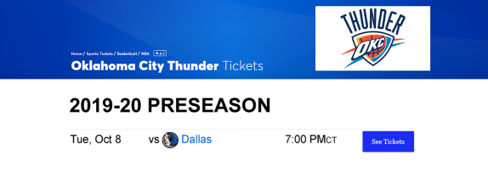 | 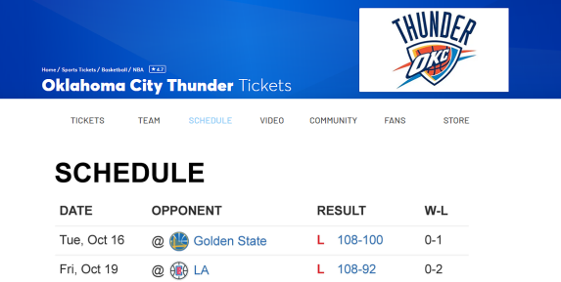    
1st  Page | - The simple navigability condition provides available ticket info/link (i.e., see tcikets button) only. | - The complex condition also includes previous game results and more navigational links (e.g., tickets, team, video, etc.).
1st  Page | - The participnats were asked to find one specific game info (Oct 8, 2019) and click the needed link to move to the next page.

 | Simple Navigability | Complex Navigability
2nd Page | 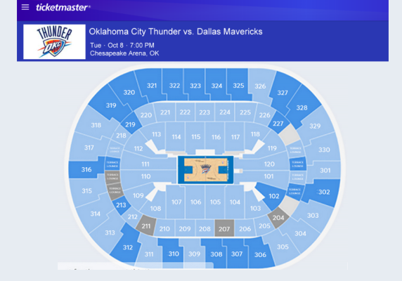 | 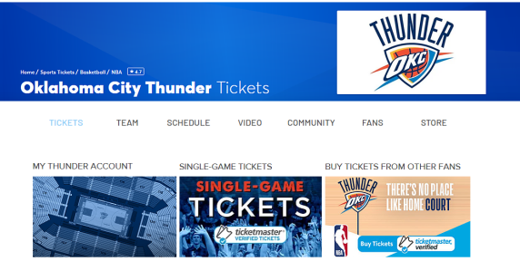
2nd Page | - By clicking the “see tickets” button, the simple navigability condition will link to the arean map for the game directly. | - If users click the “ticket” link on the MENU bar in the complex condition, it will direct users to the genreal ticket page (the page contains “season tickets,” “single game,” etc. options ) unless they scroll the page all the way down to the available game part and click the ticket link (which will link to the arena map for the game directly).

 | Simple Navigability |  | Complex Navigability
3rd  Page | High Interactivity  (360° seat section viewing) | No  Interactivity  (fixed seat section viewing) | 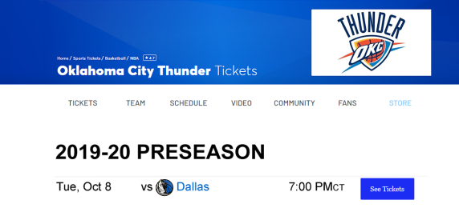
3rd  Page | 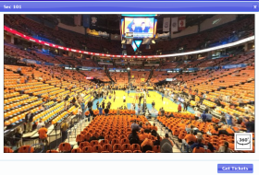 | 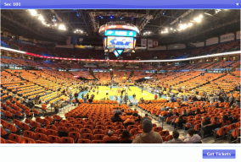
3rd  Page | - Once users click on the section through the map, they will see the relative seat section viewing in either high or no interactivity condition. |  | - If users click the “single game” option in the general ticket page , the next page will show the available ticket info/link.
4th  Page | _______
4th  Page |  |  | - By clicking the “see tickets” button, it will link to the arean map for the game directly.

 | Simple Navigability | Complex Navigability
5th  Page | _______ | High Interactivity  (360° seat section viewing) | No  Interactivity  (fixed seat section viewing)
5th  Page | _______ | - Once users click on the section through the arena map, they will see the relative seat section viewing in either high or no interactivity condition.

Appendix B: Pretest Questionnaire
I would like to ask you a few questions regarding your opinions and experiences with basketball ticketing websites. Please indicate your agreement with each of the items below that best represent your opinions.
 | Have you ever purchased basketball ticket(s) online?
 | 1- Yes |  |  |  | 2- No
 | (If Yes, move to Question 2, if No, move to Question 3)
2. | Which NBA ticketing websites do you usually use?
 | 1- Ticketmaster
 | 2- StubHub
 | 3- AXS
 | 4- SeatGeek
 | 5- FlashSeat
 | 6- TicketCity
 | 7- Vivid Seats
 | 8- Other (please specify)________________________________
3. | To what extent do you consider yourself an NBA fan?
 | 1- Strongly Disagree | 2 | 3 | 4 |  | 5 | 6 | 7- Strongly Agree
4. | How many NBA games did you attend during the 2018-19 season?
 | 1- None
 | 2- 1-3
 | 3- 4-6
 | 4- 7-9
 | 5- More than 10
5. | What is your favorite NBA team? __________________________
Instruction (Please read carefully)
Assume you are a customer who wants to buy ticket(s) from the lower level sections (section 101-120) for a game on October 8, 2019. Please carefully examine the following ticketing website and identify which section you would purchase seats from.

Note: When accessing the arena map, please click on different sections (section 101-120) to see the respective views. After you find the section with the view you prefer, return to this page and click the “Next” button to continue the survey.

[TICKETING WEBSITE LINK]

[After browsing the ticketing website and clicking “Next” button]
Based on your experience of the ticketing website you just browsed, please indicate your opinion by selecting the appropriate option from the following questions.
[Navigability]
1. | This website provides the fewest number of clicks necessary to access the ticket information.
 | 1- Strongly Disagree | 2 | 3 |  |  | 4 |  | 5 | 6 |  | 7- Strongly Agree
2. | Overall, this website has a simple navigational structure.
 | 1- Strongly Disagree | 2 | 3 |  |  | 4 |  | 5 | 6 |  | 7- Strongly Agree
3. | This website is well organized to locate ticket information.
 | 1- Strongly Disagree | 2 | 3 |  |  | 4 |  | 5 | 6 |  | 7- Strongly Agree
4. | This website provides an easy process to find the ticket information.
 | 1- Strongly Disagree | 2 | 3 |  |  | 4 |  | 5 | 6 |  | 7- Strongly Agree
[Interactivity]
1. | This website provides me a 360° relative seat section viewing function.
 | 1- Strongly Disagree | 2 | 3 |  |  | 4 |  | 5 | 6 |  | 7- Strongly Agree
2. | While I was viewing the relative seat section, I could move freely to view what I wanted to see.
 | 1- Strongly Disagree | 2 | 3 |  |  | 4 |  | 5 | 6 |  | 7- Strongly Agree
3. | While viewing the relative seat section, I had control over what I could do on the website.
 | 1- Strongly Disagree | 2 | 3 |  |  | 4 |  | 5 | 6 |  | 7- Strongly Agree
[Team Identification (Oklahoma City Thunder)]
1. | I am a fan of the Oklahoma City Thunder.
 | 1- Strongly Disagree | 2 |  | 3 | 4 |  | 5 |  |  | 6 | 7- Strongly Agree
2. | It is important to be a fan of the Oklahoma City Thunder.
 | 1- Strongly Disagree | 2 |  | 3 | 4 |  | 5 |  |  | 6 | 7- Strongly Agree
3. | It is important to me that the Oklahoma City Thunder wins.
 | 1- Strongly Disagree | 2 |  | 3 | 4 |  | 5 |  |  | 6 | 7- Strongly Agree
[Fan Passion (Oklahoma City Thunder)]
1. | I am passionate about the Oklahoma City Thunder.
 | 1- Strongly Disagree | 2 |  | 3 | 4 |  | 5 |  |  | 6 | 7- Strongly Agree
2. | I prioritize my time to follow the Oklahoma City Thunder.
 | 1- Strongly Disagree | 2 |  | 3 | 4 |  | 5 |  |  | 6 | 7- Strongly Agree
3. | The Oklahoma City Thunder is on my mind.
 | 1- Strongly Disagree | 2 |  | 3 | 4 |  | 5 |  |  | 6 | 7- Strongly Agree

[Team Identification (Dallas Mavericks)]
1. | I am a fan of the Dallas Mavericks.
 | 1- Strongly Disagree | 2 | 3 | 4 | 5 | 6 | 7- Strongly Agree
2. | It is important to be a fan of the Dallas Mavericks.
 | 1- Strongly Disagree | 2 | 3 | 4 | 5 | 6 | 7- Strongly Agree
3. | It is important to me that the Dallas Mavericks wins.
 | 1- Strongly Disagree | 2 | 3 | 4 | 5 | 6 | 7- Strongly Agree
[Fan Passion (Dallas Mavericks)]
1. | I am passionate about the Dallas Mavericks.
 | 1- Strongly Disagree | 2 | 3 | 4 | 5 | 6 | 7- Strongly Agree
2. | I prioritize my time to follow the Dallas Mavericks.
 | 1- Strongly Disagree | 2 | 3 | 4 | 5 | 6 | 7- Strongly Agree
3. | The Dallas Mavericks is on my mind.
 | 1- Strongly Disagree | 2 | 3 | 4 | 5 | 6 | 7- Strongly Agree

Now, for a few last questions to help us understand you answers.
- What is your age? [ ]
- What is your state and zip code? [ ]
- What is your gender?
a) Male
b) Female
c) Other (please specify) _______________
- What is your marital status?
a) Married
b) Widowed
c) Separated
d) Divorced
e) Single and have never been married
f) Other (please specify) _______________
- What is the highest level of education you have completed?
a) Less than High School
b) High School / GED
c) Some college
d) 2-year College Degree
e) 4-year College Degree
f) Master's degree
g) Doctoral Degree
i) Professional Degree (JD, MD)
- What is your race?
a) White/Caucasian
b) African American
c) Hispanic
d) Asian
e) Native American
f) Pacific Islander
g) Other (please specify) _______________
h) Prefer not to answer
- What is your total yearly household / family income from all sources?
a) 0-9,999
b) 10,000-19,999
c) 20,000-29,999
d) 30,000-39,999
e) 40,000-49,999
f) 50,000-59,999
g) 60,000-69,999
h) 70,000-79,999
i) 80,000-89,000More
j) 90,000-99,000
k) More than 100,000

Appendix C: Study Stimuli (for the Main Study)
 | Simple Navigability | Complex Navigability
1st
Page
1st  Page | - The simple navigability condition provides available ticket info/link (i.e., see tcikets button) only. | - The complex condition also includes previous game results and more navigational links (e.g., tickets, team, video, etc.).
1st  Page | - The participnats were asked to find one specific game info (Oct 8, 2019) and click the needed link to move to the next page.

 | Simple Navigability | Complex Navigability
2nd Page |  | 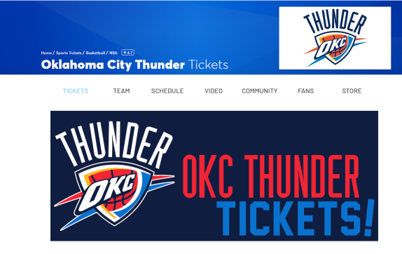
2nd Page | - By clicking the “see tickets” button, the simple navigability condition will link to the arean map for the game directly. | - If users click the “ticket” link on the MENU bar in the complex condition, it will direct users to the general ticket page unless they scroll the page all the way down to the available game part and click the ticket link (which will link to the “I’m not a robot” confirmation page directly).

 | Simple Navigability |  | Complex Navigability
3rd  Page | High Interactivity  (360° seat section viewing) | No  Interactivity  (fixed seat section viewing) | 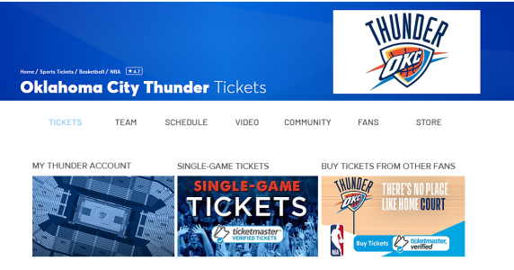
3rd  Page | - Once users click on the section through the map, they will see the relative seat section viewing in either high or no interactivity condition. |  | - If users click on the “OKC THUNDER TICKETS”, it will direct them to the second ticketing page containing “season tickets,” “single game,” etc. options.
4th  Page | _______
4th  Page |  |  | - If users click the “single game” option on the second ticketing page , the next page will show the available ticket info/link.

 | Simple Navigability | Complex Navigability
5th Page | _______ | 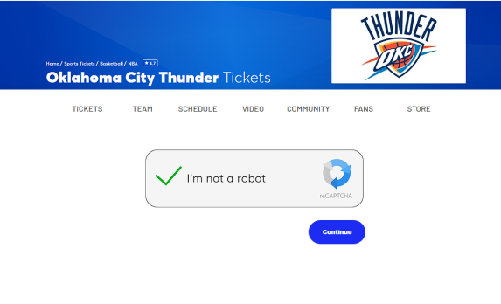
5th Page | _______ | - After users click the “see tickets” button, a confirmation page “I’m not a robot” will pop up.
6th Page | _______
6th Page | _______ | - By clicking the “continue” button, it will link to the arean map for the game.

 | Simple Navigability | Complex Navigability
7th  Page | _______ | High Interactivity  (360° seat section viewing) | No  Interactivity  (fixed seat section viewing)
7th  Page | _______ | - Once users click on the section through the arena map, they will see the relative seat section viewing in either high or no interactivity condition.

Appendix D: Main Study Questionnaire
I would like to ask you a few questions regarding your opinions and experiences with BASKETBALL TICKETING WEBSITES. Please indicate your agreement with each of the items below that best represent your experience.
1. | Have you ever purchased NBA game ticket(s) online?
 | 1- Yes | 2- No
 | (If Yes, move to Question 2, if No, move to Question 3)
2. | Which NBA ticketing websites do you typically use?
 | 1- Ticketmaster
 | 2- StubHub
 | 3- AXS
 | 4- SeatGeek
 | 5- FlashSeat
 | 6- TicketCity
 | 7- Vivid Seats
 | 8- Other (please specify)________________________________
3. | To what extent do you consider yourself an NBA fan?
 | 1- Strongly disagree
2 - Disagree
3 - Somewhat disagree
4 - Neither agree nor disagree
5 - Somewhat agree
6 - Agree
7 - Strongly agree
4. | How many NBA games did you attend during the 2018-19 season?
 | 1- None
 | 2- 1-3
 | 3- 4-6
 | 4- 7-9
 | 5- More than 10
5. | What is your favorite NBA team? __________________________

Instructions (Please read carefully and follow the instruction)
Assume you are a customer who wants to buy ticket(s) from the lower level sections (section 101-120) for a game on October 8, 2019, regardless of price. Please carefully examine the following ticketing website and identify which section you would purchase seats from.

Note: When accessing the arena map, please CLICK ON different sections (section 101-120) to see the respective views (＊＊＊if you choose to skip this step, you will be directed to the end of the survey and forfeit the MTurk reward). After you find the section with the view you prefer, return to this page and click the “Next” button to continue the survey.

[TICKETING WEBSITE LINK]

[After browsing the ticketing website and clicking “Next” button]
Based on your experience of the TICKETING WEBSITE YOU JUST BROWSED, please indicate your opinions by selecting the appropriate option from the following questions.
1. | Did you see the relative seat section view through the arena map?
 | 1- Yes | 2- No
 | (If Yes, continue the survey, if No, skip to the end of the survey)
2. | From Section 101-120, which section has the view you prefer? __________________________
3. | What was the color of the t-shirts laid out on the seats in the relative seat section views?
 | 1- Blue
 | 2- Orange
 | 3- Purple
 | 4- Green
 | 5- Red
 | 6- Other (please specify)________________________________
 | 7- I am not sure
 | (If participants’ answer is not 2 or 7, then skip to the end of the survey)

Based on your experience of the TICKETING WEBSITE YOU JUST BROWSED, please indicate your agreement with each of the questions below that best represent your opinions.
[Interactivity]
1. | This website provides me a 360° relative seat section viewing function.
 | 1- Strongly Disagree | 2 | 3 | 4 | 5 | 6 | 7- Strongly Agree
2. | While I was viewing the relative seat section, I could move freely to view what I wanted to see.
 | 1- Strongly Disagree | 2 | 3 | 4 | 5 | 6 | 7- Strongly Agree
3. | While viewing the relative seat section, I had control over what I could do on the website.
 | 1- Strongly Disagree | 2 | 3 | 4 | 5 | 6 | 7- Strongly Agree
[Navigability]
1. | How many clicks did it take to reach the final seat section page?
1 | 1- 1 click | 2 | 3 | 4 | 5 | 6 | 7- 7 clicks
2. | This website provides the fewest number of clicks necessary to access the ticket information.
 | 1- Strongly Disagree | 2 | 3 | 4 | 5 | 6 | 7- Strongly Agree
3. | Overall, this website has a simple navigational structure.
1 | 1- Strongly Disagree | 2 | 3 | 4 | 5 | 6 | 7- Strongly Agree
4. | This website is well organized to locate ticket information.
 | 1- Strongly Disagree | 2 | 3 | 4 | 5 | 6 | 7- Strongly Agree
5. | This website provides an easy process to find the ticket information.
 | 1- Strongly Disagree | 2 | 3 | 4 | 5 | 6 | 7- Strongly Agree

[User experience] In this section, we would like you to rate the TICKETING WEBSITE YOU BROWSED on the following scales.
annoying | 1 | 2 | 3 | 4 | 5 | 6 | 7 | enjoyable
unattractive | 1 | 2 | 3 | 4 | 5 | 6 | 7 | attractive
unfriendly | 1 | 2 | 3 | 4 | 5 | 6 | 7 | friendly
confusing | 1 | 2 | 3 | 4 | 5 | 6 | 7 | clear
complicated | 1 | 2 | 3 | 4 | 5 | 6 | 7 | easy
not understandable | 1 | 2 | 3 | 4 | 5 | 6 | 7 | understandable
inefficient | 1 | 2 | 3 | 4 | 5 | 6 | 7 | efficient
slow | 1 | 2 | 3 | 4 | 5 | 6 | 7 | fast
cluttered | 1 | 2 | 3 | 4 | 5 | 6 | 7 | organized
obstructive | 1 | 2 | 3 | 4 | 5 | 6 | 7 | supportive
does not meet expectations | 1 | 2 | 3 | 4 | 5 | 6 | 7 | meets expectations
unpredictable | 1 | 2 | 3 | 4 | 5 | 6 | 7 | predictable
demotivating | 1 | 2 | 3 | 4 | 5 | 6 | 7 | motivating
inferior | 1 | 2 | 3 | 4 | 5 | 6 | 7 | valuable
not interesting | 1 | 2 | 3 | 4 | 5 | 6 | 7 | interesting
antiquated | 1 | 2 | 3 | 4 | 5 | 6 | 7 | leading edge
dull | 1 | 2 | 3 | 4 | 5 | 6 | 7 | creative
old-fashioned | 1 | 2 | 3 | 4 | 5 | 6 | 7 | innovative

[Attitude toward the site] Please indicate your agreement with each of the items below that best represent your opinions about the TICKETING WEBSITE YOU BROWSED.
1. | I found the website to be good.
 | 1- Strongly Disagree | 2 | 3 | 4 | 5 | 6 | 7- Strongly Agree
2. | The website is interesting.
 | 1- Strongly Disagree | 2 | 3 | 4 | 5 | 6 | 7- Strongly Agree
3. | I liked the website.
 | 1- Strongly Disagree | 2 | 3 | 4 | 5 | 6 | 7- Strongly Agree
[Intention to purchase the tickets] The items below focus on how likely it is that you are thinking about PURCHASING THE TICKET(S) AFTER BROWSING THE TICKETING WEBSITE (with the ASSUMPTION that you are a customer who wants to buy ticket(s) for a game on October 8, 2019, regardless of price). Please indicate your agreement with each of the items below.
1. | It is likely that I will purchase the ticket(s).
 | 1- Strongly Disagree | 2 | 3 | 4 | 5 | 6 | 7- Strongly Agree
2. | It is probable that I will purchase the ticket(s).
 | 1- Strongly Disagree | 2 | 3 | 4 | 5 | 6 | 7- Strongly Agree
3. | It is possible that I will purchase the ticket(s).
 | 1- Strongly Disagree | 2 | 3 | 4 | 5 | 6 | 7- Strongly Agree

[Open-ended Question] After browsing this ticketing website, do you have suggestion(s) to improve the website design and/or the browsing process? Why do you think this (these) would improve the design and/or the browsing process?
[Team Identification (OKC Thunder)] Please indicate your agreement with each of the items below that best represent your opinions.
1. | I am a fan of the Oklahoma City Thunder.
 | 1- Strongly Disagree | 2 | 3 | 4 | 5 | 6 | 7- Strongly Agree
2. | It is important to be a fan of the Oklahoma City Thunder.
 | 1- Strongly Disagree | 2 | 3 | 4 | 5 | 6 | 7- Strongly Agree
3. | It is important to me that Oklahoma City Thunder wins.
 | 1- Strongly Disagree | 2 | 3 | 4 | 5 | 6 | 7- Strongly Agree

[Fan Passion (OKC Thunder)] Please indicate your agreement with each of the items below that best represent your opinions.
1. | I am passionate about the Oklahoma City Thunder.
 | 1- Strongly Disagree | 2 | 3 | 4 | 5 | 6 | 7- Strongly Agree
2. | I prioritize my time to follow the Oklahoma City Thunder.
 | 1- Strongly Disagree | 2 | 3 | 4 | 5 | 6 | 7- Strongly Agree
3. | The Oklahoma City Thunder is on my mind.
 | 1- Strongly Disagree | 2 | 3 | 4 | 5 | 6 | 7- Strongly Agree
4. | For this question, please answer “somewhat disagree” directly.
 | 1- Strongly Disagree | 2 | 3 | 4 | 5 | 6 | 7- Strongly Agree

[Team Identification (Dallas Mavericks)] Please indicate your agreement with each of the items below that best represent your opinions.
1. | I am a fan of the Dallas Mavericks.
 | 1- Strongly Disagree | 2 | 3 | 4 | 5 | 6 | 7- Strongly Agree
2. | It is important to be a fan of the Dallas Mavericks.
 | 1- Strongly Disagree | 2 | 3 | 4 | 5 | 6 | 7- Strongly Agree
3. | It is important to me that Dallas Mavericks wins.
 | 1- Strongly Disagree | 2 | 3 | 4 | 5 | 6 | 7- Strongly Agree

[Fan Passion (Dallas Mavericks)] Please indicate your agreement with each of the items below that best represent your opinions.
1. | I am passionate about the Dallas Mavericks.
 | 1- Strongly Disagree | 2 | 3 | 4 | 5 | 6 | 7- Strongly Agree
2. | I prioritize my time to follow the Dallas Mavericks.
 | 1- Strongly Disagree | 2 | 3 | 4 | 5 | 6 | 7- Strongly Agree
3. | The Dallas Mavericks is on my mind.
 | 1- Strongly Disagree | 2 | 3 | 4 | 5 | 6 | 7- Strongly Agree

[Media Device] In this section, I would like to ask you a few questions regarding the MEDIA DEVICE you used for this online survey. Please answer the questions below that best represent your device.
1. | Which media device did you use for this online survey?
 | 1 - Smart phone
 | 2 - iPad/Tablet
3 | 3 - Touch screen laptop
 | 4 - Laptop without touch screen
5 | 5 - Desktop
 | 6 - Other (please specify)________________________________
2. | What is your device screen size? ________________________________

Now, for a few last questions to help us understand you answers.
- What is your age? [ ]
- What is your state and zip code? [ ]
- What is your gender?
a) Male
b) Female
c) Other (please specify) _______________
- What is your marital status?
a) Married
b) Widowed
c) Separated
d) Divorced
e) Single and have never been married
f) Other (please specify) _______________
- What is the highest level of education you have completed?
a) Less than High School
b) High School / GED
c) Some college
d) 2-year College Degree
e) 4-year College Degree
f) Master's degree
g) Doctoral Degree
i) Professional Degree (JD, MD)
- What is your race?
a) White/Caucasian
b) African American
c) Hispanic
d) Asian
e) Native American
f) Pacific Islander
g) Other (please specify) _______________
h) Prefer not to answer
- What is your total yearly household / family income from all sources?
a) 0-9,999
b) 10,000-19,999
c) 20,000-29,999
d) 30,000-39,999
e) 40,000-49,999
f) 50,000-59,999
g) 60,000-69,999
h) 70,000-79,999
i) 80,000-89,000
j) 90,000-99,000
k) More than 100,000

Appendix E: Amazon Mechanical Turk Recruitment Message
(This is how the HIT will look to Workers via mTurk)

Title: Your experiences and perceptions of the basketball ticketing website

 | Reward: $0.50 per HIT | HITs available: 1
 | Duration: 15 Minutes
Description: | If you are 18 and above, I invite you to participate in a research study being conducted under the auspices of the University of Oklahoman. Your participation will involve completing surveys exploring your opinions about the basketball ticketing website.
Keywords: | NBA, online ticketing, survey
Qualifications Required: | HIT Approval Rate (%) for all Requesters' HITs greater than 95, Number of HITs Approved greater than 1000 , Location is US

Appendix F: Unsigned Online Consent Form
I am Fuwei Sun from the Gaylord College of Journalism & Mass Communication at the University of Oklahoma and I invite you to participate in my research project entitled Sports Online Ticketing: The Effects of Navigability and Interactivity on Consumers’ Experiences, Attitudes, and Behavioral Intentions. This research is being conducted at the University of Oklahoma-Norman campus. You were selected as a possible participant because you meet the age qualification and Amazon Mechanical Turk eligibilities. You must be at least 18 years of age to participate in this study. Also, your MTurk “HIT Approval Rate (%) for all Requesters' HITs” is greater than 95%, “Number of HITs Approved” is greater than 1000, and your location is US.
Please read this document and contact me to ask any questions that you may have BEFORE agreeing to take part in my research.
What is the purpose of this research? The purpose of this research is to understand your experiences and perceptions of the sports ticketing website.
How many participants will be in this research? About 300 people will take part in this research.
What will I be asked to do? If you agree to be in this research, you will be asked to browse a basketball ticketing website and complete a questionnaire regarding your experiences and perceptions of the site.
How long will this take? Your participation will take 15-20 minutes to complete.
What are the risks and/or benefits if I participate? There are no risks and no benefits from being in this research.
Will I be compensated for participating? You will be reimbursed for your time and participation in this research. Each participant will be paid $0.50 for participation.
Who will see my information? In research reports, there will be no information that will make it possible to identify you. Research records will be stored securely and only approved researchers and the OU Institutional Review Board will have access to the records. Data are collected via an online survey system that has its own privacy and security policies for keeping your information confidential. Please note no assurance can be made as to the use of the data you provide for purposes other than this research.
What will happen to my data in the future? We will not share your data or use it in future research projects.
Do I have to participate? No. If you do not participate, you will not be penalized or lose benefits or services unrelated to the research. If you decide to participate, you don’t have to answer any question and can stop participating at any time. However, there will be questions designed to check if you are following the survey instruction. Failing to answer these correctly will result in nonpayment.
Who do I contact with questions, concerns or complaints? If you have questions, concerns or complaints about the research or have experienced a research-related injury, contact me at
(405) 973-4708 or fuweisun5@ou.edu. Dr. Doyle Yoon can be reached at (405) 325-5205 or dyoon@ou.edu
You can also contact the University of Oklahoma – Norman Campus Institutional Review Board (OU-NC IRB) at 405-325-8110 or irb@ou.edu if you have questions about your rights as a research participant, concerns, or complaints about the research and wish to talk to someone other than the researcher(s) or if you cannot reach the researcher(s).
Please print this document for your records. By providing information to the researcher(s), I am agreeing to participate in this research.
I agree to participate (click should connect to survey)
I do not want to participate (click should connect to a Thank You for considering page)
This research has been approved by the University of Oklahoma, Norman Campus IRB.
IRB Number: 10794 Approval date: May 24, 2019

