UNIVERSITY OF OKLAHOMA

GRADUATE COLLEGE

VOCEM INTERNUM

A DOCUMENT

SUBMITTED TO THE GRADUATE FACULTY

in partial fulfillment of the requirements for the

Degree of

DOCTOR OF MUSICAL ARTS

By

IOANNIS ANDRIOTIS
Norman, Oklahoma
2018

VOCEM INTERNUM

A DOCUMENT APPROVED FOR THE
SCHOOL OF MUSIC

BY

______________________________
Dr. Konstantinos Karathanasis, Chair
______________________________
Dr. Marvin Lamb
______________________________
Mr. Daren Kendall
______________________________
Dr. Sarah J. Ellis
______________________________
Dr. Sanna F. Pederson

© Copyright by IOANNIS ANDRIOTIS 2018
All Rights Reserved.

ACKNOWLEDGEMENTS

I am grateful for the mentoring my composition professors, Dr. Konstantinos Karathanasis and Dr. Marvin Lamb, have provided me with during my graduate studies at the University of Oklahoma. This dissertation would not have been possible without their insightful instruction and consultation.
I would like to also express the deepest gratitude to my wife and flutist, Alyssa Andriotis. Her assistance with both composing Vocem and creating this support document was of utmost importance for the realization of my dissertation.
Over the last few years, I have had the pleasure to work closely with percussionist Ricardo Coelho de Souza. His previous collaboration on live electronic pieces has helped me better understand the overall compositional and performance process of live electronic music. In addition, I would like to thank Richard Dudas for kindly explaining the inner-mechanics of MaxMSP during the International Computer Music Conference of 2015. His suggestions helped me develop my MaxMSP platform.
Finally, I would like to thank my parents and parents-in-law for their emotional and financial support during my graduate studies in the USA.

TABLE OF CONTENTS

List of Figures vi
Abstract vii
Chapter 1: The Overall Compositional Process 1
Chapter 2: Composing Vocem 8
Chapter 3: Structure & Formal Elements 15
Chapter 4: Selection of Materials 21
Chapter 5: Digital Signal Processing 25
Chapter 6: Music Notation 28
Chapter 7: The Compositional Method 31
Chapter 8: MaxMSP Design 38
Conclusion 53
Bibliography 55

LIST OF FIGURES

Figure 2.1 Coding in Opusmodus 12
Figure 3.1. Overall form illustration 16
Figure 3.2. Mirroring scheme between sections A and B 17
Figure 8.1. Overall signal flow diagram 38
Figure 8.2. Typical signal chain for the control of the input signal 39
Figure 8.3. Signal distribution after the Input section 40
Figure 8.4. Illustration of the design of the two nested poly~ objects 40
Figure 8.5. Examples of automatic gain compensation 42
Figure 8.6. Layout of the interface: top-level window 43
Figure 8.7. Programing example of loading a DSP patch and a sound file 44
Figure 8.8. Layout of the interface of the Input section 44
Figure 8.9. Drop-down menu method 46
Figure 8.10. Illustration of the mute and dim system 46
Figure 8.11. Monitoring and quick access system 47
Figure 8.12. Example of applying changes to a DSP patch 49
Figure 8.13. Example of creating variations 49

ABSTRACT

My dissertation project served as an opportunity to explore the various technical and aesthetical concepts of electroacoustic music composition. Over the last few years, my main focus was on composing a live electronic piece for an acoustic instrument and computer by creating my own method for composing, programing, and performing live electronic music. Hence, my dissertation project can be viewed as a twofold process: the first was composing Vocem Internum, or Vocem in short, for alto flute and electronics, and the second was a research project on the design of my own compositional method using MaxMSP by Cycling74.
In chapters 1-6 of my support document I will discuss my compositional process and influences, provide a formal analysis of my piece, touch upon concepts of my decision-making process in regard to choosing materials and Digital Signal Processing (DSP), and lastly, explain the music notation process. Chapters 7-8 will focus on the reasons that led me to creating my own compositional method for live electronics instead of utilizing existing methods. Also, in these chapters I will explain the core and main design of my compositional system.

CHAPTER 1

Overall Compositional Views & Influences

As an undergraduate student composer, I was solely interested in acoustic mediums, primarily instrumental chamber and orchestral music. However, my point of view changed soon after I was introduced to the works of composers such as György Ligeti, Luciano Berio, Iannis Xenakis, Anton Webern, George Crumb, and Toru Takemitsu. Through the study of their works, and specifically their instrumentation and orchestration techniques, I came to realize that my true passion in music laid in the exploration of timbre and texture. I had the opportunity to compose music for a few installation projects, where I exclusively used the computer for sound design and music composition. Because of these experiences, I soon realized that composition by digital means provided me with tools to manipulate timbral and textural elements in sound and music in unparalleled ways compared to acoustic music mediums. Thus, during my graduate studies in the United States, I made the leap to electroacoustic music.
My compositional perspective has been greatly influenced by a few select composers of acoustic and electroacoustic music. Their representative pieces have had a great impact on my understanding of the various compositional practices and have provided me with a great pool of instructional materials with respect to form, orchestration, instrumentation, timbre, and musical texture.
György Ligeti’s Kammerkonzert was very influential to my compositional thinking in terms of manipulation of compositional materials at both micro and macro levels. Ligeti’s principles of micropolyphony and texture-based motion found in Kammerkonzert have played an important role on my preference in granular synthesis.
Michael Searby in his article “Ligeti's Chamber Concerto - Summation or Turning Point?” explains that the structural outline of the first movement in Kammerkonzert is “a slow evolving and expanding pitch cluster.” This cluster is “articulated in the foreground by canonic development. [...] However, only the resulting textural micropolyphony can be heard, not the individual cannons.”
My adaptation of Ligeti’s idea of micropolyphony can be heard in the way I transform collections of sound-objects into either sparse or dense textures. This is achieved by means of sampling techniques, and mainly by utilizing variations of granular synthesis techniques. Whereas in Kammerkonzert, the individual “canons” are intended to be heard as a unit, the different types of textural manipulation in Vocem determines whether the grains are perceived as individual layers (micro level) or as sparse/dense textures on the whole (macro level). Examples of this compositional technique can be found in the second section of Vocem where the focus shifts constantly between the interaction of individual gestures (micro) and the transformation of those gestures into either textures or rhythmic patterns (macro).
Continuing on in the discussion of texture manipulation, Iannis Xenakis’s orchestral works provided an example of how to form and deconstruct massive textures. From pieces like Metastasis, I learned how the precise control of elements such as pitch range, rhythm, dynamics, melodic contour, density and clusters, articulation, and timbre affects the overall character of a texture/sound mass. Additionally, Xenakis’s concepts of order versus chaos and abrupt transitions from thunderous passages to peacefully quiet sections found in Metastasis are all elements that I utilize numerous times in my pieces as well as in Vocem.
George Crumb’s Ancient Voices of Children was the first piece that helped me realize the potentials of musical space. After listening to the effect created when the singer sang into the piano while the sustain pedal was pressed down, I immediately became obsessed with two things: 1) exploring the subtle changes in timbre of a sound source when altering the surrounding materials and reflective surfaces, and 2) listening carefully to how sounds fade away and how this prepares the ground for the following musical gesture(s). I consider this as the beginning of my studies in sympathetic vibration, resonance filters, and the use of reverberation as a compositional element.
Anton Webern’s Drei kleine Stücke, Op. 11 was my first interaction with an instrumental miniature. Through analyzing this piece, I became aware of how the careful juxtaposition of musical events, timbres, and extended techniques forges a sense of interconnectivity that provides an overall coherency. In my acousmatic works, I strive for precise control over timbre, dynamics, and transients on a micro level. Judging from the compositional necessity of micromanaging my materials, I believe that in a subconscious level Webern’s music played an important role in my understanding of material juxtaposition and the interaction of short musical gestures.
Toru Takemitsu provided an example of a composer remaining true to his philosophy of respectfully utilizing the musical tradition(s) that best expressed his creative thought. As Haruyo Sakamoto mentions, Takemitsu’s music is “a significant cultural bridge between the East and the West. Takemitsu’s music accomplishes this unique melding of cultures and traditions, especially through the use of traditional Japanese instruments, in his completely innovative works that are heavily influenced by Western music models.” The unique sound qualities created by the fusion between Japanese traditions and Western music intrigued me and led me to learn more about Takemitsu. As I delved into his compositional philosophy, I came across one of the composer’s interviews published by the Soundtrack! Magazine in 1996. In this interview, Takemitsu stated, “Someone once criticized my music as getting to be very old fashioned. Maybe I am old, but I am looking back to the past with nostalgia. Composers are sometimes afraid to use tonality, but we can see anything from the tonal to the atonal—this is our treasure.” This statement has had a great impact upon my compositional thinking and aesthetics. At the time of my reading, I was still very cautious with using tonal references in my music, mainly because I was afraid of being characterized as “old-fashioned.” Takemitsu’s views helped me realize that being honest towards my art and myself was the key to develop my compositional skills. In fact, Vocem features several melodic passages that reference qualities of earlier styles of music. For example, the use of stable tones as resting points (C4, D4, C5) and the regular use of semitones after large skips. Most likely, these melodic characteristics are reminiscences from my study in traditional harmony and tonal counterpoint.
During my graduate studies, I was introduced to the soundscape music of Hildegard Westerkamp. Her work inspired me to explore the concept of pure musical intention in sound and music. In particular, I am fascinated with how Westerkamp presents pieces in which one can listen and appreciate sound in its pure state and also still listen to a well-structured and coherent composition.
In my acousmatic music, I have always preferred to embrace the imperfections and jitteriness of natural sounds, as opposed to the sterile character of computer-generated sounds. Westerkamp’s artistry of raw/unprocessed material utilization helped influence this decision. As the composer mentions in the sleeve notes of her CD Transformations, “I feel that sounds have their own integrity and need to be treated with a great deal of care and respect. Why would I process a cricket’s voice but not my daughter’s?” Likewise, I find myself spending a lot of time in the studio trying to understand the true potentials of a given sound before I process and transform it into something that deviates from the original sound source. Listening carefully to the microelements and attributes of said sound has now become part of my compositional routine. This has greatly improved my listening skills as well as my understanding of materials’ interconnection and approach to Digital Signal Processing.
The great production values of De Natura Sonorum by Bernard Parmegiani helped me realize the true potentials of the preparatory compositional stage. Soon after listening to this piece, I became conscious about the importance of collecting/generating high-quality raw material for achieving good sonic results. I find that the editing and processing of high-quality recorded sounds provides good results when controlling elements such as transients, resonances, emphasizing jittery elements of soft sounds, and highlighting spatial elements such as tails of sounds fading away.
In order to achieve my goal of capturing pristine sounds, I had to learn in-depth about the theory of digital audio as well as experiment with traditional and non-standard recording techniques. In a way, De Natura Sonorum provided me with the motivation needed to improve my technical skills and also develop methods of organizing my compositional materials that makes the finding and recalling of specific sounds more logical for my way of composing electronic music.
All things considered, even though I am currently using electronic music as my primary means of artistic expression, my compositional perspective and learning is driven by the fusion of both acoustic and electroacoustic music mediums. While it is true that my preference is for electroacoustic music because it offers me advanced ways to explore timbre in sound and music, I still learn about timbre from acoustic pieces as well. As Curtis Roads notes in his book Composing Electronic Music: A New Aesthetics, “in musical practice, what we call timbre is an undeniably powerful force and has always been used creatively by composers under the rubric of orchestration.”

CHAPTER 2
Composing Vocem

One of the first steps in composing Vocem was to realize the potentials and roles of both the acoustic instrument (flute) and its electronic partner (computer) in this musical dialogue. The decisions regarding the functionality and role of the instruments used in Vocem came down to a need for a thorough understanding of the instruments’ sonic and aesthetical capabilities. The more conscious I was about my instruments’ compositional/stylistic use in musical practice, the more confident I felt with my compositional and performance decisions.
As Andrew Hallifax states in his book The Classical Musician’s Recording Handbook, “each development, whether incremental or revolutionary, depends upon the tradition from which it stems.” Although Hallifax’s quote is referring to the art of recording classical music, this principle that new ideas stem from their former traditions can apply to other creative artistic projects, such as in composing music. Indeed, I consider the study of music literature (tradition) very important for developing a solid technique and understanding for the instrument or genre for which one wishes to compose.
In order to refresh my flute writing skills, I revisited pieces such as Claude Debussy’s Syrinx, Edgard Varèse’s Density 21.5, Toru Takemitsu’s Voice, and Luciano Berio’s Sequenza I, as I consider these pieces to be the most influential in my study of flute writing technique. I also studied live electronic pieces for flute and electronics such as Elaine Lillios’s Among Butterflies, Kaja Saariaho’s NoaNoa, Mario Davidovsky’s Synchronisms No.1, and Laconisme de L’Aile, and Karlheinz Essl’s Sequitur I, among many others.
I learned a great deal from all of the compositions that I studied, but a few made lasting impressions in the way that the composers chose to utilize their materials. Takemitsu’s flute writing employs a combination of extended techniques with timbral manipulation. All the techniques used—extended techniques, the addition of the voice, melodic contour, timbral characteristics—are approached in a manner that connects all material into one cohesive gesture. His extended techniques are not used for the sake of using extended techniques; each has a role in the overall flow and support of musical ideas.
I was also particularly drawn to how Saariaho used the human voice in both the acoustic flute part and in the electronic part of NoaNoa to connect and synthesize the two instruments. This piece played an important role in my decision to utilize the human voice as one of the main materials in Vocem. I also realized the importance of properly amplifying the voice to achieve its full sonic abilities in my own composition. To further study this idea, I looked to Peter Elsea book, The Art and Technique of Electroacoustic Music. Elsea looks into the concept of amplification in live electronic music both from a technical and aesthetical perspective. He discusses how amplification has become an essential part of electroacoustic music performance, and in some cases, it cannot be separated from the composition.
Along with the idea of amplification in live electronic music, I realized that I needed to research the traditions and potentials of the computer as an instrument. Therefore, I focused on learning more about the history of electronic instruments and their use within the practice of electroacoustic music. Sergi Jordà in his “Interactivity and live computer music” explores the history of performance elements in live electronic music, with emphasis on the use of computers and gestural controllers. Joel Chadabe provides a thorough insight on the history of electronic music and how interaction with electronic instruments affects the performance. Roger Dannenberg in his “Real-Time Scheduling and Computer Accompaniment” provides his insight on musical timing and programing for real-time interaction. Trevor Wishart in his book On Sonic Art explores the idea of using the computer as a “universal instrument,” and touches upon social elements of electronic music, implying that computers could possibly be the key for making art a central part of community. Paul Théberge, in his book Any Sound You Can Imagine, explains how technology has changed musical performance over the years.
In Vocem, the computer functions in multiple roles: as an autonomous instrument that stands in the foreground, as a supportive layer for the flute (accompaniment), as an equal partner to the flute in this interactive musical dialogue, as a playback device for the pre-recorded sound files, the brain of the Digital Signal Processing, and finally, the compositional and performing platform.
Another important aspect of the compositional process was the generation of materials and compositional ideas from improvisational sessions. As a matter of fact, most of the materials and compositional ideas that are used in Vocem are the results of my collaboration with my flutist, Alyssa Andriotis. Often times, I had a clear understanding of a compositional concept and all I needed from my performer was assistance with materializing into sound whatever I was describing. In other cases, I would record the flutist while she was improvising freely. Then, I would go through the recorded materials and look for any sort of ideas that I could utilize compositionally and create a “library” of ideas for later use.
When I had a good sense of the pitch, rhythmic, timbral, and formal components I wanted to develop, the next phase for composing Vocem was to construct the two instrumental parts.
I used a combination of compositional techniques for the flute material. In addition to the more traditional approach of pencil and paper to manually write down and develop ideas, I also used the algorithmic engine of Opusmodus to generate musical ideas. This software helped provide a good starting point for constructing musical phrases as well as assisting with motivic variation.
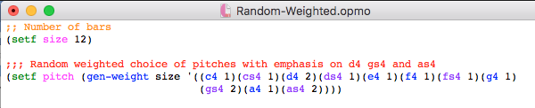
Figure 2.1. Coding in Opusmodus to create motivic variations.

In the introduction of his book Composing Interactive Music, Todd Winkler compares various elements of interactive electronic music with those elements of a good conversation. Winkler explains that when two people are sharing words and thoughts, both parties are engaged; one thought spontaneously affects the next and ideas seem to flow naturally.
In a similar manner as with human conversations, I find that acoustic instruments and electronics can create a musical dialogue where both instruments are treated as equal partners in this musical interaction. The more distinct the roles and the balance of this musical conversation between the performer and the computer, the easier it is for the audience to follow and understand the music. For this reason, the electronics’ part in Vocem was designed with interaction in mind.
Over the years, various methods of performing with electronics have been developed with the main difference being the use of fixed media and real-time processing for generating the electronics’ part. Both methodologies of real-time DSP and pre-recorded materials form a different type of interaction with both positive and negative aspects.
In Vocem, I used both real-time processing and pre-recorded materials to shape the interaction between the flute and the computer. The decision of which method to use depended heavily on timing/cuing parameters as well as deciding which of the two methods would make it easier for the performer to create a convincing dialogue with the electronics.
In general, I prefer to use real-time processing when exact-timing of cueing is required as well as for pitch-based processing. This allows the performer to not have to synchronize with the electronic part and also not have to worry about intonation as the electronics will adapt to the live-input. This also provides the performer with more freedom in interpretation and phrasing.
The pre-recorded materials in Vocem are used in two different roles. One role is as an ambient or background layer that supports the flute line in the foreground. The other role is as an almost “fake” real-time processed material, which I call fixed electronics. I use this type of interaction to speed up the compositional process since it is easier to create sound files than create a processing module in MaxMSP. This method also helps to keep CPU at a minimum to allow for a performance of the piece even on slow computers.
To summarize, the composition of Vocem was a multistep process in which I had to research, collaborate, compose the actual piece, as well as develop my own compositional platform for live electronics. I paid particular attention to the interaction between the flute and the computer. As Winkler emphasizes in Composing Interactive Music, “interaction is a two-way street. When only one person does the talking it is not interactive–it is a lecture, a soliloquy.” I also carefully chose the different forms of interaction in Vocem because this plays an important role in the piece’s impact and understanding by the audience. I strove to create an instrumental line for the flute that was both appealing for the performer and allowed for several forms of interaction with the computer, providing equal roles to both instruments for a balanced performance.

CHAPTER 3
Structure & Formal Elements

Vocem is a material driven composition where the sonic attributes of the sounds used in conjunction with the type of Digital Signal Processing (DSP) outline the form of the piece. I started composing Vocem by collecting and experimenting with various materials, but without having any particular musical form in mind. I then focused on finding the type of structural design that best conveyed my compositional ideas while also highlighting specific attributes of the chosen materials and their respective DSP techniques. As Toru Takemitsu once stated:
My musical form is the direct and natural result which sounds themselves impose, and nothing can decide beforehand the point of departure. I do not in any way try to express myself through these sounds, but, by reacting with them, the work springs forth itself.

Similarly, I find that letting the materials determine the pacing and unfolding of musical ideas allows the music to obtain a natural flow. For this reason, instead of following a fixed-form method where the manipulation of the materials is somehow determined by the needs of the pre-defined form, I let the materials define the form of my piece.
Curtis Roads in his book Composing Electronic Music: A New Aesthetics, explains that textural and timbral elements have been thoroughly utilized as formal elements by several composers in acoustic works of 20th-century music:
Timbral/textural composition had been explored in the domain of acoustic instrumental music by Gyorgy Ligeti, Helmut Lachenmann, Giacinto Scelsi, Gérard Grisey, Natasha Barrett, Iannis Xenakis, and others. These works play with the continuum between pitch and noise and are not necessarily aligned to a regular metric grid. In these pieces, variations in timbre and voice density play a structural role.

As mentioned in the first chapter of my document, my study of works by Ligeti and Xenakis has greatly influenced my understanding in the use of timbre and texture as formal elements. Hence, the decision of using timbre and texture to structure the main sections of Vocem came very naturally to me.
In particular, each musical idea in Vocem utilizes a discrete set of sound sources and type of DSP to provide distinct character to each section and its subdivisions. Figure 3.1 is a comprehensive illustration of the overall form, subdivisions, associated materials, and types of used DSP techniques.
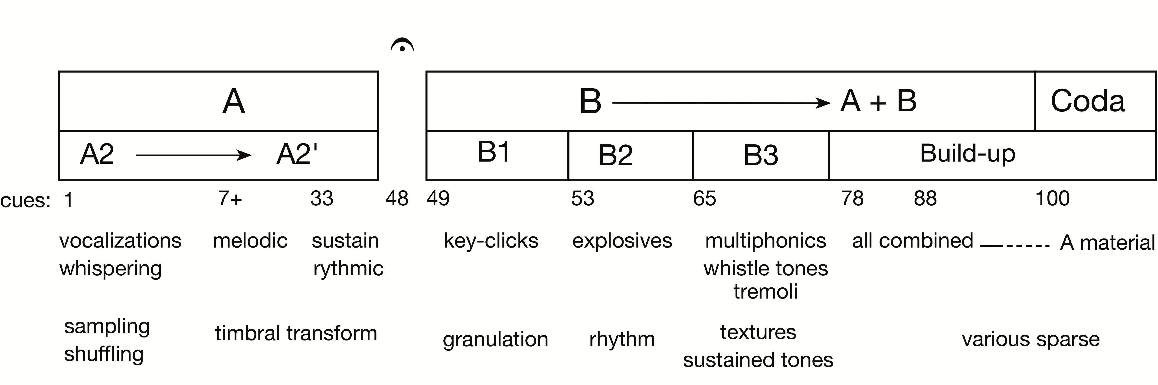
Figure 3.1. Overall form illustration including sub-divisions and explanation of the DSP.
In the large scheme, Vocem is divided into two main sections, A and B. Section A is defined by the use of vocalizations and melodic materials, whereas rhythmic and textural development is the focal point of section B.
In A1 my concentration is on the use of unfamiliar/uncommon sound sources such as pitched whispered tones and inhaling/exhaling sounds. As A1 unfolds, the abstract materials are gradually substituted with more familiar materials that have defined pitch, such as melodic fragments and trills/tremolos.
In a similar manner, section B mirrors the same formal scheme. Section B1 introduces materials based on extended techniques (uncommon), whereas B2 and B3 utilize more conventional materials like rhythmic elements and sustained tones (familiar).

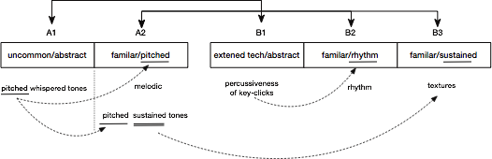
Figure 3.2. Mirroring scheme between sections A and B.

Moving forward, DSP techniques are not only used to create the electronic’s part and interaction, but also contribute to the formal design of the piece. As stated earlier, each section and its subdivisions utilize a discrete set of DSP technique as a means of providing a distinct character to said segment(s). For example, the compositional focus during cues 65-70 as well as on the final section (cues 101-103) is on the development of textural elements via the use of Fast Fourier Transform processing (freezing) and various sampling techniques.
Sampling techniques are also used in the B section to create the rhythmic build-up that leads to the climax (cues 88-89). However, during cues 65-70 and 101-103 the use of sampling techniques provides a slow and smooth character to the music, as opposed to cues 88-89 where sampling techniques generate the energy that drives the major build-up. In other words, it is both the performer’s materials and the different types of DSP contribute to the overall form. This in turn ensures that both the performer and the electronics are equal partners of this musical dialogue.
The character of the reverb varies depending on the application much in the same way the sampling techniques alter the character of the music in different sections. Specifically, I use reverb to support the formal structure, direct the listener’s attention to specific elements, provide the desired character/attitude to the performer’s sound, and finally, make it easier for the flutist to project his/her sound in the hall.
For instance, section A ends with the flute and electronics dying away with the support of an algorithmic reverb. This reverb is specifically tailored to provide a very smooth and natural fade-out as a means of enhancing the psychoacoustic illusion of said sounds vanishing away. The effectiveness of the fade-out coupled with the moment of silence that follows (medium fermata ca. 3-4sec.) are crucial for separating sections A and B. By highlighting and enhancing this fade out, I make it clear to the listener that section A has come to an end and a new section is about to begin. Here, the reverb’s spatial characteristics are used as a marking point that separates sections A and B. Therefore, in this case that particular reverb functions as a subtle support to the formal structure of Vocem.
The fresh start of the B section (cue 49) engages the listener and brings attention to the nuances of the soft key-clicks that mark that section. Ultimately, if the listener is aware of the flute’s key click sounds (raw/unprocessed material), it should be much easier for him/her to realize how the raw materials are being processed and transformed. The latter is especially important as it allows for a better understanding of the development of musical ideas, and consequently, for a better understanding of the piece’s progression.
I also used reverb techniques to help the performer stand out from the electronics as well as to obtain a wider and bigger sound. To achieve this, I layered two reverbs with each having different character and parameters. The first reverb is equalized and saturated so as to provide an almost intimate sound that enhances the subtle nuances of the whispered tones. It is meant to support the performer’s sound without being noticeable. For this reason, this reverb module is panned close to the center and it is also compressed so it can blend naturally with the performer’s live sound. The second reverb has a longer tail, steep low-cut filter at 250 Hz, boosted high frequencies with a subtle high-shelf filter, and panned hard left and hard right with different delay times and feedback for each side. This delayed reverb acts as a subtle “echo” to widen the performer’s sound. The wide spreading of this second layer of reverb into the concert hall enhances the clarity of the performer’s sound without necessarily making things louder.

To conclude, the form in Vocem is mainly defined by the development of pitch, timbral, rhythmic, and textural components. Additionally, the unique sonic characteristics each DSP technique possesses provide a clear distinction between the various musical ideas. In this way, the DSP techniques used in different parts of Vocem not only highlight specific attributes of the chosen materials, but also contribute to the overall form.

CHAPTER 4
Selection of Materials

The sound sources that are used in Vocem were chosen based on the diversity of their musical attributes, their interconnection with the rest of the materials, and their ability to provide an overall development of musical ideas in both the instrumental part and the electronics.
For instance, the flute's explosive tongue-rams produce sounds with fast attack and short decay, which is a common characteristic of non-sustained percussion instruments such as woodblocks, xylophone, and snare drum. The defined transients of the tongue-rams allow me to highlight rhythmic elements by including these percussive-like sounds in the flute part as well as extending the idea of rhythmic development by means of DSP.
The tongue-ram’s defined transients can be further utilized as an onset that automatically triggers the electronics. To be specific, the electronics are initially inactive, but are constantly “listening” and analyzing the input signal (microphone). The electronics are programmed to seek a sound that possesses the characteristics of the tongue-ram (loudness, pitch, dynamic envelope) within a given time frame. After the recognition of the model sound (tongue-ram) is detected and validated, the electronics are activated immediately without any further interference from the computer user.
As Denis Smalley explains in his Spectromorphology, elements such as anacrusis and attack can be utilized as onsets that drive the directionality and behavior of musical gestures. Smalley argues that some onsets “look forward” expressing a transition to something new whereas other onsets are “linked backwards” to prolong and maintain previous behaviors. Manuella Blackburn in her article “Composing from spectromorphological vocabulary: proposed application, pedagogy and metadata,” expands on Smalley’s concept. Blackburn explains that in more complex scenarios the onset of a sound can “exhibit dual functionality” where the release of a sound terminates the previous sound while also providing an onset for the following sound.
In Vocem, I utilize sounds with defined transients to create a sequence of triggered events, much in the same way as Blackburn’s idea. For example, a tongue-ram activates the electronics for real-time DSP and also triggers a sound file (playback). A second tongue-ram changes the parameters of the real-time DSP and at the same time acts as an onset that gradually fades out this real-time DSP. The third tongue-ram triggers a fade out of the first sound file and starts the playback of another sound file, and so forth.
After experimenting with my materials, I favored the idea of utilizing rhythmic and granular textures as the distinct characteristic of section B. Hence, I decided to use key clicks and various other improvisatory flute sounds of a similar nature, as these kinds of sounds possess both granular and percussive attributes. Also, the jitteriness of the key-clicks provides a desirable degree of unpredictability to the interaction between the flute and the electronics because of the slight variations in pitch, density, dynamic envelope, and timing/spacing of the key click gestures.
Further, I have always been fascinated with the nuances of the sound of the human voice and I wanted to bring out this idea—even in a piece that was not originally intended for the voice. As I mentioned earlier, a major influence in my decision to fuse human voice with flute was NoaNoa (1992) by Kaja Saariaho. I particularly liked the delicate sonic qualities of the amplified human voice when resonating through the flute. For this reason, I decided to use a series of pitched whispered tones and breathing sounds as the initial and final gestures of Vocem to highlight aspects of the human voice when fused with the mechanical medium of the flute.
At this point, I should clarify that I am not interested in using spoken words in my composition, as these would immediately create social/political associations and suggest an interpretation of the music. My attention is on finding the sonic characteristics of human sounds that can be manipulated for musical means; for example, creating rhythmic patterns out of vocalizations as I do during the last section of B in Vocem.
In regard to pitch materials, although my intention was not originally to create material based on certain pitch-class sets, further analysis reveals there are a few recurring sets. The sets that are most commonly used are [0, 1, 2], [0, 1, 3], and [0, 1, 2, 3]. These sets were derived from the experimentation with my flutist, Alyssa Andriotis.
As can been seen, all of the materials used in Vocem have been assigned musical roles. Their purpose is to provide for the instrumental and/or electronic part (local level), support the development of compositional ideas (macro level), or a combination of both. Some of the sound sources, like the key clicks and tongue-rams, were selected because of their diverse possibility, while others were chosen to link and connect the musical with the non-musical, like the whispered sections.

CHAPTER 5
Digital Signal Processing

Vocem utilizes several Digital Signal Processing (DSP) methods and techniques for generating and controlling the electronics’ part such as harmonizers, filtering, freezing, reverberation, dynamics, granular and multi-tap delays, distortion effects, and sampling techniques.
To begin with, delays and sampling techniques are the main DSP methods I use to create rhythmic patterns. With granular and multi-tap delays, the processing is happening instantaneously (real-time) creating immediate interaction between the performer and the electronics. The way I employ granular and multi-tap delays provides quick results both with the creation of rhythmic patterns as well as with constructing an interactive dialogue between the performer and computer. However, both of these delay methods are dependent on the performer’s live-input, which makes the process extremely difficult for expanding the DSP after the performer has stopped playing. For this reason, I prefer to utilize granular and multi-tap delays for rhythm creation only on a micro level (short musical gestures – brief interaction).
On the other hand, sampling methods allow me to create materials independent of the performer's live-input. I have found that the use of sampling techniques is better for the production of rhythmic gestures of extended length (macro level). The fact that the performer’s live sound is stored in a buffer means that the captured materials can be accessed and further processed at any given point—even long after everything has been recorded into the buffer (offline processing). Cues 88-89 is a good example of the latter process. The rhythms that drive the energy and pacing of the major build-up (cues 88-89) are based on vocalized samples stored in a buffer from the performer’s live-input as well as playback of pre-recorded materials.
Dynamics processors, saturation/distortion, equalizer, and filters are used either for the enhancement or control of program material. For example, during the whistle tones passage (B3) the high-frequency spectrum is boosted with an equalizer in order to help the soft whistle tones stand out a little bit and be heard. For the same reason, a slight amount of distortion is applied to all whispered phrases in order to obtain a more intimate and slightly distorted sound quality, which in turn helps with speech intelligibility.
In order to prevent unwanted rumble and low-frequency noises reaching the listener, a low-cut filter is applied to the performer’s live-input. Likewise, a gate decides which sounds are part of the program material, and therefore should be outputted to the speakers, and which sounds are considered noise and should be removed. The latter is particularly useful for minimizing the potential of feedback during the performance.
The last level of control is achieved with the use of compressors and limiters. These dynamic processors are programmed to monitor the input and output signals and make sure that the program material is within a comfortable loudness range at all times.
Finally, FFT-based DSP modules and harmonizers are used to create textures and chords/clusters out of sustained materials. For instance, in B3 during the section with the timbral trills, multiphonics, and whistle tones both processes are used. Most of the supportive textures in this passage are created from the performer’s live-input via means of FFT processing, reverberation, and pitch-shifting.

CHAPTER 6
Music Notation

The score of Vocem combines Finale Music Notation software with Affinity Designer by Serif. The implementation of a dedicated professional graphic design software was necessary for illustrating the electronics as well as the non-standard extended flute techniques since Finale is not capable of creating such detailed-oriented musical symbols.
On a technical level, I used Finale to create a template that included the overall page layout with the performer’s staff and appropriate spacing for notating the electronics’ cues and graphics. Then, all of the musical elements that could be notated by traditional notation means were inputted into Finale and exported as graphic files compatible with Affinity Designer (PDF, and EPS files). After aligning the page’s layout template with the exported musical excerpts into Affinity Designer, I created graphics to depict the electronics as well as other melodic and rhythmic elements that were difficult to notate in Finale. The cover and special symbols pages were created directly into Affinity Designer.
Creating the score for Vocem was a particular challenging task. Visualizing the electronics is a very subjective and abstract process; and secondly, the ambiguous nature of the used sounds combined with the non-standard extended flute techniques were difficult to illustrate clearly in a meaningful, musical manner. That said, it was by no means my intention to create an accurate visualization of the electronics’ part, but rather to provide sufficient information for the performer regarding the timing, dynamics, timbre, and texture/shape of the electronics so he/she could best synchronize with the MaxMSP cues.
For single-pitch passages/events, instead of exporting images from Finale, I used the Maestro font as text directly into the Affinity Designer software. The advantage of this method is that using the native tools of a vector-based graphic software results in high-resolution illustrations, as opposed to pixelated images when exporting graphics from Finale. Also, this method expedites the overall notation process since good results can be achieved with the use of a single application.
Further, special emphasis was given to page turning so the flutist could easily follow and perform the music without having to rush when he/she has to make a page turn. The careful design of page turning not only benefits the instrumentalist, but also enhances the overall listening experience. In my opinion, the audience should stay concentrated in listening to the music rather than getting distracted by the sound of pages turning loudly or by the view of a nervous performer who races against time to execute a page turn.
Lastly, during my participation in electroacoustic music events such as the International Computer Music Festival (ICMC) and the New York Electroacoustic Music Festival (NYCEMF), I noticed that many performers utilized tablets for reading and performing music instead of hard copies. The fact that a tablet can be paired with a foot-pedal for page turning allows performers to keep both hands on their instrument while effortlessly applying the desired page turns. I find this method a very good solution for reading and following music during a performance. For this reason, after the successful defense of my dissertation, I would like to create one more version of my score specifically designed for use with tablets and similar electronic devices.

CHAPTER 7

The Compositional Method

The introduction of computers in the 1980s redefined the way electronic composers were creating and performing music. Although technologies for live electronics already existed, the computer offered an elegant alternative providing an easier platform in which to compose and perform with electronics.
In his article “Real-Time Interactive Digital Signal Processing: A View of Computer Music,” Cort Lippe states that during the 1980s software and “commercial MIDI gear began offering composers with little or no programming experience the ability to make computer music, much of it in real time.” The user-friendly graphical interface provided by the new software applications made the tedious process of composing electronic music easier than ever. Javier Alejandro Garavaglia echoes the same sentiment in his article “Raising Awareness about Complete Automation of Live-Electronics.” Garavaglia explains that around the mid-1980s, analog gear had been gradually discarded in favor of the newer and easier to use computer software.
New computer technologies opened up a whole new sonic world, liberating composers from the time-consuming technological limitations of former mediums. A modern electroacoustic composer has more, and arguably better, technology to choose from compared to the pioneering electronic music composers. Modern computers solved the technical issues that early electroacoustic composers faced, but the computers also created problems of their own, namely by posing questions regarding their use in the compositional process.
Eduardo Reck Miranda, in the epilogue of his book Composing Music with Computers, expresses his thoughts on the idea of using the computer as a compositional tool.
The computer is undoubtedly a powerful tool for musical composition: it enables composers to try out new musical systems, to build rules-based generative programs, to map extra-musical formalisms onto musical cultures, and so forth. The range of possibilities is overwhelming.

Nowadays, the electroacoustic music student composer is faced with this difficult task of finding his/her own voice in a medium with overwhelmingly unlimited potentials. With a whole world of technical and aesthetical possibilities available, the question now becomes what technologies the electroacoustic music composer should utilize and how.
In Tod Machover’s article, “Thoughts on Computer Music Composition,” he argues that work with computers exaggerates creativity problems. According to Machover, computers introduced many challenges for the electronic music composer primarily in regard to decision-making, material utilization, and use of musical form.
The computer imposes no aesthetics or rhetorical constrains. It exists as a thinking tool that stimulates the imagination and provokes thought about the compositional process itself as well as with re-inventing the relationship between composers and the new materials; but however without providing any answers to those questions.

On the same topic, in the preface of The Computer Music Tutorial, Curtis Roads highlights some of the major challenges of the process of understanding the possibilities of new computer music mediums. Roads explains that computer music knowledge “reflects on an interdisciplinary spirit because it draws from composition, acoustics, psychoacoustics, physics, signal processing, synthesis, performance, computer science, and electrical engineering.” As a result of this well-rounded pedagogy in computer music, the study of electronic music composition appears to be a rather difficult task since it necessitates expertise in both music and science.
It is clear that the challenges posed by existing and emerging technologies make the study of electroacoustic music composition demanding. The rapid progression of computer-related technologies constantly alters the role and utilization of the computer as both a compositional platform and as an electronic instrument, making the compositional process even more difficult. For this reason, the electronic music composer can be easily baffled by the vast amount of possibilities computers create every time a new role or functionality is assigned to the computer. Finding a way to creatively and musically utilize these new technologies takes a substantial amount of time and effort, both for the professional and the student electronic music composer.
The compositional necessity of creating my own unique method for composing and performing live electronic music derived from all of the artistic and technological challenges described above by Roads, Miranda, and Machover. I felt the need to invent a system that allowed me to stay focused on composing music, rather than having to constantly overcome technical challenges. Consequently, I started experimenting with how I could design a compositional platform that allowed me to materialize my creative ideas quickly and with minimum programming effort, while also automatically preventing potential technical errors. This made my overall process of composing, rehearsing, and performing live electronic music easier.
Although existing live electronic methods have been tested and have provided relatively good results, I always felt that I was artistically constrained by the technological and compositional limitations of those methods. In other cases, I even felt overwhelmed by the complexity of the design, which required an immense amount of knowledge to operate those systems, even on a basic level.
For instance, some platforms like SuperCollider and variations of C-based languages have excellent compositional and sound design tools, but the programs themselves have a very steep learning curve. Also, sharing SuperCollider patches with performers is a particularly difficult task due to the complexity of the coding-oriented platform and lack of sufficient interface, which makes the operating of such system almost impossible for the average user (performer).
Other methods like [matrix~]-based MaxMSP patches are easier to understand and share, but they have some compositional limitations in regard to signal flow as well as with applying changes to the patch during the rehearsal without affecting previous and preceding musical events. Additionally, this kind of [matrix~]-based method accumulates a large number of nested objects, making debugging and navigating the patch difficult for the user (composer).
A good solution for my way of workflow would have been a system like Kyma by Symbolic Sound. This software-hardware package has several programming and sonic advantages over the previously mentioned methods. This system has a fully-functional software interface (layout), libraries and ready-made compositional tools, and an external hardware box for the DSP. However, the monetary cost of the system is not an accessible solution for the average student.
As can been seen, there are several options, all suggesting different workflows and approaches to creating and performing live electronic music. However, I needed a system that not only assisted with composing and programming, but also provided solutions to storing and recalling compositional ideas. This would allow for a more efficient experimentation with various materials and make it possible to apply changes instantly upon the performer’s requests during the rehearsal, without affecting preceding and following programmed materials. Ideally, I wanted a system that would consume the least amount of CPU as possible while still allowing advanced signal flow and DSP. Also, since the performance of the piece is of the utmost importance, I needed to include a user-friendly interface that allows both composers and performers to do quick sound-checking during performances and rehearsals.
Since the previously mentioned methods did not include all of the elements I needed, and also knowing that I was not going to settle with just partially fulfilling my compositional and performing needs, my solution to this problem was to create my own compositional platform. This way, I would have full control over the parameters of the system as well being able to modify this platform to be compatible with future technologies.
Therefore, my research focus during the last few years has been on the creation of an interactive system that allows me to think more as a composer and less as a programmer. This is not to say that my method is better compared to existing methods. I would be naïve to assume that my system could accommodate all compositional purposes and fit all the electronic composers’ artistic needs. However, the fact that my system has been specifically designed to support my overall compositional process makes it more suitable for my way of creative thinking.

CHAPTER 8

MaxMSP Design

The core design of my MaxMSP patch is based on a three-step concept of controlling the Input section, the electronics (DSP and Tape), and the Output. These three main stages are then divided into smaller segments for a finer control over the signal flow, overall dynamics, and frequency content of the various signals. The diagram below illustrates the overall signal flow from its initial phase up to the final step when the signal reaches the speakers.

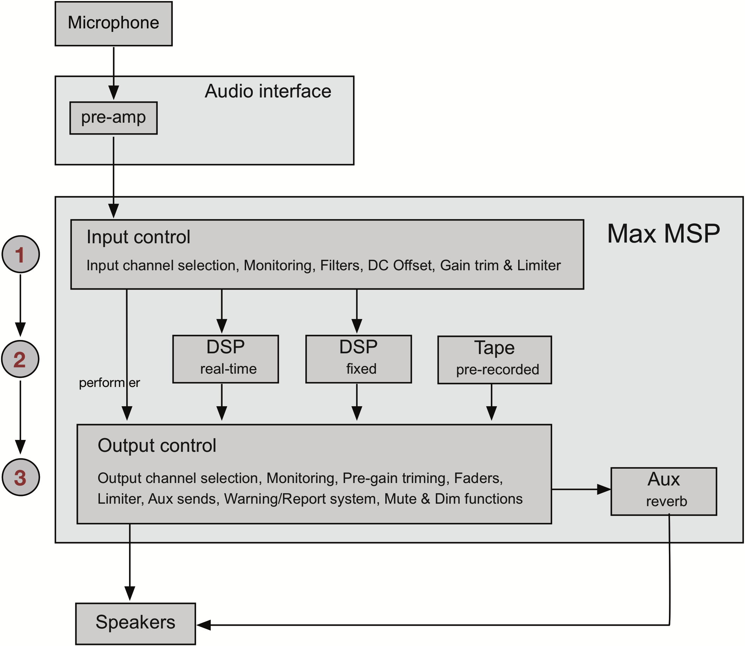
Figure 8.1. Overall signal flow diagram.
Stage 1: Input control
When the microphone’s signal reaches MaxMSP, it first passes through the Input control section. This is where the incoming signal is analyzed and compared with what is considered the “desired” signal. After the comparison, it is up to the Input section’s algorithm to decide what kind of “corrective” processing is required to compensate for any differences in amplitude and/or frequency content between the incoming signal and the “ideal” signal. This way, before the signal reaches the DSP section, MaxMSP can roughly estimate the loudness and frequency content of the signal to be processed and be prepared to put a halt to unpredicted amplitude changes if needed. A typical chain of “corrective” DSP for the incoming signal looks like this:
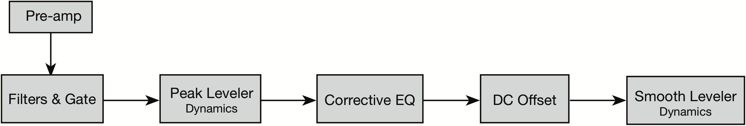
Figure 8.2. Typical signal chain for the control of the input signal.

Stage 2: The Electronics
After the signal leaves the Input section, it is distributed to the Performer’s fader and to the DSP section, so it can be further processed to create the electronics. Figure 8.3 illustrates:

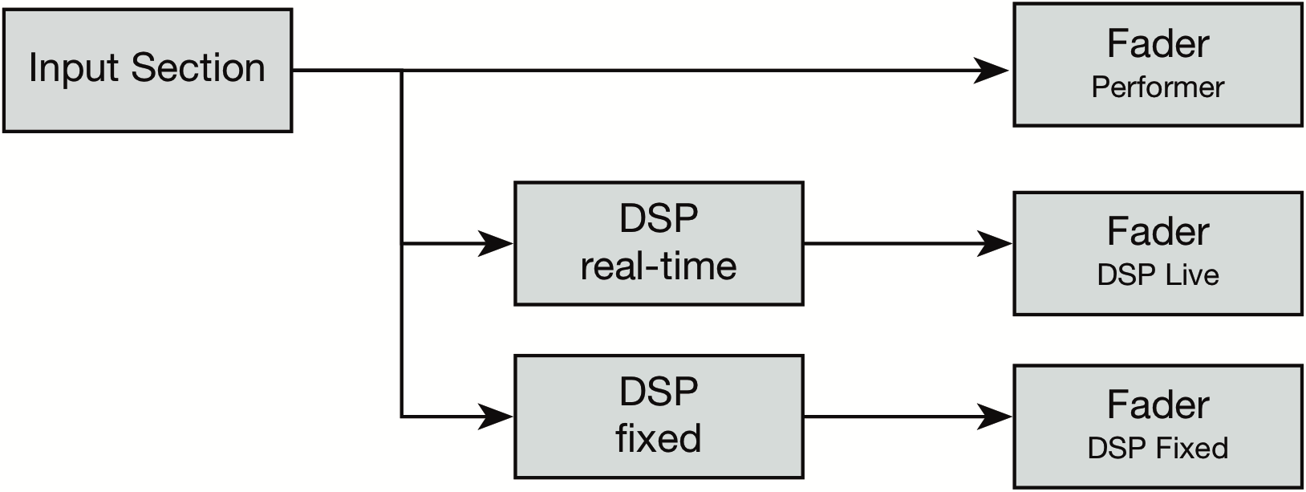
Figure 8.3. Signal distribution after the Input section.

The DSP section is based on a network of two nested poly~ objects. The first poly~ (parent/top-level) handles audio routing and distributes lists of information to the individual DSP modules and sub-patches. The second poly~ (inside parent) is responsible for both the real-time DSP as well as for the fixed DSP (signal-triggered sound files). This is where the individual DSP modules are placed.

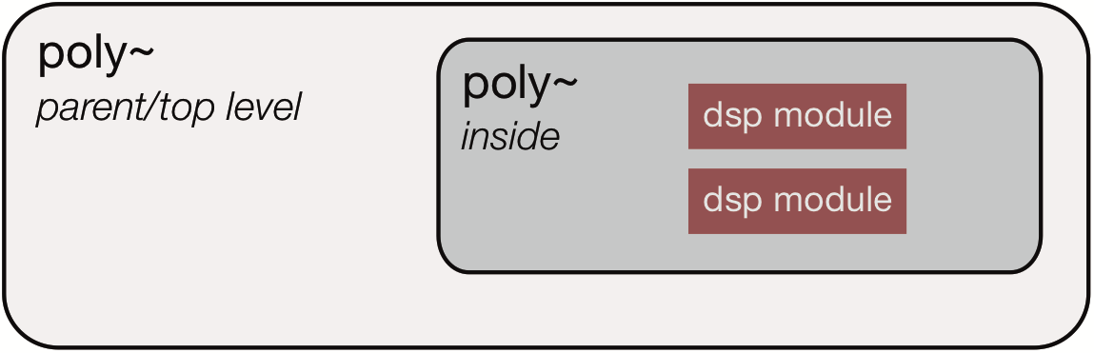
Figure 8.4. Illustration of the design of the two nested poly~ object for handling the DSP.

To control the DSP, I take advantage of the ability of the poly~ to dynamically load and unload patches. Here is an example of how this system works: when the main patch is initialized, the top-level poly~ will automatically give a command to the internal poly~ to load the default empty patch that I have specified (pre-programmed). On cue 1, the internal poly~ will replace the empty patch with another patch, for instance a patch that contains three delays. If the delays are only needed during cues 1-2, all I have to do is to replace the delays’ patch with the default empty patch at cue 3. Now, the internal poly~ can be used again on a different cue to load another patch for signal processing, and so forth. So, even with just a single poly~ object, I am able to do several different kinds of processing.

Stage 3: The Output Section
In the Output section, the signal passes through the pre-gain (trimming) stage before it is sent to the fader for mixing. The pre-gain system is my solution to automatically compensate for gain changes caused by the addition/removal of DSP patches and Tape materials. Instead of having to manually override the faders whenever objects are added to the signal chain, I find it more convenient to program the pre-gain system to handle the volume changes. Figure 8.5 is an illustration of this concept that explains the gain compensation in three different scenarios of combining various DSP signals.
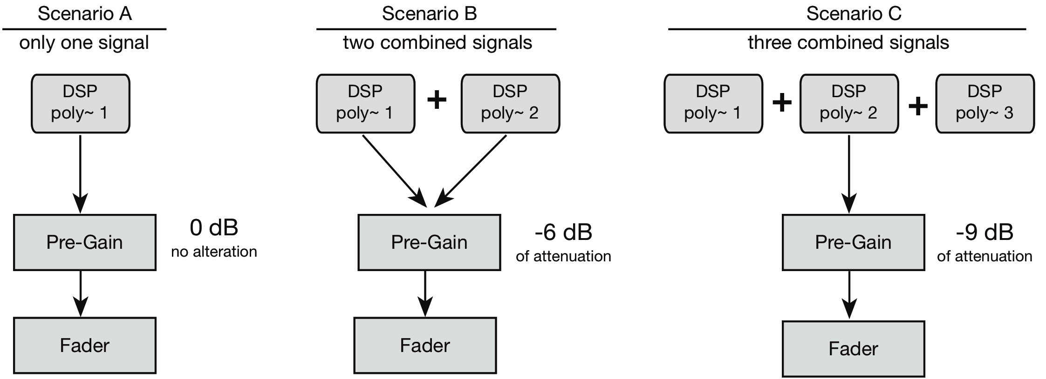
Figure 8.5. Examples of automatic gain compensation during the pre-gain phase.

The fader section is the last level of control before the signal is sent to dac~ (Digital to Analog Conversion), and finally to the speakers. The fader includes controls for the output gain, output channel destinations, and send level for the auxiliary channel (reverb).

The interface
To speed up the compositional and programming process, I designed an interface which makes all the controls and monitoring of the various parameters accessible directly from the top-level window. This way, I can have quick access to any parameters, modules and patches, pre-recorder materials, and hardware and routing options without having to navigate to separate windows or even to unlock the patch. After experimenting with various designs and methods, I ended up using the layout seen below.
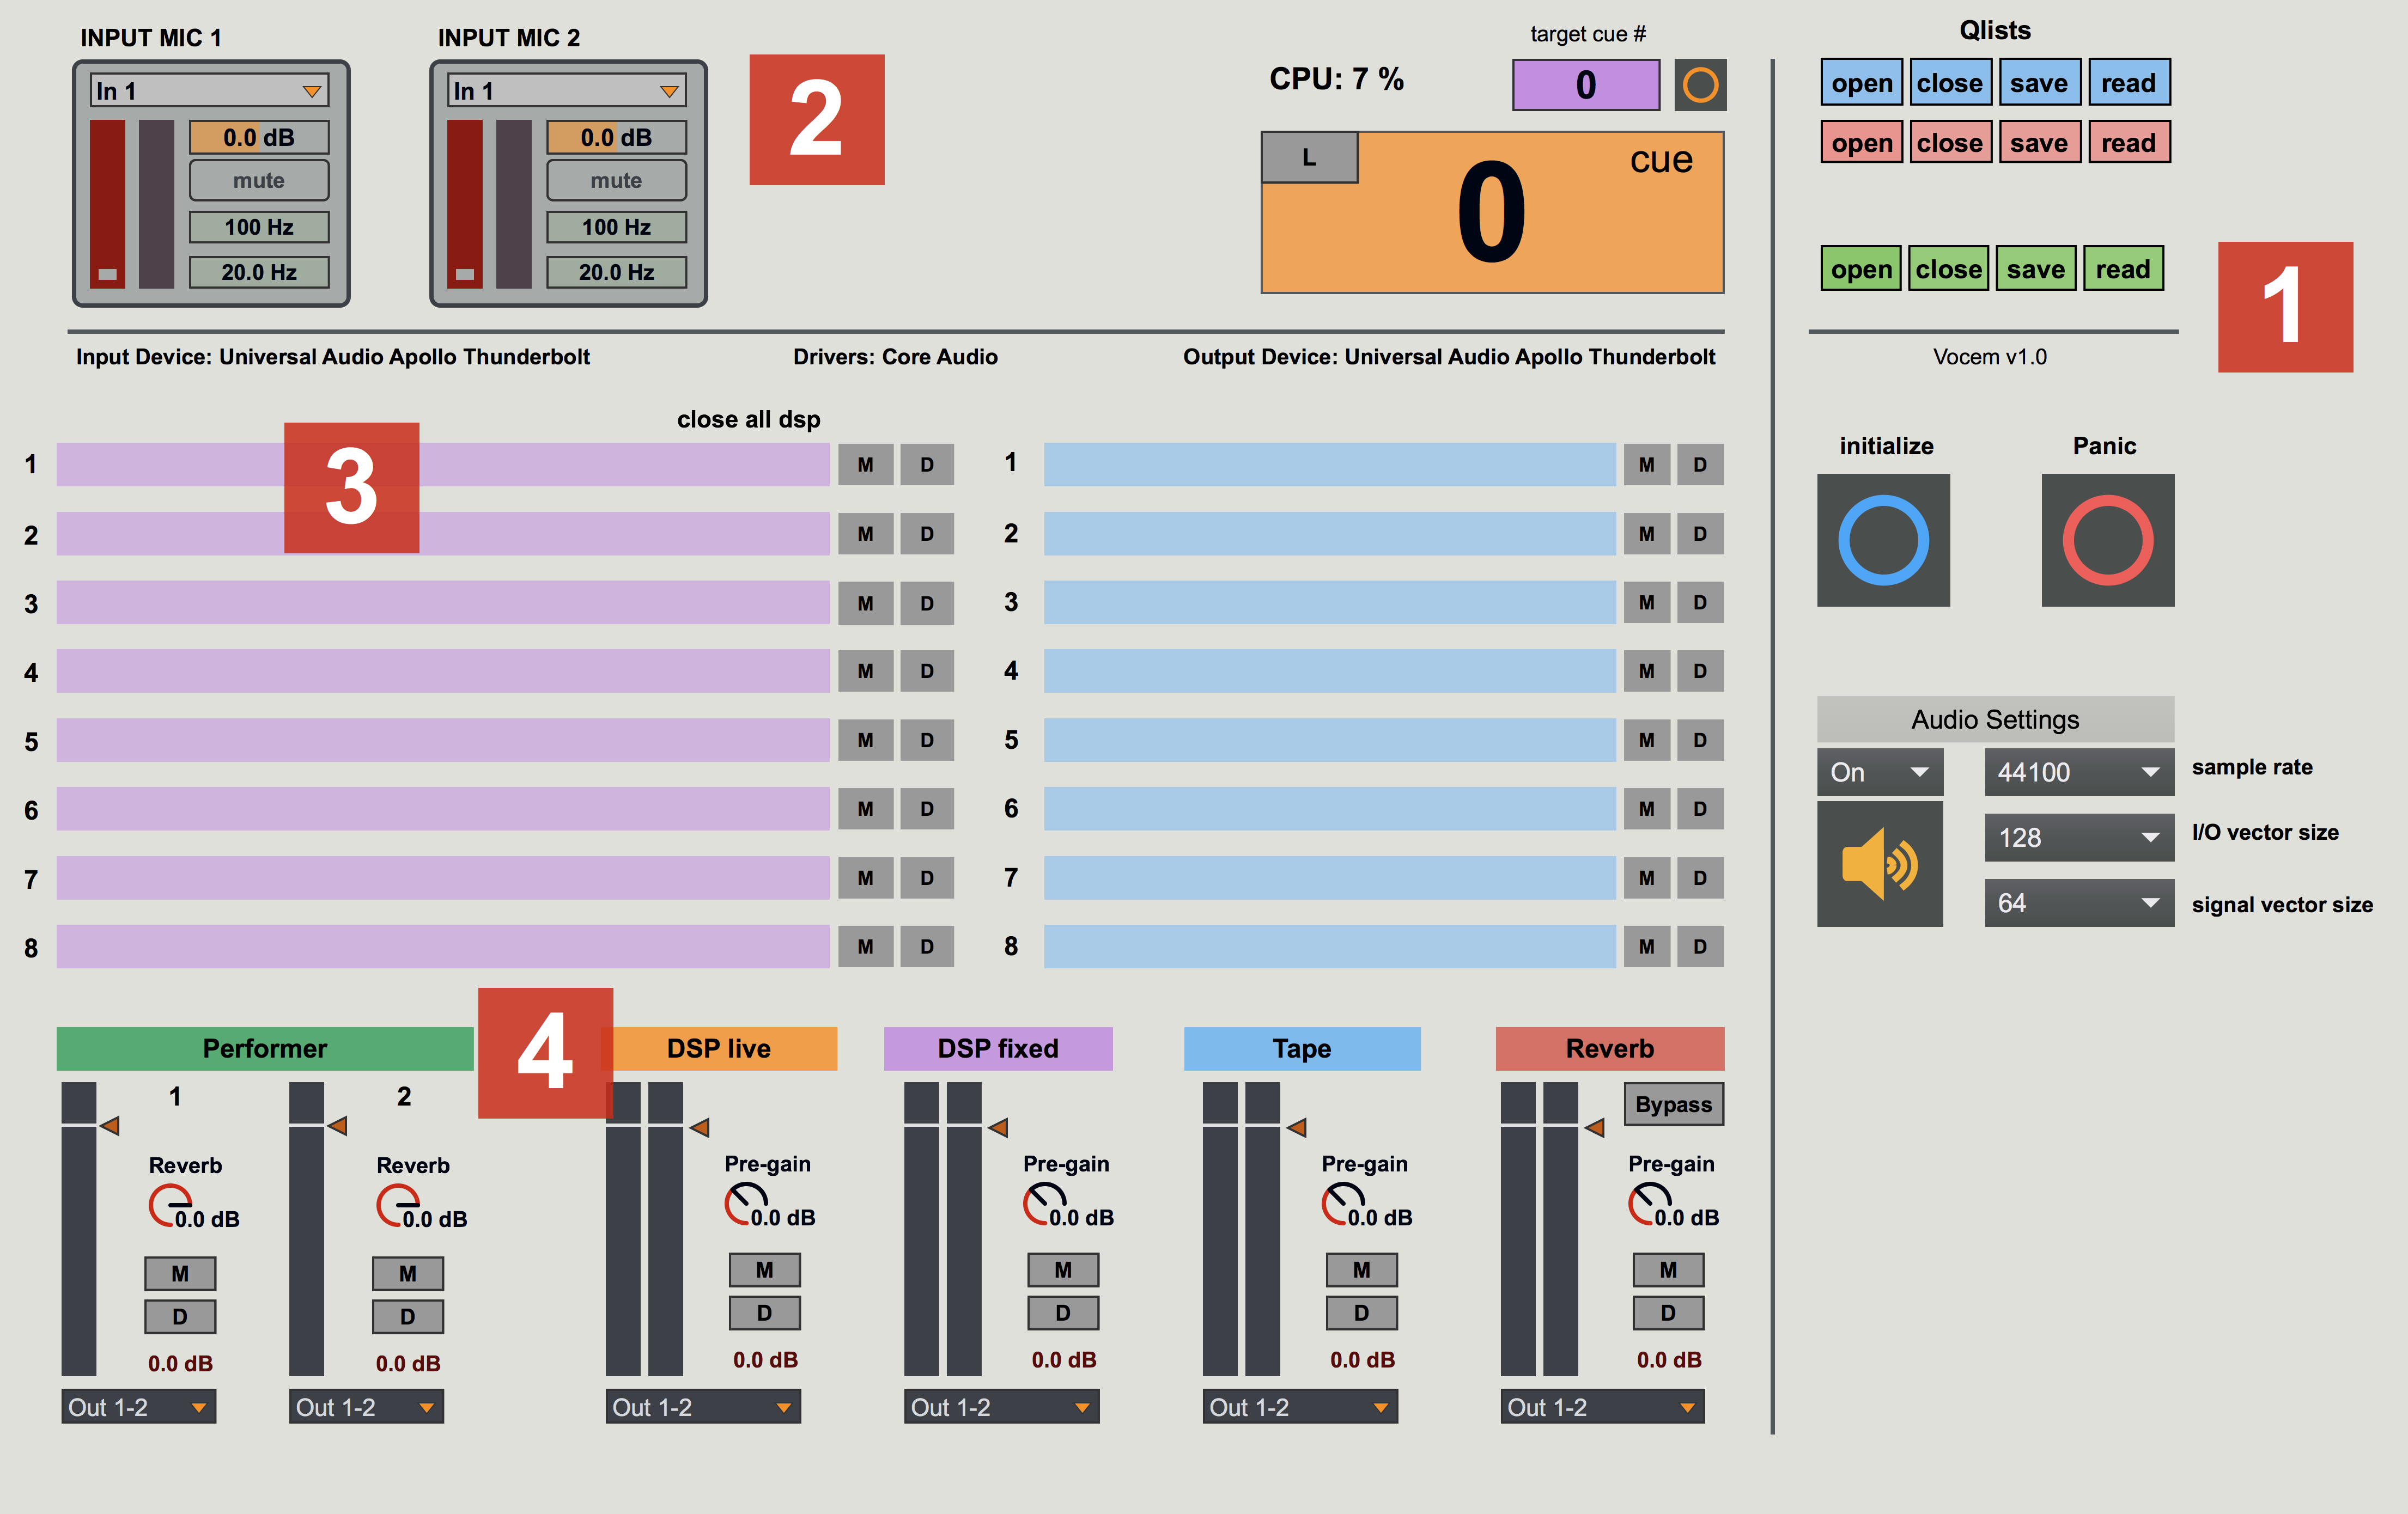
Figure 8.6. Layout of the interface – top-level window.
1: Control & Settings | 3: DSP & Tape monitoring
2: Input control section | 4: Output control section

The first section (right side) provides quick access to the audio settings as well as to the objects that are required for the programming. Hitting the “Initialize” button (blue) will setup all default parameters of the patch and its various objects automatically. If the red “Panic” button is pressed during the performance or rehearsal, the patch is programmed to stop any audio signal from going to the speakers in case of excessive loudness due to feedback.
The big orange number box displays the current cue number and functions as a “conductor” for the patch and the Qlists. The blue Qlist holds the parameter settings for initializing the patch whereas the red Qlist determines how to stop the audio in case of emergency. The green Qlist is responsible for sending a string of information/messages to the individual sections and objects of the patch, which generate the electronics. These messages will tell the DSP and Tape sections which modules should be used at specific points in the piece (cues) and which sound file should be played-back respectively.
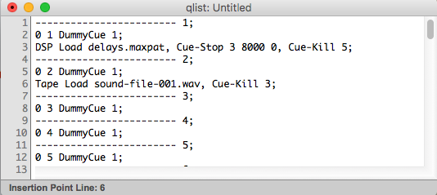
Figure 8.7. Programing example of loading a DSP patch and a sound file using the DSP Qlist.

The upper left zone (2) contains the Input section for controlling the incoming signal. Here is a description of the various controls.
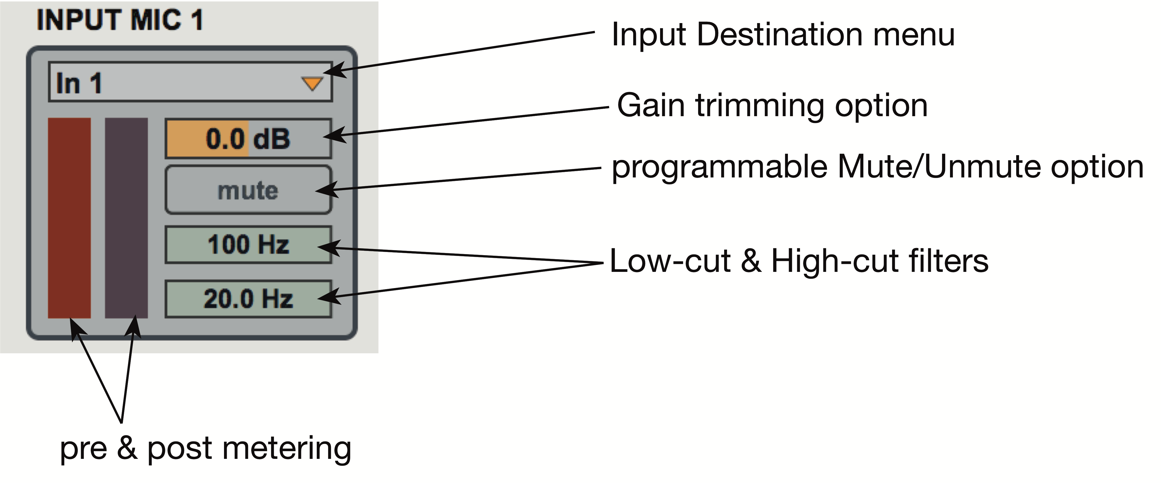
Figure 8.8. Layout of the interface of the Input section.
The red level meter (left, pre-corrective) monitors the signal sent from the audio interface into MaxMSP. It is only used for monitoring purposes and can neither be selected nor be altered. This meter provides visual feedback during rehearsals and performances. For example, when the performer walks on stage the red meter should monitor the audience’s applause as it is captured by the microphone. This way, I know that my audio connections are configured correctly, and I can now proceed with the performance of my piece without wasting additional time on sound checking. The meter to the right monitors the signal sent to the DSP section and after is has been “corrected” by the corrective algorithm of the Input section (post-corrective algorithm).
To simplify routing settings, I created a system of drop-down menus that allows the user to change the input and output destinations directly from the top-level window of the patch. For example, if I needed to change the input channel for the microphone, I could select the different inputs straight from the drop-down menu above the performer’s fader without having to access the I/O settings of MaxMSP. The same is true for the output menu located below the faders (output section) in case I wanted to alter the routing destinations for the output.
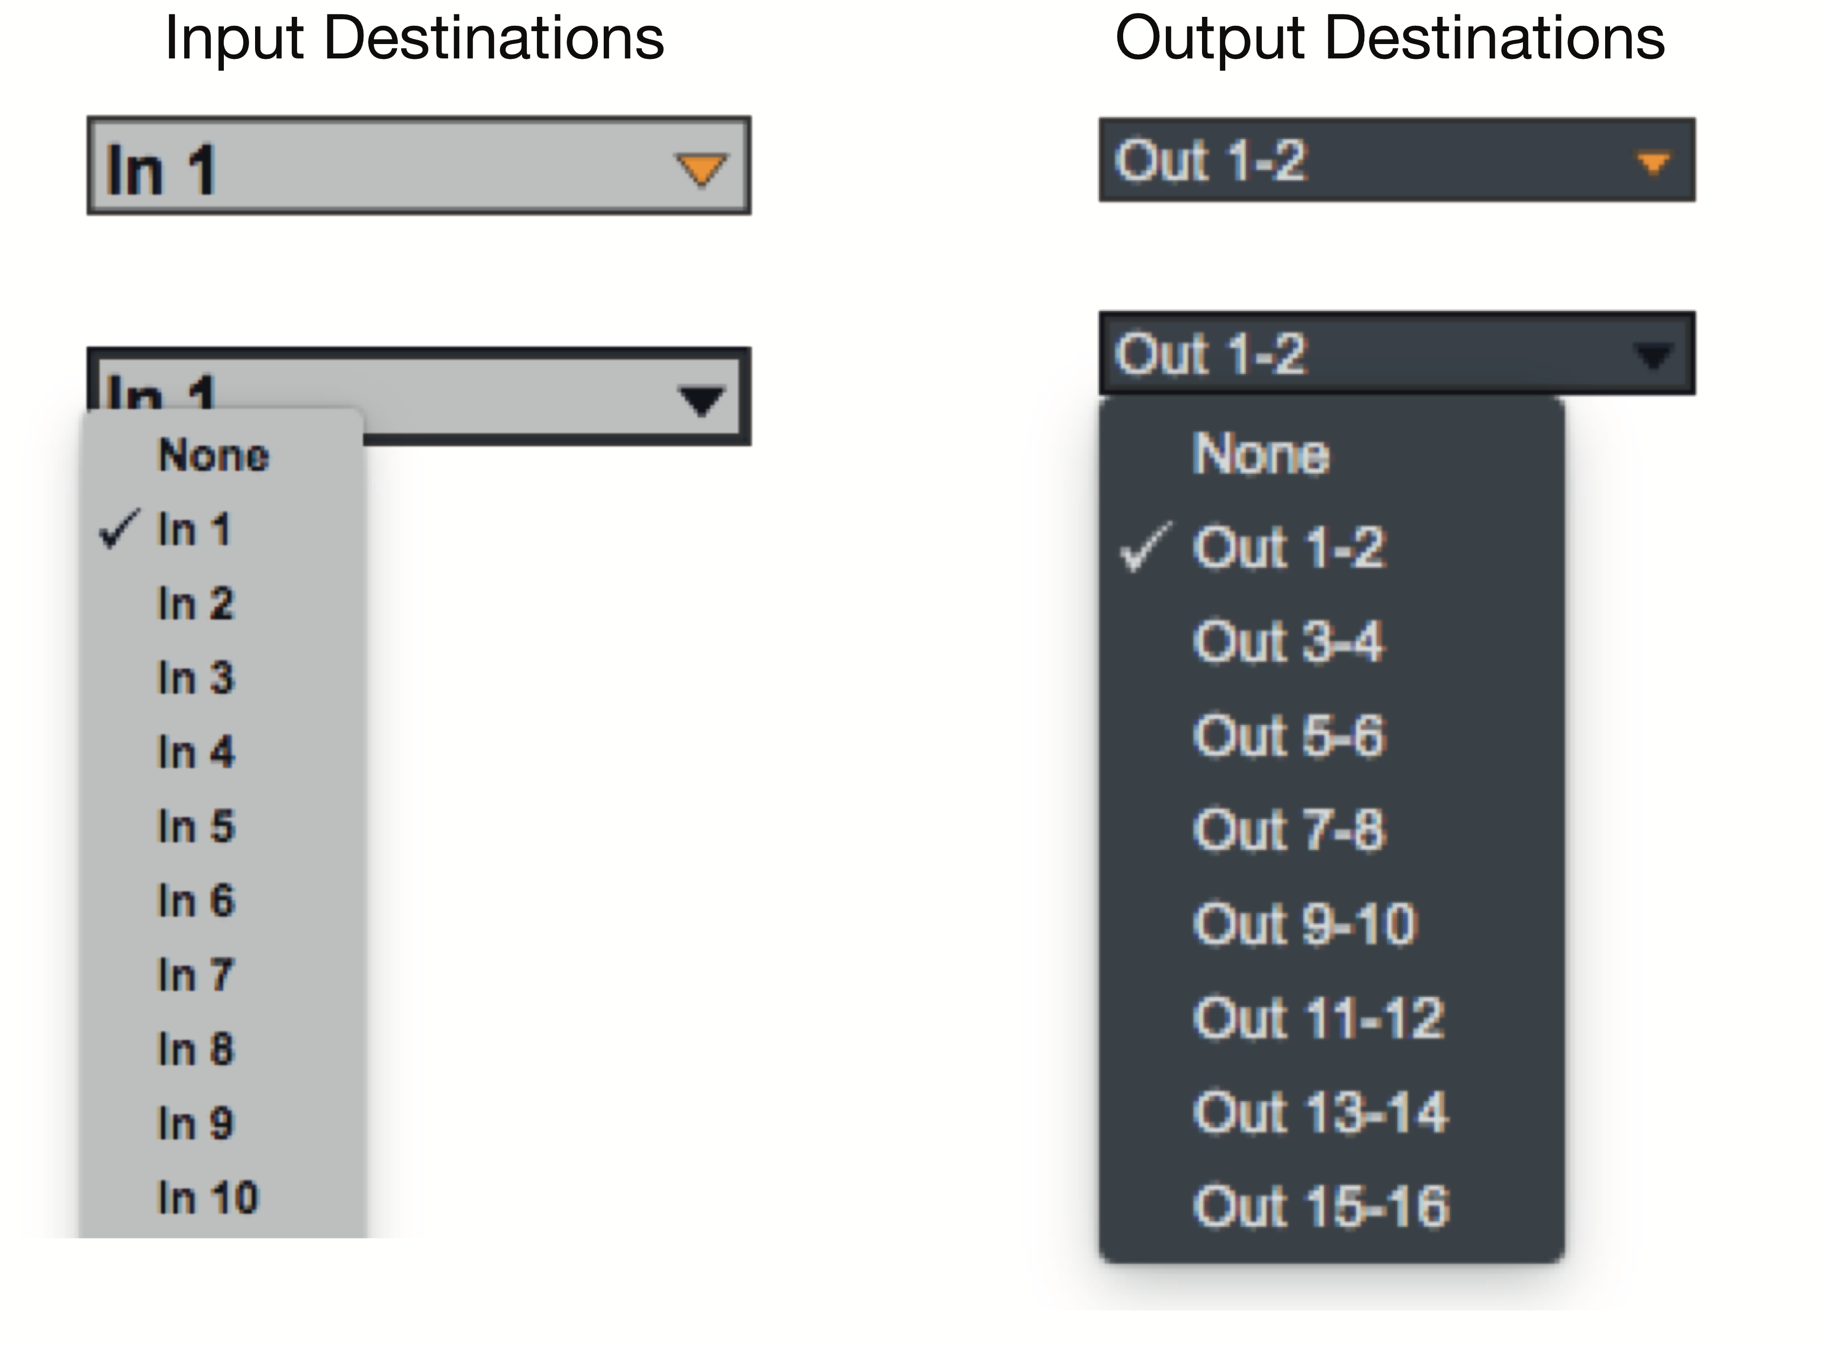
Figure 8.9. Drop-down menu method for the routing of the input and output destinations.

Similarly, to speed up the compositional and programming process, I designed a network of global and local-level muting and diming (-9db of gain reduction) functions. This allows me to quickly focus on individual processing modules and/or tape materials with a click of a button, instead of having to unlock the patch and alter the routing architecture of the individual processing patches (marked areas 3 & 4).
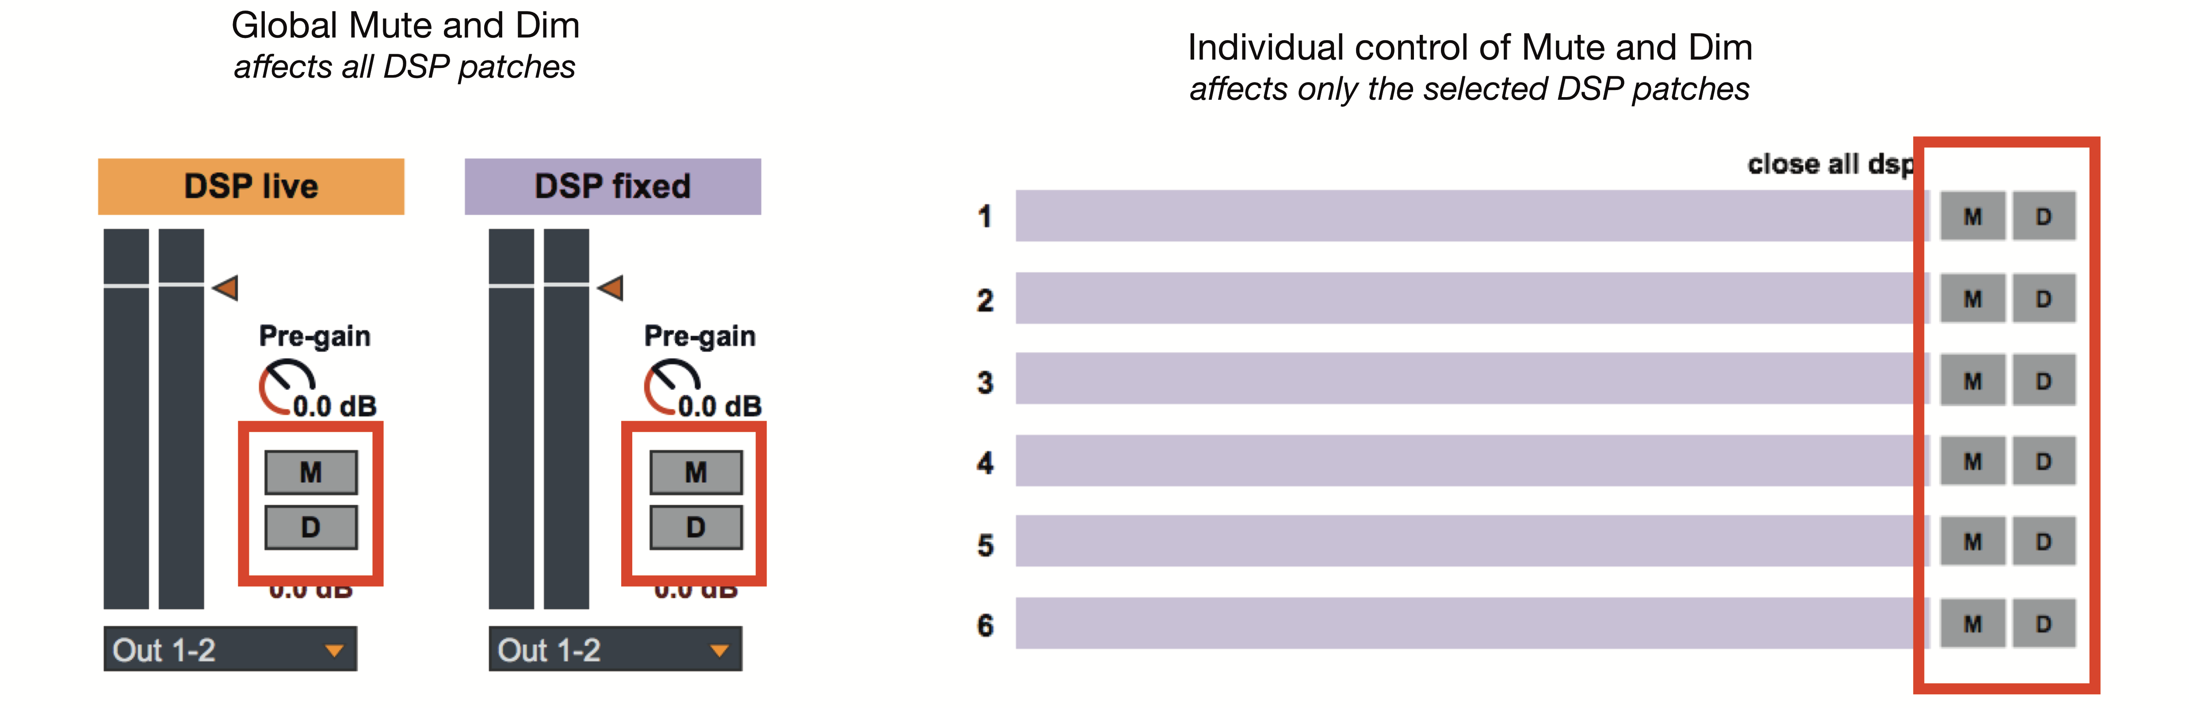
Figure 8.10. Illustration of the mute and dim system.

Lastly, the names of the DSP patches and audio files that are currently in use are reported in the purple and blue boxes located in the middle of the patch (3). Having an overview (monitoring) of the entirety of the electronics and pre-recorded materials allows me to be more efficient with programming, especially when synchronizing musical events that are based on the triggering of several different sound files. If I wanted to quickly access any of the DSP modules to apply a change during a rehearsal, all I would have to do is click on the DSP module’s name and a pop-up window would bring up the sub-patch assigned to this particular processing.
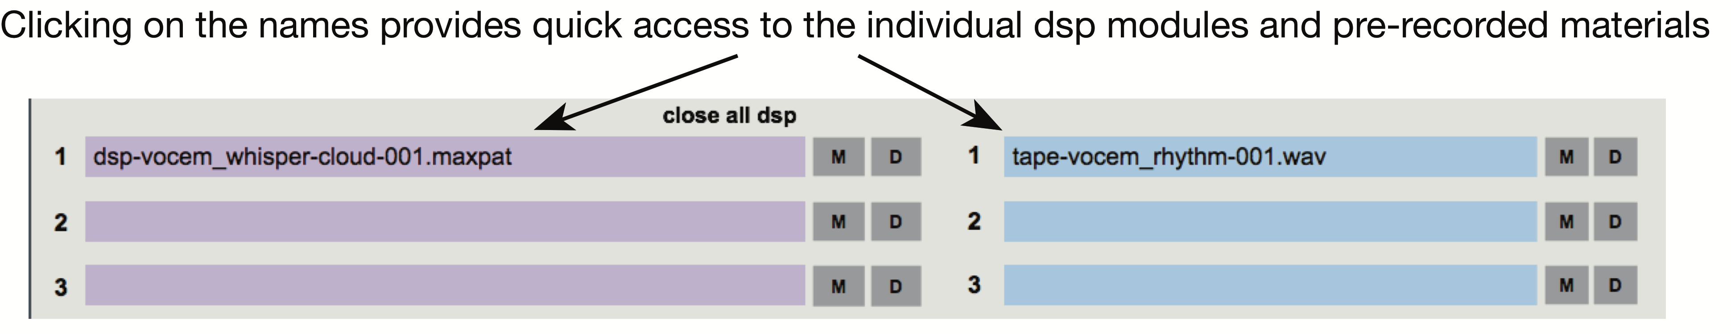
Figure 8.11. Monitoring and quick access system for the DSP and Tape materials.

Advantages of the current method
I find that my current method for composing live electronics music has several advantages over the traditional method of the matrix-based system which I had been previously been using. With the nested poly~ objects approach, I can create a patch that changes dynamically based on my needs. I am only using what I need for the amount of time I need it, and then I replace the various DSP patches with empty patches that do not consume any CPU. This helps reduce CPU usage, as I never utilize more than a handful of objects at a time. This also keeps the number of used objects and modules to a minimum. The fewer the objects, the cleaner the design becomes, which makes it easy to know where to look in order to apply changes anytime debugging is needed.
With the earlier design of the matrix-based method, all of the DSP modules had to be embedded within the main patch. This accumulated an extensive number of objects, which was slowing down the whole system. That is because MaxMSP had to make a substantial effort to report function calls and used signals as well as to create graphics for each one of the objects in the patch, regardless of whether they were in use or not. Additionally, having a large number of objects present at all times was making the navigation around the patch difficult. As a result, debugging with the matrix-based method was a particularly time-consuming process. With my current method, debugging is a relatively fast and straightforward as the few DSP modules that are in use are all gathered under a single location (DSP patch), which can be accessed directly from the top-level window with the click of a button.
Another advantage of my current method compared to the matrix-based system is the ability to have more options with the signal flow between the various DSP modules as well as being able to alter the settings and architecture of the various DSP modules and their connections on the fly during rehearsals. For example, let us say that I have loaded a DSP patch into one of the internal poly~ objects that contains two delays and a chorus. During the rehearsal, my performer suggests filtering out one of the two delays and removing the chorus. All I would have to do is delete the chorus and insert a filter from my library of DSP modules between the right delay and the dac.
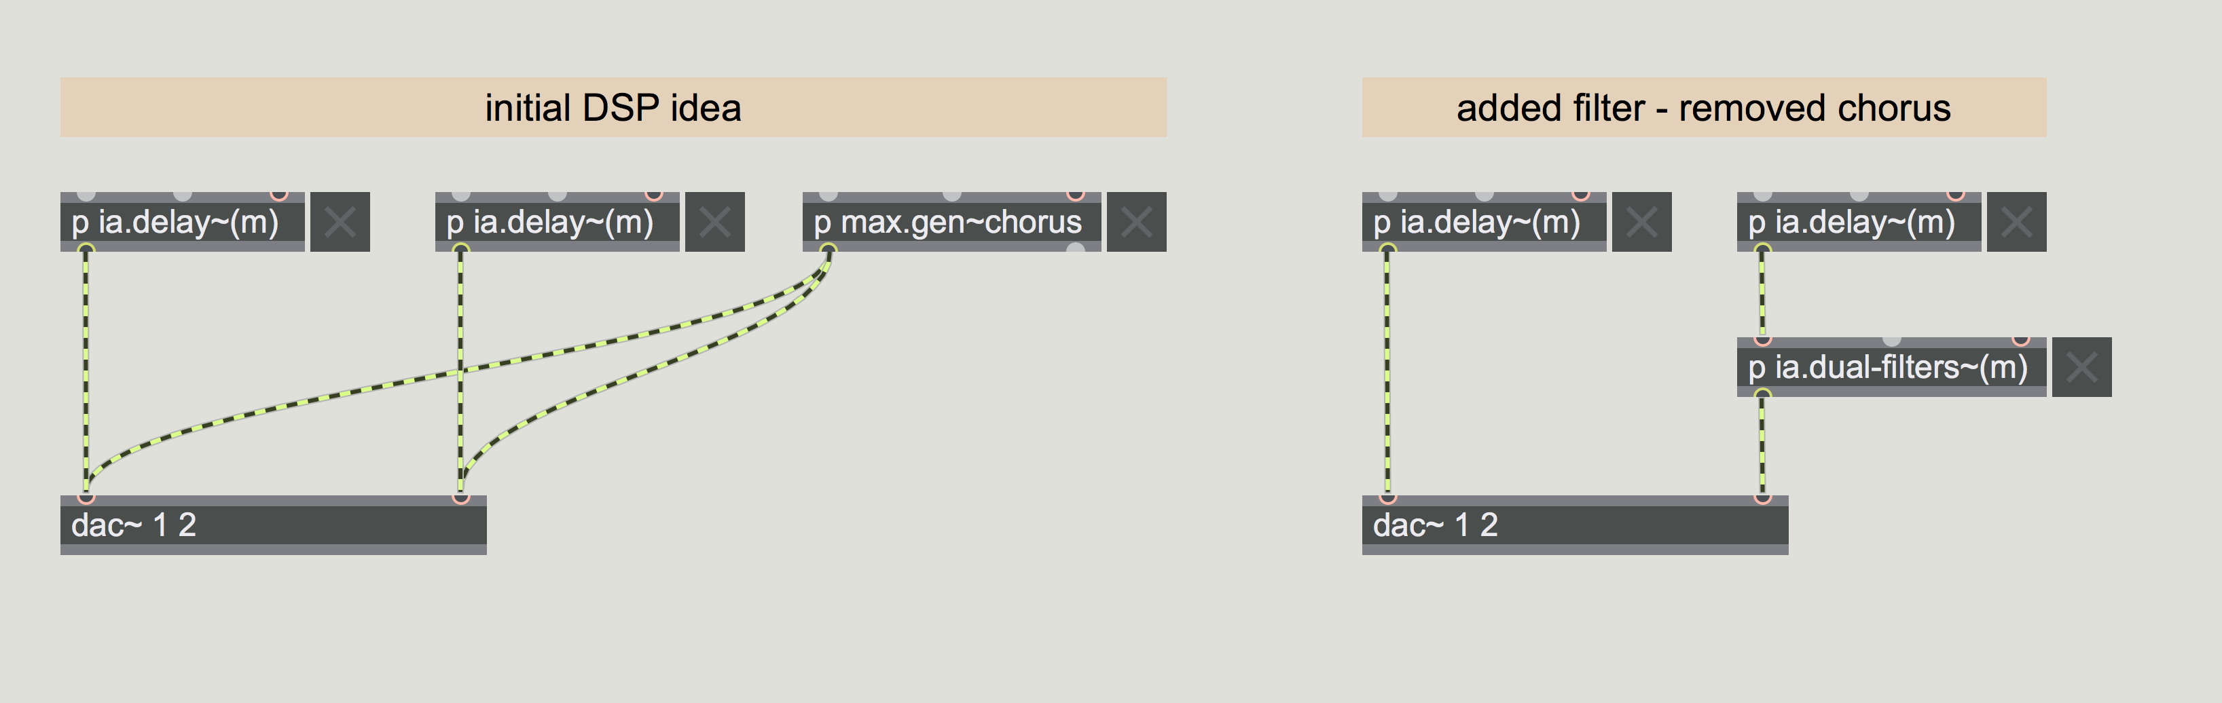
Figure 8.12. Example of applying changes to a DSP patch.

If I would like to try an alternative DSP design, I could very simply copy and paste any group of processing modules within the same patch, apply the changes instantly, and compare the variation(s) to the original design.
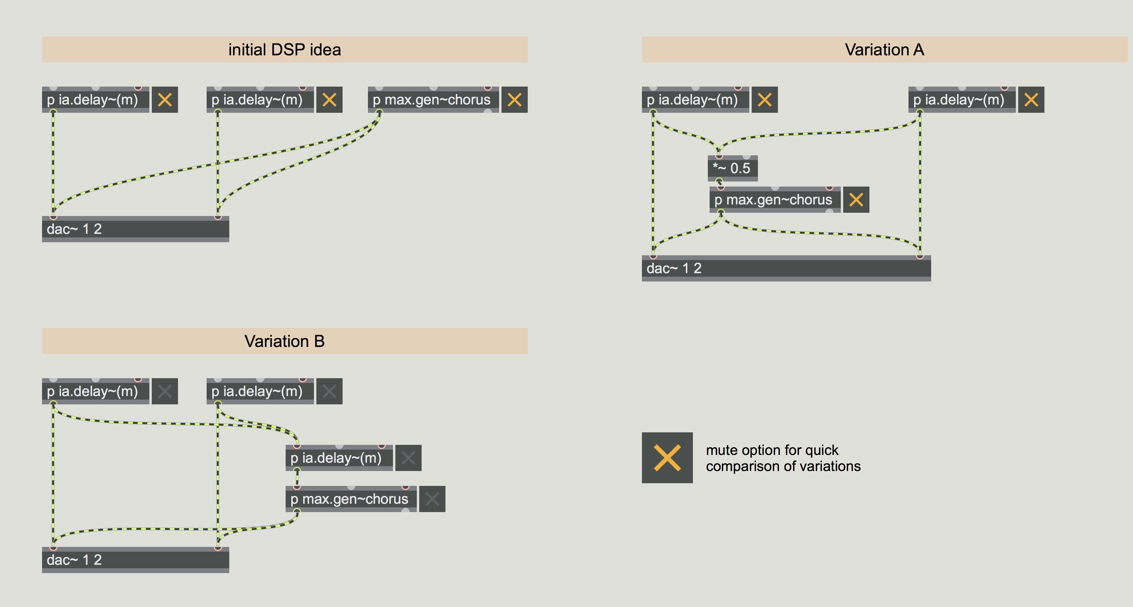
Figure 8.13. Example of creating variations to a group of processing modules within a DSP patch.

On the contrary, applying the same changes with the matrix method to create variations would not have been as easy. If I were using the matrix-based system, I would have had to navigate where the matrix~ was located, modify the inputs and outputs of the matrix~ to accommodate for the changes, create wireless send~ and receive~ objects to establish the new connections, connect the wireless send~ and receive~ objects to their designated inputs and outputs on the matrix, and use the matrix control object to send signal from one module to another. After comparing the different variations and deciding which should be kept, I would also have had to find a way to program how to route the audio signals via the matrix control as well as program the commands for enabling/disabling the individual active/inactive DSP modules. The matrix~ method requires several steps to alter the design and experiment with various types of processing. With my current method, all I have to do is to drag and drop a module from my pre-made library into the patch and then connect the audio wires from one module to another.
Also, I spent a substantial amount of debugging-time when routing in the matrix-controlled method. Setting up coordinates in the format of “0 0 1” to a matrix~ with an average of 32-50 inputs/outputs meant that there would be several programming and typing errors because of the vast amount of numbering options included in this process. Cort Lippe provided a solution to this problem by hiding/wrapping the three-number coordinate behind a symbol (module’s name like delay, chorus etc.), which when recognized by the system would send the correct coordinate data to the matrix control, making the programming of the Qlist more musical. Still though, one had to spend a great amount of time with pre-programming every single connection just to be able to begin programming the routing commands. With my current method I do not have to program any of the audio connections as they are already established by default as soon as the patch is loaded. Eliminating the need to program the commands for the audio routing has dramatically decreased debugging time.
The last important different between my system and the previous matrix-based method is cutting out some of the possibilities of human error. With the matrix system, I would have had to be extremely cautious so as to not accidentally delete or rearrange anything else while altering the matrix~, as this would affect previous and preceding events that are using the DSP modules connected to the matrix. With my method, I can work in a safer mode because any alterations I make to the patch will only affect that specific DSP patch and not any other events.
To summarize, the new system allows me to be more productive with composing live electronics because of its operation. The ability to access any needed parameters directly from the top-level window combined with the fact of not having to overcome major technical/engineering challenges makes the overall creative and programming processes easier. Arguably, this makes the process of composing live electronic music more enjoyable since less time is being devoted to re-programming and altering the architecture of the main patch.

CONCLUSION

Vocem provided a good opportunity for me to research, explore, and improve my understanding of the existing methods and tools of live electronic music. I find that it is important for one to explore the various available options and decide which are the right tools for his/her artistic needs. It is also important for one to find the proper use of those tools in order to lead the creative process to a higher level. Richard Boulanger, in the foreword to the second volume of Electronic Music and Sound Design, reflects on the notion of the artistic utilization of technology:
“As we all know, digital cameras are so “smart” today that it is virtually impossible to take a bad picture. But how to frame and freeze a moment in time, and to that frozen moment “speak” through time – no camera can do that. A “photographer” does that.”

Indeed, the tool is important, but what is even more important is finding ways of artistically utilizing the tool to create new ideas with said tool. MaxMSP is a great compositional tool, which is the reason it has become one of the most popular platforms for composing and performing with live electronics. However, the use of MaxMSP as a method for composing live electronics can be ambiguous due to the unlimited potentials of this software platform.
My motivation for a thorough exploration of the tools of live electronic music derived from the compositional need to find a method that could allow me to keep things simple and clear to increase my productivity as a composer. Vocem provided me with this opportunity; to research, experiment with the tools of live electronic music, and find my own way to utilize MaxMSP as a compositional platform for composing and performing with live electronics.

BIBLIOGRAPHY

Blackburn, Manuella. “Composing from spectromorphological vocabulary: proposed application, pedagogy and metadata.” Paper presented at Electronic Music Studies Conference, Buenos Aires, June 22-25, 2009. Accessed March 13, 2018. http://www.ems-network.org/ems09/papers/blackburn.pdf.

Boulanger, Richard. Forward to Electronic Music and Sound Design. Vol. 2, Theory and Practice with Max and MSP, by Alessandro Cipriani and Maurizio Giri, vii-x. Rome: ConTempoNet s.a.s., 2014.

Breyer, Wolfgang. “A Conversation with Toru Takemitsu by Karsten Witt.” Last modified June 23, 2015. http://www.runmovies.eu/toru-takemitsu/.

Chadabe, Joel. Electric Sound: The Past and Promise of Electronic Music. Upper Saddle River, NJ: Prentice-Hall, 1997.

Chenette, Jonathan Lee. “The Concept of Ma and the Music of Takemitsu.” Paper presented at the National Conference of the American Society of University Composers, University of Arizona, March 1985. Accessed February 25, 2018. http://www.adminstaff.vassar.edu/jochenette/Takemitsu_essay_Chenette.pdf.

Dannenberg, Roger. “Real-Time Scheduling and Computer Accompaniment.” In Current Directions in Computer Music Research, edited by Max V. Mathews and John R. Pierce, 225-261. Cambridge, MA: MIT Press, 1989.

Elsea, Peter. The Art and Technique of Electroacoustic Music. Middleton, WI: A-R Editions, 2013.

Garavaglia, Javier Alejandro. “Raising Awareness about Complete Automation of Live-Electronics.” In Auditory Display, edited by Sølvi Ystad, Mitsuko Aramaki, Richard Kronland-Martinet, and Kristoffer Jensen, 438-465: Berlin, Springer, 2010.

Hallifax. Andrew. The Classical Musician’s Recording Handbook. London: Sanctuary, 2004.

Jordá, Sergi. “Interactivity and live computer music.” In The Cambridge Companion to Electronic Music, edited by Nick Collins and Julio d’Escriván, 89-106. Cambridge, NY: Cambridge University Press, 2007.

Lippe, Cort. “Real-Time Interactive Digital Signal Processing: A View of Computer Music.” Computer Music Journal 20, no. 4 (Winter 1996): 21-24. Accessed September 8, 2017. http://www.jstor.org/stable/3680412.

Machover, Tod. “Thoughts on Computer Music Composition.” In Composers and the Computer, edited by Curtis Roads, 89-111. Los Altos, CA: William Kaufmann, 1985.

Miranda, Eduardo Reck. Composing Music with Computers. Music Technology Series, edited by Francis Rumsey. Woburn, MA: Focal Press, 2001.

Roads, Curtis. Composing Electronic Music: A New Aesthetic. New York: Oxford University Press, 2015.

______. Preface to The Computer Music Tutorial, xiii-xviii. Cambridge, MA: MIT Press, 1996.

Sakamoto, Haruyo. “Toru Takemitsu: The Roots of His Creation.” DMA diss., Florida State University, 2003. Accessed February 25, 2018. DigiNole.

Searby, Michael. "Ligeti's Chamber Concerto - Summation or Turning Point?" Tempo, no. 168 (March 1989): 30-34. Accessed February 10, 2018. http://www.jstor.org/stable/944856.

Smalley, Denis. “Spectromorphology: explaining sound-shapes.” Organised Sound 2, no. 2 (1997): 107-26. Accessed March 13, 2018. https://doi.org/10.1017/S1355771897009059.

Théberge, Paul. Any Sound You Can Imagine: Making Music/Consuming Technology. Hanover, NH: University Press of New England, 1997.

Westerkamp, Hildegard. Liner notes to Transformations. Hildegard Westerkamp and Brian G’froerer. empreintes DIGITAles 1031. CD. 2010.

Winkler, Todd. Composing Interactive Music: Introduction and Background. Cambridge MA: MIT Press, 1998.

Wishart, Trevor. On Sonic Art. Edited by Simon Emmerson. Rev. ed. Amsterdam: Harwood Academic, 1996.

. Michael Searby, "Ligeti's Chamber Concerto - Summation or Turning Point?" Tempo, no. 168 (March 1989): 30, accessed February 25, 2018, http://www.jstor.org/stable/944856.
. Haruyo Sakamoto, “Toru Takemitsu: The Roots of His Creation,” abstract, (DMA diss., Florida State University, 2003), accessed February 25, 2018, viii, DigiNole.
. Wolfgang Breyer, “A Conversation with Toru Takemitsu by Karsten Witt,” last modified June 23, 2015, http://www.runmovies.eu/toru-takemitsu/.
. Hildegard Westerkamp, liner notes to Transformations, Hildegard Westerkamp and Brian G’froerer, empreintes DIGITAles 1031, CD, 2010.
. Curtis Roads, Composing Electronic Music: A New Aesthetic (New York: Oxford University Press, 2015), 15.
. Andrew Hallifax, The Classical Musician’s Recording Handbook, (London, Sanctuary, 2004), 11.
. Peter Elsea, The Art and Technique of Electroacoustic Music (Middleton, WI: A-R Editions, 2013), 447-464.
. Sergi Jordá, “Interactivity and live computer music,” in The Cambridge Companion to Electronic Music, ed. Nick Collins and Julio d’Escriván (Cambridge, NY: Cambridge University Press, 2007), 89-106.
. Joel Chadabe, Electronic Sound: The Past and Promise of Electronic Music (Upper Saddle River, NJ: Prentice-Hall, 1997), 286.
. Roger Dannenberg, “Real-Time Scheduling and Computer Accompaniment,” in Current Directions in Computer Music Research, ed. Max V. Mathews and John R. Pierce (Cambridge, MA: MIT Press, 1989), 225-261.
. Trevor Wishart, On Sonic Art, ed. Simon Emmerson, rev. ed. (Amsterdam: Harwood Academic, 1996), 325-332.
. Paul Théberge, Any Sound You Can Imagine: Making Music/Consuming Technology (Hanover, NH: University Press of New England, 1997), 186.
. Opusmodus is a scripting computer language for the generation of music ideas based on the input one enters in the software. https://opusmodus.com
- . Todd Winkler, Composing Interactive Music: Introduction and Background (Cambridge, MA: MIT Press, 1998), 3.
- . Winkler, 3.
. Dominic Gill and Toru Takemitsu, liner notes to Takemitsu – Corona/For Away/Piano Distance/ Undisturbed Rest, Roger Woodward, Decca Head 4, Vinyl, 1974, quoted in Jonathan Lee Chenette, “The Concept of Ma and the Music of Takemitsu,” paper presented at the National Conference of the American Society of University Composers, University of Arizona, March 1985, accessed February 25, 2018, http://www.adminstaff.vassar.edu/jochenette/Takemitsu_essay_Chenette.pdf.
. Roads, Composing Electronic Music, 35.
. Of course, I mean striking those instruments just once with a mallet or stick. Techniques like tremolos and rolls give the illusion of a continuous sound, but practically speaking, they are just a sequence of several single hits in rapid succession.
. Denis Smalley, “Spectromorphology: explaining sound-shapes,” Organised Sound 2, no. 2 (1997): 115, accessed March 13, 2018, https://doi.org/10.1017/S1355771897009059.
. Manuella Blackburn, “Composing from spectromorphological vocabulary: proposed application, pedagogy and metadata,” (paper presented at Electronic Music Studies Conference, Buenos Aires, June 22-25, 2009), 3, accessed March 13, 2018, http://www.ems-network.org/ems09/papers/blackburn.pdf.
. Cort Lippe, “Real-Time Interactive Digital Signal Processing: A View of Computer Music,” Computer Music Journal 20, no. 4 (Winter 1996): 21, accessed September 8, 2017, http://www.jstor.org/stable/3680412.
. Javier Alejandro Garavaglia, “Raising Awareness about Complete Automation of Live-Electronics,” in Auditory Display, ed. Sølvi Ystad, Mitsuko Aramaki, Richard Kronland-Martinet, and Kristoffer Jensen (Berlin: Springer, 2010), 439.
. Eduardo Reck Miranda, Composing Music with Computers, Music Technology Series (Woburn, MA: Focal Press, 2001), 205.
. Tod Machover, “Thoughts on Computer Music Composition,” in Composers and the Computer, ed. Curtis Roads (Los Altos, CA: William Kaufmann, 1985), 90-111.
. Ibid, 90.
. Curtis Roads, preface to The Computer Music Tutorial (Cambridge, MA: MIT Press, 1996), xiv.
. Richard Boulanger, forward to Electronic Music and Sound Design, vol. 2, Theory and Practice with Max and MSP, by Alessandro Cipriani and Maurizio Giri (Rome: ConTempoNet s.a.s., 2014), viii.

