UNIVERSITY OF OKLAHOMA
GRADUATE COLLEGE

THE EFFECT OF A NON-CIRCADIAN PHOTOPERIOD ON THE GROWTH, PHYSIOLOGY, AND PRODUCTION OF A ROMAINE LETTUCE CULTIVAR

A THESIS
SUBMITTED TO THE GRADUATE FACULTY
in partial fulfillment of the requirements for the
Degree of
MASTER OF SCIENCE

By
JOSHUA HUGHES
Norman, Oklahoma
2022
THE EFFECT OF A NON-CIRCADIAN PHOTOPERIOD ON THE GROWTH, PHYSIOLOGY, AND PRODUCTION OF A ROMAINE LETTUCE CULTIVAR

A THESIS APPROVED FOR THE DEPARTMENT OF MICROBIOLOGY AND PLANT BIOLOGY

BY THE COMMITTEE CONSISTING OF
Dr. Heather McCarthy, Chair
Dr. Abigail Moore
Dr. Lara Souza

© Copyright by JOSHUA HUGHES 2022
All Rights Reserved.
Acknowledgements
I am eternally grateful to my family and friends for their support throughout the last three years. I also would like to recognize my advisor Dr. Heather McCarthy for all the guidance she has given me throughout my research and graduate school experience. I would also like to acknowledge the suggestions and contributions of my committee and lab members.
Table of Contents
Abstract vi
Introduction 1
Methods 5
Lettuce Cultivation and Growth Chambers 5
Lettuce Size Assessment 7
Measurement of gas exchange 8
Leaf Soluble Sugar and Starch Analysis 10
Statistical Analysis 12
Results 13
Canopy size and biomass production 13
Gas Exchange 15
Leaf Sugar 17
Leaf starch 19
Discussion 21
Literature Cited 28

Abstract
The circadian rhythm serves to match plant physiology and behavior with the environmental cycles caused by the rotation of the planet. The circadian rhythm contributes towards the structure and function of plants and their overall performance which is an important consideration in agriculture. Arabidopsis has served as a model plant for understanding circadian function, but it is important to establish if these lessons can be extrapolated to other species. This study investigated the effect of a non-circadian light cycle on Lactuca sativa (lettuce) plants reared from germination in those conditions. Canopy size, gas exchange, and carbohydrate storage and use were investigated, and it was found through repeated measures ANOVA analyses that non-circadian light cycles are indeed associated with decreases in many metrics commonly associated with plant performance such as stomatal conductance, carbon dioxide exchange, leaf-level sugar storage, and canopy area, but not with total canopy volume or total biomass. This opens up the possibility of further analysis into the feasibility of using non-circadian light cycles in controlled environment agricultural settings and indicates some cross species agreement with the effects these light cycles are found to have with the model species Arabidopsis.

Introduction
The circadian rhythm is an endogenously arising rhythm of about 24 hours resulting from the daily, complex loop of clock genes and their protein products (Johnson et al. 2004). The circadian rhythm is associated with many physiological changes that occur within plant cells and is frequently observed to offer a competitive advantage in environments under the daily oscillations caused by the earth’s rotation (Gorton et al. 1989; Dodd et al. 2005). This internal rhythm is matched to the external conditions via a combination of the temperature oscillations the plant experiences between day and night (Barak et al. 2000) and photoreceptors receiving blue and red light following a long period of darkness (Millar 1995), but the circadian rhythm itself has not been shown to effectively adapt itself to non-circadian light cycles (Graf et al. 2010). When the endogenous circadian rhythm does not match the timespan of the environmental oscillations, the plant is unable to effectively match physiological processes to the external environment (McClung 2010).

Research into the endogenous circadian rhythm is relatively recent in the field of plant biology, with the first scientific observations being made in 1729 when plant leaves were observed to continue moving in constant dark conditions (de Mairan 1729). It was not until 1968 that it was discovered that many physiological processes are controlled by an endogenous rhythm such as stomatal movement and photosynthetic activity (Cumming and Wagner 1968). By the 1990s Arabidopsis began to emerge as a system in which genetic analysis could be undertaken and it was found that a number of genes were under circadian control (Millar and Kay 1991, McClung and Kay 1994).

In Arabidopsis, plants growing in environments that do not match their circadian rhythm such as those with light or temperature cycles that are significantly different from 24 hours have been shown to suffer in their ability to conduct photosynthesis and carbon storage (Dodd et al. 2005), utilize starch throughout the night (Graf et al. 2010), and produce chlorophyll (Green et al. 2002). These deviations in plant physiology are due to the downstream effects of the protein peaks that were ultimately induced by disagreement between circadian rhythm of the plant and the experienced photoperiod. The circadian rhythm aids in the prediction of dawn and dusk and the synchronization of synthesis of light harvesting proteins and chlorophyll (Dodd et al. 2005). A disagreement between the endogenous rhythm and environmental oscillations can lead to situations where starvation signals are triggered sooner than would be expected in circadian settings and in turn hamper plant growth (Graf et al 2010.) An agreement between the circadian rhythm and external photoperiod is associated with higher fitness in both wildtype Arabidopsis and transgenic lines with endogenous circadian rhythms ranging from 20 to 28 hours. This agreement in photoperiod is associated with up to 20% greater chlorophyll production and up to 80% more carbon fixation in wild type plants than transgenic plants when grown in a circadian photoperiod (Dodd et al. 2005). In addition to this, it has been shown that wildtype Arabidopsis grown under circadian periods of 17-20 hours did not effectively utilize their carbohydrate storage throughout the day with individuals having about 40% more starch available at sunrise than those grown under a typical 24-hour photoperiod (Graf et al 2020), and up to double the leaf sugar concentrations after nightfall (Morae et al. 2022). These indicators of reduced function agree with the observations that disagreement among circadian rhythm and diurnal oscillation are associated with up to 30% reduced biomass in Arabidopsis (Graf et al. 2010).

Although there has been some work done in establishing the role of a circadian cycle in Arabidopsis as a model plant, it is important to understand how the lessons gained can be applied to other species. Of specific interest to this study is Lactuca sativa, commonly known as lettuce. Lactuca sativa is an important agricultural crop in much of the world and amounts to over 15% of the total dollar value generated from vegetables in the United States, the largest share of any individual species (USDA 2016). In addition to this, the species is becoming very popular in hydroponic and controlled environment agriculture systems with total lettuce biomass production in hydroponic systems more than doubling between 2014 and 2019 in the United States (USDA 2014; USDA 2019). Due to the combination of economic importance and popularity in controlled environment systems, lettuce is a plant with an obvious need for further study in the realm of circadian cycles. Some research into the effect of non-circadian photoperiods has already been performed, including important work in gene expression. This has established the existence of a circadian rhythm in lettuce through the protein oscillations in genes common to both lettuce and Arabidopsis that continue to occur in constant light (Higashi et al. 2016). A common theoretical model between Arabidopsis, lettuce, and other crop plants also explains the synchronization of the circadian rhythm to external conditions that is an important part of maximizing plant production. (Ukai 2013).

Considering that the circadian period of Arabidopsis is largely controlled by CCA1 and LHY genes (Lu et al. 2009) and that these genes originate in an ancestor common to flowering plants (McClung 2010) it is expected that lettuce will follow similar physiological trends to Arabidopsis when subjected to non-circadian photoperiods. That is, the expectation is that lettuce plants both in the greater-than-circadian and less-than-circadian groups will have a smaller size, and lower stomatal conductance than those receiving a normal 24-hour photoperiods. Compared to circadian plants, the less-than-circadian plants are expected to have carbohydrate levels that are lower at pre-dusk and higher at pre-dawn, while greater-than-circadian plants are expected to have similar carbohydrate levels at pre-dusk and lower at pre-dawn due to an inability to predict sunrise from their circadian clocks. However, since the CCA1 and LHY genes are associated with other functions such as cold and freezing tolerance in Brassicas (Seo & Mas 2015, Xin et al. 2019) and drought response in soybeans (Wang et al. 2021) this could be a faulty assumption as some other yet unidentified gene system may have a greater impact on the circadian rhythm in lettuce.

In environments where light and temperature cycles are not limited to those imposed by the earth’s rotation, it is important to fully understand how a species may respond and develop when exposed to unnatural environmental conditions. This project set out with the goal of establishing a baseline of how the lettuce species may, in general, respond to non-circadian photoperiods in terms of growth, physiology, and production. This will be determined by measuring and analyzing how a non-circadian photoperiod impacts the following characteristics of lettuce: canopy size and biomass, stomatal conductance and whole-plant gas exchange, and leaf carbohydrate levels. Negative effects from non-circadian photoperiods are observed in both the greater and less than circadian photoperiod directions, and so it is expected that the direction of effects will be similar for all experiments except for carbohydrate level due to the previously discussed importance in predicting sunrise (Graf et al. 2010, Dodd et al. 2005).

Methods

Lettuce Cultivation and Growth Chambers
The lettuce cultivar used in the study was Parris Island Cos, chosen for its relative genetic uniformity as an heirloom cultivar and its tall and narrow growing shape which is ideal for the growth chamber environment. The lettuce was grown for 8 weeks in total as measured from germination to harvest. Lettuce was grown in 0.95L size nursery pots in coco coir growing medium, and were bottom-watered 3 times per week. Plants were fertilized twice per week using MaxiGro powder fertilizer (General Hydroponics, Berkeley, California) at a concentration of 5 grams of fertilizer per liter of water.

Lettuce was grown in 81x81x162cm mylar lined growth tents (Coolgrows, Quanzhou, Jinjiang China) for the entirety of the experiment. Light was provided through six 40W day-light LED bulbs (Auzilar, Shenzhen City, Guangdong China) at a height that was raised throughout the experiment to maintain a PAR of 550 μmol/m²/s at the canopy level. Previous studies have shown that lettuce plants reach 90% of the species light saturated photosynthetic rate at this light intensity (Zhou et. al 2020). The light cycle in the growth tents was controlled via an Arduino Uno (Arduino, Somerville, Massachusetts) connected to a 5 volt relay (HiLetgo, Shenzhen City, Guangdong China) and an Adafruit 3296 Clock & Timer (Adafruit Industries, New York City, New York)

Airflow to the tent was provided constantly through 10cm 195 CFM inline duct fans (Vivosun, Ontario, Canada) and ensured a consistent growing environment of 23°C at 30% humidity during the day and 20°C at 40% humidity during the night. Temperature and humidity were measured through DHT22 (Adafruit Industries, New York City, New York) multipurpose sensors suspended at canopy level and were logged every 15 minutes. A pilot experiment was performed to establish these baselines, and it was found that temperatures fell within 0.1° C and 5% humidity of the desired levels 95% of the time after a warming period of 4 hours and a cooling period of 1 hour after the lights turn on and off respectively.

Three experiments were performed in total, with each experiment consisting of two groups (two growth tents) of ‘non-circadian’ and ‘circadian’ plants. Two experiments assessed the effect of less-than-circadian light cycles (day-night cycle shorter than 24 hours) with the third assessing the effect of a more-than-circadian light cycle. For each experiment, both circadian and non-circadian groups had an equal ratio of light and dark. Plants in experiment 1 and experiment 3 received three times as many daylight hours as night-time hours, and plants in experiment 2 received only twice as many daylight hours as night-time hours. This is visualized below in Figure 1. The first experiment had 10 plants per tent, for 20 plants per treatment, however this was lowered to 8 plants per tent for subsequent experiments in order to minimize possible effects of plant crowding.

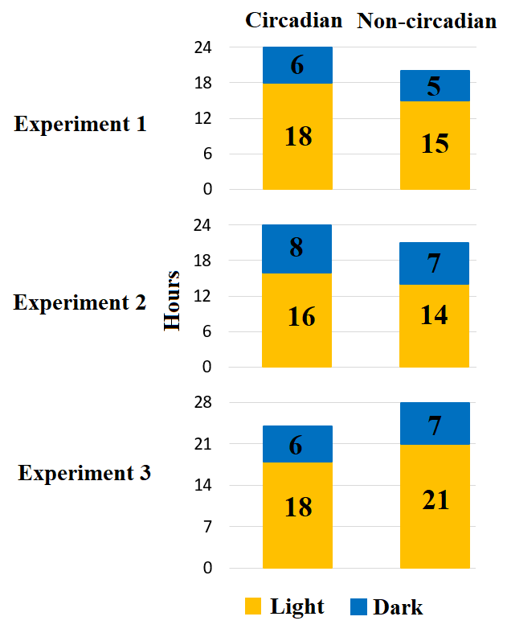
Figure 1: Visual representation of experiment light cycles.

Lettuce Size Assessment
Lettuce size was measured non-destructively via photography using a known scale. Photographs were taken weekly at the same time as the stomatal conductance measurements, and a camera stand was used to ensure consistent photography conditions across weeks. From these images, measurements were taken for canopy area and canopy height using ImageJ (Schneider 2012). Canopy area was defined as the area the leaves take up when viewed directly from above as measured through the irregular outline formed by the leaves. An estimate of canopy volume was calculated by multiplying canopy height and canopy area. This estimates the volume of the canopy as a cylinder with a base area equivalent to the measured canopy area. This approach is not as accurate as measuring volume through immersion; however it requires minimal additional handling of the plants and avoids complications involved with submerging the plants. Other shapes were considered as representations of canopy volume, however destructive volume measurements via immersion in a pilot experiment showed that estimating the volume as a cylinder was the closest approximation to the immersion volume.

At the end of each experiment, the plants were cut at the soil surface and the above ground biomass were dried completely for 48 hours at 65° C before mass was measured. The lettuce roots were too fine to reliably separate from growing media and so were not included in biomass measurements.

Measurement of gas exchange
Gas exchange was assessed in two different ways throughout the course of the experiments: leaf level stomatal conductance and whole-plant level gas exchange. Plant gas exchange was always measured between 4 and 6 hours after the lights were turned on in order to reflect mid-day conditions.

Stomatal conductance was measured weekly using an SC-1 Leaf Porometer (Decagon Devices, Inc., Pullman, Washington), starting in the third week after gemination. At least three leaves on each plant were measured and averaged to get a value for each plant. Leaves were selected for porometry based on their size and age. The youngest leaves were prioritized but leaves that were too small to fit in the porometer were disregarded.

Whole-plant level gas exchange was measured twice across the 8-week experiment, at the 6th week and the 8th week, using a LICOR-6400 (LI-COR Inc, Lincoln, Nebraska) configured for a custom chamber with a volume of 37.8 liters. The measurement chamber consisted of a 37.8-liter aquarium of dimensions 25.4x50.8x31.75cm and a small fan for air circulation. Separation of the canopy (and surrounding air) from the open air was achieved through methods derived from an established protocol put forth by Vourlitis (1993). A large plastic bin was filled with sand up to about 8 centimeters of depth such that electrical cabling and LICOR cordage could be buried, and which would allow space for the chamber to be sealed against the atmosphere when the plant was inserted, and the chamber buried into the sand. A picture of this setup is included as figure 2. While within the gas-exchange chamber, the plant was subjected to light identical to what it experienced in the growth tents (PAR = 550 μmol/m²/s). Measuring the change in carbon dioxide concentration across 5 minutes allowed for the calculation of the total carbon absorption into the plant, acting as an analogue for sugar production via photosynthesis. Net carbon change was divided by the canopy area of the plant in order to account for variations in plant size and represent carbon dioxide flux on a canopy area basis.
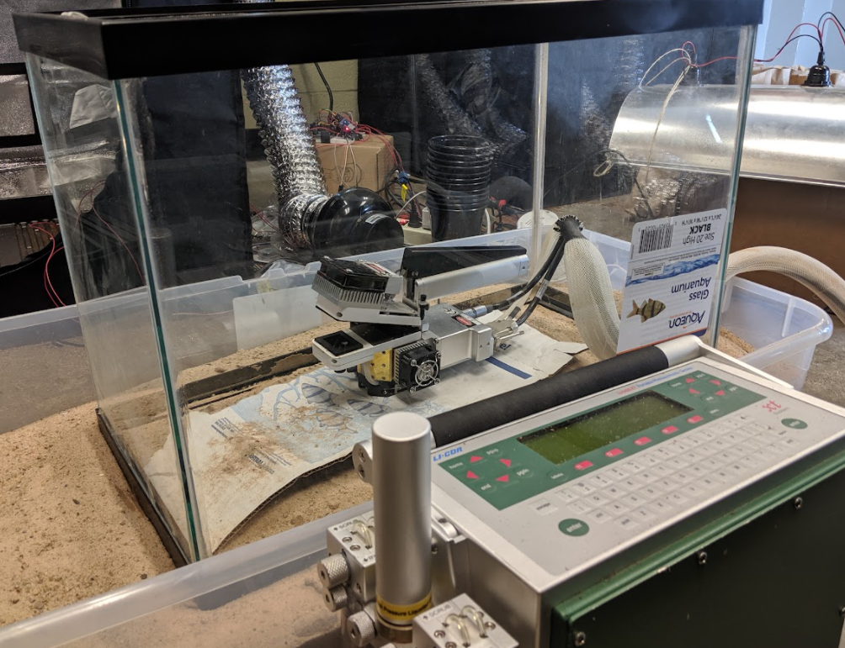
Figure 2: Photograph of whole-plant gas exchange measurement system

Leaf Soluble Sugar and Starch Analysis
Leaves were collected for soluble sugar analysis during the 6th and 8th weeks of each experiment. Each plant had a leaf collected an hour before dawn (pre-dawn), 4 hours after sunrise (midday), and an hour prior to the growth chamber lights turning off (pre-dusk). Each leaf was frozen in liquid nitrogen before being dried in a 65°C heater. One half of the blade of each leaf was collected into a 2 mL microcentrifuge tube and ground using stainless steel metal beads at for 5 minutes at 900 RPM to ensure uniform consistency using a Geno/Grinder (Horiba, Kyoto, Japan). After powdering the samples, the metal beads were removed and the mass was saved for sugar extraction.

Leaf soluble sugar was extracted from ground tissue using hot ethanol extraction following Chow and Landhausser (2004). Three washing steps were performed with 1.5mL of 80% ethanol added to the microcentrifuge tubes. Ethanol was then boiled in a 95°C water bath (Benchmark Scientific, Sayreville, New Jersey) for 10 minutes. Boiled samples were centrifuged using a Microfuge 20R Centrifuge (Beckman Coulter, Indianapolis, Indiana) at 12500RPM for 5 minutes and the supernatants were collected and combined. This protocol is able to extract 99.5% of soluble sugar in a sample (Chow and Landhausser 2004). The remaining pellet was saved for starch analysis.

Leaf starch was hydrolyzed using sulfuric acid hydrolysis techniques modified from Grotelueschen and Smith (1967). The starch pellet saved from the previous soluble sugar extraction was hydrolyzed by adding 2mL of 0.005N sulfuric acid to each tube and then heating it at 95°C for 30 minutes in a water bath. Following hydrolyzation, the tubes were centrifuged at 12500RPM for 5 minutes and the supernatant drained. The pellets were rinsed with cold water, centrifuged again, and then dried. Newly soluble sugar was extracted and measured from the hydrolyzed pellet using the above method applied to the ground leaf sample.

Sugar extracts for both soluble sugar and starch were treated using a phenol-sulphuric acid assay adapted to a microplate format (Masuko et al. 2005). Undiluted sugar samples were unable to be read by the spectrophotometer, and so were diluted to one-tenth concentration. 150μL of dilute sugar extract was added to a microcentrifuge tube followed by 450μL of 95% sulfuric acid and 90uL of 5% phenol solution. Tube was shaken to mix and heated in a 95°C water bath for 5 minutes before being cooled to room temperature. Two replicates of 280μL of each treated sugar solution was transferred to a microplate and were measured using a Synergy HT microplate reader (Biotek Instruments, Winooski, Vermont) taking spectrophotometry measurements at 490nm. Glucose solutions of known sugar concentrations were used to construct calibration curves, and so soluble sugar concentrations are reported as glucose equivalent. Starch content of the samples was estimated by multiplying the glucose content of the hydrolyzed pellet by the glucose equivalent of 0.9 (Chow and Landhausser 2004).

Statistical Analysis
Statistical analysis was performed using R. Analyses were performed within each experiment and across the collection of experiments. Each group was compared in canopy area, canopy volume, stomatal conductance, carbon flux, above ground biomass, and soluble leaf sugar. Since each measurement besides biomass was taken multiple times across the experiment, a repeated measures ANOVA was performed with the metric in question as the response variable. Within experiments, the response variable was considered a factor of measurement week and light treatment (circadian vs. non-circadian), and across experiments the response variable was considered a factor of measurement week, experiment number, and light treatment.

In order to visualize the relationship between non-circadian and circadian measurement values across every experiment in a single graph, ratios were made by dividing each individual non-circadian measurement by the average of the circadian group’s measurement that week. This serves as a visual tool to easily compare how different the measurement values between the two treatment groups are each week. Error bars in graphs show the standard deviation of these ratios.

Results

Canopy size and biomass production
Although non-circadian plants had a significantly lower canopy area in experiment 3 (p = .006; Table 1), repeated measures ANOVA across all experiments did not show a significant effect of light treatment on canopy area (p = .063). Final canopy area varied widely between experiments, ranging from a minimum of 400 ± 96 cm² in experiment 3 to 1193 ± 192 cm² in experiment 2, but the non-circadian plants in most cases maintained an area close to their circadian counterparts (Figure 3d). Figure 3d shows the similarity in canopy area response across experiments, with non-circadian canopy areas within 5% of circadian plants by the final week of measurement.
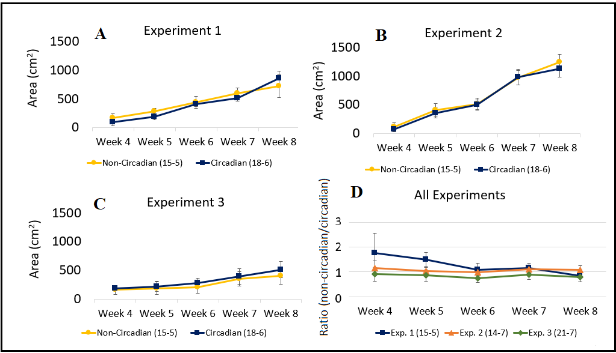
Figure 3: Weekly canopy area for each experiment (a-c) and comparison of non-circadian/circadian area ratios across experiments (d). Error bars represent standard deviations.
Non-circadian plants had a significantly larger canopy volume across the experiments than their circadian counterparts (p = 0.049; Table 1), although this effect was not significant in experiments 2 and 3 (p = .290 and .055 respectively). On average non-circadian plants had a 9.3% larger final canopy volume, with circadian and noncircadian plants having an average volume of 15812 ± 3575 and 16999 ± 3929 cm³ respectively. There is notable variation between individuals leading to a relatively large standard deviation in volume ratios as shown in Figure 4.

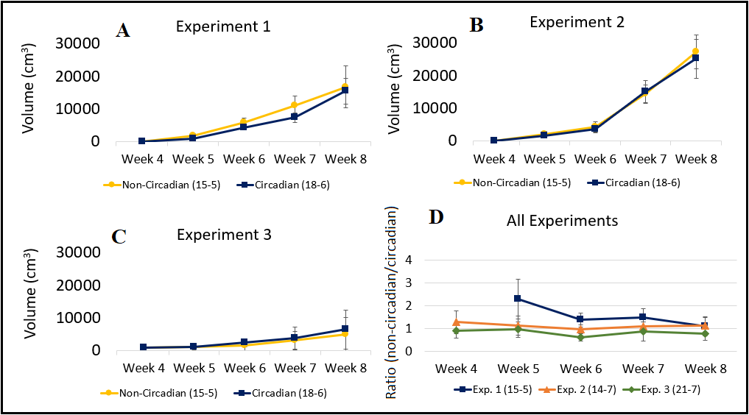
Figure 4: Weekly canopy volume for each experiment (a-c) and comparison of non-circadian/circadian volume ratios across experiments (d). Volume was derived from canopy area and plant height. Error bars represent standard deviations.

End of experiment aboveground biomass was not significantly different between the circadian and non-circadian plants for any of the within-experiment (p = .07, p = .54, p = .15; Table 1) or across-experiment analyses (p = .08). Figure 5a shows the final biomass results for each experiment. On average, circadian plants had 12.3% more biomass than non-circadian plants, with an average final aboveground biomass of 18.1 ± 5.28g and 15.85 ± 5.02g respectively.
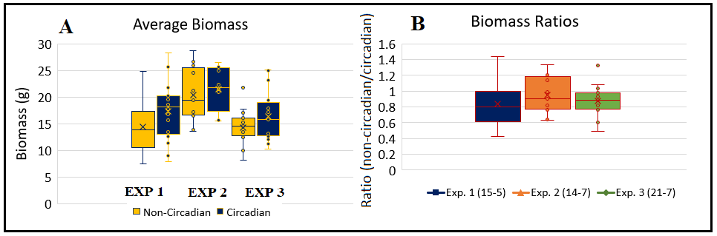
Figure 5: Final aboveground biomass for each experiment (a) and comparison of non-circadian/circadian biomass ratios (b). Error bars represent standard deviations.

Gas Exchange
Within experiments it was found that stomatal conductance was significantly different between treatment groups in Experiment 1 and Experiment 3 (p = .003, p = .029; Table 1), and across experiments it was found that plants growing under a non-circadian light cycle had significantly lower stomatal conductance than the circadian groups (p << 0.05; Table 1). Stomatal conductance was on average 9.6% lower for non-circadian plants, with average values being 235.9 ± 57.9 and 211.9 ± 54.8 mol H₂O/m²/s (circadian and non-circadian respectively). Figure 6a-d shows the average stomatal conductance for each experiment in addition to a project-wide comparison between each non-circadian group in relation to their respective circadian cohort. Stomatal conductance was generally higher in the first 6 weeks of the experiment, with peaks usually occurring around week 6. Following this peak, stomatal conductance values tended to trend decline until harvest in week 8.
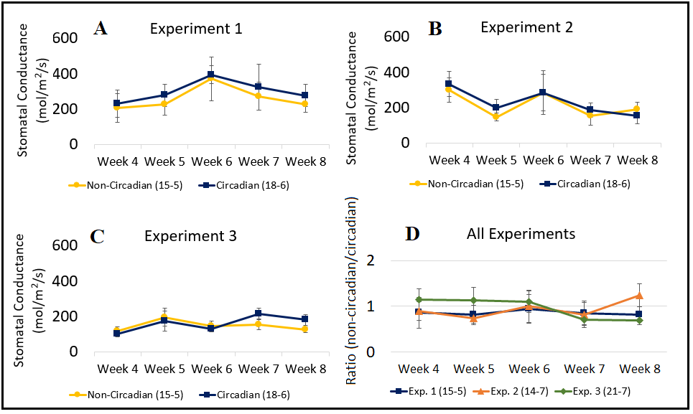
Figure 6: Weekly stomatal conductance (mmol of water transpired per unit area per second) within each experiment (a-c) and comparison of non-circadian/circadian stomatal conductance ratios across experiments (d). Error bars represent standard deviations.

Although within experiment significant effects for light treatment were only seen in Experiment 3 (p << .05; Table 1), across all experiments the net carbon dioxide exchange (on a plant canopy area basis) was found to be significantly affected by the light treatment (p = 0.004; Figure 7), with non-circadian plants absorbing 13% less carbon dioxide per unit of time than their circadian counterparts. Circadian and non-circadian plants had an average carbon dioxide flux of 2.83 ± .85 and 2.48 ± 1.11 umol/m²/s respectively. These results are consistent with the findings in the stomatal conductance and its relationship to photosynthetic rate. Figure 7a-d shows the overall carbon exchange values for each experiment as well as the overall non-circadian/circadian relationships.
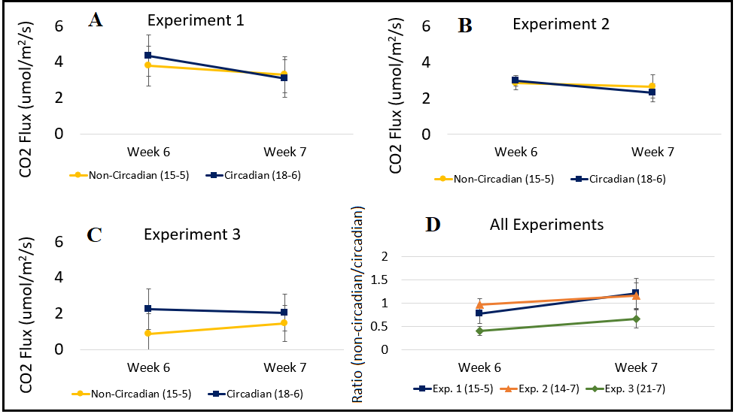
Figure 7: Plant carbon exchange within each experiment (a – c) and comparison of non-circadian/circadian ratios of carbon exchange across experiments (d). Derived from carbon concentration absorption rate and leaf canopy area. Error bars represent standard deviations.

Leaf Sugar
Across the project it was found that leaf sugar was consistently highest just prior to the lights turning off for circadian plants (pre-dusk; P << 0.05, Table 1), but the relationship is less clear within the non-circadian plants. For non-circadian plants, some sampling dates showed significant sugar concentration peaks in the pre-dawn or mid-day sampling times, and only a single sample date (Experiment 1, Week 8) showed a significant difference in the expected direction between pre-dawn and pre-dusk sugar concentrations.
It was also found that the light treatment significantly affected the overall sugar content, with non-circadian plants generally having slightly lower leaf sugar concentrations at pre dusk and on average across the three time periods (p << 0.05). Although Experiment 1 and Experiment 2 showed non-significant differences in sugar concentration between treatment groups (p = .135, p = .057) Leaf sugar content in non-circadian plants was 34% lower than in circadian plants on average at the pre-dusk sampling time. Pre-dusk sugar concentrations averaged 296.8 ± 147.2 and 217.1 ± 105.1 mg/g for circadian and non-circadian plants respectively. For nearly all sampling dates, non-circadian plants had a lower average leaf sugar concentration as shown by the non-circadian/circadian ratios (Figure 8g-h).
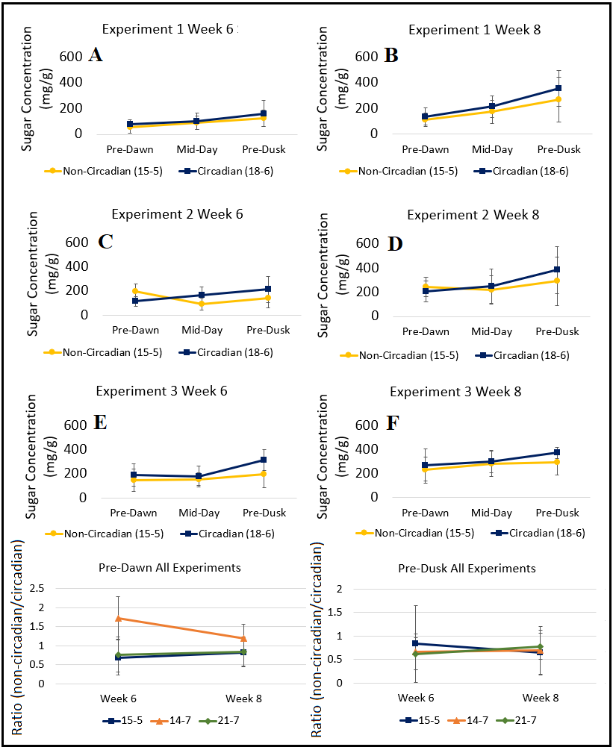
Figure 8: Leaf sugar concentrations within each experiment (a-f) expressed as glucose equivalent and ratios of non-circadian/circadian sugar concentration ratios across experiments (g-h). Error bars represent standard deviations.

Leaf starch
The leaf starch data was inconclusive, not showing consistent patterns across experiments or time of day. Starch concentrations did not have a consistent peak time for either circadian or non-circadian groups, with peaks occurring at all of the sampling times depending on the experiment and significant differences between pre-dawn and pre-dusk starch concentrations not being seen. It was found that there was no significant relationship observed between treatment groups, light ratios, or individual plant sugar concentrations to the measured starch concentrations. These results may not be reliable due to measurement noise, however this data is still presented here for reference (Figure 9).
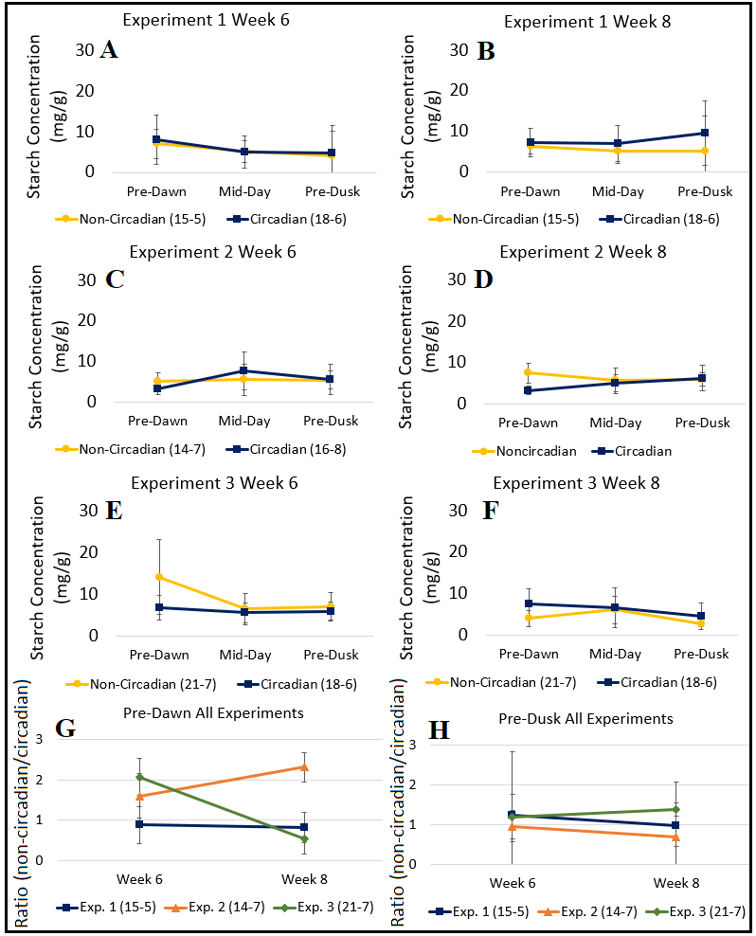
Figure 9: Leaf starch concentrations within each experiment (a-f) expressed as glucose equivalent and ratios of non-circadian/circadian starch concentration ratios across experiments (g-h). Error bars represent standard deviations.

Table 1: p-values for within-experiment and across-experiment repeated measures ANOVA tests. Significant effects are highlighted in yellow.
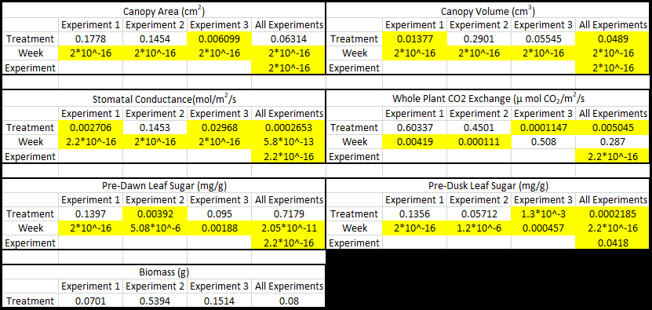

Discussion
For most plant size measurements, there were no significant differences found between the plants growing in the non-circadian and circadian light cycles. Non-circadian plants showed a slightly higher canopy volume than their circadian counterparts, but canopy area and aboveground dry biomass were not significantly different between the circadian and non-circadian plants. Gas exchange did show significant plant-level effects with non-circadian plants having significantly lower stomatal conductance and per canopy area CO² exchange than their circadian counterparts. Non-circadian plants also had slightly lower leaf sugar, and unexpected trends in their sugar concentrations throughout the day. Leaf starch analyses did not produce interpretable results. In general, these results point toward a conclusion that non-circadian photoperiods lead to less physiologically active plants, but these effects do not translate to affect the final harvested biomass. Comparison to other literature is limited by the nature of circadian rhythm research, which is primarily focused on clock-mutant Arabidopsis genetic-lines, with a relative lack of circadian research in non-model species. However, these results point to a possible conclusion that lettuce has a high resistance to the negative effects that may be conferred by a non-circadian photoperiod, possibly due to less reliance on endogenous protein cycles for physiological responses to occur. This could suggest that lettuce relies more on external conditions to regulate physiological conditions than an internal rhythm. A comparison between Arabidopsis and lettuce could be done to validate this hypothesis using reference gene analysis such as is done in Arabidopsis genetic research currently (Hassidim et al. 2017).

Plant canopy size and biomass production results were somewhat unexpected when compared to Arabidopsis research. For Arabidopsis, non-circadian photoperiods of 20 or 28 hours were distinctly associated with up to 30% decreased biomass (Graf et al. 2010). Leaf area is somewhat harder to compare given the difference in leaf shape for the species, but in general photoperiods that were not aligned with circadian rhythm reduced Arabidopsis rosette area by up to 60% (Ruts et al. 2012). Based on these results, lettuce seems less sensitive to non-circadian photoperiods than expectations from Arabidopsis would suggest. This is somewhat supported by research into photoperiods drastically shorter than 24 hours, such as 3/3 or 6/6 hours of light and dark per day which have shown significant reductions in lettuce size of around 20% less biomass and 10% less canopy area (Zhou 2020). This would suggest that slight deviations from a circadian photoperiod may have little effect on lettuce size, but larger deviations would. Although we observed some significant effects of non-circadian photoperiods in lettuce, they are not as strong or as quickly appearing as in Arabidopsis, suggesting a potentially strong ability to cope with non-circadian lighting regimes.

Through transgenic gene reporting it has been confirmed that lettuce shares many of the same circadian rhythm controlling genes as Arabidopsis (Higashi et al. 2016). It has also been observed that these genes experience similar expression patterns as is seen in Arabidopsis, based on observations of their behavior in constant light conditions. In spite of this, there have not been studies aimed towards comparing the strength of these rhythms in lettuce versus other plants, which opens a potential avenue of future research.

Although circadian rhythm effects were not clear in the canopy size and biomass analyses, circadian plants had significantly higher stomatal conductance and CO₂ exchange rates than their non-circadian counterparts. While stomatal conductance is only a measure of stomatal openness, it is correlated with photosynthetic rates in lettuce (Broadley et al. 2001) and so these results are consistent with each other. On a treatment effect level, these results somewhat agree with Arabidopsis results since non-circadian photoperiods are associated with up to 60% lower carbon fixation (Dodd et al. 2005) and up to 75% lower peak stomatal conductance (Dodd et al. 2003) with photoperiods of 20 and 28 hours. The reductions seen in lettuce have a much lower absolute value with only about 10% lower stomatal conductance and carbon exchange across the three experiments. This would give further support to the idea that lettuce has some resistance to non-circadian effects.

In this study, plants with non-circadian photoperiods had about 30% lower leaf sugar concentrations than those in circadian regimes. This agrees with Arabidopsis results in direction, although the effects are much larger in Arabidopsis. It has been observed that non-circadian photoperiods reduced soluble leaf sugar in Arabidopsis by between 50% and 60% (Moraes et al. 2022). This reduction in soluble leaf sugar would be expected to be associated with a decrease in initial leaf starch levels at nightfall and a reduced ability of the plant to prevent starvation effects at night when cellular respiration is occurring (Graf et al. 2010). The observation of lower leaf sugars in non-circadian plants agrees well with the gas exchange results and the previously discussed relationship between stomatal conductance and photosynthesis rates in lettuce (Dodd et al. 2005, Broadley et al. 2001). Unfortunately, the starch analysis proved inconclusive despite being one of the primary questions of the experiment. The expectation was that leaf starch would follow a similar trend to leaf sugar, with the exception of the pre-dawn sample period where starch was expected to be highest in the less-than-circadian plants (Experiments 1 and 2) and lowest in the greater-than-circadian treatment of Experiment 3. This would signal an inability to sufficiently utilize stored starch before sunrise, or an inability to ration starch through a longer night for the less-than and greater-than circadian plants respectively. Further understanding of starch dynamics would have granted insight into the relationship between circadian period and plant biomass accumulation, given that starch is essential for providing stored energy throughout the night when the plant is not generating energy through photosynthesis. Previous research established that lettuce plants in normal light environments generally have between 10-20% as much starch as they do sugar at a dusk sampling (Chen and Yang 2018), however measured samples varied wildly between 1-20% ratios of starch to sugar. These unexpected findings may be the result of measurement noise overshadowing the relatively low starch concentrations being measured.

Some of the observations of this study raise further questions, such as the somewhat conflicting conclusion that non-circadian plants are absorbing significantly less carbon, while growing to a similar size as circadian plants. It is possible that actual differences in canopy area are being obfuscated by differences in canopy shape or specific leaf area between the circadian and non-circadian plants, however this does not explain the biomass results. One possibility is that non-circadian plants invested less in belowground biomass compared to circadian plants, such that the total biomass of the non-circadian plants was actually lower than the above ground biomass would indicate. This kind of shift in biomass allocation (decrease in root-shoot ratio) would be consistent with classical allocation theory (Thornley 1972; Dewar 1993) that predicts plants should shift their allocation towards organs that will allow them to gain more of whatever resource is most limiting. A plant experiencing a less than circadian photoperiod would be experiencing more light in a 24 period than a plant in the corresponding circadian photoperiod. Research into resource allocation in response to circadian stress is limited, but in the Arabidopsis relative Boechera stricta it has been found that a less than circadian photoperiod is associated with a larger amount of belowground biomass and a higher root-shoot ratio (Salmela et al. 2016). We were not able to explore this possibility as lettuce roots are very delicate, which made it difficult to obtain the exact belowground mass of each plant. A future experiment could investigate plants grown in soil-less hydroponic conditions where root biomass would be more easily assessed.

More refined analyses may be needed to establish the relationships between starch and circadian period, such as enzymatic digestion instead of acid hydrolysis as the starch conversion process. High variation throughout the experiment could also be affecting the interpretation of these results, so a larger sample size of plants may be helpful in isolating any differences. It should also be considered that genetic variation in the seeds could impact the variance observed. Parris Island Cos lettuce is a heritage line of seed meaning it is generationally inbred to reduce genetic variation, but some genetic effects could and likely do still exist.

In general, it seems like a non-circadian photoperiod has some measurable effect on the physiological processes of the wildtype lettuce plant but does not hurt it enough to significantly reduce the size of the plant. This opens the possibility for further research in more extreme circadian periods, as well as the possibility for different photoperiod decisions to be made in controlled environment agriculture systems, especially in indoor systems that do not need to be exposed to normal environmental oscillations. Further genetic study of this species could also be warranted, with the establishment of individuals with mutated clock-genes being a specific goal for circadian rhythm research and the possible comparisons it might open up to a larger branch of Arabidopsis research.
Literature Cited
Barak, S., Tobin, E., Andronis, C., Sugano, S., & Green, R. (2005). All in good time: the Arabidopsis circadian clock. Trends in Plant Science, 5(12), 517-522.
Broadley, M., Escobar-Gutierrez, A., Burns, A., & Burns, I. (2001). Nitrogen-limited growth of lettuce is associated with lower stomatal conductance. New Phytologist, 152(1), 97-106.
Chen, X.-l., & Yang, Q.-c. (2018). Effects of intermittent light exposure with red and blue light emitting diodes on growth and carbohydrate accumulation of lettuce. Scientia Horticulturae, 234, 220-226.
Chow, P., & Landhausser, S. (2004). A method for routine measurements of total sugar and starch content in woody plant tissues. Tree Physiology, 24, 1129-1136.
Cumming, B., & King, R. (1972). Rhythms as photoperiodic timers in the control of flowering in Chenopodium rubrum L. Planta, 103, 281-301.
de Mairan, J.-J. (1729). Observation botanique. Hist. Acad. Roy. Sci., 35-36.
Dewar, R. (1993). A root-shoot partitioning model-based on carbon-nitrogen water interactions and Munch phloem flow. Functional Ecology, 7, 356-368.
Dodd, A., Kusakina, J., Hall, A., Gould, P., & Hanaoka, M. (2013). The circadian regulations of photosynthesis. Photosynthesis Research, 119, 1-2.
Dodd, A., Parkinson, K., & Webb, A. (2003). Independent circadian regulation of assimilation and stomatal conductance in the ztl-1 mutant of Arabidopsis. New Phytologist, 162, 63-70.
Dodd, A., Salathia, N., Hall, A., Kevei, E., Toth, R., Nagy, F., Hibberd, J., Millar, A., Webb, A. (2005). Plant Circadian Clocks Increase Photosynthesis, Growth, Survival, and Competitive Advantage. Science, 309, 630-633.
Dunlap, J., Loros, J., & DeCoursey, P. (2009). Chronobiology: Biological Timekeeping. Sunderland, Massachusetts: Sinauer Associates, Inc.
Gorton, H., Williams, W., Binns , M., Gemmell, C., Leheny, E., & Shepherd, A. (1989). Circadian Stomatal Rhythms in Epidermal Peels from Vicia Faba. Plant Physiology, 90, 1329-1334.
Graf, A., Schlereth, A., Stitt, M., & Smith, A. (2010). Circadian control of carbohydrate availability for growth in Arabidopsis plants at night. PNAS, 107(20), 9458-9463.
Green, R., Tingay, S., Wang, Z.-Y., & Tobin, E. (2002). Circadian Rhythms Confer a Higher Level of Fitness in Arabidopsis Plants. Plant Physiology, 129, 576-584.
Grotelueschen, R., & Smith, D. (1967). Determination and identification of nonstructural carbohydrates removed from grass and legume tissue by various sulfuric acid concentrations, Taka-Diastase, and water. Journal of Agricultural and Food Chemistry, 15(6), 1048-1051.
Hassidim, M., Dakhiya, Y., Turjeman, A., Hussien, D., Shor, E., Anidjar, A., . . . Green, R. (2017). CIRCADIAN CLOCK ASSOCIATED1 (CCA1) and the Circadian Control of Stomatal Aperture. Plant Physiology, 175(4), 1864-1877.
Higashi, T., Aoki, K., Nagano, A., Honjo, M., & Fukuda, H. (2016). Circadian Oscillation of the lettuce Transcriptome under Constant Light and Light-Dark Conditions. Frontiers in Plant Science, 7(1114).
K. Inoue, T. A. (2018). Circadian clock during plant development. Journal of plant research, 131(1), 59-66. doi:10.1007/s10265-017-0991-8
Lu , S., Knowles, S., Andronis, C., Ong, M., & Tobin, E. (2009). CIRCADIAN CLOCK ASSOCIATED1 and LATE ELONGATED HYPOCTYL function synergistically in the circadian clock of arabidopsis. 150(2), 834-843.
Masuko, T., Minami, A., Iwasaki, N., Majima, T., Nishimura, S.-I., & Lee, Y. (2005). Carbohydrate analysis by a phenol–sulfuric acid method. Analytical Biochemistry, 339, 69-72.
McClung, C. (2006). Historical Perspective Essay: Plant Circadian Rhythms. The Plant Cell, 18, 792-803.
McClung, C. (2010). A modern circadian clock in the common angiosperm ancestor of monocots and eudicots. Journal of Biology, 9(20), 1-4.
McClung, C. R. (2006). Plant circadian rhythms. The plant cell, 18(4), 792-803. doi:10.1105/tpc.106.040980
McClung, C., & Kay , S. (1994). Circadian rhythms in Arabidopsis thaliana. In Arabidopsis, 615-637.
Millar, A., & Kay, S. (1991). Circadian control of cab gene transcription and mRNA accumulation in Arabidopsis. Plant Cell, 3, 541-550.
Millar, A., Isabelle, C., Strayer, C., Chua, N.-H., & Kay, S. (1995). Circadian Clock Mutants in Arabidopsis Identified by Luciferase Imaging. Science, 267, 1161-1163.
Moraes, T., Mengin, V., Peixoto, B., Encke, B., Hohne, M., Krause, U., & Stitt, M. (2022). The circadian clock mutant ihy cca1 elf3 paces starch mobilization to dawn despite severely disrupted circadian clock function. Plant Physiology, 1-25.
Ruts, T., Matsubara, S., Wiese-Klinkenberg, A., & Walter, A. (2012). Aberrant temporal growth pattern and morphology of root and shoot caused by a defective circadian clock in Arabidopsis thaliana. The Plant Journal, 72, 154-161.
Salmela, M., Greenham, K., Lou, P., McClung, R., Ewers, B., & Weinig, C. (2016). Variation in circadian rhythms is maintained among and within populations in Boechera stricta. Plant, Cell & Environment, 39, 1293-1303.
Schneider, C., Rasband, W., & Eliceiri, K. (2012). NIH Image to ImageJ: 25 years of image analysis. Nature Methods, 9(7), 671-675.
Seo, P., & Mas, P. (2015). Stressing the role of the plant circadian clock. Trends in Plant Science, 20, 230-237.
Thornley, J. (1972). A balanced quantitative model for root:shoot ratios in vegetative plants. Annals of Botany, 36, 431-441.
Ukai, K., Mrase, H., & Fukuda, H. (2013). Spatiotemporal dynamics of circadian clock in lettuce. IFAC Proceedings Volumes, 46(4).
USDA NASS. (2014). 2012 Census of Agriculture. USDA NASS.
USDA NASS. (2017). Crop Values 2016 Summary. USDA NASS.
USDA NASS. (2020). 2017 Census of Agriculture. USDA NASS.
Vourlitis, G., Oechel, W., Hastings, S., & Jenkins, M. (1993). A System for measuring in situ CO2 and CH4 flux in unmanaged ecosystems: an arctic example. Functional Ecology, 7(3), 369-379.
Wang, K., Bu, T., Cheng, Q., Dong, L., Su, T., Chen, Z., Kong, F., Gong, Z., Liu, B., Li, M. (2021). Two homologous LHY pairs negatively control soybean drought tolerance by repressing the ABA responses. New Phytologist, 229, 2660-2675.
Xin, H., Xianchao, N., Pan, X., Wei, L., Min, Y., Yu, K., Lunwen, Q., Wei, H. (2019). Comparative transciptome analyses revealed conserved and novel responses to cold and freezing stress in Brassica Napus L. Genomes Genetics, 9, 2723-2737.
Zhou, J., Wang, J., Hang, T., & Li, P. (2020). Photosynthetic characteristics and growth performance of lettuce (Lactuca sativa L.) under different ligh. Photosynthetica, 58(3), 740-747.

