University of Oklahoma

Graduate College

Cuyamungue Black-on-tan: Establishing diversity in tewa pueblo biscuitware to improve dating of the Protohistoric period in northern new mexico

A thesis

submitted to the Graduate Faculty

in partial fulfillment of the requirements for the

Degree of

Master of Arts

By

Christina Stewart
Norman, Oklahoma
2018

Cuyamungue Black-on-tan: Establishing diversity in tewa pueblo biscuitware to improve dating of the Protohistoric period in northern new mexico

A thesis approved for the
Department of Anthropology

By

______________________________
Dr. Samuel Duwe, Chair

______________________________
Dr. Sarah Trabert

______________________________
Dr. Matthew Pailes

© Copyright by Christina Stewart 2018
All Rights Reserved.

Acknowledgements
My research would not have been possible without the contribution of many other people and institutions. First, I would like to say thank you to my committee members, Sam Duwe, Sarah Trabert, and Matthew Pailes, who always had time to work with me and give helpful advice along the way. Your support, guidance, and honest feedback have been invaluable throughout this project. I would also like to extend a thank you to the other faculty at the University of Oklahoma and the Archeological Survey, whose mentorship and encouragement has been integral in my successful completion of the program.
Thank you to the Maxwell Museum for allowing me to access to the Sapa’owingeh collections. I would also like to extend a special thanks to Dr. Sunday Eiselt and Rachel Burger at Southern Methodist University. Your aid in understanding and transporting the Sapa’owingeh collections helped to make this project happen. Further, it is through your mentorship that I became interested in Southwest archaeology and grew to become a more confident and competent researcher. To my fellow graduate students at the University of Oklahoma, I cannot thank you enough for the friendship and help over the last two years. I could always count on you for words of wisdom, frank edits, and constant encouragement.
Last but certainly not least, there are not words to express my appreciation to my family. You have never questioned my ability to achieve my goals, even when I had little faith in myself. Your unconditional love and support continually inspire me to become a kinder and more driven person.

Table of Contents

Acknowledgements I
List of Tables V
List of Figures VI
Abstract VII
Chapter 1: Introduction 1
Chapter 2: Culture History 6
Regional Background 6
Tewa People 9
Previous Research 10
Culture History 11
Early Occupation 14
The Classic Period (A.D. 1350-1598) 15
Ongoing Research Questions 18
Depopulation of the Lower Chama Watershed 18
Reasons for Depopulation 21
Conclusion 22
Chapter 3: Tewa Pottery 23
Impacts of Ceramic Research 23
Tewa People as Biscuitware People 24
The Biscuitware Area 25
Biscuitware Trade 25
Variation 26
Tewa Series Pottery 27
Biscuitware 29
Typological Descriptions 31
Cuyamungue Black-on-tan 35
Conclusion 36
Chapter 4: Research Design 37
Research Question 37
Sapa’owingeh 38
Ceramic Sampling 41
Attribute Analysis 45
Attributes Recorded for All Sherds 48
Rim Attributes 51
Ceramic Typologies 52
Conclusion 53
Chapter 5: Results 54
Analysis 54
Cuyamungue Black-on-tan 55
Rim Height 55
Slip Color 57
Sherd Thickness 59
Biscuitware Variation 61
Rim Shape 61
Firing Core 63
Mica Presence 64
Banding Lines 66
Continuity 68
Conclusion 69
Chapter 6: Discussion and Conclusion 70
Cuyamungue Black-on-tan 70
Variation 72
Continuity 73
Conclusion 74
References 76
Appendix A: Attribute Analysis 84

List of Tables

Table 1. Tewa Series pottery. 28
Table 2.Table of sampling contexts. 43
Table 3. Ceramic mean dates of the plazas from Sapa'owingeh based on field notes of Tewa Series ceramic types. 44
Table 4. Table of attributes in this study and their relevance. 47
Table 5. Number of different kinds of pottery identified in this study. 55
Table 6. Mean, median, and upper and lower percentiles of rim heights for different biscuitware types. 57
Table 7. Results of the Tukey Kramer HSD post hoc test. 57
Table 10. Table of statistical tests and results for different biscuitware attributes. 69

List of Figures

Figure 1. The Lower Chama Watershed and surrounding regions. 8
Figure 2. The chronology of the Lower Chama watershed. 13
Figure 3. Type description of Abiquiú Black-on-gray. 33
Figure 4. Type description of Bandelier Black-on-gray. 34
Figure 5. Type description of Cuyamungue Black-on-tan. 35
Figure 6. Map showing the location of Sapa'owingeh. 39
Figure 7. Aerial photo of Sapa'owingeh 40
Figure 8. Excavation map of Sapa'owingeh 45
Figure 9. Biscuitware rim form chart based on Kidder and Amsden (1931). 52
Figure 10. Box and whiskers comparison of rim height by pottery type 57
Figure 11.Mosaic plot of slip color by pottery type 58
Figure 12. Box and whisker plot of sherd thickness by pottery type 60
Figure 13. Mosaic chart of rim shape by pottery type 62
Figure 14. Mosaic plot of firing cores by pottery type showing that Abiquiú Black-on-gray has a higher percentage of cores than other types. 64
Figure 15. Mosaic plot showing the different percentages of mica in the slips of ceramics by pottery type. 66
Figure 16. Plot of interior banding distance by rim height. 67

Abstract
Researchers know that during the Late Classic period (A.D. 1500-1598) Tewa Pueblo people living in the Lower Chama watershed started moving southeast towards the Rio Grande, a process that eventually lead to the depopulation of the valley. However, archaeologists are still unsure of why and when Tewa people started to depopulate the Chama. There are several explanations researchers use to explain why Tewa people started leaving the area that date to a specific time of Tewa history between the Late Classic period and Historic period (1598-1760). The explanations range from environmental instability in the Late Classic period (Towner and Salzer 2013), the spread of European diseases (Ramenofsky 1988), or the increased demands of Athapaskan raiding (Hammond and Rey 1953:1059) and Spanish colonial policies of population concentration (Wozniak 1992) during the Historic period. One way to address this challenge of understanding why Tewa people started moving south is to better date the later occupation of sites in the region. In this thesis I argue that a way to improve the dating Late Classic period sites in the Lower Chama watershed is to analyze the abundant and locally-produced biscuitware ceramics to better resolve the Tewa ceramic typology.
There are two accepted biscuitware types, Abiquiu Black-on-gray (Biscuit A) and Bandelier Black-on-gray (Biscuit B), with wide chronological dates. In this study I evaluated Harlow’s (1973) observations to investigate if there is an identifiable third and later type, Cuyamungue Black-on-tan (Biscuit C), that would allow researchers better address these chronological issues in the region. Harlow (1973) argued Late Classic period (A.D. 1500-1598) biscuitwares have taller rims, a tanner slip, and thinner walls than the preceding Abiquiu Black-on-gray and Bandelier Black-on-gray. In this study, I evaluated Harlow’s (1973) observations about changing biscuitware forms during the Classic period at the site of Sapa’owingeh (LA 306), by analyzing 2,519 sherds from across the village. Based on this analysis there were statistically significant differences in the rim height, slip color, and wall thickness that support Harlow’s Cuyamungue Black-on-tan type. Additionally, I found statistically significant differences between types in the presence of firing cores, the shapes of rims, the correlation of banding lines to rim height, and the presence of mica in the slips of biscuitwares. Therefore, Cuyamungue Black-on-tan is a type that researchers can use to refine dating of Late Classic period sites in the Northern Rio Grande, which will help archaeologists to improve our understanding of why Tewa people started leaving the region during the Late Classic period. Understanding when and why Tewa people left the Chama has implications for the way that researchers understand Tewa connections to the Lower Chama watershed, and dealt with the many pressures of Spanish contact and colonization.

Chapter 1: Introduction
The Lower Chama watershed was a center of Tewa population during the Classic period (A.D. 1350-1598) (Duwe 2011:370); however, it seems by the early seventeenth century that no Tewa people were permanently living in the valley. While researchers understand the general trends of population movement in the Chama, archaeologists still don’t understand why Tewa people started to leave the region during the Late Classic period (A.D. 1500-1598) and eventually depopulate the area during the Early Historic period (A.D. 1598-1760). Several hypotheses have been proposed including drought and climatic instability (Towner and Salzer 2013), European epidemics (Ramenofsky 1988), Athapaskan raiding (Hammond and Rey 1953:1059), Spanish colonial policies of population concentration (Wozniak 1992), or a combination of these factors. One challenge of explaining the depopulation of the Chama is a lack of chronological control which impeded researcher’s ability to understand settlement patterns and population movement in the sixteenth century (Ramenofsky and Feathers 2002). In this thesis, I propose refining the local ceramic typology to allow archaeologists to better date this critical time period in Tewa history.
The Rio Chama watershed is part of the larger Northern Rio Grande region in north- central New Mexico. Today there are no occupied pueblos in the valley. However, based on Tewa oral history and a century of archaeological fieldwork researchers know the Lower Chama as a homeland of the Tewa Pueblos, who now reside in the six historic Tewa villages near the Rio Grand, north of Santa Fe: Ohkay Owingeh, Santa Clara, Tesuque, San Illdefonso, Pojoaque, and Nambe. According to Ohkay Owingeh’s emergence and migration tradition (Ortiz 1969:14-16), the Tewa people emerged from the Sipofene, or the underworld, in southern Colorado. They traveled southward toward New Mexico in separate groups, the Summer People and the Winter People, who eventually reunited in the Lower Chama watershed where they built the pueblo of Posi’owingeh. Eventually, the Tewa moved away from Posi’owingeh and spread to create six different villages across the Rio Grande region where they took their traditions with them. Their origin tradition is one key example of the importance that the Lower Chama watershed holds for Tewa people at Ohkay Owingeh. Tewa people have deep connections to the Chama. Harrington (1916) recorded hundreds of Tewa place names still used at Ohkay Owingeh that describe archaeologically known pueblos that they are connected with. There is also evidence for continued and connection to the Lower Chama watershed found by regional archaeologists, like the presence of historic artifacts at Tewa shrines at Classic period sites and evidence for the continued use of the valley by Tewa pastoralists (Eiselt and Darling 2013:6.77).
Traditionally, archaeologists estimated that Tewa people completely left the Lower Chama watershed prior to Spanish colonization in 1598 (Mera 1934; Wendorf and Reed 1955). However, with growing access to translated Spanish documents (Hammond and Rey 1953; Schroder and Matson 1965) it seems likely that the Spanish encountered some of the villages in the area during explorations in the late sixteenth century. With this new information, researchers are starting to question previous narratives of Tewa abandonment of the region, and how we understand the transition of Tewa populations to the historic pueblos to the south (Eiselt and Darling 2013; Schaafsma 2002; Schroeder 1979; Wozniak 1992). Understanding the reasons, timing, and settlements of the Tewa during this transition helps archaeologists understand the complex connection the Tewa have to an area they are supposed to have abandoned.
There are several different arguments as to how, when, and why the Tewa started to leave the Lower Chama watershed. The main three push factors that archaeologists cite for causing the out migration from the Chama is the general climatic variability in the Chama during the Late Classic, the introduction of Athapaskan groups to the area, or the pressures of Spanish contact. Each of these explanations for the depopulation of the Lower Chama watershed aligns with more specific dates. For example, Towner and Salzer’s (2013) environmental reconstruction show that there is a general drying trend and environmental instability in the area during the 1530s that worsens during the 1570s and 1590s. Therefore, dating depopulation to the sixteenth century may indicate that environmental factors were a major catalyst for a Late Classic migration from the valley. On the other hand, if it can be shown that many villages were occupied into the Historic period then other causes may have played an important role. These include raiding of villages by Athapaskan-speaking people who were cited as burning pueblos in the early seventeenth century (Hammond and Rey 1953:1059) or the effect of Spanish policy to concentrate the Pueblo people in just a few Spanish-controlled mission villages (Wozniak 1992:51). This forced aggregation is just one part of missionization and colonization process that the Tewa faced after the Spanish established residence in northern New Mexico in 1598. Arguments for the Tewa abandonment of the Chama by the Historic period, or for a lack of full-time occupation of the region, imply that a change in settlement strategies constitutes a loss of Tewa people's connection to the land (Barrett 2002). Understanding the dates of when the Tewa started leaving the Lower Chama watershed will help to show why Tewa settlements changed over the Late Classic period and Early Historic period, which influence modern perceptions abandonment and connection to the land.
Pottery is the primary line of evidence researchers utilize to date sites in the Rio Chama watershed. However, this is complicated by the locally painted pottery typology of the Tewa biscuitwares which have very wide date ranges and a lack of typological clarity during the Late Classic period. Currently, there are only two widely used biscuitware types, Abiquiú Black-on-gray and Bandelier Black-on-gray, which were produced mainly during the Early (A.D. 1350-1450) and Middle Classic periods (A.D. 1450-1500). In 1973, Francis Harlow proposed a third biscuitware type, Cuyamungue Black-on-tan, which he theorized was made between A.D. 1450-1550. He argued that Cuyamungue Black-on-tan had tanner slips, thinner walls, and rims taller than both Abiquiú Black-on-gray and Bandelier Black-on-gray. Researchers do not currently use Cuyamungue Black-on-tan because no one has ever tested Harlow's observations and the type remains poorly described. A Late Classic period biscuitware would be helpful in clarifying later occupation of pueblos in the region.
This project aims to investigate the validity of the Cuyamungue Black-on-tan type as one way to address the problem of chronological dating in the area. To test and determine if Cuyamungue Black-on-tan sherds are identifiable and statistically significant, I analyzed a sample of pottery from Sapa’owingeh (LA 306), the largest known Classic period pueblo in the Lower Chama watershed. I performed an attribute analysis on the sherds, focusing on the attributes that Harlow outlined, as well as other relevant characteristics of biscuitware, like temper type and quality of slip, to understand how pottery production changed over time.
I found that Cuyamungue Black-on-tan sherds showed a range of difference from other biscuitware types. Cuyamungue Black-on-tan is tanner, thinner, and had taller rims than both Bandelier Black-on-gray and Abiquiú Black-on-gray, which confirms Harlow’s observations. I also found that the shape of biscuitware rims changes over time, as does the presence of mica in the slip, and presence of firing cores. I argue that Cuyamungue Black-on-tan is both an identifiable and useful type to aid in the dating of sites.
As archaeologists are able to better date the Late Classic period component of sites in the Lower Chama watershed they will also have the tools to start approaching the question of why Tewa people started leaving the area. Understanding when and why the Tewa began their movement away from the Chama pueblos is important because it contextualizes their actions and helps to show that Tewa people did not abandon the region. Contact with the colonial Spanish empire drastically changed the trajectories and lived experience of Puebloan people. From the Christian missionization of Puebloan worldviews to fundamental changes to settlement strategies, Spanish colonial endeavors sought to impact all aspects of the Pueblo world (Wozniak 1992: 51). However, change and movement are one of the most consistent parts of the Pueblo world (Naranjo 2008). Paradoxically, it is through change that the Pueblo world persisted through the many challenges of Spanish contact and colonization.

Chapter 2: Culture History
Tewa people lived in the Lower Chama watershed for hundreds of years, since the Coalition period, but during the Late Classic and Historic period archaeologists assume they started to move south to the Rio Grande. Archaeologists still do not have a good understanding of how, when, and why the Tewa moved to the Rio Grande. One of the main reasons archaeologists have a muddled knowledge of this transition is because of a lack of chronological control in the region during the Late Classic period, and refining the local biscuitware chronology is one way to address this problem. In this chapter, I introduce the culture history of the Lower Chama watershed and ongoing research into the population movements and social dynamics of the Late Classic period. First, I set the stage and explain the geographic and environmental setting of the Lower Chama watershed. Second, I give an overview the archaeological research in the region. Third, I review the known culture history of the Chama, with focus on the Classic period. Finally, I discuss the lingering questions researchers have about the Late Classic period and depopulation of the Lower Chama watershed.

Regional Background
The Lower Chama watershed is a part of the greater Northern Rio Grande region in northern New Mexico (Figure 1). It is a tributary of the Rio Grande and includes the Rio Chama, and three of its major drainages, the Rio del Oso, the Ojo Caliente and El Rito Creek. These drainages and the Rio Chama are some of the most consistent sources of water in the region. The regional climate of the Rio Chama watershed is semi-arid, with most precipitation falling during the summer monsoon rains from June-September (Anschuetz 1998:250). The Lower Chama tributaries are situated in the valley between the Jemez and the Tusas mountains. This area consists of river valleys, badlands covered in shrubs and grasses, and at higher altitudes, forests of juniper, pinion, and ponderosa pine. The diversity of elevation and availability of both permanent and intermittent water creates diverse vegetative zones and attracts a wide variety of fauna, from traditional game animals like mule deer, elk, bighorn sheep, and antelope, to smaller creatures like hares, squirrels, and gophers (Bailey 1913). On the alluvial benches of the Chama’s drainages within the Lower Chama watershed, Ancestral Tewa people built many of the Classic period pueblos.
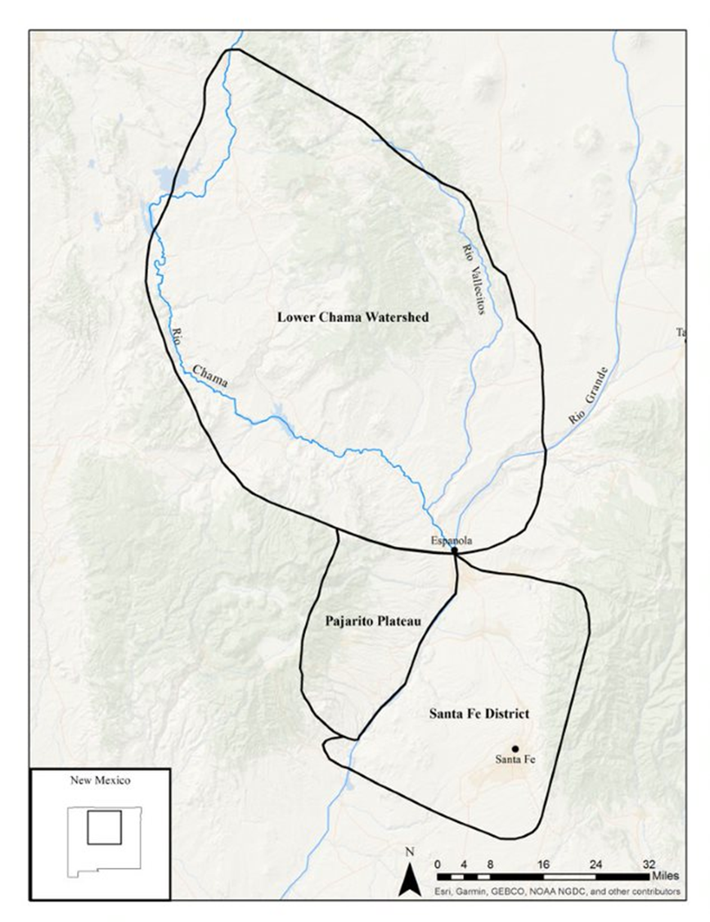
Figure 1. The Lower Chama Watershed and surrounding regions.

Tewa People
Tewa people are part of the greater Pueblo world, which consists of 28 pueblos and four language families: Hopi, Zuni, Keresan, and Tanoan (Eggan 1950). Tewa, as a language is most closely related to Tiwa and Towa, which are all part of the Tanoan language group. Today, there are six Tewa-speaking pueblos in New Mexico: Ohkay Owingeh (formerly San Juan Pueblo), Nambe, Pojoaque, San Ildefonso, Santa Clara and Tesuque. Tewa is language, and while the Tewa pueblos do have shared cultural traits, each of the pueblos has its own history and governing bodies.
We know ethnographically that the Tewa world is defined by the four sacred peaks: Tsikomo to the west, Oku Pin to the south, Ku Sehn Pin to the east, and Conjilon Peak to the north (Harrington 1916; Ortiz 1969). The boundary described by the four sacred peaks closely align with historical and archaeological evidence of Tewa occupation and land use in northern New Mexico. Tewa ancestors have lived in this area since at least A.D. 1300, and archaeologists start to recognize a distinct Tewa material culture by the fifteenth century (Duwe 2011:97). Each of the six modern Tewa pueblos is positioned within a unique watershed and the larger area, and archaeologists find that the different watersheds of the Tewa basin also have their own unique identities. In this research project I focus on the Lower Chama watershed, an area which is closely associated with Ohkay Owingeh pueblo (Eiselt and Darling 2013).
One of the shared characteristics of Tewa societies is a moiety system made up of the Summer and Winter People. Their dual moiety social system influences most of Tewa social and religious life (Parsons 1929:120; Ortiz 1969). The Summer and Winter Chiefs alternate leadership of the pueblo in a yearly cycle. Tewa moiety divisions and social organization are at the heart of the Tewa origin tradition, starting from when the people left the underworld and solidifying when the moieties reunited at Posi’owingeh.
According to Ohkay Owingeh’s emergence and migration tradition, before they lived in this world, the Tewa resided in the Sipofene, the world under a lake far to the north of New Mexico (Ortiz 1969:14-16). One day in the Sipofene, the Corn Mothers asked man to venture into the world above the lake. When this man returned from our world to the Sipofene, the Corn Mother made him the Hunt chef. In turn the Hunt chief appointed two other men to be the Summer and Winter chiefs and lead their people in to the world above and eventually lead Tewa people during their respective season. Four times the Tewa left the Sipofene for our world, and four times they returned because they were incomplete. When they were finally complete, the Hunt chief split the Tewa between the Summer and Winter chiefs. The Summer chief lead his people to our world and then traveled a southern route to the west of the Rio Grande, while the Winter chief lead his people to the east of the Rio Grande. Both the Summer and Winter people traveled, until they reunited at a village named Posi’owingeh. At Posi’owingeh Tewa people again became one people but maintained their duality of Summer and Winter. Eventually, the Tewa moved away from Posi’owingeh and spread to create six different villages across the San Juan where they took their traditions with them including a dual-division system that the Corn Mother had given them (Ortiz 1969).

Previous Research
The first European records of the Rio Chama watershed are in 1541 with Cornado’s entrada, when a foraging party reached the Tewa basin and continued through Spanish colonization of New Mexico (Hammond and Rey 1966). During the late nineteenth century explorers began to describe and map the region and archaeologists began archaeological research around the turn of the twentieth century (Bandelier 1892; Harrington 1916; Hewett 1906; Yarrow 1879). J.A. Jeanҫon (1912) was the first archaeologist to excavate in the Lower Chama watershed and ushered in an era of scientific research in the area which began in earnest during the 1930’s. H.P. Mera (1934, 1935) conducted his archaeological survey of the “biscuitware area” where he mapped the cultural divisions in the area based on pottery. Frank Hibben (1937) excavated Riana Ruin, where he devised one of the first chronologies in the area. Excavation continued in the region through the 1970’s, mostly in the form of field schools like the ones conducted by the University of New Mexico at Sapa’owingeh (LA 306) (Ellis 1975). After the 1970’s researchers turned their interests to other regions of the Northern Rio Grande and excavations in the Lower Chama watershed decreased.
Most of the recent archaeological research in the Lower Chama watershed has focused on survey or re-excavation of previously excavated sites (Anschuetz 1998; Duwe 2011, 2017; Eiselt and Darling. 2013). To this day, archaeological survey coverage of the region is spotty at best. Some areas, like the Rio del Oso drainage, have almost complete survey coverage (Anschuetz 1998). However, on average, only ten percent of the Lower Chama watershed has been surveyed (Duwe and Anschuetz 2013:98).

Culture History
Today, archaeologists use variants of Wendorf and Reed’s (1955) chronology to understand the culture history of the Northern Rio Grande. The Wendorf and Reed (1955) chronology is a local variant of the Pecos chronology, and consists of four periods: Developmental (A.D. 900-1200), Coalition (A.D. 1200-1350), Classic (A.D. 1350-1598), and Historic (A.D. 1598-1800). Here, I use Duwe’s (2011:243) modified chronology which is a better fits the much shorter occupation history of the Lower Chama watershed (Figure 2).

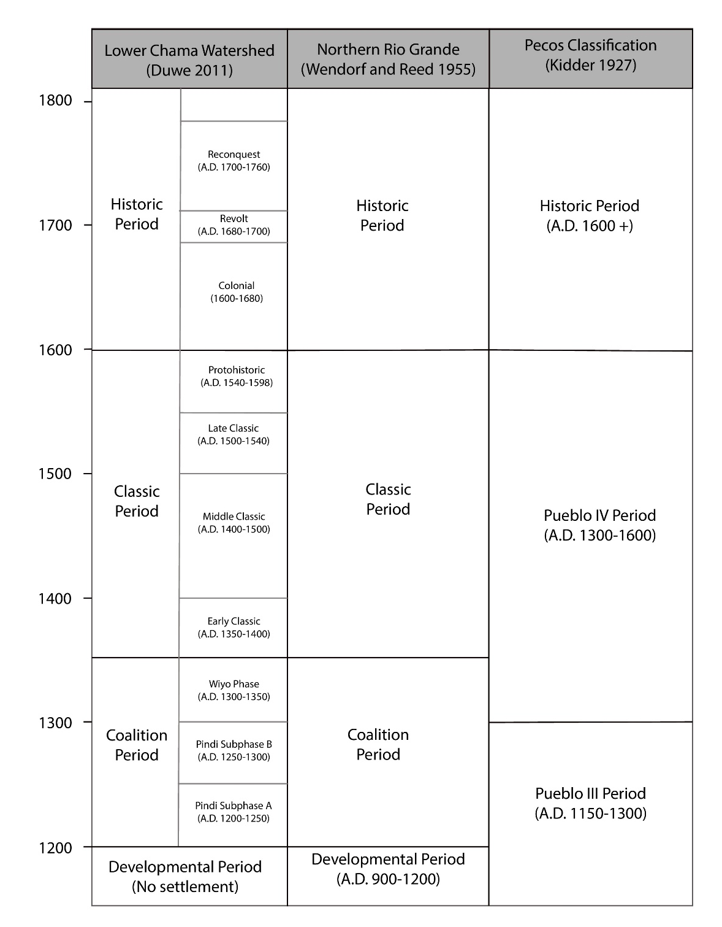
Figure 2. The chronology of the Lower Chama watershed. Figure adapted from Duwe (2011:243).

Early Occupation
Researchers have yet to find a permanent village site that dates to, or prior to, the Developmental period (A.D. 900-1200) in the Lower Chama watershed, though there is evidence of seasonal occupation of the region from the Archaic to the Developmental periods (Anschuetz 1998:216; Post 2013). This is especially befuddling to archaeologists because much of the rest of the Northern Rio Grande was populated before the Coalition period (A.D. 1200-1350) and the Chama had ample arable land. Beal (1987:18) hypothesized that people were discouraged from living in the Chama because it is on the eastern edge of the Gallina culture area where there is documented evidence of endemic violence during this time.
Characterized by the emergence of carbon-painted Santa Fe Black-on-gray and Wiyo Black-on-gray ceramics, the Coalition period (A.D. 1200-1350) encompassed a period of transformation where the population in the region grew and coalesced. The first settlers started to move into the Chama in the mid-thirteenth century and began to build small, dispersed pueblos in the more southern parts of the watershed (Anschuetz 1998; Beal 1987). Towards the end of the Coalition period, between A.D. 1300-1350, there was a population increase. Residents of the Chama started aggregating into larger communities and migrants from other areas joined existing pueblos and built new ones (Duwe 2011:265). Duwe (2011:277) shows that there is a fourfold increase in the number of habitation rooms in the region during the late Coalition. Eiselt and Darling (2013:14) estimate that by the end of the Coalition, 76% of the population was living in one of these growing villages.
This population increase in the Chama between A.D. 1300 and 1350 is consistent with a larger trend seen by archaeologists throughout the Northern Rio Grande. Researchers are still debating how the population grew between A.D. 1300-1350. Some argue that it was from internal growth (Boyer et al. 1986; Mera 1935; Wendorf and Reed 1955) while others suggest it was due migration from the San Juan region (Jeanҫon 1923; Ortman 2010, 2012, 2014). Archaeologists have recently started to find a middle ground hypothesis, that the population in the Northern Rio Grande was increasing on its own, but that demographic trends and other evidence also point to migration from the Mesa Verde region (Duwe and Cruz 2018; Schillaci and Lakatos 2016; Schillaci et al. 2017). The Coalition period’s transformation in the Chama’s population and pueblos sets the stage for the growth and building of the Classic period.

The Classic Period (A.D. 1350-1598)
Archaeologists characterize the Classic period (A.D. 1350-1598) by the building of large villages, the continued aggregation of people into large villages, and the eventual depopulation of the region. The Classic period is a time of greater coalescence and cultural transformation in the Lower Chama watershed, and the emergence of Tewa cultural identity. This is identified by archaeologists through a regionalization of ceramics, rock art, architecture, ritual technologies, and landscapes (Duwe 2011; Ellis 1950; Futrell 1998; Olesen 2004; Wilcox 1991). Duwe (2011) subdivides the Classic period into four periods based on trends in demography as follows: Early Classic (A.D. 1350-1400), Middle Classic (A.D. 1400-1500), Late Classic (A.D. 1500-1540), and the Protohistoric (A.D. 1540-1598).
During the Early Classic period (A.D. 1350-1400), people started establishing new pueblos in the lowlands of the Chama. This includes sites like Sapa’owingeh (LA 306), Cerro Colorado (LA 307), and Posi’owingeh (LA 632). During this time, people coalesced at two different scales. First, local inhabitants moved from their small villages in the highland mesa tops to larger sites in the lowlands (Orcutt 1991). Second, there was a large migration into the region (Duwe 2011). Eiselt and Darling’s (2013: 2.20) population reconstruction shows that at the start of the Classic period (A.D. 1350) around 1,300 people lived in the valley, and by A.D. 1400 the population had swelled to 11,000. Based on demographic trends in the Northern Rio Grande, archaeologists suggest that most of these new residents came from the neighboring Pajarito Plateau (Duwe 2011; Duwe and Anschuetz 2013; Duwe et al. 2016; Ortman 2014).
This trend of population growth and pueblo construction peaked during the Middle Classic period (A.D. 1400-1500). Residents of the valley began to live in one of 11 villages throughout the area and smaller sites fell completely out of use (Duwe 2011:290). Eiselt and Darling’s (2013:21) population reconstruction estimates that there were about 13,300 people living throughout the area. It is during this Middle Classic period that archaeologists start to identify cosmological, and architectural trends that reflect elements of Tewa social identity (Duwe 2011:290).
As opposed to the Early and Middle Classic periods, the Late Classic period (A.D. 1500-1600) is characterized by population decline. The last tree ring cutting dates in the Chama watershed are between A.D. 1490-1529 (Duwe 2011:304), and it seems that people chose to either aggregate or move south of the Chama. While population reconstruction for this period is difficult, by the end of the Late Classic period the population was a fraction of what it was during the Middle Classic. This trend of dramatic population decline was mirrored across the entire Tewa Basin (Ortman 2014). Scholars now think that this was not a single dramatic event of either population loss or migration, but rather a drawn-out movement of people southward that eventually lead to the depopulation of the Lower Chama watershed (Duwe 2011; Eiselt and Darling 2013). Archaeologists though are still unsure of the exact locations and size of villages that people were living in and how intensive this occupation was (Duwe 2011; Eiselt and Darling 2013; Ramenofsky and Feathers 2002; Schaafsma 2002; Schroder 1979; Schroder and Matson 1965; Wozniak 1992)
Lightfoot and Simons (1998:140) define the Protohistoric as beginning with the first contact with Europeans and ending with the first permanent European settlements. As such, this means that Protohistoric period is different between regions. The first documented European explorers in the Chama watershed were a foraging party from Coronado's expedition who arrived in the region in A.D. 1541 and the establishment of the first Spanish settlement at Yunque’owingeh by Juan de Oñate in A.D. 1598 (Schroeder and Matson 1965). It was not until A.D. 1591, when Castano de Sosa explored the area that the Spanish encountered the Tewa in the Lower Chama watershed. Compared to the height of the Classic period, in the sixteenth century only a small population of people were living in the region. However, this population was large enough for the Spanish to install a governor at Te’ewi’owingeh in A.D. 1591 but by 1608 Tewa villages were no longer mentioned in surviving Spanish documents (Wozniak 1992:51).
The final movement of Tewa people from pueblos like Te’ewi’owingeh after 1608 is likely due to the pressures of Spanish colonialism (Wozniak 1992:51). During this period Spanish documents recount the increased problems of raids from Athabaskan groups, who would raid and burn down pueblos (Hammond and Rey 1958:1046). Citing this problem as reasons to institute a new policy of forced aggregation to Spanish controlled villages, though this also boon to missionization efforts that the Spanish were also instating at the time (Wozniak 1992:51).

Ongoing Research Questions
In the Lower Chama watershed, archaeologists have only a tenuous grasp of the chronology of the Protohistoric period. Researchers still do not have a good understanding of how people lived, and possibly reoccupied the Lower Chama watershed during this period. This is mainly because researchers still don’t have good chronological control in the region (Ramenofsky and Feathers 2002). Due to this problem, during the Late Classic period archaeologists are still unclear of the complex ways that Tewa people continued to live and use the Lower Chama watershed even after the center of Tewa population had moved southward during this time.

Depopulation of the Lower Chama Watershed
Rather than total abandonment, the center of Tewa population in the Northern Rio Grande slowly shifted southward. Depopulation began around 1500, during the Late Classic period. Researchers are still unclear as to the timing, process, and reasons for this slow emigration from the region (Eiselt and Darling 2013:2.9). Although the regional population was declining after 1500, it seems that Tewa people were still aggregating to larger pueblos in the Lower Chama watershed as well.
Through Spanish documents researchers understand that there were still people living in the Lower Chama watershed in the early historic period. Oñate’s list of pueblos in 1598 documents Tsama’owingeh in the Lower Chama watershed as still being occupied (Hammond and Rey 1966:320). Based on these same documents, Wozniak (Wozniak 1992:51) argues that not only was Tsama’owingeh occupied, but that Sapa’owingeh, Pesede’owingeh, and Ku’owingeh were also occupied until the early 1600s. There is also archaeological evidence that people were using sites in the Lower Chama watershed both for permeant occupation and as a refuge in times of crisis. In a popular press article Ellis (1975) reported finding sheep bones at Sapa’owingeh, however this report has never been verified. During the reanalysis of the faunal collection from Sapa’owingeh housed at the Maxwell Museum, which is the vast majority of the collection, Eiselt and colleagues were unable to relocate these bones (Eiselt and Darling 2013:2.24).
Beyond full time habitation of the region, Tewa people also traveled through and reoccupied the Lower Chama watershed in times of distress. When part of Coronado’s foraging parties first visited the Northern Rio Grande in A.D. 1541, several of the pueblos were vacant because their residents had fled to the north when news of the expeditions arrival preceded them (Hammond and Rey 1966:244). This pattern continued during the Pueblo revolts where Spanish sources argue that after the Tewa expelled the Spanish from northern New Mexico, that Tewa people left the Rio Grande pueblos to reoccupy some more northern pueblos (Wozniak 1992:57).
There is both documentary and archaeological evidence that Tewa people to some extent lived in the Lower Chama watershed after A.D. 1500 and beyond Spanish contact. However, scholars still debate to what extent Tewa people were living in the region. Albert Schroder (1979) and Frank Wozniak (1992) argue that Tewa people still had full time residence in the Lower Chama watershed through the early 1600’s. On the other hand, Curtis Schaafsma (2002) argue that Tewa people were cultivating the land in the watershed, but that people stopped living in the area by the mid-1500s. Both arguments rely on tenuous evidence and poorly dated contextual information (Eiselt and Darling 2013; Ramenofsky and Feathers 2002). A lack of understanding of the timing of population movements is one of the main reasons why archaeologists are still arguing about the intensity of occupation in the Lower Chama watershed during the Protohistoric and early Historic periods.
Ann Ramenofsky and James Feathers (2002) argue that the reason that archaeologists do not understand this demographic transition is because of poor chronological control in the region. Compared to the rest of the Northern Rio Grande, the Chama has substantially fewer radiocarbon dates and tree-ring dates than other regions, and the ceramic chronology is not as tightly seriated as typologies to the south. This problem is compounded by conflicting historical accounts and archaeological population reconstructions during the Late Classic period (Duwe 2011: 306). Until researchers address some of these chronological problems during the Late Classic period, Tewa people’s movements out of the Lower Chama watershed will remain murky. In this study, I argue looked at the local biscuitware ceramic typology as one way to address some of the chronological problems that Ramenofsky and Feathers (2002) raise.

Reasons for Depopulation
Why Tewa people started leaving the Lower Chama Watershed is still unclear. In some cases, it seems that there was a violent end to the occupation as several Classic period pueblos. Pesede’owingeh and Poshu’owingeh were burned (Jeanҫon 1919;1923), and the bodies of 13 young men were found in a burned Kiva during Wendorf’s (1953) excavation of Te’ewi’owingeh (LA 252). Therefore, the threat of violence may have influenced people’s choices to aggregate and move out of the Chama. Tewa tradition tells that they moved southward because of violence from Apache groups in the area (Wozniak 1992:51). Archaeologists are still unclear how widespread violence was during the Classic period, and or what factors might have led to increased violence in the region.
Drought and disease are the two main theories researchers use to argue why violence increased during the Late Classic (Ramenofsky 1988; Wendorf and Reed 1955). However, recent research shows that these alone are unlikely causes for the population shifts during the Late Classic period. Early climatic reconstructions in the Lower Chama watershed suggested that there may have been a 60 year drought around the time of depopulation; however, according to reconstructions by Towner and Salzer (2013:58), this drought may not have been as bad in the Lower Chama watershed as previously assumed. Towner and Salzer’s (2013:58) reconstruction of the environment during the Late Classic period do show an increase in environmental instability though, a trend that only worsens during the Historic period. Ramenofsky (1988) hypothesized that the population decline in the Northern Rio Grande and the Chama was from the rapid spread of European diseases. It is unlikely that this is the explanation because the depopulation of the Chama was a long and slow process, rather than a quick event which researchers expect to see in the event of an epidemic. However, the paucity of research for this period makes it hard for archaeologists to understand the dynamics that lead to Tewa population movement out of the Lower Chama watershed.

Conclusion
Archaeologists understand the broader movements and population trends in the Lower Chama watershed. However, there are still many questions about depopulation that researchers still cannot answer. The Late Classic period and Protohistoric period is a pivotal time not only in the Lower Chama watershed, but the Northern Rio Grande as a whole. Tewa people moved their center of population from the Lower Chama watershed further south, along the Rio Grande but archaeologists still don’t know how or why they did this. To better approach these questions, archaeologists need a better way to date Late Classic period sites in the region, and a better defined ceramic typology would help untangle many of the chronological issues.

Chapter 3: Tewa Pottery
To archaeologists biscuitware pottery is a hallmark of Tewa culture and their occupation of the Northern Rio Grande during the Classic period. Currently researchers are unclear about why and when Tewa people moved from the Lower Chama watershed to the historically known pueblos along the Rio Grande because they lack a good chronology of the Classic period pueblos in the region. Studying biscuitware ceramics is one way to address this problem. Ceramics are the principle way archaeologists assign dates to sites in the region, and refining the current biscuitware typology will help archaeologists better date the movement and population of Tewa people during the Classic period. In this chapter, I first introduce the Tewa Series of ceramics. Then I expand on the significance that biscuitwares have had on archaeological interpretations of the occupation of the Lower Chama watershed. I explain how archaeologists classify biscuitwares and review the history of research on biscuitware ceramics. Finally, I explain why biscuitwares are important to addressing questions of Tewa population movement in the Northern Rio Grande.

Impacts of Ceramic Research
Early archaeologists in North America conflated material culture with the people and cultures they studied, a point of view researchers now label "pots as people". Biscuitware is so prevalent in the Lower Chama watershed that it is a key example of this problem. While we now call the area the Tewa Basin or the Lower Chama watershed, H.P. Mera named it the “Biscuitware Area” (1934), after the pottery he found. Hibben (1937), based on his excavations of Coalition era pueblos, called the people who lived in the Lower Chama watershed the “Biscuitoid People” after the pottery found at the sites. Biscuitoid pottery is an early name for Wiyo Black-on-white, and is the type that directly precedes Abiquiú Black-on-gray. Biscuitoid pottery is one of the main ways that Hibben (1937) conceptualized the cultural boundaries of the Northern Rio Grande. Mera and Hibben noticed that ceramic production and trade are foundational to the way that archaeologists interpret the archaeology of the Lower Chama watershed.

Tewa People as Biscuitware People
In the 1930’s, while doing a survey in the Lower Chama watershed, H.P. Mera noticed how the pottery he was finding on survey was exceedingly similar to the pottery in the ash middens at modern Tewa pueblos. In A Survey of the Biscuitware Area (1934) he postulated that if people had allowed him to continue to research their modern trash deposits he could have further proven the continuity between modern Tewa pottery and biscuitware. However, he did not understand why people living at the Pueblos did not want him digging through their ash piles (Mera 1934:1).
While it was surprising to the Tewa people of Mera’s time that there was a researcher going through their trash, his conclusion that they were connected to the people of the Lower Chama valley must have been unsurprising. They know their history and that their ancestors came from the pueblos to the north. In many ways, biscuitwares can be viewed as one marker of Tewa identity in the Northern Rio Grande. Ceramics do not define Tewa people or the boundaries of a culture area, but rather are one line of evidence that archaeologists can use to understand the complex movements and dynamics of Tewa people during the Classic period.

The Biscuitware Area
Mera’s early research in the Lower Chama watershed, and across the Northern Rio Grande, found that there were distinct regions of ceramics across the Northern Rio Grande (Mera 1934, 1935). During the Classic period, archaeologists find that a stark difference in ceramics starts to appear. People in the Lower Chama watershed and Pajarito Plateau continued to make matte-paint pottery, of which biscuitware is a type. To the south people started to make pottery painted with lead glazes (Mera 1935). The transition to glaze paints shows a technological transition to a drastically different paint recipe and firing technique than people in the Lower Chama watershed used. The boundary between areas were glaze wares and biscuitwares stayed seemingly consistent through the Classic period (Mera 1934). Further, even the motifs and design styles that decorate the biscuitware and glazeware pottery are different and show different patterns of change over time (Graves and Eckert 1998).

Biscuitware Trade
Not only do archaeologists find a difference in ceramic production between the biscuitware and glazeware areas, but they also find a trade difference in the ceramics of the regions. Archaeologists find biscuitwares at Classic period sites across the whole Northern Rio Grande; however, in the Lower Chama watershed, archaeologists find few glazewares (Curewitz 2008). This is part of a more general trend in the Lower Chama watershed where archaeologists find only a small portion of exchange goods during the Classic period. Glazewares were produced in the Middle and Southern Rio Grande regions. Through ceramic petrography researchers have shown that glazewares were produced at only a few pueblos in the Rio Grande region and then widely traded within the glazeware area (Habicht-Mauche 1993; Schleher 2010; Shepard 1936).
Archaeologists interpret this trade imbalance and production difference of ceramics in several different ways. Graves and Eckert (1998) argue that the production and exchange difference between the two areas shows a growing divide in religious sects. Curewitz (2008) argues that the trade difference in the regions is due to differential feasting and trade patterns between the two regions that helped to encourage ceramic specialization in the biscuitware area. Mera (1934) argued that the ceramic regionalization showed different cultural traditions. Most of this research reinforces the homogeneity of material culture in the Lower Chama watershed and emphasizes the differences of material culture between the northern and southern areas of the Northern Rio Grande.

Variation
To Northern Rio Grande archaeologists, biscuitware has a reputation for being a very homogeneous type. This is partially a typological problem, by nature types increase the perception that there is more similarity within types and difference between types (Chilton 1999). Researchers only recognize two biscuitware types, and typically only find that the main difference between these types is slip application. This perception is underscored by Michelle Hagstrum’s (1985) study that argues for standardization in biscuitware production. Over the decades, most of the archaeological research using biscuitware ceramics has focused on analyzing biscuitwares as a counterpoint to trends in glazeware ceramics to the south, rather than focusing on biscuitwares themselves (Creamer et al. 2002; Curewitz 2008; Graves and Eckert 1998). This perceived homogeneity is one of the reasons that ceramicists have not focused on biscuitwares as much as other Northern Rio Grande ceramics, especially in comparison to glazewares which are temporally diagnostic. Is the similarity of biscuitware ceramics a research bias or is there as much regional similarity as archaeologists have assumed? In this study, I will also explore this lingering question of variation in biscuitware ceramics.

Tewa Series Pottery
Researchers classify biscuitware ceramics as part of the larger Tewa Series of pottery. The Tewa Series refers to a sequence of painted ceramics produced in the Northern Rio Grande between AD 1050-1730 (Table 2), and whose later distribution is similar to the historically known distribution of Tewa speakers (Harlow 1973:22). The Tewa basin is bordered by the Jemez mountains the west and east, the Sangre de Cristo Mountains to the east, and the Pajarito Plateau to the south. Early types in this series had wide distributions across the Northern Rio Grande; however, as the population of Tewa speakers shifted south around the time of Spanish contact, so did the production of Tewa Series. Beyond distribution, Tewa Series pottery, was made from local volcanic clay and temper resources (Kidder and Shepard 1936). However, through the series archaeologists note various temporal sifts in ceramics, from the type of paint used, to firing, to the color of slips (Wilson 2007).

Type Name | Date Range | Description | Reference
Kwahe’e Black-on-white | 1050-1250 | Brown mineral paint, no slip, and geometric designs | (Habicht-Mauche 1993)
Santa Fe Black-on-white | 1175-1350 | Carbon paint, no slip, interior decoration only, and geometric designs | (Habicht-Mauche 1993)
Wiyo Black-on-white | 1300-1400 | Carbon paint, highly polished surfaces with a greasy feel, lightly slipped, and geometric designs | (Habicht-Mauche 1993)
Abiquiú Black-on-gray | 1375-1450 | Only interior slip, thick porous walls, dark carbon paint, and presence of fire clouds | (Kidder and Amsden 1931)
Bandelier Black-on-gray | 1400-1550 | Similar to Abiquiú Black-on-gray, except slip on interior and exterior, and thicker rims | (Kidder and Amsden 1931)
Cuyamungue Black-on-tan | 1450-1550 | Carbon paint, tan slips, and taller rims | (Harlow 1973b)
Sankawi Black-on-cream | 1525-1600 | Crazed cream slips, thin walls, pumice, and sand temper. Only produced on the Pajarito Plateau | (Harlow 1973b)
Tewa Red (Polychrome) | 1650-1750 | Exterior red slips, with a white banded slip in which paint is applied | (Harlow 1973b)
Table 1. Tewa Series pottery.

Biscuitwares are the Classic period contingent of the Tewa series and includes Abiquiú Black-on-gray, Bandelier Black-on-gray, and Cuyamungue Black-on-tan. Like the rest of the Tewa Series ceramics, biscuitwares are made of volcanic clay, and tuff tempered but they are distinct within the series because they were fired at lower temperatures and have thick walls (Kidder 1915). Archaeologists identify the Classic period as the time that people in the Tewa basin start to produce a material culture that reflects modern Tewa identity (Mera 1934). Biscuitwares are enmeshed in many of the ways that archaeologists define the boundaries of the Tewa basin, understand trade during the Classic period, and see a growing Tewa identity in the Northern Rio Grande.

Biscuitware
The first official definition of biscuitware is in Kidder and Kidder’s (1917) paper Notes on Potter of Pecos. Kidder and Kidder defined two biscuitware types, Abiquiú Black-on-gray (Biscuit A) and Bandelier Black-on-gray (Biscuit B), which Kidder and Amsden (1931) elaborated on in Pottery of the Pecos. H.P. Mera (1934) was the first archaeologist to define the boundaries of biscuitware in A Survey of the Biscuitware Area, which was highly focused on the Lower Chama watershed. It is through Mera’s research in survey and ceramics across the Northern Rio Grande that archaeologists started to understand the different areas of ceramic production and exchange in the region.
In the second volume of Pottery of Pecos (Kidder and Shepard 1936) Anna O. Shepard and Alfred Kidder followed up the previous analysis of Pecos pottery. Kidder exhaustively describes biscuitware form and decoration. In her section of the volume, Shepard describes the results of her pioneering study on ceramic paste and petrography of Pecos ceramics. Shepard speculated that biscuitwares were made from bentonite-type clays, probably montmorillonite, which is exceedingly hard to work with. Because of this observation, Shepard was able to verify Mera’s observations that biscuitwares were primarily produced on the Pajarito Plateau and in the Lower Chama watershed where montmorillonite clay is more prevalent.
Harlow (1973) later amended the biscuitware typology by adding a third type, Cuyamungue Black-on-tan (Biscuit C). This was based on his observation that the pottery form and color changes later in time. Unfortunately, Harlow had a relatively small sample size and never followed up on this study. His assertion of a later Cuyamungue Black-on-tan has never been verified. Further, Harlow’s description of Cuyamungue Black-on-tan remains vague, making it hard for archaeologists to try and identify this possible type.
In many cases, archaeologists focus on biscuitware ceramic research as a comparison to the changes occurring on glazeware ceramics to the south. Graves and Eckert (1998) reviewed the stark contrast in the biscuitware and glazeware areas in addition to design attributes in the different traditions to argue diverging ideological developments in the Northern and Central Rio Grande areas. Creamer’s (2002) study of ceramics from across the Northern Rio Grande verified that biscuitwares and glazewares were useful to estimate pueblo growth and depopulation by micro-seriating both types of ceramics from thirteen different sites. Curewitz’s (2008; Curewitz and Foit 2018) analyzes the tempers of both biscuitware and glazeware to argue for increasing production and exchange as part of changes in social organization between the Coalition and Classic periods.
Not all research on biscuitwares include glazeware comparisons. Michelle Hagstrum (1985) studied the number of gestures that it would take to decorate as an argument for increased standardization and specialization over time. As part of his larger discussion of Tewa coalescence, Duwe (2011) studied the chemical composition of Tewa pottery, which included biscuitwares. He was able to differentiate between groups of ceramics based on if they were produced in the Lower Chama watershed or on the Pajarito Plateau using chemical composition. Nicole East (2014) studied biscuitware mineralogical data using X-ray diffraction and found that Shepard’s assertion that potters were using bentonite-type clay was correct and that there is a mineralogical difference in sherds in the Lower Chama watershed and the Pajarito Plateau. As more researchers refocus research interests in the Lower Chama watershed archaeological knowledge of biscuitwares increased; however, further work is needed to understand Tewa occupation of the Lower Chama watershed.

Typological Descriptions
In the biscuitware typology, there are two types that archaeologists confidently use, Abiquiú Black-on-gray (Biscuit A), and Bandelier Black-on-gray (Biscuit B). There is a possible third type that is still poorly defined, Cuyamungue Black-on-tan (Biscuit C). Archaeologists know biscuitware by its relative uniformity. The main difference between Abiquiú Black-on-gray and Bandelier Black-on-gray is that Bandelier Black-on-gray is slipped and painted on both the interior and exterior of the bowl, while Abiquiú Black-on-gray is only slipped and painted on the interior. Otherwise, archaeologists recognize biscuitwares by their thick walls, porous paste, tuff temper, and geometric designs (Kidder and Amsden 1931; Mera 1934; Harlow 1973b). Researchers typically find them in the Northern Rio Grande, especially in the Lower Chama watershed and Pajarito Plateau and were residents made them during the Classic periods.
Significant to note here is that biscuitware jars present a problem for archaeologists in the Northern Rio Grande. Researchers have primarily focused on bowls because they are the most prevalent vessel form. Because slip presence is the main way to type sherds, jars are problematic because they are only slipped on the exterior. Jar forms are relatively rare but in most cases are un-typeable (Wilson 2007). Most of the jars that archaeologists have discovered are from the same contexts as other Bandelier Black-on-gray bowls (Kidder and Amsden 1931); however, there have been a few jars found in contexts with Abiquiú Black-on-gray bowls. Some archaeologists argue that only Bandelier Black-on-gray ceramics have jar forms (Kidder and Amsden 1931), but conventional wisdom remains that jars cannot be assigned a biscuitware type and that most of the type descriptions are not as relevant to jar forms (Harlow 1973b; Wilson 2007).
Abiquiú Black-on-gray is the earliest type in the biscuitware typology and was produced around 1375-1450 A.D. It is decorated only on the interior, and typically not slipped on the exterior (Figure 3). The slip is white to gray, with fire clouding present on both the interior and the exterior of vessels, with some light polishing on the interior but it maintains a matte finish. Abiquiú Black-on-gray walls are thick, soft, and surprisingly lightweight, ranging in color from white to gray (Wilson 2007). Tuff is the primary temper type, though some sands can also be present (Kidder and Shepard 1936). Paint is always a light to dark organic pigment. The designs on biscuitware are distinctive for their formulaic geometric designs. Bowls typically have banding near the rim and near the bottom of the vessel that demarcates the design area. Within this panel of design potters typically created repetitive geometric designs featuring triangles, stripes, and rectangular spirals (Kidder and Shepard 1936; Hagstrum 1985; Graves and Eckert 1998). Figures, either human or animal, are rare on all biscuitware ceramics.

Abiquiú Black-on-gray
 | Dates | A.D. 1375-1450
 | Slip | Fire Effected Gray
 | Temper and Paste | Majority Naturally Occurring Tuff
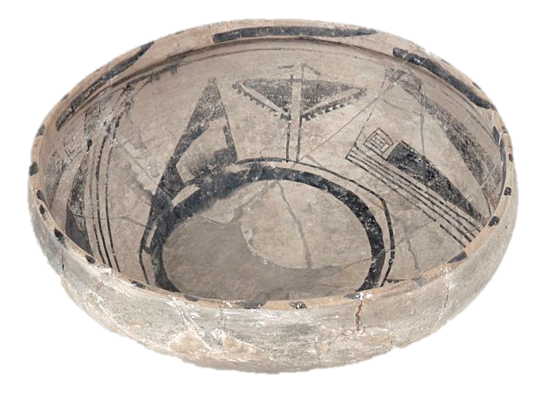 | Distinguishing Features | Only Slipped on Interior  Primarily Bowl Forms  Thick Walls that Make a Clinking Sound  Geometric Designs
(Wilson 2013, Figure 37572) | References | (Harlow 1973; Kidder and Amsden 1931; Mera 1934; Wilson 2007)
Figure 3. Type description of Abiquiú Black-on-gray.

As already mentioned, Bandelier Black-on-gray is technologically almost indistinguishable from Abiquiú Black-on-gray (Figure 4). Archaeologists date Bandelier Black-on-gray from A.D. 1400-1550 Bandelier Black-on-gray also has thick, porous, tuff tempered walls. The paste occurs in a range of colors from white to gray. A slip was applied by potters to both the interior and exteriors of the vessel and is typically thick ranging in color from white to gray, with fire clouding on the interior and exterior. Rims do become thicker, more square, and potters start to add tick marks to this thicker flat surface on the rims (Kidder and Shepard 1936). Designs are similar, following the same style of banded panels of repetitive geometric designs.

Bandelier Black-on-gray
 | Dates | A.D. 1400-1550
 | Slip | Fire Effected Gray
 | Temper and Paste | Majority Naturally Occurring Tuff
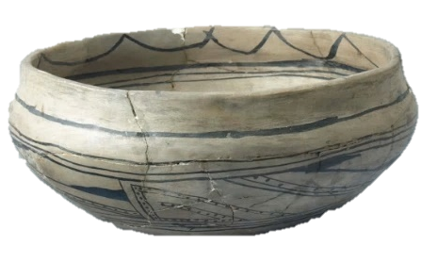 | Distinguishing Features | Slipped on Interior and Exterior  Primarily Bowl Forms  Thick Walls that Make a Clinking Sound  Thick Geometric Designs
Photo by Christina Stewart (2015) | References | (Harlow 1973; Kidder and Amsden 1931; Mera 1934; Wilson 2007)
Figure 4. Type description of Bandelier Black-on-gray.

Cuyamungue Black-on-tan is still a poorly defined and applied type since Harlow identified the type in 1973. Harlow based his identification and description off of observations made by other researchers who had seen the same trends over time in biscuitware ceramics (Kidder and Amsden 1931; Kidder and Shepard 1936; Markham 1968) (Figure 5). Archaeologists think that Cuyamungue Black-on-tan was produced between A.D. 1450-1550, but this date range needs to be further confirmed by additional work. There is a later type produced on the Pajarito Plateau, Sankawi Black-on-cream (A.D. 1500-1600), which is substantially thinner than biscuitware and has a crackled cream slip. Harlow saw Cuyamungue Black-on-tan as a transitional ware between Bandelier Black-on-gray and Sankawi Black-on-cream, or a classification for sherds that he could not place in either of the other types. The main difference he found was that Cuyamungue Black-on-tan is that rims had to be over 2.5 mm in height and have a tanner slip on the body. He differentiated Cuyamungue Black-on-tan from the concurrent Bandelier Black-on-gray, by the presence of taller rims, thinner walls, tanner slip, and poorly executed design (Harlow 1973b).
Cuyamungue Black-on-gray
 | Dates | A.D. 1450-1550
 | Slip | Fire Effected Tan
 | Temper and Paste | Naturally Occurring Tuff
 | Distinguishing Features | Slipped on Both Surfaces  Taller Rims  “Sloppy” Designs  Thinner Walls
Photo by Christina Stewart (2015) | References | (Harlow 1973; Wilson 2007)
Figure 5. Type description of Cuyamungue Black-on-tan.

Cuyamungue Black-on-tan
As I discussed in Chapter 2, though researchers have learned much in the past century, there are lingering issues of chronological control during the Late Classic and Protohistoric periods in the Lower Chama watershed. Currently, most of the research that archaeologists conduct is based on archaeological survey. In surveys, most sites are dated through typing ceramics, or from going back to previously excavated sites and using ceramic mean dating (Anschuetz 1998; Duwe 2011; Eiselt and Darling 2013). Biscuitwares are some of the key ceramics used to date Lower Chama watershed sites, by virtue of their prevalence. There are two main problems for archaeologists in the area that use biscuitware for dating sites. First, biscuitware ceramics have very wide date ranges, which makes it hard to closely date sites. Because this type remains poorly identified and unconfirmed, professional archaeologists only cautiously use it (Wilson 2007).
Not having an agreed upon Late Classic period ceramic typology in the Lower Chama watershed presents problems for researchers, especially in dating Protohistoric sites. The presence of a later period biscuitware ceramic would be helpful for archaeologists trying to date Late Classic and Protohistoric sites. This is especially true for answering my research questions about how Tewa people continued to use and live in the Lower Chama watershed after the center of Tewa population moved southward during the Late Classic period. However, it is only helpful if the type is identifiable and different from other biscuitware types. In this study, I evaluate Harlow’s observations to see if Cuyamungue Black-on-tan is identifiable and a statistically significant ceramic type, as one way to address chronological dating issues in the Lower Chama watershed.

Conclusion
Biscuitware ceramics are the predominate painted ceramics in the Lower Chama watershed. In this chapter, I reviewed the research background of ceramics in the Lower Chama watershed and explained the biscuitware typology. Ceramics are one of many ways that archaeologists try to understand the social dynamics of Tewa people during the Classic period and have helped to shape the way that archaeologists interpret cultural differences and change in the area. In this study, I clarify the Cuyamungue Black-on-tan ceramic type and affirm its utility as one way for archaeologists to better date Tewa occupation of sites in the Lower Chama watershed.

Chapter 4: Research Design
Tewa people have been producing distinctive pottery in the Northern Rio Grande for hundreds of years, and this pottery is one key tool archaeologists use to understand population movements of Tewa people in the area. In this study I aim to clarify the chronology of biscuitware ceramic typologies to allow archaeologists to better study the Late Classic period in the Lower Chama watershed. To do this, I analyzed biscuitware ceramics from the Classic period site of Sapa’owingeh. In this chapter I outline the methods I used to analyze the Sapa’owingeh collection of painted sherds. I discuss the known history of Sapa’owingeh and then I explain my sampling strategy of ceramics from the site. Finally, I expand on my attribute analysis and the use of attributes that I utilized in my analysis.

Research Question
In this study I am interested in addressing two main questions about biscuitware ceramics. First, is Harlow’s (1973) description of Cuyamungue Black-on-tan an identifiable and statistically different type than Bandelier Black-on-gray? Second, is there variation in biscuitware ceramics between types? Addressing these questions will allow archaeologists to more confidently type biscuitware ceramics and better date sites during the Late Classic period. To answer these questions, used an attribute analysis. Sapa’owingeh is an appropriate location to perform this analysis because it is the largest Classic period pueblo in the Lower Chama watershed and thus has a large collection of biscuitware sherds from previous excavations.

Sapa’owingeh
The site of Sapa’owingeh (LA 306, also known as Sapawe) is near the modern town of El Rito and overlooks El Rito creek (Figure 6). Sapa’owingeh is the largest Classic period pueblo in the Rio Chama watershed and possibly New Mexico (Beal 1987). It is a sprawling coursed adobe pueblo with 24 room blocks, seven plazas, and an estimated ten kivas (Figure 7). The differing rates of ceramic types across the site support archaeologist’s hypotheses that it was an accretional pueblo or built slowly over time rather in one planned construction epoch (Beal 1987: 126; Duwe 2011:283). As I discussed in Chapter 2, the Classic period in the Lower Chama watershed is characterized by population growth and coalescence, Sapa’owingeh is an excellent example of this process. Duwe et al. (2016) used drone technology and rubble mound volume to estimate that there were around 2,541 rooms at Sapa’owingeh during its height. Additionally, archaeologists found an expansive network of grid gardens surrounding the pueblo. Eiselt et al. (2013) and Duwe et al. (2016) identified hundreds of mulched-grid gardens that when combined, cover more than 87 kilometers of terraces surrounding Sapa’owingeh.

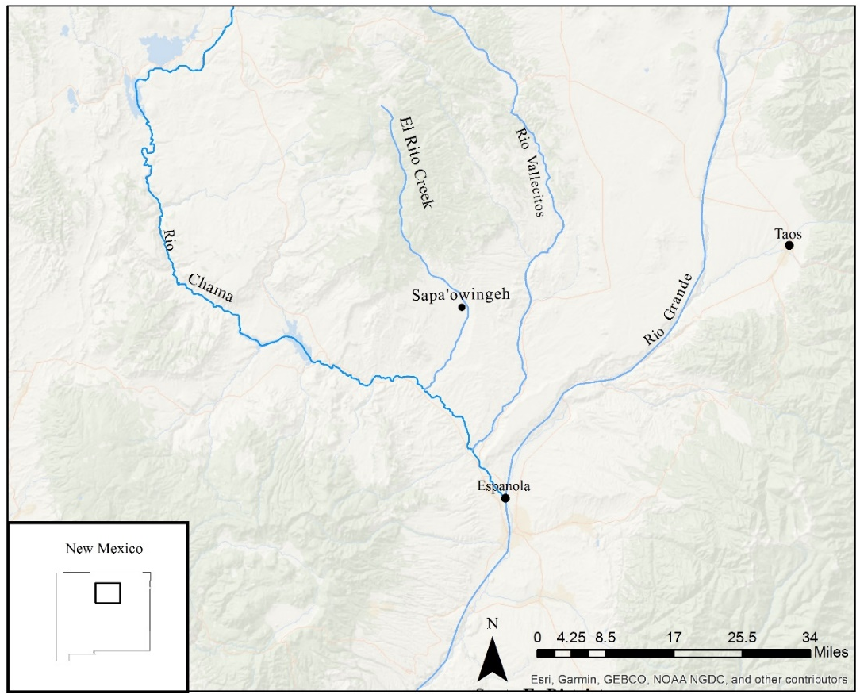
Figure 6. Map showing the location of Sapa'owingeh.

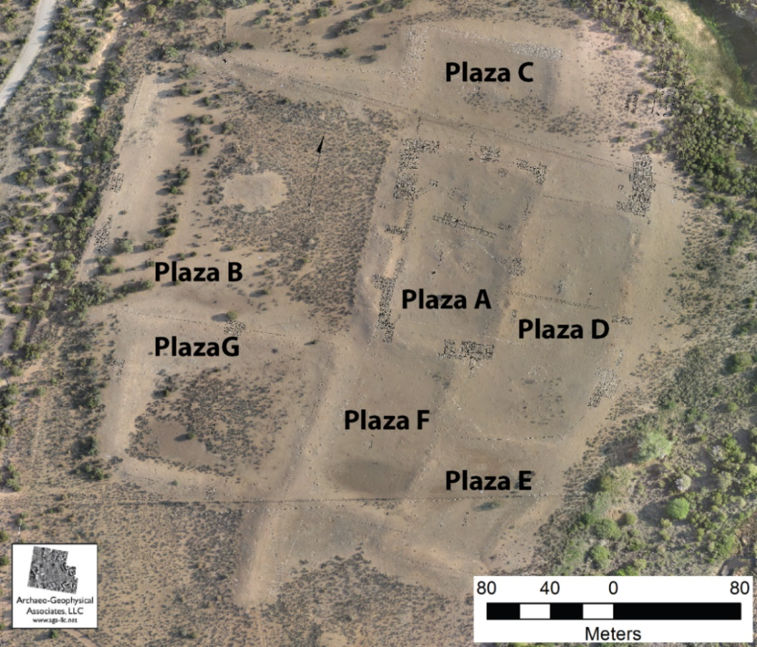
Figure 7. Aerial photo of Sapa'owingeh (Willis and Walker 2013, Figure 13).

Researchers find it hard to accurately date the occupation of Sapa’owingeh because the pueblo is so large and built over time. Beal (1987:92) argued that residents started building Sapa’owingeh in A.D. 1300 and eventually left by A.D. 1525. Based on Tree-ring dates from the University of New Mexico excavations, researchers estimate that Sapa’owingeh was occupied between A.D. 1380-1409+ based on 30 samples from four plazas (Duwe 2013). Ceramic mean dating, based on ceramic samples from each of the plazas, gives a wider date range 1383-1500+ (Duwe 2013:A4.37). Although the date that people left Sapa’owingeh is still debated what Tewa people and researchers know is that many of the residents of Sapa’owingeh moved further south and coalesced with other Tewa to create communities like Yunque’owingeh and Ohkay Owingeh.
Schroeder and Matson (1965:131-133) argue that Sapa’owingeh was likely one of the mountain villages where Tewa people took refuge when the Spanish army approached Yunque-owingeh and Ohkay Owingeh in A.D. 1541. Evidence for occupation of Sapa’owingeh into the 1600’s is sparse. As I already mentioned, the first line of evidence for historic period occupation of Sapa’owingeh is the possible presence of sheep bones. The second line of evidence for Late Classic and Historic period occupation of Sapa’owingeh comes from ceramics. Ellis’ excavations uncovered 19 Glaze F sherds. Glaze F is a southern glazeware that date between A.D. 1625-1700 (Schaafsma 2002). This find was reaffirmed by Eiselt and Darling in their reanalysis of the collection (2013:6:12).
Researchers have been interested, at last informally, in Sapa’owingeh since Adolph Bandelier’s (1892) exploration of the region during the late nineteenth century, and several early twentieth-century accounts mention the site (Hewett 1906, 1938; Mera 1934). However, it was not formally mapped until H.P. Mera’s expedition in the 1930s. The University of New Mexico field school, under the direction of Florence Hawley Ellis, excavated at Sapa’owingeh between 1963 and 1969 (Ellis 1975; Skinner 1965). More recently, in 2013 archaeologists mapped Sapa’owingeh and its surrounding grid gardens using drones (Eiselt and Darling 2013).

Ceramic Sampling
The pottery collections used in this sample are on loan from the University of New Mexico’s Maxwell Museum. The sample that I used was selected by Sunday Eiselt and Samuel Duwe for their 2013 ceramic analysis. Ellis excavated from plazas A, B, C, D, E and F and I included samples from each. I analyzed samples from 42 rooms (Table 2) and three kivas, totaling 2,519 sherds. I analyzed only decorated wares from each room. I divided my sampling by plaza because it is the most accurate locational information from the field school excavations. Unfortunately, the only known excavation map is from the second season of excavation (Figure 8). While student notes are helpful to understanding the context of rooms, plaza grouping is still the most reliable contextual information for many rooms without a map. Within the selected ceramic sample I chose from rooms with the most complete contexts. Additionally, I made sure to include all sherds that came from floor levels because they are the sherds most likely to be in context, rather than just room fill (LaMotta and Schiffer 1999). Duwe (2013:416) provides ceramic mean dates from each plaza at Sapa’owingeh which helps to show the stages that different plazas of the pueblo were built and occupied (Table 3).

Plaza F | Context | Fill | Fill | Fill | Fill | Fill | Fill
Plaza F | Room # | FN1 | FN1 | FN2 | FN4 | FN4 | FN14
Plaza E | Context | Fill | Fill | Fill | Floor | Floor | Fill | Fill | Fill | Floor | Floor | Floor | 2nd Floor
Plaza E | Room # | EE1 | EE1 | EE1 | EE2 | EE2 | EE2 | EE2 | EE2 | K6 | K6 | K6 | K6 | K6 | K6
Plaza D | Context | Fill | Floor | Fill | Fill | Fill | Fill | Fill | Fill | Fill | Fill | Fill | Fill
Plaza D | Room # | D3 | D11 | DE | DE5 | DE5 | DE9 | DE12 | DE12 | DE12E | DE14 | DN2 | DN2
Plaza C | Context | Fill | Fill | Fill | Fill | Fill | Fill | Fill | 2nd Floor
Plaza C | Room # | CW2 | CW3 | CW3 | CW4 | CW7 | CW12 | CW12 | K10
Plaza B | Context | Fill | Fill | Fill | Fill | Fill | Fill | Fill | Fill | Fill | Fill | Fill
Plaza B | Room # | BE1 | BS1 | BS3 | BS3 | BS4 | BS4 | BS4 | BS4 | BW1 | BW2 | BW27
Plaza A | Context | Fill | Fill | Fill | Fill | Fill | Fill | Fill | Fill | Fill | Fill | Fill | Fill | Fill | Fill | Fill | Fill | Fill | Fill
Plaza A | Room # | A30 | A33 | A3N | A3N | A3N | A4N | AE3 | AS13 | AS13 | AS14 | AS14 | AS14 | AS14 | AS14 | AS19 | AS19 | T1 | KA
Table 2.Table of sampling contexts.

Plaza | Early Date | Late Date | Mean Date
A | 1392 | 1500 | 1451
B | 1378 | 1500 | 1443
C | 1380 | 1500 | 1442
D | 1384 | 1500 | 1445
E | 1396 | 1545 | 1478
F | 1391 | 1500 | 1446
G | 1340 | 1600 | 1450
Table 3. Ceramic mean dates of the plazas from Sapa'owingeh based on field notes of Tewa Series ceramic types (Duwe 2013:Table A4.15).
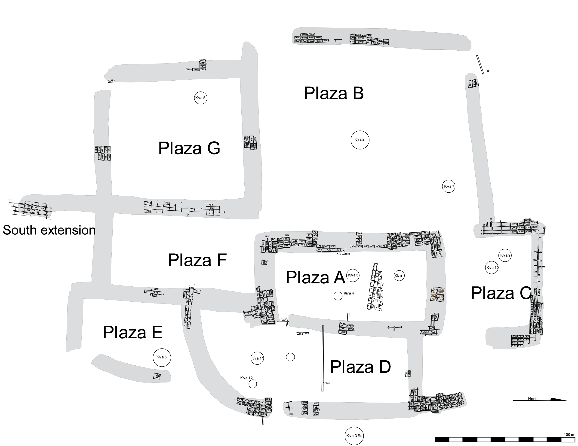
Figure 8. Excavation map of Sapa'owingeh (Original map by Tom Windes, digitized by Rachel Burger).

Attribute Analysis
In this study, I only analyzed the decorated ceramics from each context, excluding the plainwares and micaceous wares which were separated by other analysts looking at this collection (Eiselt and Darling 2013). I used an attribute analysis of both technological and design attributes to study these decorated sherds and then typed the sherds based on this attribute analysis. Attribute analysis is helpful to answer my questions about biscuitware change and typology because recording attributes of various parts of ceramics is a way to analyze either diversity or similarity in a sample (Rice 1987:320). For this analysis I recorded 16 different attributes of painted pottery (Table 4). To test Harlow’s explanation of Cuyamungue Black-on-tan I included attributes focused on changes in slip color, rim height, and sherd thickness. In analyzing biscuitware variation I included attributes that previous studies have used to show biscuitware similarity or variation (Creamer et al. 2002; Duwe 2011; Eiselt and Darling 2013; Kidder and Shepard 1936).

Attribute | Description | Citation
Form | Biscuitwares are primarily bowl forms but they were also made in jars and other forms as well | (Kidder 1915)
Slip Presence | Where slip is applied on bowls is considered diagnostic between Abiquiú and Bandelier Black-on-gray | (Kidder 1915)
Slip Quality | Biscuitwares are typically thick slipped but the presence of a crackled/crazed slip is considered diagnostic of a later type, Sankawi Black-on-cream | (Kidder and Amsden 1931)
Slip Color | Harlow argues that later in time Cuyamungue Black-on-tan slips become more tan | (Harlow 1973a)
Temper | Biscuitwares are associated with tuff temper but Shepard’s work shows that sand is also a typical temper type as well | (Kidder and Shepard 1936)
Paste Color | Like slip color, biscuitwares are typically gray | (Kidder and Shepard 1936)
Core | Despite their low firing biscuitwares do not typically have reduced firing cores | (Kidder and Shepard 1936)
Wall Thickness | Harlow argues that over time biscuitware becomes thinner | (Harlow 1973a)
Pigment | Previous studies show that biscuitwares are painted with organic pigment, but not the quality of the paint | (Kidder 1915)
Orifice Diameter | One of the hallmarks of standardization in ceramics is uniform size | (Curewitz 2008)
Rim Form | Kidder noticed that there was variation in the shape of rims | (Kidder and Shepard 1936)
Rim Width | Rim width is supposed to increase between Abiquiú Black-on-gray, and Bandelier Black-on-gray | (Kidder and Amsden 1931)
Rim Height | Harlow argued that Cuyamungue Black-on-tan are taller than other types | (Harlow 1973a)
Banding Width | Creamer argues that over time the width of the first banding line of biscuitwares increases over time | (Creamer et al. 2002)
Banding Distance | Creamer also argues that the distance of banding lines from the rim increases | (Creamer et al. 2002)
Presence of Mica in Slip | Based on an observation during this study
Table 4. Table of attributes in this study and their relevance.

Attributes Recorded for All Sherds
I recorded the size, vessel form, slip color and quality, temper, paste color, core presence, thickness, and paint pigment for each sherd. Any sherd that I could refit, I counted as one sherd. First, I size sorted each of the sherds into one of five size categories using a series of nested circles that increased by 2-cm increments. I also sorted sherds by vessel forms based on sherd shape, size, and location of slip and decoration. The categories of form I used are based on typical ceramic forms found in the Tewa culture area in both the historic and prehistoric eras and which includes bowl, jar, seed jar, plate, cup, duck pot, and indeterminate (Kidder and Amsden 1931). I recorded wall thickness in millimeters using digital calipers. I measured thickness in three different spots on the sherd and then averaged the three thicknesses.
Slip is an important part of biscuitware typologies. The presence of slip on the exterior of bowls is the main way to differentiate Abiquiú Black-on-gray from Bandelier Black-on-gray (Kidder 1915). Biscuitwares are known for their thick fire effected slip but Harlow (1973) argues that later in time biscuitware slips become tanner. Finally, Sankawi Black-on-cream which is part of the Tewa Series of ceramics and produced after Cuyamungue Black-on-tan typically have a slip with a diagnostic crackle or crazing effect. To address these observations of Tewa Series pottery I analyzed several aspects of ceramic slip. I recorded the presence of slip on the interior and exterior of sherds, the quality of the slip, and the slip color on the interior and exterior of the sherds. I also analyzed the quality of the slip, characterizing slip quality by thick, thin, crackled/crazed, or other treatments. A slip was thick if it covered the entirety of the sherd with no paste peeking through; it was thin if I could see the underlying paste; and crazed slip was identified by the diagnostic cracks in the slip. Finally, I identified slip color on both the interior and exterior of the vessel when possible. I coded for fire effected (gray), white, cream, tan, and other.
I also recorded data on temper. Temper is a aplastic material added to clay that modifies its properties when wet or dry or after firing (Rice 1987:407). Biscuitwares are associated with tuff temper but Shepard’s (1936) study of temper show that there are other tempers present especially sand and mica. To identify temper, I used a 30x magnifying loupe on a fresh break on the sherd to assess temper types. I coded for eight different kinds of temper that are typical in decorated ceramics in the Northern Rio Grande: fine tuff or ash, large tuff fragments, vitrified tuff, sand, sherd, dark igneous rock, quartz sand, and mica. Fine tuff or ash is identified by small white or gray specks in the cross-section (Shepard 1956). Large tuff fragments are identified by large white and gray fragments of vesicular stone. Vitrified tuff is tuff with reflective glass inclusions (Shepard 1956). Sand is identified by small particles of angular to rounded grains ranging from brown to gray. I identified two types of sand, dark igneous rock which is identified by its color on a scale from gray to black, and quartz sand which is lighter in color, more reflective and has a more translucent quality (Shepard 1956). Mica temper is identified by its thin round plates that are highly reflective.
Paste color and ceramic cores are helpful indicators of firing atmosphere and temperature (Kidder and Shepard 1936:341). Typically, biscuitwares despite their low firing, researchers have not often observed cores (Wilson 2007). I also assessed paste color, coding as: black, brownish-gray, gray, brownish-black, dark brown, brown, yellowish brown, light-brown, orangish-brown, reddish-brown, red, orange, white, and indeterminate. There are two main kinds of cores indicating reduced and oxidized firing atmospheres. Reduced cores are identified by a dark banding present in ceramics that were made of clay with high organic content and the conditions of firing were not such that the carbon could be completely oxidized (Rice 1987:345). In contrast, oxidized cores have a reddish-orange band that is from high levels of iron compounds that were highly fired. The presence of different firing cores in pottery is indicative of different firing atmospheres and clay contents. When people fire pottery in an atmosphere with little oxygen, it can produce cloudy dark finishes to ceramics and a firing core (Shepard 1956). Additionally, firing cores can appear when a ceramic is not fired at a high enough temperature to for all of the organic material in the clay to burn off.
Shepard’s (1936) work with biscuitware ceramics showed that biscuitwares are low fired ceramics, which is part of the reason that they make such a distinctive sound and have the name biscuitware. I recorded reduced cores, oxidized cores, banded cores, exterior reduced, interior reduced, interior oxidized, exterior oxidized, and no cores.
Finally, on decorated sherds I identified different kinds of paint. Organic and mineral paints are the most common paints in the American Southwest. Organic paints are made from plants like bee weed and produce a watery paint that creates a light gray to dark black color (Rice 1987:148). Mineral paints, on the other hand, are darker black, thicker and turn red when fired at high temperatures. In this Tewa Series of ceramics Kawahe’e Black-on-white is the last pottery to be painted with mineral paint, and all subsequent types are painted with organic paint (Wilson 2007). In this study, I coded for mineral black, dark organic black, washy organic black, and mixed paints. I differentiated washy organic paint from dark organic paint if I could see the slip under the paint.

Rim Attributes
For rim sherds, I recorded additional information about vessel shape, size, and decoration. The rim attributes that I recorded for are orifice diameter, rim shape, width of rim, inner planed rim height, banding line width, and banding line distance from rim. For sherds large enough I recorded percentage of rim present and diameter using an orifice radius chart, which consists of a sheet with concentric rings of different radii that I fit the rim curvature to. I did not record vessel diameter for sherds where less than 5% of the rim was present because there is not enough curvature present to fit the rim to the chart. I measured the width of the rim in millimeters using digital calipers and always took this measurement at the center of the rim. When recording inner planed rim height, I used digital calipers to measure the distance from the rim to the inflection point of the sherd’s rim on the interior of the sherd. Rim height is an important variable to measure because Harlow (1973) argues that Cuyamungue Black-on-tan rims become taller, typically higher than 2.3 cm.
A consistent design element in biscuitware through time is the presence of a banding line, typically below the rim, which frames the design panels on the vessel (Kidder and Amsden 1931:140). Creamer and colleague’s (2002) study of Northern Rio Grande ceramics showed that one of the few areas of variation in biscuitware ceramics is that the width and distance of banding lines changes from Abiquiú Black-on-gray to Bandelier Black-on-gray. I measured the interior and exterior distance of the banding line from the rim, and the width of the banding of both lines in millimeters using a pair of digital calipers.
Finally, I recorded the vessel rim shape using a rim chart. Kidder and Amsden (1931) recorded a range of biscuitware rim forms. They divided this range of rim styles into four main categories, plain, flaring, semi-standing, and heightened (Figure 9). I used their existing rim form divisions and drawings to create a rim form chart that I fit rims to. I only identified rim shape on rim sherds that included the inflection point where the neck meets the body of the vessel.
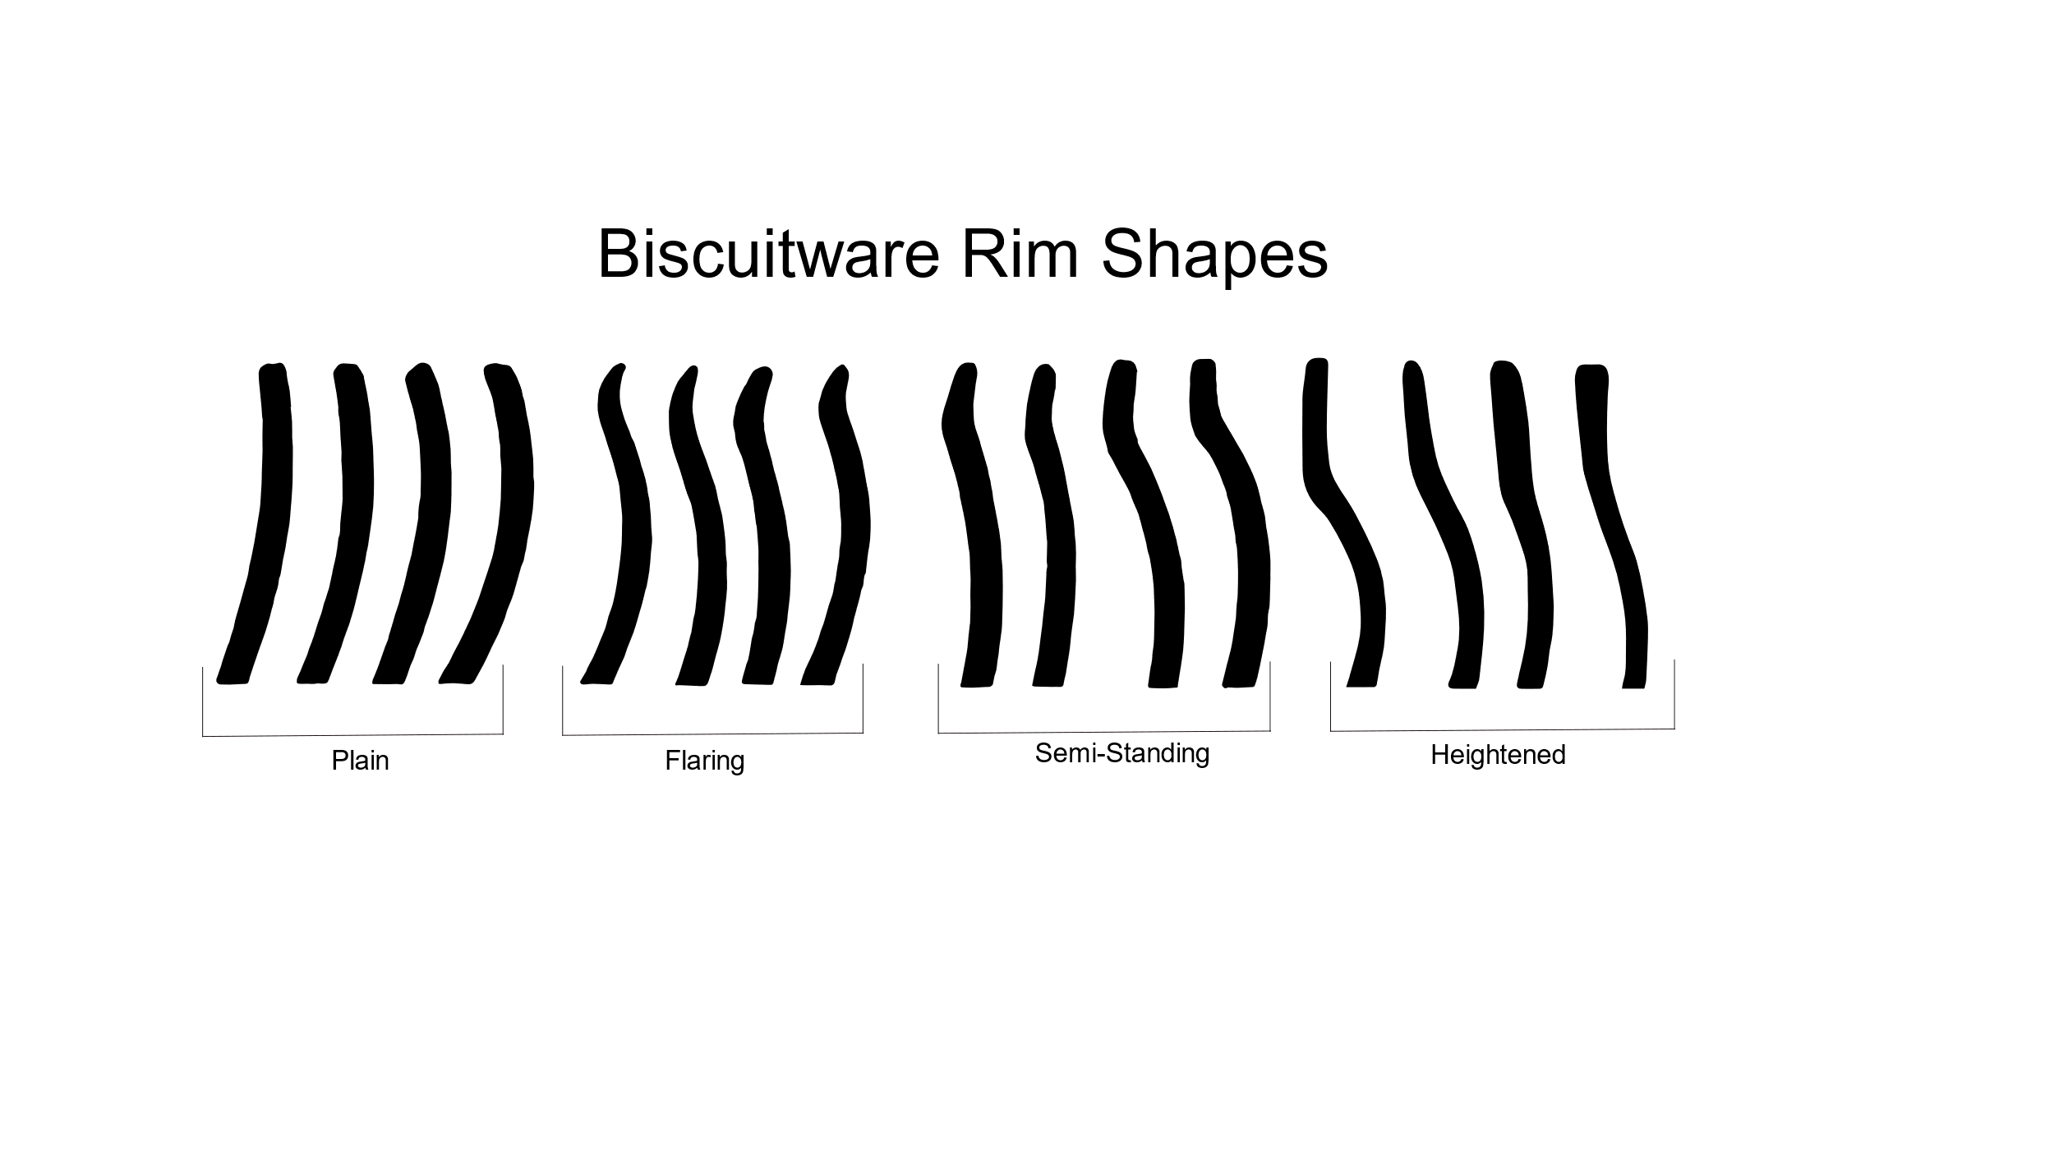
Figure 9. Biscuitware rim form chart based on Kidder and Amsden (1931).

Ceramic Typologies
After a comprehensive ceramic analysis, I typed the ceramics in the collection. This collection is mostly comprised of Classic period Tewa basin ceramics and there are very few trade wares present. No glazewares or other ceramics from outside of the Tewa Basin were included in this study because they had already been separated out from my sample. I used several type descriptions to type the ceramics in the collection (Harlow 1973; Kidder and Amsden 1931; Wilson 2007). For a more comprehensive discussion of ceramic typologies and Tewa Series types please refer to Chapter 3.

Conclusion
In this chapter I discussed the sampling from the site of Sapa’owingeh and the attribute analysis I used to address questions of variation in biscuitware ceramics over time. Biscuitwares are a distinctive part of Tewa material culture produced during the Classic period. Understanding the variation present in biscuitwares and improving the current ceramic typology will help archaeologists further investigate how Tewa people started moving south during the Late Classic period. The results from this attribute analysis will help archaeologists will further explore these problems.

Chapter 5: Results
In this chapter, I present the results of my study of biscuitware ceramics from the site of Sapa’owingeh. In this study I am interested in testing Harlow’s (1973) assertions to see if there is a statistically significant difference in Cuyamungue Black-on-tan ceramics from previous biscuitware types based on rim height, slip color, and sherd thickness. I found that there were statistically significant differences in Cuyamungue Black-on-tan ceramics. I also collected data on other attributes of biscuitware from Sapa’owingeh. I found that there was a statistically significant change in the shape of rims and firing cores over time, and that there is more variation in temper types than previously assumed. These results are important because they provide archaeologists a better way to date sites, and help show the movements of Tewa people during the Late Classic period in the Lower Chama watershed.

Analysis
During my attribute analysis, I analyzed 2,518 sherds from across the site of Sapa’owingeh. I studied only the painted wares at the site, of which 2,436 sherds were typed as biscuitware. There were small numbers of Santa Fe Black-on-white, Wiyo Black-on-white, and Sankawi Black-on-cream (Table 5). Most of the pottery forms found consisted of bowls, but there are some jars, and one duck pot sherd (Table 5).

 | Bowl | Bowl/  Jar | Duck | Jar | Unid. | Total
Abiquiú Black-on-gray | 549 | 3 | 0 | 3 | 0 | 555
Bandelier Black-on-gray | 1348 | 9 | 0 | 17 | 0 | 1374
Cuyamungue Black-on-tan | 93 | 3 | 0 | 21 | 0 | 118
Sankawi Black-on-cream | 16 | 3 | 0 | 21 | 0 | 40
Santa Fe Black-on-white | 5 | 0 | 0 | 0 | 0 | 5
Wiyo Black-on-white | 11 | 0 | 0 | 0 | 0 | 11
Unidentified Biscuitware | 86 | 59 | 1 | 204 | 0 | 350
Unidentified | 15 | 0 | 0 | 1 | 45 | 65
Table 5. Number of different kinds of pottery identified in this study.

Cuyamungue Black-on-tan
When Harlow initially described Cuyamungue Black-on-tan, he focused on changes in biscuitware slip color and rim form. He argued that Cuyamungue Black-on-tan rims were taller, the vessel walls were thinner, and the slip color became tanner. To test Harlow’s assertion, I used only typed Cuyamungue Black-on tan bowl sherds because that is what his observations were based on. Unfortunately, because I typed the sherds based on Harlow’s descriptions I do not have a completely independent statistical tests. I recorded attributes of rim height, slip color, and sherd thickness and found that there were statistically significant differences in all three categories.

Rim Height
Descriptive statistics show that there is a general trend of taller rims by type, the median rim height of biscuitware ceramics increased by at least 5 mm between each type (Table 6). I found that Abiquiu Black-on-gray had a mean rim height of 15.51 cm, Bandelier Black-on-gray a mean rim height of 20.34 cm, and Cuyamungue Black-on-tan a mean rim height of 26.05 cm. To test if there is a significant difference in rim heights between Abiquiú Black-on-gray, Bandelier Black-on-gray, and Cuyamungue Black-on-tan I used an ANOVA test. An ANOVA test compares the means of several groups to test the null hypothesis that all of the cases are from the same population (Drennan 2010:169) . For this test I used only typed biscuitware bowl rim sherds (n=196). The data for rim height was positively skewed and to normalize the data I used a log transformation. On the normalized data I was able to perform an ANOVA comparison of means and found that there is a statically significant difference between the types (p<.0001) (Figure 10). Next, I used a Tukey-Kramer HSD post-hoc test to see if all the types rim heights are different from each other. I found that each of the pairs had statistical significance (Table 7). This rejects the null hypothesis that the rim heights come from the same population of sherds. I suggest that this shows that over time, between types, biscuitware rim height increases. This reinforces Harlow’s (1973) claim that Cuyamungue Black-on-tan rims are taller than previous biscuitware types. For Cuyamungue Black-on-tan rims in this study I found that the mean rim height is 26.5 mm, while the lower quartile 22 mm, and the upper quartile is 32 mm (Table 7).
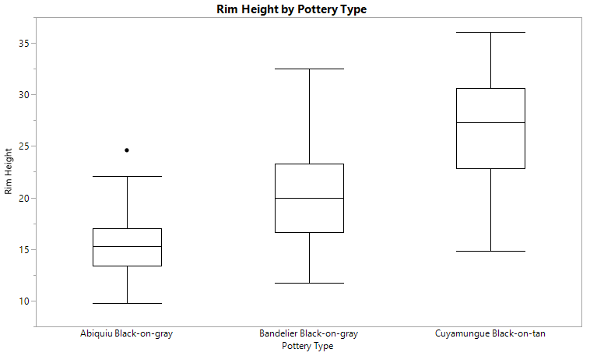
Figure 10. Box and whiskers comparison of rim height by pottery type, which shows the different means and distribution of rim heights by pottery type.

Type | Mean | Median | 25% | 75%
Abiquiú | 15.51 | 15.3 | 13.4 | 18.7
Bandelier | 20.34 | 20 | 16.68 | 25.64
Cuyamungue | 26.05 | 27.1 | 22.03 | 32.4
Table 6. Mean, median, and upper and lower percentiles of rim heights for different biscuitware types.

Comparison | P Value
Abiquiú and Bandelier | P<.0001
Abiquiú and Cuyamungue | P<.0001
Cuyamungue and Bandelier | P<.0001
Table 7. Results of the Tukey Kramer HSD post hoc test.

Slip Color
Harlow’s (1973) second observation about Cuyamungue Black-on-tan is that it had a tanner slip than previous types. To test this, I used a Chi Square analysis which compares count data between groups (Drennan 2010: 182). I coded for the color of slip during analysis and included the colors, white, tan, gray, cream, and other based on Munsell. For this analysis I used all typed biscuitware sherds (n=2,051). A Chi Square analysis comparing the different rates of slip color showed a statistically significant difference of slip color between types (p<.001). This rejects the null hypothesis that these sherds come from the same population and there is no variation in slip color. A mosaic plot of the slip colors by type (Figure 11), shows that there is a drastic increase in the proportion of tan slip on Cuyamungue Black-on-tan slips. The distribution of colors remained relatively consistent between Abiquiú Black-on-gray and Bandelier Black-on-gray.
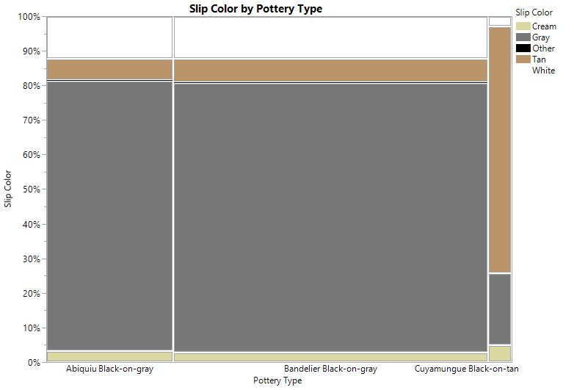
Figure 11.Mosaic plot of slip color by pottery type, which shows that Abiquiú Black-on-gray and Bandelier Black-on-gray have predominantly gray slips and Cuyamungue Black-on-tan has predominantly tan slips.

Sherd Thickness
The third attribute that Harlow (1973: 26) argued is different about Cuyamungue Black-on-tan sherds is that they have thinner walls (Figure 12). A comparison of means and medians shows that there is a small decrease in wall thickness over time (Table 8). To test this, I used a Wilcoxon Ranked Sums test, which is a non-parametric form of an ANOVA test that compares the means of different groups of continuous data. The sherd thickness data I collected was not normal and could not be transformed, which is why I used a non-parametric test. A Wilcoxen Ranked Sums test found that the differences between all three types to be statistically significant (p<.0001), which rejects the null hypothesis that these samples are from the same population. A Tukey Kramer HSD post hoc test (Table 8 and 9) showed that the difference in thickness between Abiquiú Black-on-gray and Bandelier Black-on-gray is not statistically significant (p=05). On the other hand, the difference in thickness between Cuyamungue Black-on-tan and both Abiquiú Black-on-gray and Bandelier Black-on-gray are statistically significant (p<.0001) (Table 9). I suggest that this means that Harlow’s (1973:26) argument that Cuyamungue Black-on-tan sherds are thinner is supported in this analysis.
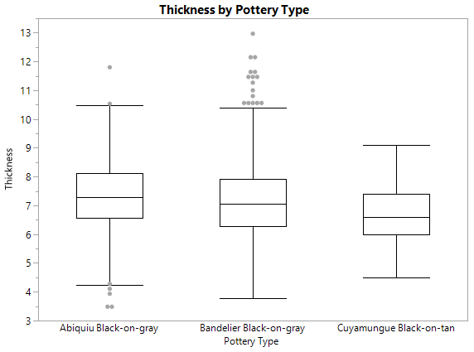
Figure 12. Box and whisker plot of sherd thickness by pottery type, which shows that Cuyamungue Black-on-tan is thinner than Abiquiú Black-on-gray and Bandelier Black-on-gray.

Type | Mean | Median | 25% | 75%
Abiquiú | 7.3 | 7.3 | 5.63 | 8.13
Bandelier | 7.16 | 7.06 | 6.2 | 7.9
Cuyamungue | 6.6 | 6.6 | 6 | 7.4
Table 8. Mean, median, and upper and lower quartiles of sherd thickness for different biscuitware types.

Comparison | P Value
Abiquiú and Bandelier | P=.05
Abiquiú and Cuyamungue | P<.0001
Cuyamungue and Bandelier | P<.0001
Table 9. P values for Tukey Kramer HSD post hoc test comparing sherd thickness.

Biscuitware Variation
In previous studies where biscuitware ceramics were studied in comparison to glazewares, very little variation was found between biscuitware ceramic types. Through my attribute analysis I found that there are four attributes that have more variation than previously acknowledged. The shape of rims changes significantly overtime, the presence of firing cores changes between types, and the presence of mica in the slip of ceramics also changes.

Rim Shape
In Pottery of Pecos (Kidder and Shepard 1936) Kidder recorded several different rim shapes for biscuitware pottery. For this test, I used only typed biscuitware bowl rims with enough rim to assess rim shape (n=284). To test this, I used a Chi Square analysis to compare the percentages of different shapes by pottery type. A Chi Square analysis found a statistically significant difference between pottery types (p<.0001), which rejects the null hypothesis that there is no variation in the shape of rims between biscuitware types. A mosaic graph of the changes in rim shape between types (Figure 13) shows that Abiquiú Black-on-gray is majority flaring and plain rim forms, while Cuyamungue Black-on-tan has many more tall and straight rims. It is important to note that the change in rim shape and the change in rim height, which I previously discussed, are related and not independent variables of each other.
With the exception of Kidder’s (1936) study, few researchers have addressed biscuitware form variation. This study shows that there is variation in the shape of biscuitware rims through the Classic period. Rim shape can be helpful for identifying ceramic types, and I argue is one of the most diagnostic parts of Cuyamungue Black-on-tan bowls. However, rims are just one way that vessel forms can change. Here I show that both Abiquiú Black-on-gray and Cuyamungue Black-on-tan have an overwhelming use of rim types rim type at Sapa’owingeh.
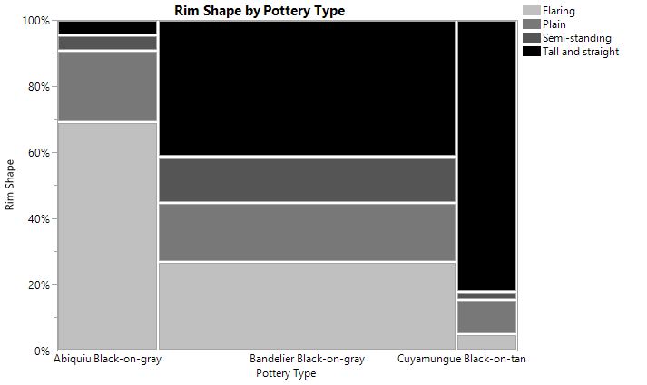
Figure 13. Mosaic chart of rim shape by pottery type showing the different percentages of rim shapes in different pottery types.

Bandelier Black-on-gray shows more variation in the range of rim shapes that potters were making. In their study of biscuitware design Graves and Eckert (1998) argued that over time the design motifs on biscuitwares became more restricted, unlike the glazeware area to the south. I argue that changing rim form shows that while biscuitware design motif became more restricted over time, biscuitware vessel forms were less restricted during most of the Classic period when Bandelier Black-on-gray is most popular. In future studies, it will be beneficial to study biscuitware whole vessels for changes in vessel form over time.

Firing Core
Cores are one way archaeologists gain insight into how pottery is fired. To investigate change in firing cores I used a Chi-Square analysis to compare different kinds of firing cores between types. A chi-square test of different firing types found that there was a statically significant difference (p<.0001). To test this information, I used information from all typed biscuitware sherds (n=2,076). To avoid low cell counts I combined the categories banded core, exterior oxidized, interior oxidized, and oxidized core into one category called Other. This shows that there was a decrease in exterior reduction between Abiquiú Black-on-gray and Cuyamungue Black-on-tan in addition to an increase in no firing cores (Figure 14).
The results from this study suggest that Tewa pottery firing practices did change over time. Abiquiú Black-on-gray, the earliest biscuitware type, has higher rates of reduced cores than both Bandelier Black-on-gray and Cuyamungue Black-on-tan. I would suggest that this means that either firing temperature or duration increase throughout the Classic period at Sapa’owingeh, or that the organic content of the clays people used changed. In future research, it would be enlightening to see if this pattern for biscuitware core reduction is present at other pueblos in the region, and if there is also any spatial patterning to differences in firing practices.
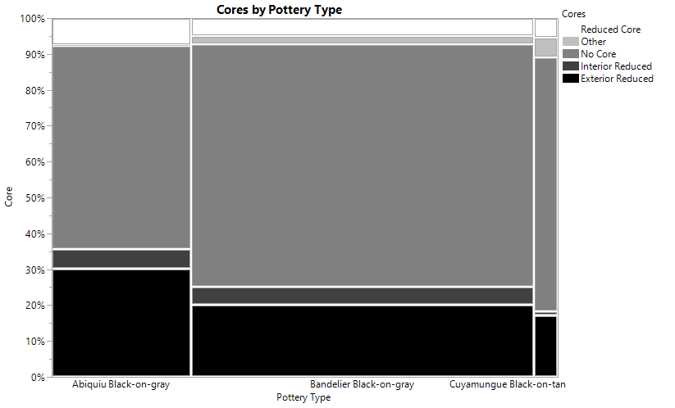
Figure 14. Mosaic plot of firing cores by pottery type showing that Abiquiú Black-on-gray has a higher percentage of cores than other types.

Mica Presence
One of the attributes that I added after starting the study was the presence of mica in the slip of ceramics. In her petrographic study of biscuitware ceramics, Anna O. Shepard did find mica in the paste of ceramics, but she did not note the presence of this in the slips of biscuitwares (Kidder and Shepard 1936). During this study, I found mica in the temper of 60% of the biscuitware ceramics in my sample (Figure 15).
There are differences, however, in the presence of mica in the slip of different types of ceramics. Using a Chi Square analysis, which tests for count differences in categorical types, I compared the percentage of presence or absence of mica in the slips of different biscuitware types. In this analysis I included all typed biscuitwares (n=2,076). I found that there is a statistically significant difference between pottery types (p<.001), which rejects the null hypothesis that presence of different firing cores remained the same in all biscuitware types. For this analysis I used Abiquiú Black-on-gray has a lower presence in the slip with mica presence than in either Bandelier Black-on-gray or Cuyamungue Black-on-tan (Figure 15). The presence of mica is important because there are mica deposits near Cerro Colorado in the Lower Chama watershed, but mica is not as prevalent in other parts of the Tewa basin.
I had not intended to record the presence of mica in slips because no other researchers have noted this in published works before. The presence of mica as temper had been noted by Shepard (1936) but not in the slips of ceramics. However, during the early stages of analysis I found a consistent enough presence of mica flakes in slip that I included it as part of my attribute analysis. Interestingly, I found that unlike mica in the temper of biscuitwares, that the presence of mica in slips decreased later in time because Abiquiú Black-on-gray had highest presence of mica presence in the slip but later in time with both Bandelier Black-on-gray and Cuyamungue Black-on-tan it was less prevalent. This is important because mica deposits are found throughout the Lower Chama watershed but not on the Pajarito Plateau, the other major area where biscuitwares were produced.
The mica I noticed in these slips could be coming from several sources. Much of the valley bottoms and terraces in the Lower Chama watershed are made from Quaternary gravel and sand deposits weathered from Precambrian and Tertiary deposits especially in the Sangre De Cristo Mountains and Tusas Mountains (Muehlberger 1960). These Precambrian volcanic and sedimentary deposits include layers of mica and other minerals. Through weathering of the Precambrian layer, mica is prevalent throughout the Lower Chama watershed in both sand and some clay deposits (Muehlberger 1960). Mica is a distinctive part of the temper and slip of Tewa plainware ceramics, which were also produced at Sapa’owingeh. I suggest that the mica in the slip of biscuitware comes from these naturally occurring deposits in either clay or from sand temper. Sapa’owingeh is closer to the mica deposits in the lower Chama watershed than other sites. Mica presence in biscuitwares may be one way to differentiate the production and exchange of biscuitwares in the Tewa Basin.
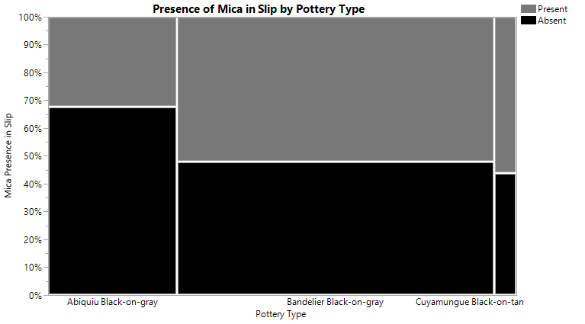
Figure 15. Mosaic plot showing the different percentages of mica in the slips of ceramics by pottery type.

Banding Lines
Creamer et al. (2002) in their study of biscuitware ceramics from across the Northern Rio Grande found that one of the only changes in biscuitware ceramics was a difference in the width of the first banding line on the exterior of vessels. Their study included samples from Sapa’owingeh, though none of those ceramics were included in this study. As part of my attribute analysis I measured the thickness of banding lines on both the interior and exterior of vessels. Using a Wilcoxen Ranked Sum test, I did not find that there were any statistically significant differences in the size of first banding lines on either the interior (p=.2) or exterior (p=.5) of biscuitware vessels.
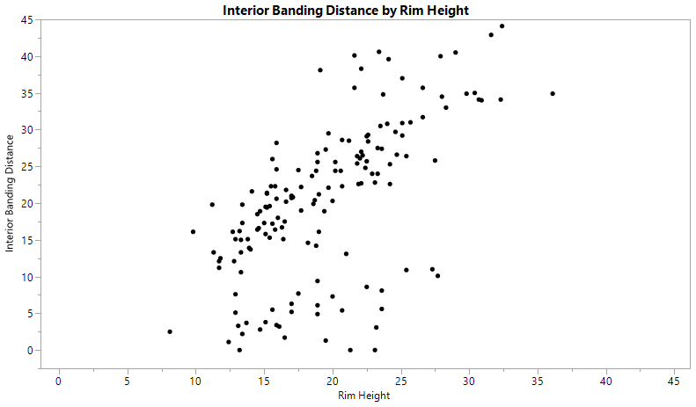
Figure 16. Plot of interior banding distance by rim height.

Although banding line width did not change there was a trend in the distance of first banding line from the rim. A correlation analysis found that there is a positive correlation between increasing rim height and interior banding distance from the rim (r=.62) (Figure 16). More interestingly there are two groups in this correlation, one which has a very strong positive correlation, and one with a lower rate of change. These two groups do not align with pottery from different types, vessel forms, or plazas. It is likely that this correlation is influenced by something I did not code for in this analysis, like decorative motif.

Continuity
Although I found differences in attributes of some biscuitwares there are other attributes that did not have statistically significant results or conclusive results. Slip quality, paste color, pigment, and temper types all had high p-values, which could not reject the null hypothesis that there was no difference between the samples (Table 10). Three tests had inconclusive results. Slip quality, paste color, and pigment all had high numbers of low cell counts, which in a Chi-square analysis casts doubt on the results (Drennan 2010) (Table 10). However, this was because each test had an overwhelming percentage of one or two attributes. Paint was primarily dark organic pigments, cores were mostly gray or brownish gray, and slip quality was typically thick.
Similarity over time is something that archaeologists associate with biscuitwares, and I also found that there are attributes that show very little change over time. As I previously mentioned with mica temper, the tempering of biscuitware ceramics consistently uses tuff, sand, and mica through time. Consistency like temper shows continuity in practice of making biscuitware ceramics through generations of Tewa potters in the Lower Chama watershed. I find it likely that there are other areas of consistency in biscuitware ceramics through time that were not addressed in this study and would be avenues for future research.

Attribute | Test | Significance Value
Orifice Diameter | Wilcoxen Ranked Sums | p=.86
Banding Width | Wilcoxen Ranked Sums | p=.17
Sand Temper | Chi-square | p=.75
Tuff Temper | Chi-square | p=.89
Mica Temper | Chi-square | p=.78
Slip Quality | Chi-square | Low Cell Counts
Paste Color | Chi-square | Low Cell Counts
Pigment | Chi-square | Low Cell Counts
Table 8. Table of statistical tests and results for different biscuitware attributes.

Conclusion
In this study I found that Harlow’s observations about Cuyamungue Black-on-tan are significantly different than Abiquiú Black-on-gray, and Bandelier Black-on-gray. Cuyamungue Black-on-tan sherds have taller rims, tanner slips, and slightly thinner walls. This means that Cuyamungue Black-on-tan likely exists as a usable type, separate from Bandelier Black-on-gray. Additionally, there was some variation between biscuitware types, the forms of rims change between types. I also found a differential rate of firing cores, and presence of mica in the slip of ceramics throughout all types. These observations are important for archaeologists as they try to reconstruct chronological variation in ceramics of the Northern Rio Grande and for future studies of temporal and spatial change of biscuitware ceramics.

Chapter 6: Discussion and Conclusion
During the Late Classic period, many, but not all, Tewa people moved south to the Rio Grande. However, archaeologists still do not understand why the Tewa the south. Locally produced biscuitware ceramics are one tool archaeologists use to explore the social dynamics of how people lived in and left the Lower Chama watershed. In this study, I address two issues with the biscuitware chronology: the presence of a possible third and later biscuitware pottery type, Cuyamungue Black-on-tan, and the presumed homogeneity of biscuitware pottery types. I argue that Cuyamungue Black-on-tan is a useful and identifiable type and that there is variation in the rim shapes, firing cores, and mica use across biscuitware types.

Cuyamungue Black-on-tan
In 1973, Harlow described a new biscuitware ceramic type called Cuyamungue Black-on-tan and argued that there was a change in biscuitware ceramics later in time to have taller rims, tanner slips, and thinner walls. In this study, I tested Harlow’s type description of Cuyamungue Black-on-tan and found that it was both an identifiable type and that there is a statistically significant difference between Cuyamungue Black-on-tan sherds from previous biscuitware types. Using the results, I expand on Harlow’s description of Cuyamungue Black-on-tan and explain the significance of these differences in biscuitware ceramics.
I found that most diagnostic part of Cuyamungue Black-on-tan sherds is the rim shape and height. The shape of Cuyamungue Black-on-tan rims’ is what Kidder (Kidder 1936) would call a “tall heightened rim”, which has a tall straight rim with a slight lip at the top. The rims are also taller than previous types. I found that the inner planed rim height of Cuyamungue Black on tan types is typically between 22 mm and 30 mm tall, though some may exceed this measurement. Based on this study, I would recommend that only rim sherds or whole vessels should be identified as Cuyamungue Black-on-tan. Although there are other attributes of Cuyamungue Black-on-tan that can be found on body sherds, rim sherds have enough different variables present including rim shape and rim height, that it is more secure to type.
Cuyamungue Black-on-tan sherds are, as the name suggests, tanner than both Bandelier Black-on-gray or Abiquiu Black-on-gray. I would define this tan color in the range of 10YR 7/4 on the Munsell Color Scale (Munsell 1976). Although the slip color is tan, Cuyamungue Black-on-tan still has a presence of gray fire clouds on vessels, which can change the color of the slip to a grayer shade on some sections of the vessel. Occasionally, the tan slip does not start at the rim of vessels, but rather at the shoulder of the vessel. Both fire clouds and location of slip make it hard to identify Cuyamungue Black-on-tan ceramics by slip alone because both can change the perception of color of the slip on a sherd. Tan slip is an important component to identifying Cuyamungue Black-on-tan sherds, but it is not the most defining feature of this ceramic type.
Generally, Cuyamungue Black-on-tan sherds are thinner than previous biscuitware types. The average thickness of Cuyamungue Black-on-tan sherds is 6.6mm. However, the average thickness of Bandelier Black-on-gray is 7.2mm and Abiquiú Black-on-gray is 7.4mm. Although the average thickness of Cuyamungue Black-on-tan is thinner, the difference between the averages are not that far apart. Additionally, handmade ceramics have variation of thickness within one vessel, making thickness alone a poor attribute to distinguish between biscuitware types.
Although I found differences in Cuyamungue Black-on-tan from other biscuitware types, there are still many similarities in attributes present. Cuyamungue Black-on-tan is primarily tuff tempered but can also include other materials. I also recorded consistent use of sand temper, as an addition to tuff, in biscuitwares from Sapa’owingeh, as well as small reflective pieces of mica. Sherds still make a diagnostic clinking sound that is a product of being a low fired ceramic. Bowls are slipped on both the interior and exterior, and painted on both surfaces with thick slips with no crazing. They were constantly painted with dark organic paints and feature similar geometric designs as Bandelier Black-on-gray and Abiquiú Black-on-gray.

Variation
The second implication of my findings is that there are attributes that change over time in biscuitware pottery. Archaeological research on biscuitware in the last few decades has focused more on the continuities in biscuitware over time (Creamer et al. 2002) and standardization (Curewitz and Foit 2018; Curewitz 2008; Hagstrum 1985). In chapter three I discussed how this research emphasized the homogeneity between biscuitware types, based on comparisons of glazewares to the south. Rather in this study I focused just on the changes in biscuitwares themselves and found that there are statistically significant changes in firing cores, mica presence, and rim form over time. Changing attributes of technology and form can be important lines of evidence for studying communities of practice and other ceramic production (Crown 1994; Duff 2002; Eckert 2008; Huntley 2008) that will allow archaeologists use biscuitware ceramics in studies beyond chronological reference.

Continuity
Although I did find variation in several attributes of biscuitware pottery over time, I still found many areas of continuity between biscuitware types. Temper materials, paint type, slip quality, paste color, and banding line width all did not have statistically significantly differences between ceramic types. Ceramic research tends to focus on change, typologies are based on the idea of change, and differences through time and space help archaeologists understand changes in population dynamics and ceramic production. However, continuity over time can have equally important implications for how archaeologists interpret the archaeological record. This study reaffirms that there are many similarities between biscuitware types throughout the Classic period in the Lower Chama watershed.
Future Directions
Moving forward, this study will help more archaeologists to use this type and contribute to a refined chronological control in the Lower Chama watershed’s Late Classic period. However, this study only analyzed biscuitware from one site in the region, in future research it would be helpful to incorporate collections from across the Northern Rio Grande for a comparative study. Further, this study does not address Cuyamungue Black-on-tan’s temporal span. More studies need to address the problems with chronological control over the biscuitware typology, which Ramenofsky and Feathers call for in their 2002 article. I would suggest that there is a good possibility that Cuyamungue Black-on-tan’s production may extend later than the proposed A.D. 1550 based on the reported presence of biscuitwares at the site of Te’ewi’owingeh (Wendorf 1953:48-53) which was occupied into the Historic period. However, this is a hypothesis that requires further research.
Additionally, I found that there are significant changes in some aspects of biscuitware over time. Moving forward it will be necessary to explore this temporal change in production and style with a larger sample size that has better context. Several of the areas of variation, from firing to vessel form warrant follow up to see if this is a change only happening at Sapa’owingeh or if it is seen outside of this one pueblo. Additionally, there are several areas of attributes that this study did not cover. I focused solely on analysis of sherds, excluding whole vessels which could be an important source of information on vessel form. Finally, I did not address any aspects of decorative styles and motifs of design. These topics warrant further research by archaeologists in the Northern Rio Grande.

Conclusion
Recently researchers have started to question the typical archaeological narrative of the Lower Chama watershed’s Classic period: that between 1500 and 1598 the region went from one of the centers of Tewa population to completely abandoned (Wendorf and Reed 1955; Ramenofsky and Feathers 2002). With the aid of historic Spanish documents, it is becoming clearer that at least some Tewa people were living in the area until at least the early seventeenth century (Hammond and Rey 1953; Wozniak 1992). However, the lack of chronological clarity of when Tewa people started moving south also obscures the reason for their move to the south. There are several plausible reasons that Tewa people may have started moving south that align with temporally significant events like climatic instability during the Late Classic (A.D. 1500-1598) (Towner and Salzer 2013), or the Athapaskan raiding (Hammond and Rey 1953:1059), or Spanish colonial pressures of population concentration (Wozniak 1992:51). Without understanding when and why the Tewa started to move from the Classic period pueblos in the Chama, archaeologists have trouble contextualizing the continued deep connections that Tewa people have with the Lower Chama watershed.
In this study I do not solve the issue of when and why Tewa people started moving from the Lower Chama watershed. However, I do illuminate a tool for archaeologists to start better dating sites during the Late Classic period that will make it more feasible to answer these questions. Cuyamungue Black-on-tan and other biscuitwares are a helpful artifact type for researchers to date sites in the Northern Rio Grande, as well as an opportunity to explore ways in which Tewa potters changed their production of ceramics through the dynamic Classic period.
The Late Classic and Historic periods were dramatic times of change for the Tewa and the Pueblo world. They were times of population movement, foreign contact, and forced colonization by the Spanish. Through change and movement, the Pueblo world persisted in ways that are important for researchers to understand as they try to conceptualize the dynamic connections of Pueblo people to their past.

References

Anschuetz, Kurt F.
1998 Not Waiting for the Rain: Integrated Systems of Water Management by Pre-Columbian Pueblo Farmers in North-Central New Mexico. Unpublished Ph.D. dissertation, Department of Anthropology. University of Michigan, Ann Arbor.

Bailey, Vernon
1913 Life Zones and Crop Zones of New Mexico. In North American Fauna Bulletin 35. U.S. Government Printing Office, Washington D.C.

Bandelier, Adolph
1892 Final Report of Investigations Among the Indians of the Southwestern United States, Carried on Mainly in the Years from 1880 to 1885. Papers of the Archaeological Institute of America, American Series IV (Pt II). John Wilson and Sons, Cambridge.

Barrett, Elinor M.
2000 The Geography of the Rio Grande Pueblos in the Seventeenth Century. Ethnohistory 49(1):123-169.

Beal, John D
1987 Foundation of the Rio Grande Classic: The Lower Chama River, A.D. 1300-1500. Report Submitted to the Office of Cultural Affairs, Historic Preservation Division, by Southwest Archaeological Consultants, Inc., Albuquerque.

Boyer, Jeffrey L., James L. Moore, Steven A. Lakatos, Nancy J. Akins, C. Dean Wilson, and Erick Bilnman
1998 Remodeling Immigration: A Northern Rio Grande Perspective on Depopulation Migration, and Donation-Side Models. In Leaving Mesa Verde: Peril and Change in the Thirteenth-Century Southwest, edited by Timothy A. Kohler, Mark D. Varien, and Aaron M. Wright, pp. 285-322. University of Arizona Press, Tucson Arizona.

Chilton, Elizabeth S.
1999 One Size Fits All: Typology and Alternatives for Ceramic Research. In Material Meanings: Critical Approaches to the Interpretation of Material Culture. Edited by Elizabeth S. Chilton pp. 44-61. University of Utah Press, Salt Lake City.

Creamer, Winifred, David Burdick, Patricia Hamlen, Jonathan Hass, Lisa Renken, Aaron Wenzel, and Kit Nelson
2002 Ceramic Analysis of Intra- and Intersite Occupation at Protohistoric
Pueblos in the Northern Rio Grande. In Traditions, Transitions, and Technologies: Themes in Southwestern Archaeology. Proceedings of the 2000 Southwest Symposium, edited by Sarah H. Schlanger, pp. 58-70. University of Colorado Press, Boulder.

Crown, P.L.
1994 Ceramics and Ideology: Salado Polychrome Pottery. University of New Mexico Press, Albuquerque.

Curewitz, Diane
2008 Changes in Northern Rio Grande Ceramic Production and Exchange, Late Coalition Through Classic (A.D. 1250-1600). Unpublished Ph.D. dissertation, Department of Anthropology. Washington State University, Pullman.

Curewitz, Diane C. and Franklin F. Foit
2018 Shards in Sherds: Identifying Production Locations and Exchange Patterns using Electron Microprobe Analysis of Volcanic Ash Temper in Northern Rio Grande Biscuit Ware. Journal of Archaeological Science: Reports 18: 487-498.

Drennan, Robert D.
2010 Statistics for Archaeologists: A Common Sense Approach. Springer, United States.

Duff, A.I.,
1999 Regional Interaction and the Transformation of Western Pueblo Identity, A.D. 1275e1400. Ph.D. Dissertation. Department of Anthropology, Arizona State University, Tempe.

Duwe, Samuel
2011 The Prehispanic Tewa World: Space, Time and Becoming in the Pueblo Southwest. University of Arizona.
2013 Appendix 3. In Population History, Agricultural Land Use and Cultural Continuity in the Ohkay Owingeh Homeland, Rio Chama Watershed. Southwest Heritage Research, LLC, Dallas.
2017 Re-excavation of Palisade Ruin (LA 3505):2016 University of Oklahoma Archaeological Field School at Abiquiu Lake Recreation Area, Rio Arriba County, New Mexico. Albuquerque, New Mexico.

Duwe, Samuel G. and Kurt Anschuetz
2013 Ecological Uncertainty and Organizational Flexibility on the Prehispanic Tewa Landscape. In From Mountaintop to Valley Bottom: Understanding Past Land Use in the Northern Rio Grande Valley, New Mexico, edited by Bradley Vierra pp. 95-112. University of Utah Press, Salt Lake City, Utah.

Duwe, Samuel, Sunday Eiselt, Andrew Darling, Mark D Willis, and Chester Walker
2016 The Pueblo Decomposition Model: A Method for Quantifying Architectural Rubble to Estimate Population Size. Journal of Archaeological Science. Vol. 65 pp. 20-31.

Duwe, Samuel and Patrick Cruz
in press Tewa Origins and Middle Places. In The Continuous Path: Pueblo Movement and Archaeology of Becoming, edited by Samuel Duwe and Robert W. Preucel. University of Arizona Press, Tucson.

East, Nicole
2014 Clay Mineralogy Variation in Classic Period Biscuit Ware Ceramics. Masters Thesis. Eastern New Mexico University.

Eckert, S.L.
2008 Pottery and Practice: the Expression of Identity at Pottery Mound and Hummingbird Pueblo. University of New Mexico Press, Albuquerque.

Eggan, Fred
1950 Social Organization of the Western Pueblos. University of Chicago Publications in Anthropology. University of Chicago Press, Chicago.

Eiselt, Sunday and Andrew Darling
2013 Population History, Agricultural Land Use and Cultural Continuity in the Ohkay Owingeh Homeland, Rio Chama Watershed. Southwest Heritage Research, LLC, Dallas.

Ellis, Florence Hawley
1950 Big Kivas, Little Kivas, and Moiety Houses in Historical Reconstruction. Southwestern Journal of Anthropology 6:286-302
1975 Highway to the Past: The Valleys of the Rio Chama and Rio Gallina. New Mexico Magazine 53(5): 18-40.

Futrell, Mary E
1998 Social Boundaries and Interaction: Ceramic Zones in the Northern Rio Grande Pueblo IV Period. In Migration and Reorganization: the Pueblo IV Period in the American Southwest, edited by Katherine Speilmann. Arizona State University Anthropological Research Papers No. 51. Tempe.

Graves, William M., and Suzanne L. Eckert
1998 Decorated Ceramic Distribution and Ideological Developments in the Northern Central Rio Grande Valley, New Mexico. In Migration and Reorganization: the Pueblo IV Period in the American Southwest, pp. 263-283. Arizona State University, Tempe.

Habicht-Mauche, J.A.
1993 The Pottery from Arroyo Hondo Pueblo, New Mexico: Tribalization and Trade in the Northern Rio Grande. School for Advanced Research Press, Santa Fe, New Mexico.

Hagstrum, Melissa B
1985 Measuring Prehistoric Ceramic Craft Specialization: A Test Case in the American Southwest. Journal of Field Archaeology 12(1): 65-75.

Hammond, George P, and Agapito Rey
1953 Don Juan De Onate, Colonizer of New Mexico, 1595-1628. Coronado Cuarto Centennial Publications, vols. V and VI. University of New Mexico Press, Albuquerque.
1966 The Rediscovery of New Mexico, 1580-1594. Coronado Historical Series Vol. 3. University of New Mexico Press, Albuquerque.

Harlow, Francis H
1973 Matte-Paint Pottery of the Tewa, Keres and Zuni Pueblos. Museum of New Mexico, Santa Fe.

Harrington, John Peabody
1916 The Ethnogeography of the Tewa Indians. In 29th Annual Report of the Bureau of American Ethnology for the Years 1907-1908. Government Printing Office, Washington, D.C.

Hewett, Edgar L.
1906 Antiquities of the Jemez Plateau, New Mexico. Bulletin No. 32. Smithsonian Institution, Washington, D.C.

Huntley, D.L.
2008 Ancestral Zuni Glaze-decorated Pottery: Viewing Pueblo IV Regional Organization through Ceramic Production and Exchange. The University of Arizona Press, Tucson

Hibben, Frank C.
1937 Excavation of the Riana Ruin and Chama Valley Survey, Anthropological Series Bulletin 300. University of New Mexico Press, Albuquerque.

Jeanҫon, J.A.
1912 Ruins at Pesedeuinge. Records of the Past 11:28-37
1923 Excavations in the Chama Valley, New Mexico. Bulletin 81. Bureau of American Ethnology, Washington, D.C.

Kidder, Alfred V.
1915 Pottery of the Pajarito Plateau and Some Adjacent Regions in New Mexico. Memoirs of the American Anthropology Association 6.Washington D.C.

Kidder Alfred V. and Charles A. Amsden
1931 The Pottery of Pecos Volume 1, The Dull-Paint Wares. Yale University Press, New Haven.

Kidder, Alfred V, and Anna O. Shepard
1936 Pottery of Pecos, Volume II. Yale University Press, New Haven.

LaMotta, Vincent M. and Michael B. Schiffer
1999 Formation Process of House Floor Assemblages. In The Archaeology of Household Activities, edited by Penelope Mary Allison, pp. 19-29. Routledge, London.

Lightfoot, Kent and William S. Simmons.
1998 Culture Contact in Protohistoric California: Social Contexts of Native and European Encounters. Journal of California and Great Basin Anthropology 20(2):138-170.

Markham, Janet
1968 The Whole and Restorable Pottery Vessels from Sapawe. University of New Mexico, Albuquerque New Mexico

Mera, H.P.
1934 The Survey of the Biscuit Ware Area in Northern New Mexico. Technical Series No. 6. Laboratory of Anthropology, Santa Fe, New Mexico.
1935 Ceramic Clues to the Prehistory of North Central New Mexico.
Technical Series No. 8. Laboratory of Anthropology, Santa Fe, New Mexico.

Muehlberger, William R.
1960 Precambrian Rocks of the Tusas Mountains, Rio Arriba County, New Mexico. New Mexico Geological Society, Guidebook to the Rio Chama County, 11th Field Conference, pp. 45-47.

Munsell
1976 Munsell Book of Color: Matte Finish Collection. Munsell Color: Macbeth Division of Kollmorgen corporation, Baltimore.

Olesen, Nancy H.
2004 Rock Art on the Pajarito Plateau. In Archaeology of Bandelier National Monument: Village Formation on the Pajarito Plateau, New Mexico, edited by Timothy A. Kohler, pp.265-292. University of New Mexico Press, Albuquerque.

Orcutt, Janet D
1991 Environmental Variability and Settlement Changes on the Pajarito Plateau, New Mexico. American Antiquity 56(2):315-332.

Ortiz, Alfonso
1969 The Tewa World: Space, Time, Being, and Becoming in a Pueblo Society. University of Chicago Press, Chicago.

Ortman, Scott G.
2010 Evidence of a Mesa Verde Homeland for the Tewa Pueblos. In Leaving Mesa Verde: Peril and Change in the Thirteenth-Century Southwest, edited by Timothy A. Kohler, Mark D. Varien, and Aaron M. Wright, pp. 222-261.University of Arizona Press Tucson, Arizona.
2012 Winds from the North: Tewa Origins and Historical Anthropology. University of Utah Press, Salt Lake City.
2014 Uniform Probability Density Analysis and Population History in the Northern Rio Grande. Journal of Archaeological Method and Theory 23(1): 95-126.

Parsons, Elsie Worthington Clews
1929 The Social Organization of the Tewa of New Mexico. The American
Anthropological Association, Menasha, Wis.

Post, Stephen
2013 Transitional Archaic and Emergent Agricultural Settlement in the Lowland-Upland Settings of the Northern Rio Grande, New Mexico. In From Mountaintop to Valley Bottom: Understanding Past Land use in the Northern Rio Grande Valley, New Mexico. Edited by Bradley J. Vierra pp. 81-95. The University of Utah Press, Salt Lake City.

Ramenofsky, Ann F
1988 Vectors of Death: The Archaeology of European Contact. University of New Mexico, Albuquerque.

Ramenofsky, Ann F. and James K Feathers
2002 Documents, Ceramics, Tree Rings, and Luminescence: Estimating Final Native Abandonment of the Lower Chama. Journal of Anthropological Research 58(1):121-159.

Rice, Prudence M.
1987 Pottery Analysis: A Source Book. 2nd ed. University of Chicago Press, Chicago.

Schaafsma, Curtis F.
2002 Apaches de Navajo. Seventeenth-Century Navajos in the Chama Valley of New Mexico. University of Utah Press, Salt Lake City.

Schillaci, Michael A. and Steven A. Lakatos
2016 Refiguring Population History of the Tewa Basin. Kiva 82(4):121-151.

Schleher, Kari L.
2010 The Role of Standardization in the Specialization of Ceramic Production San Marcos Pueblo, New Mexico. University of New Mexico, Albuquerque New Mexico.

Schroder, Albert H.
2010 Pueblos Abandoned in Historic Times. In Handbook of North American
Indians, vol. 9, Southwest, edited by Alfonso Ortiz, pp. 236-254 Smithsonian Institution, Washington, D.C.

Schroder, Albert H, and Dan S. Matson
1965 A Colony on the Move: Gaspar Castano de Sosa’s Journal, 1590-1680. University of New Mexico Press, Albuquerque.

Shepard, Ana Osler
1956 Ceramics for the Archaeologist. Carnegie Institution of Washington, Washington.

Skinner, S. Alan
1965 A Survey of Field Houses at Sapawe, North Central New Mexico. Southwestern Lore: 18-24.

Towner, Ronald H. and Mathew W. Salzer
2013 From Montana. In From Mountaintop to Valley Bottom: Understanding Past Land Use in the Northern Rio Grande Valley, New Mexico, edited by Bradley J. Vierra, pp. 54-68. University of Utah Press, Salt Lake City.

Wendorf, Fred and Erick Reed
1955 Alternative Reconstruction of Northern Rio Grande Prehistory. El Palacio 62: 131-165.

Wilcox, David
1991 Changing Contexts of Pueblo Adaptations, A.D. 1250-1600. In Farmers, Hunters, and Spaniards: Interaction between the Southwest and Plains, edited by Katherine A. Spielmann, pp.128-154. Tucson: University of Arizona Press.

Willis, Mark D. and Chester Walker
2013 Low Altitude Aerial Investigation at sites LA274, LA297, LA306, LA71, LA380, and LA252. In Population History Agricultural Land Use and Cultural Continuity in the Ohkay Owingeh Homeland, Rio Chama Watershed. Southwest Heritage Research, LLC, Dallas.

Wilson, Dean C
2013 Abiquiu Biscuit A) Black-on-white. Office of Archaeological Studies Pottery Typology Project.

Wilson, Gordon P.
2007 Easy Field Guide to Tewa Ceramics. Technical Series, Bulletin no. 14. Laboratory of Anthropology Publications, Santa Fe New Mexico.

Woziniak, Frank E.
1992 Ethnohistory of the Abiquiu Reservoir Area. In History and Ethnohistory Along the Rio Chama, edited by Frank J. Wozniak, Mead F. Kemrer, and Charles M. Carrillo, pp. 1-49. U.S. Army Corps of Engineers, Albuquerque District, Albuquerque, New Mexico.

Yarrow, H.C.
1879 Notice of a Ruined Pueblo and an Ancient Burial-Place in the Valley of the Rio Chama. In Report upon United States Geographical Surveys West of the One Hundredth Meridian-Under the Direction of George M. Wheeler, Vol. 8. Washington D.C.

Appendix A: Attribute Analysis
Biscuitware Ceramic Analysis
Catalog #
Bag#
Room
Level
Floor?
Variable | Code | Value
Pottery Type | 1 | UNID Biscuit
 | 2 | Abiquiu B/g
 | 3 | Bandelier B/g
 | 4 | Cuyemungue B/t
 | 5 | Sankawi B/c
 | 6 | Santa Fe B/w
 | 7 | Wiyo B/w
 | 8 | Other (explain)
 | 99 | Indt.

Basic Attributes
Form
Variable | Code | Value
Form | 1 | Jar
 | 2 | Bowl
 | 3 | Jar/Bowl
 | 4 | Seed Jar
 | 5 | Plate
 | 6 | Cup
 | 7 | Duck
 | 99 | Indt.

Vessel Part
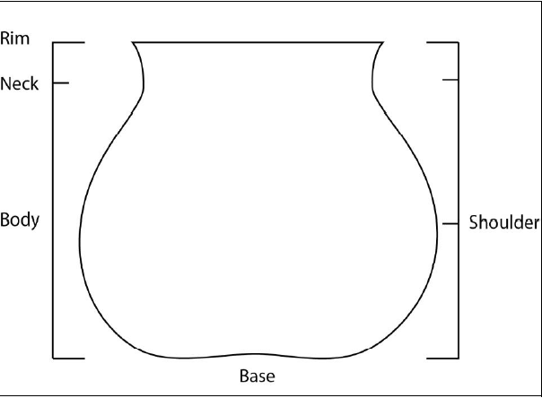

Variable | Code | Value
Vessel Part | 0 | Indeterminate.
 | 1 | Rim only
 | 2 | Rim and some neck
 | 3 | Rim neck and shoulder
 | 4 | Body
 | 5 | Base
 | 6 | Body and some base
 | 7 | Other

Size Class
Variable | Code | Value
Size classification | 1 | <4 cm
 | 2 | 4<6 cm
 | 3 | 6<8
 | 4 | 8<10
 | 5 | >10

Slip
Variable | Code | Value
Slip Exterior | 1 | Present
 | 2 | Absent
 | 99 | Indt

Variable | Code | Value
Slip Interior | 1 | Present
 | 2 | Absent
 | 99 | Indt

Variable | Code | Value
Slip Quality | 1 | Thick
 | 2 | Thin
 | 3 | Crackled/Crazed
 | 4 | Other
 | 99 | Indt.

Variable | Code | Value
Slip Color Interior | 1 | Fire effected (gray)
 | 2 | White
 | 3 | Cream
 | 4 | Tan
 | 5 | Other
 | 99 | Indt.

Variable | Code | Value
Slip Color Exterior | 1 | Fire effected (gray)
 | 2 | White
 | 3 | Cream
 | 4 | Tan
 | 5 | Other
 | 99 | Indt.

Temper
Variable | Code | Value
Temper | 1 | Fine tuff or ash
 | 2 | Large tuff fragments
 | 3 | Vitrified tuff
 | 4 | Sand
 | 5 | Sherd
 | 6 | Dark igneous
 | 7 | Quartz sand
 | 8 | Mica
 | 99 | Indt.

Paste
Variable | Code | Value
Paste Color | 1 | Black
 | 2 | Brownish-gray
 | 3 | Gray
 | 4 | Brownish-black
 | 5 | Dark brown
 | 6 | Brown
 | 7 | Yellowish-brown
 | 8 | Light-brown
 | 9 | Orangish-brown
 | 10 | Reddish-brown
 | 11 | Red
 | 12 | Orange
 | 13 | White
 | 99 | Indt.

Core
Variable | Code | Value
Core | 0 | No core
 | 1 | Reduced core
 | 2 | Oxidized core
 | 3 | Banded core
 | 4 | Exterior reduced
 | 5 | Interior reduced
 | 6 | Interior oxidized
 | 7 | Exterior oxidized
 | 99 | Indt.

Wall Thickness
Variable | Code | Value
Wall thickness | - | Continuous
 | 0 | N/A
 | 99 | Indt.

Pigment
Variable | Code | Value
Pigment | 0 | None
 | 1 | Mineral black
 | 2 | Dark organic black
 | 3 | Washy organic black
 | 4 | Mixed
 | 5 | Other
 | 99 | Indt.

Design Present
Variable | Code | Value
Design Present | 1 | Present
 | 0 | Not present

Mica Present Slip?
Variable | Code | Value
Mica Present | 1 | Present
 | 0 | Not present

Rim
Orifice Diameter
Variable | Code | Value
Orifice Diameter | - | Continuous
 | 99 | Indeterminate

Rim Shape
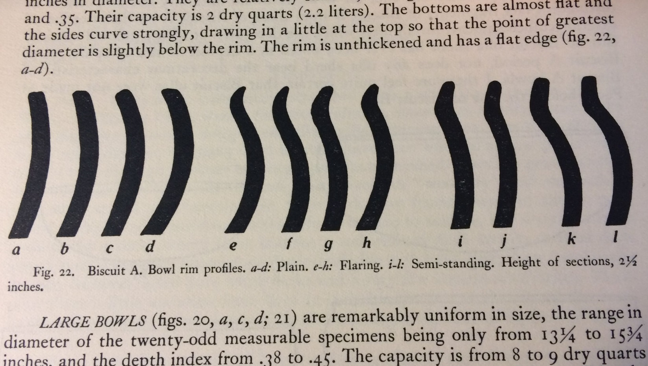
Rim Shape 1

Rim Shape 2

Rim Shape 3
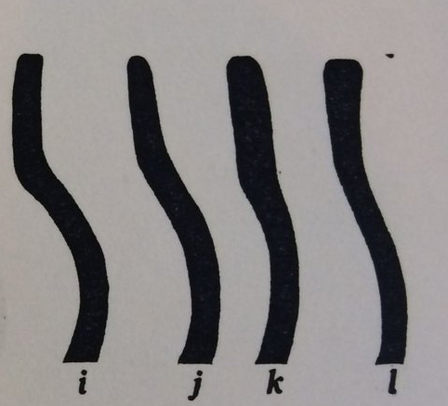
Rim Shape 4

Variable | Code | Value
Rim Form (Kidder 1923) | 1 | Plain
 | 2 | Flaring
 | 3 | Semi-standing
 | 4 | Heightened
 | 99 | Indt.

Width of Rim Top
Variable | Code | Value
Width of rim top | - | Continuous
 | 99 | Indeterminate

Width of Widest Part of Rim
Variable | Code | Value
Width of widest part of rim | - | Continuous
 | 99 | Indeterminate

Inner Planed Rim Height
Variable | Code | Value
Inner Planed Rim Height | - | Continuous
 | 99 | Indeterminate

Banding
Variable | Code | Value
Interior Banding Line Width | - | Continuous
 | 99 | Indeterminate

Variable | Code | Value
Interior Banding Line Distance from Rim | - | Continuous
 | 99 | Indeterminate

Variable | Code | Value
Exterior Banding Line Width | - | Continuous
 | 99 | Indeterminate

Variable | Code | Value
Exterior Banding Line Distance from Rim | - | Continuous
 | 99 | Indeterminate

