UNIVERSITY OF OKLAHOMA
GRADUATE COLLEGE

NON-INVASIVE LOAD MONITORING IN FEMALE DIVISION 1 COLLEGIATE GYMNASTICS

A THESIS
SUBMITTED TO THE GRADUATE FACULTY
in partial fulfillment of the requirements for the
Degree of
MASTER OF SCIENCE

By
MAEGAN BREWER
Norman, Oklahoma
2021

NON-INVASIVE LOAD MONITORING IN FEMALE DIVISION 1 COLLEGIATE GYMNASTICS

A THESIS APPROVED FOR THE
DEPARTMENT OF HEALTH AND EXERCISE SCIENCE

BY THE COMMITTEE CONSISTING OF

Dr. Jason Campbell, Chair

Dr. Chris Black

Dr. Rebecca Larson

© Copyright by Maegan Brewer 2021
All Rights Reserved.

Table of Contents
Abstract v
Chapter I – Introduction 1
Introduction 1
Research Questions 5
Hypotheses 5
Significance of the Study 7
Delimitations 8
Limitations 8
Assumptions 8
Operational Definitions 8
Chapter II – Literature Review 10
Introduction 10
Stress, Fatigue, and Recovery 10
Accelerometry 16
Short Recovery Stress Scale 18
Collegiate and Gymnastics Specific Stress 19
Chapter III - Methodology 23
Introduction 23
Research Design 23
Subjects 24
Procedures 24
Statistical Analyses 28
Chapter IV - Results & Discussion 30
T-tests 31
Repeated Measures ANOVA 34
Correlations 36
Under-recovery and Excess Stress 44
Monotony 44
Training Phase Patterns for Recovery, Stress, Sleep, and Soreness 45
Training Phase Team Averages for Recovery, Stress, Sleep, and Soreness 50
Discussion 52
Limitations 59
Chapter V - Conclusions 61
Practical Significance and Applications 61
Future Study Recommendations 62
Practical Recommendations 63
References 65

Abstract
Gymnasts is a high intensity, monotonous, and extremely physically and mentally demanding sport. Despite strong research in other, primarily male, populations, internal and external load measures have been scarcely researched in female gymnasts. PURPOSE: The purpose of this retrospective analysis is to assess the utility and effectiveness of monitoring internal load, via subjective ratings of physical, mental, and emotional status, and external load, through accelerometry-based metrics, in NCAA female gymnasts. METHODS: Internal and external load was tracked for one preseason (September 2019 thru January 2020) for a NCAA Division I women’s gymnastics team. The SRSS was used for subjective internal load measures and Catapult trackers were used to measure objective external load. The SRSS tracked recovery and stress measures with an added visual analogue scale for sleep and soreness, while the Catapult trackers monitored Player Load, Player Load per Minute, Average Player Load, Total Inertial Movement Analysis (IMA), and IMA jump counts. RESULTS: All internal load measures correlated with one another and external load measures were found to be related to one another, however no relationship existed between internal and external load measures. Sleep and soreness also showed correlations with many load measures. External load generally decreased over the training blocks of the preseason. CONCLUSION: Individualized internal and external load monitoring may be necessary for eliciting optimal recovery and performance in elite female gymnasts.
KEY WORDS: Internal load, External load, Gymnasts, Sleep, Soreness, Monotony

Chapter I – Introduction

Introduction
Optimizing performance has long been a priority among coaches, trainers, and athletes. In order to increase performance, training is most effective when tailored to individual athletes (Alexiou & Coutts, 2008). With this goal in mind, accurate assessment of the dose-response relationship between training and recovery is crucial. Athlete load monitoring via routine objective and subjective measurements can be used to modify training and recovery for individual athletes and has become increasingly popular in field sports such as soccer and American football. Despite the success in field sports, athlete monitoring has been scarcely used in Olympic sports, primarily due to financial restraints and cultural norms. One such sport is women’s gymnastics. With the unique combination of biomechanical and bioenergetic characteristics of gymnastics across the various events, monitoring may provide insight into the demand on these athletes. In a study of NCAA athletes, Lanese et al. (1990) compared gymnasts to other gender-matched sports. Gymnastics showed the highest injury rate of any sport despite having the lowest number of participants in the study (Lanese et al., 1990). This may, in part, result from a lack of modernized training methods, consistent with the latest training adaptation research and the absence of periodization approaches used to normally determine athlete loading and recovery needs. Therefore, the addition of load monitoring may be essential for providing better insight into the specific demands placed on these athletes, which could potentially help reduce injury rates and/or increase performance.
Athlete monitoring in field sports typically involves distance, velocity, and acceleration-based metrics, along with collision-based metrics in contact sports such as rugby and American football. Monitoring of these variables may be less important in gymnastics, due to the nature of the competitive events. However, gymnasts still experience rotational speeds >20 meters per second while somersaulting in the air, take-off/landing forces that may equal 5-17.5 times their body weight, and centripetal force reaching 3.1-3.6 times their body weight while swinging on the uneven bars (Sands, 2000). In addition to the extreme forces applied to gymnasts, attaining elite status usually requires early specialization with training starting as young as 5 years old and up to 40 hours per week, which increases the likelihood of injury (Daly et al., 2001).
In a recent investigation in collegiate sport, Hwang & Choi (2016) found that NCAA athletes’ perceived stress was more dependent on academic anxiety than either competition or training stress. In the 2019-2020 academic year, 53 of 74 gymnastics teams currently competing at the NCAA level, had a team GPA of 3.5 or higher, indicating a high focus on academic success amongst female gymnasts (Women’s Collegiate Gymnastics Association, 2020). When taken collectively, the combination of high training monotony, elevated injury risk, and academic demand seems to signal the need for athlete monitoring both inside and outside of practice and competition.
Evidence of the current methods of injury prevention is lacking, indicating a need for further research on practical ways to protect gymnasts (Sands, 2000; Daly et al., 2001). The current methods for injury prevention have focused on education, spotting (i.e. physically assisting the gymnast to perform a skill), technique drilling, and equipment such as landing surfaces and spring floor configuration (Daly et al., 2001). Riddled with monotonous movements both in competition and practice, and subjectively judged for difficulty and execution, gymnasts face physical and mental stressors different from most other sports (Snyder, 1990). The two main athlete monitoring components are external (dose) and internal (response) load. External load measures, which represent the imposed stress (physical, mental, emotional, etc.) placed on an individual, are used in the design of training periodization strategies (practice, weight room, conditioning, etc.). Internal load measures, which represent the response to stress (physical, mental, emotional, etc.), are used to determine individual and/or position group dose-response patterns. Research into ways to monitor and assess internal and external load in female gymnasts is lacking. However, determination of these measures may be vital in order to maintain and further develop the health and performance of this cohort.
Some of the most popular tools used for athlete monitoring include body-mounted accelerometers, recovery-stress questionnaires, force plates, training impulse (TRIMP) scores, ratings of perceived exertion (RPE), and session ratings of perceived exertion (sRPE). Wearable accelerometers have been used heavily in Australia and now in the United States, where findings across various sports have demonstrated associations between increased external load and decreased recovery (Heishman et al., 2018). Sport-specific relationships have also been identified between high running speeds and hamstring injury in elite male soccer players (Ruddy et al., 2018). It would seem logical these methods may also prove useful in gymnastics. Recovery-stress questionnaires are a popular internal load monitoring tool. Some of the most prominent questionnaires currently include the Recovery-Stress Questionnaire (RESTQ), the Acute Recovery Stress Scale (ARSS), and the Short Recovery Stress Scale (SRSS). The RESTQ is popular because several variations such as the RESTQ-short, RESTQ-sport, and RESTQ-coach were developed from the original RESTQ to be more applicable to specific populations. More recent literature explores the relationship between subjective recovery questionnaires and external load measures and findings have shown that the questionnaires may yield more useful results than external load monitoring but the combination of internal and external load monitoring measures provides the most valuable insights (Saw et al., 2016). Subjective measures are able to detect both acute and chronic training adaptations (Saw et al., 2016). The results of one study suggest that monitoring stress-recovery state combined with performance can help elicit optimal training adaptations, thereby helping to prevent overtraining (Nagle et al., 2015). Subjective measures have been found to be useful in various sports, which may point to their potential utility in gymnastics.
Acknowledging the complexities of gymnastics, some understood and some unknown, it would seem both innovative and pertinent to better understand the multi-modal stress and recovery dynamics of the sport, as well as better assess the physical demands beyond repetitions of skills and routines. It is known that training monotony increases training strain which may lead to non-functional overreaching. The particularly monotonous training and competition convention that exists within gymnastics, may, in part, explain the high rates of injury and practice days missed by gymnasts. Potentially, with these new insights, training periodization models can be more accurately created to assist with decreasing monotony and increased training outcomes.
Therefore, the purpose of this retrospective analysis is to assess the utility and effectiveness of monitoring internal load, via subjective ratings of physical, mental, and emotional status, and external load, through accelerometry-based metrics, in NCAA female gymnasts. Of key interest are the changes that occur in these variables across one academic semester (preseason training period). In addition, soreness patterns and sleep patterns will be examined to provide additional nuance to relationships between imposed stresses and the resulting performance and recovery responses.

Research Questions
- Are accelerometry-based external loads (Total Player Load (PL^{Total}), Player Load per min (PL^{-1min}), Player Load 1D-Up (PL^{Z}), and IMA jump count (IMA)) different across the four training phases (Skills/General Prep 1, Combinations/General Prep 2, Practice Routines/Special Prep 1, Competitive Routines/Special Prep 2) of a collegiate women’s gymnastics preseason?
- Where did the highest and lowest accelerometry-based external load (PL^{Total}, PL^{-1min}, PL^{Z}, IMA) scores occur and how did they relate to the highest and lowest soreness, sleep quality, and practice duration measurements during pre-season training?
  - Were the highest and lowest external and internal load metrics significantly different from each other?
  - Did significant changes in external load result in significant changes to stress composite and recovery composite scores for the following day?
  - Did significant changes in external load result in significant changes to soreness and sleep quality scores for the following day?
- Are accelerometry-based external loads (Total Player Load (PL^{Total}), Player Load per min (PL^{-1min}), Player Load 1D-Up (PL^{Z}), and IMA jump count (IMA)) significantly related to subjectively measured internal loads (sleep, soreness, recovery, stress)?
Do relationships exist between sleep and soreness measures with the subjective physical, mental, and emotional domains of the stress recovery scale?

Hypotheses
- Alternative Hypothesis: Accelerometry-based external load measures do differ across preseason training phases, with Skills/General Prep 1 being higher than Combinations/General Prep 2 and Practice Routines/Special Prep 1 being higher than Competitive Routines/Special Prep 2.
    - Null Hypothesis: There is no difference in accelerometry-based external load measures across preseason training phases.
- Alternative Hypothesis: The highest external load scores occurred at the beginning and end of each training phase and the lowest external load measures occurred in the middle of the training phases. High external load measures preceded high soreness, preceded low sleep quality scores.
    - Null Hypothesis: There was no pattern in the high and low external load scores.
  - The highest and lowest external and internal load metrics were significantly different from each other.
    - Null Hypothesis: The highest and lowest external and internal load metrics were not significantly different.
  - Increased external load resulted in increased stress composite and decreased recovery composite scores on the following day. Decreased external load resulted in decreased stress composite and increased recovery composite scores for the following day.
    - Null Hypothesis: Changes in external load measures did not significantly influence stress composite or recovery composite scores.
  - Significant increases in external load resulted in significant increases in soreness and significant decreases in sleep quality for the following day. Significant decreases in external load resulted in significant decreases in soreness and significant increases in sleep quality for the following day.
    - Null Hypothesis: Significant changes in external load did not significantly affect soreness or sleep quality.
- Alternative Hypothesis: Accelerometry-based external load measures are significantly inversely related to sleep and recovery and significantly directly related to soreness and stress.
    - Null Hypothesis: Accelerometry-based external load measures are not significantly related to sleep, soreness, recovery, or stress.
  - Sleep and soreness measures directly correlate with the subjective physical, mental, and emotional domains of the stress recovery scale.
    - Null Hypothesis: Sleep and soreness measures do not correlate with the subjective physical, mental, and emotional domains of the stress recovery scale.

Significance of the Study
As gymnastics has one of the highest injury rates in the NCAA and collegiate gymnasts have unique mental and emotional stressors with subjective judging and high academic demands, modernized injury prevention techniques are imperative to increasing performance and effectively preventing injury. With the absence or near absence of a formulized monitoring system to understand the physical, mental, and emotional demands of participation in collegiate gymnastics, objective accelerometry-based and subjective recovery-stress measures may help coaches, trainers, and other support staff increase the proficiency and safety of the training and competition process.

Delimitations
- Participants will have no existing orthopedic injuries
- Participants will be aged between 18-25 years at the start of the study
- Participants will be active NCAA female gymnasts competing at the Division 1 level

Limitations
- The sample will be a convenience sample
- All participants will be from the same NCAA Division I women’s gymnastics team
- All accelerometry data will be collected during practice by the team head athletic trainer and thus the researchers were not present to ensure all measurement guidelines were followed (timing, proper use, proper fit, etc.)
- All participants will fill out the survey each day, on their own, without the assistance of the researchers to ensure they were completed properly and upon waking.

Assumptions
- Participants understand the SRSS questionnaire and answer it properly and accurately
- Participants answer the SRSS questionnaire at the same time each morning, as prescribed
- All equipment is properly calibrated and worn correctly by participants as specified by the researchers
- Participants were honest about their injury status

Operational Definitions
Immediate Recovery: Recovery that occurs during bouts of rapid effort when one muscle group is not used for a short period of time; allows for regeneration of ATP (Bishop et al., 2008).
Short-Term Recovery: Short-term recovery occurs with intermittent rest, such as between sets or other intervals (Bishop et al., 2008).
Training Recovery: Training recovery occurs across hours or days between training sessions or competition (Bishop et al., 2008).
Non-functional Overreaching: A short term decline in performance ability unaccompanied by symptoms of overtraining such as negative adaptations (Kellmann et al., 2018).
Overtraining: Overtraining syndrome is categorized by a negative response to excessive training or exercise neglecting proper recovery causing negative effects to multiple body systems and changes in mood (Kreher & Schwartz, 2012).
Player Load (PL): A measure of player acceleration in three dimensions (Barrett et al., 2014).
Player Load Per Minute (PL^{min-1}): Total Player Load divided by session duration in minutes.
Player Load 1D Up (PL^{Z}): Player Load that occurs in the vertical Z plane.
Visual Analog Scale (VAS): Linear, numerical scale used to rate qualities such as state and mood in questionnaires (Kellmann & Kolling, 2019).
Internal Load: The relative physiological and psychological stress imposed on athletes during training sessions or competition (Halson, 2014).
External Load: The amount of work completed by an athlete during a training session or competition (Wallace et al., 2009).

Chapter II – Literature Review

Introduction
Currently, athlete tracking and performance monitoring in the United States are predominantly used in men’s sports such as American football, soccer, and hockey. Research related to the load imposed throughout practice and competition, referred to as external load, is lacking in women’s sports, resulting in an incomplete understanding of training adaptations, performance demands, and injury etiology in this population. Specifically, women’s gymnastics presents unique external load demands based on the bioenergetic and biomechanical nature of the sport. Women’s gymnastics also represents the sport with the highest injury rates, particularly in the lower extremities and the head and neck region. As a result, a deeper understanding of the physical, mental, emotional, and technical demands of gymnastics seems warranted. A thorough search of SportDiscus and PubMed was conducted using combinations of the following search terms: accelerometry, wearable technology, PlayerLoad, fatigue, recovery, stress, collegiate athlete, female gymnast, academic stress, gymnastics injury, female athlete triad, internal load, external load, and NCAA gymnasts. Articles were chosen, reviewed for relevance, and summarized relative to the current investigation’s specific aims.

Stress, Fatigue, and Recovery
Stress is any physiological or biological deviation from the body’s optimal state (Kellmann, 2002). Stressors originate from factors affecting the body from the outside, which can include exercise, training, academics, and relationships, all of which are experienced by collegiate athletes (Kellmann, 2002; Hwang & Choi, 2016). Stress can be acute or chronic, depending on the stressor and duration (Lopes Dos Santos et al., 2020). Depending on perception and coping methods, stress can be seen as negative (distress) or positive (eustress) (Lopes Dos Santos et al., 2020). Stress can have positive effects on the body, but if not properly managed, the effects can result in negative outcomes such as overtraining, fatigue, injury, sickness, and burnout (Kellmann, 2002). When stress is managed properly, positive adaptations are elicited which is the expected outcome of a well-planned training program.
A sport-specific recovery-fatigue continuum has been proposed in a consensus statement by many exercise physiologists (Kellmann et al., 2018). This continuum demonstrates the complexity of both fatigue and recovery and shows that the two are highly interrelated. As the body endures more stress and becomes increasingly fatigued, it strays farther from and demands more to return to a state of recovery. A certain degree of fatigue is necessary to elicit functional overreaching, which enhances performance (Kellmann et al., 2018). In contrast, fatigue becomes a problem when sufficient recovery is not allowed.
Recovery has been defined as a complex process of physical restoration over time (Kellmann et al., 2018). Recovery occurs across three distinct time periods, immediate, short term, and training recovery. During a training session or competition, fatigue is defined as the failure to maintain the desired or expected force output (Bishop et al., 2008; Taylor et al., 2012). Immediate recovery occurs between rapid efforts such as the time one leg is not active during sprints (Bishop et al., 2008). Short term recovery encompasses the intermittent rest that occurs during training and competition (Bishop et al., 2008). Finally, training recovery occurs between sessions, the time from one competition or training to another, usually hours or days (Bishop et al., 2008). Alternatively, fatigue can be thought of as a lack of physiological and psychological balance that must be compensated for with proper recovery (Kellmann et al., 2018). Debien et al. (2020) found that gymnasts are chronically under-recovered, demonstrated by a score of <13 on the total quality recovery (TQR) scale, for about half the competitive season. A negative correlation between recovery and training load was identified using session RPE and TQR, suggesting a modification to training programming may be warranted (Debien et al., 2020).
Mental fatigue has been shown to affect physical performance in athletes. Mental fatigue can be defined as tiredness resulting from cognitive activity (Marcora et al., 2009). When mentally fatigued subjects were compared with a non-fatigued control group, the experimental group had a significantly lower time to exhaustion in a cycling test than the control (Marcora et al., 2009). In 2016, Smith et al., found that after a mental fatiguing treatment (the Stroop task), soccer players covered shorter distances in a Yo-Yo test than those who had not had the fatiguing treatment. These studies, taken together, illustrate the potential value of monitoring mental fatigue in order to maintain and/or increase performance. Mental fatigue has been shown to affect performance in multiple exercise types, making it an important consideration across all sports.
Another factor that may contribute to the mismanagement of stress and fatigue is a mismatch between how a coach and player may view the intensity and/or challenge of a given training session. According to Doeven et al. (2017), there is often a discrepancy between coaches and athletes in their ratings of intensity produced by a training session. Often, a session that a coach intends to be light may be experienced as heavy by athletes and vice versa. Additionally, coaches tend to believe that players are more recovered than they actually are, therefore would train athletes harder than they should be provided their recovery level (Doeven et al., 2017). Perpetuation of this cycle could lead athletes to a state of chronic under-recovery and nonfunctional overreaching. Many different measures have been used to assess load, fatigue, and recovery on an individual level. Previous studies have utilized these to create a more comprehensive picture of player load and recovery (Doeven et al., 2017). Additional research is needed to recognize the potential impact of implementing such measures in gymnasts.
There are risks associated with competing and training in an under-recovered state, which include chronic stress, nonfunctional overreaching, a reduction in work capacity and performance ability, and even illness or injury (Fomin & Nasedkin, 2013). Keane et al. (2015) studied sport-specific muscle damage in female field sport athletes. After muscle damage was induced by a repeated-sprint protocol, athletes showed delayed onset muscle soreness, increased blood creatine kinase levels, increased sprint times, and decreased countermovement jump performance up to 72 hours post damage (Keane et al., 2015). All signs of damage are important, but the increased sprint times show that under-recovery could decrease performance in competition and may correspond to changes in subjective soreness ratings and/or blood markers.
Therefore, the identification of valid, reliable, and practically relevant measures is warranted to elucidate the interplay between stress, fatigue, and recovery in individual athletes of a particular sport, such as gymnastics. When the internal and external loads experienced by these athletes are properly assessed, training approaches can be tailored to enhance the physiological, technical, and tactical domains that lead to optimal performance.
Internal load is the relative psychological and physiological response to the imposed external load (Halson, 2014). Internal load can be influenced by training status and environmental conditions (Halson, 2014). As training status and some environmental conditions are unique to each athlete, monitoring internal load seems necessary in order to properly train athletes. Depending on the recovery state of an athlete, the same absolute workload could be perceived as more or less intense (Halson, 2014). Internal load can be measured using several different methods including Rating of Perceived Exertion (RPE), Session Rating of Perceived Exertion (sRPE), and Recovery-Stress Questionnaires, as well as sleep and soreness visual analog scales (VAS).
Subjective monitoring is frequently used as an alternative to more expensive and more technically demanding approaches (e.g., force plates, accelerometers, dynamometers, etc.) when this type of external load monitoring equipment is not available or practical. The RESTQ-Sport has been shown to follow the dose-response relationship in training loads measured through RPE (Nicolas et al., 2019). In this investigation into collegiate athletes, training load was negatively associated with perceived recovery and positively associated with perceived stress (Nicolas et al., 2019). In fact, evidence exists in some investigations that subjective measures may be more dependable than other load monitoring measures. In a systematic review, subjective stress and recovery measures such as RESTQ and POMS questionnaires have been shown to have high sensitivity for mood disturbance, stress, and perceived recovery (Saw et al., 2016). Overall subjective well-being, as measured by each study’s respective questionnaire, was responsive to changes in both acute and chronic training stress (Saw et al., 2016).
Additionally, subjective measures may represent an athlete’s readiness more accurately than objective measures when examining their congruity to performance outcomes (e.g. yards gained, high-speed running distance, peak power) (Saw et al., 2016). For instance, Dumoriter et al. (2018) measured training load in female gymnasts using sRPE (RPE x training duration in minutes), while also monitoring sleep over a 14-week period. Gymnasts trained according to their respective age groups and seniors competed in national and world competitions at the end of the study (Dumortier et al., 2018). Training was tapered through a one-week, general method (non-specific for the individual), using team sRPE to determine tapering protocol, as proposed by Toubekis et al. (2013) before competitions. The study showed that lower sleep values resulted in higher sRPE values (Dumortier et al., 2018). Additionally, senior gymnasts that had higher sRPE values scored poorly compared to those with lower sRPE values in their World Championship competition (Dumortier et al., 2018). The authors suggest the proposed tapering method was insufficient, especially for lesser trained gymnasts due to its general, non-individualized nature (Dumortier et al., 2018). A potential remedy for insufficient universal tapering strategies could be individualized monitoring leading to a more specific tapering approach.
While subjective measures had previously been mistakenly perceived as lesser monitoring data when compared to objective measures, more and more studies are showing that subjective measures are highly valuable (Collette et al., 2018; Govus et al., 2018; Nicolas et al., 2019; Saw et al., 2016). Lastly, subjective measures are typically questionnaires, they can be used frequently, especially shortened versions, in order to routinely monitor athletes and adapt training intensities and durations. Many studies have found correlations between internal and external load monitoring measures (Govus et al., 2018; McLaren et al., 2018). Pretraining subjective wellness (soreness, sleep, and energy) was shown to increase about 2.3% with a 1 point increase in PL with significant correlation (Govus et al., 2018). Strong correlations (CI = 0.74-0.83) between internal load (sRPE) and external load (total distance) have been found in athletes (McLaren et al., 2018). Given these strong correlations between monitoring internal and external load, coaches have an opportunity to choose measuring/monitoring approaches congruent with their time, budgetary, and staff constraints. The key to implementation of any load monitoring program is the likelihood of getting full and consistent participation from the athletes themselves, and the ease with which data can be organized, analyzed, and disseminated for training adjustments. It would seem the use of both subjective and objective measures in gymnastics could help with the difficulty coaching staffs experience with preparing for four vastly different events.

Accelerometry
Accelerometers are devices that monitor movement-related accelerations in all three cardinal planes and associated axes in order to determine the intensity of a bout of exercise (Chen & Bassett, 2005). Accelerometer-based tracking was first adopted by researchers in the 1980s, but has progressed to a mainstay amongst field-based sports in Europe, Australia, and increasingly in the United States (Troiano et al., 2014). The popularization of accelerometry comes, in part, as a result of the devices becoming more reliable and affordable (Chen & Bassett, 2005; Troiano et al., 2014). Previously, accelerometers were a single-use device, however more recently, devices that measure accelerometry have begun to include other measures such as heart rate, ECG, and temperature (Chen & Bassett, 2005).
In one recent study, accelerometry-based devices were used to determine differences between positions in NCAA Division I football players via inertial movement analysis, distance covered, and maximum velocity (Bayliff et al., 2019). Significant differences were found between positions in each measure, which suggests that an individualized training approach may be necessary (Bayliff et al., 2019). Similarly, gymnasts participate in unique events, resulting in the need for assessment of individualized demands placed on the body. Much of the forces seen in gymnastics are in a vertical direction, with torques primarily occurring around the superoinferior and mediolateral axes.
Training load in athletes is the relative physical and psychological stressors placed on an individual athlete throughout a session (Bourdon et al., 2017). Monitoring training load in athletes can identify changes in performance, aid in periodization for coaches, evaluate readiness to play, and assess fatigue (Bourdon et al., 2017; Halson, 2014). Individually monitoring training load can help determine differences in position or event (Bayliff et al., 2019). Player load (PL) (proprietary to Catapult Sports Innovations) is a measure of external load taken by accelerometers contained in their GPS-enabled tracking device, which also contains a triaxial gyroscope, and magnetometers to detect geographical orientation. As mentioned previously, external load is the demand placed on athletes throughout training, practice, and competition (Bredt et al., 2020). Player load is calculated with a formula taking changes in acceleration in all three planes into account:
Player load = $\sqrt{\frac{{(a_{x1}-a_{x-1})}^{2}+{(a_{y1}-a_{y-1})}^{2}+{(a_{z1}-a_{z-1})}^{2}}{100}}$
with x, y, and z variables representing their respective plane and a representing acceleration (Boyd et al., 2011).
Player load monitoring in elite footballers has been previously used in conjunction with tracking hamstring injury incidence and has shown a connection between the amount of time spent at certain running speeds and injury (Ruddy et al., 2018). Players who spent more time running at a high speed (≥24 km/hour) per week were at a higher risk of hamstring injury (Ruddy et al., 2018). Monitoring player load in these athletes and maintaining minimal time running ≥24 km/hour per week during practices could minimize hamstring injury incidence. Another study in collegiate basketball players found that changes in PL were inversely related to countermovement jump performance; as PL values increased, athletes ability to perform in countermovement jump measures decreased (Heishman et al., 2018). Additionally, previous PL measures had direct effects on subsequent PL (Heishman et al., 2018).
With further research, this specific finding could be generalized for other sports and types of injuries to minimize injury for all athletes. Player load is a concept that spans across all sports even though each is unique in its training and movement patterns. Player load monitoring using accelerometers has not been studied in gymnastics, despite monotonous training and competitions and high injury rates associated with the sport.

Short Recovery Stress Scale
One of the more prominent methods of measuring internal load is through questionnaires. The RESTQ has been the most commonly accepted and widely used internal load questionnaire. The RESTQ is a 76 item questionnaire that assesses overall stress, including social-emotional stress and performance stress, and overall recovery (Kallus & Kellmann, 2016). Various versions of the RESTQ exist with the most common being the RESTQ-Basic, RESTQ-Sport, RESTQ-Coach, and RESTQ-Work, each available in shortened and modified versions (Kallus & Kellmann, 2016). More recently, the Acute Recovery and Stress Scale (ARSS) and the Short Recovery Stress Scale (SRSS) have become increasingly popularized. The ARSS is a 32 item questionnaire designed for athletes that assesses recovery aspects including physical and mental performance capability, emotional balance, and overall recovery and stress aspects including muscular stress, lack of activation, negative emotional state, and overall stress (Kellmann & Kolling, 2019). The SRSS is an 8 item questionnaire that assess stress and recovery using a visual analog scale (Kellmann & Kolling, 2019). The SRSS measures four physical recovery markers including physical performance capability, mental performance capability, emotional balance, and overall recovery and four stress markers including muscular stress, lack of activation, negative emotional state, and overall stress (Kellmann & Kolling, 2019). The ARSS usually takes 5 minutes to complete while the SRSS takes about 50 seconds (Kellmann & Kolling, 2019). The ARSS strongly correlates with the RESTQ-Sport-76 with values between 0.52 and 0.71 for physical performance capability, being in shape, and muscular stress scores (Nässi et al., 2017). The SRSS was not as strong with correlation values between 0.38 and 0.60 (Nässi et al., 2017). Kellmann and Kolling found stronger correlations between 0.42-0.74 (2019). Most questionnaires can be used frequently, especially shortened versions, in order to routinely monitor athletes and adapt training schedules, which is what is appealing and unique about the SRSS.
The ARSS and SRSS have been shown to be effective in several studies across various populations (Collette et al., 2018; Flynn et al., 2017; Raeder et al., 2016). Flynn et al. (2017) successfully used the SRSS in female collegiate volleyball players to determine individual response to training. The SRSS has shown high response rates, 97%, in female collegiate athletes (Flynn et al., 2017). The SRSS has been shown to be sensitive to changes in strength training load compared to session intensity (RPE) and muscle damage (blood creatine kinase) in trained, competitive male and female athletes (Raeder et al., 2016). Finally, the ARSS has also been shown to respond to training loads effectively in elite swimmers (Collette et al., 2018). Despite the recent development of the SRSS, the scale has been successfully used in various populations of well-trained athletes.

Collegiate and Gymnastics Specific Stress
Collegiate athletes must find the balance between academics and athletics. Academics can impose an additional stressor above what other elite athletes face. In one study, academic anxiety was the biggest influencer on collegiate athletes’ perceived stress (Hwang & Choi, 2016). In addition to academic anxiety, psychological responses to stress were compounded by personal and social factors (Hwang & Choi, 2016). A negative relationship between grade point average and stress has been identified, showing the importance of attention to academics for collegiate athletes (Hwang & Choi, 2016). Correlations have also been identified in collegiate athletes between perceived academic distress and depressed mood, negative sleep quality, fatigue, and performance demands (Lopes Dos Santos et al., 2020). Collegiate athletes have several things vying for their time and attention such as practice, team responsibilities, competition, academics, and social relationships that can become mental distressors if not handled properly. As shown in previous studies, mental fatigue can limit physical performance, showing the toll that improperly handled academic stress could take on collegiate athletes (Smith et al., 2016). Additionally, psychological stress has been shown to increase injury rates in collegiate athletes (Mann et al., 2016). For gymnasts, psychological stress could be academic, social, or competition (e.g., mental and/or emotional strain associated with events judged against subjective yet stringent criteria) and training expectations and demands. As mental fatigue and stress can impair performance and each athlete has a unique set of academic stressors, it may be important to monitor these variables in collegiate gymnasts in an effort to avoid improper recovery.
A typical gymnastics training protocol consists of four phases, conditioning and skill preparation, skill combinations preparation, competitive routines preparation, and competition (Sands et al., 1993). In collegiate gymnastics, events vary by sex. For women, more lower body musculature is used in events including floor, uneven bars, beam, and vault. For men, more upper body musculature is used in events including floor, rings, pommel horse, parallel bars, high bar, and beam. The unique events and muscles used elicit unique injury patterns. Men are more likely to suffer upper body injuries, whereas women are more likely to suffer lower extremity injuries (Westermann et al., 2015). Additionally, a higher injury rate has been found among freshman athletes, which could indicate an additive effect of changes in training associated with joining a collegiate program mixed with growth/development of the younger athlete (Westermann et al., 2015). With the specific competitive routines performed at gymnastics meets, the majority of gymnast’s training involves either performing complete routines or first and second halves of the entire routine. This may lead higher levels of monotony (lack of training variability) during practice sessions, resulting in increased strain on the same specific musculoskeletal structures, increasing local fatigue and the likelihood of injury.
When compared to other collegiate sports, both men’s and women’s gymnastics had higher rates of injury than any other of the seven sports studied with all but one gymnast reporting an injury during the study (Lanese et al., 1990). Overall, male and female gymnasts made up only 9% of the subjects in Lanese et al., but accounted for 34% of all injuries that occurred (1990). Data from a 5-year study shows that female gymnasts practice with injury approximately 71% of the time (Sands et al., 1993). Overuse injuries make up about 22% of all injuries in gymnastics, which may be a result of the monotony applied to the body throughout training and competition (Caine et al., 1989). In addition to the high risks of injuries due to monotony, female gymnasts also face a high reinjury rate at 33% (Daly et al., 2001). Injury rates are clearly skewed in gymnastics as compared to other sports, thus the need for an athlete monitoring-based approach to training and recovery seems warranted.
Teams may adopt various approaches to injury prevention such as adaptive coaching techniques, spotting, warm-ups, and physical conditioning; however, most have not been proven effective (Daly et al., 2001). These outdated methods of injury prevention need to be improved upon. Lanese et al. (1990) found that although men and women across 8 sports had similar injury rates, female gymnasts have been reported to be injured at higher rates than male gymnasts. Additionally, women’s gymnastics had the highest number of days of the season missed as a result of injury (Lanese et al., 1990). A clear mismatch exists between female gymnasts and other athletes, male and female alike.
In addition to their training load, female gymnasts experience a complex set of emotions as a result of the subjective nature of scoring in gymnastics. In one case study evaluating the emotions experienced by ten female collegiate gymnasts during a meet, each reported nervousness and many reported fear of injury, frustration and disappointment, and happiness and joy (Snyder, 1990). Many of these emotions are common across all sports, but the aspect of being judged against specific yet subjective physical/aesthetic standards add an aspect not present in most collegiate athletics. These unique emotional experiences in female gymnasts may have an effect on internal load, possibly increasing their accumulated stress and delaying full mental/emotional recovery when compared to normal training and academic demands present for most collegiate athletes.
In summary, many factors influence internal and external load that should be monitored, especially in female collegiate gymnasts. With elevated mental stress due to academics and the subjective nature of gymnastics scoring, increased risk of injury above other sports, and the monotony of practice and competition, female collegiate gymnasts seem to need monitoring methods in order to prevent overtraining, reduce injury incidence, and to improve performance. Gymnastics coaches are still rooted in the antiquated monitoring methods outlined by Daly et al. (2001). Even though the need seems evident, there is a striking lack of research in the NCAA Women’s Gymnastics realm, which makes this study a crucial step in the process of establishing the efficacy and practicality of athlete monitoring in gymnastics.

Chapter III - Methodology

Introduction
Monitoring performance has become increasingly widespread in sport, but especially in field sports like soccer and football. Using internal and external load measures may help the practitioner better assess recovery which could help prevent non-functional overreaching in their athletes. These measures have not been previously utilized in gymnasts. The current investigation seeks to expand on athlete monitoring research used in other sports to gain a basis for the following outline of procedures. Although similar data has never been collected in the collegiate female gymnast population, the success in other sports provides evidence that monitoring could be beneficial in this cohort as well.

Research Design
In a retrospective study spanning across a preseason (September 2019 thru January 2020), subjective and objective load and recovery measures were tracked in one NCAA Division I women’s gymnastics team from the Southeastern Conference (SEC). The SRSS was used for subjective internal load measures and Catapult trackers were used to measure objective external load. Each participant completed the SRSS each morning and select participants wore Catapult trackers throughout each training session. Accelerometry-based metrics include Player Load, Player Load per Minute, Average Player Load, Total Inertial Movement Analysis (IMA), and IMA jump counts. Additionally, assessments of individual body part and total body soreness, along with sleep quality were tracked daily via a 100mm visual analog scale (VAS). By tracking internal and external measures together, the two can be compared with each other to help determine the dose-response nature of preseason training and the efficacy of these various monitoring techniques in collegiate women’s gymnastics.

Subjects
Eighteen female NCAA Division I gymnasts participated in this study. All participants were from a single team with each team member participating, all were competing at an elite level. All participants were female between the ages of 18-25 years old and free from orthopedic injury. Freshman through seniors were included in the study.

Procedures

Short Recovery-Stress Scale
Participants were familiarized to the Short Recovery-Stress Scale (SRSS) prior to beginning data collection. Once preseason training began, each participant received a text message each morning at 5:45am CST with a link to the SRSS for completion upon waking. The SRSS remained consistent throughout the investigation with the same eight questions, in the same order to avoid any errors. Each question asked about a unique recovery-stress aspect including physical performance capability, mental performance capability, emotional balance, overall recovery, muscular stress, lack of activation, negative emotional state, and overall stress, each with 4 distinct adjectives used to clarify the rating scale. They are as follows:
- Physical performance capability – strong, physically capable, energetic, full of power
- Mental performance capability – attentive, receptive, mentally alert, concentrated
- Emotional balance – pleased, stable, in a good mood, having everything under control
- Overall recovery – recovered, rested, muscle relaxation, physically relaxed
- Muscular stress – muscle exhaustion, muscle fatigue, muscle soreness, muscle stiffness
- Lack of activation – unmotivated, sluggish, unenthusiastic, lacking energy
- Negative emotional state – feeling down, stressed, annoyed, short-tempered
- Overall stress – tired, worn-out, overloaded, physically exhausted.
Each aspect was measured on a Likert scale ranging from 0 to 6 with the anchors “Does not apply at all” at 0 and “Fully applies” at 6. Participants were asked to rate all recovery measures in comparison to their “best ever recovery state” and all stress measures in comparison to their “highest ever stress state”. In addition to being familiarized to the questionnaire, instructions and specific questions were included each day related to subjective sleep and soreness. Responses were collected automatically, then transferred into Excel for initial analysis. In Excel, stress composite and recovery composite scores were generated for each individual participant.

Sleep and Soreness
Sleep quality and soreness were measured within the same survey as the SRSS. Participants were asked to rate their soreness on a scale from 0 (“no pain”) to 100 of (“worst pain imaginable”) in their shins, quads, hamstrings/glutes, shoulders, and low back, respectively. For sleep quality, participants rated their previous night’s sleep on a scale from 0 representing “I don’t feel rested at all; I slept poorly” to 100 representing “I feel completely rested; I slept well”. Participants were familiarized to the questions and the survey was administered as stated before, at the same time of day for all participants. Responses were collected automatically then transferred into Excel for analysis.

Player Load
Total Player Load (PL^{Total}), Player Load per min (PL^{min-1}), Player Load 1D-Up (PL^{Z}), and IMA jump count (IMA) were measured and tracked using the Catapult OptimEye S5 GPS-enabled accelerometers (Catapult Innovations, Melbourne, VIC, Australia). Accelerometry data was collected at 100Hz and GPS was collected with a 10Hz GPS engine with accuracy up to 50cm. The internal tri-axial gyroscope senses rotational accelerations which include roll (related to the frontal plane and anteroposterior axis), pitch (related to the sagittal plane and mediolateral axis), and yaw (transverse plane; superoinferior axis). All data was transmitted from the accelerometers within 250 meters from the receiver. Catapult systems have been found to be valid and reliable in high speed sports among several populations (Barrett et al., 2014; Boyd et al., 2011, 2013; Chambers et al., 2019). In practice and competition, a 90% CI, 0.84-0.98 specificity, and 0.83-0.96 specificity has been found in elite Australian rugby and elite Australian football players (Boyd et al., 2013; Chambers et al., 2019). Using treadmills, a 0.8-0.97 ICC and 4.2-14.8% CV has been found (Barrett et al., 2014). Player load was calculated with the following equation:
Player load = $\sqrt{\frac{{{(a_{x1}-a_{x-1})}^{2}+(a_{y1}-a_{y-1})}^{2}+{(a_{z1}-a_{z-1})}^{2}}{100}}$.
Nine participants selected by the coaching staff wore the GPS-enabled accelerometers. These participants were selected based on their participation in at least 3 of the 4 competitive events and across the four classes (3 Freshmen, 2 Sophomores, 2 Juniors, and 2 Seniors). For each practice session, nine participants wore the same Catapult unit throughout, and training staff ensured proper placement for each participant’s unit according to the manufacturer’s guidelines, on the participant’s back in a supportive harness, in between the scapulae. Devices were donned in the team dressing room and turned on once the gymnast entered the training area by the team’s athletic trainer, who verified they were “powered on” and recording/transmitting a signal to linked laptop. Load accumulation data were collected during all gymnastic-related training sessions in inertial measurement units (IMU) and began when athletes took the floor for the pre-practice warm-up and ended when they left the floor at the conclusion of practice. All metrics were initially recorded using the proprietary Catapult software (Openfield, Catapult Innovations, Melbourne, VIC, Australia) then transferred into Excel and SPSS for further analysis. The OptimEye S5 has been found to be valid used indoors in team sports (Roell et al., 2019). Inertial Movement Analysis was also measured by the Catapult OptimEye S5 trackers. IMA was recorded by the Catapult software and jump counts were grouped into high band, medium band, and low band. Bands depend on the sport and can be programmed into the software. For this data, the bands were set as low (0–2.5 m/s), medium (2.5-5 m/s), and high (>5 m/s). Catapult OptimEye S5 accelerometers have been shown to be valid and reliable with inter-device effect sizes as 0.54-1.20, and ICCs as 0.77-1.0 (Nicolella et al., 2018).

Preseason Training Phases
A typical collegiate gymnastics preseason is divided into roughly four, 3-week preparation phases: General Preparation 1 (GP1), General Preparation (GP2), Specific Preparation 1 (SP1), and Special Preparation 2 (SP2). Briefly, these phases can be distinguished as follows:
- GP 1 – Mostly individual skills are performed on each event. Some combinations of 2-3 skills may be connected. This phase typically represents the highest repetition volumes of the preseason. Gymnasts perform three weight room training days, and three specific conditioning days within the gymnastics facility
  - Low to moderate intensity workout with highest volume
- GP 2 – Combinations of skills are utilized, and vaults move from low, soft landings and drills to higher, firmer landings. Routine events progress toward “half sets” where the routine is split evenly between “first half” and “second half” combinations of skills. Typically, these half sets are done with follow ups on skill combinations used to improve overall technique and routine specific conditioning. Three weight room training days, and three specific conditioning day within the gymnastics facility
  - Moderate intensity workout with moderately high volume
- SP 1 – Main focus becomes half routines and full routines without a full competition landing (either a softened landing or lowered landing for dismount). Competition vaults are performed with landing mats at heights greater than regulation. Mini-intrasquads (one or two events) judged for gymnasts/coaches to determine scoring potential.
  - Moderately high intensity workout with moderate to low volume
- SP 2 – Full routines with competitive landings are performed on all routine-based events and vaults with full difficulty and firm landings at regulation height are utilized. Intrasquads on all events representing a “mock competition” are performed and include full competitive landings. Combinations and/or half sets may be repeated to focus on key areas of scoring improvement. The final training sessions prior to competitive season. Lowered volume and increased intensity. Two weight training days and three specific conditioning days within the gymnastics facility.
  - Highest intensity workout with low to moderate volume

Statistical Analyses
All statistical analyses were performed in Excel 16.28 and SPSS Version 26, 2018. For all SPSS analyses, the a priori significance level was set at p ≤ 0.05. If data passed the assumption of normality via the Kolmogorov-Smirnov test, a paired sample t-tests was used to examine the highest and lowest values for the recovery composite score (RS), the stress composite score (SS), PL^{Total}, PL^{min-1}, PL^{Z}, IMA jump count (IMA), total body soreness (TS), and sleep quality (SQ). Any data not following a normal distribution was analyzed using the Wilcoxon signed-rank test instead. Additionally, all metrics were analyzed using a one-way ANOVA with repeated measures (or Friedman’s test if normality is not assumed) to determine if significant differences exist across the four 3-week training blocks typical of a collegiate gymnastic preseason (GP1, GP2, SP1, SP2). If a significant ANOVA result was observed, a Bonferroni post-hoc analysis was performed to determine where specific differences exist. Lastly, the Pearson product moment correlation (Spearman rank-order correlation if assumptions are not met) was used to examine the relationship between the differences in high to low, as well as the relationship between the high and low score of all variables. Data was reported as mean ± SEM. Monotony and strain calculations were done in Excel, using monotony = daily mean load ÷ standard deviation of weekly training load; strain = weekly training load x monotony.

Chapter IV - Results & Discussion
Descriptive statistics are listed in Table 1 and Table 2 below. Each internal and external load variable is provided with their corresponding team mean ± standard deviation, along with the minimum and maximum team average score, respectively.
Table 1: Mean (±SD), minimum, and maximum values for all internal load variables, (n=18).
Variable | Mean ± SD | Minimum | Maximum
Physical recovery | 3.07 ± 0.04 | 2.64 | 3.80
Mental recovery | 3.36 ± 0.04 | 2.83 | 4.07
Emotional recovery | 3.26 ± 0.04 | 2.50 | 4.08
Overall recovery | 2.91 ± 0.04 | 2.31 | 3.80
Recovery composite | 12.60 ± 0.13 | 11.15 | 15.33
Physical stress | 2.87 ± 0.05 | 1.35 | 4.13
Mental stress | 2.47 ± 0.06 | 1.47 | 3.08
Emotional stress | 2.14 ± 0.06 | 1.20 | 3.23
Overall stress | 2.67 ± 0.06 | 1.50 | 3.31
Stress composite | 10.15 ± 0.18 | 6.80 | 12.69
Calves soreness | 24.94 ± 0.87 | 9.21 | 36.63
Shins soreness | 18.32 ± 0.80 | 4.57 | 27.17
Quads soreness | 29.15 ± 0.90 | 8.79 | 37.92
Hamstring soreness | 36.58 ± 0.91 | 11.71 | 47.56
Shoulder soreness | 35.57 ± 0.94 | 19.29 | 52.25
Low Back soreness | 48.69 ± 0.91 | 29.64 | 59.79
Soreness composite | 193.27 ± 4.14 | 86.21 | 249.88
Sleep | 57.16 ± 0.68 | 47.08 | 66.38

Table 2: Mean (±SD), minimum, and maximum values for all external load variables, (n=8).
Variable | Mean ± SD | Minimum | Maximum
PL (AU) | 565.29 ± 10.16 | 345.96 | 766.57
PL/min (AU/min) | 3.06 ± 0.04 | 2.35 | 3.83
PL 1D Up (AU) | 382.71 ± 7.39 | 185.59 | 499.82
IMA High | 29.38 ± 1.12 | 6.63 | 54.57
IMA Medium | 58.42 ± 2.47 | 24.57 | 114.33
IMA Low | 46.03 ± 3.05 | 8.14 | 133.57
Total IMA | 117.79 ± 3.72 | 41.63 | 206.71

T-tests
Paired samples t-tests were performed comparing the data from the highest and lowest days for Recovery Composite, Stress Composite, Soreness Composite, Sleep Quality, PL, and Total IMA and can be examined in Table 3. Briefly, when considering the highest and lowest Recovery Composite days, the variables that demonstrated significant differences between the two days included Stress Composite (p = 0.020), IMA Medium (p = 0.008), and IMA Low (p = 0.011).

Table 3: Recovery composite high day and low day with corresponding internalª (n=18) and external^{b} (n=8) load values which occurred on that same day.
 | High Value | Low Value | Significance | Effect Size
Recovery compª | 13.00 ± 0.49 | 12.29 ± 1.57 | p = 0.113 | 0.854
Stress compª | 8.57 ± 1.84 | 11.71 ± 1.97 | p = 0.020* | 1.100
Soreness compª | 142.14 ± 33.08 | 201.86 ± 45.76 | p = 0.055 | 0.708
Sleepª | 58.43 ± 6.64 | 52.57 ± 8.49 | p = 0.180 | 0.605
IMA Total^{b} | 113.29 ± 16.26 | 85.86 ± 15.87 | p = 0.060 | 1.707
IMA High^{b} | 29.00 ± 2.62 | 21.71 ± 5.17 | p = 0.299 | 1.779
IMA Medium^{b} | 111.85 ± 22.71 | 28.71 ± 7.42 | p = 0.008* | 4.921
IMA Low^{b} | 90.43 ± 24.14 | 7.71 ± 2.15 | p = 0.011* | 4.827
PL^{b} | 617.61 ± 59.57 | 344.94 ± 25.42 | p < 0.001** | 5.954
* Denotes statistical significance at the p<0.05 level
** Denotes statistical significance at the p<0.01 level

For the highest and lowest Stress composite days, Stress composite (p = 0.020), IMA Medium (p = 0.008), and IMA Low (p = 0.011) showed significant differences between the two days. The highest Recovery composite day was the same day as the lowest Stress composite day and the lowest Recovery composite day was the same day as the highest Stress composite day. PL low occurred on the same day as Recovery composite low and Stress composite low.
Table 4: Stress composite high day and low day with corresponding internalª (n=18) and external^{b} (n=8) load values.
 | High Value | Low Value | Significance | Effect Size
Stress compª | 11.71 ± 1.97 | 8.57 ± 1.84 | p = 0.020* | 1.100
Recovery compª | 12.29 ± 1.57 | 13.00 ± 0.49 | p = 0.113 | 0.854
Soreness compª | 201.86 ± 45.76 | 142.14 ± 33.08 | p = 0.055 | 0.708
Sleepª | 52.57 ± 8.49 | 58.43 ± 6.64 | p = 0.180 | 0.605
IMA Total^{b} | 85.86 ± 15.87 | 113.29 ± 16.26 | p = 0.060 | 1.707
IMA High^{b} | 21.71 ± 5.17 | 29.00 ± 2.62 | p = 0.299 | 1.779
IMA Medium^{b} | 28.71 ± 7.42 | 111.85 ± 22.71 | p = 0.008* | 4.921
IMA Low^{b} | 7.71 ± 2.15 | 90.43 ± 24.14 | p = 0.011* | 4.827
PL^{b} | 344.94 ± 25.42 | 617.61 ± 59.57 | p < 0.001** | 5.954
* Denotes statistical significance at the p<0.05 level
** Denotes statistical significance at the p<0.01 level

For the highest and lowest PL days, PL (p = 0.028), IMA High (p = 0.016), IMA Medium (p = 0.004), IMA Low (p = 0.009), and IMA Total (p = 0.002) showed significant differences.

Table 5: PL high day and low day with corresponding internalª (n=18) and external^{b} (n=8) load values.
 | High Value | Low Value | Significance | Effect Size
PL^{b} | 766.57 ± 40.05 | 330.34 ± 24.63 | p = 0.028* | 13.121
IMA High^{b} | 47.33 ± 4.50 | 22.83 ± 5.97 | p = 0.016* | 4.635
IMA Medium^{b} | 84.83 ± 13.07 | 30.17 ± 8.61 | p = 0.004* | 4.939
IMA Low^{b} | 62.17 ± 14.50 | 7.33 ± 2.50 | p = 0.009* | 5.271
IMA Total^{b} | 172.17 ± 16.37 | 89.00 ± 28.40 | p = 0.002 | 3.588
Recovery compª | 13.17 ± 2.23 | 12.50 ± 1.84 | p = 0.747 | 0.328
Stress compª | 9.33 ± 2.62 | 12.50 ± 2.14 | p = 0.392 | 1.325
Soreness compª | 184.50 ± 51.00 | 181.83 ± 48.68 | p = 0.692 | 0.054
Sleepª | 65.00 ± 6.32 | 51.50 ± 9.97 | p = 0.361 | 1.617
* Denotes statistical significance at the p<0.05 level
** Denotes statistical significance at the p<0.01 level

For the highest and lowest IMA Total days, IMA Total (p <0.001) and IMA High (p = 0.002) showed significant differences.
Table 6: IMA Total high day and low day with corresponding internalª (n=18) and external^{b} (n=8).
 | High Value | Low Value | Significance | Effect Size
IMA Total^{b} | 206.21 ± 13.34 | 89.71 ± 13.39 | p < 0.001** | 8.717
IMA High^{b} | 51.43 ± 4.35 | 29.00 ± 2.62 | p = 0.002* | 6.247
IMA Medium^{b} | 89.29 ± 8.24 | 111.86 ± 22.71 | p = 0.270 | 1.321
IMA Low^{b} | 55.43 ± 19.47 | 90.43 ± 24.14 | p = 0.057 | 1.596
PL^{b} | 560.81 ± 15.19 | 617.61 ± 69.57 | p = 0.290 | 1.128
Recovery compª | 14.43 ± 1.31 | 13.14 ± 1.30 | p = 0.898 | 0.988
Stress compª | 7.71 ± 1.82 | 8.43 ± 1.56 | p = 0.959 | 0.425
Soreness compª | 148.14 ± 36.15 | 166.29 ± 36.51 | p = 0.221 | 0.500
Sleepª | 55.57 ± 6.37 | 63.71 ± 8.11 | p = 0.097 | 1.116
* Denotes statistical significance at the p<0.05 level
** Denotes statistical significance at the p<0.01 level

Repeated Measures ANOVA
Significant differences were shown between training phases for the external load variables PL, PL per minute, PL 1D Up, IMA high, IMA medium, IMA low, and IMA total. The internal load variables recovery composite, stress composite, soreness composite, and sleep values showed no significant differences across the training blocks. Mauchly’s Test of Sphericity showed that sphericity was violated for PL (p = 0.021), therefore a Greenhouse-Geiser correction was used. PL (p<0.001) was found to be significantly different between each phase. Pairwise comparisons with a Bonferroni correction showed GP2 was significantly greater than SP1 (642.15 ± 17.67 vs. 574.15 ± 15.19, respectively, p = 0.019, ES = 0.211) and SP2 (522.35 ± 17.00, p < 0.001). SP1 was found to be significantly greater than SP2 (p = 0.012). Mauchly’s Test of Sphericity showed that sphericity could be assumed for PL per minute (p = 0.925). PL per minute (p<0.001) was significantly higher during GP2 compared to SP1 (3.34 ± 0.07 vs. 3.05 ± 0.08, p = 0.018, ES = 0.175) SP2 (2.83 ± 0.07, p = 0.018). Mauchly’s Test of Sphericity showed that assumed sphericity was violated for PL 1D Up (p = 0.004), so a Greenhouse-Geiser correction was again used. Pairwise comparisons with Bonferroni correction showed that PL 1D Up (p<0.001) during GP2 was significantly greater than SP1 (439.15 ± 13.43 vs. 388.76 ± 11.43, p = 0.021, ES = 0.217) and SP2 (439.15 ± 13.43 vs. 350.00 ± 11.72, p < 0.001). Additionally, SP1 had significantly higher PL 1D Up when compared to SP2 (388.76 ± 11.43 vs. 350.00 ± 11.72, p = 0.008).
Mauchly’s Test of Sphericity showed that sphericity could be assumed for IMA high (p = 0.253). IMA high (p=0.002) showed significant differences between GP2 and SP2, with GP2 being significantly greater than SP2 (35.07 ± 2.58 vs. 24.70 ± 2.20, p < 0.001, ES = 0.120). SP1 was also found to be significantly greater than SP2 (30.12 ± 1.59 vs. 24.70 ± 2.20, p = 0.027). Mauchly’s Test of Sphericity showed that sphericity could be assumed for IMA Medium (p = 0.262). IMA Medium (p<0.001) showed significant differences between GP2 and SP1 with GP2 being significantly greater than SP1 (78.90 ± 4.43 vs. 65.05 ± 5.52, p = 0.033, ES = 0.192). GP2 had a significantly higher IMA Medium when compared to SP2 (78.90 ± 4.43 vs. 46.37 ± 3.43, p < 0.001). Additionally, SP1 was also shown to be significantly greater then SP2 (65.05 ± 5.52 vs. 46.37 ± 3.43, p = 0.009). Mauchly’s Test of Sphericity showed that sphericity could be assumed for IMA low (p = 0.899). IMA Low (p=0.002) showed significant differences between GP2 and SP1, with GP2 being significantly greater (67.04 ± 6.33 vs. 46.14 ± 5.69, p = 0.012, ES = 0.095). Additionally, GP2 was shown to be significantly greater than SP2 (67.04 ± 6.33 vs. 40.70 ± 5.49, p = 0.001). Finally, Mauchly’s Test of Sphericity showed that sphericity could also be assumed for Total IMA (p = 0.743). Total IMA (p<0.001) showed significant differences between GP2 and SP1 and GP2 and SP2, with GP2 being significantly greater than SP1 (148.32 ± 7.52 vs. 119.46 ± 5.82, p = 0.002, ES = 0.208) and SP2 (148.32 ± 7.52 vs. 97.12 ± 6.97, p < 0.001). Additionally, SP1 was found to be significantly greater than SP2 (119.46 ± 5.82 vs. 97.12 ± 6.97, p = 0.025).

Correlations
Internal load measures predominantly correlated strongly with each other. Physical recovery had strong to moderate positive correlations with mental recovery (r = 0.531; p < 0.001), emotional recovery (r = 0.467; p < 0.001), overall recovery (r = 0.636; p < 0.001), and recovery composite (r = 0.791; p < 0.001). Mental recovery also had moderate to strong positive correlations with emotional recovery (r = 0.572; p < 0.001), overall recovery (r = 0.525; p < 0.001), and recovery composite measures (r = 0.809; p < 0.001). Emotional recovery had moderate to strong positive correlations with overall recovery (r = 0.472; p < 0.001) and recovery composite (r = 0.780; p < 0.001). Recovery measures showed weak to strong negative correlations to stress measures. Recovery composite and stress composites showed a strong negative correlation (r = ⁻0.828; p < 0.001). Physical recovery had weak to moderate negative correlations with each stress measure: physical stress (r = ⁻0.441; p < 0.001), mental stress (r = ⁻0.520; p < 0.001), emotional stress (r = ⁻0.375; p < 0.001), overall stress (r = ⁻0.494; p < 0.001), and stress composite (r = ⁻0.590; p < 0.001). Mental recovery also showed weak to moderate negative correlations to each stress measure; physical stress (r = ⁻0.303; p < 0.001), mental stress (r = ⁻0.398; p < 0.001), emotional stress (r = ⁻0.376; p < 0.001), overall stress (r = ⁻0.463; p < 0.001), and stress composite (r = ⁻0.473; p < 0.001). Emotional recovery showed weak to strong negative correlations to each stress measure; physical stress (r = ⁻0.295; p < 0.001), mental stress (r = ⁻0.449; p < 0.001), emotional stress (r = ⁻0.636; p < 0.001), overall stress (r = ⁻0.514; p < 0.001), and stress composite (r = ⁻0.586; p < 0.001). Overall recovery showed weak to moderate negative correlations to each stress measure; physical stress (r = ⁻0.556; p < 0.001), mental stress (r = ⁻0.410; p < 0.001), emotional stress (r = ⁻0.340; p < 0.001), overall stress (r = ⁻0.515; p < 0.001), and stress composite (r = ⁻0.549; p < 0.001).
Recovery composite and sleep demonstrated a strong, positive correlation (r = 0.739; p < 0.001). However, sleep had weak moderate correlations with each recovery measure; physical recovery (r = 0.399; p < 0.001), mental recovery (r = 0.464; p < 0.001), emotional recovery (r = 0.416; p < 0.001), overall recovery (r = 0.383; p < 0.001), and recovery composite (r = 0.513; p < 0.001). Recovery composite and soreness composite had a weak negative correlation (r = ⁻0.341; p < 0.001). Soreness composite had weak negative correlations with each recovery measure; physical recovery (r = ⁻0.311; p < 0.001), mental recovery (r = ⁻0.262; p < 0.001), emotional recovery (r = ⁻0.168; p < 0.001), overall recovery (r = ⁻0.399; p < 0.001), and recovery composite (r = ⁻0.341; p < 0.001). Most recovery measures were significantly negatively correlated with most soreness measures.
Stress measures all had weak to strong positive correlations with each other. Stress composite showed moderate to strong positive correlations with physical stress (r = 0.695; p < 0.001), mental stress (r = 0.843; p < 0.001), emotional stress (r = 0.804; p < 0.001), and overall stress (r = 0.862; p < 0.001). Physical stress had weak to moderate correlations with the other stress measures, mental stress (r = 0.446; p < 0.001), emotional stress (r = 0.338; p < 0.001), and overall stress (r = 0.541; p < 0.001). Mental stress showed moderate correlations with emotional stress (r = 0.638; p < 0.001) and overall stress (r = 0.631; p < 0.001). Emotional stress and overall stress had a moderate correlation (r = 0.617; p < 0.001). All stress measures had a significant weak negative correlation with sleep; physical stress (r = ⁻0.195; p < 0.001), mental stress (r = ⁻0.336; p < 0.001), emotional stress (r = ⁻0.366; p < 0.001), overall stress (r = ⁻0.363; p < 0.001), and stress composite (r = ⁻0.384; p < 0.001). Physical stress had a moderate negative correlation with soreness composite (r = ⁻0.460; p < 0.001).
No significant correlations were found between external load measures and any of the recovery, stress, soreness, or sleep measures.
As expected, PL and PL per minute had a strong positive correlation (r = 0.742; p < 0.001), PL and PL 1D Up had a strong positive correlation (r = 0.986; p < 0.001), and PL per minute and PL 1D Up had a strong positive correlation (r = 0.761; p < 0.001). PL had weak to moderate correlations with IMA high band (r = 0.361; p < 0.001), IMA medium band (r = 0.618; p < 0.001), IMA low band (r = 0.508; p < 0.001), and total IMA (r = 0.553; p < 0.001). PL per minute also had weak to moderate correlations with IMA high band (r = 0.329; p < 0.001), IMA medium band (r = 0.464; p < 0.001), IMA low band (r = 0.284; p < 0.001), and total IMA (r = 0.473; p < 0.001). PL 1D Up showed weak to moderate correlations with IMA high band (r = 0.377; p < 0.001), IMA medium band (r = 0.634; p < 0.001), IMA low band (r = 0.518; p < 0.001), and total IMA (r = 0.551; p < 0.001).
Player Load and IMA, when paired with the following day’s internal load data, showed several significant correlations. Recovery composite was negatively correlated with stress composite (r = ⁻0.828; p < 0.001) and positively correlated with sleep (r = 0.739; p < 0.001). Stress composite had a moderate negative correlation with sleep (r = ⁻0.477; p = 0.045). Player Load had strong positive correlations with PL per minute (r = 0.848; p < 0.001) and PL 1D Up (r = 0.990; p < 0.001). Additionally, PL per minute had a strong positive correlation with PL 1D Up (r = 0.887; p < 0.001). Correlations between internal and external load measures and correlations with soreness were not found.

Table 7. Correlations between SRSS individual recovery measures, recovery composite, soreness composite, and sleep
 | Physical recovery |  | Mental recovery | Emotional recovery | Overall recovery | Recovery composite | Soreness composite | Sleep
Physical recovery |  | . | 0.531** | 0.467** | 0.636** | 0.791** | ⁻0.311** | 0.399**
Mental recovery |  | 0.531** | . | 0.572** | 0.472** | 0.809** | ⁻0.262** | 0.464**
Emotional recovery |  | 0.467** | 0.572** | . | 0.472** | 0.780** | ⁻0.168** | 0.416**
Overall recovery |  | 0.636** | 0.525** | 0.472** | . | 0.808** | ⁻0.399** | 0.383**
Recovery composite |  | 0.791** | 0.809** | 0.780** | 0.808** | . | ⁻0.341** | 0.513**
Soreness composite |  | ⁻0.311** | ⁻0.262** | ⁻0.168** | ⁻0.399** | ⁻0.341** | . | ⁻0.114**
Sleep |  | 0.399** | 0.464** | 0.416** | 0.383** | 0.513** | ⁻0.114** | .
**Denotes statistical significance at the p < 0.001 level, whereas *denotes statistical significance at the p < 0.05 level. SRSS = Short Recovery Stress Scale, (n=18)

Table 8. Correlations between SRSS individual stress measures, stress composite, soreness composite, and sleep
 | Physical stress |  | Mental stress | Emotional stress | Overall stress | Stress composite | Soreness composite | Sleep
Physical stress |  | . | 0.446** | 0.338** | 0.541** | 0.695** | 0.460** | ⁻0.195**
Mental stress |  | 0.446** | . | 0.638** | 0.631** | 0.843** | 0.109* | ⁻0.336**
Emotional stress |  | 0.338** | 0.638** | . | 0.617** | 0.804** | 0.059 | ⁻0.366**
Overall stress |  | 0.541** | 0.631** | 0.617** | . | 0.862** | 0.176** | ⁻0.363**
Stress composite |  | 0.695** | 0.843** | 0.804** | 0.862** | . | 0.232** | ⁻0.384**
Soreness composite |  | 0.460** | 0.109* | 0.059 | 0.176** | 0.232** | . | ⁻0.114**
Sleep |  | ⁻0.195** | ⁻0.336** | ⁻0.366** | ⁻0.363** | ⁻0.384** | ⁻0.114** | .
**Denotes statistical significance at the p < 0.001 level, whereas *denotes statistical significance at the p < 0.05 level. SRSS = Short Recovery Stress Scale, (n=18)

Table 9. Correlations between SRSS individual recovery measures and stress measures
 | Physical recovery | Mental recovery | Emotional recovery | Overall recovery | Recovery composite
Physical stress | ⁻0.441** | ⁻0.303** | ⁻0.295** | ⁻0.556** | ⁻0.480**
Mental stress | ⁻0.520** | ⁻0.398** | ⁻0.449** | ⁻0.410** | ⁻0.539**
Emotional stress | ⁻0.375** | ⁻0.376** | ⁻0.636** | ⁻0.340** | ⁻0.528**
Overall stress | ⁻0.494** | ⁻0.463** | ⁻0.514** | ⁻0.515** | ⁻0.606**
Stress composite | ⁻0.549** | ⁻0.473** | ⁻0.586** | ⁻0.549** | ⁻0.661**
**Denotes statistical significance at the p < 0.001 level, whereas *denotes statistical significance at the p < 0.05 level. SRSS = Short Recovery Stress Scale, (n=18)
Table 10. Correlations between PL and IMA measures
 | PL |  | PL/min | PL 1D Up | IMA High | IMA Med | IMA Low | Total IMA
PL |  | . | 0.742** | 0.986** | 0.361** | 0.618** | 0.508** | 0.553**
PL/min |  | 0.742** | . | 0.761** | 0.329** | 0.464** | 0.284* | 0.437**
PL 1D Up |  | 0.986** | 0.761** | . | 0.377** | 0.634** | 0.518** | 0.551**
IMA High |  | 0.361** | 0.329** | 0.377** | . | 0.502** | 0.173* | 0.623**
IMA Med |  | 0.618** | 0.464** | 0.634** | 0.502** | . | 0.622** | 0.636**
IMA Low |  | 0.508** | 0.284* | 0.518** | 0.173* | 0.622** | . | 0.337**
Total IMA |  | 0.553** | 0.473** | 0.551** | 0.623** | 0.636** | 0.337** | .
**Denotes statistical significance at the p < 0.001 level, whereas *denotes statistical significance at the p < 0.05 level. SRSS = Short Recovery Stress Scale, PL = Player Load, IMA = Inertial Movement Analysis, (n=8).

Under-recovery and Excess Stress
Recovery composite scores were used to determine the incidence of under-recovery throughout the preseason. Recovery composite ranges from 0-24, with 24 being the most recovered. The team showed recovery composite scores under 20 about 97% of the preseason or 689/713 scores. Additionally, recovery composite was under 16 about 80% of the preseason or 572/713 scores. Similarly, stress composite scores were used to determine the incidence of excess stress throughout the preseason. Stress composite ranges from 0-24 with 0 being the least stress and 24 being the most stress. The team showed stress composite scores over 8 about 70% of the preseason or 499/713 scores. Additionally, stress composite was over 12 about 34% of the preseason or 240/713 scores.

Monotony
Monotony scores for each training phase (GP2, SP1, and SP2) were calculated using the PL data. Typically, a monotony score <2 is considered desirable. Strain was calculated from monotony scores, with lower scores being more desirable. As shown in Figure 1 below, GP2 and SP1 found very high monotony and strain scores, and SP2, while lower than GP2 and SP1, was still higher than desired. GP2 showed a monotony score of 8.2 with a strain score of 475.3. SP1 showed a monotony score of 8.5 with a strain of 443.4. Finally, SP2 showed a monotony score of 5.5 with strain of 326.6. SP1 showed the highest monotony and strain levels, followed closely by GP2. SP2 had lower monotony and strain, but the levels were still exceeded the desired monotony score of <2.
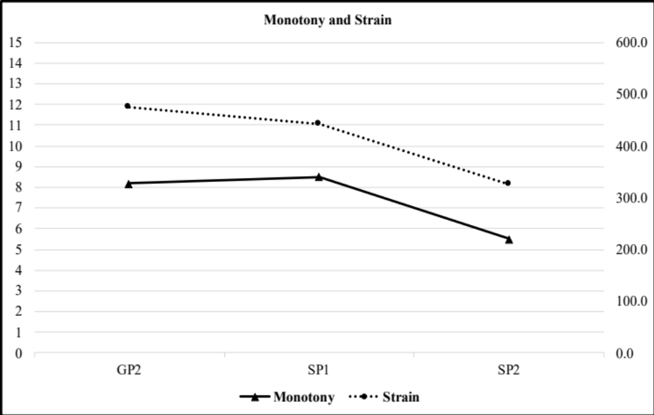
Figure 1: Monotony and Strain values for GP2, SP1, and SP2, (n=8).

Training Phase Patterns for Recovery, Stress, Sleep, and Soreness
Day to day changes within the 4 training phases can be seen in Figures 2-9 below. Signs of monotony and periodization may be seen in the charts. Several days in a row of similar numbers may point to monotony, while increased variations across days may point to proper periodization. Differences may also be seen for the same measures in different phases. Player Load and Player Load per minute are both noticeably lower in SP2 as compared to GP2 and SP1. This supports the previous finding in the Repeated Measures ANOVAs.
Recovery composite and stress composite scores primarily trended opposite from one another. One date shows both recovery and stress decreasing from the previous day (9/20) and two dates show both increasing from the previous day (9/26, 10/25). High recovery and low stress scores are seen on each Monday with data shown (9/16, 9/23, 9/30, 10/7, 10/14, 10/21, 10/28, 11/4, 11/11, 11/18, and 11/25). To less of a degree but still notable, soreness typically saw a dip on most of these same dates.
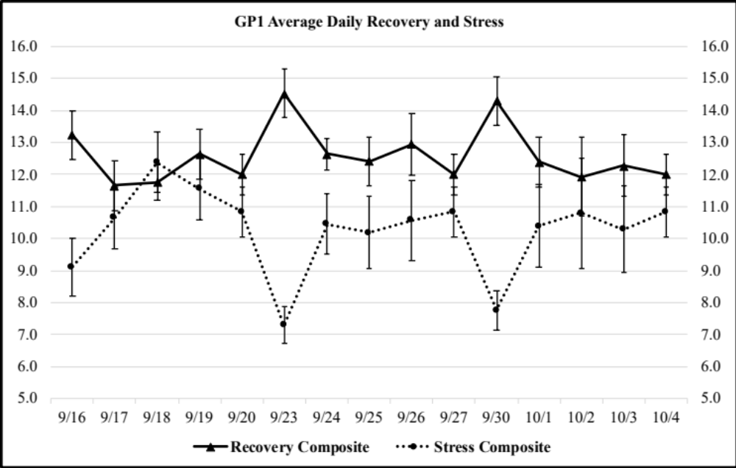
Figure 2: Team Avg (n=18) Recovery Composite and Stress Composite scores for GP1 (9/16 – 10/4).

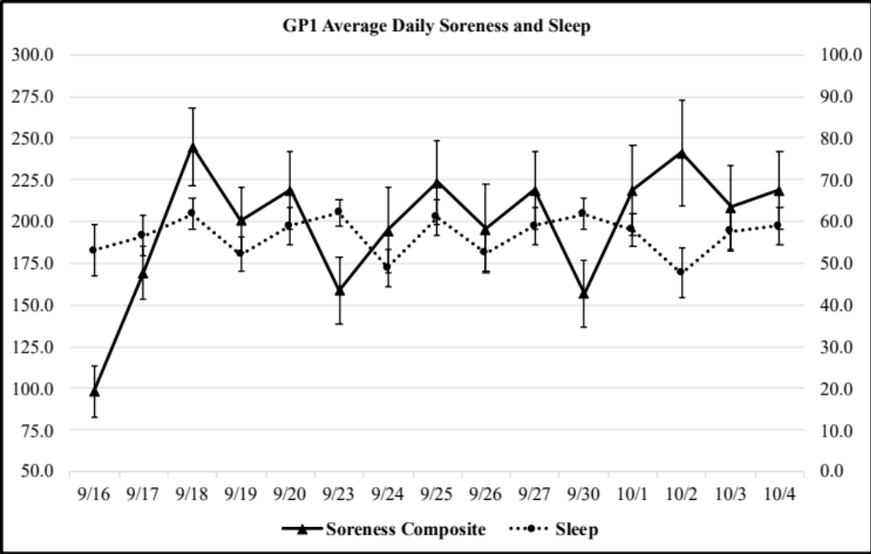
Figure 3: Team Avg (n=18) Soreness Composite and Sleep Score across GP1 (9/16 – 10/4).

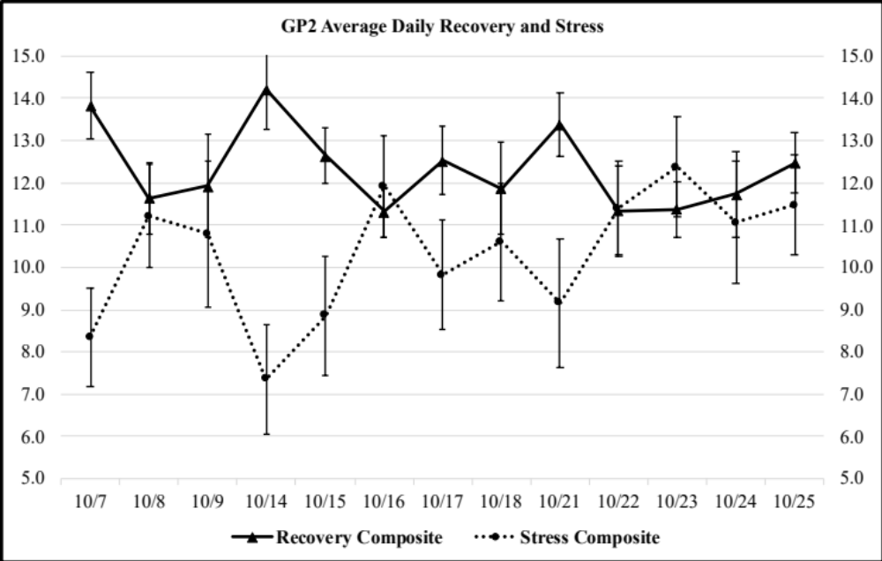
Figure 4: Team Avg (n=18) Recovery Composite and Stress Composite scores for GP2 (10/7 – 10/25).

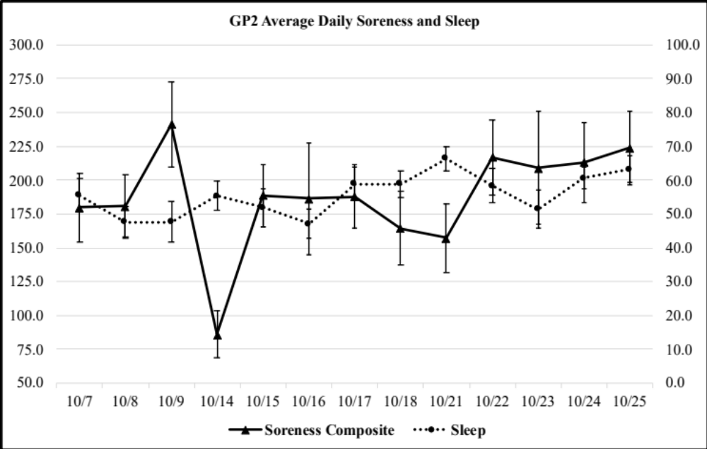
Figure 5: Team Avg (n=18) Soreness Composite and Sleep Score across GP2 (10/7 – 10/25).

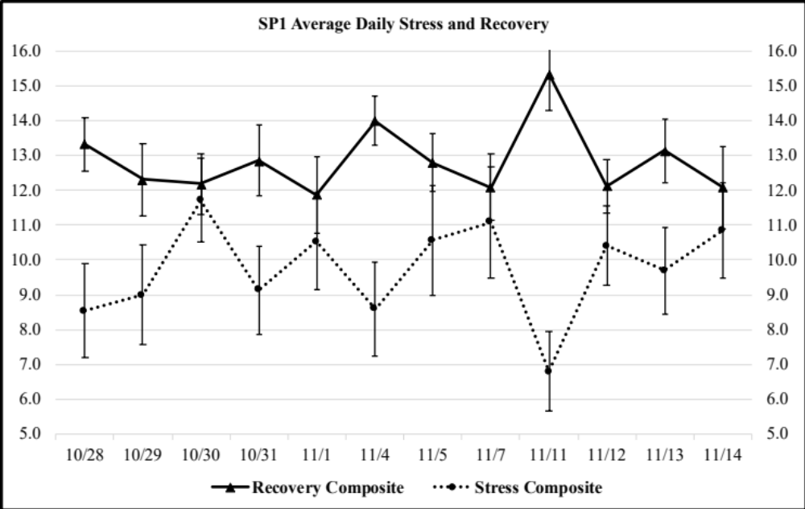
Figure 6: Team Avg (n=18) Recovery Composite and Stress Composite scores for SP1 (10/28 – 11/14).

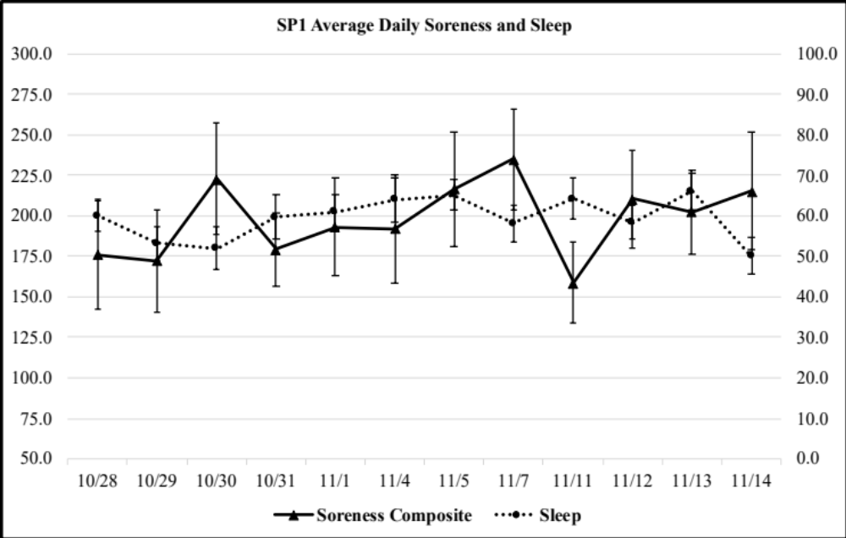
Figure 7: Team Avg (n=18) Soreness Composite and Sleep Score across SP1 (10/28 – 11/14).

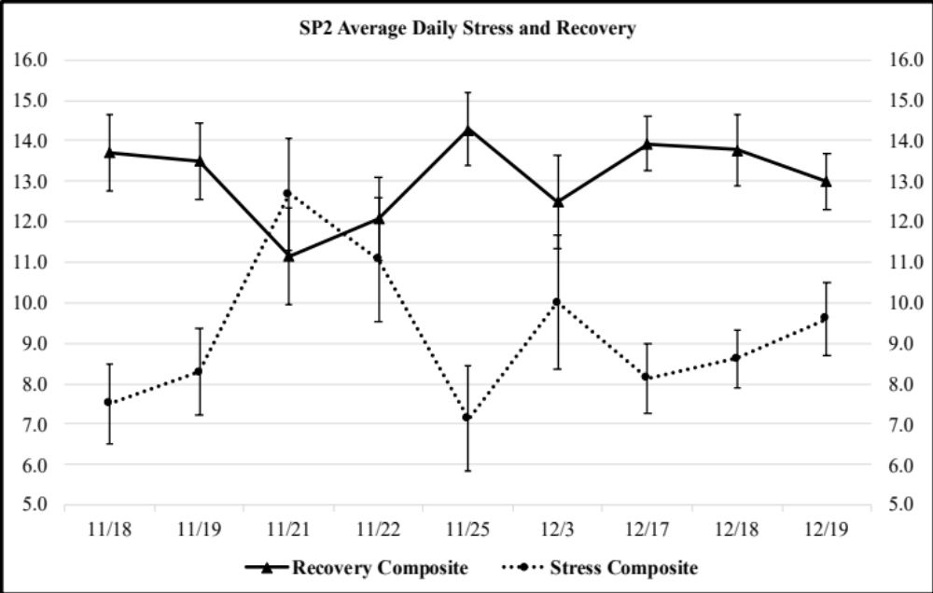
Figure 8: Team Avg (n=18) Recovery Composite and Stress Composite scores for SP2 (11/18 – 12/19).

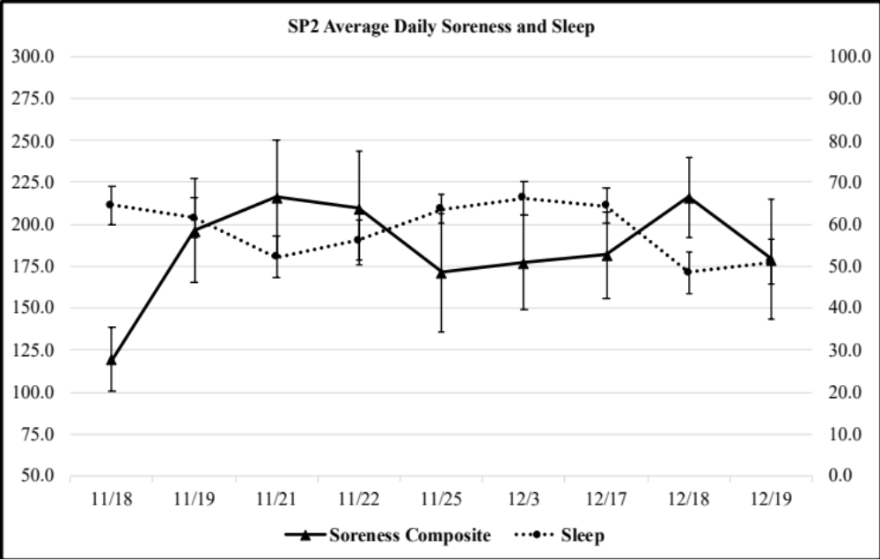
Figure 9: Team Avg (n=18) Soreness Composite and Sleep Score across SP2 (11/18 – 12/19).

Training Phase Team Averages for Recovery, Stress, Sleep, and Soreness
Player Load and Player Load per minute for GP2, SP1, and SP2 are shown in the following figures (10-12). PL and PL/min primarily followed the same trends, which is to be expected as PL/min is a calculation from PL. SP2 showed the most variation in PL and PL/min, which is seen in Figure 12. No noticeable trends existed within each training phase.
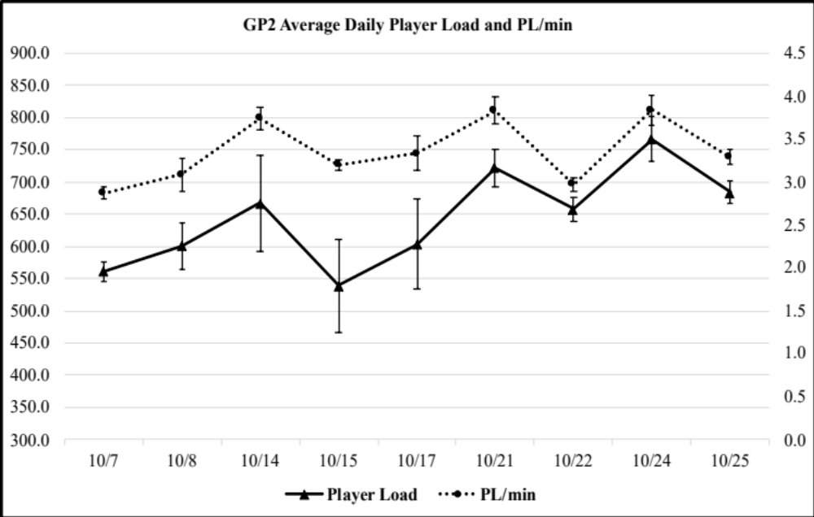
Figure 10: Team Avg (n=8) Player Load and Player Load per Minute across GP2 (10/7 – 10/25).

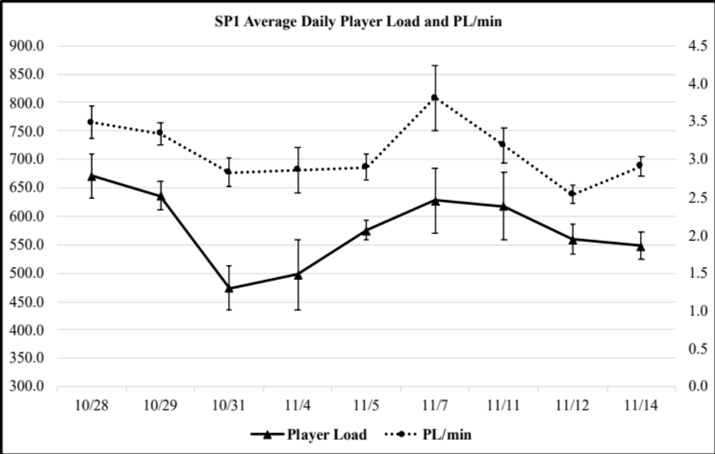
Figure 11: Team Avg (n=8) Player Load and Player Load per Minute across SP1 (10/28 – 11/14).

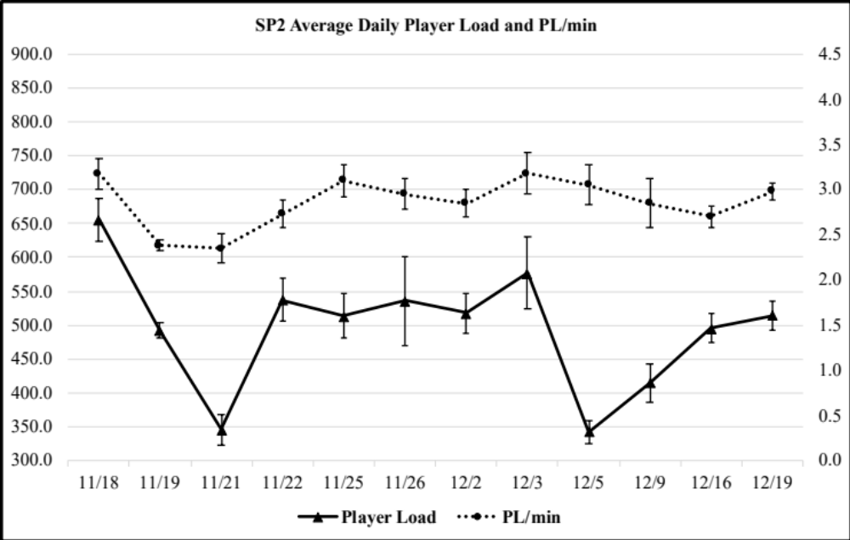
Figure 12: Team Avg (n=8) Player Load and Player Load per Minute across SP2 (11/18 – 12/19).

Discussion
The purpose of this study was to determine the utility and effectiveness of internal and external load monitoring in female NCAA Division I gymnasts. Efficacy for load monitoring, as well as feasibility, has been previously established in other sports but had yet to be determined amongst gymnasts. The main findings of this study were: 1) SRSS measures were highly correlated with one another, 2) external load measures were highly interrelated with one another, and 3) external training loads were significantly different across the preseason training phases.
The main findings from the SRSS were that recovery and stress measures were significantly inversely related. Sleep had a significant and negative relationship with soreness and stress measures, while also being positively and significantly related to recovery measures. Finally, soreness was positively and significantly related to stress measures, while being negatively and significantly related to recovery measures. Tables 7-9 show the strong relationships between the recovery and stress measures. Physical stress and emotional recovery have the weakest negative correlation at r = -0.295, although it is still significant at the p<0.001 level. The strongest correlation is seen between stress composite and overall stress at r = 0.862 also significant at the p<0.001 level.
The SRSS has not been previously used in female elite gymnasts. However, similar to the present study, Flynn et al. (2017) found strong inverse correlations between stress and recovery (r = -0.833, p < 0.01) in elite female volleyball players. The current study found a correlation of r = -0.611, p < 0.01 between the stress composite and recovery composite scores. Flynn et al. (2017) collected data during the season, while the present study utilized preseason data, which may be responsible for the slight discrepancy in correlation strength. This finding may support the utility and accuracy of the SRSS in female elite gymnasts, but differences in preseason and competition season relationships between internal and external load metrics would need to be compared across a full season to tease out what metrics offer the best value for determining athlete readiness.
The main findings related to soreness and sleep measures were that soreness was positively correlated with stress measures and negatively correlated with recovery measures whereas sleep was positively correlated with recovery measures and negatively correlated with stress measures, shown in Tables 7 and 8. The correlations were weak but still highly significant at the p < 0.001 level. Sleep and soreness, as expected, were found to be inversely related with one another, r = -0.114 at the p < 0.001 level. Conversely, sleep and soreness were not significantly correlated with external load measures such as PL and PL/min. Similar findings to our own have been shown in NCAA football players, however data from another investigation did reveal sleep had an association with physical performance in gymnasts up to 18 years of age (Dumortier et al., 2018; Govus et al., 2018). Dumortier et al. (2018) found that increased total sleep time correlated strongly with better player rank by the coaching staff, r = -0.857, p = 0.014. In relation to internal load and sleep, Govus et al. (2018) found that sleep and sRPE were not related (p = 0.99). This discrepancy may point to sleep and performance/perception of effort being more dependent on age rather than sport. Additionally, it could show a discrepancy between measurement tools of sleep and external/internal load. Contrary to the present study, a previous investigation showed no significant correlation between sleep and soreness (Sawczuk et al., 2021). This could be due to a slight difference in age, as Sawczuck et al. used athletes 16-18 years old while participants in the present study ranged from 18-22 years old, or a difference in sport or sex, with the previous study consisting of a variety of sports and both male and female participants (2021). Overall, the present study points to sleep being important for increases in recovery and decreases in soreness and stress. Although it may be expected that external load correlates with sleep and soreness, no such finding existed in the present study. It may still be important to monitor sleep in athletes to ensure optimal conditions for recovery despite its inability to predict expected work volume and intensity in a subsequent workout.
All external load measures were shown to be positively correlated with one another, suggesting that the measures are dependent. This finding was to be expected, as external load measures (distance, load, acceleration, and jump counts) have been shown to move reliably/predictably with each other in soccer, team handball, and hockey players, (Luteberget et al., 2018; Ruddy et al., 2018; Spangler et al., 2018; Van Iterson et al., 2017). As accelerometry measures have not been used in female collegiate gymnasts, this may be significant for load monitoring in the present population. Accelerometry may allow for a more “nuanced” examination of a sport involving primarily vertical bounding movements but also spinning around the mediolateral and superoinferior axes during flipping and twisting.
The main findings from the external load measures were the differences between training phases. Throughout the preseason, PL, PL per minute, PL 1D Up, IMA high, IMA medium, IMA low, and IMA total all showed significant differences between training blocks. Typically, each measure significantly decreased over the progression of the preseason (GP2>SP1>SP2) although some only showed significant differences between GP2 and SP2. The general methodology utilized in most sport team training, is a diminishment in preseason volume of training as the competitive season gets closer, across the week and then a maintenance volume that is held steady through the end of championship season.
This finding indicates that despite suggestions by others from earlier research (Sands, 2000), collegiate gymnastics coaches/trainers may employ effective periodization strategies during training. It has been believed that most gymnastics teams do not properly periodize their training programs, however this was not shown in the current study’s PL findings. The cited reasons for a lack of periodization is an absence of relevant training and education in gymnastics coaches (Sands, 2000). Previously, it was believed that gymnastics coaches did not have any adaptive load monitoring or injury prevention procedures (Daly et al., 2001; Lanese et al., 1990). There could have been an increase in coaches with relevant training and/or degrees, or the coaches of the present study could have such experience. The lack of a similar pattern in the internal load measures was an interesting finding and may be a result of the physical, mental, and emotional intensity of gymnastics (high volume of work, injury risk awareness, being judged, aesthetic pressure, etc.) and other factors outside of gymnastics, as various stressors such as academics, campus social life, and family life, have been shown to strongly contribute to recovery and stress scores (Cavallerio et al., 2016; Hwang & Choi, 2016; Marcora et al., 2009).
The external load and internal load data showed no correlations. Previous studies have shown correlations between internal and external load measures in collegiate male basketball players, elite female swimmers, and elite female soccer players (Alexiou & Coutts, 2008; Collette et al., 2018; Heishman et al., 2018; Raeder et al., 2016). Debien et al. (2020) found a negative correlation between recovery (measured with TQR) and training load (measured with RPE) in gymnasts (r = -0.32, p < 0.001). Others have pointed to inaccuracies in generalizations of a simple correlation between internal and external load as a result of the many intricacies of each (Collette et al., 2018). Saw et al. (2016) showed in a systematic review that subjective measures may demonstrate well-being better than objective measures. Some studies have also pointed to a time effect between training load and internal load (Collette et al., 2018). Collette et al. (2018) found that individuals may experience a time delay between training and the effects of that training on responses within the ARSS, ranging from 0-7 days for sRPE and ACWR. The current investigation used each day’s external load and the proceeding day’s internal load (evaluated each morning at 6:00am CST), thus it is possible gymnasts and/or collegiate athletes may also experience time delays that resulted in a lack of association between internal and external loads in the present study. This may be analogous to the pattern observed with delayed onset muscle soreness (DOMS), therefore it is plausible that measures of internal load may manifest changes in a similar fashion. A lack of correlation in the present study may be due the intricacies of gymnastics, or an increased sensitivity to change in subjective measures over objective measures. Additional assessments are needed to determine the consistency of this finding.
Recovery composite was higher than average on each Monday that data was present throughout the preseason. Stress composite and soreness typically showed lower than average numbers on Mondays. These trends could be due to decreased academic and training loads over the weekend, increasing preparedness each Monday. Despite these findings, sleep did not show noticeable differences after weekends or throughout the week. This could be due to changes in sleep and wake times over the weekend or possible lower sleep quality on weekends. As high recovery and low stress and soreness are present on Mondays, that may be useful to coaches in planning properly periodized workouts. Most other days did not show a consistent pattern throughout the preseason. Some Mondays showed increased PL values, however any consequences from these values were not seen on the internal load measures on Tuesdays.
The present population experienced high rates of under-recovery. About 97% of the preseason the team showed recovery composite scores under 20 and under 16 about 80% of the preseason. Previous studies have shown that gymnasts present as under-recovered about 51% of the season (Debien et al., 2020). Debien et al. used TQR to determine recovery and determined that 13/20 (65% recovered) was considered under-recovered (2020). The present study used 20/24 (83% recovered) and 16/24 (66% recovered) as two markers for a state of under-recovery. Despite a similar age group, the previous study does not specify whether the elite gymnasts are enrolled in any academic program, which could be the reason the current study found a higher incidence of under-recovery among the participants. This may point to the impact of academics on recovery in collegiate athletes and therefore the importance of individualized monitoring and enhanced academic support measures. Stress composite scores showed increased values of 8/24 (33% stressed) 499/713 scores or about 70% of the preseason and 12/24 (50% stressed) 240/713 scores or about 34% of the preseason. Increased stress scores throughout the preseason may point to even higher stress scores during the season because of competition and travel stress. This, again, may point to a necessity of individual internal load monitoring in female collegiate gymnasts, particularly to assess if differences in controllable factors such as the travel mode used to attend competitions (i.e., bus vs. air vs. no travel) result in negative consequences.
Monotony and strain showed extremely high scores, especially in GP2 and SP1. With the demanding training hours and repeated movements in practice, high scores of monotony are not unexpected. A previous study has pointed to the high monotony levels that female gymnasts withstand (Dumortier et al., 2018). Dumortier et al. found a weekly training monotony of 2.33 ± 0.66 AU; the present study found monotony scores of 8.2, 8.5, and 5.5 AU throughout the training phases, GP2, SP1, and SP2, respectively. The discrepancies found between the two could be a result of competition level, Dumortier et al. (2018) studied gymnasts from under 13 to seniors in high school. Several other studies have also found high levels of monotony in collegiate and elite athletes, with most of them showing that such levels may lead to overtraining and injury (Clemente et al., 2020; Debien et al., 2018; Delecroix et al., 2019; Fessi et al., 2016). One study lacked conclusive findings in preseason studies in elite gymnasts (Debien et al., 2020). In the present study, monotony and strain scores were the lowest in SP2, which could be due to an intended tapering and/or increased presence of reciprocating high/low training days as the season was approaching. Similarly, a few studies have found that monotony scores were higher in the preseason than in season (Clemente et al., 2020; Fessi et al., 2016). Clemente et al. (2020) found that preseason monotony was significantly higher (p > 0.001) in the first and second halves of the preseason, with no significant differences (p = 0.990) between the first and second half of the competitive season. Fessi et al. (2016) had similar findings with a significant difference between preseason and in season monotony (p > 0.01). Differences between preseason and in season monotony could be due to increased intensity during competition as compared to practice, which might decrease weekly monotony. It seems that monitoring monotony may be an important piece of information to consider for avoidance of overtraining and injury in collegiate and elite athletes. Overall, the present findings in monotony patterns, despite being concerning, are congruent with most of the previous literature.
The high monotony and strain findings seem contrary to the seemingly periodized external load measures in figures 10-12. However, monotony and strain findings are fairly congruent with changes in external load between training phases. Monitoring internal and external load specifically for periodization may provide more insight into whether gymnastics coaching staffs have proper periodization strategies, if any.
Internal and external load measures, sleep, soreness, monotony, and strain measures may be valuable in elite female gymnasts. The present study showed similar findings to previous studies in other age and sport populations. If such measures could be used to prevent or predict injury and overtraining in gymnasts, it would be vital for coaching staffs to do so. Increasing performance cannot be accomplished in a state of under-recovery, over-reaching, over-training, or injury.

Limitations
As a retrospective study, several limitations exist that may inhibit the fullest understanding of recovery and performance in elite female gymnasts. Injury, individual academic schedules, and menstrual cycle data were unavailable. As studies have shown that high external load factors can contribute to injury, mental stress contributes to decreases in performance, and the menstrual cycle has been shown to affect many measures in female athletes specifically (Cristina-Souza et al., 2019; Freemas et al., 2021). Monotony and strain have both been found to be higher during the follicular phase vs. the ovulatory phase demonstrating consideration is warranted to determine the net effect of training vs. menstrual cycle phase (Cristina-Souza et al., 2019). Additionally, Freemas et al. (2021) found total mood disturbance (POMS) and fatigue to be increased during the midluteal phase, although no significant difference was found for RPE. Thus, these factors may play a role in internal and external loads or help further explain patterns in the data.
The small sample size of one collegiate team is restrictive, and a larger and more diverse sample in the future would give more power to the data. As each participant was from the same team, trained by the same coaching staff, any evidence of periodization or injury prevention can only be attributed to that team, and cannot be assumed for the entire sport or NCAA Division I Women’s Gymnastics. However, looking at one team helped control, in part, for differences in the athlete/coach relationship, the day-to-variability in coaching methods across multiple teams, as well as talent differences that may affect the physical, mental, and emotional capacities for training and stress resiliency. The Catapult trackers were donned by the athletes and checked by the team’s coaching staff and the collection of the external load data was performed by the athletic trainer each day. Although the athletic trainer and gymnasts were trained on the proper procedures, mistakes that disrupt data accuracy may have occurred. Nevertheless, there were no reported malfunctions with trackers, uploading of data, or timing related to their use.

Chapter V - Conclusions
The purpose of this study was to determine whether internal and external load monitoring are effective in female collegiate gymnasts. The main hypotheses were:
- Accelerometry-based external load measures will differ across preseason training phases, with Skills/General Prep 1 being higher than Combinations/General Prep 2 and Practice Routines/Special Prep 1 being higher than Competitive Routines/Special Prep 2.
All accelerometry-based measures did differ across training phases, showing a general trend of decreasing external loading as the preseason progresses.
- The highest external load scores will occur at the beginning and end of each training phase and the lowest external load measures will occur in the middle of the training phases. High external load measures will precede high soreness and low sleep quality scores.
No noticeable trends in high and low external load scores within each training phase exist, however significant differences do exist between training phases. No correlations were found between external load measures and soreness or sleep scores on the following day.
- Accelerometry-based external load measures will be inversely related to sleep and recovery and directly related to soreness and stress.
No correlations were found between external load and internal load measures, sleep, or soreness.

Practical Significance and Applications
To our knowledge, this is the first study to use these measures in conjunction with one another in female NCAA Division I gymnasts. The implications of these findings are that internal and external load monitoring may be useful in elite female gymnasts to help ensure proper recovery and periodization in the present group. Internal load, sleep, and soreness measures may be used by coaches to monitor their team’s preparedness to practice or compete through simple, time efficient questionnaires readily available via smart phone. External loads may hold more value in determining if proper periodization protocols are being incorporated into training, yet the expense and expertise required to collect and analyze the data may be problematic without the presence of a sport/data scientist. The differences observed in external training loads over the different training phases may suggest that elite gymnastics employs more effective periodization strategies than previously assumed.
It is pertinent for athletes and coaching staff to move toward a common goal of decreasing the prevalence of overtraining and injury in collegiate female gymnasts. To increase performance and compete and train effectively, a state of recovery must be reached. Monitoring internal and external load and monotony/strain ratios may be key to accomplishing this goal.

Future Study Recommendations
As a result of the lack of literature assessing utility of internal and external load measures in female athletes and gymnasts, future studies are warranted.
In this population, further studies of differences in internal and external load dependent on the competitive events each gymnast participates in specifically could be useful for further insight into whether individualized periodization and recovery could be necessary (e.g., a one event specialist vs. a three-event gymnast). Competing and training for each event may require unique load and/or recovery, in which case, each gymnast may need different periodization and recovery measures.
Secondly, using current internal and external load measures in conjunction with academic demands (i.e., exams, papers, presentations, etc.) may show effects in individual athletes training load and recovery differently than the team as a whole. It has been found that academic stressors can have an effect on performance in collegiate athletes (Hwang & Choi, 2016; Marcora et al., 2009). This could be pertinent to a more wholistic understanding of demand on NCAA gymnasts. Laying academic schedules on top of the expected training plan may further clarify where adjustments need to be made in training or help with the interpretation of when performance declines or opportunities may manifest.
Third, further investigation into whether monotony and strain may meaningfully contribute to or predict injury and/or overtraining in gymnasts is warranted. With the various studies in collegiate and elite athletes in other sports showing such findings, similar patterns may exist in gymnasts. Such a study seems pertinent due to the extremely high monotony levels found in the present study in conjunction with the high injury rates in gymnasts present in previous studies.
Finally, an investigation on what role academic class plays in recovery and stress measures may be justified. The transition from high school to college entails changes in academic rigor, training rigor, and social and familial relationships. These changes may be evident in training readiness, recovery, and stress in underclassmen, whereas upperclassmen may have already become accustomed and adjusted to collegiate stressors, as well as, created useful strategies for stress mitigation. Previous studies have shown age-related differences in sleep and performance in gymnasts, suggesting this data may be useful (Dumortier et al., 2018).

Practical Recommendations
The present retrospective study was developed to find whether internal and external load monitoring could be effective in female NCAA Division I gymnasts. As this is an under-researched population and a small sample size was used, future studies investigating the utility of these measures with a larger sample would enhance the current understanding. Additionally, as this was a retrospective study, in the future other data such as menstrual cycle, any additional physical activity, and injury data could be useful but not available in the present study.

References
Alexiou, H., & Coutts, A. J. (2008). A Comparison of Methods Used for Quantifying Internal Training Load in Women Soccer Players. International Journal of Sports Physiology and Performance, 3(3), 320–330. https://doi.org/10.1123/ijspp.3.3.320
Barrett, S., Midgley, A., & Lovell, R. (2014). PlayerLoadTM: Reliability, Convergent Validity, and Influence of Unit Position During Treadmill Running. International Journal of Sports Physiology & Performance, 9(6), 945–952.
Bayliff, G. E., Jacobson, B. H., Moghaddam, M., & Estrada, C. (2019). Global Positioning System Monitoring of Selected Physical Demands of NCAA Division I Football Players During Games. The Journal of Strength & Conditioning Research, 33(5), 1185–1191. https://doi.org/10.1519/JSC.0000000000003137
Bishop, P. A., Jones, E., & Woods, A. K. (2008). Recovery From Training: A Brief Review: Brief Review. The Journal of Strength & Conditioning Research, 22(3), 1015–1024. https://doi.org/10.1519/JSC.0b013e31816eb518
Bourdon, P. C., Cardinale, M., Murray, A., Gastin, P., Kellmann, M., Varley, M. C., Gabbett, T. J., Coutts, A. J., Burgess, D. J., Gregson, W., & Cable, N. T. (2017). Monitoring Athlete Training Loads: Consensus Statement. International Journal of Sports Physiology & Performance, 12, S2-161.
Boyd, L. J., Ball, K., & Aughey, R. J. (2011). The Reliability of MinimaxX Accelerometers for Measuring Physical Activity in Australian Football. International Journal of Sports Physiology & Performance, 6(3), 311–321.
Boyd, L. J., Ball, K., & Aughey, R. J. (2013). Quantifying External Load in Australian Football Matches and Training Using Accelerometers. International Journal of Sports Physiology & Performance, 8(1), 44–51.
Bredt, S. da G. T., Chagas, M. H., Peixoto, G. H., Menzel, H. J., & Andrade, A. G. P. de. (2020). Understanding Player Load: Meanings and Limitations. Journal of Human Kinetics, 71(1), 5–9.
Caine, D., Cochrane, B., Caine, C., & Zemper, E. (1989). An epidemiologic investigation of injuries affecting young competitive female gymnasts. The American Journal of Sports Medicine, 17(6), 811–820. https://doi.org/10.1177/036354658901700616
Cavallerio, F., Wadey, R., & Wagstaff, C. R. D. (2016). Understanding overuse injuries in rhythmic gymnastics: A 12-month ethnographic study. Psychology of Sport and Exercise, 25, 100–109. https://doi.org/10.1016/j.psychsport.2016.05.002
Chambers, R. M., Gabbett, T. J., & Cole, M. H. (2019). Validity of a Microsensor-Based Algorithm for Detecting Scrum Events in Rugby Union. International Journal of Sports Physiology & Performance, 14(2), 176–182.
Chen, K. Y., & Bassett, D. R. (2005). The Technology of Accelerometry-Based Activity Monitors: Current and Future: Medicine & Science in Sports & Exercise, 37(Supplement), S490–S500. https://doi.org/10.1249/01.mss.0000185571.49104.82
Clemente, F. M., Silva, R., Ramirez-Campillo, R., Afonso, J., Mendes, B., & Yung-Sheng Chen. (2020). Accelerometry-based variables in professional soccer players: Comparisons between periods of the season and playing positions. Biology of Sport, 37(4), 389–403.
Collette, R., Kellmann, M., Ferrauti, A., Meyer, T., & Pfeiffer, M. (2018). Relation Between Training Load and Recovery-Stress State in High-Performance Swimming. Frontiers in Physiology, 9. https://doi.org/10.3389/fphys.2018.00845
Cristina-Souza, G., Santos-Mariano, A. C., Souza-Rodrigues, C. C., Osiecki, R., Silva, S. F., Lima-Silva, A. E., & De Oliveira, F. R. (2019). Menstrual cycle alters training strain, monotony, and technical training length in young. Journal of Sports Sciences, 37(16), 1824–1830.
Daly, R., Bass, S., & Finch, C. (2001). Balancing the risk of injury to gymnasts: How effective are the counter measures? British Journal of Sports Medicine, 35(1), 8–19. https://doi.org/10.1136/bjsm.35.1.8
Debien, P. B., Mancini, M., Coimbra, D. R., de Freitas, D. G. S., Miranda, R., & Bara Filho, M. G. (2018). Monitoring Training Load, Recovery, and Performance of Brazilian Professional Volleyball Players During a Season. International Journal of Sports Physiology & Performance, 13(9), 1182–1189.
Debien, P. B., Miloski, B., Werneck, F. Z., Timoteo, T. F., Ferezin, C., Filho, M. G. B., & Gabbett, T. J. (2020). Training Load and Recovery During a Pre-Olympic Season in Professional Rhythmic Gymnasts. Journal of Athletic Training, 55(9), 977–983. https://doi.org/10.4085/1062-6050-402.19
Delecroix, B., Mccall, A., Dawson, B., Berthoin, S., & Dupont, G. (2019). Workload monotony, strain and non-contact injury incidence in professional football players. Science & Medicine in Football, 3(2), 105–108.
Doeven, S. H., Brink, M. S., Frencken, W. G. P., & Lemmink, K. A. P. M. (2017). Impaired Player-Coach Perceptions of Exertion and Recovery During Match Congestion. International Journal of Sports Physiology & Performance, 12(9), 1151–1156.
Dumortier, J., Mariman, A., Boone, J., Delesie, L., Tobback, E., Vogelaers, D., & Bourgois, J. G. (2018). Sleep, training load and performance in elite female gymnasts. European Journal of Sport Science, 18(2), 151–161.
Fessi, M. S., Nouira, S., Dellal, A., Owen, A., Elloumi, M., & Moalla, W. (2016). Changes of the psychophysical state and feeling of wellness of professional soccer players during pre-season and in-season periods. Research in Sports Medicine, 24(4), 375–386.
Flynn, A., Walters, J., Lang, H., Perkins, A., & Goodin, J. (2017). Validation of The Short Recovery Stress Scale Questionnaire During Women’s Volleyball In-Season Training. 6.
Fomin, R., & Nasedkin, V. (n.d.). EFFECTIVE MANAGEMENT OF ATHLETE PREPARATION. 32.
Freemas, J. A., Baranauskas, M. N., Constantini, K., Constantini, N., Greenshields, J. T., Mickleborough, T. D., Raglin, J. S., & Schlader, Z. J. (2021). Exercise Performance Is Impaired during the Midluteal Phase of the Menstrual Cycle. Medicine & Science in Sports & Exercise, 53(2), 442–452. https://doi.org/10.1249/MSS.0000000000002464
Govus, A. D., Coutts, A., Duffield, R., Murray, A., & Fullagar, H. (2018). Relationship Between Pretraining Subjective Wellness Measures, Player Load, and Rating-of-Perceived-Exertion Training Load in American College Football. International Journal of Sports Physiology and Performance, 13(1), 95–101. https://doi.org/10.1123/ijspp.2016-0714
Halson, S. L. (2014). Monitoring Training Load to Understand Fatigue in Athletes. Sports Medicine, 44(2), 139–147. https://doi.org/10.1007/s40279-014-0253-z
Heishman, A. D., Curtis, M. A., Saliba, E., Hornett, R. J., Malin, S. K., & Weltman, A. L. (2018). Noninvasive Assessment of Internal and External Player Load: Implications for Optimizing Athletic Performance. 8.
Hwang, S., & Choi, Y. (2016). Data Mining in the Exploration of Stressors Among NCAA Student Athletes. Psychological Reports, 119(3), 787–803. https://doi.org/10.1177/0033294116674776
Kallus, K. W., & Kellmann, M. (2016). The Recovery-Stress Questionnaires: User Manual.
Keane, K. M., Salicki, R., Goodall, S., Thomas, K., & Howatson, G. (2015). Muscle Damage Response in Female Collegiate Athletes After Repeated Sprint Activity. The Journal of Strength & Conditioning Research, 29(10), 2802–2807. https://doi.org/10.1519/JSC.0000000000000961
Kellmann, M. (2002). Enhancing Recovery: Preventing Underperformance in Athletes. Human Kinetics. https://books-google-com.ezproxy.lib.ou.edu/books?hl=en&lr=&id=Qp-WkTxvlvIC&oi=fnd&pg=PP9&dq=enhancing+recovery&ots=qJ4FwXjr7R&sig=9WVNqJsssxOxHQgMI3NpeZWcd0A#v=onepage&q=enhancing%20recovery&f=false
Kellmann, M., Bertollo, M., Bosquet, L., Brink, M., Coutts, A. J., Duffield, R., Erlacher, D., Halson, S. L., Hecksteden, A., Heidari, J., Kallus, K. W., Meeusen, R., Mujika, I., Robazza, C., Skorski, S., Venter, R., & Beckmann, J. (2018). Recovery and Performance in Sport: Consensus Statement. International Journal of Sports Physiology & Performance, 13(2), 240–245.
Kellmann, M., & Kolling, S. (2019). Recovery and Stress in Sport. Routledge.
Kreher, J. B., & Schwartz, J. B. (2012). Overtraining Syndrome. Sports Health, 4(2), 128–138. https://doi.org/10.1177/1941738111434406
Lanese, R. R., Strauss, R. H., Leizman, D. J., & Rotondi, M. (1990). Injury and Disability in Matched Men’s and Women’s Intercollegiate Sports. American Journal of Public Health, 80(12), 1459–1462.
Lopes Dos Santos, M., Uftring, M., Stahl, C. A., Lockie, R. G., Alvar, B., Mann, J. B., & Dawes, J. J. (2020). Stress in Academic and Athletic Performance in Collegiate Athletes: A Narrative Review of Sources and Monitoring Strategies. Frontiers in Sports and Active Living, 2. https://doi.org/10.3389/fspor.2020.00042
Luteberget, L. S., Holme, B. R., & Spencer, M. (2018). Reliability of Wearable Inertial Measurement Units to Measure Physical Activity in Team Handball. International Journal of Sports Physiology & Performance, 13(4), 467–473.
Mann, J. B., Bryant, K. R., Johnstone, B., Ivey, P. A., & Sayers, S. P. (2016). Effect of Physical and Academic Stress on Illness and Injury in Division 1 College Football Players. The Journal of Strength & Conditioning Research, 30(1), 20–25. https://doi.org/10.1519/JSC.0000000000001055
Marcora, S. M., Staiano, W., & Manning, V. (2009). Mental fatigue impairs physical performance in humans. Journal of Applied Physiology, 106(3), 857–864. https://doi.org/10.1152/japplphysiol.91324.2008
McLaren, S. J., Macpherson, T. W., Coutts, A. J., Hurst, C., Spears, I. R., & Weston, M. (2018). The Relationships Between Internal and External Measures of Training Load and Intensity in Team Sports: A Meta-Analysis. Sports Medicine, 48(3), 641–658. https://doi.org/10.1007/s40279-017-0830-z
Nagle, J. A., McMillan, J. L., Munkasy, B. A., Joyner, A. B., Roorda, A., Scott, M. K., & Rossi, S. J. (2015). Changes in Swim Performance and Perceived Stress and Recovery in Female Collegiate Swimmers Across a Competitive Season. J. Swimming Research, 23, 44–53.
Nässi, A., Ferrauti, A., Meyer, T., Pfeiffer, M., & Kellmann, M. (2017). Development of two short measures for recovery and stress in sport. European Journal of Sport Science, 17(7), 894–903.
Nicolas, M., Vacher, P., Martinent, G., & Mourot, L. (2019). Monitoring stress and recovery states: Structural and external stages of the short version of the RESTQ sport in elite swimmers before championships. Journal of Sport and Health Science, 8(1), 77–88. https://doi.org/10.1016/j.jshs.2016.03.007
Nicolella, D. P., Torres-Ronda, L., Saylor, K. J., & Schelling, X. (2018). Validity and reliability of an accelerometer-based player tracking device. PloS One, 13(2), e0191823. https://doi.org/10.1371/journal.pone.0191823
Raeder, C., Wiewelhove, T., Simola, R. Á. D. P., Kellmann, M., Meyer, T., Pfeiffer, M., & Ferrauti, A. (2016). Assessment of Fatigue and Recovery in Male and Female Athletes After 6 Days of Intensified Strength Training: Journal of Strength and Conditioning Research, 30(12), 3412–3427. https://doi.org/10.1519/JSC.0000000000001427
Roell, M., Mahler, H., Lienhard, J., Gehring, D., Gollhofer, A., & Roecker, K. (2019). Validation of Wearable Sensors during Team Sport-Specific Movements in Indoor Environments. Sensors, 19(16), 3458. https://doi.org/10.3390/s19163458
Ruddy, J. D., Pollard, C. W., Timmins, R. G., Williams, M. D., Shield, A. J., & Opar, D. A. (2018). Running exposure is associated with the risk of hamstring strain injury in elite Australian footballers. British Journal of Sports Medicine, 52(14), 919–928. https://doi.org/10.1136/bjsports-2016-096777
Sands, W. A. (2000). Injury Prevention in Women’s Gymnastics. Sports Medicine, 30(5), 359–373. https://doi.org/10.2165/00007256-200030050-00004
Sands, W. A., Shultz, B. B., & Newman, A. P. (1993). Women’s gymnastics injuries: A 5-year study. The American Journal of Sports Medicine, 21(2), 271–276.
Saw, A. E., Main, L. C., & Gastin, P. B. (2016). Monitoring the athlete training response: Subjective self-reported measures trump commonly used objective measures: a systematic review. British Journal of Sports Medicine, 50(5), 281–291. https://doi.org/10.1136/bjsports-2015-094758
Sawczuk, T., Jones, B., Scantlebury, S., & Till, K. (2021). Influence of Perceptions of Sleep on Well-Being in Youth Athletes. The Journal of Strength & Conditioning Research, 35(4), 1066–1073. https://doi.org/10.1519/JSC.0000000000002857
Smith, M. R., Coutts, A. J., Merlini, M., Deprez, D., Lenoir, M., & Marcora, S. M. (2016). Mental Fatigue Impairs Soccer-Specific Physical and Technical Performance: Medicine & Science in Sports & Exercise, 48(2), 267–276. https://doi.org/10.1249/MSS.0000000000000762
Snyder, E. E. (1990). Emotion and Sport: A Case Study of Collegiate Women Gymnasts. Sociology of Sport Journal, 7(3), 254–270. https://doi.org/10.1123/ssj.7.3.254
Spangler, R., Rantalainen, T., Gastin, P. B., & Wundersitz, D. (2018). Inertial Sensors are a Valid Tool to Detect and Consistently Quantify Jumping. International Journal of Sports Medicine, 39(10), 802–808. https://doi.org/10.1055/s-0044-100793
Taylor, K.-L., Chapman, D., Cronin, J., Newton, M., & Gill, N. (2012). Fatigue Monitoring in High Performance Sport: A Survey of Current Trends. Journal of Australian Strength and Conditioning, 20, 12–23.
Troiano, R. P., McClain, J. J., Brychta, R. J., & Chen, K. Y. (2014). Evolution of accelerometer methods for physical activity research. British Journal of Sports Medicine, 48(13), 1019–1023. https://doi.org/10.1136/bjsports-2014-093546
Van Iterson, E. H., Fitzgerald, J. S., Dietz, C. C., Snyder, E. M., & Peterson, B. J. (2017). Reliability of Triaxial Accelerometry for Measuring Load in Men’s Collegiate Ice Hockey. Journal of Strength & Conditioning Research, 31(5), 1305–1312.
Wallace, L. K., Slattery, K. M., & Coutts, A. J. (2009). The Ecological Validity and Application of the Session-RPE Method for Quantifying Training Loads in Swimming: Journal of Strength and Conditioning Research, 23(1), 33–38. https://doi.org/10.1519/JSC.0b013e3181874512
Westermann, R. W., Giblin, M., Vaske, A., Grosso, K., & Wolf, B. R. (2015). Evaluation of Men’s and Women’s Gymnastics Injuries: A 10-Year Observational Study. Sports Health, 7(2), 161. https://doi.org/10.1177/1941738114559705
Women’s Collegiate Gymnastics Association. (2020). Annual Report 2020 [Press Release].

