UNIVERSITY OF OKLAHOMA
GRADUATE COLLEGE

ARCHAEOLOGY OF EASTERN SONORA, MEXICO: A RECONSIDERATION OF RIO SONORA/SERRANA SOCIAL ORGANIZATION THROUGH COMPARATIVE CERAMICS ANALYSIS

A THESIS
SUBMITTED TO THE GRADUATE FACULTY
In partial fulfillment of the requirements for the
Degree of

MASTER OF ARTS

By
JOSE R. VIVERO MIRANDA
Norman, Oklahoma
2021

ARCHAEOLOGY OF EASTERN SONORA, MEXICO: A RECONSIDERATION OF RIO SONORA/SERRANA SOCIAL ORGANIZATION THROUGH COMPARATIVE CERAMICS ANALYSIS

A THESIS APPROVED FOR THE
DEPARTMENT OF ANTHROPOLOGY

BY THE COMMITTEE CONSISTING OF

Dr. Matthew Pailes
Dr. Jessica Cerezo-Román
Dr. Patrick Livingood

© Copyright by JOSE R. VIVERO MIRANDA 2021
All Rights Reserved.

ABSTRACT

This study will provide an additional perspective on the socio-political organization of the late precolonial and protocolonial period (AD 1250 to ~1550) in the Rio Sonora/Serrana region through an analysis of textured ceramic traditions. This research consists of a quantitative and qualitative analysis of the decorative treatments of ceramic collections, from three rivers valleys from eastern Sonora (Sonora, Moctezuma, and Fronteras valleys). The Sonora Valley sample is newly analyzed and includes ceramics from multiple sites and importantly several discrete architectural zones of the primate village site of San Jose. The samples permit evaluation at three spatial scales of variation in the use of texturing and painting treatments and defined layout “styles”. The variation is compared to preexisting models regarding pan-regional political confederacies, intra-valley “statelet” organization, and inter-site relationships. Some support is found for these classic models, which are reconsidered in an updated discussion of group identity at all three scales.

To my Family, Professors, and Friends

ACKNOWLEDGEMENTS

First, and most importantly, this research is dedicated to my father. Thank you, Mr., for always providing the means for success in life. Delfy and Victoria, the love, patience, and comprehension during the difficult times have been vital for me to keep on track. Beto and Mom, thank you for supporting me since the beginning of my dreams and giving me the motivation to accomplish them. I have to thank Dr. Matthew Pailes for your always wise and accurate suggestions and comments to improve this research. Thank you also for your trust in me and in this research. My special thanks are also owed to the Committee, your comments and suggestions were vital for this research. I would also like to show gratitude to all my professors during the Master's Program. Your teachings have been crucial in my academic formation. Thank you Pierce, despite being far from home, you have become a member of our family.

Thank you all because you are part of my history, my dreams, and my life.

TABLE OF CONTENTS
Contents
1. INTRODUCTION 1
2. CULTURAL HISTORY 7
2.1 Conquerors and Friars accounts 7
2.2 Geographers and Archaeologists in the Rio Sonora/Serrana region 17
2.3 Late 20th Century and “Statelet” models 21
2.3.1 Di Peso’s “Statelet” Model 23
2.3.2 Riley’s “Statelet” Model 24
2.3.3 Doolittle’s “Statelet” Model 25
2.3.4 R. Pailes “Statelet” Model 28
2.3.5 “Statelet” models re-evaluation 30
3. THEORY 34
3.1 “Style” Theories 35
3.1.1 Types of Styles 38
3.1.2 Social Interaction Theory 39
3.1.3 Information-exchange theory 40
3.2 Identity 40
3.2.1 Identity, Style, Social Boundaries and Communities of Practice 43
4. METHODS 46
4.1 Inter-Valley 50
4.2 Intra-Valley 50
4.3 Intra-site 51
4.4 Analysis 51
4.4.1 Incising 54
4.4.2 Punctating 57
4.4.3 Paint 59
4.4.4 Psuedo-Corrugated 61
4.4.5 Brushing 61
4.4.6 Design attribute definitions 61
4.4.7 Punctate variants 68
5. ANALYSIS 70
5.1 Inter-Valley Analysis (Sonora, Moctezuma, and Fronteras Valleys) 70
5.1.1 Treatment Category Analysis 71
5.1.2 Sonora Valley and Moctezuma Valley Red Paint Distribution 81
5.2 Intra-Valley Analysis (Sonora River Valley) 82
5.2.1 Treatment Category Analysis 83
5.2.2 Style Category Analysis 84
5.3 Intra site analysis (San Jose site, SON K:4:24; Areas A, B, and C) 91
5.3.1 Treatment Category Analysis 91
5.3.2 Style Category Analysis 94
6. SYNTHESIS OF RESULTS 102
6.1 Inter-Valley Results 102
6.2 Intra-Valley Results (SON K:4:24 & NON K:4:24) 104
6.3 Intra-Site SON K:4:24 (Areas A, B, & C) 106
7. DISCUSSION 109
8. REFERENCES CITED 122

LIST OF FIGURES AND TABLES

Figures
- Research area location. 6
- Intra-valley sites’ location (Sonora Valley). 51
- Angled design decoration. 56
- Parallel design decoration. 56
- Brushed decoration. 56
- Painting framed by parallel design decoration. 56
- Dash punctate regular patterning incise-framed decoration. 58
- Regular circle-punctate patterning filler field, incised-framed; 58 adjacent paint decoration.
- Regular pin-punctate patterning filler band, incised-framed; 58 adjacent paint decoration.
- Three element band (Painting incise-framed; regular patterning 58 dash-punctate bounding field decoration.
- Painting framed by pin-punctate bounding bands decoration. 60
- Pin-punctate framed by incising; adjacent paint decoration. 60
- Circle-punctate filler band framed by angled-incise design with 60 painting bounding field decoration.
- Painting framed by diamond-punctate bounding bands decoration. 60
- Painting treatment relationship. 63
- Styles’ sketch 67
- Punctate variants 69
- Decorated ceramic assemblage sizes of the 70 Sonora (OU-original data), Moctezuma (Legacy data-Pailes 2016), and Fronteras valleys (Legacy Data-Carpenter et al 2019).
- Sonora valley “treatments” distribution (OU-original data) 72
- Moctezuma valley “treatments” distribution (Legacy data-Pailes 2016) 72
- Fronteras valley “treatments” distribution 73 (Legacy data-Carpenter et al 2019)
- Moctezuma valley sample treatments distribution with 75 including cases with brushed as the sole treatment (Legacy data-Pailes 2016).
- Sonora Valley decorative treatments distribution 76 (excluding incising treatment) OU-original data.
- Moctezuma Valley decorative treatments distribution 77 (excluding incising treatment) (Legacy data-Pailes 2016).
- Fronteras Valley decorative treatments distribution 77 (excluding incising treatment) (Legacy data-Pailes 2016).
- Rio Sonora Valley red ware distribution by Munsell 81 divisions (OU-original data)
- Moctezuma Valley red ware distribution by Munsell 82 divisions (Legacy data-Pailes 2016).
- Ceramic sample frequencies of the SON K:4:24 83 and NON K:4:24 sites (OU-original data).
- SON K:4:24 decorative treatments distribution (OU-original data). 84
- NON K:4:24 decorative treatments distribution (OU-original data). 84
- ANOVA analysis of the “max size” in relation to Style 86 . Sonora River Valley (OU-original data).
- Sonora Valley Single-line style distributed by size range. 87
- Sonora Valley Angled-design Style distribution by max size. 87
- Styles distribution in SON K:4:24 group. 88
- Styles distribution in NON K:4:24 group. 88
- Styles distribution in SON K:4:24 group (excluding parallel design). 89
- Styles distribution in NON K:4:24 group (excluding parallel design). 89
- Area A treatments distribution (SON K:4:24 Intrasite scale). 92
- Area B treatments distribution (SON K:4:24 Intrasite scale). 93
- Area C treatments distribution (SON K:4:24 Intreasite scale). 93
- Styles’ general distribution, Area A (SON K:4:24 Intrasite scale). 95
- Styles’ general distribution, Area B (SON K:4:24 Intrasite scale). 96
- Styles’ general distribution, Area C (SON K:4:24 Intrasite scale). 96
- Area A, Styles distribution not included parallel 97 design (SON K:4:24 intrasite scale).
- Area B, Styles distribution not included parallel 98 design (SON K:4:24 intrasite scale).
- Area C, Styles distribution not included parallel design 98 (SON K:4:24 intrasite scale).
Tables
- Treatment count distribution for each valley. 74
- X² treatment category distribution evaluation at the 79 inter-valley scale.
- X² Test of independence for the Sonora, Moctezuma, 79 and Fronteras treatments category.
- Three River Valleys treatments, percentages and 80 counts distributions.
- SON K:4:24 styles frequencies. 90
- NON K:4:24 styles frequencies. 90
- Treatments distribution by collecting areas (San José). 91
- Treatment distribution per San Jose collection areas. 94
- X² tests results for Areas A & B. 94
- X² tests results for Areas B & C. 94
- X² tests results for Areas A & C. 94
- Styles distribution by Collection Areas A, B, and C 99
- Test for SON K:4:24 areas A and B (excluding parallel design). 101

1. INTRODUCTION
This research will provide a novel perspective on the social organization of eastern Sonora through ceramic analyses. The project will focus on the Sonora Valley and include previously collected data from the Moctezuma, and Fronteras valleys (Figure 1). All of these valleys are part of the Rio Sonora/Serrana cultural region. Ceramic analysis in the Rio Sonora/Serrana region has hitherto played a minor to negligible role in discussions of social organization. The scarcity of painted and textured ceramics in assemblages is, no doubt, the primary reasons researchers have focused on other lines of archaeological evidence. Most previous approaches to ceramic analysis in this region have either focused only on evidence of foreign exchange through an examination of rare trade wares or preliminary attempts at typological schemas.
The specific goals of this analysis are twofold. First, this research provides the first systematic investigation of textured ceramics in the region and establishes a preliminary set of typological distinctions. Second, this study will evaluate previous proposals of cultural affiliation and interaction patterns based on the distribution of stylistic variation perceptible at three spatial scales: inter-valley, intra-valley, and intra-site. The central question that permeates all three analysis scales asks if it is possible to evaluate socio-political integration based on the distribution of decorative attributes of Rio Sonora/Serrana textured ceramics. To foreshadow my conclusions, the results suggest that further study may ultimately provide a means to go beyond simple questions of affiliation to address deeper issues of group identity.
Ceramics are the most ubiquitous artifact in the archaeological record of the Rio Sonora/Serrana, but the rarity of decorated types and the prevalence of texturing (as opposed to painting) has resulted in this material class garnering little previous attention. This study will focus on these textured ceramics in an attempt to evaluate if previous hypotheses about social organization at various scales can be verified or augmented. Recognizing that “social organization” is a generic catch all, I note the ultimate goal of analyses, not fully achieved in this thesis is to engage with arguments that elements of material culture reflect group identities (Weissner 1989).
For my purposes, identity is conceived of as the result of a process of dynamic construction rooted in personal and group history/experience reflective of the relations between individuals and groups (Wells 1996). Identity is relational, in that it marks units as unique only through also marking connections to those who share sameness. Identity thus reflects distinctions not only at the level of the individual, but also larger social entities. A first step in this process is simply identifying the elements relevant to various forms of identity of construction and mapping their distributions in space. A focus on ceramics will thus broaden the range of possibilities to reconstruct various facets of social organization that correspond to group identities.
As discussed below in the cultural history section, questions of identity, as presently conceived, have not generally been a focus of prior research. For the past six decades of research a heavy reliance on ethnohistoric accounts in conjunction with the theoretical interests of processual archaeology constrained most research to focus on issues of demography, agriculture, irrigation, and large-scale trade networks. In this sense, decorated ceramics played a minor role in establishing large-scale patterns of affiliation in an overall data poor context that prioritized economic and political interaction over other domains.
Many of these themes were also pursued for their relevance to questions ultimately rooted in neighboring areas. The primary example of this is the persistent debate (Di Peso 1974; R. Pailes 1986, 1990; R. Pailes and Whitecotton 1979, 1995; Riley 1979) over the role of the Rio Sonora/Serrana region as both a receiver and source of immigrant populations and how the region facilitated inter-regional exchange. Locally, these issues have been framed by the search for foreign materials, which further devaluated the “mundane” textured wares. Despite the omission of ceramics or most other forms of material cultural variation from discussions, the aforementioned research topics were fruitfully developed into larger narrative interpretations by a variety of scholars. For instance, Di Peso 1966, 1974; Doolittle 1984, 1988; R. Pailes 1980, 1990, 1997; Riley 1979, 1987, 1999; all reconstruct aspects of Rio Sonora/Serrana social organization that include details such as demographic organization, the scale of political integration, regional alliances, and the roles of warfare and exchange. Even though, these models contrast in many aspects, they overall have succeeded in outlining a number of proposals that are testable with ceramic data and that can be recast in their orientation to emphasize multiple domains of interaction and related embedded social identities. Importantly, previous models suggest scales of interaction that occurred across the regions, including inter-valley “confederacies” (Riley 2005) of allied river valleys, and smaller intra-valley units, so called “statelets”, that dominated river valleys (Riley 2005) or sections of river valleys (Doolittle 1988). To this we can add the standard questions developed in neighboring regions about how ceramics might reflect aspects of the political economy negotiated at the village (site) level.
Importantly, more recent research has continued to pursue these issues that often questions the validity of previously inferred social units (Carpenter and Vicente 2009; M. Pailes 2015, 2015a, 2016, 2017). These projects have attempted to both verify inferences based on ethnohistorical models and to pursue explanations for variation at sub-regional scales and often employ hitherto under-analyzed archaeological evidence. The evaluation of rare-goods —turquoise, obsidian, marine shell, painted ceramics— and mundane goods produced meaningful distributional patterns that mostly fail to support large scales of integration while still tacitly implying a broadly shared “ethnic” sameness to the region. This research is thus timely in that it can draw from competing models while also proposing new theoretical territory for future work.
In summary, this research will continue to build on previous models by testing established interpretations regarding scales of interaction and incorporating new insights on what types of identity are captured in material culture that might reflect different sorts of interaction. My research will attempt this at three scales: interaction between valleys (Sonora, Moctezuma and Fronteras), interaction within one valley (Sonora), and interaction within one large site that dominated a larger social unit (SON K:4:24 [San Jose site]). The cultural history section will provide the necessary background details to explain the genesis of specific questions. To make assumptions explicit, I offer three propositions to be evaluated at the three different scales.
Inter-valley, the Moctezuma and Sonora Valleys will evidence greater similarity to each other than either do to the Fronteras Valley. This is based on previous assumptions that larger confederations followed linguistic lines (Riley 2005), and these would potentially divide the Fronteras Valley from the others.
Intra-valley, there will be a high level of homogeneity between sites, and the decorative differences that do appear will likely be due to more elaborate and diverse ceramics being consumed at the largest site in the valley (SON-K:4:24 [San Jose site]). This inference is based on the assumption that all the sampled sites were part of the same “statelet” in which many aspects of social identity were shared, but perhaps more diverse personas existed at San Jose.
Inter-site, there will be high conformity in the assemblage with some minimal differences between different architectural zones. This is based on the assumption that public architecture may have been the location of special events in which unique designs were consumed and that there were undoubtedly some internal differences to Rio Sonora/Serrana communities that may be represented in ceramics.
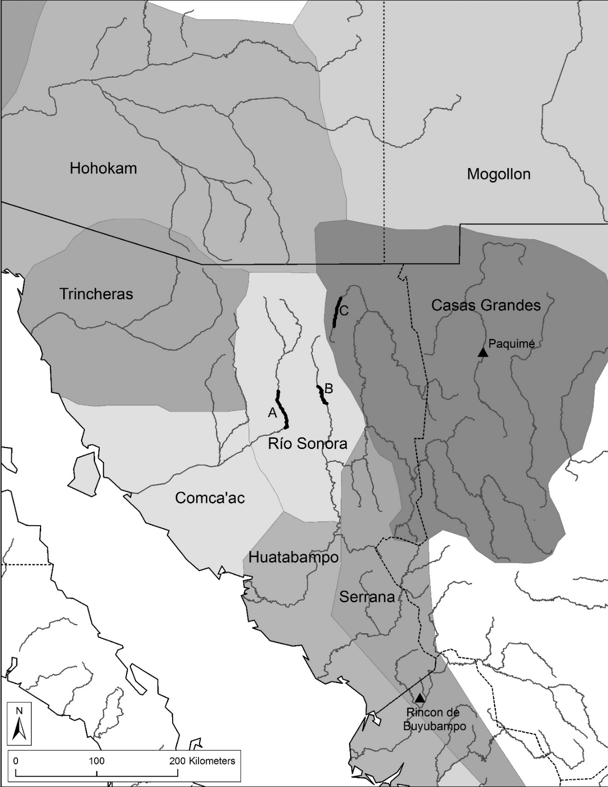
Figure 1. Research area location: A-Sonora, B-Moctezuma, C-Fronteras

2. CULTURAL HISTORY
It has been almost five centuries since the first European contact with eastern Sonora’s indigenous populations. Academic research of the region began in the 1800s (Lange and Riley 1970 [Bandelier 1884] and since then, knowledge of the history and prehistory of one of the most populated regions in the borderlands during the 16th century has been slowly accumulating. This thesis aims to contribute one more element to this story by considering ceramic evidence from the late precolonial/protocolonial period Sonora Valley and, to a lesser extent, reconsidering data from the Fronteras and Moctezuma valleys. This chapter will provide an overview of previous research to situate this new data and provide context to the specific research inferences stated in the introduction. The process of constructing the cultural history of this region can be divided into four principal phases. The latter three correspond to three periods of archaeological investigation characterized by different methods and theoretical goals. The first is the early Colonial period of the 16th and 17th centuries and is itself an object of historical and anthropological study in the subsequent three periods. The motivations for understanding the local inhabitants in this era was obviously quite distinct, being targeted at resource exploitation and proselytization.

2.1 Conquerors and Friars accounts
The earliest relevant accounts of the Serrana/Rio Sonora region are provided by four explorers and their associated chroniclers: Cabeza de Vaca, 1528-1536 (Adorno and Pautz 1999), Marcos de Niza, 1539 (Hallenback 1949), Vázquez de Coronado, 1540-1542 (Hammond and Rey 1940), and Francisco de Ibarra, 1565 (Obregon 1928). By the time of the first account, Diego de Alcatraz, who later would become a captain in the Coronado expedition, had already impacted populations in northern Sinaloa and southern Sonora through Spanish explorations carried out all along the Pacific coast (Adorno and Pautz 1999). However, there is little record of these activities.
The descriptions from Cabeza de Vaca’s account relevant to this research corresponds to the last part of his journey when his party reached northern Chihuahua and entered into northeastern Sonora. Cabeza de Vaca’s journey began a decade earlier. He and his companions, Andres Dorante de Carranza, Alonso del Castillo Maldonado, and Estebanico, were part of a major expedition led by Panfilo de Narvaez (Adorno & Pautz 1999). The Narvaez expedition’s goal was the exploration of the territory of Florida and inland regions westwards. After this expedition shipwrecked in the Gulf of Mexico, Cabeza de Vaca’s party sought to return to central Mexico through the continent’s interior. They were unaware of the distances entailed, which required a journey of 1000 km from the Gulf of Mexico to the Pacific coast. In the near decade long trip, the group explored much of the interior and exhibited a genuine curiosity for Native lifeways (Favata and Ferandez 1995).
Upon returning to “civilized” Mexico, Cabeza de Vaca wrote an account of his party’s travels (Adorno 2004:256). This document was an important source of information even in the colonial period and was cited by Gonzalo Fernandez’s (Theisen 1972) and Fray Bartolome de las Casas’s (de Las Casas 1967) in their analyses. The most notable descriptions of the study region provided by Cabeza de Vaca pertains to the town Corazones, so-called for a gift of 600 deer hearts received there by the party (Adorno and Pautz 1999). His account also describes physiography, wild resources, and most importantly, ethnographic details. These data became important references for the later explorations into the US southwest. One very important element of Cabeza de Vaca’s accounts was the rumored richness of the town of Cibola reported by the natives of Corazones. This information would become the principal motivator for Marcos de Niza's and Vazquez de Coronado's subsequent explorations.
None of the European members of the Cabeza de Vaca exploration could be persuaded to join a return trip. However, Estebanico´s slave status resulted in his forced participation. Besides Fray Marcos de Niza and Estebanico, the subsequent exploration was accompanied by Honorato as a second priest and several hundred Indigenous people. Their goal was to investigate the rumors of larger populations with considerable wealth to the north. Although Estabanico guided the return expedition, the route he followed possibly passed more to the west of the Cabeza de Vaca route (Hallenbak 1949).
Fray Marcos de Niza´s expedition was composed of two groups. Estebanico led the first group, which met with catastrophe when his party arrived at the Pueblo of Cibola (Zuni) where Estebanico was killed. In response, Marcos de Niza proceeded to within view of the Pueblo, but no further, before returning. The description provided by De Niza supported the rumors received by Cabeza de Vaca and described an adobe town with a size, architecture, and potential wealth rivaling that of Tenochtitlan (Hallenback 1949; Hammond and Rey 1940:63), which is an obvious exaggeration.
The reported equivalence between the Mexica Capital and the Pueblo town of Cibola spurred Coronado´s expedition in 1540. This expedition was the largest-scale exploration into the region during the early Colonial period. The expedition included several hundred Spanish and a larger number of Native Mexicans as well, with some estimates as high as several thousand (Hammond and Ray 1940).
Castañeda´s and Jaramillo´s accounts are the principal chronicles for the Coronado expedition, but they do not describe Sonora in detail. Similar to the previous Conquistadors, the Sonora River Valley is the most likely corridor for this exploration as the group established a garrison at the town of Corazones described by Cabeza de Vaca. This rearguard party quickly found itself in conflict with indigenous residents and were forced to move the garrison several times. On his return journey, Coronado may have taken the Moctezuma valley to avoid these now hostile groups (Coronado et al 1904). The reality of the Cibola region and the failure by the Coronado expedition to find any other substantial form of exploitable wealth discouraged subsequent expeditions for several decades.
Francisco de Ibarra's expedition in 1563 represented the final exploration of the region. Obregon was the principal chronicler of this expedition. The Sonora River Valley is again a likely corridor for much of the expedition, but this is debated (Di Peso 1974). Like Coronado, Ibarra encountered resistance in whichever valley he passed through and thus was forced to explore new terrain on the return trip, likely through the Bavispe Valley. There are some inconsistencies between Obregon’s and earlier descriptions of the region. For example, the size of villages is inconsistent, as discussed further below (Obregon 1928:174).
To some extent, these accounts are questionable due to a lack of consistency when compared to archaeological evidence. Disagreements over how to resolve such divergences has been a central point of debate in subsequent interpretations, but these accounts remain fundamental to archaeological research to this day. The Spanish conquest, not only of Northwest Mexico but of all of the New World, must be understood as a process that followed two paths. One is the conquistador’s expansionist zeal driven by economic objectives. The second prime motivation was the desire for the conversion of local populations to Christianity. These motives strongly color the data provided in early chronicles both in their limited focus and in the questionable veracity of statements. There is also an obvious issue of ethnocentrism, particularly in regard to Native religious practices, which has serious implications when archaeologists interpret the role of ritual specialists and other leadership roles based on ethnohistoric materials. Despite these obstacles there is much useful data in ethnohistoric documents that has permitted tentative reconstructions of certain political and social divisions within the Rio Sonora/Serrana region relevant to the present research.
Examples of more reliable data in these reports includes information provided on architecture, exchange items, subsistence production, and warfare. Cabeza de Vaca’s description includes references to the high agriculture productivity of the region and corresponding density of the population. Specifically, Cabeza de Vaca notes the practice of multi cropping (Adorno and Pautz 1999: 235, 251) in the Rio Sonora/Serrana, which strongly influenced more recent reconstructions. (Doolittle 1984). In fact, these two issues, demography, and productive potential, have dominated much of the relevant archaeological debate from the late twentieth century to today. Though many authors have treated these documents as accurate and thus estimate high population density (Doolittle 1988, 1984; Fletcher 1979; Hasan 1978; Pailes 2015 Sauer 1935 Turner 1976), there are also detractors that encourage caution and are skeptical about the veracity of such documents. They argue that the available archaeological data do not support population density or agriculture-potential arguments, indicating that researchers have been too uncritical in their use of documentary sources (McGuire and Villalpando 1989).
The narratives of the early Spaniard explorers contain allusions to aspects of the belief system of the native populations, which could be relevant to social divisions or other sources of variation encoded on ceramics. However, most of these observations and descriptions are strongly influenced by the perceived potential for Christian conversion. Certain characteristics of ceremonies do imply ritual specialists were an important part of the socio-politic structure in eastern Sonora. For instance, Las Casas notes rituals associated with deer are important throughout the Sierra Madre Occidental (Riley 2005). Additionally, there are valuable references to a complex trade networks that included slaves obtained in organized warfare. For some researchers, these references denote a high degree of social stratification in the nodal villages of the Rio Sonora/Serrana region (Riley 2005).
Cabeza de Vaca´s, Coronado’s, and Ibarra’s chroniclers all describe houses and their configuration within a settlement. This data is critical to later interpretations of settlement patterns and thus social divisions that reflect community and other sorts of political boundaries (Doolittle 1984). Descriptions of primate or nodal settlements are another relevant topic of the early chronicles. The overall impression is of clustered but not always contiguous houses (Coronado et al 1904:199-200). Vázquez de Coronado includes references (Coronado et al 1904: 201) to underground houses (pit houses), which is important due to the archaeological attention paid to this type of architecture and an example discussed below excavated at the San Jose site. Obregon’s account mentions terraced houses and houses of two and three stories (Obregon 1928: 174). To Ibarra, the layout of houses was disordered and not grouped. However, in one town, he mentions a central plaza with all the houses configured around this central space (Hammond and Rey 1928: 180), suggesting integrative mechanisms at the village level. In short, descriptions depicting complex settlement systems configured by diverse architectural forms, undoubtedly reflect social organization schemas (Doolittle 1988: 2).
According to the above, the size of the settlements is one of the more questionable issues that arises from contradictory statements in the chronicles. To some extent this make sense if we contextualize the undoubtedly exaggerated information. It should be remembered some of these accounts were the means for the explorers to legitimize continued support from the Spanish Crown. Greater numbers of Indigenous people implied a richer environment, available labor, and opportunities for proselytization. Examples of demographic statements include an unnamed town with 200 houses referenced by Obregon, Ibarra’s chronicler (Hammond and Rey 1928). It was also stated by Obregon that Cucumpa had 500 houses, Oera had 1000 houses, and one town located in the Valley of Sonora had 3000 houses (Hammond and Rey 1928: 161-193).
In terms of settlement patterns, Obregon provided the most detailed information. “The spacing between towns was three to four leagues apart (Hammond and Rey 1928: 175). To some extent, this description is consistent with Cabeza de Vaca’s first account, regarding the settlement configuration. He noted that houses were not contiguous, and were more dispersed than all-together (Thiesen 1972: 356). These statements indicate not only that large towns were somewhat distant from each other, but that they were also associated with larger regions. In Obregon’s account the differentiation of settlement size is crucial for the recognition of political units in the river valleys. “Numerous smaller settlements also appear to have existed surrounding and between the larger places. Around this province there are large settlements forming separate small provinces. They are composed of ten or twelve pueblos, and round this valley there are many more pueblos” (Hammond and Rey 1928: 175).
It is important to mention that the descriptions comprising the ethnohistoric accounts correspond to a limited area of the eastern Sonoran Sierra Madre. The accounts refer to the densest populated areas in the region, corresponding to the major river valleys of the Sierra Madre Occidental. Most of the information may correspond to the Sonora Valley area. This identification remains debated (Bolton 1949; Reff 1981; Sauer 1932; Carpenter 2007; Di Peso 1974b) and thus the exact location of the settlements mentioned in the ethnohistorical information is uncertain. For this reason, the information provided should be read as denoting a general picture of settlement patterns in the Serrana/Rio Sonora. This sort of data is important for interpreting the socio-political schemas implied in demographic distributions and internal village organization.
The 16th century corresponds to the fiercest periods of the conquest process. The various northward explorations to find the riches of Cibola were obviously unsuccessful from an economic standpoint. Interaction in this period was intermittent and was followed by decades of even sparser contact. The biases of the conquistadors unquestionably limited the perception of how the region was organized in terms of cultural and social characteristics. Almost fifty years after Ibarra’s exploration, the Jesuits' missionization efforts reached Sonora in the early seventeenth century. The demographic situation that the Jesuits found was clearly diminished from the exploration era, possibly due to the introduction of Old-World diseases (Reff 1985). By the early seventeenth century, the belligerent and vital towns, the warlike federations, and the socially complex groups of eastern Sonora reported by conquistadors were visibly diminished into small rancherias thinly spread over the valleys (Riley.2005:152).
Despite the altered demographic contexts, the mission enterprise provides a significant amount of information on Indigenous lifeways. However, as with the early exploration accounts, it is necessary to contextualize this information. On a larger geographic scale, it is also worth noting that the eastern-Sonora region had already been indirectly affected by the processes of conquest and evangelization that began at the San Felipe and Santiago mission in northern Sinaloa during 1583 (Eckhart 1960).
Friar Andres Pérez de Ribas´s “Triunfos de Nuestra Santa Fe entre gentes las más bárbaras y fieras del nuevo orbe” is the seminal Jesuit work on the Sonora-Sinaloa region. This work is composed of twelve books that describe the advance of the mission enterprise from its beginning in 1591 to the time of its writing in 1644, a period of almost fifty years. It should be noted that exaggerations of certain information were common during this period, specifically regarding demographic patterns. For example, the population estimate of the Pueblo region by the secular Captain Antonio Espejo and friar Alonzo de Benavides was clearly inflated in order to provide an optimistic view of the natural wealth of the region in order to continue receiving support from the crown. (Riley 2005:160).
Still, it is undeniable that there are valuable descriptions provided, specifically in the realm of customs, language, and religion, of local peoples that were not noted by the sixteenth-century conquistadors. The very different aims of the Jesuits, their long-term residence in the region, and disease induced changes were the main sources of divergence in the details provided by accounts of this period compared to the earlier exploration era. The Jesuits' long-term interaction with native populations in northern Sinaloa and Sonora, allowed them to discuss patterns of regional variation. The Jesuits also interacted with a more representative cross section of society, not only core settlements. As mentioned by Eckhart (1960) "Jesuits moved river by river and tribe by tribe". Their concern with the potential for Christian-conversion also led to a pan-regional perspective on the demography of the region and changes in cultural affiliation (Carpenter and Vicente 2009).
Contrary to the limited observations that resulted from the conquistador’s economic aims, the Jesuits missionization efforts provide significant information on social organization. Some examples that can be mentioned are Perez de Riba’s reports regarding multi-crop production in the Sonora Valley (Hallenback 1949:25) that parallel those of the conquistadors. The Jesuits also provide detailed information regarding irrigation technology during the 17th century (Pérez de Ribas 1944, Vol. 2; 186) that provides nuance to our understanding of indigenous people’ use of irrigation. Most importantly, there are also numerous mentions of persons that missionaries found particularly problematic or useful, which we can now interpret as various types of ritual specialists and political leaders. These provide a few glimpses on the scale of Indigenous social institutions relevant to the current project.
The use of ethnohistory in archaeology requires an analogical process. Historically, analogical approaches have led the researchers to assume that analogical data, ethnohistoric in this case, is evidence of the cultural past (Wylie 1985). This can be highly problematic if analogies are not delineated correctly. In this case, the conquistadors' and missionaries accounts of the- 16th and 17th centuries are assumed as applicable sources of analogy to comprehend groups that inhabited the Rio Sonora/Serrana region in the 1200 to 1500 AD. The common obstacle in the analogical process is assuming that cultural similarities transcend space and time. The analogical process, in summary, delineates a static scenario, constrains our comprehension of social change, coerces our ideas about mechanisms of social interaction processes required for social change, and significantly limits the conception of identity because it suppresses dynamism. Ideally, the analogical practice should serve as a means for generating a hypothesis whose credibility is established on independent, non-analogical grounds.
Additionally, it is worth considering in what context historical accounts acquire relevance and importance? Their significance relies on their status as statements from the past reported by an observer. This reported experience creates a chain of “heard and pass it on” that provides information that we must assess critically. Historical accounts must be seen as a chain of transmission, in that each of the parties is a link that historical context has shaped, and that requires researchers to evaluate the truthfulness and verifiability of each statements in the chain (Vansina 1985:27-30).

2.2 Geographers and Archaeologists in the Rio Sonora/Serrana region
Before addressing the first phase of archaeological research within the Rio Sonora/Serrana region, it is necessary to consider two facts that influenced the trajectory of research during the transition between the nineteenth century and the twentieth century. The first is the severe constraints imparted by the lack of archaeological information, which encouraged large-scale comparisons based on diffusionist thinking. The related second issue is the problematic conceptual trends that characterized the discipline during the late nineteenth century until the first half of the twentieth century. Focusing attention on these factors and their attendant assumptions allows us to understand the contexts and larger goals of researchers (Lange and Riley 1970 [Bandelier 1884]; Lumholtz 1973 [1902]; 1990 [1923]; Ekholm 1939; Sauer and Brand 1931).
This first archaeological approaches applied in the Rio Sonora/Serrana emphasized other basic descriptions and the relationship between sites and the environment. This is apparent in the early work of Bandelier. He notes that: “the river bottom is not fit for permanent habitation…villages stand upon terraces so cut up by gulches that only room for small pueblos is found on their surface” (Bandelier 1892: 487). However, the above should be understood in the context of the visible archaeological evidence and its potential to provide archaeological explanations. Although, Bandelier was the first quasi-professional archaeologist to enter into eastern Sonora, it was Amsden (1928) who is credited as undertaking the first formal archaeological project in eastern Sonora. He defined the Rio Sonora culture through the inspection of ten archaeological sites along the Sonora and the Moctezuma drainages, establishing the first official archaeological fieldwork (Amsden 1928). Bandelier’s and Amsden’s work encompass a time span of three decades. The next archaeological research did not occur until the 1930s with Sauer and Brand’s extensive archaeological surveys in Sonora (Sauer and Brand 1931).
During the first four decades of intermittent archaeological research in the Rio Sonora/Serrana region, it is possible to perceive a shift in archaeological thinking. Technical descriptions of the widely scattered archaeological sites in the region encompass a significant portion of the accumulated information for this period. Overall, the research in this era was mostly unsystematic, peripatetic surveys. This research methodology produced minimal data focused mainly on themes such as architectural size and characteristics, and the distribution of the sites in relation to the river valleys (Amsden 1928: 47 & Bandelier 1892: 487). Later in this period discussions regarding population sizes and the potential for migration into the region took on a greater role as researchers moved from description to explanation (Amsden 1828; Brand 1935; Sauer 1935).
One of the descriptions regarding the size of the sites and population estimates is provided by Bandelier who noted that sites ranged from ten to fifty small houses, inferring that “none of the villages could have sheltered more than a few hundred people” (Bandelier 1892: 487-488). Bandelier also notes scarcity of archaeological settlements on the wider landscape. Observations also stress the simplicity of architectural forms and the scattered distribution of settlements. Comparisons to Mesoamerica led to an early inference of environmental determinism that portrayed the Rio Sonora/Serrana as a response to the harsh climate.
Reliance on comparisons with neighboring cultural regions influenced the capacity of archaeologists to comprehend the Rio Sonora/Serrana region. Many descriptions must be understood in a context of implicit comparisons to Mesoamerican or Puebloan regions with more substantial architecture. Ekholm noted the following, “The sites are rather rare and difficult to find” (Ekholm 1939; 8). For Amsden, the settlements were often identified as “little more than a scattering of houses not placed in any very definite order” (Amsden 1928; 47). Overall, the Rio Sonora/Serrana archaeological record for these researchers was diffuse and minimal. Undoubtedly, this phase of research reflects problematically data poor circumstances, given the approximately 700 km²of the cultural region. This resulted in failures to perceive the complexity of the region not only in terms of demographics and related settlement distributions, but also in regard to the perception of social interaction at broader scales. The descriptions of material distributions on a larger scale was also problematic in the sense that surveys and sporadic excavation resulted in pan-regional models of interaction rooted mostly in better known areas such as Mesoamerica, the American Southwest, and the Chihuahuan Plateau. These efforts did perceive the possibility to use the distribution of foreign goods to provide a perspective on the importance of exchange to the sociopolitical organization of the Rio Sonora/Serrana (M. Pailes 2016).
One issue addressed during this era and influential for subsequent research were hypotheses related to the settlement process of the Rio Sonora/Serrana region and its timeline. Amsden (1928) and Sauer & Brand (1931: 73) provided the first insights on this subject. For Sauer and Brand (1931) the architecture of the Rio Sonora/Serrana indicated a cultural affiliation with the US Southwest. However, ceramics similarities with Chihuahuan materials alluded to other source populations. These models proposed a migration around AD 1400 from eastwards (Chihuahua). Later Di Peso (1974, 799) found Brand’s model useful and correlated this migration process with the collapse of the Casas Grande region at about AD 1350. It is important to note that Di Peso was off in his dating of Casas Grandes’ termination (Dean and Ravesloot 1993) and there is in fact substantial contemporaneous material in the Rio Sonora/Serrana region.
Amsden suggested that the absence of deep middens indicated that the occupation and settlement of the Rio Sonora/Serrana region was late and brief. His model argued that migration was the result of the collapse of Colorado Plateau and Rio Grande cultures in Pueblo IV times, AD 1300 to 1450 (1928: 49). Other researchers like Lister (1958:122-115) suggested that the expansion of a pre-Mogollon group from the upper US Southwest resulted in a migration process southward. The usage of a diffusionist perspective during this period of research is unquestionable and reflects a lack of archaeological data from the Rio Sonora/Serrana region.
The discipline of geography heavily influenced archaeology during this period through the work of Carl Sauer and Donald Brand (Sauer 1935; Sauer and Brand 1931), who consistently maintained that when Europeans arrived, the Natives were not only prosperous and well-balanced ecologically but also numerous. In subsequent studies (1930-1935), based on Mooney's (1928)Kroeber's (1934) and Rosenblat's (1935) figures, methods, and assumptions, the potential role of ethnohistoric chronicles as a complementary source of information to archaeological evidence became apparent (Danevan 1992:1).
To some extent, these researchers were able to correlate specific elements of the ethnohistorical accounts to their interpretations of the archaeological evidence. These interpretations were limited to correspondences with subjects typically of interest to archaeologists such as pottery, architecture, and social organization. However, Sauer (1935), Sauer and Brand (1931), and Ekholm (1939) views of the region were still constrained by an absence of local archaeological data. This led to the continued use of large-scale comparisons to neighboring cultural regions, like Mesoamerica and the US Southwest. The suggested influence of neighboring regions on the Rio Sonora/Serrana did open the possibility to delve into wider material culture analysis of regional interaction.

2.3 Late 20th Century and “Statelet” models
Shifting trends in archaeological theory during the twentieth century drove the consideration of new questions and the development of more elaborate methods to approach archaeological evidence. “New Archaeology” heavily influenced some aspects of researchers’ interests for this period while the role of the ethnohistorical accounts continued to serve as a base of interpretation. In this sense, topics valued by New Archaeology and approachable with ethnohistoric data became predominant during the mid-twentieth century. Examples include demography, agriculture, commerce, subsistence, and warfare. The second period of archaeological research in the Rio Sonora/Serrana is defined by a more refined interest in macro-scale interactions, specifically the inter-relationship of the Hohokam, Mogollon, and the Casas Grandes worlds in the fifteenth century. A related principal interest of researchers in this period was the relationship between Puebloan groups and the Aztatlan region with the Rio Sonora/Serrana serving as a significant intermediary between these groups (Riley 1987, 2005).
In addition to the interest in fostering a broader perspective on the role of the Rio Sonora/Serrana in regional interaction networks, the topic of demography continued as a central theme. Archaeological research aimed to verify and exemplify the specific ethnohistorical accounts that described demographic conditions in the Rio Sonora/Serrana regions. It is important to mention that during the early-20th-century the ethnohistorical chronicles became the target of more critiques in research on Rio Sonora/Serrana groups (McGuire and Villalpando 1989). Increasing archaeological information on the Rio Sonora/Serrana made incongruencies with the conquistadors’ accounts more apparent. Ethnohistorical data remained extremely important in interpretations, but their role and relation to archaeological data was reconsidered.
One of the most significant theoretical models to emerge in this period of research is the concept of the “statelet” (Di Peso 1974; Riley 1976, 1987, 1999, 2005; Doolittle 1980; Pailes 1980). These models were important for contributing more coherent explanations about cultural development in the Rio Sonora/Serrana region that incorporated available data on demography, migration, and agriculture schemas. In this way, they provided the first regional schema not focused on extra regional processes (Pailes 1978; Pailes 1980; Phillips 1989). To some extent Di Peso’s approach to the Casas Grandes region during the 1960s and the 1970s (Di Peso 1966; 1974), instigated the subsequent attention towards the Rio Sonora/Serrana region. Several significant archaeological projects (Di Peso 1974, Riley 1976, Pailes 1978) occurred in the neighboring eastern Sonora and the Casas Grandes regions within this period. The most relevant project was conducted by Richard Pailes in the 1970s focused on the Sonora Valley and lasted for several years. The 1970-era witnessed the first large-scale systematic reconnaissance, excavation, and materials analysis.

2.3.1 Di Peso’s “Statelet” Model

Di Peso’s work in the Casas Grandes region in the 1960s was influential on the trajectory followed by eastern Sonoran archaeology. Di Peso’s “Northern Sierra” (Northeastern portion of the Rio Sonora/Serrana) concept (1966) established this geographical region as an open territory of social interaction. That is, the "Northern Sierra" was assumed as a hinterland area in terms of cultural development, which was greatly influenced by external cultural elements, mostly from the Casas Grandes region. However, later in 1974, Di Peso's "Northern Sierra" concept took a different tack by incorporating the accumulated data of the Casas Grandes region and the Paquimé site through the monumental publication on Casas Grandes (Di Peso 1974). The wealth of data provided in his all-encompassing archaeo-history of the Gran Chichimeca affected understanding of the Rio Sonora/Serrana in three different ways. First, Paquimé was a major population center, with far reaching political, ritual, and economic power. Second, the “Northern Sierra” was included, within the “Casas Grandes Archaeological Zone” (Di Peso 1974:1,5). Third, and possibly the most influential for the comprehension of the Rio Sonora/Serrana, Di Peso linked cultural developments in eastern Sonora with Paquimé through the recording of similar Casas Grandes pottery in the Tres Rios area along the southern limits of the upper Río Bavispe in Sonora (Di Peso 1974: 3:834).

2.3.2 Riley’s “Statelet” Model
Riley’s perception of the Rio Sonora/Serrana region's social development was influenced by Di Peso’s assumptions regarding the power that Casas Grandes exerted pan-regionally. It is crucial to mention that most of Riley’s reconstructions regarding the socio-political organization of Eastern Sonora groups was based on exploration texts from the Ibarra expedition (Hammond and Rey 1928) with other chronicles such as Coronado, Pérez de Ribas, Cabeza de Vaca, and Marcos de Niza also making important contributions. To some extent, it is possible to perceive some affinity of Riley’s definition of a “Statelet” with Mendizabal’s (1928) concept of “pequeños estados” applied in West Mexico. Nonetheless, the most significant influence in Riley’s model corresponds to Di Peso’s earlier work in Casas Grandes region (Di Peso 1966; 1974).
Riley’s “statelet” model portrayed the Rio Sonora/Serrana population as divided into several autonomous political provinces. This reconstruction inferred Rio Sonora/Serrana settlement patterns were hierarchical and characterized by one large site that organized the social-political, and economic interaction with surrounding smaller settlements along large sections of river valleys. Riley also inferred from the conquistadors' accounts the citizens of these provinces or statelets "...had a more complex political structure than the Pueblo Indians” (Riley 1970).
Riley’s conception of the social organization of the Rio Sonora/Serrana statelets drew on Richard Pailes’s and William Doolittle’s 1970s work in the Sonora River Valley that provided data viewed as complementary to Ibarra’s accounts. Specifically, data generated by this project provided Riley with justification for the idea that “statelets” were integrated by a centralized political and religious elite. The reported ball-courts identified during these surveys were particularly crucial in this inference (Riley 1991:197).
Riley’s model inferred the political integration of the Serrana was achieved through two institutions: warfare and trade. Alliances referenced by Obregon, were important for inferring macro scales of affiliation that spanned river valleys. This led to Riley’s interpretations that Rio Sonora/Serrana groups were organized into confederacies (Riley 2005). There were two major federations in this area. One was under the control of Corazones and probably included the Sonora, Moctezuma, and perhaps Bavispe Valleys. The second was controlled by Oera and had a more southerly distribution. The above has implications related to linguistic lines, Opata vs Pima (Riley 2005: 162-163).
Riley´s statelet model is crucial because it implies the necessity to evaluate the cultural development of the Rio Sonora/Serrana within a regional-scale social-political framework. In this way, the model also represents the continuation of Di Peso´s work. Riley draws from Di Peso his inferences that the development of the Rio Sonora/Serrana statelets was a result of immigration from Paquimé's collapse (Riley 1987, 2005), but with an updated post 1450 date.

2.3.3 Doolittle’s “Statelet” Model
The 1975-1978 archaeological project led by Richard Pailes in the Rio Sonora Valley provided the data for Doolittle to elaborate the "statelet" model. Both Riley's and Doolittle's “statelet” model relies on conquistadors’ accounts as essential sources of demographic data (see Reff 1985). However, Doolittle's model was tested by archaeological data from the Rio Sonora Valley project. Doolittle's provided the first systematic survey of a Rio Sonora/Serrana valley. Doolittle’s data added important nuance to our understanding of the regional archaeological landscape since it was the first to collect data relevant to small sites and the relationship between sites. The data also allowed him to evaluate the existing migration models (Di Peso 1974; Riley 1976). His chronological inferences about the growth of populations in the valley led him to ultimately reject Casas Grandes migration as a significant factor in the regional trajectory (Doolittle 1984).
The most important data in Doolittle’s argument are the approximately two hundred archaeological settlements recorded within the Rio Sonora Valley. This data complemented the earlier researchers’ information in terms of the settlement pattern and its density (Lange and Riley 1970 [Bandelier 1884]; Lumholtz 1973 [1902]; 1990 [1923]; Sauer and Brand 1931). The high number of recorded archaeological sites by Doolittle was consistent with inferences derivable from the conquistadors’ chronicles (Cabeza de Vaca; Marcos de Niza; Vazquez de Coronado; Ibarra; Obregon) and previous interpretations by Sauer and Brand (1931) and Riley (1987). The main discrepancy among researchers insights was the explanation for the increasing number of settlements and presumably overall population.
Doolittle also ultimately argued for the highest estimate of regional populations. For instance, he argued even the highest numbers given in ethnohistorical documents were reasonable, such as Obregón’s, the chronicler of Ibarra’s 1565 expedition, observation of 20,000 residents in one valley (Doolittle 1988:64). Doolittle raised the regional population estimate to 100,000 people, a figure estimated from irrigation and agricultural potential carrying capacity (Doolittle 1984). Several ethnohistoric references are relevant to this calculation. As noted above, double and triple cropping was reported by Cabeza de Vaca, and irrigation systems were described by Fray Marcos de Niza and Jaramillo. It is worth noting that there is year-round perennial water availability in the Sonora Valley and most of its major tributaries. Based on these statements Doolittle assumed precolonial systems operated near maximum potential. Taking this one step further, he used 1970s productive totals and the amount of total arable land to arrive at his figure of 100,000 (Doolittle 1988).
As mentioned, the “statelet” models provided the opportunity to refine the study of the Rio Sonora/Serrana region while still retaining a concern for established research questions. Doolittle’s “statelet” model, whichfocused on demography estimates while also incorporating new insights on agriculture and irrigation systems is a good example of this relationship. For Doolittle´s model, the extensive archaeological evidence collected within the Sonora Valley challenged aspects of the scenarios proposed by Riley and Di Peso regarding the Rio Sonora/Serrana settlement process. Specifically, through the correlation between the radiocarbon dating of materials with settlement pattern he portrayed a divergent trajectory for the Rio Sonora/Serrana settlement process based on local endogenous growth.
The intensive reconnaissance by Pailes and Doolittle of this sub-region complemented by excavation, tentatively established a chronological sequence of two occupational phases, an Early period (Viejo) ca. 1000-1200 AD; and Late period ca. 1350-1550 AD. (Pailes 1978). Changes in architectural style, settlement pattern, and their association with radiocarbon dated material was the basis for arguing that most changes were due to local socio-political development (Doolittle 1984). Pit-houses exclusively represent the Early period occupation in this schema. Their decline and the increase of adobe surface structures correspond to a transitional period. Lastly, the Late Period is characterized by a predominance of above ground adobe architecture and public architecture, but the latter is present only at a few settlements in the Rio Sonora Valley (Doolittle 1988). These observations were important to defining the political and economic significance of specific sites. Doolittle’s model employed four size categories: Regional center; Nucleated village; Hamlets; and Rancherias (Doolittle 1988: 52-55). Doolittle social organization model was the most detailed to date and expounded the change in the settlement patterns and indicated greater efforts at social and political consolidation (Doolittle 1988). In summary, Doolittle’s “statelet” model concluded that the development of the social structures of the Rio Sonora/Serrana happened through local processes.

2.3.4 R. Pailes “Statelet” Model

Both R. Pailes’s and Doolittle’s social organization models derived from the same 1970s Rio Sonora project, but their interpretations contrast regarding the perceived population growth’s causality. R. Pailes (1978) perspective differed in certain aspects from Doolittle's, regarding the socio-political organization of the Rio Sonora/Serrana region during the Early and Late occupation periods. Pailes agreed with Doolittle’s population growth model, however, for R. Pailes such estimates were dependent on immigration processes. To some extent, the pan-regional Di Peso's model in the early 1970s was still influential for R Pailes model. R.Pailes model defined the regional social organization and its development as part of a broader interaction structure with the US Southwest, the Casas Grandes territory, and Mesoamerica (Pailes 1978; 1980). This theoretical approach drew heavily from Wallerstein's World System Theory (Wallerstein 1974) which influenced the elements of the ethnohistorical references he centered in his interpretations. Specifically, R. Pailes focused on ethnohistorical references that addressed commerce, trade, or exchange schemas that insinuated long distance interaction with neighboring cultural regions.
According to R. Pailes the archaeological data, in the form of specific pottery types and architecture characteristics, indicated regular interaction between the Rio Sonora/Serrana region with the US Southwest, Casas Grandes, and northern Sinaloa (R. Pailes 1978). That is, the archaeological data portrayed a dynamic, outward oriented region that contrasts with Doolittle's model. R. Pailes also noted the physical geography of the region implied the Rio Sonora Valley and its various tributary streams were natural pathways to communicate with the US Southwest, the Casas Grandes Region, and northern Sinaloa territory. It is important to remember that these interpretations are contemporary to Di Peso's assumptions regarding Paquimé’s status as an important Mesoamerican commercial center that placed the Medio phase AD 1060-1340, and its later abandonment at the beginning of the Tardio period, around the AD 1340 (Di Peso 1974). However, R. Pailes understating about the development of the Rio Sonora/Serrana differed in several ways from Di Peso’s. For Pailes, eastern Sonora and its particular geographic location was determinant to its function as an interconnection between the various regions of northwest Mexico, the US Southwest and western Mesoamerica. In R. Pailes model, Paquimé and Casas Grandes were still influential in the Rio Sonora/Serrana region development but in a context of exchange. Later, the reconsideration of occupation phases of Paquimé by Dean and Ravesloot (1993) indicated that the Medio Period —AD 1200-1500— and tardio Period —AD 1500-1600— of Paquimé were contemporary to the Rio Sonora/Serrana major occupation period.
The emergence of the statelet models highlighted issues such as inequality and hierarchy to complement existing questions of a political and economic nature. Ethnohistoric references to rare-goods exchange and the new evidence for a clear hierarchized social structure expressed in the settlement pattern were combined to propose new theories of elite emergence in the Rio Sonora/Serrana. The focus on long distance exchange also reinforced interest in pan-regional exchange models with Mesoamerica, the American Southwestern, and the Casas Grandes region (R. Pailes 1980). These discussions were part of the long standing interest in models regarding the influence of neighboring cultural regions in the development of the political landscape of the Rio Sonora/Serrana and neighboring US Southwest (Haury 1945; Pepper and Nelson 1927; Adorno and Pautz 1999; Hallenbeck 1949; Hammond and Rey 194; Obregón 1928; Pailes 1980; McGuire 1980). However, this period still suffered from a lack of archaeological information regarding the groups that inhabited most of the river valleys of the Rio Sonora/Serrana region.

2.3.5 “Statelet” models re-evaluation
The third period of archaeological research in the Rio Sonora/Serrana region recognized the need to broaden investigations to include other rivers valleys of the region. For example, Quijada and Douglas (Quijada and Douglas 2003; Douglas and Quijada 2004) investigated the Bavispe Valley and M. Pailes (2017) the Moctezuma Valley. The aims of these projects were to evaluate if the descriptions of the Sonora valley were true of the larger region. Additionally, the results provided a means to evaluate the role of exchange in rare and exotic goods on a broad scale as an elite mechanism for control as proposed by Di Peso (1974) and R. Pailes (1980).
Douglas and Quijada (2004) argue that the Bavispe Valley data provides a contrasting scenario. There was a lack of evidence to support a long distance or even significant regional exchange network and even the basics of the settlement pattern were substantially different than that described in the Sonora Valley. Indeed, the lack in some cases of exotic and rare goods led them to argue that competition was expressed at much smaller scales between local groups.
M. Pailes’s work in the Moctezuma Valley (2016) continued to focus in part on exotic and rare goods exchange. He inferred evidence of local production and materials acquisition and subsequent distribution as opposed to true long-distance exchange. The absence or rarity of specific materials like obsidian, turquoise, marine shell, and foreign painted ceramics, in the various river valleys provide important evidence regarding the political economy of the Sonora River region and its lack of integration (M. Pailes 2016). M. Pailes (2016) adds a new perspective to discussions of exchange and the larger sociopolitical landscape by illustrating the circulation of mundane goods (plain ceramics) at the intra-valley scale. The distributional patterns of specific goods through quantitative analyses have provided crucial information to rethink the Riley and R. Pailes statelet models. Importantly these distributional patterns of materials have suggested smaller scales of political units within river valleys and little evidence of broader confederacies. These inferences are based on archaeological evidence that seem to contrast earlier conclusions drawn principally from ethnohistoric chronicles.
As a component of this discussion, M. Pailes also revisited issues of demography and agricultural productivity provided by Doolittle. While finding general support for Doolittle’s maximum estimates the inferred sequence and related cultural history is very different. The population estimates by Doolittle (1980) for the Sonora Valley seem to be consistent with M. Pailes (2016) updated calculations based on measuring the relative amount of arable land through satellite imagery in different valleys. M. Pailes argued an estimate of 11,000 inhabitants in the Central Sonora Valley distributed in two political units is feasible. The same exercise targets the Moctezuma Valley and proposes a similar valley scale division between the communities centered on the nodal sites of Teonedepa and El Nogal. These estimations are reliable for the cases of the major river valleys, but this model does not really consider populations residing outside of major streams.
These discussions of demography have generally embraced the highest estimates of population levels. It is worth noting these have not been ground truthed in any real way against archaeological proxies. A comparison to what were likely similar demographic levels in the US Southwest suggests the absolute population size may be significantly over estimated (Hill et al 2004). Criticism of the high estimates can be summarized in two points: the conquistadors exaggerated, and estimates based on productivity do not indicate what was actually achieved. In this sense, estimates of 100,000 population for the Rio Sonora/Serrana region apogee are likely not reliable. Though political organization does not hinge on population estimates, the two are obviously intertwined. Thus, it is unsurprising there has also been a reconsideration of the scale of the largest discrete political units. The scale of statelet identified by Doolittle appears to be reliable, but this is far smaller than that implied by Riley (M. Pailes 2016).
Recent investigations conducted by John Carpenter, Guadalupe Sánchez, and associates in northern Sinaloa (2008-2009) contribute meaningful information on the southern portion of the Rio Sonora/Serrana. This region was originally included in the regional definition of the Rio Sonora (R. Pailes 1973) but as pointed out by R. Pailes (1997:181-182), there are differences in the material culture that characterize the northern Sinaloa territory. This is the origin of the compound name of Rio Sonora/Serrana. This variation has been investigated through archaeological projects on the Pacific Coast and in the low Serrana foothills setting. The current archaeological knowledge is considered sufficient to label the foothills region of northern Sinaloa as Serrana (Carpenter and Sánchez 2008:30). However, the exact differences between these regions and their limits are still debated, hence my hesitation to infer any significant boundary between the two.
Data from this region supports the view that exchange was very important in the proto-colonial period. Excavations at the site of Rincón de Buyubampo (Serrana-extreme northern Sinaloa) (Carpenter and Vicente (2009) documented a cultural-transitional area, where Huatabampo and Rio Sonora interacted with a local Serrana group. A significant finding at this site was a large amount of evidence for shell-jewelry manufactured in a style similar to Trincheras (northwestern Sonora), as well as evidence of at least regional exchange in the form of prismatic obsidian cores and a copper bell, and a few Casas Grandes ceramics (Carpenter 2008). Carpenter and Vicente's (2009) research has contributed to these discussions on a larger scale. Their work has been centered to the south of the regions discussed thus far, closer to Aztatlan and other important trading centers. The presence of Rio Sonora tradition style ceramics in the northern Sinaloa Serrana indicates questions of pan-regional interaction dynamics are still important.
This chapter has provided a summary of the various approaches to understanding eastern Sonora populations in the period AD 1200-1500 with an emphasis on the Sonora River valley. The conquistadors and friars accounts have shaped all periods of archaeological research, owing in part to a lack of archaeological data. Arguably, the issues identified in the study of these documents continues to define current research agendas. One fundamental question is the scale at which various social groups formed and cooperated. The concepts of “statelets” and confederacies are two expressions of these debates. Basic questions of the nature of internal and external valley group cohesion still need to be investigated further. The ensuing sections will present a course of investigation to approach these issues through the study of decorative attributes in ceramics.

3. THEORY
The central question of this research applies to three geographic scales of analysis. These questions are drawn from existing discussions in the literature on the region, however, the resulting inferences all correspond to different social dimensions (social identity, linguistics, etc.) at the inter-valley scale; political and social dimensions at the intra-valley scale; and more individualistic attributes at the intra-site scale i.e. social class, religious sodality membership, etc. For this reason, it is necessary to review the intersection of theories concerning the concepts of style (Conkey 1990; Sacket 1982; Plog 1983; Hegmon 1992), communities of practice (Lave and Wegner 1991; Wegner 1998, Mills 2002; Eckert 2008, 2012), and identity (Jenkins 1996; Blinkhorn 1997; Jones 1997; Matthews 1995; Meadows 1997; Pluciennik 1997; Wells 1998, Mills 2002).
A review of the concept of style will serve as a theoretical bridge to infer how the differences and similarities exhibited in decorated ceramics assemblages reflect potters' decisions during the ceramic production process. It is essential to point out that the manufacture of ceramic, including the pottery decoration process, can be perceived from different perspectives. That is, some analytic approaches can prioritize utilitarian use/functional aspects, other the ritualistic aspects of pottery consumption, and other boundaries in broader social networks that reflect other dimensions of social ascription. However, all these style’s use/function schemas are constrained by social norms that characterize the potters’ group (Sackett 1982). That is, the review of concepts of identity and its different dimensions provides a framework for why ceramic stylistic patterning may correspond to diverse forms of social boundaries at various spatial scales (Gosselain 2000).
This section will also review the communities of practice perspective, which aims to shed light on the interactional processes that led to the sharing of ceramic styles at the three evaluated geographic scales. This perspective draws attention to how craft production is learned, and techniques are spread among a community. I follow Lave and Wegner (1991:49), in that learning is defined as “increasing participation in communities of practice”. Learning is thus seen as an “evolving, continuously renewed set of relations” (Lave and Wegner 1991:50) in which all individuals express multiple and specific characteristics that mark them as participating in various levels and domains of social groups in a community.

3.1 “Style” Theories
An early interest in styles schemas can be traced to culture historians as early as the 1940s with Kriegger (1944). Style in this era was a utilitarian concept that expressed how the historical knowledge was transmitted across generations. Style was also central to the task of delineating chronologies and typologies. In these applications style was a self-evident concept upon which historical consciousness is based (Conkey and Hastorf 1991:3). The “New Archaeology” of the mid-twentieth century modified conceptions of style. Two key points emerged from these discussions. Styles were newly conceived of as cultural products, quasi-codes that archaeologists could read and interpret (Conkey 1990:9), and also in their older role as a means to schematize space and time variables (Binford 1972:203). For both perspectives style represented an inherent property of archaeological materials. Style remained passive in the understanding of material culture, and instead of being enlisted to explore emic meaning, it was observed from an outside perspective (Sackett 1977:372). That is, the goal was to identify style rather than explain it.
Binford’s (1965) view typifies these processual conceptualizations of culture as an adaptative system in which artifacts made by humans were cultural products, and thus, were seen as being outputs of cultural and behavioral systems. That is, more than having an active role in society they were perceived as adaptative components produced by a cultural system beyond the comprehension of individual agents. This narrow view is reflected in Binford’s articulation of style as the idea that culture “is not necessarily shared but participated in by an individual” (Binford 1965: 205).
The last decades of the twentieth century saw a reconsideration of the style concept and attempts to understand it from a more active and emic perspective, that is, as a product of human activity (Wobst, H. M 1977; Hodder 1985; Miller, D. 1982; Shanks, M and Tilley, C. 1987). Although archaeology in the late twentieth century was characterized by a considerable diversification of theoretical positions, a core definition of style emerged that was used by archaeologists of very different theoretical perspectives. According to Hegmon (1992) there are two basic tenets. First, style is a way of doing something (Sackett, J.R. 1982; Hodder 1990; Weissner, P. 1984), and second, “style” involves a choice among various alternatives (David, Sterner, Gavua 1988; Hardin 1984; Sackett 1982).
Within these two widely identified tenets for approaching style, researchers present particularities with their own definitions. Most emphasize style as an active component of human actions that plays an intentional role in signaling (Hegmon 2000). For Sackett (1982), style involves choices between functionally equivalent alternatives, and a style is “a highly specific and characteristic manner of doing something, which, by its very nature is peculiar to a specific time and place” (Sackett 1982: 63, 113-115). According to Weissner (1984), “style is a form of non-verbal communication through doing something in a certain way that communicates information about relative identity” (Weissner 1984: 107). For Hodder, “style is “a way of doing”, where “doing” includes the activities of thinking, feeling, and being (Hodder 1990:45). According to Plog (1983) and Hegmon (2000:519), within the gap between style’s passive and active perspective, there exist several analytical processes that link material culture variation, style, and human activity. The endeavors to reduce the gap between the passive and active perception of the style concept are revealed in examining the relationship among stylistic variation and aspects of social organization (Hegmon 2000:125).
Following the idea that style can be assumed as a way of doing something, it is essential to point out that style is not a unidimensional phenomenon. It might be associated with various domains of the social structure. In this sense, style may be contextual, polysemic and have different situational roles. However, one crucial aspect is that style expresses a form of group affiliation. As mentioned, the role of style may be context specific. In this sense, interaction with other groups (at multiple social distances) are critical in the construction processes of identity (Wells 1996). It is in these contexts that style potentially takes on the function of an identity label (Wobst 1977). As such, it is perhaps no surprise that much research on style focuses on events in which it is assumed multiple groups or diverse social personas within groups came together in order to perform their societally expected roles. Regional Southwest examples include communal feasting events, which are ritually, politically, and socially charged, especially when these events take place above the household scale (Mills 2007; Mills et al. 2002; 210-233). In such contexts, archaeologists expect the use of pottery with specific decoration to signify meaningful social attributes in various aspects of styles —defined below in section 3.1.3—.

3.1.1 Types of Styles
The identification of various types of styles developed from efforts to close the gap between passive and active perspectives in the concept of style. This work has demonstrated that style is not a unidimensional phenomenon, that is, different types of style can occur simultaneously on the same object and be interpreted differently in variable situations (Sackett 1982; Weissner 1984). Sackett describes two levels of style. On one hand, he argues that style resides in the choices made by artisans, particularly choices that result in the same functional end. The results of these choices are called isochrestic variation, that is, “equivalent in use”. These choices are learned or socially transmitted, and variation may therefore reflect both social interaction and historical context. In contrast to the isochrestic category, the iconological approach maintains that style, by definition, has as its primary function the purposeful symbolic expression of social information (Sacket 1982:73-73,113-115).
For Wiessner (1984), style is perceived as multi-faceted in that style is able to communicate and transmit information that denotes both personal and social identification. “Emblemic” style has a distinct referent and often carries information about groups and boundaries. “Assertive” style has no distinct referent, but carries information about vaguer notions, often relating to individual identity and expression. It is important to note that despite the fact that these two kinds of style convey different kinds of information, it is possible that they occur on the same object and make use of the same elements (Wiessner 1984:136-138).
The debates that have shaped the study of active and passive styles have expanded the range of questions archaeologists ask with style data. The potentials are illustrated by the conversation between Sackett and Wiesnner regarding types of styles. Sackett’s perspective and its emphasis on function is more closely tied to the New Archaeology’s passive conception of style, which in consequence constrains the potential to perceive style as a realm of actively constructed social schemas. On the contrary, Wiessner’s considerations of style, as a non-verbal communication system that reflects a groups’ relative identity, encourages a contextual approach, in which style is intentionally manipulated, reflecting an active role.

3.1.2 Social Interaction Theory
Most researchers agree, the degree of stylistic similarity between individuals, residence groups, or villages is directly related to the amount of social interaction between those individuals, groups, or villages. As noted by Flannery (1976), this argument is assumed to be universally true of smaller social groups and is one of the basic assumptions on which archaeologists founded the culture area approach. Relatedly, social interaction theory states that stylistic similarities or differences can be used to identify membership in regional social groups and is able to estimate levels of interaction intensity. Thus, it is assumed that if a pair of contemporaneous sites share a higher coefficient of similarity than another contemporaneous pair, there was greater contact between the former pair (Englebretch, W. 1974).

3.1.3 Information-exchange theory
Martin Wobst’s (1977) information-exchange theory posits that style functions in cultural systems as an avenue of communication. He defines style as “the part of the formal variability in material culture that can be related to the participation of artifacts in processes of information exchange”. He also establishes that style is a relatively expensive form of communication. Stylistic information exchange will only be used in certain contexts so as to maximize the communication of certain types of information like social group membership, status, wealth, religious systems, and political ideology (Wobst 1977:321). It is also important to note that information exchange theory does not explain all aspects of style or material culture variation, and the utility of stylistic messages decreases with increasing social distance between the sender and receiver in much the same way increasing distance between dialects may become mutually unintelligible.

3.2 Identity
According to Jenkins (1996:18), identity denotes the ways in which individuals and collectivities are distinguished in their relations with other individuals and collectivities. In this view, the traditional archaeological perspective of identity is opposed, precisely because the discipline has not assumed identity as subjective and contingent, but conversely as objective, inherent and primordial. According to Erikson (1968) and Cohen (1994), identity is a dynamic construction based on personal, or group history and experience and on relations between individuals and groups. For Hall (1996) identities are constructed through interaction between people, and the process by which it is acquired and maintained requires choice and agency. Through agency we define who we are. We are potentially able to choose the groups we want to identify with, although this selection is always constrained by structures beyond our control such as boundaries and our own body (Diaz-Andreu and Lucy 2005; 2). In this sense, identity represents at the individual and in the collective levels the connection with a larger social entity, to provide the means by which people and groups can interact, and to define the parameters of interaction (Wells 1996). Similarly, as Hodder (1982:185) notes “the extent to which cultural similarity relates, for example, to interaction, depends on the strategies and intentions of the interacting groups and how they use, manipulate, and negotiate material symbols as part of those strategies”. According to Wells (1998), it is thus necessary to begin archaeological inquiries of identity by asking: how did people use their material culture to define themselves as individuals, both in relation to other individuals and in relation to social groups? Such questions have been advanced by three insights regarding the relationship between subject and object that exemplify the development of archaeological thinking from New Archaeology through the Post-Processual period.
Binford (1962) with his focus on the extrasomatic means of adaptation expressed an influential approach to object-subject relationships but this is not the trajectory that leads to the present interpretations; however, it can be described as the first insight. Subsequent scholars devoted more effort to delineating the relationship between material culture and the crafter by perceiving the object as an active agent that people negotiate with to construct meanings, and to communicate information to others.
The second insight relevant to the subject-object relationship is foreshadowed by Barth (1969), Bentley (1987), and Eriksen (1993). It is characterized by a shift in the perception of material culture and identity delineated by a view of identity as dynamic as opposed to static (Wells 1998:241). For archaeologists this approach presents major constraints due to the ethnographic basis of the research. However, well it is true that cases based on ethnographic data provide the basis for the approach, archaeological data present a complement to the ethnographic evidence (Wells, 1995). In cases where ethnographic data is absent, archaeologist have focused their attention on specific forms of material culture and their distributional patterning in the landscape, like decorated ceramics, jewelry, ceremonial objects, or public architecture. These serve as ethnic markers or similar symbols of group identity (Mills 2002:58). Considering material culture as the result of social interaction allows the perception of contested social relationships as they were negotiated and the study of the active construction of social identity (Diaz-Andreu and Lucy 2005;9). Overall, identity is the material outcome of a series of choices made by socially constrained individuals that is contingent on the character of the material culture employed (Wells 1998).
A third insight corresponds to the decisions where individual agency has serious implications for the production and manipulation of material culture (Carr and Neitzel 1995; Cowgill 1993; Hill and Gunn 1977; Mithen 1993). For Hodder (1979, 1982, 1989), Shanks and Tilley (1987), and Thomas (1996), there exists a complex relationship among people and manufactured objects exemplified on two levels. One, objects have a given meaning to owners, regardless of whether they were crafted or acquired fully formed. Second, in the process of making and using objects, people imbue them with meanings. Therefore, according to Thomas (1996:159) “complex artifacts” are objects that bear some degree of decorative elaboration, and represent “networks of significance”, that synthesize information about the identity of the individuals who make and use them. From this perspective, the role of human agency is defined as the means to control the ones that participate within a system. In this sense, style, as part of any material culture item, involved social action, including simultaneously “meaning and experience, subject and object, interpretation and observation” (Hodder 1985:4). Significant within this view of style are the political motivations reflected in pottery decoration, which could be interpreted as “part of the negotiation of power, defining boundaries, and producing social differences” (Hodder 1985:4).
For this thesis, I can only consider certain domains of interaction at particular spatial scales, largely owing to a lack of prior research. However, it is also likely ceramics decorations, in fact, highlighted different domains and by extension different motivations for expressing identity at different spatial/social scales. In this sense, the above perspectives on identity are relevant for the current research, in which the obtained results will provide the opportunity to discuss multiple dimensions of the Rio Sonora/Serrana social organization, from a novel perspective. This project relies on the basic premise that aspects of group identity are reflected in specific decorative attributes and by extension shared patterning in the use of specific styles and techniques reflect levels of social interaction at various territorial scales.

3.2.1 Identity, Style, Social Boundaries and Communities of Practice
As discussed above, there are specific elements of material culture styles that are intentionally produced, however, these are often not directly part of the instrumental functional purpose of an object, that is, attributes that are not necessary to pottery’s role as a container, serving dish, etc. Incising and other texturing or alteration of internal or external surfaces in most cases are examples of investments not directly related to these sorts of instrumental aims, but instead serve to communicate information about the maker, or consumer that reflects specific cultural norms that denote aspects of identity (sensu Dietler and Herbich 1994; Eriksen 1993).
Following Thomas (1996:159), decorated objects are able to express “networks of significance”. This implies a sequence of relationship between the producers-objects-users. In this interrelationship the objects are imbued with elements that denote identifying elements employed by the producers. The concept of networks of significance (Thomas 1994) represents an important concept to comprehend the relationship between identity, style, and social boundaries. In this perspective it is important to note that the style of an artifact in most cases is not directly related to its practical purpose, but instead functions to communicate information about the maker and/or the user (Dietler and Herbich 1994).
Styles that result from intentional production and use of elements in decorated objects represent “networks of significance” that are twofold in that they convey meaning about both the people/person who make the object and the ones that use the object. Following Thomas (1994:159), the interrelationship between such significant objects and the people among whom they are created and employed is important. The crafting process of decorated objects and their use creates ties and memberships relevant to specific styles. Perhaps this process is not significant for the entire identity formation process, but it is possible to perceive it as part of the construction and appropriation of a group identity.
In the realm of style, such dialectical relationships are key to the association between style and identity and towards defining social boundaries. However, it is crucial to recognize that certain acts of style appropriation/adoption are related to deliberate expressions of identity, while others perhaps, reflect a group’s dispositions and remain in the subconscious, as part of a group’s habitus (Gosselain 2000). As obviously intentional and varied decorative elements, the sorts of attributes considered in this thesis are unlikely to be passive, or the result of subconscious patterns of behavior. Potters certainly realized that designs had the potential to convey information and actively choose what information to convey. In the exercise of design creation, all participants must share at least to some degree in the same system of signaling, that is, all members of the process must understand the signs and symbols used in order for communication to occur. Thus, the variations—patterning—of specific expressions are constructed from the universally understood elements or decorations that allow for identity to be communicated (Wells 1998: 244).
Archaeological endeavors to understand the intersectionality among identity, style, and social boundaries, historically have left as understudied the processes by which knowledge and skill are transmitted from generation to generation, resulting in the material culture we examine. Theories of communities of practice (Wegner 1998) pay special attention to this topic. Studying the relationship between materials and identities necessitates studying how shared characteristic of material features solidify into a tradition (Costin 1998). As mentioned by Wendrich (2012:1), “the relative stability of these patterns is dependent on the transfer of knowledge from one person to the other, and from one generation to the next.” Critical to this process, is that identifiable attributes may often begin as simply the common method that carries no overt meaning. It is only when these doxa are thrown into contrast with alternatives that they are forced to the level of conscious decisions about conforming to group norms.
According to Lave and Wegner (1991), learning and knowledge develop through social interaction, and communities can be assumed as units of learning. In the relationship between learning, knowledge, and social interaction, Lave and Wegner (1991:49) define learning as "increasing participation in communities of practice." All individuals have multiple ways to be located in participation fields defined by overlapping communities. A reconstruction of the historical, social context in which politics, religion, and economics brought heterodoxies to the level of consciousness are necessary to fully comprehend the meaning behind the significance of material characteristic shared between groups. A task that cannot be achieved in a single thesis.
The above summary implies we should consider observed variations as meaningful derivations of a universally shared repertoire of expressions in a communication system. As such, I argue ceramic stylistic patterning of the sort utilized in the Rio Sonora/Serrana provides a means to approach and comprehend social boundaries shaped by shared "networks of significance". It is true that archaeological evidence in this case lacks the nuance to provide by itself all-encompassing reconstructions regarding social identities or to facilitate interpretations of the specific content on which they are based. Future ethnohistorical research will hopefully contribute to this sort of contextual analysis and interpretation in the future.

4. METHODS
This case study analyzes 2060 sherds decorated with textured treatments from the Sonora Valley. This assemblage is part of total collection of 320,280 sherds in which 8305 are decorated specimens. The provenience of the sample assemblage encompasses nine archaeological sites spread along 20km of the Sonora Valley. The analyzed sample corresponds to a randomly selected assemblage from a curated collection held at the University of Oklahoma, excavated in the 1970s. The development of the cataloging system for the sample proceeded simultaneously with this analysis. As such, the sample was drawn randomly from the 1970-decade project general collection.
The site SON K:4:24 (San Jose) encompasses 95% of the sample (1971 potsherds), while the eight remaining sites encompass the other 5% (89 potsherds). This is obviously a very uneven distribution that will hinder some analyses, but it is likely commensurate to both the actual archaeological work conducted in the 1970s and the importance of SON K:4:24 in the valley’s precolonial organization. SON K:4:24 was the Sonora Valley's socio-political center, while the other eight sites that constitute the NON-K:4:24 assemblage represent hamlets and rancherias distributed mostly in the southern portion of the Sonora Valley (Figure 2).
This sample is not intended to serve as an exhaustive overview of ceramic decorative treatments in the larger Sierra Madre Occidental. Ongoing material culture research in the area will continue to contribute to enhancing the understanding of social dynamics in this larger region. It is important to stress that unlike most contemporary work in the neighboring US Southwest, this thesis is essentially creating the first ever typology of textured ceramics for the Rio Sonora/Serrana region. As such, it was not clear prior to beginning the analysis which attributes were going to be the most useful. Accordingly, an approach was taken in which many attributes were recorded to facilitate experimentation to identify those which are most useful for various approaches to ceramic analysis. The resulting analysis methodology focused on categorizing the different decorative textured characteristics and their relation to each other in a systematic qualitative framework. The utilized approach describes the sample from the general to the particular in a partially hierarchical schema. This methodology provides this analysis with a clear means to evaluate changes and variations in the relative distribution of ceramic decorative treatments and styles at various spatial scales.
The evaluation of the Sonora Valley sample aims to provide information about ceramic decorative variations at two different spatial levels intra-site and intra-valley. Significant effort will also be expended at the inter-valley scale by means of a comparison with previously reported materials from the Moctezuma and Fronteras Valleys. As described in other sections, the noted differences provide insights on social organization reflective of several dimensions of group identity. The scales of analysis are further described in the following sections.

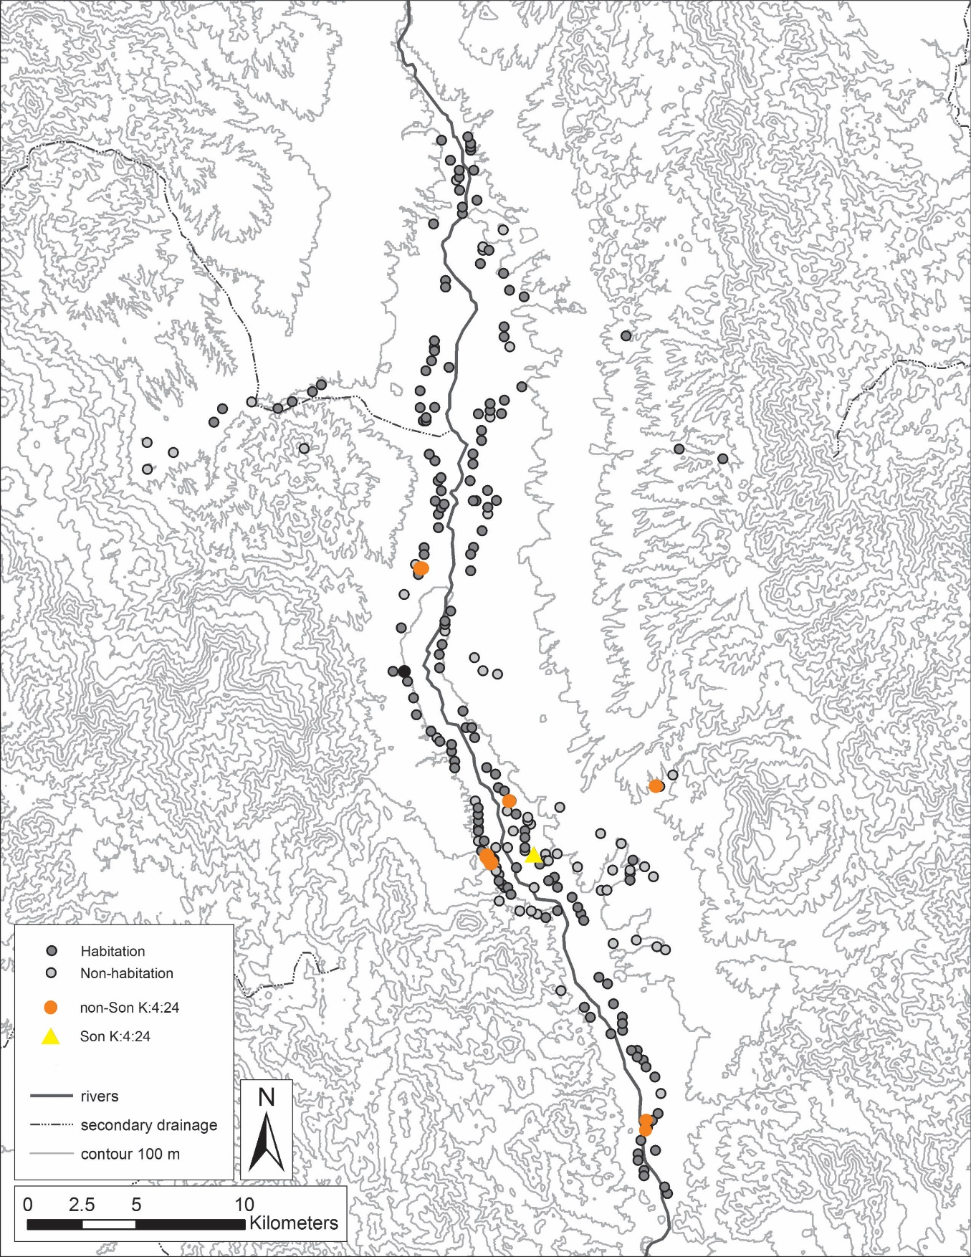
Figure 2. Intra-valley sites’ location (Sonora Valley)

4.1 Inter-Valley
The regional scale analysis will focus on an inter-valley comparison between the decorative treatments recorded by this analysis and two neighboring valleys. The Moctezuma Valley with a sample assemblage of 521 decorated sherds recorded from three archaeological sites and the Fronteras Valley with a sample of 503 sherds from four archaeological sites. The comparative analysis between these areas will provide a novel perspective on the interaction between these neighboring areas and allow inferences regarding the extent to which these valleys participated in a larger sphere of socio-political integration in the Rio Sonora/Serrana region. This ceramic data will complement the reconstructions described in the cultural history chapter, regarding the social dynamics of the region, specifically the potential for political confederations as well as shared social aspects of identity such as language and ethnicity more broadly.

4.2 Intra-Valley
The intra-valley scale of analysis encompasses nine archaeological sites. As noted above, the low number of sherds from most sites makes the only viable approach a simple comparison between the large site of (SON K:4:24) and all other sites combined (Non-K:4:24). SON K:4:24 (Sonora Valley) contributes with 95% to the total Sonora Valley sample. The other 5% is distributed among the remaining eight archaeological sites. In terms of the decorative attributes, the frequency of each will provide crucial insight regarding the scale of shared decorative repertoires between both groups. Likewise, it will be possible to minimally investigate distributional patterns of decorative styles within the Sonora Valley, thus providing a different perspective on social interaction relevant to the proposed political units of statelets.

4.3 Intra-site
The skewed distribution of the overall sample toward the site SON K:4:24 does, in fact reflect not only the relative amount of excavation conducted at different sites but also the inference of site importance in the socio-political landscape. Accordingly, I will also separately analyze the San Jose site (SON K:4:24) through at the intra-site scale. Records of the 1970s archaeological excavations in the Sonora Valley are useful to divide the site SON K:4:24 sample into three provenience areas. According to the excavation records, the site SON K:4:24 materials considered in this thesis correspond to areas A, B, and C. Area A is dominated by a ball-court and a large platform as well as domestic contexts. Area B corresponds to a large communal pithouse, and area C corresponds to a small pithouse and an adobe house. This level of analysis will investigate if there is variation in the frequency of ceramic decorative attributes within the site. The archaeological features that constitute each collecting area will permit us to determine if certain activities (ritual/domestic) are associated with different frequencies of ceramic decorations.

4.4 Analysis
The following definitions correspond to the basic information recorded for each sherd as part of the analysis process. Again, not all will be employed in the final analysis of this thesis, but they are listed here to denote availability.
- Provenience– This information corresponds to the site and unit/level provenience of ceramic sherds as recorded by the original investigators.
- Max length (mm)– The maximum dimension of the sherd (obtained with a vernier caliper). This is useful for estimating relative breakage indicative of assemblage formation processes.
- Thickness (mm) – The cross-section thickness of a representative portion of the sherd (obtained with a vernier caliper). This is useful for inferring variation in manufacturing and possibly vessel function.
- Munsell Data – The Munsell system was utilized for the recording of ceramic paste and red paint colors. This category provides a consistent means of describing qualitative changes in paste and paint color indicative of source material and presumably color scheme preference. Note that light condition was held as constant as possible during the entire analysis to avoid introducing variation.
- Design Surface – This category refers to the surface(s) of design execution, i.e. interior or exterior surface.
Further analysis categories classify decorative elements in a partially hierarchical system. The assemblage is divided into the following categories defined below.
The goals of this research and the nature of the analyzed materials makes a hierarchical approach to ceramic decoration a useful means to describe decorative attributes. A hierarchical framework allows us to deconstruct decorative attributes into useful units for analysis. The hierarchy for such units in this case study is determined by the various analytical levels of: “approach”, “treatment”, and finally “variants” as defined below. Analysis can, in theory, be fruitfully carried out any level of the hierarchy and analyzing different levels can add nuance to patterns of variation. In practice, this research focuses almost exclusively on “treatments” and “styles”, a category described below which is not within the hierarchical framework. Previous research suggests the lower levels of a hierarchical schema are the most useful scale of analysis (Douglas and Lindauer 1988: 622).
Decorative approach corresponds to the highest level of the hierarchical analysis. There are two defined approaches for the present sample, textured, and painted. The emphasis of this thesis is almost completely on the textured approach. Ceramics decorated only through painting were not a component of the analyzed sample and are mostly inferred to be foreign imports. There is also a likely local redware and related red-on-brown tradition. The textured and painted approaches are not mutually exclusive, as painted red elements are common on textured ceramics. It is important to note, that because sherds with only red paint were not part of the analysis, no statements can be made regarding the overall prevalence of redwares. Treatment refers to the classification of variation within approaches. There are three common treatments in the Sonora Valley assemblage. The two treatments under the texturing approach are incising and punctuating. A few other treatments found in neighboring valleys are also defined below for comparative purposes, these include brushing and several kinds of corrugation. There is only one relevant treatment under the painting approach in the analyzed sample, which is the aforementioned use of red paint. The analysis also classifies certain attributes at a final level called variant. The description of variants is most relevant to punctating, which includes a range of different shapes of punctating. There are only a few variants of incising among the Sonora Valley sample, pertaining to line width and combinations of line-widths. However, incising variants are more common in other regional contexts, such as the Moctezuma Valley (Pailes 2016:73-74).
Analysis is complicated by the fact that designs are often composed of combinations of elements at all levels. To address this the non-hierarchical dimension of style was also defined. This category pertains to distinctive combinations of elements and their layout and relation with each other. However, the possibility to fully apply a none-hierarchical approach in this case-study is constrained by the nature of archaeological evidence that is analyzed. That is, the lack of complete vessels in this analysis, or even larger sherds that would represent more interpretable characteristics of design structures impedes the capacity to present a repertoire of various decorative motifs or to evaluate discernable stylistic variation (Jeringan 1986). Despite these obstacles, I define numerous styles based on the combinations of the treatments defined below and their relational layout. In the sense that these “styles” are not decomposable or combinatorial.
The definition of the various decorative categories for this research was constrained by the need to be comparable with the regional comparative samples of the Moctezuma (M. Pailes 2016) and Fronteras Valleys (Carpenter’s et al 2019. One purpose of this thesis is to further standardize the analytical categories to provide a framework for further investigations in the Rio Sonora/Serrana region that is also commensurate with approaches in the surrounding regions of the US southwest, Casas Grandes, northern Sinaloa, and Trincheras (western Sonoran). The following sub-sections provide a more precise definition of the relevant textured treatments:

4.4.1 Incising
Incising is defined as engraving a design by cutting or scrapping into the clay surface at any stage of drying, from soft to bone dry. In the Rio Sonora/Serrana region, incising was apparently always accomplished at or before the leather-hard stage of drying. Incising is the most common treatment in the sample. Incising can be categorized into three different variants: single, double, and multi-width. As the names imply, these simply refer to the width of the incised line(s) and by extension the tools utilized. Due to the overwhelming ubiquity of “single” in the Sonora Valley, it is not a particularly useful categorization for intra-valley or intra-site comparisons. For consistency, incising was selected as the focal element in defining style-layouts that employed multiple elements. This simply means that elements of this treatment were described first and that other treatment elements are described in regard to how they were juxtaposed to incising. There are, of course, examples, where incising is not present, in which case punctuating is used as the focal element. The categories that include incising as a component of the style are indeterminate (single line), curvilinear Incise, parallel design, angled design, three element band, sub-parallel design, crosshatch, and erratic (described below). Figures 3 through 6 provide a few examples of incised styles.

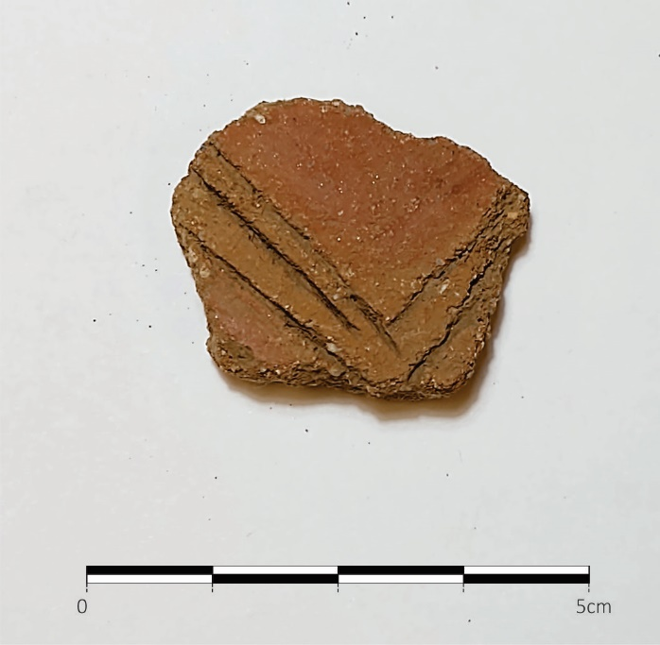 | 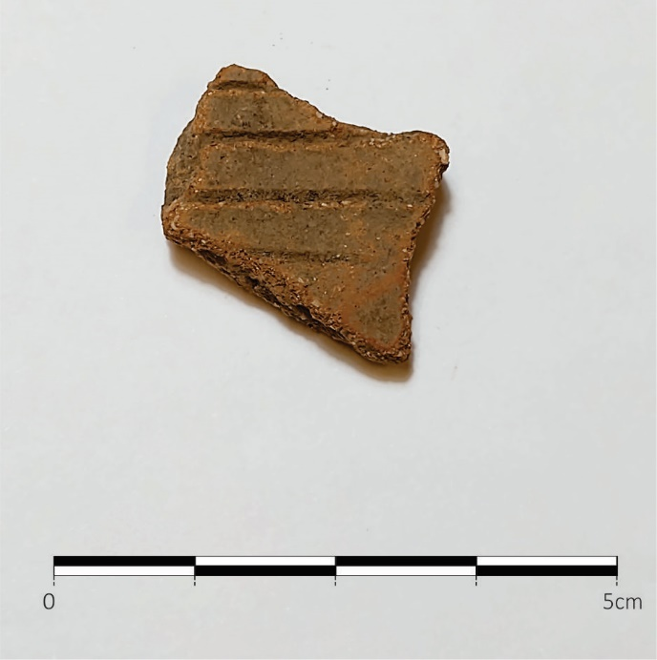
Fig 3. Angled design | Fig 4. Parallel design
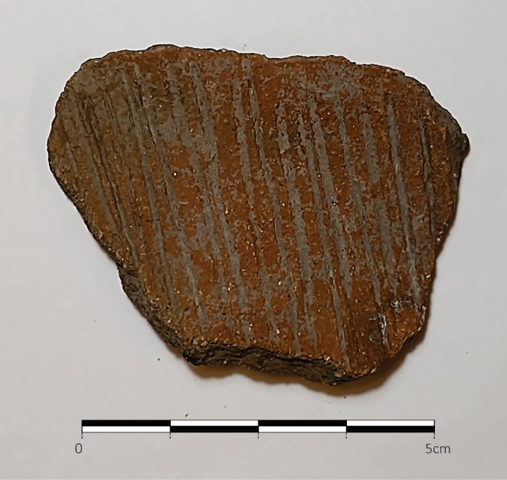 | 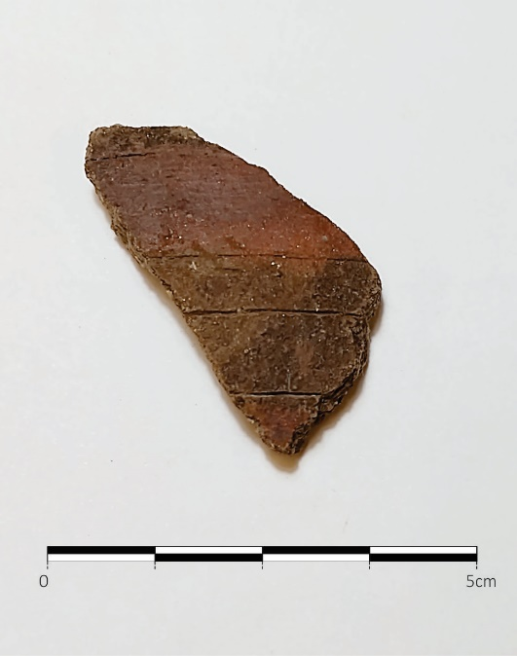
Fig 5. Brushed | Fig 6. Painting framed by parallel design

4.4.2 Punctating
Punctating is defined as an impression produced by a variety of tools (sticks, reeds or other tools or implements) pressed into the clay to produce a small stamped impression. Punctating is the second most common treatment in the sample. The punctating treatment includes nine variants: diamond-punctate, U-punctate, circle-punctate, lunate-punctate, pin-punctate, rectangle-punctate, triangle-punctate, finger-nail-punctate, and dash-punctate. As the names imply, these variants correspond to the shape of the punctate, which is itself reflective of the utilized instrument. There are two specific cases where three punctating variants (pin-punctate, circle-punctate, and dash-punctate) co-exist as a filler layout. Other than these cases, there is no combination of punctate variants.
There are a variety of styles in which multiple approaches and treatments co-occur. There are cases where punctating and painting occur together without incising decoration. In these cases, punctating usually has a framing role to the paint treatment. More complicated layouts like the three-element band are expressed by the co-existence of the three treatments on a ceramic-sherd. In these scenarios, incising serves as a framer or divider for regions of punctating and painting. In contrast, there are cases where punctating is the only treatment such as: punctated # rows, and punctate field. Punctated number (#) rows refer to linear arrangements of punctates with one, two, or three linear rows. No cases exist with more than three punctated rows. In the Punctated field style, the distribution of the punctating is haphazard and serves as a filler field. There are also scenarios where the punctated one row and punctated two rows style co-exist with a painted treatment. When this happens, as mentioned above, the punctating creates a framer for the paint treatment. Other styles for punctating treatment, that occur in conjunction with incising include punctate framer, regular filler band, erratic filler band, regular filler field, and erratic filler field. Figures 7 through 10 provide several examples of punctate styles.
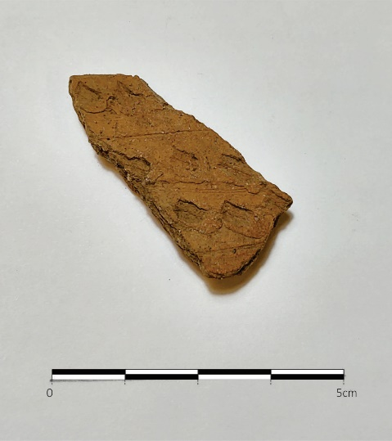 | 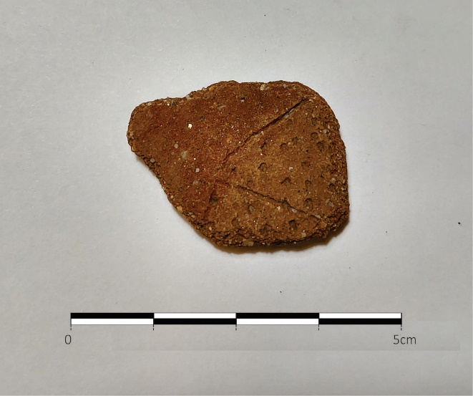
Fig 7. Dash punctate regular patterning incise-framed | Fig 8. Regular circle-punctate patterning filler field, incised-framed; adjacent paint
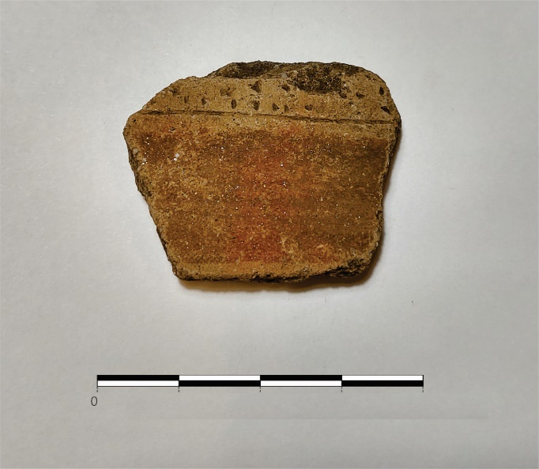 | 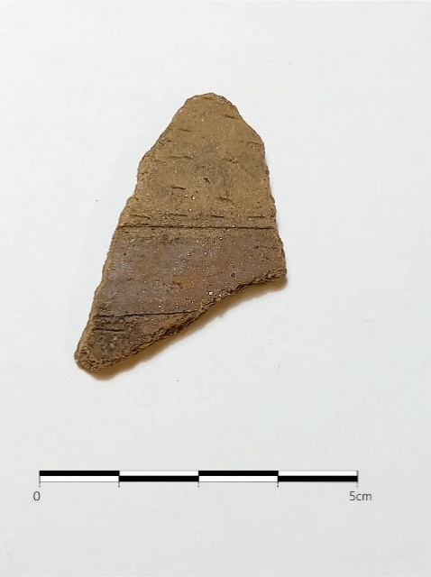
Fig 9. Regular pin-punctate patterning filler band, incised-framed; adjacent paint | Fig 10. Three element band (Painting incise-framed; regular patterning dash-punctate bounding field)

4.4.3 Paint
Red paint has a unique distinction in the collection, because it is the least represented treatment in the analyzed sample. However, it should be stressed the sample only considers a portion of the textured assemblage, so this low frequency is not clearly indicative of the overall prevalence of redwares. In order to understand the use of the painting treatment in the collection, it is necessary to describe its relationship with incising and punctating treatments. The category “paint location” specifically records the relational organization of painting and other treatments but is not a focus of analysis, Instead this information is more usefully considered as a component of the overall defined styles. Figures 11 through 14 provide several examples of paint locations.

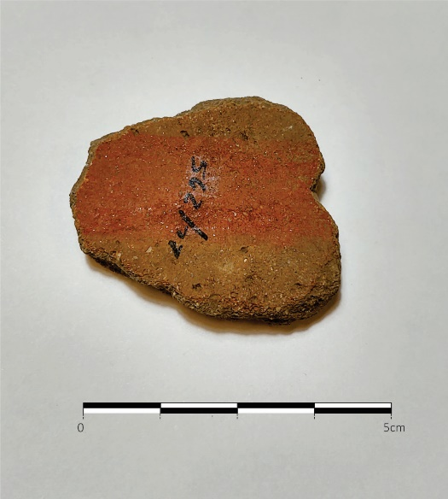 | 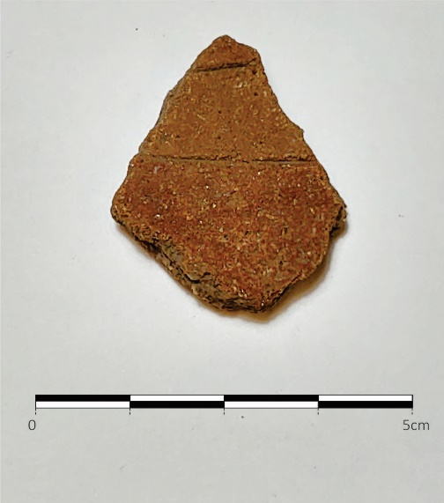
Fig 11. Painting framed by pin-punctate bounding bands | Fig 12. Pin-punctate framed by incising; adjacent paint.
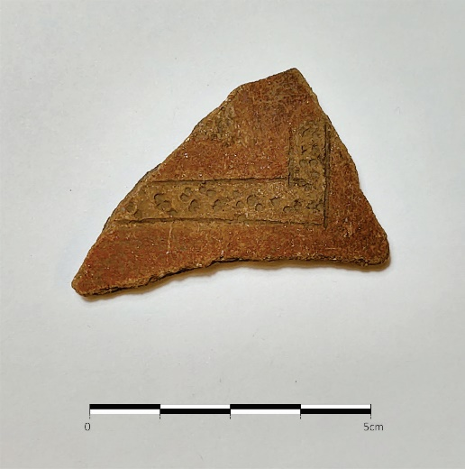 | 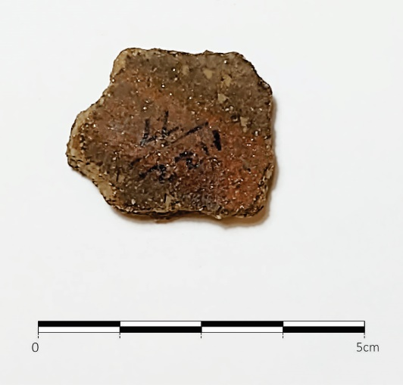
Fig 13. Circle-punctate filler band framed by angle-design with painting bounding field. | Fig 14. Painting framed by diamond-punctate bounding bands

4.4.4 Psuedo-Corrugated
True corrugation results from the partial preservation of the coils used in forming the vessel. The resulting ridges of clay encircle the vessel in stacked rings. Pseudo-corrugation is formed through a variety of methods that produce patterns of ridges or that mimic corrugation. Punctated/Pseudo Corrugated is a form of punctuating in which the overall appearance mimics corrugation. That is, the punctating in this case creates the appearance of linear ridges and grooves on the sherd surface. This treatment is also known by other regional names such as Cloverdale corrugated (Kurota and Roger 2008). All forms of the corrugation treatment are absent in the Sonora Valley sample but are defined here due to their prevalence in comparative samples.

4.4.5 Brushing
This treatment is characterized by non-homogenous lines produced by dragging a bundle of fibers across the sherd surface. The resulting design often has an overall subparallel orientation, but other variations are known. Sherds that only have brushing were not considered in this sample as the sample was not curated in a manner that permitted their easy quantification. The treatment is described here solely for purposes of comparison with the Moctezuma Valley where brushing was occasionally employed alongside some other textured treatment.

4.4.6 Design attribute definitions
The following list corresponds to the locational categorization of the painting treatment in relation to incising and punctating treatment decorations (Figure 15):
- Adjacent – Paint decoration located at the margin of a sherd and bounded on one side by another treatment. Incising is much more often present in the sample in this role compared to punctating.
- Punctate framed – The painting decoration is bounded by one of the nine punctate variants. Pin-punctate, circle-punctate, and dash-punctate are the most common punctate variants when punctating and painting are the only treatments occurring on a sherd (See sub-section 4.4.7 for punctating variants definitions). Punctate framed occurs in two styles. One corresponds as mentioned above to scenarios where painting and punctating are the only decoration treatments in a sherd. This scenario is the punctate row(s) style. The second corresponds to scenarios where incising appears as a third component. In this situation, the style is defined as three element band.
- Bounding field – Paint decoration provides a framing field that encloses incising and/or punctate decorations. No cases exist of paint as a bounding field for only punctating. One of the contrasting characteristics in comparison to the bounding Bands category if that bounding Field encompasses a larger portion of the sherd with paint. In some of these cases, the incising or the punctating are barely perceived on the sherd.
- Bounding bands – This scenario is characterized by two painted bands that enclose, in most of the occasions, a punctate filler band or a punctate filler field that is also bounded by incising. Several cases exist in which this sort of paint location is only employed with incising, but no cases exist where paint serves as bounding bands for only punctating.
- Incise framed – This layout describes a relationship between incising and painting treatments in which the painted area is framed by incising, expressing a band form.
- Superimposed – Paint is applied over an incised style. There is only one case in the assemblage that represents this relationship.
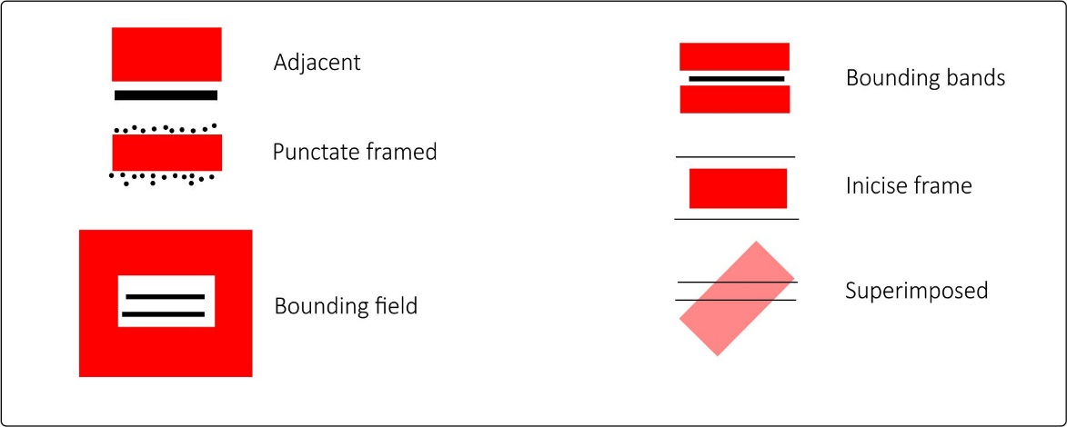
Figure 15. Painting treatment relationship
The following corresponds to the style categorization that constitute the assemblage:
- Indeterminate (single line) – This corresponds to the simplest style. It is defined as one straight line without further elaboration. There is a large number of cases in the sample characterized by this style. It is likely that many of the sherds in this category actually correspond to more elaborate styles but due to breakage into small sherds only a single incised line can be perceived.
- Curvilinear Incise – This is a rare style that employs curved lines in any way.
- Parallel Design – This style is defined by two or more straight lines in parallel. It is likely some proportion of this style are fragments of the more elaborate angled design described next. There are three sub-groups for the incised parallel lines defined by the relationship to punctating, and paint location (Figure 4).
  - With Punctate Bands – These punctate bands can be regular or erratic filler elements framed by parallel incised lines. Paint treatments are not typically related to this incised and punctated layout. However, when paint appears it is usually adjacent.
  - With Punctate Field – Punctating in this style covers a wide area of the sherd. Examples with a regular distribution of punctating likely reflects a pattern applied with a specialized tool. Examples of erratic distributions of punctating corresponds to disordered fields.
  - With Punctate Framer – The punctating in this layout presents a punctate row parallel to the incising with either the dash, pin, or circle variants.
- Angled Design – This style is represented by one or more incised lines. These lines are executed as individual elements or parallel sets that intersect on their trajectories. The style potentially forms internal triangular shaped fields. There are three sub-groups in which punctating has three different relationships with incising.
  - With Punctate Bands – This variation employs circle, dash, pin, or F-nail punctates to create one to three bands of punctating in a regular or erratic distribution. In the cases where paint also appears, its location is mostly as adjacent.
  - With Punctate Field – Either circle, dash, pin, or triangle punctate variants cover a considerable area of the sherd. The distribution of the punctating can be regular or erratic. When paint is also present, its location is mostly bounding and functions as a framer for the punctating. Out of the three angled design with punctating, this variation appears most frequently.
  - With Punctate Framer – Punctating frames incising. In this variation no relationships with painting are evident in the sample. Only circle and pin punctate variants are utilized and with no more than three rows.
- Three Element Band – This style is defined by the combination of the three treatments (incising, punctating, and red painting) in a linear (parallel) arrangement. The incising and punctating both can have a framer role to the painting. However, the incising is most commonly the outer treatment followed by punctating, which is represented as a filler field or a filler band. The punctate filler can be regular or erratic in distribution. The painting treatment is always between textured treatments in this style.
- Sub-Parallel Design – Similar in execution to parallel design, this style is characterized by small acute angles in the incising line’s trajectories, likely due to imprecise execution of an intended parallel design. Punctating in relation with sub-parallel design is expressed in three layouts.
  - With Punctate Bands – One or two punctate bands appear in conjunction with the sub-parallel incising. In this case there is no relationship with painting.
  - With Punctate Field – Circle or pin punctates create a wide punctated area that decorate the sherd in addition to the sub-parallel design. Painingt may appear located adjacent to the other treatments.
  - With Punctate Framer – Circle punctates play a framer role to the sub-parallel design. In order to be considered a punctate framer no more than three punctate rows are present in an ordered (not erratic) layout. Painting encloses the incising and punctating treatments, that is, painting functions as a bounding field.
- Crosshatch – This style is defined as two or more sets of parallel lines that cross each other forming a net-like or crosshatch pattern.
- Erratic – This style is characterized by incising with no discernable design and typically includes lines crossing each other in a haphazard layout.
- Framed Paint – This style is characterized strictly by the relationship between an incised single line and a painted band. Paint is located adjacent to the incising, seemingly maintaining a parallel relationship.
- Framed Punctate Band – A regular or erratic punctated band that may be anyone of the nine punctate variants. This band is framed by an incised single line. When painting also appears in this relationship it is frequently adjacent to the incising-punctate combination.
- Framed Punctate Field – An incised single line frames a punctated field. The punctate field can be expressed in a regular or erratic manner. When painting appears in this style, the punctating is applied in a regular manner. The painting is likely to be placed adjacent to the incising.
- Punctate Field –This style is described as a large area of a sherd decorated by punctating. All nine punctate variations exist in this style. However, just one variant is present in any one case.
- Punctate Row(s) – This style is represented by one, two, or three punctated rows. Any of the nine punctate variants may be used, but never combinations. When painting is present, the punctating is always a framer to the paint.
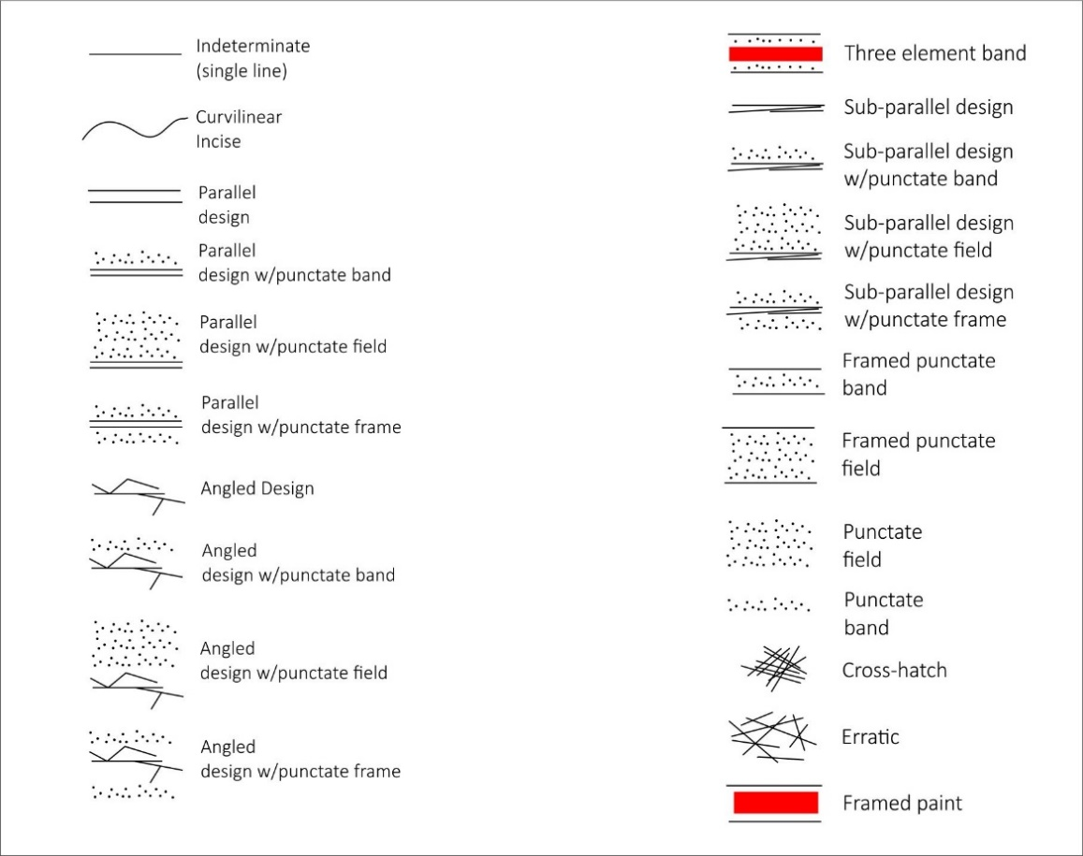
Figure 16. Styles’ sketch
As described above, the lowest level of the hierarchical analysis are variants. The vast majority of incising is classified as normal and rarely as double execution. As the name implies, double execution presents a double-width size of a normal incised line. There are several systematic associations in the sample between variants and styles. When incising appears in combination with punctating the only variants are circle-punctate or pin-punctate. When double incising is present in relation to painting, the style is always in a parallel design or angled design, and paint location can be adjacent or as bounding bands.

4.4.7 Punctate variants
There are nine punctating variants. Where punctating co-occurs with other treatments or solely decorates a sherd, three variations pin-punctate, dash-punctate, and circle-punctate characterize most cases. Thus, the remaining punctating variants, rectangle-punctate, triangle-punctate, diamond-punctate, f-nail punctate, u-punctate, and lunate-punctate, rarely occur. The following correspond to the description of the nine punctating variants in the sample:
- Pin-Punctate – A fine-solid-point tool is used for this punctate design. It is the most frequent among the punctating variants.
- Diamond-Punctate – This punctating design was formed by a diamond shaped tool. The diamond sizes can vary from 2mm to 8mm.
- U-Punctate – This punctate form resembles the “letter U”. It is the least common variant of punctating in the Sonora Valley.
- Circle-Punctate – This form refers to circles produced by a hollow circular point. Circles sizes vary from 4mm to the 9mm, below the minimum measurement this style is considered-pin-punctate, which is solid as opposed to hollow.
- Dash Punctate – This punctated design is defined by regular dashes (short lines). There is minimal variation in size.
- F-Nail-Punctate – This variant was likely produced by the potter using their fingernail as a tool. The execution is somewhat similar to the U-Punctate, however, the main difference is that the F-Nail variation is significantly smaller than the U-Punctate.
- Lunate-Punctate – This variant is similar in form and size to the F-Nail variation, but the Lunate-Punctate is expressed in a low-relief carving form. Seemingly a tool was designed for this purpose.
- Rectangle-Punctate – This form is similar to lunate-punctating in that it is executed by a low-relief carving. The consistency of its form suggests that an object was used for this purpose. The size of the squares is in the range of 2x2mm or 3x3mm, and a low relief carving of 1~2mm depth.
- Triangle-Punctate - This punctate variant is similar to lunate and square punctating in that it is expressed in a low-relief carving form. It likely results from a tool specifically designed for this purpose due to the consistency of the triangle form in the sherds.
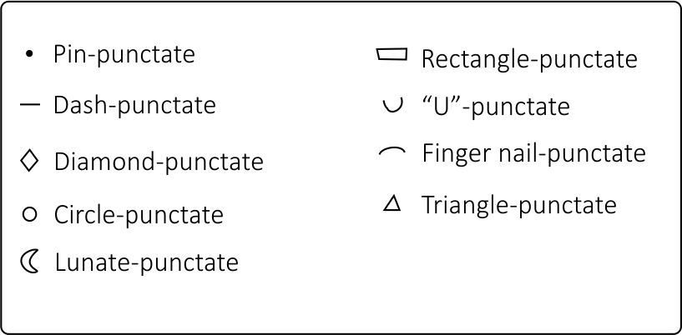
Figure 17. Punctate variants

5. ANALYSIS
This section primarily focuses on the analysis of the Sonora Valley assemblage, but also includes statistical comparisons with assemblages from neighboring valleys to facilitate the inter-valley comparisons. The intra-valley comparison will be facilitated by a comparison of the SON K:4:24 and NON-SON K:4:24 sites. Despite these two assemblages’ uneven sizes, the division will provide a means to evaluate aspects of identity corresponding to political affiliation proposed for the Sonora Valley (statelets). The intra-site scale analysis focuses on three areas of SON K:4:24. This scale of analysis offers a means to infer the social diversity of personas within this important site and its interaction with outside groups. As described above, this research studied 3083 decorated (textured) sherds. The materials corresponding to the Sonora River Valley were drawn randomly from a larger assemblage pertaining to the archaeological work conducted by the University of Oklahoma conducted in late 1970s. In contrast, the Moctezuma and Fronteras valley collections correspond to the entire recovered textured assemblages during fieldwork seasons conducted in the 2010s.

5.1 Inter-Valley Analysis (Sonora, Moctezuma, and Fronteras Valleys)
The Sonora, Moctezuma, and the Fronteras Valleys represent three distinct sub-regions of the larger Rio Sonora/Serrana region. The Rio Sonora Valley assemblage is the largest, followed by the Moctezuma, and at last, the Fronteras dataset (Figure 18).

Figure 18. Decorated ceramic assemblage sizes of the Sonora (OU-original data), Moctezuma (Legacy data-Pailes 2016), and Fronteras valleys (Legacy Data-Carpenter et al 2019).
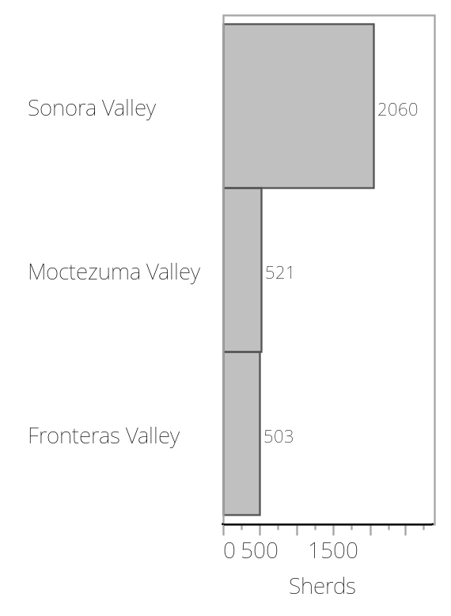

5.1.1 Treatment Category Analysis
The decorative attributes were deconstructed hierarchically to perceive differences and similarities both within the respective valley assemblages and to exterior regions (see Methodology chapter). The treatment and style categorizations of variation discussed in the Methods section will provide the primary basis for comparisons. These data will then be interpreted in light of suspected social relationships in the following sections. The three principal treatments (red paint, incising, and punctating) are shared in the three valleys but are distributed very differently. The same is true in regard to combinations of these treatments. There are also treatments that are specific to each valley (Figures 19, 20, and 21).

Figure 19. Sonora valley “treatments” distribution (OU-original data)
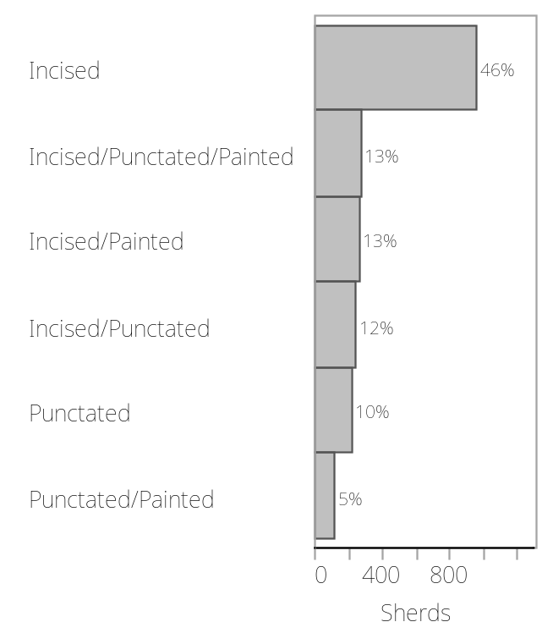
Figure 20. Moctezuma valley “treatments” distribution (Legacy data-Pailes 2016)
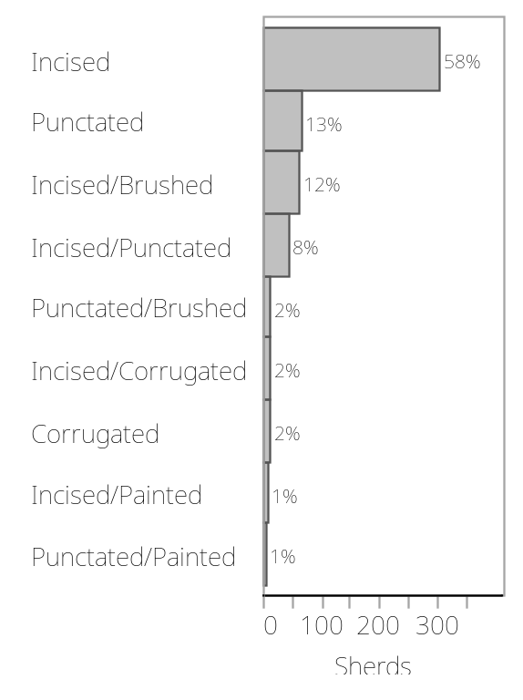

Figure 21. Fronteras valley “treatments” distribution (Legacy data-Carpenter et al 2019)
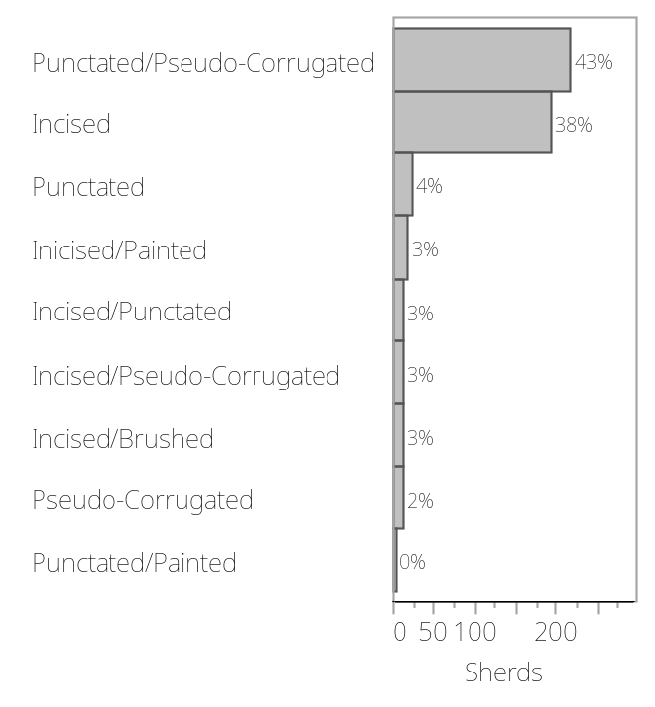
One of the similarities among the three valleys is the predominant use of incising as a decorative treatment. However, the combination of incising with other treatments encompasses one of the more evident points of deviation among the samples. Apparently, the Sonora Valley is less diversified in terms of decorative treatments. The Moctezuma and the Fronteras Valleys have in each case a significant additional treatment (brushed combined with other treatments and punctated/pseudo-corrugated respectively). It is important to mention that there is a distinction made in the region between the true and pseudo corrugated treatment of the Moctezuma (and other regions) and the punctated/pseudo-corrugated) of the Fronteras valley (and other regions) (Carpenter and Sanchez 2007; Carpenter and Vicente 2008). For the purpose of this analysis corrugated and pseudo-corrugated will be treated as equal.
It is important to note that the brushed texture is also a common treatment within the Sonora Valley but in this study, no brushed cases appear in the analyzed sample. It is also important to mention that in this case study brushed sherds were not included when this was the only treatment, but only when it occurs in conjunction with a second treatment. Ceramicists in the region do not generally consider brushing by itself to be a form of “decoration”, hence its exclusion.
Provenience Valley | Incised | Punctated | Corrugated | Incised-Punctate | Punctated-Painted | Incised-Painted | Incised-Punctated-Painted | Incised-Corrugated | Incised-Brushed | Punctated -Corrugated | Punctated-Brushed
Moctezuma Valley | 304 | 66 | 12 | 42 | 3 | 7 | 0 | 12 | 63 | 0 | 12
Fronteras Valley | 193 | 22 | 12 | 14 | 2 | 17 | 0 | 13 | 13 | 217 | 0
Rio Sonora Valley | 956 | 212 | 0 | 244 | 112 | 267 | 269 | 0 | 0 | 0 | 0

Table 1. Treatment count distribution for each Valley
As exemplified in Table 1, each valley has a characteristic treatment or a combination of treatments that make it at least somewhat unique from a regional perspective. For example, the Sonora Valley is characterized by a much greater prevalence of red paint on textured sherds with 650 sherds out of 2060 in the total assemblage. The absence of treatments such as brushed or corrugated also reflects a point of difference in relation to the Moctezuma and Fronteras valleys. The incising treatment appears to be representative in the Sonora Valley sample, appearing as the sole treatment in more than half of the assemblage.
The Moctezuma Valley collection is similar to the Sonora Valley, incising and punctating are the most common treatments, representing more than 80% of the total collection. Corrugated and brushed combined with other treatments also appear in the assemblage denoting a difference with the Sonora Valley, and conversely establishing some similarities with the Fronteras Valley. As noted, the Moctezuma sample only considers brushing when it is combined with another treatment. If sherds with only brushing were included, they would constitute 82% of the textured assemblage (Pailes 2016:66) (Figure 22). The proportion of solely brushed sherds cannot currently be calculated for then Sonora Valley. Qualitatively, solely brushed sherds are present but at a much-reduced frequency. The prevalence of punctated/pseudo-corrugated impart a unique quality to the Fronteras Valley. Incising, though common in the sample, is not as prevalent as in the Moctezuma and the Sonora valleys.

Figure 22. Moctezuma valley sample treatments distribution with including cases with brushed as the sole treatment (Legacy data-Pailes 2016).
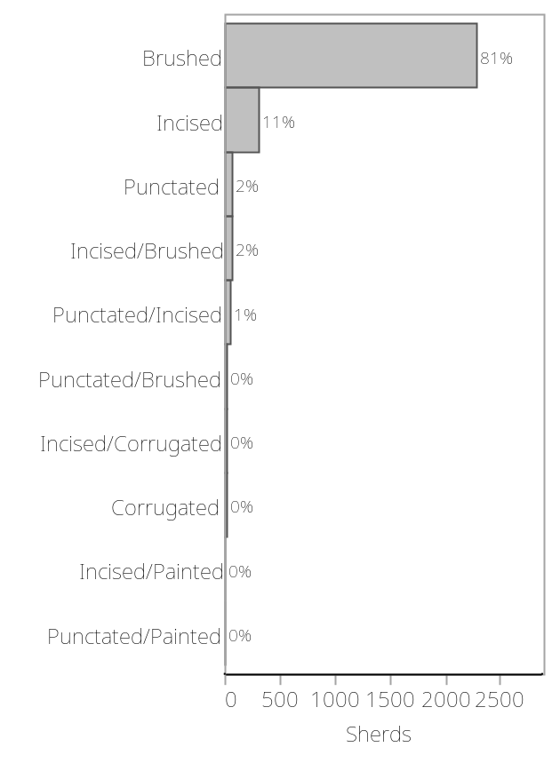
Table 1 demonstrates the percentage that the incising treatment represents for each assemblage; its prevalence results in a very skewed distribution and impedes the perception of variation among the other treatments. Incising is unquestionably the dominant regional treatment in the analyzed samples for these three river valleys. To perceive other more subtle differences, a further analysis of the three assemblages is performed that excludes incising, thus enhancing the perceptibility of other treatments. These data are presented in Figures 23, 24 and 25. In the Sonora Valley sample (Figure 23), the distribution of three sets of decorative treatments combination (Incised/Punctated 24%, Incised/Painted 22%, and Incised/Punctated/Painted 24%) is fairly even. In contrast, punctating as the sole decorative treatment encompasses only 19% of the assemblage. The Punctated/Painted combined treatments are even less common at 10% of cases.
Figure 23. Sonora Valley decorative treatments distribution (excluding incising treatment) OU-original data.
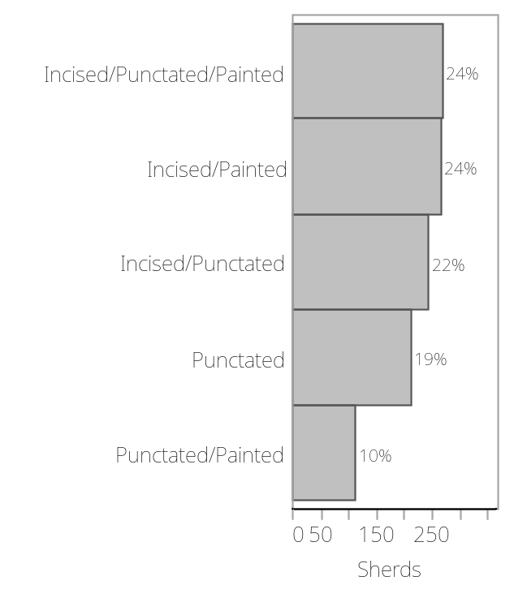

Figure 24. Moctezuma Valley decorative treatments distribution (excluding incising treatment) (Legacy data-Pailes 2016)
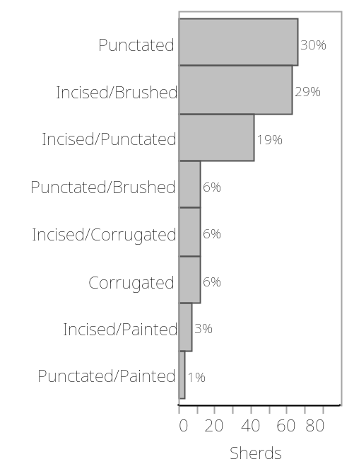

Figure 25. Fronteras Valley decorative treatments distribution (excluding incising treatment) (Legacy data-Carpenter et al 2019)
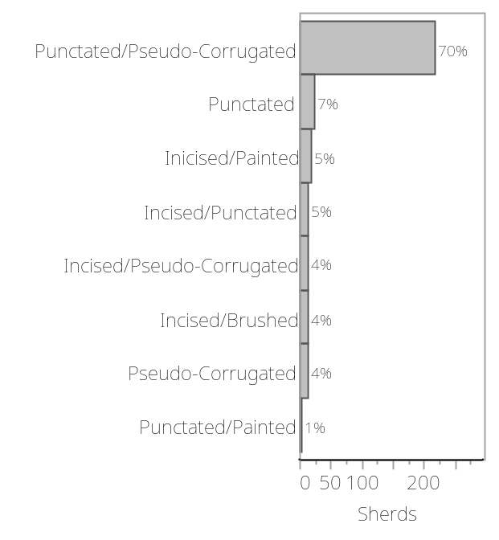
When incising is excluded, the Moctezuma Valley presents an uneven decorative-treatment distribution (Figure 24) in comparison to the Sonora Valley case. The punctating treatment in the Moctezuma sample represents 31% of the sample, incising/brushing 29%, and punctating/incising 18%. The remaining treatments are scattered in two groups. The first is composed by the treatments: corrugated, incised/corrugated, and punctated/brushed treatments that each represent 6% of the sample. The second decorative attributes group includes the incised/brushed, the incised/painted, and punctated/painted. These treatments characterize 1% ~ 3% of the sample.
The Fronteras River Valley decorative-attributes distribution is also distinct. In this case, it is the very high frequency of punctated/pseudo-corrugated treatment that sets the assemblage apart from other river valleys. Examining the remaining decorative treatments that compose the Fronteras valley collection, it is apparent that there are two sub-groups of frequencies. Pseudo-corrugated, incised/brushed, incise/pseudo-corrugated, incised/punctated, incised/painted, and punctated range from 4% ~ 7%. Punctating represents 7% of cases in the Fronteras Valley, which is far lower than the Sonora or Moctezuma valleys.
Although incising occurring as the sole treatment is excluded in this analysis, it is important to stress its significance. The three valleys’ samples all include treatment combinations that include incising with another treatment. Overall, this pattern is relatively uniformly distributed in the three valleys (Figure 23, 24, 25). Punctating is the second most informative treatment in the inter-valley comparison. This is evident in the high relative frequency of this treatment in the Moctezuma Valley, with punctating as the sole treatment making up almost 50% of the analyzed sample. For the Fronteras Valley, standard punctating as the sole decoration is rare. This valley instead stands out for punctated/pseudo-corrugation. In the Sonora Valley, punctating is less prevalent than in the other valleys due to the evenness in the frequency of treatments. However, the distribution of punctating in relationship to the other treatments is a critical point of distinction for the Sonora Valley. Punctating is the exclusive treatment in 19% of the analyzed sample and co-occurs with incising and painting and also frequently co-occurs with painting and incising.
In order to provide an additional perspective on the similarities and differences between the river valleys, the analyzed samples were evaluated with X² tests. Table 2 presents the utilized data set; it was necessary to only consider the decorative treatments shared in all the three valleys, as the X² analysis is unreliable when performed on a dataset with many “0” values (see Table 1). Both Pearson and Likelihood ratio tests indicate that there is a statistically significant difference between the three River Valleys (n = 2461, df = 8, X² = 0.029, p = .0001). The differing frequencies of incising and punctating, are the primary source of this result. The frequencies of treatment combinations are also important (Table 3).
Table 2. X² treatment category distribution evaluation at the inter-valley scale
Provenience Valley | Incised | Punctated | Incised-Punctate | Punctated-Painted | Incised-Painted
Moctezuma Valley | 304 | 66 | 42 | 3 | 7
Fronteras Valley | 193 | 22 | 14 | 2 | 17
Rio Sonora Valley | 956 | 212 | 244 | 112 | 267

Table 3. X² Test of independence for the Sonora, Moctezuma, and Fronteras treatments category
  Test | ChiSquare | Prob>ChiSq
  Likelihood Ratio | 21.463 | 0.0003*
  Pearson | 21.414 | 0.0003*
  Test | ChiSquare | Prob>ChiSq
  Likelihood Ratio | 127.719 | <.0001*
  Pearson | 96.990 | <.0001*
  Test | ChiSquare | Prob>ChiSq
  Likelihood Ratio | 65.753 | <.0001*
  Pearson | 57.431 | <.0001*
n = 670, df = 4, X² = .0188, p = .0001 | n = 2213, df = 4, X² = .0229, p = .0001 | n = 2039, df = 4, X² = .0127, p = .0001
Moctezuma – Fronteras Test | Moctezuma – Sonora Test | Sonora- Fronteras Test

Table 4 summarizes the absolute counts and relative percentages of each treatment(s) that contribute to the valley samples. A few observations are worthy of further note. The Sonora River Valley, as mentioned above, presents a sample heavily skewed toward the incising treatment. Combinations of incising with painting and punctating, are also common. In the case of the Moctezuma Valley, incising is the most common decoration, however, the prevalence of punctating and its combination with brushing denotes a difference in comparison with the Sonora Valley. The Fronteras Valley, in contrast, has a distinct treatment distribution. The unique type of punctated/pseudo-corrugated is the most common treatment in the sample and incising corresponds to the second common treatment. Other meaningful information derivable from Table 4 is the diversity of treatments that characterize each valley. Even though the Moctezuma Valley and the Fronteras Valley have unique treatments within their collections, the Sonora Valley seemingly has more treatment combinations, thus giving the impression of more decorative diversity.
Table 4. Three River Valleys treatments, percentages and counts distributions
 | Fronteras Valley | Moctezuma Valley | Sonora Valley |  | Fronteras Valley | Moctezuma Valley | Sonora Valley
Corrugated | 12 | 12 | 0 | Incised/Punctated/Painted | 0 | 0 | 269
Corrugated | 0.39% | 0.39% | 0% | Incised/Punctated/Painted | 0% | 0% | 8.72%
Incised | 193 | 304 | 956 | Punctated | 22 | 66 | 212
Incised | 6.26% | 9.86% | 31% | Punctated | 0.71% | 2.14% | 6.87%
Incised/Brushed | 13 | 63 | 0 | Punctated/Brushed | 0 | 12 | 0
Incised/Brushed | 0.42% | 2.04% | 0% | Punctated/Brushed | 0% | 0.39% | 0%
Incised/Corrugated | 13 | 12 | 0 | Punctated/Corrugated | 217 | 0 | 0
Incised/Corrugated | 0.42% | 0.39% | 0% | Punctated/Corrugated | 7.04% | 0% | 0%
Incised/Painted | 17 | 7 | 267 | Punctated/Incised | 0 | 42 | 0
Incised/Painted | 0.55% | 0.23% | 8.66% | Punctated/Incised | 0% | 1.26% | 0%
Incised/Punctated | 14 | 0 | 244 | Punctated/Painted | 2 | 3 | 112
Incised/Punctated | 0.45% | 0% | 7.91% | Punctated/Painted | 0.06% | 0.1% | 3.63%

5.1.2 Sonora Valley and Moctezuma Valley Red Paint Distribution
Though not a focus of the analysis, redware hues, colors, and values (Munsell System) were also compared between the Sonora and Moctezuma valleys to gauge similarity in technological approaches and preferences. For the Sonora Valley sample (Figure 26), red paint primarily encompasses the hues 10R, 2.5YR, 5R, 5YR, 7.5R, and 7.5YR, but most specimens are 10R or 2.5R. The values are mostly “4”; chromas have a wide dispersion centered on “6”. For the Moctezuma Valley, the 10R and 7.5YR hues comprise most of the red paint variation. The majority of the red paint cases correspond to the 10R hue with value/chroma 4/4, 4/6, 5/4, and 5/6. The 7.5R hue is characterized by the value/chromas of 4/4, 4/6, and 4/8. The histogram in Figure 27 presents this data.
Figure 26. Rio Sonora Valley red ware distribution by Munsell divisions (OU-original data)
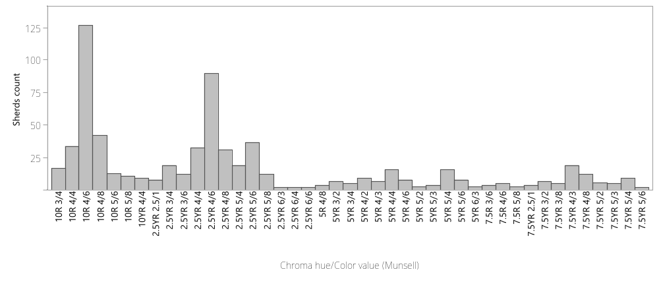

Figure 27. Moctezuma Valley red ware distribution by Munsell divisions (Legacy data-Pailes 2016)
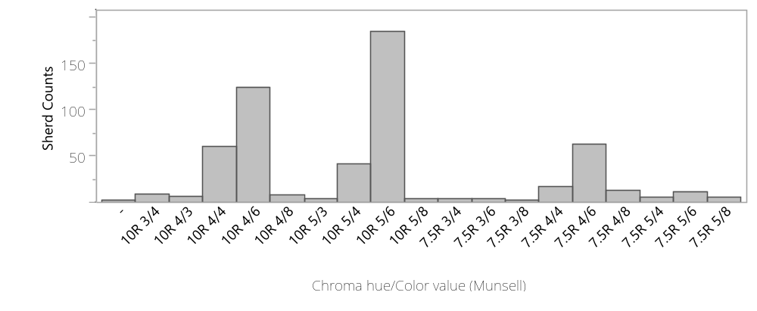

5.2 Intra-Valley Analysis (Sonora River Valley)
This analysis considers two geographic scales of analysis within the Sonora Valley, the intra-valley scale, and the intra-site scale of SON K:4:24. In regard to the intra-valley analysis, there is a heavily skewed distribution of sub-sample sizes as expressed in Figure 28 in regard to site provenience. This limitation should be kept in mind in regard to both the analyses that are possible and the confidence in their implications. Site by site comparisons will be simplified to SON K:4:24 and the NON K:4:24 . Site SON K:4:24 was one of the largest sites recorded, a likely “nodal” center, and was the target of most investigations. The sample sizes are not necessarily representative of actual ceramic artifact abundances, only the amount of work performed.

Figure 28. Ceramic sample frequencies of the SON K:4:24 and NON K:4:24 sites (OU-original data)
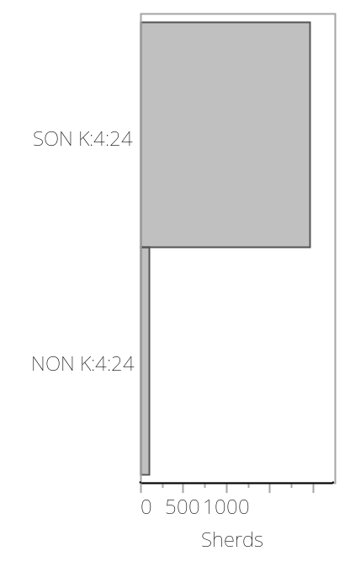

5.2.1 Treatment Category Analysis
Analyzing the percentage of each treatment is informative. Incising occupies almost the same percentage in both group samples encompassing nearly 50%. The percentages of the treatments and treatments-combinations are similarly distributed in both groups. The percentage of cases of three treatments co-occurring simultaneously (incising, punctating, and painting) is similar in both groups, occupying 13% on the SON K:4:24 group, while representing 12% in the NON K:4:24 group. The frequency of the punctating treatment presents a similar scenario with 10% in the SON K:4:24 group and 8% in the NON K:4:24 group. In contrast, there are several categories that present notably divergent percentages. Incising co-occurring with painting comprises 13% of the SON K:4:24 sample in comparison to 7% in the NON K:4:24 sample. Incising and punctating treatments co-occurring on the same sherd comprise 12% of the SON K:4:24 sample and in the NON K:4:24 group encompasses 16% of the sample (Figures 29 and 30).
Figure 29. SON K:4:24 decorative treatments distribution (OU-original data) | Figure 30. NON K:4:24 decorative treatments distribution (OU-original data)
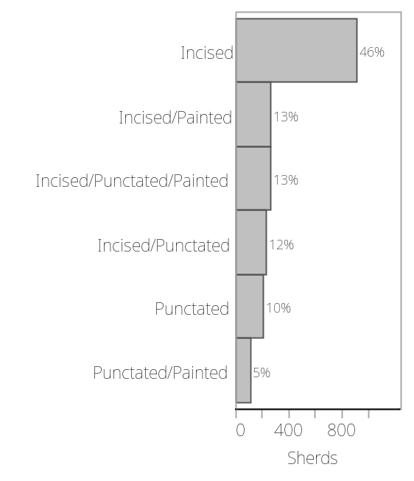 | 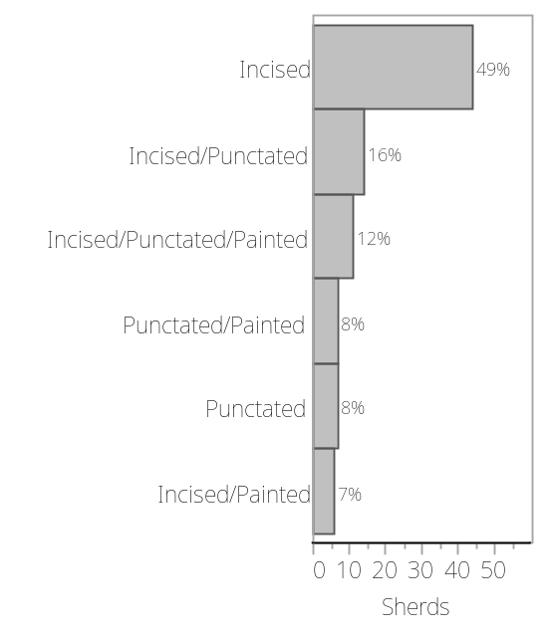

5.2.2 Style Category Analysis
As noted previously, some of the defined styles are problematic in that they may result from a partial capturing of a more complex style through breakage. This is most clear in regard to the prevalent single-line style. In this case, it is possible that this style could be a partial expression of another incising treatment such as parallel or angled designs or many others. If this is the case, such problematic styles should be more prevalent on smaller sherds. This is evaluated in figures 31, 32, and 33, which find no support for this inference. All styles have a similar mean maximum-dimension. Figure 31 provides the distribution of all the recognized styles according to an ANOVA analysis. The single-line and the angled-design styles are marked to highlight their similarity in their size distribution (Figures 32 and 33). Figure 31 thus allows me to mostly refute reservations about the validity of the single-line and similar styles. Note the distribution of the specimens for both decorative styles portray a normal distribution, not skewed towards the smaller or larger sherds for either case. Both single line and angled design present modes in the high 20s, though a statistical difference might be perceptible the actual difference in sherd size represented is unlikely to reflect limitations in categorical identification. Nonetheless, some caution will be exercised in interpreting the significance of variation in the distributions of styles.

Fig 31. ANOVA analysis of the “max size” in relation to Style. Sonora River Valley (OU-original data)
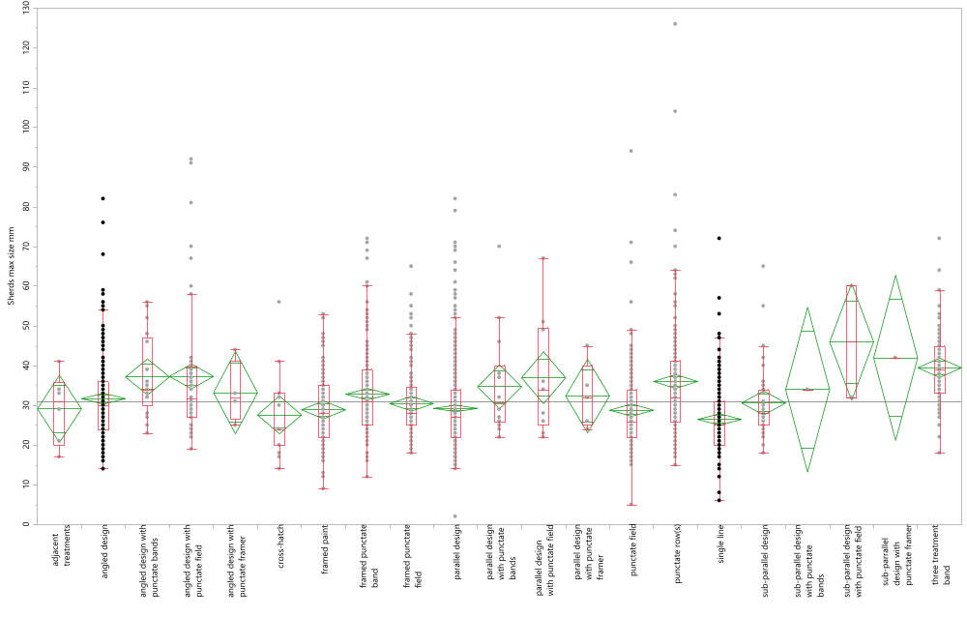

Decorative Styles
Figure 32. Sonora Valley single-line style distributed by size range | Figure 33. Sonora Valley angled-design style distributed by size range
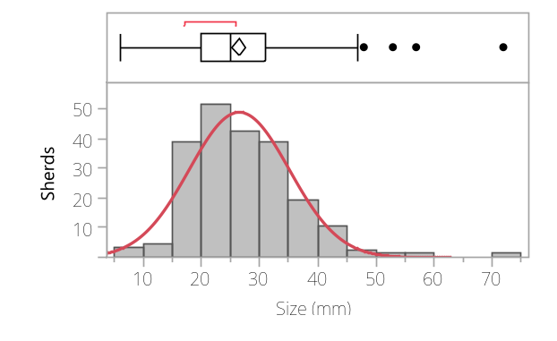 | 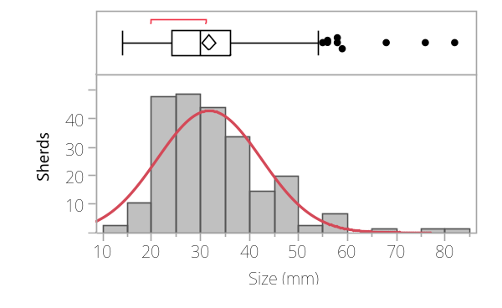
The styles distribution for both groups is expressed in Figures 32 and 33. Two significant considerations emerge from analyzing the figures. The first corresponds to the preference for the parallel-design in both groups, which is one of the incising-treatment layouts. The second observation is that the SON K:4:24 group includes more style diversity. However, the substantially different sample sizes are likely a major factor in this difference. Figures 34 and 35 provide a general panorama of the style distributions for both sub-samples. Note that the values expressed as 0% refer to styles that correspond to a single sherd in the sample.

Figure 34. Styles distribution in SON K:4:24 group
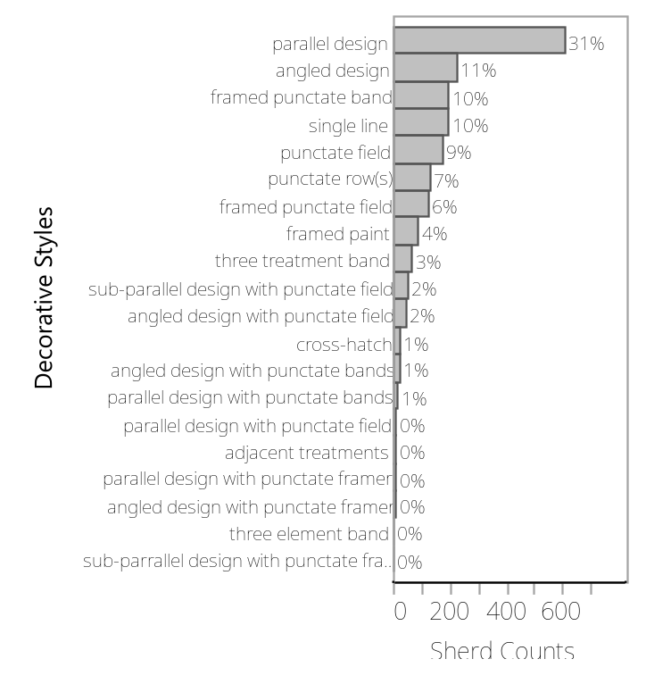

Figure 35. Styles distribution in NON K:4:24 group
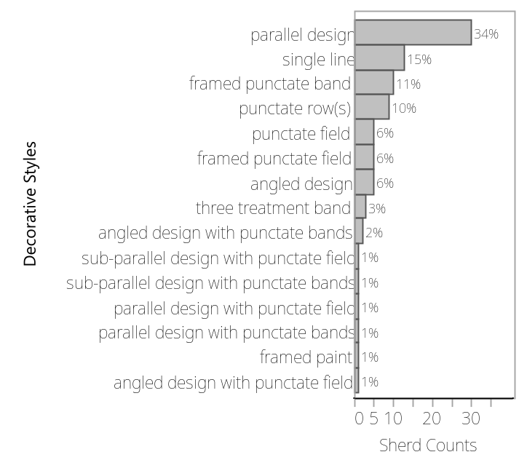

Figure 36. Styles distribution in SON K:4:24 group (excluding parallel design)
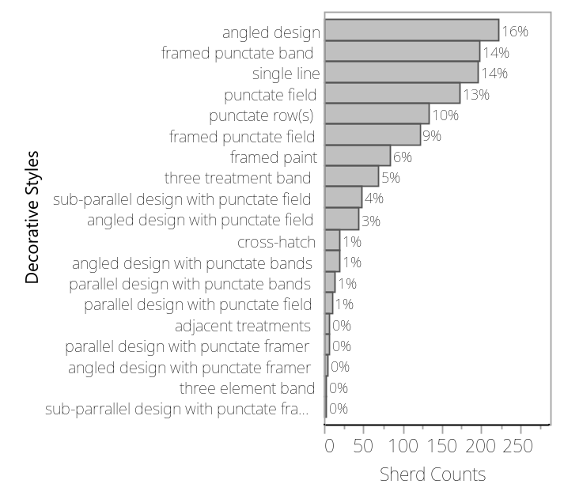
Figure 37. Styles distribution in NON K:4:24 group (excluding parallel design)
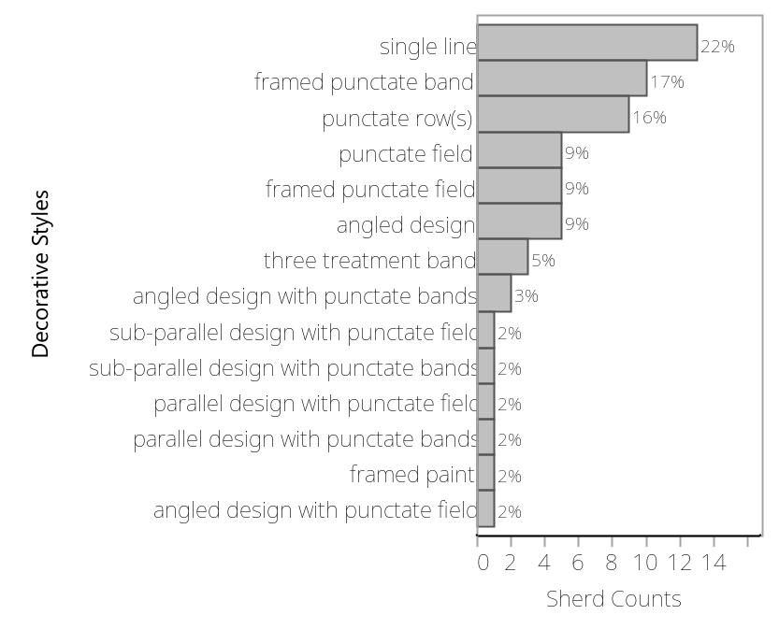
The rarity of the remaining styles in these Figures suggest excluding the parallel design (when it is the only style in a sherd) is necessary to perceive variations between other styles present in the two groups. Figures 36 and 37, allow us to examine the importance of other styles in both sample distributions. For the group SON K:4:24, the angled-design (16%), the framed punctated-band (14%), the punctate-field (13%), and the single-line (14%) are styles that are also relatively common. For the SON K:4:24 group, there are three styles that present appreciable percentages. These are the framed punctated-band (17%), the punctated-row(s) (16%), and the single-line (22%). Additionally, the angled-design and the framed punctate-field are styles that contribute 9% of the total counts in both samples.
The X²-test of independence for the styles-category was conducted twice, including the parallel-design (n = 2055, df = 20, X² = .0032, p = .0004), and also excluding it (n = 1420, df = 19, X² = .0043, p = .0001). These results are statistically significant and establish that the two groups are distinct (Tables 5 & 6).
Table 5. SON K:4:24 styles frequencies | Table 6. NON K:4:24 styles frequencies
  Style | Count
  adjacent treatments | 6
  angled design | 222
  angled design with punctate bands | 19
  angled design with punctate field | 43
  cross-hatch | 19
  framed paint | 83
  framed punctate band | 197
  framed punctate field | 120
  parallel design | 605
  parallel design with punctate bands | 13
  parallel design with punctate field | 9
  parallel design with punctate framer | 5
  punctate field | 173
  punctate row(s) | 133
  single line | 197
  sub-parallel design | 47
  three treatment band | 70
  Style | Count
  angled design | 5
  angled design with punctate bands | 2
  angled design with punctate field | 1
  framed paint | 1
  framed punctate band | 10
  framed punctate field | 5
  parallel design | 30
  parallel design with punctate bands | 1
  parallel design with punctate field | 1
  punctate field | 5
  punctate row(s) | 9
  single line | 13
  three treatment band | 3

5.3 Intra site analysis (San Jose site, SON K:4:24; Areas A, B, and C)
This level of the analysis aims to exemplify the differences and similarities in decorative attributes of ceramics in the three defined areas at the San Jose site (SON K:4:24). This scale of examination has the potential to determine what decorative patterning characterize areas A, B, and C, which correspond to discrete architectural areas of the site and possibly activities undertaken by distinct constellations of social personas.

5.3.1 Treatment Category Analysis
The decorative-treatment distributions corresponding to the three areas reflects uneven contributions of each area to the overall site assemblage. Area A contributes 1264 sherds to the sample, area B 671 sherds, and area C 36 sherds. Table 7 presents the count of treatments in these three areas.
Table 7. Treatments distribution by collecting areas (San José)
Provenience Units | Incised | Punctated | Incised-Punctated | Punctated-Painted | Incised-Painted | Incised-Punctated-Painted | Totals
Area A | 577 | 112 | 168 | 55 | 182 | 170 | 1264
Area B | 317 | 91 | 58 | 49 | 70 | 86 | 671
Area C | 18 | 2 | 4 | 1 | 9 | 2 | 36

Because the incising treatment in the SON K:4:24 sample overwhelms all other treatments at 46% of the total sample (see Figure 2), it is necessary to exclude this treatment to better perceive variation. Figures 38, 39, & 40 express what other treatments characterize each of the analyzed areas. There are several patterns worth noting. The following treatments of area A (Figure 39) present a relatively even distribution: incising/painting, incising/punctating, and incising/punctating/painting co-occurring simultaneously. Although these three treatment-combos have similar frequencies, the sherds decorated with the co-occurrence of incising and painting are slightly greater. Punctated as the sole treatment, and punctating/painting are less common in the sample. In regard to area B (Figure 39), the most common treatments are punctating as the sole decorative treatment and incising/punctating/painting. The treatment composed of incising/painting is the third most common decorative treatment, while incising/punctating and punctating/painting are the least common decorative treatments. The area C sample presents several distinctions in comparison to the decorative-treatment frequencies of areas A and B. A cautionary note is warranted given the small sample size for this area as shown in Figure 40. It is also important to note that one decorative treatment, incising/painting encompasses 50% of the sample. Recall for area A this treatment combination was only 27% of the cases.
Figure 38. Area A treatments distribution (SON K:4:24 Intreasite scale)
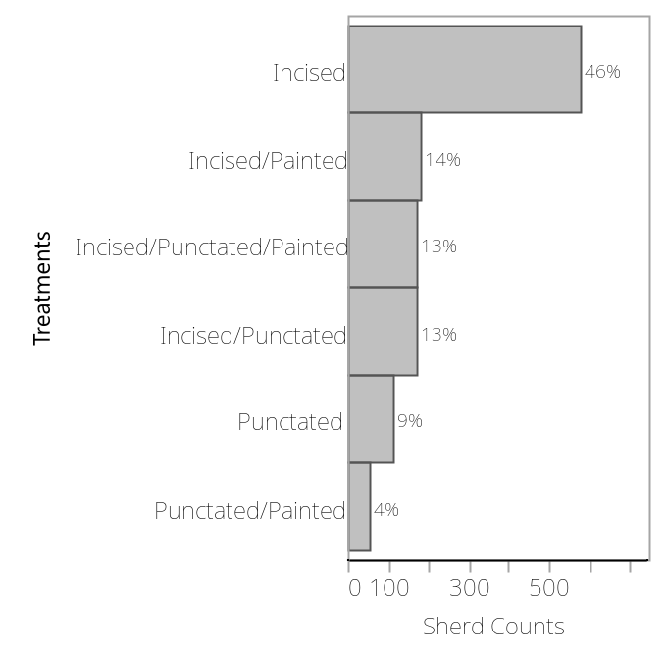

Figure 39. Area B treatments distribution (SON K:4:24 Intrasite scale)
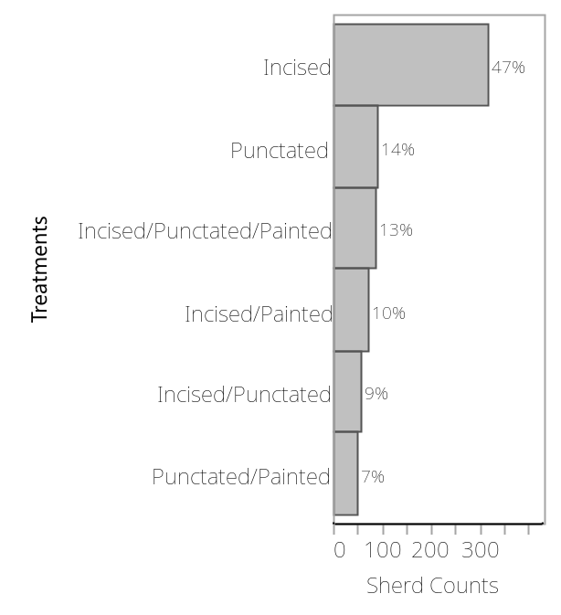

Figure 40. Area C treatments distribution (SON K:4:24 Intrasite scale)
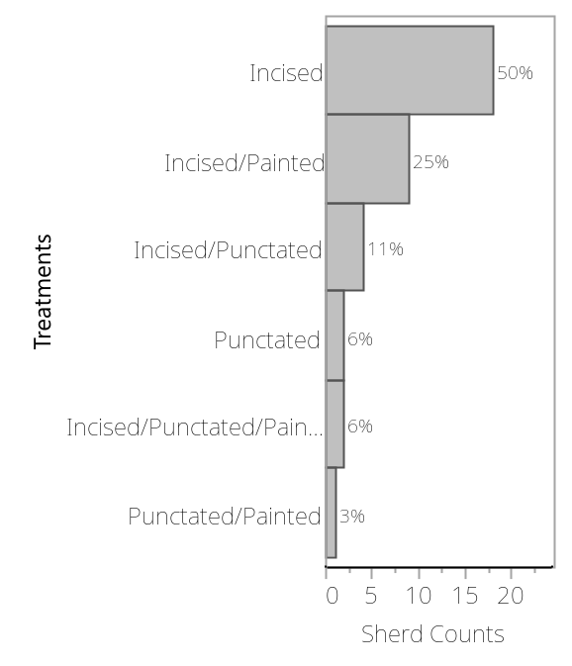
Based on the above decorative treatment frequencies pairwise X² test were performed to complement the graphical data of Figures 38, 39, and 40. The X² test of independence for the area A and B variables established a statistically significant difference (n = 1041, df = 4, X² = .0091, p = .0001). Therefore, it is possible to say that area A and area B are distinct. The results obtained for the areas B and C comparison was more equivocal (n = 372, df = 4, X² = .0087, p = .023). The results are too ambiguous to make a clear claim of dependence or independence between variables. The obtained values do hint at the possibility that there is an appreciable difference between these areas. Lastly, the statistical evaluation for the comparison between areas A and C resulted in a contradictory conclusion. The X² test to evaluate the dependence or independence between areas A and C, indicated the association between variables “Areas A and C” is not statistically significant (n = 705, df = 4, X² = .0023, p = .250).
Table 8. Treatment distribution per San Jose collection areas
Provenience Units | Incised | Punctated | Incised-Punctated | Punctated-Painted | Incised-Painted | Incised-Punctated-Painted
Area A | 577 | 112 | 168 | 55 | 182 | 170
Area B | 317 | 91 | 58 | 49 | 70 | 86
Area C | 18 | 2 | 4 | 1 | 9 | 2

  Test | ChiSquare | Prob>ChiSq
  Likelihood Ratio | 29.631 | <.0001*
  Pearson | 29.941 | <.0001*
  Test | ChiSquare | Prob>ChiSq
  Likelihood Ratio | 10.236 | 0.0366*
  Pearson | 11.312 | 0.0233*
  Test | ChiSquare | Prob>ChiSq
  Likelihood Ratio | 5.059 | 0.2813
  Pearson | 5.375 | 0.2509
Table 9. X² tests results for Areas A & B | Table 10. X² tests results for Areas B & C | Table 11. X² tests results for Areas A & C

5.3.2 Style Category Analysis
The styles distributions at this analysis scale are presented in Figures 41, 42, and 43. As with other scales of analysis, one style so overwhelmed the sample that essentially no other variation could be evaluated unless it was excluded. In this case, it was again parallel design that was excluded in order to perceive the distribution and importance of the other styles at the intra-site scale. Excluding parallel design, Figures 44, 45, and 446 show the distinct distributional patterning that characterizes each collection area at the San José site (SON K:4:24). The unevenness of the remaining styles in the three groups is appreciable. The following figures (44, 45, and 46) correspond to the distribution of the styles within the respective areas A, B, and C. The styles distribution patterning in areas A and B resemble the general distribution of styles at the San Jose site, while area C presents a contrasting pattern with less style variation in comparison to areas A and B.
Figure 41. Styles’ general distribution, Area A (SON K:4:24 Intrasite scale)
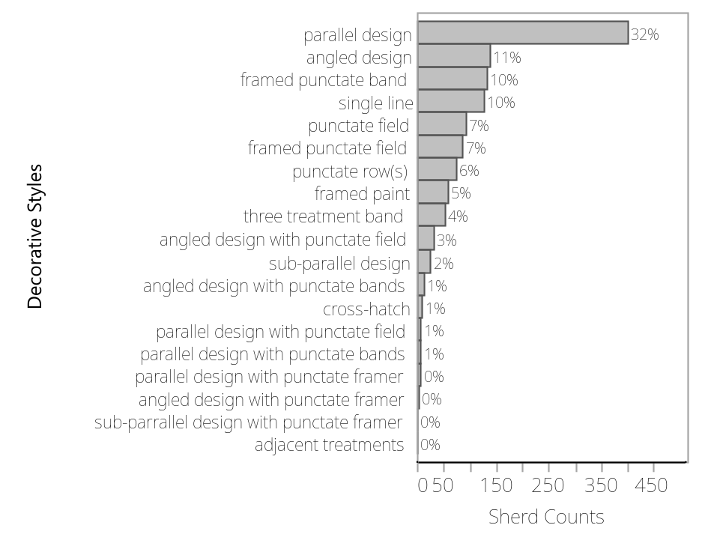

Figure 42. Styles’ general distribution, Area B (SON K:4:24 Intrasite scale)
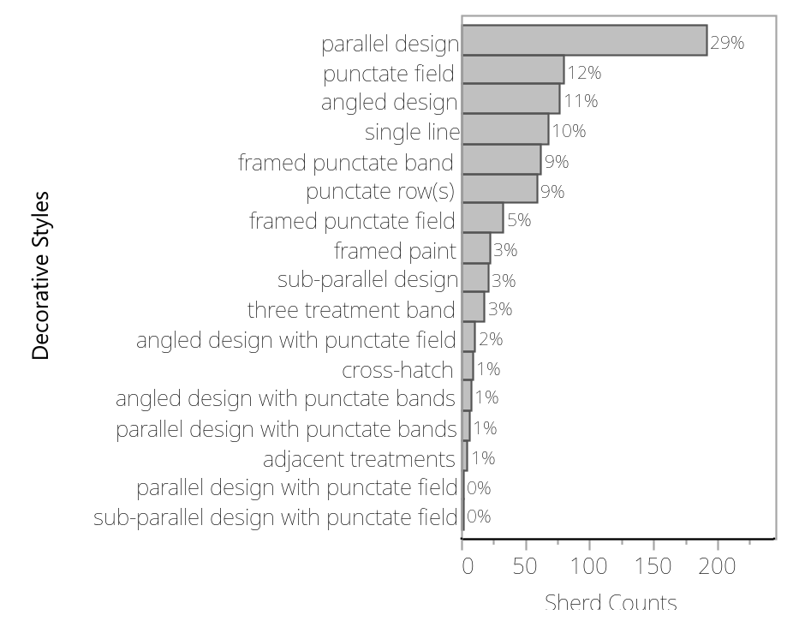

Figure 43. Styles’ general distribution, Area C (SON K:4:24 Intrasite scale)
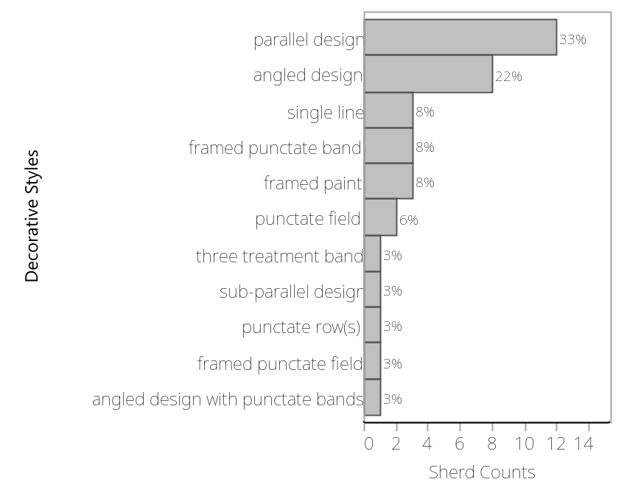
Area A is characterized by the following styles: angled design, framed punctate band, and single line are in the range from 16% to ~ 15%. The styles punctate field, framed punctate field, punctate row (s), and three treatment band, are styles that contribute to the area A sample in the range from 11% ~ 6%. The remaining styles are characterized by percentages in the range from 4% ~ 0% (Figure 44).

Figure 44. Area A, Styles distribution not included parallel design (SON K:4:24 intrasite scale)
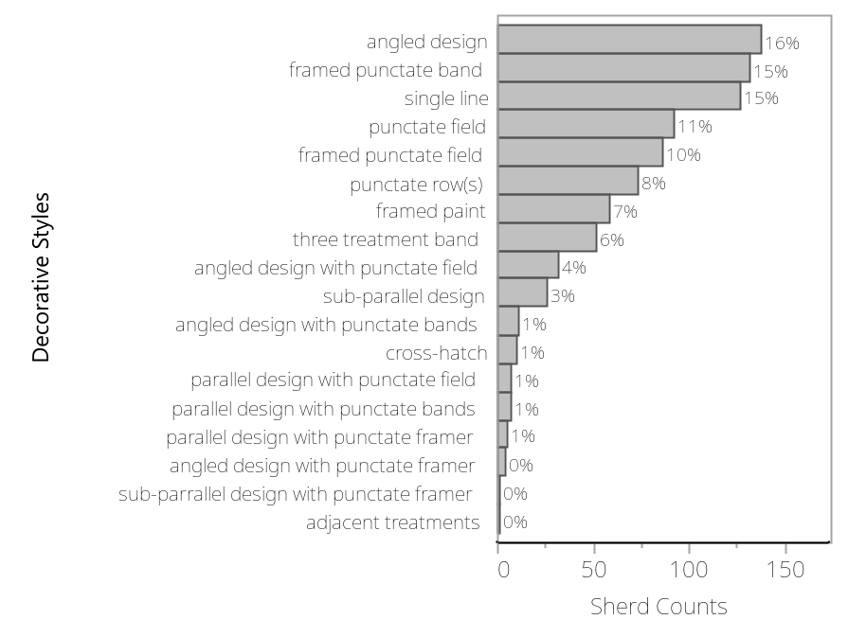
The distribution of the styles within area B (Figure 45) is similar but not identical to area A. Area B is shaped by five styles with a percentage range from 17% to ~ 12% (angled design, framed punctate band, punctate field, punctate row (s), and single line). Several more styles constitute a second group with percentages from 7% to ~ 4% (framed painted, framed punctate field, sub-parallel design, and three treatment band). The styles with percentages from 2% to ~ 1% correspond to a third group (angled design with punctate bands, angled design with punctate field, crosshatch, parallel design with punctate band, parallel design with punctate field, sub-parallel design with punctate field).
Figure 45. Area B, Styles distribution not included parallel design (SON K:4:24 intrasite scale)
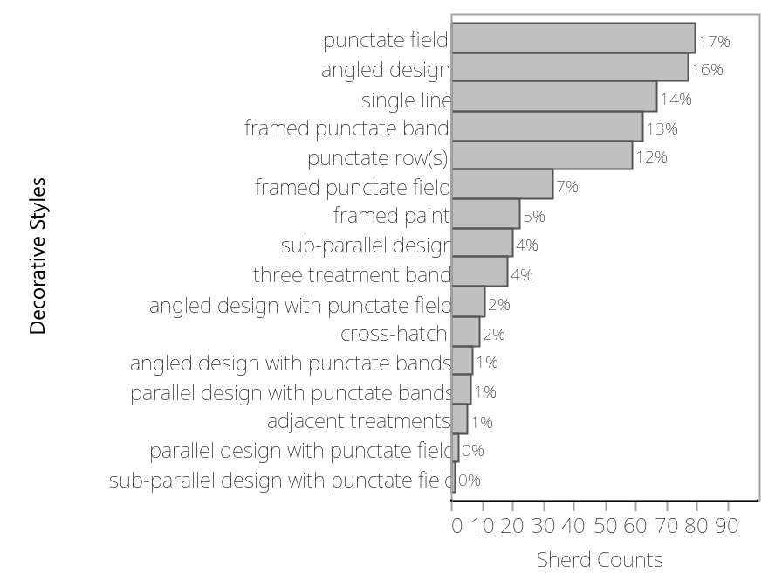
Figure 46. Area C, Styles distribution not included parallel design (SON K:4:24 intrasite scale)
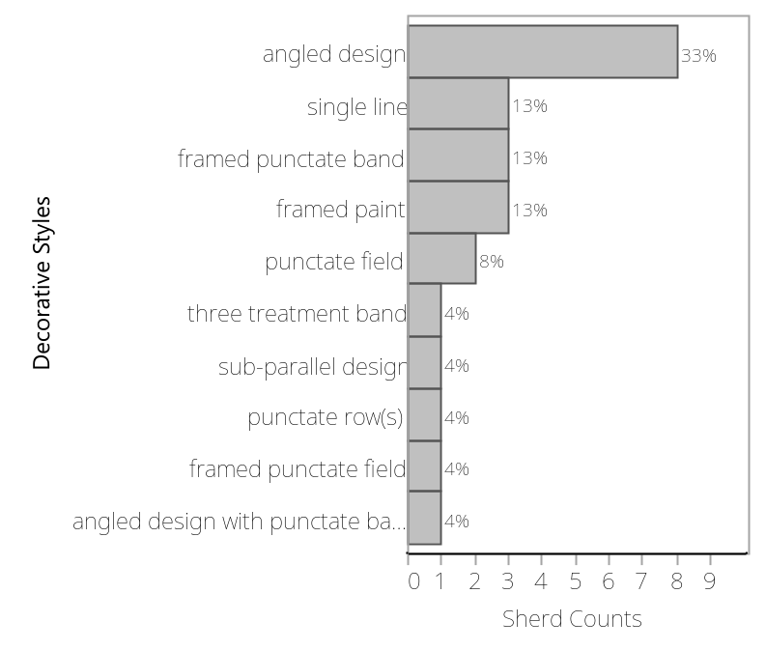
The styles distribution in area C is characterized by 33% angled design, and a relatively even distribution of the remaining styles. There may be slight indications of two and perhaps three groups in the remaining styles. One group includes the styles: framed paint, framed punctate band, and single line, with percentages of 13% in all cases. The punctate field style with 8% of the sample is grouped separately. The last group is composed of angled design with punctate bands, framed punctate field, punctate row (s), sub-parallel design, and three treatment band. Each of these styles encompasses 4% for the area C sample (Figure 46).
Table 12. Styles distribution by Areas A, B and C, Collection Areas
Styles | Area A | Area B | Area C | Styles | Area A | Area B | Area C
adjacent treatments | 1 | 5 | 0 | parallel design with punctate bands | 7 | 6 | 0
angled design | 137 | 77 | 8 | parallel design with punctate field | 7 | 2 | 0
angled design with punctate bands | 11 | 7 | 1 | parallel design with punctate framer | 5 | 0 | 0
angled design with punctate field | 32 | 11 | 0 | punctate field | 92 | 79 | 2
angled design with punctate framer | 4 | 0 | 0 | punctate row(s) | 73 | 59 | 1
crosshatch | 10 | 9 | 0 | single line | 127 | 67 | 3
framed paint | 58 | 22 | 3 | sub-parallel design | 26 | 20 | 1
framed punctate band | 132 | 62 | 3 | sub-parallel design with punctate field | 0 | 1 | 0
framed punctate field | 86 | 33 | 1 | sub-parallel design with punctate framer | 1 | 0 | 0
parallel design | 401 | 192 | 12 | three treatment band | 51 | 18 | 1

Table 12 presents the style frequencies. Pairwise X² test were performed to complement Figures 29, 30, and 31. It is important to mention that statistics for comparisons between areas A, B, and C were tested considering the parallel design and excluding this style. Both approaches produced contrasting results, specifically in the evaluation among areas A and C, and areas B and C. The X² test of independence for area A and B variables resulted in a statistically significant difference between areas A and B; excluding parallel design (n = 1338, df = 18, X² = .0071, p = .0001), and when including parallel design (n = 1931, df = 19, X² = .0054, p = .0001). Test of independence for areas A and C variables indicated dependence among variables, when including parallel design in the evaluation (n = 1297, df = 18, X2 = .0019, p =.889) and excluding it (n = 884, df = 17, X² = .0026, p = .850). And the X² test of independence for areas B and C variables did not result in a statistically significant result between areas B and C, when parallel design is included (n = 706, df = 16, X² = .0040, p = .686) as well as when excluded from the evaluation (n = 502, df = 15, X² = .0053, p = .643). Table 13 presents the values associated with the X² tests for areas A and B. The styles where punctating occurs are clearly major contributors to the resulting statistical significance.

Table 13. X² Test for SON K:4:24 areas A and B (excluding parallel design)
Count | adjacent treatments | angled design | angled design with punctate bands | angled design with punctate field | angled design with punctate framer | cross-hatch | framed paint | framed punctate band | framed punctate field | parallel design with punctate bands
Total %
Expected
Deviation
Area A | 1 | 137 | 11 | 32 | 4 | 10 | 58 | 132 | 86 | 7
Area A | 0.07 | 10.24 | 0.82 | 2.39 | 0.3 | 0.75 | 4.33 | 9.87 | 6.43 | 0.52
Area A | 3.8565 | 137.549 | 11.5695 | 27.6383 | 2.571 | 12.2123 | 51.42 | 124.694 | 76.4873 | 8.35575
Area A | -2.8565 | -0.5486 | -0.5695 | 4.36173 | 1.429 | -2.2123 | 6.57997 | 7.30643 | 9.51271 | -1.3558
Area B | 5 | 77 | 7 | 11 | 0 | 9 | 22 | 62 | 33 | 6
Area B | 0.37 | 5.75 | 0.52 | 0.82 | 0 | 0.67 | 1.64 | 4.63 | 2.47 | 0.45
Area B | 2.1435 | 76.4514 | 6.43049 | 15.3617 | 1.429 | 6.78774 | 28.58 | 69.3064 | 42.5127 | 4.64425
Area B | 2.8565 | 0.54858 | 0.56951 | -4.3617 | -1.429 | 2.21226 | -6.58 | -7.3064 | -9.5127 | 1.35575
Count | parallel design with punctate field | parallel design with punctate framer | punctate field | punctate row(s) | single line | sub-parallel design | sub-parallel design with punctate field | sub-parallel design with punctate framer | three treatment band | Total
Total %
Expected
Deviation
Area A | 7 | 5 | 92 | 73 | 127 | 26 | 0 | 1 | 51 | 860
Area A | 0.52 | 0.37 | 6.88 | 5.46 | 9.49 | 1.94 | 0 | 0.07 | 3.81 | 64.28
Area A | 5.78475 | 3.21375 | 109.91 | 84.843 | 124.694 | 29.5665 | 0.64275 | 0.64275 | 44.3498
Area A | 1.21525 | 1.78625 | -17.91 | -11.843 | 2.30643 | -3.5665 | -0.6428 | 0.35725 | 6.65022
Area B | 2 | 0 | 79 | 59 | 67 | 20 | 1 | 0 | 18 | 478
Area B | 0.15 | 0 | 5.9 | 4.41 | 5.01 | 1.49 | 0.07 | 0 | 1.35 | 35.72
Area B | 3.21525 | 1.78625 | 61.0897 | 47.157 | 69.3064 | 16.4335 | 0.35725 | 0.35725 | 24.6502
Area B | -1.2152 | -1.7862 | 17.9103 | 11.843 | -2.3064 | 3.56652 | 0.64275 | -0.3572 | -6.6502

6. SYNTHESIS OF RESULTS
The results of this investigation provide a new perspective and relevant data to evaluate previous discussions of the socio-political integration of the Río Sonora/Serrana cultural region during the "Late Prehistoric period," ca. AD 1200 to 1500. The results indicate that the study of decorated ceramics in the region can provide a fruitful archaeological perspective that generates inferences about social organization in the region. Specifically, the analyses described above enlisted both qualitative and quantitative methods to provide a novel perspective on group identities in the Rio Sonora/Serrana region. As previously described, this discussion pertains to three physical scales of interaction: inter-valley (Sonora, Moctezuma, and Fronteras valleys), intra-valley (SON K:4:24 and NON K:4:24), and intra-site scales (SON K:4:24; areas A, B, and C). The question that permeates all three analysis-scales asks: do the decorative attributes expressed in the Rio Sonora/Serrana textured ceramics provide a means to infer notions of socio-political integration?

6.1 Inter-Valley Results
This analysis-scale comprised a comparison of data from the Sonora, Moctezuma, and the Fronteras valleys. Recall that the sample from the Sonora Valley is only a small part of a much larger collection analyzed expressly for this thesis. Conversely, the entirety of the more modest collections from the Moctezuma and Fronteras valleys were analyzed previously by M. Pailes (2016) and Carpenter (et al 2019) (Figure 18).
Descriptive statistics for the treatments analysis for the Sonora, Moctezuma, and Fronteras valleys produced contrasting results. Several insights emerged from this level of analysis. For the Sonora and Moctezuma valleys the incising treatment was the predominant treatment for the two regions whereas incising in the Fronteras Valley represented the second most common treatment after the punctated/pseudo-corrugated treatment. Additionally, the frequency with which incising co-occurs with various other treatments is one of the more evident points of variation among the samples.
The commonness of certain treatments was also an impediment in that it masked variation among other rarer treatments. Figures 19, 20, and 21, depicted the relative commonality of treatments while excluding incising. This analysis highlighted three patterns. The first was regarding the Sonora Valley, in which the remaining treatments were almost evenly distributed with the exception of the punctated/painted treatment (Figure 19). The second point was the significance of the incising/brushing, punctating/incising, and the punctating treatment (Figure 20) in the Moctezuma Valley. These three treatments encompassed almost 80% of the non-incising sample. The third point pertains to the Fronteras Valley where the punctated/pseudo-corrugated treatment comprises 70% of the collection with the remaining treatments all individually less than 7% of the sample (Figure 21). To provide a different perspective regarding similarities and differences of treatments frequencies, the X² test of independence further evaluated the treatment distributions of the three groups (Table 3). The relation between the Sonora, Moctezuma, and Fronteras river valleys were significantly different.
The painting treatment category was present in the Sonora and the Moctezuma Valleys. The Fronteras Valley comprised only two cases, which resulted in its exclusion from this evaluation. Both, the Sonora and the Moctezuma valleys shared the 10R hue which encompassed most of the red-ware variation. Specifically, the value/chroma 4/4 and 4/6 in the 10R hue for both samples represented more than 50% of the redware color variation in each sample.
In summary, the analysis results of the three river valleys evaluated in terms of their decorative attributes reflect clear differences. The Sonora Valley has more elaborate designs and the Fronteras Valley is unique due to the punctated/pseudo-corrugated treatment. However, overall, there is a high degree or overlap in the types of treatments used. Despite the apparent difference between the valleys, the ubiquity of treatments such as incising and punctating in the textured tradition suggest participation of the three river valleys in some kind of shared social network that clearly also allowed for a fair degree of innovation.

6.2 Intra-Valley Results (SON K:4:24 & NON K:4:24)
Recall that the small size of the NON K:4:24 samples makes all interpretations tenuous. Descriptive statistics for the intravalley scale of analysis of decorative treatments indicates both groups employed an equal variety of textured treatments (SON K:4:24 and NON K:4:24). However, there were some discrepancies in terms of the frequencies of treatments (Figure 29 and Figure 30). The two groups were similar in regard to the commonness of incising, in both samples; this treatment encompassed almost half of the assemblages. The two groups also shared a similar percentage of the incised/punctated/painted treatment. The discrepancies among both groups are expressed in the remaining treatments. Among these, the NON K:4:24 group percentage values are more uneven than the SON K:4:24 group. One significant difference was that the incised/punctated treatment in the NON K:4:24 percentage was considerably larger than its value for the SON K:4:24 group. In contrast, the treatment incised/painted is almost double in the SON K:4.24 than what it is for the NON K:4:24 assemblage. The punctated/painted treatment percentage in the SON K:4:24 sample is relatively smaller than the NON K:4:24 sample.
Some degree of styles frequency variation was also evident between the groups. SON K:4.24 was more diverse than NON K:4:24. As noted above, this may simply be due to the substantial differences in sample sizes. However, there were also notable frequency distribution differences. Some similarities also are noteworthy, parallel design, single line, framed punctate design were common to both groups. The predominance of parallel-design styles constrained the perception of differences among the remaining styles. The exclusion of the parallel design from the two groups revealed some degree of difference between the other styles within the groups (Figures 36 & 37). For the SON K:4:24 group, angled design was the most common treatment, even larger than single line and framed punctate band. In the NON K:4:24 group, angled design was also common, as well as punctate row (s), and to a lesser extent framed punctated field and punctated field, but the most significant observation is the commonness of the single line style. As noted in the analysis section, a X² test of independence indicated that the differences in proportions of non-parallel design styles between the groups Son-K:4:24 and NON K:4:24 was significant.
The split of the Sonora River Valley sample in the SON K:4:24 group and the NON K:4:24 group indicates some potential distinctions in terms of the frequency of decorative attributes. There are however more similarities between the groups in terms of treatments and styles distributions as exemplified during the descriptive statistics assessment (see Analysis section). The discrepancies in the style category were sufficient to produce a statistically significant result from a X² test of independence. Again, the very different sample sizes should be stressed, as the much larger SON K:4:24 sample predictably exhibits the greater internal variation. However, there is potentially a cultural explanation in these results in that the styles lacking in the NON K:4:24 group could denote a less diverse array of social personas. The San Jose site (SON K:4:24 group) as the largest site in the Sonora Valley and the likely primate village of the local “statelet”, would be expected to contain more diverse ceramics due to both the special functions carried out at this site and the potential for higher status and more diverse social persona at the site who may have consumed ceramics with restricted distributions.

6.3 Intra-Site SON K:4:24 (Areas A, B, & C)
As noted, incising was the most common treatment for the Sonora Valley and specifically at SON K:4:24. At the intra-site scale its predominance remained for all three site areas. The distribution of other (non-incising exclusive) treatments within areas A and B was relatively even, but this was not the case for area C. In contrast to areas A and B, for area C, incising was even more common comprising 50% of the sample followed by the incised/painted treatment with 25%. The prevalence of incising as the sole treatment in the area specific samples again necessitates its exclusion to perceive more subtle differences between samples. Area B had a more uniformly even treatment distribution. Punctating as the sole decorative treatment was the most common in area B. Contrasting to areas A and C, treatments co-occurring with incising in area B were second in prevalence after punctating. For area C, treatments distributions presented a somewhat different configuration in comparison to areas A and B. The incised/painted treatment encompassed 50% of the sample. The remaining treatments were non-uniform but all present significantly lesser percentages. One important observation is that incised/painted and punctated/painted treatments percentage values for areas A and C were similar. Importantly, painting in conjunction with texturing approaches, which makes the Sonora Valley sample unique in a regional comparison, was common to all three areas. As described in the Analysis section, the X² tests, performed on treatments excluding the ubiquitous incising produced mixed and hard to interpret results. There were significant results when comparing areas A and B; a comparison of areas B and C was too ambiguous to make a clear claim of dependence or independence, while comparison of areas A and C indicated a non-statistically significant relationship.
In regard to styles, parallel design was the most common style employed at the San Jose site. This was problematic in that it made the perception of variance between the frequency of other styles in the three collection areas difficult to perceive. The subsequent exclusion of the parallel-design style resulted in a clearer characterization of the remaining styles. In this analysis, areas A and B were characterized by five styles: angled design, framed punctate band, punctate field, punctate rows, and single line (Figures 45 and 46). In contrast, area C was dominated by angled design, with a lower representation of framed paint, framed punctate band, and single line, among the larger percentages (Figure 47). Statistical evaluation determined that differences between area A and B were significant, but B and C, and A and C were not. Table 13 exemplifies that the various styles that include punctatating are a significant difference between areas A and B. It is important to note that differences among areas are more apparent in regard to frequencies as opposed to the presence or absence of unique treatments or styles.
Contextual information regarding the collecting areas A, B, and C, is fundamental for the interpretation of these patterns. All three areas incorporate domestic space. Area A is also associated with a ball-court and a platform mound. Area B is associated with a large pit house likely used as a community space for a segment of the population. Area C is apparently purely domestic with a small pithouse and an adobe house. I suggest that the disparity of style frequencies reflects the type of archaeological context for each area. Area A, characterized by the ball-court and a platform is the collecting area with more variation in terms of styles. It is likely that this area was the locus of social interaction for residents from the entire site (see section 2.3.3). In fact, it is likely this social interaction was not limited to San Jose locals, but hosted populations from the entire valley or at least the local Rio Sonora “statelet”. I infer that high-status foreign visitors may have interacted within this space. The differences that characterize areas A and B are intriguing. Perhaps the type of social interaction in these areas and its intensity is reflected in the less diverse assemblage of Area B. That is, although the large pit house was likely a communal space of some sort it may have been less open to diverse peoples or outsiders. Again, table 13 summarizes critical information in terms of what decorative attributes constitute the variation between these areas. The small size of the sample from Area C complicates forming inferences about its relationship with other areas. However, it is possible to suggest that social status may be an important element of the tentatively inferred differences.

7. DISCUSSION
This research's central goal is to contribute to understanding the social organization of the Moctezuma, Fronteras, and especially the Sonora valleys. The results of this this project may ultimately contribute to many discussions, including patterns of pan-regional cultural affiliation, socio-political integration among Rio Sonora/Serrana valleys, the veracity of the statelet concept, and local social dynamics within the San Jose site (SON K:4:24).
This research's central premise assumes ceramic decorative attributes are reflective of social variables, which capture aspects of social identity at various scales. Assuming ceramics are reflective of spatially bounded groups is obviously complicated by the frequent movement of people (including) potters between communities. Previous ethnohistorical work suggests the movement of peoples between valleys was common in the protohistoric period (Radding 1997). Ethnohistorical accounts also imply statelets were characterized by a central village with surrounding dependent satellite sites that may be relevant to patterns of movement within valleys (Riley 1985). Recent archaeological research in the Moctezuma valley (M. Pailes 2016) suggests that brownware ceramics more clearly evidence interaction among local groups than decorated pottery and rare goods. M. Pailes interpreted this as frequent exchange of ceramics between groups (possibly statelets) based on paste composition data. The data of this thesis clearly reflects interaction between groups at all scales, but lacking provenance (compositional) data, we cannot fully resolve in most cases whether it was pots or people who were moving.
Expanding on the idea that social interaction among groups was most likely organized at the household scale, it is important to emphasize the role of women as the purveyors of ceramic technology. This inference is drawn from the last century of archaeological discussions of ceramic craft production (Brumfiel 1991; Gero 1991; Hastorf 1991; Skibo and Schiffer 1995; Wright 1991). Archaeological and ethnographic research in the US Southwest, in particular, has driven new avenues of research to re-interpret women's role as potters and thus, as significant agents in the maintenance of group identities (Mills 1995). Much work remains to be done on this front in the Rio Sonora/Serrana region. Ethnographic data suggests the Opata were patrilineal thus further supporting an inference of female mobility contributing to the spread of symbolic repertoires. However, moving beyond these simple cautions and observations to more fully understand the role of gender in the construction of identity at multiple spatial scales and by extension different domains of identity must await future research.
The river valleys evaluated in this study are representative of the Rio Sonora/Serrana culture tradition but do not represent the total extension of the entire Rio Sonora/Serrana region. In this sense, the results provided in this case study are directly applicable only for these river valleys but also point to fruitful possibilities in future evaluations of other sub-regions to enhance comprehension of social dynamics on larger scales. This research provides one of the first attempts in the broader region to understudied themes related to issues of cultural affiliation and identity. Thus, this research aims to complement information from neighboring regions to comprehend the extent and character regarding pan regional social dynamics.
The decorative attributes observed in this analysis likely were not exclusively developed in any of the river valleys considered. The same basic range of treatments is common to much of the greater Southwest including the Casas Grandes region and much of the US Mogollon. In this analysis, treatments and stylistic variation are assumed to be contingent with potters’ decisions, made within a bounded set of cultural traditions that allow for some latitude that is both intentionally and passively constrained. If this is true, the decorative patterning in ceramics should allow us to infer differential ascription to social identities at these broad geographic scales. As discussed above the theoretical basis for this assumption is that ceramic decorative attributes obviously correspond to the core definition of “style”, and therefore represent a way of doing something within the boundaries delineated by social norms (Weissner 1984). In this sense, the “style” or a specific decorative attribute(s) of ceramics, can be assumed to operate as a component of a non-verbal communication system providing information on identity (Weissner 1984:184). At each analysis scale the variation of decorative patterning establishes degrees of sameness or difference that can be extrapolated to correspond to a continuum of interaction: that is the more similarity in decorative patterning the more interaction, and inversely the more difference in decorative patterning among groups, the less the social interaction.
In regard to the inter-valley analysis scale, the statistical analysis, specifically the X² test of independence and manifest differences in the presence or absence of treatments established that the three river valleys were distinct. That is, despite a mostly shared repertoire of techniques there exist sufficient differences in the frequency of treatments to clearly distinguish the assemblages. This observation implies the uniqueness of each river valleys denotes an intent in each sub-region to self-differentiate socially from others in at least some contexts.
Building on the idea of sameness and difference in decorative patterning as a marker of social interaction and group-identification, several tentative inferences can be made. The ubiquity of incising may denote participation in a pan-regionally recognized repertoire. Painting decoration in conjunction with texturing may be significant in that it suggests relatively stronger ties between the Moctezuma and the Sonora valleys in the considered data sets. Further, punctated/pseudo-corrugated in the Fronteras Valley denotes a clear distinction with the Moctezuma and the Sonora valleys, possibly referencing interaction with sub-regions out of this study range to the north (Kurota and Rogers 2018).
Moving beyond the simple observation of shared patterns between the Moctezuma and Sonora we can make some more speculative assertions. The rarity of painting/incising and the obvious greater investment in executing multiple treatments suggests these ceramics may have been more valued, and thus perhaps indicate their consumption included upper echelons of society. Nonetheless, the ubiquitous of the punctated/corrugated and the brushed ceramics within the Fronteras and Moctezuma valleys respectively suggests each valley also followed a unique history of social development. To stretch the evidence, we might even suggest the complete absence of types such as punctated/pseudo-corrugated in the Moctezuma or Sonora valleys indicates potters themselves rarely, if ever, moved. As implied above, this would imply households did not regularly establish connections of intermarriage at this scale between these regions.
Further unraveling the relationships between valleys necessitates considering other contextual data. Specifically, the Sonora Valley may have held a position of relative greater importance in the socio-political landscape of the Rio Sonora/Serrana region. The San Jose site was purportedly the nodal center of a large socio-political unit with one of only two ball courts in the valley that are also unique in a regional context. The communal pithouse room, arguably also added to the importance of the site in a manner not known to be replicated in other valleys. These special features suggest the site likely hosted many visitors at ball games and other communal events.
The unique nature of the San Jose site in the archaeological landscape of the Rio Sonora/Serrana region certainly corresponds to the ceramic assemblage’s stylistic variation. Areas such as the ballcourt and communal pithouse hosted communal events in which local groups and groups beyond the Sonora Valley interacted. It is important to recognize that the gendered aspects of these events are still poorly understood. Some events may have only involved one gender, and it is not entirely clear that all participants would carry their own ceramics to these events. However, we can still make the assumption that greater diversity in ceramics does equate to a greater diversity of social personas.
It is possible to perceive ceramic decorative attributes of each analyzed valley as reflective of different group identities, but it is also important to emphasize that the elements that are shared between valleys suggests a high degree of interaction. Reconstructing identities based on these sorts of spatial differences in assemblages entails significant speculation about their basis. As mentioned, identity is contextual and historical and constructed by the interaction between groups (Hall 1996). Hypothesizing about patterns of social interaction represent one significant step in addressing the central question of this research. Moreover, potential scenarios of interaction are key to operationalizing theories of style, identity, and communities of practice. The ethnohistorical accounts suggest interaction among valleys was typical; nonetheless, it has never been evaluated archaeologically at this scale. In this sense, this research provides the first approach to the topic from a novel perspective in hopes of spurring future discussions.
Overall, the paucity of archaeological research in the region constrains inferences about the context in which interaction occurred to relatively generic and speculative scenarios. As mentioned, communal events could be a significant setting where, despite the enactment of many social differences, there was also a space of mingling in which the end products of various craft traditions were shared, tried out, and otherwise introduced to new social personas. Within these interaction dynamics there must have been ample opportunity for the biased spread of both techniques and meanings between various spatially definable communities (Eckert 2008; 2012; Lave and Wenger 1991; Mills 2002; Wenger 1998).
The resulting geographically diverse crowds that gathered at sites such as San Jose may have both been influenced heavily by what they saw as the prestigious patterns of this important place while also adding to its status by bringing ceramics (and other goods) to the site. The end result would be the higher diversity evidenced in the stylistic variation of the San Jose sample. In future studies, it would be useful to attempt compositional sourcing methods to infer if certain treatments and styles, such as painted/incised were exclusively made near this site and serve as markers of interaction when found in other locals.
More directly, the results provided at this analysis scale support the idea of preferential political and religious interaction among the river valleys within an even broader background of shared identities. These inferences are relevant to interpretations such as Riley’s (2005) of confederacy organizations in the Rio Sonora/Serrana region differentiated by linguistic variation (Hammond and Rey 1928). These results are also relevant to Pailes’ recent work, that found little evidence for regional interaction in rare goods, but curiously noted mundane goods like ceramics moved relatively frequently (Pailes 2016). It is important to note, his research was focused on exchange between communities of the same river valley as opposed to between valleys, nonetheless, this allows us to consider a similar interactional pattern at larger scales.
As noted in the cultural history section, proposals for migration as a source of population growth have been common in this region. The exceptional nature of the San Jose site suggests it may have been a location particularly attractive to migrants. Future research should focus on evaluating relevant evidence. Tentatively, I note the Moctezuma Valley shows more clear affiliations with the Sonora Valley assemblage than other analyzed assemblages. Aside from the prevalence of the incising treatment, the incised/punctated and the punctated/painted treatments may represent unique ties that denote relationships between valleys. These ideas are obviously hypothetical, but it is worth stressing Flannery’s (1976) observation that the degree of stylistic similarity among groups is directly related to the amount of social interaction between the groups in the relevant spheres in which that material culture is employed. However, these inferences should be further tested through future comparisons of other classes of material culture and hopefully sourcing studies.
It is, of course, also important to focus on what is held in common across the samples. The observed variation of a regionally predominant patterns (incising) locally common design implementation, and relatively rare but consistent diversity in basic utilized treatments and style elements could indicate a number of scenarios. One alternative is a relatively generic model of interaction in which treatment and style approaches were copied openly and freely, perhaps only constrained by geographical distance. An alternative possibility is that the potters themselves moved between certain valleys such as the Moctezuma and Sonora presumably facilitated by the fostering of affinal kinship ties through intermarriage. Similar inferences have been drawn in the US Southwest (Mills 2005) where more data is available. These alternative scenarios to some extent correspond with Doolittle’s (1984) and Pailes’s (1978) results from the extensive project in the Sonora Valley. Settlement pattern analysis and its correlation to the radiocarbon dating record indicated that the late occupational period of the Sonora Valley was characterized by a substantial increase of hamlets and rancherias. Though Pailes (2017) doubts the veracity of this pattern, some degree of growth is fairly certain within the Sonora Valley during the late occupational period and immigration was a postulated mechanism.
Based on Doolittle’s data we are relatively certain the San Jose site was one of the longest occupied in the valley, beginning in the Early Period, which certainly has ramifications for its central role. That is, even though immigration to the valley may have been an important factor, newcomers would have been moving into a region with established traditions. Tentatively I infer the painting texturing combinations that are thought to be an important decorative attribute signaling identity for the Sonora Valley were established early and do not seem to change in their social saliency.
At a smaller geographic scale, a comparison of the NON K:4:24 to the San Jose assemblage denotes some slight differences in treatment frequencies. The statistically significant difference that characterizes the two groups in regard to style suggests a similar story. It is important to stress these differences are not dramatic and are most likely a reflection of the NON K:4:24 group employing only a subset of the variation present in the SON K:4:24 group. That is, the groups are not independent in the social sense. I interpret these differences in light of the associated activities at the San Jose site which was one of the two regional centers in the Sonora Valley. That is, one important characteristic of the San Jose site is the public architecture that implies this settlement functioned as the center that neighboring communities visited for communal interaction and where various identities interacted giving rise to the greater degree of variance of styles.
An important caveat is related to the time span that the analyzed samples represent. The paucity of archaeological research in the region constrains our perception of more detailed occupational phases. This forces us to treat the analyzed materials as a single continuous occupation. As a result, there is no visible diachronic stylistic variation perceivable. These limitations are most acute in relation to variation at the San Jose site, and its influence on the valley. Based on the published radiocarbons dates, I assume the San Jose site is one of the longest occupied sites in the valley from the early period until the late period. It is far more tenuous to make assumptions about the NON K:4:24 group, although many are likely exclusively late occupations. The similarity in assemblages between these two groups on the one hand further obfuscates diachronic analysis but also provides a basis for making inferences about integration and the maintenance of a valley wide identity. Specifically, perhaps newcomers’ integration into the Sonora Valley was constrained by a set of social norms partially reflected in the paint texturing combination that was seemingly adopted by all residents to some extent. If correct, this analysis scale suggests the mostly uniform ceramic styles reflect a shared identity in which the establishment of social boundaries resulted in the formation of a form of social coherence that disguised internal tension (Hodder 1985).
The intra-site analysis gives us one more view on social distinctions evidenced by ceramic variation. The variations in decorative patterning suggest some sort of social boundaries existed between the inhabitants of the three areas. Again, building on Flannery’s assumption (1976), that the degree of stylistic variation is representative of the amount of social interaction among groups, it is obvious the three areas had much more in common than they had in difference. However, it is necessary to consider the associated activities of the areas’ architecture to address the decorative patterning variation. The subtle differences in conjunction with the contextual architectural data indicate there may have been some social differences including those that might be reflected in differing levels of prestige or power. The associated activities of the three types of architecture of areas A, B, and C can be correlated with the subtle differences in decorative patterning. Therefore, it is possible that the evident stylistic variation reflects social boundaries within the San Jose site.
The quantitative evaluations support these assertions. The differences that characterize the relationship between areas A and B is certainly influenced by the characteristic activities associated with the ball-court and communal pithouse, respectively. As mentioned, the ball court was undoubtedly the locus of social interaction at the San Jose site, not only among locals but with visitors from other regions. It is thus unsurprising this area appears more diverse and richer in rarer styles. Area B is harder to interpret, however, the large pithouse was almost certainly a community space where different types of social interaction occurred, which produced a distinct ceramic assemblage characterized by less variability. The sequestered nature of the interior of the Area B pithouse was perhaps a more exclusive setting that did not welcome outsiders while still serving as an important locus of interaction for a subset of the local site elite. Recall, that these inferences are constrained by unequal sample sizes and that the evaluation of larger samples from the San Jose site may provide contrasting results. It would also be fruitful in future research to focus on evaluating the relationship between areas A and B through another type of archaeological evidence. The apparent similarity between areas A and C is somewhat problematic to this reconstruction, as Area C is interpreted as entirely mundane domestic space. However, the very small sample size of Area C makes any inference tentative.
In summary, the decorative attributes expressed in the analyzed samples permit the evaluation of inferences regarding socio-political integration at three geographic scales. This research depicts the Sonora Valley and the San Jose site in particular as an important nexus of social interaction, at least for the neighboring Moctezuma Valley, and to a lesser extent for the Fronteras Valley. It is important to stress that these inferences are based on an interpretation of the decorative attributes as a non-verbal communication system (Weissner 1984) that must be perceived as active forces in social interaction among groups. In this sense, decorative attributes constitute a framework in the cultural systems that provides an avenue of communication to denote group affiliation as well as individual qualities within these groups, such as status, wealth, religious systems, and political ideology (Wobst 1977).
Geography has a crucial role in the inferred socio-political integration scenario. It is possible to argue for this case study that the more distant the valleys, the less social interaction. Nonetheless, most of the decorative patterning variation that characterizes the three Rio Sonora/Serrana sub-regions can be discerned at the San Jose site. I argued above this, in part, reflects the special role of the site and its characteristic activities associated with the ball court at San Jose. The interaction between the groups, denoted in the stylistic variation at the San Jose site, should be interpreted through the lens of the complex relationships among people and manufactured objects, in which each stylistic element that occurred at the San Jose site was embedded in its own particular identity schema. In this sense, as argued by Thomas (1996:159) the objects that bear some degree of decorative elaboration (complex artifacts) are representative of "networks of significance". Despite their decorative variations they also share specific stylistic characteristics that allow integration into a social network reflective of social phenomenon.
According to the above considerations, and assuming decorative patterning denotes group identity, the results of this work can be interpreted in light of Pailes's recent work in the Moctezuma Valley (2016). He found that certain forms of social interaction were delineated in the realm of mundane ceramics (including textured ceramics) more than in rare goods. This has implications for models of political economy. The relative lack of rare goods at the San Jose site suggests its unique role was not as a commerce center, but perhaps as an important religious center where rituals served to congregate and integrate specific persona from neighboring sub-regions. These inferences should be subjected to future research in the area, focusing on different lines of evidence, including an updated evaluation of rare-goods distributional patterns for the three valleys.
There are other unrealized potentials for the decorative attributes discussed in this thesis. The statement that decorative patterning denotes group identity seems secure. However, identity is not static but dynamic (Wells 1998), and its construction process is shaped by time and space factors, that is, historical context. In this line of thinking, an approach to reveal how decorative patterning served as a diachronic cultural element and force of change is yet to be realized. I offer some tentative ideas that merit further testing. Specifically, I suggest that the Sonora Valley, over time, from the Early period until the contact period, represented a nexus of interaction that heavily influenced the socio-political landscape through power negotiations, defining boundaries, and producing social differences (Hodder 1985). In this model, I suggest that the integration of the Sonora, Moctezuma, and Fronteras valleys, occurred in a context where the religious and political institutions of the Sonora Valley were more important than the direct control of commerce.

8. REFERENCES CITED
Adorno, R.
2004 La Prole de Cabeza de Vaca: El Legado multicentenario de una de las primeras jornadas europeas en América del Norte. In Latinoamericana., Año 30, No. 60 (2004), pp. 251-268
Adorno, R., and C. P. Pautz
1999 Álvar Núñez Cabeza de Vaca: His Account, His Life, and the Expedition of Pánfilio de Navárez, Vol 1. Lincoln: University of Nebraska Press.
Amsden, M.
1928 Archaeological Reconnaissance in Sonora. Southwest Museum Papers 1. Los Angeles.
Bandelier, A. F.
1890 Final Report of Investigations Among the Indians of the Southwestern United States Carried on Mainly in the Years from 1880 to 1885, Part I. Papers of the Archaeological Institute of America, Americana Series 3. Cambridge.
Barth, F. (ed.)
1969 Ethnic Groups and Boundaries, Allen and Unwin, London
Bentley, G. C
1987 Ethnicity and practice. Comparative studies m Society and History 29: 24-55.
Binford, L R
1962 Archaeology as Anthropology American Antiquity, 28 (2), pp. 217-225
1972 An Archaeological Perspective. London: Seminar Press
Blinkhorn, P. W.
1997 Habitus, social identity and Anglo-Saxon pottery. In Cumberpatch, C. C, and Blinkhorn, P. W. (eds.), Not So Much a Pot, More a Way of Life, Oxbow Books, Oxford, pp. 113-124.
Bolton, H. E
1949 Coronado, knight of pueblos and plains. Albuquerque: University of New Mexico Press.
Brand, D D.
1935 The Distribution of Pottery Types in Northwest Mexico. American Anthropologist 37(2): 287-305.
Brumfiel, E.M.,
1991 Weaving and Cooking: Women's Production in Aztec Mexico. Pp. 224-51 in Engendering Archaeology: Women and Prehistory (ed. by J.M. Gero and M.W. Conkey). Oxford: Basil Blackwell
Carpenter J & Sánchez G
2007 Proyecto Norte de Sinaloa: Rutas de Intercambio. Nuevos hallazgos arqueológicos en la región del Valle del Río Fuerte, Norte de Sinaloa. In Diario de Campo: Boletín Interno de los Investigadores del Área de Antropología. No. 93, INAH., pp. 18-29.
2008 Informe Final del Proyecto Arqueológico de Salvamento Acueducto Álamo Dorado, Sonora. Centro INAH-Sinaloa
Carpenter, J. P., and J. Vicente
2009 “Fronteras compartidas: La conformación social en el norte de Sinaloa y sur de Sonora durante el periodo cerámico (200 d.C.-1532 d.C.),” Espacio-tiempo 3(1): 82–96.
Carpenter J, Pailes M, and Sánchez G.
2019 Informe de las investigaciones realizadas en el proyecto Sahuaripa y la Sierra Central de Sonora 2017-2019. INAH-Sonora
Carr, C, and Neitzel, J. E.
1995 Style, Society, and Person: Archaeological and Ethnological Perspectives, Plenum, New
Cohen, A. P
1994 Self Consciousness: An Alternative Anthropology of Identity, Routledge, London.
Conkey M and Hastorf C,
1991 The Uses of Style in Archaeology. In America Anthropology, Vol 93, Issue 4(1991)
Conkey, M.
1990 Experimenting with style in archaeology: Some historical and Theoretical issues.,pp.5-17
Coronado, Francisco Vásquez de, et al.
1904 The Journey of Coronado: 1540-1542; from the City of Mexico to the Grand Canon of the Colorado and the Buffalo Plains of Texas, Kansas, and Nebraska, as Told by Himself and His Followers. United States, A.S. Barnes, 1904.
Cowgill, G.
1993 Beyond criticizing the New Archaeology. American Anthropologist 95: 551-573.
Costin, C.L
1998 Introduction: Craft and Social identity. In Archaeological papers of the American Anthropological Association, 8: 3-16.

Dean and Ravesloot
1993 The Chronology of Cultural Interaction in the Gran Chichimeca. In Culture and Contact: Charles C. Di Peso’s Gran Chichimeca, edited by Anne I. Woosley and John C. Ravesloot, pp. 83-103. University of New Mexico Press, Albuquerque.
Dean E, A.
1984 Social Interaction and Ceramic Design: Community-wide Correlates in Quinua, Peru. In Prudence Rice, ed., Pots and Potters, current approaches in ceramic archaeology Monograph 24. Los Angeles: Costen Institute of Archaeology, University of California, Los Angeles, 133-161.
De Las Casas, Bartoleme
1967 Apologetica Historia Sumaria. 2 vols., edited by Edmundo O'Gonnan. Mexico: Universidad Nacional Autónoma de Mexico, Instituto de Investigaciones.
Denevan, W. M.
1992 Native American Populations in 1492: Recent Research and a Revised Hemispheric Estimate. In the Native Population of the Americas in 1492, edited by W. M. Denevan, 2d ed., xvii-xxxviii. Madison: University of Wisconsin Press.
1996 Carl Sauer and Native Population Size. In Geographical Review, Jul., 1996, Vol. 86, No. 3, Latin American Geopgrahpy., pp. 385-397.
Di Peso, C. C
1974b Casas Grandes: A Fallen Trading Center of theGran Chichimeca: Medio Period. Vol. 2. Flagstaff: Northland Press.
Doolittle, W. E.
1984 Settlements and the Development of “Statelets” in Sonora, Mexico. Journal of Field Archaeology, Vol. 11, No. 1(1984)., pp. 13-24.
1984 Cabeza de Vaca’s land of maize: an assessment of its agriculture. Journal of Historical Geography., 10, 3(1984)., pp. 246-262
1988 Pre-Hispanic occupancy in the valley of Sonora, Mexico: Archaeological confirmation of Early Spanish Reports. Tucson: Anthropological Papers of The University of Arizona No. 48, University of Arizona Press
Douglas, E.J, & Quijada, C.
2005 Di Peso’s Concept of the Northern Sierra: Evidence from the Upper Bavispe Valley, Sonora, Mexico. In Latin American Antiquity, Sep., 2005, Vol. 16, No. 3 (Sep., 2005), pp. 275-291. Cambridge University Press.
Douglas A. and Lindauer O,
1988 Hierarchical and Non-hierarchical approaches to ceramic design analysis: A response to Jeringan. In American Antiquity, Jul., 1988, Vol. 53, No. 3(Jul., 1988)., pp. 620-626
Eckhart, G.
1960 A Guide to the History of the Missions of Sonora, 1614-1826. In Arizona and the West, Summer, 1960., Vol. 2, No. 2(1960), pp. 165-183. Journal of the Southwest.

Ekholm, G.
1939 Results of an Archaeological Survey of Sonora and Northern Sinaloa. Revista Mexicana de Estudios Antropológicos 3: 7-10.
Emberling, G.
1997 Ethnicity in Complex Societies: Archaeological Perspectives. Journal of Archaeological Research, Vol.5. No. 4., pp. 295-344.
Englebrecht, W
1974 The Iroquois: archaeological patterning on the tribal level. World Archaeology. 6:52-65
Eriksen, T. H
1993 Ethnicity and Nationalism: Anthropological Erikson, E. H. (1968). Identity: Youth
Flannery, K. V
1976 Analysis of stylistic variation within and between com- munities. In The Early Mesoamerican Village, ed. K. V. Flannery, pp. 251-54. New York: Academic. 373 pp.
Fletcher, R.
1979 People and Space: A Case Study on Material Behavior. In Pattern of the Past: Studies in Honour of David Clarke, edited by Ian Hodder, Glynn Isaac, and Norman Hammond, pp. 97-128. Cambridge: Cambridge University Press.

Gero, J.M.
1991 Genderlithics: Women's Roles in Stone Tool Production. Pp. 163- 93 in Engendering Archaeology: Women and Prehistory (ed. by J.M. Gero and M.W. Conkey). Oxford: Basil Blackwell
Gosselain, O.
2000 Materializing Identities. Journal of Archaeological Method and Theory., Vol. 7, No.3, [Ethonoarchaeology] (Sep., 2000), pp. 187-217.
Hallenbeck, C.
1949 The Journeys of Fray Marcos de Niza. Dallas: University Press
Hammond, GP., and A. Rey
1928 Obregon's History of 16th Century Explorations in Western America Entitled: Chronicle, Commentary, or Relation of the Ancient and Modern Discoveries in New Spain and New Mexico, Mexico, 1584. Los Angeles: Wetzel.
1940 Narratives of the Coronado Expedition, 1540-1542. Albuquerque: University of New Mexico Press.
Hardin, M. A
1984 Models of decoration. In The Many Dimensions of Pottery: Ceramics in Archaeology and Anthropology, ed. A. C. Pritchard and S. E. van der Leeuw, pp. 575-607. Amsterdam: Univ. Amsterdam.

Hassan, F. A.
1978 Demographic Archaeology. In Advances in Archaeological Method and Theory, Vol. 1, edited by Michael B. Schiffer, pp. 49-103. New York: Academic Press.
Hastorf, C.A.
1991 Gender, Space, and Food in Prehistory. Pp. 132-59 in Engender- ing Archaeology: Women and Prehistory (ed. by J.M. Gero and M.W. Conkey). Oxford: Basil Blackwell.
Hegmon, M.
1992 Archaeological Research on Style. Annual Review of Anthropology, 1992, Vol. 21., pp. 517-536.
Herbich, I.
1987 Learning Patterns, Potter Interaction and Ceramic Style among the Luo of Kenya. The African Archaeological Review, 1987, Vol. 5, Papers un-Honour of J. Desmond Clark (1987), pp. 193-204.
Hill, Brett J., Jeffery J. Clark, William H. Doelle, and Patrick D. Lyons
2004 Prehistoric Demography in the Southwest: Migration Coalescence, and Hohokam Population Decline. American Antiquity 69(4):689–716.
Hill, J. N., and Gunn, J.
1977 The Individual in Prehistory, Academic Press, New York.

Hodder, I.,
1979 Economic and social stress and material culture patterning. American Antiquity 44: 446-454.
1982 Symbols in Action, Cambridge University, Cambridge. Hodder, I. (ed.) (1989). The Meanings of Things: Material Culture and Symbolic Expression, Unwin Hyman, London
1985 Postprocessual archaeology. Adv. Archaeol. Method Theory 8:1-26
1989 The Meanings of Things: Material Culture and Symbolic Expression, Unwin Hyman, London.
1990 Style as historical quality. See Ref. 17, pp. 44-51
Jernigan, E. W.
1986 A Non-Hierarchical Approach to Ceramic Decoration Analysis: A Southwestern Example. American Antiquity, Jan., 1986, Vol. 51, No. 1 (Jan 1986), pp. 3-20.
Jones, S.
1997 The Archaeology of Ethnicity. Constructing Identities in the Past and the Present, Routledge, London.
Lange, C. H., and C.L. Riley (eds. and annots.)
1970 The Southwestern Journals of Adolph F Bandelier: 1883-1884. Albuquerque: University of New Mexico Press.

Kroeber, A. L.
1925 Handbook of the Indians of California. Bureau of American Ethnology Bulletin No. 78. Washington, D.C.: Smithsonian Institution. 1934. Native American Population. American Anthropologist 36 (1):
Lave, J. and Wenger, E
1991 Situated Learning: Legitimate Peripheral Participation. Cambridge, England : Cambridge University Press
Lister, R. H. (ed.)
1958 Archaeological Excavations in the Northern Sierra Madre Occidental. Chihuahua and Sonora, Mexico. University of Colorado Studies Series in Anthropology 7. Boulder: University of Colorado.
Lumholtz, Carl
1902 Unknown Mexico: A Record of Five Years' Exploration Among the Tribes of the Western Sierra Madre; in the Tierra Caliente of Tepic and Jalisco; and Among the Tarascas of Michoacan. Vol. I. New York: Charles Scribner's Sons.
Matthews, K. J.
1995 Archaeological data, subculture and social dynamics. Antiquity 69: 586 594.
Meadows, K. I.
1997 Much ado about nothing: The social context of eating and drinking in early Roman Britain. In Cumberpatch, C. C, and Blinkhorn, P. W. (eds.). Not So Much a Pot, More a Way of Life, Oxbow Books, Oxford, pp. 21-3
Mecham, J
1927 Francisco de Ibarra and Nueva Vizcaya. Duke University Press
Miller, D
1982 Artefacts as Categories. Cambridge: Cambridge Univ. Press
Mills, B.
1995 Gender and the Reorganization of Historic Zuni Craft Production: Implications for Archaeological Interpretation. Journal of Anthropological Research, 51(2), 149-172
Mithen, S
1993 Individuals, groups and the Palaeolithic record. Proceedings of the Prehistoric Society 59: 393-398.
McGuire, R. H., and M. E. Villalpando.
1989 “Prehistory and the Making of History in Sonora,” in D. H. Thomas, ed., Columbian Consequences: Archaeological and Historical Perspectives on the Spanish Borderlands West, Vol. 1. Washington: Smithsonian Institution Press, 159–179.
Mooney, J.
1928 The Aboriginal Population of America North of Mexico. Smithsonian Miscellaneous Collections, 80 (7). Washington
David, Sterner, and Gavua
1998 Why pots are decorated. Current Anthropology, Vol. 29, No. 3., The University of Chicago Press on behalf of Weneer-Gren Foundation for Anthropological Research., 365-389.
Núñez, C. V. A., Favata, M. A., & Fernández, J. B.
1993 The account: Alvar Núñez Cabeza de Vaca's Relación. Houston, Tex: Arte Público Press.
Obrégon, B.
1928 Obrégon’s History of 16th Century Explorations in Western America: Chronicle Commentary, or Relation of the Ancient and Modern Discoveries in New Spain and New Mexico, Mexico 1584, translated, G. P. Hammond and A. Rey. Los Angeles: Wetzel Publishing Company.
Pailes, Richard A.
1978 The Rio Sonora Culture. In Prehistoric Trade Systems. In Across the Chichimec Sea: Papers in Honor of J. Charles Kelley, edited by Carroll L. Riley and Basil C. Hendrick, pp. 20-39.
1990 “Elite Formation and Interregional Exchanges in Peripheries,” in P. E. Minnis and C. L. Redman, eds., Perspectives on Southwestern Prehistory. Boulder: Westview Press, 213–222.
Pailes, R. A., and J. W. Whitecotton
1979 “The Greater Southwest and the Mesoamerican ‘World’ System: An Exploratory Model of Frontier Relationships,” inW. J. Savage and S. I. Thompson, eds., The Frontier: Comparative Studies II. Norman: University of Oklahoma Press, 105–121.
1995 “The Frontiers of Mesoamerica: Northern and Southern,” in J. E. Reyman, ed., The Gran Chichimeca: Essays on the Archaeology and Ethnohistory of Northern Mesoamerica. Aldershot: Avebury, 13–45.
1997 An Archaeological Perspective on the Sonoran Entrada: The 1540-1542 route across the Southwest. In Flint, R., and Flint, S. C. (eds), The Coronado Expedition to Tierra Nueva, University Press of Colorado, Boulder, pp. 177-189.
Pailes, M.
2015a Political Landscapes of Eastern Sonora, Mexico: A view from the Moctezuma Valley, Ph.D. dissertation, School of Anthropology, University of Arizona, Tucson.
2015 The Political Landscapes of Eastern Sonora, Mexico: A reconsideration of scale and organization. Latin American Antiquity 26(4), 2015, pp 530-549.
2016 Exchange economies of late prehistoric eastern Sonora, Mexico: A re-evaluation based on provenance data analyses. Journal of Field Archaeology, 41:5, 587-602
2017 Northwest Mexico: The Prehistory of Sonora, Chihuahua, and Neighboring Areas. In Journal of Archaeological Research 25., pp. 373-420(2017).
Peréz de Ribas, D.l T. Reff, M. Ahern, R. K. Danford, and R. K. Danforth
2001 History of the Triumphs of our Holy Faith Among the Most Barbarous and Fierce Peoples of the New World. In The Journal of Arizona History, Vol. 42, No. 4 (Winter 2001), pp. 473-475. Arizona Historical Society.
Phillips, David A., Jr.
1989 Prehistory of Chihuahua and Sonora, Mexico. Journal of World Prehistory Vol. 3., pp. 373-401.
Plog, S.
1983 Analysis of Style in Artifacts. Annual Review of Anthropology, 1983, Vol. 12(1983)., pp. 125-142
Pluciennik, M. Z
1997 Historical, geographical and anthropological imaginations: Early ceramics in Southern Italy. In Cumberpatch, C. C, and Blinkhorn, P. W. (eds.), Not So Much a Pot, More a Way of Life, Oxbow Books, Oxford, pp. 37-56.
Reff, D.T
1985 The Demographic and Cultural Consequences of Old-World Disease in the Greater Southwest, 1520–1660. Ph.D. dissertation, University of Oklahoma, Norman. Ann Arbor: ProQuest Dissertations and Theses.
1991 Anthropological Analysis of Exploration Texts: Cultural Discourse and the Ethnological Import of Fray Marcos de Niza’s Journey to Cibola. American Anthropologist, New Series, Vol. 93, No.3(1991)., pp. 636-655.
Rilley, C.
1976 Las Casas and the Golden Cities. In Ethnohistory, Winter, 1976, Vol. 23, No. 1 (Winter, 1976), pp. 19-30. Duke University Press
1979 Casas Grandes and the Sonoran Statelets. Paper presented at the Chicago Anthropological Society, Field Museum, Chicago.
2005 Becoming Aztatlán: Mesoamerican Influence in the Greater Southwest, AD 1200-1500, University of Utah, Press, Salt Lake City.
Rosenblat, A.
1935 El desarrollo de la poblaci6n indigena de America. Tierra Firme 1 (1): 115-133; 1 (2): 117-148; 1 (3): 109-141. 1967. La población de America en 1492: Viejos y nuevos artículos. Mexico City: Colegio de Mexico
Sauerlander, W
1983 From stylus to style: reflections on the fate of a notion. Art Hist. 6:253-70
Sauer, C. O.
1932 The Road to Cibola. Ibero-Americana 3: 1-58.
1935 Aborignial Population of Northwestern Mexico. Ibero-Americana 10. University of California Press, Berkeley
Sauer, C. O. and Brand D.
1931 Prehistoric Settlements of Sonora, with Special Reference to Cerros de Trincheras. University of California Publications in Geography 5(3): 67-148
Sackett, J. R
1973 Style, function and artifact variability in palaeolithic assemblages. In The Explanation of Culture Change, ed. C. Renfrew, pp. 317-25. Lon- don: Duckworth
1982 Approaches to style in lithic archaeology. Journal of. Anthropological. Archaeology. 1:59-112
Shanks, M. and Tilley, C
1987 Reconstructing Archaeology: Theory and Practice. Cambridge: Cambridge Univ. Press.
Shapiro, M.
1953 Style. In Anthropology Today, ed. A. L. Kroeber, pp. 287-312. Chicago: Aldine
Skibo, J., and M.B. Schiffer
1995 The Clay Cooking Pot: An Exploration of Women's Technology. In Expanding Archaeology (ed. by J.M. Skibo, W. Walker, and A. Nielson). Salt Lake City: University of Utah Press. In press
Stahl, A.
2013 Archaeological Insights into Aesthetic Communities of Practice in western Volta Basin. In African Arts, 46(3), pp. 54-67.
Theisen, G (trans)
1972 The Narrative of Alvar Nunez Cabeza de Vaca with Oviedo's Version of the Lost Joint Report Presented to the Audiencia of Santo Domingo. Barre: The Imprint Society.
Thomas, J
1996 Time, Culture and Identity: An Interpretive Archaeology, Routledge, London
Turner, B. L., II
1976 Population Density in the Classic Maya Lowlands: New Evidence for Old Approaches. Geographical Review 66: 73-82.
Vansina, J.
1985 Oral Tradition as History. The University of Wisconsin Press
Warren, F.
1962 Jesuits Historians of Sinaloa-Sonora. In The Americas, Vol. 18. 4(Apr., 1962), pp. 329-339. Cambridge University Press
Wendrich, W.
2012 Archaeology and apprenticeship: body knowledge, identity, and communities of practice. The University of Arizona Press.
Wenger, E.
1998 Communities of Practice: Learning, Meaning, and Identity. New York: Cambridge University Press.
Wells, P. S
1995 Identities, material culture, and change: "Celts" and "Germans" in Late Iron Age Europe. Journal of European Archaeology 3: 169-
Wiessner, P
1990 Is there a unity to style? See Ref. 17, pp. 105-12

Wilyie, A.
1985 A reaction against Analogy. In Advances in Archaeological Method and Theory. Vol. 8(1985). Pp.63-111
Wobst, H. M.
1977 Stylistic behavior and information exchange. In For the Director: Research Essays in Honor of James B. Griffin, ed. C. B. Cleland, pp. 317-42
Wright, R.P.
1991 Women's Labor and Pottery Production in Prehistory. Pp. 194- 223 in Engendering Archaeology: Women and Prehistory (ed. by J.M. Gero and M.W. Conkey). Oxford: Basil Blackwel

