University of Oklahoma

Graduate College

the interactions of wearable computers and cognitive processes: can cognitive theory help wearables improve human performance and mitigate device distraction?

A Dissertation

submitted to the Graduate Faculty

in partial fulfillment of the requirements for the

Degree of

Doctor of Philosophy

By

Colton Jeffrey Perry
Norman, Oklahoma
2015

The interactions of wearable computers and cognitive processes: can cognitive theory help wearables improve human performance and mitigate device distraction?

A Dissertation approved for the
department of psychology

By

______________________________
Dr. Scott Gronlund, Chair

______________________________
Dr. Lynn Devenport

______________________________
Dr. Robert Terry

______________________________
Dr. Michael Wenger

______________________________
Dr. Randa Shehab

© Copyright by colton jeffrey perry 2015
All Rights Reserved.

Acknowledgements
A number of people have helped and influenced me throughout my education. Dr. Scott Gronlund has been an excellent mentor and colleague, guiding me through my academic development through both undergraduate and graduate programs. I would also like to thank the rest of my committee, Dr. Lynn Devenport, Dr. Robert Terry, Dr. Michael Wenger, and Dr. Randa Shehab, for all the work and help they put into my research. Dr. Rick Thomas and Dr. Sowon Hahn also deserve mention for their time and ideas spent in my committee.
My wife, Kristina Perry, has been an enormous help, supporting me in all manners through my education. I couldn’t imagine making it this far without her. My parents, Desirée Shadoan and Jeffrey Perry, have always been there for me when I needed them (and maybe when I thought I didn’t, but of course they were right). My brothers Cody and James Perry helped shape the person I am, challenging me and sharpening my mind and will from an early age. My grandparents, Ralph and Marie Shadoan, Dr. Francis Perry, and Mary Katherine “Nana Dee” Moore, set examples of how to be a good person that I can only hope to live up to.
The number of friends that have influenced me over the years is far too long for this space, but everyone across preschool to graduate school, from Barnes, Carl Albert, OU, or The CB, had a part in where and who I am, and I can’t thank them enough. The members of my lab have been great over the years: Dr. Shannon Toftely, Dr. Stacey Wetmore, and Ryan McAdoo. Thanks for everything.
Finally, the experiments presented here would not have been possible without Marty Rand, who programmed it all (and did an excellent job while he was at it).
Table of Contents
Acknowledgements iv
List of Tables vi
List of Figures and Illustrations vii
Abstract viii
Introduction 1
Experiment 1a 8
Method 8
Results 15
Discussion 19
Experiment 1b 21
Method 22
Results 24
Discussion 26
Experiment 2 28
Method 29
Results 35
Discussion 37
General Conclusions 39
References 42
Appendices 47

List of Tables
Table 1. Excluded outliers in all experiments.................................................................47
Table 2. Akaike Information Criteria measures..............................................................48

List of Figures and Illustrations
Figure 1. Experiment 1a response distributions, before and after trimming outliers......49
Figure 2. Experiment 1a pairwise comparisons..............................................................50
Figure 3. Experiment 1b response distributions, before and after trimming outliers......51
Figure 4. Experiment 1b pairwise comparisons..............................................................52
Figure 5. Experiment 2 response distributions, before and after trimming outliers........53
Figure 6. Experiment 2 pairwise comparisons.................................................................54
Illustration 1. Experiments 1a and 1b environment representations...............................55
Illustration 2. Experiment 2 environment representations..............................................56
Abstract
The prevalence of smart devices and wearable computers is steadily increasing (IDC, 2014a; 2014b). Despite this, there is little research on the interaction of these devices and cognitive processes such as attention, perception, and working memory. In particular, head-mounted computers known as smart eyewear have the potential to both greatly improve and greatly harm their users’ cognitive processes by taking on difficult tasks or presenting distracting information, respectively. We conducted three experiments that investigate these potential interactions by simulating smart eyewear in a simple 3D virtual environment. Our primary focus was determining if presenting different types of information with different timing schedules would improve or harm participants’ performance during visual search and basic navigation tasks. We found that facilitating information often improved performance in both tasks, distracting information often harmed performance, and mixed information resulted in differing effects across tasks. Presentation timing also mediated these effects in visual search tasks, but did not affect navigation tasks. These findings provide a foundation for research into the manners in which wearable computers can affect the way humans process information in various situations.
The interactions of wearable computers and cognitive processes: Can cognitive theory help wearables improve human performance and mitigate device distraction?
The smart device market, and mobile technology in general, is one of the fastest growing segments of technology (IDC, 2014b). Smartphones alone are expected to ship over 1 billion units worldwide. Within the mobile smart device market, a new category of wearable computers (or wearables) has recently emerged. These devices are expected to provide the next major boom in consumer technology; sales have tripled from 2013 to 2014 and are expected to increase by over 500% yet again by 2018 (IDC, 2014a). These estimates include three primary categories of wearable computers: fitness trackers, which contain sensors to collect movement and biometric data to aid in health and exercise analysis; smartwatches, more complex devices that typically contain graphical displays to present the wearer with the time or notifications and information provided through a connection to a smartphone; and smart eyewear, head-mounted computers that often present head-up displays for notifications, messaging, media consumption, and augmented reality such as overlaying restaurant names or other points of interest over a user’s visual field. Smart eyewear is still in its infancy as a product category, with only one device with any considerable market penetration, Google’s Glass device, which is still currently in a development phase and not for consumer release (and which may soon be discontinued for additional revision). Despite that few devices are currently in public hands, Google Glass alone is expected to reach 21 million units of annual sales by 2018 (Danova, 2013).
While research regarding smartphones and their interactions with cognition is plentiful, very little research has been conducted regarding wearable smart devices. Most examples available focus on the physical design of hypothetical head-mounted displays (e.g. Cakmakci & Rolland, 2006), and a forward-thinking study from 1995 proposed recommendations for head-mounted transparent displays to present augmented reality information (Rolland et al. 1995). One modern study focuses on the potential health and quality of life benefits that wearable computers may afford, mentioning applications in medical fields as well as the benefits to daily life that augmented reality may provide (Kipkebut et al., 2014). Perhaps the most relevant line of research in regards to the present study, Sawyer, Finomore, Calvo, and Hancock (2014) compared drivers’ ability to react to changing traffic situations while messaging with Google Glass or a smartphone in the context of a driving simulator. While they found that Glass took less effort and allowed participants to better maintain their lane while messaging, both Glass and smartphones resulted in large reaction time increases, neither particularly more effective at alleviating this issue.
Smart eyewear is perhaps the most interesting of these products from a cognition perspective as such devices provide the greatest opportunity for interfering with or augmenting cognitive processes. Most apparently, placing a persistent display in an individual’s field of vision will likely reduce perceptual resources available for attending the environment. Previous research has found that situations of high perceptual load can prevent individuals from processing additional environmental information, and can often result in even high-salience cues going unnoticed (Lavie, 2010; Cartwright-Finch & Lavie, 2007; Lavie et al., 2004). High perceptual load occurs when the low-level perceptual systems have too many stimuli in their receptive fields, overloading the systems. Under high perceptual load, attention tends to only be able to focus on task-relevant items, with any additional stimuli going largely ignored. Smart eyewear designs typically include high-complexity full-color displays. Such a display has the potential to consume considerable perceptual resources, which could lead to dangerous inattentiveness for pedestrian users or, more concerning, for users operating a vehicle, as seen in Sawyer et al. (2014). While it is likely not possible to eliminate this issue entirely, design choices such as a display that is only visible when necessary may help to alleviate it, reducing the amount of time one must dedicate perceptual resources to the device.
In addition to low-level resource consumption, smart eyewear has the potential to disrupt higher-level cognitive functions through device operating and interaction. As with any smart device, many features require user input and interaction in order to accomplish a task. The planning and execution of these operations can consume finite working memory resources, disrupting higher-order cognitive control functions and reducing an individual’s ability to selectively attend to environmental features (Lavie & de Fockert, 2005). The resulting higher working memory load may be a double-edge sword in the environment; situations of higher working memory load typically produce a greater percentage of task-irrelevant distractor intrusions. In the case of a pedestrian using smart eyewear, this may result in oncoming traffic intruding on the task of viewing an email—a beneficial intrusion in the long run. However, relying on luck for the right intrusions to enter attention at the right times is hardly an optimal strategy, particularly in complex environments.
This is especially true for motorists again. Driving is a complex multitasking event that requires constant visual, aural, and vestibular monitoring alongside manual operation to steer and maintain speeds. While many of these tasks become automatized over time, fast reactions to the proper information are vital during heavy traffic or unexpected situations. Over a decade of research has demonstrated that talking on a cell phone can harm driving performance (Strayer & Johnston, 2001; Fazeen et al., 2012), including the use of hands-free devices (Strayer & Drews, 2007). Texting (Drews et al., 2009; Yannis et al., 2013) and voice operations (Maciej & Vollrath, 2009, Sawyer et al., 2014) result in similar distractions as well. These findings also extend to pedestrians (Schwebel et al., 2012). The common thread across these studies is the depletion of working memory resources resulting in participants reacting more slowly, failing to attend to important stimuli, and causing more accidents. Smart eyewear presents opportunities for all of these distractions for both motorists and pedestrians. Identifying situations where these devices may be problematic could again help to alleviate the issues, applying the findings to create smart designs to mitigate the most common or egregious problems, or in the least to avoid them.
Luckily for the prospects of wearables and smart eyewear, not all design must be focused on avoiding pitfalls and minimizing cognitive encumbrances. The main potential benefit for smart eyewear is the ability to offload cognitive operations that the user would otherwise have to perform, thus freeing additional resources for other tasks. When designing smart eyewear, the device and user could be considered two pieces of a single cognitive system, each with its own resources and functional specialties (Zhang & Norman, 1994; Zhang & Wang, 2009). Using this approach, designers can optimize the system to allow both components to perform tasks at which they excel while supplementing each other’s flaws. One area smart eyewear could aid users is in visual search tasks. Huang and Pashler (2007) demonstrated that visual search is often passively guided by the contents of working memory, what they termed consonance-driven search. In this way, working memory serves as a top-down cognitive control system that drives low-level processes, resulting in an increased chance of attending to environmental features that are congruent with the information active in working memory, even if the individual is not actively searching. However, an individual’s ability to activate a particular target in working memory is limited by the ability to retrieve the target from long-term storage or to reference a cue from the environment, placing limits on the times one can willfully take advantage of this process.
Wearable computers, provided they have an active data connection, are limited only by the data they can access on the Internet, providing a vast set of information to reference, which would be particularly useful for locating unfamiliar objects or locations in a new environment. By showing the user the target imagery, the device could aid the user in finding it by activating it in working memory, thus driving perceptual processes to seek it out. This may also be used as a simple reference where the user would check the display then check objects in the environment for comparison, but that may be the more inefficient solution as the constant referencing would actually take time away from searching the environment, and the constant presence of the display may interfere with the search process. Assuming the target image need only be in working memory to facilitate improved search, the better design choice may be for the display to present the information briefly then vanish.
Smart eyewear could also help augment individuals’ ability to navigate an environment. When navigating in an unfamiliar area, or along an unfamiliar path with a map, people must rely on retrospective memory (“What is the path I have to follow?”) and prospective memory (“When I reach this location, I must turn this way.”) to accomplish the goal, while using working memory to maintain this information and manage attention and decisions along the path. Lavie and de Fockert (2005) and many others have already demonstrated how overworked working memory can be detrimental. Prospective memory is also particularly taxing, consuming working memory resources (Einstein et al., 2005) and interfering with any additional concurrent tasks (Cohen et al., 2012). Smartphones with spoken turn-by-turn directions can help mitigate these problems, but may still require manual operation and glances towards the display, removing attention from the environment. Smart eyewear can present the same navigation information without changing the user’s field of view while providing live updates to any upcoming route changes. Additionally, geo-fencing features, which allow for certain functions to be triggered at certain geographical locations, can take the place of many prospective memory tasks, as the device will react to a spatial cue and provide a reminder as opposed to the user having to remember to react to that cue. However, as with the visual search augmentation, proper design of these features is key to optimizing their ability to help their users. Navigating a busy city with a perpetually visible, animated, high contrast display may prove too taxing on visual resources, resulting in important information such as traffic or other pedestrians going unnoticed. And across all features of smart eyewear, secondary functions such as voice, image, and text messaging, emails, and other useful features can serve all as distractions while using the device to accomplish a different task.
Intuition suggests that the best course of action is to activate the display when context requires it and to keep interactions as succinct as possible to prevent unnecessary distraction. But recommendations of this sort should come defined by research, of which there is little, as previously mentioned. The present study tested various design choices for smart eyewear in the contexts of visual search and environmental navigation. These experiments used the Oculus Rift, a virtual reality presentation device with a stereoscopic 3D display and an array of motion tracking sensors, to test simulated smart eyewear presented as a secondary display within the headset.
Experiments 1a and 1b used the presentation of facilitating or distracting information to help or harm performance in a simple visual search task. Facilitating information followed the consonance-driven search hypothesis (Huang & Pashler, 2007), such that by placing the target object in working memory, we expected participants to be faster at locating the object in the visual search space than if they viewed a distracting object. We also manipulated the duration of the secondary display’s presence, presenting it either just prior to each trial or throughout the entire trial. If participants are able to make use of the image beyond a simple reference point, and placing its activation in working memory is aiding visual search, we expected to see improvements even when the facilitating information was only visible pre-trial. In fact, we expected the constant display trials to produce longer search times as the additional perceptual load may interfere with the search task. Similarly, we expected the presentation of distracting information to increase search time (Treisman & Gelade, 1980).
Experiment 2 focused on navigation, using the secondary display to present facilitating information in the form of navigation directions along various routes through a simulated urban environment. Participants saw distracting information in the form of irrelevant images in several conditions. Similar to the previous experiments, we also manipulated the duration of the secondary display; some conditions featured a context-dependent display, only providing information when the location in the environment requires it, while others used a constant display throughout entire trials. We believed that the presence of facilitating directions would result in faster completion times and fewer errors, with distracting information increasing both completion times and error rates. We also believed that the constant display could result in more errors in navigation for reasons similar to previous experiments.

Experiment 1a

Method
Participants
Participants included 14 students from the University of Oklahoma and 14 members of the local community. University participants registered via a university website in order to fulfill research participation requirements; community participants were recruited through direct contact and social media listings. University participants’ ages ranged from 18-23, M = 19.4; community participants’ ages ranged from 26-29, M = 27.5. The total sample included 17 males and 11 females. All participants had normal or corrected-to-normal vision using contacts to prevent eyeglasses from interfering with the Oculus Rift. Four university participants were excluded during data collection, two due to an error in the experiment software, which was then corrected, one due to color-blindness, and one due to motion sickness. Four additional participants were recruited in their places.
Software and Apparatus
Oculus Rift: The Oculus Rift Development Kit 1 (OculusVR, 2015) virtual reality headset was used as the primary visual interface. This device is a head-mounted system that uses a 7-inch 1280x800 pixel parallax stereoscopic 3D LCD display with a pixel density of 215.63 pixels per inch. The display is then presented to each eye through a pair of aspheric lenses; this results in an effective resolution of approximately 640x800 pixels per eye, though there is overlap from shared pixels in each lens. The display provides a 114.5º binocular field of view. The headset uses a 9-axis head tracking system, including 3-dimensional tracking via an accelerometer, gyroscope, and magnetometer. These sensors result in a head tracking latency of approximately 2ms and a positional refresh rate of 1000hz. Combined with the LCD display’s 10ms refresh rate, the system results in approximately 60ms head-motion to display-update latency.
Unity 3D: The experiments were developed using the Unity 3D engine (Unity, 2015), a video game development platform that uses a combination of pre-built visual editing tools and a variety of object-based development languages, such as C#, Javascript, or Ruby, to create applications for several platforms. The Unity 3D engine has built-in support for the Oculus Rift; the object-based language support also allowed for data collection and output tailored to experimental needs.
PCs: Data collection occurred on Dell Alienware PCs. The PCs contain Intel i5-4570 CPUs at 3.2ghz clock speeds. Graphics processing is handled by AMD R9 270 GPUs at 950mhz clock speeds with 2 gigabytes video-RAM.
Virtual environment: The environment used was a simple stereoscopic 3D space with a 16:10 blue rectangular backdrop. The camera, which provided the participant’s point of view for the program, was placed centered on the backdrop at a distance that resulted in the backdrop filling the entire field of view. Beyond the visible plane, the space was black to discourage participants from exploring outside the area of interest. While some head motion was reflected by the camera to prevent nausea from vestibular/visual incongruence, the entire search space was visible without head motion, allowing participants to look forward to complete all tasks. Visual search objects as well as the secondary display (the simulated wearable computer) appeared in the space between the camera and the plane, creating the effect of the objects being projected on the plane and the secondary display floating directly above the participant’s right eye. See Illustration 1a for an example of the environment with all components active.
Search objects: Objects for the visual search task included three-dimensional basic shapes that varied along three dimensions: shape, color, and texture. Shapes included cubes, spheres, and tetrahedrons (referred to as “pyramids” in the experiment to prevent confusion); colors included blue, red, and yellow; textures included solid color, dotted, and a striped pattern. These objects maintained consistent width and height dimensions (40x40 pixel), as well as depth location in the search space, across shapes.
Secondary display: The secondary display was an object within the virtual environment that simulated a head-mounted wearable computer. This display appeared as a colorless semi-transparent rectangle in the upper-right portion of the primary display. The display was approximately 150x150px. In the virtual environment, it appeared at a fixed location near the camera and in front of the rectangular backdrop, creating the appearance that the secondary display sat just above the participant’s right eye. To display information, images were superimposed on the semi-transparent rectangle. The secondary display was not always present during the experiment, appearing only when conditions dictate it be visible.
Instructions box: The instructions box was a simple rectangle that appeared in the center of the display to provide pre-block and pre-trial instructions. The bottom of the display contained a countdown until the beginning of the next trial during timed portions of the experiment.
Design
Experiment 1a was a 3 x 2 repeated measures design with a separate control condition including the following factors: secondary display information (facilitating, distracting, mixed facilitating and distracting); secondary display timing (constant or pre-trial). All participants completed trials under all conditions. Trials were presented in blocks such that each cell of the factorial was completed consecutively; blocks were ordered by incomplete counterbalancing (14 orders repeated twice for 28 participants). The blocks are as follows:
- No information (control)
- Facilitating information with constant secondary display
- Facilitating information with pre-trial secondary display
- Distracting information with constant secondary display
- Distracting information with pre-trial secondary display
- Mixed facilitating/distracting information with constant display
- Mixed facilitating/distracting information with pre-trial display.
In all conditions, a text description of the target object was displayed at the beginning of each trial. Facilitating information was defined as a visual representation of the actual target object provided by the secondary display. Thus, if the target description was “red solid cube”, an image of a red solid cube was shown in the secondary display. Distracting information, on the other hand, was a visual representation of an incorrect object. The image displayed shared no features with the target object. In this example, the displayed object may have been a blue dotted sphere. Mixed facilitating/distracting information was a combination of these two, with facilitating information displayed in 50% of trials and distracting information in the remaining trials. Under constant secondary display conditions, the facilitating or distracting information appeared with the search objects and remained throughout the trial; the pre-trial secondary display only appeared for four seconds prior to the trial beginning as the text description was displayed. The control condition did not feature any secondary display information.
Procedure
Participants were first asked if their vision was normal or corrected to normal and if they were prone to motion sickness. Following this, they provided informed consent to participate in the experiment. Each participant was then given a pseudoisocrhomatic plate (PIP) color vision test (Waggoner, 2014). Only one participant failed to correctly answer all items on the PIP test and was excluded from further data collection. After the color vision test, participants completed a brief orientation period with the Oculus Rift. The primary purpose of this period was to calibrate the device; specialized software provided by OculusVR guided the participant through adjusting the display’s settings to best provide a 3D experience based on inter-pupillary distance and personal perception.
After opening the experiment program, participants began by inputting demographic information on the program’s welcome screen. From here they were provided with instructions for the experiment and encouraged to ask any questions if there was any confusion. When ready, participants pressed a button to begin the experiment. It began with a brief tutorial demonstrating five example trials and allowing participants to familiarize themselves with the controls. Following these trials, the program selected one of the seven blocks of trials based on the incomplete Latin square ordering, which varied the type of information and presentation timing for the secondary display. Each block was fully completed before moving on to another block until the experiment was complete. A block began with the instruction box presenting the specific instructions for that block. For example, the instructions for the Facilitating/Pre-trial display conditions read:
“For this block of trials, your simulated wearable computer will provide you with an image of the target object in a given trial, and can be used to help in your search task. It will appear shortly after your text description of the target object, but will only remain visible for several seconds before the search objects appear. The simulated wearable computer will not be visible after the search objects appear.”

Participants began the block’s trials with a confirmation key press.
Before a given trial, the instruction box first displayed a countdown to the trial start. Alongside the countdown, it presented a text description of the trial’s target object. This description included the three primary dimensions along which these objects varied (e.g. “Red Striped Cube”). For the control condition, 16 randomly generated visual search objects appeared against the backdrop after a brief delay. Each object was procedurally generated for each individual trial such that the visual search object properties were randomly selected on a trial-by-trial basis. Objects spawned within approximately an effective 450x360px rectangle (450x360px per eye with parallax adjustments) with a minimum distance of 80px between the midpoints of any two objects. The objects did not appear behind the location of the secondary display to prevent occlusion. Only one target object appeared per trial; the remaining objects matched the target on no more than two dimensions. Rates of object similarity to the target were governed by predefined variables; five distractors shared zero dimensions with the target, five shared one dimension, and five shared two dimensions. For all pre-trial conditions, the secondary display information appeared with the target object description and remained present until the visual search objects were displayed. For constant-display trials, the secondary display appeared with the visual search objects and remained until a given trial was complete.
After the objects appeared, participants used a mouse to move a cursor through the search space and select the target object. The cursor began each trial from the center of the space to prevent tracking from previous trials from interfering with subsequent trials. Incorrect selections resulted in visual feedback, the cursor briefly flashing red, but participants could make as many selections as necessary until the target object was found. Selecting the target terminated the trial. The program recorded information about all selections, correct or incorrect, including time to selection, location of the object in the search space, and the visual characteristics of the object. The primary variable of concern was time to trial completion. This process was repeated until participants completed all trials. After all blocks were completed, the participants were given a break and then moved on to the next experiment.

Results
We predicted that facilitating information would result in faster completion times while distracting information would result in slower times when compared to the control condition. We also expected pre-trial secondary display conditions to perform better than constant displays.
In addition to our primary measures, we also collected data regarding target location and incorrect selections. Target location, measured as the distance from the center of the search space, had a significant impact on completion time, F (1, 3902) = 208.17, p < .001. This is an intuitive finding, as participant input must always travel from the center of the space outwards to the chosen object. However, as the location of the target object was randomly generated per trial, it likely had little to no influence on performance across experimental conditions. To verify this, we used secondary display timing (pre-trial, constant) and information type (facilitating, distracting, mixed facilitating/distracting) as predictors for target location in a linear mixed model. The test found no significant effects for timing, F (1, 3902) = .871, p = .351, or information type, F (2, 3902) = .360, p = .698, suggesting that target distances did not systematically vary across conditions. Incorrect selections were not analyzed as performance was too high on average; participants rarely made mistakes, leaving too little data to investigate.
Extreme outliers
A small percentage of the data contained completion times far greater than the majority of responses. There were 39 scores across conditions that exceeded two standard deviations above the mean (overall M = 1.889s, SD = 3.6s). A graphical inspection of the data in the form of “violin plots”, seen in Figure 1, generated by the ggplot2 package in R (R, 2008) demonstrated just how unbalanced the distribution of responses was. These violin plots compare two factors (in this case information type along the x-axis and display timing represented as plot color) against a continuous dependent variable, completion time in this case. The plots are similar to boxplots, presenting the mean, quartile ranges, and outliers as a typical boxplot would, but surrounding these with a density distribution that represents the number of observations along a given range of the y-axis. As seen in Figure 1a, which shows the un-trimmed data, the vast majority of responses occurred within the 1-3s range, but the distribution extends above 100s.
These extreme values amounted to approximately one percent of the overall data, which were discarded as likely affected by interference from external factors, including errors in the experimental program. In fact, many of these excluded data showed signs of an inconsistent “hit-box” (the area of the display participants must click to register a selection) for the target object, observed when recorded incorrect selections had click coordinates very similar to those of the target object. Figure 1b, while still containing values that extend beyond the main bodies of the distributions, represents a much more reasonable distribution for time course data. While additional outlier omission may have been justifiable, this first cut was chosen as a stopping point to err on the conservative side of data exploration. Trimming these values resulted in M = 1.865s, SD = .874s.
In order to determine if this trimming had a systematic effect on responses across experimental conditions, a chi-square analysis was performed for the frequencies of outliers removed from condition, which found no significant relationship between trimmed frequencies and condition, χ² (3) = 4.789, p = .091. It is worth noting that the facilitating information / pre-trial display cell had more outliers than the other categories, likely driving the moderate effect seen in the analysis. Table 1 contains the frequencies of outliers removed from each cell.
Generalized linear mixed model analysis
As the responses for the completion time measure are far from normally distributed, a standard regression was not appropriate. Measures of kurtosis had a minimum of 14K; typically anything beyond 3-5K is considered beyond the assumptions of even the more flexible linear mixed regression models. In addition, all Shapiro-Wilk tests for normality returned significant non-normal results (all p < .001). This is clearly evidenced in the distributions in Figure 1. To account for this, we analyzed the data using a generalized linear mixed model analysis in IBM SPSS. This model allows for non-normal probability distributions to be used in comparisons while also modeling random intercepts for each participant in order to account for shared variance from repeated measures.
To find an appropriate distribution for analysis, we compared three probability distributions (normal, gamma, inverse-Gaussian) using a factorial model with information type and display timing as predictors of completion time. Due to the high kurtosis values of the data, robust comparison procedures were selected in the model, which control for individual data points that may unduly influence the outcome. This also results in more conservative statistical tests. These models produced Akaike Information Criterion values, which can be used in model comparison to find the best fit. While the value on its own is largely arbitrary based on constants and sample sizes from any given dataset, the relative differences between the values can be useful for determining fit (Burnham & Anderson, 2004). In addition, we computed Akaike weights (Wagenmakers & Farrell, 2004), which estimate the likelihood of a given model being the best fit of those compared. As seen in Table 2, the inverse Gaussian probability distribution was overwhelmingly favored over normal and gamma distributions; as such we proceeded with the analyses using this model.
The overall model found significant fixed effects for information type, F (2,3900) = 4.328, p = .013, and display timing, F (1,3900) = 16.904, p < .001, as well as a significant interaction, F (2,3900) = 4.775, p = .008. Pairwise comparisons using the estimated marginal means method for information type revealed that facilitating information (M = 1.602s, SE = .025s) conditions produced faster completion times than distracting conditions (M = 1.707s, SE = .028s), t (3900) = -2.8, p = .005. Mixed facilitating/distracting (M = 1.622s, SE = .025s) conditions also outperformed distracting information, t (3900) = -2.294, p = .022. The control condition did not differ from any conditions, nor did facilitating conditions differ from the mixed information condition. For display timing, the pre-trial display (M = 1.582s, SE = .02s) resulted in faster performance than the constant display (M = 1.705s, SE = .022s), t (3900) = 4.11, p < .001. Of note, pre-trial display conditions approached significance relative to control conditions (M = 1.658s, SE = .038s), t (3900) = 1.775, p = .076. Pairwise relationships for both factors are represented in Figures 2a and 2b.
The interaction between information type and display timing is of particular interest (see Figure 2c). Under constant display timing, all effects of information type disappeared. The previous effects of facilitating and mixed information outperforming distracting information only occur under pretrial display conditions (all p < .001), and in fact, as seen in Figure 2c, facilitating information separates itself from the control condition with the pre-trial display.

Discussion
The data for Experiment 1a support the hypothesis that information provided by a wearable computer can influence visual search processes, particularly in the case of facilitating information, where viewing an image of the search target produced faster performance than distracting information. In addition, facilitating information and distracting information performance also trended better and worse than the control condition, respectively, though these trends were not significant in the overall model. Moreover, participants performed better when the secondary display was presented pre-trial than when it appeared during the trial. Alone, this would support the perceptual load hypothesis (Lavie, 2010; Cartwright-Finch & Lavie, 2007; Lavie et al., 2004) that additional information visible during the task can detract from cognitive performance. However, these two factors cannot be interpreted individually, as the interaction of the two appears to be driving the effects. When the secondary display is present throughout the visual search task, the displayed information seems to have no effect on participants, as no information type conditions differ from one another, nor do they differ from the control condition. When the display is presented before the trial, facilitating information conditions separate from both distracting and control conditions, allowing participants to receive the benefit the information provides.
This potentially suggests two processes at play that are not mutually exclusive, one a low-level automatic process, the other a higher-order metacognitive strategy. First, presenting facilitating information prior to the trial allows for the image to be loaded into working memory, driving automatic search processes that result in faster location of the target object. This is directly in line with the consonance-driven search hypothesis (Huang & Pashler, 2007), providing support for the theory in general as well as its use in augmenting search processes through the use of wearable computers. Second, the fact that distracting information seems to have little effect on search processes (as the distracting conditions never differed from control) suggests that participants may be simply ignoring information that does not help them. The slight trend slower than control may be influenced by some intrusion from the incongruent information, but participants seem to largely be unaffected by the presentation of an incorrect object. Similarly, during constant display trials where the secondary display may serve to hinder performance by drawing attention and perceptual resources, participants may be actively suppressing the display to optimize their search.
Neural evidence suggests that when instructed to ignore certain stimuli, participants are able to strategically deploy mechanisms to ignore the unwanted information through executive control regions in the prefrontal cortex (Payne, Guillory, & Sekuler, 2013; Huang & Sekuler, 2010), including active suppression of otherwise-intruding salient distractors (Gaspar & McDonald, 2014). As these are active processes governed by prefrontal cognitive control and working memory, this suggests that our task in Experiment 1a did not exhaust these executive resources, allowing participants to create and deploy a strategy for ignoring potentially harmful task-irrelevant information. This is interestingly evidenced by the mixed information condition as well. Despite only receiving facilitating information on half of these trials, participants performed equally as well as with facilitating information, receiving the same benefits with a pre-trial display. Participants’ strategies for parsing the search task for relevant information seems to have been effective enough to identify and ignore irrelevant information on a trial-by-trial basis while still using helpful information to complete the task.

Experiment 1b
In Experiment 1a, participants conducted visual searches within a space that was small enough such that every object in the space would be clearly visible while focusing on the center of the display. The primary purpose of Experiment 1b was to extend these findings into a larger search space that would require a more demanding search process. When searching for objects or features in real-world settings, people must typically look beyond their initial field of view. Despite still taking place in a simple virtual environment, increasing the search space so as to require participants to turn their heads to search all objects should highlight the processes elucidated in Experiment 1a in a more naturalistic manner. We expected to find similar results, but on a larger time scale and with more exaggerated effects between conditions.

Method
Participants
Participants were identical to Experiment 1a as all participants completed all experiments.
Software and Apparatus
The software and apparatus for Experiment 1b were almost identical to Experiment 1a. The main change was an expansion of the virtual environment. In Experiment 1a, the visual search space only filled the visible area of the Oculus Rift display. Experiment 1b expanded this space to extend beyond the visible dimension of the display. For example, the Oculus Rift can display a 16:10 visual field of 1280x800 pixels. The visual search space in Experiment 1b was doubled to 2560x1600 pixels. This allowed participants to use the headset’s head tracking features to visually explore the space through head movements. The secondary display’s behavior was also adjusted, as it tracked with the participant’s point of view. That is, even if the participant turned his/her head, thus turning the camera and shifting his/her point of view, the secondary display remained in the same upper-right coordinates of the primary display. See Illustration 1b for an example of the environment with all components active.
Design
The design for Experiment 1b was largely identical to Experiment 1a. It was a 3 x 2 repeated measures design (with a separate control condition) including the following factors: secondary display information (facilitating, distracting, mixed facilitating and distracting); secondary display timing (constant or pre-trial). The control condition had no secondary display. All participants completed trials under all conditions, which were presented in blocks such that each cell of the factorial was completed consecutively. Blocks were ordered by incomplete counterbalancing, using unique orders from Experiment 1a such that participants never received the same block order.
Procedure
The procedure for Experiment 1b was also similar to Experiment 1a. The block structure, trial structure, and majority of the variables recorded remained unchanged. The expanded visual search space introduced a new input method for participants: head-motion control. In order to search the space outside of the initial centered 1280x800 pixel space, participants turned their heads to look throughout the expanded area. The head tracking sensors in the Oculus Rift headset converted these motions into camera controls in the program, adjusting the field of view to correspond to the participants’ spatial orientation.
The range of coordinates that visual search objects appeared in was expanded as well, and the restriction preventing objects from appearing behind the secondary display was lifted as the secondary display will now track with the participant’s field of view as opposed to remaining in a static location. Between each trial, participants were instructed to return their head to a neutral, forward-facing position. As the instructions for the following trial always appeared at the center of the search space, this was necessary to view the description of the next target object. This also ensured participants began each trial searching from the center of the space. The program recorded coordinates, object dimensions, and time to selection for all selected objects as in Experiment 1a. Time to completion was again the primary variable of interest.

Results
Our predictions followed those of Experiment 1a. We again checked for an effect of target location; target distance from the center of the search space significantly predicted completion time, F (1, 3905) = 492.439, p < .001. However, as in Experiment 1a, this did not differentially affect experimental conditions, display timing F (1, 3905) = 2.03, p = .154, information type F (1, 3905) = .661, p = .516. Incorrect selections were not analyzed as performance was too high on average; participants rarely made mistakes, leaving too little data to investigate.
Extreme outliers
As with Experiment 1a, a relatively small percentage of the data contained completion times exceeding reasonable values. There were 54 scores across conditions that exceeded the same two standard deviations above the mean criterion (overall M = 2.306s, SD = 2.39s). These values were excluded as in Experiment 1a. The same occasional hit-box error occurred with many of these data as well. After trimming, the mean and standard deviation were M = 2.111, SD = .99. The removal process again had no systematic effect across experimental conditions, χ² (3) = .494, p = .781. Figure 3 reflects the changes in distributions as a result of extreme outlier exclusion, and Table 1 contains frequencies of exclusions across conditions.
Generalized linear mixed model
The responses were again non-normally distributed, all Shapiro-Wilk tests for normality returning significant results (all p < .001). As such, we employed the generalized linear mixed model procedure with robust procedures for analyses. We again compared three probability distributions (normal, gamma, inverse Gaussian) with a factorial model of information type and display timing predicting completion time to ensure analyses were conducted with the most appropriate model; the inverse Gaussian distribution was heavily favored (see Table 2).
The overall model found significant effects for information type, F (2, 3900) = 8.555, p < .001, display timing, F (1, 3900) = 5.5, p = .019, and a significant interaction, F (2, 3900) = 3.621, p = .027. Pairwise comparisons of the estimated marginal means for information type revealed that facilitating information (M = 2.06s, SE = .03s) resulted in faster completion times than distracting information (M = 2.243s, SE = .034s), t (3900) = -4.049, p < .001. In addition, distracting information also resulted in worse performance than both mixed information (M = 2.107s, SE = .03s), t (3900) = 3.003, p = .003, and control (M = 2.117, SE = .044, t (3900) = 2.262, p = .024. Facilitating, control, and mixed conditions did not differ from one another. For display timing, participants were faster with pre-trial displays (M = 2.094, SE = .026) than constant displays (M = 2.179, SE = .025), t (3900) = -2.344, p = .019; performance did not differ between control and either constant or pre-trial display conditions. Pairwise relationships are represented in Figures 4a and 4b.
The interaction between information type and display timing was similar to that of Experiment 1a (see Figure 4c). No effects of information type occurred during constant display conditions, though facilitating information trended towards faster performance than distracting information, t (3900) = -1.656, p = .09. In pre-trial display conditions, facilitating information, mixed information, and control all performed better than distracting information, and facilitating information performed better than control (all p < .001). Interestingly, participants performed significantly faster when comparing the two display timing conditions for both facilitating information (facilitating-constant M = 2.116, SE = .041; facilitating-pre-trial M = 2.003, SE = .038; mixed-constant), t (3900) = -2.035, p = .042 and mixed information (mixed-pre-trial M = 2.011, SE = .038; mixed-constant M = 2.203, SE = .044), t (3900) = -3.316, p = .001.
It is also worth noting that the statistical routine used to generate Figures 2, 4, and 6 (summarySEwithin in R) uses a less conservative estimate of standard error than the generalized linear mixed model, resulting in facilitating information’s separation from other information types under constant conditions, a difference not reflected in the model. We would caution against any strong interpretations of this effect due to the inconsistency between the two routines.

Discussion
Experiment 1b extended our findings from Experiment 1a to a larger, more variable search field that required a more demanding search process and more time than a static visual field. Viewing facilitating information again resulted in increased performance relative to distracting information; in addition to this, the more difficult task allowed distracting information to harm performance relative to control. The mixed task again fell between facilitating information and control, differing significantly only from the distracting condition. Participants also performed better with a pre-trial display than with a constant display. Continuing the similarities to Experiment 1a, the interaction appears to have driven these effects; all significant effects occurred during the pre-trial display conditions. These patterns demonstrate the more difficult task’s ability to separate trends occurring in Experiment 1a.
It also appears that the more demanding search task broke down the strategies employed during the simpler Experiment 1a. Rather than ignoring distracting information as in the previous task, it harmed participant performance relative to the control group. This may be due to a deficit in cognitive control, which previous research has demonstrated can result in an inability to suppress task irrelevant intrusions (Lavie & De Fockert, 2005; Lavie 2010). Participants may have been concentrating more on managing their search of the visual space rather than suppressing intrusions, particularly as parts of the space were always beyond their vision, requiring additional resources to keep track of searched and to-be-searched regions.
Interestingly, participants seemed to retain the ability to suppress the secondary display during constant display conditions. Despite improvements and deficits introduced in the pre-trial conditions for facilitating/mixed and distracting information, respectively, no information type differed from control during constant display, and it is possible participants ignored the display entirely. This would suggest that information loaded into working memory prior to the task is more difficult to suppress than information presented concurrent with the task. It may be that participants employ a wholesale suppression strategy during constant display conditions, ignoring all information that is not directly related to the search, while selectively attending to information that may be useful and suppressing information that may be harmful during pre-trial conditions. The within-condition differences found between constant and pre-trial facilitating and mixed information may support this notion, as it demonstrates that the information ignored during constant conditions can be useful when attended. Future exploration of the matter of differing suppression strategies, or difficulty in suppression, depending on the timing of additional information during search tasks may be beneficial to better understanding the processes involved in the interaction of wearables and cognitive processes.

Experiment 2
While Experiments 1a and 1b focused on simple visual search processes, the goal of Experiment 2 was to investigate similar effects of wearable computers on environmental navigation. GPS navigation is a common use case for smart devices, and smart eyewear affords the opportunity to present this information in a head-up manner, potentially negating gaze direction problems that can arise from standard GPS devices and smartphones. As with previous studies, matters such as the timing of information presentation as well as the type of information display, such as information that will help with the navigation task or intrusions that may distract the individual, may influence the net benefits of such a device. To test these effects, we had participants complete moderately complex navigation paths in a virtual city environment. The environment itself was relatively simple, with no distinguishing features for path finding and a bird’s-eye view to maintain orientation between presentation of the navigation path and the actual task. Despite the simple construction, the experiment was designed to highlight the potential effects a wearable might have on efficiency of navigation as well as ability to attend to events in the environment.

Method
Participants
Participants were identical to Experiment 1a and 1b as all participants completed all experiments.
Software and Apparatus
Oculus Rift, Unity 3D, PCs, Secondary Display, Instructions box: The hardware and software development tools, as well as the secondary display and instructions box elements, were identical to Experiments 1a and 1b.
Avatar: The participant’s avatar was a simple blue sphere placed in the virtual environment that the participant used to navigate from point to point. It was allowed to move in four directions (north, south, east, west).
Virtual environment: The environment was a simple 3D space containing a rectangular plane divided into a series of grids similar to a simple urban environment. These grids included streets, the primary grid of vertical and horizontal pathways spanning the plane; sidewalks, which flanked streets on all sides; and crosswalks, which were placed at each street intersection to allow movement between sidewalks. Streets were black, two-lane pathways with a dashed yellow line dividing the lanes. They were arranged equidistant both horizontally and vertically across the plane. Sidewalks were light grey paths arranged along the perimeter of all streets, surrounding simulated buildings (rectangular obstructions), forming square movement paths, or city blocks, for the participant’s avatar. At street intersections, which prevented sidewalks from directly connecting between city blocks, crosswalks appeared as compressed white dashed lines. The participant avatar was only able to move along sidewalks and crosswalks, which provided a method for traversing the entire grid. The environment spanned a total of 36 city blocks arranged in a 6x6 grid. Each block took approximately three seconds to traverse. The camera was placed directly overhead and covered a 16:10 portion of the total grid equivalent to roughly one half of a city block. The camera was also fixed above the player avatar, moving concurrently with it; head tracking allowed participants to look further along any direction as they traversed the space, but the camera always remained centered above the player avatar. See Illustration 2 for example of the environment.
Map: Prior to each trial, participants were presented with a smaller representation of the entire environment. The primary function of the map was to display the current trial’s path that the participant must navigate. The path was a simple series of straight-line directions from the current location of the participant avatar to a different point on the map, represented by a light blue line with a green square marking the endpoint of the trial. Each path spanned a distance of six city blocks with at least three turns. This map contained all of the environment features (streets, sidewalks, crosswalks, and obstacles), giving participants a snapshot of their goal for a given trial. The map was also accessible via a key press during all trials if the participant required an additional reference.
Obstacles: Streets had simple objects traveling along them to represent traffic. The obstacles appeared as red rectangular prisms, similar in style to a city bus. These objects maintained consistent speeds and spacing to ensure their influence remained relatively constant across trials. The obstacles were distributed such that participants should encounter three to four intersections with obstacles passing through per trial.
Distracting images: Distracting information was presented in the form of images taken from a pool of experimental stimuli (Migo, Montaldi, & Mayes, 2012) that included several hundred black and white images of various categories such as apples, cookies, flowers, cars, and screwdrivers.
Design
Experiment 2 was a 3 x 2 repeated measures design with a separate control condition including the following factors: secondary display information (facilitating, distracting, mixed facilitating and distracting); secondary display timing (constant or context-dependent). All participants completed trials under all conditions. Trials were presented in blocks such that each cell of the factorial was completed consecutively. Blocks were ordered by incomplete counterbalancing, using unique orders from Experiments 1a and 1b such that no participant repeated the same ordering. The blocks were as follows:
- No information (control)
- Facilitating information with constant secondary display
- Facilitating information with context-dependent secondary display
- Distracting information with constant secondary display
- Distracting information with context-dependent secondary display
- Mixed facilitating/distracting information with constant display
- Mixed facilitating/distracting information with context-dependent display.
Facilitating information was defined as an indication of the direction of travel necessary to remain on the trial path. Thus, if the current correct travel direction is north, an arrow indicating north appeared in the secondary display. Distracting information was represented by images irrelevant to the navigation task. Mixed facilitating/distracting information was a combination of these two, where the display had a 50% chance to select either facilitating or distracting information when cued to update. Under constant secondary display conditions, the facilitating or distracting information was present throughout the entirety of each trial; the context-dependent secondary display only appeared as a participant approached a defined zone, which triggered the presentation of the next direction. For example, an arrow indicating north would appear at the beginning of a trial and remain for several seconds. The secondary display would then disappear until the participant reached the next intersection, at which point it would reappear and indicate the change to west. The control condition did not feature any secondary display information; any additional directional references came from calling the map with a key press.
Procedure
After opening the experiment program, participants began by inputting demographic information such as age and gender on the program’s welcome screen. From here they were provided with instructions for the experiment and encouraged to ask any questions if there was any confusion. When ready, participants pressed a button to begin the experiment. The program began with several practice trials, allowing participants to acclimate to the virtual environment and controls. Following this, blocks were presented in counterbalanced order based on the predefined ordering for a given participant. Each block was fully completed before moving on to the next block until the program was complete. A block began with the instruction box presenting the specific instructions for that block. For example, the instructions for the cacilitating/context-dependent display conditions read:
For this block of trials, your simulated wearable computer will provide you with a directional arrow indicating the direction you must travel to remain on the trail path. The arrow will appear as soon as your trial begins, then will disappear shortly after. As you approach a turn in the trial path, the arrow will briefly reappear to indicate your new direction.

Participants began the block’s trials with a confirmation key press.
Before a trial began, participants were presented with the map of the environment with the current trial’s navigation path indicated in blue. The map displayed for seven seconds before the trial began to allow participants time to view their navigation path. At the beginning of the trial, the secondary display indicated the first direction of travel in facilitating conditions or an irrelevant object in distracting conditions. For context-dependent secondary display trials, the display would then disappear after two seconds. Participants then traveled along the environment’s sidewalks until reaching the next direction change. At this point in facilitating conditions, the secondary display would appear with the next direction in context-dependent trials, or it will update to the appropriate direction in constant trials. In distracting conditions, the display would simply present a different irrelevant image. Mixed facilitating and distracting conditions had the display select either the next direction or an irrelevant image. Control condition trials presented no secondary display. At any point, participants were able to call the map of the trial by pressing the space bar. Viewing the map prevented all motion.
Throughout all trials, obstacles traversed the streets at consistent rates and with even distributions across the environment. Participants were encouraged to avoid obstacles while crossing streets, adding another element to the environment they must attend to while navigating to the trial’s endpoint. If a collision occurred, the program provided visual feedback in the form of the avatar flashing red to indicate a mistake, but travel was not interrupted.
Avatar motion was limited to the actual path for a given trial. That is, it was impossible for the participant to leave the set path. This was done to avoid complex algorithmic challenges that would arise from programming the secondary display to automatically update to return the participant back to the path (such as a GPS may reroute a driver when he/she takes an incorrect turn). While this would have been a more ecologically valid scenario, it was not a viable option given the program’s current capabilities.
Several variables were recorded throughout a trial. The primary variable of interest was time to completion for each navigation task, measured from the onset of participant control to the arrival at the trial’s endpoint. We also measured the number of collisions with obstacles as well as the number of “bad inputs” participants attempted. A bad input was defined as any directional input that would take the avatar off of the path. A small buffer zone was created along the paths to prevent inadvertent mistakes from being recorded; the counter only triggered when a participant was clearly attempting to travel in an incorrect direction. Bad inputs resulted in visual feedback in the form of the avatar flashing red, similar to a collision.
After completing all blocks, participants were debriefed regarding all experiments and allowed to ask any questions.

Results
In general, we expected facilitating information to result in better performance (faster completion times, fewer mistakes, fewer obstacle collisions) and less reliance on the optional map. As with Experiments 1a and 1b, we also expected the timing of the secondary display to impact these measures.
Extreme outliers
Aside from one measure that was immediately excluded (completion time = 2,973s, > 70x the average), the degree of extreme outliers was much less pronounced than Experiments 1a and 1b, likely due to the greater variance in responses, which resulted in a more gradual curve towards the positive end of the distribution (see Figure 5a). Because much of the tail of the distribution appeared to be systematic with performance and not due to external influences, we adopted a more conservative definition for outlier removal, excluding only completion times greater than three standard deviations above the mean (M = 46.04s, SD = 9.128). This resulted in 12 exclusions which did not systematically affect the experimental conditions, χ² (3) = .1,143, p = .545. See Table 1 for frequencies of removed data across conditions and Figure 5 for violin plots before and after outlier trimming.
Secondary measures
For Experiment 2, we collected data on the number of times a participant attempted to leave the navigation path (“bad inputs”), the number of times the map was referenced during a given trial, and the number of collisions with obstacles within a trial. Obstacle collisions rarely occurred (M in all conditions < 1 collision per trial), and as such did not provide enough data for analysis. Number of bad inputs and number of map references were analyzed with a linear mixed model using information type and display timing as predictors of each measure. Information type significantly predicted number of bad inputs, F (2,1059) = 30.624, p < .001, such that facilitating information (M = 2.117, SE = .161) resulted in significantly fewer occurrences than control (M = 3.556, SE = .223), mixed (M = 3.781, SE = .154), or distracting information (M = 3.432, SE = .156), t (1059) = -4.780, p < .001. Information type also predicted map references, F (2, 1059) = 167.665, p < .001), with facilitating information (M = .168, SE = .121) resulting in fewer references than control conditions (M = 2.609, SE = .167), mixed (M = 2.689, SE = .116), and distracting (M = 2.969, SE = .167), t (1059) = -10.175, p < .001. Distracting information also resulted in significantly more map references than control, t (1059) = 2.309, p = .021. No other information type conditions produced significant results; display timing was not a significant predictor of either measure.
Generalized linear mixed model
The responses were again non-normally distributed, all Shapiro-Wilk tests for normality returning significant results (all p < .001). Our comparison of probability distributions for the generalized linear mixed model using information type and display timing as predictors of completion time again favored the inverse Gaussian distribution, which we used for the analysis (see Table 2).
As predicted, the model found significant effects for information type, F (2, 1059) = 46.032, p < .001. Display timing produced no significant effects, and there was no interaction. Pairwise comparisons using the estimated marginal means from the model found that completion times were faster with facilitating information (M = 42.161s, SE = .429s) than control (M = 46.756s, SE = .648s), mixed (M = 47.994s, SE = .578s), and distracting conditions (M = 47.360s, SE = .578s), ts (1059) = -5.913, -7.866, -8.106 (respectively), all p < .001. Figure 6 demonstrates the factorial relationship of all model variables, notably that facilitating information is the only condition that had any effect on completion time, and that display timing made almost no difference across conditions, statistically or numerically.

Discussion
Unlike Experiments 1a and 1b, secondary display timing had no impact on participant performance for any measure, in the form of either direct effects on results or via interaction with information type. Instead, it appears that in the context of this experiment, only facilitating information, and distracting information in the case of map references, resulted in any changes in behavior. Facilitating information, in this case in the form of navigation directions presented on screen, resulted in greatly improved performance on all analyzed measures. These conditions reduced bad inputs by nearly a third, almost eliminated the need to reference the map, and decreased completion times by approximately five seconds relative to other conditions. This is an intuitive finding, as the navigation information reduces the probability of making directional mistakes because the necessary direction is always available, is redundant with the information provided by the map, and the combination of these outcomes would directly impact completion time.
It is surprising that distracting information had so little an impact on performance. Experiment 1b demonstrated that task irrelevant intrusions can overcome top-down suppression when cognitive load is increased, but participants seemed to largely ignore distracting information in Experiment 2. This active suppression may be evidenced by the increase in map calls under distracting information conditions. Holding the navigation path in working memory requires a complex coordination of retrospective (remembering what direction to turn in) and prospective memory (remembering when to turn). If participants allocated resources to suppress distractors, they may have lost capacity for path maintenance, resulting in the increased frequency of map references. It is also interesting that, unlike Experiments 1a and 1b, participants did not benefit from mixed information conditions. Whereas previously they appeared to parse the inconsistent display for relevant information, it was completely ignored in Experiment 2. The process of separating useful from irrelevant information may have been too costly to devote resources to this task, and so participants instead seemed to have suppressed the mixed information displays just as they would distracting information.
The lack of an effect from display timing is surprising as well. This may be due to both experimental conditions occurring on-line in the experiment. That is, secondary display information was always presented while participants were actively engaged in the task. In Experiments 1a and 1b, pre-trial information was presented during a period when the only task was to encode the target object’s description. This may have given participants time to evaluate the secondary display and make the most use of it before the trial began. This time was not afforded during Experiment 2, and so participants’ parsing strategies may have been more frugal, using the display only if it were guaranteed to be helpful, and attempting to suppress it if it might be harmful.
The results of Experiment 2 demonstrate the benefits navigation information from a wearable computer can provide, clearly creating a more efficient situation for pathfinding to an unknown location. However, it also produced signs of deleterious effects on cognitive resources when participants had to ignore the information presented to them. While in this case that only resulted in more frequent references to a map, the environment was relatively simple, obstacles were evenly spaced, and participants’ point of view allowed them to see potential obstacles coming around corners that would be occluded in a first-person perspective. A real urban environment would present many more complications to the task and may require much more of participants’ cognitive resources. In such a situation, resources spent on suppressing distraction from a wearable computer may be far more detrimental than observed here. Given the proclivity for communication and notifications in smart devices, this is a considerable concern.

General Conclusions
Across three experiments, we demonstrated the effects of several potential interactions of smart eyewear and cognitive processes. Most of these interactions were helpful, resulting in increased performance under certain conditions. Loading an image into working memory allowed participants to complete visual search tasks more quickly, supporting the consonance driven search hypothesis (Huang & Pashler, 2007) and its use in helping people search their environment. Presenting head-up navigation instructions allowed people to traverse their path without worry of maintaining directional instructions, perhaps the best example in these experiments of freeing cognitive resources by offloading complex tasks to an external device, which would allow the user to better monitor the environment for obstacles, dangers, or anything else of interest (Zhang & Norman, 1994; Zhang & Wang, 2009).
However, some of the interactions revealed could pose potential problems, particularly when task irrelevant information is presented through a wearable device. Many of the deficits observed across these experiments likely involved the suppression of task-irrelevant information or information presented in a context where the individual does not have the resources to determine if the information is relevant or irrelevant. As the suppression of these now-intrusions is an active and costly process (Payne, Guillory, & Sekuler, 2013; Huang & Sekuler, 2010), valuable information in the environment may be missed when users are presented with information that has to be ignored. For a pedestrian in an urban environment, missed information may result in an embarrassing bump or a fatal accident; for a motorist, the risks are even higher, and the windows for missing information are much slimmer. While there are clear benefits to the use of wearable computers, smart eyewear included, the manner in which they interact with cognitive processes must be better understood to better inform design choices and use scenarios.
The experiments presented here are a first step in the direction of understanding the ways wearable computers affect cognitive processes, both for better and worse. There is a wealth of potential scenarios to investigate on this topic. We focused on basic tasks in experimental environments to gain an understanding of low-level interactions that may be at play. Future studies can build on this work by incorporating more complex environments with similar tasks, by testing new interactions in similar basic environments, or both. In addition, neural evidence could strengthen our hypothesis of the deleterious effects of suppressing task-irrelevant information presented by wearables. Uncovering what situations result in clear separation of types of information or the manner that information is presented would be invaluable for recommending designs for future products. Likewise, determining what levels of environmental complexities in which these effects persist will help in understanding the limits of the benefits and the range of the deficits to human performance that wearable computers present. Understanding of how these devices impact people is still in its infancy; thorough research and strong theory can help grow our understanding and smooth the adoption process as these devices become more prevalent and more complex.

References
Burnham, K.,P., Anderson, D., R. (2004). Understanding AIC and BIC in model selection. Sociological Methods & Research, 33(2). 261-304.
Cakmakci, O., & Rolland, J. (2006). Head-worn displays: a review. Display Technology, Journal Of, 2(3), 199–216.
Cartwright-Finch, U., & Lavie, N. (2007). The role of perceptual load in inattentional blindness. Cognition, 102(3), 321–340.
Cohen, A.-L., Jaudas, A., Hirschhorn, E., Sobin, Y., & Gollwitzer, P. M. (2012). The specificity of prospective memory costs. Memory, 20(8), 848–864. doi:10.1080/09658211.2012.710637
Danova, T. (2013). Web article. Retrieved from http://www.businessinsider.com/google-glass-sales-projections-2013-11
Drews, F. A., Yazdani, H., Godfrey, C. N., Cooper, J. M., & Strayer, D. L. (2009). Text messaging during simulated driving. Human Factors: The Journal of the Human Factors and Ergonomics Society. Retrieved from http://hfs.sagepub.com.ezproxy.lib.ou.edu/content/early/2009/12/16/0018720809353319.short
Einstein, G. O., McDaniel, M. A., Thomas, R., Mayfield, S., Shank, H., Morrisette, N., & Breneiser, J. (2005). Multiple Processes in Prospective Memory Retrieval: Factors Determining Monitoring Versus Spontaneous Retrieval. Journal of Experimental Psychology: General, 134(3), 327–342. doi:10.1037/0096-3445.134.3.327
Fazeen, M., Gozick, B., Dantu, R., Bhukhiya, M., & González, M. C. (2012). Safe driving using mobile phones. Intelligent Transportation Systems, IEEE Transactions On, 13(3), 1462–1468.
Gaspar, J.M., McDonald, J.,J. (2014). Suppression of salient objects prevents distraction in visual search. The Journal of Neuroscience, 34(16), 5658-5666.
Huang, L., & Pashler, H. (2007). Working memory and the guidance of visual attention: Consonance-driven orienting. Psychonomic Bulletin & Review, 14(1), 148–153.
Huang J, Sekuler R. (2010). Distortions in recall from visual memory: two classes of attractors at work. Journal of Vision, 10(2), 24.1–24.27.
IDC (2014a). Press release. Retrieved from http://www.idc.com/getdoc.jsp?containerId=prUS24823414
IDC (2014b). Press release. Retrieved from http://www.idc.com/getdoc.jsp?containerId=prUS24794914
Kipkebut, A., & Busienei, J. (2014). Evaluation of Ubiquitous Mobile Computing and Quality of Life in Wearable Technology. Retrieved from http://ijiset.com/v1s3/IJISET_V1_I3_12.pdf
Lavie, N. (2010). Attention, distraction, and cognitive control under load. Current Directions in Psychological Science, 19(3), 143–148.
Lavie, N., & De Fockert, J. (2005). The role of working memory in attentional capture. Psychonomic Bulletin & Review, 12(4), 669–674.
Lavie, N., Hirst, A., de Fockert, J. W., & Viding, E. (2004). Load theory of selective attention and cognitive control. Journal of Experimental Psychology: General, 133(3), 339.
Maciej, J., & Vollrath, M. (2009). Comparison of manual vs. speech-based interaction with in-vehicle information systems. Accident Analysis & Prevention, 41(5), 924–930.
Migo, E. M., Montaldi, D., & Mayes, A. R. (2013). A visual object stimulus database with standardized similarity information. Behavior research methods, 45(2), 344-354.
OculusVR (2015). Oculus Rift Development Kit 1. Available from http://www.oculus.com/rift/
Payne, L., Guillory, S., Sekuler, R. (2013). Attention-modulated alpha-band oscillations protect against intrusion of irrelevant information. Journal of Cognitive Neuroscience 25(9), 1463-1476.
R Development Core Team. (2008). R: A language and environment for statistical computing. R Foundation for Statistical Computing. Vienna, Austria. ISBN 3-900051-07-0. Available from http://www.R-project.org.
Rolland, J. P., Holloway, R. L., & Fuchs, H. (1995). Comparison of optical and video see-through, head-mounted displays. In Photonics for Industrial Applications (pp. 293–307). International Society for Optics and Photonics. Retrieved from http://proceedings.spiedigitallibrary.org.ezproxy.lib.ou.edu/proceeding.aspx?articleid=981546
Sawyer, B.D., Finomore, V.S., Calvo, A.A., Hancock, P. A. (2014). Google Glass: A Driver distraction cause or cure? Human Factors: The Journal of the Human Factors and Ergonomics Society. 56. 1307-1321. doi: 10.1177-/0018720814555723
Schwebel, D. C., Stavrinos, D., Byington, K. W., Davis, T., O’Neal, E. E., & de Jong, D. (2012). Distraction and pedestrian safety: how talking on the phone, texting, and listening to music impact crossing the street. Accident Analysis & Prevention, 45, 266–271.
Strayer, D. L., & Drews, F. A. (2007). Cell-phone–induced driver distraction. Current Directions in Psychological Science, 16(3), 128–131.
Treisman, A. M., & Gelade, G. (1980). A feature-integration theory of attention. Cognitive Psychology, 12(1), 97–136.
Unity (2015). Unity3D Ver. 5 [Software]. Available from http://www.unity3d.com/unity.
Wagenmakers, E.J., Farrell, S. (2004). AIC model selection using Akaike weights. Psychonomic bulletin & Review, 11(1), 192-196.
Waggoner, T. L. (2014). Pseudoisocrhomatic Plate (PIP) Color Vision Test 24 Plate Edition. Retrieved from: http://colorvisiontesting.com/ishihara.htm.
Yannis, G., Laiou, A., Papantoniou, P., & Christoforou, C. (2014). Impact of texting on young drivers’ behavior and safety on urban and rural roads through a simulation experiment. Journal of Safety Research, 49, 25–e1.
Zhang, Jiaje, & Norman, D. A. (1994). Representations in distributed cognitive tasks. Cognitive Science, 18(1), 87–122.
Zhang, Jiajie, & Wang, H. (2009). An exploration of the relations between external representations and working memory. PloS One, 4(8), e6513.
Appendices
Table 1
Excluded outliers in all experiments.
Experiment 1a |  |  | χ² (3) = 4.789, p = .091
 | Facilitating | Distracting |  |  | Mixed |  |  |  | Total
Constant | 3 | 6 |  |  | 4 |  |  |  | 13
Pre-trial | 12 | 6 |  |  | 2 |  |  |  | 20
Total | 15 | 12 |  |  | 6
Control | 6
Experiment 1b |  |  | χ² (3) = .494, p = .781
Constant | 7 | 12 |  |  |  | 6 |  | 25
Pre-trial | 4 | 10 |  |  |  | 3 |  | 17
Total | 11 | 22 |  |  |  | 9
Control | 12
Experiment 2 |  |  |  | χ² (3) = 1.43, p = .545
Constant | 1 | 0 |  |  |  | 1 |  | 1
Context-Dependent | 0 | 3 |  |  |  | 3 |  | 6
Total | 1 | 3 |  |  |  | 4
Control | 4
Table 2
Akaike Information Criteria measures for probability distributions across experiments.
Experiment 1a
 | AIC | ΔAIC* | Akaike weight
Normal | 10,030.075 | 2,741.767 | ~0
Gamma | 7874.701 | 586.393 | 4.64e⁻¹²⁸
Inverse Gaussian | 7,288.308 | * | .999...
Experiment 1b
Normal | 11,480.648 | 1,732.625 | ~0
Gamma | 10,072.89 | 324.867 | 2.85e⁻⁷¹
Inverse Gaussian | 9,748.023 | * | .999...
Experiment 2
Normal | 7,665.637 | 242.171 | 2.603e⁻⁵³
Gamma | 7,489.142 | 75.667 | 3.71e⁻¹⁷
Inverse Gaussian | 7,413.476 | * | .999...
*Note: Change in AIC is reported relative to best-fitting model.
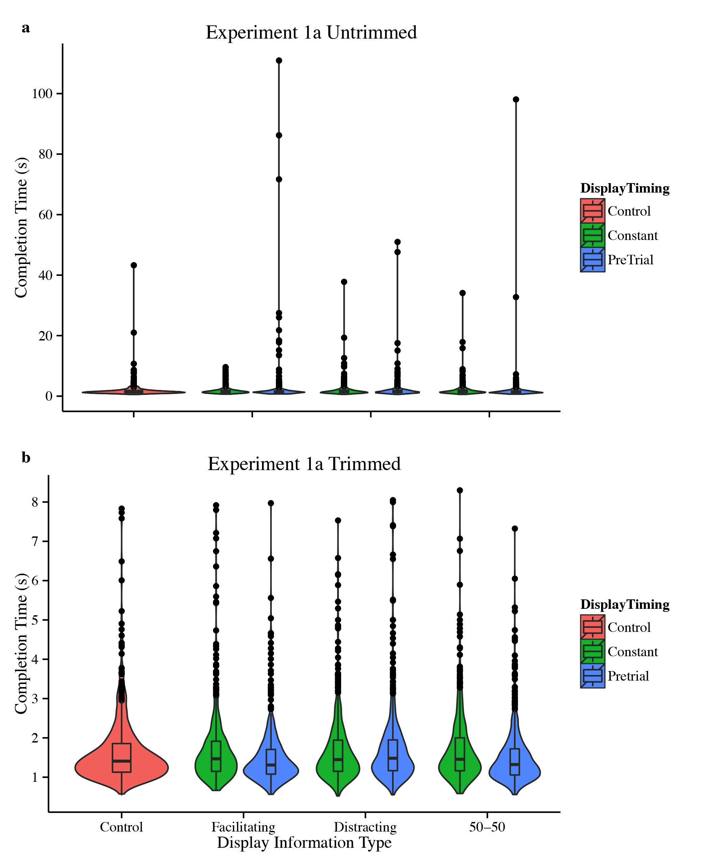
Figure 1. Experiment 1a response distributions, before and after trimming outliers.
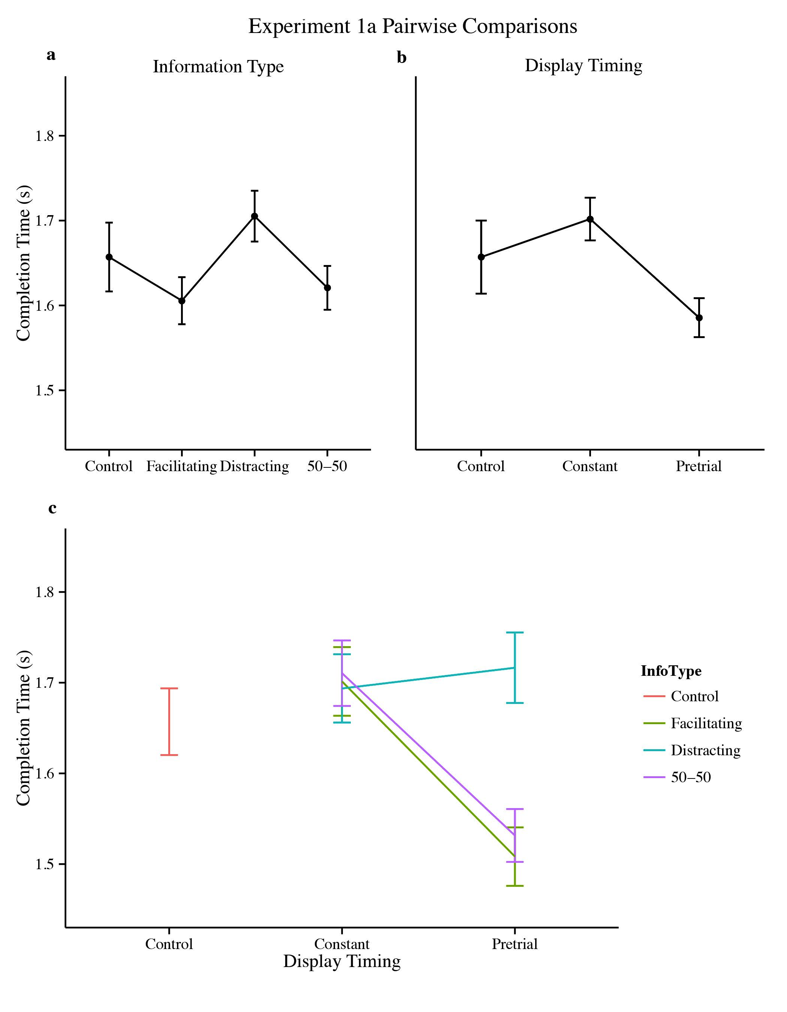
Figure 2. Experiment 1a pairwise comparisons for a) information type, b) display timing, and c) model interaction as predictors of completion time. Error bars represent the standard error around the means as calculated by R function summarySEwithin.
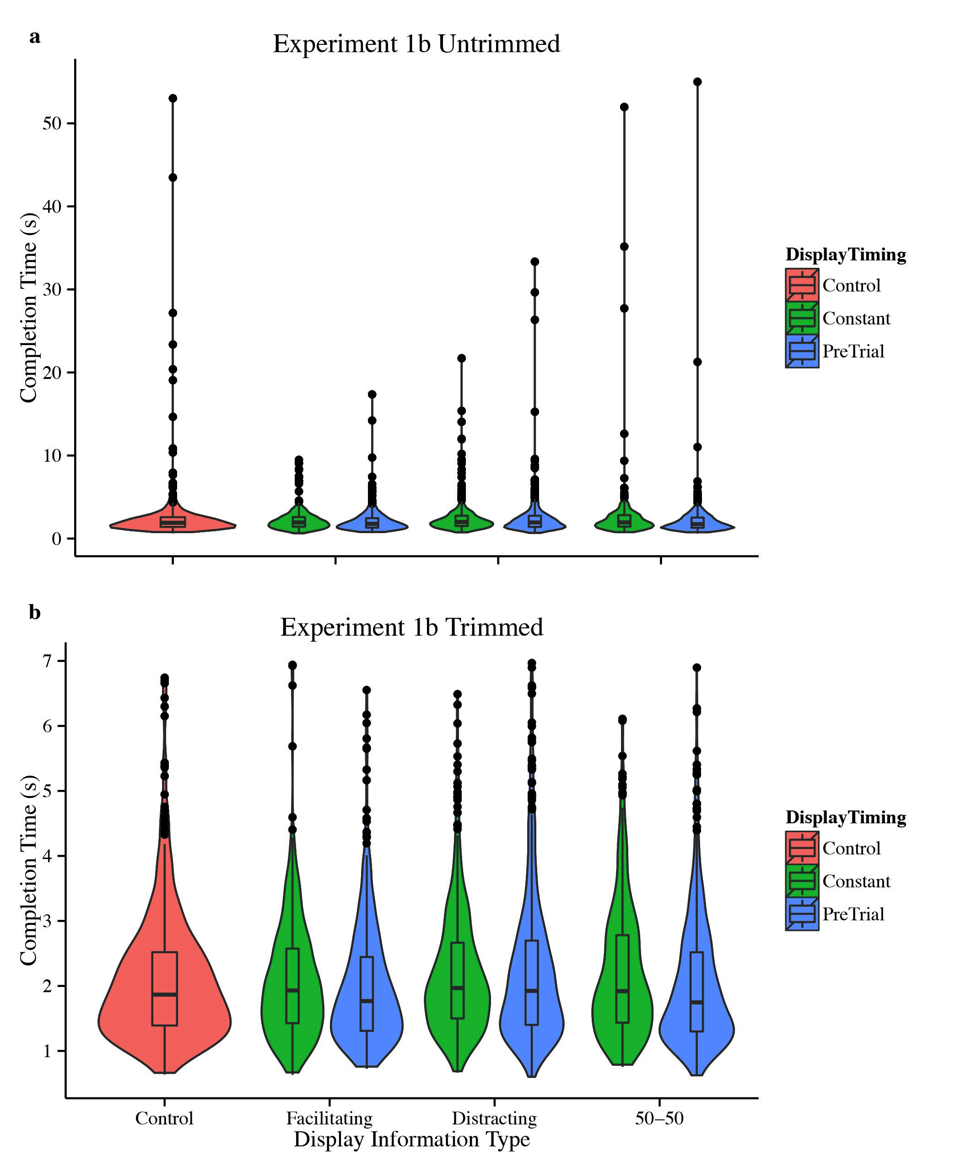
Figure 3. Experiment 1b response distributions, before and after trimming outliers.
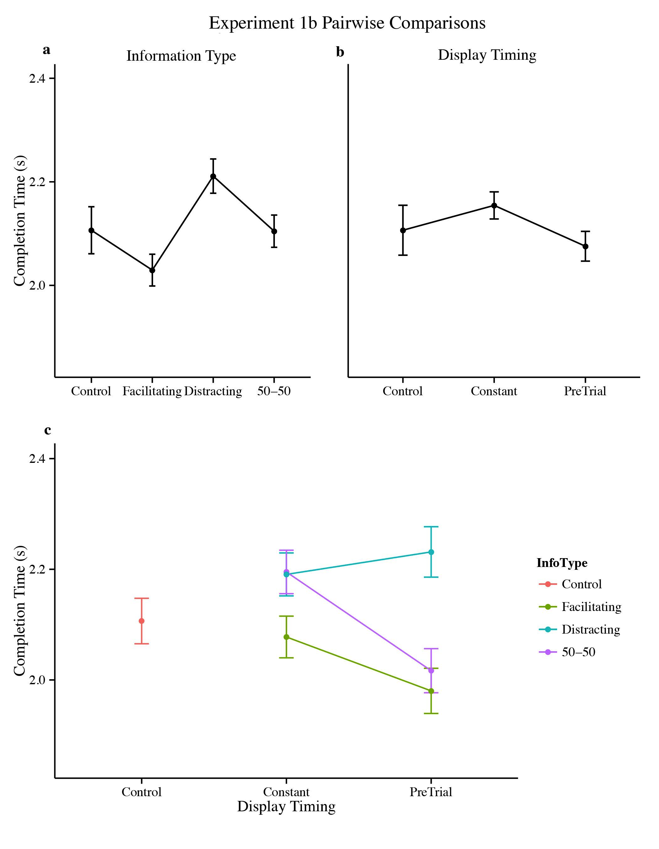
Figure 4. Experiment 1b pairwise comparisons for a) information type, b) display timing, and c) model interaction as predictors of completion time. Error bars represent the standard error around the means as calculated by R function summarySEwithin.
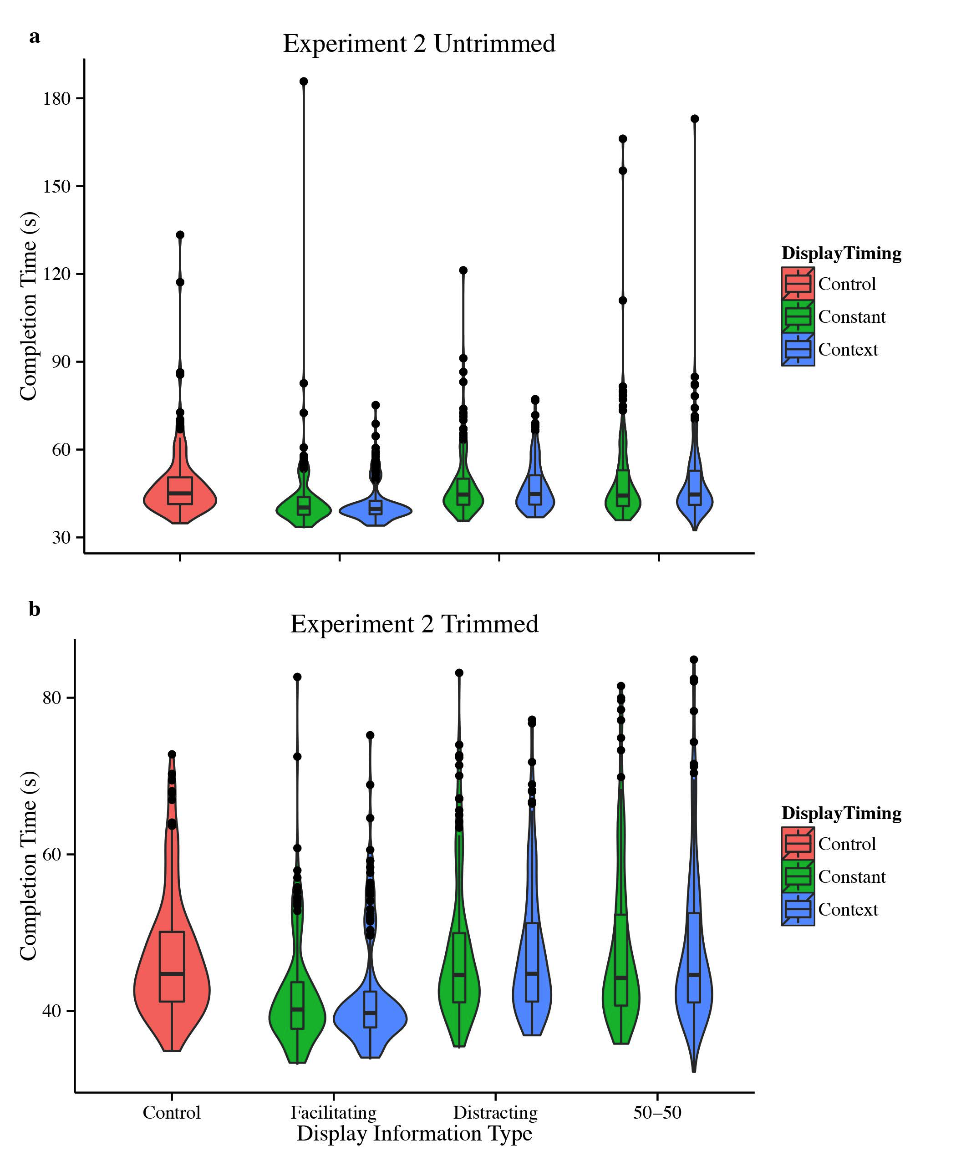
Figure 5. Experiment 2 response distributions, before and after trimming outliers.
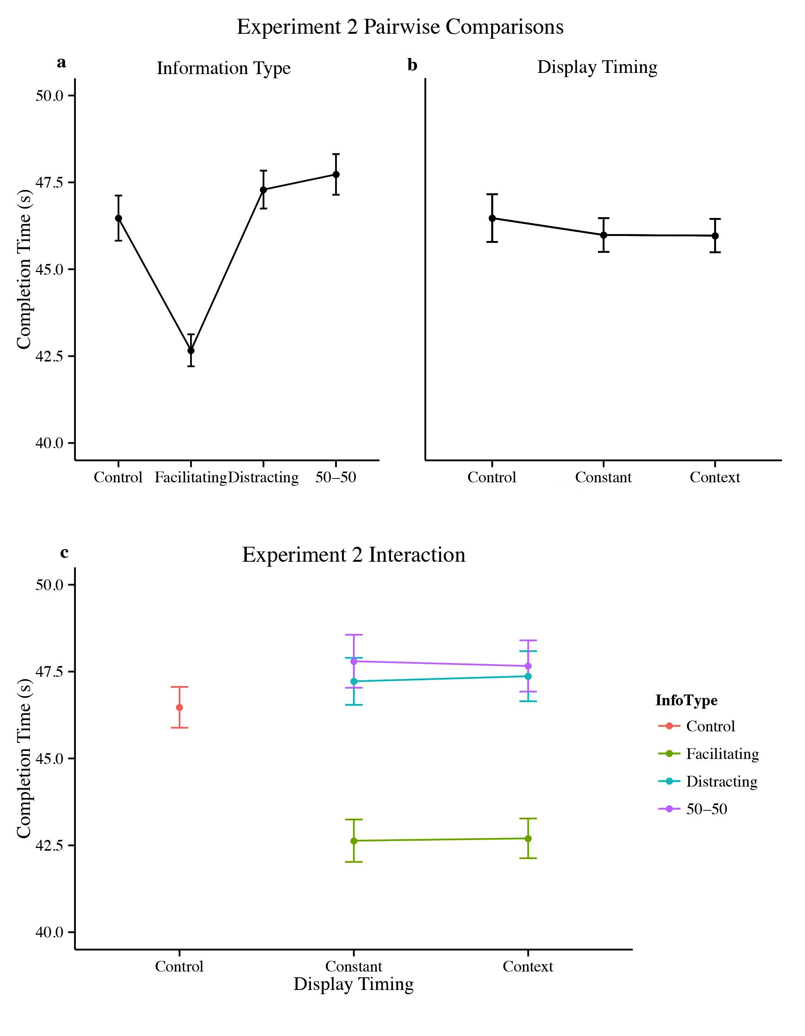
Figure 6. Experiment 2 pairwise comparisons for a) information type, b) display timing, and c) model interaction as predictors of completion time. Error bars represent the standard error around the means as calculated by R function summarySEwithin.
Illustration 1. Environments in Oculus Rift for Experiments 1a and 1b. Both panels represent constant facilitating information trials. Note, these screenshots do not reflect the spatial representation with the 3D effect present.
Illustration 2. Environment in Oculus Rift for Experiment 2. a) View of the pre-trial map. b) View during a facilitating information trial. Note, these screenshots do not reflect the spatial representation with the 3D effect present.

As presented to the participants, “simulated wearable computer” was already defined as the secondary display inside the Oculus Rift headset. As these instructions were presented within the headset, there did not appear to be any confusion for participants.

