University of Oklahoma

Graduate College

Use of Intelligent Pumping System to develop reservoir Characterization

A thesis

submitted to the Graduate Faculty

in partial fulfillment of the requirements for the

Degree of

Master of Science

By

Saket Srivastava
Norman, Oklahoma
2018

Use of Intelligent Pumping System to develop reservoir Characterization

A thesis approved for the
MEWBOURNE SCHOOL OF PETROLEUM AND GEOLOGICAL ENGINEERING

By

______________________________
Dr. Catalin Teodoriu, Chair

______________________________
Dr. Hamidreza Karami

______________________________
Dr. Gioia Falcone

© Copyright by SAKET SRIVASTAVA 2018
All Rights Reserved.

This thesis is dedicated to my parents, my closest friends and everyone else who have made me strive for excellence and become the person I am today.

Acknowledgements
First and foremost, I would like to thank PD Dr. Dr,-ing. Habil Catalin Teodoriu for his continuous guidance and support through the entire length of the project and also my master’s degree in the University of Oklahoma. Without him, this research would have not been possible. I would like to thank my parents Sanjeev and Meena Srivastava for being the constant pillars of strength in my life, for guiding and providing me the opportunity to pursue my masters in United States. Also, my friends and teaching staff who have directly or indirectly played a major role in my life to help me achieve what I set out to.

Table of Contents

Acknowledgements iv
List of Tables vii
List of Figures viii
Chapter 1: Introduction 1
1.1 Motivation 1
1.2 Pumps 3
1.3 Pump Classification 4
1.3.1 Hydrodynamic Pumps: 4
1.3.2 Hydrostatic Pumps 5
1.3.3 Major differences 8
1.3.4 Further classifications 8
1.4 Pumps in Oil and Gas 9
1.4.1 Downhole applications of pumps used in Artificial lift 9
1.5 Smart Technology 21
Chapter 2 : Literature Survey 23
2.1 Flow Loops 23
2.1.1 Defining a flow loop 24
2.1.2 Multiphase flow 26
2.1.3 Existing facilities 31
Chapter 3 : Experimental Studies 43
3.1 Objective of Experiment 43
3.2 Experimental Setup 43
3.3 Components 46
3.3.1 Physical components 46
3.3.2 Electronic components 48
3.4 Experimental Procedure 53
3.4 Intelligent Well Test 54
Chapter 4 : Results and Discussions 58
4.1 Errors and uncertainties in experimentation 73
Chapter 5 : Conclusions and Future work 74
References 76

List of Tables
Table 1 Major differences between the two kinds of pumps 8
Table 2 Example of flow loop facilities reported 34
Table 3 Flow loop test section with length in multiple of diameter. 35
Table 4 10 pin input connector 51
Table 5 Pressure flow tests 54

List of Figures

Figure 1 Pump Classification 4
Figure 3 Rotary displacement pump (IFSTA, 2015) 6
Figure 4 Progressive Cavity Pump 7
Figure 10 ( Electrical submersible pump components, J. Eck et al.,1999) 19
Figure 11 Pump performance curve (top) and effect of increasing stages(bottom) (Wilson et al., 1986) 20
Figure 12 Baker Hughes virtual flow meter neural network 21
Figure 13 ESP Surveillance ( Oilfield Review, 2008) 22
Figure 15 Two phase flow 27
Figure 16 Two phase vertical flow regime (petroblogger.com) 29
Figure 17 Two phase horizontal flow regime 30
Figure 18 Process of flow loop study 32
Figure 19 Categorization of test section lengths 36
Figure 21 Real-time pump diagnostics 39
Figure 23 Intelligent digital flow loop 42
Figure 24 Process Flow Diagram for Experiment 44
Figure 30 Wiring hookup for the pressure transducers. 52
Figure 31 Completed wiring 52
Figure 33 Isochronal and modified isochronal 57
Figure 34 Test 1 Plot 59
Figure 35 Test 2 plot 61
Figure 36 Test 3 plot 63
Figure 37 Single phase IPR 64
Figure 39 Test 4.2 66
Figure 40 Test 4.3 67
Figure 42: ΔT Estimation 70
Abstract
With the advancement in drilling and production technologies, deeper and more challenging formations are drilled every day. A pivotal part of sustaining this advancement is to permanently monitor the reservoir. While PDG (Permanent Downhole Gauges) have been in use since 1960s, handling and interpreting tons of rows of data has always been cumbersome. Moreover, the gauges have to be dependable enough to sustain bottom hole conditions for their lifetime (Schlumberger, 2015).
Focusing attention to artificial lift applications, downhole P/T data plays a huge role in assessing if the bottom hole conditions are ideal in bringing the fluid to the surface, even if the reservoir has a high deliverability. Interestingly, completion design for submersible pumps nowadays includes downhole sensors for pressure/temperature reading, which opened doors to multiple utilization ideas and innovations.
Baker Hughes in 2014 introduced a virtual flow meter concept that recorded pump parameters to optimize the working of an ESP up to 90% accuracy. Standard techniques to monitor flow are not only expensive to operate but also not readily available at all times. The following thesis takes inspiration from their approach to go one step further and gain more knowledge about the reservoir itself using the pump parameters. Through the experimental work, this thesis aims to understand how the reservoir behaves during production and shut in phases to estimate the inflow performance of the well. Estimating accurate reservoir pressures after shut in periods also helps in monitoring the productivity index of the reservoir in study.

Chapter 1: Introduction

Motivation
Pumps are at the heart of the oil and gas industry with widespread uses. With utilization as mud pump, at surface facilities or even downhole, pumps form the backbone of drilling and production engineering. With advancements in technologies, pumps are also a pivotal piece of equipment in multiphase flow loops to generate different flow regimes for various testing parameters as discussed in the following chapters.
The motivation of the thesis stems from the idea to develop smarter pumps that do more than just pumping fluid from one point to another. An attempt was made to connect pumps at different locations virtually. This would not only make lab testing more affordable but also help simulate various test sections with different inclinations by just remotely linking test flow loops of different inclinations together. This concept has been discussed at length in the chapters that follow.
Similarly, downhole pumps can be tested using the same smart pump technology where a pump recording irregular data can be compared to a similar pump in a remote location in same working conditions. Now, comparing pump parameters can easily reveal if the pump is faulty or it’s the formation conditions to blame.
Moreover, pumps are not designed to be conventionally run at different flow rates but using variable speed drives, these pumps can smartly switch to different flow rates. This can help to simulate well test conditions where variable flow rates along with appropriate shut in times can help infer information about the reservoir. This can help illustrate near well bore/skin influence on the well as the time period for transient pressure buildup curves can be analyzed by pump pressure curves.
Placing downhole gauges in ESP is not a new phenomenon. Medina et al. 2012, demonstrated how single optical fiber can reveal temperature and vibration data when placed strategically at multiple locations on the ESP. This data can then be used to optimize the working of the pumps. Schlumberger in 2015 also aimed to optimize their ESP operation by precise flow measurements through an algorithm that was based on basic pump parameters namely pump intake pressure, discharge pressure and pump frequency.
To go into depths of using pumps to remotely link them for testing purposes, some light has been shed in the following chapters on the types of pumps being used in oil and gas industry with focus on downhole pumps.

1.2 Pumps
In very simple words, pumps are mechanical devices used to move fluids such as gases and liquids from point A to B. They can be operated manually, via electricity, engines or any other power source. Its invention almost dates back to 200 BC when an inventor and mathematician from Greece, Ctesibius introduced a water organ, which was basically an air pump with bottom valves, rows of pipes on top and a layer of water between them. This was pretty much the principal idea behind what we call a reciprocating pump today.
Be it water-cooling or fuel injection in cars, artificial replacements of a human heart or simply pumping water from wells, pumps have an extensive range of applications across all engineering disciplines. Our focus is on the inexhaustible need of pumps in the oil and gas industry. They are used in the drilling and exploration industry and in every component of the production of oil and gas. It is used for hundreds of tasks, right from mud pumps used for circulating drilling mud to pumps used for production of oil and gas to the surface. Multiphase pumps are then used to move the production stream consisting of oil, water and gas to the centralized processing facility. These pumps work downhole, at the surface or even on the sea bed in all offshore operations. Our focus will remain on the downhole pumps that are a major component of the artificial lift industry. But before we move our focus on downhole pumps, getting an insight into how these pumps work is essential. Its classification according to operations, pump performance criteria and testing procedures all are pivotal in understanding pump selection.

1.3 Pump Classification
The primary function of the pump is to raise the pressure of the fluid. This in turn imparts a desirable velocity to the fluid as it is moved from one place to another. While pumps are classified on a broad range of criteria, there are two basic types of pumps, namely, Hydrodynamic (Non-positive displacement pumps) and Hydrostatic (positive displacement pumps).
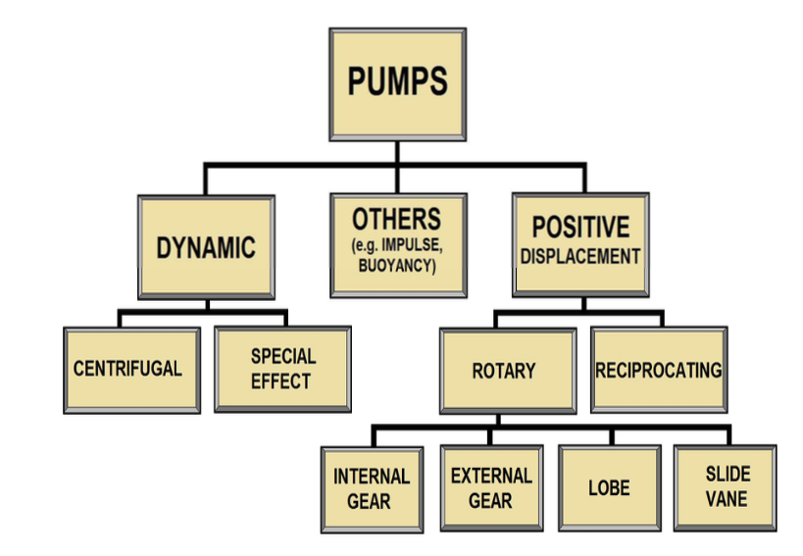
Figure 1 Pump Classification

1.3.1 Hydrodynamic Pumps:
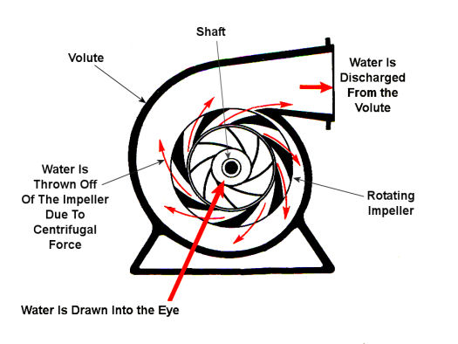
These works at relatively low pressures and transfer fluid through a rapidly rotating impeller that is placed inside a special casing. They typically require an electric motor for the rotation of the impeller inside the casing. Centrifugal pumps and axial flow pumps are examples of the same kind. The impeller consists of curved vanes fitted on the shroud plates. As the impeller lies immersed in fluid at all times, while the impeller moves, so does the fluid trapped between the vanes. The working force is centrifugal as the fluid that is radially displaced by the action of the impeller creating inlet suction. The pressure generated is a function of the rotating speed. Figure 1 shows a centrifugal pump in which the rotational mechanical energy is converted to an increase in the kinetic energy of the fluid. These pumps provide a continuous flow rate. These are the most widely used pumps in the oil and gas industry.
Figure 2 Basic Centrifugal design ( Crane Engineering, 2108)

1.3.2 Hydrostatic Pumps
These pumps are also called positive displacement pumps as they have a cavity that is filled by a fluid volume and by alternating this cavity, the fluid volume is displaced. These may be either fixed displacement pumps or variable displacement pumps. These pumps are used to transmit power through the pressure generated by the pump. These pumps are used for power transmission as they always deliver a constant volume of liquid for each cycle of operation. Hence they are also called constant flow machines. However, theoretically it is not attainable. Though it is independent of the discharge pressure or head, these pumps need a back pressure relief valve incase the resistance to flow is large.
These pumps are further classified as:
- Rotatory type positive displacement pumps
- Reciprocating type positive displacement pumps

Rotatory Type Displacement Pumps
These pumps trap liquid as the rotate towards the discharge side. By doing so they end up creating a vacuum for the suction line. What works in its favor is that there is no need to bleed air from the system as it can efficiently move gas as well. But if operated at high speeds, the fluid can cause erosion. This can create clearances and loss in efficiency. Slow and steady rpm is the key for high efficiency.
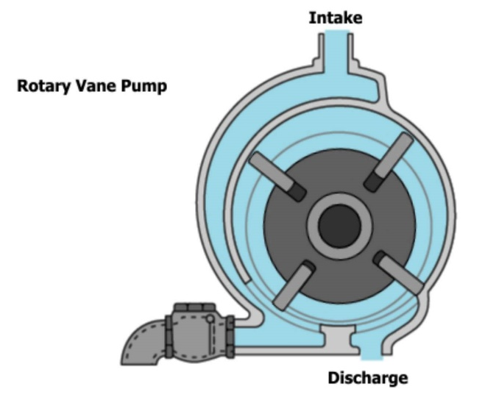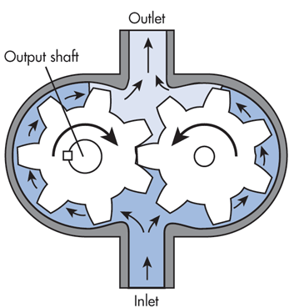
Figure 3 Rotary displacement pump (IFSTA, 2015)

Figure 3 shows a rotatory vane pump on the left which traps a volume of fluid between the rotor and the casing, drawing more fluid in the inlet section. The figure on the right performs the same function with gears instead of vanes for motion. Another popular kind of rotary pump is the screw pumps which houses two screws inside the casing that entraps liquid within its thread and moves the liquid as it rotates. These pumps cannot handle solid flow due to the tight clearance between the elements.
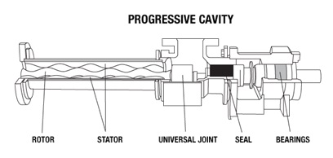
Figure 4 Progressive Cavity Pump
Another kind is the progressive cavity pump which is extensively used downhole in artificial lift systems. Its working and principles will be discussed in length in the next section. Unlike screw pumps, these pumps are designed to move liquid containing solids.

Reciprocating type positive displacement pumps
This kind of pumps include a reciprocating mechanism to expand and contract by oscillating a piston, diaphragm or a plunger. Using check valves at both ends, reverse flow is prevented. Also, the reciprocating mechanism works at constant intervals. As a part of the reciprocating mechanism, for example a plunger, move outwards, it decreases the pressure in the chamber causing inward pressure to open the check valve and gather fluid into the chamber. Thus with a decreasing cavity on the outlet and an expanding cavity on the inlet, the total volume remains the same. Plunger pumps, piston pumps and diaphragm pumps are common examples of reciprocating type which will be discussed at length in the next chapter.

1.3.3 Major differences

Positive Displacement Pumps | Centrifugal Pumps
Well suited for power transmission as it generates a higher pressure in the fluid. | Best suited for continuous flow operation
Better suited for high viscosity applications due to higher volumetric efficiencies. | These pumps are inefficient at even moderate viscosity.
This pump produces a constant flow regardless of system head or pressure. | The flow varies according to the head or the system pressure.
Progressive cavity pumps, plungers, sucker rod pumps are a few examples. | Mud pumps, electrical submersible pumps are a few examples.
These pumps have closed fitted components causing very small leakages. | These pumps don’t have very small clearances so are not self-priming.
Table 1 Major differences between the two kinds of pumps

1.3.4 Further classifications
Pumps can be further classified on a lot of different criteria. A list of these is written below.
- On basis of service liquid: It can be used for either oil, water or mud (slurry).
- On basis of mounting: Can be vertically or horizontally mounted pumps.
- On basis of position with respect to fluid: Submerged or externally placed pumps.
- On basis of stages: Can be single or multiple staged depending on the number of impellers. Can also be further classified on basis of type of impeller.
- On basis of construction: Can be like a mono motor without coupling of the motor and pump or like the other pumps that require coupling.

1.4 Pumps in Oil and Gas
Both centrifugal and positive displacement pumps are widely used in the oil and gas industry. They are very commonly used in tri-phase or multiphase applications. This process reduces costs of equipment, makes installation easier, makes production more efficient and has a smaller pump footprint.
Electric submersible pumps, deep well pumps and axial pumps are all centrifugal pumps used for submerged fluid applications. While ESP will be discussed at length in the next chapter, an ESP pushes fluid rather than pulling it making it more reliable and efficient. Axial pumps use multiple impeller stages like the deep well pump and can offer up to 92000 cubic feet of pump capacities.
Progressive cavity pumps and twin screw pumps are examples of positive displacement pumps used. Both can handle difficult liquids with high solid and viscous content. This report will focus only on downhole pumps used in artificial lift systems.

1.4.1 Downhole applications of pumps used in Artificial lift
Artificial lift is very essential in the life of a well when the reservoir pressure is not enough to flow the fluid mixture to surface. When this natural drive mechanism is not strong enough, artificial lift is employed for greater production. It is generally performed on all wells at some point of their life. The two main types of artificial lift utilised in the industry are pumping systems and gas lifts.
Gas lifts work on the principle of lowering the bottom hole pressure to have a higher productivity. By infusing gas in the flowing mixture of fluids, the pressure gradient decreases thereby decreasing the bottom hole pressure. Pumping systems on the other hand, increase the pressure at the bottom of the tubing string to a required amount to lift the fluids to the surface. Our focus will remain on these pumping systems being used.
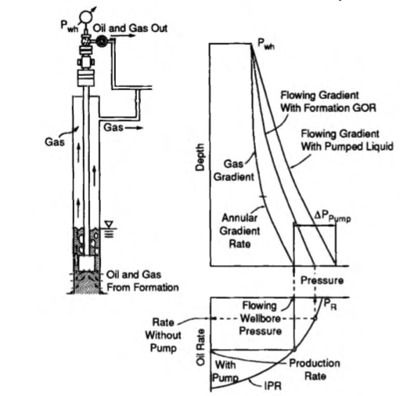
Figure 5 Effect of artificial lift on IPR curve ( Economides et al. 2013)
The figure above shows a gas lift on left and the change in pressure gradient with depth. Gas lifts cause a lower pressure gradient causing a better operating flow rate as seen in the IPR curves. As seen, the pumps cause an increase in the fluid gradient as it makes the fluid flow gas free. But subtracting the pump work done as an external force, the well can still be produced at a higher oil rate as seen from the IPR curve above.
The pumping systems can be divided as following.
Artificial lift systems

ESP
Plunger Lift
Hydraulic Pump
Sucker rod pumps
PCP
Even though pumps are divided into centrifugal and positive displacement pumps, they can also be divided into electric and hydraulic pumps. While jet pumps and hydraulic submersible pumps fall into the hydraulic pump category, others fall into the electric pump category.

Sucker Rod Pumps
Also known as rod lift, these are the oldest and the most widely used form of artificial lift dating back to being used for water wells. Almost 80% of all wells use a sucker rod at some stage of their life. It was in 1925 that John H. Suter got a patent for this reciprocating piston pump that would commonly be used to produce oil from wells in the years to come.

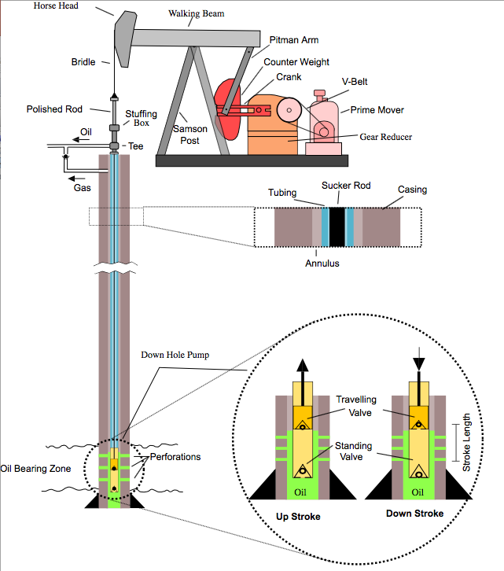

As seen above, the reciprocating action of the polished rod is derived from the rotational motion of the crank which is in turn run by the prime mover. As the polished rod reciprocates, so does the sucker rod which is connected to a downhole pump. The pump has check valves on both sides, standing valve and traveling valve namely. During upstroke, the standing valve opens, sucking the fluid into the barrel. With down stroke, the traveling valve opens, pushing the liquid into the tubing. While many other calculations like the pump stroke length, pump speed, power requirements are required for a stable operation, the effectiveness of this positive displacement pump is measured by the volume of the fluid displaced by the pump and not the pressure increase. This wellbore fluid compression is enough to displace the fluids up to the surface.
Figure 6 Pump jack ( wikipedia.com )
The volumetric flow is measured as:
$$q=0.1484 N E_{v}A_{p}S_{p}$$
while N is the pump speed in rpm, $E_{v}$is the volumetric efficiency, $A_{p}$ is the area of the plunger pump in inches square, $S_{p}$ is the plunger stroke length in inches and q is the flow rate in bbl/day. In conclusion, these pumps give a high system efficiency of 40-60 % (Dover, 2018) and are very economical. A lot of optimisation techniques exist currently. Another big advantage is its flexibility with stroke length, pump speed and rod diameter. Although issues like mechanical wear of tubing and rods, higher gas ratios and limitation to handle loads exist, rod pumps are still utilized in 80 % of the wells in USA.

Progressive cavity Pumps
Also, referred to as Moineau pump or mono pump after its inventor Rene Moineau, these pumps are preferred due to excellent suction lift capabilities, low requirement of head and good solid handling capacity. They have a gentle, low shearing pump action, which makes them the best technology for oil and water separation. This actively prevents the formation of emulsions.
It consists of a helical rotor, typically coated with hard chrome and a stator, which is an internally moulded double shaped helix. As the rotor moves inside the stator, it creates a tightly sealed cavity that carries the liquid to the discharge port as shown in figure 4.
Some major advantages include successful handling of viscous and troublesome fluid, high suction capacity of up to almost 28 feet in appropriate installations (Continental pumps, 2017), minimal vibrations due to a predictable and steady flow rate.
Problems arise when there is a multiphase flow regime. Particularly CO2, H2S and aromatic compounds damage the elastomer performance (Dover, 2018). Free gas also reduces volumetric efficiency. This coupled with deviated wells can lead to issues like breakage of rotor, abrasive damage and chemical attack on the rotor surface.
In conclusion, progressive cavity pumps are used in highly viscous fluid flow in which centrifugal pumps are not very suited. Centrifugal pumps become mechanically and volumetrically inefficient in such cases (Liberty Process, 2018). This also causes a surge in power usage. PC pumps on the other hand have higher flow, less power consumption and greater efficiency. PC pumps are therefore designed for tough pumping conditions with abrasive solid content.

Hydraulic Pumps
There are two kinds of hydraulic pumps used in the industry: Jet pumps and piston pumps (also called reciprocating positive displacement pump). Hydraulic pumps were utilised as artificial lift as early in 1932, when the first piston pump was installed in California by C.J Coberly. Jet pump was commercialized later by 1970 (Beckwith, 2014).The major advantage of these pumping units are no moving parts which makes them ideal for deviated, crooked and horizontal well conditions.
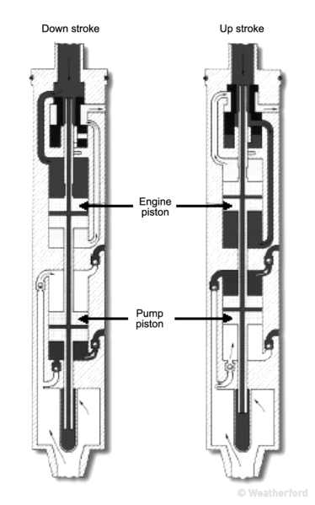
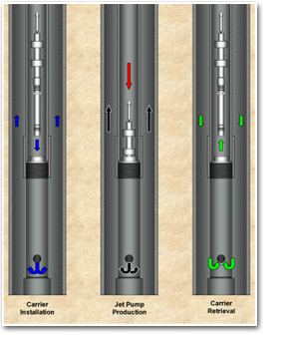

Figure 7 Jet and Piston pump illustration ( Jet lift systems, 2018)
As seen in figure above, pump retrieval is a very easy process done simply by reversing the flow direction in the tubing. It can be pumped back into place for reinstallation. Figure 7 shows a piston pump’s cross section. The driving principle is Pascal’s law in which an increase in pressure of a confined fluid is transferred equally to every point in the container. The driving fluid is called the power fluid. It pushes the engine piston up that in turn draws in formation fluid from the pump piston. The opposite motion of the same engine piston pushes the formation fluid up to surface. Thus piston pumps can be used over a wide range of capacities to accommodate different well conditions. It has a strong drawdown capacity but cannot handle a lot of gas as it can typically handle GLR of 10:1 to 100:1. It also lacks in solid handling unlike PC pumps. It requires a clean power fluid for operation too.
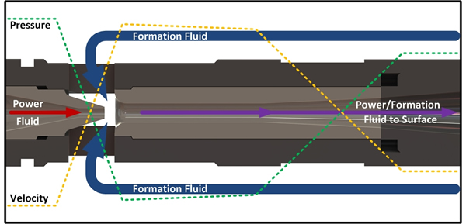
Jet pumps on the other hand work on the principle of Venturi effect. Venturi effect is basically a reduction in the fluid pressure and an increase in its velocity when the fluid is confined to flow through a nozzle. As one can see in figure 8 below, the power fluid is made to flow through a choke that causes a reduction in pressure at this zone. This creates a suction force for the formation fluid to be sucked into the pump intake zone.

Figure 8 Jet pump cross section ( Tech Flo, 2018)

Thus there is a comingled fluid flow to the surface. As this flow travels to the diffuser, the flow area diverges which causes a reduction in fluid velocity and an increase in the fluid pressure. This is necessary to carry the flow to surface. It has excellent solid and gas handling capacity as it has no moving parts. It can typically handle GLR of 100:1 to 1500:1 and solids from 0-200 microns. Depending on pressure availability, jet pumps can work at flow rates ranging from 25-2000 BPD (Dover,2018). Major limitations of jet pumps include high pressure surface line requirements. It is viewed as an old and inefficient artificial lift system as producing rate depends on the bottom hole pressure and its inability to pull vacuum.

Plunger Lift
Plunger lift are unique systems that are designed to work using no energy input. It is relatively inexpensive and uses the reservoir energy for the reciprocating action of the plunger to lift the fluid to the surface. It is majorly used in gas wells that produce liquid along with the gas in the form of water or condensate. The liquid makes it difficult for natural flow to the surface by increasing the bottom hole pressure. Plunger lift is a very useful technique for this deliquification problem.

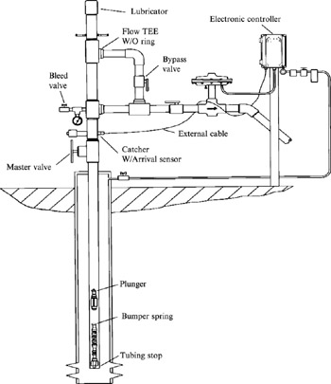

Figure 9 Plunger lift well completion ( Lea et al., 2008)
As seen in figure 9, the plunger falls through the tubing bypassing any liquid accumulation in the tubing till it reaches the ball in the bumper spring. There is a pressure build-up below the bumper spring until the pressure is large enough to push the fluid column up to the surface to begin a new cycle.
Plunger lifts are efficient in preventing hydrate and paraffin build up, removing accumulated liquid, minimizing shut-ins and extending the life of the well. Since plungers are available in all sizes and designs for different well flows, this form of cyclic pump can be broadly used for all well types.

Electric Submersible Pump
One of the popular kinds of artificial lift for high production rates are electrical submersible pumps (ESP) which are deployed in more than 200,000 wells worldwide (Schlumberger, 2015). As seen below, a typical ESP configuration consists of a multistage centrifugal pump in series with a submersible electric motor, gas handling equipment, power cables, protector housing and surface components.
The pumps are powered from surface by protected cables and can pump up to 30,000bbl/day, which is much more than other artificial lift pumps.
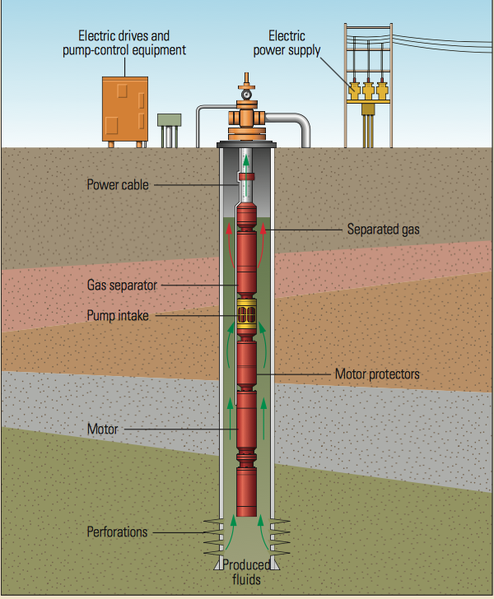
Figure 10 ( Electrical submersible pump components, J. Eck et al.,1999)

Submersible pumps are long pieces of equipment whose length and diameter are dependent on the required horsepower to support the high flow rate. Each stage consists of an impeller that rotates and the diffuser that remains stationary. Each of these stages are stacked over one another to form a multistage pump. As the fluid leaves the impeller, it is diffused into the diffuser converting its velocity to pressure gain for the discharge side. This process repeats itself until an incremental gain in pressure is achieved.
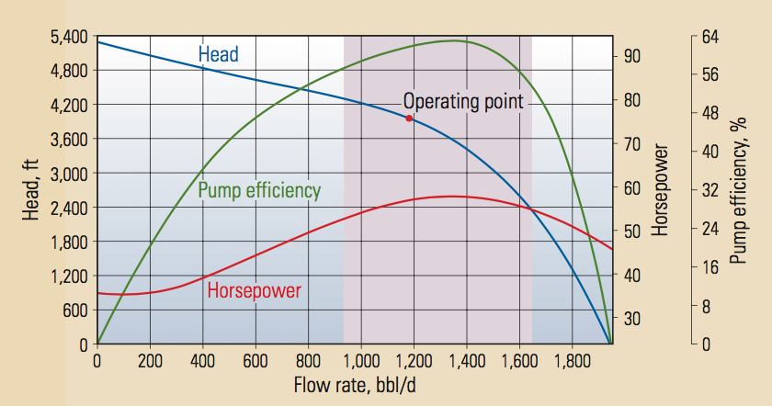
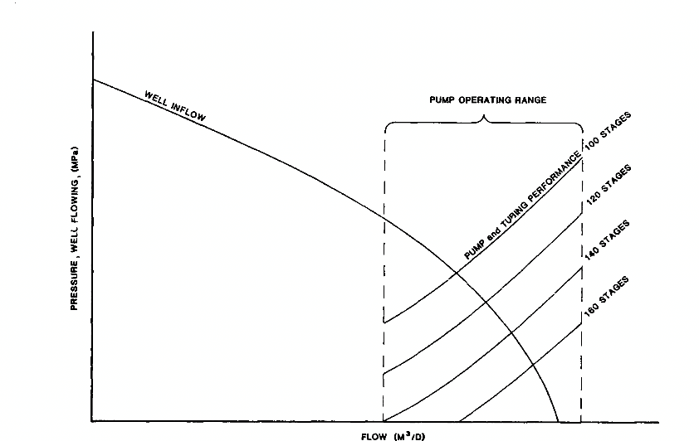
Figure 11 Pump performance curve (top) and effect of increasing stages(bottom) (Wilson et al., 1986)
The pump curves are defined for each pump that relate the horsepower of the pump to the flow rate, head generated and to the pump efficiency. The curve also has an operating range defined for the operator to keep the ESP within this range during its life in the well. Nowadays SCADA system records the downhole data and the Variable speed drive quickly adjusts pump parameters to keep the ESP in this operational limits. Therefore, as ESP are vital in moderate to high pump rates in a well, they are also sometimes restricted by its length especially during severe doglegs. It also needs high voltage motors at surface and are generally expensive to maintain and operate.

1.5 Smart Technology
While the goal of recovering more hydrocarbons remain the same, economic constraints and technological advancements have led to smarter equipment and smarter processes. For example, an operator, instead of focusing on one well at a time for improvement, can look at an entire field of wells. He can make a reservoir management decision based on hundreds of these smart wells. Smart, because these wells can permanently monitor downhole conditions and even monitor productivity from each section of the reservoir. The completions on these wells are equipped with flow control devices, permanent downhole monitoring and state of the art control systems.
Another example is the Baker Hughes virtual flow meter concept that brings together downhole sensor capabilities and neural network technology to predict real time flow measurements. It utilizes ESP pump parameters to provide high accuracy flow measurement values.
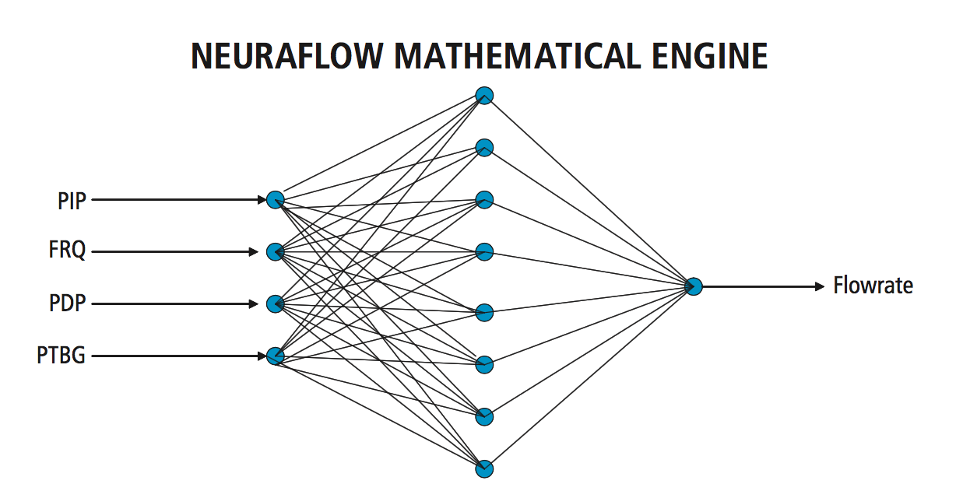
Figure 12 Baker Hughes virtual flow meter neural network
Figure 12 shoes how parameters such as the pump intake pressure, discharge pressure, frequency and tubing pressure can be fed into the system to accurately measure flow rate values. This can revolutionize production technology. Another wonderful example is in the field of monitoring and controlling equipment performance where an ESP pump failure can be avoided by continuously monitoring its parameters by placing sophisticated sensors downhole. Figure 13 displays how different sensor data from an ESP in a Texas well are plot on a single graph for monitoring purpose. The intake pressure values at 300 psi are much higher than the design limit of 150psi. On realizing the situation, the pump was assessed for issues and a damaged choke was worked upon which brought the pump intake value within design limits. The irregular spikes in pressure are due to shut in during routine maintenance of the pump.
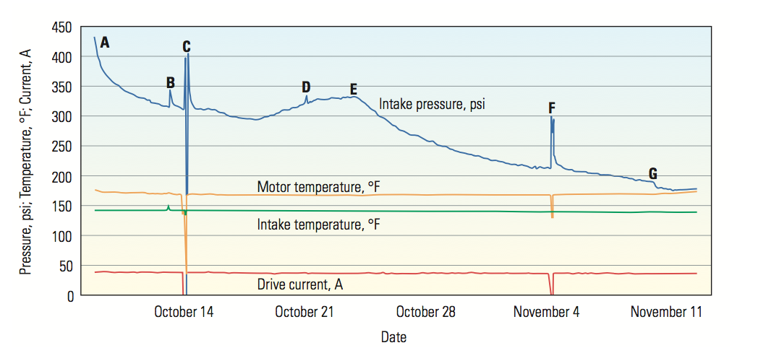
Figure 13 ESP Surveillance ( Oilfield Review, 2008)
ESP monitoring technique can also be combined with technology that aims at reservoir management. Thus recovering from the reservoir happens in sync with optimized pump performance.

Chapter 2 : Literature Survey

2.1 Flow Loops
Flow loops are a pivotal part of the oil and gas industry as they are required to study and understand multiphase flow regimes for different fluid compositions in different flow configurations possible. There are possibilities of transportation of gas, oil, water, solid particles all together. This might be within the well bore, through the riser or from the platform to the shore through pipelines. The flow occurs at different pressures and temperatures with different pipe geometries, inclinations and fluid types. Multiphase flow models exist but their accuracy depends a lot on experimental verifications. Therefore, for a variety of applications, a variety of flow loops exist in the world.
Flow loops have been used extensively to carry multiphase flow meter tests to check performance of commercial flow meters in Pennsylvania, USA (FMC 2017), Norway (StatoilHydro 2008), Saudi Arabia (Benlizidia et al., 2016). Subsea multiphase metering performance tests have also been achieved by Weatherford in 2016. Sand transport is another major issue during production. Sand carrying ability and its verification using an X-ray CT imaging has also been achieved on flow loop study in Canada (London et al. 2012). Also, flow assurance studies have been extensively performed at TUFFP, Tulsa. This includes corrosion as well as deposition studies involving paraffins, hydrates, wax and asphaltenes.

2.1.1 Defining a flow loop
Falcone et al. (2008) summarized flow loop classification and reporting into 5 broad categories. Namely, total length of the flow loop, operating parameters, test section length, instrumentation and range of phase flow rates. While the basic purpose of the flow loop remains to successfully establish a controlled atmosphere for multiphase flows so that a variety of other testing criteria can be assessed. The above-mentioned classification of flow loops will greatly determine the usage of the flow loop as different flow loops meet different criteria. Depending on the applicability, the total length of a flow loop can vary from a few meters to up to 1000 m as seen in the large scale loop in SINTEF. Pipeline flow, geothermal plants are a few examples of longer lengths of flow loops. The other major aspect is the test section, which is independent of the total length of the flow loop although the development phase for the multiphase flow is dependent on the total length of the loop. Normally, the test sections are comprised of transparent PVC material to view the flow pattern within. The only limitation to this is when using high operating pressure flow loops. Falcone and Teodoriu (2008) report that vertical test sections are necessary for multiphase-flow investigation. Another aspect that greatly impacts multiphase flow development is the operating pressure of the flow loop especially in cases where compressible fluids are involved (Benlizidia et al., 2016). While higher operating pressures of up to 25MPa are possible, generally the pressure rating is below 10MPa. These high-pressure loops can help validate multiphase flow models that were originally built for lower pressures.

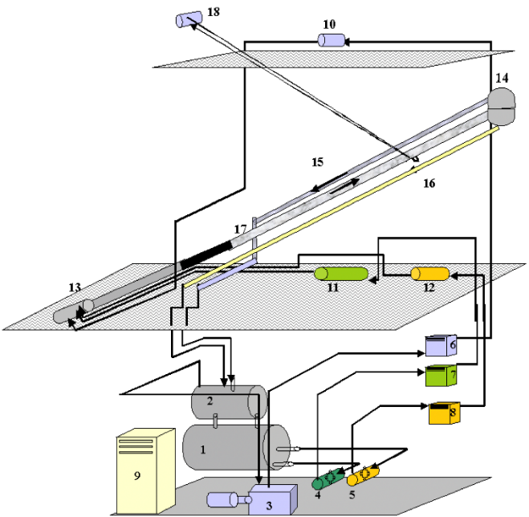
While flow loops are greatly used to study the testing of multiphase-flow meters, the development of proper flow regimes are instrumental in calibrating and verification of the flow meters. Depending on the flow rates circulated in the system along with the right equipment capability, the flow regimes required, are generated. The flow loops have ample of sensors attached to measure different test requirements. While majorly all of them are equipped with temperature, differential pressure and phase holdup sensors, this aspect of a flow loop is widely open for customization. Figure 14 is a schematic view of a general multiphase closed flow loop. The flow test bench is the test section of the flow loop. The pump and compressor are responsible for achieving liquid and gas flow rates. The separators are responsible for singling out oil/gas flow for individual monitoring.. Here, 1 and 2 are oil-water and gas-liquid separators, 3 is the gas compressor, 4 and 5 are water and oil pump respectively, 6-8 are heat exchangers for gas, water and oil, 9 is the electricity board, 10-12 are flow meters for gas, water and oil, 13 is the mixing section, 14 is the pre-separator, 15-16 are return pipes, 17 is the test section and 18 is the winch.
Figure 14 Detailed multiphase flow loop schematic (IFE, 2012)
Multiphase flows will be discussed in the next section as well as different flow loops from across the world will be looked into. This will lay a base for defining the purpose of flow loop study for developing intelligent pumps.

2.1.2 Multiphase flow
Be it in oil or gas producing wells, injection wells or pipeline flow, there is bound to be more than one phase in the flow stream. Research on multiphase flow has been performed since ages as it is one of the most common phenomenon in nature. Be it fog, snow or simply bubbling of gas bubbles in an aerated drink, multiphase flow has been a multi-disciplinary research topic. In oil and gas particularly, two-phase flows occur is oil wells when the well produces a significant amount of water. In the same situation if the pressure drops below the bubble point pressure, gases evolve making it a gas-liquid-water multiphase flow. Sometimes the third phase can be a solid particle for example, sand. The solid phase is usually incompressible. Understanding phase holdup and superficial velocity is important as many of the flow loops list superficial velocity values for the multiphase flows.
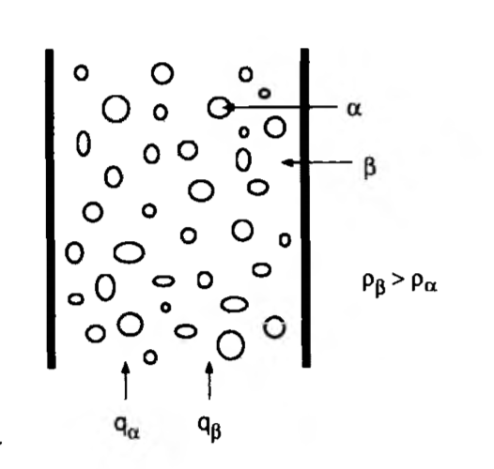
Figure 15 Two phase flow

As one can observe from figure 15 that α is the lighter, less viscous, more compressible phase as compared to β which is denser. The denser phase appears to be “held up” as compared to the lighter phase and will hence have a higher value of the holdup. Therefore, the parameter holdup (y) is defined as a fraction of the volume of the denser phase in pipe ($V_{β})$ to the total volume of the pipe segment ($V).$
$$y_{β}=\frac{V_{β}}{V}$$
Another parameter, slip velocity, defines the difference between the average velocities of the two phases. Superficial velocity is a parameter that relates both hold up and slip velocity. It is not a true velocity value. It is instead the average velocity of a phase if it were occupying the entire volume of the pipe segment. It is defined in the equation below.
$$u_{sα}=\frac{q_{α}}{A} and u_{sβ}=\frac{q_{β}}{A}$$
Here $u_{sα}$ and $u_{sβ}$ represent the superficial velocities of α and β. Also,$q_{α} and q_{β}$represent the volumetric flow rates of the two different phases. A is the cross sectional area of the pipe segment in question. These parameters are essential in understanding multiphase flow in flow loops. The flow regime developed in the loop will be a qualitative overview of the phase distribution. A lot of studies have been done to understand the different flow regimes and most importantly the transition periods. Majorly, two-phase flow has been widely studied and classified. This gas-liquid two-phase flow has been classified into vertical and horizontal flow in pipes. Different flow models have also been proposed to accurately predict flow patterns and pressure drop along the pipe. Govier and Aziz,1977 have also determined that superficial velocities of air and water greatly determine the flow patterns. If vertical flow is considered, bubble flow, slug flow, churn flow and annular flow are four types of flow regime. Figure 15 below shows how a single phase liquid flow can transition to bubble flow with the intrusion of gas. In bubble flow, the gas phase has little or no impact on the pressure gradient in the pipe. With increasing gas-liquid ratio, flow transitions to slug flow where the gas bubbles are bigger and more stable than the previous phase. The gas velocity is higher than the liquid velocity and has slugs of gas in between. The pressure gradient starts getting affected by the gas phase in this flow regime. Churn flow is more like a transition phase where gas phase starts to dominate. This is followed by the annular-mist flow where the gas phase becomes continuous and is the controlling factor. The liquid phase is just a secondary layer on the pipe.
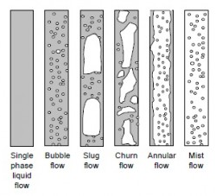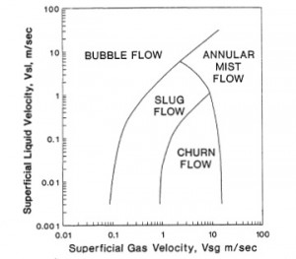
Figure 16 Two phase vertical flow regime (petroblogger.com)

As seen in the figure above, if there is gas intrusion in liquid phase flow, its usually in slug or churn flow. Annular-mist flow is a phenomenon more likely observed in steam-stimulated wells or in condensate reservoirs. Also, producing from a deep reservoir especially near its bubble point, the flow is bubble. As soon as the pressure drops, gas phase emerges and flow becomes slug in nature. This also results in a drop in superficial liquid velocity as seen in the figure on the right, above. Two of the most popularly used flow correlations are Beggs and Brills (1973), which is applicable for various inclinations of flow and modified Hagedorn and Brown (1977) correlation which is applicable for vertical flow. Gray correlation (1974) is more commonly used for gas wells producing liquid.
In horizontal flow, the flow regime is again dependent on flowing gas-liquid ratio as well as the geometry of the system. Unlike bubble flow in vertical pipes, the bubbles settle on the top layer of the pipe, when in horizontal flow. With increasing gas flow, there is formation of plugs. Further increase in gas phase results in stratified flow which is an interface of gas and liquid. This later results to wavy flow which forms crests that eventually touch the top of the pipe. This is slug flow, which can extend to hundreds of feet in some cases. When gas flow completely dominates, it results in annular flow. As seen in the figure on the right, superficial velocities of liquid and gas annular greatly determine the transition between flow regimes.
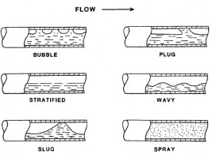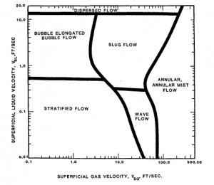
Figure 17 Two phase horizontal flow regime

Amongst other correlations for pressure gradient calculation in horizontal wells, Beggs and Brill (1973) is most commonly used with the Payne et al. (1979) correction. Also, models like Dukler (1969) and Eaton et al. (1967) have a factor of kinetic energy included in the calculation of the pressure gradient. We move on to see how these models have been successfully applied in flow loops across the world with different geometry and flow capabilities.

2.1.3 Existing facilities
SINTEF in Norway reports that nearly 50% of the worldwide investment from oil and gas companies to understand multiphase flow has been done in Norway that led to building the first two-phase test flow loop in 1983. This also led to the successful development of flow simulators like OLGA in 1984. While Norway has been at the forefront of development of multiphase flow loops, the rest of the world has also caught up in rapid speed. While the knowledge of such flow loops existing is known, its somewhat difficult to obtain information about the same in public domain. Falcone and Teodoriu (2008) did an extensive research on multiphase flow research facilities worldwide and the scope of improvement for the same. A need for a standardized reporting of flow loop is needed and the guidelines to the parameters required for reporting has been identified in the same paper. Using the same research as a guideline, a lot of flow loops across the world were analyzed.
A questionnaire was sent to research facilities worldwide which included a survey, that if completed, would automatically update the current capability of the existing flow loop in that facility. The parameters that were requested to be reported were:
- Name of flow loop.
- Total length of flow loop.
- Testing section length of flow loop.
- Direction and inclination of flow.
- Diameter of pipe used for the loop.
- Maximum operating pressure/temperature.
- Multiphase flow details.
- Superficial velocities of individual phases.
- Flow development section length (If available ).
This laid the foundation for defining the concept of intelligent pumps. As one can see, there are 17 reported research facilities with different capabilities in terms of operating pressure, flow inclinations, test section length etc.

Figure 18 Process of flow loop study

The figure above illustrates the general procedure followed during flow loop study of flow parameters. The objective of the experimentation is clearly defined before moving into understanding the factors that might influence the process. The objective of experimentation might circle around flow meters and the flow regime development or testing other equipment and parameters under the influence of different flow regimes. This would require measurement sensors placed at strategic points to ensure that the flow regime is maintained/generated at the testing section. The experimentation is then carried out to experimentally verify flow models or to empirically form one, as an example.
Table 2 below summarizes examples of various flow loop research facilities across the world. There are many more than the ones reported below, but figure 18 provides a good idea of how these flow parameters are defined and reported. The various parameters essential in a flow loop study have been reported below.
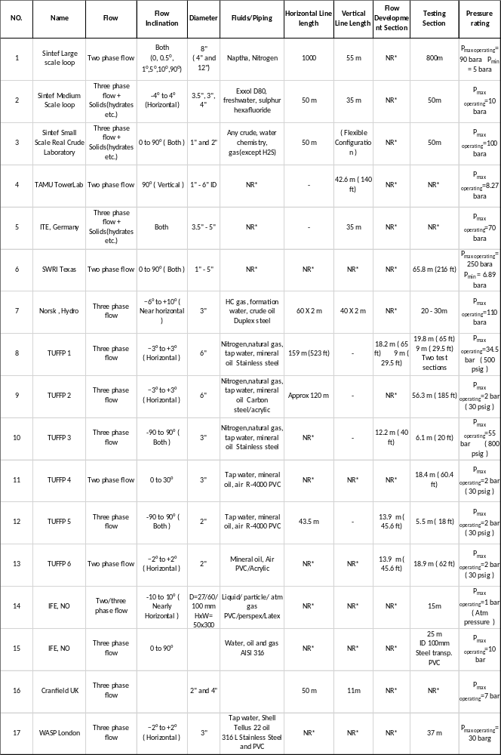
Table 2 Example of flow loop facilities reported
Table 2 summarizes flow loops with respect to their test sections reported. These test section are commonly reported in multiple of their testing diameter value. As one can observe, the test sections range from 64 to almost 485 times the diameter of the flow loop. These numbers seem rather random but plotting them on a graph in figure 19 puts light on a rather interesting aspect of the flow loops under study.
Name | Test Section  ( X D)
Norsk , Hydro | 328
TUFFP 1 | 59
TUFFP 1 | 130
TUFFP 2 | 370
TUFFP 3 | 80
TUFFP 4 | 241
TUFFP 5 | 108
TUFFP 6 | 372
NACE P NO. 4068 | 100
CSM | 64
Sinteff Medium Scale | 492
IFE Low Pressure, NO | 291
IFE Well Flow loop, NO | 250
WASP, London | 485
Table 3 Flow loop test section with length in multiple of diameter.

There is a clear distinction of two groups of testing sections that are defined on basis of diameter multiples. While group one averages 100 times the diameter, group two averages 300 times the diameter. Studying this further can reveal how the construction of the flow loop can affect the purpose of its utilization.
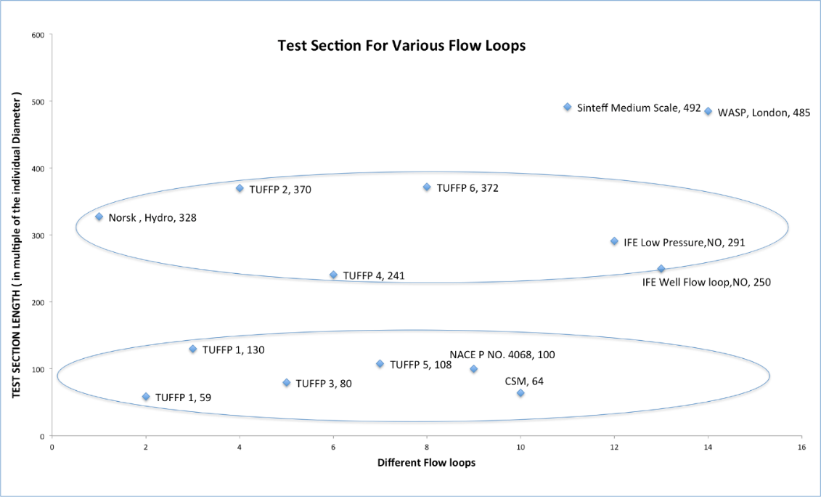
Figure 19 Categorization of test section lengths
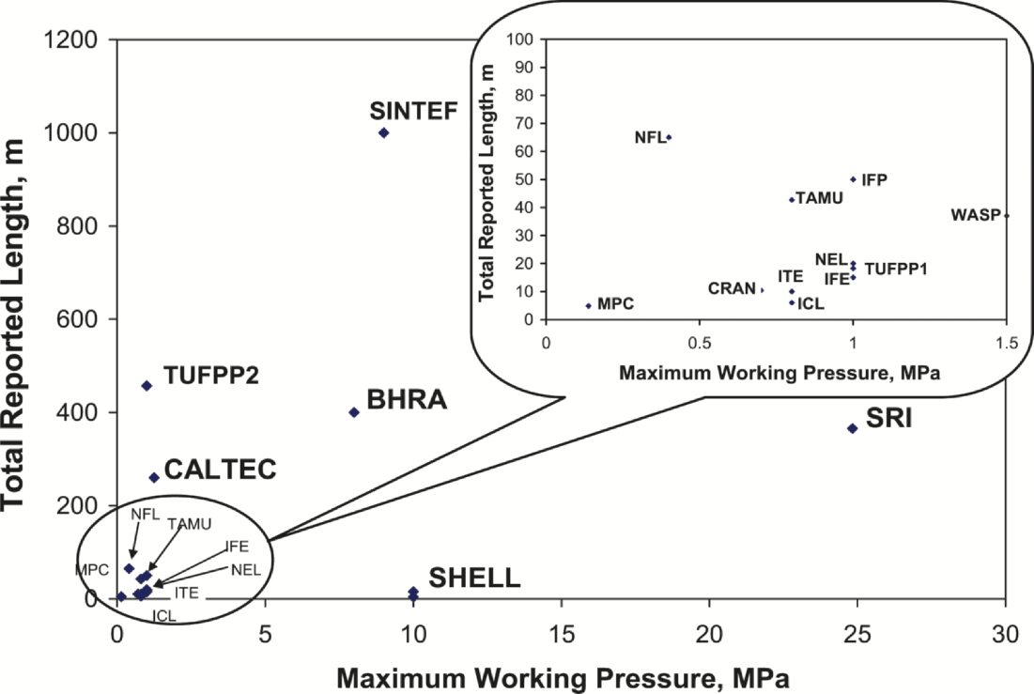
The figure below provides an understanding of the total length reported on the existing flow loops vs. the working pressure of the flow loop. Barring some, the average working pressure of the flow loops do remain close to 1Mpa with loop lengths of 100m.
Figure 20 Summary of flow loop research facilities (Falcone and Teodoriu ,2008)
2.1.4 Latest Pump Technologies
As seen in the previous section, every different research lab utilizes a flow loop for different purpose. Waltrich et al.(2014) proposed the concept of building a unique research laboratory that would remediate the issue of having multiple flow loops at different parts of the world that decrease the capital cost enormously. This starts with building a multi-purpose flow loop that is accessible and flexible enough to meet various testing needs. This would not only save thousands of dollars but also be more efficient. Labshare (2014) reports that 400 million dollars was spent every year in Australia for educational laboratories but only 10% of them are used after these laboratories become operational. A lot of the results instead, if allowed can be placed on a common platform for reference and planning of future experiments.
A reason why so many flow loops exist in the world and a lot of them are not reported in public domain is because the test procedures and results remain confidential. Service companies conduct these experiments in their respective research facilities. Partly, this seems understandable, especially when the company is working on innovation. But in most cases, for example, dealing with flow assurance issues due to hydrate formation, paraffin deposition, downhole equipment testing, experiments can be dealt with in a more structured manner. Waltrich et al. (2014) proposed a web based system to remotely integrate different flow loop capabilities into one. While literature reports very few examples of remote experiments in the oil and gas industry, Chevron (1988) carried out automated experiments which could be controlled and monitored from a different computer. Not only were the experiments safer to perform but also had the capability to control motors rates and valve switching over the Internet.
This Hardware in Loop (HIL) concept has been successfully implemented in aviation and automotive industry. Bringing this concept of experimentation to the oil and gas industry is being highly researched upon where a drill string component can be tested for high pressure and temperature without placing it downhole. Pederson et al., 2013 developed a HIL testing set up for drilling control system before actually placing them on field.
Waltrich et al., 2014 described three novel approaches in their paper. One involves using the HIL testing concept to conduct real-time remote experiments and construct well conditions. The other involves interaction between two experimental facilities. Lastly, to use the capability of multiple remote facilities to validate numerical simulation models. While the paper discusses the latter most concept in detail for well challenge diagnostics, we shift our focus onto the real-time monitoring and interaction of lab experiments at different facilities.
Real-time Pump Diagnostics
This includes carefully analyzing a Downhole pump in a well by measuring basic operating pump parameters for example torque, frequency and rotational speed. Whenever the situation arises when the pump readings are abnormal or erroneous, the pump has to be pulled out for diagnostics. This can prove to be an expensive process. With the option of real-time testing, one can predict if it’s the pump that is acting faulty or it is the flow regime in the well that is different than anticipated.
This involves creating another flow loop with a similar pump. This pump testing flow loop consists of flow generating equipment mainly including a pump and a compressor. The testing section of this loop includes a pump similar to the one placed in the well. The data from the Downhole pump is transferred to the flow loop which creates a real-time change in the flow regime similar to the original wellbore condition. The data is recreated in the pump testing flow loop and reformulated and run until it coincides with the actual data in the field. If the flow regime is a churn flow, the flow generating equipment generates a churn flow in the flow development region which is depicted in the figure below. This real-time testing of pump lets the operator know of pump issues if any by simply comparing values with the pump being tested in lab.
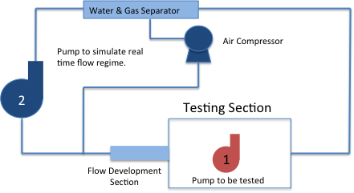
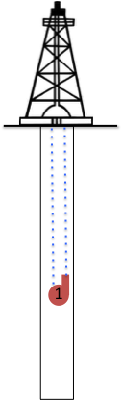
Figure 21 Real-time pump diagnostics

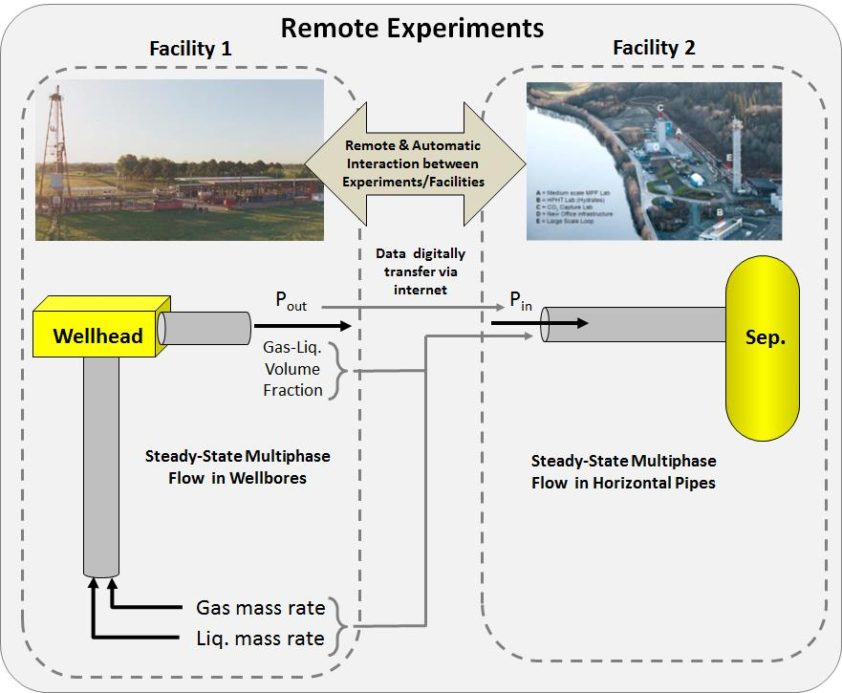
On the other hand, figure 22 is a good example to illustrate the concept of lab experiment interaction between different research facilities. Facility one has a vertical flow loop that is sufficient to simulate the casing to wellhead flow. For the case of studying flow from the wellhead to the separator, a horizontal flow loop is required which is present in facility two. By remotely connecting the two facilities through the internet, one can access and utilize both the flow loops. In facility one, steady state multiphase flow has been developed and the data at the wellhead is recorded. Since flow development depends on geometry of the pipe, fluid properties and physical properties, basic parameters to develop the same characteristics such as pressure, gas-liquid volume fraction, Reynolds number is recorded. These are the outlet conditions from facility one.

Figure 22. Remotely connecting research facilities. (Waltrich et al., 2014)
The outlet conditions at facility one is then digitally transferred over as the inlet conditions for facility two where the flow conditions are imitated using pumps and compressor and sensors and actuators. Facility two has a flow development region where the flow regime is developed before moving into the horizontal testing section. This interaction between the two systems opens the door to a lot of other experimental ideas where different inclination pipes if coupled with each other through the remote flow-loop linking feature, almost any part of a well can be studied.
A wellbore can be completely studied by breaking it into smaller flow loops of different inclinations and combining them. Figure 23 below shows a mini wellbore with three different sections for the vertical, curve and the horizontal section. Table 3 shows different sizes of flow loops with different inclinations. Using the possible configurations of flow loops available in different research facilities across the world, any possible section of the well can be studied.
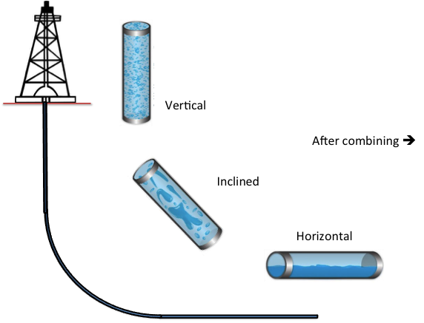
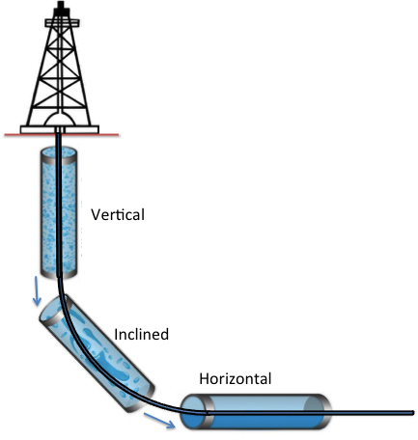
Figure 23 Intelligent digital flow loop

As seen in the figure above, the outlet conditions at the vertical section can be remotely sent to another location to provide the inlet condition of the inclined flow loop. Continuing, the outlet condition at the inclined pipe section is then used for the inlet conditions at the horizontal flow loop research facility. This summarizes how any well geometry can be broken down into smaller parts that can be easily studied by linking them together.

Chapter 3 : Experimental Studies

3.1 Objective of Experiment
The objective of the experiment was to use the concept of intelligent pumping to develop more knowledge of the reservoir. Pumps are usually run at one particular flow rate but if used at different flow rates, they open the window to many possibilities. For example, if voltage supply to a pump is changed, the pump performs differently with different flow rates.
Therefore, by using basic parameters such as PIP (Pump Intake Pressure), PDP (Pump Discharge Pressure) and varying the voltage supply to the pump, one can simulate multiple flow rates from the well and see how the reservoir reacts to different depletion rates. The experiment aims to develop different techniques in which reservoir pressure buildup tests can be run by switching off the pump for different intervals without requiring to shut in the well completely. The experiment also aims in utilizing this technique to develop a way to measure the reservoir pressure using the pump pressure curves.

3.2 Experimental Setup
The experimental setup is a flow loop designed to closely mimic a reservoir as much as possible. The elements of the experiment contain a reservoir (water tank ) along with a ball valve to imitate the productivity control of the reservoir where opening or closing this valve regulates the amount of water that is allowed to pass to the Downhole pump. While this part of the loop looks at the inflow performance of the reservoir, the remaining section of the flow loops is mimicking the outflow study. The remainder of the pipe has frictional losses as the pump discharge pressure forces the water back to the tank as seen in the figure 24 below.
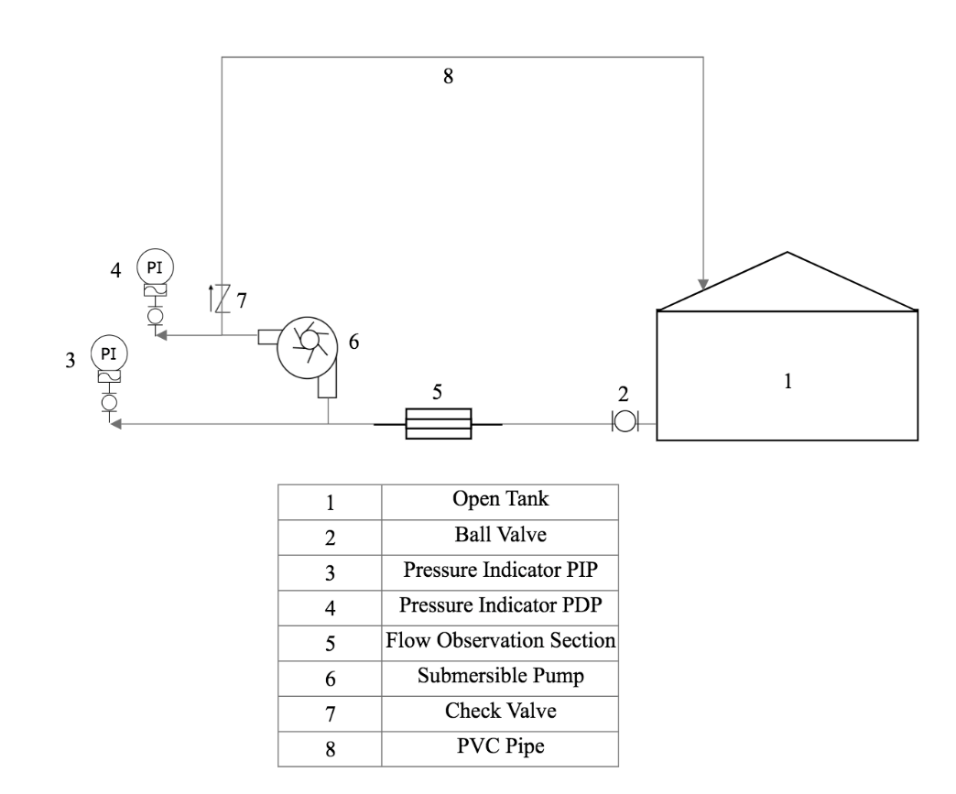
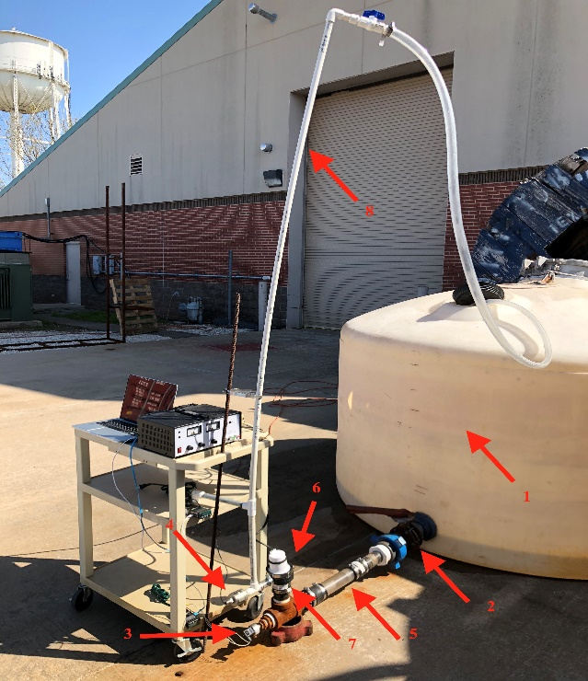
Figure 24 Process Flow Diagram for Experiment
While the tank is filled with water, it is connected to a pipe via a ball valve at the base of the tank. The objective of this valve, as discussed is to simulate different drawdown conditions from the reservoir as closing this valve makes the pump work harder to draw water from the reservoir. This valve opens to a series of connectors before it connects to a transparent PVC pipe for observation. Again, the size of the reservoir tank is very large as compared to the pipe that connects from the tank to the pump. Therefore, the volume within the pipe is naturally much smaller than the tank. This creates a situation that is close to reality with the wellbore volume being much lesser than the reservoir volume. Furthermore, using an inverted T connection, the submersible pump is fit on the pipe while the other side is for measuring the pump intake pressure as seen in the figure 24. The pump discharge pressure indicator is placed on the discharge side of the pump as seen below. A check valve is placed in the pipe to prevent the backflow of the liquid column above the tank in case of well shut in (pump off) condition. This ensures that the intake pressure measured by the pressure indicator below the pump is a true measure of the reservoir response only. The pump itself is a submersible pump that is basically a centrifugal pump placed below the head of the tank and uses that pressure to effectively pump the water up the pipe. The initial design of the setup included installation of the pump and sensors inside the tank to simulate a closer to field application of the pump being inside the wellbore while pumping the fluid but adding two sensors as well as power and measurement cables inside the tank made the setup disorganized. Figure 24 is a simpler yet much more effective idea to go about a flow loop involving a submersible pump.
There are further additions in the actual experimental setup. The power supply for the pump comes from the dual range DC power supply component. The advantage of this is to control the flow rate of the pump by varying the voltage input to the pump. Thus the pump is capable of running at multiple flow rates instead of one and can be used for multi-rate test of the reservoir. The pressure sensors at the intake and discharge side of the pump are calibrated before installation on the setup. The sensors are both connected to omega PLATINUM series meters for calibration and measurement of pressure values. These advanced display meters have a provision of USB C connection to a laptop where the huge volume of data can be stored for testing. The remainder of the pipe is connected back to the tank for completing the flow loop.

3.3 Components
The experimental loop can be broken down into physical and electronic components. While the physical aspects such as the pump and the flow loop component ensure a good testing environment, the electronics are critical in making this experiment more than just an ordinary pump testing flow loop. Let’s have a look at both of them individually.

3.3.1 Physical components
The physical components include the tank, connectors, pipe, valves and the pump. The tank volume is approximately 800 gallons and is large enough as compared to the volume of water in the flow loop to say that the tank acts like a reservoir. It is an open tank and is thus at atmospheric pressure.
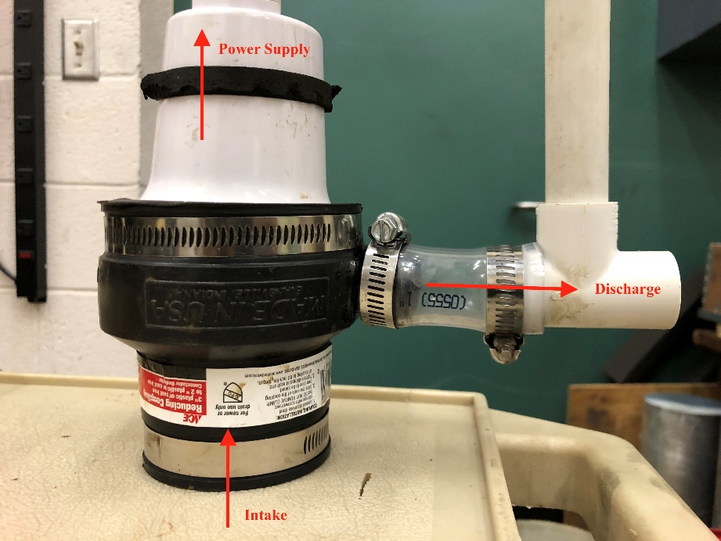
Figure 25 Submersible pump

The submersible pump is shown in figure 25. The submersible pump works within a range of 10-15 VDC and at 5-7 A. The pipe connectors are thoroughly sealed using Teflon tape to ensure no leakage in the loop. Different connectors are used to attain different fitting parameters for the sensors as well. Finely a secure pipe connection was established.
Figure 26 Pump Calibration

Pump Calibration
Using voltage variations, the pump is then calibrated for different flow rates. To attain this calibration, the pump is made to run for 2 minutes before attaining a constant flow velocity. A simple stopwatch is used with a large container the to measure the volume of flow water that flows through the pump for a fixed time interval of 30 seconds. This is repeated for different values of voltage supplied to the pump as the flow rate generated would differ. The voltage is then plot vs. the flow rate in gallons per minute. Figure 26 shows the linear relationship between the two parameters, also concluding that flow rates of 6-7 gpm are attainable from the pumps since our range of experimentation is 10-15V.

3.3.2 Electronic components
The electronic component of the experiment consists of three major components including dual range DC power supply, pressure transducers and display meters. A laptop is needed to record the data from the sensors.

Power Supply
The dual range DC power supply controls the voltage and ampere input to the pump. The voltage used for the pump range from 0-18V and current from 0-7 A. By varying the voltage to the pump, the pump frequency is controlled which in turn changes flow rate from the pump. The pump is then calibrated with input voltage for different flow rates.

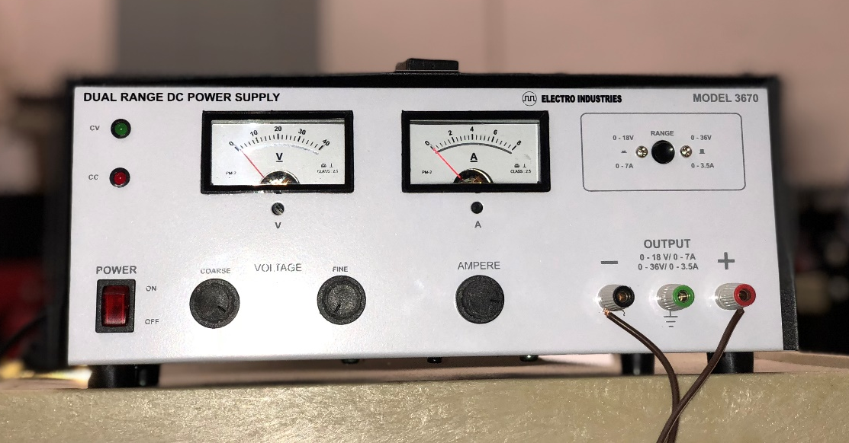

Figure 27 Variable power supply for pump

Pressure Transducers
These are the most critical components of the circuit as they convert the fluid pressure to electric signals, which can be assessed and recorded in the database. Most pressure transducers require an electrical input, which is referred to as excitation voltage. In our case, we have two pressure transmitters that operate from 15-30 Vdc and 24 Vdc. The transducer, when exposed to pressure source produces a proportional output, which can be in voltage, current or frequency. The outputs current from the transducers used are in mV and in Vdc. Let’s take a look at them individually.

Pump Intake Pressure Transducer
The intake pressure sensor uses excitation voltage of 14-30 Vdc to give an electric output from 1-5V. The pressure ranges from 0-1 bar absolute which is 1-14.5 psi. This pressure transducer is calibrated to the atmospheric pressure, which was 0.971 bar at the time of measurement.
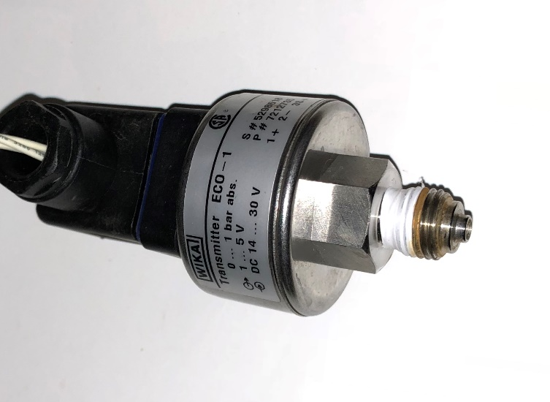
Figure 28. Pump intake pressure transducer

Pump Discharge Pressure Transducer
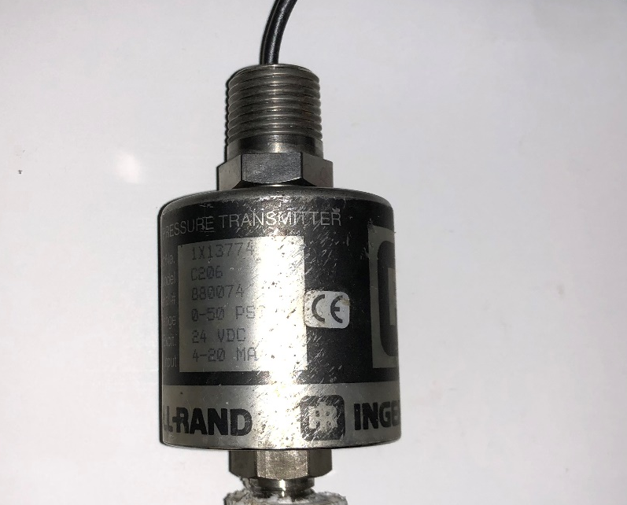
Figure 29 Pump discharge pressure transducer

The discharge pressure sensor uses a 24Vdc input excitation and a current output. Usually, these kinds of transducers are called transmitters. Thus with varying excitation voltage this pressure transmitter produces 4-20mA outputs. This sensor is calibrated from 1-50 psig.

Pressure Display Meter
Omega DP32PT PLATINUM meter series is used for data acquisition from the pressure transmitters. This series from Omega is most commonly used for temperature, strain and process measurements and can handle Vdc or mA dc from the pressure transmitters. These are easy to use and configure. These panels consist of universal 10 pin input connectors for different input signals making this meter very versatile. Table4 below summarizes the input connectors.
Pin No. | Code | Description
1 | ARTN | Analog return signal (analog ground) for sensors
2 | AIN+ | Analog positive input
3 | AIN- | Analog negative input
4 | APWR | Analog power currently only used for 4-wire RTDs
5 | AUX | Only used with controller models
6 | EXCT | Excitation voltage output referenced to ISO GND
7 | DIN | Digital input signal (latch reset), Positive at > 2.5V, ref. to ISO GND
8 | ISO GND | Isolated ground for serial communications, excitation, and digital input
9 | RX/A | Serial communications receive
10 | TX/B | Serial communications transmit

Table 4 10 pin input connector

While the output connection of the meters was AC power supply, figure 30 below summarizes the wiring hookup for internally and externally excited sensors on the input side of the display meters.
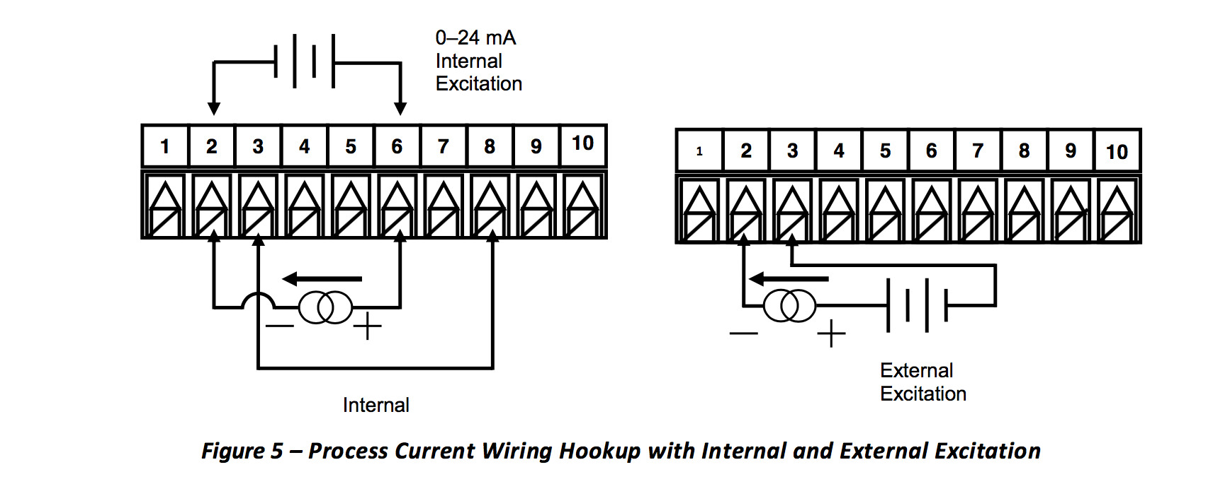
Figure 30 Wiring hookup for the pressure transducers.
Figure 31 summarizes both the intake and discharge pressure sensor connections with the display meters. Using USB connection, the data from the display meters will be recorded in real time.
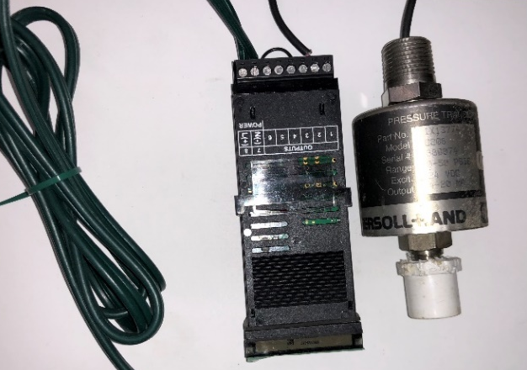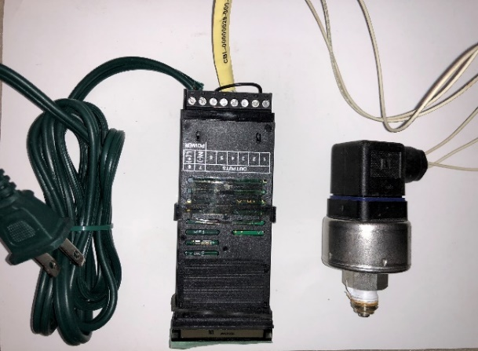
Figure 31 Completed wiring

3.4 Experimental Procedure
The procedure for experimental analysis of the submersible pump is explained in two broad phases. One being the testing phase where a lot of parameters were assessed and included in the experiments. The experiments in the trial phase were not clearly defined as the limits of the equipment as well as their performance were tested. Once the data acquisition worked in tandem with varying flow rates, the variation of possible voltage inputs to the pump was assessed. The motor worked perfectly within the range of 12-16V.
Moving further with the trial phase, the ball valve was tested which regulated the flow from the reservoir tank to the submersible pump. It was observed that the valve can simulate the productivity from the reservoir which was one of the objectives of the experiment. In conclusion, the trial phase defined the start and the limits of the experiment.
On progression, tests were arranged in 4 broad categories. While three of these categories includes interval testing, the fourth one was carried out in shorter pulses. Table 5 summarizes the four categories and tests performed during the analysis of the reservoir.

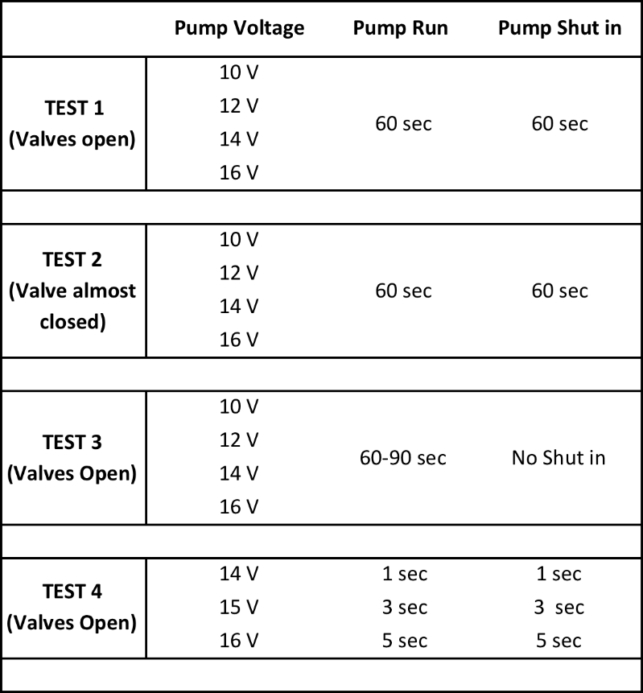
Table 5 Pressure flow tests

3.4 Intelligent Well Test
The purpose of intelligent well test is to estimate well deliverability. Using the reservoir condition and bottom hole flowing pressure, deliverability testing can help estimate production capacity of the well. AOF (Absolute open flow) potential of a well is also sometimes an indicator of the well productivity as used by regulatory agencies but theoretically the well cannot produce at this rate.
Since the experiment deals with a single phase flow, we draw inspiration from reservoir inflow performance (IPR) for an oil well and the gas backpressure curve, which is used to predict the deliverability of a gas well. While the IPR is a relationship between the surface production rate and the well bottom hole flowing pressure ( q vs p_{wf} ), one can easily predict the flow rate at any point of time throughout the life of the well by relating it to the flowing bottom hole pressure. The gas backpressure relationship is an empirical relationship developed by Rawlins et al. (1935) after testing almost 500 wells. Through his research, it was noted that the gas flow rate from the well (q_{g}) was related to the difference in squares of average reservoir pressure (p_{r}) and the flowing bottom hole pressure (p_{wf}). The equation is displayed below. Where C is the flow constant and n is the deliverability constant.
$$q_{g}=C{({\overline{p}}_{R}^{2}-p_{wf}^{2})}^{n}$$
$$\log\left(p_{r}^{2}-p_{wf}^{2}\right)=\frac{1}{n}\log\left(q\right)- \frac{\log{(C)}}{n}$$
$\log\left(p_{e}^{2}-p_{wf}^{2}\right)=\frac{1}{n}\log\left(q\right)- \frac{\log{(C)}}{n}$
Since the flow rate has been calibrated for the experiments, we need to find a way to measure the flowing bottom hole pressure and the reservoir pressure. Performing a test similar to well testing gives us the required unknown parameters.
As one can observe from the categories of tests in the previous section, the tests are based on the traditional well testing methods in gas wells. Flow after flow well testing method includes four different rates of flow and the respective bottom hole pressure measured alongside with it as seen in figure 32. The gas backpressure curve fits perfectly for flow after flow test.
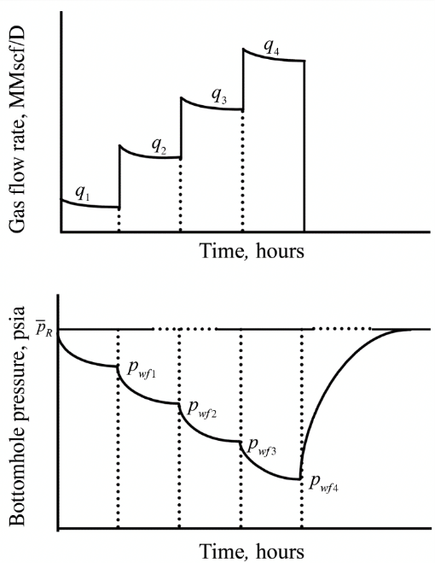
Figure 32 Flow after flow test
The intelligent pump proposed in the experimental section above can solve the issue of stabilizing different flow rates by quickly changing to different flow rates using a variable control pump. As one can see in the figure above, the pressure drawdown curve changes for different flow rates as there is a new flowing bottom hole pressure each time. As soon as the well is shut in, the pressure builds up to the reservoir pressure. This is very similar to test 3 where the pump is run at increasing flow rates at 10-16V for 60-90 sec without any shut in period. Looking at the conventional isochronal and modified isochronal tests that are performed on gas wells, the experiments performed in this thesis are quite similar. In the isochronal test, unlike flow after flow test, the well is shut in and produced in alternate order.
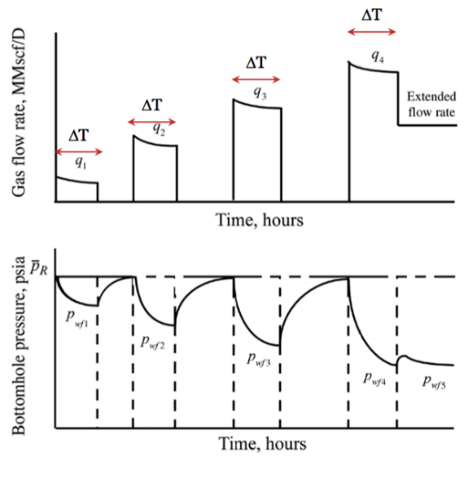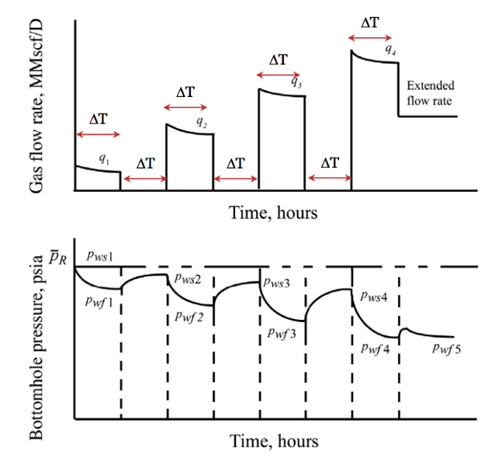
Figure 33 Isochronal and modified isochronal

After a fixed interval of producing at a flow rate q for time Δt, the well is shut in and the pressure is allowed to build up to the reservoir pressure. Modified isochronal on the other side includes same duration of producing and shut in time. Hence, the pressure buildup is not up to the reservoir pressure. In the list of experiments listed above, test 1 aims at a well production of 60 second and shut in for 60 seconds to allow the pressure to buildup. Test 2 has equal intervals of 60 seconds of alternate run times as well but the primary difference is the degree at which the valve is open for the experiment. The aims of both of these tests were to see how much time it would take for the pressure to build up to the reservoir pressure.
Test 4 is similar to a pressure pulse test although pressure pulse test is more applicable to check reservoir communication, permeability etc. between wells. In our situation, pulse testing was done to exactly measure time taken for the reservoir pressure to stabilize to understand near wellbore conditions.
Chapter 4 : Results and Discussions
The current chapter deals with all the results from the individual tests and how they can be interpreted to get a fairly good idea of the reservoir, its productivity and possible considerations for future work. Also effort has been made to estimate the deliverability of the reservoir through the experiments.
The plot of PIP (Pump intake pressure) vs. PDP (Pump discharge pressure) has been plot in orange and blue respectively in the figures below. The graphs below as well as the others that follow have been plot on primary and secondary vertical axes plot for comparing the intake and discharge pressure. The production from the pump as well as well shut in cases can be analyzed together. The discharge pressure in most cases has been plot between 0 to 10 psig whereas the pump intake pressure is close to about atmospheric. Since the focus remains on understanding how the reservoir behaves when the well is shut in (pump switched off condition), the data acquisition system is vital for the experiments. The pressure data from the experiment was initially collected at 5 sample frequency which did not prove sufficient as there was not enough data points to analyze the transient behavior of the reservoir when the well is shut in. To solve this issue, data from the experiments were then collected at 15-20 samples per second that has its pros and cons. It is advantageous when it comes to minute analysis of the pressure buildup phase but it can be cumbersome to deal with 8000 data points for each experiment. This is similar to the issue faced in the industry when dealing with multiple down hole sensors that feed tons of data points in real time. Nonetheless, the tests have been performed with a high sampling rate throughout to predict the behavior as close to reality as possible.
Experimental results from Test 1 have been plot in the figure 34 below. This test is run at different flow rates that are controlled by varying the voltage supply to the pump. In the first instance, at 10V, the orange plateau represents the flowing bottom hole pressure whereas the blue plateau represents the pump discharge pressure. Both these cases are when the pump is running. What is extremely fascinating is when the pump is switched off. As soon as the pump switches off, the discharge pressure falls drastically. The intake pressure at the same moment starts to increase. This is an indication of the pressure buildup in the reservoir.
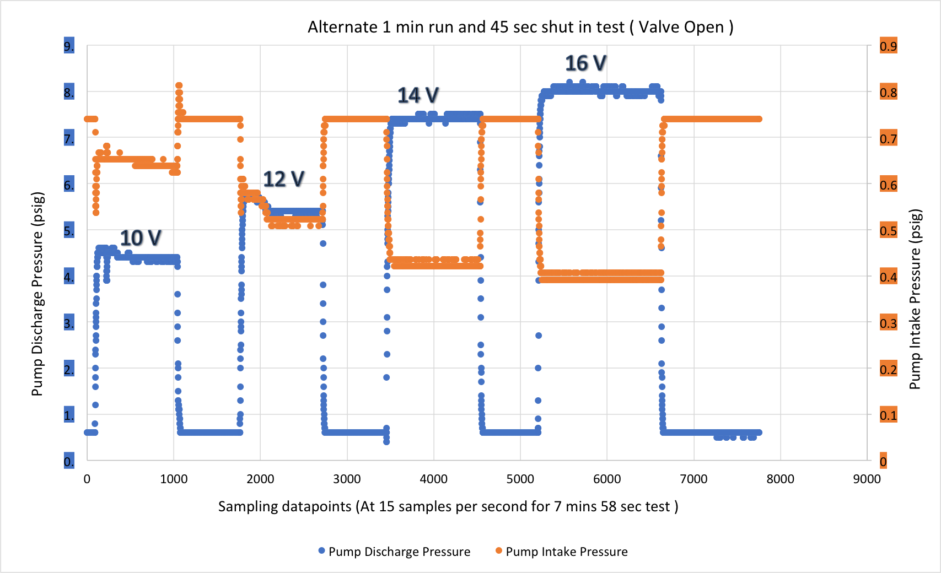
Figure 34 Test 1 Plot

Fortunately, the pressure stabilizes in the duration of the shut in period which shows that the experiment was successful in reaching the steady state phenomenon. This pressure value is indicated by the plateau of the higher orange lines which remains constant irrespective of the varying flow rates. This value is indicative of the reservoir pressure which is equal to the atmospheric pressure plus the hydrostatic pressure in the reservoir tank.
One can observe how the flow rates are then varied by varying the voltage supply to the pump. This causes a change in the plateau of the discharge pressure for each flow rate. This also causes the bottom hole pressure to change as the differential pressure across the pump changes due to greater flow rates changing the current bottom hole flowing pressure for that particular flow rate. Interestingly, as soon as the well is shut in, the pressure buildup in the well is indicated by the sudden rise in the orange line in form of dots on the plot. Now even though the experiment is performed at the highest sampling rate possible, it is fairly difficult to obtain more data points as the time duration for this transient behavior is very quick in the case of dealing with ideal situations. A well in reality has a lot of different factors that help determine the time duration of this behavior. This leads to discussing how near wellbore conditions can make a huge impact on the drawdown for the pump. Since the pressure drop near the well bore also depends on the frictional losses due to the permeability of the formation and the skin factor associated with the well, the gate valve at the reservoir tank was used to further analyze the wells. Effectively closing or opening the valve dictates the ease of flow from the reservoir tank and is thus an indication of productivity index of the reservoir. Since the productivity index of the well, for steady state, depends on the production flow rate and the drawdown pressure difference, different valve positions were selected for changing the pressure drawdown into the well. Test 2 was run at almost closed valve position of the reservoir tank. This helps simulate a formation which is tighter and less permeable.
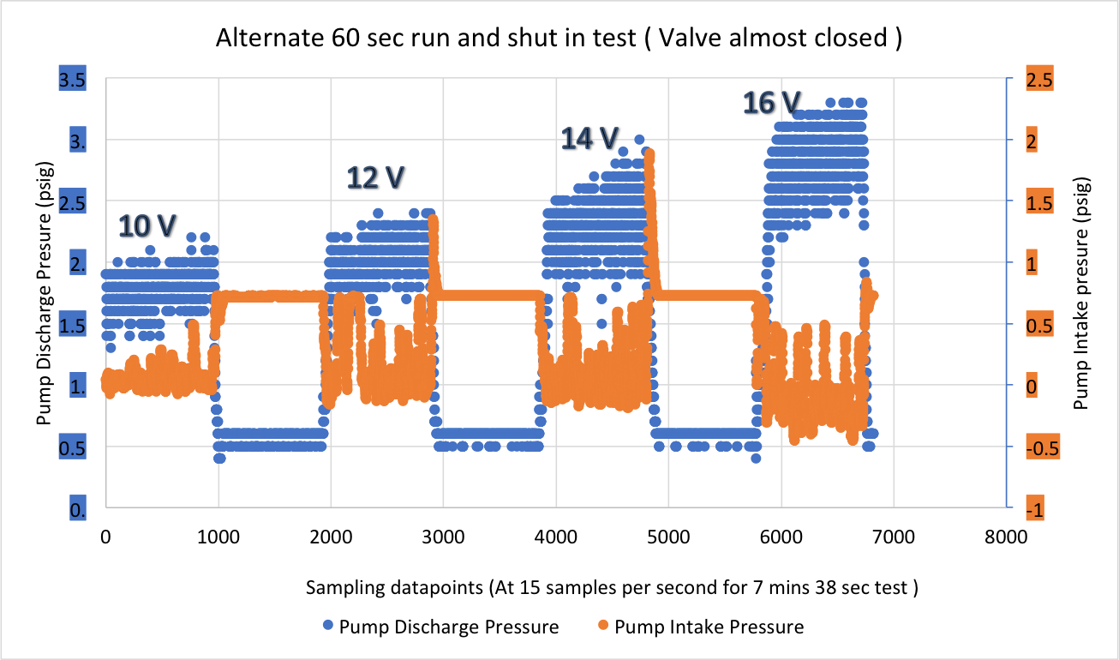
Figure 35 Test 2 plot

As one can observe from figure 35 pressure data points are more scattered than the previous experiment. Even though the sampling rate remained the same for both cases, it really came down to the head the pump can generate. The closing of the valve caused a sudden drop in pressure or near vacuum conditions that starved the pump of sufficient flow rate. This in turn causes suction cavitation at the eye of the impeller where bubbles start to flow over to the discharge side of the pump. These bubbles were observed in the clear, observatory section of the pipe connecting the tank to the pump. In the plot above, one can observe the erratic up and down movement of the pressure values which are caused when the bubbles in the flow develop pressure shockwaves in the pump and the setup. Even though the data points on the plot above are erratic in display, it still follows a pattern observed in the previous experiment where shutting in the well resulted a pressure buildup in the reservoir. Not only was this buildup drastic but it also included a spike in pump intake pressure as soon as the pump was shut in. This is caused by a sudden pressure pulse on the transducer when the water column at the discharge side flowed back in due to sudden release of the suction side pressure of the pump. This backflow had needed to be controlled for accurate measurements and hence a check valve was placed at the discharge side of the pump to ensure zero flow back from the discharge to the intake side. These tests were similar to the isochronal test where different production flow rates are measured with either varying or constant shut in periods. In our case, the shut in duration plays no major impact as the pressure buildup curves are very quick to stabilize.
Flow after flow test has been discussed at length in the previous section and how it can prove to be a vital well deliverability testing method. This method though is for gas wells. Since the experiment deals with a single phase water reservoir, a linear relation between the flow rate and the pressure drawdown is used which is also known as productivity. The experimental procedure in test 3 is similar to the flow after flow test with 4 different flow rates at 10, 12, 14, 16 V respectively. Each flow rate is maintained for a proper duration until the flowing bottom hole pressure stabilizes. This can be seen by observing the orange markers. As soon as the pump flow rate is changed to a higher value, the bottom hole pressure drops quickly and eventually stabilizes. This stabilization is necessary before moving on to the next flow rate. The equation for productivity index is illustrated below as:

$$q=J(p_{r}-p_{wf})$$
As seen in this equation, J is the productivity index of the reservoir which depends
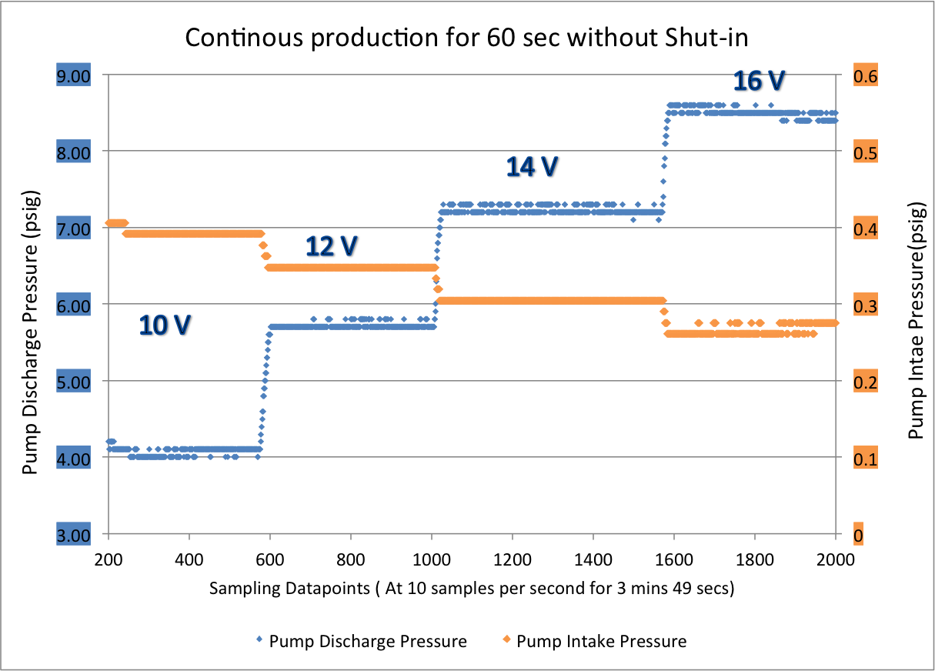

Figure 36 Test 3 plot

During shut in, the bottom hole pressure stabilizes to the reservoir pressure and can be used in the equation above. In our case, shut in bottom hole pressure can be estimated from Test 1 and 2 above as psig. This is equal to the reservoir pressure in our situation.
The well is made to flow at four different flow rates as shown above. Another advantage of having a smart pump lies in getting the true bottom hole pressure values from the pump intake sensors instead of attaining flowing wellhead pressure and converting to flowing bottom hole pressures.

The average flowing bottomhole pressure values have been considered from figure 36 to combine it with the callibrated flow rate values to generate a single phase IPR for the reservoir. This is shown in figure 37.
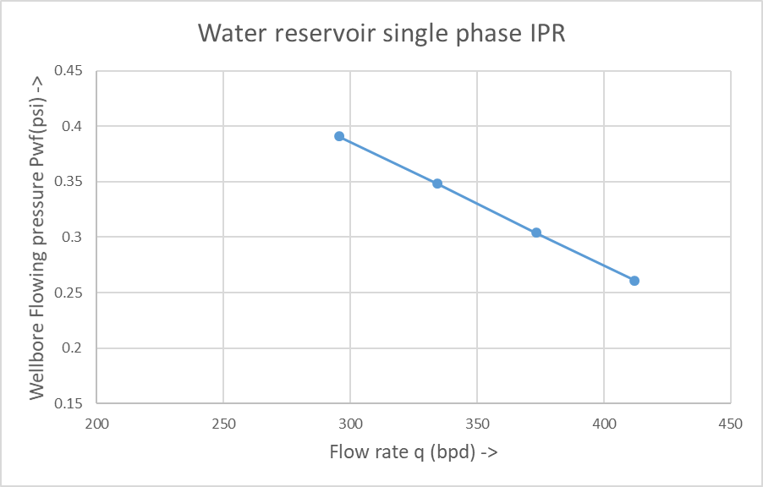
Figure 37 Single phase IPR

After observing in the previous tests, as soon as the well is shut in, the time taken for the pressure buildup to change from a transient curve to stabilize to the reservoir pressure is quite less. 45-60 second shut in periods are longer than needed. Therefore, the focus of the next set of experiments shifted towards short duration tests to actually effectively and accurately measures this transient time flow. All of these experiments were run at 14V as running at this minimum flow rate ensured no suction cavitation seen as observed in previous cases.
Since the focus primarily remains on when the pump is shut in, all the three cases in test 4 are placed in the same sampling data point range from sample no. 300 to 500. Test 4.1 has an alternate 1-second run and shut in time. The intake pressure does follow the pressure buildup trend but 1-second flow fluctuations do not give a clear set of points that can be further analyzed. Moreover, even though the reservoir is quick enough, the pump is not strong enough as the discharge pressure does not stabilize in the same time duration.
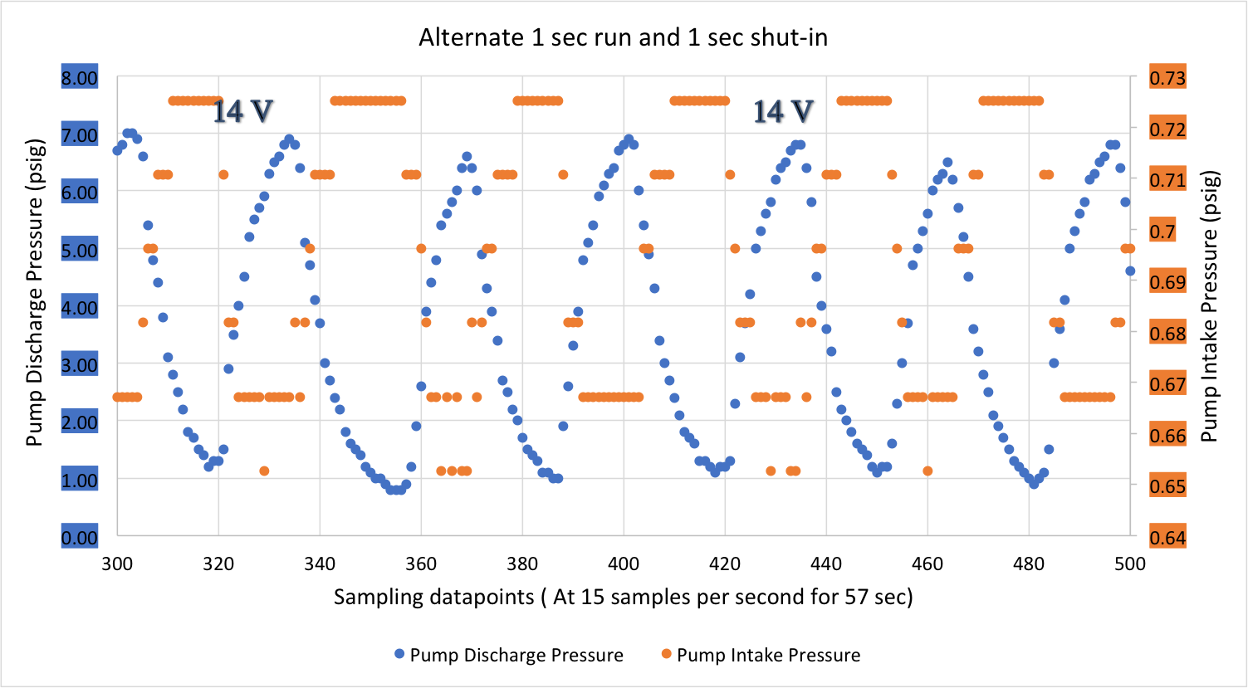
Figure 38 Test 4.1

The pressure curves observed in Test 4.2 are more distinct and identifiable. In test 4.1, where it took almost 5-7 data points for plotting the transient flow, Test 4.2 collects almost 10 data points for analysis. Moreover, the pump intake pressure also stabilizes to the reservoir pressure soon enough as seen by the orange plateau observed. Irrespective of the higher sampling rate, the discharge pressure does not completely stabilize. It does curve down as compared to the previous test that shows that it is close to the stabilization condition.
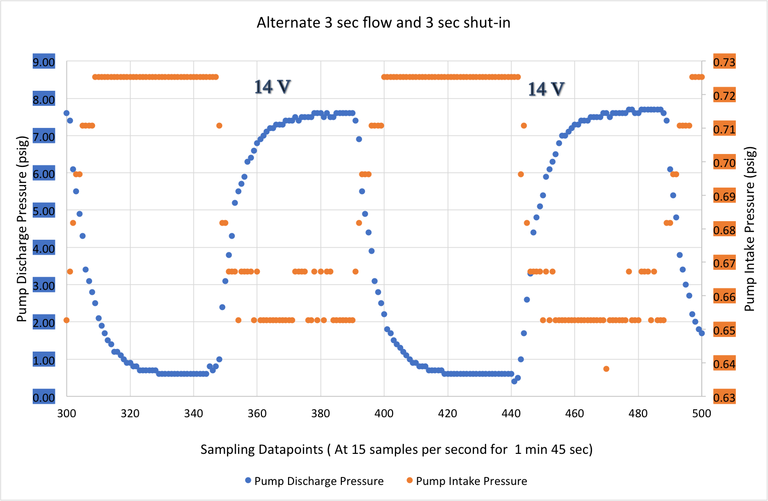
Figure 39 Test 4.2

The process was continued over to the alternate 5 sec run and shut in phase that resulted in the figure below. It is again plot between the same data point range of 300 to 500. One can compare the previous two tests to observe how test 4.3 is a more gradual increase in pressure points as the well is shut in. It even has a drop point marked in orange which displays the start of the transient phase flow towards stabilization of the well. These points are then handpicked for further analysis of the transient flow time period. Also, the discharge curves have also stabilized which shows that both the reservoir and the pipe, that is the inflow and the outflow part of the well has achieved stabilization and further analysis can be continued on them.
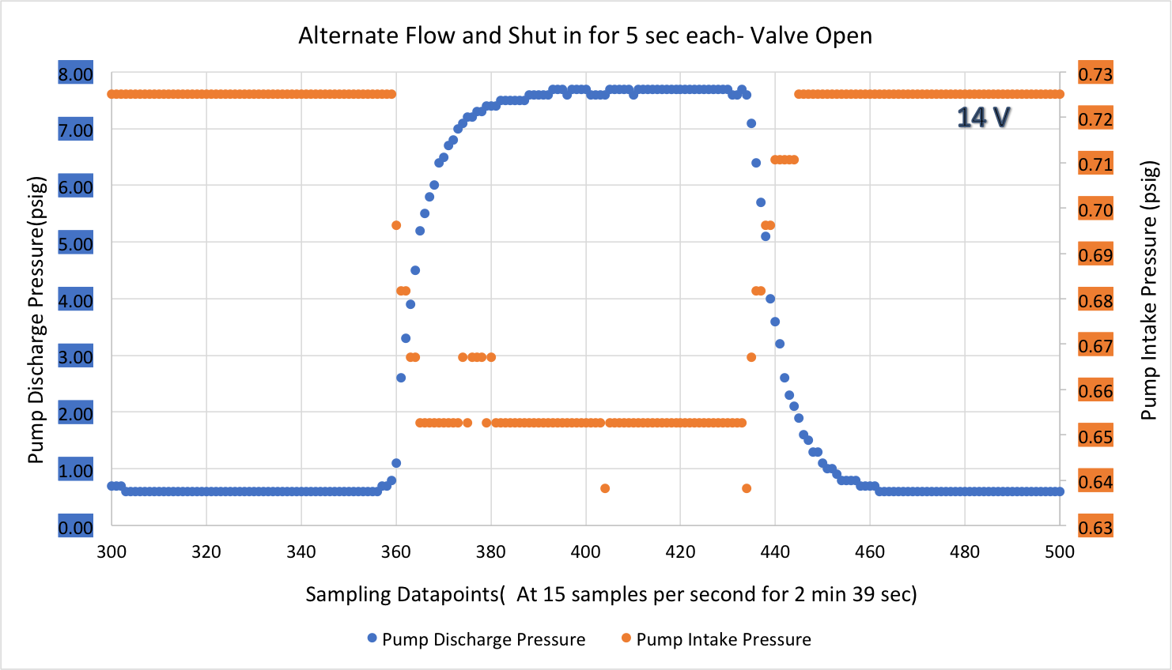
Figure 40 Test 4.3

Since the well deliverability depends on the production rate and the driving force of the reservoir, which is the reservoir pressure, relating both of them gives an inflow performance relationship (IPR). The following calculations aim to achieve the same.
The volume of the reservoir tank is significantly large as compared to the volume inside the pipe segment connecting the reservoir tank to the submersible pump. This can be seen in the flow loop diagram below.
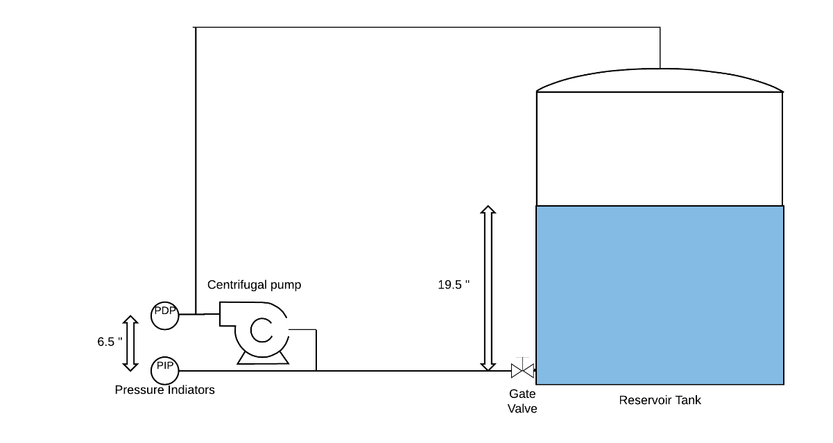
Figure 41 Process flow diagram
The water in the tank is exposed to the atmospheric pressure P_{atm}. The height of the water column during the experiment remains at 19.5 inches. Therefore, the pressure in the reservoir is the sum of the atmospheric and the hydrostatic pressure as shown in the equation below.
$$P_{r}= ρgh_{1}+ P_{atm}$$
As we move from the reservoir to the pump, we face a pressure loss in the pipe segment connecting the tank to the pump. This in the real case represents the near well bore condition for the well. This can be equated in the equation below as
$$∴ΔP=P_{r}-PIP$$
where PIP is the pump intake pressure measured by one of the lower sensor in the process flow diagram above, P_{r} is the reservoir pressure and ΔP is the pressure drop from the reservoir to the pump which is also known as drawdown.
It is maximum in the case of flowing conditions and minimum in the case when the well is shut in for pressure buildup. Thus, ΔP can be characterized on the basis of pressure at the inlet of the pump and the reservoir pressure. Also, this pressure drop is dependent on the flow rate and the resistance to flow offered by the pipe segment connecting the reservoir to the pump that includes the pipes and the gate valve. In the actual well case scenario, pressure drop due to skin is also a component of the total pressure drop. Pressure drop due to skin is a function of the flow rate and the resistance to flow offered by the permeable formation that depends on the permeability k, viscosity μ, skin s_{exp} and reservoir height.
Therefore,
$$∆P_{s}=\frac{qμ}{2πkh}s_{exp}$$
where ΔP_{s} is the skin factor pressure loss, q is the flow rate and s_{exp} is the skin factor for the experiment. The flow rate in this situation is the flow rate during the transient phase. The pressure in the reservoir stabilizes when the entire volume of water in the pipe connecting the tank to the pump flows back into the reservoir to stabilize at the atmospheric pressure. Using the time taken for the transient flow and the volume of the pipe segment, a good estimate of the flow rate can be made. For this calculation, the reservoir is estimated to be at a constant pressure and the volume of water in the pipe segment has to be calculated. The volume was theoretically calculated by measurement of the pipe sections as 0.77 gallons of water. The ΔT value can be estimated from the graphs by looking at the orange markers for pump intake pressure as soon as the well is shut in. The figure 42 a zoomed in picture of the 5 sec run and shut in case where the transient time can be measured and analyzed.
Since we have optimized our experiment after a lot of trials and understanding how the reservoir and the pump respond, we finally have a very smooth transient curve for our analysis. We see exactly 12 data points during the interval, which starts with the situation where the pump was running constant at 14V. The first pressure drop point is recorded by the data acquisition system after which the pressure starts to continuously buildup. The end point is where the pressure stabilizes to the reservoir pressure again which is denoted by the orange plateau at 0.725 psi.
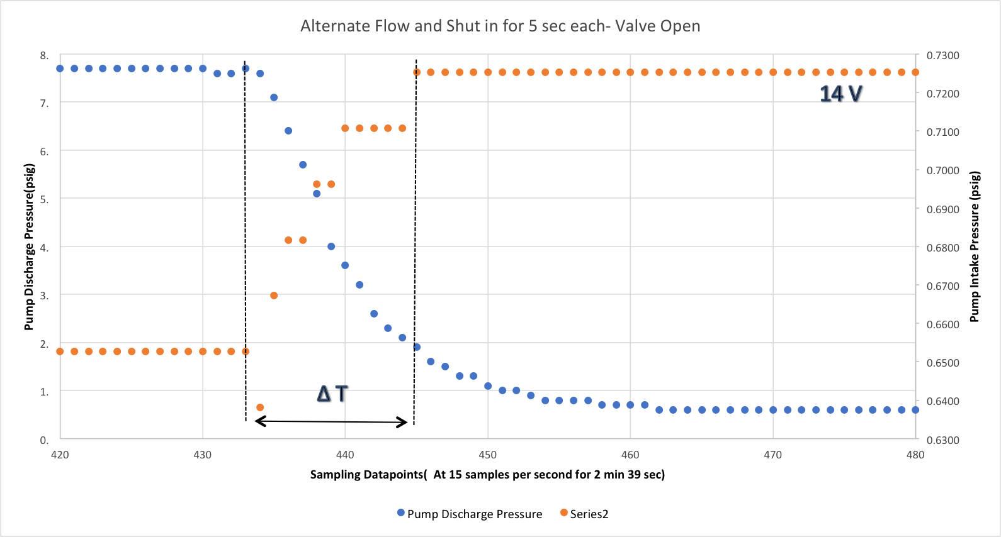
Figure 42: ΔT Estimation

ΔT is calculated at 748 ms which seems pretty quick as compared to real well cases due to significant other factors. The setup above is a downscaled version of the well and has to resistance to flow apart from a semi closed gate valve. The reservoir is comparatively larger than the pump but is completely permeable. These cause immediate movement of pressure pulses to reach the limits of the reservoir and stabilize the pressure quickly.
The flow rate can be then calculated as;
$$q_{inst}= \frac{Vp}{∆T}$$
where q_{inst} is the flow rate during the transient flow and V_{p} is the volume of the pipe segment which is very small as compared to the reservoir volume. Hence, instantaneous q_{inst} is calculated as 61.7 gpm or 2117.75 bbl/day. From the equation defined earlier,
$$Since ΔP_{s}=PIP-P_{r},$$
$$P_{r}=PIP reading ( when well is shut in )$$
$$P_{r}=0.725 psi$$
The reservoir pressure value can also be verified using the hydrostatic head calculation. Since, $P_{r}= ρgh_{1}+ P_{atm}$
Since we are dealing with gauge pressure readings, P_{r} = 0.433 psi/ft. * (19.5”/12) ft.
Where 0.433 psi/ft. is the pressure gradient for water and 19.5” is the reservoir tank water level. Hence after calculation,
$$P_{r}=0.704 psi$$Hence the approximation of using a value of 0.725 psi for reservoir pressure is more accurate. Pump Intake Pressure (PIP) has a value of 0.653 psi while running. Therefore, moving further with the calculations,
$$ΔP_{s}=0.653-0.725 psi$$
$$ΔP_{s}=-0.072 psi$$
$$-0.072=\frac{2117.75*μ}{2πkh}s_{exp}$$
$$-0.072=141.2*\frac{2117.75*μ}{2πkh}s_{exp}$$
$$s_{exp}=- 0.151*{10}^{-5}* \frac{kh}{μ}$$
Where, μ is the viscosity of the fluid in cp, k is the permeability of the formation in md and h is the reservoir thickness in feet. This equation gives us a good estimation for finding the skin associated with the formation by feeding in the viscosity, reservoir thickness and the permeability values. The objective of the experiment was to get information about the reservoir by performing well shut-ins using a submersible pump. The pressure graphs did display an interesting profile of buildup of pressure and hence the transient time for the flow could be calculated. This led to an equation that could help estimate the skin factor, which is a very important tool for assessing the inflow performance of the well.
$$q_{inst}=\left( {PIP}_{flowing}-{PIP}_{shut-in} \right)\frac{2πkh}{μs_{exp}}$$
The following equation helps determine a relationship between the flow rate and the pump intake values during production and shut in. Using formation properties, the skin factor can also be estimated.

4.1 Errors and uncertainties in experimentation
Experimentation involves approximations that need to be assessed for final accuracy of the result. Errors arise from different sources during measurements to equipment constraints. Being aware of these errors and including them adds legitimacy to the result. The uncertainties that were faced in the experimentation process have been discussed in the section below under various categories.
- Environmental error:
Due to immediate working environment. Patm = 1.013 bar whereas atmospheric pressure actual value =0.971 bar. Error = 4%​
- Sensor Sensitivity: This has been approximated to about 0.5% error. For example, the pressure discharge sensor can have fluctuations of 0.25 psig. ​
- Physical variations: ​
1. Pipe measurement for volume calculation has been approximated to an average circumference of 7” and length 36” to get a volume of 0.77 gallons. Error of about 5%​
2. Calibration of flow rates required measuring constant flow for 30 seconds but the water level in the reservoir changes during this time gap. This causes a difference in head and thus a difference in the flow generated. The flow rate values were approximated to remain the same for 30 seconds of flow.
- Lag time error: This can be observed when the pump input voltage change causes changes in flow rate. The quick fluctuations though millisecond in value were excluded from measurements.

Chapter 5 : Conclusions and Future work
Through this research, an idea of intelligent pumping system has been introduced that is not only beneficial for remote lab testing between different lab facilities in the world but can also be used for real-time testing of down hole equipment remotely. By extending the idea of pump flexibility to varying pump flow rates, an experimental setup was created that simulated inflow behaviour to a submersible pump. The tests were successfully run to infer reservoir related information.
- An equation was successfully formed that related the pressure intake curves to the near well bore conditions through which the skin factor of the formation could be easily inferred. Understanding near well bore pressure losses is pivotal in inflow performance relationship.
- This provides an affordable measurement of downhole parameters including skin factor, reservoir pressure and flow rates without the need of placing extra equipment downhole. Therefore, instead of using expensive downhole gauges, the sensors on the submersible pump can itself help record down hole data that is useful to an operator.
- These pump pressure curves are available real time itself to differentiate unusual behaviour as quickly as possible. This saves cost and time to the operator.
The experimental work done in the previous chapter is quite a novel approach in which the inflow to a well is simulated using a large reservoir tank and the near wellbore resistance to flow is simulated through the connecting pipe with the gate valve. To continue the work on the setup, the valve can be replaced by a sophisticated system in which the degree of opening of the valves could be recorded because in real sense it would mean controlling the productivity index of the reservoir. Tighter formations would offer more resistance to flow whereas more permeable formations will have less flow obstruction. Moreover, the connecting pipe can be filled with sand to create a permeable membrane for flow resistance so that skin factors can be analysed. Analysing this would help in creating a more accurate equation than the one presented that relates the skin factor pressure loses to the pump intake curves. Of course, this would also need a screen for protecting sand intake into the pump.
Moreover, the water levels in the tank can be played with to simulate a range of high to low reservoir pressures. In the long run, multiphase fluid flow can be introduced into the system by injecting gas into the system to create favourable flow regimes. Understanding fluid properties better will definitely help optimise the performance curves for the submersible pump (Caicedo et al. 2012). Also, developing an algorithm for reservoir prediction would require real field data to verify and implement.

References

Eck Joseph, 2000.Downhole Monitoring: The Story So Far. Schlumberger, Houston, Texas.

Dover. 2017. Rod Lift. https://www.doverals.com/products/rod-lift ( accessed 20th Oct 2017)

Rigzone, 2017. How does artificial lift work? https://www.rigzone.com/training/insight.asp?insight_id=315&c_id=( accessed 20th Oct 2017)

Liberty,2017. When to use progressive cavity pumps. http://www.continentalultrapumps.com/store/kcfinder/upload/files/Pump%20Guide%282%29.pdf=( accessed 20th Oct 2017)

Beckwith, R. (2014, October 1). Pumping Oil: 155 Years of Artificial Lift. Society of Petroleum Engineers. doi:10.2118/1014-0101-JPT

Source rock, 2017. http://www.sourcerock.ca/=( accessed 25th November 2017)

Tech-flo, 2017. Jet pumps for Oil production. http://www.tech-flo.net/jet-pumps.html. =( accessed 10th Dec 2017)

Lea,J.F et al., Gas Well Deliquification , 2nd ed., Elsevier, Amsterdam 2008.
https://www.slb.com/~/media/Files/resources/oilfield_review/ors99/win99/pages20_33.pdf

Wilson, B. L. (1986, January 1). Understanding the Basics of Electrical Submersible Pump Performance. Society of Petroleum Engineers. doi:10.2118/14050-MS

Algeroy John, 2008. Electric Submersible Pumps for Artificial Lift Intelligence. Oilfield Review, Houston, Texas.

StatoilHydro. 2008. K-lab (Kårstø). http://www.statoilhydro.com/en/
TechnologyInnovation/TechnologyManagement/ResearchCentres/
Porsgrunn/Pages/Porsgrunn.aspx.

London, M., Cameron, S. M., & Pierce, G. (2012, January 1). Flow Loop for X-Ray CT Imaging of Sand Transport. Society of Petroleum Engineers. doi:10.2118/157897-MS

Falcone, G., Teodoriu, C., Reinicke, K. M., & Bello, O. O. (2008, September 1). Multiphase-Flow Modeling Based on Experimental Testing: An Overview of Research Facilities Worldwide and the Need for Future Developments. Society of Petroleum Engineers. doi:10.2118/110116-PA

Benlizidia, I., Al Jarri, A. S., & Al Anazi, M. A. (2016, September 26). Multiphase Flow Meter Performance Evaluation Using Live Hydrocarbon Flow Loop Mimicking Real Field Conditions. Society of Petroleum Engineers. doi:10.2118/18158

Economides et al.,2013. Petroleum Production Systems.

Beggs, H. D., and Robinson, J. R., “Estimating the Viscosity of Crude Oil Systems,” JPT, 1140-1141, September 1975.

Brown, G. G., Katz, D. L., Oberfell, C. G., and Alden, R. C., “Natural Gasoline and the Volatile Hydrocar bons,” NGAA, Tulsa, OK, 1948.

Flow regimes in horizontal and vertical pipes. http://www.ingenieriadepetroleo.com/flow-regimes-in-horizontal-and-vertical-pipes/

Waltrich, P. J., Zhang, H., & Teodoriu, C. (2014, October 27). Remote Real-time Experimental Diagnostics for Well Challenges. Society of Petroleum Engineers. doi:10.2118/170953-MS

Labshare. The LabShare Institute. Accessed 2014.

Pedersen, T. and Smogeli, Ø. 2013. Experience from Hardware-in-the-Loop Testing of Drilling Control Systems. SPE Drilling & Completion 28 (04): 308-315. DOI: 10.2118/163509-pa

Medina, M., Torres, C. E., Sanchez, J., Boida, L., Leon, A. J., Jones, J. A., & Yicon, C. (2012, January 1). Real-Time Downhole Monitoring of Electrical Submersible Pumps Rated to 250 degree C Using Fiber Optic Sensors: Case Study and Data Value in the Leismer SAGD Project. Society of Petroleum Engineers. doi:10.2118/153984-MS

Cooper, D., Rutter, R., Forsberg, M., & Martinez, I. (2016, October 17). Fiber-Optic Monitoring in Electrical Submersible Pump Systems. Society of Petroleum Engineers. doi:10.2118/181239-MS

Ghaith Arfaoui. Bachelor Thesis. Smart Well Completion

Mohaghegh et al.,2008. Smart Completions, Smart Wells and Now Smart Fields; Challenges & Potential Solutions. SPE Distinguished Lecture.

