UNIVERSITY OF OKLAHOMA
GRADUATE COLLEGE

THE DESIGN OF AN EXPERIMENTAL SET UP FOR THE TESTING AND CHARACTERIZATION OF MECHANICAL FACE SEALS

A THESIS
SUBMITTED TO THE GRADUATE FACULTY
in partial fulfillment of the requirements for the
Degree of
MASTER OF SCIENCE

By
ALFREDO BECERRIL CORRAL
Norman, Oklahoma
2021
THE DESIGN OF AN EXPERIMENTAL SET UP FOR THE TESTING AND CHARACTERIZATION OF MECHANICAL FACE SEALS

A THESIS APPROVED FOR THE
SCHOOL OF AEROSPACE AND MECHANICAL ENGINEERING

BY THE COMMITTEE CONSISTING OF

Dr. Zahed Siddique, Chair
Dr. Yingtao Liu
Dr. Wilson Merchan-Merchan
Dr. Raghu Madhavan

© Copyright by ALFREDO BECERRIL CORRAL 2021
All Rights Reserved.

Acknowledgments
I would like to thank Dr. Zahed Siddique for his guidance and mentoring during my college career, for the opportunity to do research under his tutelage, and for his help in achieving my educational goals. His patience, kindness, and encouragement illuminated my academic path and allowed me to move forward. I would also like to thank Dr. Raghu Madhavan for his constant support during my research, as well as for providing his technical expertise and guidance allowing me to overcome many challenges. Likewise, I would like to extend a thank you for Dr. Wilson Merchan-Merchan for introducing me to the world of academic research and microscopy as well as for contributing his time and service to form part of my thesis committee. In the same way, I would like to thank Dr. Yingtao Liu for providing his time and service to form part of my thesis committee.
I would like to thank Melissa Foster and Bethany Burklund from the AME office for all their help during my research and their dedication to help students. I would like to thank Billy Mays and Greg Williams who helped me in any way they could during times of hardship. I would like to thank Christopher Glenn for introducing me to the different research projects and for his support and friendship during my academic career.
I would like to thank Morgan Eckhoff for her unconditional support during my academic career. Her patience and optimism helped me prosper in my studies and research. I would also like to thank my father and my mother, who’s support and knowledge inspired me during my graduate career.

Table of contents
Acknowledgments iv
Chapter 1: introduction 1
1.2 Problem statement 2
1.3 Research objectives 3
1.4 Overview of approach 7
1.5 Thesis outline 8
Chapter 2: Background on MFS 10
2.1 Introduction 10
2.2 Overview of face seals 10
2.3 Industrial applications of face seals in oil and gas 11
2.4 Materials used in Mechanical face seals 12
2.5 Hydrodynamic lubrication regimes 14
2.6 Friction and wear 17
2.7 Chapter summary 19
Chapter 3: Design process 20
3.1 Introduction 20
3.2 D1 – Define project objectives 21
3.3 D2 – Concept definition 23
3.4 D3 – Embodiment design 25
3.4.1 Motor drive 26
3.4.2 Leakage measurement 27
3.4.3 Pressure measurement and control 28
3.4.4 Heating system 28
3.4.5 Oil and debris circulation 29
3.4.6 Control and data acquisition system 29
3.5 Chapter summary 30
Chapter 4: Manufacture process. 31
4.1 Introduction 31
4.2 Test housing 32
4.3 Driving sub-system 34
4.4 Volume measurement subassembly 37
4.5 Vacuum filling system 39
4.6 Heating system 42
4.7 Debris circulation loop 44
4.8 Data acquisition system 45
4.9 Test bench 48
4.10 Chapter summary 50
Chapter 5: Testing the experimental set up. 52
5.1 Introduction 52
5.2 Testing parameters 52
5.2 Validation testing 53
5.4 Contaminant testing 59
5.5 Surface defect testing 61
Chapter 6: Microscopic analysis of the sealing face. 64
6.1 Introduction 64
6.2 Normal operation – Validation testing seal imaging 66
6.3 Rough operation – Contaminant testing seal imaging 68
6.4 Chapter summary 72
Chapter 7: Concluding remarks 73
7.1 Thesis summary 73
7.2 Research limitations 76
Works Cited 77
Appendix 79

Abstract
This thesis was centered on the design and manufacture of an experimental set up for the characterization of sintered silicon carbide mechanical face seals utilized in the oil and gas industry. The design process was focused on the ability to recreate operation conditions encountered by MFS in the oil and gas industry. The objectives for the research were established through discussion with the project sponsor. The requirements established for the project were the ability to control operation parameters such as: rotational speed of the seal, internal pressure differential, and oil temperature, as well as to record these operational parameters.
An iterative design process was followed to develop a design of the experimental set up. During this process, the different components and their requirements were identified based on the objectives established along with the project sponsor. The different inputs, functions, and outputs of the experimental set up were defined through the embodiment design. This embodiment design was used in the selection and manufacture of different components and subsystems.
The design and manufacture of the experimental set up was divided in different subsystems that were integrated. The subsystems include: driving system, which was designed to drive the rotor in the seal assembly. Similarly, a volume measurement system was designed and manufactured to monitor the volume of oil contained by the MFS tested and calculate the leakage through the sealing interface as well as to apply and monitor pressure to the contained fluid. A heating system was built to control the operating temperature of the seal. An oil circulation loop was designed to introduce abrasive particles to the test housing. These systems were integrated under a data acquisition system and a control panel developed using LabView software and National Instruments components. The integration of the subsystems under this platform allowed for the automation of the testing process and enabled long duration tests.
A series of experiments were carried out during the commissioning of the system. These tests proved the ability of the experimental set up to maintain test constant parameters for a duration of 300 hours. Similarly, the ability of the experimental set up to operate under extreme environmental conditions and with atypical components was proved during the testing process.
Optical fluorescent microscopy and confocal laser scanning microscopy were used to analyze two of the tested face seals: one exposed to normal operating conditions, and one in which abrasive particles were introduced to the sealing interface. This analysis allowed to identify a concentration of material erosion towards the inner radius of the sealing profile. Furthermore, microscopic analysis revealed the formation of concentric groves formed by the accumulation of abrasive particles on the sealing interface during the contaminant testing carried out.

Chapter 1: introduction

1.1 Importance of face seals
One of the most common and essential components of industrial systems are pumps and the system associated with them. Hence, problems in fluid transport systems and their components are of particular interest to ensure that process downtime as well as operational and labor costs are maintained low [1]. One of the most common causes of failure in pumping systems is the failure of mechanical seals used to separate working fluid from mechanical components [2]. The wide variety of applications in which mechanical seals are used makes them a crucial component in most industrial systems. Thus, the reliability of mechanical seals can be tied to the production and transportation industrial fluids. This thesis will be focused on Mechanical Face Seals (MFS), which are a type of mechanical seal in which the sealing surfaces are normal to the axis of the seal. Figure 1.1 shows a schematic illustrating the main components of a typical mechanical face seal assembly [3].
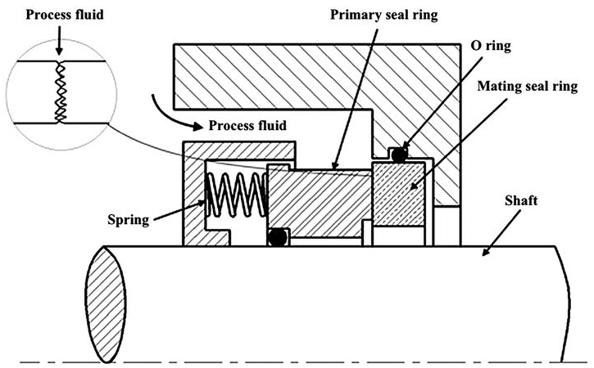
Figure 1.1: Schematic of a typical Mechanical Face Seal showing the main components [3].
Mechanical Face Seals are designed for low leakage, less maintenance and longevity; they can operate under high fluid pressures and high speeds [4]. For this reason, the development of reliable face seals that can meet and surpass industry standards as well as operate in harsh environments has gained traction within manufacturing companies and industry providers. Nevertheless, many different challenges related to understanding the optimal materials used for the seals as well as the best manufacturing processes required to produce components with adequate properties remain to be faced.

1.2 Problem statement
One of the most common causes of failure for face seals is the degradation of the sealing face due to friction [5]. Some of the different wear mechanisms that govern the performance of this type of seal cannot be independently analyzed since they influence each other. Examples of this are changes in temperature and pressure that affect both the properties of the fluid and the interaction between the seal components [6]. Hence, the design of the experimental set up was centered on addressing the requirements set by the sponsor of the project while maintaining the technical and financial limitations in mind. The experimental equipment must be capable of replicating the operating conditions that the components face during operation as well as control and record these conditions. The problem to be addressed in this thesis is the design of a testing system that allows to measure the performance of face seals under different environmental conditions to accelerate the wear of the components.
The components that form the experimental setup were selected based on different requirements related to the performance of the tested seals. While most of the components were available through vendors, some of the components were fabricated specially for the system. To facilitate the design and manufacture process for the experimental set up, project management concepts from industry were introduced. In this way, this research combines academic and industrial approaches to solve the problem. To ease the construction of the experimental set up, the fabrication process was divided in two main phases: project planning and design, and project fabrication and commissioning. The project planning and design was centered around ensuring that the produced equipment was able to recreate the operational conditions faced by the tested seals, while the project fabrication and commissioning was focused on ensuring the repeatability of tests. Thus, the design process was centered around facilitating the testing of seals under a wide range of specified conditions.

1.3 Research objectives
Face seals are a type of mechanical seal in which the sealing interface is located normal to the axis of the seal. These seals are used to prevent leakage in the radial direction of the seal and are typically employed in rotating shafts [6]. Face seals are designed for low leakage, minimum maintenance, and long operational lives; they can operate under high fluid pressures and high speeds. Heat generated by friction on seal ring surfaces is a major factor that causes deterioration of face seals and shortens their life. Excessive temperature rise can greatly alter the seal geometry and vaporize the sealing fluid, resulting in low lubrication conditions at the sealing interface [7]. These effects usually lead to excessive leakage and ultimately render the seal inoperable. Hence, the research objectives are to:
- Design and build an automated experimental set up that can simulate a variety of operational conditions regarding temperature, pressure differential, and rotational speed.
- Implement a modular design that can fit different sized seal geometries according to the specifications set by the project sponsor.
- Test and analyze different mechanical face seals subjected to different testing parameters to compare the effects of different environmental conditions.
- Analyze the wear features produced on the sealing face of different mechanical face seals tested using the developed experimental set up.
The requirements of the design for the experimental apparatus were discussed with the project sponsor during the writing of this thesis. These requirements were based on the typical operation conditions of industrial equipment found in the oil and gas industry. The following is a summary of the required parameters and ranges that the testing set up was required to cover:
- Internal pressure differential across the sealing interface with a range of 10 psi to 150 psi.
- Oil temperature with a range of 70 F to 300 F. This parameter is of crucial importance since it governs the properties of the process fluid and the performance of the seal.
- Constant angular speed with a range of 100 to 5000 rpm to recreate the range of operating conditions specified by the sponsor.
- Maximum applied torque capacity of 50 lb-in to drive the components analyzed.
- Internal oil volume change measurements larger than 0.01 cc to capture small changes in the contained fluid.
- Oil and debris circulation on the exterior of the seal to simulate rough environmental conditions found in the oil and gas industry.
To analyze the performance of the different MFS the experimental set up developed was required to record data of the operational parameters of the seal. Chapter 2 presents a detailed description of the physical variables that affect MFS. The operating conditions that the experimental set up was required to control, monitor, and record can be summarized as the following parameters:
- Torque applied to drive the rotor of the seal: This parameter is tied to the performance of the seal and can be used to compare the seals tested.
- Internal oil temperature: This parameter affects the properties of the working fluid and the interaction between the sealing components.
- Applied pressure differential across the sealing interface: This is closely tied to the performance of the seal and allows for the comparison of the seals tested.
- Contained oil volume within the test assembly: The oil leakage through the seal interface was calculated by measuring changes in the oil contained.
To simulate the normal operation characteristics of face seals, the experimental set up included a test housing containing the face seals to be tested. The test housing has designed and fabricated by a third party in order to accommodate for proprietary technology as well as to recreate complex features and components independent of the geometry of the seal tested but closely tied to its performance. In this sense, the components used to hold the face seal in place, as well as to deliver torque to the component, are guaranteed to recreate the operational characteristics of industry conditions through the introduction of commercially available proprietary technology designed for this application.
Furthermore, since the face seals tested are designed to have a long working life, another requirement for the experimental set up specified by the sponsor was the ability to operate autonomously for continuous periods of up to 300 hours. For this reason, one of the priorities in the design of the set up was the automation of testing and the design of a control panel that allowed for remote monitoring of the experimental set up. This aspect of the design meant the inclusion of electromechanically controlled equipment as well as an array of sensors and a data acquisition system. Chapter 3 presents a detailed description of the hardware selected for the automation of the experimental process, and the control software developed for the testing set up.
Similarly, it is important to understand the wear features caused by the operation of the components. By understanding both the physical and chemical changes in the sealing surface of the components we can gain deeper insight on the effects that each testing parameter has. To facilitate the understanding and comparison of the effects of different parameters, Scanning Electron Microscopy and Advanced Light Microscopy techniques were used to characterize the asperity of the sealing face as well as other wear features and imperfections caused by operation of the seal. This study allows us to directly observe and compare the effects of different parameters over the components tested.

1.4 Overview of approach
The approach for the fabrication of experimental setup was divided in two main parts: the design process and the manufacture process. Figure 1 illustrates the approach employed while developing the testing set up. The objectives and requirements for the project were defined during the design process. Following ideation, the required components were manufactured or sourced from a vendor and a working prototype of the experimental set up was manufactured. Then, the working prototype was tested and evaluated against the established requirements and research objectives. This process followed several iterations to identify and solve problems with the design, until a satisfactory experimental set up for testing MFS was developed.
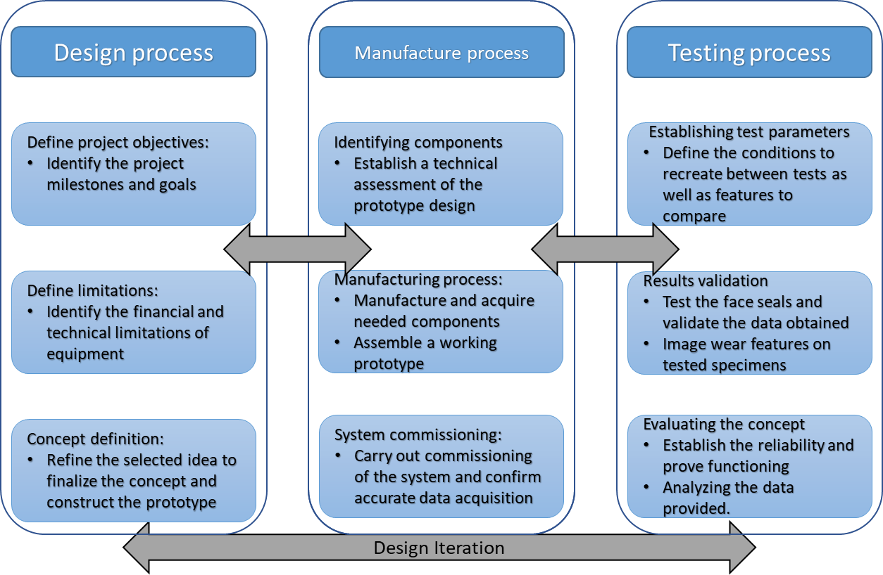
Figure 1.2: Overview of the design approach utilized during this thesis.

1.5 Thesis outline
Chapter 1 introduced the importance of face seals and provides background and motivation for the research conducted in the thesis. This chapter also specifies the research question and objectives.
Chapter 2 introduced relevant theory through a detailed literature review about the different mechanisms that govern the functioning of face seals. This chapter also includes an overview of the materials and manufacturing processes used in industry for the fabrication of face seals.
Chapter 3 described the design process for the experimental set up. The design process was divided in a number of steps in order to make the project manageable and keep track of the progress made. Each part of the design process is described in a sequential manner, beginning from the ideation and development of the concept selected for the experimental set up, and culminating with the assembly and testing of the experimental set up used.
Chapter 4 described the process of determining the testing parameters and procedures used to answer the research question. This section states and explains the reasoning behind the selection of the experimental conditions under which the face seals were tested.
Chapter 5 Focused on the testing approach and procedure used to compare the different face seals. In this section, the choices made for the design of the experimental set up are justified and explained. In this way, this section showcases the reliability of the experimental set up while also providing insight to the experimental procedures used.
Chapter 6 is focused on the comparison of the observed wear features for the different seals tested. In this section, Scanning Electron Microscopy images of the face seals before and after the experiments are presented. The micro photography of the sealing surface reveals changes to the structure of the sealing face and provides insight on the wear mechanisms that limit the useful life of face seals.
Chapter 7 presented the conclusions gathered from the research efforts and provides a summary of the experimental results obtained. This chapter also presents an overview of the challenges and limitations faced during the research project as well as recommendations for future studies.

Chapter 2: Background on MFS

2.1 Introduction
Mechanical face seals are classified as a type of dynamic seal, meaning that their main function is to separate or isolate two chambers filled with liquid mixed with particles placed under a pressure differential with components in movement [1]. Before delving into the specific aspects of face seals related to this research, it is important to have a clear understanding of the industrial applications of face seals as well as the conditions under which this type of seal operates. This chapter presents a description of the operation of mechanical face seals as well as a review of the different types of face seals materials and their application in industry.

2.2 Overview of face seals
Mechanical face seals are typically used to contain fluids in rotating components. This type of seals is commonly composed of two concentric rings spinning with relation to each other, one fixed to a stationary support and one driven by a rotating shaft. These rings are then held in contact using springs or other mechanisms to apply a constant closing force as shown in figure 2.1 [3]. The loading applied to close both parts of the seal must be large enough to overcome frictional forces without applying excessive pressure that could affect the longevity of the components [7]. The sealing interface for this kind of seal is the narrow ring where the two faces contact each other.
Figure2.1: Schematic of a typical Mechanical Face Seal showing the main components [3].

2.3 Industrial applications of face seals in oil and gas
Mechanical Face Seals are typically used in applications where minimum leakage of the contained fluid is one of the most important criterions along with the ability to tolerate rough environments and prevent the ingress of contaminant particles into the system [6]. These advantages make MFS common components in all kinds of machinery, from washing machines to industrial equipment. Examples of these industrial applications are sealing rotating shafts in pumping systems used for the transport of liquid, boring machinery, used to drill tunnels and service shafts in the mining industry, and sealing shafts and hubs in heavy machinery and industrial equipment [11].
Mechanical face seals excel in applications related to the transport of liquids as they can create a barrier to separate media using components in relative rotation with each other. This characteristic of the design makes them especially useful as it allows for the separation of fluids from mechanical and electrical components such as pumps and motors. In the case of boring machinery one of the most important aspects of the design of the seals used is the ability to prevent abrasive debris and particles expected to be present in the normal operation of the components from entering the system.

2.4 Materials used in Mechanical face seals
The materials from which mechanical face seals are fabricated are of critical importance since they must be able to withstand the previously defined environmental conditions. One of the main characteristics of the materials selected are the need for high tensile and compressive strength. During operation, face seals are subjected to compression in the form of a mechanical closing force and to tension due to the pressure contained in the interior of the seal. Furthermore, it is important that the material selected for the seal has good dimensional stability and hence a high stiffness modulus in order to maintain its initial shape. This is because deformation of the sealing face would result in poor performance as the sealing interface would develop irregularities and gaps that would limit the sealing ability of the component [12]. Lastly, the material selected must have the appropriate tribological properties to withstand the effects of friction over long periods of time. Due to the conditions of high temperature and the need to withstand mechanical and chemical wear ceramics have become some of the most prominent materials in the fabrication of mechanical seals [7]. Typical ceramics used in the fabrication of face seals include alumina or silicon carbide. These materials are notable due to their relatively high yield strength and elasticity modulus as well as low density and high thermal conductivity.
In this case the denomination ‘typical’ refers to carbide ceramics that contain traces of silica as binder materials. These materials have relatively low densities and high thermal conductivity. In contrast, atypical ceramics are composed of graphite and binder agents such as metal alloys or hydrocarbon resins [4]. One of the main differences between both classifications is the porosity of the material, which in turns affects its resistance to corrosion.
Aluminum oxide (Al₂O₃) is a typically used material in the fabrication of face seals. This is a poly-crystalline material with variable purity and a grain size of 1-5µm intersected by a glass phase [4]. For this reason, the properties of alumina-based seals can vary greatly between samples. Similarly, silicon carbide (Si-C) based seals are composed of grains with a size ranging from 2-80µm. The relatively large size of the grains, and the different phases in which carbon can be present causes variance in the properties of the material. For this reason, two main types of silicon carbide can be defined: Sintered Si-C seals with traces smaller than 2% of binder material; reaction bonded Si-C and graphite seals infiltrated with silicone [12]. As shown in figure 2.3 [4], sintered Si-C has closely bonded grains that create a strong matrix. In contrast, the grains in reaction bonded Si-C are separated by silica, giving it favorable tribological properties such as thermal conductivity at the expense of chemical resistance.
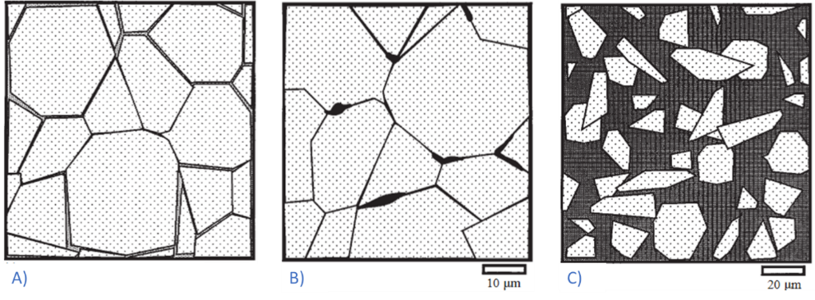
Figure 2.2: Schematic of the microstructure of different Silicone Carbide based materials used for Mechanical face seals. A) Alumina based sintered B) Sintered silicon carbide C) Reaction bonded silicon carbide.
On the other hand, atypical ceramics are made of carbon-graphite and are considered as such due to the high contents of resin or metallic impregnant used to decrease the overall porosity. Nevertheless, this high concentration of binding agent means lower resistance to the effects of temperature and corrosion [6]. These seals are fabricated with a variety of binding materials such as phenolic resin, antimony, and non-toxic polyester for food processing applications [13]. In this way, this type of mechanical seal can be adapted to a variety of applications and environmental conditions.
This thesis will be focused on the analysis of Silicon Carbide MFS used in the oil and gas industry and provided by the project sponsor. The seals analyzed in this research are direct sintered silicon carbide shown in figure 2.2. These seals were designed for operation under rough environmental conditions such as high temperature and contaminant presence, to be highly resistant to degradation due to chemical corrosion, as well as high resistance to degradation and erosion of the sealing face due to the effects of friction.

2.5 Hydrodynamic lubrication regimes
Hydrodynamic and hydrostatic pressure act against the closing force and push the fluid along the pressure differential through the sealing interface. Generally, the working fluid for mechanical seals is oil since it is suitable at providing the necessary lubrication and cooling required for optimum operation. The contained fluid then forms a thin film between the seal faces which acts both as a sealing barrier and a lubricating agent between the seal faces [2]. The development of this lubricating film is crucial to the performance and longevity of mechanical face seals [6]. The thickness of the lubricating film depends on the magnitude of the difference between the closing load and the forces acting against it and can be used to define three main lubrication regimes as shown in Figure 2.3 [6].
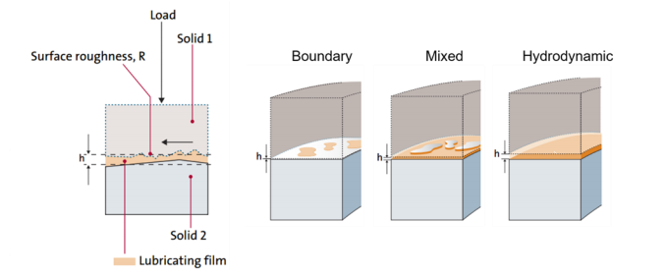
Figure 2.3: Lubrication regimes as defined for mechanical face seals [6].
- Boundary Lubrication: The fluid is not able to form a film at the seal interface since the hydrostatic and hydrodynamic pressure are not able to overcome the closing force between the stator and rotor parts of the seal. Direct contact between the seal faces occurs causing little to no fluid leakage with high friction and damage across the seal faces [5]. While minimum leakage occurs in this lubrication regime, damage to the sealing surface decreases the useful life of the seal.
- Hydrodynamic Lubrication: The pressure developed inside the seal faces overcomes the closing force and separates the seal components. The fluid transmits the entire load and the asperities on the seal faces do not contact each other [5]. This causes substantial leakage with little to no friction and wear across the seal faces.
Figure SEQ Figure \* ARABIC 2: Lubrication regimes for two seal faces under a closing load [1].
Figure SEQ Figure \* ARABIC 3: Stribeck curve establishing the dependency of the coefficient of friction on operating parameter [1].
- Mixed Lubrication: The load is distributed between the lubricating film and the seal face asperities. The magnitude of the pressure differential is enough to force the movement of liquid into the seal interface without overpowering the closing force. Under this condition a moderate amount of fluid leakage, friction, and damage across the sealing faces is expected.
In the case of industrial applications, the mixed lubrication regime is the most interesting to study since it provides a good balance between fluid leakage and mechanical friction on the face of the seal. For this reason, the studies and experiments carried
Performance metrics of the lubrication regime depends on multiple parameters referring to the spring, shaft, fluid characteristics, rotational velocity, etc. [1]. The development of a mathematical model for predicting the regime boundaries is complicated by the dependence on operating parameters. To simplify dependency, a general parameter of lubrication, G, is implemented as [8]:
$G=\frac{ηv∆r}{F_{N}}$
where η is the viscosity, v is the rotational velocity, ∆r is the change of width, and $F_{N}$ is the axial load [8]. The calculated friction coefficient at the seal contact can be plotted in a Stribeck diagram as a function of the operational conditions, which is depicted in the Stribeck curve shown in Figure 2.4 [14]. From this figure we can observe that the frictional coefficient of the sealing interface depends on the defined lubrication parameter and does not follow a linear relation. Furthermore, the lubrication parameter is a combination of different variables describing the lubricating fluid and the operational conditions of the MFS.
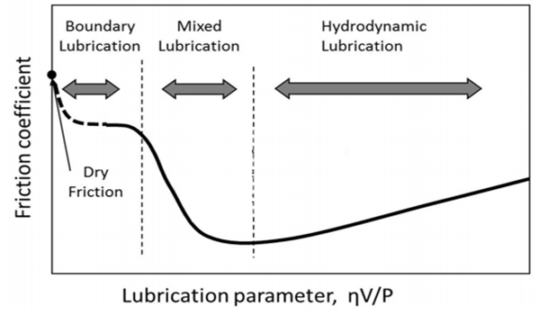
Figure 2.4: Stribeck curve showing the relation between the friction coefficient and the lubrication parameter for mechanical face seals [14].

2.6 Friction and wear
The torque applied to the mechanism is closely related to the friction forces at the seal interface and hence to the performance of the component. To ensure the containment of the fluid as well as a long operational lifetime it is important to find a balance between the sealing efficiency and the frictional forces. For this reason, most of the mechanical face seals used in industrial applications operate within the Mixed Lubrication regime. Multiple studies such as the work by Lubinge [6] have been performed to create a model that allows us to characterize the transition from the hydrodynamic lubrication regime to the mixed lubrication regime. In this model, the frictional forces between are distinguished for the different phases. In the hydrodynamic regime the force dominating is the shear stress in the lubricant between the seal faces. In this case, the shear forces are low, and the behavior of the fluid can be assumed to be Newtonian, hence the shear stress can represent with the following equation:
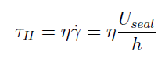 (1)
Where $η$ is the dynamic viscosity and $\dot{γ}$ is the shear rate, $U_{seal}= ωr$ , and$h$ is the film thickness [6]. Similarly, Lubinge [6] describes the friction force as
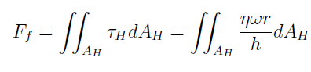 (2)
Where $A_{H}$ represents the contact area of the seal pair.
Likewise, the frictional force in the boundary lubrication regime is determined by the shear strength of the material of the sealing face of the component, as described by equation X, where N refers to the number of asperities in contact, defined as $A_{c}$, and $τ_{Ci}$ represents the shear strength of the individual asperities.
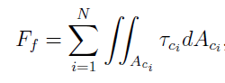 (3)
By superimposing equations (2) and (3) we can obtain an expression for the frictional forces in the case of the mixed lubrication regime, as shown in equation (4). This model accounts for the combined effects of the shear force of the lubricant at the sealing interface, as well as the shear strength of the seal material.
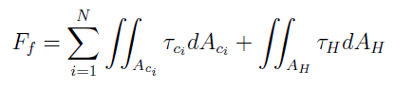 (4)
From the development of these mathematical relations we can observe the interdependence of different physical variables that affect the performance of mechanical face seals. A clear example of this dependence is shown in the relation between the shear forces and the temperature, and hence viscosity of the working fluid. For this reason, one of the main objectives in this thesis was the control and measurement of the physical variables governing the performance of MFS such as torque applied, process temperature, and pressure differential on the seal interface.

2.7 Chapter summary
Given that one of the main objectives of this research is to design and fabricate an experimental set up to evaluate and compare the performance of mechanical face seals under different conditions, it is important to understand the functioning of the seals in question as well as the mechanisms that govern their failure. Understanding the industrial applications of face seals, as well as the variety of conditions to which they are subjected, allows to gain useful insight for the design of the testing set up. The reviewed literature provides information about the operational conditions of face seals.
In this way, chapter 2 presents an overview of the different parameters that govern the performance of mechanical face seals. These parameters include the lubrication mechanisms that allow the seal to work.

Chapter 3: Design process

3.1 Introduction
Industrial projects usually involve different systems and sub-systems that are generally complex and involve multiple steps to produce useful results. To facilitate the management of these projects and ensure the completion of the objectives the design process is divided in different stages. Figure 3.1 shows a schematic of the approach used in the design process of the experimental set up. This design is a joint effort between different teams to create a working experimental set up to simulate real world operation conditions of face seals. The design process was divided on four stages that followed an iterative cycle. The definition of the project objective and goals was the first step in the process. Once the requirements were set and prioritized, the design concept was developed and refined into an embodiment design. From this figure we can observe that the design and fabrication of the experimental set up were part an iterative process in which the design was constantly evaluated to ensure that it met the defined project goals. This chapter includes an overview of the required goals and milestones completed during each phase of the design process of the testing system for mechanical face seals.
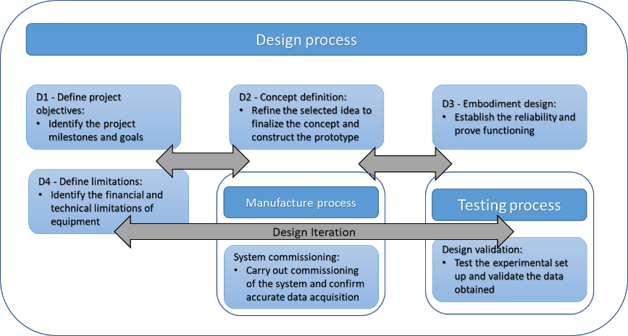
Figure 3.1: Schematic of the approach used during the design of the experimental set up.

This approach allowed to define the different functions that the testing set up was expected to perform while ensuring the technical feasibility of the solutions proposed, as well as their integrability as part of a robust testing system to evaluate and compare the performance of mechanical face seals.

3.2 D1 – Define project objectives
The most necessary aspect to initiate a project is to establish the objective and goals that give the need for the research question. For this project, the principal requirements were defined in function of the parameters that govern the operation of mechanical face seals. Therefore, the goal of this research was to design and construct an experimental set up for the testing of mechanical face seals and the measurement and recording of operational parameters. Figure 3.2 shows a schematic of the requirements defined for the project. The initial requirements can be classified as input variables and output variables. The input variables refer to the parameters that control the operation of the seal. To ensure an accurate representation of working conditions, the experimental set up must be able to control the velocity of the rotating ring, the closing force between the seal faces, and the pressure differential across the seal interface. Similarly, output variables refer to the measurements of pressure, torque, temperature, and fluid leakage that must be recorded to characterize the performance of the tested seals. Lastly, the testing set up designed must accommodate for the geometry of a test housing designed and provided by a third party. The purpose of this test housing is to hold the tested face seals in conditions that most closely resemble the operation of the industrial machinery in which the tested seals are typically used. By using a housing provided by a third party we are able to ensure that all the mechanical features, tolerances, and proprietary technology used in the real world are closely reproduced.
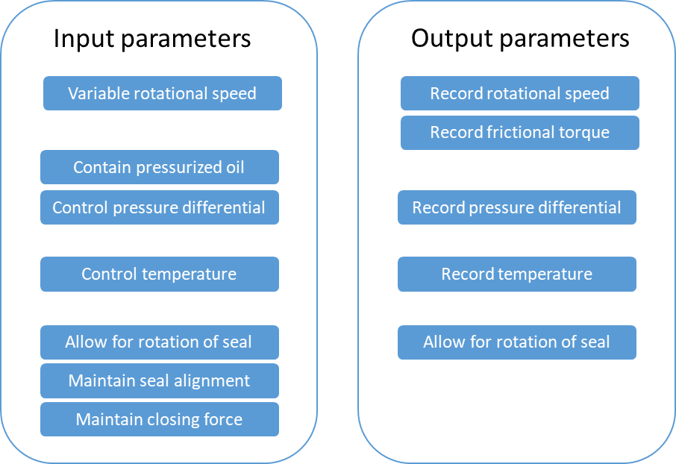
Figure 3.2: Requirements list derived from the operational parameters of MFS.

3.3 D2 – Concept definition
Once the basic requirements were established, it was possible to identify critical aspects and characteristics of the design for the testing et up. Since the key aspects of the experimental set up were determined in function of the parameters governing the operation of the mechanical seals, the different components must be able to satisfy performance requirements to capture data with the desired level of accuracy. Figure 3.3 shows a block diagram of the principal elements that compose the main structure of the testing apparatus. The contained subsystems in the experimental set up can be divided as follows: a motor mechanism used to drive the seal; a heating system, a pressure and leakage measurement system, and a system for circulating oil on the exterior of the seal, and a digital control platform for automatization and data recording. This diagram is useful as it allows us to identify the main components and functions that the set up will accomplish. This information was used to select the components of each sub system as well as to integrate them as part of a system.
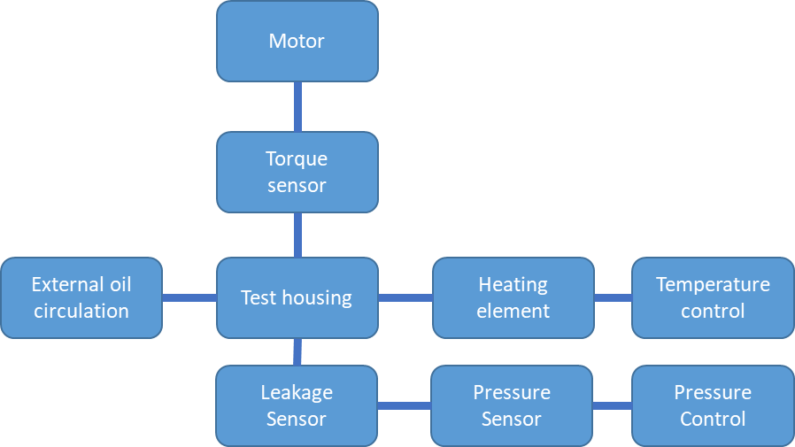
Figure 3.3: Block diagram showing main components of the testing set up.
The elements presented in the block diagram address specific functions that correspond to the requirements list shown in figure 3.2. These functions can be described as follows:
- Motor: Required to drive the seal assembly and create the operating conditions of the MFS tested. Similarly, the selected motor must provide variable rotational speed.
- Torque sensor: Used to record operational data of MFS and evaluate their performance. Also used to provide control and safety measures in the testing set up.
- Test housing: Provided by the project sponsor and used to hold the seals during operation. The designed test housing makes use of proprietary to replicate the operation conditions of MFS in the oil and gas industry.
- Heating elements: Necessary to replicate temperature conditions encountered by the components in field operation. The selected heating elements must allow for a range of testing temperatures that allow for the evaluation of MFS at different conditions.
- Temperature control: The experimental set up must allow for precise control of the operating temperature of the MFS tested. Furthermore, the set up must provide safety measures for the heating elements.
- Pressure control: The experimental set must allow for precise control of the pressure differential across the sealing interface.
- Pressure sensor: Used to record the operation conditions of the MFS during the testing process.
- Leakage sensor: Used to record and analyze the performance of the seals tested. The sensor selected must be able to register small changes in volume according to the characteristics of the seals tested.
- External oil circulation: The experiment must be able to recreate field conditions and introduce contaminants to the exterior of the seal. This feature allowed for a better reproduction of real-world conditions within the experiments.
From the block diagram we can appreciate that the test housing acts as a common point for the different sub-systems included in the design for the experimental set up. This characteristic of the design is crucial since it gives insight to the diverse parameters that control the performance of mechanical face seals while highlighting the need of integration for the separate sub-systems that conform the testing set up.

3.4 D3 – Embodiment design
Different sub-systems were defined using the initial requirements list and the block diagram created during the conceptual part of the design process. The sub-sections of the experimental system that were identified are: a motor mechanism used to drive the seal; a heating system, a pressure and leakage system, and a system for circulating oil on the exterior of the seal. These sub-assemblies were designed to accomplish very different functions and thus present different challenges. The following section explains the function of each sub-system and defines the performance requirements of each component. Table 3.1 shows a categorized requirements matrix developed using the block diagram shown in figure 3.2 as well as the requirements defined during the concept refinement phase of the design process and shown in figure 3.1. This list is divided in the different sub-systems previously discussed and presents a breakdown of the components used for each.
Table 3.1: Requirements matrix for the experimental set up.
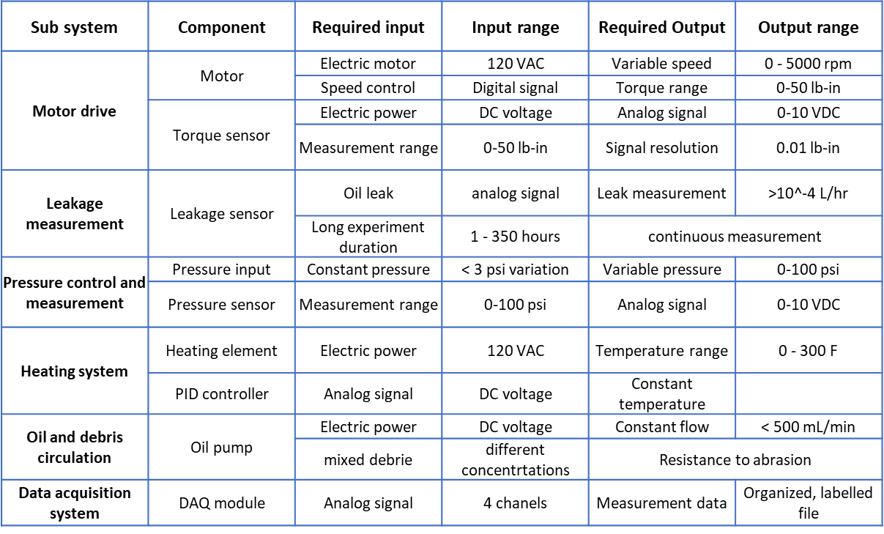
The requirements matrix will be useful for the rest of the design process and during the fabrication process. Example of this are the range values included for different components, these values were useful during the component selection. The information contained in the requirements lists reflects the project goals to be accomplished and thus it is helpful while evaluating the performance of the different sub-system.

3.4.1 Motor drive
One of the main characteristics of mechanical face seals is their ability to contain fluid within rotating components. Furthermore, the performance of the component is strongly related to the rotational speed as well as the fictional torque between the seal faces. For this reason, one of the most important functions of the testing set up is to be able to rotate part of the seal at a constant, controllable speed. A variable speed electric motor would be ideal to produce the necessary rotational speed in a constant and controllable manner. The motor used must be able to replicate the operational conditions encountered by the face seals that will be tested using the experimental set up. The following list illustrates the performance requirements that the selected electric motor must be able to satisfy
- Maximum rotational speed of 5,000 RPM
- Maximum output torque of 50 lb-in
- Variable speed
In addition to driving the rotation of the seal, the experimental system must also be able to measure and record the torque applied to assembly. This data would then be used to characterize the performance of the face seals and analyze the effect of variations in different operational parameters.

3.4.2 Leakage measurement
Another main parameter that defines the performance of sealing components is the amount of leaked fluid as a function of operational time. While designing a system to measure the fluid leakage of mechanical face seals it is important to have in consideration that very low leak rates are expected from the component. A requirement for the design of the testing system is a high signal resolution to measure minute changes in the contained volume in the order of ${10}^{-4} L/hr$. This parameter was discussed with the sponsor and determined based on the characteristics of the MFS selected for testing as part of this thesis. The need for such a small resolution in this measurement arises in response of the small leakage expected to occur during the tested process. This means that the system designed must integrate a solution that allows for measurement of relatively small fluid flows without interfering with the sealing mechanism. This sensor must also allow for continuous measurements in order to ensure that all relevant changes are measured and recorded.

3.4.3 Pressure measurement and control
In a similar way, the experimental set up is required to integrate a system that allows for the control and measurement of the pressure differential across the seal interface. This area of the testing system is crucial since the operating pressure of mechanical face seals is one of the main parameters governing their operation. Internal pressure is related to the closing force between the sela faces, and the distortion of the seal geometry [7]. For the design of the testing system, a working range of 0-100 psi is required as this will allow to test different conditions found in industrial applications of the face seals to be tested.

3.4.4 Heating system
Among the requirements of the testing set up is the ability to control and measure the operating temperature of the seal. This parameter is of high importance as it affects both the properties of the contained lubricating fluid and the behavior of the mechanical seal. Furthermore, the industry conditions encountered by mechanical seals encompass high temperatures. For these reasons, a system to control and monitor the operating temperature of the testing assembly was included in the experimental set up.
The heating system must be able to accommodate for a comprehensible range of temperatures without interfering with the sealing mechanism. Since the aim of the experimental set up is to test mechanical face seal sunder typical industrial operating conditions, a working range of 70-300 °F was chosen.

3.4.5 Oil and debris circulation
In parallel, an important aspect of field conditions for most sealing components is the presence of contaminating particles. These particles can cause premature failure of the components due to wear and tear caused by abrasion. To simulate these conditions, the experimental set up included an independent hydraulic flow loop to circulate oil with a prescribed concentration of abrasive particles mixed in it.
Different selections of particle material, size, and concentration within the carrying fluid would then allow the experimental set up to simulate different conditions real to what the seal would be expected to face during operation. This system must be able to move a relatively low flow across the low-pressure side of the seal interface. Similarly, the addition of this sub-system must not interfere with the sealing mechanism and must be independent of the high-pressure side of the system.

3.4.6 Control and data acquisition system
Lastly, the experimental set up requires the ability to read and record the data related to each of the previously described operational parameters. For this reason, a Data Acquisition System is a crucial part of the testing set up as it allows to capture relevant data to evaluate and compare the performance of the tested mechanical face seals. This data acquisition system must also serve as the main control panel of the experimental set up, allowing the different sub-systems to be integrated and work in synchrony. Hence the control and data acquisition system must have the following characteristics
- Allow for the control of the different sub-systems of the experimental set up.
- Allow for the measurement of the different data channels from the sub systems.
- Record data of the relevant parameters and create a usable file that allows for data analysis in an efficient way.
Through the refinement of the initial concept, we were able to identify crucial aspects that the final design must contain to be considered successful. These requirements are based on the need to simulate a range of operating conditions representative of industrial applications of mechanical face seals and were decided in collaboration with the different stakeholders involved in the development of the project

3.5 Chapter summary
Chapter 3 presents an overview of the design process of the experimental apparatus for the testing of mechanical face seals. In this chapter we review the project goals and the research question to be answered through this research. This is to design and construct a testing set up that can simulate a range of operating conditions for mechanical face seals based on real world industry conditions. Then, an initial concept of the design was created using information from the stakeholders involved in the project, as well as theoretical background on the working of mechanical face seals. This initial concept served as a template to define the different sub-systems to be integrated as part of the experimental set up. Each of these concept areas was then refined based in collaboration with a third party that provided guidelines about industry conditions and standards to define concrete requirements and operational ranges for the components of the set up. These numerical values and defined characteristics were organized in a requirements list that served as a basis to guide and evaluate the fabrication process of the experimental set up. In this way, chapter 3 presents a summary of the ideation process that drove the selection of components and fabrication of the testing apparatus for mechanical face seals.

Chapter 4: Manufacture process.

4.1 Introduction
The fabrication process of the of the experimental set up is presented in this chapter. It is important to note that the construction of this set up represents a joint effort between different capstone and research teams. Figure 4.1 shows a schematic of the experimental set up as built.
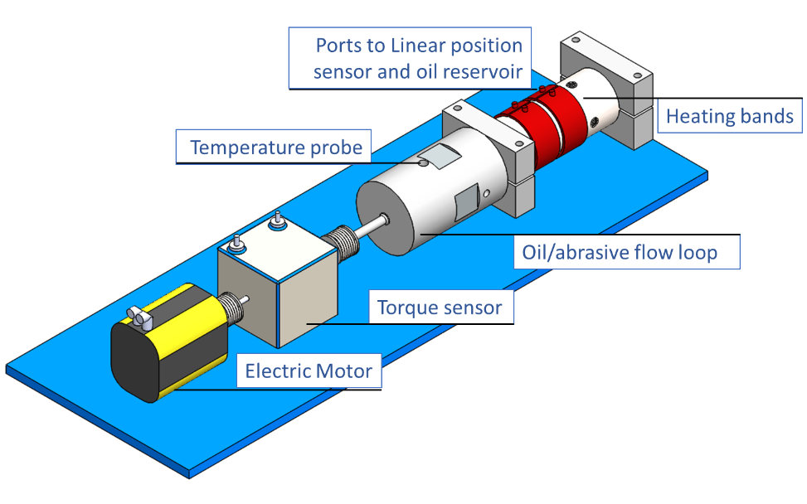
Figure 4.1: Solid model of the experimental set up showing the different components used.
The experimental set up consists of different sub-systems that perform specific functions. This chapter presents a detailed description of the components of each sub system.

4.2 Test housing
The experimental set up was aimed to emulate the operating conditions of the silicon carbide face seal regarding temperature, fluid pressure, and seal alignment. The testing apparatus was designed to fit a cylindrical test housing designed and provided by a third-party stakeholder in the project. In this way, the experimental set up aims to closely replicate the real-world conditions encountered by the mechanical face seals tested. The main function of this test housing is to hold both parts of the face seal while providing a constant closing force between them and allowing the creation of a pressure differential on the sealing surface. One of the main requirements for this test cylinder is to be installed in a vertical orientation during testing. Figure 4.2 shows a schematic of the test housing.
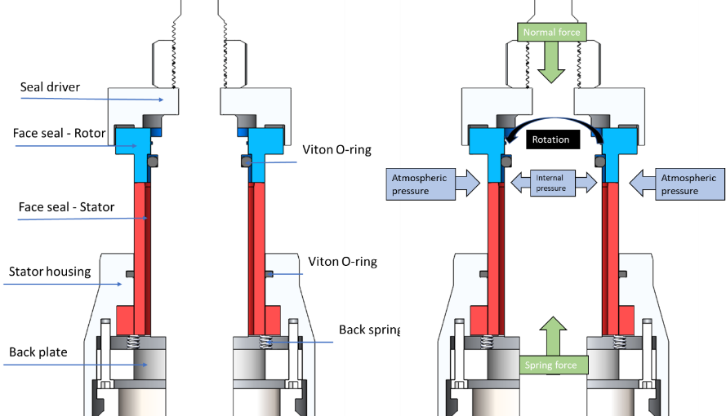
Figure 4.2: Schematic of the assembly for face seal testing. The stator (red) is held in place while the rotor (blue) is free to move.
This assembly consists of two self-mating silicon carbide rings contained in a pressurized chamber. The test assembly holds the bottom part of the seal stationary while allowing the top half to rotate along with the shaft. A set of six springs apply a vertical force on the stator to create contact pressure between the faces of the mechanical seal. This feature of the design is crucial as it provides a constant closing force across the multiple experiments performed. The test assembly was then connected to the drive system using a flexible coupling to compensate for possible misalignment.
To ensure consistency between experiments and the replication of operating conditions for MFS an assembly procedure was devised and followed for all experiments. The drive shaft was positioned inside the cylinder as shown in figure 4.3a. This shaft was centered using a stack of thrust bearings. Then, the stator sub assembly that contained the stator half of the seal, a set of springs to provide closing force, and a back plate bolted to a steel cap, as shown in figure 4.3b.
A)  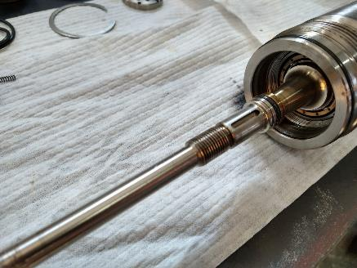 | B)  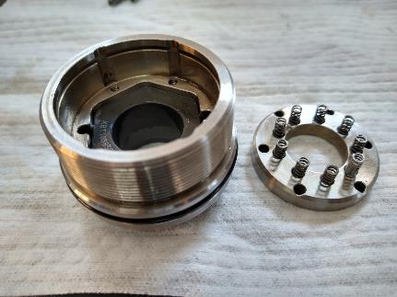
Figure 4.3: Test housing assembly used for the experimental set up. A) Drive shaft inside the testing cylinder. B) Stator subassembly showing back springs used to provide the closing force on the seal.

The rotor was then slid over the shaft along with a seal driver. These components secured in place using a set of locking rings and locking nuts as shown in figure 4.4. Finally, a cap with 2 ports to contain the face seal and oil was screwed on.
A)  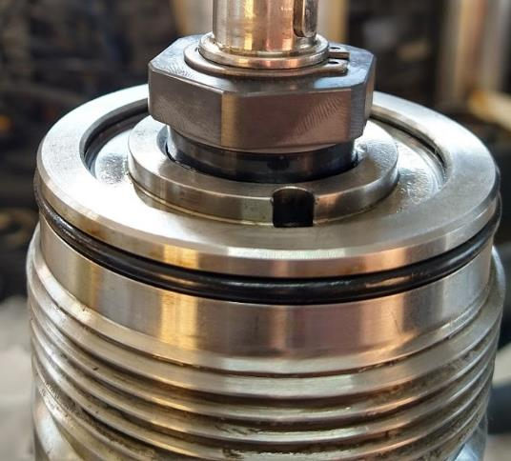 | B)  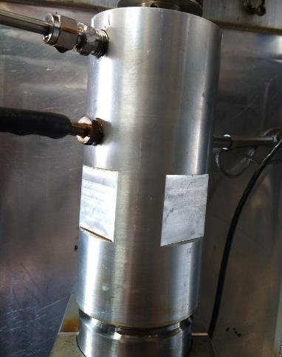
Figure 4.4: Assembled MFS and test housing for experimental set up. A) The rotor was slid over the shaft and secured against the stator ring. B) A closing cap with hydraulic ports was closed the housing.

4.3 Driving sub-system
The wear rate, along with the leak rate of the face seals is greatly influenced by the rotational speed at which it operates. In contacting face seals, where the contact area is in the mixed lubrication regime, an increased rotational speed would result in greater wear. However, in the case of non-contacting seals, where the mechanism is hydrodynamically lubricated, a lower speed would increase the leak rate. This means that the type of electric motor chosen must be able to run continuously for extended periods of time at a constant velocity, as well have the option of adjusting the rotational speed during operation. For this reason, the motor chosen was a 1.00 KW, model AKM41H servo motor manufactured by Kellmorgen Motors. The motor has a maximum rating of 6000 RPM at 24.5 Nm. Furthermore, the servomotor selected has a programmable resolver that allows precise control of speed and direction. These parameters cover the range specified in the requirements and is readily compatible with multiple data acquisition and control systems, thus facilitating the integration process as part of a consolidated experimental set up. Table 4.1 shows other relevant specifications of the motor which were also considered when selecting the component.
Table 4.1: Motor specifications
Parameter | Value
Operational torque | 24.5 Nm
Maximum torque | 76.3
Maximum rated RPM | 6,000 RPM
Maximum continuous power | 1.0 KW

After selecting the motor, a torque sensor was selected to monitor the torque applied to the seal interface. The selected torque sensor required to be integrated with the electric motor through a mechanical shaft and control software. The sensor selected was a Himmelstein MCRT Model 48201. This torque sensor is rated for 8000 RPM and 2.5 Nm, also covering the requirements previously stated. This sensor was selected as it features a straight shaft through its body. This would allow for simple installation, coupling and alignment with the electric motor and the test housing. Table 4.2 presents a summary of the relevant specifications of the selected torque sensor.

Table 4.2: Torque sensor specifications
Parameter | Value
Operational torque | 24.5 Nm
Maximum torque | 76.3
Maximum rated RPM | 6,000 RPM
Maximum continuous power | 1.0 KW

Lastly, mechanical couplings were required to join the components and allow power transmission to the rotor half of the face seal. The couplings were selected based on the peak torque produced by the system. Flexible couplings rated for 17.5 Nm provided by Sevometer were selected with simplicity in mind as they would compensate for any misalignment between the components. Table 4.3 presents a summary of the relevant information of the couplings selected for the power drive sub-assembly of the experimental set up.
Table 4.3: Selected mechanical couplings for the drive assembly.
Components | Coupling model
Motor-Sensor | ST-200-0.625 x 0.750
Sensor-Test housing | ST-200-0.394 x 0.625

The selected component was assembled on top of a machined steel plate as shown in figure 4.5. A set of bores were machined on the steel plate to ensure the alignment of the components and facilitate the assembly process. This assembly was then fitted on the test bench and integrated with sensors and hydraulic system.
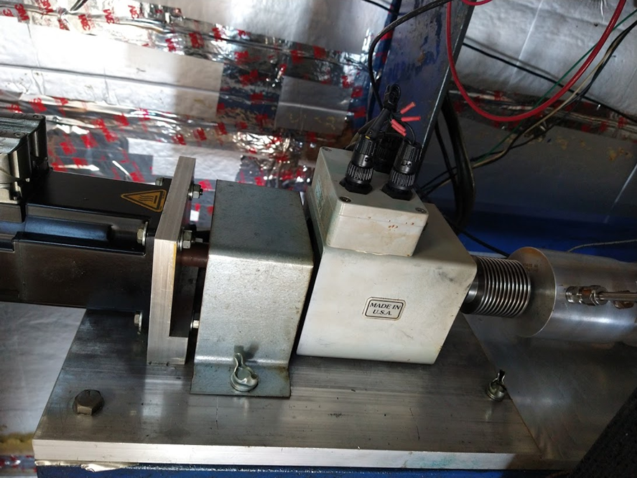
Figure 4.5: Driving subsystem installed on a machined baseplate to ensure alignment.

4.4 Volume measurement subassembly
Aside from the testing cylinder and the mechanical drive of the face seal, the testing apparatus required to hold pressurized oil as well as a system to measure the oil leak across the seal interface. One of the main factors in measuring the volume of oil leaked were the expected low leak rates for the tested seals. These expected leak rates were too low to be measured directly as flow. For this reason, it was chosen to construct an oil supply for the seals with the ability to measure and control the volume of oil contained. By measuring the contained volume through the duration of the experiment it is possible to obtain an accurate measurement of the volume leaked and the leak rate across the seal interface. Furthermore, the oil reservoir constructed for the test housing must be able to hold pressurized oil. To accomplish both functions, a linear position sensor was incorporated into a pressure vessel. Figure 4.6 shows a schematic of the pressure accumulator constructed for the experimental set up. One side of the vessel contained oil and was connected to the test housing while the other side was connected to a nitrogen tank at a constant pressure. Changes in the volume of oil contained by the face seal result in displacement of the position sensor. This information was collected by the data acquisition system and used to calculate the volume of oil leaked through the face seal over time.
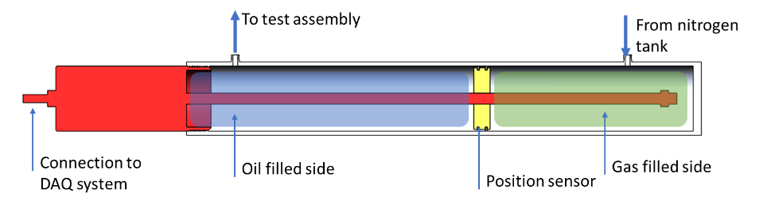
Figure 4.6: Linear position sensor used in the test set up. The sensor used allows pressure to be transferred from a nitrogen bottle to the test assembly. Changes in volume are calculated from the displacement of the position sensor.
The volume measurement sub assembly was connected to a pressurized nitrogen as this offers a simple way to provide a constant pressure to the system that can be easily adjusted for different experiments. Figure 4.7 shows a connection schematic of the volume measurement sub assembly. This arrangement offered multiple advantages for studying the performance of mechanical face seals such as constant oil volume and leak measurement, high resolution, and the ability to maintain the sensor independent from the test housing. In this way, the solution implemented allows for the use of different housing geometries
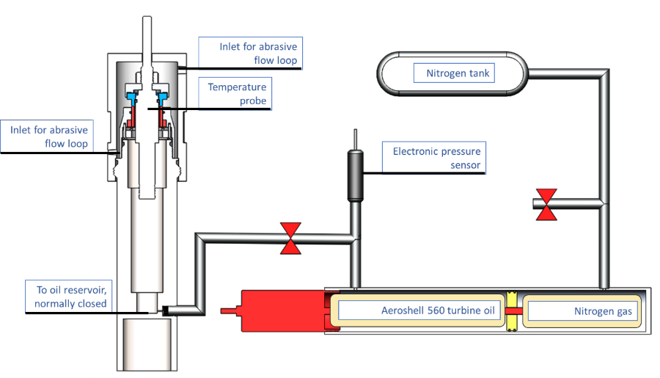
Figure 4.7: Hydropneumatics system used for the experimental set up. A linear position sensor encased in an airtight chamber is used to separate nitrogen gas and the selected working oil. Changes in oil volume are measured by the sensor and used to calculate oil leak and leak rate.

In this way, the volume measurement sub-system of the experimental set up offers an innovative way of applying a constant pressure and measure minuscule changes in the volume of fluid contained over relatively long periods of time. Furthermore, this device provides a simple process to replicate pressure conditions for repeated experiments.

4.5 Vacuum filling system
In order to ensure that the test cylinder and the measurement assembly were completely filled with oil, a vacuum filling system was used to prepare the experimental set up for each experiment. The use of a vacuum pump and a vacuum tank as shown in figure 4.8, allows to extract all the air from the system and drive hydraulic fluid through the assembly. The vacuum pump was connected to a tank fitted with a vacuum gauge. This tank created a separation between the system and the pump to prevent the movement of oil through the pump.
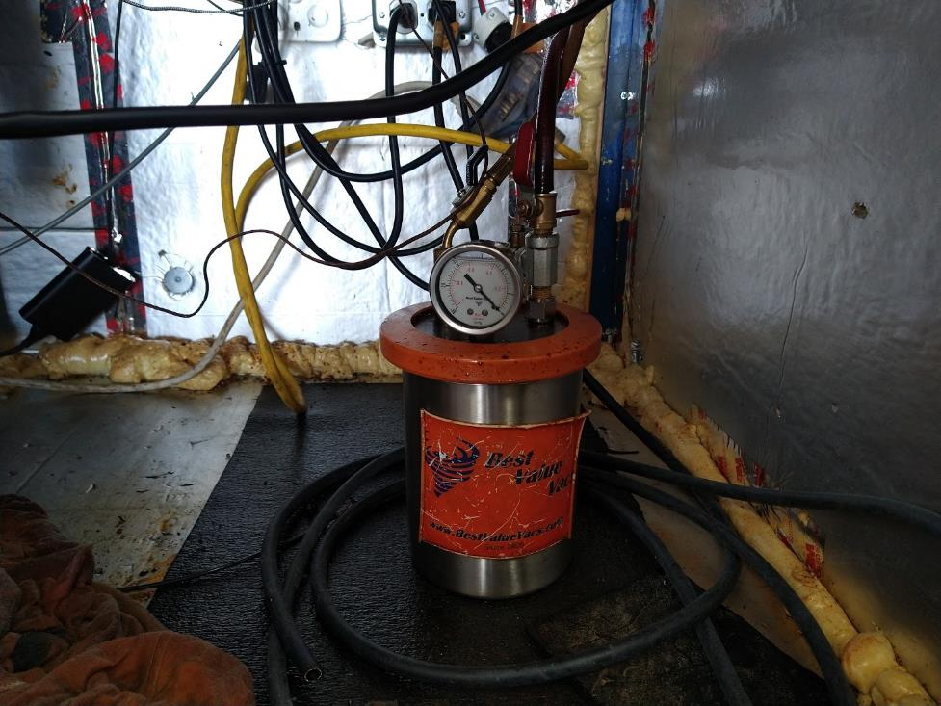
Figure 4.8: Vacuum tank as installed in the system. The vacuum tank prevents the ingress of oil into the vacuum pump and the generation of oil mist.
The vacuum tank was then connected a port on the volume measurement sensor, where a set of valves was used to direct the flow oil through the sensor. Figure 4.9 shows a schematic of the hydraulic connections for the system.

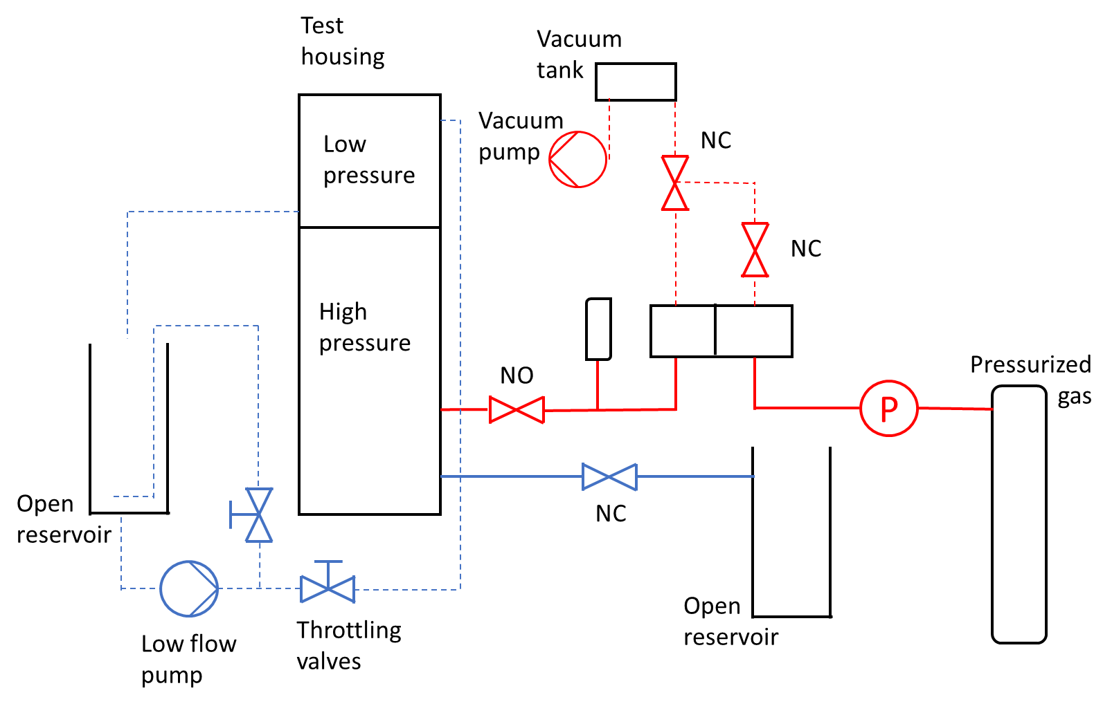
Figure 4.9: Hydro-pneumatic diagram of the system. The vacuum pump is used to draw oil through the system and ensure all air is evacuated.

A vacuum filling process was created for the system to ensure that the operating conditions were recreated through the experiments carried out. The vacuum filling process started by ensuring that the lid of the vacuum tank was properly seated, and all the valves were in the correct position. Then the following steps were followed:
- The vacuum pump was started, and the directing valve was used to evacuate the air from the sensor.
- The directing valve was then changed, and the pump was used to circulate oil from the reservoir through the system
- Fluid was circulated for a minimum of three minutes while moving the test cylinder shaft
- The valves were then set to operating position and the system was closed off to hold pressure.

4.6 Heating system
Another important parameter to control and monitor during experiments is the temperature of the face seal. Ceramic resistive elements were selected to heat the test housing to the temperatures required for testing. This type of element would be able to reach the maximum desired temperature of 300°F for extended periods of time as required. Furthermore, the cylindrical geometry of the heating elements allowed for efficient heat transfer into the housing body and simple installation. The required power consumption of the heating elements was determined to ensure that the system would reach the desired temperature within an appropriate time. Furthermore, the thermal load was distributed between two heating elements to create a better temperature distribution along the test housing. Figure 4.10 shows the heating elements used on the experimental set up. These heating elements were controlled using a PID controlled to heat the system to a desired temperature for testing.
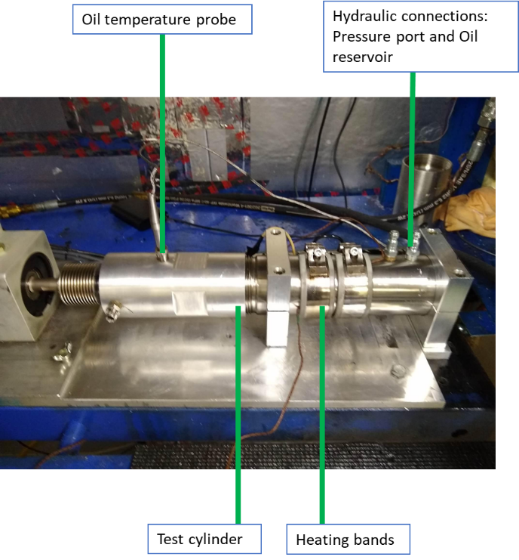
Figure 4.10: Heating elements installed on the experimental set up.

The controller selected was a digital PID provided by Omega due to its ease of use and installation as well as its reliability. A set of thermocouples were then used to monitor the surface temperature of the test housing during the experiments. Figure 4.11 shows the PID selected and installed in the system.
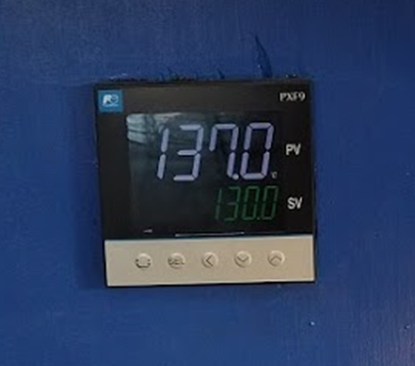
Figure 4.11: PID controller model PXF9 provided by Omega. This controller is used to drive the heating system of the experimental set up.

4.7 Debris circulation loop
An oil flow loop to circulate abrasive debris on the outside of the face seal. A gravity fed; low flow; gear pump was employed to move oil mixed with aluminum oxide particles. This type of pump was selected as it had the capacity to operate with oil at the required maximum temperature of 225 °C. Furthermore, the selected gear pump was able to handle contaminants mixed within the working fluid without suffering major damage. The flow to the low-pressure area of the test cylinder was controlled by adjusting two throttling valves on the discharge of the pump. Figure 4.11 shows the flow control system for the circulation loop. One return line, carrying most of the flow served to stir the oil reservoir to maintain the aluminum oxide particles in suspension. A second line, with a throttling valve set on minimum fed a creeping flow to the test housing. Due to its simplicity, this sub-system was able to perform independently for the required test duration.
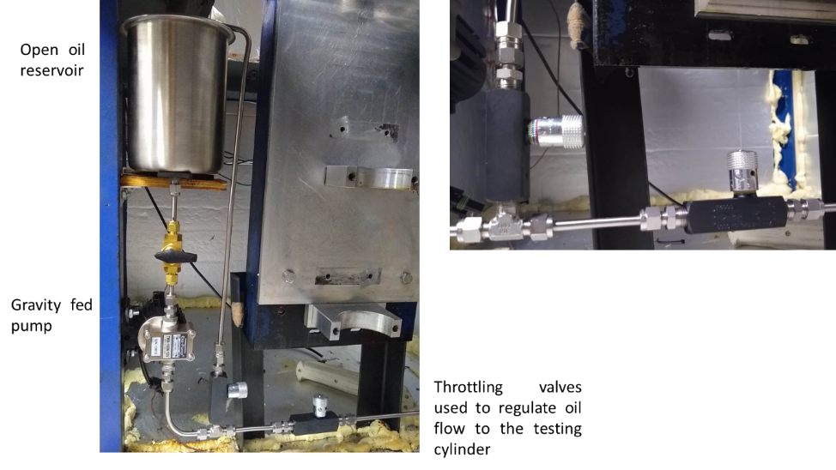
Figure 4.11: Debris circulation loop as installed in the system. A 12V scavenger pump was selected due to its ability to run continuously and its resistance to wear and damage

4.8 Data acquisition system
Different sensors for monitoring the speed and torque of the motor, measuring the differential pressure across the seal interface, and measuring the oil temperature at the face seal. These sensors were selected to produce analog signals that could easily be interpreted by computer software. A multi-channel 1MHz-NI-DAQ-XX was chosen as the data acquisition system to convert analog signals to digital data and process the data. This platform was selected as if offers flexiblity between sensors and an easy set up for control and instrumentation panels. Furthermore, LabView software was used for the control and automation of the set up as well as for the data conditioning and processing. A Microsoft Excel code was made to calculate the volume change and leak rate over the duration of the tests.
The data acquistion system was built to provcess analog signals from a vairty of sensors used to monitor the performance of the MFS tested. These sensors included an encoder to monitor the speed of the driving motor, a torque sensor to monitor the driving force, a pressure transducer to record the pressure differential across the seal interface, and thermocouples used to measure the operating temperature of the system. Given the variety of inputs and required electronic coneecitons, three different NI-Daq modelues were selected. Figure 4.12 shows the NI data acquisition system with the selected modules installed and connected to their respective inputs. From this figure we can see the integration of the different sub systems under a simple control system. In this case, the NI modules used are connected to different sub systems.
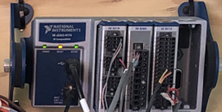
Figure 4.12: National Instruments Data Acquistion Modules as installed in the experimental set up. Each module recieves signals from sensros to contorl the different sub systems
The control software for the system was coded in LabView as this platform offers the inclusion of a virtual control pannel for the components as well as data display and recording capablities. Figure 4.13 shows a snapshot of the virtual control pannel created for the experimental set up. From this control pannel it is possible to control the rotational speed of the motor, the different sensors installed in the system
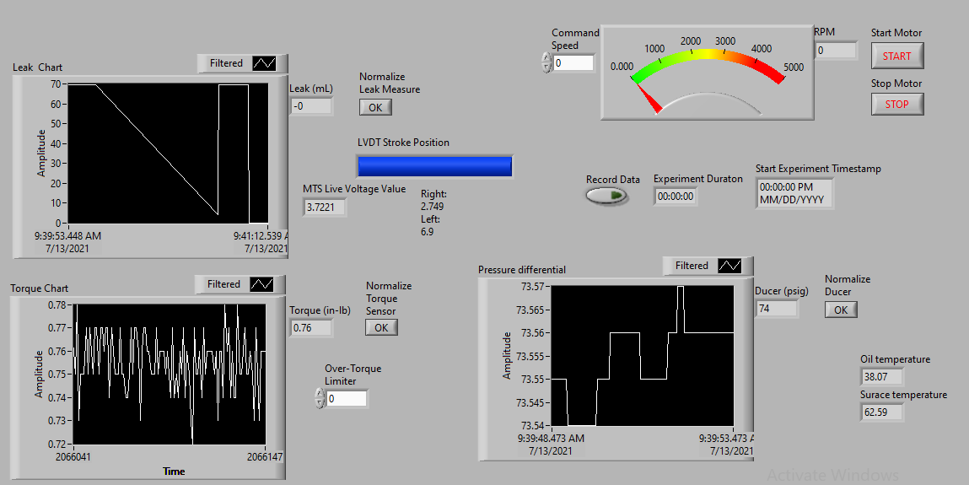
Figure 4.13: LabView control pannel developed for the experimental set up showing the operation parameters captured during testing of the MFS.
This pannel served as the main control point for the experimental set up and was created using the NI coding platform LabView. This platform allowed for streamlined integration of the different sensors through built in tools that allow processing of analog signals and recording of process data in digital form. Figure 4.14 shows a section of the computer code developed. In this figure we can the connection between sensors and processing tools used to capture the data. A similar integration process was followed for each of the inputs. The complete code developed can be found in the appendix.
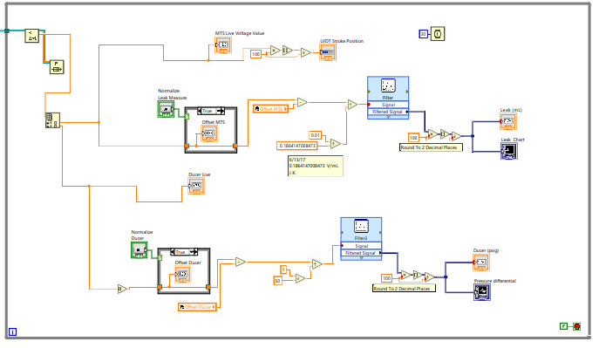
Figure 4.14: Example of the LabView code used to integrate sensors and condition input signals in the experimental set up.
One of the main advantages of the use of LabView software for the development of the experimental set up was the ability to automate the testing process. Once the intial paramteres for the experiment such as pressure differential rotational speed, and process temperature the testing set up was able to be monitored from distance and the experiments could run unatended for long periods of time.

4.9 Test bench
All the previously descrubed subsystems had to be integrated as part of one testing unit. To accomplish this, the different parts of the experimental aparatus were installed on a testing bench. The design of this bench prioritized the ablity to rotate the test housing system by 90° to facilitate working on the system while maintining the test housing in a vertical orientation during testing. The testing bench included a solid base for the drive motor, torque sensor, and 2 clamps to hold the testing cylinder. Figure 4.6 shows a picture of the testing bench constructed.
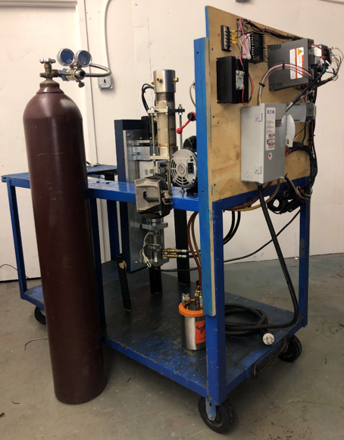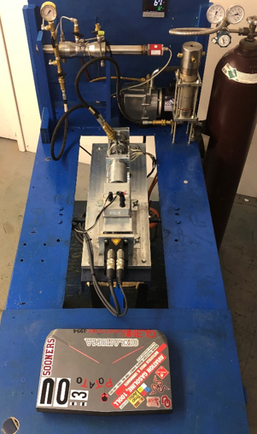
Figure 4.15: Experimental set up constructed for testing MFS showing main components.
The driving sub system was installed on the rotating bench. The alignment of the components and the sturdiness of the assembly were ensured through the use of a machine base plate bolted onto the bench. Similarly, the volume measuremnt sensor was integrated to the bench and positioned for ease of use during the testing procedure. After consulting with the sponsor, it was decided to construct an enclosure around the experimental set up. This enclosure improved the capacity of the testign set up to maintain a constant temperature during the required experiment duration, and added a layer of safety by isolating the components. Figure 4.16 shows the final experimental set up developed for this thesis.

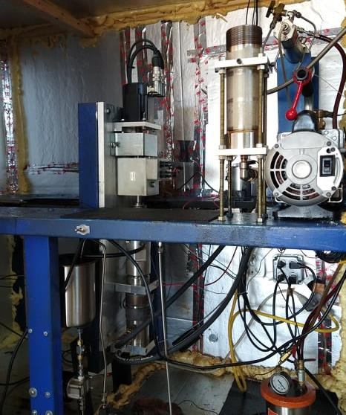
Figure 4.16: Final iteration of the experimental set up constructed for testing MFS showing main components.

4.10 Chapter summary
Chapter 4 presented a detailed description of the manufacture process and the components selected for the development of the expeimental set up. These components were selected based on specifictions and requirements provided by the project sponsor and established during the design process of the thesis, explained in chapter 3.
This chapter presents a description of the test housing used for the testing of MFS. This test housing was designed and manufactured by a third party in order to ensure the inclusion of propietary technology belonging to the oil and gas industry. An assembly prcess for this housing was also presented in this chapter. Following this trend, the diffeent subsystems of the experimentla set up were introduced and explained. These sub systems include the driving subsystem, composed of an electric motor and a torque sensor; the volume measurement sub assembly designed and developed to monitor the leakage through the seal interace; a vacuum filling system developed for the preparation of the set up prior to experiments; A heating system and debris circulation loop used ot recreate field conditions pertaining the oil and gas industry. A data acquistion system also used to contorl and monitor the experimentla set up.
Finally, this chapter described th einetgration of these subsystems as part of the experimental set up as developed for this thesis.

Chapter 5: Testing the experimental set up.

5.1 Introduction
Testing the performance of the set up allows us to identify the strenghts and weaknesses of the platform constructed and to make ncessary changes to it. A testing procedure was designed to ensure the repeatibilty of experiments as well as to expose the seals to conditions that simulate normal operation of the component. The testing procedures includes steps to prepare the MFS assembly and to prepare the testing set up to maintain constant operation parameters. Data of these parameters is then recorded and analyzed to compare the performance of the seals under different conditions.

5.2 Testing parameters
The testing procedure was aimed at replicating the industrial operation of MFS in the laboratory. One of the main aspects of the testing was the experiment duration. Due to the characteristics of silicone carbide as a seal material and the low leakage expected from the seal, it was important to establish an expeirment duration in which it was possible to observe changes to the performance of the seal. Similarly, the pressure, temperature, and rotational speed of the seal needed to be modulated to reflect industry conditions, and maintained throught he duration of the experiment. Table 5.1 presents a summary of the testing parameters used to evaluate the system. The preload of the seals and the concentricty of the rings was maintained by the test housing and hence was easiliy repeated between tests.

Table 5.1: Summary of testing parameters used for the commisioning of the system
Test | Pressure  (psi) | Temperature  (F) | Speed  (RPM) | Duration  (hrs.)
Validation | 80 | 300 | 3000 | 300
Contaminant | 60 | 300 | 3000 | 70
Defect | 30 | 300 | 3000 | 16

These parameters are examples of the tests perofmed to showcase the capability of the system for future experiments. The maximum value for pressure was 100 psi, as this was the limit of the MFS selected for testing. Similarly, the testing temperature was selected in function of the conditions encoutered by the seals in industry, as well as the capacity of the system to reach the desired temperature within a reasonable time. For this reason, the maximum testing temperature selected was 300 °F. Lastly, a maximum experiment duration of 300 hours was selected in order to capture changes in behavior of the seal due to settling and morphological changes to the sealing surface during the initial part of the test.

5.2 Validation testing
One of the main concenrns regarding the capability of the system was its ablity to run continuously for more than 200 hours while maintining constant parameters. Hence, the validation testing was centered on long experiment duration. Four different tests were carried out to ensure the ability of the experimental set up to collect results over the experiment duration. This data was also used to study the leak rate of the tested MFS during normal operation of the seal. These experiments demonstrated the ablity of the system to maintain a constant temperature and pressure for the duration of the experiment, while recodring the oil leakage throught the seal interface. The data collected was then used to compare and analyze the performance of the seals tested.
The experimental parameters for the validation testing can be summarized as follows:
- Working fluid: Aeroshell 560 turbine oil.
- External seal temperature: 300 F
- Applied pressuredifferential: 80 psi
- Rotational speed: 3000 rpm
- Test duration: 300 hours
- External fluid: Aeroshell 560 with abrassive particles at 12% weight concentration
- Abrasive particles introduced: Aluminum oxide grains, 60 µm average size
First, the test cylinder was assembled according to the assembly procedure, ensurign that the preload force and the concentricity of the seal rings is constant between tests. The system was vacuum filled with Aeroshell 560 oil and allowed to reach a test temperature of 300 F. Figure 5.1 shows a plot of the temperature data recorded for each experiment. From this figure we can observe that the temperature of the oil on the exterior of the seal maintained a stable temperature for the duration of the experiment.

Figure 5.1: Oil temperature as recorded for the duration of the test showing a steady value for each experiment.
Following these preparation steps the rotor was spun at a constant speed 3000 rpm , and the internal pressure was increased to 80 psi. These parameters were maintained constant and recorded for the duration of the test. Figure 5.2 shows a plot of the pressure differential maintained by the MFS tested for the duration of the experiments. In this plot we can observe that the magnitude of changes in pressure is within an acceptable margin of ±5 psi. Changes in pressure during the experiment were likely a result of changes in the performance of the MFS tested.

Figure 5.2: Internal pressure as recorded for the duration of the test. In this figure we can observe a variation of approximately 5 psi for each experiment.

The third operation parameter related to the performance of the MFS tested was the torque applied to drive the rotor ring of the seal assembly. Figure 5.3 shows a plot of the torque applied as measured by the experimental set up. In this figure we can appreciate changes in the driving force of the seal which are likely a result of degradation of the sealing face. Chapter 6 goes into a more detailed explanation of the damage observed on the MFS tested during these experiments.

Figure 5.3: Torque applied to the rotor part of the MFS as recorded for the duration of the test.

From these figures we can observe that the system is able to maintain the desired testing parameters for the duration of the test. The oil temperature sees little variance through the experiment duration with the most significant changes of approximately 10 C occuring due to the ramping contol of the PID. Similarly, the system is able to maintain the desired operating pressure. Figure 5.4 shows a plot of the leak measured for the four experiments. From this plot we can appreciate the low magnitude of the oil leakage as well as the need to carry out long duration experiments. Furthermore, in this plot we can observe negative changes in the volume of oil leaked through the seal. These changes were caused by localized temeprature changes at the seal interface whhich in turn cause expansion of the conatined fluid.

Figure 5.4: Oil leakage through the seal interface as recorded by the set up for the duration of the experiment.

The results obtained from this validation testing serve to prove the ability of the developed experimental set up to sustain the specified operation parameters of the MFS tested. Furthermore, the repeatability of the results obtained through the validation testing provide a reference for the expected behavior of the MFS tested with the experimental set up. This data was also used to establish a baseline to which different testing methods could be compared. Finally, the experiment series proves the ability of the developed set up to run autonomously for the required period of 300 hours to collect data that reflects the real operation of MFS in the oil and gas industry and satisfies the requirements of the project sponsor.

5.4 Contaminant testing
Once the ability of the system to maintain experiments for long durations and the repeatibilty of results was proved, a different test was conducted to test the capacity of the system to recreate worst-case envoronmental conditions to test the operational limits of the MFS tested. To accomplish this, the debris circulation loop was loaded with oil mixed with aluminum oxide particles. The oil selected was Aeroshell 560, as this is the same fluid contained by the seals. The aluminum oxide particles had a mean size of 60 µm and was mixed at a concentration of 12% weight. The debries were circulated on the exterior of the seal. Furthermore, during the assembly process, aluminum oxide particles were deposited directly on the sealing interface. The adition of contaminants between the sealing faces was aimed to recreate inadequate operating conditions for the MFS tested. This data was then compared with the data obtained during the validation testing to establish a criteria for failure of the seal. The experimental parameters set can be summarized as follows:
- Working fluid: Aeroshell 560 turbine oil
- External seal temperature: 70 F (ambient temperature)
- Applied pressuredifferential: 60 psi
- Rotational speed: 3000 rpm
- Test duration: 70 hours
- External fluid: Aeroshell 560 with abrassive particles at 12% weight concentration
- Abrasive particles introduced: Aluminum oxide grains, 60 µm average size
In this test a large volume of oil was able to move through the seal intrface. The volume leaked during 70 hours was comparable to the volume lost after 300 hours durning the validation testing, this was criteria to determine failure of the seal. This was likely caused by the prescence of contaminant debries that damaged the seal interface and limited the perfromance of the MFS. Figure 5.5 shows a plot of the volume changes in the oil contained by the seal. In this figure we can observe a period of 25 hours where the leakage is minimum followed by a steady leak until the end of the experiment. This experiment was repeated a second time. In the second trial, an accelerated initial leakage was observed until the end of the experiment.

Figure 5.5: Oil leakage recorded for the contaminant test. In this plot we can observe the abrupt effects of damage due to contamination.
A summary plot of the testing paramters of the contaminant testing is shown in figure 5.6. From this plot we can observe that the operational parameters of the seal were maintained constant through the experiment duration. In this case, the torque aplied to drive assembly was higher than what was observed during the validation testing. Nevertheless, the oil temperature and the recorded pressure differential were stable regardless of the addition of abrasive particles at the sealing interface. This aspect of the experimental results means that the high leakage observed was not related to the operational parameters of the MFS tested and instead was related to the introdution of contaminants. Chapter 6 goes into a more detailed description of the effects of the aluminum oxide particles introduced and the degradation of the saealing face caused by it.

Figure 5.6: Summary plot of the operation parameters of the mechanical face sela for the contaminant testing. This plot shows a summary of the torque applied to drive the seal, the pressure differential across the seal interface, and the oil temperature for the duration of the experiment.

5.5 Surface defect testing
A face seal with a manufacture surface deffect was tested as an aditional study to verify the technical limitations of the experimental set up. The MFS rotor ring tested for this experiment had an average deviation of approximately 4 µm. This waviness on the sealing face was created during the fabrication of the components and provides a baseline to determine the performance of a seal deemed to be unfit for operation. Furthermore, the testing of this seal was expected to push the capacity of the experimental set up to monitor large changes in the contained volume. Figure 5.7 shows a plot of the calculated oil leakage for the experiment duration. From this plot we can observe that the magnitude of the volume leaked throught the sealing interface was significantly larger than what was observed during the validation and contimant testing. The testing parameters can be sumarized as follows:
- Working fluid: Aeroshell 560 turbine oil.
- External seal temperature: 300 F
- Applied pressuredifferential: 30 psi
- Rotational speed: 3000 rpm
- Test duration: 16 hours

Figure 5.7: Oil lekage measured for the MFS with a manufacture defect on the sealing surface.

5.6 Chapter summary
This chapter illustrates the testing phase of this project. During the testing process, the experimental setup was used to perform a series of experiments developed to prove the functionality of the system and obtain useful data to evaluate the performance of MFS. During the testing process the design integrity and performance were proved to be valid. The testing procedure was formulated based on the requirements established during chapter 2. The testing parameters and results were presented in this chapter. These experimental results demonstrated the ablity of the system to maintain a constant temperature and pressure for the duration of the experiment, while recodring the oil leakage throught the seal interface. The validation test showed the ablity of the experimental set up to maitain the testing parameters within an acceptable margin for a duration of 300 hours. Nevertheless, one of the main insights from this test was that we could observe the effects of thermal expansion of the oil in the form of negative leakage in the set up. Similarly, in the contaminant testing larger volume of oil was able to move through the seal intrface. This was likely caused by the prescence of contaminant debries that damaged the seal interface and limited the perfromance of the MFS. From this test we were able to observe the performance of the tested MFS in harsh environmental conditions, emulating inadequate operation. The data obtained through the contaminant testing was then used to define criteria for seal failure. Finally, by testing a MFS with a manufacture defect we were able to test the ablity of the experimental set up to acurately record relatively large changes in volume. In this test we observed accelerated oil volume loss through the seal interface that did not interfer with the operation of the expeirmental set up.

Chapter 6: Microscopic analysis of the sealing face.

6.1 Introduction
As part of their normal operation, MFS undergo thermal deformation that affects the contact area between the sealing rings [9]. This deformation along the sealing interface can have a negative effect on the performance of the seals, leading to excesive leakage [16]. In thisc ase, the deformation is caused by thermal expansion of the sealing rings and pressure differential, with the largest deformation concentrated on the inner radius of the sealing surface [17]. Figure 6.1 shows a schematic of the deformation expected to be observed during on MFS as a result of a non-uniform temperature distribution.
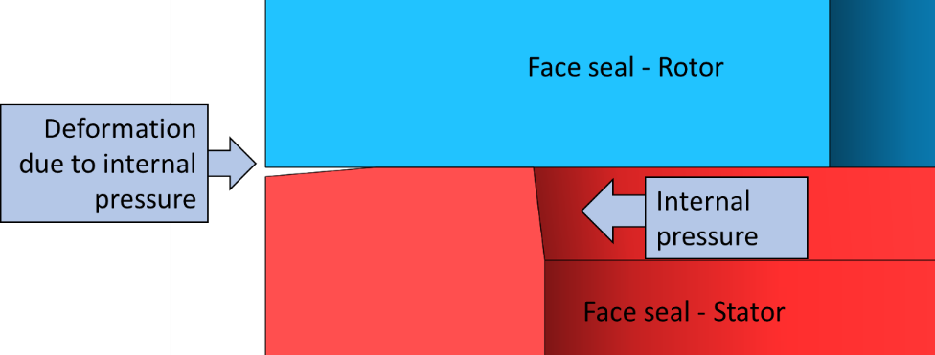
Figure 6.1: Schematic of the deformation of the MFS as a result of thermal expansion and pressure effects on the component.
The sealing surface of two of the tested MFS used during the testing process were imaged using different microscopy techniques. These images were used to evaluate the degradation of the sealing faces and served to confirm the deformation of the seals during operation.
Figure 6.2 shows a MFS specimen imaged before experimentation. This image illustrates the initial state of the components tested. Firstly, a MFS tested under typical operating conditions was imaged as a baseline specimen. The imaged seal contained wear features developed during the validation testing of this thesis. The images obtained from this sample were used to compare the degradation of the seal face used during the contaminant testing. The seals imaged shared common features regarding the distribution of the degradation across the sealing profile. Nevertheless, the introduction of abrassive particles created unique wear features observed after the contaminant testing was completed. This chapter presents a description and comparison of the wear features developed during the testing of the Mechanical Face Seals.
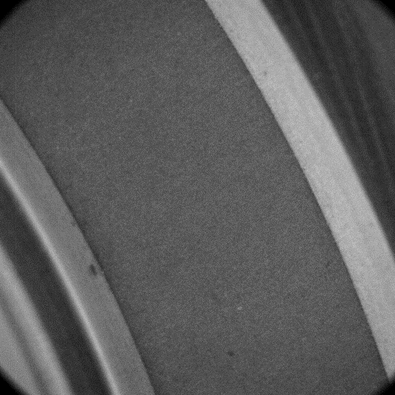
Figure 6.2: Sealing face on an intact specimen illustrating the initial condition.

6.2 Normal operation – Validation testing seal imaging
The first seal amalyzed through microscopic imaging was exposed to typical operatin conditions during the validation testing, as decribed in chapter 5. This test specimen was selected as it was expected to present typical degration and wear features. Thus, the images obtained from the microscopic analysis of this component were used to evaluate the effects of introduced abrassive particles and compare the degradation patterns. Figure 6.3 shows an section of the rotor ring imaged using an optical epifluorescence microscope. In this figure we can observe a non-uniform wear distribtion on the contact area between the sealing rings, shown in red.
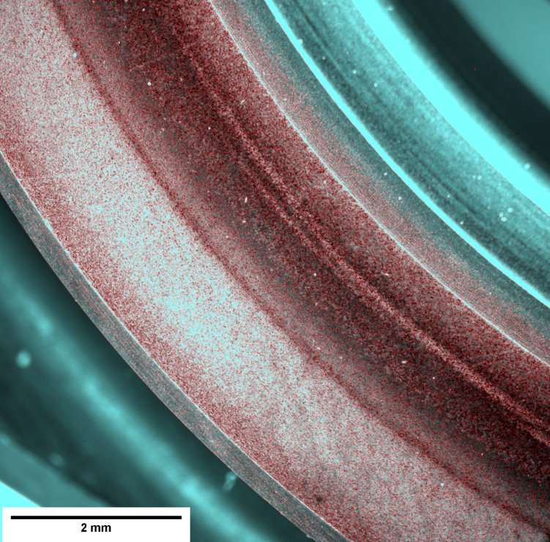
Figure 6.3: Optical image of the MFS tested showing the contact area between the sealing rings (red).
From figure 6.3 it is possible to appreciate the concentration of wear on the inner radius of the sealing ring. This image serves as evidence of the thermal deformation of the MFS developed during typical operation of the component. Furthermore, this image shows degradation of the sealing profile in the form of scratches and material erosion that were likely to contribute to spikes and variation in the torque applied during the experiment.
Figure 6.4 shows a section of the corresponding stator ring imaged using the Leica SP8 confocal laser scanning microscopy. This image shows the light reflected from the top layer of the sealing profile while omitting out of focus light outside of this plane. In this image we can observe the path of stray particles as they formed groves and scratches in the radial direction of the seal. Furthermore, the imaging technique utilized to develop this figure shows further evidence of the concentration of wear on the inner radius of the sealing rings, corresponding to thermal deformation.
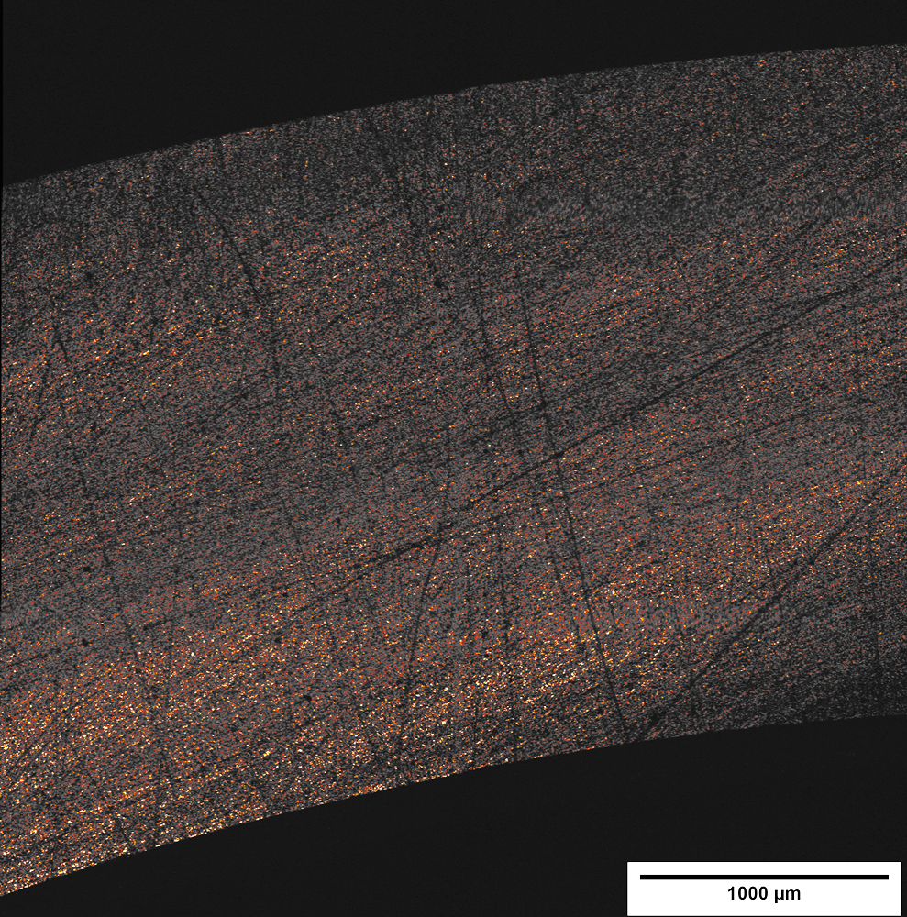
Figure 6.4: Confocal laser scanning microscopy image of the top layer of the sealing profile on the stator ring of the MFS used during the validation testing.
From the microscopic imaging and analysis of the MFS tested under typical operating conditions we were able to obtain valuable information about the degradation of the sealing profile developed during experimentation. Firstly, a concentration of wear on the inner radius of the sealing rings was observed. This feature serves as evidence of thermal deformation of the components and matches the expected patterns. Secondly, the imaged seals showed signs of degradation due to movement of stray particles across the sealing profile. Both of the features observed were likely to contribute to the leakage of the seal and serve as a baseline to compare the wear features developed in further experiments.

6.3 Rough operation – Contaminant testing seal imaging
Following the contaminant testing described in Chapter 5, the MFS used was imaged using different microscopy techniques. The images obtained showed unique wear features developed due to the introduction of abrasive particles in the sealing interface. The particles introduced were aluminum oxide with a mean size of 60µm. This material and size for the particles were selected after discussion with the sponsor due to its hardness and common application as lapping material [18]. The analysis of the face degradation caused by these conditions serves to understand the behavior of the tested MFS under unfavorable conditions. Furthermore, the images obtained present an example of failure caused by extreme environmental conditions and provides evidence of the ability of the tested component to withstand abrasion.
Figure 6.5 shows a section of the rotor ring used during the contaminant testing imaged through an optical epifluorescent microscope. From this figure we can appreciate the extreme degradation of the sealing profile caused by the introduction of aluminum oxide particles. Several concentric rings are observed across the contact area of the sealing rings. Furthermore, significant quantities of material have eroded such that a recess has been created at the sealing interface. The degradation observed through the optical imaging of the rotor ring was likely the major factor leading the high leakage recorded during the testing process previously described in Chapter 5.
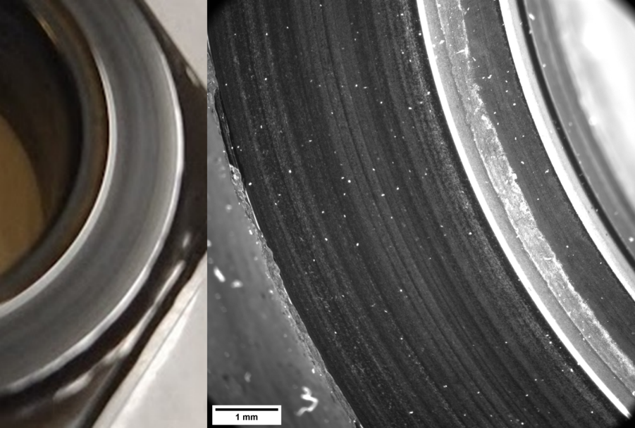
Figure 6.5: Reflected light image of the MFS rotor showing the sealing interface.
Further imaging of the specimen was carried out using confocal laser microscopy to better understand the degradation of the MFS caused by the introduction of abrasive particles. Figure 6.6 shows a section of the stator ring obtained using a Leica SP8 confocal microscope. In this image it is possible to appreciate the several concentric rings that formed due to the rotation of the seal and the accumulation of abrasive particles at the seal interface. Furthermore, the contrast created through the use of confocal laser microscopy it is possible to appreciate a similar concentration of degradation closer to the inner radius of the seal. In this case, the specimen imaged shares this distribution with the specimen tested at typical operating conditions.
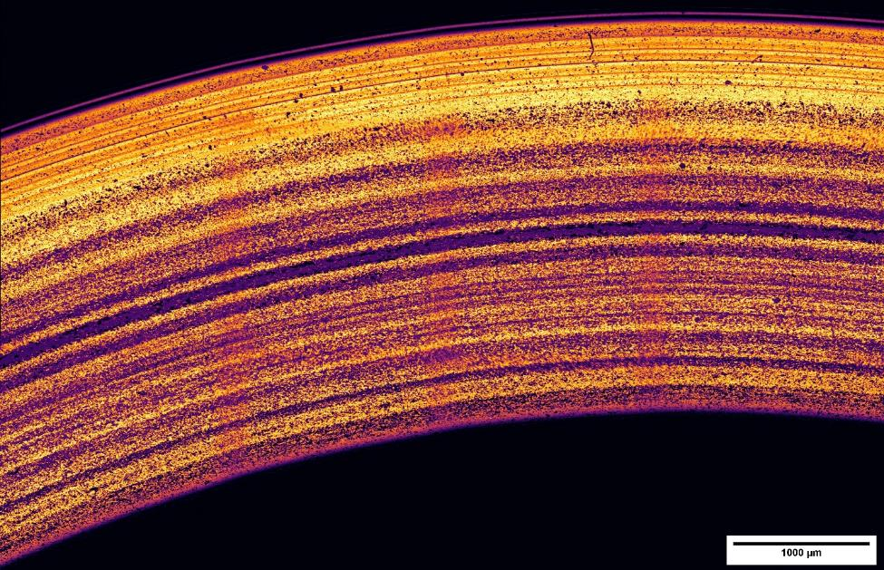
Figure 6.6: Section of the stator ring showing signs of abrasion obtained through reflective confocal laser microscopy.
Another interesting characteristic of the MFS imaged is the concentration of thicker and deeper groves at the center of the sealing profile. The use of confocal light scanning microscopy allowed for the measurement of the thickness of the groves observed on the specimen. Figure 6.7 shows a cross section of the sealing profile and a measurement plot of the thickness of the features on the sealing surface as well as relative differences in height caused by differences in the intensity of the light reflected during the imaging process. From this figure we can observe that the thicker rings, with an average width of 100 µm are located at the center of the sealing profile. Furthermore, in this plot we can observe that the groves formed on towards the inner radius of the ring seal are thicker and deeper than those formed on the outer radius. Thus, this image serves as evidence of the effects of thermal deformation during operation of the seal.
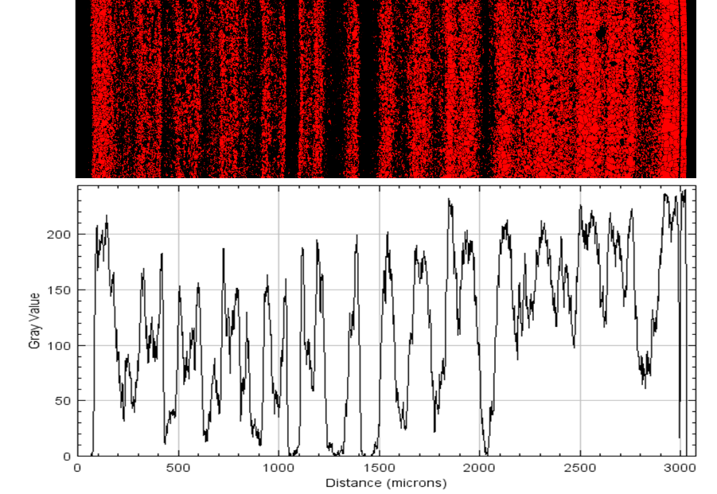
Figure 6.7: Surface plot of the damaged seal showing grove width and relative depth
By using different microscopic imaging techniques to analyze the sealing surface of the MFS tested during the contaminant test described in chapter 5 we were able to obtain useful information about the wear mechanisms that caused high leakage during the experiment. Through optical imaging of the seal, it was possible to observe clear evidence of the accelerated erosion of material at the contact area between the seal rings. Furthermore, confocal laser scanning microscopy imaging provided detail of the size and distribution of the rings formed by the accumulation of abrasive particles during the testing process.

6.4 Chapter summary
This chapter presents the microscopic imaging and analysis of two different MFS tested under different conditions during the testing process presented in chapter 5 of this thesis. From this analysis we were able to observe and evaluate the degradation of the sealing profile on the MFS used. The first seal imaged was tested under typical operating conditions encountered in the oil and gas industry as part of the validation testing. The images obtained from this specimen represent typical wear features developed by MFS during operation. These features include a concentration of wear on the inner radius of the sealing rings, as well as evidence of movement of stray particles through the sealing profile. In contrast, the images of the MFS used for the contaminant testing obtained through the use of confocal laser scanning microscopy showed significantly different features. In this case, the introduction of abrasive aluminum oxide particles to the sealing interface caused the formation of concentric circular groves on the sealing face. The groves formed showed to be thicker at the center of the sealing profile with decreasing width towards the edges of the ring. Furthermore, in this case the effects of thermal deformation were also visible, showing greater evidence of material erosion towards the inner radius of the ring.

Chapter 7: Concluding remarks

7.1 Thesis summary
The main objective of this thesis was the design and manufacture of an experimental testing set up for the characterization of sintered silicon carbide mechanical face seals utilized in the oil and gas industry. The manufacture of the experimental set up represented a joint effort between different research teams. The design of the set up, manufacture of the platform, commissioning of the system, and imaging of the tested MFS were completed through the duration of this research project as a team effort.
The importance of the development of this experimental set up is centered on the need to have an appropriate understanding of the behavior and performance of MFS under different conditions. To accomplish this objective, the design of the experimental set up was based on the ability to recreate operation conditions encountered by MFS in the oil and gas industry. The objectives for the research were established through discussion with the project sponsor. The main requirements established were the ability to control operation parameters such as: rotational speed, applied pressure differential, and working temperature, as well as to record operational parameters such as applied torque.
A background review was carried out to understand the different physical variables that govern the performance of mechanical face seals. Furthermore, different materials used for the fabrication of MFS and their properties were presented to have a better understanding of the conditions faced by the components.
An iterative design process was used to define a concept for the design of the experimental set up. During this process, the different components and their requirements were identified based on the objectives established along with the project sponsor. Once the different inputs, functions, and inputs of the experimental set up were defined, an embodiment design for the set up was developed. This embodiment design allowed for the selection and manufacture of different components and subsystems that were selected and integrated as part of a cohesive platform.
The design and manufacture of the experimental set up was divided in different subsystems that were then integrated. The first group described was the driving system, which was designed to provide mechanical power and drive the rotor in the seal. Similarly, a volume measurement system was designed and manufactured to monitor the volume of oil contained by the MFS tested and calculate the leakage through the sealing interface as well as to apply and monitor pressure to the contained fluid. Furthermore, a vacuum filling system was developed to ensure that the system was correctly filled with oil and all air was evacuated. Following this trend, a heating system was developed to control the operating temperature of the seal and allow for the comparison of the performance of MFS under different conditions. Following this, a circulation loop was designed to introduce abrasive particles to the exterior of the seal and reproduce harsh environmental conditions. All of these systems were integrated under a data acquisition system and a control panel developed using LabView software and National Instruments hardware. The integration of the subsystems under this platform allowed for the automatization of the testing process and enabled long duration tests.
Following the manufacture process of the experimental set up, a series of experiments and testing parameters were devised along with the project sponsor in order to prove the functioning of the set up and obtain useful data regarding the performance of mechanical face seals. To this end, different experiments were carried out during the testing process. These tests proved the ability of the experimental set up to maintain test constant parameters for a duration of 300 hours. Similarly, the ability of the experimental set up to operate under extreme environmental conditions and with atypical components was proved during the testing process.
Finally, microscopic analysis of the MFS tested was carried out in order to obtain information about the sealing face degradation and wear patters formed during testing. To this end, optical fluorescent microscopy and confocal laser scanning microscopy were used to analyze two different seals: one exposed to normal operating conditions, and one with abrasive particles introduced to the sealing interface. From this analysis we were able to observe a concentration of material erosion towards the inner radius of the sealing profile. This served as evidence of thermal deformation of the seals that occurred during the testing process. Furthermore, microscopic analysis revealed the formation of concentric groves formed by the accumulation of abrasive particles on the sealing interface during the contaminant testing carried out.
The result of this research was the development of an innovative and reliable experimental set up for the testing and comparison of mechanical face seals used in the oil and gas industry.

7.2 Research limitations
Different challenges and limitations were encountered during the design process of the experimental set up. Some of the limitations of the current design include:
- Changes in temperature of the working fluid due to the interaction of the sealing components caused thermal expansion of the contained fluid in the test housing. This thermal expansion was shown as negative leakage in the data collected. This occurred due to the inability to account for variation in temperature caused by the friction between the sealing faces. This friction generated excessive heat leading to an increase in temperature that was not able to be regulated by the heating control system installed in the set up.
- The long duration of the experiments as well as the operating conditions selected for the experiments created the need for constant maintenance of the set up. Unexpected failures and problems with the test housing created the need the creation of a preventive maintenance routing. One of the most common problems encountered was the failure of the secondary seals in the test housing. These seals were damaged during the testing process and needed to be replaced after each experiment.

Works Cited

[1] | S. H. Yu Zhang, Y. Zhang and L. Chen3, "Optimization and Analysis of Centrifugal Pump consideringFluid-Structure Interaction," The scientific world journal, pp. 1-9, 2014.
[2] | E. Ioannides and B. S. Nau, "Fluid Sealing," in Fluid Mechanics and its Applications 8, Netherlands, Springer, 1992.
[3] | N. &. K. M. Xiao, "A Review of Mechanical Seals Heat Transfer Augmentation Techniques.," Recent Patents on Mechanical Engineering., vol. 6, pp. 87-96, 2013.
[4] | B. S. Nau, "Mechanical seal face materials," BHR Group Limited, Cranfield, Bedford, vol. 211, no. J, pp. 165-183, 1997.
[5] | K. K. McKee, G. Forbes, I. Mazhar, R. Entwistle and I. Howard, "A review of major centrifugal pump failure modes with application to the water supply and sewerage industries," Curtin University, Western Australia.
[6] | H. Lubinge, "On the lubrication of mechanical face seals," PhD thesis. Univeristy ofT wente, 1999.
[7] | S. H. R. C. X.Q. Yu*, "Frictional Characteristics of Mechanical Seals with a Laser-Textured Seal Face," Journal of Materials Processing Technology 12, vol. 129, pp. 463-466, 2002.
[8] | F. K. ORCUTT, "An Investigation of theOperation and Failure ofMechanical Face Seals," Journal of lubrication technology, vol. 91, no. 4, pp. 713-725, 1969.
[9] | S. S. G. a. H. HIRANI, "Design and Development of a Test Setup for Online Wear Monitoring of Mechanical Face Seals Using a Torque Sensor," Tribology Transactions, vol. 52, pp. 47-58, 2009.
[10] | B. T. J. F. Noel Brunetiere, "TEHD Lubrication of Mechanical Face Seals in Stable Tracking Mode: Part 1—Numerical Model and Experiments," Transactions of the ASME, vol. 125, pp. 608-617, 2003.
[11] | V. P. Àlex de la Cruz Gargallo, "Mechanical Face Seals: Test Rig Development and Analysis of the Frictional Behaviour," in Master of Science Thesis TRITA-ITM-EX 2019:248 KTH School of Industrial Engineering and Management Department of Machine Design, Stockholm, Sweden, 2019.
[12] | A. B. S. H. a. J. B. L. C. Erickson, "Tribological characterization of alumina and silicon carbide under lubricating sliding," TRIBOLOGY INTERNATIONAL, vol. 93, no. 20083-10, pp. 83-93, 1993.
[13] | Y. L. Q. W. Y. W. Xingyu ZHAO, "Frictional performance of silicon carbide under different lubrication conditions," State Key Laboratory of Tribology, Tsinghua University, Beijing 100084, China, DOI 10.1007/s40544-014-0039-.
[14] | R. Smith, "API type pressurised dual seals – design configurations for contaminated upstream pumping applications," in Fluid Machinery Congress 6-7 October 2014, Woodhead Publishing, 2014, pp. 33-43.
[15] | B. T. a. J. F. e. S. NOEL BRUNETIERE, "A Simple and Easy-To-Use TEHD Model for Non-Contacting Liquid Face seals," Tribology Transactions, vol. 46, no. 2, pp. 187-192, 2003.
[16] | T. Sahoo, "Making centrifugal pumps more reliable," World pumps, vol. 2009, pp. 32-36, 2009.
[17] | B. Nau, "Mechanical seals: service experience," Tribology International, vol. 19, no. 4, pp. 184-186, 1986.

Appendix
