UNIVERSITY OF OKLAHOMA
GRADUATE COLLEGE

AUDIT SIGNALS OF ACCOUNTABILITY AND TRANSPARENCY IN THE MARKETPLACE OF DONOR INFORMATION

A DISSERTATION
SUBMITTED TO THE GRADUATE FACULTY
in partial fulfillment of the requirements for the
Degree of
DOCTOR OF PHILOSOPHY

By
MARK W. SMITH
Norman, Oklahoma
2019

AUDIT SIGNALS OF ACCOUNTABILITY AND TRANSPARENCY IN THE MARKETPLACE OF DONOR INFORMATION

A DISSERTATION APPROVED FOR THE
MICHAEL F. PRICE COLLEGE OF BUSINESS

BY

Dr. Kevan Jensen, Chair

Dr. Brant Christensen

Dr. Andrew Cuccia

Dr. Wayne Thomas

Dr. Michael Mumford

© Copyright by MARK W. SMITH 2019
All Rights Reserved.

TABLE OF CONTENTS

LIST OF TABLES vi
LIST OF FIGURES vii
ACKNOWLEDGEMENTS viii
ABSTRACT ix
1. INTRODUCTION 1
2. BACKGROUND AND LITERATURE REVIEW 6
2.1 Nonprofit Organizations 7
2.2 The Marketplace of Donor Information 8
2.2.1 Internal Revenue Service Form 990 8
2.2.2 Charity Rating Agencies 10
2.2.3 Nonprofit Organization Websites and Social Media 14
2.3 Financial Statement Audits as a Donor Evaluation Tool 14
2.3.1 Uniform Standards for Audits 15
2.3.2 Auditor Independence 16
2.4 Research on the Use of Financial Statement Audits by Donors 17
2.4.1 Audit Availability as a Factor in Interpreting Archival Research 19
3. HYPOTHESIS DEVELOPMENT 21
3.1 The Audit as an Accountability Signal 21
3.2 The Audit as a Transparency Signal 22
3.3 The Interaction of Audit Signals with Other Donor Information 23
4. METHOD 26
4.1 Experimental Task 26
4.2 Independent Variables 27
4.3 Dependent Variable 28
4.4 Participants 28
4.5 Expected Results and Evaluation of Hypotheses 29
5. RESULTS 30
5.1 Experiment One 31
5.2 Experiment Two 32
5.3 Additional Analysis 35
5.3.1 Manipulation Check Questions 35
5.3.2 Selection of Covariates 36
5.3.3 Demand Effects 37
5.3.4 Order Effects 38
5.3.5 Participants Reported Use of Donor Information 39
6. CONCLUSION 39
REFERENCES 41
APPENDIX A 70
APPENDIX B 103

LIST OF TABLES
TABLE 1 - Descriptive Statistics of MTurk Participants - Experiment One 49
TABLE 2 - Frequency Table for Categorical Variables - Experiment One 50
TABLE 3 - Mean of Dependent Variable by Treatment - Experiment One 51
TABLE 4 - Repeated Measures Analysis of Variance - Experiment One 53
TABLE 5 - Analysis of Variance of Contrast Variables - Experiment One 55
TABLE 6 - Descriptive Statistics of MTurk Participants - Experiment Two 57
TABLE 7 - Frequency Table for Categorical Variables - Experiment Two 58
TABLE 8 - Mean of Dependent Variable by Treatment - Experiment Two 59
TABLE 9 - Repeated Measures Analysis of Variance - Experiment Two 61
TABLE 10 - Analysis of Variance of Contrast Variables - Experiment Two 63
TABLE 11 - Mean of the Suggested Donation Amount by Group, Charity and Order of Presentation 65
TABLE 12 - Frequency of Information Use by Source 66

LIST OF FIGURES
FIGURE 1 - Experimental Procedures 67
FIGURE 2 - Graph of Means of Dependent Variable - Experiment One 68
FIGURE 3 - Graph of Means of Dependent Variable - Experiment Two 69

ACKNOWLEDGEMENTS

Many people were an integral part of my journey for the last five years and the journey would not have been completed without them. No one was more instrumental in my completion of a PhD than my dissertation chair, Dr. Kevan Jensen. Dr. Jensen displayed remarkable patience in mentoring me during the PhD program. I have enjoyed many hours of conversation with Dr. Jensen about research, teaching, and life.
I thank the members of my dissertation committee, Dr. Kevan Jensen, Dr. Brant Christensen, Dr. Andrew Cuccia, Dr. Wayne Thomas, and Dr. Michael Mumford. It is a privilege to have access to such an esteemed group for my committee. These individuals were not only available for committee duties but were an active part of my education the last five years. Dr. Richard Price deserves recognition for his patience in answering more than his fair share of questions. Other faculty, not named here but deeply appreciated, gave encouragement and advice that always seemed to come at the right time and kept me moving forward. Every journey is better in great company, and I thank my cohort, Curtis Farnsel and Shannon Jemiolo for the camaraderie that helped sustain me through the program.

Audit Signals of Accountability and Transparency in the Marketplace of Donor Information

ABSTRACT
Potential donors have many sources of information when evaluating charities. IRS Form 990 is a readily accessible source of information. Charity rating organizations exist to help donors evaluate charities (i.e. Charity Navigator, CharityWatch, Give.org, etc.) and their evaluations are easily accessible. While many charities are required to have an audit, there is generally no uniform requirement to make the audit easily accessible to donors, and extant research indicates that a majority of charities do not make their audits easily accessible. This research project reasons that a financial statement audit is unique among information sources and thus sends accountability signals that other information sources cannot. Charities can further send a transparency signal to donors by making their audit easily accessible. Do donors receive the accountability and transparency signals of the audit? How do the accountability and transparency signals sent by the audit interact with other sources of information available to donors? I examine these questions using an experiment. I find that donors value the accountability signal sent when an organization has an audit. I also find that donors incrementally value the transparency signal sent when the organization makes the audit easily accessible. I do not find sufficient evidence to conclude that the audit signals interact with other information available to donors.

Keywords: audit value; accountability; transparency; signaling; charity ratings; donation decision; nonprofit; voluntary disclosure.

INTRODUCTION
This study examines whether donors value the accountability and transparency signals sent when a nonprofit organization has an audit and makes the audit easily accessible to donors. The scholarly study of what actions on the part of nonprofits increase or decrease donations spans decades and cuts across many disciplines (e.g. accounting, economics, communications, marketing, public policy, psychology, etc. [see Bekkers and Wiepking 2011a for an extensive review of this literature]). This cross-disciplinary interest in understanding donor behavior is motivated by the sheer magnitude of the nonprofit sector (individual donors in the United States of America gave an estimated $322 billion to charity in 2017 [Giving USA 2018]). This study contributes to the literature on donor behavior by examining donor reliance on the presence of an audit in a way that can establish causality. This study also contributes to the literature by being the first study to examine how donors react to a nonprofit’s willingness to make its audit easily accessible to donors.
There are over one million public charities in the United States of America (NCCS). Consequently, donors have a potentially overwhelming choice when determining which charities to donate to. While the organization’s mission is primary in any giving situation, individuals may also consider how organizations in a given space make use of their donated dollars. Donors have many options for evaluating a charity’s use of the donations it receives. One option is the publicly available information form that charities are required to file with the Internal Revenue Service (Form 990). Another option is to rely on someone else’s evaluation of the charity and many charity rating organizations exist to fill this role. Charity Navigator, Charity Watch, Give Well, GuideStar and the Better Business Bureau are examples of organizations that donors may consult before making a giving decision. The charity’s website is another potential option for obtaining information about the charity’s mission and stewardship.
Financial statement audits are unique among the information sources available to donors. Auditors are bound by uniform requirements regarding independence (AU-C §200.14) and objectivity (AU-C §220.A4, AICPA 2014) in a way that other information sources are not. Consequently, financial statement audits provide assurance in a way that other sources of donor information cannot. The unique assurance provided by an audit has led many charity rating agencies to reason that obtaining an audit is a strong signal of an organization’s accountability to donors. These same rating agencies make a further distinction between accountability and transparency and reason that transparency is signaled when the charity makes the audit easily accessible to donors. This study follows the conventions of the charity rating agencies in generally defining accountability as oversight, epitomized by having an audit, and generally defining transparency as ease of access to information, epitomized by making the audit available on the organization’s website (BBB Wise Giving Alliance 2018, Charity Navigator 2018a, CharityWatch 2018a, Evangelical Council for Financial Accountability 2018a, 2018b).
The study of the accountability signal of the audit (i.e. the signal sent to donors by the mere existence of an audit) is motivated by the lack of research that can establish causality between an audit and donor behavior. As explained in greater detail in the background section of the paper, research associating audits, audit outcomes and auditor characteristics with donor behavior has been archival in nature. This archival research is confounded by the lack of donor accessibility to audits (described in the paragraph below). This lack of audit accessibility motivates the study of the transparency signal of the audit (i.e. the signal sent when the audit is made easily assessible to donors).
Despite the widely held opinion among charity rating agencies that charities can signal a commitment to transparency by making their audit easily accessible, many charities do not do so. Extant research indicates that making the audit easily accessible is not the norm. Reported percentages of nonprofits that posted a copy of their audit on their website include 20 percent in Kirk and Abrahams (2017), 36 percent in Gordon, Khumawala, Kraut and Neely (2010) and “more than 50%” in Kitching (2009).
It is possible that donors do not value the signals of accountability and transparency sent by an audit in a way that charity evaluators think they should. Perhaps potential donors do not make the same distinction between simply having an audit and making the audit easily accessible that charity evaluators do. The frequency with which charities fail to make their audits easily accessible could suggest that the charities themselves do not perceive a negative impact on donations for failing to disclose their audit. Thus, the question is whether donors value the accountability and transparency signals of an audit.
Audit signals of accountability and transparency are not the only signals available to donors. Academic research has examined donor’s reaction to the signal sent by charity rating agency evaluations and the results of these studies have been mixed. Gordon, Knock and Neely (2009), Chen (2016), and Harris and Neely (2016) are examples of studies that find an association between charity rating agency evaluations and donations. Silvergleid (2003), Szper and Prakash (2011), and Yoruk (2016) are examples of studies that do not find an association between charity rating agency evaluations and donations. Sloan (2009) and Agyemang, Bay, Cook and Pacharn (2018) are examples of studies that find conditional associations between charity rating agency evaluations and donations.
Based on the above referenced studies, the impact of charity rating agency evaluations on donations appears to be an open question. This study contributes to the literature on the association between charity rating agency evaluations and donations by examining how the accountability and transparency signals of an audit interact with the signals sent by charity rating agency evaluations. Later sections of this paper detail instances where charity rating agencies disagree in their evaluation of a charity. This study utilizes this observed rater disagreement to examine the possibility that in the case of mixed signals from the charity rating agencies donors might place more reliance on the audit signals.
To summarize, three research questions are examined. Do donors value the accountability signal sent when a charity has an audit? Do donors value the transparency signal sent when a charity makes its financial statement audit readily accessible (and is the value of the transparency signal incremental to the value of the accountability signal)? Do donors rely more on the accountability and transparency signals of the audit when donors receive mixed signals from other sources (i.e. charity rating agencies in disagreement)?
These research questions were examined using a repeated measures ANOVA where the accountability and transparency signals of the audit were varied within subjects and the signal sent by charity rating agency evaluations was varied between subjects (the complete experimental instrument illustrating all experimental conditions can be found in Appendix A). The variation in the accountability and transparency signals of the audit was operationalized by presenting participants with three different charities (one charity did not have an audit, one charity had an audit but did not make the audit accessible to donors, and one charity had an audit and made the audit accessible to donors). The variation in the signals from the charity rating agency evaluations was operationalized by randomly assigning participants to either a condition where the charity rating agencies agreed in their assessment of the charities or a condition where the charity rating agencies disagreed.
Participants assumed the role of an employee of a company. In their role as an employee, the participant was tasked with vetting charities for a corporate giving program. Participants received information to evaluate each of the three charities in turn (order of presentation was randomized) and made a decision regarding the amount that should be donated to the charity. The value that a donor places on a particular signal is difficult to accurately measure, but in the context of a donation decision the donation amount seems a reasonable proxy for value and thus was used as the dependent variable.
I find that donors value the accountability signal sent when an organization has an audit (donations were significantly higher when a charity had an audit than when a charity did not have an audit). I also find that donors incrementally value the transparency signal sent when an organization makes the audit easily accessible (donations were significantly higher when a charity made its audit available on its website compared to when a charity had an audit but did not make the audit available on its website). I do not find sufficient evidence to conclude that the audit signals interact with other signals available to donors (i.e. donors did not rely more on the audit signal when the charity rating agencies sent mixed signals).
This study contributes to the literature on donors use of audits by demonstrating under experimental conditions that donors respond to the accountability signal sent when a nonprofit organization undergoes an audit. Donor reliance on audits has been examined in archival settings, but not in an experimental setting where causality can be tested. It was important to examine the question under experimental conditions because the extant literature indicates that donors do not have wide access to nonprofit audits. It is reasonable to assume that the associations found between audits and other variables of interest in archival research are driven by the audit in a public company setting where audit disclosure is mandated, but the same assumption may not be reasonable in the nonprofit setting where audits are not widely available.
In addition to contributing to the literature on donors use of audits, this study also contributes to the literature on voluntary disclosure of information. This contribution stems from revealing that donors value the transparency demonstrated by a nonprofits willingness to make its audit easily accessible to donors. and the value of the transparency signal is incremental to the accountability signal of simply undergoing an audit. I am not aware of any other studies that address the distinction between undergoing an audit and making the audit available to donors. Understanding this distinction is important in a setting where audit disclosure is typically voluntary.
This study also examines the role of audits in a setting where other sources of donor information provide mixed signals. I am aware of only one other study (Harris and Neely 2016, using archival data) that examines the impact of mixed ratings from charity rating agencies on donations and thus my study adds to that limited literature. Finally, this study contributes to the emerging literature that finds a muted response by nonprofit monitors due to the limited accessibility of audits in the nonprofit sector (Burks 2018) and calls for audit mandates in the nonprofit sector (Duguay 2018).

BACKGROUND AND LITERATURE REVIEW
There is an enormous literature that seeks to determine why individuals give to charity. Bekkers and Wiepking (2011a) reviewed over 500 articles that addressed the determinants of charitable giving by individuals. Based on their review, they identified eight key mechanisms that have been studied as determinants of philanthropy: (a) awareness of need (b) solicitation (c) costs and benefits (d) altruism (e) reputation (f) psychological benefits (g) values, and (h) efficacy. Ariely, Bracha and Meier (2009) categorize motives for giving as intrinsic (i.e. altruism), extrinsic (i.e. tax deduction) or image motivation (i.e. social approval). In the accounting literature, Gordon and Khumawala (1999) address the giving question and note that there are internal motivations (i.e. altruism, guilt avoidance, etc.) and external influences (recognition, peer pressure, tax deduction, etc.) that drive an individual’s decision to give.
Whether driven by internal or external motivations, once an individual decides to become involved in philanthropy they will need to decide which organizations to support. The “which organization” question is addressed using financial and nonfinancial information (Gordon and Khumawala 1999). The accounting literature, including this study, focuses on the use of financial and governance information by donors when answering the which organization question (see section 2.4 for a discussion of how “financial information” has been operationalized in the literature).
However, charity rating agencies (discussed is section 2.2.2), authors of many of the works cited in this paper, and the charities themselves, are quick to acknowledge that financial and governance metrics alone are not sufficient to evaluate the impact of a charity. Evaluating a charity’s lasting impact and program success is notoriously difficult for donors, charity evaluators and the charities themselves. Financial and governance metrics are easily observable compared to measures of impact and program success for which there are no easily observable, verifiable, uniformly defined metrics. Despite the limitations of financial and governance metrics they are still important for giving decisions and worthy of study. As noted by CharityWatch Founder Daniel Borochoff, a charity cannot have impact if it spends only a small portion of its donations on programs (Perry 2012).
To appreciate the uniqueness of the accountability and transparency signals sent when a charity has an audit and makes its audit easily accessible to donors it is necessary to understand the marketplace of information available to potential donors. Accordingly, this background is provided in section 2.2. Before addressing the information available to donors, I provide a general background on nonprofit organizations in the section below.

2.1 Nonprofit Organizations
Section 501(a) of the Internal Revenue Code (the Code) allows organizations meeting certain requirements to seek exemption from federal income tax. Central to the exemption criteria is the requirement that the organizations must be organized for one or more of the purposes specifically designated in the Code. Section 501(c) of the Code specifies 29 types of organizations that can apply for exemption from federal income tax (IRS 2018).
There are over 1.5 million registered nonprofits in the United States of America (Urban Institute, 2016). The most common of the 29 types of 501(c) organizations are those classified as 501(c)(3) organizations. There are over 1.2 million 501(c)(3) organizations (Urban Institute, 2016). 501(c)(3) organizations qualify for exemption if they are organized and operated exclusively for religious, charitable, scientific, literary, educational and other similar purposes. 501(c)(3) organizations are unique among the 501(c) organizations in that contributions to these organizations are generally deductible as charitable contributions on the donor’s federal income tax return.
501(c)(3) organizations are further classified as either private foundations or public charities. Public charities are organizations such as churches, educational organizations, hospitals, medical research organizations, and publicly supported organizations. Publicly supported organizations are those organizations that normally receive a substantial portion (one-third) of their total support from a governmental unit or the general public. Approximately 1.1 million 501(c)(3) organizations are classified as public charities and most nonprofit organizations that come to mind are classified as public charities (e.g. Red Cross, United Way, Salvation Army, Nature Conservancy, American Heart Association, etc.) Organizations classified as public charities are the focus of this paper (the terms “public charity”, “charity”, and “nonprofit” are used interchangeably throughout the remainder of the paper).

2.2 The Marketplace of Donor Information
Donors expect organizations to be good stewards of the resources entrusted to them and engage in activities consistent with the stated objectives of the organization (Abila 2016, Salesforce 2016). Donors have many options for evaluating charities, including required government filings, charity evaluation groups, the organizations website, and audited financial statements. The following sections detail the various sources available to donors as well as the findings of relevant research regarding those sources.

2.2.1 Internal Revenue Service Form 990
Public charities are required to file an annual information return with the Internal Revenue Service (“Form 990”). An organization’s Form 990 is readily available to potential donors. The Form 990 is an information rich document that contains detailed financial information and also covers such topics as the organizations mission and accomplishments toward achieving the mission, governance and management structure, and compensation of directors, officers and key employees., In addition to the Form 990 there is an extensive list of schedules that organizations may be required to attach to the Form 990. The schedules provide details about transactions such as lobbying activities, compensation, and transactions with related parties.
Due to the richness of information provided on the Form 990 and the form’s availability, it has the potential to be a primary source of information for potential donors. Additionally, many charity rating agencies (discussed in detail in the section that follows) rely heavily on the Form 990 in their evaluation of an organization. However, many academic studies have examined potential problems with the accuracy of Form 990. Krishnan, Yetman and Yetman (2006) tested a sample of NFP’s that reported receiving public donations yet reported zero fundraising expenses on their Form 990. The authors examined the websites of these NFP's for evidence of fundraising activity and concluded that about 40 percent of the NFP’s examined that reported zero fundraising expenses on their 990 probably incurred some fundraising expenses (p. 405). Krishnan et al. (2006) then compared fundraising expenses reported on the NFP’s Form 990 to fundraising expenses reported on the NFP’s audited financial statements for a sample of 101 NFP’s. They found that 37 percent of the NFP’s reported lower fundraising expense on Form 990 than on the audit and concluded that “the occurrence of under reported fundraising is pervasive to many nonprofits” (p. 408). Consistent with the reasoning advanced in section 2.3 and section 3 of this paper, the authors compared the Form 990 amounts to the audit because “we presume that the audited financial statement is more accurate … as the financial statements are required to be prepared in accordance with GAAP and are subject to independent verification by auditors” (p. 406).
Gordon, Khumawala, Kraut, and Meade (2007) performed a detailed analysis of the Form 990 by comparing 24 financial variables reported on the Form 990 to data in the audited financial statements for a sample of 39 environmental organizations. They concluded that the Form 990’s contained numerous preparation errors ranging from mathematical and transposition mistakes to omissions of required information. Even more troubling was their comparison of functional expenses per the Form 990 and functional expenses per the audited financial statements that revealed these amounts did not agree in sixty-four percent of the NFP’s sampled (it is noteworthy that the authors assessed the quality and reliability of the Form 990 by comparing the Form 990 to the audited financial statements, consistent with the propositions in section 2.3 and section 3 of this paper).
Several other studies have examined potential problems with the accuracy of Form 990. Keating, Parsons and Roberts (2008) compare fundraising expenses per Form 990 to telemarketing fees reported by professional telemarketers on state regulatory filings. They find that 74 percent of the NFP organizations in their sample fail to properly report telemarketing expenses in the Form 990. Krishnan and Yetman (2011) examine expense category shifting (from administrative and fundraising expense to program expenses) in nonprofit hospitals by comparing expenses on Form 990 to expenses reported in regulatory filings. They find that the nonprofit hospitals program expenses were higher on Form 990 than those reported on the more likely to be scrutinized regulatory filings. Burks (2015) examined accounting errors in NFP’s and observed that approximately one-third of the error corrections noted in audited financial statements were not disclosed on the Form 990 (pp. 356 – 357). In summary, the Form 990 is a readily accessible source of detailed financial and nonfinancial information for donors, however, considerable evidence indicates that Form 990 information is not always accurate.

2.2.2 Charity Rating Agencies
Another option for donors is to rely on someone else’s evaluation of the charity. Several organizations exist to fill this role. Charity Navigator, Charity Watch, Give Well, GuideStar and the Better Business Bureau’s Wise Giving Alliance are examples of organizations that donors may consult before making a giving decision. These websites typically present evaluations, often accompanied by ratings, of NFP’s as well as articles intended to educate donors. These websites vary in their breadth of coverage and in their rating methodologies.
Charity Navigator (https://www.charitynavigator.org/) is a 501(c)3 organization whose mission is to “make impactful philanthropy easier for all”. Charity Navigator is funded by donations from individuals, corporations and foundations, and does not knowingly solicit contributions from the charities they evaluate. Charity Navigator claims to be the largest and most-utilized evaluator of charities. Charity Navigator rates over 9,000 charities, has over 700,000 registered users and their site was visited over 11 million times in 2017. Charity Navigator rates charities across two dimensions 1) financial health and 2) accountability and transparency. Evaluations are based primarily on the organization’s Form 990 and supplemented by information from the organization’s website. Charities are rated on a star system ranging from 0 stars to 4 stars (exceptionally poor to exceptional, respectively).
Due to Charity Navigator’s substantial presence in the charity rating space it has attracted the attention of academic researchers. Using archival data, Gordon, Knock and Neely (2009) examined whether contributions to rated charities were sensitive to a change in Charity Navigator ratings. The authors found that contributions were sensitive to a change in ratings on the Charity Navigator website and the change in contributions was directionally consistent with the change in ratings. Given that Charity Navigator’s ratings are based exclusively on information that is already publicly available the authors suggest that Charity Navigator’s ratings provide incremental information content. In a follow up to Gordon et al. (2009), Yoruk (2016) tested a sample of charities that were close to the cutoff thresholds for the star ratings. For the firms that were close to the cutoff thresholds, a one star increase in rating did not result in an increase in contributions for the full sample of charities or a sample of relatively large charities. However, for relatively small charities that were at the 2 to 3-star cutoff and the 3 to 4-star cutoff there was a significant increase in contributions associated with an increase in the star rating.
Szper and Prakash (2011) also examined the impact of a change in Charity Navigator ratings on contributions for a sample of charities in Washington state and found that a change in Charity Navigator ratings had no effect on contributions. The authors supplemented their quantitative analysis with interviews of nonprofit personnel. The nonprofit interviewees felt that their supporters “have a more nuanced understanding of their work than the Charity Navigator ratings are able to convey” (p. 132). Consequently, the interviewees indicated that they were not surprised that ratings did not impact contributions.
The Better Business Bureau’s Wise Giving Alliance, know colloquially as BBB Wise Giving Alliance or Give.org (http://www.give.org/), has also been the subject of academic research. Give.org is a 501(c)3 organization whose mission is to “help donors make informed giving decisions”. Charities choose to participate in Give.org’s evaluation process by voluntarily disclosing information to Give.org. There is no charge to charities to be evaluated, but eligible charities can license a BBB Accredited Charity Seal. Per Give.org’s 2017 Form 990, 88 percent ($1.9 million) of their revenues are generated from charity seal licenses. Give.org evaluates approximately 1,500 nationally soliciting charities., Charities are evaluated on 20 Standards for Charity Accountability. The standards cover governance and oversight, effectiveness, finances and fund raising and informational materials. The charity’s achievement of the standards is compiled into a single report and made available for free at the Give.org website. Compliance with the standards is evaluated through voluntary disclosure when charities complete a Charity Questionnaire which is a combination of self-reported data and data that can be verified through other sources (i.e. Form 990, audits).
Using archival data, Sloan (2009) examined the effect of BBB Wise Giving Alliance ratings on contributions for a sample of New York charities. She found that positive ratings increased donor contributions, however, negative ratings did not impact contributions. Also using archival data, Chen (2016) also examined whether meeting all BBB Wise Giving Alliance accountability standards was positively associated with public support. He found that participating in Give.org’s accountability program and meeting all of the accountability standards was associated with increased public support. In an experimental setting, Agyemang, Bay, Cook and Pacharn (2018) operationalized their financial information variable as whether a charity passed the BBB Benchmarks. Their study found that positive versus negative financial information (e.g. passing or failing the BBB benchmarks) did not impact donors’ decision to give, however, positive financial information did lead to a larger donation amount.
CharityWatch (https://www.charitywatch.org) is another commonly used charity rating agency. CharityWatch is a 501(c)3 organization whose mission is to “maximize the effectiveness of every dollar contributed to charity by providing donors with the information they need to make more informed giving decisions”. CharityWatch is funded by membership subscriptions which allow access to all of CharityWatch’s ratings and analysis (individual memberships are $50). CharityWatch markets itself as “America's most independent, assertive charity watchdog”, a claim that has often been supported by industry observers and the media. CharityWatch evaluates approximately 600 charities through analysis of the Form 990, annual reports and audited financial statements. CharityWatch assigns a letter grade of A+ to F to evaluated charities. Charities are evaluated on financial metrics and governance and transparency metrics. The letter grade is derived solely on the basis of the financial metrics, however, CharityWatch believes the governance and transparency metrics are helpful to donors, and rated charities cannot receive top-rated status without meeting both the financial metrics and the governance and transparency metrics. Using archival data, Silvergleid (2003) examined the impact of CharityWatch’s rating on donations to evaluated charities. He found that CharityWatch’s ratings did not have a statistically significant effect on donations.
GuideStar is a 501(c)(3) whose mission is to “revolutionize philanthropy by providing information that advances transparency, enables users to make better decisions, and encourages charitable giving”. GuideStar compiles data from public sources (e.g. Form 990’s received directly from the IRS) and the nonprofits themselves and organizes the data into a Nonprofit Profile. Nonprofit profiles can be viewed with a basic membership which is free of charge but requires registration. GuideStar offers Premium and Pro memberships ($1,500 and $2,000 annual fee, respectively) that are designed for use by NFP managers, board members, researchers, grant writers, etc. The depth of these nonprofit profiles is dependent on the depth of information provided by the nonprofit being profiled. Since GuideStar receives Form 990’s directly from the IRS, the GuideStar website has information on approximately 1.89 million 501(c)(3) organizations and recorded nearly 9 million unique website visitors in 2017. While not a rating agency, GuideStar does bestow a Seal of Transparency upon organizations depending on the level of information that the organizations submit to GuideStar to assist in the development of their profile. Over 48,000 organizations received the Seal of Transparency in 2017.
In contrast to charity evaluators that provide information for thousands of charitable organizations based on public information, GiveWell (https://www.givewell.org) is an organization that strives to provide information beyond financial and governance metrics. GiveWell is “dedicated to finding outstanding giving opportunities through in-depth analysis”. GiveWell devotes thousands of hours to researching charities (including site visits) to arrive at their recommendations. This depth of analysis necessitates less breadth of coverage and consequently GiveWell limits its analysis to “priority programs” focusing on the global poor. Based on their research, GiveWell produces a list of nine recommended charities and eight standout charities.

2.2.3 Nonprofit Organization Websites and Social Media
The charity’s website is another potential avenue for obtaining information about the charity’s mission and stewardship. Early research on charity websites sought to determine the prevalence of website use in the nonprofit sector (e.g. Tuckman, Chatterjee and Muha 2004). A natural progression of the research was to examine the association between the information on a nonprofit’s website and donations. Saxton, Neely and Guo (2014) find a positive association between financial and performance disclosures on a charity’s website and donations and suggest “that the Web has become a critical component of the nonprofit information environment” (p. 141).
Recent research has focused attention on the quality of charity websites and user expectations (e.g. Díaz, Blázquez, Molina, and Martín-Consuegra 2013, Kirk and Abrahams 2017). There is a rapidly growing body of research on the adoption and use of social media by nonprofits (see Lovejoy, Waters, and Saxton 2012, Guo and Saxton 2014, Lee 2018 as examples of this emerging literature). A review of this vast literature is beyond the scope of this paper, but it is reasonable to conclude that donors engage with charities through websites and social media and this trend is likely to continue.

2.3 Financial Statement Audits as a Donor Evaluation Tool
Given the information sources detailed in the previous pages, what is the role of financial statement audits to the individual donor for vetting charities? The uniform standards that govern the performance of an audit, and the independence from the charity required of an auditor allows the auditor to provide assurance in a manner that other charity evaluators cannot. The assurance provided by an audit has led to the wide acceptance of the audit as a signal of a charity’s commitment to accountability (BBB Wise Giving Alliance 2018, Charity Navigator 2018a, CharityWatch 2018a, Evangelical Council for Financial Accountability 2018a). Beyond the accountability signal of an audit, a nonprofit can signal a commitment to transparency by making the audit easily accessible to potential donors. Before fully addressing the accountability and transparency signals of the audit in section 3, the remainder of this section analyzes in more detail the differences between audits and other sources of donor information that make the audit signal unique (subsections 2.3.1 and 2.3.2) and summarizes the extant research on the use of audits by donors (subsection 2.4).

2.3.1 Uniform Standards for Audits
There are no uniform objective criteria for evaluating charities that charity evaluation websites must follow. This lack of uniform criteria can benefit donors in that they can choose a rating agency that evaluates charities on the metrics that are most important to them. However, the lack of uniform criteria can lead to divergent evaluations. For example, Feed the Children continuously received an “F” rating from CharityWatch during the period 1995 to 2008 and only in fiscal year 2017 improved beyond a “D” rating (CharityWatch 2018b, 2009). For most of this same time period Feed the Children received 3 and 4-star ratings (4 stars representing “exceptional”) from Charity Navigator (Charity Navigator 2018b.). In the absence of uniform rating criteria, it is incumbent on the donor to invest the time and effort to understand the methodology of the ratings. Financial statement audits on the other hand must uniformly conform to Generally Accepted Auditing Standards, and, those standards require the auditors to express an opinion on the charity’s compliance with the uniform principles governing the application of accounting, Generally Accepted Accounting Principles (AU-C §700).

2.3.2 Auditor Independence
The most substantive difference between the audit and other sources of donor information is the mindset of the auditor. Auditors are required to be independent from the charities they audit (AU-C §200.14). In contrast to an audit, the Form 990 can be prepared by the organization itself. If the Form 990 is prepared by a source outside of the organization, the preparer is subject to the same advocacy requirements (AICPA 2010) and the same potential for advocacy bias on behalf of the organization as would be the case for other tax returns (e.g. Kahle and White 2004).
Auditors are also bound to a code of ethics that requires them to be objective (AU-C §220.A4, AICPA 2014). While charity rating agencies may strive for objectivity and independence in their evaluations and ratings, there is no requirement for independence from the organizations they evaluate and no requirement to be objective in carrying out their evaluations. Charity evaluation websites can implicitly or explicitly champion certain charities to varying degrees (i.e. seals of approval, “top-rated” status, selectively evaluating charities, etc.). Nonprofit organizations own websites are a necessary vehicle for issue advocacy and fundraising but clearly lack independence from the charity and objectivity towards the information provided.
In contrasting Form 990 information and audited financial statements, CharityWatch states:
Unlike some raters that rely on the tax form alone, CharityWatch reviews a charity's tax form in conjunction with its more reliable audited financial statements, which are produced by independent, Certified Public Accountants outside of the charity. Audits often include information that a charity chooses to not report about itself in its tax form.
The audit is unique among information sources where independence and objectivity are concerned. In short, audited financial statements provide assurance., ,

2.4 Research on the Use of Financial Statement Audits by Donors
There have been many studies examining donors use of charities financial information (see Parsons 2003, and Wong and Ortmann 2016, for reviews of this literature). Financial information has been operationalized with many different variables in prior research (see Trussel and Parsons 2007). The program ratio, appears to be the most commonly used piece of financial information and has been used in both archival and experimental settings (e.g. Yetman and Yetman 2012, Van der Heijden 2013). Ratios representing administrative expenses and fundraising expenses as a percentage of total expenses have also been commonly used (e.g. Buchheit and Parsons 2006, Li, McDowell, and Hu 2012). Summarized financial statements (e.g. Khumawala, Parsons, and Gordon 2005), financial information presented as charts and graphs (e.g. Parsons 2007) and a much broader set of financial information including some combination of the ratios previously mentioned along with financial statements have also been used in prior research (e.g. McDowell, Li and Smith 2013).
Studies that specifically look at the use of financial statement audits by donors are few. Using archival data, Kitching (2009) examines the association between donations and using a Big 5 auditor. She finds that charities benefit from engaging a Big 5 auditor; however, after controlling for the charities’ reputation the effect of auditor choice dissipates suggesting that the charity’s reputation and the choice of auditor are substitute mechanisms for signaling credibility of financial information.
Using archival data, Feng (2013) and Amin and Harris (2017) examine donor reactions to nonprofit’s going concern audit opinions. Feng (2013) finds no significant change in public support as a result of a going concern opinion; however, other researchers have suggested that design decisions in Feng (2013) may have impacted the findings. Amin and Harris (2017) examine the reactions of multiple stakeholders to nonprofit’s going concern audit opinions. Their results suggest that donors consider going concern opinions when making giving decisions, as evidenced by organizations with sophisticated donors experiencing a decrease in donations and organizations with unsophisticated donors experiencing an increase in donations after receiving a going concern opinion.
Using archival data and exploiting the addition of a comprehensive list of governance questions to the IRS Form 990 beginning in 2008, Harris, Petrovits, and Yetman (2014) examined the effect of nonprofit governance characteristics on donations. Twenty-one governance characteristics from the 990 were distilled into 7 governance factors using exploratory factor analysis. One factor emerging from the factor analysis was a factor that included whether a nonprofit had an audit (or a review) and whether there was an audit committee. The authors posited that the increase in accountability that comes from an audit would improve donor confidence which would lead to more donations. They found that the audit factor is significantly, positively associated with donations. In Table 5 the authors tabulate the effect of governance on donations by donation type. It is interesting to note that the audit factor was significant at the 1 percent level for organizations that received government grants, federated campaigns (i.e. United Way) or had large donors (measured as at least one donor who gave $5,000). The strong association between the audit factor and government grants and federated campaigns is not surprising given that an audit is often a condition of receiving those funds. For donations that were not government grants or proceeds from federated campaigns, the audit factor was significant at the 10 percent level (n = 15,560).
Using archival data, a working paper by Duguay (2018) evaluates how donor behavior is affected when audits are mandated. Examining this question is possible since some states require nonprofits that meet certain size thresholds to have an audit. Duguay (2018) posits that, for many donors, it is prohibitively costly to consult charities financial filings to determine which organizations report information that reflects efficient and legitimate operations. However, an audit mandate can lead donors to believe that charities are better monitored, thus reducing information frictions. The author concludes that the variations in donor behavior that he finds suggest that mandated audits reduce information frictions. A significant underlying assumption of Duguay (2018) is that donors have some awareness of the audit regulation.

2.4.1 Audit Availability as a Factor in Interpreting Archival Research
The archival studies reviewed above show an association between donations and the presence of an audit, donations and the findings of an audit, and donations and auditor characteristics. These results suggest that donors use audited financial statements when making giving decisions. A confounding factor in these archival studies is that extant research indicates that audits of nonprofits are generally not easily accessible to donors.
Of the studies that I am aware of, Kitching (2009) reports the highest rate of audit accessibility. Kitching noted that “more than 50%” of her sample, drawn from 228 of the largest, most widely known charities, made their complete audit available on their websites (p. 513, footnote 9). Other studies indicate far less audit accessibility. Gordon, Khumawala, Kraut and Neely (2010) studied a non-random sample of 75 relatively large NFP’s and found that only 36% posted their audited financial statements on their website. Using more recent data, Kirk and Abrahams (2017) examined a sample of 431 public charity websites and found that only 20% post any annual reports or financial disclosures on their website (p. 481 and Appendix A).
It is possible that charities might make their audits available through other outlets, rather than via their own website. In addition to the option of making the audit easily accessible on its own website, a charity could make its’ audit available on Guidestar.org (a central repository for Form 990 and other nonprofit information described in section 2.2.2). Burks (2018) reported that about 13 percent of the organizations on Guidestar with revenues greater than $1,000,000 made their audits available (23 percent for charities with revenues greater than $10,000,000). The percentage of these large nonprofits electing to make their audit available on Guidestar.org is in stark contrast to the number of nonprofits that had an audit (Burks reports that in a random sample of nonprofits, audits were obtained by 85 percent of organizations with revenue from $1 - $2.5 million and 95 percent of organizations with higher levels of revenue). Burks (2018) results suggest that nonprofit monitors might not use the difficult to access audits. Burks examined the reaction of nonprofit monitors (i.e. donors, board members) to financial reporting problems (accounting errors and internal control deficiencies). While donations did tend to fall after accounting errors were disclosed, they only fell after the errors were reported on the easily accessible Form 990 (rather than being disclosed solely in the audited financial statements).
In summary, archival studies often attribute variation in donation outcomes to audits. However, it is unknown whether donors referenced the audit or incorporated the audit into their giving decisions. Given the limited availability of audits, it is possible that despite efforts to control for endogenous factors, endogenous factors are still driving the results found in the archival studies. Consequently, I have employed an experimental design to examine whether the existence of an audit, and the ease of accessibility of the audit are factors in donors giving decisions.

HYPOTHESIS DEVELOPMENT
In the evaluation framework used by many charity rating agencies, accountability and transparency are two related but distinct concepts. Accountability generally refers to oversight and is demonstrated when a charity has an audit (as discussed in section 2.3, the audit is unique in the level of assurance it provides relative to other sources of oversight). For example, the Evangelical Council for Financial Accountability states “The annual audit by an independent CPA firm … helps ensure, and is evidence of, financial accountability to an organization’s constituencies” (ECFA 2018a). Transparency generally refers to the ease of access that donors have to information and is commonly measured by whether the audited financial statements are available on the organization’s website. This study follows the conventions of the charity rating agencies in defining accountability and transparency.

3.1 The Audit as an Accountability Signal
Obtaining an audit is an obvious way for charities to signal accountability to donors. Many charities are required to have an audit. Charities that expend federal funds of $750,000 or more during a fiscal year are required by the Office of Management and Budget (OMB) to have an audit (Uniform Administrative Requirements, 2013). Many states have a requirement for audited financial statements. Charities that participate in the Combined Federal Campaign are required to have an audit if they have annual revenues of $250,000 or more. Other potential sources of audit requirements for charities are lenders, funding agencies (i.e. United Way, private foundations, etc.) and the charity’s own governing documents.
Obtaining an audit can also be a choice since not all charities are required to have an audit. The for-profit literature has examined settings where audits are voluntary. Exploiting a natural experiment where voluntary audits replaced mandatory audits for private firms in the U.K., Lennox and Pittman (2011) found that credit rating agencies upgraded the credit ratings of companies that continued to be audited in the absence of an audit mandate, indicating that firms can send signals about their favorable borrowing characteristics that are in addition to the assurance signal sent by an audit. Kausar, Shroff and White (2016) also contribute to the literature that finds that the choice to obtain an audit itself provides incremental information to financial statement users, and they also provide evidence that the information revealed from observing the audit choice is obscured in a mandatory audit regime.
The distinction between the mandatory versus voluntary nature of the audit is not relevant for the current study (the preceding reference to studies in the for-profit literature was presented simply to acknowledge that a literature examining mandatory versus voluntary audits exists). As a practical matter, only the most diligent donors could potentially determine whether the nonprofit was required to have an audit. More importantly, this study is concerned with the accountability signal of the audit. Consistent with the verbiage used on charity rating sites, the typical donor could take accountability to simply mean that someone was looking over management’s shoulder, and whether that oversight was mandatory or voluntary is secondary to whether the oversight was present.

3.2 The Audit as a Transparency Signal
Although there are many reasons a charity might be required to have an audit, there is no uniform, statutory requirement for charities to make their audits publicly available. Many academic studies have criticized the lack of a uniform disclosure requirement. For example, Hofmann and McSwain (2013) note that the lack of a mechanism to ensure that charities audits are publicly available creates a situation where different donors have access to different information. Academic researchers have reported varying degrees of success in obtaining audits for their studies (a review of this literature was presented in section 2.4.1).
Making the audit easily accessible to donors is a widely accepted signal of a charity’s commitment to transparency. Charity Navigator’s accountability and transparency metrics include whether a charity has an audit and whether the audited financial statements are published on the charity’s website (Charity Navigator 2018a). To meet CharityWatch’s transparency benchmarks and earn top-rated status a charity must post a complete copy of its most current audited financial statement on its website (CharityWatch 2018a). Give.org’s 20 Standards for Charity Accountability include a requirement that charities with annual income in excess of $500,000 make available to all, on request, audited financial statements “in the interest of transparency and earning the public’s trust” (BBB WGA 2018). The Evangelical Council for Financial Accountability transparency standard requires that “every organization shall provide” a complete set of financial statements, including the auditor’s report and notes to the financial statements (ECFA 2018b). Academic researchers also note the importance of making the audited financial statements easily available. Gordon et al. (2010) recommend that charities make five or more years of their annual reports readily accessible to donors on the organization’s website and that the annual report include the complete audited financial statements as well as the notes to the financial statements and the opinion letter.
In summary, the preceding sections detail the signals of accountability and transparency embodied in a financial statement audit, but do individual donors receive the signal? Is it important to donors that charities undergo an audit? Many charities choose not to make the audit readily accessible to donors even though the voluntary disclosure of the audit (i.e. posting the audit to the organization’s website) is seen by many in the charity space as a key signal of transparency. Do donors receive this transparency signal and does it provide value incremental to the accountability signal? These questions lead to the following hypothesis:
H1: Donors value the accountability signal sent when a charity has a financial statement audit.
H2: Donors value the transparency signal sent when a charity makes its financial statement audit readily accessible.

3.3 The Interaction of Audit Signals with Other Donor Information
Ratings by charity evaluators may serve as a signal to potential donors of the charity’s stewardship and accountability for the donations the charity receives. As conveyed in the section of this paper providing background on charity rating agencies, the effect of charity rating agencies evaluations on donations has shown mixed results in the research literature. Typically, prior studies have examined donor’s response to a single rating agency’s rating. However, as previously described, there are occurrences when rating agencies disagree in their evaluation of nonprofits. The observation that charity rating agencies sometimes disagree in their evaluation of a charity naturally leads to a question regarding the strength of the rating agency signal when the rating agencies disagree.
An exception to the extant literature that has typically examined the impact of a single rating organization’s rating on subsequent donations to nonprofits is Harris and Neely (2016). In their study they investigated the impact of multiple information signals (i.e. multiple charity rating agency evaluations). Using archival data, the authors examined the association between rating agency ratings and level of donor support. They found that being rated (versus not being rated) was associated with significantly higher donations, and that this result held even for charities that received a bad rating. They also found that charities rated by three agencies received more donations than charities rated by two agencies, and charities rated by two agencies received more donations than charities rated by a single rating agency.
The authors then examined the impact of the signal sent by consistent versus mixed ratings. The authors posited that “if nonprofits evaluated by more than one charity rating organization receive a consistent signal about their underlying quality (either good or bad) donors will respond by relying more on the signal and thus strengthen the association between public support and the rating” (p. 994). They examined the impact on donations of receiving a consistently good rating, a consistently bad rating (i.e. the good or bad rating is consistent among multiple rating agencies) or a mixed rating (i.e. the rating agencies do not agree in their rating). They found that organizations that received consistently good ratings were associated with significantly more donations than organizations that received consistently bad ratings or mixed ratings. However, in all cases (i.e. even consistently bad ratings) the ratings were significantly, positively, associated with more donations than not being rated at all.
It seems counterintuitive that donor support would be significantly, positively associated with the condition where multiple rating agencies agreed that a nonprofit organization had earned a poor rating. A possible explanation is that donors don’t rely on rating agency ratings as suggested by archival studies that find no association between ratings and donor support. Survey evidence also suggests that most donors (more than 77%) don’t reference charity rating agencies before making a giving decision (Cnaan, Jones, Dickin, and Salomon 2011). However, as discussed in the Method section of the paper, different donors could have different information needs. For example, donors making large donations might require more information before making a giving decision than donors making a small donation. Donor’s motivation for giving could also be a factor in determining how much information a donor requires before making a giving decision.
An experimental setting allows me to test the value of the signal sent by charity rating agencies under conditions of rater agreement and rater disagreement in a setting where it might be expected that donors would require more information before making a giving decision (i.e. a large donation). It is possible that donors that receive a mixed signal from charity raters will respond with lower donations.
Of interest in this study is how the accountability and transparency signals from the audit interact with signals from the charity rating agencies. It is possible that the audit signals will be stronger (i.e. more relied upon) when there is disagreement between the raters. Psychology literature finds that when decision makers pursue information in the face of uncertainty they tend to put more weight on the obtained information than they might have otherwise (Bastardi and Shafir 1998). When faced with divergent ratings from charity evaluators donors may search for more information (i.e. the audit signals) to discriminate among charities and donors may put more weight on the information that was sought out. This possibility leads to the following hypothesis:
H3: The value of the accountability and transparency signals sent by a financial statement audit will be different when charity raters agree than when charity raters disagree.

METHOD
This study examines the signal sent to donors when a charity has an audit and provides easy access to the audit (i.e. making the audit available on the charity’s webpage). This study also examines how the audit signals interact with the signals sent by other sources of donor information, specifically evaluations by charity rating agencies. A donor’s need for information may depend on the circumstances of the gift. Only a motivated donor is likely to expend the effort required to consider multiple sources of information. Thus, the experimental setting of this project is designed to motivate a sufficient level of effort (i.e. participants will be making a large, hypothetical donation rather than an actual token donation). Theoretical underpinnings of this design choice are presented below.
Gordon and Khumawala (1999) argue that the type of exchange and the motivation for the gift influence the demand for information. For example, if the charitable gift is given directly to the beneficiary or the gift is a small one-time gift, then the need to exert effort to obtain and use financial information is less than when the gift is given to a nonprofit organization that mediates the interaction between the giver and the beneficiary in an on-going relationship between the donor and the nonprofit organization. They posit that “most philanthropic motivations for giving theoretically support wise giving. Whether people are actually motivated to make use of financial information is an empirical issue” (p. 45).
Wong and Ortmann (2016) develop a model of giving that shows that giving decisions might be affected by a price-information tradeoff. They suggest that donors care about the charity price (e.g. the administrative and fundraising expenses claimed by the charity) but dislike searching for information. Their model suggests that donors find ways to decrease the information costs (such as relying on charity watchdogs). Their review of the literature leads them to conclude that there is support for a price-information trade-off.

4.1 Experimental Task
In both experiment one and experiment two, participants assumed the role of an employee vetting three charities for a corporate giving program (the experimental instrument was designed and administered using Qualtrics and is presented as Appendix A). Participants were instructed that another employee of the company had already evaluated the charities on program effectiveness, and it was the responsibility of the participant to evaluate the charities financial and governance characteristics. In all treatment conditions the participants received the same basic information about the charities (i.e. source of revenues, breakdown of expenses between program expense, administrative expense and fundraising expense). Participants also received two charity watchdog group’s evaluations of the charities. The availability of the charity’s audit varied for each of the three charities (no audit was performed, an audit was performed but not posted to the organizations website, an audit was performed and posted to the organizations website). Participants viewed the information for one charity at a time. The order of presentation of the charities was randomized and participants could not return to previous screens and change their previous answers. Participants then answered manipulation check questions and provided demographic information (see Figure 1 for a summary of the experiment).

4.2 Independent Variables
The research question was studied using a repeated measures ANOVA where one factor was varied between subjects and the other factor was varied within subjects. H2 proposed that donors perceive the transparency signal sent by a charity when the charity makes its audited financial statements easily accessible to donors, thus, one independent variable varied the accessibility of the audit as follows: no audit performed, audit performed but not posted to the organization’s website, audit performed and posted to the organization’s website. This manipulation of the audit variable also addresses H1 (that donors value the accountability signal sent when a charity has an audit).
Because the main research question concerns how potential donors respond to varying degrees of audit accessibility, the accessibility of the audit was varied within subjects. In their Model of Individual Giving, Gordon and Khumawala (1999) recognize that donors must choose among charities and their model highlights the role of financial information in helping donors decide “which organization” to support. The reality that donors choose among many charities has led many researchers to employ a within-subjects design when studying factors that impact donors giving decisions (e.g. Khumawala et al. 2005, Buchheit and Parsons 2006, Van Der Heijden 2013, McDowell et al. 2013, Agyemang et al. 2018).
Donors may use the information provided by charity rating agencies as a signal of a charity’s stewardship of donor funds. However, donors can receive mixed signals from rating agencies if the ratings differ. To examine the impact of mixed ratings on the strength of the charity rating agency signal, the other independent variable varied the rating of the charity rating agencies as follows: in one experimental condition, the raters agree on their evaluation of the charity (i.e. three out of four stars, letter grade of B on a scale from A to F), and in the other experimental condition the raters disagree (i.e. one rater assigns a rating of three out of four stars and the other rater assigns a grade of D on a scale of A to F). The rating agency variable was varied between subjects (subjects were randomly assigned to one of the between-subjects conditions).

4.3 Dependent Variable
The value donors place on any given piece of information is difficult to accurately measure. In the case of a giving decision, the impact of a piece of information on the donation amount seems a reasonable proxy for the value of the information. Three measures were used as a proxy for the value donors placed on the information given to them: (1) the likelihood that the participant would recommend the charity be included in the corporate giving program (measured on a 7-point Likert-type scale ranging from definitely would not recommend to definitely would recommend (2) the suggested donation amount measured using a sliding scale (with possible donation amounts ranging from $0 to $3,000) and (3) how confident the donor was that the funds would be used as intended (measured on a 7-point Likert-type scale ranging from not confident at all to extremely confident).

4.4 Participants
An appraisal of the extant literature suggests that college students of various levels are the most commonly used participants in experimental studies that have examined the use of financial information by donors (e.g. Khumawala et al. 2005, Buchheit and Parsons 2006, Parsons 2007, Li et al. 2012, McDowell et al. 2013, Agyemang et al. 2018). Other participants used include NFP financial officers and foundation executives (e.g. Khumawala et al. 2005) and participants recruited using Amazon Mechanical Turk (Van der Heijden 2013) and SurveyMonkey (Lauck and Brozovsky 2018). The participants for this study were recruited using Amazon Mechanical Turk.

4.5 Expected Results and Evaluation of Hypotheses
The experimental conditions are presented below.
 | Between subjects
Within subjects | Raters agree (+, +) | Raters disagree (+, -)
No audit performed “Charity A” | A₁ | B₁
Audit performed but not posted on organization’s website “Charity B” | A₂ | B₂
Audit performed and posted on organization’s website “Charity C” | A₃ | B₃
DV = one of the three proxies for value described in section 4.3

H1 addresses the accountability signal sent by having an audit. If simply having an audit is the primary value of the audit to donors, regardless of whether the audit was made easily accessible to donors, then the value of the dependent variable in A₁ will be less than the value of A₂ and A₃ and the value of A₂ and A₃ will not be statistically different, likewise, the value of B₁ will be less than the value of B₂ and B₃ and the value of B₂ and B₃ will not be statistically different . H2 predicts that making the audit easily accessible sends a valuable transparency signal to potential donors that is incremental to the accountability signal. If H2 is supported, then the value of the dependent variables will be significantly higher in A₃ than in A₁ and A₂ (and the value of the dependent variables in B₃ will be significantly higher than in B₁ and B₂).
H3 predicts that the value of one independent variable (the accountability and transparency signal sent by having an audit and making the audit easily accessible) will vary depending on the level of the other independent variable (whether the charity’s evaluation by the rating agencies are in agreement). H3 will be supported if the interaction effect between audit accessibility and charity ratings is significant.

RESULTS
Before analyzing the results and considering the possible implications of the findings, certain limitations that arise from design choices regarding participants and task should be noted. Participants were recruited using Amazon Mechanical Turk (“MTurk”). MTurk participants have been used in prior studies on donor behavior (e.g. Van der Heijden 2013). However, the educational background and income level of MTurk participants, particularly when minimum levels of education and income are not specified as in this study, might be cause for reservation among some readers.
Participants assumed the role of an employee making a hypothetical donation decision as part of a corporate giving program. Embodied in this design are two choices (1) whether the donor donates from their own funds and (2) the donation amount. A large donation amount (up to $3,000) was chosen to motivate participants to take the task seriously and induce information search. This large donation amount precluded a design choice where participants would be making the donation from their own funds. Similar hypothetical donation designs have been used in the accounting literature (e.g. Khumawala et al. 2005, Van Der Heijden 2013). To the extent that participants process information differently when making a hypothetical donation than when using their own funds, my results are impacted.
Consistent with the reality that donors have a choice among many charities, participants compared three charities (within-subjects design). While participants saw all manipulations of the audit signal variables, participants made a donation decision regarding only one charity at a time, and participants were not able to adjust their donation decisions based on information they received regarding subsequent charities. Stated differently, participants did not view all three charities and then make an allocation between the three charities. Trade-offs are inherent in any design choice. My design choice could lead participants to anchor to their first choice (or the second choice if they do not become aware of the manipulation after viewing only the first charity). If donors value the audit signals as hypothesized, then an allocation task would likely have resulted in the entire donation amount being allocated to the charity that had an audit and made the audit readily accessible, which would result in a loss of information regarding the incremental effects of the audit signals. In my judgement, the design chosen also minimized demand effects relative to an allocation task. Bearing the limitations above in mind, the results of the experiments are discussed below.

5.1 Experiment One
Participants were recruited using Amazon Mechanical Turk (MTurk). One-hundred and ten participants completed the experiment. Four participants responses were rejected due to a combination of failing manipulation check questions and completing the experiment in approximately one-quarter of the time taken by the average participant. Descriptive statistics of the 106 retained participants are presented in Table 1 (frequencies of responses for categorical variables are presented in Table 2). Participants were randomly assigned to one of two groups representing the two between-subject’s conditions (charity rating agencies agree on the charity’s rating; charity rating agencies disagree on the charity’s rating). The average participant was 36.86 years old, 48 (45.28 percent) of the participants were female, 59 (55.66 percent) of the participants were married and 64 (60.38 percent) of the participants reported having donated to charity in the past twelve months. The highest level of education most commonly completed by participants was a bachelor’s degree (38 participants, or 35.85 percent). The most commonly reported level of household income was between $30,001 and $60,000 (43 participants or 40.57 percent). Demographic characteristics of the two groups were not statistically different except for gender and the number of participants that had donated to charity in the past twelve months (see Table 1 for details). Further analysis confirmed that gender and whether participants had donated to charity in the last twelve months did not impact the main results reported below.
Table 4, Panel A, reports the test of the hypotheses when the dependent variable is the suggested donation amount (with possible donation amounts ranging from $0 to $3,000). H1 posits that donors value the accountability signal sent when a charity has a financial statement audit and H2 posits that donors value the transparency signal sent when a charity makes its financial statement audit readily accessible. The main effect of the audit availability manipulation (notated as “charity” in Table 4) is significant (p <.0001) indicating that not all means of the dependent variable (reported in Table 3) are equal across all treatment conditions. Using contrast and profile comparisons (Table 5, panels A and B, respectively) verifies that the mean suggested donation is significantly higher for the charity that had an audit but did not make the audit easily accessible to donors than the suggested donation to the charity that did not have an audit. Likewise, the mean suggested donation is significantly higher for the charity that had an audit and made the audit easily accessible to donors than the suggested donation to the charity that had an audit but did not make the audit easily accessible to donors. These results are consistent with H1 and H2.
H3 posits that the value of the accountability and transparency signals sent by a financial statement audit will be different when charity raters agree than when charity raters disagree. Table 4 reports that the main effect of the charity rating agency ratings (notated as “group” in Table 4) is significant (p = 0.0034). Participants in the condition where the rating agencies were in agreement suggested a donation that was significantly higher than the donation suggested by participants in the condition where potential donors received a mixed signal from the charity rating agencies. However, there was no interaction between the charity rating variable and the audit accessibility variable and thus, for experiment one, H3 was not supported.

5.2 Experiment Two
With one exception, experiment two was identical to experiment one. In experiment one, the group that received charity rating agency evaluations that were in agreement, received charity evaluation reports reflecting a letter grade of B and a rating of three out of four stars. In experiment two, the group that received charity rating agency evaluations that were in agreement, received charity evaluation reports reflecting a letter grade of C and a rating of two out of four stars.
This change in the manipulation of the ratings variable was made due to the outcome of experiment one. In experiment one there was a significant difference in the amount of donations between groups, with the participants in the ratings agreed condition suggesting a significantly higher donation than those in the ratings disagree condition. In retrospect, the manipulation in the ratings disagree condition may have precluded an interaction between the independent variables from occurring. Participants in the ratings disagree condition received an evaluation report from Charity Compass reflecting a rating of 3 out of 4 stars, which is equal to a score between 80 and 90 out of 100. Participants also received an evaluation report from Charity Guard reflecting a letter grade of D. It is possible, that rather than perceiving this manipulation as a cause for uncertainty, and thus a cause for an increased reliance on other information such as the presence of an audit, participants simply averaged the grade to a C. If participants did in fact average the grade to a C, then the between-subjects condition effectively tested the difference in suggested donation between a B rated charity and a C rated charity. Consequently, in experiment two, the raters agree condition was changed so that the rating agencies agreed on a grade of C. With the perceived grades now potentially equal between conditions, the effect of the uncertainty caused by the mixed ratings might have more opportunity to manifest.
As in experiment one, participants were recruited using Amazon Mechanical Turk (MTurk). One-hundred and ten participants completed the experiment. Four participants responses were rejected due to a combination of failing manipulation check questions and completing the experiment in approximately one-quarter of the time taken by the average participant. Descriptive statistics of the 106 retained participants are presented in Table 6 (frequencies of responses for categorical variables are presented in Table 7). The average participant was 36.76 years old, 45 (42.45 percent) of the participants were female, 36 (33.96 percent) of the participants were married and 66 (62.26 percent) of the participants reported having donated to charity in the past twelve months. The highest level of education most commonly completed by participants was a bachelor’s degree (43 participants, or 40.57 percent). The most commonly reported level of household income was between $30,001 and $60,000 (34 participants or 32.08 percent). Demographic characteristics of the two groups were not statistically different (see Table 6 for details).
Table 9, Panel A, reports the test of the hypotheses when the dependent variable is the suggested donation amount (with possible donation amounts ranging from $0 to $3,000). H1 posits that donors value the accountability signal sent when a charity has a financial statement audit and H2 posits that donors value the transparency signal sent when a charity makes its financial statement audit readily accessible. The main effect of the audit availability manipulation (notated as “charity” in Table 9) is significant (p <.0001) indicating that not all means of the dependent variable (reported in Table 8) are equal across all treatment conditions. Using contrast and profile comparisons (Table 10, panels A and B, respectively) verifies that the mean suggested donation is significantly higher for the charity that had an audit but did not make the audit easily accessible to donors than the suggested donation to the charity that did not have an audit. Likewise, the mean suggested donation is significantly higher for the charity that had an audit and made the audit easily accessible to donors than the suggested donation to the charity that had an audit but did not make the audit easily accessible to donors. These results are consistent with H1 and H2.
H3 posits that the value of the accountability and transparency signals sent by a financial statement audit will be different when charity raters agree than when charity raters disagree. Table 9 reports that the main effect of the charity rating agency ratings (notated as “group” in Table 4) is not significant (p = 0.4065). The lack of an effect of the charity ratings is consistent with my expectations based on the modification to the manipulation of the charity rating variable in experiment two. However, as in experiment one, there was no interaction between the charity rating variable and the audit accessibility variable and thus, H3 was not supported. It is possible that participants in the raters disagree condition simply averaged the grade to a C and thus did not intensify their search for information. It is the intensified search for information that was hypothesized to lead to more reliance on the audit signals in the raters disagree condition. It is also possible that participants in the raters disagree condition did put more weight on the audit signals, but the effect of this increased weight, relative to the effect of the weight placed on the audit cues in the raters agree condition, is simply not large enough to result in an interaction.

5.3 Additional Analysis

5.3.1 Manipulation Check Questions
Participants answered two manipulation check questions. Both questions were presented as multiple-choice questions. The first question asked participants “What was the dollar amount range of possible donations?”. Answer choices were: there was no possible range of donations; $0 to $1,000; $0 to $3,000; or $0 to $5,000. The correct answer was $0 to $3,000. In experiment one 98 out of 106 participants (92 percent) answered this question correctly and in experiment two 99 out of 106 participants (93 percent) answered this question correctly. Results are quantitatively and qualitatively the same when participants that missed this manipulation check question are excluded from the analysis.
Manipulation check question two asked participants “How many of the charities that you reviewed (Charity A, Charity B and Charity C) had a financial statement audit?” Answer choices were: All of the charities had a financial statement audit; None of the charities had a financial statement audit; One of the charities had a financial statement audit; or Two of the charities had a financial statement audit. The correct answer was that two of the charities (Charity B and Charity C) had a financial statement audit. Initial testing of the experimental instrument indicated that this question might be difficult for participants to answer correctly even if they were attentive during the experimental task. In both experiment one and experiment two 57 out of 106 participants (54 percent) answered this question correctly, indicating that participants had trouble recalling the details of the individual charities after completing the task for all three charities. Two MTurk participants expressed concern over this manipulation check question indicating that it was difficult to recall the details of any particular charity after completing the task for all three charities. Results are quantitatively and qualitatively the same when participants that missed this manipulation check question are excluded from the analysis.

5.3.2 Selection of Covariates
Data was collected regarding participants age, gender, education level, income, marital status, history of past donations to charity, time to complete the task and need for cognition. Information regarding covariates was captured to determine whether the covariates had a significant impact on the main effects discussed in section 5.1 and 5.2. In no instances did the covariates impact the main effects.
Age, gender, education level, income and marital status were chosen as covariates because prior research generally finds these factors to be positively associated with charitable giving (Bekkers and Wiepking, 2011b, Wiepking and Bekkers, 2012). However, the task the participants completed did not require them to make a decision regarding a donation of their own money. Rather, participants assumed the role of an employee making a decision on behalf of the company they worked for (and their fellow employees). Making a donation from you own money is likely a different decision than making a donation on behalf of others. However, it is possible that the factors that cause a person to be generous with their own money might also cause a person to be generous with other people’s money. Consequently, the impact of those factors on the dependent variable was controlled for.
Participants history of past donations has been commonly used in the accounting literature to validate participants suitability as surrogates for potential donors (e.g. Parsons 2007, Li, McDowell, and Hu 2012, Li, McDowell, and Smith 2013), While the participants themselves were not making a donation, this information was collected in part to be consistent with the covariates used in prior accounting literature and in part to examine the information used by participants when making their past donation decisions (see section 5.3.5 for analysis).
The need for cognition refers to an individual’s tendency to engage in and enjoy thinking (Cacioppo and Petty 1982). Given the repetitive, yet cognitively demanding nature of the experimental task, it was important to control for participants motivation to complete cognitive tasks. Need for cognition was measured using the six-item scale developed in de Holanda Coelho, Hanel, and Wolf (2018).

5.3.3 Demand Effects
The primary research question addressed in this study was whether donors valued the accountability and transparency signals of an audit in a way that is consistent with the recommendations of many thought leaders in the charitable giving space. To evaluate a potential donor’s response to potentially varying levels of accountability and transparency, the potential donor must be aware of the variation, thus, a within-subjects design was employed. A within-subjects design is appropriate because donors typically choose from among many charities, and consequently, a within-subjects design has been employed in similar accounting studies (e.g. Khumawala et al. 2005, Buchheit and Parsons 2006, Van Der Heijden 2013, McDowell et al. 2013, Agyemang et al. 2018).
Schepanski, Tubbs, and Grimlund (1992) note that “accounting researchers have long expressed serious reservations about the use of within-subjects designs in judgment and decision-making research.” The primary concern raised by accounting researchers is that participants, once they become aware of the experimental manipulation, will respond in a way that they think will help the experimenter find the results the experimenter desires. Schepanski et al. (1992) describe conditions that must be true for demand effects to occur. Among those conditions are (1) participants would have to pay attention to demand cues (2) participants would have to correctly discern the hypothesis from the demand cues and (3) the participants would have to be motivated to act on the demand cues.
It is expected that upon seeing the second charity in the experiment, and particularly after seeing the third charity, participants would be aware of the experimental manipulation and thus the first condition identified above is likely satisfied. It is less clear that participants would correctly discern the hypothesis (recall from section 4.1 that participants could not return to previous screens) and consequently, it is less clear that the second condition is met. Schepanski et al. (1992) identify aspects of the experimental setting that might impact participants motivation to act on the demand cues. One factor that would reduce participants motivation to act is anonymity. Participants in this study were anonymous. Another factor impacting participants motivation to act is the status of the experimenter. Due to the Institutional Review Board requirements and the Amazon Mechanical Turk interface, my identity was known to the participants. However, I hold no status or authority over the participants and the participants complete the experiment online and I had no interaction with the participants before or during the experiment. Based on the nature of the relationship between the experimenter and the participants it seems unlikely that the participants would be motivated to “help” me achieve my desired results (assuming the participant had correctly deduced the hypothesis). In summary, all the conditions necessary for demand effects to bias my results have not been conclusively met.

5.3.4 Order Effects
Three charities (Charity A, Charity B and Charity C) were presented to participants with varying degrees of accountability and transparency (operationalized as the absence/presence of an audit and ease of access to the audit). Participants viewed the information for one charity at a time and made their decisions for the first charity they viewed before proceeding to view information for the second charity, etc. Participants could not go back in the experiment and change their donation amount once a donation decision had been made for a particular charity, regardless of the information they would receive about subsequent charities (and participants could not go back to review the information for previously viewed charities). The saliency of the within-subjects manipulation possibly varied depending on the order of presentation of the charities. To minimize the impact of order effects, the order of presentation of the charities to the participants was randomized.
There were six possible orders that participants could encounter: (1) ABC (2) ACB (3) BAC (4) BCA (5) CAB or (6) CBA. The frequency of occurrence of each possible order, as well as the mean donation amount is presented in Table 11. The main effects of the between-subjects factor (which was significant in experiment one but not in experiment two) and the within-subjects factor are observable in Table 11. The order of presentation was randomly assigned by Qualtrics, and consequently the number of participants in each treatment condition varies. The small number of observations in many treatment conditions makes further analysis of the data in Table 11 problematic. While parsing this data in future research with larger samples might be interesting, the point of randomizing the order of presentation in the current experiment was primarily to minimize potential bias due to order effects.

5.3.5 Participants Reported Use of Donor Information
After completing the experimental task, participants were asked about their donation history. Specifically, participants were asked “Have you donated to charity in the last 12 months?” Participants that answered yes to this question were then asked “When you have donated to charity, which of the following sources of information did you consider before making a donation? (please select all that apply): None; Friends or family; The Charity's website; Charity Watchdog websites; The Charity's IRS Form 990; The Charity's financial statement audit.” A summary of the frequency of consideration of the information sources reported by participants is presented in Table 12, Panel A. All participants, regardless of past donation history, were asked “If you were to donate to a charity in the future, which of the following sources of information are you likely to consider before making a donation? (please select all that apply): None; Friends or family; The Charity's website; Charity Watchdog websites; The Charity's IRS Form 990; The Charity's financial statement audit.” Participant responses are summarized in Table 12, Panels A and B.
The most commonly used sources of information by participants that had donated to charity in the past 12 months (“past donors”) were “Friends of family” and “the Charity’s website” (35 percent and 52 percent respectively). Only 18 percent of past donors reported using “Charity Watchdog websites” which is consistent with the survey evidence cited in section 3.3. Less than ten percent of past donors reported using the IRS Form 990 or the audit. Past donors indicated that they would dramatically increase their use of charity watchdog websites and a charity’s audit in the future. While the purpose of this project was not to raise donors’ awareness of potentially underutilized sources of information, it is gratifying to see that participants came away from the experiment with useful information.

CONCLUSION
This study was motivated by the reliance in the extant literature on archival studies to establish an association between nonprofit audits and donations, and the related, confounding observation that nonprofit audits are not easily accessible to donors. The choice by nonprofits to not make their audits easily accessible to donors is interesting given the importance that charity evaluators place on not only the presence of an audit (accountability) but also the ease of access to the audit (transparency). Results of the experiments carried out in this study demonstrate a causal relationship between the presence of an audit and increased donations, thus donors do value the accountability signal of an audit. Results also demonstrate that donors value the transparency signal sent when the organization makes the audit easily accessible. Moreover, the results indicate that the value of the transparency signal is incremental to the value of the accountability signal. For nonprofits that do not make their audits easily accessible, these results should cause them to reconsider their reasons for withholding the audit. Future research could examine whether the results of the present experiments match the revealed preferences of donors.

REFERENCES
Abila. 2016. Donor Loyalty Study. Available at: http://www.abila.com/donorloyaltystudy/ (last accessed March 26, 2019).
Agyemang, I., D. Bay, G. L. Cook, and P. Pacharn. 2018. Individual Donor Support for Nonprofits: The Roles of Financial and Emotional Information. Behavioral Research in Accounting. In Press.
American Institute of Certified Public Accountants (AICPA). 2010. Statements on Standards for Tax Services. New York, NY: AICPA.
American Institute of Certified Public Accountants (AICPA). 2014. Code of Professional Conduct, “Integrity and Objectivity Rule” [1.100.001.01] (Issued June 2014. Effective December 15, 2014). Retrieved September 27, 2018 from https://pub.aicpa.org/codeofconduct/Ethics.aspx.
Amin, K., and E. E. Harris. 2017. Nonprofit stakeholder response to going-concern audit opinions. Journal of Accounting, Auditing & Finance 32 (3): 329-349.
Ariely, D., A. Bracha, and S. Meier. 2009. Doing good or doing well? Image motivation and monetary incentives in behaving prosocially. American Economic Review 99 (1): 544-555.
Bastardi, A., and E. Shafir. 1998. On the pursuit and misuse of useless information. Journal of Personality and Social Psychology 75 (1): 19-32.
BBB Wise Giving Alliance. 2018. The Care We Put Into Our Reports. Available at: http://give.org/for-donors/the-care-we-put-into-our-reports/ (last accessed October 2, 2018).
Bekkers, R., and P. Wiepking. 2011a. A literature review of empirical studies of philanthropy: Eight mechanisms that drive charitable giving. Nonprofit and Voluntary Sector Quarterly 40 (5): 924-973.
Bekkers, R., and P. Wiepking. 2011b. Who gives? A literature review of predictors of charitable giving part one: religion, education, age and socialisation. Voluntary Sector Review 2 (3): 337-365.
Buchheit, S., and L. M. Parsons. 2006. An experimental investigation of accounting information’s influence on the individual giving process. Journal of Accounting and Public Policy 25 (6): 666-686.
Burks, J. J. 2015. Accounting errors in nonprofit organizations. Accounting Horizons 29 (2): 341-361.
Burks, J. J. 2018. Reactions of Nonprofit Monitors to Financial Reporting Problems. Journal of Financial Reporting 3 (1): 47-71.
Cacioppo, J. T., and R. E. Petty. 1982. The Need for Cognition. Journal of Personality and Social Psychology 42 (1): 116-131.
CharityWatch. 2009. The Most Outrageous Charity in America: Larry Jones’ Feed the Children. Available at: https://www.charitywatch.org/charitywatch-articles/the-most-outrageous-charity-in-america-larry-jones-39-feed-the-children/30
CharityWatch. 2018a. Criteria & Methodology. Available at: https://www.charitywatch.org/charitywatch-criteria-ethodology#transparency_benchmark (last accessed October 2, 2018).
CharityWatch. 2018b. CharityWatch Hall of Shame. Available at: https://www.charitywatch.org/charitywatch-articles/charitywatch-hall-of-shame/63 (last accessed October 17, 2018).
Charity Navigator 2018a. How Do We Rate Charities' Accountability and Transparency? Available at: https://www.charitynavigator.org/index.cfm?bay=content.view&cpid=1093 (last accessed October 2, 2018).
Charity Navigator. 2018b. Historical Ratings for Feed the Children. Available at: https://www.charitynavigator.org/index.cfm?bay=search.history&orgid=3691 (last accessed October 17, 2018).
Chen, G. 2016. Does meeting BBB accountability standards affect charitable giving? A study of New York Metropolitan area charities, replicated by a US national sample. International Review on Public and Nonprofit Marketing 13 (1): 49-68.
Cnaan, R.A., K. Jones, A. Dickin, and M. Salomon. 2011. Nonprofit watchdogs: Do they serve the average donor? Nonprofit Management and Leadership 21 (4): 381-397.
de Holanda Coelho, G. L., P. H. P. Hanel, and L. J. Wolf. 2018. The very efficient assessment of need for cognition: developing a six-item version. Assessment, doi: 10.1177/1073191118793208.
Díaz, E., J. J. Blázquez, A. Molina, and D. Martín-Consuegra. 2013. Are the non-governmental organizations' web sites effective? Qualitative Market Research: An International Journal 16 (4): 370-392.
Duguay, R. 2018. The Economic Consequences of Financial Audit Regulation in the Charitable Sector. Working paper, The University of Chicago. Available at SSRN 3273498.
Evangelical Council for Financial Accountability. 2018a. ECFA Standard 3 – Financial Oversight. Available at: http://www.ecfa.org/Content/Comment3 (last accessed October 2, 2018).
Evangelical Council for Financial Accountability. 2018b. ECFA Standard 5 – Transparency. Available at: http://www.ecfa.org/Content/Comment5 (last accessed October 2, 2018).
Feng, N. C. 2013. Economic consequences of going concern audit opinions in nonprofit charitable organizations. Journal of Governmental & Nonprofit Accounting 3 (1): 20-34.
Fischer, M., T. P. Gordon, and S. B. Khumawala. 2008. Tax-exempt organizations and nonarticulation: Estimates are no substitute for disclosure of cash provided by operations. Accounting Horizons 22 (2): 133-158.
Froelich, K. A., and T. W. Knoepfle. 1996. Internal revenue service 990 data: Fact or fiction? Nonprofit and Voluntary Sector Quarterly 25 (1): 40-52.
Garven, S. A., A. W. Beck, and L. M. Parsons. 2017. Are audit-related factors associated with financial reporting quality in nonprofit organizations? Auditing: A Journal of Practice & Theory 37 (1): 49-68.
Giving USA 2018: The Annual Report on Philanthropy for the Year 2017, a publication of Giving USA Foundation, 2018, researched and written by the Indiana University Lilly Family School of Philanthropy. Available online at www.givingusa.org.
Gordon, T. P., C. L. Knock, and D. G. Neely. 2009. The role of rating agencies in the market for charitable contributions: An empirical test. Journal of accounting and public policy 28 (6): 469-484.
Gordon, T. P., and S. B. Khumawala. 1999. The demand for not-for-profit financial statements: A model of individual giving. Journal of Accounting Literature 18: 31-56.
Gordon, T., S. B. Khumawala, M. A. Kraut, and J. A. Meade. 2007. The Quality and Reliability of Form 990 Data: Are Users Being Misled. Academy of Accounting and Financial Studies Journal. 11: 27-49.
Gordon, T. P., S. B. Khumawala, M. Kraut, and D. G. Neely. 2010. Five dimensions of effectiveness for nonprofit annual reports. Nonprofit Management and Leadership 21 (2): 209-228.
Grein, B. M., and S. L. Tate. 2011. Monitoring by auditors: The case of public housing authorities. The Accounting Review 86 (4): 1289-1319.
Guo, C., and G. D. Saxton. 2014. Tweeting social change: How social media are changing nonprofit advocacy. Nonprofit and voluntary sector quarterly 43 (1): 57-79.
Harris, E.E. and D.G. Neely. 2016. Multiple information signals in the market for charitable donations. Contemporary Accounting Research 33 (3): 989-1012.
Harris, E., C.M. Petrovits, and M.H. Yetman. 2014. The effect of nonprofit governance on donations: Evidence from the revised form 990. The Accounting Review, 90 (2): 579-610.
Hofmann, M.A. and D. McSwain. 2013. Financial disclosure management in the nonprofit sector: A framework for past and future research. Journal of accounting literature 32 (1): pp.61-87.
Kahle, J. and R. White. 2004. Tax professional decision biases: The effects of initial beliefs and client preference. The Journal of the American Taxations Association 26: 1-30.
Kausar, A., N. Shroff, and H. White. 2016. Real effects of the audit choice. Journal of Accounting and Economics 62 (1): 157-181.
Keating, E. K., L. M. Parsons, and A. A. Roberts. 2008. Misreporting fundraising: How do nonprofit organizations account for telemarketing campaigns? The Accounting Review 83 (2): 417-446.
Khumawala, S. B., L. M. Parsons, and T. P. Gordon. 2005. TRACKS: Assessing the quality of not-for-profit efficiency ratios: Do donors use joint cost allocation disclosures? Journal of Accounting, Auditing & Finance 20 (3): 287-309.
Kirk, K., and A. S. Abrahams. 2017. Evaluating Public Charity Websites: Stage Model versus Automated Service. Nonprofit Management and Leadership 27 (4): 475-491.
Kitching, K. 2009. Audit value and charitable organizations. Journal of Accounting and Public Policy 28 (6): 510-524.
Krishnan, R., and M. H. Yetman. 2011. Institutional drivers of reporting decisions in nonprofit hospitals. Journal of Accounting Research 49 (4): 1001-1039.
Krishnan, R., M. H. Yetman, and R. J. Yetman. 2006. Expense misreporting in nonprofit organizations. The Accounting Review 81 (2): 399-420.
Lauck, J., and J.A. Brozovsky. 2018. Fraud in The Nonprofit Sector: Rebuilding a Charitable Image. Journal of Accounting, Ethics and Public Policy 19 (2): 215-256. Available at SSRN: https://ssrn.com/abstract=3256398
Lee, Y. 2018. Is your church “liked” on Facebook? Social media use of Christian congregations in the United States. Nonprofit Management and Leadership 28 (3): 383-398.
Lennox, C. S., and J. A. Pittman. 2011. Voluntary audits versus mandatory audits. The Accounting Review 86 (5): 1655-1678.
Li, W., E. McDowell, and M. Hu. 2012. Effects of financial efficiency and choice to restrict contributions on individual donations. Accounting Horizons 26 (1): 111-123.
Lovejoy, K., R. D. Waters, and G. D. Saxton. 2012. Engaging stakeholders through Twitter: How nonprofit organizations are getting more out of 140 characters or less. Public Relations Review 38 (2): 313-318.
McDowell, E. A., W. Li, and P. C. Smith. 2013. An experimental examination of US individual donors’ information needs and use. Financial Accountability & Management 29 (3): 327-347.
National Center for Charitable Statistics. (NCCS). Quick Facts About Nonprofits. https://nccs.urban.org/data-statistics/quick-facts-about-nonprofits (accessed August 14, 2018).
Nelson, M. W., and W. B. Tayler. 2007. Information pursuit in Financial Statement Analysis: Effects of Choice, Effort, and Reconciliation. The Accounting Review 82 (3): 731-758.
Parsons, L. M. 2003. Is accounting information from nonprofit organizations useful to donors? A review of charitable giving and value-relevance. Journal of Accounting Literature 22: 104-129.
Parsons, L. M. 2007. The impact of financial information and voluntary disclosures on contributions to not-for-profit organizations. Behavioral research in accounting 19 (1): 179-196.
Perry, S. 2012. An MBA’s Sleuthing Skills Put Charities on the Hot Seat. The Chronicle of Philanthropy June 28. Available at: https://www.philanthropy.com/article/An-MBA-s-Sleuthing-Skills/156441.
Salesforce. 2016. 2016 Connected Nonprofit Report. Available at: https://www.salesforce.org/nonprofits/connected-nonprofit-report-2016/ (last accessed March 28, 2019).
Saxton, G. D., D. G. Neely, and C. Guo. 2014. Web disclosure and the market for charitable contributions. Journal of Accounting and Public Policy 33 (2): 127-144.
Schepanski, A., R.M. Tubbs, and R.A. Grimlund. 1992. Issues of concern regarding within-and between-subjects designs in behavioral accounting research. Journal of Accounting Literature 11: 121. Retrieved from https://search.proquest.com/docview/216310543?accountid=12964
Silvergleid, J. E. 2003. Effects of Watchdog Organizations on the Social Capital Market. New Directions for Philanthropic Fundraising 2003 (41): 7-26.
Sloan, M.F. 2009. The effects of nonprofit accountability ratings on donor behavior. Nonprofit and voluntary sector quarterly, 38 (2): 220-236.
Szper, R. and A. Prakash. 2011. Charity watchdogs and the limits of information-based regulation. VOLUNTAS: International Journal of Voluntary and Nonprofit Organizations, 22 (1): 112-141.
Trussel, J. M., and L. M. Parsons. 2007. Financial reporting factors affecting donations to charitable organizations. Advances in Accounting 23: 263-285.
Tuckman, H. P., P. Chatterjee, and D. Muha. 2004. Nonprofit Websites: Prevalence, usage and commercial activity. Journal of Nonprofit & Public Sector Marketing 12 (1): 49-67.
Uniform Administrative Requirements, Cost Principles, and Audit Requirements for Federal Awards; Final Rule, 78 FR 78662 (December 26, 2013).
United States of America, Department of the Treasury, Internal Revenue Service. Tax Exempt Status for Your Organization. IRS Pub. 557. Washington: GPO. 2018
Urban Institute, NCCS Business Master 2016. https://nccs.urban.org/data-statistics/quick-facts-about-nonprofits. (accessed August 14, 2018).
Van Der Heijden, H. 2013. Charities in competition: Effects of accounting information on donating adjustments. Behavioral Research in Accounting 25 (1): 1-13.
Wiepking, P., and R. Bekkers. 2012. Who gives? A literature review of predictors of charitable giving. Part Two: Gender, family composition and income. Voluntary Sector Review 3 (2): 217-245.
Wong, J., and A. Ortmann. 2016. Do donors care about the price of giving? A review of the evidence, with some theory to organise it. VOLUNTAS: International Journal of Voluntary and Nonprofit Organizations 27 (2): 958-978.
Yetman, M. H., and R. J. Yetman. 2012. Do donors discount low-quality accounting information? The Accounting Review 88 (3): 1041-1067.
Yörük, B. K. 2016. Charity Ratings. Journal of Economics & Management Strategy 25 (1): 195-219.

TABLE 1
Descriptive Statistics of MTurk Participants
Experiment One
_____________________________
Age = participants age in years
Gender = 1 = female; 0 = male
Educ = 1 = less than high school degree; 2 = high school diploma or equivalent; 3 = some college but no degree; 4 = associate degree; 5 = bachelor's degree; 6 = master's degree; 7 = PhD, JD, MD (see Table 2 for frequency distribution)
Income = 1 = less than $10,000; 2 = $10,001 to $30,000; 3 = $30,001 to $60,000; 4 = $60,001 to $90,000; 5 = $90,001 to $130,000; 6 = more than $130,000 (see Table 2 for frequency distribution)
Married = 1 = married; 0 = never married, separated, divorced, widowed
Past_Don = 1 = participants have donated to charity in the past 12 months; 0 otherwise
NFC = score on a scale of 1 through 30, with a higher score indicating a higher need for cognition, on a six item Need for Cognition scale (de Holanda Coelho, et al 2018)
Time = time to complete the experimental instrument

TABLE 2
Frequency Table for Categorical Variables
Experiment One

___________________________________
Educ = highest level of school completed
Income = household income in the previous year (before taxes)
TABLE 3
Mean of Dependent Variable by Treatment
Experiment One
Panel A
Dependent Variable = What amount do you recommend be donated to Charity N? (possible range of donations $0 - $3,000)

Panel B
Dependent Variable = How likely are you to recommend that Charity N be included in the corporate giving program? (measured on a scale ranging from “Definitely would not recommend” [-3] to “Definitely would recommend” [+3])

TABLE 3 – Continued

Panel C
Dependent Variable = How confident are you that Charity N will use the donated funds as intended (measured on a scale ranging from “Not confident at all” [-3] to “Extremely confident” [+3])

___________________________________
Charity A = charity that did not have an audit
Charity B = charity that had an audit but did not make the audit easily accessible to donors (i.e. post the audit on its website)
Charity C = charity that had an audit and made the audit easily accessible to donors (i.e. posted the audit on its website)
Group 1 = condition where charity rating agency ratings are in agreement
Group 2 = condition where charity rating agency ratings do not agree
TABLE 4
Repeated Measures Analysis of Variance
Experiment One
Panel A
Dependent Variable = What amount do you recommend be donated to Charity N? (possible range of donations $0 - $3,000)
Panel B
Dependent Variable = How likely are you to recommend that Charity N be included in the corporate giving program? (measured on a scale ranging from “Definitely would not recommend” [-3] to “Definitely would recommend” [+3])

TABLE 4 - Continued

Panel C
Dependent Variable = How confident are you that Charity N will use the donated funds as intended (measured on a scale ranging from “Not confident at all” [-3] to “Extremely confident” [+3])
___________________________________
The tables above report the results of a repeated measures ANOVA where one factor was varied between subjects and the other factor was varied within subjects.
Group was manipulated as follows: one group received charity rating agency evaluations that were in agreement and the other group received evaluations that were not in agreement Participants were randomized into one of the two groups.
Charity was manipulated as follows: One charity did not have an audit; a second charity had an audit but did not make the audit easily accessible to donors (i.e. post the audit on its website); and a third charity had an audit and made the audit easily accessible to donors (i.e. posted the audit on its website). The order of the presentation of the charities was randomized.

TABLE 5
Repeated Measures Analysis of Variance
Analysis of Variance of Contrast Variables
Experiment One
Panel A
___________________________________
Dependent Variable = What amount do you recommend be donated to Charity N? (possible range of donations $0 - $3,000)
The first level of charity is the charity that did not have an audit.
Charity_2 represents the charity that had an audit but did not make the audit easily accessible to donors (i.e. post the audit on its website).
Charity_3 represents the charity that had an audit and made the audit easily accessible to donors (i.e. posted the audit on its website).

TABLE 5
Repeated Measures Analysis of Variance
Analysis of Variance of Contrast Variables
Experiment One
Panel B
___________________________________
Dependent Variable = What amount do you recommend be donated to Charity N? (possible range of donations $0 - $3,000)
The first level of charity is the charity that did not have an audit.
Charity_1 represents the charity that had an audit but did not make the audit easily accessible to donors (i.e. post the audit on its website).
Charity_2 represents the charity that had an audit and made the audit easily accessible to donors (i.e. posted the audit on its website).

TABLE 6
Descriptive Statistics of MTurk Participants
Experiment Two

_____________________________
Age = participants age in years
Gender = 1 = female; 0 = male
Educ = 1 = less than high school degree; 2 = high school diploma or equivalent; 3 = some college but no degree; 4 = associate degree; 5 = bachelor's degree; 6 = master's degree; 7 = PhD, JD, MD (see Table 7 for frequency distribution)
Income = 1 = less than $10,000; 2 = $10,001 to $30,000; 3 = $30,001 to $60,000; 4 = $60,001 to $90,000; 5 = $90,001 to $130,000; 6 = more than $130,000 (see Table 7 for frequency distribution)
Married = 1 = married; 0 = never married, separated, divorced, widowed
Past_Don = 1 = participants have donated to charity in the past 12 months; 0 otherwise
NFC = score on a scale of 1 through 30, with a higher score indicating a higher need for cognition, on a six item Need for Cognition scale (de Holanda Coelho, et al 2018)
Time = time to complete the experimental instrument

TABLE 7
Frequency Table for Categorical Variables
Experiment Two
____________________________________
Educ = highest level of school completed
Income = household income in the previous year (before taxes)

TABLE 8
Mean of Dependent Variable by Treatment
Experiment Two
Panel A
Dependent Variable = What amount do you recommend be donated to Charity N? (possible range of donations $0 - $3,000)

Panel B
Dependent Variable = How likely are you to recommend that Charity N be included in the corporate giving program? (measured on a scale ranging from “Definitely would not recommend” [-3] to “Definitely would recommend” [+3])

TABLE 8 – Continued

Panel C
Dependent Variable = How confident are you that Charity N will use the donated funds as intended (measured on a scale ranging from “Not confident at all” [-3] to “Extremely confident” [+3])

___________________________________
Charity A = charity that did not have an audit
Charity B = charity that had an audit but did not make the audit easily accessible to donors (i.e. post the audit on its website)
Charity C = charity that had an audit and made the audit easily accessible to donors (i.e. posted the audit on its website)
Group 1 = condition where charity rating agency ratings are in agreement
Group 2 = condition where charity rating agency ratings do not agree

TABLE 9
Repeated Measures Analysis of Variance
Experiment Two
Panel A
Dependent Variable = What amount do you recommend be donated to Charity N? (possible range of donations $0 - $3,000)

Panel B
Dependent Variable = How likely are you to recommend that Charity N be included in the corporate giving program? (measured on a scale ranging from “Definitely would not recommend” [-3] to “Definitely would recommend” [+3])

TABLE 9 - Continued

Panel C
Dependent Variable = How confident are you that Charity N will use the donated funds as intended (measured on a scale ranging from “Not confident at all” [-3] to “Extremely confident” [+3])
___________________________________
The tables above report the results of a repeated measures ANOVA where one factor was varied between subjects and the other factor was varied within subjects.
Group was manipulated as follows: one group received charity rating agency evaluations that were in agreement and the other group received evaluations that were not in agreement Participants were randomized into one of the two groups.
Charity was manipulated as follows: One charity did not have an audit; a second charity had an audit but did not make the audit easily accessible to donors (i.e. post the audit on its website); and a third charity had an audit and made the audit easily accessible to donors (i.e. posted the audit on its website). The order of the presentation of the charities was randomized.

TABLE 10
Repeated Measures Analysis of Variance
Analysis of Variance of Contrast Variables
Experiment Two
Panel A
___________________________________
Dependent Variable = What amount do you recommend be donated to Charity N? (possible range of donations $0 - $3,000)
The first level of charity is the charity that did not have an audit.
Charity_2 represents the charity that had an audit but did not make the audit easily accessible to donors (i.e. post the audit on its website).
Charity_3 represents the charity that had an audit and made the audit easily accessible to donors (i.e. posted the audit on its website).
TABLE 10
Repeated Measures Analysis of Variance
Analysis of Variance of Contrast Variables
Experiment Two
Panel B
___________________________________
Dependent Variable = What amount do you recommend be donated to Charity N? (possible range of donations $0 - $3,000)
The first level of charity is the charity that did not have an audit.
Charity_1 represents the charity that had an audit but did not make the audit easily accessible to donors (i.e. post the audit on its website).
Charity_2 represents the charity that had an audit and made the audit easily accessible to donors (i.e. posted the audit on its website).

TABLE 11
Mean of the Suggested Donation Amount by Group, Charity and Order of Presentation
This table presents the mean of the dependent variable “What amount (in dollars $) do you recommend be donated to Charity N?” on a scale of $0 to $3,000. Charity A did not have an audit. Charity B had an audit but did not make the audit easily accessible to donors (i.e. post the audit on its website). Charity C had an audit and made the audit easily accessible to donors (i.e. posted the audit on its website).

TABLE 12
Frequency of Information Use by Source
This table summarizes participants reported past use and intended future use of various sources of information available to donors (participants were instructed to select all information sources that apply).

FIGURE 1
Experimental Procedures
Identical for Experiment One and Two (except where noted)

FIGURE 2
Graph of Means of Dependent Variable (DV Measured as Amount of Suggested Donation ranging from $0 to $3,000)
Experiment One
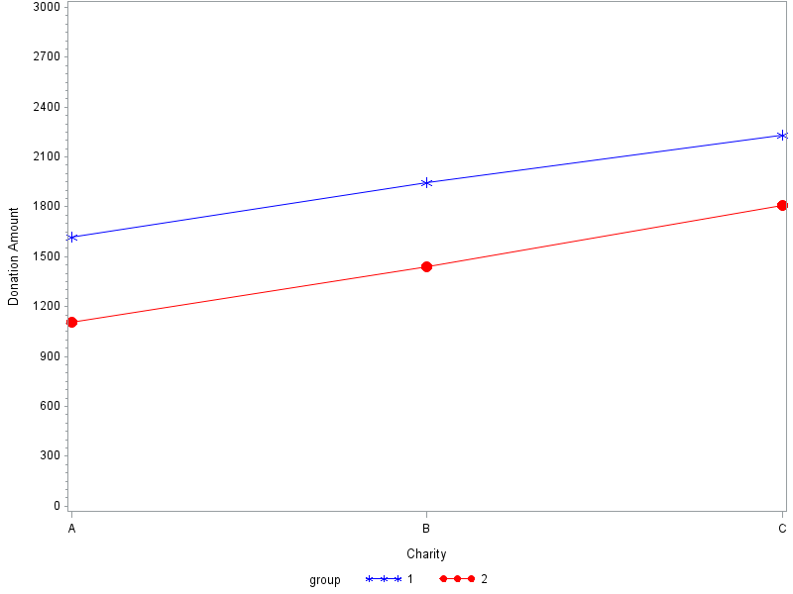
Charity A = charity that did not have an audit
Charity B = charity that had an audit but did not make the audit easily accessible to donors (i.e. post the audit on its website).
Charity C = charity that had an audit and made the audit easily accessible to donors (i.e. posted the audit on its website).
Group 1 = condition where charity rating agency ratings are in agreement
Group 2 = condition where charity rating agency ratings do not agree

FIGURE 3
Graph of Means of Dependent Variable (DV Measured as Amount of Suggested Donation ranging from $0 to $3,000)
Experiment Two
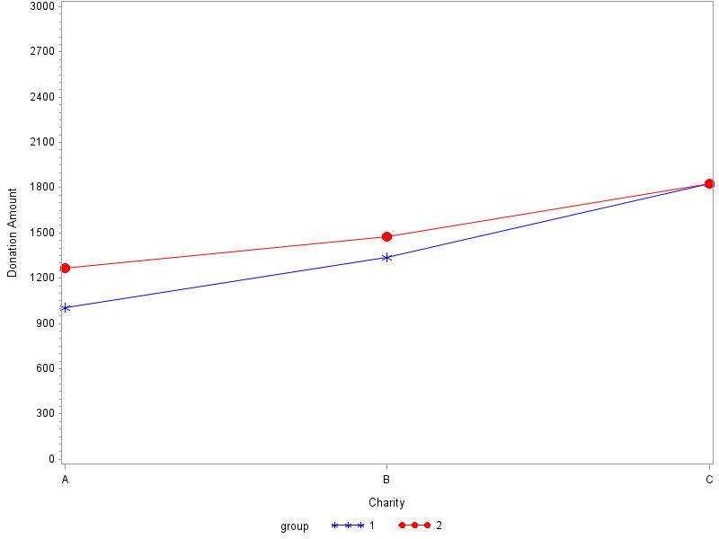

Charity A = charity that did not have an audit
Charity B = charity that had an audit but did not make the audit easily accessible to donors (i.e. post the audit on its website).
Charity C = charity that had an audit and made the audit easily accessible to donors (i.e. posted the audit on its website).
Group 1 = condition where charity rating agency ratings are in agreement
Group 2 = condition where charity rating agency ratings do not agree

APPENDIX A
Experimental Instrument
***Recruitment Script and IRB form omitted
For the survey that follows you are to assume the role of an employee of CSR Company (CSR). CSR has a corporate giving program. As part of the corporate giving program, CSR makes donations to nonprofit organizations throughout the year. The employees of CSR decide what causes to support and the amount that will be donated.
---------------------------------------------------------------------------------------------------------------------
Four times each year employees of CSR take a vote and select a category of nonprofit organizations to support that quarter. The employees of CSR are entrusted with the responsibility of vetting nonprofit organizations in the selected category and recommending the amount of the donation that should be made to the nonprofit organization.
---------------------------------------------------------------------------------------------------------------------
This quarter, CSR employees have decided to consider donations to organizations that train service dogs for individuals with physical and mental disabilities. Three nonprofit organizations (referred to as Charity A, Charity B and Charity C) that exist to fulfill this purpose have been selected for further consideration.
Employees of CSR will evaluate the nonprofits on their program effectiveness (i.e. does the organization accomplish its stated goals of training dogs and matching them with individuals who need service dogs) and financial and governance characteristics (i.e. how the organization uses, and accounts for, the donations it receives).
---------------------------------------------------------------------------------------------------------------------
Another employee has evaluated the program effectiveness of the three organizations and all three organizations are effectively accomplishing their mission of training dogs and matching dogs with individuals.
---------------------------------------------------------------------------------------------------------------------
You have been entrusted with the responsibility of evaluating the organizations on financial and governance characteristics (i.e. how the organization uses, and accounts for, the donations it receives).
You will be provided with summarized financial information for the organizations. You will also be provided with evaluations of the organizations performed by two highly respected charity watchdog groups (Charity Compass and Charity Guard).
---------------------------------------------------------------------------------------------------------------------
To assist you with your evaluation, the general guidelines suggested by the Better Business Bureau for evaluating a nonprofits use of financial resources are provided below:

Program Expenses – The nonprofit should spend at least 65% of its total expenses on program activities (i.e. training dogs and placing them with individuals).

Fundraising Expenses – The nonprofit should spend no more than 35% of its total expenses on fund raising.
---------------------------------------------------------------------------------------------------------------------
Many, but not all, nonprofit organizations are required to have a financial statement audit. For example, if an organization expends over $750,000 in federal funds then the organization would be required to have a financial statement audit. None of the three nonprofits that you will be evaluating received federal funds and thus are under no legal obligation to have an audit.
---------------------------------------------------------------------------------------------------------------------
Some nonprofit organizations that have no legal obligation to have an audit choose to voluntarily undergo an audit. Nonprofit organizations that have an audit are under no legal obligation to make the audit accessible to potential donors (i.e. posting the audit on the nonprofit's website where potential donors can easily review the audit).
---------------------------------------------------------------------------------------------------------------------
On the following pages you will evaluate each charity independently. Each organization can receive a donation amount ranging from $0 to $3,000, and the amount donated to one charity does not impact the amount donated to another charity (meaning, you are not allocating the funds between the three organizations, but rather deciding what amount between $0 and $3,000 each charity should receive).
---------------------------------------------------------------------------------------------------------------------
You will view information for one nonprofit organization at a time. After viewing the information for the nonprofit organization you will be asked to make a decision about the donation to that organization. After making your donation decision for the first organization you will proceed to make the same decision for the second organization, and then the third organization.
Since the evaluation of each organization is independent of your evaluation of the other organizations you will not be able to go back and change your donations for the organizations you have already reviewed.
---------------------------------------------------------------------------------------------------------------------
The other employees of CSR are counting on you to make wise use of the funds! If for any reason you have concerns about a charity, it is permissible to limit the amount of the donation. Any funds not allocated to a charity will be set aside by CSR Company in a separate bank account for the corporate giving program and the funds will be rolled forward to future periods (meaning that the unallocated funds will still only be used for future charitable donations).
---------------------------------------------------------------------------------------------------------------------If you wish to review any of the previous screens please do so now using the back button below (you will not be able to return to these screens later).
Press the next button to begin your evaluation of the charities.
-------------------------------------------------------------------------------------------------------------------------------***At this point participants are randomized into one of two groups for the between-subjects manipulation. Group one participants see charity rating agency reports that are in agreement in their evaluation of the charity (letter grade of B and a rating of 3 out of 4 stars in experiment one, and a letter grade of C and a rating of 2 out of 4 stars in experiment two, for brevity, only experiment one is shown below). In both experiments one and two, group two participants see charity rating agency reports that are not in agreement in their evaluation of the charity (letter grade of D and a rating of 3 out of 4 stars).
***The screens that follow are from the between-subjects condition where charity rating agencies evaluations are in agreement. The order of the presentation of the charities (Charity A, Charity B and Charity C) was randomized.

Charity A - Summary Financial Information and Charity Watchdog Evaluation Reports
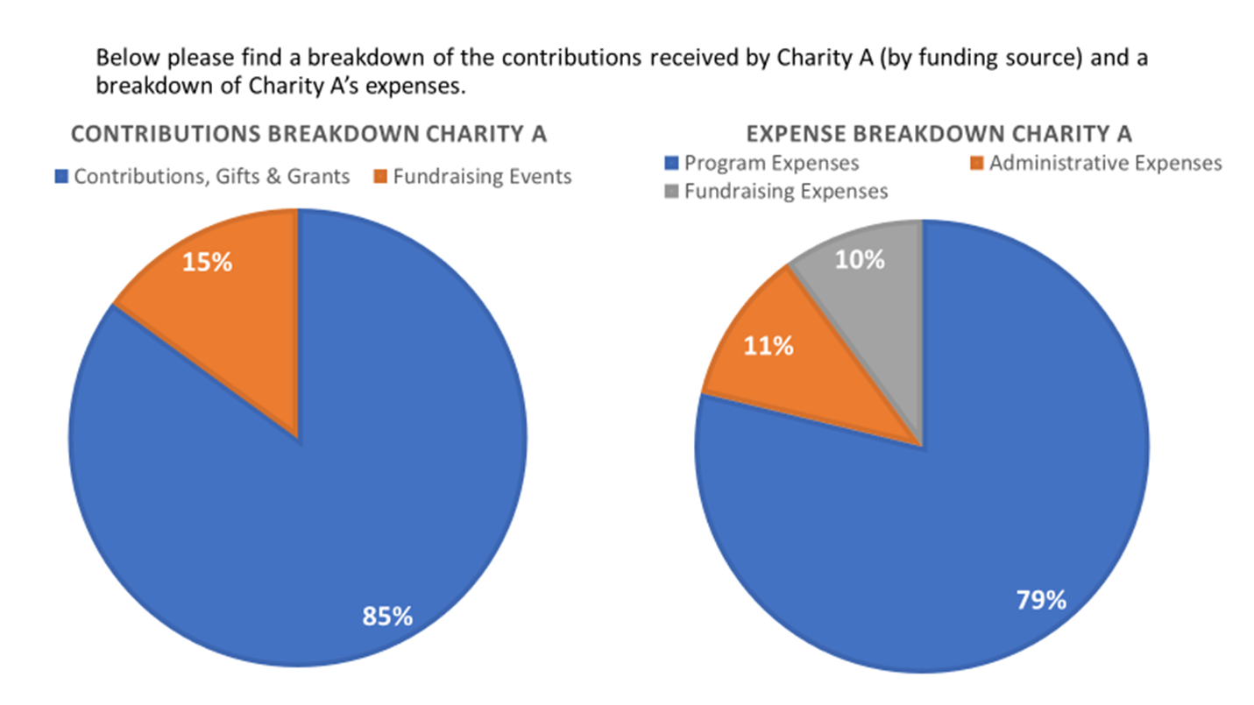

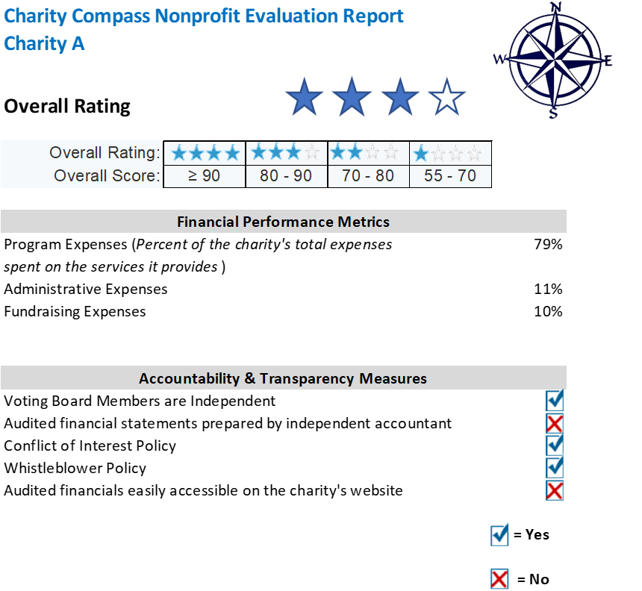

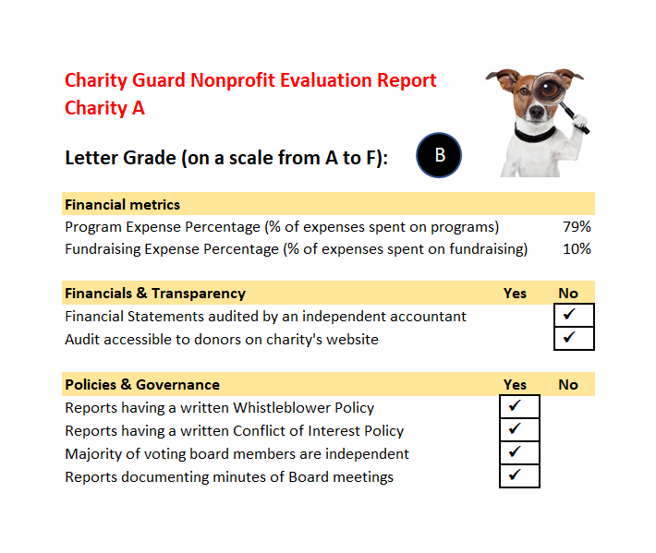

Please answer the following questions regarding possible donations that might be made to Charity A

How likely are you to recommend that Charity A be included in the corporate giving program?
 | Definitely would not recommend |  |  |  |  |  |  | Definitely would recommend

 | -3 | -2 | -1 | 0 | 1 | 2 | 3

Drag the slider to indicate your answer | 

How confident are you that Charity A will use the donated funds as intended?
 | Not confident at all | Neutral | Extremely confident

 | -3 | -2 | -1 | 0 | 1 | 2 | 3

Drag the slider to indicate your answer

What amount (in dollars $) do you recommend be donated to Charity A?
 | 0 | 300 | 600 | 900 | 1200 | 1500 | 1800 | 2100 | 2400 | 2700 | 3000

$ dollars

Charity B - Summary Financial Information and Charity Watchdog Evaluation Reports
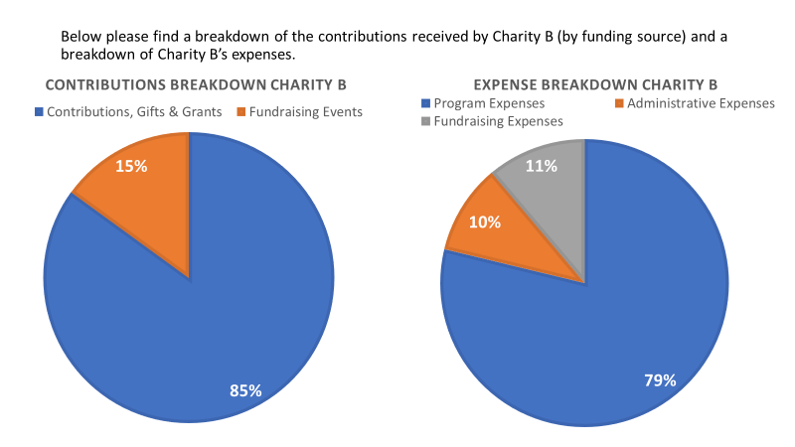

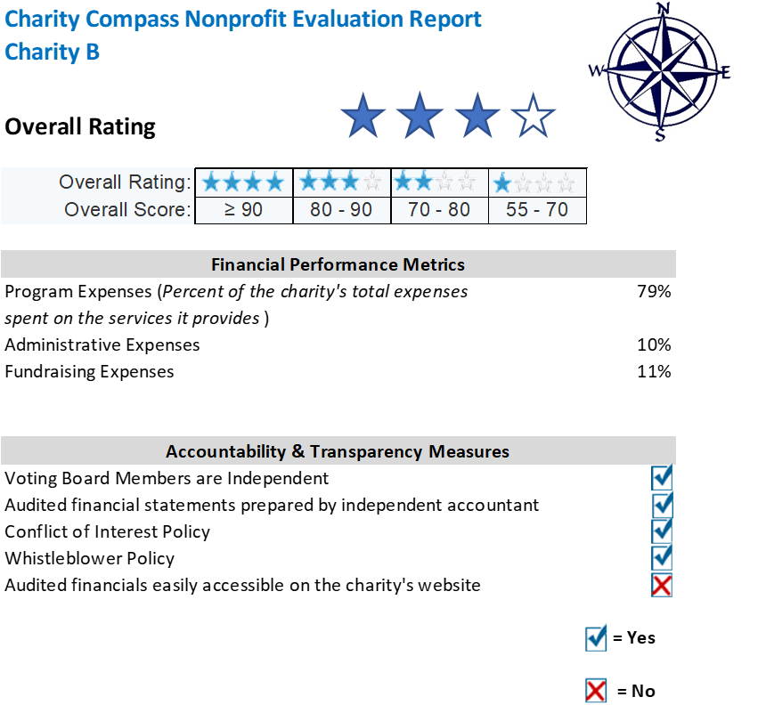

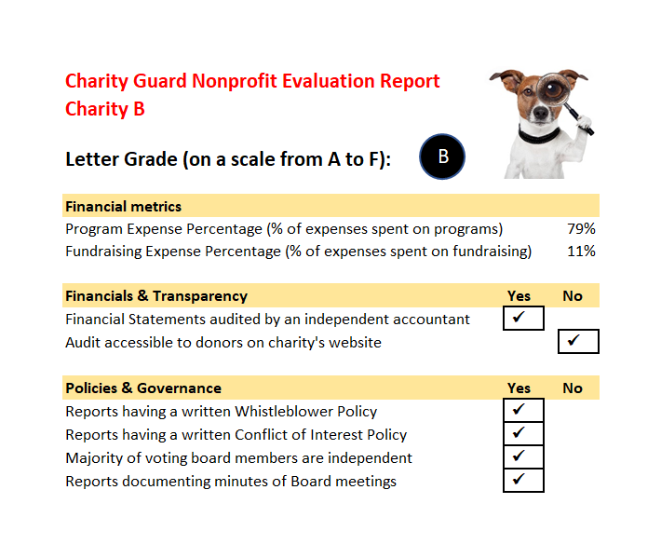

Please answer the following questions regarding possible donations that might be made to Charity B

How likely are you to recommend that Charity B be included in the corporate giving program?
 | Definitely would not recommend |  |  |  |  |  | Definitely would recommend

 | -3 | -2 | -1 | 0 | 1 | 2 | 3

Drag the slider to indicate your answer

How confident are you that Charity B will use the donated funds as intended?
 | Not confident at all | Neutral | Extremely confident

 | -3 | -2 | -1 | 0 | 1 | 2 | 3

Drag the slider to indicate your answer

What amount (in dollars $) do you recommend be donated to Charity B?
 | 0 | 300 | 600 | 900 | 1200 | 1500 | 1800 | 2100 | 2400 | 2700 | 3000

$ dollars

Charity C - Summary Financial Information and Charity Watchdog Evaluation Reports
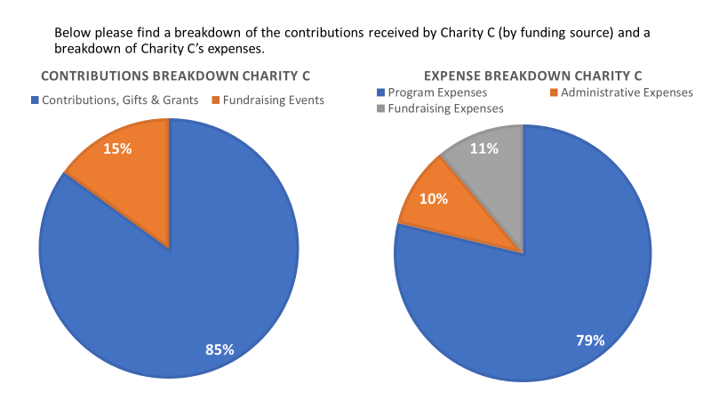

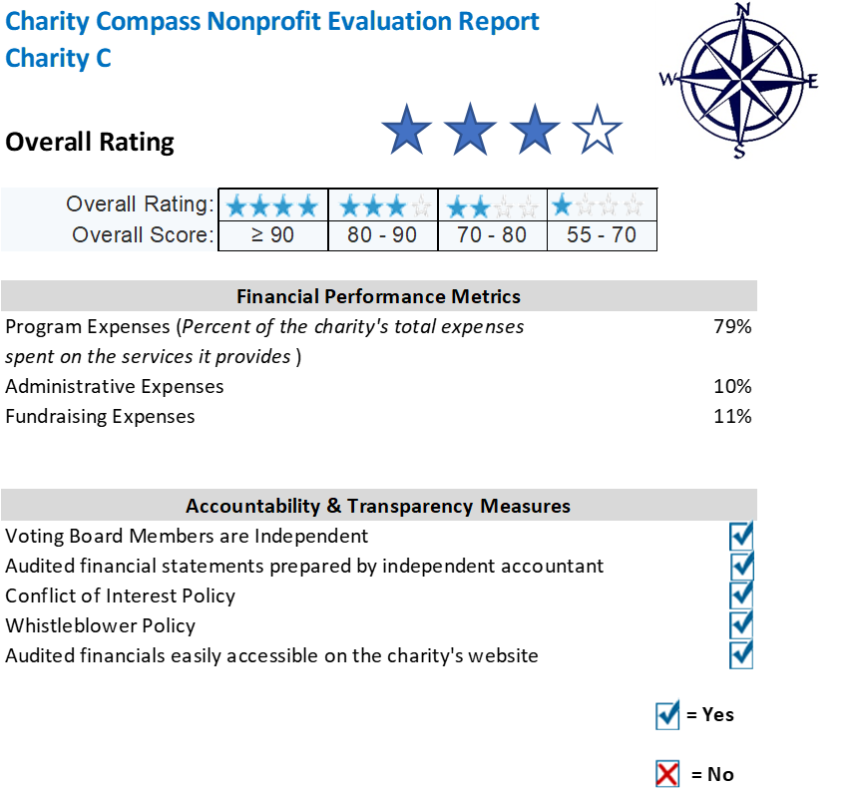

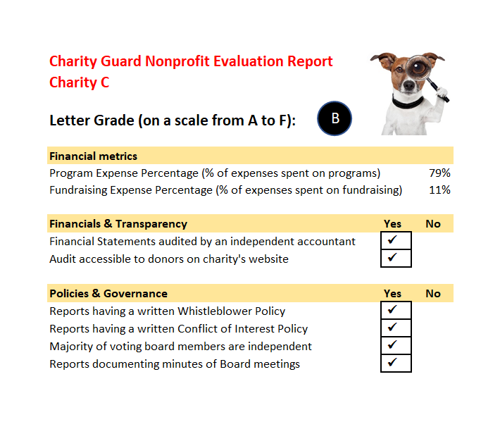

Page Break

Please answer the following questions regarding possible donations that might be made to Charity C

How likely are you to recommend that Charity C be included in the corporate giving program?
 | Definitely would not recommend |  |  |  |  |  | Definitely would recommend

 | -3 | -2 | -1 | 0 | 1 | 2 | 3

Drag the slider to indicate your answer

How confident are you that Charity C will use the donated funds as intended?
 | Not confident at all | Neutral | Extremely confident

 | -3 | -2 | -1 | 0 | 1 | 2 | 3

Drag the slider to indicate your answer

What amount (in dollars $) do you recommend be donated to Charity C?
 | 0 | 300 | 600 | 900 | 1200 | 1500 | 1800 | 2100 | 2400 | 2700 | 3000

$ dollars

***The screens that follow are from the between-subjects condition where charity rating agencies evaluations are not in agreement. The order of the presentation of the charities (Charity A, Charity B and Charity C) was randomized.

Charity A - Summary Financial Information and Charity Watchdog Evaluation Reports

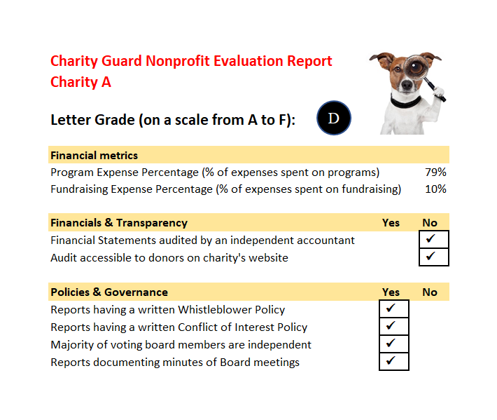

Please answer the following questions regarding possible donations that might be made to Charity A

How likely are you to recommend that Charity A be included in the corporate giving program?
 | Definitely would not recommend |  |  |  |  |  | Definitely would recommend

 | -3 | -2 | -1 | 0 | 1 | 2 | 3

Drag the slider to indicate your answer

How confident are you that Charity A will use the donated funds as intended?
 | Not confident at all | Neutral | Extremely confident

 | -3 | -2 | -1 | 0 | 1 | 2 | 3

Drag the slider to indicate your answer

What amount (in dollars $) do you recommend be donated to Charity A?
 | 0 | 300 | 600 | 900 | 1200 | 1500 | 1800 | 2100 | 2400 | 2700 | 3000

$ dollars

Charity B - Summary Financial Information and Charity Watchdog Evaluation Reports

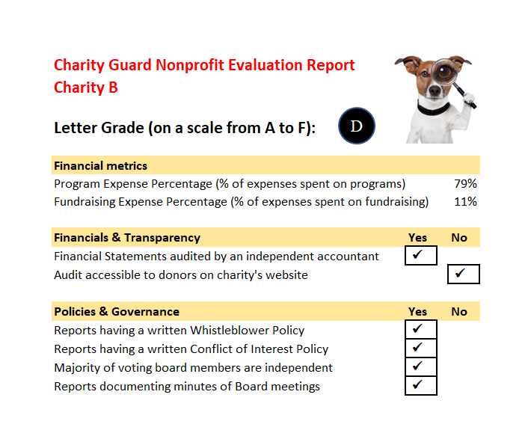

Please answer the following questions regarding possible donations that might be made to Charity B

How likely are you to recommend that Charity B be included in the corporate giving program?
 | Definitely would not recommend |  |  |  |  |  | Definitely would recommend

 | -3 | -2 | -1 | 0 | 1 | 2 | 3

Drag the slider to indicate your answer

How confident are you that Charity B will use the donated funds as intended?
 | Not confident at all | Neutral | Extremely confident

 | -3 | -2 | -1 | 0 | 1 | 2 | 3

Drag the slider to indicate your answer

What amount (in dollars $) do you recommend be donated to Charity B?
 | 0 | 300 | 600 | 900 | 1200 | 1500 | 1800 | 2100 | 2400 | 2700 | 3000

$ dollars

Charity C - Summary Financial Information and Charity Watchdog Evaluation Reports

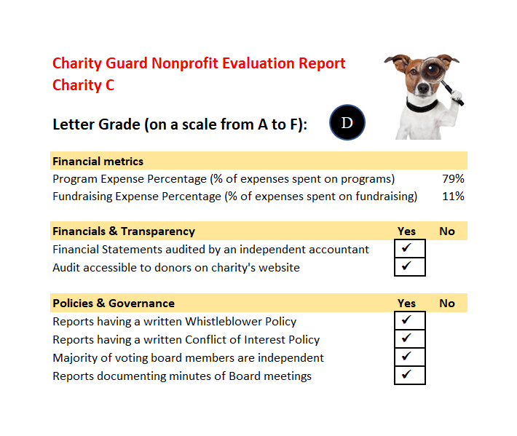

Please answer the following questions regarding possible donations that might be made to Charity C

How likely are you to recommend that Charity C be included in the corporate giving program?
 | Definitely would not recommend |  |  |  |  |  | Definitely would recommend

 | -3 | -2 | -1 | 0 | 1 | 2 | 3

Drag the slider to indicate your answer

How confident are you that Charity C will use the donated funds as intended?
 | Not confident at all | Neutral | Extremely confident

 | -3 | -2 | -1 | 0 | 1 | 2 | 3

Drag the slider to indicate your answer

What amount (in dollars $) do you recommend be donated to Charity C?
 | 0 | 300 | 600 | 900 | 1200 | 1500 | 1800 | 2100 | 2400 | 2700 | 3000

$ dollars

***Manipulation check questions
What was the dollar amount range of possible donations?
- There was no possible range of donations
- $0 to $1,000
- $0 to $3,000
- $0 to $5,000

How many of the charities that you reviewed (Charity A, Charity B and Charity C) had a financial statement audit?
- All of the charities had a financial statement audit
- None of the charities had a financial statement audit
- One of the charities had a financial statement audit
- Two of the charities had a financial statement audit

***Demographic Information
Please enter you Age (using numbers)
________________________________________________________________

Gender
- Male
- Female

What is the highest level of school you have completed or the highest degree you have received?
- Less than high school degree
- High school graduate (high school diploma or equivalent including GED)
- Some college but no degree
- Associate degree in college (2-year)
- Bachelor's degree in college (4-year)
- Master's degree
- Doctoral degree
- Professional degree (JD, MD)

Please indicate the answer that includes your entire household income in (previous year) before taxes.
- Less than $10,000
- $10,001 to $30,000
- $30,001 to $60,000
- $60,001 to $90,000
- $90,001 to $130,000
- more than $130,000

Are you now married, widowed, divorced, separated or never married?
- Married
- Widowed
- Divorced
- Separated
- Never Married

***Questions regarding donation history
Have you donated to charity in the last 12 months?
- Yes
- No

Display This Question:
If Have you donated to charity in the last 12 months? = Yes

When you have donated to charity, which of the following sources of information did you consider before making a donation? (please select all that apply)
- None
- Friends or family
- The Charity's website
- Charity Watchdog websites
- The Charity's IRS Form 990
- The Charity's financial statement audit

If you were to donate to a charity in the future, which of the following sources of information are you likely to consider before making a donation? (please select all that apply)
- None
- Friends or family
- The Charity's website
- Charity Watchdog websites
- The Charity's IRS Form 990
- The Charity's financial statement audit

***Six item need for cognition scale
Almost Done! This is the last page of the survey.
For each of the six statements below, please indicate whether or not the statement is characteristic of you or of what you believe.
 | extremely uncharacteristic of me | somewhat uncharacteristic of me | uncertain | somewhat characteristic of me | extremely characteristic of me
I prefer complex to simple problems
I like to have the responsibility of handling a situation that requires a lot of thinking
Thinking is not my idea of fun
I would rather do something that requires little thought than something that is sure to challenge my thinking abilities
I really enjoy a task that involves coming up with new solutions to problems
I would prefer a task that is intellectual, difficult, and important to one that is somewhat important but does not require much thought

APPENDIX B
Information Differences Between Internal Revenue Service Form 990 and Audited Financial Statements
As detailed in the section of the paper titled Internal Revenue Service Form 990, the most widely available source of financial information for donors is Form 990. Basic financial information per the Form 990 and audited financial statements are qualitatively similar in many respects, however, there are differences. Generally Accepted Accounting Principles (GAAP) require a Statement of Cash Flows (ASC 958-205-45-4) while the Form 990 has no equivalent to the Statement of Cash Flows. Motivated by the omission of a statement of cash flows on the Form 990, Fischer, Gordon and Khumawala (2008) attempted to derive cash flows from operations using Form 990 data and concluded that cash flows from operations cannot be accurately derived from the Form 990 leaving the audit as the primary source of this information.
Another difference in the presentation of basic financial information regards the reporting of expenses by function. Part IX of the Form 990 is a Statement of Functional Expenses that presents expenses in their natural categories (i.e. salaries and wages, occupancy, etc.) by function (e.g. program expense, management and general expense and fundraising expense). The reporting of expenses by nature and function required by ASC 958-205-45-6 differs from the Form 990. The Form 990 presents all program expenses in one column, while ASC 958-205-45-6 requires disaggregation of major classes of program services. The disaggregation of major classes of program services could be useful to donors, for example, in determining the relative weight of resources devoted to an organization’s different programs.
In addition to the differences in required financial statements noted above, there are other differences in information that might be of interest to donors. The notes to audited financial statements may contain information that would not be reflected on the Form 990 such as information regarding subsequent events and contingent liabilities. In some instances, the Form 990 includes information that is not included in audited financial statements. Many donors are interested in the compensation of charities directors and employees as evidenced by charity watchdogs’ provision of this information to donors. Form 990 (Part VII) contains detailed information regarding compensation of officers, directors, key employees and highly compensated employees and independent contractors that is not available from audited financial statements. The Form 990 contains an exhaustive checklist of governance metrics such as the number of board members, and the presence or absence of written policies regarding conflicts of interest, whistleblowing, etc. Some differences between the Form 990 and audited financial statements are a matter of form rather than substance.
Froelich and Knoepfle (1996) interviewed NFP executive directors and accountants, as well as tax and audit professionals from firms hired by the NFP’s. The interviewees were asked to compare the Form 990 and the audit. The consensus of the interviewees was that “both [Form 990 and the audit] are necessary to get a balanced view and that neither alone, and certainly not just pieces of each, would be adequate for evaluating organizational performance” (p. 48).

Throughout this paper the terms “audit”, “financial statement audit”, and “audited financial statements” are used interchangeably. These terms refer to a single document that includes the auditor’s report, the audited financial statements and accompanying notes, and any other required supplementary reports and schedules.
Donations made by foundations and corporations totaled $67 billion and $21 billion respectively (Giving USA 2018).
As explained in detail in section 2.1, most nonprofit organizations that come to mind are classified as public charities (e.g. Red Cross, United Way, Salvation Army, Nature Conservancy, American Heart Association, etc.). Organizations classified as public charities are the focus of this paper (the terms “public charity”, “charity”, and “nonprofit” are used interchangeably throughout the remainder of the paper).
The return filed is dictated by the charity’s size. Public charities with gross receipts normally less than $50,000 file Form 990N – Electronic Notice (e-Postcard) for Tax-Exempt Organizations Not Required to File Form 990. Public charities with gross receipts less than $200,000 and total assets less than $500,000 file Form 990EZ – Short Form Return of Organization Exempt from Income Tax. All other public charities must file Form 990 - Return of Organization Exempt from Income Tax (hereafter referred to as “Form 990N”, “Form 990EZ”, or “Form 990”, respectively). Filing requirements retrieved from: Internal Revenue Service. Form 990 Series - Which Forms Do Exempt Organizations File (Filing Phase In). https://www.irs.gov/charities-non-profits/form-990-series-which-forms-do-exempt-organizations-file-filing-phase-in (accessed August 14, 2018).
The most convenient access to Form 990 is provided by Guidestar.org (https://www.guidestar.org/Home.aspx) which serves as a central repository for Form 990. The IRS requires that the Form 990 is made available for public inspection (I.R.C. § 6104.). While the requirement for public inspection only requires that a copy of the Form 990 be available at the office of the NFP during normal business hours, many NFP’s post their most recent Form 990 on their website. Form 990’s filed since January 2018 can also be accessed at https://www.irs.gov/charities-non-profits/tax-exempt-organization-search.
The financial information presented in Form 990 is similar in many respects to the financial information in audited financial statements. The focus of this study is on the transparency signal sent by a charity when it makes its audited financial statements readily accessible to donors rather than any differences in the financial information between the Form 990 and audited financial statements. For interested readers, the differences between the financial information available on Form 990 versus audited financial statements is presented in Appendix B.
Form 990 is a 12-page form comprised of twelve parts. The form had a major revision in 2008 and has remained largely unchanged through the 2017 form.
There are 16 supporting schedules that an organization may be required to file depending on the organization’s operations. All public charities must complete Schedule A which verifies that the organization is correctly classified as a public charity (as opposed to a private foundation). Schedule O provides the organization with an opportunity to provide additional information on issues that come to light during completion of the Form 990 and is a valuable resource in gathering information about an organization.
User statistics are per Charity Navigator’s website https://www.charitynavigator.org (Accessed September 20, 2018)
https://www.charitynavigator.org/index.cfm?bay=content.view&cpid=5593#starcalculation
Statistics per http://www.give.org/about-bbb-wga/more-about-us/ and the 2016 Form 990 accessed at http://www.give.org/globalassets/wga/annual-reports/bbb-wga-2016-990.pdf.
In addition to the nationally soliciting charities evaluated at Give.org, regional Better Business Bureaus evaluate regionally soliciting charities using the same evaluation criteria as Give.org.
http://www.give.org/for-charities/How-We-Accredit-Charities/. Charities are assigned one of the following findings: standard is met, standard is not met, or unable to verify.
See “The CharityWatch difference at https://www.charitywatch.org/about-charitywatch/charitywatch-difference/3113/3118 (accessed October 10, 2018)
For an example of a particularly comprehensive Nonprofit Profile see GuideStar’s profile of itself at https://www.guidestar.org/profile/54-1774039 (accessed October 8, 2018). Metrics cited in this paragraph regarding organizations covered and website visitors come from this Nonprofit Profile.
GiveWell’s methodology for identifying and evaluating charitable organizations is complex. Interested readers can find out more by visiting https://www.givewell.org/how-we-work.
https://www.givewell.org/charities/top-charities (accessed October 10, 2018).
Other examples of divergent ratings include: Guide Dogs for the Blind which has a four-star rating from Charity Navigator but receives an F rating (downgraded from an A- for large asset reserves) from CharityWatch; Muscular Dystrophy Association which receives a B+ rating from CharityWatch but a 2-star rating (73.9 numerical score) from Charity Navigator.
For a strident commentary on the methodology of rating agencies see Chapter 9 - § 9.12 of The Law of Fundraising by Bruce R. Hopkins and Alicia M. Kirkpatrick (2017) which can be accessed at ProQuest eBook Central https://ebookcentral-proquest-com.ezproxy.lib.ou.edu/lib/oulaw/detail.action?docID=4825796# (accessed October 2, 2018) or LexisNexis https://www.lexisnexis.com/hottopics/lnacademic/?verb=sr&csi=324903 (accessed October 2, 2018).
For a commentary on charity rating agencies from the perspective of the charities being rated see the 2005 report published jointly by The National Council of Nonprofit Associations and The National Human Services Assembly titled “Rating the Raters: An Assessment of Organizations and Publications That Rate/Rank Charitable Nonprofit Organizations”.
https://www.charitywatch.org/about-charitywatch/charitywatch-difference/3113/3118 (accessed October 2, 2018).
Burks (2015) examines accounting errors in nonprofit organizations by examining errors disclosed in audited financial statements. The study is motivated in part by concerns over audit quality in the nonprofit sector. The sample included audits by Big 4, second tier, regional and small auditors. Big 4 and second tier auditors were significantly less likely to be associated with errors. The coefficient on regional and small firms was also negative but not statistically significant (Table 3). Although error rates for nonprofit audits were higher than publicly traded companies during the sample period (6.1% vs. 3.8%, 2006-2010) the author finds the overall results encouraging and contrary to concerns that small auditors are allowing material errors to go uncorrected (p. 359).
Garven, Beck and Parsons (2017) examine the effect of audit-related factors (i.e. auditor size, tenure, specialization, etc.) on nonprofit financial reporting quality (FRQ). Specialization and unexplained audit fees are the only factors that are significantly, positively associated with all four measures of FRQ used in their study. Auditor size and tenure are significantly and positively associated with FRQ in certain tests (with medium size firms providing higher quality).
In a compelling study, Grein and Tate (2011) use the unique setting of public housing authority audits to examine monitoring by auditors in a nonprofit setting with low litigation risk, management incentives to misstate data, and dominated by smaller audit firms. They find that audits result in material adjustments to the financial statements and an overall pattern of audit adjustments consistent with reducing potential management bias in the financial statements.
The program ratio is the percentage of an organization’s total expenditures that is devoted to programs and services. This ratio is commonly calculated from Form 990 (Part IX line 25B/Part IX line 25A).
Administrative expense percentage and fundraising expense percentage are commonly calculated from Form 990 (Part IX line 25c/Part IX line 25A and Part IX line 25D/Part IX line 25A, respectively).
Per the online appendix to Duguay (2018), 23 states had an audit mandate for some nonprofits while 27 states and the District of Columbia had no audit mandate.
A detailed examination of state filing requirements is beyond the scope of this paper. Interested readers can access a concise summary of state requirements at the National Council on Nonprofits website. https://www.councilofnonprofits.org/nonprofit-audit-guide/state-law-audit-requirements (accessed August 17, 2018)
The Combined Federal Campaign (https://www.opm.gov/combined-federal-campaign/) is an annual workplace charity campaign for Federal employees overseen by the Office of Personnel Management (OPM). The OPM estimates that there are over 20,000 participating charities. Requirements for participating charities are available at: https://www.opm.gov/combined-federal-campaign/information-for-charities/#url=Qualifications-Materials (accessed October 17, 2018).
Part XII, line 3a and 3b of IRS Form 990 would inform donors that an audit was required by the Single Audit Act and OMB Circular A-133. Part IV, Line 12a and 12b, and Part XII, line 2b would also inform donors that an audit was performed, but donors would not necessarily know whether the audit was mandatory or voluntary A diligent donor could determine if the organization was required to complete an audit by state statute, however, there would be instances where an organization had an audit and it would be impossible for the donor to know with certainty if the audit was mandatory (i.e. required by the organizations governing documents, required to maintain a line of credit, etc.) or voluntary.
To control for any inferences participants might make regarding the mandatory or voluntary nature of the audit, the participants were told that the audit was voluntary in all experimental conditions.
It should be noted that a good rating was associated with significantly more donations than a bad rating, but a bad rating was associated with significantly more donations than being unrated.
To address endogeneity concerns Harris and Neely 1) employ a two-stage Heckman approach 2) construct a matched-pair sample and 3) employ change analyses.
The general findings from psychology that effort expended to obtain information impacts the processing of that information have been found to hold in an accounting context (Nelson and Tayler 2007).
The experimental instrument was approved by the University of Oklahoma Institutional Review Board.
MTurk workers were compensated $2.50 for completing the experiment. The criteria for the MTurk workers to participate in the survey were: 1) located in the United States 2) Human Intelligence Task (HIT) approval rate greater than 97% and 3) more than 1,000 approved HIT’s.
Results are quantitatively the same when the analysis is ran using the two other dependent variables (i.e. “How likely are you to recommend that Charity N be included in the corporate giving program?” and “How confident are you that Charity N will use the donated funds as intended?”, reported in Table 4, Panel B and Panel C, respectively).
Mauchly’s test indicated that the assumption of sphericity had been violated, χ²(2) = 66.04, p <.0001, therefore Greenhouse-Geisser corrected tests are reported (ε = 0.87).
MTurk workers were compensated $2.50 for completing the experiment. The criteria for the MTurk workers to participate in the survey were: 1) located in the United States 2) Human Intelligence Task (HIT) approval rate greater than 97% 3) more than 1,000 approved HIT’s and 4) the workers could not have participated in experiment one.
Results are quantitatively the same when the analysis is ran using the two other dependent variables (i.e. “How likely are you to recommend that Charity N be included in the corporate giving program?” and “How confident are you that Charity N will use the donated funds as intended?”, reported in Table 9, Panel B and Panel C, respectively).
Mauchly’s test indicated that the assumption of sphericity had been violated, χ²(2) = 66.04, p <.0001, therefore Greenhouse-Geisser corrected tests are reported (ε = 0.91).
As reported in Table 9, in experiment two the donation amount was not statistically different between the group that saw rater agreement on a C rating vs. the group that saw rater disagreement with one rater assigning a grade of B and the other rater assigning a grade of D. In untabulated results, the donation amounts in experiment one for the group that saw rater disagreement with one rater assigning a grade of B and the other rater assigning a grade of D were not statistically different from the donation amounts reported in experiment two.
No prediction could be made regarding the effect sizes because (1) there is a lack of literature examining the effect of audit accessibility on donor decision making and (2) the archival accounting literature that examines the impact of having an audit on donor decision making does not report the effect sizes observed in those studies.
In pilot testing, including a sample of 20 participants comprised of accounting doctoral students and students in a 3000-level accounting course, 7 of the 20 participants missed this manipulation check question.
In experiment two, if participants that missed manipulation check question two are excluded the interaction effect approaches significance (p > 0.1112). If participants that missed both manipulation check question one and two are excluded (53 out of 106 participants missed both manipulation check questions, primarily driven by the results from manipulation check question two) the interaction effect is p > 0.1046. The trend of the interaction is that the difference between groups (raters agree, raters disagree) is largest when there is no audit and decreases when there is an audit (but not disclosed) and decreases yet again when there is an audit and the audit is disclosed.
For example, Part X of the Form 990 is a Balance Sheet which is in most respects similar to the Statement of Financial Position required by ASC 958-205-45-4 and Part VIII of the Form 990 is a Statement of Revenue that is similar to the Statement of Activities required by ASC 958-205-45-4.
The classification of expenses by function (e.g. program, management and general, and fundraising) is only required for 501(c)(3) and 501(c)(4) organizations. The current study focuses on public charities which are 501(c)(3) organizations and thus are required to report expenses by function, rather than simply in total.
For example, World Vision disaggregates its program expenses into international programs, domestic programs and public awareness and education on its 2017 audited financial statements while these amounts are presented in the aggregate in column B of Part IX on the Form 990. (https://www.worldvision.org/about-us/financial-accountability-2#1468438377863-040c8abd-5609, accessed October 16, 2018).
Guidestar publishes an annual Nonprofit Compensation Report, Charity Navigator publishes an annual Charity CEO Compensation Study, and CharityWatch has a link on its home page to an article showing the top 25 charity compensation packages.

