UNIVERSITY OF OKLAHOMA
GRADUATE COLLEGE

CONSERVATION OF NEOTROPICAL PARROTS: POPULATION RESPONSES TO FOREST COVER CHANGE AND TRADE PRESSURE AND A TOOL TO PREDICT SENSITIVITY TO DEFORESTATION

A DISSERTATION
SUBMITTED TO THE GRADUATE FACULTY
in partial fulfillment of the requirements for the
Degree of
DOCTOR OF PHILOSOPHY

By
DAVID C. HILLE
Norman, Oklahoma
2022
CONSERVATION OF NEOTROPICAL PARROTS: POPULATION RESPONSES TO FORESET COVER CHANGE AND TRADE PRESSURE AND A TOOL TO PREDICT SENSITIVITY TO DEFORESTATION

A DISSERTATION APPROVED FOR THE
DEPARTMENT OF BIOLOGY

BY THE COMMITTEE CONSISTING OF

Dr. Eli Bridge, Chair
Dr. Michael A. Patten
Dr. Bruce Hoagland
Dr. Jeff Kelly
Dr. Donald J. Brightsmith

© Copyright by DAVID C. HILLE 2022
All Rights Reserved.

Acknowledgements
I thank my advisor, Michael Patten, for his persistent confidence and seeing me through successfully to the end. I thank Eli Bridge for stepping in at a crucial time as chair of my committee and giving me the support to finish, and my committee, Bruce Hoagland, Jeff Kelly, and Donald Brightsmith for their sustained direction and support. I thank David Wiedenfeld and Martín Lezama for their past field efforts, monitoring data, and logistical support. I thank Francisco Muñoz, who endured long and arduous 2013 and 2017 field seasons around the entire country of Nicaragua. He could not have been outperformed in skill or attitude. I thank Paso Pacifico and ALAS for their in-country collaboration. Liliana Chavarria-Duriaux and Georges Duriaux and Jean-Michel Maes offered great logistical guidance. Viviana Ruiz-Guitterez offered much support in occupancy modeling. Very importantly, I thank Carlos Mejia of MARENA for the permits to allow this work and substantial logistical support that aided in successful surveys. Also, I thank the staff at the Oklahoma Biological Survey who provided much support. Finally, I thank Sarah Hille for her unwavering belief in me and my ability to complete this body of work. This work was funded by the Sutton Avian Scholarship (CAS at OU), World Parrot Trust, Parrot Fund – Amigos de las Aves USA, OU Department of Biology, OU College of Arts and Sciences, and OU Graduate College.

Table of Contents

Acknowledgements……………………………………………………………………………………………..iv
Abstract……………………………………………………………………………………………………………..viii
CHAPTER 1: MULTIPLE RESPONSES OF NEOTROPICAL PARROTS TO FOREST COVER CHANGE
OVER A TWO DECADE PERIOD………………………………………………………………………..1
Introduction……………………………………………………………………………………………………………………1
Methods…………………………………………………………………………………………………………………………3
Vegetation Data Collection…………………………………………………………………………………3
Occupancy Estimates………………………………………………………………………………………….3
Statistical Analysis………………………………………………………………………………………………3
Results……………………………………………………………………………………………………………………………4
NDVI Summary……………………………………………………………………………………………………4
Profile Analysis of NDVI………………………………………………………………………………………5
Profile Analysis of Occupancy and NDVI……………………………………………………………..5
Discussion………………………………………………………………………………………………………………………6
NDVI Patterns…………………………………………………………………………………………………….6
Parrot Response to Forest Cover Changes………………………………………………………….6
Conclusion……………………………………………………………………………………………………………………10
References……………………………………………………………………………………………………………………10
Tables…………………………………………………………………………………………………………………………..16
Figures………………………………………………………………………………………………………………………….17
CHAPTER 2: MULTIPLE RESPONSES OF NEOTROPICAL PARROTS TO ACCESSIBILITY AS AN
INDICATOR OF TRADE PRESSURE………………………………………………………………….23
Introduction………………………………………………………………………………………………………………...23
Methods……………………………………………………………………………………………………………………….24
Study Area and Study Species……………………………………………………………………………24
Parrot Surveys…………………………………………………………………………………………………..24
Accessibility Data Collection……………………………………………………………………………..25
Occupancy Modeling and Model Selection……………………………………………………….26
Results………………………………………………………………………………………………………………………….26
Accessibility Data………………………………………………………………………………………………26
Occupancy Models and Model Selection…………………………………………………………..26
Discussion…………………………………………………………………………………………………………………….27
Accessibility Effect and Potential Drivers of Trade Pressure………………………………27
Conclusion……………………………………………………………………………………………………………………29
References……………………………………………………………………………………………………………………30
Tables…………………………………………………………………………………………………………………………..34
Figures………………………………………………………………………………………………………………………….35
CHAPTER 3: CONSERVATISM AS A TOOL TO ELICIT SENSITIVITY TO DEFORESTATION AND
CORRELATES IN A HIGHLY ENDANGERED AVIAN FAMILY……..……………………….41
Introduction…………………………………………………………………………………………………………………41
Methods……………………………………………………………………………………………………………………….42
Study Area and Study Species……………………………………………………………………………42
NDVI Data Collection…………………………………………………………………………………………42
Generation of CoC as Sensitivity to Deforestation Values…………………………………43
Database Compilation of Explanatory Variables………………………………………………..43
Statistical Analysis…………………………………………………………………………………………….44
Results………………………………………………………………………………………………………………………….44
NDVI Data Summary…………………………………………………………………………………………44
CoC Values, Explanatory Variables, and Their Relationship……………………………….44
Discussion…………………………………………………………………………………………………………………….45
Niche Breadth Correlates………………………………………………………………………………….45
Conservation and Management Implications……………………………………………………46
Methodology Considerations……………………………………………………………………………47
Conclusions………………………………………………………………………………………………………………….47
References……………………………………………………………………………………………………………………48
Tables…………………………………………………………………………………………………………………………..53
Figures………………………………………………………………………………………………………………………….57

Abstract
The avian order Psittaciformes (parrots) is one the most at-risk group of birds in the world because of the combination of deforestation and overexploitation for wildlife trade. Studies to better understand and quantify the relative threats of deforestation and overexploitation are needed for conservation and management. The Central American country of Nicaragua provides an opportunistic study system towards that end. Deforestation and trade pressure have occurred consistently over multiple decades, including 1995 to 2013, a two-decade period from which population monitoring data is available. We used species-specific population data from a nation-wide parrot monitoring program to test the effects of deforestation and trade pressure and used a predictive tool to identify correlates to parrot sensitivity to deforestation.
To understand the effects of deforestation on parrot populations, we used Normalized Difference Vegetation Index (NDVI) to determine the extent deforestation affects population trends, described by occupancy. We ran multiple profile analyses to compare distribution-specific NDVI and species-specific occupancy. Population trends explained by NDVI demonstrated a regional pattern between the Pacific and Caribbean and showed two primary connections to forest cover change. While some parrots were negatively affected by forest loss and declined, others appeared to take advantage of the resulting open habitats.
Because of its smaller human population densities surrounded by more intact forest, we focused on the Caribbean region to better understand the dynamics of trade pressure on parrot populations. We evaluated the effect of geographic accessibility, a surrogate variable to estimate trade pressure from poacher activity, on parrot occupancy in the year 2013. We produced an accessibility metric adjusted for population density and used them as site covariates in occupancy models to explain occupancy. Geographic accessibility depressed parrot populations for some species, but not all. Accessibility was of greater relevance for species with apparent high market demand and less for species with apparent lower market demand.
Finally, as a tool to predict parrot sensitivity to deforestation and understand characteristics associated with high levels of sensitivity, we generated species-specific sensitivity to deforestation values, objectively represented by the coefficient of conservatism (CoC). The CoC is empirically generated by NDVI values and parrot presence or absence. Using Bayesian statistics, we tested the sensitivity values to determine their relationship to eight biogeographic, biological, and ecological variables. Results showed that parrots are predisposed to varied responses to deforestation related to the biogeographic regions of their distributions, adaptations to habitat types, and their dispersive nature. Additionally, the results implied that species with higher CoC values ought to be given careful conservation assessment to determine if they are at increased risk because of their sensitivity to deforestation.

Multiple Responses of Neotropical Parrots to Forest Cover Change Over a Two Decade Period
Introduction
Among the many negative ecological effects of deforestation, including but not limited to ecosystem function loss (Rocha-Santos 2018), disruption to natural water cycles (Ruiz-Vásquez et al. 2020), degradation of soil function (Veldkamp et al. 2020), and the intensification of global climate change from reduced carbon sequestration and increased atmospheric concentrations of carbon dioxide (Chakravarty et al. 2012, Sedjo and Sohngen 2012), consideration of biodiversity loss is highly important. At a global scale, 411Mha of tree cover was lost between 2001 and 2020, a 10% decrease from 2000 tree cover, approximately 16% of which was classified as primary forest loss (Hansen et al. 2021), with a pantropical pattern of emerging hot spots of forest loss (Harris et al. 2017). Historical strongholds of forest such as the Amazon are increasingly threatened⎯2019 and 2020 deforestation patches have increased in size in comparison to the previous ten years (Trancoso 2021). Areas of high endemism, which hold precarious representatives of biodiversity, such as Wallacea, are not exempt from deforestation (Voigt et al. 2021). The connection between deforestation and biodiversity loss grows more robust as it is studied (Allnutt et al. 2008) and elicits extinction estimations rising to the rhetoric of “mass extinction” (Giam 2017).
Multiple dynamics of deforestation affect forest-dependent avian communities in a variety of ways, with implications for the conservation of avian biodiversity. At the broadest scale of understanding, deforestation negatively affects forest birds directly by decreasing habitat availability. Regional studies that analyzed how deforestation affects bird diversity demonstrate that forest-dependent birds are at high risk of range reduction and of extirpation or even extinction (Sodhi et al. 2010, Patten and Smith-Patten 2012, Cooper et al. 2017, Symes et al. 2018). At a finer scale, the mechanisms of forest fragmentation and degradation shed light on the processes by which these outcomes occur. Fragmented forests, existing in isolated patches of decreasing size, can reduce forest bird species populations by 65% (Gustavo Verga et al. 2020). Whereas forest fragmentation is detrimental to birds across all latitudes, it appears to have more grave consequences for tropical forest birds, likely because of adaptive characteristics of tropical bird populations related to patchy distributions, low densities, and narrow physiological tolerances (Bregman et al. 2014). It is possible that a time lag of 20 years may pass before extirpations occur as a result of the deforestation (Shaw et al. 2013), after which the avian community must pay the “extinction debt” it has incurred. Additionally, the degradation of forest structure creates winners and losers in avian communities determined by guilds. When forest is not completely lost but is degraded in natural structure and complexity, frugivore populations suffer while omnivores are less affected and even can thrive (Thiollay 1998, Sodhi et al. 2004, Burivalova et al. 2015). Moreover, a secondary impact of deforestation may be an increased avian disease prevalence because of a rise in disease vectors, novel inter-species interactions, and deteriorated immune health (Sehgal 2010).
There is nevertheless opportunity for avian community response to either forest regrowth or forest conversion. Forest regrowth, a process including successional growth transitioning to secondary forest, is positive for forest-dependent species, as one would expect. After 20–40 years of forest regeneration, species richness of bird communities can recover to the original levels (Dunn 2004), but species recovery begins much sooner, with evidence of 11-fold increase in species richness after only four years of active forest recovery (Roels et al. 2019), and forest regrowth of even small patches benefits species recovery (Huang and Catterall 2021).
A common cause of deforestation is forest conversion to pasture or for agricultural use, which creates a range of habitat types to be used by birds. Generalist species may adapt to the altered landscape, but often there is a net loss of biodiversity. It is estimated that 20–25% of the global bird population has been lost to habitat conversion (Gaston et al. 2003). When considering forest conversion to pasture, avian species richness and abundance is 20–33% less than that of comparable mature forest (Huang and Catterall 2021). Conversion to some small-scale agriculture types may provide levels of benefit to forest-dependent birds, but monoculture plantations are largely deleterious to biodiversity. Conversion of forest to palm oil plantations is one such example. Oil palms generate forest canopy, but these palms provide no more vegetative benefit to avian communities than pastures and agrarian land uses and, hence, provide no habitat for most forest-associated birds (Lees et al. 2015). The conversion leads to decline in avian diversity and alters community composition to favor omnivore, granivore, and carnivore feeding guilds while reducing insectivores and frugivores (Munira Azman et al. 2011).
Along with overexploitation for wildlife trade, deforestation is credited as a major cause for the precarious global conservation situation of order Psittaciformes (hereafter parrots; Berkunsky et al. 2017, Olah et al. 2016). In many cases, however, the conservation community has described parrot populations without direct attribution to the cause of known trends. Grey Parrot (Psittacus erithacus) historic range reduction is associated with likely population declines (Tamungang et al. 2014). Turquoise-fronted Parrot (Amazona aestiva) population declines are likely linked to deforestation because of loss of nesting cavities (Berkunsky et al. 2012). High dependency of forest is estimated as a predictor of extinction for the parrots of Oceania (Olah et al. 2018). More temporally extensive work, such as a 1995–2013 population trend study of Nicaragua’s parrots, provide details on species-specific population decreases and increases but cannot explicitly link the cause of the population changes (Hille 2014). Meanwhile, human-modification of habitat is shown to be quickly encroaching on regions identified as parrot conservation hotspots (Vergara-Tabares et al. 2020).
Understanding how deforestation patterns effect family-level biodiversity allows the conservation community to apply the knowledge at a global extent. As members of an order that is considered one of the most at-risk, parrots are prime candidates for studies of the effects of deforestation on population trends. We combined a deforestation assessment from change in Normalized Difference Vegetation Index (NDVI) values with documented parrot population trends from occupancy estimates in the country of Nicaragua to determine to what extent deforestation patterns affect the observed population trends. Nicaragua presented as an opportunistic study system because of available parrot population trend data from 1995 to 2013 and the simultaneously occurring forest change (deforestation and forest regrowth) during this period. Given parrot associations with forested habitat, we hypothesized that parrot population trends will be positively associated with forest cover. When NDVI increases, we predict parrot occupancy will increase, and decreases in NDVI will be associated with reduced parrot occupancy.
Methods
Vegetation Data Collection
We used NDVI values to estimate deforestation and to test the effect of deforestation on occupancy trends. We produced Global Inventory Monitoring and Modeling System (GIMMS) NDVI values from satellite data collected by the Advanced Very-High-Resolution Radiometer (AVHRR) instrument (Tucker et al. 2004). Data were collected in association with 81 survey transects established by Hille (2014) and are defined by the direct lines connecting the point locations in one survey route. Each transect was sampled for NDVI with the application of four buffer sizes⎯5-km, 10-km, 20-km, and 40-km. Because NDVI represents the amount of greenness, all NDVI values from water surfaces were removed to avoid bias from sizable non-vegetated surfaces.
We selected NDVI data from the years 1994, 1998, 2002, and 2012, years immediately prior to the years in which parrot surveys were conducted and so will give the most accurate assessment of vegetative cover that affected the parrot populations in the survey years. Data extracted were in bi-monthly intervals. Mean NDVI of each transect and its buffered area were calculated, based on all cells within the selected buffered area.
Occupancy Estimations of Parrot Populations
We used occupancy estimates as a population parameter, the probability that a site is occupied while accounting for imperfect detection (MacKenzie et al. 2002), calculated by Hille (2014) from presence/absence surveys conducted at the previously mentioned transects stratified across three ecoregions of Nicaragua and visited in four survey years. Occupancy estimates in at least three survey years from 1995, 1999, 2004, and 2013 were available for nine species (Eupsittula nana, Eupsittula canicularis, Psittacara strenuus, Psittacara finschi, Brotogeris jugularis, Pionus senilis, Amazona albifrons, Amazona autumnalis, Amazona farinosa) and two subspecies of Amazona auropalliata treated separately because of their disjunct distributions (A. a. auropalliata and A. a. parvipes). For all survey and occupancy estimation methodology in four survey years (1995, 1999, 2004, and 2013) refer to Hille (2014).
Statistical Analysis
We used profile analysis (Simms and Burdick 1988) to compare NDVI between years and to compare NDVI and occupancy. Profile analysis tests the correlated responses between multiple dependent variables measured at the same time. In this study we test two sets of profiles: 1) mean NDVI of the 5 km, 10 km, 20 km, and 40 km buffered transects, and 2) the mean NDVI of the four buffered transects with the addition of occupancy estimates. The profile analysis ran three tests: 1) parallelism of profiles to ask if the patterns of the means are similar, with the null hypothesis that profiles are parallel, 2) difference in levels between profiles to ask if there is a difference between the means, with the null hypothesis of no difference among levels, and 3) flatness of profiles to ask if means within a profile change over time, with the null hypothesis that profiles are flat with no change over samples (Tabachnick and Fidell 2007). The profile analysis was done using R.4.1.0 (R Core Team, 2021) and the profileR (v.0.3-5, 2018) package.
We ran eleven profile analyses of mean NDVI of the four buffered transects, a single profile analysis for nine species and the two disjunct subspecies, where inclusion of mean NDVI data was determined by a geospatial overlay selection function in the software program ArcMap 10.7. Mean NDVI data was included for a species/subspecies when transects fell within described distributions estimated by Chavarria-Duriaux and Hille (2018). Mean NDVI, from each year (1994, 1998, 2003, and 2012) was included for each taxon only when occupancy estimates, from Hille (2014), were available for the corresponding survey years. Extent of distributions were consistently applied in all four years with the exception of P. finschi which exhibited an expansion of range during the study period (Portillo-Reyes et al. 2017). In response to the range expansion, we evaluated transect inclusion year-by-year and relied upon eBird data to estimate (Sullivan et al. 2009) its distribution for each year.
We ran an additional eleven profile analyses, just as described above, but with the addition of occupancy estimates for each species/subspecies that correspond to the transects from which mean NDVI was calculated. Profile analyses with the combined mean NDVI and occupancy estimates test for the interaction of mean NDVI change and occupancy change.
Results
NDVI summary
Selection of NDVI data at each of the 81 transects in all four survey years resulted in 7,776 NDVI measurements, 24 at each transect in 1994, 1998, 2003, and 2012. Data were collected with all four buffer sizes applied. Annual means were calculated from the 24 bands within a year, resulting in four NDVI means for each transect (1994, 1998, 2003, and 2012) and for each buffered dataset, totaling 1,296 NDVI means, 324 from each buffered dataset. From all 1,296 NDVI means over four collection years, NDVI mean range from 0.48 to 0.87, with a mean of 0.75 (SD = 0.01; Table 1). The range of mean NDVI are classified moderate to high values indicating that within the transects there is vegetation that ranges from sparse shrubs and grasslands to dense forest.
Profile Analysis of NDVI
Geospatially selected mean NDVI values of each buffer, for each taxon’s distribution were paired with occupancy estimates (N=11–46 in 1994, N= 11–48 in 1998, N=19–55 in 2003, and N=10–63 in 2012). Five taxa (E. nana, P. strenuus, P. finschi, A. farinosa, A. a. auropalliata, and A. a. parvipes) were missing one year of data, either 1998, 2003, or 2012, because occupancy estimates were not available to pair them with. In the case of P. finschi, sample size grew from 20 to 35 because of its expanding distribution during the study period.
All 11 parallelism tests on mean NDVI profiles failed to reject the null hypothesis of parallelism (p > 0.05), indicating that the pattern of NDVI change among the survey years is similar in all buffers. For all taxa, the “difference in levels” test between buffers failed to reject the null, indicating that mean NDVI levels were equal in the 5-km, 10-km, 20-km, and 40-km buffers.
Describing the patterns of NDVI values on transects at the four spatial scales (buffers of 5-km, 10-km, 20-km, 40-km) would potentially help elucidate parrot trend occupancy based on surface area sampled at multiple scales. Because all buffer levels of mean NDVI were parallel in each analysis, we know that with reference to the amount of vegetative change from 1994 to 2012, the four spatial scales do not differ in demonstrating mean NDVI patterns of change. Additionally, levels of mean NDVI did not differ across spatial scales, implying that all buffers operate similarly in detection of NDVI. Therefore, inclusion of all four buffers does not aid our ability to interpret occupancy change in relation to mean NDVI change.
For all taxa, flatness of mean NDVI profiles were rejected (p < 0.001), indicating that in all 11 distributions, mean NDVI changed between three or four years of NDVI sampling. When mean NDVI change is reported 1994–1998 (N=9) mean NDVI always decreases (range 3.22%–4.09%). In all cases when mean NDVI change 1998–2003 is reported (N=6), there is increase in mean NDVI (range 0.66%–4.07%), and similarly 2003–2012 (N=7), there is increase in mean NDVI (range 2.02%–4.25%). All distributions demonstrate similar patterns of change with decrease in mean NDVI 1994–1998 and increase 1998–2003 and 2003–2012.
Profile Analysis of Occupancy and NDVI
Nine taxa showed no correlated response between NDVI and occupancy while two showed a correlated relationship. Profile parallelism tests for nine taxa reject the null hypothesis (E. nana, E. canicularis, P. finschi, B. jugularis, P. senilis, A. albifrons, A. a. auropalliata, and A. a. parvipes, p < 0.001; P. strenuus, p = .003; Figure 1). For these taxa the occupancy profiles are not parallel to the NDVI profiles, and difference in levels and flatness test are not necessary.
For A. autumnalis, the profile parallelism test fails to reject the null hypothesis, indicating that occupancy estimates are parallel to mean NDVI and suggests a correlation. The profiles are not flat, as the null hypothesis flatness is rejected in the flatness of profiles test (p = 0.02). Therefore, patterns of occupancy of A. autumnalis and NDVI over the temporal period of the study are similar and the pattern shows significant temporal change (Figure 2a).
Similarly, occupancy estimates for A. farinosa are parallel to mean NDVI, with failure to reject the null hypothesis of the profile parallelism test. However, the profiles also fail to reject the null hypothesis of flatness. Therefore, patterns of occupancy of A. farinosa and NDVI over the temporal period of the study are similar, but the pattern does not change temporally (Figure 2b).
Discussion
NDVI Patterns
NDVI patterns prior to testing correlated responses with occupancy sheds light on forest cover change patterns for the entire country. However, we determined that sampling NDVI at increasing spatial scales around a transects does not elucidate finer patterns of NDVI at a transect−all buffers are parallel and do not exhibit statistically significant differences in means. But NDVI does change over the study period, indicating active forest cover change that parrots are possibly responding to.
Although levels of change appear to vary slightly in magnitude between the sampled distributions, mean NDVI within each of the eleven parrot taxa distributions follow the same general pattern of change over the study period. All distributions sampled decreased in mean NDVI 1994–1998 and subsequently increased 1998–2003 and again 2003–2012. Given that these eleven distributions cover a large portion of Nicaragua, these results imply all regions of Nicaragua experienced similar patterns of vegetative change, whether connected to the same drivers of change or not.
The consistent NDVI trend we observe could be explained by the forest transition model, which is defined as rapid forest loss followed by gradual stabilization of forest cover that eventually leads to some level of forest recovery (Mather 1992). The region of Central America was broadly engaged in this pattern leading up to beginning of this study. Deforestation was rapid, with steep forest loss from the 1950s to the 1970s, before slowing into the 1990s with signs of secondary succession and recovery (Kaimowitz 1996). The NDVI rise 1998–2012 recorded in Nicaragua could be the result of a regional trend of stabilization and recovery after the 1990s.
In the case of Nicaragua considered as a whole, the forest transition model is only partially validated. There is supporting evidence to suggest deforestation as the cause for NDVI decrease 1994–1998 for the whole country, as the model would predict. According to United Nations Food and Agriculture Organization (FAO) data, Nicaragua had a 3% annual decrease in forest cover 1990–2000 (Bray 2010). But Global Forest Watch reports a national 10% decrease 2001–2012, years in which mean NDVI increased, where all political departments experienced net tree cover loss during this period, but two regions account for 69% of the loss: Southern Autonomous Atlantic Region (RAAS) and Northern Autonomous Atlantic Region (RAAN). Additionally, Redo et al. (2012) determined Nicaragua to have experienced net deforestation during 2001–2010, a loss of 7,961 km², representing the highest deforestation rate within Central America. Their analysis confirmed that the majority of deforestation 2001–2010 occurred in the moist forest biome of the Caribbean region, a finding also determined by Srinivasan et al. (2020) who reported a 34% loss of forest land type during 2001–2011 in the Caribbean.
Complicating the interpretation of increased NDVI 1999–2012, FAO forest cover change data suggests that there is not a pattern of forest recovery for the entire country of Nicaragua (Bray 2010), and Redo et al. (2012) provided satellite imagery that indicated the beginning of forest recovery in the dry forest biome of the Pacific region. A report sponsored by the FAO confirms that there was a 22% increase in dry forest of the Pacific region during 2001–2011 (Srinivasan et al. 2020). So, although NDVI decrease 1994–1998 can be explained by deforestation trends, the subsequent NDVI increase 1998–2012 presents interpretive challenges for the whole of Nicaragua.
Although complex, interpretation of vegetation change evinced by NDVI change during 1998–2012 is better understood when examined in context to deforestation and agricultural data in specific relation to the Pacific and Caribbean regions independently. The NDVI increase in the Pacific likely is due to forest regrowth, following the forest transition model, which is supported by multiple sources of forest cover analysis (Redo et al. 2012, Srinivasan et al. 2020). But the documented deforestation in the Caribbean (Redo et al. 2012, Srinivasan et al. 2020) is not captured by our studies’ NDVI trends and cannot be interpreted as forest regrowth. Instead, it likely is influenced by unique regional drivers of land cover change and forest conversion to agriculture. During this period, when deforestation advanced throughout the Caribbean but mean NDVI values increased, cultivation of two agricultural cash crops in the Caribbean intensified rapidly: oil palm (Elaeis guineensis) by 486% and cacao (Theobroma cacao) by 122%. Given that the NDVI signatures of these two dense tree plantations are not distinguishable from natural forest cover, it is reasonable to suggest that they account for the rise in NDVI 1998–2012 (Asubonteng 2007; Panuju and Trisasongko 2012), a forest conversion to agriculture event rather than a forest regrowth event.
Parrot Response to Forest Cover Changes
Occupancy patterns and NDVI trends were not often correlated, and in several cases occupancy declined steadily while NDVI increased. Hence, the relationship between occupancy and NDVI observed in this study do not support our predications that occupancy will be positively associated with NDVI. However, we will provide evidence that when additional deforestation data are considered to provide regional context for NDVI interpretation it does appear that parrot population response to deforestation is detected. It is prudent to view parrot occupancy response to NDVI separately in context of the Pacific and Caribbean regions. According to these NDVI trend interpretations, all parrots in this study were exposed to forest cover loss in their Nicaraguan distributions 1995–1999. In subsequent years, 1999–2013, these parrots experienced differing patterns of vegetative change determined by the region within which they are distributed: Pacific or Caribbean. It is then reasonable to interpret the parrot population responses of each species with application of region-specific vegetation trends where all species experienced forest loss 1995–1999 followed by either forest regrowth in the Pacific or continued forest loss and forest conversion to agriculture in the Caribbean. If, then, our predictions were to be confirmed, species with distributions in the Pacific would first decrease and then increase, while species with distributions in the Caribbean would only decrease.
The Pacific region of Nicaragua is dominated by lowland elevation dry and thorn forest and holds the primary distributions of four parrots in this study (E. canicularis, P. strenuus, A. albifrons, and A. auropalliata auropalliata). These four, separate into two observable patterns of occupancy response to NDVI: either an increase in occupancy despite the NDVI trend or an occupancy pattern that tracks similar to NDVI, but not close enough to be parallel. Despite a decrease in NDVI and documented forest loss 1995–1999 two species increase in occupancy (E. canicularis and A. albifrons). It is possible that the level of forest loss up to 1995 had not reached a scale that would lead to population decreases for these species. It also is possible that because these two species are adapted to open habitats (Juniper and Parr 2010), they can increase their population sizes in association with some loss of forest. As habitat generalists they presumably outcompete the specialists (Verga et al. 2020) in the altered habitat. Their populations rose in the midst of ongoing forest loss, but continued to rise 1999–2013 while forest recovered in the region. Given that their populations appear to increase regardless of forest loss or regrowth it seems likely that other factors are at play in support of their population increase during the study.
For two parrots in the Pacific, occupancy response to NDVI suggests that their population decreases are, in part at least, a result of forest loss and the subsequent regrowth. In both cases, there is an occupancy increase during 1999–2013 for P. strenuus, and then during 2004–2013 for A. auropalliata auropalliata, but the magnitude of increase is notably greater than is seen in NDVI. This relationship suggests that both species are responding positively to forest regrowth, most likely colonizing secondary forest quickly, an anticipated response for taxa that inhabit forest, woodland, and second growth (Juniper and Parr 2010). Nonetheless, the magnitude of occupancy increase suggests there are additional factors also benefiting these populations.
A factor that may influence parrot population increases of the four taxa within the Pacific region, in addition to the forest regrowth, is the Nicaraguan national ban on parrot trade--legislation passed and implemented in 2004. The assumed decrease in trade pressure in the Pacific during this time period, potentially helps to account for the respective occupancy increases 2004–2013: E. canicularis (2% increase), A. albifrons (34% increase), and A. auropalliata auropalliata (119%). If decreased trade pressure during this time period were a factor, A. auropalliata auropalliata had the most to gain. Trade data from Nicaragua in the years leading up to the ban report that this species was the second most exported parrot and had the highest domestic and international value on illicit markets (Wiedenfeld et al. 1999). The disproportionate increase in occupancy may be the result of a population depressed by trade pressures that was allowed to recover with ample habitat after the trade ban became enforced.
For the parrots primarily distributed in the forests and pine savannas of the Caribbean region, multiple patterns emerge providing evidence of opposing responses to deforestation and forest conversion. The divergent responses elucidate a pattern of decreased species richness within the parrot community. For example, we observed P. finschi, a habitat generalist adapted to open and disturbed habitat, thrive while three collocated species declined, in some cases very rapidly (P. senilis and A. auropalliata parvipes). Psittacara finschi occupancy increased 134% 2004–2013 and, even more impressively, 230% over the roughly 20-year study period (Hille 2014). The population explosion is readily explained by the documented distribution expansion of this species northward from Costa Rica through Nicaragua, reaching Honduras in 2016 (Portillo-Reyes et al. 2017), but given the species adaptability to disturbed habitats (Juniper and Parr 2010) the expansion appears to be mediated by deforestation events in the Caribbean. Meanwhile, three parrots responded negatively to the observed NDVI increase from 1999-2013 that was associated with forest conversion to agriculture. The two most drastic, P. senilis (55% decrease) and A. auropalliata parvipes (56% decrease) over the entire study period (Hille 2014), decline more rapidly 1999–2013 than 1995–1999. Not only do these two species decline when deforestation occurs, an anticipated outcome for parrots dependent on forest (Olah et al. 2016), they show no benefit from forest conversion to agriculture. Hille (2014) reports a 76% decrease in occupancy from 1999-2013 for Pyrilia hymaetotis, not included in the profile analysis, which likely responds to NDVI similarly to P. senilis and A. auropalliata parvipes. Because we know habitat generalists are not greatly affected by forest patch size or isolation and forest dependent species experience population reductions with decreasing patch size and vegetation maturity (Verga et al. 2020, Huang and Catterall 2021) we should expect to see a continued decrease in species evenness in the parrot community in the Caribbean, potentially leading to species extirpations if forest resources (e.g., fruits and seeds, nest cavities, roost sites) become too scarce.
Additionally, the divergent responses highlight parrot use of agricultural landscapes converted from forest and inform us on frugivore guild use of monoculture plantations. Supporting evidence suggests that the observed NDVI increase 1999–2013 in the Caribbean is attributed to oil palm and cacao monoculture plantations. We know that in most cases oil palm plantations do not serve to replace lost natural forest for avian communities (Lees et al. 2015) and cannot be relied upon as a stop gap for declining parrot populations. Amazona autumnalis is the only parrot that shows an increase in occupancy 2004–2013 after a decrease 1995–2004. The occupancy response is slight and at best it implies populations were in decline as a result of deforestation and areas of forest conversion to agriculture offered a benefit to the species, perhaps allowing for some level of habitat connectivity or a resource within the oil palm or cacao plantations that the species is able to use for its benefit. In its northern extent of its range, A. autumnalis is one of few bird species documented to use cacao plantations to at least some extent within the landscape matrix (Estrada et al. 1993), although from the same region of its distribution it was concluded to be sensitive to forest disturbance (Arriaga-Weiss et al. 2008).
In general, for these large frugivores in population decline because of deforestation, forest conversion to oil palm or cacao plantations does not serve as habitat. Forest restoration is the best hope for their population recoveries. It is consistently shown that forest-dependent birds increase in diversity when increasing forest landscape increases fruit biomass (Morante-Filho et al. 2018) and frugivore species richness increases as habitat quality increases (Espanola et al. 2016).
Conclusion
Parrot populations trends can be evaluated independently within the Pacific and Caribbean regions and show two primary connections to forest cover change. Some are not negatively affected by forest loss and even appear to take advantage in resulting open habitats while others experience population declines as they lose necessary habitat. Additionally, the Pacific region suggests that trade bans can be effective if implemented, as evinced by the population rebound of A. auropalliata auropalliata, which is not fully explained by the levels of forest regrowth.
Our study demonstrates the complexities of interpreting NDVI data strictly as a proxy for deforestation. Because of its inability to distinguish monoculture plantations from natural forest cover, NDVI values of oil palm or cacao plantations can mistakenly be attributed to natural forest. It was necessary for us to apply additional sources of forest cover data to interpret NDVI trends we observed. Without this, interpretations of parrot response to NDVI change run the risk of being incorrect. Additionally, our study clearly demonstrates that forest cover change cannot alone be studied as the sole driver in parrot population changes. While our study does not attempt to quantify trade pressure in Nicaragua, it does suggest that an understanding of trade pressure trends must also be considered in order to understand how it interacts with deforestation, both as variables that affect parrot populations.
References
Allnutt, T. F., Ferrier, S., Manion, G., Powell, G. V., Ricketts, T. H., Fisher, B. L., Harper, G. J., Irwin, M. E., Kremen, C., Labat, J., Lees, D. C., Pearce, T. A. and Rakotondrainibe, F. (2008). A method for quantifying biodiversity loss and its application to a 50‐year record of deforestation across Madagascar. Conservation Letters 1:173–181.
Arriaga-Weiss, S. L., Calmé, S. and Kampichler, C. (2008). Bird communities in rainforest fragments: guild responses to habitat variables in Tabasco, Mexico. Biodiversity and Conservation 17:173–190.
Azman, N. M., Latip, N. S. A., Sah, S. A. M., Akil, M. A. M. M., Shafie, N. J. and Khairuddin, N. L. (2011). Avian diversity and feeding guilds in a secondary forest, an oil palm plantation and a paddy field in Riparian areas of the Kerian River Basin, Perak, Malaysia. Tropical Life Sciences Research 22:45.

Berkunsky, I., Ruggera, R. A., Aramburú, R. and Reboreda, J. C. (2012). Major threats to Turquoise-fronted Amazon’s conservation in the Impenetrable region, Argentina. El Hornero 27:39–49.

Berkunsky, I., Quillfeldt, P., Brightsmith, D. J., Abbud, M. C., Aguilar, J. M. R. E., Alemán-Zelaya, U., Aramburú, R. M., (2017). Current threats faced by Neotropical parrot populations. Biological Conservation 214:278-–287.

Bray, D.B. (2010). Forest Cover Dynamics and Forest Transitions in Mexico and Central America: Towards a “Great Restoration”? In H. Nagendra and J. Southworth, editors. Reforesting Landscapes: Linking Pattern and Process. Springer Science.

Bregman, T. P., Sekercioglu C. H. and Tobias, J. A. (2014) Global patterns and predictors of bird species responses to forest fragmentation: implications for ecosystem function and conservation. Biological Conservation 169:372–383.

Burivalova, Z., Lee, T. M., Giam, X., Şekercioğlu, C. H., Wilcove, D. S. and Koh, L. P. (2015). Avian responses to selective logging shaped by species traits and logging practices. Proceedings of the Royal Society B: Biological Sciences 282:20150164.

Chakravarty, S., Ghosh, S. K., Suresh, C. P., Dey, A. N., & Shukla, G. (2012). Deforestation: causes, effects and control strategies. Global perspectives on sustainable forest management 1:1–26.

Chavarría-Duriaux, L., Hille, D. C. and Dean, R. (2018) Birds of Nicaragua: A Field Guide. Cornell University Press.

Cooper, T. J., Wannenburgh, A. M. and Cherry, M. I. (2017). Atlas data indicate forest dependent bird species declines in South Africa. Bird Conservation International 27:337–354.

Dunn, R. R. (2004). Recovery of faunal communities during tropical forest regeneration. Conservation Biology 18:302–309.

Española, C. P., Collar, N. J., Mallari, N. A. D. and Marsden, S. J. (2016). Large avian frugivores in the Philippines show linear responses to improvements in forest quality. Forest Ecology and Management 375:127–133.
Estrada, A., Coates-Estrada, R., Meritt, D., Montiel, S. and Curiel, D., (1993). Patterns of frugivore species richness and abundance in forest islands and in agricultural habitats at Los Tuxtlas, Mexico. In Frugivory and seed dispersal: ecological and evolutionary aspects. Springer, Dordrecht.

Gaston, K. J., Blackburn, T. M. and Goldewijk, K. K. (2003). Habitat conversion and global avian biodiversity loss. Proceedings of the Royal Society of London. Series B: Biological Sciences 270:1293–1300.

Giam, X. (2017). Global biodiversity loss from tropical deforestation. Proceedings of the National Academy of Sciences 114:5775–5777.
Hansen, M. C., Potapov, P. V., Moore, R., Hancher, M., Turubanova, S. A., Tyukavina, A., Thau, D., Stehman, S. V., Goetz, S. J., Loveland, T. R., Kommareddy, A., Egorov, A., Chini, L., Justice, C. O. and Townshend, J. R. G. (2013). High-Resolution Global Maps of 21st-Century Forest Cover Change. Science 342: 850–53. Data available on-line from: https://glad.earthengine.app/view/global-forest-change. Accessed through Global Forest Watch on 29/07/2021. www.globalforestwatch.org

Harris, N. L., Goldman, E., Gabris, C., Nordling, J., Minnemeyer, S., Ansari, S., Lippmann, M., Bennett, L., Raad, M., Hansen, M. and Potapov, P. (2017). Using spatial statistics to identify emerging hot spots of forest loss. Environmental Research Letters 12:024012. doi: 10.1088/1748-9326/aa5a2f.

Huang, G. and Catterall, C. P. (2021). Effects of habitat transitions on rainforest bird communities across an anthropogenic landscape mosaic. Biotropica 53:130–141.

Kaimowitz, D. (1996) Livestock and deforestation, Central America in the 1980s and 1990s: a policy perspective. Center for International Forestry Research. Bogor, Indonesia.

Hille, D. C. (2014). Occupancy trends of the avian family Psittacidae in Nicaragua over a 20-year monitoring period. [Unpublished master’s thesis]. University of Oklahoma.

Lees, A.C., Moura, N.G., de Almeida, A.S. and Vieira, I.C. (2015). Poor prospects for avian biodiversity in Amazonian oil palm. PloS one 10: p.e0122432.

Mather, A.S. (1992). The forest transition. Area 24:367–379.

Olah, G., Butchart, S. H., Symes, A., Guzmán, I. M., Cunningham, R., Brightsmith, D. J., & Heinsohn, R. (2016). Ecological and socio-economic factors affecting extinction risk in parrots. Biodiversity and Conservation 25:205–223.

Olah, G., Theuerkauf, J., Legault, A., Gula, R., Stein, J., Butchart, S., O’Brien, M. and Heinsohn, R. (2018). Parrots of Oceania–a comparative study of extinction risk. Emu-Austral Ornithology 118:94–112.

Panuju, D.R. and Trisasongko, B.H. (2012). Seasonal pattern of vegetative cover from NDVI time-series. In P. Sudarshana, M. Nageswara-Rao and J. R. Soneji. Tropical Forests. Intech Open Book Series. DOI:10.5772/1410.

Parr, M. and Juniper, T. (2010). Parrots: a guide to parrots of the world. Bloomsbury Publishing.

Patten, M. and Smith-Patten, B. D., (2012). Testing the microclimate hypothesis: light environment and population trends of Neotropical birds. Biological Conservation 155:85–93.

Portillo-Reyes, H. O., Joyner, L. and Elvir, F. (2017). Ampliación del rango de distribución del Perico Frentirrojo (Psittacara finschi, Salvin, 1871) para Honduras. Zeledonia 21: 52–56.

Rocha‐Santos, L., Mayfield, M. M., Lopes, A. V., Pessoa, M. S., Talora, D. C., Faria, D. and Cazetta, E. (2020). The loss of functional diversity: A detrimental influence of landscape‐scale deforestation on tree reproductive traits. Journal of Ecology 108:212–223.

Roels, S., Hannay, M. and Lindell, C. (2019). Recovery of bird activity and species richness in an early-stage tropical forest restoration. Avian Conservation and Ecology 14:9.

Ruiz-Vásquez, M., Arias, P. A., Martínez, J. A. and Espinoza, J. C. (2020). Effects of Amazon basin deforestation on regional atmospheric circulation and water vapor transport towards tropical South America. Climate Dynamics 54:4169–4189.

Sedjo, R. and Sohngen, B. (2012). Carbon sequestration in forests and soils. Annu. Rev. Resour. Econ. 4:127–144.

Shaw, D. W., Escalante, P., Rappole, J. H., Ramos, M. A., Oehlenschlager, R. J., Warner, D. W. and Winker, K. (2013). Decadal changes and delayed avian species losses due to deforestation in the northern Neotropics. PeerJ 1:e179.

Sehgal, R. N. M. (2010). Deforestation and avian infectious diseases. Journal of experimental biology 213:955–960.

Simms, E. L. and D. S. Burdick. (1988). Profile analysis of variance as a tool for analyzing correlated responses in experimental ecology. Biometrical Journal 30:229–242.

Sodhi, N. S., Liow, L. H. and Bazzaz, F. A. (2004). Avian extinctions from tropical and subtropical forests. Annu. Rev. Ecol. Evol. Syst. 35:323–345.

Sodhi, N. S., Wilcove, D. S., Lee, T. M, Sekercioglu, C. H., Subaraj, R., Bernard, H., Yong, D. L., Lim, S. L. H., Prawiradilaga, D. M. and Brook, B. W. (2010) Deforestation and avian extinction on tropical landbridge islands. Conservation Biology 24:1290–1298.

Srinivasan, S., Saborío, M., Rodríguez, A. G. and Morales, C. (2020). Agricultural transformation: Trends in farm size, crop diversification, and mechanization in Nicaragua and Peru.

Sullivan, B. L., Wood, C. L., Iliff, M. J., Bonney, R. E., Fink, D. and Kelling, S. (2009). eBird: a citizen-based bird observation network in the biological sciences. Biological Conservation 142:2282–2292.

Symes, W. S., Edwards, D. P., Miettinen, J., Rheindt, F. E. and Carrasco, L. R. (2018). Combined impacts of deforestation and wildlife trade on tropical biodiversity are severely underestimated. Nature communications 9:1–9.

Tabachnick, B. G. and Fidell, L. S. (2007). Profile analysis: the multivariate approach to repeated measures. Using multivariate statistics.

Tamungang, S. A., Cheke, R. A., Mofor, G. Z., Tamungang, R. N. and Oben, F. T. (2014). Conservation concern for the deteriorating geographical range of the grey parrot in Cameroon. International Journal of Ecology.

Thiollay, J. (1999). Responses of an avian community to rain forest degradation. Biodiversity & Conservation 8:513–534.

Trancoso, R. (2021). Changing Amazon deforestation patterns: urgent need to restore command and control policies and market interventions. Environmental Research Letters 16:041004.

Tucker, C. J., Pinzon, J. E. and Brown, M. E. (2004). Global Inventory Modeling and Mapping Studies, NA94apr15b.n11-VIg, 2.0, Global Land Cover Facility, University of Maryland, College Park, Maryland, 04/15/1994.

Veldkamp, E., Schmidt, M., Powers, J. S. and Corre, M. D. (2020). Deforestation and reforestation impacts on soils in the tropics. Nature Reviews Earth & Environment 1:590–605.

Verga, E. G., Galetto, L. and Peluc, S. I. (2020). Avian responses to forest fragmentation during the breeding and non‐breeding seasons. Ibis 162:1237–1250.

Vergara‐Tabares, D. L., Cordier, J. M., Landi, M. A., Olah, G. and Nori, J. (2020). Global trends of habitat destruction and consequences for parrot conservation. Global Change Biology 26:4251–4262.

Voigt, M., Supriatna, J., Deere, N. J., Kastanya, A., Mitchell, S. L., Rosa, I. M., Santika, T., Siregar, R., Tasirin, J. S., Widyanto, A. and Winarni, N.L., (2021) Emerging threats from deforestation and forest fragmentation in the Wallacea centre of endemism. Environmental Research Letters.

Wiedenfeld, D. A., Morales, J. and Lezama, M. (1999) Status, management, and trade of psittacines in Nicaragua. CITES Secretariat-Nicaragua, Managua, Nicaragua.

Table 1. NDVI summary is calculated from the mean NDVI values of 81 transects in each year and for each buffer. In all years and all buffers, mean NDVI mean range from 0.48 to 0.87, with a mean of 0.75 (SD = 0.01).

Figure 1. Occupancy profiles of nine taxa are not parallel to the NDVI profiles. Means with credible intervals for each taxa occupancy and NDVI within its distribution are presented: a) Eupsittula nana (N=27–35) b) Eupsittula canicularis (N=31–32) c) Psittacara strenuus (N=10–11) d) Psittacara finschi (N=23–35) e) Brotogeris jugularis (N=48–63) f) Pionus senilis (N=29–46) g) Amazona albifrons (N=31–32) h) Amazona auropalliata auropalliata (N=20–21) i) Amazona auropalliata parvipes (N=19–25).
a)
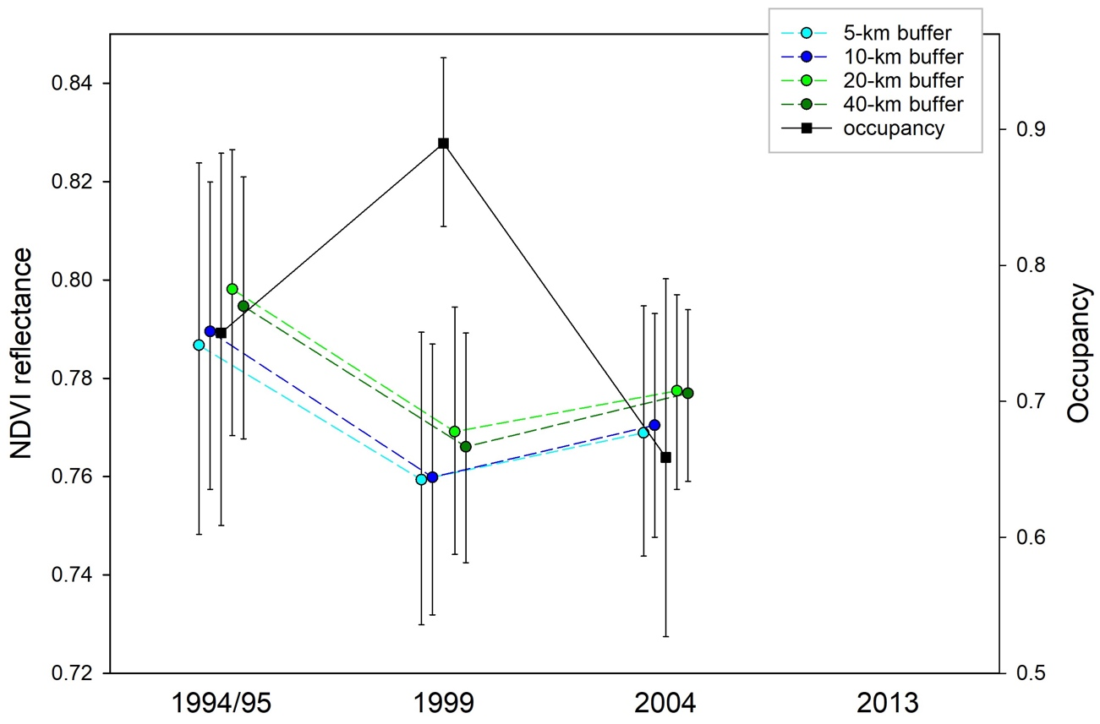

b)
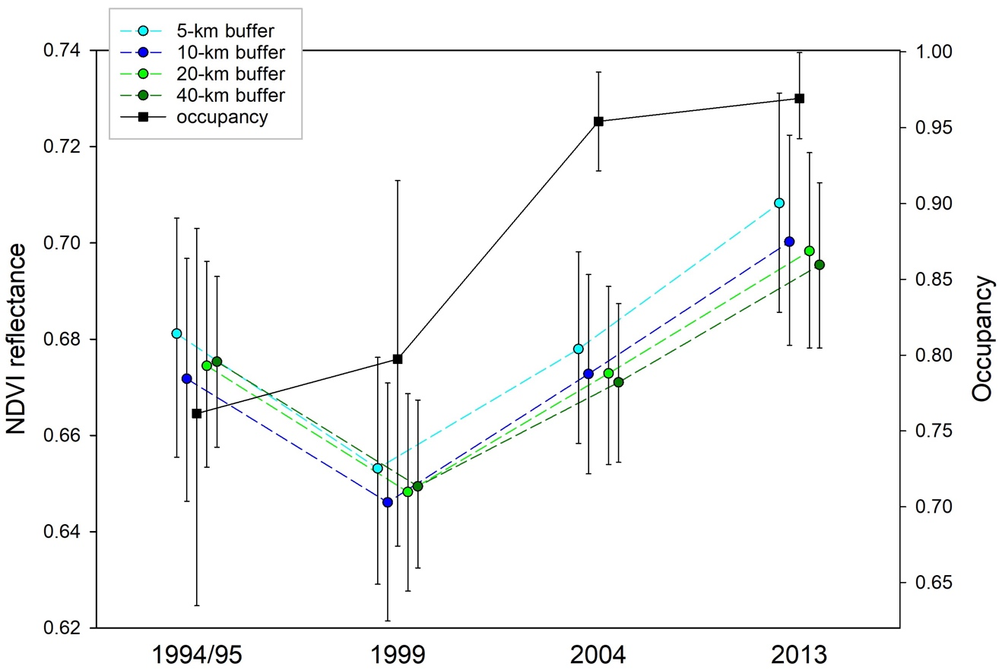
c)
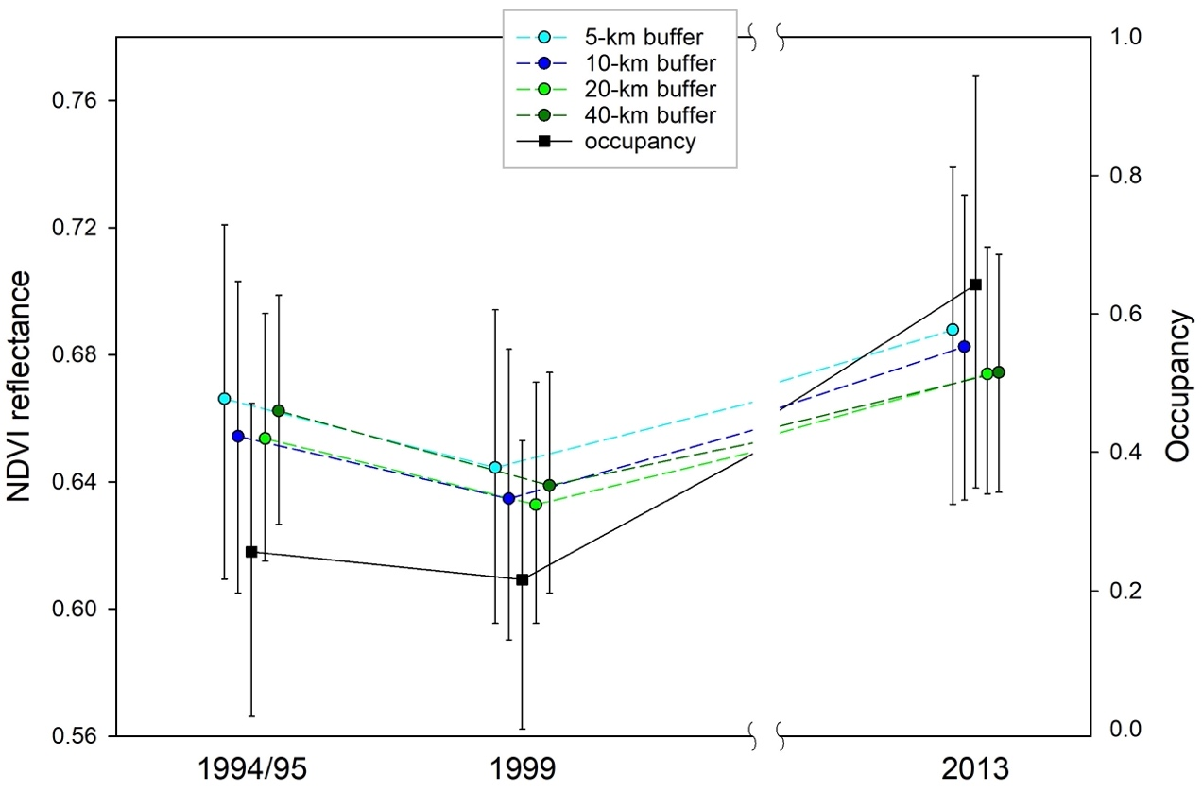

d)
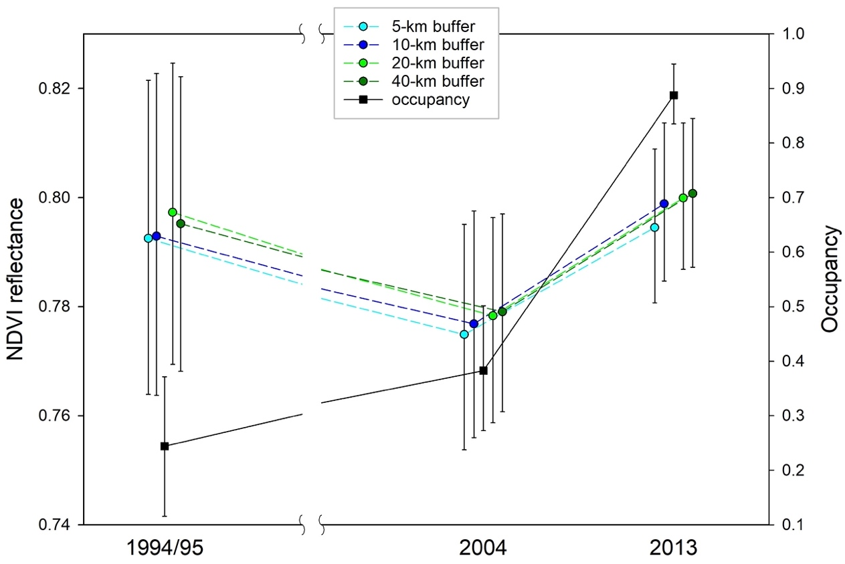

e)
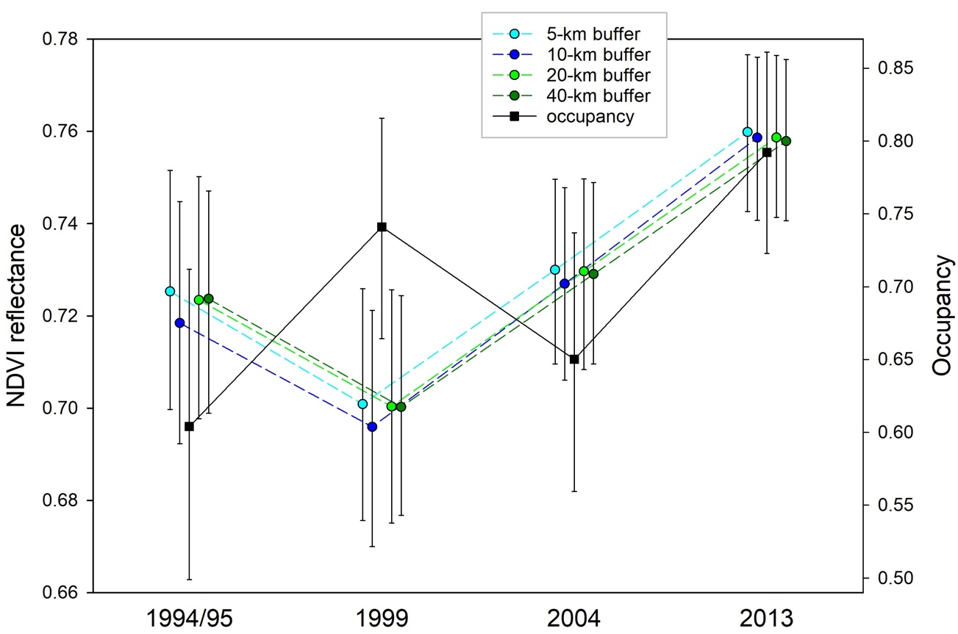

f)
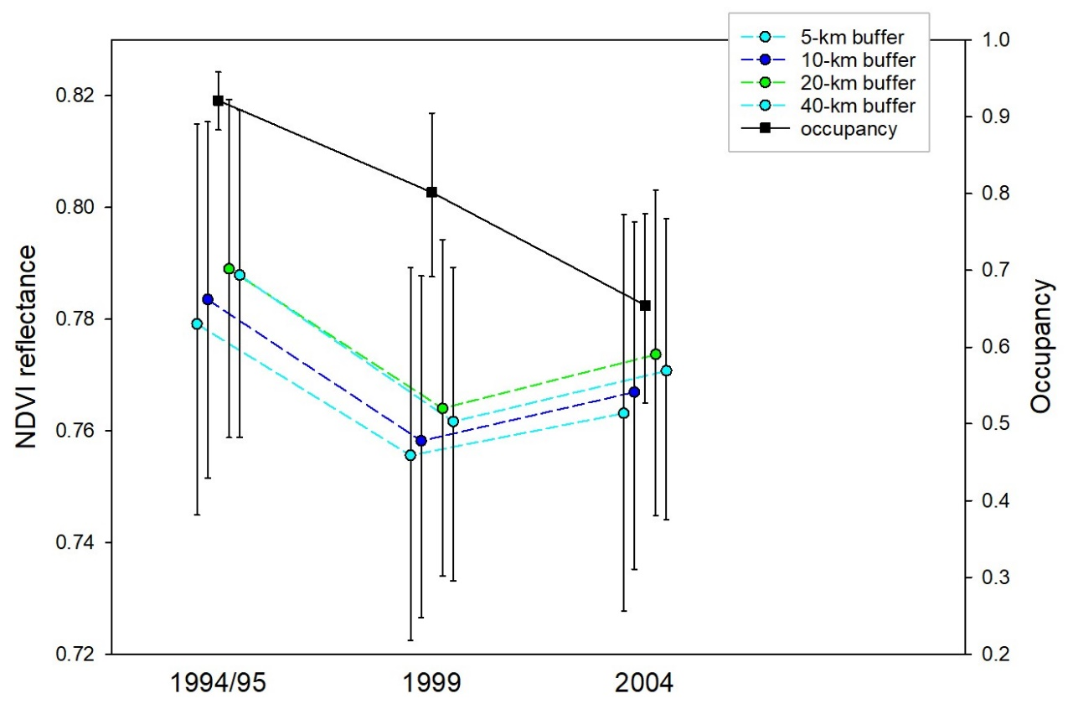
g)
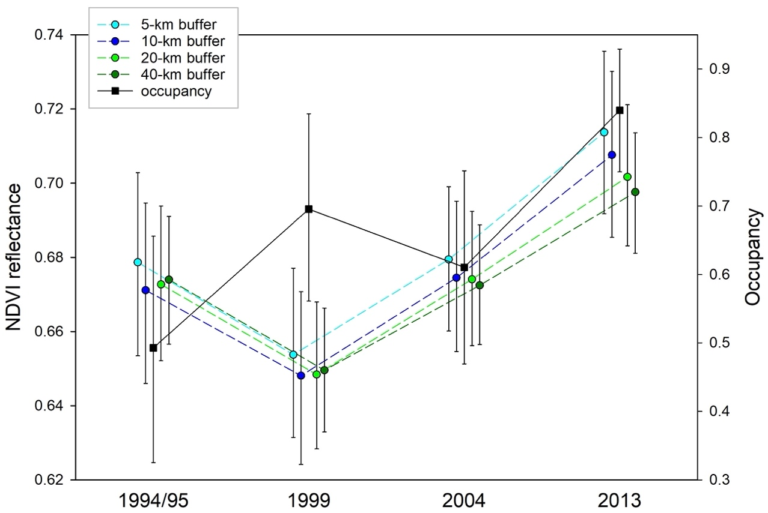
h)
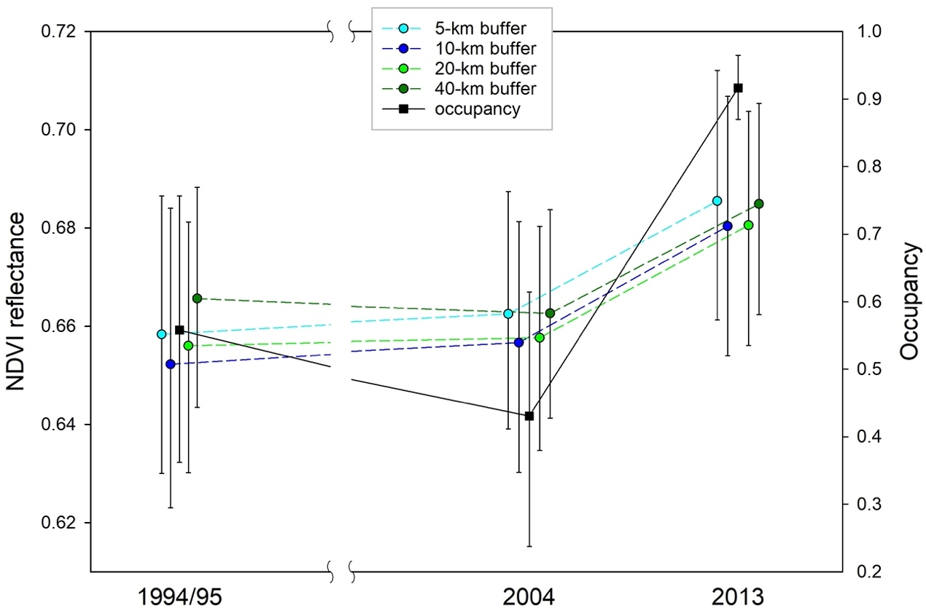

i)
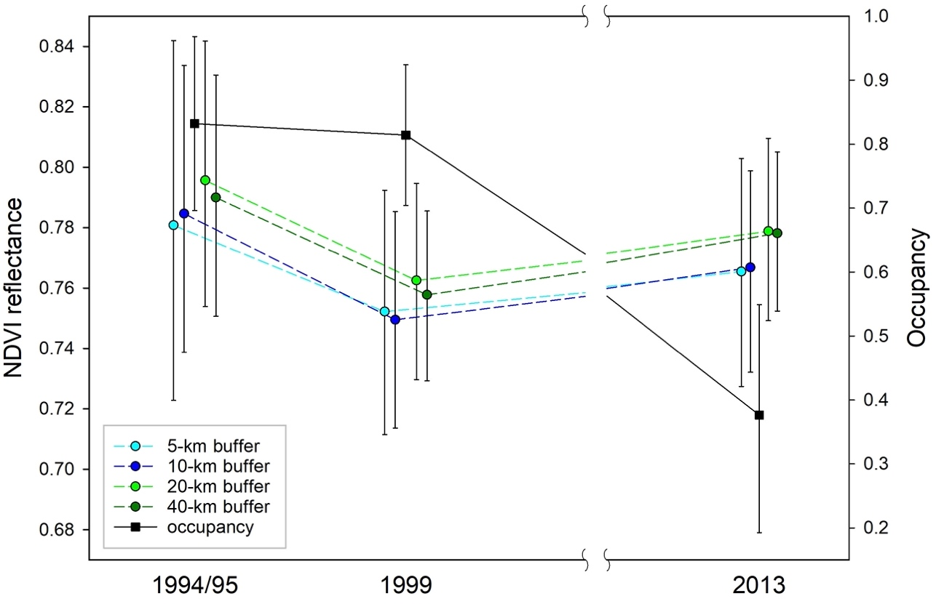
Figure 2. Occupancy profiles of two taxa are parallel to the NDVI profiles within the taxa’s distribution. Means with credible intervals for each taxa occupancy and NDVI within its distribution are presented: a) Amazona autumnalis (N=29–44) b) Amazona farinosa (N=18–26).
a)
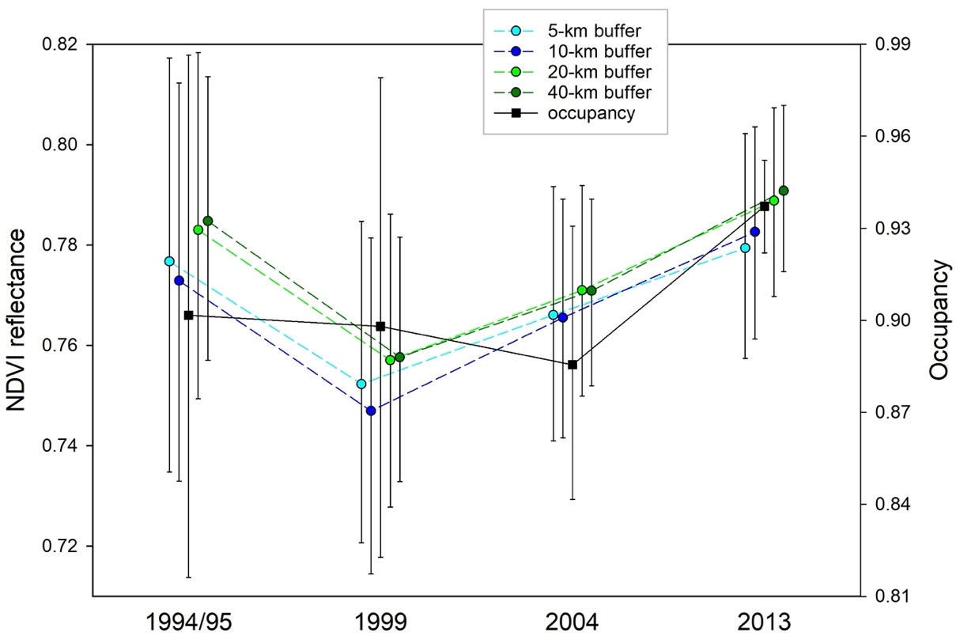
b)
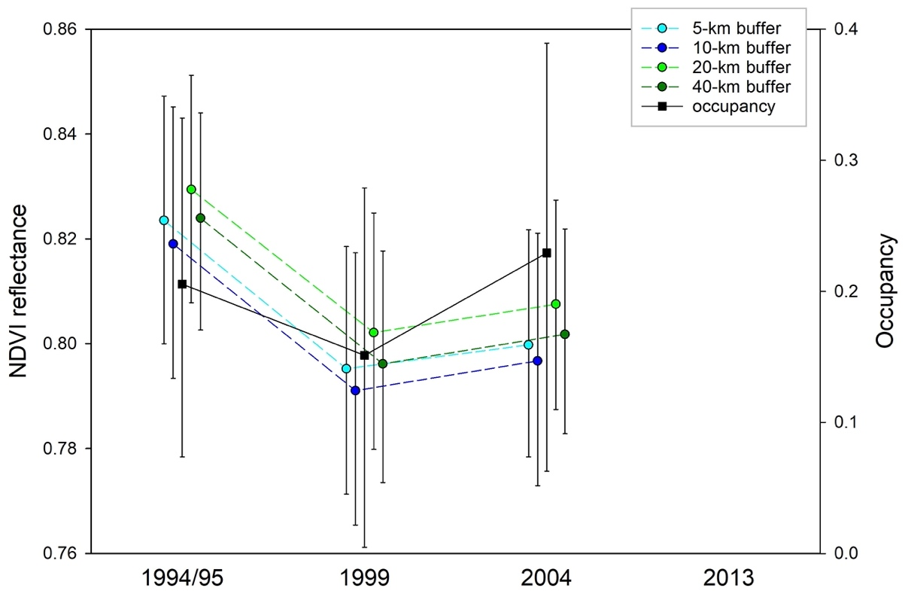
Multiple Responses of Neotropical Parrots to Accessibility as an Indicator of Trade Pressure
Introduction
Avian wildlife trade is a conservation issue created by complex human and wildlife interactions, often resulting in depressed populations and unintended negative ecological repercussions. Trade pressure, the removal of wild birds from their habitats for pet trade or body part consumption, increasingly is considered as a problem in driving persecuted species towards extinction (Beastall et al. 2016, Shepard et al. 2016, Leupen et al. 2020). Trade causes indirect negative ecological effects when non-native species escape or are released from captivity to become successful biological invaders (Cardador et al. 2017, Carrete and Tella 2008, Mori et al. 2017) or disease spread is facilitated by transcontinental and international trade pathways (Karesh et al. 2007).
It is vital to describe the effect of trade pressure on avian populations to clearly understand conservation and management implications, but it is challenging to directly measure capture rates from the wild. A range of techniques is used to quantify trade pressure in light of the challenge. Creative efforts combine traditional avian population surveys with poacher interviews, market prices, and market volumes in an effort to link population trends with market trends (Harris et al. 2015, Harris et al. 2017). Others produce a trapping pressure index or poacher selectivity indices from population surveys, species distribution models and local interviews (Biddle et al. 2020, Romero-Vidal et al. 2020). Applied techniques from an entirely different discipline, criminological research, directly analyze poacher, vendor, and consumer behaviors (Annorbah et al. 2015, Pires 2012) to assess trade pressure, sometimes collecting data from virtual marketplaces, which are increasingly prevalent locations of commerce with the advent of robust social media networks (Siriwat and Nijman 2020, Sung and Fong 2018).
Importantly, many of these studies attempt to determine variables that drive how a species experiences trade pressure. Poacher opportunity and species demand are common and competing hypotheses in determining trade pressure. There is evidence to support both hypotheses—volume of species present at markets is related to poacher opportunity (Vall-llosera and Cassey 2017) and species demand is related to attractiveness and rarity, which correlates with market prices (Krishna et al. 2019, Tella and Hiraldo 2014).
Within class Aves, trade pressure is disproportionately high for the avian order Psittaciformes, hereafter parrots. Across all birds, parrots are 14 times more likely to be in the pet trade (Bush et al. 2014) and studies that assess avifauna at a regional scale suggest poaching leads to as much as five times as many parrot species as non-parrots threatened with extinction (Clarke and By 2013). Conservation biologists have broadly inferred negative population-level effects from trade pressure by cautionary events such as the extinction in the wild of Spix’s Macaw (Cyanopsitta spixii, Juniper and Yamashita 1990) and knowledge that 38% of extinct parrot species were known to be kept as pets (Olah et al. 2016). Present-day documentation of population declines from trade pressure, such as the Grey Parrot (Psittacus erithacus, Annorbah et al. 2015), are not singular or isolated—the concern is global. An order-wide analysis of extinction risk across all regions discovered that trade pressure is the second highest risk for parrots, only behind habit conversion for agriculture (Olah et al. 2016). Considering only the Neotropics, Berkunsky et al. (2017) collaboratively combined studies on 192 parrot populations from 96 species and determined trade pressure is a threat to 68% of populations and is associated with population declines for 54% of populations.
To better understand the complex dynamics of trade pressure on parrot populations we evaluated the effect of geographic accessibility (a metric based on transportation infrastructure) on parrot occupancy. We used available data from a 2013 regional survey of parrot species in the Caribbean region of Nicaragua to estimate site occupancy and determine if, and to what degree, occupancy is explained by accessibility to humans, a surrogate variable to estimate trade pressure from poacher activity. Because of increased poacher access and movement, we hypothesized that parrot populations are affected by accessibility. We predict that accessibility will be inversely related to occupancy, a sign that where parrot habitat is easier to access, their populations will be depressed.
Methods
Study Area and Study Species
The Central American country of Nicaragua is divided into three ecoregions (the Pacific, Central Highlands, and Caribbean) characterized by vegetation types which generally delineate biogeographic patterns of the country (Fig. 1, Taylor 1963). In this study we focused on the Caribbean, represented by humid lowland forest, cloud and elfin forest, lowland pine savanna, and mangrove forest habitats (Martínez-Sanchéz and Will 2010). The Caribbean is of particular interest to us because all six species within the country identified as species of conservation concern have distributions within the Caribbean (Chavarría-Duriaux et al. 2018, Hille 2014), and accessibility varies greatly within the region because human population centers are greatly dispersed. Of the sixteen species of parrots within the country of Nicaragua, eleven have distributions within the Caribbean: Eupsittula nana, Ara ambiguus, Ara macao, Psittacara finschi, Brotogeris jugularis, Pyrilia haematotis, Pionus menstruus, Pionus senilis, Amazona autumnalis, Amazona farinosa, and Amazona auropalliata parvipes (Chavarría-Duriaux et al. 2018).
Parrot Surveys
Presence/absence data were used from nation-wide survey efforts conducted by Hille (2014) and all survey methodology can be referenced from their study. We used their survey data only from species with distributions in the Caribbean. For species with distributions reaching across multiple regions we only include data from survey transects within the Caribbean region (Fig. 1).
Accessibility Data Collection
We produced an accessibility metric adjusted for population density as a surrogate for trade pressure using freely available accessibility and population data and ArcGIS PRO software (ESRI 2021) tools. Accessibility data were available from the Weiss et al. (2018) dataset that produced a global map of accessibility at a spatial resolution of approximately one by one kilometer. Their accessibility metric is a 2015 representation of human travel time to the nearest urban center determined by surface factors that affect human movement: roads, railways, rivers, water bodies, land cover types, topographical conditions (slope angle and elevation), and national borders (Weiss et al. 2018). We extracted the accessibility data cells associated with each parrot survey transect at four buffer sizes surrounding the transects—5-km, 10-km, 20-km, and 40-km (Fig. 1, Fig. 2A). We defined a transect as all survey points within one route connected in succession by lines between the points, from which the buffers were measured.
We augmented the accessibility metric with an adjustment for the local human population. We used 2013 population density estimations available from WorldPop (2018), where population density is the number of people per square kilometer (Fig. 2B). We clipped population density data to all transects and buffers and applied a multiplicative inverse property, dividing the accessibility cell value by the overlaid population density cell value resulting in a population density weighted accessibility metric (Fig. 2C). For each transect and buffer we calculated the mean accessibility metric weighted by population density, hereafter referred to as accessibility.
Occupancy Modeling and Model Selection
We estimated occupancy (ψ), the probability that a site is occupied and is estimated by accounting for imperfect detection (MacKenzie et al. 2002), and detection (p) probabilities for ten parrot species with distributions in the Caribbean ecoregion of Nicaragua using the Hille (2014) data from their 2013 surveys. We used Program PRESENCE version 2.13.17 (Hines 2006) to estimate single-season occupancy and detection probabilities as a function of the accessibility site covariate (MacKenzie et al. 2006). To use the 2013 survey data in the occupancy design structure, we implemented a space for time substitution, where the transect was considered the site and all points within the transect were considered the sampling occasions (MacKenzie et al. 2002).
We applied a 2-stage model selection approach. Initially, we ran three models without the addition of the accessibility site covariate which included:
- constant site and constant survey detection probability, ψ(.)p(.)
- constant site and survey-specific detection probability ψ(.)p(t)
- constant site and time-of-day (am or pm) survey covariate, ψ(.)p(tod).
For each species individually, the most parsimonious base model of the three was viewed as the null model for that species, or the model that applies no effect of the accessibility metric on occupancy.
In addition to the selected null model, we added four models using accessibility data as a site covariate to explain occupancy, one for each buffer size. For each species, we ranked the five candidate models based on Akaike’s Information Criterion, adjusted for small sample size (AIC_{c}, Burnham and Anderson 2002). We assessed model goodness of fit and c-hat (ĉ) to measure model overdispersion by calculating the Pearson chi-square statistic with a parametric bootstrap procedure (N=999, MacKenzie and Bailey 2004). If ĉ >1.15 we determined the model to be poorly fitted and we subsequently ranked models on QAIC_{c} values, the quasi-likelihood adjustment for overdispersion (Burnham and Anderson 2002). We did not use models with ĉ >4.00 or a goodness of fit p-value < 0.05 because we determined them to have untrustworthy model convergence.
Results
Accessibility Data
With available data from a 2015 global accessibility map (Weiss et al. 2018) and 2013 population density (WorldPop 2018) we were able to produce an accessibility metric, at a one-by-one-kilometer spatial resolution, that reflects both travel time from the closest urban center and population size and extracted all data within four buffers from the 39-parrot survey transects in the Caribbean region (Fig. 1). Prior to adjustment for population density, mean accessibility values within transects ranged from 9.37 to 799.16, where the lowest value represents the highest level of accessibility and mean population density within transects ranged from 2.07 to 1,103.60 people per square kilometer. When we adjusted accessibility for population density, the mean transect values ranged from 0.04 to 393.13.
Occupancy Models and Model Selection
At least one model successfully produced estimates for seven of eleven species. Of a potential 55 models (5 candidate models for 11 species), 30 converged to produce trustworthy results (Table 1). Models were not successful for four species (P. menstruus, A. ambiguus, A. macao, and A. farinosa) because of lack of detections during field surveys.
Model selection suggests that there is variation in how parrot occupancy is related to human accessibility. Accessibility at survey sites best explained occupancy for three species (P. haematotis, A. autumnalis, A. auropalliata parvipes), but it was not strongly related for two species (E. nana, P. finschi), was inconclusive for B. jugularis because of confounding inferences, and for P. senilis was inconclusive because of lack of viable candidate models (Table 1).
When occupancy is related to site accessibility the additive model weight suggests substantial support for the relationship (Table 1). For example, P. haematotis, models with accessibility site covariates have a 0.89 weight, suggesting that site increase in accessibility leads to an increase in occupancy (Fig. 3). Amazona autumnalis and A. auropalliata parvipes have a smaller probability of occurrence when humans have greater access. demonstrate the inverse pattern. Models with accessibility site covariates have combined weights, respectively, of 0.96 and 0.83 and occupancy is inversely related to accessibility (Fig. 4, Fig. 5).
In contrast, the null models, which have no accessibility site covariates, are best supported for E. nana and P. finschi (Table 1), respectively with weights of 0.77 and 0.55. This implies that level of human access to survey sites have little to no effect on probability of occurrence for these two species. With one exception, for these two species, all models with accessibility site covariates considered have ΔAIC_{c}>4.00, implying little empirical support (Burham and Anderson 2002). The one exception is a ΔAIC_{c} of 0.43 and weight of 0.44 for the accessibility model of the 40-km buffer for P. finschi. However, given that the 5-km, 10-km, and 20-km buffer models each are weighted at less than 0.01 we assume that accessibility has lost its relevance at the higher spatial scale for P. finschi, rather than the alternative explanation that it is picking up a pattern at the largest scale not visible in the smaller spatial scales.
The effect of accessibility on occupancy is less clear for B. jugularis. Although the top selected model is the null model with a weight of 0.30, three accessibility site covariate models have ΔAIC_{c}<2.00, implying strong empirical support (Burham and Anderson 2002), with a combined weight of 0.63. Occupancy appears to be related to accessibility to some degree; occupancy increases with greater accessibility, similar to P. haematotis. (Fig. 6).
Discussion
Site accessibility has variable effects on parrot relative occupancy, variation that appears species-specific. Suggesting that increased poacher accessibility leads to changes in site occurrence for some parrots, but not all. For two species for whom occupancy estimations are best explained by the accessibility site covariate, occupancy is lower when accessibility is higher, implying that higher accessibility allows for increased poacher activity causing increased trade pressure on the parrot population. Two species have increased occupancy when accessibility is higher suggesting that a different force is acting upon them, correlated with accessibility but not necessarily increased trade pressure.
Accessibility Effect and Potential Drivers of Trade Pressure
Accessibility leading to higher poaching activity and trade pressure is well documented. Geographic poaching activity is strongly facilitated by roads that provide access to source locations (de Matos Dias et al. 2020, Wilkie et al. 2000), a result suggested by two species in our study–A. autumnalis, A. auropalliata parvipes. Studies of poacher activity document the distance limits from roads they are willing to travel (Watson et al. 2013); one parrot-focused study reported a five km limit that poachers rarely travel beyond to access parrots within a forest (Harris et al. 2017). It is not surprising that we detect this influence, but rather it is interesting that not all six modeled species show this link between trade pressure from high accessibility and site occupancy. This suggests there is increased trapping effort on the two aforementioned species in comparison to E. nana and P. finschi, for whom occupancy was not explained by the accessibility site covariate, and P. haematotis and B. jugularis, which have a positive relationship between accessibility and occupancy.
The importance of accessibility for individual species may be related to how attractive the species is in the context of the pet trade. Individual studies quantify attractiveness with slight variations, but all consider parrots more attractive if they are larger bodied, multi-colored, and of greater intelligence. Of the two species in our study whose occupancy is lower when accessibility is higher (A. autumnalis and A. auropalliata parvipes): 1) their base green plumages are highlighted by two additional bright colors, compared to the relatively bland green plumages or green with only one additional color of the other species (with the exception P. haematotis), 2) they are the largest bodied parrots, and 3) they are known for their intelligence evidenced by their vocal mimicry abilities. Although we do not quantify attractiveness in our study, Tella and Hiraldo (2014) described Amazona parrots in Mexico (along with the genus Ara) as quantifiably more attractive than other parrot species, and it appears that poacher selection pressure is driven by demand for the attractive parrot species in our parrot assemblage.
The conclusion is then that parrots are not guaranteed to experience higher trade pressure from accessibility, but accessibility is important if they are sought after by poachers because of high demand. These results help shed light on the ongoing effort to determine selective pressures by poachers, often simplified to either opportunity versus demand hypotheses. Pressure driven by opportunity is defined by ease of removing parrots from the wild due to better access or greater population abundance, while pressure driven by demand is a result of market price or species’ attractiveness to the consumer (Pires and Clarke 2011, 2012, Pires 2015). If opportunity were the dominant selection pressure, we would see that lower occupancy is best explained by models with the accessibility site covariate. Instead, it only best explains low occupancy for two of six species, implying that selection is not driven by opportunity. Most, but not all, of the recent and complete analyses to test opportunity versus demand for poaching selection pressures on parrots agree that attractiveness is the greater poaching selection pressure (Chan et al. 2021, Pires et al. 2021, Romero-Vidal et al. 2021, Tella and Hiraldo 2014).
If attractiveness was the characteristic that creates high demand on species negatively affected by accessibility, we should see this reflected in the relative market prices (Romero-Vidal et al. 2021, Tella and Hiraldo 2014). Indeed, historical market data from Nicaragua, both domestic and international exports, consistently rank A. autumnalis and A. auropalliata parvipes with the highest market values of the species we modeled (Lezama et al. 2005, Perez and Zuniga 1998).
Although there is evidence increase in accessibility negatively affects species occurrence when the trade pressure is driven by species’ attractiveness, for other species there is a noticeable inverse pattern that suggests some aspect of accessibility leads to increased occupancy. This is the case for P. haematotis, and although we reported the model selection for B. jugularis inconclusive because of confounding inferences, there is evidence of a relationship between high occupancy and high accessibility for this species as well. Just as poaching opportunity increases with accessibility, so does deforestation (Barber et al. 2014) which generally leads to a fragmented landscape mosaic, a mixture of forest patches of varying successional stages intermixed with open habitats (Skole and Tucker 1993). Both P. haematotis and B. jugularis are classified as habitat generalists (Chapter 3), able to use a variety of open habitats (Juniper and Parr 1998). Brotogeris jugularis is even described as preferring partly deforested areas and persists in heavily human inhabited areas such town parks and gardens (Juniper and Parr 1998) and reportedly increased in occupancy throughout the country of Nicaragua from 1995 to 2013 most likely because of the advancement of deforestation (Chapter 1, Chapter 3).
Brotogeris jugularis does not meet the criteria as an attractive species or as a species of high market value; nonetheless, it potentially could be affected by trade pressure driven by opportunity pressure, as was documented in Peruvian markets (Daut et al. 2015). This is a pattern observed in parrot trade pressure in Australia, where species with large distributions and high abundance are selected for poaching (Vall-llosera and Cassey 2017), characteristics that are true of B. jugularis in Nicaragua. However, in our data, we cannot see this opportunity trade pressure depressing B. jugularis populations in Nicaragua.
Conclusion
It does seem apparent, then, that trade pressure, assumed from accessibility, does depress parrot populations for some species, but not all. Accessibility is of greater relevance for species with apparent high demand and less for species with apparent lower demand. While poaching opportunity does lead to higher trade pressure on parrots, it is not the only outcome for how parrots are affected by landscape characteristics associated with accessibility. Forest conversion to more open habitats often occurs as an area becomes more accessible. Some parrot species responded positively to this habitat conversion.
Studies to describe trade pressure on parrots provide value when the knowledge gained enlightens further conservation and management decisions. Fruitful research efforts in this arena have demonstrated temporal and spatial patterns of trade volume or predict geographic pressure (Biddle et al. 2020, Chan et al. 2021), all which can lead to law enforcement responses to abate poaching activity (Pires et al. 2015). Our study confirms that two species we could model are negatively affected by trade pressure, one of which is already recognized as a species of conservation concern in Nicaragua (A. auropalliata parvipes, Hille 2014). Additionally, the role that access plays to increase trade pressure needs to be carefully considered when developing conservation and management plans for reserve design. Existing accessibility maps can be used to determine placement of law enforcement stations or to identify routine checkpoints.
References
Skole, D. and Tucker, C. (1993). Tropical deforestation and habitat fragmentation in the Amazon: satellite data from 1978 to 1988. Science 260:1905-1910.
Annorbah, N. N., Collar, N. J. and Marsden, S. J., (2016). Trade and habitat change virtually eliminate the Grey Parrot Psittacus erithacus from Ghana. Ibis 158:82-91.

Barber, C. P., Cochrane, M. A., Souza Jr, C. M. and Laurance, W. F. (2014). Roads, deforestation, and the mitigating effect of protected areas in the Amazon. Biological conservation 177:203-209.

Beastall, C., Shepherd, C. R., Hadiprakarsa, Y. and Martyr, D., (2016). Trade in the Helmeted Hornbill Rhinoplax vigil: the ‘ivory hornbill’. Bird Conservation International 26:137-146.

Berkunsky, I., Quillfeldt, P., Brightsmith, D. J., Abbud, M. C., Aguilar, J. M. R. E., Alemán-Zelaya, U., Aramburú, R. M., (2017). Current threats faced by Neotropical parrot populations. Biological Conservation 214:278–287.

Biddle, R., Solis-Ponce, I., Jones, M., Pilgrim, M. and Marsden, S., (2021). Parrot ownership and capture in coastal Ecuador: Developing a trapping pressure index. Diversity 13:15.

Burnham, K. P. and Anderson, D. R. (1998). Model selection and multimodal inference. 2nd edition. New York, USA: Springer-Verlag.

Bush, E. R., Baker, S. E. and Macdonald, D.W. (2014). Global trade in exotic pets 2006–2012. Conservation Biology 28:663-676.

Cardador, L., Lattuada, M., Strubbe, D., Tella, J. L., Reino, L., Figueira, R. and Carrete, M. (2017). Regional bans on wild‐bird trade modify invasion risks at a global scale. Conservation Letters 10:717-725.

Carrete, M. and Tella, J. (2008). Wild‐bird trade and exotic invasions: a new link of conservation concern?. Frontiers in Ecology and the Environment 6:207-211.

Chan, D. T. C., Poon, E. S. K., Wong, A. T. C. and Sin, S. Y. W. (2021). Global trade in parrots–Influential factors of trade and implications for conservation. Global Ecology and Conservation 30:p.e01784.

Chavarría-Duriaux, L., Hille, D. C. and Dean, R. (2018). Birds of Nicaragua: A Field Guide. Cornell University Press.

Clarke, R.V. and Rolf, A. (2013). Poaching, habitat loss and the decline of neotropical parrots: a comparative spatial analysis. Journal of Experimental Criminology 9:333-353.

Daut, E.D., Brightsmith, D.J., Mendoza, A.P., Puhakka, L. and Peterson, M.J. (2015). Illegal domestic bird trade and the role of export quotas in Peru. Journal of Nature Conservation 27:44-53.

Harris, J. B. C., Green, J. M., Prawiradilaga, D. M., Giam, X., Hikmatullah, D., Putra, C. A. and Wilcove, D. S. (2015). Using market data and expert opinion to identify overexploited species in the wild bird trade. Biological Conservation 187:51-60.

Harris, J. B. C., Tingley, M. W., Hua, F., Yong, D. L., Adeney, J. M., Lee, T. M., Marthy, W., Prawiradilaga, D. M., Sekercioglu, C. H., Winarni, N. and Wilcove, D. S. (2017). Measuring the impact of the pet trade on Indonesian birds. Conservation Biology 31:394-405.

Hille, D. C. (2014). Occupancy trends of the avian family Psittacidae in Nicaragua over a 20-year monitoring period. [Unpublished master’s thesis]. University of Oklahoma.

Hines, J. E., (2006). PRESENCE2-software to estimate patch occupancy and related parameters. Patuxent Wildlife Research Center, Laurel, Maryland, USA.

Juniper, T. and Parr, M. (1998). Parrots: A Guide to Parrots of the World. Yale University Press, New Haven and London.

Juniper, T. and Yamashita, C. (1990). The conservation of Spix's Macaw. Oryx 24:224-228.

Karesh, W. B., Cook, R. A., Gilbert, M. and Newcomb, J. (2007). Implications of wildlife trade on the movement of avian influenza and other infectious diseases. Journal of Wildlife Diseases 43:S55.

Krishna, V. V., Darras, K., Grass, I., Mulyani, Y. A., Prawiradilaga, D. M., Tscharntke, T. and Qaim, M. (2019). Wildlife trade and consumer preference for species rarity: an examination of caged-bird markets in Sumatra. Environment and Development Economics 24:339-360.

Lezama, M., Vilchez, S., Mayorga, M. and Castellon, R. (2005). III Monitoreo Nacional de Psitacidos 2004: Estado Actual y Conservacion. Proyecto Arucaria – Rio San Juan – MARENA, Managua, Nicaragua.

Leupen, B. T., Gomez, L., Shepherd, C. R., Nekaris, K. A. I., Imron, M. A. and Nijman, V. (2020). Thirty years of trade data suggests population declines in a once common songbird in Indonesia. European Journal of Wildlife Research 66:1-11.

MacKenzie, D. I. and Bailey, L. L. (2004). Assessing the fit of site-occupancy models. Journal of Agricultural, Biological and Environmental Statistics 9:300–318.

MacKenzie, D. I., Nichols, J. D., Royle, J. A., Pollock, K. H., Bailey, L. L., and Hines, J. E. (2006). Occupancy estimation and modeling. Academic Press, Burlington, Massachusetts. USA.

MacKenzie, D. I., Nichols, J. D., Lachman, G. B., Droege, S., Royle, J. A. and Langtimm, C. A. (2002) Estimating site occupancy rates when detection probabilities are less than one. Ecology 83:2248–2255.

Martinez-Sanchez, J. C. and Will, T., Eds. (2010). Thomas R. Howell’s Check-list of the Birds of Nicaragua as of 1993. Ornithological Monographs, No. 68.

de Matos Dias, D., Ferreguetti, Á. C. and Rodrigues, F. H. G. 2020. Using an occupancy approach to identify poaching hotspots in protected areas in a seasonally dry tropical forest. Biological Conservation 251:p.108796.

Mori, E., Grandi, G., Menchetti, M., Tella, J. L., Jackson, H.A., Reino, L., van Kleunen, A., Figueira, R. and Ancillotto, L. (2017). Worldwide distribution of non–native Amazon parrots and temporal trends of their global trade. Animal Biodiversity and Conservation 40:49-62.

Olah, G., Butchart, S. H., Symes, A., Guzmán, I. M., Cunningham, R., Brightsmith, D. J., & Heinsohn, R. (2016). Ecological and socio-economic factors affecting extinction risk in parrots. Biodiversity and Conservation 25:205–223.

Perez, R. and Zuniga, T. (1998). Analisis del comercio de psitacidos en Nicaragua. Encuentro 46:71–85.

Pires, S. F. (2015). A CRAVED analysis of multiple illicit parrot markets in Peru and Bolivia. European Journal on Criminal Policy and Research 21:321-336.

Pires, S. F. and Clarke, R. V. (2011). Sequential foraging, itinerant fences and parrot poaching in Bolivia. The British Journal of Criminology 51:314-335.

Pires, S. and Clarke, R. V. (2012). Are parrots CRAVED? An analysis of parrot poaching in Mexico. Journal of research in crime and delinquency 49:122-146.

Pires, S. F., Olah, G., Nandika, D., Agustina, D. and Heinsohn, R. (2021). What drives the illegal parrot trade? Applying a criminological model to market and seizure data in Indonesia. Biological Conservation 257:109098.

Romero-Vidal, P., Hiraldo, F., Rosseto, F., Blanco, G., Carrete, M. and Tella, J. L. (2020). Opportunistic or Non-Random Wildlife Crime? Attractiveness rather than abundance in the wild leads to selective parrot poaching. Diversity 12:314.

Shepherd, C. R., Nijman, V., Krishnasamy, K., Eaton, J. A. and Chng, S. C. (2016). Illegal trade pushing the Critically Endangered Black-winged Myna Acridotheres melanopterus towards imminent extinction. Bird conservation international 26:147-153.

Siriwat, P. and Nijman, V. (2020). Wildlife trade shifts from brick-and-mortar markets to virtual marketplaces: A case study of birds of prey trade in Thailand. Journal of Asia-Pacific Biodiversity 13:454-461.

Sung, Y. H. and Fong, J. J. (2018). Assessing consumer trends and illegal activity by monitoring the online wildlife trade. Biological Conservation 227:219-225.

Taylor, B. W. (1963). An outline of the vegetation of Nicaragua. Journal of Ecology 51:27–54.

Tella, J. L. and Hiraldo, F. (2014). Illegal and legal parrot trade shows a long-term, cross-cultural preference for the most attractive species increasing their risk of extinction. PLoS One 9:e107546.

Vall-llosera, M. and Cassey, P. (2017). Do you come from a land down under? Characteristics of the international trade in Australian endemic parrots. Biological Conservation 207:38-46.

Watson, F., Becker, M.S., McRobb, R. and Kanyembo, B. (2013). Spatial patterns of wire-snare poaching: Implications for community conservation in buffer zones around National Parks. Biological conservation 168:1-9

Wilkie, D., Shaw, E., Rotberg, F., Morelli, G. and Auzel, P. (2000). Roads, development, and conservation in the Congo Basin. Conservation Biology 14:1614-1622.

Weiss, D.J., Nelson, A., Gibson, H.S., Temperley, W., Peedell, S., Lieber, A., Hancher, M., Poyart, E., Belchior, S., Fullman, N., Mappin, B., Dalrymple, B., Rozier, J., Lucas, T. C. D., Howes, R. E., Tusting, L. S., Kang, S. Y., Cameron, E., Bisanzio, D., Battle, K. E., Bhatt, S., and Gething, P. W. (2018). A global map of travel time to cities to assess inequalities in accessibility in 2015. Nature 55:333-336.

WorldPop-Global High Resolution Population Denominators Project. (2018). Data available on-line from: https://dx.doi.org/10.5258/SOTON/WP00675. Accessed on 25/10/2021. www.worldpop.org.

Table 1. Candidate model ranking to assess the effect of accessibility at survey sites on parrot occupancy. Null models with constant occupancy probability, ψ(.), are compared to accessibility models measured 5-km (acc5km), 10-km (acc10km), 20-km (acc20km), and 40-km (acc40km) buffers around survey transects. Site occupancy covariates were kept constant in all null models, but detection is modeled with either constant detection probability, p(.), survey-specific detection probability, p(t), or time-of-day (am or pm) survey covariate, p(tod), to choose the most parsimonious null model. AIC_{c} is Akaike’s Information Criterion adjusted for small sample size, ΔAIC_{c} is the difference in AIC_{c} from the top model, and w_{i} is the Akaike weight.

Figure 1. Parrot survey data were collected by Hille (2014) at 39 transects within the Caribbean ecoregion.
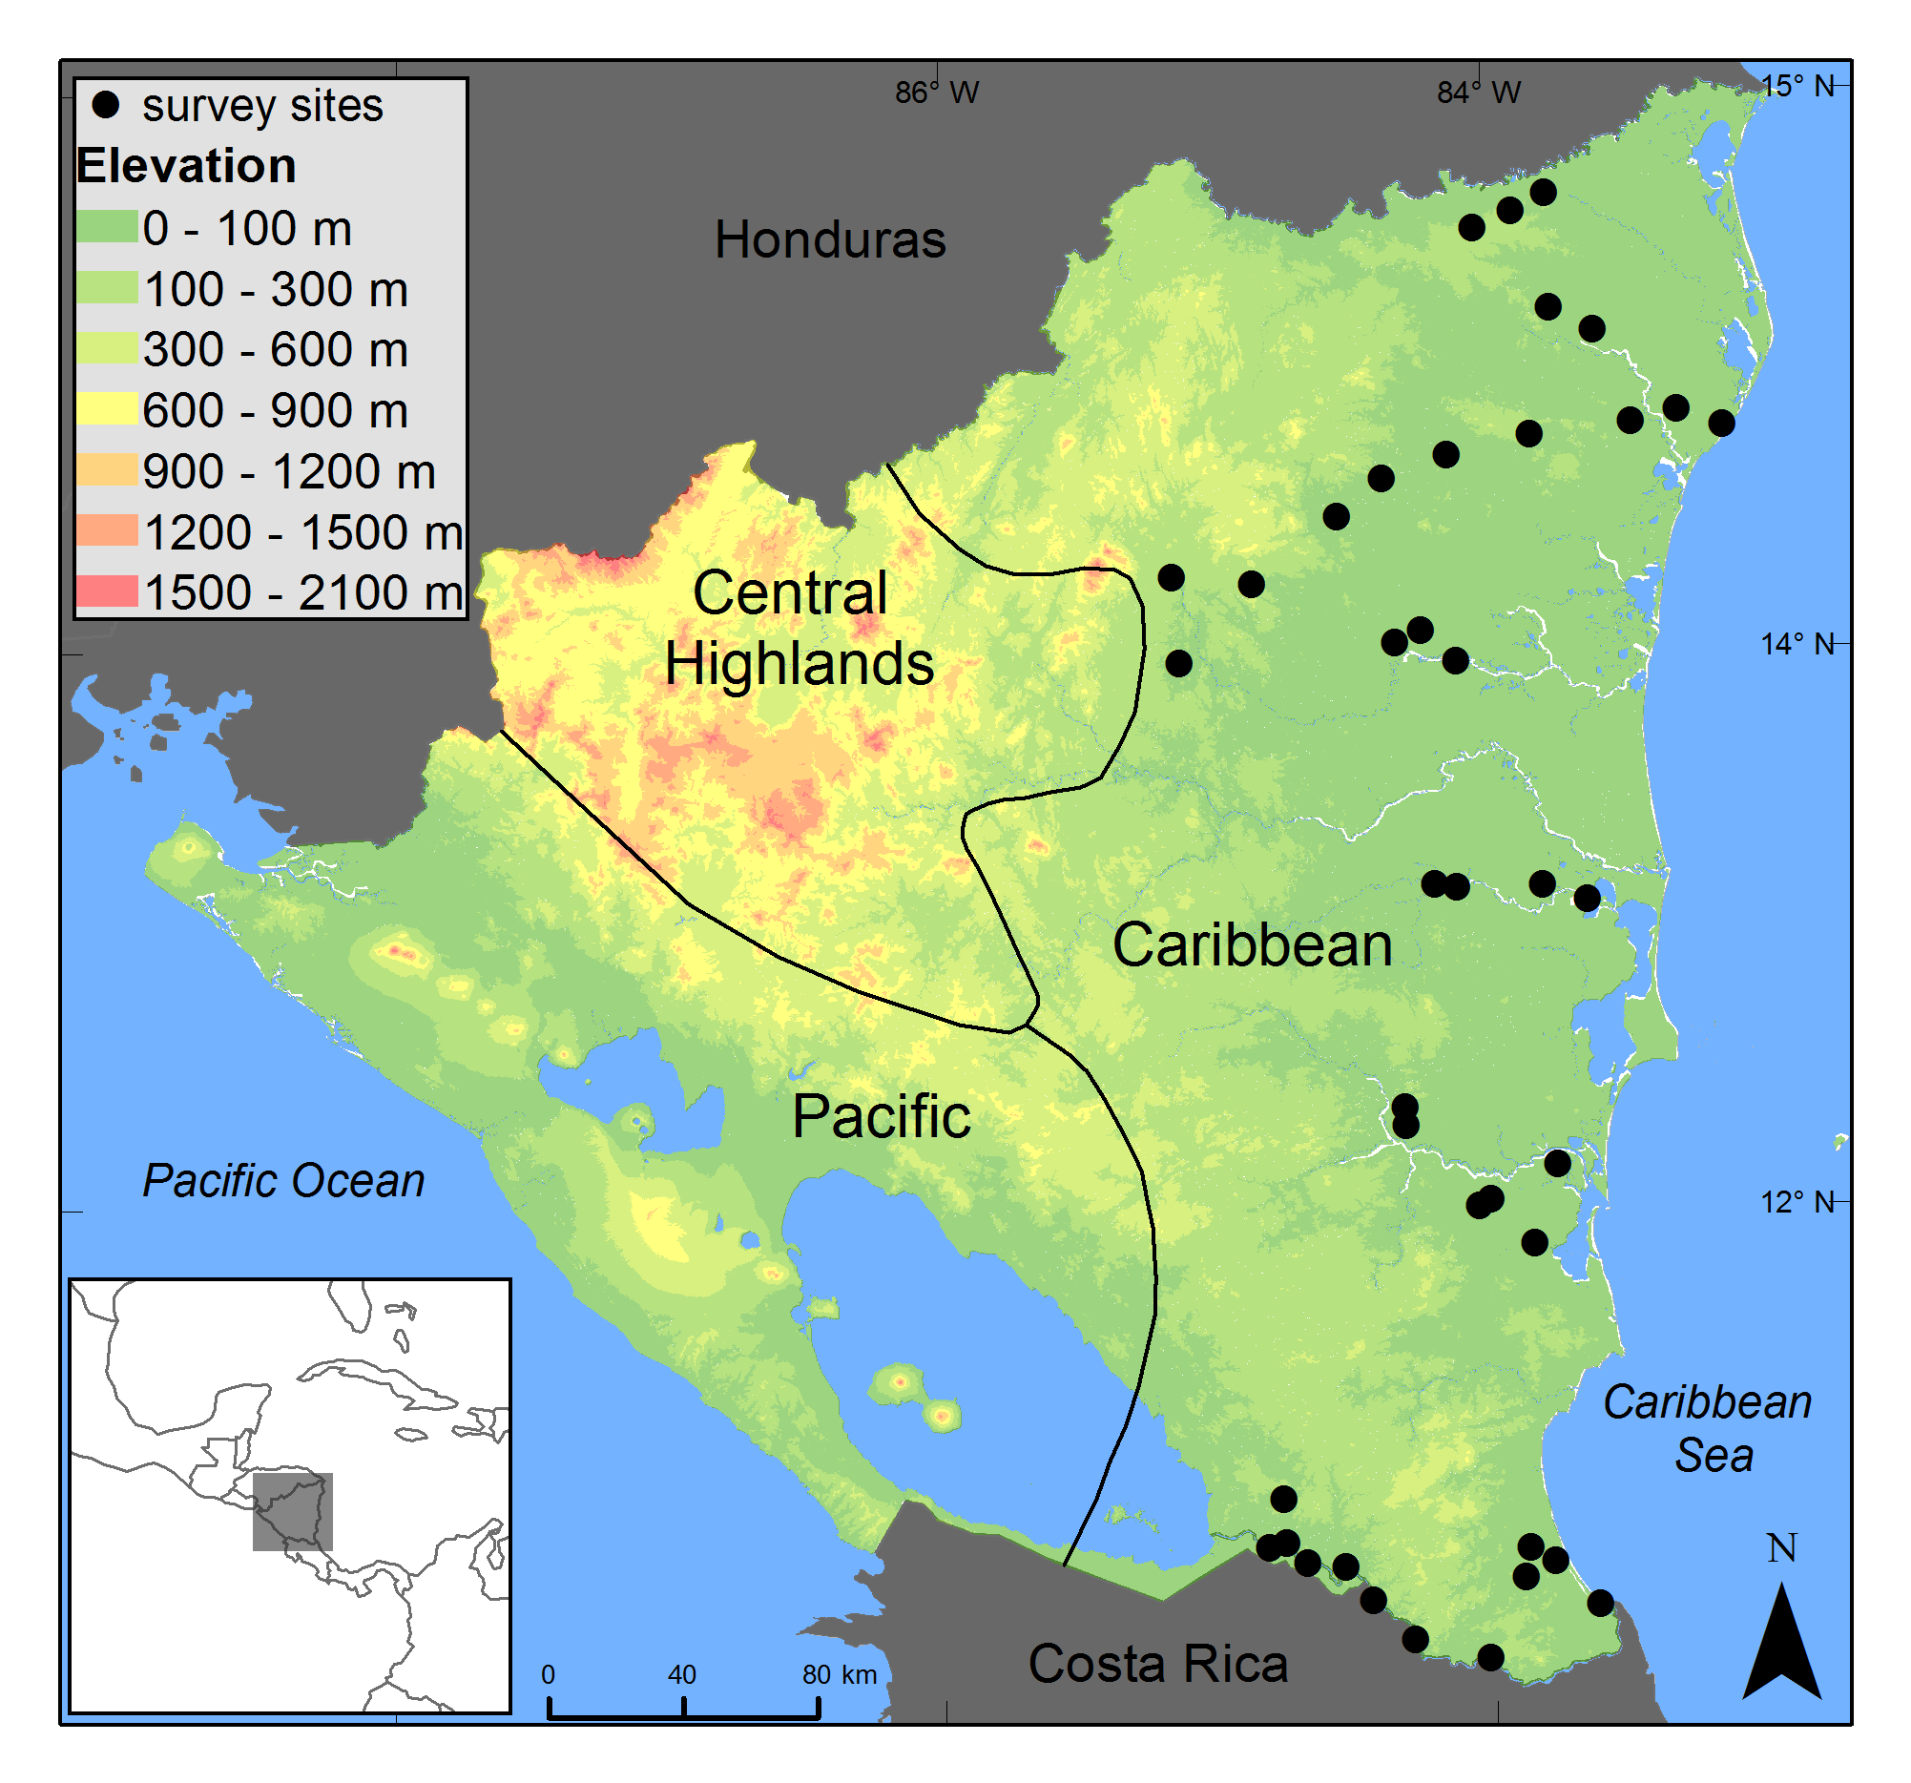

Figure 2. Accessibility was measured as a surrogate to trade pressure. Accessibility (A) was extracted for the country of Nicaragua from the Weiss et al. (2018) global dataset and adjusted for the population density of Nicaragua by dividing the accessibility cell value by the overlaid population density cell value (B) resulting in a value of accessibility adjusted for population density (C). Pre- and post- adjusted accessibility values are represented by a numeric scale where decreasing numeric value represents greater accessibility, (ie. 0=most accessible). Population density is the number of people per square km.
Figure 3. Site accessibility is positively related to occupancy of Pyrilia haematotis, best fit with a polynomial trend line.

Figure 4. Site accessibility is negatively related to occupancy of Amazona autumnalis, best fit with a logarithmic trend line.

Figure 5. Site accessibility is negatively related to occupancy of Amazona auropalliata, best fit with a linear trend line.

Figure 6. Site accessibility is positively related to occupancy of Brotogeris jugularis, best fit with a polynomial trend line.

Conservatism as a Tool to Elicit Sensitivity to Deforestation and Correlates in a Highly Endangered Avian Family
Introduction
For over four decades the concept of species conservatism has been applied to floristic quality assessment, which estimates habitat quality of plant communities (Swink and Wilhelm 1979). Within this assessment, coefficient of conservatism (CoC) is a numeric value assigned by expert opinion to vascular plant species indicating their degree of tolerance to disturbance, where CoC values range 0–10. High CoC are assigned to species with high sensitivity to habitat degradation while low CoC are assigned to species with low sensitivity and high tolerance to disturbance (Taft et al. 1997). The CoC is used in conservation and management to assess vegetative habitat quality (Andreas et al. 2004, Cretini et al. 2012, Lopez and Fennessy 2002) and community level indication of anthropogenic influence on habitat (Bried et al. 2013, Miller and Wardrop 2006). Additionally, it has been applied to address questions of biogeographic and niche principles (Matthews et al. 2005, Zinnen et al. 2021) and attempts have been made to use it as a tool to identify biological indicator species not only from plants but also the insect order Odonata (Bried et al. 2021, Kutcher and Bried 2014).
Given the increasing causes and rate of forest loss, fragmentation, and degradation, there is a conservation need to understand scaled tolerance to deforestation in vertebrate taxa (Matricardi et al. 2020, Trancoso 2021). Identifying species sensitivity to deforestation provides information for conservation and management decisions and, in addition, provides opportunity to describe predictors of response to deforestation and potential biological indicator species. Biological and ecological correlates are shown to function as reliable predictors to a species’ response to habitat change (Kellner et al. 2019, Todd et al. 2017, Quesnelle et al. 2014, Vetter et al. 2011) and aspects of biogeography and sensitivity reveal patterns helpful in reserve planning (Orme et al. 2019).
Deforestation causes habitat change ranging from complete loss to degradation that reduces quality of habitat (Souza et al. 2013), a range that presents the opportunity to evaluate species association with forest quality or a scaled sensitivity to deforestation. Common within the ecological and conservation sciences is work to determine vertebrate sensitivity to deforestation, fragmentation, and degradation (Kellner et al. 2019, Quesnelle et al. 2014, Vetter et al. 2011). However, conservatism as measured by the CoC has not yet been used for vertebrates to determine sensitivity to deforestation, yet with access to large spatial scales of habitat data, such as remote sensing data products used to determine change in habitat and habitat quality, it is possible to apply the conservatism technique to objectively characterize species scaled sensitivity to deforestation. The application of this method to quantify a species association with habitat quality has only sparingly been applied outside of plant species assemblages—to our knowledge, on one occasion with amphibians (Micacchion 2004) and one with invertebrates (Kutcher and Bried 2014)—but not for avian assemblages.
The avian order Psittaciformes (hereafter parrots) can be used to test the usefulness of CoC as a tool to understand vertebrate sensitivity to deforestation. This order is considered highly at-risk, generally attributed to compounding degrees of habitat loss and a popularity for the pet trade (Bush et al. 2014, Vergara-Tabares et al. 2020). Species in this order respond differently to deforestation, many having negative population trends while some with positive (Chapter 1). Therefore, it is valuable to provide an additional tool to understand parrot sensitivity to deforestation, adding to the present understanding of parrot extinction risk (Bennet and Owens 1997, Olah et al. 2016). BirdLife International assigns a categorical descriptor of forest dependency for parrots, presumably only based on qualitative data (2021).
In this study we use the conservatism construct as a method to quantify parrot sensitivity to deforestation. We use a nation-wide parrot monitoring dataset from Nicaragua collected over two decades to produce an objective, empirical assignment of CoC determined by species occurrence in habitat where quality is defined by the indication of greenness from Normalized Difference Vegetation Index (NDVI) values. We then evaluate potential biogeographic, biological, and ecological correlates sensitivity to deforestation.

Methods
Study Area and Study Species
We conducted our study in the Central American country of Nicaragua, a tropical country ecologically described by several habitats: thorn forest and scrub, deciduous forest (dry forest), humid lowland forest, cloud and elfin forest, highland pine or pine-oak forest, lowland pine savanna, and mangrove forest habitats (Martínez-Sanchéz and Will 2010). These terrestrial habitats are contained within distinct biogeographic regions: Pacific, Central Highlands, and Caribbean (Figure 1, Taylor 1963).
The avian family Psittacidae is represented by 16 species within its political boundaries (Chavarría-Duriaux et al. 2018), of which 11 are included in this study (nomenclature follows AOS 2022): Eupsittula nana, Eupsittula canicularis, Psittacara strenuus, Psittacara finschi, Brotogeris jugularis, Pyrilia haematotis, Pionus senilis, Amazona albifrons, Amazona autumnalis, Amazona farinosa, and Amazona auropalliata. We treated the two subspecies of A. auropalliata, A. a. auropalliata (Pacific) and A. a. parvipes (Caribbean), separately because they are disjunct and distributed wholly within either the Pacific or Caribbean biogeographic region. In total, then, our study includes 12 taxa, all of which are either primarily distributed in the Pacific or Caribbean regions, with the exception of E. canicularis which equally splits its continuous distribution between both regions.
NDVI Data Collection
We used Normalized Difference Vegetation Index (NDVI) values as a method to quantify forest cover, where NDVI > 0.500 is viewed as dense vegetation associated with forest, increasing in density up to 1 (Dalezios et al. 2001). We used Global Inventory Monitoring and Modeling System (GIMMS) NDVI values from satellite data collected by the Advanced Very-High-Resolution Radiometer (AVHRR) instrument. Data were collected in association with 81 survey transects established by Hille (2014), defined by the direct lines connecting the point locations in one survey route. Each transect was sampled for NDVI while applying four buffer sizes⎯5-km, 10-km, 20-km, and 40-km. Because NDVI represents the amount of greenness, all NDVI values from water surfaces were removed to avoid bias from sizable non-vegetated surfaces.
We selected NDVI data from the years 1994, 1998, 2002, and 2012, years directly prior to the years in which presence/absence parrot surveys were conducted and so will give the most accurate assessment of vegetative cover that affected the parrot presence or absence in the survey years. Data extracted were in bi-monthly intervals. Mean NDVI of each transect and its buffered area were calculated based on all cells within the selected buffered area for the entire year in order to avoid introduction of phenological bias.
Generation of CoC as Sensitivity to Deforestation Values
We generated species-specific sensitivity to deforestation values, objectively represented by the coefficient of conservatism (CoC; Kutcher and Bried 2014). The empirically generated species-specific parrot CoC uses NDVI values to define most- and least-disturbed habitats at transects where parrot surveys took place.
For each species, we prepared training data by selecting the NDVI values in all transects within a species’ reported distribution (Chavarria-Duriaux and Hille 2018) and in the four years earlier specified (1994, 1998, 2002, and 2012). We calculated the mean NDVI of each transect from all four pre-survey years and sorted mean NDVI from lowest to highest, labeling the first quartile as most disturbed, the fourth quartile as least disturbed, and the second and third quartiles as intermediately disturbed. Training data was prepared independently for each species and for each of the four buffers to create a total of four CoC values for each species. The CoC term is based on a species’ affinity for least-disturbed and most-disturbed habitat and is calculated by (Dufrene and Legendre 1997):
(N_{LD}/N) + (1-N_{MD}/N)
2
X 10
where N_{LD} is the number of least-disturbed transects a species was detected, N_{MD} is the number of most-disturbed transects a species was detected, and N is the total number of transects in which a species was detected. Occurrence data were collected by Hille (2014) and survey methodology can be referenced from their study. The CoC value range describes species occurrence in the most-disturbed to least-disturbed habitat on a 0 to 10 scale, where 0 represents a species that occurs only in most-disturbed habitat and 10 represents a species that occurs only in least-disturbed habitat.
Database Compilation of Explanatory Variables
We compiled a database of eight biogeographic, biological, and ecological variables to test as correlates to sensitivity to deforestation. Table 1 lists all variables used with their sources. We simplified categorical variables into dichotomous options when necessary. Although Nicaragua is fully described by three biogeographic regions (Chavarría-Duriaux et al. 2018), the Central Highlands were not considered in the biogeographic region variable because surveys in our study do not adequately cover this region. In the case of B. jugularis, which is equally distributed between Pacific and Caribbean, we calculated separate CoC from each region to accurately test the region affect. We simplified the IUCN statuses to two categories: least concern and conservation concern, where conservation concern includes near threatened, vulnerable, and critically endangered. We used BirdLife International’s definitions of habitat (level 2). Diets were categorized as either generalists, when described as such, or specialists when either only fruit or only tree seeds were listed as their preferred food source. We described nest type as either generalist, when multiple suitable nest types were reported, or specialist when only one of the following was listed as the primary nest type—termitaria, rock crevices, hardwood trees.
Statistical Analysis
We tested the difference of CoC means of the categorical explanatory variables (biogeographic region, diet, nesting, motility, and IUCN) using the Bayesian comparison of means, a Bayesian estimation for two groups (Kruschke 2013). We analyzed the relationship of the continuous explanatory variables (body size, generation time, and number of habitats) to the CoC using a Bayesian beta regression. For both tests we pooled CoC values from all buffers (N=48), with the exception of the comparison of means for region because B. jugularis was split into two regions (N=52), with different CoC for each region.

Results
NDVI Data Summary
The NDVI for each transect provided sufficient data to represent habitat quality, based on forest cover. For each buffer, we calculated 324 mean NDVI values comprised of four temporally varied (1994, 1998, 2003, and 2012) values for each of the 81 transects. The buffer of 5-km mean NDVI values ranged 0.48–0.87 (median = 0.74, SD = 0.08), 10-km values ranged 0.68–0.81 (median = 0.74, SD = 0.08), 20-km values ranged 0.62–0.77 (median = 0.74, SD = 0.07), and 40-km values ranged 0.63–0.75 (median = 0.73, SD = 0.07). Mean NDVI data selected for each taxon, to correspond to survey locations within their distributions, ranged from N = 32 to N = 212, depending on the number of survey sites and distribution size for each.
CoC values, Explanatory Variables, and Their Relationship
We calculated CoC for 12 taxa, the range of which showed a scaled sensitivity to deforestation. The CoC for parrots, including all buffers, ranged 3.9–6.8 (mean = 5.4, SD = 0.8; Table 2). Mean CoC for individual species, calculated from the four CoC, one from each buffer for a single species, ranged 4.2–6.4. The two subspecies of A. auropalliata had the two lowest mean CoC while P. senilis had the highest mean CoC (Figure 2). Across buffers, CoC for a species appear to have tight associations, however, the 40-km buffer produced apparent outlier CoC for P. strenuus and P. senilis (Figure 2).
Explanatory variables we compiled varied sufficiently which allowed us to test them as correlates to CoC values. Of the twelve taxa, seven are distributed in the Caribbean, four in the Pacific, and one species shares its distribution between both. Eight are classified by the IUCN as least concerned and four have a threatened status we classified as conservation concern (near threatened = 1, vulnerable = 1, critically endangered = 2). In addition to three generalists, six taxa nest in hardwood trees, two in termitaria, and one in rock crevices (specified as specialists). Three taxa are fruit specialists and three are tree seed specialists while the remaining six are generalists. Three exhibit nomadic and or intraregional migrations (specified as dispersive) while the remaining nine do not (specified as sedentary). Number of habitats used range 2–8 (median = 5; SD = 1.8). According to Bird Life International data (2021), habitats parrots used include subtropical/tropical moist lowland forest, subtropical/tropical moist montane forest, subtropical/tropical dry forest, subtropical/tropical heavily degraded former forest, subtropical/tropical moist shrubland, subtropical/tropical dry shrubland, subtropical/tropical mangrove vegetation above high tide level, subtropical/tropical swamp, savanna (moist), savanna (dry), plantations, pastureland, arable land, rural gardens, and urban areas. Body sizes range 18–39 cm (median = 27; SD = 6.8) and generation times 3.7–15.35 years (median = 7; SD = 3.7).
Four of eight explanatory variables showed a relationship to parrot CoC. The Bayesian comparison of means identified the variables biogeographic region, motility, and IUCN status to explain parrot sensitivity to deforestation (each have a difference of means great enough that the proportion of the posterior distribution away from zero is ≥0.95) (Table 3). The CoC is higher for parrots distributed within the Caribbean biogeographic region, exhibit dispersive motility, and are described with a “least concern” status by the IUCN. The Bayesian beta regression identified that parrots that use a greater number of habitats have lower CoC (Table 4).
Discussion
Vertebrate sensitivity to deforestation and species-level correlates to sensitivity is valuable to understand for conservation and management. Our study demonstrates the successful use of CoC to evaluate scaled sensitivity to deforestation for a highly endangered vertebrate group when presence/absence surveys and forest assessment data are available. Our results support the idea that parrots are predisposed to display a varied response to deforestation related to the biogeographic regions of their distributions, adaptations to habitat types, and their dispersive nature. Additionally, our results imply that species with higher CoC values ought to be given careful conservation assessment to determine if they are at increased risk because of their sensitivity to deforestation.
Niche Breadth Correlates
By including the diet, nesting requirements, and number of habitats used explanatory variables, we examined the niche breadth gradient effect—generalist vs. specialist. There is evidence that birds with greater niche breadth, considered generalists, are less sensitive to habitat degradation (Kellner et al. 2019). In our study, we detected a relationship between habitat specialization and sensitivity to deforestation. Parrot habitat specialists, those that use a smaller number of habitat types, are more sensitive to deforestation while habitat generalists, those that use a greater number of habitats are relatively less sensitive.
In our study, parrot habitat specialists were qualified by a lower number of habitats they use, generally types of forest, not open or disturbed habitats. High sensitivity of parrot habitat specialists signifies a preference for forest over disturbed areas, a result supported by various avian studies which demonstrate the effects of forest loss, degradation, and fragmentation on habitat specialists. Increased forest fragmentation and degradation cause declines in habitat specialists’ abundance and richness (Verga et al. 2020; Huang and Catterall 2021). Meanwhile, species documented to use open habitats, demonstrating a larger niche breadth, are affected less by forest fragmentation (Vetter et al. 2011) resulting in community composition of open areas containing more generalists than specialist (Scott et al. 2006).
Conservation and Management Implications
Parrots distributed in the Caribbean region of Nicaragua generally have higher sensitivity to deforestation than those in the Pacific, signifying that they have greater forest dependency whereas parrots in the Pacific are more likely adapted to open habitats at some level. A notable exception is A. albifrons, a Pacific species with high sensitivity to deforestation. Forest dependency is a known predictor of extinction risk for parrots (Olah et al. 2016) and therefore should be considered in conservation and management decisions. In this case, identification of deforestation-sensitive parrots in the Caribbean can be used to make decisions about protected area establishment and management. For multiple decades, the criteria for designing protected areas has elicited robust discussions on size, coverage, and placement, to name a few, (Simberloff and Abele 1976, Brooks et al. 2004, Bax and Francesconi 2019) and even after establishment, protected area management is not guaranteed to be successful (Leverington et al. 2010, Cazalis et al. 2020). Deeper understanding of sensitivity to deforestation within an avian community benefit protected area design (Orme et al. 2019) and resource allocation decisions to improve the management of existing reserves, especially given that cost-effective indicators are coveted when making conservation decisions (Bal et al. 2020).
Also of conservation interest is that eight parrots with an IUCN “least concern” status have greater sensitivity to deforestation than the four labeled as “near threatened” (A. farinosa), “vulnerable” (E. canicularis) or “critically endangered” (A. auropalliata, both subspecies). This result should not call into question the threatened status of these four as there is a complexity of different factors that can lead to parrot populations declines other than deforestation (Berkunsky et al. 2017), and it is worth noting that A. farinosa did receive a high CoC mean score of 6.1. However, it does question if the conservation status is accurately defined for all parrot species. This is perhaps best exemplified by Pionus senilis (CoC mean = 6.4) and Pyrilia haematotis (CoC mean = 5.8). Not only does CoC show that they are relatively sensitive to deforestation but these two species reportedly experienced significant populations declines from 1995 to 2013 (Hille 2014) bringing into focus that the CoC indicates their conservation status should be carefully considered to determine if they warrant greater concern. Furthermore, BirdLife International categorizes forest dependency of P. senilis as “moderate” and that of A. farinosa as “low”, which raises concerns that not all forest dependency rankings are validated when empirically determined. This demonstrates that our methodology could improve efforts for global conservation assessments of entire taxonomic groups such as this.
Methodology Considerations
Although our study successfully demonstrates utility of CoC to describe a species’ sensitivity to deforestation, increase our understanding of species-specific traits related to sensitivity, and inform conservation and management decisions, study design adjustments can yet be made to improve the inference power from CoC. One example of bias in our study comes from the NDVI data we used to characterize the level of disturbance to forest, or deforestation. Although NDVI values will signify forest cover, high density tree cover is not necessarily natural forest but can be biased by monoculture plantations such as oil palm (Elaeis guineensis) and cacao (Theobroma cacao), whose NDVI signatures are not distinguishable from natural forest cover (Asubonteng 2007, Panuju and Trisasongko 2012). It is proposed that at least a small portion of >0.50 NDVI values in the Caribbean region of Nicaragua during the second half of our study represent the dense tree of cover of plantations rather than natural forest (Chapter 1). Because our training data spans likely only has a few sites where plantations replaced forest towards the end of the study it is unlikely that the bias greatly affects CoC calculations. This potential bias does help to explain high CoC for P. finschi (CoC mean = 5.97), which is intuitively inaccurate. This is a species that is well adapted to open or disturbed habitats (Juniper and Parr 1998), to the extreme that it has experienced major expansion of its distribution northward through Nicaragua to Honduras following opened habitat from deforestation (Portillo-Reyes et al. 2017, Chapter 1). It stands to reason that removing the monoculture plantation bias from the NDVI dataset would produce more accurate sensitivity evaluation.
Even though our dataset works successfully to produce CoC that show relationships to explanatory variables, the relationships would most likely produce stronger signals for inference with a greater inclusion of taxa. We test CoC for 12 taxa within the political boundaries of one country. With the use of citizen science data from sources such as eBird and forest coverage data from a source such as the Global Forest Watch (Hansen et al. 2013) it would be possible to calculate CoC for avian taxonomic groups with much broader spatial resolution in order to amplify the usefulness of the CoC technique.
Conclusion
Our study demonstrates the value of CoC to assess vertebrate tolerance to habitat disturbance, a form of measuring sensitivity to deforestation when using NDVI values to assess habitat quality. We demonstrate the success of this technique to score sensitivity to deforestation, a tool useful to determine habitat quality, assess species-specific traits as correlates to sensitivity, and inform conservation and management decisions. Whereas our study demonstrates the application of this technique with only a small dataset, the use of larger datasets will magnify the value of this technique.

References
Andreas, B. K., Mack, J. J., and McCormac, J. S. (2004). Floristic Quality Assessment Index (FQAI) for vascular plants and mosses for the State of Ohio. Ohio EPA.
Chesser, R. T., S. M., Billerman, K. J., Burns, C., Cicero, J. L., Dunn, B. E., Hernández-Baños, A. W., Kratter, I. J., Lovette, N. A., Mason, P. C., Rasmussen, J. V., Remsen, Jr., D. F. Stotz and K. Winker. (2021). Check-list of North American Birds (online). American Ornithological Society. http://checklist.aou.org/taxa
Bal, P., Rhodes, J. R., Carwardine, J., Legge, S., Tulloch, A., Game, E., Martin, T. G., Possingham, H. P., and McDonald-Madden, E. (2021). How to choose a cost-effective indicator to trigger conservation decisions? Methods in Ecology and Evolution 12:520–529.
Bax, V. and Francesconi, W. (2019). Conservation gaps and priorities in the Tropical Andes biodiversity hotspot: Implications for the expansion of protected areas. Journal of Environmental Management 232:387–396.
Bennett, P. M., and Owens, I. P. (1997). Variation in extinction risk among birds: chance or evolutionary predisposition?. Proceedings of the Royal Society of London. Series B: Biological Sciences 264:401–408.

Berkunsky, I., Quillfeldt, P., Brightsmith, D. J., Abbud, M. C., Aguilar, J. M. R. E., Alemán-Zelaya, U., Aramburú, R. M., (2017). Current threats faced by Neotropical parrot populations. Biological Conservation 214:278–287.

BirdLife International. (2021). IUCN Red List for birds. Downloaded from http://www.birdlife.org on 9/9/2021.

Bried, J. T., Jog, S. K., and Matthews, J. W. (2013). Floristic quality assessment signals human disturbance over natural variability in a wetland system. Ecological indicators 34:260–267.

Bried, J. T., Fouts, T. S., and Jog, S. K. (2021). Searching for Indicator Species of High Floristic Quality Depressional Wetlands in the US Southern Plains. Wetlands 41:1–9.

Brooks, T. M., Bakarr, M. I., Boucher, T., Da Fonseca, G. A., Hilton-Taylor, C., Hoekstra, J. M., Mortiz, T., Olivieri, S., Parrish, J. Pressey, R. L., and Rogrigues, A. S. (2004). Coverage provided by the global protected-area system: is it enough? BioScience 54:1081–1091

Bush, E. R., Baker, S. E., and MacDonald D. W. (2014). Global trade in exotic pets 2006–2012. Conservation Biology 28:663–676.

Cazalis, V. Princé, K., Mihoub, J. B., Kelly, J. Butchart, S. H., and Rogrigues, A. S. (2020). Effectiveness of protected areas in conserving tropical forest birds. Nature Communications 11:1–8.

Chavarría-Duriaux, L., Hille, D. C. and Dean, R. (2018) Birds of Nicaragua: A Field Guide. Cornell University Press.

Cretini, K. F., Visser, J. M., Krauss, K. W., and Steyer, G. D. (2012). Development and use of a floristic quality index for coastal Louisiana marshes. Environmental monitoring and assessment 184:2389-2403.

Dalezios, N. R., Domenikiotis, C., Loukas, A., Tzortzios, S. T., & Kalaitzidis, C. (2001). Cotton yield estimation based on NOAA/AVHRR produced NDVI. Physics and Chemistry of the Earth, Part B: Hydrology, Oceans and Atmosphere, 26(3), 247-251.
Dufrêne, M., and Legendre, P. (1997). Species assemblages and indicator species: the need for a flexible asymmetrical approach. Ecological monographs 67:345-366.

Forshaw, J. M. (2010). Parrots of the World. Princeton University Press.

Hansen, M. C., Potapov, P. V., Moore, R., Hancher, M., Turubanova, S. A., Tyukavina, A., Thau, D., Stehman, S. V., Goetz, S. J., Loveland, T. R., Kommareddy, A., Egorov, A., Chini, L., Justice, C. O. and Townshend, J. R. G. (2013). High-Resolution Global Maps of 21st-Century Forest Cover Change. Science 342: 850–53. Data available on-line from: https://glad.earthengine.app/view/global-forest-change. Accessed through Global Forest Watch on 29/07/2021. www.globalforestwatch.org

Hille, D. C. (2014). Occupancy trends of the avian family Psittacidae in Nicaragua over a 20-year monitoring period. [Unpublished master’s thesis]. University of Oklahoma.

Huang, G. and Catterall, C. P. (2021). Effects of habitat transitions on rainforest bird communities across an anthropogenic landscape mosaic. Biotropica 53:130–141.

IUCN. (2021). The IUCN Red List of Threatened Species. Version 2021-2. https://www.iucnredlist.org. Downloaded on 9/9/2021.

Juniper, T. and Parr, M. (1998). Parrots: A Guide to Parrots of the World. Yale University Press, New Haven and London.

Kellner, K. F., Duchamp, J. E., and Swihart, R. K. (2019). Niche breadth and vertebrate sensitivity to habitat modification: signals from multiple taxa across replicated landscapes. Biodiversity and Conservation 28:2647-2667.

Kutcher, T. E., and Bried, J. T. (2014). Adult Odonata conservatism as an indicator of freshwater wetland condition. Ecological Indicators 38:31-39.

Kruschke, J. K., (2013). Bayesian Estimation Supersedes the t Test. Journal of Experimental Psychology 142:573–603.

Leverington, F., Costa, K. L., Pavese, H., Lisle, A., and Hockings, M. (2010). A global analysis of protected area management effectiveness. Environmental Management 46:685–698.

Lopez, R. D. and Siobhan Fennessy, M. J. E. A. (2002). Testing the floristic quality assessment index as an indicator of wetland condition. Ecological Applications 12:487-497.

Martínez-Sánchez, J. C., and T. Will, editors. 2010. Thomas R. Howell’s check-list of
the birds of Nicaragua as of 1993. Ornithological Monographs, No. 68.

Matricardi, E. A. T., Skole, D. L., Costa, O. B., Pedlowski, M. A., Samek, J. H., and Miguel, E. P. (2020). Long-term forest degradation surpasses deforestation in the Brazilian Amazon. Science 369:1378-1382.

Matthews, J. W., Tessene, P. A., Wiesbrook, S. M., and Zercher, B. W. (2005). Effect of area and isolation on species richness and indices of floristic quality in Illinois, USA wetlands. Wetlands 25:607-615.

Micacchion, M. (2004). Integrated Wetland Assessment Program. Part 7. Amphibian Index of Biotic Integrity (AmphIBI) for Ohio Wetlands. Ohio EPA Technical Report WET/2004-7. Ohio Environmental Protection Agency, Wetland Ecology Group, Division of Surface Water, Columbus, OH, USA.

Miller, S. J., and Wardrop, D. H. (2006). Adapting the floristic quality assessment index to indicate anthropogenic disturbance in central Pennsylvania wetlands. Ecological indicators 6:313-326.

Olah, G., Butchart, S. H., Symes, A., Guzmán, I. M., Cunningham, R., Brightsmith, D. J., & Heinsohn, R. (2016). Ecological and socio-economic factors affecting extinction risk in parrots. Biodiversity and Conservation 25:205–223.

Orme, C. D. L., Mayor, S., Dos Anjos, L., Develey, P. F., Hatfield, J. H., Morante-Filho, J. C., Tylianakis, J. M., Uezu, A. and Banks-Leite, C., (2019). Distance to range edge determines sensitivity to deforestation. Nature Ecology & Evolution 3:886-891.

Panuju, D.R. and Trisasongko, B.H. (2012). Seasonal pattern of vegetative cover from NDVI time-series. In P. Sudarshana, M. Nageswara-Rao and J. R. Soneji. Tropical Forests. Intech Open Book Series. DOI:10.5772/1410.

Parr, M. and Juniper, T. (2010). Parrots: a guide to parrots of the world. Bloomsbury Publishing.

Portillo-Reyes, H. O., Joyner, L. and Elvir, F. (2017). Ampliación del rango de distribución del Perico Frentirrojo (Psittacara finschi, Salvin, 1871) para Honduras. Zeledonia 21: 52–56.

Quesnelle, P. E., Lindsay, K. E., and Fahrig, L. (2014). Low reproductive rate predicts species sensitivity to habitat loss: a meta-analysis of wetland vertebrates. PloS one 9:e90926.

Scott, D. M. Brown, D., Mahood, S., Denton, B., Silburn, A., and Rakotondraparany, F. (2006). The impacts of forest clearance on lizard, small mammal and bird communities in the arid spiny forest, southern Madagascar. Biological conservation 127:72–87.

Simberloff, D. S. and Abele, L. G. (1976). Island biogeography theory and conservation practice. Science 191:285–286.

Souza Jr, C. M., Siqueira, J. V., Sales, M. H., Fonseca, A. V., Ribeiro, J. G., Numata, I., Cochrane, M. A., Barber, C. P., Roberts, D. A. and Barlow, J., (2013). Ten-year Landsat classification of deforestation and forest degradation in the Brazilian Amazon. Remote Sensing 5:5493-5513.

Srinivasan, S., Saborío, M., Rodríguez, A. G. and Morales, C. (2020). Agricultural transformation: Trends in farm size, crop diversification, and mechanization in Nicaragua and Peru.

Swink, F. and Wilhelm, G., (1979). Plants of the Chicago Region (Revised and Expanded Edition with Keys). The Morton Arboretum, Lisle, IL., USA.

Taft, J. B., Wilhelm, G. S., Ladd, D. M., and Masters, L. A. (1997). Floristic quality assessment for vegetation in Illinois, a method for assessing vegetation integrity. Westville, Illinois: Illinois Native Plant Society.

Taylor, B. W. (1963). An outline of the vegetation of Nicaragua. Journal of Ecology 51:27–54.

Todd, B. D., Nowakowski, A. J., Rose, J. P., and Price, S. J. (2017). Species traits explaining sensitivity of snakes to human land use estimated from citizen science data. Biological Conservation 206:31-36.

Trancoso, R. (2021). Changing Amazon deforestation patterns: urgent need to restore command and control policies and market interventions. Environmental Research Letters 16:041004.

Verga, E. G., Galetto, L. and Peluc, S. I. (2020). Avian responses to forest fragmentation during the breeding and non‐breeding seasons. Ibis 162:1237–1250.

Vergara‐Tabares, D. L., Cordier, J. M., Landi, M. A., Olah, G. and Nori, J. (2020). Global trends of habitat destruction and consequences for parrot conservation. Global Change Biology 26:4251–4262.

Vetter, D., Hansbauer, M. M., Végvári, Z., and Storch, I. (2011). Predictors of forest fragmentation sensitivity in Neotropical vertebrates: a quantitative review. Ecography 34:1–8.

Zinnen, J., Spyreas, G., Zaya, D. N., and Matthews, J. W. (2021). Niche ecology in Floristic Quality Assessment: Are species with higher conservatism more specialized?. Ecological Indicators 121:107078.

Table 1. Explanatory variables in the statistical analysis to explain CoC values.
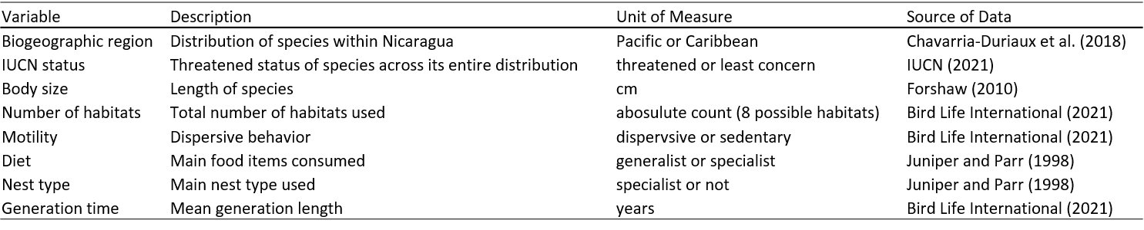

Table 2. Coefficients of conservatism (CoC) for 12 parrot taxa in Nicaragua and the number of training sites where taxa were detected; LD = least-disturbed, ID = intermediately disturbed, MD = most-disturbed, total = total number of sites with a detection, and total possible = total number of sites surveyed.
Table 3. Results of a Bayesian comparison of means (i.e. an analog to a two-sample ANOVA or t-test) for species-specific attributes of Nicaraguan parrots on species’ coefficient of conservatism. HDI refers to the Bayesian highest density credible interval, proportion >0 refers to the proportion of the posterior distribution positive (or negative), and η of moderate or higher magnitude. Boldface type highlights minimal (<5%) overlap of the posterior distribution with 0.

Table 4. Results of Bayesian beta regression for species-specific attributes of Nicaraguan parrots on species’ coefficient of conservatism. HDI refers to the Bayesian highest density credible interval, proportion >0 refers to the proportion of the posterior distribution positive (or negative), and η is effect size (estimated from Bayesian correlation). Boldface type highlights minimal (<3%) overlap of the posterior distribution with 0.

Figure 1. Three biogeographic regions—Pacific, Central Highlands, and Caribbean—broadly categorize the ecological communities within the country of Nicaragua.
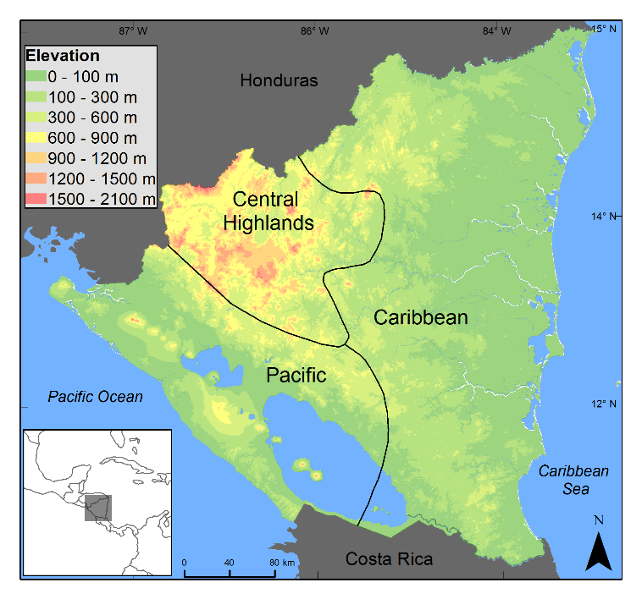

Figure 2. The mean coefficient of conservatism (CoC) with standard deviation, based on CoC calculations for each buffer size (5-km, 10-km, 20-km, and 40-km) is presented. The median CoC (5.4) is represented by the gray horizontal line. A species above or below the median indicate differing scaled sensitivity to deforestation (higher CoC = greater sensitivity, lower CoC = greater tolerance).
