University of Oklahoma

Graduate College

STUDIES UTILIZING DECELLULARIZED HUMAN AMNIOTIC MEMBRANE AND SW-620 CELLS AS A PRELUDE TO 3D IN VITRO CULTURES

A thesis

submitted to the graduate faculty

in partial fulfillment of the requirements for the

Degree of

Master of Science

By

melissa narum
Norman, Oklahoma
2017

STUDIES UTILIZING DECELLULARIZED HUMAN AMNIOTIC MEMBRANE AND SW-620 CELLS AS A PRELUDE TO 3D IN VITRO CULTURES

A thesis approved for the
stephenson school of biomedical engineering

By

______________________________
Dr. Vassilios Sikavitsas, Chair

______________________________
Dr. Edgar O’Rear

______________________________
Dr. Roger Harrison

© Copyright by melissa narum 2017
All Rights Reserved.

Acknowledgements
First and foremost, I want to thank Morgan McCoy. Her enthusiasm and excitement for research came at the perfect time. She was a pivotal helper in the lab. Getting to see her build her confidence in the lab was inspirational and I hope she continues to pursue research throughout her college career.
Second, I would like to thank Julian Arrizabalaga and Jin Liu from Dr. Ulli Nollert’s lab. Without their help, I would not have been able to switch my project so late in the semester and still be successful. Julian’s help with the membrane made a large component of this project possible.
I want to thank Dr. Vassilios Sikavitsas for being a steadfast advisor and believing in me even when I didn’t believe in myself. His support of my project and advice has allowed me to move forward and complete my project.
I want to thank Dr. Randall Hewes, dean of the graduate college for granting me a tuition waiver for the summer semester.
I want to thank Jakob Townsend for being an important resource for my research.
I also want to thank Dr. Harrison and his lab member Patrick McKernan. They were pivotal in providing myself and my lab with knowledge of how to culture cancer cells and physically proving us with the MDA-MB-231 and PC-3 cells.
I also need to thank Cortes Williams for giving me the opportunity in the first place to join the lab. Without his training, I may never have known how to culture cells or half of the pieces of equipment found in the lab. Thanks for giving me the initial opportunity.
Special thanks to Chelsea Coffey and Alison Jalanti for sharing an office space and being around to bounce ideas around. They were there to discuss and talk in both stressful times and productive times. Their work ethics were inspirational, with all of us balancing work, school and research!
I want to thank Nathan Richbourg for his knowledge and assistance in the lab. He spent his time trying to assist with the fluorescent microscopy, even though it didn’t fully pan out.
I also want to thank Dr. Edgar O’Rear for his support over the years, especially in tight times. His biological transport class peaked my interest in the biomedical sciences for the second time. I thank him for being on my committee and always being around for a quick chat.
I want to thank Thomas Pooler for constantly supporting me emotionally throughout the year. He is able to talk me down from stressful times and end up smiling on the other side. He is a strong, steadfast and a positive influence with the ability to help me keep everything in perspective.
I want to thank my brother, Steven, for helping me with the picture formatting as well just being around the labs. I can always count on him for help with the random things. I hope he continues his journey with biomedical engineering and continues to expand on his research.
Finally, I want to thank my parents, Craig and Denise Narum, for supporting me unconditionally throughout this journey. Especially through this past year, with veterinary school applications, interviews along with classes and research, they’ve stood by my side emotionally and helped talk me through the tough times and celebrate the good times.
Special thanks to Colorado State School of Veterinary Medicine for believing in me and offering me admission in the class of 2021. Boomer Sooner and go Rams!

Table of Contents
Acknowledgements iv
Table of Contents vii
List of Figures xi
Abstract xii
1. Introduction 1
Impact of Cancer 1
Introduction to Metastasis 1
Animal Models 1
Human Clinical Models 2
In Vitro Models 3
2D Static in vitro Culture 4
2D In Vitro Culture on Inserts 4
3D In Vitro Hydrogel Models 5
3D In Vitro Synthetic Scaffolds 6
3D In Vitro Natural Tissue Models 7
Co-culture Using Mesenchymal Stem Cells 8
3D In Vitro Tumor Spheroids 9
Goal of Study 10
Colon Cancer Overview/Motivation 10
Colon Cancer Staging and Treatment 11
Colon Cancer Metastasis Mechanisms 12
Overview of the Amniotic Membrane 13
2. Materials 15
Cell Line 15
Amniotic Membrane 15
3. Methods 16
Cell Culture 16
SW-620 16
Splitting 17
Decellularization of Amniotic Membranes 19
Static Membrane Growth 21
Overview of the Five Day Membrane Study 24
Sampling: Two Day Membrane Study 25
Sampling: Five Day Membrane Study 25
Method of Analysis 25
DNA Assay 26
Population Doubling Rate 28
Statistical Analysis 28
4. Results 29
Static Amniotic Membrane Culture 29
Experiment #1: Two Day Culture 29
Experiment #2: Five Day Culture 30
5. Discussion 36
Static Amniotic Membrane Culture 36
6. Conclusion 39
7. Future Aims 40
8. References 43
9. Appendices 45
Appendix 1: Standard curve for SW-620 DNA quantification 45
Appendix 2: Standard curve for two day membrane experiment 45
Appendix 3: Standard curves for five day membrane experiment 45
Day 0 and 1 46
Day 2 and 3 46
Day 4 and 5 47
Appendix 4: DNA Assay Protocol 47
Appendix 5: Cell Splitting Protocol 49
Appendix 6: Tissue Preparation for a DNA assay 50
Appendix 7: PBS Preparation 51
Appendix 8: Media Preparation 52
Appendix 9: Cryogenically Freezing Cells 53
Appendix 10: Plating Cells from Cryopreservation 54
Appendix 11: Counting Cells with the Hemocytometer 54
Appendix 12: Decellularization of the Amniotic Membrane 55
Appendix 13: SW-620 Culture in Flask (directly from cryopreservation) 56
Appendix 14: SW-620 Cells Culture in Flask (progression after splitting) 57
Appendix 15: Glossary 57
Appendix 16: Abbreviations 58

List of Figures
Figure 1: Colon cancer polyp [21] 11
Figure 2: Stainless steel washer 22
Figure 3: Representative 6-well plates with membranes 23
Figure 4: Two day static membrane experiment with SW-620s; dashed line represents the initial number of cells seeded 29
Figure 5: Days 1-5 static membrane growth seeded with SW-620 cells 31
Figure 6: Days 1-5 static membrane controls without cells 32
Figure 7: Day 5 amniotic membrane without cells 33
Figure 8: Day 5 amniotic membrane seeded with SW-620 cells 34
Figure 9: Five day static membrane experiment with SW-620s; dashed line represents the initial number of cells seeded 35

Abstract
The prevalence of cancer in modern society has increased from 14.1 million new diagnoses and 8.2 million deaths in 2012 to an estimated 21.7 million new diagnoses and 13 million cancer-related deaths projected in 2030 [1]. The development of novel methods for 3D in vitro tumor growth can help to understand better the progression of the disease and eventually provide new therapeutic approaches, especially at the personalized medicine level. Human amniotic membrane is a promising biological scaffold for the growth of cancer cells and ultimately tumorigenesis. The membrane is antimicrobial and contains important extracellular matrix components for cancer cell growth. SW-620 colon cancer cells were seeded on the surface of the decellularized human amniotic membrane in the presented studies. SW-620 colon cancer cells were shown to proliferate on decellularized amniotic membrane in a shortened seeding and culturing two day procedure. A five day seeding and culturing on the decellularized membrane procedure resulted in a three day proliferative period (days 0 through 3) with a 60% seeding efficiency on day 0 (555,000 initially seeded cells). The number of cells plateaued from days 3 to 5. These results provide a promising proof-of-concept in 3D in vitro monolayer culture. Future work is necessary to improve the use of human amniotic membrane as a 3D in vitro scaffold through layering or surface modifications. Comparison of the genotypic expression between the in vivo, 3D in vitro amniotic membrane and 2D culture models using PCR is also necessary to determine if the cells are behaving like cells in physiological conditions.

Introduction

Impact of Cancer
Cancer is a rapidly-evolving, devastating disease that is projected to be diagnosed in 39.6% of men and women in the United States at some point in their lives [2]. In 2016, the projections for new cancer cases in the United States alone was 1.7 million with roughly 600,000 people perishing from the disease. On the global scale, there were an estimated 14.8 million new cases and 8.2 million cancer-related deaths in 2012 [3]. Cancer has a significant impact on global health and is the second highest cause of death in the world.
The complexity of cancer, which comprises many different diseases, requires extensive research to understand its progression and to improve therapeutic treatments. In the following sections, methods of 2D and 3D cell culture and animal models for study of cancer proliferation and metastasis are discussed. An overview of colon cancer and the characteristics of the amniotic membrane is also included.

Introduction to Metastasis
Primary cancer removal is often followed by reappearance of the tumor in the same or an alternative site via metastasis. Metastasis is actually the predominant cause of cancer-related fatalities. The exact mechanisms of metastasis and cause of cancer are still only conjecture, which increases the need for cancer-based research.

Animal Models

Currently, animal models are used to study tumor growth and other aspects of cancer biology. The predominant animal model used for cancer research is the mouse [4]. Specifically, nude mice are used to study the growth of human cancers. Zebrafish and rats are also used as animal models for cancer research. Mice and other animal models are important to develop studies for general cancer research and preclinical research. Animal models represent an in vivo system with the cancer behaving similarly to the native environment. The limitation of animal models is that even though they are a living system, they do not perfectly represent how the cancer develops and progresses in the human body. In addition, nude mice have a compromised immune system. Apart from the biological differences, tumor size is an additional factor where animal models and human patients differ [5]. The maximum size that a tumor can reach in a mouse model is much smaller than what would be found in human tumors. This can impact the overall growth and metabolic state of the tumor and lead to different responses when testing drug efficacy.

Human Clinical Models
Human clinical models are also used in modern cancer research, especially when studying chemotherapy efficacy on cancer in vivo. The largest issues with using humans, especially as a preliminary model to study cancer, are finding patients who qualify and are willing to participate in the trial. When drugs are fast-tracked into human clinical trials, long term effects and other side effects are unknown and may detrimentally impact the patient. Human tumors are the most accurate in terms of the actual growth and development of the cancer since the cancer lines being studied are originally derived from humans but can be surrounded by ethical obstacles for finding trial participants.
Personalized medicine is currently evolving to include cancer patients with highly diversified tumor characteristics that are otherwise categorized in general groups in order to develop therapeutic approaches. Readily available primary cancer cells from biopsies make in vitro models, which can be used to understand better the response of cancer cells to a variety of chemotherapeutic drugs, a potentially powerful tool in rapid screening of anti-cancer agents. Cancer treatments formulated in in vitro models will spare the patient from unnecessary harm due to aggressive treatment options and observations can be made as to which drugs work on a patients’ specific cancer. Individualized treatment plans are under development and are being explored through immunotherapies and targeted therapies and can be expanded through the application of 3D in vitro cancer growth models. 2D and 3D models still need to be refined in order to reflect in vivo conditions and be fully manipulated in vitro.

In Vitro Models
Modern cancer research has utilized both 2D (monolayer culture on tissue culture plates) and 3D in vitro models. The current focus of these models is tumor growth, cell migration, cell adhesion, maintenance of in vivo-like morphology mimicking the characteristics of gene expression, metabolic state, cell-cell interactions of the native tumor microenvironment [6]. 3D in vitro models refer to cellular constructs that extend beyond a simple monolayer. They can be generated using exclusively cellular aggregates that can grow into tumor spheroids. Alternative approaches include the use of hydrogels to entrap cancer cells and allow them to grow in an environment containing components of their native extracellular matrix and growth factors [7]. Synthetic and natural scaffolds have also been used as they provide extended surface area available for cancer cell attachment and growth. Microfluidic networks have also been tested in cancer research and they constitute a special category between 2D and 3D models [8].

2D Static in vitro Culture
2D in vitro static cell culture involves a culture environment devoid of flow and monolayer growth. Generally, static culture is performed in a petri dish, flask or well plate and media is supplemented to the container [7]. Static culture is beneficial to culture studies since a vast majority of cells can be cultured in this way and is widely used due to ease of use. The major weakness of 2D monolayer culture is the inability to recreate the 3D nature of actual tumors and studies have shown that the lack of three dimensionality compromises the phenotypic characteristics of many cancer cell types. Another weakness of 2D in vitro cell culture is that there are no extracellular matrix components present which limits the extent of which in vitro cancer cells can resemble in vivo cellular growth.

2D In Vitro Culture on Inserts
One example of a 2D modeling environment is culture on inserts. Culturing on inserts is useful when trying to understand angiogenesis, transport, cell-cell interactions and invasion [9]. The main premise of cell culture inserts is that they consist of a thin, porous membrane that allows for the media to pass through the membrane [10]. This allows both the lower and upper surface of the cells to be exposed to the same nutrients. The membrane can consist of a synthetic material of a known porosity. The porosity is meant to mimic in vivo conditions due to the fact that surfaces in the body are generally porous to some degree and allow for extracellular cell-cell signaling. Some of the common materials used for the membrane are polycarbonate, polyethylene terephthalate, cellulose esters and polytetrafluoroethylene [9],[11]. These inserts are also used to grow co-cultures of different cell types using the same environment. Cells can be grown on top of the porous membrane and below the membrane on the bottom of the well plate. This allows for cell communication as well as controlled co-culturing. One of the main limitations of culturing on cell inserts is that the shape of the insert does not resemble the shape of a tumor in vivo. The main growth progression is in a monolayer which is not how tumors progress in vivo. Culture using cell inserts is a better method of 2D in vitro culture when compared to traditional growth in flasks due to the ability to maintain a co-culture and allow for cell-cell communication, which both mimic in vivo conditions.

3D In Vitro Hydrogel Models

One 3D culture method is imbedding cells in natural or synthetic materials in a hydrogel. For embedding, cells can either be seeded onto a porous surface or entrapped in a hydrogel. Hydrogels can be formed from many different materials, both synthetic and natural, and are used to mimic the natural extracellular matrix microenvironment. Some examples of synthetic hydrogel materials include: polyethylene glycol, poly(hydroxymethyl methacrylate), polyvinyl alcohol, and polycaprolactone [7]. Natural materials include: alginate, chitosan, hyaluronan, dextran, collagen and fibrin. Matrigel is another example of a naturally-based material. Matrigel primarily contains collagen IV, laminin and enactin and was originally derived from Englebreth-Holm-Swarm tumors in mice [12]. One potential limitation of a 3D hydrogel tumor model is that cell adhesions are not part of the entrapment process. If there is a need to study cell attachment, then a hydrogel would be lacking due to the fact that the cells are physically trapped and are not required to adhere through their own processes.
Special precautions are needed when cross-linking is required in hydrogel formation. Some chemical cross-linking can be toxic to cells and UV or light based cross-linking can also be harmful to the cells [13]. Despite this, hydrogels can be tuned to a specific desired environment in terms of the material and directional growth for a 3D cell culture.

3D In Vitro Synthetic Scaffolds
Synthetic scaffolds are also used as a platform for 3D in vitro cancer models. These scaffolds are considered to be a solid scaffold and can be created through a variety of methods. This includes 3D printing, electro-spinning and other methods to create pores [14]. Some examples of materials that are used to form synthetic scaffolds include poly(lactic) acid, poly(glycolic acid) and poly(lactic-co-glycolic acid). These specific materials are biodegradable which could have mixed results in 3D tumor growth. The positive of biodegradability is that the cancer cells will be able to proliferate and take over the structure previously occupied by the scaffold material. On the contrary, the scaffold may break down before the tumor architecture is established and bi-products of degradation may impact the growth of the cancer and possibly make the culture less representative of in vivo conditions. The benefits of synthetic scaffolds as a base of cancer cell growth is that they can be reproduced, especially when using a 3D printed scaffold. The same template can be used to create more scaffolds with specific parameters and porosity. A limitation of using synthetic scaffolds is that the scaffold can influence the directionality of cellular growth and result in deviations from in vivo-like growth patterns. They also do not contain extracellular matrix components and are considered inert in terms of interactions with the cells. Research in our lab (Cortes/McKernan/Sikavitsas, unpublished) demonstrated a lack of adhesion and growth of cancer cells seeded on 3D printed poly(lactic acid) scaffolds as well as electro-spun poly(lactic acid) scaffolds. The cancer cells were not able to bind to either of these scaffolds in a 48-hour period even when adhesion peptides (RGD) were incorporated on the poly(lactic acid) surface.

3D In Vitro Natural Tissue Models
Scaffolds derived from natural tissues also demonstrate promise as a 3D culture platform. Especially for human-derived tissues, the propensity to support cellular growth and proliferation is evident [7]. They contain an extensive network of extracellular matrix components that promote cell binding. Specific examples of natural-derived tissues used in current research include the small intestine submucosa (SIS), human umbilical vein (HUV) and amniotic membrane to name a few [15]. Natural materials can be decellularized before seeding with new cells since the presence of the preexisting cells if often undesirable with the exception of cases where co-cultures of cancer cells are explored. The decellularization process results in some damage to the native architecture of the extracellular matrix; however, cells can still favorably adhere to the decellularized tissues using the extracellular matrix components which still closely resemble the native state. Specifically, the human amniotic membrane is a thin material that seems to resemble a 2D environment as opposed to a 3D environment. This can be remedied by layering membranes on top of each other to increase the scaffold thickness. Cells can be seeded between the layers to also improve cell growth in three dimensions. Significant limitations include individual variation as well as reliable sourcing. Natural materials, especially of human nature, can be difficult to source. Individual variation is a challenge and variability in sample size is almost impossible to eliminate.

Co-culture Using Mesenchymal Stem Cells
Mesenchymal stem cells (MSCs) have been thought to impact the growth of tumors in vivo through cellular communication. The impact of MSCs on tumor growth is questionable due to the fact that many studies have demonstrated that they increase growth and many others have demonstrated that they inhibit growth [16]. Stem cells can promote tumor growth by means of differentiating into pericytes or endothelial cells involved in angiogenesis. The secretion of VEGF by the MSCs also helps to promote angiogenesis within the tumor. Tumor cells can communicate with MSCs and other cells within the tumor by use of extracellular vesicles [17]. This communication method is two-way with both the MSCs and tumor cells able to produce extracellular vesicles. The vesicles contain non-coding RNA (ncRNA) which influences cancer initiation, progression and pre-metastatic niche formation. MSCs are also involved in immune suppression of B and T lymphocytes and natural killer cells [16]. This allows for the tumor to continue with growth and proliferation with only limited immune resistance. It is also believed that MSCs can influence and control the epithelial-to-mesenchymal transition (EMT) which leads to increase metastasis and invasiveness. The inhibition/increase discrepancy may be partially due to the timing of MSC introduction into the tumor. Some studies demonstrate that introducing MSCs to established tumors inhibits the growth of the tumor. Other studies demonstrated that the addition of MSCs with cancer cells improved tumor formation. Introducing MSCs with cancer cells at the beginning of growth may be useful to promote angiogenesis and tumor proliferation in 3D in vitro models.

3D In Vitro Tumor Spheroids
Currently, 3D cancer models have focused on several different materials and experimental designs. Some examples include culturing multicellular aggregates (spheroids), hydrogels, synthetic scaffolds and seeding cells on natural tissue.[6]. Maintaining the health of cancer spheroids over time is a challenge. As the spheroid expands in the radial direction due to cell proliferation, the spheroid becomes more tightly packed with cells in the interior experiencing hypoxia [18]. The transport limitations of spheroids result in a rapidly expanding mass due to direct contact with the media and nutrients and a necrotic center that has little to no access to vital nutrients. One benefit of the spheroid is the natural form that it takes as it grows. Spheroids are aggregated so that the tumor-like form already exists as the cells proliferate. A downfall to a tumor spheroid model is that in the purest form, there is not existing extracellular matrix. Apart from this, the tumor size is limited in the radial direction due to the transport limitations that occur without angiogenesis.

Goal of Study
The main point of this study is to determine the growth and proliferation of cancer cells seeded on a decellularized human amniotic membrane. The amniotic membrane was specifically chosen for this application due to accessible sourcing as well as being human-derived. The cancer line that has been used is the SW-620 colon cancer cell line. The results of this aim will be developing preliminary model for future work involving surface modification and 3D cancer cell growth using the amniotic membrane.

Colon Cancer Overview/Motivation
Colon cancer is the third most common type of cancer found throughout the world for both sexes [19]. There are more than a million new cases each year, with roughly half of those cases being fatal. In this study, the SW-620 colorectal adenocarcinoma cell line was chosen due to the resemblance of the amniotic membrane to the mucosa of the colon. This line was also chosen due to its rapid proliferation rate.

Colon Cancer Staging and Treatment
Colon cancer is classified using a staging system. Stage 0 refers to carcinoma in situ, or a grouping of abnormal cells located in the intraepithelial or lamina propria of the colon [20]. Stage 0 is the lowest stage classification for colon cancer. The worst and most progressed stage of colon cancer is stage 4. Stage 4 is uniquely characterized by metastasis to either 1 or multiple other organs. The primary tumor can be in any classification and the lymphatic system has been invaded to some extent.
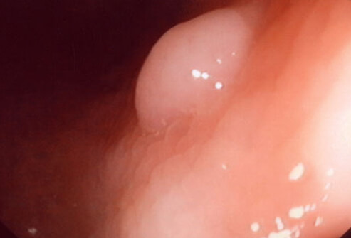
Figure 1: Colon cancer polyp [21]
The tumor initially appears as a small polyp (Figure 1) which can either be benign or malignant [21]. Polyps can be discovered through a routine colonoscopy performed by a physician. Some benign tumors have the ability to become malignant so surgical removal of abnormal polyps is advised. If not surgically removed, the polyps can grow in size to cause physical discomfort along with other gastrointestinal abnormalities. Typically, colon cancer survival has not improved despite advances in chemotherapies and radiation-based treatments. The survival rate ranges from 90% in the initial stage 0 to stage 2 detection on a 5-year basis [22],[23]. The rate drops to as low as 10% for 5-year survival when detected at stage 4 metastasis. Tumor excision through surgery allows for this high rate of 5-year survival for the lower stage patients [22]. Stage 4 colorectal cancers are generally treated with chemotherapy. Drugs that are currently on the market consist of 5-fluorouracil, leucovorin and several others. Some drugs are now utilizing targeted approaches using monoclonal antibodies. These drugs specifically target the epidermal growth factor receptor (EGFR) to slow or stop the rate of metastasis. Others are able to inhibit growth and development pathways needed for cancer metastasis. Bevacizumab targets the VEGF system when used in combination with other chemotherapy drugs [24]. Targeting the VEGF pathway is important to limit tumor growth. VEGF is responsible for controlling angiogenesis in healthy cells and is upregulated in cancer cells [25]. Limiting the development of new blood vessels in cancerous tumors ensures that the cells on the interior of the tumor do not receive proper nutrients. Tumors rely on a network of blood vessels for nutrient transport and are not sustainable through nutrient diffusion processes alone.

Colon Cancer Metastasis Mechanisms
Current mechanisms for metastasis in cancer cells include the influence of cancer stem cells (CSCs) [22]. It is not known if these cells mutate from healthy sources of stem cells or if cancer cells have the ability to dedifferentiate into CSCs. Regardless of source, CSCs are responsible for the tumorigenic and metastatic properties of cancer cells. In epithelial cell cancers, cells undergo epithelial-to-mesenchymal transition and obtain properties similar to stem cells [22],[23]. These properties include infinite proliferation, self-renewal and apoptotic resistance. EMT is the critical step in order for cancer cells to expand from a primary grouping of abnormal cells to a metastatic phenotype with the ability to travel to distant locations in the body. EMT is also characterized by increased drug resistance and the down regulation in production of E-cadherin. The loss of E-cadherin allows the cells to separate in attachment to neighboring cells and migrate throughout the body. This process occurs relatively quickly in colorectal cancers and contributes to the aggressiveness and poor prognosis of metastatic stage 4 cancer. The metastatic colon cancer cells invade the basement membrane and are able to invade both the lymphatic and circulatory system. This allows for them to traverse the lumen of the vessels (intravasation) and exit the lumen (extravasation) to reach other organs and produce new tumors.

Overview of the Amniotic Membrane
The amniotic membrane, or amnion, is a thin, extraembryonic membrane of the placenta that functions as an immune barrier to the fetus [26]. The chorionic membrane, or chorion, is found on the outside of the amniotic membrane and is also part of the placenta. The amniotic membrane is composed of several different components including: fibronectin, elastin, nidogen, collagen I, III-VI, elastin and hyaluronic acid. These components are generally found as part of the extracellular matrix of many cells. The amniotic membrane is compatible with many different ECM components and ideal as a tissue engineering scaffold due to its low immunogenicity. The DNA of the membrane epithelial cells contain Fas L, TNF and TRAIL which are all genes that induce apoptosis. These genes can cause leukocytes to commence apoptosis which reduces the effectiveness of an immune response against the amniotic membrane. The amnion is also antiangiogenic and is avascular in nature. The amniotic membrane is antimicrobial due to its production of β-defensins which kill invading microbes. The anti-inflammatory properties derive from the suppression of cytokines that cause inflammation as well as IL-1α and IL-1β expression. The cells of the amniotic membrane also produce secretory leukocyte proteinase inhibitor and elafin which also contribute to the anti-inflammatory properties. The combination of these factors make the amniotic membrane an ideal choice as a scaffold material for tissue engineering. The membrane also maintains its mechanical strength and shape even after excision from the placenta and chorion and after the decellularization process. This enhances the stability as a scaffold material. The membrane is also semipermeable which could assist nutrient diffusion or cellular penetration. Literature states that its thickness ranges from 70-180 μm in thickness which could be plausible for cells to traverse or permeate [26]. Stacking of the amniotic membrane has also been utilized with cell seeding to create an improved 3D in vitro scaffold (Mathilde/Nollert, thesis).

Materials

Cell Line
SW-620
The SW-620 cell line is derived from a 51 year old male Caucasian patient [27]. The cells were harvested from the lymph node (metastatic site) after the original colorectal adenocarcinoma spread. The characterization of disease progression was Duke’s type C. The cell line is considered to be adherent epithelial cells but these specifically have already gone through metastasis. These cells were purchased in September 2016 from American Type Culture Collection (ATCC) and delivered in a frozen state. They were cultured and expanded to grow the cell stock when they arrived in November 2016. Extra cells were frozen and stored in liquid nitrogen until needed for culture. To date, these cells have only been cultured for DNA quantification and for seeding on the amniotic membrane.

Amniotic Membrane
Amniotic membranes used in this thesis were sourced from Norman Regional Hospital in Norman, OK. These amniotic membranes were 5 days old when donated at no charge. Specifically, the membranes in this thesis were processed by Julian Arrizabalaga in October 2016 and decellularized by him.

Methods

Cell Culture

SW-620
The SW-620 cells were cultured in accordance to the guidelines set in place by the ATCC with some slight modifications [27]. Cells taken from cryopreservation in liquid nitrogen were thawed in a water bath and added to a Falcon tube, supplemented with Leibovitz’s L-15 media (Life Technologies ™). This Falcon tube was then centrifuged for 5 minutes at 1100 rpm. The supernatant was pipetted out of the Falcon tube and the concentrated cells were re-suspended with L-15 media to a concentration of 1 million cells/mL. The supernatant was removed in this process in order to remove any DMSO which is toxic to cells in general [28]. In each T-75 flask, 1 mL of cell and media mixture was added. Each flask was supplemented with another 9 mL of L-15 media to a final flask volume of 10 mL.
For general culture and expansion, the cells were rinsed with 3 mL of PBS per flask the day after plating. The PBS was suctioned out with a pipette and 10 mL of L-15 media were added to the flask. After this step, media was changed every 3 days (2 days between each media change). Media changes were continued until cells reached 85-90% confluent on the bottom of the flask. The splitting procedure is documented in the section following the culture of PC3 cells. SW-620 cells were split using 1:4 to 1:10 ratio of original flasks to new flasks needed.
SW-620 cells were prepared for cryopreservation by splitting the cells and re-suspending the cells using cryogenic media. 1 mL of the cell media mixture with a concentration of 1 million cells per 1 mL was placed into each 1 mL cryogenic tube. Tubes were placed in a slow, controlled freezing container and placed in a -80°F freezer overnight. The next day, tubes were taken and placed in cryogenic storage tanks for long-term storage.

Splitting
Splitting a cell culture, or subculturing, refers to removing the cells from the original flask and moving them into new flasks to expand their growth. There are several important factors to determine the correct time to split a cell culture [28]. Confluence, or the cell monolayer density on the bottom of a flask or culture vessel, is a prime indicator of when to split. This can be visually determined using a light microscope and is characterized by high cell density and little to no areas of space without cells. When cells reach confluence, they need to be split within a 24 hour period or else there is a risk of apoptosis and longer recovery when the flasks are subcultured. Timing is also an indicator of a subculture requirement. Yield and growth are consistent as long as the seeding density is maintained and should occur over a set time period. Each cell line has different timing requirements and multiplication times. Confluence and timing are the most used methods of determining when a cell culture should be split within this lab and this thesis.
Splitting requires several different materials and is based on a standardized protocol within the Sikavitsas lab with minor adjustments. Media, trypsin and PBS must first be brought to temperature in a 37°C water bath. The specific media used is the same media used for culture of a particular cell line. Once they are up to temperature, cells are placed under the Bio-Hood and the existing media is suctioned out of the flask. 3 mL of Dulbecco’s phosphate buffered saline (PBS, Life Technologies™) is added to each culture flask and gently flowed over the bottom of the flask. This step removes any existing debris or serum that can inhibit the action of trypsin [28]. The PBS is then suctioned out of each flask and 2 mL of trypsin is added to each flask. This is gently rinsed over the bottom of the flask to ensure contact with the entire cell monolayer. Flasks are then incubated at 37°C and the designated CO₂ setting for 5 minutes. After this incubation period, fresh media (8 mL/flask) is added to the trypsin and used to rinse the monolayer and suspend cells in the media mixture. This rinse is repeated by suctioning and flowing the media along the bottom of the flask. After roughly 15 rinses using the same media, the media, trypsin and cell suspension is taken out of the flask and placed in a Falcon tube for centrifugation. If the total cell/media/trypsin volume is under 15 mL, a 15 mL Falcon tube is used for centrifugation. If the total cell/media/trypsin volume is under 50 mL and greater than 15 mL, a 50 mL Falcon tube is used for centrifugation. More Falcon tubes can be used if the total volume exceeds 50 mL.
A small, well-mixed sample (<1 mL) is taken from the Falcon tube in order to be counted. Cells were counted using a hemocytometer. 20 μL of the well-mixed cell/media sample was combined with 20 μL of trypan blue and mixed. A glass cover slip was placed on top of the hemocytometer and 10 μL of the trypan blue/media mixture was pipetted into each side of the hemocytometer. Cells were counted on both sides of the hemocytometer. Live cells appeared as bright, white circles under the microscope. The specific counting protocol is found in Appendix 11.
The Falcon tube is spun at a speed of 1100 rpm for 5 minutes until a cell pellet forms at the bottom of the tube. All supernatant is suctioned out using a sterile glass pipette, leaving a small amount of media directly around the cell pellet. Cancer cells have a tendency to not pack as tightly as other cells and can result in cell loss if the small amount of media is not maintained around the pellet at this step. The cells are resuspended to a concentration of 10⁶ cells/mL of fresh media and pipetted so that 1 mL of cell resuspension is placed in each new flask. This is supplemented with 9 mL of fresh media so that each flask contains a total volume of 10 mL. The splitting ratio differs between cell lines and is discussed for each cell line in the cell culture section of this thesis.

Decellularization of Amniotic Membranes
This protocol is the current protocol for amniotic membrane decellularization in Dr. Nollert’s lab and was performed by Julien Arrizabalaga to prepare all amniotic membranes used in this thesis. The decellularization protocol is found in Appendix 12.
The first steps of the decellularization protocol involved removing the amniotic membrane from the chorionic membrane and rest of the placenta. This is performed by blunt dissection by hand. Once the amniotic membrane is isolated, the umbilical cord is removed for other projects and the rest of the placenta is discarded as biohazard. The membrane is placed in a beaker of distilled water to removed blood and swell the spongy layer. The membrane is placed on a flat tray with the stromal side facing upwards. The spongy layer on top of the stromal side is removed by hand to not destroy the actual membrane. Using a 3D printed rectangle template (6.5 cm by 9.5 cm), the membrane was cut into smaller rectangles using a scalpel. A small cut was made at the bottom left hand corner of each rectangle in order to differentiate the top from the bottom. The membranes are placed in a 250 mL bottle and placed in the -86°C freezer for two hours. At the end of the two hour freeze, they are placed in the water bath at 37°C for 15 minutes and frozen/thawed again. After the second thaw, membranes are rinsed with distilled water and transferred to a 500 mL bottle filled with 400 mL of distilled water and 0.03% (w/v) sodium dodecyl sulfate. These bottles are then placed on an orbital shaker for 12-24 hours at 100 rpm. Membranes are washed in new bottles of 400 mL of distilled water and transferred to new bottles at 5, 15 and 40 minutes and 1, 6 and 24 hours. In order to remove residual DNA, membranes are incubated with 20-50 μg/mL DNase in a Tris buffer solution on an orbital shaker for 2 hours at 100 rpm. Membranes are then rinsed with distilled water. To sterilize the membranes, they are placed in a solution of 0.2% (v/v) peracetic acid and 4% ethanol in distilled water for 2 hours on an orbital shaker at 100 rpm. The bottles are wrapped in aluminum foil to maintain sterilization activity of the peracetic acid. Under the Bio-Hood, the membranes are washed in sterile distilled water at 100 rpm for 10, 20 and 30 minutes. They are washed again for 24 hours in distilled water at the same orbital shaker conditions. After the final distilled water wash, membranes are transferred into sterile PBS and the pH is recorded right after transfer and after 24 hours and should be in the biological pH range (7.2 to 7.4). The membranes are transferred into a final sterile PBS solution with antibiotics and stored in the 4°C refrigerator until needed.

Static Membrane Growth
Decellularized amniotic membranes were obtained from Julian Arrizabalaga and Jin Liu from Dr. Nollert’s research lab. The decellularization protocol was performed by Julien and sterile, decellularized membranes were placed in PBS for storage in the 4°C refrigerator. These membranes were placed in the PBS in October 2016.
Membranes were prepared the day before cell seeding for both cell growth studies. Stainless steel A4 washers (also provided by Julien and Dr. Nollert’s lab) were sterilized in batches of six in the anprolene sterilizer for 12 hours. Tools were also sterilized in the same batch as the washers. Specific tools included a pair of curved hemostats, a scalpel handle, a pair of scissors, a large forceps, beakers and a large petri dish. Membranes were taken from the sterile PBS and placed on the large petri dish using a large forceps. This was done one at a time to avoid crowding or contamination. The cut corner of each membrane was oriented so that the cut corner was on the bottom left side of the membrane. This ensures that cells are seeded on the correct side of the membrane. A 3D printed square template was placed on the membrane and the scalpel equipped with a sterile blade was used to cut out small squares of membrane. The dimension of this template and the approximate dimensions of the membrane was 2.5 cm X 2.5 cm. The total surface area of the cut membrane was 6.25 cm². The measured thickness of the amniotic membrane (n=1) was 86.6 +/- 6.1 μm in the laboratory. This value was measured by taking ten different measurements on various parts of a decellularized membrane using an iGaging® micrometer. The micrometer measures to an accuracy of +/- 4 μm. Each square was transferred into a sterile, non-tissue culture 6-well plate with care taken to ensure that the correct side was facing upwards. A washer was carefully placed on top of the flattened, square membrane in each well plate (Figure 2). The washer thickness, outer diameter and inner diameter dimensions were 0.2, 3.4 and 2 cm, respectively. The resulting exposed membrane surface area for cell seeding was 3.14 cm². The washer is not biologically reactive with the membrane or cells and is used to keep the membrane flat and stable on the bottom of the well plate.

Figure 2: Stainless steel washer
This process was continued until all well plates were filled with membrane squares and washers. Each well was supplemented with 5 mL of L-15 media. All well plates were placed in the incubator at 37°C and atmospheric CO₂ overnight to bring to temperature.
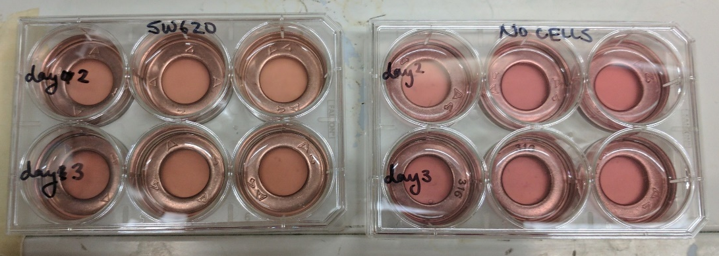
Figure 3: Representative 6-well plates with membranes
On the day of seeding, the cell flasks were split according to the splitting protocol. Cells were counted using the hemocytometer and trypan blue staining. Each cell-seeded membrane was seeded with 500,000-1,000,000 cells per 0.15 mL. Control membranes were not seeded with cells and were supplemented with L-15 media. The first seeding was done with the initial concentration of cells in the volume of 0.15 mL placed directly on the membrane in the inner circle of the washer. All well plates were then incubated in the 37°C and atmospheric CO₂ incubator for an hour. After the hour, membranes were reseeded by taking the supernatant from the sides of the washer and pipetting it back onto the center of the membrane. At this time, media was placed in the water bath to bring up to 37°C. Well plates were incubated for another hour and reseeded at the end of that hour. In total, there were 3 seeding periods and 2 hours of incubation. After the last seeding period, 5 mL of L-15 media was pipetted carefully and slowly onto the top of each washer. By placing media onto the washer, cells were less likely to be washed off due to the media while still filling the well with media. The media flowed off of the washer and over the amniotic membranes. The day 0 sample was taken at this point. All other well plates were placed back into the incubator until samples needed to be taken.
For the static membrane growth experiments, the SW-620 cell line was used. This explains why L-15 media was used for all static membrane experiments. Sample sets were taken in triplicate. The sampling process requires a pair of hemostats or forceps and a pair of scissors. The washers are removed from the wells and placed on a petri dish. One at a time, the amniotic membrane is lifted from the well using the hemostats and cut into small pieces using the scissors. The small pieces are placed into a small sample tube filled with 1 mL of nanopure water. Once all the samples are placed in their respective collection tubes, they are sonified for 5 seconds each. 200 μL of trypsin is added to each collection tube under the Bio-Hood. They are then incubated for 1 hour in the 37°C/atmospheric CO₂ incubator. Following the incubation step, samples are sonified for 10 seconds each and placed in the -20°F freezer until the freeze/thaw cycles can be completed.

Overview of the Five Day Membrane Study
Media changes were performed on day 2 (before the sample) and on day 4 (after the day 4 sample and before the day 5 sample). This would ensure that cells are favorably adhering to the membrane and can withstand a media change. The SW-620 cells were still used for the study. A total of 555,000 cells suspended in 0.15 mL of media was seeded onto each cell-seeded, experimental membrane. No fixed samples were taken during the trial in order to save resources and only focus on growth in terms of DNA content present per membrane.

Sampling: Two Day Membrane Study
Day 0 samples were taken immediately following the third seeding period. A total of 3 DNA assay samples were taken and processed according to the DNA assay preparation protocol per day for membranes seeded with cells. Two DNA assay samples were taken on both day 0 and day 2 for the membranes without cells. On all sample days, 3 membrane samples were taken and fixed for the membranes seeded with cells. A fixed sample was taken on day 0 and day 2 for membranes not seeded with cells. The samples were fixed by gentle submerging into PBS 3 times and then placed in fixing solution (10% formalin in PBS (v/v)) for 15 minutes. After the 15 minute period expired, samples were placed in a labelled collection tube filled with 1 mL of 70% ethanol and stored in the refrigerator.

Sampling: Five Day Membrane Study
For each day of sampling, three samples were taken and processed according to the DNA assay protocol for each experimental group. For example, on day 0, there were three samples taken for the control (no cell) group and three samples take for the experimental (SW-620) group. Each sample was analyzed in triplicate during the DNA assay and averaged together to get the final value. This was different from the first experiement in that each day sample had a corresponding control sample for accuracy.

Method of Analysis

DNA Assay
Preparing the sample for analysis differs slightly when analyzing a tissue material versus a synthetic scaffold. For the amniotic membrane scaffolds, samples to be used for DNA assay were taken according to the lab protocols found in the Sikavitsas lab. This specific protocol can be found in Appendix 6. Each membrane scaffold was taken from the well and cut into small pieces using scissors. The small pieces were placed in a small sample tube in 1 mL of nanopure water. Each sample was then sonified for 5 seconds. After sonication, 200 μL of trypsin was added to each sample tube. The samples were then incubated at 37°C and atmospheric air conditions for 1 hour. The reason that they were incubated in atmospheric air was because the SW-620 cells are cultured in that condition. Following the hour of incubation, samples were sonified again for 10 seconds each and placed in the -20°C freezer.
The samples being assayed were taken out of the freezer and allowed to thaw at room temperature. During this period, the DNA standards were prepared using a serial dilution method. Standard 4 was prepared to a concentration of 3 μg/mL by combining 30 μL of DNA standard and 970 μL of nanopure water. For consistency, the serial dilution was performed in the same manner for each assay needed in this thesis but it could be calculated to make different volumes of each standard by using the C₁*V₁=C₂*V₂ equation for dilutions. To ensure proper concentrations, each standard was vortexed for a few seconds before proceeding to the next standard. To make standard 3, 700 μL of standard 4 was added to 1.4 mL of nanopure water. Standard 2 was prepared by adding 1 mL of standard 3 to 2.8 mL of nanopure water. Finally, standard 1 was prepared by adding 2 mL of standard 2 to 4 mL of nanopure water. The final concentrations of standards 1, 2 and 3 were 0.1, 0.3 and 1 μg/mL respectively. Standard 0 simply consists of pure nanopure water.
The buffer solution was prepared according to the “DNA Assay” protocol sheets found within the lab. Appendix 4 includes the protocol for preparing the buffer solution as well as preparing the well plates for assay. The amount of buffer varied with the amount of samples being analyzed. The volume amount of 20X TE buffer solution and amount of nanopure needed to dilute to a 1X buffer was listed on the assay sheet. Once the buffer was mixed, half of the volume was transferred to another container. The secondary container was wrapped in foil to protect from the light and set aside to be mixed with PicoGreen later on.
A DNA assay was preformed using an Invitrogen™ Quant-iT™ PicoGreen™ dsDNA Assay Kit [29]. Opaque 96-well plates were prepared and the layout of the well plate was drawn in the lab notebook to ensure accuracy and precision. Initially, 107 μL of buffer solution (the half not wrapped in foil) was pipetted into each occupied well. This includes wells occupied by the standards. Before adding samples or standards to the wells, each was vortexed gently to ensure homogeneity. Once mixed, 43 μL of sample or standard was added to the designated wells. Each sample/standard was analyzed in triplicate. The assay protocol sheets also included the amount of PicoGreen needed for the number of samples. The designated volume of PicoGreen was added to the buffer half wrapped in the foil. This set was performed in the dark since PicoGreen is light sensitive and premature exposure to light skews the results of the assay. Once the PicoGreen buffer solution was vortexed, 150 μL was added to each occupied well. The plate is covered for 5 minutes with foil to set before running through the spectrophotometer/fluorometer.

Population Doubling Rate
The population doubling rate was calculated using the results of the DNA assay and confirmed using the microscope images in Figure 5. The cell number determined from the assay was multiplied by two to determine the doubled population. The amount of time to reach population doubling was then interpolated using the assay results (values with cell numbers between the doubled day 0 value) and the calculated doubled population for day 0.

Statistical Analysis
Statistical significance was determined using the T-test Excel built-in function. A star above the bars in the graph signifies a p-value of less than 0.05. Error bars represent the standard deviation for each sample.

Results

Static Amniotic Membrane Culture

Experiment #1: Two Day Culture
The first experiment was a true proof-of-concept trial to determine if the SW-620 cells were viable when seeded on the decellularized amniotic membranes. The seeding concentration per membrane was 10⁶ cells/membrane. The 10⁶ cells were contained in 0.15 mL of media which was seeded onto each membrane.
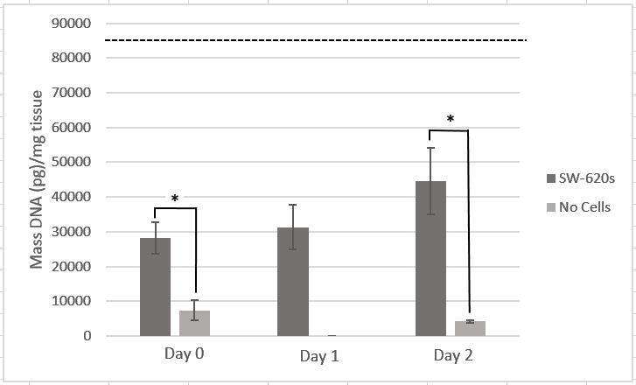
Figure 4: Two day static membrane experiment with SW-620s; dashed line represents the initial number of cells seeded
The results of the DNA assay for the day 0 controls, the day 2 controls and the days 0-2 cell-seeded samples are depicted in Figure 4. A substantial number of cells were lost and did not adhere from the initial seeding to the time of the day 0 sample collection. The values did begin to increase after the initial drop between seeding and day 0.

Experiment #2: Five Day Culture
The pilot study was repeated and expanded from two days to five days. Images were also taken for a visual representation of the cell proliferation on the membrane. Figure 5 tracks the progress of SW-620 cell growth from before the day 1 sample up until right before the day 5 sample. The same wells (day 5, middle no cells and day 5, middle cells) were imaged over the course of the entire experiment for consistency.
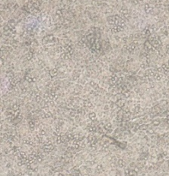
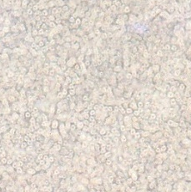
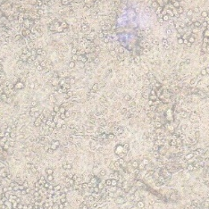
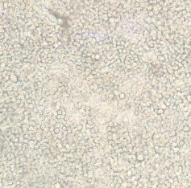
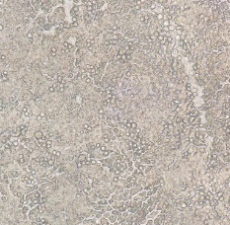
Figure 5: Days 1-5 static membrane growth seeded with SW-620 cells
Day 3
Day 1
Day 2
Day 4
Day 5

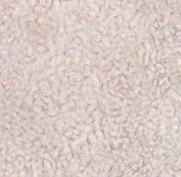
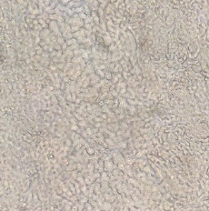
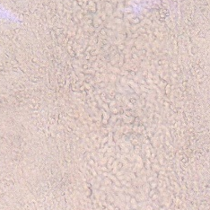
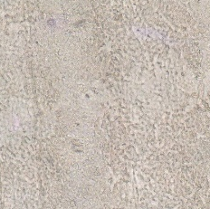
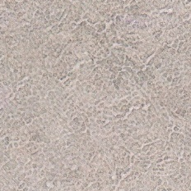
Day 4

Day 3

Day 2

Day 1

Day 5

Figure 6: Days 1-5 static membrane controls without cells

Figure 6 shows the images taken of the control membranes without any cells. No growth appears on the surface and no cross contamination of cells ended up on the control membranes.
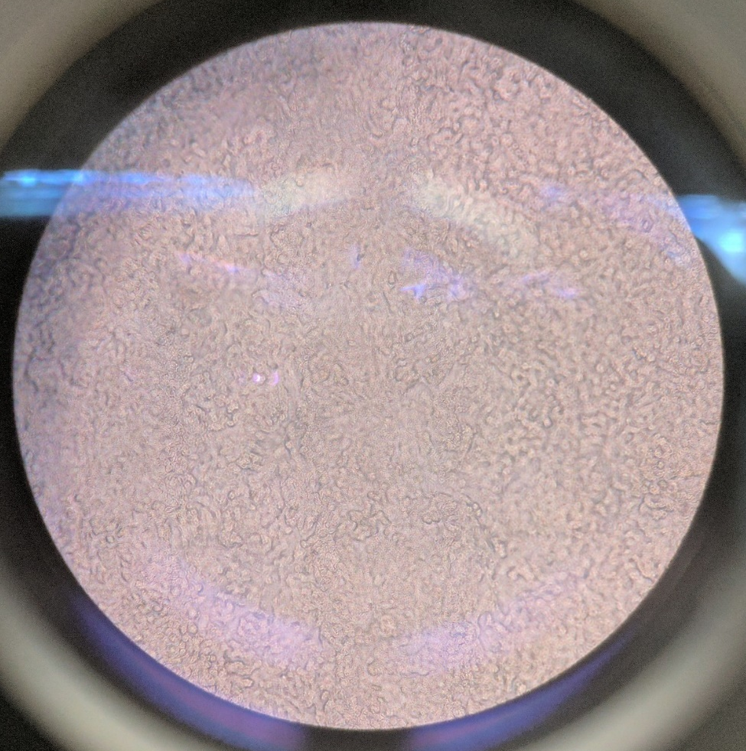
Figure 7: Day 5 amniotic membrane without cells

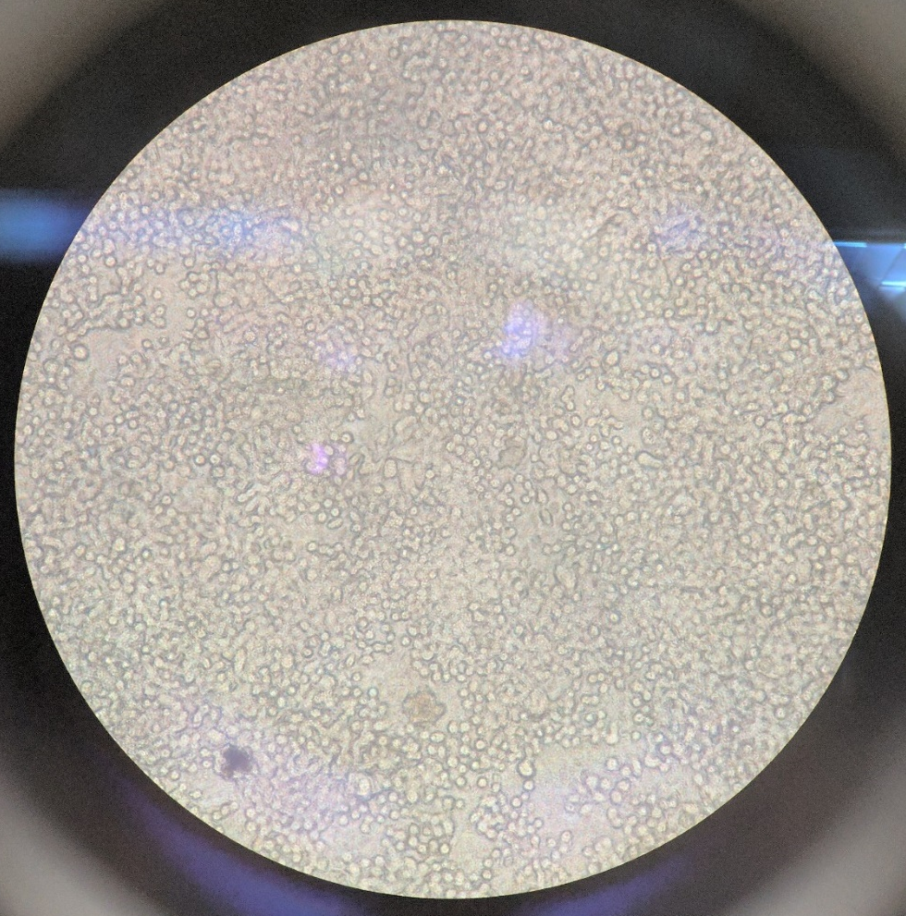
Figure 8: Day 5 amniotic membrane seeded with SW-620 cells

Figures 7 and 8 are higher magnification images (using the 20X setting on the light microscope) of day 5 right before samples were taken. The surface architecture of the membrane can be observed on the membrane without cells. The membrane with cells shows about a 70-80% confluency of cells on the surface. Cells can be seen throughout the entire surface of the membrane.

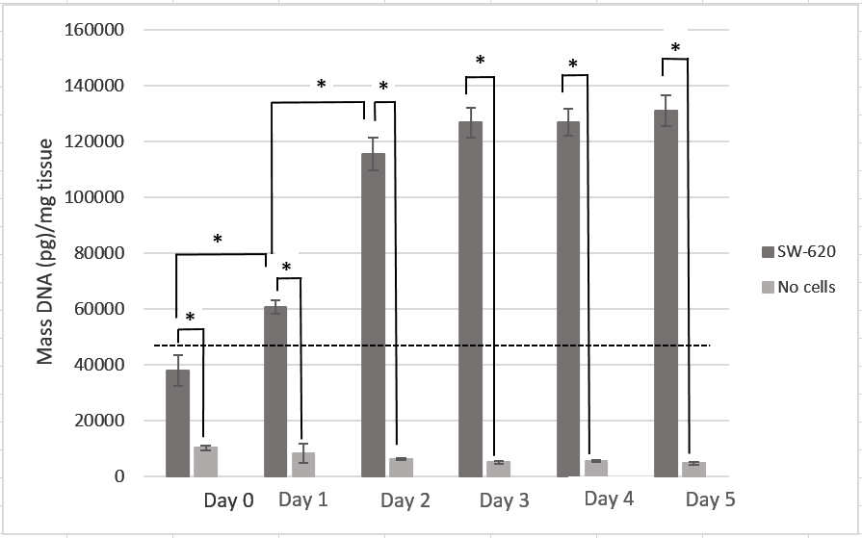
Figure 9: Five day static membrane experiment with SW-620s; dashed line represents the initial number of cells seeded

There were 555,000 SW-620 cells initially seeded onto the membrane with an observed seeding efficiency of 60% on day 0 as observed in Figure 9. There was a significant increase in the mass of DNA per mg of tissue between days 0 and 1 as well as days 1 and 2. The DNA mass per mg of tissue values plateaued from days 3 to 5, with no significant increase or decrease over these days. There was a 300% increase in the mass value of DNA per mg of tissue comparing the value for day 0 to day 5. The population doubling rate of the SW-620 cancer cell seeded on the amniotic membrane was estimated to be between 1 and 2 days.

Discussion

Static Amniotic Membrane Culture
The main goal of this study was to determine the seeding efficiency and proliferation of SW-620 cells seeded and cultured on the surface of decellularized human amniotic membrane. The amniotic membrane cancer cell cultures are critical proof-of-concept experiments (Figures 4 and 9) that will potentially lead to more extensive investigation of the use of the human amniotic membrane as a 3D in vitro cancer model. The experiments presented include visual images of the membrane (Figures 5-8) and are able to confirm the proliferation of SW-620 cancer cells on the surface of the membrane. From the top down view, cells can be viewed forming a monolayer on the surface of the membrane. Media changes that often pose cell detachment if cell adhesions are weak, did not seem to impact the adhesion or growth of the cancer cells on the surface of the amniotic membrane. Increasing the extent of the culture period can help to determine if cells are able to eventually organize into a small tumor on the human amniotic membrane.
Colon cancer tumors begin as small polyps on the surface of the lining of the colon. This is a flat, long environment since the mucosa of the colon extends along the circumference and length of the colon. The human amniotic membrane can physiologically resemble this flat environment. The possibility of seeding healthy colon endothelial or mucosal cells on the membrane first and then introducing the colon cancer cells may even be able to accelerate the tumorigenesis process and allow the exploration of colon cancer cells with healthy cells residing in that microenvironment and may be critical in tumor formation or metastasis.
Figures 5 and 6 depict images of the decellularized amniotic membrane over the five day culture period. Figure 5 represents the membranes that were seeded with SW-620 cells and Figure 6 shows the membranes that were not seeded with cells. Cells appear as rounded shapes with slightly darker nuclei. Cells can be seen proliferating in a monolayer in Figure 5. The images of the membranes that were not seeded with cells only display the surface architecture of the membrane and do not contain any rounded cell shapes. This signifies that there was no cross contamination of cells to the control membranes. Figures 7 and 8 provide a view of the amniotic membrane before the day 5 sample was taken (on day 5) zoomed at 20X magnification. Figure 7 depicts the control membrane and Figure 8 depicts the membranes seeded with SW-620 cells. Cells in Figure 8 can be differentiated from the surface architecture of the membrane in Figure 7 in that the cells appear as consistently small and rounded figures. The surface of the membrane appears irregular in shape and not small, round shapes. The cell monolayer in Figure 8 is nearly confluent, which is a promising result in the proliferation of SW-620 cancer cells on the amniotic membrane.
One metric that can be used to compare the growth of the SW-620 cells in vitro on the amniotic membrane to in vitro 2D flask cultures and in vivo tumor growth is the population doubling rate. The doubling rate is most accurate when measured before the culture reaches high levels of saturation. This is done to limit the amount of impact that cell crowding has on the proliferation rate. Using the DNA assay results and images taken through the light microscope of the amniotic membrane, the population doubling rate can be estimated. For the in vitro amniotic membrane culture, the population doubling rate was approximately measured to be between 1 and 2 days (30 hours, Figure 9). Using Appendix 14 (2D culture growth of SW-620 cells) and literature cultures, the population doubling rate for 2D flask culture is 26 hours [30]. A study growing SW-620 tumors in Rowett athymic rats determined that the doubling rate in vivo was 5.5 days [31]. The value for the in vitro membrane study falls in between the physiological doubling rate than 2D flask doubling rate. This could suggest that culturing cells on the thin amniotic membrane results in a semi-3D environment, but more experiments are required to strengthen the validity of this observation as discussed in the future aims section.

Conclusion
SW-620 cancer cells were able to be seeded and proliferate onto the decellularized human amniotic membrane in in vitro culture studies. The cancer cells were able to form a nearly confluent monolayer on the surface of the amniotic membrane. SW-620 cells seeded on the amniotic membrane had a population doubling rate in between the doubling rate of an in vivo rat tumor model than the 2D flask culture. There are still unanswered questions regarding this study, including cell penetration and gene expression as well as improving the three dimensionality of the amniotic membrane. Cell penetration can be quantified through histology, gene expression can be determined and compared to in vivo conditions using PCR and the three dimensionality can be improved by layering the membrane and seeding cells between the layers. Though these questions need to be addressed further, the preliminary results regarding the monolayer growth of the SW-620 cells on the decellularized amniotic membrane were promising.

Future Aims
There is more work needed in order to fully understand how these cells bind to the membrane and grow in longer time periods. Histology, successful fluorescent staining and Live/Dead assay would be useful to understand if there is any cellular penetration occurring through the membrane as well as cell viability. In order to have a viable 3D model, there must be cellular penetration and in turn, tumorigenesis. Staining and histology would be necessary to see the cellular penetration by repeating the five day study. PCR would also be useful to quantifying the cellular activity of the SW-620 cells growing in a monolayer versus a 3D in vitro model versus an in vivo animal model. Cells generally express different genes depending on their environment. Confirming that these cells are able to act like in vivo cells is necessary before moving forward with amniotic membrane as a scaffold and a clinically relevant model solution. According to literature, there are several genes that can be used to assess colon cancer behavior using RT-PCR. The housekeeping gene that can be used was glyceraldehyde-3-phosphate dehydrogenase (GADPH) [32]. There are 15 relevant genes that can be examined. These genes are as follows: monocarboxylate transporter (MCT), human glutamate decarboxylase (GAD67), human serine proteinase inhibitor (P19), human glutathione transferase M3 (GSTM3), human subunit C of V-ATPase (vat C), homo sapiens mRNA for translocation protein-1, human cyclin D (cyclin D1), human ataxia-telangiectasia locus protein (ATM) gene, homo sapiens apoptosis-related protein TFAR15 (TFAR15), human CO-029, human surface antigen (ESA), homo sapiens mRNA for ASM-like phosphodiesterase 3b, human interferon regulatory factor (Humirf5) and homo sapiens mRNA for IFN-inducible γ2 protein. This is not a complete list of genes that can be monitored for the SW-620 cell line but can be used as a starting point for RT-PCR monitoring.
Repeating the five day study with PC-3 cells, MDA-MB-231 cells and other cancer cell lines would also be necessary to determine if the successful seeding and proliferation was cell-specific or can be repeated for different cell lines. The morphology of both of those lines is different than that of the SW-620s and their reaction to the amniotic membrane needs to be documented. Additionally, repeating the experiments with natural (non-decellularized) membrane could be used as a control measure. This would determine if there is any significant changes between the decellularized and non-decellularized membrane and any interactions between the existing cells and cancer cells and could be explored further.
Since the amniotic membrane is very thin in nature, surface modifications can be made to the membrane in order to expand into more sophisticated 3D models. Models involving larger scale 3D spaces resembling in vivo tumors require a larger scaffold capable of supporting cell growth in all three dimensions as opposed to only a monolayer. The amniotic membrane scaffold can be stacked in order to provide a larger scaffold. This scaffold can be seeded with cells in between the layers to promote cell penetration through the membrane to form an in vitro tumor. The type and extent of modifications depends on the results from the attachment of the other cancer lines to the decellularized, unmodified membrane. Testing the other lines first will determine if modifications are necessary or if the cells bind to the amniotic membrane. This will also ensure that the seeding results determined using the SW-620 cells are not only cell-line specific and can be repeated with different cell lines. Further research is necessary to determine the adhesion mechanisms of cancer cells to each other and to other tissues.

References
[1] A. C. Society. "Global Cancer Facts & Figures," https://www.cancer.org/research/cancer-facts-statistics/global.html.
[2] NIH. "Cancer Statistics," https://www.cancer.gov/about-cancer/understanding/statistics.
[3] J. Ferlay et al., “Cancer incidence and mortality worldwide: Sources, methods and major patterns in GLOBOCAN 2012,” International Journal of Cancer, vol. 136, no. 5, pp. E359-E386, 2015.
[4] N. S. Yee et al., “Animal Models of Cancer Biology,” Cancer Growth Metastasis, vol. 8, no. Suppl 1, pp. 115-8, 2015.
[5] J. B. Kim et al., “Models of breast cancer: is merging human and animal models the future?,” Breast Cancer Res, vol. 6, no. 1, pp. 22-30, 2004.
[6] L. C. Kimlin et al., “In vitro three-dimensional (3D) models in cancer research: an update,” Mol Carcinog, vol. 52, no. 3, pp. 167-82, Mar, 2013.
[7] T. Andersen et al., “3D Cell Culture in Alginate Hydrogels,” Microarrays (Basel), vol. 4, no. 2, pp. 133-61, Mar 24, 2015.
[8] S. Halldorsson et al., “Advantages and challenges of microfluidic cell culture in polydimethylsiloxane devices,” Biosens Bioelectron, vol. 63, pp. 218-31, Jan 15, 2015.
[9] T. Scientfic. "Cell Culture Inserts," https://www.thermofisher.com/us/en/home/life-science/cell-culture/cell-culture-plastics/cell-culture-inserts.html.
[10] T. Scientific, "Versatile is smart! The power behind culturing cells on a porous membrane," Cell Culture Cafe, 2014.
[11] M. Sigma. "Millicell® Cell Culture Inserts," http://www.emdmillipore.com/US/en/product/Millicell-Cell-Culture-Inserts,MM_NF-C10504.
[12] C. S. Hughes et al., “Matrigel: a complex protein mixture required for optimal growth of cell culture,” Proteomics, vol. 10, no. 9, pp. 1886-90, May, 2010.
[13] W. E. Hennink, and C. F. van Nostrum, “Novel crosslinking methods to design hydrogels,” Adv Drug Deliv Rev, vol. 54, no. 1, pp. 13-36, Jan 17, 2002.
[14] E. Knight, and S. Przyborski, “Advances in 3D cell culture technologies enabling tissue-like structures to be created in vitro,” J Anat, vol. 227, no. 6, pp. 746-56, Dec, 2015.
[15] S. Khalil et al., “A Cost-Effective Method to Assemble Biomimetic 3D Cell Culture Platforms,” PLoS One, vol. 11, no. 12, pp. e0167116, 2016.
[16] A. H. Klopp et al., “Concise Review: Dissecting a Discrepancy in the Literature: Do Mesenchymal Stem Cells Support or Suppress Tumor Growth?,” Stem Cells (Dayton, Ohio), vol. 29, no. 1, pp. 11-19, 2011.
[17] T. Lopatina et al., “Cross Talk between Cancer and Mesenchymal Stem Cells through Extracellular Vesicles Carrying Nucleic Acids,” Frontiers in Oncology, vol. 6, pp. 125, 2016.
[18] C. Fischbach et al., “Engineering tumors with 3D scaffolds,” Nat Methods, vol. 4, no. 10, pp. 855-60, Oct, 2007.
[19] S. Crotti et al., “Extracellular Matrix and Colorectal Cancer: How Surrounding Microenvironment Affects Cancer Cell Behavior?,” Journal of Cellular Physiology, vol. 232, no. 5, pp. 967-975, 2017.
[20] L. J. Rose. "TMN Classification for Colon Cancer," http://emedicine.medscape.com/article/2006674-overview.
[21] WebMD. "Understanding Cancer of the Colon," http://www.emedicinehealth.com/slideshow_colorectal_cancer/article_em.htm.
[22] M. De Rosa et al., “The biological complexity of colorectal cancer: insights into biomarkers for early detection and personalized care,” Therapeutic Advances in Gastroenterology, vol. 9, no. 6, pp. 861-886, 08/07, 2016.
[23] O. Ayinde et al., “Tissue transglutaminase induces Epithelial-Mesenchymal-Transition and the acquisition of stem cell like characteristics in colorectal cancer cells,” Oncotarget, Feb 16, 2017.
[24] H. F. Seow et al., “Advances in targeted and immunobased therapies for colorectal cancer in the genomic era,” OncoTargets and therapy, vol. 9, pp. 1899-1920, 03/31, 2016.
[25] P. Carmeliet, “VEGF as a Key Mediator of Angiogenesis in Cancer,” Oncology, 2005.
[26] R. Mohan et al., “Human Amnion Membrane: Potential Applications in Oral and Periodontal Field,” Journal of International Society of Preventive & Community Dentistry, vol. 7, no. 1, pp. 15-21, 2017.
[27] ATCC. "SW620 [SW-620] (ATCC® CCL-227™)," https://www.atcc.org/products/all/CCL-227.aspx.
[28] R. Freshney, Culture of Animal Cells: Wiley-Liss Inc, 2000.
[29] F. Scientific. "Invitrogen™ Quant-iT™ PicoGreen™ dsDNA Assay Kit "; https://www.fishersci.com/shop/products/invitrogen-quant-it-picogreen-dsdna-assay-kit-2/p-4924836.
[30] A. T. C. Collection, "NCI-PBCF-CCL227 (SW620) Colorectal Adenocarcinoma," 2012.
[31] J. J. Stragand et al., “Growth Characteristics of Human Colonic Adenocarcinomas Propagated in the Rowett Athymic Rat,” Cancer Research, vol. 42, no. 8, pp. 3111, 1982.
[32] S. Huerta et al., “Gene expression profile of metastatic colon cancer cells resistant to cisplatin-induced apoptosis,” Int J Oncol, vol. 22, no. 3, pp. 663-70, Mar, 2003.
[33] Dictionary.com. "in situ," http://www.dictionary.com/browse/in-situ?s=ts.
[34] Dictionary.com. "in vitro," http://www.dictionary.com/browse/in-vitro?s=t.
[35] Dictionary.com, “in vivo,” 2017.
[36] W. S. Inc. "What is Nanopure Water," https://www.apswater.com/article/334/What-is-Nanopure-Water.

Appendices

Appendix 1: Standard curve for SW-620 DNA quantification

Appendix 2: Standard curve for two day membrane experiment

Appendix 3: Standard curves for five day membrane experiment

Day 0 and 1

Day 2 and 3

Day 4 and 5

Appendix 4: DNA Assay Protocol
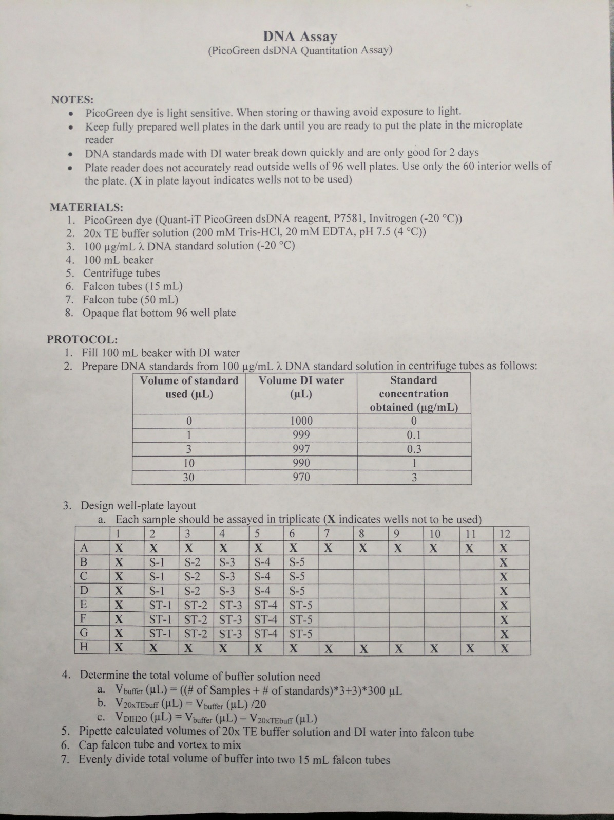


Appendix 5: Cell Splitting Protocol
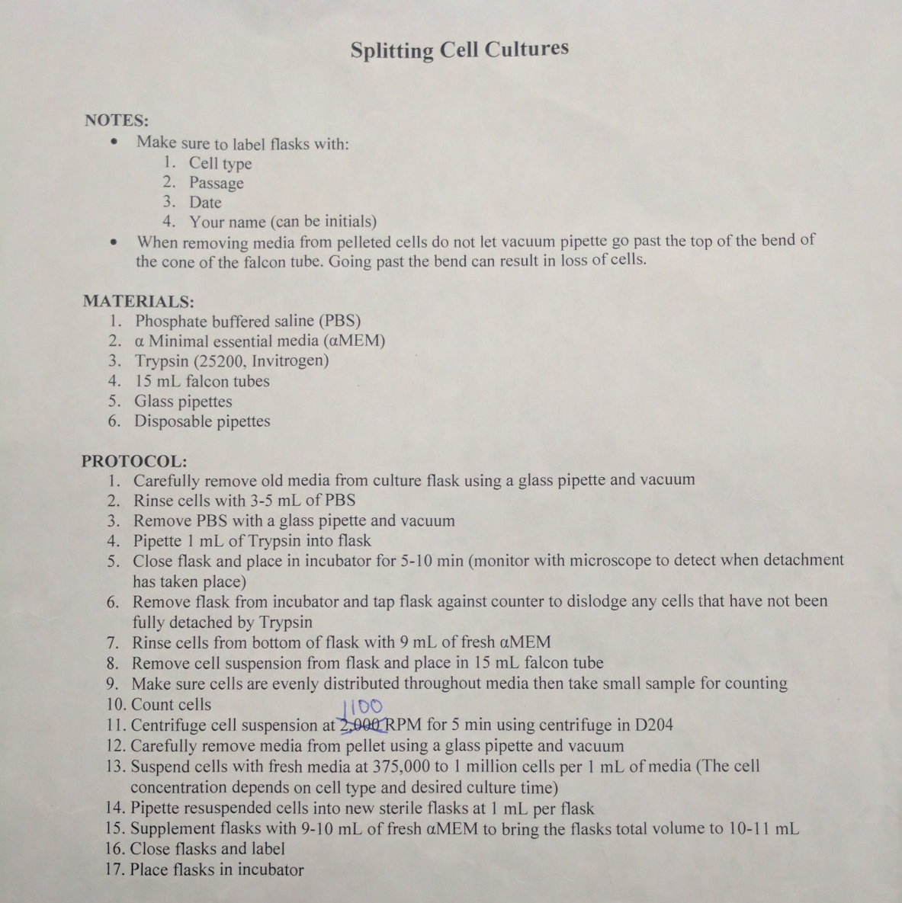

Appendix 6: Tissue Preparation for a DNA assay
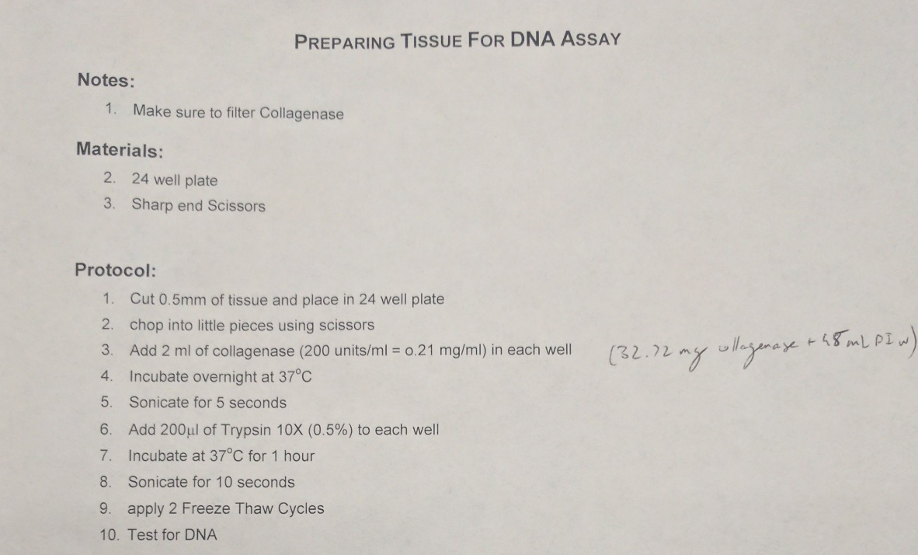

Appendix 7: PBS Preparation
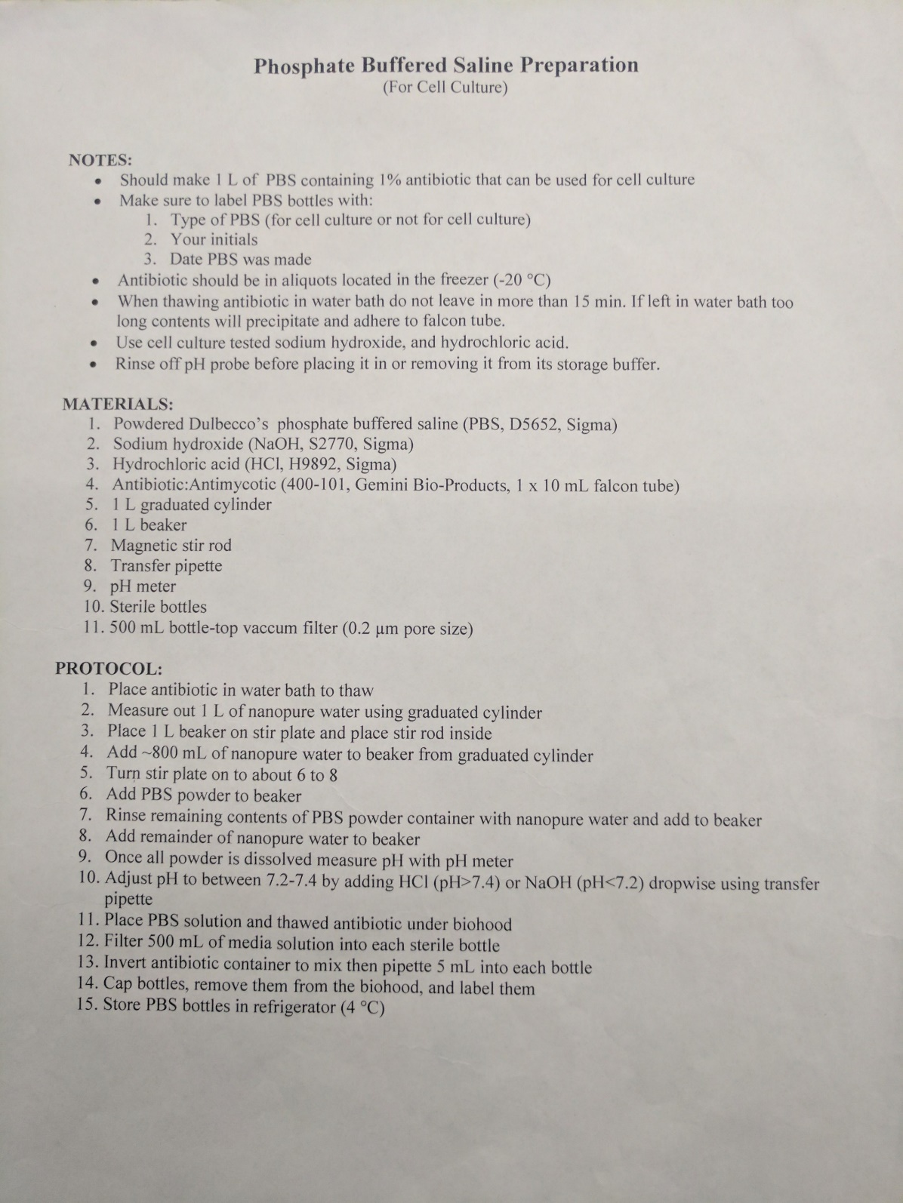

Appendix 8: Media Preparation


Appendix 9: Cryogenically Freezing Cells
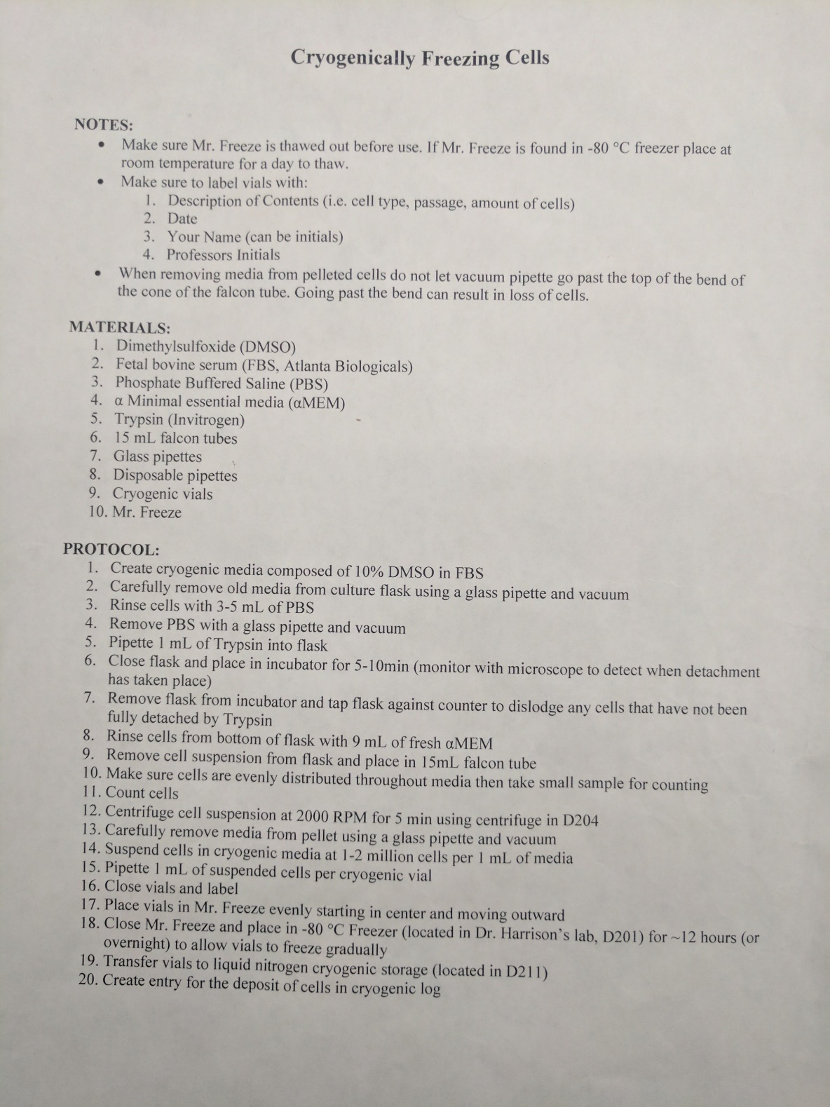

Appendix 10: Plating Cells from Cryopreservation
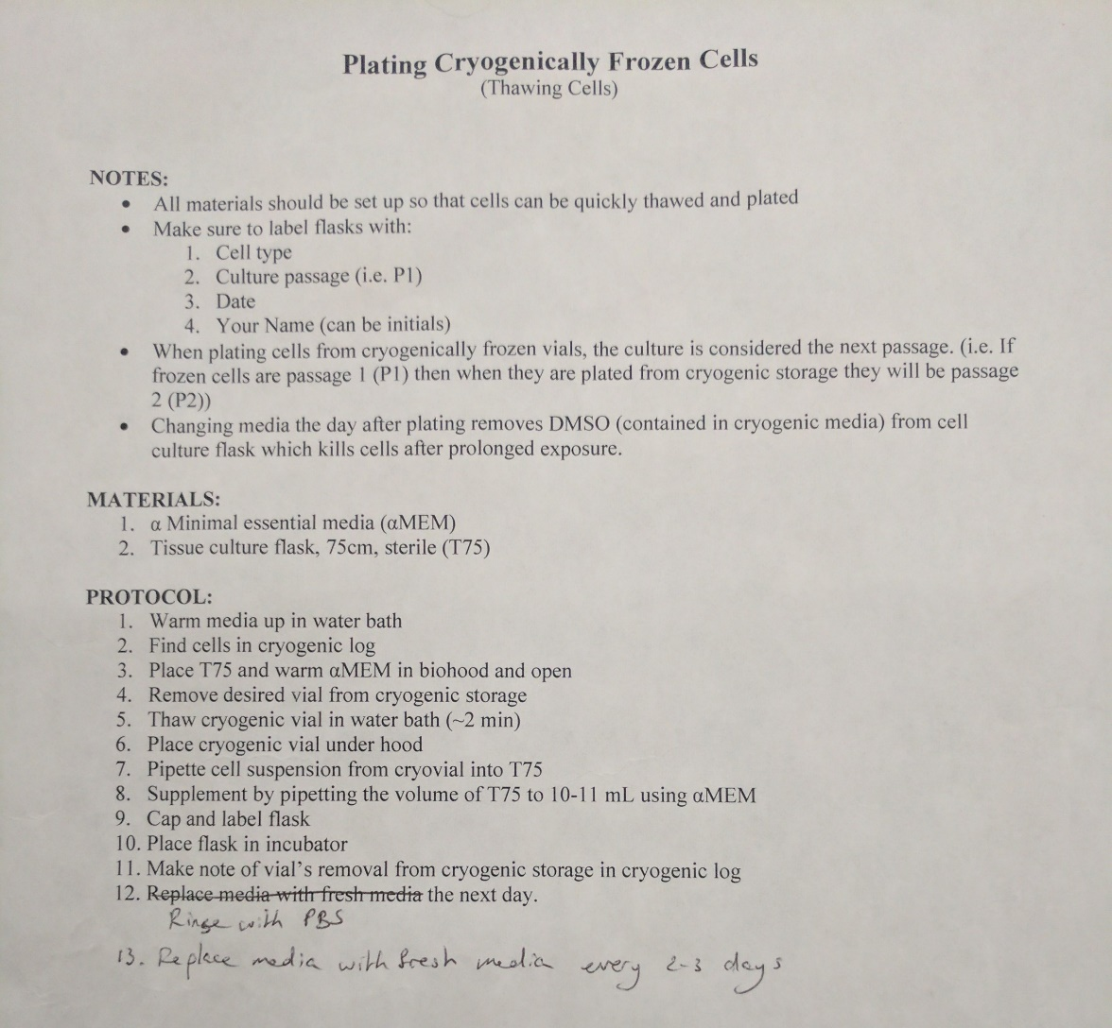

Appendix 11: Counting Cells with the Hemocytometer


Appendix 12: Decellularization of the Amniotic Membrane
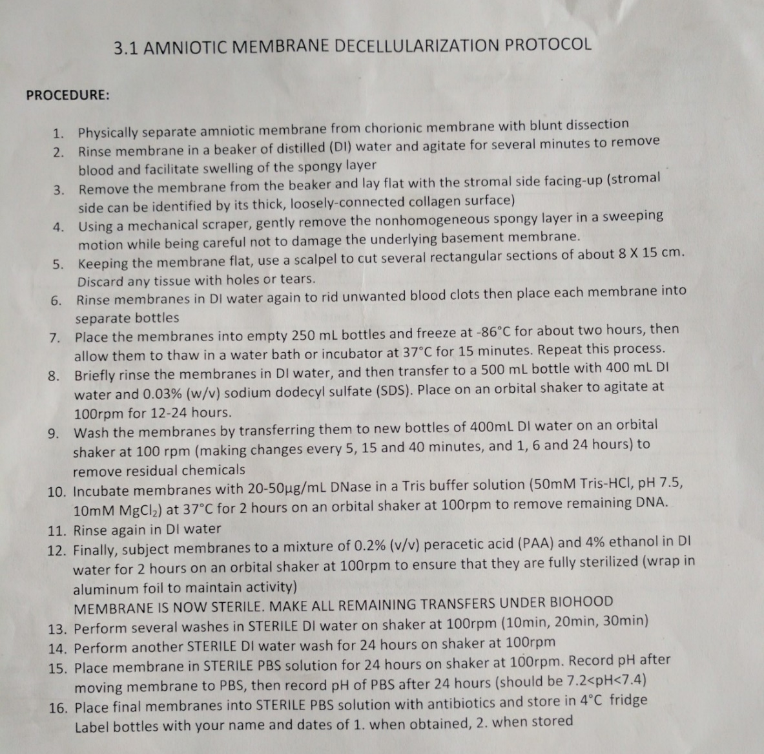

Appendix 13: SW-620 Culture in Flask (directly from cryopreservation)
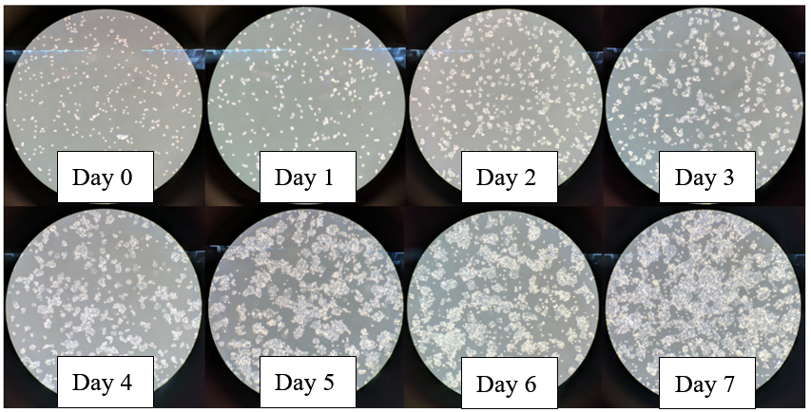

Appendix 14: SW-620 Cells Culture in Flask (progression after splitting)
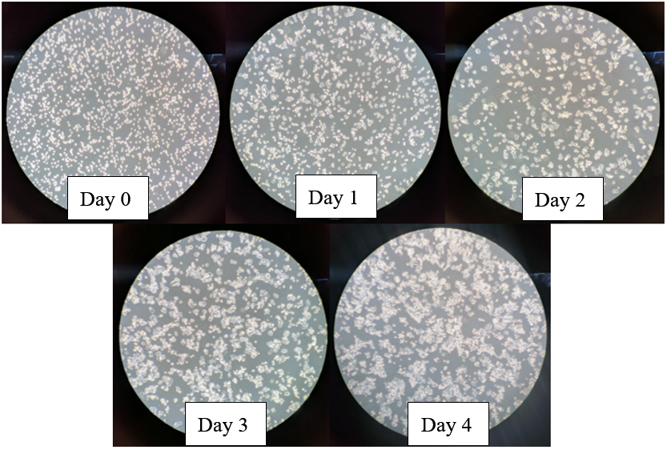

Appendix 15: Glossary
Glossary
Amniotic membrane: Innermost, thin membrane of the placenta
Cryopreservation: The state of freezing cells in liquid nitrogen at -196°C
F-12k HAM: Media used to culture PC-3 cells
Gleason score: A score quantified by a pathologist to classify prostate cancer
In situ: In a localized state or condition [33]
In vitro: Occurs in a laboratory vessel outside of the body [34]
In vivo: Made to occur within a living organism [35]
L-15: Media used to culture SW-620 and MDA-MB-231 cells
MDA-MB-231: Breast cancer cell line obtained from ATCC
Nanopure water: Water with 18.2 megaohm ionic purity with negligible bacteria [36]
PC-3: Prostate cancer cell line obtained from ATCC
Quant-iT™ PicoGreen™ dsDNA Assay Kit: DNA assay kit used to determine concentration of DNA in a sample using absorbance
RPMI-1640: Media used to culture PC-3 cells
Seeding: Adding cells to a material or flask at a specific concentration and volume
Sonication: Sound energy is applied to agitate particles in a sample
Splitting: The action of lifting cells from a flask and moving them to new flasks for culture expansion
Static culture: Culture conditions with no flow regime
SW-620: Colon cancer cell line obtained from ATCC
Tumorigenesis: Process of generating new tumors

Appendix 16: Abbreviations
Abbreviations
ATCC: American Type Culture Collection
ATM: Human ataxia-telangiectasia locus protein
CO₂: Carbon dioxide
CSC: Cancer stem cell
DMEM: Dulbecco’s minimal essential medium
DMSO: Dimethyl sulfoxide
DNA: Deoxyribonucleic acid
EGFR: Epidermal growth factor receptor
EMT: Epithelial-to-mesenchymal transition
ER: Estrogen receptor
ESA: Human surface antigen
GAD67: Human glutamate decarboxylase
GAPDH: Glyceraldehyde-3-phostphate dehydrogenase
GSTM3: Human glutathione transferase M3
Humirf5: Human interferon regulatory factor 5
MCT: Monocarboxylate transporter
MSC: Mesenchymal stem cell
ncRNA: Non-coding RNA
P19: Human serine proteinase inhibitor
PBS: Phosphate buffered saline
PCR: Polymerase chain reaction
PLLA: Poly-L-lactic acid
PR: Progesterone receptor
PSA: Prostate-specific antigen
RNA: Ribonucleic acid
TFAR15: Homo sapiens apoptosis-related protein TFAR15
Vat C: Human subunit C of V-ATPase

