University of Oklahoma

Graduate College

INTRA-COLONIAL SPACES: DESIRE AND DISPLACEMENT IN IMAGES OF INDIAN TERRITORY, THE HAWA’IAN ISLANDS, AND NEW MEXICO TERRITORY, 1885-1920

A Dissertation

submitted to the Graduate Faculty

in partial fulfillment of the requirements for the

Degree of

Doctor of Philosophy

By

JAMES FREDERICK PECK
Norman, Oklahoma
2016

INTRA-COLONIAL SPACES: DESIRE AND DISPLACEMENT IN IMAGES OF INDIAN TERRITORY, THE HAWA’IAN ISLANDS, AND NEW MEXICO TERRITORY, 1885-1920

A Dissertation approved for the
SCHOOL OF VISUAL ARTS

By

______________________________
Dr. Kenneth Haltman, Chair

______________________________
Dr. Alison Fields

______________________________
Mr. B. Byron Price

______________________________
Dr. W. Jackson Rushing III

______________________________
Dr. Warren Metcalf

______________________________
Dr. Mary Jo Watson

© Copyright by JAMES FREDERICK PECK 2016
All Rights Reserved.
Dedication
I dedicate this dissertation to my late mother, Patricia Eileen (Hardie) Peck, who always believed in me; to my wife, Sydney Nicole Peck, who always supported me; and to my son, Alexander Walter Peck, who always laughed at my jokes. There is no way this dissertation would have ever been completed without each and every one of you. I love you all.

Miss you, mom.

Acknowledgments

I would like to extend my sincere thanks to my dissertation chair, Kenneth Haltman. You have always held me to the highest standards. If I did not always reach those standards, the fault lies with me. You taught me to look more closely at art, to read texts more carefully, and to write more thoughtfully - if not always more concisely.
I would also like to thank Jack Rushing, Byron Price, and Alison Fields for helping me mature as a scholar. Your stimulating classes, honest feedback, and demanding assignments made a world of difference. I hope you each recognize something of your teaching in the finished product.
Finally, a great big thanks to all of my friends, teachers, relatives, and colleagues who helped me get here in the first place. I wish I had space to name you all. What follows is a woefully incomplete list: Jeanne Bishop, Brad Collins, Aaron De Groft, Brian Ferriso, Connie Ferrell, Jack Freiberg, Charles Mack, Bill Peck, Charles Peck, Steve Peck, and Brian Sprague.

Table of Contents
Acknowledgments iv
List of Figures vi
Abstract ix
Chapter 1 – Introduction 1
Chapter 2 – Indian Territory: A Contested Space 15
Chapter 3- Kilauea Volcano: Colonial Desire and Displacement in Hawai’i 70
Chapter 4 – Painting Indians: The Gaze and Pueblo Modernism 112
Chapter 5 – Conclusion 174
Bibliography 177

List of Figures
Figure 2.1 – Scottish Ranch and English Ranch 60
Figure 2.2 – Cover Illustration, Oklahoma! 60
Figure 2.3 – George Catlin, Comanche Warriors with White Flag 61
Figure 2.4 – George Catlin, Comanche Meeting the Dragoons 61
Figure 2.5 – Catlin, The 1st Regiment of Dragoons 62
Figure 2.6 – John Mix Stanley, International Indian Council 62
Figure 2.7 – John Neagle, Portrait of John Ross 63
Figure 2.8 – James W. Champney, An Indian Territorial Mansion 63
Figure 2.9 – James W. Champney, Bridge Across North Fork of Canadian River 64
Figure 2.10 – James W. Champney, Limestone Gap-Indian Territory 64
Figure 2.11 – Bird’s Eye View of Tulsu 65
Figure 2.12 – Camp Alice / Payne and Party Arrested 65
Figure 2.13 – Camp Alice / Payne Arrested Photo 66
Figure 2.14 – Uncle Sam Feeding “Poor Lo Indian” 66
Figure 2.15 – Royal Ranch / John Hittson’s Ranch 67
Figure 2.16 – Cherokee Phoenix Masthead 67
Figure 2.17 – Cherokee Advocate front page 68
Figure 2.18 – Tipi with Battle Pictures 68
Figure 2.19 – George Catlin, Teh-toot-sah (Dohasan) 69
Figure 2.20 – E.A. Burbank, Portrait of Silver Horn 69
Figure 3.1 – Jules Tavernier, Kilauea at Night 103
Figure 3.2 – Jules Tavernier, A Disputed Passage 103
Figure 3.3 – Jules Tavernier, Artist’s Reverie 104
Figure 3.4 – Typical Volcano Paintings 104
Figure 3.5 – Fire Fountains 105
Figure 3.6 – Frontispiece, from Voyage of H.M.S. Blonde 105
Figure 3.7 – Detail, Frontispiece, from Voyage of H.M.S. Blonde 106
Figure 3.8 – Titian Ramsay Peale, West Crater of “Kaluea Pele” 106
Figure 3.9 – Edward Myer Kern, Lava Lake, Volcano Kilauea 107
Figure 3.10 – Jules Tavernier, Volcano House Interior 107
Figure 3.11 – Fireplace and Chimney, Volcano House 108
Figure 3.12 – Kilauea in Action 108
Figure 3.13 – Illustrations of World’s Fair Cyclorama 109
Figure 3.14 – Titian Ramsay Peale, Kilauea by Day 109
Figure 3.15 – Detail, Kilauea by Day 110
Figure 3.16 – Alexander Lancaster 110
Figure 3.17 – View of Kilauea, 2012 111
Figure 4.1 – Walter Ufer, Their Audience 160
Figure 4.2 – Walter Ufer at San Geronimo Dance 160
Figure 4.3 – E.I. Couse. Pottery Vendor 161
Figure 4.4 – E.I. Couse, Moki Snake Dance 161
Figure 4.5 – Woody Crumbo, Land of Enchantment 162
Figure 4.6 – Walter Ufer, Land of Maňana 162
Figure 4.7 – Detail, Land of Maňana and Awa Tsireh, Bull and Koshare 163
Figure 4.8 – Detail, Jim and His Daughters, and Detail, Self Portrait 163
Figure 4.9 – Walter Ufer, Going East 164
Figure 4.10 – Chicago Artist Wins Prize in New York 164
Figure 4.11 – Detail, Going East 165
Figure 4.12 – Walter Ufer at His Easel 165
Figure 4.13 – Walter Ufer, Artist with Model 166
Figure 4.14 – Walter Ufer, Luzanna and Her Sisters 166
Figure 4.15 – Albert Lujan and Albert Looking Elk 167
Figure 4.16 – Berninghaus, A Son of the War Chief 167
Figure 4.17 – Albert Lujan at Taos Pueblo 168
Figure 4.18 – Dan Namingha, Afternoon Rain Clouds 168
Figure 4.19 – Albert Looking Elk, Untitled (Taos Pueblo Scene) 169
Figure 4.20 – Albert Lujan, View of Taos Pueblo 169
Figure 4.21 – Albert Looking Elk, Burros at Taos Pueblo 170
Figure 4.22 – “Cliff Dwellers” and “Cheyenne Chief & Family” exhibits 170
Figure 4.23 – Mirabal, Taos Pueblo Scene 171
Figure 4.24 – Marjorie Eaton, Bust of Juan (Mirabal) 171
Figure 4.25 – Juan Mirabal, Taos Pueblo Scene 172
Figure 4.26 – Taos Pueblo to Blue Lake 173
Figure 4.27 – Juan Mirabal, Xmass Eve 173
Figure 4.28 – Juan Mirabal, Fall at Taos Pueblo 172

Abstract
Depending primarily on image analysis, this dissertation considers a heretofore understudied artistic construct, the American intra-colonial aesthetic. Produced as a byproduct of displaced American colonialist desires near the turn of the twentieth century, the visual practices used to achieve this aesthetic were flexible and multivalent, and included the use of visual erasure or displacement of indigenous peoples; the use of Euro-American visual surrogates, or placeholders who visually appropriate the land; the depiction of indigenous peoples as existing only in the ethnographic present; and the appropriation of natural resources into a non-indigenous epistemology. In addition, indexicality, a meta-narrative element that suggests the limits of ideology in art-making, is examined.
This analysis locates the American intra-colonial aesthetic through three different cases studies of marginalized contact zones within the burgeoning American empire, circa 1885-1920 – Indian Territory, the Hawaiian Islands, and New Mexico Territory. While each chapter makes a different argument about the nature, scope, and characteristics of the intra-colonial aesthetic, the arguments are highly inter-related and depend upon, and strengthen, one another. Methodologically, I privilege images as primary historical documents, foregrounding my belief that art remain the first and best evidence for the art historian. Finally, I apply Edward Said’s concept of the Orient, and its inverse, the Occident, as theoretical constructions. As such, images and texts made by Euro-Americans concerned with colonial desire are counterbalanced by images and texts made by indigenous peoples concerned with native survival and sovereignty.

– Introduction
American artists at the turn of the twentieth century frequently constructed images of American territorial zones as marginalized, quasi-colonial spaces. Such images suggested thematic and historiographical equivalencies between America’s intra-colonial spaces and Europe’s newly acquired colonial possessions in Africa. Yet the emergent visual aesthetic practice came to reflect not European conquest but American territorial expansionism. The aesthetic can first be seen in certain Northern images made of the Reconstruction South in the 1870s. By the 1880s, such visual practices came to characterize many images of America’s territorial possessions. Depending primarily on image analysis, this dissertation locates and defines a heretofore understudied intra-colonial aesthetic within the American artistic milieu. Unlike proponents of Manifest Destiny, who presupposed the American West to be a tabula rasa upon which settlers could effortlessly inscribe nationalistic prerogatives, those who produced and were informed by intra-colonial art acknowledged and attempted to invalidate the pre-existing territorial claims, however implicit, of indigenous inhabitants. In this model, texts and images produced of these territorial areas inscribed others, particularly Natives, as inherently inferior in terms of race, class, and gender. Yet this intra-colonial model produced meaning and identify not only for the marginalized group but for the dominant group as well.
The pictorial practices artists used to achieve visual colonization of marginalized regions and peoples were flexible and multivalent, yet four visual practices stand out. First, artists frequently used visual erasure or displacement of indigenous peoples as a strategy to empty the land of legitimate stakeholders. Second, artist frequently used visual surrogates, or Euro-American placeholders, as a way to visually appropriate the land. Third, when artists did represent indigenous peoples, they often pictured them in the ethnographic present. At best, indigenous peoples are shown as maladjusted to white ways; at worst, they are shown as savage barbarians. Fourth, when natural resources are depicted, they are appropriated into non-indigenous epistemologies and shown as exploitable source material for artists and authors, portending their eventual appropriation as an American economic resource.
In addition to these pictorial practices, one further intellectual construct will be examined. Artists working in the intra-colonial aesthetic, sometimes unintentionally, sometimes intentionally, indexed the art-making process in their art. While such indexicality has multiple causes, it invariably provides a tacit acknowledgement of the constructedness of such imagery. Unlike the four pictorial practices defined above, such acknowledgements – of constructedness, fictionality, and departures from mimesis – do not work to naturalize intra-colonial aesthetic. Rather, they provide ironic meta-content which at times serves to undermine an otherwise naturalized ideological program. Such meta-narrative elements suggest the limits of ideology in art-making.
In this project, I argue that in portraying the peoples and places within Indian Territory, the Hawaiian Islands, and New Mexico Territory through an intra-colonial aesthetic, texts and images validated, and fed into, the desire by some segments of post-bellum American society to see these lands, once thought of as useless impediments to progress and / or desolate, desert places, as exploitable resources for colonialist enterprises. To do so, artists first subjectified (i.e., made subjects of), and then objectified, people, places, and events. Objectified images informed a visual language of desire, one which pictured places and resources as both desirable and available to future settlers. In doing so, artists served as a colonialist avant-garde, as hunters, capturing images which fed the national hunger for land and resources.
American powerbrokers, poorly positioned after the Civil War to join in the imminent European “Colonial Scramble” for Africa (1881-1914), looked to artistic renderings of territorial possessions to project an image of America as a colonial power equal to the colonialist nation states of Europe. I base this interpretation on Jennifer Greeson’s study of Edward King’s 1875 travelogue The Great South: A Record of Journeys in Louisiana, Texas, the Indian Territory, Missouri, Arkansas, Mississippi, Alabama, Georgia, Florida, South Carolina, North Carolina, Kentucky, Tennessee, Virginia, West Virginia, and Maryland [hereafter, The Great South]. In her analysis, Greeson convincingly argues that this mammoth, two and a half year undertaking financed by Scribner’s Magazine can profitably be read as an attempt by Scribner’s editor Josiah Gilbert Holland to “represent the southern states under Reconstruction as a colonized region of the US, parallel to colonized regions of the European powers around the globe.” This, Gleeson concludes “was, fundamentally, to assert a new state of equality for the US amongst the imperial nations of the world.” According to Greeson, The New South packaged “southern states [under Reconstruction] . . . . as a sort of domestic Africa – an imaginative parallel field for projection of imperial power within the US.” Just two decades later, in 1898, the American government would manifest its colonial ambitions through the annexation of Hawai’i, and the acquisition of the Philippines, Guam, and Puerto Rico in the Spanish-American war.
Each chapter of the dissertation addresses the development of the American intra-colonial aesthetic through a different case study. While each chapter makes a different argument about the nature, scope, and characteristics of the intra-colonial aesthetic, the arguments are highly inter-related and depend upon, and strengthen, one another. Methodologically, throughout the project, I privilege images as primary historical documents. In looking closely at the images of these three intra-colonial spaces, I am foregrounding my belief that images remain the first and best evidence for the art historian. The narratives I create, although necessarily speculative, provide relative truths while expanding, rather than contracting, interpretive possibilities. In this vein, I model my close looking on the works of the Prownian, or Yale, model of visual analysis. Examples include the works of Kenneth Haltman and Alexander Nemerov. Haltman and Nemerov have both foregrounded non-canonical art made by relatively obscure artists. Through close looking, both art historians open virtually unknown works to rich interpretive analysis informed by history writ large.
The theoretical writings of Edward Said (1935-2003) are central to this dissertation. In his landmark book Orientalism (1972), Said argued that the Orient, and its inverse, the Occident, developed in Europe not primarily as geographic places, but rather as theoretical constructions made by Western writers and imposed upon Eastern subjects. “The Orient is . . . one of its [Europe’s] deepest and most recurring images of the Other. In addition, the Orient has helped to define Europe (or the West) as its contrasting image, idea, personality.” Inherent in this practice of othering is a dismissal of the other as different, spectacular, and inferior in a variety of ways. Said’s concept of the Orient has been influential on the postmodernist project of questioning the structures, and strictures, of institutional knowledge, received wisdom, and authority.
Said’s concept of Orientalism is not without its critics. Louisa Schein, summarizing other scholars’ analyses of Said’s weaknesses, points out that such “totalizing bifurcation of the globe into the categories of representer-represented” threatens to obscure “the historical multiplicity of axes of domination,” while excluding “the "West" as a potential object of essentialist representation.” Schein points out that such an argument stops just short of “the conclusion that the "East" is mute and is therefore inherently incapable of othering.” Said’s approach, according to Jennifer Robertson, further clarifying the same claim, tends to "both further privilege Euro-American intellectual and theoretical trends as universal and obfuscate and neutralize the histories and legacies of non-Western imperialisms and associated 'othering' practices." Said’s concept of Orientalism, while useful, has certain limitations: it flattens local history into a totalizing schema; it threatens to mute Eastern voices (i.e., the voices of others) of dissent; it tends to privilege, and thus re-inscribe, Western intellectual hegemony; and it fails to recognize that processes of ‘othering’ happened, and continue to happen, within the East, and within states.
Responding to these weaknesses, a number of scholars have applied Said’s model to the production of intra-state difference, called variously internal orientalism or internal colonialism. Internal colonialism posits that the process Said termed orientalism works within states. As stronger regions of a nation state continuously ‘others’ a weaker region of that state, especially through cultural outlets, national and regional identities are produced, and reproduced, ad infinitum. Paralleling Said’s concept of orientalism, internal orientalism is based on exploitation and domination of weaker regions by stronger regions. Stronger regions tend to represent, in texts and images, subordinate regions as afflicted by vices and defects. David Jaanson contends that such representations:
have an internal consistency, a common imagery and vocabulary which writers, artists, scholars, business leaders, and government officials all draw upon in producing their representations of the inferior region. The latter would also be viewed as an object for study, as rational, scientific methods and techniques are applied to study the region’s problems with the hopes of bringing it into line with the national standard. The people of the subordinate region might even be characterized as a different “race,” with distinct physical characteristics. This region would certainly be construed as different, so as to set it apart from the rest of the state and allow it to serve as an other against which a positive national identity may be derived.

It is this “internal consistency” and “common imagery and vocabulary” that I am interested in defining in representations of Indian Territory, the Hawai’i an Islands, and New Mexico Territory, allowing for a cogent application of Said’s general concept of Orientalism as refined through various scholars vis-à-vis the construct of internal orientalism or internal colonialism, which I refigure as an intra-colonial aesthetic.
In addition to Orientalism, this dissertation explores the ideas put forward by Mary Louise Pratt in Imperial Eyes: Travel Writing and Transculturation. Pratt defines travel writing – and much of the material under discussion fall into this category – as a product of the contact zone, defined as a space “in which peoples geographically and historically separated come into contact with each other and establish ongoing relationships, usually involving conditions of coercion, racial inequity, and intractable conflict.” This definition foregrounds the historic situations that produced travel literature, while keeping the asymmetry of power in perspective. Imperial, or intra-colonial, travel writing and image making must always be judged against this background of asymmetrical power.
Pratt also reinforces the importance, first introduced by Said, of the interdependence of oppressor and oppressed. Pratt is interested in learning how travel writing helped to produce Europe’s image of itself. She argues that while imperial countries think that they define colonial possessions through cultural production, “the imperial metropole . . . habitually blinds itself to the reverse dynamic, the power colonies have over their ‘mother’ countries.” In this, Pratt sees the metropole’s “obsessive need to present and re-present its peripheries and its others continually . . . to know itself. Travel writing, among other institutions,” she concludes, “is heavily organized in the service of that need.” To this end, this dissertation explores how images of the periphery (the territories) help define the metropole’s (America’s) image of itself.
In this same vein, it is also important to ask, as does Pratt, “What do people on the receiving end of empire do with metropolitan modes of representation? How do they appropriate them? How do they talk back? What materials can one study to answer those questions?” This is the most difficult problem Pratt confronts, as cultural products that respond directly to imperial culture have historically been difficult, and sometimes impossible, to recover. Yet all hope is not lost. Native newspapers, often written partially or completely in Native languages, prospered throughout indigenous lands in late nineteenth-century America. While these newspapers tended to comment on specific issues of the day, other cultural resources such as painting, poetry, and ceremony, provide a way of locating a generalized voice of cultural resistance within a specific tribe or group. In paintings of Native peoples, it is important, too, to determine, to the extent possible, how the artist and model negotiated pictorial agency. Finally, because many Native tribes have a conception of history that attempts to understand the present-day through historic parallels, in some instances accounts from the contemporary descendants of those who lived in these places can offer insights.
In Chapter two, “Indian Territory: A Contested Space,” I look intently at a richly illustrated Boomer book, Oklahoma! Politically and Topographically Described, published in 1885. The analysis problematizes the pro-settlement tone of the prose and pictures in one piece of promotional literature of the mid-1880s, and offers a counter-narrative of resistance. While the romantic and fanciful illustrations of an agriculturally fecund land free of Indians in Oklahoma! makes the opening of the Indian and Oklahoma Territories to white settlement, and Oklahoma’s subsequent entry into the union, seem inevitable, voices of resistance, which unfolded through newspapers, magazines, promotional tracts, and Native ledger drawings, posed a challenge to American cultural hegemony. As Said reminds us, "Never was it the case that the imperial encounter pitted an active Western intruder against a supine or inert non-Western native; there was always some form of active resistance . . . ." Moreover, "The power to narrate, or to block other narratives from forming and emerging, is very important to culture and imperialism, and constitutes one of the main connections between them." The cultural products of the colonized class offer counter-narratives which can challenge the dominant discourse. Without investigating this counter-narrative, only half the story can be told.
One prominent voice of resistance from within Indian Territory was the Cherokee Advocate, a newspaper printed by members of the Cherokee Nation. The Advocate, printed weekly in both English and Cherokee, published dissenting editorials and opinion pieces from its own editors, as well as others culled from national newspapers and magazines, throughout the 1880s. These articles and editorials suggest that Indian resistance to white encroachment manifest in the Indian Wars of the 1870s was continued through various media. These voices of resistance and dissent joined a national debate about land disputes between white settlers and Indians. Analyzing articles, letters, and editorials drawn from the Advocate circa 1885 provides a better understanding of an historic example of resistance to cultural hegemony. When considered together, the editorials and articles written and aggregated by the Cherokee Advocate, along with paintings by the Kiowa artist Silver Horn, offer a generalized counter-hegemonic voice of resistance within the Indian Territory that questioned the pro-white, pro-settlement assumptions presented in the text and illustrations of the Boomer booklet.
In chapter three, “Kilauea: Volcano Imagery and Hawaiian Sovereignty, circa 1885,” I focus on my analysis of a single painting, Jules Tavernier’s 1885 View of Kilauea Volcano at Night. In this dramatic image, Tavernier echoes and invokes six decades of written and visual travel accounts which described the “discovery” of Kilauea by Europeans and Americans. Such travel accounts lead, ultimately, to Kilauea being understood, especially by non-Natives, as a site of scientific importance and sublime beauty. This focus on science and tourism, which persists to this day, attempts to displace the centuries-old native narrative of the volcano as Pele, a powerful being similar to a god, whom many Native Hawaiians, past and present, honor and fear.
The very process of any non-Native Hawaiian traveling to the center of the volcano, submitting the volcano to scientific experiments and empirical observations, and producing travel narratives, drawings and paintings, inherently challenges Hawaiian systems of knowledge and belief. As such, Kilauea at Night captures the transformation of the volcano, and thus Hawaii, from a site of colonialist contact with a “primitive” land to a potent tourist magnet. In this way, Tavernier’s painting records the performance of an intra-colonial act, and is analyzed to help define the intra-colonial aesthetic. Ultimately, View of Kilauea Volcano at Night themetizes changes in the colonial situation of Hawaii. By presenting Hawaii as a primitive paradise “discovered” by European and American explorers, these volcano discovery narratives, both written and painted, served as an important Euro-American rhetorical device, one that positioned the volcano, the Hawaii Islands, and the Hawaiian people, within a Euro-American epistemology.
Yet Hawaiians, like virtually all invaded peoples, resisted this Euro-American epistemology. In the 1880s, the election of a new king who championed a return to native Hawaiian ways, along with the performance and printing of ancient forms of hula, informed a widespread resistance movement that is still ongoing today. The origin and spread of these forms of cultural resistance are explored in an effort to give contexts to what historically have been hard-fought debates over land use, some of which persist until this day.
In my concluding chapter, “Painting Indians: The Gaze and Pueblo Modernism,” I consider several paintings made by Walter Ufer in Taos, New Mexico, between 1914 and 1920. In these paintings, Ufer features Native American subjects gazing out directly, even defiantly, at (presumably) Euro-American viewers. Such returned gazes by native subjects were extremely rare in narrative genre scenes at this time, and make Ufer’s Indian paintings unsettling because, at a fundamental level, the outward gaze of the subject inherently involves the viewer with the inner life of the subject depicted. In this way, Ufer emphasized that his subjects, Pueblo Indians from Taos were real people and the paintings themselves were artificial spaces created by the artist. Thus viewing one of Ufer’s “gaze” paintings is to view an artistic fiction created by the artist. Once the fiction of the paintings is exposed, it becomes easier to see Taos and the Pueblo as colonial contact zones.
The patronage Ufer and his colleagues gave to Taos Pueblo Indians had an unexpected and salutary consequence. Several former models, including Albert Looking Elk, Albert Lujan, and Juan Mirabal, all eventually established careers as artists. The painting practices, an accommodation to the reality of a cash-based economy, also allowed these three artists to negotiate modernity. None of the three painted in the flat, auto-ethnographic style widely accepted as authentic by white patrons. Instead, in the case of Looking Elk and Lujan, they adapted a three-dimensional illusionistic style more closely associate with Taos Society of Artist members like Ufer. Mirabal, on the other hand, took elements of Western realism, the flat, abstract Indian style, and European Modernism to forge his own path. The rise of these three Pueblo Modernists in the 1920s and 1930s points to the importance of culture in the struggle for sovereignty.
This dissertation considers for the first time an American intra-colonial aesthetic, a heretofore unexplored artistic construct produced as a byproduct of displaced American colonialist desires. As an interpretive lens, the identification and definition of an intra-colonial aesthetic points to imperialist ambitions within the United States. However, cultural works expressing resistance by oppressed Native groups toward this visual colonialism may provide new avenues to interpret America’s self-image. Using a case-study approach, I attempt to locate this visual practice in different marginalized contact zones within the burgeoning American empire, circa 1885-1918. I seek to penetrate deeply, not widely. The trade off, if there is one, may be that certain germane areas might not be included in this study. My goal is to provide a model, a methodology, which future scholars might apply to the study of other intra-colonial images. In this way, this dissertation will contribute to the larger study of American art by considering exploration art in late nineteenth century within a larger historical and geographic milieu of colonial ambition and imperialist desire.

Chapter 2 – Indian Territory: A Contested Space
English Ranch in Oklahoma and Scottish Ranch, two illustrations from an 1885 book promoting American settlement of Indian Territory, offer a prospective intra-colonial vision of Indian Territory controlled by white colonists and shaped by Western civilization. In both images, small figures in the foreground, stand ins for would-be white American homesteaders, provide the viewer with a commanding view of mountains, plains, prairies, rivers and streams, trees, deer, fish, agriculture, and livestock (fig. 2.1). These images perfectly illustrate the pro-settlement sentiment of the text they accompany in Oklahoma! Politically and Topographically Described: History and Guide to the Indian Territory: History and Guide to the Indian Territory. Biographical Sketches of Capt. D.L. Payne, W.L. Couch, W.H. Osborn, and Others (hereafter Oklahoma) (fig. 2.2). Written and published by A.P. Jackson and E. C. Cole, Kansas-based bankers and land agitators, the pro-settlement tone of the prose and romantic, fanciful illustrations of an agriculturally fecund land free of Indians makes the opening of the Unassigned Lands, and eventually Indian Territory, to white settlement seem inevitable.
Fanciful illustrations like these mark a subtle but important divergence from earlier images of Indian Territory. The two most prodigious pre-Civil War Indian Territory artists, George Catlin and John Mix Stanley, painted images of a contact zone, a place defined by asymmetrical power, occupied by the dispossessed, controlled by colonial forces, and surveyed and studied ultimately as a precursor to white settlement. The images describe a liminal place, a fragile, transitory amalgam of displaced Indians, the American soldiers sent west to control and protect them, and the few non-Indian allowed to live there. Even so, compared to Boomer images from the 1880s, explored later in this chapter, Catlin and Stanley portrayed a place whose future was still undetermined.
Despite the colonial over-determinism seen in the Oklahoma images, Indian Territory, like every colonial territory, was a contested space. In Indian Territory, resistance to colonization took several forms. One prominent voice of resistance was the Cherokee Advocate. The Advocate, printed weekly in English and Cherokee, published dissenting editorials and opinions from their own editors, as well as those culled from national newspapers and magazines, throughout the 1880s. These voices of resistance and dissent, which advocated for Indian sovereignty and independence, joined a national debate about land disputes between white settlers and Indians. Articles, letters, and editorials drawn from several issues of the Advocate in the mid-1880s offer an opportunity to better understand Indian resistance to cultural hegemony.
Another form of resistance was the art of Kiowa artist Silver Horn (1860-1940). The son of an accomplished warrior, grandnephew of an important Kiowa chief, and a significant medicine man in his own right, Silver Horn perpetuated and celebrated centuries of Kiowa lifeways through his artistic output. Silver Horn’s Ghost Dance, an 1891 hide painting, depicts the messianic, anti-colonial dance popular with many Plains tribes in the 1890s, focuses on an act of resistance that prophesied a world in which dead Indians and buffalo would be resurrected and tribes could return to the old way, and a “tidal wave of new soil would cover the earth, bury the whites, and restore the prairie.”
When considered together, the editorials and articles written and aggregated by the Cherokee Advocate and the ledger art of Silver Horn offer a generalized counter-hegemonic voice of resistance within the Indian Territory that questioned the pro-white, pro-settlement assumptions presented in the text and illustrations of the Boomer booklet. These contrasting world views were debated in newspapers and magazine both inside the Indian Territory and throughout the United States. Settlement of Indian Territory by white settlers was in no sense predetermined. That we know the outcome of these contested ideas in no way diminishes the importance of the debate.

Indian Territory in the 1830s and 1840s: An Inhospitable Place
Considered in isolation, English Ranch in Oklahoma and Scottish Ranch seem unremarkable, even mundane. However, seen in an historical context, they mark the point of origin of a new intra-colonial aesthetic. Until the Civil War, almost all images of Indian Territory were produced by either Catlin or Stanley in the 1830s and 1840s. Generally, these artists produced images that described the inhabitants and conditions of an open-air prison. Yet what was missing was a blatant ideology of desire to possess Indian land.
George Catlin arrived in Indian Territory in 1834, disillusioned with Indians in the east who, generally, had lived among whites for generations and therefore did not meet the young artist’s Romantic notion of “real” Indians, i.e., those not tainted by corrupting white influences. Catlin, like so many of his contemporaries, was involved in so-called “salvage” work; he tried to preserve, in paint and in text, what he saw as a dying race. That the United States government policies were largely to blame for the disappearance of Indians and Indian culture was an irony largely lost on those involved in salvage work. The progress of the entire continent toward Western civilization was the only outcome most Americans could foresee.
During the 1830s, Catlin found his real Indians among the Osage and Comanche, and to a lesser extent, in the recently-relocated Cherokee, Choctaw, and Creek, in Indian Territory. Catlin arrived in Indian Territory just as Indian removal and relocation efforts ratcheted into full effect. He spent two months painting the likenesses of Creeks, Cherokees, Choctaws, and Osages at Fort Gibson. Later that summer, the artist travelled with the Dodge-Leavenworth Expedition, accompanied by the U.S. Dragoons, also known as the 1st Cavalry Regiment of the Army, from Fort Gibson to the Washita Mountains in south-central Indian Territory to meet with Plains tribes. Osage, Kiowa, and Comanche, long established in the region, opposed the government's resettlement policy and resented the eastern Indians being moved into their territory; General Leavenworth and Colonel Dodge went south to invite these Indian tribes to a peace council at Fort Gibson to be held later that year.
Catlin’s views of the region and its people, later widely exhibited and published, were the first to be made by any artist. Although he was only in Indian Territory for a few months, Catlin made, over the next six years, about 450 paintings based on his time in Indian Territory, and throughout his career, more than a thousand works based on his encounters with Indians in the west. Taken together, Catlin’s paintings made in or of Indian Territory form a vast and important archive. Although Catlin primarily made portraits of individual Indians, I will focus my analysis on a smaller subgroup, pictures of the interaction between Indian and U.S. Dragoons in the summer of 1834.
Comanches, Kiowas, and Osages had had had relatively less contact with whites than the eastern tribes forcibly moved to the Territory. The Comanche, particularly, had had, until 1820, almost no direct contact with the American government. Catlin used his position within the government expedition to provide a unique view of the historic meeting between the Comanches and the Dragoons, which happened near Fort Sill. In Comanche Warriors, with White Flag, Receiving the Dragoons, the left half of the composition is divided between a tall peak of the Wichita mountains (the background) and the undulating green expanse of the prairie (mid-ground and foreground) (fig. 2.3). On the right, the mountains, characterized by a series of lower peaks offer a visual echo of encamped Comanche teepees. Comanche horsemen ride, fast and free, from a herd of wild horses toward the encampment. They join a single line of riders in the mid-ground headed toward the Dragoons. Nearer the Dragoons, several Comanche riders break into a disorganized sprint toward the American cavalry. Metaphorically, the Comanche race from their wild past (the horses) toward their uncertain future among western civilization (the Dragoons).
Here, then, is a visual representation of two worlds colliding. The foreground is defined by the precise linear pattern made by the Dragoons marching in formation. The crisp lines and formal uniforms contrast with the Comanche riders and the soft undulations of the verdant prairie. In the second row of Dragoons, two soldiers hold out white flags. Comanchee Meeting the Dragoons can be read as the second act of this drama (fig. 2.4). A Comanche horseman, Little Spaniard, is shown leading a charging line of Indians. He rears up on his white horse; his barely controlled forward movement and exaggerated gestures are met with mild surprise in Catlin’s group of three, emphasized by the backward movement of their horses. Catlin got sick during the trip and so did not continue on to meet the Comanche. Working from reports made by his assistant, the artist nevertheless positioned himself at the epicenter of the historic meeting. Catlin appears closest to Little Spaniard, who proffers a white buffalo robe flag, confirming a peaceful encounter.
In The First Regiment of the U.S. Dragoons, the Comanche chase buffalo through the regimented lines of the Dragoons (fig.2.5). The image conveys an uneasy humor colored by very real danger. On the one hand, the painting offers the viewer a bit of fun, hi jinx on the high Plains. On the other, the Comanche, by breaking protocol and joining in the hunt, confirm how little the two sides really knew each other. Though long in contact and confrontation with the Spanish, the Comanche had had little contact with Americans. The First Regiment of the U.S. Dragoons is a visual reminder of just how tenuous the situation was in Indian Territory in 1834. Considering the purpose of the meeting and the Comanche’s animosity toward both eastern Indians and to would-be foreign rulers, it is easy to read against the playful nature of the hunt and see instead a feint, a mock battle and a contest of wills and lifestyles.
By the time John Mix Stanley traveled to the Indian Territory in 1842, much had changed since Catlin’s sojourn eight year earlier. Stanley arrived just a few years after the conclusion of the Cherokee Trail of Tears, a ruinous event in which as many as 6,000 Cherokee perished. During this time, all inhabitants of the Territory - eastern transplants, western locals, and the U.S. military - were busy trying to make the best out of a bad situation. For the eastern Indians, this meant trying to re-establish the government, commerce, educational system, and tribal customs they had been forced to give up during the great migration west. Stanley seems to have sensed his fortuitous timing, because he stayed, on and off, in the Territory from 1842 to 1845, longer than any other non-native artist before or after him. During his time there, Stanley set up a portrait studio at Fort Gibson; traveled twice to the Texas border to meet and paint Comanche, Seneca, and Delaware representatives; painted portraits of Cherokee Principal Chief John Ross and family at Bayou Menard; and visited Creek settlements on the North Canadian River.
Yet his most important painting was completed in Tahlequah, in June 1843. There he attended a grand council of tribes called by Cherokee Principal Chief John Ross. From this he painted International Indian Council, (Held at Tahlequah, Indian Territory, in 1843 (fig. 2.6), the first political painting made in Indian Territory since Catlin’s Dragoon paintings a decade earlier. What was almost certainly a chaotic scene of hundreds of Indian delegates from more than a dozen tribes in a multitude of dress and poses crowded into a small area is made orderly through Stanley’s composition. The painting forces order from chaos, and visually dovetails closely with Ross’ goals.
Stanley uses visual devices borrowed from the Renaissance to expand the appeal of the painting beyond reportage and into the realm of history painting. The painting is organized by the orthogonal lines of the roof, which provides a convenient organizational conceit – an inverted, one-point linear perspective scheme. As the roof orthogonal lines converge toward a single vanishing point, the structure orders the space into foreground, mid-ground, and background. The space is further defined by three large bays supported by wooden posts. Each post terminates in triangular jousts or supports. While the orthogonal lines move the viewer’s eye toward the distance, the vertical supports stop this movement. The vertical support closest to the picture plane splits the structure into left and right halves. Standing erect in front of the central vertical support post is General Zachary Taylor, a future president of the United States. John Ross, principle chief of the Cherokee and the man who called the grand council, sits directly to Taylor’s left, his characteristic black coat and bow tie in evidence.
Other attendees, anonymous today, were clearly portraits made by Stanley and inserted into the complex scene. Portraits in the foreground give way to barely-defined masses further into the distance. By their dress, the Indians to the left represent western Plains Indians, while those on the right side represent eastern Indians. Taylor, the only American military or government official in evidence, is conspicuous by both his central location and by his status as an outsider. His dress, demeanor, posture, position and likeness mark him as the most important attendee. He stands confidently at the center of the council and looks out toward the viewer. Ross echoes Taylor’s direct gaze, yet he is seated, subordinate to Taylor.
Overall, the painting reveals much about Ross’s political aspirations and his goals for hosting the grand council, while hinting that Indian Territory might be emerging from the chaos caused by forced migrations. Even so, Taylor’s presence underscores the tenuous nature of Indian self-governance and sovereignty. Called just three years after the end of the Trail of Tears, the council was called by Ross in an attempt to consolidate his political power. When Ross arrived in Indian Territory in 1839, he was greeted by several thousand Cherokee settlers who had been coerced to move west years earlier. They had been established in Indian Territory for more than a decade by this point, and had their own leaders and their own ideas about how to move forward in Indian Territory; few old settlers felt any allegiance toward Ross. For his part, Ross realized his power was based in numbers; more than 10,000 Cherokee had arrived from the east. The new arrivals made up more than two thirds of the Cherokee population, and under the leadership of Ross they set out to reestablish the legal, governmental, and social institutions they knew from their homelands in the Southeast. Ross’s effort met repeatedly with challenges from the old settlers; the council was a very public effort on his part to demonstrate and consolidate power.
At the same time, Ross was trying to avoid a war with the Osage and other established western tribes, attempting to establish law and order in a chaotic time, and combating disease and poverty among his people. He was also battling the United States government for the political and territorial future of his tribe, and more broadly, for Indians throughout the Territory. Ross wanted to renegotiate treaties so that the Cherokee could receive more money, and he argued for the removal of all U.S. military from all Indian lands because he understood that true sovereignty could not be achieved with a foreign military stationed throughout Indian Territory. In many respects, Stanley’s painting dovetails with Ross’s goals, so much so that it seems almost like propaganda. Yet Taylor’s presence, and the chief’s visual subjugation to Taylor, makes it clear what a difficult task lay ahead for the Indians in the Territory. While International Indian Council presents orderliness unthinkable during Catlin’s visit, it also subtly undermines the progress to which it bears witness. Yet compared with Catlin’s Dragoon paintings of the previous decade, it is clear too that the tribes were working toward making life work in the Territory.
Ross clearly understood the connection between power and imagery. Just 3 years after orchestrating the Tahlequah meeting, he had his portrait painted by John Neagle (fig. 2.7). Ross prominently holds the August 6, 1846 Treaty of Washington, which achieved many of the goals he had set for the Tahlequah meeting – it ended the covert war between the various Cherokee factions and united the Old Settlers, the Treaty Party, and Ross’ National Party.

The Making of Oklahoma: From the Civil War to the Boomers
The 1840s and 1850s were a time of relative peace and calm in Indian Territory. Yet all was not well, and the 1860s would see sharp reversals for tribes throughout America. Although invaders had been taking land from Indians since 1492, the trend accelerated sharply in the second half of the nineteenth century. At the conclusion of the Civil War in 1865, the United States government used the Confederate allegiance of some Indians living within Indian Territory as a pretext to force re-negotiations of several treaties from the 1830s, including the Treaty of New Echota with the Cherokees. Such renegotiations between colonizers and the colonized reenact the asymmetry of power inherent to any colonial relationship; as a result, the colonized (Indians) tended to view forced renegotiations of treaties as invalid and unjust, while the colonizers (non-Indians) tended to return to these negotiations for moral and legal justification for taking land. These forced renegotiations set the stage for the formation of the state of Oklahoma. The lands ceded by the Creeks and Seminoles after the Civil War became the Unassigned Lands, nearly two million acres encompassing and centered on modern-day Oklahoma City; the ceded lands of the Cherokees became the Cherokee Outlet, i.e., the panhandle of present-day Oklahoma.
The coercive efforts by the United States to take millions of acres from Creek, Seminole, and Cherokee Indians were part of a trend. In 1862, Congress passed the Homestead Act, which allowed certain citizens to get freehold title to 160 acres of land, virtually for free, mostly in the Mid-West and West. Tribal members, who were not granted universal United States citizenship until 1924, were excluded. By the 1870s, however, much of the most desirable land was gone, taken either by homesteaders, or more often, bought and resold at a profit by land speculators. Would-be settlers had been agitating for the United States government to open up the Unassigned Lands to colonization since shortly after the end of the Civil War. Yet the imminent closing of the frontier, anticipated since the early 1870s and seen as imminent by many in the 1880s, intensified efforts by some to force the government’s hand in the matter.
Around 1880, the most visible and vocal pro-settlement advocates earned the moniker “Boomers” for the land boom they anticipated when the Unassigned Lands opened for non-Indian settlement. Boomers tended to call the Unassigned Lands Oklahoma, a term derived from two Choctaw words meaning red people. From 1879 until 1884, Colonel David Payne (1836-1884), the infamous Boomer leader, headed up three separate incursions into the Unassigned Lands in an effort to create the first permanent non-Indian civilian settlement within the borders of Indian Territory. Many of the Boomer ventures were poorly planned and executed, and often ended in disgrace for the Boomers and their leader. One incursion, into Rock Falls in the Cherokee Outlet, was particularly disastrous for Payne. After burning his buildings and confiscating his printing press, the U.S. Army took him and his followers on a punishing wagon journey overland to Fort Smith. On the way, Payne and his men were paraded through the streets of Tahlequah, capitol of the Cherokee Nation.
After Payne’s death, from 1884 until 1889, William L. Couch (1850-1890), Payne’s top lieutenant, led four more incursions into the Unassigned Lands. In each instance, the U.S. cavalry rounded up the Boomers and their followers, imprisoned them briefly, and returned them to non-Indian lands. Finally, in 1889, two events tilted the field forever toward non-Indian settlement of the Unassigned Lands and, eventually, the rest of Indian Territory. First, the U.S. government persuaded the Creeks to release their claim on the Unassigned Lands in exchange for $2,225,000. Second, the U.S. Congress passed the Springer Amendment, which began the process of placing the Unassigned Lands within the federal public domain and open to homesteaders. At 12 noon on April 22, 1889, the first Oklahoma Land Rush commenced.
In 1890, the Organic Act incorporated the Unassigned Lands into the newly-formed Oklahoma Territory. Between 1889 and 1893, white settlers laid claim to, under the auspices of the United States government, more than nine million acres of Indian lands in five separate land runs. These millions of acres were incorporated into Oklahoma Territory, which came to occupy roughly the western half of what had been a much larger Indian Territory. Beginning in 1887 and accelerating throughout the 1890s, U.S. agents, through the General Land Use Act (Dawes Act), brought allotment to Indian lands, and eventually, to Indian Territory. Allotment, a government policy that compromised native sovereignty by outlawing communal landownership and coercing Indians into accepting individual land grants and ceding extra land to white settlers, had the effect of destroying Indian Territory, which eventually disappeared in 1907, subsumed, along with Oklahoma Territory, into the state of Oklahoma.
The mainstream media largely supported the efforts of colonists. In the May 18 1889 issue of Harper’s Weekly, William Willard Howard described the rush and the conquered land in glowing terms in a lavishly illustrated four-page feature article. The land consisted of “rolling, grassy uplands and . . . wooded river-bottoms,” as well as trees “bursting into the most beautiful foliage of early spring,” and “apple orchards set in fertile meadows.” Beyond purple prose, Howard saw a deeper significance to the land run; the “rush across the border at noon on the opening day must go down in history as one of the most noteworthy events of Western civilization.” Howard understood the Unassigned Lands to be part of Indian Territory. Indeed, this was part of the appeal of the Land Run. With the run, “The last barrier of savagery in the United States was broken down.”
Yet Howard’s account of Oklahoma as a lush, verdant, and fertile does not square with the verdict passed by earlier writers and travelers through the region. Major Stephen Long, whose party travelled briefly through Oklahoma in 1820, produced a map that labeled the area as the Great American Desert. Time, a perceived limited supply of free land, and an explosion in travel writing all helped change the national conversation around the destiny of Indian Territory.

The Great South: Indian Territory & the Beginning of Intra-Colonial Aesthetic
After the Civil War, many authors and artists traveled to the former Confederate states to provide local color of the Reconstruction South to Northern and European readers. In 1875, Edward King published images of the Indian Territory in the sprawling travelogue The Great South: A Record of Journeys in Louisiana, Texas, Indian Territory, Missouri, Arkansas, Mississippi, Alabama, Georgia, Florida, South Carolina, North Carolina, Kentucky, Tennessee, Virginia, West Virginia, and Maryland. (hereafter The Great South). King’s travelogue was financed by Scribner’s Monthly magazine editor Josiah Gilbert Holland. In Holland’s employ, King travel thousands of miles across the South, over a two-and-a-half-year period, from 1873 to 1875. The product of this travel, a series of articles published in Scribner’s, proved popular, and Holland further capitalized on King’s efforts by collecting and publishing the articles in book form. The articles, and subsequently the book, were illustrated by over 500 wood engravings based on the drawings of James Wells Champney, a New England-based artist who had accompanied the King expedition.
The Great South is part of a long tradition of travel writing, a genre problematized in recent scholarship. While King’s first two travelogue books, My Paris: French Character Sketches (1868) and Kentucky’s Love; or Roughing It Around Paris (1873), indulged American’s tastes for all things French, The New South paralleled and chronicled the broader American colonialist enterprises, and equated the Reconstruction South with European colonialism.
The Great South includes 17 images drawn by Champney of Indian Territory. Unlike the earlier images by Catlin and Stanley, The Great South made no secret of colonial desire. In An Indian Territorial Mansion, a tree stump and axe suggest that the man in the foreground has singlehandedly constructed his own piece of civilization from the wilderness (fig. 2.8). The small, primitive log cabin in the foreground is dwarfed by the vast prairieland stretching out into the right distance. The message is clear - with an axe and a strong back, any white settler could remake a corner of this wild land into their own ranch or farm. Nothing interrupts this agricultural fantasy of rugged American individualism.
In Bridge Across North Fork of Canadian River, Indian Territory (M., K. & T. Railway), the railroad indicates direct government and industry support of American settlement in Indian Territory (fig. 2.9). The parallel lines of the symmetrical railroad tracks impose logic and reason upon the wilderness as it neatly bisects the Territory. The parallel lines of the tract lead to, and are framed by, the superstructure of a bridge, itself framed by the barrel vault offered by the design of the plate. Order, stability, technology and progress characterize the scene and embrace Indian Territory. In Limestone Gap-Indian Territory, the progress promised by the railroad is contrasted with the primitive ways of the past (fig. 2.10). The foreground is dominated by skeletal remains, the ruins of a horse-drawn wagon. Progress is coming, though – a train can be seen arriving from the distance. In short order, the train will pass right by the wagon. Limestone Gap was an important stop on the Texas Road, a commerce corridor connecting Kansas and Texas, long controlled, at least partially, by Indians. The King party came through the Territory in 1873-74, just months after the railroad opened.
While the railroad was an unambiguous sign of progress to Americans, Indian tribes understood it to be a breach of their sovereignty. In the view of recent Chickasaw historians writing on behalf of their Nation’s cultural center, trains:
brought unwanted changes. The Chickasaw Nation lost control over certain portions of our land when the U.S. government transferred rights-of-way to the railroads. The opening of un-allotted lands started to create the “checkerboard” we now have on our landscape. The railroads transported large numbers of intruders into the Chickasaw Nation and they permanently changed the makeup of our yaakni (land).

The railroad was devastating to Indian sovereignty; it provided unimpeded passage into and through the territory; the right of way granted to the railroads further eroded the Indian Territorial footprint; and the commerce the railroad generated either did not, or did not fully, benefit Indian tribes. Before the construction of the railroad bridge at Limestone Gap, the Chickasaw had been charging travelers $1 to pass over a wooden footbridge at Limestone Gap, generating as much as $100 per day. The railroad drove a stake through the heart of the Territory. A decade later, an east-west railroad line would bisect the territory again. Soon after, the Land Runs began, then allotment. Statehood was simply the last nail in the coffin of Indian sovereignty.

Oklahoma! A Boomer Tract Described
Ten years after The Great South, another, much smaller book, Oklahoma!, appeared. The book included thirty-nine distinct wood engravings, purportedly of Indian Territory, among them, English Ranch in Oklahoma and Scottish Ranch in Oklahoma. Twenty-five of the images, or about two-thirds, focus on the land. This was no coincidence. Land, and who controls it, was central to the foundational American Myth of the Frontier. According to cultural historian Richard Slotkin, “the conquest of the wilderness and the subjugation or displacement of the Native Americans . . . have been the means to our achievement of a national identity [and] phenomenally dynamic . . . civilization.” The yeoman farmer was an agent of progress against the wilderness precisely because he reenacted the conquest of the wilderness, which had to be taken forcibly from Indians, and therefore reenacts the foundational myth of America. Conflict between Indians and whites was unavoidable because “ineluctable political and social issues [made] coexistence between primitive natives and civilized Europeans impossible on any basis other than subjugation,” and struggles between whites and Indians inevitably became “wars of extermination,” with land as the prize.
In the Oklahoma booklet, land was indeed the prize, portrayed as an untapped natural wonderland of fecund land, bountiful forests, and fruitful plains, rivers and streams. To a one, these images focus on the land at the expense of the indigenous people of the region. In nearly every landscape image, the artist, or artists, employed a high horizon line; some of the compositions are up to eighty percent land. Represented as devoid or nearly devoid of people, buildings, Indians, and even railroads (as noted, by 1885, the Territory was bisected by two rail lines), the land pictured is ripe for development by yeoman farmers. The authors were trying to foment a land boom; the illustrations served this ideological end.
It took some effort to represent Indian Territory as a desolate, unpopulated plain. By 1885, more than 70,000 Indians lived throughout the Territory, and tribal governments had built impressive buildings, churches, homes, and infrastructure in the bigger towns, all of which the Boomer booklet purposefully obscured. Compare, for example, the images accompanying “A Zig-Zag Journey in Indian Territory,” an article published in Frank Leslie’s Illustrated Newspaper on August 11, 1888, which shows various towns in Indian Territory to be dotted with houses, civic buildings, schools, and even teepees. Particularly interesting is Bird’s Eye View of Tulsu, Creek Nation, the earliest recorded image of what is now the city of Tulsa, Oklahoma, complete with the Katy railroad running through the town (fig. 2.11).
Promotional tracts like Oklahoma relied on the power of rhetoric to win over skeptical audiences. Promotional materials for Western states and territories tended to emphasize the abundance of the West while downplaying the harsh conditions settler would find upon arrival. Most Western booster tracts painted the past as savage, the future as a time in which all free and cheap land would be gone, and the present as the only moment in which to act. They offered would-be settlers a promised land of mild seasons, bountiful fields, and verdant forests full of nature’s bounty. Yet by the 1880s, the high rainfall and mild climate settlers had come to depend on since the early 1870s had changed to severe drought and extreme temperatures, especially in the northern Plains states of Kansas and Nebraska.
By 1885, Cole and Jackson had reason to anticipate that some readers would be leery of such utopian promises. In this light, the profusion of illustrations can be read as an attempt by the authors to offer reassurance to wary consumers. Most of the images share a concrete, hard edged photo aesthetic, lending them a documentary feel; the images, realized in black and white, are all framed like photos, and at least two of the images can be traced back to recognizable source photographs. For example, an illustration of Camp Alice in the Oklahoma boomer booklet, opposite page 18, is based on an 1883 photograph by Karl P. Wickmiller (figs. 2.12 & 2.13). By the late nineteenth century, photography had attained the status of a truthful, honest translation of the observed world. Martha Sandweiss, analyzing the attitudes of several western explorers and the changing role of photography in illustrating the west, observes: “For Cherry, as well as Hittell and Hayden, the very literalism of photography, its seeming ability to transcribe and convey the details of the physical world into two-dimensional form, made it the ideal medium for illustration. How could one argue with its details, its accuracy, its absolute fidelity to things observed?” By equating their images with photographs by emphasizing the hard edge photo aesthetic, and by using photographs as source material for at least two of their images, the authors of Oklahoma assert the trustworthiness of their Boomer images and text.
Cole, in his prefatory remarks, goes to great lengths to describe Oklahoma as a fecund yet untapped land of plenty:
From time immemorial there has lain a most enchanting country in the midst of a great nation. Still little is known concerning its true vastness by the average American of to-day. Within its boundaries lie the Indian Territory and the Oklahoma country; a country that will contribute to the world’s granary, the world’s treasury, the world’s highway. It is a picture of a fleeting phase in our national life; it makes a new geography for that portion of America. Little is known of it-little of its greatness, richness, and beauty. Its forests and prairies await the laborer and the capitalist; its cataracts, cañons, and crests woo the painter; its mountains, salt beds, and stupendous vegetable production challenge the naturalist. Its climate invites the invalid, healing the systems wounded by ruder climates. Its fields are large.

Like promotional booster tracts before, Cole and Jackson create a sense of urgency, presenting an image of a vast, little-known, fertile place, which represents “a fleeting phase in our national life” that needed to be taken advantage of quickly. Many settlers and would-be settlers in the mid-1880s were defeated by the dry, extreme climate of the Northern Plain and fearful that available land would soon disappear forever. Oklahoma offered one last place for settlers to live the American dream. Inherent to any imperialistic enterprise such as America’s conquest of Indian lands was the belief that “primitive” natives could not efficiently, or fully, extract the value from their land or their culture. The images and text present a fertile land completely and utterly underutilized; Cole and Jackson organize, objectify, and “other” Indians and their lands for the benefit of white settlers.
The large majority of the images emphasize the land as vast, wide open, fecund, and nearly uninhabited. Especially notable for their absence are Indians, featured in only three images out of 39, and in two of the three, present only by omission, i.e., teepees pictured side-by-side with colonist’s wagons or log cabins. Flesh and blood Indians are shown in only one image, as caricatures, dependent on white beneficence. The absence of Indians and the untapped potential of the rich land serve as visual justification for the takeover of Indian lands. The Indian Wars were nonetheless a recent, and painful, memory for Indians and non-Indians alike. In these images of Oklahoma, a land free of Indians suggested that colonizers need not fear red-on-white violence.
The text of the booklet offered all sorts of data to support the safety of the land and its unseen inhabitants. Chapter four goes into great detail about the size of the Indian Territory, the population and location of various tribes, and their progress toward various markers of Western civilization: Christianity, classical educational and agriculture standards. Chapter five details every school and school teacher in the Indian Territory. Together, the text of these chapters paints the tribes as nearly civilized, mostly Christian, largely agricultural, and entirely harmless. By comparison, the illustrations that accompanying the text are sparse, and illustrate a colonized landscape (page 32), industry in the form of cattle (page 38), and Uncle Sam Feeding Poor Lo Indian (opposite page 46), a patronizing morality parable that shows Indians in the role of passive beneficiaries of U.S. government beneficence (fig. 2.14).
Some irony exists in the fact Cole and Jackson chose these images to advertise Oklahoma. Access to Indian Territory was difficult to arrange in the 1880s. No evidence exists to suggest that either Jackson or Cole, or any of their agents, visited Indian Territory, or that any artist travelled through Indian Territory in the mid-1880s. Unless a visitor was attached to the U.S. military, the best way to view the Territory was out the window of a train. Yet these images suggest extensive travel through the Territory. In reality, neither Jackson nor Cole traveled through Indian Territory. Rather, they based some of their images on photographs, while basing others on images cribbed from an earlier book that had nothing to do with Indian Territory.
While A.P. Jackson’s identity has been lost to history, Elrick C. Cole was a lawyer, judge, bank president, politician, and land-agitator from Great Bend, Kansas, near the Kansas-Oklahoma border. While Cole’s background explains the Boomer sentiment of the booklet, it does not explain why eight of the major landscape images included actually depict scenes from Arkansas, Kansas, Illinois and Texas. Originally drawn by prolific Kansas artist Henry Worrall for Historic Sketches of the Cattle Trade from the South and Southwest (1874), the publisher of both books, Ramsey, Millett & Hudson of Kansas City, MO, seems to have repurposed the Worrall images, editing their captions and sizes. No one, it seems, has noted this borrowing previously. In one particularly interesting example, the publishers cut down “John Hittson’s Ranch on the Bijou, Colorado” to exclude a railroad going through the Colorado landscape. The resulting image, repurposed and re-titled Royal Ranch in Oklahoma (p.117), passes as an authentic image of Oklahoma to an audience with no direct experience of the land (fig. 2.15).
On the one hand, the origin of these images works to undercut the authority of the very book they illustrate. In image and in text, the book is at pains to portray Indian Territory as a benign, Indian-free arcadia, though the land was in fact inhabited by more than 70,000 Indians under the full control of neither the U.S. military nor various Indian tribes. If these images had been more accurately titled and cited, they would have lost their authority as authentic descriptions of the land settlers might encounter. The mislabeling sells the book’s central premise of available, fecund, Indian-free land. On the other hand, the mislabeling servers another purpose – it provides a forward-looking image of what Indian Territory could be under U.S. rule – productive farm and ranch land under the protection of the U.S. military with minimal input or interference from Indians. From an ideological point of view, there was no downside to the deception. If readers accepted the images as authentic, they would easily accept the underlying premise the publishers wished to advance. If readers recognized the images as from other states, it would only reinforce their sense of the potential of Indian territory.
Such borrowings underscored the transformative possibilities Boomers saw in opening the Territory. The ideological purpose of these images was reinforced by the book design. The images focus on single vignettes of land surrounded by oceans of text, separated physically from other images, surrounded by graphic frames, and thus presented as a discreet from each other. In this way, the images offer a visual equivalency to allotment, the U.S. government policy that stripped Indian Nations of communally held lands, corroded Native sovereignty, cut up the land, and ultimately destroyed Nations.
The Art of Resistance: Indian Territory Press and Silver Horn
The ideological claims made in Oklahoma were by no means universally accepted. The seeming inevitability of white settlement was a tool used in the pursuit of colonialism. Pro-settler sentiment most often, and most forcefully, met resistance in the pages of Indian newspapers. By the mid-1880s, a number of Indian nations produced newspapers. Of these, the Cherokee Advocate was the oldest and most influential. The Advocate was the heir of the Cherokee Phoenix, first published in 1828 in pre-removal Cherokee lands in Georgia, and was a joint effort between Christian missionaries and the Cherokee Elias Boudinot, the first Native American newspaper publisher and editor in history. The Phoenix masthead consisted of a phoenix rising from the ashes, an apt allusion to Cherokee survival and rebirth amid hardships (fig. 2.16). Like the newspaper, the iconography is bicultural; it relates both to the mythical regenerative Greco-Roman / Christian bird as well as to the sacred fire of the Cherokee origin story.
Boudinot served as editor of the Phoenix from 1828 until 1834, when the paper ceased production amid mounting pressure on the Cherokee nation to relocate to Indian Territory. Boudinot, a mixed-blood Cherokee who married into a prosperous Connecticut family, believed that Cherokee removal was inevitable, a position that put him in opposition with many Cherokee citizens, most notably Principal Chief John Ross. In 1835, Boudinot and other Cherokee leaders signed the Treaty of New Echota, which ceded all Cherokee lands in the Southeast to the United States, and ultimately became the legal basis for Cherokee removal and the subsequent Trail of Tears. That signature cost him his life. Shortly after relocating to Indian Territory, in 1839, John Ridge, Major Ridge, and Elias Boudinot, three leaders of the Treaty Party, were assassinated by members of Ross’s National Party.
In spite of his premature death, Boudinot had set in motion an important precedent with the Phoenix. In 1844, under the leadership of editor William Potter Ross, nephew of John Ross, the Cherokee Phoenix was reborn as the Cherokee Advocate. Written in English and in Sequoyah’s Cherokee syllabary, a powerful symbol of national identity to Cherokees, the Advocate was the primary way the Cherokee Nation shared information with its people for more than 60 years (1844-1906). The paper covered many topics, from goods for sale to the laws of the Cherokee Nation to local gossip (fig. 2.17). The newspaper was produced for two distinct publics, those at home, Cherokees, and those at a distance, i.e., Euro-Americans. The combination of Cherokee and Euro-American signatories printed side-by-side in a Native-published paper created a “bicultural public sphere” from which Cherokee editors hoped to shape and influence public opinion and defend and protect Cherokee rights. Moreover, according to historian Phillip Round, print culture in the nineteenth century provided “Native authors and their communities with a much needed weapon in their battles against relocation, allotment, and cultural erasure.”

The Cherokee Advocate: Shaping Public Opinion
One way the Advocate tried to influence public opinion was by publishing the views of individual Cherokee citizens, many of whom expressed ideas that contradicted popular sentiment outside of Indian Territory. Many Cherokee used the Advocate platform to argue that their society was the equal of American and European societies. In 1884, Edward A. Burke, the Director General of the 1884-1885 New Orleans World Cotton Centennial Fair, invited W.A. Duncan, a teacher from the Cherokee Nation, to submit Cherokee Nation educational displays. Burke’s invitation included a requirement that the Cherokee Nation appropriate some funds toward fabrication and transportation of the displays, which were to be exhibited from December 16, 1884 to June 2, 1885.
Early in 1885, Duncan wrote a lengthy plea to the Advocate urging the Cherokee Nation to appropriate the necessary funds. Duncan argued that
it would be beneficial to the Cherokee Nation to have its educational exhibits displayed there by the side of those of those from all the states of the United States as well as from Europe and other parts of the world. Such a measure would have placed the Cherokee Nation in company with the great commonwealth of polite nations. The moral effects of such association would, in the end, do more for the support and perpetuation of our national existence than can possibly be done by legislation, diplomacy or such defense as even the Chieftain may be able to make. [emphasis added]. Legislation is good, but without prevenient sentiment out of which to make law, law becomes gossamer. [. . . ] It is a wall of sentiment which the Cherokee Nation needs for its protection, and, from the conditions of the case the Cherokee Nation is compelled to assist the civilization of the age in making that wall, or suffer the consequences of its own indiscreetness.

That Duncan felt Cherokee educational displays at the World’s Fair “would, in the end, do more for the support and perpetuation of our national existence than can possibly be done by legislation (or) diplomacy” speaks volumes. Duncan understood that survival depended on more than laws and treaties, which become “gossamer.” Rather, the Cherokee needed “sentiment,” the basis of ideology, on their side.
The Advocate also offered Cherokees a platform to defend their people and their culture from outsider attacks. In one such example, a Cherokee wrote to the Advocate to expresses disappointment in an article written by Gen. Nathan Reaves published in the New York Herald. The author summarized Reaves’ position in the following terms:
You [Indian] should not be that because it is not like me [white man], you should be like this, because it is exactly like me. With him [Reaves] civilization is simply the transformation of an Indian into a white man, instead of a true man.

Later, the writer derided Reaves for capitalizing on the Cherokee “in the same way Duchahlu did the monkeys.” Invoking Duchahlu, a naturalist famous for regaling New York City audiences with tales of African monkeys, was uncalled for:
[This is] an incident in real life which, for cruel absurdity, rivals anything to be found in the wildest fiction. People tend to hate Duchahlu's monkeys much as people will hate Reaves' Cherokees. The Indian problem is a moral question; it has nothing to do with the subject of natural history.

The author categorically rejects the implicit false equivalence between Indians and wild animals. A few weeks later, the editors came to the defense of the letter writer’s critique of Reaves: “The article of D.W.C.D. . . . was simply a protest against harsh and unjust criticism of our people by gentlemen who get their confidence and abuse it intentionally or otherwise.”

Boomers and Sooners, 1882-1885
After the emergence of the Boomer movement in the late 1870s, land, and who had the legal and moral right to own it, became one of the dominant themes of the newspaper. As early as 1882, the Advocate covered land issues aggressively. As an example, the paper’s editors took exception to an unconfirmed - and ultimately false - report that Captain Payne had re-entered Indian Territory. The Kansas-based paper that originally printed the report felt sure that Payne’s latest settlement efforts would lead, inevitably, to non-Native settlement of Indian Territory, concluding that opening Oklahoma for settlement was settled. The Advocate editors shot back: “The entire statement is false. Payne is not in Oklahoma” but “probably bumming wherever he can get his grub for free and find a few loafers who will listen to his twaddle. The decision of the Secretary of the Interior, published in this issue, settles the Oklahoma business.” The Advocate editor set the record straight – Payne was not in Oklahoma – and offers a none-too-subtle critique of him and his followers as lazy and opportunistic. Finally, the author points to the decision of the Secretary of the Interior, printed in the very same issue of the paper, as proof that the pro-settlement article is meritless, cleverly, using the same word – settled – to very different ends.
The Advocate took positions on issues that threatened the sovereignty of all tribal lands in Indian Territory. In the May 12, 1882 issue, the editors of the Advocate went so far as to advocated for gubernatorial candidates in the upcoming Choctaw election. “The Advocate . . . must advise the Choctaws to vote for Smallwood for governor. McCurtain has shown the cloven foot by advocating a railroad scheme, that will, if not attacked . . . be the cause of total destruction of the whole five civilized tribes of the IT.” Smallwood, the editor claims, “is the man the Choctaws should support by all means if they propose to hold onto their homes and country. He is a man corporations cannot buy. He will not sell his country, or help to set a precedent such as McCurtain has done.”
By 1885, with Boomer sentiment on the ascendancy nationwide, the Advocate became an even more important tool against colonialist forces. In the first half of 1885, dozens of article dealt directly with the Boomer crisis, cattle leases, and the deliberations of the U.S. Congress regarding Indian Territory and the Cherokee Nation. By 1885, the debate over Oklahoma had reached a critical tipping point, as evidenced by the more than 330 newspaper stories about the Oklahoma Boomer movement in U.S. newspapers published, by my calculation, between 1885 and 1886. In 1885, Payne, the primary fomenter of Boomer sentiment, was dead, and his top assistant, a Captain Crouch, had taken up the Boomer banner. A January 9, 1885 Cherokee Advocate editorial titled "Moving on Oklahoma Boomers" reports on the recent invasion by Crouch and 300 would-be colonists, subsequently removed from the Stillwater area of Indian Territory by troops stationed at Fort Sill and Fort Reno under the command of General Edward Hatch. The writer fears the colonists “will obey Capt. Crouch’s orders implicitly and will resist the soldiers when he gives the word. They are all well-armed and prepared for a fight. They will not be removed except by superior numbers and force.” In the end, the colonists, like those before them, left without a fight. Yet the belief that the Boomers might eventually engage U.S. troops in armed conflict was a real fear shared by many in Indian Territory. Many other articles appeared, both in the Advocate and in other America newspapers, regarding this and subsequent Boomer invasions.
While the Boomers were the proximate, and most visible, cause of distress, the real issue was the U.S. government. In 1885 many Cherokees wrote eloquently and at length about the fate of Indian lands. One Cherokee author, T.S. Gilliland argued in an editorial titled “Oklahoma Land Question” that Indians bought, or rather traded for, their land in Indian Territory fair and square with prime lands in Southeast, and that the only ones with a right to settle in Indian Territory were other Indian tribes per the 1866 treaty. Gilliland rebuts the argument, popular among land agitators, that settlers could take land because Indians were not farming it. Gilliland reasons if that were the case, any unfarmed land in any state could be taken by settlers. Besides, Indians were not “hunting vagabonds,” but rather “intelligent, peaceable citizens, self-supporting and independent. They have more schools to the number of inhabitants than any state in the Union and support them out of their own money. They have seminaries,” Gilliland explains, “where the higher branches are taught that would be a credit to any state in the Union.”
Gilliland, like many Native American writers of the day, makes the argument that by any marker of civilization, Indians were the equal of whites. This argument points out a central characteristic of the American colonialist project: most Americans saw Indians as inherently inferior. No matter how logical the argument put forth and regardless of their accomplishments or progress toward white cultural standards, Indians were seen as less than human and unworthy of self-determination.
If land were given or sold to non-Indian settlers, the tribes understood perfectly well the consequences. W.A. Duncan, in an article title “The Great Question,” put the risk in blunt, stark terms, asking, rhetorically, “Are the Five Civilized Tribes Prepared to Dissolve Their Nationality?” Duncan warns:
There has never been a period in the history of the Cherokees, Choctaws, Chickasaws, Creeks and Seminoles where unanimity of feeling and purpose was so indispensable as at the present time. Clouds are on the horizon; and dangers gather thick on every side. I tremble for the consequences; I cannot give my consent to see our people destroyed.

Later, Duncan concludes:

Selling land in any way, and to any extent, is absolutely incompatible with the continuance of our existence as people. To sell land is to dissolve our nationality. In vain may philosophy strive to find a solution of the paradox, as to the sale of lands and the existence of the Cherokee government. The Cherokee government and Cherokee land must stand or fall together. [emphasis added] Better, by far, to part with all the funds we have in the hands of the United States Government, than to part with those lands lying west of Arkansas River, unless it be for occupancy by friendly Indians as provided in the Treaty of 1866. To that we could not object, nor have we a disposition to do so, since the treaty settles the point.

Duncan and other Native contributors to the Advocate around 1885 all seem to sense that the fate of Indian Territory was soon to be decided. Duncan’s pronouncement that the “Cherokee government and Cherokee land must stand or fall together” underscores the importance of the debate. The Cherokee Advocate, although limited by finite funding, audience, and reach, was an important arbiter and tool in colonial resistance.
The efforts of the Cherokee press did not end there, however. Printed memorials, a genre of public writing uniquely able to express Indian grievances to the larger world, often published in the Congressional Record, included personal biographies and tribal histories, and variously begged for help from U.S. government and asserted tribal sovereignty. Memorials played an important part in establishing what Philip Rounds terms Print Constitutionalism among Southeast tribes. Memorials started orally in council houses. Only after years of consensus building did they appear in print. In this way, memorials worked to preserve tribal consensus, helped preserve a sense of “landedness” among Native people in spite of removals, and helped form a literate Indian public. Memorial of the Indian Delegates from the Indian Territory (1880), printed in the Congressional Record, predicts and rejects the coming of allotment to Indian Territory. Here, the tribe argued that Cherokee needs were grounded in tribal polity, not individual need. “We (Cherokee) hold our lands as Nations and not as individuals.” The place Cherokee spoke from in print, both newspapers and memorials, was a newly formed public space that paralleled older, local tribal practices in council house and other ceremonial places.

Land and Race in Oklahoma: Allotment and the Dissolution of Indian Territory
One theme that runs through these texts is doom and foreboding. These apocalyptic words that suggest the imminent dissolution of Indian nations cannot be fully understood except in the context of allotment, by the mid-1880s an important and divisive issue in Indian Territory. Although the land runs of the 1880s and 1890s transferred millions of acres from Indians to non-Indian settlers, allotment was far more ruinous to Native sovereignty. Through treaties and laws, the United States had been pursuing allotment of Indian lands since at least 1798. Indians generally held all lands in common, whereas Europeans and Euro-Americans practiced private landownership, at least for the privileged classes.
Although the U.S. government had pursued allotment of Native lands through treaties since colonial times, it was the Dawes Act of 1887, also known as the General Allotment Act, that put allotment into motion. The Dawes Act gave the President of the United States the right to survey Indian lands and divide them into individual allotments of between 40 and 160 acres, to be held in trust by the federal government for 25 years. In return, Indians who accepted allotment would be granted U.S. citizenship. Objections from Indian Territory governments, who pointed to treaty provisions that prohibited allotment, provided a reprieve until 1893, the year Senator Henry L. Dawes led the allotment commission into Indian Territory. Dawes’ team began enrolling Indians in 1894. The Dawes Act was supplemented by the Curtis Act in 1898, which began the process of abolishing tribal governments, compelling allotment and the sale of surplus land, and dissolving tribal courts. Allotment of tribal lands began in 1899. All told, Indian tribes lost control over 90 million acres of land due to allotment. These lands were subsequently made available to non-Indian homesteaders and corporations.
Senator Dawes, who introduced the Act believed, as did many other Americans, that lands held in common interrupted Indian “progress” by inhibiting selfishness and, therefore, Indians from becoming American. Dawes understood that it was crucial to transform Indians into individual property owners because doing so would, in time, dissolve Indian Nations and make all Indians and all Indian lands part of America. Dawes spoke for many white would-be settlers, who talked about allotment and taking Indian lands interchangeably. White settlers saw America as a republic of white, landowning men, and so to transform Indians into the white American system, land had to be transferred to individual landowners. Indian tribes understood all too well what was at stake. The Creek Nation opposed allotment precisely because they understood that their nation and land were indivisible. According to historian David Chang, land to the Creeks “was homeland, inseparable from the polity of the nation. It was a means of defending the autonomy of Creek farmers and the sovereignty of the people as a whole.”
The Cherokee Advocate provided a new, public sphere for Indians to protest the imminent loss of their sovereignty. It was also part of a wider web of print culture in the United States as a whole, not just within Indian Territory. The visual arts, on the other hand, did not circulate as widely, and fewer examples exist of Indian artists arguably talking back though their art. Even so, one artist in particular, Silver Horn, who was prolific, left a unique legacy of survivance and resistance in his art.

Silver Horn: Survivance and Art
One of the most unique and powerful objects ever painted by Silver Horn was Tipi with Battle Pictures, an historic Kiowa tipi thought lost for almost a century. It came back to public consciousness in 2012, when the Oklahoma Historical Society announced that they had purchased the only known copy of Daughter of Dawn, a little-known silent film shot in 1920 that prominently features the tipi. Shot on the grassy plains of Oklahoma in the Wichita Mountains Wildlife Reserve, the movie featured, for the first time in history, an all Native cast. More than 300 Kiowa and Comanche Indians from the reservation near Lawton, Oklahoma, came to play the roles. As Jordan Wright of Indian Country Today Media describes,
The Indians, who had been on the reservation less than 50 years, brought with them their own tipis, horses and gear. Featured in the film were White Parker, Esther LeBarre, Hunting Horse, Jack Sankeydoty and Wanada Parker, daughter of Quanah Parker, a Comanche chief and one of the founders of the Native American Church movement. Among the 100 extras were Slim Tyebo, Old Man Saupitty and Oscar Yellow Wolf.
To add verisimilitude, [director Norbert] Myles incorporated the tribe’s tipis, horses, personal regalia and other artifacts, and shot scenes of the Comanches using cross-tribal Plains Indian sign language. He also shot scenes of tribal dancing while the women prepared buffalo for a celebratory meal.
The director gave the Indian actors great freedom, allowing the Kiowa and Comanche actors and extras to dictate the material culture items seen in the film, and even some dances and ceremonies depicted therein. The result did more than just “add verisimilitude” – it added an element of cultural resistance.
Perhaps the best example of this is the prominent inclusion of Tipi with Battle Pictures, an important and well-documented Kiowa tipi (fig. 2.18), a gift to the Kiowa Chief Dohasan by the Cheyenne Chief Nikko-se-vast in the 1840s. Dohasan (also spelled Teh-toot-sah), principal chief of Kiowa from 1833 to 1866, lived a colorful life full of the contradictions common in the reservation era. In 1834, a year after he consolidated the Kiowa, Dohasan had his likeness painted by George Catlin (fig.2.19), who called his sitter “a very gentlemanly and high minded man, who treated the dragoons and officers with great kindness while in his country. His long hair, which was put up in several large clubs, and ornamented with a great many silver broaches, extended quite down to his knees.”
If Catlin’s words portray the Kiowa chief in a positive light as an intelligent, kind, and noble man, the same cannot be said for his painted portrait. Dohasan is presented as an amalgamation of ethnographic details – the silver sash, bone necklace, gold armbands, body and face paint are realized in great detail, whereas his body is a mass of nearly shapeless clay, an indistinct container free of musculature meant only to carry ethnographic details. Heightening this effect, Catlin placed Dohasan before a typical Kiowa thatched hut. Not just an amalgamation of ethnographic details or a museum prop, but not fully a person, either.
At the time Catlin met him, Dohasan was a warrior who led a confederation of free Kiowa that lived and hunted throughout the southwest. A staunch defender of Kiowa sovereignty, he nonetheless signed several treaties with the United States, including the Little Arkansas treaty that began the reservation era for the Kiowa. His nephew, Agiati, became chief at Dohasan’s death. Agiati, too, fought a losing battle to retain sovereignty for the Kiowa. Agiati’s son, Dohasan’s grandnephew, was Silver Horn. When, in 1916, Silver Horn and his nephew Stephen Mopope renewed (i.e., repainted) the Tipi with Battle Pictures, they were renewing the same tipi Silver Horn lived in as a child. By lending the tipi to be included in Daughter of Dawn, Silver Horn and his family lent a visual link to pre-reservation Kiowa life. Owned by the greatest Kiowa chief of all times and maintained through the difficulties of the transition to reservation life, Tipi with Battle Pictures, and Silver Horn, exemplified a deliberate and defiant act of cultural resistance.
Silver Horn’s resistance can profitably be understood as a byproduct of the colonial contact zone, an apartheid world defined by inequality and conflict. His life and art were subject to contradictions and accommodations to reality. Many of Silver Horn’s patrons were white; he briefly served in the United States army; and he even experimented with Western, three-dimensional illusionism under the influence of E.A. Burbank, who painted Silver Horn’s likeness in almost trompe-l’oeil style in 1898. (fig. 2.20). Even so Silver Horn’s art and his life offer an important counter-narrative to white settlement of Indian lands. A compromiser, he was neither a hero nor a victim. In this way, his art is an important example of what cultural theorist Gerald Visenor has described as survivance; it has “an active sense of presence,” provides for “the continuance of native stories,” while offering a “renunciation of dominance, tragedy and victimry.”
Silver Horn was born in 1860 at a time when the Kiowa were still a nomadic warrior tribe engaged in buffalo hunting, horse raids, trade, and intertribal warfare. The grandnephew and son of great Kiowa chiefs, Silver Horn undoubtedly might have been expected to become a great warrior. However, when he was a child, the Kiowa signed the Medicine Lodge treaty, which restricted the tribe to Indian Territory and forced them to give up all other lands. Even so, the conservative Guhale band, led by Silver Horn’s father, resisted reservation life until their 1874-75 surrender. In this and many other ways, Silver Horn’s art and life mirror the fate of his tribe.
Early in life, Silver Horn had made a good deal of narrative hide art, a long-established form that served as a way to record and advertise various accomplishments in warfare, granting the men responsible social recognition and standing. His hide art work was done primarily on tipi liners and muslins and depicted indigenous warrior narratives. Tipi liners would have been produced in public, open for review and critique by other Kiowa. Silver Horn’s hide art nonetheless marks an early adaptation to social modernity in that at least some was made for sale. Hide art sometimes included visionary art, a genre that depicted encounters with the supernatural, associated with vision quests. Besides painted tipis, such visionary art was frequently used to decorate hide shields. Once Kiowa warriors were confined to the reservation and open warfare ended, the primary uses for visionary art disappeared.
Hide art, which had been primarily concerned with male warrior life, understandably had less relevance during a time when male warriors had fewer and fewer chances to distinguish themselves in war. In time, Silver Horn’s artistic production reflected his tribe’s move to reservation life. Silver Horn later became known for his ledger art, an art form that derived stylistically from hide art yet served a different purpose within Kiowa society and was often made for non-native audiences. Narrative ledger art in the reservation period shifts media, from hide to paper, and subject, from current war deeds to past war scenes and genre scenes. The shift in subject matter matched the shift in audiences. Ledger art, more portable, legible, and salable than hide art, quickly gained buyers among Indian agents and others connected to the burgeoning trade in Indian goods. Ledger art flourished during the reservation period, a time when Kiowa were restricted to Indian Territory and no longer engaged in active warfare. The reservation period provided Silver Horn with new ways to make art, new markets previously unknown, and new styles of representation to explore.
Many of the drawing Silver Horn produced in the 1880s were made for Dudley Brown, whose patronage eventually led Silver Horn back to visionary art. For Brown, Silver Horn produced the so-called Field Museum Books, quasi-personal sketchbooks in which the artist introduced new topics – myths, histories, the peyote religion, the Ghost Dance, and abstract images derived from visions. Silver Horn was uniquely positioned to bring visionary art back because he occupied a singular role within Kiowa society. He was a fully active participant, but also, as an artist, spent a great deal of time ethnographically observing and recording Kiowa lifeways. This dual position, insider and outsider, allowed him to shape and record the changing tribe, and lent his work a tremendous if ironic thematic richness for various audiences.
In August 1891, Silver Horn enlisted in L Troop at Fort Sill, where he reported to Lt. Hugh Scott. At Fort Sill, Silver Horn’s subject matter shifted again to include images of the Medicine Lodge dance and the Sun Dance Ceremony. He specialized in images of Saynday the trickster, a transgressive figure who breaks the rules of normal behavior, uses secret knowledge and tricks to overcome larger, more powerful adversaries, and helps the Kiowa people, is useful way to understand Silver Horn’s life and career. On many levels Silver Horn accommodated reservation life, yet he protested treaties and laws that hurt Kiowa sovereignty, including the so-called Jerome Amendment of 1889 that set allotment into motion in Indian Territory; painted scenes of the Sun Dance Medicine Lodge Ceremony long after it was banned in 1891; and participated in the Peyote religion and the Ghost Dance. Silver Horn also became a medicine man and a keeper of medicine bags and sacred tribal knowledge.

Conclusion
It fell to artists in service of scientific and military endeavors to create the earliest images of Indian Territory. Though these images were not explicitly concerned with colonial domination, desire for Native land was never far from the surface. In the 1830s and 1840s, Catlin and Stanley painted images full of the chaos characteristic of this particular colonial situation. Even so, these artists did not portray Indian Territory as a lost cause. Stanley’s work especially suggests that perhaps Indian nations, left to their own devices, could survive, if not thrive, with limited sovereignty. Yet images made of Indian Territory after the Civil War, notably those made for the New South travelogue and the Boomer booklet Oklahoma, reveal a new intra-colonial ideology that assumes, as a matter of course, that Indian Territory would soon be subsumed into America.
After the Indian Wars and just before the first Oklahoma land run, the fight for Indian Territory continued through cultural outlets. One, the Cherokee Advocate, gave voice to Indian decent and tried to delegitimize American arguments for colonization of Indian Territory. Likewise, Silver Horn, himself a product of the contact zone, produced works from within the Kiowa tribe that resisted American cultural hegemony and provided visual references to pre-contact times. The ultimate fate of Indian Territory was never completely abandoned by the tribes.

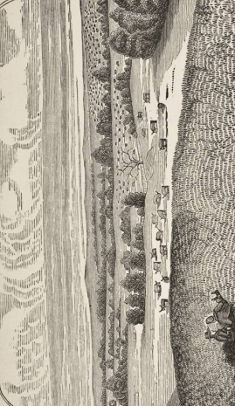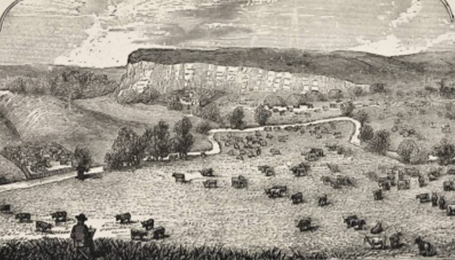
Figure 2.1 – Scottish Ranch and English Ranch

Henry Worrall (?), Scottish Ranch in Oklahoma & English Ranch in Oklahoma, wood engraving, 3 ½ x 6 inches, illustration from Oklahoma! Politically and Topographically Described . . . Kansas City, MO: Ramsey, Millett & Hudson, 1885.

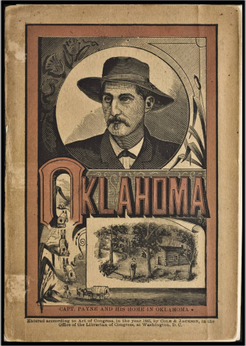
Figure 2.2 – Cover Illustration, Oklahoma!

Henry Worrall (?), Cover Illustration, wood engraving, 3 ½ x 6 inches, illustration from Oklahoma! Politically and Topographically Described . . . Kansas City, MO: Ramsey, Millett & Hudson, 1885.
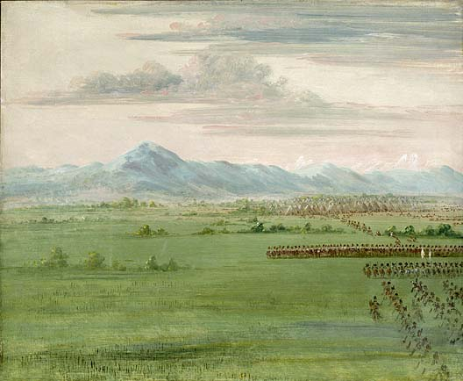
Figure 2.3 – George Catlin, Comanche Warriors with White Flag

George Catlin, Comanche Warriors, with White Flag, Receiving the Dragoons, 1834. Oil on canvas, 24 × 29 1/8 inches. Smithsonian American Art Museum, Washington, D.C. Gift of Mrs. Joseph Harrison, Jr. (1985.66.353).

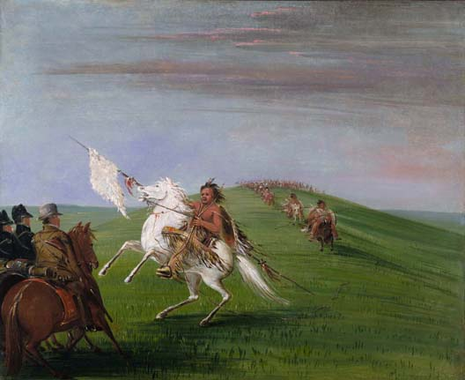
Figure 2.4 – George Catlin, Comanche Meeting the Dragoons

George Catlin, Comanche Meeting the Dragoons, 1834, oil on canvas, 24 × 29 inches. Smithsonian American Art Museum, Washington, D.C.
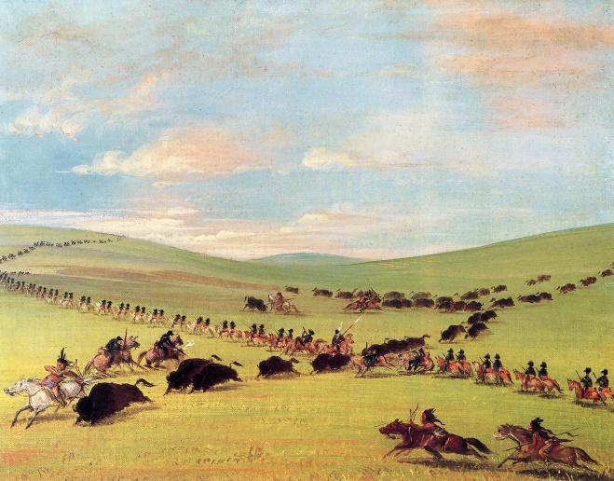
Figure 2.5 – Catlin, The 1st Regiment of Dragoons

George Catlin, The 1st Regiment of the United States Dragoons with Several Indian Hunters and Guides Meeting a Herd of Buffaloes in Texas, 1852, oil on canvas, 13 13/16 × 3 × 17 inches. Gilcrease Museum, Tulsa, Oklahoma.

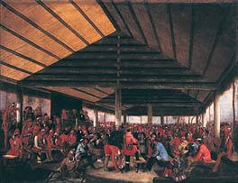
Figure 2.6 – John Mix Stanley, International Indian Council

John Mix Stanley, International Indian Council (Held at Tahlequah, Indian Territory, in 1843), 1843, oil on canvas, 40 ^{1/2} × 31 ^{1/2} inches. Smithsonian American Art Museum, Washington, D.C.

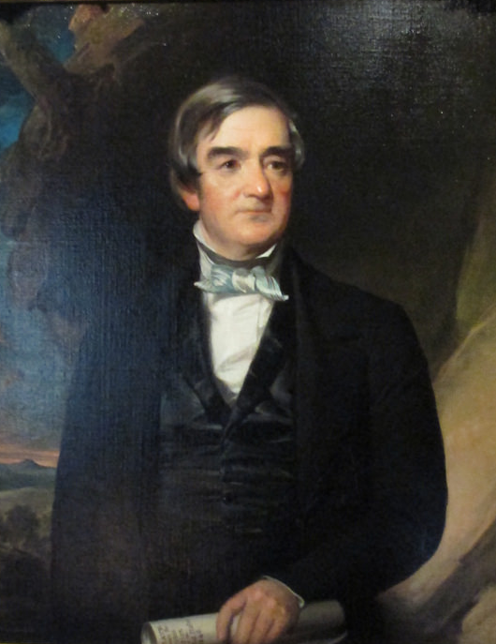
Figure 2.7 – John Neagle, Portrait of John Ross
John Neagle, Portrait of John Ross (Chief of the Cherokees), 1848, oil on canvas. Philbrook Museum of Art, Tulsa, OK.

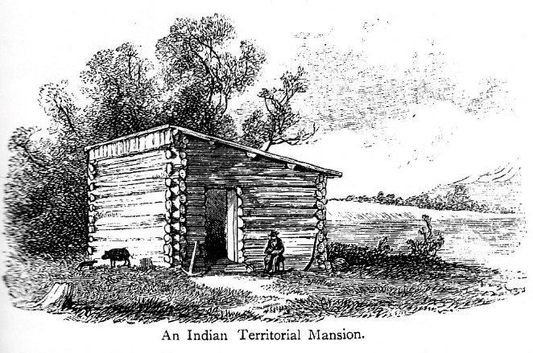
Figure 2.8 – James W. Champney, An Indian Territorial Mansion

James Wells Champney, An Indian Territorial Mansion, wood engraving, illustration from Edward King, The Great South: A Record of Journeys in Louisiana, Texas, the Indian Territory, Missouri, Arkansas, Mississippi, Alabama, Georgia, Florida, South Carolina, North Carolina, Kentucky, Tennessee, Virginia, West Virginia, and Maryland. Hartford, CT: American Publishing Co., 1875.

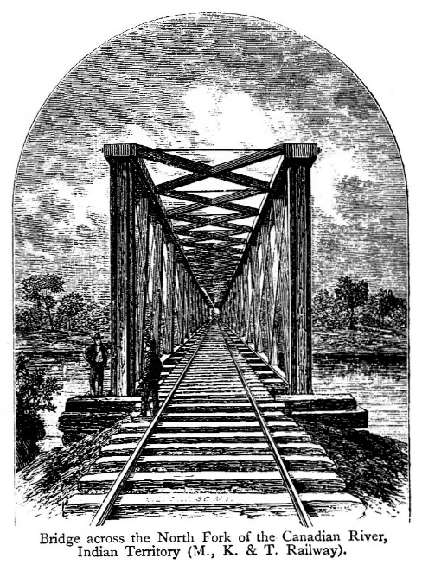
Figure 2.9 – James W. Champney, Bridge Across North Fork of Canadian River

James Wells Champney, Bridge Across North Fork of Canadian River, Indian Territory (M., K. & T. Railway), wood engraving, illustration from Edward King, The Great South: A Record of Journeys in Louisiana, Texas, the Indian Territory, Missouri, Arkansas, Mississippi, Alabama, Georgia, Florida, South Carolina, North Carolina, Kentucky, Tennessee, Virginia, West Virginia, and Maryland. Hartford, CT: American Publishing Co., 1875.

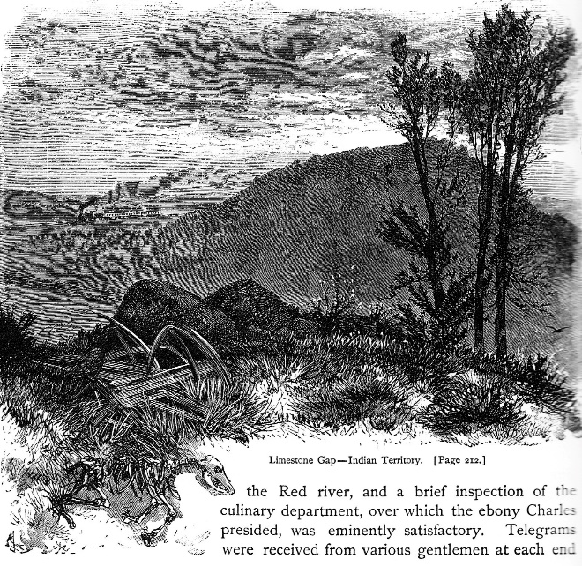
Figure 2.10 – James W. Champney, Limestone Gap-Indian Territory

James Wells Champney, Limestone Gap-Indian Territory, wood engraving, illustration from Edward King, The Great South: A Record of Journeys in Louisiana, Texas, the Indian Territory, Missouri, Arkansas, Mississippi, Alabama, Georgia, Florida, South Carolina, North Carolina, Kentucky, Tennessee, Virginia, West Virginia, and Maryland. Hartford, CT: American Publishing Co., 1875.
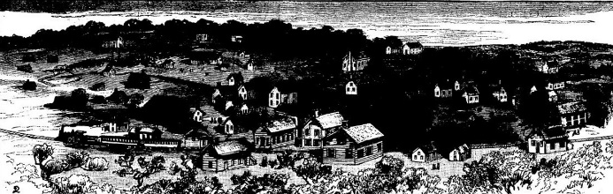
Figure 2.11 – Bird’s Eye View of Tulsu

“Bird’s Eye View of Tulsu,” wood engraving, illustration from George E. Foster, "A Zig-Zag Journey In Indian Territory," Frank Leslie's Illustrated Newspaper, August 11, 1888: 417+.

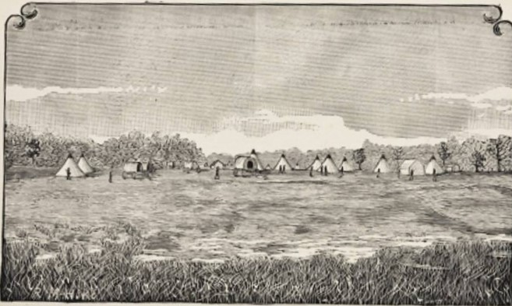
Figure 2.12 – Camp Alice / Payne and Party Arrested

Henry Worrall (?), Camp Alice, On North Canadian, Where Capt. Payne and Party Were Arrested, 3 ½ x 6 inches, wood engraving, illustration from Oklahoma! Politically and Topographically Described . . . Kansas City, MO: Ramsey, Millett & Hudson, 1885.

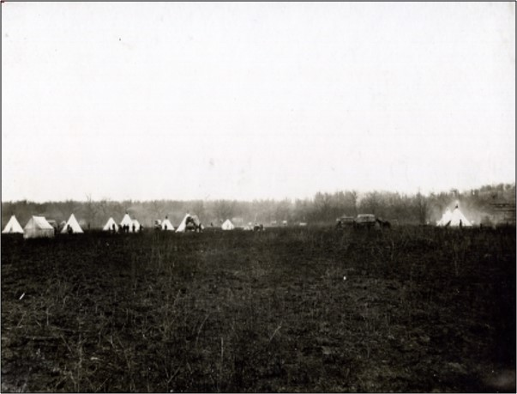
Figure 2.13 – Camp Alice / Payne Arrested Photo

Karl P. Wickmiller, Camp Alice Where Payne & Party Were Arrested, March 1883, photograph. Thomas N. Athey Collection. Courtesy, Oklahoma Historical Society.

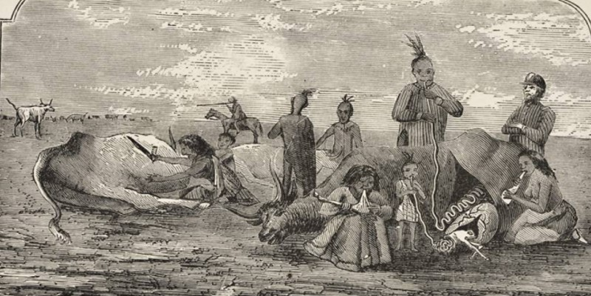
Figure 2.14 - Uncle Sam Feeding “Poor Lo Indian”

Henry Worrall (?), Uncle Sam Feeding “Poor Lo Indian,” wood engraving, 3 ½ x 6 inches, illustration from Oklahoma! Politically and Topographically Described (Kansas City, MO: Ramsey, Millett & Hudson), 1885.

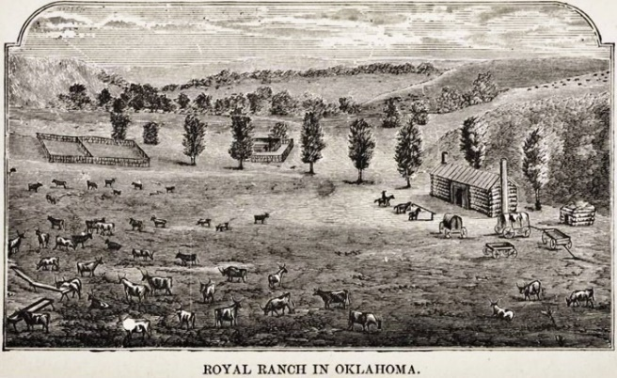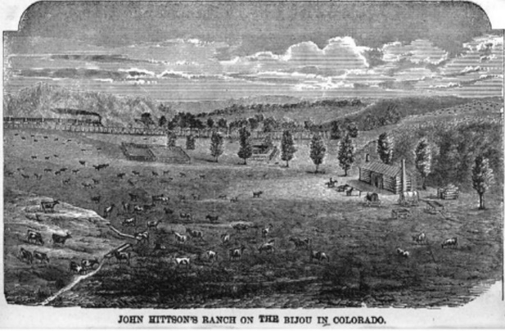
Figure 2.15 – Royal Ranch / John Hittson’s Ranch

Henry Worrall, “Royal Ranch in Oklahoma,” wood engraving, 3 ½ x 6 inches, illustration from Oklahoma! Politically and Topographically Described (Kansas City, MO: Ramsey, Millett & Hudson), 1885, opposite 116.

Henry Worrall, “John Hittson’s Ranch on the Bijou in Colorado,” wood engraving, 4 x 7 iches, illustration from Joseph J. McCoy, Historic Sketches from the Cattle Trade. Kansas City, MO: Ramsey, Millett, and Hudson, 1874, opposite 346.

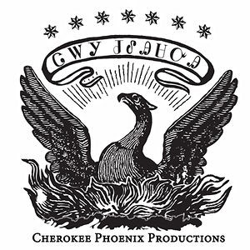
Figure 2.16 – Cherokee Phoenix Masthead

Cherokee Phoenix Masthead. Cherokee Phoenix Twitter, accessed September 29, 2016. https://twitter.com/cherokeephoenix

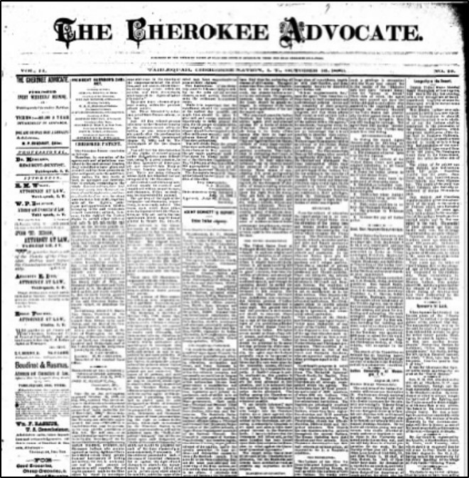
Figure 2.17 – Cherokee Advocate front page

Typical Cherokee Advocate front page, October 10, 1880.

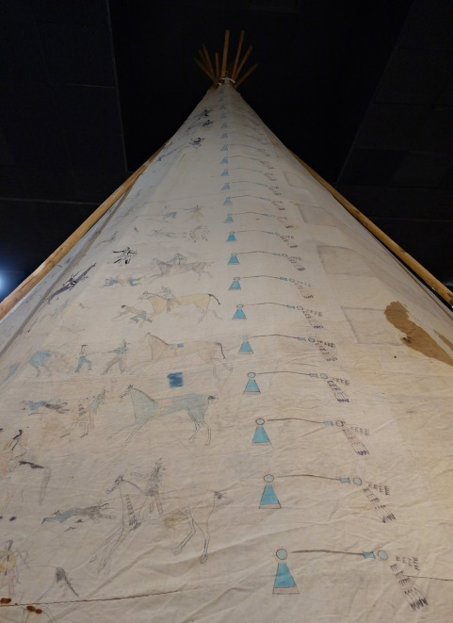
Figure 2.18 – Tipi with Battle Pictures

Tipi with Battle Pictures, c. 1830s, pigment on fabric. Oklahoma Historical Society, accessed September 28, 2016. http://www.okhistory.org/blog/?p=214
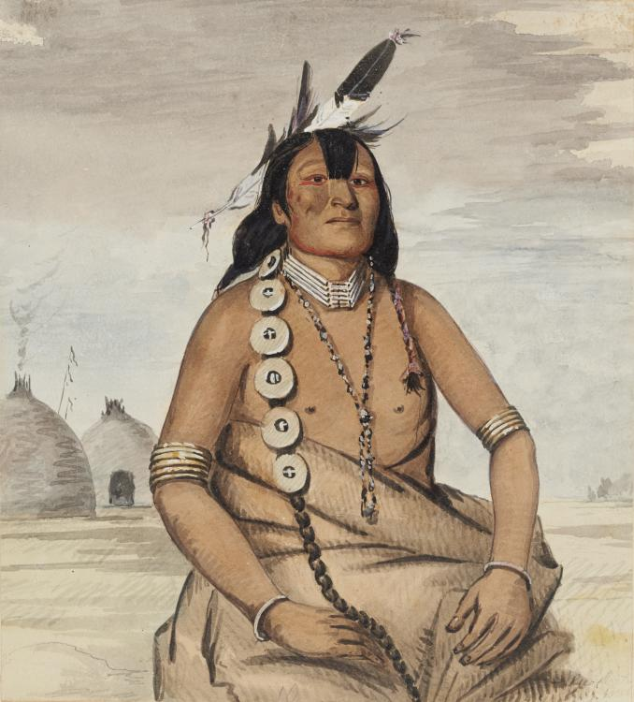
Figure 2.19 – George Catlin, Teh-toot-sah (Dohasan)

George Catlin, Teh-toot-sah (Dohasan), 1836, watercolor on paper, 7 ^{3/4} x 7 inches. Gilcrease Museum, Tulsa, OK.

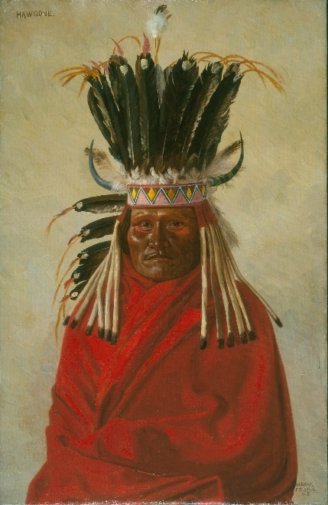
Figure 2.20 – E.A. Burbank, Portrait of Silver Horn

Elbridge Ayer Burbank, Portrait of Silver Horn, c. 1898, oil on canvas. The Newberry Library, Chicago, IL.

Chapter 3- Kilauea Volcano: Colonial Desire and Displacement in Hawai’i
In View of Kilauea Volcano at Night of 1885, Jules Tavernier constructed an image of Kilauea Volcano as dramatic as it was improbable (fig. 3.1). The viewer is placed at a precarious point inside the crater of the volcano. Yet the artist, whose view we share, is absent. We are given no clue as to how the artist/viewer ended up in the fiery pit, or how they might get out. The artist is a displaced presence that has sunk like a stone into water; we are left with just ripples to examine. Further scrutiny of these ripples reveals that View of Kilauea Volcano at Night thematizes profound changes in Hawai’i’s colonial situation over the course of the nineteenth century.
The displaced artist and the subtle formal choices he made harken back to an older narrative tradition, in prose and in paint, of colonial travels to the volcano and through the lava field. Earlier written travel accounts and paintings that describe the “discovery” of Kilauea focus on the central role played by the non-Native explorer. This Euro-American narrative, in which the volcano is described as an object of both scientific study and of sublime beauty, came to dominate, and displace, a centuries-old native traditional figure, volcano as Pele, a powerful atua, honored and feared, “with powers and qualities of the same kind as those of living men, but greater.” Rhetorically, these volcano discovery narratives positioned the volcano, the Hawaiian Islands, and the Hawaiian people within a Euro-American epistemology. The displaced artist, and the subtle formal choices he made, spoke also to the volcano’s appeal as a dramatic touristic spectacle in the 1880s. Tavernier’s painting places viewers in direct confrontation with Kilauea’s fiery lava. This new aesthetic, which emphasized spectacle and appealed primarily to tourists, challenged the old Native Hawaiian ways of knowing the volcano as Pele. Yet Native Hawaiian’s resisted this foreign rescription. Through the press, and through hula, a Polynesian dance form that dramatizes or portrays the accompanying chants, Hawaiians actively worked to save their way of knowing Kilauea, home of Pele, the central figure in the creation story of the Hawaiian Islands.

Jules Tavernier: An Itinerant Artist Discovers Kilauea
Jules Tavernier’s life story reflects the westward movement of nineteenth century Euro-American colonialism and American Manifest Destiny. Born in Paris in 1844 to a French father and English mother, Tavernier first trained as an artist in the atelier of the academic artist Félix Barrias, under whose tutelage he exhibited several paintings at the annual Salon. In 1871, he left Paris for London, where he worked briefly as an illustrator for the London Graphic. A few months later, Tavernier sailed for New York, where he became a regular contributing illustrator to Harper’s Weekly and several other illustrated magazines. In 1873-1874, Harper’s sent Tavernier on assignment to the western territory. The artist traveled through Missouri, Kansas, Indian Territory, Colorado, Wyoming, Nebraska, Utah, and California, sending illustrations back to New York for publication. In 1874, he settled first in San Francisco, then Monterey, where he reestablished himself as a fine artist. Tavernier left California a decade later, sailing for the Hawaiian Islands in December 1884. He settled in Honolulu and gained recognition in Hawai’i, and to a lesser degree in California, primarily for dramatic volcano paintings like the one we have been considering. Tavernier died May 18, 1889 in Honolulu.
Tavernier’s idea to paint Kilauea Volcano preceded his arrival in Hawai’i in several ways. Artistically, many of his Western paintings are visual precursors to his volcano paintings. In A Disputed Passage (1876), painted during his time in Northern California, a horse-drawn wagon approaches a narrow, wooded trail (fig. 3.2). The trail, blocked by a felled tree, is framed by large evergreen trees in the mid-ground. Further back, a V-shaped aperture rises between two distant mountains. The tall, vertical opening is framed twice – once by the evergreens and again by the mountainous aperture. A glowing sunset occupied the center of the aperture. The title, A Disputed Passage, recalls the days of the great California migration of 1849 and suggests the real subject of the painting is the struggle between white settlers and Natives. Like Kilauea at Night, the viewer is focused on a confrontation with a sublime fire on land that once belonged to Natives.
Another painting, Artist’s Reverie, Dreams at Twilight, more fully anticipates Tavernier’s Hawaiian themes (fig. 3.3). In this somewhat grandiose self-portrait from 1876, the artist confronts fire to gain artistic inspiration. Tavernier sits directly in front of a camp fire, smoking a pipe. He mostly ignores the literal fire in front of him, instead focusing on the more figurative fire in the distance – the blood-red sunset. The artist reinterprets his direct confrontation with these fires as catalyst for the creative process. The immediate result can be seen in the small painting behind Tavernier, in which the artist has reduced and transferred this wild, untamed land into the conventions of landscape painting. Artist’s Reverie, Dreams at Twilight functions as a metanarrative; Tavernier tames various creative fires and translates his confrontation with the sublime into art. In Hawai’i, Tavernier discovered the perfect subject for such artistic metaphors.
At the same time Tavernier’s art was moving thematically and formally toward confrontations with the sublime, his life was moving him ever closer to Hawai’i. His long association, in San Francisco and Monterey, with Charles Warren Stoddard would have predisposed him favorably to Hawaiian subjects. Stoddard, a travel-writer who had sailed to Hawai’i several times in the 1860s and 1870s, authored the travel-journal South Sea Idylls and founded the Monterey artist’s colony. Perhaps more important to nurturing Tavernier’s fascination with Hawai’i, though, was the counsel of fellow artist Joseph Strong, with whom Tavernier shared a Monterey studio for several years. Strong had lived in Hawai’i with his missionary parents as a child. In 1882, Strong left Monterey to return to Hawai’i, where he and his wife, Isobel, settled for a decade. Almost immediately, the Strongs began writing to Tavernier, urging him and his wife to join them. Late in 1883, Tavernier acceded, at least in principle, and, in late in 1884, he got his first chance to paint a Hawaiian volcano scene. While still in California, Tavernier received a commission from Edward Macfarlane, owner of the San Francisco newspaper The Wasp, for two volcano paintings, works based on oral, written, and photographic descriptions. In November, he displayed these works at the Monterey Palette Club, and in December, The Wasp published an illustration of them, a “grand and realistic picture of the burning lake at Kilauea . . . done in fourteen colors,” in its Christmas edition. Joseph and Isobel Strong greeted Tavernier on December 23, 1884, at the dock in Honolulu.
Whatever his motivation for sailing to the Pacific, Tavernier could not have picked a more propitious moment to travel to Hawai’i. From the 1880s until the early twentieth century, the lava vent in the caldera floor of Kilauea experienced near-continuous volcanic activity. Tavernier and other Volcano School artists traveled to the volcano regularly to sketch and paint from life, producing hundreds of paintings, all of which centered on the confrontation between viewer and lava (fig. 3.4). The paintings produced by these artists share so many common characteristics as to border on formulaic. Typical volcano paintings of the 1880s focus on a close-up view of the crater of Kilauea seen through a frame of jagged lava rocks. Most are set at night, which allows the artists to explore tenebristic contrasts of light and dark, providing built-in drama. The lava field is shown in a state of flux, contrasting white-and-yellow eruptions of lava with the yellow-red and crimson-red majority of the lava field, which in turn gives way to cooler browns and blacks of crusted-over lava. Clouds are often featured immediately above the crater, obscuring the sky above except for a silvery moon shining through a small break in the clouds.
Volcano School paintings focus the viewer on the singular, static moment when the traveler / artist “discovers” the crater. The viewer is dropped into the scene with no reference to travel or time; the moment of discovery exists alone and separate from history. Yet on closer inspection, Tavernier’s View of Kilauea Volcano at Night does subtly suggest movement to, and through, the crater. The horizon line echoes the concave aperture through which the viewer sees the crater. This echo effectively compresses the visual field, making the immense space seem more manageable. At the top of the crater the suggestion of a road or path circles the caldron, encouraging an imaginative circumnavigation of that suggests a way into and out of the immense crater.
Above the level of the crater rim, the sky resolves into various hues of gray, blue, brown, and black, the colors of the smoke rising from the fiery lava bed below. The dark colors and lack of light lend a funereal mood to the painting while providing a ceiling for the cauldron, insulating the scene and sending the viewer’s eye back into the crater. The convex lines offered by the crater and horizon add to this insularity by leading the eye, circularly, from the depths of the lava field, back up through the crater/horizon lines, and up to the sky. This circularity leads the viewer’s eye up, down, and around the oval shape formed by the lines of the crater, suggesting movement around its perimeter. The circularity, too, leads the eye continuously back to the lava field, the focal point of the image. The lava bed’s brilliant, saturated reds, red-oranges, and yellows give way to browns and blacks, stable “furrows” made of cooler colors indicating that some level of crust has formed. These cooler colors provide the viewer a path through the lava field. To the left and the right, white-yellow molten lava flares burst through the semi-stable crust, shooting vertically up through the air.
The centrality of the lava field is important because in many volcano discovery narrative texts, crossing the lava field serves as the climax of the expedition. In Mark Twain’s version, first recounted in letters sent back to the Sacramento Union in 1866 and subsequently retold in Roughing It (1872), he describes how, after spending a night at the Volcano House, a small guest house, he descended into the crater and crossed the lava field. Guided by Marlette, a mysterious stranger, the pair “skipped over the hot floor and over the red crevices with brisk dispatch and reached the cold lava safe but with pretty warm feet.” Marlette saves Twain from the lava several times, finding the path not by lantern light, but with his feet. Marlette, well versed in the crossing, could differentiate between the old, worn lava trail and the newer, more brittle lava by feel and by the changing sounds underfoot.
The conclusion of Twain’s adventure comes when he and Marlette reach the far end of the cauldron. The trip, “a long tramp, but an exciting one,” ends with Twain’s assessment:
The spectacle presented was worth coming double the distance to see. Under us, and stretching away before us, was a heaving sea of molten fire of seemingly limitless extent. The glare from it was so blinding that it was some time before we could bear to look upon it steadily. [. . . ] At unequal distances all around the shores of the lake were nearly white-hot chimneys or hollow drums of lava, four or five feet high, and up through them were bursting gorgeous sprays of lava-gouts and gem spangles, some white, some red and some golden – a ceaseless bombardment, and one that fascinated the eye with its unapproachable splendor.
Twain goes on to describe the heaving and crashing environment all around him and his guide: “a . . . sudden red dome of lava,” the size of a house “would heave itself aloft like an escaping balloon, then burst asunder.” Crashing, seething, jarring – are the words Twain uses to describe his exhilarating experience. Though perhaps exaggerating somewhat, Twain offers a fair description of what travelers might have faced on a particularly active night.
In fact, the visual path Tavernier provides through the lava field in View of Kilauea at Night might be imagined as an illustration of Twain’s nighttime volcano adventure. Yet the aesthetics of the 1880s differed from the 1860s. Whereas the trip to the volcano had once been as important as the descent into and through the crater, by the 1880s only the direct confrontation with the lava remains central. All of which serves as an index to the diminution of Kilauea as a site of Native authority and to the rise of the volcano as a sublime tourist site.

Lord Byron Discovers the Volcano
Twain’s travel log, taken in its entirety, bridges two traditions. The written narrative, which stretches out over an entire chapter, is the offspring of older discovery narratives. Yet Twain’s story was accompanied by illustrations including a dramatic view of the author and his companion looking out in awe at the lava field that anticipates the aesthetic of the 1880s (fig. 3.5). The older tradition was informed by early travelogue accounts such as those published by missionaries William Ellis in 1823 and C.S. Stewart in 1828. Of these previous narratives, Lord Byron’s account was the most widely distributed and read.
British Admiral George Anson Byron, 7th Baron Byron, sailed to Hawai’i, then known to Westerners as the Sandwich Islands, to return the bodies of King Kamehameha II and Queen Kamāmalu, who had died of measles during a state visit to England. Voyage of H. M. S. Blonde to the Sandwich Islands, in the Years 1824-1825 was compiled by travel writer Maria Callcott from the various journals and notes made by Byron and some of the officers and others who made the journey. In Callcott’s retelling, Byron and a dozen Englishmen, accompanied and assisted by nearly 200 Native Hawaiians, traveled overland from Hilo Bay to visit the crater of Kilauea. The trip took two days, covering 25 miles the first day and at least 12 the second day. On the surface, the Byron narrative is a straightforward account of progress toward Kilauea. Yet travel narratives produced in the colonial situation were never innocent or free of ideology. Within the narrative, two interrelated ideological arguments are put forward. First, Byron’s crew is eager to submit the land to scientific research and study; second, native Hawaiian histories, especially those concerning Pele, are diminished and dismissed. Both themes, ultimately, diminish native authority.
Byron gives great attention to measurements. He describes one of the lava craters as 900 feet deep and the lava plain within the crater as fifteen or sixteen miles in circumference, calculating the crater, from brink to bottom, at more than thirteen hundred feet. In a similar vein, in a long footnote, Byron provides various measurements (the crater’s height from sea level - 3,000 feet; the distance from Hilo Bay - about 28 English miles) along with mathematical proofs and a brief etymology of the word Peli. These measurements and descriptions contribute implicitly to the account’s success in explaining Hawai’i, and Kilauea, to a Western audience familiar with similar travel narratives of exotic, far-off places.
Dismissing Native histories and religious beliefs is another major theme in the account. Upon reaching the floor of the crater, Byron retells the story of Kapiolani, the descendant of an important Hawaiian chief who converted to Christianity. Hawaiian’s believed that anyone who descended into Pele’s fiery cauldron without offering a sacrifice and proper respect would be consumed by the lava. In an attempt to convince other Hawaiians to convert to Christianity, Kapiolani descended into the crater of Pele without first offering a sacrifice. After she successfully emerged from the lava pit, the missionaries used her story as propaganda to promulgate the Christian faith. Byron’s “discovery” of Kilauea coincided in time closely with Kapoiolani’s story, and thus reenacts her descent and defeat of Pele, this time in the name of the British Empire.
Byron’s narrative culminates in what literary historian David Spurr calls the commanding view. This view offers the author aesthetic enjoyment as well as information and authority (figs. 3.6 and 3.7). Byron’s party looks down to the volcano floor from a distance of “more than thirteen hundred feet.” Below, they can see
a rugged plain, where many a cone, raised by the action of the fire below, was throwing up columns of living flames, and whirls of smoke and vapor, while floods of liquid fire were slowly winding through scoriae and ashes, here yellow with sulphur, and there black, or grey, or red, as the materials which the flames had wrought on varied.”

This description at a distance is beautiful, authoritative, and filled with factual observations. The commanding view offers the travel writer and reader a sense of dominion over unknown, strange, new landscapes. The commanding view at once organizes space, makes exploration and mapping possible, and serves as a precursor to colonization.
The commanding view also invests the landscape with meaning to convey material and symbolic richness which would be evident to the educated Western reader. Thus upon reaching the summit of Kilauea, Byron’s party, “with almost as much joy as Balboa could have felt on first discovering the Pacific . . . hailed a cloud of smoke that was issuing from the crater,” thus equating the party’s arrival at the volcano with Vasco Núñez de Balboa’s “discovery” of the South Pacific in 1513. The allusion is fitting, for as surely as Balboa initiated the era of European colonialism in the Pacific, Byron’s journey initiated the final chapter in this hemispheric domination. The narrative also alludes to the Bible, ancient Rome (Vesuvius), and even Daniel DaFoe’s A New Voyage Round the World (1724), in which the narrator equates the night lights emitted from Kilauea with those of the volcanoes of the Andes.

Early Paintings – Peale, Kern, and the Art of Exploration
Early paintings of Kilauea largely follow both Byron’s narrative and the precedent set by his book’s engraved frontispiece. Titian Ramsay Peale, artist, naturalist, and son of Charles Willson Peale, travelled to Hawai’i as part of the United States South Seas Exploratory Expedition under the command of Lt. Charles Wilkes. Wilkes, commanding six vessels, travelled a total of 87,000 miles, leaving the east coast of America and visiting South America, Antarctica, the Pacific Islands, Australia, and Singapore, before rounding the Cape of Good Hope to return to America. The Wilkes Expedition, the first sponsored by the U.S. government in the Pacific, collected 40 tons of artifacts, including flora, fauna, maps, sketches, charts, drawings, and diagrams. This extraordinary treasure formed the core collection of the Smithsonian when it opened in 1858. From September 30 to December 2, 1840, the U.S. South Seas Exploratory Expedition set anchor in Hawaiian waters. Their primary goal, to make the Pacific frontier visible to the American public, was both immodest and improbable.
Peale traveled overland from Hilo to the crater of Kilauea in mid-November. In West Crater of “Kaluea Pele” From the Black Ledge, he places the expedition team much closer to the center of the crater than does the illustration of Bryon’s account (fig. 3.8). The back wall of the crater rises ominously above the figures, with the result that they, and the viewer, feel engulfed by the volcano. Approximately 15 years after Peale’s travels, Edward Myers Kern made several images of Kilauea when he traveled to Hilo Bay with the USS Vincennes in 1856. In Kern’s Lava Lake, Volcano Kilauea, Hawai’i, the figures, and thus the viewer, are even closer to the fires of the volcano (fig. 3.9). Smoke rises from the crater floor at a safe distance from the attendant figures, in Kern the figures stand directly on the crater floor. Were the volcano to erupt, they, along with vicarious viewers, would be engulfed in a fiery mass of lava.
Tavernier’s View of Kilauea Volcano at Night is heir to these earlier images, yet pushes the drama further. If Peale, then Kern, get the viewer ever closer to the volcano, Tavernier puts the viewer in direct confrontation with it. Tavernier’s viewer is closer than ever to danger, but a controlled danger, a spectacle meant to remind tourists of their harrowing confrontation with Pele. As travel to, and through, the volcano became a more commonplace activity, the confrontation with something sublime, foreign, and other offered something more important to represent. This shifting aesthetic of confrontation with lava also points broadly to changes in Hawai’i’s colonial situation vis-à-vis the United States, and the different audiences for these images.
A Shift to Tourism: Bringing the Volcano to the People
In 1824, when Lord Byron arrived, perhaps a few hundred Europeans and Americans, comprised mainly of missionaries and a few merchants, lived in the islands, and Hawai’i was completely self-ruled and autonomous. By the time Tavernier arrived in Honolulu in1884, thousands of American and European businessmen and missionaries had been cultivating Hawai’i as a site of colonial exploitation for six decades. In 1840, Kamehameha III became Hawai’i’s first Christian ruler; by 1874, when European and American military troops first took an active role in shaping the Hawaiian government, the majority of Hawaiians identified as Christian. In 1876, Claus Spreckles, owner and operator of a large California sugar refinery, moved to Hawai’i and established the first major industry in the Islands at Sprecklesville Sugar Plantation. The growing influence of Euro-American missionaries and businessmen effectively prepared the course of empire, presaging Hawai’i’s eventual loss of political autonomy. In 1893, a group of sugar planters, led by Sanford Dole, overthrew the Hawaiian Monarch Queen Liliuokalani in a coup. The coup was done with the tacit blessing of the United States government, who sent 300 U.S. Marines to Hawaii to enforce the overthrow of the queen. The coup, along with other political, military, and legal changes in Hawai’i, implemented through various covert and overt Euro-American influences, came to favor colonization, which in turn led to Hawai’i’s annexation by America in 1898.
As both subtle and not-so-subtle forces of colonialism exerted a corrosive effect on Hawai’i’s sovereignty, Kilauea developed as Hawai’i’s first tourist site. By the time Mark Twain arrived in Hawai’i in 1866, the volcano tourism industry was in full swing. Twain, as previously mentioned, stayed overnight at the Volcano House, a long-standing hotel / guest house located on the bluffs above the crater of Kilauea built in the 1840s. In 1866, its rude thatched buildings were replaced by a hotel consisting of several bedrooms, a lanai (porch or veranda), and a common room. Throughout the century, more improvements were made, and in 1877, a permanent wood structure was constructed. Tavernier’s small watercolor Volcano House Interior shows the main living area of the 1877 structure to have been a cozy Victorian sitting room, a far cry from earlier accommodations (fig. 3.10). Several guests sit reading, arraigned in a circle around a red brick fireplace, an imagined domesticated simulacrum of the mighty volcano (fig. 3.11). The scene subtly, ironically, deconstructs the adventures awaiting these visitors to Kilauea. Cosseted by hoteliers, porters, guides, beast of burden and provisions, the tourists we see will leave their comfortable cocoon just long enough to travel to the volcano. For such travelers, Kilauea had become an aestheticized tourist spectacle, a phenomenon to be discussed, written about, and seen from relative safety.
Tavernier’s work in Hawai’i responded to this shift to tourism in various ways. In October 1885, he started work on a deluxe picture book of Hawai’i, to be sold in the United States and Europe. Prospectively titled The Rainbow Land, An Artist’s Rambles Through the Hawaiian Islands, Tavernier was to supply sketches while Horace Wright, a reporter he knew from his association with Harper’s Weekly, was to provide the text. A form of travel writing, such picture books attempted to organize and regularize unfamiliar places, while enticing travelers to experience the wonders of the world in person. Tavernier’s anticipated a 500-page volume that would include 16 chromolithographs and hundreds of black and white figures. The Hawaiian press reported on the book’s progress, noting when Tavernier took various sketching trips around the islands, when prominent Hawaiians agreed to contribute chapters, and when Tavernier completed significant new pictures.
For reasons lost to history, the project never materialized. Nevertheless, in the summer of 1886, Tavernier started another ambitious project, The Great Panorama of Kilauea, a massive cyclorama of the erupting volcano. Tavernier’s hope was that people would pay to see the panorama so as to be completely surrounded by the volcano. The effort, finished in October 1886 took him 4 months, cost nearly $2,000 in canvas and supplies, and stood, when completed, eleven feet high and ninety feet wide. In late 1886, the cyclorama was put on display in Maui and Honolulu, and then sent on to San Francisco, with plans for a tour of Chicago, Philadelphia, Boston, and London. Once completed, the massive canvas was shipped to Washington, D.C., to be photographed and copyrighted. The world tour never took place, however, due to contractual difficulties and Tavernier’s fear, in spite of his copyright, that the cyclorama would be copied by others. The cyclorama, left in a warehouse, was eventually claimed by a creditor, never to be seen again.
The Pacific Commercial Advertiser called the panorama "wonderful, beautiful [and] grand . . . Hawai’i's Wonder." Another newspaper account commented that Tavernier’s panorama “will doubtless be the means of drawing an ever-increasing stream of tourists.” While earlier graphic representations of the volcano, from the print included in Lord Byron’s account, to paintings by Peale and Kern, were made in specific scientific/military contexts, Tavernier’s efforts made obvious Hawai’i’s transformation from a site of limited Euro-American colonialism to a place on the verge of American territorial status. The volcano itself had been mastered; it had been made into a commodity, a Native site at which non-Natives gathered, then transformed, into texts, science, or art, and ultimately, into fame, glory, and money.
Tavernier’s cyclorama achieved, literally, what his paintings could not – it placed the viewer directly inside of the volcano. Tavernier was capitalizing on what made his paintings so successful in Hawai’i – the authentic confrontation between viewer and volcano. Reviewing an 1885 exhibition of paintings by Joseph Strong and Tavernier, a critic for the Saturday Press opined that one volcano painting by the former might benefit from the removal of “two obtrusive figures in the foreground.” Figures in the foreground, a staple of earlier volcano paintings by Peale and others, had apparently come to be considered obtrusive. The aesthetics of the 1880s dictated a direct confrontation with the lava, linking the volcano ever closer to spectacle and tourism (fig. 3.12).
The same reviewer effusively praised Tavernier’s volcano painting in which no people can be seen. It was Tavernier’s “graphic realism” and faithful use of colors that the critic found especially praiseworthy:
The daring of Tavernier’s coloring might have made those present who had never been to the volcano doubt its truthfulness. But those who had been there were unanimous and enthusiastic in their praise. “It is surely never colored thus,” said one critical miss. “Have you seen the original?” asked her companion. “Not yet.” “Then, begging your pardon, you are scarcely qualified to judge. I have seen it twice. The first time the color effects could not have been more faithfully reproduced on that canvas. The second time there was a riot of livid hues that the subdued coloring of that picture – vivid, startling though it is – does not even faintly indicate. The floor of the great crater was a molten sea that broke in billows of fire against those craggy barriers. Over coloring? It is absolute fidelity – to one of that marvelous crater’s innumerable phases.”

The critic conflates dramatic effect in Tavernier’s painting with authenticity. Such images might serve as advertisements and help Hawai’i develop as a tourist destination. The critic concludes by recounting the painting’s upcoming exhibition schedule, which included stops in San Francisco and New York. It makes sense that his 1889 obituary in the Hawaiian Gazette notes, “Mr. Tavernier has been the means of largely increasing the tourist travel to the islands.”

World’s Columbian Fair of 1893 and the Walter Burridge Cyclorama
While Tavernier’s book never materialized, and his cyclorama never reached a mass audience, the idea for a cyclorama of Kilauea percolated, just a few years after his death, into something much grander. The central attraction of the Hawaiian display at the World’s Columbian Exposition of 1893 in Chicago was a massive, three-dimensional octagonal reproduction of Kilauea Volcano on the Midway Plaisance – Tavernier’s idea for a cyclorama realized for a worldwide audience. Its creator, Walter Burridge, a theater designer and set painter from Chicago, painted from sketches and studies he had made firsthand at Kilauea. Burridge was in the employ of the Wilder Steamship Company, owner of the Volcano House and one of the top companies bringing tourists to Hawai’i. The Hawaiian Gazette wrote of the project:
The Columbian Exposition offers an opportunity to advertise this country and make its advantages known, which is simply unparalleled. It is safe to assume that no opportunity will offer itself on a similar scale within perhaps a generation to come. The Hawaiian government and private individuals should strain every nerve to utilize this opportunity to the utmost. Hawai’i must be properly represented. We must have a full and fine exhibit – one which will illustrate with completeness the character, condition and prospects of the country, which will give an adequate conception of its generous climate and the unrivalled fertility of its soil.

The cyclorama, sixty feet high, one hundred and forty feet in diameter and four hundred and twelve feet long, was so real, according to one reviewer, that “the spectator is transported for the time being to the scene itself.” This hints at the ultimate purpose of the cyclorama – to “transport” the viewer to the volcano and thereby simulate an authentic experience (fig. 3.13). Burridge’s cyclorama, the ideological offspring of Tavernier’s efforts, brings this form of visual expression to its logical conclusion, by literally encompassing viewers in a faux volcano in a display of authenticity.
Authenticity, argues sociologist Dean MacCannell, is key to a satisfying all touristic experience, and tourism was an important way in which the leisure class defined itself. In his seminal study The Tourist: A New Theory of the Leisure Class, MacCannell posits that the expansion of modern society is “intimately linked . . . to modern mass leisure, especially to international tourism and sightseeing.” For the leisure class, contemporary Western civilization is inauthentic; authenticity exists instead in other places and historical periods. “As a worker, the individual’s relationship to his society is partial and limited . . . and restricted to a single position among millions, while as a tourist, the individual may step out into the universal drama of modernity.” Tourism, argues MacCannell, allows modern society to artificially preserve and reconstruct the pre-modern world, and thereby confers ideological mastery over the “primitive.” Pre-modern places and things establish “the definition and boundary of modernity by rendering concrete and immediate that which modernity is not.” By subordinating all of the world’s peoples and places to their own needs, the modern leisure class subordinates all pre-modern civilizations into a single conceptual entity. The pre-modern world gives definition to the modern world, and pre-modern sites of awe and wonder, such as Kilauea, serve as markers of difference. Tourism rhetorically reaffirmed for Tavernier’s privileged viewers their superior place in society, and authentic experiences with pre-modern sights such as Kilauea reaffirm modern identity.
Seen in this light, the Wilder Steam Ship’s sponsorship of the Burridge cyclorama project suggests that, by 1891, the volcano was fully understood, at least by non-Hawaiians, as a premier tourist attraction. For those who could not come to the mountain, the mountain, so to speak, was brought to them. The Chicago World’s Fair was attended by an estimated 27 million people, by any metric a fantastic return on investment. The Burridge cyclorama subsequently traveled to San Francisco to the California Midwinter International Exposition of 1894, held in San Francisco, which was attended by an estimated two million visitors. There, a “performance” of the volcano, undertaken for a private opening, included a “station for spectators” to stand, which “is supposed to be a heap of lava which exuded and solidified in the center of the crater.” The performance included “a priest [who] climbed the cliffs that rimmed the scene and chanted an invocation to Pele,” whose “form added to the realism of the effects.” The priest’s chant “was a queer, almost heartrending chant,” while “the singing by the Pele quartet . . . was decidedly plaintive and pretty.”
From about 1880 forward, a view of Kilauea emphasizing direct, unmediated confrontation between lava and viewer came to dominate paintings of the crater. Tavernier’s views, which helped establish and perpetuate this aesthetic, associated with authenticity, attempted to erase the boundary between viewer and volcano. His efforts were redoubled and expanded after his death by the Wilder Steamship Company with the commissioning of an even larger cyclorama, which was the highlight of Hawai’i’s display at both the Chicago’s World Fair of 1893 and the California Midwinter’s Fair of 1894. Tavernier’s and Burridge’s cyclorama projects appropriated the volcano for a world-wide audience. Once Kilauea was transformed into pure spectacle, Tavernier’s body, the non-Native body, could disappear, metaphorically sublimated into the fiery crater. While in the descriptions and visual representations of the 1830s or 1840s, the body of the explorer/artist stood out in contrast with “primitive” landscape, by the 1880s and the advent of the so-called “Volcano School,” the white Euro-American explorer / artist had become so naturalized into Hawaiian society that Tavernier omitted himself from his volcano paintings, entirely. As Hawai’i’s colonial fate became ever clearer, it was the Native body that was promoted as strange, exotic, and other. As the nineteenth century gave way to the twentieth, it was the body of the hula dancer that came to dominate the destination image of Hawai’i in the American mind. By 1893, on the eve of Hawai’i’s eventual annexation by the United States, drawing vacationers to Hawai’i had become a major concern of newspapers and various capitalist enterprises. Kilauea, long an important indigenous location, had been appropriated by the modern leisure class as a symbol of differentiation and superiority over that which was other. It was as enticement for tourism and as advertisement for empire that Taverinier’s Kilauea paintings fulfilled their ultimate purpose.

Pele’s Body: Resistance, Hula, and the Newspapers
What did Native Hawaiians think of this shift toward colonialism and tourism? The non-Hawaiian writers of Hawaiian history, from Captain Cook’s first arrival in 1778 until at least the 1960s, perpetuated the myth that Hawaiians passively accepted, even welcomed, invasion and colonial domination. Noenoe K. Silva has argued that the idea of Native Hawaiian passivity is “one of the most persistent and pernicious myths of Hawaiian history,” achieved only by systematically ignoring Hawaiian-language sources materials, especially newspapers published from the 1860s through the turn of the twentieth century. Recovering indigenous voices is important because any historical account that normalizes Native passivity normalizes the power imbalances inherent in the colonial situation. Silva and other historians have more recently recognized that Native Hawaiians resisted colonial hegemony at every opportunity.
At a time when Native Hawaiian’s were forced to cede ever more sovereignty to America, the election of King Kalākaua, who reigned from 1874-1891, provided a brief period of cultural resurgence for Hawaiians. Though Kalākaua had many failings and was, like his predecessors, forced to cede important rights to colonizing forces, he is fondly remembered by many Hawaiians because he promoted a return to pre-contact culture. Under Kalākaua, various forms of hula, many of which had been suppressed by the missionary ruling class, enjoyed a resurgence. Hula was featured prominently in Kalākaua’s coronation ceremonies. One hula in particular caught the attention of William R. Castle, a missionary’s son. Castle instigated the arrest of the printers of the coronation ceremony program on charges of obscenity for printing the title of one hula that celebrated the fecundity of the royal line.
Less noticed by the missionary establishment were the various hulas performed for the coronation ceremonies that honored Pele, the atuna of the volcano, and her family. The performance of hula Pele at the coronation countered the dominant colonial narrative. Hula, and the attendant stories which inform the hula chants, were narratives of, by, and for the Hawaiian people. The public chanting of the verses, and their publication, were subversive acts. Hula was ostensibly suppressed by the missionary establishment because they found the dancing lewd. However, the content of the hula chants should have perhaps given them more cause for alarm. Many chants tell the history of Hawai’i from an indigenous perspective. Hula Pele chants detail the life of Pele and her sister Hi‘iaka, the foundation story of Hawai’i, “the fountain-head of Hawaiian myth and the matrix from which the unwritten literature of Hawai’i drew its life-blood.” Pele’s journey resulted in her violent death and dismemberment that brought about immortality in the form of a land-birthing female deity. Pele, who controlled all volcanic activity, had created the Hawaiian archipelago during her travels.
This powerful creation story was ascendant under Kalākaua’s rule not just in the promotion of hula but also in the newspapers. Beginning in the 1860s, Pele appeared in both missionary establishment English-language papers and in Native-language newspapers. The missionary-controlled Ka Hae Hawai’i (Hawaiian Flag) frequently printed reader comments condemning traditional Hawaiian lifeways. However, these same reader comments sometimes recounted and endorsed resistance to colonization. For example, in the September 11, 1861 issue, K.W. Kawaiahao commented, “Some folk [take] bones to the crater of Pele, in order to consecrate Pele as a god for them. This is the persistent activity of some people living near Puna.” The writer goes on to describe one such journey in some detail, and includes what sorts of offering these people bring, what route they take, the proper place within the crater to place the offerings, and the chants they sang. Though the writer ends his missive with the lament, “shall we return to the ways of darkness”?, he first gets across vital information to any Native person wanting to join in the outlawed worship of Pele.
More important for resistance, though, was Ka Hoku o ka Pakipaki (Star of the Pacific), part of a long tradition of resistance newspapers in Hawai’i. Established in 1861 by David Kalākaua, future king of Hawai’i, Ka Hoku o ka Pakipaki talked back to those in power by printing the grand epic of Hi’iakaikapoliopele, the story of Pele and her youngest sister, Hi‘iaka. The publication of this important legend in the Hawaiian language, fifty years before Nathanial Emerson, son of American missionaries, used it as source material for his book, Pele and Hiiaka: A Myth of Hawai’i (1907), shows that Native Hawaiians were already active in what would be labeled salvage work if done by or for outsiders.
Hula plays a large role in the story, which concerns the travels of Pele’s sister, Hi‘iaka, and the various loves and betrayal of the two sisters. Ethno-historian David Charlot observes, “the Pele religion is intimately connected with the hula. The episode at the shore with [Hi ‘iaka and] Hõpoe is considered in some traditions to be the origin of that dance form and the Pele story continues to be an inspiration today. [Hula] Dances can characterize the god and narrate stories. Series of dances can present extended sections of the complex or indeed the whole complex itself; that is, the whole story could be told in chant and dance with little or no prose connection.” The resurgence of hula Pele during the reign of King Kalākaua, its performance at his coronation, and the publication of the epic Pele story in the newspaper he founded, all point to an era when the meaning of Pele, and by extension her home, Kilauea, was being fiercely contested by Native Hawaiians.
Native Hawaiian also resisted the colonial narrative, albeit in a more nuanced and subtle way, by acting as Pele’s gatekeeper. The thousands of tourists hiking through the volcano supplied an ever increasing demanded for native guides. One traveler, tongue in cheek, wrote “Notice. Parties attempting to visit the Lakes without a guide, will be supplied with the necessary articles on short notice, for a decent funeral, and certificate granted for the Life Insurance Co.'s.” Most tourists headed for the volcano stayed at the Volcano House and secured a guide in the employ of the hotel to lead them to the base of the caldera. As early as 1840, native guides and porters were crucial to Titian Ramsay Peal reaching Kilauea. In Kilauea y Day, the three figures in Peale’s group, outfitted in military dress and carry the accoutrements of scientific discovery / military conquest are led by and depend on Native porters who carry supplies in net-covered calabashes balanced on either end of a burden stick (fig. 3.14). Despite their importance, they are undifferentiated and anonymous (fig. 3.15).
By the 1880s, some of the guides had reputations and were known by name. One such guide, Alexander Lancaster, who was employed by the Volcano House from 1885-1924, appears in a photograph from 1912 (fig. 3.16). Lancaster’s service to the volcano made him something of a local celebrity:
Alec Lancaster, the well-known guide at the crater, has made a trail to a ledge of pahoehoe, a distance of 200-feet from the brink, and takes down to that point those visitors who desire to make a closer inspection than can be made at the edge. So far not many have shown a willingness to accept Alec’s invitation.
In the photograph, Lancaster is outfitted with a lantern, a canteen, thick boots, straw hat, and walking stick, all important tools which helped him guide tourists through the fantastic, sometimes dangerous volcanic landscape. If non-Native tourists serve in such images as a manifestation of Western cultural and political hegemony over Hawai’i, the native guide serves as their ever-present guardians. Forced to survive in a cash-based economic system, native guide attempted to control what they could – access into, and interpretation of, a sacred place.
Lancaster, in fact, was widely known to be a believer in Pele. One time, Lancaster, along with George Lycurgus, the former owner of Volcano House, walked to the crater of Kilauea
and invoked some prayers to the volcano goddess. Following that, they tossed into the fire pit an Ohelo berry lei made by Lancaster. As a final gesture, Lycurgus tossed in a bottle of gin which had been partially drained by him and Lancaster on the walk to the pit. More prayers followed and the two of them returned to the Volcano House for the night. Within hours after the men went to bed, the volcano began erupting.
Native guides like Lancaster also make a sustained appearance in the guest books from the Volcano House. Theses book, started in 1865 and kept through at least 1891, were used by guests to record volcanic activity. They frequently described their confrontations with the volcano, changes in the size and height of the crater, or in the type or volume of volcanic material, or sudden differences in volcanic activity. For tourists, it was a strange, exotic, and ever-changing landscape that offered the opportunity to describe details in vivid, visual language.
Many guides take life in these passages. In the 1880s, tourists typically secured one or more native guides and porters at their port of entry, typically Hilo, to get them to the Volcano House. Some specialized in the Hilo-to-Volcano trip, while others continued with their groups onto the crater’s floor. At the hotel, guests had several experienced guides to choose from. Of the several hundred entries left at the Volcano House from the early 1870s through the early 1890s, 67 specifically mention native guides. Of these, 32 name a specific guide, some of them in multiple entries, accounting for 23 total guides named.
Guests almost universally celebrate the guides, thank them for keeping them safe, and give them credit for knowledge of the terrain and various geological phenomena. Yet sometimes, the knowledge of the guides is described as spiritual rather than scientific. Repeating stories attributing supernatural phenomena to Pele, authors sometimes attribute these accounts explicitly to guides. At other times, they represent a more generalized understanding, the received wisdom of the tourist zone. A February 24, 1873, entry by Lieutenant A.B. Carter is typical:
This arrival [at the Volcano House] was mainly due to Joe Puni, our guide and a very good guide he is. We would advise anyone having him as guide to make him go to the crater as he is an excellent hand carrying specimens of lava etc., and as he is a pretty heavy man, he makes an excellent leader over doubtful places. (This is a puff for Joe.)
Beyond the standard duties of guiding his group safely over challenging ground and collecting lava samples, Joe Puni also professed his belief in Pele:
Found old Pele rather active during the day, and this evening the old girl is illuminating grandly, but she is not doing her best and as the natives tell us on undoubted authority will not do it again until this present king dies and another is elected. Joe is good Christian, but he believes in that freak of Miss Pele implicitly, giving the reason that it always has been so, even at the recent election of Lunalilo and strange to say argument couldn't convince him against what he has seen.

Though a good Christian, Joe believed in, and promoted to Western travelers, the idea that Pele interceded in the politics of modern day Hawai’i – in this case, the election of King Lunalilo in 1873, the first popularly-elected King. Like Pueblo people of the Southwest who long incorporated Christian and Native beliefs in a syncretic hybrid, this guide believed both in the Christian faith and in the atuna Pele. While Puni was exploiting the volcano for profit, he was also promoting Kilauea as the sacred home of Pele, just the sort of accommodation common in the colonial contact zone.
It was, nevertheless, easy for guides to conflate the sacred and the profane, and turn Pele into something of a faux spirit, an ill-tempered Volcano mascot. One visitor reported that he had lost his hat: the Hawaiian guide said “Pele came and took it. Certainly there was little wind.” Attributing volcanic activity to Pele is a running theme through the pages of the Volcano House register, and it is difficult to know if these reports of Pele come from sincere belief in the powerful atuna, tourists desire to experience the “authentic” Hawai’i, or a mixture of both.

Domination and Resistance
“The struggle over geography is not only about soldiers and canons but also about ideas, about forms, about images and imaginings.” Edward Said

Kilauea is no ordinary Hawaiian site, just as lava is no ordinary geologic material (fig. 3.17). Kilauea was, and continues to be, one of the most spectacular sites in the Hawaiian Islands precisely because lava represents, in physical form, transformation and metamorphosis. Lava created the Hawaiian Islands, and lava continuously adds to the very foundation of the Hawaiian land. Hawaiian culture was, and is, literally built upon lava. In providing a view into the crater of Hawaii’s most active volcanic crater, Tavernier and other artist in the 1880s provided a view into the very heart of Hawaii, and provided non-Hawaiians a view of a resource, and by extension, a people and a culture, mastered by colonial narratives and desires. On a meta-narrative level, lava suggests the transformative and regenerative possibilities offered to Euro-American’s through their encounter with the “primitive” inherent to nineteenth-century travel to “exotic” locales.
Yet to paraphrase Said, ideas matter, and who controls ideas matters. Kilauea continues to be contested to this day. Each year, Hawai’i Volcanoes Nation Park hosts approximately 2.6 million visitors, making it far and away Hawai’i’s most popular tourist destination, and one of the top destinations worldwide. The park, part of the National Park System, is staffed and maintained by the United States government. While the text panels provide visitors with some basic understanding of Native Hawaiian histories, the nineteenth-century travel narrative is reenacted millions of times each year by tourists who come to see one of the wonders of the world. The Volcano House is still in business; the historic 1877 building now functions as a gift shop located across from the crater. Yet some Native Hawaiians still worship the atua Pele; they leave her offerings, sing ancient chants, and perform hula Pele. Some even protest the park’s use of this sacred site, dispute its interpretations, and call for the park to vacate this and other Hawaiian volcanos. For many Hawaiians, Kilauea remains a contested colonial contact zone.

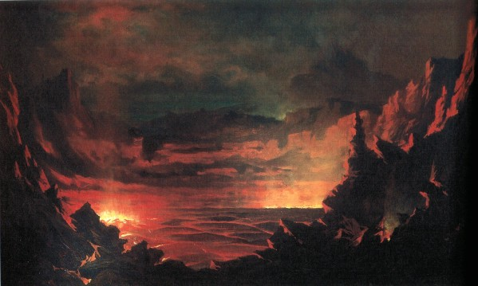
Figure 3.1 – Jules Tavernier, Kilauea at Night

Jules Tavernier, Kilauea at Night, 1885, oil on canvas, 24 x 30 inches. Private Collection, Hawaii.

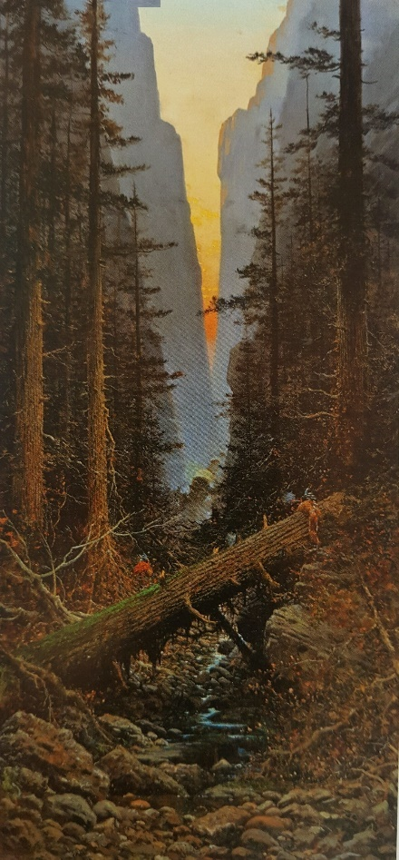
Figure 3.2 – Jules Tavernier, A Disputed Passage

Jules Tavernier, A Disputed Passage (in the Days of ‘46), 1876, oil on canvas, 50 x 24 inches. Gilcrease Museum, Tulsa, OK.
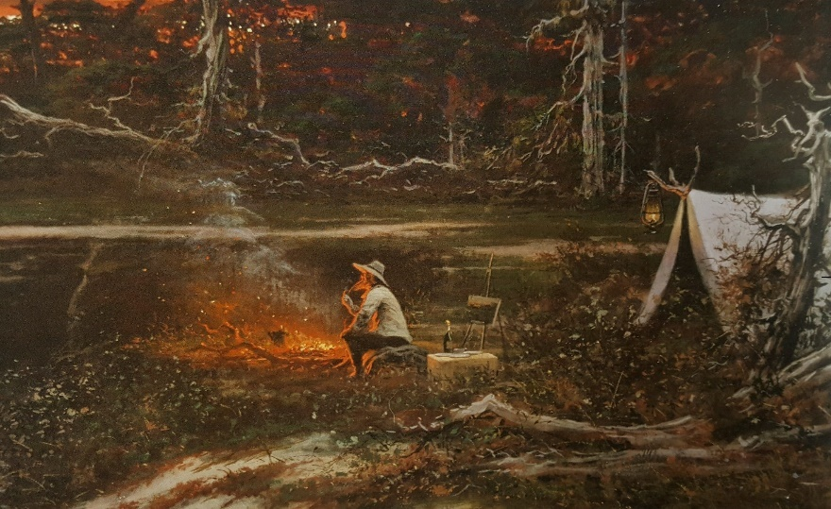
Figure 3.3 – Jules Tavernier, Artist’s Reverie

Detail. Jules Tavernier, Artist’s Reverie, Dreams at Twilight, 1876, oil on canvas, 61 x 127 inches. Collection of Oscar and Judy Lemer, long term loan to the Capitol Art Program, California State Capitol.

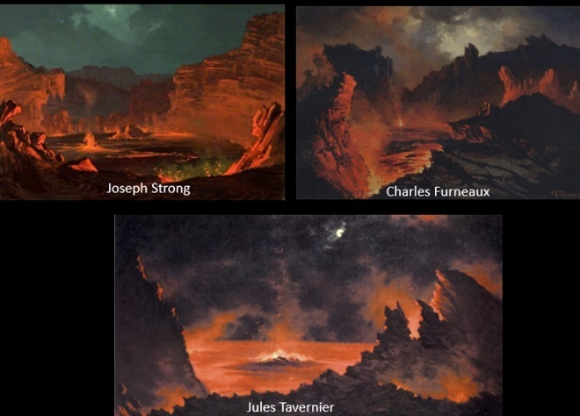
Figure 3.4 – Typical Volcano Paintings

Typical Volcano Paintings by Joseph Strong, Charles Furneaux, and Jules Tavernier, circa 1880-1885.

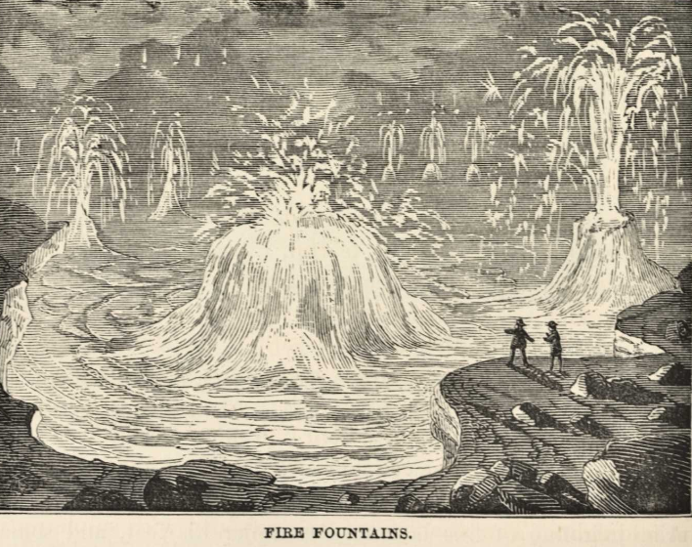
Figure 3.5 – Fire Fountains

Fire Fountains, illustration from Mark Twain, Roughing It (Hartford: American Publishing Co, 1873), 540.

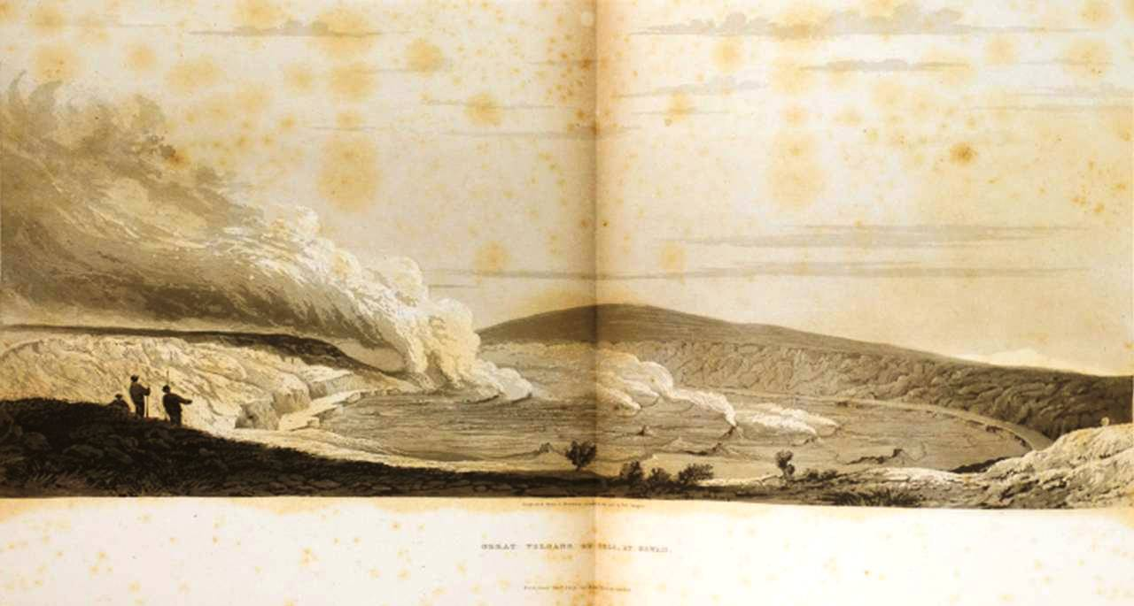
Figure 3.6 – Frontispiece, from Voyage of H.M.S. Blonde

Frontispiece, from Voyage of H.M.S. Blonde to the Sandwich Islands, in the Years 1824-1825 (London: J. Murray, 1826).

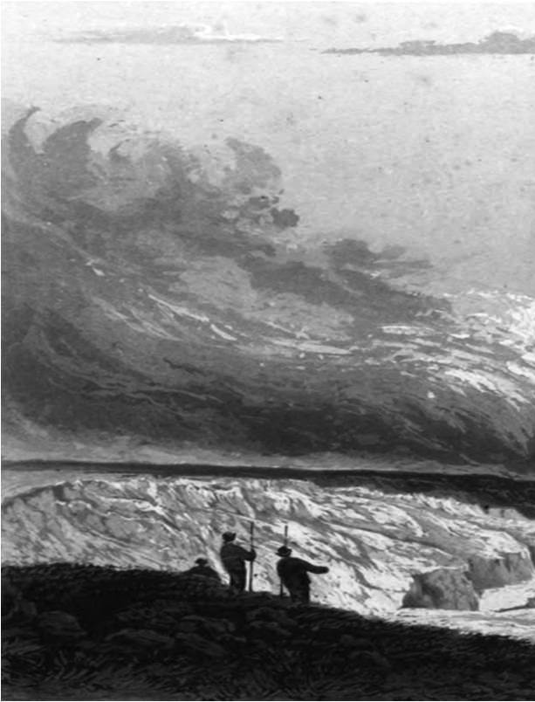
Figure 3.7 – Detail, Frontispiece, from Voyage of H.M.S. Blonde

Detail, Frontispiece, from Voyage of H.M.S. Blonde to the Sandwich Islands, in the Years 1824-1825 (London: J. Murray, 1826).

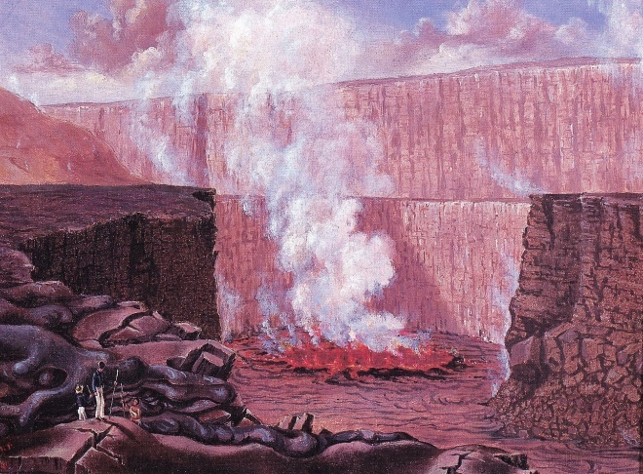
Figure 3.8 – Titian Ramsay Peale, West Crater of “Kaluea Pele”

Titian Ramsay Peale, West crater of “Kaluea Pele” from the Black Ledge, 1841, oil on board, 10 ¼ x 13 ¼ inches. Department of Library Services, American Museum of Natural History, New York.

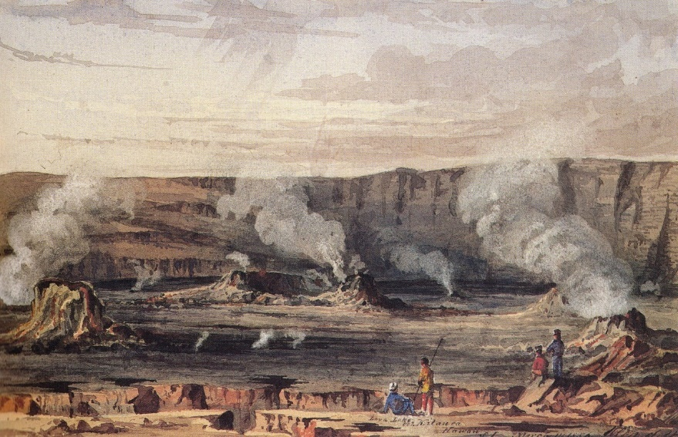
Figure 3.9 – Edward Myer Kern, Lava Lake, Volcano Kilauea

Edward Myer Kern, Lava Lake, Volcano Kilauea, Hawaii, 1856, watercolor on paper, 6 ^{1/8} x 9 ^{5/16} inches. Museum of Fine Arts, Boston, Gift of Maxim Karolik.

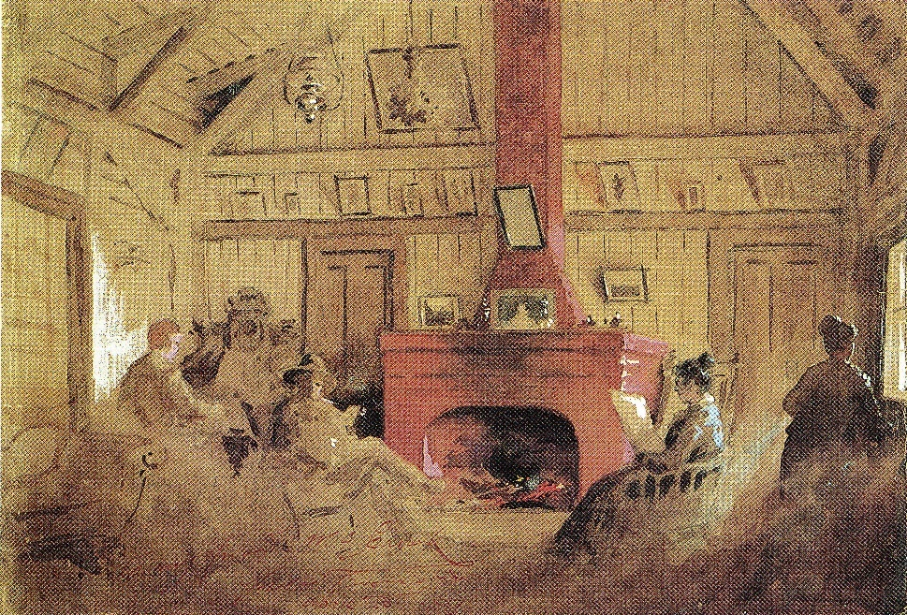
Figure 3.10 – Jules Tavernier, Volcano House Interior

Jules Tavernier, Volcano House Interior, c. 1886, watercolor heightened with white over pencil on paper, 10 ^{1/16} x 14 ^{5/8} inches. Private collection.

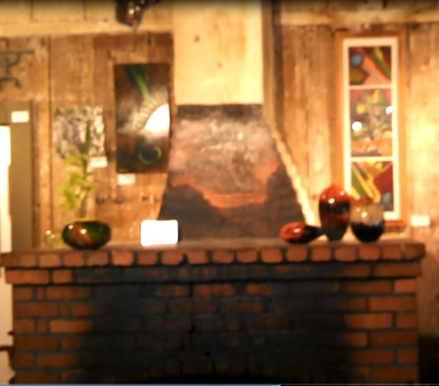
Figure 3.11 – Fireplace and Chimney, Volcano House

Fireplace and Chimney, Volcano House, 2012. Photograph ©James Peck.

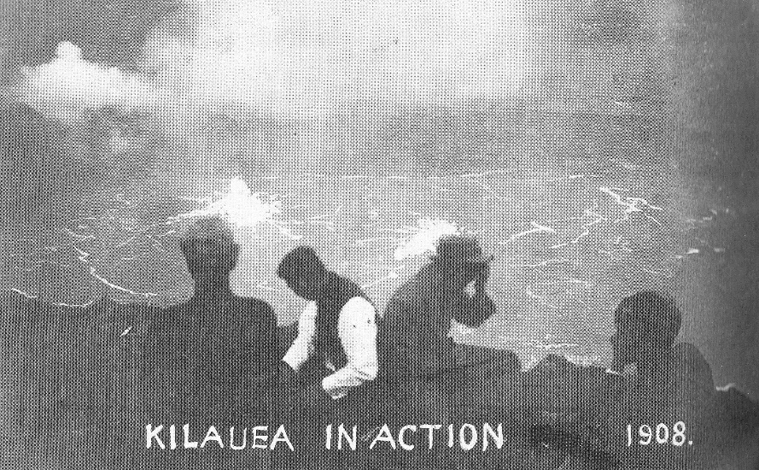
Figure 3.12 – Kilauea in Action

Kilauea in Action, 1908. Illustration from Darcy Bevins, ed. On the Rim of Kilauea: Excepts from the Volcano House Register, 1865-1955 (Honolulu: Hawai’i Natural History Association, 1992), 150.

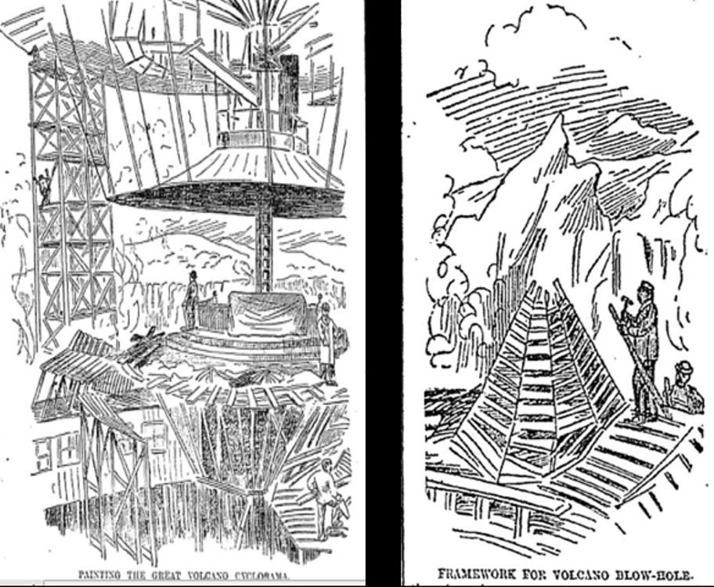
Figure 3.13 – Illustrations of World’s Fair Cyclorama

“Painting the Great Volcano Cyclorama” and “Framework for Volcano Blow-Hole,” Illustrations from “World’s Fair Doings.” Daily Inter Ocean (Chicago), March 1, 1893.

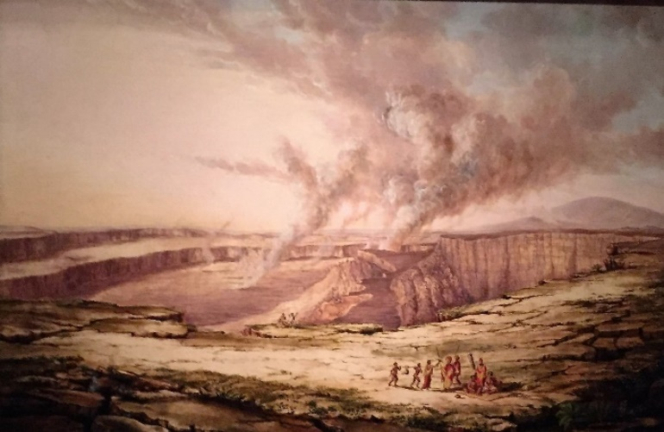
Figure 3.14 – Titian Ramsay Peale, Kilauea by Day

Titian Ramsay Peale, Kilauea by Day, 1841, oil on canvas, 20 ¼ 30 ^{1/8} inches. Bernice P. Bishop Museum, Honolulu. Gift of Albert Rosenthal.

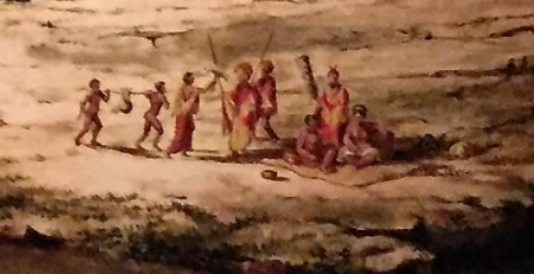
Figure 3.15 - Detail, Kilauea by Day

Detail. Titian Ramsay Peale, Kilauea by Day, 1841, oil on canvas, 20 ¼ 30 ^{1/8} inches. Bernice P. Bishop Museum, Honolulu. Gift of Albert Rosenthal.

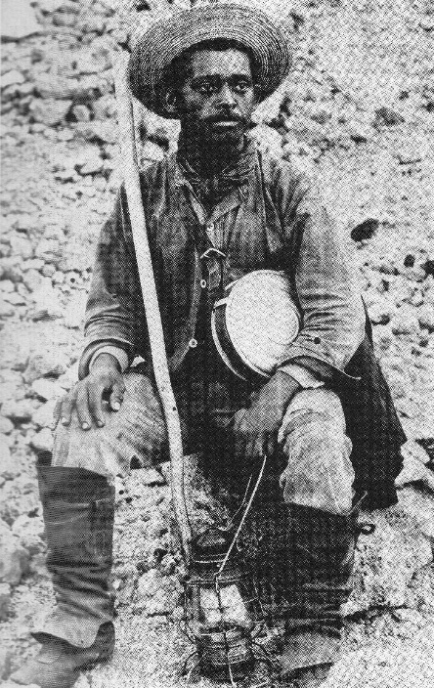
Figure 3.16 - Alexander Lancaster

Alexander Lancaster, Employed by the Volcano House from1885 to 1912, accessed October 5, 2016. http://imagesofoldhawaii.com/alexander_p_lancaster/

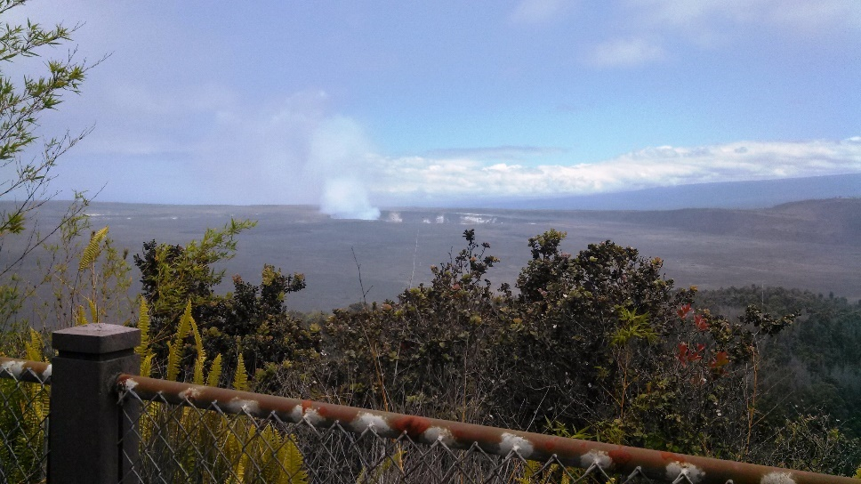
Figure 3.17 – View of Kilauea, 2012

View of Kilauea from the Volcano House. June 12, 2012. Photograph ©James Peck

Chapter 4 – Painting Indians: The Gaze and Pueblo Modernism

Between 1916 and 1920, Walter Ufer differentiated himself artistically from his colleagues in the Taos Society of Artists (TSA) in two important ways. First, he painted Native Americans in contemporary dress toiling at everyday activities, while most TSA members preferred to depict Native Americans in the ethnographic present, i.e., imagined as they looked and acted before contact with Euro-America. Second, Ufer frequently featured Native Americans gazing out directly, even defiantly, at the viewer. In contrast, most TSA artists depicted Native Americans passively receiving the European-American gaze. Beyond noticing these differences in dress, occupation, and use of the gaze in Ufer’s Indian paintings, historians and critics have largely left these aspects of Ufer’s artistic production unexamined.
Ufer’s tendency to show Native figures in his images looking back deserves further scrutiny. Ufer’s paintings are unsettling because, at a fundamental level, the outward gaze of the subject inherently confronts the viewer with the inner life of the subject depicted. Thus by using the gaze, Ufer reminds the viewer that his subjects, Native Americans and Hispanics from Taos, New Mexico, are real people, and that the painting itself is an artificial space created by the artist. The process of viewing one of Ufer’s “gaze” paintings is thus manifestly an act of visually consuming an artistic fiction created by the artist. The gaze thus represented is also fundamentally indexical; it reflexively implies not only the viewer’s presence, but that of the artist as well, encouraging the viewer to understand a painting as manifestly about the artist, the artistic process, and the act of looking.
In Their Audience, Land of Mañana, Going East, and Luzanna and Her Sisters, Ufer had good reason to emphasize process and artistry over mimetic illusionism. Nearly 40 years old at the time of his first real artistic successes in 1916-1917, Ufer, throughout his career oscillated between artistic apotheosis and financial disaster. From 1916 to 1920, he won five major prize medals in juried East coast exhibitions and saw his sales and prices soar, yet a series of personal, professional, and societal upheavals served to keep him in a liminal position in the art world; thus, I analyze Ufer’s “gaze” paintings also as a byproduct of these personal and professional insecurities. Ultimately, the gaze also serves as a point of entry to evaluate paintings by Ufer and his other TSA cohort as a site of negotiation between colonial and anti-colonial aims and ambitions of artists and models alike.
Not only were the Taos Indian models who posed for TSA artists real people, they lived real lives. Several models used their experience in the artist’s studios to enhance their lives by becoming artists in their own right. Albert Lujan, Albert Looking Elk, and Juan Mirabal each spent time posing for members of the TSA, and each in turn used that experience to negotiate modernity. Forced to survive in a cash-based economy, these Pueblo artists used their own agency to gain a modicum of fame and money at a time when neither were easy to come by at Taos Pueblo.
In the case of Albert Lujan and Albert Looking Elk, they did so by performing their identity publicly at the Pueblo, trading in on Euro-American fantasies for an income. For each, their identity as an artist provided cash while allowing them to participate fully in Pueblo life. They painted one primary subject, Taos Pueblo; they painted in a Western, or non-Indian style; and they sold their works relatively cheaply. Previously written off as tourist art, their paintings attentively read reveal much about the resistance and survivance inherent in their artistic practice. Juan Mirabal, conversely, practiced a different type of resistance – he fell in love with a white artist, Marjorie Eaton, trained with a Lithuanian-American Modernist artist and teacher, Louis Ribak, and pursued the type of fine art career typically not accessible to Indians in the 1930s.

Walter Ufer and the Gaze
Between 1916 and 1920, Walter Ufer made a series of paintings in Taos that problematized the role of the artist, the Indian, and the gaze. The earliest of these, Their Audience (1916), an arresting painting, was at once unsettling and immensely intriguing (fig. 4.1). Seven pueblo Indian women, ranging in age from young adolescence to early adulthood, stand in the foreground of the composition. Their bodies physically block the entrance to the pueblo on which they stand; their cross-armed stances and defiant gazes are not welcoming. They stand right at the edge of the pueblo rooftop; another step and they would be over the edge, tumbling out of the picture space and into the viewer’s space. Painted from a low perspective, they seem larger than life and even somewhat menacing.
The formal dress of these female figures suggests that they might be gazing down from to Pueblo down at a viewer, or viewers, while a dance or other religious ceremony is in progress in the plaza below. In a 1916 postcard, Ufer gazes out at the viewer while attending such an event (fig. 4.2), possibly the 1916 San Geronimo Dance, which might have served as inspiration for Their Audience. The figures draw a line between public and private spheres. Six of the seven cross their arms around themselves, protectively drawing their shawls close around their bodies. The middle five figures look out and slightly off to the left, as if distracted by something in the distance. The young women to the extreme right and left, however, guard their territory with their startlingly direct, unwavering gazes.
The young woman to the left, sitting or kneeling, draws her black shawl tightly around her body, even obscuring part of her face. Her eyes drill straight forward, engaging the viewer. This aspect of her gaze is unmistakable; distant, distrustful, and challenging. She is dressed simply, in a solid blue dress covered by a black shawl. The black of her shawl echoes that of the pot at her feet, connecting her both to Native American artistry (both shawls and pots made by the pueblo inhabitants) and with the body of a pot or vase. Her form intersects with the figure to her right, blocking viewer access into this private space. A flower garland snakes around the black pot, and reaches down into the viewer’s space from the rooftop, connecting, however tenuously, sacred and profane, private and public.
The young woman to the far right offers a compelling counterpoint. Standing, wearing a red dress with a floral-patterned white shawl, her eyes are more questioning, her face more open. Her feet rest on a blanket, again analogizing the woman with her tribe through material culture. The blanket spreads out over the pueblo in such a way as to lie partially on the rooftop and partially on the exterior wall of the pueblo, gently mediating the inner sanctum sanctorum occupied by the young woman and the public space of the square below. In spite of her crossed arms, her eyes are more questioning than distrustful or challenging. This relative openness echoes her open stance and body language; she stands slightly off to the side, offering the viewer the only break in the impenetrable fence of bodies along the roofline.
Perhaps this painting is so unsettling and intriguing because it conforms to Western expectations and disappoints them at the same time. The artist lines the female figures up for inspection and implicitly offers them up for the viewer to consume. Ufer has connected them through analogy to femininity (pot, flower garland) and to arts and crafts (blanket, shawls, pot), and has, implicitly, commoditized them as well. In these ways, Their Audience illustrates a colonial relationship between a Euro-American artist and his Native American subjects.
By around 1900, Euro-American artists and other intellectuals started to see Native Americans as an artistic resource. As cultural historian Leah Dilworth has argued:
Artists, anthropologists, promoters of tourism, and writers . . . established an essentially colonial relationship with them [Native Americans]. Those who made representations of Indians used Native American cultures as a kind of raw material that they turned into art, scientific data, or dollars. ”

Inherent to any imperialistic enterprise is the belief that “primitive” natives cannot fully or efficiently extract the value from their land or their culture. For European-American artist, this justified taking raw materials –i.e., images of Native Americans and their culture – from the land and translated them into art, and ultimately, money.
This was the operative paradigm for the painters who came to Taos between 1898 and the 1920s. The Pottery Vendor by Eanger Irving Couse features a half-nude male Indian left of center against an abstract, muted grey brown background (fig. 4.3). The artist has balanced the right side of the composition with various Southwestern Indian pottery pieces. A large, earth-colored olla dominates an impressive grouping of pottery probably derived from Couse’s own burgeoning collection. The implied vertical line that runs from the large pot on the ground to the smaller pot hanging above it provides a rough visual echo of the Indian’s body and head. The overall effect reduces the Indian to a commodity comparable to the attendant pottery.
The figure looks out from his studio space but does not really see the viewer. His distracted, sidelong glance does not interact with nor implicate the viewer, and thus, the viewer does not become involved psychologically with the subject. Distancing the subject further, the focus on ethnographic details – the beaded leggings and the pot, for example – salvages those details at the expense of the sitter’s personality.
In contrast, the two flanking figures in Their Audience, by means of their direct gazes, do not allow the viewer to regard them simply as commodities. In this way, the viewer cannot read Their Audience reductively as an image of male, and by extension imperialist, domination. Instead, the Native American subjects were an integral part of the viewing experience because the viewer could not help but to engage in the psychology of the moment. If viewers were indeed present at a ceremonial dance, why, exactly, were they looking not at the dance below, but at an impenetrable row of statuesque female figures, denying our gaze into their culture? Perhaps because by the time Their Audience was painted, several southwest Native American cultures were restricting access and image making at their sacred ceremonies.
By 1916, Euro-American artists had already successfully packaged and sold Native Americans and their culture through representations of their sacred ceremonies and dances. The railroads aided in this commoditization. In the 1880s, the Atchison, Topeka, and Santa Fe Railroad began service to and from Santa Fe, New Mexico. The railroads, originally seen as a conduit to relocate easterners who wanted to settle the west, increasingly began promoting tourism as a means to increase revenues. By the turn of the twentieth century, tourism was expanding throughout the southwest. Attracted by the warm climate, the picturesque setting, and remnants of ancient Native American cultures, European-Americans started visiting Indian communities and ceremonies as tourist attractions. Those promoting the southwest as a tourist destination characterized Native Americans of the Taos Pueblos as part of the “American Orient,” a happy “ancient” culture of “ethnic others” who lived in houses, were agricultural, nominally Christian, and non-threatening to whites.
Yet, the “exotic” continued to excite and fascinate the white colonial mind. From 1880 to 1920, the Hopi Snake Dance was the most represented of all southwest Indian ceremonies. As a result, white Americans increasingly identified Native peoples of the southwest with this and other dances and ceremonies. As the Snake Dance circulated through texts, images, and as a tourist attraction, it became a commodity sold by whites to other whites. As an example, Eanger Irving Couse’s Moki Snake Dance of 1904, purchased by the Santa Fe railroad in 1907 and used by the Fred Harvey Company as a poster and illustration thereafter, places the white viewer in the middle of the action at the most dramatic moment of the dance (fig. 4.4). In response to this commercial use of their sacred dances, between 1913 and 1920, the Hopi gradually restricted, then banned, sketching and photographing these events. Region-wide, by the 1920s many southwest Indian groups followed the Hopi and either restricted or banned artists from representing many such sacred ceremonies.
Walter Ufer first arrived in Taos in 1914, at about the time the Hopi and other groups were starting to restrict access. Though famous for his statement, “I paint the Indian as he is. In the garden digging – In the field working – Riding amongst the sage – Meeting his woman in the desert – Angling for trout – In meditation,” it took Ufer a few years to come around to this point of view. Ufer’s principle patron, H. Carter Harrison, then mayor of Chicago, advised him, “The man who makes himself the [Jean-François] Millet of the Indian, who paints him just as he is, as he lives, will strike the lasting note, persuaded him to this view. Perhaps Ufer was persuaded by his patron’s words, and perhaps he saw the writing on the wall. Not only did other members of the TSA such as Couse and Sharp have the ethnographic paintings market cornered, but the window of access to paint sacred ceremonies such as the Snake Dance was quickly closing.
The final bit of intrigue surrounding its title, Their Audience, both overdetermined and ambivalent: overdetermined in that, even without a title, it is clear that this painting is all about viewing and being viewed; ambivalent in that the title underlines the instability at its heart, namely the identity of the subject. Are the stern-faced women viewing the ceremony below the “audience” for that ceremony, so that “their” refers to the unseen dancers, or, is the audience the imagined viewer below. Indeed, ultimately, could not the figures in the upper left of the composition, positioned on a more distant, higher rooftop, be the audience for the seven female figures, the viewer, and the ceremony? The pictorial ambiguity makes it clear that the title serves as a purposeful reminder of the artificiality of the canvas. All the world’s a stage, Ufer’s Indians play their parts. In Their Audience, Ufer has created a manifestly fictive space wherein the figures act out a dramatic play or vignette that has the effect of making a commodity not of the Indians, but the canvas upon which they are acting.
Their Audience might also have served as a template for such purposefully ironic works as Woody Crumbo’s Land of Enchantment, 1946 (fig. 4.5). Located somewhere in the Southwest, Crumbo’s now-iconic image describes a typical roadside encounter between white patrons, parodied as clueless and out of touch, and Indians, stereotyped as solemn and spiritual beings. Crumbo place the Indian family behind their art, which serves as a metaphorical shield blocking both the tourists and the Indians from really seeing one another. While Ufer’s art had to pass within the conservative milieu of Chicago patrons in the nineteen-teens and the retardataire TSA, Crumbo, a Potowatomi Indian from Oklahoma best known for his work in the 1940s and 1950s, was more free than Ufer to satirize the theatrical moment of contact between white tourists and the Indians selling their wares. Whether Crumbo knew of Ufer’s work is less important than that they both appreciated the ironic and humorous possibilities offered by the buying and selling of Indian life, culture and arts, and the sometimes unwitting role played by whites in promoting and promulgating a colonial relationship well into the twentieth century.
That Ufer should emphasize that Their Audience was a depiction of a fictive space and thus a work of art makes more sense when we consider his career in 1916. At the moment he painted Their Audience, Ufer was on the cusp of losing his most important patron. Though within the next three years, he would win multiple national juried exhibitions, and be heralded as a major force in the Chicago art scene, he remained at the same time, desperate for money and patronage.
Land of Mañana (1916)
In Land of Mañana (tomorrow), three male figures dominate the center of the composition (fig. 4.6). The figure to the left sits with his back against an adobe wall. He has wrapped himself tightly in a blanket; just behind and to the left of his feet sit a black-colored and a cream-colored pot. Like in Their Audience, the blanket and pottery analogize the Indian to “traditional” arts and crafts. The figure to the right is dressed in western cloths. The hat, the mustache, and the man’s dark skin mark him as Hispanic. To his right an odd, amorphous figure crowds the edge of the picture space. At first glance, it appears to be an Indian blanket that stands up to form an odd, anthropomorphic figure. Yet on closer analysis, a form that suggests a head caps the black and white striped blanket, similar to a Navajo first phase chief’s blanket, which oddly echoes the form of human legs. The black-and-white color and the odd anthropomorphic nature of the form suggests that it represents a koshare, an embodiment of the trickster (fig. 4.7). The trickster informs the humor of the title manifest in the composition.
Ufer seems to have struck a chord with the public with Land of Mañana. In 1917, it won the Frank G. Logan Medal at the Chicago Art Institute, which led a Chicago Herald Examiner reporter to dub Ufer “Chicago’s biggest figure in art today.” The reporter also gives the only recorded contemporary reaction to Land of Mañana, describing the painting as “bright, deep, full of nothing but painting and feeling, modern and yet restrained . . .” The reporter hit upon one salient feature of Land of Mañana which makes it stand out, namely its “modernism.” Yet it is through composition, figure relationships, the use of the gaze, and an ironic title – all things well within the reach of a fairly conservative academically-trained artist – that Ufer makes his biggest artistic impact.
If the outward gaze in Their Audience reminds the viewer of the artificiality and theatricality of the artistic process, in Land of Mañana serves to make sure the viewer understands the none-so-subtle double meaning of the title. The three figures represent both of Taos’s “ancient” cultures, Indian and Hispanic. The figures are caught in a genre snapshot of everyday life in Taos. Yet Ufer forces the viewer into a conversation with the figures by placing them so close to the picture plane. Further, the central figure, Jim Mirabel, Ufer’s longtime model and close friend, gazes at the viewer quizzically, almost challenging us, making sure we get the importance of his gaze as it relates to the wry title, The Land of Mañana, the land of tomorrow.
The playfulness of the title becomes clear in Jim’s doubtful eyes. Even the seated man, who at first glance appears asleep, seems to have a half-smile playing on his lips, gently mocking the viewer. The Hispanic figure to the right, who does not look out at the viewer, wears a typical Taos cowboy hat, closer to a sombrero than a traditional cowboy hat and related to cavalry hats of the day. It has a high peak in the center and a wide, even brim all around. Ufer was fond of wearing just this sort of modified cowboy hat which therefore analogizes the Hispanic figure with the artist, and the artist with Jim Mirabel (fig. 4.8). In this way, the artist and his good friend Jim deliver a wry message to the viewer: in looking at this image of Taos today, you are looking at the Taos of tomorrow. It is not a land of enchantment, a land of tourism, but a land where Anglos, Hispanics, and American Indians live side-by-side. In this construction, the “vanishing” Indian has neither disappeared nor really assimilated.
Thus by reversing the gaze, the central figure in The Land of Mañana reverses the salvage paradigm, presupposing that Indian culture was dying out and that it was the task of the non-Native archaeologists, artists, and historians to “salvage” it for future generations. Because only the old, the authentic, and the pure had any value to well-intentioned non-Native scholars and artists who operated within the salvage paradigm, they created a self-fulfilling prophesy: true Indian art existed only in the mythic past and not in the present. However, by the nineteen-teens, many Euro-Americans were beginning to realize that Native Americans were not vanishing, and were not really assimilating, either. While it is true that American Indians were under immense social, political, and economic pressure during the first two decades of the twentieth century, they were not disappearing but changing and adapting.
Euro-Americans nevertheless typically continued to portray Native Americans in one of several stereotypical modes – as noble savage, vanish Indians, etc., inhabiting a vague “ethnographic present” where the actual present led by Indians was erased. This was perhaps most evident in the relatively new medium of film, which confined Native Americans “to other temporal and cultural orders . . . through containment within fields of nostalgia.” From 1900 to 1913, motion picture companies released over 100 silent films about Native Americans, and from 1914 until the end of the silent movie era in 1927, they released nearly 100 more each year. All of these early films fit Native Americans into one stereotype or another, and because hundreds of thousands, if not millions of viewers saw these films, they were far more effective in shaping racist and imperialistic views of Indians than artists ever could. Even Joseph K. Dixons’s low-budget 1913 independently produced and distributed Song of Hiawatha was viewed by 400,000 people across the country.
In some ways, Ufer’s “gaze” paintings such as Land of Mañana feel like film stage sets. Ufer’s actors, like silent film stars, communicate with the “audience” or viewer through loaded emotional facial expressions and meaningful glances, gestures, and body language. However, unlike the fledgling film industry, which profited from racist depictions of Native Americans, Ufer used ironic titles and clever composition to suggest an alternative to the noble / savage / vanishing race tropes utilized by popular entertainment and ethnographic photographers. Indeed, in Land of Mañana, he seems to offer a view toward a more egalitarian future.
Ufer’s Taos gaze paintings should not be confused with ethnographic photography. While the returned gaze might seem entirely conventional, even, arguably constitutive of works of ethnographic portraiture, important differences exist. While native subjects in ethnographic portraiture frequently gazed back in the direction of the picture plane, they rarely met the viewer’s gaze directly. Even when they did, the effect was often a passive look - or stoic, or noble, et cetera - according to what the artist deemed appropriate for a member of a dying race. Sometimes, ethnographic artists like Edward Curtis got cooperation from Indian sitters, who could choose to be psychologically available, or not, depending on the situation and artist-sitter interaction. Even so, ethnographic portraits rarely if ever offered the same level of nuance. Ufer’s native subjects use the returned gaze in a way both different and much rarer because direct, but also at times menacing or even bizarre. In Ufer’s constructed tableau vivants, native subjects not only have pictorial agency, but also act out (pleasantly) ambiguous scripts, actors in peculiar plays.

Going East (1917)
At first glance, Going East (fig. 4.9) seems full of implied forward movement. All four figures and the burro emerge from off-stage left; the edge of the picture space actually cuts off the back leg of the man on the far left, and to the right, crowds the head of the burro, which lends the image the immediacy of a snap-shot. The implied diagonal line that flows from left to right begins at the walking stick held over the shoulder of the man at the far left. It reemerges in the long, slender form of the barrel of the rifle held by the right-most man. Repetition and rhythm create a further sense of momentum. The repetition of the vertical forms of the Indians moving across the canvas indicates movement from left to right; the procession of slightly bent and angled legs has the same effect. A large clearing in the clouds to the right of center is reminiscent of the curved form of the olla carried by the central woman. Likewise, the cotton candy-like forms of the soft, wispy clouds overhead recur in the sagebrush on the ground. The net result of the implied motion, repetition and rhythm is that the figures move forward, albeit in a slow, solemn, processional way.
However, several visual elements give pause to this movement. The composition is not balanced – three of the four Indians have yet to move past its center. An even bigger visual constraint on movement in Going East comes in the form of the off-center cross at the heart of the composition. The previously-mentioned left to right vertical offered by the walking stick / gun, which nearly spans the length of the canvas, intersects with the vertical form of the Indian woman carrying the large olla, which likewise spans virtually the entire height of the canvas. The Indian woman’s feet touch the profane earth, while her body, and by extension the open mouth of the olla, reaches toward the heavens. Likewise, the horizontal axis links the group en mass with the mountains behind them. Thus, the complex composition holds these two axes, the celestial and the terrestrial, in tension.
The final element of restraint comes in the gaze of the last man on the left. Unlike the other figures, he does not look ahead to a destination, but directly out toward the viewer. His disconcerting gaze is a mixture of consternation, anger, and resignation. It serves to reverses the dominant, objectifying Euro-American gaze. In the simple act of staring back, the Indian challenges his role as exotic other, as an object to be consumed by the colonial eye. Thus, the viewer becomes the object, judged by the Indian with scorn and distaste. The outward gaze underscores the fact that Going East is a portrait of constrained movement. The artist as a result might be said to invite the viewer to ponder the fate of this group of Indians, and the fate of the artist. Going East can best be understood as a sly reference by the artist to the transitional nature of his career and patronage circa 1917. In 1913, the up-and-coming Ufer was among a handful of promising Chicago artists to catch the eye of Harrison, who, along with several other cultured Chicagoans including the meat packing magnate Oscar Mayer, formed a syndicate dedicated to sending up-and-coming Chicago artists to the Southwest. Both Ufer and Harrison saw the region as a regenerative space for American art. Even though Ufer and his primary Chicago patron seemed to agree philosophically, they had a turbulent and tumultuous relationship. The main point of contention was artistic direction – Ufer did not appreciate Harrison’s input; Harrison, for his part, could not resist offering Ufer increasingly specific advice about his art and career. Ultimately, the rift between artist and patron was too deep to heal, and in 1916 Ufer lost his Chicago patronage.
The following year, 1917, Ufer was elected both president of the Palette and Chisel Club in Chicago, and a member of the Taos Society of Artists. That same break-out year, he won the Frank G. Logan Prize from the Chicago Art institute for Land of Mañana, and Finally, Going East won him the prestigious Thomas B. Clark Prize at the National Academy of Design in New York City in 1918. Although this was Ufer’s third prize-winning painting, the imprimatur of the National Academy had the potential to make his career. Knowing he had lost his most important patron, Ufer painted a tour de force masterpiece in Going East, visually complex and filled with subtle tension, with a title that implied much more than was immediately apparent in the narrative. In a sense, Going East was exactly the type of painting Ufer needed to establish his career back East!
The Chicago press confirmed Ufer’s new celebrity. Under the headline “Chicago Artist Wins Prize In New York,” on March 11, 1918, The Chicago Daily Tribune reported on Ufer’s win (fig. 4.10). The Tribune also reproduced Going East above a picture of the artist, concentrating studiously in front of a Taos landscape painting. Five days later, on March 16, 1918, The Chicago Examiner also commented on Ufer’s prize, stating that Ufer’s “brilliant composition” which was “painted at Taos, NM” helped break down the East coast art establishment’s bias against Midwestern artists. Forgotten in this gush of good press was the fact that Ufer had lived in Chicago for only about fifteen years, was born in Germany, and studied there for nearly a decade. To the critic at the Examiner, Ufer was a local artist who made good back East. In this sense again it was Walter Ufer whose career and reputation were going East, a reading supported by the placement of the painting’s title in the Chicago Tribune story, floating above the artist’s photograph.
Even more telling is Ufer’s head-turned pose in the Tribune layout, which echoes the head-turned pose of Jim Mirabel, the trailing Indian in Going East (fig.4.11). By posing for the Tribune photograph in a way that directly invokes Mirabel’s pose, Ufer lent further credence to the idea that he identified with the Taos Pueblo Indians, and that he understood painting to be at least somewhat a performance for the market.
The head-turned gazes in Going East and its echo in the layout in the Chicago Tribune is reminiscent of other head turned gazes employed by Ufer at around this time. Just as the sombrero-wearing figure in Land of Mañana refers obliquely to Ufer because of the artist’s penchant for wearing similar hats, so too the head-turned gaze became something of a signature for Ufer circa 1916-1920. One photograph from this period features Ufer looking defiantly over his shoulder or with head cocked at an odd angel to his body (fig. 4.12). The head-turned gaze, then, is an abstract, indexical signature, calling attention to the presence of the artist and to the fiction of the painting.
Another example of Ufer’s use of the gaze can be found in Artist with Model of 1920 (fig. 4.13), really a double portrait in which Ufer and his good friend and frequent model mug like adolescents for a snapshot. Ufer identified with Mirabel specifically and with Pueblo Indians generally. That he made this manifest in his paintings suggests that the gaze, head-turned or straight-forward, worked for Ufer as a signature. He further underscores this fact in Self Portrait of 1923, which, when compared to Jim and His Daughter of the same year, makes the connection between the two crystal clear (see fig. 4.8). On one level, by signing these paintings with the gaze, which we must now understand as analogous to the gaze of the artist, Ufer connected himself with his Native American subjects.
By connecting himself visually with his Native American subjects, Ufer may have been deflecting questions about his own heritage perhaps subconsciously. Ufer maintained throughout his life that he had been born in America, and most sources still list him as American-born, yet he was born in Germany and emigrated to American with his parents as a young boy. During the nineteen-teens and 20s, many artists and intellectuals, such as John Sloan, Alice Henderson Corbin, and Mabel Dodge Luhan, were promoting the American Indian and their art as a uniquely American resource. Perhaps Ufer, who understandably would have been highly sensitive to anti-German sentiment in America at the dawn of U.S. involvement in World War I in 1917, saw a way to strengthen his identification with America by identifying with that most “pure” and unique of American resources, the American Indian.

Luzanna and Her Sisters (1920)
In Luzanna and Her Sisters (1920), the narrative centers on three female Indian figures seated on and near a windowsill located within Ufer’s home in Taos (fig. 4.14). The two younger girls, one to the left of the central figure, one to the right, are engaged in their surroundings; the girl on the right looks out over her shoulder, gazing through the window toward the world outside in a visual reference back to the head-turned Ufer gaze identified in connection with Going East. The central figure, a full grown woman, sleeps, her body resting at an odd angel to the window sill she sits on. She slides, almost imperceptibly, to the left of the visual field, propped up by the window frame. Her body opens up toward the viewer, while her hands rest in a native-made basket, her work hidden from view. To the contrary, the body of the girl on the right is closed off to inspection by the viewer. Her movement toward the window and, by extension, the outdoors indicates a longing for nature or a desire to be out of the Ufer household. Typically, the final figure, the girl on the left, gazes directly out at the viewer. Her cocked head echoes her questioning gaze. She is a cipher, a question mark for the viewer to contemplate. Though it would be easy to dismiss this painting as a pretty genre scene, the artist, in a now familiar move, gets the viewer to look more closely through his manipulation of gazes within the image. Both gazes intrigue – the girl on the right looks out, and in doing so turns her body from the viewer. She serves as a sort surrogates for the painter. On the other side, the girl to the left penetrates the viewer with the now-familiar menacing gaze.
Once the viewer has stopped to ponder the significance of these gazes, other oddities come into focus. All three female figures sit propped up on the window sill and frame. This effectively puts them stage. Ufer puts them on display, but unlike in Their Audience, Land of Mañana, or Going East, this theatricality seems completely contrived. Their stage set is inside of Ufer’s household and they act out an ambiguous vignette. All three figures occupy space left of the centerline provided by the window frame, and each figure takes on a different, off-balance pose. The permeable window behind the “stage” heightens this ambiguity by mediating between inside and outside. The Taos sunlight that streams in suggest that the real beauty of Taos is outside among nature. The two vessels to the right – one a native black ware pot, the other a European or European American designed glass vase – symbolically reenacts the scene to the left. The glass vessel, European on a superficial level, contains a local flower, an example of native Taos beauty, and the “stage” serves as a meta-container for Native Americans, who perform for their European audiences. In contrast, the contents of the dual neck black pot, thoroughly Indian, remain a mystery.
Ufer himself suggested in an interview that he understood the painting process to be somewhat theatrical, making the point that he painted his large paintings all at once without making preparatory sketches, saying, “I put my full vitality and enthusiasm into the one and original painting.” He also typically painted en plein aire - subjects, artist, canvas, and paints were all part of the same (often) sun-infused performance-driven moment. In this way, the act of painting, inherently theatrical by its nature, became a performance involving artist and subjects.
Ufer never enjoyed the level of wealth and fame commensurate with his TSA colleagues. Monographs and / or major retrospectives have been completed on Oscar Berninghaus, Ernest Blumenshein, Eanger Irving Couse, Herbert Dunton, Bert Geer Phillips, and Joseph Henry Sharp in the last twenty-five years. Conversely, Ufer’s posthumous critical reputation has languished – with one small retrospective in 1970 accompanied by a slim catalogue, but no substantial monograph and little critical writing since his death in 1936.
However, change is afoot. Over the past 3 years, Ufer’s star has been on the rise. In 2014, a large retrospective, Walter Ufer: Rise, Fall, Resurrection, opened at the National Cowboy and Western Heritage Museum in Oklahoma City. While the exhibition, accompanied by a modest catalog of the same name by Dean Porter, expanded Porter’s biographical research on Ufer at the expense of a more critical appraisal, the exhibition and catalog exposed a large number of the enigmatic artist’s works to the wider world. In contrast, A Place in the Sun: The Southwest Paintings of Walter Ufer and E. Martin Hennings, a major 2016 travelling exhibition, was a more ambitious and more scholarly effort than anything previous. Even so, a certain defensiveness is evident in the exhibition’s aim to raise Ufer and Hennings out of the milieu of “western American art” and place them “back within the pantheon of great American painters.” Whether either artist was ever central to the American canon is debatable. Even so, perhaps all of this renewed attention will encourage viewers and scholars to engage Ufer’s paintings in a more substantive way. If so, the possible interpretations will expand rather than contract – which might just be the ultimate reward for gazing upon Ufer’s fictions.
Whatever the outcome of this renewed interest in Ufer, his extensive use of the returned gaze should not be understood as merely structural and thematic. This visual device is also fundamentally indexical, reflexively implying not only the viewer’s presence, but that of the artist, too. This returned gaze encourages the viewer to understand a painting as manifestly about the artist, the artistic process, and the act of looking. Ufer attempted to maintain the colonial order of the white artist / Indian subject, yet the indexicality of his project destabilized this balance, suggesting the fragility of the colonial narrative. This embedded gaze offered a point of entry into a site of negotiation between colonial and anti-colonial aims and ambitions of artists and models alike. For while Americans, accustomed to ethnographic exhibitions at World’s Fairs in which American Indian’s “performed” their cultures, the Taos Pueblo became the equivalent of a living museum. The Pueblo, transformed into a site of touristic desire and viewed through the lens of the museum effect, became the natural place for the Pueblo Indians to perform their identity. Yet Ufer’s paintings suggest the danger in assuming that all historic actors are part of the historic paradigms ascribed to them. The direct, deliberate gaze of Ufer’s models marks a logical end point for the intra-colonial aesthetic. When the intra-colonial subject begins to talk back, or look back, then intra-colonialism as a formal artistic device had run its course. Not coincidentally, by 1918 and the end of World War I, America’s colonial aspirations had, like Ufer’s artistic ambitions, met resistance.

From Models to Artists: Pueblo Tourist Art, Indian Identity, and Pueblo Modernism

That Ufer and his TSA colleagues received good value from the Indian models they employed is undeniable. Their paintings based on these models provided the artists significant income and a modicum of fame. Even so, little attention has been given to the sometimes life-long relationships that formed between model, artists, and their families. Some models used their experience in the studio as a springboard to their own artistic endeavors. In the process, they negotiated, or managed, modernity by taking advantage of opportunities afforded to them in the contact zone.
From about 1915 until the 1940s, Albert Looking Elk Martinez (1880-1941) and Albert Lujan (1892-1948) made thousands of small oil paintings in a Euro-American style (fig. 4.15). Later, Mirabal (1903-1970) followed the path set forth by the two Alberts, albeit to a lesser extent and with subtle variations. All three artists were from Taos Pueblo, and all three had posed for various TSA artists.
Their paintings take Taos Pueblo and the Sangre de Cristo Mountains as primary subjects. Sold to tourists visiting the Pueblo, these paintings have long presented a problem for critics and historians, who have historically judged American Indian easel paintings against the flat, decorative, non-illusionistic, auto-ethnographic Santa Fe Style. By this standard, these three Taos Pueblo artists and their tourist paintings hardly qualify as “Indian.” Yet it seems inadequate to explain these men, who were active and full participants in their culture, or their paintings, which seem to be all about Pueblo identity, as anything other than Indian.
These artists’ insistent, incessant repetition of Taos Pueblo and the Sangre de Cristo mountains as subject matter deserves further scrutiny. Rather than analyzing them as assimilated Indians working in a co-opted, derivative Euro-American style, it would be more useful to describe them as Pueblo Modernists, defined by W. Jackson Rushing III as Pueblo artists who successfully negotiated social Modernity. Through a sustained visual analysis of several characteristic paintings by each artist, I will suggest that these artists negotiated modernity [i.e., managed modern social life] by thematizing Pueblo-ness in their paintings. By focusing on the Pueblo and the Sangre de Cristo Mountains to the near exclusion of all other subjects, all three artists rooted their paintings in powerful signs of indigenous sovereignty. Further, by painting and selling their works at Taos Pueblo, Looking Elk and Lujan performed their Pueblo-ness for tourists, who in turn gained value through affirming the “Indianess” of their purchases. By leveraging artistic skills learned from Anglo artists to survive, and even thrive, in a cash economy, Looking Elk and Lujan ultimately afforded themselves more time to be Indians. As such, their art reads as both co-optation and resistance. Juan Mirabal, on the other hand, represents a different case; his syncretic style and fine art training mark him as closer to the emergent American artists coming out of New York and Santa Fe in the late 1930s and early 1940s.
To be successful, Albert Looking Elk Martinez and Albert Lujan had to find ways to achieve success in Taos, which, in the 1919s and 1920s, met Mary Louise Pratt’s definition of a contact zone. Pueblo Indians and the white tourists and artists who visited and lived in Taos did not interact as equal, but rather as historically disparate groups engaged in an asymmetrical struggle for resources. Because of the asymmetrical relationships between white painters and Indian models, Albert Looking Elk and Albert Lujan had to navigate the new cash economy foisted upon Puebloan peoples in New Mexico and Arizona with great dexterity. A close reading of each artist’s biography reveals that both Looking Elk and Lujan emerged from this circumstance successfully by co-opting white artistic styles and methods to navigate social modernity. In the process, they created art that bore “witness [to] innumerable small meetings across cultural boundaries,” while illustrating native nationalism.
In 1898, Oscar Berninghaus (1874-1952), along with Joseph H. Sharp (1859-1852), arrived in Taos. In 1915, Berninghaus, Sharp, and four other artists formed the Taos Society of Artists (TSA), a commercial artist’s association that evolved into an artist’s colony. Soon after they arrived, these artists began employing Taos Indians as models. Albert Looking Elk started modeling for Berninghaus in 1900, making him among the first Taos Indians to model for a TSA artist. In a typical painting featuring Looking Elk, such as A Son of the War Chief, Berninghaus generalized Looking Elk, and in the process, transformed the Pueblo Indian into an all-purpose Plains Indian (fig. 4.16). At some point before 1918 the relationship between model and artist changed fundamentally; Looking Elk became, at least informally, Berninghaus’s student.
To some extent, it made sense that a model-artist would emerge from this milieu. Berninghaus was largely self-taught and probably would have admired and encouraged Looking Elk’s self-motivation and determination. Every other founding member of the TSA trained extensively in the academic European system, which valued the teacher/student relationship. By 1918, Looking Elk had given up modeling full time to become an artist in his own right. Looking Elk found himself in a unique position in which he gained the employment of, and at least some level enjoyed friendship with, Berninghaus and several other TSA artists. Longtime friendships between artist and models were not uncommon. One of E.I. Couse’s favorite and most-often used models, Ben Lujan, works for the Couses for decades and considered them his adopted parents. Ben’s nephew, Eliseo, also a model, called the Couses Grandfather and Grandmother. By all accounts, the Couses considered Lujan and his nephew part of the family.
Albert Lujan occasionally modeled for various TSA artists as well. Yet his path to becoming an artist differed substantially from that of Looking Elk. Albert’s father, born in Pueblo Isleta, had been adopted into Taos Pueblo by Tony Lujan’s grandfather. Tony Lujan, a part-time farmer and occasional TSA model, married Mabel Dodge Sterne, a New York socialite and patron of the arts who was influential with the TSA and various cultural powerbrokers in Taos and Santa Fe, in 1923. Because of these family connections, Albert enjoyed access to and knowledge of TSA artists and the Anglo art colony forming in Taos in the teens.
One day in about 1915, Albert, in his capacity as a fiscal (similar to a deacon or church elder) for Taos Pueblo church, was busy painting the church exterior. On a break, he decided to try his hand at painting a Taos Pueblo scene similar to the type Albert Looking Elk was then making. A well-meaning Anglo tourist, fascinated that Lujan spontaneously started making art, encouraged him, buying that first painting and subsequently a set of paints and a batch of canvases for the aspiring artist. This creation story is at best romantic, and possibly apocryphal. Bradley Taylor less romantically characterized Lujan as the ultimate entrepreneur, a man who marketed his paintings by producing and selling them at the Pueblo, handing out business cards, and entertaining tourists with hoop dances performed by his young nephew, Bobby Lujan. Albert Looking Elk also “performed” his Indianess by painting en plein aire at the Pueblo, and like Lujan, commissioned at least one postcard of himself painting at the Pueblo (fig. 4.17).
Although Lujan’s creation story, told to various researchers by Albert’s nephews in the 1990s, probably retains a grain of truth, it fits too seamlessly into J.J. Brody’s reductive, Indian-painters-as-white-puppets thesis to be taken at face value. In Brody’s model, published in Indian Painters and White Patrons (1971) and frequently cited until at least the late 1990s, “modern Indian painting has been . . . not a truly native expression derived from aboriginal forms but merely a passive response to White paternalism.” On the surface, Brody’s model seems to fit Lujan and Looking Elk equally. Both emerged as artists through the aegis, encouragement, and positive feedback of non-Indian teachers and patrons. Yet once we begin to explore the multiple complex and multivalent relationships that developed between TSA artists and these Taos painters, the limitations of Brody’s model become apparent. As Looking Elk’s story makes obvious, these relationships do not always follow predictable patterns and Brody’s model leaves no room for Native agency, instead positioning Native artist as passive vessels fulfilling white desires.
Four things separated Looking Elk and Lujan from Brody’s model: agency, access, Pueblo-ness, and performance. Through active agency, each artist took advantage of the various levels of access they had into the non-Indian art world. For each, tourist art satisfied white desire for authentic Indian paintings, in part through performance. Yet ultimately, the repetition of the Pueblo and the surrounding mountains as subjects reinforced their Pueblo-ness by encoding potent symbols of indigenous nationalism iconographically. Vernon G. Lujan of Taos Pueblo, writing in 2003, maintained that Looking Elk and Lujan “were first and foremost members of the Pueblo of Taos, with all the rights and responsibilities of community membership and that which it entail[ed].” Far from inauthentic Indians co-opted by capitalism and the white man’s desires, these Pueblo Modernists manipulated their asymmetrical relationships to the best of their advantage.

Difference and Sameness: The Santa Fe School versus the Taos Style
Albert Looking Elk and Albert Lujan, along with John Concha (1877-1969) and Juan Mirabal (1903-1970), and possibly a few additional as yet unidentified artists from Taos Pueblo, formed a small, distinctive clique committed to painting in a three dimensional, Euro-American style. As my analysis will suggest, nothing could be more Puebloan, or more Indian, than the subject matter these artists chose. Undoubtedly, the single largest reason a realist tradition flourished at Taos Pueblo from 1915 until the 1940s was the proximity of TSA artists to the Pueblo, and the frequency with which those artists hired men (and some women) from the Pueblo to model for them. The TSA was a rear-guard movement that clung to academic principles long after most leading American artists had begun employing some form of mediated European Modernism. Through modeling and other domestic chores, some models formed unique and enduring relationships with their non-Indian employers. For Albert Looking Elk, his privileged relationship allowed him first to observe, them to emulate, Berninghaus. For Albert Lujan, his occasional modeling for TSA artists, his family connections to Mabel Dodge, and his entrepreneurial spirit allowed him to make a career as an artist.
Yet these artists existed, and still exist, outside of the mainstream of accepted twentieth-century Indian easel painting. From the 1890s onward, American Indian easel paintings have been judged against the flat, decorative, non-illusionistic, auto-ethnographic Santa Fe Style that emerged between 1910 and 1920. By 1935, a second generation of artists who had inherited this style garnered national and even international audiences. Because others have exhaustively documented the development of the Santa Fe Studio style, what follows is an abbreviated sketch of how that came into existence.
Between 1900 and 1920, various non-Indian scholars, anthropologists, artists, and cultural powerbrokers in New Mexico attempted to facilitate what they saw as a return to an authentic Indian painting style by the peoples of the Rio Grande Pueblos. Some of the earliest artists, such as Crescencio Martinez, Julian Martinez, and Tonita Peña of San Ildefonso Pueblo, were encouraged by their white patrons to paint so-called “authentic” Indian subjects in a flat, linear, decorative style similar to pictographs in caves and paintings on ancient kiva walls. In attempting to revive what they saw as a moribund Native painting tradition, their white sponsors, men like Edgar Lee Hewett, believed they were helping Indians by providing them a way to make a living while practicing an indigenous art form. Soon, accepted Puebloan subjects emerged and stylistic norms developed. Acceptable subjects included elements from Puebloan cosmology, ceremonial dances, or scenes of everyday Pueblo life. These subjects were to be painted in watercolors on paper only. Stylistically, the paintings were flat, i.e., non-three dimensional, linear, and colorful. By 1932, Dorothy Dunn started teaching at the Santa Fe Indian School and codified these conventions into unbreakable laws. The American regionalist painter Alexandre Hogue, writing four years before Dunn started teaching, summarized Dunn’s paternalism thus:
Occasionally some poor misguided fellow comes to Dr. Hewett or Mrs. Van Stone at the museum [Museum of Fine Arts, Santa Fe] hoping to exhibit his work done in oils after the white man’s manner. To us they are pitiful specimens . . . but they won’t be misguided long. The museum policy is to refuse to show such works, and the artist is sent away with the promise that work done in his own traditional manner will be shown and pushed. Those in power at Taos have not been so uncompromising and, as a result, two Taos tribesmen are turning out the kind of stuff we see done in show windows. Their work is atrocious.

It is tempting to imagine that the “two Taos tribesmen,” whose artwork Hogue terms “atrocious,” were Albert Looking Elk and Albert Lujan. Indeed, both artists were working full bore by this time, and they would have had the example of the Taos Society of Artists to point out the value of exhibiting their artwork in a museum setting. Hogue’s statement points to the problem most whites had with Taos Pueblo realism in the 1920s and beyond – the stain of white influence. Canvas, oil paints, and especially three-dimensional illusionism were foreign pollutants to the pure Pueblo soul. The irony, of course, is that during this time period, white patronage and paternalism profoundly influenced all Indian easel paintings in New Mexico, either in the form of concerned white anthropologists and museum directors (Hewett, Santa Fe) or of paternalistic white artists and curio-seeking tourists (Couse and Berninghaus, Taos). Each group of Indian painters received specific feedback from white patrons as to what was most acceptable. Santa Fe patrons approved of Pueblo painters emulating white ideas of authentic Puebloness; Taos artists approved of Pueblo painters emulating their painting style, a dynamic reinforced by sales to tourists.
In this postmodern moment, it seems obvious that Pueblo artists who worked in either the Santa Fe or TSA style were managing social modernity in manifold ways. Style and subject matter were tools with which Pueblo artists managed their place in the social order. Albert Looking Elk established his Puebloness in his paintings in much the same way that Dan Namingha of Hopi did (fig. 4.18), by repetition of, and association with, sacred Pueblo places.
Taos and Santa Fe painters managed social modernity differently. It is easy to see injustice in the fact that Looking Elk and Lujan were until recently left out of the history of twentieth century Pueblo painting, and were for the most part in their lifetimes denied access to Santa Fe patrons. Yet the idea that an artist wanted, or even needed, critical acclaim to thrive is a Western construct. As it happened, both Looking Elk and Lujan probably made far more money from their art than most Santa Fe-style Indian artists made from theirs. Bradley Taylor estimates Lujan made over 2,000 oil paintings during his thirty-year career. At one dollar per painting, Lujan made perhaps thousands of dollars over his lifetime from his paintings, money that supplemented his income from modeling and farming. Looking Elk, more prominent in the pueblo and a better artist in higher demand, received up to $5 per painting and was nearly as prolific. Both Looking Elk and Lujan made enough money to have more time to be full participants in Pueblo life. This extra time paid off, as both artists were full and active members of tribal life in Taos Pueblo, evidenced by Looking Elk’s tenure as Governor of Taos Pueblo in 1938, and Lujan’s multiple appointments as fiscal of Taos Pueblo Church. Albert Looking Elk was the first member of Taos Pueblo to buy a car, a Studebaker, which was “all from the art,” according to Lujan’s nephew, Ernesto, who added, “That was the influence on the whole tribe.”

Pueblo, Mountains, Sovereignty
Like almost all of the tourist paintings produced by Looking Elk and Lujan, Looking Elk’s circa 1925 Untitled (Taos Pueblo Scene) is small, produced in oil, and takes as its subject Taos Pueblo and the surrounding Sangre de Cristo mountains (fig. 4.19). By framing the Pueblo with the mountains, the picture encourages the viewer to compare and contrast the two. In this example, the Pueblo emerges from the land, from which it is made, from the left and extends on an orthogonal line toward the mid-ground. Progress stops when the Pueblo meets the mountains. This ground-line orthogonal repeats in each successive level of the Pueblo. As the building rises, each levels become smaller, and correspondingly closer to the framing mountains. The vignette contains minimal details. The artists omitted or abstracted people into a few lines of paint, emphasizing instead the geometric regularity and the stability of the Pueblo itself, which proceeds across the painting in a series of regular, rational, geometric shapes suggestive of both human ingenuity and the geometry of the mountains. The repetition of ladders, darkened doorways, and rectangular shapes further underscores this sense of regularity and geometry.
If possibly, Albert Lujan’s Untitled (View of Taos) of 1941emphasizes the Pueblo even more – it dominates about fifty percent of the canvas (fig. 4.20). Lujan accomplished this by taking a low perspective and focusing tightly on the Pueblo, to the left, and a small out building, to the right. A blind alley near the center of the plaza leads to the mountains in the distance. As in Looking Elk’s painting, here the Pueblo emerges from the surrounding terrain, which shares its color and texture. A single earthen horno, or bread oven, occupies the center of the plaza. Its quasi-anthropomorphic form and eye-like oculus bear witness to the utter bareness of the scene.
The plaza spills outward toward the viewer. The area is markedly void of people, just the opposite of ceremonial times when the plaza filled up with people. In the Looking Elk example discussed above, people are present but greatly reduced and abstracted. Since Spanish colonial times, Taos Pueblo and other Rio Grande Pueblos fought, with varying degrees of success, to keep their religious practices secret. When Berninghaus, Sharp, and other like-minded Euro-American artists “discovered” the Pueblos in the 1890s, their presence created tension. To represent a ceremony, even one open to the public, was to diminish its power. As images of ceremonial dances circulated, they became commodities sold by whites to other whites. In response, many Pueblos banned visitors from recording their ceremonies.
The empty plaza in these paintings by Looking Elk and Lujan, then, takes the place of photographs, drawings, and paintings of ceremonial dances formerly made and distributed by white visitors. These Pueblo modernists never painted ceremonial scenes for tourists, and so emphasized the differences between their images and similar images made by TSA artists before the general prohibition took effect. As an example, Ufer’s Their Audience of 1917 [see fig. 4.1] implies the staring eyes of white tourists consuming a ritual ceremony, probably the San Geronimo Dance. In the same space, Looking Elk and Lujan place the viewer in the middle of a barren, solitary plaza, open to the imagination but not to the commoditization of the sacred by non-Indians.
When more genre elements are included, as in Burros at Taos Pueblo, a five by seven and three-quarter inch oil on board painting from circa 1928, Looking Elk still never gives away anything sacred (fig. 4.21). The rhythmic nature of Looking Elk’s loose, almost broken brushwork and the narrative elements such as the burros and the laundry left out to dry make this painting stand out from other TSA-inspired Pueblo art. A corner of one of the Pueblo buildings juts out from the left and proceeds along an orthogonal toward the center. The rectangular Pueblo echoes a low-slung walled structure made of pueblo material emerging from the right along a similar orthogonal toward the vanishing point. A large pile of hay is visible inside the low walled structure. By providing a visual echo as the structural nucleus of this more visually complex image, Looking Elk refers obliquely to the trinity of sky, mountains, and pueblo/land. In these examples, the distant mountains interlock, like pieces in a giant puzzle. Although aware of Western artistic conventions such as atmospheric and one-point perspective, shading, and modeling, Lujan and Looking Elk tended to elide the distance between the Pueblo, the mountains, and the sky.
The effect was to flatten space and press all three elements closer to each other and closer to the picture plane, lending the scene a sense of quiet urgency. In Burros at Taos Pueblo, shadows populate the foreground, an area structurally defined by the Western convention of one-point linear perspective. Yet as the elements of the picture recede into the distance, the illusion of depth disappears and the places where the pueblo, mountain and sky unite become more abstract. Thus, Pueblo space, where sky, land and pueblo intersect, is abstract and therefore less comprehensible. The plaza, inhabited only by two burros and a pile of hay, is open for inspection by non-Pueblo eyes, while the sacred intersection of pueblo signifiers sky/mountain/pueblo/land remains unattainable.
Looking Elk and Lujan tended to divide their landscapes evenly into three vertical bands, one for sky, one for mountains, and one for pueblo/land. Yet these bands interlock: the land gives shape (literally) to the Pueblo, while the Pueblo melts into the framing mountains, which gently negotiate the sky above. Visually, the paintings insist that the three elements interconnect. What more powerful assertion of Pueblo identity and sovereignty that the ancient pueblo, which had sustained the Puebloans for almost one thousand years, the sacred mountains, the home of their deities, and the sky, which for centuries had provided sustenance through rain?
These three elements were, and still are, key to restoring the adobe of Taos Pueblo. As their website explains:
The Pueblo is made entirely of adobe – earth mixed with water and straw, then either poured into forms or made into sun-dried bricks. The walls are frequently several feet thick. The roofs of each of the five stories are supported by large timbers – vigas – hauled down from the mountain forests. Smaller pieces of wood--pine or aspen latillas—are placed side-by-side on top of the vigas; the whole roof is covered with packed dirt. The outside surfaces of the Pueblo are continuously maintained by replastering with thick layers of mud. Interior walls are carefully coated with thin washes of white earth to keep them clean and bright.

In Burros at Taos Pueblo, all of the elements needed to make the pueblo and thus to sustain the Puebloan people lie in plain view. Front and center, the dirt of the plaza recedes from the picture plane back to the pueblo structures. A shallow watering hole lies in front of the structure that holds the hay, and in the mountains, trees, from which the wood of the pueblo was gathered, are plentiful. In their tourist paintings, Looking Elk and Lujan painted the same elements over and over again, in the process inscribing their paintings with uniquely Puebloan signifiers without giving up Pueblo ritual secrets.
While Looking Elk and Lujan were able to make aspects of modernity work for them, generally the early twentieth century was a time of great change and adversity for the Puebloan peoples of the Rio Grande area. The U.S. government policies of assimilation, land cessation (the Dawes Allotment Act, 1887) and cultural suppression (the Bursam bill, 1922) led many Americans to doubt that Puebloan society would last more than a few decades. In 1906, the U.S. government added Blue Lake, a ritual site in the Sangre de Cristo where Taos people went for ceremonial reasons, to National Forest lands. From the moment the U.S. government took the land, the people of Taos Pueblo made every effort to regain it, eventually prevailing. In this climate, in the middle of a sixty-four-year struggle to regain sacred lands, it is difficult to read paintings of Taos Pueblo framed by the Sangre de Cristo Mountains created by full and active members of Pueblo society as anything but political statements of sovereignty.

Performance and Repetition at Taos Pueblo
To varying degrees, both Looking Elk and Lujan “performed” their Pueblo-ness for tourists. Since no gallery or museum would show their works, Looking Elk and Lujan made and sold their paintings at the Pueblo, making a virtue of necessity. As mentioned above, Lujan used the hoop-dances of his nephew, Bobby, to entice buyers, and both artists posed for, and sold, postcards. Notably, these postcards show Lujan and Looking Elks in the act of painting; in other words, these were commoditized pictures that circulated among potential non-Indian buyers that portrayed the artists performing Pueblo identity. In Lujan’s postcard (see fig. 4.17), the artist leans back in a high-backed chair positioned in the plaza. His expression is one of concentration; the viewer sees the artist just as he adds a brush stroke to a painting. He wears his hair in traditional braids, and he has a white frock wrapped around his lower body, from his waist to his knees, covering Western clothes. The Pueblo, the subject of Lujan’s paintings and the symbol of the man, frames the upper margin of the composition.
In Looking Elk’s postcard (see fig. 4.15), made in 1938 while he served as Governor of Taos Pueblo, the viewer once again glimpses the artist at the moment of creation, just as brush meets support. Befitting his background as a TSA model and student of Oscar Berninghaus, Looking Elk paints indoors, i.e., in the studio. Lujan, who received no formal art training, paints en plein aire. Other than that, the two images are more similar than different. Both men wear traditional braids and a waist to knees white smock over Western clothing; Looking Elk’s shirt appears store-bought. These images attest to the particular authenticity of each artist. Unable or unwilling to paint like “real” Indians (i.e., in the flat Santa Fe decorative style) Looking Elk and Lujan established their Pueblo credentials through their association with the Pueblo itself. By painting their art in full view of tourists, selling their art from curio shops within the Pueblo, and advertising their art as a quintessential product of Taos Pueblo, they overcame the Santa Fe bias and achieved some modicum of success.
What was it about such performances of Pueblo identity that validated the art of these men for non-Pueblo tourists? Since the railroads first made access to the pueblos of New Mexico possible for middle class non-Indian tourists, they became sites of spectacle and commoditization. Audiences prepared for museum-like experiences brought certain expectations with them into the Pueblo. Cultural historian Barbara Kirshenblatt-Gimblett has argued that “museum exhibitions transform how people look at their own immediate environs,” and because of this, “the museum experience itself becomes a model for experiencing life outside its walls.” In World’s Fairs and ethnographic exhibitions of Indian culture from the 1880s onward, live Indians frequently “performed” their cultures for white audiences, carrying out everyday activities to the delight of white audiences (fig. 4.22). Tourism, on the other hand,
takes the spectator to the site, and as areas are canonized in the geography of attractions, whole territories become extended ethnographic theme parks. An ethnographic bell jar drops over the terrain. A neighborhood, village, or region becomes, for all intents and purposes, a living museum in situ. The museum effect, rendering the quotient spectacular, becomes ubiquitous.

The Pueblo, transformed into the object of touristic desire and viewed through the lens of the museum effect, became the natural place for Pueblo Indians to perform their identity. For Looking Elk and Lujan, this meant painting.
One further benefit to selling works of art in situ was the effect of repetition. Both Looking Elk and Lujan sold their paintings from curio shops, probably little more than small ante rooms in their pueblo homes. Looking Elk and Lujan probably had, and any given moment, dozens of similar, if not nearly identical, paintings on hand, crowding their small curio shops. To this day, Taos Pueblo artists, situated in similar small galleries, present much the same image to the tourist – row upon row of similar paintings. Within the confines of a curio shop, small and sparse by Eastern urban standards, the tourist would be greeted by perhaps as many as 50-75 paintings hung Salon style on the adobe walls. All of these paintings had Taos Pueblo as its subject. Each painting, completed in oils on either artist’s board or canvas, would have been of similar size – most about 5 x 7 inches, with only a few more than 8 x 10 inches.
Logically, one might assume that the repetition of subject, media and support, and size in such a confined space would make a potential buyer less interested in acquiring one. Counterintuitively, this type of display might have actually helped Lujan and Looking Elk to sell their works. This is because, according to Christopher Steiner, a sense of ethnographic authenticity depends on redundancy and repetition to “create its own standard of beauty.” A tourist faced with a wall of Indian paintings or African masks or Polynesian textiles often finds reassurance in numbers, which create a canon of representation authorizing purchases. In a sense, the similarity of the paintings reaffirms their ethnographic authenticity.

Juan Mirabal
Juan Mirabal (1903-1970) remains the least known of the three Taos Pueblo painters. Although he produced pieces similar to those of Looking Elk and Lujan, no record exists that he painted on the plaza or sold his paintings from the Pueblo (fig. 4.23). He worked until his death in 1970, but never overtly marketed his works as did Looking Elk or Lujan. Instead, Mirabal seems to have attempted to establish a career as a fine artist, though with limited success. A full generation younger than Looking Elk and a decade younger than Lujan, he appears to have had one foot firmly placed in the Pueblo world and one foot placed in the world beyond its borders. Mirabal started as a model for Joseph Henry Sharp and Eanger Irving Couse, and like Looking Elk and Lujan, eventually started to paint. As a young man just out of the military in the 1920s, he had enrolled briefly at the Santa Fe Indian School. In the 1930s, he met and became romantically involved with Marjorie Eaton, a young Anglo artist who lived in Taos in the late 1920s and early 1930s. Eaton, responsible for painting one of only two known portraits of Mirabal (fig. 4.24), also spent time learning the art of true, or buon, fresco, under the tutelage of Diego Rivera, and presumably taught the medium to Mirabal, who completed several frescoes, one of which can still be seen in Rancho de Taos. Mirabal spent time, too, at the Taos Valley Art school run by the Modernist painter Louis Ribak (1902-1972) in Taos in the late 1940s. Mirabal’s training set the stage for him to form a style divergent from that preferred and perfected by the two Alberts.
In his earliest known dated work, an untitled scene of Taos Pueblo from around 1935, now at the Harwood Museum in Taos, Mirabal displays a style best characterized as a syncretic blend of Pueblo Modernism, the Santa Fe School, and Euro-American Modernism (fig. 4.25). While the composition clearly owes something to the older Pueblo Modernist style, Mirabal’s work was, by any standard, much more ambitious. It is, in fact, relatively large - nearly 40 inches wide, fully 5 to 10 times larger than the typical tourist pieces made by Lujan or Looking Elk. This painting was made not for sale to a passing tourist but rather as an example of art for art’s sake.
The use of abstraction, too, marks this work as both ambitious and a singular accomplishment in the canon of Pueblo Modernism. The familiar forms of the Pueblos appear yet at odd angles to one another. No longer seen from a privileged, Euro-American point of view, Mirabal uses a modified bird’s eye perspective to further throw the scene askance and off-kilter. The limited and inconsistent use of linear perspective and modeling compresses the narrative field, making poignant interconnections between visual elements. This compression makes objects at a great distance from the Pueblo, like Blue Lake, seem immediately accessible. The Pueblos, too, are distorted. No longer uniform rectangular blocks set at orthogonal angles to the picture plane, parts of these structures jut out like pieces added to a Cubist sculpture. It is as if a painting by Albert Lujan was blown up to 10 times its normal size, then viewed through a distorting lens. Mirabal made other images in a quasi-Cubist style, such as in this undated Taos scene, where the artist channels his inner Picasso to great effect (fig. 4.26). The Pueblo, set against autumnal colored trees, is realized in a decidedly Cubist manner, making obvious the inherent geometry in both the Pueblo and the mountains that frame the Pueblo.
In the Harwood painting, the Rio Pueblo de Taos, the river that cuts through the middle of the ancient Pueblo, takes center stage. The river splits the Pueblo, then jogs through the Sangre De Christo mountains along a long, meandering east by northeast course, eventually arriving at Blue Lake, the most sacred place of the Taos Pueblo Indians and their mythical point of origin. Via the Rio Pueblo de Taos, it is about a 16-mile hike to Blue Lake from the Pueblo, or, as the crow flies, about 11 miles (fig. 4.27). Yet in Mirabal’s compressed composition, the river leads directly to Blue Lake in a straight shot. This visual compression and distortion has the effect of emphasizing the strong connection between the Pueblo and its most sacred place.
Unlike Looking Elk’s or Lujan’s paintings, Mirabal’s scene take place at a specific time – the afternoon before San Geromimo Day. To the left of the river, San Geronimo Day matachina dancers congregate near the pole that will soon be climbed by clowns (Koshare) in an effort to reach and retrieve the harvest foods placed at the top. The river leads to Blue Lake, which is flanking by two parrot heads, omnipotent protective symbols. They guard Blue Lake, and thus literally, the religious secrets of Taos Pueblo. Likewise, Mirabal protects his culture by creating an image set the day before the celebration. This contrasts with an earlier 1932 painting Xmas Eve (fig. 4.27), in which Mirabal features Taos Pueblo participants in the Matachines Dance in Taos plaza. While painting images of religious ceremony was frowned upon by Taos elders, it was something that was very much encouraged under white patronage at the Santa Fe Indian School where Mirabal was a student in the early 1930s. By 1935, however, Mirabal seems to have come to an accommodation wherein he created an ambitious abstract scene of Taos Pueblo that embraces Blue Lake and ceremonial life at Taos Pueblo, but nevertheless hid, or protected, aspects of Pueblo life from the general public.
Conclusion
In combining pre-Modernist and Modernist stylistic tendencies from the Anglo community with auto-ethnographic symbolism and subjects, Mirabal, like Albert Looking Elk and Albert Lujan, created potent images of Pueblo sovereignty. All three negotiated social modernity in several ways. They started out as models then later learned to paint, either directly or indirectly, from their encounters with white artists and teachers. In painting, each found a way to make more money, and have more agency, than they could have had as models. With this money, they were able to supplement their incomes, sometimes significantly. This extra money had the added benefit of allowing each artist more time to be a full and active participant in Pueblo life. By including the Pueblo and the sacred Sangre de Cristo mountains in almost all of their paintings, they produced works of art that read as both tourist art and as symbols of Pueblo sovereignty and nationalism. Though some, like Alexandre Hogue, compared their art negatively to the flat, linear, decorative, auto-ethnographic Santa Fe Style, these three artists successfully managed the challenged of social modernity. While in some instances their paintings look hackneyed, by viewing them through the lens of Pueblo Modernism we can see their contribution to American Indian art history. In the end, Albert Looking Elk Martinez, Albert Lujan, and Juan Mirabal added their mark as Pueblo Modernists.

Figure 4.1 – Walter Ufer, Their Audience

Walter Ufer, Their Audience, 1916, oil on canvas, 47 ¼ x 57 ¼ inches. Snite Museum of Art, Notre Dame University.

Figure 4.2 – Walter Ufer at San Geronimo Dance

Walter Ufer at San Geronimo Dance, Taos Pueblo, 1916. Illustration from Dean Porter et al., Taos Artists and Their Patrons, 1898-1950. Albuquerque, NM: University of New Mexico Press, 1999, 86.

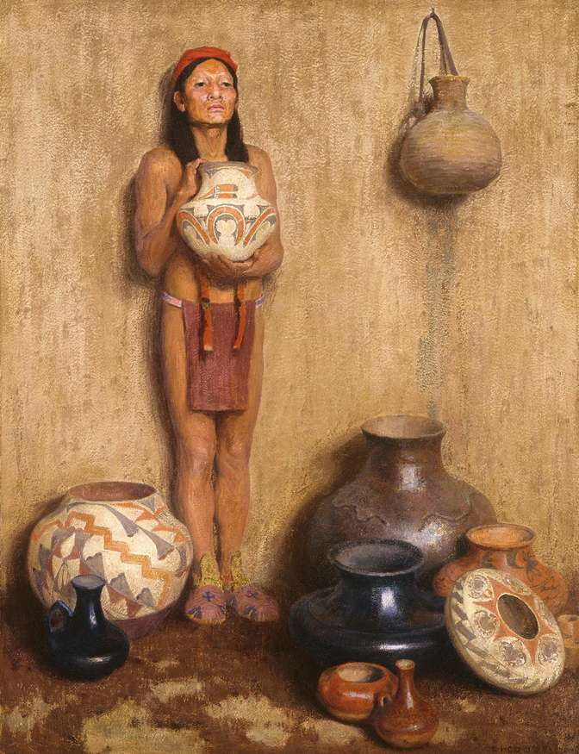
Figure 4.3 – E.I. Couse. Pottery Vendor

Eanger Irving Couse, Pottery Vendor, 1916, oil on canvas, 45 ½ x 34 ½ inches. The Eugene B. Adkins Collection at the Fred Jones Jr. Museum of Art, the University of Oklahoma, Norman, and the Philbrook Museum of Art, Tulsa, Oklahoma.

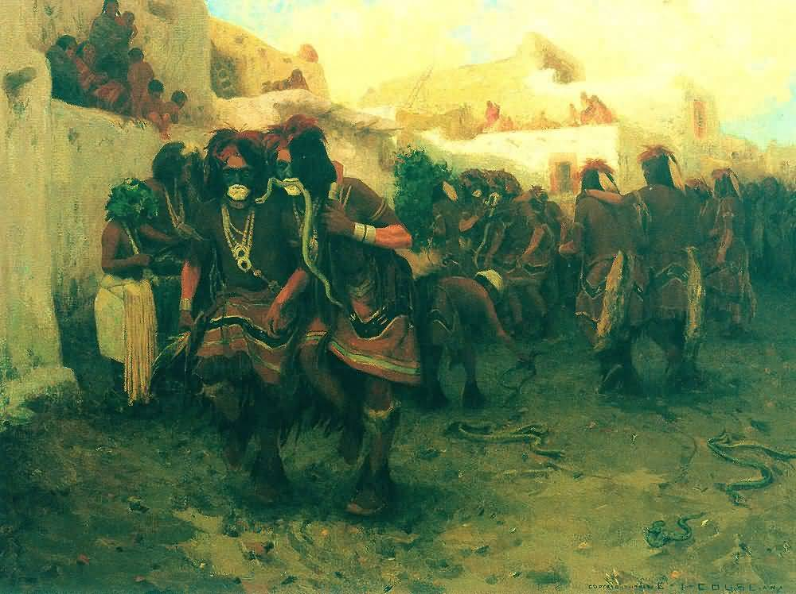
Figure 4.4 – E.I. Couse, Moki Snake Dance

Eanger Irving Couse, Moki Snake Dance, 1904, oil on canvas, 36 x 48 inches. Anschutz Collection, Denver. CO.

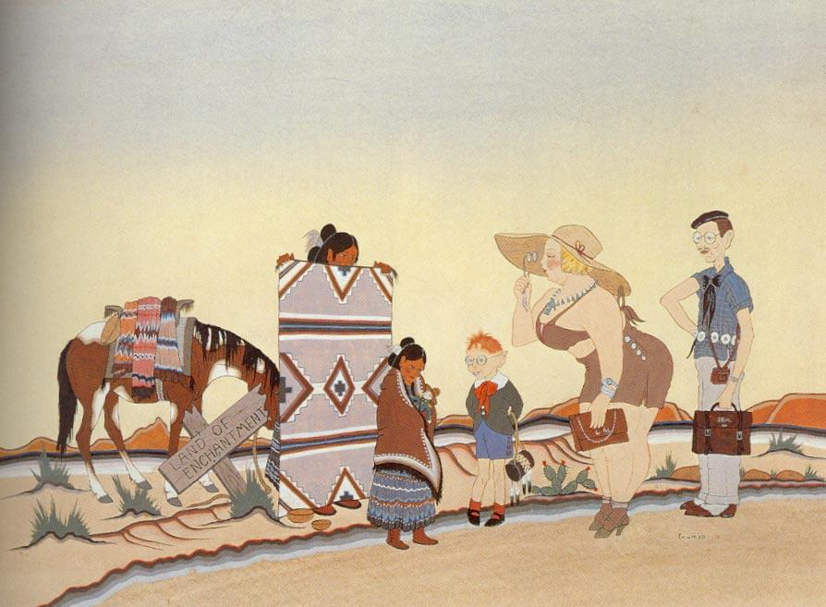
Figure 4.5 – Woody Crumbo, Land of Enchantment

Woody Crumbo, Land of Enchantment, 1946, watercolor on board, 17 ½ x 23 inches. Philbrook Museum of Art, Tulsa, OK.

Figure 4.6 – Walter Ufer, Land of Maňana

Walter Ufer, Land of Maňana, 1916, oil on canvas, 50 x 50 inches. Union League Club of Chicago.
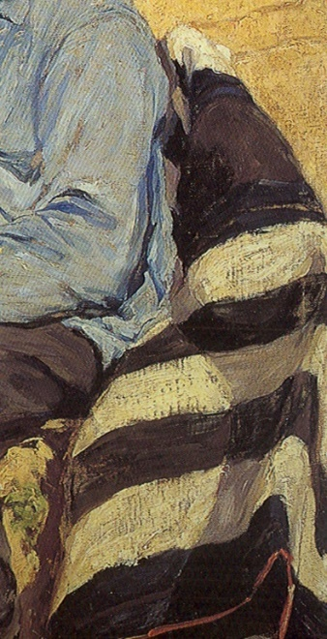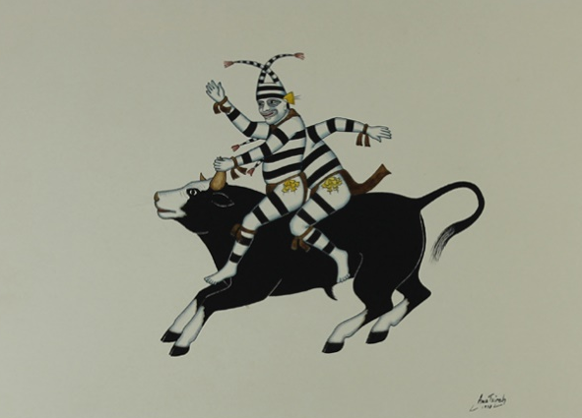
Figure 4.7 – Detail, Land of Maňana and Awa Tsireh, Bull and Koshare

Detail, Walter Ufer, Land of Maňana, 1916, oil on canvas, 50 x 50 inches. Union League Club of Chicago.

Awa Tsireh, The Bull and the Koshares, watercolor on paper, 1938. California Academy of Sciences.

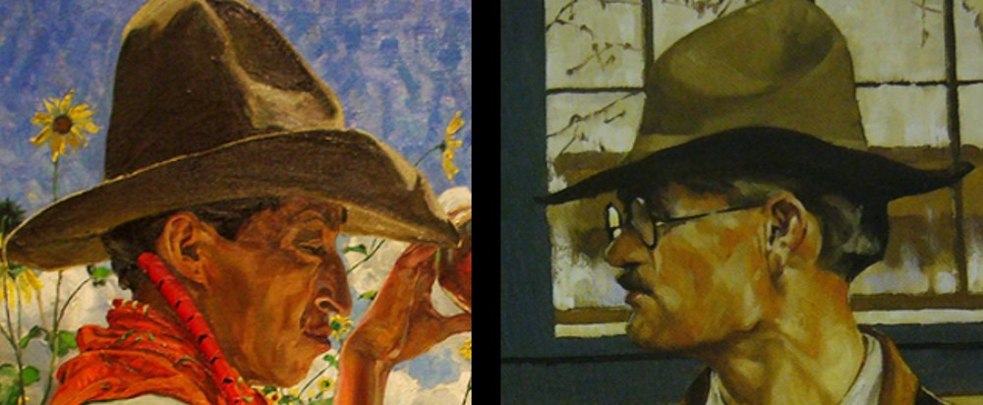
Figure 4.8 – Detail, Jim and His Daughters, and Detail, Self Portrait
Detail, Walter Ufer, Jim and his Daughter, 1923, oil on canvas, 30 x 25 inches. Chicago Art Institute; Detail, Walter Ufer, Self Portrait, 1923, oil on canvas, location unknown. Image – Christies.

Figure 4.9 – Walter Ufer, Going East

Walter Ufer, Going East, 1917, oil on canvas, 51 x 51 inches. The Eugene B. Adkins Collection at the Fred Jones Jr. Museum of Art, the University of Oklahoma, Norman, and the Philbrook Museum of Art, Tulsa, Oklahoma.

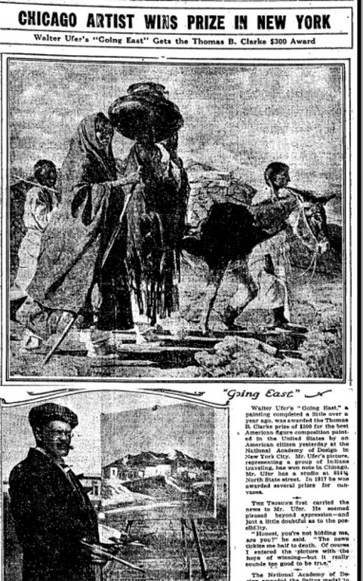
Figure 4.10 – Chicago Artist Wins Prize in New York

“Chicago Artist Wins Prize in New York, The Chicago Daily Tribune, March 11, 1918.

Figure 4.11 – Detail, Going East

Detail. Walter Ufer, Going East, 1917, oil on canvas, 51 x 51 inches. The Eugene B. Adkins Collection at the Fred Jones Jr. Museum of Art, the University of Oklahoma, Norman, and the Philbrook Museum of Art, Tulsa, Oklahoma.

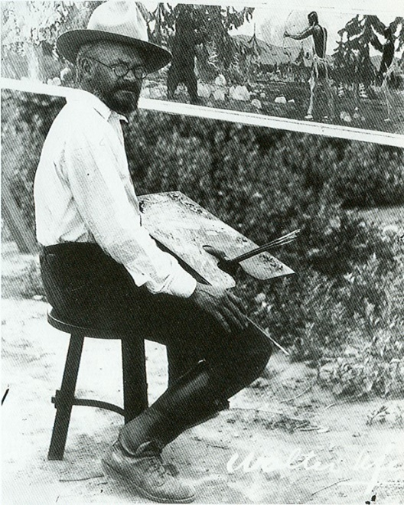
Figure 4.12 – Walter Ufer at His Easel

Walter Ufer at His Easel, c. 1920. Illustration from Dean Porter, et al., Taos Artists and Their Patrons, 1898-1950. Albuquerque, NM: University of New Mexico Press, 1999.

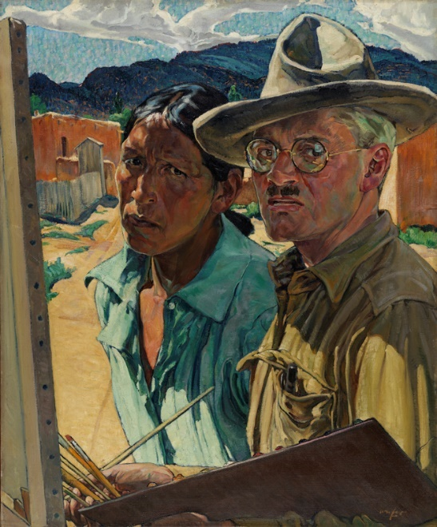
Figure 4.13 – Walter Ufer, Artist with Model

Walter Ufer, Artist with Model, c. 1920, oil on canvas, 30 x 25 inches. Pennsylvania Academy of Fine Arts.

Figure 4.14 – Walter Ufer, Luzanna and Her Sisters

Walter Ufer, Luzanna (Lousuanna Lujan) and Her Sisters, 1920, oil on canvas, 50 ^{1/8} x 50 ^{3/16} inches. Baltimore Art Museum.

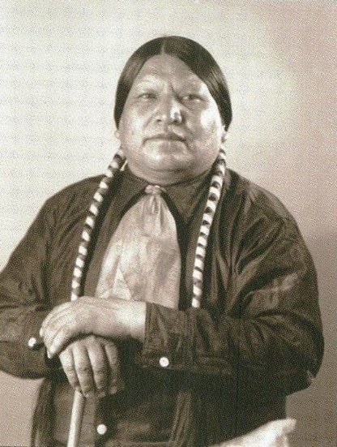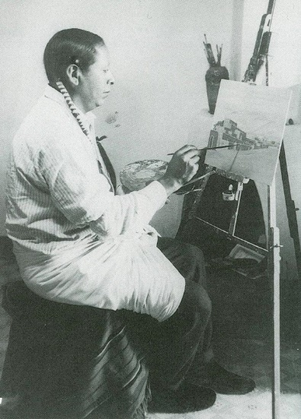
Figure 4.15 – Albert Lujan and Albert Looking Elk

(Left) Photograph of Albert Lujan. Illustration from Daid Witt et al, Three Taos Painters: Albert Looking Elk Martinez – Albert Lujan –Juan Mirabal. Santa Fe: Harwoood Museum of Art, 2003; (Right) Postcard of Albert Looking Elk, Governor of Taos Pueblo, 1938. Museum of New Mexico, Santa Fe. Illustration from Samuel Watson III, “Stylistic Plurality in the Paintings of Albert Looking Elk: An Examination of Patronage,” American Indian Art Magazine 20, no. 1 (Winter 1994): 62-69.

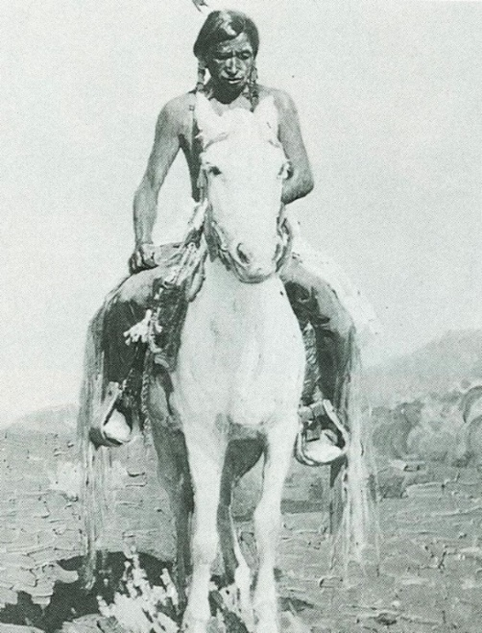
Figure 4.16 – Berninghaus, A Son of the War Chief

Oscar Berninghaus, A Son of the War Chief, oil on canvas. Untraced. Illustrated in Samuel Watson III, “Stylistic Plurality in the Paintings of Albert Looking Elk: An Examination of Patronage,” American Indian Art Magazine 20, no. 1 (Winter 1994): 62-69.

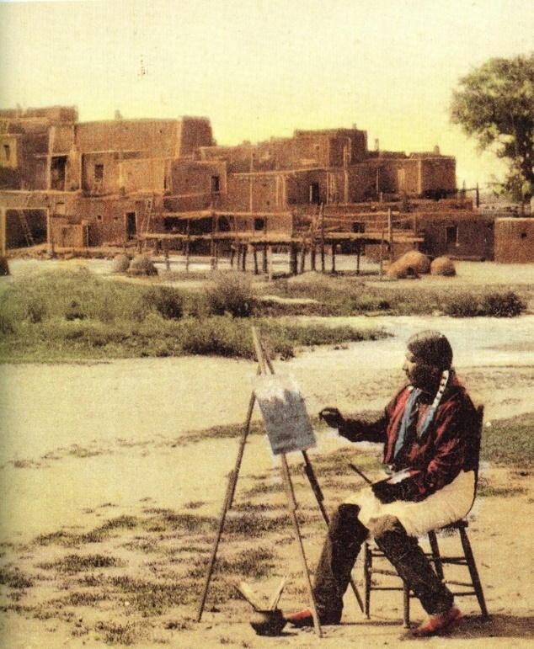
Figure 4.17 – Albert Lujan at Taos Pueblo

Postcard, Albert Lujan at Taos Pueblo, c. 1930. Collection of American Indian Art Magazine.

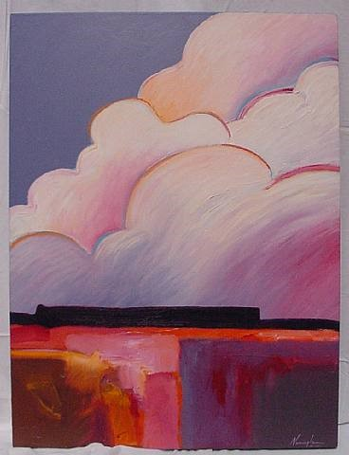
Figure 4.18 – Dan Namingha, Afternoon Rain Clouds

Dan Namingha, Afternoon Rain Clouds, 1987, Acrylic on canvas. Gallery Sam, accessed October 10, 2016. http://www.artnet.com/galleries/gallery-sam/artist-dan-namingha/

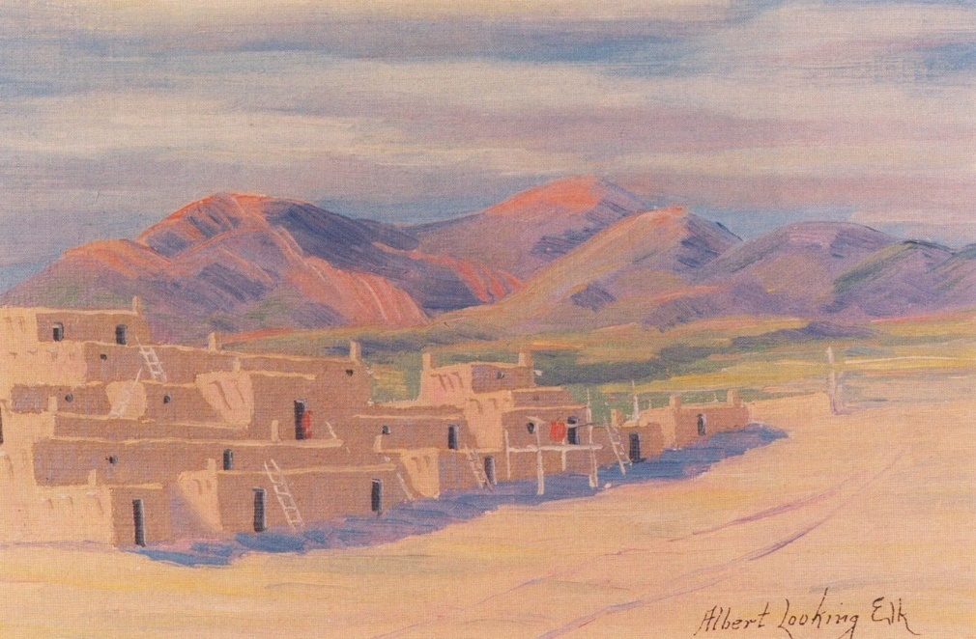
Figure 4.19 – Albert Looking Elk, Untitled (Taos Pueblo Scene)

Albert Looking Elk, Untitled (Taos Pueblo Scene), n.d., oil on board. School of American Research, Santa Fe, NM.

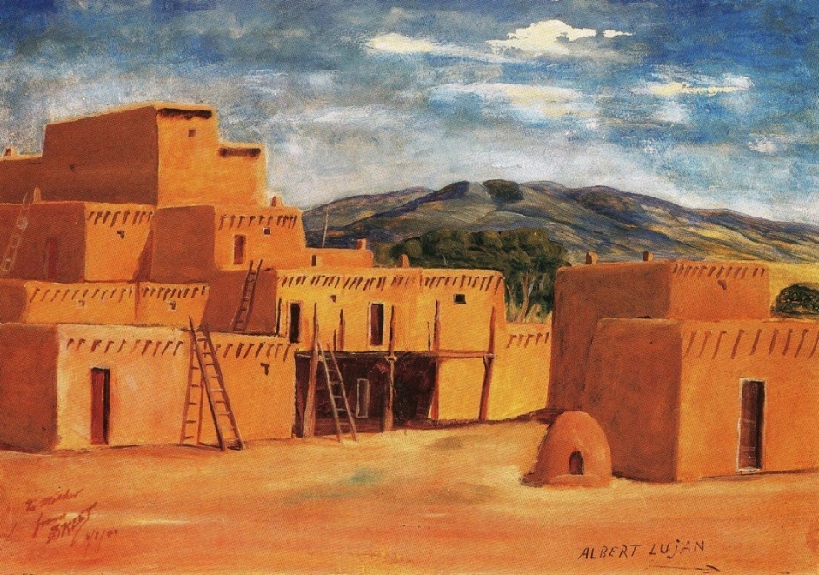
Figure 4.20 – Albert Lujan, View of Taos Pueblo

Albert Lujan, Untitled (View of Taos Pueblo), c. 1941, oil on canvas. National Cowboy Hall of Fame and Western Heritage Museum, Oklahoma City, OK.

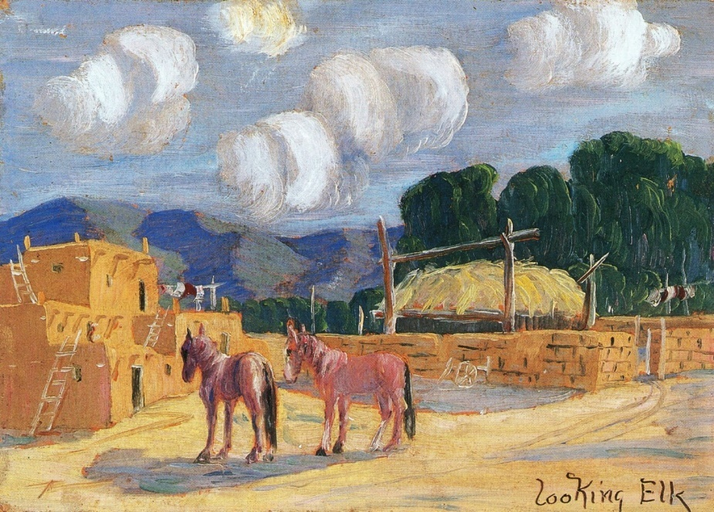
Figure 4.21 – Albert Looking Elk, Burros at Taos Pueblo

Albert Looking Elk, Burros at Taos Pueblo, c. 1928, 5 x 7 inches, oil on board. Philbrook Museum of Art, Tulsa OK.

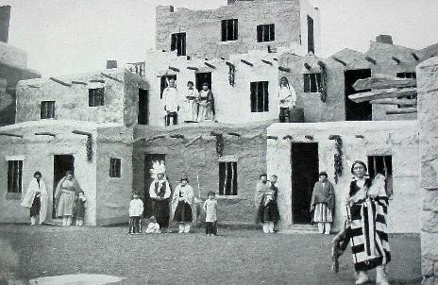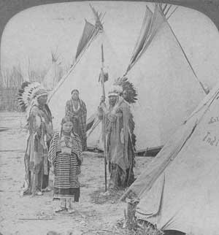
Figure 4.22 – “Cliff Dwellers” and “Cheyenne Chief & Family” exhibits

“Cliff Dwellers” and “Cheyenne Chief & Family” Exhibits, Louisiana Purchase Exposition, St. Louis, MO, 1904.

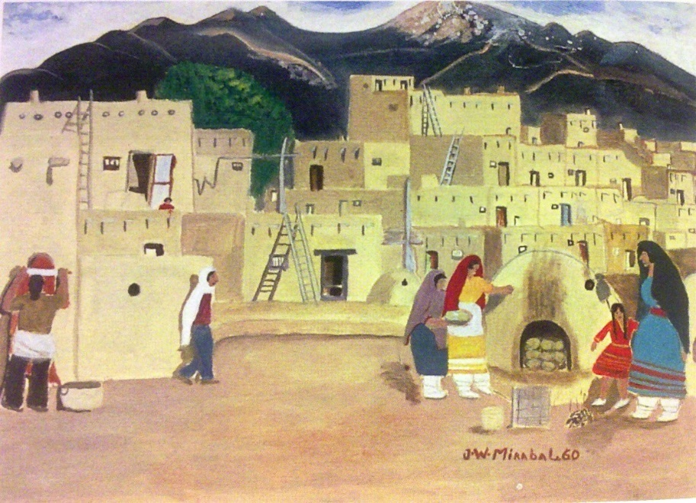
Figure 4.23 – Mirabal, Taos Pueblo Scene

Juan Mirabal, Untitled (Taos Pueblo Scene), no date, oil on panel. Private Collection.

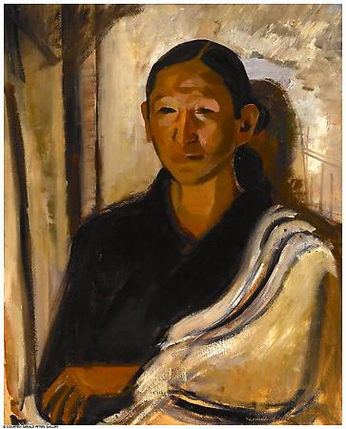
Figure 4.24 – Marjorie Eaton, Bust of Juan (Mirabal)

Marjorie Eaton, Bust of Juan (Mirabal), c. 1930, oil on board, 30 x 24 inches. Gerald Peters Gallery, Santa Fe, NM.

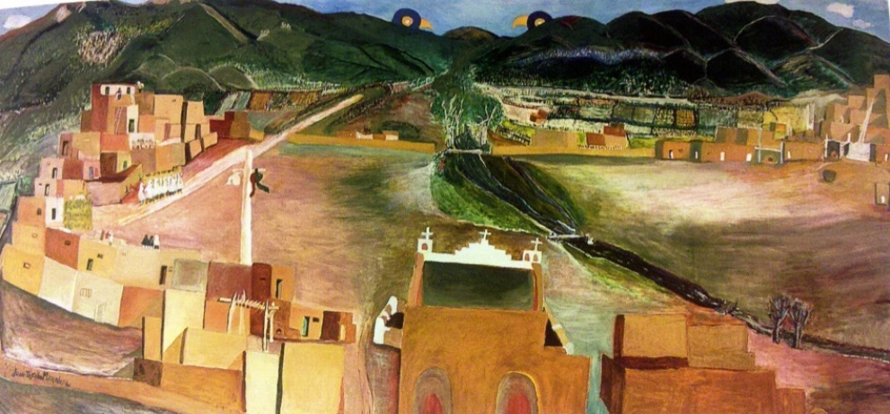
Figure 4.25 – Juan Mirabal, Taos Pueblo Scene

Juan Mirabal, Untitled (Taos Pueblo Scene), c. 1935, oil on panel. Harwood Museum of Art, Taos, New Mexico.

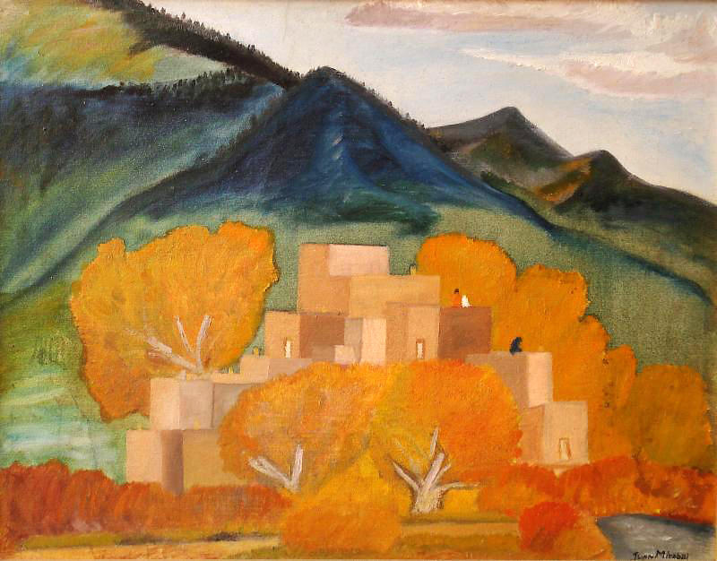
Figure 4.26 – Juan Mirabal, Fall at Taos Pueblo

Juan Mirabal, Fall at Taos Pueblo. c. 1930, oil on panel. Millicent Roger Museum, Taos, NM.

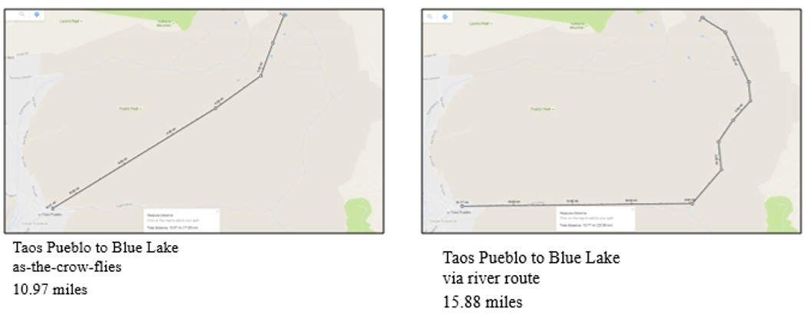
Figure 4.27 – Taos Pueblo to Blue Lake

Google Maps. Taos Pueblo to Blue Lake, accessed October 14, 2016, https:///www. google.com/maps

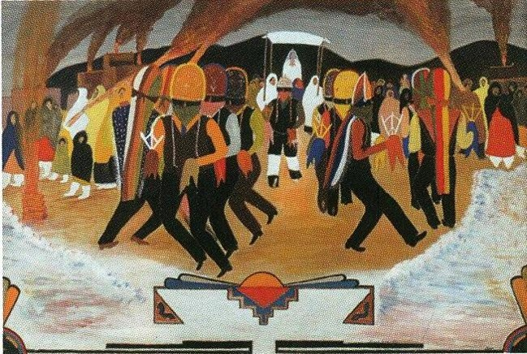
Figure 4.28 – Juan Mirabal, Xmass Eve

Juan Mirabal, Xmass Eve, c. 1932, oil o panel. Charlotte Mittler Collection.

Chapter 5 – Conclusion

Between 1885 and 1920, Indian Territory, the Hawaiian Islands, and New Mexico Territory shared many geopolitical characteristics that made them ideal for this study. Each area was marginal to the burgeoning American empire, yet would in time become vital. In each case, indigenous peoples were forced to accommodate white settlers under coercive conditions that threatened their sovereignty and culture. Finally, in each case, Euro-American artists made compelling images and texts of the people and the land, and in each case, Native peoples resisted the colonizing narrative through images and texts.
Yet in each case, interesting differences emerged, too. Indian Territory in the nineteenth century was composed of dozens of tribes and so the emerging voices of resistance were Cherokee, Creek, Kiowa and more. At first an overlooked place, by 1885 Indian Territory was a militarized contact zone ringed by would-be settlers. In contrast, American and European artists visited the Hawaiian Islands, a far distant outpost virtually unknown to westerners at the start of the century, in the 1880s and transformed Kilauea volcano into a premier tourist zone. Rather than through images, Hawaiians resisted via newspapers and hula. Like Hawai’i, artists visited New Mexico Territory in part to capitalize on romantic spectacle, in this case of the ancient Puebloan people of Taos. Some native models resisted, though, both through the art they were featured in and through their choice to take up a career as artists.
Moving forward, I believe that the American intra-colonial aesthetic identified and defined in this dissertation will help focus attention on the effects the contact zone has had on shaping the images and texts made in other marginalized areas. The intra-colonial aesthetic, seen in the light of America’s bourgeoning empire at the turn of the twentieth century, can be a useful tool to open up avenues of research for future scholars of art made in other colonial contact zones throughout the world.
Specific to the study of American art, the intra-colonial aesthetic could be useful in analyzing images and texts created both in the North American continent as well as in the nascent American territorial empire. At the same time the American global empire was spreading, the geography of the continental United States was solidifying into today’s map. Of particular interest, Arizona, admitted to the Union in 1912, and Alaska, admitted to the Union in 1959, faced similar, yet different, problems from Indian Territory. Both Arizona and Alaska started as far-west territories, and each faced the problems inherent in a contact zone, yet the unique history of each area and the vastly different geography of each should be served well by the flexible intra-colonial model.
Worldwide, in the aftermath of the 1898 Spanish-American War, Cuba briefly (1898-1902) and the Philippines for a much longer time (1898-1946) were part of the America imperial orbit. The case of the Philippines, ruled for three centuries by Spain, could be an especially profitable case study in the different responses to different colonial situations. In contrast, both Puerto Rico and Guam remain territorial possessions of the United States. Much as native Hawaiians still resist non-Hawaiian ways of knowing and using Kilauea, it would be interesting to compare and contrast historic and contemporary forms of resistance to colonialism as seen in art and texts in Guam and Puerto Rico.
The final area of research that could be furthered with this model is the “Scramble for Africa” and global colonialism from the 1870s to World War I. Although significant attention has been given to this topic, history and literary studies have tended to lead the way. What additional contributions can art historians make?

Bibliography
Adamson, Walter L. Hegemony and Revolution: A Study of Antonio Gramsci’s Political and Cultural Theory. Berkley, CA: University of California Press, 1980.

Alvarez, Joseph, ed. Mark Twain’s Geographic Imagination. Newcastle Upon Tyne: Cambridge Scholar, 2009.

“A Notable Picture: The Latest from the Brush of Jules Tavernier,” Pacific Commercial Advertiser, September 23, 1887. Accessed September 27, 2016. http://chronicli ngamerica.loc.gov/lccn/sn85047084/1889-06-21/ed-1/.

Bacca, Elmo. “Taos Pueblo Painters.” New Mexico Magazine 81, no 1 (January 2003): 64-68.

Bedell, Rebecca. The Anatomy of Nature: Geology and American Landscape Painting, 1825-1875. Princeton, NJ: Princeton University Press, 2001.

Banner, Stuart. “Preparing to Be Colonized: Land Tenure and Legal Strategy in Nineteenth-Century Hawaii.” Law and Society Review, 39, no. 2 (June 2005): 273-314.

Barrell, John. The Dark Side of the Landscape: The Rural Poor in English Paintings, 1730-1840. Cambridge: Cambridge University Press, 1983.

Barter, Judith A. Window on the West: Chicago and the Art of the New Frontier, 1890- 1940. Chicago: Art Institute of Chicago, and New York: Hudson Hills Press, 2003.

Beaulieu, Jill, and Mary Roberts, eds. Orientalism’s Interlocutors: Paintings, Architecture, Photography. Durham: Duke University Press, 2002.

Berlo, Janet, ed. The Early Years of Native American Art History: The Politics of Scholarship and Collecting. Seattle: University of Washington Press, 1992.

Bernstein, Bruce, and W. Jackson Rushing III. Modern by Tradition: American Indian Painting in the Studio Style. Albuquerque: Museum of New Mexico Press, 1995.

Bevins, Darcy, ed. On the Rim of Kilauea: Excepts from the Volcano House Register, 1865-1955. Honolulu: Hawai’i Natural History Association, 1992.

Bickerstaff, Laura M. Pioneer Artists of Taos. Denver: Old West Publishing Company, 1983.

Biographical History of Barton County, Kansas. Barton County: Great Bend Tribune, 1912.
Blumenschein, Ernest L., and Bert G. Phillips. “Appreciation of Indian Art.” El Palacio 6 (May 1919): 178-179.

Broder, Patricia Janice. Taos, A Painter’s Dream. Boston: New York Graphic Society, 1980.

“Boomer Movement.” Oklahoma Historical Society Encyclopedia of Oklahoma History and Culture. http://digital.library.okstate.edu/encyclopedia/entries/S/SP016.html (Accessed September 27, 2016).

Brody, David. Visualizing American Empire: Orientalism and Imperialism in the Philippines. Chicago: University of Chicago Press, 2010.

Brody, J.J. Indian Painters and White Patrons. Albuquerque, NM: University of New Mexico Press, 1971.

Bronner, Simon, ed. Consuming Visions: Accumulation and Display of Goods in America, 1880-1920. New York: W.W. Norton and Company, 1989.

Bryant, Keith L. “The Atchison, Topeka and Santa Fe Railway and the Development of the Taos & Santa Fe Art Colonies.” The Western History Quarterly 9, no. 4 (October 1978): 437-453.

Bulington, Judy James Bellamy. “The Artist-as-Traveler and Expanding Horizons of American Cosmopolitanism in the Gilded Age.” PhD diss., Indiana University, 1997.

Cahill, E.H. “American Has Its Primitives.” International Journal 75 (March 1920): 80-83.

California World’s Fair Corporation. Final Report of the California World’s Fair Commission, Including a Description of All Exhibits from the State of California, Collected and Maintained Under Legislative Enactments, at the World’s Columbian Exposition Chicago, 1893. Sacramento: State Office, 1894.

Callcott, Maria, George Anson Byron, and Richard Rowland Bloxam. Voyage of H.M.S. Blonde to the Sandwich Islands, in the Years 1824-1825. London: J. Murray, 1826.

Cameron, William E., Thomas W. Palmer, and Frances E. Willard. The World’s Fair, Being a Pictorial History of the Columbian Exposition. Grand Rapids: P.D. Farrell & Co., 1893.

Carrier, James. “Occidentalism: The World Turned Upside-Down.” America Ethnologist 19, no. 2 (1992):195–212.

George Catlin. Letters and Notes on the Manners, Customs, and Traditions of the North American Indians. London: Egyptian Hall, Piccadilly, 1841, and New York: Dover, 1973. 2 volumes.

Champney Sketches MSS Archive. Lilly Library Manuscript Collections. Lilly Library, Indiana University. Accessed September 27, 2016. http://www.indiana.edu/ ~liblilly/ lilly/mss/html/champnsk.html.

Chang, David. The Color of the Land: Race, Nation, and the Politics of Landownership in Oklahoma, 1832-1929. Raleigh: University of North Carolina Press, 2010.

Chapin, Helen G. “Newspapers of Hawai’i 1834 to 1903: From He Liona to the Pacific Cable,” Hawaiian Journal of History 18 (1984): 47-86.

Charlot, John. “Pele and Hi‘iaka: The Hawaiian-Language Newspaper Series.” Anthoropos 93 (1998): 60.

Chave, Anna C. “O’Keefe and the Masculine Gaze.” In Marianne Doezema and Elizabeth Milroy, eds. Reading American Art. New Haven: Yale University Press, 1998, 350-370.

Cherokee Nation. “Nearly 100 Years Later: The Cherokee Advocate Newspaper Printing Press Returns to Cherokee Nation.” http://www.cherokeenation.org /News/Stories/24204.aspx, accessed August 16, 2016.

“Chicago Artist Wins Prize in New York.” Chicago Daily Tribune. March 12, 1918.

Chon, Kye-Sung. “Tourism Destination Image Modification Process: Marketing Implications.” Tourism Management 12, no. 1 (March 1991): 68-72.

Clark, Thomas D. Travels in the New South, A Bibliography. Norman, OK: University of Oklahoma Press, 1962.

Collins, Bradford. “The Dialectic of Desire, the Narcissism of Authorship: A Male Interpretation of the Psychological Origins of Manet’s Bar.” In Bradford Collins, ed. 12 Views of Manet’s Bar. Princeton, NJ: Princeton University Press, 1995.

Conzon Michael P. Mapping Manifest Destiny: Chicago and the American West. Chicago: Newberry Library, 2007.

Couse Archive. Correspondence, Eliseo Lujan to Virginia Couse Leavitt, 1984.
E.I. Couse Foundation, Taos, NM.

Curtis, Natalie. “The Perpetuation of Indian Art. Outlook (November 22, 1913): 623.

Denzin, Norman K. Indians in Color: Native Art, Identity, and Performance in the New West. London: Routledge, 2015.

Desmond, Jane C. Staging Tourism: Bodies on Display from Waikiki to Sea World. Chicago: University of Chicago Press, 1999.

Derrida, Jacques Of Grammatology. Translated by Gayatri Chakravorty Spivak. Baltimore: The Johns Hopkins University Press, 1976.

Dilworth, Leah. Imagining Indians in the Southwest: Persistent Visions of a Primitive Past. Washington and London: Smithsonian Institution Press, 1996.

Dippie, Brian. Catlin and His Contemporaries: The Politics of Political Patronage. Lincoln: University of Nebraska Press, 1990.

Duncan, W. A. “The Great Question.” Cherokee Advocate. April 3, 1885, n.p. 19th Century U.S. Newspapers. http://find.galegroup.com (accessed August 16, 2016.)

_____ “Things as They Are.” Cherokee Advocate. January 9, 1885, n.p. 19th Century U.S. Newspapers. http://find.galegroup.com (accessed August 16, 2016.)

Dunn, Dorothy. American Indian Painting of the Southwest and Plains Area. Albuquerque, NM: University of New Mexico Press, 1968.

Eldredge, Charles, Julie Schimmel, and William Truettner. Art in New Mexico, 1900- 1945: Paths to Taos and Santa Fe. Santa Fe: Santa Fe Museum of Fine Arts, 1986.

_____. “Ernest Blumenschein’s The Peacemaker: Native Americans, Greeks, and Jurisprudence circa 1913.” American Art 15, no. 1 (Spring 2001): 35-51.

Emerson, Nathanial B. Pele and Hiiaka, A Myth from Hawai’i. Hilo: Edith Kanaka’ole Foundation, 1993.

Ewing, Robert Nichols. Jules Tavernier (1844-1889): Painter and Illustrator. PhD diss., University of California, Los Angeles, 1978.

Exhibition of Recent Paintings by Walter Ufer. New York: Macbeth Gallery, 1928.

Fenn, Forrest. Teepee Smoke: A New Look into the Life and Work of Joseph Henry Sharp. Santa Fe: One Horse Land and Cattle Company, 2009.

Field, Isobel. This Life I’ve Loved. New York: Longmans, Green and Company, 1941.

Foster, George E. "Zig-Zag Journey Indian Territory." Frank Leslie's Illustrated Newspaper (New York). August 11, 1888: 417+. Accessed September 28, 2016. 19th Century U.S. Newspapers. http://find.galegroup.com.

Fifield, James Clark, ed. American Bar: A Biographical Directory of Contemporary Lawyers of the United I States and Canada. Minneapolis and New York: The James C. Fifield Company, 1922.

Foucault, Michel. Discipline and Punish: The Birth of the Prison. New York: Vintage Books, 1995.

Forbes, David W. Encounters with Paradise: Views of Hawaii and its People, 1778 -1941. Honolulu: Honolulu Academy of Arts, 1992.

Fried, Michael. Courbet’s Realism. Chicago and London: University of Chicago Press, 1990.

Frost, Richard. “The Romantic Inflation of Pueblo Culture.” American West 17 (Jan.- February 1980): 5-9; 56-60.

Furneaux, Charles. Narrative of the Lava Flow of 1880-1. Manuscript, Hawaiian Historical Society Library, Honolulu, HI.

Garrison, Tim. “Pan-Nationalism as a Crisis Management Strategy: John Ross and the Tahlequah Conference of 1843.” In Lisa Ford, Tim Rowse, and Anna Yeatman, eds. Between Indigenous and Settler Governance, 48-59. London: Routlege, 2012.

Gilliland, T. S. "Oklahoma Land Question." Cherokee Advocate, February 20, 1885: n.p. 19th Century U.S. Newspapers. Accessed September 28, 2016.

Glischinski, Steve. Santa Fe Railroad. Osceola, WI: Motor Books International, 1997.

Goetzmann, William H. and William N. The West of the Imagination. 2nd Ed. Norman: University of Oklahoma Press, 2009.

Graburn, Nelson H. H., ed. Ethnic and Tourist Arts: Cultural Expressions for the Fourth World. Berkeley: University of California Press, 1979.

Gramsci, Antonio. Selections from the Prison Notebooks of Antonio Gramsci. Edited and translated by Quinton Hoare and Geoffrey Nowell Smith. New York: International Publishers, 1971.

Greeson, Jennifer Rae. “Expropriating ‘The Great South’ and Exporting ‘Local Color’: Global and Hemispheric Imaginaries of the First Reconstruction.” American Literary History 18, no. 3 (Fall 2006): 496-520.

_____. “The Figure of the South and the Nationalizing Imperatives of Early United States Literature.” The Yale Journal of Criticism 12, no. 2 (1999): 209-248.

Gregory, Derek. “Imaginative Geographies.” Progress in Human Geography 19, no. 4 (1995): 447-485.

Greene, Candice S. Silver Horn: Master Illustrator of the Kiowas. Norman, OK: University of Oklahoma Press, 2001.

Hechter, Michael. Internal Colonialism: The Celtic Fringe in British National Development, 1536-1966. Berkley: University of California Press, 1975.

Hage, Ghassan. “The Spatial Imaginary of National Practices: Dwelling Domesticating / Being –Exterminating.” Environment and Planning D: Society and Space 14 (1996): 463-485.

Haltman, Kenneth. Looking Close and Seeing Far: Samuel Seymour, Titian Ramsay Peale, and the Art of the Long Expedition, 1818-1823. University Park, PA: Pennsylvania State University Press, 2008.

Hartley, Marsden. “Aesthetic Sincerity.” El Palacio 5 (December 9, 1918): 332-333.

_____. “America as Landscape.” El Palacio 5 (December 21, 1918): 340-42.

_____. “Red Man Ceremonials: An American Plea for American Esthetics.” Art and Archaeology 9 (January 1920): 7-14.

_____. “The Scientific Esthetic of the Redman.” Art and Archaeology 13 (March 1922): 113-119.

_____. “Tribal Esthetics.” The Dial 65 (November 1918): 399-401.

Hassrick, Peter, and Elizabeth Cunningham. In Contemporary Rhythm: The Art of Ernest L. Blumenschein. Norman: University of Oklahoma Press, 2008.

“Hawai’i’s Wonder – Jules Tavernier’s Great Panorama of Kilauea.” Pacific Commercial Advertiser (Honolulu). June 21, 1889. http://chroniclingamerica. loc.gov/lccn/sn85047084/1889-06-21/ed-1/ (Accessed September 27, 2016).

Henderson, Alice Corbin. “A Boy Painter Among the Pueblo Indians and Unspoiled Native Work.” New York Times Magazine (September 6, 1925): 18-19.

_____. “Crescencio Martinez –Artist.” El Palacio 5 (August 3, 1918): 67-69.

_____. “Native American Artists.” Art and Archaeology 13 (March 1922): 103-112.

Hewett, Edgar. “Native American Artists.” Art and Archaeology 13, no. 3 (March 1922): 103-112.

Hogue, Alexandre. “Pueblo Tribes Aesthetic Giants, Indian Art Reveals,” El Palacio 24, no. 12 (1928): 214-218.

Hoving, Thomas. The Art of Dan Namingha. New York: Harry N. Abrams, 2000.

Howard, William Willard. “The Rush to Oklahoma,” Harper's Weekly 33 (May 18, 1889): 391-94.

Hsu, Hsuan. “Literature and Regional Production.” American Literary History 17, no. 1 (Spring 2005): 36-69.

Hughes, Edan Milton. Artists in California, 1786-1940, L-Z. Sacramento: Crocker Art Museum, 2002.

Ikemoto, Wendy Nalani Emiko. The Space Between: Paired Paintings in Antebellum America. PhD diss., Harvard University, 2009.

Imada, Adria L. Aloha America: Hula Circuits Through the U.S. Empire. Durham and London: Duke University Press, 2012.

_____. “Transnational Hula as Colonial Culture.” The Journal of Pacific History 46, no. 2 (September 2011): 149-176.

Isaac, Gwyneira. Mediating Knowledges: Origins of a Zuni Tribal Museum. Tucson, AZ: University of Arizona Press, 2007.

Jackson, A.P., and Elrick C. Cole. Oklahoma! Politically and Topographically Described: History and Guide to the Indian Territory: Biographical Sketches of Capt. David L. Payne, W.L. Couch, WM.H. Osborn, and Others. Kansas City: Ramsey, Millett and Hudson, 1885.

Jackson, Frances. National Parks in Hawaii: 50 years, 1916-1966; A Short History of Hawaii Volcanoes National Park, Haleakala National Park. Honolulu: Hawaii Natural History Association, 1966.

James, Edwin, Stephen H. Long, and Thomas Say. Account of an Expedition from Pittsburgh to the Rocky Mountains, Performed in the Years 1819, 1820. London: Longman, Hurst, Rees, Orme, and Brown,1823. Vol. III. https://books.google. (accessed July 20, 2016).

“James Wells Champney Papers.” Henry N. Flynt Library, Deerfield, MA. http://library.historic-deerfield.org (accessed June 4, 2014).

Jansson, David R. “Internal Orientalism in America: W.J. Cash’s ‘The Mind of the South’ and the Spatial Construction of American National Identity.” Political Geography 22 (2003): 293–316.

Judd, Laura Fish, and Dale Lowell Morgan. Honolulu: Sketches of Life in the Hawaiian Islands from 1828 to 1861. Chicago, IL: Lakeside Press, 1966.

“Jules Tavernier,” Pacific Commercial Advisor, Nov. 11, 1884. Accessed September 27, 2016. http://chroniclingamerica.loc.gov/lccn/sn85047084/1889-06-21/ed-1/.

Justice, Daniel Heath. Our Fire Survives the Storm: A Cherokee Literary History. Minneapolis: University of Minnesota Press, 2006.

Kaeppler, Adrienne. “Rembrandt Peale’s Hawaiian Ethnographic Still Life.” The Hawaiian Journal of History 27 (1993): 227-238.

Kaplan, Amy. The Anarchy of Empire in the Making of US Culture. Cambridge: Harvard University Press, 2002.

Kasay, Jennifer Fish. “Agents of Imperialism: Missionaries and Merchants in Early- Nineteenth-Century Hawaii.” The New England Quarterly 80, no. 2 (June 2007): 280-298.

KHON 2 TV. “Group Starts Continuous Protest of Telescope on Manua Kea,” http:// khon2.com/2015/03/26/groups-start-continuous-protest-of-telescope-on-mauna- kea/ (accessed May 10, 2015).

Kilauea Visitor Center. “Plan Your Visit.” http://www.nps.gov/havo/planyourvisit/ kvc.htm (accessed July 11, 2011).

Kilpatrick, Jacquelyn. Celluloid Indians: Native Americans and Film. Lincoln, NE: University of Nebraska Press, 1999.

Kinietz, William Vernon. John Mix Stanley and his Indian Paintings. Ann Arbor: University of Michigan Press, 1942.

King, Edward. The Great South: A Record of Journeys in Louisiana, Texas, the Indian Territory, Missouri, Arkansas, Mississippi, Alabama, Georgia, Florida, South Carolina, North Carolina, Kentucky, Tennessee, Virginia, West Virginia, and Maryland. Hartford: American Publishing Co., 1875.

King, Edward. The Great South, edited by W. Magruder Drake and Robert R. Jones. Baton Rouge: Louisiana State Press, 1972.
Kirshenblatt-Gimblett, Barbara. Destination Culture: Tourism, Museums, and Heritage. Berkley, CA: University of California Press, 1998.

Kraft, James, and Helen Farr Sloan. John Sloan in Santa Fe. Washington, DC: Smithsonian Institution, 1981.

Ladd, Barbara. Nationalism and the Color Line in George W. Cable, Mark Twain, and William Faulkner. Baton Rouge: Louisiana State University Press, 1996.

Lawrence, D.H. “America, Listen to Your Own.” New Republic 25 (December 15 1920): 69.

_____. “Just Back from the Snake Dance –Tired Out.” Laughing Horse no. 11 (September 1924): n.p.

Lawrence, Ernest R. Alone with the Past: The Life and Photographic Art of Roland W. Reed. Afton, MN: Afton Historical Society Press, 2012.

Leavitt, Virginia. Eanger Irving Couse: Image Maker for America. Albuquerque: Albuquerque Museum, 1991.

Leeds, Valerie. Robert Henri in Santa Fe: His Work and His Influence. Santa Fe: Gerald Peters Gallery, 1998.

Lekisch, Barbara. Embracing Scenes About Lakes Tahoe and Donner: Painters, Illustrators, and Sketch-Artists, 1855-1915. Lafayette: Great West Books, 2003.

Lewis, Lloyd D. “Untitled,” Chicago Herald. February 3, 1917.

Lindstrom, Richard. “‘Not from the Land Side, but from the Flag Side’: Native American Responses to the Wanamaker Expedition of 1913.” Journal of Social History. 30, no. 1 (1996): 209-227.

“Local News” The Daily Honolulu Press, September 22, 1885. Accessed September 27, 2016. http://chroniclingamerica.loc.gov/lccn/sn85047084/1889-06-21/ed-1/.

Luhan, Mabel Dodge. “Awa Tsireh.” The Arts 11 (June 1927): 298-300.

_____. “A Bridge Between Cultures.” Theater Arts Monthly 9 (May 1925): 297-301.

_____. Edge of Taos Desert – An Escape to Reality. New York: Harcourt, Brace & Co., 1937.

Lukavic, John. Southern Cheyenne Orthodoxy; A Study in Materiality. PhD diss., University of Oklahoma, 2012.

Lunquiens, H.M. “Jules Tavernier,” Honolulu Academy of Arts Annual Bulletin 2 (1940): 29.

Lyman, Christopher M. Vanishing Race and other Illusions: Photographs of Indians by Edward S. Curtis. Washington, DC: Smithsonian Institution Press, 1982.

MacCannell, Dean. The Tourist: A New Theory of the Leisure Class. Berkley: University of California Press, 1999.

MacDonald, Gordon A., and Douglass H. Hubbard, Volcanoes of the National Park in Hawaii, 5th edition, Honolulu: Hawaii Natural History Association, 1970.

Maier, Steven. Jules Tavernier: Hawai’i’s First Real Painter. Honolulu 31 (1996): 80- 84, 93.

Marcus, George E., and Fred R. Myers. The Traffic in Culture: Refiguring Art and Anthropology. Berkley: University of California Press, 1995.

Eyewitness to History, “Massacre at Wounded Knee, 1890,’ Accessed January 25, 2015. http://www.eyewitnesstohistory.com/knee.htm.

McCoy, Joseph G. Historic Sketches from the Cattle Trade of the West and Southwest. Kansas City: Ramsey, Millett, and Hudson, 1874.

McGeough, Michelle. Through Their Eyes: Indian Painting in Santa Fe, 1918-1945. Santa Fe: Wheelwright Museum of the American Indian, 2009.

McKnight, David. “The Australian Aborigines, in Anthropology,” In Richard Fardon, ed. Localizing Strategies: Regional Traditions of Ethnographic Writing, 58. Washington DC: Smithsonian Institution Press, 1990.

Meinig, D.W. The Shaping of America: A Geographic Perspective on 500 Years of History, Volume 2: Continental America, 1800-1867. New Haven: Yale University Press, 1993.

Meyers, Fred. “‘Primitivism,’ Anthropology and the Category of ‘Primitive Art’,” in Chris Tilley, Susanne Kuechler, Michael Rowlands, Webb Keane and Patricia Spyer, eds. Handbook of Material Culture, 267-284. New York: Sage Press, 2006.

Miller, Angela. The Empire of the Eye: Landscape Representation and American Cultural Representation –1825-1875. Ithaca: Cornell University Press, 1995.

Moore, James. “Ernest Blumenschein's Long Journey with Star Road.” American Art 9, no. 3 (Fall 1995): 7-27.

"Moving on Oklahoma Boomers." Cherokee Advocate, January 8, 1885: n.p.

National Archives and Records Administration. “Dawes Act 1887.” OurDocuments.gov. (Accessed July 2, 2016).

New Zealand Electronic Text Centre. “Explorers of the Pacific: European and American Discoveries in Polynesia: George Anson Byron.” http://www.nzetc.org/ tm/ scholarly/tei-BucExpl-t1-body-d20-d4.html (accessed May 3, 2011).

Nemerov, Alexander. The Body of Raphaelle Peale: Still Life and Selfhood, 1812-1824. Berkley: University of California Press, 2001.

Nemerov, Alexander. Frederic Remington and Turn-of-The-Century America. New Haven: Yale University Press, 1995.

Osorio, Jonathan. Dismembering Lāhui: A History of the Hawaiian Nation to 1887. Honolulu: University of Hawai’i Press, 2002.

Ott, John. Local Color: The Taos Society of Artists and the Marketing of Ethnicity. Master’s Thesis. University of California, Los Angeles, 1996.

_____. “Reform in Redface: The Taos Society of Artists Plays Indian.” American Art 23, no. 2 (Summer 2009): 80-107.

Paasi, Anssi. Territories, Boundaries, and Consciousness: The Changing Geographies of the Finnish- Russian Borders. Chichester: John Wiley & Sons, 1996.

Pacific Reporter, Volume 35, Containing all the Decisions of the Supreme Courts of California, Kansas, Oregon, Colorado, Washington, Montana, Arizona, Nevada, Idaho Wyoming, Utah, New Mexico, Oklahoma and Court of Appeals Colorado. St. Paul: West Publishing Co., 1894.

Parsons, Elsie Clews. Taos Pueblo. New York and London: Johnson Reprint Corporation, 1970.

Peck, James, ed. In the Studios of Paris: William Bouguereau and His American Students. Tulsa, OK: Philbrook Museum of Art, 2006.

Peckham, Harry Houston. Josiah Gilbert Holland in Relation to His Times. Philadelphia: University of Pennsylvania Press, 1940.

Peixotto, Ernest. “The Taos Society of Artists.” Scribner’s Magazine 60 (August 1916): 257.

Perdue, Theda, and Michael D. Green. The Cherokee Removal: A Brief History with Documents. Boston: Bedford/St. Martin's, 2005. 2nd edition.

Philbrick, Nathanial. Sea of Glory: America’s Voyage of Discovery, the U.S. Exploring Expedition, 1838-1842. NY: Viking Press, 2003.

Pinney, Christopher, and Nicolas Peterson, eds. Photography’s Other Histories. Durham: Duke University Press, 2003.

Pollock, Griselda. “Feminism/Foucault – Surveillance/Sexuality.” In Norman Bryson, Michael Ann Holly, and Keith Moxley, eds. Visual Culture: Images and Interpretations,1-41. Hanover and London: Wesleyan University Press, 1994.

Porter, Dean. “Reevaluating Walter Ufer.” Southwest Art 29, no. 11 (April 2000): 84-7, 136.

_____ et al., Taos Artists and Their Patrons, 1898-1950. Albuquerque, NM: University of New Mexico Press, 1999.

Pratt, Mary Louis. Imperial Eyes: Travel Writing and Transculturation. London and New York: Routledge Press, 2008. 2nd edition.

Prown, Jules. “Mind in Matter: An Introduction to Material Culture Theory and Method,” Wintertur Portfolio 17 (Spring 1982): 1-19.

_____. “Style as Evidence,” Wintertur Portfolio 15 (Autumn, 1980): 197-210.

_____, and Kenneth Haltman, eds. American Artifacts: Essays in Material Culture. East Lansing: Michigan State University Press, 2000.

Riley, Michael J. “Trapped in the History of Film: Racial Conflict and Allure in the Vanishing American,” in Peter C. Rollins and John E. O’Connor, eds. Hollywood’s Indian: The Portrayal of the Native American in Film, 58-72. Lexington, KY: The University Press of Kentucky, 2003.

Richardson, Albert D. Beyond the Mississippi: From the Great River to the Great Ocean. Hartford: American Publishing Co., 1867.

Robertson, Jennifer. "Mon Japon: The Revue Theater as a Technology of Japanese Imperialism." American Ethnologist 22, no. 4 (November 1995): 973.

Rodriguez, Sylvia. “Art, Tourism, and Race Relations in Taos: Toward a Sociology of the Art Colony.” Journal of Anthropological Research 45, no. 1 (Spring 1989): 77-99.

Round, Phillip H. Removable Type: Histories of the Book in Indian Country, 1663- 1880. Chapel Hill, NC: The University of North Carolina Press, 2010.

Rubin, Louis B. George Washington Cable: The Life and Times of a Southern Heretic. New York: Pegasus, 1969.

Rudnick, Lois P. Mabel Dodge Luhan: New Woman, New World. Albuquerque: University of New Mexico press, 1987.

____________. Utopian Vistas: The Mabel Dodge Luhan House and the American Counterculture. Albuquerque: University of New Mexico Press, 1996.

Rushing III, W. Jackson. “Marketing the Affinity of the Primitive and the Modern: René d’Harnoncourt and ‘Indian Art of the United States,’” in Janet Berlo, ed. The Early Years of Native American Art History: The Politics of Scholarship and Collecting, 191-236. Seattle, WA: University of Washington Press, 1992.

_____. Native American Art and the New York Avant-Garde: A History of Cultural Primitivism. Austin: University of Texas Press, 1995.

_____. “Native Authorship in Edward Curtis's "Master Prints." American Indian Art Magazine 29, no. 1 (Winter 2003): 58-63.

Rushing III, W. Jackson. ed., Native American Art in the Twentieth Century, London and New York: Routledge, 1999.

Said, Edward. Culture and Imperialism. New York: Random House, 1993.

_____. Orientalism. New York: Vintage Books, 2003.

_____. “Secular Interpretation, The Geographic Element, and the Methodology of Imperialism,” in Gyan Prakash, ed. After Colonialism: Imperial Histories and Postcolonial Displacements, 21-39. Princeton, NJ: Princeton University Press, 1995.

Sanders, Gordon. Oscar Berninghaus: Mater Painter of American Indians and The Frontier West. Taos: Taos Heritage Publishing, 1985.

Sanjek, Roger. “The Ethnographic Present,” Man 26, no. 4 (December 1991): 612.
Sanweiss, Martha. Print the Legend: Photography and the American West. New Haven: Yale University Press, 2002.

Schein, Louisa. “Gender and Internal Orientalism in China.” Modern China 23, no. 1 (January1997): 69-98.

Schimmel, J. and R.R. White. Bert Geer Phillips and the Taos Art Colony. Albuquerque: University of New Mexico Press, 1994.

Schroeder, Jonathan E., and Janet L. Borgerson. “Packaging Paradise: Organizing Representations of Hawaii,” in A. Prasad, ed. Against The Grain: Advances in Postcolonial Organization Studies, 32-53. Copenhagen: Liber & Copenhagen Business School Press, 2012.

Scott, Sascha. Painting of Pueblo Indians and the Politics of Preservation in the American Southwest. PhD diss., Rutgers University, 2008. http://dx.doi.org/doi: 10.7282/T3571CCX (accessed September 4, 2011).

Severson, Don R., Michael D. Horikawa, and Jennifer Saville. Finding Paradise: Island Art in Private Collections. Honolulu: Honolulu Academy of Arts, University of Hawaii Press, 2003.

Shields, Scott A., Claudine Chalmers, and Alfred C. Harrison, Jr. Jules Tavernier: Artist and Adventurer. Portland: Pomegranate, 2013.

Silva, Noenoe K. Aloha Betrayed: Native Hawaiian Resistance to American Colonialism. Durham & London: Duke University Press, 2004.

Sloan, John. "The Indian Dance from an Artists Point of View.” Arts and Decoration 20 (January 1924): 17, 56.

_____. “Modern Art is Dying.” Echo 4 (December 1926): 22-23.

Slotkin Richard. The Gunfighter Nation: Myth of the Frontier in Twentieth Century America. Norman: University of Oklahoma Press, 1998.

Smith, Thomas Brent. A Place in the Sun: The Southwest Paintings of Walter Ufer and E. Martin Hennings. Norman: University of Oklahoma Press, 2016.

Spivak, Gayatri Chakravorty. In Other Worlds: Essays in Cultural Politics. London & New York: Methuen, 1987.

Spurr, David. The Rhetoric of Empire: Colonial Discourse in Journalism, Travel Writing, and Imperial Administration. Durham: Duke University Press, 1993.

Stanley, Henry. How I Found Livingstone. New York: Scribner, Armstrong & Co., 1872.

Steiner, Christopher B. “Authenticity, Repetition, and the Aesthetics of Seriality: The Work of Tourist Art in the Age of Mechanical Reproduction,” in Ruth B. Phillips and Christopher Steiner, eds. Unpacking Culture: Art and Commodity in Colonial and Postcolonial Worlds, 87-103. Berkley: University of California Press,1999.

Stillman, Amy Ku’uleialoha. “Of the People Who Love the Land: Vernacular History in the Poetry of Modern Hawaiian Hula.” Amerasian Journal 28 3 (2002): 85-108.

Sumida, S. “Reevaluating Mark Twain’s Novel of Hawaii.” American Literature Review 61, no. 4 (1989): 586-609.

Taft, Robert. Artists and Illustrators of the Old West. New York: Scribner’s, 1953.

Tangarō, Taupōuri. “Preface to the 2005 Edition,” In Nathanial B. Emerson, Pele and Hiiaka, A Myth from Hawai’i, iii-iv. Hilo, HI: Edith Kanaka‘ole Foundation, 1993.

Taylor, Bradley F. “Albert Lujan: Entrepreneurial Pueblo Painter of Tourist Art 1892- 1948,” American Indian Art Magazine 25, no. 4 (Autumn 2000): 56-65.

Theroux, Joseph. “Genius Displayed: Jules Tavernier.” Hawaiian Journal of History 39 (2005): 1-18.

Thomas, Nicholas. Possessions: Indigenous Art, Colonial Culture. London: Thames and Hudson, 1999.

_____. “Partial Texts: Representation, Colonialism, and Agency in Pacific History.” The Journal of Pacific History 25, no. 2 (December 1990), 139-158.

Torgovnick, Marianna. Gone Primitive: Savage Intellects, Modern Lives. Chicago and London: The University of Chicago Press, 1990.

Traugott, Joseph. The Art of New Mexico: How the West Was One. Santa Fe, NM: Museum of New Mexico Press, 2007.

Troccoli Joan Carpenter. First Artist of the West: George Catlin Paintings and Watercolors. Tulsa, OK: Gilcrease Museum, 1993.

Truettner, William H., ed. The West as America: Reinterpreting Images of the Frontier, 1820-1920. Washington and London: National Museum of American Art: Smithsonian Institution Press, 1991.

Turner, Frederick Jackson. The Frontier in American History, New York: Holt and Co, 1920.

Twain, Mark. Roughing It. Hartford: American Publishing Co, 1873.

Twain, Mark, and A. Grove Day. Mark Twain's Letters from Hawaii. New York: Appleton Century,1966.

Udall, Sharyn. “The Irresistible Other: Hopi Ritual Drama and Euro-American Audiences.” TDR 36, no. 2 (Summer 1992): 23-43.

Udall, Sharon. Contested Terrain: Myth and Meaning in Southwest Art. Albuquerque: University of New Mexico Press, 1996.

Ufer in Retrospective. Phoenix, AZ: Phoenix Art Museum, 1970.

“Ufer, Painter of Southwest, dies at Taos.” Art Digest 10 (September 1936): 13.

“Untitled Article.” Saturday Press (Honolulu), February 7, 1885.

“Untitled Article.” Hawaiian Gazette, October 27, 1891.

“Untitled Article.” The Morning Call (San Francisco), September 6, 1893, p. 1.

“Untitled Article.” The Hawaiian Holomua (Honolulu), January 20, 1894.

Viola, Herman, and Carolyn Margolis, eds. Magnificent Voyagers: The U.S. Exploratory Expedition, 1838-1842. Washington, DC: Smithsonian Press, 1985.

Vizenor, Gerald. Manifest Manners: Narratives on Postindian Survivance. Lincoln: Nebraska, 1999.

Volcano House Register, Volume 3, 1885-1891. Hawai'i Volcanoes National Park Archive.

Walter, Paul A.F. “The Santa Fe – Taos Art Movement.” Art and Archaeology 4 (December 1916): 330-338.

Walter Ufer: Sixteen Paintings. New York: Christie, Manson & Woods International, 1982.

Watkins, Lisa M. Painting the American Indian at the Turn of the Century: Joseph Henry Sharp and his Patrons, William H. Holmes, Phoebe A. Hearst, and Joseph G. Butler, Jr. PhD diss., Florida State University, 2000.

Watson III, Samuel E. Pueblo Indian Painting at Taos and the Art of Albert Looking Elk. Master’s Thesis, University of New Mexico, 1994.

_____. “Stylistic Plurality in the Paintings of Albert Looking Elk: An Examination of Patronage,” American Indian Art Magazine 20, no. 1 (Winter 1994): 62-69.

Whitt, Laurie Anne. “Cultural Imperialism and the Marketing of Native America.” American Indian Culture and Research Journal 19, no. 3 (1995): 1-31.

White, Robert R. The Taos Society of Artists. Albuquerque: Historical Society of New Mexico by University of New Mexico Press, 1983.

Wilkes, Charles. Narrative of the United States Exploring Expedition, During the Years 1838-1842. London: Ingraham and Cooke, 1852, vols. 1-4.

Wilkins, Thurman. The Cherokee Tragedy: The Ridge Family and the Decimation of a People. Norman, OK: University of Oklahoma Press, 1986.

Witt, David, et al, Three Taos Painters: Albert Looking Elk Martinez – Albert Lujan – Juan Mirabal. Santa Fe: Harwoood Museum of Art, 2003.

Womack, Craig S. Red on Red: Native American Literary Separatism. Minneapolis and London: University of Minnesota Press, 1999.

“World’s Fair Doings.” Daily Inter Ocean (Chicago), March 1, 1893.

Wood, Houston. Displacing Natives: The Rhetorical Production of Hawai’i. Lanham: Rowman and Littlefield Publishers, 1999.

Wright, Jordan. “Discovery of Long-Lost Silent Film with All-Indian Cast Has Historians Reeling,” Indian Country Today. Accessed August 8, 2012. http://indiancountrytodaymedianetwork.com/2012/08/28/discovery-long-lost -silent-film-all-indian-cast-has-historians-reeling-131494.

Wright, Thomas L., Taeko Takahashi, and J.D. Griggs. Hawai’i Volcano Watch: A Pictorial History1779-1991. Honolulu: University of Hawai’i Press, 1992.

Wrobel, David. Promised Lands: Promotion, Memory, and the Creation of the American West. Lawrence, KS: University Press of Kansas, 2002.

Wyckoff, Lydia, ed. Visions and Voices: Native American Painting from the Philbrook Museum of Art, Tulsa and Santa Fe: Philbrook Museum of Art / University of New Mexico Press, 1996.

See John Barrell, The Dark Side of the Landscape: The Rural Poor in English Paintings, 1730-1840 (Cambridge: Cambridge University Press, 1983), 1-34. Barrell suggests that how the agricultural / rural poor were represented, or not represented, in eighteenth-century landscapes and genre paintings was indicative of the social relationship between the rich and the poor in English society at that time. Barrel argues that artistic constraints, i.e., what the artist could or could not represent, helps the viewer see how imagery is organized. Barrell’s argument rests on the importance of displacement; what a painter does not, or cannot, picture is as important to our understanding of a painting as what is pictured.
The ethnographic present, according to David McKnight, is “the present which existed in the traditional past and not the period when the ethnographer was in the field.” See David McKnight, “The Australian Aborigines in Anthropology,” in R. Fardon, ed., Localizing Strategies: Regional Traditions of Ethnographic Writing (Washington DC: Smithsonian Institution Press, 1990), 58. Roger Sanjek, clarifying McKnight, explains that the danger of the ethnographic present is that “certain aspects of the present may be ignored, while other aspects of the present [may] be taken to represent 'traditional' life . . . but then written about in the present tense.” See Roger Sanjek, “The Ethnographic Present,” Man 26, no. 4 (December 1991), 612.
Jennifer R Greeson, “Exploring The Great South and Exporting ‘Local Color’: Global and Hemispheric Imaginaries of the First Reconstruction,” American Literary History 18 (Fall 2006), 496-520.
Ibid, 499.
Ibid.
Both Haltman and Nemerov practice a method of close looking and analysis championed by their teacher, Jules Prown, sometimes called the Prownian or Yale school of visual analysis. See Kenneth Haltman, Looking Close and Seeing Far: Samuel Seymour, Titian Ramsay Peale, and the Art of the Long Expedition, 1818-1823 (Penn State University Press, 2008); Alexander Nemerov, The Body of Raphaelle Peale: Still Life and Selfhood, 1812-1824 (University of California Press, 2001); and idem, Frederic Remington and Turn-of-The-Century America (Yale University Press, 1995).
Edward Said, Orientalism (New York: Vintage Books, 2003), 1-2.
Louisa Schein, “Gender and Internal Orientalism in China,” Modern China 23, no. 1 (January 1997), 72. For more on the perceived shortcomings of Said’s model, see also Derek Gregory, “Imaginative Geographies,” Progress in Human Geography 19, no. 4 (1995), 447-485; Gayatri Chakravorty Spivak, In Other Worlds: Essays in Cultural Politics (London & New York: Methuen, 1987); James Carrier, “Occidentalism: The World Turned Upside-Down,” American Ethnologist 19, no. 2 (1992), 195–212.
Jennifer Robertson, "Mon Japon: The Revue Theater as a Technology of Japanese Imperialism,” American Ethnologist 22, no. 4 (November 1995), 973.
David R. Jansson, “Internal Orientalism in America: W.J. Cash’s ‘The Mind of the South’ and the Spatial Construction of American National Identity,” Political Geography 22 (2003), 296.
Ibid, 297.
Mary Louise Pratt, Imperial Eyes: Travel Writing and Transculturation (London: Routledge, 2008), 8.
Ibid.
Ibid.
Ibid.
John Lukavic, Southern Cheyenne Orthodoxy; A Study in Materiality, Doctoral Dissertation (Norman: University of Oklahoma, 2012), xvi-xviii. Lukavic relies heavily on interviews with living Southern Cheyenne consultants to demonstrate, however, for instance, “moccasins serve as the material manifestation of religious ideology and actively circulate within an orthodox Cheyenne system of cultural values.” Lukavic’s research depends on contemporary consultants to reflect on Cheyenne beliefs system, past and present.
Walter L. Adamson, Hegemony and Revolution: A Study of Antonio Gramsci’s Political and Cultural Theory (Berkley: University of California Press, 1980), 170-172. The pro-colonization stance taken by the authors of Oklahoma! is not surprising - historically, the dominant / colonizing class has transmitted their ideas through cultural outlets in an attempt to realize cultural hegemony.
Edward Said, Culture and Imperialism (New York: Random House, 1993), xii.
Ibid, xiii.
A.P. Jackson & E.C. Cole, Oklahoma! Politically and Topographically Described: History and Guide to the Indian Territory: Biographical Sketches of Capt. David L. Payne, W.L. Couch, WM. H. Osborn, and Others (Kansas City: Ramsey, Millett & Hudson, 1885), 5.
English Ranch in Oklahoma was first published in Joseph G. McCoy, Historic Sketches from the Cattle Trade of the West and Southwest (Kansas City: Ramsey, Millett, and Hudson, 1874), 367. For a full list of prints appearing first in Cattle Trade (1874) and subsequently in Oklahoma!, see note 38.
Walter L. Adamson, Hegemony and Revolution: A Study of Antonio Gramsci’s Political and Cultural Theory (Berkley: University of California Press, 1980), 170-172. According to Gamsci, the dominant / colonizing class tends to transmit their ideas through cultural outlets in an attempt to realize cultural hegemony. Accordingly, Oklahoma codifies, promotes and transmits the ideas of the dominant/colonizing culture.
Edward Said, Culture and Imperialism (New York: Random House, 1993), xii.
Ibid, xiii. Said’s theory of cultural resistance posits that although cultural products made by members of the colonizing class help maintain the colonial narrative, the cultural products made by members of the colonized class typically have offered active resistance to colonization.
Eyewitness to History. “Massacre at Wounded Knee, 1890,” www.eyewitness tohistory.com/knee.htm (accessed September 12, 2016).
Craig S. Womack, Red on Red: Native American Literary Separatism (Minneapolis and London: University of Minnesota Press, 1999), 11. I read these editorials and articles in sympathy with Craig Womak’s theory of Native American Literary Separatism, which “emphasizes Native resistance movements against colonialism, confronts racism, discusses sovereignty and Native nationalism,” and seeks to connect American Indian cultural production with struggles for liberation and land.
A version of the proceeding analysis of paintings by George Catlin and John Mix Stanley first appeared in James Peck, “Indian Territory, 1819-1861: Romance and the Spirit of Discovery,” in Byron Price, ed., Picturing Indian Territory: Portraits of the Land That Became Oklahoma, 1819–1907 (Norman: University of Oklahoma Press, 2016), 3-26.
Joan Carpenter Troccoli, First Artist of the West: George Catlin Paintings and Watercolors (Tulsa, OK: Gilcrease Museum, 1993), 135.
Ibid.
George Catlin. Letters and Notes on the Manners, Customs, and Traditions of the North American Indians. London: Egyptian Hall, Piccadilly, 1841, and New York: Dover, 1973, vol. 2, 56-57.
W. Vernon Kinietz, John Mix Stanley and His Indian Paintings (Ann Arbor: University of Michigan Press, 1942), 31.
Thurman Wilkins, The Cherokee Tragedy: The Ridge Family and the Decimation of a People (Norman, OK: University of Oklahoma Press, 1986), 316-328.
For an account of the political differences between Cherokee factions at this time, see Tim Garrison, “Pan-Nationalism as a Crisis Management Strategy: John Ross and the Tahlequah Conference of 1843,” in Lisa Ford, Tim Rowse, Anna Yeatman eds., Between Indigenous and Settler Governance (London, Routlege, 2012), 49-50.
The Frontier Thesis, which argued that America was formed by the existence of its Western frontier, was first codified and fully articulated by historian William Jackson Turner in his paper, “The Significance of the Frontier in American History” delivered to the American Historical Association in 1893 in Chicago. See Frederick Jackson Turner, “The Significance of the Frontier in American History,” The Frontier in America History (New York: Hot and Co, 1920), 293.
Stan Hoig, "Boomer Movement," Encyclopedia of Oklahoma History and Culture, www.okhistory.org (accessed October 15, 2016).
Dianna Everett, "Springer Amendment," Encyclopedia of Oklahoma History and Culture, www.okhistory.org (accessed October 15, 2016).
Dianna Everett, "Indian Territory," Encyclopedia of Oklahoma History and Culture, www.okhistory.org (accessed October 15, 2016).
William Willard Howard, “The Rush to Oklahoma,” Harper's Weekly 33 (May 18, 1889), 391-94.
President Thomas Jefferson referred to the area as an “immense and trackless desert” and the expedition leader Zebulon Pike wrote "these vast plains of the western hemisphere, may become in time equally celebrated as the sandy deserts of Africa". See D.W. Meinig, The Shaping of America: A Geographical Perspective on 500 Years of History, Volume 2: Continental America, 1800-1867 (New Haven: Yale University Press, 1993), 76.
Oklahoma was a desert place because, in Long’s estimation, it was “almost wholly unfit for cultivation, and of course uninhabitable by a people depending upon agriculture for their subsistence.” See James, Edwin, Long, Stephen H, Say, Thomas, and United States, Account of an Expedition from Pittsburgh to the Rocky Mountains, Performed in the Years 1819, 1820 (London: Longman, Hurst, Rees, Orme, and Brown,1823), vol. III, 236. Long’s view was not, however, completely representative of early descriptions of Indian Territory. For example, Samuel Woodhouse, who traveled through the Indian Territory in 1849-1850, generally describes the land as lush and bountiful. See John S. Tomer and Michael J. Brodhead, ed., A Naturalist in Indian Territory, The Journals of S.W. Woodhouse, 1849-50, Norman: University of Oklahoma Press, 1992.
“Champney Sketches MSS,” Lilly Library Manuscript Collections, http://www.indiana.edu/~liblilly/lilly/mss/html/champnsk.html (accessed October 15, 2016). From the website: “The Champney sketches are drawings of the post-Civil War South by James Wells Champney, 1843-1903, painter and illustrator, who accompanied Edward Smith King on a trip of more than 25,000 miles through the South in 1873-1874 to make drawings for a series of articles for which King was collecting material.”
See Introduction, page 4, for a more complete rehearsal of this argument.
If, however, the settler pictured is an Indian, the author / artist could be making fun of Indians by exploiting the irony between the grandeur of the word “mansion” used in the title and the backward, primitive appearance of the house.
This image is based on a photograph by Robert Benecke. See Price, Painting Indian Territory, 37-38.
Text panel, Chickasaw Cultural Center. Visited August 4, 2014.
W. Magruder Drake and Robert R. Jones, eds., Edward King, The Great South (Baton Rouge: Louisiana State Press, 1972), 205, 213.
Richard Slotkin, The Gunfighter Nation: Myth of the Frontier in Twentieth Century America (Norman, OK, 1998), 10-12.
Ibid.
David Wrobel, Promised Lands: Promotion, Memory, and The Creation of the American West (Lawrence: University Press of Kansas, 2002), 52-53.
“Photo of Camp Alice,” Oklahoma Historical Society Archives Catalog, https://okhistory.cuadra.com/ starweb3/l.skca-catalog/servlet.starweb3 (accessed October 15, 2016).
Martha Sanweiss, Print the Legend: Photography and the American West (New Haven and London: Yale University Press, 2002), 285.
Jackson & Cole, Oklahoma!, 5.
Jonathan E. Schroeder and Janet L. Borgerson, “Packaging Paradise: Organizing Representations of Hawaii,” from A. Prasad, ed., Against The Grain: Advances in Postcolonial Organization Studies (Liber & Copenhagen Business School Press, 2009), 1. http://papers.ssrn.com/sol3/papers.cfm?abstract_id=1312015, (accessed April 13, 2009). Schroeder and Borgerson’s central thesis is summed up in the first line of the abstract: “This chapter focuses [on] . . . how representation(s) by dominant groups enables colonialist processes of organizing objectification, and ontological othering.”
The etymology of “Poor Lo Indian” derives, indirectly, from Alexander Pope’s “Essay on Man” (1734), which includes the lines: “Lo, the poor Indian! whose untutor'd mind / Sees God in clouds, or hears him in the wind.” In 1859, Horace Greely titled a letter “Lo, the poor Indian” and derivation thereof became derisive shorthand for American Indians. Greely characterizing Indians as “children”, belonging “to the very lowest and rudest ages of human existence,” who were “utterly incompetent to cope in any way with the European or Caucasian race.” He continues, “a truly Christian community would treat [Indians as] a band of orphan children,” and opines, “thrown on its hands, the aborigines of this country will be practically extinct within the next fifty years.”
I drew this conclusion after an extensive search of the Picturing Indian Territory database, housed at the Charles M. Russell Center for the Study of Art of the American West at the University of Oklahoma, Norman, OK. This database consists of almost 700 images of Indian Territory and Oklahoma Territory made circa 1819 to 1906.
For biography of Cole, see Biographical History of Barton County, Kansas (Barton County: Great Bend Tribune, 1912), 75. See also James Clark Fifield, ed., American Bar: A Biographical Directory of Contemporary Lawyers of the United I States and Canada (Minneapolis and New York: The James C. Fifield Company, 1922), 333; and The Pacific Reporter, Volume 35, Containing all the Decisions of the Supreme Courts of California, Kansas, Oregon, Colorado, Washington, Montana, Arizona, Nevada, Idaho Wyoming, Utah, New Mexico, Oklahoma and Court of Appeals Colorado (St. Paul, MN, West Publishing Co., 1894), 828.
The following images appear first in Historic Sketches from the Cattle Trade (1874) and then Oklahoma! Politically and Topographically Described (1885): Oklahoma! (p. 47): Uncle Sam Feeding “Poor Lo” Indian / Historic Sketches Cattle (p. 68): Uncle Sam Feeding Po Lo and Family; 2. Oklahoma! (p. 61): English Ranch in Oklahoma / Historic Sketches Cattle (p. 367): Wm. Shaffer’s Ranch; 3. Oklahoma! (p. 78): Untitled / Historic Sketches Cattle (p. 170): “Corn Feeding” on John T. Alexander’s Farm, Morgan Co., Illinois; 4. Oklahoma! (p.117): Royal Ranch in Oklahoma / Historic Sketches Cattle (p. 347): John Hittson’s Ranch on the Bijou, Colorado (cuts out RR!); 5. Oklahoma! (p.118): Winter Quarters in Oklahoma / Historic Sketches Cattle (p. 267): Winter Quarters of W. Wheeler’s Cowboys on the Solomon River; 6. Oklahoma! (p.123): Winter Herding Camp in Southern Oklahoma / Historic Sketches Cattle (p. 394): Winter Herding on Upper Arkansas River Dennis Sheely’s Camp; 7. Oklahoma! (p.138): Ranch Branding in Oklahoma / Historic Sketches Cattle (p. 222): Ranch Banding – Road Branding; 8. Oklahoma! (p.144): Oklahoma Cattle Drive for Chicago Market / Historic Sketches Cattle (p. 94): Col. O. W. Wheeler’s Herd, on Route for Kansas Pacific Railway in 1867.
In this image title, the use of the word “royal” may be a veiled reference to ranchers leasing land in the Cherokee strip, many of whom were Englishmen or Scotts. All such ranchers were resented by Boomers, who coveted the land but could not yet colonize the area.
David Chang, The Color of the Land: Race, Nation, and the Politics of Landownership in Oklahoma, 1832-1929 (University of North Carolina Press, 2010), 71.
Daniel Heath Justice, Our Fire Survives the Storm: A Cherokee Literary History (Minneapolis; University of Minnesota Press, 2006), 203.
Theda Perdue, Michael D. Green. The Cherokee Removal: A Brief History with Documents. Boston: Bedford/St. Martin's; 2nd edition, 2005.
Round, Removable Type, 129. Sequoyah taught the syllabary to Cherokee in the Arkansas diaspora who then communicated in Cherokee to other Cherokee back east.
“Nearly 100 Years Later: The Cherokee Advocate Newspaper Printing Press Returns to Cherokee Nation,” accessed August 16, 2016, http://www.cherokee.org/ News/Stories/24204.aspx.
Round, Removable Type, 136-137.
Ibid, 139.
Ibid, 5.
W. A. Duncan, "Things as They Are," Cherokee Advocate, January 9, 1885: n.p.
Ibid.
The Cherokee Advocate, January 26, 1883
The Cherokee Advocate, February 16, 1883.
The Cherokee Advocate, May 5, 1882.
Ibid.
The Cherokee Advocate, May 12, 1882.
Search completed using Nineteenth Century American Newspapers database resulted in 338 articles using “Boomer” and “1885-1886” as search terms.
"Moving on Oklahoma Boomers." Cherokee Advocate, January 8, 1885: n.p.
T.S. Gilliland, “Oklahoma Land Question,” Cherokee Advocate, February 20, 1885: n.p.
W. A. Duncan, “The Great Question,” Cherokee Advocate, April 03, 1885: n.p.
Round, Removable Type, 146-147.
Ibid, 142, 145.
Creeks opposition to allotment dates to at least 1878. Chang, The Color of the Land, 84.
“Dawes Act (1887),” National Archives and Records Administration, accessed July 27, 2016, OurDocuments.Gov.
Chang, The Color of the Land, 74.
Ibid.
Ibid.
Ibid, 7.
The concept of survivance is explored at length by Gerald Vizenor, Manifest Manners: Narratives on Postindian Survivance (Lincoln: Nebraska, 1999).
Jordan Wright, “Discovery of Long-Lost Silent Film with All-Indian Cast Has Historians Reeling,” Indian Country Today, accessed August 8, 2012. http://indiancountrytodaymedianetork.com/2012/08/28/discovery-long-lost-silent-film-all-indian-cast-has-historians-reeling-131494
George Catlin. Letters and Notes/ North American Indians, 74.
“Dohasan,” Texas History Online, accessed October 15, 2016, https://tshaonline.org /handbook/online/ articles/fdo47
Wright, “Discovery of Long-Lost Silent Film,” 2012.
Mary Louise Pratt, Imperial Eyes, 8.
Vizenor, Manifest Manners, vii. Silver Horn’s meeting with Burbank, and his subsequent brief adaptation of an illusionistic style shows that he was flexible as an artist and could adapt to meet the needs of the market or his community.
Candice S. Greene, Silver Horn: Master Illustrator of the Kiowas (Norman, OK: University of Oklahoma Press, 2001), 33.
Greene, Silver Horn, 36.
Ibid, 11.
Ibid, 54, 58.
Ibid, 12-13.
Ibid.
Ibid, 51
Ibid, 6
Ibid, 67
Ibid, 21
Ibid, 42-44
Houston Wood, Displacing Natives: The Rhetorical Production of Hawaiʻi (Lanham, MD: Rowman and Littlefield Publishers, 1999), 83.
Throughout this dissertation, I use the spelling “Hawai’i” as the proper name of the island archipelago American state in the South Pacific, and “Hawaiian” as an adjective to describe someone or something from Hawai’i. This distinction is in keeping with best practices and reflects the Style Guide of the University of Hawai’i System, accessed October 16, 2016, seagrant.soest.hawaii.edu/sites/default/.../uh_style_guide_ 1_1.doc.
For the Volcano School, see David W. Forbes, Encounters with Paradise: Views of Hawai’i and its People, 1778-1941 (Honolulu: Honolulu Academy of Arts, 1992), 173-199; Don R. Severson, Michael D. Horikawa, and Jennifer Saville, Finding Paradise: Island Art in Private Collections, Honolulu Academy of Arts (Honolulu: Honolulu Academy of Arts, University of Hawai’i Press, 2003), 89-95.
Robert Nichols Ewing, Jules Tavernier (1844-1889): Painter and Illustrator Doctoral Dissertation (University of California, Los Angeles, 1978), 298-302. Other primary sources for Tavernier include: H.M. Lunquiens, “Jules Tavernier,” Honolulu Academy of Arts Annual Bulletin 2 (1940), 29; Isobel Field, This Life I’ve Loved (New York: Longmans, Green, and Co., 1941); Steven Maier, “Jules Tavernier: Hawai’i’s First Real Painter,” Honolulu 31 (1996), 80-84, 93; Joseph Theroux, “Genius Displayed: Jules Tavernier,” Hawaiian Journal of History 39 (2005), 1-18; Scott A. Shields, Claudine Chalmers, and Alfred C. Harrison, Jr., Jules Tavernier: Artist and Adventurer (Portland: Pomegranate, 2013).
For more on the trip west and a list of illustrations made by Tavernier and his artistic partner, Paul Frenzeny, see Robert Taft, Artists and Illustrators of the Old West (New York: Scribner’s, 1953), 94-116. Regarding the Western expedition, Ewing, Jules Tavernier, “The Trip West,” 47-90, largely follows Taft, while providing some clarifications.
Isobel Field, This Life I’ve Loved, 126-127, 136-149. Isobel Osbourne Strong Field (1858-1953) was married to Joseph Strong in 1879. They divorced in 1892.
For more biography on Joseph Strong, see Barbara Lekisch, Embracing Scenes About Lakes Tahoe and Donner: Painters, Illustrators, and Sketch-Artists, 1855-1915 (Lafayette, CA: 2003), 159-160; Edan Milton Hughes, Artists in California, 1786-1940, L-Z (Sacramento, CA: Crocker Art Museum, 2002), 1074.
Pacific Commercial Advisor, November 11, 1884.
Ewing, Jules Tavernier, 200-201, 301.
Ibid.
Pacific Commercial Advertiser, November 11, 1884.
Joseph Theroux, “Genius Displayed: Jules Tavernier,” 4.
Ewing, Jules Tavernier, 211.
Mark Twain and A. Grove Day, ed., Mark Twain's Letters from Hawai’i (New York: Appleton-Century,1966), 67-76.
Twain and Day, Mark Twain's Letters from Hawai’i, 74-75.
Ibid, 75.
See Wood, Displacing Natives, 182-185, for a bibliography of early tourists to the crater.
“Explorers of the Pacific: European and American Discoveries in Polynesia: George Anson Byron,” New Zealand Electronic Text Centre, accessed May 3, 2011, http://www.nzetc.org/tm/scholarly/tei-BucExpl-t1-body-d20-d4.html
Maria Callcott, George Anson Byron, and Richard Rowland Bloxam, Voyage of H.M.S. Blonde to the Sandwich Islands, in the Years 1824-1825 (London: J. Murray, 1826), preface and 175-189.
Ibid, 180.
The story of Kapiolani was a popular and influential story, especially among missionaries and other non-Native settlers. The story is recounted at length by Laura Fish Judd, wife of missionary Dr. Gerrit P. Judd, in Laura Fish Judd and Dale Lowell Morgan. Honolulu: Sketches of Life in the Hawaiian Islands from 1828 to1861 (Chicago, IL: Lakeside Press,1966), 143-147.
I am using David Spurr’s interpretation of Mary Louis Pratt, who identifies three distinct rhetorical devices, for his clarity and concise wording. See David Spurr, The Rhetoric of Empire: Colonial Discourse in Journalism, Travel Writing, and Imperial Administration (Durham: Duke University Press, 1993), 16-27; and Pratt, Imperial Eyes, 2008, 204.
Byron et al, Voyage of H.M.S. Blonde, 183.
Spurr, Rhetoric of Empire, 17. Spurr’s concept of the commanding view is drawn, ultimately, from Michel Foucault’s Discipline and Punish: The Birth of the Prison, particularly Foucault’s reflections on Jeremy Bentham’s panopticon. The panopticon offers non-corporeal vision and, by extension, panoptic vision creates differences and inequalities. The observer has the advantage of sight over the observed, and this power of observation creates a trap for the observed. “Like the supervisor in the Panopticon, the writer who engages this [commanding] view relies for authority on the analytic arrangement of space from a position of visual advantage.”
Byron et al, Voyage of H.M.S. Blonde, 180-181.
Byron et al, Voyage of H.M.S. Blonde, 185-186. In one particularly eloquent passage, referring to both Defoe and the bible, the narrator writes, “Night increased the magnificence, perhaps the horror, of the scene. The volcano caused what Defoe calls “a terrible light in the air.” The roar occasioned by the escape of the pent up elements, and the fearful character of the surrounding scenery, suited with that light; and all impressed us with the sense of the present Deity [Peli], such as when from Sania he gave, with thundering and with lightning, the tablets of the law [the Ten Commandments].
For more on the Pacific Expedition, see Nathanial Philbrick, Sea of Glory: America’s Voyage of Discovery, the U.S. Exploring Expedition, 1838-1842 (NY: Viking Press, 2003); and Magnificent Voyagers: The U.S. Exploratory Expedition, 1838-1842., Herman Viola and Carolyn Margolis, eds. (Washington, DC, Smithsonian Press, 1985).
Wendy Nalani Emiko Ikemoto, The Space Between: Paired Paintings in Antebellum America, Doctoral dissertation (Cambridge: Harvard University, 2009), 135-141.
Charles Wilkes, Narrative of the United States Exploring Expedition, during the Years 1838-1842 (London: Ingraham and Cooke, 1852), vol. 4, 127. Peale’s paintings, besides their obvious purposes as topographical records for a government expedition, may have been made, in part, as stand ins for the landscape of Hawai’i in natural history settings. Peale frequently used expeditionary imagery as backgrounds for taxidermy animals, either in paintings of animals or in specimen boxes, which were displayed at his father’s Philadelphia Museum. See Kenneth Haltman, Looking Close and Seeing Far: Samuel Seymour, Titian Ramsay Peale, and the Art of the Long Expedition, 1818-1823 (Penn State University Press, 2008), 153-155. Haltman describes the “imagined” resurrection of a mule deer in Peale’s watercolor painting of 1822 as “Peale’s anticipation of the taxidermic mount he hoped it would one day become.”
Forbes, Encounters with Paradise, 113-118 (Peale); 151 (Kern).
For an introduction to the power and influence held in Hawai’i in the early and mid-nineteenth century by missionaries and merchants, see Jennifer Fish Kasay, “Agents of Imperialism: Missionaries and Merchants in Early-Nineteenth-Century Hawai’i.” The New England Quarterly 80, no. 2 (June 2007), 280-298.
Stuart Banner, “Preparing to Be Colonized: Land Tenure and Legal Strategy in Nineteenth-Century Hawaii,” Law and Society Review 39, no. 2 (June 2005), 273-314. Māhele, a series of land laws implemented from 1845 to 1855 under the rule of Kamehameha III, ended the communal, semi-feudal land-tenure system Hawaii had employed before contact. By modeling Hawaiian land laws closely after land laws in America and Europe, Kamehameha III and other Hawaiian elites hope to ensure that their eventual colonial rulers would recognize their land claims.
In 1891, a new, larger building was constructed and the 1877 structure became an attached extension to the new hotel. During a 1991 campaign to expand and improve the Volcano House, the 1877 structure was moved back away from the crater, and today serves as the Volcano Art Center art gallery and gift shop. “Volcano Art Center, accessed June 14, 2012. http://volcanoartcenter.org/.
Theroux, “Genius Displayed,”7-8; Forbes, Encounters with Paradise, 179. Charles Furneaux, another Volcano School painter, also had unrealized plans for such a book (176).
For sketching trip, see Daily Honolulu Press, September 18, 1885, 3; For Judge Ahahauo Fornanola’s participation, see The Daily Honolulu Press, September 22, 1885.
Theroux, “Genius Displayed,” 10.
From “Hawai’i’s Wonder – Jules Tavernier’s Great Panorama of Kilauea,” Pacific Commercial Advertiser, June 21, 1889.
Pacific Commercial Advertiser, September 23, 1887. The reporter was commenting on a second, never realized Tavernier volcano panorama project.
Writing about Native Americans living in the American Southwest at the turn of the twentieth century, Leah Dilworth has argued, “Artists, anthropologists, promoters of tourism, and writers . . . established an essentially colonial relationship with them [Native Americans]. Those who made representations of Indians used Native American cultures as a kind of raw material that they turned into art, scientific data, or dollars.” Leah Dilworth, Imagining Indians in the Southwest: Persistent Visions of a Primitive Past (Washington and London: Smithsonian Institution Press, 1996), 6.
Saturday Press, February 7, 1885.
Darcy Bevins, ed., On the Rim of Kilauea: Excepts from the Volcano House Register, 1865-1955 (Hawai’i Natural History Association, 1992), 24, 27. The Wilder Steamship Company owned the Volcano House from 1885-1891.
Hawaiian Gazette, October 27, 1891.
William E. Cameron, Thomas W. Palmer, & Frances E. Willard, The World’s Fair, Being a Pictorial History of the Columbian Exposition (Grand Rapids, MI: P.D. Farrell & Co., 1893), 675-676.
Tavernier’s ghost was a real presence in Chicago. Included in the California exhibit were 21 photographic views of the Hawaiian Islands, along with “four oil paintings, all exhibited by the Oceanic Steamship Company of San Francisco,” one of which was listed as Volcano of Kilauea-Hawaiian Islands by Jules Tavernier.” See Final Report of the California World’s Fair Commission, Including a Description of All Exhibits from the State of California, Collected and Maintained Under Legislative Enactments, at the World’s Columbian Exposition Chicago, 1893 (Sacramento, CA: State Office, 1894), 54.
Dean MacCannell, The Tourist: A New Theory of the Leisure Class (Berkley: University of California Press, 1999), 3, 7-8, 13.
Ibid.
The Morning Call, San Francisco, September 6, 1893, 1.
The Hawaiian Holomua, January 20, 1894.
Adria L. Imada, “Transnational Hula as Colonial Culture,” The Journal of Pacific History 46, no. 2 (September 2011), 149.
I borrowed the phrase “destination image” from Kye-Sung Chon, “Tourism Destination Image Modification Process: Marketing Implications,” Tourism Management 12, no. 1 (March 1991), 68-72. Jane C. Desmond convincingly argues that during the first three decades of the twentieth century, the tourism industry in Hawai’i successfully substituted the hula girl for the volcano as the destination image of Hawai’i. See Jane C. Desmond, Staging Tourism: Bodies on Display from Waikiki to Sea World (Chicago and London: University of Chicago Press, 1999), 2-78.
Noenoe K. Silva, Aloha Betrayed: Native Hawaiian Resistance to American Colonialism (Durham & London: Duke University Press, 2004), 1.
See for example Jonathan Osorio, Dismembering Lāhui: A History of the Hawaiian Nation to 1887. Honolulu: University of Hawai’i Press, 2002; and Amy Ku’uleialoha Stillman, “Of the People Who Love the Land: Vernacular History in the Poetry of Modern Hawaiian Hula,” Amerasian Journal 28 3 (2002).
Silva, Aloha Betrayed, 111.
Ibid.
Nathanial B. Emerson, Pele and Hiiaka, A Myth from Hawai’i (Hilo: Edith Kanaka‘ole Foundation, 1993), v.
Taupōuri Tangarō, “Preface to the 2005 Edition,” Emerson, Pele and Hiiaka, i.
Silva, Aloha Betrayed, 62.
Helen G. Chapin, “Newspapers of Hawai’i 1834 to 1903: From He Liona to the Pacific Cable,” Hawaiian Journal of History 18 (1984), 47-86.
John Charlot, “Pele and Hi‘iaka: The Hawaiian-Language Newspaper Series,” Anthoropos 93 (1998), 60. Charlot observes, “The Pele religion is intimately connected with the hula. The episode at the shore with Hõpoe is considered in some traditions to be the origin of that dance form.”
Signed M.T. Donnell, Undertaker of Honolulu, no date. From The Volcano House Register, Volume 3, 1885-1891. I offer a special thanks to Tracy Laqua, Curator, Hawai'i Volcanoes National Park, for giving me access to these files.
Evening Bulletin, June 15, 1902.
“Pele’s Grandson,” accessed Nov. 1, 2016. http://imagesofoldhawaii.com/ alexander_p_lancaster/
Ibid.
A large number of the more notable letters are presented in Bevins, On the Rim., see note 42 for full citation.
The Volcano House Register, Volume 3, 1885-1891.
H. Glanville Barnacle and William Yates of Cheshire, England, December 20, 1874. The Volcano House Register, Volume 3, 1885-1891.
Edward Said, Culture and Imperialism (New York: Vintage, 1980), 7.
Soft Primitivism is a rhetorical construction referring to the “positive” aspects of the “noble savage.” For a discussion on the origins of Primitivism and the controversy surrounding “primitive art” as a category, see Fred Meyers, “’Primitivism,’ Anthropology and the Category of ‘Primitive Art’,” in Handbook of Material Culture. Chris Tilley, et al, eds. (London; Thousand Oaks, CA: SAGE, 2006), 268-269.
“The Kilauea Visitor Center,” accessed April 27, 2012. http://www.nps.gov/havo/ planyourvisit/kvc.htm
See, for example, “Group Starts Continuous Protest of Telescope on Manua Kea,” from KHON 2 TV website, accessed May 10, 2015, http://khon2.com/2015/03/ 26/groups-start-continuous-protest-of-telescope-on-mauna-kea/
One exception to this rule would be Stephen Good’s treatment of Ufer in Laura M. Bickerstaff, Pioneer Artists of Taos (Denver: Old West Publishing Company, 1983), 113-173.
Dean Porter, et al., Taos Artists and Their Patrons, 1898-1950 (Albuquerque, NM: University of New Mexico Press, 1999), 86.
Bradford Collins, “The Dialectic of Desire, the Narcissism of Authorship: A Male Interpretation of the Psychological Origins of Manet’s Bar,” In Bradford Collins, ed., 12 Views of Manet’s Bar (Princeton, New Jersey: Princeton University Press, 1995), 121. Collins posits that in Manet’s Bar at the Folies-Bergère, a painting that is inherently about the gaze, “the precise theme of Manet’s work is an unexplained disappointment of carefully cultivated male expectations.”
Leah Dilworth, Imagining Indians in the Southwest: Persistent Visions of a Primitive Past (Washington and London: Smithsonian Institution Press, 1996), 6.
Jonathan E. Schroeder and Janet L. Borgerson, “Packaging Paradise: Organizing Representations of Hawaii,” from A. Prasad, ed., Against The Grain: Advances in Postcolonial Organization Studies. (Liber & Copenhagen Business School Press, 2009), 1-35, accessed April 13, 2009, http://papers.ssrn.com/sol3/papers.cfm? abstract http://papers.ssrn.com/sol3/papers.cfm?abstract_id=1312015.
Caroline J. Fernald’s ongoing doctoral research has gone to great lengths to identify and catalog much of the Couse collection.
Dilworth, Imagining Indians, 33.
Steve Glischinski, Santa Fe Railroad (Osceola, WI: Motor Books International, 1997), 13. Because of difficult terrain, the Santa Fe Railroad originally bypassed Santa Fe. Instead, the company delivered passengers by jitney to a sour line in Lamy, New Mexico, that connected to the main Santa Fe line.
Dilworth, Imagining Indians, 21
Dilworth, Imagining Indians, ibid and see Chapter 1, “Representing The Hopi Snake Dance,” 21-77, for a complete discussion of this phenomenon.
Ibid, 68.
Exhibition of Recent Paintings by Walter Ufer (New York: Macbeth Gallery, 1928), n.p.
Quoted in Dean Porter, Taos Artists and Their Patrons, 91.
Elsie Clews Parsons and Ralph L. Beals, “The Sacred Clowns of the Pueblo and Mayo-Yaqui Indians,” American Anthropologist 36, no. 4 (Oct. - Dec., 1934), 491-514.
Lloyd D. Lewis, Chicago Herald, February 3, 1917.
Janet Berlo, ed., The Early Years of Native American Art History: The Politics of Scholarship and Collecting (Seattle, WA: University of Washington Press, 1992), especially Chapter 3.
Michael J. Riley, “Trapped in the History of Film: Racial Conflict and Allure in the Vanishing American,” in Peter C. Rollins, and John E. O’Connor, eds. Hollywood’s Indians: The Portrayal of the Native American in Film (Lexington, KY: The University Press of Kentucky), 2003, 65.
Jaquelyn Kilpatrick, Celluloid Indians: Native Americans and Film (Lincoln, NE: University of Nebraska Press, 1999), 22.
Richard Lindstrom, “‘Not from the Land Side, but from the Flag Side’: Native American Responses to the Wanamaker Expedition of 1913,” Journal of Social History 30, no. 1 (1996), 211.
For Curtis’ engagement with his Indian subjects, see W. Jackson Rushing III, “Native Authorship in Edward Curtis's "master prints," American Indian Art Magazine 29, no. 1 (Winter 2003): 58-63. On Native authoship, Rushing asserts, “one suspects that his [Curtis’] sitters had a sense that they were imprinting themselves indelibly on the pages of history.” A fellow photographer, Roland W. Reed, frequently asked Indian models to reenact scenes dozens of times until they got it just right See Ernest R. Lawrence, Alone with the Past: The Life and Photographic Art of Roland W. Reed (Afton, MN: Afton Historical Society Press, 2012).
The subjects of the painting, typically identified as Jim Mirabel and his family, might be heading toward Taos Pueblo’s most sacred site, Blue Lake, in the Sangre de Christo mountains, located 15 miles east / north east of the Pueblo. See Dean Porter and Mike Leslie, Walter Ufer: Rise, Fall, Resurrection (Oklahoma City: National Cowboy and Western Heritage Museum), 39.
For a complete accounting of the relationship between Ufer, Harrison, and the Chicago syndicate, see Dean Porter, Taos Artists and Their Patrons, 87-98.
“Chicago Artist Wins Prize in New York,” Chicago Daily Tribune, March 12, 1918, accessed November 30, 2008. http://www.proquest.com.ezproxy1.lib.ou.edu.
Ufer in Retrospective (Phoenix, AZ: Phoenix Art Museum, 1970), 1.
I confirmed that the scene was set within Ufer house while visiting Taos. As of June, 2016, both the Ufer house and the Ufer studio still stand. They are located across from one another near the intersection of Des Georges Lane and Des George Place, Taos, NM.
Broder, Taos, A Painter’s Dream, 225.
See Dean Porter and Mike Leslie, Walter Ufer: Rise, Fall, Resurrection, 99-100. Although Porter’s purpose is contained largely to biography, he usefully catalogs the critical writing on Ufer from 1936 until 2001.
Thomas Smith, ed., A Place in the Sun: The Southwest Paintings of Walter Ufer and E. Martin Hennings. (Norman: University of Oklahoma Press, 2016). The exhibition was organized by and exhibited at the Denver Art Museum and the Philbrook Museum of Art in 2016.
Denver Art Museum, “A Place in the Sun: The Southwest Paintings of Water Ufer and E. Martin Hennings to Debut at the Denver Art Museum,” accessed October 12, 2016. http://denverartmuseum.org/article/press-release/place-sun-southwest-paintings-walter-ufer-and-e-martin-hennings-debut-denver
Barbara Kirshenblatt-Gimblett, Destination Culture: Tourism, Museums, and Heritage (Berkley, CA: University of California Press, 1998), 51.
Ibid, 54.
Thanks to Professor Rushing for introducing me to this concept in a graduate seminar, Pueblo Modernism.
Mary Louise Pratt, Imperial Eyes: Travel Writing and Transculturation (London and New York: Routledge Press, 2008), 8.
Ruth B. Phillips, “Why Not Tourist Art? Significant Silences in Native American Museum Representations,” in Gyan Prakash, ed., After Colonialism: Imperial Histories and Postcolonial Displacements (Princeton, NJ: Princeton University Press, 1995), 99.
Edward Said, “Secular Interpretation, The Geographic Element, and the Methodology of Imperialism,” in Prakash, After Colonialism, p. 29. For Said, “native nationalism” follows specific histories of colonization and resistance. I understand this to mean that the idea of native nationalism, specific to Taos Pueblo, should be understood as primarily cultural rather than political.
For more on Looking Elk, see Samuel E. Watson III, “Stylistic Plurality in the Paintings of Albert Looking Elk: An Examination of Patronage,” American Indian Art Magazine 20, no. 1 (Winter 1994), 62-69; Samuel E. Watson III, Pueblo Indian Painting at Taos and the Art of Albert Looking Elk, M.A. Thesis (University of New Mexico, 1994).
Gordon Sanders, Oscar Berninghaus: Mater Painter of American Indians and The Frontier West (Taos, NM: Taos Heritage Publishing, 1985), 50.
James Peck, “A Defining Moment: William Bouguereau and the Education of Eanger Irving Couse,” James Peck et al, In the Studios of Paris: William Bouguereau and His American Students, Tulsa, OK: Philbrook Museum of Art, 2006, ad passim.
“Untitled Article,” Taos Valley News 1918 10 (2): 5.
Correspondence between Eliseo Lujan and Virginia Couse Leavitt (1984), E.I. Couse Archive, part of the E.I. Couse Foundation, Taos, NM.
Bradley F. Taylor, “Albert Lujan: Entrepreneurial Pueblo Painter of Tourist Art 1892-1948,” American Indian Art Magazine 25, no. 4 (Autumn 2000), 59, n. 4.
Taylor, “Albert Lujan,” 60.
Ibid, 56-64.
Ibid, 60, quotes nephew Bobby Lujan in 1999; Lydia Wyckoff, ed., Visions and Voices: Native American Painting from the Philbrook Museum of Art (Tulsa and Santa Fe: Philbrook Museum of Art/University of New Mexico Press, 1996), 29, 172. Wyckoff quotes nephews Lorenzo and Ernesto Lujan in 1995.
J.J. Brody, Indian Painters and White Patrons (University of New Mexico Press, Albuquerque, New Mexico), 1971.
Critics and scholars have virtually ignored the artist-model relationship I Taos. One pleasant exception is Forrest Fenn’s new monograph, Teepee Smoke: A New Look into the Life and Work of Joseph Henry Sharp (Santa Fe, NM: One Horse Land and Cattle Company, 2009). Fenn provides a number of anecdotes concerning artist-model relationships.
Vernon G. Lujan, “Anomalies of the Southwest Indian Painting Movement,” in David Witt et al, Three Taos Painters: Albert Looking Elk Martinez – Albert Lujan – Juan Mirabal (Harwoood Museum of Art, 2003), 4.
James Peck, “Kiowa 5," The Routledge Encyclopedia of Modernism. Taylor and Francis, 2016, accessed November 30,2016. https://www.rem.routledge.com/ articles/kiowa-5.
See, for example, Bruce Bernstein, “Art for the Sake of Life,” in Bruce Bernstein and W. Jackson Rushing III, Modern By Tradition: American Indian Painting in the Studio Style (Museum of New Mexico Press, 1995), 3-26; David W. Penney and Lisa Roberts, “America’s Pueblo Artists: Encounters on the Borderland,” in W. Jackson Rushing III, ed., Native American Art in the Twentieth Century (London and New York: Routledge, 1999); Michelle McGeough, “Progressive Education and the Santa Fe Indian School,” in Michelle McGeough, ed., Through Their Eyes: Indian Painting in Santa Fe, 1918-1945 (Santa Fe, NM: Wheelwright Museum of the American Indian, 2009), 17-42.
Alexandre Hogue, “Pueblo Tribes Aesthetic Giants, Indian Art Reveals,” El Palacio 24, no. 12 1 (1928), 214-218.
Taos models were well aware that TSA artists made a relative fortune off their likenesses, as evidenced by a strike organized by the models, probably in the early 1920s. The models protested their meager pay (twenty-five cents an hour) as compared to the prices, often in the hundreds of dollars, realized by TSA artist’s for their paintings. See Forrest Fenn, Teepee Smoke, 237.
Thomas Hoving, The Art of Dan Namingha (New York: Harry N. Abrams, 2000), 11. Hoving points out that the sacred mesas of Hopi recur in many of Namingha’s otherwise abstract paintings.
Watson, “Stylistic Plurality in the Paintings of Albert Looking Elk,” p. 62. Watson points out that some white patrons, most notably Mary Cabott Wheelwright, hired Looking Elk to complete “authentic” Pueblo paintings, i.e., non-three-dimensional watercolors of Pueblo events and ceremonies. Not practiced in this style, Looking Elk’s watercolors are generally considered much weaker in execution.
Taylor, “Lujan,” 60.
Wyckoff, Visions and Voices, 172.
Gwyneira Isaac, Mediating Knowledges: Origins of a Zuni Tribal Museum (Tucson, AZ, 2007), 56-57.
Dilworth, Imagining Indians in the Southwest, 68.
One or two examples of ceremonial subjects have come to light in Lujan’s body of work. See Taylor, “Lujan,” figures 6 and 7. For Looking Elk, see note 55.
According to the Taos Pueblo, archaeological records indicate the oldest sites at the Pueblo are at least one thousand years old. Hlauuma (north house) and Hlaukwima (south house) date from about 1500-1550, accessed April 30, 2010. http://www.taospueblo.com/about.php.
Taos Pueblo, accessed April 30, 2010. http://www.taospueblo.com/ about.php
Taos Pueblo website, accessed April 30, 2010. http://www.taospueblo.com/ about.php. This six-decade effort paid off in 1970, when in a landmark reversal, the Nixon administration decided to return the 48,000 acres of mountain land.
Ironically, one of Looking Elk’s 5 x 7 inch paintings may have been mailed as a postcard. See Watson, “Stylistic Plurality in the Paintings of Albert Looking Elk,” 64.
Kirshenblatt-Gimblett, Destination Culture, 51.
Ibid, 54.
I experienced just such an effect when I purchased three small paintings by Geraldine Lujan on a visit to Taos Pueblo in 2009.
Christopher B. Steiner, “Authenticity, Repetition, and the Aesthetics of Seriality: The Work of Tourist Art in the Age of Mechanical Reproduction,” in Ruth B. Phillips and Christopher B. Steiner, eds., Unpacking Culture: Art and Commodity in Colonial and Postcolonial Worlds (Berkley: University of California Press, 1999), 93-94.
For Juan Mirabal, see Witt et al, Three Taos Painters, 2003; Elmo Bacca, “Taos Pueblo Painters,” New Mexico Magazine 81, no 1 (January 2003): 64-68; and Norman K. Denzin, Indians in Color: Native Art, Identity, and Performance in the New West (London: Routledge, 2015), 111-114.
Bacca, “Taos Pueblo Painters,” 67.
Ibid, 68.
Mirabal painted a fresco at a private residence, which is now the Adobe and Pines Inn, Rancho de Taos, NM. See Witt, Three Taos Painters, 15.
Taos News, “Sacred Tradition: San Geronimo Feast Day is celebrated at Taos Pueblo,” accessed October 13, 2016. http://www.taosnews.com/news/sacred-tradition-san-geronimo-feast-day-is-celebrated-at-taos/article_634cc91c-4cbb-54b8-b6b4-7853277f 92bc.html. San Geronimo day is celebrated every September 30.
Harwood Museum, “Juan Mirabal,” accessed October 13, 2016. http://collections.harwood museum.org/view/objects/asitem/3500/14/title-asc?t:state:flow=20e977de-26c8-474b-ad93-41562a897eba. Although identified as parrot heads by the Harwood Museum, parrot heads are not related to Taos Pueblo symbolism. Mirabal may have known the parrot symbolism, which is more often associated with Hopi, from his time at the Santa Fe School in the early 1930s, which drew students from various Pueblos.

