University of Oklahoma
Graduate College

The St. Johns River: An archival project investigating interior occupation of the St. Johns River Region by Native Americans during the Colonial Period

A THESIS
SUBMITTED TO THE GRADUATE FACULTY
in partial fulfillment of the requirements for the
Degree of
Master of Arts

By
James Sutton
Norman, Oklahoma
2021

The St. Johns River: An archival project investigating interior occupation of the St. Johns River Region during the Colonial Period

A THESIS APPROVED FOR THE
Department of Anthropology

BY THE COMMITTEE CONSISTING OF

Dr. Asa Randall
Dr. Samuel Duwe
Dr. Sean O’Neill

© Copyright by James Sutton 2021
All Rights Reserved.

Abstract

My project focuses on studying burial mounds along the St. Johns middle valley during the Colonial Period, ca. 1500-1845CE. Currently, little is actually known regarding the interior of the St. Johns or which cultures utilized mounds and to what extent. What we do know is that the St. Johns River Region in Florida experienced numerous social interactions since the Middle to Late Archaic Periods (6050-1250BCE) however, most archaeological research has focused on mound structures along the St. Johns River prior to the Colonial Period (1500CE). The purpose of my research is to evaluate the extent of occupation of the St. Johns River Region interior in the Colonial Period by looking for characteristics that suggest mound usage during this time. This is an archival project that is comparing and analyzing the early investigations of the St. Johns River Region with current research to determine interior occupation of the St. Johns River.
By doing so, we see the long-standing importance that moundedness held to St. Johns cultures and the relevancy of mounding through time and space. Past peoples along the St. Johns constructed their life through the building of mounds which served as sacred spaces where social processes were ongoing. By studying mound reuse through time, we can better understand why these spaces were continually returned to. Additionally, by studying mound use through time I am also exploring theoretical concepts of mound identity, language, and cosmology that were important to Native American communities that inhabited the St. Johns River both prior and after European incursion, and whether these spaces offered Native American communities spaces to resist colonialism.

Acknowledgements

I would first like to thank Dr. Asa Randall for suggesting this project to me and guiding me through this arduous process. My first year at OU was burdened by numerous issues including deaths in the family, COVID-19, raising two children, managing multiple jobs, and almost withdrawing. I juggled between advisors during this interim period before working with Dr. Randall, who, coincidentally, was originally my first advisor before I jumped around. I want to thank you for being patient with me during this last year, for listening to my worries and open-mindedly letting me verbalize my frustrations. I have never considered myself very academic but somehow you managed to turn my interests into something pertinent, meaningful, and a delight to work on (outside of those long hours!). Thank you for everything.
I also want to thank my committee members Dr. Sam Duwe and Dr. Sean O’Neill for their continued support of this project and my progress through the program. Both of you offered mentoring and time during your busy schedules to offer guidance and constructive criticisms, that I have taken to heart. Dr. Duwe, your work was always a basis for my own. I humbly thank you for giving me tools to succeed. Dr. O’Neill, thank you for introducing me to linguistics and a broad range of theory that has made this thesis even stronger.
I want to thank my family for all their years of support, especially my mother and father who have always supported me in my many endeavors. I want to thank Bruce Lee, who’s teachings encouraged me to learn martial arts, better health practices, hard work and perseverance without which I would have fallen by the wayside. I want to thank my children for teaching me patience and love that I never knew I had in me. And, finally, I want to thank my fiancée for her enduring love and support and complete faith in me. I don’t know where I’d be without you.
Table of Contents

Chapter One: Introduction 1-8
Chapter Two: Landscape 9-23
Chapter Three: Culture and Ethnohistory 24-40
Chapter Four: Methods 41-51
Chapter Five: Analysis 52-79
Chapter Six: Conclusion 80-85
References 86-90

List of Figures

2.1 Southeastern North America Time Period Chart 11
2.2 St. Johns River Middle Valley 16
2.3 Distribution of Archaic Sites 17
2.4 Woodland Period Sites 19
3.1 Map of St. Johns 25
3.2 Native Language Map 30
3.3 Timucua Ceremony 32
3.4 Indian Group Chart 35
3.5 Yamasee Sites 37
4.1 List of St. Johns Sites 46
5.1 Mapped Sites along St. Johns 56
5.2 Silver Ornament at Dunn’s Creek 57
5.3 Iron Axe at Thursby 60
5.4 Gold Ornament at Thursby 60
5.5 Silver Ornament Thursby 61
5.6 Hontoon-Thursby Effigies 61
5.7 Fort Florida Mound 63
5.8 Silver Ornament at Cook’s Ferry 66
5.9 Gold Disc at Cook’s Ferry 66
5.10 Tick Island Complex Map 70

List of Tables

3.1 Colonization Chart 28
5.1 List of Mound Sites 53
5.2 List of Mound Sites with Colonial Characteristics 54
5.3 List of site ID’s 55
5.4 Site list and Associations 73

Chapter One:
Introduction
The effects of colonialization on Native American communities cannot be understated. In truth, the disappearance of Native American cultures and customs has continued to be an issue in the post-colonial era. Archaeologists often face enormous pressure when trying to employ methods to help recover these disappearances because of the erasure of past colonial histories; however, there are examples where the reevaluation of colonial documents and records might shed light on how past peoples adapted to changing cultural, political, and social worldviews. The St. Johns River valley is one such place where archaeologists can explore colonial imprints to better understand how Native American communities adapted, reacted, and often resisted colonial intrusion through landscape modification and reuse to ensure their traditions continued.
Additionally, the St. Johns River in Florida offers archaeologists a glimpse into matters of meaning and agency of past peoples of the region. By this I mean that an inference of social interactions involving ritual and ceremony as well as a variety of behaviors be it cosmological, ideological or social, of past peoples may be understood in terms of meaning across time. The St. Johns is a region that has a long history of Native American interactions since at least the Middle and Late Archaic Periods (5450-1250BCE), but scholarship that has studied this broad period, often referred to as -‘prehistory’, focuses on natural histories and adaptation (Randall 2020). Analyzing the material record, however, does not always offer a clear explanation to such inferences but does provide contextual clues of past actions that we as archaeologists did not witness. This partially leaves out the importance of meaning that is constructed through social interaction and agency, of which, cultural practices along the St. Johns used extensively. In a manner of speaking, acts of agency are special events through the activities of people (Hymes 1981; De Certeau 1984: 19-22). For the St. Johns, acts of agency have existed for over nine millennia (Randall 2019). This can be seen in the presence of mound sites all along the St. Johns and its waterways. Mounding practices and events popped up along the St. Johns for centuries in different cultural, social, and ritual contexts in a regular occurrence through the imposition of community-based practices of landscape modification (Sassaman 2008; Randall 2015: 10-11).
The St. Johns River Valley is embodied in the long-term alteration and modification of the landscape; archaeological excavations of the region’s Archaic and Woodland Periods cultural resources have shed light on the past lifeways and behaviors associated with these long-term events of agency, however, most scholarship has emphasized the archaeological record prior to 1500CE (Aten 1999; Randall 2008; Randall 2019; Sassaman 2008). Largely, the knowledge of these acts has come through the evaluation of mound structures of shell and or earth along the exterior coastline and interior landscape, specifically along the St. Johns River. Unfortunately, most of the mounded record of human inhabitation is now missing or significantly altered due to destructive 19th and 20th century land use practices. As a result, archaeologists must rely on pre-destruction records for several of these mounds as well as what existing data is currently available.
Observation and analysis of these physical structures from the mid-to-late 19th century was divided on whether these mounds were geological or anthropogenic (human-made) in nature. Nineteenth century archaeological investigations by Jeffries Wyman and Clarence B. Moore offered a variety of views documenting ethnographic, cultural, political, and archaeological context of the St. Johns upper, lower, and middle valleys. Each concluded, to varying degrees, that these mounds were indeed made by Native Americans of the region. Their work illustrates as much, and both highlight that mounds were used in variety of contexts including burial and mortuary (Wyman 1875; Moore 1894). The descriptions themselves offer various accounts of these mounds and their means of construction and purpose; however, closely analyzing Wyman’s and Moore’s work, the finest details of their notes reveal multiple variations in documenting mound size, height, width, and diameter. Yet, their research fundamentally depicts the implied importance of mound structures that laced the St. Johns with several mounds that exhibited features of repurposing and continued redevelopment and reuse.
The state of Florida is home to a variety of Native American people whose ancestral homelands encompassed the St. Johns River. Much of this has been concentrated on using shell and other available materials of the region to modify the landscape and construct monuments that functioned within ancient hunter gatherer communities that lived among this region. Many of the shell mounds archaeologists observed in the region were built during the Mount Taylor period, 5450-2250BCE (Moore 1894; Randall 2015). The extensive work done by Moore detailed in parts I and II of Certain Sand Mounds of the St. Johns River indicates that many mounds were most likely used in a variety of ritual and mortuary contexts (Moore 1894). These structures became more complex throughout this period, transitioning from a predominantly shell casing to eventually utilizing sand compositions. (Wyman 1875; Moore 1894; Randall 2015). According to the notes of Wyman and Moore, there were fluctuations in size and utilization of mounds throughout time, some ranging to over 400 feet in circumference and featuring numerous burials. Current scholarship has continued to address the fluctuations in mound size and features in notable mound sites along the middle valley such as those of larger complexes like Tick Island and Hontoon. Ultimately these mounds were monuments that held meaning. Their creation, an act of human agency. These structures were designed and built for a purpose and functioned in a variety of contexts through time.
With European expansion into Florida, hostile interactions erupted between both Europeans and indigenous peoples. These types of interaction were drive by missionization, Christianization, acculturation, and assimilation. As such, intra-fighting between indigenous peoples was another dynamic during this period (Milanich 2004; Ashley 2018: Weisman 2007; Martin 2011; Frank 2005). This can be seen among the Timucua, Yamasee, Mayaca, Jororo, Seminole, and Creek; the latter noted to have often taken in Native American refugees. We know that mounds occupied a role in the broader cosmology of the Southeast, but little is known as to what extent these structures were utilized by each culture along the St. Johns and whether these roles changed during colonization. Ethnohistorical records indicate the mounds occupied a ritual or ceremony place among indigenous peoples of the St. Johns, such as with the Timucua, but archaeological evidence to mound usage along the middle valley as well as assigning specific cultural attributions is limited.
Much has been documented on the Archaic Period, ca. 5450-1250BCE, but mound construction did not end after this time. In fact, an intensification and proliferation of sand mounds existed past the Archaic Period in what is commonly known as the Woodland Period and Mississippian Period (Randall 2019). In regard to the continued occupation of these monuments of meaning, we now know that mound building was an important lifeway for hunter gatherers of the St. Johns. Undoubtedly, the sheer number of mounds that continued to be constructed throughout time imply their importance, and, as the material records shows, many of the bodies excavated in these types of mounds were arranged anatomically and intentionally. Many where even found with implements of stone, shell, or ceramic adornments with more recent burials even containing articles of European making (Moore 1894; Randall 2015). It is here that more detailed scholarship is needed to account for the presences of characteristics that imply or suggest mound usage into the Colonial Period. By revaluating the collective body of evidence, we may connect these monuments to the importance they held for the peoples of the St. Johns throughout time.
Current research tends to lean towards the importance of mound building in the Archaic and later pre-Colonial Period due to the dating of these structures that place their creation and usage to this period as well as the great degree in which they dotted the valleys of the St. Johns during this Period. In doing so, the narrative of moundedness becomes a story only told during the pre-Colonial. Careful examination of past evidence along with current scholarship has suggested that this was not the case but determining mound usage is problematic due to the obliteration of these sites by modern times. To gauge continued usage of mounds into the Colonial Period requires a readjustment in theoretical application to rebuild accurately and justly the narrative that moundedness was and remained a focal point for cultures of the St. Johns interior well into the Colonial Period.
My research examines the continuity of mounding practices along the St. Johns through time. The purpose of my research is to evaluate whether occupation of the St. Johns interior continued into the Colonial Period by looking for characteristics attributable and categorizable as ‘Colonial’ or more recently used. This means identifying instances where foreign items such as metals of gold or silver are present in mounds or examining their superficial or intrusive nature. In doing so, it will additionally explain the importance of mound building as a long-standing social event, thus espousing the reasoning behind their continued usage through time. Among the sites I investigated, 17 sites featured at least one characteristic of use in the Colonial Period. Ultimately, traditional lifeways that involved mounding did not die out by the Colonial Period. Furthermore, while mound building continued, the roles that mounds occupied might have changed due to European incursion and colonial imprinting.
This is primarily an archival project as the Covid-19 pandemic had made it impractical to travel to conduct on-site evaluation of mounds along the St. Johns, however, this is also beneficial as most of these mounds no longer exist or only partially survive. A reevaluation of the written record regarding these mounds is equally important as much of what we currently know about mounds along the St. Johns come from mid-to-late 19th century archaeological investigations. By comparing and analyzing the early investigations of the St. Johns River region and comparing it with current research, important contributions to moundedness and interior occupation of the region can be gleaned. Additionally, I will be incorporating an eclectic use of anthropological theory to explain and answer my thesis and its corresponding arguments.
Essentially, I make a case for the interior occupation of the St. Johns by examining the past and present literature regarding the region’s burial mounds and offering a re-examination of the material and theoretical evidence thus shifting the narrative of moundedness through to the Colonial Period, ca. 1500CE. It is a narrative blended of past and present that come together at the ‘event’ (Bakhtin 1939; Perrino 2015; Hymes 1981). This interlocking illustrates that past peoples of the St. Johns were not merely caching the dead but venerating them through longstanding events. Fundamentally, the people that inhabited the St. Johns during this time built their life through social events. Burial mounds were constructed via these events. They were
Spaces where on-going social processes and acts of moundedness were continued and reused. These mounds were monuments, structures, and sacred spaces. Indicators of reuse for burial mounds are what archaeologists can observe and through the incorporation of additional theoretical inputs, the importance of this ‘reuse’ through time can be explained.
Outline of Thesis
In Chapter Two I examine the changing landscape of the St. Johns River valley and construct a body of theory to describe the importance this landscape held to Native American communities through time. I define and utilize practice theory, the concept of inscription, and the essence of the social event and how that relates to landscape. I also explore the changing landscape of the St. Johns including the development of mound building along the St. Johns and how it brought Native American peoples together in order to bundle items and reproduce traditions through social events.
In Chapter Three I examine the St. Johns River valley during the Colonial Period to examine and contextualize mound building during this time. I also explore whether mound building occupied a particular language among peoples of the St. Johns. I address whether an identity of cohesion is formed between members of a kinship through the act of mound building as well as to explain if mounds were used as a way to resist European encroachment into Native territories. This implies the maintenance of old traditions and creation of newer identities through the reuse of space.
In Chapter Four I provide an overview of my research which is focused on archival documentations of mounds along the St. John’s River valley, particularly the middle valley. I reexamined some of the earliest investigations into the region by William Bartram, Jeffries Wyman, and C.B. Moore and their methods and descriptions of mound sites. This chapter is primarily a synthesis of archival materials and recent scholarship to build criteria for determining mound use during the Colonial Period.
In Chapter Five I analyze a variety of mound sites, mostly centered on the middle valley. These derive from the archival materials of Bartram, Wyman, Moore and I cross examine these where able with more recent scholarship. The primary characteristics that I use to examine mound use during the Colonial Period involve superficial or intrusive burials or the presence of specific metals and associations. I further detail specific sites that are suggestive of use during the Colonial Period and discuss the importance of these sites and why they might have been used during this time. I then draw my conclusions and provide final comments in Chapter Six.
The St. Johns has a long history of mound building where mounds acted as a focal point for social interactions, however, these interactions were not infinite and by the Colonial Period the extent of mound usage is relatively limited from an archaeological standpoint. By reexamining the available information on the use of mounds between the Archaic and Colonial Periods, we may then begin to explain how traditional lifeways continued along the St. Johns despite compounding factors from outside forces that irrevocably damaged and altered these lifeways.

Chapter 2:
Landscape

Introduction
From the Middle Archaic through the St. Johns II Period (Figure 2.1), mounds were constructed in various places along the valleys of the St. Johns. Current and past documentation of the region’s material record contains evidence for the continued reuse of these mounds into the Colonial Period roughly 1500CE, and beyond. The St. Johns long history of landscape modification provides numerous theoretical avenues in which archaeologists might evaluate the importance of meaning through time. This includes the use of practice theory, inscription, and the essence of the social event and how that relates to the broader understanding of landscape theory.
In this chapter I explore the changing landscape of the St. Johns River. I will then detail the development of mound building along the St. Johns River region and how it brought Native American peoples together to bundle items and reproduce traditions through social engagements known as events. By doing so I begin to explain why mound building was important to past peoples along the St. Johns River and why that held importance into the pre-colonial and post-colonial times.
Social Landscape Theory
Understanding the landscape means investigating the on-going social and or cultural processes that were used to engage with the landscape and its environment in the past. Landscape is the study of social geographies and how ancient communities responded to their environment, as such, there is not an integrated landscape theory for archaeologists (Randall 2015: 11). How we can overcome this is by engaging in theory that embodies the usage of landscape with past communities. This can be defined as ‘ways of operating’ in that people are communicating by spatially acting out languages as a type of topographical system (De Certeau 1984: 19-22). Mound building is a process that allowed Native American communities to both physically and spiritually express their ideology. This means that mound building was also a way of making, Native American communities created their social and cultural identities through processes involving landscape, people, and the human spirit (Dillehay 2007: 1-4, 22; De Certeau 1984: 22-24). They built their beliefs and cultures through practice. This is the essence of practice theory. Essentially, people of the St. Johns created a physical and mental link between identity and materiality.

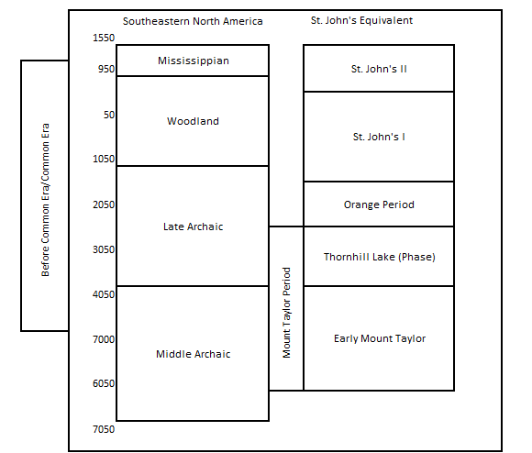
Figure 2.1: Southeastern North America culture history chart with St. Johns River region equivalent periods after Randall 2019.

In doing so, forms of meaning are then generated from these types of practices. In his book on constructing histories, Randall (2015:11–12) argues that imbuing meaning to the landscape is known as inscription. This is a process that can be situated into many contexts be it ritual, ceremonial, or burial. This can create a narrative in which the essence of human interaction is encoded onto the landscape, therefore meaning may take on a persisting role as long as people continue to engage with their landscape. Mounds are a sacred space, and this means that they can also be ceremonial landscapes reflecting world-views that are also characteristic of long term histories either culturally, socially, or ideologically (Ashmore 2008; Randall 2015).
The building of mounds along the St. Johns River by Native American communities is an expression of their lifeway, or life essence, that is tied to the water and its resources. Natives along the St. Johns have traditionally exploited aquatic resources, such as shellfish, since the Mount Taylor Period and these practices have indicated that they then created social geographies along the River via settlement construction and integrative mortuaries (Randall 2008). Similarly, Dillehay (2007:3–4) writing about mounds and community in South America stresses that such practices like mound building, are transformed by social events that impart multiple meanings along the landscape. Mound building is an interactive experience requiring people to come together to alter their landscape and thus create a monument of meaning. Those that built them were constructing their history through practice by way of a social event which allowed them to achieve their expression of world view.
The very act of altering the natural state of the landscape for specific purposes concedes a notion of cultural cohesion through the act of mound-building. Transforming natural materials of the region into a monument that held meaning was a way for these communities to express who they were. These were practices that represent broader social processes of socialization, identity, and cohesion (McNiven 2012). This is the very essence of moundedness, the value in belief of the importance of constructing mounds as a way of life.
Conversely, placing the body in the ground held a sacred meaning, and as the dating of these burial mounds suggest, they continued to be used for thousands of years (Randall 2008; Randall 2015:9–11). These mounds are essentially a product of agency, a dimension of communal cohesion and identity that existed in deep time (McNiven 2012; Randall 2020). These were important spaces in which hunter gatherers could participate in communal actions. Past peoples of the St. Johns traveled hundreds of miles to participate in such ceremonies at sacred places and reoccupying these places has a long history in the region (Randall 2015:6–13; Randall 2020). Chronicling specific meanings and importance of these past social events as they relate to each individual within a community, such as how they felt or what meanings were being communicated and received from these places, is hard to determine. If we view mounds as an expression of human agency, not just a material achievement that occupied a physical space, we can then explore the broader social processes that were required in order for mound construction to remain vital to Native American communities of the St. Johns across time and space (Hymes 1986; Randall 2020; Kroskrity 1999).
One way to facilitate this view is by what Dillehay (2007: 21–22) refers to as ‘mound literacy’ in that the mound and its creation have their own particular language and identity. Modern scholarship has tended to emphasize long-term change in the histories of hunter gatherers, especially the importance of landscape adaptation, but hunter gatherer histories are also created through meaning inscribed upon the landscape (Randall 2015: 5–14). Mound building is a social process that unfolds through landscape interaction and thus not inseparable with landscape. Social meaning comes from its modification, and thus landscape embodies a particular language to those that engage with it (Randall 2015: 11; Dillehay 2007: 21).
In most regards, language is way to communicate ideas, emotions, and symbols. We can see from the materials that are still visible that these places were used for specific purposes and that they held meaning to those that engaged with them. Meaning is inscribed to sacred places through the act of manipulation and enjoyment, social activity, and through ritual narratives that place importance on specific ceremonial practices (Dillehay 2007: 20–24; De Certeau 1984: 22). Studying burial mounds through this theoretical lens also helps to explain how they represent aspects of identity for those that engaged with them and how they communicated with these ‘living beings’ through cultural customs centered on ceremony and ritual (Dillehay 2007: 1–3).
Our current understanding of mound usage in the Colonial Period is limited in the middle valley, but given Spanish impositions, these sacred spaces might have offered Native American communities a landscape to resist European influence (Dillehay 2007: 2–5, 20–24; I elaborate further on resistance-refuge theory in the next chapter and how this pertains to mound usage in the Colonial Period). As such, mound usage would have been a special event that existed outside of acculturation and assimilation by Europeans during this time. Once again this would imply mound usage was indeed constructed and used through social events which are systems of social involvement (Hymes 1981; Turner 1974).

Environmental Change and Mound building along the St. Johns
Understanding the importance of mound building leading up to the Colonial Period first requires the evaluation of the changing landscape in order to understand how past peoples of the St. Johns River region were able to modify their environment and build mounds that acted as constructs of meaning through time, and then examine the history of mound building prior to the 1500s. When examining the environmental history of the St. Johns it is difficult to escape the early impressions of its environment as described by William Bartram. From a Western perspective, Bartram provides early details of the region describing it as full of lush trees of oak and pine, vast marshes, and beautiful plains at every turn (Bartram 1784). In truth, this description is a relatively recent observation of its landscape and environment. The topography of Florida at this time was hardly the same environment that existed millions of years before. Many of its current coastal landscape features, including the eastern portions of the St. Johns platform and upper valley were under water (Scott 1997).
The study of ancient Florida vegetation corroborates this picture of deep-water coverage in comparison to the state’s current sea level (Walls and Hansen 1993). Most likely at its highest, sea levels were roughly in the nature of 18-20 meters above where they are today, compared to previous estimations that they were 70 meters or more (Walls and Hansen 1993; Scott 1997). Largely undergoing metamorphosis with the death of the Pleistocene and subsequent birth of the Holocene, this period brought with it newfound change to the exterior and interior of ancient Florida. Although, aspects of this change, notably the fluctuations of sea levels and low-lying parts of various platforms were happening before the Pleistocene (Scott 1997). According to geological investigations, sea levels would rise and fall in fluctuations leading up to the Holocene Period (Scott 1997; Walls and Hansen 1993). By the Archaic, new waterways had opened up providing avenues for human expansion and settlement (Figure 2.2). The middle valley is a region stretching from north of Lake George further south towards Lake Harney (refer to Figure 2.2). The St. Johns as a whole, like the Nile, flows North. North of Lake George extending to what is modern day Jacksonville is the lower valley while the region between Lake George and Lake Harney is the middle valley with the most southern part below Lake Harney to west of the Indian River is consider the upper valley.
The St. Johns, like much of Florida, has continued to see these kinds of fluctuations over the course of several millennia with rising sea levels and flooding occurring during the Holocene altering the very landscape all along the St. Johns River valley (Aten 1999). These fluctuations in water, a primary source of life for those that lived there, was met with arduous intent to modify the environment. As is currently experienced, Florida has a humid subtropical climate with heavy rainfall from May through September with infrequent freezing in the Northern and Southern parts, not unlike what was experiences thousands of years ago.

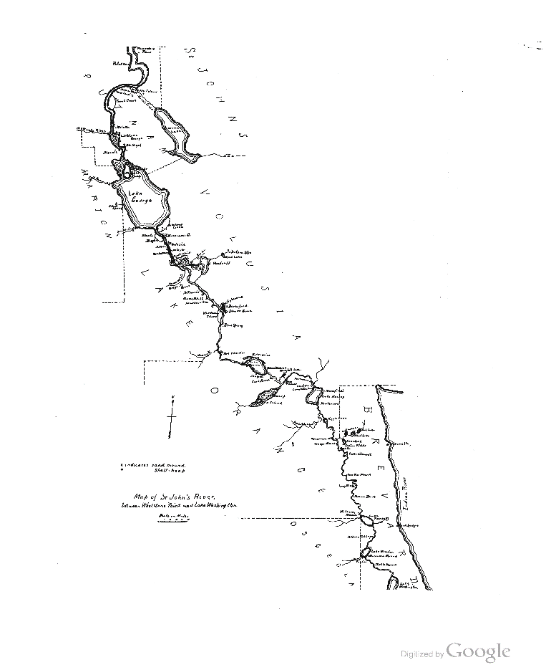
Figure 2.2: The middle and upper valleys of the St. Johns River as illustrated in Moore’s Certain Sand Mounds of the St. Johns River Florida. (Moore 1894: 9)
Ancient Culture History
The earliest persistent evidence for occupation of the St. Johns occurs during the Middle Archaic Period. Locally, we recognize the Mount Taylor culture, which is subdivided into several periods or phases in which communities transformed their landscape with the creation of shell mounds. The Late Archaic is characterized by the Thornhill Lake phase (ca. 3750BCE-2650BCE), which saw these communities continuing to participate in economies that revolved around rituals. These regional participations increased during the Orange Period (ca. 2650BCE-1250BCE), with a continued emphasize shell fishing. By the Woodland Period, the Southeast saw a wide adoption of pottery and social gathering that greatly emphasizing mortuary ritual and rising sea levels ushered in new, intensive landscape use (Figure 2.3; Randall 2019). Past people’s intent to modify their environment could be seen in the sheer magnitude of mounds that emerged. With a more humid climate, the environment was more suitable for inhabitation along interior waterways and coastal regions that were once submerged, and with the presence of new waterways opening up, more settlement opportunities presented themselves and allowed for the practice of landscape modification. Essentially, water had quit submerging landscapes along the St. Johns
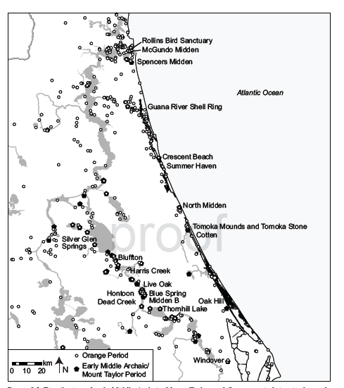
Figure 2.3: Distribution of Archaic Sites 5450-1250BCE (Randall 2019: 206, Fig 8.2)
It is during this modification that the nature of inscription can be understood as an act occurring through the practice of constructing mounds. In his book Constructing Histories, Randall (2015: 10-15) makes a case for the social histories that were inscribed onto the landscape which was a process of imbuing meaning to sacred spaces that were fundamentally important to the people at that time. Those that lived along the St. Johns were deeply connected to the resources there and utilized them locally to build monumental structures throughout the Archaic. From their diet to resources, they used to construct mounds; Native American communities were deeply invested in the coastal lifeways that were present along the St. Johns. The extensive utilization of shells in burial mound construction and the effort it must of took to create these physical structures represent the long-term custom of crafting meaning through practice. The very act of digging into the soil and gathering shell to both create mounds and style adornments for the dead to have when buried are characteristic of the importance of this practice.
Additionally, mound constructions throughout this period were not isolated to a single region but rather existed all over exterior and interior regions of Florida. The nature of mound building was not lost by the ending of the Late Archaic, in actuality, past and present scholarship suggests the opposite. According to Randall (2019) from 1250BCE-1450CE, a time frame encompassing what is known as the Woodland and St Johns I and II Periods (refer to Figure 2.1), the distribution of mound sites intensified (Figure 2.4) and was largely characterized as a widespread adoption of mortuary rituals and ceramic pottery. There was also a proliferation of sand mound burials. The St. Johns I period represented Woodland Period traditions with mortuary rituals at mounds constructed of sand and shell, and the St. Johns II Period, roughly contiguous with the Mississippian Period, (ca. 900-1400CE), was largely identifiable by higher population densities, check stamped pottery and early incursions by European colonists (Randall 2019).
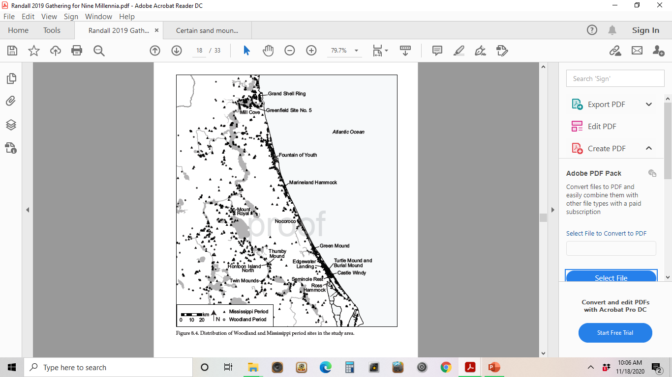
Figure 2.4: Distribution of Woodland and Mississippian Period Sites, ca. 1250BCE-1450CE (Randall 2019: 216, Fig 8.4)

This time frame features notable examples of mounds with extensive burials. With the continued construction of these burial mounds across thousands of years and their intensification all along the St. Johns, these sacred spaces must have held meaning not only to those that built and reused them during this time but also to those that had once occupied them. This reuse of space and landscape across time suggests a cultural belief in moundedness which was reproduced for countless generations. As archaeological studies have noted, burial mounds were constructed in plenty and with the purpose of venerating the dead, this process developed throughout the Archaic and continued into the Woodland Period (Aten 1999; Randall 2015; Randall 2019). So, if we are to believe that past communities along the St. Johns indeed built their social histories through the practice of landscape modification, then it is possible that meaning was then inscribed unto them during construction and remained meaningful long after the mound was completed which could explain why some places came to be repeatedly occupied (Randall 2015: 4–5, 11).
Studies into the region have continually hinted at the importance of these places. Both Wyman and Moore’s investigations, while biased and destructive, revealed the intentionality behind these mounds in that they were not geological in nature but created with careful and considerate knowledge of the landscape as can be ascertained by the planned arrangement of the dead within them. (Wyman 1875; Moore 1894). The careful deposition of bodies found in several of these burial mounds and the presences of adornments and objects in close proximity indicate that they were put there for a reason. What is evident in the Woodland Period and beyond was the intentionality not just to create new mounds that once dotted the St. Johns, but to revisit old ones. Articulating the social histories around burial mounds in the St. Johns is difficult because while some physical evidence of them remains, extensive data regarding these mound sites existing and being reused through time no longer physically exist due to urbanization, looting, and previously destructive excavations. What is listed here is a brief summary of a selection of mounds that have been characterized as having existed and been used from or during the Archaic, Woodland, and St. Johns II period, roughly 5450BCE-1450CE.

Examples of Mound Histories
One of the most well-documented burial mound complexes is Tick Island. In their investigation of Harris Creek in the middle valley, Jan and Bullen (1978) examined Moore’s work of the area and found human remains in similar locations and depths, ultimately concluding that the site was utilized throughout the Archaic and even that superior burials of this site might be dated to the St. Johns II Period. Aten (1999) concurs that the Harris Creek site 8V024, would have been utilized between the span of the Archaic and St. Johns II Period. Most scholars tend to side that this site was likely used at least until the Woodland period; however, dating and documentation tends to vary. The site provides archaeologists with a burial mound usage time frame leading up to the Colonial Period, a period which featured early incursions of Europeans into the region (Randall 2019: 220).
Thursby Mound site (8VO2600) is another important burial mound dating to the Woodland Period and was built on top of an Archaic shell midden. This site was situated along the Middle Valley north of Lake Monroe as part of the greater Hontoon Island Complex with over 7000 years of inhabitation (Randall 2005; Randall 2019). The earliest reported findings of this site come from C.B. Moore whose site descriptions report the finding of numerous objects including skeletons in various sediment layers (Moore 1984). Additionally, the presence of gold was noted in one of the burials encountered by Moore (Moore 1894: 67).
Past and present archaeologists have noted Thursby to have been used during the Woodland or St. Johns I Period. In his examination of sites, Goggin (1952) lists it as a possible St. Johns I site. There is evidence that it was used beyond this period due to presences of metal found (Moore 1894). As seen in many of the burial mounds along the St. Johns, stratigraphic evidence builds a compelling picture that Thursby was reused for burial purposes, and recent scholarship has continued to attribute the site to the Woodland and St. Johns Periods.
Another notable site, outside of the study area, and encompassing the St. Johns Period is Mill Cove complex (Goggin 1952; Randall 2019; John 2020). Mill Cove was located along the lower valley of the St. Johns in what is now Jacksonville, Florida. Mill Cove has been documented as an early St. Johns II site similar to Mississippian mounds and featured two burial mounds as well as communal mortuary mounds: Grand Mound (8DU14), and Shields Mound (8DU12); arguably, this complex is unbested by other St. Johns II sites in terms of its size and assortment of archaeological associations (John 2020: 5–12).
As suggested, sites like Thursby and Mill Cove were likely used until the end of St. Johns II period, roughly 1300CE (Goggin 1952; Johns 2020). Additional sites attributed to the Woodland, St. Johns I & II Periods include Turtle Mound, Hontoon Island, and Fort Florida Mound, among others (Goggin 1952; Randall 2019). These sites merely scratch the surface of those that potentially existed at or during this time; however, archaeological investigation of these sites corroborate the narrative that mound building continued well after the Late Archaic and through to the St. Johns II Period. Coincidentally, if we look elsewhere in the American Southeast, we find similar types of structures, most notably Mississippian burial mounds. Arguably, this cultural period in which burial mounds of similar nature were constructed, might have had ideological influence reaching into parts of Florida (Johns 2020). To what extent Mississippian culture had on St. Johns culture is debatable, but what we do know is the context of mound building was central to a variety of people and cultures both around the St. Johns River region and elsewhere in the Southeast. As recent studies indicate, the practice of burial mound reuse did not entirely die out by the end of the St. Johns II period.
Conclusion
As explored in the Mount Taylor to the St. Johns II Period, mounds were an act of agency, and their construction required resources and time from Native American communities along the St. Johns. As previously examined, mound building did not end after the Archaic and were sacred spaces where communities came together to imbue meaning through practice. Both Wyman and Moore’s investigations examined the intentionality underlying mound construction, as well as depositional features that indicated mound usage across time but were not entirely focused on other aspects of mound building like their ceremonial or social aspects (Milanich 2012; Randall 2015; Aten 1999). If we recall, such complexes like Tick Island represent a strong narrative for the importance of mound use through time due to numerous burials with adornments intentionally placed throughout various layers of strata (Aten 1999; Randall 2019).
Chapter Three:
Culture and Ethnohistory
Examining the Colonial Period of the St. Johns is particularly important because there are written records of Native American peoples and their cultural practices and histories that involve mound use. If we recall, I am investigating burial mound usage in the middle valley of the St. Johns (Figure 3.1). The accounts I examined, along with recent scholarship, build a narrative that mound construction occupied a cultural language among peoples of the St. Johns, that is to say that by building these monuments Native American communities communicated their ideological, ceremonial, and social characteristics to each other. In this chapter I am trying to answer whether an identity of cohesion formed between members of a kinship through the very act of building mounds. Additionally, I also explore whether mounds might have been used as a way to resist European encroachment into Native territories by maintaining old traditions and creating newer identities through the reuse of space. I first consider relevant theory. Then I provide a framework of the Colonial period. Then I describe the known Native American cultures that inhabited the region.
Mounds and Identity
Essentially, each culture has its own social phenomenon, therefore, certain identities are culturally specific (Bucholtz and Hall 2004). Identity can be universal in that it has multiple conceptions and understandings (Sokefeld 1999). In truth, defining identity is purposefully broad and ambiguous, often incorporating multiple meanings of humanness which can also be created through practice (Appadurai 1996; Sokefeld 1999; Holland et al. 1998). In many cases along the St. Johns, what has been left behind by past peoples expresses an identity of cultural cohesion represented through burial of their dead in monuments. As Randall points out, Mount Taylor Period communities buried their dead in prepared mounds near or underneath communal areas (Randall 2015:145–146). These practices persisted into the Woodland Period, with Archaic spaces being returned to (Randall 2020). There is culture invested in the remembrance of the dead and venerating them in mound structures.
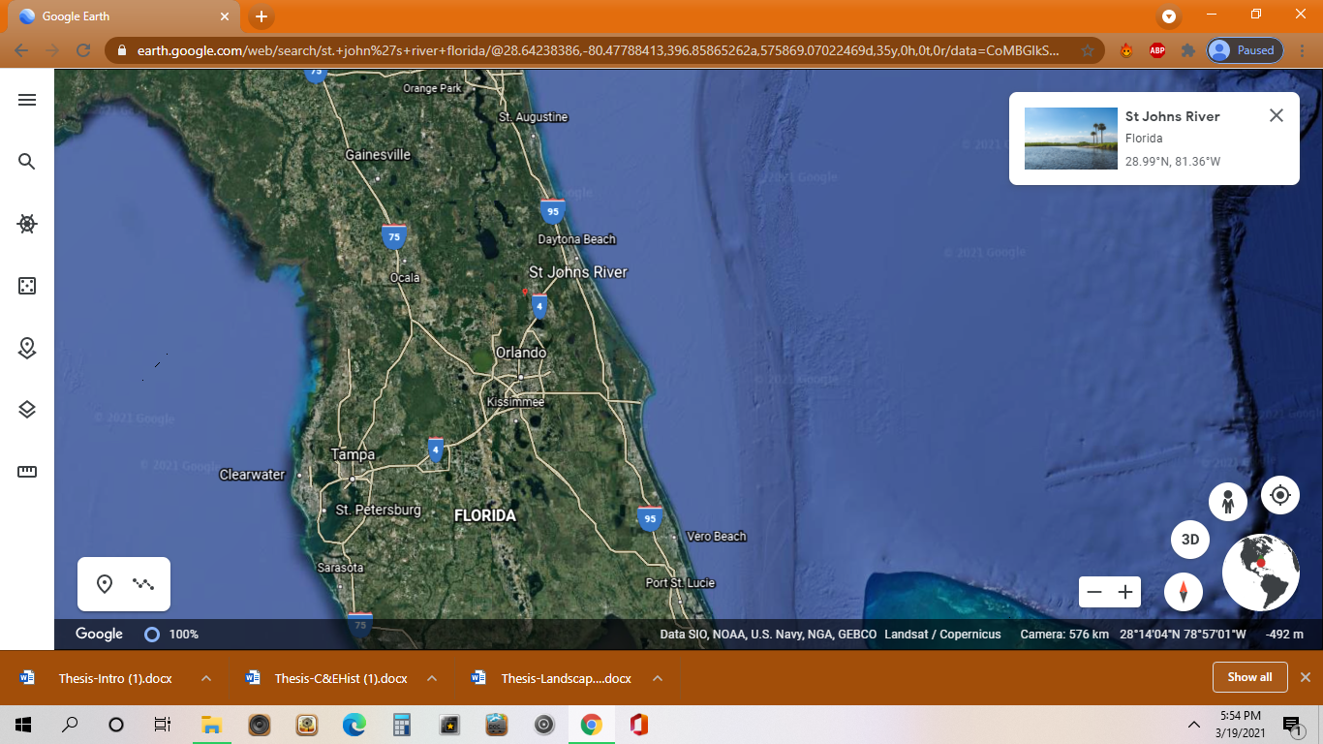
Figure 3.1: Image of the St. Johns River as it appears today (Google Earth 2021).

Additionally, the act of mound building and inscription are participatory and situated in what Bakhtin would refer to as “time-space” which highlights the role of an interconnective tissue that connects time and space together and negotiates social encounters and relations across generations (Bakhtin 1939). The mound occupies this role and creates continuity in language and cultural practices through time. We can see that from the Archaic to Mississippian Periods, roughly a 5,000-year time span, mounds were a loci for St. Johns River valley cultures to construct their histories; this is a broad chronotope of social engagement across long periods of time and space (Randall 2020). Mound building pulled past people of the St. Johns River together for a specific purpose at a certain time and place to engage with one another. Fundamentally, mound building is a social event that existed as a way to express culture; therefore, it is also an expression of identity.
The aspect of identity also imposes a matter of adaptation to a changing environment due to European incursion. For many Native American peoples in Florida, as well as in general, there was an emphasis on cultural continuity but with increased missionization, many were forced to engage with European political and economic systems. In the process, they constructed new identities for survival as an economic periphery of the Spanish empire or through resistance (Arkush 2011; Bushnell 2014; Voss 2015; Worth 2002). This resistance-refuge theory has been argued for other territories, in which indigenous peoples recreate their identities by returning to previously occupied spaces (Schneider 2015). This is important because it symbolizes that mounds were used not only as a mechanism to reproduce Native traditions but also to maintain these traditions among a changing social, cultural, and political world. Native American communities along the St. Johns were faced with these changes due to European encroachment on their land.
As I’ve previously explained, mounds occupied a language among communities, not just in the Southeast, and this language allowed them to continue to communicate their cosmological and ideological beliefs through practice. These were sacred spaces, and as such, they might have allowed Native American communities to resist further European colonization by returning to them. If we recall, this was one of Dillehay’s (2007:2–5) theoretical arguments regarding mound usage among Native American communities in Chile. Mounds were a language and those that used them engaged with that language. If that language were threatened by outside forces, returning to these mounds might have provided a way for Native American communities to continue to generate their belief systems through mound literacy, the process of generating a particular language and identity through mounding (Dillehay 2007: 20–24). Through the act of returning, old identities might be continued, and new identities created; these were acts of resistance (Schneider 2015; Frank 2005; Weissman 2007).
This is a theoretical landscape to consider because as archaeologists we cannot go back in time to see this behavior as it unfolded but there are evidences suggestive of such behaviors in the Colonial as examined with Yamasee and Seminole resistance (Ashely 2018; Schneider 2015; Bossy 2014; Voss 2015). This is an important area to investigate because, as Dillehay and Schneider suggest, returning to sacred spaces allow for the continuation and or recreation of identity. Essentially this means that archaeologists might be able to draw more inference about Native American identity through the evaluation of landscapes than previously thought.
Brief Overview of Colonial Era History along the St. Johns River
Florida’s Colonial history can be broadly divided into four eras based on colonial authority: First Spanish Period, English Period, Second Spanish Period, and the American Period (Table 3.1). European incursion into Florida was a restricted and limited progression that unfolded unevenly (see Table 3.1). Historians have noted the date of European arrival as 1513CE, but other scholarships suggest varying dates to this claim (Deagan 2013). Throughout the 1500s, Europeans expanded into native territories of Florida, mostly along coastal settlements and North of the Florida Keys, and their relations with these communities differed from place to place and from community to community (Deagan 2013; Bushnell 2014). While expansion into Florida was uneven it was also aggressive towards Native Americans of the region both spiritually and physically. Missionization and Christianization were prominent among St. Johns communities such as the Timucua and Yamasee, and archaeologists have noted numerous processes of social change among Natives such as how and where they buried their dead (now in cemeteries) and the types of ceremonies that were performed (McEwan 2001). As Bushnell (2014) notes, the impact of Christianization was vast and rapidly spread among Native American communities like the Timucua.

Table 3.1: Colonization periods in Florida for use in this thesis.
 | European Colonization of Florida
 | 1565 to 1763 |  | 1763 to 1784 |  | 1784 to 1821 |  | 1821 to 1845
 | 1st Spanish Period |  | British Florida |  | 2nd Spanish Period |  | American Period
 | Pedro Menendez establishes first European settlement (1565) |  | Seven Years' War (1756-63) |  | Spanish regain control of Florida (1784) |  | Territorial Period of the United States (1821-42)
 |  |  | British gain control of Florida (1763) |  | 1st Seminole War (1813-14) |  | Two Florida’s merged  into new capital: Tallahassee
 |  |  | British map Florida: engage in relations with Creek and Seminole. |  | Spain cedes Florida Territory to United States (1821) |  | Indian Removal (1830)
 | French Arrive two years later |  |  |  |  |  | 2nd Seminole War (1835-42)
 | English and Spanish Conflicts begin in Florida (1586) |  | War for American Independence (1776-83) |  |  |  | Florida becomes U.S. state (1845)
 | St. Augustine is destroyed

Spanish intrusion was a process of conquest, and in their attempts to conquer Florida territory, their relations between the indigenous peoples of Florida were often one-sides matters of diplomacy where only the Spanish prevailed (Bushnell 2014). De Soto’s expedition between 1539–1543 as well as French establishment of Fort Carolina at the mouth of the St. Johns revealed that European footprints were not disappearing but rather extending (Deagan 2013). It was not uncommon for Native American communities to form bonding kinships with each other despite their own interregional conflicts as a way to resist further European encroachment by the late 17th century, this of true of the Yamasee and Timucua (Bossy 2014). For other communities like the Seminole Creek, European resistance involved numerous instances of violence and abuse of power. Histories of bloodshed, ethnic persecution, and assimilation resulted in recurring war among the Seminole and Spanish by the 19th century (Piper et al. 1982; Strang 2014). In truth, this type of conflict was happening elsewhere in the Americas during Colonial times. If we look to the Southwest, Spanish missions had sought to crush indigenous spiritual and religious practices through missionization, such as with the Pueblo, and the result was the Pueblo Revolt of 1680 (Weber 1999: 21–40).
What does the imprint of settler colonialism mean for mound building in the Colonial Period? We know that by the earliest of European incursions (much later in the middle valley), the St. Johns was already a region of intense mound construction. Native American cultures embodied moundedness. To understand the value of mounds as a cultural language and expression of identity, we must view moundedness as a cultural practice, in what Clifford Geertz would describe as ‘the total way of people’ (Geertz 1973). It was an important aspect not only to Native American communities of the St. Johns, but elsewhere in the Southeast. In truth, numerous Native languages and communities existed in the Southeast (Figure 3.2), and many of these cultures used mounds in broad social contexts.
It is during this time that we begin to see European articles appear in Native American burials, both mound and non-mound, as well as a dependence on European trade goods by certain Natives American communities (Ehrhardt 2005; Deagan 2013; Piper et al. 1982). During De Soto’s expedition, for example, he introduced numerous items like glass beads, Spanish coins, and metals to the region and archaeologists have recovered such items from the region, specifically findings of European glass and metal beads from Tatham Mound in Citrus County (Deagan 2013).
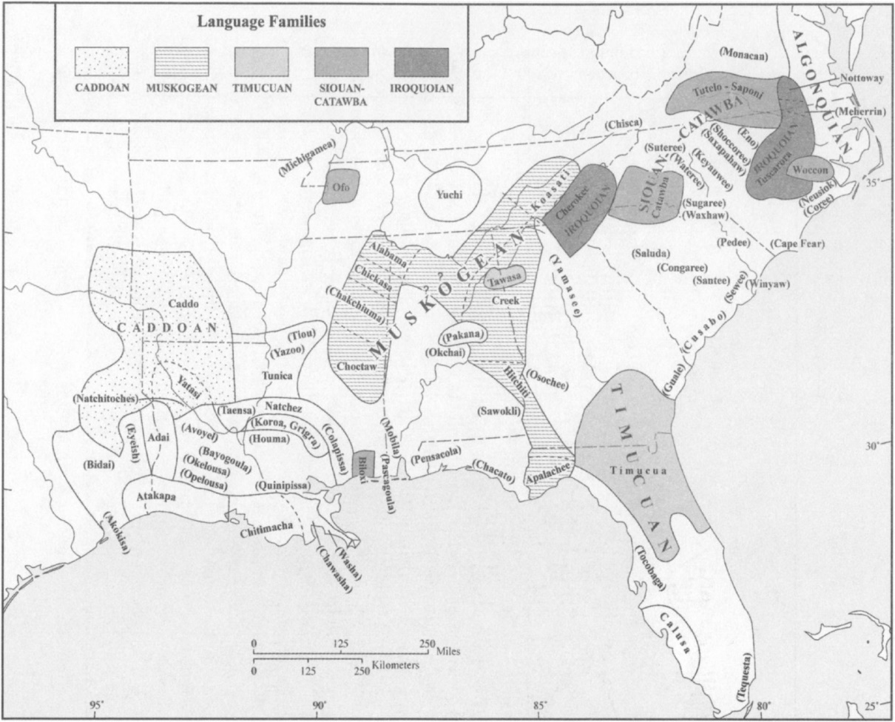
Figure 3.2: Map of major Native family languages in the Southeast (Goddard 2005: 3, Map 2).

Overview of Native American Cultures in Florida During the Colonial Period
In this section I introduce the primary cultural groups known to have inhabited the St. Johns River valley. I proceed historically, first discussing the Timucua, Mayaca, and Jororo and then subsequent inhabitants.

Timucua
Perhaps one of the most Colonial documentations of Native American mounding in Florida comes from the recordings of the Timucua by French Huguenots Laudonniere and Jacques Lemoyne during their expeditions into Northern Florida. What archaeologists know is that by the mid-to-late 1500s, the Timucua were the most populous of native societies in Northeastern Florida, utilizing multiple dialects and consisting of a variety of moiety systems (Milanich 2002; Milanich 2004; Goddard 2005). According to contemporary accounts, the Timucua had a population of roughly 200,000 spread out over 25 to 35 small communities before the Spanish began to subjugate them into missionary systems (Milanich 2002; Milanich 2004; Spike 2006; Worth 2002).
While records indicate that the Timucua occupied most of Northern Florida during the 16th century, the evidence as to which mounds they occupied is difficult to discern. From written sources of Lemoyne and De Soto, archaeologists and historians know that Timucuan culture consisted of highly symbolic and ritualized way of life in that life and death interacted with each other every day and that the burial was an important component of the Timucuan beliefs regarding purity and pollution (Spike 2006; Milanich 2004). Life and death were an important component in Timucuan cosmology that occupied both sides of their cosmological and symbolic diagrams (Spike 2006). Likewise, the very act of death was a polluting element that must be composited into a state where death may be purged of pollution. The mound might have served this purpose.
Observations by Lemoyne document such Timucuan burial practices (Figure 3.3) and show that this was not an exclusionary exercise of Timucuan culture but engaged at large by the kinship. These observations and the archaeological record seem to agree that mound-building was a practice that held meaning to various Native American communities for thousands of years, and accounts by Lemoyne document these practices within Timucua society. While Lemoyne’s colonial imprint is unmistakable, it does not mean he was an uninterested observer. Historically, Western societies have gauged Native American thought through such observations and recordings, but these accounts are undoubtedly problematic and do not reveal the process of social and cultural interaction that archaeologists seek by examining the material record and connecting it with broader concepts involving past human behavior (Bushnell 2014; Arkush 2011). Colonial observations are not always represented in the material record.
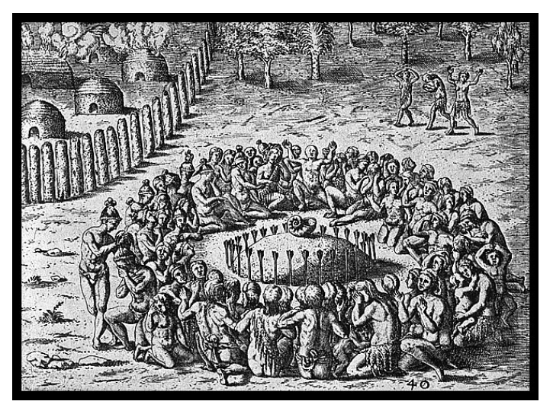
Figure 3.3: This account documents the creation of a small Timucuan burial mound and ceremony (Spike 2006: 59, Fig 4.1).
The Timucua occupied the largest territory of Florida by the 1500s, a territory that encompassed the lower and middle valley in which mounds were constructed (Ashley 2018). Current scholarship as argued that such monuments were still being built during the 1300s with occupation possibly lasting until at least the 1600s in neighboring Southeast territories like Central Georgia (Holland and Lulewicz et al. 2020). Timucua inhabited the Northeastern region of Florida, but mound usage in the Colonial Period is unclear from the archaeological record (Goddard 2005; Spike 2006; Hann 1996; Spike Milanich 2004; Milanich 2002). That being said, the effects of colonialism were disastrous for the Timucua and other Native American communities in the region, and it is difficult to determine how or when such practices of mound building ultimately were abandoned Timucuan society. There was a disparity in terms of trading and interaction with the Spanish, and continued assimilation resulted in the Timucua being pushed back to St. Augustine, a notable Spanish trading center, where they continued to experience economic, political, and religious loss (Hann 1996; Milanich 2002; Milanich 2004). By 1633, almost all societies in the region of St. Augustine were assimilated, meaning they were forced into adapting European customs (Worth 2002).
Mayaca and Jororo
The inhabitants of the middle valley, and thus those communities who were likely immediate descendants of St. Johns II populations there, are known as the Mayaca. There is some controversy over who the Mayaca were, and what their relationship to the Timucua was. Furthermore, another group, the Jororo, may have likewise inhabited the region. Primarily, the Mayaca have been connected to Lake George in the middle valley, while the Jororo inhabited the region south of the Mayaca in Osceola County (Figure 3.4; Milanich 2004: Ashley 2018). As Hann (1991) notes, the Mayaca are mainly linked to other Timucua speaking peoples of the 17th century, like the Jororo, and lived further south than Lake George along Mathiaca and Mayrra. In short, the Mayaca and Jororo are often mentioned together in Spanish documents mainly because they share a similar language often referred to by the Spanish as Mayaca, but their exact linkage is unknown (Milanich 2004; Hann 1991). Both Native American groups inhabited the middle valley of the St. Johns in territories that are also in near vicinity to the Timucua.
Because of limited interactions with either missions or Spanish authorities during the First Spanish Period, we know comparably little about Mayaca and Jororo lifeways. Sites such as Philip Mound lie within territory associated with the Jororo (Milanich 2004). Various Spanish trade goods have been found at this site suggesting European trading during the time Spanish missions were commenced and we can assume that Spanish held some power over the Jororo, possibly Mayaca, with the destruction of Timucuan’s mission by the 1700s (Milanich 2004). The Spanish would extend their hegemony further south into the Mayaca and Jororo territories, and trading might have offered an avenue in which to make further political and economic gains over them as they were known as ‘resistant’ Native American peoples to the Spanish Reconquista (Bushnell 2014).

Figure 3.4: Native American groups of 16th century Florida. (Milanich 2004, Fig 1)

Yamasee
If we look elsewhere in the Southeast, we also see possible mound usage by other cultures that originated north of the St. Johns. The Yamasee were one such example, most likely belonging to the Southern Creek hinterlands of Gaule or what is modern day Georgia (refer to Figure 3.2; Swanton 1922). According to Ashley (2018) the Yamasee were an immigrant native community who emigrated from Georgia around 1670s and settled along Timucuan territories, including mound sites in these areas. They had aggressive relations with the Spanish eventually stemming from trading conflicts that eventually erupted into war by the early 1700s (Swanton 1922; Ashley 2018). Not much is really known in terms of Yamasee culture outside of certain pottery shards, assemblages, and Spanish letters indicating their resistance against European colonizers. What we do know is that the Yamasee continued to settle in Florida during the late 1670s, settling in Amelia Island and other locations while combating the Spanish and other native groups like the Timucua (Ashley 2018: 57–61).
Archaeological evidence suggests that the Yamasee utilized or at the very least occupied mounds in Spanish Florida. According to Ashley (2018) sites such as Mount Royal 8PU35 on the St. Johns and site 8VO2567 on the Atlantic Coast (Figure 3.5), had presences of Yamasee ceramic assembles. The presence of Yamasee ceramics at these places suggests that mounds were a place for them to interact. Determining the exact context in which these sites were used is difficult, but we can theorize that the Yamasee used them for specific reasons to either claim land as their own from other Native American communities during their migration or to resist European colonization. We know that Yamasee actively resisted missionization since the 1660s, refuting conversion to Christianity and often formed ties with other southeastern Indians like the Timucua to resist Spanish dominance (Bossy 2014).

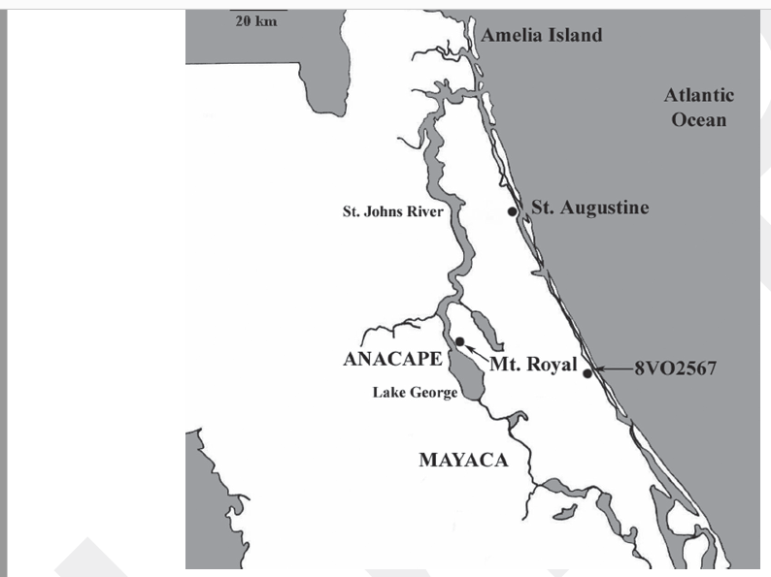
Figure 3.5: Mounds associated with Yamasee occupation (Ashley 2018:72, Map 3)

Muskogee, Creek, Seminole
The Muskogee, Seminole and Creek were also prominent cultures during the Colonial Era. Ancestral Seminole had existed outside Florida prior to the 1700s, they were similar to ancestral Creek and Muskogee, their religious beliefs rooted in Mississippian concepts of purity (Weisman 2007: 199–201). These beliefs resemble the purity and pollution cosmology of Timucuan culture. And much like the Timucua, the Seminoles that inhabited Florida were undergoing missionization.
While the Muskogee had experienced a sustained period of autonomy, Creek tribes became displaced during the assimilation phase of the 1700s with the Upper Creek splitting off to become tribally associated with the Florida Seminole Creek (Martin 2011; Frank 2005). By the mid-18th century, Seminole had begun to enter into Northern Florida where they faced further assimilation and eventual ethnogenesis during and after the Second Seminole War of 1835-42 (Weisman 2007). If ethnogenesis suggests the creation of a new identity, for the Seminole, this might have meant reaffirming colonial or traditional identity lost during European incursion by actively resisting colonial imprints. By the Second Seminole War, Seminoles had enduring ties to Florida, they came to see themselves as a coherent ethnicity with a culture (Strang 2014). The Seminole had a history with cultural struggles in the region, and at its core, resistance was an emphasis on cultural continuity through struggles (Voss 2015).
In his excavations of the St. Johns, Moore details a burial mound near Baynard Point where Seminole leaders confirm its pre-existence prior to the onset of the Seminole War, and while he does not elaborate on this any further he does address in his writings that the mound had presences of glass beads and brass articles of European make (Moore 1894: 189). This was not an uncommon Seminole tradition to incorporate grave goods bartered from Europeans (Piper et al. 1982). The Spanish had sought to deprive Natives like the Seminole of their cultural practices through assimilation even seeing them unfit to hold precious metals like iron or gold. Yet, with dwindling missionary systems and Spanish settlements continuing to be an economic loss, trading with Native American communities became a reality (Bushnell 2014). Including such European articles in traditional burials might have been a way for Seminole, and other Natives American peoples, to resist Spanish assimilation and acculturation that sought to rob them of their cultural practices (Piper et al. 1982; Bushnell 2014). The Spanish and the Americans saw the Seminole, and other Native of Florida, as unequal, and while some Native American communities chose to be a part of Spanish mission systems others resisted and continued to engage in cultural practices well into the 19th century (Bushnell 2014; Arkush 2011). They essentially created new sociopolitical identities to resist and adapt to a changing landscape while maintaining aspects of their colonial practices.

Conclusion
If we consider how mounds were used in a broader context along the St. Johns and the greater Southeast, we can theorize that mounds were most likely a part of Seminole language and custom, and likely important to the creation of new identities. The very mention of Baynard Point by the Seminole who Moore encountered suggests that such spaces were not unknown to them by this time. Furthermore, as examined in other Native American communities of the St. Johns, mounds were sacred spaces. It is possible that mounds such as those near Baynard Point, were still a part of their life despite intense assimilation, because they held meaning to them. This might explain why the Seminole Moore encountered could recall and remember the time in which the mound was last used.
The act of mound-building was an important cultural practice along the St. Johns, and most likely continued into the Colonial Period. As seen throughout the Archaic and Woodland Periods, mound building was a way to imbue meaning to the landscape. This was done through a communal activity, an event. These types of practices also reveal dynamics of agency, such as cultural language and identity. During the Colonial Period we see European descriptions of Native American communities such as the Timucua as they engaged in these events.
Culture and ethno-history of this region combined with archaeological investigations since the 19th century has illustrated how these practices were used as a way to communicate elements of cultural importance, be it ceremonial or cosmological. They have also illustrated how cultural identities may further explain the importance that mounds held for Native American communities of the St. Johns. In certain ways, mounds might have been used as a way to both express cultural practices and to resist European influence. While exact meanings behind the creation of these types of mound are not entirely known, archaeological evidence in combination with Colonial accounts weave a narrative that these spaces were created through a cultural language that embodied moundedness. These mounds were not inanimate objects, they were a part of St. Johns cultures and therefore a reflection of their cultural identity.

Chapter 4: Methods
Introduction
Investigating burial mound usage on the St. Johns during the Colonial Period is complicated because when looking for evidence of Colonial Period use in Native American contexts, often times archaeologists look for small index artifacts of European make to indicate post contact inhabitation (Panich and Schneider 2019). For archaeologists investigating the St. Johns, they must also contend with temporal dimensions that do not always leave direct or physical evidence. We currently know little about mound usage in the middle valley of the St. Johns during the Colonial Period. As Holland and Lulewicz et al. (2020) explain, mound construction did exist to some extent in the Southeast as can be seen with the Dyer Mound in Georgia that featured periodical construction for about 130 years post European contact. Furthermore, these mounds have been documented as important spaces for Native American communities to engage with, especially along the St. Johns River. History tends to gauge indigenous practice through reported speech and customs, incidentally this makes determining authenticity of Native customs and practices difficult; it is becomes a blurring between history with folklore in an attempt to record (Bushnell 2014). Essentially, it becomes difficult for archaeologists to determine whether an act performed by indigenous peoples was accurately recorded by Western sources firsthand or overheard from a secondhand source. Archaeological investigations, both past and present, have continued to examine how Native American peoples along the St. Johns modified their landscape but which specific cultures utilized these sacred spaces is difficult to determine if looking only at articles of European make as not all Native American cultures incorporated these items extensively (Piper et al. 1982).
My research is focused on archival documentations of these mounds, many of which no longer exist in a capacity to be physically studied. This refers to the inability to go out and conduct on-site excavations or study existing artifacts that have previously been excavated rendering them destroyed, lost, or only partially surviving. As such, for my research I reexamined some of the earliest ethno-Colonial and archaeological investigations into the region by William Bartram, Jeffries Wyman, and C.B. Moore. I am mainly concerned with their methods as well as their descriptions of burial mounds that they encountered with my eye focused on specific descriptions that are suggestive of mound usage into the Colonial Period.
An extensive analysis of my research will be provided in the subsequent chapter. For this chapter, I will provide a synthesis of the archival materials including brief histories and documentations of the environment. as it pertains to mound descriptions. I will discuss mounds encountered by Bartram, Wyman, and Moore as well compare and contrast similarities and irregularities in mound descriptions by both Wyman and Moore as well as terminology that potentially suggests Colonial usage. For the latter, I am focusing in on key terms used by both Wyman and Moore in their descriptions of burial mounds that indicate their usage or age by carefully defining these terms that are otherwise misleading and entirely contextual to the investigator during excavation. I also problematize these terms and what they mean for mound usage for the Colonial Period and examine how others have handled similar issues in this regard.
Sources
In this section I will be focusing on the sources I used to devise a method to analyze Colonial use of mound sites, including burial. I will examine each in a chronological order from the earliest archaeological/ethnographical inferences and investigations while incorporating recent scholarship that has also examined the impacts and influences of Bartram, Wyman, and Moore. I will begin by contextualizing Bartram’s observations, primarily drawing from his work Travels Through North & South Carolina, Georgia, East & West Florida published in 1791. I will then examine Wyman in context utilizing both transcripts from his notes between the years 1867-73 supplied to me by Dr. Asa Randall of the University of Oklahoma as well as Wyman’s work Freshwater Shell Mounds of the St. Johns published in 1875. Finally, I will look at Moore’s contributions by analyzing his work Certain Sand Mounds of the St. Johns River Valley parts I and II.
To begin, it is important to talk about the impact that Bartram had on later archaeological investigations in the 19th and 20th centuries. Like Wyman and Moore, Bartram’s observations of the St. Johns River region still hold important information that cannot be obtained elsewhere (Randall 2008). William Bartram essentially laid the foundation for archaeological work in Southeastern North America, this might come as no surprise given his father was a farmer, traveler, observer, collector and public figure who shared his findings and collection with royal society (Stoltman 2004). Bartram was introduced to the region through his father’s journeys but would eventually return to the St. Johns River Valley on his own expedition by 1773.
Yet throughout his journey in Florida, he makes specific statements regarding mounds that emphasize their noticeability and visibility. His expedition into the region was primarily botanical in nature but he saw many sites, including mounds along the St. Johns, to which he attributed to Native Americans (Stoltman 2004). In truth, Bartram’s writings provide a starting point to the study of mounds in the St. Johns.
Prior to his expedition in Florida, Bartram wrote about mound structures all along his journey. One example can be seen nearing the end of his travels in Georgia. While no archaeologist, Bartram describes this structure as an old, magnificent monument by ancient inhabitants and that they “are visible” to him upon leaving of Wrightsborough in Georgia (Bartram 1791: 33–37; Stoltman 2004). He goes on to describe this as a “stupendous conical pyramid, or artificial mount of earth” and that it existed long before the discovery of the continent by Europeans (Bartram 1791:37–38). His descriptions of this structure, its shape and artificialness imply that Bartram was making a connection, however small, that these structures were not geological but anthropogenic in nature, and visible, meaning that they were not entirely hidden from everyday view.
After crossing Amelia Island in Florida, Bartram documented several Native American mounds. Particularly, he is noted to have seen the remnants of a large sand mound and three other shell mounds in Fernandina (Harper 1998: 42, 65). These were later described by Dr. Brinton to be about 10 feet above the ground level (Brinton 1859). Bartram’s observations were most likely of shell and sand mounds and shell middens similar to what Wyman and Moore also observed. In his writings we get descriptions of a type of human made monument that resembles common burial mound descriptions by Wyman and Moore, and that these types of monuments still physically existed by the mid-to-late 18th century.
The first serious archaeological investigation to propel this observation forward was done by Jeffries Wyman (Stoltman 2004). Unlike Bartram, Wyman conducted archaeological work along the St. Johns seeking to answer specific questions of their origins (Randall 2015). Wyman, a comparative anatomist, was intrigued by the St. Johns after an introduction to its history by G.A. Peabody and Putnam, and thus pursued an investigation into whether these were geological formations or humanmade. The first systemic archaeological examinations of the St. Johns River Valley were done by Wyman during his first tenure as director of Harvard’s Peabody Museum in 1867 (Stoltman 2004). Like Bartram’s observations, Wyman documented multiple shell mounds, fields, and shell middens.
While skeptical, his excavations reveal an intellectual curiosity of determining the act of agency behind these structures unlike the motives behind most antiquarians (Randall 2015; Wyman 1875; Aten 1999). He argued on the basis of the excavations he conducted into various mounds throughout the years 1867-1873, concluding that these sites were indeed anthropogenic in nature similar to Bartram’s observations of mound structures he encountered during his own expedition into Florida. Examinations of shell mounds during these years highlight the use of mounds for burial purposes as well as their features representing anthropogenic origin due to intentionality through the deposition of human remains, pottery, and bone implements (Wyman 1875).
If we refer to his notes during these years we see that Wyman initially set out in 1867 exploring as far as south as Salt Lake in the upper valley before primarily transitioning his focus to the middle valley between the years 1871-73 with intermittent work done in the lower valley (Wyman 1867; Wyman 1871; Wyman 1873; Randall 2015). While some of the sites he mentions are further south than my research area several others at this time lay in the middle valley, and thus his expedition in 1867 is pertinent to my research. Particularly, Wyman notes the presences of near surface skeletons and burial mounds with intrusive characteristics and presences of metal implements (I will discuss this in more detail in the next section).
It was C.B. Moore who offered the first intensive examination of the St. Johns River and put Wyman’s work under scrutiny. His excavations on mound sites in the region formed the bulk of his work, Certain Sand Mounds of the St. Johns River Florida published in 1894. In it he provides a comprehensive list of the sites where he conducted archaeological examination, although in some instances he was unable to perform excavation due to lack of permission by landowners or due to previous excavations that had rendered sites destroyed (Figure 4.1; Moore 1894). While Moore’s findings concur that the burial mounds he investigated were a product of human agency, his work was primarily on exploring European interrelations with Natives of the area.

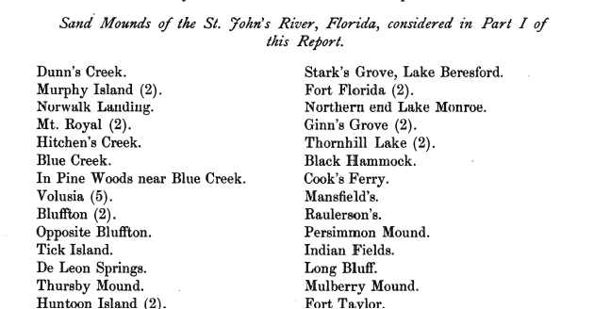

Figure 4.1: List of St. Johns River Mound sites documented by Moore in Certain Sand Mounds of the St. Johns River Florida, Part I.

Moore was Harvard educated and well-trained, employing reconnaissance and excavation in his examination of mound sites along the St. Johns River; in actuality, burial mounds in particular became the primary focus of his after investigating the region (Stoltman 2004). Part of the reason for this was what Moore found in these types of mounds. In several cases, Moore documented finding exotic items and attempted to source these items which he later concluded to have been introduced through trading with Europeans (Moore 1984; Stoltman 2004).
How does one translate 19th century recordings into modern data?
The question remains of how does one translate the recordings done by Bartram, Wyman and Moore into modern data that may be used to infer mound usage in the Colonial Period? First would be to operationalize definitions and descriptions of these types of mounds observed by each. Bartram’s observations provide an important jumping off point that emphasizes mound structures were anthropogenic (later verified through Wyman’s and Moore’s efforts) and that they their physical presence was still visible to both Native American peoples and European colonists in the region. If we compare his descriptions of the mounds he recorded with others who investigated the region, like Wyman and Moore, we can see that many these structures were shell and sand mounds. The difficulties with Bartram are determining Colonial use of these mounds as Bartram’s expedition was primarily botanical in nature not archaeological. For that we must turn to Wyman’s and Moore’s work in the region.
Both offer important recordings of the mounds they excavated that might reveal mound usage into the Colonial. On numerous occasions Moore notes finding burials near the surface. If using the law of superposition, this would suggest these burials to be less old than ones found further below. Wyman makes similar statements during his expeditions into the St. Johns in 1867 frequently addressing the finding of near surface skeletons, stating them to be ‘superficial burials’, although based on translations on his writings, a specific range of depth is not definitively stated (Wyman 1867).
Moore provides a range to which we may infer superficial burial depth. In his excavation of Thornhill Lake in the middle valley, Moore states to finding skeletons in both the white and brown sand layers, 1ft 6 inches to 5ft respectively; additionally, in several of his notes on superficial burials he refers to them in either the brown or white soil layers, near the surface, or no deeper than six feet below the surface (Moore 1894: 8, 50, 58, 88). Elsewhere, he mentions finding burials with artifacts between 6 inches and 1.5 ft from the surface at Thursby and Thornhill, yet also mentions finding presences of glass beads at only 3 inches below the surface with metals found at 6 inches below the surface at Raulerson’s (Moore 1894). If we broadly define ‘superficial’ to be burials found near the surface, this will refer to encountering burials at between 3 inches and 5 feet below the surface. Six feet below the surface might be considered Archaic as several mound burials found at this depth in the region have been dated to the Archaic Period (Moore 1894; Randall 2015: 9–11, 145–147; Aten 1999).
This is, however, a partially problematic term because it does not differentiate between burials that are superficial and those that might be recently disturbed or reused. Among his recordings, near surface burials and artifacts are in many cases categorized by Moore as intrusive (Moore 1894:47, 85). In other regions, the term has been defined in association with mounds that have interfused features or associations from older occupations or where inhumation of graves or excavation of graves have occurred long after the origin occupants abandoned the site (Richie 1937; Mann 2005). Argumentatively, intrusive might also mean a soil layer that has intruded upon another layer, not necessarily indicative of repeated use. In order to differentiate intrusive from superficial, I primarily looked for instances where both Wyman and Moore applied the use of the term ‘intrusive’ with a burial due to its depth and the variety of artifacts found with or in near association, these include presences of European articles not original to the area as well as Native American artifacts of brass, stone or ceramics. This would suggest possible reuse.
Current scholarship has made note of various instances where such characteristics are an example of ‘longue durée’, or the reuse of landscape over a long-term period (Mann 2005; Randall 2019). There is not a consistency in the definition of this term other than the implication of some aspect of reuse of a sacred place after its original creation which makes defining intrusive let alone identifying intrusive burials difficult. For my purposes, intrusive burials might best be described as burials that have characteristics of reuse which can include depositional disturbances of the soil or presences of grave goods from multiple occupational periods or simply a layer that has intruded upon an older surface. My analysis of the St. Johns in the next chapter will include the evaluation of intrusive burials as a characteristic of mound reuse into the Colonial Period. It also worth noting that past and present scholarship has noted that superficial and intrusive burials as evidence of reuse (Moore 1894; Mann 2005).
A final aspect that is worth discussing and problematizing is the presences of metals as indicators of Colonial mound usage. Metallurgic associations found in burial mounds indicate an intercourse with Europeans at some point in time as such associations like gold or silver were not in distribution in Florida prior to European arrival. If we look elsewhere, the finding of European articles in burials are not exclusive to the St. Johns. In their examination of the Northeastern Kimberley Aboriginals of Australia, Harper et al. (2021) explain that presences of colonial items like glass or metal are suggestive of reuse by Aboriginals in post-contact or post-incursion periods. When looking at Colonial sites, presences of metal implements like iron or steel, articles of gold or steel adornments, glass fragments, glass beads, and additional associations like hawk-balls are recurring items that appeared in mounds. (Wyman 1867; Moore 1894). Their presence allows observers to connect mound use and reuse with these items with the arrival of settler colonists, if not present, then such connections are difficult to place (Moore 1894).
In his investigations of the St. Johns in 1867, Wyman highlights the presence of metal found in a burial at Black Hammock which he describes as an iron instrument, most likely a spear point, and stresses the mound to be of modern make (Wyman 1867). Likewise, Moore mentions finding similar items at Dunn’s Creek south of Palatka in the lower valley indicating European intercourse, possibly through trading. (Moore 1894). Additionally, in his investigation of Thursby Mound in the middle valley, Moore states to have found a skeleton of a woman superficially buried with an ornament of gold in close proximity to beads and shells (Moore 1894: 67).
While the presence of such metals might possibly represent mound usage into the 16th century and beyond, metal alone is not a sole indicator of Colonial use. Nevertheless, the descriptions of such metals having been buried with other articles like glass beads along with intrusive and superficial burial characteristics paints a picture of mound usage that existed in the St. Johns after the St. Johns II period. As such, the presences of precious metals in burial mounds are the third criteria that I use to examine burial mound usage in the Colonial during my analysis chapter.
Conclusion
The writings of Bartram, Wyman, and Moore illustrate that mound structures held some type of importance to Native American communities. For Bartram, his accounts mark an attempt to suggest mounds as human-made and important monuments that were still seen and felt whereas Wyman and Moore provide a more archaeological context through direct excavation and documentation of these sacred places. In order to determine if these places were indeed utilized along the St. Johns middle valley during the Colonial Period, certain features must be present to suggest as much.
I have mentioned three such characteristics. The first would be superficial burials, which are a frequented term used throughout the writings of Wyman and Moore, and even more recent scholarship. With regards to stratigraphy, the closer the remains are to the surface the more likely they are newer. A second would be the reuse of these sacred places. This implies an intrusive nature to their existence; therefore, repeated use would be an indicator of ‘recent’ mound usage or disturbance. The final characteristic would be the presence of metals. As suggested by Wyman and Moore, metal would indicate trading with Europeans at some point in time, and thus their inclusion in burials is another indicator of mound usage into Colonial times.
Chapter 5: Analysis
Introduction
As I summarized in the preceding chapter, the focus of my research is on investigating burial mound usage along the St. Johns in the Colonial Period, c. 1500-1845CE. I examined archival documents that mention these types of mounds whose features may no longer be observable outside of the literature. In my methods chapter, I briefly summarized Bartram’s, Wyman’s, and Moore’s observations and investigations of the St. Johns River region and how it pertains to my research, mainly focusing on their methods of inference that suggest mound usage into the Colonial Period. In doing so, I summarized how their writings suggest and attempt to explain the important of burial mounds to Native American communities of the St. Johns. The purpose of this was to provide the theoretical and methodological scaffolding to my research, as I am fundamentally concerned with burial mound usage in the middle valley.
The characteristics from Wyman’s and Moore’s investigations that suggest Colonial usage of burial mounds are that of superficial or intrusive burials and the presence of metals such as iron, gold, or silver; however, in this chapter I will provide a more in depth dissection of these inferences by Wyman and Moore while additionally including more recent scholarship that has also investigated and noted similar characteristics. Wyman and Moore’s research still shapes current understandings of the region and its burial mounds and practices (Randal 2008). In many instances, the most detail regarding marginal burial mounds or shell heaps can only be gleaned from their work.

I will begin by analyzing sites in which two or more of these characteristics are present and also highlight instances where data might support such claims of Colonial use but have been deemed inconclusive or unclear. I will also compare and contrast recent scholarship regarding various sites that both Wyman and Moore investigated when relevant before providing my concluding thoughts. In my analysis, I looked at 34 sites (Table 5.1) with a total of 17 sites that feature one or more of the criteria for Colonial usage that I have previously outlined (these are compiled in Table 5.2). While I am mainly concerned with mound usage in the middle valley, I have also noted instances of superficial or intrusive burials and the presence of metals that appeared within the literature for burial mounds that lay outside the middle valley to provide context to the extent in which mounds were used by and after the arrival of Europeans (Table 5.3, Figure 5.1).

Table 5.1: Compilation of mound sites examined for Colonial use in this thesis.
 | List of Mound Sites Examined for Colonial Use
 | Dunn's Creek | Rock Island | Salt Lake
 | Bluffton | Old Enterprise | Ropes' Island
 | Thursby Mound | Palmetto Mound | Fernandina
 | Ginn's Grove | Murphy Island | Watson's Landing
 | Thornhill Lake | Norwalk Landing | Fort Florida Mound
 | Black Hammock | Mt. Royal | Possum Bluff
 | Cook's Ferry | De Leon Springs | Osceola Mound
 | Raulerson's | Hontoon Island | Juniper Creek
 | Mulberry Mound | Fort Taylor | Long Bluff
 | Indian Fields | Hitchen's Creek | Blue Creek
 | Tick Island | Mansfield's
 | Baynard Point | Blue Spring

Table 5.2: List of mound sites in random order that feature one or more of the associated characteristics for Colonial use (intrusive or superficial burials or presences of metals like iron, gold, or silver) as well as sites that have been determined inconclusive due to lack of permission to investigate or previously disturbed or destroyed materials.
Site Name | Type | Superficial | Intrusive | Metal
Dunn's Creek | Burial | Yes | Yes | No
Bluffton | Unclear | Yes | Yes | No
Thursby Mound | Unclear | Yes | No | Yes
Ginn's Grove | Burial | Yes | Yes | No
Thornhill Lake | Unclear | Yes | No | No
Black Hammock | Burial | Unclear | No | Yes
Cook's Ferry | Burial | Yes | Yes | Yes
Raulerson's | Burial | Yes | No | Yes
Mulberry Mound | Burial | Yes | No | Yes
Salt Lake | Burial | Yes | No | No
Ropes' Island | Unclear | Unclear | Unclear | No
Fort Florida Mound | Unclear | Yes | No | Yes
Blue Spring | Shell Heap | Unclear | No | No
Osceola Mound | Burial | Yes | No | No
Juniper Creek | Burial | Yes | No | No
Baynard Point | Unclear | Yes | No | Yes
Tick Island | Burial | Yes | Yes | No

Table 5.3. List of mound sites with site ID’s and map ID’s where locational data were available (note, the sites listed in this table correlate with Figure 5.1 and do not feature all sites that I investigated due to lack of available locational data).

SITEID | MapID | Historic | SITENAME
NA00023 | 1 |  | FERNANDINA MOUNDS/N-23 BULLEN&GRIFFIN'52
PU00014 | 2 | YES | DUNN'S CREEK MOUND
PU00018-19 | 3 |  | MURPHY ISLAND MIDDEN A
PU00035 | 4 |  | MOUNT ROYAL MOUND AND MIDDEN
VO00004-6 | 5 |  | HITCHENS CREEK MIDDEN A
LA00006 | 6 |  | JUNIPER CREEK MOUND
LA00008 | 7 |  | DUVAL'S MIDDEN (ON BLUE CREEK)
VO00030-31 | 8 |  | DE LEON SPRINGS
VO00022-23 | 9 |  | BLUFFTON MIDDEN
VO00025 | 10 |  | TICK ISLAND BURIAL MOUND
VO00024 | 11 |  | Harris Creek
VO00035-36 | 12 | YES | THURSBY MIDDEN
VO00042-43 | 13 |  | BLUE SPRINGS MIDDEN A
VO00048-49 | 14 | YES | FORT FLORIDA MIDDEN and Mound
VO00055 | 15 |  | ENTERPRISE MIDDEN
VO00057 | 16 |  | STONE ISLAND/ROCK ISLAND/DOCTOR'S ISLAND
 | 17 |  | Watson's Landing
VO00058-60 | 18 |  | THORNHILL LAKE MIDDEN
SE00004-6 | 19 | YES | GINNS GROVE/SPEARS LANDING MOUND
SE00012-13 | 20 | YES | COOKS FERRY/KING PHILLIPS TOWN MIDDEN/Mound
SE00009-10 | 21 | YES | BLACK HAMMOCK MIDDEN
BR00009 | 22 |  | INDIAN MOUND STATION (past salt lake)
BR00004 | 23 |  | POSSUM BLUFF
BR00005 | 24 |  | INDIAN FIELDS
OR00006 | 25 |  | LONG BLUFF 1
OR00009 | 26 | YES | MULBERRY MOUND 1

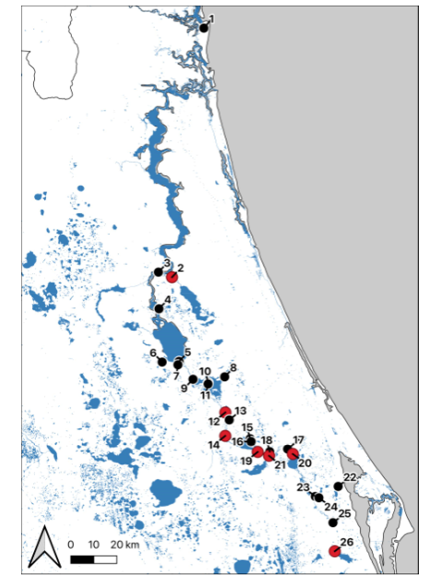
Figure 5.1: Mapped sites along the St. John’s River. Note: numbers correlate to Table 5.3, red dots indicate sites that are of historic use.

Dunn’s Creek
Located in Putnam County the lower limits of the middle Valley, Dunn’s Creek is described by Moore as a sand mound about 10 feet high with a circumference of 210 with a truncated cone; the site is about three miles from the St. Johns and nine miles south of Palatka hidden by the woods (Moore 1894). While north of my research area, Dunn’s Creek does feature characteristics that suggest Colonial use.
In his descriptions, Moore explains finding numerous burials where portions of skeletons were revealed through digs by previous visitors, and that these remains were exclusive to three feet from the surface (Moore 1894: 8). In addition to this, Moore also mentions this site being of Colonial Period due to the presence of metal. In one burial, brass earrings with a metal loop smoldered on was recovered, another featured sand having been tinged red, possibly because of iron, and an iron axe was recovered from yet another burial (Moore 1894). Moore also mentions the finding of an ornament of silver (Figure 5.2), as well as fragments of glass (Moore 1894:8–11). While Moore ultimately concludes this site to have characteristics of usage past late antiquity, he mentions the relative difficulty in assigning its origins. Argumentatively, Moore does address that the numerous artifacts found at Dunn’s Creek indicate European intercourse, possibly through trading. Dunn’s Creek is the only burial mound outside the middle valley to feature both intrusive and superficial burials as well as having the presence of metal.

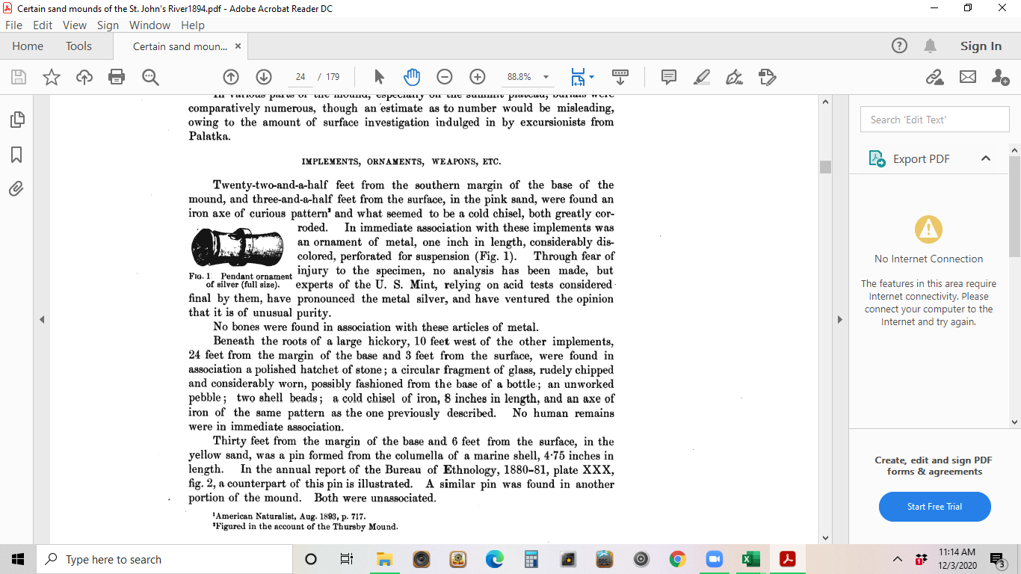

Figure 5.2: Pendant ornament of silver found at Dunn’s Creek by Moore as illustrated in Certain Sand Mounds of the St. Johns River Florida (Moore 1894: 11, Fig 1)
Bluffton
Formerly known as Orange Bluff, Bluffton lies on the east bank of the St. Johns River in Volusia County. Moore notes the site to feature many shell heaps and also a conical mound of sand and shell while Wyman’s descriptions of the site include it to have 2 burial mounds roughly 12 to 15 feet in height with Wyman excavating one of them (Moore 1894; Wyman 1872; Wheeler et al. 2000). In his examination of St. Johns burial mounds, Moore’s examination of Bluffton in Volusia County describes the sites as having similar characteristics like those encountered as Dunn’s Creek. His team excavated Bluffton in the month of March 1879, after they had obtained permission to do so. In his analysis, Moore (1894) explains that he and his team were permitted to make superficial examinations of the mound at Bluffton and that they found a burial lying just a short distance below the surface (45). He states that with exception of several intrusive burials met a short distance beneath the surface, no other human bones were found just more ‘intrusive’ interments (Moore 1894).
Wyman makes similar recordings of superficial characteristics at Orange Bluff with more specific depth recognition. Orange Bluff is described as featuring two burial mounds of 12 to 15fth with a considerable number of human skeletons found on the summit as well as a few inches beneath the surface and of these he refers to them belonging “to recent burials” (Wyman 1872). These descriptions fit the categories of intrusive and superficial but greater context is needed provide a definitive assessment to this site.
Ultimately, Moore concludes that these burials and the superficial and intrusive findings of interments most likely belonged to the period of the burials (Moore 1894: 47–48). In his assessment of St. John period sites, Goggin (1952) juxtaposes this by determining Bluffton to be a St. Johns I site that featured no element of intrusive or superficial burials. Additionally, Wheeler et al. (2000) notes the burial mound to be Archaic but that the top of the burial mound that Moore excavated was capped with shell midden material from an adjacent site and featured an intrusive burial. A notable missing element in this site is the complete lack of any kind of metals. As Randall and Tucker (2012) further explain, Bluffton Burial Mound most likely dates to the Archaic with radiocarbon dating indicating initial burials to date to the Mount Taylor, specifically, the Thornhill Lake Phase.
Thursby Mound
Thursby Mound was located in Volusia County, immediately opposite a shell mound of Hontoon Island. Thursby Mound was a height of 11 feet, had a circumference of 300 feet in the form of a truncated cone (the site is part of the greater Hontoon Island Complex; Moore 1894: 64). In his work, Certain Sand Mounds, Moore describes Thursby Mound site 8V035/36 with great detail. He makes mention of original interments being found away from the mound and in the white sand, roughly one and half feet below the surface (Moore 1894). These findings align with the near surface characteristics of superficial burials.
Most the findings at Thursby are categorized as superficial, these include shells, chert, a lance head and an iron axe (Figure 5.3) that were found. While numerous skeletons were discovered one particular burial possibly indicates the site’s usage into the Colonial Period. Moore states to have found a skeleton (possibly of a woman) superficially buried with an ornament of gold (Figure 5.4) in close proximity to beads and shells, another burial had an ornament of silver with it (Figure 5.5) (Moore 1894: 67). Similar ornaments have also been found at St. Augustine. In part II of his work, Moore makes additional notes regarding Thursby mentioning the finding of artificially colored red sand, as well as celts of iron or steel found superficially (Moore 1894). Ostapkowics et al. (2017) note additional associations at Thursby, in particular, several wooden animal effigies were recovered from the nearby riverbed. Radiocarbon dates suggest that at least two of these could have been erected during the early Colonial period similar to other effigy carvings that date between the para-colonial and post-colonial periods (Figure 5.6). These additional associations suggest that Thursby Mound was utilized to some extent during the Colonial Period. Similarly, work by Purdy (1987) demonstrates that Hontoon Island on the other side of the River was likely inhabited during the start of the Colonial era.

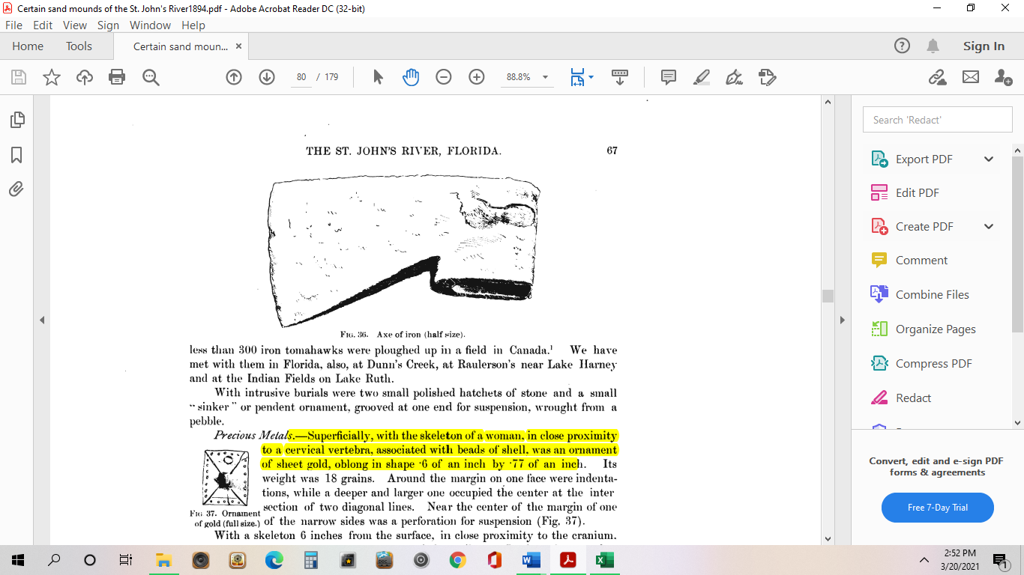
Figure 5.3: Axe of Iron from Thursby Mound (Moore1894: 67, Fig 36).

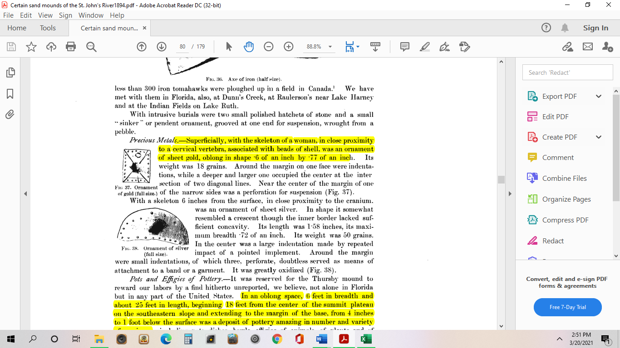
Figure 5.4: Ornament of gold described by Moore as a gold sheet approximately .6 of an inch by .77 of an inch from Thursby Mound (Moore 1894:67, Fig 37).

Figure 5.5: Described by Moore as a sheet of silver 1.58 inches in length with a breadth of .72 of an inch found 6 inches below the surface with a skeleton from Thursby Mound (Moore 1894:67, Fig 38).

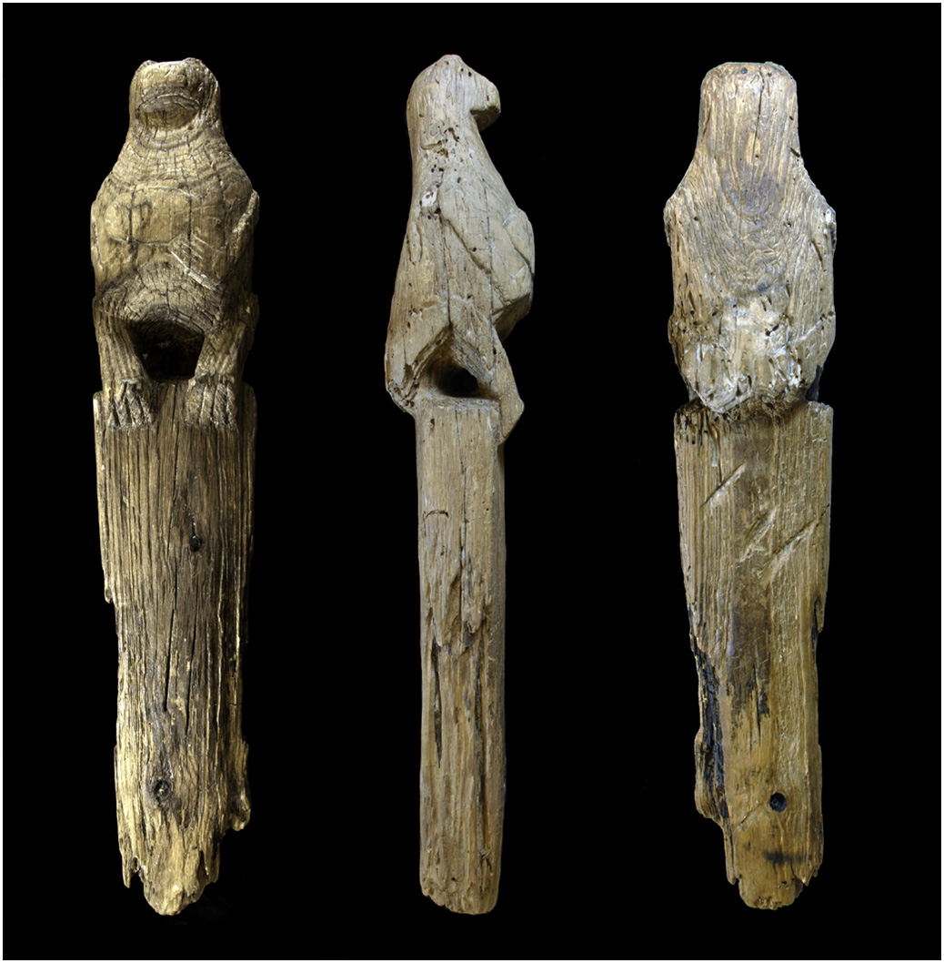
Figure 5.6: Three views of Otter carvings from Hontoon-Thursby site group dated 1456-1635 (Ostapkowicz et al. 2017:Fig 2).

Fort Florida Mound
Fort Florida Mound has multiple indicators of Colonial use. According to Randall (2015), Wyman’s excavations in 1871 note presences of Seminole burials in the Fort Florida Mound as well as presences of metal (Fig 5.7). Based on these recordings by Wyman, these skeletons are referred to as Seminole and modern. Their deposition being at only 5 or 6 inches below the surface. It is also important to note here of the presence of an iron implement as such metals were not present prior to Europeans. Additionally, Wyman notes of glass beads that were also found, these items are additional associations suggesting trading with European as glass was not a common material for Native American communities along the St. Johns prior to the 16th century (Wyman 1871; Ehrhardt 2005; Randall 2015). Moore briefly mentions the site in Certain Sand Mounds but concluded that the site, was, to him, of little baring because of disturbed skeletons from previous investigations (Moore 1894). Yet, Goggin (1952) identifies the site to be intrusive and a possible St. Johns II site.

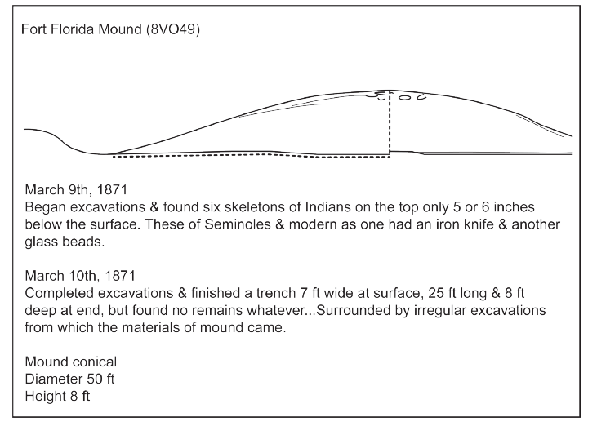
Figure 5.7: Wyman’s notes on Fort Florida Mound as detailed by Randall (Randall 2015: 7, Fig 3).

Ginn’s Grove
Ginn’s Grove was located in Orange County, previously known as Spear’s Landing, lies in view of the river along the left bank built upon a shell-heap with a circumference of 300 feet with a heigh of 10 feet (Moore1894: 84). Moore’s examination of Ginn’s Grove notes the site to have features of superficial and intrusive burials. The excavation, mainly done by trowel, was noted to have found superficial burials at length with scrapers and shells, but also that some of the burials were taken to be intrusive as well (Moore 1894). Moore does not specify exactly why the team categorized them this way given the previous classification as superficial. Additionally, Moore also states to having found beads in association with these burials. Of the beads, Moore believed them to be superficial (Moore 1894: 87).
In his writing, Moore explains the analogy of these beads, which were found near the surface, were much like the beads on several mounds in the same section as described by a previous observation by Dr. Brinton as made of glass; however, Moore and his team did not discover any more beyond the surface but were inclined to believe the beads to be superficial (Moore 1894). The absence of metal might substantiate Moore’s claims that this site did not feature any European interaction, but the presence of beads and superficial and intrusive characteristics might suggest the site having been visited during at least the St. Johns II period, roughly 1450CE. (Goggin 1952).

Mulberry Mound
Located in Orange County a few hundred yards from Lake Poinsett, Moore documents the site to be about 8ft in height and with a circumference of about 300 feet (Moore 1894). This particular site has multiple compelling features that suggest Colonial use, and Moore writes descriptively regarding the various burials and implements that were recovered. Of the most important, Moore documents numerous superficial burials between 1ft and 1.5 feet below the surface that were accompanied by multiple metal implements and glass beads (Moore 1894). In two specific burials, one female and the other male, Moore (1894) documents finding an iron implement, an iron blade, two iron fish spears, and an iron or steel knife.
The only characteristic not described by Moore is of intrusive burials. In other studies, this site is not listed as superficial, intrusive, or assigned to a particular time period (Goggin 1952). The sheer amount of metal implements found at this site is compelling given such metals like iron are commonly associated with European interplay by the 17th century (Ehrhardt 2005). Besides Mulberry, only Raulerson’s has been documented to have more metal implements.
Raulerson’s
Raulerson’s Mound was located at the southeastern end of Lake Harney in Volusia County, where the river enters into the Lake and surrounded by two shell fields, it was recorded with a height of 6 feet and a circumference of 180 feet (Moore 1894). There are a few important characteristics of Raulerson’s that is worth noting. The first being the sheer amount of metals that were found during Moore’s excavation of the site. It is not entirely clear whether Moore was suggesting this mound to be strictly used for burial purposes, but he does note encountering bodies near the surface and further below. After four feet, Moore recognizes that the artificial portion of this mound ends, the remainder he determined to pertain to a period that has no connection to the artificial portion on top (Moore 1984). In the burials, Moore records the finding of numerous metal implements. Of one burial, he mentions, “two steel or iron fish spears, a chisel of the same metal with a curved cutting edge," lay near the cranium of the skeleton as did a large number of glass beads (Moore 1894). He goes on to describe various metal implements in other burials, mostly of iron or steel (Moore 1894: 94).
Cook’s Ferry/King Philip’s
A sand mound located in Orange County just north of Lake Harney along the west bank with a height of about 12 feet and a circumference of 245 feet (Moore 1894: 89). Also known as King Philips Mound, Cook’s Ferry is noted by Moore to contain several features that suggest Colonial use. Moore and his team were allowed to observe of the mound from the property owner and they obtained numerous beads found superficially at the site as well as an ornament of metal (Figures 5.8 and 5.9; Moore 1894). It is worth noting that these artifacts were not found by Moore but given to them by the property owner who told of their finding. Moore does state that the precious metal and beads were mostly likely “derived from Spanish sources” (Moore 1894: 89). Based on his descriptions, he notes the mound had previously been dug into at many different places.

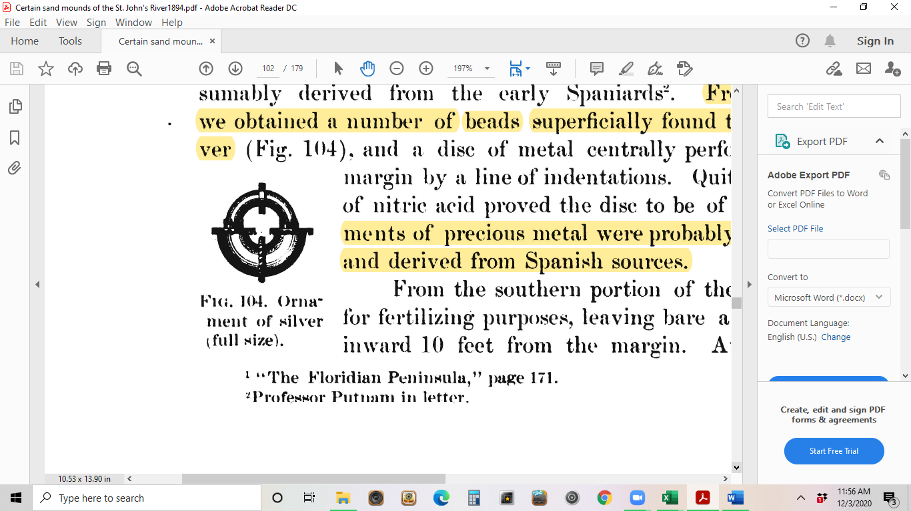

Figure 5.8: Illustration of silver ornament found by Moore at Cook’s Ferry as illustrated in Certain Sand Mounds of the St. Johns River Florida (Moore 1894: 89, Fig 104).

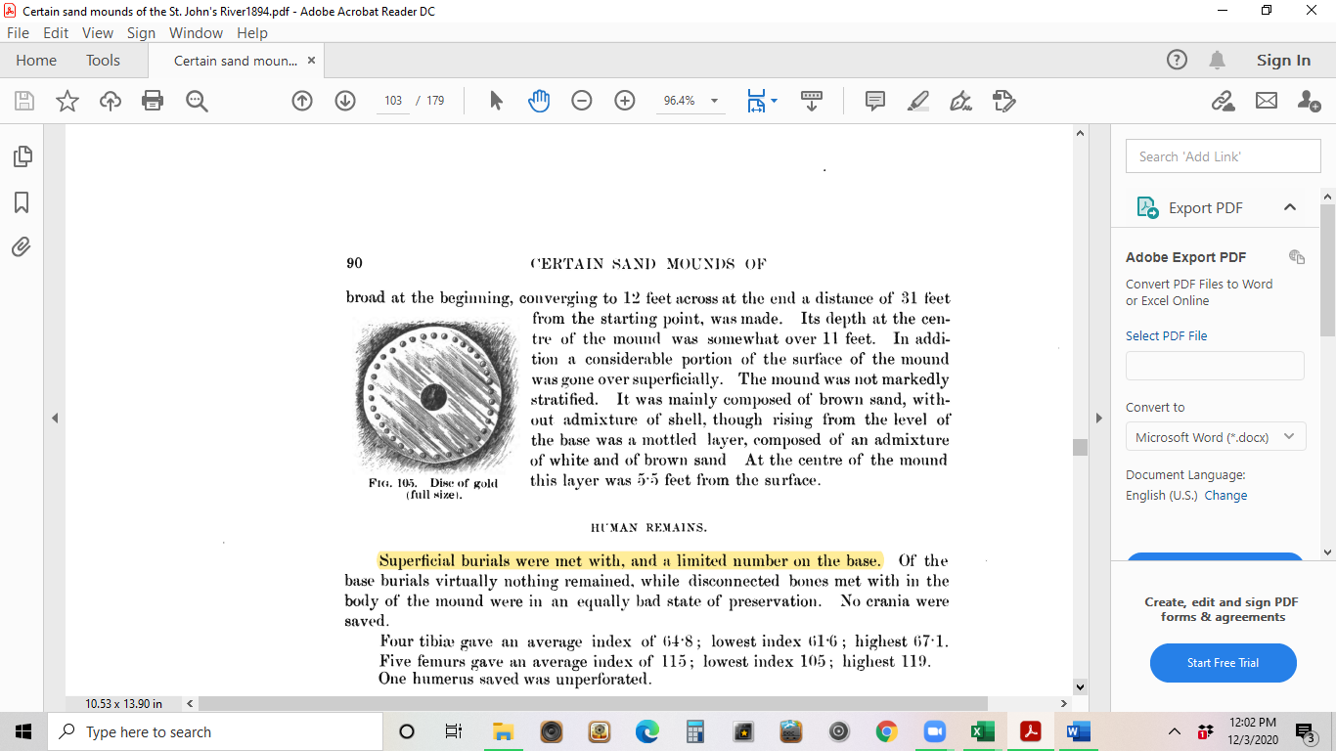
Figure 5.9: Disc of gold (originally described as silver before nitric acid revealed it to be gold) found by Moore at Cook’s Ferry (Moore 1894: 90, Fig 105).

Ultimately, Cook’s Ferry is an unusual and important site. It is documented as having superficial features, numerous burials, metals (gold), and the presences of beads. Moore determined the site to have revealed nothing of importance, but this is doubtful considering his descriptions of the site. Additionally, Moore (1894) mentions that the beads he had obtained were, until recently, in abundance on the mound’s surface, many of which were covered in a pure, gold leaf. Goggin (1952) lists the sight as a possible St. Johns II and additionally classifies it as intrusive. Cook’s Ferry is the only site in my analysis to contain all three characteristic that are suggestive of Colonial use.
Baynard Point
The mound near Baynard Point was located in Clay County on the western side of the St. Johns near a fortification that was said to date to Spanish occupation (Moore 1894) This particular lies outside the research area but includes characteristics that suggest Colonial usage. Moore notes to have found burials between two and three from the surface, one belonging to a male and the other belonging to a female that was adorned with silver earrings of European patterning, bits of glass, beads, and brass article of European make (Moore 1894: 189). The beads were oval white. Moore (1894) concludes that portions of the mound was most likely built, “by Indians of the St. Johns in post-Columbian times,” due to the presences of European articles (189). These items are suggested to have been obtained through trading.
Black Hammock
Black Hammock was located in Orange County, its name given by Wyman, it has a height of about 4 feet with a 170 foot circumference (Moore 1894: 88). Wyman visited Black during 1867. His transcripts provide a few accounts of superficial characteristics at this mound (Randall 2015; Wyman 1867). This is the first site in which Wyman states to be of modern make. He documents the finding of three skeletons (1 female) along with the presences of beads, an arrowhead, and an iron instrument that he suspects to be a spear point of some kind (Wyman 1867). In his journal, this observation has a printed date of Thursday, February 14th, 1867. In addition to the presence of a metal, Wyman states, “This mound is of course modern”, in his writings, although the exact context of modern is not detailed (Wyman 1867). It can be assumed, based on similar writings in his transcripts that he classifies this mound as recent due to presences of metal and beads. In his excavation of Black Hammock, Moore notes the site to have been rendered valueless to further research do to numerous unsystematic investigations (Moore 1894: 88). This site is not documented to feature any intrusive characteristics.
Blue Spring
Wyman visited Blue Spring sometime in 1872, the actual printed date is of June 19th, 1868; most likely this is because Wyman often reused or wrote over previous journal pages. He notes finding worked arrowheads, flint, pottery, and turtle shell near the thin loam layer of a shell heap and observing human bones protruding from a field nearby (Wyman 1872). The problem here is that Wyman does not provide enough context to accurately assess this particular site, whether there is a burial mound presence outside of the shell heap, therefore conclusion to this site being used in the Colonial is unclear and inconclusive. While his descriptions do indicate near-surface implements he does not clarify his reasonings for not excavating the site further. He states that the site’s usage was “not of long-term or immediate occupation,” but without dating of this site it is difficult to determine what time range it was used based on Wyman’s observations (Wyman 1872). Wyman’s use of language regarding long-term and immediate might imply the site did not exist in the deep past but also not of recent use. This might place the site in-between occupations periods, but which is hard to say without further study. Ultimately, Blue Spring might have at one point held some characteristics of possible Colonial usage, too little is examined archaeologically to accurately assess the relevancy of this site.
Osceola Mound
In March of 1872, Wyman excavated the Osceola Mound and recorded finding flint at the superficial portion but did not find any other implements; he does record that portions of human skeleton were also removed but does specify the depth in which they were encountered just that they were removed from the principal mound (Wyman 1872). In addition to these, Wyman also notes to have found additional material features nearby. His writings are unclear to this exact location but notes that twenty fragments of human bones were found in superficial shells (Wyman 1872). It is also unclear if Wyman was investigating a shell heap or a burial mound.
Tick Island/Harris Creek
A more difficult assignment for Colonial use of burial mounds comes from the analysis of Tick Island Complex. Tick Island is described as exceeding any other St. Johns mound in terms of size and has a long history of mound construction (Moore 1894; Randall 2019). In his examination, Tick Island is described as having an enormous circumference of 478 feet with a height of 17 ft, and details numerous superficial burials of anatomically arranged bodies in the upper soil layer (Moore 1984: 49–51). The Tick Island complex was comprised of two mounds: Tick Island mound, and Harris Creek mound respectively (Figure 5.10)
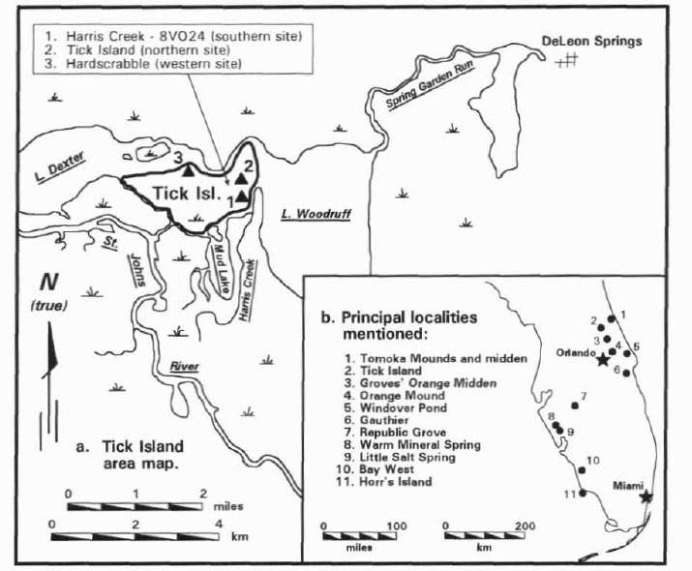
Figure 5.10: Tick Island Complex and its various localities (Aten 1999: 132, Fig 1).

In Moore’s investigation of the Tick Island Mound, he concludes that nothing indicating contact with Europeans was met, however, careful reading of his work reveals that his examinations were most likely at the Tick Island, but he does describe Harris Creek as featuring acres of shells (Moore 1894; Aten 1999). Moore also notes finding superficial skeletons in anatomical order and that they might be intrusive, particularly the finding of a young body at only four feet from the surface near the base of the mound in addition to finding sand that was artificially colored red during his examination but notes that presences of glass, beads, or metal items, items usually associated with intrusive burials after the-coming of whites, were not found (Moore 1892; Moore 1984:50). In his study, Aten (1999) argues that the Tick Island complex, most likely Harris Creek, to having been occupied sometime between the Mount Taylor and St. Johns II phases and possibly intrusive (Aten 1999: Goggin 1952). Even so, more recent scholarship has tended to place the use of the site complex and its mortuary practices to the Archaic and Woodland Periods (Randall 2008: Randall 2019).
Discussion
If we recall, my research is centered on investigating mound usage in the St. Johns middle valley. In my analysis, I primarily focused on Wyman’s and Moore’s work in the region as well as current scholarship that has additionally weighed in on their observations. In their recordings, both Wyman and Moore describe various instances where mounds were most likely used in the Colonial Period due to a combination of features like superficial or intrusive burials in association with European articles or metals like gold, steel, or iron along with other associations often linked with Europeans like glass beads. Of the 34 sites that I investigated, 17 had some form of evidence for Colonial period use, 8 had metal, 6 had beads; 5 had intrusive burials, and 14 had superficial burials, as previously noted, intrusive and superficial burials could possibly be pre-colonial unless containing additional European associations (refer to Tables 5.1 and 5.2).
Intrusive/Superficial Burials
As I’ve previously outlined, intrusive burials are burials that appear to have been reused or to have intruded upon another soil layer. There is difficulty assigning a time period to these types of burials without additional associations such as metals like silver or gold, other Colonial objects such as glass beads. As such, intrusive burials may be assigned to pre-Columbian times if there are not additional associations to indicate otherwise (Deagan 1985). The same can be said for superficial burials; however, these near surface burials are suggestive of more recent burials because of their deposition. Being a few inches below the soil indicates that these bodies are more recent than those that are encountered further below the surface. Yet without more context such as dating of implements or adornments, superficial burials could belong to the St. Johns II Period or prior.
Of the intrusive burials examined, only Cook’s Ferry had presences of metal in association with burials. Bluffton, Ginn’s Grove, and Tick Island are also noted to have intrusive burials but did not contain metals (or metal implements) and are commonly recorded along with superficial characteristics. Almost every instance where intrusive burials are noted so too are superficial burials (Moore 1894). This suggests that these sites may have been utilized during colonial times, but more documentation is needed to accurately assess these sites without additional associations.
Bundling
As Wallis and Blessing (2005) have examined, burial mounds were used as places to bundle items prior to the Colonia Period. This was a type of practice that held significance. There was logic to bundling, when things were bundled together they confer agency to other items when combined; thus, bundling brought multiple things together (Wallis and Blessing 2005). This included people. And yet, the bundling of European items or European influenced goods represented a change in Native people’s burial customs by the 1500s. Commonly bundled items included glass beads or glass fragments along with metal tools and metal adornments which were found in 6 sites that I analyzed (Table 5.4).

Table 5.4: Compilation of sites and known archaeological associations for use in this thesis.
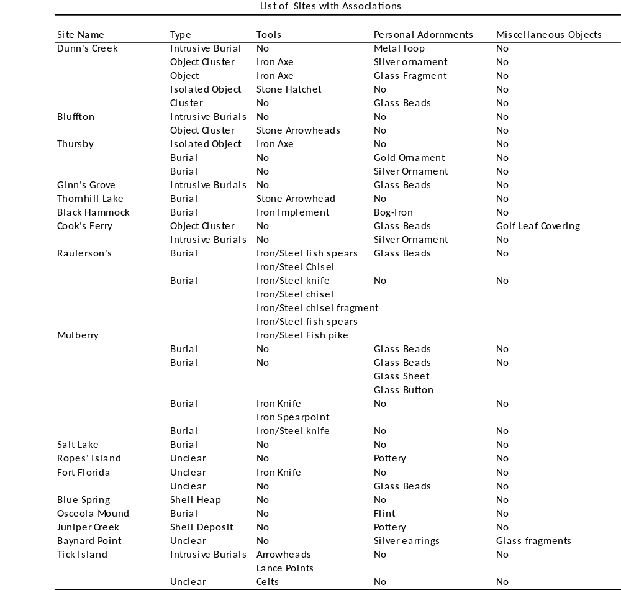
We know that metals like gold, iron, and silver can be dated to colonial times whereas other metals, like copper, were already present in Native American communities in certain compacities. For instance, we have descriptions of copper chest plates used by indigenous peoples of the St. Johns at Mount
Royal by the time the Huguenots observed them during the 1500s (Moore 1894; Deagan 1985). Determining which Native American communities utilized which mounds is difficult. We know that the Timucua occupied most of Northeastern Florida and had regular contact with the Spanish through trading and eventual missionization, but we also know that other Native American peoples of central Florida, like the Mayaca, also had dealings with the Spanish and most likely used mound structures to some extent (Deagan 1985; Sitler 2017; Hann 1991). As Sitler (2017) explains, the Mayaca inhabited the middle valley, especially around Lake George, by the 16th century and still visited certain sites like DeLeon Springs where remnants of an ancient burial midden existed. While their dealings with the Spanish were often conflictual, their material culture was partially influenced by the Spanish during missionization and the Mayaca began to incorporate ornate utilitarian items in burials (Sitler 2017; Deagan 1985). Hann (2001) summarizes that the Mayaca were described by the French as residing around Lake George and further south towards Mayrra and they even describe the Mayrra chief as being “rich in gold and silver”, (166). Although archaeological evidence to this claim is light, it is possible that the presences of gold or silver ornaments found in burials in the middle valley might be Mayaca as the interment of aboriginal grave goods in burials were becoming more common during colonial times both in Florida and elsewhere (Moore 1894; Deagan 2013; Deagan 1985; Harper et al. 2021). Additionally, as Hann (1991) notes, the Mayaca were missionized along with the Jororo by 1675, and both began to incorporate European material culture at this time.
Chronology
What do these characteristics actually say chronologically? In order to determine a dating to these sites, archaeologists need to pay close attention to presences of metals like gold, iron, or silver as well as glass articles in association with intrusive and superficial burials. Archaeologists must consider burial mounds as a palimpsest into the intentionality of past peoples. There are a few instances where bundled items appeared in mounds outside of my research area but are important to the broader argument of mound building that I am making.
The first would be Dunn’s Creek. As Moore noted, this mound is 10 feet high with a circumference of over 200 feet. Many of his descriptions indicative that the mound was occupied in recent times. In one burial Moore goes on to explain finding brass and copper buttons, spherical in shape and evident of European origin as one of the button still had a metal loop smoldered on suggesting use as a possible earring (Moore 1894: 8). He goes on to explain finding half a score of skeletons, many that appeared to have been disturbed by previous workers, and that these were “found exclusively of superficial character, and this would indicate an intrusive origin for the burials in the Dunn's Creek mound. " (Moore 1894: 15). His investigation of Dunn’s Creek revealed the mound to contain glass fragments and an axe of either iron or steel. He concludes this site to be partially proof of recent use to the interment with implements of European origins which must be assigned to the post Columbian period (Moore 1894: 8).
I would conclude this site to having been used to some extent in the Colonial Period due to the presences of superficial and intrusive characteristics and burials as well as the interment of silver and iron implements in association with glass. These objects bare similarity to many Seminole burials during the 19th century, as these often feature European trade goods and a distinct lack of shells (Piper et al. 1982). Given the location in the lower valley, Dunn’s Creek is situated in what is considered Timucua territory; however, by the early 18th century Timucua has become missionized and their burial practices notably shift to utilizing cemeteries within these missions (McEwan 2001). Additionally, Timucua customs still involved burial mound construction by the time of European contact, it is possible that mound sites like Dunn’ s Creek were occupied by the Timucua prior to missionization (Deagan 1985).
Similarly, Baynard Point offers another important lower valley inference. Primarily, the presence of trade items. Moore states to have found a skeleton man and woman found, woman found with silver earrings of European pattern, 4 bits of glass, and brass articles of European make; additionally, a great quantity of oval white glass beads were recovered (Moore 1894). These types of white ornaments have been considered exotic and somewhat common in Seminole burials, whose traditions include the incorporation of European trade items like glass and white ornamental beads or metals (Piper et al. 1982; Ehrhardt 2005). This site was most likely used during the Colonial Period.
In the middle valley, there are several mound sites that feature superficial or intrusive burials as well as presences of metals (refer to Table 5.2), but I would like to further discuss the implications of Cook’s Ferry, Mulberry, Raulerson’s, and Thursby as features numerous characteristics that suggest Colonial use more clearly. As previously mentioned, Cook’s Ferry contains superficial and intrusive burials along with the presences of gold (originally determined to be silver) along with numerous glass beads found superficially. It is the only mound I analyzed to feature all three characteristics. Goggin (1952) lists the site to the St. Johns II period, while Moore deemed the site to have features that derived from Europeans. In his book, Wyman (1875) lists the mound King Philipstown mound as one of the more important burial mounds. Determining its cultural attribute is more difficult. The site is noted to have presences of metal adornments and glass beads but does not contain metal tools (possibly suggesting that it is non-Seminole). It is possible this is Mayaca given the territory, but further analysis is needed in this case.
Likewise, the Mulberry Mound is of similar size and circumference and containing many superficial burials along with glass beads. The primary difference between these two sites is the presence of metal implements such as an iron spearpoint and iron knife; Mulberry also contained white glass beads (Moore 1894: 101-102). Careful reading of Moore’s reveals that he classifies this mound to the period of when shell-heaps were produced despite the evidence of glass and metals. Additionally, the only other site to feature prominent source of metal implements is the Raulerson’s Mound.
While Raulerson’s is not noted to feature intrusive burials, Moore mentions to having found numerous metal implements and glass. Of these metal implements, Moore states to having found two steel or iron fish spears, a similar chisel of the same metal, a bladed knife, another implement resembling an adze, fragmentary chisels, a fish spear and spike, all iron or steel (Moore 1894: 94). Similar to Mulberry, burials at Raulerson’s were adorned with implements and glass beads similar to other documentations of Seminole burials with the absence of metal ornaments. These findings are similar to the Fort Florida Mound where Wyman noted presences of metal implements, glass beads and asserts the skeletons were of Seminole burials (Randall 2015).
We also see similar metal implements and presences of gold and silver in Thursby Mound but with the lack of glass beads. If we recall, Hann (1991) details that a Mayaca chief was described by the French as being rich in metals like gold and silver, but also notes that Hontoon Island provides data of the Mayaca being primarily hunter gatherers. With Thursby being part of the greater Hontoon Island Complex, the presences of these metals might suggest Mayaca use, and we also know that Spanish documents indicate that the Mayaca began to incorporate Spanish material culture during missionization in the late 17th century (Hann 1991). Additionally, burials at Thursby had a great number and variety of pottery (Moore 1894). The style of pottey has been described as Mayaca, which bares similarity to other pottery of the St. Johns Periods (Hann 1991). This would suggest that Thursby Mound might not be of Seminole use but of Mayaca. Seminole burials by the mid 1800s (especially those in cemeteries) featured an adoption of European trade goods such as metal containers instead of aboriginal pottery unlike the Mayaca (Piper et al. 1982; Hann 1991). This gives further credence to the burials examined at Thursby to have been used by the Mayaca in the Colonial Period.
Conclusion
In my analysis of Wyman’s and Moore’s writings, along with recent literature, I documented the observation of superficial and intrusive properties as well as the presences of metals in various burial mound sites that were examined by Wyman and Moore. As I’ve previously explained, the presence of metals alone does not imply mound usage in colonial times, but its association with other characteristics like superficial and intrusive burials are suggestive of recent use.
While Wyman and Moore’s work is detailed, much of their combined work did not focus on determining the usage of burial mounds into the Colonial Period but rather to answer other archaeological questions regarding agency and outside influence. To provide greater context, I incorporated recent literature on specific burial mound sites where applicable. Yet, there are several instances were documentation is limited to only what was recorded by Wyman and Moore.
Among the sites I analyzed, Dunn’s Creek, Thursby, Fort Florida, Ginn’s Grove, Mulberry, Raulerson’s, Baynard Point and Cook’s Ferry represent the most compelling cases for Colonial use of burial mounds in the middle St. Johns River valley. To a lesser extent, the sites Black Hammock, Bluffton Blue Spring, Osceola Mound, and Tick Island feature various characteristics of possible usage into the Colonial Period, but an accurate account of these sites is marred by inconclusive documentation by either Moore or Wyman because of selection bias, site destruction, or lack of permission to investigate or due to only featuring one characteristic suggestive of Colonial use. I also noted where certain mounds might have been used by Native American communities such as the Timucua, Mayaca and Seminole but also where further research is needed.

Chapter 6:
Conclusions
Throughout this thesis I have examined the interior occupation of the St. Johns River throughout the Colonial Period, looking at the use of burial mounds in the middle valley. This region has featured numerous mound building since the Archaic, after which the practice of mound building continued. Past peoples along the St. Johns built their life through the practice of mound building, a social event. These were sacred spaces with on-going social processes and landscape alteration and reuse.
The history of past peoples’ agency along the St. Johns River Valley is embodied in the long-term alteration and modification of the landscape, however, archaeologists have predominantly studied these long-term events of human agency prior to the Colonial Period. Observation and analysis of these physical structures of agency from the mid-to-late 19th century was divided on whether these mounds were geological or anthropogenic.
Nineteenth century archaeological investigations conducted by Jeffries Wyman and Clarence B. Moore offered archaeological context of the St. Johns upper, lower, and middle valleys determining that theses mounds were anthropogenic. Their descriptions offered various accounts of these mounds including their construction and purpose. Both their works depict the implied importance of these mound structures that dotted the St. Johns with several mounds featuring characteristics of repurposing, redevelopment and reuse. We know that mound building was an important lifeway for hunter gatherers along the St. Johns and the number of mounds that continued to be constructed and reused throughout time suggest their importance.
Fundamentally, past peoples of the St. Johns River built their life through the construction of mounds. They were spaces where acts of moundedness were continued and reused. By examining these spaces, archaeologists can observe aspects of reuse and by doing so we might then see the long-standing importance and continuity that moundedness held to St. Johns cultures through time. Additionally, by examining the use of mounds in the Colonial Period, offers us a window in understanding and explaining why and how these traditional lifeways that had continued for thousands of years were now being shattered during colonialism. Ultimately, we might also explore how mounding practices and language were thus changed from the reproduction of traditional lifeways and histories to recapturing or creating new lifeways in the wake of European incursion and invasion. These types of ethnogenesis are not only relevant for the St. John’s in the Colonial Period but elsewhere around the world.
In my thesis I explored the extensiveness of mound building through time and the importance of this practice to Native American communities of the St. Johns. This practice did not end by the 16th century and archaeological evidence continues to suggest that mound usage continued into colonial times; in addition, there are several instances where implements of Native American adornments were interred with articles of European making (Holland and Lulewicz et al. 2020). In my research, I examined a variety of archival materials and current scholarship to build a methodology to analyze mound usage in this time. I proposed that the presences of superficial and intrusive burials along with presences of exotic metals like gold or silver and additional associations that were not native to the region, like glass, are strong indicators for colonial use; however, individual findings of any one characteristic does not imply mound usage.
In my analysis I concluded that there were several mounds, both within and outside the research area, that featured such characteristics suggestive of colonial use. These included the sites of Thursby, Fort Florida, Mulberry, Cook’s Ferry, Raulerson’s, Baynard Point and Dunn’s Creek where presences of metal tools and ornaments, glass fragments and glass beads were found with bodies or in near association of bodies in several of these sites. Among these sites, superficial and intrusive characteristics were noted in multiple instances.
Using these characteristics as indicators of mound usage in the Colonial Period also illustrates the importance that mound building had to Native American communities of this region. They continued to reuse these mounds across time, incorporating features found in the environment such as shell, fish, and stone, but also materials they bartered from Europeans. By altering their environment, Native American communities of the St. Johns also built an important segment of their social and ceremonial life through the practice of mound construction. This implies the development of meaning through social involvement (Turner 1974). Burial mounds represented both a physical and mental structure in which to reinforce cosmological and ideological beliefs. They also represented the importance of the social event. Mound building was an important component of these communities and it existed for thousands of years. Those that built them were constructing their history through practice, which required them to come together for an event.
With this perspective, we can then begin to understand the belief that Native American communities of the St. Johns built mounds to act as monuments of meaning and that they were not forgotten by the 16th century. Contemporary studies of these mounds have argued that they form a belief bound in ‘moundedness’ or mounds as living and interactive experiences, and even that mounds were seen as living people. These mounds came into importance through the very act of their creation. Once again, this echoes Hymes’ concept of the difference between social and normal events. Mound building was a specific, special moment in time among Native American communities of the region that existed outside the normal routines of their daily life. If we are to believe this concept of ‘moundedness’, that these mounds occupy a living space and even acting as brethren themselves, then we cannot believe that mounds would just be vacated and forgotten with the changing of time. Thus, examining the construction of these mounds through time provides an opportunity to explain and understand why Native American peoples of the St. Johns altered their landscape, why they continued to build and reuse mounds, and how these mounds were a place of meaning for them.
Essentially, I am examining the interior occupation of the St. Johns by analyzing past and present literature regarding the region’s burial mounds and offering a re-examination of the material and theoretical evidence thus shifting the narrative of moundedness through to the Colonial Period, 1500CE. This illustrates that past peoples of the St. Johns were not merely caching the dead but venerating them through events.
Further analysis of the sites mentioned in this thesis as well as additional sites along the St. John’s River might allow archaeologists to gauge burial mound usage more accurately in Colonial times. One way might be to reexamine the burial practices of Native American communities that inhabited the St. John’s River Region in the pre and post-colonial era. For my research, I focused primarily on archival materials that documented characteristics suggestive of burial mound use in the Colonial Period. As such, I only partially focused on the cultural attributes that may be assigned to each mound site. Further analysis of these attributes might reveal the specific Native American cultures that utilized these mound sites and thus a time period may be determined.
Future research might also continue to develop the concept that Dillehay proposed which embodies the belief that mounds act as living people. As previously articulated, past communities along the St. John’s created their beliefs through mound building, and mounds acted as a member of the kinship in which others actively communicated with. Thus, examining this concept might further explain why Native American communities returned to use mounds as a way to continue their cultural dialogue. Dialogism is part of the chronotope and is subject to social relations and tensions through time that ultimately suffuse language as a whole. Mounds act as multiple languages and offer different points of view within a single cultural language or society but are always communicating symbols and belief systems to those that engage with them. This is the heart of the social event and Bakhtin’s chronotope.
Additionally, this also has relevancy for future research outside of the Southeast. Viewing mounds as embodying language also means that by continuing to engage with mounds reproduced core beliefs that were at risk of being converted through colonialism. Also, by viewing mounds as an acting member in a kinship or society, mounds take on a language role which confers meanings and symbols to neighboring villages or in changing times. We can see such resistance movements through language among the Maya during the Colonial Period were Maya peoples found refuge from Spanish linguistic conversion by continuing to use their traditional Maya languages in spite of pressures to adopt a Spanish language system (Hanks 2010: 38-58). This historical parallel is not dissimilar to how indigenous peoples along the St Johns used mounds as an active language and through engaging with them that language continued to be reproduced. This is the very concept that Dillehay explains as mound literacy. In another example, Dillehay (2007: 1-10, 398-402) explains the Araucanians in Chile utilized mounds as both a means to engage in language and to actively resist Europeans, thus utilizing their large population density and social organization within their ‘mounded geography’ were able to defeat and expel the Spanish from their sacred spaces.
Similarly, if we examine Seminole history, we see that mounds might have offered them a means to seek refuge, resist, and reproduce their traditional lifeways much like the Maya or Araucanians. According to Frank (2005), Creek and Seminole often acted in ways to show their resistance to Spanish dominance, one such way was their embracement of refugees from other tribes as a way to resist European political and colonial hegemony. With political acts of resistance such as these occurring, returning to mounds might also have provided similar ways to continue to challenge the growing autonomy of the Spanish, at least symbolically, much like how the Yamasee resisted Spanish mission systems by occupying mounds that served as symbolic fortresses.
Ultimately, we also see that indigenous peoples that inhabited the St. Johns during this time built their life through social events. Burial mounds were constructed via these events. They were spaces where on-going social processes and acts of moundedness were continued and reused. These mounds were monuments, structures, and sacred spaces. Indicators of reuse for burial mounds are what archaeologists can observe and through the incorporation of additional theoretical inputs, the importance of this ‘reuse’ through time can be explained. Not much is known about mound usage along the middle valley during the Colonial Period but by examining the material record along with ethnohistorical and historical accounts, archaeologists may be in a position to further understand the importance that mounds continued to have for indigenous peoples during this time.

References Cited
Arkush, Brooke S.
2011. Native Responses to European Intrusion: Cultural Persistence and Agency among Mission Neophytes in Spanish Colonial Northern California. Colonial Archaeology, 2011, Vol. 45, No. 4 (2011): 62-90.
Ashley, Keith.
2018. Yamasee Migrations into the Mocama and Timucua Mission Province of Florida. In The Yamasee Indians: From Florida to South Carolina (Ed. Denise Bossy). London: University of Nebraska Press: 55-80.
Aten, Lawrence.
1999. Middle Archaic Ceremonialism at Tick Island, Florida. The Florida Anthropologist, (52/3): 131-200.
Bakhtin, Mikhail
1938. Forms of Time and of the Chronotope in the Novel. In The Dialogic Imagination. Austin: Univ. Texas Press: 84–258.
Bartram, William
1791. Travels Through North & South Carolina, Georgia, East & West Florida, the Cherokee Country, the Extensive Territories of the Muscogee, or Creek Confederacy, and the Country of the Choctaws; Containing An Account of the Soil and Natural Productions of Those Regions, Together with Observations on the Manners of the Indians. Embellished with Copper-Plates: Electronic Edition. Bartram, William, 1739-1823
Brinton, Daniel.
1859. Notes on the Florida Peninsula; Its literary History, Indian Tribes, and Antiquities. Philadelphia: Joseph Sabin.
Bossy, Denise.
2014. Spiritual Diplomacy, the Yamasees, and the Society for the Propagation of the Gospel:
Reinterpreting Prince George's Eighteenth-Century Voyage to England. Early American, Studies, Spring 2014, Vol. 12, No. 2 (Spring 2014): 366-40.
Bucholtz and Hall.
2004. Language and Identity. In A Companion to linguistic Anthropology (Ed. Alessandro Duranti). UK, USA: Blackwell Publishing: 369-394.
Buren, Mary Van.
2010. The Archaeological Study of Spanish Colonialism in the Americas. Journal of Archaeological Research, June 2010, Vol. 18, No. 2 (June 2010): 151-201
Bushnell, Amy Turner.
2014. "These people are not conquered like those of New Spain": Florida's Reciprocal Colonial
Compact. The Florida Colonial Quarterly, Winter 2014, Vol. 92, No. 3, 500 Years of Florida History—The Seventeenth Century (Winter 2014): 524-553.
Deagan, Kathleen A.
1985. Spanish-Indian Interaction in Sixteenth-Century Florida and Hispaniola. In Cultures in Contact (Ed W. Fitzhugh). Virginia: Smithsonian Inst Pr; 1st edition: 281-318.
2013. The Colonial Archaeology of Sixteenth-Century La Florida. The Florida Colonial Quarterly, Winter 2013, Vol. 91, No. 3, 500 Years of Florida History—The Sixteenth Century (Winter 2013): 349-374.
Dillehay, Tom.
2007. Monuments, Empires, and Resistance. Cambridge: Cambridge University Press.
Johns, Sherman.
2020. Mill Cove Complex Lithic Typology: Understanding Early Mississippian Period Social Exchange in Northeastern Florida. Dissertation: University of Central Florida.
Frank, Andrew K.
2005. Taking the State Out: Seminoles and Creeks in Late Eighteenth-Century Florida. The Florida Colonial Quarterly, Summer, 2005, Vol. 84, No. 1, Special HFlorida
Issue: Florida History from Transnational Perspectives (Summer, 2005):10-
27
Geertz, Clifford.
1973. The Interpretation of Cultures. New York: Basic Books.
Goddard, Ives.
2005. The Indigenous Languages of the Southeast. Anthropological Linguistics, Spring, 2005, Vol. 47, No. 1 (Spring, 2005): 1-60
Hanks. William E,
2010. Converting Words: Maya in the Age of the Cross.: Berkeley, London, Los Angeles: University of California Press.
Hann, John.
1991. Mayaca and Jororo and Missions to Them. The Florida Anthropologist, (24/2-4): 164-175.
1996. History of the Timucuan Indians. Florida: University Press of Florida.
Harper et al.
2021. Metal burial: Understanding caching behaviour and contact material culture in Australia’s NE Kimberley. Journal of Social Archaeology. 0(0): 1–25.
Holland, Dorothy et al.
1998. “A Practice Theory of Self and Identity,” in Identity and Agency in Cultural Worlds (Eds. Dorothy Holland, Debra Skinner, William Lachicotte Jr., and Carole Cain). Harvard University Press, Cambridge, Massachusetts, London, England: 19-46.
Holland-Lulewicz et al.
2020. Enduring Traditions and the (Im)materiality of Early Colonial Encounters in the Southeastern United States. American Antiquity, (85/4): 694-714.
Hymes, Dell
1981. “In Vain I Tried to Tell You”: Essays in Native American Ethnopoetics. Nebraska: University of Nebraska Press.
Kroskrity, Paul.
2002. Telling Stories in the Face of Danger: Language Renewal in Native American Communities. Norman: University of Oklahoma Press.
Mann, Rob.
2005. Intruding on the past: The Reuse of Ancient Earthen Mounds by Native Americans. Southeastern Archaeology, Summer 2005, Vol. 24, No. 1 (Summer 2005): 1-10
Martin, Jack.
2011. A Grammar of Creek (Muskogee). E-book, Lincoln: University of Nebraska Press, 2011, https://hdl.handle.net/2027/heb.31453. Accessed 10 Feb 2021.
McEwan, Bonnie G.
2001. The Spiritual Conquest of La Florida. American Anthropologist, Sep. 2001, Vol. 103, No. 3 (Sep. 2001): 633-644.
McNiven, Ian.
2013. Ritualized Middening Practices. Journal of Archaeological Method and Theory, (20/4): 552-587.
Milanich, Jerald T.
2002. “"A Very Great Harvest of Souls": Timucua Indians and the Impact of European Colonization. Smithsonian Contributions to Anthropology: 113-120
2004. Timucua. In Handbook of North American Indians (Ed. Raymond D. Fogelson). Washington: Smithsonian Institution, (14): 219-228
2004. Early Groups of Central and South Florida. In Handbook of North American Indians (Ed. Raymond D. Fogelson). Washington: Smithsonian Institution, (14): 213-218.
Moore, Clarence B.
1892. A Burial Mound of Florida. The American Naturalist, Feb 1892: 129-143.
1894. Certain Sand Mounds of the St. Johns River Part I. University of Virginia. Philadelphia: The Levytype Company.
1894. Certain Sand Mounds of the St. Johns River Part II. University of Virginia. Philadelphia: The Levytype Company.
Perrino, Sabrina
2015.Time and Space in Oral Narrative. In The Handbook of Narrative Analysis (Ed. Anna De Fina and Alexandra Georgakopoulou). Nebraska: United Kingdom: Wiley Blackwell: 141-159.
Piper et al.
1982. Cultural Responses to Stress: Patterns observed in American Indian Burials of the Second Seminole War. Southeastern Archaeology, Winter 1982, Vol. 1, No. 2 (Winter 1982):122-137
Purdy, Barbara
1987. Investigation at Hontoon Island (8-VO-202) An Archaeological Wetsite in Volusia County, Florida: An Overview and Chronology. The Florida Anthropologist. (40/1): 4-12.
Randall, Asa.
2008. Archaic Shell Mounds of the St. Johns River, Florida. SAA Archaeological Record. Nov 2008, (8/5):13-16.
2015. Constructing Histories: Archaic Freshwater Shell Mounds and Social Landscapes of the St. Johns River, Florida. Florida: University Press of Florida.
2019. Gathering for a Millennia along the Atlantic Coast and St. Johns River of Northeast Florida. In The Archaeology of Human-Environmental Dynamics on the North American Atlantic Coast (Ed. Leslie A. Reeder-Myers, John A. Turck, and Torben C. Rick.) Gainesville, FL: University Press of Florida: 199-231.
Randall, Asa.
2020. Deep Time on the Eternal River. In The Historical Turn in Southeastern Archaeology (Ed. Robbie Ethridge and Eric E. Bowne). Gainesville, FL: University Press of Florida:17-42.
Randall, Asa and Bryan Tucker.
2012. A Mount Taylor Period Radiocarbon Essay from the Bluffton Burial Mound (8VO23). The Florida Anthropologist. 65(4).
Ritchie, William.
1937. Culture Influences from Ohio in New York Archaeology. American Antiquity, Jan. 1937, Vol. 2, No. 3 (Jan. 1937): 182-194
Sassaman, Keith.
2008. The New Archaic, It Ain’t What It Used To Be. SAA Archaeological Record. Nov 2008, (8/5): 6-8.
Schneider, Tsim D.
2015. Placing Refuge and the Archaeology of Indigenous Hinterlands in Colonial California. American Antiquity, (80//4): 695-713.
Schneider, Tsim D. and Lee M. Panich.
2019. Categorical Denial: Evaluating Post-1492 Indigenous Erasure in the Paper Trail of American Archaeology. American Antiquity 84(4), 2019: 651–668.
Scott, Thomas M.
1997. Miocene to Holocene history of Florida. In The Geology of Florida (Eds A.F. Randazzo and D.S. Jones). Gainesville, FL: University Press of Florida: 57-68.
Sitler, Robert.
2017. Immersed in the Millennial History of DeLeon Springs. Journal of Florida Studies. (1/6).
Sokefeld, Martin, 1999. “Debating Self, Identity, and Culture in Anthropology.” Current Anthropology 40(4): 417-447.
Spike, Tamara.
2006. To Make Graver This Sin. Concepts of Purity and Pollution Among the Timucua of Spanish Florida. The Florida State University. Dissertation.
Stoltman, James.
2004. 2004 History of Archaeological Research. In: Fogelson, R D Handbook of North American Indians, volume 14: Southeast. Washington: Smithsonian Institution:14–30.
Strang, Cameron B.
2014. Violence, Ethnicity, and Human Remains during the Second Seminole War. The Journal of American History, March 2014, Vol. 100, No. 4 (March 2014): 973-994.
Swanton, John Reed
1922. Early History of Creek Indians and their Neighbors. Bureau of American Ethnology Bulletin. 73: 1-492.
Tanner, Nancy.
1975.Matrifocality in Indonesia and Africa, and Among Black Americans. In Woman, Culture and Society (Eds. Rosaldo, Michelle and Louise Lamphere). Stanford: Stanford University Press: 129-156.
Turner, Victor.
1974. Dramas, Fields, and Metaphors. Ithaca: Cornell University Press.
Voss, Barbara.
2015. What’s New? Rethinking Ethnogenesis in the Archaeology of Colonialism. American Antiquity, October 2015, Vol. 80, No. 4 (October 2015): 655-670.
Watts, WA., and B.C.S. Hansen
1994. Pre-Holocene and Holocene pollen records of vegetation history from the Florida peninsula and their climate implications. Palaeogeography, Palaeoclimatology, Palaeoecology 109 (1994): 163-176
Weisman, Brent R.
2007. Nativism, Resistance, and Ethnogenesis of the Florida Seminole Indian Identity. Colonial Archaeology, (41/4): 198-212.
Wheeler et al.
2000. A New Look at the Mount Taylor and Bluffton Sites, Volusia County, with an Outline of the Mount Taylor Culture. Florida Anthropologist. 53(2-3): 132-157.
Worth, John
2002. Spanish Missions and the Persistence of Chiefly Power. In Transformations of the Southeastern Indians, 1540-1760 (ed. Robbie Ethridge and Charles Hudson). Jackson: University Press of Mississippi.
Wyman, Jeffries.
1867. Transcripts, year 1867.
1872. Transcripts, year 1872.
1875. Fresh-Water Shell Mounds of the St. Johns River. Peabody Museum of Science. Salem, Massachusetts: Peabody Academy of Science.

