University of Oklahoma

Graduate College

THE TRANSITION OF A COMMUNITY OF PRACTICE TO A PROFESSIONAL LEARNING COMMUNITY FOR HIGH SCHOOL BIOLOGY TEACHERS:
A CASE STUDY

A thesis

submitted to the Graduate Faculty

in partial fulfillment of the requirements for the

Degree of

MASTER OF Education

By

ABIGAIL JORDAN LEGGATE
Norman, Oklahoma
2018

THE TRANSITION OF A COMMUNITY OF PRACTICE TO A PROFESSIONAL LEARNING COMMUNITY FOR HIGH SCHOOL BIOLOGY TEACHERS:
A CASE STUDY

A thesis approved for the
DEPARTMENT OF INSTRUCTIONAL LEADERSHIP
AND ACADEMIC CURRICULUM

By

______________________________
Dr. Timothy A. Laubach, Chair

______________________________
Dr. Kathleen Crowther

______________________________
Dr. Kelly Feille

© Copyright by abigail JORDAN leggate 2018
All Rights Reserved.

Dedication

“Now this is not the end. It is not even the beginning of the end. But it is, perhaps, the end of the beginning”.

- Winston Churchill

To my parents. My dad, the most intellectual man I know, and my Mom, the best friend a girl could have. For their infinite love and support, and for being my role models, my sounding board, and my biggest cheerleaders.

To Harry and Anna, for always inspiring me to be the best role model that an older sister should be. And to my fiancé, Brian, for his love and patience knows no limits! I finished this thing! Now let’s get married!

Acknowledgements

I would like to convey my sincere appreciation and thanks to my thesis committee, Dr. Kathleen Crowther and Dr., Kelly Feille. I admire you both greatly, and I feel privileged to have received your guidance through this thesis writing process.

I would like to express my deepest gratitude to my advisor and committee chair, Dr. Timothy Laubach, whose passion for teaching greatly raises the bar for anyone in education. His collegiality and mentorship through this process over the past two years has been invaluable.

Table of Contents

Acknowledgements iv
Abstract vii
Introduction 1
Review of the Literature 2
Professional Learning Communities vs Communities of Practice 2
Sources of Difficulty in Professional Learning Communities 3
Benefits of Professional Learning Communities 4
Methods 6
Context and Participants 7
Data Collection 8
Data Analysis 9
Findings 11
Question 1: How did the community of practice come to be a reality for high school Biology I teachers? 11
Question 2: How did the informal CoP transition to a formal PLC? 12
Question 3: How did the implementation of the PLC occur? 14
Question 4: How do the biology teachers feel about engaging in the PLC as compared to their reflections of feelings while in the CoP? 14
Discussion 19
Implications 21
Recommendations 22
Conclusion 23
References 25
Appendix A: Prospectus 28
Appendix B: IRB Letter of Approval 60
Appendix C: Informed Consent 61
Appendix D: Interview Questions 63
Appendix E: Concept Map for the Community of Practice 66
Appendix F: Concept Map for the Professional Learning Community 67

Abstract
Professional Learning Communities are hailed as efficient tools for fostering collaboration among teachers and improving achievement among students. This qualitative case study seeks to understand the transition of an informal collaborative group (Community of Practice/CoP) to a formal collaborative group (Professional Learning Community/PLC). This case study utilized semi-structured interviews of three biology teachers who comprise the Biology teacher PLC at a suburban high school in a West South Central state. The participants composed the informal collaborative group, experienced the transition to a professional learning community, and now comprise the formal collaborative group (PLC). The interviews were audio-recorded and then transcribed, verbatim, for data analysis. The researcher coded the interview transcriptions and looked for emergent themes from the data. The study concluded that the transition to the PLC was initiated and facilitated by the school’s administration and that the most arduous task in implementation was providing a common plan during which they could meet as a PLC. The participants reported feeling that their PLC is more efficient and easier to collaborate in comparison to their experiences in the CoP.
Keywords: professional learning community, case study, science teachers

A journal-ready thesis for submission to the
Journal of Science Teacher Education
Print ISSN: 1046-560X Online ISSN: 1573-1847
Instructions for authors may be accessed at https://www.tandfonline.com/action/authorSubmission?journalCode=uste20&page=instruction

Introduction
In today’s educational society, the idea of collaboration among teachers has garnered the interest of school administrators (Cowan, 2009; DuFour, 2006; Leane, 2018). For the past several decades, collaboration has been defined as an efficacious tool to foster an environment of improvement in our schools (DuFour, 2006). Collaborative groups that are initiated and supported by either building - or district level administrators are referred to in the literature as Professional Learning Communities (or PLCs) (Cowan, 2009; DuFour, 2006; Hord, 2004; Leane, 2018). PLCs are composed of educators who are working together collaboratively through inquiry and research at structured times throughout the school day in hopes of attaining higher levels of achievement from their students (DuFour, 2006). Typically, membership is a "forgone conclusion" within the schools (Blankenship & Ruona, 2007; Hord, 2004). Research suggests that PLCs are a “powerful vehicle” to provide researchers with collaborative opportunities (Mintzes, Marcum, Messerschmidt-Yates, & Mark, 2010).
Multiple studies lend to the notion of a positive relationship between PLC implementation in schools and improvement in both teaching practices and student achievement (Cowan, 2009; DuFour et al., 2006; Hord, 1998; McLaughlin & Talbert, 2010). As a result, more administrators are seeking to implement these groups in their schools in hopes of facilitating school improvement (DuFour et al., 2006; Many, 2009).
In some cases, teachers decide to form collaborative groups without the facilitation of their administration; these informal groups are referred to as a Community of Practice (or CoP) (Wenger, 2015). A CoP operates in a similar fashion to PLCs in terms of collaboration and the common goal of student achievement, and in that they allow for teacher learning to occur (Goodnough, 2007). However, members of a CoP must meet on their own time and sometimes at off-site locations (Wenger, McDermott & Snyder, 2002).
This case study is based on a department level PLC that consists of four Biology I teachers at a suburban High School in a West South Central state, where the teachers have already undergone the transition from a CoP to a PLC. Therefore, the purpose of this study is to describe the creation of a CoP for a group of high school biology teachers, trace the transition from an informal CoP to a formal PLC, and then uncover the implementation of the PLC. This case study may add to the literature on PLC implementation and to the literature on how a PLC evolves from a CoP and then operate following PLC implementation.

Review of the Literature
For decades, the concept of collaboration among school teachers has been a prevalent topic in education (DuFour et al., 2006). School administrators are seeking to achieve this collaboration through the implementation of PLCs (Cowan, 2009; Hord, 1998; McLaughlin & Talbert, 2010). However, in some schools, teachers are initiating these groups on their own; these groups are referred to as a CoP (Jones & Dexter, 2014; Wenger, 2015; Wenger, McDermott & Snyder, 2002).

Professional Learning Communities vs Communities of Practice
PLCs are models of collaboration that encourage teamwork and professional development between teachers, qualities that are beneficial for achievement among students and to student learning (Cowan 2009; Hart, 2013; Hord, 1998; McLaughlin & Talbert, 2010). DuFour and Eaker (1998), founding researchers on the concept of PLCs, defined them as bands of teachers who work collaboratively toward the common goal of student achievement. Furthermore, they suggested that there are several characteristics which constitute PLCs. These characteristics are as follows: shared mission and values, collective inquiry, collaborative teams, action orientation and experimentation, continuous improvement, and results orientation (DuFour & Eaker, 1998). PLCs are groups that operate where supportive conditions within the school are provided by administration (Hord, 2004). PLCs are beneficial in allowing teacher professional development in collaborative, communicative environments among teachers (DuFour, 2006; Cowan, 2009; Hord, 1998).
In contrast, a CoP is a group of people who have a common interest and who have committed to working collaboratively to share ideas (Wenger, 2015). A CoP within schools does not necessarily have a regular meeting time or location that is facilitated by administration; instead, the CoP meets at a time and location that is convenient for the members (Jones & Dexter, 2014; Wenger, 2015). Thus, membership in a CoP is voluntary. These collaborative groups offer an opportunity for teachers to engage in collaboration while seeking a favorable overall outcome (Wenger, McDermott, & Snyder, 2002). Members of these groups engage with one another to share ideas and knowledge and to work through inquiry toward a common goal (Saint-Onge & Wallace, 2003).

Sources of Difficulty in Professional Learning Communities
There are numerous sources of difficulty that could plague an administrator during the implementation process of a PLC (Blitz & Schuluman, 2016; Cowan, 2009; Hord, 1998; McLaughlin & Talbert, 2010). Ferguson (2013) determined that the biggest issue faced in a school was the lack of additional funds which were earmarked for PLC implementation. This unanticipated problem meant that the school could not hire adequate supervision for the students while the teachers were meeting in their PLCs, which led to push back from parents and teachers.
Additional problems can arise if the administrators fail to garner “buy in” from the teachers who are asked to work collaboratively. Graham (2007) employed a mixed methods study that examined the relationship between teacher involvement in a PLC and teacher performance. Results suggested that PLCs have the opportunity to achieve significant improvements in teacher effectiveness. However, these positive results were only attainable if there was a presence of leadership within those groups.
Another difficulty that administrators may encounter during the implementation stage of a PLC is when veteran teachers likely have a teaching practice with which they are comfortable and that they feel is effective (DuFour, 2006; Leane, 2018). Thus, it might prove difficult for these teachers to adapt to a new, collaborative, teaching style (Blitz & Schuluman 2016; Cowan, 2009; Leane, 2018).

Benefits of Professional Learning Communities
The PLC literature is replete with the resulting benefits for teachers and students alike (Cowan, 2009; DuFour, 2006; Hord, 1998; McLaughlin & Talbert, 2010). PLCs are beneficial to establishing collaboration among teachers, to fostering teamwork among teachers, and to improving student performance (DuFour, 2006). PLCs give teachers a forum through which they are able to share their practices, materials, and tools (Wong, 2010). PLCs work to remove practices of teacher isolation by replacing them with environments which promote teamwork (Mohabir, 2009). For example, Leane (2018), a principal who was new to her role, noticed that her teachers were working in isolation and running their classes independently. The principal, having engaged in PLCs herself, knew of the benefits first hand and implemented PLCs in her school. Following implementation, the school saw an improved culture among teachers and higher achievement among students. Collaborative environments, as observed by Leane, cultivated a climate of teamwork and community that is inclusive for all teachers and allowed for continuous professional development, improvement, and communication (Cowan, 2009; DuFour, 2006; Hord, 1998; McLaughlin & Talbert, 2010). These groups afford teachers the opportunity to engage in a critical reflection of their practices, as well as allowing teachers to learn from those whom they are regularly meeting with (Hord, 1998; McLaughlin & Talbert, 2010).
As aforementioned, PLCs create opportunities for teamwork and professional development among teachers. A favorable consequence of these opportunities for teachers is an improvement in student achievement (Cowan, 2009; DuFour, 2006). The customs that are created through PLCs are customs of cohesiveness among teachers, achieved through collaboration which serves to better the effectiveness of teachers (Cowan, 2009; DuFour, 2006; McLaughlin & Talbert, 2010). This often leads to a greater achievement in students who have teachers who are a part of a team (Cowan, 2009; DuFour, 2006; Hord, 1998).
This qualitative case study acknowledges the plethora of research that has investigated how PLCs are implemented successfully in schools and how they function post-implementation. This qualitative case study was utilized for the purpose of exploring the lesser known transition from an existing CoP to a PLC. The researcher seeks to understand how the evolution of a PLC occurs in situations where there is already an informally functioning collaborative teacher group (CoP) in place. The following research questions guided this study: (a) How did the CoP come to be a reality for the high school Biology I Teachers? (b) How did the informal CoP transition to a formal PLC? (c) How did the implementation of the PLC occur? (d) How do the biology teachers feel about engaging in the PLC as compared to their reflections of feelings while in the CoP?

Methods
Identifying with the constructivist research paradigm, the researcher chose to conduct this qualitative study with case study methodology (Stake, 1999). Creswell and Creswell (2018) suggest several characteristics for qualitative research such as: performing the research in the participants natural setting, utilizing the researcher as the key instrument, using multiple sources of data, using inductive and deductive data analysis, understanding the participants meaning, using emergent design, and creating a holistic account.
According to Merriam (1988), Yin (1989), and Stake (1999), a case study is a detailed examination of one particular event. Merriam (1988) elaborated that the case study is an in-depth description and analysis of a "bounded system." For the purpose of this case study, the "bounded" system was the Biology I department and their participation in the transition from an informal CoP to a formal PLC. A case study research strategy provided flexibility that allowed for a moldable research design throughout the duration of the study. The research design associated with this study was approved by the university institutional review board (IRB) and the local review board of the participating school district.

Context and Participants
For this case study, the site and its participants were purposefully selected to best assist the researcher in understanding the research problem and answering the research questions (Creswell & Creswell, 2018). The school where the participants were employed was a large, suburban high school (grades 9-12) in a West South Central state. According to the most recent data available (Office of Educational Quality & Accountability, 2016), student enrollment was 2,378 with 1.5% students identified as English Language Learners and 16.2% students identified as having special needs. The ethnic makeup of the student body consisted of the following groups: Caucasian (77%), Hispanic (10%), Native American (5%), Black (4%), and Asian (5%). Thirty-four percent of students were eligible for free/reduced lunch. The school offered 13.5 units of science, which closely aligned with other subject areas. Regular education students scored above the state average on Biology I end-of-instruction tests.
The school employed 101 teachers who had 15 years average experience. Four of these teachers were assigned to primarily teach Biology I, which is typically taken by high school freshmen. The boundary for participant selection was that the teacher must be a member of the Biology I PLC and must also have been a member of the Biology I CoP, therefore ensuring that participants experienced the transition from a CoP to a PLC. Due to scheduling and availability, three of four teachers agreed to participate in this study. Their pseudonyms for this study are Riley, Jordan, and Alex. These teachers have 29 years total combined teaching experience (ranging from 5 - 18 years) with 12 years combined biology teaching experience at this particular school (ranging from 3-5 years). Each biology teacher taught five, 53-minute classes each day in addition to one common planning period and lunch.

Data Collection
Data collection included initial teacher interviews and researcher’s notes on her perception of the interview, which she recorded at the conclusion of each interview. Each participant was interviewed face-to-face by the researcher following an approved interview protocol at a time and location which was mutually agreed upon. Individual interviews were utilized for the purpose of garnering open-ended responses from the participants that would elicit their own views and opinions (Creswell & Creswell, 2018). Semi-structured interview questions were developed for this study and were constructed prior to the researcher entering the field (see Appendix D). Utilizing a semi-structured interview gave the researcher some control over the questioning and allowed for an easy conversation with each participant (Stake, 1995).
Interview questions were divided into four clusters: teacher background, involvement in the informal CoP, involvement in the transition from a CoP to a PLC, and involvement in the formal PLC. Due to the nature of asking semi-structured questions, exact questions asked of each participant varied slightly. However, each interview consisted of an opening question, the main content of the interview, and a closing question. The opening question served to orient each participant to the study, to make them feel at ease, and to get them talking about themselves. The opening question asked each participant how long they had been teaching, and how long they had been teaching Biology I at this school. The body of the interview consisted of questions that were phrased in a manner that seemed friendly to the participant and that were structured around the transition from the CoP to the PLC. The researcher used questioning probes, which allowed her to ask the participants to elaborate on an answer they had given. This probing technique served to allow the participants to lead the conversation while the researcher was able to listen (Creswell & Creswell, 2018). The closing remarks allowed the researcher to ask each participant if there was any additional information that the participant felt would aid the researcher in understanding the transition.
Each interview averaged 20 minutes in length and was audio-recorded. The first half of the interview surveyed participants about their experience and feelings of their membership in the CoP, and the latter half of the interview surveyed participants about their experience and feelings of their membership in the PLC.

Data Analysis
The researcher utilized several procedures for analyzing qualitative data, such as, utilizing simultaneous procedures and winnowing the data (Creswell & Creswell, 2018). Simultaneous procedures were utilized when the researcher immediately transcribed the first interview and began analyzing the interview data while interviewing the next participant. Winnowing the data occurred when the researcher read through each of the interviews and identified several themes from relevant data and excluded non-relevant data. After themes were identified, the researcher aggregated the data accordingly. The researcher did not use any type of coding software but rather coded by hand. The researcher felt that coding by hand allowed for a more accurate interpretation of the participant's attitudes toward the transition from a CoP to a PLC.
The researcher followed the data analysis process as suggested by Creswell and Creswell (2018). The steps followed a sequential order and consisted of the following activities: (a) organize and prepare the data for analysis (the researcher transcribed each interview verbatim); (b) read all the data (the researcher read each transcript to gain a general idea of the information and to reflect on the overall meaning); (c) start coding data (the researcher organized data by identifying segments of the interview and writing a word(s) to represent a category); (d) generate a description and themes (the researcher described the various events that occurred through the transition from the CoP to the PLC; these themes will be presented in the Findings); and (e) represent the description and themes (the researcher will convey the findings of the analysis in the Discussion).
To ensure trustworthiness of the data, the transcribed interviews were checked to ensure that no mistakes were made during the transcription (Creswell & Creswell, 2018). The researcher had intended to conduct a follow-up interview with each participant to allow the findings to be member-checked (Creswell & Creswell, 2018). However, due to an unforeseen circumstance in the state that caused some time constraints toward the end of the semester, the researcher was only able to member-check the findings with one participant. This participant verified the findings as being accurate with how his/her feelings as well as the feelings of the members of the PLC. Trustworthiness of the findings was also addressed by data triangulation via the analysis of two sources of data, the participant interview transcriptions as well as an analysis of the researcher’s notes.

Findings
A number of important themes emerged from the analysis of the biology teachers' responses to the semi-structured interview questions about the transition from a CoP to a PLC as well as from the researcher’s field notes. The researcher identified four major themes pertaining to the participant's responses of their time in the CoP: Irregular Meeting Times, Inefficiency, Collaboration, and Reliance and Utilization. The researcher identified five major themes pertaining to the responses from the participants of their time in the PLC: Regular Meeting Times, Efficiency, Collaboration, Reliance and Utilization, and Perceived Value. Each theme will be described within the context of answering each research question.

Question 1: How did the community of practice come to be a reality for high school Biology I teachers?
An Accidental Occurrence
The CoP came to fruition as “an accidental result of a voluntary expectation from [the] administration that the biology teachers would work together,” (Alex). Riley, offered some more insight into this expectation “when [we] were interviewed they asked us if we were comfortable working in a group, on our own time”. The participant interviews revealed that the administration had an expectation of the Biology I teachers to give a common assessment and to have a standardized pacing so that there was some “sort of uniformity between all of the Biology classes” (Jordan). Although the administration expected this of their teachers “they didn’t give [them] any time to meet in school. It was like ok, you have to do this, I don’t mind if you can’t eat lunch, but you have to do it” (Jordan). Thus, in order to meet these expectations, the four Biology I teachers decided to work together and to meet at times when it was convenient; however, the timing of these meetings would not always work with everyone’s schedule. That meant that they would often have meetings even when some teachers could not attend, and sometimes the meetings “would be as short as 30 minutes” (Jordan). “Luckily, [they] are all pretty efficient people who want to get things done” (Alex), so the teachers “ended up meeting about three times a month for about thirty minutes at a time, usually at lunchtime” (Riley).
The Leader
The teachers identified Riley as the leader of their CoP. Additionally, when asked the question of how the CoP came into existence, Riley self-identified as being the leader of the CoP. Riley stated that they
knew it was an expectation for [them] to meet as a group, but it really took a few years for [the teachers] to get into a collaborative group that worked well together...it took a few years of different rotations of teachers in and out of positions (for various reasons such as subject changes to job changes) to get our CoP to where it was last year [functioning collaboratively and effectively during meetings]… eventually I was the teacher who had the most seniority, and so [the administration] just kind of elected me into the role [of group leader].

Question 2: How did the informal CoP transition to a formal PLC?
Administration Support
The initiative to transition from a CoP to a PLC came from the freshman principal "whose aim was to give the teachers for each of the freshmen-level classes (who teach the same subject), the same planning period" (Jordan). The participants first learned about the intent to create a "common plan" during the year prior to PLC implementation (2016/2017 school year). Although the participants already worked collaboratively as a CoP, they were advocates for the formal PLC when they learned that it was a potential possibility. Alex stated that the biology teachers felt that "biology was not a subject that needed [a PLC] because [they] already did it on [their] own" but that they felt that having a common period which they could meet, every week, would greatly “improve [their] efficiency and, of course, [they] are appreciative of the time to have together [now], during the [school] day.”
The principal worked with the school scheduling coordinator to create a schedule that not only gave the Biology I teachers a common planning period but also gave other subject area teachers a common planning period throughout the day. Providing teachers the same planning period gave them an opportunity to work collaboratively in a time that was facilitated by administration. A common planning period allowed each of the subject area teachers for a particular course to be available at the same time during the school day. This common planning period effectively created a foundation for a PLC for each core subject team of teachers. Jordan stated that the process of coordinating the schedules of four subject area teachers in order to provide a common planning period was "a challenging one."
Jordan stated that although they were advocates of the common plan and of the PLC, they felt that the administration did not effectively communicate with the teachers throughout the initiation process. Jordan stated that the teachers did not learn that they had actualized the intention of a common planning period until speaking to one another and realizing that they all shared the same planning period. Alex added to this by stating that if they had known about the common plan, "say, in the summer", they could have planned some more effective PLC meetings for the beginning of the school year.

Question 3: How did the implementation of the PLC occur?
The implementation of the PLC occurred after the administration provided the members of the PLC a common planning period every day during which they could meet. The PLC began meeting in their newly formalized manner in August 2017. The meetings took on a "similar structure to the CoP meetings” (Jordan), except now, the participants could “meet every Tuesday at 10:00 am, for an hour if [they] need to” (Alex). The meetings, which now occur weekly and for a longer period of time, are still collaborative like the previous CoP meetings. However, now that the participants had the opportunity to meet weekly they were “able to be much more efficient with [their] time” (Riley) and “collaboration is easier because [they] know [they] will see each other again the next week” (Alex). The PLC still employs an informal aspect in that if a teacher needs something or has a question for one of their teacher peers, they "have no problem running next door to ask" (Jordan). However, "the formalized aspect of the PLC (meeting weekly, for a whole class period)” has, according to the participants, “improved the efficiency" of the meetings (Jordan).

Question 4: How do the biology teachers feel about engaging in the PLC as compared to their reflections of feelings while in the CoP?
For the purpose of answering this question, the researcher visualized the four themes that emerged from the participants’ reflections of their time in the CoP and the five themes that emerged from the participants’ reflections of their time in the PLC by creating two concept maps. The concept maps (found in Appendices E and F) were constructed in an effort to create a visual representation of the themes and sub-themes that emerged from the participants' semi-structured interviews. Looking specifically at the themes along the top of the map, and then relying on the sub-themes to draw context, the researcher looked specifically at the connections between the themes that are revealed in both concept maps. The researcher identified four themes regarding participant reflection on their time in the CoP: Irregular Meeting Times, Inefficiency, Collaboration, and Reliance and Utilization. The researcher identified five themes when the participants were asked about their feelings regarding the PLC, which were as follows: Regular Meeting Times, Efficiency, Collaboration, Reliance and Utilization, and Perceived Value. For the purpose of answering these questions, the researcher will compare the changes in emergent themes between CoP and PLC.
Each of the themes are interrelated to the sub-themes and to each other, but the biggest difference between the concept maps is the regularity of meeting times. Although there are 4-5 emergent themes that are identified, the biggest difference between an informal collaborative group and a formal collaborative group was regularly scheduled meetings and administration support (DuFour, 2006; Wenger, 2015). Thus, the researcher chose to present this data by first illustrating the relationship between the regularity of the meeting times and the efficiency of the meetings. Following this, the researcher will present a comparison of each of the themes, through the lens of meeting Regularly.
Regularity of Meetings and Efficiency
When the participants were asked to draw on their experiences from their membership in the CoP, they described their frustration of times when the entire group could not meet due to a scheduling conflict. Participants sometimes have lunch duty or obligations outside of school with their children, which hindered their ability to meet before/after school or during the lunch period. This led to participants meeting only when necessary.
Evidently, this irregular meeting schedule caused some of the participants to feel that the meetings were “not as efficient as they could have been” (Jordan). Alex stated that “since the meetings were only 30-45 minutes, if [they] met at lunchtime, [they] couldn’t always finish the tasks that [they] had intended to work on during the meetings”. When the transition occurred to a PLC where the participants had a regularly scheduled, weekly meeting for the duration of one class period, the participants reported feeling that they were able to be much more efficient with their time and able to accomplish more at their meetings (Jordan).
Although stated as two different themes, regularity of meetings and efficiency are related in that by meeting more regularly they will be able to be more efficient as a group. The factors that contributed to increased efficiency and regular meeting times are as follows:
- Most of the time all of the participants can attend (it is an administrative expectation that the participants will attend)
- The meetings take place every Tuesday and last between 50 minutes and 1 hour.
- They meet even when it is not necessary, just to check in with one another and to ensure that they are on the same page, and the same pace, with the material that they are teaching.

Regularity of Meetings and the Effect on Collaboration

A concern that the participants had with their informal collaborative experience was that collaboration on common assessments was difficult when the participants did not have a regular meeting time. Despite the negative feelings held by participants about inefficiency and irregular meeting times, the participants stated that they felt that the ability to collaborate was still utilized “as well as it could be given the circumstances” (Riley). Some of the participants share a hallway with one another and recalled the fact that they would often “run over to [another teacher’s] room to ask [them] about an assignment real quick”. Jordan, stated that they “felt comfortable doing so, due to the relationship [they] had built” during the CoP. Although they could not meet weekly, the participants had created an environment of comfort and trust with one another through their meetings. Thus, when the transition to a PLC occurred, giving the participants regularly scheduled meetings, they were starting from a different place than a new PLC would have been without the informal collaborative group. This was due to the fact that they already knew each other and had been collaborating, informally, for two years. The factors that contributed to the ability to better collaborate are as follows:
- The members of the PLC are able to share lesson plans and daily activities due to the fact that they meet so often.
- The members of the PLC see each other weekly, so they are able to hold each other accountable in terms of pacing and writing common assessments.
Alex stated that "it is just all around easier to collaborate and have efficient meetings because we know that we are meeting every Tuesday, and we know that we have expectations (such as common assessments and pacing) which we, as a group, intend to meet". Thus, the data suggest that the transition to a PLC has improved the efficiency as well as the teachers' overall perceptions of the collaborative meetings.
Regularity of Meetings and Reliance and Utilization

A common theme among the participant responses was that they rely on each other and utilize each other as a resource. The participants recalled the ability to cover each other's classes and to “cover each other’s backs” (Jordan) when the participants did not have a common planning period. Having a common planning period hindered the participants from their ability to cover each other's classes if a teacher had to run an errand or drop something off for their child (Jordan, Riley). The participants regard this as a negative aspect of the formalized collaborative group.
Additionally, the participants reported relying on each other for support with administration, with difficult students, and with parent interactions, both in the CoP and the PLC. During the semi-structured interview, the researcher asked Riley “do you feel that you could rely on each other for help communicating with administrators/ students/parents more so in the CoP or the PLC?” Riley responded that it was definitely easier to rely on each other for this type of communicative help now that they meet every week.
Regularity of Meetings and the Effect on Feeling Valued by the Administration

The addition of the idea that teachers feel valued by the administration now they have regular meeting times is explained through Jordan's statement that the teachers "feel that [their] time is valued now because the administration isn't just saying 'okay you need to have common assessment, but we aren't going to give you time to make that happen. No, they're saying, we recognize that collaboration will help you as teachers, and we want to give you the chance to make that happen, so here is a common plan". The teachers feel that now that the administration has given them the chance to meet during the school day, that their time is valued and that "[they] are a valuable asset to student learning” (Jordan). This has led to better relationships between the teachers and the administration. Jordan said they feel happier with the notion that the administration respects their time.

Discussion
The idea of PLCs for teachers is very much in vogue throughout the field of education. Numerous administrators are seeking to institutionalize these collaborative groups in their schools to enhance teacher development and increase student achievement (Cowan, 2009; DuFour, 2006; Hord, 2004; Leane, 2018). However, some schools seek collaboration among teachers but do not facilitate it, as seen in the school site for this case study. Participants were interviewed to elicit their opinions on collaborating with their teacher peers on their own time prior to PLC implementation. It appears that hiring decisions may have been based on a teacher's willingness to engage in collaboration. There was an administration expectation of the Biology I teachers to administer common assessments and to have common pacing within their classrooms. These expectations caused the Biology I teachers to feel the need to meet, as it was easier to talk about these expectations in person than to initiate the collaboration via email (Jordan). Thus, the teachers would meet whenever it was convenient (about 3 times a month (Riley).
At the onset of this study, the literature informed the researcher that the process of initiating a PLC is a difficult one (Blitz & Schulman, 2016; Du Four, 2006; Jones & Dexter, 2014; Leane, 2018). However, in this particular study, the difficulties did not reside with the teachers feeling unable to collaborate or to work as a team (Blitz & Schuluman, 2016; Cowan, 2009; Leane, 2018) or with a lack of funding (Ferguson, 2013; Leane, 2018). Rather, the data suggest that the most arduous part of the transition from a CoP to a PLC for this school and these teachers was the requisite scheduling and planning that was facilitated by the administration allowing subject area teachers to have a common plan.
The actual implementation of the PLC did not occur until the 2017/2018 school year via the utilization of a common plan. The actual transition for these particular teachers was not as difficult as it could have been if the teachers had not been collaborating and working as a team prior to implementation (Blitz & Schuluman, 2016; Cowan, 2009; Leane, 2018). The transition for these teachers, who had been engaging in a CoP prior to this year, was less about adjusting to working together and more about a smooth transition to a regular meeting time. “[They] already worked so well together, so [their] meetings are very natural (Alex)”. An important aspect of collaboration is building and foresting trust among participants so that collaboration is a simple task (Saint-Onge & Wallace, 2003). Thus, the most difficult part of the transition laid at the hands of the administrators whose task it was to coordinate and facilitate a common plan for their teachers.
After gaining an understanding of the implementation process of the PLC, the researcher was eager to understand how the participants felt about their new, formal, collaborative group. The researcher asked the participants a variety of questions pertaining to their emotions regarding the PLC. The purpose of creating the concept maps was to give a visualization of the data for comparative purposes. The data show that the overall feeling among participants was positive when reflecting on their feelings of the PLC as compared to their feelings of the CoP. This was due to a multitude of factors including the regularity of the meetings, the efficiency of the meetings, and the fact that the teachers feel that they (and their time) is valued by the administration. The findings show that the participants felt that the only negative about the regular meeting times was that because they all share a common plan period now, they no longer have the flexibility to cover each other’s schedules the way they could in previous years. However, the participants' attitudes allude to the idea that the “good” - being efficient, regularly scheduled meetings, and a feeling of value from the administration - outweighs the “bad” - the inability to cover each other’s schedules.

Implications
This study provides an understanding of how a PLC is implemented when a CoP is already in place. While the benefits of PLCs have been established, knowing and anticipating how to implement these collaborative groups within schools can be a challenge. This challenge has implications for administrators who seek to establish PLCs in their schools, particularly in schools where teachers are already working collaboratively.
In this particular case study, the most difficult task in the implementation process was working around teachers' schedules. The literature suggests that potential sources of difficulty come from a lack of leadership and a lack of funding (Du Four, 2006; Leane, 2018; Jones & Dexter, 2014). For this case, these difficulties were not evident in the data. Understanding the ease that the teachers who were already meeting collaboratively had in transitioning to meeting as a PLC may encourage administrators to formalize collaborative groups in their own schools.

Recommendations
This qualitative case study allowed the researcher to understand the transition from an informally operating collaborative group (CoP), to a formal collaborative group (PLC). The findings suggest that the most difficult aspect of the implementation of a PLC from a CoP was engaging with each teacher’s schedule in order to allow the Biology I teachers to have a common planning period. As this was a case study looking explicitly at the Biology I teacher PLC to understand the transition as they experienced it, the administrators were not approached for interview. However, future studies exploring the transition in a school where there is a CoP transitioning to a PLC may seek to interview the administrators as well as the teachers to understand more of the difficulties that may be encountered in the implementation process. Further research on this transition process would aid administrators in facilitating this type of transition in their own schools.
Additionally, when the participants were asked questions regarding a comparison of their feelings from their reflection of their time in the CoP, to their feelings during their current engagement in the PLC, the teachers introduced the idea of feeling valued by their administration. The participants reported feeling that their time was valued by their administration, which contributed to relationships between teacher and administrator. Future studies may seek to understand if the feeling of value from administrators is common to all transitions from a CoP to a PLC. If this feeling of value was further researched and shown to be beneficial in schools, then it may lead to teachers and administrators advocating for a transition like this for their professional environment.

Conclusion
This study described the transition of an informal collaborative group (a CoP), to a formal collaborative group (a PLC), in a suburban high school in a West South Central state. This qualitative case study served to help understand the transition from a CoP to a PLC. The participant responses during the semi-structured interviews suggest that their CoP was the result of an expectation from their administration to give common assessments and instruction at the same pace throughout curricular units. The study findings also suggest that the implementation process of the PLC was entirely facilitated by the administrators. The data from the interviews suggest that the most arduous task in the implementation of the PLC was scheduling all of the teachers to allow for them to have the same planning period. Additionally, participants reported feeling a greater sense of efficiency in their new, regularly occurring, collaborative meetings. This can be attributed to the fact that everyone’s schedules now allow for them to attend the meetings, and that collaboration is easier.
Collaboration among school teachers has been credited with improving student achievement and improving interactions among teachers (Cowan, 2009; DuFour, 2006). PLCs are systematically studied throughout educational literature and point to a wealth of benefit to teacher engagement in these groups (Cowan, 2009; Hord, 1998; Leane, 2018; McLaughlin & Talbert, 2010). When teachers are given the opportunity to meet during the school day, their meetings are more efficient because everyone is able to attend, and they are able to meet for longer periods of time. This study suggests that if administrators are able to facilitate a common planning period to accommodate a more formal PLC in schools where teachers already meet collaboratively in an informal CoP, then these teacher groups may improve in efficiency and in collaboration.

References
Ahn, J. (2017). Taking a step to identify how to create professional learning communities--Report of a case study of a Korean public high school on how to create and sustain a school-based teacher professional learning community. International Education Studies, 10(1), 82-92.

Blankenship, S. S., & Ruona, W. A. (2007, Feb-Mar). Professional learning communities and communities of practice: a comparison of models, literature review. Paper presented at the Academy of Human Resource Development International Research Conference in The Americas, Indianapolis, IN.

Blitz, C. L., & Schulman, R. (2016). Measurement instruments for assessing the performance of professional learning communities. Washington, DC: Regional Educational Laboratory Mid-Atlantic. Retrieved from https://files.eric.ed.gov/fulltext/ED568594.pdf

Bolam, R., McMahon, A., Stoll, L., Thomas, S., Wallace, M., Greenwood, A., Hawkey, K., Ingram, M., Atkinson, A., & Smith, M. (2005). Creating and sustaining professional learning communities. Research Report No. 637. London, England: General Teaching Council for England, Department for Education and Skills.

Byrd, T. S. (2012). A case study of certified support staff members' perceptions of professional learning communities (Doctoral dissertation). Available from ProQuest Dissertations Publishing. (Order No. 3517136).

Chen, P., & Wang, T. (2015). Exploring the evolution of a teacher professional learning community: A longitudinal case study at a Taiwanese high school. Teacher Development, 19(4), 427-444.

Creswell, J. W., & Creswell, J. D. (2018). Research design: Qualitative, quantitative, and mixed methods approaches (5th ed.). Thousand Oaks, CA: Sage.

DuFour, R., & DuFour, R. (2006). The power of professional learning communities. National Forum of Educational Administration & Supervision Journal, 24(1), 2-5).

DuFour, R., & Eaker, R. (1998). Professional learning communities at work: Best practices for enhancing student achievement. Alexandria, VA: Association for Supervision and Curriculum Development.

Ferguson, K. (2013). Organizing for professional learning communities: Embedding professional learning during the school day. Canadian Journal of Educational Administration and Policy, 142, 50-68.

Graham, P. (2007). Improving teacher effectiveness through structured collaboration: A case study of a professional learning community. RMLE Online: Research in Middle Level Education, 31(1), 1-17.

Goodnough, K. (2017) Moving Science off the “Back Burner”: Meaning Making Within an Action Research Community of Practice, Journal of Science Teacher Education, 19:1, 15-39, DOIL 10.1007/s10972-007-9007-1

Hairon, S., & Dimmock, C. (2012). Singapore schools and professional learning communities: Teacher professional development and school leadership in an Asian hierarchical system. Educational Review, 64(4), 405-424.

Hart, K. S. (2013). Teacher collaborative planning in professional learning communities (Doctoral dissertation). Available from ProQuest Dissertations Publishing. (Order No. 3601483)

Honner, A. M. (2010). PLCs require more than learning a secret handshake: A case study of the transition to professional learning communities in one midwestern suburban middle school (Doctoral dissertation). Available from ProQuest Dissertations Publishing. (Order No. 3401057)

Hord, S. M. (1997). Professional learning communities: Communities of continuous inquiry and improvement. Austin, TX: Southwest Educational Development Laboratory. Retrieved from http://www.sedl.org/pubs/change34/plc-cha34.pdf

Hord, S. M. (2004). Professional learning communities: An overview. In S. Hord (Ed.). Learning together, leading together: Changing schools through professional learning communities (pp. 5-14). New York: Teachers College Press.

Mintzes, J., Marcum, B., Messerschmidt-Yates, C., & Mark, A., (2017) Enhancing Self-Efficacy in Elementary Science Teaching With Professional Learning Communities, Journal of Science Teacher Education, 24:7, 1201-1218,DOI: 10.1007/s10972-012-9320-1

Jones, C. M. (2013). Out of isolation and into collaboration: Sustaining the work of professional learning communities in a secondary school. (Doctoral dissertation). Available from ProQuest Dissertations Publishing. (Order No. 3589390)

Jones, W. M., & Dexter, S. (2014). How teachers learn: The roles of formal, informal, and independent learning. Educational Technology Research and Development, 62(3), 367-384.

Leane, B. (2018). A vision that changed a school. Principal Leadership, 19, 54-57.

Many, T. W. (2009). Make time for collaboration. TEPSA. Retrieved March 18, 2018 from www.tepsa.org

McDonough, J. S. (2013). A case study of how professional learning communities influence morale and rigor in the classroom (Doctoral dissertation). Available from ProQuest Dissertations Publishing. (Order No. 3606252)

Mohabir, A. D. (2009). The principal's role in implementing professional learning communities within a school: A case study. (Doctoral dissertation). Available from ProQuest Dissertations Publishing. (Order No. 3400288)
Office of Educational Quality & Accountability. (2016). Oklahoma school profiles. Retrieved from https://www.edprofiles.info/report-card

Saint-Onge, H., & Wallace, D. (2003). Leveraging communities of practice for strategic advantage. Boston, MA: Butterworth-Heinemann.

Tam, A. C. F. (2015). Exploring teachers' beliefs about teacher learning in professional learning communities and their influence on collegial activities in two departments. Compare: A Journal of Comparative and International Education, 45(3), 422-444. https://doi.org/10.1080/03057925.2013.872025

Wang, T. (2016). School leadership and professional learning community: Case study of two senior high schools in northeast China. Asia Pacific Journal of Education, 36(2), 202-216.

Wenger, E., McDermott, R., & Snyder, W. (2002). Cultivating communities of practice. Boston, MA: Harvard Business School Press.

Wenger-Trayner, E., & Wenger-Trayner, B. (2015) Introduction to communities of practice: A brief overview of the concept and its uses. Retrieved from http://wenger-trayner.com/introduction-to-communities-of-practice/

Wong, J. N. (2010). What makes a professional learning community possible? A case study of a mathematics department in a junior secondary school of China. Asia Pacific Education Review, 11(2), 131-139.

Yazan, B. (2015). Three approaches to case study methods in education: Yin, Merriam, and Stake. The Qualitative Report, 20(2), 134-152. Retrieved from http://www.nova.edu/ssss/QR/QR20/2/yazan1.pdf

Appendix A: Prospectus
University of Oklahoma

Graduate College

THE TRANSITION OF A COMMUNITY OF PRACTICE TO A PROFESSIONAL LEARNING COMMUNITY FOR HIGH SCHOOL BIOLOGY TEACHERS:
A CASE STUDY

A prospectus

submitted to the Graduate Faculty

in partial fulfillment of the requirements for the

Degree of

MASTER OF Education

By

ABIGAIL JORDAN LEGGATE
Norman, Oklahoma
2018

Chapter 1: Introduction
Over the past several decades, researchers have begun to identify collaboration among teachers as the most effective tool for improvement in our schools (Cowan, 2009; DuFour et al., 2006; Hord, 1998; McLaughlin & Talbert, 2010). This collaboration can be achieved through the use of professional learning communities (Cowan, 2009; DuFour et al., 2006). Professional learning communities (PLCs) are believed to provide an excellent framework through which researchers can focus on the challenges that plague our schools, such as, difficulty communicating with colleagues, isolation among teachers, and students who are difficult to reach (DuFour et al., 2006). There are multiple studies lending to the notion that there is a relationship between creating PLCs for improvement in teaching practices and improved learning among students (Cowan, 2009; DuFour et al., 2006; Hord, 1998; McLaughlin & Talbert, 2010). Therefore, educational practitioners have advocated for professional learning communities, believing these PLCs will provide opportunities for teachers to engage in professional development opportunities (Blitz & Schulman, 2016; Cowan, 2009; DuFour et al., 2006; Hord, 1998; McLaughlin & Talbert, 2010). The plethora of research that is available on the benefits of PLCs has led to a rise in administrators implementing these communities in their schools (Blitz & Schulman, 2016; Cowan, 2009; DuFour et al., 2006; Hord, 1998; Many, 2009; McLaughlin & Talbert, 2010).
Professional learning communities are becoming increasingly more common in the field of education, due to the fact that administrators are seeking to actualize them for their teachers (DuFour et al., 2006; Many, 2009). A definition of a professional learning community can be drawn from the literature as a collection of educators who are dedicated to collaboration through research and inquiry, to attain higher levels of achievement in their students (DuFour et al., 2006). These communities can be initiated from administrators at the district level or at the school level. Often, administration provides supportive systems within the schools which allow for a functioning professional learning community (Hord, 2004). The overarching agreement among researchers is that professional learning communities are an efficient method for promoting teacher collaboration and engagement among school teachers (Blitz & Schulman, 2016; Du Four, 2006; Hord, 2004; Jones & Dexter, 2014). Professional learning communities occur during a designated time that can be provided by either the district or school administration (Many, 2009). Typically, it is previously concluded that teachers are mandated to be a part of the PLC by virtue of their subject level and depending on the school (Blankenship & Ruona, 2007; Hord, 2004).
Statement of the Problem
In some schools, teachers on their own have created communities similar to PLCs. Consequently, these groups do not have explicit meeting times provided by administrators or by the school district (Jones & Dexter, 2014; Wenger, McDermott, & Snyder, 2002). Professional learning communities that are not formalized are known as communities of practice or as critical friends (Jones & Dexter, 2014; Wenger, McDermott, & Snyder, 2002). For the purpose of this study, we will refer to these groups as communities of practice (CoP). A community of practice functions similarly to a professional learning community; however, it is not constrained by meeting times and it meets when the participants decide it is best (Jones & Dexter, 2014; Wenger; 2015). A key difference between PLCs and communities of practice is that, in an informal setting, teachers are able to constantly offer help and collaborative thinking to their colleagues. Additionally, members of these groups must meet on their own time, outside of their normal scheduling. Thus, an issue may arise that these teachers are not provided the support by the school or district which facilities meeting times or other opportunities such as professional development (Jones & Dexter, 2014; Wenger, McDermott, & Snyder, 2002).
The problem lending itself to this study is a deficiency model where the literature is replete on information about the creation of a PLC when there was no prior collaborative group in place, however, there is not a lot of literature documenting the transition from an informal CoP to a formal PLC. In many schools, teachers have been meeting organically, behind the scenes, and now they are receiving support from their administration. However, there is no information on how this transition occurred.
Using the search terms: “professional learning community”, “community of practice”, “critical friends”, “transition from a community of practice to a professional learning community”, “transition to a plc”, “implementation of a plc”, implementation of a community of practice”, the researcher identified a deficiency in the literature on the implementation of a professional learning community from when there is already an informally operating collaborative group in place among teachers. We know from existing literature (Cowan, 2009; DuFour, 2006; Many, 2009) how to create PLCs, but we cannot identify how to help these teachers and schools go from an informal, organic collaborative group, to a top-down PLC. Several researchers have laid the foundation to the implementation procedures that administrators can expect to utilize when creating a professional learning community from scratch (Cowan, 2009; Many 2009; McLaughlin & Talbert, 2010). According to the literature, teachers perceive that there are many factors such as, trust building, fostering respect between faculty members, and creating time for PLC meetings which are important in fostering a successful professional learning community (Cowan, 2009; Many, 2009). It would seem that implementation of a professional learning community is a lengthy process and, in some cases, requires four stages: the stage before any type of professional learning community is initiated, the stage before implementation, the stage during implementation, and the stage after implementation when the PLC is active in the schools (Cowan, 2009; Morrisey 2000). These stages should occur before they can become effective professional learning communities (Cowan, 2009; Morrisey 2000). Furthermore, some documented successful strategies that administrators can implore to foster a professional learning community are: improving and building the capacity of the staff, planning and equipping teachers for a de-privatization of their practices, designating a time and a place for PLC meetings, and establishing an educational purpose that is agreed upon among staff members (Many, 2009; Mohabir, 2009).
Background and Need
The background of this study is based largely on research that investigates how professional learning communities are successfully implemented in schools, and how they function post-implementation (Ahn, 2017; Cowan, 2009; Hord, 1998; McLaughlin & Talbert, 2010). The wealth of literature (Blitz & Schulman, 2016; Cowan, 2009; DuFour et al., 2006; Hord, 1998; Jones & Dexter, 2014; Many, 2009; McLaughlin & Talbert, 2010) for professional learning communities serves to define the term “professional learning community,” to outline any difficulties that may be faced by teachers and administration, and to characterize the benefits felt by teachers and students. Professional learning communities are an effective way to improve student learning and they are known to be learning-oriented and growth-promoting groups. These groups are inclusive and allow for collaboration among teachers (Cowan 2009; DuFour et al., 2006; Hord, 1998; Many, 2009).
The literature defines the “what” of professional learning communities as a forum through which teachers are able to collaborate and to obtain professional development in a way which will lead to an improved level of achievement among students (DuFour et al., 2006; Hord, 1998; McLaughlin & Talbert, 2010). Additionally, the literature defines the “why” of professional learning communities as beneficial in affording teachers their own sense of a community with the school, to creating opportunities for collaboration and teamwork, and improving student performance (Byrd, 2012; DuFour et al., 2006; Hart, 2013; Hord, 1998; McDonough, 2013; McLaughlin & Talbert, 2010).
Purpose of the Study
The purpose of this case study is to describe the creation of a CoP for a group of high school biology teachers, trace the transition from an informal CoP to a formal PLC, and then uncover the implementation of the PLC. This study will add to the literature that is available on the implementation of professional learning communities (Ahn, 2017; Cowan, 2009; Hord, 1998; Many, 2009; McLaughlin & Talbert, 2010) by giving some insight as to how professional learning communities are created from informal groups such as communities of practice, and how these new PLCs function within schools. This study will be conducted through a case study (Stake, 1995) of a professional learning community consistent of four Biology I teachers at a large, suburban high school a west south central state. The case study looks specifically at a department-level PLC of four biology teachers at a large suburban high school, in which the teachers have already undergone the transition to a PLC. With the small sample size of teachers studied in this investigation, a case study will be the most effective method due to the adjustable design, which allows for an iterative process which remains malleable throughout the investigation (Stake, 1995; Yazan, 2015). Data collection will occur through semi-structured interviews with each of the 4 teachers in the Biology I PLC. Following collection of the data, the semi-structured interviews will be analyzed (via breaking down our impressions) (Stake 1995, pp. 71). This case study may add to the literature on professional learning community implementation, and to the literature on how professional learning communities function. Although there is no “one-size-fits all guide or strategy in establishing professional learning communities in a school” (Ahn, 2017), with more information about the implementation of the professional learning communities when there is already an organic, collaborative group in place, administrators may have an easier time making this transition in their schools.
Research Questions
This study will be guided by the following research questions: 1) How did the concept of a community of practice come to be a reality for the high school Biology I Teachers? 2) How did the informal CoP come to transition to a formal PLC? 3) How did the implementation of the PLC occur? 4) How do the Biology teachers feel about engaging in the PLC vs their reflections of feelings while in the CoP?

Significance of the Study

This study will add to the literature on the implementation of professional learning communities in schools. This study will also give some insight into the implementation of a professional learning community, when the teachers have already been meeting and working collaboratively in an informal, organic manner. School administrators and teachers who are seeking to transform their informal collaborative group to a formal professional learning community may benefit from this study by gaining some knowledge on the implementation stages and transition from a CoP to a PLC.
Delimitations
The teachers chosen in this case study were four Biology I teachers at a high school in a west south central state. These participants were all members of the Biology I PLC and they had all been previous members of the informal, CoP. In order to gain an accurate idea of the transition from a CoP to a PLC, participants must have been members of the collaborative group in both veins. Semi-structured interviews were utilized instead of observations to gain an understanding as to what the participants think and feel about the transition from the CoP to the PLC. Case study design was utilized in this study due to the small sampling size of the participants. Case study methodology proves most favorable for research including people (Stake, 1995). The most convincing reason for the researcher to utilize the case study method for this study is the flexibility of case study design, which allows the researcher to modify the study as needed.

Ethical Considerations
Prior to conducting this study, ethical considerations will be taken by seeking approval from the University of Oklahoma through IRB, as well as gaining local IRB permission from the school district. After gaining approval from both the University and school district IRB, the researcher will seek participant approval through a signed consent form (see Appendix C). Additional ethical considerations will be considered through selecting a site with which the researcher does not have vested interest in the outcome. Although the researcher is completing her internship semester at the study site, she is not an employee of the school.
In beginning the study, ethical considerations will be observed by disclosing the purpose of the study to both the school district IRB and to each of the participants. Additionally, there will be no coercion or pressure from the researcher in obtaining signed consent from each of the participants. This is ensured by sending an IRB-approved email to each of the participants when recruiting them for the study.
Ethical considerations will be assured during data collection by avoiding deception when interacting with the participants. The participants knew when they scheduled the interview that the researcher was collecting data on their groups’ transition from a community of practice to a professional learning community. The researcher will use semi-structured interview questions (Appendix D) in order to guide the interview. The research site will not be disrupted at all, as the researcher was collecting data via interviews. During data analysis, ethical considerations will be followed by storing the data on a password protected device and by assigning each participant a pseudonym to ensure their anonymity.
Chapter 2: Review of the Literature
The collaboration of school teachers is an idea that has been prevalent in education and educational literature for the past several decades (DuFour et al., 2006). Such collaboration in schools is often achieved through the implementation of professional learning communities (PLCs) (Cowan, 2009; Hord, 1998; McLaughlin & Talbert, 2010) or through the use of communities of practice (CoP) (Jones & Dexter, 2014; Wenger, McDermott & Snyder, 2002).
Opportunities for teacher collaboration within schools have been researched in a variety of different ways, by a multitude of researchers. It would seem that there are different types of collaborative groups. In terms of professional learning communities, there is a relatively universal idea of what is exactly a professional learning community; however, there are different ideas on how they should be implemented in a school; the difficulties that are faced by teachers in professional learning communities; and the benefits that these groups have for teachers and students.
For the purpose of my case study, I desire to understand the transition from an informal professional learning community, or community of practice (CoP), to a formal professional learning community for a group of high school biology teachers. Therefore, this literature review will address four areas related to the formalization of a professional learning community, and the ways in which it functions thereafter. The first section of this review will address research related to defining “Professional Learning Community” and will also define “Community of Practice”. The second section will focus on research studies about the implementation of professional learning communities in areas where there are none. The third section will look at any potential difficulties that could arise when constructing professional learning communities in schools. The fourth section will analyze the benefits of professional learning communities. This literature review serves to outline many of the different studies that have been conducted on professional learning communities and summarizes the findings of each.
The literature on professional learning communities is very detailed and outlines a variety of different settings in which PLCs are present in schools. However, I have identified a deficiency in the literature regarding PLC creation and implementation when there is a previous, organic collaborative group in place. Additionally, I believe there is a gap present when looking specifically at the formalization of a PLC, and its effect on how the PLC is operated. Although I was able to identify several articles on the implementation of a PLC in schools, none of the research studies looked at the transition to a professional learning community in schools where teachers were already working collaboratively. Thus, lending to my study, seeking to understand how a professional learning community was formalized in a suburban high school in a west south central state.
Professional Learning Community vs Community of Practice
Collaboration of school teachers is considered to be an incredibly effective way to increase student learning (Cowan, 2009; DuFour et al., 2006; Honawar, 2008). For the past several decades, this collaboration has occurred through what is called a professional learning community. A professional learning community (PLC) is a model that promotes teamwork, collaboration, and professional development among staff, which is considered to be beneficial to student learning (Cowan 2009; Hart, 2013; Hord, 1998; McLaughlin & Talbert, 2010). While there is no definition of a Professional Learning Community that is universally accepted, different researchers and organizations have varying interpretations of professional learning communities.
DuFour and Eager (1998) are founding researchers, who describe professional learning communities as groups which have a focus on the learning of their students, whereby educators work together in order to create higher levels of achievement and learning in their classrooms. DuFour and Eaker characterize professional learning communities as having several of the following defining characteristics: shared mission and values, collective inquiry, collaborative teams, action orientation and experimentation, continuous improvement, and results orientation (DuFour & Eaker, 1998). In contrast, Hord (2004) suggests the following defining characteristics of PLCs: supportive and shared leadership, shared values and vision, collective learning and application of learning, supportive conditions, and shared practice. Regardless of which model one chooses to pursue, PLCs are created for the purpose of attaining high levels of learning among students and are also beneficial in fostering collaborative and supportive environments for teachers (DuFour et al. 2006; Cowan, 2009; Hord, 1998).
Professional learning communities are usually initiated by administration and often, the administration will provide a supportive condition within the school for the PLC to take place (Hord, 2004). PLCs are also known to foster professional development among its teachers through their commitment to a continuous level of improvement and an inquiry- and action-based approach to education (DuFour et al. 2006). PLCs are known to be effective in fostering collaboration and student achievement in schools (Leane, 2018), and it is believed that school leaders “who build learning organizations and implement PLCs in their buildings have the opportunity to create and sustain a context for change and continuous improvement” (Jones, 2013). In recent years, PLCs have been increasingly promoted as being an effective way to allow for engagement and professional development among teachers (Blitz & Schulman, 2016; Cowan, 2009; Hord, 1998; McLaughlin & Talbert, 2010).
Similarly to the idea of professional learning communities, the concept of a community of practice has varying definitions among researchers. The term, “community of practice” was introduced by Lave and Wenger in 1991 and later expounded upon by Wenger in 1998 who describes a community of practice as a group of people who partake in a collaborative learning process for a greater overall outcome (Wenger, 2015). Wenger, along with McDermott and Snyder (2002), characterize communities of practice as groups of people who have a common problem or passion about a certain topic, and who deepen their knowledge of this topic through an ongoing interaction. It is evident that members of communities of practice have a common interest and are committed to sharing information and to working collaboratively (Jones & Dexter, 2014; Wenger, McDermott, & Snyder, 2002). Therefore, membership in a community of practice allows educational practitioners to engage in collaboration and to provide one another with professional support (Wenger, 2015). Partaking in a community of practice is typically voluntary and meeting times are not definitive but, irregular, meeting when it is convenient (Jones & Dexter, 2014; Wenger, 2015). Thus, when a group of teachers engage in a community of practice, rather than a professional learning community, the teachers likely do not have an explicit meeting time that was facilitated for them by their administrators; instead, these teachers typically elect to meet of their own volition and on their own time (Jones & Dexter, 2014). Communities of practice may take on many different forms of interaction. For instance, members could meet collaboratively face-to-face or virtually (Wenger, McDermott & Snyder, 2002).
Teacher Perception and Implementation of a PLC
Though becoming increasingly popular, many schools are only just starting to explore the idea of establishing professional learning communities, are learning how to implement them and, are experiencing a transition period from having no formal professional learning community, to having a formalized meeting time and agenda (Cowan, 2009; Leane, 2018; Morrisey 2000).
At a school in Western Colorado, when a new principal took over the school in the 1970’s, she realized that her teachers had been working and running their classes independently of one another and without a good working relationship with other teachers or with the administration (Leane, 2018). The principal was aware of all the research backing the benefits of professional learning communities, and she knew the benefits first hand, due to having participated in numerous professional learning communities before becoming principal (Leane, 2018, pp 55). The new principal knew that something had to change, and she hoped that through the implementation of professional learning communities for her teachers, not only would they see an improvement in student achievement, but also in school culture (Leane, 2018, pp 56). After PLC implementation, not only was the school culture and the hope for student achievement attained, but teachers at the school have better classroom climates, they have a lot more fun, and they have a sharpened focus (Leane, 2018, pp 57).
In 2015, a longitudinal study at a high school in Taiwan, documented the transition of a school which had no formalized Professional Learning Community, from the pre-implementation stage, to a few years post PLC implementation. The study concluded that there were four stages that could be cohesively explained during this transition period: the “non-initiated stage, initial stage, implementation stage, and institutionalization stage” (Chen & Wang, 2015). The implementation of the PLC at this school was successful and thus, points to the idea that administrators can expect the process to take some time (Chen & Wang, 2015). With the collaborative space, and the trust that this principal placed in his staff, the teachers were given a sense of autonomy which proved beneficial in achieving a collaborative environment.
Achieving successful creation of professional learning communities in schools is a process which requires several stages and thus, administrators cannot expect that the professional learning community can be quickly developed and implemented (Cowan, 2009; Hord, 1998; McLaughlin & Talbert, 2010). As well as the time that is necessary, it is equally necessary to develop a foundation of respect and confidence among the staff (Blitz & Schulman, 2016; Du Four, 2006; Jones & Dexter, 2014).
Potential Sources of Difficulty

The literature reveals the difficulties facing administrators and teachers in professional learning communities (Blitz & Schulman, 2016; Du Four, 2006; Leane, 2018; Jones & Dexter, 2014).
Difficulties in the Implementation of a Professional Learning Community
As with any reformation in a school, administrators could face a multitude of difficulties when attempting to create and implement a professional learning community in their school (DuFour, 2006). One of the biggest issues that can impede successful implementation of a professional learning community is funding. For some administrators who do not want to ask their teachers to spend additional time before or after school to meet as a professional learning community, issues arise as to how to allow the teachers to meet while still having supervision for the students (Blitz & Schulman, 2016; Cowan, 2009; Hord, 1998; McLaughlin & Talbert, 2010). A case study (Ferguson, 2013) published in the Canadian Journal of Educational Administration and Policy, illustrated the issues that a school administration faced in implementing PLCs without additional funds earmarked for implementation, that could be used for student supervision during the time when the teachers were meeting as a professional learning community (Ferguson, 2013). The principal combatted this issue by creating a teacher buddy system to allow for student supervision while the teachers were engaging in their PLCs (Ferguson, 2013). Ultimately, there was tension among the principals, teachers, parents, and unions that arose with this new tactic (Ferguson, 2013). Without the funds to either hire additional teachers to supervise the students while their teachers are meeting, or to pay the teachers for their additional time if they meet before or after-school, many school officials face pushback from teachers and parents (Leane, 2018), such was the case in Ferguson’s study.
Aside from the problem that can arise from a lack of funding, similar problems can arise if administrators face a lack of leadership in the professional learning communities. There is a strong importance placed on effective school leadership in developing PLC practices (Hairon & Gimmick, 2012). Several cases studies that looked at PLC implementation, suggested that the largest problem in initiating the new learning community was a lack of leadership or the need for support for leadership from the administration (Honnert, 2010; Leane, 2018). In a mixed-methods case study which examined the relationship between performance of teachers in a middle school and their involvement in PLCs, Graham (2007), outlined the idea that professional learning communities have potential to achieve significant improvements in teaching effectiveness. Data was collected from 6th, 7th and 8th grade core subject teachers via a survey, interviews and a review of documents. The results showed that this improvement is especially prevalent among teams that are comprised of same-subject, same-grade, teachers (Graham, 2007). However, that potential is dependent on several factors, one of which being the effectiveness and presence of leadership (Graham, 2007). Without effective leadership and support from administration, it is difficult to achieve “buy-in” from the teachers who are asked to participate in the learning communities (Blitz & Schuluman, 2016; Cowan, 2009; Hord, 1998; McLaughlin & Talbert, 2010). If the buy-in from teachers is inadequate, administration will likely see a difficulty in successfully achieving professional learning communities in their schools.
Difficulties in Teacher Adaptation to a Professional Learning Community
The buy-in from teachers is necessary to allow for implementation of professional learning communities. However, the literature reveals that some teachers find the transition from solitary work to teamwork to be challenging for a myriad of reasons, which could affect the amount of buy-in (Blitz & Schuluman, 2016; Cowan, 2009; Leane, 2018). Many of the teachers who will be asked to adopt the professional learning communities as a part of their practice have spent years operating individually and have established routines and processes in their classroom, which they feel are effective (DuFour, 2006; Leane, 2018). Thus, it might prove difficult for some of these teachers to adapt to a new working environment that is collaborative and inquisitive. Perhaps a way to combat this problem would be to create a professional learning community that is department- and grade-level specific; as is the case at the suburban high school where I am conducting my case study.
Benefits to Teacher Involvement in a Professional Learning Community
Despite the tiresome task of implementing professional learning communities in schools, and the difficulties of both implementation, and of teachers’ ability to change their practice; for the past several decades, there has been a rise in the popularity of professional learning communities for teachers (Cowan, 2009; Hord, 1998; Leane, 2018; McLaughlin & Talbert, 2010). Much of the literature holds that the opportunity for professional learning communities offers teachers their own sense of community (DuFour, 2006). With the overarching idea that Professional Learning Communities lend themselves easily to teacher collaboration, teamwork, and to improving student performance, it should come as no surprise that much of the literature focuses on the benefits of a teacher involvement in PLCs (Cowan, 2009; DuFour, 2006; Hord, 1998; Leane, 2018; McLaughlin & Talbert, 2010).
Collaboration and Teamwork
The study, A Case Study of How Professional Learning Communities Influence Morale and Rigor in the Classroom, further exemplifies this notion. In her qualitative case study, McDonough (2013), explored how PLCs influence rigor and teacher morale in the classroom. The study participants were teachers of grades 6-8 core subjects at 2 high schools in Texas (McDonough, 2013). The researcher conducted focus-group interviews and found that the result of a professional learning community was a collaborative environment, which was based largely on communication and trust (McDonough, 2013). Her findings suggest that due to the PLCs, “teacher morale was positively impacted” and that the implications of the practice “include setting a vision for the campus that focuses on collaboration, develop a level of trust among the campus, provide time for collaboration, set goals or expectations for collaborative meetings, and have the administrator participate and be a part of the collaborative meetings” (McDonough, 2013).
Likewise, at a school in Worcester, Massachusetts, a professional learning community which consists of four of the youngest teachers in the school, are learning by observing veteran teachers in their schools (Mednick, 2004). The professional learning community of teachers frequently covers each other’s classes in order to allow for members of the PLC to visit classrooms of experienced teachers to learn from their practices (Mednick, 2004). These teachers make observations of classroom management skills, teaching techniques and strategies, and then reflect and discuss them in their professional learning community (Mednick, 2004). The outcome from this PLC practice has been that teachers are able to really learn from each other in an effective manner. Although this type of observational culture requires a shift in the school dynamic, Mednick believes that the result of teacher collaboration and improved practices is worth the change (Mednick, 2004).
Another idea that was found to be an effective outcome of professional learning communities was the fact that PLCs allow teachers the ability to share their individual practices, as well as their tools and materials; “with the aim of searching for ‘good practice’, based on the outcome of collective inquiry” (Wong, 2010). With this in mind, the idea that collaboration leads to teamwork among school teachers, as a benefit from engaging in a Professional Learning Community, can be drawn (Cowan, 2009; DuFour, 2006; Hord, 1998; McLaughlin & Talbert, 2010). This idea is fortified by the results of a research study of professional learning communities in a Junior Secondary School in China; which suggests that a professional learning community will “result in recapturing of the school community by reshaping the existing values and cultures and resolving problems such as teacher isolation and individualism” (Wong, 2010).
This idea of removing teacher isolation in schools by implementing a more team-oriented climate through professional learning communities, is also touched upon in a study which examined a Principal’s role in implementing professional learning communities (Mohabir, 2009). This qualitative case study looked at one school in particular to examine the role of the principal in PLC implementation (Mohabir, 2009). Data collection was performed via interviews, document analysis and observations to answer the research questions “1) How is the school organized to incorporate learning communities? 2) What strategies are essential in implementing learning communities? 3) What challenges were encountered in implementing learning communities?” (Mohabir, 2009). When the principal took on the role, she sought to change the isolationistic culture to a collaborative one which would be a stronger foundation for implementing learning communities (Mohabir, 2009). She did so, by taking the book clubs, that were already in place, and transforming them into learning communities, with coaches as the leaders. (Mohabir, 2009). The result was a much more inclusive environment for teachers who could begin to work as a team in the newly created collaborative environment (Mohabir, 2009). Thus, speaking again, to the idea of teamwork and community that can be invoked through the implementation of a professional learning community for schoolteachers, and the benefits which it may have (Cowan, 2009; DuFour, 2006; Hord, 1998; McLaughlin & Talbert, 2010).
Professional Development and Student Achievement
Literature on professional learning communities is brimming with studies crediting professional learning communities for improved student achievement. (Cowan, 2009; DuFour, 2006; Leane, 2018). A descriptive case study in Georgia (Byrd, 2012), sought to examine the perceptions that support staff had of professional learning communities in a middle school (Byrd, 2012). Data collection occurred via open-ended interviews, review of documents, and observations (Byrd, 2012). The data indicated that the participants thoughts PLCs beneficial to student achievement as well as to professional development (Byrd, 2012).
Similarly, a case study in Texas sought to determine if the reform efforts to bring professional learning communities into schools was causing an impact on student achievement (Hughes & Kritsonis, 2007). The quantitative study identified 64 schools all across Texas who were employing the use of professional learning communities for their teachers (Hughes & Kritsonis, 2007). Data collection involved comparing the scores of these schools on the state mandated Texas Assessment of Knowledge and Skills (TAKS) test before and after the professional learning community implementation (Hughes & Kritsonis, 2007). The researchers then calculated the difference between the scores and the results indicated that the scores on the TAKS test showed improvement after implementation of the professional learning communities (Hughes & Kritsonis, 2007).
One can conclude that due to the increased ability for teacher collaboration, the chance for teachers to experience professional development, whether formal or informal, is present (DuFour, 2006; Hord, 1998; McLaughlin & Talbert, 2010). Evidently, teachers who are involved in professional learning communities have the opportunity to engage in critical reflection of their practice, and to learn from the teachers with whom they are meeting with, regularly (Hord, 1998; McLaughlin & Talbert, 2010). It can be assumed that students would likely benefit from the professional development of their teachers by having increased student achievement and a better classroom climate (Leane, 2018). Professional Learning communities allow for teachers to work together as a team, and to allow teachers to freely share materials and ideas (Blitz & Schuluman, 2016; Cowan, 2009; DuFour, 2006; Hord, 1998; McLaughlin & Talbert, 2010). The culture that is achieved with a professional learning community is one of collaboration and cohesiveness (Cowan, 2009; McLaughlin & Talbert, 2010). This serves to improve the effectiveness of teachers (DuFour, 2006). Additionally, students who learn from teachers who are a part of professional learning communities are likely to have greater achievement than students who learn from teachers who function individually, without the support of a team (Cowan, 2009; DuFour, 2006; Hord, 1998;).
Conclusion
Professional Learning Communities are effective in creating a forum in which teachers can collaborate with one another to share their materials and ideas (McDonough, 2013; Mednick, 2004; Mohabir, 2009; Wong, 2010). Though implementation of professional learning communities in schools is a lengthy process, and although there are some difficulties that are faced both by the administration and teachers during this implementation process (Ferguson, 2013; Graham, 2007; Leane, 2018), the benefits of PLCs have a greater effect. The benefits of professional learning communities that are presented in the literature, are overwhelmingly persuasive on the effectiveness of professional learning communities for school teachers (Byrd, 2012; Hughes & Kritsonis, 2007; Leane, 2018; McDonough, 2013; Mednick, 2004; Mohabir, 2009; Wong, 2010). Giving teachers the ability to collaborate and to take part in a team-oriented working environment, allows them the opportunity to engage in informal professional development and to work constantly to improve achievement among their students. The literature supports the notion that professional learning communities are an asset to teachers, and that they allow for a team-oriented environment in which teachers can collaborate (Cowan, 2009; DuFour, 2006; Hord, 2004). However, there is a gap in the literature regarding the implementation in schools from an informal PLC (where teachers meet on their own time, of their own volition), to a formal PLC, where administrators allow the teachers time to meet during the day. Additionally, there is a gap in the literature regarding how the “formal” PLC functions under the new conditions and on how the teachers feel about their membership in this new PLC.

Chapter 3: Methods
A growing trend in the field of Education is the use of collaboration among teachers for the purpose of school improvement (Cowan, 2009; DuFour et al., 2006; Leane, 2018). Collaboration of this sort is achieved through the use of professional learning communities (PLCs) which are thought to provide an opportunity for improvement in various areas such as isolation of teachers, difficulty reaching particular students, and professional development (DuFour et al., 2006; Honowar, 2008; Mohabir, 2009). Throughout the years, PLCs have been studied, and researchers have concluded that there are numerous benefits to PLC involvement for teachers (DuFour et al., 2006; Honowar, 2008; Mohabir, 2009). Professional learning communities are groups which are given an explicit meeting time (typically by their administration) whereby teachers have the opportunity to meet within the school day. The general consensus of these meetings is that they are a productive environment for teacher collaboration and interaction (Blitz & Schulman, 2016; Du Four, 2006; Jones & Dexter, 2014). When a professional learning community appears to be in place but is not facilitated by administrators (i.e. teachers do not have a common planning period or designated time during the school day when they can meet), some teachers elect to meet on their own time (Wenger, McDermott & Snyder, 2002). Collaborative groups like this are referred to as Communities of Practice, or as Critical Friends (Jones & Dexter, 2014; Wenger). For the purpose of this research study, informally operating professional learning communities will be referred to as communities of practice (CoP).
The problem lending itself to this research study is a deficiency that has been determined in the literature. Research on professional learning communities is replete on information about creation of a professional learning community when there has been no prior collaborative group in place (Cowan, 2009; DuFour, 2006; Leane, 2018). However, there is little literature that documents the transition from an informal collaborative group, such as a community of practice, to a formal, professional learning community. In many schools, teachers have created collaborative groups of their own, without the facilitation of their administration and have now transitioned to a professional learning community after having obtained administrative support. However, there is little information in the literature about how this transition occurred.
The purpose of this research is to explore the transition from an informal professional learning community (e.g. community of practice) to a formal professional learning community. The study will be conducted as a case study and data will be collected via interviews of four (4) Biology I teachers at a west south central high school.
The researcher identifies with constructivist paradigm, which works well with this case study, as this allowed her to recognize each participant’s “views of the situation being studied” (Creswell, 2003, pp 8). Qualitative research permits the researcher to uncover trends in the data that is collected (Creswell & Creswell, 2018). Under the qualitative umbrella, the researcher chose to conduct this study using Case Study methodology due to the small sample size of the participants. According to Stake (1995), Case Study methodology is most beneficial when conducting research with people and in this instance, the researcher is both a gatherer and an interpreter of their research. Perhaps the most compelling reason for utilizing Case Study methodology for this study, was its flexibility, which allows for a malleable research design throughout the study (Stake, 1995; Yazan, 2015).
Setting
The school where the participants are employed is a large, suburban high school in a west south central state. According to the most recent data available, student enrollment is 2,378 with 1.5% students identified as English Language Learners and 16.2% identified as students with special needs. The ethnic makeup of the student body consists of the following groups: Caucasian (77%), Hispanic (10%), Native American (5%), Black (4%), and Asian (5%). Thirty-four percent of students are eligible for free/reduced lunch. The school employs 101 teachers who have 15 years average experience. The school offers 13.5 units of science, which closely aligns with other subject areas. Regular education students score above the state average on Biology I end-of-instruction tests. The school contains four teachers who teach Biology I.
Sample/Participants

The case study specifically looks at a Biology I PLC in which the teachers have already undergone the transition from a CoP to a PLC. All of the teachers in the PLC were also members of the CoP. The teachers in the PLC are the only Biology I teachers at the suburban high school and, they have all been teaching at this high school for at least three years.
Role of Researcher and Reflexivity
The researcher will be spending the current semester as an intern teacher at the suburban high school where the study will be conducted. Through her internship, the researcher has the opportunity to engage in the Biology I teacher PLC via observation and engaging in conversation with the PLC members at their weekly meetings. The researcher learned, through her interaction with the teachers, that they have not always had the time (given to them from the administrators) to meet during the school day, and that last year the group, consequently, operated as a CoP. Thus, the researcher is motivated to ask the question as to how the transition from a CoP to a PLC arose: how the new PLC functions after the transition: and how the teachers feel about engaging in the PLC vs their reflections of their feelings while in the CoP.
Data Collection

Due to the emergent process for qualitative research, the initial plan for research cannot be exactly described, as some phases of the plan may change as the researcher begins to collect data (Creswell & Creswell, 2018). However, the researcher is planning to collect data interviewing each participant at a time and location that is mutually agreed upon by the researcher and participant (Creswell & Creswell; 2018). Qualitative interviews will be utilized for the purpose of asking generally open ended and unstructured questions, for the purpose of eliciting opinions and ideas from participants (Creswell & Creswell, 2018). These qualitative interviews will be semi-structured, which will allow researcher to be equipped with a list of previously constructed questions which she may use to guide her through the interview and data collection process (Stake, 1995). The semi-structured interviews will allow the researcher to have some control over the questioning and also to allow for an ease of conversation that did not have to strictly adhere to interview questions (Stake, 1995). The questions will pertain to the participant’s own teaching background, their interaction in the CoP, questions regarding the transition from CoP to PLC, and their interaction in the current PLC. Due to the semi-structured nature of the interviews, the exact interview questions may differ slightly from one participant to another. Each interview will be audio-recorded and later transcribed by the researcher. (Creswell & Creswell; 2018). Additionally, the researcher will take notes during the interviews, and immediately after the interviews, regarding her initial thoughts and feelings (Creswell & Creswell, 2018).
Data Analysis
Following each semi-structured interview, audio recordings will be transcribed verbatim (including all “ums”, and “hmms”) by the researcher, in order to prepare the data for analysis (Creswell & Creswell; 2018). To ensure reliability of the data, the transcriptions will be checked to ensure that no mistakes were made during the transcription (Creswell & Creswell, 2018). Each interview transcription will then be read through, for the purpose of gaining an idea of the overall tone of the interview and to garner an idea of any general ideas presented in the data (Creswell & Creswell, 2018). The interview transcriptions will be coded twice in order to ensure a thorough analysis, and transcriptions will be coded for prevalent common words and/or themes (Creswell & Creswell, 2018). The researcher will further analyze the coded interviews to find any emergent themes and any sub themes in an effort to provide some meaning to the researcher’s impressions of the data (Stake, 1995). The researcher will analyze the interview questions pertaining to the process of the transition from a CoP to a PLC in order to gain an understanding of the development of a PLC from a CoP. Upon analysis of the feelings of each teacher (both their reflection of their feelings while engaging in the CoP and their feelings while currently engaging in the PLC) the researcher will construct two concept maps relating the themes and sub themes, in order to provide a visual of the data (Creswell & Creswell, 2018). The first concept map should cover the participant’s feelings that were prompted during the interview by their reflection of their time in the CoP. The second concept map should cover the participant’s feelings that were prompted during the interview when asked about their feelings of engaging in the PLC. For reliability, the researcher will member check the information by sharing the findings with the participants and to give them the opportunity to reflect on the findings (Creswell & Creswell, 2018). Validity will also be achieved via triangulation of the data, by utilizing two sources of data for data analysis: the participant's interviews and the researcher's notes that she took immediately following the interviews.
References

Ahn, J. (2017). Taking a step to identify how to create professional learning communities--Report of a case study of a Korean public high school on how to create and sustain a school-based teacher professional learning community. International Education Studies, 10(1), 82-92.

Blankenship, S. S., & Ruona, W. A. (2007, Feb-Mar). Professional learning communities and communities of practice: a comparison of models, literature review. Paper presented at the Academy of Human Resource Development International Research Conference in The Americas, Indianapolis, IN.

Blitz, C. L., & Schulman, R. (2016). Measurement instruments for assessing the performance of professional learning communities. Washington, DC: Regional Educational Laboratory Mid-Atlantic. Retrieved from https://files.eric.ed.gov/fulltext/ED568594.pdf

Byrd, T. S. (2012). A case study of certified support staff members' perceptions of professional learning communities (Doctoral dissertation). Available from ProQuest Dissertations Publishing. (Order No. 3517136)

Chen, P., & Wang, T. (2015). Exploring the evolution of a teacher professional learning community: A longitudinal case study at a Taiwanese high school. Teacher Development, 19(4), 427-444.

Creswell, J. W., & Creswell, J. D. (2018). Research design: Qualitative, quantitative, and mixed methods approaches (5th ed.). Thousand Oaks, CA: Sage.

DuFour, R., & DuFour, R. (2006). The power of professional learning communities. National Forum of Educational Administration & Supervision Journal, 24(1), 2-5).

DuFour, R. & Eaker, R. (1998). Professional learning communities at work: Best practices for enhancing student achievement. Alexandria, VA: Association for Supervision and Curriculum Development.

Ferguson, K. (2013). Organizing for professional learning communities: Embedding professional learning during the school day. Canadian Journal of Educational Administration and Policy, 142, 50-68.

Graham, P. (2007). Improving teacher effectiveness through structured collaboration: A case study of a professional learning community. RMLE Online: Research in Middle Level Education, 31(1), 1-17.

Hart, K. S. (2013). Teacher collaborative planning in professional learning communities (Doctoral dissertation). Available from ProQuest Dissertations Publishing. (Order No. 3601483)
Honner, A. M. (2010). PLCs require more than learning a secret handshake: A case study of the transition to professional learning communities in one midwestern suburban middle school (Doctoral dissertation). Available from ProQuest Dissertations Publishing. (Order No. 3401057)

Hord, S. M. (1997). Professional learning communities: Communities of continuous inquiry and improvement. Austin, TX: Southwest Educational Development Laboratory. Retrieved from http://www.sedl.org/pubs/change34/plc-cha34.pdf

Hord, S. M. (2004). Professional learning communities: An overview. In S. Hord (Ed.). Learning together, leading together: Changing schools through professional learning communities (pp. 5-14). New York: Teachers College Press.

Hughes, T. A., & Kritsonis, W. A. (2007). Professional learning communities and the positive effects on student achievement: A national agenda for school improvement. National Forum Journals.

Jones, C. M. (2013). Out of isolation and into collaboration: Sustaining the work of professional learning communities in a secondary school. (Doctoral dissertation). Available from ProQuest Dissertations Publishing. (Order No. 3589390)

Jones, W. M., & Dexter, S. (2014). How teachers learn: The roles of formal, informal, and independent learning. Educational Technology Research and Development, 62(3), 367-384.

Leane, B. (2018). A vision that changed a school. Principal Leadership, 54-57.

Many, T. W. (2009). Make time for collaboration. TEPSA. Retrieved March 18, 2018 from www.tepsa.org

Mednick, A. (2004). Teachers working together to improve instruction. Conversations Turning Points Transforming Middle Schools, 4(2), 1-12.

McDonough, J. S. (2013). A case study of how professional learning communities influence morale and rigor in the classroom (Doctoral dissertation). Available from ProQuest Dissertations Publishing. (Order No. 3606252)

Mohabir, A. D. (2009). The principal's role in implementing professional learning communities within a school: A case study. (Doctoral dissertation). Available from ProQuest Dissertations Publishing. (Order No. 3400288)

Office of Educational Quality & Accountability. (2016). School profiles. Retrieved from https://www.edprofiles.info/report-card

Tam, A. C. F. (2015). Exploring teachers' beliefs about teacher learning in professional learning communities and their influence on collegial activities in two departments. Compare: A Journal of Comparative and International Education, 45(3), 422-444. https://doi.org/10.1080/03057925.2013.872025

Wang, T. (2016). School leadership and professional learning community: Case study of two senior high schools in northeast China. Asia Pacific Journal of Education, 36(2), 202-216.

Wenger, E., McDermott, R., & Snyder, W. (2002). Cultivating communities of practice. Boston, MA: Harvard Business School Press.

Wenger-Trayner, E., & Wenger-Trayner, B. (2015) Introduction to communities of practice: A brief overview of the concept and its uses. Retrieved from http://wenger-trayner.com/introduction-to-communities-of-practice/

Wong, J. N. (2010). What makes a professional learning community possible? A case study of a mathematics department in a junior secondary school of China. Asia Pacific Education Review, 11(2), 131-139.

Yazan, B. (2015). Three approaches to case study methods in education: Yin, Merriam, and Stake. The Qualitative Report, 20(2), 134-152. Retrieved from http://www.nova.edu/ssss/QR/QR20/2/yazan1.pdf

Appendix B: IRB Letter of Approval
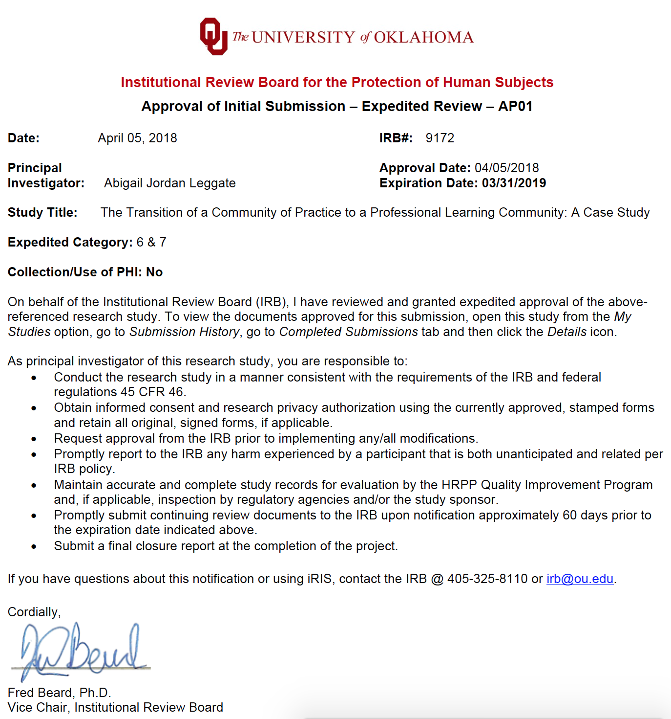

Appendix C: Informed Consent


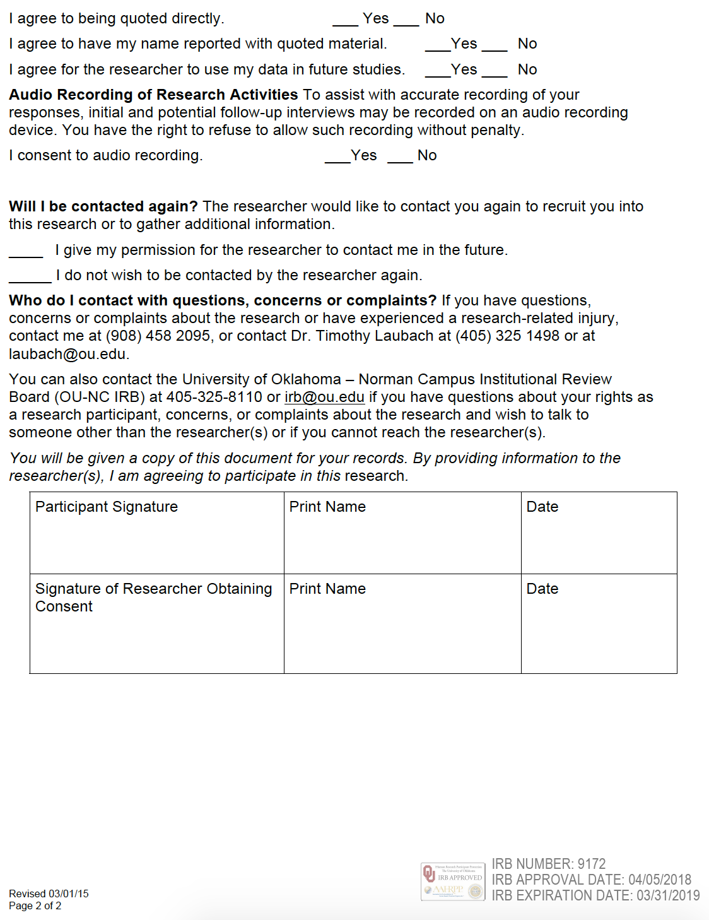

Appendix D: Interview Questions


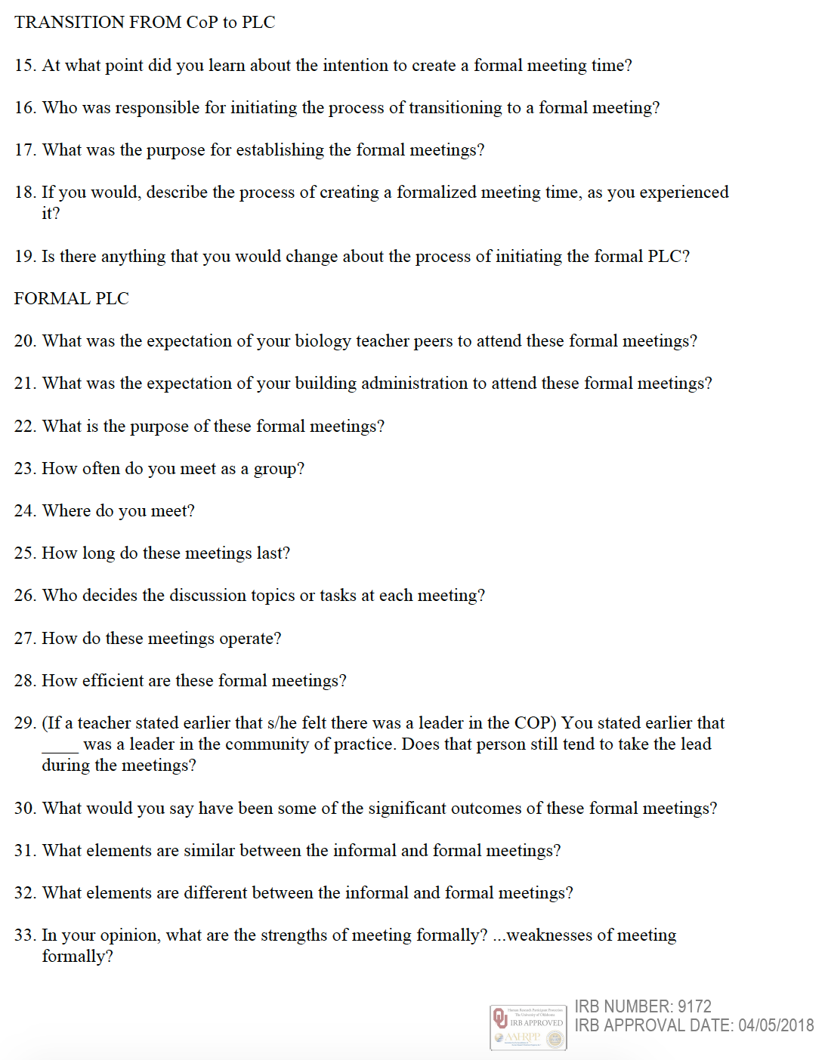



Appendix E: Concept Map for the Community of Practice
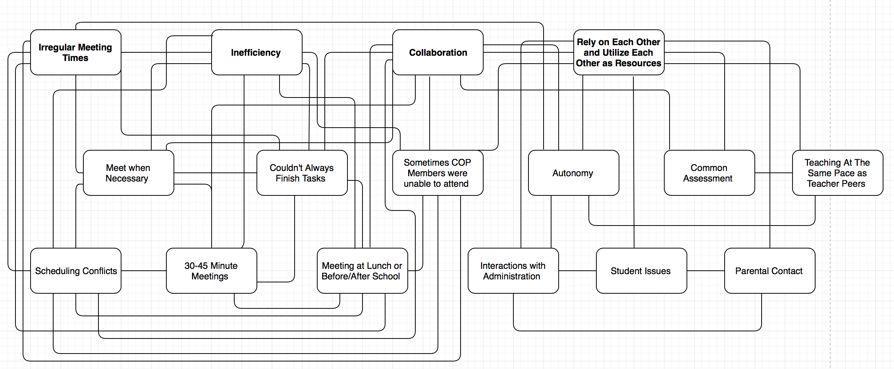

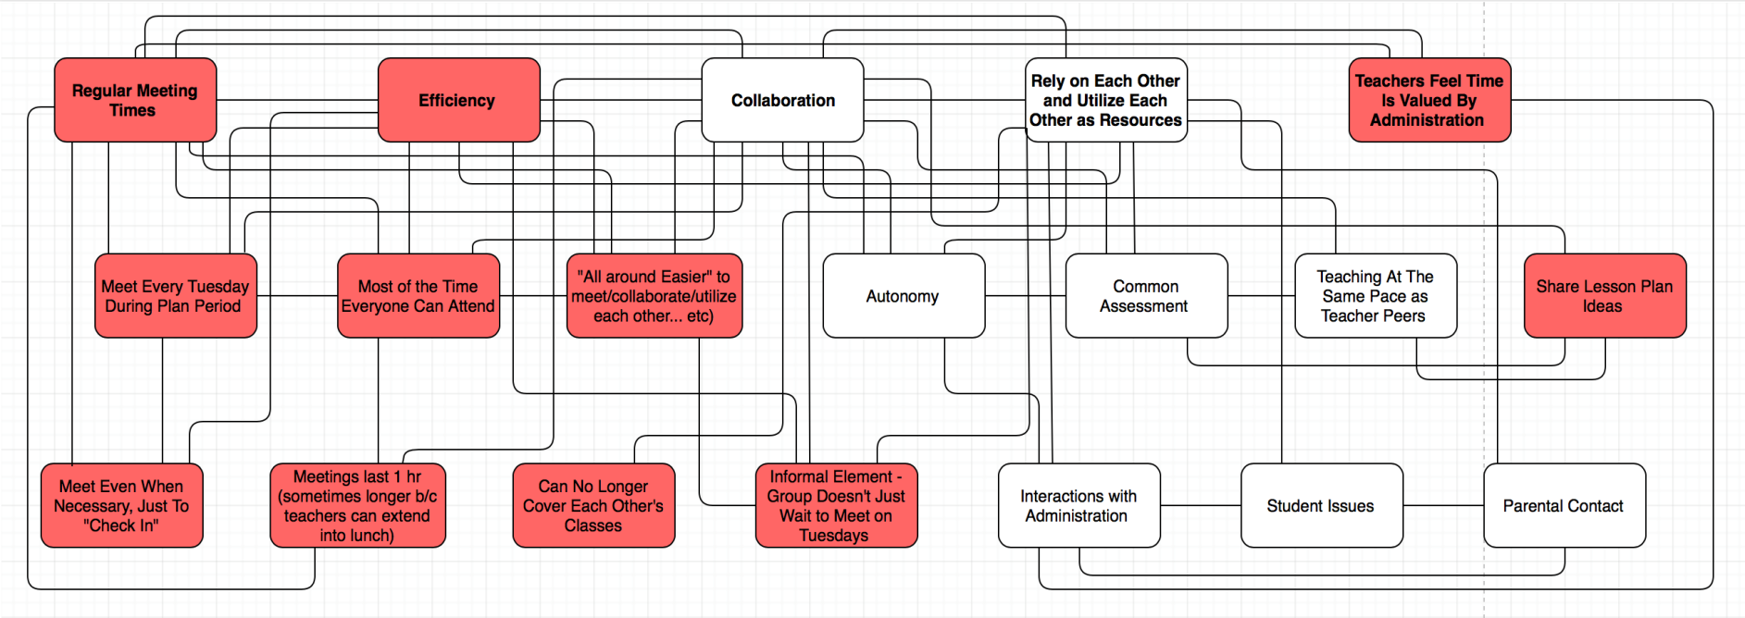
Appendix F: Concept Map for the Professional Learning Community

