UNIVERSITY OF OKLAHOMA
GRADUATE COLLEGE

THE IMPACT OF CAPITAL OUTLAY INEQUITIES ON SCHOOL DISTRICT COST SAVING MEASURES IN A CLIMATE OF BUDGET REDUCTIONS

A DISSERTATION
SUBMITTED TO THE GRADUATE FACULTY
In partial fulfillment of the requirements for the
Degree of
DOCTOR OF PHILOSOPHY

BY
TAMMIE REYNOLDS
Norman, Oklahoma
2019

THE IMPACT OF CAPITAL OUTLAY INEQUITIES ON SCHOOL DISTRICT COST SAVING MEASURES IN A CLIMATE OF BUDGET REDUCTIONS

A DISSERTATION APPROVED FOR THE
DEPARTMENT OF EDUCATION LEADERSHIP AND POLICY STUDIES

BY

Dr. Jeffrey Maiden, Chair
Dr. Howard Michael Crowson
Dr. Mary Gracie Branch
Dr. Gregg Garn
Dr. John Jones

© Copyright by TAMMIE REYNOLDS 2019
All Rights Reserved.

ACKNOWLEDGEMENTS
Completing this journey fulfills a personal goal, but getting here encompasses the support, time and assistance from many people in my personal and professional life. I would like to acknowledge a few of them, but throughout this process there were many more who encouraged, shared experiences, and wisdom, to which I am forever grateful.
To my committee members, Dr. Branch, Dr. Crowson, Dr. Garn, and Dr. Jones, your suggestions, knowledge, and high expectations allowed me to finish this dissertation. Each one of you provided expertise that helped me see this project from a different role, and I became a better researcher every time we met. To Dr. Maiden, I am forever in your debt for the many hours of mentoring. Somehow you managed to allow me to lead this process and still rely on you to guide it. Thank you for the quick edit turnarounds, late night emails, last minute meetings, and the belief we could get here by May.
To my colleagues at Elgin and Cache. I know you will hate that I grouped you together, but in my eyes you are not rival districts, but the best collection of educators, friends and colleagues anywhere. You have provided the learning opportunities, wisdom, and the experiences that I draw from as a practitioner. I love you all and proudly call myself an Owl & Bulldog with equal pride.
To my Lawton Cohort, who started this journey with me and have been my cheerleaders throughout. Only you know what this process truly entails and the sacrifices required to tackle this degree as a working educator. You are an amazing group of achievers and friends that I never expected to have, but wouldn’t want to do this without. And, especially to Channa Byerly, for all the late night pep talks, the deadline reminders, the carpool conversations, and your encouraging, competitive drive; I will never doubt you again. We did it!
To my sister and her family, Amy, Don, Emily & Joshua, thank you for making everything in life a little more manageable, sweeter, and fuller because you are there to share it.
To my parents, Marilyn & Tommy, you have always made me feel like I could accomplish anything with honest, hard work, and you provide the example to prove it. My whole life, you have encouraged and challenged, but reminded me that I make my own choices and to finish what I start. Thank you for instilling the value of education, for always being present, and for ensuring that I knew I was loved no matter what failures or celebrations life brings.
To my children, Erin, Clayton, Jonathan & Katie, you are my world, and there is no accomplishment that brings me as much joy as my love for each of you. Watching you grow into smart, caring, independent adults has been the delight of my life. You make me incredibly proud to be your mom, and I relish celebrating your milestones and successes as if they were my own. Thank you for giving that back to me as I cross this finish line.
To my husband, Randy, God has blessed our lives immensely over 28 years. Thank you for setting my goals as yours, for sharing your dreams with me, and for putting in the love, time, and work to build a family and life together.

TABLE OF CONTENTS
LIST OF TABLES xi
LIST OF FIGURES xiii
ABSTRACT xiv
Chapter One: INTRODUCTION 1
Statement of Purpose 1
Background of the Problem 2
Fiscal Equity 3
State Aid General Funding 4
Capital Outlay Equity 5
Statement of the Problem 6
Problem in Context 7
Oklahoma Funding Equity 8
Oklahoma’s Rural Demographic 9
Funding Challenges 10
Impact on Education Outcomes 11
Research Questions 13
Overarching Research Question: 13
Significance Statement 14
Limitations 15
Assumptions 15
Overview of Method 15
Summary 16
Definitions 17
Chapter Two: LITERATURE REVIEW 18
Equity and Adequacy in Education Funding 19
Legal Challenges to Public School Finance Inequity 20
Horizontal and Vertical Equity in Funding 23
Capital Funding 25
State Options for Capital Funding 27
Crossover Funds 31
Resource Equity 33
Four-Day School Weeks 33
Instructional Time 37
Class Sizes 39
Summary 43
Chapter Three: METHODOLOGY 45
Research Context 46
Oklahoma Public School Funding 46
Local Funding 46
Equity Issues 50
Crossover Funds 50
Rural School Vulnerabilities 51
Research Questions 52
Overarching Research Question: 52
Data Sample 53
Description of Variables 53
Independent Variables 54
Dependent Variables 55
Data Analysis 57
Regression Analysis 57
Equity Analysis 58
Methodological Assumptions 59
Validity 60
Limitations 60
Summary 60
Chapter Four: PRESENTATION OF DATA ANALYSIS AND RESULTS 62
Overarching Research Question: 63
Research Questions 63
Budget Reduction Climate 64
Logistic Regression Analysis for Four-Day School Weeks 65
Research Question 1 65
Multiple Linear Regression Analysis 69
Research Question 2 69
Research Question 3 73
Resource Equity Analysis 77
Research Question 4 77
Summary 79
Chapter Five: FINDINGS, CONCLUSIONS, AND SUGGESTIONS FOR FURTHER RESEARCH 81
Study Design 82
Research Question 1 83
Research Question 2 84
Research Question 3 84
Research Question 4 84
Summary of the Study Findings 84
Research Question 1: Findings Summary 84
Research Question 2: Findings Summary 86
Research Question 3: Findings Summary 87
Research Question 4: Findings Summary 89
Conclusions 92
Research Question 1: Conclusions 92
Research Question 2: Conclusions 94
Research Question 3: Conclusions 96
Research Question 4: Conclusions 100
Concluding Remarks 102
Recommendations for Future Research 104
Implications for Policy and Practice 104
Summary 105
References 107
Appendix A 122
Tests of Robustness: Instructional Time 122
Appendix B 128
Tests of Robustness: Class Size 128

LIST OF TABLES
Table 4.1 Number of Oklahoma Districts Utilizing 4-Day School Weeks 66
Table 4.2 Logistic Regression Model Summary 67
Table 4.3 Logistic Regression Results for 4-day Week Variable, 2014 68
Table 4.4 Logistic Regression Results for 4-day Week Variable, 2015 68
Table 4.5 Logistic Regression for 4-day Week Variable, 2016 68
Table 4.6 Logistic Regression for the 4-day Week Variable, 2017 68
Table 4.7 Logistic Regression for 4-day Week, 2018 69
Table 4.8 Model Summary for Instructional Time Dependent Variable 70
Table 4.9 Multiple Linear Regression Results for Instructional Time, 2014 71
Table 4.10 Multiple Linear Regression Results for Instructional Time, 2015 71
Table 4.11 Multiple Linear Regression Results for Instructional Time, 2016 71
Table 4.12 Multiple Linear Regression Results for Instructional Time, 2017 72
Table 4.13 Multiple Linear Regression Results for Instructional Time, 2018 72
Table 4.14 Instructional Time Average for 2014-2018 72
Table 4.15 Regression Model Summary for Class Size 74
Table 4.16 Class Size Regression Results for Class Size 2014 76
Table 4.17 Class Size Regression Results for Class Size 2015 76
Table 4.18 Class Size Regression Results for Class Size 2016 76
Table 4.19 Class Size Regression Results for Class Size 2017 77
Table 4.20 Class Size Regression Results for Class Size 2018 77
Table 4.21 Instructional Time Equity Measures 78
Table 4.22 Class Size Equity Measures 78
Table 5.1 Capital Revenue: Inequity Example 90
Table 5.2 Capital Outlay Example from 2018 91

LIST OF FIGURES
Figure 2.1: Increasing Gap Between Teacher and Student Count (OSDE, 2019) 40
Figure 3.1 Lorenze Curve ("About the Lorenz Curve", 2018) 59
Figure 4.1 Graph of State Aid to Oklahoma Schools, 2010-2018 64
Figure 4.2 Graph of Per-Pupil Valuations, 2014-2018 65
Figure 4.3 Graph of Instructional Time: Maximum, Minimum, & Average 73
Figure 5.1 EdBuild National Policy Map for Poverty 100

ABSTRACT
The purpose for conducting this study was to determine whether inequitable capital outlay capacity, as defined by district valuation, was associated statistically with the following cost-saving measures: implementation of a 4-day school week, reduction in instructional time, or increasing class sizes. Traditionally, these cost-saving measures are associated with expenditures in a schools district’s general fund; however, the current study builds upon previous research by Hime and Maiden (2017) who documented an advantage for districts with healthy capital outlay from “crossover funding,” which are expenditures allowable from multiple revenue sources. The utilization of crossover funding creates a disequalizing effect on equitably distributed revenue. When budget reductions occur in state aid, logic follows all districts should be equally impacted because the revenue is distributed equitably. Therefore, district wealth should not be associated with these operational cost-saving measures. This study found statistically significant relationships between schools districts’ per-pupil valuations, a 4-day school week, reductions in instructional time, and increased class sizes, indicating that inequitable capital funding in Oklahoma was associated with a decrease in equity for state aid revenue. Specifically, class sizes were inversely associated with district wealth across all years of the study. The results indicate the more than 600,000 Oklahoma students in districts with low property values are disadvantaged by larger classes, a 4-day school week, and a decreased amount of instructional time compared to their peers in wealthier districts.

INTRODUCTION
The Federal government of the United States has always had a limited role in funding public education. Although federal funding for specific students and school programs has increased over the past five decades, elementary and secondary schools in nearly every state are primarily funded through a state aid formula (Leachman, Albares, Masterson, & Wallace, 2016). Nationally, state aid accounts for 46% of the revenue for public education nationwide, 45% of revenue comes from local sources, and only 9% of revenue comes from federal sources (2016). State funding structures have been challenged for equity in the courts over the past several decades. Specifically, in the 1970’s and 1980’s, many funding formulas were overhauled after court mandates (Davis, 1985; OSDE, 2017; Parker, 2016). State and federal funds for general education are now more likely to be distributed with equitable formulas; however, capital outlay funding has not received the same attention. Because capital outlay funding is frequently based solely on local funding, property wealth remains its primary predictor, making capital outlay funding a pressing issue of educational equity (Hime & Maiden, 2017).

Statement of Purpose
The purpose of this quantitative, causal comparative study is to determine whether capital outlay inequities have a relationship to cost-saving measures more often associated with budget reductions in operational funding. If so, are these inequities more pronounced in rural districts and those with student populations of low socioeconomic status. This research builds on a previous study by Hime and Maiden (2017), who demonstrated that inequities in capital outlay mask inequities in general funding. Oklahoma, for example, has been shown to have an equitable state aid formula (Deering & Maiden, 1999; EdBuild, 2018; Hancock, 2008; Maiden, 1998; Maiden & Stearns, 2007). However, the research demonstrated how school districts in Oklahoma were able to use building and bond funds to supplement instructional expenditures in general funding, which introduced funding inequities even when the state aid formula applied was equitable. Using these “crossover funds,” wealthier districts with higher per-pupil valuations, gained an obvious advantage for capital projects, but a less than obvious advantage for instructional expenditures. The current study builds from the recommendation for further research in the Hime and Maiden (2017) study that further influential effects of inequities in capital outlay should be explored. Because of the disequalizing effect on general funds observed in their study (2017), an exploration is timely about whether capital outlay inequities could have effects on operational cost-saving measures, such as the 4-day school week, increases in class sizes, or reductions in instructional time.

Background of the Problem
Families have a fundamental expectation schools will provide the needed skills and opportunities for their children to effectively obtain gainful employment and participate as educated citizens (U.S. Department of Education, 2013). Public policy makers share in this expectation. In A Nation at Risk (1983), the Federal government placed equity and high-quality schools for all students at the forefront of maintaining a globally competitive economy, declaring that, “our goal must be to develop the talents of all to their fullest” (1983, p.5). The majority of modern education public policy, including the No Child Left Behind Act of 2001 and the Every Student Succeeds Act has worked toward creating equitable academic outcomes for students (Baker, Sciarra & Farris, 2012). However, these public policies provided mixed results with students living in poverty still performing lower academically than their middle to upper middle-class peers and serious educational opportunity gaps persist (Ladson-Billings, 2006).
Poverty or race should not determine destiny, and zip code should not determine educational opportunity. Sadly, segregation for poverty and rural demographics remains legal, sixty-five years after Brown v Board of Education (1954) officially ended racial segregation. It costs citizens their dreams, and it is costly to our nation.
Underutilization of human potential is economically costly (McKinsey and Company, 2009; Baker, Sciarra, & Farris, 2012). Funding and achievement inequities “impose on the United States the economic equivalent of a permanent national recession.” (p. 1). A better public education system has been perceived as key to creating jobs and restoring economic prosperity, with “fair school funding” as the “essential precondition for the delivery of a high-quality education” (Baker Sciarra, & Farris, 2012, p. 30). In recent years, however, legislation has focused more on reform than funding, even though the judicial system has increased its attention on equity for school funding during this same time period.

Fiscal Equity
Since the 1970’s, state supreme courts have found 16 school finance systems unconstitutional (Augenblick, Myers & Anderson, 1997). These funding cases were litigated based on constitutional language of the state, while predicated on two primary arguments, equity and adequacy. Disparities in educational funding resulted in discrimination because students who reside in poorer districts were treated differently from those who reside in more affluent districts or the lower funding level in poorer districts resulted in a deprivation of education opportunity. (Verstegen & Whitney, 1997, p. 331). Adequate education opportunity standards were later defined in Rose v Council for Better Education (1989), when the Kentucky Supreme Court established seven outcome standards (1997). Many lower courts adopted these standards, and several state legislatures adjusted their funding formulas after the ruling (Oklahoma State Department of Education, 2016; Parker, 2016; 1997). Equity and adequacy arguments continued to be intertwined in court decisions regarding education funding over several decades. Public education is vital to our democratic culture, and it is impossible to have adequacy without equity because both are essential for equal citizenship (Satz, 2008).

State Aid General Funding
Funding through state aid formulas was designed specifically to ensure adequate support for schools without placing a disproportionate tax burden on those districts with limited taxable resources (Augenblick, Myers & Anderson, 1997). A state aid formula, often in the form of a foundation plan, designates a minimum per-pupil amount for funding. Utilizing state tax revenue, districts with less local funding then receive state aid formula funds to supplement the local districts’ tax revenue to reach the minimum per-pupil funding.
Initially, funding systems were concerned mostly with equity. Equity in school funding ensures schools having fewer resources can accomplish the same goals as those who have more (Johnson & Maiden, 2010). It is not the same as equality, but instead indicates resources are distributed fairly on a need basis. Horizontal equity, where a student in one district received the same funding as a like student in another, received early attention. However, since the Elementary and Secondary Education Act (1965), vertical equity has come to the forefront. Vertical equity accounts for the different cost pressures individual school districts face. For example, a district serving a high proportion of children with learning disabilities has a greater need for resources than a district serving fewer children with disabilities. Currently, vertical equity is generally attained with pupil weights through a weighted formula (Augenblick, Myers & Anderson, 1997). In a weighted student formula (WSF), students without added needs have a weight of 1.0, but students requiring more resources receive an added calculated weight: 1.25.
Even with the attention paid to education finance equity, significant differences in the fairness of state funding systems remain. In a 2012 report, only 17 states were found to have progressive funding systems, which utilized weighted systems that provided more aid to high poverty districts (Baker, Sciarra, & Farris, 2012). Because there is no federal constitutional requirement of equity in school funding, studies attempting to measure equity from state to state face hurdles with differing definitions, formulas, and methodologies (Augenblick, Myers, & Anderson, 1997; Filardo et al., 2010). Every state has a different state funding system, and searing inequity exists in some of them (Baker, Sciarra, & Farris, 2012).

Capital Outlay Equity
Funding inequities between and within states are even more pronounced regarding capital outlay funding. While numerous court challenges to the adequacy and equity of state finance systems for school operating funds have occurred, contests to a state’s funding of school facilities occur far less often (Duncombe, Wang, 2009). Less litigation and a higher reliance on local ad valorem funding has created inadequate, regressive funding systems for facilities. From 2005-2008, 30% of capital outlay funding for schools was provided by the states (Filardo et al., 2010). “Eleven states contributed nothing, 14 provided less than 20%, 12 paid between 20% and 50%; and 13 states and the District of Columbia provided over 50% of the capital outlay facility costs” (2010, p. 3). The facts are troubling because an increase in state assistance equates to an increase in equity (Duncombe & Wang, 2009; EdBuild, 2018). Currently, there are four states in which local funding is wholly the source of capital outlay: Nebraska, Nevada, Oklahoma, and South Dakota (TLC, 2006). In Oklahoma, for example, the only source of the capital outlay funding is a five-mill levy on real and personal property located within the boundary of the school district or local education agency (LEA) (OSDE, 2017).
Nationally, inequity concerns in capital revenue are exacerbated in rural areas of the country. It is more expensive to provide comparable education services in areas with small populations and in isolated rural areas (Maiden, 2003). Intensifying equity concerns are the poverty statistics of rural school children. One-third of students in U.S. rural communities come from families living in poverty (2003). The tax base in these rural areas is often composed of lower-value farmland that provides inadequate revenue to meet the capital needs of districts. “Rural schools face funding issues metropolitan areas do not. Many of these funding issues deal directly with capital outlay and the inability of rural districts to renovate, remodel, equip, and build facilities” (Johnson, & Maiden, 2010, p.2). Common afflictions related to lower per-pupil capital outlay include: an inadequacy of infrastructure to support emerging educational technology, deferred maintenance, and the lack of capacity to meet the needs of growing enrollment (Maiden, 2003).

Statement of the Problem
In their study of Oklahoma’s capital funding system, Hime and Maiden (2017) demonstrated the impact that one restricted revenue source can have on another. They explain how inequity in capital outlay revenue had the ability to crossover and create inequity in operational funds. Their study describes the impact crossover inequity could have on educational outcomes.
Until the U.S. Government Accounting Office (1985) brought national attention to the limitations in school infrastructure data, studies on capital revenue sources and how states funded school facilities were rare (Crampton, Thompson & Vesely, 2004; Maiocco, 2004; Sielke, 2001). The federal and state courts have historically invested more time on the equity and adequacy of instructional funding compared to capital outlay (Crampton, Thompson, & Vesely, 2004; Duncombe & Wang, 2009; Hime & Maiden, 2017). This lack of attention is, in large part, due to the view that school infrastructure is a responsibility of the local school district. This is problematic, given the inequity of local ad valorem funding, especially in rural areas of the country (Duncombe & Wang, 2009; Johnson & Maiden, 2010; Maiden & Stearns, 2007; Vincent, 2018). Although research links increased state capital outlay funding to increased overall educational equity, several states continue to lack equalized funding for capital outlay (EdBuild, 2018; Filardo et.al, 2010; Maiocco, 2004). Research positively correlates the condition of facilities to increases in student achievement (Baker, 2016; Cellini, Ferreira & Rothstein, 2010; Earthman, 2002). However, studies relating capital outlay funding to outcomes other than student academic achievement are lacking. While student academic achievement is an important product of the U.S. public education system, it is not the only relevant measurement. Smaller class sizes, as were put in place for the Tennessee STAR experiment, yielded an array of benefits beyond achievement (Finn & Achilles, 1999). Both learning behaviors and discipline incidents improved in the smaller classes (1999). Instructional time has a conclusive relationship to achievement, but time is money (Carroll, 1989; Jez & Wassmer, 2013). Reductions in instructional time are being utilized as cost-saving measures to address failing budgets, yet the profundity of the problem is unknown. Given recent research on the impact of capital funding inequities on general fund equity, a strong study on the consequences of capital funding inequities is overdue (Hime & Maiden, 2017).

Problem in Context
The state of Oklahoma is well-suited for a case study on capital funding inequities. Unlike most states, Oklahoma’s capital outlay funding system is solely funded from the tax base of the local district (TLC, 2006). Compared to its surrounding states, Oklahoma has the lowest per-pupil spending and teacher pay (2017). The state has experienced the largest education funding cuts in the nation since the Great Recession (Leachmen, Masterson & Figueroa, 2017). The Center on Budget and Policy Priorities (2017) estimates Oklahoma cuts to education funding at 28.2%, but not all districts are being equally affected by revenue reductions. Many districts are rural and small. Some of these are property poor, surrounded by farmland, and some are experiencing an increased wealth due to oil or wind farms. Deep budget cuts have increased inequity for the educational funding system in Oklahoma; symptoms of the crisis are evident in 4-day school weeks, reduction of instructional time, and teacher shortages.

Oklahoma Funding Equity
Equitable State Aid. Oklahoma attempts to provide horizontal and vertical equity through foundation aid, the use of a weighted student formula to distribute state aid. The state provides vertical equity by acknowledging certain students cost more to educate due to disabilities, age, and socioeconomic status (OSDE, 2017). Oklahoma’s funding formula has been previously shown to be an equitable method of distributing funds (Deering & Maiden, 1999; EdBuild, 2018; Hancock, 2008; Maiden, 1998; Maiden & Stearns, 2007).
Unlike state aid for instruction and student spending, Oklahoma has no method to equalize capital funding (ASCE, 2017; TLC, 2006). Previously, Oklahoma attempted to address inequity in capital funding in 1984 with the passage of Oklahoma State Question 578. It established the Public Common School Building Equalization Fund (Haxton, 2009). Utilizing this fund, the Oklahoma State Board of Education (OSBE) can allocate monies to LEAs for capital improvements through an equalization formula (2009). “However, no money has ever been deposited to the fund” (p. 58).
Gross inequity exists in capital revenue received by districts based on its local ad valorem, but Oklahoma has avoided adequacy and equity lawsuits because its state aid formula has repeatedly been found to be equitable (Deering & Maiden, 1999; EdBuild, 2018; Hancock, 2008; Maiden, 1998; Maiden & Stearns, 2007). If true equity existed in Oklahoma schools, budget cuts would impact districts equally during times of budget reductions; however, this has not been the case.

Oklahoma’s Rural Demographic
Oklahoma is a state with many small, rural districts with approximately 78% of districts in Oklahoma considered rural (NCES, 2004). In addition, 80% of Oklahoma high schools have average daily memberships (ADMs) below 500 students, and 29% have ADMs below 100 students ("OSSAA.com - Oklahoma Secondary School Activities Association," 2017). Property values are lower in rural areas, and these districts tend to have more students from lower socioeconomic circumstances (Jimerson, 2005; Johnson & Maiden, 2010).
Inequity is increasing for districts in rural Oklahoma for local ad valorem funding. Windmill farms, oil wells, oil refineries, and other industries are creating wealth in select, small districts. In 2015, ad valorem values in Oklahoma ranged from $2,500 per-pupil to $600,000 per-pupil (Hime & Maiden, 2017). By 2018, this range increased from $3,505 to $834,593. “The wide range in local school tax base creates a significant discrepancy in the possible revenue for capital improvement needs” (2017, p. 2) It is problematic because when building funds will not cover capital expenses, a district must choose whether to defer maintenance, or spend instructional funds, which negates equity created by the per-pupil funding formula (Davis, 1985).
Small, rural districts are especially vulnerable to inequity in capital funding. When windmill farms, oil wells, oil refineries, or power plants move into rural areas, gains and losses are created in capital funding. For districts adding revenue, budgeting flexibility is gained. This flexibility diminishes the impact of funding cuts in state aid. Specifically, it may diminish the necessity of a 4-day week, a reduction in overall instructional time, or increased teacher-student ratios. For districts with low capital outlay, the loss of budgeting flexibility results in deferred maintenance to facilities, lack of upgrades to technology, and cuts to personnel.

Funding Challenges
To complicate the inequity problem in capital funding, public schools are suffering from shrinking state education budgets. Oklahoma is among 12 states with lower school funding than before the Great Recession of 2008-2009 (Leachmen, Masterson & Figueroa, 2017). When the Great Recession hit, property values fell. States like Oklahoma that reduced state funding during the Great Recession, exacerbated a difficult situation which existed due to increased challenges in raising local ad valorem revenue during this same time period. Loss of property value during the Great Recession equated to loss of capital outlay funding; thus, capital spending fell sharply, and has not recovered in many Oklahoma districts (Leachmen, Masterson & Figueroa, 2017).
Contributing to the school revenue problems in Oklahoma were multiple revenue failures in 2016 and 2017, which reduced funding for all state agencies. Following these revenue failures, Local Education Agencies (LEA) in Oklahoma received reductions through the state aid formula. In 2018, school funding was again reduced by approximately 2% when a cigarette sales tax, a portion of the state education revenue, was ruled unconstitutional.
As with other state education budget reductions, the impacts on small, rural districts with lower-wealth were especially severe. Smaller districts operate less efficiently simply due to their size and reduced economy of scale (Baker, Sciarra, & Farrie, 2012). For example, every district must have an algebra teacher. Rural teachers may serve only five students in their classroom compared to 20-30 students served in a single teacher’s class in a large urban or suburban school district. Efficiency in per-pupil funding levels off at approximately 2,000 students (Boser, 2013). Only 11% of Oklahoma districts have greater than 2,000 students ("Average Daily Membership (ADM) and Average Daily Attendance (ADA)", 2018). Wealthier districts, with higher capital funding, can compensate for budget cuts and inefficiencies. Building funds can pay custodial and maintenance salaries, utility expenses, insurance premiums, and durable goods, such as furniture and textbooks (Oklahoma State Department of Education, 2017). These “crossover” funds increase budget flexibility by shifting expenses away from operational funds during tight budget years (Hime & Maiden, 2017).
Capital Bonding Inequity. Inequity in capital funding can also affect the ability to borrow funds, (Hime & Maiden, 2017). In Oklahoma, a Local Education Agency (LEA) is authorized to borrow up to 10% of its valuation if approved by sixty-percent of registered voters through a bond issue (OSDE, 2013). Bond issues are the primary method for school districts to obtain funding for construction projects. Bond funds may also be used to equip, repair, or renovate existing school buildings, and they may be used to purchase school furniture, fixtures, technology, or “making improvements to any school site” (O.S. §70-15-101). By addressing capital outlay projects with bond funds, without dedicating general funds, districts can preserve operating funds for instruction. Hime and Maiden (2017) demonstrated the crossover of building and bond funds to general fund instructional expenditures. It illustrated how inequities in one funding source can impact another source of funds previously found to be equitable.

Impact on Education Outcomes
Well-maintained facilities positively affect student behavior, health, and academic achievement (Lackney, 1997; Schneider, 2002). Having more funding for capital outlay can result in added instructional funding, affecting class sizes and instructional time (Maiden & Hime, 2017). More recent studies show a positive correlation between funding and increased student achievement (Baker, 2016; Greenwald, Hedges, & Laine, 1996: Loubert, 2008). When districts have access to more resources, they can afford to provide professional development opportunities that invest in teacher quality. School districts can also provide teacher stipends, supplement wages to recruit skilled teachers, and allocate funds for technology, textbooks, or other instructional resources. While capital outlay funding may not directly affect a district’s instructional budget, inequitable access to crossover funds have negatively affected instructional budgets of small, rural districts.
Four-Day School Weeks. In Oklahoma, a district must provide 1,050 instructional hours in a year. An additional 30 hours of professional development is added for a total requirement of 1,080 hours (OSDE, 2017). The local board of education adopts a district’s yearly calendar and is permitted to arrange instructional time into a 4-day week.
Coinciding with the budget cuts, many Oklahoma districts have transitioned to a 4-day week. In 2017, 91 districts followed the schedule, which is slightly less than 20% of all school districts in Oklahoma (Holder 2017). According to available research studies, most of these districts use the 4-day week to save money (Anderson and Walker, 2015; Colorado Department of Education; 2016; Domier, 2009; Hewitt & Denny, 2011; Lefly & Penn, 2011: Plucker, Cierniak, & Chamberlin, 2012). However, the Education Commission of the States (ECS) estimates maximum savings at 5.45%, and most districts glean savings closer to 2% (2012).
Budget savings are not the only cited benefit of the 4-day week. Multiple studies document increased student/teacher attendance and increased student/teacher morale (Farris, 2013; Hale, 2003; Sagness and Salzman, 1993). Therefore, some superintendents have also cited the teacher shortage, and the ability to use the schedule to recruit teachers, as a reason to adopt the calendar.
Reduction of Instructional Time. In Oklahoma, the 4-day week has been controversial. State leaders have been critical of the image for education the alternative calendar has given the state. They believe it damages the ability to recruit business to Oklahoma. Therefore, many districts have chosen to reduce school days, without fully converting to a 4-day week. Reduction of days provided savings to the district in transportations and support salaries (Anderson & Walker, 2015). However, it is more concerning than simply rearranging the calendar into a 4-day week. Increased instruction time positively correlates to increased student achievement (Goodman, 2014; Hansen, 2011; Marcotte & Hemelt, 2008; Patall, Cooper & Allen, 2010).
Class Sizes. The combination of the need to reduce budgets and the lack of qualified teachers may be equating to larger class sizes for Oklahoma students. In 1990, Oklahoma enacted legislation which set mandatory class sizes for students in public schools. However, in 2002, the legislature exempted districts from the mandates due to reductions in funding (Fine, 2018). Class sizes have been climbing ever since, and it is a troubling trend. According to Darling-Hammond (2000), teacher quality has the greatest impact on student achievement. Furthermore, smaller student-to-teacher ratios positively correlate to increase student achievement and reduced discipline incidents in the classroom (Finn & Achilles, 1999; Schneider, 2002).

Research Questions
The study will be directed by the following research questions:
Overarching Research Question: How do inequities in capital outlay capacity in Oklahoma public schools relate to cost-saving measure implemented during reductions in state aid from 2014 through 2018?
Research Questions:
- Is there a relationship between per-pupil capital outlay funding capacity and district adoption of a 4-day instructional week, controlling for percent students in poverty and whether a district is rural?
- Is there a relationship between district per-pupil capital outlay funding capacity and average district yearly instructional time, controlling for percent students in poverty and whether a district is rural?
- Is there a relationship between per-pupil capital outlay funding capacity and district average class sizes, controlling for percent students in poverty and whether a district is rural?
- What is the overall degree of resource equity of instructional time and class sizes across districts?

Significance Statement
Capital outlay funding equity in schools is an understudied area. This goal of this study is to fill this gap in scholarly literature. Current contributions do not provide an assessment on the consequences of inequitable capital funding. If a relationship exists between inequitable capital funding and the outcomes normally associated with general funding, such as larger class sizes, further studies would be warranted.
Since 2008, Oklahoma has cut education more than any state in the nation (Leachmen, Masterson & Figueroa, 2017). Due to faltering education budgets and growing dissent among constituents, lawmakers have sought creative ways to adequately fund schools. This study will provide a better understanding of Oklahoma school funding and the impacts of inequities in capital outlay.

Limitations
The data utilized in the analysis was selected from only one state, Oklahoma, and was limited to five fiscal years. This limits the ability to generalize data to other states. However, Oklahoma, with approximately 520 districts, does provide a robust data set. Additionally, this study used data obtained from the Oklahoma State Department of Education (OSDE). While data from the OSDE is regulated, it is often self-reported by Oklahoma districts. In addition, the assessed valuations for districts rely on the accurate assessments of real and personal property in each school district. Currently, 77 elected county assessors exist in Oklahoma, and inconsistent assessments between counties is a possibility. It was also a concern whether the statistical models could measure significance because very few 4-day districts existed in the first three years of the study. Finally, this study does not address adequacy. It examines equity and the relationship to funding outcomes, but does not address the amount of revenue needed to reverse negative effects.

Assumptions
The Oklahoma Cost Accounting System (OCAS), used by the Oklahoma State Department of Education and its school districts to track revenue and expenditures, supplied much of the data for this investigation. Any coding errors in the data are assumed to be randomly distributed across the districts and years of study.

Overview of Method
The purpose of the study is to explore whether a relationship exists between capital outlay funding capacity and cost-saving measures implemented by public schools during budget reductions. The independent variables of a 4-day week, annual instructional time, class sizes, and the covariates of rural and poverty, are examined. Two types of regression models will be utilized. Binary logistic regression addresses the first research question. Multiple linear regression is employed for research questions two and three. A Gini Coefficient measures equity for instructional time and class sizes. A McLoone Index also provided an equity measure for instructional time. Each of these statistical tests are performed for five years of data from 2014 to 2018.

Summary
The current study examines the relationship between capital revenue inequities and the measures implemented by public schools in response. Resource equity in general funds has largely been addressed through litigation. Conversely, capital needs funding remains a pressing issue of educational equity. In Oklahoma, budget reductions in state aid were greater than any other state in the years after the Great Recession. State aid in the state is distributed equitably, but capital funding is based solely on a 5-mill levy on a district’s valuation. Therefore, property wealth of Oklahoma districts continues to be the primary predictor of capital revenue. Districts using 4-day school weeks have drastically increased in number, class sizes have risen, and instructional time has decreased. Four-day weeks are more frequently observed in small, rural schools. If funding was equitable, the impacts of revenue cuts would be experienced equally.
In a recent study of Oklahoma’s school funding system, Hime and Maiden (2017) demonstrated that districts with greater property wealth used increased revenue from capital outlay to create a disequalizing effect on otherwise equitable state aid revenue through crossover funds. This study seeks to determine if the inequity in capital outlay could also be associated to budget reduction measures.
A school district’s greatest expense is personnel. When searching for savings, districts will either eliminate positions (increasing class size) or eliminate calendar days to reduce payroll for non-certified personnel. Personnel are an operational fund expense, but the implications of Hime and Maiden’s (2017) study is that capital outlay inequities may have other influential effects. The researchers specifically mention achievement and teacher salaries (2017). This study explores whether a district’s ability to raise capital revenue could correlate to its implementation of cost-saving measures when state aid is reduced.

Definitions
Capital Outlay – Tax revenue received by school districts for building maintenance. In Oklahoma a 5-mill tax levy on the district’s adjusted valuation is the revenue source.
Crossover Funds – Expenditure flexibility resulting from the ability to pay expenses from multiple fund sources, especially limited fund sources, such as those traditionally used for capital outlay (Hime & Maiden, 2017).
Locale – In this study, the National Center for Education Statistics designation, which relies on the Census Bureau information, was utilized. Designations include: rural, urban, and suburban, but for the purpose of this study, a school district was either designated rural, or nonrural.

LITERATURE REVIEW
The purpose of the following literature review is to explore relevant research for a study of capital inequities and cost-saving measures in a climate of budget reductions. This current research builds upon a previous study by Hime and Maiden (2017), which examined capital outlay inequities in Oklahoma and its impact on equitable state aid. The researchers demonstrated that school districts with property wealth can use the flexibility from increased capital funding to gain an advantage in operational funding (2017). A study implication indicates additional effects of inequitable capital outlay should be explored. The current study seeks to determine if a relationship exists between inequities in capital improvement funding and three cost-saving measures: the 4-day school week, reduced instructional time, and larger class sizes.
This review describes the current research on fiscal equity, followed by a more in-depth discussion of applicable litigation and equity methods associated with capital outlay. Litigation has frequently focused on operational funding equity (Crampton, Thompson & Vesely, 2004), and capital needs remain largely a concern of the local district (21st Century School Fund, National Council on School Facilities, The Center for Green Schools, 2016; 2004; Filardo, Cheng, Allen, Bar & Ulsoy, 2010). Public education’s continued emphasis on local control conflicts with research, which confirms increased state participation in funding positively correlates to greater equity (2016; Augenblick, Myers, & Anderson, 1997; 2010; GAO, 1995; Murray, Evans, & Schwab, 1998). Next, a discussion is provided concerning methods used by states to supplement the local district’s ad valorem. Then, because the present study builds upon previous research completed by Hime and Maiden (2017), the study and its implications are explained. Finally, research is explored regarding the relationship of capital outlay inequities to certain cost-saving measures. Specifically, 4-day weeks, reductions in instructional time and increased class sizes are scrutinized.

Equity and Adequacy in Education Funding
Our democracy and economy depend on all citizens being educated (A Nation at Risk, 1983; Baker Sciarra, & Farris, 2012; McKinsey & Company, 2009; Salz 2008). Although education constitutes the majority percentage of most state budgets (21st Century School Fund, National Council on School Facilities, The Center for Green Schools, 2016; Filardo, Cheng, Allen, Bar & Ulsoy, 2010; Odden & Picus, 2000), most revenue for schools comes from local ad valorem taxes. This creates a disadvantage for many schools and students because they live in areas with lower property wealth than their peers, regardless of their socioeconomic status (2016; Crampton, Thompson & Vesely, 2004; Filardo, Cheng, Allen, Bar & Ulsoy, 2010; Johnson & Maiden, 2010).
Historically, local communities or religious organizations sponsored schools in the United States (Odden & Picus, 2000). It was not until the nineteenth century that compulsory attendance laws were established and control shifted from communities and churches to the state government (2000). States began to rewrite their constitutions to create statewide structures to finance schools (2000). Over the next century, controversies emerged about “constitutional phrases, such as “general and uniform,” “thorough and efficient,” “basic,” or “adequate” and whether it meant an equal amount of dollars would be spent for every student in the state, or if it meant providing an adequate education program for every student, but with different amounts of total dollars and similar opportunities (Odden & Picus, 2000, p. 9-10).
When school revenue is dependent solely upon local ad valorem taxes, large inequalities emerge between districts’ per-pupil expenditures (21st Century School Fund, National Council on School Facilities, The Center for Green Schools, 2016; Duncombe & Wang, 2009; Filardo, Cheng, Allen, Bar & Ulsoy, 2010; Hime & Maiden, 2017; Johnson & Maiden, 2010; Maiden & Stearns, 2007). Higher property wealth equates to healthier budgets that are evidenced in better facilities, teachers, and overall services (2016; Filardo, Cheng, Allen, Bar & Ulsoy, 2010). In the 1970’s, litigation resulted in equalization formulas to provide more operational dollars in state funding for property-poor districts. The emerging ideology during this time was that states should ensure each district had equal per pupil funding. A few decades later, the debate turned from equitable state funding to an adequate level for every student to have opportunities for success, as it was realized that equality in funding was not achievable. An explanation follows of the more prominent cases and resulting finance reform.

Legal Challenges to Public School Finance Inequity
Equity and adequacy of funding in education came to the forefront in the 1970’s (Verstegen & Whitney, 1997). Litigation was based on two arguments. Either disparities in educational funding resulted in discrimination because students who reside in poorer districts were treated differently from those who reside in more affluent districts, or the lower funding level in poorer districts resulted in a deprivation of education opportunity (1997).
Serrano v. Priest was a groundbreaking case for school funding occurred in California in 1971 (Dupre, Davis & Kiracofe, 2004; Verstegen & Whitney, 1997). The “Serrano principle” was set as a standard to consider when weighing inequity claims (2004). It provided the standard that a child’s education must be “a function of the wealth of a state as a whole,” not “a function of the wealth of the local community” (2017, p. 2359). Interpreting California’s constitution, education was declared a fundamental right. It was compared in importance to the right to vote (2017).
One of the most significant and defining decisions for school funding occurred in 1973. San Antonio Independent School District v. Rodriguez involved Mexican-American parents in a low-income area of San Antonio who challenged inequities of Texas school funding. The parents sued in federal courts and culminated with the U.S. Supreme Court ruling that education was not a fundamental right of the U.S. Constitution (Dupre, Davis & Kiracofe, 2004; Parker, 2016). The important case firmly rooted school funding as a state responsibility.
Less than a month after Rodriguez, New Jersey’s entire state finance system was declared unconstitutional due to funding inequities between districts (Verstegen & Whitney, 1997). During the next few decades, nearly half of U.S. education funding systems were challenged (Davis, 1985). Approximately 16 were declared unconstitutional (Augenblick, Myers & Anderson, 1997). Then, in 1989, a milestone decision in a Kentucky case did much more than declare its funding system unconstitutional. Rose v. Council for Better Education ruled the entire education system unconstitutional (1997). The court delineated out 7 “essential competencies,” which were subsequently adopted by lower courts as adequacy standards (1997, p. 339).
- Sufficient oral and written communication skills to enable students to function in a complex and rapidly changing civilization;
- Sufficient knowledge of economic, social, and political systems to enable the students to make informed choices;
- Sufficient understanding of governmental processes to enable the students to understand the issues that affect his or her community, state, and nation;
- Sufficient self-knowledge and knowledge of his or her mental and physical wellness;
- Sufficient grounding in the arts to enable each student to appreciate his or her cultural and historical heritage;
- Sufficient training or preparation for advanced training in either academic or vocational fields so as to enable each child to choose and pursue life work intelligently; and
- Sufficient levels of academic or vocational skills to enable public school students to compete favorably with their counterparts in surrounding states, in academics or in the job market (1997, p. 339).

The case greatly concerned in governors and legislators who feared their education system would not meet the Rose standards. As a result, several states overhauled their funding formulas in an effort to close the gap in per-pupil expenditures (Davis, 1985; Oklahoma State Department of Education, 2013; Parker, 2016). Oklahoma Governor, Henry Bellmon, convened a special legislative session. “The ad valorem tax on homes, farms, and businesses is a failure,” Mr. Bellmon said. “We must and can do better” (Mathis, 1989). The Governor proposed a school tax that would have eliminated the reliance on property taxes (1989). The school tax failed, but Governor Bellmon eventually signed HB 1017, “The Education Reform Act of 1990” ("House Bill 1017", 2018). It was funded with $560 million over five years out of several state funds and included landmark reforms (2018). Courts ruled funding formulas as unconstitutional due to violation of the equal protection clause in Texas’, Arkansas’, and Kansas’s state constitutions (Haxton, 2009). Kansas’ public-school funding system was ruled unconstitutional by the Rose standards in October 2017 ("EdBuild | Funded - State", 2018).
Initially, court cases addressed equity in funding. As the Wyoming Supreme court stated in Washakie Co v Herschler, 1980, “It is our view that until the equality of financing is achieved, there is no practicable method of achieving the equality of quality” (Verstegen & Whitney, 1997, p. 336). The court also specified, “we would agree that there are factors other than money involved in imparting education, those factors are not easy of measurement and comparison…Equality of dollar input is manageable” (1997, p. 335). Funding was the focus, because it could be more easily controlled by the legislature. However, the milestone case of Pauley v. Bailey, 1983, was significant because the West Virginia Supreme Court ruled the school finance system unconstitutional due to deprivation of equal opportunities for student success. Thus, it set an output standard for adequacy. The opinion stated, “disparities of expenditures were tolerable if an adequate minimum education was provided to all the state’s children” (1997, p. 337). Rose v. Council for Better Education did the same with its seven competencies, and courts have continued to intertwine adequacy with equity arguments ever since.

Horizontal and Vertical Equity in Funding
Following years of litigation in the 1990’s, overall equity in state education funding increased (21st Century School Fund, National Council on School Facilities, The Center for Green Schools, 2016; Augenblick, Myers & Anderson, 1997; Filardo, Cheng, Allen, Bar & Ulsoy, 2010; GAO, 1995; Murray, Evans & Schwab, 1998; Wilson, Lambright & Smeeding, 2006). Most states addressed inequities from property wealth among districts through foundation aid formulas at the state level (Augenblick, Myers & Anderson, 1997). Legislators used a combination of both local and state revenue in this type of formula to ensure horizontal equity, a type of equity achieved when a student in one district receives the same per-pupil funding as a like student in another. Though states had shown improvements in equity, only nine achieved fiscal neutrality, according to an Augenblick, Myers, and Anderson (1997) study of equity across states. Negative equity, when less wealthy districts receive more funding, was calculated in three states, and the rest remained with varying degrees of inequity (1997). Increasing the percentage of state funding resulted in increased horizontal equity among districts (21st Century School Fund, National Council on School Facilities, The Center for Green Schools, 2016; Augenblick, Myers, & Anderson, 1997: GAO, 1995; Murray, Evans, & Schwab, 1998). Filardo, Cheng, Allen, Bar & Ulsoy (2010) reviewed state data including constitutional language and political climate for equity form 1972 through 1992. They discovered that when constitutional language emphatically addressed equity, a state’s educational finance system had increased equity among districts (2010). The study was evidence that substantial equalization of funding could also be influenced by public input and opinions as much by legal decisions (2010).
In contrast to horizontal equity, which seeks to ensure equal inputs for comparable students, the debate about vertical equity involves disparate treatment of students with atypical needs. Equal per-pupil funding does not take into account that certain students require more resources to show gains in achievement. Students with disabilities, language barriers, and poverty bring challenges that require supplementary educational services in order to perform well in school. Therefore, it is necessary to devise funding formulas that account for differences in the costs to educate students with specific characteristics. Vertical equity relies on “unequal treatment of unequals” to achieve equity in outcomes.
Vertical equity is often achieved by states through a weighted student formula (WSF) (Ladd, 2008). There are approximately 43 states using this approach (Huang, 2004). Students requiring extra resources are calculated with an additional weight. For example, students would initially be provided a weight of 1.0, but then students requiring supplementary language services would be given an added 0.5 weight for a total of 1.5 calculation in the formula. Equality in this context requires equitable spending per weighted pupil.
A concern with the implementation of a Weighted Student Formula (WSF) is determining appropriate weights for categories of students. The literature often uses a cost-function approach to determine the weighted factors (Duncombe & Yinger, 2004; Reschovsky & Imazeki, 2003). The weights should be relative to the cost of supplementary resources required to teach the students when concentrated in a district (2008). Equity in this approach would be enhanced with the use of statistically calculated weights (2004). Nevertheless, the effective weights determined by scholars differ greatly from the implemented weights used by state legislatures.

Capital Funding
Capital funding has not received the same attention for equity among state legislations. As a result, “school facilities funding in the United States is inherently and persistently inequitable” (21st Century School Fund, National Council on School Facilities, The Center for Green Schools, 2016, p.3) Traditionally, collecting revenue for facilities has been a local responsibility. In Oklahoma, for example, capital outlay is funded by a 5-mil tax levy on the assessed valuation of taxable property in the district boundaries (OSDE, 2013). It is the only revenue for the building fund, as there is no state funding for capital outlay (21st Century School Fund, National Council on School Facilities, The Center for Green Schools, 2016). Oklahoma is a rural state with an abundance of farmland; agriculture is a top industry. Consequentially, there are many districts that struggle to fund capital improvement due to low district valuations (Johnson & Maiden, 2010).
Litigation of cases based on capital funding is extremely rare. The first significant case to address school facilities was Pauley v Bailey (1984). It led to educational reforms in West Virginia, including the creation of the School Building Authority in 1988 to assume responsibility of capital needs (2004). The state is considered the first to associate educational opportunities to educational facilities (Maiden & Stearns, 2007). The Pauley decision required a master plan for educational improvement that included broad directives concerning school facilities (Crampton, Thompson & Vesely, 2004). The plan mandates space and quality requirements, including storage facilities, and it defined activity and academic functions of school facilities (2004).
In 1994, the first case based solely on school infrastructure inequity was litigated in Arizona (Crampton, Thompson & Vesely, 2004). Roosevelt Elementary School District v. Bishop was originally dismissed by lower courts, but upon appeal, the Arizona Supreme Court blamed disparities between poor districts and wealthy schools on the assessed valuation differences between districts (2004). Attorneys in the case presented indoor pools, state-of-the-art technology, and covered athletic stadiums as examples of privilege in wealthier districts. The court found per-pupil valuations ranged from $5.8 to $749 million (2004).
Despite an increase in litigation, and encouraging court decisions, infrastructure funding remains less than adequate (21st Century School Fund, National Council on School Facilities, The Center for Green Schools, 2016). In 2011, President Obama presented a report that provided details about deferred maintenance in American schools. An estimated $270 million would be required to address the backlog of maintenance and repairs (White House Press Secretary, 2011). A U.S. General Accounting Office (1996) study suggested a need of $1.7 billion. The study (1996) went on to calculate $112 billion would be required to bring schools to “good overall condition” (p.1), and found the concerns were exacerbated in rural schools (Johnson & Maiden, 2010). Then, a 2016 report recommended $145 million per year to maintain, operate, and renew facilities (21st Century School Fund, National Council on School Facilities, The Center for Green Schools, 2016). While a study by Crampton, Thompson and Hagey (2001) estimated $266.1 billion was required to meet capital needs. Even if there is agreement that safe, updated facilities are a critical need for learning, all of these illustrate a lack of agreement on an exact definition of adequate facilities, (Card and Krueger, 1996; Greenwald, Hedges, and Laine, 1996; Jackson, Johnson, and Persico, 2015; Lyons, 2001).
Legislatures are slow to implement reforms because they do not often welcome reports, studies, or court decisions indicating the increased need for revenue. Consequentially, new legislation might be implemented, but school districts may find they have exchanged increased funding for less local control (Crampton, Thompson & Vesely, 2004). Legislatures also have competing interests for a limited amount of revenue, i.e. prisons, roads, and higher education (Crampton, Thompson & Vesely, 2004). Because all elected officials are strongly motivated by their voters’ needs, representatives from wealthier districts might not be as inclined to equalize funding (2004). In 2008, the Great Recession slowed economies. Despite the desire for more spending on capital outlay, spending was reduced by $29 billion (Leachman, Albares, Masterson & Wallace, 2016).

State Options for Capital Funding
Regardless of litigation and state legislatures arguing for adequacy and equity, the U.S. system of public education maintains a strong emphasis on local control, which holds especially true for school facilities’ funding. Of the $1.26 trillion in public school capital outlay between 1994 and 2013, about 81 percent came from local sources (21st Century School Fund, National Council on School Facilities, The Center for Green Schools, 2016). Despite multiple studies indicating more state funding equates to greater equity, only 19 percent of funding came from the states (Augenblick, Myers, & Anderson, 1997: GAO, 1995; Murray, Evans, & Schwab, 1998).
States use many types of aid to bring more equity to capital outlay. Hawaii, because it is a single school district for the entire state, pays for all capital improvements (ASCE, 2017; 21st Century School Fund, National Council on School Facilities, The Center for Green Schools, 2016). Some states provide only debt services (2017; TLC, 2006). There are 12 states that pay part of construction costs (2017; 2016; Duncombe & Wang, 2009; Thompson, 1985). Four states without capital improvement funding are: Nebraska, Nevada, Oklahoma, and South Dakota (2017; 2006). Eight states include facilities funding as part of the state aid, and twelve states equalize funding based on property wealth (2017; 2016; 2006; 2009; 1985). What follows is an overview of methods used by these states to provide supplemental funding to schools for capital needs.
Debt Services. A state has a larger tax base, and often, a better credit rating than a local district. By using its credit rating and guaranteeing a loan, the interest rate is lower, reducing the cost for the district (Duncombe & Wang, 2009). Certain states also make the principal and interest payments on local bonds (ASCE, 2017; TLC, 2006). New Hampshire does this with annual grants to districts based either on fiscal efficiency or property wealth (2017; 2006). New York provides reimbursements based on project types and wealth of the district (2017; 2006) Finally, Maine creates a priority list and funds projects with subsidies depending upon funds available (2017; 2006). Seven states provide loans to districts, sometimes with loan forgiveness (2017; 2006). Overall, debt aid reduces costs for districts either by lowering interest or providing the loan (Thompson, 1985). Borrowing funds takes less time for districts (1985), and districts are not required to go to voters to pass a bond referendum (Crampton, Thompson & Vesely, 2004). However, loans do not correct the problem of a district’s insufficient capacity to maintain its facilities (1985).
Full Funding. Hawaii, because it is a single school district for the entire state, funds all capital improvements (ASCE, 2017; 21st Century School Fund, National Council on School Facilities, The Center for Green Schools, 2016; TLC, 2006). There are four states – Connecticut, New Jersey, Rhode Island, and West Virginia – that provide full facility funding under certain circumstances (2017; 2016; 2006). Though in actual practice, a truer definition would be that local districts are not required to contribute to receive funding (Thompson, 1985). New Jersey provides at least 40% cost share of all school facilities (2006). As a direct result of the 1997 court case Abbott v. Burke, low-wealth districts in New Jersey receive 100% of the approved facility cost (2006), but Florida has provided significant capital funding since 1973 (1985). The advantage of state-funded construction is that districts are not required to rely on their assessed valuation. This contributes to greater equity, but the district has a consequence of losing local control when the state provides full funding (1985).
Project Funding. Project funding is used by twenty-two states, usually through an application process, for construction projects (TLC, 2006). Funding might pay for all, part of a project, or merely provide loan assistance. Often there are requirements for the district to meet as part of the project funding. For example, in Pennsylvania, reimbursements for facility projects are tied to an agreement that the school district will bring the entire building up to the latest construction codes and educational standards (2006). Texas provides project funding that is essentially debt service whereby a district applies for bonds to fund instructional facilities (2017; 2006), and the state issues the bonds for the project instead of the local taxpayers. Funding is also often associated with an inverse relationship to capital revenue for a district (Thompson, 1985). Advantages to project funding are that equalization formulas are utilized for distributing revenue and a vested interest is maintained by the district because it retains local control. A disadvantage of project funding may be in the required large initial investments; these can be a hindrance to the effectiveness of program (1985).
Flat Funding. Flat funding is another type of capital funding found in nineteen states (ASCE, 2017; TLC, 2006). “Lump-Sum Aid” does not depend on any contribution from the school district (Duncombe & Wang, 2009; Maiocco, 2004; Odden & Picus, 2000; Sielke, 2001; Thompson, 1985). The amount is determined through an equalizing formula. All Texas school districts with outstanding debt receive this revenue (2009; 2006). In Kentucky, the School Facilities Construction Commission uses a statement of school facility construction needs certified by the Kentucky Board of Education to determine the allocation received (2017; 2009; 2006). Wyoming, however, uses square footage computations to distribute facilities funding to all schools in the state (2017; 2009; 2006). Advantages for this type of funding are that local control is maintained, and the use of a state’s tax base provides greater equity (Thompson, 1985). Receipt of flat funding, despite any demonstrated need, reduces the local tax burden, but can conceal the inability of a district to support its own capital needs (Odden & Picus, 2000; 1985).
Match Funding. Another type of aid available to districts in 20 states is match funding (21st Century School Fund, National Council on School Facilities, The Center for Green Schools, 2016; Duncombe & Wang, 2009; TLC, 2006). In California, there is a 50/50 state and local share for new construction (ASCE, 2017; 2006). Renovations are funded at 60/40 based on the facility’s age and capacity (2017; 2006). In Washington, the percentage of shared cost ranges with district valuation and enrollment (2009; 2006).
Equity in Capital Aid. Duncombe and Wang (2009) performed an equity study on differing types of capital funding aid across the states. The study took a five-year average of capital spending per pupil and adjusted for regional cost differences and poverty. Districts in states with matching aid had higher per-pupil capital expenditures than the other states (2009). States with lump-sum aid spend less than those with matching aid, and states with no aid spent the least on capital outlay (2009). The lowest equity was found in lump-aid states when compared to matching aid or no building aid (2009). An increased risk for future litigation was discovered in states with no aid for capital outlay (2009; Thompson, 1985). Finally, the study also calculated a significant, positive relationship between inequality and the number of small districts in a state (2009).
Overall, equity and adequacy in operational funds have received the focus from state legislatures. In contrast, capital outlay remains an understudied area and continues to be viewed as a predominantly local concern. Nevertheless, it is clear that state aid for capital outlay increases equity and requires additional study (21st Century School Fund, National Council on School Facilities, The Center for Green Schools, 2016; Luke, 2007; Thompson, 1985).

Crossover Funds
In the previous review, capital outlay and operational funding are scrutinized independently. Few researchers have questioned the equity consequences of one revenue source on another (Chambers, 1996; Hime & Maiden, 2017). However, Hime and Maiden (2017) investigated how capital outlay inequity impacted operation fund equity. They documented an advantage for districts with property wealth, and thus healthy capital outlay, in operational funding (2017).
In Oklahoma, operational funds are distributed equitably (EdBuild, 2018; Deering & Maiden, 1999). Conversely, capital outlay is based on ad valorem and thereby predicted by property wealth (Maiden & Stearns, 2007; Hime & Maiden, 2017). Because constitutional language restricts the use of capital revenue, logic would follow that the inequities in capital outlay would be isolated. For example, capital improvement should be restricted to building maintenance and improvement; operational funding should be restricted to salaries and instructional expenses. However, Hime and Maiden (2017) demonstrated that in some cases capital revenue may be used for operational expenses (OSDE, 2017). Property and casualty insurance, purchase of equipment, and maintenance salaries are expenditures that can be paid from capital funds in Oklahoma (2017). These same expenses can also be paid from a district’s general fund (2017). Hime and Maiden (2017) labeled these “crossover funds.” In the study, school districts were grouped by property wealth into low, moderate, and high wealth. From expenditure data, they calculated a “smaller than $100 per pupil difference in current + crossover between the moderate and low groups,” but “the high group was more than $250 per pupil higher than either of the other two groups” (2017, p. 95). They concluded that districts with property wealth gained an advantage by using the flexibility in capital outlay to increase funds available for operational expenditures (2017). The same crossover flexibility was lost for property-poor districts. Therefore, capital outlay inequities indicated a disequalizing effect on general fund equity.
A dissertation study in Florida found similar results (Chambers, 1996). The researcher studied several districts with the capacity to transfer capital outlay funds to its general fund. A high degree of equity existed before the transfers in the Florida Education Finance Program, which funds operational expenditures for school districts (1996). However, after the transfers, a loss of equity occurred in operational revenue (1996).
In both studies, the primary concern with the flexibility of crossover funds is equity. Districts with high property valuations garner the ability to increase operational funding. These districts not only benefit from better facilities, but also the ability to offer higher salaries, more professional development to teachers, and extra educational opportunities to students. It also increased the ability to absorb budget cuts. Oklahoma specifically, has documented equity issues in capital outlay (Hime & Maiden, 2017; Johnson & Maiden, 2010; Maiden & Stearns, 2007). The state has experienced budget cuts in recent years prompting 20% of districts to convert to a 4-day school week (Holder, 2017). Additionally, many districts are cutting costs by reducing instructional time, or eliminating staff, creating larger class sizes. The Hime and Maiden (2017) study suggested further research on other consequential effects of inequities of capital funding.

Resource Equity
Since the controversial Coleman report (1968), school funding and its effect on educational outcomes has been questioned. While there are a few studies indicating no correlation (Hanushek, 1989), more studies show funding increases outcomes (Barrett, Davies, Zhang & Barrett, 2015; Chan, 1979; Earthman, 2002; Frazier, 1993; Greenwald, Hedges, & Laine, 1996; Loubert, 2008; Uline & Tschannen, & Moran, 2008). However, educational outcome studies are generally limited to operational funding equity, omitting essential capital outlay revenue. The explanation of crossover funding above provides evidence of this concern.
Symptoms of financial stress can be observed in several cost-saving measures. In the 10 years since the Great Recession, reductions in school budgets have proliferated (Leachman, Albares, Masterson & Wallace, 2016). If cuts were equitable, logic follows that the effects would be equitable. This does not appear to be the case. In Oklahoma, 20% of districts have converted to a 4-day week. The impacted school districts are largely rural and small (Holder, 2017). Because the largest share of a school district’s budget is personnel, in order to reduce costs, district leaders reduce days to cut payroll. While teacher salaries are based on a yearly contract, support personnel are paid hourly. Reductions in days cut hourly payroll, transportation, and utility expenses. When budgets are stressed, districts refrain from hiring, so class sizes increase. Reductions in instructional time and staff are consequential effects observed as a result of financial stress. Below is an explanation of why these effects are significant.

Four-Day School Weeks
Many states, including Oklahoma, allow districts to use a 4-day school week when a district’s local board of education votes to use hours instead of days to meet minimum instructional time. The Oklahoma law was approved in 2009 to provide flexibility to districts after inclement weather days. In that year, 120 schools nationally utilized a 4-day week, less than one percent of all U.S. schools (Donis-Keller & Silvernail, 2009). In 2015, there were 36 districts on a 4-day schedule in Oklahoma. In 2016, there were 51. In 2017, that number almost doubled 97 districts. With over five hundred districts, approximately 20% of Oklahoma districts use the schedule (Holder, 2017).
Financial. The savings from the 4-day schedule are inconsistently reported. Culbertson (1982) studied twelve districts in Colorado switching to the 4-day schedule. The districts recorded savings in the following ways: 7-25% in heating, depending on the weather and building conditions, 20-25% on fuel for buses, and 20% for students, teachers, and other employees (1982). Savings were also found in substitute pay and maintenance costs (1982). Mondays off produced greater savings versus Fridays (1982). Gaines (2008) estimated the savings at approximately 2%. The Education Commission of the States (ECS) estimate maximum savings at 5.45% (Griffith, 2011). Others estimate savings closer to 2% (Plucker, Cierniak, Chamberlin, 2012). For districts in a financial crisis, even a small savings may be worth the change, especially if those savings may be put back into instruction.
Because many expenses of a school are yearly costs, a full 20% savings cannot be realized. For example, staff training must be completed, and curriculum must be evaluated; district and school administrators will often continue to work on a five-day schedule, even if students are in session four (Griffith, 2011). Also, salaries account for over 80% of a district’s budget. Teacher salaries cannot be reduced, as they are a yearly contract based on minimum required instructional time. Understandably, superintendents may not be willing to cut support salaries. Cutting salaries in rural areas where the district may be the largest employer can be politically unpopular and further damage a community already in financial crisis. Nevertheless, in a financial crisis even a small savings is beneficial, especially if it prevents reductions in force.
Student Achievement. The debate about whether there are financial savings in a 4-day week becomes moot if student achievement is harmed. Schools are measured by student outcomes. Political pressure demands increases in achievement, and the alternate schedule, regardless of fiscal savings, cannot survive if achievement falls.
Several studies find achievement remains consistent following the transition to a 4-day week (Domier, 2009; Farris, 2013; Feaster, 2002; Hale, 2003; Roeth, 1985). In Montana, however, where half the districts are on 4-day weeks, Tharp (2014) documented an initial increase in student achievement during the first two years, but in the next three years, scores declined (Tharp, Matt, & O’Reilly, 2016). Hewitt and Denny (2011) examined Colorado students’ achievement across several grade levels. Elementary students scored slightly better in the 4-day schedule, while secondary students scored slightly less, but neither had achievement significantly different from their five-day counterparts. Anderson and Walker (2015) evaluated Colorado test scores before and after districts changed to a 4-day week by analyzing data spanning a decade for fourth and fifth grade reading and math scores. When data was corrected for socioeconomic differences, “the four-day schedule was associated with a 7.41 percentage point increase in the percentage of students scoring proficient or advanced in math” (p. 329). Overall, a positive relationship was shown between the 4-day week and student achievement, even after several years (2015). And most recently, Farris (2013) found an increase in student scores over a three-year period on the Idaho Standard Achievement Test (ISAT). Colorado Department of Education (CDE) sponsored a study of all Colorado schools using the schedule. There were 68 districts at the time; student academic achievement and growth in similar sized districts on five-day and 4-day calendars were documented as very similar (Lefly & Penn, 2011). The CDE concludes in their manual “from a policy perspective a 4-day school week should be made on the cost savings or stakeholder preference rather than to increase test scores” (Colorado Department of Education, 2016, p.7); “conversely, it does not appear concern over student academic performance should be a reason not to implement a 4-day school week” (Hewitt & Denny, 2011, p. 7).
In his aforementioned analysis, Tharp (2014) found initial increases in student achievement, but eventually scores declined. He concluded, “One constant is that schools that convert to a 4-day week typically do not change back to a traditional 5-day per week format, as it becomes part of the culture of the district…once the 4-day week becomes part of the culture, the loss of the days of instruction appears to negatively affect student performance” (Tharp, 2014, p. 83-84).
Stakeholder Perceptions. Stakeholders’ perceptions have been garnered through studies using surveys or interviews. Researchers have found the 4-day week provides a boost in morale and student engagement (Farris, 2013; Feaster, 2002; Hale, 2003; Sagness & Salzman, 1993). Farris (2013) further discovered participation in extracurricular activities increased, and teachers reported increased professional time for collaboration. Jenkins and Gorrafa (1973) found increased productivity in the 4-day schedule. A longer day during a 4-day week produced higher completion rates of curriculum compared to a five-day week (1973).
Negative perceptions about the calendar were discovered also. Fischer and Argyle (2016), found an increase in youth property crimes, particularly larceny, in the counties where the school had transitioned to a 4-day week (2016). Gaines (2008) revealed there was a perception of teachers having a day off, even though the time in school is the same because of the extended day. Feaster (2002) surveyed parents in Custer, South Dakota. One parent responded, “I feel we are still paying tax-dollars to pay teachers for one less day of school” (p. 87).
Hale (2003) documented negative effects from the longer day for young students. Complaints were recorded from coaches who do not like practicing after a longer school day because their athletes are kept at school even later (Culbertson, 1982). Another concern was absent students or teachers who miss more instruction time than normal because of the longer days (Hill & Heyward, 2017). Farris (2013) also noted obtaining child care for at-risk students and children with special needs was problematic on the fifth day. Hill and Heyward (2017) worried for students on free and reduced lunches missing a day of meals. Also, “rural students consistently do less well in college on a variety of outcomes, i.e. readiness for credit-bearing courses, grades, rate of progress, and graduation, than urban students from similar income groups” (p. 1). Rural areas are already at a disadvantage and 4-day weeks may put a population of students at even greater risk (2017). Overall, the most common concerns expressed above were fifth-day childcare and extended time young students are in school (Feaster, 2002; Farris, 2013; Hale, 2003).

Instructional Time
Instructional time has demonstrated a strong, positive correlation to achievement (Berliner, 1990; Fredrick & Walberg, 1980; Levine, 1989; Smith, 2000). The amount of time students are actively engaged in learning strongly impacts their achievement. Berliner (1990) called it “commonsensical,” because obviously students who spend more time studying learn more. Carroll (1989) emphasizes that whenever learning does happen, it requires time (1989).
However, the research becomes more complicated when applied at an organizational level. Inquiry into these complications are frequently linked to Carroll’s (1989) “Model of School Learning” introduced in 1963. Carroll (1989) proposed five postulates of variables to account for variation in school achievement. Three were related to time: aptitude, opportunity to learn, and perseverance (1989). Studies after the Carroll model focused on both the use of time and the structure of the school day (Fredrick & Walberg, 1980). Evidence that simply adding time in order to increase achievement was countered by caveats that all time is not equal. Even Charles Judd, as early as 1918, examined instructional time and student engagement during the school day. He asked teachers to observe students to determine how long they remained on task (Judd, 1918). He recorded the visual cues students displayed when they were off-task, and recorded methods teachers used to get them back on track. In his book, An Introduction to Scientific Research in Education, Judd (1918) referred to the teacher who is able to keep students engaged as the “entertainment factor” in the classroom. The quality of the instructor, student attendance, and IQ of students are a few variables found to complicate the argument of instructional time alone increasing student outcomes (Berliner 1990; 1989; 1971; Levine, 1987). As Carroll (1989) cautioned, it is not the time that matters, but what happens during the time.
Levine (1987) used economic theory in his research to study instructional time and the cost of adding more school days to the calendar. He found a small rise in achievement relative to “substantial” increases in instructional time (1987). In his model, he argued that previous researchers neglected to consider the equilibrium where students’ efforts are peaked, and beyond that effort is reduced resulting in no increase in learning (1987).
Both Carroll (1989) and Levine (1987) concur that quality of instruction was also a key to increasing student achievement, not simply time (1989). “Teachers must be not only intelligent and competent as classroom managers, but also adequately knowledgeable about the subject matter they teach” (1989, p. 6). A student’s opportunity to learn is not simply related to time, but in having a teacher capable of providing the opportunity. Most research on instructional time eventually comes back to the quality of the instructor as well (Berliner, 1990; Carroll, 1989; Fredrick & Walberg, 1980; Levine, 1989). For many years, research has indicated teacher quality plays a key role in student achievement (Darling-Hammond, 2000; Ferguson, 1991; Harris & Sass, 2011; Owings, Kaplan, & Chappell, 2011; Rothstein, 2010). “Indeed, one of the primary goals of the No Child Left Behind law was to have a “highly qualified teacher” in every classroom” (Harris & Sass, 2011, p. 1).

Class Sizes
The No Child Left Behind law mandated class sizes (Harris & Sass, 2011). It is necessary for students to be able to access their teacher. However, between 2008 and 2012, there was a 53% decline in enrollment in teacher preparation programs (Castro, Quinn, Fuller & Barnes, 2018). During these same years, economic downturns have affected school district budgets. These have combined to exacerbate negative impacts on schools by increasing class sizes. Figure 1 below from the Oklahoma State Department of Education’s budget hearing presentation illustrates the widening gap between student enrollment and teaching staff. In a recent dissertation, Amber Cowell (2018) confirmed budget cuts and the teacher shortage crises were interrelated to larger class sizes in Arizona.
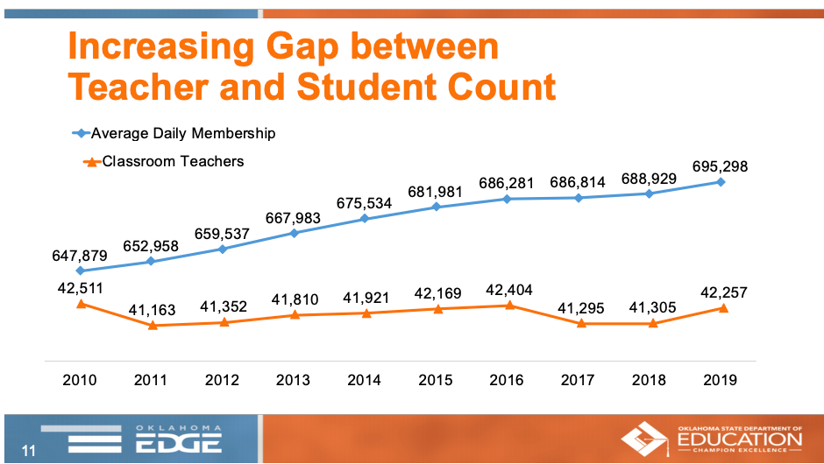
Figure 2.1: Increasing Gap Between Teacher and Student Count (OSDE, 2019)
In the United States, four states have conducted class size studies (Shin & Chung, 2009). In 1985, PRIME TIME was Indiana’s pilot program to reduce class sizes in kindergarten through 3rd grade (Weis, 2000; Boyland & Jarman, 2012). The state gave categorical grants to districts to reduce class sizes to a ratio of 1:18 in kindergarten through 1st grade, and a ratio of 1:20 in 2nd through 3rd grades (2012). It has been criticized for being hastily implemented. There was not enough classroom space for the number of teachers needed, and many schools added instructional aides instead of reducing the class size (2012). Nonetheless, there were small gains in achievement measured (2000). A 1987 evaluation of the program also reported increased teacher morale and reduced student discipline for students placed in smaller classes (2000). Wisconsin and California implemented similar programs during the 1996-1997 school year. Wisconsin’s program was referred to as SAGE and reduced class sizes to fifteen (Molnar et al., 1999). An increase in achievement was reported for students in the smaller class size; it appeared especially beneficial for African American students and students of poverty (1999). California reduced K-3rd grade class sizes to a maximum of 20 students (2000). Because California did not see the same gains, the implementation fidelity and program rules have been criticized as being too lenient to realize significant results (Sims, 2008). Additionally, in a review of the California program, Jepsen & Rivkin (2009) found benefits of smaller classes were diminished by lack of teacher quality.
Alternatively, the Tennessee’s Project STAR, a controlled, scientific experiment, has become the most well-known study on class sizes. Lamar Alexander, and former Secretary of Education under President George Bush, was the governor who implemented Project STAR (Finn & Achilles, 1999; Mosteller, 1995). Four universities helped design and implement the four-year study (1999; 1995). Students in kindergarten through 3rd grade were randomly placed in small class sizes of 13-17, regular class sizes of 22-25, and regular classes with instructional aides. Achievement results were compared for the three groups using several assessments (1999; 1995). The experiment was sizeable, encompassing approximately 6,500 students in 330 classrooms (1999; 1995). The outcome of the study found substantial improvements in early learning of students in the smaller classes (1999; 1995). In fact, it yielded “an array of benefits of small classes, including improved teaching conditions, improved student performance during and after the experimental years, improved student learning behaviors, fewer classroom disruptions and discipline problems, and fewer student retentions” (1999, p. 98).
The Tennessee experiment continued into a Lasting Benefits Study in 1989 (1999; 1995). Students who had been placed in the smaller classes during the experiment continued to have perceived benefits, even after returning to larger classes (1999; 1995). The academic advantages were statistically significant in every subject through 7th grade (1999). Achievement results were not significantly different in classes with instructional aides, only with the low student to certified teacher ratio (1999).
Evidence indicates the key to the benefits of the small classes is student engagement (Finn & Achilles, 1999). “In general, teachers of small classes do not alter their primary teaching strategies; small classes are academically superior not because they encourage new approaches to instruction but because teachers can engage in more of the basic strategies, they have been using all along” (1999, p. 103). The need for student engagement with a teacher is perhaps the reason why an instructional aide did not have equivalent effects as a smaller class per teacher in Project STAR. “A classroom of 40 pupils and 2 teachers, for example, cannot be expected to have the same impact on achievement as two classes each with 20 pupils and 1 teacher: (Finn & Achilles, p. 107). Students find it more difficult to withdraw and are more engaged with the teacher in a small class (1999).
Even with the conclusive evidence of the Tennessee STAR experiment, class size remains a controversial topic of study. It is economically expensive, and it is often a choice, where legislatures, school officials, or parents have deliberately chosen one limited resource over another. Therefore, it can often be correlated with other determinants and may bias study results (Hoxby, 2000). Analysis based on literature have produced mixed results. Glass and Smith (1979) performed a meta-analysis on 80 studies and found “little doubt that, other things equal, more is learned in smaller classes” (p.15). Hanushek (1999) performed a meta-analysis of studies and found class sizes did not relate to higher achievement. Analysis of literature, however, is only as good as the underlying studies. Many of these studies do not truly use class-size as the input; they use per-pupil ratios as an estimate (Hoxby, 2000). While per-pupil ratios are acceptable, they are not as accurate. When reviewing individual studies, the research produces diverse results. Nandrup (2016) recently performed a study in Danish public schools and found benefits of small class size in 2nd through 6th grade. Hoxby (2000) attempted to randomize the sample through a method using timing of births. She also used surveys to determine minimum and maximum class size rules for every district in Connecticut. She concluded that class reductions did not have an effect on achievement (2000).
While the studies above are a sampling of research available, the Tennessee STAR experiment remains the standard. The quantity of scientifically experimental data is more extensive than any study since, which is why it remains the most convincing study on the topic. STAR findings indicate the greatest impact occurs in the early childhood grades (American Education Research Association, 2008; Finn & Achilles, 1999; Molnar et al., 1999; Mosteller, 1995). Class sizes of 15 to 17 are estimated as ideal for kindergarten and first grades, and there is no experimental evidence that subtracting only a few students from large classes yields similar benefits (2008).

Summary
This chapter reviewed the relevant literature for a study on capital funding inequities and the cost-saving measures that districts implement in a budget-reduction climate. Fiscal equity, adequacy litigation, and the resulting reforms were examined. Historically, operational funding has received a greater focus by courts and legislators. Capital outlay equity remains an understudied topic, but research studies in this review found that an increase role by the state in funding increased equity among districts. Therefore, several funding mechanisms used by states to fund schools is explored.
The current study builds upon research by a previous study performed by Hime and Maiden (2017). Thus, the results, conclusions, and implications of their study is provided. In addition, an examination of relevant research for the cost-saving measures implemented by districts during budget reductions is provided.
In Chapter 3, the methodology is explained, which is used to perform an analysis of Oklahoma’s capital outlay inequities and the cost-saving measures implemented by districts due to budget reductions following the Great Recession. The chapter begins with an explanation of Oklahoma’s public-school finance system, and then the research questions are identified, which direct the study. Descriptions of variables, sampling techniques, and data analysis conclude the chapter.

METHODOLOGY
The purpose of this quantitative, nonexperimental study is to examine the relationship between and capital funding inequities, measures implemented by school districts during the 2014-2018 school years in response to the national budget-cutting climate. School districts in the United States have struggled with budget reductions following the years of the Great Recession; since 2008, states have been forced to prioritize fiscal burdens as tax revenue has fallen. During this same time, districts have embraced a variety of cost cutting measures; the 4-day school week has grown in popularity, instructional time has been reduced, and class sizes have increased. These are not usually factors related to inequity in capital funding. These factors are normally associated with general funding; however, such measures may also be affected by naturally occurring inequities in capital outlay funding. The current study builds upon previous research in which Hime and Maiden (2017) demonstrated inequity in one restricted fund can affect equity in another restricted fund. They provided evidence that inequitable capital funding can have a disequalizing effect on equitably distributed operational revenue. Given this empirical evidence, it is necessary to examine the extent to which the inequity of capital funding also affects operational fund measures, beyond those identified by Hime and Maiden (2017).
Chapter 3 describes the context for the current research and explains the methodology used to determine variables, collect and analyze data. Oklahoma is the selected state of study. The chapter begins with an explanation of the funding system used by Oklahoma to distribute equitable state aid and the ad valorem process districts use to collect capital improvement revenue. Next, the methodology for this research is provided followed by a description of each variable. All Oklahoma districts provide the data set for the study. The capacity for Oklahoma districts to meet capital needs is the independent variable. The dependent variables for this study are: whether or not a district uses a 4-day school week, annual instructional time, class size, and the covariates of poverty and whether a district is rural. Data analysis for the study is completed using regression models, both logistic regression and multiple linear regression are employed. Finally, equity analysis, and the chapter ends with assumptions and limitations of the study.

Research Context
Oklahoma is the selected state of study, as it is not feasible to perform this analysis on a national scale. The state offers a unique context for a capital funding equity study because there is no government role in capital outlay (ASCE, 2017; TLC, 2006). Thus, property wealth solely predicts revenue. The state relies exclusively on ad valorem funding for capital needs, but it has an equitable state aid funding formula for distributing operational funds to its public schools (Deering & Maiden, 1999; EdBuild, 2018; OSDE, 2013). Since the Great Recession, Oklahoma has cut school funding 28.2%, more than any other state (Leachman, Albares, Figueroa, 2016). Districts are strained from budget cuts, and inequities in capital funding are more apparent. Oklahoma also provides a large data set with a rural demographic, 78% of Oklahoma districts are small and rural ("NCES", 2017), including 90 districts that follow a 4-day calendar (OSDE, 2019). To better understand these issues in context of Oklahoma’s funding system, a detailed explanation of its school finance formulas is provided.

Oklahoma Public School Funding

Local Funding
In Oklahoma, funding comes primarily from property taxes on real and personal property within a school district boundary (Davis, 1985; OSDE, 2013). Property taxes in Oklahoma create three revenue sources for a school district: general fund, building fund, and sinking fund (2013). Local funds are then supplemented by state aid for operational costs. No state aid is provided for building or sinking funds. Property taxes are generally considered a progressive tax. The higher the property value; the more the citizen will pay (Odden & Picus, 2000). The Oklahoma Constitution limits taxation of property to 35 percent of its value (2013). For example, if a property’s value were determined to be $100,000; then, $35,000 would be taxed. Property taxes are levied in mills; 1 mill is 1/1000 of a dollar.
General Fund Revenue. General funds constitute a school district’s operational budget. These funds pay for salaries, instructional materials, and utilities. Four levies, totaling 35 mills, go to fund a district’s general fund. In addition, the state collects, divides and distributes a county 4-mill levy to school districts within that county (OSDE, 2013). The method equalizes funding across a county. It is only distributed back to the schools within the county where it is collected. Therefore, a high-value industry within the county may benefit all school districts.
To supplement a district’s general fund, Oklahoma utilizes a foundation aid formula. The purpose of the foundation aid is to equalize funding for a schools’ instructional expenses per student (Odden, & Picus, 2000). Local revenues are chargeable against a district’s state aid. The local revenue plus a district’s state aid provides the minimal per-pupil funding. This is an amount set each year by the Oklahoma legislature. For 2018, the total appropriation for public schools was $2,448,399,829.00 for a state enrollment of 694,816 students. Common Education is approximately 36% of the Oklahoma state budget ("Office of Management and Enterprise Services (OMES)", 2019).
Oklahoma’s state aid formula was adopted in 1981 (Hancock, 2008). It is a two-tiered, weighted student formula (WSF) and also has a section for transportation aid. A district’s weighted average daily membership (WADM) is calculated to determine enrollment. Categorical weights are given to students whose special circumstances are known to be more costly. Vertical equity is created in the formula by providing more resources to those with greater needs. Each year, the legislature appropriates a minimum per-pupil funding amount for the formula. Fiscal neutrality is created by specifying an amount of state aid inversely proportionate to a district’s wealth and ability to provide educational funding (2008). The formula does this by charging the districts ad valorem revenue against the appropriated funding from the state. Districts as a whole are also equalized through indexes. A small school receives an index based on enrollment, for example (OSDE, 2013). There are also indexes for districts with teachers who have advanced degrees and experience as well as districts located in a low-density population area.
Oklahoma’s current state aid formula was studied in 2008 and 2018. Both task forces found the formula to be an equitable method to distribute operational funding (EdBuild, 2018; Hancock, 2008). No task force has examined equity in funding capital outlay.
Capital Funding. In addition to property taxes for a school district’s general fund, a building fund levy equal to 5 mills is assessed on real and personal property within a district (OSDE, 2013). The 5-mill tax is designated for capital expenses and is paid directly to a district (2013). The building fund may be used by a school district for “erecting, remodeling, and repairing school buildings, or for purchasing furniture” (p. 10). It may also be used to pay for casualty insurance, maintenance, and equipment (2013). Because the building fund is not part of the state aid formula, it is not chargeable against a district. It is also not equalized in the state’s funding formula (TLC, 2006). The inequity in Oklahoma’s capital funding may best be explained using an example.
Since districts in Oklahoma receive a 5-mill levy on the assessed valuation, and a district with a net valuation of $430 million would equate to $2 million for capital outlay (OCAS, 2017). Another district’s net valuation of $67 million would equate to $335 thousand for capital outlay (OCAS, 2017). Both districts have equivalent amounts of students and capital needs. However, the first district receives 6 times the funding for capital outlay as the second. The revenue imbalance with districts in the example are further exacerbated because district valuation also determines bond funding.
In 1984, Oklahoma attempted to address inequity in capital funding with the passage of Oklahoma State Question 578; it was an amendment to State Question 368, which established the Public Common School Building Equalization Fund (Haxton, 2009). The Oklahoma State Board of Education (OSBE) could allocate funds for capital improvements through an equalization formula (2009). “However, no money has ever been deposited to the fund” (p. 58). Oklahoma was later sued by the Oklahoma Education Association (OEA) for inadequate funding of schools, though the lawsuit was dismissed (2009; "Judge tosses schools’ lawsuit", 2006). An OEA study during the lawsuit found Oklahoma schools were underfunded by as much as $1 billion for infrastructure (2009). Currently, the Public Common School Building Equalization Fund remains unused.
Bond Funding. The final revenue Oklahoma districts receive from local property taxes is funded through passage of bond referendums. The passage of a bond issue allows local districts to become indebted when approved by sixty-percent of registered voters (OSDE, 2013). The debt is paid from a sinking fund levy assessed by the county on the real and personal property within a district (2013). Bonds are the only additional method to gain funding for construction, and a district may not bond beyond 10% of the district’s valuation (Haxton, 2009; OSDE, 2013). Therefore, Oklahoma school district’s bonding capacity is directly related to the district’s capacity to collect capital outlay. Furthermore, bond revenue is restrictive, meaning only what is in the bond issue’s legal description may be funded with bond revenue (2009: 2013). Finally, the sinking fund levy is calculated based on the debt, is not pre-determined, and the county cannot collect more than is required to fund the district’s debt (2013). If a district does not have debt, it will not collect revenue for a sinking fund.

Equity Issues
School districts with low valuations are challenged by bond and capital funding inequity to meet capital needs (Hime & Maiden, 2017; Johnson & Maiden, 2010; Maiden & Stearns, 2007). The state does not provide funding to districts for the building or bond funds, and as a result, capital outlay funding has been shown to be inequitable (2017; 2010; 2007). It is predicted solely by the property wealth of the district. By not equalizing funding, Oklahoma allows geography to affect student outcomes (2010).
Though capital outlay in Oklahoma is not equalized, revenue for the general fund of a district is equalized through its funding formula (OSDE, 2013). Horizontal and vertical equity is created in general operational funding for districts through a weighted student formula (WSF). A fixed based funding amount per-pupil is determined by legislation. Categorical weights are assigned for students the state acknowledges are more costly to educate. A weighted average daily membership (WADM) is calculated from the number of students enrolled multiplied by the categorical weights assigned to the students. The WADM is used in the state aid formula to determine funding to create vertical equity. Per-pupil funding is set each year by an allocation from the Oklahoma legislature, which provides horizontal equity.

Crossover Funds
With equity in operational funds, but not in its capital improvement funds, Oklahoma provided a unique setting for the Hime and Maiden (2017) study. Oklahoma school districts use their general funds for operational expenses, such as salaries and instructional expenditures. Building funds are allowed for
erecting, remodeling, repairing, or maintaining school buildings, for purchasing furniture, equipment and computer software to be used on or for school district property, for repairing and maintaining computer system and equipment, for paying energy and utility costs, for purchasing telecommunications utilities and serves, for paying fire and casualty insurance premiums for school facilities, for purchasing security systems, for paying salaries of security personnel, or for one or more, or all of such purposes (OS 70-18-118).

Hime and Maiden (2017) demonstrated that districts with property wealth, and thus healthy capital outlay, were able to use building funds for allowable operational needs. Expenses such as salaries of maintenance, insurance payments, equipment, and technology expenses are a few examples of expenses that can be paid by either general or building funds. Hime and Maiden (2017) labeled these funds from dual sources exampled above as “crossover funds.” The crossover funds have a disequalizing impact on Oklahoma’s operational funding.

Rural School Vulnerabilities
An additional equity concern for Oklahoma is the number of small, rural school districts. These districts are negatively affected by the inequities in capital revenue (Johnson & Maiden, 2010, Maiden, 1998; Maiden & Stearns, 2007). Oklahoma has approximately 554 school districts, and 78% of them are considered rural (“State Public School and District Directories", 2017). Rural districts tend to be smaller, have more students from lower socioeconomic circumstances, their students and buses travel farther distances, which increases fuel costs (Jimerson, 2005; 2010; 1998; 2007) Also, they offer lower salaries compared to urban districts, which makes competing for quality teachers a challenge (2005; 2007). The buildings in rural areas are often older, increasing costs for heating, cooling, and maintenance (2005). Rural schools are also declining in enrollment as younger, educated and more mobile families are migrating to jobs in urban areas, leaving behind an older, financially-challenged population with a smaller tax base (2005).
Rural schools are especially hard hit in times of financial crisis (Maiden, 1998). “Farmland, forested areas, and mining areas” found in rural towns “are worth much less than in the dense residential and commercial districts found in urban communities” (Johnson & Maiden, 2010, p. 3). Rural school districts have lower than average district valuations leading to lower capital outlay revenue (2010; Maiden & Stearns, 2007). When state funding declines, rural districts with low valuations cannot compensate with local funding sources (2010; 2007). Nonetheless, schools are expected to continue to offer the same educational services and maintain buildings. Because these districts have lower valuations than their urban peers, they have less funding for capital projects (2010). Oklahoma does not equalize capital funding. Therefore, schools use cost-saving measures to compensate for the inequities in capital outlay.

Research Questions
The present study uses a nonexperimental, quantitative approach with logistical and multiple linear regression methodology to research the following questions:
Overarching Research Question: How do inequities in capital outlay capacity in Oklahoma public schools relate to cost-saving measures implemented during reductions in state aid from 2014 through 2018?
Research Questions:
- Is there a relationship between per-pupil capital outlay funding capacity and district adoption of a 4-day instructional week, controlling for percent students in poverty and whether a district is rural?
- Is there a relationship between district per-pupil capital outlay funding capacity and average district yearly instructional time, controlling for percent students in poverty and whether a district is rural?
- Is there a relationship between per-pupil capital outlay funding capacity and district average class sizes, controlling for percent students in poverty and whether a district is rural?
- What is the overall degree of resource equity of instructional time and class sizes across districts?

Data Sample
All Oklahoma public school districts with an assessed valuation are included in the sample. Charter schools and virtual school districts are excluded because they lack school district boundaries with real and personal property valuations. Without assessed value, they do not collect capital revenue. Approximately 514 districts remain after the exclusions. With 514 districts for each of the 5 years under study, 2014-2018, the study includes over 3,500 lines of data.

Description of Variables
The current study used extant, ex post data. The data sources were the Oklahoma State Department of Education (OSDE) website and the National Center for Education Statistics (NCES) website. Annual financial data is reported to OSDE from public school districts through the Oklahoma Cost Accounting System (OCAS). Statistical data is reported to OSDE from school districts through annual accreditation and personnel reports. Data for district locale, the categorical variable for whether a district is rural, was obtained from the NCES website.

Independent Variables
Capital Outlay Capacity. The first independent variable in this study is the continuously scaled variable of capital outlay capacity. Independent variables serve as predictors for the dependent variables in this study. The variable was calculated by dividing assessed valuation by enrollment to find a per-pupil valuation amount. It is an appropriate measure for capital outlay and was used in two prior studies to measure inequities in Oklahoma capital outlay: Maiden and Stearns (2010) and Hime and Maiden (2017).
In Oklahoma, every district receives a fixed rate of building fund revenue equal to 5 mills of the district’s total assessed valuation (OSDE, 2017). There are many reasons to use valuation as a measure of equity for capital outlay in Oklahoma. For one, districts have individual variations in their current building fund balances. These may be as a result of carry over funds, the district adding funds from gifts, grants, rental or sale of property, and federal sources, such as Impact Aid (2017). Beyond this annual funding, valuation is also a determinant for bond funding, and finally, during budget cuts, districts tend to be conservative in spending. The OSDE has noted a rise in carryover balances for all funds and a decrease in expenditures (Holder, 2017). After 2 years of revenue failures, resulting in mid-year cuts for schools, officials believe school districts are halting spending for anything not essential (2017). Constructing capital inequities from the capacity a district has for capital needs based on per-pupil valuation provides a purer description.
Economically Disadvantaged. The percent of economically disadvantaged students, a continuously scaled variable with values from 1 to 100, was used as an independent, control variable in this analysis. Oklahoma districts report the number of students receiving free or reduced lunches and their annual enrollment to OSDE. The data is published on the OSDE website.
Rural. The final independent, control variable for this study is whether or not a district may be considered rural. The data for this dichotomous, categorical variable, was obtained from the National Center for Education Statistics’ (NCES) website. NCES identifies every U.S. public school district’s locale; however, for this study, a district was simply coded as either as “1” for rural or “0” for non-rural.

Dependent Variables
Three dependent variables are examined for a relationship between capital outlay capacity and three cost-saving measures: 4-day school weeks, instructional time, and class sizes. A description of each variable is provided, and the justification for including it in the study follows.
Four-Day School Weeks. The dichotomous, categorical variable of whether a district follows a 4-day calendar is the first dependent variable. Oklahoma school districts must report whether a 4-day calendar is used as part of its annual accreditation report. It was reported as either “yes” or “no” by districts. The 4-day variable was coded as “1” for districts following a 4-day week or “0” for a regular calendar. To be considered as a 4-day district, the schedule must be utilized for the entire year. Certain districts in Oklahoma, for example, do not take a spring break and release all Fridays during the last quarter. For this study, these districts were not considered a 4-day district.
Whether a 4-day school week negatively affects student outcomes is debatable (Domier, 2009; Farris, 2013; Feaster, 2002; Hale, 2003; Roeth, 1985; Tharp, 2014). In Oklahoma, however, the number of districts using the 4-day week have tripled. Government leaders are critical of the policy because they believe it damages the state’s ability to attract businesses ("EXCLUSIVE: Gov. Fallin Looks Forward with Her Education Goals", 2016). Selected superintendents have stated the 4-day week is as much an incentive for teacher recruitment as a cost-saving measure, but others insist the alternative calendar has beneficial savings (OSDE, 2017). Four-day school weeks are used more often in small, rural areas (Plucker, Cierniak, & Chamberlin, 2012), where district have lower capital outlay (Maiden, 1998). Determining whether a relationship exists between inequities experienced by these districts and a 4-day week is timely.
Instructional Time. Instructional time, a continuously scaled variable, is the second dependent variable. It is reported yearly by all districts during accreditation in either in days or hours. Because districts also report instruction time in a school day, it is possible to convert days to hours of instruction for all districts. Differing instructional hours among schools within a district were averaged. The resulting data set was instructional time, measured on a continuous scale in hours, for every district in Oklahoma from 2014 to 2018.
Instructional time and its relationship to academic achievement is well-established (Berliner, 1990; Fredrick & Walberg, 1980; Levine, 1989). When Oklahoma lawmakers allowed districts to calculate instructional time in hours, the purpose was flexibility for making up inclement weather days. However, in the years following the Great Recession, superintendents reduced time for cost savings. The 4-day week has been controversial, but removal of time is less obvious. The reduction in time provides savings in transportation, hourly salaries, and utilities.
Class Size. Average class size is the third and final dependent variable. It was calculated by dividing the Full Time Equivalency (FTE) for instructional staff by the unweighted student enrollment. The number of teachers employed by a district is reported to the OSDE in annual personnel report. District enrollment is reported through annual statistical reports. The data set for this variable included the average district class size, on a continuous scale, for every Oklahoma district during the years 2014-2018.
A school districts’ greatest operational expense is personnel. Generally, it is 80-85% of the budget. When state aid is reduced, school boards may need to decrease personnel to balance budgets. Teachers lost through attrition may not be replaced or non-essential programs may be cut. Eliminating teachers is a concerning trend because smaller class sizes are known to affect student outcomes (Finn & Achilles, 1999: Jepsen & Rivkin, 2009).

Data Analysis

Regression Analysis
The primary purpose of the first four research questions is to determine the extent of the relationship of the three dependent variables: 4-day school weeks, instructional time and class sizes to the independent variable, per-pupil valuation, controlling for two additional independent variables. The study will use logistical and regression analysis, IBM SPSS. Because the first question uses a dichotomous, categorical, dependent variable, a binary logistic regression was employed to determine the extent of the relationship to capital outlay. For research questions 2 and 3, the relationship was examined using multiple linear regression. Regression models are used to determine the relationship among events, objects, or phenomena, not to predict causation.
Standard (least-squares) multiple regression analysis is carried out to test predictive relationships between multiple predictors and a single dependent measure. The dependent measure is assumed continuous, whereas the predictors can be either categorical (after appropriate dummy coding) or continuous. The model includes the assumption of a linear relationship between the independent and dependent variables, and the assumption that the residuals are independently and normally distributed and exhibit constant variance (Crowson, 2019).

The basic principle of this type of analysis to explore how the variables interact and contribute to the effects of one variable on another. Multivariate analysis uses multiple variables as predictors to better determine whether a statistically significant relationship exists (Crowson, 2019; Lomax & Hahs-Vaughn, 2012). In this study, poverty percentage and district locale are covariates to per-pupil valuation. Collectively, these independent variables are used by the model to predict the dependent variables. The measures from multiple regression include: coefficient of multiple determination, multiple correlation, and tests of significance (2019; 2014).

Equity Analysis
Research question 4 is an analysis of wealth neutrality in the distributions of data for the variables instructional time and class sizes. The Gini coefficient and McLoone index were calculated for this purpose. These tests were completed on each year’s data set in order to compare equity over time.
Gini Coefficient. Economists use the Gini coefficient for measuring wealth neutrality (Guthrie, Springer, Rolle & Houck, 2007;). A Gini Coefficient is the ratio between the line of equality on Lorenz Curve and the curve of the data to the triangular area (2007). The Gini Coefficient is the ratio “A” to “B” on the graph. IBM SPSS was used for analysis. A lower Gini Coefficient is associated with increased fiscal equity.
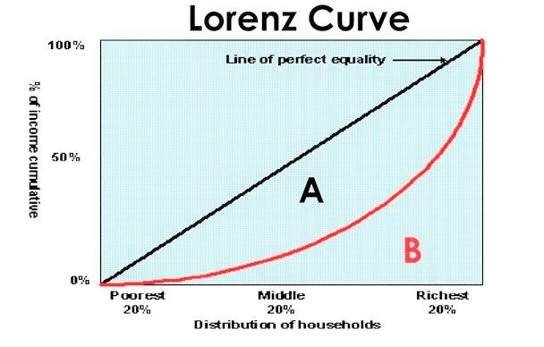
Figure 3.1 Lorenze Curve ("About the Lorenz Curve", 2018)
McLoone Index. The McLoone Index was applied to measure horizontal equity. It is based on a belief that the most important objective in equity is to elevate those in the lower half of the distribution (Gurthrie, et. al, 2007). The McLoone is an econometric index and measures how close values are to the median. The index will be between 0 and 1. Maximum equity is at 1.00 with a McLoone Index above 0.98 preferred (Verstegen, 2015).

Methodological Assumptions
Regression models make several assumptions. First, in MLR there is an assumption that the relationship is linear (Lomax & Hahs-Vaughn, 2014; Muijs, 2004). Furthermore, the variables must be independent and have homogeneity of variance. Normality is another assumption, and finally, in MLR, there is an assumption of noncollinearity. To ensure this assumption is not true, several regressions may be run, changing the X variable in each. It is difficult to achieve statistical significance if this assumption is not met (2014). Robustness checks are utilized to assess violations of assumptions.

Validity
Internal validity threats for this study can arise from an omitted variable or an error during data analysis. If another factor is correlated to the dependent variable, errors in the model could result. Additionally, it would be a threat to internal validity if there are errors in the data, or if the analysis is completed incorrectly. Peer review should assist in reducing this possibility.
External validity threats arise in analytical generalizations to outside populations. In this study, a total population sample of all Oklahoma districts with assessed valuations was used. This reduces threats to external validity.

Limitations
A limitation to the study involves the analysis which highlights only one of the four states not providing capital outlay to schools ("How Your State Funds School Construction," 2018). In addition, the amount of data offered by Oklahoma is sufficiently large, but including more states could strengthen the policy argument. Also, the current study does not address adequacy even though it is a pressing issue. “Officials in all three branches of federal, state, and local government are continually faced with questions of how much money is needed for an education system to be deemed adequate” (2007, p. 285).

Summary
In this chapter, the methodology was provided for the current quantitative, nonexperimental study analyzing the predictive relationship between capital funding inequities and cost-saving measures implemented by Oklahoma public schools in response to budget reductions after the Great Recession. The chapter began with an analysis of Oklahoma’s public-school funding system since Oklahoma provides the context for the study. The research questions are specified and variables described, followed by a rationalization of the procedures for data analysis. Chapter 4 provides an interpretation of the data analysis.

PRESENTATION OF DATA ANALYSIS AND RESULTS
Chapter 3 provided an overview of the methodology to analyze data collected for a study about the impact of capital outlay inequities on cost-saving measures. Chapter 4 ensues with a brief explanation of the budget reduction climate in Oklahoma, followed by a review of the design, variables, data collection, and a restatement of the research questions driving the study. Data analysis is presented after each research question with tables, graphs, and descriptions for a thorough explanation of methods and results.
The purpose of this study was to examine whether a school district’s capacity to address capital needs could have a relationship to the cost-saving measures of a 4-day week, reduced instructional time, or increased class sizes. Typically, budget reduction measures have not been related to capital outlay in the literature. Cost-saving measures usually originate from general funding, where state aid revenue is deposited. Salaries, which are 80-85% of a district’s overall budget, are disbursed from this operational funding. When cuts to state aid are extensive, salaries must be reduced to realize substantial savings in the general fund. However, Hime and Maiden (2017) recently demonstrated that wealthy districts with ample capital revenue have the ability to pay certain general fund expenditures from their capital outlay funding because Oklahoma statute permits this flexibility. They labeled the building funds utilized for operational expenditures as “crossover funds” (2017). A disequalizing effect on general fund equity was measured in the Hime and Maiden (2017) study due to the impact of the crossover funds (2017). Their findings demonstrated an ability for districts with high per-pupil valuations to pay higher teacher salaries. Essentially, the high-valued districts were using the advantage from copious capital revenue to supplement operational funds. The current study explores whether inequities in capital revenue could also relate to cost-saving measures normally associated with general fund revenue. The study was guided by the following research questions:
Overarching Research Question: How do inequities in capital outlay capacity in Oklahoma public schools relate to cost-saving measure implemented during reductions in state aid from 2014 through 2018?
Research Questions:
1. Is there a relationship between per-pupil capital outlay funding capacity and district adoption of a 4-day instructional week, controlling for percent students in poverty and whether a district is rural?
2. Is there a relationship between district per-pupil capital outlay funding capacity and average district yearly instructional time, controlling for percent students in poverty and whether a district is rural?
3. Is there a relationship between per-pupil capital outlay funding capacity and district average class sizes, controlling for percent students in poverty and whether a district is rural?
4. What is the overall degree of resource equity of instructional time and class sizes across districts?
Statistical and financial data used for this study were collected from the Oklahoma State Department of Education and the Oklahoma Cost Accounting System for fiscal years 2014 through 2018. Data indicating the rural or non-rural locale for each district was obtained from the National Center for Education Statistics (NCES) website. Data used in the analysis included:
- Total Enrollment
- Assessed valuation (Assessed valuation was divided by total enrollment to calculate per-pupil valuation.)
- Districts using a 4-day week
- Instructional hours per school year
- The Full Time Equivalency (FTE) of teacher, coded 210 or 215 in personnel report (Total enrollment was divided by FTE to calculate class size.)
- Rural locale
- Poverty, reported to OSDE as percentage free and reduced lunch

Budget Reduction Climate
During the years of this study, Oklahoma school districts received several reductions in state aid following years of economic recession. In 2016 and 2017, multiple general revenue failures occurred, resulting in mid-year cuts to every state agency, including education. The consequences for school districts were reductions to the state aid funding formula. Figure 4.1 demonstrates the trends in appropriations for Oklahoma school districts during the years preceding and throughout the current study.

Figure 4.1 Graph of State Aid to Oklahoma Schools, 2010-2018

Oklahoma has also experienced a slow recovery in property values as a result of the economic recession. An independent variable for this study included a school districts’ capacity to raise capital outlay. In Oklahoma, districts rely solely on the assessed valuation for capital improvement funds; therefore, the variable was measured by per-pupil assessed valuation. Figure 4.2 illustrates assessed valuations during the years of the study, and the graph exemplifies the minimum and maximum per-pupil valuation for the years under study. According to the graph, the recovery in property values have not been equally shared. In 2014, the range for per-pupil valuation was $523,056.62, but by the end of the study, the range had increased to $831,087.61.
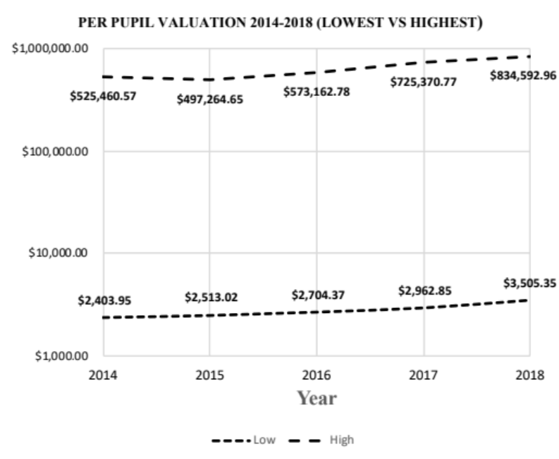
Figure 4.2 Graph of Per-Pupil Valuations, 2014-2018

Logistic Regression Analysis for Four-Day School Weeks
Research Question 1: Is there a relationship between per-pupil capital outlay funding capacity and district adoption of a 4-day instructional week, controlling for percent students in poverty and whether a district is rural?
Three independent variables were used in the analysis for research question 1:
- Per-pupil assessed valuation
- Rural locale
- Poverty level
The dependent variable to be predicted was whether a 4-day week was followed by the school district. Because it is was a binary, dichotomous variable, the data was analyzed through a logistic regression model. An analysis was performed for each year, 2014 through 2018.
The number of schools operating on a 4-day week is depicted in Table 4.1 below. During the five years of the study, the usage of a 4-day week tripled. In 2014, only 29 districts utilized the alternative schedule, but by the end of the study, 91 districts adopted the calendar. The highest quantity occurred in 2017, when 97 districts followed a 4-day week.
Table 4.1 Number of Oklahoma Districts Utilizing 4-Day School Weeks
YEAR | 4DAY | NON 4DAY | TOTAL | PERCENT
2014 | 29 | 480 | 509 | 6%
2015 | 35 | 481 | 516 | 7%
2016 | 48 | 459 | 507 | 10%
2017 | 97 | 416 | 513 | 23%
2018 | 91 | 422 | 513 | 22%

In the early years of the study, the small number of districts proved problematic for analysis, as logistic regression models require more cases than linear regression. When the outcome is rare, even if the overall data set is large, the logistic regression model cannot accurately estimate the relationship between variables (Lomax & Hahs-Vaughn, 2012).
Table 4.2 below provides the values for the Cox & Snell R squared for each of the five logistic regressions. The pseudo R squared is essentially a percentage indicating the degree to which the independent variables can collectively predict the dependent variable. A Cox & Snell R squared, unlike a standard R squared, never reaches either zero or one. The values in the table indicate the amount of variance for this analysis is low, especially in the early years. In 2014, the R squared value is .022, or 2.2%. By the end of the study, in 2018, the R squared is 9.9%. Thus, the goodness-of-fit for the model increased in the last two years of the study.
Table 4.2 Logistic Regression Model Summary
Year | Cox & Snell R Square
2014 | 0.022
2015 | 0.049
2016 | 0.041
2017 | 0.077
2018 | 0.099

Tables 4.3 through 4.7 include the results from the analysis. The tables list the Wald test statistic with associated degrees of freedom, the significance test, and the exponentiated coefficient known as the odds ratio. The $β$ coefficient indicates the change in the log odds, which corresponds to one unit of change in the listed independent variable, holding all other variables constant. A Bonferroni correction is utilized for tests of significance because 15 regressions models are included for the 3 variables over 5 years. Therefore, p < .05/15 =0.003 is used to determine statistical significance.
For 2014 through 2016, there were no statistically significant relationships found among variables. In 2015, for the rural variable only, the coefficient, standard error, and Wald test could not be treated as valid in the model given a problem with quasi-separation. Nonetheless, the remaining coefficients and tests can be treated as valid (Allison, 2008). Importantly, the likelihood ratio chi-square test for problem predictors can also be treated as valid (Allison, 2008; see also: http://support.sas.com/kb/22/599.html). The likelihood ratio test for Rural District was not significant (p=.998) in the model.

Table 4.3 Logistic Regression Results for 4-day Week Variable, 2014
2014 Logistic Regression Variables in the Equation
 | B  (change in log odds) | S.E.  (standard error) | Wald | df | Sig.  (p<.003) | Exp(B)  (odds ratio)
Per Pupil Valuation | 0.000 | 0.000 | 0.373 | 1.000 | 0.541 | 1.000
Poverty | 1.150 | 1.109 | 1.077 | 1.000 | 0.299 | 3.159
Rural District | 2.207 | 1.026 | 4.623 | 1.000 | 0.032 | 9.086
Constant | -5.604 | 1.251 | 20.073 | 1.000 | 0.000 | 0.004

Table 4.4 Logistic Regression Results for 4-day Week Variable, 2015
2015 Logistic Regression Variables in the Equation
 | B  (change in log odds) | S.E.  (standard error) | Wald | df | Sig.  (p<.003) | Exp(B)  (odds ratio)
Per Pupil Valuation | 0.000 | 0.000 | 0.244 | 1.000 | 0.621 | 1.000
Poverty | 2.777 | 1.251 | 4.926 | 1.000 | 0.026 | 16.064
Rural District | N/A | N/A | N/A | N/A | N/A | N/A
Constant | -23.035 | 3555.398 | 0.000 | 1.000 | 0.995 | 0.000

Table 4.5 Logistic Regression for 4-day Week Variable, 2016
2016 Logistic Regression Variables in the Equation
 | B  (change in log odds) | S.E.  (standard error) | Wald | df | Sig.  (p<.003) | Exp(B)  (odds ratio)
Per Pupil Valuation | 0.000 | 0.000 | 0.267 | 1.000 | 0.606 | 1.000
Poverty | 2.975 | 1.128 | 6.962 | 1.000 | 0.008 | 19.596
Rural District | 1.636 | 0.610 | 7.189 | 1.000 | 0.007 | 5.136
Constant | -5.633 | 0.997 | 31.926 | 1.000 | 0.000 | 0.004

Table 4.6 Logistic Regression for the 4-day Week Variable, 2017
2017 Logistic Regression Variables in the Equation
 | B  (change in log odds) | S.E.  (standard error) | Wald | df | Sig.  (p<.003) | Exp(B)  (odds ratio)
Per Pupil Valuation | 0.000 | 0.000 | 3.876 | 1.000 | 0.049 | 1.000
Poverty | 1.840 | 0.788 | 5.448 | 1.000 | 0.020 | 6.295
Rural District | 1.905 | 0.438 | 18.913 | 1.000 | 0.000 | 6.718
Constant | -4.060 | 0.703 | 33.371 | 1.000 | 0.000 | 0.017

Table 4.7 Logistic Regression for 4-day Week, 2018
2018 Logistic Regression Variables in the Equation
 | B  (change in log odds) | S.E.  (standard error) | Wald | df | Sig.  (p<.003) | Exp(B)  (odds ratio)
Per Pupil Valuation | 0.000 | 0.000 | 4.465 | 1.000 | 0.035 | 1.000
Poverty | 2.927 | 0.836 | 12.263 | 1.000 | 0.000 | 18.669
Rural District | 1.983 | 0.477 | 17.249 | 1.000 | 0.000 | 7.264
Constant | -5.024 | 0.789 | 40.510 | 1.000 | 0.000 | 0.007

A statistically significant relationship between rural districts and a 4-day week for both 2017 and 2018 is found through the analysis. It is a positive correlation (b=1.905 in 2017; b=1.983 in 2018), indicating that rural districts are more likely to utilize a 4-day school week. In 2018, a statistically significant relationship is depicted between poverty and the 4-day variable. It is also a positive correlation (b=2.927), indicating a higher poverty percentage increased the prospect of a district utilizing a 4-day week. Without a Bonferroni correction, a significant relationship was found between the per-pupil valuation and a 4-day week for the years 2017 & 2018, (p < .049 for 2017 and p < .035 in 2018).

Multiple Linear Regression Analysis
Research Question 2: Is there a relationship between district per-pupil capital outlay funding capacity and average district yearly instructional time, controlling for percent students in poverty and whether a district is rural?
Three independent variables were used in the analysis for research question 2 include:
- Per-pupil assessed valuation
- Rural locale
- Poverty level
The dependent variable for this question was a measure of annual instructional time. The variable is continuously scaled; therefore, a multiple linear regression model was selected for data analysis. The analysis was performed for each year 2014 through 2018. Because there are 15 regressions, a Bonferroni correction is used for the test of significance (p < .05/15 =0.003).
Table 4.8 illustrates the R, R squared, and adjusted R square values for the linear regression functions. The R squared values provide a goodness-of-fit measure for the relationship between the independent variables collectively to the dependent variable. In this model, the predictors account for a small amount of the variation in instructional time, a range of .9% in 2014 to 2.6% in 2018. Furthermore, there is shrinkage in the fit from the R square values to the adjusted R squares. The adjusted R square value is 0.4% in 2014 and 1.8% in 2018. These are small goodness-of-fit values for the multiple linear regression model. Included in Table 4.8 is the Standard Error of the Estimate (SEE). Listed chronologically for the years of the study, these values were sizeable at 42.805, 40.714, 42.201, 45.085, and 42.460. Jointly, the R squared and SEE values confirm that the model is not employing the independent variables reliably to predict the dependent variable.
Table 4.8 Model Summary for Instructional Time Dependent Variable
Year | R | R Square |  | Adj. R Squared | Standard Error of Estimate
2014 | 0.097 | 0.009 | 0.004 |  | 42.805
2015 | 0.098 | 0.010 | 0.004 |  | 40.714
2016 | 0.105 | 0.011 | 0.005 |  | 42.201
2017 | 0.171 | 0.029 | 0.023 |  | 45.085
2018 | 0.155 | 0.026 | 0.018 |  | 42.460

Although Tables 4.9 to 4.13 illustrate the results for the multiple linear regressions, there are no statistically significant relationships found for years 2014 through 2017. Conversely, in 2018, Table 4.13 demonstrates a statistically significant relationship between per-pupil valuation and instructional time (b=6.13E-05, SE=0.00, t=3.191, p<.002). For every 1 unit of change in the per-pupil valuation, b=6.13E-05 units of change are estimated in instructional time. However, the small amount of variance and large error estimate depicted from Table 4.8 above (R² = .026, and SEE = 42.260) remain problematic for this result.
Table 4.9 Multiple Linear Regression Results for Instructional Time, 2014
2014 Coefficients Instructional Time
 | Unstandardized Coefficients |  | Standardized Coefficients |  |  | Collinearity Statistics
MODEL | B | Std. Error | Beta | t | Sig. | Tolerance | VIF
(Constant) | 1119.674 | 7.504 |  | 149.216 | 0.000
Per Pupil Valuation | 6.13E-05 | 0.000 | 0.078 | 1.701 | 0.089 | 0.943 | 1.061
Poverty | -9.932 | 9.828 | -0.046 | -1.011 | 0.313 | 0.967 | 1.035
Rural District | 0.298 | 4.485 | 0.003 | 0.066 | 0.947 | 0.971 | 1.030

Table 4.10 Multiple Linear Regression Results for Instructional Time, 2015
2015 Coefficients Instructional Time
 | Unstandardized Coefficients |  | Standardized Coefficients |  |  | Collinearity Statistics
MODEL | B | Std. Error | Beta | t | Sig. | Tolerance | VIF
(Constant) | 1127.728 | 7.879 |  | 143.134 | 0.000
Per Pupil Valuation | 0.000 | 0.000 | 0.076 | 1.669 | 0.096 | 0.937 | 1.067
Poverty | -11.460 | 10.806 | -0.048 | -1.061 | 0.289 | 0.961 | 1.041
Rural District | -2.727 | 4.272 | -0.029 | -0.638 | 0.524 | 0.960 | 1.042

Table 4.11 Multiple Linear Regression Results for Instructional Time, 2016
2016 Coefficients Instructional Time
 | Unstandardized Coefficients |  | Standardized Coefficients |  |  | Collinearity Statistics
MODEL | B | Std. Error | Beta | t | Sig. | Tolerance | VIF
(Constant) | 1131.656 | 8.370 |  | 135.197 | 0.000
Per Pupil Valuation | 0.000 | 0.000 | 0.036 | 0.784 | 0.434 | 0.948 | 1.055
Poverty | -22.778 | 11.381 | -0.090 | -2.001 | 0.046 | 0.968 | 1.033
Rural District | -2.350 | 4.438 | -0.024 | -0.530 | 0.597 | 0.962 | 1.040

Table 4.12 Multiple Linear Regression Results for Instructional Time, 2017
2017 Coefficients Instructional Time
 | Unstandardized Coefficients |  | Standardized Coefficients |  |  | Collinearity Statistics
MODEL | B | Std. Error | Beta | t | Sig. | Tolerance | VIF
(Constant) | 1121.541 | 9.004 |  | 124.556 | 0.000
Per Pupil Valuation | 0.000 | 0.000 | 0.117 | 2.598 | 0.010 | 0.946 | 1.057
Poverty | -25.590 | 12.079 | -0.094 | -2.119 | 0.035 | 0.969 | 1.032
Rural District | -7.586 | 4.694 | -0.072 | -1.616 | 0.107 | 0.966 | 1.035

Table 4.13 Multiple Linear Regression Results for Instructional Time, 2018
2018 Coefficients Instructional Time
 | Unstandardized Coefficients |  | Standardized Coefficients |  |  | Collinearity Statistics
MODEL | B | Std. Error | Beta | t | Sig. | Tolerance | VIF
(Constant) | 1104.490 | 8.600 |  | 128.434 | 0.000
Per Pupil Valuation | 0.000 | 0.000 | 0.145 | 3.191 | 0.002 | 0.934 | 1.071
Poverty | -4.081 | 11.255 | -0.016 | -0.363 | 0.717 | 0.951 | 1.051
Rural District | -7.197 | 4.447 | -0.072 | -1.618 | 0.106 | 0.959 | 1.043

Table 4.14 Instructional Time Average for 2014-2018
Year | Maximum | Minimum | Average
2014 | 1313 | 1019 | 1117
2015 | 1298 | 1021 | 1121
2016 | 1313 | 978 | 1116
2017 | 1313 | 977 | 1104
2018 | 1296 | 912 | 1101

Table 4.14 represents the maximum, minimum, and average range for instructional time during the five years of the study. The range for average instructional time was 16 hours, maximum instructional time was 17 hours, and minimum instructional time was 107 hours. These values confirm the low variation in the data for this variable. Figure 4.3 illustrates the decreasing trend for these values. The graph makes evident that districts with the lowest annual instructional time had the greatest decline for this variable.

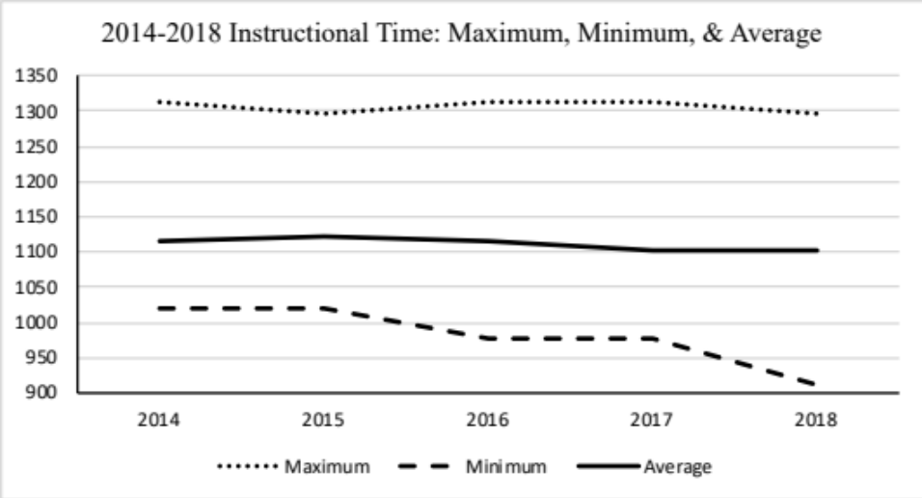
Figure 4.3 Graph of Instructional Time: Maximum, Minimum, & Average
Research Question 3: Is there a relationship between per-pupil capital outlay funding capacity and district average class sizes, controlling for percent students in poverty and whether a district is rural?
For research question 3, the following independent variables were used in the analysis:
- Per-pupil assessed valuation
- Rural locale
- Poverty level
The dependent variable for this question was class size, which is a continuously scaled variable and was calculated by dividing a district’s student enrollment by its Full Time Equivalency (FTE) for teachers. The Oklahoma State Department of Education (OSDE) requires districts to report classroom teachers separate from other certified personnel. For example, counselors and administrators are excluded from FTE for teachers. Performing the calculation using this method increases the accuracy for class size.
A multiple linear regression model was utilized for analysis of the three independent variables for each year of the study. A Bonferroni correction was used for a test of significance to prevent a Type I error due to the 15 regressions performed. The results follow in Tables 4.15 through 4.20 with tests of robustness located in Appendix B.
R squared values, the goodness-of-fit measure for the model, are documented in Table 4.15. Over the five years of the study, the R squared value increased from 2014 (R² = .308) to 2018 (R²= .387), while the amount of shrinkage in adjusted R square values (.304 to .383) is small. The Standard Error Estimates (SEE = 2.148, 2.088, 2.003, 2.202 & 2.105), combined with the R squared values, indicate the model was successful in utilizing the independent variables to predict class size, the dependent variable.
Table 4.15 Regression Model Summary for Class Size
Model Summary Class Size
YEAR | R | R SQUARE | ADJ R SQUARE | Standard Error of the Estimate
2014 | 0.555 | 0.308 | 0.304 | 2.148
2015 | 0.094 | 0.353 | 0.349 | 2.088
2016 | 0.603 | 0.363 | 0.359 | 2.003
2017 | 0.585 | 0.342 | 0.338 | 2.202
2018 | 0.622 | 0.387 | 0.383 | 2.105

Tables 4.16 through 4.20 below describe the coefficients and tests of significance for the analyses. For every independent variable in the model a statistically significant relationship was calculated, indicating that per-pupil valuation, percent students in poverty, and rural locale were each predictors of class size for every year of the study when controlling for the other variables. An inverse relationship between per-pupil valuation and class sizes was observed. For every one unit of class size increase, a decrease of per-pupil valuation (b = -2.05E-05, -2.11E-05, -1.93E-05, -1.96E-05, and -1.63E-05) was estimated in 2014 – 2018. Thus, increases in capital outlay capacity resulted in decreases in class sizes when controlling for other predictors.
Rural locale and school district poverty percentage was found to have a statistically significant inverse relationship in the regression analysis. Rural districts were estimated to have smaller class sizes (b= -1.613, -1.548, -1.471, -1.169, -1.330). Because the data is dummy coded for rural districts (rural=1; non-rural=0), the regression coefficient is interpreted as a difference in the means, controlling for the remaining predictors (Crowson, 2019). The adjusted means for the rural variable was statistically, significantly different from zero for all years in the model. Because rural districts are smaller, but must have the required classroom teachers, regardless of the number of students, logic follows that they would have lower class sizes.
Poverty percentage in districts was also estimated to have a statistically significant inverse relationship (b=-2.506, -1.548, -3.062, -3.263, & -4.262, p< .000 for all years). As poverty percentage increased in school districts, class sizes decreased. While this may seem counterintuitive, federal funds supplement students in poverty through Title I funding. In addition, Oklahoma’s weighted student formula provides added funding for economically disadvantaged students.
In a multiple linear regression, the beta ($β$) coefficient is a standardized version of b, and allows for a comparison of an independent variable’s impact on the dependent variable. Table 4.16 exemplifies that per-pupil valuation variable has the greatest effect on the dependent variable (For 2014, $β$= -11.364 for per-pupil valuation, $β$= -5.082 for poverty percentage, and $β$= -7.165 for rural local). The result is consistent across all years of the study; per-pupil valuation indicates the greatest standard deviation increase for each t test.

Table 4.16 Class Size Regression Results for Class Size 2014
2014 Coefficients Class Size
 | Unstandardized Coefficients |  | Standardized Coefficients |  |  | Collinearity Statistics
MODEL | B  (change in log odds) | Standard Error | Beta | t | Sig. Sig.  (p<.003) | Tolerance | VIF
(Constant) | 18.421 | 0.377 |  | 48.916 | 0.000
Per Pupil Valuation | -2.05E-05 | 0.000 | -0.433 | -11.364 | 0.000 | 0.943 | 1.061
Poverty | -2.506 | 0.493 | -0.191 | -5.082 | 0.000 | 0.967 | 1.035
Rural District | -1.613 | 0.225 | -0.269 | -7.165 | 0.000 | 0.971 | 1.030

Table 4.17 Class Size Regression Results for Class Size 2015
2015 Coefficients Class Size
 | Unstandardized Coefficients |  | Standardized Coefficients |  |  | Collinearity Statistics
MODEL | B  (change in log odds) | Standard Error | Beta | t | Sig. Sig.  (p<.003) |  | Tolerance | VIF
(Constant) | 19.161 | 0.404 |  | 47.430 | 0.000
Per Pupil Valuation | -2.11E-05 | 0.000 | -0.470 | -12.795 | 0.000 |  | 0.937 | 1.067
Poverty | -3.523 | 0.554 | -0.231 | -6.359 | 0.000 |  | 0.961 | 1.04
Rural District | -1.548 | 0.219 | -0.257 | -7.070 | 0.000 |  | 0.961 | 1.041

Table 4.18 Class Size Regression Results for Class Size 2016
2016 Coefficients Class Size
 | Unstandardized Coefficients |  | Standardized Coefficients |  |  | Collinearity Statistics
MODEL | B  (change in log odds) | Standard Error | Beta | t | Sig. Sig.  (p<.003) | Tolerance | VIF
(Constant) | 18.898 | 0.397 |  | 47.601 | .000
Per Pupil Valuation | -1.93E-05 | 0 | -0.487 | -13.327 | .000 | 0.948 | 1.055
Poverty | -3.062 | 0.539 | -0.205 | -5.675 | .000 | 0.967 | 1.034
Rural District | -1.471 | 0.211 | -0.254 | -6.988 | .000 | 0.962 | 1.04

Table 4.19 Class Size Regression Results for Class Size 2017
2017 Coefficients Class Size
 | Unstandardized Coefficients |  |  | Standardized Coefficients |  |  |  | Collinearity Statistics
MODEL | B  (change in log odds) | Standard Error | Beta |  | t | Sig. Sig.  (p<.003) | Tolerance |  | VIF
(Constant) | 19.391 | 0.440 |  |  | 44.106 | 0.000
Per Pupil Valuation | -1.96E-05 | 0.000 | -0.509 |  | -13.768 | 0.000 | 0.947 |  | 1.056
Poverty | -3.463 | 0.589 | -0.215 |  | -5.881 | 0.000 | 0.970 |  | 1.031
Rural District | -1.169 | 0.228 | -0.187 |  | -5.117 | 0.000 | 0.967 |  | 1.034

Table 4.20 Class Size Regression Results for Class Size 2018
2018 Coefficients Class Size
 | Unstandardized Coefficients |  |  | Standardized Coefficients |  |  | Collinearity Statistics
MODEL | B  (change in log odds) | Standard Error | Beta |  | t | Sig. Sig.  (p<.003) |  | Tolerance | VIF
(Constant) | 19.930 | 0.426 |  |  | 46.744 | 0.000
Per Pupil Valuation | -1.63E-05 | 0.000 | -0.523 |  | -14.548 | 0.000 |  | 0.934 | 1.071
Poverty | -4.262 | 0.558 | -0.272 |  | -7.637 | 0.000 |  | 0.951 | 1.051
Rural District | -1.330 | 0.220 | -0.214 |  | -6.032 | 0.000 |  | 0.959 | 1.043

Resource Equity Analysis
Research Question 4: What is the overall degree of resource equity of instructional time and class sizes across districts?
To answer the final research question, a Coefficient of Variation (CV) and a Gini Index were calculated for both variables, class size and instructional time. The McLoone Index was calculated for instructional time. These values were used to ascertain the level of wealth neutrality and the extent to which class sizes and instructional time are related to the local wealth of districts.
The CV was calculated by dividing the standard deviation for the population by the mean, the quotient is a measure of the dispersion of values in the data set for each variable. A higher CV indicates greater dispersion, and in this context, less equity. The McLoone Index is a measure of equity for the revenue distribution below the median. It is expressed as a ratio of the actual revenue in the bottom half of the distribution relative to the total revenue that would be received if the group studied were at the median revenue. The assumption is that if all values are ordered from least to greatest, perfect equity is achieved when every district had the same amount of revenue, or instructional time in this scenario, as the district at the median. The value for the McLoone ranges from zero to one. As the index approaches one, equity for the lower half of the distribution increases. The Gini Index was computed for class sizes versus per-pupil valuations, and instructional time versus per-pupil valuation. A Gini Index of 0 equates to perfect equity while a 1 reflects perfect inequity. Tables 4.21 and 4.22 indicate the results of these equity tests.
Table 4.21 Instructional Time Equity Measures
 | Coefficient of Variation | Gini Coefficient |  | McLoone Index
2014 | 0.04 | 0.43 |  | 0.97
2015 | 0.04 | 0.44 |  | 0.97
2016 | 0.04 | 0.45 |  | 0.98
2017 | 0.04 | 0.46 |  | 0.97
2018 | 0.04 | 0.47 |  | 0.98

Table 4.22 Class Size Equity Measures
Year | Coefficient of Variation | Gini Coefficient
2014 | 0.18 | 0.48
2015 | 0.18 | 0.48
2016 | 0.18 | 0.49
2017 | 0.18 | 0.50
2018 | 0.18 | 0.52

The data analysis for instructional time is depicted in Table 4.21. The CVs were consistent across the five years of study; a 4% dispersion of data is indicated by the calculation for instructional time. The CV is a percentage and has a range from 0 to 100; therefore, 4% is a small value. It demonstrates little variation for values in the data set. The Gini coefficient for instructional time had a range of 0.43 to 0.47. The Gini coefficient also has a value from 0 to 100; therefore, the values of 0.43 to 0.47 indicate inequity. More importantly, because the Gini increased over the years of the study, a decrease in equity is observed. The McLoone Index is also given in Table 4.16 for instructional time. A McLoone Index of 1 equates to perfect equity below the median. For instructional time, the McLoone Index was consistent for all five years at either .97 or .98, implying a high degree of equity in the lower distribution.
Table 4.22 lists the equity calculations for class size. An 18% dispersion in data is indicated for all five years of the study (CV=0.18). Comparatively, class size has more variation than instructional time, though both are small values. A McLoone Index is not computed for class sizes since the calculation depends upon higher values being more equitable. Because lower class sizes are preferred, this measure is not valid for this variable. For 2014 through 2018, the Gini coefficients range from 0.48 to 0.52. Because greater equity is achieved when the Gini coefficient equals 1, the ratio is indicative of inequity for class size. An increase in the Gini is also observed for class sizes, indicating equity decreased during the years of the study.

Summary
Chapter 4 explained results from the data analysis utilized to determine whether relationships exist between the independent variables of 4-day weeks, annual instructional time, or class sizes, and the dependent variable of inequitable capital revenue. It began with a description of the fiscal climate in Oklahoma during the years of data collection. Then, tables, graphs, and a narrative descriptive of the findings were presented from the logistic regressions, multiple linear regressions, and equity tests following each of the research questions. Chapter 5 follows with a discussion of the findings, the conclusions, policy implications, and suggestions for further research.

FINDINGS, CONCLUSIONS, AND SUGGESTIONS FOR FURTHER RESEARCH
Chapter 4’s purpose was to clarify the data analysis for a study about the impact of capital outlay inequities on cost-saving measures, as well as the methodology, variables used, and research questions. Data analysis was depicted using tables, graphs, followed by a narrative concerning each research question. Chapter 5 opens with an overview of the study and its design. A discussion of findings and conclusions drawn from Chapter 4 follow, organized by research questions. The chapter concludes with implications for policymakers and recommendation for further research.
This study included an exploration into methods utilized by school districts to cut costs in order to balance budgets during a climate of state aid reductions in the funding formula and the relationship between those methods and inequitable capital outlay. Normally, cost-saving methods are associated with general funds; but recently, Hime and Maiden (2017) demonstrated a disequalizing effect on state aid in operational funds due to “crossover funding” in capital outlay where property-wealthy districts were found to be utilizing copious capital revenue to supplement operational funding. The crossover funding held specific benefits for paying higher teacher salaries and increased instructional spending. In Oklahoma, state statute defines the expenditures allowed from general funds or building funds. Equipment, furniture, technology, insurance payments, and maintenance staff salaries are examples of allowable expenses to be paid from either operational or capital improvement revenue sources. In the findings of their study, Hime and Maiden (2017) found lower-wealth districts rely heavily on the revenue from the state aid formula, but property-wealthy districts were able to supplement state aid from healthy capital outlay, which grants them the advantage of flexibility in budgeting. The wealthy districts could shift expenses from one fund to another to better absorb cuts in state aid and balance their budgets. Chambers’ (1996) Florida study drew similar conclusions.
The above disequalizing effect in state aid equity is examined by the current study to determine whether a relationship also exists between capital outlay inequities and the cost-saving measures of an alternate school calendar, reductions in instructional time, or increased class sizes. During tough budget situations, districts superintendents adopt a variety of cost-saving measures. Any realistic method must reduce payroll because approximately 80-85% of school budgets are comprised of salaries. Because teacher pay is set by the state legislature, which provides a minimum annual salary schedule, reducing instructional hours or school days does not decrease the percentage of a district’s budget to pay teacher salaries. Eliminating positions is the only feasible method to reduce the amount allotted to salaries. Alternatively, reducing instructional time or school days will reduce hourly support staff salaries. During the years of this study, the number of school districts implementing a 4-day school week tripled; school districts have cut instructional time by as much as 107 hours, and class sizes have risen. Ideally, with an equitable state aid formula, cuts in state aid should equally affect all districts and no relationship should exist between these cost-saving measures and district wealth.

Study Design
District-level data from Oklahoma was utilized in the analysis, predicated on the fact that revenue is allocated to districts and based on district-wide data. Data for the study was ex post facto for the years 2014-2018, and included the following:
- Assessed ad valorem valuation collected from Oklahoma Cost Accounting System (OCAS) as reported from county assessors. Assessed valuation was divided by total enrollment to calculate per-pupil valuation.
- District calendar data was collected from each Oklahoma school district reporting to Oklahoma State Department of Education (OSDE) for annual accreditation.
- Full Time Equivalency (FTE) of teachers, coded 210 or 215 in personnel report, for each Oklahoma school district reporting to OSDE for annual personnel accounting. (Total enrollment was divided by FTE to calculate class size.)
- Instructional hours per school year collected from each Oklahoma school district reporting to OSDE for annual accreditation.
- Poverty percentage of Oklahoma school districts reporting to OSDE for economic disadvantaged first quarter statistical data reporting.
- Rural locale collected from National Center for Education Statistics reporting from Census Bureau.
- Total Enrollment for each Oklahoma school district reporting to OSDE for annual statistical data reporting.
The data above was utilized to address four research questions:
Research Question 1: Is there a relationship between per-pupil capital outlay funding capacity and district adoption of a 4-day instructional week, controlling for percent students in poverty and whether a district is rural?
The dependent variable for this question was whether a 4-day week was followed by the school district. Three independent variables were used for research question 1:
- Per-pupil assessed valuation
- Rural locale
- Poverty level
Research Question 2: Is there a relationship between district per-pupil capital outlay funding capacity and average district yearly instructional time, controlling for percent students in poverty and whether a district is rural?
The dependent variable for this question was a measure of annual instructional time. Three independent variables used in the analysis for research question 2 include:
- Per-pupil assessed valuation
- Rural locale
- Poverty level
Research Question 3: Is there a relationship between per-pupil capital outlay funding capacity and district average class sizes, controlling for percent students in poverty and whether a district is rural?
The dependent variable for this question was class sizes. The three following independent variables were used in the analysis:
- Per-pupil assessed valuation
- Rural locale
- Poverty level
Research Question 4: What is the overall degree of resource equity of instructional time and class sizes across districts?

Summary of the Study Findings

Research Question 1: Findings Summary
Research question 1 asks if there is a relationship between per-pupil capital outlay funding capacity and district adoption of a 4-day instructional week, controlling for percent students in poverty and whether a district is rural. A binary logistic regression model was utilized to answer research question 1 because the dependent variable was a dichotomous variable. The 4-day week variable was dummy coded for use in the model. Four-day districts were given a code of “1,” and the districts not utilizing a 4-day week were coded as “0.” The small number of districts utilizing a 4-day week during the early years of the study proved problematic for the logistic regression model due to the fact that a larger number of cases is required compared to a linear regression model. If the outcome variable is scarce in the data set, even if the overall quantity is large, the logistic regression model does not accurately estimate the relationship between variables (Lomax, Hahs-Vaughn, 2012). In 2014, there were only 29 districts using the alternative calendar. The number increased in 2015 to 35, and again to 48 in 2016; however, those increases amount to less than 10% of Oklahoma school districts operating on a 4-day week in those years. Alternatively in 2017 and 2018, there were 97 and 91 respectively, districts employing the 4-day week, which more than doubles the number in the first two years of the study.
From the Wald test, a statistically significant relationship is indicated in 2017 and 2018 between the 4-day week and rural locale. Its positive correlation indicated that a rural designation increased the likelihood a district will adopt a 4-day week. In 2018, another statistically significant relationship is indicated between the poverty percentage of a district and a 4-day week. The positive correlation demonstrated that a higher poverty percentage increased the probability of a district choosing to utilize a 4-day week for that year. A Bonferroni correction was applied to each of the regression analyses because there were 15 of them (p < .05/15 = .003). The Cox & Snell R Squared measure for 2017 was .077, and for 2018, it was .099. These are low, but increasing, goodness-of-fit values. Without a Bonferroni correction, a significant relationship would be indicated between per-pupil valuation and the 4-day week for 2017 & 2018. The result indicates a relationship exists, but not a statistically significant one between these variables.

Research Question 2: Findings Summary
Research question 2 asks if there is a relationship between district per-pupil capital outlay funding capacity and average district yearly instructional time, controlling for the percentage of students in poverty and whether a district is rural. The dependent variable of annual instructional time is a continuously scaled variable; therefore, a multiple linear regression model was used in the analysis of data for this question. For the span of time under study, districts that had previously observed the maximum amount of instructional time, decreased their annual instructional time by 17 hours. Those districts attending the minimum amount, further reduced their instructional time by 107 hours over the five years. The average reduction of instruction time was 16 hours for the same time period. Because it is a small amount of variation in the data set, the R squared for the model indicated a very small goodness-of-fit, and a large Standard of Error (SEE). The R squared values over the years of study were: .009, .010, .011, .029, & .026, and the Standard of Error (SEE) measurements were: 42.8, 40.7, 42.2, 45.1, & 42.5. The R Square values indicate that the model is only able to predict 1-2% of the variance for instructional time, and there is shrinkage in the adjusted R square values. The SEE values indicated 40-42% error. Collectively, the R squared and SEE indicate that the model is not able to use the independent variables to predict the dependent variable reliably.
There was a single statistically significant relationship in the data analysis for instructional time. In 2018, a significant relationship was measured between per-pupil valuation and annual instructional time (b=6.13E-05, SE=0.00, t=3.191, p<.002). In that year, R² = .026, and SEE = 42.260. Even though a statistical relationship between per-pupil valuation and instructional time was observed in 2018, the small amount of variance and large error estimate are problematic for the outcomes of the t-test.

Research Question 3: Findings Summary
Research question 3 asks if there is a relationship between per-pupil capital outlay funding capacity and district average class sizes, controlling for percent students in poverty and whether a district is rural. The class size variable was also a continuously scaled dependent variable; therefore, a multiple linear regression model was utilized for data analysis. The class size calculation was computed by dividing enrollment by the number of teachers reported on a district’s personnel report because the quotient is a more accurate measurement of class size than if all certified personnel were used. Oklahoma districts report certified personnel by job type, allowing classroom teachers to be isolated for this variable.
The R squared values indicated a goodness-of-fit for the model to predict the variation in the class size dependent variable of 30.8% - 38.7%, which increased over the five years of the study. The Standard Error of the Estimates (SEE) were two units, indicating that the model was successful in utilizing the independent variables collectively to predict class size, the dependent variable. For all years of the study, and for all three independent variables, statistically significant relationships were calculated by the multiple linear regression models. Comparing the outcomes for the independent variables’ beta ($β$) coefficients, a determination can be made about which variable had the greatest effect on the dependent variable for the model. Per-pupil valuation had the largest beta coefficients for each t test in all years.
Poverty and class sizes indicated in a statistically significant inverse relationship across the years of study. An increase in poverty percentage demonstrated a decrease in class sizes. While this may seem counterintuitive, Oklahoma is one of 40 states providing additional resources for students from low-income households (EdBuild, 2018). In Oklahoma, a student who receives free or reduced lunches is counted as a 1.25 weight in the state aid formula (2018). The weighted formula’s purpose is to provide supplemental state funding to districts with a concentration of poverty. Additionally, Oklahoma receives $155 million in supplementary federal Title I funding each year for (OSDE, 2019). A combination of these added revenue sources likely created the inverse effect.
Rural districts had an inverse, statistically significant relationship to class sizes for all years, 2014-2018. Rural locale was a dummy coded variable with rural districts coded as a “1,” and non-rural districts were coded as “0.” In a multiple linear regression, the regression coefficient measures the difference in the means, controlling for the remaining predictors (Crowson, 2019). The adjusted means for rural locale were statistically and significantly different from zero for all years in the model. Oklahoma is one of 33 states that provide additional resources for rural districts either directly or through their transportation systems (EdBuild, 2018). Additionally, logic follows that smaller districts must continue to offer minimum services regardless of class size. For example, a teacher must be hired for each grade level, regardless of the number of students. An algebra teacher, English teacher, and science teacher is required whether or not there exists a full class of students. Therefore, it is understandable why small, rural schools would be associated with smaller class sizes in the model.
Per-pupil valuation also had a statistically significant inverse relationship across the years of study. The greater the capital outlay capacity for a district, the lower the class sizes measured in the multiple linear regression. The beta ($β$) coefficient (2014= -0.433, 2015= -0.470, 2016= -0.487, 2017= -0.509, 2018= -0.523) demonstrates that the relationship increased in magnitude over the years of study, coinciding with decreases in capital outlay. Recall, in 2014, the minimum per-pupil assessed valuation was $2,403.95 and the maximum was $525,460.57. By 2018, the minimum per-pupil assessed valuation was $3,505.35 and the maximum was $834,592.96 per-pupil.

Research Question 4: Findings Summary
Research question 4 asks what the overall degree of resource equity is for instructional time and class sizes across districts. To answer this question, a Coefficient of Variation (CV) and Gini coefficient was calculated for both class sizes and instructional time, and a McLoone Index was calculated for instructional time.
The Coefficient of Variation (CV) is the standard deviation for population divided by the mean. For instructional time, the CV=0.04 for all years of the study. The low value demonstrates a small dispersion of values within the data set. The McLoone Index is a measure of equity for the revenue distribution below the median. It is expressed as a ratio of the actual revenue in the bottom half of the distribution relative to the total instructional time received if the group studied were at the median revenue. As indicated by the lack of variance in the data set, the McLoone (either 0.97 or 0.98 for all years) demonstrated a high degree of equity, probably because districts received nearly equal amounts of instructional time. The Gini coefficient confirms decreased equity for this variable. Over the five years, the Gini coefficient was computed as: .43, .44, .45, .46, & .47. Notably, the coefficient is trending up, which is associated to a decrease in equity.
For class size, CV=0.18, for all five years. The data set was associated with increased variance when compared with instructional time. The Gini coefficients for 2014-2018, were .48, .48, .49, .50, & .52. Because greater equity is revealed as the Gini coefficient approaches 1, inequity is associated with the values for class sizes. Furthermore, an increase in the Gini over the years of study, demonstrated a decrease in equity.
Table 5.1 provides an example from Hime and Maiden’s (2017) study of crossover funding for resource equity. The table illustrates the capital revenue disparity between two very similar Oklahoma school districts. Moore and Edmond are both suburbs of Oklahoma City and have similar enrollments and demographics, but their total assessed valuations favor Edmond. The table also includes two variables from the current study. Edmond’s advantage for capital outlay is determined by a difference of $25,262727.00 in Total Ad Valorem Revenue. Another advantage was derived from per-pupil valuation calculated from the current study, which equates to $43,007.54 for Moore, and $72,903.32 for Edmond. The table also illustrates increased instructional time is a further advantage on behalf of Edmond by 27.9 annual hours and decreased class sizes by 0.6 students per teacher.
Table 5.1 Capital Revenue: Inequity Example
District  (2016) | Valuation | Building Fund (5 mills) | Bond Funds  (30 mills) | Total Ad Valorem Revenue | Inst Time | Class Size
Edmond | $1,749,242,280.00 | $8,746,211.40 | $52,477,268.00 | $61,223,479.40 | 1109.4 | 18.8
Moore | $1,027,450,081.00 | $5,137,250.41 | $30,823,502.00 | $35,960,752.41 | 1081.5 | 19.4
Difference | $ 721,792,199.00 | $3,608,961.00 | $21,653,766.00 | $25,262,727.00 | 27.9 | -0.6
Note: Reprinted from “An Examination of the Fiscal Equity of Current, Capital, and Crossover Educational Expenditures in Oklahoma School Districts”, Hime, S. & Maiden, J., 2017, Institute for the Study of Education Finance, 001FR.

Table 5.2 illustrates an equity example from the current study and indicates the same advantages as Table 5.1 above. The example districts are: Pryor in northeast Oklahoma, Newcastle is in central Oklahoma, and Elgin in southwestern Oklahoma. The Oklahoma districts listed in Table 5.2 are similar in enrollment; however, in the NE part of the state, Pryor has a considerably larger valuation due to a Google data storage plant in its district boundaries. Newcastle, situated south of the capitol in the central part of the state, is considered rural, but has low poverty and greater property values. Elgin is located in SW Oklahoma, an agricultural area of the state with low poverty, but lower property values.
Table 5.2 Capital Outlay Example from 2018
District | Valuation | Building Fund (5 mills) | Per-Pupil Valuation | 4  Day | Rural | Inst Hours | Class Size | %  Poverty
Pryor | $532,991,204.00 | $2,664,956.02 | $194,451.37 | 0 | 0 | 1144.9 | 15.1 | 0.57
Newcastle | $107,125,523.00 | $ 535,627.62 | $48,516.99 | 1 | 1 | 1070.0 | 17.9 | 0.35
Elgin | $ 73,396,044.00 | $ 366,980.22 | $31,219.07 | 0 | 1 | 1098.5 | 18.3 | 0.41

Table 5.2 demonstrates Pryor’s advantage because the district’s capital outlay profits students with more instructional time in a class. Interestingly, and counter to the other districts, Pryor increased its instructional time during the period of this study. For 2014 through 2016, the district reported 1109.25 hours. In 2017, its instructional time increased to 1116.21, and in 2018, the district increased again to 1144.92 annual instructional hours. This is an overall increase of 35.67 hours. The table displays an advantage for Newcastle over Elgin for capital outlay, and also demonstrates an advantage for class sizes. However, Newcastle’s instructional hours for 2018 were 1070.0 hours. The decrease in instructional time is complicated by Newcastle’s implementation of the 4-day week in 2017. Before that year, Newcastle students attended a greater number of hours than Elgin. Elgin has the lowest capital outlay of the example districts and the largest class sizes. Notably, Elgin has reduced its instructional time 39 hours over the years of the study, consistent with the trend of all districts.

Conclusions

Research Question 1: Conclusions
The first research question asks if there is a relationship between capital outlay funding capacity and district adoption of a 4-day instructional week, when controlling for percent students in poverty and whether a district is rural. The question was addressed with a logistic regression model using the independent variables of per-pupil valuation, rural locale, and poverty percentage and the dependent variable of whether districts used a 4-day week. The model indicated statistically significant relationships between the following:
- rural locale and 4-day instructional weeks in the years 2017 and 2018
- poverty percentage and 4-day instructional weeks in 2018
Oklahoma has a known equity problem for capital outlay in rural districts (Johnson & Maiden, 2010; Maiden, 1998; Maiden & Stearns, 2007). The current study associates this inequity in capital outlay with the 4-day week in 2017 and 2018. Rural districts tend to be smaller, have more students from lower socioeconomic circumstances, and have lower valuations; their students and buses travel farther distances, increasing fuel costs (Jimerson, 2005; 2010; 1998; 2007). Logic suggests savings from transportation due to a 4-day week could be increased in rural districts compared to urban districts. However, Oklahoma provides additional transportation funding for low density districts in the funding formula (EdBuild, 2018; OSDE, 2017); therefore, it cannot be simply a transportation advantage forcing the adoption of the alternative calendar.
A statistically significant inverse relationship was associated with percentage of poverty in a district and the use of the 4-day week. While this may seem counterintuitive, the result is not unexpected due to additional funding provided to economically disadvantaged students through the Oklahoma funding formula and federal Title I revenue. Also, rural districts are known to have more students from lower socioeconomic circumstances (Jimerson, 2005; Johnson & Maiden, 2010; Maiden, 1998; Maiden & Stearns, 2007). “One-third of children residing in rural communities are from families below the poverty level nationally” (Maiden, 1998, p.4). The higher incidence of poverty contributes to the smaller assessed valuations for rural districts. However, the trend of higher poverty districts utilizing a 4-day week is troubling because several studies find stakeholder concerns for childcare and the lack of services for students, including a school lunch on the fifth day (Feaster, 2002; Gaines, 2008; Hale, 2003).
A relationship was also observed in 2017 and 2018, between per-pupil valuation and the 4-day school week, but it was not statistically significant with a Bonferroni correction. Conversely, Johnson and Maiden (2010) measured a statistically significant relationship between rural locale and reduced capital outlay expenditures for Oklahoma districts while Stearns and Maiden (2007) measured a statistically significant relationship between capital expenditures and per-pupil valuation. The combined evidence indicates the observed relationship between 4-day weeks and per-pupil valuation is an important one.
The objective of this research question was to evaluate whether equity in capital funding was related to use of the alternative calendar. Oklahoma has an equitable formula for distributing state aid (Deering and Maiden, 1999); therefore, reductions in state aid should also be equitable. Why then, after years of state aid reductions, have some district superintendents chosen a 4-day week in order to balance budgets when other superintendents have not? As a preliminary qualitative study for this dissertation, ten superintendents completing their first year utilizing a 4-day instructional week were interviewed (Reynolds, 2017). Although almost every superintendent mentioned realized financial benefits, it is contrary to current research that significant savings exists (Gaines, 2008; Plucker, Cierniak, Chamberlin, 2012; Sagness and Salzman, 1993). The literature estimates total savings from a 4-day week at 2-5% (2008; Griffin, 2011; 2012). However, literature also confirms that the vast majority of schools who switch to a 4-day schedule, are small, rural schools, and they do so for the purpose of saving money (2012). While many Oklahoma superintendents acknowledged expected savings were small, they stated a willingness to accept the small savings due to the current financial climate.
Overall, the research on the efficacy of the 4-day week overall is conflicting. While it does not appear to greatly impact achievement (Domier, 2009; Farris, 2013; Feaster, 2002; Hale, 2003; Roeth, 1985), the literature indicates it quickly becomes part of the school culture and districts typically do not return to a 5-day week (Tharp, 2014). Oklahoma leaders are not happy with the number of districts currently utilizing the schedule. The law allowing districts to use a 4-day week was approved in 2009 with the intent to provide districts flexibility in making-up inclement weather days. At that time, less than 1% of schools in the U.S. schools utilized a 4-day week (Donis-Keller & Silvernail, 2009). It could not have been expected that several years later, over 20% of Oklahoma schools would choose the schedule in response to budget reductions and teacher shortages.

Research Question 2: Conclusions
Research question 2 asks if there is a relationship between district per-pupil capital outlay funding capacity and average district yearly instructional time controlling for percent student in poverty and whether a district is rural. The question was addressed using a multiple linear regression model with the independent variables of per-pupil valuation, rural locale, and poverty percentage and the dependent variable of instructional time. The multiple linear regression model indicated the lone statistically significant relationship was between per-pupil valuation and instructional time in 2018
Recall, the outcome was problematic due to the low variance, as documented by the R² values. For 2018, R²=.018, indicating that only 1.8% of the variation in instructional time was predicted collectively by the independent variables. Also, the SEE value was 42.5, indicating a 42.5% error in the prediction for 2018. Even in the face of the limited variance, however, to find a statistically significant relationship is remarkable.
Tables 5.1 and 5.2 depicted the relationship between instructional time and per-pupil valuation; the same relationship measured in the 2018 regression model. In addition, in Chapter 4, Figure 4.3 illustrated an overall drop in the maximum, minimum, and average instructional time of all Oklahoma districts. The maximum time dropped by 17 hours, the average dropped by 16 hours, and the minimum instruction time dropped 107 hours over the 5 year of the study. It is a troubling trend because the literature documents a strong, positive correlation between the time students are engaged in learning and achievement outcomes (Berliner, 1990; Fredrick & Walberg, 1980; Levine, 1989; Smith, 2000). Simply put, students who spend more time studying learn more (1990).
In Levine’s (1989) study, he utilized an economic theory to measure the cost of instructional time. The connection between time and money is important because in the years of the current study, districts have slowly reduced instructional days to garner similar savings realized by implementing a 4-day week. In this way, the districts escaped the blatant criticism from state leaders, while reaping the savings in support salaries, transportation, and substitutes. However, consistent instructional time, rearranged into a 4-day week, does not have the same consequences for student achievement (Anderson and Walker, 2015; Colorado Department of Education; 2016, Domier, 2009; Hewitt & Denny, 2011; Lefly & Penn, 2011) as a decrease in overall instructional time (Berliner, 1990; Fredrick & Walberg, 1980; Levine, 1989; Smith, 2000). The statistically significant inverse relationship between inequitable capital outlay capacity and instructional time, combined with the overall trend of reductions in state aid, suggests districts may be addressing budget shortfalls with decreases to instructional time. The finding also suggests that inequitable capital outlay capacity created a disadvantage for those districts with lower assessed valuations for this variable. It is a troubling outcome, and further research is required to determine whether a trend is emerging. A replication of this study for instructional time in subsequent years is warranted.

Research Question 3: Conclusions
Research question 3 asks if there is a relationship between per-pupil capital outlay funding capacity and district average class sizes, controlling for percent students in poverty and whether a district is rural. A multiple linear regression model was utilized for data analysis with the independent variables of per-pupil assessed valuation, rural locale, and percentage of poverty in Oklahoma districts. The dependent variable measured class size by dividing total district enrollment by the Full Time Equivalency (FTE) of teachers. The R squared values indicated a good model fit each year, calculated between .304 and .387 across the five years. The Standard Error of the Estimate was approximately 2.0 – 2.2 units. These values demonstrate that the model collectively was successful in applying the independent variables to predict class size. The model predicted the following statistically significant relationships:
- between per-pupil assessed valuation and class size for 2014-2018
- between rural locale and class size for 2014-2018
- between district poverty percentage and class size for 2014-2018
The beta ($β$) coefficients, when compared for all variables, suggest per-pupil valuation had the greatest impact on class size in the model. The statistically significant inverse relationship between capital outlay capacity and class size during the 5 years of the current study illustrate a possible consequence of inequitable capital funding for Oklahoma students. Indeed, students in Oklahoma districts with lower assessed valuations were associated with decreased access to their instructors because of larger class sizes.
Like many states, Oklahoma has witnessed a trend in increasing class sizes. The teacher shortage combined with reductions in state aid have been previously identified as possible explanations. Members of the Oklahoma State Department (OSDE) recently brought the concern regarding increasing class sizes in Oklahoma to the attention of legislators. Figure 2.1 provided an OSDE graphic illustrating the class size trend for the state, as included in the 2020 budget presentation to lawmakers (OSDE, 2019). However, given the findings of this study, Oklahoma districts may be inequitably experiencing class sizes.
The overall concern for increased class sizes arises from the reduced access to teachers because an effective teacher is a strong determinant of student achievement (Darling-Hammond, 2000; Ferguson, 1991; Harris & Sass, 2011; Owings, Kaplan, & Chappell, 2011; Rothstein, 2010). One of the primary goals of the No Child Left Behind law was to provide a “highly qualified teacher” to students, and the federal law mandated small class sizes as part of this goal (Harris & Sass, 2011, p. 1). Smaller class sizes, especially in elementary, are correlated to increased achievement and decreases in undesirable student behaviors (2000). Furthermore, the positive effects of small classes increase in magnitude for minority and economically disadvantaged students.
In the United States, four states have conducted class size studies: Indiana, Wisconsin, California, and Tennessee (Shin & Chung, 2009). Tennessee’s Project STAR is the only controlled, scientific experiment, however, and has become the exemplar for class size studies. One outcome of the four-year study was substantial improvements in early learning for students in class sizes of 13-17. The study yielded many benefits of small classes, including improvements in: teaching conditions, student performance, student learning behaviors, discipline, and student retentions (Finn & Achilles, 1999, p. 98). The study also debunked the theory that effects were simply due to decreases in adult to student ratios because adding teacher aides to the classrooms did not produce similar benefits (1999). “A classroom of 40 pupils and 2 teachers, for example, cannot be expected to have the same effects on achievement as two classes each with 20 pupils and one teacher (Finn & Achilles, p. 107). Students require access to a teacher, not simply another adult.
The findings of the current study suggest class size may be adversely affected by inequitable capital funding. Unlike the previous research questions, in which statistically significant relationships were found after years of reductions to state aid, the findings for class size suggests inequity throughout the years of study. Also, because the majority of a district’s budget is composed of teacher salaries, balancing its budget following repeated reductions in state aid, requires eliminating teacher positions. Only a small percentage of savings comes from reducing instructional time, or implementing a 4-day school week because the savings from those reductions are derived from support wages. These conclusions are consistent with Hime and Maiden’s (2017) findings that school districts with greater access to capital improvement revenue are better able to support higher teacher salaries; however, this study also associated wealthier districts with an overarching capacity to hire greater numbers of teachers and thus, offer decreased class sizes.
The statistically significant inverse relationship between rural schools and class size may seem counterintuitive; however, rural schools must offer required courses, regardless of size. Every school must have a first grade; high schools must offer Algebra I, English, and U.S. History, irrespective of the number of students in a class. Oklahoma is one of 33 states that provides additional resources for sparse districts or small schools, either directly through the state aid formula or with transportation aid (EdBuild, 2018). School funding formulas must account for the diseconomies of scale in small, rural schools in order to provide equal educational opportunities for students (Bowles & Bosworth, 2002). For example, Bowles and Bosworth (2002) measures a 2% increase in per-pupil costs for every 10% decrease in school size. Therefore, it is likely the additional funding created the inverse effect. Notably, the consolidation argument has traditionally centered around administration costs, but it is possible, given the findings in the current study, that class size should be more closely examined.
The relationship between poverty percentage and class size was also negative, indicating that an increase in district poverty percentage was associated with lower class sizes. Approximately, 9% of total funding for schools is from federal sources, distributed by equitable formulas (Leachman, Albares, Masterson, & Wallace, 2016). For example, Oklahoma receives over $150 million in Title I funding for students in poverty (OSDE, 2019). In addition to the supplemental federal funding, the Oklahoma state aid formula creates greater equity for districts where poverty is concentrated through its funding formula. Oklahoma provides additional resources for students from low-income households by weighting them as 1.25 in the state aid formula. Figure 5.2 below illustrates the states who receive additional funding for student from poverty.
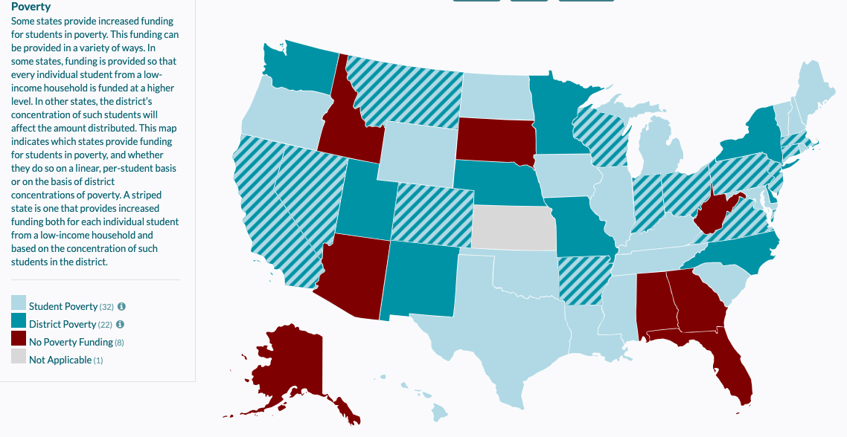
Figure 5.1 EdBuild National Policy Map for Poverty

Research Question 4: Conclusions
Research question 4 asks what the overall degree of resource equity is for instructional time and class sizes across district. The question was addressed by calculating a Coefficient of Variation (CV) and Gini Index for both variables, and a McLoone Index for instructional time.
The outcomes for instructional time confirmed the low dispersion of values in the data set observed in the multiple linear regression models for research question 2 (CV=.04 for all years). The Gini coefficient was calculated at .43 in 2014 and increased to .47 in 2018, indicating a loss of equity over the 5 years. The McLoone index was calculated at either .97 or .98 for each year. The outcome of the McLoone indicates a high degree of equity; however, given the low dispersion of values implied by the CV, instructional time was equitable due to the relatively invariant values across districts.
For class sizes, CV=.18, indicated an 18% dispersion for the data set. The Gini coefficient was .48 in 2014 and increased to .52 in 2018, representing a decrease in equity over the years of study. A McLoone index was not calculated for class sizes because this calculation depends upon higher values being more equitable. Lower class sizes are preferred; therefore, a McLoone index is not valid for this variable.
For both variables the more meaningful results were found with the Gini coefficients. A Gini coefficient has a value between 0 and 1, with 0 indicating perfect equity, and perfect inequity at 1. The Gini coefficients for both variables are in the middle of the scale. More importantly, however, both are increasing. This is an indication of decreasing equity in both instructional time and class sizes when compared to the resource equity of per-pupil valuations. In Chapter 4, Figure 4.2 illustrated the growing inequity for district per-pupil valuations. In 2014, the maximum per-pupil valuation was $525,460.57 and the minimum per-pupil valuation was $2,403.95. However, by 2018, the maximum per-pupil valuation increased to $834,592.96 while the minimum per-pupil valuation increased to $3,505.35. The range for these values increased from $523,056.62 in 2014 to $831,087.61 in 2018. These values indicate growing inequity in capital outlay. It is not surprising given that Oklahoma is one of only four states to provide no state assistance to districts for capital outlay. Oklahoma does not supplement capital funding for districts; a local district’s assessed valuation is the sole basis for raising capital revenue. In 1984, Oklahoma attempted to address inequity in capital funding with the passage of Oklahoma State Question 578; it was an amendment to State Question 368, which established the Public Common School Building Equalization Fund (Haxton, 2009). The Oklahoma State Board of Education (OSBE) could allocate funds for capital improvements through an equalization formula (2009). “However, no money has ever been deposited to the fund” (p. 58).

Concluding Remarks
Oklahoma had the greatest cuts to education of any state from 2008-2015 (Leachman, Albares, Masterson & Wallace, 2016). After several years of cuts to state aid, in 2016 and 2017, there were multiple general fund revenue failures, resulting in deep cuts to the funding formula for school districts. By 2018, fiscal inequities were overtly exposed, especially for districts lacking the advantage of property wealth, which provided access to the flexibility of crossover funding (Hime & Maiden, 2018). It was during this year that statistically significant relationships between capital revenue capacity, the 4-day week, and instructional time were found. The 4-day week and reducing instructional time, both remove days from the school calendar, generating savings in expenditures for hourly support salaries, transportation, substitutes, and utilities. The literature documents the savings from these cuts at 2-5%. Perhaps in 2018, school superintendents, disadvantaged by inequities in capital revenue, were willing to take even the smallest savings to balance their budgets. The duress of multiple-year budget reductions combined with the lack of capital outlay crossover funding flexibility in lower-wealth districts, created a situation where superintendents from property-poor districts may have been willing to seek drastic cost-saving measures to balance their operational budgets, as documented by the statistical relationships found. A follow up study in subsequent years is warranted to examine whether the trend continues or resolves as school funding recovers.
Importantly, a more consistent result of the study was the statistically significant relationship found between the inequities in capital funding and class size for all 5 years of the study. In this research, class sizes were calculated based on the number of Full Time Equivalency (FTE) of teachers; therefore, the increase in class size occurred because there were less classroom teachers in a district. Traditionally, teachers are paid from operational funding, which is supported from state aid revenue, not capital outlay. There is no provision to pay teachers from capital outlay in Oklahoma. Personnel is 80-85% of a school district’s operational budget and the most significant budget savings are found in eliminating teachers. Cost-saving measures of reducing instructional time, or adopting a 4-day week will not provide the same percentage of savings as eliminating teachers. Even though inequity was obviously exposed in capital outlay capacity during the period under study due to the budget reduction climate, it is deeply troubling that there is a possibility the inequity in capital outlay may be impacting school districts’ operational funding to the extent that district wealth is statistically associated with class size.
Unintentionally, the Oklahoma statute that provides flexibility to use capital revenue for certain operational expenses, has created a disequalizing effect on state aid (Hime and Maiden, 2017). Oklahoma has successfully examined equity in its state aid funding formula through multiple task forces, as recently as 2018. However, inequity in capital funding has largely been ignored, and there are consequences. Lack of equity in schools has been shown to depress economic growth because underutilization of human potential is costly (McKinsey and Company, 2009; Baker, Sciarra, & Farris, 2012). Furthermore, several studies have shown equity increases with state funding of capital outlay, often referred to as “flat funding” or “lump-sum aid” (Duncombe & Wang, 2009; Maiocco, 2004; Odden & Picus, 2000; Sielke, 2001; Thompson, 1985), and Oklahoma has a constitutional fund for providing state aid for capital revenue, the State Public Common School Building Equalization Fund, but it has never been funded.

Recommendations for Future Research
Possible Future Research:
- Oklahoma is one of 4 states lacking state funding for capital improvements even though multiple studies have found capital outlay to be inequitably funded. Study into more outcomes are needed to determine additional consequences resulting from legislative neglect of addressing this policy is needed.
- A strong adequacy study to determine capital improvement needs in Oklahoma is long overdue.
- There are 77 county assessors in Oklahoma. The gravity of their responsibility to accurately and consistently assess property is demonstrated to have consequences for Oklahoma students by this research. A study into the precision of county assessors’ valuations between counties is warranted.
- This research uncovered a trend of Oklahoma school districts reducing instructional time. A statistically significant result was found in 2018. Equity measures also indicated decreasing equity for this variable. More study is necessary to determine if there is an emerging trend.
- A study into class sizes in small, rural schools is warranted to determine if the diseconomy of scale and the associated costs necessity to offer required classes could surpass the traditional argument of administrative costs being the primary concern for consolidation of small districts.

Implications for Policy and Practice
Despite multiple studies demonstrating equity increases when funding is collected and dispersed at the state-level (ASCE, 2017; 21st Century School Fund, National Council on School Facilities, The Center for Green Schools, 2016; Thompson, 1985; TLC, 2006), Oklahoma remains one of four states solely funding capital improvements at the local level (2006). In Oklahoma, property wealth is the sole predictor of capital outlay even though the practice has been demonstrated to disadvantage students in low-wealth districts. Oklahoma has perhaps avoided school funding lawsuits due to its equitable state funding formula (Deering & Maiden 1999), but Hime and Maiden (2017) demonstrated inequitable capital funding has a disequalizing effect equitable distributed state aid. The disequalizing effect also impacted a district’s ability to pay teacher salaries (2017). This study observed statistically significant relationships between inequitable capital outlay capacity and a 4-day week, decreased instructional time, and increased class sizes. The inequity was illustrated to be worsening, increasing fiscal disadvantages for Oklahoma students in lower-wealth districts. Yet Oklahoma has a constitutional provision for the State Public Common School Building Equalization Fund, but no legislature has appropriated funding. The need for the appropriations and the utilization of this fund are supported by the current study.

Summary
The current study supported the recent findings by Hime and Maiden (2017) that inequities in capital outlay have a disequalizing impact on operational funding in Oklahoma school districts. Specifically, the findings of this study included statistical relationships between inequitable capital outlay capacity and the 4-day week, reduced instructional time, and increased class sizes. The study found statistical relationships between capital outlay, the 4-day week, and instructional time in 2018, after years of multiple general revenue failures resulting in state aid cuts to schools. Also, a statistical relationship was associated with capital outlay and decreased class size for all 5 years of the study.
The conclusions of the study indicate districts with greater property wealth garner an advantage to provide, more instructional time, traditional 5-day school weeks, and reduced class sizes. Smaller class sizes are due to increased numbers of teachers in a district per student enrollment. Because Oklahoma has no provision to pay teachers from capital outlay, the association demonstrates an impact on operational revenue due “crossover funding” from increased capital revenue, which is solely based on local wealth in Oklahoma. Furthermore, the equity measures in this study indicate the inequities are worsening for Oklahoma students.

References
21st Century School Fund, National Council on School Facilities, The Center for Green Schools. (2016). State of our schools, America's K-12 facilities.
A Nation at risk: The imperative for educational reform. (1983). The Elementary School Journal, 84(2), 113-130. doi: 10.1086/461348
About the Lorenz Curve. (2018). Retrieved from https://medicalexecutivepost.com/2018/01/26/about-the-lorenz-curve/
Allison, P. D. (2008, March). Convergence failures in logistic regression. In SAS Global Forum (Vol. 360, pp. 1-11).
Anderson, D., & Walker, M. (2015). Does shortening the school week impact student performance? Evidence from the four-day school week. SSRN Electronic Journal, 10(3), 314-349. doi: 10.2139/ssrn.2008999
ASCE. (2017). 2017 Infrastructure report card (pp. 1-3). ASCE.
Augenblick, J., Myers, J., & Anderson, A. (1997). Equity and adequacy in school funding. The Future Of Children, 7(3), 63. doi: 10.2307/1602446
Baker, B. (2016). Does money matter in education?. Albert Shanker Institute.
Baker, B., Sciarra, D., & Farris, D. (2012). Is school funding fair? A national report card. Newark, N.J.: Education Law Center.
Barrett, P., Davies, F., Zhang, Y., & Barrett, L. (2015). The impact of classroom design on pupils' learning: Final results of a holistic, multi-level analysis. Building And Environment, 89, 118-133. doi: 10.1016/j.buildenv.2015.02.013
Berliner, D. (1990). What's all the fuss about instructional time?. New York: Teachers College Press. Retrieved from https://www.researchgate.net/profile/David_Berliner2/publication/242745201_What%27s_All_the_Fuss_About_Instructional_Time/links/02e7e53c6d5eb45271000000/Whats-All-the-Fuss-About-Instructional-Time.pdf
Blatchford, P., Bassett, P., & Brown, P. (2008). Do low attaining and younger students benefit most from small classes? Results from a systematic observation study of class size effects on pupil classroom engagement and teacher pupil interaction. Presentation, American Educational Research Association Annual Meeting.
Boser, U. (2013). Size matters: A look at school district consolidation. Retrieved from https://www.americanprogress.org/wp-content/uploads/2013/08/SchoolDistrictSize.pdf
Bowles, T., & Bosworth, R. (2002). Scale economies in public education: Evidence from school level data. Journal of Education Finance, 28(2).
Boyland, L., & Jarman, D. (2012). The impacts of budget reductions on Indiana’s public schools. Journal Of Studies In Education, 2(3). doi: 10.5296/jse.v2i3.1715
Card, D., & Krueger, A. (1996). School resources and student outcomes: An overview of the literature and new evidence from North and South Carolina. Journal Of Economic Perspectives, 10(4), 31-50. doi: 10.1257/jep.10.4.31
Carroll, J. (1989). The Carroll model: A 25-year retrospective and prospective view. Educational Researcher, 18(1), 26. doi: 10.2307/1176007
Castro, A., Quinn, D., Fuller, E., & Barnes, M. (2018). Policy brief 2018-1: Addressing the importance and scale of the U.S. teacher shortage. University Council for Education Administration.
Cellini, S., Ferreira, F., & Rothstein, J. (2010). The Value of school facility investments: evidence from a dynamic regression discontinuity design*. Quarterly Journal Of Economics, 125(1), 215-261. doi: 10.1162/qjec.2010.125.1.215
Chambers, M. (1996). The Effects of additional revenues from capital outlay transfers on the equity of a state school finance system (Doctor of Education). University of Florida.
Chan, T. (1979). The impact of school building age on pupil achievement.
Coleman, J. (1968). Equality of educational opportunity. Equity & Excellence In Education, 6(5), 19-28. doi: 10.1080/0020486680060504
Colorado Department of Education. (2016). Four-day school week manual. Denver: Colorado Department of Education.
Cowell, A. (2018). The U.S. public school system and the implications of budget cuts, the teacher shortage crisis, and large class sizes on marginalized student (Master of Arts). Arizona State University.
Crampton, F., Thompson, D., & Vesely, R. (2004). The forgotten side of school finance equity: The role of infrastructure funding in student success. NASSP Bulletin, 88(640), 29-52. doi: 10.1177/019263650408864004
Crowson, H. (2019). Statistics for the real world: a gentle introduction - Multiple regression analysis. Retrieved from https://sites.google.com/view/statisticsfortherealworldagent/multiple-regression-analysis?authuser=0
Culbertson, J. (1982). Four day school week for small rural schools. Washington, D.C.: National Institute of Education.
Darling-Hammond, L. (2000). Teacher quality and student achievement. Education Policy Analysis Archives, 8, 1. doi: 10.14507/epaa.v8n1.2000
Davis, G. (1985). Effects of Kansas' capital outlay valuation-based funding on local school districts (M.S.). Fort Hays State University.
Deering, P., & Maiden, J. (1999). The fiscal effects of state mandated class size requirements in Oklahoma. Journal Of Education Finance, 25(2), 195-210.
Domier, P. (2009). Every second counts: School week and achievement. Capella University.
Donis-Keller, C., & Silvernail, D. (2009). A review of the evidence on the four-day school week. Center for Education Policy, Applied Research and Evaluation, University of Southern Maine. Retrieved from http://www.schoolturnaroundsupport.org/sites/default/files/resources/CEPARE%20Brief%20on%20the%204-day%20school%20week%202.10.pdf
Duncombe, W., & Yinger, J. (2004). How much more does a disadvantaged student cost?. SSRN Electronic Journal. doi: 10.2139/ssrn.1810836
Dupre, A., Davis, J., & Kiracofe, C. (2004). Education finance litigation: A review of recent state high court decisions and their likely impact on future litigation.
Earthman, G. (2002). School facility conditions and student academic achievement. Retrieved from https://escholarship.org/uc/item/5sw56439
EdBuild | Funded - State. (2018). Retrieved from http://funded.edbuild.org/state/OK
Edbuild. (2018). Oklahoma education funding formula. Presentation, Oklahoma State Aid Task Force Meeting, Oklahoma State Capital.
Educate Oklahoma: Per pupil spending. (2016). Retrieved from http://www.news9.com/story/32866446/educate-oklahoma-per-pupil-spending
Farris, B. (2013). The four-day school week: Teacher perceptions in a rural/secondary setting. Idaho State University.
Feaster, R. (2002). The effects of the four-day school week in custer, South Dakota (M.S.). University of South Dakota.
Ferguson, R. (1991). Racial patterns in how school and teacher quality affect achievement and earnings. Challenge, 2(1), 1-35.
Filardo, M., Cheng, S., Allen, M., Bar, M., & Ulsoy, J. (2010). State capital spending on pk-12 school facilities. Washington, D.C.: 21st Century School Fund & National Clearinghouse for Educational Facilities.
Finn, J., & Achilles, C. (1999). Tennessee's class size study: Findings, implications, misconceptions. Educational Evaluation And Policy Analysis, 21(2), 97. doi: 10.2307/1164294
Fischer, S., & Argyle, D. (2016). Juvenile crime and the four-day school week.
Frazier, L. (1993). Deteriorating school facilities and student learning.
Fredrick, W., & Walberg, H. (2019). Learning as a function of time. He Journal Of Educational Research, (73), 4.
Fultonberg, L. (2016). “We will be losing in the race to the bottom,” Oklahoma poised to take last place in teacher salaries. Retrieved from http://kfor.com/2016/05/31/we-will-be-losing-in-the-race-to-the-bottom-oklahoma-poised-to-take-last-place-in-teacher-salaries/
Gaines, G. (2008). Focus on the school calendar: The four-day school week. Atlanta: Southern Regional Education Board.
Glass, G., & Smith, M. (1979). Meta-analysis of research on class size and achievement. Educational Evaluation And Policy Analysis, 1(1), 2-16. doi: 10.3102/01623737001001002
Goodman, J. (2014). Flaking out: Student absences and snow days as disruptions of instructional time. Retrieved from https://pdfs.semanticscholar.org/a215/fcf57af0a665382c00793e347dffd7e3bc7d.pdf
Greenwald, R., Hedges, L., & Laine, R. (1996). The effect of school resources on student achievement. Review Of Educational Research, 66(3), 361-396.
Griffith, M. (2011). What savings are produced by moving to a four-day school week. Denver: Education Commission of the States.
Guthrie, J., Springer, M., Rolle, R., & Houck, E. (2007). Modern education finance and policy. Boston: Pearson/Allyn and Bacon.
Hale, R. (2003). A case study of the four-day school week in five South Dakota prekindergarten-12 public schools (Ed.D). University of South Dakota.
Hancock, K. (2008). A Choice of a new funding formula. Retrieved from https://files.eric.ed.gov/fulltext/ED503788.pdf
Hansen, B. (2011). School year length and student performance: Quasi experimental evidence. Retrieved from http://citeseerx.ist.psu.edu/viewdoc/download?doi=10.1.1.187.1565&rep=rep1&type=pdf
Hanushek, E. (1989). The impact of differential expenditures on school performance. Educational Researcher, 18(4), 45-62. doi: 10.3102/0013189x018004045
Hanushek, E. (1999). Some findings from an independent investigation of the Tennessee STAR experiment and from other investigations of class size effects. Educational Evaluation And Policy Analysis, 21(2), 143. doi: 10.2307/1164297
Harris, D., & Sass, T. (2011). Teacher training, teacher quality and student achievement. Journal Of Public Economics, 95(7-8), 798-812. doi: 10.1016/j.jpubeco.2010.11.009
Haxton, P. (1998). Capital funding in Oklahoma school districts (Ed.D). Oklahoma State University.
Hewitt, P., & Denny, G. (2011). The four-day school week: Impact on student academic performance. Rural Educator, 32(2).
Hill, P., & Heyward, G. (2017). A troubling contagion: The rural 4-day school week | Brookings Institution. Retrieved from https://www.brookings.edu/blog/brown-center-chalkboard/2017/03/03/a-troubling-contagion-the-rural-4-day-school-week/
Hime, S., & Maiden, J. (2017). An examination of the fiscal equity of current, capital, and crossover educational expenditures in Oklahoma school districts. Retrieved from http://www.educationfinance.us/publications/isef-crossover-study/
Holder, M. (2017). Four day weeks [Email].
House Bill 1017. (2018). Retrieved from https://okpolicy.org/house-bill-1017/
Hoxby, C. (2000). The effects of class size and composition on student achievement: New evidence from natural population variation. The Quarterly Journal Of Economics, 115(4), 1239-1285. doi: 10.2139/ssrn.144929
Huang, Y. (2004). Appendix B: A guide to state operating aid programs for elementary and secondary education. In J. Yinger, Helping children left behind: State aid and the pursuit of education equity (pp. 331-351). Cambridge: MIT Press.
Jackson, C., Johnson, R., & Persico, C. (2015). The effects of school spending on educational and economic outcomes: Evidence from school finance reforms. The Quarterly Journal Of Economics, 131(1), 157-218. doi: 10.1093/qje/qjv036
Jenkins, J., & Gorrafa, S. (1973). The four day school week: Scheduling effects. The Journal Of Educational Research, 66(10), 479-480. doi: 10.1080/00220671.1973.10884536
Jepsen, C., & Rivkin, S. (2009). Class size reduction and student achievement. Journal Of Human Resources, 44(1), 223-250. doi: 10.3368/jhr.44.1.223
Jez, S., & Wassmer, R. (2013). The impact of learning time on academic achievement. Education And Urban Society, 47(3), 284-306. doi: 10.1177/0013124513495275
Jimerson, L. (2005). Special challenges of the "no child left behind" act for rural schools and districts. The Rural Educator, 26(3).
Johnson, C., & Maiden, J. (2010). An examination of capital outlay funding mechanisms in Oklahoma. Journal Of Education Finance, 36(1), 1-21. doi: 10.1353/jef.0.0027
Judd, C. (1918). Introduction to scientific study of education [Ebook]. Boston: Ginn and Company. Retrieved from https://play.google.com/books/reader?id=zP4AAAAAYAAJ&printsec=frontcover&output=reader&hl=en&pg=GBS.PR1
Lackney, J. (1999). The relationship between environmental quality of school facilities and student performance. Energy smart schools: Opportunities to save money, save energy and improve student performance. A congressional briefing to the U.S. House of Representatives Committee on Science.. Washington, D.C.: U.S. House of Representatives Committee on Science.
Ladd, H. (2008). Reflections on equity, adequacy, and weighted student funding. Education Finance and Policy, 3(4), 402-423. doi: 10.1162/edfp.2008.3.4.402
Ladson-Billings, G. (2006). From the achievement gap to the education debt: Understanding achievement in U.S. schools. Educational Researcher, 35(7), 3-12. doi: 10.3102/0013189x035007003
Leachman, M., Albares, N., Masterson, K., & Wallace, M. (2016). A punishing decade for school funding. Retrieved from https://www.cbpp.org/research/state-budget-and-tax/a-punishing-decade-for-school-funding
Leachman, M., Albares, N., Masterson, K., & Wallace, M. (2016). Most states have cut school funding, and some continue to cutting. Center on Budget and Policy Priorities. Retrieved from http://www.cbpp.org/research/statebudgetandtax/ moststateshavecutschoolfundingandsomecontinuecutting
Lefly, D., & Penn, J. (2011). A comparison of Colorado school districts operating on four-day and five-day calendars 2011. Denver: Colorado Department of Education. Retrieved from http://www.cde.state.co.us/sites/default/files/documents/research/download/pdf/coloradofourdayandfivedaydistricts.pdf
Levine, H., & Tsang, M. (1987). The economics of student time. Economics Of Education Review, 6(4), 357-364. doi: 10.1016/0272-7757(87)90019-7
Lomax, R., & Hahs-Vaughn, D. (2012). An introduction to statistical concepts (3rd ed.). New York: Routledge.
Loubert, L. (2008). Increasing finance, improving schools. The Review of Black Political Economy, 35(1), 31-41. doi: 10.1007/s12114-008-9019-x
Luke, C. (2007). Equity in Texas education facilities funding (Doctor of Education). University of North Texas.
Lyons, J. (2001). Do school facilities really impact a child’s education. CEFPI.
Maiden, J. (1998). Financing statewide education reform in Oklahoma. Educational Considerations, 25(2). doi: 10.4148/0146-9282.1384
Maiden, J., & Stearns, R. (2007). Fiscal equity comparisons between current and capital education expenditures and between rural and nonrural schools in Oklahoma. Journal Of Education Finance, 33(2), 147-169.
Maiocco, F. (2004). Funding public school construction in the united states (Doctor of Philosophy). Washington State University.
Marcotte, D., & Hemelt, S. (2008). Unscheduled school closings and student performance. Education Finance And Policy, 3(3), 316-338. doi: 10.1162/edfp.2008.3.3.316
Mathis, N. (1989). Session called in Oklahoma to debate taxes for schools - Education Week. Retrieved from https://www.edweek.org/ew/articles/1989/08/02/08360067.h08.html
McKinsey and Company. (2009). The economic impact of the achievement gap in America's schools. McKinsey & Company. Retrieved from http://www.mckinsey.com/clientservice/socialsector
Molnar, A., Smith, P., Zahorik, J., Palmer, A., Halbach, A., & Ehrle, K. (1999). Evaluating the SAGE program: A pilot program in targeted pupil-teacher reduction in Wisconsin. Educational Evaluation and Policy Analysis, 21(2), 165. doi: 10.2307/1164298
Mosteller, F. (1995). The Tennessee study of class size in the early school grades. The Future Of Children, 5(2), 113. doi: 10.2307/1602360
Murray, S., Evans, W., & Schwab, R. (1998). Education-finance reform and the distribution of education resources. The American Economic Review, 88(4), 789-812. Retrieved from Retrieved from http://www.jstor.org/stable/117006
Nandrup, A. (2015). Do class size effects differ across grades?. Education Economics, 24(1), 83-95. doi: 10.1080/09645292.2015.1099616
National Center for Education Statistics (NCES). (2019). Retrieved from https://nces.ed.gov/
National Commission on Excellence in Education. (1983). A nation at risk: The imperative for educational reform. The Elementary School Journal, 84(2), 113-130. doi: 10.1086/461348
NCES (2016). Number of public elementary and secondary education agencies, by type of agency and state or jurisdiction: 2013-14 and 2014-15. Retrieved from https://nces.ed.gov/programs/digest/d16/tables/dt16_214.30.asp
News9.com. (2016). EXCLUSIVE: Gov. Fallin looks forward with her education goals. Retrieved from http://www.news9.com/story/33676221/exclusive-gov-fallin-looks-forward-with-her-education-goals
NewsOK.com. (2006). Judge tosses schools lawsuit. Retrieved from http://newsok.com/article/2822276
Odden, A., & Picus, L. (2000). School finance: A policy perspective (2nd ed.) (1st ed.). Boston: McGraw-Hill Higher Education.
Office of Management and Enterprise Services (OMES). (2019). Retrieved from https://www.ok.gov/OSF/documents/bud19.pd
Oklahoma State Department of Education (OSDE). (2017). 2017 School law book. Oklahoma City: Oklahoma State Department of Education.
Oklahoma State Department of Education (OSDE). (2017). Analysis of expenditures of districts on a four-day school week. Oklahoma City: Oklahoma State Department of Education. Retrieved from http://sde.ok.gov/sde/sites/ok.gov.sde/files/FDSW%20Report.pdf
Oklahoma State Department of Education (OSDE). (2013). Oklahoma school finance technical assistance document. Oklahoma City: Oklahoma State Department of Education.
Oklahoma State Department of Education (OSDE). (2019). FY 2020 Budget request hearing presentation. Retrieved from https://sde.ok.gov/sites/default/files/FY20-Budget-Request-Book-Budget-Hearing.pdf
OSSAA.com - Oklahoma Secondary School Activities Association. (2017). Retrieved from http://www.ossaa.com/ossaahome.aspx
Owings, W., Kaplan, L., & Chappell, S. (2011). Troops to teachers as school administrators. NASSP Bulletin, 95(3), 212-236. doi: 10.1177/0192636511415254
Parker, E. (2016). Constitutional obligations for public education. Denver: Education Commission of the States.
Patall, E., Cooper, H., & Allen, A. (2010). Extending the school day or school year. Review Of Educational Research, 80(3), 401-436. doi: 10.3102/0034654310377086
Plucker, J., Cierniak, K., & Chamberlin, M. (2012). The four-day school week: Nine years later. Center For Evaluation & Education Policy, 10(6).
Reschovsky, A., & Imazeki, J. (2003). Let no child be left behind: Determining the cost of improving student performance. Public Finance Review, 31(3), 263-290. doi: 10.1177/1091142103031003003
Reynolds, Tammie. (2017). Leadership perceptions and experiences from Oklahoma superintendents. Unpublished manuscript, University of Oklahoma.
Roeth, J. (1985). Implementing the four-day school week into the elementary and secondary public schools. Ball State University.
Rose v Council for Better Education (Kentucky Supreme Court 1989).
Rothstein, J. (2010). Teacher quality in educational production: Tracking, decay, and student achievement. Quarterly Journal Of Economics, 125(1), 175-214. doi: 10.1162/qjec.2010.125.1.175
Sagness, R., & Salzman, S. (1993). Evaluation of the four-day school week in Idaho suburban schools.
Satz, D. (2008). Equality, adequacy, and educational Policy. Education Finance And Policy, 3(4), 424-443. doi: 10.1162/edfp.2008.3.4.424
Schneider, M. (2002). Do school facilities affect academic outcomes?. Retrieved from https://files.eric.ed.gov/fulltext/ED470979.pdf
Shin, I., & Chung, J. (2019). Class size and student achievement in the United States: A meta-analysis. KEDI Journal Of Educational Policy, 6(2).
Sielke, C. (2001). Funding school infrastructure needs across the states. Journal Of Education Finance, 27(2), 653-662. Retrieved from http://www.jstor.org/stable/20764025
Sims, D. (2008). A strategic response to class size reduction: Combination classes and student achievement in California. Journal Of Policy Analysis And Management, 27(3), 457-478. doi: 10.1002/pam.20353
Tharp, T. (2014). A comparison of student achievement in rural schools with four and five day weeks (Doctor of Education). University of Montana.
Tharp, T., Matt, J., & O’Reilly, F. (2016). Is the four-day school week detrimental to and student success?. Journal Of Education And Training Studies, 4(3). doi: 10.11114/jets.v4i3.1308
Thompson, D. (1985). Examination of equity in capital outlay funding in Kansas school districts: Current methods, alternative, and simulations under three selected equity principles (Doctor of Education). Oklahoma State University.
Texas Legislative Council (TLC). (2006). State roles in financing public school facilities. Austin: Texas Legislative Council.
U.S. Department of Education. (2013). For each and every child - A Strategy for education equity and excellence. Washington, D.C.: ED Pubs Education Publications Center.
U.S. General Accounting Office (GAO). (1995). School facilities: The condition of America's schools. Washington, DC: U.S. GAO.
Uline, C., & Tschannen‐Moran, M. (2008). The walls speak: the interplay of quality facilities, school climate, and student achievement. Journal Of Educational Administration, 46(1), 55-73. doi: 10.1108/09578230810849817
Verstegen, D., & Whitney, T. (1997). From courthouses to schoolhouses: Emerging judicial theories of adequacy and equity. Educational Policy, 11(3), 330-352. doi: 10.1177/0895904897011003004
Vincent, J. (2018). Small districts, big challenges: Barriers to planning and funding school facilities in California's rural and small public school districts. Center for Cities + Schools, Institute of Urban and Regional Development, UC Berkeley.
Weis, T. (2000). Indiana's PRIME TIME. Contemporary Education, 62(1).
White House Press Secretary. (2011). FACT SHEET: Repairing and modernizing America's schools.
Wilson, K., Lambright, K., & Smeeding, T. (2006). School finance, equivalent educational expenditure, and the income distribution: Equal dollars or equal chances for success?. Education Finance And Policy, 1(4), 396-424. doi: 10.1162/edfp.2006.1.4.39

Appendix A

Tests of Robustness: Instructional Time
Table A.1 Collinearity Diagnostics, Instructional Time, 2014
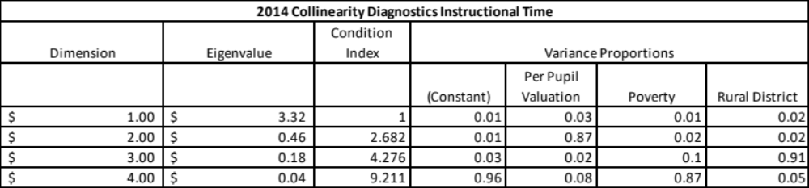
Table A.2 Collinearty Diagnostics, Instructional Time 2015
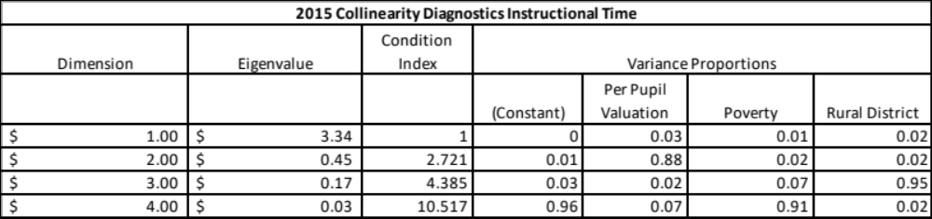

Table A.3 Collinearty Diagnostics, Instructional Time 2016
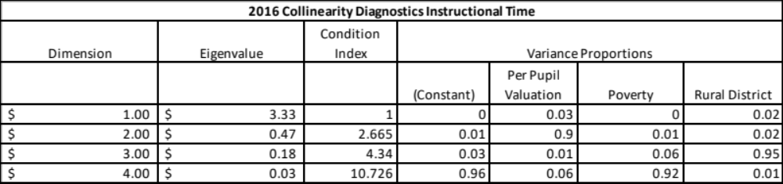

Table A.4 Collinearty Diagnostics, Instructional Time 2017
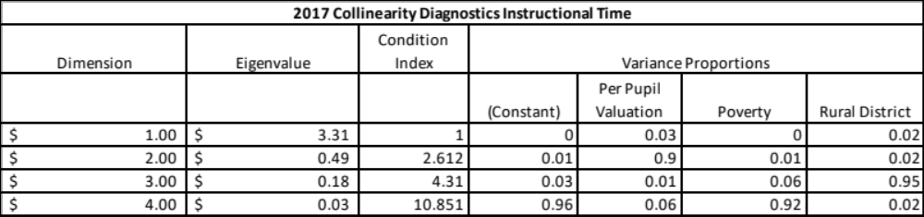

Table A.5 Collinearty Diagnostics, Instructional Time 2018
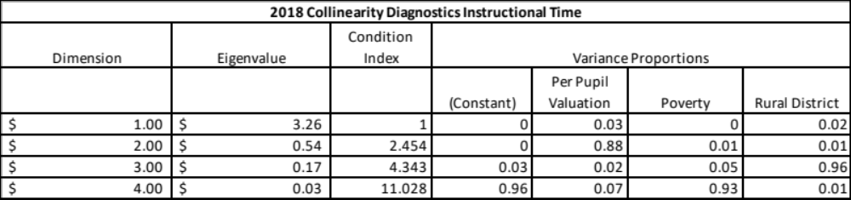
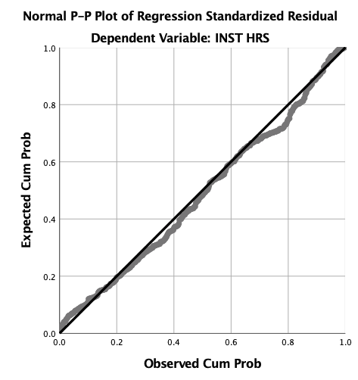
Figure A.1 Plot of Regression, Instructional Time, 2014
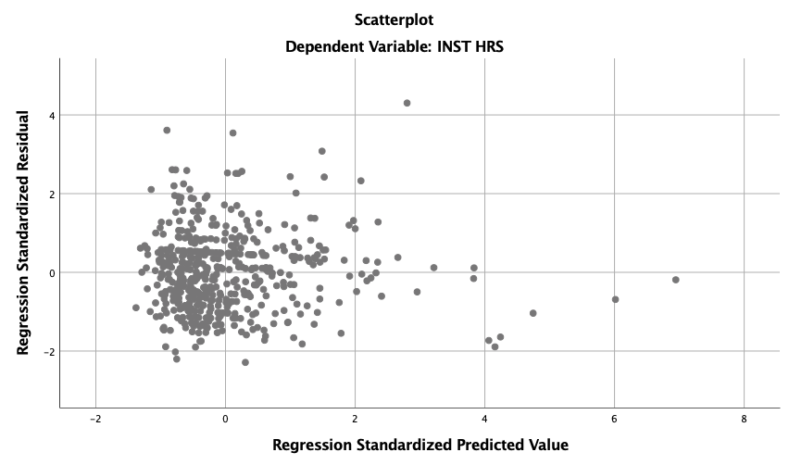
Figure A.2 Scatterplot, Instructional Time, 2014

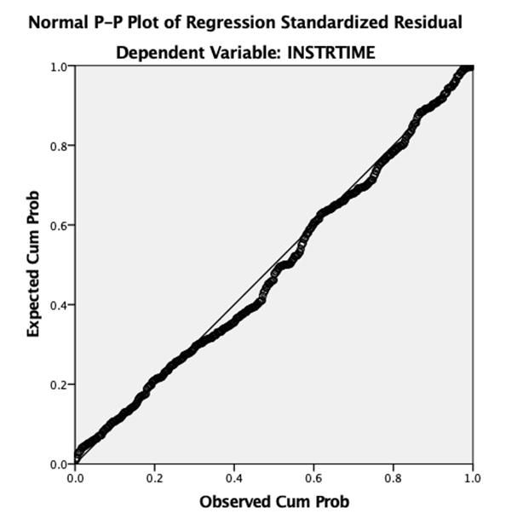

Figure A.3 Regression, Instructional Time, 2015

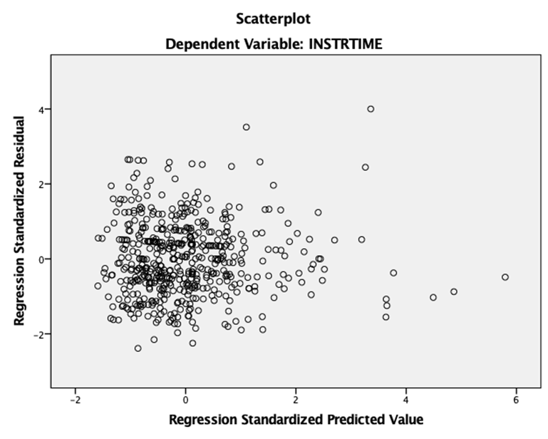
Figure A.4 Scatterplot, Instructional Time, 2015

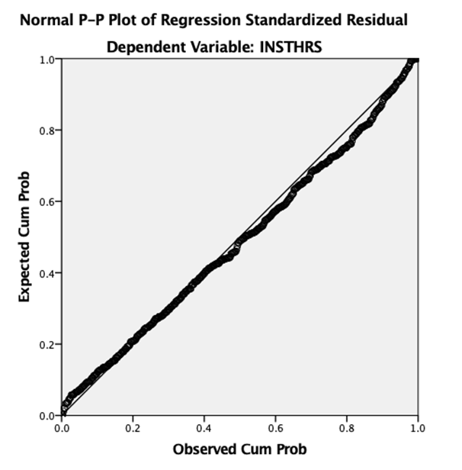
Figure A.5 Regression, Instructional Time, 2016

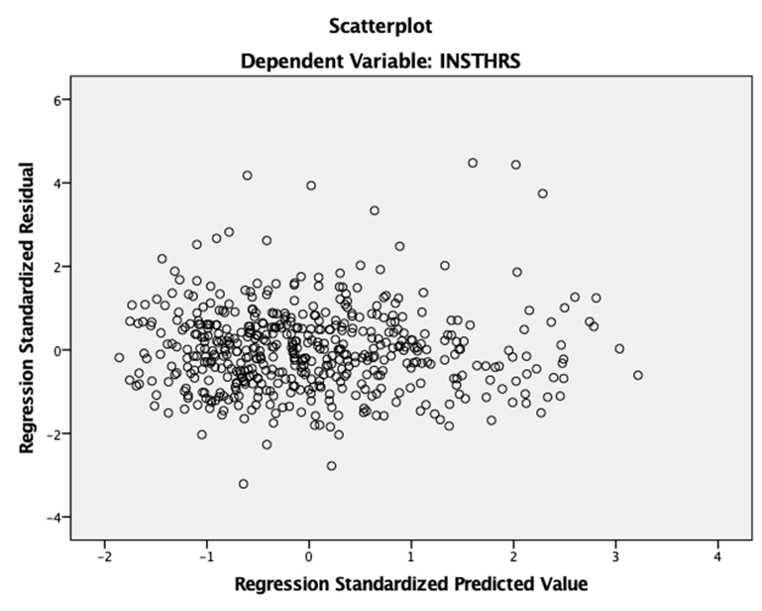
Figure A.6 Scatterplot, Instructional Time, 2016

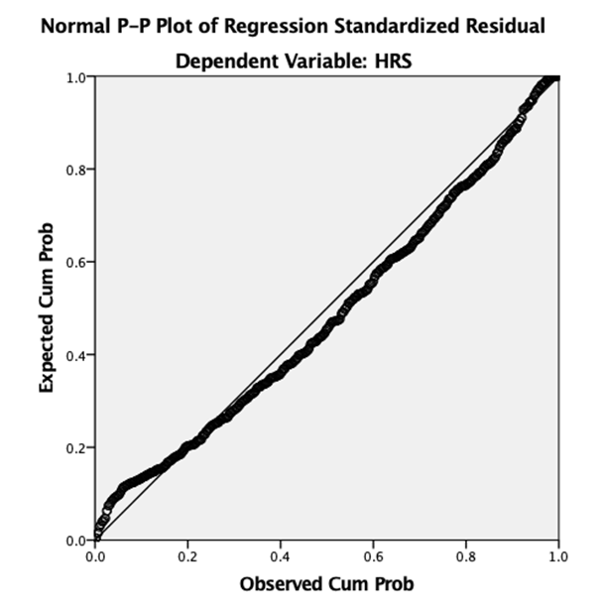
Figure A.7 Regression, Instructional Time, 2017

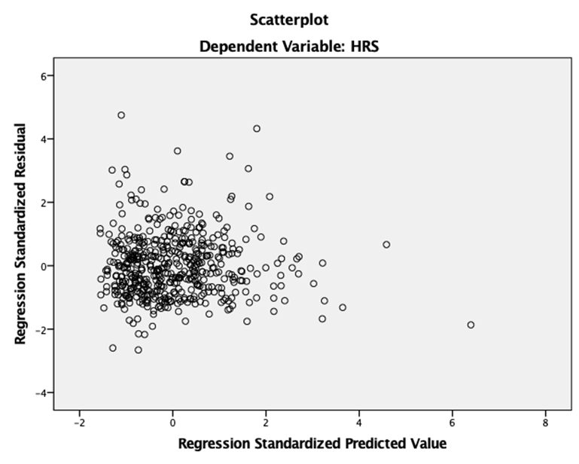
Figure A.8 Scatterplot, Instructional Time, 2017

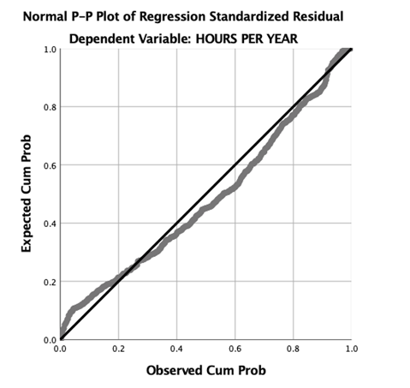
Figure A.9 Regression, Instructional Time, 2018

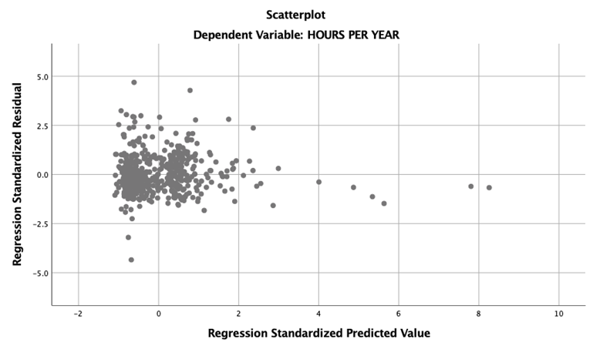
Figure A.10 Scatterplot, Instructional Time, 2018

Appendix B

Tests of Robustness: Class Size
Table B.1 Collinearty Diagnostics, Class Size, 2014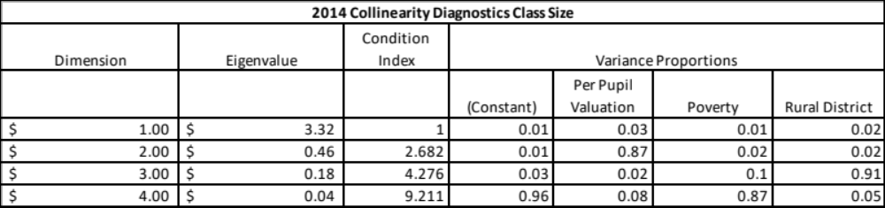

Table B.2 Collinearty Diagnostics, Class Size, 2015
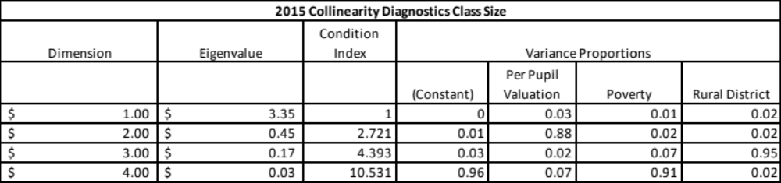
Table B.3 Collinearty Diagnostics, Class Size, 2016
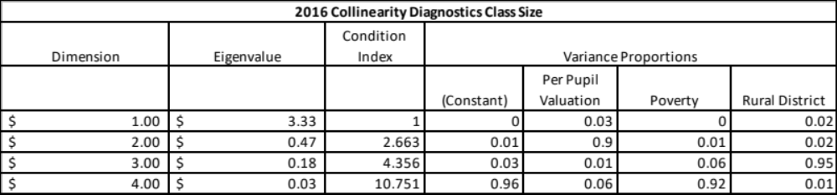
Table B.4 Collinearty Diagnostics, Class Size, 2017
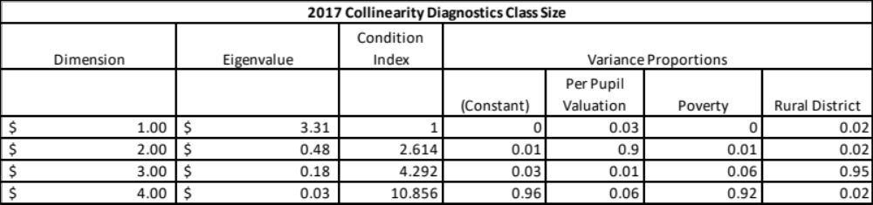
Table B.5 Collinearty Diagnostics, Class Size, 2018
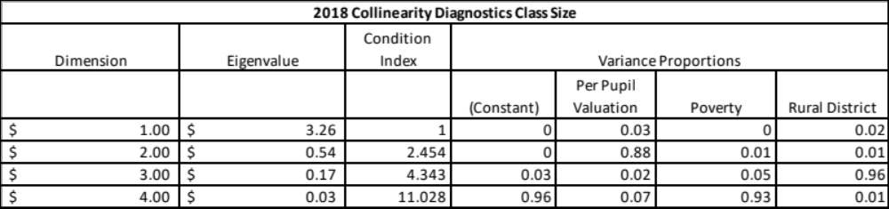

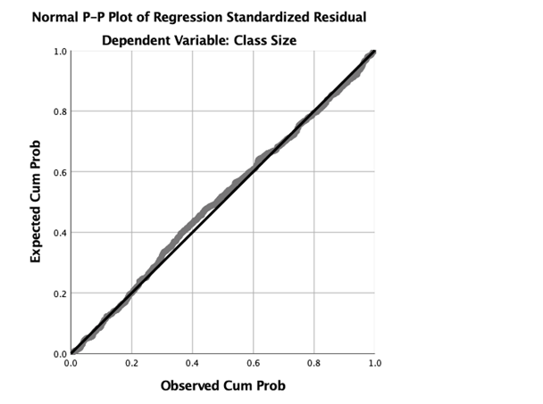
Figure B.1 Regression, Class Size, 2014
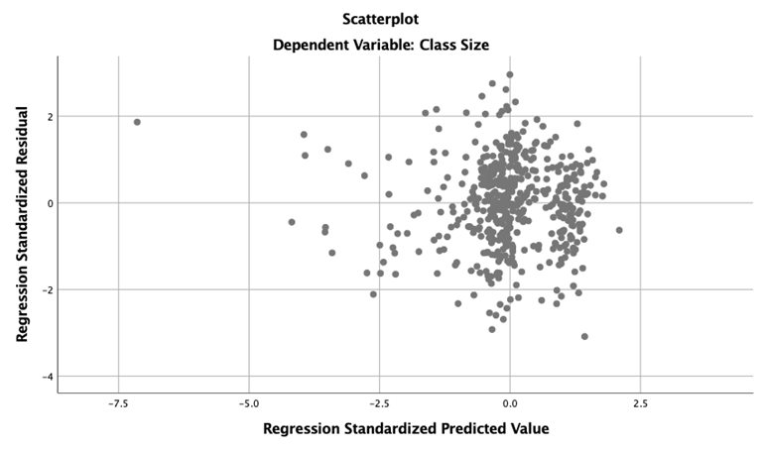
Figure B.2 Scatterplot, Class Size, 2014

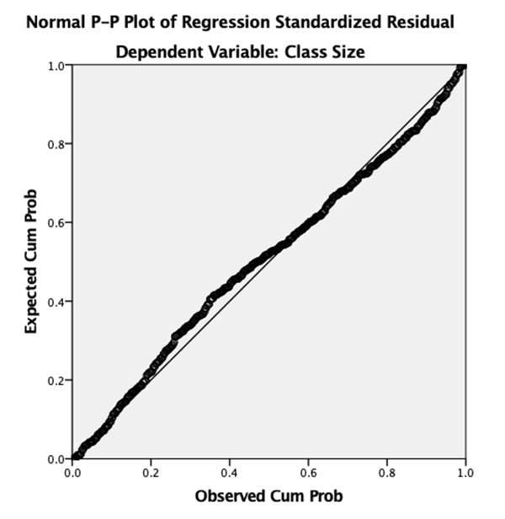
Figure B.3 Regression, Class Size, 2015

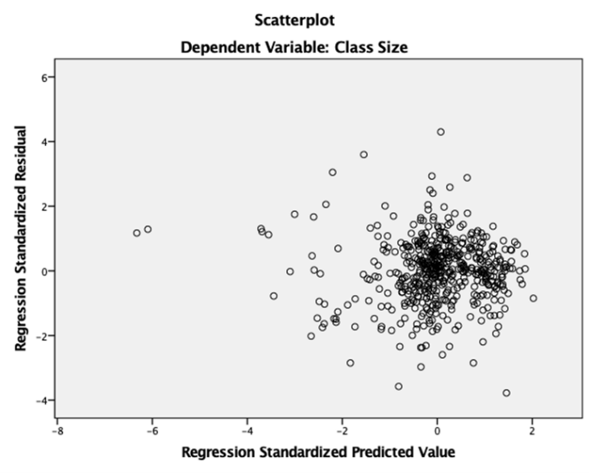
Figure B.4 Scatterplot, Class Size, 2015

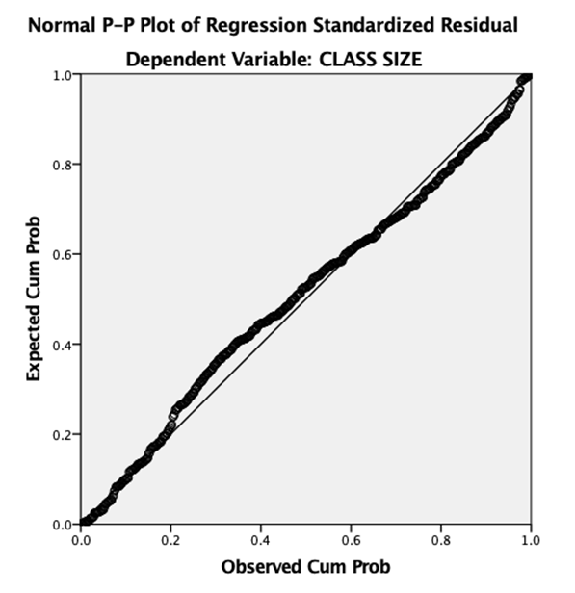
Figure B.5 Regression, Class Size, 2016

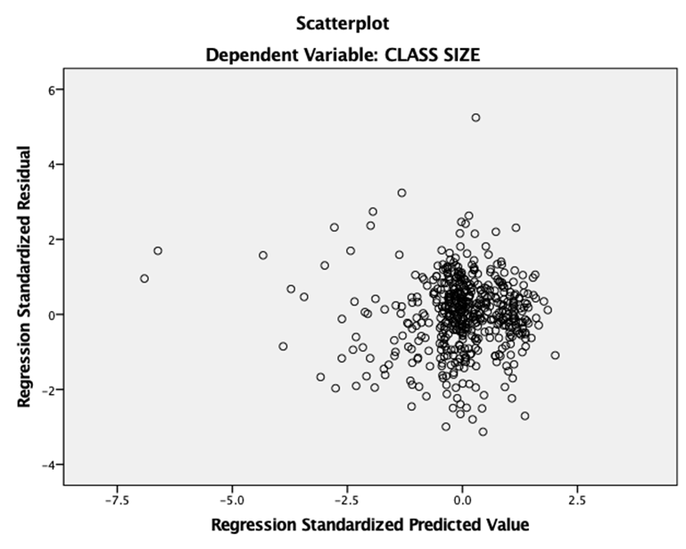
Figure B.6 Scatterplot, Class Size, 2016

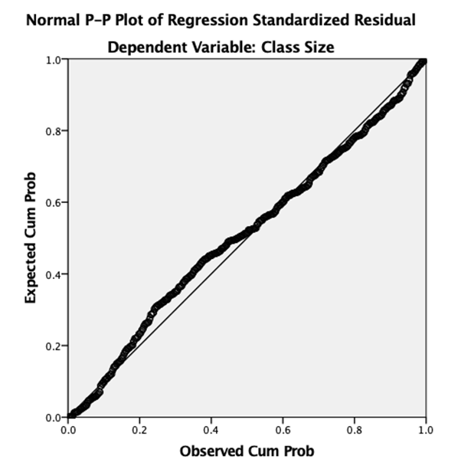
Figure B.7 Regression, Class Size, 2017

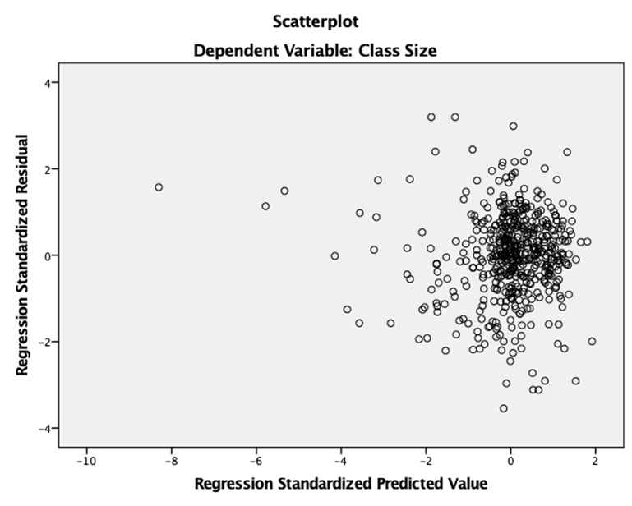
Figure B.8 Scatterplot, Class Size, 2017

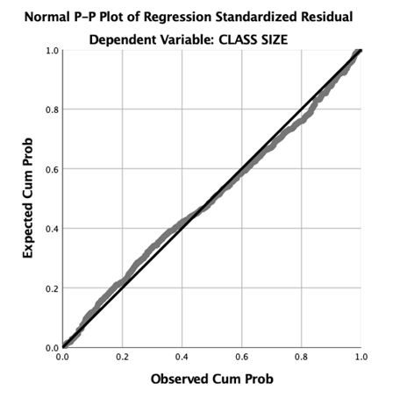
Figure B.9 Regression, Class Size, 2018

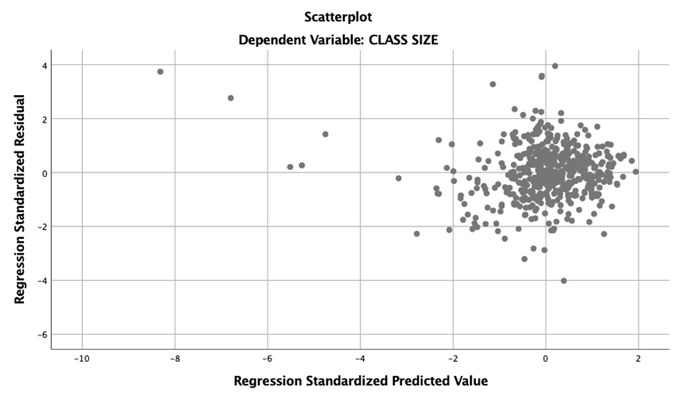
Figure B.10 Scatterplot, Class Size, 2018

