UNIVERSITY OF OKLAHOMA
GRADUATE COLLEGE

SPEAKING OURSELVES INTO BEING: CULTURAL IDENTITY DEVELOPMENT AMONG AFRICAN AMERICAN ARTISTS/EDUCATORS

A DISSERTATION
SUBMITTED TO THE GRADUATE FACULTY
in partial fulfillment of the requirements for the
Degree of
DOCTOR OF PHILOSOPHY

By
ANITA A. HOPSON MALONE
Norman, Oklahoma
2017

SPEAKING OURSELVES INTO BEING: CULTURAL IDENTITY DEVELOPMENT AMONG AFRICAN AMERICAN ARTISTS/EDUCATORS

A DISSERTATION APPROVED FOR THE
INSTRUCTIONAL LEADERSHIP AND ACADEMIC CURRICULUM

BY

______________________________
Dr. Neil O. Houser, Chair

______________________________
Dr. Lawrence Baines

______________________________
Dr. T. Elon Dancy

______________________________
Dr. Kirsten Edwards

______________________________
Dr. Stacy Reeder

© Copyright by ANITA HOPSON MALONE 2017
All Rights Reserved.
Acknowledgements

With my deepest gratitude, Thank you, thank you all!

First, I give thanks and praise to the ancestors, my father, Herman David Hopson. Also, to all the Grandmothers and Grandfathers, Great Grandmothers and Great Grandfathers, and those who went before them, because of their struggles, I stand here today. When we call their names, they live on, they stay with us.

Thank you Momma and family, for all of your love and support. With a very special thank you to my daughter Bridgette Alise, she and I have lived with this dissertation for so many years. She bared it and me, with grace, patience and dignity. To my sons, I borrow strength from you when I feel to weak to go on, Brandon and Kenny, thank you.

Thank you Courtney Vaughn for introducing me to Dr. Neil Houser, my chair. Neil has been my biggest cheer leader and the rainbow in my clouds. I am eternally grateful to him and all of my committee members, past and present. Thank you.

Throughout this journey God placed angels along the path. I want to thank my College of Ed. Angels, Ladies you were always there for me through the beast and worst of times. I want to thank all my OU Sistas, you held me up when I stumbled. You may not have known it, but so many times I leaned on your love and support to get through just one more day. When I contemplated giving up, God sent me a Sista Angel to remind me that what I do here is not about me it's for WE. For the ones who were not allowed to attend, and for the ones they don't want to let in. I was given the privilege to occupy a seat. But I never sat alone, I sat there with Daddy, I sat there with my Grandmothers, who cleaned white folks homes so their grandbabies could rise up. I sat there for my kids, so that they too would know that the Ancestor also put out a seat for them.

And now it's my turn to "lift as I climb."

May God Bless and keep you, Thank you all so very much.

Table of Contents

Acknowledgements iv
List of Figures vii
Abstract vii
Chapter One: Introduction 1
Topic and Problem Statement 1
The Value of Culturally Responsive Arts-Based Educational Relationships for Positive Identity Development Among Marginalized People 5
Chapter Two: Interpretive Lens 9
The Legacy of Racism and the Persistence of White Supremacy 11
Critically Conscious and Culturally Responsive Curriculum and Instruction 28
The Value of Culturally Responsive Arts-Based Educational Relationships for Positive Identity Development Among Marginalized People 31
Chapter Three: Research Methods 37
The Research Methodology: Critical Ethnography 37
Research Design 42
Confidence and Trustworthiness 43
Criteria for the Selection of Research Participants 49
The Participants 50
My Positionality 54

Ideological Tensions Between Afrocentrism and Critical Race Theory 57
Chapter Four: Research Findings 62
The Impact of Culturally Relevant Arts-Based Educational Relationships on Afrocentric Identity Development 63
Culturally Relevant Educational Relationships Provided an Introduction to African Ties 76
Culturally Relavent Educational Relationships Encouraged and Supported Critical Consciousness 88
Culturally Relavent Educational Relationships Helped Develop and Fulfill a Sense of Obligation and Commitment to Other African American People and Communities 91
Chapter Five: Summary of Findings and Implications for Education 94
Summary of Findings 94
Implications for Education 103
Teacher-Education : Cultural Connections Through Self-Reflexivity in All Classes 105
References 110
Appendix A: Participants' Art 155
Appendix B: Participants' Contact Information 129

List of Figures
Figure 1. Types of Mankind 14

Figure 2. One Hundred Years 71

Figure 3. Rythemically Speaking 77

Figure 4. The Blacker the Berry 89

Abstract
This dissertation presents a critical ethnographic study of four Afrocentric Artists/Educators on their journey toward cultural identity recovery. A problem many marginalized groups face is identity conflict related to discontinuity or misappropriation of their cultures. This study sought to understand the potential of culturally relevant arts-based educational experiences and relationships to facilitate Afrocentric identity development among African Americans and, presumably, also other people of color. Since African philosophical thought such as the concept of Ubuntu and tenants of critical race theory were central to the experiences of the participants, these constructs (among others) were utilized to interpret the data.
Essentially, the study reveals, from a personal perspective, how these four artists/ educators benefitted from their arts and culturally responsive arts-based educational relationships with their own mentors to enhance their cultural growth. Their personal artistic abilities and interests afforded them opportunities to build positive relationships with their mentors, to develop critical consciousness, and to meet felt responsibilities to pass forward their cultural knowledge.
Insights gained from this study may inform educational theory and practice regarding ways to promote positive cultural identity formation within and beyond formal preservice teacher education programs with the aim of building stronger, more critical, and more reflective teacher-student relationships. The educational goals of cultural identity recovery are to increase cultural competence and self-reflexivity not only among people of color but among educators in general. This study envisions the development of culturally aware and connected teachers and students who critique inequitable power relationships and continue the hard work of creating socially just schools and societies.

Key Terms: Afrocentric, Art, Counter-Storytelling, Culturally Responsive Pedagogy, Mentors, Discontinuity, Critical Consciousness, Unconscious Biases, Cultural Identity Recovery, Critical Race Theory, Sankofa.

CHAPTER ONE: INTRODUCTION

Topic and Problem Statement
In the United States of America, African Americans and many other people of color have suffered, and continue to suffer, traumatic physical, social, emotional, and economic injury resulting from the historical and psychological legacy of racism and the persistence of both overt and covert forms of white supremacy (Bell, 1992a; Burrell, 2010; Cha-Jua, 2001; Ladson-Billings, 2016; Massey, 2009; Omi and Winant, 1994). Educators and others have sought to address these problems through critical, culturally responsive curriculum and instruction (Banks, 2009; Baldwin, 2003b; Cha-Jua, 2001; Nieto, 1996; Sleeter and Bernal, 2004; Tatum, 2003). Research has also been conducted on the value of culturally responsive arts-based education, broadly defined, on positive identity development among African Americans and others (Eisner, 2002, 2004; Asante, M. & Asante, K., 2002). Yet the trauma persists (Asante,1991; King,1995).
Many African Americans and others from socially and economically marginalized groups suffer from identity loss, discontinuity from their cultural and historical identities, and misappropriation of their cultures. Visually identifiable ethnic youth such as Native Americans, the Hmong, Latinos, African Americans, and other “children of color” continue to be forced to function at various levels of cultural identity loss and cultural conflict (Banks, 2009). The historical context of cultural identity loss continues to have an impact on society and education today. This study considered internal and external influences impacting African Americans and other marginalized cultures which often lead to identity conflicts and identity loss.
African Americans are one of the many groups that continue to experience culture-related identity loss (Gay, 2000; Kunjufu, 2002). For African Americans, cultural identity loss began during the transatlantic slave trade and, in many ways, continues today. Many African Americans have been separated from their cultural resources: from African and African American elders and from the full and complete history of the African diaspora. In place of these authentic historical and cultural resources, African Americans have been provided alternative references—including false corporate visualizations—which often serve as cultural identity sources (hooks, 1996).
bell hooks (1996 & 1992) discusses the cultural infiltration of media. She relays examples of how cultural infiltration has resulted in destructive behaviors in the African American community. The pervasiveness of the negative imagery distorts the African American culture, which hampers positive identity development for people of color (Dyson, 2008 & 1996; Hilliard, 1995b; hooks, 1996 & 1992; Kunjufu, 1995; Wanzer-Serrano, 2015). Too often, the lack of accurate cultural history and knowledge allows this imagery to stand in for African American culture (hooks, 1996 & 1992).
Dewey (1938) argued that continuity of experience is essential to education and growth, while experiences that distort continued growth are “miseducative.” Conversely, discontinuity is the state of being disconnected from the whole. Many critical issues faced in schools today, particularly among African American youth and other children of color, have their roots in a sense of discontinuity or disconnectedness (Banks, 2009; Kohl, 1995). Many students of color continue to experience internal disconnection, or separation, leaving them struggling to negotiate these distances.
In order to manage this disconnection, students of color may utilize an array of coping mechanisms, both positive and negative (Spencer, Cunningham & Swanson, 1995; Spencer & Markstrom-Adams 1990; Chavous, 2006-2011; Schwandt, 2006). Some students with strong cultural connections use resiliency strategies to help negotiate the space, while others may choose more oppositional stances as coping mechanisms (Byrd & Chavous, 2011; Chavous, Bernat, Schmeelk-Cone, Caldwell, Kohn-Wood, & Christians, 2003; Fordham, 1995; Kohl, 1995; Ogbu, 1987). Addressing student responses to cultural discontinuity would require teacher preparation programs to teach how to disrupt the status quo in favor of a “race conscious curriculum” (Buras, 2014; Milner & Self, 2014). Milner and Self (2014) stress the need for “racial demography and curriculum emphases about race” if the goal is to reduce “racial incongruence” between students of color and their teachers. This must occur while creating opportunities for pre-service teachers, African American as well as white, to study how oppression and the marginalization of people of color works. Too few African American teachers have had significant opportunities to learn and unlearn lessons of race, racism, and teaching (Milner & Laughter, 2015). It is essential for African Americans and other people of color to reconnect, to return to, to recover what has been lost – to experience a cultural Sankofa. And for this to occur, their teachers, must be prepared to assist in the process.
The trauma of racism consists of both material factors, involving material resources, physical locations, and factors related to time, and ideal factors, such as personal thoughts, beliefs, and feelings as well as shared ideas such as social norms and institutionalized assumptions. Ideal factors can be conscious or unconscious. These factors have created significant problems for African Americans and others, including cultural identity loss. Many individuals from socially and economically marginalized groups suffer from destructive identity loss, discontinuity from their cultural identities, and misappropriation of their cultures. The historical context of African American cultural identity and subsequent identity losses continues to have an impact on society and education today. Other visually identifiable ethnic youth, including Native Americans, the Hmong, Latinos, and other “children of color” are also forced to function at various levels of cultural conflict and identity loss (Banks, 2009).
Although some important efforts have been made in pk-12 and higher education (Banks, 1995; Gay, 2000; Hilliard, 1995c; Dixson, 2006), more work is still needed to close the distance between what the child experiences at home and school (Dewey,1990; Kohl, 1995). In order to manage the disconnections they feel, students may exhibit an array of coping mechanisms, both positive and negative (Spencer, 1995 & 1990; Chavous et al., 2003; Schwandt, 2006).
Some student-centered teaching models, like culturally responsive pedagogy (Gay, 2000), do seek to teach to the “whole child.” Yet, many students and teachers of color do not feel whole within themselves and in their formal educational settings. As James Banks (1995) states, “Many ethnic minority students are alienated in the school…they experience cultural conflict and discontinuities that result from the cultural differences between their school and community” (p. 19). Thus, there is a continuing need to support cultural identity recovery and development in education.

The Value of Culturally Responsive Arts-Based Educational Relationships for Positive Identity Development Among Marginalized Peoples
Fortunately, numerous scholars have begun to explore ways to address the sense of discontinuity experienced by socially, culturally, and economically marginalized groups both in schools and society. In light of these ongoing problems, they have asked where marginalized groups can find authentic sources for identity development. One potential answer to this question may be found within the arts (Dewey, 1990; Eisner, 2002; Eisner & Day 2004). Important relationships between identity and the arts are discussed by many educational theorists, including Elliot Eisner and John Dewey. In cultural terms, identity development is also addressed through culturally relevant pedagogy, espoused by educators like James Banks (2009 & 1989), Geneva Gay (2000), and Asa Hilliard (1991-1992).
In The School and Society, Dewey (1990) argues that the goal of schools should be to prepare the child to become a holistic member of the community, to be self-directed and service oriented. He suggests that teaching and learning should be child-centered, interconnected, affirming, and holistic. According to Dewey, this can best be accomplished when “schools are permeated throughout with the spirit of art” (1990, p. 89) and with an extension of the child’s home life. In Dewey’s ideas of child-centered education, he envisions creating unity and coherence in what students experience in their daily lives and a curriculum that appeals to the “materials of (the child’s) culture (and) to his imagination” (Dewey, 1990).
Dewey goes on to explain the kinetic connections art allows students to make to their studies and lives. He looks at how the arts can reduce discontinuity:
All art involves physical organs: the eye and hand, the ear and voice; and yet it is something more than the mere technical skill required by the organs of expression …it is other than any number of ideas by themselves. It is a living union of thought and the instrument of expression. (p. 89)

Another theorist who has examined the relationships between art, identity, and education is Elliott Eisner. Eisner argues that if an aim of education is to have students make meaning of their world, then there must be continuity between art and expression as well as the school and the home (Eisner, 2002; Eisner & Day, 2004). This continuity implies an education that affirms the whole child. Eisner’s argument is that the arts can develop the mind in unique ways. He explains that art “engenders meanings and qualities of experience” (2002, p. 43) that help us understand our world and ourselves. He argues that art education can foster continuity. According to Eisner (2002), the arts can help student “create and experience the aesthetic features of images and understand their relationship to the culture of which they are part” (p. 43).
For people of color, regaining a sense of wholeness can be vital to their self-preservation. A major part of this wholeness involves history and culture. As noted by Woodson (1933), “If a race has no history, if it has no worthwhile tradition, it becomes a negligible factor in the thought of the world, and it stands in danger of being exterminated” (p. 43).
While art can help create a unity between the home and school, culturally relevant education may hold the potential to ground marginalized students with an authentic identity rooted in their history. Gay (2000) defines culturally responsive teaching as:
Using the cultural knowledge, prior experiences, and performance styles of diverse students to make learning more appropriate and effective for them; it teaches to and through the strengths of these students.…Culturally responsive teaching is: validating, comprehensive, multidimensional, empowering, transformative, and emancipatory. (p. 29)

For many of these same reasons, student-centered, culturally relevant arts-based teacher education can also help support positive identity development and formation. If Dewey and Eisner are correct, art has the potential to assist in positive identity formation. Numerous scholars such as Gay (2000), Banks (1989) and Hilliard (1991-1992) attest to value of education centered on children and their cultures. There are real possibilities for African Americans, as well as members of other marginalized groups, to recover cultural continuity through the use of culturally relevant teaching utilizing the arts.
A variety of traumatic ideal and material factors have contributed to personal and societal challenges associated with discontinuity in the identity development of African American youth and other students of color (Banks, 1989; Burell, 2010; Cha-Jua, 2001; Tatum, 2003). Part of the solution may involve helping students within these communities to reconnect and recover a more holistic sense of identity and history (Asante, 1995; Karenga, 2002; Buras, 2014; Burell, 2010; Chavous, et al., 2003; Wanzer-Serrano, 2015). One possible way to reconnect and recover cultural identity may be through use of the arts both inside and outside of schools.
In light of these concerns and possibilities, the purpose of this study was to better understand the influence of culturally relevant arts-based educational experiences, especially meaningful relationships with culturally grounded mentors, on the identity development African American students. In order to gain this information, I decided to study the impact of such experiences and relationships on four self-identified Afrocentric artists/educators. Therefore, the research question guiding the study was:
What impact, if any, have culturally relevant arts-based educational experiences and relationships had on the identity development of four Afrocentric artists/educators?

CHAPTER TWO: INTERPRETIVE LENS

In the United States of America, African Americans have suffered and continue to suffer traumatic injuries from the legacy of racism and the persistence of white supremacy (Bell, 1980; Cha-Jua, 2001; Ladson-Billings, 2016; Massey, 2009; Omi and Winant, 1994). Educators and others have long sought to address these problems through critical, culturally responsive curriculum and instruction (Banks, 2009; Nieto, 2009; Bell, 1980; Cha-Jua, 2001; Ladson-Billings, 2016; Massey, 2009; Omi and Winant, 1994). Research has also been conducted on the value of culturally responsive arts-based educational relationships for positive identity development among African Americans and others (Banks, 1996; Michna, 2009). Collectively, these three areas – the legacy of racism and persistence of white supremacy, culturally responsive curriculum and instruction, and the value of culturally responsive educational relationships for positive identity development – form a critical and cultural lens through which it will be possible to interpret the findings.

The Legacy of Racism and the Persistence of White Supremacy
African Americans continue to suffer traumatic injuries from the historical and psychological legacy of racism and the persistence of white supremacist beliefs and actions.
The trauma of racism will be discussed in terms of material factors and ideal factors. Traumatic material factors are those that are tangible or concrete. These might include resources, physical location, or time. Ideal trauma factors are those that are related to concepts. Examples might include psychological concepts like thoughts, beliefs or feelings. These can be conscious or unconscious. Although material and ideal factors are ultimately interrelated, I will discuss them as separate categories.
Oppressive material and ideal conditions have created discontinuity and fragmentation in the identity development of many African Americans, which helps perpetuate various other personal and social challenges (Banks, 1989; Al, 1989; Burell, 2010; Cha-Jua, 2001; Tatum, 2003). This implies that part of the solution may involve reconnecting and recovering a more holistic sense of identity and history (Asante, 1995; Al, 1989; Karenga, 2002; Buras, 2014; Burell, 2010; Chavous, et al., 2003; Wanzer-Serrano, 2015).
Traumatic Material Factors
There are a number of material factors that have contributed traumatic injuries to African Americans. In the Platonic sense, material factors reference the physical, sensory world. These factors are those things that can be seen, felt and heard. Tangible material factors represent physical or concrete access to resources and refer to actual physical restraints, restrictions, and control. Tangible material factors also include the denial of access to necessary resources. Some of the most significant material factors that have affected African Americans include physical enslavement, legal segregation, and defacto segregation. These are just a few of the numerous traumatic material factors affecting the lived experiences of African Americans. Even though these examples are listed under tangible material factors, all three, physical slavery, legal segregation and defacto segregation, have inflicted and continue to inflict grave emotional psychological trauma to African Americans that resonate throughout our society today. Material and ideal factors are inextricably bound, each compounding the other.
Physical Enslavement. Physical enslavement is one of the most powerful material factors that has negatively affected African Americans. America held a unique form of slavery, chattel slavery (Karenga, 2002; Reynolds, 2013; Woods, 1998). Chattel slavery is a form of slavery in which captives were considered the complete property of their owners, similar to livestock, and as property, all offspring were born into the same ownership condition as the mother.
Historically, throughout the world, slavery had been a result of warfare, imprisonment, and economic opportunity (e.g., indentured servitude, chain gangs) (Stampps, 1967; Woods, 1998). In America, however, enslavement became entangled with racism. The church, the state, and business and economic interests were complicit in the formation and maintenance of chattel slavery (Sicker, 1998). Each had a role in creating cognitive dissonance regarding African slaves in the minds of white Americans, including many avowed “Christians.” This was necessary to justify their participation in rapes, tortures, mutilations, and intimidation of their captives. It was asserted that “Certain races could be morally enslaved, because as a group they were ‘natural slaves.’ European races were natural rulers based on racial differences” (Reynolds, 2013, http://www.patheos.com/blogs/philosophicalfragments/2013/12/05/historical-parochialism-american-slavery-is-not-ancient-slavery/).
Formal laws were enacted within the American colonies to institutionalize and justify slavery. The first enslaved Africans arrived in Jamestown on August 20, 1619. The labor demands of the new colonies created the atmosphere for enslavement to take hold, but legislation was necessary to maintain it. For example, a 1672 Virginia law designated Africans as lifelong servants, and a 1667 Law of Virginia (260, Act III) declared being baptized in the Christian faith does not alter the condition of enslavement in spite of prior European practices avoiding the enslaving of Christians.
Of course, Virginia was not the only colony to develop such codes. In part, the 1740 Slave Code of South Carolina declared:
And be it enacted…That all Negroes and Indians mulattoes or mustizoes who now are, or shall hereafter be, in this Province, and all their issue and offspring, born or to be born, shall follow the condition of the mother, and shall be deemed, held, taken reputed and adjudged in law, to be chattels personal [emphasis mine], in the hands of their owners and possessors, …and assigns, to all intents, constructions and purposed whatsoever; … it shall be always presumed that every Negro…is a slave, unless the contrary can be made appear, …in which case the burthen of the proof shall lye on the defendant. (Duhaime.org, Law Museum, p. 4)

As demonstrated by this first code, the 1740 South Carolina Slave Codes were designed to anticipate any contingency and legal challenges to ensure the perpetuation of slavery. Article 16 of the same document addressed the problem of runaway slaves and their failure to obey their owners:
Be it therefore enacted by the authority aforesaid, that the several crimes and offences hereinafter particularly enumerated, are hereby declared to be felony, without the benefit of the clergy, that is to say: - if any slave, free Negro, mulattoe, Indian or mustizoe, shall willfully and maliciously .… steal, take or carry away any slave, being property the property of another, with intent to carry such slave out of the Province … shall suffer death as a felon. (Duhaime.org, Law Museum, p. 15)

As such, laws were developed to relegate the enslaved and all of their descendants to perpetual physical servitude, ever increasing numbers of Africans continued being imported to America.
As slavery expanded in the U.S., slave holding states continued to create new laws to protect “chattel property ownership” and new justifications for their barbarism. These laws were supported by pseudo-science. Examples include “scientists” like Josiah Clark Nott, who theorized Africans were a separate species of man from the European. He used drawings (his own) to demonstrate the differences in each skull type: the ideal man, the African, and the ape. In his drawings, the African skull appears more primate than the skull of an actual ape (Figure 1).
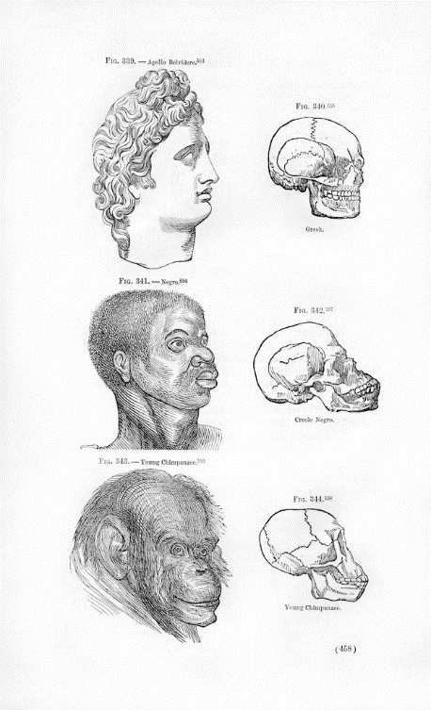
Figure 1. Illustration in Josiah Clark Nott and George Robins Gliddon (1854) Types of Mankind (6th edition), Philadelphia: Lippincott, Grambo & Co., p. 458.

Likewise, the physician, Samuel Cartwright, developed a psychological diagnosis, drapetomania, which meant running away from one’s owners. His claim was that drapetomania only inflicted enslaved Negroes. The signs of onset of the illness were “sullenness and displeasure with their station.” The cure for this disease was a severe whipping. Cartwright presented this condition as a pathology. Although drapetomania was widely derided even during its time, Southern states embraced the diagnosis that African’s seeking freedom must be experiencing an “infliction” while simultaneously supporting a booming cottage industry for the capture of runaways.
Slave holders perpetuated the delusion of the happy slave while terrorizing enslaved Africans into submission. Media accounts such as newspapers, published letters, and personal accounts from Southern whites regaled the happy Negroes singing and dancing. Slaveholders attested that Negros would not know what to do with themselves if left to their own devices.
In reality, those who were enslaved never gave up on their quest for freedom. Africans held in bondage seldom accepted their condition, if not for themselves, then for their children. Resistance and rebellions were commonplace. There were numerous accounts of rebellions, both small and large, involving individual and group acts of resistance. Examples included destruction of equipment and tools, poisonings, infanticides, and escapes. Resistance occurred by any means possible. Some escaped enslavement and headed as far north as opportunity allowed them. Others, known as known as Maroons or “outlyers,” took refuge in heavily wooded areas or swamps. From time to time, maroon communities waged guerilla warfare type strikes on the plantations and plantation owners (Sicker, 1998; Asante & Karenga, 2006; Karenga, 2002). Guerilla attacks were seldom successful, yet Maroon insurrections continued through the end of slavery. Maroons freed small and large groups of enslaved people, and sometimes slaveholders were executed to free entire plantations.
As Maroon-lead attacks and revolts increased, whites lived more and more in fear of uprisings, which bred suspicion and paranoia among slaveholders. One particular maroon community included 21 homes and rice fields in the swamps near the Savannah River. From this post, the maroons led freedom raids against area plantations. Such actions increased the slaveholders’ anger and cruelty toward those they held in bondage. Fear of slave revolts resulted in newer, even more restrictive slave codes. In some ways, both the enslaved and the slaveholders lived under the constant threat violence. Prior to the end of physical enslavement, African Americans resisted slavery at every turn. After physical slavery was ended, they would continue their struggle for freedom through the next phase of oppression, legal segregation.
Legal Segregation. Legal segregation is another traumatic material factor that has injured, and continues to injure, African Americans. Legal segregation, also called de jure segregation, involved laws that separated people by racial categories. These legal structures maintained the racial stratification and separation formerly maintained by slavery. Legal segregation spanned several eras stretching from the Emancipation Proclamation in 1863 to the passage of the Civil Rights laws in the 1960’s. These laws covered nearly every aspect of African American life, including employment, education, pay, public accommodations, and access to the courts, among many other things.
Reconstruction, 1865-1877, was the first legal remedy provided to formally enslaved Americans. The Reconstruction Acts of 1867 imposed conditions on the Confederate states as precursors to rejoining the union. The terms included writing new state constitutions, providing voting rights to all adult males, dividing the states into military districts, and ratifying the 14th Amendment ending slavery and establishing birthright citizenship. The Civil Rights bill of 1866 was enacted by overriding President Andrew Johnson’s veto. Reconstruction afforded Black men the right to vote and hold office. At its height, more than 1500 southern Black men were elected to state and federal offices, serving between 1870 and 1890. Many Black legislators were eager to show their patriotism and willingness to move forward rather than rehashing grievances against slavery. As Legislators, they ushered in a progressive agenda including building hospitals and establishing labor rights.
Although Southern states had not yet broadly adopted free public education, Black legislators established free public schools that benefitted poor whites as well as Black children (Bailey, 2010; Foner, 1987). Black legislators typically focused their agendas on items to improve living conditions for all citizens. Southern whites, upset about the prospect of Black men serving in government, waged a blistering media campaign against the Black legislators, depicting them as monkeys, buffoons, drunkards, and over sexualized predators. Many southern whites believed Black men lacked the intelligence and competence to govern. The last Black legislator to serve in congress was George Henry white (Bailey, 2010). Even after all Southern African American men were removed from governance, the legacy of their New Deal style laws would remain.
Political pressures increased as the 1876 elections approached. Rutherford B. Hayes brokered a deal for the Southern vote, agreeing to release the former Confederate states from federal intervention, thus ending Reconstruction. Two prominent media campaigns were particularly damning to African American men: the 1915 movie Birth of a Nation, directed by D.W. Griffith, and Claude Bowers’ (1929) bestselling book, The Tragic Era. Both were highly effective propaganda pieces perpetuating the idea of lazy, corrupt Black politicians, and both were a boon for recruitment and membership in white supremacy groups during this time.
The Civil Rights act of 1866 was repealed in 1883, thus dismantling Reconstruction. Civil rights and voting rights for all southern Blacks were revoked. Although Reconstruction ended, legal segregation continued in the form of Jim Crow laws. Jim Crow, racial apartheid in the United States, consisted of social norms and laws, enacted throughout the former slave states, codifying Blacks as second class citizens:
The term “Jim Crow” laws evidently originated from a minstrel show character developed during the mid-nineteenth century….The Jim Crow Laws emerged in southern states after the U.S. Civil War. First enacted in the 1880s by lawmakers who were bitter about their loss to the North and the end of Slavery, the statutes separated the races in all walks of life. The resulting legislative barrier to equal rights created a system that favored whites and repressed Blacks, an institutionalized form of inequality that grew in subsequent decades with help from the U.S. Supreme Court. Although the laws came under attack over the next half century, real progress against them did not begin until the Court began to dismantle Segregation in the 1950s. The remnants of the Jim Crow system were finally abolished in the 1960s through the efforts of the Civil Rights Movement. (thefreedictionary, 2008, http://encyclopedia.thefreedictionary.com/Jim+Crow+Rice)

Most often, we as American educators understand Jim Crow Laws as public accommodation policies (e.g., related to water faucets, bathrooms, rear entries, and bus seating). Yet, one of the most economically devastating aspects of Jim Crow was housing discrimination and segregation. Although African Americans have bravely fought in every U.S. war, Black troops returning from World Wars I and II were denied homes and home loans given to white returning veterans, and Black veterans and their families were forced to remain in overcrowded inner city apartments with very few homes available in Black neighborhoods. Those homes, through redlining, were assessed high loan rates that intentionally devalued Black owned homes. This made it even more difficult for Black families to obtain and build assets.
Even though the fight for civil rights is thought to have begun in the 1950s, African Americans have been fighting for equal rights since 1865. The Civil Rights Movements sought to end “separate but equal” policies and practices. These movements involved grassroots activism in response to injustice and inequality in the United States. The movements sought judicial approaches to ending the injustices of American apartheid. Yet, not all African Americans agreed with these approaches. Some groups sought a sovereign state approach, self-rule and self-determination, while others worked for a return to an African homeland they had never personally known. Yet, another group sought equality and equal protection under the law. From these conflicts, two primary camps would emerge, those for economic equality and those for public accommodations. In the end, the incrementalism of public accommodations would win the day. During, the late 1950’s and 60’s the fight for equality for African Americans and other ethnic minority communities would move from the streets to the courts.
Legal segregation statutorily ended with the Civil Rights Acts of 1964 to 1969. Laws would change, but hearts and minds would not. During the 1960’s Americans from every walk of life made efforts to fully integrate America. Unfortunately, these efforts – and laws – were short lived. Almost immediately, various legal challenges were mounted to water down or remove each effort to remedy the racial injustices of the previous 400 years. As a result, just small vestiges of those effective integration efforts still remain in place today. There seemed to be very little popular appetite to rectify the historic wrongs of slavery and American apartheid. It is true that legal segregation ended, but only to be resurrected as defacto segregation.
Defacto Segregation. A third material factor that contributes to past and present traumatic injuries to African Americans and other people of color is defacto segregation. The term defacto segregation most commonly refers to certain forms of school integration, but it also applies to “instances where legislation does not overtly separate people by race (de jure segregation), however racial imbalance remains” (Merriam-Webster’s Learners Dictionary, http://www. learnersdictionary.com/definition/de%20jure).
Defacto segregation is a traumatic material factor that can involve the denial of resources such as wealth or access to equal quality education. Most Americans live, attend school, and go to church in highly segregated spaces. Current housing patterns are an example of defacto racial segregation. Black and Brown communities often collect fewer taxes and receive substantially fewer public resources, which in turn makes these communities less desirable. “Racial discrimination and prejudice are translated so directly into economic disadvantage through housing markets” (Massey, 1990, p. 354). Housing discrimination and restrictive practices limit the wealth creation and accumulation for African Americans and other families of color.
Black wealth has often been restricted by these housing limitations. Housing restrictions also limit educational opportunities, employment, and asset accumulation through home equity. Studies indicate that “during the 1970’s Black poverty became more persistent and geographically concentrated in American cities” (Massey, 1990, p. 348). After legal segregation ended, white citizens continued to strive to keep their neighborhoods white. These practices took place in many ways. Realtors would not advise or show African Americans housing in white neighborhoods, and bribes and intimidation were used to discourage Blacks from buying into white neighborhoods. In Lorraine Hansberry’s A Raisin in the Sun, a true-to-life scene illustrated how a white community bribed a Brown family not to move into their community. Numerous tactics were and are employed to keep neighborhoods segregated.
Since school funding follows local property and business taxes, poor Black and Brown neighborhoods with low property values provide lower funding to predominately Black and Brown schools. Therefore, the most economically disadvantaged areas receive the least amount of federal and state resources to educate their children. The limits to education directly correlate to lower employment opportunities. These educational and economic prejudices and inequities continue for poor people and their communities. According to Massey, housing segregation intensifies poverty, and poverty intensifies segregation (1990). According to Sundiata Chu-Jua (2001):
Bulmer and Solomos posit that ‘the salience of ethnicity and race … has become more evident during the last thirty years.’⁶ Yet, many observers contend that contemporary rac(e)ism is more covert than in previous historical periods. … the trend toward new racism is a result of the ‘changing socio-economic environment of contemporary societies.’ The implication is that the appearance and properties of racial oppression responded to changes in a society’s political economy. This suggests that rac(e)ism has been pervasive and persistent, but not unchanging. This makes sense, since to believe that fundamental change has not occurred in African Americans’ and Black people’s relationship to the U.S. political economy, the state, and civil society, or between them and Euro-Americans and other U.S. nationalities, is to locate African people outside the historical process. If the system of racial oppression in the United States has changed over time, how do we account for Blacks’ continuing location on the ‘bottom rail’? (p. 26)

Racism has undergone a metamorphosis, but in keeping with Chu-Jua’s assertions, the appearance of racism is the persistent and unchangeable nature of Black oppression. Racism has continued to evolve from its most blatant status, during enslavement, into even more insidious because less visible forms.
Traumatic Ideal Factors
Just as there are many traumatic material factors that have affected African Americans, there are also numerous traumatic ideal factors that have contributed to their injuries. Ideal factors are psychological and/or emotional. There are many ideal factors that have contributed to the suffering of African Americans. Some of the most significant kinds of ideal factors include overt racism, implicit bias (unconscious racism), and racism as “common sense” (Haney-Lopez, 1969). Psychological factors can be extremely damaging because of their impact on the emotional and physical state.
The emotional damage of racism has been illustrated by numerous scholars, including Cornel West and Carter G. Woodson. Cornel West addressed “Black sadness” as the deep depression borne of the crushing weight of racism. Carter G. Woodson (1933) explains the toll years of oppression leaves on the psyche of a people:
If you make a man feel that he is inferior, you do not have to compel him to accept an inferior status, for he will seek it himself. If you make a man think that he is justly an outcast, you do not have to order him to the back door. He will go without being told; and if there is no back door, his very nature will demand one (1933, pp. 85-86).

This collective toll racism has taken on African Americans has resulted from many forms of racism such as overt racism, commonsense racism, and implicit bias or unconscious racism.
Overt Racism. One ideal factor affecting African Americans is overt racism. Overt racism refers to blatant or intentional racism. Among the many traumatic ideal factors affecting African Americans, overt racism is usually considered the easiest to recognize and is widely denounced. We often look back at past historical periods and strongly condemn thoughts and actions that in their time may have seemed harmless to the perpetrators.
Overt racism can take many forms, from public or private name calling and hate crimes to racial profiling among the police. Often, people and or communities react in outrage to obvious racial blunders such as name calling such as use of the “n” word, racist fraternity chants, or political candidates declaring an entire category of immigrants to be rapists and drug dealers. Many would agree that certain hate crimes are racist, such as a Black father being dragged to death behind a pickup truck or the lynching of Black and Brown people, past and present. The Southern Poverty Law Center has noted the dramatic increases in white Nationalist violence and threats of violence since the election of Barack Obama, the first African American President.
Although such actions are easily identified and harshly condemned, they do not get at the heart of institutionalized racism, which is rationalized, sustained over time, and often implicit rather than explicit. For example, racial profiling is often not seen as being racist. While most Americans of color, who far too often live the experience, denounce the overtness of state agents violating the civil and personal rights of its darker citizens, many or white Americans identify alternative and necessary reasons for racial profiling. As a result, they do not recognize police- and state-sanctioned racial profiling as racism.
Implicit Bias. A second ideal factor that continues to negatively affect African Americans and others is implicit bias. Implicit bias refers to unconscious racism and racialized behavior. The Harvard Psychology Department, in conjunction with noted researchers such as Mahzarin Banaji, Anthony Greenwald, and Brian Nosek, has been studying implicit bias since 1992. They created Project Implicit, a set of on-line social cognition tests that measures thoughts and feelings outside of conscious awareness and control (Greenwald, Mahzarin, & Noesk, 1998). “Project Implicit is the product of this team of scientists whose research produced new ways of understanding attitudes, stereotypes and other hidden biases that influence perception, judgment, and action” (Teachman & Nock, 2011, https://implicit.harvard.edu/implicit/aboutus.html). Project implicit defines implicit bias as follows:
Implicit racial bias is a mental process that causes most of us to have negative attitudes about people or groups of people based only on their race or ethnicity.
Many researchers believe that implicit racial bias is fueled by ‘symbolic’ attitudes that we all develop over the course of our lives starting at a very early. These attitudes are formed from distorted messages that we are exposed to every day from a variety of sources ... television, newspapers, magazines, conversations with people we trust ... that depict African Americans and other people of color in a negative light. (p.2)
Ongoing research and training indicates how implicit biases are prevalent in our daily lives. For example, historically, African American unemployment rates remain at twice the national average. According to the U.S. Bureau of Labor Statistics, unemployment rates for March 2016 by race charted Black or African American unemployment (9.0%) at twice the rate of whites (4.3%). This disparity has remained constant throughout the reporting years of 1990 to March 2016. These statistics are relational to social norms. When coupled with educational disparities, the impact of racialized hiring practices adds to the monetary wage gap.
A comprehensive study by the Center for Economic Policy Research (2014) revealed the extent of racial trauma in Black employment and hiring. In their 2014 report titled “A College Degree is No Guarantee,” the Center conducted an audit study using trained Black and white personal who applied for the same positions using identical fictitious resumes. The executive summary from this study revealed that white applicants were twice as likely to get callbacks as Black applicants. Even when a criminal record is added to the white applicant’s resume, he is still more likely to get called back. A college degree affords African Americans little reprieve. The uses of fictitious profiles in research with white and Black applicants for jobs, housing, or loans have all shown similar results. Studies show definitive racial biases against African Americans, especially darker skinned African Americans. Such practices can result in predominantly white work places and neighborhoods and higher loan expenses for African Americans without any explicit intent to discriminate. Bonilla-Silva (2016) calls this racism without being racist.
Remaining unaware of the material and ideal traumatic factors of racism in America often results in irreversible damage to African Americans and other visibly identifiable and marginalized individuals, families, and communities. Unlike its overt racism, implicit bias works at unconscious levels until, directly or deliberately, it is brought to one’s attention through education or training. Fortunately, with education, there are ways to bring racism out from the shadowy unconsciousness into the forefront of our thought. People can be taught to be more aware of their own unexamined biases. Such education is essential when dealing with implicit bias. Finally, in addition to overt racism and implicit bias, there is yet another ideal manifestation of racism that must be considered: Commonsense racism.
Racism as “Commonsense”. A third ideal factor is racism as “commonsense” (Omi and Winant, 1994; Haney-Lopez, 1969). Merriam-Webster’s Learners dictionary defines common sense as judgment based on a simple perception of the situation or facts; taken for granted assumptions (2003, location 1398). Racism as “Commonsense” is explained as
a complex set of background ideas that people draw upon but rarely question in their daily affairs….They are codes of thinking and acting that facilitate the minutiae of our lives. That minutiae takes on great significance, for it helps to constitute our identities and our world views. Racial ideas operate within this sphere of common sense – that we regularly rely on, yet infrequently examine, assumptions about race (Haney-Lopez, 1969, locations 113, 115-117).

Racial common sense is made up from our “stock ideas and practices”, unspoken codes that help us organize how we think about and do not think about race. These codes are taken for granted racial assumptions we all make about people from our own racial/ethnic background and people from other racial/ethnic backgrounds (Haney-Lopez, 1969; Rudd, 2012).
Omi and Winant (1994) offered:
Racial beliefs operate as an “amateur biology,” a way of explaining the variations in “human nature.” Differences in skin color and other obvious physical characteristics supposedly provide visible clues to differences lurking underneath. Temperament, sexuality, intelligence, athletic ability, aesthetic preferences and so on are presumed to be fixed and discernible from the palpable mark of race. Such diverse questions as our confidence and trust in others (for example, clerks or salespeople, media figures, neighbors). (p. 4)

Racial commonsense works as a kind of shorthand for the mind. It fills in unknown information based on pre-established stereotypes we learn in society and through media (hooks,1992 & 1996; Rudd, 2012). “These attitudes are formed from distorted messages that we are exposed to every day from a variety of sources – television, newspapers, magazines, conversations with people we trust – that depict African Americans and other people of color in a negative light” (Rudd, 2012, http://kirwaninstitute.osu.edu/docs/AACLD_implicit_bias_and_education.pdf ). These racial ideas inform us about how races are stratified in American society. Because this is a type of shorthand in our decision-making we uncritically “follow the scripts laid out for us by common sense” racism (Haney-Lopez, 2003, location 122; Massey, 1990).
Unfortunately, these scripts have become acceptable racialized attitudes. For instance, when businesses, schools, neighborhoods, and churches are predominantly made up of a single racial group, we tend to accept it as a matter of fact. This is the way that racism as common sense works. It stems from our acceptance of racial situations without consideration of or concern for hiring practices, housing discrimination, or social norms that have led to the creation of predominately single race spaces. Most Americans look at highly segregated spaces as “just the way things are” without considering the historical context to how we arrived at this place. Many Americans continue to accept, uncritically, the historical processes by which predominately white spaces have been created and maintained. Failure to take a critical look at these outcomes is how we have arrived at racism as commonsense. Commonsense racism can be countered with the knowledge that all peoples have meaningfully contributed to human history (Asante, 1995), and one way to promote this understanding is through culturally responsive and critically conscious curriculum and instruction.

Critically Conscious and Culturally Responsive Curriculum and Instruction
Because many racialized practices are so socially normalized as to have become “commonsense,” many believe it is vital for educators to disrupt the status quo. From this perspective, education must provide culturally responsive and critically conscious curriculum and instruction in schools and colleges of education (Chavous et al., 2003; Gay, 2000; Rowley, Sellars, & Zimmerman, 1998). Preservice teachers, and the children they go on to teach, cannot become proficient in culturally responsive pedagogies unless they have been exposed to these perspectives and practices (Milner & Self, 2014).
Educational theorists like Ladson-Billings and Gay advocate the use of culturally responsive and critically conscious curriculum and instruction “to reduce the negative impact of educational hegemony and can result in positive psychological and emotional outcomes in students of color.” (Cholewa, Goodman, West-Olatunji & Amatea, 2014, p. 16). In the United States, we center European culture at the expense of all others so that what is being presented as neutral or normative in actuality is ethnically centered toward whiteness and white students (Banks, 1989). Eurocentric curriculum is monoethnic and is taught without naming it to be so. It teaches white students that they are at the center of education and society. Eurocentrism is taught without critically reflecting on its impact to students of color. The Eurocentric curriculum keeps students of color at the periphery while centering white students. The overall assumption of such a curriculum is that we teach what is necessary and important (Hirsch, 1987); therefore, what is not taught is assumed to be of little value (Anyon, 1979; Banks, 1989).
Biology textbooks and Crayola packaging describe the skin of white people as “flesh color.” Brown and other hues of skin are rendered something other than “flesh.” Humans are typically depicted with blond hair and blue eyes. White children can experience Sally, Dick, and Jane of the Basal Readers as confirming and validating representations of themselves as those who are normal. African American children more likely find themselves cast as other, alien, and not normal, or more likely, rendered invisible and not cast in the curriculum at all. (Love, p. 230)

Classroom books and materials more often than not exclude images of children of color or relegate them to supporting characters as it centers the actions around images of white children. In centering European culture over all other cultures, schools inadvertently support white supremacy. In this way, monoethnic teaching reinforces ideal racism. For Culturally Responsive Pedagogy to serve as an anti-racism tool, it must be applied in teaching children and preservice teachers alike. I believe this approach must be made apparent in teacher education programs for teacher education to avoid falling into the normative patterns of “commonsense racism.”
Critically consciousness is a central construct in Paulo Freire’s (2000) classic Pedagogy of the Oppressed. The academic origins of concept emanate from DuBois’ notion of double consciousness and are mirrored in Freire’s concept of critical consciousness, or conscientizacao. Critically conscious curriculum and instruction – or critical pedagogy – is curriculum and instruction aimed at raising critical consciousness to promote humanization and liberation from oppressive ideal and material conditions. In common urban vernacular, being woke is an expression of critical cultural consciousness. Critical consciousness refers to having an awareness, often a new awareness, of oppressive conditions related to power relations, cultural norms, gender issues, social and economic inequities, political inequalities, and other social issues that have had an impact on society (Kumagai & Lypson, 2009; Kozol, 1991).
Afrocentrically, critical consciousness is more closely tied to a cultural awareness, as argued by Gay and Kirkland (2003) in their article, Developing cultural critical consciousness and self-reflection in preservice teacher education. Kirkland aptly defines the concept:
Critical cultural consciousness is the ability of students to analyze their familial, cultural, social, academic, and personal experiences to develop a healthy ethnic identity. It also is a holistic worldview that affirms the cultural heritage of self and others, and maintains a commitment to self-reflection for achieving a deeper sense of human dignity (2001, p. 26).

Culturally responsive curriculum and instruction is responsive to the cultures of the students. It is curriculum and instruction that recognizes, values, and utilizes students’ cultural experiences as a basis for classroom practice. Molefe Asante explains why it is important to center instruction on the cultures of the students:
in education, centricity refers to a perspective that involves locating students within the context of their own cultural references so that they can relate socially and psychologically to other cultural perspectives. Centricity is a concept applied to any culture. The centrist paradigm is supported by research showing that the most productive method of teaching any student is to place his or her group within the center of the context of knowledge (Asante, 1990). ... A person educated in a truly centric fashion comes to view all groups’ contributions as significant and useful. Even a white person educated in such a system does not assume superiority based upon racist notions (p. 171, 1991).
Asante continues his argument using the example of African American centered education:
Why has Afrocentricity created so much of a controversy in educational circles? The idea that an African American child is placed in a stronger position to learn if he or she is centered – that is, if the child sees himself or herself within the content of the curriculum rather than at its margins – is not novel (Asante, 1980). What is revolutionary is the movement from the idea (conceptual stage) to its implementation in practice, when we begin to teach teachers how to put African American youth at the center of instruction. In effect, students are shown how to see with new eyes and hear with new ears. African American children learn to interpret and center phenomena in the context of African heritage, while white students are taught to see that their own centers are not threatened by the presence or contributions of African Americans and others (1991, p.174).
Asante’s argument is that education, currently, is culturally centered around only one ethnic group. This is limiting to all students. The educational goal should be to culturally center all children (Asante, 1991; Spring, 1991). Scholars as diverse as Dewey, Asante, and Hilliard appear to agree that we should first teach from the child’s home. Along similar lines, according to Howard & Amah (2006), “The cultural knowledge, prior experiences, frames of reference, and performance styles…make learning more relevant and effective…culturally validating and affirming” (p. 225). Teaching and learning begins from the child and then broadens to include other cultural perspectives. Following this logic, for African American students, Afrocentricity should be “the stepping-stone from which the multicultural idea is launched. For African Americans, at least, a truly authentic multicultural education must be based upon the Afrocentric initiative (Asante, 1991).
Numerous traditional African perspectives and practices exist that are of tremendous value not only to African Americans but to all Americans and, in fact, all of society. One example involves the philosophy of Ubuntu which, according to Chiku Malunga and Charles Banda (2004), is:
a selfless spirit of living for the betterment of a person’s environment using all talents at his or her disposal and not resting easy knowing that another is in need. It is based on the understanding that any good or evil we do to another person or people, we are actually doing to ourselves. This puts us under obligation to support and do good to others. The extended family in Africa is built on this principle. (p. 11)
Based on an understanding of the tremendous value of traditional African perspectives and practices, advocated of culturally-relevant pedagogy insist that it is essential to teach not only African American children but also pre-service teachers of color, as well as all students, from their own cultural centers. Using critically conscious and culturally responsive pedagogy, we can begin to decolonize education so that all students can feel more culturally connected, affirmed, and culturally affirming to others.
Counter-storytelling provides a means for members of subordinated groups to address those circumstances where the prevailing conception of justice provides no language or means by which the marginalized person can express how he or she has been injured or wronged in terms that the system will understand (Delgado & Stefancic, 2001). In counter storytelling, the researcher uses personal anecdotes or sometimes fictive composites to comprehend the data. The griot also tells stories, although the purposes and delivery differ from those of counter-storytelling. According to Samuel Boadu (1996), traditional oral art:
serves three broad purposes: ritual, entertainment, and education. (The) oral artist relies on the spontaneity of rendition unlike the artists a text….The oral artist in the traditional African society performs basically for benefit of society…The pedagogic role of the artist in the traditional African society is illustrated by the art of storytelling (pp. 84-85).
Counter-Storytelling and the Majoritarian Perspective. In educational research, information is often represented as a majoritarian-story, from a perspective centering whiteness (Solórzano & Yosso, 2016). Majoritarian stories are unconsciously recognized as the established “truths” in the cannon. These perspectives are seldom critiqued and are often accepted by Black and white researchers alike as facts (Kretovics & Nussel, 1994; Persell, 1977, Solórzano & Yosso, 2016). Yet, majoritarian stories always explain phenomena in relation to the whiteness. “Currently, many teacher education programs draw on majoritarian stories to explain educational inequity through a cultural deficit model and thereby pass on beliefs that students of color are culturally deprived” (Persell, 1977, p. 133; also see Solórzano & Yosso, 2016, as cited in Kretovics & Nussel, 1994). For example, academic achievement is typically discussed as a majoritarian story. White researchers often compare African American academic test scores against those of white students, and the distance has been labeled the “academic achievement gap” (Love, 2004, http://dx.doi.org/10.1080/10665680490491597). Therefore, majoritarian story-telling works like “common sense” racism; it is positioned as neutral, apolitical, and also invisible.
As an alternative to majoritarian story-telling, Critical Race Theory offers counter-storytelling. Counter-storytelling is a methodology that intentionally centers those who have historically been left at the margins. Counter-stories promote the cultural wealth or “funds of knowledge” historically and currently found in communities of color. If the aim is to disrupt hegemony and promote emancipatory justice, I believe there needs to be serious consideration of counter-storytelling, which “represents a paradigm shift in discourse about race and racism in education by challenging existing methods of conducting research on race and inequality” (Love, 2004, n. p.).
Counter-stories as proposed by Solórzano and Yosso (2016) add nuance to the critique of current representations of the idea of an achievement gap. They note that the distance between white and Asian test scores are not similarly named nor represented as a deficiency on the part of white students. They note that the majoritarian story does not address 200 years of housing segregation that created separate and decidedly unequal schooling. Majoritarian versions of this story are taught as part of the education cannon, printed in newspapers, and utilized by politicians to establish education policies and funding.
Black researchers also tell majoritarian stories. For example, Fordham and Ogbu (1986) postured the notion that resistance to “acting white” is a primary cause of lower achievement and the placement of fewer students of color in advance placement classes. Ahistoric considerations and cultural misunderstandings on the part of Ogbu led to the canonization of this majoritarian idea that African American families devalue academic attainment (Diamond, Lewis, & Gordon 2006; Tyson, Darity & Castellino 2005). However, the idea that resisting “acting white” contributes to ongoing marginalization of African Americans fits the majoritarian narrative and supports white supremacy; therefore, it remains part of the racial common sense of education.
Counter-storytelling offers a substitute to majoritarian stories. According to Delgado and Stefancic (2001), counter-stories can include personal narratives, parables, conceptualizations, and narratives based on composite characters. This methodology is rooted in the cultural practices and perspectives of many African and other Indigenous peoples. For example, as a “new Mestiza,” Anzaldúa (1990) argues for research from the perspectives of peoples at the margins, from what she refers to as the “borderlands.” She states that “if we have been gagged and disempowered by theories, we can also be loosened and empowered by theories” (1990, p. xxvi). Solórzano &Yosso (2016) agree and expand on Anzaldua’s ideas: “Our response draws on the strengths of communities of color. If methodologies have been used to silence and marginalize people of color, then methodologies can also give voice and turn the margins into places of transformative resistance” (p. 137).
There is an African cultural practice referred to as “speaking it into being.” From this perspective, giving voice to a thought puts that thought out into the universe where it is physically manifested. Many believe it is long past time that we voice the changes we want to see in teacher education and educational research. It is time to speak our academic selves into being. When we at the borders make ourselves heard, we can begin to transform ourselves from objects to subjects (Freire, 2000), to move from invisibility to visibility, to speak ourselves into being within the academy.
Many socially and economically marginalized groups continue to experience a sense of discontinuity from their cultural identity (Banks, 2009; Hilliard, 1995a). These identity conflicts are present in schools and society. In light of this ongoing problem, where can marginalized groups find authentic sources for identity development? It is possible that culturally relevant pedagogy linked to arts-based educational relationships could serve as a basis for positive identity development among African Americans and other peoples of color.
The literature indicates that various traumatic ideal and material factors continue to pose personal and societal challenges associated with discontinuity in the identity development of African American youth and other students of color (Banks, 1989; Baldwin, 2003a; Burell, 2010; Cha-Jua, 2001; Tatum, 2003). Part of the solution may involve helping students within these communities to reconnect and recover a more holistic sense of identity and history (Asante, 1991 Spring; Karenga, 2002; Buras, 2014; Burell, 2010; Chavous, et al, 2005; Wanzer-Serrano, 2015). One possible way to reconnect and recover cultural identity may be through use of the arts both inside and outside of schools.
In light of these concerns and possibilities, the purpose of this study was to better understand the influence of culturally relevant arts-based educational experiences, especially meaningful relationships with culturally grounded mentors, on the identity development African American students. To gain this information, I decided to study the impact of such experiences and relationships on four self-identified Afrocentric artists/educators. Again, the question guiding the study was: What impact, if any, have culturally relevant arts-based educational experiences and relationships had on the identity development of four Afrocentric artists/educators?

CHAPTER THREE: RESEARCH METHODS

The Research Methodology: Critical Ethnography
In order to learn about the possible impact of personal art on the identity development of self-proclaimed Afrocentric artists/educators, I conducted a qualitative study using critical ethnographic research methods. Critical ethnography is a form of critical social research, which is a variation of qualitative research. In this section I will first discuss qualitative research methods in general. Then I will discuss critical ethnographic methods in particular.
What is qualitative research, and how is it conducted? There are many variations and different ways to define qualitative research. Yet, there are some common understandings that can be used as a starting point. Essentially qualitative research is interpretivist research (Geertz, 1973; Wilson, 1977). Qualitative research seeks to describe, interpret, and explain human qualities reflected in the thoughts, experiences, and actions of those who are studied. Qualitative research is also naturalistic because it seeks to understand these human qualities as they exist in people’s natural settings (Wilson, 1977). James Key (1997) says: “Qualitative research is a generic term for investigative methodologies described as ethnographic, naturalistic, anthropological, field, or participant observer research” (p. 21). https://www.okstate.edu/ag/ agedcm4h/academic/aged5980a/5980/newpage21.htm
A major aim of qualitative research is to relate a more complete and comprehensive view of the participants and issues being researched. Whereas quantitative research attempts to apply quantifiable numeric values to discrete data, qualitative researchers try to gain a broader, more contextualized understanding of what is going on in the lives or situations of those they are studying. While quantitative researches may seek to remove the investigator from the investigation, qualitative researchers inject themselves into the research (Smith, 1987). Qualitative research is naturalistic, meaning that studies investigate people and issues in their natural state (Denzin, 2011; Quantz & O’Connor,1988; Smith, 1987; Glaser & Strauss, 1967).
Ethnographic research is one of many variations of naturalistic qualitative research (Behar, 1997; Denzin, 2011; Schwandt, 2001; Quantz, 1998; Quantz & O’Connor, 1988; Smith, 1987). A major distinction is that ethnography has traditionally been used by anthropologists for the study of cultures. Although ethnography has tended to be more comprehensive and longitudinal than other qualitative approaches, many of which have their roots in sociology (Becker, 1978; Glaser & Strauss, 1967), ethnographic studies do not necessarily have to be longitudinal (Behar, 1997; Denzin, 2011; Fetterman, 1998; Quantz, 1998). The key for this study is that its primary focus is on culture.
I conducted a particular kind of ethnographic study called critical ethnography. Ethnographic research is one variation of qualitative (interpretivist, naturalistic) research (Wilson, 1977), and critical ethnography is one variation of ethnographic research (Denzin, 2011). Critical ethnography, like other critical social research, is interpretivist and naturalistic (Denzin, 2011; Quantz, & O’Connor, 1988; Smith, 1987; Glaser & Strauss, 1967). Since critical ethnography is a form of qualitative research, it uses many of the same basic methods of data collection and analysis.
Although critical ethnography is a form of qualitative research, its purposes go beyond a desire simply to interpret the perspectives or actions of the participants. In addition to interpreting their views and actions, an additional purpose of critical ethnography is to empower those participants and, if possible, to promote social transformation (Denzin, 2011, Carspecken, 1996). Schwandt (2001) defines critical ethnography as:
studies that engage in cultural critique by examining larger political, social, and economic issues and that focus on oppression, conflict, struggle, and power. These studies are critical of the parochial, romantic, politically conservative, and limited vision of traditional ethnographies. (p. 44)

Critical ethnography can be viewed as the presentation of “cultural discourse situated in time and space as authored” by a particular social group (Quantz & O’Connor, 1988, p. 108). David Fetterman (1998) used the term “advocate ethnographers” (p. 135) to describe ethnographers who actively seek to promote social justice for a group of people and who writes in order to change political opinions or raise awareness in the public arena (Fetterman, 1998). The major difference between standard ethnography and critical ethnography is that, in identifying the perspectives of the participants, critical ethnography explicitly considers issues of power and justice, and ultimately issues a call to action (Denzin, 2011; Fetterman, 1998; Carspecken, 1996; Quantz, 1992).
Kristen Buras (2004) extends and complicates the definition of critical ethnography:
The etymology of the word ethnography is instructive, with ethno referring to a race or a people and graphy referring to writing. Ethnography is the practice of writing the life of a people. This is the essence of critical race praxis: using the production of knowledge to rewrite the circumstances and conditions that dehumanize us (p. 62).

Ethnographic research with critical praxis, as defined by Buras, can allow a people to write themselves back into humanity. This can provide an important counter to the dominant narratives that have written marginalized peoples out of American history in racist societies.
As my study unfolded, I began to see my participants not only as Afrocentric artists/educators, but also, increasingly, as cultural storytellers, as griots, reaching back to recover and reconstruct what had been taken away, our history and culture. As cultural griots, they used their media to tell stories of African Americans, counterbalancing destructive majoritarian narratives (e.g., of Africa, “the Dark Continent,” a primitive place of desolation, despair, degradation, and war, whose people must also be dark and desolate) with positive counter-narratives of our own construction.
Critical ethnography, like other forms of qualitative research, is interpretivist in nature. Interpretivist methodologies tend to be situated in time and to be context-specific (Denzin, 2011; Carspecken, 1996; Quantz, 1992). Interpretivist research is actually doubly interpretive (Wilson, 1977). It not only asks others to interpret their reality, it also interjects the researcher’s interpretations of others’ interpretations. Since my questions asked whether the participants’ art affected their cultural identity development, I sought to discover their personal interpretations of art, aesthetics, culture, race and identity from their perspectives. However, as a researcher, I recognize that I also interpreted their interpretations through my own lens as well.
A primary purpose of critical ethnography is to empower marginalized groups and to promote social transformation through social political action (Christians, 2005; Guba & Lincoln, 2005). Social groups are empowered when they define themselves, their culture, and processes in their lives (Davis, 2011). In essence, participants become empowered as they define their lived realities, and the researcher may assist in this process.
According to many, the critical ethnographer holds an advocacy position. This stands in direct contrast to the objective observations of many quantitative researchers. According to Denzin (2011), in critical ethnography “the researcher (is) an advocate for change, a passionate participant, an agent of self-reflective action. The researcher is not a ‘disinterested observer’” (p. 45). Critical qualitative inquiry requires the investigator to take a “moral and ethical” stand in support of the issues related to the studied group (Denzin, 2011, p. 26). The critical ethnographer aims to shine a light on complex power relations between cultures of color and the dominant culture. Denzin (2011) states:
As a cultural critic, the researcher speaks from an informed moral and ethical position. He or she is anchored in a specific community of progressive moral discourse.…Accordingly, this ethic asks that interpretive work provide the foundations for social criticism, and social action. These texts (the proposed research) represent calls to action. As a cultural critic, the researcher speaks from an informed moral ethical position....The moral ethnographer takes sides. (p. 28)

Denzin refers to this advocacy role as being a “criticalist” (Carspecken, 1996, p. 3). A criticalist is one who applies a critical eye to power relationships. In this study, I will approach my findings from an advocacy position. In part, the study will be a search for possibilities of empowerment and social justice.
Thus, critical ethnography, by definition, embraces an advocacy position (Denzin, 2011; Fetterman, 1998; Carspecken, 1996; Quantz, 1992). Since I want to both understand and advocate for culturally relevant art in order to empower visibly identifiable minority communities and to increase culturally historical knowledge for members of these groups, I decided to use a critical ethnographic research approach.

Research Design
Data collection and analysis and the presentation of findings are similar for many qualitative approaches. In general, there are five basic processes, including: (1) data collection; (2) data coding; (3) data analysis; (4) presenting the findings; and (5) interpreting the findings. Most qualitative research methodologies utilize some variation of interviews and observations to gather the data, and a variety of coding and thematic analysis procedures to manage, organize, and interpret the findings.
Critical ethnographic research in education utilizes similar methods, following much of the same design as critical or advocacy research. The major departure from other qualitative research is the purpose of critical ethnography. According to Denzin (2011) and Carspecken (1996), this involves political action. Although different models exist for critical ethnography, I propose to use a variation of Carspecken’s (1996) design. Carspecken’s model includes the following five stages:
- Compiling the primary data (data collection)
- Preliminary reconstructive analysis (data coding)
- Dialogical data generation (data analysis)
- Describing system relations (presenting the findings)
- System relations as explanations of findings (interpreting the findings)
Although I used this basic approach, I combined his last two stages for reasons I will describe below. In the following sections, I describe each of Carspecken’s stages and explain how they were used in my own study of the role of the arts in the recovery and development of cultural identity.
Compiling the Primary Data: Data Collection. Compiling the primary data is equivalent to data collection in other qualitative research designs. Carspecken (1996) says “information collected…is ‘monological’ in nature because the researcher ‘speaks’ alone” at this step in the design (p. 42). The critical researcher acts more or less as an objective observer in this early stage of the process. In my study, I systematically compiled the primary data through the following steps: initial contact; collection of corresponding data; preliminary structured interviews; and primary observations.
The sample participants were initially contacted by telephone and/or email. I made personal contact with the potential participants via email and telephone calls, and this was followed by face-to-face visits.
Shortly after the initial contact, I began collecting corresponding data. At this point, extensive notes were compiled, known among qualitative researchers as “thick description”. The descriptive data came from interview notes, theoretical notes and personal memos recorded in my journal, and audio and visual recordings. Additional forms of corroborating data included, but not be limited to, biographies, press releases, reviews, announcements, and resumes gathered from or about the participants. These forms of corroborating data provided useful information about the participants’ experiences, perspectives, and actions. This corroborating data helped ensure a more comprehensive and accurate interpretation of the personal perspectives of each of the participants.
I first conducted structured interviews to gain background and other demographic information. Among other things, I asked about the participants’ lives, educational backgrounds, and art experiences. I also asked about their social and cultural experiences and perspectives. From this information, I began structuring follow-up interview questions.
A vital part of the study was primary observations. This involved multiple viewings of each participant’s artworks and/or art forms. Viewings took place in their workspaces, studios, and various other sites and locales where their creative processes naturally took place. Multiple viewings allowed me to glean more and varied information from each of the art forms and artists. Viewing and analyzing personal art as I went provided a more complete picture of each artist/ educator, including their philosophical beliefs and other perspectives.
Preliminary Reconstructive Analysis: Data Coding Methods. Carspecken (1996) labels the next stage as preliminary reconstructive analysis. This stage is related to data coding methods in other qualitative studies. It is considered “preliminary” because it is an early attempt to systematically organize and make sense of the data. It is considered “reconstructive” because the data record that has been collected “articulates those cultural themes and system factors that are not observable and that are usually unarticulated by the actors themselves” (Carspecken, p. 42). Therefore, it is up to the researcher to “reconstruct” the meanings in patterns, themes, and factors that may be present at conscious and unconscious levels among the participants.
Dialogical Data Generation: Data Analysis Methods. Data analyses in third stage of the design are referred to as dialogical data generation. The information that was collected and partially analyzed in stages one and two will now be extensively combed through. Analysis of data moves the data collection process from a monological (researcher-centered) process to a dialogical (researcher-participant interactive) process. At this point the analysis of data generated from the study becomes democratic, including fully interactive interviews, initial observations, and full participant observation.
Shortly after conducting the preliminary interviews, more extensive follow-up interviews took place. Along with these sets of interviews, I attended performances and publications of the participants’ various art presentations and forums.
The interviews were conducted in stages. I began with unstructured interviews that were followed by semi-structured questions regarding the participants' perspectives on issues that emerged during preliminary reconstructive analysis and dialogical data generation. As necessary, there were follow-up interviews and additional questions for clarification. Although the additional interviews became increasingly unstructured, they also became gradually more focused on emergent issues and themes. At this stage, the interviews relied heavily on a dialogical approach, with emerging information continuing to guide the direction of the study.
Finally, it is important to note that the effectiveness of my interviewing required getting to the point in a conversation where my participants did not worry about how they presented themselves. In some cases, this required dispensing with formal academic discourse and pretenses, instead speaking in a more comfortable vernacular. Code shifts of this nature are reflected in a number of quotes. Rather than trying to sanitize or otherwise clean up these quotes, I have chosen, as much as possible, to leave them in their original form.
Conducting Systems Analysis: Interpreting Data Findings. The combined fourth and fifth
stages involve discovering and explaining system relations as findings. At this point the researcher begins to relate broader social systems to local sites and situations uncovered in the study. According to Carspecken (1996), social spaces such as media (movies, television, music, the Internet) can provide “key social theoretical concepts that make it possible to link reconstructive analysis with system theories” (p. 43). Deep analysis of the data can “suggest reasons for the experiences and cultural forms (the researcher) reconstructed” (p. 43).
In my case, analysis of local data involved taking into account the social positions the participants held not only within their respective communities but also within the broader structures of American culture, art culture, and the educational system. Again, multiple observations, dialogical data generation, and careful analyses helped ensure that my interpretations accurately represented the cultural phenomenon being studied, including the experiences and perspectives of the participants.
Carspecken (1996) calls for an explanation of system relations. He states, “People produce culture to cope with daily conditions of life” (p. 203). Stages four and five involved interpreting the experiences and perspectives of the cultures and systems that were studied in relation to predominant cultures and systems. For this study, comparisons were drawn between African American cultures and the dominant American society; however, in the course of the investigation, other comparisons also arose, such as the relation between ethnic-based art cultures and dominant or majority art cultures. Related insights involved factors such as the recovery, maintenance, and reproduction of Afrocentric culture within the larger context of mainstream society.
In stages one through three, the focus was primarily on the social sites, cultural factors, personal histories, and art activities of the four participants. In stages four and five, the focus shifted to complex relationships between the sites and participants as well as between local and global system relationships. Analyses during these latter stages were where the greatest social critique occurred.

Confidence and Trustworthiness
Like other researchers, qualitative researchers, including critical ethnographers, need to address issues of confidence and trustworthiness. Qualitative researchers do not normally use terms like validity and reliability, yet they, too, must try to accurately represent their findings to ensure the greatest possible confidence in the study. Two confidence issues involve the transferability and credibility of the findings. Transferability deals with questions of generalization. A generalization question might be: “Can this case be related to or transferable to other cases?” (Schwandt, 2006, online).
Another confidence issue involves the question of credibility. A credibility question might be: “Is this research believable?” The perceived accuracy and truth of a study are judged by the consensus of audiences or stakeholders served by the study (Lincoln & Guba, 2005; Schwandt, 2006; Glaser & Strauss, 1967). To help ensure confidence in my methods, it was important not to determine ahead of time what I expected to find, and to be prepared to be proven wrong by the data if they did not fit with my own assumptions. It was also important not to narrow my actual or imagined audience only to those who would be inclined to agree with me.
One way to do promote greater confidence in one’s findings is to distinguish between emic perspectives and etic perspectives. According to anthropologists, an emic perspective is data expressed in the categories and meanings of the subjects or participants, while an etic perspective is “data expressed in the researcher’s language or the categories of some theory” (Smith, 1987, p. 174).
In this study, I present both emic and etic perspectives. I tried to understand and present as much of the emic perspective as possible, obtaining data through interviews with the artists in their natural settings. Yet, as a researcher, I also interpreted what I saw and heard through my own views and values, based on my own experiences and concerns as an Afrocentric woman, as well as the scholarly literature through which I framed the study and interpreted and analyzed the findings. To create greater confidence among readers, I have tried to be clear about where my views are expressed as opposed to the views of the participants. This was important so that I did not attribute my own perspectives to the participants (or vice versa), even though there were many times in which we strongly agreed.
Yet another way to provide greater confidence in the findings accurately representing the views of the participants is through a process called member-checking. To do this I presented summaries and preliminary analyses and conclusions to the participants and asked them to comment on how accurately my summaries reflected what the participants had in mind.

Criteria for the Selection of Research Participants
The research participants I chose to study were four Afrocentric African Americans. I selected four African American artists/educators as research participants. Each participant was someone who self-reported having a positive Afrocentric identity. Each participant met all research criteria. Therefore, each identified himself or herself as Afrocentric, as an artist, and as an educator. Although the artists were selected as a convenience sample, they were carefully chosen based on the defined criteria.
The participants were artists who used different media. They were individuals who were either already known to me or who had been made known to me, and they were available in the Oklahoma City metropolitan area for the purposes of conducting multiple interviews and personal observations of their art forms, events, and processes. Because art can be a deeply personal aspect of an artist’s persona, observation of the primary and personal art forms, events, and processes would inform much of the research and provide valuable insights into their personal identities.
Because this study utilized African Americans as an illustrative example of marginalized minority groups in general who may be engaged in the recovery of cultural identity, all the participants were native born African Americans over the age of fifty. Why use the term African American? Based on the age of the participants in this study, it is evident that during their lifetimes they have been labeled many things, Negro, Colored, Afro-American, Black, and African American. Currently “African American” is the most commonly used term, a name many African Americans choose to define ourselves. In my view, it best represents us as part of the African diaspora. In my view, it honors the enslaved Africans that endured so that we might exist and thrive today. Other members of the diaspora – Continental, Caribbean, and other first generation Americans of African descent – were excluded from consideration as participants in this study due to the possibility that their immigrant history may have introduced additional variables related to immigration, assimilation, and lived histories or experiences outside of the United States.
Finally, to be considered for inclusion, all participants had to have been an educator at some point in their careers, and they had to have publicly published or performed their personal art in some form or another. It was not necessary for the participants to have simultaneously performed both functions. Nor was it necessary that their publications or performances were done for economic profit.
The personal nature of art, aesthetics, and creativity, in and of itself, required allowances for unforeseeable circumstances, such as additions or deletions in terms of the art forms, processes, and experiences of the artists. Many artistic people work in multiple genres; therefore, it was understood that the perspectives, experiences, processes, and artworks of the participants could be evolving and emergent.

The Participants
I chose four participants. These participants met all the stated criteria. All four participants considered themselves to be Afrocentric in terms of their lifestyles and their art. Each participant was a native born United States citizen from the Midwestern or Southern states. The participants worked in different artistic genres. Each participant was either currently teaching or had previously taught and/or performed their personal art. These individuals were chosen for the unique perspectives each could bring to the research.
The research participants included DWe Williams, Jahruba, Joyce Tease-Jackson, and Al Bostick. DWe was an African American female in her late fifties. She specialized in historical performance. Among the four participants, DWe had the most extensive formal educational background. She held current teaching certifications and had taught art, speech, and theater in public schools and social spaces.
Jahruba was an African American male in his mid-sixties. He was a musician specializing in “the talking drums” and a modern day griot. Jahruba regularly worked as an artist-in-residence throughout the Oklahoma City metropolitan area. He taught drumming, “talking drums” and African history simultaneously.
Joyce was an African American female in her early sixties. She is an accomplished painter, doing portraitures and illustrating children's books, murals and backdrops. She is the only participant to work full-time at something other than her art. Joyce is a retired middle-school art teacher.
Finally, Al was an African American male in his early sixties. His specialties included theatrical acting, singing, dancing, visual art, sculpture, and found art. Al was considered by some a modern-day Renaissance man. He had taught at the university and had developed a method of teaching reading and mathematics using drumming rhythms.
The Potential Impact of Age and Geographical Location. It cannot be assumed that all possible participants in a study of this nature would perceive the issues in identical ways. For example, factors such as age and geographical location can certainly influence one’s perspectives. When considering the experiences and perceptions of my participants from the perspective of age and location, I am of two thoughts. In light of recent political events within the United States, I believe younger participants may have reached many of the same conclusions drawn by my middle-aged participants. As to geographical location, it can be argued than nearly equal levels of racism exist in the Southern and Northern regions of the United States, differing mostly in its directness rather than its magnitude.
Regarding age, Afrocentric approaches tend to honor the wisdom of elders. Age is believed to provide a perspective on life and survival that many younger people (including millennials) are still grappling with. Many millennials, for example, have only recently become aware of the naivety of assuming we live in a post-racial society. Many children who came of age under the first Black President have been swayed by media and politicians who were quick to sweep racism under the rug. Although warnings from elders did little to sway some millennials from this position, lulls in racial tensions have been short lived. The spectacle of Treyvon Martin’s murder sent many disillusioned youth back into the spaces occupied by their elders. In spite of the rhetoric of change, too often it appears the United States is one highly publicized racist issue away from where we have always been. Whether the issues are bus boycotts, burning white-owned stores during civil unrest, or the O. J. Simpson trial, we are seldom very far from falling back into separate and unequal camps.
According to Bell (2004), during lulls in reports of overt racism Americans experience “interest conversion” in which Black youth can fall prey to white ideologies that subtly support white supremacy. Examples include ideas such as the existence of a post-racial society, reverse discrimination, and colorblind institutions, to name a few. Because our elders have lived through these phases, new racial occurrences are less likely to shock them.
Geographical location as an extenuating variable may have a minimal effect. Having lived both on the West Coast and in the Bible-belt South, I believe geographical locations have less to do with the degree or magnitude of racism that exists than with its directness or indirectness. In my experience, Southern racism is often more direct than the hidden or obscured forms of racism that exist in more “liberal” states. In the era of Trump, all pretense appears to have fallen by the wayside. Now it seems even White millennials are more aware of subtle forms of racism, and greater numbers of older liberals are beginning to recognize limitations of American equality.
The United States is a house built on the ideal and material foundations of slavery. In perpetuity, a house remains an extension of its foundation. Until the original foundation is up-ended, all future construction will continue to be built on the rot of enslavement. While Americans who live with the comfort of personal home improvements may be able to ignore the signs of decay, the warping floors, creeping molds, water stains seeping through superficial paint, and faulty wiring of microaggression negate the claims of a home repaired. Hooded millennials marking the injustices experienced by Treyvon Martin and others, marching in the streets with hands held high, protestors donning “I can’t breathe” and #BlackLivesMatter paraphernalia, provide vivid reminders of the foundational rot that is too often ignored in the name of “colorblindness.”

My Positionality
Since I also identify as an Afrocentric Artist/Educator, it is important to acknowledge that I am, by self-identification, a racial insider or “native” researcher. Brown (2004), Behar (1997) and others discuss the necessity of self-reflection among researchers from within the community being studied, of constant interrogation of our own presuppositions and biases. According to Asante (1991 Spring), “most fields of inquiry recognize that a researcher's presence must be accounted for in research or a historian's relationship to data must be examined in seeking to establish the validity of a conclusion” (p. 267).
My approach to this research was in some ways both emic and etic. It was emic from my positionality as an Afrocentric artist and educator; however, it was etic with regard to my role as a researcher applying educational theories to the lives of practices of my participants. According to Brown (2004), “researchers who are positioned as an ‘insider’ will have greater access to in-depth knowledge, meanings, and interpretations that may not be available to the researcher perceived as an ‘outsider’” (p. 171). I align myself as a racial insider and vulnerable observer (Behar, 1997), choosing disciplined subjectivity (Wilson, 1977) over dispassionate objectivity.
From the perspective of a cultural insider, I gained a deeper conceptual understanding of the contextual meanings shared by the participants. Al and DWe often used songs and quoted African/African American stories and plays to emphasize cultural concepts. Jahrubaba told tales of African villagers to convey deeper understandings, while Joyce evoked the Black church and spirituality to extend culturally embedded meanings. As a “racial insider” I was able to extract rich meanings from the context and tones that may not always be superficially present in their interviews. Often the participants used a “cultural shorthand,” a phrase or term that denoted broader concepts from shared live experiences. As a racial insider, it is possible that I experienced a shared cultural positioning not available to all researchers.
However, even as a well-positioned insider, educational researchers often represent dominant institutions such as American colleges or universities. African American communities may rightfully mistrust such predominantly white institutions (PWIs). The predominantly white University, like much of the South, resisted, “dragged its feet,” on integration, and too often remains supportive of many aspects of white supremacy. Some of my participants had negative, racialized experiences with the University. I too, have had my own difficult racial past in PWIs. Therefore, my association with the University was initially met with skepticism. My motives were perceived as questionable.
Anthony Brown (2014) discussed the apprehension shared by many African American communities regarding the significance of university-based research. There are “expressed concerns over universities’ desires to just theorize about the Black education and not provide viable solutions to deeply entrenched problems within the African American community... gathering data that will have no value to the Black community” (p. 171). Some of my participants expressed this very concern. I did not overcome their objections; however, I believe their Afrocentric beliefs and practices eventually overrode their skepticism toward my etic position. In the end, their participation came down to kindness, a willingness to “just help a sista’ out.”
As a researcher, I chose to allow my positionality to fluctuate between emic and etic. In so doing, I allowed myself a distance to reflect on the cultural practices of the artist/educator phenomenon. Even within my distancing, I remained more in line with the sensibilities of Behar – being a “vulnerable observer.” I could not divorce myself from my own subjective experience. This research was not just the existential questioning of others, but also my need to grapple with my own intersectionality, with the ways the multitude of isms – classism, racism, sexism – directly and indirectly affect my life. I find myself situated in the research, searching for how to achieve cultural integrity in oppressive societies. Like Behar, I claim no objective observation; my passion for this research was to seek safety in a homeland of Afrocentric ontology, in the healing balm of Afrocentric art.
How a “Bad” Kid Became a Teacher. Like many African Americans, I recall a multitude of negative and/or racialized interactions with teachers, beginning as a kindergartner and continuing through middle school and high school. Moreover, these experiences have repeated as a parent. I recall many difficult conversations, as laid out by Sarah Light-foot (date, include in references). As a parent, I brought into parent-teacher conferences the “ghosts” of my relationships with teachers and the education system. My kindergarten teacher told me directly that the white children didn’t have to play with me or give me my fair turn to ride in the wagon after I patiently waited in line. My first teacher used racial epitaphs when discussing me with other teachers and students. Middle school was not much better. Several teachers were either directly racist or were condescending to the Black and Brown students. As a child, I refused to accept any perceived injustice from my teachers. I was extremely disruptive, with the intent of remove racist teachers from our classrooms. This resulted in repeated in- and out-of-school suspensions. Our schools practiced “leveling” (a.k.a. tracking and ability grouping). In spite of my grades and high test scores, the school administration in my middle school did not allow me to be placed in the college preparatory tract. My father petitioned the school board, demanding that I be placed on the college preparatory tract.
This “bad kid” had an advocate, Herman David, my Dad. But not all children of color have adults who have studied district policies and procedures to inform their voting decisions. My father forced the school to allow me to move forward, but many other children of color face gate-keepers who limit the life-chances of students as early as third grade. As a parent I, too, was a ferocious advocate and watchdog for my children. I never forgot the teachers and administrators who had so little respect for our communities and families, and I continue to hold a commitment to advocate for other-peoples and our children.
Ideological Tensions Between Afrocentrism and Critical Race Theory
It is important to acknowledge that some ideological tensions do exist between Afrocentrism and Critical Race Theory. Two such tensions involve differing assumptions regarding the construct of race and presumed connections between higher education and perceptions of assimilation. Although these issues do exist, I believe they represent fairly minor differences in view of the broader struggle for equality. These are in-house conflicts; the larger battle is with white supremacy rather than rhetorical or ideological differences in approaches used to remediate racism.
I interpret the claim that race is a social construction as an academic discussion rather than a practical application. I acknowledge there are viable differences in perspective, yet I view the debate in terms of a both-and rather than either-or proposition. CRT can help us understand the historical context in which race was constructed. Firstly, CRT insists that we recognize race as a biological fiction and social construction. Race is considered a biological fiction because genetically there are far more differences among people of African descent than there are differences between people socially determined as Black and those deemed White. As a social construction, race remains fluid.
Historically, society has constantly moved people from, into, and between racial categories. This has recently taken the form of allowing people to legally straddle racial classifications in census reporting, permitting more than one racial category to be indicated. With an increase of White women giving birth to Black children, there has also been the creation of a “mixed” category, meaning one Black and one White parent. Other examples of racial discrepancies and fluidity involve historical designations of the Irish followed by the Italians as White while Latinx, although ethnically Hispanic, must still delineate Black or White. Each of these changes have had economic and/or political foundations and implications. Critical race theorists help make the invisibility of racism more apparent by placing these “taken for granted” assumptions at the center of the dialogue, requiring the necessity of conversation. From an Afrocentric perspective, even though the existence and permanence of racism is accepted, these difficult and frank conversations on how we became a racialized society are fully welcomed.
Afrocentrists tend to expend less ink opining on the structure of race, preferring a more practical perspective. For Afrocentrists, irrespective of its beginnings, race is now real, it has been spoken into being. What was perhaps originally socially constructed now has real life-and-death consequences for Africans across the diaspora. The question now is how to thrive in spite of racism and white supremacy. The Afrocentric answer, is to turn inward and back, to become our better selves through the teachings of the ancestors and the guidance of the elders. Through aligning our thoughts and actions with traditional virtues and principles such as those Ma’at and the Ngu Saba, Africans believe we can live moral and just lives.
Afrocentrists, like critical race theorists, carry no delusions that racism will end or that White supremacists will freely accept equality of opportunity and legal and economic justice for all people. On this point, we agree. While Critical Race Theorists advocate hard-hitting social critique and radical structural transformation, the Afrocentric response emphasizes strength in unity, cooperation, faith, creativity and self-determination. Ours is a practical approach to surviving and thriving as we work to dismantle white supremacy.
Both approaches are vital for our survival. As I frequently say, “My Daddy taught me how to fight the good fight, my Momma taught me how to survive the fight.” We need to know our history, how the United States has become the racialized nation we are today, while providing people of color practical resources derived from ethnocentric knowledge to help us survive, thrive and heal.
In many cases, CRT theorists tend to be younger and more aligned with pro-feminist and pro-LGBTQ issues than are Afrocentrists. This may be largely attributable to the advanced ages of the founders of Afrocentricity. Afrocentrists were the students who marched to create Black studies programs in PWIs. If DuBois’s Talented Tenth can be seen as the forbearers of today’s highly educated Critical Race Theorists, Marcus Garvey, with his working class roots, might be seen as the forbear of American Afrocentricity.
One charge against Afrocentrism has involved apparent misogyny and homophobia. It is true that some traditional Afrocentrists, as older men, may have fallen prey to the same mentality of male dominance experienced by some Black religious leaders and original Civil Rights leaders, exhibiting traits within the White communities they protested. However, there is evidence that misogyny was originally imported into traditional African societies through trade and other interactions with European and Middle Eastern cultures.
There is also an anti-intellectual strand within the Afrocentric movement that sees itself as a ground-up workers’ movement. This is contrasted against DuBois’ Talented-Tenth, which envisioned Black intellectuals rising to the cultural challenge to lead the masses and uplift them all as they climbed. Unfortunately, many African Americans feel that the Talent Tenth has failed to live up to its commitment to the Black community. Many of the Talented Tenth have fallen into self-aggrandizement, creating separate and unequal segments within Black society.
In some cases, highly educated Black Americans with lighter complexions have segregated themselves from the broader Black community, attempting extreme assimilation into White upper classes. Such activities have fomented mistrust and alienation toward the Black intelligentsia. Even Carter G. Woodson admonished the highly educated negro as useless to the people. Thus, some Afrocentrists have distanced themselves from those suspected to be assimilationists, proffering self- and community-learning over formal education. However, today’s groups have little resemblance to that past. There are self- and community-taught Afrocentrists as well as those who are highly educated in formal institutions. As Derrick Bell (1992b) asserts:
The goal of racial equality is, while comforting to many whites, more illusory than real for blacks. For too long, we have worked for substantive reform, then settled for weakly worded and poorly enforced legislation, indeterminate judicial decisions, token government positions, even holidays. I repeat. If we are to seek new goals for our struggles, we must first reassess the worth of the racial assumptions on which, without careful thought, we have presumed too much and relied too long (Kindle).
The stakes are high, and the success are few. But both camps have common goals. Afrocentric perceptions of the intelligentsia should be taken as a warning rather than an admonition. I do not see their positions as mutually exclusive. Both can offer a complement to the other. I think both can reside comfortably in the hearts of minds of critical researchers as they both reside in mine.

CHAPTER FOUR: RESEARCH FINDINGS

The question guiding this study was “What impact, if any, have culturally relevant arts-based educational experiences and relationships had on the identity development of four Afrocentric artists/educators?” The study was predicated on the assumption, supported by the literature, that African Americans and other people of color continue to suffer traumatic injuries from the historical and psychological legacy of racism and the persistence of white supremacy today (Bell, 1980; Cha-Jua, 2001; Ladson-Billings, 2016; Massey, 2009; Omi and Winant, 1994). The trauma of racism has created discontinuity in the identity development of many African Americans and others, which helps perpetuate the problem of cultural discontinuity (Banks, 1989; Al, 1989; Burell, 2010; Cha-Jua,2001; Tatum, 2003).
The literature suggests that racism, as a phenomenon, is impacted by both material factors and ideal factors. Material trauma factors are those that are more tangible or concrete. Ideal trauma factors are those that are related to conscious or unconscious concepts, thoughts, beliefs, or feelings. In light of these factors, this study sought to identify and demonstrate the importance of using culturally relevant art to better understand one’s own connections to personal history and to the possibilities of healing long-established material and ideal traumatic factors.
Based on the research question, I interviewed and observed four participants, documenting their unique yet related paths from their southern childhoods to their current self-identities as Afrocentric artists/educators. In response to the research question, the data suggest that each of the participants’ personal art did, in fact, impact their Afrocentric identity development. Beyond this general finding, I also found that the personal art of each participant: (1) provided an introduction to their historic ties to their African heritage; (2) nurtured and encouraged their critical consciousness development; and (3) influenced the development of an obligation and commitment to their people and communities.

The Impact of Culturally Relevant Arts-Based Educational Relationships on Afrocentric Identity Development
One of the central findings of this study was that culturally relevant arts-based educational relationships did, in fact, have a significant impact on the identity development of the four participants. In order to more fully appreciate the nature and power of this influence, I will begin by describing each participant’s life and art in greater detail. The first participant was DWe Williams, an African American female in her late fifties. DWe specialized in historical performance. Among the four participants, she had the most extensive formal educational background. She held current teaching certifications and had taught art, speech, and theater both in public schools and public social spaces.
DWe’s primary genre was performing arts. She participated in and won regional and state competitions for her recitations, which propelled her on to special appearances on local television shows. DWe recalled often being underestimated because of her dark complexion. She commented that people remarked on how articulate she was for a dark-skinned girl. She stated that she tried to just ignore the limitations put upon her, attempting to be “in many ways oblivious to all that.” DWe shared:
I grew up in the South during the time of what, in part, if you’re dark you got nappy hair and you know you have two strikes against you, though I had an equalizing force in that I’m dark-complected, you know. I naturally had kinky nappy hair. You know what it would have been called. But I was, in many ways, oblivious to a lot of that. Because I was outspoken, I was articulate, I was sharp, I was spunky, and I just did what did anyway.

Throughout her life, DWe struggled against pressures of colorism. She reported that growing up she did not have any “conscious” role models. By this she meant that she did not have any African American adults in her life who consciously promoted their African heritage. During her childhood in the 1960s many jobs were closed to all African Americans, and other, better paying jobs, were limited primarily to light-skinned Blacks.
Although facing significant societal restrictions, DWe was proud of her artistic achievements, including successful recitals and performances. Her art helped sustain DWe against the racism she and other African Americans and people of color faced at the time. DWe eventually went on to attend college where she was formally trained in theater education and speech with a focus in creative drama in children’s theater.
While in college DWe met her first proudly Afrocentric person, a college professor, Zora Billie. Ms. Billie, with her dark skin and big natural hair, showed DWe that a dark-skinned woman can be “regal,” can be successful. DWe described her as a strong and confident woman. “She was my humanity instructor and, … literally, I had never met another African American person who was like, she was poised. She was articulate and yet, she was clearly Afrocentric in what she did.”
DWe described Ms. Billie as a dark-skinned woman with big natural hair. DWe recalled that she had never met anyone that was proudly dark-skinned, successful, and that carried herself so regally. From her perspective, this gave DWe permission to also be a regal, dark-skinned woman. Essentially, DWe became Ms. Billie’s “unofficial teacher assistant.” DWe stated that this relationship was reminiscent of the old African adage, “you have to see it to be it.” According to DWe, she finally had someone successful who looked like her that she could look up to and who she could model herself after as a teacher.
Unfortunately, Ms. Billie died from a fatal car accident. However, her constant encouragement stayed with DWe, propelling her to go on to graduate school. After completing her graduate degree, she took a one-year artist-in-residence position in Lawton, Oklahoma. This position allowed DWe to practice her arts and create content and programs such as Soulful Stories, a series of historical theatrical reenactments of regional African American History.
What DWe had intended to be a short stay in southern Oklahoma became the place where she set up roots and raised her family. As a result of the mentoring she received and her subsequent work in the arts, DWe lived her life more “consciously.” Her personal art, cultural understandings, and entire her lifestyle were now more integrated into her identity as a person of the African diaspora.
The second participant, Jahruba, an African American man in his sixties, was raised in the mid-south. At that time and place, choir or choral music was a requirement for all elementary and middle school students, and the high school Jahruba attended had an exceptional music department. In fact, according to Jahruba, it was known for turning out many world renowned artists. Jahruba's teachers recognized his choral and saxophone talents early on, and those who exhibited exceptional musical abilities were chosen to participate in traveling choirs.
Although music remained a constant throughout Jahruba’s education, by middle school his father had taken a job at the Air Force base, and his family relocated into a white neighborhood where he attended a predominately white middle school. Shortly after his family moved into the white neighborhood, they experienced white flight. As Jahruba recalled, “the whole block sees us coming, then all of a sudden you see people moving.” By his junior year of high school, Jahruba had returned to predominately Black schools. In his high school, he explained, “I learned a lot about music, saxophone playing, and all that stuff, but I was really interested in drumming.” In time, his love and affinity for drums would become his life.
In high school, Jahruba met the mentor who first introduced him to African and African American pride and culture. His mentor was Clara Looper, his best friend's mother, a prominent freedom fighter in the Civil Rights movement. Jahruba described Looper’s impact and approach:
before we would go to sit-ins, you had to go to a, a workshop with her. And then at the workshops she would tell you how you are going to act when we get out there on the streets. This is how you need to act, you need to act like this, okay. And so don’t put your head down. Look the white man straight in his eye. When you say, you walk up there and say you want to eat, if you say your name, say your name loud and clear…Don't let nobody say, “What you say?” You say it loud and clear so he can never ask you to say it again. She wanted you to speak firmly. So we kinda, uh, grew up with the mentality that we don’t have to lower our heads, as in not look you in the eye. You better look them in the eye.

Essentially, Jahruba was being taught pride, resistance and empowerment. As a result, much of his high school experience was marked by his music and learning to fight for Black freedoms.
After high school, Jahruba briefly attended college, then moved to Northern California to pursue his music. In the San Francisco Bay Area, he met people of African descent from all around the world: “People from all over the world (came) and play(ed) drums. We would get together on a Saturday or Sunday, and they were all like phenomenal players.” Many of the drummers he met attended local universities and/or worked in the Bay Area, gathering in public parks to play their native music on their native drums. Jahruba gained many cultural connections and insights:
A lot of the music, when you study African music, you find that they have a Savanna blues session, which sounds a lot like our blues that they were playing in the Savannah area of Africa. They have a music that sounds just like the blues. Of course, our guitar, our violin, all the blowing instruments, they all came from there. So it is quite remarkable about the music inheritance that we have from Africa.

Jahruba frequently joined in, playing and studying numerous African drumming variations. He was amazed that other people of African descent knew so much more about their culture and history than he did about his own. Exposure to Africans knowledgeable about their own heritage and history increased a curiosity within him. He experienced a growing awareness that others had something more, knew something more, about their culture and history. As he put it, “Wearing that flag – when they’re wearing those colors, you know that they know a little something.” He seemed to long for that “something” that many African Americans do not have. He expressed recognition that something was missing, that something important had been lost, as well as the importance of beginning to reconnect:
Once you sport your flag (there) is something about it...because the colors are liberation colors. But if I have on my colors and I'm identified culturally, then it's a whole different thing. If they think you're from the continent, they'll treat you a little bit differently than if they think that I am an African-American. But if I have on my colors and I'm identified culturally, then it's a whole different thing.

While living in the Bay Area, Jahruba was called to active duty by the draft board. After his service, he would use the GI bill to return to college, attending San Francisco University, where he began a program in Black studies. He recalls a conversation with white friends that influenced this decision.
I had a conversation with some white friends, and one of the white dudes said, “What has Black people ever contributed to to a American culture? Except that you were always slaves, but I mean we've given you a chance, and da da da...” I was furious, but the only thing I knew was Frederick Douglass, and Booker T. Washington, and Harriet Tubman, and I could bring up those. And he knew those, too. You know what I'm saying? So here I am, not knowing anything about me. So I decided to study me.

Based on experiences like these, Jahruba began to realize many white people educated in western and northern states could actually name more African Americans in history then he knew himself. Finding this lack of knowledge both embarrassing and disconcerting, Jahruba declared to himself, “I'm going to study me, I'm going to study me. And so studying me takes me back to Africa.” Vowing to return to his African heritage, never again would he be uninformed about who he was and from whom he had come. According to Jahruba, “once you find the history of who you are, and who you came from, you can look at life a little bit differently.”
Jahruba’s growth into his Afrocentricity took several years and many mentors along the way. His transitions were sparked from a series of events throughout his early years and continued into and through his adulthood. As a result, it seemed abundantly clear that he now has a highly developed sense of his Afrocentric identity both as a person and an artist.
The third participant was Joyce Tease-Jackson, an African American woman in her early sixties. Joyce described herself as a quiet and reserved child in elementary school. However, early on her classmates took notice of her ability to draw:
I remember how I realized that I always wanted to do art. In the second grade I drew a picture of the church, and everybody loved it, and everyone wanted me to draw them one. And of course this was very unusual for me, so I felt so good ... I was just so amazed that people appreciated something that I did.

Although Joyce loved the appreciation she received for her art, her art was also an inner dialogue. Within her family, her art was merely viewed as a little hobby. As a result, Joyce observes, “I think I have been more appreciative of art since … I didn't have a strong background in arts as far as my family.” Joyce was raised in a very religious African-American family, so much so that at one point in her life she feared that her love of art was ungodly. She stated, “I am just now remembering this – it seemed like idolatry.” Because she suspected that she loved art above God, Joyce found it difficult to give herself permission to do art, to be an artist.
It is just that we have never felt that we've ever had the luxury of being part of the arts. We felt the arts is about the people who have all of the money all of the time in the world, and we do not have the money or the time for that. That’s my thinking.

These inclinations even migrated with Joyce into her college years. Joyce attended an Historically Black College or University (HBCU) in a mid-southern state that had an excellent art school. She dreamed of becoming in illustrator, but she was also encouraged to teach. Therefore, in college, she studied to become an art teacher. While in college, Joyce had a persistent Afrocentric art professor named Dr. Oakes who was, himself, a notable artist. Many years of travel, including study in Africa, had influenced his art. Professor Oakes encouraged Joyce to purse teaching and art internships. As a result, Joyce went on to become an art teacher, spending more than 20 years teaching in the public school system. After retirement, Joyce opened her own art studio – her own community art space.
Today Joyce’s studio is bustling with Black art. Scenes of African-Americans in many works represent various aspects of life. Many portraits are of African American children at play. Others include intercessory angels, florals, the first Black president, and portraits of women. Joyce has also illustrated several books for different African-American writers. Among other things, Joyce’s studio contains backdrop screens depicting historic events in African American life in Oklahoma. These backdrops are for the theater group “Rhythmically Speaking,” an organization founded by DWe, one of Joyce's Afrocentric mentors. Through their collaboration, Joyce and DWe work on projects that teach and promote African American culture.
Joyce’s art speaks to her own continuing cultural growth. In describing one of her award-winning art pieces, for example, Joyce stated, “This was about the fact that people ahead of us, our ancestors, made all of this happen...they were working, they were thinking about it maybe being better. They couldn't necessarily see this, but it was that kind of energy that we came in on” (Figure 2).

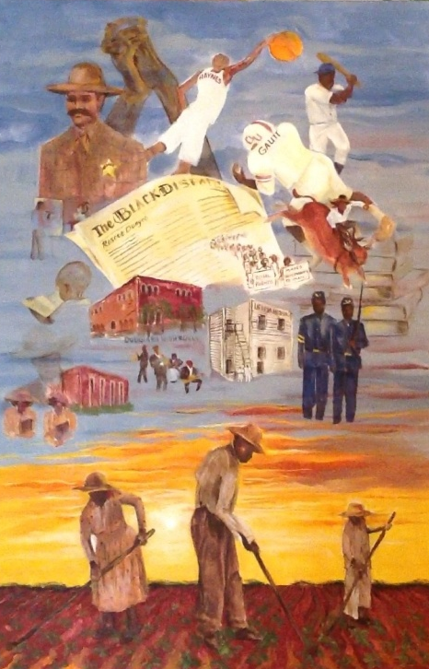

Figure 2. One Hundred Years.
Although Joyce did not explicitly identify herself as Afrocentric, both her artwork and her associations with others, such as Professor Oakes and DWe, suggested that she was on a continuing journey toward becoming more African centered in spirit and consciousness if not in name. Joyce is engaged in ongoing projects with Afrocentric artists. Although her exposure to their views have impacted her thinking, she had not yet explicitly embraced an Afrocentric identity. This is certainly understandable. Black Americans of my participants’ generation have lived through many name configurations associated with their African descent, including Negro, colored, Afro-American, Black, and African American. Joyce views herself as Black or African American. She considers that Afrocentric may be the next name she will live through during her lifetime.
Joyce explains her thoughts and feelings in the following way: “I don't know. That's just the thought that I had. I think there are Black people who feel that they are Black and they have got to make a statement in the world. There’s an entire variety of races and cultures, but if you have that in you as your motivation, then that is what you are supposed to be doing.” Of the four participants, I believe Joyce is most representative of how most African Americans culturally identify themselves. As noted earlier, Joyce is proud to be a Black American.
The final participant was Al Bostick, an African American man in his sixties. Whereas Jahruba and DWe were exposed to Afrocentric ideas during their young adulthood, encountering people outside their southern upbringing immediately after high school, Al was exposed much earlier and more organically to pro African and Pan-African ideologies. In fact, Al’s narrative reveals a natural progression of Afrocentric identity development that unfolded throughout his life. According to Al, early exposure to positive African identities gave him strength of character and affirmed his sense of self.
Al’s childhood experience was relatively uncommon to most African Americans of his generation. One factor involved his birthplace, New Orleans, Louisiana, which retained many African cultural practices. Growing up in New Orleans provided early exposure to multicultural and Afrocentric people, ideologies and thinking. Although Louisiana is a former Confederate state, New Orleans has a unique character. Post enslavement, it blended a variety of cultural influences from its slave holding past. Many African Americans retained ties to their African roots, as evident in the African-inspired development of jazz culture, strong voodoo traditions, and various foods and other cultural influences. Al believes this contributed significantly to his exposure to people with Afrocentric perspectives and identities.
Another factor in Al’s development involved his family, particularly his military father. According to Al, he had the good fortune to experience a cosmopolitan family upbringing. He shared that he was not raised in a typical African American family: “I grew up in a household which was very eclectic… I spent some time in Washington DC with my dad ... his horizons were really broadened ... we also had things from Baghdad, Italy, and Egypt and all over the place.”
Because his father was well travelled, Al felt that he developed a broader view of the world. Knowledge of other peoples, places, and artifacts introduced in the home influenced Al perspectives. According to Al, since Louisiana “was a slave state, I was being introduced to my heritage and background, and as a result of that I wanted to know more about who I was and where I was from.” Al believed his desire to understand his identity and history and his more inclusive way of thinking was observable in his parents and grandparents. Although Al did not characterize his grandparents as Afrocentric, he relayed the memory of his grandparents:
I grew up with grandparents (who), although they were not connected to Africa, were very very sure of who they were. In the realm of slavery. So that they shared with me stories about my great grandparents. I met my great grandparents. My great-grandmother, she lived on the land. They used proverbs in the house, so we're connected. And then when I started, when you do the research, I find that Africans are very fond of teaching lessons through Proverbs. And though we Americanize the proverbs, I, and so I can connect back with my grandmother what's said in some proverb in the book that came from the African continent. And okay then, I have that question. How did she get it? Was it her mother, her mother's mother, her mother's father's father? How far back do we have to go to connect ourselves to that identity which is in us?

Al recognizes that much of his family history involved long-held cultural connections to an African past. These cultural understandings were integrated into his identity from early in his life.
A location of particular significance to Al was The Treme Community Center in New Orleans, an Afrocentric cultural community center run by Pan-Africanists. Al participated in the theatre and art programs there:
I worked for a theater in the community, and it was very Afrocentric. And so there was drumming, there was dancing, there was, um, the rituals that were first connected to the enslaved population. But then letting us know that it was started in Africa and then was brought here. It was brought into Louisiana. So as a result of that, I was immersed in it.
Al reports that the Pan-Africanist director provided direct historical knowledge and practices of African people. The center taught African American art, plays, history, and culture. As a result, Al was afforded a rare opportunity to receive a cultural immersion into his own African cultural heritage. This was also encouraged and supported by his family.
Al began attending college at Grambling University, an HBCU located in northern Louisiana, and studied in the art department. From there he went to the University of Oklahoma eventually ending up in Oklahoma City. In his descriptions of many of his professors' behaviors, they appeared to range from dismissive to culturally insensitive. For example, cultural slights were common occurrences in the theater department at the University of Oklahoma, for example, he and the other Black theater students had to provide their own make-up because the department was unaware of make-up and lighting factors relevant to people of color. Al recounted various arguments within the department when he expressed distaste for doing plays that limited the Black students to servant roles. The instructors insisted that these roles had a fullness to them, and they refused to consider his concerns. Al credits his Grambling professors for preparing him for many future challenges:
That professor said to me, “Yes, I am going to teach you African American theater…but I'm also going to teach Shakespeare and that so that when you’re going to, when you go into their environment, you can do anything.” He said, “But at the same time what I'm going to teach you is that within those cultures, we circumnavigated the globe, we were there too.…so your job is to find out who we were, when we were there in their environment. They do not look at us that way. They look at it from their perspective.”

Al stated that his Black teachers at Grambling anticipated many of the difficulties their students would face. They foresaw the necessity of teaching their Black students to think and perform from an inner place of strength and pride, to know that they belonged in every space and that they were capable of achieving whatever they desired. Al believed he and his peers received training above and beyond the other thespians (theater persons). He claimed they could perform the theater of their culture better than any other culture. His teachers instilled a confidence in their students that they knew he would have to go beyond the doors of the HBCU. As a result of these early experiences, Al believed he experienced far less internal cultural conflict than might have otherwise been the case. In later theatrical events in predominantly white settings, he felt well-equipped to stand up during cultural conflicts. Al’s felt his propensity to speak out on issues of inclusion to his white instructors, to “teach” them lighting, make-up, and alternate casting, indicated self-assurance in the face of oppression due his cultural connectedness.

Culturally Relevant Educational Relationships Provided an Introduction to African Ties
A major finding, beyond the basic fact that culturally relevant arts-based educational relationships did indeed have a significant impact on my participants’ identity development, was that these relationships provided an introduction to their history, their cultural ties, and their African heritage. Each participant possessed artistic abilities and interests that were recognized and validated by one or more influential mentors, and each was provided important opportunities to better understand their cultural connections to their African heritage. For each of my participants, art offered a catalyst for cultural reintegration, connecting them to their cultural heritage as part of a personal journey toward greater wholeness. In a sense, their mentors planted within them the okra seeds to develop their Afrocentric lives.
All of my participants had artistic abilities and interests that were recognized and validated by one or more Afrocentric mentors (mentors/teachers/activists) within the African American community. Through personal relationships with their mentors, my participants were introduced to positive perceptions of Africa and African culture. As the data suggest, my participants’ talents were recognized and validated at various times throughout their lives. This reinforces the fact that becoming Afrocentric, like most forms of identity development, is seldom a linear progression. The process can be a journey of life-long learning and discovery, and so it was for these four sojourners. Each participant’s journey was uniquely his or her own. One participant, DWe, had a single, highly significant Afrocentric influence. Another participant, Al, was part of a Pan-Africanist group in his younger years, while the others had various influential people at key times in their lives that propelled their Afrocentric journeys. The common thread was that all four came from unwelcoming southern roots to live more personally validated and validating African-centered lives.
In the case of DWe, her artistic talents were discovered early in life. DWe describes herself primarily as a storyteller. As a middle-schooler and teenager, DWe wrote and performed poetry and prose, her own as well as that of well-known African Americans. DWe is currently renowned for her historic reenactment plays and storytelling. Her primary talents are her theater productions and oratory skills. In traditional African terminology, DWe might be considered a modern day griot.
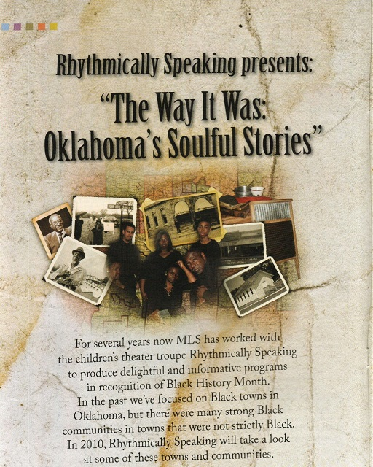
Figure 3. Rhythmically Speaking 1

DWe was born and raised in North Carolina where she also attended a historically Black college. There, she was formally trained in theater education and speech with a focus in creative drama in children’s theater. While in college, DWe met her first proudly Afrocentric person, a college professor named Zora Billie. This professor became her mentor. DWe described Zora Billie as a strong and confident woman.
Under Ms. Billie’s tutelage, DWe was introduced to many African art forms and aspects of African culture. In time, DWe would learn about African sculpture, masks, and history. She stated that in their time together they “would generally be creative.” Ms. Billie constantly encouraged DWe to go on to graduate school, stating that in spite of any obstacles she faced, she would be successful. Unfortunately, Ms. Billie died in a fatal car accident, but her constant encouragement stayed with DWe and propelled her to go on to graduate school. Because she had a mentor who recognized and validated her gifts, DWe continued her formal and informal learning her heritage and culture.
Whereas DWe had one highly influential Afrocentric mentor, Jahruba’s mentors were many and varied, each offering different perspectives for different times throughout his Afrocentric development. As we recall, Jahruba was also a new griot storyteller and musician. However, Jahruba specialized in African “talking drums.” He often incorporated traditional African instruments into his stories. In middle school and high school, he was noted for his musical abilities. He credits an early mentor, a local Civil Rights freedom fighter named Clara Looper, as someone who recognized and validated his gifts. Clara was a high school teacher and social activist who organized sit-ins at downtown diners and store counters in the early days of the fight for civil rights. This local Civil Rights freedom fighter educated Jahruba and the community on the many triumphs of African Americans through nonviolent resistance. Among other things, this local icon, teacher, and social advocate organized and trained students for civil disobedience. According to Jahruba, Ms. Looper:
was very important. I didn't know it, but that changed my life because after that I began to realize I was in a struggle to find out who I am After that. Because she turned on the light to my past and how important it was to for us to connect with Africa.

To help garner support for the movement and educate the whole community, Looper put on several historically based plays about African Americans. Jahruba participated in all of her activities. He recalls: “I went to Clara Looper’s camp in the city, and before we would go to sit-ins, you would have to go to a workshop with her.”
During this time, it was common to teach and prepare students to engage in acts of civil disobedience in church basements, civic halls, and community forums, sometimes referred to as Civil Rights schools. Under Clara Looper’s guidance, Jahruba learned about Black pride. Jahruba observed that during those sit-ins he saw the power of music to sway people’s hearts and soothe their fear and anger. He recalls the specific songs and how they provided courage during the protests. During this time, Jahruba learned about accomplished African Americans in Oklahoma and throughout the United States.
Although Clara Looper’s training and history lessons stayed with Jahruba, he did not yet have a desire to further pursue his African heritage. After a brief stint in state college, Jahruba relocated to Northern California. There he worked as a street musician. In California he encountered international African musicians and drummers. These drummers of African descent from different parts of the globe became his next set of mentors, encouraging the continued development of his talents and cultural growth. He told of how musicians would gather in public parks and play. He often joined them, playing and studying their variations to drumming. Each musician played their native music, using their native drums.
From his earlier participation in the Civil Rights Movement, Jahruba had developed in himself as a Black man; however, he did not yet consider himself Afrocentric. Reflecting on this period, Jahruba was amazed that other people of African descent knew so much than he did about their culture and history. As these park musicians shared their knowledge of music and Africa heritage, Jahruba’s exposure to other Africans of the diaspora sparked his interest in becoming more knowledgeable about his own African heritage. Jahruba credits these sessions for everything he learned about drumming: “So in California that's when I became interested in and I saw a real African culture. Living in Oklahoma I never even saw anybody even dress like African Back in those days but in California it was different.”
Through his experiences in the Bay Area, Jahruba came to the disconcerting realization that many white people could actually name as many or more prominent African Americans as he could. This harsh realization was to remain with him for years. Around this time, Jahruba was contacted by the Draft Board and called to active duty in Vietnam. After his military service, Jahruba used the GI bill to return to college, where he attended San Francisco University. Given the opportunity to attend college, Jahruba pronounced “And I'm going to study me; I'm going to study me.”
Years after their first encounter, Jahruba recalled the pride of “those Africans in the parks,” which came from their knowledge of their own culture: “And once you get that, being you, then I'm really satisfied that there is nothing else that you can tell me about me…You can't insult me anymore. I know who I am and where I came from.” For Jahruba, the Afrocentric path took several years to achieve and many mentors along the way. The path to Afrocentricity is very common among those who consciously choose to make this transition. Conscious and intentional Afrocentric transitions often spark from a series of events or experiences.
Although Jahruba’s to Afrocentricity is common among those who consciously choose to make such a transition, the most common path for the majority of African Americans who make the journey would probably be most similar to that of Joyce. As previously noted, Joyce is a retired public-school art teacher and a full-time visual artist. As a painter specializing in African American skin tones, her work has become well recognized. Joyce's work focuses primarily on African American children and depictions of detailed historical scenes.
Joyce's talents were first recognized during her elementary school years, which ignited her continued interest in art. Public recognition of Joyce’s artistic talents made her feel special, allowing her to be noticed and appreciated by her peers and teachers. However, Joyce did not have Afrocentric mentors until much later in her life. Although as an adult she was aware of Pan-Africanists and others with Afrocentric ideologies, Joyce states that eh had never given these ideas much personal consideration. Joyce’s Afrocentric encounters where principally during two stages in her life, first in college at an HBCU, and later after retiring from a career in teaching.
As a child Joyce, used her artistic talents to help overcome her shyness. Because her elementary teachers and classmates recognized and validated her remarkable drawing abilities, Joyce believes her art helped her build the confidence she would need to go on to college. Attending an HBCU, Joyce met her next mentor, an art professor, accomplished artist, and world traveler. Joyce recalls that her mentor had studied in Paris and spent several years in Central Africa. His artwork and teaching was heavily African centered, an influence still apparent in Joyce's own art.
Joyce's next Afrocentric mentor was one of my other participants, DWe. As an Afrocentric mentor, DWe recognized and validated Joyce's artistic talents. DWe commissioned Joyce to illustrate a children's book and create the backdrops for her plays. Through these collaborations, Joyce was regularly exposed to Afrocentric ideologies, folklore, and culture. Ongoing exposure to Afrocentric mentors gradually increased Joyce’s knowledge and understanding of African and African American culture. Joyce proclaims that she loves being Black. She speaks lovingly of all the beautiful color tones and richness in the pigments when she is painting Black faces. Joyce professes, “I don't know where that really came from, but I always think that I'm Black for reason, you know.” Although Joyce does explicitly identify herself as Afrocentric, her art shows strong indications of her Afrocentric understandings and sensibilities.
Joyce has maintained personal and artistic relationships with her mentors, continuing her growth toward greater Afrocentricity, while simultaneously maintaining skepticism toward the whole thing: “There are Black people who feel that they...have got to make a statement in the world. There's an entire variety of races and cultures, but if you have that in you, as your motivation, then that is what you are supposed to be doing.” Joyce’s comments reveal a certain ambivalence toward being African centered, which is understandable when one considers how Africa is positioned within our broader society. Indeed, all four participants expressed being pushed and pulled to abandon their Afrocentric perspectives and practices. Within this context, Joyce explained her own path:
I think I’m finding my way as far as who I am as an arts person, as an artist, as an on the journey of becoming. You are never really there; it’s a journey. And so you just keep going, keep discovering, keep finding, and you realize it’s not even about paintings that you sell, at all, or that other people see, although you should share, but it’s about growing. Growing. You and my growing is through the arts.

While Joyce expressed the greatest reluctance to accept and acknowledge an African-centered identity, the person with the deepest roots in Afrocentrism was Al. Al was the participant most likely to be considered a renaissance artist. He is an actor, dancer, painter, and, most importantly, a cultural griot. Al’s introduction to Afrocentricity began at a much younger age, and his path unfolded more organically than those of the other participants. As such, Al’s narrative reveals a more natural progression throughout his entire life. The mentors who most influenced Al’s Afrocentric progression began within his family and included a Pan-Africanist cultural center within his community.
Through his military father, Al was continually exposed to world cultures. His Afrocentric development continued when he and his mother moved to Louisiana with its large, intact, African American populations. A long history in the same place enabled Al to participate in, maintain, and become more cognizant of African cultural practices. While in Louisiana, Al’s family encouraged his involvement in a Pan-African/Afrocentric community cultural center that taught African art and culture.
The Pan-African/Afrocentric Community Cultural Center was essential to Al’s development. Al spoke of his early experiences learning more Afrocentrically and refining his arts at the center: “like whenever I do my paintings, my paintings carry my images. They carry the wide nose, the dark brown skin, um, the accomplishments we did when we were brought here to help build this place. You know, because you can only do that through identify.” According to Al, the center made sure students had a full and complete history of themselves both here in America and back in Africa, before enslavement. Recalling his time he felt truly connected, Al stated, “so anything I do with Art, most of my friends would tell you, I argue for my identity in that particular piece. You know whether it’s dance music or theater. We have to see ourselves, to be ourselves. And if we don’t see ourselves, it’s not us.” Because of those two early cultural influences in particular, Al believed he had developed a consistent recognition and validation of his Afrocentric identity.
Of the four participants’ cultural experiences, it could be argued that Al’s Afrocentric journey is a model example of early, consistent, cultural development among children. Due to his organic exposure to his cultural history, Al's Afrocentric development became deeply integrated into his personality and was clearly definable in his art work. However, recognition and validation of the artistic talents of all four participants provided an important introduction to their African heritage. The next juncture would be more difficult and fluid, involving the integration of cultural connections into an increasingly complex Afrocentric identity.
Although the arts were the conduit through which my participants were exposed to their history, the larger point is that each of them had one or more Afrocentric mentors who helped them develop cultural connections to their African heritage. Through these relationships, each participant developed a more Afrocentric identity than would have otherwise been possible. In many small ways, remnants of African culture have been retained in African American communities. As the participants became more aware of these remnants, they became more socially, personally, and spiritually connected to Africa. After learning about African perspectives and practices, they were better able to recognize African influences within African American culture. We can still see these influences – these carryovers from the past – in our families, our worship, our art forms and more, if we know how to recognize them. One of the most important gifts of my participants’ mentors was the ability to see what has never completely disappeared. Throughout the study, my participants shared numerous ways in which they feel their connections to Africa.
Al recalled his ongoing exposure to Afrocentric ideas, noting that “there are stages in my life that I again realize that I am truly connected to Africa” As one of many examples, Al shared that he felt transformed by his new understanding of African dance:
When I took an African dance class…the movements spoke to me naturally. There was a sense of freedom, I felt, in terms of moving my body, and then, and doing the research to find out what African dance truly means. Like they dance flat-footed, which showed their connection to earth and God.

Other examples of Al’s cultural transformation involved times he was physically and emotionally moved by African artifacts and performances. For example, he recalled:
You know, a mask will speak to me. When I went, I go into a museum, I'm going to the mask area. It’s like you can feel the ancestors. I actually feel connected to them. There is a serenity that, that comes over me...that makes me feel like I am beautiful. Like someone took the time to carve or sing or paint something that is connected to me, culturally. Then there is – there is no peace like that. I am, then I know who I am. I don’t have to worry about who I am, or being lost, or what have you. I know who I am.

Like Al, Jahruba also expressed feelings of deep connection to African culture through African items, artifacts, and the playing of traditional African instruments. Jahruba offered an explanation of his spiritual experience: “So that stuff jumps out at you, when you see, when you see it. Nobody has to tell you ‘that is African.’ It kinda’ jumps out at you, and you feel it, and you might not know what it means, but you can feel it.” After being exposed to African culture, learning from Africans throughout the diaspora, Jahruba expressed feelings of connection to his African past. He described feeling a sense of connectedness “to the African inside” when singing, when drumming, when teaching himself new instruments, “in the ways the elders taught back in the villages.” According to Jahruba:
You've got to think African. And so my idea is I wasn’t born in Africa. Africa was born in me so, so everything is Africa to me. So when I see something that came from the continent like [gets up and picks up a carved drum]…when I see something that comes from Africa like a drum like this. And so, “Is this drum Afrocentric, and am I Afrocentric for wanting to play a drum like this?” But I feel like this drum, it feels like I can see that campfire where he played in that little village, and the singing songs, and they're singing praise songs, and they’re singing harvest songs…

Jahruba described passionate feelings of cultural reconnection to his African heritage. His understanding, expressed especially through music, is that knowledge was what helped him make this transition back to being an African who happens to be from America.
Like Al and Jahruba, DWe also internalized African history and culture as part of her identity. She shared, “knowledge of our history and folklore can guide and inform our lives. Knowing our history gives us a strong sense of who we are.” Similar views were expressed by Al, who often paraphrased the words of Chester Higgins: “We are of Africa. Even though we no longer live in Africa, Africa is within us, therefore we remain within Africa.” When asked whether he would perceive these connections to African culture and heritage if he had not known his mentors, Jahruba answered, “Africa just speaks to me, okay. From the music to the people, like I say, ‘It’s just in me.’…Was I this way before I learned about Africa? I think my environment dictated to me about Africa because they didn’t let Africa in.”
Finally, like the others, Joyce also expressed feelings of deep connection to her African American heritage. She insisted that her strongest connections were through her art. According to Joyce, “I do know that I am African American, and I am Black, and it is just an experience that is probably different, but I also believe that every individual experience is different.” This was an acknowledgement by Joyce that there is more than one way to be Afrocentric, that everyone must discover for him or herself how they will make the cultural connections and to what depths they will allow themselves to be carried along Afrocentric streams of consciousness. I believe Joyce is a proud African American who is not yet fully conscious of her African identity, an identity that is nonetheless revealed through her art. As Joyce acknowledged, “the arts helped me to touch a part of myself that I wouldn't know about otherwise.” In Joyce’s art we see traces of the influences of her Afrocentric mentors and, through them, the history and culture of the Africans who inevitably have impacted us all.
In the South, African culture has long been rendered taboo within the Black community. Yet, cultural remnants that remained hidden during enslavement provided material and allowed participants rediscover an African culture that “was and is still here” (Rampersad & Roessel, 2006, p. 39). My participants now know themselves to be Africans, but they needed their mentors to reintroduce them to the Africa already inside of them. Through culturally relevant educational relationships, they have recovered cultural jewels that have enabled them to integrate Afrocentric ideas into their social identities. As they have continued their journeys toward wholeness, their Afrocentric identities have provided resiliency against the material and ideal conditions of racism.

Culturally Relevant Educational Relationships Encouraged and Supported Critical Consciousness
In addition to introducing African history and heritage, culturally relevant arts-based educational relationships with Afrocentric mentors also encouraged, nurtured, and sustained the development of critical consciousness. Art has long been a vehicle to express the social political conscious of oppressed, voiceless, and marginalized communities “in the tradition of the griot, or West African storyteller, and the knowledge that racially oppressed communities must tell their stories to survive as well as challenge racism” (Buras, 2011, p. 45). As new griots, my participants were culture-keepers, teachers, and storytellers, constructing counter-narratives to majoritarian stories of racial inferiority. One of Al’s counter-stories was a painting responding to the juxtaposition of the concepts “Black and ugly,” originally created by the majority community, but perpetuated in communities of color. Al lamented, “They systematically beat down children in our culture. And our children will look at things, and the parents, and the parents are equally as guilty, because it’s...generational….so I got a painting in here that is called, The Blacker the Berry. I’ve got a girl who is blue-black, and I juxtapose her with an orange so she looks even darker” (Figure 3). Al’s desire was for Black children to see the beauty in their dark skin, regardless of what society portrays as beauty.
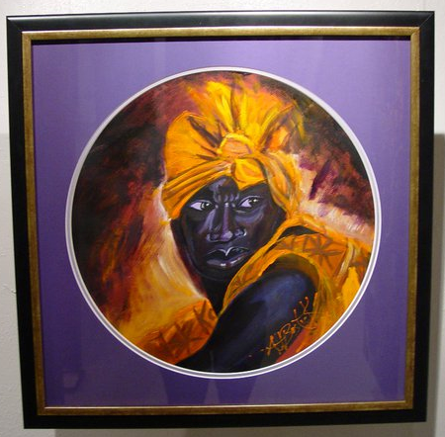

Figure 4. The Blacker the Berry.

As another example of an Afrocentric mentor encouraging the development of critical consciousness, Joyce created a series she called “intersession angels.” Joyce explained that these were angels passing through portals, coming to offer or advise alternative paths to African American youth “making poor decisions.” This work counters the story that Black youth have no direction, no guidance. As another example, Jahruba created and played percussion instruments whose origins could be traced to Africa, sharing counter-stories with music emanating from African instruments.
Similarly, DWe sang epic stories of African American heroes and sheroes. According to DWe, “Even though the consciousness of what slavery was all about maybe does not exist the same, it’s the way that slavery worked in such an insidious manner that … (has) as much to do with why [color issues] stay alive...because we still have issues about good hair, and those terms still come up.” From the perspective of my participants, the necessity of counter-stories is still quite apparent. An oppressed people does not readily walk away from negative imagery applied by their oppressors (Fanon, 2004; Freire, 2000; Kincaid, 1988).
In opposition to dominant cultural norms, my participants viewed African culture and art as a way to express love of community, love of self. Rejecting majoritarian narratives, they had learned to love African skin tones, hair types, facial features, body types, vocal intonations, and physical presences. With this as a starting point, their counter-stories sought to teach other African Americans to love our phenotype and to love where we came from – the African continent. According to Jahruba, it is essential for people of color to embrace their culture with “feeling, love, awe, and education…and if…people try to destroy this history, that art stands as a testimony of what you know. That art work stands as our testimony.” DWe concurs: “Knowledge of our history and folklore can guide and inform our lives. Knowing our history gives us a strong sense of who we are.”
Two important motifs in African American folklore are the people returning home, and people remembering they can fly. Al discussed Virginia Hamilton’s retelling of a favorite story:
the imagery is so beautiful, and the idea is so powerful because that the first statement in the book is “The people could fly, don’ cha’ know.” And we here have forgotten how to fly. We have forgotten how to fly. It’s our culture that allows us to fly, that gives us the wings. Our culture gives us the wings, so if you know who you are, you can fly.

Knowing one’s history is vital, not only through parables and stories, but also through rigorous study. Woodson (1933) offers this warning, “Those who have no record of what their forebears have accomplished lose the inspiration, which comes from the teaching of biography and history” (p. 6). Just as parables and folklore offer moral grounding, studying our histories via African and African American scholars can provide much needed historical grounding. My participants felt it was important for African Americans, especially our children, to learn their history from people of color. As has been said, only a fool would allow his oppressor to educate his children (Fanon, 2004; Woodson, 1933).

Culturally Relevant Educational Relationships Helped Develop and Fulfill a Sense of Obligation and Commitment to Other African American People and Communities
Finally, beyond introducing African history and heritage and encouraging, nurturing, and sustaining the development of critical consciousness, culturally relevant arts-based educational relationships with Afrocentric mentors also appeared to foster a sense of obligation and a commitment to pay forward one’s cultural knowledge and art. Just as my participants each had mentors who acknowledged their talents and nurtured their growth, so did they strive to serve others while continuing their own cultural recovery by sharing their knowledge and talents. Three of the participants were Griots (storytellers, culture keepers, historians), and all four were educators.
In these roles, all four participants expressed and fulfilled a sense of obligation to their people and communities. For example, each of my participants was involved in creating and/or maintaining some form of Afrocentric art center. Joyce was an original member of the Ntu Art Association of Oklahoma City, Inc. (Ntu). Part of Ntu’s mission is to provide a permanent art and cultural building in the Northeast community, a historically Black neighborhood. Since its inception, Ntu has continued to maintain community spaces for the arts, for local history collections, and for cultural artifacts.
DWe, on the other hand, developed an arts curriculum that brought together youth and elders to create and produce historical reenactments. DWe developed and maintained relationships with performing arts schools and other artistic programs, maintaining an active presence with students of color. As DWe stated, “I wanted my own children to learn from people that were like them so that they knew you could learn from African Americans.” She continues to develop and create an Afrocentric art curriculum available primarily to vulnerable populations.
Jahruba, too, has maintained a public presence. He can often be seen holding drum circles in public art spaces, recreating the likeness of an African village center, a gathering place for all the people. Just as the griots who have gone before him, Jahruba brings several drums to the center and invites the public to join him, drumming and learning. Imparting his wisdom to his audience, in many ways this is the continuation of his art center, an art academy camp featuring African drumming and heritage. His school’s curriculum and goals are designed to offer authentic opportunities for students to explore and develop their love for the arts.
Finally, in recognition and praise to the Treme center, Al expressed a desire for an African cultural center similar to the one he attended in his youth. Al was a founding member of several African American art projects over the years, and dance remains an intricate part of who he is. Al is especially proud of a dance group he developed:
I started an all-Black company here in Oklahoma years ago which was called Black Moves 2, and our theme was (that we were a) modern dance company with a primitive center. That’s the way we called it. So we started our bases with African movement and then layered every other dance form on top of that. So identity is important. And again, when you know who you are, what you are about, no one can take that away from you. No one. And it exudes power, and our children need that right now.
In providing these services to future generations, each of my participants also renewed and refreshed their own cultural connections. Here, again, are the fundamental ideas of Ubuntu and the African Sankofa, that we must go back to our roots in order to move forward, living for the “betterment of our environment, using all talents at [our] disposal…not resting easy knowing that another is in need…based on the understanding that any good or evil we do to another person or people, we are actually doing to ourselves” (Malunga and Banda, 2004, p. 11).
As new cultural Griots, my participants remain life-long learners, extending and expanding their cultural knowledge. They are empowered by learning, and they empower others through their teaching. Each appeared to perceive an obligation to their mentor to “pay it forward,” to pass on their knowledge and positive perceptions of Africa and African Americans to others.

CHAPTER FIVE: SUMMARY OF FINDINGS AND IMPLICATIONS FOR EDUCATION

Summary of Findings
This study was based on the question: What impact, if any, have culturally relevant arts-based educational experiences and relationships had on the identity development of four Afrocentric artists/educators? The study was located within the context of a history of traumatic ideal and material conditions of racial oppression that continue to negatively impact African Americans and other marginalized members of society. I wanted to explore Afrocentric identity development as a possible means of resisting and overcoming oppressive and racist conditions and to consider the implications for critical, culturally responsive education. Among other things, I endeavored to capture four powerful counter-narratives chronicling each participant’s path toward the achievement of greater cultural integration and wholeness. Each of the four participants experienced a unique journey toward developing a more culturally integrated, more whole, more Afrocentric identity.
Although each participant experienced a unique journey toward becoming more Afrocentric, collectively their journeys offer insight into what identity recovery might look like for others, including both African Americans and other marginalized peoples who have suffered and continue to suffer from cultural identity loss within the continuing context of white supremacy. These insights may provide important possibilities for education as a means of promoting personal and social emancipation through identity recovery. Among other things, the findings support the use of collaborative teaching and learning to reclaim the authentic histories of people whose histories have been lost, often intentionally torn from them to ensure their continued subjugation. My hope is that the insights provided might be of assistance in helping others experience their own Sankofas.
Each of my four participants experienced a unique journey toward becoming more Afrocentric. I have attempted to retrace the trajectories of the participants’ personal paths, exploring how each came to live a more historically and culturally informed life. Yet the participants’ personal journeys also offer insight into what identity recovery might look like for African Americans in general. It can be argued that those who choose to become more Afrocentric, more culturally and historically aware of their African heritage, are likely to follow one or more of the paths similar to those taken by these participants. However, just as there is not one right way to be African American, there is not one right way to be Afrocentric. A personal journey toward cultural reintegration is just that, a personal and unique journey that each person must take in her or his own time and space. The study spotlighted the unique journeys for each of the four participants. One goal of the project was to honor the personal courage of each of the participants in their attempts to live in more culturally connected ways to their African heritage within the context of their personal art – all of this while allowing their art to educate, to heal, and to raise critical consciousness, both theirs and ours. I revisit their journeys.
DWe’s Afrocentric journey was probably the most linear story. DWe’s situation, involving only one major Afrocentric influence, follows the simplest logical pattern in relation to the findings. Throughout her life, DWe had some knowledge of African American history. Her greatest cultural growth took place in college, an HBCU, where she encountered her mentor and began a full cultural immersion into her culture and history beyond simply the learning of African American history. Nearly forty years later, her cultural transformation into deeper identity integration remains evident in her arts and her lifestyle today. DWe’s transformation story is a typical experience for many students of color who discover a highly influential mentor or teacher, whether through college, work, social activism, or prison, that who teaches them about what it meant and means to be African before and beyond enslavement.
The next most common experience may be similar to Jahru’s. Early seeds of knowledge were planted with his exposure to the social activism of the Civil Rights struggle, to the work of international African artists, and his formal education in African and African American Studies (known then as Black Studies). The main difference between the Afrocentric growth of Jahru and DWe was that DWe had one mentor while Jahru experienced many influential mentors throughout his various life stages. Jahru’s experience was less of an intense immersion and more of a continual process of growth. Experiences like Jahru’s may be common for many African Americans who consciously attempt cultural integration.
Joyce’s story comes closest to representing the broadest group of African Americans. Joyce had a general awareness and knowledge of African American history but few opportunities to learn and study African history. Even though Joyce is proudly African American, her experiences and identity were influenced by external conditions and labels – colored, Negro, Black, Afro, African American – usually not of her volition. Afrocentric influences for Joyce included people she met later in her life. Unfortunately, experiences encountered during later in life cannot influence identity formation during life’s formative periods and major transitions. This was very much the case for Joyce, who, although at times seemed interested in extending herself toward an Afrocentric identity, was never quite able to fully embrace the lifestyle and changes it imposed.
Al’s Afrocentric journey was rare, having been introduced to multicultural perspectives, including Afrocentrism, at a very young age. Through his father’s military travels, Al was introduced to multiple cultures. Through the cultural congruency of New Orleans’
African American communities and exposure to Pan Africanist perspectives, Al was afforded continual teaching and learning involving his African heritage. Based on the fundamental goals of culturally responsive education, Al’s journey may have been the most conducive to the development of a strong cultural identity. From the perspective of culturally responsive education, an ideal would be to for students of color to experience culturally connected teaching and learning throughout their lives, supported not only in schools but also in their homes and communities (Delpit, 1995; Gay, 2000; Hilliard, 1995b, 1995c, 1995d; Moll & Cammarota, 2016).
Although cultural integration, like language acquisition, is valuable at any age, it is most effective if experienced during the formative years (Perani, Paulesu, Galles, Dupoux, Dehaene, Bettinardi, Cappa, Fazio & Mehler, 1998). Yet, most African Americans do not have ready access to mentors with a strong understanding of African history and identity, and even those who do possess such knowledge may not be willing to openly express their Afrocentric identity. Some African Americans live an outwardly Afrocentric lifestyle for a time, expressed in their clothing and hairstyles and reflected in the practice of traditional African languages and/or religions, only to return to more socially acceptable stances. This is not to insinuate that genuine commitment and connections are abandoned, but to acknowledge that they are often practiced more subtly.
Since living in an Afrocentric way often means living in stark opposition to majoritarian cultural norms, each of my participants experienced and exhibited social and economic consequences for choosing to live their lives and create and perform their arts in culturally connected ways. It is therefore understandable that individuals at different times in their lives may choose to live in more or less outwardly Afrocentric ways. Just as natural hair can be perceived as a political statement for Black women, choosing to live outwardly Afrocentric is often seen as radical. Additionally, choosing to focus on African or Black art can be less financially viable than following more assimilationist approaches to art production. Nonetheless, these participants chose to live Afrocentric lives, to live holistically, to produce Black and African art, and to pass their cultural knowledge on to the next generation. Choosing to visibly identify as Afrocentric can take extraordinary courage, yet it is essential to disrupt majoritarian perceptions. This is what my participants chose to do.
There is a saying that African American children “cannot be what they cannot see.” The presence of educators like these Afrocentric participants, who are willing to show up in classrooms, libraries and community events, proudly displaying their cultural heritage, can provide a brief reprieve for children who are so often marginalized by majoritarian ideologies. For that period of time, in that moment, in the presence of the elders representing their African heritage, the child is at the center. For this brief time, the child is the subject rather than the object, the other. If there is to be any hope in disrupting long-standing social inequities, colleges of education must recognize this need and participate in teaching cultural connectedness as a primary function of self-reflective praxis in teacher education.
The data clearly indicate that my participants’ personal art has had a significant impact on their cultural identity development. Each participant reported that art has played a crucial role in their identity formation and that art continues to be an intricate part of their daily lives. The data revealed three findings in particular. First, culturally relevant arts-based educational relationships provided an introduction to African and African American heritage. Second, culturally relevant arts-based relationships nurtured and encouraged critical consciousness. Third, culturally relevant arts-based educational relationships served as a means of developing and fulfilling social obligations and commitments to the African American community by passing forward one’s own Afrocentric knowledge and wisdom.
With regard to the first finding, that my participants’ culturally relevant arts-based relationships provided an introduction to their African and African American heritage, enslaved Africans were historically forbidden by custom and by law to practice their cultural customs. Generations later, long after the end of physical enslavement, the afterlife of slavery perpetuated taboos against openly maintaining and practicing African traditions and customs. Through the perpetuation of these formal and informal mechanisms, Black folk lost much but not all of their African heritage. Over the centuries, many African Americans have continued to find ways to remain connected to their distant past. This was the case with my participants whose personal art provided means of re-introduction to their cultural ties to their African heritage. Through various forms of art, my participants’ mentors helped cultivate creative ways of understanding and dealing with African American history. Three of my four participants had limited opportunities during childhood to learn about Africa and African Americans. However, at different stages in their lives, each encountered others with the cultural awareness necessary to teach them about their Black heritage. Only Al was fortunate enough to have had early and consistent exposure to African American cultural knowledge.
The second finding was also confirmed as each participant demonstrated, repeatedly, that their culturally relevant relationships encouraged, nurtured, and sustained their critical consciousness. Each participant indicated that they nurtured and maintained themselves through these relationships. In spite of what others may have wanted or expected of them, they continued engaging with others as they created and produced their art, and this persistence indicated their resolve to remain true to themselves. As a result, their personal art and arts-based relationships helped each participant build inner strength and knowledge that could be passed to the next generation.
My participants also found their culturally relevant relationships to be healing and fulfilling. Each believed his or her arts-based relationships helped build resilience to the daily negativity experienced by African Americans and other visibly identifiable ethnic groups. Collectively, they discussed many ways in which these relationships have been a healing balm, nurturing mind, body and soul.
Another factor was that for these Afrocentric artists/educators, their arts-based relationships were both financially and emotionally sustaining. On the one hand, their personal art was a means of making a living. On the other hand, it was their ability for self-expression. Through their art and arts-based relationships, they expressed their love and appreciation of Africa, of the people of the African diaspora, and of African American culture. In their arts and relationships, each clearly critiqued power differentials and social inequities in our society. Their arts-based relationships provided a path, a way to recover their cultural identities. For these participants, these relationships were a catalyst to cultural reintegration, a means of striving toward wholeness.
The third major finding was that the participants’ culturally relevant arts-based relationships served as a means of establishing and fulfilling a social obligation and commitment to pass their Afrocentric knowledge and wisdom forward to others within their community. One of the ways my participants realized and maintained their cultural recovery was through sharing their knowledge and talents with others. Each respondent expressed a deep-seated need to pass on the information they had learned throughout their lives. This was a self-imposed responsibility tied to each of their personal perceptions of being African centered. The participants indicated that their desire to serve had been empowering not only to themselves but also to others.
Through continual teaching and learning, my participants not only achieved and maintained their own cultural integration but also reached out to others in much the same way their mentors had reached out to them. In this way, they appeared to live the African axiom “each one, teach one,” which acknowledges responsibilities of outreach and reciprocity. As educators, as artists, as cultural griots, my participants’ counter-stories helped perpetuate positive perspectives of African Americans’ lived experiences. As modern day griots, they assumed personal responsibility as social historians and keepers of the culture. As Afrocentrists, these artists/educators represented a return to African tradition, embracing African philosophies such as the philosophy of Ubuntu.
Taken together, these findings support and extend existing ideas on critical race theory, culturally responsive pedagogy, and critical ethnography. According to Buras (2014), critical ethnography as ethnographic research involving critical praxis can allow marginalized peoples to write themselves back into humanity, countering majoritarian stories that have written them out of dominant histories and otherwise marginalized them in society. The Afrocentric artists/ educators who participated in this study were counter-storytellers, reaching back in time to recover and reconstruct what had been taken, their histories and their cultures. Their art was their gateway to their Afrocentric identities.
As cultural griots, such storytellers can counter destructive majoritarian narratives of African Americans and other marginalized groups, offering positive counter-narratives, emic stories of their own lives, histories and cultures, rather than etic constructions composed by others. Individually and collectively my participants told a counter-hegemonic story of Africa and the people of the diaspora, a more complete history of Africa and African-Americans, shining new light on their own and others’ perceptions. Their new, Afrocentric prism allowed them to turn their gaze from object to subject, directing the light back onto themselves as well as outward toward their community. This enabled them to see themselves in new and different ways, incongruent with the apartheid society around them. Their new sight allowed for personal growth, leading to critical questioning of the society they lived in, and this critical consciousness, spurred by greater understanding of their history and culture, was their awakening.

Implications for Education
What are the implications of these findings for teaching and practice? There are many possible conclusions that could be drawn from the data, but three main ideas come to mind. First, we need to focus on cultural identity development in preservice education because teachers need to understand and value their own cultural backgrounds – and the value of diversity in general – in order to support their students’ cultural understandings and development. Second, one way to promote culturally-responsive growth is to make cultural connections via self-reflexivity in all classes. It is important to ensure that this is incorporated across the curriculum to help ensure that the teaching and valuing of culture will no longer be treated and seen merely as an add-on. Finally, higher education needs to advocate and support meaningful connections within local communities so children can begin their development early and continue throughout their lives.
Focusing on Cultural Identity Development in Preservice Education
One of the major implications of this study involves the need to focus on cultural identity development in preservice education. This is essential because teachers need to understand and value their own cultural backgrounds as well as the value of diversity in general in order to support similar development among their students. If we are serious about promoting healthy identity development in schools, it makes sense for culturally relevant pedagogy to seriously inform the praxis in pre-service teacher education programs. Until teachers have reconciled their own cultural disconnections, they will have limited ability to help students become culturally whole.
Afrocentricity can be a starting point for African Americans, but any ethnocentricity can be a beginning. We all have a culture heritage, and many have multiple heritages. Who we were is vital to understanding who we are. Every ethnic culture is indigenous to a land, and every indigenous culture had storytellers who spun the epic tales, fables, songs and poems that told of their lineages and heroic deeds, of who the people were. In African philosophical terms, our ancestors only die when we forget to tell and retell their stories; to call their names. We need to reconnect to our cultural heritages, to re-call our ancestors’ names, to name who we were in order to reclaim our wholeness.
Because we cannot give a gift we do not possess, it would be very difficult for preservice teachers to teach in culturally responsive ways until they have managed to comprehend culture, their own cultures, and the value of culture in general. By honing in on their own cultural heritages, pre-service teachers could begin to recognize that we are all cultural beings, and that culture matters. In this way they would be better positioned to guide and encourage the cultural recovery, development, and integration of their own future students.

Teacher-Education: Cultural Connections Through Self-Reflexivity in All Classes
Teacher-educators already recognize the value and necessity of self-reflection (Schon, 1987; Cochran-Smith & Lytle, 2009). However, culturally relevant pedagogy has not yet been sufficiently implemented across the curriculum in teacher education. Culturally relevant pedagogy could be relatively easily incorporated into the reflection component of any lesson in any subject. First, students would need to be guided in identifying and meaningfully connecting to their cultural heritages. Both white students and students of color would need to engage in cultural identity recovery. Assignments would include cultural self-reflection as an aspect or dimension of the overall reflection that occurred as part of a course reading or following the teaching of a lesson.
My recommendation would be for students to first reflect on their own cultural heritage, identifying connections (and disconnections) with their assignments and lessons. Next, they should expand their focus, reflecting on their culture’s relationships to power and privilege within society. Continual attention to culture, privilege, and power would promote not only a deeper understanding of each student’s heritage, but also greater sensitivity to the plight of others. For all students, but especially white students, it would be important to learn about the Western creations of “whiteness” and “cultural othering” – about how the cultural heritages of white Americans have been erased and blended (Roediger, 2005; Fasching-Varner, 2014). Recognizing the value of one’s own culture, the extent of one’s own cultural loss, and the oppressive mechanisms involved in cultural invasion can help create empathy and understanding for others necessary to engage in further critical reflection.
Ideally, this would need to occur in all classes for two reasons. First, developing a critical cultural consciousness is not a simple task. In a society in which people of color and whites alike have been denied access to their traditional cultural roots as part of the price of acceptance into the broader culture, there is much work to be done in the quest for cultural recovery. This cannot be accomplished with limited effort. Second, efforts at promoting cultural reintegration and critical consciousness have often been viewed as add-ons to the curriculum. This creates the impression that such activities are not essential when, for African Americans and other historically oppressed populations, at least, there may be no more essential endeavor than to recover our identities and develop the capacity to resist and transform the ongoing legacy of white supremacy and racism.
I believe teacher education programs need to refocus preservice education to value and support their students’ cultural understandings and development. It is important to ensure that this is incorporated across the curriculum so the teaching and valuing of culture will no longer be seen and treated merely as an add-on. Banks’ (2003) early work included the creation of a system to integrate multiculturalism into the curriculum in four progressive levels, which he called contributions, additive, transformation, social action. Unfortunately, most teachers only attempt the first two levels of multicultural integration. Teachers’ failures to move on to the transformation and social action levels have opened Banks’ work to criticism. Some CRT educators ridicule his work as superficial. I disagree. The application of his process is superficial. My fear is that teachers will likewise apply minimal effort to cultural recovery.
Another concern is that although cultural recovery might be pursed in earnest in the beginning, later on it might begin to be glossed over by superficial attempts at cultural recovery through arts-based relationships. To help build positive cultural experiences for students, especially students-of-color, teachers must first understand and value their own cultural backgrounds and the value of diversity in general. Only then can they begin to value the cultural diversity of their students (King, 1991).
To promote culturally-responsive growth, preservice teachers must begin making cultural connections for themselves via self-reflexivity. White students may feel that focusing on cultural identity is divisive. Joyce King (1991) believes what comes across as hostility toward diversity is often her students’ expressing feelings of guilt:
The real challenge of diversity is to develop a sound liberatory praxis of teacher education which offers relatively privileged students freedom to choose critical multicultural consciousness over dysconsciousness. Moving beyond dysconsciousness and miseducation toward liberatory pedagogy will require systematic research to determine how teachers are being prepared. (pp. 143-144)
To avoid half-hearted efforts as we strive for liberation, I believe all preservice teachers should be required to take several ethnic studies classes in African studies, Latino/Latina studies, Native American studies, gender studies, and so forth. These courses could be very effective immersion experiences. As white teachers grow to understand that they too have ethnicity and culture, it could help build empathy toward people of other cultures.
I acknowledge that the system is highly resistant to change. It is unrealistic to expect colleges of education to send students outside of their department to make these cultural connections. There are time and budgetary concerns. So then what? One possibility would be for education programs to partner with ethnic studies, with teacher education programs offering pedagogy and training for non-majors to create cross-listings and income generating courses. With more ethnic studies students being exposed to teacher education, there would be the possibility of increasing minority enrollments.
On the other hand, higher education could serve as a conduit, bridging public school systems and local communities. Since public schools are unlikely to readily adopt such policies, colleges of education could help create public-private partnerships to connect children with local cultural artists/educators. Educators, like the four participants in this study, could increase the numbers of children and adolescents with whom they work while teacher education programs would gain authentic cultural teachers to build arts-based experiences and relationships. Reminiscent of Deweyan laboratory schools, these spaces, Sankofa schools, could provide innovative spaces for praxis for marginalized students. This could be a win-win situation for communities of color, colleges and universities, culturally grounded artists/educators, and children beginning their ethnocentric development early enough to continue throughout their lives.
Supporting, Advocating, and Connecting with Local Communities
Finally, practitioners in higher education need to establish, advocate, and support meaningful connections within local communities of color. This is essential in order for children to begin their cultural recovery early and to continue it throughout their lives. As documented throughout this study, African Americans are bombarded with images and language that portrays them in a negative light. Encounters with negative perceptions begin at very early ages. Each of my participants had many racialized experiences throughout their lives, and these conditions have not gone away. Sustained exposure to such experiences without intervention contributes to the continuing damage of countless children’s and adolescents’ self-images.
Local cultural centers like Al’s Treme Center could exist throughout the state and across the country. Recognizing the need to begin early, local mentors, artists, and activists have taken a lead in developing and maintaining spaces for cultural recovery and growth. However, there is a need for continued development into adulthood and throughout life. Cultural identity recovery needs to occur in all spaces, both formal and informal, public and private. For this reason, it is imperative that teacher education programs partner with local communities to create a continuity of growth that can transcend generations.

References

Ani, M. (1994). Yurugu: An African-centered critique of European cultural thought and behavior. Trenton, NJ: Africa World Press.

Anyon, J. (1981). Social Class and School Knowledge. Curriculum Inquiry, 11(1), 3-42. doi:10.2307/1179509

Anzaldúa, G. (1987). Borderlands: la frontera (2nd, ed). San Francisco: Aunt Lute.

Anzaldúa, G. (1990). Making face, making soul =: Haciendo caras : creative and critical perspectives by women of color. San Francisco: Aunt Lute Foundation.

Asante, K. W. (Ed.). (2002). African dance: An artistic historical and philosophical inquiry. Trenton NJ: African World Press.

Asante, M. K. (1991). The Afrocentric idea in education. The Journal of Negro Education, 60(2), 170-180. doi:10.2307/2295608

Asante, M. K. (1995). Afrocentricity. Trenton NJ: African World Press.

Asante, M. K. & Asante, K. W. (Eds.), (2002). African culture: The rhythms of unity. Trenton NJ: African World Press.

Asante, M. K. & Karenga, M. (2006). Handbook of Black Studies. Thousand Oaks, CA: Sage Publications.

Asante, M. K. & Ravitch, D. (1991, Spring). Multiculturalism. The American Scholar, 60(2), 267-276. http://www.jstor.org/stable/41211906
Bailey, R. (2010). Neither Carpetbaggers nor Scalawags: Black Officeholders During the Reconstruction of Alabama 1867-1878. Montgomery, Al: New South Books.

Banks, J. A. (1991, Summer-Fall). Teaching Multicultural Literacy to Teachers.
Teaching Education, 4 n(1), 135-44 Sum-Fall

Banks, J. A. (1992). African American scholarship and the evolution of multicultural education. The Journal of Negro Education, 61(3), 273-286. doi:10.2307/2295248

Banks, J. A. (1995). Multicultural education: Historical development, dimensions, and practice. In J. A. Banks & C. A. M. Banks (Eds.), Handbook of Research on Multicultural Education (pp. 3-24 & pp. 617-627). New York, NY: Macmillan.

Banks, J. A. (Ed.). (1996). Multicultural education, transformative knowledge, and action. New York, NY: Teachers College Press.

Banks, J. A. (Ed.), (2009). The Routledge international companion to multicultural education. New York, NY: Routledge.

Baldwin, J. A. (2003a). Fifth avenue uptown: A letter from Harlem. Nobody Knows My Name: More Notes of a Native Son. Alexandria VA: Alexander Street Press LLC. S11366-D003

Baldwin, J. A. (2003b). Notes of a native son. Nobody Knows My Name: More Notes of a Native Son. Alexandria VA: Alexander Street Press LLC. S11366-D003

Behar, R. (1997). The vulnerable observer: Anthropology that breaks your heart. Boston: Beacon Press.

Bell, D. (1980). Brown v. Board of Education and the Interest-Convergence Dilemma. Harvard Law Review, 93(3), 518-533. doi:10.2307/1340546

Bell, D. (1992a). Faces at the bottom of the well: The permanence of racism. New York, NY: Basic Books.

Bell, D. (1992b). Faces at the bottom of the well: The permanence of racism. [Kindle DX version]. Retrieved from Amazon.com

Bell, D. (2016). Who's afraid of critical race theory? In A. D. Dixson (Ed.), Researching Race in Education: Policy, Practice, and Qualitative Research (2nd ed.), 31-43. New York, NY: Routledge.

Billings, W. (1991). The Law of Servants and Slaves in Seventeenth-Century Virginia. The Virginia Magazine of History and Biography, 99(1), 45-62. Retrieved from http://www.jstor.org/stable/4249198

Blassingame, J. (1979). The slave community. New York, NY: Oxford University Press.

Bonilla-Silva, E. (2016, July 22). The linguistics of color blind racism: How to talk nasty about blacks without sounding “racist” critical sociology, 28(1-2), 41 - 64. Retrieved from 10.1177/08969205020280010501

Brown, A. L. (2014). Complex orientations of racial insider status: A case of an African American male researcher. In A. D. Dixson (Ed.), Researching Race in Education: Policy, Practice, and Qualitative Research, 169-184. Charlotte, NC: Information Age.

Buras, K. L. (2014). From Carter G. Woodson to Critical Race curriculum studies. In A. D. Dixson (Ed.), Researching Race in Education: Policy, Practice, and Qualitative Research, 31-66. Charlotte, NC: Information Age.

Burgess, G., & Burgess, H. (2016). The Beyond Intractability Project. Retrieved from The Conflict Information Consortium. Boulder, CO: University of Colorado. http://www.beyondintractability.org/

Burrell, T. (2010). Brainwashed: Challenging the Myth of Black Inferiority. New York, NY: SmileyBooks.

Byrd, C. M., & Chavous, T. (2011). Racial identity, school racial climate, and school intrinsic motivation among African American youth: The importance of person-context congruence. Journal Of Research On Adolescence (Wiley-Blackwell), 21(4), 849-860. doi:10.1111/j.1532-7795.2011.00743.x

Capra, F. (1996). The web of life: A new synthesis of mind and matter. London: Harper Collins.

Carspecken, P. H. (1996). Critical ethnography in educational research a theoretical and practical guide. New York, NY: Routledge.

Cha-Jua, J. (2001). Racial formation and transformation: Toward a theory of black racial oppression. Souls: A Critical Journal of Black Politics, Culture, and Society 25–60.

Chavous, T. (2006-2011). Psychology of classroom learning: An encyclopedia. Education.com. Retrieved from http://www.education.com/reference/article/ethnic-identity-and-academic-achievement/

Chavous, T. M., Bernat, D., Schmeelk-Cone, K., Caldwell, C., Kohn-Wood, L. P., & Zimmerman, M. A. (2003). Racial Identity and Academic Attainment Among African American Adolescents. Child Development, 74(4), 1076–1091.

Cholewa, B., Goodman, R. D., West-Olatunji, C., & Amatea, E. (2014, February). A qualitative examination of the impact of culturally responsive educational practices on the psychological well-being of students of color. The Urban Review, 46(4), 574-596. DOI: 10.1007/s11256-014-0272-y

Christians, C. G. (2005). Ethics and politics in qualitative research. In N. K. Denzin & Y. S. Lincoln (Eds.), Handbook of Qualitative Research (3rd ed.), (pp. 139-164). Thousand Oaks, CA: Sage.

Clark, K. (1940). The development of skin color as a factor in racial identification. Journal of social psychology, 11(92), 159-169. Retrieved from http://dx.doi.org/10.1080/00224545.1940.9918741

Clark, K. B., & Clark, M. K. (2010). Consciousness of self and the emergence of racial identification in negro preschool children. The Journal of Social Psychology, 10(4) 591-599. Retrieved from http://dx.doi.org.ezproxy.lib.ou.edu/10.1080/00224545.1939.9713394. (Original published 1939)

Crenshaw, K. W. (2016). Mapping the margins: Intersectionality, identity politics and violence against women of color. In A. D. Dixson (Ed.), Researching Race in Education: Policy, Practice, and Qualitative Research (2nd ed.), (pp. 223-250). New York, NY: Routledge.

Daniel Tatum, B. (2003). Why are all the black kids sitting together in the cafeteria? And other conversations about race. New York, NY: Basic Books.

Daniel Tatum, B. (2016). Teaching white students about racism: The search for white allies and the restoration of hope. In D. Gillborn, & G. Ladson-Billings (Eds.), Foundations of critical race theory in education (2nd ed.), (pp., 278-289). New York, NY: Routledge.

Davis, K. A. (2011). Critical qualitative research in second language studies: Agency and advocacy. Charlotte, NC: Information Age Publishing.

Davis, R. L. F. (2002). Creating Jim Crow. Educational Broadcasting Corporation. Retrieved from http://voyager.dvc.edu/~mpowell/afam/creating2.pdf

Delgado, R. (2016). Affirmative action as a majoritarian device: Or, do you really want to be a role model? In D. Gillborn, & G. Ladson-Billings (Eds.), Foundations of critical race theory in education (2nd ed.), (pp. 106-112). New York, NY: Routledge.

Delgado Bernal, D., & Villapando, O., (2016). An apartheid of knowledge in academia: The struggle over the legitimate knowledge of faculty of color. In D. Gillborn, & G. Ladson-Billings (Eds.), Foundations of critical race theory in education (2nd ed.), (pp. 77-93). New York, NY: Routledge.

Delpit, L. (1995). Other people’s children: Cultural conflict in the classroom. New York, NY: The New Press.

Denzin, N. K. (2010). The qualitative manifesto: A call to arms. Walnut Creek, CA: Left Coast Press.

Dewey, J. (1938). Experience and education. New York, NY: Collier Books.

Dewey, J. (1990). The school and society and the child and the curriculum. Chicago: The University of Chicago Press.

Diamond, J. (2006). Still separate and unequal: Examining race, opportunity, and school achievement in integrated suburbs. The Journal of Negro Education, 75(3), 495-505. Retrieved from http://www.jstor.org/stable/40026817

Diamond, J. B., Lewis, A., & Gordon, L. (2006). Rethinking Oppositionality: Positive and Negative Peer Pressure among Black Students in a Suburban High School. Paper presented at the Annual Meeting of the American Educational Research Association (n.p.). Retrieved from http://citation.allacademic.com/meta/p_mla_apa_research_citation/1/0/4/5/1/pages104514/p104514-1.php

Diop, C. A. (1955). M. Cook (Ed.). The African origin of civilization, myth, or reality. (M. Cook trans.). Westport, New York, NY: Lawrence Hill.

Diop, C. A. (1991). In H. J. Salemson, & M. de Jagar (Eds.). Civilization or barbarism, An authentic anthropology. (Y. M. Ngemi, Trans.). Westport, New York, NY: Lawrence Hill.

Dixson, Adrienne D. (2014). Researching Race in Education: Policy, Practice, and Qualitative Research. Charlotte, NC: Information Age.

Du Bois, W. E. B. (1903). The Souls of Black Folk. Bartleby, New York, NY:1999. (Original work published 1903)

Duhaime, L. (2012, November). The 1740 Slave Code of South Carolina. Duhaime.org, Law Museum. Retrieved from http://www.duhaime.org/LawMuseum/LawArticle-1494/1740-Slave-Code-of-South-Carolina.aspx Last updated: Saturday, February 2, 2013

Dyson, M. E. (2006). Is bill Cosby right? Or has the black middle-class lost its mind. Basic Civitas Books: New York.

Dyson, M. E. (June 13, 2008). Michael Eric Dyson on Rap and Hip-Hop. Retrieved from the World Wide Web, In Arts & Culture, Retrieved from http://bigthink.com/ideas/784

Dyson, M. E. (1996). Between God and gangsta rap. Oxford University Press: New York.

Eisner, E. W. (1998). The kinds o f schools we need: Personal essays. Portsmouth:
Heinemann.

Eisner, E. W. (2002). What can education learn from the arts about the practice of education? The encyclopedia of informal education. Retrieved from www.infed. org/biblio/eisner_arts_and_the_practice_or_education.htm.

Eisner, E. W. (2004). The arts and the creation of mind. New Haven: Yale University Press.

Eisner, E. W., & Day, M. D. (Eds.), (2002). Handbook of research and policy in art education. London: Lawrence Erlbaum Associates.

Fanon, F. (2004). The wretched of the earth: Frantz Fanon. New York, NY: Grove Press.

Farrell, E., Peguero, G., Lindsey, R., & White, R. (1988). Giving voice to high school students: Pressure and boredom, Ya know what I’m sayin? American Educational Research Journal, 25 (4), 489-502.

Fetterman, D. M. (1998). Ethnography: Step by step. Thousand Oaks, CA: Sage Publications.

Free dictionary.com (2008). Jim Crow. http://encyclopedia.thefreedictionary.com/Jim+Crow)

Freire, P. (2000). The pedagogy of the oppressed. New York, NY: Continuum.

Fordham, S. (1988). Racelessness as a factor in Black students’ school success:
Pragmatic strategy or pyrrhic victory? Harvard Educational Review 58(1), 54-
84.

Fordham, S. (1995). Blacked out: Dilemmas of race, identity, and success at capital high. Chicago, IL: University of Chicago Press.

Fordham, S., & Ogbu, J. (1986). Black students’ school success: Coping with the burden of acting white. Urban Review, 18, 176-206.

Foner, E. (1975, August). Andrew Johnson and Reconstruction: A British View. The Journal of Southern History, 41(3), 81-390.

Foner, E. (1987, Dec.). The Constitution and American Life: A Special Edition, Rights and the Constitution in Black Life during the Civil War and Reconstruction. The Journal of American History, 74(3), 863-883.

Foner, E. (1988). Reconstruction: America’s Unfinished Revolution. New York, NY: Harper and Row.

Gavins, R. (2004, January). Literature on Jim Crow. OAH Magazine of History, 18(2), 13-16.

Gay, G. (2000). Culturally responsive teaching theory, research & practice. New York, NY: Teachers College Press.

Gay, G., & Baber, W.L. (Eds.), (1985). Expressively Black: The cultural basis o f ethnic
identity. New York: Praeger.

Gay, G. & Kirkland, K. (2003). Developing cultural critical consciousness and self-reflection in preservice teacher education. Theory Into Practice, 42(3), 181-187. url: http://dx.doi.org/10.1207/s15430421tip4203_3

Geertz, C. (1973). Thick description: Toward an interpretive theory of culture. The Interpretation of Cultures: Selected Essays, 3(30). New York, NY: Basic Books.

Gillborn, D., & Ladson-Billings, G. (2016). Foundations of critical race theory in education (2nd ed.), New York: Routledge.

Giroux, H. A. (1992). Border crossings: Cultural workers and the politics o f education.
New York: Routledge.

Glaser, B. & Strauss, A. (1967). The discovery of grounded theory. Chicago, IL: Aldine.

Glesne, C. (1999). Becoming qualitative researchers: An introduction, (2nd Ed.). New York: Addison Wesley Longman.

Gordon, BM . (1995). Knowledge construction, competing critical theories, and
education. In J. A. Banks & C. A. M. Banks (Eds.), Handbook o f research on
multicultural education (pp.184-199). New York: Macmillan.

Goodlad, J. I. (1997). In praise o f education. New York: Teachers College Press.

Grant, C.A. & Tate, W. F. (1995). Multicultural education through the lens of the

multicultural education researcher. In J.A. Banks & C.A. M. Banks (Eds.),

Handbook o f research on multicultural education (pp.145-166). New York:

Macmillan.

Greene, M. (1995). Releasing the imagination: Essays on education, the arts, and social

change. San Francisco: Jossey-Bass.

Guba, E. G., & Lincoln, Y. S. (Eds.), (2005). The sage handbook of qualitative research. Thousand Oaks: Sage Publications.

Hale, D. J. (1994). Bakhtin in African American Literary Theory. ELH, 61(2), 445-471. Retrieved from EBSCOhost.

Haney-Lopez, I. F. (2003). Racism on trial: The Chicano fight for justice. Cambridge, MA: Belknap Press.
Hansberry, L., Nemiroff, R. (ed.), (1961). A Raisin in the Sun. New York: Signet, Penguin Group.

Heath, S. B. (1995). Ethnography in communities: Learning the everyday life of
America’s subordinated youth. In. J. A. Banks & C. A. M. Banks (Eds.),
Handbook of research on multicultural education (pp. 114-128). New York:
Macmillan.

Hermes, M. (1999). Research methods as situated response: Toward a First Nation's
methodology. In L. Parker, D. Deyhle, & S. Villenas (Eds.), Race is...race isn't:
Critical race theory and qualitative studies in education, (pp. 83-100). Boulder,
CO: Westview Press

Hilliard, A. G. (Dec91/Jan92). Why we must pluralize the curriculum. Educational leadership, 49(4), (pp. 12-16).

Hilliard, A. G. (1995a). The Maroon within us. Baltimore, MD: Black Classics Books.

Hilliard, A. G. (1995b). Conceptual confusion and the persistence of group oppression through education. The Maroon within us. Baltimore, MD: Black Classics Books.

Hilliard, A. G. (1995c). Saving our children. The Maroon within us. Baltimore, MD: Black Classics Books.

Hirsch, E. D., Kett, J. F., & Trefil, J. (1998). Cultural literacy: What every American needs to know. New York, NY: Vintage Books.

hooks, b. (1992). Black looks: Race and representation. Boston, MA: South End Press.

hooks, b. (1996). Reel to real, race sex and class at the movies. New York: NY, Routledge.

Holloway, J. E. (2010). African crops and slave cuisines. The Slave Rebellion Web Site. Retrieved from http://slaverebellion.org/index.php?page=home

Howard, T. C., & Amah, I. A., (2006). Bridging the gap: Effective practice and research to improve African American student achievement. In H. R. Milner & E. W. Ross (Eds.), Race, Ethnicity, and Education: Racial Identity in Education, (Vol. 3), (pp. 219-236). Westport, CT: Praeger Perspectives.

Jackson, J. F. (1999). What are the real risk factors for African American children? Phi
Delta Kappan, 81(4), 308-312.

James, P. K. (1997). Research Design in Occupational Education. Oklahoma State University Retrieved from the world wide web http://www.okstate.edu/ag/agedcm4h/academic/aged5980a/5980/newpage2.htm

Jim Crow laws. (n.d.) Dictionary of Unfamiliar Words by Diagram Group. (2008). Retrieved from http://www.thefreedictionary.com/Jim+crow+era

John, C. A. (2003). Clear word and third sight: Folk groundings and diasporic consciousness in African Caribbean writing. Durham, NC: Duke University Press.
Jones-Wilson, F.C., Amez, N. L., & Asbury, C.A. (1992). Why not public schools?
Journal of Negro Education, 61(2), 125-137.

Karenga, M. (2002). Introduction to Black studies (3rd ed.). Los Angeles, CA: University of Sankore Press.

Key, J. P. (1997). Research design in occupational education. Oklahoma State University Retrieved from http://www.okstate.edu/ag/agedcm4h/academic/aged5980a/5980/newpage21.html

Kincaid, J. (1988). A small place. New York: Penguin.

King, J. E. (1995). Culture-centered knowledge: Black studies, curriculum
transformation, and social action. In. J. A. Banks & C. A. M. Banks (Eds.), Handbook of research on multicultural education (pp. 265-290), New York: Macmillan.

Kirkland, K. (2001). Brothers in the spotlight: Effects on critical cultural consciousness of African American males in a suburban high school. Unpublished doctoral dissertation, University of Washington, Seattle.

Kumagai, A. K., & Lypson, M. L. (2009). "Beyond cultural competence: critical consciousness, social justice, and multicultural education." Academic medicine 84(6), 782-787.

Kliebard, H. M. (2004). The struggle for the American curriculum 1893–1958 (3rd ed.). New York, NY: Routledge Falmer.

Kohl, H. R. (1995). I won't learn from you: And other thoughts on creative maladjustment. New York, NY: New Press.

Kozol, J. 1991. Savage inequalities: Children in America's schools. New York, NY: Crown.

Kretovics, J. & Nussel, E. (Eds.). (1994). Transforming urban education. Boston: Allyn and Bacon.

Kunjufu, J. (1995). Countering the conspiracy to destroy Black boys. Chicago, IL: First Printing.

Kunjufu, J. (2002). Black students-Middle class teachers. Chicago, IL: African American Images
Ladson-Billings, G. (1992). Liberatory consequences of literacy: A case of culturally relevant instruction for African American students. The Journal of Negro Education, 61(3), (pp. 378-391). Retrieved from doi:10.2307/2295255

Ladson-Billings, G. (1994). The dreamkeepers: Successful teachers of African American children. San Francisco, CA: Jossey-Bass.

Ladson-Billings, G. (1995). But that's just good teaching: The case for culturally relevant pedagogy. Theory into Practice, 34(3), (pp. 159–165).

Ladson-Billings, G. (1999). Preparing teachers for diverse student populations: a critical race theory perspective. Review of Research in Education, 24, (pp. 211-247).

Ladson-Billings, G. (2006). From the achievement gap to the education debt: Understanding achievement in U.S. schools. Educational Researcher, 35(7), (pp. 3-12). Retrieved from http://www.eric.ed.gov/ERICWebPortal/simpleSearch.jsp.

Ladson-Billings, G. (2016). Just what is critical race theory and what's it doing in a nice field like education? In A. D. Dixson (Ed.), Researching Race in Education: Policy, Practice, and Qualitative Research, (2nd ed.), (pp. 15-30). New York, NY: Routledge.

Lagemann, E. C. (Summer, 1989). The plural worlds of educational research. History of Education Quarterly, 29(2), 183-214.

Love, B. J. (2004). Plus 50 Counter-Storytelling: A Critical Race Theory Analysis of the “Majoritarian Achievement Gap” Story Equity & Excellence in Education Vol. 37(3), 227-246. Retrieved from http://dx.doi.org/10.1080/10665680490491597

Lee, C. D., & Slaughter-Defoe, D. T. (1995). Historical and sociocultural influences on
African American education. In. J. A. Banks & C. A. M. Banks (Eds.), Handbook o f research on multicultural education (pp. 348-371). New York: Macmillan.

Levine, D., Lowe. R., Peterson, B., & Tenorio, R. (Eds.), (1995). Rethinking schools: An agenda for change. New York, NY: The New Press.
Lomawima, K. T. (1995). Educating Native Americans. In. J. A. Banks & C. A. M.
Banks (Eds.), Handbook o f research on multicultural education (pp. 331-347).
New York: Macmillan.

Malunga.C., & Banda, C. (2004). Understanding Organizational Sustainability Through African Proverbs: Insights for Leaders and Facilitators. Washington D. C.: Pact Publications. Retrieved from http://www.uneca.org/sites/default/files/uploaded-documents/Statistics/UNGGIM2016/lmis_ke_istd07_fulltext_pcms_formated_final.pdf#page=77

Marshall, P. (1983). Praisesong for the Widow. New York, NY: Penquin Books.

Massey, D. S. (1990). American Apartheid: Segregation and the making of the underclass. American Journal of Sociology, 9(2), 329-357. Retrieved from URL: http://www.jstor.org/stable/2781105

Massey, D.S. (2009) Racial Formation in Theory and Practice: The Case of Mexicans in the United States. Race and Social Problems, 1(1), 12-26. doi:10.1007/s12552-009-9005-3

Mbiti, J. S. (1991). Introduction to African religion (2nd ed). London: Heinemann.

Merriam, S. B. (1998). Qualitative Research and Case Study Applications in Education: Revised and Expanded from Case Study Research in Education. San Francisco, CA: Jossey-Bass.

Michna, C. (2009, September). Stories at the Center: story circles, educational organizing, and fate of neighborhood public schools in New Orleans. In the wake of Hurricane Katrina: New Paradigms and Social Visions. (New Orleans Center for Creative Arts). American Quarterly, 61(3), 529-555.

Milner, H. R. (2003). Teacher reflection and race in cultural contexts: History, meanings, and methods in teaching: Teacher reflection and race in cultural contexts,. Theory Into Practice, 42(3). 173-180. http://dx.doi.org/10.1207/s15430421tip4203_2

Milner, H. R., & Laughter, J. C. (2015). But good intentions are not enough: Preparing teachers to center race and poverty. The Urban Review, 47(2), 341–363. doi:10.1007/s11256-014-0295-4

Milner, H. R, & Selfie, C. A. (2014). Studying Race in Teacher Education: Implications from ethnographic perspectives. In A. D. Dixson (Ed.), Researching Race in Education: Policy, Practice, and Qualitative Research, (pp. 3-30).Charlotte, NC: Information Age.

Nieto, S. (1995). A history of the education of Puerto Rican students in U.S. mainland
schools: “Losers,” “Outsiders,” or “Leaders”? In. J. A. Banks & C. A. M. Banks
(Eds.), Handbook o f research on multicultural education (pp. 388-411). New
York: Macmillan.

Nieto, S. (1996). Affirming diversity: The sociopolitical context o f multicultural
education. White Plains: Longman.

Nieto, S. (1999). The light in their eyes: Creating multicultural learning communities.
New York: Teachers College Press.

Oakes, J. (1985). Keeping tracks: How schools structure inequality. New Haven: Yale
University Press.

Ogbu, J. U. (2003). Black American students in an affluent suburb: A study of academic disengagement. Mahwah, NJ: L. Erlbaum Associates.

Omi, M. & Winant, H., (1994). Racial Formation in the United States: from the 1960s to the 1980s, (2nd ed.), (pp. 3-13). New York, NY: Routledge & Kegan Paul.

Parker, D. Deyhle, & S. Villenas (Eds.), Race is...race isn’t : Critical race theory
and qualitative studies in education, 205-230. Boulder, CO: Westview.

Patterson, J. P. (2006, February 8). Education Review. Review of the book, Kliebard, Herbert M. (2004). The Struggle for the American Curriculum, 1893–1958 (3rd ed.), New York, NY: RoutledgeFalmer. Retrieved from http://www.edrev.info/reviews/rev465.htm.

Perani, D., Paulesu, E., Galles, N. S., Dupoux, E., Dehaene, S., Bettinardi, V., Cappa, S. F., Fazio, F., Mehler, J. (1998). The bilingual brain. Proficiency and age of acquisition of the second language. Brain; 121(10). 1841-1852. doi: 10.1093/brain/121.10.1841

Persell, C. (1977). Education and inequality : A theoretical and empirical synthesis. New York: Free Press.

Quantz, R. & O’Connor, T. (1988). Writing critical ethnography: Dialogue, multivoicedness, and carnival in cultural texts. Educational Theory, 38(1), 95-109.

Quantz, R. A. (1992). On Critical Ethnography (with Some Postmodern Considerations). In M. D. LeCompte, W. L. Millray & J. Preissle (Eds.), The Handbook of Qualitative Research in Education. San Diego, CA: Hartcourt Brace & Co.

Rampersad, A., & Roessel, D. E. (Eds.), (2006). Poetry for Young People: Langston Hughes 1902-1967. New York: Sterling Children's Books.

Reynolds, J. M. N. (2013, December 5,). Historical parochialism: American slavery is not ancient slavery. Patheos.com, copy right 2008-2016. Retrieved from http://www.patheos.com/blogs/philosophicalfragments/2013/12/05/historical-parochialism-american-slavery-is-not-ancient-slavery/

Rowley, S., Sellars, R., Chavous, T, & Smith, M.A. (1998). The journal of personality and social psychology. The Relationship Between Racial Identity and Self-Esteem in African American College and High School Students, 74(3), 715-724.

Rubineau, B., & Kang, Y., (2012). Bias in white: A longitudinal natural experiment measuring changes in discrimination, Management Science, 58(4), 660-677.

Rudd, T. (2012, August 12). Implicit racial bias: implications for education and other critical opportunity domains. Kirwan Institute for the Study of Race and Ethnicity (n.p.). Retrieved from http://kirwaninstitute.osu.edu/docs/AACLD_implicit_bias_and_education.pdf

Sicker, T. (Producer), Groleau,R., Mizell, L. & Benedict, C. (Writers), (1998). Africans in America (Film). WGBH Educational Foundation. Retrieved from http://www.pbs.org/wgbh/aia/part1/index.html
Schwandt, T. A. (2001). Dictionary of qualitative inquiry. Thousand Oaks, CA: Sage publications.

Schwandt, T. A. (2006). Opposition redefined. International Journal of Qualitative Studies in Education, 19(6), 803-810.

Sleeter, C. E., & Bernal, D. D. (2004). Critical pedagogy, critical race theory, and antiracist education: Implications for multicultural education. In J. A. Banks and C. A. M. Banks (Eds.), Handbook of Research on Multicultural Education (2nd ed.), 240-258. San Francisco: Jossey-Bass.

Smith, F. (1998). The Book of Learning and Forgetting. New York, NY: Teachers College Press.

Smith, M. L. (1987, Summer). Publishing qualitative research. American educational research, 24(2), 175-181.

Solórzano, D. G. & Yosso, T. J. (2016). Critical race methodology: Counter-storytelling as an analytical framework for Educational Research. In A. D. Dixson (Ed.), Researching race in education: Policy, practice, and qualitative research (2nd ed.),127-142. New York, NY: Routledge.

Spencer, M. B., Cunningham, M., & Swanson, D. P. (1995). Identity as coping: Adolescent African American males' adaptive responses to high risk environments. In H. W. Harris, H. C. Blue & E. H. Griffith (Eds.), Racial and ethnic identity, 31–52. New York, NY: Routledge.

Spencer, M. B., & Markstrom-Adams, C. (1990). Identity processes among racial and ethnic minority children in America. Child Development, 61, 290–310.

Stampp, K. M. (1967). The peculiar institution: Slavery in the ante-bellum South. New York: Knopf.

Steele, C. M., & Aronson, J. (1995). Stereotype threat and the intellectual test performance of African Americans. Journal of personality and social psychology, 69(5), 797–811.

Taylor, E. (2016). Critical race theory and interest convergence in the backlash against affirmative action: Washington state and initiative 200. In A. D. Dixson (Ed.), Researching Race in Education: Policy, Practice, and Qualitative Research (2nd ed.), 113-123. New York, NY: Routledge.

Tutu, D. M., (1999). No future without forgiveness. NY: Doubleday.

Tyson, K., Darity, W., & Castellino, D. R. 2005.”It's Not "A Black Thing": Understanding the Burden of Acting White and Other Dilemmas of High Achievement.” American Sociological Review, 582-605(24)

Wanzer-Serrano, D. (2015). The New York Young Lords and the Struggle for Liberation. Philadelphia: Temple University Press. Retrieved from Amazon [Kindle].

Williamson, M. (1992). A return to love: Reflections on the principles of a course in miracles. New York, NY: Harper Collins. 7, 190-191.

Wilson, S. (1977). The Use of Ethnographic Techniques in Educational Research. Review of Educational Research, 47(2), 245-265.

Wolfe, G. C. (1988). The Colored Museum. New York, NY: Grove Weidenfeld.

Woodson, C. G., (1926, April). Negro history week.: The journal of negro history. Association for the Study of African American Life and History 11(2), 238-242. Retrieved from URL: http://www.jstor.org/stable/2714171 Accessed: 24-03-2017 23:23 UTC

Woodson, C. G., (1933). The Mis-Education of the Negro. Washington D.C.: Associated Publishers.

Zimmerman, M. A. (2003). Racial identity and academic attainment among African American adolescents. Child Development, 74(4), 1076–1091.

Appendix A: Participants' Art

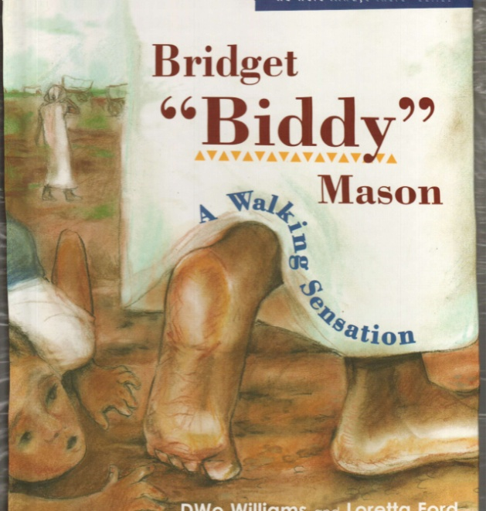
DWe’s children’s book

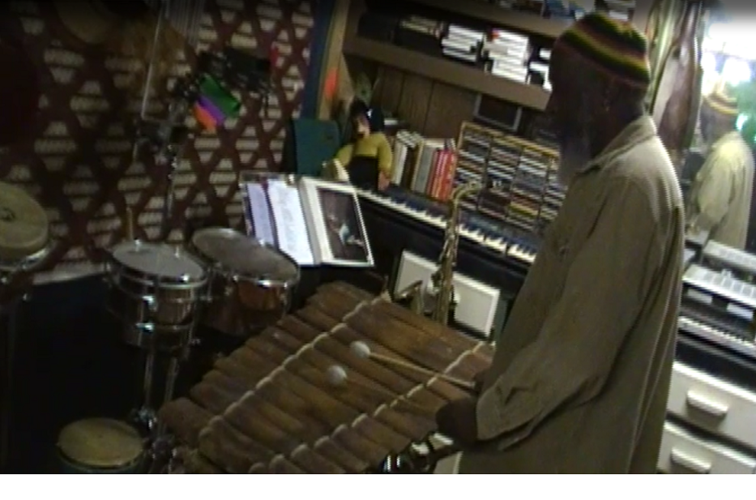
Jahruba and his Balafon

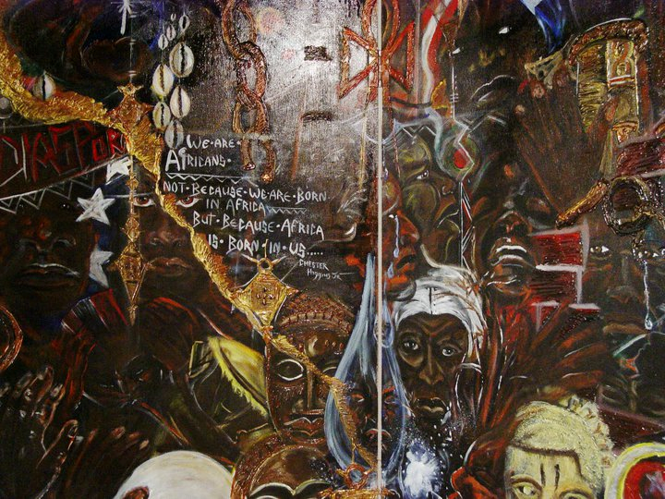
Al’s Higgins’ Panel

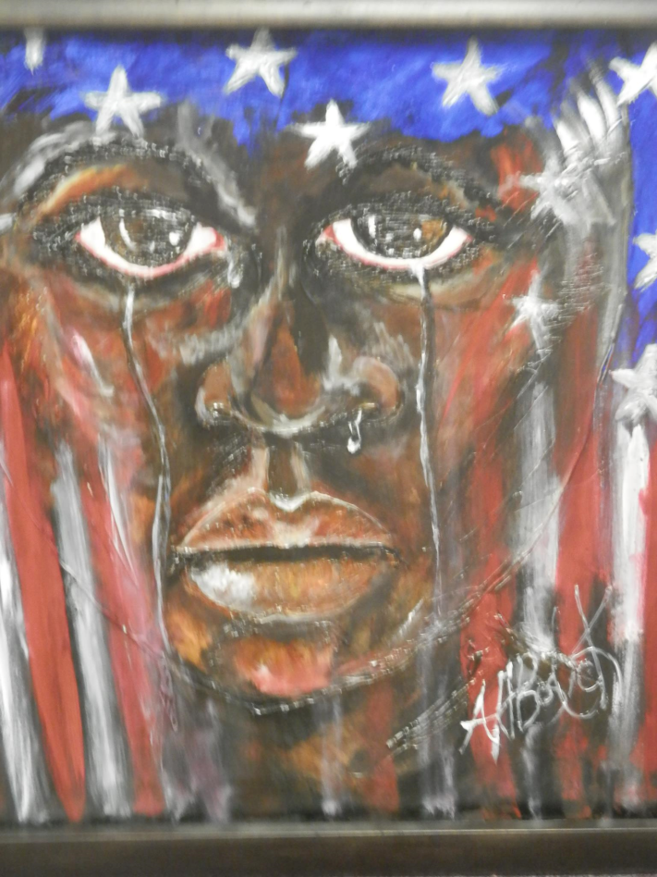
Al’s Tears of Black America

Appendix B: Participants' Contact Information

Jahruba Lambeth
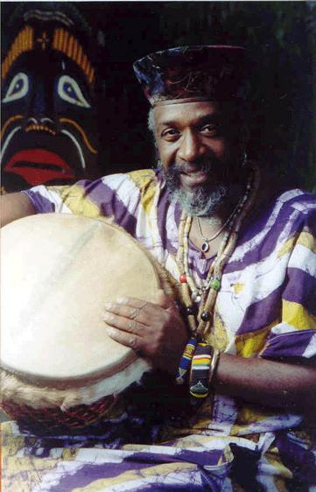
Jahruba
Jahruba Lambeth is an African born in Oklahoma whose family has been in the Norman area since the land run. He calls himself a 20th Century Griot -- an African storyteller -- who shares his cultural history through songs and stories handed down by his ancestors.

He selects stories that encourage young people to think for themselves -- such as the story of the greedy hunter of Ibo village who found out the hard way about the power of greed, or Fulumbo of the Fulanis, the handicapped boy who saved his village from Zulu raiders with the magical rhythm of peace. There are stories of Ananzi the spider, always up to tricks, and many more. In addition to a BA in African Studies from San Francisco University, Jahruba has studied with master drummers and street musicians from around the world.

Email: Jahruba.Lambeth@gmail.com
Phone: 405-321-1781
Website: www.jahruba.com
Facebook: https://www.facebook.com/jahruba



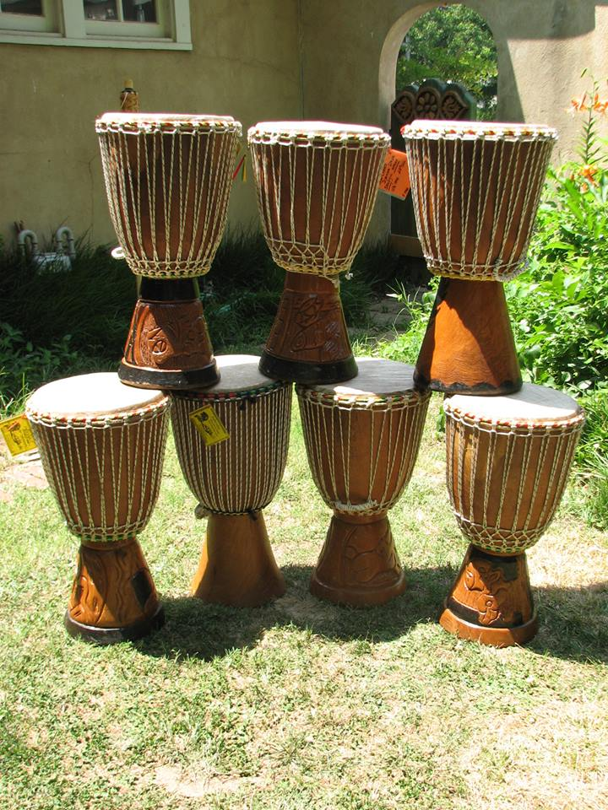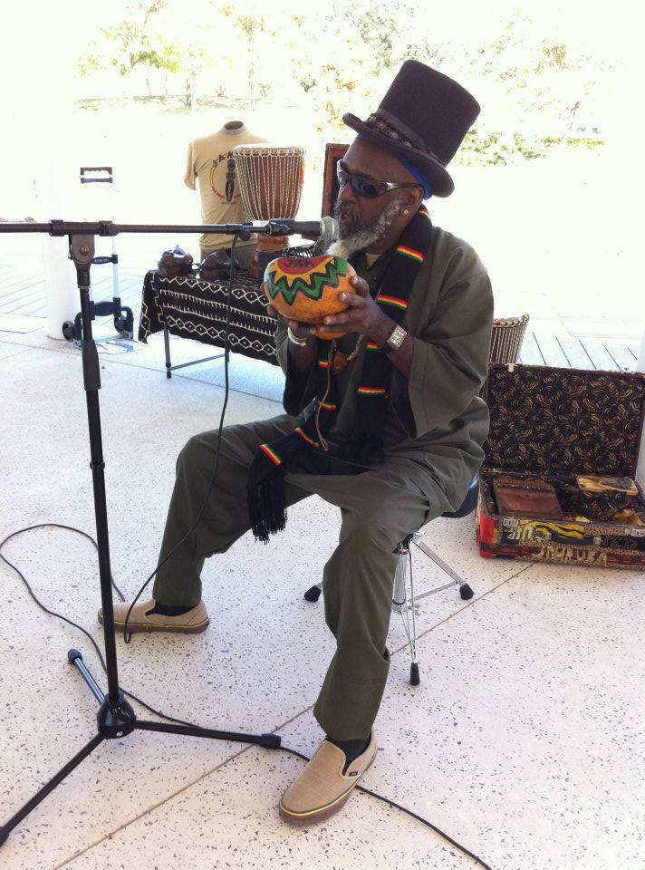
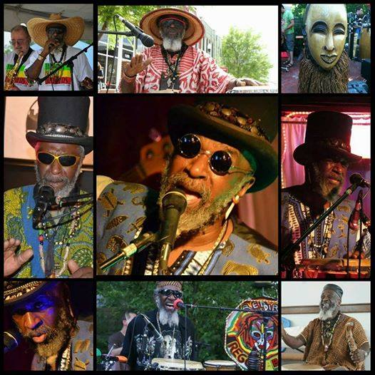
Jahruba Lambeth

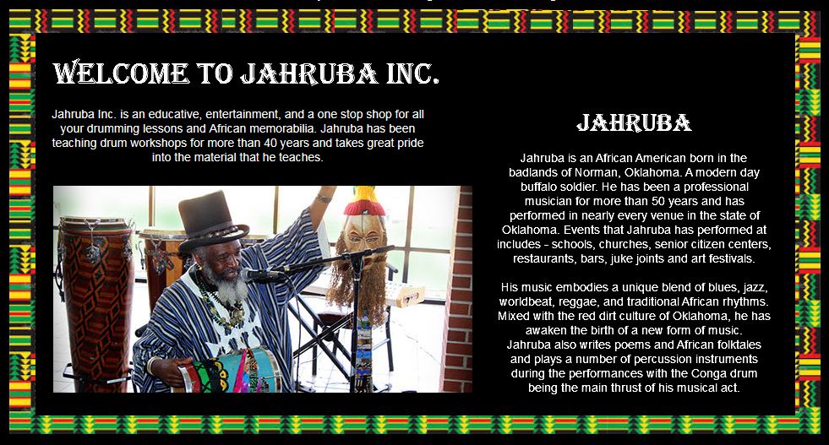
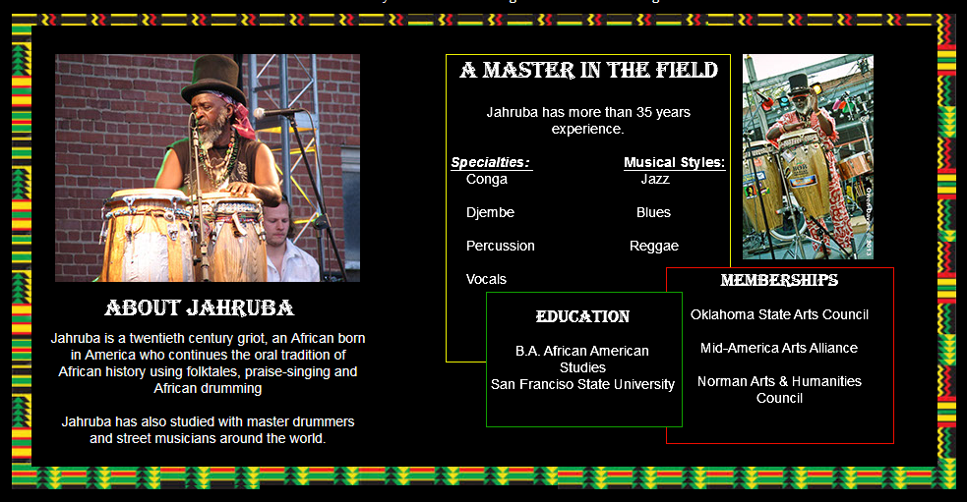

DWe Williams

Rhythmically Speaking & Ebony Voices
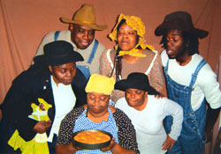 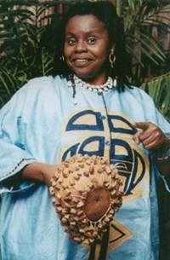 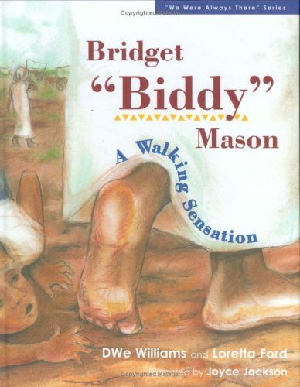

Booking Information: Saved from amazon

DWe Williams
2609 NW 38th Street
Oklahoma City, OK 73112

Phone:
(405) 942-0810 (405) 740-5335

Email: ewdwms@sbcglobal.net

Website: www.rhythmicallyspeaking.net

Availability: Year round

Fees:
DWe Williams, Storytelling $400 - $2000
Rhythmically Speaking Presents $800 - $2500
Ebony Voices $650 - $2000
A Hidden Soldier $800 - $2,000
Performing Arts Corps fee (available to elementary schools only) $250

Bio:
Rhythmically Speaking
Rhythmically Speaking is a diverse theatre company committed to providing educational and entertaining theatre for youth and family audiences. The company combines storytelling, drama, songs, rhythm, rhymes and plenty of audience participation to create a robust theatre experience. Rhythmically Speaking creates thematic productions suitable for use in schools and communities. There is always a song, and a thought to take home and ponder after the show.
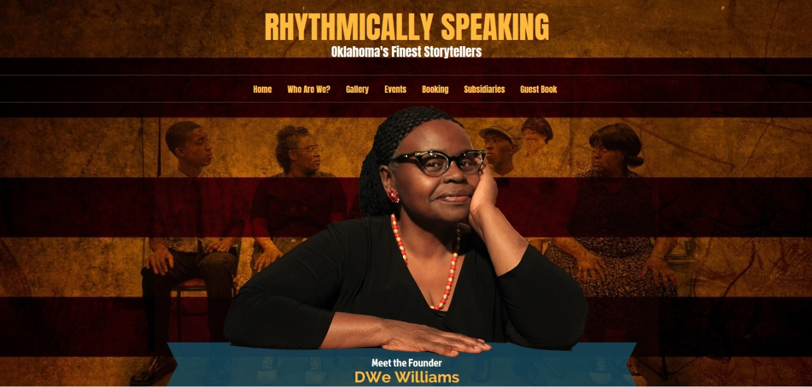
Ebony Voices
Ebony Voices is a storytelling unit of Rhythmically Speaking that incorporates music and womanly style in the telling of stories from the perspective of women. Women who have been birthin' and burpin' and buildin' a bold new body of people as they redefine the boundaries of their time. They deal with a wide array of issues and themes real and imagined, projected in song and story. Ebony Voices specializes in original songs replete with acappella harmonies that plant their stories in the hearts and minds of the audience.

Joyce Tease-Jackson
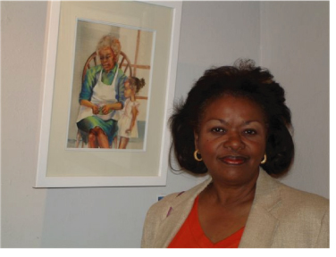

About
Art Garden Studio is located at the address 1416 Ne 10th St in Oklahoma City, Oklahoma 73117. They can be contacted via phone at (405) 232-0968 for pricing, hours and directions. Art Garden Studio specializes in Graphics, Paintings & Murals, On Location.
Art Garden Studio provides Senior Portraits, Cards, Consultations to it's customers.
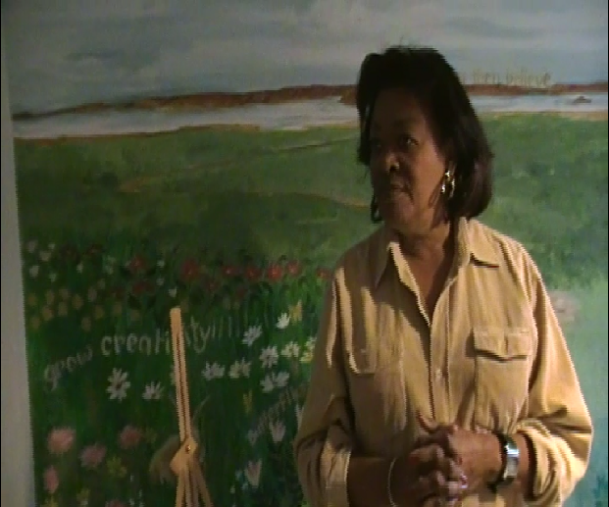
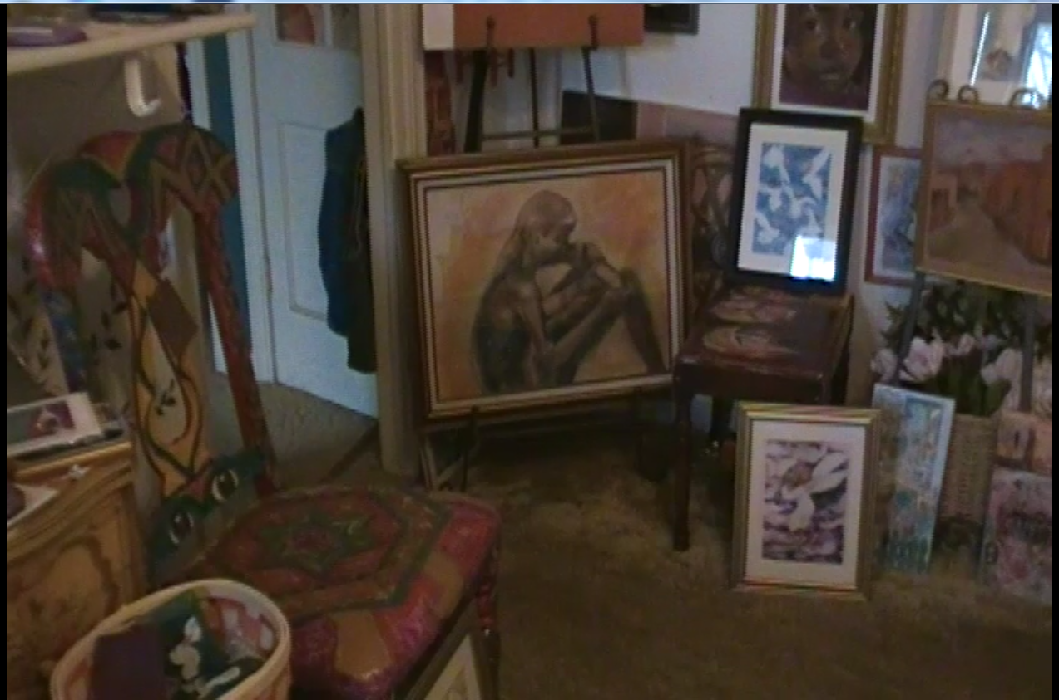
Art Garden Studio

Albert H. Bostick, Jr.
4509 N. Pennsylvania #12
Oklahoma City, Oklahoma
(405) 706 -3869 (cell)
(405) 521-8040 (office)
Website: www.basicallybostick.com
E-mail: aesoptells@aol.com

BASICALLY BOSTICK PROJECTS, INC.

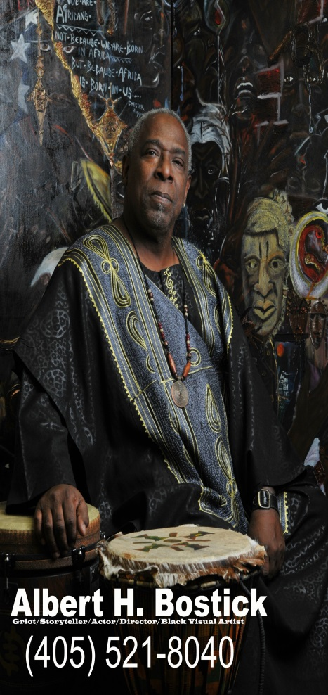
ALBERT H. BOSTICK Jr.
PERFORMANCES* VISUAL ARTIST* THEATRICAL PERFORMANCES* VISUAL ART EXHIBITIONS* WORKSHOPS* INSERVICES*ACTING CLASSES*ARTIST IN RESIDENCE*OKLAHOMA TOURING ROSTER
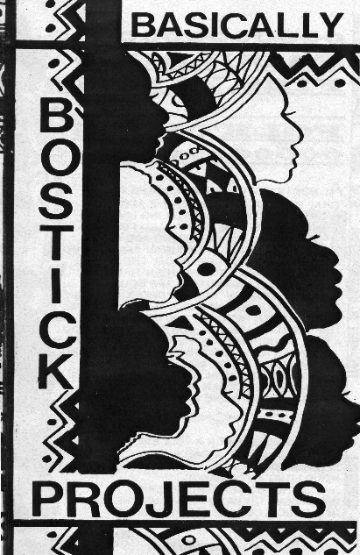
Basically Bostick Projects, Inc.
2401 W I-44 service Rd. Suite 209
Oklahoma City, ok. 73112
Office: (405) 521-8040
Cell; (405) 706-3869
aesoptells@aol.com

Basically Bostick Projects, Inc. is a Renaissance Arts organization dedicated to showcasing, preserving and developing theatre, acting classes, performances, storytelling and visual arts which highlight African American culture.
BIOGAPHY

Renaissance artist Albert H. Bostick Jr. (Al to those who know him), is an actor, choreographer, director, playwright, visual artist, and a storyteller, a true griot in every since of the word. In all of the art forms Al uses the African and Afro-American past as a foundation for his creativity. “I believe my purpose on this earth is to collect and disseminate all things Black and beautiful (even ugliness has a sense of beauty). I study the poets, writers, visual artists, dancers, actors, performers, historians, life from an African American perspective. I believe I am connected to my African past for as Chester Higgins states: “I am African, not because I am born in Africa, but because Africa is born in me” All that I am is a result of all that have gone before me, my mother, my father, my grandfathers and grandmothers, their mothers, fathers, grandmothers and grandfathers my elders, my art is grounded in these people and I have become part of a foundation they laid. I believe that if I do not continue this legacy, their legacy, will be lost and forgotten, because other cultures are not as concerned about your culture as they are about their own.

ACTING/DIRECTING/TOURING/PERFORMANCE
Al Bostick is a consummate Actor and director. He has performed and hundreds of amazing theatrical roles, and directed from the works of Baldwin, Wilson, and Shakespeare to name a few. He has directed for the BLAC, Inc., Oklahoma Children’s Theatre, of Oklahoma City, The St. Louis Black Repertory Theatre of St. Louis, Dillard University of New Orleans, Coppin State University of Baltimore, Maryland.
Bostick has written and directed numerous touring shows available to theatres and libraries. These shows are related to everything from education to African and African American culture.

THEATRICAL PERFORMANCES:
Shakespeare’s Heroes, Kings, Clowns & Villains
Anansi the Spider
The Adventures of Brer Rabbit
At the End of The Rainbow, There’s Only Rain
Black Voices of the Harlem Renaissance
The Amazing Adventures of Captain Tex Book
The Buffalo Soldiers
Bass Reeves: Black Federal Marshal
Bill Pickett, Bulldogger

Jambo!
Al Bostick, modern-day griot, storyteller, and Renaissance man, is now in the process of booking for the 2015-2016 season.
Basically Bostick Projects, presents, workshops, teacher in-services, theatrical performances,African-American Art Exhibitions, poetry programs, After-school programs, storytellings, and leture demos.

Booking can be done by contacting us at :
(405) 521-8040 or by email at aesoptells@aol.com.
If you are a non-profit and wish to take advantage of the Artist-in-Residence/Touring rosters of the Oklahoma Arts council, your organization may prove eligible for a grant (must be applied 60 days before program).

><><<>><<>><><><<>><><><<>><><><><><><><<><><><><><><<><><><><><><<><><><><><

Basically Bostick Projects, believes that:
IN ORDER TO BE YOURSELF, YOU MUST SEE YOURSELF…
Book Now!!!!

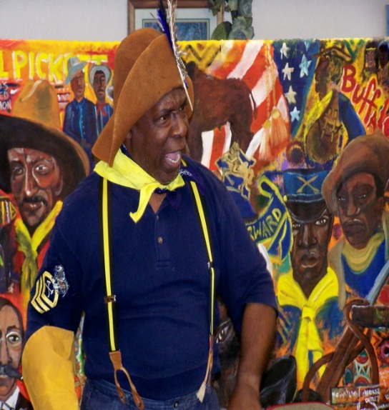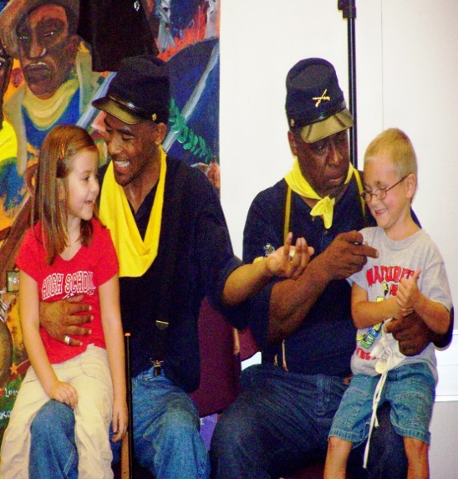
STORYTELLING
“A story. A story, let it come, let it go…”

Albert Bostick Jr. (Mr. B., Mr. Al. or Mr Albostick {kids sometimes say it as one word}), has been a storyteller for more than twenty years, a career that started as an artist-in-residence with the Oklahoma Arts Council.
Bostick hails from New Orleans, Louisiana, and has long had an interest in the folklore of Africa and African-Americans .

As an Oklahoma Artist-in-residence, Bostick has performed residencies in Oklahoma public schools, delighting children and adults alike with his lively, creative storytelling abilities. He has also taught Folklore and fables for the Great Expectation Institute at Northeastern State University in Tahlequah Oklahoma.
Al has traveled from Massachusetts to New Orleans, sharing the folklore of Africa, and African Americans, in his one-man performance, Fabulous Fibs,fables and Folklore…
Currently, Bostick is listed with the Oklahoma Arts Council, and The Arts Council of Oklahoma City, as a teaching artist and mentor.

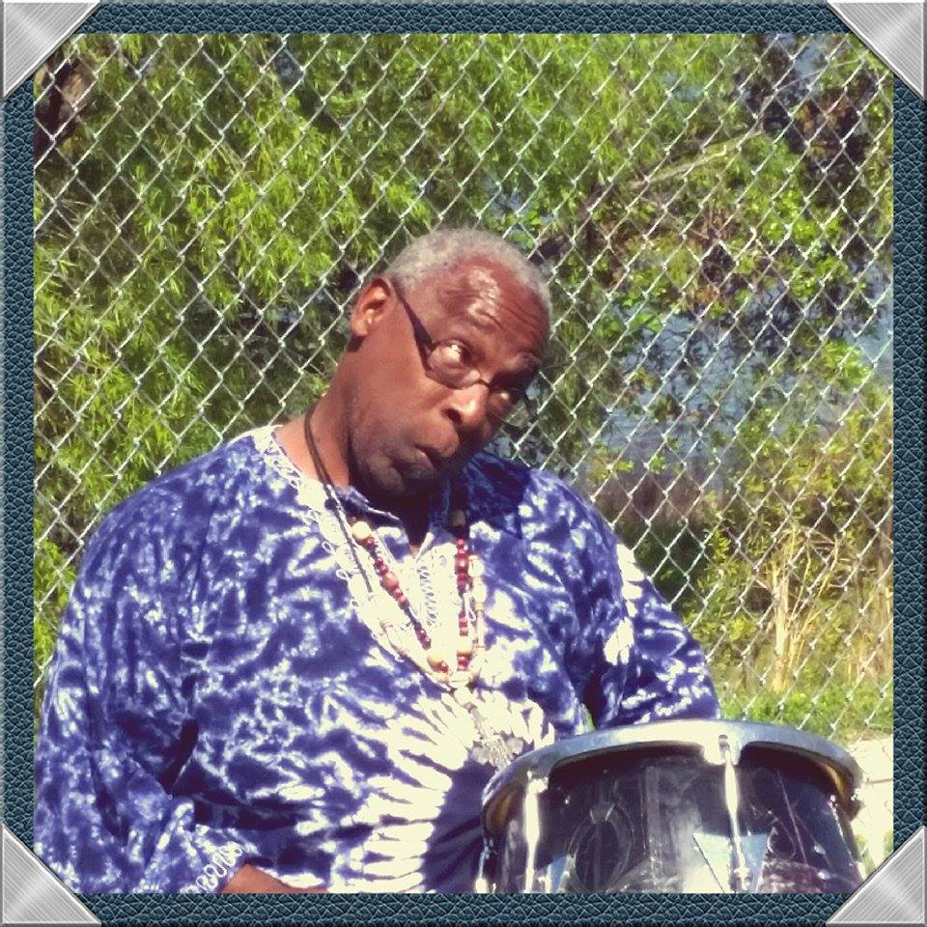 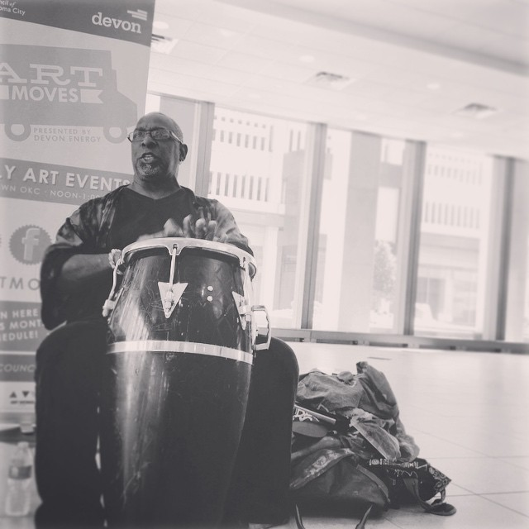 Visual Arts /Exhibitions
IN ORDER TO BE YOURSELF, YOU MUST SEE YOURSELF…
My art is a reflection of my African and African American Diaspora. Diaspora is defined as a people scattered. These peoples scattered, carried with them, their voices, songs, sounds, their movement, clothing, tools, and artifacts who they were. They handed these things down and instilled them into their offspring. Though I don’t know my specific connection, I am one of those offspring. My images reflect the social, political, religious, poetic, traditions. My work reflects my duality of being both African and American.
*
Bostick is a self-taught visual artist. Using the medium of acrylic paint Bostick captures the images of African and African American culture. His paintings are bold, beautiful and dynamic. His Artist statement is:
“As a visual artist my images reflect the duality of my Southern-American and African heritages and the social, political, religious, literary and artistic quests of my ancestors and elders of the Black/African Diaspora. The subjects of my paintings are derived from the histories, stories, lives and dilemmas and beautiful triumphs of being Black and African American.
My color palate ranges from the brilliant jewel tones of African textiles, tones of African fabric and beads, to the burnished bronze skin-tones of my ancestors. The warm earth tones of southern terrain, the red clay and browns along the banks of the Mississippi, the emerald and grey-greens of the Spanish moss laden oaks and the blue-black earth of the fertile colors of the Mississippi riverbanks.
*
ALBERT H. BOSTICK JR.
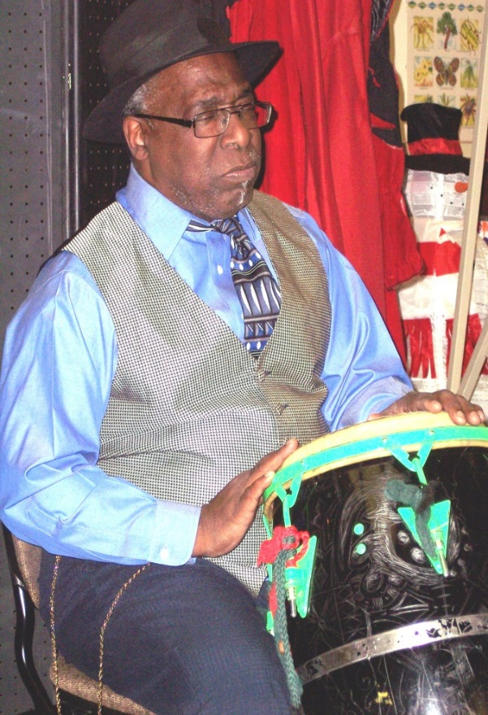
Renaissance artist and modern-day griot
Albert H. Bostick Jr. has a diverse career that spans over thirty years in the pursuit of artistic excellence. Bostick is an actor, director, playwright, choreographer, visual artist, folklorist and storyteller. In short he is a true Renaissance artist. Having attended Grambling State University, Bostick holds a Bachelor of Arts degree in Acting/Directing and has completed course work towards a Master’s Degree at the University of Oklahoma.
Bostick’s credentials include work with the Free Southern and the Dashiki Project Theatres of New Orleans, the Pollard Theater of Guthrie Oklahoma, The American Theater Company of Tulsa, Oklahoma, Oklahoma Shakespeare in the Park, Oklahoma Children’s Theatre, Carpenter Square Theatre all of Oklahoma City, and the Black Liberated Arts Center of Oklahoma City, where he served as Artistic Director for 15 years.
He has performed with LaCharles Purvey, having directed Condescending White Boys, for his Black Don’t Crack Productions and performed for Brilliant Soul Theatre.
Bostick’s awards and accommodations are numerous. He is a recipient of a Governor’s Arts Award, in arts education and an accommodation from the state of Oklahoma for Excellence. He is listed in Outstanding Young Men of America. He has been recognized by the American Association of Community Theatres for his portrayal of Zachariah Pieterson in Athol Fugard’s The Blood Knot which was chosen to represent the United States in the Canadian International Theater Festival in Montreal Canada. He has been listed with the State Arts Council’s Artist in Residence and Touring Roster for over 20 years where he is constantly sort after as an instructor, performer and mentor. He is proprietor of Basically Bostick Projects, a performance and Black Visual Arts studio, in Oklahoma City Oklahoma.
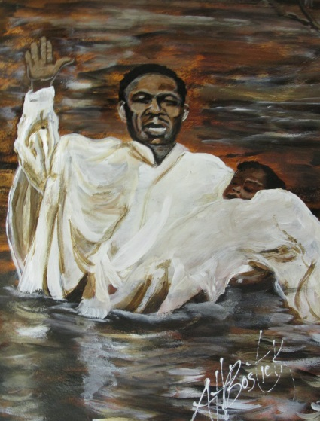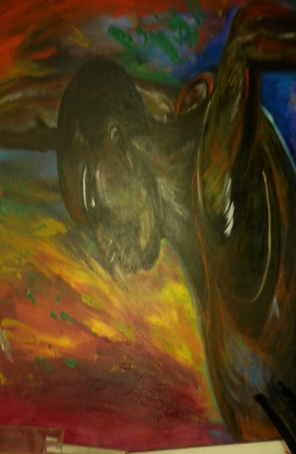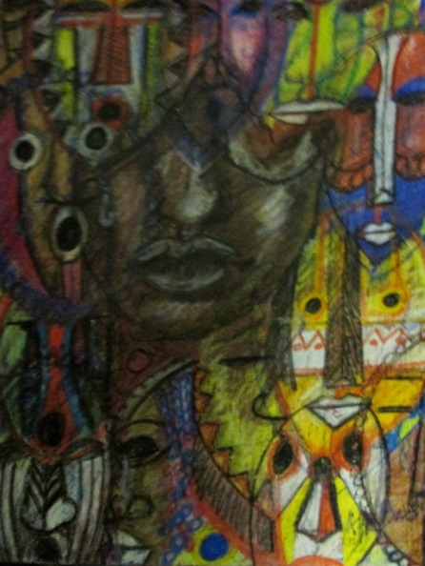

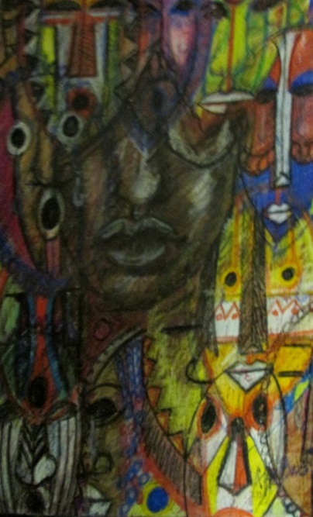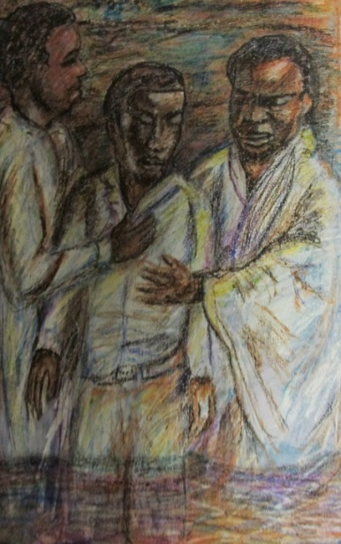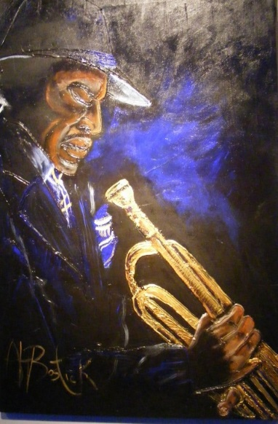
IN-SERVICES/WORKSHOPS
Basically Bostick is available to do workshops and in-services in the arts :
*Storytelling
*Performance and Theatre activities and the classroom
*Visual Arts, Maskmaking/Drawing
*Animal Centers, in Character Development

ARTIST IN RESIDENCE

Al Bostick is an Oklahoma teaching artist, and has traveled throughout Oklahoma and Kansas
Presenting and working in classrooms, introducing teachers and children to the wonderful world of storytelling:

Learning Goals:

•Cross-cultural story recognition as well as geographical tales recognizing mores and cultural similarities and differences
•Creative dramatics and the utilization of storytelling techniques to create dramatic pieces
•Exploration of the elements of storytelling
•Exploration of rhymes, and songs work and secular from the African and African American Diaspora
•Learning formulas for telling tales
•Utilizing storytelling across the curriculum
•Familiarization of African and African American Folklore

Carter G. Woodson (1933) used this term with regard to the “miseducation of the Negro” years prior to Dewey’s eventual popularization of the term with his 1938 publication.
A Sankofa is the idea that we must go back to our roots in order to move forward. We must reach back and gather the best of what our past has to teach us so we can achieve our full potential as we move forward. Whatever we have lost, forgotten, forgone, or been stripped of, can be reclaimed, revived, preserved, and perpetuated. Visually and symbolically, a “Sankofa” is expressed as a mythic bird that flies forward while looking backward with an egg (symbolizing the future) in its mouth.
Although material and ideal factors are ultimately interrelated, I will initially discuss them as separate categories.
“assembly declared that ‘baptisme doth not alter the condition of the person as to his bondage or ffreefome’ In the 1670 act, no Christians were to be sold as slaves. But in the 1682 statute, a Christian servant ‘who and whose parentage and native country are not Christian at the time of their first purchase . . . by some Christian' could be sold as a slave, notwithstanding his conversion to Christianity before importation. This allowed slaves who had become Christians in the West Indies to be sold in Virginia as slaves. The provision echoed one in a 1667 statute declaring that slaves in Virginia would not be made free by virtue of their conversion to Christianity once there. Now, conversion before importation would not release them either” (Billings, 1991, p.58).
Eisner’s (1985) null curriculum is also relevant here.
“A griot (/ˈɡri.oʊ/; French pronunciation: ​[ɡʁi.o]), jali or jeli (djeli or djéli in French spelling) is a West African historian, storyteller, praise singer, poet and/or musician. The griot is a repository of oral tradition and is often seen as a societal leader due to his or her traditional position as an advisor to royal personages. As a result of the former of these two functions” (Wikipedia, https://en.wikipedia.org/wiki/Griot).
All four participants elected to have their real names used in this document.
One participant, Joyce, still does not explicitly name herself as such. However, her art and art production represent an Afrocentric orientation, and she maintains current relationships with Afrocentric mentors.
Okra arrived in the New World during the transatlantic slave trade in the 1600s. It is a small part of our culture that survived. Okra or gumbo, as it is called in Africa, found exceptional popularity in New Orleans.

