UNIVERSITY OF OKLAHOMA
GRADUATE COLLEGE

NEW SPECIES OF ICTIOBUS (CYPRINIFORMES, CATOSTOMIDAE) FROM THE LATE MIOCENE (CLARENDONIAN) OGALLALA FORMATION, BEAVER COUNTY, OKLAHOMA

A THESIS
SUBMITTED TO THE GRADUATE FACULTY
In partial fulfillment of the requirements for the
Degree of
MASTER OF SCIENCE

By
GREG WILBERT
Norman, Oklahoma
2021
NEW SPECIES OF ICTIOBUS (CYPRINIFORMES, CATOSTOMIDAE) FROM THE LATE MIOCENE (CLARENDONIAN) OGALLALA FORMATION, BEAVER COUNTY, OKLAHOMA

A THESIS APPROVED FOR THE
DEPARTMENT OF BIOLOGY

BY THE COMMITTEE CONSISTING OF

Dr. Cameron Siler, Chair
Dr. Richard Cifelli
Dr. Stephen Westrop
Dr. Dahiana Arcila
Dr. Nicholas Czaplewski

©Copyright by GREG WILBERT 2021
All Rights Reserved.

Table of Contents

Abstract…….………………………………………………………………………………………………………………v
Introduction…….………………………………………………………….……………………………….……………1
Materials and Methods……………………………………………………………………………………..……..5
Preparation methods…………..……………………………………………….……………………….5
Anatomical abbreviations………………..……………………...………….………………………..6
Institutional abbreviations………………..…..………………………………………………………6
Comparative materials…………………..……………………………………………………………..6
Systematic paleontology…………………………………………………………………………………………..7
Description……………..………………………………………………………………………………………..………8
Discussion……………………….………………………………………..……………………….……………………19
Conclusion……………………………………………………………………………………………………………….23
Acknowledgements……………………………………………………………………………………..…..…..…24
Literature cited………………………………..…………………..…………………………….……………….….42

ABSTRACT
The Ogallala Formation is an accumulation of fluvial and lacustrine sediments deposited in the high plains of North America during the middle Miocene to early Pliocene. Most famous for its highly diverse mammalian fauna, the Ogallala Formation also represents an important record for aquatic taxa as well, including in Oklahoma Atractosteus, ?Esox, Ictalurus, Micropterus, ?Aplodinotus, Alligator, turtles, mollusks, freshwater sponges, and diatoms. Here, I describe a new species of buffalo fish (genus Ictiobus) based on a fossil from the Late Miocene (Clarendonian) of western Oklahoma. This specimen was found in a diatomite derived from a brackish lake (due to underlying Permian salt beds), discovered in approximate articulation, upside down, and lacking the caudal half of the postcranial skeleton. The skull preserves roughly 28 elements, along with remnants of the dorsal spines, fin rays, and multiple cycloid scales covering portions of the skeleton. The opercular series on each side lay open, with the dorsal skull bones (frontal, parietal, and supraoccipital) remaining in full articulation. The dentary, premaxilla, and other rostral skull bones are deflected laterally and preserved next to elements of the skull roof. Generally, the bones are well-preserved except where a dense root-mass plane has intersected the skeleton and top of the skull.
The genus Ictiobus is represented by five extant species: I. bubalus, I. cyprinellus, I. labiosus, I. meridionalis, and I. niger, ranging from Central America to Canada, as well as one Pliocene species, I. aguilerai from Hidalgo, Mexico. The new Oklahoma species can be differentiated from the living and fossil species based on its serrated cleithrum, the large shelf on the anterior end of the gnathic ramus, and the sharp angular interior margin of the
preopercle. The addition of this new species adds valuable data for the early evolution of the
genus, including potentially important implications for the biogeography of living Ictiobus. I. phyllisae n. sp. is the oldest known species of Ictiobus; it is most closely related to fossil I. aguilerai; the two form a clade with extant I. bubalus. Given the Clarendonian age (about 12 Ma) of I. phyllisae n. sp., initial cladogenesis within Ictiobus began well back in the Miocene.

INTRODUCTION
The catostomids, are often called suckers due to their ventrally facing mouths used to suck up a variety of organic material (Harris et al., 2014). Mostly benthic, their habitat includes temperate rivers and lakes across North America, from Canada to Guatemala, and they are also present in eastern Asia (Smith, 1992). The largest of the catostomids, Ictiobus cyprinellus, has recently been shown to have a much longer life span than originally thought, living up to 112 years of age (Lackmann et al., 2019). Ictiobus is one of the 12 genera of Catostomidae that occur in North America (Nelson et al., 2004). Although there tends to be a high level of hybridization among Ictiobus species (Harris et al., 2014; Bart et al., 2010), there are currently five agreed-upon extant species of Ictiobus, the buffalo fish, and three species of its closest living relative Carpiodes, the river carpsuckers (Smith, 1992; Harris and Mayden, 2001; Doosey et al., 2009): Ictiobus cyprinellus Valenciennes, 1844 (big mouth buffalo), I. bubalus Rafinesque, 1818 (small mouth buffalo), I. niger Rafinesque, 1819 (black buffalo), I. labiosus Meek, 1904 (fleshylip buffalo), I. meridionalis Gunther, 1868 (Usumacinta buffalo); Carpiodes carpio Rafinesque, 1829 (river carpsucker), C. cyprinus Lesueur, 1817 (quillback), and C. velifer Rafinesque, 1820 (highfin carpsucker). Extinct species include only Ictiobus aguilerai Alvarado-Ortega et al. 2006 and the new Ogallala species being described here.
Catostomidae fossils are well represented in the Cenozoic in North America (Cavender, 1986). Within North America the oldest catostomid fossils are from the middle Eocene (Cavender, 1998). Catostomids are thoroughly represented from the Eocene through Oligocene, many placed in the genus Amyzon, with specimens from Canada (Wilson, 1980), Nevada (Cope, 1872), and Wyoming’s Green River Formation (Grande et al., 1982), among others throughout the rest of the Paleogene (Smith, 1992; Liu et al., 2016). The oldest Ictiobus fossils, middle Miocene in age, were discovered in South Dakota (Cavender, 1986). A few Ictiobus bones including two incomplete opercular were described from the late Illinoian of southwest Kansas, (Smith, 1963). Also, a fossil I. niger with multiple elements from the late Pleistocene has been reported in Kansas (Neff, 1975). An early Pleistocene I. cyprinellus was described from Nebraska (Smith and Lundberg, 1972). Also from Nebraska, there is an undescribed partially articulated I. cyprinellus, from the middle Pleistocene. Fragmentary elements from the Pleistocene have also been found in the Trinity River Terrace, Texas including an opercle and a fragment of the fourth left pleural rib of the Weberian complex (Uyeno and Miller, 1962). Jesus Alvarado-Ortega et al. described a series of disarticulated fossil elements of Ictiobus aguilerai that were found in Hidalgo, Mexico, from the Pliocene (Alvarado-Ortega et al. 2006).
Ictiobus fossils found within Oklahoma have thus far been from Beaver County, within the Ogallala Formation (Fig. 1A). A small collection of disarticulated elements was referred to as I. bubalus (Smith, 1962). Ictiobus fossil material seems to be somewhat common but in small numbers of elements found at each locality. Fully articulated specimens are rare; hence the Oklahoma specimen found in 2011 is exceptional in its completeness, being mostly articulated and having most of the skull elements present (Wilbert et al. 2018).
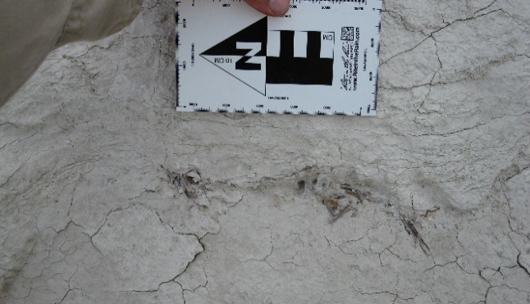
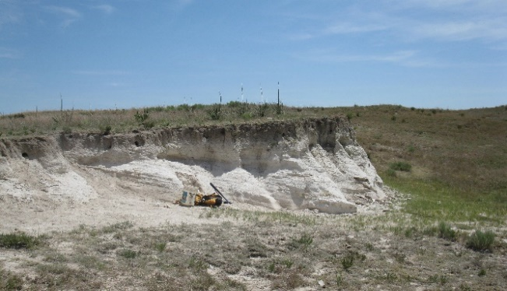
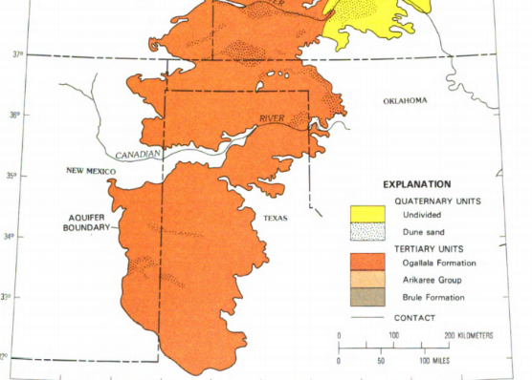
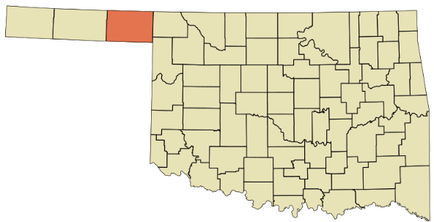
The Ogallala Formation is a large fluvial deposit that underlies parts of eight states, mostly consisting of clays, silts, sands, and gravels (Fig. 1B). The Ogallala is considered the principal component carrying the High Plains aquifer, which also includes two underlying geologic units found farther north in western Nebraska: the Brule Formation and the Arikaree Group. Most of the sedimentation of the High Plains aquifer was deposited during the Miocene (24 to 5 million years ago); as a result of the weathering of the uplifted mountains in the west (Gutentag et al., 1984). The Ogallala Formation has zones that are highly fossiliferous and is famous for the diversity of its mammalian fauna. It is also proving to be an important area for aquatic taxa as well (Chaney and Elias, 1938).
FIGURE 1― Geological and geographic occurrence of new species of Ictiobus. A. Map of Oklahoma, with Beaver County shown in orange; B. principal geologic units that constitute the High Plains aquifer; the Ogallala Formation (shown in orange with fossil location marked with an X), is geographically widespread, outcropping from South Dakota to Texas (modified from Gutentag et al., 1984); C. Fossil locality OMNH V1678, Beaver county, Oklahoma; D. OMNH 77567 in situ. (C, D courtesy Nick Czaplewski).

A
C
B
D
x
FIGURE 2―Ictiobus phyllisae n. sp. OMNH 77567. A. The prepared specimen; B. Ictiobus phyllisae without the matrix, to show the individual bones; the grey represents mostly described skull and pectoral girdle bones; the purple is mostly post cranial material; and the red are scales. Key for abbreviations can be found in materials and methods.
A
B
The fossil fish reported herein was found by the Native Explorers group, led by Dr. Kent Smith and Dr. Nicholas Czaplewski, about 10 km south of the town of Gate, in Beaver County Oklahoma, in the summer of 2011. The specimen was found within a diatomite layer of the Ogallala Formation (Fig. 1C, D), lacking half of the postcranial skeleton and composed of a mostly articulated skull with some of the anterior elements laterally displaced. Also within the collected jacket are a scattering of ribs and large cycloid scales. Most of the skull elements not affected by the layer of root innervation are in good condition, the other elements vary in quality from just etched, to nearly destroyed. The posterior portion of the skeleton was the originally exposed surface, as seen in the top right corner of figure 2.
From another nearby site, the same Native Explorers group discovered a single opercle (Fig. 3A, B) from what appears to be the same new species as the one described below. It is slightly compressed and etched by roots but is identifiable as Ictiobus, with the convex dorsal margin typical of the genus (Smith, 1992).
MATERIALS AND METHODS
Preparation methods
Most of the preparation was done under the microscope with carbide needles. Butvar B-76 was used to stabilize the bone due to the fragile nature of the specimen.
Anatomical abbreviations
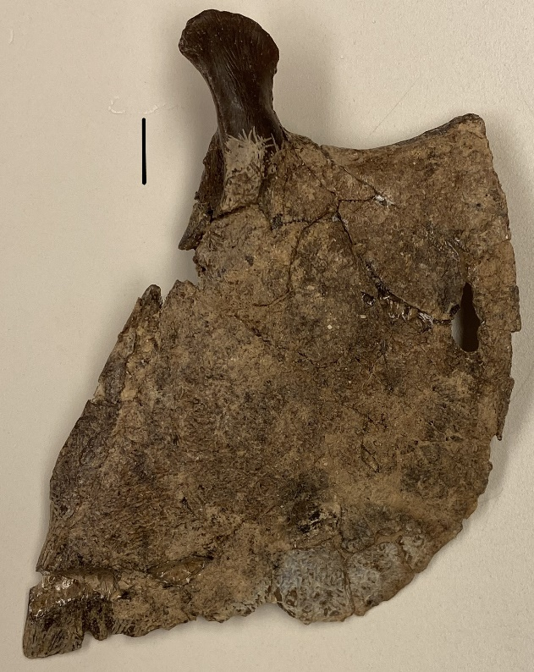
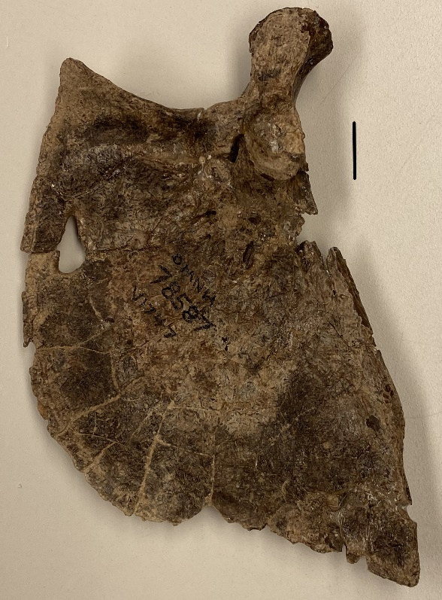
For consistency, some abbreviations were used from Alvarado-Ortega et al. (2006) and Grande et al. (1982): a, anguloarticular; cl, cleithrum; co, coracoid; de, dentary; df, dorsal fin; en, endopterygoid; ep, epiotic; fr, frontal; h, hyomandibular; io, infraorbital; iop, interopercle; la, lacrimal; le, lateral ethmoid; m, metapterygoid; mx, maxilla; op, opercle; p, palatine; pa, parietal; pf, pectoral fin; pl, palatine; pmx, premaxilla; pop, preopercle; pt, pterotic; ptg, pterygiophores; q, quadrate; ra, retroarticular; s, scapula, scl, supracleithrum; so, supraorbital; soc, supraoccipital; sop, subopercle; sp, sphenotic; t, tripus; w, pleural rib of fourth centrum.
FIGURE 3―Ictiobus phyllisae n. sp. OMNH 78587, isolated opercle, A. Lateral view; B. Medial view. Scale bars are 1 cm.
A
B

Institutional abbreviations
OMNH, Oklahoma Museum of Natural History; UNSM, University of Nebraska State Museum.
Comparative materials
I started out by preparing the fossil and identifying the exposed skull and postcranial bones. To aid in my identification, I mostly used the Ictiobus skeletal material which was in the vertebrate paleontology recent collection. To help compare the different osteology of each Ictiobus species to the fossil, I spoke with Dr. Henry Bart from Tulane University, New Orleans, about getting a few of the Ictiobus species on loan, and I received specimens belonging to two species (I. cyprinellus and I. bubalus). The OMNH ichthyology collections had a few skeletal specimens that are useful for assessing variation within species (I. bubalus, two specimens; I. niger, two specimens). Also, I worked with Richard Snow, OU’s fisheries biologist, to obtain some comparative specimens since he works with Oklahoma rough fish. This allowed me to study multiple specimens of all three buffalofish that live within the U.S. A few skeletal elements of I. bubalus and I. cyprinellus were also collected from the shoreline of Lake Keystone, near Tulsa Oklahoma. In all, the skeletal study collection I assembled includes four specimens of I. cyprinellus, six specimens of I. bubalus, and four specimens of I. niger. Of the 14 representative modern specimens collected, I cleaned and prepared five. There were also two fossil Ictiobus specimens available for study. The opercle (OMNH 78587) from near the OMNH V1678 site, as well as the block from Nebraska of a partially articulated Ictiobus cyprinellus UNSM 118584.
The following software was used for the phylogenetic analysis shown below. The data set was condensed into Mesquite 3.61 and was executed in PAUP 4.0, which produced one tree. Then a bootstrap and Bremer decay were run in PAUP 4.0, showing support at each node. The characters 1-157 are modified from Smith, 1992 and reduced to Ictiobinae and two outgroups (Leptobotia was used as the outgroup in PAUP). Characters 158-162 are from the description of Ictiobus phyllisae n. sp., and characters 163-177 are modified from Alvarado-Ortega et al. 2006 (Appendixes 1 and 2).
SYSTEMATIC PALEONTOLOGY
Family CATOSTOMIDAE sensu Nelson, 1994
Subfamily ICTIOBINAE sensu G. R. Smith 1992
Genus ICTIOBUS Rafinesque, 1820
ICTIOBUS PHYLLISAE new species

Diagnosis: Ictiobus species distinct from other named taxa in having a robust lateral external gnathic ramus, a low-profile coronoid process that extends posteriorly to the middle of the anguloarticular; serrations on the lateral anterior margin of the cleithrum; and a sharp angled interior margin of the preopercle.
Etymology: This new species is named in memory of my mom, Phyllis Irene Wilbert, who always encouraged me to work hard and supported my love of science.
Type: Holotype, OMNH 77567, consisting of skull and partial postcranial skeleton.
Referred specimen: OMNH 78587, isolated opercle.
Locality: OMNH V1678, about 10 km South of Gate, Beaver County, Oklahoma.
DESCRIPTION
Most of the skull bones belonging to the dorsal surface of OMNH 77567 are represented; a few from the anterior part of the skull are missing or displaced. The ventral skull bones are unknown but possibly could be underneath and visible with a CT scan image. The bones visible include the frontals, parietals, supraoccipital, sphenotics, pterotics, epiotics, and a partial lateral ethmoid.
The lateral ethmoid, a paired bone on the anterolateral part of the skull, is represented by only its posterior portion. This element is attached to the dermethmoid and frontal bones on the dorsal view, triangular in shape, and concave with multiple pores (Fig. 4A).
The frontals are paired elements, anterodorsally located, and attach to the supraoccipitals on the lateral sides. The anteriormost end forms a straight suture with the dermethmoid, as well as the lateral ethmoid. The anterior part forms a wing-like structure that attaches to the sphenoid posterolaterally. There is a parallel row of serrated processes near the medial suture. The posterior portion is long and narrow, with the serrated processes continuing along it, as well as the medial border forming part of the frontal-parietal fontanelle (Fig. 4A). The pterotic is paired and mostly represented in this fossil by the anterior portion, which is easily visible; the posterior portion is mostly crushed and root intrusion has obscured the borders (Fig. 4B).
In dorsal view the paired sphenotic has an L-shape, where the longer portion is twice as long as the shorter. The longer of the two processes follows the frontal laterally, extending along the posterior end of the orbit (Fig. 4B).
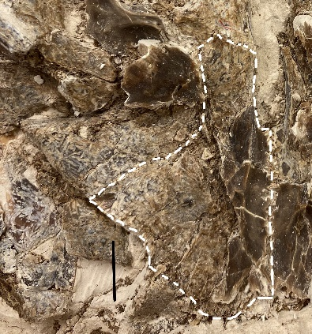
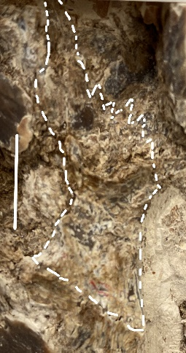
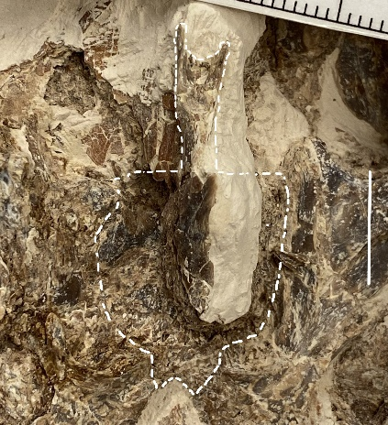
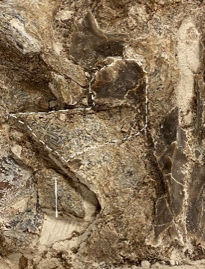
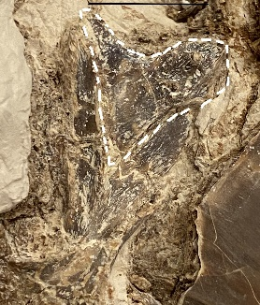
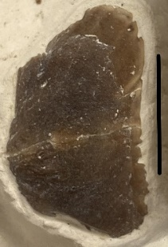
The supraoccipital, seen in dorsal view, is located posterocentrally on the neurocranium and is unpaired. The anterior end protrudes outward and forms a small portion of the posterior end of the frontal-parietal fontanelle. Overall, it is square in shape with a central crest that extends past the posterior end of the skull (Fig. 4C).
FIGURE 4―Ictiobus phyllisae n. sp. OMNH 77567, skull bones in dorsal view. A. Frontal, Lateral ethmoid; B. Sphenotic, Pterotic; C. Supraoccipital; D. Parietal; E. Epiotic; F. Supraorbital. Scale bars are 1 cm.
A
le
fr
B

C
D
E
F
sp
pt
The parietals viewed dorsally are paired, wing-shaped bones that are about twice as long as they are wide. Anteriorly they are joined to the posterior end of the frontals as well as the pterotics. The mesial margins make up the posterior edge of the frontal-parietal fontanelle. When viewed laterally, on the posterior end, the suture with the epiotic and supraoccipital form a diagonal zig-zag pattern. About midway along its length and immediately before the suture with the supraoccipital, the bone drops dorsally with a rim overhanging (Fig. 4D).
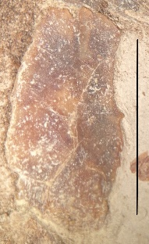
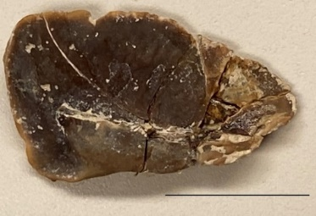
The epiotic is a paired element, in dorsal view it is triangular and located dorso-posteriorly. The dorsal-most processes protrude out farther than the main bone, forming a Y-shape. The lateral-most process has a bumpy texture where the post-temporal bone attaches. Anteriorly it attaches to the palatine and ventrally it attaches to the pterotic bone (Fig. 4E).
A
B
FIGURE 5―Ictiobus phyllisae n. sp. OMNH 77567, suborbital bones. A. Lacrimal (suborbital 1) medial view; B. Suborbital unknown number, lateral view. Scale bars are 1 cm.
The supraorbital is paired and generally square with rounded edges in shape, concave and much thicker towards the dorsal side. Forming the top of the orbit, it attaches by zigzag pattern sutures to the lateral ethmoid and frontal bones (Fig. 4F).
The lacrimal or suborbital 1 is paired and is a flat, triangular bone with rounded corners and is the first in the circumorbital bones that encircle the bottom half of the eye. There is a small ridge running horizontally on the medial dorsal side (Fig. 5A).
There is only one other suborbital bone represented on the block, it is of uncertain identity and the other suborbitals are unknown. Ovaloid in shape, it is thick, flat, and smooth on the exposed side (Fig. 5B).
Jaws: A representative element is present for each bone from the jaws of Ictiobus phyllisae; premaxilla, maxilla, dentary, anguloarticular, and retroarticular.
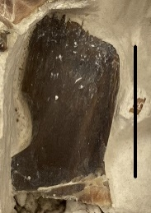
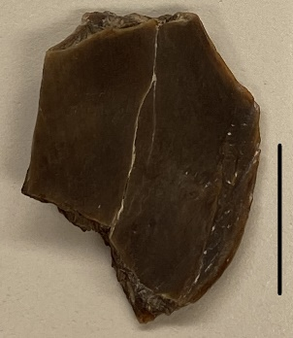
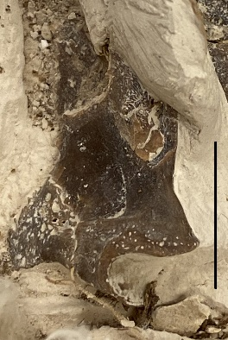
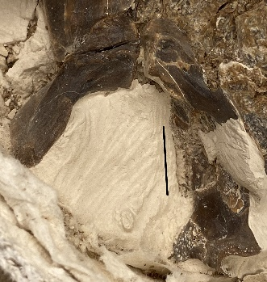
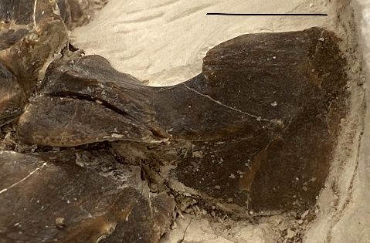
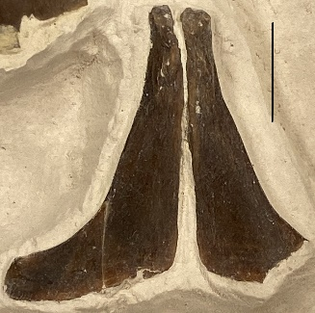
The maxilla is represented by two separate broken pieces. The J-shaped portion represents the ventral end (Fig. 6A1). Most of the bone is smooth, except toward the tip where it is textured for muscle attachment. The other piece, representing the middle portion of the maxilla, is flat and smooth on both sides, rhomboidal in shape when viewed laterally (Fig. 6A2). There is an angular portion on the posterior side, that angles downward toward the J-shaped portion, that measures about 135 degrees.
Lateral view
Dorsal view
A1
A2
B
E
C
D
a
ra
FIGURE 6―Ictiobus phyllisae n. sp. OMNH 77567, jaw bones. A1. ventral portion of the maxilla, in lateral view; A2. mid-portion of maxilla, in lateral view; B. anguloarticular in medial view, retroarticular in lateral view; C. Lateral view of the dentary; D. Dorsal view of left and right dentaries; E. Anterior view of the premaxilla. Scale bars are 1 cm.
The anguloarticular in lateral view is generally rectangular in shape and thin on the anterior end, where it attaches to the dentary’s posteromesial surface. It becomes much thicker on the posterior end where the articulation with the quadrate occurs. Viewed dorsally the articulation facet is concave and runs horizontally. Below the facet and slightly anteriorly is where the retroarticular attaches; there is a concave notch to accommodate that bone (Fig. 6B).
The retroarticular bone is small and generally shaped like a pyramid; it is located ventroposteriorly on the anguloarticular and in medial view it has numerous pores on the surface (Fig. 6B).
The dentary is roughly triangular in lateral view (Fig. 6C). When viewed laterally the anterior portion is about half the thickness of the posterior end. The anterior gnathic ramus is large and massive. Dorsoposteriorly, the coronoid process has a low profile but it rises higher than the gnathic ramus, and is off center and slightly angles outward from the main line of the dentary. This process also extends posteriorly, overlapping the anguloarticular about halfway. The foramen for Meckel’s cartilage is located just posterior to the point where the anterior end of the coronoid process starts, when viewed medially. In dorsal view the anterior gnathic ramus forms a triangular shape with a ridge going across the middle horizontally. This ridge is larger medially and overhangs posteriorly slightly, within this depression there are multiple mandibular sensory canal openings. Anteriorly from this ridge is smooth flat bone, which protrudes quite massively (Fig. 6D).
The premaxillary is a thin L-shaped bone, with the vertical process about 1.58 times longer than the horizontal process. The horizontal process has a slight arching posteriorly curve and is blade like. At the conjunction of the horizontal and vertical processes, the anterior angle is about 110 degrees and the posterior angle is more of a gradual slope to about 150 degrees (Fig. 6E).
The suspensorium includes the hyomandibular, quadrate, metapterygoid, entoperygoid, and palatine.
The hyomandibular is thick and blade shaped, the posterior edge is much thicker than the anterior edge where there is a groove to accommodate the preopercle and opercle. The anterior portion is very thin and forms a fan-like arch, leading down to the ventral portion which is a thick extension of the anterior portion. The dorsal portion is thicker and has articular knobs that articulate with the sphenotic and pterotic bones. There is also an articular facet on the dorsoposterior surface that articulates with the opercle (Fig. 7A).
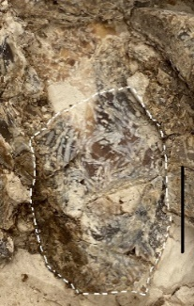
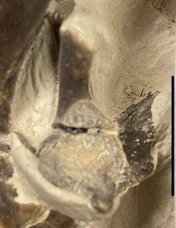
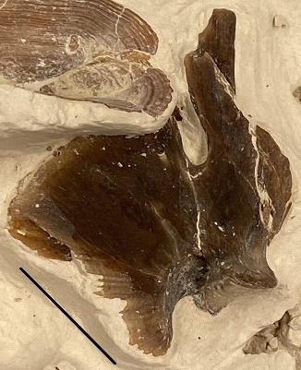
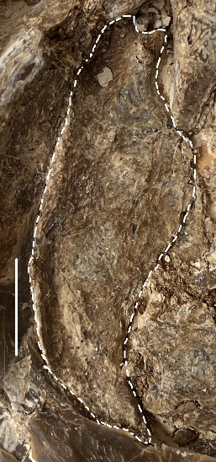
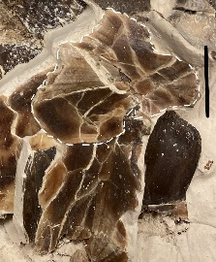
The quadrate in lateral view has two main parts; of these, a thicker, shaft-like ventral region contains (on the anterior portion) the robust condyle where it contacts the articular bone of the lower jaw. This condyle is larger on the lateral side than the medial side. The posterior end of this “shaft” overlaps the anterior end of the preopercle. Just above this contact there is a V-shaped groove where the symplectic bone (unknown) would have attached. The dorsal portion of the quadrate is very thin and is diamond shaped; the suture for contact with the pterygoid bone (unknown) is feathery and is placed anteriorly. Below this contact the quadrate arches inward and downward toward the condylar portion of the “shaft” (Fig. 7B).
A
B
D
E
FIGURE 7―Ictiobus phyllisae n. sp. OMNH 77567, hyomandibular series. A. Hyomandibular in lateral view; B. Quadrate in lateral view; C. Partial metapterygoid in lateral view; D. Endopterygoid in lateral view; E. Palatine in medial view. Scale bars are 1 cm.
C
Only one surface of the metapterygoid is visible; it is a paired, thin, laminar bone, triangular in shape with rounded edges. Both left and right metapterygoids are present but both are highly damaged (Fig. 7C).
The endopterygoid (mesopterygoid) is a very thin, oval-shaped bone with a concave facet area on the anterior end where it articulates with the palatine (Fig. 7D).
The palatine is also a paired element, and is vaguely Y-shaped. Shown in medial view the facet where it articulates with the prevomer is visible. Directly behind the facet is the ethmoid process, which is long, round, and tube-like. Only a small portion of the maxilla process is visible, angled off to the right in the figure (Fig. 7E).
Of the opercular series, the opercle, preopercle, subopercle, and interopercle are present; all of these are paired elements.
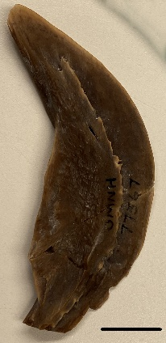
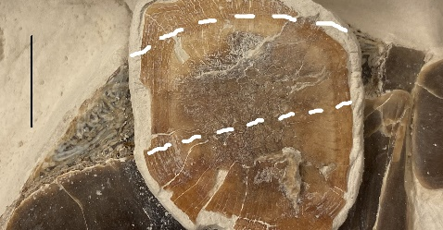
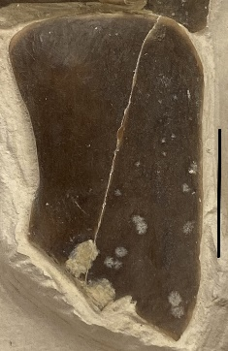
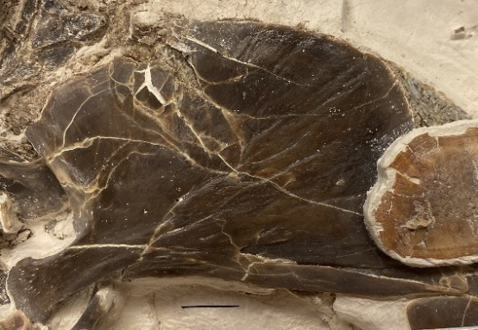
The opercle is one of the larger bones of the skull. It is fan shaped and taller than wide, with a long opercular arm located dorsally that slightly widens, fanning out radially. The dorsal margin is slightly concave. The posterior margin has a gradual arch and forms a roughly 120-degree angle with the ventral margin, which is straight. The anterior margin is also straight and forms an angle of 70 degrees with the ventral margin. In anterolateral view there is a small opening that extends ventrally forming a groove reaching the ventral margin, the anterior margin folds back and overlaps the groove. On the exterior surface, there are a few pores that have small groves radiating out from below the opercular arm, to points all along the posterior and ventral margins (Fig. 8A).
FIGURE 8―Opercle series of Ictiobus phyllisae n. sp. OMNH 77567, in lateral view. A. Opercle; B. Preopercle; C. Subopercle, dashed lines indicate margins obscured by the scale; D. Posterior half of the Interopercle. Scale bars are 1 cm.
A
C
D
B
The preopercle is one of the few bones that has one of its paired elements loose from the rest of the articulated specimen. It forms an open C-shape with ends that lie almost vertical and horizontal and lies directly in front of the opercle, where the horizontal end connects to the posterior end of the quadrate. The posterior edge is evenly curved, thin and blade like. The anterior edge has a sharp angle of about 140 degrees where the horizontal and vertical processes come together. In lateral view there is an overlapping ridge coursing along the center and following the curve of the bone along its length. On this specimen the anterior most tip is missing (Fig. 8B).
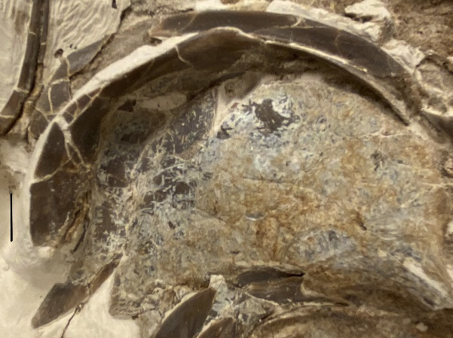
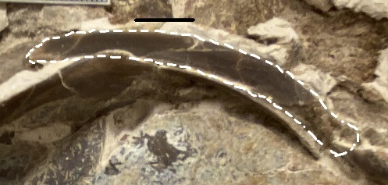
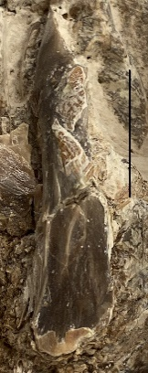
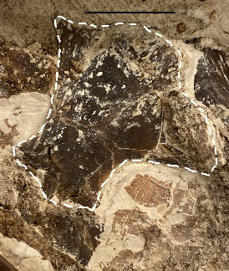
The subopercle is mostly obscured by a large fish scale and part of the opercle; it also has been etched by roots but the general shape can be distinguished. It is similar to that seen in other Ictiobus species, having a flat, bladelike appearance, with the ventral edge forming a smooth, consistent curve (Fig. 8C).
A
B
C
D
FIGURE 9―Ictiobus phyllisae n. sp. OMNH 77567, pectoral girdle bones. A. Cleithrum in lateral view; B. Coracoid in medial view; C. Supracleithrum in lateral view; D. Posttemporal in lateral view. Scale bars 1 cm.
The interopercle is represented by the posterior portion only. This part of the bone is thin, much longer than it is tall, and rectangular in form, with a slight point on the dorsoposterior margin (Fig. 8D).
The pectoral girdle includes the cleithrum, coracoid, supracleithrum, and posttemporal.
The cleithrum is a large, paired, complex bone that has a U-shape in lateral view, with a ridge on the anterior margin. This forms a groove along the lateral surface of the cleithrum which the supracleithrum lies within in the dorsal half. Midway along this ridge it drops dorsally and has some small serrations. In anterior view there is a laminar, deep, bowl-shaped area, which is very thin, with the medial edge coming to a point below the lower margin of the bowl area (Fig. 9A).
The coracoid, a paired element, has been rotated so the medial view is presented. This is a thin, delicate bone which attaches to the medial posterior margin of the cleithrum, along with the scapula and mesocoracoid. The ridge where the four bones attach to each other is visible on the anterior end. The bone was presumably concave, as in other species of the genus, has been flattened and fractured (Fig. 9B).
The supracleithrum is a long, narrow, and slightly curved bone that lies along the dorsal portion of the cleithrum and attaches to the post-temporal bone. There is a groove along the length that forms a slight ridge along the anterior edge (Fig. 9C).
The posttemporal bone is small, long, and flattened on each end, where it attaches to
the supracleithrum posteriorly and the epiotic anteriorly (Fig. 9D).
Notable post cranial bones: Dorsal fin, pectoral fin, pterygiophores, epineural/epipleural, and ribs
There are small portions of the dorsal (Fig. 10A) and pectoral fins (Fig. 10B) present; these are insufficient for description. The bones that support the dorsal fin (pterygiophores), ventral and anterior of the dorsal fin, are present but mostly have scales coating their surface (Fig. 10A). There is only one partial intermuscular bone (epineural/epiplural) present (Fig. 10C).
The few ribs that are present in the block, are scattered toward the far end, away from the rest of the skeleton (Fig. 10D)
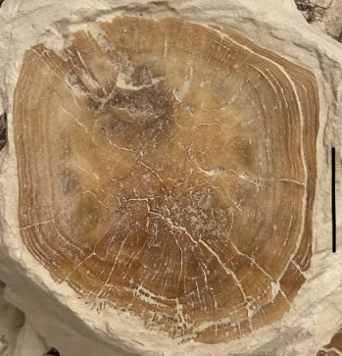
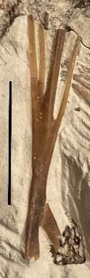
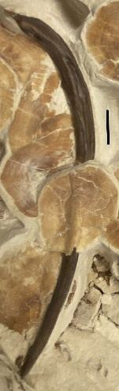
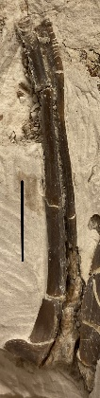
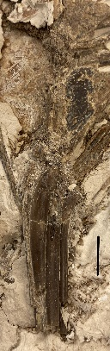
There are many large cycloid scales within the block; some have drifted away from the main fossil and others have adhered to the skeleton itself. There is only one that is noticeably different and appears to be a dorsal or ventral scale. The scale in the picture is from an unknown location on the body (Fig. 10E).
FIGURE 10―Ictiobus phyllisae n. sp. OMNH 77567, A. Partial dorsal fin, scale-covered pterygiophores; B. Partial pectoral fin; C. Partial epineural/epipleural; D. Rib, with a scale draped over rib shaft; E. Cycloid scale. Scale bars are 1 cm.
A
C
D
E
B
df
ptg

Vertebral column
There are a few visible vertebrae, but these are mostly obscured by scales or other bones.

Suspensorial pleural ribs
There is a portion of the pleural ribs visible that has been displaced lateroposteriorally, showing the posterior surface, along with elements of the Weberian apparatus (mostly the right tripus can be seen in laterodorsal view).

DISCUSSION
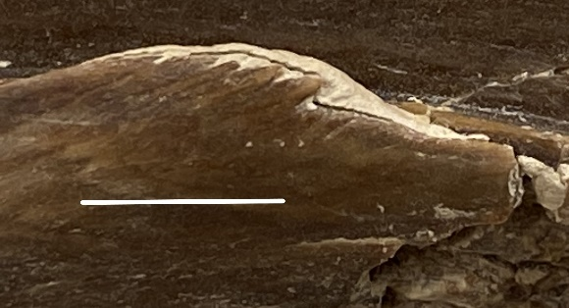
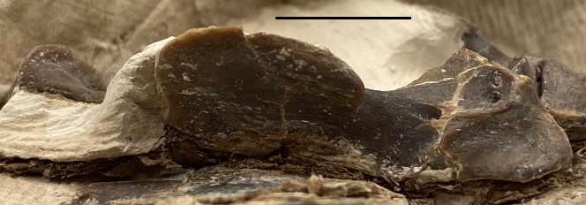
Ictiobus phyllisae n. sp. is most similar to I. bubalus, but it shows a few distinct characters that are outside the range of variation. It is included in the family Catostomidae because it has the following characters described by G. R. Smith (1992). Both of the opercles, OMNH 78587 and OMNH 77567 (Fig. 3, Fig. 8A) have a slightly concave dorsal margin; the lower jaw is smooth and lacking the sensory canal; the lateral ethmoid is porous (Alvarado-Ortega et al. 2006).
FIGURE 11―Ictiobus phyllisae n. sp. OMNH 77567, A. Variations within the dentary, preopercle, and cleithrum of the different species of Ictiobus. Figure modified from Alvarado-Ortega et al. 2006; B. Coronoid process of the dentary in lateral view; C. Serrations on the cleithrum in anterior view. Scale bars are 1 cm.
I. aguilerai
I. bubalus
I. cyprinellus
I. phyllisae
A
B
C
Ictiobus phyllisae n. sp. is placed as a member of Ictiobus because of the morphology of the palatine bone: the ethmoid process is longer than the premaxillary process, a condition which is unique to Ictiobus (Smith, 1992; Alvarado-Ortega et al. 2006) (Fig. 7E).
There are a few characters that separate Ictiobus phyllisae n. sp. from the others in the genus. The dentary is similar in shape to that of I. bubalus in lateral view but is strikingly different when viewed dorsally. The gnathic ramus is wide, with the anterior margin extending much wider than I. bubalus (Fig. 11A). In addition, the coronoid process is not in line with the ridge running along the length of the jaw; rather, it is angled outward and continues farther posteriorly than in all other species of Ictiobus (Fig. 11B).
The cleithrum has small serrations on the anterior margin, which I did not observe on specimens belonging to any other species, irrespective of size (Fig. 11C).
The preopercle is generally similar to that of I. bubalus but has a sharp angle of about 140 degrees on the anterior margin. The horizontal and vertical processes have straight margins that overlap slightly, instead of one continuous curve as seen in I. bubalus. The vertical process is also much wider in lateral view (Fig. 11A).
The opercle of the Nebraska fossil, UNSM 118584, has a concave dorsal margin, characteristic of Catostomidae (Fig. 12A) (Smith, 1992). There are a few available elements that have the characteristics of Ictiobus cyprinellus; the interopercle is triangular in shape, with a high point posteriorly (Fig. 12B, C) and the dentary has a large and narrow dorsal surface, of the gnathic ramus (Fig. 12D, E) (Alvarado-Ortega et al. 2006).
The phylogenetic analysis was executed in PAUP 4.0, using a branch and bound search for efficiency, this produced one tree with a CI index of 0.90, CI excluding uninformative characters of 0.84, retention index (RI) of 0.84, rescaled consistency index (RC) of 0.76, and a tree length of 152. There are both binary and multistate characters present in the matrix, the multistate characters were treated as unordered and equally weighted. Inapplicable states were coded with a question mark. After preforming a bootstrap and Bremer Decay in PAUP, the results showed weakly supported nodes with only one (node H) being 100 percent. This is most
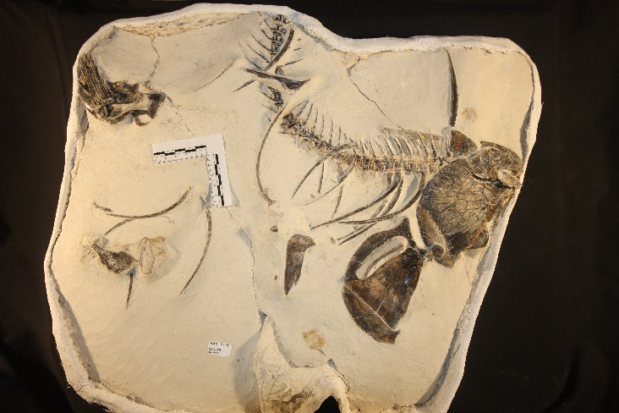
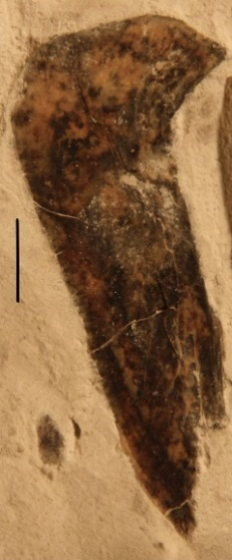
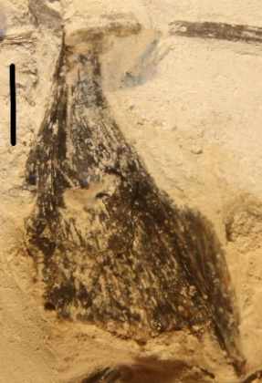
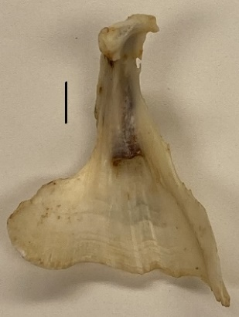
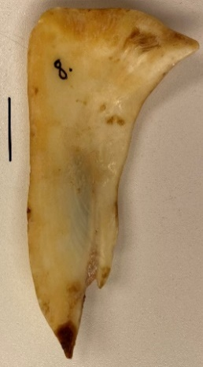
likely due to the lack of available characters within the fossil specimens. The general grouping of the Ictiobinae (Ictiobus and Carpiodes) is present and is well agreed upon (Alvarado-Ortega et al. 2006; Smith, 1992). Ictiobus phyllisae n. sp. is placed as a sister group to I. aguilerai, within the Ictiobus family and it has them both closely related to I. bubalus (Fig. 13). These results are reinforced by my observations of the skeletal material, with I. bubalus elements being the most similar to I. phyllisae n. sp.
A
B
D
FIGURE 12―A. An undescribed fossil Ictiobus from Nebraska UNSM 118584; B. Left interopercle, medial view; C. Extant I. cyprinellus, left interopercle; D. Left dentary, medial view, missing the coronoid process; E. Extant I. cyprinellus, left dentary. Scale bars 1 cm.
C
E
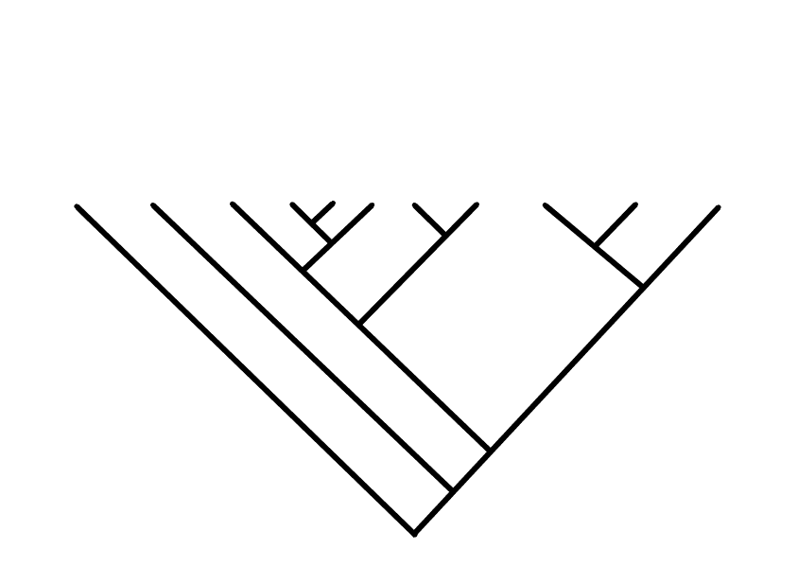
The character optimization states the changes at each node in Appendix 3. The transition at node C to B, shows I. phyllisae n. sp., I. aguilerai, and I. bubalus with a hyomandibular intermediate in width. The change at node B to A shows that I. phyllisae n. sp. and I. aguilerai lack the articular-angular crest. At node A to I. phyllisae n. sp., the serrated cleithrum character is unique to this species.
(74,1) A
B (56,1)
(<50,1) C
D (61,1)
(78,2) E
(58,1) F
G (77,1)
H (100,2)
I (3+)
Leptobotia
Cyprinus
Ictiobus niger
Ictiobus phyllisae
Ictiobus aguilerai
Ictiobus bubalus
Ictiobus labiosus
Ictiobus cyprinellus
Carpiodes cyprinus
Carpiodes carpio
Carpiodes velifer
FIGURE 13―Placement of Ictiobus phyllisae n. sp. within the Ictiobinae, using Leptobotia as the outgroup. The letters at the nodes correspond to Appendix 3, showing the character support. The bootstrap and Bremer Decay Index are added in parenthesis respectively.
CONCLUSION
The genus Ictiobus belongs to the family Catostomidae, which range mostly in North America and eastern Asia (Smith, 1992). Ictiobus fossils, mostly represented by isolated skeletal elements are known throughout the Ogallala Formation, which covers a large area from South Dakota to Texas. Within this formation a fossil representing a new species of Ictiobus was found in the panhandle of Oklahoma by the Native Explorers group in 2011. The Miocene age (Clarendonian, which is approximately 10 to 13 mya) places this Ictiobus as one of the earliest known. This fossil is largely articulated and lacking the caudal half of the postcranial skeleton. The completeness and articulated nature of this specimen is unique among previously found fossil Ictiobus. Unique characters of three bones distinguish Ictiobus phyllisae as a new species. Compared with extant and fossil specimens, the anterior process on the gnathic ramus of the dentary is larger and wider, the preopercle has a sharp angled anterior margin and the cleithrum has small serrations on the anterior margin. A previously undescribed Pleistocene Ictiobus fossil from Nebraska is shown to represent the living species I. cyprinellus, due to similarities in structure of the interopercle and gnathic ramus of the dentary. A phylogenetic analysis places I. phyllisae n. sp. and I. aguilerai (a fossil species from the Pliocene of Mexico) as sister taxa high within the Ictiobinae, which implies that all of the extant Ictiobus species evolved in the early Miocene or before. Further study is needed, however, because this result is weakly supported, being based on a small number of characters visible on the fossil specimens.
ACKNOWLEDGMENTS
I would like to thank the many people that were involved, starting with my committee, Dr. Richard Cifelli (University of Oklahoma, Norman, OK), Dr. Dahiana Arcila (University of Oklahoma, Norman, OK), Dr. Stephen Westrop (University of Oklahoma, Norman, OK), Dr. Cameron Siler (University of Oklahoma, Norman, OK), and Dr. Nicholas Czaplewski (Sam Noble Museum, Norman, OK) for all of the help, opportunities and sharing of your time. I am indebted to Dr. Kent Smith (Oklahoma State University, Center for Health Sciences, Tulsa, OK) and Dr. Czaplewski for making the Native Explorers program possible. I thank Dr. William Matthews (University of Oklahoma, Norman, OK) for teaching me ichthyology and getting me in contact with Dr. Hank Bart (Tulane University, New Orleans, LA), who graciously loaned me some specimens. Dr. Joseph Frederickson (Weis Earth Science Museum, University of Wisconsin, Oshkosh, WI) gave me tutorials for Affinity Designer and generously gave me use of his equipment. I am grateful to the many students and grad students of the Native Explorers group of 2011 for finding and collecting the fossils, and Brenton McCullough for the use of his field notes. Kyle Davies (Sam Noble Museum, Norman, OK) provided expert advice on preparation and use of the lab. Jennifer Larsen and Sara Cartwright (Sam Noble Museum, Norman, OK) gave considerable help with comparative specimens in their collections. I thank Shane Tucker (University of Nebraska-Lincoln, NE) for bringing the Nebraska fossil to Oklahoma so I could study it. I am grateful to OU fisheries biologist Richard Snow (University of Oklahoma, Norman, OK) for the many comparative specimens he supplied. I thank the lab volunteer John Stonecipher who prepared the isolated opercle in figure 3. Jessica De Smet did a little initial preparation on the fish block OMNH 77567. Lastly, I thank previous grad students, student workers and volunteers that helped with this project.

Appendix 1.
Phylogenetic Characters and state codes. Characters 1-157 are modified from Smith, 1992. Characters 158-162 are from the description of Ictiobus phyllisae n. sp., with the addition of characters 163-177 modified from Alvarado-Ortega et al. 2006.
1. OTIC FORAMINA. 0=enlarged (Smith, 1992:fig. 1e), 1=restricted (Smith, 1992:fig. 1d).
2. HYPOBRANCHIALS. 0=1st, 2nd, and 3rd hypobranchials short, 1=1st and 2nd long and subequal, 2=1st longer than 2nd.
3. BASIOCCIPITAL KEEL. 0=double pedicel surrounds aorta posteriorly, 1=double pedicel around aorta reduced, 2=pedicel compressed (Smith, 1992:fig. 1e).
4. UROHYAL PROCESS FOR HYPOHYAL LIGAMENTS AND MEDIAN LAMINA. 0=hypohyal processes adjacent at anterior end of robust median lamina (Smith, 1992:fig. 2c and d), 1=adjacent hypohyal processes at anterior end of a neck that tapers posteriorly into median and horizontal laminae (Smith, 1992:fig. 2a and b), 2=widely separated and robust hypohyal processes (Smith, 1992:fig. 2e, f, i, l, and m), 3=weak and widely separated hypohyal processes on transverse shield with long median lamina (Smith, 1992:fig. 2g, j, and k), 4=processes separated and median lamina short (Smith, 1992:fig. 2h and n), 5=median lamina nearly obsolete.
5. UROHYAL HORIZONTAL LAMINA. 0=slender anterior constriction (Smith, 1992:fig. 2a), 1=moderate anterior constriction (Smith, 1992:fig. 2f), 2=moderately long, broad, and tapered (Smith, 1992:fig. 2e and l), 3=about as short as broad (Smith, 1992:fig. 2b, g, j, k, and m), 4=extremely broad, robust wings anteriorly placed (Smith, 1992:fig. 2c, d, h, and n), 5=horizontal lamina reduced to posterior flanges on corners of a vertical triangle (Smith, 1992:fig. 2n), 6=horizontal lamina obsolete.
6. METAPTERYGOID. 0=simple posterior lamina near hyomandibular, 1=lamina braces hyomandibular (Smith, 1992:fig. 3a), 2=prominent lateral lamina and mesial struts brace hyomandibular (Smith, 1992:fig. 3b and c), 3=as in state 2 with mesial ventral process bracing quadrate (Smith, 1992:fig. 3c).
7. SYMPLECTIC. 0=wedge-shaped with simple contact to metapterygoid (Smith, 1992:fig. 3b), 1=sutured into metapterygoid notch (Smith, 1992:fig. 3a and d), 2=complex, tripartite and sutured into metapterygoid (Smith, 1992:fig. 3c).
8. OPERCLE SHAPE. 0=no broad concavity behind articular process, 1=broad concave dorsal edge, 2=shorter, strongly concave dorsal edge.
9. EXTERNAL STRIATIONS ON OPERCLE. 0=present, 1=absent.
10. SUPRAORBITALS. 0=present (Smith, 1992:fig. 4c), 1=absent (Smith, 1992:fig. 4a and d).
11. 4TH and 5TH NEURAL ARCHES AND SPINES. 0=only 4th a part of Weberian neural complex, 1=5th with zygapophysis to neural complex, 2=5th significantly articulated to neural complex.
12. 1ST TRANSVERSE PROCESS. 0=long, 1=small, 2=minute.
13. 4TH CENTRUM. 0=laterally visible, 1=mostly occluded.
14. RIDGE ON NEURAL SPINE 2-3. 0=present, 1=obsolete.
15. LATERAL LINE. 0=present, 1=largely or completely absent.
16. 6TH HYPURAL. 0=present, 1=absent.
17. INTEROPERCLE. 0=semi-lunate (Smith, 1992:fig. 3a, b, and d), 1=rectangular (Smith, 1992:fig. 3c), 2=slender rectangular, 3=slender angular.
18. DERMETHMOID SHAPE. 0=domed rectangle (Smith, 1992:fig. 4), 1=sharply narrower posteriorly, 2=wide and laterally elevated, 3=narrow and laterally elevated, 4=short and wide, 5=narrow bar, 6=rough triangle (not ordered).
19. EPIOTIC PROCESS. 0=present (Smith, 1992:fig. 4a and b), 1=absent (Smith, 1992:fig. 4c and d).
20. SWIMBLADDER. 0=1 or 2 chambers, 1=3 chambers.
21. CERATOHYAL. 0=long with postventral process well developed, 1=medium, process well developed (Smith, 1992:fig. 2p, q, and s), 2=short, process reduced or absent (Smith, 1992:fig. 2r and t).
22. PREFRONTAL/DERMETHMOID CONTACT. 0=anterior corners widely separated (Smith, 1992:fig. 4a and b), 1=anterior corners close or connected (Smith, 1992:fig. 4c and d).
23. SUBTERMPORAL FOSSA. 0=deep, 1=shallow with exoccipital corner present in the fossa (Smith, 1992:fig. 1d), 2=shallow with exoccipital excluded from the fossa (Smith, 1992:fig. 1e).
24. DENTARY LENGTH AND ANGLE. 0=jaw long, little deflected (Miller and Smith, 1981:fig. 10a, d, and g), 1=moderate length with ventral deflection (Smith, 1966:fig. 4a), 2=short and anteriorly deflected (Smith, 1966:fig. 4b), 3=truncated and strongly deflected mesially (Smith, 1966:fig. 4c-e).
25. GILL RAKERS. 0=simple ridges with spines (Smith, 1992:fig. 5a-c), 1=spines in clusters (Smith, 1992:fig. 5d), 2=rakers forming secondary branches (Smith, 1992:fig. 5e), 3=secondary branches dominate, 4=three-dimensional net of raker branches (Smith, 1992:fig. 5f).
26. MAXILLARY, POSTERIOR PROCESS. 0=elongate posterior arm (Miller and Smith, 1981:fig. 11e), 1=short posterior arm (Miller and Smith, 1981;fig. 10c).
27. LOWER LIP LOBES. 0=thin, 1=moderate, 2=long, 3=very long.
28. POSTTEMPORAL FOSSA. 0=absent, 1=restricted, 2=large (Smith, 1992:fig. 4a-d).
29. FRONTAL PORES. 0=small, in regular row, 1=small scattered (Smith, 1992:fig. 4c and d), 2=large and clustered (Smith, 1992:fig. 4a and b).
30. ARTICULAR-ANGULAR. 0=mesial or lateral crests between condyle and retroarticular, 1=crests lost.
31. HYOMANDIBULAR/PREOPERCULAR CONTACT. 0=simple, 1=extensive, involving high shoulder and median flap from hyomandibular.
32. FRONTAL CONTACT WITH ORBITOSPHENOID AND PLEUROSPHENOID. 0=sutured, 1=cartilage.
33. ANTERIOR PARASPHENOID. 0=narrow, rodlike, 1=broad and flat.
34. mMdh-A. 1=functional diploid (apomorphic), 2=duplicate.
35. Gpi-A. 1=functional diploid, 2=duplicate.
36. Gpi-B. 1=functional diploid, 2=duplicate.
37. G3pdh-A. 1=functional diploid, 2=duplicate.
38. Ak-A. 1=functional diploid, 2=duplicate.
39. Pgdh-A. 1=functional diploid, 2=duplicate.
40. Ldh-B. 1=functional diploid, 2=duplicate.
41. sAat-A. 1=functional diploid, 2=duplicate.
42. Ald-C. 1=functional diploid, 2=duplicate.
43. Acp-A. 1=functional diploid, 2=duplicate.
44. Ck-A. 1=functional diploid, 2=duplicate.
45. sMdh-A. 1=functional diploid, 2=duplicate.
46. sMdh-B. 1=functional diploid, 2=duplicate.
47. Ldh-A. 1=functional diploid, 2=duplicate.
48. mAat-A. 1=functional diploid, 2=duplicate, 3=triplicate (Buth, 1979a)
49. CEREBELLUM SIZE (as % total brain). 0=21-27, 1=30-33, 2=>35.
50. FACIAL LOBE SIZE (as % total). 0=>22, 1=12-19, 2=7-10.
51. VAGAL LOBE SIZE (as % total). 0=32-38, 1=25-29, 2=18-23.
52. MEDIAN OPTIC FISSURE. 0=present, 1=absent.
53. VAGAL LOBE SHAPE. 0=swollen and occluding facial lobe, 1=contact over posterior facial lobe, 2=not quite in contact behind facial lobe, 3=flared and widely separate.
54. LIP PAPILLAE. 0=absent, 1=weak papillae, 2=papillae, 3=plicae (not ordered).
55. LOWER LIP NOTCH. 0=wide and deep (Miller and Smith, 1981;fig. 6), 1=deep (ibid.:fig. 4c), 2=moderate (Smith and Keohn, 1971:fig. 2d), 3=slight (ibid.:fig. 2b).
56. CAUDAL PEDUNCLE SCALES. 0=>17, 1=16, 2=12 (Jenkins, 1970).
57. PELVIC FIN BREEDING MODIFICATION. 0=none, 1=males or both.
58. PTEROTIC RIDGE. 0=broad (Smith, 1992:fig. 4a and b), 1=intermediate (Smith, 1992:fig. 4c), 2=sharp (Smith, 1992:fig. 4d).
59. SNOUT TUBERCLES. 0=absent, 1=small, 2=large, 3=reduced to 3.
60. INTERCALAR. 0=present (Smith, 1992:fig. 1e), 1=absent.
61. MEDIAN BRANCHIAL RIDGES ON GILL RAKERS. 0=broad (Smith, 1992:fig. 5a), 1=narrow (Smith, 1992:fig. 5c), 2=with accessory knobs (Smith, 1992:fig. 5d), 3=bridged over by conjoint rakers (Smith, 1992:fig. 5b)(not ordered).
62. PREMAXILLARY PROCESS OF MAXILLA. 0=arises posteriorly on neck (Miller and Smith, 1981:fig. 11e), 1=shifted to below head of bone (ibid.:fig. 10c and f), 2=directed anteriorly (ibid.:fig. 10a, d, and g).
63. DORSAL RIDGE OF MAXILLA. 0=rounded, 1=extended post-dorsally.
64. NUMBER OF INFRAORBITALS. 0=5+ (Smith, 1992:fig. 1b), 1=4 (Smith, 1992:fig. 1a), 2=3 (Smith, 1992:fig. 1c), 3=2 suborbitals including lacrimal.
65. SHAPE OF SUBORBITALS. 2-6. 0=heavy and deep, 1=thin and deep (Smith, 1992:fig. 1a-c), 2=thin, medium depth, 2=thin and slender.
66. FRONTAOPARIETAL FONTANELLE. 0=absent, 1=partial (Smith, 1992:fig. 4a), 2=wide (Smith, 1992:fig. 4b and c).
67. DORSAL FIN RAYS. 0=18+, 1=14-15, 2=12-13, 3=11, 4=9-10.
68. PREDORSAL SCALE NUMBER. 0=30-39, 1=40-49, 2=50-56.
69. LATERAL SCALE NUMBER (FOR CATOSTOMUS). 0=fewer than 65, 1=70-89, 2=90-109
70. VERTEBRAL NUMBER (FOR CATOSTOMUS). 0=40-42, 1=43, 2=44-45.
71. HEAD LENGTH (% standard length). 0=24+, 1=21-23, 2=20.
72. CAUDAL PEDUNCLE DEPTH (% standard length). 0=9.5+, 1=8-9.5, 2=<8.
73. CAUDAL INTERRADIAL PIGMENT. 0=present (Smith, 1966:fig. 9b), 1=absent (ibid.:fig. 9a).
74. JAW CARTILAGES. 0=weak (Smith and Koehn, 1971:fig. 2f), 1=moderate rounded (ibid.:fig. 2c and d), 2=strong truncated (ibid.:fig. 2b).
75. OUTER UPPER LIP PAPILLAE. 0=well developed (Smith, 1966:pl. 1a), 1=moderate, 2=absent (ibid.:pl. 1e).
76. OUTER LIP NOTCHES. 0=absent, 1=weak, 2=strong.
77. GILL RAKER NUMBER. 0=15-22, 1=22-25, 2=26-31, 3=32-39, 4=40-50.
78. GUT LENGTH. 0=4 or fewer coils, 1=6 coils, 2=more than 6 coils.
79. PERITONEUM PIGMENT. 0=absent or sparse, 1=black.
80. HYOMANDIBULAR. 0=slender, 1=intermediate, 2=truncate, 3=with pterygoid notch.
81. PREOPERCLE. 0=slender obtuse, 1=intermediate, 2=wide, triangular.
82. MAXILLA, LOWER RIDGE. 0=knob, 1=low curve, 2=intermediate, 3=strong anteroventral ridge for muscle attachment.
83. HEMOGLOBIN, ANODAL. 0=single strong band, 1=3 strong and 3 weak bands, 2=3 strong and 4 weak bands.
84. HEMOGLOBIN, CATHODAL. 0=absent, 1=2 weak bands, 2=strong band with intermediate mobility, 3=strong band with high mobility.
85. ESTERASE Ia’. 0=absent, 1=present.
86. ESTERASE Ia. 0= absent, 1=present.
87. ESTERASE Ib. 0=present, 1=absent.
88. TRANSFERRIN 1. 0=present, 1=absent.
89. TRANSFERRIN 2. 0= present, 1=absent.
90. TRANSFERRIN 3. 0= absent, 1=present.
91. TRANSFERRIN 4. 0= absent, 1=present.
92. TRANSFERRIN 5. 0= absent, 1=present.
93. MAXIMUM BODY SIZE. 0=greater than 2 kg, 1=0.1-2 kg, 2=usually less than 100g.
94. LOWER LIMB OF PREOPERCLE. 0=long, 1=short, 2=abbreviated.
95. ANTERO-VENTRAL PLATE OF MAXILLA (for Moxostoma). 0=convex, 1=concave neck.
96. NUMBER OF LATERAL LINE SCALES. 0=35-41, 1=42-53, 2=55-65, 3=66+.
97. NUMBER OF POST-WEBERIAN VERTEBRAE. 0=28-31, 1=32-36, 2=37-41, 3=42-44.
98. PHARYNGEAL DORSAL KNOB. 0=absent, 1=present.
99. NUMBER OF DORSAL FIN RAYS. 0=<18, 1=21-32, 2=30-37, 3=52-57.
100. SADDLE-BLOTCH PATTERN. 0=none, 1indistinct, 2=4/4 or 3.5, 3=4/3, 4=solid horizontal stripe (Jenkins, 1970).
101. PEDUNCLE LENGTH IN SMALL LARVAE. (PC1=0). 0=2.1-2.2, 1=1.5-2.0.
102. PEDUNCLE LENGTH IN LARGE LARVAE. (PC1=.6). 0=4.0-4.1, 1=3.2-3.7.
103. TRUNK LENGTH IN SMALL. 0=3.6-4.4, 1=6.1-6.9.
104. TRUNK LENGTH IN LARGE. 0=5.0-5.7, 1=6.2-6.3.
105. HEAD LENGTH IN SMALL. 0=1.0-1.3, 1=1.3-1.5 (plesiomorphic), 2=1.5-1.6.
106. HEAD LENGTH IN LARGE. 0=2.0-2.3, 1=2.4-2.5 (plesiomorphic), 2=2.6-2.7.
107. EYE LENGTH IN SMALL. 0=0.4-0.52, 1=0.54, 2=0.58-0.62.
108. EYE LENGTH IN LARGE. 0=0.7-0.9, 1=0.98.
109. BODY DEPTH IN SMALL. 0=0.4-0.6, 1=0.6-0.8, 2=0.8-0.9.
110. BODY DEPTH IN LARGE. 0=0.8-0.9, 1=0.9-1.2 (plesiomorphic), 2=1.3.
111. SIZE AT HATCHING (as regression of PC1 on log total length). 0=-0.58, 1=-0.36-0.19, 2=0-0.3.
112. YOLK SAC SHAPE (ratio of height to length). 0=0.25-0.37, 1=0.13-0.22.
113. EGG DIAMETER (after water hardening, in mm). 0=1.8-2.3, 1=2.6-2.7, 2=3.0-3.4, 3=3.8.
114. PRE-ANAL MYOMERS. 0=27-31, 1=33-35, 2=36-39.
115. POST-ANAL MYOMERES. 0=13-14, 1=7-11.
116. TIME OF UROSTYLAR FLEXION. 0=0.2-0.5, 1=0.5-0.6.
117. TIME OF DORSAL FIN RAY FORMATION (as in 116). 0=0.2-0.3, 1=0.4-0.61 (plesiomorphic), 2=0.79.
118. TIME OF ANAL FIN RAY FORMATION (as in 116). 0=0.49-0.52, 1=0.58-0.7, 2=0.74.
119. TIME OF COMPLETE MEDIAN FIN FORMATION (as in 116). 0=0.63-0.67, 1=0.75-0.81 (plesiomorphic), 2=0.85-0.90.
120. TIME OF PECTORAL BUD FORMATION (as in 116). 0=0.0, 1=0.11 (plesiomorphic), 2=0.17, 3=0.25.
121. TIME OF YOLK ABSORPTION (as in 116). 0=0.13-0.14, 1=0.19-0.33 (plesiomorphic), 2=0.38-0.47.
122. TIME OF HEAD STRAIGHTENING (as in 116). 0=0.0, 1=0.04-0.05, 2=0.07-0.11, 3=0.17 (plesiomorphic).
123. TIME OF EYE PIGMENTATION (as in 116). 0=0.0-0.07, 1=0.14 (plesiomorphic), 2=0.29-0.37.
124. TIME OF LATERAL STRIPE FORMATION (as in 116). 0=0.0, 1=1.0, 2=>1.0.
125. NUMBER OF LARGE PREDORSAL BONES. 0=0-2, 1=3-4, 2=5-7.
126. PHARYNGEAL CURVATURE (in Moxostoma, Jenkins, 1970). 0=high radius, 1=low radius.
127. BODY FORM. 0=deep, 1=moderate, 2=slender, 3=depressed.
128. FIN SHAPE (in Moxostoma, Jenkins, 1970). 0=straight, 1=round.
129. NUPTIAL COLOR. 0=absent, 1=blue or black, 2=pink or red.
130. CAUDAL STRIPE (in Moxostoma, Jenkins, 1970). 0=absent, 1=present.
131. NINTH CRANIAL NERVE EXIT. 0=between exoccipital and prootic (Smith, 1992:fig. 1e), 1=through exoccipital (Smith, 1992:fig. 1d).
132. ANTERODORSAL PROFILE OF NEURAL ARCH 2-3 OF WEBERIAN APPARATUS. 0=steep, 1=moderate angle, 2=not deep.
133. LATERALIS CANAL BONES ON PREOPERCLE. 0=embedded, 1=partly superficial and attached at surface, 2=none embedded, canal mostly attached at surface, 3=all canal bones detached from surface.
134. SCALE SHAPE. 0=obovate, 1=sharp anterolateral corners.
135. ANTERIOR RADII ON SCALES. 0=few, 1=numerous, 2=extend in parallel into lateral fields, 3=numerous lateral radii.
136. DERMETHMOID SPINE. 0=long and broad, 1=short and broad, 2=short and deflected ventrally, 3=long and slender (Smith, 1992:fig. 4a and b), 4=moderate and expanded at base (Smith, 1992:fig. 4c), 5=short and slender (not ordered).
137. DENTARY, MESIAL MENTAL FORAMEN. 0=near dorsal edge (Miller and Smith, 1981:fig. 10f), 1=intermediate, 2=near Meckel’s cartilage (ibid.:fig. 10d), 3=as in state 2 and much enlarged.
138. PREMAXILLARIES. 0=lateral wing much longer than dorsal process (ibid.:fig. 10d), 1=lateral wing slightly longer than dorsal process, 2=lateral wing slightly shorter than dorsal process (ibid.:fig. 10c), 3=lateral wing much shorter than dorsal process.
139. POSTERIOR RADII OF LATERAL SCALES. 0=annual increase series ca. 5-10-15, 1=increase series ca. 3-6-12, 2=increase series ca. 3-3-6-6.
140. CEPHALIC SENSORY CANALS. 0=embedded in bone, 1=detached.
141. BASIOCCIPITAL PROCESS. 0=absent, 1=present and solid, 2=fenestrate.
142. HYOMANDIBULAR. 0=anterior condyle elongate, articulates with sphenotic and pterosphenoid, 1=small, articulates only with sphenotic.
143. SECOND PLEURAL RIB OF WEBERIAN APPARATUS. 0=descending process absent, 1=present but unsutured to 4th rib, 2=descending processes of 2nd and 4th ribs broadly sutured together.
144. MANDIBULAR SENSORY CANALS. 0=present, 1=lost.
145. LATERAL ETHMOID. 0=single sheet of nonporous bone, 1=triradiate in longitudinal section and porous, 2=spinous (not ordered).
146. ORIGIN OF DILATOR OPERCULI. 0=not expanded onto dorsal surface of frontal, 1=broadly expanded over post-dorsal surface not of frontal, with slip under ventral surface of frontal, 2=extensive origin on post-dorsal surface of frontal, none on ventral surface.
147. DERMOSPHENOTIC. 0=prominent, 1=minute.
148. POSTTEMPORAL. 0=prominent, 1=reduced.
149. POSTERIOR PTEROTIC FOSSA. 0=dorsal to intercalary, 1=ventral to intercalary, 2=obsolete.
150. NUMBER OF CAUDAL RAYS. 0=19, 1=18.
151. PHARYNGEAL ARCH. 0=low triangular cross-section few teeth, 1=low triangular cross-section many teeth, 2=high triangular x-section, many teeth, 3=high, flat x-section, extremely numerous teeth.
152. ANTEROMESIAL SYMPHYSIS OF CLEITHRUM. 0=anterior to anterolateral margin, 1=subequal, 2=posterior.
153. CLEITHRUM-CORACOID FENESTRA. 0=much larger than scapular fenestra, 1=reduced to size of scapular fenestra, 2=minute or absent.
154. PALATINE LENGTH (ECTOPTERYGOID TO MAXILLARY LIGAMENT). 0=long, 1=short.
155. PREPALATINE PROCESS OF PALATINE. 0=undeveloped, 1=equal to maxillary process, 2=extended or separated from maxillary process by notch, 3=with basal boss for prepalatine bone.
156. PALATINE ANGLE. 0=straight, 1=oblique, right angle between axis and maxillary process.
157. ETHMOID PROCESS OF PALATINE. 0=short, 1=long.
158. SERRATED CLEITHRUM. 0=absent, 1=present.
159. SHARP ANGLED PREOPERCLE ANTERIOR MARGIN. 0=curved, 1=angled.
160. GNATHIC RAMUS ANTERIOR PROCESS, IN DORSAL VIEW. 0=absent, 1=thin, 2=intermediate, 3=wide, 4=bilobulate.
161. OUTWARDLY ANGLED CORONOID PROCESS. 0=in line with the jaw, 1=angled outward, not in line with the jaw.
162. CORONOID PROCESS EXTENDS POSTERIORLY. 0=short, 1=long.
163. SHAPE OF THE UROHYAL HORIZONTAL LAMINA. 0=short rectangle, moderate longer than wide, 1=medium rectangle, moderate longer than wide, 2=long triangle-ovoid, 3=jagged triangle.
164. SIZE OF UROHYAL VERTICAL LAMINA. 0=short, 1=medium, 2=large and tapered.
165. SHAPE OF SUPENSORIAL PLEURAL RIBS IN LATERAL-EXTERNAL VIEW. 0=triangular with curved margins, 2=triangular with straight margins, 3=triangular with curved margins and projected forward, 4=triangular with straight posterior and slightly curved anterior margins.
166. SHAPE OF SUSPENSORIAL PLEURAL RIBS IN ANTERIOR-POSTERIOR VIEW. 0=narrow rectangle, 1=wide rectangle, 2=trapezoid, lateral margins projected outward ventrally.
167. PROJECTION OF THE SUSPENSORIAL PLEURAL RIBS (IN LATERAL VIEW). 0=anteroventral, 1=downward.
168. LENGTH OF CERATOHYAL. 0=short, 1=medium, 2=long.
169. PROCESS FOR THE CERATOHYAL IN THE INFRAOPERCLE. 0=absent, 1=present.
170. UROHYLA PROCESSES FOR HYPURAL LIGAMENTS. 0=absent or minute, 1=intermediate, 3=robust, long, and separated.
171. SUPENSORIAL PLEURAL RIBS JOIN (PLEURAL RIBS III + IV) IN LATERAL VIEW. 0=complex web and shallow (almost flat), 1=complex web and deeply folded inward.
172. ANTERIOR PROCESS OR SPINE OF THE DERMETHOID. 0=fine (wide base and thin tip), 1=coarse (wide, short, and rounded).
173. ANTERIOR BORDER OF UROHYAL HORIZONTAL LAMINA (IN LATERAL VIEW). 0=rounded, 1=with a little curvature.
174. SHAPE OF EXOCCIPITAL. 0=inverted C, 1=O.
175. LATERAL PROCESS OF THE PREMAXILLA. 0=short lateral wing, 1=large lateral wing.
176. ANTERIOR BORDER OF THE DERMETHMOID. 0=concave, 1=straight or convex.
177. INTEROPERCLE. 0=uniformly deep, curved in its posterior end, 1=triangular.

Appendix 2
Matrix of 177 characters modified from Smith, 1992 and Alvarado-Ortega et al., 2006. The numbers correlate to the states in Appendix 1 and are presented for nine suckers and two outgroups. Question marks represent inapplicable states and not all extant species have been examined for all characters (Smith, 1992).
Leptobotia
10113 00011 010?0 00500 20120 10000 000?? ????? ????? ????? ???00 0?0?1 00032 14200
00002 00002 00??? ????? ??032 00000 ????? ????? ????? ????? ????? ?20?0 10000 30000 00100 10?00 00000 00??? ????? ????? ????? ??
Cyprinus
00110 00000 01000 00600 00000 00000 000?? ????? ????? ???00 10100 00000 00000 00000 00000 00002 00??? ????? ??000 00010 ????? ????? ????? ????? ????1 ?0?00 00000 00010 10000 00000 00000 00??? ????? ????? ????? ??
Ictiobus niger
02022 11100 10000 00200 10220 00210 01122 22221 22221 11?02 01010 00010 30011 20000 00000 04110 02??? ????? ??001 00010 11000 00001 10000 01120 12002 01?00 00001 00211 21211 21111 30010 01002 00003 10111 11110 00
Ictiobus bubalus
02022 11100 10000 00200 10220 10210 01122 22221 22221 11?02 01010 00010 30011 20000 00000 04111 02??? ????? ??001 00010 11000 00001 11000 01120 02002 00?00 00001 10211 21211 21111 30010 01001 00000 00100 00000 00
Ictiobus cyprinellus
02021 11100 10000 00000 00200 10210 01122 22221 22221 11?02 01010 00010 11011 20000 00000 04110 02??? ????? ??001 00010 11000 00001 10000 01110 02002 00?00 00001 10101 21211 21111 30000 01000 00230 10202 11111 11
Ictiobus labiosus
02022 11100 10000 00200 20220 10210 011?? ????? ????? ????? ???21 0?0?? 31011 20000 10000 04110 02??? ????? ??001 0?010 ????? ????? ????? ????? ????1 02?00 ?0001 10311 21211 21111 30000 0100? ?0003 10002 11110 00
Ictiobus phyllisae
????? ??100 ?0??? ?0??? ???2? ???11 0???? ????? ????? ????? ????? ??0?? ????1 2???? ????? ????1 0???? ????? ???0? ????? ????? ????? ????? ????? ????? ????? ??001 ?02?? ???11 ??1?? ????0 01113 11??? ????? ????0 ?0
Ictiobus aguilerai
???22 1?100 ?0??? ?02?? 10?2? 0??11 0?1?? ????? ????? ????? ????? ????? ?00?1 2???? ????? ????1 02??? ????? ???01 ????? ????? ????? ????? ????? ????? ????? ??0?? 102?? ?1?11 ??1?? ????0 01004 00114 21102 11110 00
Carpiodes cyprinus
02023 11100 10000 00300 10220 00210 01112 22222 22111 21?02 01010 00010 30010 20000 00000 03200 02??? ????? ??001 00010 11000 00001 11000 01120 13022 00?00 00201 10311 21211 21111 30010 00002 00??? ????? ????? ??
Carpiodes velifer
02023 11100 10000 00300 10220 00210 01?12 22222 22121 21?02 01010 00010 30010 20000 00000 03200 02??? ????? ??001 00010 11000 10001 11000 11120 12022 00?00 00201 20311 21211 21111 300100 0000? 00??? ????? ????? ??
Carpiodes carpio
02023 11100 10000 00300 10220 00210 01112 22222 22111 21?02 01010 00010 30010 20000 00000 03200 02??? ????? ??001 00010 11000 00001 11000 11220 11012 00?00 00201 20311 21211 21111 30010 0000? 0030? ??0?? ????0 ??
Appendix 3
Character change list:
Character | CI | Steps |  | Changes
1 | 1.000 | 1 | Leptobo | 1 <=> 0 | node_I
2 | 1.000 | 1 | node_I | 0 ==> 2 | node_H
3 | 1.000 | 1 | node_I | 1 ==> 0 | node_H
4 | 1.000 | 1 | node_I | 1 ==> 2 | node_H
5 | 1.000 | 1 | node_I | 3 ==> 0 | Cyprinus
 |  | 1 | node_H | 3 ==> 2 | node_E
 |  | 1 | node_D | 2 ==> 1 | Ictiobus cyprinellus
6 | 1.000 | 1 | node_I | 0 ==> 1 | node_H
7 | 1.000 | 1 | node_I | 0 ==> 1 | node_H
8 | 1.000 | 1 | node_I | 0 ==> 1 | node_H
9 | 1.000 | 1 | Leptobo | 1 <=> 0 | node_I
10 | 1.000 | 1 | Leptobo | 1 <=> 0 | node_I
11 | 1.000 | 1 | node_I | 0 ==> 1 | node_H
12 | 1.000 | 1 | node_I | 1 ==> 0 | node_H
18 | 1.000 | 1 | Leptobo | 5 <-> 2 | node_I
 |  | 1 | node_I | 2 --> 6 | Cyprinus
 |  | 1 | node_D | 2 ==> 0 | Ictiobus cyprinellus
 |  | 1 | node_H | 2 --> 3 | node_G
21 | 0.500 | 1 | Leptobo | 2 <-> 0 | node_I
 |  | 1 | node_I | 0 --> 1 | node_H
 |  | 1 | node_E | 1 --> 0 | node_D
 |  | 1 | node_D | 0 --> 2 | Ictiobus labiosus
23 | 1.000 | 1 | Leptobo | 1 <-> 0 | node_I
 |  | 1 | node_I | 0 --> 2 | node_H
24 | 0.500 | 1 | node_I | 2 ==> 0 | Cyprinus
 |  | 1 | node_D | 2 ==> 0 | Ictiobus cyprinellus
26 | 0.333 | 1 | Leptobo | 1 <=> 0 | node_I
 |  | 1 | node_B | 0 ==> 1 | Ictiobus bubalus
 |  | 1 | node_E | 0 ==> 1 | node_D
28 | 1.000 | 1 | node_I | 0 ==> 2 | node_H
29 | 1.000 | 1 | node_I | 0 ==> 1 | node_H
30 | 1.000 | 1 | node_B | 0 ==> 1 | node_A
32 | 1.000 | 1 | node_I | 0 ==> 1 | node_H
33 | 1.000 | 1 | node_I | 0 ==> 1 | node_H
34 | 1.000 | 1 | node_H | 1 --> 2 | node_E
40 | 1.000 | 1 | node_H | 1 --> 2 | node_G
43 | 1.000 | 1 | node_H | 1 --> 2 | node_E
44 | 0.500 | 1 | node_H | 1 --> 2 | node_E
 |  | 1 | node_F | 1 --> 2 | Carpiodes velifer
46 | 1.000 | 1 | node_H | 1 --> 2 | node_G
50 | 1.000 | 1 | node_I | 0 --> 2 | node_H
51 | 1.000 | 1 | node_I | 0 --> 1 | Cyprinus
52 | 1.000 | 1 | node_I | 0 --> 1 | node_H
53 | 1.000 | 1 | node_I | 0 --> 1 | Cyprinus
54 | 1.000 | 1 | node_I | 0 ==> 1 | node_H
 |  | 1 | node_D | 1 ==> 2 | Ictiobus labiosus
55 | 1.000 | 1 | node_D | 0 ==> 1 | Ictiobus labiosus
59 | 1.000 | 1 | node_I | 0 --> 1 | node_H
60 | 1.000 | 1 | Leptobo | 1 <=> 0 | node_I
61 | 1.000 | 1 | node_I | 0 ==> 3 | node_H
 |  | 1 | node_D | 3 ==> 1 | Ictiobus cyprinellus
62 | 1.000 | 1 | node_E | 0 ==> 1 | node_D
64 | 1.000 | 1 | Leptobo | 3 <-> 0 | node_I
 |  | 1 | node_I | 0 --> 1 | node_H
65 | 1.000 | 1 | Leptobo | 2 <=> 0 | node_I
 |  | 1 | node_H | 0 ==> 1 | node_E
66 | 1.000 | 1 | Leptobo | 1 <-> 0 | node_I
 |  | 1 | node_I | 1 --> 2 | node_H
67 | 1.000 | 1 | Leptobo | 4 <=> 0 | node_I
68 | 1.000 | 1 | Leptobo | 2 <=> 0 | node_I
71 | 1.000 | 1 | node_D | 0 ==> 1 | Ictiobus labiosus
75 | 1.000 | 1 | Leptobo | 2 <=> 0 | node_I
77 | 1.000 | 1 | node_I | 0 --> 3 | node_H
 |  | 1 | node_H | 3 --> 4 | node_E
78 | 1.000 | 1 | node_I | 0 --> 1 | node_H
 |  | 1 | node_H | 1 --> 2 | node_G
79 | 1.000 | 1 | node_H | 0 ==> 1 | node_E
80 | 1.000 | 1 | node_I | 2 ==> 0 | node_H
 |  | 1 | node_C | 0 ==> 1 | node_B
82 | 1.000 | 1 | node_I | 0 ==> 2 | node_H
94 | 1.000 | 1 | Leptobo | 3 <=> 0 | node_I
95 | 1.000 | 1 | Leptobo | 2 <-> 0 | node_I
 |  | 1 | node_I | 0 --> 1 | node_H
99 | 1.000 | 1 | Leptobo | 0 <=> 1 | node_I
106 | 1.000 | 1 | node_F | 0 ==> 1 | Carpiodes velifer
112 | 0.500 | 1 | node_C | 0 --> 1 | node_B
 |  | 1 | node_H | 0 --> 1 | node_G
116 | 1.000 | 1 | node_G | 0 ==> 1 | node_F
118 | 1.000 | 1 | node_F | 1 ==> 2 | Carpiodes carpio
119 | 1.000 | 1 | node_E | 2 --> 1 | node_D
121 | 0.500 | 1 | node_C | 0 --> 1 | Ictiobus niger
 |  | 1 | node_H | 0 --> 1 | node_G
122 | 1.000 | 1 | node_G | 2 ==> 3 | Carpiodes cyprinus
 |  | 1 | node_F | 2 ==> 1 | Carpiodes carpio
124 | 1.000 | 1 | node_H | 0 --> 2 | node_G
 |  | 1 | node_F | 2 ==> 1 | Carpiodes carpio
125 | 0.500 | 1 | node_I | 1 --> 2 | node_H
 |  | 1 | node_D | 2 ==> 1 | Ictiobus labiosus
127 | 0.667 | 1 | Leptobo | 2 <=> 0 | node_I
 |  | 1 | node_C | 0 ==> 1 | Ictiobus niger
 |  | 1 | node_D | 0 ==> 2 | Ictiobus labiosus
131 | 1.000 | 1 | Leptobo | 1 <=> 0 | node_I
133 | 1.000 | 1 | node_H | 0 ==> 2 | node_G
135 | 1.000 | 1 | node_I | 0 ==> 1 | node_H
136 | 0.750 | 1 | Leptobo | 3 <-> 0 | node_I
 |  | 1 | node_I | 0 --> 1 | node_H
 |  | 1 | node_C | 1 ==> 0 | Ictiobus niger
 |  | 1 | node_G | 1 ==> 2 | node_F
138 | 1.000 | 1 | node_I | 0 ==> 3 | node_H
 |  | 1 | node_E | 3 ==> 2 | node_C
 |  | 1 | node_D | 3 ==> 1 | Ictiobus cyprinellus
139 | 0.500 | 1 | Leptobo | 0 <=> 1 | node_I
 |  | 1 | node_D | 1 ==> 0 | Ictiobus cyprinellus
140 | 1.000 | 1 | node_I | 0 ==> 1 | node_H
141 | 1.000 | 1 | Leptobo | 0 <-> 1 | node_I
 |  | 1 | node_I | 1 --> 2 | node_H
142 | 1.000 | 1 | node_I | 0 ==> 1 | node_H
143 | 1.000 | 1 | Leptobo | 1 <-> 0 | node_I
 |  | 1 | node_I | 0 --> 2 | node_H
144 | 1.000 | 1 | node_I | 0 ==> 1 | node_H
145 | 1.000 | 1 | node_I | 0 ==> 1 | node_H
146 | 1.000 | 1 | Leptobo | 1 <-> 0 | node_I
 |  | 1 | node_I | 0 --> 2 | node_H
147 | 1.000 | 1 | node_I | 0 ==> 1 | node_H
148 | 1.000 | 1 | node_I | 0 --> 1 | node_H
149 | 1.000 | 1 | node_I | 0 ==> 1 | node_H
150 | 1.000 | 1 | node_I | 0 ==> 1 | node_H
151 | 1.000 | 1 | node_I | 0 ==> 3 | node_H
154 | 0.500 | 1 | node_I | 0 --> 1 | node_H
 |  | 1 | node_E | 1 --> 0 | node_D
157 | 1.000 | 1 | node_H | 0 ==> 1 | node_E
158 | 1.000 | 1 | node_A | 0 ==> 1 | Ictiobus phyllisae
159 | 1.000 | 1 | node_A | 0 ==> 1 | Ictiobus phyllisae
160 | 1.000 | 1 | node_C | 2 --> 1 | node_B
 |  | 1 | node_B | 1 --> 3 | node_A
 |  | 1 | node_A | 3 --> 4 | Ictiobus aguilerai
 |  | 1 | node_E | 2 --> 0 | node_D
161 | 1.000 | 1 | node_A | 0 ==> 1 | Ictiobus phyllisae
162 | 1.000 | 1 | node_A | 0 ==> 1 | Ictiobus phyllisae
163 | 1.000 | 1 | node_B | 0 --> 1 | node_A
 |  | 1 | node_D | 0 ==> 2 | Ictiobus cyprinellus
 |  | 1 | node_H | 0 --> 3 | node_G
164 | 1.000 | 1 | node_B | 0 --> 1 | node_A
 |  | 1 | node_D | 0 ==> 3 | Ictiobus cyprinellus
165 | 0.667 | 1 | node_C | 0 --> 3 | Ictiobus niger
 |  | 1 | node_B | 0 --> 4 | node_A
 |  | 1 | node_D | 0 --> 3 | Ictiobus labiosus
166 | 1.000 | 1 | node_C | 1 --> 0 | node_B
 |  | 1 | node_B | 0 --> 2 | node_A
167 | 1.000 | 1 | node_B | 0 --> 1 | node_A
168 | 1.000 | 1 | node_E | 0 ==> 1 | node_C
 |  | 1 | node_D | 0 ==> 2 | Ictiobus cyprinellus
169 | 1.000 | 1 | node_C | 0 ==> 1 | Ictiobus niger
170 | 1.000 | 1 | node_C | 2 ==> 1 | Ictiobus niger
 |  | 1 | node_B | 2 ==> 0 | Ictiobus bubalus
171 | 1.000 | 1 | node_B | 1 ==> 0 | Ictiobus bubalus
172 | 1.000 | 1 | node_B | 1 ==> 0 | Ictiobus bubalus
173 | 1.000 | 1 | node_B | 1 ==> 0 | Ictiobus bubalus
174 | 1.000 | 1 | node_B | 1 ==> 0 | Ictiobus bubalus
175 | 1.000 | 1 | node_D | 0 ==> 1 | Ictiobus cyprinellus
176 | 1.000 | 1 | node_D | 0 ==> 1 | Ictiobus cyprinellus
177 | 1.000 | 1 | node_D | 0 ==> 1 | Ictiobus cyprinellus

Literature Cited

Alvarado-Ortega, J., O. Carranza-Castañeda, and G. Alvarez-Reyes. 2006. A new fossil species of Ictiobus (Teleostei: Catostomidae) from Pliocene lacustrine sediments near Tula de Allende, Hidalgo, Mexico. Journal of Paleontology, 80(5):993-1008.

Bart Jr., H. L., M. D. Clements, R. E. Blanton, K. R. Piller, and D. L. Hurley. 2010. Discordant molecular and morphological evolution in buffalofishes (Actinopterygii: Catostomidae). Molecular Phylogenetics and Evolution, 56:808-820.

Buth, D. G. 1979. Duplicate gene expression in tetraploid fishes of the tribe Moxostomatini (Cypriniformes, Catostomidae). Comparative Biochemistry and Physiology (B) 63:7-12.

Cavender, T. M. 1986. Review of the fossil history of North American freshwater fishes, 699–724. In C. H. Hocutt and E. O. Wiley (eds.), The Zoogeography of North American Freshwater Fishes. John Wiley and Sons, New York.

Cavender, T. M. 1998. Development of the North American Tertiary freshwater fish fauna with a look at parallel trends found in the European record, Italian Journal of Zoology, 65(S1):149-161.

Chaney, R. W., and M. K. Elias. 1938. Late Tertiary floras from the High Plains. With a chapter on the lower Pliocene vertebrate fossils from the Ogallala Formation (Lavern Zone) of Beaver County, Oklahoma. Contributions to Palaeontology, Carnegie Institution of Washington, Washington D. C., 47-72.
Cope, E. D. 1872. On the Tertiary coal and fossils of Osino, Nevada. Proceedings of American Philosophical Society, 12:478–481.

Doosey, M. H., H. L. Bart Jr., K. Saitoh, M. Miya. 2009. Phylogenetic relationships of catostomid fishes (Actinopterygii: Cypriniformes) based on mitochondrial ND4/ND5 gene sequences. Molecular Phylogenetics and Evolution, 54:1028-1034.

Grande, L., J. T. Eastman, and T. M. Cavender. 1982. Amyzon gosiutensis, a new catostomid fish from Green River Formation. Copeia, 1982(3):523–532.
Gutentag, E. D., F. J. Heimes, N. C. Krothe, R. R. Luckey, and J. B. Weeks. 1984. Geohydrology of the High Plains Aquifer in parts of Colorado, Kansas, Nebraska, New Mexico, Oklahoma, South Dakota, Texas, and Wyoming, U. S. Geological Survey Professional Paper 1400-B.
Harris, P. M., G. Hubbard, and M. Sandel. 2014. Catostomidae: Suckers, Ch. 13, pp. 451-501. In Warren Jr, M. L., and B. M. Burr. 2014. Freshwater Fishes of North America Petromyzontidae to Catostomidae. Johns Hopkins University Press, Baltimore.
Harris, P. M., and R. L. Mayden. 2001. Phylogenetic relationships of major clades of Catostomidae (Teleostei: Cypriniformes) as inferred from mitochondrial SSU and LSU rDNA sequences. Molecular Phylogeny and Evolution, 20:225-237.
Jenkins, R. E. 1970. Systematic studies of the catostomid fish tribe Moxostomatini. Unpubl. Ph.D. dissert., Cornell University, Ithaca, New York.
Lackmann, A. R., A. H. Andrews, M. G. Butler, E. S. Bielak-Lackmann, and M. E. Clark. 2019. Bigmouth Buffalo Ictiobus cyprinellus sets freshwater teleost record as improved age analysis reveals centenarian longevity. Communications Biology, 2:1.
Liu, J., M. V. H. Wilson, A. M. Murray. 2016. A new catostomid fish (Ostariophysi, Cypriniformes) from the Eocene Kishenehn Formation and remarks on the North American species of †Amyzon Cope, 1872. Journal of Paleontology, 90(2):288-304.
Miller, R. R., and G. R. Smith. 1981. Distribution and evolution of Chasmistes (Pisces: Catostomidae) in western North America. Occasional Papers of the Museum of Zoology, University of Michigan, 696:1-46.
Neff, N. A. 1975. Fishes of the Kannapolis local fauna (Pleistocene) of Ellsworth County, Kansas. University of Michigan, Museum of Paleontology, Papers on Paleontology, 12:1-43.

Nelson, S. J. 1994. Fishes of the World (third edition). John Wiley and Sons, New York, 514 pp.

Nelson, J. S., E. J. Crossman, H. Espinosa- Perez, L. T. Findley, C. R. Gilbert, R. N. Lea, and J. D. Williams. 2004. Common and scientific names of fishes from the United States, Canada, and Mexico. American Fisheries Society, Special Publication 29, Bethesda, Mary land.

Rafinesque, C. S. 1820. Ichthyologia Ohiensis, or natural history of the fishes inhabiting the river Ohio and its tributary streams, preceded by a physical description of the Ohio and its branches. Western Review and Miscellaneous Magazine, 1819-1820.

Smith, C. L. 1962. Some Pliocene fishes from Kansas, Oklahoma, and Nebraska, Copeia, 1962(3):505-520.

Smith, G. R. 1992. Phylogeny and biogeography of the Catostomidae, freshwater fishes of North America and Asia, 778–826. In R. L. Mayden (ed.), Systematics and Historical Ecology of North American Freshwater Fishes. Stanford University Press, California.

Smith, G. R., and R. K. Koehn. 1971. Phenetic and cladistic studies of biochemical and morphological characteristics of Catostomus. Syst. Zool., 20:282-297.

Smith, G. R., and J. G. Lundberg. 1972. The Sand Draw fish fauna. Bulletin of the American Museum of Natural History, 148(1):1-148.

Uyeno, T., and R. R. Miller. 1962. Late Pleistocene fishes from a Trinity River Terrace, Texas. Copeia, 1962(2):338-345.

Wilbert, G. A., J. A. Frederickson, N. J. Czaplewski, and K. S. Smith. 2018. New Ictiobus Species from the Late Miocene (Clarendonian) Ogallala Formation, Beaver County, Oklahoma. Society of Vertebrate Paleontology Abstracts with Programs. 240.

Wilson, M. V. H. 1980. Eocene lake environments: Depth and distance-from-shore variation in fish, insect, and plant assemblages, Palaeogeography, Palaeoclimatology, Palaeoecology, 32:21-44.

