UNIVERSITY OF OKLAHOMA
GRADUATE COLLEGE

A LOOK INTO SECONDARY TEACHERS’ PERCEIVED KNOWLEDGE AND ATTITUDES OF APPLIED BEHAVIOR ANALYSIS AND THEIR EFFECT ON CLASSROOM USE

A DISSERTATION
SUBMITTED TO THE GRADUATE FACULTY
In partial fulfillment of the requirements for the
Degree of
DOCTOR OF PHILOSOPHY

BY
SHELBY L. DORSEY
Norman, OK
2021

A LOOK INTO SECONDARY TEACHERS’ PERCEIVED KNOWLEDGE AND ATTITUDES OF APPLIED BEHAVIOR ANALYSIS AND THEIR EFFECT ON CLASSROOM USE

A DISSERTATION APPROVED FOR THE
DEPARTMENT OF EDUCATIONAL PSYCHOLOGY

BY THE COMMITTEE CONSISTING OF

Dr. Kendra Williams-Diehm, Chair

Dr. Howard Crowson

Dr. Emily Kuntz

Dr. Aiyana Henry

Dr. Annie Baghdayan

© Copyright by Shelby L. Dorsey 2021
All Rights Reserved.
Abstract

Teachers are under pressure to improve both academic and behavioral outcomes for students’ in-school and post-school performances. Secondary school teachers are tasked with not only meeting challenging instructional and curriculum needs but also addressing their students’ diverse social and behavioral needs. The purpose of this study was to examine secondary teachers’ knowledge and attitude toward applied behavior analysis (ABA) and their use of ABA. Furthermore, this study examined if knowledge and attitude predicted use of ABA.

Dedication
To Tatum and Violet, I hope my strive for education and effort in this document have taught you that you must persevere to accomplish your dreams. What I have learned can be summed up in this advice: take feedback thoughtfully and gracefully, think outside of your lived experiences, and focus on your effort because it is the key to making all things happen.

Acknowledgments
I cannot express the sheer magnitude of my gratitude toward the people I have been so fortunate to be supported by, but I shall try.
Thank you to my advisor, Dr. Kendra Williams-Diehm. Your guidance through every stage of the process was invaluable. To my committee members: Dr. Annie Baghdayan, your mentorship, fierce support, and pure brilliance changed my life in more ways than one. I am so grateful for your guidance. Dr. Aiyana Henry, from Italy to Norman, you have been my calm water. Your reliability and diplomatic advice have served me well. Dr. Howard Crowson, your willingness to help, thoughtful advice, and unmatched expertise have made all the difference. Dr. Emily Kuntz, I appreciate your willingness to join my committee, provide critical feedback, and add a healthy dose of optimism; it was crucial to my advancement.
To my mentors: Dr. Ruth Boyd, Dr. Allen Boyd, Dr. Tracy Henry, Jessica Bowers, Dr. Susan Nichols, and Doretha Garman, thank you for believing in me. Your support has allowed me to follow my dreams and given me the opportunity to learn from the best. You each inspire me in so many ways.
To my editor, Dr. Kylie Lyons, thank you for sharing your wisdom freely, for believing in me, and for pushing me towards this finish line. Dr. Belkis Choiseul-Praslin, I appreciate your willingness to help with some of the most difficult tasks down to the last minute. You are a lovely person and a brilliant professor!
To my parents and sisters: Dad, thank you for believing in my ideas. Your support is the reason I dream as big as I do. You once said that you thought I could do anything but be a pilot; I took that literally. Mom, thank you for giving me strength. My tenacity, fearlessness, independence, and self-assurance come from you, and they allow me to chase every dream with an unbridled will. Marley, thank you for your loyalty and understanding. Your partnership is a foundational piece of my life. Darby, thank you for your unwavering support of my ideas and beliefs, and I hope to lead by example.
To my family: Jalen, my eternal optimist and the biggest supporter, thank you for loving me so deeply. Your encouragement to persevere has been a cornerstone of my success. To Tatum, my catalyst, your presence has inspired me to do the unimaginable, provided me with strength in times of doubt or fear, and given me a reason to prove that I can succeed. To Violet, my mirror, stay wild!
Finally, to my honorable mentions: Maurice “MJ” Porter, Dayna Parker, Joy Johnson, Jeanette Brown, Jonna Cox, Deanna DeBose, Jayne Turner, Kendra Stewart, Desiree Jefferson, Alyson Price, and Dawn Walker, you each have made a significant impact on my life, my education, and my ability to write this dissertation. Thank you for your humor, perspectives, friendship, ideas, and willingness for almost constant brainstorming. I thank each of you for being you and for being a part of my journey. You are so appreciated.
Table of Contents
Acknowledgments............................................................................................................................5Table of Contents............................................................................................................................7
List of Tables................................................................................................................................10
Chapter 1: Introduction.................................................................................................................12
Research Background..........................................................................................................13
Positive Behavioral Intervention and Support....................................................................15
Problem Statement..............................................................................................................17
Research Purpose................................................................................................................18
Chapter 2: Review of Literature..................................................................................................22
Multi-Tiered Systems of Support.......................................................................................24
Behavior Analysis..............................................................................................................28
Applied Behavior Analysis................................................................................................29
Evidence-based Practices...................................................................................................33
Effective Practices for Teachers........................................................................................36
Chapter 3: Methodology..............................................................................................................42
Research Design..............................................................................................................43
Participants......................................................................................................................44
Response Rate.................................................................................................................46
Questionnaire Items.........................................................................................................48
Data Analysis..................................................................................................................55
Chapter 4: Results........................................................................................................................57
Research Question 1......................................................................................................59
Research Question 2......................................................................................................66
Research Question 3......................................................................................................72
Research Question 4......................................................................................................78
Chapter 5: Discussion..................................................................................................................83
Findings............................................................................................................................83
Research Question 1.................................................................................................83
Research Question 2.................................................................................................86
Research Question 3.................................................................................................86
Research Question 4.................................................................................................87
Conclusion........................................................................................................................88
Implications and Limitations.....................................................................................92
References......................................................................................................................................94

Appendices
Appendix A: IRB Approval .....................................................................................................117
Appendix B: Recruitment Materials ........................................................................................118
Appendix C: Survey Instrument ..............................................................................................121
Appendix D: Referenced Surveys............................................................................................142

List of Tables
Table 1..........................................................................................................................................55
Table 2..........................................................................................................................................57
Table 3..........................................................................................................................................60
Table 4..........................................................................................................................................60
Table 5..........................................................................................................................................60
Table 6..........................................................................................................................................61
Table 7..........................................................................................................................................62
Table 8..........................................................................................................................................63
Table 9..........................................................................................................................................63
Table 10........................................................................................................................................64
Table 11........................................................................................................................................65
Table 12........................................................................................................................................65
Table 13........................................................................................................................................66
Table 14........................................................................................................................................66
Table 15........................................................................................................................................67
Table 16........................................................................................................................................68
Table 17........................................................................................................................................68
Table 18........................................................................................................................................69
Table 19........................................................................................................................................69
Table 20........................................................................................................................................70
Table 21........................................................................................................................................71
Table 22........................................................................................................................................71
Table 23........................................................................................................................................72
Table 24........................................................................................................................................73
Table 25........................................................................................................................................73
Table 26........................................................................................................................................73
Table 27........................................................................................................................................74
Table 28........................................................................................................................................75
Table 29........................................................................................................................................75
Table 30........................................................................................................................................76
Table 31........................................................................................................................................76
Table 32........................................................................................................................................77
Table 33........................................................................................................................................78
Table 34........................................................................................................................................79
Table 35........................................................................................................................................79
Table 36........................................................................................................................................81
Table 37........................................................................................................................................81
Table 38 .......................................................................................................................................82

Chapter 1: Introduction
Currently, teachers are under pressure to improve both academic and behavioral outcomes for students’ in-school and post-school performances (Flannery et al., 2013; Lane et al., 2021). Secondary school teachers are tasked with not only meeting challenging instructional and curriculum needs but also addressing their students’ diverse social and behavioral needs (Flannery et al., 2013). In a traditional secondary public school setting, time and financial constraints limit the possibility of delivering individualized support to all students who fail to acquire the necessary skills and knowledge, leading to poor working conditions for teachers (Chemlynski, 1996; Feitler & Tokar, 1982). Classroom working conditions have been found to be a highly predictive factor of teacher satisfaction. In cases where teachers report poor classroom working conditions, classroom management and student behavior are often listed as stressors that contribute to their decision to leave the profession (Hanks et al., 2019; Harris et al., 2019; Skaalvik & Skaalvik, 2016).
Schools can address challenging student behavior through effective classroom management if universal teacher expectations are supported through training, coaching, and role-playing provided during pre-service teacher training and continuing professional development at both the school and school district levels. Unfortunately, because of teachers’ multifaceted academic responsibilities and students’ diverse social and behavioral needs, organization-wide systems can be perceived as a checklist of unclear expectations rather than efficacious programming that leads to strong outcomes, especially considering that system-wide support procedures do not lend themselves to the consequence-based approaches adopted in teachers’ pre-service learning (Bailey, 1991; Martella et al., 2003). This results in a higher likelihood of burnout of teachers and, ultimately, teacher attrition (Nguyen et al., 2019). Currently, two-thirds of teachers in the US who leave the profession cite reasons other than retirement as a catalyst for their departures (Garcia & Weiss, 2019; Sutcher et al., 2017). Consequently, over a span of more than forty-five years, behavior management has emerged as a major trend among teachers and researchers in the United States (Dunlap et al., 2010; Martella et al., 2012; McPartland & Dill, 1977; Sulzer-Azaroff, 1986). One of the most pressing reasons for adopting behavior management is to reduce teacher attrition, as teacher shortages lead to dire, far-reaching consequences for society as a whole (Nguyen et al., 2019).
As of 2021, the impact of the COVID-19 pandemic is predicted to have alarming repercussions for the teaching profession, leading to an increase in overall teacher attrition. According to the most recent National Center for Educational Statistics (NCES, 2020) data, one in three teachers stated that the COVID-19 pandemic has made them more likely to leave the profession early, and this figure increased to one in two in teachers over the age of 50 (Taie & Goldring, 2020). However, most importantly, research indicates that “high turnover rates reduce achievement for students whose classrooms are directly affected, as well as for other students in the school” (Sutcher et al., 2017, p. 1).
Research Background
Teachers need well-researched behavior-management strategies to alleviate some of the aforementioned challenges. A teacher is the single most important element that a school can utilize to improve student achievement (Marzano, 2003; Meyers et al., 1997). The existing research shows that “effective teachers appear to be effective with students of all achievement levels regardless of the levels of heterogeneity in their class” (Meyers et al., 1997, p. 63) [emphasis in original], and if a teacher is ineffective, students with differing abilities will make inadequate progress comparatively (Meyers et al., 1997; Sulzer-Azaroff, 1986).
For the past decades, psychologists and educators have been working toward finding the best behavioral management and pedagogical strategies for students with and without disabilities in a variety of settings. Best practices in both general and special education have evolved to include a multitude of technologies for teaching and shaping students’ classroom behavior. However, as Martella et al. (2011) explain, it is a mistake to address behavior management as a set procedure that can be used on command to decrease students’ disruptive behaviors in the classroom. Instead, behavior management practitioners should adopt a behavioral lens in order to understand the role of students’ environments in shaping their behaviors in classrooms. While the school and classroom environments are not the only two environments in a student’s life, they are the only two that teachers can control (Martella et al., 2011).
Evidence-based practices (EBPs) are professional practices that have been subjected to rigorous research. EBPs are interventions that can be effective for a large majority of the population that is being served (Cook et al., 2014). EBPs are used in general education and special education as behavioral interventions to promote good student behavior. Although effective, the existing research indicates that teachers are ill-equipped to determine the appropriate EBPs to address problem behaviors, particularly in the area of classroom management, despite receiving the relevant pre-service and in-service training (Adamson et al., 2019; Bailey, 1991; Begeny & Martens, 2006; Flower et al., 2017; Freeman et al., 2014; Wei et al., 2010). Thus, it is essential for school administrators to implement frameworks that promote students’ prosocial behavior, cooperative behavior, and academic success as a means of decreasing problem behavior (Horner & Sugai, 2015; Martella et al., 2012; Mitchell et al., 2017; Nelson et al., 1996; Nelson et al., 2002; Nelson et al., 2009; Sugai & Horner, 2009). However, this is a challenge because schools often lack the ability to support such learning environments due to reduced resources, growing diverse populations, students who exhibit severe problem behavior, and an inability to adopt and maintain policies and practices that meet the needs of all students (Eber et al., 1997; Holt et al., 2004; Knitzer et al., 1990; Martella et al., 2012; Nelson et al., 2002; Nelson et al., 2009; Stevens & Price, 1992; Sugai & Horner, 2009; Walker et al., 1995).
Positive Behavioral Intervention and Supports
For the purpose of this study, all positive behavior support programs (i.e., Positive Behavioral Interventions and Supports [PBIS] and School-Wide Positive Behavioral Interventions and Supports [SWPBS]) were identified. PBS is derived from the 1997 reauthorized Individuals with Disabilities Education Act (IDEA). PBS operates using a preventive approach and values of positive behavior support that originate from the core principles of applied behavior analysis (ABA). This strategy supports the success of all students and is a prevention-oriented way for schools to “(a) organize evidence-based practices, (b) improve their implementation of those practices, and (c) maximize academic and social behavior outcomes for students” (“Positive Behavioral Intervention & Supports,” 2016, p. 3).
Unlike prepackaged curricula, PBS is neither a scripted intervention nor a manualized strategy. Instead, it is a school-wide framework that utilizes EBPs to construct multifaceted systems that manage multiple factors simultaneously (Harrison & Thomas, 2014). PBS focuses on four elements: (1) outcomes, (2) data, (3) practices, and (4) systems (Horner & Sugai, 2015). These elements can be achieved by supporting student and staff behavior, decision-making, and social competence and academic achievement; however, these behavior supports cannot be applied to every student without heeding the culture of the school and that of the individual students in the school (Fallon et al., 2012); thus, PBS is a responsive approach that is applicable for all student populations. Additionally, PBS is becoming an increasingly popular strategy for improving the disproportionality of special education referrals and disciplinary referrals. In the PBS approach, the use of constructive and preventive strategies that emphasize data-driven decision-making procedures, use of learning history, and attention to the significance of contextual factors allows each school to operate within its own culture and provide relevant interventions based on specific needs. These strategies are preventive in nature and are complementary to the core ABA approaches and constructs (Tincani, 2007a).
In a review of the literature on positive behavior support strategies currently practiced by Fallon et al. (2012), two major areas were determined to be contributing factors to the successful delivery of ABA in PBS: the classroom context and teacher preparation. A disadvantage of PBS is that it is not effective within culturally disadvantaged school settings when it is implemented without proper use of functional behavior assessment (FBA), which assesses the causes of the problem behavior rather than only addressing the behavioral problems superficially (Harrison & Thomas, 2014). This supports the use of ABA, which is considered to be adaptable and appropriate for diverse student populations (Fallon et al., 2012; Fallon et al., 2018; Gregory et al., 2017; Vincent et al., 2011; Vincent & Tobin, 2012). Thus, teachers must be sensitive to their classroom composition and, consequently, capable of preemptively applying appropriate EBPs. This awareness should be sharpened in teacher preparation programs, wherein they learn best practices.
Existing research indicates that despite most institutions’ best efforts, a disproportionate number of culturally diverse students in the US are referred to special services or identified as students with one or more disabilities, who require special services/special education (Fallon et al., 2012; Vincent & Tobin, 2011). Similarly, it is suggested that behavioral referrals also follow this trend: “Disparate school-based discipline practices at the national, state, and building level for African American and Hispanic/Latino students…[lead to] negative effects on individual students...and overall school climates” (Harrison & Thomas, 2014). A disproportionate number of non-White students with disabilities receive referrals for disciplinary misconduct in comparison to their White counterparts with and without disabilities (Capatosto et al., 2017; Cross et al., 1989; Skiba et al., 2002; Skiba et al., 2008).
Problem Statement
Presently, it appears that teachers’ understanding of and experiences with ABA are limited to the familiarity of use among the autism population, particularly as therapy or service delivery of ABA (Allen & Bowles, 2014; Alotaibi, 2015; Austin & Marshall, 2008; McCormick, 2011; Randazzo, 2011; Smyth et al., 2019). ABA challenges the traditional approach to behavior management because of its proactive application instead of reactive application (Martella et al., 2003). However, there is some consideration that teachers have not realized that what they are currently using in their classrooms is behaviorism, the foundation of ABA (Broughton, 1974), and that ABA is the foundational principle of the multi-tiered systems of support (MTSS) framework; they believe the practice is to be implemented by a trained behavior analyst rather than themselves (Putnam & Kincaid, 2015). This lack of understanding can affect the social validity of interventions implemented through MTSS. If used as a set of guiding principles, ABA may lead to consistent practice among educational professionals who teach diverse student populations and decrease disproportionality in special education referrals and discipline referrals. Additionally, the use of ABA as a set of guiding principles may also alleviate some of the challenges associated with teacher attrition. However, teachers may not have the training or resources to access the benefits of ABA. A more robust understanding of MTSS, grounded in the theory of behaviorism and ABA, has been shown to increase teachers’ understanding of why a shift from their previous consequence-based approach is necessary (Dowey et al., 2007; Grieger, 1972; McCormick, 2011; Merrett & Wheldall, 1982; Throll & Ryan, 1976; Vane, 1972 ; Wheldall & Congreve, 1980). Knowledge of ABA can assist in further emphasizing how a systems-level adoption of a proactive, antecedent-based, and data-informed approach of MTSS benefits both students and teachers in significant ways (Kremer & Moore, 1978; Lane et al., 2018; Wheldall & Congreve, 1980).
This study seeks to examine teacher familiarity with ABA to fully understand teachers’ awareness and understanding of ABA and how, if at all, they implement the technology in a secondary school setting.
Research Purpose
MTSS is theoretically grounded in ABA (Lane et al., 2018). The empirically supported behavior principles used to change and sustain socially significant behaviors in ABA are similarly used in the MTSS framework as prevention and, when necessary, intervention (Pullen & Kennedy, 2019). It is relevant to investigate the knowledge, attitudes, and use of ABA, specifically among secondary teachers who teach at school using the MTSS framework because the social validity of such interventions is important for its effectiveness (Freeman et al., 2017).
Although the knowledge, attitude, and use of ABA in the classroom have been studied previously (McCormick, 2011; Randazzo, 2011), the subjects of focus were elementary teachers and/or teachers who primarily taught students with the disability category label of autism spectrum disorder (ASD). As of 2020, all 50 states in the United States have reported the use of MTSS in general education school settings (Berkeley et al., 2020); however, no study has addressed secondary teachers’ knowledge, attitude, and use of ABA in the classroom. To understand how educators are currently using this technology in public schools, it is critical to collect data through surveying methods.
Research Questions
The following research questions will guide this study: Research Question 1: What level of perceived knowledge do secondary teachers have on applied behavior analysis? How is this perceived knowledge impacted by demographic factors? Research Question 2: What level of perceived attitude do secondary teachers have on applied behavior analysis? How is this perceived attitude impacted by demographic factors? Research Question 3: What level of perceived use do secondary teachers have on applied behavior analysis? How is this perceived use impacted by demographic factors? Research Question 4: Does perceived knowledge, attitude, and use predict the other?
Definitions of Major Variables and Terms
The following operational definitions are provided for the clarification of terminology used throughout this study.
Academic Response to Intervention (RTI)
Academic RTI is a preventive system approach to improve school-wide and individual achievement through high-quality universal instruction and additional tiered supports provided in response to student needs. This includes collaboration across general and special education. Decisions in academic RTI are based on data obtained from validated screening and progress-monitoring tools. While these data may be used as part of the special education eligibility-determination process, academic RTI includes all academic instruction systems, including core classroom instruction (McIntosh & Goodman, 2016).
Positive Behavior Support (PBS)
For the purpose of this study, the term positive behavior support (PBS) is used to encompass all social and emotional behavior frameworks (i.e., PBIS and SWPBS). PBS is a framework for implementing EBPs, providing a three-tiered continuum of support to students, using systems to support staff in the implementation of the practices, and using data for decision-making. Thus, PBS includes a three-tiered approach for managing social and emotional behavior. PBS emphasizes an instructional approach to behavior support, prevention through environmental change, adaptation to local context, and using the principles of ABA to achieve outcomes that are valued by staff, students, and families (McIntosh & Goodman, 2016).
Integrated MTSS
The integrated MTSS model provides all students with the best opportunities to succeed both academically and behaviorally in school. MTSS focuses on providing high-quality instruction and interventions tailored to student needs across domains and monitoring progress frequently to make decisions about changes in instruction or goals. It is not simply the implementation of both academic RTI and PBS systems; there is a systematic and careful integration of the academic and behavioral systems to enhance the efficiency and effectiveness of all school systems (McIntosh & Goodman, 2016).
Evidence-based Strategy
The phrase evidence-based strategy is used to describe EBPs and evidence-based methods (EBMs). Based on NCLB (2001), evidence-based strategies (EBSs) are defined as any practice or strategy based on peer-reviewed research, involving the application of systematic and objective procedures to obtain knowledge that is reliable and valid with regard to educational activities and programming.
Applied Behavior Analysis
Applied Behavior Analysis (ABA) is defined explicitly as “a scientific approach for discovering environmental variables that reliably influence socially significant behavior and for developing a technology of behavior change that takes practical advantage of those discoveries” (Cooper et al., 2020, p. 2). MTSS, PBIS, SWPBS, RTI, and other multitiered systems of support fall under the umbrella of “ABA.” For the duration of this paper, the acronym ABA will be used to encompass all strategies, interventions, and multitiered systems of support.

Chapter 2: Literature Review
In the past two decades, the United States has seen increased expectations placed on teachers’ workloads (Harris, 2007; Harris et al., 2019; Kelchtermans, 2017; Skaalvik & Skaalvik, 2016; Torres, 2014). In an attempt to provide support to teachers, many policymakers and school leaders have implemented a system framework to assist teachers in juggling the aforementioned responsibilities (Harris et al., 2016; Lane et al., 2018). Unfortunately, this has resulted in an increased scheduling of meetings and systems that do not seem to align with the approaches learned by teachers during pre-service training (Burkhauser, 2017). Increased expectations from teachers have led to teachers reporting a decreased level of respect for them and a lesser respect for their craft (Harris, 2017; Skaalvik & Skaalvik, 2016). In a study, only 10% of the teachers surveyed believed that the current expectations placed on teachers were reasonable (Harris et al., 2019). This finding supports the growing reports of toxicity in the public school environment, encompassing the stressed relationship between teachers and students (Ravitch, 2016).
Currently, teachers are under pressure to improve both classroom and student outcomes for in-school and post-school performances (Flannery et al., 2013). Secondary school teachers are tasked with not only addressing challenging instructional and curriculum needs but also responding to the social and behavioral needs of their students (Flannery et al., 2013). In a traditional secondary public school setting, time and financial constraints limit the possibility of delivering individualized support to all students who fail to acquire the necessary knowledge and skills. Unfortunately, as of 2021, the impact of the COVID-19 pandemic is predicted to have alarming repercussions for the profession, including an increase in overall teacher attrition. According to the most recent National Center for Educational Statistics (NCES, 2020) data, one in three teachers stated that the COVID-19 pandemic has made them more likely to leave the profession early, and this figure increases to one in two for teachers over the age of 50 (Taie & Goldring, 2020). However, most importantly, the extant research indicates that “high turnover rates reduce achievement for students whose classrooms are directly affected, as well as for other students in the school” (Sutcher et al., 2017, p. 1).
Nguyen et al. (2019) conducted a substantial meta-analysis of the literature on teacher attrition and retention. They added 120 additional recent studies to this literature that determined that the rate of teacher attrition has grown substantially over the last two decades. In this expanded examination of the extant literature from 1980 to 2018, they found compelling evidence that school organization characteristics, particularly student behavior problems, administrative support, and professional development and training, strongly influence whether teachers stay or leave the profession:
Taken together, these results suggest that there are many school organizational characteristics that could be used to lower teacher attrition. In particular, lowering student disciplinary problems, improving the work environment, increasing administrative support, and providing better professional development and induction/mentoring for beginning teachers are all viable actions that can be taken to reduce teacher attrition. (Nguyen et al., 2019, p. 33)
When teachers are well-versed in best practices and understand how to implement EBPs with fidelity, they are able to respond to students’ diverse needs, including academic-to-behavioral concerns with cultural sensitivity, in a way that is rewarding for both the student and themselves.
Conversely, teachers who are not prepared to respond to the multifaceted needs of diverse classrooms experience negative outcomes. McKinney et al. (2005) found that “50 percent of urban teachers leave the profession within the first five years of their career, citing behavior problems and management as factors influencing their decision to leave” (p. 16). Nguyen et al. (2019) determined that there is little evidence to suggest that the urban setting plays any role in influencing teacher attrition. Instead, teachers leave the profession for similar reasons across various school sizes and levels of urbanity, and there is little evidence that “percent free or reduced priced lunch (FRPL), percent individualized education plan (IEP), and schools with the majority of students classified as low socioeconomic status” (Nguyen et al., 2019, p. 4) play any major role in influencing teacher attrition. However, there is substantial research indicating that teacher attrition is lower for schools with high student achievement; teachers are less likely to leave the profession if they work in schools or districts with high- or above-average academic achievement (Eller et al., 2000; Hanushek et al., 2004; Nguyen et al., 2019). Existing research indicates that not only do teachers want to work where students are successfully learning, but they also want to learn successfully. Teachers who receive effective in-service professional development are also less likely to leave than those who do not do so (Nguyen et al., 2019).
Myriad practices are employed by schools to address both the behavioral and academic needs of students. A broadly responsive framework that addresses early identification and intervention of student behavioral and academic needs emerged in the form of MTSS, described as “a special education model that was based on prevention, early and accurate identification, and aggressive intervention using research-based strategies and procedures” (Pullen & Kennedy, 2019, p. 28).
MTSS
MTSS is an overarching problem-solving framework consisting of efficient delivery of a curriculum and EBPs that allow schools to meet the individual academic and behavioral needs of all students (Pullen & Kennedy, 2019). MTSS is described by the Office of Special Education and Rehabilitative Services (OSERS, 2015) using a definition of Pullen and Kennedy follows:
A schoolwide approach that addresses the needs of all students, including struggling learners and students with disabilities, and integrates assessment and intervention within a multi-level instructional and behavioral system to maximize student achievement and reduce problem behaviors. (Pullen & Kennedy, 2019, p. 17)
All decision-making within MTSS relies on the following procedure: data collection through a series of screening assessments and progress monitoring; review of findings on a universal, group, and individual level to guide instruction; and intervention selection (Sugai, 2013). A common equation for MTSS for school-wide change is the layering of specific programs such as RTI and PBS to address both academic and behavioral needs of each student (Stewart et al., 2007).
Schools that implement only academic models and those that implement only behavior models may not observe the kinds of results found by schools that combine both academic and behavioral school-wide models (Martella et al., 2012; Stewart et al., 2007). MTSS facilitates the creation of a school-wide system of adjustable supports, allowing educators to pivot immediately to provide appropriate levels of support based on student data to prevent academic regression or disparity and severe problem behavior (Harlacher et al., 2014; Pullen & Kennedy, 2019). The purpose of this integrative framework is to promote data-based decision-making, objective identification of student behavioral needs, systematic instructional support and interventions, and progress monitoring to track and promote growth in a multifaceted system (McIntosh & Goodman, 2016; Stewart et al., 2007).
MTSS models typically have three tiers of support and intervention that progressively become more intensive (Harlacher et al., 2014; Pullen & Kennedy, 2019). Tier 1 focuses on universal support provided to all students (e.g., class lessons and classroom rules/expectations). Tier 2 targets a subset of students identified as needing support beyond that provided in Tier 1. Tier 3 provides highly individualized and intensive intervention for a small number of students whose academic or behavioral performance has not been adequately addressed in previous tiers. Each tier is created to support a need that is identified by data collected on academic and behavioral performance and includes instruction and support of varying levels of intensity (Freeman et al., 2017).
Identification of student placement begins by gathering a baseline of individual current skills and/or deficits for progress monitoring and subsequently providing specific, ongoing support strategies as progress, or lack thereof, is made. Once the student reaches a predetermined performance level, the types and numbers of supports are decreased, and the student continues to be monitored to ensure their continued growth. If the data collected show regression in student performance, a reintroduction of intervention provides appropriate levels of support for ensuring students’ academic and behavioral success.
Tier 1
Tier 1, or primary intervention, reaches the broadest student population; while all students have access to Tier 1, approximately 80% of the students become successful with these supports. All students experience Tier 1 behavior support.
“Tier 1” level focuses on establishing a schoolwide positive social culture that includes (a) defining and teaching a small set of behavioral expectations (e.g., be respectful, be responsible, and be safe), (b) establishing a ubiquitous system for reinforcing performance of these expectations, (c) implementing a consistent system for interrupting, correcting, and redirecting behavioral errors, and (d) building an efficient system to collect, summarize, and use data for decision-making. (Horner & Sugai, 2015, p. 81)
Tier 2
Tier 2, or secondary prevention, reaches approximately 10%–15% of students whose needs are determined to be more significant than those addressed in Tier 1. These students “benefit from additional structure, more overt and frequent antecedent prompts, a higher rate of positive recognition, and elevated training in both behavioral expectations and self-regulation skills” (Horner & Sugai, 2015, p. 81).
Tier 3
Tier 3, or tertiary prevention, is designed for the approximately 5% of the total number of students who are identified as needing more intensive support than what is provided in Tier 2. Tier 3 includes individualized assessment, individualized support plan design, comprehensive support plan implementation, and the management of support by a team uniquely organized to meet the preferences and needs of the individual student(s). When implementing Tier 3 behavior supports, this team considers the student’s behavioral, academic, mental health, physical, social, and contextual variables (Horner & Sugai, 2015).

Positive Behavior Supports
While PBS is judicious in its implementation, it allows for flexible implementation. It utilizes the three tiers of MTSS that emphasize outcomes, practices, systems, and data as top priorities in the school setting (Pullen & Kennedy, 2019). PBS can be used as a global package and is often implemented in entire school districts, typically known as the SWPBS, allowing for consistent practices across all grade levels. Horner and Sugai (2015) state, “School-wide [PBS] is a framework for delivering both the whole-school social culture and additional tiers of behavior support intensity needed to improve educational and social outcomes for all students” (p. 80). For the purpose of this study, all positive behavior support programs (i.e., PBIS and SWPBS) were identified as PBS.
PBS operates using a preventive approach toward students’ social and behavioral management, utilizing values originating from the core principles of ABA. This method supports the success of all students and is a prevention-oriented way for schools to “(a) organize evidence-based practices, (b) improve their implementation of those practices, and (c) maximize academic and social behavior outcomes for students” (Sugai et al., 2000, p. 131). Horner and Sugai (2015) state that behavior analysis primarily impacts PBS in three key areas:
(a) The emphasis on operational definitions of behavior and intervention elements, (b) the logic model used to select environmental manipulations designed to alter student and staff behavior, and (c) an unrelenting commitment to measurement of both implementation fidelity and the impact of [PBS] on student outcomes. (p. 80)
Schools no longer need to approach students of concern with compartmentalized responses to the students’ behavioral and academic performance issues; instead, “this comprehensive approach is important given the recent shift by schools from a reactive approach to behavior management to a proactive one” (Martella et al., 2012, p. 324). The employment of EBPs by teachers in their pedagogy is of critical importance to address students’ behavior management.

Behavior Analysis
Drawing from B. F. Skinner’s theory of behaviorism (Cooper et al., 2007), behavior analysis is based on the idea that learning is a function of change in behavior that behaviorists call operant conditioning (OR). OR is defined as “the basic process by which operant learning occurs; consequences (stimulus change immediately following responses) result in an increased (reinforcement) or decreased (punishment) frequency of the same type of behavior under similar motivational and environmental conditions in the future” (Cooper et al., 2007, p. 700). Simply, each change in a person’s behavior is the result of that individual’s response to something that occurs in the environment.
Currently, behavior analysis is addressed through four primary means: (1) behaviorism, (2) experimental analysis of behavior, (3) ABA, and (4) practice guided by behavior analysis (Cooper et al., 2020). The experimental analysis of behavior focuses on finding and analyzing the fundamental principles of the observed behaviors, whereas ABA focuses on solving issues that are socially significant by using the defining principles and techniques of behavior analysis in measurable ways (Baer et al., 1968; Cooper et al., 2007; Cooper et al., 2020; Fisher et al., 2011). For the purpose of this study, the primary focus is on the fourth domain of behavior analysis, practice guided by ABA, as this domain focuses on the professional application of ABA to improve the lives of participants as a result of a change in their behavior through interventions informed by the applied research of the third domain, ABA (Cooper et al., 2020).

Applied Behavior Analysis (ABA)
ABA is defined explicitly as “a scientific approach for discovering environmental variables that reliably influence socially significant behavior and for developing a technology of behavior change that takes practical advantage of those discoveries” (Cooper et al., 2020, p. 2). ABA first seeks to understand the relationship between the occurrence of behavior and the environmental factors that influence that behavior and subsequently seeks to develop individualized interventions for improving socially significant behaviors. This work is conducted by behavior analysts who “conduct experiments aimed at discovering and clarifying functional relations between socially significant behavior and its controlling variables, with which they can contribute to the further development of humane and effective technologies of behavior change” (Cooper et al., 2020, p. 21).
ABA is a relatively new technology, and it is “the process of applying sometimes tentative principles of behavior to the improvement of specific behaviors” (Baer et al., 1968, p. 91). Baer et al. (1968) published a seminal work titled “Some Current Dimensions of Applied Behavior Analysis,” in which they described the seven foundational dimensions of ABA in detail. These dimensions are: (1) applied, which refers to the requirement that studies and interventions must be relevant to societal needs and target socially significant behaviors; (2) behavioral, which implies that all studies must directly measure observable behavior and not make assumptions; (3) analytical, which implies that the experimenter has control over the response; (4) technological, which implies that experimental conditions are thoroughly identified, operationally defined, and replicable; (5) conceptual, which implies that procedures are well described and in tune with the framework of behaviorism; (6) effective, which implies that interventions must yield substantial changes in behavior; and (7) generality, which provides generalized outcomes that show that behavioral change is durable over time and in a wide array of environments. Regardless of the variation in intervention programs or service delivery, all ABA treatments display these seven foundational dimensions (Cooper et al., 2020).
Reinforcement is a vital element of ABA. A reinforcer is “a stimulus change that increases the future frequency of behavior that immediately proceeds it” (Cooper et al., 2007, p. 34), meaning that anything that strengthens the desired response is a reinforcer. According to Cooper et al. (2020), positive reinforcement is “the most important and most widely applied principle of behavior” (p. 252). There are many relevant applications of Skinner’s reinforcement theory, as it applies to education and instruction. In his 1968 book The Technology of Teaching, Skinner (1968) addressed programmed instruction as follows:
[It is] primarily a scheme for making an effective use of reinforcers, not only shaping new kinds of behavior but in maintaining the behavior in strength. A program does not specify a particular kind of reinforcer (the student may work under aversive control or for money, food, prestige, or love), but it is designed to make weak reinforcers or small measures of strong ones effective. (p. 155)
Skinner’s ideas and theories of programmed instruction and operant conditioning have evolved and been incorporated into practice guided by ABA in Western school systems in many different ways, such as direct instruction, precision teaching, personalized systems of instruction, and imitation training (Cooper et al., 2020).
Practice Guided by ABA
Practice guided by ABA seeks to use evidence-based interventions, as these have been found to be effective through rigorous applied research to improve socially significant behavior and shape the occurrence of behavior and the environmental factors that influence that behavior (Cooper et al., 2020). Practice guided by ABA emerged as the fourth domain of behavior analysis when the practitioners of behavior analysis began designing and implementing behavioral change programs using interventions and strategies derived from experimentally validated applied research (Cooper et al., 2007). A defining characteristic of ABA is the discipline’s commitment to improve the lives of practitioners of ABA in an applied manner, as these practitioners use behavior change programs as a method of service delivery in any field. These practitioners (e.g., a teacher, therapist, etc.) are tasked with identifying and changing socially significant behaviors that lead to improvements in daily life for both the student and those with whom they interact on a regular basis—including parents, teachers, classmates, or colleagues in a work environment — and behaviors that may encompass “social, language, academic, daily living, self-care, vocational, and/or recreation and leisure behaviors” (Cooper et al., 2007, p. 16). Socially significant behaviors occur regularly as one moves throughout daily life. It is vital that the behavior analyst effectively serves the needs of a student whose needs cannot be met with a one-size-fits-all intervention. Jon Bailey (Cooper et al., 2020), an expert in the ethics of ABA, discusses the relevance of the technology of ABA. He also discusses its benefits that are incomparable to other psychological approaches; this belief is mirrored by Cooper et al., (2020), who stated:
ABA’s pragmatic, natural science approach to discovering environmental variables that reliably influence socially significant behavior and to developing a technology to take practical advantage of those discoveries offers humankind its best hope for solving many of its problems...applied behavior analysis research and practice have improved human performance and the quality of participants’ lives across a wide range of areas. (p. 21)
MTSS is a preventive framework that utilizes ABA tools, viewing student misbehavior as an opportunity to reteach and reinforce expected behaviors through the use of research-based behavioral interventions that are appropriate for all students, resulting in a more positive school climate (Sugai et al., 2000; Sugai & Horner, 2009; Sugai & Simonsen, 2020).
However, some ABA scholars discredit MTSS as a vehicle of ABA. Tincani (2007b) asked those critics to be mindful of B. F. Skinner’s (1938) early work, in which he distinguished the difference between what a behavior looks like—the topography—and what is maintaining the behavior—the function—of operant behavior in his concept of the operant. Although MTSS uses different terminology and strategies for describing interventions and protocols, the application of behavioral principles to minimize challenging behavior is consistent. Many critics may find that when evaluated using impact on students and its potential to improve behavior analytic delivery, MTSS, PBS, and RTI are excellent complements to ABA scholars working in behavior analysis (Tincani, 2007b). A continued investigation into these technologies is needed, especially as more defined populations of students are identified. This study directs stakeholders, including general and special educators, policymakers and legislators, clinicians, and parents, who work to develop culturally competent programs to ensure strong outcomes for children with and without disabilities.
Behavior Management with ABA
The first step in a behavior management program is to teach a student what a specific behavior entails by using a skill-acquisition program using methods derived from ABA. Students are instructed to learn new skills using EBPs, such as functional behavior assessments (FBA), differential reinforcement procedures, environmental management, and preventive (or antecedent) behavioral interventions (Bloh & Axelrod, 2008; Fielding et al., 2013; Hursh, 2007).
McIntosh and Goodman (2016) stated, “Over the past 50 years, solid evidence has accumulated indicating that academic skills and behavior are linked, meaning that students with low academic skills are more likely to exhibit unwanted behavior in schools and vice versa” (p. 21). As a set of guiding principles, components of ABA may lead to consistent practices among educational professionals for managing diverse student populations.
Evidence-based Practices. EBPs are professional practices that have been subjected to extensive rigorous research. IDEA (2004) called for “applying scientifically based findings to facilitate systemic changes, related to the provision of services to children with disabilities, in policy, procedure, practice, and the training and use of personnel” (20 U.S.C. §1463, P.L. 108-446 §663). In answering this call, the education discipline adopted the term evidence-based practices, which originated from the medical community (Sackett et al., 1996). This term is also commonly used by other fields to describe interventions and strategies “shown by high quality research to have meaningful effects on [consumer] outcomes” (Cook & Odom, 2013). EBPs are interventions that can be effective for a large majority of the population being served (Cook et al., 2016). They are used in general education, special education, and ABA as interventions for behavior change. While both the education and medical fields actively promote the use of EBPs, their definitions, uses, rigor, and professional buy-in vary notably between the fields. It must be noted that not all EBPs used in education are created equally, and not all EBPs have the same effect on each student or group of students. Specifically, for children of color and/or children from diverse backgrounds, using EBPs is more effective and leads to higher success rates than using non-EBPs. However, because it is important to identify the strategy that is most effective for each student, collecting data from each utilized EPB and reviewing that data is the best way to ensure students receive effective interventions. The most effective EBP must then be incorporated into the instructional services required by the individual student.
EBPs in Education. EBPs in education are defined as interventions or programs that are supported by high-quality research studies that demonstrate experimental control and result in improved student outcomes (Brantlinger et al., 2005; Cook & Cook, 2011; Cook & Odom, 2013; Odom et al., 2010; Reichow et al., 2008). This is different than the applied research domain of ABA, in which professionals are trained to evaluate each student’s improvement with every individual intervention using data-based decision-making; education professionals often lack the training to effectively use EBPs.
While teacher education programs and professional development are reported to leave teachers unprepared to consistently and effectively use EBSs, EBPs are nonetheless mandated by the ESEA Reauthorization: The Every Student Succeeds Act (ESSA, 2015) and IDEA (2004). Each of these federal mandates requires teachers to use, to the greatest possible extent, academic and behavioral practices and procedures grounded in strong empirical research in order to meet the mandate that all public school students participate in high-stakes assessment in an attempt to demonstrate the students’ levels of understanding of grade-level curriculum objectives in the areas of reading and math.
For educators to fulfill the mandates set by the federal government, they need to implement EBPs (Brantlinger et al., 2005; Burns & Ysseldyke, 2009; Odom et al., 2010; Reichow et al., 2008). These federal regulations are also tied to federal funding allocations for public schools across the nation, obliging schools to rely on meaningful research to make data-based decisions when determining instructional programming and methodologies. EBPs used in settings with special education students and students of color are an opportunity for these students to close the achievement gap. Low achievement is a variable that often plagues students of color. A large body of research documents a consistent pattern of Asian and White students performing better on achievement tests compared to their Black, Latinx, and Indigenous counterparts (Gregory & Weinstein, 2004; NCES, 2003). When such an achievement gap exists, schools are likely to see underperforming students become frustrated; this has been linked to a higher rate of school disruption and aggression (Choi, 2007; Miles & Stipek, 2006). Multifaceted approaches may offer the promise of closing the achievement gap for special education students if EBPs continue to be implemented for their explicit success with low-achieving students.
EBPs in ABA. As identified in the education literature (Callahan et al., 2008; Callahan et al., 2010; Horner et al., 2002; Myers et al., 2007; Rosenwasser & Axelrod, 2001; Simpson, 2001; U.S. Department of Health and Human Services, 1999), and for the purpose of this study, ABA is considered an EBP. In the discipline of ABA, common EBPs are defined as
a treatment or intervention that has been shown to be effective by a substantial body of high-quality, peer-reviewed scientific research. When implementing any treatment, regardless of the type or amount of research evidence to support it, practitioners can and should verify its effectiveness with the students or clients they serve by direct and frequent measurement. (Cooper et al., 2020, p. 75)
When employing an intervention or practice, an ABA practitioner can appraise the intervention by collecting data and analyzing the exact protocol to verify its effectiveness and making appropriate changes based on the evidence provided by the data.
In general, ABA interventions meet the criteria set forth by the federal government for EBPs, as all ABA interventions are function-based interventions by design (Fielding et al., 2013; Hursh, 2007; Rosenwasser & Axelrod, 2001). ABA is defined explicitly as “a scientific approach for discovering environmental variables that reliably influence socially significant behavior and for developing a technology of behavior change that takes practical advantage of those discoveries” (Cooper et al., 2020, p. 2). Due to its evidence-based nature and the data-driven decision-making employed to create objective changes, the use of in-depth and theory-based of EBPs in ABA should serve as a model for special educators to serve students of color with and without disabilities. Thus, “this comprehensive approach is important given the recent shift by schools from a reactive approach to behavior management to a proactive one” (Martella et al., 2012, p. 324). It is critical that teachers employ EBPs in their methodology to address behavior management.
Effective Practices for Teachers
Implications for Non-EBPs in the Classroom. Consistent findings of disproportionality in school discipline referrals and exclusionary punishment suggest that racial and ethnic disparities in discipline begin at the classroom level (Gregory et al., 2010; McIntosh et al., 2014; Skiba et al., 2002; Skiba et al., 2008; Wallace et al., 2008). The differential selection suggests that students from diverse backgrounds are far more likely to be singled out for problem behavior, despite similar behavior being exhibited by White students (McFadden et al., 1992; Piquero, 2008; Shaw & Braden, 1990; Wehlage & Rutter, 1986). Vavrus and Cole (2002), in an ethnographic observational study, stated that many public school office referrals that led to school suspension were due to “violation of implicit interactional codes,” (p. 89 ) including consistently reported violations of a student calling into question the teacher’s authority or the established classroom practice. Not coincidentally, there was a disproportionate number of students of color from those singled out (Capatosto et al., 2017). Compared to White students, it is more likely for Black students to be issued a discipline referral for both defiance (Gregory & Weinstein, 2008) and non-compliance (Skiba et al., 2008). Taken together, these strongly suggest that the processes of differential selection at the classroom level can contribute to disparities in discipline.
“Differential selection” (Gregory et al., 2010 ) is a hypothesis that is part of a bigger framework to understand racial disparities in subjective judgment that can contribute to the understanding of racial discipline and achievement gaps in public schools across the United States. The application of exclusionary punishment in school discipline procedures paired with subjective criteria and flexibility in punishment criteria may be detrimental to Black, Latinx, and Indigenous youth (Gregory et al., 2010; Morrison & Skiba, 2001; Morrison et al., 2001), resulting in differential selection.
Schoolwide Supports. PBS has been successful in decreasing disproportionality in special education and increasing the positive behavior of students with disabilities and students of color with and without disabilities (Vincent & Tobin, 2012). PBS operates by using the preventive approach and values of positive behavior support that originate from the core principles of ABA. This approach supports the success of all students and is a prevention-oriented way for schools to “(a) organize evidence-based practices, (b) improve their implementation of those practices, and (c) maximize academic and social behavior outcomes for students” (Sugai et al., 2000, p. 131). PBS meets the criteria for EBPs as a function-based intervention; however, ABA provides a distinction: an SWPBS model that utilizes FBAs and interventions is an EBP, an SWPBS model that does not utilize FBAs and interventions is not an EBP (Putnam & Knoster, 2016). If the SWPBS model does not provide FBAs and interventions, it does not qualify as a practice guided by ABA or an EBP. Implications for further research include practice guided by ABA in school settings to address the disproportionality and low achievement of students of color by means of its evidence-based nature and its reliance on data-driven decision-making.
A significant component of ABA is its reliance on data-driven decision-making outcomes. Teachers can use student, teacher, and program data to evaluate outcomes, guide interventions, and make future decisions. These behavior-management examples use components of ABA and can be implemented in any classroom, regardless of the age of the student, current academic level, racial or cultural make-up of the classroom, or the subject taught (Cooper et al., 2020 ). Each example listed above is also free of cost and does not require teachers or school districts to obtain any additional curriculum materials.
Secondary Setting
Nguyen et al. (2019) found that high school and middle school teachers were consistently more likely to leave the profession than elementary teachers. Secondary teachers not only leave the profession more often than elementary teachers, but a higher percentage of secondary teachers reported student misbehavior, student tardiness, and class cutting as factors interfering with their ability to teach (Martella et al., 2012; McFarland et al., 2019; Ross et al., 2012). A 2011 study by Moore found some significant predictors of teacher discontent, leading to attrition. These predictors include “certification type, school size, rural locale, teacher perceptions of student problems, and classroom control” (Moore, 2011, p. 3 ). Additionally, this study also pointed out some significant predictors of teacher contentment that reduce the likelihood of attrition. These predictors include “teacher race and ethnicity, highly qualified status, and minority student enrollment” (Moore, 2011, p. 3 ). School climate is cited as a contributing factor to teacher attrition, a pervasive issue plaguing secondary schools across the country (Garcia & Weiss, 2019; McFarland et al., 2019). Utilizing a behaviorist approach in secondary schools for promoting students’ academic and behavioral success is promising but under-researched (Freeman et al., 2016; Gregory & Ripski, 2008; Gregory et al., 2014; Gregory et al., 2015; Putnam et al., 2002).
Teacher Perception. To develop a practical strategy for use in a setting, administrators should implement school-wide practices that can be easily utilized by educators and remain consistent across settings. “If an intervention is socially valid, it can hardly be effective...social validity is not sufficient for effectiveness, but it is necessary to effectiveness” (Baer et al., 1987, p. 323). The opinions of an intervention’s consumers are critical to its success (Kern & Manz, 2004). Teachers are more likely to use interventions effectively in their classrooms if they view the goals, procedures, and outcomes as socially important. It is imperative for teachers to view ABA as a socially valid practice. Teachers must believe that the specific interventions used in ABA are easy to implement, feasible in the context of classroom routines and expectations, and cost-effective for their settings; if they do so, they are more likely to adopt, implement, and sustain ABA in their classrooms (Baer & Schwartz, 1991; Hursh, 2007; Kern & Manz, 2004; McCormick, 2011).
Teachers are limited in their exposure to ABA and how it can be utilized in the classroom setting. However, even a small amount of professional exposure to ABA has shown to result in a better understanding of ABA, which has resulted in an increase in positive attitudes toward the subject (Allen & Bowles, 2014; Dowey et al., 2007; McCormick, 2011; Randazzo, 2011). Thus, it is critical to understand the reciprocity of practice guided by ABA as a therapeutic or clinical service for developing behaviors and skills that is generalizable to multiple settings and that acts as an educational framework for skill acquisition and problem behavior reduction (Martella et al., 2014). Examples of reciprocity include a therapist providing a home-based therapy service that uses positive reinforcement in the natural environment to increase emerging language skills. Similarly, teachers can provide positive reinforcement in the classroom environment to increase emerging language skills. Another example is a classroom teacher using task analysis and employing reinforcement frequently while teaching an important classroom routine to increase the likelihood that students in the class will follow that routine in the future. Similarly, an ABA therapist uses task analysis and employs reinforcement frequently while teaching important self-care routines to increase the likelihood of students completing their daily routine. This demonstrates the practicality of ABA for use in the classroom by general and special education teachers, as well as by behavior analysts in medical models.
Despite the relevance of ABA as an EBP in both skill acquisition and problem behavior reduction for students of all ages, as well as its availability for use in varied educational settings, many teachers do not consistently implement ABA strategies (Allen & Bowles, 2014; Axelrod et al., 1990; McCormick, 2011; Randazzo, 2011; Skinner & Hales, 1992; Tillery et al., 2010). Data are limited on the various knowledge, attitudes, and uses of ABA for secondary general educators, as previous studies primarily targeted teachers whose students were diagnosed with ASD, special education teachers, or primary/elementary classroom teachers (Allen & Bowles, 2014; Alotaibi, 2015; McCormick, 2011; Randazzo, 2011; Smyth et al., 2017).
Chapter 3: Methodology
The purpose of this study was to investigate secondary general and special education teachers’ levels of the following: Research Question 1: What level of perceived knowledge do secondary teachers have on applied behavior analysis? How is this perceived knowledge impacted by demographic factors? Research Question 2: What level of perceived attitude do secondary teachers have on applied behavior analysis? How is this perceived attitude impacted by demographic factors? Research Question 3: What level of perceived use do secondary teachers have on applied behavior analysis? How is this perceived use impacted by demographic factors? Research Question 4: Does perceived knowledge, attitude, and use predict the other?
The field of behaviorism first seeks to understand the relationship between the occurrence of behavior and the environmental factors that influence that behavior; second, it seeks to develop individualized technology for improving socially significant behaviors (Cooper et al., 2020). In practice guided by ABA principles, it is not always possible for practitioners to view situations with existing data or to have access to variables of interest. ABA is considered applied research that is operationally defined as “a scientific approach for discovering environmental variables that reliably influence socially significant behavior and for developing a technology of behavior change that takes practical advantage of those discoveries” (Cooper et al., 2020, p. 2). However, in this study, applied research is not employed to discover environmental variables that influence socially significant behavior. Instead, references to ABA are under the domain of classroom practices guided by ABA, which is operationally defined as the design, implementation, and evaluation of behavior-change programs to improve the lives of participants as a result of changes in their behaviors (Cooper et al., 2020).
This chapter presents information regarding the methods used in the study, the selection of subjects, data-collection techniques, instrument development, and content validity.

Research Design
This study employed two forms of nonexperimental research design: survey and correlational research design. First, a quantitative survey (questionnaire) was employed to collect data from a sample using web-based technology. A correlational and cross-sectional survey design was used for data collection (Creswell, 2014). This method was utilized in this study because of its ability to sample a large geographic area at a low cost and within a shorter time frame, and because it allows for ease of data organization (Bartlett et al., 2001; Cook & Cook, 2016; Fowler, 2009; Gall et al., 2007; Saleh & Bista, 2017).
The subject matter presented in the literature review has been relatively under-researched; thus, a descriptive survey design was employed in this study to fill this research gap. Descriptive research provides important information from the target population that can be used to assess reliably the state of affairs in public schools, develop a theory, or suggest areas for future research. It must be noted that a descriptive survey design without additional research is unable to determine how variables relate to each other, and further research may be needed to compare some variables discovered after the data are analyzed (Cook & Cook, 2016; Creswell & Creswell, 2017; Mertens, 2014; Rumrill et al., 2011).
The methods used in this study also fall under the category of correlational research design. Correlational research is non-experimental in nature and allows the researcher to measure and determine the extent to which factors under investigation covary (Creswell & Creswell, 2017). Martella et al. (2013) identify three main attributes to correlational research: hypothesis, grouping, and data. First, since there is no prior research conducted on secondary teachers’ self-reported or perceived knowledge, use, or attitude of ABA in classroom use. Since this study was exploratory, the researcher made no a priori hypotheses concerning how variables in this study would be interrelated.
In this study, the term “perceived” was used because participants self-reported their “perceived” use, knowledge, and attitude toward ABA. Second, grouping, or group membership, in a correlational study requires an operational definition of membership (Creswell & Creswell, 2017; Martella et al., 2013). Participants for this study are defined in detail in the section below but can be generalized as in-service secondary teachers. Finally, though a wide range of tools and tests can be utilized in correlational research, the researcher created a survey questionnaire for this specialized topic (see Appendix C). The survey responses were the main source of data collection, and analysis for this study are described further in the sections below.

Participants
Regarding the survey participants, the target population consisted of teachers (general or special education) who were listed as current teachers in a secondary setting (grades 6–12) for at least one class period per day in a public, private, or charter school. According to the NCES, in the fall of 2017, there were 3.2 million teachers in the United States (NCES, 2019). To answer the research questions, a sufficient sample size was needed for analysis. Though there is no singular minimum sample size recommended for survey or correlational studies, the study sample had to encompass all three tests used in analysis to produce reliable results.
Participant Enrollment Procedures
Permission to conduct this study was obtained from the Internal Review Board (IRB) of the University of Oklahoma, Norman, Oklahoma. Multiple strategies were utilized to recruit participants for the study, guided by the suggestions of Saleh and Bista (2017), who examined factors impacting online survey response rates in education research.
A snowball and referral methodology comprising three parts was utilized (Levine, 2014). Initially, an invitation was emailed to individuals within the researcher’s personal networks, requesting that they forward the message to other people who might be interested (Saleh & Bista, 2017). Second, the researcher utilized social media, particularly Facebook and Instagram posts, with an invitation and a link to the survey. Following this, the researcher emailed a personalized invitation greeting, and the URL to access the study survey was sent to all secondary-certified teachers listed on the Oklahoma Teacher Registry accessed by the State of Oklahoma and all secondary staff who were members of the Texas Education Association (TEA). Moreover, all participants were encouraged to share the URL with all their networks potentially including secondary teachers. The researcher expected that the encouragement to share the survey would create a snowball sampling effect where the original research participants would recruit other participants to complete the survey, leading to an increased number of participants (Levine, 2014). Data were collected for six weeks and included three reminder requests to complete the survey and/or forward the URL to an educational professional, with one request sent every two weeks for the duration of the collection, as recommended by Saleh and Bista (2017), to gain optimum participation.
This strategy led to the participation of a large number of teachers with a wide range of demographic information and allowed for the assumption that participants were knowledgeable of best practices in education and a range of knowledge in practice guided by ABA. It also allowed for a broad view of professional development needs in the area of ABA in secondary schools and related specific needs of the participating teachers.
The procedures for protecting the rights and human welfare of human subjects involved in the study were submitted for approval to the Institutional Review Board of the University of Oklahoma.
Response Rate
The Qualtrics online survey management system was used to administer the survey. A total of 152,421 emails were sent with 1,118 surveys opened by a participant, to which991 respondents provided at least one response (63%), an acceptable response for online survey completion (Nulty, 2008). A total of 31 surveys were completed after following the link shared over the researchers’ personal Facebook page, and 252 surveys were completed through an anonymous link shared through social media outlets. A total of 991 respondents completed the survey. The responses provided a snapshot of the secondary teacher population in primarily southwestern and midwestern states in the United States public school setting, although not all survey respondents fit that demographic description.
Of the 991 respondents, 932 agreed to participate in this study, and the remaining 55 respondents were discarded from the data set. The data of respondents who chose “I do not want to participate” but completed the survey were not analyzed. From the 931 usable responses, 58 participants did not answer the first 3 demographics questions (total years of teaching experience, current teaching setting, and secondary school settings they had experience teaching in) and were removed from the data set, leaving 872 responses. Out of the 872 responses, 71 responded that they were not currently teaching in a secondary school setting and were removed from data set. In addition, 63 respondents who did not answer this question were removed, leaving 795 survey responses. Block 5 of the survey began with the attitude questions using Likert scales, and 169 participants stopped at that section and did not complete the survey. These participants were removed from the data set, resulting in 626 valid responses. Of these, 539 completed the questionnaire and were used in the analysis; 87 incomplete surveys were removed from the data set. The final number of respondents used in the analysis was 539.
Missing Data
Measured Respondents.In survey-based research work, it is usually not possible to receive complete data, as some questionnaires may not be returned or fully completed (Cooper et al., 2006). Missing data are values left empty by the respondents while filling out questionnaires (Hair Jr. et al., 2006), which creates a problem for data analysis, potentially resulting in failure to evaluate critical facts (Cordeiro et al., 2010; Creswell & Creswell, 2017; Hair Jr. et al., 2006; Kang, 2013).
Missing data handling is a technical task during data analysis, with the options of either assigning a suitable value for the missing data or deleting the record with missing data. There is a four-step process for handling missing data: (1) determine whether the type of missing data is ignorable, (2) determine the extent of missing data, (3) identify whether the missing data are categorized as missing completely at random (MCAR) or missing at random (MAR), and (4) select the imputation method based on the randomness of the missing data (Hair Jr. et al., 2006).
As this study was quantitative and used a close-ended questionnaire for all variables, there were no ignorable missing data within the 539 respondents used for analyses. Therefore, the percentage of missing data values for each item was determined. If the missing data accounted for less than 10% of a particular item, this was considered acceptable. Subsequently, the randomness of the missing data was determined.
The maximum amount of missing data was 1.5%, which was considered acceptable. Three types of randomness patterns were considered: MCAR, missing not at random (MNAR), and MAR (Kang, 2013). Finally, the imputation for treating missing values was considered. As the amount of missing values was minimal, any imputation method to identify missing data patterns was appropriate (Creswell & Creswell, 2017; Hair Jr. et al., 2006).
Expectation maximization (EM) techniques, which are considered effective, were used to manage missing data. This helps produce a new data set through the maximum likelihood method, with missing values replaced with predicted values via the maximum likelihood algorithm (Dempster et al., 1977). While other techniques may cause estimation biases, EM controls the mean substitution and regression substitution. According to Little (1988), if the MCAR test has an insignificant p value (p > 0.05), the data are likely MCAR (Garson, 2015). Table 1 shows the statistical results of the MCAR test based on Little (1998), indicating that the data were MCAR and the test was insignificant.

Table 1

MCAR Test Results

Chi-Square | DF | Sig.
2492.129 | 2448 | 0.262

Instrument
No instrument currently exists that specifically assesses a respondent’s professional background, training, knowledge of educational programming related to ABA, use of ABA strategies in the school setting, attitudes toward ABA in the school setting, and professional needs as they relate to ABA. Therefore, a survey instrument (questionnaire) was created to conduct this assessment. The researcher developed the survey instrument based on the existing literature and with a section of the questions replicating prior studies that was altered to fit the target participants of this study (Harlacher, 2016). The basis of this survey was modeled after the seminal Autism Survey, developed by Stone (1987), and its subsequent iteration by Campbell et al. (1996). In addition, the questions selected for attitude, knowledge, and use were developed based on similar instruments used in previous studies with differing settings or participant demographics (Martin & Baldwin, 1993; Martin et al., 2007; McCormick, 2011; Musgrove, 1974; Randazzo, 2011; The Incredible Years, 2012). The format was adapted from surveys of two dissertations in which the authors developed questionnaires from similar existing surveys (McCormick, 2001; Randazzo, 2011). These dissertations were also drawn upon for survey questions and structure.
Participants rated how much they agreed with statements describing classroom-management techniques based on the principles of behavior analysis using a 5-point Likert scale. Questions measuring the usefulness and frequency of use of specific classroom-management techniques were developed based on the Teacher Classroom Management Strategies Questionnaire produced by The Incredible Years (2012). First, participants rated how often they used the seven ABA-based classroom-management techniques on a 5-point scale from “very often” to “never.” Next, participants rated how useful they found each technique for managing their classroom on a 5-point scale from “extremely useful” to “not at all useful” as well as the technique’s reliability (see Appendix X).
Questionnaire Items
For the purpose of this study, the questionnaire was composed of the following major themes: (1) demographics, (2) attitudes toward ABA, (3) use of ABA strategies in the school setting, and (4) knowledge of educational programming related to ABA. With the exception of the questions eliciting demographic information, the survey utilized a Likert scale with five response options, with the response relevant to the question being asked. To assess the self-reported knowledge of each teacher, participants were asked to check a box indicating how knowledgeable they are on the listed strategy, coded 1 (not at all knowledgeable) to 5 (very knowledgeable). To assess the self-reported usage of the strategy, the teacher indicated how often they used each strategy, coded 1 (never use) to 5 (very often use). There were no short descriptive answers or fill-in-the-blank questions; this was based on the recommendation to craft a survey that was short and concise for higher response rates (Saleh & Bista, 2017). It was estimated that the teachers would need approximately 11 to 20 minutes to complete the survey. A complete survey is provided in the Appendix.
Professional Background and Training. The first section of the survey consisted of four blocks that requested participants’ demographic information. This section included a subsection of questions related to whether or not the participants had received a course in behavior management based on Blum’s (1994) study. Blum (1994) indicated that many teachers do not take a behavior-management course during their pre-service learning. Further, Randazzo (2011) found a significant correlation indicating that teachers who had not taken a specific behavior-management course were more likely not to use instructional techniques associated with ABA.
Gender and Ethnicity. Gender and ethnicity were not included in the demographic section of the survey. Saperstein and Westbrook (2015) urged future researchers to think critically about requesting gender information in surveys.
A hyper-gendered world of “males” and “females,” “brothers” and “sisters, and “husbands” and “wives” shapes what we can see in survey data. If not altered, surveys will continue to reproduce statistical representations that erase important dimensions of variation and likely limit understanding of the processes that perpetuate social inequality. (Saperstein & Westbrook, 2015).
Several institutional review boards suggested that asking for someone’s gender identity in a survey may not justify collecting the data in the first place (Utah IRB, 2021). By eliminating the need to answer such questions as gender/sex/sexual orientation, participants may be more comfortable continuing the questionnaire (Utah IRB, 2021). Therefore, gender and ethnicity information were considered irrelevant to the data analysis, and omission from the survey was considered to follow best practices for the most inclusive version of the questionnaire.
Experience Demographics Items. The first item in this section required participants to choose a range of total years they had been teaching. The second item asked the participants whether they were currently teaching in a secondary school setting (grades 6-12) as a “yes” or “no” response. The third item required participants to check a box indicating what type of population they primarily taught, with responses including “general education,” “special education,” and “other” with a blank space to specify any other secondary settings in which they had secondary teacher experience. The fourth item asked participants to indicate their current teaching certificates. The fifth item asked the geographic setting of the participants’ current school, with answers including “rural,” “midsize,” “suburban,” “urban,” and “other” with a blank to provide more information. The sixth item asked participants to check all the topics in which they received training or professional development in their current district. The seventh item asked participants if their current school implemented a tiered system of support, with “yes, “unsure,” and “no” as possible answers. The eighth item asked the participants if they ever taught in a school that implemented a tiered system of support, with “yes, “unsure,” and “no” as possible answers.

Education Demographics Items. The second block consisted of items regarding education demographics. For the first item in this section, participants were required to check all boxes that applied regarding academic degree(s) that they held, including bachelor’s, master’s, doctorate, and/or other. A blank space was provided to specify any additional degrees. The second item asked participants to indicate whether they took a course in their graduate or undergraduate education that primarily focused on behavior management, with “yes,” “no,” and “other” as options and a blank to fill in more information. The third item asked participants to check all of the topics they have taken coursework in as part of their bachelor’s degree from this following list: (a) ABA, (b) autism spectrum disorder, (c) response to intervention, (d) behavior management intervention, (e) multi-tiered systems of support, (f) direct instruction, (g) discussed some of these in other courses but not specific coursework, and (h) none of the above. The fourth item asked participants if they were currently enrolled in a graduate program or if they currently had a degree pending. The fifth item asked participants to check all of the topics they had taken coursework in as a part of a master’s or doctoral degree from the following list: (a) applied behavior analysis, (b) autism spectrum disorder, (c) response to intervention, (d) behavior management intervention, (e) multi-tiered systems of support, (f) direct instruction, (g) discussed some of these in other courses but not specific coursework, and (h) none of the above. The sixth item asked participants to check all of the topics they had taken coursework in that was not part of a pending or obtained degree from the following list: (a) applied behavior analysis, (b) autism spectrum disorder, (c) response to intervention, (d) behavior management intervention, (e) multi-tiered systems of support, (f) direct instruction, (g) discussed some of these in other courses but not specific coursework, and (h) none of the above.
Experience with ABA Items. The third block of the questionnaire asked specific questions regarding the participants’ relationship with ABA, including a self-report rating of the following questions: (a) How knowledgeable do you rate yourself in the area of applied behavior analysis?” (b) “During your teaching experience have you worked with a student who received applied behavior analysis (ABA) as an intervention for autism spectrum disorder inside or outside the classroom? and (c) Do you know anyone personally who participates in applied behavior analysis (ABA) as an intervention for autism spectrum disorder either as a recipient or a therapist? Past research has found that a personal relationship with a person receiving ABA services as an intervention for ASD significantly impacts their attitude of ABA as a strategy or intervention (McCormick, 2011; Randazzo, 2011)
Attitude, Use, and Knowledge of ABA. The second section of the survey consisted of three blocks that examined participants’ attitudes, use, and knowledge. Participants rated how much they agreed with statements describing classroom-management techniques based on the principles of behavior analysis using a 5-point Likert scale. Questions measuring the usefulness and frequency of use of specific classroom-management techniques were developed based on the Teacher Classroom Management Strategies Questionnaire produced by The Incredible Years (2012). First, participants rated how often they used the seven ABA-based classroom-management techniques on a 5-point scale from “very often” to “never.” Next, participants rated how useful they found each technique for managing their classroom on a 5-point scale from “extremely useful” to “not at all useful,” as well as the techniques’ reliability.
Attitudes Toward ABA in the School Setting. The fifth section of the survey assessed teachers’ attitudes toward ABA strategies used in the school setting. Attitude theorists have stated that attitudes are multidimensional, can form in many ways, and are subject to change based on individual lived-experiences, contextual settings, education, and time (Albarracin et al., 2005; Alzen, 2005). To measure attitudes toward the use of ABA in the school setting, the survey included eight items adapted from McCormick’s (2011) dissertation. Additionally, items were obtained from Baker (2005) and Kaff et al. (2007) regarding teachers’ feelings and beliefs about the techniques, strategies, and interventions of ABA. The participants were asked to evaluate the listed statements on a 5-point Likert scale.
Use Regarding ABA Strategies in the School Setting. The fourth section asked teachers to rate their use of the listed ABA strategies in the school setting. To measure the participants’ self-reported frequency of use of ABA, the survey included eight items adapted from McCormick (2011), regarding how often the teachers use empirically demonstrated techniques, strategies, procedures, and interventions of ABA identified by Callahan et al. (2008) and Callahan et al. (2010). The teachers evaluated the statements on a 5-point Likert scale. Responses were coded as 1 (“very frequently use”) to 5 (“not used at all”).
Knowledge of Educational Strategies Related to ABA. The third section of the survey comprised items to assess participants’ self-reported knowledge of each ABA strategy. Response options were coded from 1 (“not at all”) to 5 (“a great deal”).

Data Analysis
Survey data obtained from the online platform Qualtrics (Qualtrics, Inc., 2010) were coded and uploaded to SPSS Statistics (28) software. Descriptive statistics were utilized to examine the frequencies, patterns, and mean scores of categorical survey items. To examine factors related to the research questions, a linear regression model was used to predict a categorical or outcome variable from a set of predictor variables (Peng et al., 2002) and assist the researcher in examining participants’ (1) knowledge of educational programming related to ABA, (2) use of ABA strategies in the school setting, and (3) attitudes toward ABA in the school setting. Each question was coded with a quantitative value and entered into SPSS. Prior to any analysis, all data were checked for accuracy by computing the descriptive statistics for each item and examining the minimum and maximum variables. The responses for negatively phrased items were also reverse coded before analysis.
This study aimed to ascertain whether there was a relationship between secondary teachers’ knowledge of ABA and attitudes toward ABA and the use of ABA in the classroom. Three quantitative tests were considered to answer the research questions: analysis of variance (ANOVA), Pearson’s correlation, and general linear regression. First, a series of one-way ANOVAs was utilized to analyze demographic differences, knowledge differences, attitude differences, and use differences in each category. ANOVAs are an appropriate test when the purpose is to determine if there are significant differences between the means of independent variables (Rutherford, 2011). Post-hoc Tukey’s tests were conducted for any ANOVAs that showed significant results (p < 0.05). Tukey’s post-hoc is a commonly used test for assessing all pairwise comparisons in a one-way ANOVA when the assumption of homogeneity of variances is not violated (Kirk, 2013; Westfall et al., 2011). Two-way ANOVA was used when there were two categorical variables that are treated as predictors of a continuous outcome variable (Creswell & Creswell, 2017; Rutherford, 2011). Next, a Pearson’s correlation (r) was considered to determine the relationship between two variables and the degree to which the variables were related (Allen, 2017); however, this step was not used in the final analysis. Finally, a simple linear regression was used in this study to determine the linear relationship between the variables and predict values of the dependent variables based on different values of the independent variable (Creswell & Creswell, 2017). For this study, the researcher is exploring whether there are relationships between demographic variables and the factors of perceived knowledge, attitude, and use by secondary classroom teachers.
Chapter 4: Results
This study investigated secondary general and special education teachers’ levels of the following: Research Question 1: What level of perceived knowledge do secondary teachers have on applied behavior analysis? How is this perceived knowledge impacted by demographic factors? Research Question 2: What level of perceived attitude do secondary teachers have on applied behavior analysis? How is this perceived attitude impacted by demographic factors? Research Question 3: What level of perceived use do secondary teachers have on applied behavior analysis? How is this perceived use impacted by demographic factors? Research Question 4: Does perceived knowledge, attitude, and use predict the other? The investigation looked at the teachers’ self-reported responses to the survey instrument to produce their perceived knowledge, attitudes, and use of ABA strategies and interventions in the classroom. A total of 539 educators completed the survey instrument; their results are described below.
Preliminary Analyses
Demographics
Location
Practicing public school teachers in the mid-south-central portion of the continental United States were invited to participate in the study. The link for the survey was shared via social media, targeting United States secondary teachers. To keep the survey anonymous, participants’ locations were not tracked; however, 60% (707) of all returned surveys were from the email list compiled with public school teachers in the mid-south-central portion of the continental United States.
Years of Teaching
Out of 539 respondents, 79 (14.7%) had 1-4 years of teaching experience, 137 (25.4%) had 5- 10 years of teaching experience, and 323 (59.9%) had over 10 years of experience in the field of teaching.
Type of Setting
A total of 371 respondents (59.6%) were experienced in general education settings, 187 (30.1%) were experienced in special education settings, and 64 (10.3%) had experience in other secondary settings.
Geographic Setting of Current School
A total of 56 respondents (10.4%) taught in a midsize setting, 135 (25.0%) taught in a rural setting, 189 (35.1%) were in a suburban setting, 145 (26.9%) were in an urban setting, and 14 (2.6%) taught in other geographic settings.
Prior Training or Professional Development as a Teacher
A total of 102 respondents (7.9%) selected ABA, 217 (16.8%) selected autism spectrum disorder, 313 (24.3%) selected response to intervention, 308 (23.9%) selected behavior management intervention, 152 (11.8%) selected multitiered system of support, and 197 (15.3%) selected direct instruction. In response to the implementation of a tiered system of support in the current school, 360 respondents (66.8%) answered “yes,” 72 (13.4%) answered “no,” while 107 (19.9%) were unsure.
Highest Degree Completed
The majority of the respondents (n = 289, 53.6%) held a master’s degree, 225 (41.7%) held a bachelor's degree, and 22 (4.1%) held a doctoral degree. The majority of respondents (n = 359, 66.6%), answered “no,” 21 (3.9%) answered “other,” and 159 (30.3%) answered “yes” regarding participating in coursework related to behavior management. In addition, 91 respondents (17.1%) answered “yes” regarding being currently enrolled in a graduate program or having a degree pending, 436 (80.9%) answered “no,” while 11 (2.0%) answered “other.”
Coursework
Coursework As Part of a Bachelor’s Degree. A total of 84 respondents (14.3%) selected ABA, 91 (15.5%) selected autism spectrum disorder, 97 (16.5%) selected response to intervention, 134 (22.8%) selected behavior management intervention, 73 (12.4%) selected multitiered system of support, and 108 (18.4%) selected direct instruction.
Coursework As Part of a Pending or Completed Master’s or Doctoral Degree. A total of 57 respondents (12.3%) selected ABA, 82 (17.7%) selected autism spectrum disorder, 86 (18.5%) selected response to intervention, 98 (21.1%) selected behavior management intervention, 65 (14.0%) selected multitiered system of support, and 76 (16.4%) selected direct instruction.
Table 2

Demographics of Survey Participants

Characteristic | Frequency
 | n | %

Teaching experiences  1-4 years | 79 | 14.7
5-10 years | 137 | 25.4
10+ years | 323 | 59.9
Type of secondary setting you have experience teaching in
General education | 371 | 59.6
Special education | 187 | 30.1
Other | 64 | 10.3
Geographic setting of your current school
Midsize | 56 | 10.4
Rural | 135 | 25.0
Suburban | 189 | 35.1
Urban | 145 | 26.9
Other | 14 | 2.6
Topics that you have had training or professional development in as a teacher in your current district
Applied behavior analysis | 102 | 7.9
Autism spectrum disorder | 217 | 16.8
Response to intervention | 313 | 24.3
Behavior management intervention | 308 | 23.9
Multitiered systems of support | 152 | 11.8
Direct instruction | 197 | 15.3
Does your current school implement a tiered system of support?
Yes | 360 | 66.8
No | 72 | 13.4
Unsure | 107 | 19.9
Highest degree completed
Bachelor’s degree | 225 | 41.7
Master’s degree | 289 | 53.6
Doctoral degree | 22 | 4.1
Other | 3 | .6
Participation in behavior management course
Yes | 159 | 30.3
No | 359 | 66.6
Other | 21 | 3.9
Currently enrolled in a graduate program or have a degree pending
Yes | 91 | 17.1
No | 436 | 80.9
Other | 11 | 2.0
Topics that you have taken coursework in as part of a pending or completed bachelor’s
Applied behavior analysis | 84 | 14.3
Autism spectrum disorder | 91 | 15.5
Response to intervention | 97 | 16.5
Behavior management intervention | 134 | 22.8
Multitiered systems of support | 73 | 12.4
Direct instruction | 108 | 18.4
Topics that you have taken coursework in as a part of a pending or completed master’s or doctoral degree
Applied behavior analysis | 57 | 12.3
Autism spectrum disorder | 82 | 17.7
Response to intervention | 86 | 18.5
Behavior management intervention | 98 | 21.1
Multitiered system of support | 65 | 14.0
Direct instruction | 76 | 16.4

Preliminary Factor and Reliability Analyses
A conceptual framework was developed based on the literature to examine the responses from 539 secondary classroom teachers to verify that the items measured what they purported to assess. Each of the three variables in this study was subjected to Cronbach’s alpha reliability tests to check the internal consistency and reliability of each question in the data set. Cronbach’s alpha was used for multiple scale items to determine whether the items included converged. Following Gliem and Gliem (2003), a value above 0.7 was considered acceptable and reliable. To ensure that all the designed questions were reliable, three variables were used: perceived knowledge, perceived attitudes, and perceived use, with the latter two tested separately. The following table shows the reliability of all scales was above 0.70 (Table 3), indicating that the scales had acceptable internal consistency.
Table 3
Test of Reliability

Scale | Cronbach’s alpha | Number of items
Perceived knowledge | 0.781 | 16
Perceived attitudes | 0.824 | 20
Perceived use | 0.814 | 16

Research Question 1: What is the level of perceived knowledge of secondary teachers regarding ABA? How is this perceived knowledge impacted by demographic factors?
The results of descriptive statistics analyses indicated that the mean value of the perceived knowledge of teaching staff regarding ABA was 3.4456 (See Table 4). Perceived knowledge was measured using a five-point Likert scale; therefore, the teachers surveyed indicated a moderate-to-significant perceived knowledge regarding ABA.
Table 4
Mean Value of Perceived Knowledge
 | Mean | SD
Perceived knowledge | 3.4456 | 0.51199

Total Years of Teaching Experience
The impact of teaching experience on teacher knowledge of ABA was assessed through a one-way ANOVA model in which knowledge served as the dependent and total years of teaching experience as the independent variable. As can be seen in Table 5, results from this test indicate there is no statistically significant difference between the mean perceived knowledge for total years of teaching experience (p = 0.278).
Table 5
ANOVA 1.1
Knowledge
 | Sum of Squares | df | Mean Square | F | Sig.
Between Groups | .672 | 2 | .336 | 1.283 | .278
Within Groups | 140.357 | 536 | .262
Total | 141.029 | 538

Secondary Teaching Setting
The impact of secondary teaching setting on teacher knowledge of ABA was assessed through a two-way ANOVA model in which knowledge served as the dependent variable and type of secondary setting you have experience teaching in GEN/SPL as the independent variable. As can be seen in Table 6, the p value for General Education Setting is 0.070, which is greater than 0.05, and the p value is 0.000 for Special Education Setting, which is less than 0.05. This indicates that at a 0.05 level of significance, the null hypothesis can be rejected for Special Education Setting but not for General Education Setting. Thus, it can be concluded that there exists significant difference between the mean perceived knowledge for type of secondary setting teachers have experience teaching within.

Table 6
ANOVA 1.2
Dependent Variable: Knowledge
Source | Type III Sum of Squares | df | Mean Square | F | Sig.
Corrected Model | 20.229ª | 3 | 6.743 | 29.863 | .000
Intercept | 3303.444 | 1 | 3303.444 | 14630.281 | .000
Q1.3_whatsetting_answer_General_Education_Setting | .746 | 1 | .746 | 3.303 | .070
Q1.3whatsetting_answer_Special_Education_Setting | 7.239 | 1 | 7.239 | 32.061 | .000
Q1.3_whatsetting_answer_Other | .020 | 1 | .020 | .088 | .767
Error | 120.800 | 535 | .226
Total | 6539.984 | 539
Corrected Total | 141.029 | 538
a. R Squared = .143 (Adjusted R Squared = .139)

Geographic Setting of Current School
The impact of geographic setting on teacher knowledge of ABA was assessed through a one-way ANOVA model in which knowledge served as the dependent variable and geographic setting of teachers’ current school as the independent variable. As can be seen in Table 7, results from this test indicate there is no statistically significant difference between the mean perceived knowledge for geographic setting (p = 0.139). Thus, teaching staff from different geographical locations did not differ in terms of perceived knowledge regarding ABA, as all the significance values were greater than 0.05.
Table 7
ANOVA 1.3
Knowledge
 | Sum of Squares | df | Mean Square | F | Sig.
Between Groups | 1.818 | 4 | .455 | 1.744 | .139
Within Groups | 139.211 | 534 | .261
Total | 141.029 | 538
Does your current school implement a tiered system of support?
The impact of current school implement a tiered system of support on teacher knowledge of ABA was assessed through a one-way ANOVA model in which knowledge served as the dependent and current school implement a tiered system of support as the independent variable. As can be seen in Table 8, results from this test indicate there is a statistically significant difference between the mean perceived knowledge for school implementation of a tiered system of support (p = 0.000). Thus, it can be concluded that there exists significant difference between the mean perceived knowledge for current school implement a tiered system of support.
Table 8
ANOVA 1.4
Knowledge
 | Sum of Squares | df | Mean Square | F | Sig.
Between Groups | 5.573 | 2 | 2.787 | 11.037 | .000
Within Groups | 134.823 | 534 | .252
Total | 140.396 | 536

Because there was statistical significance, a post-hoc Tukey’s HSD test was conducted in which category pairs for current school implement a tiered system of support show differences between the mean perceived knowledge (see Table 9). The Tukey HSD test shows that teachers whose current school implement a tiered system of support have higher perceptions of their ABA knowledge over teachers whose schools do not implement a tiered system of support (M = .167, p value = 0.027) or over teachers who are unsure if their school implements a tiered system of support (M = .241, p value = 0.000). As those p values are less than 0.05, it can be concluded that there exists a significant mean difference of perceived knowledge between those pairs.
Table 9
Tukey’s HSD 1.4
Dependent Variable: Knowledge
Tukey HSD
(I) Does your current school implement a tiered system of support? Example: RTI, MTSS, PBS, and/or TEACCH etc. | (J) Does your current school implement a tiered system of support? Example: RTI, MTSS, PBS, and/or TEACCH etc. | Mean Difference (I-J) | Std. Error | Sig. | 95% Confidence Interval
 |  |  |  |  | Lower Bound | Upper Bound
No | Unsure | .07383 | .07659 | .600 | -.1062 | .2538
No | Yes | -.16738* | .06490 | .027 | -.3199 | -.0149
Unsure | No | -.07383 | .07659 | .600 | -.2538 | .1062
Unsure | Yes | -.24121* | .05536 | .000 | -.3713 | -.1111
Yes | No | .16738* | .06490 | .027 | .0149 | .3199
Yes | Unsure | .24121* | .05536 | .000 | .1111 | .3713
*. The mean difference is significant at the 0.05 level.

Highest Degree Completed
The impact of highest degree completed on teacher knowledge of ABA was assessed through a one-way ANOVA model in which knowledge served as the dependent variable and highest degree completed as the independent variable. As can be seen in Table 10, result indicates no significant mean differences.
Table 10
ANOVA 1.5
Knowledge
 | Sum of Squares | df | Mean Square | F | Sig.
Between Groups | 1.422 | 3 | .474 | 1.816 | .143
Within Groups | 139.607 | 535 | .261
Total | 141.029 | 538

Coursework
Coursework Focusing Primarily on Behavior Management During the Bachelor’s Degree. The impact of participation in behavior management course on teacher knowledge of ABA was assessed through a one-way ANOVA model in which knowledge served as the dependent variable and participation in behavior management course as the independent variable. As can be seen in Table 11, results from this test indicate there is a statistically significant difference between the mean perceived knowledge for highest degree completed (p = .004). Thus, it can be concluded that there exists significant difference between the mean perceived knowledge and participation in behavior management course.
Table 11
ANOVA 1.6
Knowledge
 | Sum of Squares | df | Mean Square | F | Sig.
Between Groups | 2.899 | 2 | 1.450 | 5.646 | .004
Within Groups | 137.093 | 534 | .257
Total | 139.993 | 536

Because there was statistical significance, a post-hoc Tukey’s HSD test was conducted in which category pairs for participation in behavior management course show differences between the mean perceived knowledge (see Table 12). The Tukey HSD test shows that teachers who participated in behavior management courses have higher perceptions of their ABA knowledge over teachers who did not participate in behavior management course (M = .154, p value = 0.004). Interestingly, teachers who attended a behavior management course did not have significant differences in their perception of ABA knowledge over teachers who selected “other” as an option (p value is 0.124).
Table 12
Tukey HSD 1.6
Dependent Variable: Knowledge
Tukey HSD
(I) In your bachelor’s degree coursework did you participate in a course that focused primarily on behavior management: - Selected Choice | (J) In your bachelor’s degree coursework did you participate in a course that focused primarily on behavior management: - Selected Choice | Mean Difference (I-J) | Std. Error | Sig. | 95% Confidence Interval
 |  |  |  |  | Lower Bound | Upper Bound
No | Other | .07626 | .11376 | .781 | -.1911 | .3436
No | Yes | -.15408* | .04848 | .004 | -.2680 | -.0401
Other | No | -.07626 | .11376 | .781 | -.3436 | .1911
Other | Yes | -.23034 | .11773 | .124 | -.5070 | .0464
Yes | No | .15408* | .04848 | .004 | .0401 | .2680
Yes | Other | .23034 | .11773 | .124 | -.0464 | .5070
*. The mean difference is significant at the 0.05 level.

Research Question 2: What is the level of perceived attitude of secondary teachers toward ABA? How is this perceived attitude impacted by demographic factors? What is the level of perceived attitude of secondary teachers toward ABA?
The results of descriptive statistics analyses indicated that the mean value of the perceived attitude of teaching staff regarding ABA was 3.367 (see Table 13). Perceived attitude was measured using a five-point Likert scale; therefore, the teachers surveyed indicated a moderate-to-significant perceived knowledge regarding ABA.
Table 13
Mean Value of Perceived Attitude
 | Mean | SD
Perceived knowledge | 3.367 | 0.4504

Total Years of Teaching Experience
The impact of attitude on teacher knowledge of ABA was assessed through a one-way ANOVA model in which attitude served as the dependent variable and total years of teaching experience as the independent variable. As can be seen in Table 14, results from this test indicate there is no statistically significant difference between the mean perceived attitude for total years teaching (p = 0.). Thus, total years of teaching was not a determining factor in teacher attitude on ABA.
Table 14
ANOVA 2.1
Attitude
 | Sum of Squares | df | Mean Square | F | Sig.
Between Groups | .282 | 2 | .141 | .693 | .500
Within Groups | 108.853 | 536 | .203
Total | 109.135 | 538

Type of Teaching Setting
The impact of secondary teaching setting on teacher attitude of ABA was assessed through a two-way ANOVA model in which attitude served as the dependent variable and type of secondary setting you have experience teaching in GEN/SPL as the independent variables. As can be seen in Table 15, the p value for General Education Setting is 0.215, which is greater than 0.05, and the p value is 0.000 for Special Education Setting, which is less than 0.05. This indicates that, at 0.05 level of significance, the null hypothesis can be rejected for Special Education Setting but not for General Education Setting. Thus, it can be concluded that there exists significant difference between the mean perceived knowledge for type of secondary setting teachers have experience teaching within.
Table 15
ANOVA 2.2
Dependent Variable: Attitude
Source | Type III Sum of Squares | df | Mean Square | F | Sig.
Corrected Model | 7.545ª | 3 | 2.515 | 13.245 | .000
Intercept | 3046.926 | 1 | 3046.926 | 16046.029 | .000
Q1.3_whatsetting_answer_General_Education_Setting | .293 | 1 | .293 | 1.543 | .215
Q1.3whatsetting_answer_Special_Education_Setting | 5.692 | 1 | 5.692 | 29.976 | .000
Q1.3_whatsetting_answer_Other_ | .156 | 1 | .156 | .823 | .365
Error | 101.589 | 535 | .190
Total | 6218.513 | 539
Corrected Total | 109.135 | 538
a. R Squared = .069 (Adjusted R Squared = .064)

Geographic Setting of Current School
The impact of attitude on teacher knowledge of ABA was assessed through a one-way ANOVA model in which attitude served as the dependent variable and geographic setting as the independent variable. As can be seen in Table 16, results from this test indicate there is no statistically significant difference between the mean perceived attitude for total years teaching (p = 0.417). Thus, geographic setting was not a determining factor in teacher attitude on ABA.
Table 16
ANOVA 2.3
Attitude
 | Sum of Squares | df | Mean Square | F | Sig.
Between Groups | .511 | 4 | .128 | .628 | .643
Within Groups | 108.624 | 534 | .203
Total | 109.135 | 538

Does your current school implement a tiered system of support?
The impact of current school implement a tiered system of support on teacher attitude of ABA was assessed through a one-way ANOVA model in which attitude served as the dependent variable and current school implement a tiered system of support as the independent variable. As can be seen in Table 17, results from this test indicate there is a statistically significant difference between the mean perceived attitude for teachers whose school implemented a tiered support system (p = 0.003).
Table 17
ANOVA 2.4
Attitude
 | Sum of Squares | df | Mean Square | F | Sig.
Between Groups | 2.306 | 2 | 1.153 | 5.777 | .003
Within Groups | 106.559 | 534 | .200
Total | 108.865 | 536

Because there was statistical significance, a post-hoc Tukey’s HSD test was conducted in which categories current school implement a tiered system of support show differences between the mean perceived attitude (see Table 18). The Tukey HSD test shows that teachers whose schools implemented a tiered support system have higher perceptions of their ABA attitude over teachers whose schools implemented a tiered support system (M = .142, p value = 0.037) and over teachers who were unsure if their schools implemented a tiered support system (M = .137, p = 0.021).
Table 18
Tukey HSD 2.4
Dependent Variable: Attitude
Tukey HSD
(I) Does your current school implement a tiered system of support? Example: RTI, MTSS, PBS, and/or TEACCH etc. | (J) Does your current school implement a tiered system of support? Example: RTI, MTSS, PBS, and/or TEACCH etc. | Mean Difference (I-J) | Std. Error | Sig. | 95% Confidence Interval
 |  |  |  |  | Lower Bound | Upper Bound
No | Unsure | -.00535 | .06809 | .997 | -.1654 | .1547
No | Yes | -.14216* | .05770 | .037 | -.2778 | -.0066
Unsure | No | .00535 | .06809 | .997 | -.1547 | .1654
Unsure | Yes | -.13682* | .04922 | .016 | -.2525 | -.0211
Yes | No | .14216* | .05770 | .037 | .0066 | .2778
Yes | Unsure | .13682* | .04922 | .016 | .0211 | .2525
*. The mean difference is significant at the 0.05 level.

Highest Degree Completed
The impact of highest degree completed on teacher attitude of ABA was assessed through a one-way ANOVA model in which attitude served as the dependent variable and highest degree completed as the independent variable. As can be seen in Table 19, results from this test indicate there is a statistically significant difference between the mean perceived attitude for teachers based on their level of education (p = 0.024).
Table 19
ANOVA 2.5
Attitude
 | Sum of Squares | df | Mean Square | F | Sig.
Between Groups | 1.915 | 3 | .638 | 3.185 | .024
Within Groups | 107.220 | 535 | .200
Total | 109.135 | 538

Because there was statistical significance, a post-hoc Tukey’s HSD test was conducted in which categories of highest degree completed show differences between the mean perceived attitude (see Table 20). The Tukey HSD test shows statistically significant results for the difference of perceived attitude between bachelor’s degree and master’s degree (p = 0.012). Thus, it can be concluded that mean perceived attitude is statistically significantly different for bachelor’s degree and master’s degree holders.
Table 20
Tukey’s HSD 2.5
Dependent Variable: Attitude
Tukey HSD
(I) Highest Degree Completed: - Selected Choice | (J) Highest Degree Completed: - Selected Choice | Mean Difference (I-J) | Std. Error | Sig. | 95% Confidence Interval
 |  |  |  |  | Lower Bound | Upper Bound
Bachelor's Degree | Master's Degree | -.12266* | .03980 | .012 | -.2252 | -.0201
Bachelor's Degree | Doctoral Degree | -.08266 | .10000 | .842 | -.3404 | .1751
Bachelor's Degree | Other | -.11978 | .26018 | .968 | -.7903 | .5507
Master's Degree | Bachelor's Degree | .12266* | .03980 | .012 | .0201 | .2252
Master's Degree | Doctoral Degree | .04000 | .09901 | .978 | -.2152 | .2952
Master's Degree | Other | .00288 | .25980 | 1.000 | -.6667 | .6724
Doctoral Degree | Bachelor's Degree | .08266 | .10000 | .842 | -.1751 | .3404
Doctoral Degree | Master's Degree | -.04000 | .09901 | .978 | -.2952 | .2152
Doctoral Degree | Other | -.03712 | .27552 | .999 | -.7472 | .6729
Other | Bachelor's Degree | .11978 | .26018 | .968 | -.5507 | .7903
Other | Master's Degree | -.00288 | .25980 | 1.000 | -.6724 | .6667
Other | Doctoral Degree | .03712 | .27552 | .999 | -.6729 | .7472
*. The mean difference is significant at the 0.05 level.

Coursework
Coursework Focusing Primarily on Behavior Management During the Bachelor’s Degree. The impact of participation in behavior management courses on teacher attitude of ABA was assessed through a one-way ANOVA model in which attitude served as the dependent variable and participation in behavior management courses as the independent variable. As can be seen in Table 21 results from this test indicate there is a statistically significant difference between the mean perceived attitude for teachers who participated in behavior management courses (p = 0.000).
Table 21
ANOVA 2.6
Attitude
 | Sum of Squares | df | Mean Square | F | Sig.
Between Groups | 4.586 | 2 | 2.293 | 11.822 | .000
Within Groups | 103.564 | 534 | .194
Total | 108.150 | 536

Because there was statistical significance, a post-hoc Tukey’s HSD test was conducted in which categories of participation in behavior management courses show differences between the mean perceived attitude (see Table 22). The Tukey’s HSD test shows statistically significant results for the difference of perceived attitude between teachers who participated in behavior management courses over teachers who did not (p = 0.000) and over teachers who were unsure if they had participated in courses (p = 0.011). Thus, it can be concluded that mean perceived attitude is statistically significantly different for teachers who participated in behavior management courses.
Table 22
Tukey’s HSD 2.6
Dependent Variable: Attitude
Tukey HSD
(I) In your bachelor’s degree coursework did you participate in a course that focused primarily on behavior management: - Selected Choice | (J) In your bachelor’s degree coursework did you participate in a course that focused primarily on behavior management: - Selected Choice | Mean Difference (I-J) | Std. Error | Sig. | 95% Confidence Interval
 |  |  |  |  | Lower Bound | Upper Bound
No | Other | .18924 | .09887 | .136 | -.0431 | .4216
No | Yes | -.17630* | .04214 | .000 | -.2753 | -.0773
Other | No | -.18924 | .09887 | .136 | -.4216 | .0431
Other | Yes | -.36554* | .10233 | .001 | -.6060 | -.1251
Yes | No | .17630* | .04214 | .000 | .0773 | .2753
Yes | Other | .36554* | .10233 | .001 | .1251 | .6060
*. The mean difference is significant at the 0.05 level.

Research Question 3: What is the level of perceived use of secondary teachers regarding ABA? How is this perceived use impacted by demographic factors?
The results of descriptive statistics analyses indicated that the mean value of the perceived use of teaching staff regarding ABA was 2.8778. Perceived knowledge was measured using a five-point Likert scale; therefore, the teachers surveyed indicated a low perceived use of ABA in the classroom.
Table 23
Mean Value of Perceived Use
 | Mean | SD
Perceived knowledge | 2.8778 | 0.62907

Total Years of Teaching Experience
The impact of teaching experience on teacher use of ABA was assessed through a one-way ANOVA model in which use served as the dependent variable and total years of teaching experience as the independent variable. As can be seen in Table 24, results from this test indicate there is no statistically significant difference between the mean perceived knowledge for total years of teaching experience (p = 0.572).
Table 24
ANOVA 3.1
Use
 | Sum of Squares | df | Mean Square | F | Sig.
Between Groups | .443 | 2 | .222 | .559 | .572
Within Groups | 212.459 | 536 | .396
Total | 212.902 | 538

Table 25
Two-Way ANOVA 3.1
Dependent Variable: Use
Source | Type III Sum of Squares | df | Mean Square | F | Sig.
Corrected Model | 46.399ª | 3 | 15.466 | 49.696 | .000
Intercept | 2352.347 | 1 | 2352.347 | 7558.471 | .000
Q1.3_whatsetting_answer_General_Education_Setting | 2.394 | 1 | 2.394 | 7.691 | .006
Q1.3whatsetting_answer_Special_Education_Setting | 15.838 | 1 | 15.838 | 50.890 | .000
Q1.3_whatsetting_answer_Other_ | .149 | 1 | .149 | .479 | .489
Error | 166.503 | 535 | .311
Total | 4676.703 | 539
Corrected Total | 212.902 | 538
a. R Squared = .218 (Adjusted R Squared = .214)

Geographic Setting of Current School
The impact of geographic setting on teacher use of ABA was assessed through a one-way ANOVA model in which use served as the dependent variable and geographic setting of teachers’ current school as the independent variable. As can be seen in Table 26, results from this test indicate there is no statistically significant difference between the mean perceived use for geographic setting (p = 0.165). Thus, teaching staff from different geographical locations did not differ in terms of perceived use regarding ABA, as all the significance values were greater than 0.05.
Table 26
ANOVA 3.3
Use
 | Sum of Squares | df | Mean Square | F | Sig.
Between Groups | 2.571 | 4 | .643 | 1.632 | .165
Within Groups | 210.331 | 534 | .394
Total | 212.902 | 538

Does your current school implement a tiered system of support?
The impact of current school implement a tiered system of support on teacher use of ABA was assessed through a one-way ANOVA model in which use served as the dependent variable and current school implement a tiered system of support as the independent variable. As can be seen in Table 27, results from this test indicate there is a statistically significant difference between the mean perceived knowledge for school implementation of a tiered system of support (p = 0.000). Thus, it can be concluded that there exists significant difference between the mean perceived use for current school implement a tiered system of support.
Table 27
ANOVA 3.4
Use
 | Sum of Squares | df | Mean Square | F | Sig.
Between Groups | 6.424 | 2 | 3.212 | 8.318 | .000
Within Groups | 206.210 | 534 | .386
Total | 212.634 | 536

Because there was statistical significance, a post-hoc Tukey’s HSD test was conducted in which category pairs for current school implement a tiered system of support show differences between the mean perceived use by Tukey’s HSD multiple comparison test (see Table 28). The Tukey’s HSD test shows that teachers whose school implemented a tiered system of support had higher perception of use of ABA than teachers whose schools did not implement a system of support (p = 0.011) and for teachers who were unsure if their schools had a system of support (p = 0.232). It can be concluded that there exists a significant mean difference of perceived use.
Table 28
Tukey’s HSD 3.4
Dependent Variable: Use
Tukey HSD
(I) Does your current school implement a tiered system of support? Example: RTI, MTSS, PBS, and/or TEACCH etc. | (J) Does your current school implement a tiered system of support? Example: RTI, MTSS, PBS, and/or TEACCH etc. | Mean Difference (I-J) | Std. Error | Sig. | 95% Confidence Interval
 |  |  |  |  | Lower Bound | Upper Bound
No | Unsure | .00024 | .09472 | 1.000 | -.2224 | .2229
No | Yes | -.23187* | .08026 | .011 | -.4205 | -.0432
Unsure | No | -.00024 | .09472 | 1.000 | -.2229 | .2224
Unsure | Yes | -.23212* | .06847 | .002 | -.3930 | -.0712
Yes | No | .23187* | .08026 | .011 | .0432 | .4205
Yes | Unsure | .23212* | .06847 | .002 | .0712 | .3930
*. The mean difference is significant at the 0.05 level.

Highest Degree Completed
The impact of highest degree completed on teacher use of ABA was assessed through a one-way ANOVA model in which knowledge served as the dependent variable and highest degree completed as the independent variable. As can be seen in Table 29, results from this test indicate there is a statistically significant difference between the mean perceived knowledge for highest degree completed (p = 0.006). Thus, it can be concluded that there exists significant difference between the mean perceived use for the highest degree completed.
Table 29
ANOVA 3.5
 | Sum of Squares | df | Mean Square | F | Sig.
Between Groups | 4.921 | 3 | 1.640 | 4.219 | .006
Within Groups | 207.981 | 535 | .389
Total | 212.902 | 538

The only p value which is less than 0.05 is for the difference of perceived use between bachelor’s degree and master’s degree, and that p value is 0.003. Thus, it can be concluded that mean perceived use is statistically significantly different for bachelor’s degree and master’s degree holders.
Table 30
Tukey’s HSD 3.5
(I) Highest Degree Completed: - Selected Choice | (J) Highest Degree Completed: - Selected Choice | Mean Difference (I-J) | Std. Error | Sig. | 95% Confidence Interval
 |  |  |  |  | Lower Bound | Upper Bound
Bachelor's Degree | Master's Degree | -.19539* | .05543 | .003 | -.3383 | -.0525
Bachelor's Degree | Doctoral Degree | -.13162 | .13928 | .781 | -.4906 | .2273
Bachelor's Degree | Other | -.27556 | .36237 | .872 | -1.2094 | .6583
Master's Degree | Bachelor's Degree | .19539* | .05543 | .003 | .0525 | .3383
Master's Degree | Doctoral Degree | .06378 | .13790 | .967 | -.2916 | .4192
Master's Degree | Other | -.08016 | .36184 | .996 | -1.0127 | .8523
Doctoral Degree | Bachelor's Degree | .13162 | .13928 | .781 | -.2273 | .4906
Doctoral Degree | Master's Degree | -.06378 | .13790 | .967 | -.4192 | .2916
Doctoral Degree | Other | -.14394 | .38374 | .982 | -1.1329 | .8450
Other | Bachelor's Degree | .27556 | .36237 | .872 | -.6583 | 1.2094
Other | Master's Degree | .08016 | .36184 | .996 | -.8523 | 1.0127
Other | Doctoral Degree | .14394 | .38374 | .982 | -.8450 | 1.1329
*. The mean difference is significant at the 0.05 level.

Coursework
Coursework Focusing Primarily on Behavior Management During the Bachelor’s Degree. The impact of participation in behavior management course on teacher use of ABA was assessed through a one-way ANOVA model in which use served as the dependent variable and participation in behavior management course as the independent variable. As can be seen in Table 31, results from this test indicate there is a statistically significant difference between the mean perceived knowledge for highest degree completed (p = .000). Thus, it can be concluded that there exists significant difference between the mean perceived knowledge and participation in behavior management course.
Table 31
ANOVA 3.6
Use
 | Sum of Squares | df | Mean Square | F | Sig.
Between Groups | 10.319 | 2 | 5.159 | 13.681 | .000
Within Groups | 201.390 | 534 | .377
Total | 211.709 | 536

Because there was statistical significance, a post-hoc Tukey’s HSD test was conducted in which category pairs for participation in behavior management course show differences between the mean perceived use (see Table 32). The Tukey’s HSD test shows that teachers who participated in behavior management courses have higher perceptions of their ABA use over teachers who did not participate in behavior management courses. Interestingly, teachers who attended a behavior management course did not have significant differences in their perceptions of ABA knowledge over teachers who selected “other” as an option.
Table 32
Tukey’s HSD 3.6
Dependent Variable: Use
Tukey HSD
(I) In your bachelor’s degree coursework did you participate in a course that focused primarily on behavior management: - Selected Choice | (J) In your bachelor’s degree coursework did you participate in a course that focused primarily on behavior management: - Selected Choice | Mean Difference (I-J) | Std. Error | Sig. | 95% Confidence Interval
 |  |  |  |  | Lower Bound | Upper Bound
No | Other | .09779 | .13787 | .758 | -.2262 | .4218
No | Yes | -.29654* | .05876 | .000 | -.4346 | -.1584
Other | No | -.09779 | .13787 | .758 | -.4218 | .2262
Other | Yes | -.39434* | .14269 | .016 | -.7297 | -.0590
Yes | No | .29654* | .05876 | .000 | .1584 | .4346
Yes | Other | .39434* | .14269 | .016 | .0590 | .7297
*. The mean difference is significant at the 0.05 level.

Research Question 4: Does perceived knowledge, attitude, and use predict the other?
How does knowledge predict attitude and perceived use of applied behavior analysis?
Does perceived knowledge predict attitude?
To examine the impact of perceived knowledge on attitude, a linear regression analysis was conducted. The model summary results indicated that the value of R-square was 0.241, or 24.1%, indicating that knowledge caused 24.1% of variation in attitude. ANOVA confirmed that the results were statistically significant (F [1,537] = 170.548, p = 0.000). The coefficient beta (β = 0.491, p < 0.05) demonstrated that perceived knowledge positively and significantly predicted attitude. Therefore, with a one-unit increase in perceived knowledge, teachers’ attitudes positively changed by 0.491 units. The value of R Square is 0.241, which means that 24.1% of total variations of Knowledge can be explained by Attitude.
The linear regression analysis was applied to test the impact of two independent variables “perceived attitude” and “perceived use” of applied behavior analysis on the dependent variable “perceived knowledge” separately.
The adjusted R-square for perceived attitude is 0.241, or 24.1%, which means that perceived knowledge predict 24.1% variation in perceived attitude. The results are statistically significant at 0.05 confidence interval (F [1, 537] = 170.548, p < 0.000). The coefficient beta for perceived attitude is 0.491 (p = 0.000), which shows a statistically significant impact of perceived knowledge on perceived attitude. This indicates that, with a 1-unit increase in perceived knowledge, perceived attitude increases by 0.491 units.
Table 33
Linear Regression 4.1
Regression Analysis Summary of Perceived Knowledge Predicting Perceived Attitude
Variable | B | 95% CI | β | t | p
Constant | 1.88 | [1.65, 2.11] |  | 16.308 | .000
Perceived attitude | .432 | [.37, .48] | .491 | 13.059 | .000
R-squared = 0.241 or 24.1%
Moreover, the value of adjusted R-square for perceived use is 44.4%, which indicates 44.4% variation in perceived use due to perceived knowledge. The results are statistically significant (F [1, 537] = 428.341, p < 0.000). The coefficient beta for perceived use is 0.666 ( (p = 0.000), which shows a statistically significant impact of perceived knowledge on perceived use. Perceived use increases by 0.666 units with 1-unit increase in perceived knowledge.
Table 34
Linear Regression 4.2
Regression Analysis summary of perceived knowledge predicting perceived use
Variable | B | 95% CI | β | t | p
Constant | .58 | [-.213, .328] |  | .419 | .675
Perceived use | .82 | [.741, .896] | .666 | 20.696 | .000
R-squared= 0.444 or 44.4%
How does attitude predict knowledge and perceived use of applied behavior analysis? To examine the impact of perceived knowledge on use, linear regression was utilized. The value of R-square indicated that perceived knowledge caused a 44.4% variation in use. In addition, the ANOVA results were statistically significant (F [1,537] = 428.341, p = 0.000).
The value of the coefficient beta indicated that perceived knowledge positively and significantly predicted use (β = 0.666, p = 0.000 < 0.05). This indicated that with a 1-unit increase in perceived knowledge, use increased by 0.666 units. The value of R-Square is 0.444, which means that 44.4% of total variations of knowledge can be explained by use. The p value of regression coefficient of attitude is 0.000, which is less than 0.05. The regression coefficient of use is 0.542, which means that for per-unit-increment-of-use, the knowledge will be increased by 0.542 unit on average.
How does attitude predict knowledge and perceived use of applied behavior analysis? The linear regression analysis has been applied to test the impact of two independent variables, perceived knowledge and perceived use of applied behavior analysis on the dependent variable “perceived attitude,” separately. The adjusted R-square for perceived attitude is 0.241, or 24.1%, which means that perceived attitude predicts 24.1% variation in perceived knowledge. The results are statistically significant at 0.05 confidence interval (F [1, 537] = 170.548, p < 0.000). The coefficient beta for perceived knowledge is 0.491(p = 0.000), which shows a statistically significant impact of perceived attitude on perceived knowledge. It can be stated that a with 1-unit increase in perceived attitude, perceived knowledge increases by 0.491 units.
Table 35
Linear Regression 4.3
Regression Analysis summary of perceived attitude predicting perceived knowledge
Variable | B | 95% CI | β | t | p
Constant | 1.567 | [1.281, 1.852] |  | 10.792 | .000
Perceived knowledge | .558 | [.474, .642] | .491 | 13.059 | .000
R-squared= 0.241 or 24.1%
Moreover, the value of adjusted R-square for perceived use is 17.8%, which indicates 17.8% variation in perceived use due to perceived attitude. The results are statistically significant (F [1, 537] = 116.060, p < 0.000). The coefficient beta for perceived use is 0.422 (p = 0.000), which shows a statistically significant impact of perceived attitude on perceived use. Perceived use increases by 0.422 units with 1-unit increase in perceived attitude.
Table 36
Linear Regression 4.4
Regression Analysis Summary of Perceived Attitude Predicting Perceived Use
Variable | B | 95% CI | β | t | p
Constant | .895 | [.531, 1.260] |  | 4.823 | .000
Perceived use | .589 | [.481, .696] | .422 | 10.773 | .000
R-squared = 0.178 or 17.8%
How does use predict knowledge and perceived attitude of applied behavior analysis? The linear regression analysis was applied to test the impact of two independent variables, perceived use and perceived attitude, of applied behavior analysis on the dependent variable perceived knowledge, separately. The adjusted R-square for perceived knowledge is 0.444, or 44.4%, which means that perceived use predict 44.4% variation in perceived knowledge. The results are statistically significant at 0.05 confidence interval (F [1, 537] = 428.341, p < 0.000). The coefficient beta for perceived knowledge is 0.666 (p = 0.000), which shows a statistically significant impact of perceived use on perceived knowledge. It can be stated that with a 1-unit increase in perceived use, perceived knowledge increases by 0.666 units.
Table 37
Linear Regression 4.5
Regression Analysis Summary of Perceived Use Predicting Perceived Knowledge
Variable | B | 95% CI | β | t | p
Constant | 1.885 | [1.734, 2.037] |  | 24.434 | .000
Perceived knowledge | .542 | [.491, .594] | .666 | 20.696 | .000
R-squared= 0.444 or 44.4%
Moreover, the value of adjusted R-square for perceived knowledge is 17.8%, which indicates 17.8% variation in perceived knowledge due to perceived use. The results are statistically significant (F [1, 537] = 116.060, p < 0.000). The coefficient beta for perceived knowledge is 0.422 (p = 0.000), which shows a statistically significant impact of perceived use on perceived knowledge. Perceived knowledge increases by 0.422 units with 1-unit increase in perceived use.
Table 38
Linear Regression 4.6
Regression Analysis Summary of Perceived Attitude Predicting Perceived Knowledge
Variable | B | 95% CI | β | t | p
Constant | .895 | [.531, 1.260] |  | 4.823 | .000
Perceived knowledge | .589 | [.481, .696] | .422 | 10.773 | .000
R-squared= 0.178 or 17.8%

Chapter 5: Discussion

The purpose of this study was to investigate secondary general and special education teachers’ self-reported attributes, including (1) knowledge regarding ABA and the impact of demographic factors on knowledge, (2) attitude toward ABA and the impact of demographic factors on attitude, (3) and use of ABA and the impact of demographic factors on use, as well as to (4) determine whether self-reported knowledge, attitude, and use predicted the other. Unlike previous research, this study focused on secondary teachers to extend the current literature within the fields of ABA and education. Current literature indicates school climate is a contributing factor to teacher attrition, which continues to plague secondary schools across the country (Garcia & Weiss, 2019; Martella et al., 2010). Utilizing a behaviorist approach in secondary schools for promoting students’ academic and behavioral success is promising but is under-researched (Freeman et al., 2016; Gregory et al., 2014; Gregory et al., 2015; Gregory & Ripski, 2008; Putnam et al., 2002). Few previous studies explored teachers’ perspectives of ABA, and the researcher found no studies conducted in the United States of secondary general and special education teachers’ perceived knowledge, attitude, or use. This quantitative survey, while simplistic in its design and implementation, served an exploratory purpose to answer the research questions. Another unique part of this study is that the demographic factors collected were not used in the previous studies but were drawn from suggestions for further research made in those studies. To understand how educators are interacting with ABA as a technology in public schools, it is critical to collect data through surveying methods.
Research Question 1: What level of perceived knowledge do secondary teachers have on applied behavior analysis? How is this perceived knowledge impacted by demographic factors?
Findings of this study indicate that overall teachers have a moderate (M = 3.5036) perceived knowledge of ABA. Total years of teaching experience and geographic location were the only two demographic categories to imply perceived attitude cannot be meaningfully predicted. Perceived knowledge was impacted by the demographics in the following ways: (a) Total years of teaching experience? Perceived knowledge for applied behavior analysis does not change with an increase in the number of years of teaching experience;(b) Type of secondary setting you have experience teaching in (GEN/SPL)? Perceived knowledge highest for teachers who teach in a special education setting; (c) What is the geographic setting of your current school? The type of secondary school setting has no impact on the level of perceived knowledge; (d) Does your current school implement a tiered system of support? Employees teaching in schools with tiered support system have higher level of perceived knowledge as compared to others; (e) Highest degree completed? The level of perceived knowledge of teachers does not change with change in highest degree completed; (f) Participation in behavior management course? Teaching staff with experience participating in behavior management coursework in their bachelor’s degree have higher perceived knowledge for applied behavior analysis as opposed to those who did not participate in such coursework
Research Question 2: What level of perceived attitude do secondary teachers have on applied behavior analysis? How is this perceived attitude impacted by demographic factors?
Findings of this study indicate that, overall, teachers have a positive perceived attitude of ABA. Total years of teaching experience and geographic location were the only demographic categories used in the survey that indicated that perceived attitude cannot be meaningfully predicted. Perceived attitude was impacted by the demographics in the following ways: (a) Total years of teaching experience? Perceived attitude for applied behavior analysis does not change with an increase in the number of years of teaching experience. (b) Type of secondary setting you have experience teaching in (GEN/SPL)? Perceived attitude is negative for those who are teaching in the general school setting as compared to those have taught in special setting or both settings; (c)What is the geographic setting of your current school? The type of secondary school setting has no impact on the level of perceived attitude; (d)Does your current school implement a tiered system of support? Employees teaching in schools with tiered support systems have more positive perceived attitudes as compared to others;. (e) Highest degree completed? Perceived attitude becomes positive with an increase in education level; (f) Participation in behavior management course? Teaching staff with experience participating in behavior management coursework in their bachelor’s degrees have higher perceived attitudes for applied behavior analysis as opposed to those who did not participate in such coursework.
Research Question 3: What level of perceived use do secondary teachers have on applied behavior analysis? How is this perceived use impacted by demographic factors?
Findings of this study indicate that, overall, teachers have a low perceived use of ABA in the classroom. Total years teaching experience and geographic location were the only two demographic categories to imply that perceived attitude cannot be meaningfully predicted. Perceived use was impacted by demographics of participants in the following ways: (a) Total years of teaching experience? The perceived use for applied behavior analysis does not change with an increase in the number of years of teaching experience. These results conflict with the results found in Randazzo’s (2011) observation that teachers with more years of experience tended to perceive themselves as using ABA strategies more often; (b) Type of secondary setting you have experience teaching in (GEN/SPL)? Perceived use is less for those who are teaching in the general school setting as compared to those have taught in special setting or both settings; (c) What is the geographic setting of your current school? The type of secondary school setting has no impact on the level of perceived use; (d) Does your current school implement a tiered system of support? Employees teaching in schools with tiered support systems have more perceived use as compared to others who do not teach in a school that implements a tiered system of support; (e) Highest degree completed? Teachers with higher educational degrees tended to have a more favorable attitude toward ABA and also indicated higher frequency of use of the previously mentioned strategies compared to those with lower-level diplomas. Use becomes higher with an increase in education level; (f) Participation in behavior management course? Teaching staff with experience participating in behavior management coursework in their bachelor’s degree have higher perceived use for applied behavior analysis as opposed to those who did not participate in such coursework.
Research Question 4: Does perceived knowledge, attitude, and use predict the other?
In short, yes, each variable category correlated with the other. With a 1-step increase in perceived knowledge, perceived attitude increased by 0.491 units. Perceived use increased by 0.666 units with a 1-unit increase in perceived knowledge. This indicates that with a 1-unit increase in perceived attitude, perceived knowledge increases by 0.491 units. Perceived use increases by 0.422 units with 1-unit increase in perceived attitude. It can be stated that with 1-unit increase in perceived use, perceived knowledge increases by 0.666 units. Perceived knowledge increases by 0.422 units with a 1-unit increase in perceived use. Perceived use and knowledge are the highest predictors of these three variables.
Discussion
It is important to recognize and evaluate the factors that influence teacher behavior in school settings. Teachers who have had the opportunity to learn about ABA, regardless of how many years they have been teaching or what geographic setting they serve, have a more positive attitude and a better perceived knowledge and use of ABA strategies and interventions in the classroom. Both knowledge of ABA and attitude toward using ABA were predictors of use of ABA for secondary classroom teachers surveyed in this study. However, knowledge of ABA was a stronger predictor for use of ABA strategies in the classroom.
An important aspect that was not illustrated in the previously stated results is that the researcher found that secondary classroom teachers who personally knew someone who had participated in ABA, as a therapeutic intervention for autism spectrum disorder (ASD) in the role of either , either as a therapist or recipient, had a higher perceived attitude of ABA than secondary classroom teachers who did not know someone who had participated as a therapist or recipient in ABA as a therapeutic intervention for ASD. Due to this section of the survey being so small, it is difficult to know the implications of these findings.
Teachers’ reported frequency of use of ABA techniques was significantly predicted by the demographic variables when controlling for their number of years teaching, whether or not they mostly taught special education students, and if their current school implemented some kind of multi-tiered systems of support. Those teachers who currently teach in a special education setting were much more likely to perceive their knowledge, attitude, and frequency of use of ABA strategies much higher than all other teachers. This finding supports prior results of similar studies (McCormick, 2011, Randazzo, 2011), which indicate how important it is for teachers to continuously learn about ABA strategies throughout their careers, from teachers’ pre-service educational programming in undergraduate coursework, through continuous education opportunities in in-service and conference presentations, attainment of higher education, and into their final years of teaching. These findings also support the need for increased training in ABA strategies for general education teachers and teachers who come to education through alternative paths to certification.
Importance of Study
When teachers are well-versed in EBPs and understand how to implement them with fidelity, they are able to respond to their students’ diverse needs, including both the academic and behavioral concerns that are emphasized in current educational efforts in a culturally sensitive way, and they are able to do this in a way that is rewarding for both the student and themselves. Students experience more positive outcomes, and teachers find fulfillment in their professional lives.
Conversely, teachers who are not prepared to respond to the multifaceted needs of diverse classrooms experience negative outcomes, such as frustration and professional burnout leading to exiting the profession Although existing literature has examined teachers’ perceptions and use of applied behavior analysis (Axelrod et al., 1990; Baker, 2005; Callahan et al., 2008; Callahan et al., 2010; Foxx, 1996; Kaff et al., 2007; Lohrmann et al., 2008; McCormick, 2011; Randazzo, 2011; Skinner & Hales, 1992) this is the first study to focus on secondary general and special education teachers.
Recommendations for Practice
This study can be used as a catalyst for action. Using ABA in schools can greatly change the face of the American education system, as teacher education on foundational behavior principles and ABA in secondary schools is the best avenue for use in the classroom.
Sustained Educator Training
Behavior management courses should include in-depth, continuous training on how to effectively use multitiered systems of support based upon the foundations of behavior analysis throughout pre-service training for all educators. With a majority of the United States requiring use of multitiered systems of support to address the academic and social-emotional domains of student achievement, school districts should offer one-on-one support and training to ensure each classroom teacher is well-versed in and using ABA with fidelity to support their students. One finding of this research that was briefly documented in one prior study (Randazzo, 2011) was that special educators, in comparison to general educators, perceived themselves to be more knowledgeable about ABA strategies. To expound on this indication, this study found that not only did special educators perceive themselves to be more knowledgeable, but they also have a more positive attitude and use ABA strategies more than all other categories of educators. A review of pre-service education and contents of behavior management coursework should be reviewed to evaluate if there is a connection to special education pre-service programs and perceived knowledge, attitude, and use of ABA strategies versus general education pre-service programs and perceived knowledge, attitude, and use of ABA strategies. If teachers do not know how to use ABA, they will not be able to perform accurately and effectively under state and federally mandated multitiered systems of support. The gap in training can be filled by providing all teachers with foundational knowledge in ABA through traditional pre-service teacher-training programs, professional development and continuing education opportunities, and self-guided learning in implementing the strategies successfully and analyzing data that then informs practice in the classroom.
Use ABA to Battle Disproportionality
An examination of behavior referrals quickly indicates disproportionality in the number of referrals made based on the color of students’ skin, primarily, and disability status, secondly. In consideration of the use of ABA to combat this inequitable practice in education, first we must examine the extent to which racism and white privilege play into instructional practices in the American education system, curriculum, special education placement/services, and educational environments before students’ placement into special education (Blanchett, 2006; Capatosto et al., 2017). A disproportionate number of non-white students with disabilities receive referrals for disciplinary misconduct compared to both their white disabled and non-disabled counterparts (Skiba, 2008; Skiba et al., 2002). The recommendation to examine ABA’s effectiveness in responding to this disproportionality comes from the overarching existing research on educational professionals who are successfully using measurable academic outcomes, achieving operationally defined behavioral outcomes, and teaching positive social behaviors through interventions that are behaviorally based and culturally competent—all of which are central tenets of ABA (Ferguson, 2011; Gregory et al., 2010; Gregory & Ripski, 2008; Skiba et al., 2002; Skiba et al., 2008; Wallace et al., 2008) —to reduce the disproportionate amount of discipline and special education referrals of Black students both with and without disabilities (Bradshaw et al., 2010; Skiba et al., 2010; Sugai & Horner, 2002; Vincent & Tobin, 2011; U.S. Department of Health and Human Services, 2001).
Consistent findings of disproportionality in school discipline referrals and exclusionary punishment suggest that racial and ethnic disparities in discipline begin at the classroom level (Gregory et al., 201; Skiba et al., 2002; Skiba et al., 2008; Wallace et al., 2008). It is apparent that teacher use of ABA in the classroom plays a vital role in decreasing disproportionality as a whole. Vavrvas and Cole (2002), in an ethnographic observational study, published that many of the public school office referrals that led to school suspension were due to “violation of implicit interactional codes” (p. 91), and consistently, the reported violations were for a student calling into question the teacher’s authority or the teacher’s established classroom practice. Not coincidentally, of those students singled out for behavior referral, a disproportionate amount were students of color. Black students are more likely than White students to be issued a discipline referral for both defiance (Gregory & Weinstein, 2008) and noncompliance (Skiba et al., 2008), which, under a system backed by the science of ABA, would not be accepted categorically as “behavior.” Implementing operational definitions into all education settings is a cornerstone of appeal when advocating for the application of ABA in the school system. Without ABA’s operational definitions and strict categories of behavior, schools are able to use defiance (Gregory & Weinstein, 2008) and noncompliance (Skiba et al., 2008) as reasons for referral.
What this strongly suggests is that a process of differential selection at the classroom level can contribute to disparities in discipline. “Differential selection” (Gregory et al., 2010 pg. 81), a hypothesis that is a part of a bigger framework to understand racial disparities in subjective judgment, can contribute to the understanding of racial discipline and achievement gaps in public schools across the United States. The application of exclusionary punishment in school discipline procedures paired with subjective criteria and flexibility in punishment criteria may be detrimental to Black, Latinx, and Indigenous youth (Gregory et al., 2010; Morrison et al., 2001; Morrison & Skiba, 2001) and result in differential selection. Differential selection suggests that ethnic minorities are far more likely to be singled out for problem behavior despite comparable occurrences of the same topographic and functional behavior of White students (McFadden et al, 1992; Piquero, 2008; Shaw & Braden, 1990; Wehlage & Rutter, 1986). ABA-based school-wide programs have been successful in decreasing many types of disproportionality both in special education and discipline of Black, Latinx, and Indigenous students. It is now important that schools review training and effectively operate using behavior analysis and its prevention approach, which values positive behavior and has interventions and strategies that originate from the core principles of ABA. Using the current study to guide future research, educators can explore how to increase teachers’ knowledge, use, and attitudes of ABA, and help teachers access reinforcement through ABA interventions in their schools to increase their future frequency of use as a way to reduce the disproportionality of behavioral referrals among students of color.
Previous research also suggests that a child’s race and ethnicity can significantly influence the likelihood of being wrongfully identified as a student with a disability based on behavioral patterns they exhibit and cultural differences in upbringing, a misrepresentation that can have negative effects in both the immediate and long term (Children’s Defense Fund, 1975; Cross, 1989; Gregory et al., 2010). It is costly to treat students with special services who are nondisabled but mislabeled because of their cultural identity, as both funding and human resources are necessary to support these students in their educational attainment. While many policymakers and legislators worry about the cost of adopting culturally competent assessments and training (Gregory et al., 2010), they may be receptive to the notion that schools are serving many students who are nondisabled and, if properly identified, appropriate alternatives may be less expensive. When given support to improve their capacity to provide culturally responsive instruction, teachers can be successful in improving student learning (Darling-Hammond & Friedlaender, 2008), and when instruction improves, it is likely that special education placements will decrease (Harry & Klingner, 2006).
Limitations and Implications for Future Research
One primary limitation to this study was that the instrument relied exclusively on participants’ self-reported data. Because the secondary teachers’ self-reported perceptions and beliefs were assessed, participants’ ratings were subjective, and there were no other measures utilized to compare teachers’ perceptions. The methodology chosen for this study allows for limited generalization in the case that the sample is collected due to high non-response rate and declined invitations to participate or attract more participants who have a special interest in the subject matter, which may correlate to more knowledge about the subject matter (Saleh & Bista, 2017).
Another impactful limitation is that the use of “ABA” in the survey instrument. The researcher received emails and phone calls from potential respondents explaining that they did not take the survey or did not complete the survey because they did not know to what the acronym “ABA” was referring, or that they did not like “ABA” and did not want to participate in a survey asking about “ABA.” This limitation should be considered for all future studies, as it is possible that only participants with a broadly positive view of “ABA” participated, and that those secondary teachers who received the survey with other views may not have participated. In the future, the research could mitigate some bias by rephrasing the questions, title, and recruitment material.
Future researchers should investigate further as to whether there are any significant differences between traditionally certified preschool, elementary, and/or secondary and emergency or alternatively certified preschool, elementary, and/or secondary teachers’ (a) perceived knowledge and use of ABA strategies, (b) perceived barriers to use of ABA strategies, (c) perceived effectiveness of various instructional techniques in supporting their learning about ABA strategies, (d) instructional methods used within their training, and (e) knowledge of ABA strategies through a knowledge-based assessment.
This study demonstrates that when teachers are given access to behavior management pre-service learning, they are more likely to report using the EBP of ABA. A potentially significant contributor to the results of this study is that the researcher targeted secondary teachers in two central-southern states of the United States, excluding preschool, elementary, and other educators. Future research should examine secondary education teachers in all 50 of the United States and compare it to data gathered on the demographic categories of both teachers and students.
Future studies should attempt to replicate the findings of this and past research studies that utilize behavioral measures, such as the observation of real-life situations, while maintaining a multidimensional approach. As secondary teachers’ self-reported perceptions and beliefs were assessed, participants’ ratings were subjective and no other measures were utilized to compare teachers’ perceptions. Future research should include classroom observations to evaluate teachers’ rating scores with their use in the classroom and open-ended response questions to further evaluate the teachers’ knowledge and attitudes toward ABA.
Through this study, participants' self-reported perceptions of knowledge, use, and attitude of ABA have been investigated, but this study is fundamentally limited, as it does not report on actual secondary teacher behavior data. Further research should also compare secondary teachers’ perceptions regarding their knowledge and frequency of use of ABA techniques to administrators’ and/or colleagues’ ratings of their behavior management skills to determine whether there is consistency between measures. In addition, future research should utilize a standardized measure to assess teachers’ knowledge and frequency of use of ABA strategies as they are observed in each classroom by a researcher.
Conclusion
The rich body of research on applied behavior analysis and its use in the classroom as components of school-wide intervention should lead policymakers to investigate pre-service teacher programs, including their behavior management courses, and consider requiring additional coursework and experience in behavior management and ABA for those applying for certification both in general education and special education (Flower et al., 2017; Freeman et al., 2014; Wei et al., 2010). On a large scale, the American education system could greatly benefit from the addition of increased teacher knowledge of the basic strategies and interventions of ABA, as its implementation could lend to the narrowing of the racial discipline gap and a decrease of the school-to-prison pipeline, as well as increase overall satisfaction of educators across the United States in diverse classrooms, resulting in a drastic decrease in teaching attrition. This could lead to an improvement in the current concerns of educators at the school, district, state, and federal levels, especially as the long-term implications of the impact of COVID-19 are more greatly understood. On a smaller scale, individual classroom teachers may be able increase the academic achievement of their students by decreasing common classroom management problems, such as attention, behavior, and others, with the effective implementation of ABA strategies that are used consistently and with fidelity, thus leading to overall professional fulfillment for teachers and success for students in any classroom.

References
Adamson, R. M., McKenna, J., M., & Mitchell, B. (2019). Supporting all students: Creating a tiered continuum of behavior support for all classroom levels to enhance schoolwide multi-tiered systems of support. Preventing School Failure: Alternative Education for Children and Youth, 63(1), 62–67. http://dx.doi.org/10.1080/1045988X.2018.1501654
Albarracín, D., Gillette, J. C., Earl, A. N., Glasman, L. R., Durantini, M. R., & Ho, M. H. (2005). A test of major assumptions about behavior change: a comprehensive look at the effects of passive and active HIV-prevention interventions since the beginning of the epidemic. Psychological bulletin, 131(6), 856–897. https://doi.org/10.1037/0033-2909.131.6.856
Allen, M. (2017). The sage encyclopedia of communication research methods (Vols. 1-4). Thousand Oaks, CA: SAGE Publications, Inc. doi:10.4135/9781483381411
Allen, K. & Bowles, T. (2014). Examining the effects of brief training on the attitudes and future use of behavioural methods by teachers. Behavioral Interventions, 29, 62–76. 10.1002/bin.1376. https://doi.org/10.1002/bin.1376
Alotaibi, A. A. (2015). Knowledge and use of applied behavior analysis among teachers of students with autism spectrum disorder in Saudi Arabia [Unpublished doctoral dissertation].
Austin, J. L., & Marshall, J.A. (2008). Bridging the marketing gap: A review of how to think like a behavior analyst: Understanding the science that can change your life by Jon Bailey and Mary Burch. Applied Behavior Analysis, 41, 149–154. https://doi.org/10.1901/jaba.2008.41-149
Baer, D. M., Wolf, M. M., & Risley, T. (1968). Some current dimensions of applied behavior analysis. Applied Behavior Analysis, 1, 91–97. https://doi.org/10.1901/jaba.1968.1-91
Bailey, J. S. (1991). Marketing behavior analysis requires different talk. Applied Behavior Analysis, 24, 445–448. https://doi.org/10.1901/jaba.1991.24-445.
Baker, P. (2005). Managing student behavior: How ready are teachers to meet the challenge? American Secondary Education, 33(3), 51–64. http://www.jstor.org/stable/41064554
Begeny, J. C., & Martens, B. K. (2006). Assessing pre-service teachers’ training in empirically-validated behavioral instruction practices. School Psychology Quarterly, 21(3), 262–285. https://doi.org/10.1521/scpq.2006.21.3.262
Beltman, S., Mansfield, C. F., & Harris, A. (2016). Quietly sharing the load? The role of school psychologists in enabling teacher resilience. School Psychology International, 37(2), 172-188. https://doi.org/10.1177/0143034315615939
Berkeley, S., Scanlon, D., Bailey, T. R., Sutton, J. C., & Sacco, D. M. (2020). A snapshot of RTI implementation a decade later: New picture, same story. Learning Disabilities, 53(5), 332-342. https://doi.org/10.1177/0022219420915867
Bloh, C., & Axelrod, S. (2008). IDEIA and the means to change behavior should be enough: Growing support for using applied behavior analysis in the classroom. Early and Intensive Behavior Intervention, 5(2), 52–56. http://dx.doi.org/10.1037/h0100419
Blum, M. H. (1994). The pre-service teacher’s educational training in classroom discipline: A national survey of teacher education programs [Doctoral dissertation]. ProQuest Dissertations and Theses database (UMI No. 9434650).
Brantlinger, E., Jimenez, R., Klingner, J., Pugach, M., & Richardson, V. (2005). Qualitative studies in special education. Exceptional Children, 71(2), 195–207. https://doi.org/10.1177/001440290507100205
Brophy, J. (1999). Perspectives of classroom management: Yesterday, today and tomorrow. In H. J. Freiberg, & J. E. Brophy (Eds.), Beyond behaviourism: Changing the classroom management paradigm. Allyn & Bacon.
Brophy, J. (2006). History of research on classroom management. In C. M. Evertson, & C. S. Weinstein (Eds.), Handbook of classroom management: Research, practice, and contemporary issues (pp. 17–43). Lawrence Erlbaum.
Broughton, S. F. (1974). The unwitting behavior modifier. The Elementary School Journal, 75(3), 143-151. https://doi.org/10.1086/460885
Burkhauser, S. (2017). How much do school principals matter when it comes to teacher working conditions? Educational Evaluation and Policy Analysis, 39(1), 126–145. https://doi.org/10.3102/0162373716668028
Burns, M. E., & Ysseldyke, J. (2009) Reported prevalence of evidence-based instructional practices in special education. Special Education, 43, 3–11. https://doi.org/10.1177/0022466908315563
Callahan, K., Foxx, R., Swierczynski, A., Aerts, X., Mehta, S., McComb, M., Nichols, S.M., Segal, G., Donald, A., & Sharma, R. (2019). Behavioral artistry: Examining the relationship between the interpersonal skills and effective practice repertoires of applied behavior analysis practitioners. Autism and Developmental Disorders, 49, 3557–3570. https://doi.org/10.1007/s10803-019-04082-1
Callahan, K., Henson, R., & Cowan, A. (2008). Social validation of evidence-based practices in autism by parents, teachers, and administrators. Autism and Developmental Disorders, 38(4), 678–692. https://doi.org/10.1007/s10803-007-0434-9
Callahan, K., Shukla-Mehta, S., Magee, S., & Wie, M. (2010). ABA versus TEACCH: The case for defining and validating comprehensive treatment models in autism. Autism and Developmental Disorders, 40(1), 74–88. https://doi.org/10.1007/s10803-009-0834-0
Campbell, D.G., Reichle, N.C., & Van Bourgondien, M.E. (1996). The autism survey: An evaluation of reliability and validity. Autism and Developmental Disorders, 26(6), 621–634. https://doi.org/10.1007/BF02172351
Capatosto, K., Baek, M., & Staats, C. (2017). Discipline map user guide: A landscape of child opportunity and school discipline in Franklin County. Kirwan Institute. http://kirwaninstitute.osu.edu/wp-content/uploads/2017/05/arcgis-guide.pdf
Chemlynski, C. (1996). Discipline as teaching. Education Digest, 6, 42–48.
Choi, Y. (2007). Academic achievement and problem behaviors among Asian Pacific Islander American adolescents. Youth and Adolescence, 36, 403–415. https://doi.org/10.1007/s10964-006-9152-4
Cook, B., Buysse, V., Klingner, J., Landrum, T., McWilliam, R., Tankersley, M., & Test, D. (2014). Council for Exceptional Children: Standards for evidence-based practices in special education. Teaching Exceptional Children, 46(6), 206. http://dx.doi.org/10.1177/0040059914531389
Cook, B. G., & Cook, S. C. (2011). Thinking and communicating clearly about evidence-based practices in special education. Division for Research: Council for Exceptional Children.
Cook, B. G., & Cook, S. C. (2016) Leveraging evidence-based practice through partnerships based on practice-based evidence. Learning Disabilities, 14(2), 143–157.
Cook, B. G., Tankersley, M., Cook, L., & Landrum, T. J. (2008). Evidence-based practices in special education: Some practical considerations. Intervention in School and Clinic, 44(2), 69–75. https://doi.org/10.1177/1053451208321452
Cooper, J. O., Heron, T. E, & Heward. W. L. (2007). Applied behavior analysis (2nd ed.). Pearson.
Cooper, J. O., Heron, T. E, & Heward. W. L. (2020). Applied behavior analysis (3rd ed.). Pearson.
Cordeiro C., Machás A., & Neves M.M. (2010). A case study of a customer satisfaction problem: Bootstrap and imputation techniques. In Esposito Vinzi V., Chin W., Henseler J., & Wang H. (Eds.), Handbook of Partial Least Squares (pp. 279-287). Springer Handbooks of Computational Statistics. https://doi.org/10.1007/978-3-540-32827-8_13
Creswell, J.W. (2014). A Concise Introduction to Mixed Methods Research. Sage publications.
Creswell, J. W., & Creswell, J. D. (2017). Research design: Qualitative, quantitative, and mixed methods approaches. Sage publications.
Cross, T., Bazron, B., Dennis, K., & Isaacs, M. (1989). Towards a culturally competent system of care: A monograph on effective services for minority children who are severely emotionally disturbed. CASSP Technical Assistance Center, Georgetown University Child. doi:10.1207/s1532768xjepc0303_2
Dempster, A. P., Laird, N. M., & Rubin, D. B. (1977). Maximum Likelihood from Incomplete Data Via the EM Algorithm. JRoyal Statistical Society: Series B (Methodical), 39(1), 1-22. https://doi.org/10.1111/j.2517-6161.1977.tb01600.x
Dowey, A., Toogood, S., Hastings, R.P. and Nash, S. (2007). Can brief workshop interventions change care staff understanding of challenging behaviours? Applied Research in Intellectual Disabilities, 20, 52–57. https://doi.org/10.1111/j.1468-3148.2006.00339.x
Dunlap, G., Iovannone, R., Wilson, K. J., Kincaid, D. K., & Strain, P. (2010). Prevent-Teach-Reinforce: A Standardized Model of School-Based Behavioral Intervention. Positive Behavior Interventions, 12(1), 9–22. https://doi.org/10.1177/1098300708330880
Eber, L., Nelson, C. M., & Miles, P. (1997). School-Based wraparound for students with emotional and behavioral challenges. Exceptional Children, 63(4), 539–555. https://doi.org/10.1177/001440299706300414
Eller, W., Doerfler, C., & Meier, K. (2000). Teacher turnover in Texas: Problems and prospects. A report of the Texas Educational Excellence Project. Texas A&M University.
ESSA, S.1177 - 114th Congress (2015-2016): Every Student Succeeds Act. (2015, December 10). https://www.congress.gov/bill/114th-congress/senate-bill/1177
Fallon, L. M., Cathcart, S. C., DeFouw, E. R., O’Keeffe, B. V., & Sugai, G. (2018). Promoting teachers’ implementation of culturally and contextually relevant class‐wide behavior plans. Psychology in the Schools, 55(3), 278–294. https://doi-org.ezproxy.lib.ou.edu/10.1002/pits.22107
Fallon, L. M., O’Keeffe, B. V., & Sugai, G. (2012). Consideration of culture and context in school-wide positive behavior support: A review of current literature. Positive Behavior Interventions, 14, 209–219. https://doi.org/10.1177/1098300712442242
Feitler, F. C., & Tokar, E. (1982). Getting a handle on teacher stress: How bad is the problem? Educational Leadership, 39(6), 456–458.
Fielding, C., & Lowdermilk, J., Lanier, L., Fannin, A., Schkade A. J., Rose, C. & Simpson, C. (2013). Applied behavior analysis: Current myths in public education. American Academy of Special Education Professionals, Spring/Summer, 83–97.
Fisher, W. W., Groff, R. A., & Roane, H. S. (2011). Applied behavior analysis: History, philosophy, principles, and basic methods (pp. 3–13). In W. Fisher, C. Piazza, & H. Roane (Eds.), Handbook of applied behavior analysis. Guilford Press.
Flannery, K., Fenning, P., Kato, M. M., & McIntosh, K. (2013). Effects of school-wide positive behavioral interventions and supports and fidelity of implementation on problem behavior in high schools. School Psychology Quarterly, 29(2), 111–124. https://doi.org/10.1037/spq0000039
Flower, A., McKenna, J., & Haring, C. (2017). Behavior and classroom management: Are teacher preparation programs really preparing our teachers? Preventing School Failure, 61(2), 163–169. https://doi.org/10.1080/1045988X.2016.1231109
Fowler, F. J. (2009). Survey research methods (4th ed.). Thousand Oaks, CA: SAGE Publications.
Freeman, J., Simonsen, B., Briere, D. E., & MacSuga-Gage, A. S. (2014). Pre-service teacher training in classroom management: A review of state accreditation policy and teacher preparation programs. Teacher Education and Special Education, 37(2), 106–120. https://doi.org/10.1177/0888406413507002
Freeman, J., Simonsen, B., McCoach, D. B., Sugai, G., Lombardi, A., & Horner, R. (2016). Relationship between school-wide positive behavior interventions and supports and academic, attendance, and behavior outcomes in high schools. Positive Behavior Interventions, 18(1), 41–51. https://doi.org/10.1177/1098300715580992
Freeman, J., Sugai, G., Simonsen, B., & Everett, S. (2017). MTSS coaching: Bridging knowing to doing. Theory into Practice, 56(1), 29–37. https://doi.org/10.1080/00405841.2016.1241946
Gall, M., D., Gall, J. P., & Borg, W. R. (2007). Educational research: An introduction. Pearson.
Garcia E., & Weiss, E. (2019). The teacher shortage is real, large and growing, and worse than we thought. Economic Policy Institute. https://www.epi.org/publication/the-teacher-shortage-is-real-large-and-growing-and-worse-than-we-thought-the-first-report-in-the-perfect-storm-in-the-teacher-labor-market-series/
Gliem, J.A., & Gliem, R.R. (2003). Calculating, interpreting, and reporting Cronbach’s alpha reliability coefficient for Likert-type scales (p. 82-88). In 2003 Midwest Research to Practice Conference.
Gregory, A., Allen, J. P., Mikami, A. Y., Hafen, C. A., & Pianta, R. C. (2014). Effects of a professional development program on behavioral engagement of students in middle and high school. Psychology in the Schools, 51, 143–163. https://doi.org/10.1002/pits.21741
Gregory, A., Allen, J., Mikami, A., Hafen, C., & Pianta, R. (2015). The promise of a teacher professional development program in reducing racial disparity in classroom exclusionary discipline. In D. J. Losen (Ed.), Closing the discipline gap: Equitable remedies for excessive exclusion (pp. 166–179). Teachers College Press.
Gregory, A., Cornell, D., & Fan, X. (2011). The relationship of school structure and support to suspension rates for Black and White high school students. American Educational Research Journal, 48, 904–934. https://doi.org/10.3102/0002831211398531
Gregory, A., Cornell, D., Fan, X., Sheras, P. L., Shih, T., & Huang, F. (2010). Authoritative school discipline: High school practices associated with lower student bullying and victimization. Educational Psychology, 102, 483–496. https://doi.org/10.1037/a0018562
Gregory, A., & Ripski, M. (2008). Adolescent trust in teachers: Implications for behavior in the high school classroom. School Psychology Review, 37, 337–353. https://doi.org/10.1080/02796015.2008.12087881
Gregory, A., Russell, J. S., Noguera. P. A. (2010). The achievement gap and the discipline gap: Two side of the same coin? Educational Researcher, 39(1), 59–68. https://doi.org/10.3102/0013189X09357621
Gregory, A., Skiba, R. J., & Mediratta, K. (2017). Eliminating disparities in school discipline: A framework for intervention. Special issue on equity in school. Review of Research in Education, 41, 253–278. https://doi.org/10.3102/0091732X17690499
Gregory, A., & Weinstein, R. S. (2004). Connection and regulation at home and in school: Predicting growth in achievement for adolescents. Adolescent Research, 19, 405–427. https://doi.org/10.1177/0743558403258859
Gregory, A., & Weinstein, S. R. (2008). The discipline gap and African Americans: Defiance or cooperation in the high school classroom. School Psychology, 46, 455–475. https://doi.org/10.1016/j.jsp.2007.09.001
Grieger, R. M. (1972). Teacher attitudes as a variable in behavior modification consultation School Psychology, 10(3), 279–287. https://doi.org/10.1016/0022-4405(72)90063-5
Hanks, J., Davies, R., Christensen, S., Harris, S., Bowles, B. (2019). Teacher attrition: Factors that predict teachers’ thoughts of leaving the profession. Education Sciences, 9(4), 300.
Hanushek, E. A., Kain, J. F., & Rivkin, S. G. (2004). Why public schools lose teachers. Human Resources, 39(2), 326–354. doi:10.3368/jhr.XXXIX.2.326
Harlacher, J. (2016). An educator’s guide to questionnaire development. REL 2016–108. Regional Educational Laboratory Central. http://ies.ed.gov/ncee/edlabs.
Harlacher, J. E., Sanford, A., & Nelson, N. (2014). Distinguishing between tier 2 and tier 3 instruction in order to support implementation of RTI. RTI Action Network Monthly Newsletter. http://www.rtinetwork.org/essential/tieredinstruction/tier3/distinguishing-between-tier-2-and-tier-3-instruction-in-order-to-support-implementation-of-rti#top
Harris, D. C. (2007). Should I stay or should I go? Comparing teacher mobility in Florida’s charter and traditional public schools. Peabody Journal of Education, 82(2–3), 274–310. https://doi.org/10.1080/01619560701312970
Harris, S. P., Davies, R. S., Christensen, S. S., Hanks, J., & Bowles, B. (2019). Teacher attrition: Differences in stakeholder perceptions of teacher work conditions. Education Sciences, 9. https://doi.org/10.3390/educsci9040300
Holt, C., Smith, R., & Capps, M. A. (2004). School facilities: The state department's influence. AASA Journal of Scholarship and Practice, 1, 6–10.
Horner, R. & Sugai, G. (2015). School-wide PBIS: An example of applied behavior analysis implemented at a scale of social importance. Behavior Analysis in Practice, 8(1), 80–85. 10.1007/s40617-015-0045-4. https://doi.org/10.1007/s40617-015-0045-4
Horner, R., Carr, E., Strain, P., Todd, A., & Reed, H. (2002). Problem behavior interventions for young children with autism: A research synthesis. Autism and Development Disorders, 32(5), 423–446. https://doi.org/10.1023/A:1020593922901
Hursh, D. (2007). Exacerbating inequality: The failed promise of the No Child Left Behind Act. Race Ethnicity and Education, 10, 295–308. https://doi.org/10.1080/13613320701503264
Kaff, M. S., Zabel, R. H., & Milham, M. (2007) Revisiting cost-benefit relationships of behavior management strategies: What special educators say about usefulness, intensity, and effectiveness. Preventing School Failure, 51(2), 35–45. https://doi.org/10.3200/PSFL.51.2.35-45
Kang, Y., & Harring, J. R. (2012). Investigating the impact of non-normality, effect size, and sample size on two-group comparison procedures: An empirical study. Presented at the annual meeting of the American Educational Research Association (AERA), SIG: Educational Statisticians, Vancouver, BC.
Kelchtermans, G. (2017). ‘Should I stay or should I go?’: Unpacking teacher attrition/retention as an educational issue. Teachers and Teaching Theory and Practice. 23(8), 961–977. https://doi.org/10.1080/13540602.2017.1379793
Kern, L., & Manz, P. (2004). A look at current validity issues of school-wide behavior support. Behavioral Disorders, 30(1), 47–59. https://doi.org/10.1177/019874290403000102
Kirk, R. E. (2013). Experimental design: Procedures for the behavioural sciences (4th ed.). Thousand Oaks, CA: Sage.
Knitzer, J., Steinberg, Z., & Fleisch, B. (1990). At the schoolhouse door: An examination of programs and policies for children with behavioral and emotional problems. Bank Street College of Education.
Kremer, L., & Moore, M. (1978). Changes in attitudes towards education during teacher training. International Review of Education, 24(4), 511–513. https://doi.org/10.1007/BF00615697
Lane, K. L., Oakes, W. P., Royer, D. J., Menzies, H. M., Brunsting, N. C., Buckman, M. M., Common, E. A., Lane, N. A., Schatschneider, C., & Lane, K. S. (2021). Secondary teachers’ self-efficacy during initial implementation of comprehensive, integrated, three-tiered models. Positive Behavior Interventions, 23(4), 232–244. https://doi.org/10.1177/1098300720946628
Lane, K. L., Oakes, W., & Menzies, H. M. (2018). Comprehensive, Integrated, Three-Tiered (CI3T) models of prevention: The role of systematic screening to inform instruction. In Handbook of Response to Intervention and Multi-Tiered Systems of Support (pp. 63–76). Taylor & Francis. https://doi.org/10.4324/9780203102954
Levine, D. (2014). Even you can learn statistics and analytics: An easy to understand guide to statistics and analytics (3rd ed.). Pearson FT Press.
Little, R. J. A. (1986). A Test of Missing Completely at Random for Multivariate Data with Missing Values. American Statistical Association, 83(404), 1198-1202. 10.1080/01621459.1988.10478722
Martin, N. K., & Baldwin, B. (1993, April). Validation of an inventory of classroom management style: Differences between novice and experienced teachers. Paper presented at the Annual Meeting of the American Education Research Association, Atlanta, GA.
Martin, N. K., Yin, Z., & Mayall, H. (2007). The attitudes & beliefs on classroom control inventory-revised and revisited: A continuation of construct validation. Classroom Interaction, 42(2), 11-20.
Martella, R. C., Marchand-Martella, N. E., Woods, B., Thompson, S., Crockett, C., Northrup, E., Benner, G. J., & Ralston, N. C. (2010). Positive behavior support: Analysis of consistency between office discipline referrals and teacher recordings of disruptive classroom behaviors. Behavioral Development Bulletin: Special Section on Early and Intensive Behavioral Intervention in Children, 10, 25–33. http://dx.doi.org/10.1037/h0100517
Martella, R. C., Nelson, J. R., & Marchand-Martella, N. E. (2003). Managing behaviors in the schools: A school-wide, classroom, and individualized social learning approach. Allyn and Bacon.
Martella, R. C., Nelson, J. R., Marchand-Martella, N. E., & O’Reilly, M. (2012). Comprehensive behavior management: Individualized, classroom, and schoolwide approaches (2nd ed.). Sage.
Marzano, R. J. (2003). What works in schools: Translating research into action. Alexandria, VA: Association for Supervision and Curriculum Development.
McCormick, J. (2011). Inclusive elementary classroom teacher knowledge of and attitudes toward applied behavior analysis and autism spectrum disorder and their use of applied behavior analysis [Unpublished doctoral dissertation]. Dowling College, Brookhaven, NY.
McFadden, A. C., Marsh, G. E., Price, B. J., & Hwang. Y. (1992). A study of race and gender bias in the punishment of handicapped school children. The Urban Review, 24(4), 239–251. https://doi.org/10.1007/BF01108358
McFarland, J., Hussar, B., Zhang, J., Wang, X., Wang, K., Hein, S., Diliberti, M., Forrest Cataldi, E., Bullock Mann, F., and Barmer, A. (2019). The condition of education. https://nces.ed.gov/pubsearch/pubsinfo.asp?pubid=2019144
McIntosh, K., Girvan, E. J., Horner, R. H., & Smolkowski, K. (2014). Education not incarceration: A conceptual model for reducing racial and ethnic disproportionality in school discipline. Applied Research on Children: Informing Policy for Children at Risk, 5(2).
McIntosh, K., & Goodman, S. (2016). Integrated multi-tiered systems of support: Blending RTI and PBIS. The Guilford Press.
McKinney, S. E., Campbell-Whately, G. D., Kea, C. D. (2005). Managing student behavior in urban classrooms: The role of teacher ABC assessments. Clearing House: Educational Strategies, Issues and Ideas, 79(1), 16. https://doi.org/10.3200/TCHS.79.1.16-20
Merrett F., & Wheldall, K. (1982). Does teaching student teachers about behaviour modification techniques improve their teaching performance in the classroom? Education for Teaching, 8(1), 67–75. doi:10.1080/0260747820080109
Mertens, D. M. (2014). Research and evaluation in education and psychology: Integrating diversity with quantitative, qualitative, and mixed methods (4th ed.). Sage.
Meyers, R. K., Devlin-Scherer, W. L., Devlin-Scherer, R., Wright, W., & Roger, A. M. (1997). The Effects of Collaborative Teacher Study Groups and Principal Coaching on Individual Teacher Change. Classroom Interaction, 32(1), 18–22. http://www.jstor.org/stable/23870792
Miles, S., & Stipek, D. (2006). Contemporaneous and longitudinal associations between social behavior and literacy achievement in a sample of low-income elementary school children. Child Development, 77(1), 103–117. https://doi.org/10.1111/j.1467-8624.2006.00859.x
Moore, C. M. (2011). Why do teachers quit? An investigation of the influence of school environment and teacher characteristics on discontent and attrition [Doctoral dissertation]. Temple University. http://dx.doi.org/10.34944/dspace/1934
Morrison, G., Anthony, S., Storino, M., & Dillon, C. (2001). An examination of the disciplinary histories and the individual and educational characteristics of students who participate in an in-school suspension program. Education and Treatment of Children, 24, 276–293.
Morrison, G., & Skiba, R. (2001). Predicting violence from school misbehavior: Promises and perils. Psychology in the Schools, 38, 173–184. https://doi.org/10.1002/pits.1008
Musgrove, W. J. (1974). A scale to measure attitudes toward behavior modification. Psychology in the Schools, 11, 392-396.
Nelson, J. R., Hurley, K. L., Synhorst, L., Epstein, M. H., Stage, S. A., & Buckley, J. A. (2009). The child outcomes of a behavior model. Exceptional Children, 76, 30–37.
Nelson, J. R., Hurley, K. L., Synhorst, L., Epstein, M. H., Stage, S. A., & Buckley, J. A. (2009). The child outcomes of a behavior model. Exceptional Children, 76, 30–37.
Nelson, J. R, Johnson, A, & Marchand-Martella, M. (1996). Effects of direct instruction, cooperative learning, and independent learning practices on the classroom behavior of students with behavioral disorders: A comparative analysis. Journal of Emotional and Behavioral Disorders, 4, 53–62. https://doi.org/10.1177/106342669600400106
Nelson, J. R., Martella, R. C., & Marchand-Martella, N. E. (2002). Maximizing student learning: The effects of a comprehensive school-based program for preventing problem behaviors. Journal of Emotional and Behavioral Disorders, 10, 136–148. https://doi.org/10.1177/10634266020100030201
Nguyen, T. D., Lam, P., Springer, M. & Crouch, M. (2019). The factors of teacher attrition and retention: An updated and expanded meta-analysis of the literature. EdWorkingPaper, 19, 149. https://doi.org/10.26300/cdf3-4555
Nulty, D. D. (2008). The adequacy of response rates to online and paper surveys: What can be done? Assessment & Evaluation in Higher Education, 33(3), 301–314. https://doi.org/10.1080/02602930701293231
Odom, S. L., Boyd, B., Hall, L. J., & Hume, K. (2010). Evaluation of comprehensive treatment models for individuals with autism spectrum disorders. Journal of Autism and Developmental Disabilities, 40, 425–437. https://doi.org/10.1007/s10803-009-0825-1
Odom, S. L., Couet-Klingenberg, L., Rogers, S., & Hatton, D. (2010). Evidence-based practices for children and youth with autism spectrum disorders. Preventing School Failure, 54, 275–282. https://doi.org/10.1080/10459881003785506
Peng, C., Lee, L., & Ingersoll, G. (2002). An introduction to logistic regression analysis and reporting. Journal of Educational Research, 96, 3–14. https://doi.org/10.1080/00220670209598786
Piquero, A. (2008). Disproportionate minority contact. Future of Children, 18, 59–79. https://doi.org/10.1353/foc.0.0013
Preston, A. I., Wood, C. L., & Stecker, P. M. (2016). Response to intervention: Where it came from and where it’s going. Preventing School Failure: Alternative Education for Children and Youth, 60(3), 173–182. https://doi.org/10.1080/1045988X.2015.1065399
Pullen, P. C., & Kennedy, M. J. (Eds.). (2019). Handbook of response to intervention and multi-tiered systems of support. Routledge.
Putnam, R. F., & Kincaid, D. (2015). School-wide PBIS: Extending the impact of applied behavior analysis. Why is this important to behavior analysts? Behavior Analysis in Practice, 8, 88–91. https://doi.org/10.1007/s40617-015-0055-2
Putnam, R. F., & Knoster, T. A. (2016). A reply to the commentaries on “School-wide PBIS: An example of applied behavior analysis implemented at a scale of social importance” by Horner and Sugai (2015): PBIS is function over form: The clear behavioral roots and opportunities the PBIS framework presents to the field of behavior analysis moving forward. Behavior analysis in practice, 9, 95–101. https://doi.org/10.1007/s40617-015-0092-x
Putnam, R. F., Luiselli, J. K., & Sunderland, M. (2002). Longitudinal evaluation of behavior support intervention in a public middle school. Journal of Positive Behavior Interventions, 4, 182–188. https://doi.org/10.1177/10983007020040030701
Randazzo, M. E. (2011). Elementary teachers’ knowledge and implementation of applied behavior analysis techniques [Unpublished doctoral dissertation].
Ravitch, D. (2010). The death and life of the great American school system: How testing and choice are undermining education. Basic Books.
Reichow, B., Volkmar, F., & Cicchetti, D. (2008). Development of the evaluative method for evaluating and determining evidence-based practices in autism. Journal of Autism and Developmental Disorders, 38, 1311–1319. https://doi.org/10.1007/s10803-007-0517-7
Rosenwasser, B., & Axelrod, S. (2001). The contributions of applied behavior analysis to the education of people with autism. Behavior Modification, 25, 671–677. https://doi.org/10.1177/0145445501255001
Ross, S. W., Romer, N., & Horner, R. H. (2012). Teacher well-being and the implementation of school-wide positive behavior interventions and support. Journal of Positive Behavior Interventions, 14, 118–128. https://doi.org/10.1177/1098300711413820.
Rumrill, P. D., Cook, B. G., & Wiley, A. (2011). Research in special education: Designs, methods and applications (2nd ed.). Charles C. Thomas.
Rutherford, A. (2011). ANOVA and ANCOVA: A GLM approach (2nd ed.). Hoboken, NJ: John Wiley & Sons.
Sackett, D. L., Rosenberg, W. M., Gray, J. A., Haynes, R. B., & Richardson, W. S. (1996). Evidence based medicine: What it is and what it isn't. British Medical Journal, 312, 71–72. http://dx.doi.org/10.1136/bmj.312.7023.71
Saleh, A., & Bista, K. (2017). Examining factors impacting online survey response rates in educational research: Perceptions of graduate students. Journal of MultiDisciplinary Evaluation, 13(29), 63–74. https://journals.sfu.ca/jmde/index.php/jmde_1/article/view/487
Shaw, S. R., & Braden, J. B., (1990). Race and gender bias in the administration of corporal punishment. School Psychology, 19, 378. https://doi.org/10.1080/02796015.1990.12085476
Simpson, R. L. (2001). ABA and students with autism spectrum disorders: Issues and considerations for effective practice. Focus on Autism and Other Developmental Disabilities, 16(2), 68–71. https://doi.org/10.1177/108835760101600202
Skaalvik, E. & Skaalvik, S. (2016). Teacher stress and teacher self-efficacy as predictors of engagement, emotional exhaustion, and motivation to leave the teaching profession. Creative Education, 7, 1785–1799. 10.4236/ce.2016.713182
Skiba, R. J., Michael, R. S., Nardo, A. C, & Peterson, R. L. (2002). The color of discipline: Sources of racial and gender disproportionality in school punishment. The Urban Review, 34, 317–342. https://doi.org/10.1023/A:1021320817372
Skiba, R. J., Simmons, A. S., Gibb, A. C., Rausch, M. K., Cuadrado, J., & Chung, C. G. (2008). Achieving equity in special education: History, status, and current challenges. Exceptional Children, 74, 264–288. https://doi.org/10.1177/001440290807400301
Skinner, B. F. (1938). The behavior of organisms: An experimental analysis. Appleton-Century-Crofts.
Skinner, B. F. (1968). The technology of teaching. Prentice Hall.
Skinner, M. E., & Hales, M. R. (1992). Classroom teachers’ ‘explanations’ of student behavior: One possible barrier to the acceptance and use of applied behavior analysis procedures in the schools. Journal of Educational and Psychological Consultation, 3(3), 219–232. https://doi.org/10.1207/s1532768xjepc0303_2
Smyth, S., Reading, B. & McDowell, C. (2019). The impact of staff training on special educational needs professionals’ attitudes towards and understanding of applied behavior analysis. Journal of Intellectual Disabilities, 23(4), 541–551. https://doi.org/10.1177/1744629517739160
Stevens, L. J., & Price, M. (1992). Meeting the challenge of educating children at risk. Kappan, 74(1), 18–23.
Stewart, R. M., Benner, G. J., Martella, R. C., & Marchand-Martella, N. E. (2007). Three-tier models of reading and behavior: A research review. Journal of Positive Behavior Interventions, 9(4), 239–253. https://doi.org/10.1177/10983007070090040601
Stone, W. (1987). Cross-disciplinary perspectives on autism. Journal of Pediatric Psychology, 12(A), 615–630. https://doi.org/10.1093/jpepsy/12.4.615
Sugai G. (2013). Using systems, data, and practices interdependently to drive school and district-wide improvement. New Haven, CT: Presentation at Innovate to Eliminate Gaps in Student Achievement Workshop.
Sugai, G., & Horner, R. (2006). A promising approach for expanding and sustaining school-wide positive behavior support. School Psychology Review, 35(2), 245–259. https://doi.org/10.1080/02796015.2006.12087989
Sugai, G., & Horner, R. H. (2009). Responsiveness to intervention and school-wide positive behavior supports: Integration of multi-tiered approaches. Exceptionality, 17(4), 223–237. https://doi.org/10.1080/09362830903235375
Sugai, G., & Simonsen, B. (2020). Reinforcement foundations of a function-based behavioral approach for students with challenging behavior. Beyond Behavior, 29(2), 78–85. https://doi.org/10.1177/1074295620902444
Sugai, G., Horner, R. H., Dunlap, G., Hieneman, M., Lewis, T. J., Nelson, C. M., Scott, T., Liaupsin, C., Sailor, W., Turnbull, A. P., Turnbull, H. R., Wickham, D., Wilcox, B., & Ruef, M. (2000). Applying positive behavior support and functional behavioral assessment in schools. Journal of Positive Behavior Interventions, 2(3), 131–143. https://doi.org/10.1177/109830070000200302
Sulzer-Azaroff, B. (1986). Behavior analysis and education: Growing achievements and crying needs. Division 25 Recorder, 21, 55–65.
Sutcher, L., Darling-Hammond, L., & Carver-Thomas, D. (2017). A coming crisis in teaching? Teacher supply, demand, and shortages in the U.S. Learning Policy Institute.
Sutherland, K. S., Alder, N., & Gunter, R L. (2003). The effect of varying rates of opportunities to respond to academic requests on the behavior of students with EBD. Journal of Emotional and Behavioral Disorders, 11, 239–248. https://doi.org/10.1177/10634266030110040501
Taie, S., & Goldring, R. (2020). Characteristics of public and private elementary and secondary school teachers in the United States: Results from the 2017–18 National Teacher and Principal Survey. First Look (NCES 2020- 142rev). National Center for Education Statistics. https://nces.ed.gov/pubsearch/pubsinfo.asp?pubid=2020142rev.
Throll, D., & Ryan, B. A. (1976). Research note: Teacher attitudes toward behaviour modification. New Zealand Journal of Educational Studies, 11(1), 68–71.
Tillery, A. D., Varjas, K., Meyers, J., & Collins, A. S. (2010). General education teachers’ perceptions of behaviour management and intervention strategies. Journal of Positive Behaviour Interventions, 12(2), 86–102. https://doi.org/10.1177/1098300708330879
Tincani, M. (2007a). Beyond consumer advocacy: Autism spectrum disorders, effective instruction, and public schools. Intervention in School and Clinic, 43(1), 47–51. https://doi.org/10.1177/10534512070430010601
Tincani, M. (2007b). Moving forward: Positive behavior support and applied behavior analysis. The Behavior Analyst Today, 8(4), 492–499. http://dx.doi.org/10.1037/h0100635
Torres, A.C. (2014). “Are we architects or construction workers?” Re-examining teacher autonomy and turnover in charter schools. Education Policy Analysis Archives, 22(124), 1-26. http://dx.doi.org/10.14507/epaa.v22.1614
U. S. Department of Education, Office of Elementary and Secondary Education. (2016). Non-Regulatory guidance: Using evidence to strengthen education investments. Washington, D. C. : U. S. Department of Education.
U. S. Department of Education, Office of Special Education and Rehabilitative Services, Office of Special Education Programs. (2007). Annual report to congress on the individuals with disabilities education act, part D. Washington, D. C.: U. S. Department of Education.
Vane, J. R. (1972). A school behavior modification program: Teacher attitudes a year later. Behavior Therapy, 3, 41–44. https://doi.org/10.1016/S0005-7894(72)80050-9
Vavrus, F., & Cole, K. (2002). “I didn't do nothin”: The discursive construction of school suspension. The Urban Review, 34(2), 8-111. https://doi.org/10.1023/A:1015375215801
Vincent, C. G., Swain‐Bradway, J., Tobin, T. J., & May, S. (2011). Disciplinary referrals for culturally and linguistically diverse students with and without disabilities: Patterns resulting from school‐wide positive behavior support. Exceptionality, 19, 175–190. https://doi.org/10.1080/09362835.2011.579936
Vincent, C., & Tobin, T. (2012). The relationship between implementation of school-wide positive behavior support and disciplinary exclusion of students from various ethnic backgrounds with and without disabilities. Emotional and Behavioral Disorders, 19, 217–232. https://doi.org/10.1177/1063426610377329
Walker, H. M., Colvin, G., & Ramsey, E. (1995). Antisocial behavior in school: Strategies and best practices. Brooks/Cole.
Wallace, J. M., Goodkind, S., Wallace, C. M., & Bachman, J. G. (2008). Racial, ethnic, and gender differences in school discipline among U.S. high school students: 1991-2005. The Negro Educational Review, 59(1–2), 47–62.
Wehlage, G. G., & Rutter, R. A. (1985. Dropping out: How much do schools contribute to the problem? Teachers College Record, 87.
Wei, R. C., Darling-Hammond, L., & Adamson, F. (2010). Professional development in the United States: Trends and challenges. National Staff Development Council. https://edpolicy.stanford.edu/sites/default/files/publications/professional-development-united-states-trends-and-challenges.pdf
Westbrook, L., & Saperstein, A. (2015). New categories are not enough: Rethinking the measurement of sex and gender in social surveys. Gender & Society, 29(4), 534-560.
Westfall, P. H., Tobias, R. D., & Wolfinger, R. D. (2011). Multiple comparisons and multiple tests using SAS (2nd ed.). Cary, NC: SAS Publishing.
Wheldall, K., & Congreve, S. (1980). The attitudes of British teachers towards behaviour modification. Educational Review, 32, 53–65. https://doi.org/10.1080/0013191800320105
Wright, P. & Wright, P. (2007). Wrightslaw: Special education law (2nd ed.). Harbor House Law Press.

Appendix A: IRB
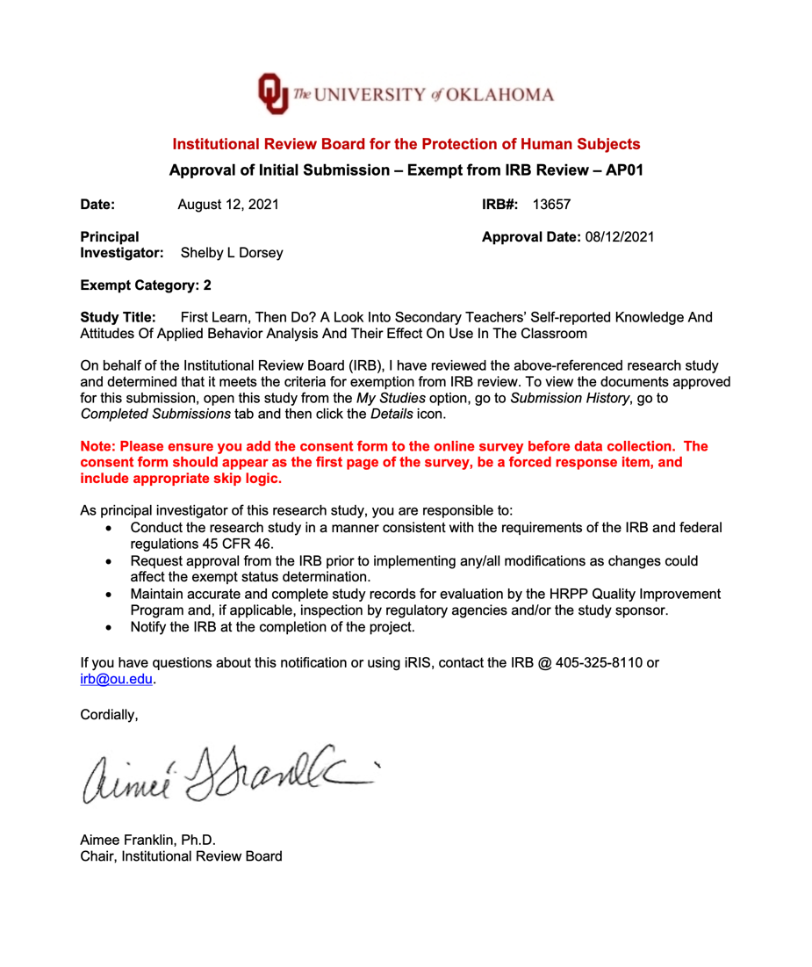

Appendix B: Recruitment Materials
Social Media post #1
Text only

Graphic flyer


Email To Participants
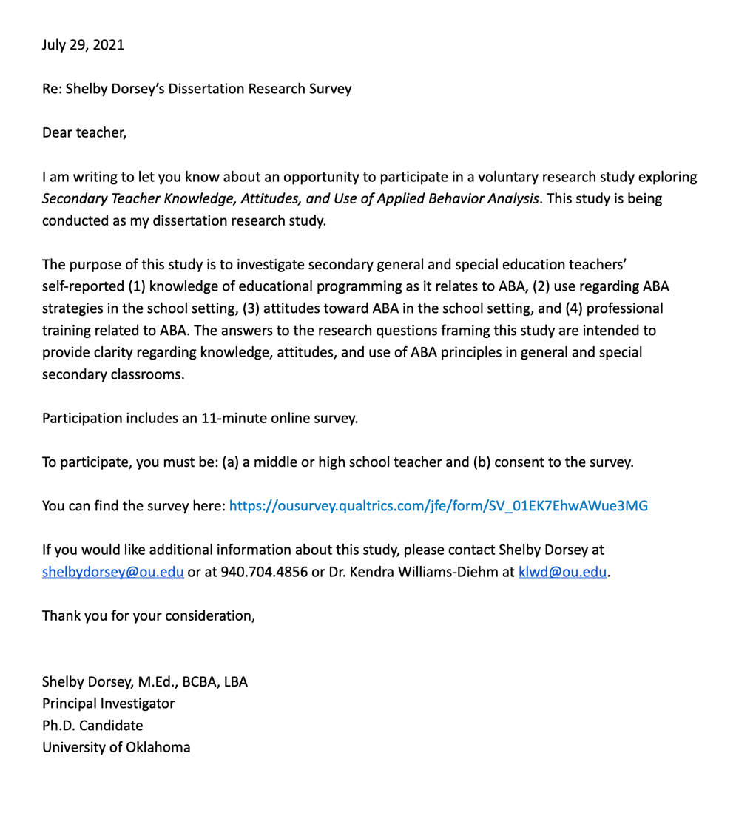

Appendix C: Survey Instrument
Secondary Teacher’s Knowledge, Attitudes, and Use of ABA
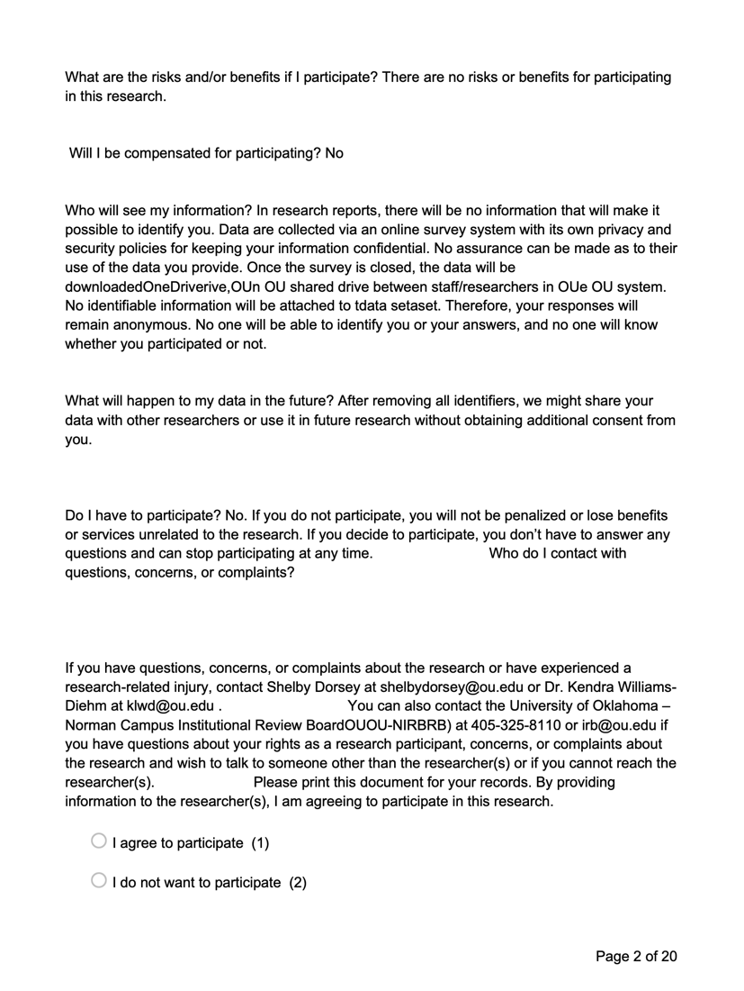
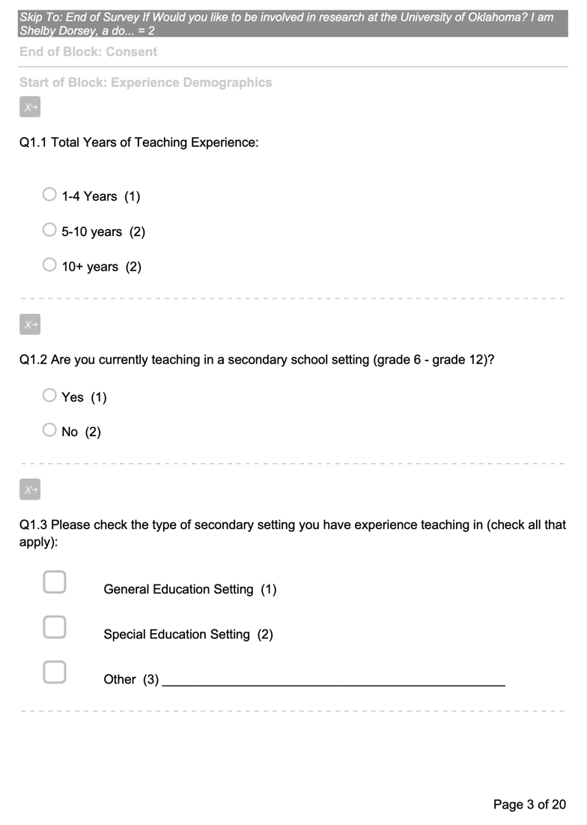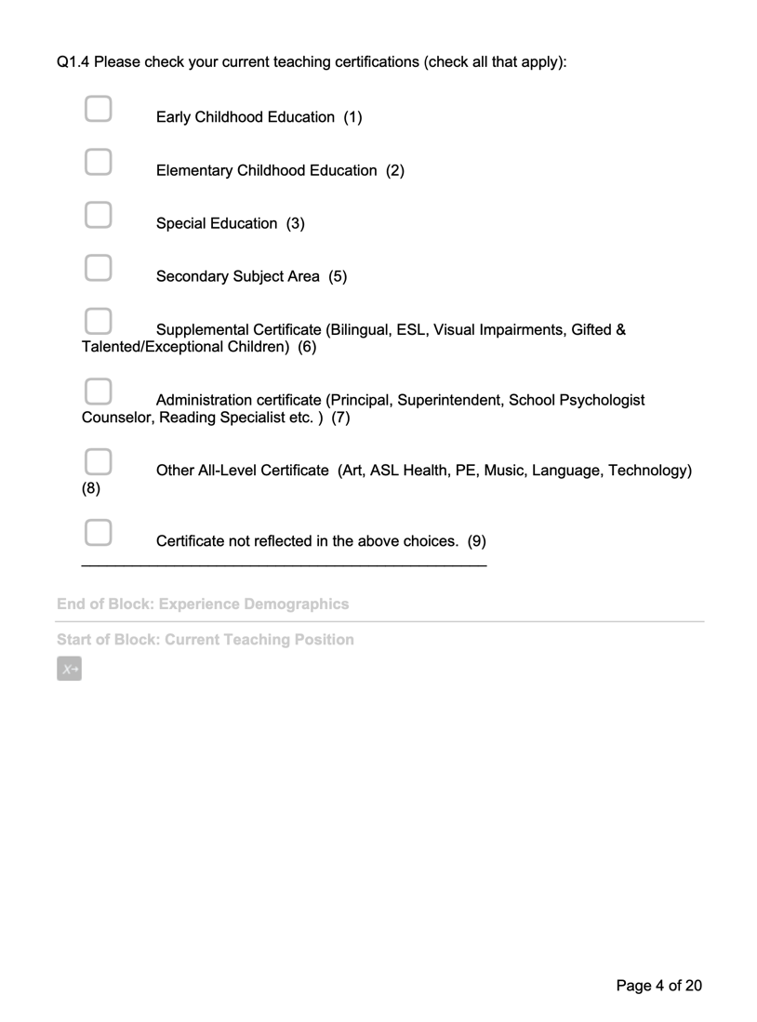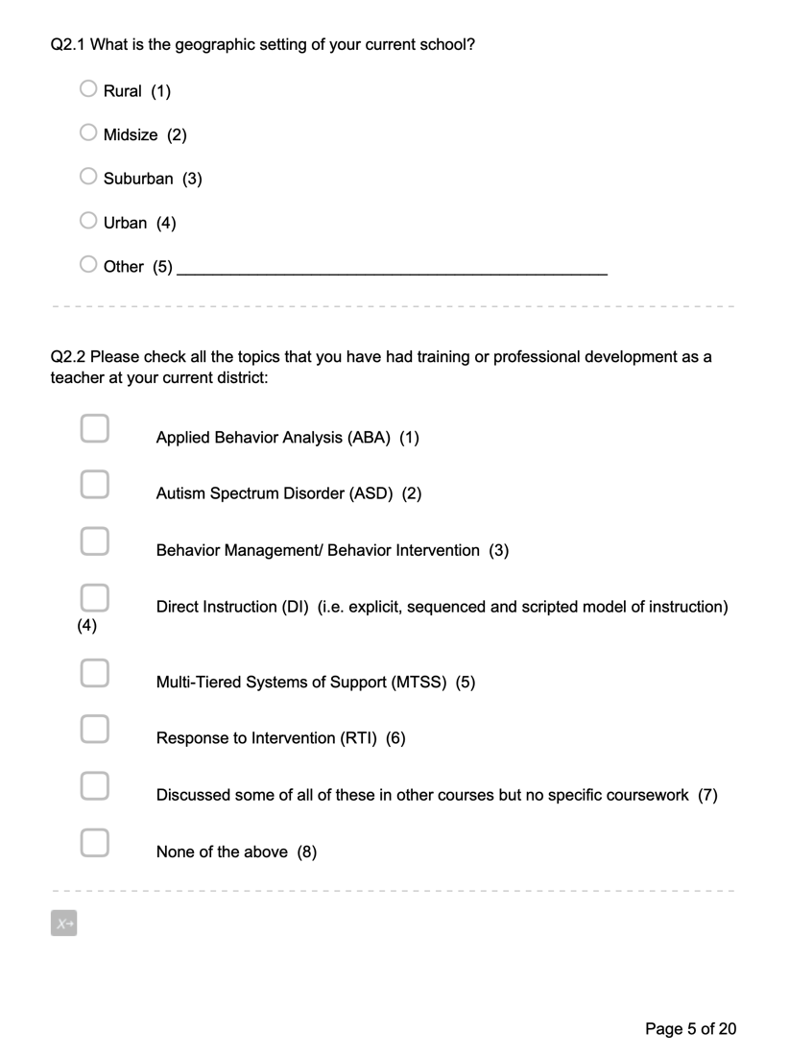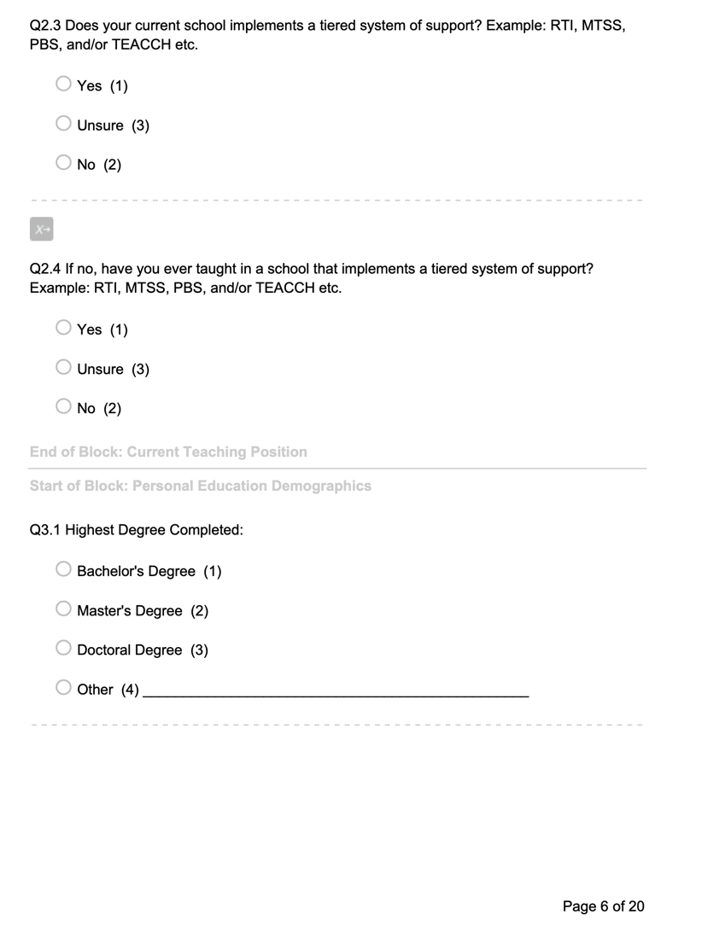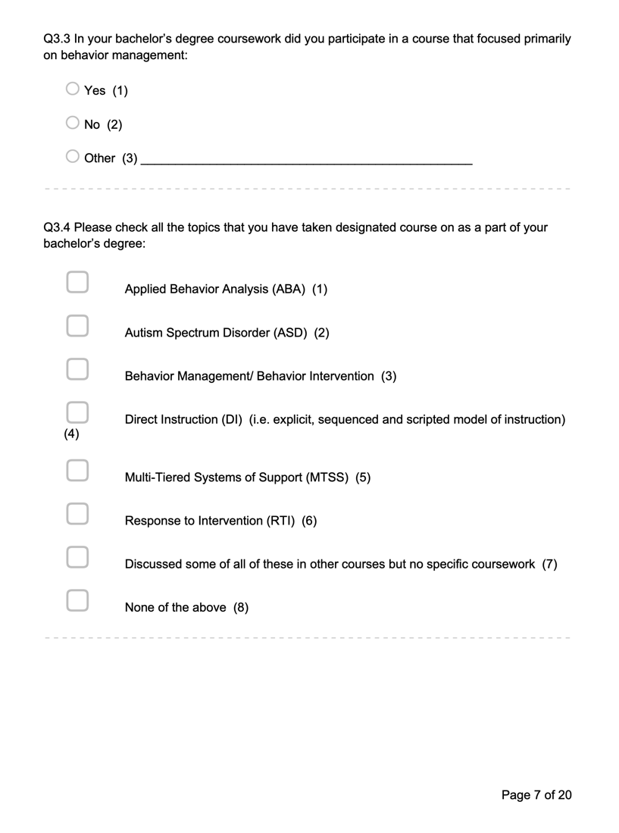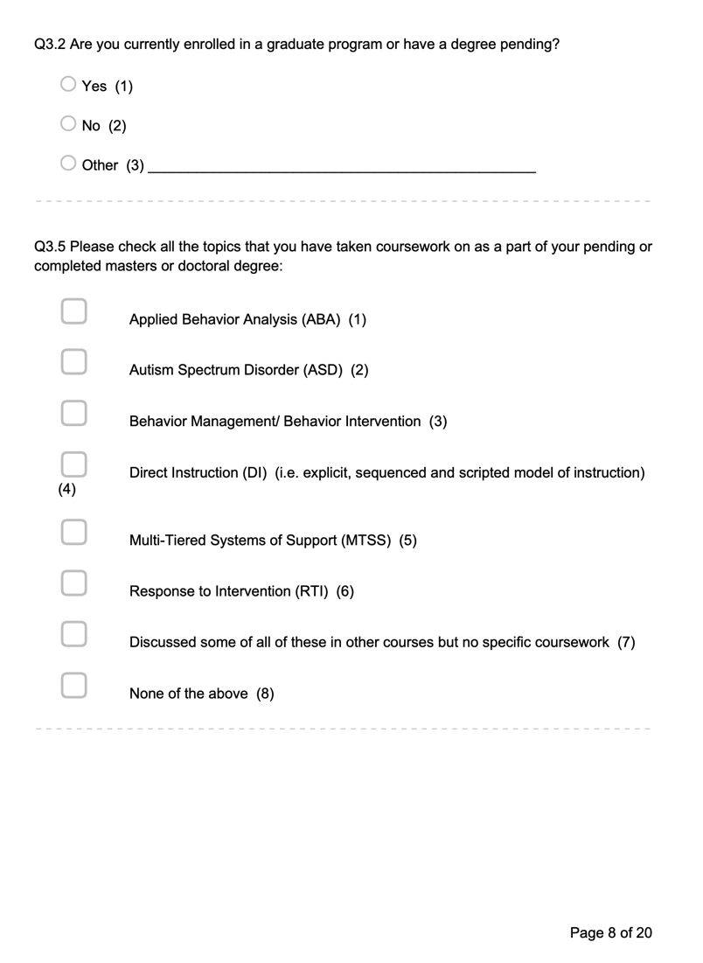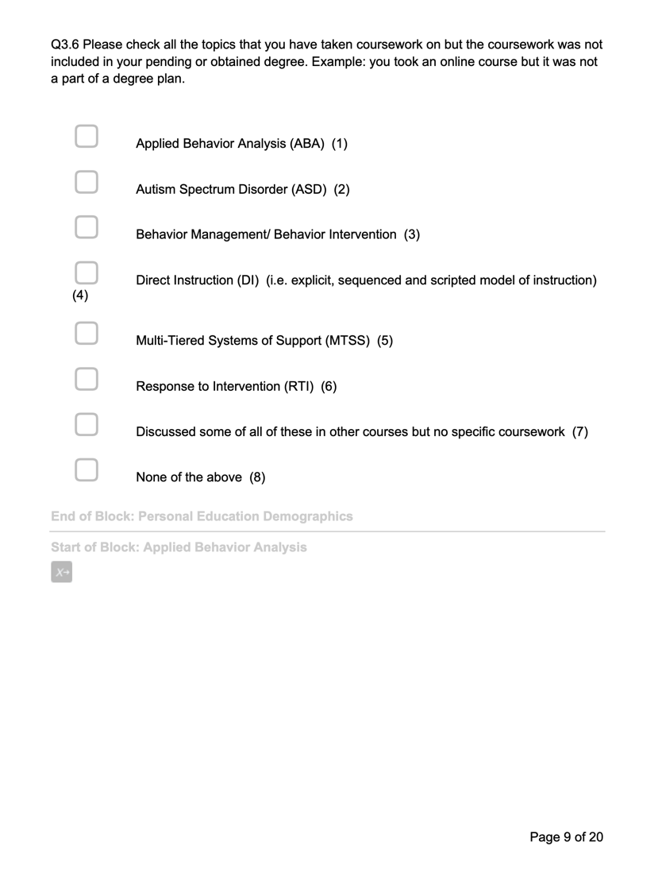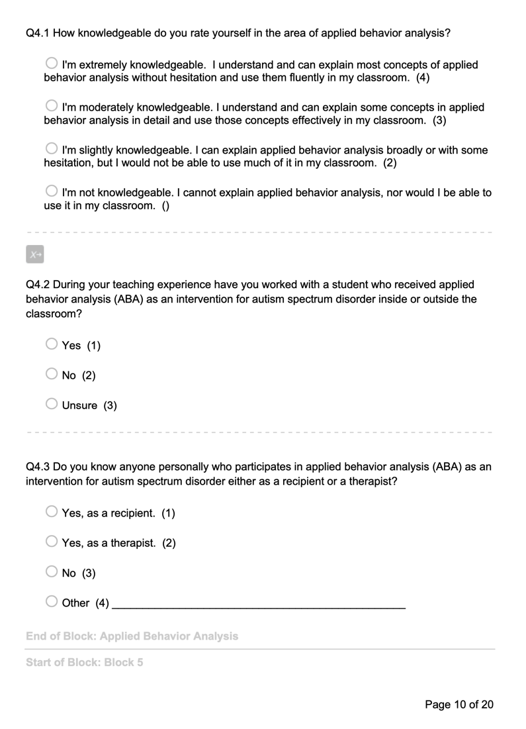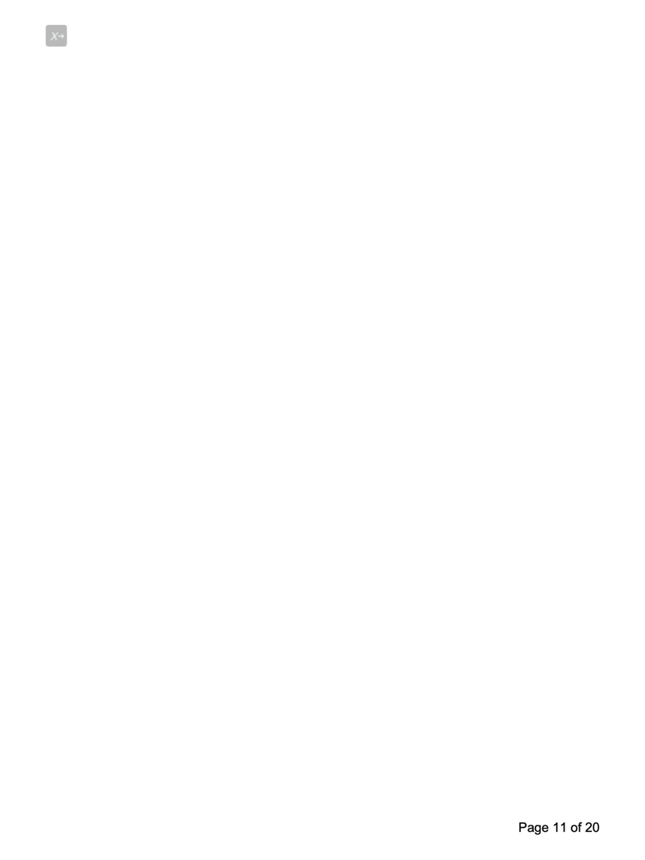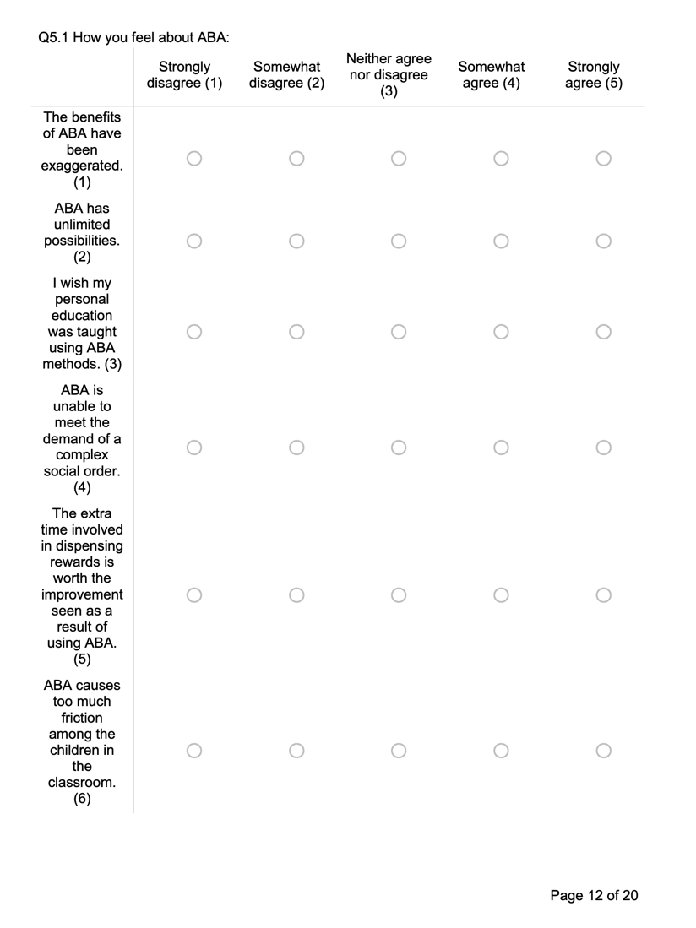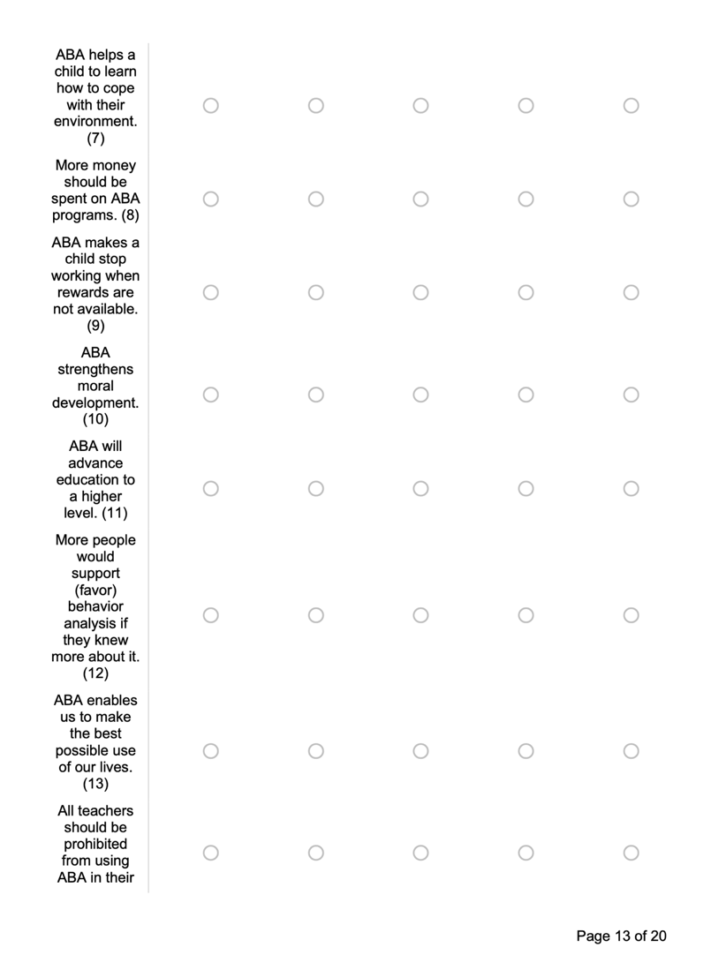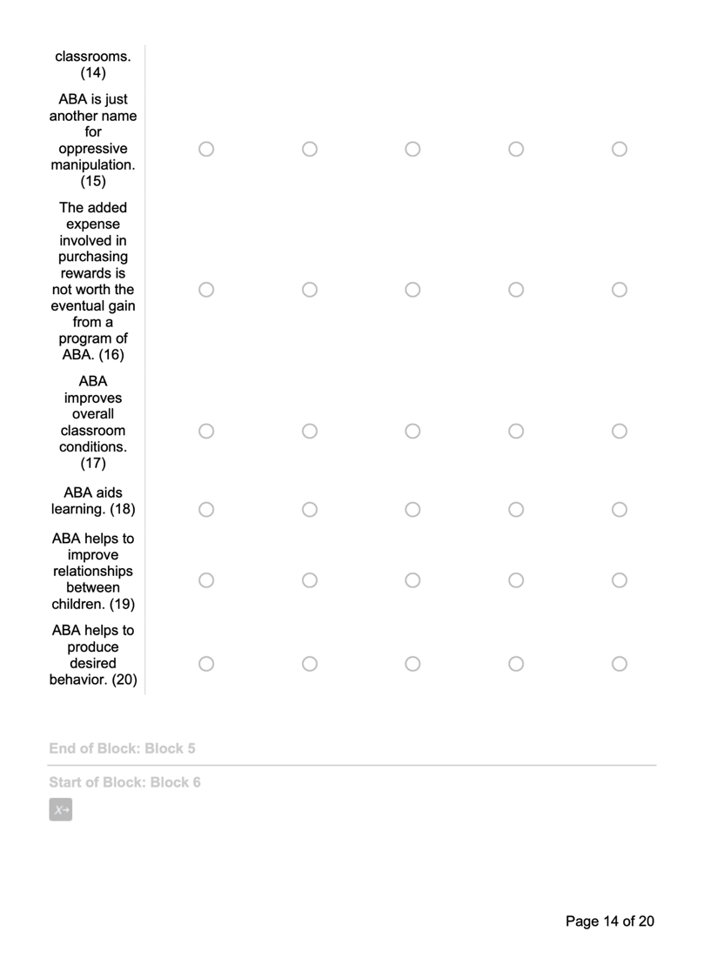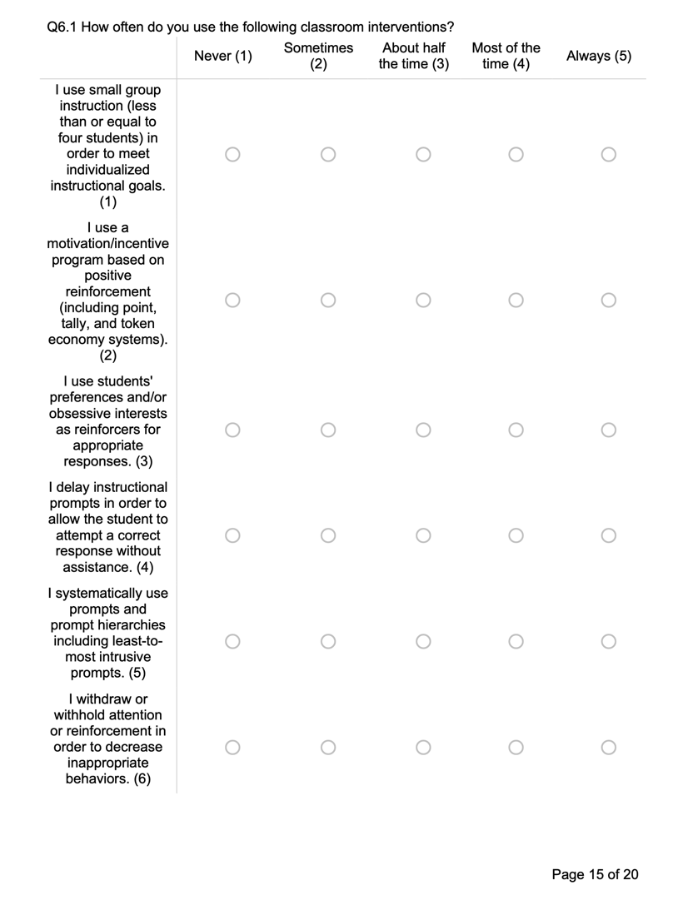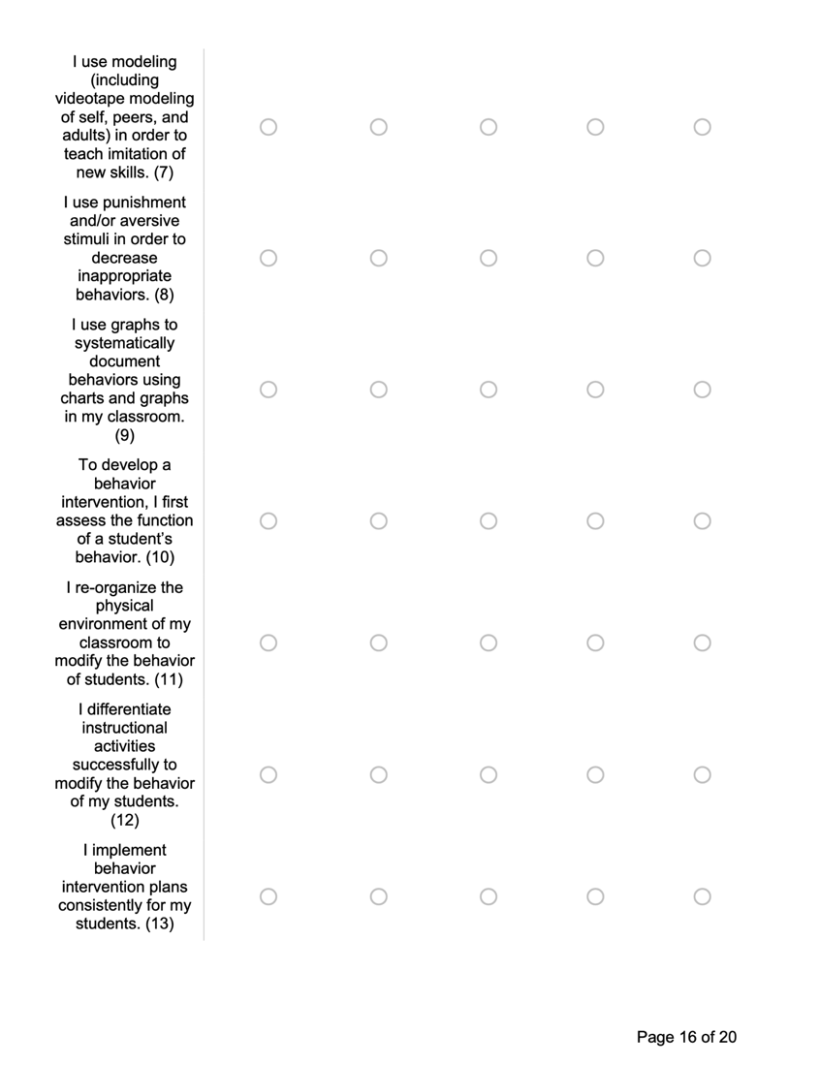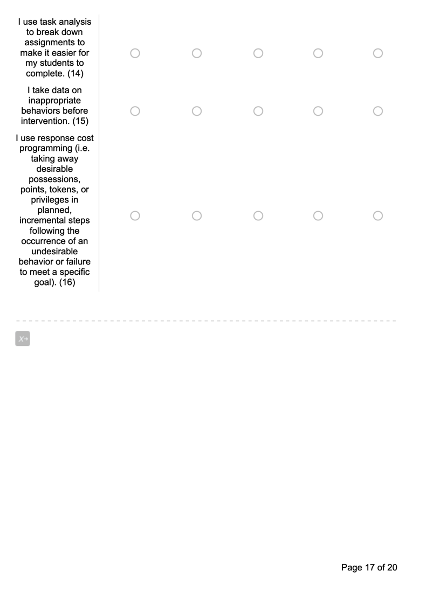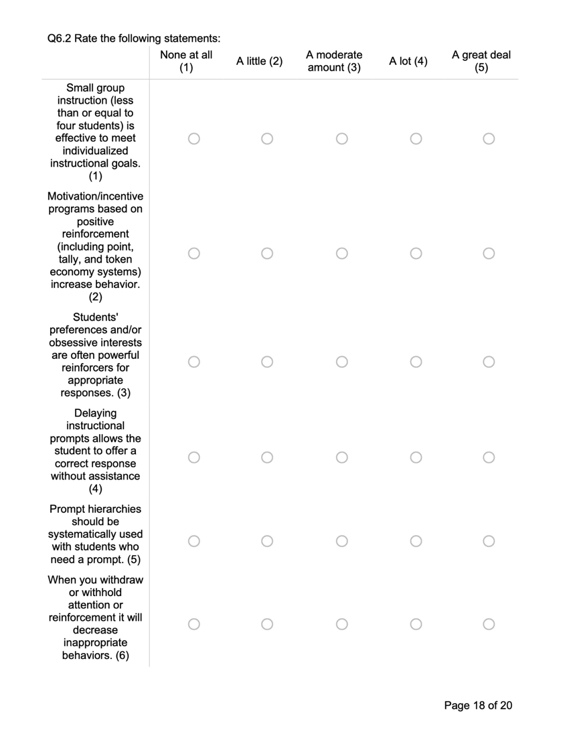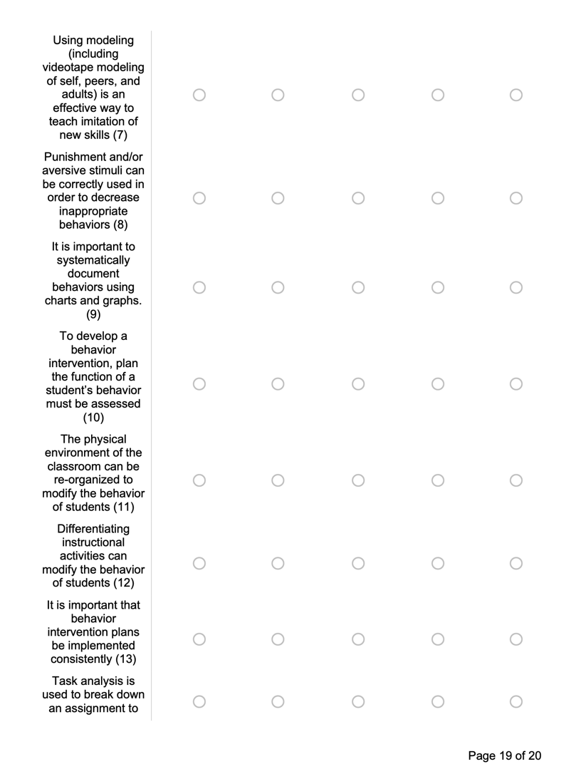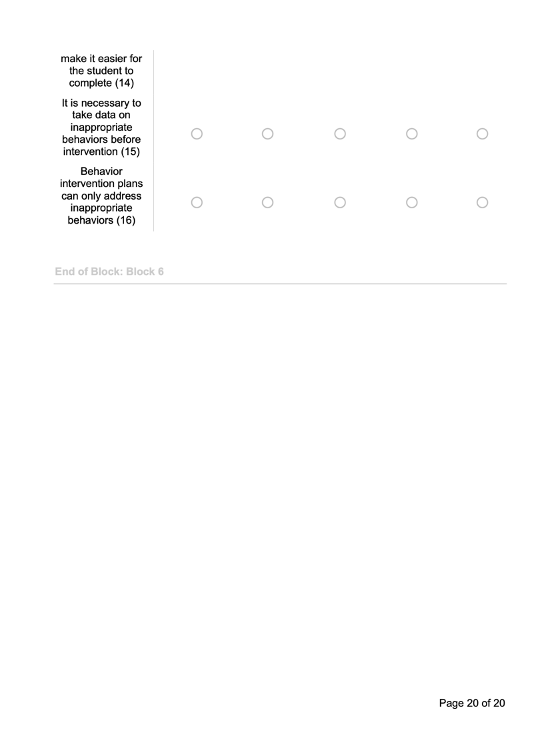

Appendix D: Referenced Survey Instruments
McCormick, 2011

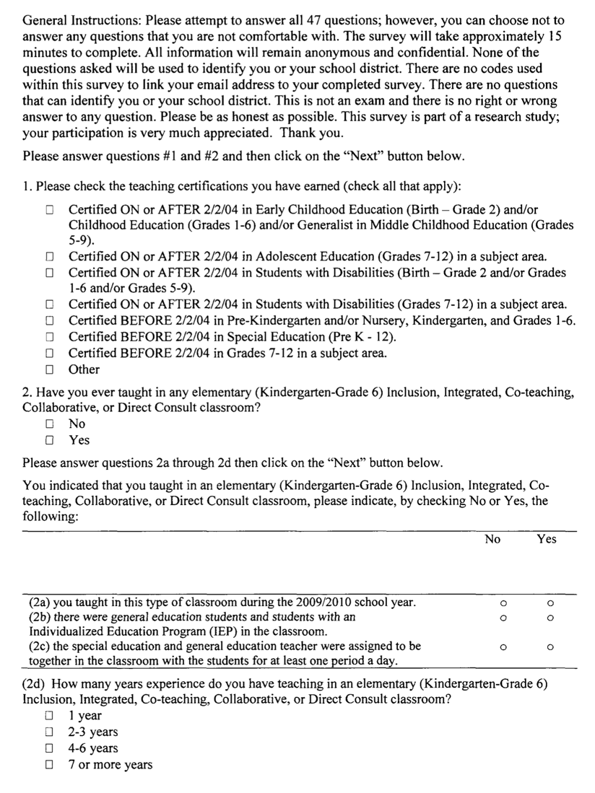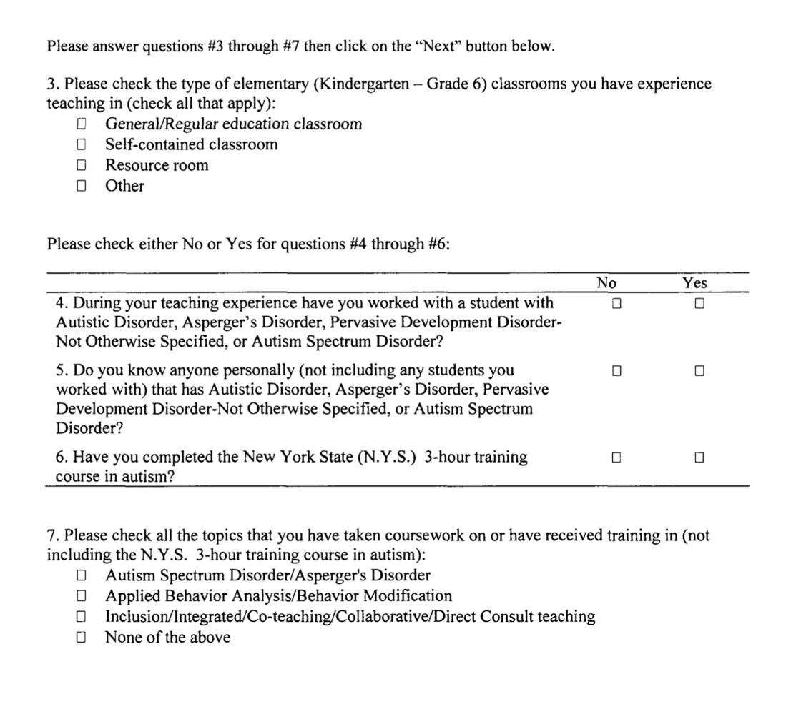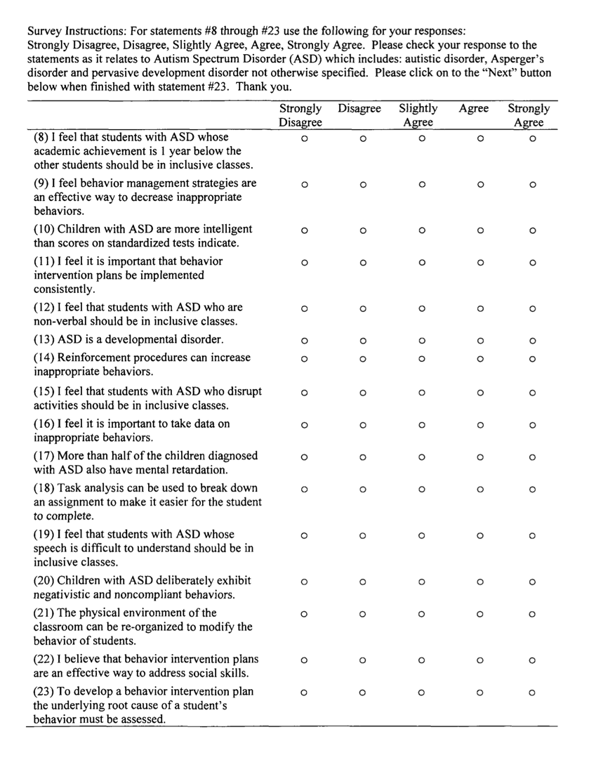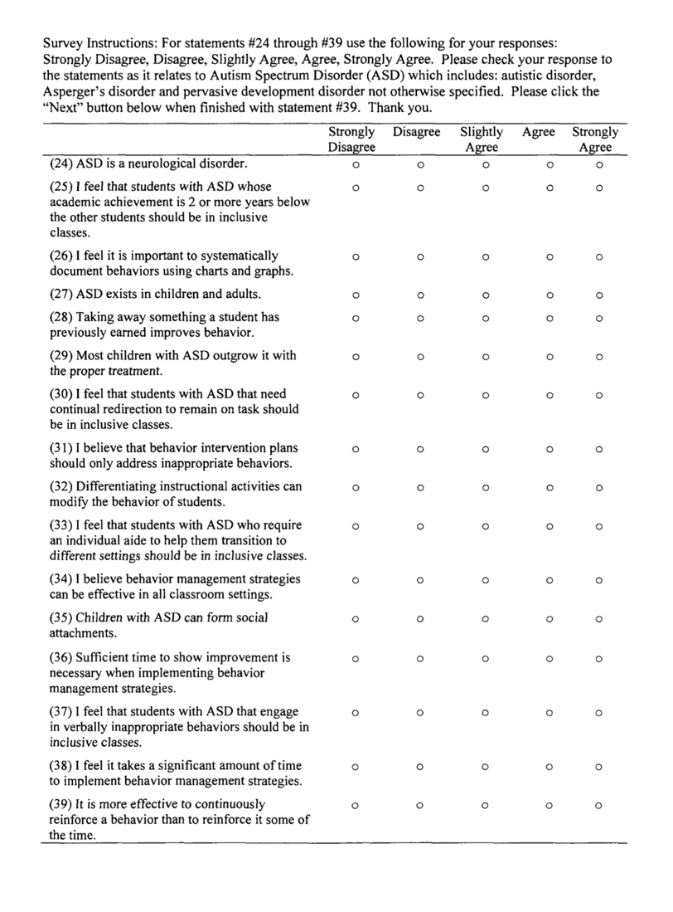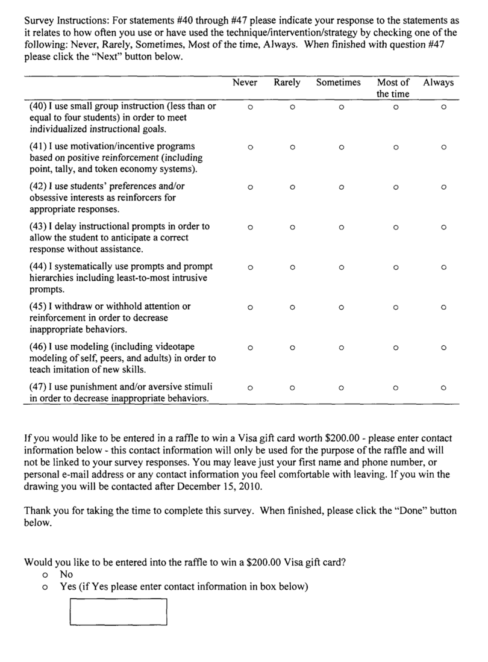

Appendix D: Referenced Survey Instruments
The Incredible Years, 2012
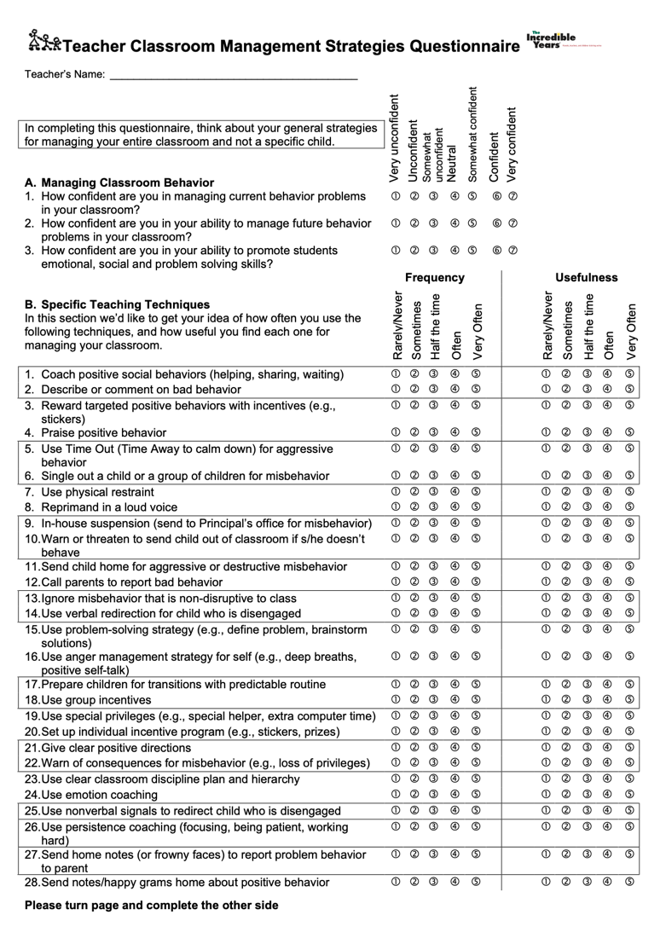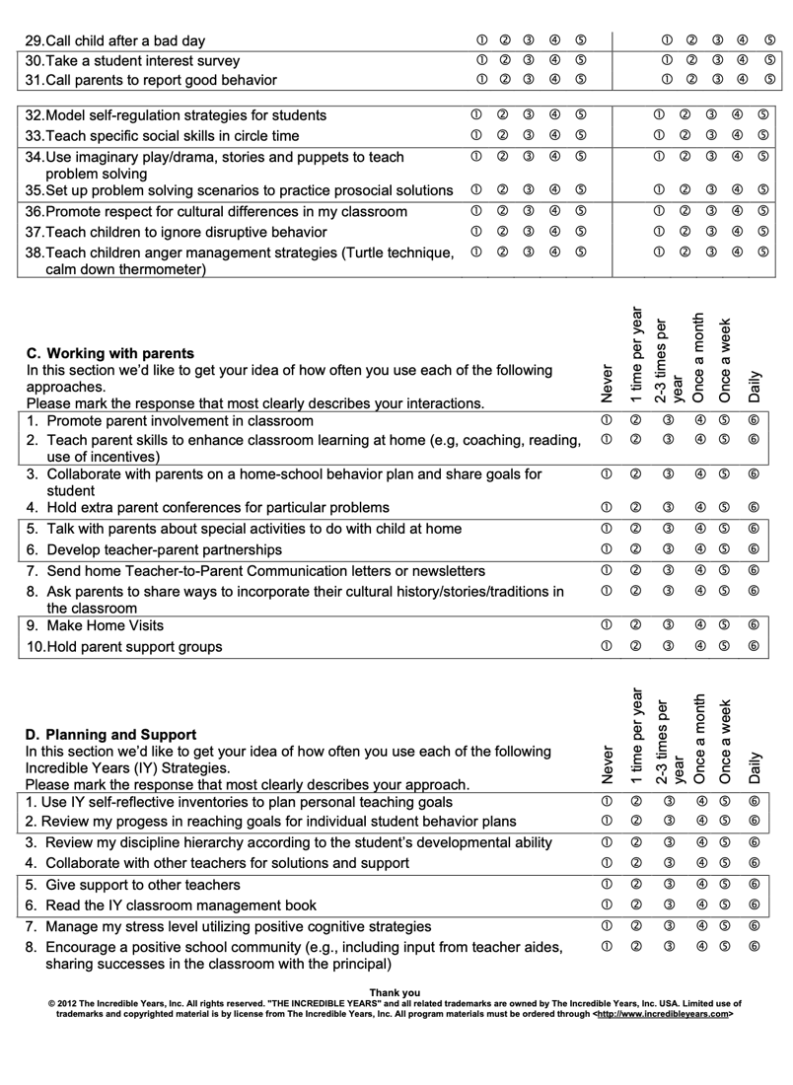

Appendix D: Referenced Survey Instruments
Randazzo, 2011
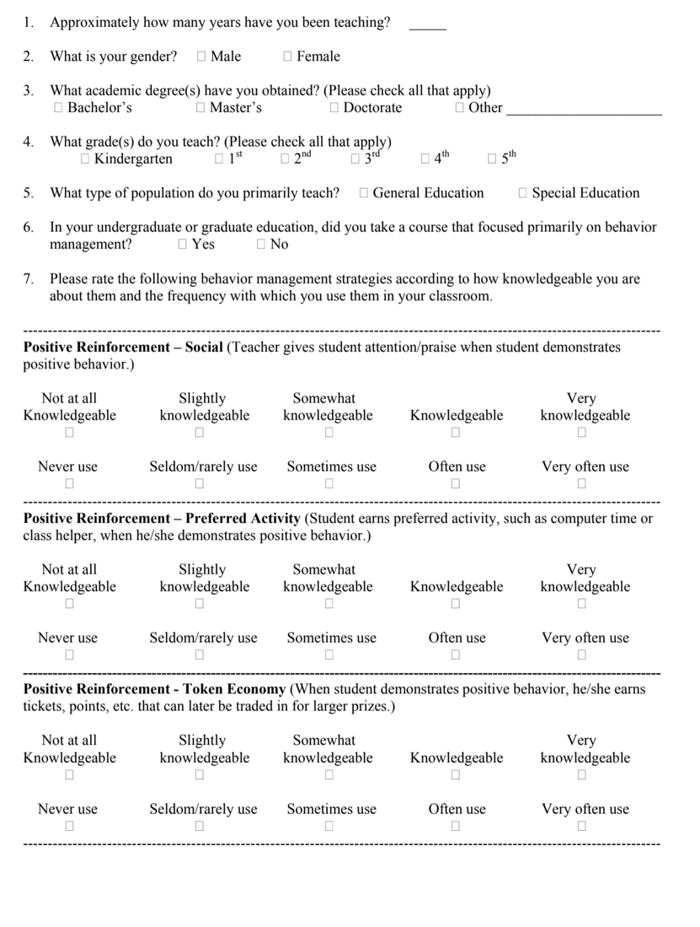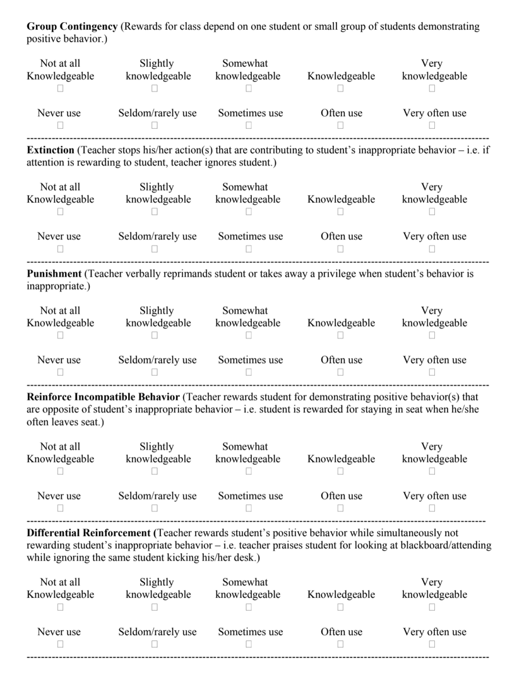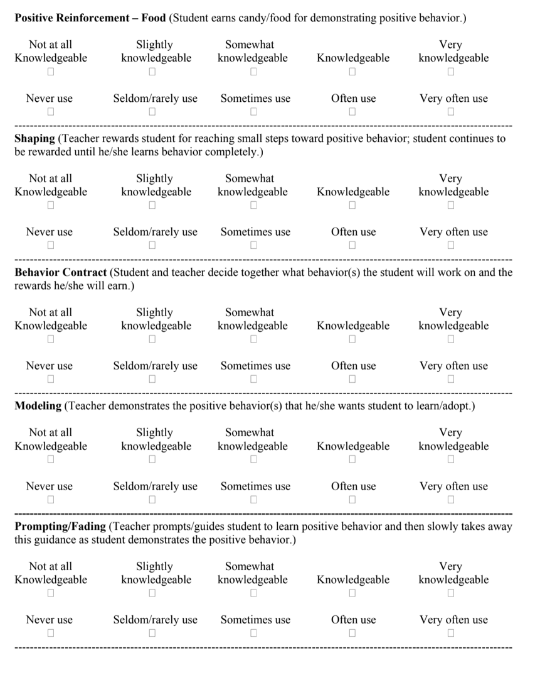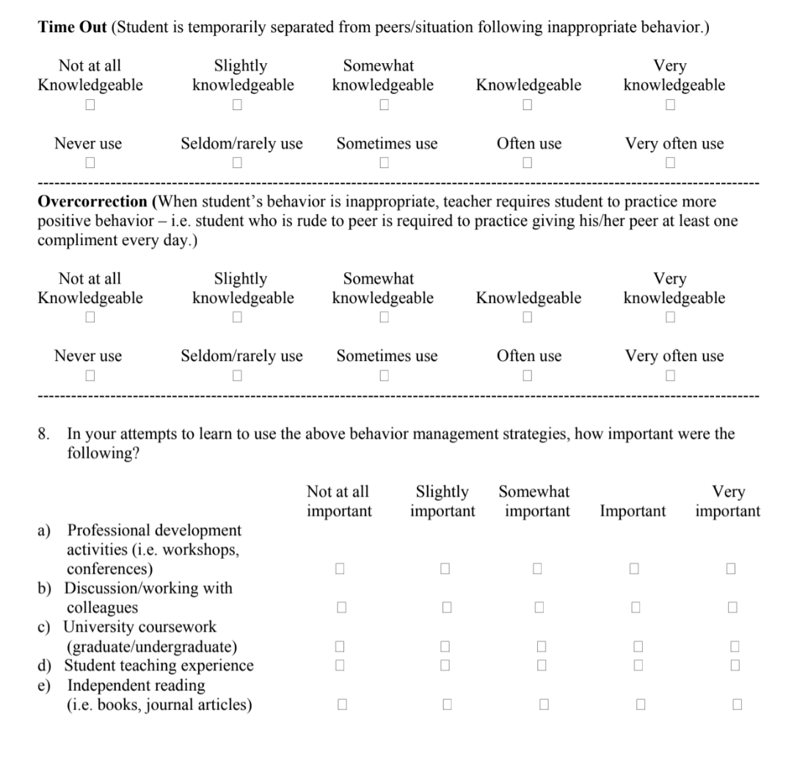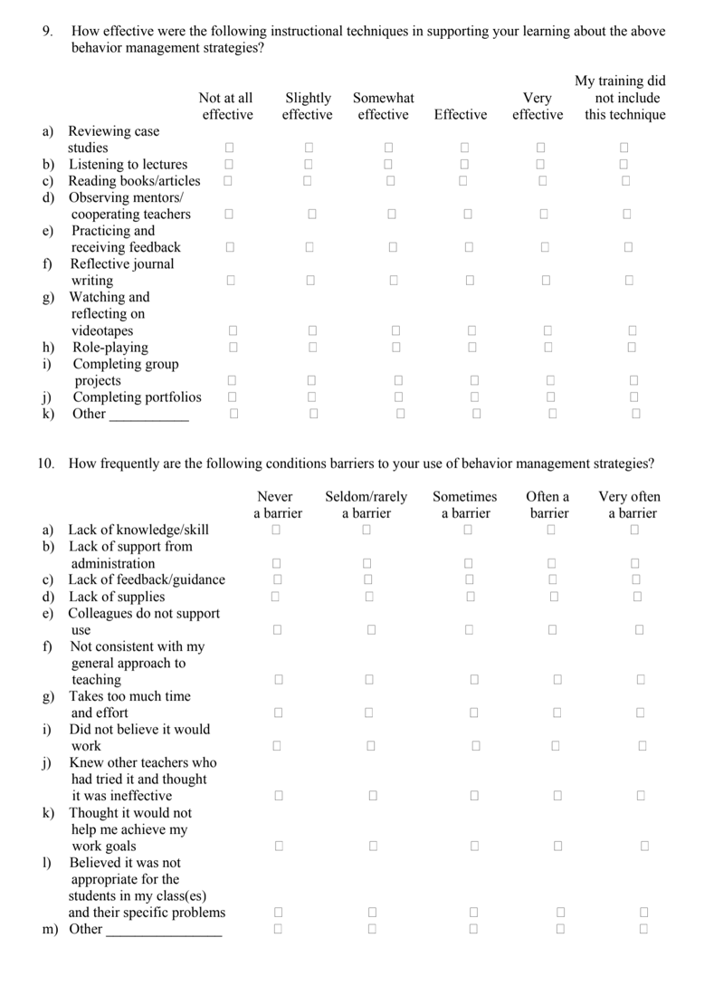

Appendix D: Referenced Survey Instruments
Musgrove, 1974
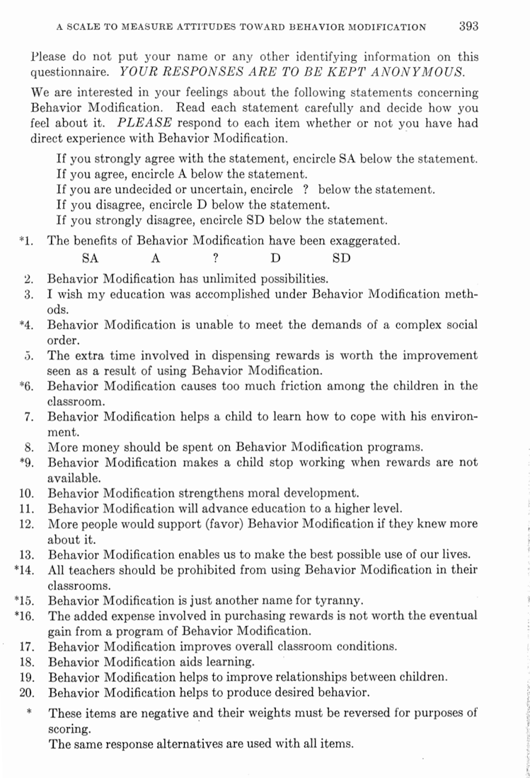

Appendix D: Referenced Survey Instruments
Martin & Baldwin, 1993

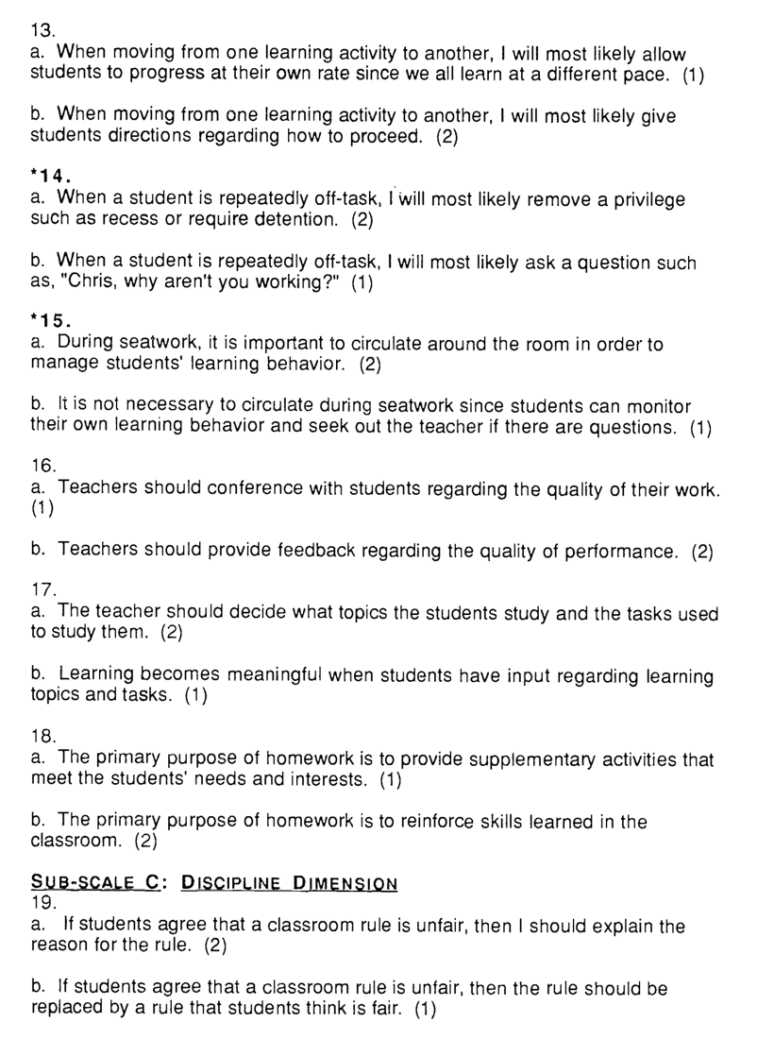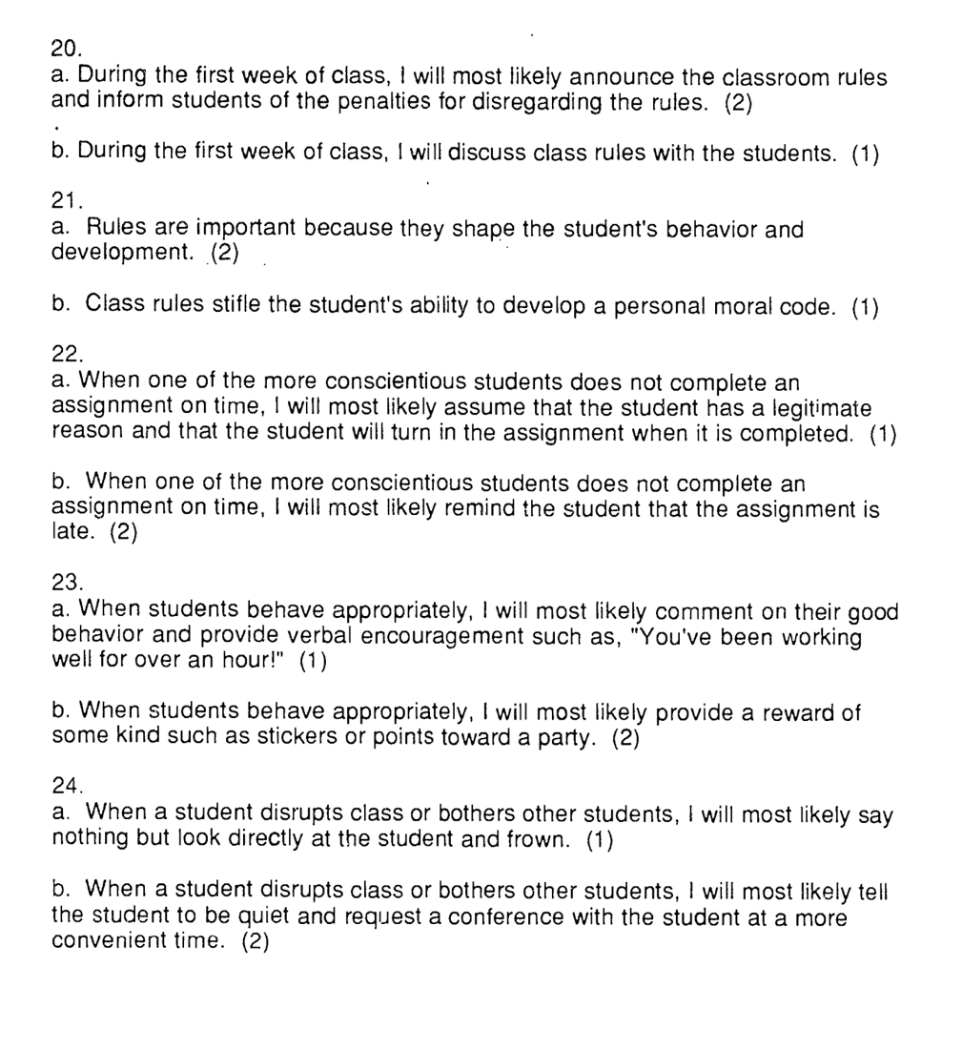

Martin et al., 2007
Appendix D: Referenced Survey Instruments

