UNIVERSITY OF OKLAHOMA
GRADUATE COLLEGE

TWO EUROPE(S)? ATTITUDES TOWARDS IMMIGRANTS ACROSS EASTERN AND WESTERN EUROPE

A THESIS
SUBMITTED TO THE GRADUATE FACULTY
in partial fulfillment of the requirements for the
Degree of
MASTER OF ARTS

By
AARON BROWN
Norman, Oklahoma
2023
TWO EUROPE(S)? ATTITUDES TOWARDS IMMIGRANTS ACROSS EASTERN AND WESTERN EUROPE

A THESIS APPROVED FOR THE
DEPARTMENT OF SOCIOLOGY

BY THE COMMITTEE CONSISTING OF

Dr. Martin Piotrowski, Chair
Dr. Loretta Bass
Dr. Ian Carrillo

© Copyright by AARON BROWN 2023
All Rights Reserved.
Table of Contents:
Introduction …............................................................................................................................ 1
Background …............................................................................................................................. 2
Economic Theories of Anti-Immigrant Attitudes ….......................................................... 2
Cultural Change Theories of Anti-Immigrant Attitudes …............................................... 3
Different Stories of Immigration Between East and West …............................................ 5
A General Source of Immigrant Attitudes …..................................................................... 7
Hypotheses ….................................................................................................................... 7
Methods …................................................................................................................................... 8
Data................................................................................................................................... 8
Variables …...................................................................................................................... 9
Human Values Scale …................................................................................................... 10
Analytical Strategy …............................................................................................................... 14
Confirmatory Factor Analysis ….................................................................................... 14
Multiple Group Analysis …............................................................................................ 17
The MIMIC Model …...................................................................................................... 18
Results ….................................................................................................................................... 19
Eastern Sample …........................................................................................................... 20
Western Sample ….......................................................................................................... 23
Year Sensitivity Check …................................................................................................ 26
Discussion ….............................................................................................................................. 26
Conclusion …............................................................................................................................. 28
Limitations ….................................................................................................................. 29
Two Europe(s)? ….......................................................................................................... 30
Appendix …………………………………………………………………………………...… 32
References ……………………………………………………………………………………. 40

Abstract:
Considering recent immigration trends as well as crises of war which have displaced large numbers of people and led to high rates of migration into and within Europe, understanding how anti-immigrant sentiments develop and how this varies across regions of Europe has become increasingly relevant. This present study examines the differing attitudes towards immigrants between Eastern European, post-Soviet, countries and Western European countries. Using data from the first nine waves of the European Social Survey (2002 – 2018), which is comprised of a representative sample of the population of Europe, across over 30 countries, I use six questions from the survey asking respondents about their views on specific aspects of immigration to create a scale of general attitudes towards immigrants. I create this scale of a general, latent concept of immigrant attitudes by using a structural equation modeling approach known as Confirmatory Factor Analysis (CFA). With this measurement of immigrant attitudes, I use a MIMIC (Multiple Indicators, Multiple Causes) model to represent the relationship of variables that develop a person’s underlying attitude towards immigrants. Preliminary results point to the existence of two separate concepts of immigration between the East and the West. As both regions have developed differences, this has led to different understandings of immigration and questions about immigrants. These findings present implications for how immigration is understood differently across various regions, as well as socio-political implications.
Introduction:
In recent decades, Europe has seen an unprecedented number of refugees fleeing turmoil in their home countries. In 2015 alone there were over one million such refugees (Schilling et al., 2017). By the next year there were over five million seeking refuge from conflict in their home countries, including Syria, Iraq, and Afghanistan (unrefugees.org). These major trends in mass migration, caused largely by displacement from war and conflict such as the Syrian Civil War in 2011 and most recently the war between Russia and Ukraine, have led researchers to turn increasing attention towards the social outcomes of these trends.
Among these outcomes is the rise in nativist and anti-immigrant sentiments across several nations, some of which preceded the so-called “migrant crisis” of 2015 and beyond (Kesic and Duyvendak, 2019; Vaughn, 2020). In fact, between 1988 and 2000, there was a distinct rise in anti-foreigner sentiment in Europe, and this trend continues (Semyonov et al., 2006). While much of the anti-immigrant sentiment tends to be directed at racial or religious minorities in the receiving countries (Casanova, 2012), the reason for the rise in nativism observed in Europe are manifold and complex. Scholars historically have attributed this phenomenon to one of two major perspectives, fear of cultural change or economic competition (Bessudnov, 2016). However, a consensus remains to be settled upon, and as will be discussed, there is a growing body of work which points to the possibility that neither perspective alone explains these trends.
There is also reason to believe that anti-immigrant sentiments differ across Eastern and Western Europe. Post-Soviet countries since the 1990s experienced dramatic population shifts, as new labor market access expanded dramatically for those who had been previously closed out. This led to new situations where ethnic minorities encountered majorities at increasingly higher rates (Kaczmarczyk and Okolski, 2005). However, as the countries of the region became more developed, they began receiving immigrants themselves at higher and higher rates, a fact which has caused political responses to this fact to be mixed (Rovny, 2014). As a result, the story of immigration in post-Soviet countries is a still new, developing one. For years, especially since the collapse of the Soviet Union, research focused on the differences between the former Soviet and the countries of the West which had remained capitalistic. Such a focus on the differences that had developed under the two systems led to an idea of inherent differences, that I am calling “Two Europe(s)”.
With the migrant crisis, rise in anti-immigrant sentiments, and differences between Eastern and Western Europe as a backdrop, I will examine whether a single, underlying concept of attitudes towards immigrants exists, and if so, whether it differs across Eastern and Western Europe. My specific research questions are whether there are differences in how respondents from Eastern Europe view immigrants compared to those from Western Europe, and whether these differences can be explained by different concepts of immigration. Using data from the European Social Survey, I will provide results that point to the conclusion that such an underlying concept exists and differs across Eastern and Western Europe.
Background:
Economic Theories of Anti-Immigrant Attitudes
Among the many perspectives on immigration attitudes that have been proposed, one such perspective deals with economic competitiveness as the root cause of rising anti-immigrant sentiment in Europe. Within this perspective, economic competitiveness is seen as affecting people’s views through their relationship to globalization. This has led to an explanation of globalization creating “losers” and “winners” in an economic sense. Spanish economist Guillermo de la Dehesa (2005) was among the earliest authors to propose this standpoint and has since been built upon and become the basis for the economic perspective of attitudinal trends generally, and specifically trends in attitudes towards immigrants. He explains that in an increasingly interconnected and economically entangled society, the benefits of such a phenomenon will not be evenly distributed and discusses how this will have an impact on those who stand to benefit more, the “winners” and those who will stand to be more disadvantaged by this process, the “losers” (de la Dehesa, 2005). Empirical research using this framework has shown that in countries with higher levels of globalization (i.e., more cosmopolitan city-centers, greater integration into global economy), that individuals tend to be more communitarian (Teney et al., 2014).
At the individual level, economic strain has been shown to lead to higher levels of distrust of others and that in times of economic downturn, this relationship is made more pronounced (Cho, 2021). Changes in unemployment rates have also been shown to have an adverse effect on immigrant acceptance since 2001 in Europe (Meuleman et al., 2009). More work from the micro-level economic perspective has shown support for the role of economic strain in creating downward mobility and in engendering feelings of competitiveness with immigrants for resources (Paskov et al., 2020). We also see that negative perceptions of immigrants often have economic features such as predicting lack of support for the welfare state (Senik et al., 2008). However, it should be noted that on average, non-nationals within many European countries experience higher levels of un-employment than do their native counterparts (Kiehl and Werner, 1999).
Cultural Change Theories of Anti-Immigrant Attitudes
Another theorized source of anti-immigrant sentiment, and one which has received increased attention in the last two decades, is a reaction to societal change in Europe. Globalization, especially in Western Europe, is believed to be a source of increased anxiety towards cultural change as well as being associated with economic competitiveness. Early studies done from the “Group Threat” perspective showed some promising results that hostility towards immigrants could be caused by a perception of immigrants as a threat to the majority racial or ethnic group (Quillian, 1995). This pushback against globalization has led to the new populist movements across Europe that often involve generating xenophobia (Azmanova, 2011). The politicization of immigration as a pushback to new immigration trends has been shown to be a significant factor in generating anti-immigrant sentiment in Europe (Hutter and Kriesi, 2020). Additionally, research on this phenomenon has shown that certain factors generate more inclusive societies, and that a single social construct may underlie the extent to which societies are inclusive and others more xenophobic (Bello, 2016). Such factors are those which lead to the social construction of a citizen’s identity and feeling of belonging, which is more accessible to outsiders (shared values) for an inclusive society, and which is less accessible to outsiders (must be member of ethnic/racial majority) for a more xenophobic one.
Further work examining cultural factors’ role in the formation of anti-immigrant sentiment, focused on how political parties’ articulation and messaging to the public were positively and significantly associated with increased distrust of immigrants (Bohman, 2011). These findings support the belief that cultural factors such as political affiliation have significant effects on immigrant acceptance levels and that this can differ by country. This perspective is further supported by research which studied the effect of contact with immigrants by the majority group. Some have even proposed that a third demographic transition is underway in Europe, which is leading to more demographic changes, however not evenly across rural and urban locations (Coleman, 2006). These findings showed that lack of contact with immigrants led to having more negative views towards them for members of the ethnic majority group (Matera et al., 2015). Living in proximity to immigrants has further been studied and shown to be significant. Specifically, higher concentrations of immigrants living in an area is positively associated with more positive views towards immigrants (Hoxhaj and Zuccotti, 2021). Research from a micro-level cultural threat perspective has shown that, perceived adoption of the ethnic majority’s culture by immigrants predicts more favorable immigrant views in general (Maisonneuve and Teste, 2007; Roblain et al., 2016)
Different Stories of Immigration Between East and West
Furthermore, some analyses have shown that globalization potentially has both economic and cultural impacts and these are intertwined more so than is often presented (Kriesi, 2006). Building on this idea, further research underscores the importance of not pitting one perspective against another and seeing both economic and cultural factors as important (Malhotra et al., 2013). Because there is support of both perspectives, my goal is to add to the overall literature by examining the possible existence of an underlying, overall view of immigrants as being either more positive or negative for the receiving country.
Many researchers have historically situated Eastern and Western Europe as distinct from each other across multiple dimensions, largely stemming from the legacy of the communist era. Socioeconomic differences between Eastern and Western Europe have been studied for years. Such differences may affect the conception of immigration differently between the two regions. The divide between the East and West can be seen across multiple life outcomes. For example, life expectancy is significantly shortened in Eastern and Central European countries, the majority of which were in the sphere of influence, or a member state of the Soviet Union. Several cascading reasons may exist for this, such as lack of access to better medical care in post-Soviet nations (Velkova et al., 1997). Life expectancy as of 2020 for the region of Eastern Europe was 69 for men and 79 for women (Clark, Statsita, 2022). This is ten years fewer than men from Western Europe and five years less for women. This pattern of poorer health among Easterners is stable even as they move to more developed, Western nations, where their health deteriorates faster than their receiving nation counterparts (Ronellenfitsch and Razum, 2004). Economic inequality has also been shown to have increased since 1989 in post-Soviet nations (Heyns, 2005).
Research on Eastern attitudes towards immigrants in the east is still developing. Analyses focusing on Russian attitudes found mixed results when comparing to earlier work done on Western European attitudes. Statistical models only explained some of the variation in attitudes within Russia (Bessudnov, 2016). In that study, results are compared against previous findings from just Western Europe alone (Ceobanu and Escandell, 2010) finding patterns of anti-immigrant sentiments to be similar, albeit some factors matter more to Russian attitudes than for Western ones, specifically geographic region of origin of the immigrants. However, comparisons were made using the same datasets. Further research done on the social differences between European regions has found that post-Soviet countries are less “open” than those of the Nordic and Western European regions in general (Magun et al., 2016). While many Western countries receive immigrants from former colonies, many Eastern countries do not share the same history of colonization as do Western countries. Instead, Eastern countries may receive immigrants from different regions of the world, and their arrival in the receiving country may affect the native population differently than the population of a former colonizing country (De Haas et al., 2020; Van Mol and De Valk, 2016). Taken together, this evidence suggests that there may be sufficient differences between the two regions that have led to the development of two separate, but similar, concepts of immigrant attitudes.
A General Source of Immigrant Attitudes
To sum, while much research exists on the causes of anti-immigrant attitudes across Europe from both cultural and economic perspectives, these findings taken together, do not support any one perspective, but rather a more general acceptance or lack of acceptance of immigrants. Factors that have led to divisive politics and rhetoric about immigrants are hotly contested (Grande et al., 2018). Lack of a clear pattern across Europe for either perspective has led to a reframing of anti-immigrant attitudes as being more complex than any one perspective would imply (Turner, 2010). Additionally, as some research suggests, it is possible that either just one or neither perspective would be able to fully explain outcomes, as they tend to ignore other important factors (Scheibner and Morrison, 2009; Rustenbach, 2010). There is also evidence suggesting that globalization has led to increasingly polarizing political landscapes across Europe, which is something not often accounted for in either of these perspectives (Emmanuele et al., 2020). Additionally, I am interested in how this underlying attitude may differ between regions of Europe, specifically the East and the West. As I will show, one major contribution of this study will be to demonstrate that a single, underlying attitude is at the root of immigrant attitudes across both regions of Europe. Furthermore, I will also demonstrate how this underlying concept is understood differently across both East and West. Because of the existence of cultural and historical differences between the countries within these two major regions, it is important to examine them separately and in fact, may point to two different stories of immigration in Europe.
Hypotheses:
Given the existing research on this topic, I anticipate that differences between East and West affect the way people from these regions view immigrants. Specifically, based on previous literature, I expect that the determinates of immigration attitudes will differ in importance and magnitude between Eastern and Western respondents. I also expect that a uniform underlying concept of immigrant attitudes exists which stems from a combination of economic, cultural, and ethnic/racial factors. The literature shows that each of these factors are important, but also that not one alone can explain immigrant attitudes. I will use a set of demographic variables, as well as a set of variables based on human values to validate the measurement of immigrant attitudes and compare across Eastern and Western samples.
Methods:
The Data:
Data for this project comes from the European Social Survey (ESS). This is a cross-national survey conducted every two years across Europe since 2001. Through face-to-face interviews, the survey asks a wide variety of questions on topics including political attitudes, religious beliefs, and behaviors, as well as general, demographic information across over 30 European countries, with a special focus on charting social, political, and economic change within the countries of Europe. Each participant is provided with a questionnaire that is either in their first language or a language in which the participants are fluent. The research team reviews the questions and answers after each interview to ensure there are no translation errors. The sample used in each country is nationally representative of that country, of all non-institutionalized people aged 15 years and older, living in private residences, and who may be of any nationality, citizenship status, or language. The design uses random probability sampling and sampling frames of individuals and households. The “minimum effective achieved sample size” for each country is 1,500 responses or 800 responses for national populations less than two million. For the current project, I used the compiled dataset of the first nine rounds of the questionnaire, so that I could gather the largest sample size possible. This accounts for a sample size of approximately 339,282 respondents, between the years 2002 and 2018. I use this large dataset to increase confidence in the generalizability of the results. This dataset allows for the cross-country analysis and has been used for to study immigrant attitudes (Davidov and Meuleman, 2012; Fahey et al., 2019).
Variables:
I used a single latent scale to measure attitudes towards immigrants consisting of six items from the questionnaire. Three of these items focused on the respondent’s opinions about what type of immigration should be allowed in their country: “To what extent do you think the country should allow people of the same race or ethnic group as most [country] people to come and live here?”, “How about people of a different race or ethnic group from most [country] people?” and “How about people from the poorer countries outside Europe?”. Responses were given on a four-point Likert scale, from 1 (allow many) to 4 (allow none). I reverse coded these so that low scores represented the most negative attitudes to be in line with the following three items. The other three items focused on the respondent’s opinions of immigrants in general, capturing a perception of immigrants either as a benefit or a threat on three different metrics. The questions asked: “Would you say it is generally bad or good for the country’s economy that people come to live here from other countries?”, “Would you say that the country’s cultural life is generally undermined or enriched by people coming to live here from other countries?”, and “Is the country made a worse or a better place to live by people coming to live here from other countries?”. The responses were given on a Likert scale from 0 (highest threat) to 10 (highest benefit). These endogenous, or measured outcome, variables allowed me to measure both the perception of immigrants living in the receiving country and attitudes about immigration in general and have been used to gauge immigrant attitudes in past research (Card et al., 2016; Pellegrini et al., 2021).
I recoded the original country variable into a binary indicator of whether the respondent was from a former communist, Eastern European country (1) or if the respondent was from a capitalist, Western European country (0). The variable includes 12 Eastern countries (N=136,252) and 13 Western countries (N=203,030).
Human Values Scale
An additional aspect of the model for this project is the inclusion of measures of human values. These human values were first described by Schwartz’s (1992) Theory of Basic Human Values as involving 10 different values that represented more general concepts such as conservation, openness to change, and self-transcendence, and which are universally accepted across all societies. Schwartz used data from a section of the European Social Survey which asked respondents questions derived from each of the basic values to find gender differences in value priority (Schwartz and Rubel, 2005) and examined variations in gender differences cross-nationally (Schwartz and Rubel- Lifschitz, 2009) again with the same data from the ESS. Building on the well-established work by Schwartz, further research was done using the ESS questionnaire based on these values. Such findings would contribute to the universality of the values, further establishing them as empirically sound. Work done using the ESS and cross-country comparisons found these values to be more salient in cross-country comparisons than individual variables were to understanding differences across cultures (Magun et al., 2016). Regarding how the human values described here affect immigration attitudes, limited research has been done. Research using the ESS measures of human values support two value dimensions applied to anti-immigrant attitudes has been found, specifically, that Conservation (consisting of the values Tradition, Security and Conformity) has a strong negative effect, and that Self-Transcendence (consisting of the values Universalism and Tradition) has a strong positive effect on immigrant attitudes (Davidov et al., 2008). I include these measures in my model to determine if this pattern holds when comparing Western Europe and post-Soviet Europe as additional indicators of attitude formation.
To create two scales of human values, for the value dimensions of conservation and self-transcendence, I used the questions from the survey which related to these two concepts as previously used by Davidov et al. (2008). In the ESS questionnaire, eleven questions are asked which correlated to one of the two value dimensions, five to self-transcendence and six to conservation. Each question provides the respondent with a statement such as “It is important to her/him to be humble and modest. She/he tries not to draw attention to herself/himself” after which the respondent is asked to answer how similar they are to this statement. For each question, responses are provided on a six-point scale, where respondents can answer if the statement provided is “Very Much Like Me” on the positive end and “Not Like Me At All” on the negative end. Responses are coded so that positive answers are lower numerically, and negative answers are higher. I reverse coded these, for ease of interpretation, meaning that higher values would represent more pro-immigrant attitudes and lower attitudes would represent more anti-immigrant attitudes.
Among the other exogenous, or independent, variables included in the model, I used a variable indicating whether the respondent is a native of the country. I created this variable by combining the four variables that ask the respondents if both they, their mother and their father were born in this country, and if the respondent belongs to a majority ethnic group in the country, where a “Yes” response to all four questions would indicate if the respondent was “native” to the country or not, to assess the attitudes of those in the majority ethnic group of each receiving country. This also ensures I was not measuring immigrants’ attitudes about other immigrants, who may have more favorable views of other immigrants (Card, et al., 2016).
I also included a variable for “urbanicity” which was recoded from the original five-category groupings into three major categories, to assess if the respondent lived in the country, a small town or in an urban context. Because of previously discussed findings of people who live in more urban areas to be more likely to harbor more positive views of immigrants (due mainly to exposure to others), geographic location is expected be important. I also included variables measuring the respondent’s religious affiliation which included the major religious categories of Europe as well as an “other” category, consisting of smaller categories accounting for less than five percent of responses each (recoded so that responses included Roman Catholic, Eastern Orthodox, Protestant, Other, and No religious affiliation). Religion has been one of many indicators which seems to have a predictive effect in acceptance of “outsider” and can vary across denominations and religious sects, and as such seemed appropriate to include in this analysis (Butkus, 2016). Because political affiliation (recoded from a 10-point scale into a “Left”, “Right” and “Middle” scale) has been shown to be instrumental in forming opinions on immigration in Europe (Hartevelda et al., 2017), I also include this variable.
Additionally, I recoded the occupational codes from the survey into a five-category occupational class scale, ranging from high-grade service to unskilled labor (Oesch, 2006). It has been shown that a person’s occupational class, either higher or lower skill levels tends to be predictive in who harbors more anti-immigrant attitudes, and that this also matters for the occupational level of the immigrants themselves, with those in the receiving country tending to be more anti-immigrant for those they perceive to be of a similar occupation level (Naumann et al., 2018). Respondent’s education level was recoded into a three-category grouping scale ranging from “less than secondary school” to “tertiary school”. Education has been well-established as an important factor in developing more positive attitudes towards other cultures and immigrants, so including this variable is expected to be significant (Lancee and Sarrasin, 2015).
Sex of the respondent is included, as women are predicted to have higher levels of openness and acceptance (Schwartz, 2005). Household net income is also included, as this variable has been used in previous work studying income using this survey (Georgellis et al., 2008). Finally, marital status and number of members living in the household are included along with respondent’s age as baseline control factors. The descriptive statistics of each of these variables are included in the tables for both the Eastern and Western samples below.
{Table 1. Here}
{Table 2. Here}
Analytical Strategy
Confirmatory Factor Analysis
I used structural equation modeling (SEM) (Bollen, 1989) to estimate a latent variable of attitudes towards immigrants using the six observed items discussed previously. I first used Principle Confirmatory Factor Analysis (PCFA) to establish how many latent variables (or factors) best fit the data. This approach takes the six items (shown in figure 1 as rectangles) used in the analysis to construct latent variable(s) and determines how much of the variance across the items is explained by the factor. How many factors should be used is determined by an eigenvalue. The generally accepted cutoff for how much variance that is explained by the factor is 1.0, or 10% (Kaiser, 1960). When I run this procedure, the first factor has an eigenvalue of 3.42, so one factor explains 34% of the variance. The second factor is above the cutoff at 1.71, but because of the amount of difference between the two, and the fact that I am trying to measure a single concept, I opt to keep just one factor, meaning that I can be confident that all six items are measuring a single concept (Acock, 2013).
From this, I have successfully established that only one latent variable fits these data. As I have mentioned earlier, the existence of a single latent concept of immigrant attitudes was among my primary aims in this research, and now allows me to continue with the process. I then use Confirmatory Factor Analysis (CFA) (Thompson, 2004). This approach to building the scale has several advantages over other approaches. Because I believe there to be an underlying, latent variable of general attitudes towards immigrants that is influencing people’s responses to the questions, CFA allows for error variance for each question to be treated separately allowing for a better measurement of the latent variable. In other words, by specifying one factor that I believe may affect the observed outcomes, I am using a more theoretically driven approach to constructing the scale. Additionally, by using this approach, I also have access to the variety of model fit statistics, which show how well different aspects of the model fit the data. (Acock, 2013). Using this scale, the assumption is that people responded to the six questions about different aspects of immigration in a way that is being affected by an underlying concept, which in this case are one’s overall attitudes about immigrants.
Next, I aimed to fit the measurement scale created by the CFA as well as possible to the data. I assume that the scale of attitudes is continuous, so I use maximum-likelihood estimation. The original fit of the scale left room for improvement, so I examined ways to improve model fit that still are theoretically driven. I found that, by allowing the errors of three of the items to covary with one another, the model fit the data relatively well. The three items for which error variances were covaried included views of immigrants as being either good or bad for the country’s economy, quality of life, and culture. It makes sense that these questions would be more theoretically similar, as they are all asking about specific aspects of people’s perceptions of immigrants’ impact on society. While I could have added further covariances, I did not want to risk the over-specification of this model, so I opted to leave it as is.
I now had a well-fit measurement scale of immigrant attitudes (represented as an oval in figure 1). All factor loadings and intercepts were statistically significant, showing that as the value of the latent variable (assumed to be a normally distributed continuous measure of a respondent’s image of immigrants) increases, the values of each item decreases (as each item is coded for low scores to correspond to negative views of immigrants and high scores are more pro-immigrant). Now that I had created the measurement scale, the next step was to determine if the latent concept was measurably the same for both Easterners and Westerners. If they were not similar, then the two groups would have different concepts of immigration and attitudes towards immigrants.
Similarly, I wanted to create a scale for the human value dimensions of Conservation and Self-Transcendence based on the associated questions from the survey in the same way as Davidov et al. (2008). Just as with the scale of immigrant attitude, I used factor analysis to fit the data to two measurement models, one for conservation and one for self-transcendence (also shown in Figure 1 as ovals). Again, I chose this method rather than a simple summative scale because I believed some values to potentially be more important to the overall concepts than others, and where a summative scale can only treat them all equally, CFA can treat them more appropriately.
Once again, I began with a PCFA to determine how many latent factors would be necessary. In doing so, I found that two factors had values higher than the cutoff of 1, 3.69 and 1.38. As a result, I determined that two latent variables would be necessary to fit the data, which is as I expected, allowed me to create a latent measurement variable of conservation and self-transcendence. Once I had created the two measurement scales, I wanted to modify the model to better fit the data. Again, by allowing the errors of certain items in the scales to covary, I was able to measurably improve the fit of the measurement scales to the data. I also needed to ensure that the items which errors were covaried were theoretically similar enough to justify this procedure. Two sets of similar questions’ errors were covaried, both of which were indicators for the conservation scale. The first two questions dealt with safety (“It is important to live in secure surroundings” and “It is important for the government to protect against threats”). The second pair of questions dealt with strict behavior (“It is important to follow the rules” and “It is important to always behave properly”). Having added these covariances, I felt confident in the overall fit of the models. Because I did not want to over fit the data, and any further modifications would have only yielded small improvements, I added these scales to the main model and proceeded to the next step in the process.
Multiple Group Analysis
To determine if the measurement scale was measuring the same thing for both groups of respondents, I used an approach called multiple group analysis (Acock, 2013). This approach has been used before in cross-country analyses for the ESS (Davidov, et al., 2015). However, in those analyses, the authors attempt to establish an equivalence test for direct comparisons. For this project, I believe that direct comparisons are not useful, as these are different processes between East and West that are leading to the formation of attitudes. For reasons previously discussed in the background, I believe there to be sufficient differences between social contexts of Eastern Europe and Western Europe that would lead to potential formation of significantly different understandings of immigration. If the two groups do view this concept in the same way, then measurement invariance would be established, meaning that there is no variation in how the model is measuring the concept. To do this, I fit the measurement model using a stepwise approach which would put various constraints on the variables’ relationships.
First, I fit a model that would not put any constraints on the model, but rather just constrains an equivalent form on the relationships of the variables, but for nothing to be equal. As expected, this model fits well enough to establish that for both groups, the model has the same form, although this assumption is weak and not especially convincing evidence of the measurement to be the same. With this as the reference model, I fit additional models that placed constraints on the relationship of the variables. The next model constrained the loadings of the variables to be the same, which, if this fit well, would strongly suggest that the latent concept is measured in the same way for both groups. The fit of the model proved to be worse, however. I decided therefore to fit the model with other constraints, those being restricting the error variances to be equal and the error variance and covariance of the latent variable to be equal, but each specification made the model fit the data increasingly worse. In addition, I used likelihood-ratio tests between the same form model and each additionally more restrictive model. However, a significant result from each test showed that the model which included the constraint fit the data significantly worse than a model that does not (Acock, 2013).
This, taken together with the poor fit of the more restrictive models means that measurement invariance could not be established, and that the latent variable was indeed measuring different concepts for Easterners and Westerners. Now that the measurement model had been constructed and the need to split the sample for two separate models established, I constructed the full model, which would provide different results for the two samples.
The MIMIC Model
A MIMIC, or Multiple Indicators, Multiple Causes Model, is a type of structural model that allows for each independent (exogenous) variable to contribute to the development of the latent variable. For latent concepts, which can often be nebulous, general concepts that are difficult by nature to precisely define, it follows that there would be a myriad of indicators that would be involved in affecting such a concept. This model is especially appropriate, as it allows for the latent variable to have a non-zero error variance, which means that it can be estimated along with the other error variances which is a stronger assumption to make than assuming that there is no error, and that every possible indicator is accounted for in the variables included (Acock, 2013).
{Figure 1. Here}
Pictured above is a path diagram which represents the relationship of the variables in the full model representing everything discussed so far.
What this diagram represents is the full model, including the structural component and the measurement scale. As I mentioned earlier, the sample population has been split between Eastern and Western respondents, and as such, there are two models. These two models are identical, with the exception that what is being estimated are Eastern European attitudes towards immigrants in one model, and Western European attitudes towards immigrants in another model. Now that the model has been constructed, I move on to discussing general trends that can be seen in the results of this model.
Results:
As I discussed earlier, establishing the single underlying latent variable of immigrant attitudes across East and West was crucial in this project. Despite the previous literature on this topic pointing to various cultural or economic reasons that develop people’s attitudes towards immigrants, this research has shown that there is a more broad, latent attitude overall, that affects the way people react to immigrants and their feelings towards them. Having established this, I will now move on to the results of both samples using this model. First, I will discuss the results of Table 2 below, which presents the results of the structural component of the full model. The results are separated into two groups, the Eastern and Western samples. It should be noted that I will not be making direct comparisons as these models are showing the results of two separate models, but rather I will be commenting on general trends across both samples.
{Table 3. Here}
Eastern Sample
Looking at results from the Eastern sample, interesting patterns emerge in Table 3. Negative coefficients indicate an anti-immigrant attitude, whereas those which are positive indicate a more pro-immigrant attitude. We see here that the strongest positive effect by far comes from the scale of self-transcendence. This means that those who score higher on the scale that aligns with the dimension of self-transcendence will also score higher on a scale of immigrant attitudes.
Other, less strong positive effects can be seen as well. All religious categories, except for Protestants, are generally pro-immigrant. We also see a significant leap in attitudes when comparing Lower Secondary education to Upper Secondary/Tertiary. As discussed in the previous literature, higher education is consistently positively associated with more positive attitudes towards immigrants (Tong, Nie, and Piotrowski, 2022), consistent with previously established findings.
As for the negative effects, as expected, the strongest effect comes from the scale of conservation. Those who score higher on this scale will score lower on the scale of immigrant attitudes. In this case, we see that those who highly adhere to conservationist values tend to have much more anti-immigrant attitudes than those who adhere more to self-transcendent values. In fact, the degree to which one adheres to conservationist values almost perfectly mirrors the degree to which one would adhere to self-transcendent values, which is in keeping with Schwartz’s original theory of value dimensions (where certain value dimensions are opposites of one another).
Interestingly, most of the other indicators have negative effects on developing one’s attitudes towards immigrants. Among the negative effects is being Protestant, compared to the reference category of “No Religion”, and contrasted against all other religious categories, which are all positive. This is interesting, as Protestants make up the smallest group by far in the overall Religion variable. In this sample of Easterners, Protestants make up only 4,000 individuals, which is also far fewer than the over 30,000 in the Western sample. This finding was at first unexpected but could be explained by virtue of how many individuals there are in the sample. Because they make up such a small minority in the East, it may be that those adherents would see immigrants of different cultural backgrounds as a threat. Doing this, the results were effectively no different than when the reference was no religion.
Moving on to the measurement component for the attitudes towards immigrants scale, the endogenous variables are presented in Table 4 below. Each indicator of one’s attitudes towards immigrants are both significant and substantial with the coefficient of the first item fixed at 1. So, for example, if an individual is one standard deviation higher on Immigrant Attitude, in other words, if they are more pro-immigrant, then they will respond .89 standard deviations higher on the question asking about immigrants’ effect on living quality. Essentially, the more pro-immigrant a person’s latent attitudes are, the higher they will respond on the questions asking their opinions about them. Interestingly, the question that indicates the most positive attitude towards immigrants is the question about their impact on the economy.
{Table 4. Here}
The endogenous variables for both the conservationist and self-transcendent scales are provided in Table 5. Again, we can see which items for both scales tend to have a greater impact on the overall scale which is a feature of using this type of scale over a simple summative one. From Table 5 we can see that for the self-transcendent scale, the question that indicates the highest adherence to the dimension of self-transcendence is the question asking the respondent the extent to which they agree with the statement on the importance of helping people and caring for others’ well-being. In other words, if a person adheres more to self-transcendence, they will respond 1.157 standard deviations higher on this question. Similarly, for the conservation scale, the question which indicates the highest adherence to that dimension is the one which asks the respondent the extent to which they agree with the statement on the importance of following traditions and customs. In this case, if a person is more conservationist in nature, they will respond 1.136 standard deviations higher on this question. Overall, for both scales, all items are statistically significant and substantial.
{Table 5. Here}
Finally, the fit statistics for the Eastern sample are provided below the coefficients. All are relatively within good ranges of acceptability except for the Chi Square. The Chi Square is a comparison measure between this model and one without any degrees of freedom, which comes from how many variables and information is being estimated here (Acock, 2013). A significant Chi Square is an indication of bad fit, which applies in this case. However, it could be that the result is an artefact of a large number (a known problem for Chi Square statistics).
Additional measures of model fit suggest a good overall fit. The Root Mean Squared Error of Approximation (RMSEA) which calculates the complexity of the model calculating error for each degree of freedom. Because this is a more complex model, RMSEA is a better indicator of goodness-of-fit. A good fit for the RMSEA is .05 or less, and here it is .03, so well within the range of acceptability. (Acock, 2013). Another measure of model fit included here is the Comparative Fit Index (CFI) a statistic based on a comparison to the baseline model. A good range for this .95 or above, and here it is extremely close at .94. So, by this standard, the model I have here is 94% better than one in which the variables are all completely unrelated. (Acock, 2013). The Tucker-Lewis Index (TLI) is also not affected by sample size, and similarly has an accepted value of .95-.97 (Cangur and Ercan, 2015). Again, here the fit is acceptable at .94, which is close to the acceptable range of fit. Finally, the Schwartz-Bayesian Information Criterion (SBIC), which helps for model selection (Kass and Raftery, 1993). For this, the lower the value, the better the model, and here it is 15,336, an acceptably low value for a sample of this size. Therefore, by all of these measures of goodness of fit for the model, I can have confidence in the model’s outcomes.
Western Sample
Moving on to the Western sample, Table 3 shows what factors are related to immigrant attitudes among Western Europeans. Again, the strongest positive effect comes from the self-transcendence scale. As with the Eastern sample, the higher a person scores on the self-transcendent scale, the more pro-immigrant they are expected to be. In fact, the degree to which this is true of Westerners is almost the same degree to which it is true of Easterners, as the value of these coefficients are quite similar.
Of the positive effects from the other variables included, we see rather similar patterns as with the Eastern sample. Once again, nearly all religious categories have positive effects on immigrant attitudes, however in this case the exception is with Eastern Orthodoxy. Another exception is with sex, as being male has a positive effect, whereas in the Eastern sample, it has a negative effect with marginal significance. Other trends remain similar across both samples, such as with education. Although the effects of education overall are more positive in the Western sample than in the East, the trend of continued higher education affecting immigrant attitudes to be more positive remains the same.
As for the negative effects, most of the variables seem to have such an effect on immigrant attitude formation. Once again, among the notable negative effects are from the conservationist scale, with an incredibly similar value to the effect it has in the Eastern sample. We also see the inverse relationship the scales of conservation and self-transcendence have with one another just as with the Eastern sample.
For the other negative effects, we see a similar pattern here as well. In the religious category, only Eastern Orthodox has an anti-immigrant effect, similar to how only Protestants had an anti-immigrant effect in the Eastern sample. In Western Europe, Eastern Orthodoxy is rather rare, and not many individuals adhere to this religion. In this sample, they make up only 9,000 individuals compared to over 21,000 in the Eastern sample. A similar explanation to the finding in the Eastern sample could be behind this finding. Being a minority themselves, it could be that immigrants could be perceived as a threat to their own struggle to maintain their cultural identity in a quickly secularizing West.
Now turning to the measurement component of the model, the endogenous variables are presented in Table 6 below. Again, we see that the question indicating the highest level of immigrant acceptance is the question on the economy at .92 standard deviations. However, similarly high is the question about living quality, with roughly the same value at .92 standard deviations. For the Western sample, questions on economy and living quality are almost equally indicative of a person’s underlying attitude towards immigrants, questions about where the immigrant is from are less so. This is true as well for the Eastern sample. For the fit statistics, again we see that the Chi Square is significant, but when considering the other fit statistics, I can have confidence in this model as well.
{Table 6. Here}
The endogenous variables for the conservation and self-transcendence scales are provided in Table 7 below. From this we can again see which questions contribute the most to the composition of the scales. All items are statistically significant and substantial in their magnitude. For self-transcendence, the question which shows the highest adherence to that dimension is again the question dealing with helping people and caring for others’ well-being, just as it was for the Eastern sample. For the conservation scale, the question with the highest value is also the same as it is for the Eastern sample, the question emphasizing the importance of following customs and traditions.
Year Sensitivity Check
In addition to these results, I conducted a sensitivity check to see if the year the survey was conducted had any effect on immigrant attitudes, specifically the years following the Syrian refugee crisis which culminated in Europe in 2015. Including the two rounds of surveys (conducted in 2016 and 2018) in the model provided tentatively interesting results. While the Western sample showed low but positive results associated with attitudes towards immigrants, the Eastern sample showed rather negative results associated with these attitudes. While these are interesting results and show one of the only ways that the two samples diverge, there are still not enough data to draw any strong conclusions from since only two years immediately following the migrant surge into Europe are currently available.
Discussion:
One of the main takeaways from these results is that the measurement invariance establishes that two metrics of immigration attitudes exist between the two samples. This means that respondents across these two regions understand immigration somewhat differently and react accordingly. In fact, because the exogenous variables behave so similarly across both samples, and do so in expected ways, I can have further confidence in these measures.
Another main takeaway here is that the strongest effects for both samples come from adding the scales of human values. Although there are interesting patterns from the other variables, these two scales seem to be the strongest drivers of attitude formation, a fact which holds true for both samples. Furthermore, not only is this true across both samples, but this pattern is incredibly similar across both samples. Both scales mirror each other in rather similar ways across both samples with the magnitude of their effects being nearly the same (1.38 to -1.53 in the West and 1.59 to -1.49 in the East). The importance of these two measures in contrast to the other indicators is not completely unexpected, as previous literature has shown. What is unique, however, is the degree to which the East and West samples are so similar in their patterns and how both value scales mimic each other across both samples.
Regarding the other exogenous variables, again we see rather similar patterns overall between the two samples. In nearly every category we see quite similar trends. In areas where they diverge, such as with the religious categories, reasons for such differences can be explained by demographic differences across the two regions of the East and West. Although there may be differences in the magnitude of the patterns we see, the patterns are quite similar nonetheless, for both the values scales and the rest of the exogenous variables.
As discussed earlier regarding the pattern of Eastern respondents being more anti-immigrant and Western respondents being more pro-immigrant after the Syrian refugee crisis, the inclusion of a year variable could be important in future research to see if this divergence between East and West holds, or if it was simply a momentary divergence between the two samples. With more data following 2015, a more well-established trend could be significant, especially since this is one of the few ways the two samples differ. However, as the pattern shows so far, there was a significant divergence between the two regions during these years. Reasons for such a divergence could come from unexpected sources. Overall, Western Europe receives far more immigrants than Eastern Europe does. In fact, for Eastern Europe, net-out migration has slowed economic improvements as highly skilled Eastern Europeans left in large numbers after the collapse of the Soviet Union and later Yugoslavia (Ilahi, Ilyina, and Zakharova, 2016). Because of the wanning population in the East compared to that of the West, waves of migrants from outside of Europe could lead to more acute negative attitudes. Importantly, Intergroup Contact Theory has historically been used to understand how contact with out-groups can improve inter-group relations. However, not all types of out-group contact can have positive effects. Furthermore, close-knit contact such as building long-lasting interpersonal relationships between members of different groups is associated with increased positive attitudes. Conversely, lower quality, more superficial contacts with different group members is actually associated with increased negative attitudes (Bentsen, 2021). Such a relationship could explain the divergence in attitudes following the Syrian refugee crisis, as 70% of the refugees settled in Germany and Sweden alone (unhcr.org, 2021) and in Western Europe generally, whereas Eastern Europe saw far fewer refugees enter the borders, and those who did merely used these countries as access points to the West.
Conclusion:
The findings of this study contribute to the overall literature on this topic, most directly, in two areas. In the first area, the findings have contributed to a better understanding of the differences between Eastern and Western Europe. The results from this analysis show support for the existence of a different conceptualization of immigration and its effect on the home country between the Eastern and Western countries of Europe. I found that two separate, but similar concepts exist for Eastern and Western European samples. Furthermore, I found that the differences between the East and the West were not in differences of human values or drivers of attitudes, but rather that respondents from these two samples have a somewhat different metric and concept of immigration. The result of this is that the differences between East and West, which previous work has mainly focused on, may be somewhat overstated, and that from these results we can see that these two regions are more similar in both the societal drivers of attitudes and what human values are most important than had previously been considered. In other words, the only true difference seems to be in an understanding of immigration and all it entails, instead of an inherent difference in values.
The second way in which this study contributes is in a better understanding of immigration attitudes overall. Previous research has attempted to explain where attitudes about immigrants originate, pointing to economic or cultural reasons. However, because of conflicting findings about the source of attitudes, some have begun to combine them and look more to an overall general view of immigrants that, for various causes, can be more negative or positive. Because of this, I set out to demonstrate how immigrant attitudes can be modeled in a way that takes multiple aspects of immigration into account. In doing so, I established the existence of a latent concept of attitudes towards immigrants which is comprised of both cultural and economic factors. As a result, the existence of such a latent concept better explains how respondents feel towards immigration in a way that is more holistic. As research in this area progresses more towards a holistic approach towards understanding attitudes towards immigration, these findings add more confidence that such an approach is correct.
Limitations:
One limiting factor of the current study is the questionnaire, and the order in which the questions are asked. Especially with the three questions about origin of the immigrants that should be allowed into the country, the order in which they appear, may be priming more negative results in the responses, based on how they are worded. However, for the current project, this may not be a major issue of concern, as the error variances are included to account for such an effect.
Furthermore, within the questions asking respondents about their perceptions of immigrants, words such as “tradition” and “culture” are used without specifically defining what this means. While some work that has been done using this same dataset has shown correlations between valuing cultural homogeneity and favoring tighter immigration policy, it is possible that such words carry differing meanings for respondents of different backgrounds even within a country (Card, et al., 2016). Without specific definitions of what these concepts mean to the respondents, nebulous words such as “culture” can even be interpreted by some as one’s culture excluding all others. While this is a potential limitation of this research, such conceptual incoherence in the meaning of such words is nothing new in the field of Sociology (Smith, 2016). However, there has been a growing trend to use such words with more consistency, and future researchers would benefit from this type of conceptual consistency.
A limitation of the data itself is that we are not able to capture the demographics of the immigrants who are moving to these areas. While the focus of this paper is to understand how residents of these European nations perceive immigration in their country and their feelings about immigrants, it would be helpful to know more precisely information about the immigrants who are arriving in these countries and compare the reality of these immigrants to how the respondents are perceiving them. A useful addition of future research would be to better understand how the realities of immigration may differ from how residents of countries perceive reality, and to see these differences cross-nationally.
Two Europe(s)?
To sum, resulting from this study, we know more about immigration attitudes and East-West differences than we did before. From these findings, I can see that there is a latent concept of immigrant attitudes that is somewhat different between the two major regions of Europe. Not only are the various causes that work together to develop a person’s attitude working differently, but the measurable indicators of this attitude are different between the two groups as well. Implications for future research include the need for considering differing factors, both historic, cultural, and economic differences when analyzing data across wide regions, and how this might affect the development of attitudes that are not directly measured. Attitudes at the macro level like this are complicated and difficult to fully explain without an over-arching framework with which to approach them. This is why I believe it to be important to take multiple factors into account, instead of just relying on perspective to explain an incredibly complex social phenomenon such as attitudes towards others.
As I stated at the beginning, despite previous work that focuses on differences between the two regions, in culture, economic status, and in values, I have found that such drivers are less important, and in fact, such drivers are largely universal between the “two Europe(s)”. This is not to say that differences do not exist, and that such differences are not so important. Such differences are multifaceted and reflect a variety of social factors, which I argue are not what cause differences in attitudes. Most importantly, future research should account for the fact that these two regions may not be as different as they are conventionally thought to be, and that situating them in the typical East-West dichotomy could be obscuring a more nuanced understanding of how values and attitudes develop across the nations of Europe.

Appendix:
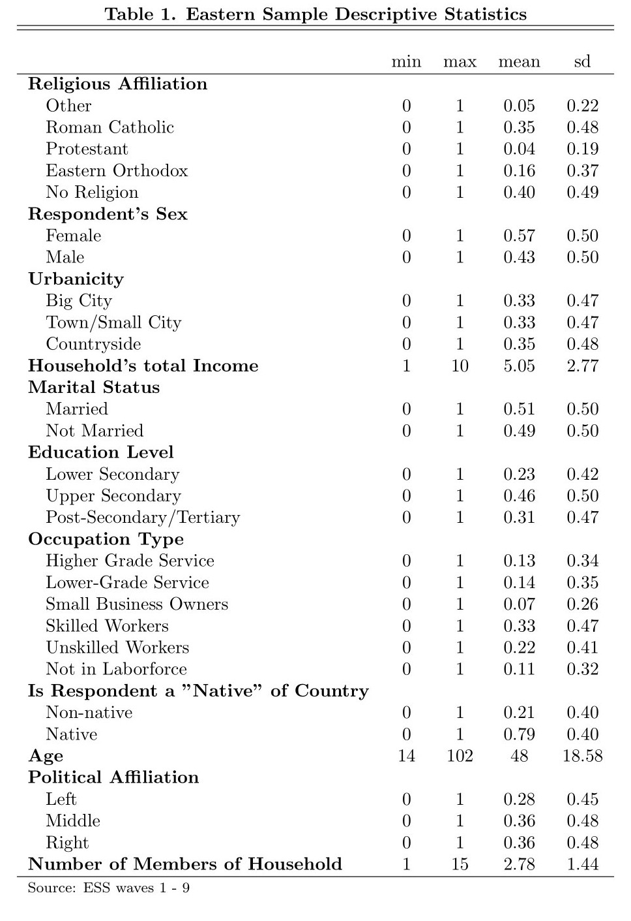

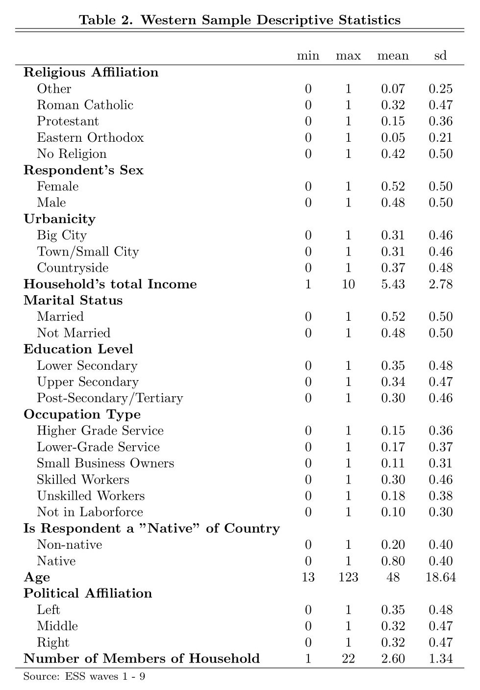

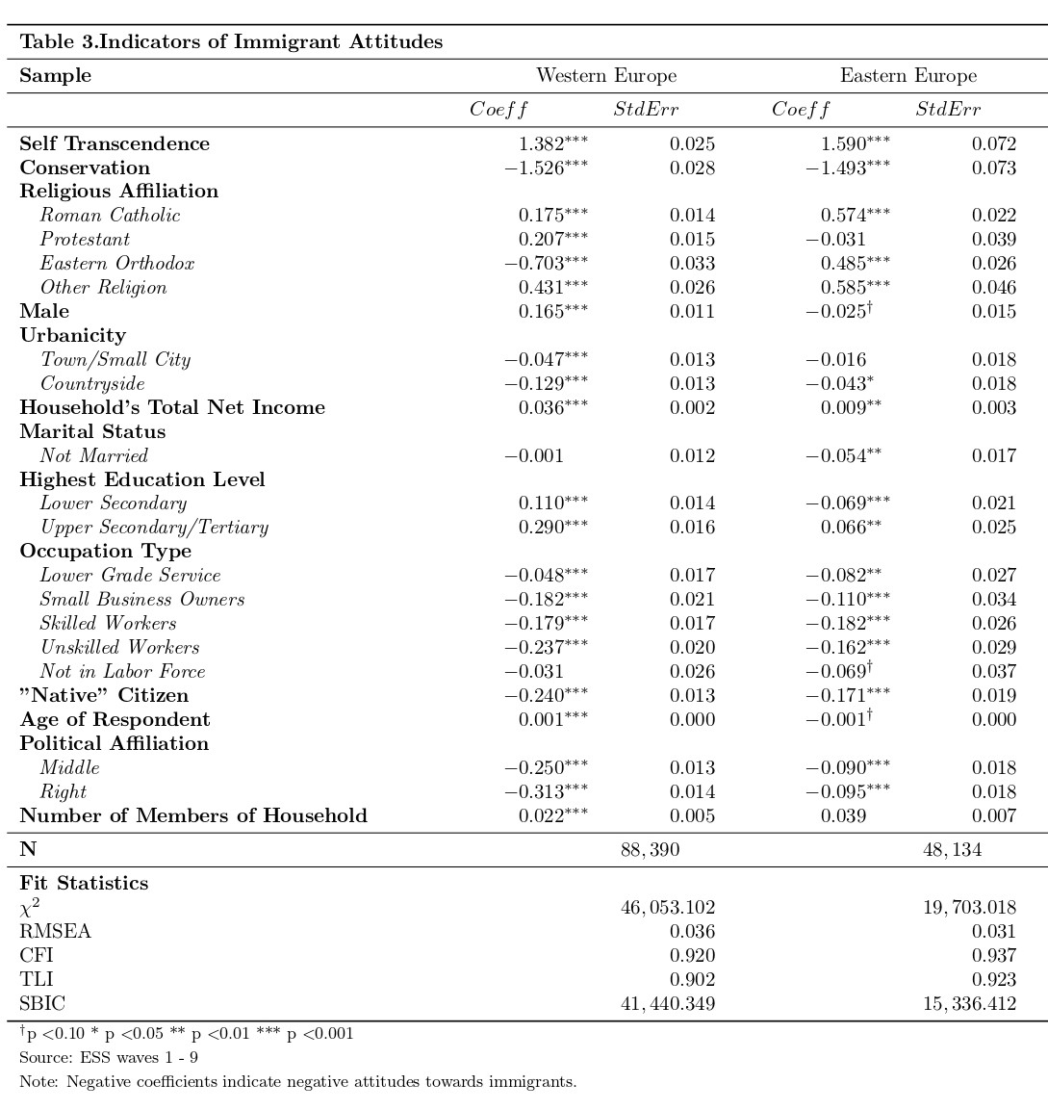

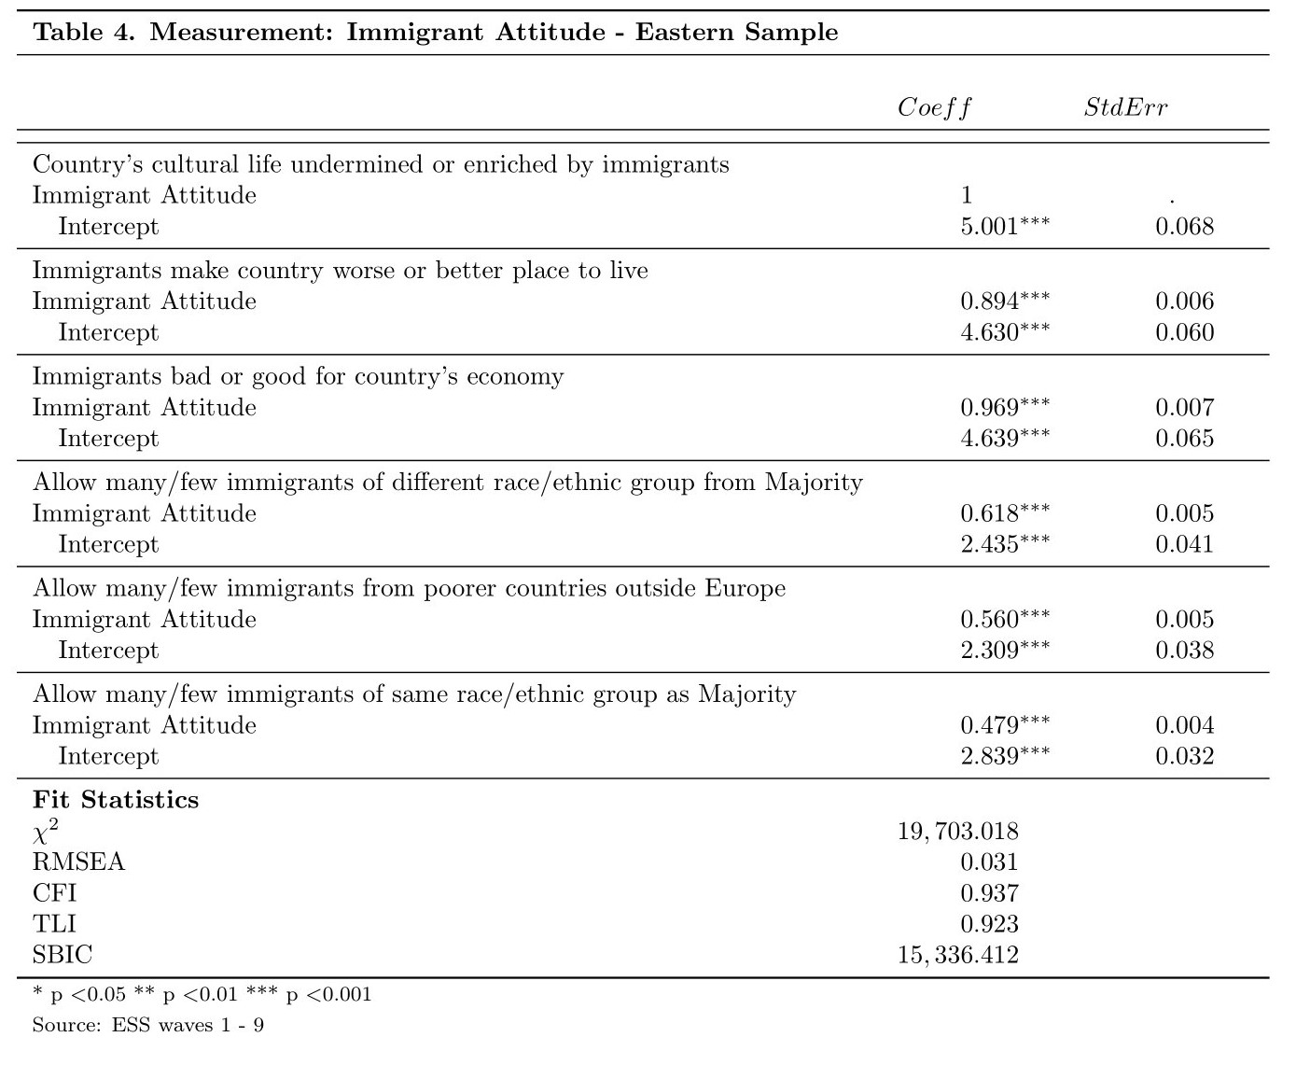

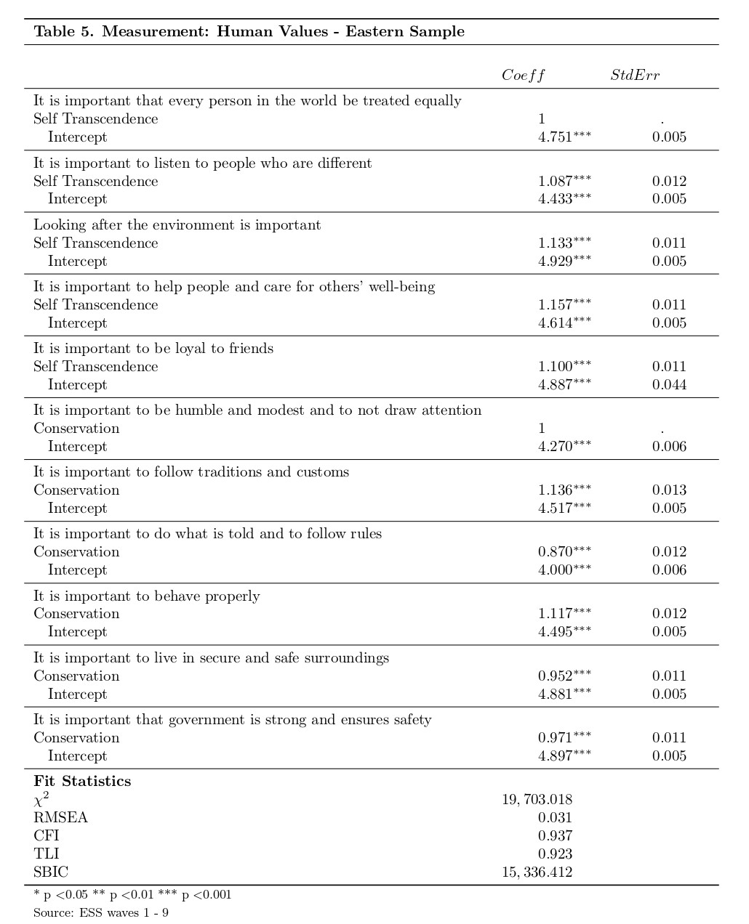

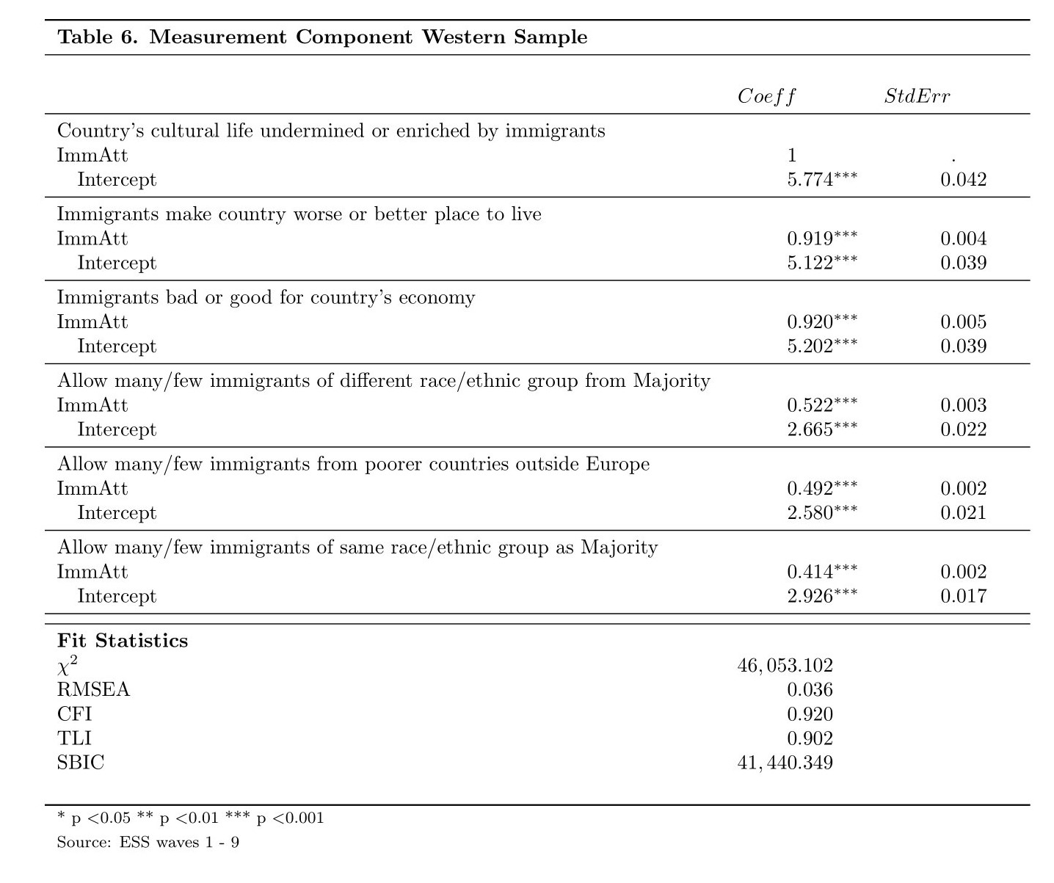

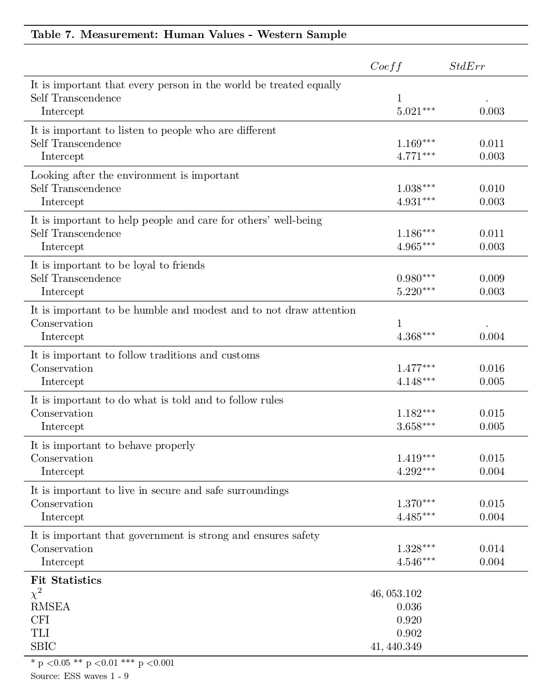

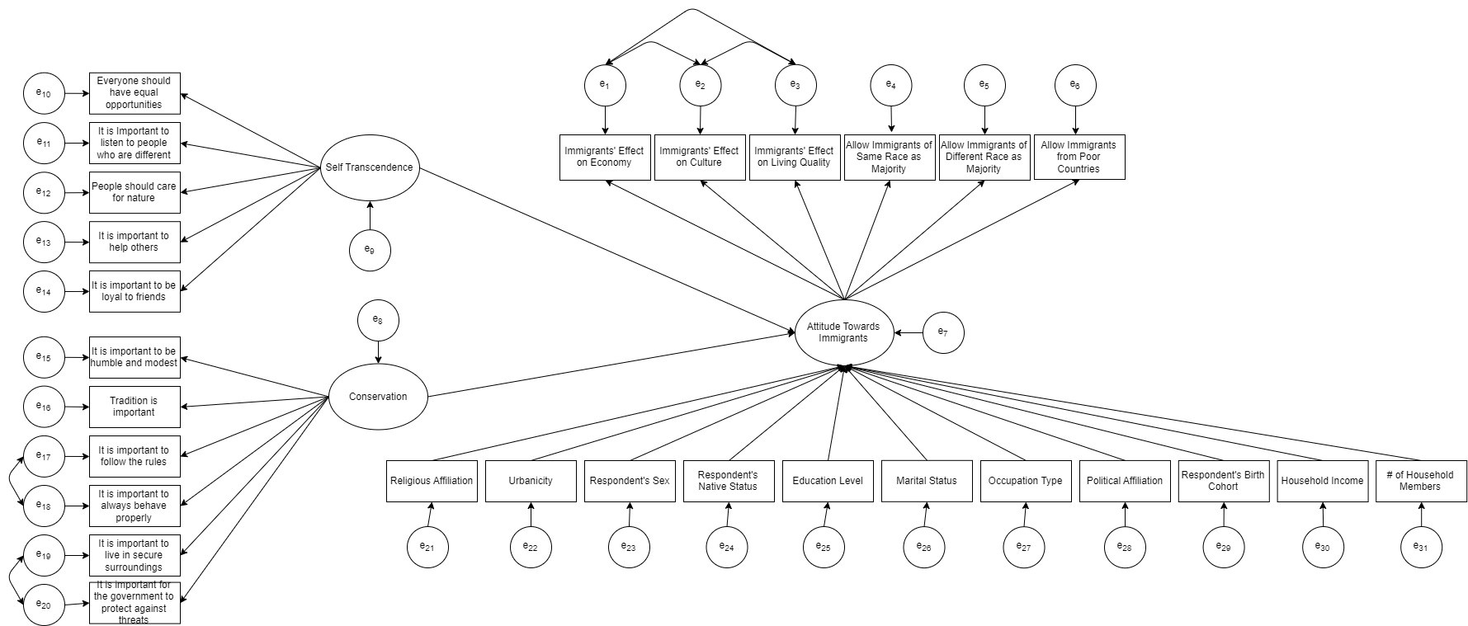
References:
- Alan C. Acock, 2013. Discovering Structural Equation Modeling Using Stata. Stata Press books, StataCorp LP
- Azmanova, Albena. 2011. “After the Left-Right (Dis)Continuum: Globalization and the Remaking of Europe’s Ideological Geography: Globalization and the Remaking of Europe’s Ideological Geography.” International Political Sociology 5(4):384–407. doi: 10.1111/j.1749-5687.2011.00141.x.
- Bello, Valeria. 2016. “Inclusiveness as Construction of Open Identity: How Social Relationships Affect Attitudes Towards Immigrants in European Societies.” Social Indicators Research 126(1):199–223. doi: 10.1007/s11205-015-0881-1.
- Bentsen, Beint Magnus Aamodt. “Intergroup Contact and Negative Attitudes Towards Immigrants Among Youth in Sweden: Individual and Contextual Factors.” Journal of International Migration and Integration, vol. 23, no. 1, Mar. 2022, pp. 243–66. DOI.org (Crossref), https://doi.org/10.1007/s12134-021-00837-x.
- Bessudnov, Alexey. 2016. “Ethnic Hierarchy and Public Attitudes towards Immigrants in Russia.” European Sociological Review 32(5):567–80. doi: 10.1093/esr/jcw002.
- Bohman, Andrea. 2011. “Articulated Antipathies: Political Influence on Anti-Immigrant Attitudes.” International Journal of Comparative Sociology 52(6):457–77. doi: 10.1177/0020715211428182.
- Bollen, Kenneth. 1989. Structural Equations with Latent Variables.
- Butkus, Mindaugas, Alma Mačiuly Tė-Šniukienė, Vida Davidavičienė, and Kristina Matuzevičiūtė. n.d. “Factors Influencing Society’s Attitudes towards Internal and External EU Immigrants.”
- Cangur, Sengul, and Ilker Ercan. 2015. “Comparison of Model Fit Indices Used in Structural Equation Modeling Under Multivariate Normality.” Journal of Modern Applied Statistical Methods 14(1):152–67. doi: 10.22237/jmasm/1430453580.
- Card, D., C. Dustmann, and I. Preston. n.d. “Understanding Attitudes to Immigration: The Migration and Minority Module of the First European Social Survey.”
- Casanova, José. 2012. “The Politics of Nativism: Islam in Europe, Catholicism in the United States.” Philosophy & Social Criticism 38(4–5):485–95. doi: 10.1177/0191453711435643.
- Ceobanu, Alin, Escandell, Xavier. 2010.“Comparative Analyses of Public Attitudes Toward Immigrants and Immigration Using Multinational Survey Data: A Review of Theories and Research” Annual Review of Sociology. DOI:10.1146/annurev.soc.012809.102651
- Cho, Seongha. 2022. “Economic Conditions and Social Cohesion: An Analysis of French European Social Survey Data.” French Politics 20(1):25–52. doi: 10.1057/s41253-021-00163-9.
- Clark, D. 2022, “Life Expectancy in Europe 2020.” Statista https://www.statista.com/statistics/274514/life-expectancy-in-europe.
- Coenders, Marcel, Marcel Lubbers, and Peer Scheepers. 2009. “Opposition to Civil Rights for Legal Migrants in Central and Eastern Europe: Cross-National Comparisons and Explanations.” East European Politics and Societies: And Cultures 23(2):146–64. doi: 10.1177/0888325408327847.
- Coleman, David. 2006. “Immigration and Ethnic Change in Low-Fertility Countries: A Third Demographic Transition.” Population and Development Review 32(3):401–46. doi: 10.1111/j.1728-4457.2006.00131.x.
- Davidov, Eldad, Jan Cieciuch, Bart Meuleman, Peter Schmidt, René Algesheimer, and Mirjam Hausherr. 2015. “The Comparability of Measurements of Attitudes toward Immigration in the European Social Survey.” Public Opinion Quarterly 79(S1):244–66. doi: 10.1093/poq/nfv008.
- Davidov, Eldad, and Bart Meuleman. 2012. “Explaining Attitudes Towards Immigration Policies in European Countries: The Role of Human Values.” Journal of Ethnic and Migration Studies 38(5):757–75. doi: 10.1080/1369183X.2012.667985.
- De la Dehesa, Guillermo. 2005. Winners and Losers in Globalization.
- Emanuele, Vincenzo, Bruno Marino, and Davide Angelucci. 2020. “The Congealing of a New Cleavage? The Evolution of the Demarcation Bloc in Europe (1979–2019).” Italian Political Science Review/Rivista Italiana Di Scienza Politica 50(3):314–33. doi: 10.1017/ipo.2020.19.
- Fahey, Éamonn, Frances McGinnity, and Raffaele Grotti. n.d. “Irish Attitudes to Muslim Immigrants.” The Economic and Social Review.
- Georgellis, Yannis, Nicholas Tsitsianis, and Ya Ping Yin. 2009. “Personal Values as Mitigating Factors in the Link Between Income and Life Satisfaction: Evidence from the European Social Survey.” Social Indicators Research 91(3):329–44. doi: 10.1007/s11205-008-9344-2.
- Grande, Edgar, Tobias Schwarzbözl, and Matthias Fatke. 2019. “Politicizing Immigration in Western Europe.” Journal of European Public Policy 26(10):1444–63. doi: 10.1080/13501763.2018.1531909.
- Haas, Hein de, et al. The Age of Migration: International Population Movements in the Modern World. 6. Auflage, Reprinted by Bloomsbury Academic, Bloomsbury Academic, 2022.
- Harteveld, Eelco, Andrej Kokkonen, and Stefan Dahlberg. 2017. “Adapting to Party Lines: The Effect of Party Affiliation on Attitudes to Immigration.” West European Politics 40(6):1177–97. doi: 10.1080/01402382.2017.1328889.
- Heyns, Barbara. 2005. “Emerging Inequalities in Central and Eastern Europe.” Annual Review of Sociology 31(1):163–97. doi: 10.1146/annurev.soc.30.012703.110637.
- Hoxhaj, Rezart, and Carolina V. Zuccotti. 2021. “The Complex Relationship between Immigrants’ Concentration, Socioeconomic Environment and Attitudes towards Immigrants in Europe.” Ethnic and Racial Studies 44(2):272–92. doi: 10.1080/01419870.2020.1730926.
- Hutter, Swen, and Hanspeter Kriesi. 2022. “Politicising Immigration in Times of Crisis.” Journal of Ethnic and Migration Studies 48(2):341–65. doi: 10.1080/1369183X.2020.1853902.
- Ilahi, Nadeem, Anna Ilyina, Daria Zakharova. 2016. “Emigration Slows Eastern Europe’s Catch Up With the West”. Retrieved April 18th, 2023 (https://www.imf.org/en/Blogs/Articles/2016/07/20/emigration-slows-eastern-europes-catch-up-with-the-west)
- Kaczmarczyk, Pawel. Okolski, Mark. 2005. “International Migration in Central and Eastern Europe – Current and Future Trends”. UNITED NATIONS EXPERT GROUP MEETING ON INTERNATIONAL MIGRATION AND DEVELOPMENT. UN/POP/MIG/2005/12
- Kaiser, H. F. (1960). The application of electronic computers to factor
analysis. Educational and Psychological Measurement, 20, 141–151.
http://dx.doi.org/10.1177/001316446002000116
- Kass, Robert E., and Adrian E. Raftery. 1995. “Bayes Factors.” Journal of the American Statistical Association 90(430):773–95. doi: 10.1080/01621459.1995.10476572.
- Kešić, Josip, and Jan Willem Duyvendak. 2019. “The Nation under Threat: Secularist, Racial and Populist Nativism in the Netherlands.” Patterns of Prejudice 53(5):441–63. doi: 10.1080/0031322X.2019.1656886.
- Kiehl, Melanie, and Heinz Werner. 1999. “The Labour Market Situation of EU and of Third Country Nationals in the European Union.”
- Kriesi, Hanspeter, Edgar Grande, Romain Lachat, Martin Dolezal, Simon Bornschier, and Timotheos Frey. 2006. “Globalization and the Transformation of the National Political Space: Six European Countries Compared.” European Journal of Political Research 45(6):921–56. doi: 10.1111/j.1475-6765.2006.00644.x.
- Lancee, Bram, and Oriane Sarrasin. 2015. “Educated Preferences or Selection Effects? A Longitudinal Analysis of the Impact of Educational Attainment on Attitudes Towards Immigrants.” European Sociological Review 31(4):490–501. doi: 10.1093/esr/jcv008.
- León-Ledesma, Miguel, and Matloob Piracha. n.d. “International Migration and the Role of Remittances in Eastern Europe.”
- Magun, Vladimir, Maksim Rudnev, and Peter Schmidt. 2016. “Within- and Between-Country Value Diversity in Europe: A Typological Approach.” European Sociological Review 32(2):189–202. doi: 10.1093/esr/jcv080.
- Maisonneuve, C. Teste, B. 2007. “Acculturation of preferences of a host community: The effects of immigrant acculturation strategies on evaluations and impression formation”. International Journal of Intercultural Relations, 31, 669-688
- Malhotra, Neil, Yotam Margalit, and Cecilia Hyunjung Mo. 2013. “Economic Explanations for Opposition to Immigration: Distinguishing between Prevalence and Conditional Impact: ECONOMIC EXPLANATIONS FOR OPPOSITION TO IMMIGRATION.” American Journal of Political Science 57(2):391–410. doi: 10.1111/ajps.12012.
- Martin, Reiner, and Dragos Radu. 2012. “Return Migration: The Experience of Eastern Europe 1: Return Migration: The Experience of Eastern Europe.” International Migration 50(6):109–28. doi: 10.1111/j.1468-2435.2012.00762.x.
- Matera, Camilla, Cristina Stefanile, and Rupert Brown. 2015. “Majority–Minority Acculturation Preferences Concordance as an Antecedent of Attitudes towards Immigrants: The Mediating Role of Perceived Symbolic Threat and Metastereotypes.” International Journal of Intercultural Relations 45:96–103. doi: 10.1016/j.ijintrel.2015.02.001.
- Meuleman, Bart, Eldad Davidov, and Jaak Billiet 2009. “Changing Attitudes toward Immigration in Europe, 2002–2007: A Dynamic Group Conflict Theory Approach.” Social Science Research 38(2):352–65. doi: 10.1016/j.ssresearch.2008.09.006.
- Naumann, Elias, Lukas F. Stoetzer, and Giuseppe Pietrantuono. 2018. “Attitudes towards Highly Skilled and Low-Skilled Immigration in Europe: A Survey Experiment in 15 European Countries: ATTITUDES TOWARDS HIGHLY SKILLED AND LOW-SKILLED IMMIGRATION IN EUROPE.” European Journal of Political Research 57(4):1009–30. doi: 10.1111/1475-6765.12264.
- Oesch, Daniel. 2006. “Coming to Grips with a Changing Class Structure: An Analysis of Employment Stratification in Britain, Germany, Sweden and Switzerland.” International Sociology 21(2):263–88. doi: 10.1177/0268580906061379.
- Paskov, Marii, Patrick Prag, and Lindsay Richards. n.d. “Does Downward Social Mobility Make People More Hostile Towards Immigrants?”
- Pellegrini, Valerio, Valeria De Cristofaro, Marco Salvati, Mauro Giacomantonio, and Luigi Leone. 2021. “Social Exclusion and Anti-Immigration Attitudes in Europe: The Mediating Role of Interpersonal Trust.” Social Indicators Research 155(2):697–724. doi: 10.1007/s11205-021-02618-6.
- Quillian, Lincoln. 1995. “Prejudice as a Response to Perceived Group Threat: Population Composition and Anti-Immigrant and Racial Prejudice in Europe.” American Sociological Review 60(4):586. doi: 10.2307/2096296.
- Roblain, Antoine, Assaad Azzi, and Laurent Licata. 2016. “Why Do Majority Members Prefer Immigrants Who Adopt the Host Culture? The Role of Perceived Identification with the Host Nation.” International Journal of Intercultural Relations 55:44–54. doi: 10.1016/j.ijintrel.2016.08.001.
- Ronellenfitsch, Ulrich, and Oliver Razum. 2004. “Deteriorating Health Satisfaction among Immigrants from Eastern Europe to Germany.” International Journal for Equity in Health 3(1):4. doi: 10.1186/1475-9276-3-4.
- Rovny, Jan. 2014. “The Other ‘Other’: Party Responses to Immigration in Eastern Europe.” Comparative European Politics 12(6):637–62. doi: 10.1057/cep.2014.25.
- Rustenbach, Elisa. 2010. “Sources of Negative Attitudes toward Immigrants in Europe: A Multi-Level Analysis”. International Migration Review. https://doi-org.ezproxy.lib.ou.edu/10.1111/j.1747-7379.2009.00798.x
- Scheibner, Gunnar B., and Todd G. Morrison. 2009. “Attitudes towards Polish Immigrants to the Republic of Ireland: An Integrated Threat Analysis.” Ethnic and Racial Studies 32(8):1431–48. doi: 10.1080/01419870902890317.
- Schilling, Tobias, Stephan Rauscher, Christian Menzel, Simon Reichenauer, Martina Müller-Schilling, Stephan Schmid, and Michael Selgrad. 2017. “Migrants and Refugees in Europe: Challenges, Experiences and Contributions.” Visceral Medicine 33(4):295–300. doi: 10.1159/000478763.
- Schwartz, Shalom H., and Tammy Rubel-Lifschitz. “Cross-National Variation in the Size of Sex Differences in Values: Effects of Gender Equality.” Journal of Personality and Social Psychology, vol. 97, no. 1, July 2009, pp. 171–85. DOI.org (Crossref), https://doi.org/10.1037/a0015546.
- Schwartz, Shalom H., and Tammy Rubel. 2005. “Sex Differences in Value Priorities: Cross-Cultural and Multimethod Studies.” Journal of Personality and Social Psychology 89(6):1010–28. doi: 10.1037/0022-3514.89.6.1010.
- Schwartz, S. H. (1992). Universals in the content and structure of values: Theoretical advances and empirical tests in 20 countries. In M. P. Zanna (Ed.), Advances in experimental social psychology, Vol. 25, pp. 1–65). Academic Press. https://doi.org/10.1016/S0065-2601(08)60281-6
- Semyonov, Moshe, Rebeca Raijman, and Anastasia Gorodzeisky. 2006. “The Rise of Anti-Foreigner Sentiment in European Societies, 1988-2000.” American Sociological Review 71(3):426–49. doi: 10.1177/000312240607100304.
- Senik, Claudia, Holger Stichnoth, and Karine Van der Straeten. 2009. “Immigration and Natives’ Attitudes towards the Welfare State: Evidence from the European Social Survey.” Social Indicators Research 91(3):345–70. doi: 10.1007/s11205-008-9342-4.
- Smith, Christian. “The Conceptual Incoherence of ‘Culture’ in American Sociology.” The American Sociologist, vol. 47, no. 4, Dec. 2016, pp. 388–415. DOI.org (Crossref), https://doi.org/10.1007/s12108-016-9308-y.
- Teney, Céline, Onawa Promise Lacewell, and Pieter De Wilde. 2014. “Winners and Losers of Globalization in Europe: Attitudes and Ideologies.” European Political Science Review 6(4):575–95. doi: 10.1017/S1755773913000246.
- Thompson, B. (2004). Exploratory and confirmatory factor analysis: Understanding concepts and applications. American Psychological Association. https://doi.org/10.1037/10694-000
- Tong, Yuying, Tianzhu Nie, and Martin Piotrowski. 2022. “Channeling Good Images but Not Substantive Blessings? Education and Social Contact on Pro-Migrant Sentiments in an Internal Migration Setting.” Social Forces 101(1):440–72. doi: 10.1093/sf/soab129.
- Turner, Tom. 2010. “WHY ARE IRISH ATTITUDES TO IMMIGRANTS AMONG THE MOST LIBERAL IN EUROPE?: Testing Structural Determinants in a Comparative Context.” European Societies 12(1):25–44. doi: 10.1080/14616690902718399.
- Van Mol, C., de Valk, H. (2016). Migration and Immigrants in Europe: A Historical and Demographic Perspective. In: Garcés-Mascareñas, B., Penninx, R. (eds) Integration Processes and Policies in Europe. IMISCOE Research Series. Springer, Cham. https://doi.org/10.1007/978-3-319-21674-4_3
- Vaughan, Kenneth R. 2021. “Anti-Immigrant Sentiment and Opposition to Democracy in Europe.” Journal of Immigrant & Refugee Studies 19(4):540–56. doi: 10.1080/15562948.2020.1843749.
- Velkova, A., J. H. Wolleswinkel-van den Bosch, and J. P. Mackenbach. 1997. “The East-West Life Expectancy Gap: Differences in Mortality from Conditions Amenable to Medical Intervention.” International Journal of Epidemiology 26(1):75–84. doi: 10.1093/ije/26.1.75.
- “Refugee Crisis in Europe: Aid, Statistics and News: USA FOR UNHCR.” Refugee Crisis in Europe: Aid, Statistics and News | USA for UNHCR, https://www.unrefugees.org/emergencies/refugee-crisis-in-europe.
- “Syria Refugee Crisis – Globally, in Europe and in Cyprus”. 18th Mar. 2021 https://www.unhcr.org/cy/2021/03/18/syria-refugee-crisis-globally-in-europe-and-in-cyprus-meet-some-syrian-refugees-in-cyprus/

https://www.europeansocialsurvey.org/ European Social Survey Website
The questionnaire is annotated where necessary to ensure that the correct interpretation of the questions is conveyed during the interviews. For each country, the questionnaire is translated into each language spoken as a first language by more than 5% of the country’s population. The ESS follows the TRAPD methodology – Translation, Review, Adjudication, Pretesting, and Documentation. Each national team is given detailed guidelines which outline the correct translation process to follow. After translation, select items are subjected to verification and survey quality coding, after which, each translated version is pre-tested. An expert translation panel oversees this process and provides help with translation strategies as well as language-specific issues for translating items (ESS Prospectus).
Countries used in the analysis (taken from the original “country” variable in the dataset: Western Europe includes Austria, Belgium, Switzerland, Germany, Denmark, Spain, France, United Kingdom, Greece, Italy, Netherlands, Norway and Portugal; Eastern Europe includes Bulgaria, Czech Republic, Estonia, Croatia, Hungary, Lithuania, Latvia, Poland, Russia, Slovenia, Slovakia and Ukraine. Note: The United Kingdom, Russia, Bulgaria, and Ukraine are not included in the Schengen Area currently. For the purposes of this paper, these countries have been included among the others as the current focus of this paper is to study overall attitudes towards immigrants from all sending countries, not just from within Europe.
For this variable, separate models were used in some analyses for East and West.
As a sensitivity check, I used a birth cohort variable instead of the age variable to determine if any additional findings came from this change. All patterns and coefficients were largely unchanged, and the changes were determined to be minimal. As a result, I have opted to include the age variable instead of a cohort variable.
This pattern remains relatively unchanged after conducting a sensitivity check of switching the reference category to another large group, Roman Catholic.
Again, with a sensitivity check of switching the reference category to Roman Catholic instead of no religion, the effects remained effectively the same. Other effects in the Western sample include strong negative effects of being on the right-wing side of the political scale, being an unskilled worker, as well as slightly stronger effects of living in the countryside, none of which are all too surprising.

