University of Oklahoma

Graduate College

Economy analysis comparison for liquefied natural gas and gas-to-liquid project in monetizing excessive natural gas production

A thesis

submitted to the Graduate Faculty

in partial fulfillment of the requirements for the

Degree of

Master of Science in Natural Gas Engineering and Management

By

pascoela marciana da silva sequeira
Norman, Oklahoma
2019

Economy analysis comparison for liquefied natural gas and gas-to-liquid project in monetizing excessive natural gas production

A thesis approved for the
Mewbourne School of Petroleum and Geological Engineering

By

Dr. Rouzbeh G. Moghanloo, Chair

Dr. Suresh C. Sharma

Dr. Ashwin Venkatraman

© Copyright by Pascoela marciana da silva sequeira 2019
All Rights Reserved.

Dedication
This thesis is dedicated to my beloved Father, Júlio Sequeira, who taught me the importance of education. Who even in his last day on earth was concerned about finishing his thesis. Unfortunately, he left this world without finishing his master’s degree program.
This is for you Dad, I love you and miss you so dearly.

Acknowledgements
First, I would like to thank the Fulbright Foreign Student Program Scholarship for their generous scholarship for the opportunity to attain my Master of Science in Natural Gas Engineering and Management. I would like to recognize the head department of Natural Gas Engineering and Management Program, Dr. Suresh Sharma for his guidance in planning courses for the past two years. I would like to acknowledge Dr. Rouzbeh G. Moghanloo for his guidance, assistance and most importantly his encouragement during the preparation of this thesis. I would also like to recognize Dr. Ashwin Venkantraman, for his willingness to be part of my thesis defense committee.
I would like to thank TIMORGAP E.P, Timor-Leste National Oil Company, particularly Gas Business Unit for providing data for this thesis.
Furthermore, I would like to thank United World College (UWC) scholarship for my undergraduate program for opening the door for higher level education abroad.
Finally, I would like to express my sincere gratitude to my mom, who always believe in me. To my siblings, thank you for all the motivation and your unconditional love and support. My special thanks to my soon-to-be husband for his support, motivation, encouragement, unconditional love, and for always believe in me. I would have not finished this program without all of your love and support.

Table of Contents
Dedication iv
Acknowledgements v
List of Tables viii
List of Figures ix
Abstract xii
Chapter 1: Introduction 1
1.1 Background 1
1.2 Assumptions 3
Chapter 2: Natural Gas 4
2.1 Natural Gas Production 4
2.2 Natural Gas Consumption 7
Chapter 3: Literature 9
3.1 Liquefied Natural Gas (LNG) 10
3.1.1 LNG Process 11
3.1.2 LNG Process 12
3.2 Gas-to-Liquid (GTL) 13
3.2.1 GTL Process 14
Chapter 4: Methodology 17
4.1 Parameters 17
4.1.1 LNG 17
4.1.2 GTL 27
4.2 Economy Metrics 36
4.3 Monte Carlo Simulation 38
4.4 Sensitivity Analysis 40
Chapter 5: Results and Discussions 42
5.1 Results 42
5.1.1 LNG 42
5.1.2 GTL 49
5.2 Discussion 57
Chapter 6: Field Analysis 60
6.1 Natural Gas Flaring in Bakken Field 60
6.2 Greater Sunrise 64
Chapter 7: Conclusions and Recommendations 74
References 76
Appendix A: Abbreviations 81
Appendix B: LNG Sample Calculations 82
Appendix C: GTL Sample Calculations 86
Appendix D: Monte Carlo Simulation 89

List of Tables
Table 1-CAPEX of LNG projects in Australia constructed in 2012-18 18
Table 2-CAPEX of LNG Projects constructed and under construction in The U.S. 19
Table 3-Existing/commercial plants with capacity and CAPEX 28
Table 4-Summary of LNG and GTL parameters used for Monte Carlo Simulations of 10,000 iterations. 39
Table 5-Parameters for low, base, and high case-scenario for LNG Plant. 40
Table 6-Parameters for low, base, and high case-scenario for GTL Plant. 41
Table 7-Shows results from 10,000 iterations of Monte Carlo Simulations for LNG Project. 44
Table 8-Overall ranking of each parameters for LNG Project. 49
Table 9-Shows results from 10,000 iterations of Monte Carlo Simulations for GTL Project. 52
Table 10-Overall ranking of each parameters for GTL Plant. 57
Table 11-Summary of best-case-scenario results of economic metrics with Capacity variable. 59
Table 12-Summary of Parameter for GTL Plant in Bakken Field 62
Table 13-Gas Composition for Greater Sunrise field 65
Table 14-Summary of LNG Plant Parameters for Greater Sunrise 67
Table 15-Shows the result of Monte Carlo simulation after 10,000 iterations for 5 MTPA LNG project in Timor-Leste. 67
Table 16-Summary parameters for GTL Plant in Greater Sunrise 70
Table 17-Results of comparing different GTL capacity with the best-case scenario parameters. 72

List of Figures
Figure 1-Comparative primary energy consumption over the past 15 years 1
Figure 2-Location of world’s Shale Plays with volume of technically recoverable shale gas in the 20 countries with the largest resources 2
Figure 3-Natural Gas Production in the World 5
Figure 4-The U.S. Natural gas production forecasted to 2050 6
Figure 5-Map of shale plays in lower 48 states in the U.S. 6
Figure 6-Pie chart of natural gas utilization in the U.S. by sector in 2017 8
Figure 7-Means of transporting natural gas to the market based on the gas delivery volume and the distance to the market 9
Figure 8-Typical LNG value of chain and the specific area of liquefaction cost 10
Figure 9-Block Flow Diagram in an LNG plant with maximum number of units 11
Figure 10-Typical natural gas and refrigerant cooling curves 12
Figure 11-Basic flowchart of indirect conversion of natural gas to liquids through syngas and Fischer-Tropsch 15
Figure 12-Recent overall project CAPEX in USD/TPA 17
Figure 13- Cost breakdown for LNG Project's OPEX 21
Figure 14-LNG capacity scale categories according to Royal Dutch Shell 22
Figure 15-United States natural gas price for industrial and wellhead for the past 10 years 23
Figure 16-Maximum feed gas treating and efficiency of plant based on feed gas composition 24
Figure 17-Minimum feed gas treating and efficiency of plant based on feed gas composition 25
Figure 18-Historical data for LNG Vessel Price from 2006-18 26
Figure 19-GTL capacity and Capital Expenditure (CAPEX) of existing plants. 28
Figure 20-Breakdown of CAPEX for GTL project 30
Figure 21-United States natural gas price for industrial and wellhead for the past 10 years 32
Figure 22-Monthly price of Crude oil in Cushing Oklahoma from the past 10 years 34
Figure 23-United States U.S. Gulf Coast Conventional Gasoline, Diesel Ultra Low Sulphur, and Crude Oil in Cushing, OK for the past 10 years. 35
Figure 24-LNG Plant Monte Carlo Simulation for NPV with x-axis in Millions of Dollars. 42
Figure 25-LNG Plant Monte Carlo Simulation for IRR with x-axis in percentages. 43
Figure 26-LNG Plant Monte Carlo Simulation for PI with x-axis in ratio. 43
Figure 27-Tornado chart for NPV of LNG Project. 45
Figure 28- Tornado chart for IRR of LNG Project. 46
Figure 29- Tornado chart for PI of LNG Project. 47
Figure 30- Tornado chart for Payback Period of LNG Project. 48
Figure 31-GTL Plant Monte Carlo Simulation for NPV with x-axis in Millions of Dollars. 50
Figure 32- GTL Plant Monte Carlo Simulation for IRR with x-axis in percentages. 50
Figure 33- GTL Plant Monte Carlo Simulation for PI with x-axis in ratio. 51
Figure 34-Tornado chart for NPV of GTL Plant. 53
Figure 35-Tornado chart for IRR of GTL Plant. 54
Figure 36-Tornado chart for PI of GTL Plant. 55
Figure 37-Tornado chart for Payback Period of GTL Plant. 56
Figure 38-Shows comparison of NPV and IRR for positive case-scenario of LNG project. 58
Figure 39- Map of U.S. Interstate and Intrastate pipelines network with Bakken Field 60
Figure 40-Natural gas vented and flared in North Dakota from 2015 to the end of 2017. 61
Figure 41- Bakken Field GTL option to minimize natural gas flaring. 63
Figure 42-Maritime permanent boundary between Timor-Leste and Australia 64
Figure 43-Distance from Greater Sunrise to Viqueque, Timor-Leste 66
Figure 44-Best-case-scenario Greater Sunrise Field LNG plant option with capacity as variable. 68
Figure 45-NPV and IRR at the y-axis as CAPEX is varying in x-axis. 70

Abstract
Natural gas price has plummeted due to shale gas production booming which causes excessive capacity. Therefore, countries such as the U.S., Australia, Indonesia, Malaysia, and others with high natural gas production are searching for practical and profitable ways of transporting and utilizing natural gas. There are five major technologies used in the transportation of natural gas namely: pipelines, Liquefied Natural Gas (LNG), Gas-to-Liquid (GTL), Compressed Natural Gas (CNG), and Gas-to-Wire (GTW) or power generation. In this thesis, the economic metrics evaluations are performed in comparing LNG to GTL. These economic metrics are Net Present Value (NPV), Internal Rate of Return (IRR), Profitability Index (PI), and Payback Period.
A Monte Carlo simulation approach is used to evaluate economic metrics on various parameters such as feed gas price, plant capacity, carbon, and thermal efficiency, capital expenditure (CAPEX), operational expenditure (OPEX), products prices, transportations, tax rate, and discount rate. Sensitivity analysis shows NPV, IRR, PI and payback period for LNG are most affected by CAPEX, products selling price, Feed gas price, and efficiency of the plant, in respective order. For GTL project, the most affected parameters are product price, thermal efficiency, and CAPEX.
A low, base and high case scenario for each parameter is used in evaluating the economic metrics. Based on these case scenarios and parameters show that the LNG project is profitable and attractive when a plant capacity is 4.25 MTPA. In contrast, the GTL project is more profitable and attractive for a small-scale plant. In other words, depending on the natural gas reserves volume LNG plant option might be more attractive than GTL or vice versa. A small-scale GTL project appears to be a good option for an excessive natural gas production like Bakken Field where the average flaring gas is 527 MMcfd. A large-scale LNG plant would be a better option for Timor-Leste where the volume of natural gas reserves in Greater-Sunrise field is approximately 9.5 Tcf. These comparisons are done for best-case-scenario where the CAPEX and feed gas price are low and product price is medium to high.
The best and profitable case-scenario for LNG project is when the CAPEX is US$1,500/TPA, the product price should be higher than US$13/MMBtu, and feed gas price should be lower than US$2.80/Mcf. This best-case-scenario yields profitable economic metrics, but the optimal option is to have LNG plant with a capacity of 4.25 MTPA. Above 4.25 MTPA, the IRR is low and below that capacity, the IRR is remained flat as 4.25 MTPA.
Additionally, best-case-scenario for GTL is when CAPEX is lower than US$45,000/bpd and product price is higher than US$156/bbl. Even though this is the best-case-scenario but a large capacity of GTL project such as 50,000 bpd for Bakken Field yields an unprofitable economic metrics. However, this best-case-scenario does generate a profitable and attractive result for smaller-scale GTL plant capacity of 500 to 1,000 bpd.
In conclusion, the best option for Bakken field is to build several 1,000 bpd GTL plants in parallel to minimize the natural gas flaring in North Dakota. On the other hand, the best option to develop Greater Sunrise field is to build 4.25 MTPA LNG plant and additional numbers of GTL plants with a capacity of 1,000 bpd. This option yields NPV of US$9.3 Million, 9.4 percent IRR, 1.2 PI, and 6.7 years of the payback period. In addition, the 1,000 bpd GTL plant yields US$238 Million of NPV, 14 percent IRR, 1.7 PI, and 5.5 years of the payback period for each GTL plant.

Chapter 1: Introduction

1.1 Background
Natural gas is one of the primary energy sources besides petroleum, coal, nuclear energy, and renewables source of energy. Unlike petroleum and coal, natural gas is a gaseous phase fossil fuel that is colorless, odorless, shapeless with its density lighter than air. Additionally, natural gas is known as the cleanest fossil fuel energy.
According to Gas Market Report (2017) natural gas will grow faster than oil and coal over the next five years. As shown in Figure 1 in 2015, natural gas makes-up nearly a quarter of electricity generation and feedstock for industry which is about twenty-four percent of energy used worldwide. The increased utilization of natural gas is due to its property that is environmental benefit relative to other fossil fuels, particularly for air quality and greenhouse gas emissions.
Figure 1-Comparative primary energy consumption over the past 15 years
(World Energy Resources, 2016)
When shale gas booming in the United States in mid-2000s, the natural gas production in the US increases, drastically. Other countries see the U.S. experience as a breaking ground and this experience also encourage others to seek for their potential natural resources.
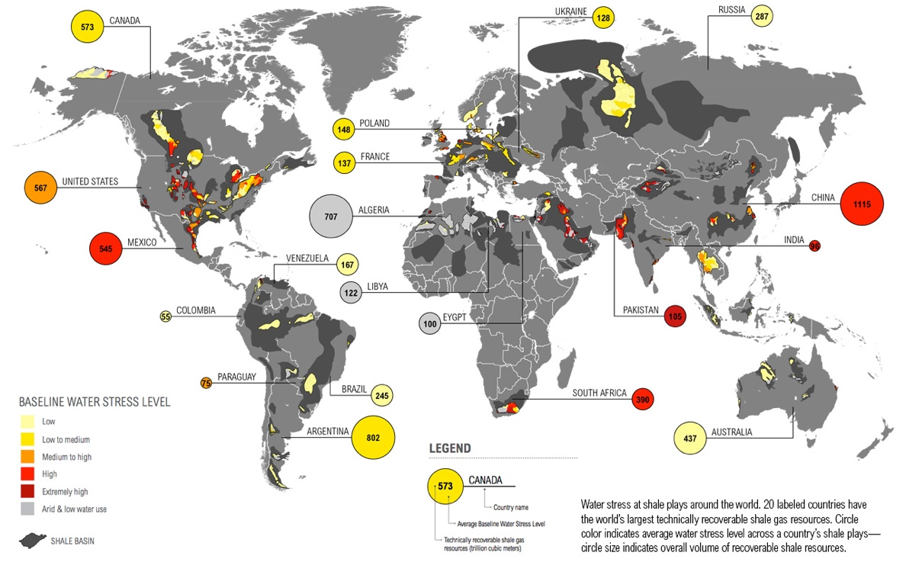
Figure 2-Location of world’s Shale Plays with volume of technically recoverable shale gas in the 20 countries with the largest resources
(Reig et al., 2014)
Even though, the U.S. is the pioneer of the hydraulic drilling and the first to recover the unconventional natural gas and oil, but as shown in Figure 2, that China has the most recoverable shale gas in the world.
The shale gas revolution through hydraulic fracturing method was once a positive addition to the petroleum industry has now negatively impacted the natural gas production. Since, the booming of shale gas productions, natural gas is currently in oversupply consequently, the price decreases leading to production cuts in the key shale fields.
The fundamental problem is not the technical aspect of natural gas production but determining a way to market natural gas in a practical, economic, feasible, and efficient manner. The common option for marketability of natural gas would be to convert natural gas into LNG which has been adapted by many countries in the world. Other options would be to convert natural gas into hydrocarbon liquid trough GTL processing plant.
The scope of this thesis is to evaluate economy feasibility and profitability by comparing between LNG and GTL projects in monetizing excessive natural gas production.

1.2 Assumptions
Assumptions made for economic metrics evaluation, are:
- Projects own by the company without having to pay dividends,
- The feed gas price is hedge, where the price does not change throughout the life of the project,
- Project life is 20 years,
- Straight line depreciation,
- The operation day is 350 days/year, and
- The inflation rate is negligible.
Factors that were not consider in this analysis, are:
- Exclude geopolitical issues and tax regulations.
- The Costs are lump sum. The technologies cost may vary since all the costs included are taking from public. Since all the technologies are company proprietary, thus the accurate costs are not available.
- No specific technology evaluation.
- Risk assessments are excluded.

Chapter 2: Natural Gas
Natural gas consists of other hydrocarbons and non-hydrocarbons compounds. The dominant hydrocarbon compound in the natural gas is methane (CH₄). Natural gas also contains smaller amount of other heavier hydrocarbon such as ethane, propane, butane and maybe condensate. Apart from hydrocarbon, natural gas also contains non-hydrocarbons compounds such as Nitrogen, Carbon dioxide, Hydrogen sulfide, water, and sometimes mercury and other contaminants.
When burned, natural gas produces energy about 1,000 British thermal unit (Btu) per standard cubic foot (scf). The flammability limit of natural gas is five and fifteen percent. When compared with coal and oil, it burns cleaner, more efficiently, and with lower levels of potentially harmful byproducts that are released into the atmosphere. More importantly, there are very large deposits of natural gas in the world. Because this resource is difficult to transport, a lot of it has been labeled as “stranded.” For these reasons, there has been a considerable increase in new gas exploration, field development, and production activities. To develop a natural gas field, one of the first important steps is to understand the fundamentals of natural gas.

2.1 Natural Gas Production
The world’s natural gas production reached 3,768 billion cubic meters (bcm) in 2017 (IEA, 2017), a 3.6 percent increase compared to 2016. According to Natural gas information 2017 overview, the growth of natural gas was driven by Australia as shown in Figure 3.
Figure 3-Natural Gas Production in the World
(IEA, 2017)
Contrary to the U.S., IEA (2017) reported that natural gas production in the U.S. increased by 47.8 bcm and 33.1 bcm in 2014 and 2015 respectively but plummeted in 2016 by 17.3 bcm. The decrease in natural gas production is due to the low natural gas price which forces many production companies to reduce their rate of production. Moreover, with the excessive capacity of natural gas production causing the price to be low.
However, the U.S. Energy Information Administration (EIA, 2018) forecasted that dry natural gas production in the U.S. will increase through 2050 by 59 percent growth from 73.6 bcfd in 2017 to 118 bcfd in 2050 as shown Figure 4 of reference case.
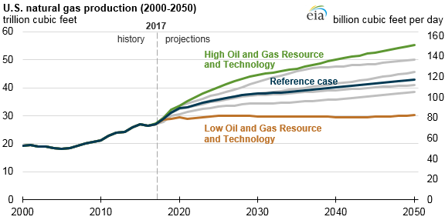
Figure 4-The U.S. Natural gas production forecasted to 2050
(EIA, 2018)
The increasing in natural gas production in the U.S. is mainly due to the shale gas production in the shale plays. The main players of a shale gas production among others such as Marcellus, Permian, Utica, Haynesville, Eagle Ford, Barnett, Woodford, Mississippian, Fayetteville, and others as shown in Figure 5.
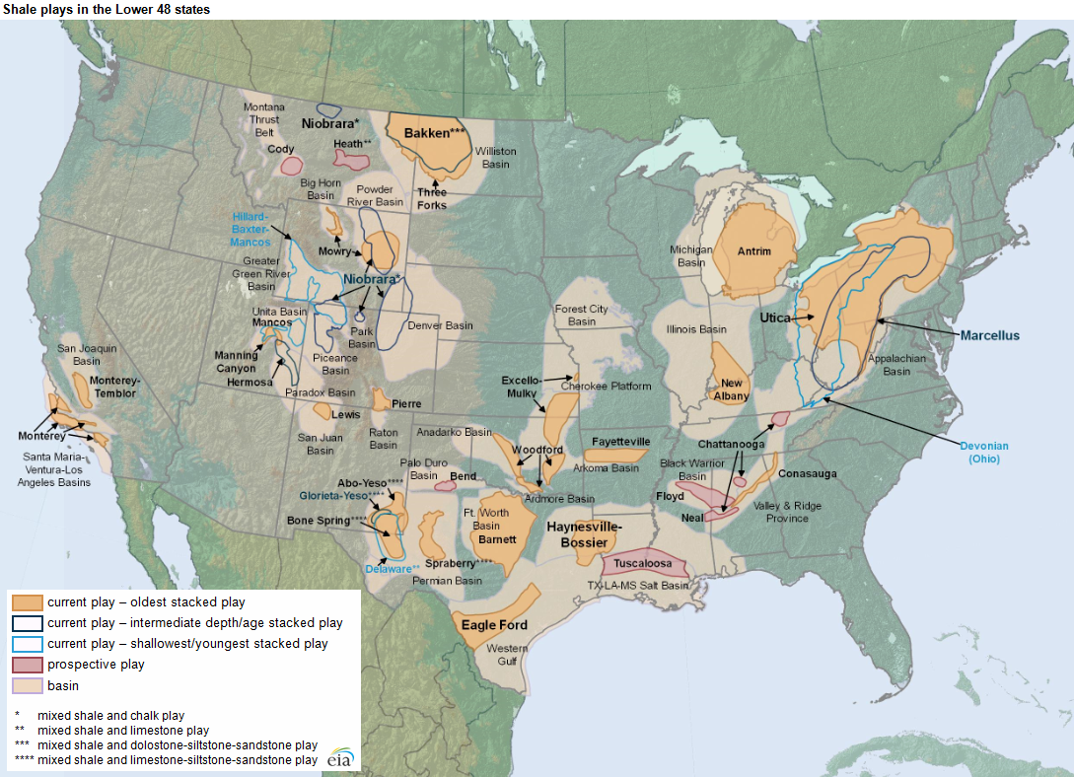
Figure 5-Map of shale plays in lower 48 states in the U.S.
(EIA, 2016)

2.2 Natural Gas Consumption
Even though natural gas production is higher and in faster growth than crude oil, the utilization of natural gas is limited. This limitation is because natural gas does not hold enough product value to be economical compared to other hydrocarbons such as crude oil when used to produce transport fuel. This is true due to U.S. imports of hydrocarbon liquids mainly for transportation fuels while natural gas production is reduced. For instance, average gasoline imported in 2016 was 600 Million bpd.
The total primary energy consumption in the U.S is 97.7 quadrillion BTU. Thirty-seven percent of the energy consumption is from petroleum, twenty-nine percent is natural gas, fourteen percent is coal, eleven percent is renewable energy and the rest is nuclear energy (EIA, 2018).
Natural gas is used as an energy source in electric power, residential, industrial, commercial, and transportation. According to the EIA in 2017, the use of natural gas in transportation is about 3 percent of the total consumption in the U.S. These transportations include motor vehicles, trains, and ships. Natural gas presence in the transportation sector is through the use of CNG and electrical as a fuel. Though, the use of natural gas in an electrical car is through power generations, where natural gas has to compete against other energy sources such as coal, petroleum, and renewables. In addition, there are only a few vehicles available for using CNG and electric because these types of vehicles required special engine and equipment hence it is still a challenge (Wang and Economides, 2009).
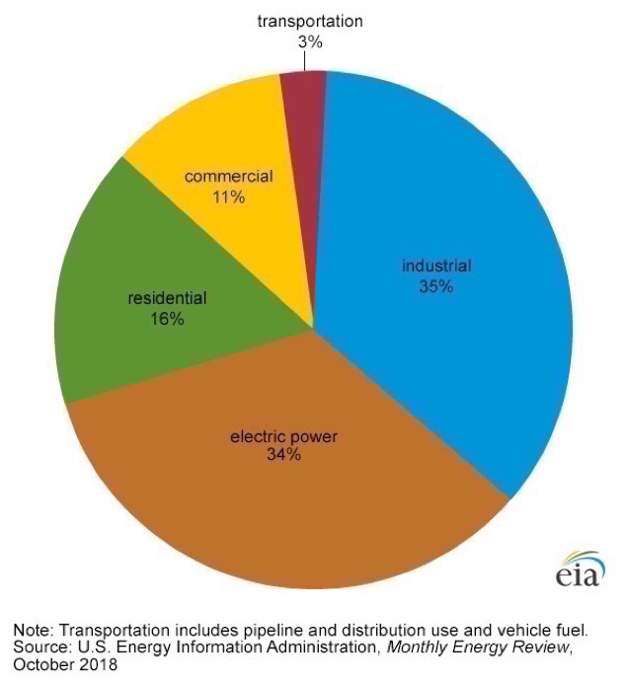
Figure 6-Pie chart of natural gas utilization in the U.S. by sector in 2017
(EIA, 2018)
Thus, it is essential to determine a way to market natural gas in a practical, economical, feasible, and efficient manner.

Chapter 3: Literature
Often times the natural gas production becomes excessive because of the distance between the production to the end user. Therefore, operators are looking for ways to turn the “liability” of this excessive gas into a profitable venture via a gathering line/facility, gas processing facility, and suitable route for transporting. There are five major technologies used in the transportation of natural gas namely: pipelines, LNG, GTL, CNG, and GTW or power generation as shown in
Figure 7.
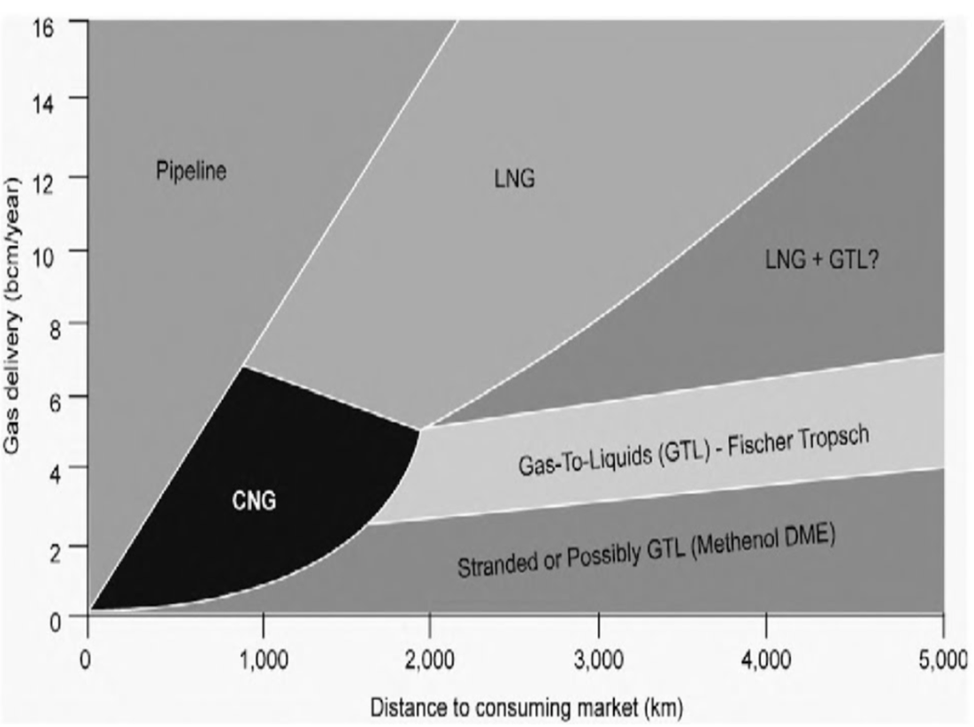
Figure 7-Means of transporting natural gas to the market based on the gas delivery volume and the distance to the market
(Wang and Economides, 2009)
From Figure 7, it is seen that the means of transportation for natural gas depends on the volume of gas to be transported and its delivery distance. For large gas volume delivery, pipeline and/or LNG transportation remain the most competitive options. But pipeline option is unpractical when the distance between the field to the market is further than 2,000 km or 3,200 miles and when the market is separated by a large body of water. When these situations occur, LNG become more viable in bring the natural gas to the market. Contrary to some location, natural gas might not have its place in the market but the demand for other petroleum products are high. In this case, natural gas can be converted to petroleum product or synthetic crude oil to serve the domestic market or the market nearby.

3.1 Liquefied Natural Gas (LNG)
Liquefied Natural Gas (LNG) is a natural gas at its liquified phase after cooling process to reach minus 250ºF. The objective of converting natural gas from its gaseous phase to its liquified phase is for the ease of transporting it and to reduce the cost of transportation. At the liquefied phase, natural gas volume shrinks from 600 to 1. This statement simply means that for 1 ft³ of LNG is equivalent to 600 ft³ of natural gas.
Figure 8-Typical LNG value of chain and the specific area of liquefaction cost
(Kotzot et al., 2017)
The of economic metrics evaluation performed only in producing region as demonstrate in Figure 8. The refrigeration and liquefaction process are the crucial element of an LNG project and its estimated to be 35 percent of the total capital expenditure (Wang and Economides, 2009). Due to the high percentage of the CAPEX, it is essential to appropriately select a liquefaction technology to be employed.

3.1.1 LNG Process
All LNG plants are different from each other and there is no standard LNG plant. Each plant is designed based of feed gas composition and product specification. However, most LNG plants should have: a receiving facility, treating unit, liquefaction unit, refrigeration unit, fractionation unit, an LNG storage section, marine facility, utility, and offsite sections.
Some example of the overall process in an LNG plant is presented in Figure 9.
Figure 9-Block Flow Diagram in an LNG plant with maximum number of units
(Kotzot et al., 2009)
In a glance, a maximum LNG plant process starts from the inlet facility where the natural gas is metered, and flow throw a slug catcher where any liquid of condensate is removed as well as the inhibitor from pipeline. Any condensate is sent to condensate stabilization unit and natural gas is sent to Acid Gas Removal Unit (AGRU). Impurities like carbon dioxide and hydrogen sulfide are removed AGRU. Water and mercury are removed in dehydration and mercury removal unit. These impurities including water and mercury are removed to prevent any ice clogged and corrosion in liquefaction unit as well as to meet product specification. Fractionation unit is where heavier hydrocarbons such as ethane plus are removed. Natural gas from fractionation unit is expected to be methane rich is sent to liquefaction unit where it is cooled to minus 250ºF with the assistance of refrigeration unit. After the liquefaction unit, natural gas is sent to the storage tank before it is loaded to its cargo through a marine facility.

3.1.2 LNG Process
Out of all the units exist in an LNG plant, the liquefaction unit is the heart of a plant. Therefore, choosing the right liquefaction technology is important and beneficial for the life of the project. As mentioned in the process that liquefaction of natural gas is based in the refrigeration cycle. A refrigerant is compressed and expanded as necessary to transport heat from the process side to natural gas side to aid the liquefying process. The efficiency of the liquefaction process determines by how closely the cooling curves of natural gas to the refrigerant cooling curve as shown in Figure 10.
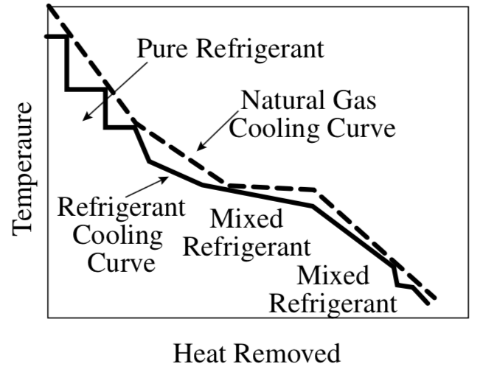
Figure 10-Typical natural gas and refrigerant cooling curves
(Wang and Economides, 2009)
The liquefaction process, refrigerant used and the size of compressor and driver combination that drives the cycle and type and capacity of heat exchangers choose will determine the capacity of an LNG plant. These variables are also the variables that set the liquefaction technologies apart.
There are several liquefaction technologies available in the market. These technologies are Propane Pre-Cooled Mixed Refrigerant (C₃MR), Optimized Cascade, Single Mixed Refrigerant (SMR), Mixed Fluid Cascade (MFC), and Dual Mixed Refrigerants (DMR). The C₃MR process from Air Product and Chemicals, Inc. (APCI) has been the dominant process in the LNG industry with 43 percent of the existing LNG plant (IGU, 2017). Aside from technology efficiency, consideration for ease to startup, ability to handle difference feed gas composition, and maintenance costs should also take into account.
Most of the existing LNG plant capacity is medium to large-scale, however with the demand of natural gas increasing the CAPEX for LNG project also increase. Recently, companies are looking into developing a small-scale LNG plant. By IGU definition small-scale LNG plant is a plant with capacity below 1 MTPA. According to Energy Outlook, a small-scale LNG can provide access to markets unavailable to large terminal and large carriers and it can be size to meet the specific demand. Additionally, small-scale LNG is less risky to the investor since the CAPEX is lower and it is faster to build due to its pre-fabricated and modularization ability. The statement is further confirmed by statement, a small-scale liquefaction plant has capacity less than 500,000 TPA and is designed to serve specific market (Biscardini et.al, 2017).

3.2 Gas-to-Liquid (GTL)
Natural gas presence in the energy sector has increase substantially through power generation, industrial, commercial, residential, and transportation. But the conventional liquid fuels will still be playing a vital role in the world of energy particularly in an aircraft sectors as jet fuel. Traditionally, liquid fuels are refinery products deriving from crude oil. However, as the number oil reserves depleted, the amount of liquid fuels consumption becomes worrisome. On the other hand, natural gas reserves and production has increase drastically to the point where natural gas production is excessive. In addition, there are countries where the only natural resource available is natural gas.
Therefore, to meet the demand of liquid fuels and to have energy security natural gas can be converted to liquid fuels through GTL process. The products of GTL process can be transported via existing infrastructure such as oil pipeline, ship, rail, and/or trucks, hence it reduces the cost of transportation. Moreover, the conversion of natural gas to liquid hydrocarbons is beneficial to the environment since the products are cleaner than traditional refinery product and zero sulfur.

3.2.1 GTL Process
The GTL process is a chemical reaction process with the aid of catalyst where natural gas is converted to liquid hydrocarbons. Depending upon the catalyst chosen for a GTL process, the liquid hydrocarbons produce include synthetic crude oil, gasoline, diesel, naphtha, kerosene, lubricant, waxes, jet-fuels, and other chemicals. The chemicals products for petrochemical feedstock are ammonia, methanol, or methyl tert-butyl ether (MBTE).
The two basic technologies use in GTL process are:
- Direct conversion of natural gas to liquid fuels, and
- Indirect conversion via synthesis gas (Syngas).
So far, direct conversion is difficult to control and economically unviable.
On the other hand, the indirect conversion is the common process employed in GTL projects. The natural gas conversion through indirect process is done in three steps shown in Figure 11:

Figure 11-Basic flowchart of indirect conversion of natural gas to liquids through syngas and Fischer-Tropsch
(Wang and Economides, 2009)
Step 1: Natural gas Reforming.
This process is when natural gas is broken down with any source of oxygen as shown in
Equation 1.
${CH}_{4}+Oxygen Source↔CO+H_{2}$………………………………….(1)
The typical source of oxygen is steam, Carbon Dioxide (CO₂), or air. The product of reforming step is known as synthesis gas (Syngas) which is predominantly Carbon Monoxide (CO) and Hydrogen (H₂). The main difference between the three sources of oxygen is the product ratio of H₂ to CO. Due to its higher ratio of H₂ to CO, the steam is used as the common method.
Step 2: Fisher-Tropsch Synthesis.
The Fischer-Tropsch synthesis is the process pioneered by two German Engineers in the early 1920s. This process converts the syngas to straight-chain hydrocarbons that include alkanes (paraffins) and alkenes (olefins) with more than 40 Carbons.
$aCO+{bH}_{2}↔C_{x}H_{y}+H_{2}O$………………………………….(2)
The number of Carbons is shown as “x” in Equation 2 and water and/CO2 are produced as bi-product depending on the CO and H₂ ratio produced in Syngas.
The length of hydrocarbons chains depends on process condition, catalyst, and the ratio of H₂ to CO in syngas. The product in this step are waxes (C₁₈₊), light oil (under C₁₇), water to be treated and gas to be recycled or use as fuel.
Step 3: Product Upgrading.
This step starts with waxes and light oil. Process involves in this product upgrading are hydrocracking, isomerization, catalytic reforming, alkylation or even standard refinery technology depending on desire product. For example, the hydrocracker is used to convert waxes into naphta (C₅-C₁₁) and diesel (C₁₂-C₁₈), light oil into gasoline (C₈) and kerosene/jet-fuel (C₁₀-C₁₃).
Out of the three steps mentioned, reforming natural gas is the most CAPEX intensives since its account for more than half of the fixed cost of the total GTL process. Nonetheless, the vital step of GTL process is Fischer-Tropsch (F-T) synthesis since this step determined the hydrocarbons liquid (Wang and Economides, 2009). Wang and Economides claimed that it is the development of catalyst that selectively accelerate reactions in producing a desirable product as well as design of corresponding reactors are the critical aspect of F-T synthesis.
Each GTL plant is different depending on the technology availability, composition of feed gas, location, market, and others. There are numbers of companies that currently proposing their GTL technology in the market, some has been in the market and others are barely in their pilot plant.
As of today, the dominant technology in the market is F-T technology by Sasol and Shell. However, there are other companies such as CompactGTL, Velocys, Gas Technologies LLC, INFRA technology, Primus, and others that are offering small-scale GTL processes.

Chapter 4: Methodology

4.1 Parameters

4.1.1 LNG
  - Capital Expenditure (CAPEX)
Due to the global high demand of natural gas, there are growing projects in the LNG industry to meet the demand particularly to countries where there is no gas pipeline. Consequently, the CAPEX of LNG liquefaction plants has been falling significantly because of the market competition, technology enhancement, and all the major projects. The CAPEX for LNG is mainly determine by location of plant, reservoir size and asset quality or quality of feed gas, location for marine facility, product specification and market, pricing stability, and others.
For this thesis the CAPEX for LNG is derived from the recent projects. The most contrast projects are those LNG projects in Australia and the U.S. projects as shown in Figure 12.
Figure 12-Recent overall project CAPEX in USD/TPA
(Songhurst, 2018)
Based on Figure 12, the Australia LNG project are the most expensive project and the U.S. projects are the cheapest. The data for the LNG project in Australia for the recent projects from 2012 to 2018 is shown in Table 1.
Table 1-CAPEX of LNG projects in Australia constructed in 2012-18
(Compile by Author)
No. | Plate Name | Location | Start-up Year | Design Capacity (MTPA) | CAPEX (US$ Million/Train) | Unit CAPEX (US$/TPA)
1 | Pluto LNG | Carnavon Area | 2012 | 4.9 | 14,000 | 2,800
2 | QLNG | Queensland | 2015 | 4.25 | 10,200 | 2,400
3 | Gorgon LNG | Barrow Island | 2016 | 5.2 | 17,700 | 3,400
4 | GLNG | Queensland | 2016 | 3.9 | 9,250 | 2,370
5 | APLNG | Gladstone | 2016 | 4.5 | 12,750 | 2,800
6 | Wheatstone LNG | Ashburton | 2018 | 4.45 | 16,500 | 3,700
7 | Ichtys LNG | Darwin | 2018 | 4.45 | 18,700 | 4,200
8 | Prelude LNG | Timor Sea | 2018 | 3.6 | 11,000 | 3,000
Based on the data gathering above, the average cost of LNG Plants in Australia is about US$3,000/TPA. Over 50 percent of the 90 MTPA committed during the period of 2010-14 occurred in Australia (Songhurst, 2018). During this considerably high constructions, Australia experienced shortage of labor, hence it increases the costs of LNG constructions. Table 1 also showed that the most expensive LNG plant in Australia is Ichtys LNG for the reason that the remote location of the Northwestern Australia. Additionally, most of the LNG projects in Australia at that time were greenfield projects – site where there is no existing industry infrastructure. Moreover, the Australian government has more strict environmental regulations in comparison to other part of the world. Most of the Australian project, especially the Gorgon project required CO₂ sequestration since it is in an island. It is important to note that, the CAPEX in Table 1 has included the upstream cost.
On the other hand, most of the LNG projects in the U.S. are brownfield projects – site where there is a previous industrial activities and infrastructures. The brownfield projects including converting the LNG importer terminal to LNG exporter terminal. The cost reduction on this project is due to the existing LNG storage tanks and marine facilities.
Table 2-CAPEX of LNG Projects constructed and under construction in The U.S.
(Compile by Author)
No. | Plate Name | Location | Start-up Year | Design Capacity (MTPA) | CAPEX (US$ Million/Train) | Unit CAPEX (US$/TPA)
1 | Sabine Pass | Louisiana | 2016 | 4.5 | 2,750 | 611
2 | Cove Point | Maryland | 2018 | 5.25 | 4,200 | 800
3 | Elba Island | Georgia | 2018 | 0.25 | 2,000 | 800
4 | Cameron | Louisiana | 2019 | 4 | 3,670 | 920
5 | Freeport | Texas | 2019 | 5.1 | 4,430 | 870
6 | Corpus Christi | Texas | 2019 | 4.5 | 5,200 | 1,150
It is much cheaper to add liquefaction trains to an existing facility than build from scratch due to the use of the existing infrastructure. As shown above in Table 2, the Sabine Pass, Freeport, and Cove Point are under US$800/TPA since these plants are addition to the existing LNG import terminal. Conversely, the Corpus Christi LNG plant is a greenfield project where the CAPEX is about US$1,100/TPA. This additional US$300/TPA covers the costs of the new tanks, jetty and utilities for the new site.
The difference in the cost between LNG projects in Australia and the U.S. can be explained by factors that affecting the CAPEX. These factors are project’s location, capacity, liquefaction process and choice of compressor driver, storage, skilled labor availability, and regulatory and permitting requirements (IGU, 2018).
Therefore, the CAPEX used for further analysis is US$1,800/TPA for base case-scenario, with US$900/TPA for low and US$2,700/TPA for high case-scenarios. These CAPEX chosen are somehow closely to the cost presented in IGU 2018 report, where the average cost of 2009-2017 in Pacific Basin is US$1,458/TPA, US$1,011/TPA in Atlantic Basin, and US$458/TPA for brownfield project (IGU, 2018). The difference between the chosen CAPEX and the valued from IGU is that the chosen CAPEX included the cost of upstream.
  - Operational Expenditure (OPEX)
Operational cost or expenditure (OPEX) usually consisted of fuel gas consumption, operation personnel, maintenance, consumables, support vessel costs such as tugs, and insurance. For this thesis, the cost for fuel is accounted from the feed gas. Depending on the efficiency of the technology used, the fuel consumption can be approximately more than 10 percent of the feed gas. For example, according to LNG cost reduction, Sabine pass is using about 9.5 percent of feed gas as fuel consumption. The main user of the fuel will be the refrigerant compressor. The usage of feed gas as fuel consumption depends upon the composition of feed gas.
Another OPEX is the operations personnel which different for every country or region, location of the plant and the complexity of the plant operation. Based on the Figure 13, the operations personnel cost is about 5 percent of total OPEX. The major OPEX after eliminating fuel cost is maintenance and spares. Maintenance contribute to about 24 percent of the total OPEX. This maintenance cost includes the additional personnel required during maintenance period, any heavy-duty haul and other spare parts that is required to be available at the workshop throughout plant operation.
Figure 13- Cost breakdown for LNG Project's OPEX
(Songhurst, 2018)
Consumables is the cost that cover the utilities and refrigerant losses. The utilities are fresh water for amine units, lubricant oil, diesel oil, other chemicals required, and any other utilities in the plant. The rest of the OPEX percentage is completed by tugs, support vessels and insurance.
By deducting the fuel gas from OPEX, the actual OPEX is ranging from 2 to 2.5 percent of CAPEX. This article also agreed that the typical OPEX is 3 percent of CAPEX per annum excluding the feed gas cost and fuel consumption. Thus, for further evaluation the OPEX of 2.5 percent CAPEX is used as base case scenario.
  - Capacity
With the availability of the LNG technologies today, the capacity of an LNG plant can range from 0.25 MTPA to 7.8 MTPA. IGU defines small-scale LNG as an LNG plants with the capacity less than 1 MTPA. Conversely, the large-scale LNG is defined as LNG plants with the capacity higher than 1 MTPA. On the other hand, the Royal Dutch Shell divided the LNG capacity scale into 3 categories: small-scale for less than 1 MTPA, medium-scale for 2 to less than 4 MTPA, and above 4 MTPA is large-scale LNG, shown in Figure14.
Figure 14-LNG capacity scale categories according to Royal Dutch Shell
(Songhurst, 2018)
Most of the existing LNG plants are medium to large-scale capacity LNG facilities. For example, Australia Pacific LNG (APLNG) is 4.5 MTPA, Gorgon LNG is 3.6 MTPA, or Sabine Pass LNG is 4.5 MTPA, all of these capacities are per train. On the largest LNG facility, the Qatar LNG both Ras Laffan and Qatargas LNG are 7.8 MTPA per train. Nonetheless, according to IGU 2018 report, there are a number of small-scale LNG facility that have being proposed with the intention to reduce the construction cost. The advantage of small-scale LNG train is modular or pre-fabricated facilities that can be pre-order prior to final investment decision (FID). The example of small-scale LNG under construction is Elba Island LNG in Georgia, USA with the capacity of 0.25 MTPA per train. The technology using in Elba Island LNG is the Moveable Modular Liquefaction System (MMLS) by Shell for 10 trains with a total capacity of 2.5 MTPA. Other small-scale LNG projects in North America are planning to use IPSMR®, OSMR®, and Prico®. The capacity used for the evaluation of this thesis is 1.5 MTPA for base case scenario, 0.75 MTPA and 2.25 MTPA, for low and high case scenarios, respectively.
  - Feed gas Price
As discuss earlier, that the feed gas price is accounted for the feed gas to be processed and the fuel consumption. The amount of feed gas required depend plant capacity and liquefaction technology efficiency employed at the plant. The raw natural gas price may vary depending on the region. However, the direct conversion used to determine the amount of natural gas is 1 TPA equal to 131 ft³ (IGU Conversion).
The data for natural gas wellhead price in the U.S. is limited to December 2012 from EIA and natural gas price for industrial is higher than the wellhead price as shown in Figure 15.
Figure 15-United States natural gas price for industrial and wellhead for the past 10 years
(Graph by Author from EIA data)
The lowest wellhead natural gas price for the past 10 years is US$2/Mcf. On the other hand, the recent industrial natural gas price is US$5/Mcf. Therefore, to evaluate the LNG project the feed gas price use is US$2, US$4, and US$6 per Mcf.

  - Technology Efficiency
As mentioned in operational expenditure (OPEX) and feed gas sections that technology efficiency depend upon the liquefaction process used in the plant and feed gas composition. For a rich feed gas composition, only 70 to 80 percent of the natural gas will be process into LNG. The 20 to 30 percent of this feed gas will be taking out in liquid slug removal, condensate stabilization, Acid Gas Removal, water removal, fuel gas, Natural Gas Liquid (NGL), nitrogen removal, and boil-off gas. This explanation is summarized in the Figure 16, this serve for a maximum treating plant.
Figure 16-Maximum feed gas treating and efficiency of plant based on feed gas composition
(Kotzot et al., 2007)
The maximum treating plant is used mainly in Australia, where the feed gas is sources from upstream with minimum treatment. Most if not all the natural gas feeds to LNG is a rich gas, meaning the feed gas contain higher amount of heavier hydrocarbons than methane.
In contrast, in the U.S. most of the feed gas to LNG plant facility has been clean to meet the pipeline specification, hence the feed gas is a lean gas. Lean gas is a natural gas that contains smaller amount of heavier hydrocarbon or higher content of inert gas like nitrogen. For lean gas, minimum treating is required as shown in Figure 17 which about 95 percent of the feed gas is converted to LNG while the 5 percent is used in fuel consumption and boil-off gas.
Figure 17-Minimum feed gas treating and efficiency of plant based on feed gas composition
(Kotzot et al., 2007)
It is assumed that the two figures above represent both Carbon and Thermal efficiency for LNG plant based on a feed gas composition. Thus, for this thesis the carbon and thermal efficiency used is ranging from the maximum treating to minimum treating plants. In other words, the efficiency percentage used is 75, 85, and 95 percent for low, base, and high case scenarios, respectively.
Additionally, among all the technologies available in LNG industry, the overall thermal efficiency of LNG is about 90 to 93 percent (Cox, 2013).
  - LNG Price
The product of LNG plant is priced differently in different regions on different seasons. Usually, in winter time the demand for natural gas or in this case LNG is high, hence the price increased. For instance, the Asian LNG prices in 2017 and 2018 winter reached over US$11/MMBtu. Conversely, during summer season the LNG price can fall down to as low as US$5/MMBtu in Northeast Asian spot price.
In Europe, the United Kingdom National Balancing Point (NBP) also varies significantly throughout the year. During the winter season, the NBP price is about US$8/MMBtu and in summer season the price is as low as US$4.50/MMBtu (IGU, 2018)
In this thesis, the LNG price use as the product price is US$11/MMBtu for the base case scenario. For low and high case scenarios the prices use US$5.50 and US$16.50 per MMBtu, respectively.

  - Transportation
LNG can be transported via truck and vessel. The common transportation in LNG industry is via LNG cargoes. The vessel size for LNG range from 25,000 to 210,000 m³, the common vessel size is ranging 90,000 to 170,000 m³. In addition, the different between LNG cargoes are in the engine driver. There are Steam Turbine (ST) and Dual Fuel Diesel Electric (DFDE).
The cost of LNG shipping is another major cost for the economic analysis of the LNG project. When the Fukushima disaster, the demand for LNG in Japan increased drastically. As the shipping activities increased the charter price also increase. Based on IGU 2018 report, the DFDE carrier day-rates is averaging about US$85,000/day in the Atlantic Basin and US$80,000/day in Pacific Basin. In the low end of the spectrum, the average charter cost for ST is about US$44,000/day.
Figure 18-Historical data for LNG Vessel Price from 2006-18
(Rogers, 2018)
As shows in Figure 18, between 2006 to 2018, the charter cost has varied from as low as US$25,000/day to as high as US$155,000/day. Giving that the recent highest charter price is US$85,000/day will be the data used as high case scenario. The lowest cost is US$27,500/day and the base case scenario is US$55,000/day.
For the purpose of Monte Carlo simulation and sensitivity analysis, other assumption parameters used are:
- Distance from Barrow Island (Australia) to Tokyo – 3,727 Nautical miles (Nm),
- Average Speed is 19 Knots (Nm/hr) for both DFDE and ST,
- Vessel Size 160,000 m³,
- Fuel Consumption is 72 Tonnes/day LNG equivalent for DFDE,
- Boil-off assumptions is 0.1% of cargo per day for DFDE, and others
The detail calculation is included in Appendix B.

4.1.2 GTL
    - Capital Expenditure (CAPEX)
The first GTL plant was established in 1992 in Mossel Bay, South Africa with Sasol as licensor. A year later, in 1993 another GTL was constructed in Bintulu, Malaysia with Shell as licensor. The capacity for Sasol plant in South Africa is 22,500 bpd, and 12,000 bpd for Shell’s GTL plant in Bintulu, Malaysia.
GTL projects had been quiet for about a decade since the establishment of the Mossel Bay and Bintulu GTL plants. In 2007, Oryx GTL plant started to produce on the full capacity of 34,000 bpd in Qatar. Shell and Qatar Oil company established the world largest GTL capacity of 140,000 bpd in Qatar in 2011. The Escravos GTL plant is starting its operation in 2014 in Nigeria with the capacity of 33,000 bpd.

Table 3-Existing/commercial plants with capacity and CAPEX
(Compiled by Author)
Year | Plate Name | Capacity (bpd) | CAPEX  (US$ Billion) | Location | Note
1992 | Mossel Bay GTL | 22,500 | 4.0 | South Africa | Operation
1993 | Bintulu GTL | 12,000 | 0.85 | Malaysia | Operation
2007 | Oryx GTL | 34,000 | 6.0 | Qatar | Operation
2011 | Pearl GTL | 140,000 | 19.0 | Qatar | Operation
2014 | Escravos GTL | 33,000 | 10.0 | Nigeria | Operation
2018 | Turkmenistan | 15,500 | 2.5 | Turkmenistan | Operation
2020 | Uzbekistan | 38,000 | 3.7 | Uzbekistan | Planned
The data from Table 3 is plotted for the capacity of the plant in barrel per day and the CAPEX for each of the capacity. The exponent of the equation from the plot is the x or appropriate power-sizing exponent.

Figure 19-GTL capacity and Capital Expenditure (CAPEX) of existing plants.
The CAPEX is the slope of the trendline which is about US$94,800/bpd as shown in Figure 19. Additionally, the CAPEX and capacity of GTL are not linearly related. In other words, the CAPEX and capacity are in power relation also known as power-sizing, which from the existing plant is about 1.1 as shown in Figure 19.
According to Cost Estimating and Estimating Models when the appropriate power-sizing exponent is equal to 1 the relationship is linear when is less than 1 it means that the relationship has economies of scale. In other words, the larger the capacity of the GTL plants the CAPEX is less costly in comparison to the linear relationship. In contrast, if the power-sizing exponent is higher than 1 as it is for this project, the relationship between the capacity and the CAPEX is diseconomies of scale. This means that, as the capacity increases the cost per unit also increased tremendously.
Unlike, previous existing plants where the main technology licensors are Sasol and Shell with large capacity of plant, nowadays there are more licensors that are merging to the market proposing small-scale GTL technology.
Velocys is working on the modular system designed for offshore deployment with the capacity of 1,000bpd capable of producing diesel and naphtha with its estimated CAPEX of US$100,000/bpd. Other companies with closed cost to Velocys are INFRA Technology and Greyrock are offering US$60,000 and US$65,000 to US$100,000/bpd. Calvert energy group and Primus are offering GTL technology with CAPEX of US$45,000/bpd and US$74,000/bpd (GGFR, 2018).
Contrary with the proposed CAPEX from other companies, Wang and Economides (2009) in the 1950s the CAPEX was US$120,000/bpd and decreased to less than US$50,000/bpd. Additionally, in 2009 when the book was written it was claimed that the CAPEX would decrease to US$35,000/bpd. Wang and Economides further declared that in the future the aimed is to reach a CAPEX below US$20,000/bpd when the catalyst and technology are advanced to enhance the efficiency of the GTL process (Wang and Economides, 2009).
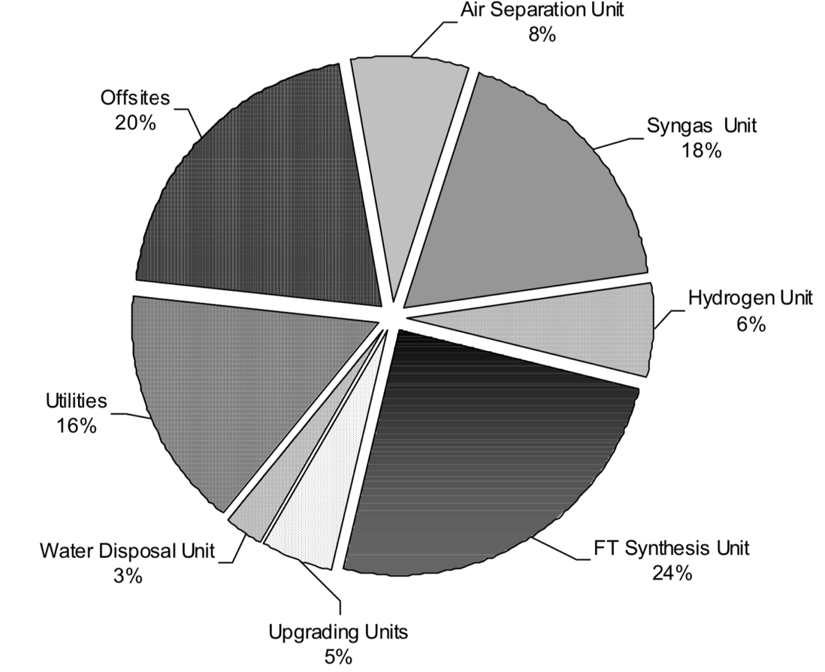
Figure 20-Breakdown of CAPEX for GTL project
(de Klerk, 2012)
Moreover, as demonstrated in Figure 20, the CAPEX for GTL plant consist of different units: air separation unit, syngas unit, hydrogen unit, F-T Synthesis unit, upgrading units, water disposal unit and utilities unit. It is assumed that all the CAPEX mentioned above have included these other costs. Aside from the cost mentioned in Figure 20, the additional costs to be included in CAPEX are gathering line cost and gas pre-treatment cost. The gathering cost is US$44,000/inch for 10-inch gathering line (The INGAA Foundation Inc., 2014). Furthermore, the pre-treatment for GTL is assumed to be equivalent to LNG plant where it ranges from 6 to 15 percent of CAPEX (Cox, 2013). However, for the GTL project the pre-treatment is not as intensive as for LNG plant, therefore the pre-treatment is expected to be about 6 percent of CAPEX.
For the base case scenario, CAPEX is US$60,000/bpd, high case scenario, US$90,000/bpd as it is near to the CAPEX found from Figure 17, and for low case scenario US$30,000/bpd closely related to Calvert technology and values predicted by Wang and Economides. Note that this CAPEX excludes the cost of gathering line and pre-treatment unit.
    - Operational Expenditure (OPEX)
Operational Expenditure (OPEX) is one of the variables that would be used to evaluate the economic feasibility of the GTL projects in the U.S. OPEX sometimes can be complicated in estimating the exact annual cost. However, it is proposed by Calvert Energy group that their OPEX is about 1.2 percent of CAPEX annually. Since there is not enough source to support the 1.2 percent OPEX, therefore a rule of thumb is used. Based on the rule of thumb for a large oil and gas industry, OPEX is about 10 to 15 percent of CAPEX. Given that the GTL plant used from this study ranging from micro to small-scale GTL, it is assumed that the OPEX is about 5 percent of CAPEX for the base case scenario including gathering line and pre-treatment except feed gas cost.
    - Capacity
As natural gas production become excessive, more companies are seeking for economical and practical way to monetize it. However, often times the natural gas field is located in a remote location where the access to the market is a challenge. Therefore, a small-scale GTL plant would be a good option to process the excessive natural gas in remote location since it does not require heavy-duty loads. Additionally, the natural gas reserves might not be sufficient to obtain the project life of the plant but with a small-scale GTL plant it can be easy to move to different location. The common capacity of small-scale GTL plant that has been proposing is ranging from 500 to 1,000 bpd.
As mentioned above the aim of the GTL economy evaluation is not to diminish the importing activity of crude oil or petroleum products but to reduce the amount of gas flaring and dependency of importing activity. Hence, the plant capacity can be range from micro to small-scale GTL. Therefore, in this evaluation, the plant capacity chosen is 1,000 bpd for the base case scenario.
    - Feed gas Price
According to World Bank Group, the CompactGTL project in Kazakhstan will convert 25 MMscfd to 2,500 bpd. This statement is further confirmed by Forst & Sullivan that a 30,000 bpd GTL plant that produce either diesel or gasoline required 300 MMscfd (Forst Pespective, 2016). In other word, a 1 MMscfd of natural gas can produce 100 bpd of either diesel or gasoline. This is the conversion that will be used throughout the calculation.
Historically, the natural gas price has varied from time to time depends upon demand and supply, weather, etc. As the demand for natural gas increasing, the natural gas price would be increasing. However, since the booming of shale gas production, the natural gas has been oversupplying which lead to low gas price. The data for natural gas wellhead price in the U.S. is limited to December 2012 from EIA and natural gas price for industrial is higher than the wellhead price as shown in Figure 21.
Figure 21-United States natural gas price for industrial and wellhead for the past 10 years
(Graph by Author from EIA data)
The lowest wellhead natural gas price for the past 10 years is US$2/Mcf. On the other hand, the recent industrial natural gas price is US$5/Mcf. However, since the GTL project proposed is utilizing the flaring natural gas and with the gathering and pre-treatment cost including in the CAPEX, the highest natural gas price is US$2/Mcf. For this thesis the feed gas prices used are US$1, US$1.50, and US$2 per Mcf for low, base, and high case scenarios, respectively.
    - Technology Efficiency
GTL plant efficiency is the unit quantities of feedstock required to produce one unit of product on an energy and/or mass basis. The energy basis efficiency is also known as thermal efficiency and the mass basis can also be carbon efficiency. As mentioned in the introduction that the GTL process and technology have been used in the market since the 19th century with the establishments of Mossel Bay and Bintulu GTL plants. For these two GTL plants, Sasol and Shell were the main players of GTL technology as licensors. Similarly, most of the recent GTL, Sasol and Shell are still maintaining their name in the market.
However, as time progress more companies proposing new technologies which shall be cheaper than the existing plants yet more efficient. Therefore, in this study, the thermal efficiency is chosen to be one of the variables, where 60 percent efficiency is the base case scenario which is aligned with the current technology of 60-65 percent. Additionally, the Carbon efficiency is 80 percent for base case-scenario (Lichun et al., 2008).
    - Product Price
For this study, it is assumed that the product after the F-T synthesis would be further upgraded to produce gasoline. Unlike the traditional refinery, F-T GTL plants are designed to produce only higher-value light and middle distillate products. From the existing GTL technology, the amount of middle distillate such as gasoline, diesel and kerosene produce are approximately three times than the typical oil refinery. However, it is unclear on the actual products of the existing GTL plants. Moreover, since there was not enough data on the CAPEX breakdown, therefore it is assumed that the final product for GTL plant in this economy analysis is synthetic crude oil.
Similar to natural gas price, the crude oil price also varies based on demand and supply, seasons, locations, and others. Crude oil import to the U.S. is totaling about 300 Million bbl in January 2019 (EIA, 2019). Hence, even if the GTL proposed is up to 10,000 bpd, the crude oil would not be oversupplied to the demand. Given that this synthetic crude oil product from GTL plant is a cleaner and zero-sulfur which means that the quality of the product is premium. The price for the crude oil is taking from the historical data in Cushing Oklahoma as shown in Figure 22.
Figure 22-Monthly price of Crude oil in Cushing Oklahoma from the past 10 years
(Graph by Author from EIA data)
As shown in Figure 20 that historically the highest crude oil price is approximately US$140/bbl. The average crude oil price for this past year is about US$62/bbl. In addition to crude oil, there are companies that claimed their technology can produce either diesel, gasoline, and/or jet fuel. For instance, CompactGTL product is diesel, Greyrock and INFRA technology can convert Syngas into diesel directly, and Primus’ technology converts syngas to gasoline (GGFR, 2018). Therefore, the gasoline and diesel price are also considered for the product price.
Similar to natural gas price, the gasoline price also varies based on demand and supply, seasons, crude oil price, locations, and others. As of 2016, the average gasoline import to the U.S. is about 600 Million bpd (EIA, 2016). Even if the GTL proposed is up to 10,000 bpd, the gasoline would not be oversupplied to the demand. Given that this gasoline product from GTL plant is a cleaner and zero-sulfur which means that the quality of the product is premium. The average premium gasoline retail price in the U.S. Gulf Coast for the past ten years is US$2/gallon ranging from US$1 to US$3.40/gallon. Assuming 1 barrel is equivalent to 42 gallons, the average premium gasoline price is US$84/bbl. Moreover, the diesel price is higher than gasoline and crude oil as shown in Figure 23.
Figure 23-United States U.S. Gulf Coast Conventional Gasoline, Diesel Ultra Low Sulphur, and Crude Oil in Cushing, OK for the past 10 years.
(Graph by Author from EIA data)
Thus, the product price used for this economy analysis is US$60, 120, and US$180 per bbl of any of either gasoline, diesel or crude oil for low, base, and high case scenarios. The price of the synthetic crude oil should be higher than the regular crude oil due to the its ability that it could produces three times more middle distillate than regular crude oil (Wood et al., 2012). Moreover, the product of synthetic crude oil holds a superior quality since it’s a low Sulphur and low aromatics in case of gasoline and diesel.
    - Transportation
Unlike the LNG transportation, the production of GTL plant is similar to any refinery products, hence, it is common to be transported using existing facilities. According to Hansen and Dursteler (2017), on average the cost of transporting oil and gas by truck is about US$20/bbl. A truck can haul up to 9,000 gallons or 200 bbl/trip. Thus, the capacity of the plant will determine the number of trips required per year. Since the transportation cost is given in dollar per barrel, the cost can be calculated by multiplying US$20/bbl to plant capacity.

4.2 Economy Metrics
Economy metrics are economy measurements used to evaluate the feasibility and profitable options to monetize the excessive natural gas production. There are four economy metrics utilized in this thesis: Net Present Value (NPV), Internal Rate of Return (IRR), Profitability Index ratio and payback period. In evaluating the economic metrics, the nine to ten mentioned parameters are used.
Additional parameters are discount rate and tax rate. The U.S. historical discount rate is average 2 percent but recently it has plateau to 3 percent and the lowest is 1 percent (Federal Reserves, 2019). Therefore, for this economical evaluation the discount rate use is 1.5, 3, and 4.5 percent for low, base, and high case scenarios respectively. Moreover, the tax rate policy in the U.S. has changed for in 2018 where the income tax is 21 percent rather than 35 percent (Blackmon, 2018). Thus, in this thesis the tax rate used varies from 12 to 35 percent.

- Net Present Value (NPV)
Net Present Value (NPV) is the sum of the present value (PV) of a future cash flow. In other word, NPV is sum of discounted future cash flow to the present either positive or negative for the life of the project minus CAPEX. The typical discounted value is 10 percent, this is commonly symbolized with $r$. The present value is estimated using equation 3;
$PV=\frac{Future Value after t periods}{{(1+r)}^{t}}$………………………………….(3)
The results of PV for every year are added in order calculate the NPV, as shown in equation 4;
$NPV=-CAPEX+\frac{C_{1}}{{(1+r)}^{1}}+\frac{C_{2}}{{(1+r)}^{2}}+\frac{C_{3}}{{(1+r)}^{3}}+…+\frac{C_{t}}{{(1+r)}^{t}}$ …………………………… (4)
Future Value after $t$ periods ($C_{t})$is equivalent to the profit after taxes, which can be estimate using equation 5;
$C_{t}=\left(Revenue-Expenses\right) x (1-Tax)$ ………………………………….(5)
Revenue is the estimate by multiplying the volume of production to the product price. Expenses are OPEX, depreciation, feed gas cost, and transportation. The project is feasible and profitable when the NPV is positive.
- Internal Rate of Return (IRR)
Internal rate of return (IRR) is discount rate at which the NPV is zero. It is easier to estimate the IRR by using excel function of IRR. The best-case scenario of a project would be the project with positive IRR and preferably IRR that is higher than the assume discount rate.
- Profitability Index
Profitability Index is the ratio of Net Present Value (NPV) to initial investment or in this thesis the CAPEX. A profitability index (PI) of 1.0 is the lowest acceptable for profitable and attractive project. Therefore, as the highest the profitability Index the project is feasible and preferable.

- Payback Period
Another economic metrics is payback period. Payback period is the time until the cash flow recovers the initial investment or CAPEX of the project. The payback period is estimated by divided the CAPEX to the profit after taxes results. The payback period is an important metrics if the company has a specified cutoff period.

4.3 Monte Carlo Simulation
Historically, Monte Carlo simulations was first used to study nuclear fission during World War II. The named Monte Carlo came from the Monte Carlo casino with its games of chance for all possible outcomes and probabilities are known.
Monte Carlo simulations are used when there are numbers of parameters that can be combined in different manner for all possibility outcomes. In other word, Monte Carlo simulations are probability model for a large number of combinations that cannot be predicted easily. Monte Carlo simulation is an important technique in forecasting model, because it assists in understanding the impact of risk and the uncertainty in prediction. Monte Carlo simulations create probability distribution or risk assessments based on known parameters. Monte Carlo simulations can also assist investors to make investment decisions by evaluating risks and the uncertainty outcomes as well as expectations.
Monte Carlo simulations work by randomly selecting a number for each given parameter within range and combine them to estimate a result. The process is repeated for tens of thousands or even millions of times, but the iterations might not be identical. Instead, collectively all the iterations will build a distribution curve. The most common one is the normal distribution curve or bell curve.
Normal distribution shows that there is an equal chance for the outcome to be higher or lower than the mean value.
The advantage of Monte Carlo simulation is its ability to consider wide range of parameters. However, the disadvantage is that the assumptions has to be realistic, good, and fair in order for the output to be good. Another disadvantage is Monte Carlo simulation tends to underestimate the probability of changing in market or financial crisis.
As mentioned earlier, there are ten parameters for the LNG project and nine parameters for GTL project. The parameters for LNG project are Capital Expenditure (CAPEX), Operational Expenditure (OPEX), plant capacity, feed gas price, technology efficiency, product price, transportation or cargo, tax rate, and discount rate. Similar parameters are used for GTL project economy evaluation except for transportation. Additionally, parameters use for both projects are varying in a wide range as shown in Table 4 therefore, without using the Monte Carlo simulation the process of prediction would be time consuming and redundant.
Table 4-Summary of LNG and GTL parameters used for Monte Carlo Simulations of 10,000 iterations.
Parameters | LNG |  | GTL
Parameters | Mean | Standard Deviation | Mean | Standard Deviation
Capacity | 1.5 MTPA | 0.75 MTPA | 1000 bpd | 500bpd
CAPEX | US$1,800/TPA | US$900/TPA | US$60,000/bpd | US$30,000/bpd
OPEX (% of CAPEX) | 2.5 | 1.25 | 5 | 2.5
Feed Gas Price (US$/Mcf) | 4 | 2 | 1.5 | 0.5
Carbon Efficiency (%) | 85 | 10 | 80 | 10
Thermal Efficiency (%) | 85 | 10 | 60 | 20
Product Price | US$11/MMBtu | US$5.5/MMBtu | US$120/bbl | US$60/bbl
Transportation | US$55,000/day | US$27,500/day | US$20/bbl | Constant
Discount Rate (%) | 3 | 1.5 | 3 | 1.5
Tax Rate (%) | 24 | 12 | 24 | 12
There is a number software available in the market to be used for Monte Carlo simulations. The most common software use in Petroleum Industry is Crystal Ball. But Monte Carlo simulations can be easily done in Microsoft Excel. For this thesis, Microsoft excel is used with 10,000 iterations because when refreshing the cell by pressing function 9 (fn9) the mean value of the outcomes does not vary largely. The result of 5, 10, and 15 thousand iterations are showing in Appendix D where it shows that the difference between these different iterations are not significant.

4.4 Sensitivity Analysis
Sensitivity analysis is performed to assess the effect and potential driving parameters in the economy metrics evaluation of Monte Carlo Simulations. These parameters are CAPEX, OPEX, plant capacity, feed gas price, carbon and thermal efficiency, product price, and transportation or cargo.
The base case scenario is taking as 100 percent and will remain constant while the low and high case scenarios, each parameter will be increased and decreased by 50 percent.
Table 5-Parameters for low, base, and high case-scenario for LNG Plant.
Parameters | Low | Base | High
Plant Capacity (MTPA) | 0.75 | 1.5 | 2.25
CAPEX (US$M/MTPA) | 900 | 1,800 | 2,700
OPEX (% CAPEX) | 1.25 | 2.5 | 3.75
Feed Gas Price (US$/Mcf) | 2 | 4 | 6
Carbon Efficiency (%) | 75 | 85 | 95
Thermal Efficiency (%) | 75 | 85 | 95
LNG Price (US$/MMBtu) | 5.50 | 11 | 16.50
Cargo (US$/day) | 27,500 | 55,000 | 82,500
Discount Rate (%) | 1.5 | 3.0 | 4.5
Tax Rate (%) | 12 | 24 | 35
The variables from Table 5 and similar assumptions for Monte Carlo Simulations are used to determine the economic metrics of NPV, IRR, PI, and Payback Period for all three case scenarios.
Unlike LNG project, the GTL project has one less parameter which is transportation. Giving that GTL product can be transported using similar transportation of the petroleum products; therefore, its cost is constant for economic evaluation.
Table 6-Parameters for low, base, and high case-scenario for GTL Plant.
Parameters | Low | Base | High
Plant Capacity (bpd) | 500 | 1,000 | 1,500
CAPEX (US$/bpd) | 30,000 | 60,000 | 90,000
OPEX (% CAPEX) | 2.5 | 5.0 | 7.5
Feed Gas Price (US$/Mcf) | 1 | 1.5 | 2
Carbon Efficiency (%) | 70 | 80 | 90
Thermal Efficiency (%) | 40 | 60 | 80
Product Price (US$/bbl) | 60 | 120 | 180
Discount Rate (%) | 1.5 | 3.0 | 4.5
Tax Rate (%) | 12 | 24 | 35
Similar assumptions for LNG’s sensitivity analysis with addition of constant power sizing are to determine the economic metrics of NPV, IRR, PI, and Payback Period for all three case scenarios. The power-sizing factor is estimated from existing GTL project as shown in Figure 19.

Chapter 5: Results and Discussions

5.1 Results

5.1.1 LNG
In Chapter 4, there are ten parameters mentioned in Table 4 for Monte Carlo simulation of 10,000 iterations of LNG project. These ten parameters are altered when evaluating the economy metrics of NPV, IRR, PI, and Payback Period in Monte Carlo simulations and sensitivity analysis.
The result of the iterations for each economy metrics should create a distribution curve. Figures 24 to 26 illustrate histogram distribution of the 10,000 iterations from Monte Carlo simulations. The y-axis of these figures is frequency of occurrence for their respective outcomes.
Figure 24-LNG Plant Monte Carlo Simulation for NPV with x-axis in Millions of Dollars.

Figure 25-LNG Plant Monte Carlo Simulation for IRR with x-axis in percentages.

Figure 26-LNG Plant Monte Carlo Simulation for PI with x-axis in ratio.
As demonstrated in Figure 24, the collective 10,000 iterations from Monte Carlo simulation for NPV evaluation is a normal distribution or bell curve. The mean or average value for the NPV is negative US$1,206 Million. Since the NPV is a normal distribution therefore by definition there is 50 percent chance of NPV higher or lower than negative US$1,206 Million. IRR distribution in Figure 25 shows the same trend where it’s a normal distribution with negative 5.3 percent as the mean value. Similarly, Figure 26 showed that the collective 10,000 iterations from Monte Carlo simulation PI is normal distribution with negative 0.2 as mean value. The summary of the 10,000 iterations of Monte Carlo simulations are presented in Table 7.
Table 7-Shows results from 10,000 iterations of Monte Carlo Simulations for LNG Project.
 | NPV (Million) | IRR | PI | Payback Period (Years)
Mean | (US$1,206) | -5.3% | -0.2 | 8.0
Median | (US$940) | -4.8% | -0.4 | 6.0
Standard Deviation | US$4,277 | 15.3% | 1.8 | 1070.0
Minimum | (US$20,078) | -32.0% | -5.2 | -81713.4
Maximum | US$16,276 | 45.0% | 8.8 | 37824.1
The Payback period has a scattered distribution; however, the number or years of investment breakthrough is 8 years as the mean value. Even though the mean values for economic metrics are negative values, there is also a probability of the project being profitable. From the Monte Carlo simulations, the probability of positive NPV is 40 percent. In addition, the probability of IRR is higher than the assumed discount rate of 4.5 percent which is 30 percent and PI higher than 1.0 ratio is 20 percent. Moreover, the probability of payback period under 20 years is 46 percent.
Similar parameters and economic metrics are used to perform sensitivity analysis in order to determine the driving force of the economic evaluations. The outcome of economic metrics estimations for sensitivity analysis are presented in Figure 27 to 30, respectively in the form of a tornado chart. The y-axis of these tornado charts are the varying parameters and the x-axis are the results of each economic metrics.
Figure 27-Tornado chart for NPV of LNG Project.

Figure 28- Tornado chart for IRR of LNG Project.
Figure 29- Tornado chart for PI of LNG Project.
Figure 30- Tornado chart for Payback Period of LNG Project.
As shown in four figures above, that the contribution of each parameter is different for each economic metric. Each parameter will be ranked from 1 to 10, with 1 having the most effect on economic metrics and 10 with less effect. The rank for each parameter is summarized in
Table 8.

Table 8-Overall ranking of each parameters for LNG Project.
Ranking | NPV | IRR | PI | Payback Period
1 | Product Price | Feed gas Price | Product Price | Feed gas Price
2 | CAPEX | Product Price | CAPEX | Product Price
3 | Feed gas Price | CAPEX | Feed gas Price | CAPEX
4 | Thermal Eff. | Thermal Eff. | Thermal Eff. | Thermal Eff.
5 | OPEX | OPEX | OPEX | OPEX
5 | Capacity | - | - | -
6 | Carbon Eff. | Carbon Eff. | Carbon Eff. | Carbon Eff.
6 | Tax rate | - | - | -
7 | Discount rate | Tax rate | Tax rate | Tax rate
7 | - | Discount rate | Discount rate | -
8 | Cargo | Cargo | Cargo | Cargo
8 | - | - | Capacity | -
9 | - | Capacity | - | Capacity
10 | - | - | - | Discount Rate
Noticed that the parameters with the greater effect to the economic metrics are feed gas price, product price, CAPEX, and Thermal efficiency. The parameters with the least effect are transportation or cargo cost, OPEX, carbon efficiency, tax rate, and discount rate. By knowing the most effected parameters to the economic analysis, the results of this sensitivity analysis can be implemented to selection and evaluation of other LNG projects. Transportation has the least effect on the result of the economic metrics, therefore it will remain constant throughout the economic metrics evaluation for LNG project.

5.1.2 GTL
For GTL project, there are nine parameters identified in chapter 4 similar to LNG project, except the transportation is constant in this evaluation. With the identified parameters and assumptions, Monte Carlo simulation of 10,000 iterations are performed to evaluate the economic metrics.
Figures 31 to 33 illustrate the histogram distribution for GTL plant from Monte Carlo simulations. The y-axis of these figures is frequency occurrence for their respective outcomes.
Figure 31-GTL Plant Monte Carlo Simulation for NPV with x-axis in Millions of Dollars.
Figure 32- GTL Plant Monte Carlo Simulation for IRR with x-axis in percentages.
Figure 33- GTL Plant Monte Carlo Simulation for PI with x-axis in ratio.
As demonstrated in Figure 31, the collective 10,000 iterations from the Monte Carlo simulation for NPV evaluation is a normal distribution or bell curve similar to LNG project. The mean or average value for the NPV is negative US$65 Million. Moreover, giving that the NPV is a normal distribution therefore there is 50 percent chance of NPV higher or lower than negative US$65 Million. However, based on calculation the probabilities of positive NPV is 40 percent and 60 percent negative NPV.
Figure 32 showed that the collective 10,000 iterations from the Monte Carlo simulation for IRR is normal distribution with the mean value of negative 5 percent. The Monte Carlo simulations showed that the probabilities of IRR to be higher than the discount rate is 26 percent and 74 percent lower.
Conversely, the curve for PI is left skewed distribution from 10,000 iterations or negative distribution. The mean value for PI is minus 0.2 and the probabilities of PI higher than 1.0 is 20 percent and 80 percent below 1.0. Furthermore, the Payback period for GTL project is 8 years as the mean value with 43 percent probability of occurrence within the project life.
The summary of the 10,000 iterations of Monte Carlo simulations are presented in Table 9.
Table 9-Shows results from 10,000 iterations of Monte Carlo Simulations for GTL Project.
 | NPV (Million) | IRR | PI | Payback Period (Years)
Mean | (US$65) | -5.0% | -0.2 | 8
Median | (US$51) | -6.0% | -0.5 | 7
Standard Deviation | US$193 | 15.0% | 1.5 | 1,480
Minimum | (US$859) | -24.0% | -3.0 | -60,521
Maximum | US$719 | 49.0% | 8.0 | 87,027
Both LNG and GTL projects analysis resulted in a wide range of outcomes for Payback Period, thus, the distribution curve is not included because the curve is undefined. Additionally, the payback period results in Monte Carlo simulations is not a good indication because of the wide range of outcome and the frequently changing mean value.
Similar to LNG project evaluation, parameters and economic metrics for GTL are used to perform sensitivity analysis in order to determine the driving force of the economic evaluations. The outcome of economic metrics estimations for sensitivity analysis are presented in Figure 34 to 37, respectively in the form of tornado chart. The y-axis of these figures is the varying parameters and the x-axis is the results of each economic metric.

Figure 34-Tornado chart for NPV of GTL Plant.

Figure 35-Tornado chart for IRR of GTL Plant.
Figure 36-Tornado chart for PI of GTL Plant.
Figure 37-Tornado chart for Payback Period of GTL Plant.
The four figures above illustrate that the contribution of each parameter is different for each economic metrics. Each parameter will be ranked from 1 to 8 with 1 having the most effect on economic metrics and 5 with less effect. The ranked for each parameter is summarized in table below.

Table 10-Overall ranking of each parameters for GTL Plant.
Ranking | NPV | IRR | PI | Payback Period
1 | Product Price | CAPEX | CAPEX | CAPEX
1 | Thermal Eff. | - | - | -
2 | CAPEX | Product Price | Product Price | Product Price
2 | - | Thermal Eff. | Thermal Eff. | Thermal Eff.
3 | Capacity | OPEX | OPEX | OPEX
4 | OPEX | Feed gas Price | Feed gas Price | Feed gas Price
5 | Feed gas Price | Carbon Eff. | Carbon Eff. | Carbon Eff.
6 | Carbon Eff. | Tax Rate | Capacity | Tax Rate
7 | Tax Rate | Discount Rate | Tax Rate | Capacity
8 | Discount Rate | Capacity | Discount Rate | Discount Rate

The sensitivity analysis for the GTL plant provided the parameters effecting the economic metrics the most are CAPEX, product price, and thermal efficiency. The parameters effecting the economic metrics the least are carbon efficiency, tax rate, and discount rate.

5.2 Discussion
The overall result of the economic metrics evaluation for both LNG project and GTL project is that both projects are feasible, profitable, and attractive when the capital expenditure (CAPEX) and feed gas cost are low whilst the product price and thermal efficiency are high. However, realistically if the efficiency increases so does the CAPEX. Thus, the best-case scenario would be to keep the efficiency as the existing efficiency. Furthermore, the LNG efficiency for both carbon and thermal should be kept constant at 85 percent. The carbon efficiency for GTL is constant at 80 percent and 60 percent for thermal efficiency.
Based on the Monte Carlo Simulations and sensitivity analysis, a positive case-scenario for LNG project would be when CAPEX is below US$1,500/TPA, product price is higher than US$13/MMBtu and feed gas price is below US$2.80/Mcf. The NPV outcome of this case-scenario is all positive for different capacities and IRR is higher than 9 percent. Additionally, the Profitability Index is higher than 1.0 and the payback period is below seven years. However, as demonstrated in Figure 38 the best capacity for LNG plant is below 4.25 MTPA because above that the IRR is low with higher investment cost.

Figure 38-Shows comparison of NPV and IRR for positive case-scenario of LNG project.
On the other hand, the positive case-scenario for a GTL project is when CAPEX is lower than US$45,000/bpd, product price is higher than US$120/bbl, and thermal efficiency is higher than 42 percent. However, as mentioned earlier even with the existing technology the thermal efficiency is 60 percent, this will remain constant. For aforementioned CAPEX and product price, the NPV and IRR are US$10 Million and 10 percent, respectively. Even though, the GTL project are profitable at positive case-scenario, this project will not be attractive due to its PI lower than 1.0. Therefore, the best-case-scenario would be when CAPEX is lower than US$45,000/bpd and product price is higher than US$156/bbl. This case scenario would result in US$95 Million NPV, 9.0 percent IRR, 1.0 PI and 7 and a half years of payback period.
Table 11-Summary of best-case-scenario results of economic metrics with Capacity variable.
Capacity (bpd) | NPV (in Millions) | IRR | PI | Payback Period  (Years)
140,000 | (US$4,680) | -2.5% | -0.2 | 19.0
100,000 | (US$2,245) | -2.0% | -0.1 | 17.5
60,000 | (US$387) | -0.5% | -0.05 | 15.6
20,000 | US$506 | 2.0% | 0.2 | 12.0
10,000 | US$436 | 3.5% | 0.4 | 11.0
5,000 | US$303 | 5.0% | 0.5 | 10.0
1,000 | US$75 | 9.0% | 1.0 | 7.5
500 | US$54 | 10.0% | 1.2 | 7.0
250 | US$30 | 12.0% | 1.4 | 6.2
100 | US$13 | 13.0% | 1.6 | 5.7
50 | US$6.4 | 13.4% | 1.6 | 5.7
As demonstrated in Table 11, even with the best-case-scenario, a large capacity of this GTL project resulted in negative NPV and PI with low IRR. The best capacity for GTL project with the given scenario is when GTL capacity is higher than 1,000 bpd with minimum capacity of 100 bpd. Below 100 bpd the NPV is very low and the IRR, PI as well as payback period is flat.

Chapter 6: Field Analysis
Most of the intense natural gas flaring occurs in fields that are far from consumers and transportation infrastructures such as interstate pipelines. As shown in Figure 39, most of the natural gas consumers in the U.S. are located in the East-Coast of the country where Bakken field is located in North side of the country, making it difficult to transport the natural gas produced. Hence, Bakken field in North Dakota is one of the most flaring fields in the U.S.
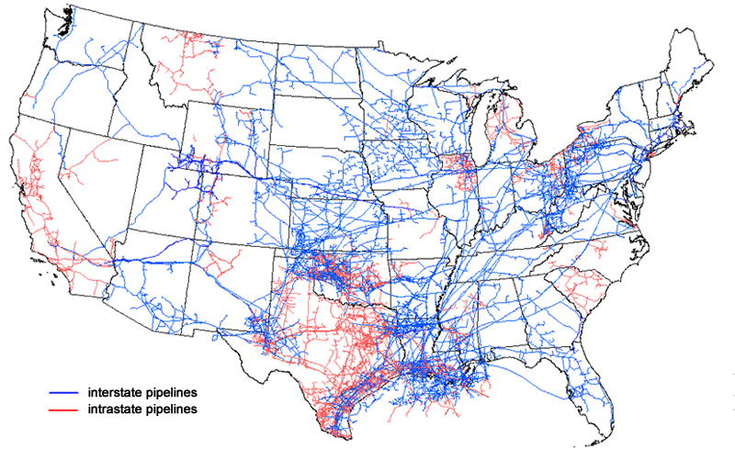
Figure 39- Map of U.S. Interstate and Intrastate pipelines network with Bakken Field
(EIA, 2018)
Moreover, the increase of natural gas production forces gas producers to vent and flare the excessive gas. In 2017 alone, the total natural gas flared in the U.S was about 335 bcf (GGFR, 2017).

6.1 Natural Gas Flaring in Bakken Field
Natural gas production in North Dakota continued to grow and reach record high of 1.94 bcfd in August 2017 (EIA, 2017). Due to the lack of infrastructure to gather and transport the natural gas production causing more than 35 percent of the gross withdrawal to be flared rather than marketed. North Dakota's Industrial Commission established a new target in 2014 to limit flaring to 10 percent by 2020, but in October 2018, the flaring was 20 percent.
Figure 40-Natural gas vented and flared in North Dakota from 2015 to the end of 2017.
(Graph by Author from EIA data)
As shown in Figure 40, the natural gas flared in North Dakota is still high even after the new target for flaring was announced in 2014. In 2012, the natural gas flared in Bakken Field was responsible for 4.5 Million metrics tonnes of CO₂ emitted to the air (Magill, 2014).
In October 2018, the natural gas production increased to 2.04 bcfd but flared about 527 MMcfd or 20 percent of the production (Dalrymple, 2018). This twenty percent flaring consists of 16 percent from the wells that are connected to pipeline, but the capacity is insufficient to capture all of the production. In addition, the 4 percent flaring is from the wells that are not connected to a pipeline (Dalrymple, 2018).
In order to achieve the 10 percent flaring limit in Bakken field, North Dakota natural gas has to be converted to LNG or to GTL. However, giving the demographic of the area where North Dakota is an inland state the options for natural gas conversion is limited. The most common transportation of LNG by land is through pipeline and it is expensive to construct LNG pipeline. LNG pipeline is expensive because it has to be a cryogenic pipeline since the temperature of LNG is minus 250ºF.
The option to monetize the excessive natural gas in Bakken field is by converting it to GTL where it can be consumed domestically within the state or it can be transported using truck and existing oil pipelines.
As mentioned above the volume of natural gas flared in 2018 was 527 MMcfd or 20 percent of the total production. If 500 MMcfd is used for a GTL plant, then it can produce 50,000 bpd using similar conversion as discussed in chapter 4. The conversion of raw natural gas to GTL is 10 Mcf per day can produce 1 bpd. A GTL plant with a capacity of 50,000 bpd is known to be a medium-scale GTL plant which is bigger than some of the existing plant like Oryx in Qatar.
In chapter 5, the higher the capacity of a GTL project the lower the IRR and the profitability index is lower than 1.0. Evaluation of Bakken Field GTL project is done by using the best-case-scenario parameters where CAPEX is US$45,000/bpd and product price is US$156/bbl. All other parameters are summarized in Table 12.
Table 12-Summary of Parameter for GTL Plant in Bakken Field
Parameter | Value | Unit
CAPEX | 45,000 | US$/Per bpd
OPEX | 5 | Percent of CAPEX
Product Price | 156 | US$/Per bbl
Carbon Efficiency | 80 | Percent
Thermal Efficiency | 60 | Percent
Feed Gas Price | 1.50 | US$/Per Mcf
Discount Rate | 3 | Percent
Tax Rate | 24 | Percent
Cargo/Transportation | 20 | US$/bbl
Gathering Line Cost | 44,000 | US$/in.
Pipe Size | 10 | In.
Pre-Treatment Cost | 6 | Percent of CAPEX
Power Coefficient | 1.1
Project Life | 20 | Years
Operation Days | 350 | Days/year

Figure 41- Bakken Field GTL option to minimize natural gas flaring.
As illustrated in Figure 41, although the capacity of 50,000 bpd will eliminate the current natural gas flaring, but it gives negative NPV, the IRR is lower than the assumed discount rate. Therefore, 50,000 bpd GTL plant is not attractive. The best option for GTL capacity to be below 1,000 bpd which results in 9.0 percent IRR and 1.0 PI. Hence, to eliminate the natural gas flaring, company can establish several 1,000 bpd GTL plant next to natural gas field.
Even though, the option of building an LNG plant in North Dakota is not feasible due to the location, however the existing LNG plants in the U.S. are profitable based on the economic evaluation done in chapter 5. Since the most effected parameter is product price hence, if the LNG price decrease all the LNG projects will experience great losses.

6.2 Greater Sunrise
- Background
The Greater Sunrise field is located in Timor Sea but the field itself is partially located inside the Joint Petroleum Development Area (JPDA), which is jointly administered by Timor-Leste and Australian government based on the 2002 Treaty. However, recently the Timor-Leste government has signed new treaty with Australia for the permanent maritime boundary. This permanent boundary gives about 80 percent of Greater Sunrise in Timor-Leste’s jurisdiction area as shown in Figure 42.
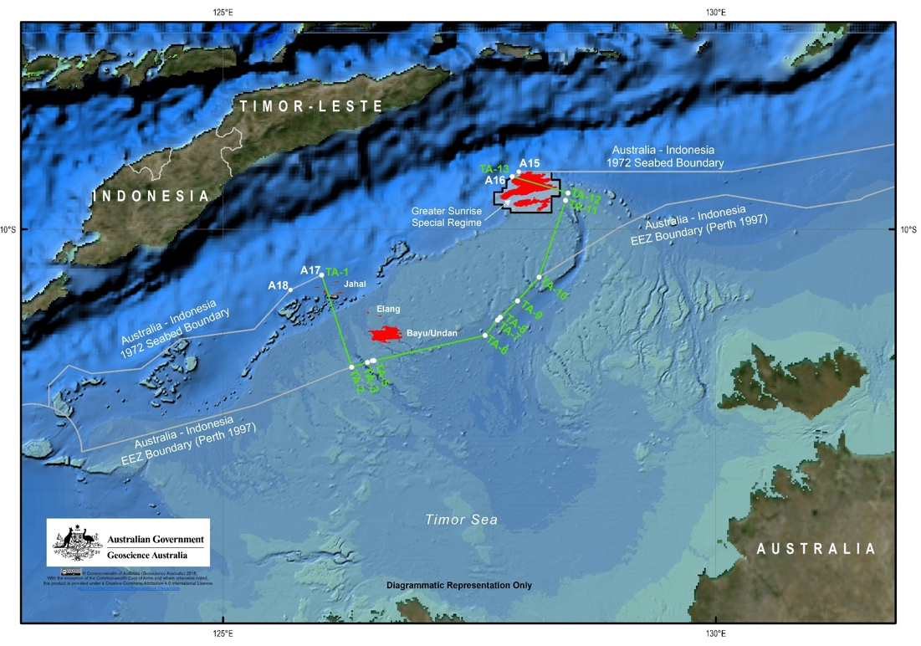
Figure 42-Maritime permanent boundary between Timor-Leste and Australia
(Strating, 2018)
The Sunrise and Troubadour fields were first discovered in 1970s and collectively these two fields have been renamed Greater Sunrise. Due to geopolitical issues and disputes, the Greater Sunrise field has not been developed and produced until this day.
In Timor-Leste’s Strategic Development Plan 2011-2030, the Government of Timor-Leste proposed the development of petroleum industry in south coast. This South Coast project is also known as Tasi Mane Project that consists of three clusters. These three clusters are the Supply Base, Petrochemical and Refinery, and the LNG plant. Additionally, the Government has proposed a 5 MTPA LNG capacity on a greenfield in Viqueque and expected for future expansion up to 20 MTPA. The LNG plant is being considered as a potential export outlet for the Greater Sunrise field. The initial gas reserves for Greater Sunrise field is 9.57 Tcf (Cadman and Temple, 2003).
- Liquefied Natural Gas (LNG) Option
The natural gas from Greater Sunrise to be processed in the LNG plant is a rich gas with the following composition.
Table 13-Gas Composition for Greater Sunrise field
(Cadman and Temple, 2003)
Gas Properties | Mole Percent
Methane | 79.41
Ethane | 4.76
Propane | 2.26
Isobutane | 0.63
N-butane | 0.95
Pentane plus | 4.9
Nitrogen | 2.97
Carbon Dioxide | 4.12
Based on the gas composition above, the efficiency chosen for this project is 70 to 80 percent because it required it is not lean since there is ethane plus and impurities. However, this gas composition does not require maximum treatment since the pentane plus is lower than 20 percent.
The capacity for the evaluation is 5 MTPA as proposed by the Government of Timor-Leste. Given that this LNG plant is going to be a greenfield project with new marine facilities, the capital expenditure (CAPEX) for this project should be higher than the LNG projects in the U.S. Additionally, since Timor-Leste is lacking of infrastructure and is located in the remote area, the CAPEX for this project should be approximately equal to the Australia LNG projects.
Therefore, the CAPEX for this project is US$2000±500/TPA. Another major cost that does not occur in any of the U.S. LNG and GTL plant is the cost of pipeline from upstream to downstream. The distance from Greater Sunrise field to the proposed LNG location is approximately 230 km or 370 miles as shown in Figure 43.
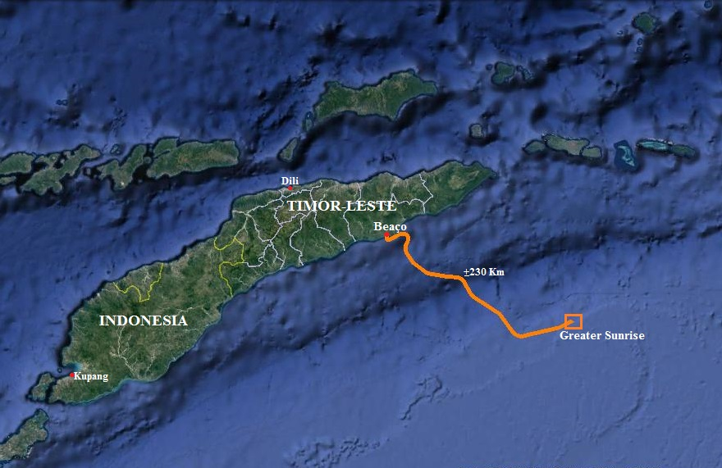
Figure 43-Distance from Greater Sunrise to Viqueque, Timor-Leste
(TIMORGAP, E.P)
According to Mark Kaiser (2017), the industry publication average offshore pipeline cost is US$3 Millions per mile. Hence, the pipeline cost from Greater Sunrise to Viqueque is US$1 Billions. The operational expenditure (OPEX) is 2.5 percent. Feed gas price is for this LNG project is taking from a wellhead price, however since there is no natural gas transaction establish in the country therefore the price is assumed to be US$4±2 per Mcf and the product price is US$11±5.5 per MMBtu. The transportation cost is remained constant as US$55,000/day with the distance of 3000 Nautical miles (Nm) to Japan-Tokyo. The distance from Viqueque to Tokyo is not available, but the distance from Timor-Leste’s capital city, Dili is available as 2,763 Nm. By factoring the distance from Dili to Viqueque and since, the cargo has to go around the island, the approximate distance should be about 3,000 Nm. Given that the greater sunrise is between lean and rich gas, therefore the carbon efficiency used is 75 percent while thermal efficiency is 85 percent taking from average LNG technology efficiency. The discount and tax rate are also considered constant parameter for this evaluation. However, due to insufficient data on discount rate from Timor-Leste therefore, the discount rate use is 3 percent. On the other hand, based on Timor-Leste tax policy the tax rate is 10 percent for regular income tax but income from mining and mining support services is 4.5 percent (Timor-Leste Ministry of Finance, 2008). However, it is unclear if the mining activities mentioned include oil and gas tax, hence the tax used is 10 percent. Parameters for LNG Plant proposing for Greater Sunrise is summarized in Table 14
Table 14-Summary of LNG Plant Parameters for Greater Sunrise
Parameters | LNG
Parameters | Mean | Standard Deviation
Capacity | 5 MTPA | Constant
CAPEX | US$2,000/TPA | US$500/TPA
OPEX (% of CAPEX) | 2.5 | 1.25
Feed Gas Price (US$/Mcf) | 4 | 2
Carbon Efficiency (%) | 85 | 10
Thermal Efficiency (%) | 85 | 10
Product Price | US$11/MMBtu | US$5.5/MMBtu
Transportation | US$55,000/day | Constant
Discount Rate (%) | 3 | 1.5
Tax Rate (%) | 10 | Constant
Table 15-Shows the result of Monte Carlo simulation after 10,000 iterations for 5 MTPA LNG project in Timor-Leste.
 | NPV (Million) | IRR | PI | Payback Period (Years)
Mean | (US$8,870) | -11.0% | -0.8 | 16.0
Median | (US$8,411) | -14.0% | -0.8 | 6.0
Standard Deviation | US$12,179 | 12.1% | 1.2 | 1,203.5
Minimum | (US$36,788) | -31.6% | -3.5 | -35,408.5
Maximum | US$17,196 | 16.6% | 2.3 | 104,648.5
The Monte Carlo simulations for a 5 MTPA LNG project with the given parameters above resulted in negative mean value of Net Present Value (NPV), internal rate of return (IRR), and Profitability index as shown in Table 15. Even though the payback period for this 8 year but the range is wide, and the results vary significantly. Therefore, based on the Monte Carlo simulations the LNG plant with 5 MTPA capacity is neither profitable nor attractive.
The best-case-scenario for developing Greater Sunrise gas field is to build a 4.25 MTPA LNG plant in Viqueque, Timor-Leste when the CAPEX is lower than US$2000/TPA, product price is higher than US$14/MMBtu, and feed gas price is lower than US$2/Mcf. For this scenario, the results are promising whereby NPV is US$11 Billion, IRR is 9 percent, PI is 1.0, and payback period is 7 years.
Figure 44-Best-case-scenario Greater Sunrise Field LNG plant option with capacity as variable.
As shown in Figure 44, the optimal option for LNG is a plant with a capacity below 4.25 MTPA, because above that capacity the IRR is lower with higher investment.
As of today, there is no natural gas consumer in the country, hence any natural gas production has to be exported to other part of the world.
- Gas-to-Liquid (GTL) Option
The capacity for the GTL is depend on the amount of natural gas that arrived at Timor-Leste’s shore for the LNG plant. Thus, taking the simple conversion from the IGU report where 1 MTPA is equal to 131 MMcfd and if only 70 percent of natural gas input produce LNG then 5 MTPA will required about 850 MMcfd. The capacity of the GTL plant for this evaluation is 80,000 bpd in order to use the maximum capacity of pipeline from Greater Sunrise field to Viqueque. The CAPEX, OPEX, and efficiency are similar to the one used for the GTL project in Bakken Field. Since, there is no existing refinery and/or petrochemical plant the GTL plant required a hydrocracking product upgrading to produce gasoline and diesel. According to Compass International, the average hydrocracking unit cost in South East Asia in US$24,700/bbl. The gasoline price in Timor-Leste is ranging from US$0.65 to US$1.60 per liter over the past 10 years and this price is pump based price. Using the conversion of 3.78 liter in a gallon and 42 gallons in 1 U.S. barrel, the price per barrel range from US$100 to US$250/bbl. For this economy evaluation, the product price used is US$200±50 per barrel. The feed gas price and the pipeline cost remained the same as for LNG plant. In addition, the pre-treatment is remained constant as 6 percent of CAPEX in previous Monte Carlo simulation for GTL. Due to the lack of data available for Timor-Leste, the transportation cost remained the same as the GTL evaluation above which is US$20/bbl. The parameters mentioned above are summarized in Table 16.

Table 16-Summary parameters for GTL Plant in Greater Sunrise
Parameter | Value | Unit
CAPEX | 45,000 | US$/Per bpd
OPEX | 5 | Percent of CAPEX
Product Price | 200 | US$/Per bbl
Carbon Efficiency | 80 | Percent
Thermal Efficiency | 60 | Percent
Feed Gas Price | 2 | US$/Per Mcf
Discount Rate | 3 | Percent
Tax Rate | 24 | Percent
Cargo/Transportation | 20 | US$/bbl
Pipeline Cost | 1.1 | US$ Billion
Pipe Size | 10 | In.
Pre-Treatment Cost | 6 | Percent of CAPEX
Hydrocracking Unit | 24,700 | US$/bbl
Power Coefficient | 1.1
Project Life | 20 | Years
Operation Days | 350 | Days/year

Figure 45-NPV and IRR at the y-axis as CAPEX is varying in x-axis.
As shown in Figure 45, a GTL plant with 80,000 bpd is profitable if CAPEX is lower than US$45,000/bpd, product price higher than US$250/bbl, and feed gas price lower than US$2/Mcf. This case-scenario would yield positive NPV and IRR but PI is lower than 1. However, the best-case-scenario with PI higher than 1.0 is when CAPEX is lower than US$45,000/bpd.
Unlike natural gas market, gasoline and diesel is the main consumption of energy in the country for both power generation and transportation. Since, the country does not have any petroleum industry or refinery, all of the gasoline and diesel consume are imported. Therefore, with establishing this GTL plant will make sure that the country is energy security and independent.
Timor-Leste’s energy market is unnoticeable in the oil and gas community, particularly when there is no data available in the public.
As discussed earlier there is a plan to build a greenfield LNG plant with a capacity of 5 MTPA. The production of natural gas in the country is mainly to be marketed to the international market given that there is no domestic market. On the other side of spectrum, gasoline and diesel demand are increasing because these are the main source of energy. According to the World Bank Report in 2010, the demand for gasoline and diesel are 186,000 and 423,000 bbl/year in 2006. These numbers should increase drastically with the increasing number of populations, the usage of transportation, and constructions activities. The demand for petroleum production will increase even more, once the South Coastal project construction begin.
However, the 80,000 bpd GTL capacity gives IRR of 9.0 percent and PI is 1.0 with 7 years payback period. A capacity lower than 80,000 bpd resulted in negative NPV, lower IRR, PI, and higher than 20 years payback period.

Table 17-Results of comparing different GTL capacity with the best-case scenario parameters.
Capacity (bpd) | NPV (in Millions) | IRR | PI | Payback Period  (Years)
80,000 | US$14,260 | 9.0% | 1.0 | 7.4
10,000 | US$1,694 | 9.0% | 1.0 | 7.4
5,000 | US$960 | 10.0% | 1.2 | 6.7
1,500 | US$341 | 13.2% | 1.6 | 5.7
1,000 | US$238 | 14.3% | 1.7 | 5.5
500 | US$128 | 16.0% | 2.0 | 5.0
100 | US$29 | 20.0% | 2.5 | 4.2
50 | US$15 | 22.0% | 2.8 | 4.0
Table 17 proof that small-scale GTL is more profitable and attractive in comparison to large-scale GTL.
There are four case-scenarios:
  - Replace the LNG plant with an 80,000 bpd GLT hence this plant will bear the cost of pipeline and feed gas cost,
  - The 5,000 bpd is an additional plant to the LNG plant as plan, with the inlet flowrate of 900 MMcfd, where 850 MMcfd is for LNG production and 50MMcf/day is for GTL production.
  - The 1,000 bpd is an additional plant to the LNG plant similar to scenario 2.
  - The 500 bpd is an additional plant to the LNG plant similar to scenarios 2 and 3.
All of these scenarios are profitable and attractive because of the NPV outcome, higher IRR and PI as well as a short amount of payback time. The second, third, and fourth scenarios are all additional plant to the plan LNG hence, the GTL plant does not bear any pipeline or feed gas cost.
Both the GTL and LNG projects scenarios are resulted in higher IRR and PI as the capacity decreases. Moreover, both GTL and LNG projects are plateau at a certain capacity. The minimum capacity for LNG is 4.25 MTPA and for GTL is 500 bpd. Therefore, the most profitable option would be to build an LNG plant with 4.25 MTPA capacity with additional numbers of 500 or 1,000 bpd GTL in parallel.
The advantage of this option is some of the common facility can be share which in turn will reduce both CAPEX and OPEX. Another advantage is short construction time because the plant is pre-fabricated and can be modularized.

Chapter 7: Conclusions and Recommendations
The economic metrics of NPV, IRR, PI, and Payback Period are used as measuring parameters to conduct Monte Carlo simulations and sensitivity analysis. The results from sensitivity analysis illustrated that both LNG and GTL projects feasibility and profitability are mostly depending on the Capital Expenditure (CAPEX), Feed gas price, and Product price. Other parameters do affect the economic metrics but in smaller scale in comparison to the aforementioned parameters. Both LNG and GTL project’s economy analysis projected that they are profitable however the Monte Carlo simulations shown the range of negative NPV and lower IRR than the assumed discount rate.
Based on the field analysis for Bakken Field and Greater Sunrise, both fields are feasible and profitable for GTL project. However, given the location of Bakken field suggest that LNG project is not an option. The Greater Sunrise is the best field to evaluate where both options are feasible and profitable. Nonetheless, the Greater Sunrise field analysis also demonstrates that the LNG project is feasible, profitable, and attractive at 4.25 MTPA. In contrast, the GTL project is more feasible, profitable, attractive in a small-scale capacity then medium to large-scale plant. Even though, the capacity does not show as a major effect during the sensitivity analysis due the range of the evaluation. But when compare the smaller-scale projects to medium and large-scale projects, the capacity parameter would affect the outcome of the economic metrics.
In conclusion, depending on the amount of the natural gas reserves LNG plant option might be more attractive than GTL or vice versa. In other word, the small-scale GTL project appears to be a good option for a flare natural gas or excessive production like Bakken Field. On the other hand, the medium to large LNG would be a better option for a big reserve develop only for LNG production. However, large-scale GTL project is neither profitable nor attractive.
Recommendations
This thesis is a preliminary study with very broad range of data available in public. Given that all the technologies available are proprietary of a company where the technology belong to, hence these data are not accurate.
There should be a further study conducted before making a decision on any project to be implemented. An investigation required for more precise and accurate analysis on the project economy included:
- The CAPEX and OPEX should be breakdown to its individual cost.
- Checking for any possible cost reduction for site preparation, marine facility for LNG project, or any other portion of CAPEX and OPEX.
- Market investigation for consumers, product prices and transportation cost.
- Location of the natural gas field and whether the project is an integrated project to define who will bear the upstream and pipeline cost.
- Precise feed gas composition and product specifications to determine appropriate technology with its own efficiency.

References
Agarwal, K. 2019. Investopedia. The Monte Carlo Simulations: Understanding the Basic, www.investopedia.com/articles/investing/112514/monte-carlo-simulation-basics.asp(accessed 10 March 2019).
Biscardini, G., Schmill, R., and Del Maestro, A. 2017. Strategy & Part of the PwC network. Small going big: Why small-scale LNG may be the next wave, www.strategyand.pwc.com/report/small-going-big (accessed 10 December 2018).
Blackmon, D. 2018. Forbes.The Final Trump Tax Bill: A clear net positive for U.S. Oil and Gas. www.forbes.com/sites/davidblackmon/2017/12/21/the-final-trump-tax-bill-a-clear-net-positive-for-u-s-oil-and-gas/#4b4b9a844420 (accessed 11 April 2019).
Cadman, S.J., P.R. Temple. 2003. Bonaparte Basin. Australia Petroleum Accumulation Report 5, 2nd Edition.
Compass International. 2018. CAPEX & OPEX Refinery Cost per Barrel a Day Benchmark Total Installed Engineering, Procurement, & Construction (EPC) 2018 Cost Basis. compassinternational.net/capex-opex-refinery-cost-per-barrel-day-benchmarks-total-installed-engineering-procurement-construction-epc-2018-cost-basis/ (accessed 11 April 2019.)
Corkhill, M. 2016. LNG World Shipping. LNG Project Costs and the luck of the draw. www.lngworldshipping.com/news/view,lng-project-costs-and-the-luck-of-the-draw_41276.htm (accessed 13 March 2019).
Cox G. 2013. CCS Learning from the LNG Sector: Report for the Global CCS Institute. WorleyParsons.
Dalrymple, A. 2018. Bismarck Tribune. North Dakota oil production, natural gas flaring reach new highs. bismarcktribune.com/bakken/north-dakota-oil-production-natural-gas-flaring-reach-new-highs/article_9795ab87-780d-5380-b385-a568d42a9e39.html (accessed 10 December 2018).
Dalrymple, A. 2018. Bismarck Tribune. N.D. oil, gas production returns to record levels. bismarcktribune.com/bakken/n-d-oil-gas-production-returns-to-record-levels/article_a7e9ab13-f850-5d89-9fa5-c4325a6fce7f.html (accessed 10 December 2018).
De Klerk, A. 2012. Gas-to-Liquids Conversion. Natural Gas Conversion Technologies Workshop of ARPA-E.
Dizikes, P. 2010. News MIT. Explained Monte Carlo Simulations. news.mit.edu/2010/exp-monte-carlo-0517 (accessed 10 March 2019).
EIA. 2018. U.S. Department of Energy: Independent Statistics & Analysis. U.S. natural gas production and consumption increase in nearly all AEO2018 cases. www.eia.gov/todayinenergy/detail.php?id=35792 (accessed 26 January 2019).
EIA. 2017. U.S. Department of Energy: Independent Statistics & Analysis. Natural gas production in Bakken region increases at a faster rate than oil production. www.eia.gov/todayinenergy/detail.php?id=33892 (accessed 19 October 2017).
EIA. 2018. U.S. Department of Energy: Independent Statistics & Analysis. The United States uses a mix of energy sources. www.eia.gov/energyexplained/?page=us_energy_home (accessed 16 June 2018).
EIA. 2018. U.S. Department of Energy: Independent Statistics & Analysis. The United States now produced nearly all of the natural gas that it uses. https://www.eia.gov/energyexplained/index.php?page=natural_gas_where (accessed 22 January 2019).
EIA. 2019. U.S. Department of Energy: Independent Statistics & Analysis. EIA expects relatively flat natural gas prices, continued record production through 2020. www.eia.gov/todayinenergy/detail.php?id=38052 (accessed January 28, 2019.)
EIA. 2017. U.S. Department of Energy: Independent Statistics & Analysis. Country Analysis Brief: Australia. www.eia.gov/beta/international/analysis_includes/countries_long/Australia/australia.pdf (accessed 20 February 2019).
EIA. 2017. U.S. Department of Energy: Independent Statistics & Analysis.Petroleum & Other Liquids. www.eia.gov/dnav/pet/hist/LeafHandler.ashx?n=PET&s=MTTIMUS1&f=M (accessed 10 April 2019).
Energy Outlook. 2018. Small but Mighty: Small-scale LNG Facilities Introduce a Clean Fuel Alternative. energy.sia-partners.com/20180731/small-mighty-small-scale-lng-facilities-introduce-clean-fuel-alternative (accessed 3 February 2019).
Federal Reserve. Discount Rate Data. www.frbdiscountwindow.org/pages/discount-rates/historical-discount-rates (accessed 10 April 2019).
Frost & Sullivan. 2016. Forst Perspective. Small-Scale GTL – Emerging Technology in Monetizing Stranded Gas. ww2.frost.com/frost-perspectives/small-scale-gtl-emerging-technology-in-monetizing-stranded-gas/ (accessed October 19, 2017).
Glebova, O. 2013. Gas to Liquids: Historical Development and Future Prospects: The Oxford Institute for Energy Studies.
Global Gas Flaring Reduction Partnership. 2018. World Bank. GGFR Technology overview – Utilization of small-scale associated gas. documents.worldbank.org/curated/en/469561534950044964/GGFR-Technology-Overview-Utilization-of-Small-Scale-Associated-Gas (accessed 25 August 2018).
Hansen, M. and E. Dursteler. 2017. Strata. Economic, environmental, and safety impacts of transportation oil and gas in the U.S. www.strata.org/pdf/2017/pipelines.pdf (accessed 18 January 2018).
Hearn, S. 2016. Investopedia. Understanding how oil companies pay taxes. www.investopedia.com/articles/investing/011216/understanding-how-oil-companies-pay-taxes.asp (accessed 11 April 2019).
IEA. 2017. Statistics – Natural Gas Information: Overview (2017 Edition). www.iea.org/publications/freepublications/publication/NaturalGasInformation2017Overview.pdf(accessed 21 June 2018).
IGU. 2018. 2018 World LNG Report: 27th World Gas Conference Edition. www.igu.org/sites/default/files/node-document-field_file/IGU_LNG_2018_0.pdf (accessed 18 February 2019).
Kaiser, M.J. 2017. Offshore Pipeline Construction Cost in the U.S. Gulf of Mexico. Marine Policy 82:147-166 http://doi.10.1016/j.marpol.2017.05.003
Kenton, W. 2019. Investopedia. Monte Carlo Simulations Definition. www.investopedia.com/terms/m/montecarlosimulation.asp (accessed 10 March 2019).
Kotzot, H., Durr, C., Coyle, D. et al. 2007. LNG Liquefaction – Not All Plants are Created Equal. KBR.
Lichun, D., Shun'an, W., Shiyu, T. et al. 2008. GTL or LNG: Which is the best way to monetize “Stranded” natural gas?. Petroleum Science Pet.Sci.(2008)5:388 dx.doi.org/10.1007/s12182-008-0063-8.
Lipski, R. Gas Processing News. Smaller-scale GTL enters the mainstream. www.gasprocessingnews.com/features/201310/smaller-scale-gtl-enters-the-mainstream.aspx (accessed 2 December 2018).
Magill, B. 2014. Climate Central. North Dakota Gas Flaring Doubles, Pumping CO2 Into Air. www.climatecentral.org/news/north-dakota-gas-flaring-doubles-pumping-co2-into-air-17212. (accessed 28 April 2019).
Newnan, D.G., Lavelle, J.P., and Eschenbach, T.G. Chapter 2: Cost Estimating and Estimating Models. In Engineering Economic Analysis, twelfth edition. Oxford University Press.
Reig, P., Luo, T., and Proctor, J.N. 2014. Water Resources Institute. Global Shale Gas Development: Water Availability and Business Risk. www.wri.org/sites/default/files/wri14_report_shalegas.pdf (accessed 8 August 2018).
Rogers, H. 2018. The LNG Shipping Forecast: cost rebounding, outlook uncertain. The Oxford Institute for energy Studies. Energy Insight: 27.
Songhurst, B. 2018. LNG Plant Cost Reduction 2014-18. The Oxford Institute for Energy Studies. OEIS Paper: NG137.
Stammers, R. 2019. Investopedia. Using Monte Carlo Analysis to Estimate Risk. www.investopedia.com/articles/financial-theory/08/monte-carlo-multivariate-model.asp (accessed 10 March 2019).
Strating, B. 2018. Asia Maritime Transparency Initiative. The Timor Sea Boundary Agreement: An Incomplete Victory. amti.csis.org/timor-sea-boundary-agreement-incomplete-victory/. (accessed 28 February 2019).
Time and Date. Distance from Dili to… www.timeanddate.com/worldclock/distances.html?n=768 (accessed 3 March 2019).
Timor-Leste Ministry of Finance. 2008. Taxation Law. https://www.mof.gov.tl/taxation/taxation-law/?lang=en (accessed 11 April 2019).
Timor-Leste Strategic Development Plan 2011-2030. Asian Development Bank. www.adb.org/sites/default/files/linked-documents/cobp-tim-2014-2016-sd-02.pdf (accessed 20 February 2019).
The World Bank. 2010. World Bank. Timor-Leste: Key Issue in Rural Energy Policy. siteresources.worldbank.org/INTEAPASTAE/Resources/TimorLeste_RuralEenergyPolicy.pdf (accessed 20 February 2019).
U.S. Commodity Futures Trading Commission. 2018. Liquefied Natural Gas Developments and Market Impacts. www.cftc.gov/sites/default/files/2018-05/CFTC_LNG0518_3.pdf (accessed 8 February 2019).
Wang , X. and Economides, M. 2009. Chapter 6: Liquefied Natural Gas (LNG). In Advanced Natural Gas Engineering. Houston, Texas: Gulf Publishing.
Wang , X. and Economides, M. 2009. Chapter 7: Gas-to-Liquid (GTL). In Advanced Natural Gas Engineering. Houston, Texas: Gulf Publishing.
Whitehead, S. 2018. New data show U.S. flaring has decreased 20 percent since 2015. www.energyindepth.org/new-data-show-u-s-flaring-decreased-20-percent-since-2015/. Accessed January 20, 2019.
Wood, D.A., Nwaoha, C., and Towler, B.F. 2012. Gas-to-Liquids (GTL): A Review of an Industry Offering Several Routes for Monetizing Natural Gas. Journal of Natural Gas Science and Engineering 9: 196—208. https://doi.org/10.1016/j.jngse.2012.07.001
Zhang , J., Shukri, T., and Tarrant, T. 2012. Handling LNG Feed Gas Variations. LNG Journal.

Appendix A: Abbreviations
Bbl Barrel
Bcf Billions Cubic Feet
Bcfd Billions Cubic Feet per Day
CAPEX Capital cost or expenditure
CNG Compressed Natural Gas
EIA U.S. Energy Information Administration
GTL Gas-to-Liquid
GTW Gas-to-Wire
IEA International Energy Agency
IGU International Gas Union
IRR Internal Rate of Return
LNG Liquefied Natural Gas
M Thousand
MM Million
Mcf or Mscf Thousand Cubic Feet or Thousand Standard Cubic Feet
MMcfd Million Cubic Feet per Day
MMBtu Million British Thermal Unit
MTPA Million Tonnes per Annum
NPV Net Present Value
OPEX Operational Cost or Expenditure
PI Profitability Index
Tcf Trillion Cubic Feet
TPA Tonne per Annum

Appendix B: LNG Sample Calculations
Calculations
OPEX is 2.5 percent of CAPEX
Straight Line Depreciation = CAPEX/Project Life
Tax is 35 percent
Discount rate is 10 percent
Project life is 350 days per year
1 Tonne of LNG/year = 131.25 cf/day
$1.5MTPA=\frac{1,500,000 Tonnes}{year}x\frac{131.25 cf/day}{1 Tonne/year}x\frac{350 days}{year}x\frac{1MMcf}{1,000,000cf}=68,775\frac{MMcf}{Year}$,
Assuming 100 percent efficiency.
For 85 percent Efficiency:
$$=68,775\frac{MMcf}{Year}x\left(1.15\right)=79,240\frac{MMcf}{Year}$$
$$\frac{LNG MMBtu}{Year}=1,500,000 \frac{LNG Tonnes}{Year}x\frac{53.38MMBtu}{1 LNG Tonne}=80,070,000\frac{MMBtu}{Year}$$
Number of Cargoes:
Capacity of Cargo used is 160,000 m³
Assuming 98 percent load: 156,800 m³ or 3,819,648 MMBtu/cargo using conversion of 1MMBtu = 24.36 m³
Cargo Cost for Dual Fuel Diesel Electric (DFDE) carrier for US$55,000/day
Example route: Browse (Australia) to Tokyo Japan is 3,727 Nautical Miles (Nm) (one way)
Average Carrier Speed: 19 Nautical miles per hour (Knots)
LNG left after unloading is 4 percent = 152,786 MMBtu
Fuel consumption 0.1percent per day = 3,920MMBtu/day
Port days = 3 days
Thus,
$$Roundtrip plus port days=\left(\frac{3,727Nm}{19Nm/hr}x\frac{1day}{24hr}\right)+3 days=19.3 days$$
Cargo cost is US$1.1 Million per number of cargo or per trip
$$Fuel Cost=\frac{3,920MMBtu}{day}x19.3days x \frac{US\$11}{MMBtu}=\frac{US\$810,911}{trip}$$
Port cost is assumed to be US$100,000/day times 3 days is US$300,000/trip.
Agents and broker fees, and insurance: 2percent of charter cost plus US$2,600/day for insurance. This equal to US$71,410/trip.
Total cost of Cargo per trip or per number of cargo is US$2.2 Million.
Revenue calculation:
$$Revenue=\frac{Volume of LNG delivered}{cargo}x\frac{Number of cargoes}{year}x \frac{LNG price}{MMBtu}$$
$$Profit before tax=Revenue-(OPEX+Depriciation+Feed gas cost+Transportation)$$
$$Profit After tax=Revenue x \left(1-Tax Percent\right)$$

Table B1: LNG Plant Base Case-Scenario Parameters and Values
Parameter | Value | Unit
CAPEX | 1,800 | US$/Per TPA
OPEX | 2.5 | Percent of CAPEX
Product Price | 11 | US$/Per MMBtu
Capacity | 1.5 | MTPA
Carbon Efficiency | 85 | Percent
Thermal Efficiency | 85 | Percent
Feed Gas Price | 4 | US$/Per Mcf
Discount Rate | 3 | Percent
Tax Rate | 24 | Percent
Cargo/Transportation | 2.2 | US$Million/Trip
Project Life | 20 | Years
Operation Days | 350 | Days/year

Table B2: Sample of Excel Worksheet for Economic Metrics Evaluation for LNG Plant
Sensitivity Analysis for LNG Project
Table B3: Parameters of Sensitivity Analysis for LNG Plant
Parameters | Low | Base | High
Plant Capacity (MTPA) | 0.75 | 1.5 | 2.25
CAPEX (US$M/MTPA) | 900 | 1,800 | 2,700
OPEX (% CAPEX) | 1.25 | 2.5 | 3.75
Feed Gas Price (US$/Mcf) | 2 | 4 | 6
Carbon Efficiency (%) | 75 | 85 | 95
Thermal Efficiency (%) | 75 | 85 | 95
LNG Price (US$/MMBtu) | 5.50 | 11 | 16.50
Cargo (US$/day) | 27,500 | 55,000 | 82,500
Discount Rate (%) | 1.5 | 3.0 | 4.5
Tax Rate (%) | 12 | 24 | 35
Table B4: Sensitivity Analysis Result of NPV for LNG Plant
Table B5: Sensitivity Analysis Result of IRR for LNG Plant
Table B6: Sensitivity Analysis Result of PI for LNG Plant
Table B7: Sensitivity Analysis Result of Payback Period for LNG Plant

Appendix C: GTL Sample Calculations
Calculations
OPEX is 5 percent
Straight Line Depreciation = CAPEX/Project Life
Tax is 35 percent
Discount rate is 10 percent
Project life is 350 days per year
10Mcfd=1bpd
For 500bpd, the feed gas required
$$500bpd x \frac{10Mcfd}{1bpd}=5,000Mcfd=5\frac{MMcf}{day}x\frac{350 days}{1 year}=1,750,000\frac{Mcf}{year}$$
$$\frac{Feed gas cost}{year}=1,750,000\frac{Mcf}{year}x\frac{US\$ 1.5}{Mcf}=\frac{US\$2,625,000}{year}=US\$2.62 Million$$
Table C1: GTL Plant Base Case-Scenario Parameters and Values
Parameter | Value | Unit
CAPEX | 60,000 | US$/Per bpd
OPEX | 5 | Percent of CAPEX
Product Price | 120 | US$/Per bbl
Capacity | 1000 | Bpd
Carbon Efficiency | 80 | Percent
Thermal Efficiency | 60 | Percent
Feed Gas Price | 1.50 | US$/Per Mcf
Discount Rate | 3 | Percent
Tax Rate | 24 | Percent
Cargo/Transportation | 20 | US$/bbl
Gathering Line Cost | 44,000 | US$/in.
Pipe Size | 10 | In.
Pre-Treatment Cost | 6 | Percent of CAPEX
Power Coefficient | 1.1
Project Life | 20 | Years
Operation Days | 350 | Days/year

Table C2: Sample of Excel Worksheet for Economic Metrics Evaluation for GTL Plant
Sensitivity Analysis for GTL
Table C3: Parameters of Sensitivity Analysis for GTL Plant
Parameters | Low | Base | High
Plant Capacity (bpd) | 500 | 1,000 | 1,500
CAPEX (US$/bpd) | 30,000 | 60,000 | 90,000
OPEX (% CAPEX) | 2.5 | 5.0 | 7.5
Feed Gas Price (US$/Mcf) | 1 | 1.5 | 2
Carbon Efficiency (%) | 70 | 80 | 90
Thermal Efficiency (%) | 40 | 60 | 80
Product Price (US$/bbl) | 60 | 120 | 180
Discount Rate (%) | 1.5 | 3.0 | 4.5
Tax Rate (%) | 12 | 24 | 35

Table C4: Sensitivity Analysis Result of NPV for GTL Plant
Table C5: Sensitivity Analysis Result of IRR for GTL Plant
Table C6: Sensitivity Analysis Result of PI for GTL Plant
Table C7: Sensitivity Analysis Result of Payback Period for GTL Plant

Appendix D: Monte Carlo Simulation
Table D1: Monte Carlo Simulations Result for 5,000 Iterations
Table D2: Monte Carlo Simulations Result for 10,000 Iterations
Table D3: Monte Carlo Simulations Result for 15,000 Iterations

