UNIVERSITY OF OKLAHOMA
GRADUATE COLLEGE

THE ROLE OF IMPRESSION MANAGEMENT
IN A RESOURCE DEPENDENT RELATIONSHIP

A DISSERTATION
SUBMITTED TO THE GRADUATE FACULTY
in partial fulfillment of the requirements for the
Degree of
DOCTOR OF PHILOSOPHY

By
JAMES M. WHEELER
Norman, Oklahoma
2014

THE ROLE OF IMPRESSION MANAGEMENT
IN A RESOURCE DEPENDENT RELATIONSHIP

A DISSERTATION APPROVED FOR THE
MICHAEL F. PRICE COLLEGE OF BUSINESS

BY

____________________________
Dr. Mark Sharfman, Chair

____________________________
Dr. Lowell Busenitz, Co-Chair

____________________________
Dr. Mark Bolino

____________________________
Dr. Laku Chidambaram

____________________________
Dr. David Townsend

© Copyright by JAMES M. WHEELER 2014
All Rights Reserved.

ACKNOWLEDGEMENTS
I would like to thank the chair of this dissertation, Mark Sharfman. Your support and guidance were invaluable. I would also like to thank the rest of my committee: Lowell Busenitz, Mark Bolino, Laku Chidambaram and David Townsend. All of you provided unique insights and helped me better understand the process of learning and thinking through phenomena.
Thank you as well to all my fellow doctoral students. You helped me a great deal. You all were tremendous resources for support and knowledge. I will miss all of you and wish you the best of luck.
Finally, I would like to thank my wife Trudy and my children, Kate, Ava and Luke. Thank you for your understanding and inspiration. I love you all so very much.

TABLE OF CONTENTS

CHAPTER: CONTENT PAGE
Abstract vi
Chapter One: Introduction 1
Chapter Two: Literature Review and Hypotheses 23
Chapter Three: Methods 65
Chapter Four: Results 91
Chapter Five: Discussion 119
APPENDIX A: Survey 167
APPENDIX B: Recruitment Letter 190
APPENDIX C: Recruitment E-mail 192
APPENDIX D: Scree Plot 195
APPENDIX E: Histogram for Variables 196
APPENDIX F: Full SPSS Process Regression Results 213
APPENDIX G: SPSS PROCESS Model 231

ABSTRACT

Venture capitalists (VCs) perform valuable services to entrepreneurs and to the economy as a whole by accelerating innovation through the funding of high potential, nascent ventures. The operational duties of a VC are many, but they have two overriding and important functions—making sound investments in great companies and securing Limited Partners who fund VC portfolio companies. Research to date has focused primarily on operational issues such as governance, vetting of opportunities and VC added value to nascent ventures. However, very little research has investigated the behaviors of VCs. Of particular interest to the author is the impression management behavior of VCs. A better understanding of VC behaviors and motivations will establish a framework that can then be linked to performance. Once performance and behaviors are linked, best practices can be conceptualized. Linking organizational impression management (OIM) to positive firm performance would contribute theoretically to the resource base of the firm (Barney, 1991) as OIM could then be considered a resource used to achieve a sustainable competitive advantage.
The competition for deals and Limited Partners (LPs) has become fierce. First, for limited partner funding, a recent paper by the Kauffman Foundation has splashed cold water on the viability of the VC investment class; in other words, it has significantly underperformed over the past decade. Second, the sourcing of potential VC investment opportunities has also become very competitive. The advent of “crowdsourcing”, “super angels”, expanded government grant programs for funding, and the advent of social media, for visibility, allow new ventures to seek alternative funding and/or build a “buzz” without the backing of top-tier VCs. The availability of these alternative funding options can have a negative effect on VCs. If a VC is shut out of the 10 or 12 a year billion-dollar companies that are created each year, they will not be able to deliver benchmark returns.
The following dissertation explores two research questions: 1) why do VCs engage in impression management in the first place and 2) what causes venture capitalists to change their impression management tactics? While on the surface these questions appear only to be relevant to the venture capital industry, this dissertation posits that the answers to these questions have broader and more generalizable implications. Specifically, do organizations use impression management strategies to manage resource dependence? If so, what tactics are used when? This dissertation, then, contributes to theory by expanding organizational impression research by examining the cross-level actions of organizational impression management strategies enacted by organizations to manage resource dependence. Additionally, this dissertation contributes to theory by expanding resource dependence theory (RDT) and its role in enacting organizational impression management (OIM) activities.
This dissertation argues that VCs use impression management to gain legitimacy with entrepreneurs and Limited Partners and other VCs. Then it discusses how firm and environmental factors influence impression management motivation and the construction of VC OIM strategies. This dissertation collected data from VCs to test the hypotheses. The proposed research model, based on mediation, did not yield support for the suggestion that: the relationship between resource dependence and legitimacy is mediated by OIM. Therefore a revised research model was developed to test whether possible moderated relationships between resource dependence (importance of entrepreneurs, VCs and LPs) and OIM strategies predicting legitimacy.
The revised research model testing moderation yielded four significant interactions. However, three of the four significant relationships were a negative. The importance of entrepreneurs (resource) moderated the relationship between signaling professional organization (OIM) and legitimacy and also moderated the relationship between image development (OIM) and legitimacy. But both relationships were negative. The importance of VCs (resource) positively moderated the relationship between organizational achievement (OIM) and legitimacy and also the relationship between the importance and personal credibility (OIM) and legitimacy. One relationship was positive and the other negative.
Specifically, VCs who place great importance on entrepreneurs and placed high importance on OIM tactics (signaling a professional organization and developing an image) were associated with less legitimacy. Similarly, VCs who placed great importance on the resource of other VCs produced one positive predictor of legitimacy (interacting with signaling organizational achievement) and one negative predictor of legitimacy (interacting with personal credibility).
The results of this research project were mixed and inconclusive. The relationship between OIM tactics and behaviors with resource dependence was negative in three out of four significant predictor relationships. For one set of variables, the relationship between resource dependence and OIM tactics predicted legitimacy positively. But, three additional significant interactions were negative. This dissertation looked to see if legitimacy was effective as a predictor of OIM strategies, rather than an outcome of OIM strategies. A post-hoc analysis yielded a negative relationship between increased legitimacy and OIM strategies.
Additionally, when reviewing many of the articles from the popular press quoted in this dissertation, it could be argued that VCs were engaging in OIM strategies because they lacked legitimacy due to poor performance. Therefore, the post-hoc analysis finding legitimacy, a resource, predicting OIM strategies is consistent with articles in the popular press. Overall, this dissertation suggests OIM strategies are utilized by organizations, at times to achieve legitimacy and at times the strategies are modified due to established legitimacy, but the results from this dissertation do not offer clarity on cause and effect.

CHAPTER 1
INTRODUCTION
Overview
“It wasn’t so long ago that venture capitalists kept secrets. The young start-ups they backed certainly sought attention, but most venture capitalists operated under levels of secrecy typically reserved for Swiss banks. Now, Sand Hill Road in Silicon Valley is one long parade route. Venture capitalists are hiring full-time public relations experts to tell bloggers and reporters of their investing prowess. They publicize their every doing and thought on Twitter and in blog posts” (Perlroth, 2012).

“95percent of VCs add zero value. I would bet that 70-80 percent add negative value to a start-up in their advising” Sun Microsystems co-founder and famed investor Vinod Khosla, (Eyal, 2013).

“Venture capital (VC) has delivered poor returns for more than a decade. VC returns haven’t significantly outperformed the public market since the late 1990s, and, since 1997, less cash has been returned to investors than has been invested in VC. Speculation among industry insiders is that the VC model is broken, despite occasional high-profile successes like Groupon, Zynga, LinkedIn, and Facebook in recent years.” “WE HAVE MET THE ENEMY… AND HE IS US”: Lessons from Twenty Years of the Kauffman Foundation’s Investments in Venture Capital Funds and The Triumph of Hope over Experience (Kauffman, 2012).

The VC industry has recently been under attack. As the quotes from the popular press above help illustrate, VCs have collectively underperformed targeted investment benchmarks and the self-described “added value,” i.e., services offered to client companies beyond funding, has been called into question. This underperformance also coincides with a significant change in VC behavior regarding impression management activities to convey the attributes deemed most desirable by entrepreneurs and Limited Partners (DeSantis Breindel et al., 2013). What caused venture capitalists to change their impression management tactics? Why did they engage in impression management in the first place? While on the surface these questions appear to be relevant to the venture capital industry, this dissertation posits that the answers to these questions have a broader and more generalizable appeal. Specifically, do organizations use impression management strategies to manage resource dependence? If so, what tactics are used when?
This author reached out to a very close friend and a venture capitalist to get his reaction to the Perlroth article, his response was: “I think VC has become so competitive for entrepreneurs, deals and LPs’ attention (and probably the latter being the most important) that they are turning to building their public image. I think it helps the LPs when they take to their committees because they can say…we should support ‘Fred Wilson's Fund…you know Fred from his daily AVC blog’. Whether it is sustainable or overcomes poor performance I don't know.” (Wheeler personal communication, 2012)
Venture capitalists (VCs) play a critical role in the U.S. economy (Timmons and Bygrave, 1986). Indeed, the economic benefits of venture investing are impressive; specifically, according to the 2011 Venture Impact Study by HIS Global Insight, 21% of GDP and 11% of private sector employment are produced from venture backed companies, and the companies that VCs fund and help start are over-represented in the Fortune 500. Moreover, VCs are not only job creators, but also are innovators who facilitate the creation and development of new industries and transform mature ones (Sahlman and Stevenson, 1985). For many years, VCs tended to maintain a low profile and often operated in relative obscurity. However, as recently described in the New York Times story quoted above and other popular press accounts, VCs who once had a reputation for secrecy and sought to stay out of the spotlight are increasingly, and sometimes aggressively, seeking publicity (Perlroth, 2012). That is, VCs are now quite conscious of their image, and many VC firms have hired Public Relations officers to help them establish legitimacy with entrepreneurs and investors as smart, savvy, resourceful, well connected market-makers (Perlroth, 2012).
VCs have two significant and distinct, but related, goals (Gorman and Sahlman, 1989). The first is to successfully invest in nascent ventures that have the potential to grow into multi-billion dollar, industry-leading companies (Gompers, 1994). The second is to raise capital from professional investors that provides the investment equity capital (Gompers, 1994). VCs invest early, help the company grow, and then seek to earn a significant return on their investment (Gorman and Sahlman, 1989). Their return on investment is realized via a harvest such as acquisition or an initial public offering (IPO) (Gompers and Learner, 2001). Unfortunately, a successful harvest is not always guaranteed. Indeed, according to Dow Jones VentureSource, of the 6,613 U.S. based companies initially funded by venture capital between 2006 and 2011, only 11% were acquired or made IPOs. Further, a study from the Kauffman Foundation (2012) discovered that VCs succeeded 30% of the time, but the outsized returns represented only 10% of the investment activity.
According to the Kauffman Foundation (2012), Venture capital (VC) has delivered poor returns for more than a decade. VC returns haven’t significantly outperformed the public market since the late 1990s, and, since 1997, less cash has been returned to investors than has been invested in VC. Speculation among industry insiders is that the VC model is broken, despite occasional high-profile successes like Groupon, Zynga, LinkedIn, and Facebook in recent years. The Kauffman Foundation investment team analyzed its twenty-year history of venture investing experience in nearly 100 VC funds with some of the most notable and exclusive partnership “brands” and concluded that the Limited Partner (LP) investment model is broken. According to their report, Limited Partners—foundations, endowments, and state pension fund—invest too much capital in underperforming venture capital funds on frequently misaligned terms. “Our research suggests that investors like us succumb time and again to narrative fallacies, a well-studied behavioral finance bias (p. 3).
They found that in their own portfolio that: 1) Only twenty of 100 venture funds generated returns that beat a public-market equivalent by more than 3 percent annually, and half of those began investing prior to 1995, 2) the majority of funds—sixty-two out of 100—failed to exceed returns available from the public markets, after fees and carry were paid, 3) there is not consistent evidence of a J-curve in venture investing since 1997; the typical Kauffman Foundation venture fund reported peak internal rates of return (IRRs) and investment multiples early in a fund’s life (while still in the typical sixty-month investment period), followed by serial fundraising in month twenty-seven, 4) only four of thirty venture capital funds with committed capital of more than $400 million delivered returns better than those available from a publicly traded small cap common stock index, and 5) of eighty-eight venture funds in our sample, sixty-six failed to deliver expected venture rates of return in the first twenty-seven months (prior to serial fundraises). “The cumulative effect of fees, carry, and the uneven nature of venture investing ultimately left us (Kauffman Foundation) with sixty-nine funds (78 percent) that did not achieve returns sufficient to reward us (Kauffman Foundation) for patient, expensive, long-term investing” (p. 3).
Recently, the percentages of “successes” or “home runs,” representing the 11% of acquired or IPO investments, has dropped significantly (Kauffman, 2012). It has been suggested that the reason for this declining performance is an oversupply of investment dollars – too much capital chasing too few opportunities. In other words, the pace of innovation has stayed constant, but the availability of equity investment capital has increased due to Limited Partners hoping to invest in the next Facebook. But the inflow of additional capital has not increased the number of opportunities. Successful startups leading to IPO has stayed relatively consistent. This increase in money supply couple with flat innovation has resulted in an oversupply of money for a fixed supply of opportunities (Kauffman, 2012). The oversupply of money chasing a constant supply of innovation has resulted in a shift in power from the VC to the entrepreneurs, which in turn has led to some “bidding wars” during the investment process. The bidding wars between competing VCs has caused valuations to increase, due to an oversupply of capital, thereby inflating the firm values. An inflated firm valuation at investment squeezes profits upon harvest (IPO or acquisition). Squeezed profits have reduced the returns to Limited Partners, and these reduced returns have caused the entire asset class to underperform over the past 10 years (Cambridge Associates, 2012).
In order for many funds to realize the outsized returns, then, VCs must ensure they are invested in one of the fifteen or so billion dollar companies created each year. The returns associated with these “home runs” far outweigh the cumulative value of “doubles” and “triples” (Gompers and Lerner, 2001; Kauffman Foundation, 2012). In order to invest in one of these special companies, a VC must find one of those billion dollar companies when they are in the nascent stage. For example, in a recent study it was found that only 39 US software based companies started since 2003 had a value over $1 billion. That equates to about .07 percent of venture-backed consumer and enterprise software startups (Lee, 2013). On average, four consumer and enterprise software companies were created a year who are valued at greater than $1 billion (Lee, 2013). A VC fund excluded from the ‘billion dollar’ club will struggle to achieve investor returns (Kauffman Foundation, 2012).
The second goal of the VC is fund raising. VCs invest money on behalf of pension funds, foundations, and high net worth families. VC firms fall into the alternative asset class, usually 5% of the portfolio, with real estate, private equity, and energy (Gompers and Lerner, 2001). The increasing numbers of Limited Partners who are being pitched by VCs to invest in billion dollar companies at the ground level are finding that every LP is chasing the same four VCs. When VCs seek to raise money, they not only compete with the other VCs in the VC segment, but also compete with the entire alternative asset class. As such, the stakes are high for VCs. With a 2% management fee and a 20% carried interest, investing in the right companies can return eight and nine-figure paydays for some venture capitalists (Gorman and Sahlman, 1989). However, the VC industry has underperformed over the past 10 years. According to Cambridge Associates’ June 2012 report, the 10-year return for Venture Capital is -4.0%, while private equity is 8.1%, and the Dow Jones Industrial Average is 2.5%.
Given the high-risk nature of the venture industry, negative returns do not instill confidence in the asset class. The 2010 edition of The Cambridge Associates US Venture Capital Index reported disappointing returns for the asset class as a whole from 2000 to 2010. The median net return to Limited Partners has not been positive for any year since 1998. Even the top quartile, the industry’s top performers, only managed a 5.59% return over the past 10 years. The underperformance of the VC investment class has raised concerns within the LP community and caused them to question the overall value of the industry. These performance concerns have caused VCs problems when trying to raise funds from LPs. VCs must not only promote their own abilities, they also must defend the asset class. The significant headwinds of raising new funds have created competition for an increasing number of VC funds. Indeed, the number of funds has almost doubled since 1991 (NVCA, 2011). However, the total dollar amount of capital under management has shrunk 35% since 2001(NVCA, 2011). Therefore, compared to ten years ago, more VC funds are chasing fewer LP dollars. This trend has caused considerable strain in the VC industry. Due to the underperformance of the asset class and an increase in the number of VC firms, raising a new fund or an additional fund has become an additional challenge for VC firms.
Resource dependence theory (RDT) is a principal approach for explaining when firms form interorganizational relationships (Pfeffer and Nowak, 1976). This is particularly relevant to VC and PE firms who act as intermediaries and are entirely dependent on the external environment for resources – because they themselves produce no products or services. VCs are entirely dependent on entrepreneurs and Limited Partners, without either, VCs would fail (Gompers and Learner, 2001). This dissertation suggests: organizational impression management (OIM) strategies are used by firms to help manage their environment and resource dependence. The use of OIM for this study involves a response to a challenge to the VC industry, in this case, underperformance for 15 years and also unanticipated competition from “super angels” and “crowd funding” and community development funds.
Resource dependence argues that organizations attempt to manage/construct their environments to make them more beneficial (Pfeffer, 2005). The seminal theoretical work in Resource Dependence Theory is Pfeffer and Salancik (1978). The book states the following; “The central thesis of this book is that to understand the behavior of an organization you must understand the context of that behavior – that is, the ecology of the organization. In order to understand the motivation for an organization to manage impressions you must understand the context of that behavior”. As organizations try to alter their environments to gain resources, they become subject to new and different constraints as their patterns of interdependence change, which the organizations then try to further negotiate (Pfeffer and Salancik, 1978:1).
A central question in organizational and strategy research is how firms gain resources (Penrose, 1959; Thompson, 1967; Barney, 1991). Resource dependence scholars focus on the resource interdependence that pushes firms to form ties (Pfeffer and Salancik), but less is known about organizational behaviors to manage both existing, and in this dissertation’s case, potential environmental resource dependent relationships.
At its foundation, RDT builds on several perspectives (e.g., reciprocation, power, culture) to understand how firms develop strategies to engage and manage their environment (Hillman et al., 2009). Thus, juxtaposing RDT with other perspectives may also offer new insights into the adoption and of these interdependency reducing strategies (Hillman et al., 2009). This dissertation suggests that a strategy for organizations to manage their environment is organizational impression management strategies.
Actions in organizations have been characterized as displaying a dual significance (Pfeffer, 1981). The tangible character of actions can be seen in the way they are used instrumentally to attain profits, promotions, and calculated goals. On the other hand, actions also display a symbolic, expressive element through which beliefs, emotions, and identities can be formed and changed. This dissertation focuses on the second goal of organizational actions, the use of symbolic or managed impression strategies by organizations in order to secure resources. Symbolic management can at best be construed as a subset of impression management, but not all forms of impression management are symbolic (Zott and Huy, 2007). Symbolic meaning is culturally specific and has to be subjectively interpreted as such by actors who are familiar with the cultural norms of a given social milieu (Zott and Huy, 2007). Impression management refers to any behavior that has the purpose of controlling or manipulating attributions formed by others (Tedeschi and Riess, 1981) by regulating the information that is presented about people or their organizations (Schlenker and Weigold, 1992; Ashford et al., 1998). This dissertation’s focus of study is limited to the impression management activities of VCs (Leary and Kowalski, 1990). In other words, what impression management activities do VCs engage in to secure Limited Partners and entrepreneurs and what role does power and resource dependence play in shaping those actions.
Given the high financial incentives of VCs and their need to appeal to both Limited Partners, for funding, and entrepreneurs, for investing, in a very crowded and competitive environment, it is not surprising VCs have shifted their impression management strategy from one that was once secretive and closed to one that is now highly visible and open. Leary and Kowalski (1990) define impression management as the process by which individuals attempt to control the impression of others. Impression management behaviors shape one’s image by regulating the information that is presented about people or their organizations (Ashford et al., 1998; Bolino, Kacmar, Turnley, and Gilstrap, 2008; Schlenker and Weigold, 1992; Tedeschi and Riess, 1981).
The OIM activities of VCs are a response to environmental, situational, actor and audience factors (Gardner and Martinko, 1998). VC firms actively respond to environmental pressures through impression management (Elsbach and Sutton, 1992). The organizational impression management process is negotiated between the VC and its audience, Limited Partners and entrepreneurs (Ginzel et al., 1993). The response of the target entrepreneurs and Limited Partners to initial OIM tactics can lead to further OIM efforts, resulting in an action-reaction cycle (Ginzel et al., 1993). This impression management cycle provides the catalyst for continuous construction, deconstruction, and reconstruction of organizational identities (Coupland and Brown, 2004). OIM is the shaping of substantive actions in order to influence stakeholder perceptions, by controlling what is disclosed and how in order to lead the target audience to a desired conclusion (Ashforth and Gibbs, 1990; Bansal and Kistruck, 2006; Schlenker, 1980). The greater the power, motivation, and political skill of the Limited Partners and entrepreneurs, the more likely that VC firms will attempt, at least symbolically, to convey what the Limited Partners and entrepreneurs stakeholder wants to see and hear from them (Pfeffer and Salancik, 1978). Impression management is seen as an important way for VC firms to enhance their image and legitimacy, and in so doing build greater resilience (Bansal and Kistruck, 2006).
The emphasis on phenomenon-driven theory development is an approach that Mintzberg (2004: 401), among others, has also advocated: Good research is deeply grounded in the phenomenon it seeks to describe. And problem-driven work, distinguished by its orientation toward explaining events in the world has been argued to provide a useful focus for research efforts in a complex, rapidly changing environment that begs for explanation and understanding (Pfeffer, 2005: 439).
Key Definitions
This dissertation examines the impression management activities of VCs as a strategic response to resource dependence. A number of key theories at the organizational level and at the individual level are discussed. To help the reader better understand the research agenda, the following key terms are defined below: Direct OIM tactics, Indirect OIM tactics, Impression Management, Legitimacy, Resource Dependence and Venture Capitalists.
OIM tactics: “techniques for presenting information about one’s own traits, abilities, and accomplishments” (Cialdini, 1989, p. 45). Tedeschi and Norman (1985) subdivide direct tactics into assertive and defensive tactics. Assertive tactics are acquisitive in nature; they are used in situations that actors view as opportunities to boost their image. Defensive tactics are adopted in response to predicaments, i.e., situations in which actors believe others may assign undesirable qualities to them (Schlenker, 1980). Actors use defensive tactics to minimize or repair damage to their images (Mohamed et al., 1999). Illustrative impression management tactics provide images of, and/or broad-brush comments about the firm’s commitment (Bansal and Kistruck, 2006). Demonstrative impression management tactics – provide specific facts and details about the firm’s operations providing facts or details regarding the organizations specific activities (Bansal and Kistruck, 2006).
Impression Management: the conscious or unconscious attempt to control images that are projected in real or imagined social interaction (Schlenker, 1980). Chatman et al. (1986, p. 196) in later work, further defined impression management and referred to it as a set of common behaviors that occur primarily because of “an interpersonal motive to impress others or to satisfy external publics.”
Legitimacy: is socially constructed and refers to a generalized perception or assumption that the actions of an entity are desirable, proper, or appropriate within some socially constructed system of norms, beliefs, and definitions (Suchman, 1995: 574).
Resource Dependence Theory: Organizations comply with the demands of others, or they act to manage the dependencies that create constraints on organizational actions (Pfeffer and Salancik, 2003: 257). To survive, organizations require resources. Typically, acquiring resources means the organization must interact with others who control those resources (Pfeffer and Salancik, 2003: 258). In that sense, organizations depend on their environments. Because the organization does not control the resources it needs, resource acquisition may be problematic and uncertain. Others who control resources may be undependable, particularly when resources are scarce. Organizations transact with others for necessary resources, and control over resources provides others with power over the organization. Survival of the organization is partially explained by the ability to cope with environmental contingencies; negotiating exchanges to ensure the continuation of needed resources is the focus of much organizational action (Pfeffer and Salancik, 2003: 260).
Venture Capital (VC) is equity capital provided to early-stage, high-potential, high risk, growth startup companies. The venture capital fund makes money by owning equity in the companies it invests in, which usually have a novel technology or business model in high technology industries, such as biotechnology, IT and software. The typical venture capital investment occurs after the seed funding round as growth funding round (also referred to as Series A round) in the interest of generating a return through an eventual realization event, such as an IPO or trade sale of the company. Venture capital is a subset of private equity.
Limitations of Extant Research
This dissertation answers the call to research in several areas and topics. First, currently there is a significant gap in understanding the motivations, tactics and effectiveness of organizational impression management, a response to Bolino et al. (2008) asking for increased IM research at the organizational level.
Second, the call for the exploration of VC signaling, a response to Busenitz (2007) asking for more focused research on the reputation of VCs and their value.
Third, using micro theories such as impression management to a cross level analysis of organizational impression management answers the call to Dutton and Dukerich (1991), Elsbach (1994), Elsback and Sutton (1992), and Russ (1991) who have shown that using individual level research to better understand organization behavior is prudent.
Fourth, resource dependence theory has become commonplace, and is widely cited, but further and deeper understanding of its causes and responses to have been answered only in part (Pfeffer, 2003). Therefore, by exploring a phenomenon, this research seeks to contribute to theoretical gaps in VC, OIM and RSD theory.
Current research on organizational impression management has gained momentum over the years (Bolino et al., 2008). However, the nascent topic has lacked focus on tactics used by organizations. Scholars have been inconsistent methodologically, recognizing the limitations of aligning behaviors and performance at the macro level (Bolino et al., 2008). Although, according to Bolino et al., (2008), the field of OIM is ‘wide-open,’ a disciplined approach to better understanding the OIM process is warranted. First, it is important to understand the motivations, skillfulness and goals of OIM in order to better understand the effectiveness of OIM. Second, once motivations, goals and activities are determined, a deeper understanding of effectiveness and links to organizational performance can be measured. This study seeks to contribute to step one, an empirical analysis of motivation, goals and skillfulness for OIM.
OIM is a relatively nascent topic of research for scholars. Methodologically, OIM research is rather “scattered” (Bolino et al., 2008). For example, Westphal and Graebner’s (2010) study was limited to organizational reactions to negative analysts’ reports. Deeper insight into behavior motivations and tactics of OIM were not deeply explored. Lounsbury and Glynn (2001) explored the value of storytelling by entrepreneurs in order to secure firm specific resource and institutional capital. Bansal and Kistruck (2006), in an empirical study, explored the effectiveness of organizational impression management effectiveness on its intended audience. Specifically, they examined whether using illustrative and demonstrative impressions effected their impression. The authors discovered that statements and tag lines lacking supportive facts proved ineffective and might erode rather than build legitimacy (Bansal and Kistruck, 2006). However, the study did not fully explore the tactics, skillfulness and antecedents of the behavior from the organizational perspective. Elsbach’s (1994) study used narratives to explain the effectiveness of the cattle industries’ response to controversial events. Bansal and Clelland’s (2004) empirical study examined organizational statements and legitimacy against unsystematic stock market risk. The study didn’t fully explore the motivations, tactics and skillfulness of OIM and the study regressed conformity, using institutional theory, rather than proactive tactics as a response to resource dependence. Mohamed et al., (1999) and Highhouse et al., (2009) both provided a suggested framework for exploring OIM. Carter (2006) argued firms facing increased visibility will increase reputational management activities and she found that firms generally direct tactics towards their more visible stakeholders. Although similar to this study via focused recipients, the motivation and skillfulness was not fully explored.
Importance of this Research
The generalizable contribution of this dissertation is posited as: 1) OIM strategies are used to manage power asymmetries with resource providers and 2) changes in organizational OIM tactics are made as a response to changes in resource distribution and changes in resource munificence within the environment. Theoretical contributions are: 1) extension of OIM, now used as a strategic response to resource dependency, 2) OIM as a strategic response to power asymmetry and environmental uncertainty, 3) cross level extension of IM, 4) organizational use of OIM strategies to manage environmental resource dependence, and 5) deeper understanding of VC behaviors and motivations.
Research on impression management typically has focused either on how subordinates manage impressions in order to impress their supervisors and earn higher performance ratings or how prospective employees use impression management to impress interviewers and earn jobs (e.g., Swider, Barrick, Harris, and Stoverink, 2011; Van Iddekinge, McFarland, and Raymark, 2007; Wayne and Ferris, 1990; Wayne and Liden, 1995). More recently, though, researchers have sought to understand impression management among CEOs, top managers, and corporate directors (e.g., Park, Westphal, and Stern, 2011; Westphal and Graebner, 2010; Westphal, and Stern, 2007). Organizational representatives and spokespersons also use IM in an effort to influence the way that others view the organization as a whole (Bolino et al., 2008). Motivations and tactics of OIM have not been explored because we don’t have a clear concept of organizational level theory that provides antecedents to motivation and tactics thereby explaining changes. Although some research has worked towards a better understanding of organizational impression management (OIM), the research is incomplete. This dissertation, then, contributes to OIM research by examining how and when impression management strategies are used by individuals and organizations who are not subordinates or interviewees. This dissertation expands IM research by exploring the cross-level actions of organizational OIM strategies enacted by organizations specifically to manage resource dependencies.
This dissertation suggests that OIM strategies can be used by organizations to manage resource dependence and power asymmetry. In other words, OIM is a strategy that can be used to manage resource dependence. This dissertation integrates RDT with OIM to consider the dynamic nature of those dependencies and power as well as the multiplexity of interdependency (Hillman et al., 2009). Resource dependence theory, although in many respects quite successful, has been too readily accepted as an obligatory citation and not often enough engaged empirically, either in concert with other theories of organizations and their environments or to further develop the theory itself (Pfeffer, 2005). This dissertation seeks to respond to that call to test.
This dissertation seeks to better understand the changing impression management strategies of venture capitalist: the motivations to manage impressions, the interactions of motivation and skillfulness and the construction of organizational impression management tactics. Unlike previous research on venture capitalists that focused on performance, this dissertation seeks to understand the behavior of venture capitalists, specifically related to impression management strategies, as a way to manage the environment and resource dependence. The study of venture capital has been extensive, but we know very little about the behavior of VCs. To date, research that has focused on VC behavior has largely focused on their pre-investment activities and their investment decision criteria and strategies (Brophy, 1986; Bygrave, 1987; Bygrave et al., 1989; Chen, 1983; Cooper and Carleton, 1979; Florida and Kenney, 1988; Gorman and Salman, 1989; MacMillan et al., 1985; MacMillan et al., 1987; Robinson, 1987; Rosenstein, 1989; Sahlman, 1990; Sahlman and Stevenson, 1985; Sapienza and Timmons, 1989; Timmons and Bygrave, 1986; Tyebjee and Bruno, 1984). In contrast, we draw upon impression management theory here to understand why VCs are motivated to use impression management strategies, the images they seek to construct, and how certain signals facilitate the effective use of impression management. Given the significant role that VCs play in the economy and the increasing relevance of impression management in this context, understanding and identifying the motivations and behaviors of VCs will establish the first part of linking behaviors, motivations and strategies to performance. Linking behavior to performance and developing best practices models will be the goal of future research.
Research has yet to provide us with an empirically grounded understanding of the distinct actions that VCs take to acquire resources. Moreover, as many VCs seem to be engaging in more or less similar activities, it is unclear what they actually do to distinguish themselves from their competing peers to acquire resources. The theoretical rationale for the suggested actions to acquire resources remains underdeveloped (Aldrich, 1999). In many instances, researchers have tended to look at these actions as a kind of checklist but have not really explored why and how performing them would have a differential impact on acquiring resources (Zott and Huy, 2007). This leads to the question of how, when and why VCs use impression management strategies effectively to better manage environmental resource dependence.
Organization of the Dissertation
The dissertation flows as follows. Chapter two provides a review of the relevant literature. After reviewing the literature, hypotheses are presented linking organizational impression management motivation and tactics to legitimacy and resource dependence. Chapter three provides information on how these hypotheses that have been developed were tested. An on-line questionnaire was sent to VCs to gather the data. OLS regression on SPSS was used to test the hypotheses. Chapter four reports the results of the hypotheses with Chapter five discussing the implications of the study and concluding the dissertation.

CHAPTER 2
LITERATURE REVIEW AND MODEL DEVELOPMENT

Background
Venture capitalists (VCs) perform valuable services to entrepreneurs and to the economy as a whole by accelerating innovation through the funding of high potential nascent ventures. The operational duties of a VC are many, but they have two overriding and important functions—making sound investments in great companies and securing Limited Partners who fund VC portfolio companies. Research to date has focused primarily on operational issues such as governance, vetting of opportunities and VC added value to nascent ventures. However, very little research has investigated the behaviors of VCs. Of particular interest to the author is the impression management behavior of VCs.
The competition for deals and LPs has become fierce. First, for limited partner funding, a recent paper by the Kauffman Foundation has splashed cold water on the viability of the VC investment class; in other words, it is not very good and should be avoided (Kauffman, 2012). Second, the sourcing of investment opportunities has also become very competitive. The advent of “crowdfunding”, “super angels”, expanded government grant programs for funding, and the advent of social media for visibility, allows new ventures to seek and acquire funding and/or build a “buzz” without the backing of top-tier VCs. If a VC is shut out of the 10 or 12 billion-dollar a year companies that are created each year, they will not be able to deliver benchmark returns (Lee, 2013).
Because of the urgency of not being shut out of those billion dollar companies created, this dissertation argues that VCs use impression management to gain legitimacy with entrepreneurs and Limited Partners. Limited Partners and entrepreneurs are the two primary resources VCs require to maintain a competitive advantage. The power has shifted from the VC to the LPs and entrepreneurs due to VC’s collective underperformance, scarcity of billion dollar opportunities and the availability of new forms of capital such as “super angels”, “crowdfunding” (Kauffman, 2012; Lee, 2013). Additionally, VCs have significantly increased and expanded their impression management activities (Olssen, 2008; Primack, 2013; Perlroth, 2012). This dissertation posits that VCs, who once yielded power over Limited Partners and entrepreneurs, now find that the power has shifted away from them and to the LPs and entrepreneurs – this is due to organizational resource dependence, environmental uncertainty, and power asymmetry. By using impression management tactics, VCs seek to overcome lost power and also they seek to control and manage their environment.
Impression Management Theory
Impression management theory was originally developed from disciplines such as literature, philosophy and sociology (Carter, 2006). Goffman’s (1959) seminal work has provided much of the foundation for impression management scholarship. He used the stage and actor as an analogy, and described how people use interpersonal communication to create a particular impression for others. Schlenker (1980), who continued to build the theory in the organizational behavior literature, defines impression management as “the conscious or unconscious attempt to control images that are projected in real or imagined social interaction.” He further defines the motivations of impression management as a way to maximize expected rewards and minimize expected punishments. Chatman et al., (1986, p.196) in later work, further defined impression management and referred to it as a set of common behaviors that occur primarily because of “an interpersonal motive to impress others or to satisfy external publics.”
Impression management refers to any behavior that has the purpose of controlling or manipulating attributions formed by others (Tedeschi and Riess, 1981) by regulating the information that is presented about people or their organizations (Schlenker and Weigold, 1992; Ashford et al., 1998). Gardner and Avolio (1998), however, have identified the development and manipulation of symbols as a subset of impression management, which they call “staging.” Symbolic management can at least be construed as a subset of impression management, but not all forms of impression management are symbolic (Zott and Huy, 2007).
This dissertation is interested only in the factors that affect self-presentation to others, not self-identity or self-identification (Leary and Kowalski, 1990). Additionally, this dissertation’s focus is based on the organization-level behavior and organization theory literature. There are two other areas of research that have similarities to impression management and organizational impression management. The first area of research that is similar is based in marketing in the form of brand management. The second area of research that is similar is based on communication in the form of public relations. Impression management refers to the process by which individuals attempt to control the impressions others form of them. Because the impressions people make on others have implications for how others perceive, evaluate, and treat them, as well as for their own views of themselves, people sometimes behave in ways that will create certain impressions in others eyes (Leary and Kowalski, 1990). For this dissertation, all VCs engage in impression management, but not all VCs are brands. A brand is an identifiable product, service, person or place, augmented in such a way that the buyer or user perceives relevant, unique added values that match their needs most closely. Furthermore, a brand’s success results from being able to sustain these added values in the face of competition (de Chernatony, 1998:20). A brand is a shared desirable and exclusive idea embodied in products, services, places and/or experiences (Kapferer, 2012). When a product or person becomes much more that a product or person it can then become a brand (Kapferer, 2012). In short, a brand exists when it has acquired power to influence the market (Kapferer, 2012). For this dissertation, only a few VCs would be considered brands, but all VCs engage in some level of impression management.
Public relations functions such as special events, public affairs, development, and press relations are not - in and of themselves - communication, but practice areas distinct from communication production, such as the preparation of news releases, speeches, videos, annual reports, and the like. Within the relational perspective, communication functions as a strategic tool in the building and maintaining of organization–public relationships. It is the management of these relationships - through both communication and behavioral initiatives - that is the appropriate framework for the study, teaching, and practice of public relations (Ledingham, 2003). Public relations research focuses on all communications from an organization, impression management focuses on the actions of the individual. In summary, for this dissertation, all VCs engage in impression management, but not all VCs are brands plus all communications and behavioral initiatives are public relations but only the specific actions of the individual are impression management. Given the underdevelopment of OIM (Bolino et al., 2008), the clarification of what differentiates OIM, branding and public relations is helpful to the reader.
Although this dissertation focuses on OIM, far more research attention has been devoted to IM at the individual level than at the organizational level (Bolino et al., 2008). Research on impression management has typically focused either on how subordinates manage impressions in order to impress their supervisors and earn higher performance ratings or how prospective employees use impression management to impress interviewers and earn jobs (e.g., Swider, Barrick, Harris, and Stoverink, 2011; Van Iddekinge, McFarland, and Raymark, 2007; Wayne and Ferris, 1990; Wayne and Liden, 1995).
This dissertation suggests that the traditionally studied individual-level behavior of impression management can be extended to better explain organizational level strategy of managing resource dependence. Staw (1991) suggests that micro and macro perspectives of the organization could benefit by generalizing the notion of behavioral dispositions at the organization level. He goes on to suggest; “we would treat organizations as if they were living, breathing entities with predictable behavioral tendencies” (p.814). In the past couple of decades, several scholars have successfully taken impression management theory to the organizational level (e.g. Dutton and Dukerich, 1991; Elsbach, 1994; Elsback and Sutton, 1992; Russ, 1991), and have shown that using individual level research as a base from which to understand organizational member actions may provide us with greater knowledge of when organizational impression management activities are most likely to be used. Mohamed et al., (1999), suggested that OIM can readily serve as a vehicle for bridging micro- and macro-level impression management theory. The level of analysis is important to establish in order to avoid biases and ambiguities (Rousseau, 1985). For this dissertation, the unit of analysis is the organization but that often is an individual. The venture capital industry is very unique in that very small organizations, sometimes just a couple of partners with a support staff of two or three individuals, invest large sums of money (Gompers and Learner, 2001). Therefore, although individuals responded the survey that provided the data for analysis, VC firms, regardless of the number of general partners, are, for this dissertation, organizations.
When impression management is extended to include organizational impression management, the research has been somewhat scattered and lacking in consistent themes (Bolino et al., 2008). In their impression management motives and behaviors review, Bolino et al. (2008) suggested five methodological approaches that have been used to examine the relatively broad number of IM tactics: 1) the defensive use of OIM tactics to restore legitimacy in the wake of controversial or image-threatening events, 2) the use of OIM to increase acceptance of controversial decisions or practices, 3) using OIM to create a specific image or accomplish a specific goal, 4) role of the audience in attempts at OIM, and 5) the use of OIM in an attempt to harm the reputation of one or more competitors. This dissertation will focus on the use of OIM tactics that create a specific image and accomplish a specific goal. For this research project, there are two primary goals for OIM strategies used by organizations (VCs) to manage environmental resource dependence: 1) to increase deal flow and 2) to raise money from Limited Partners.
At the organizational level of analysis, researchers have sought to understand impression management among CEOs, top managers, and corporate directors members (e.g., Park, Westphal, and Stern, 2011; Westphal and Graebner, 2010; Westphal, and Stern, 2007). Park, Westphal and Stern (2011) tied organizational performance to OIM by exploring the negative consequences of CEO ingratiation. The authors found support for high levels of ingratiation can result in persistent low firm performance and ultimately may increase the likelihood of CEO dismissal. Westphal and Graebner (2010) linked the use OIM tactics to positive investment analyst appraisals. An increase in formal board independence, in combination with verbal impression management directed towards analysts, results in more favorable subsequent analyst appraisals of firms, despite a lack of effect on actual board control (Westphal and Graebner 2010). Researchers have identified a number of tactics that agents use to shape the impression of an organization or event (Bansal and Kistruck, 2006). These include excuses, justifications, concessions, and refusals (Ashforth and Gibbs, 1990; Benoit, 1995; Elsbach, 1994; Mohamed et al., 1999). Davidson et al. (2004), found that individuals who were placed in the dual role of CEO and chairperson were more likely to manage impressions regarding corporate earnings than CEOs without such a duel role. They also found that OIM was most likely to occur following periods of poor organizational performance.
According to Leary and Kowalski (1990), impression management motivation is a function of three interrelated factors. Each of these motives increases the degree to which people attempt to control others’ impressions because each motivation affects the attainment of desired outcomes. The first motivation for impression management is relevance of impressions or the dependency on the target. As dependency increases, so does the motivation to manage impressions. For the VC, the target is potential entrepreneurs and Limited Partners whom they must impress in order to gain access to both investment opportunities and funding opportunities, both of which are essential for success. As such, the VC is reliant on the entrepreneur and the Limited Partners (Gompers and Learner, 2001). The second motivation to manage impressions is the value of desired outcomes. If VCs attract more successful entrepreneurs and Limited Partners, they should greatly increase profits because VCs have financial incentives tied to both fund-raising and successful investments in entrepreneurs (Gompers and Lerner, 2001). The third motivation for impression management is the perceived discrepancy between VCs’ desired and undesired images—in other words, “how they think they are currently regarded by others,” and by “how they think others may perceive them in the future.” Desired images refer to what a person would like to be and he or she really can be, at least at his or her best (Schlenker, 1985). Thus, VCs who need to improve their current image will be more motivated to manage impressions in order to be perceived more favorably by entrepreneurs and Limited Partners, the providers of dependent resources.
OIM has been used to explain organizational actions. In addition to achieving strategic goals based on performance, top management must manage their constituents’ perceptions of performance by adequately signaling and projecting a favorable image (Ginzel et al., 1992). Having a good corporate reputation has been argued as one of the best ways to attract investors (Fombrun and Shanley, 1990). Organizational leaders (including VCs) engage in impression management because they believe such behavior will improve the organization’s relations with key constituencies (Mohamed et al., 1999). Pfeffer and Salancik (1978), using resource dependence arguments, suggest that firms that are more visible to the public are increasingly more likely to face pressure to adapt to external expectations and have an increased incentive to control the scrutiny of their firm. Given the underperformance of the VC industry over the past 15 years, the VC industry has encountered intense scrutiny (Kauffman, 2012). People are more motivated to manage their impressions in front of audiences that are more powerful, have higher status, are attractive, or are more likable than for those audiences who are less so (Leary and Kowalski, 1990; Schlenker, 1980). For VCs, the power shift away from them and to LPs plus entrepreneurs has created an environment where VCs have less power and lower status than the two key groups they rely on for resources (Gompers and Learner, 2001; Primack, 2013).
OIM activities can also benefit the firm’s image that may result in a better reputation thereby assisting securing legitimacy (Stinchcomb, 1963). Highhouse et al., (2009) found that a company’s image in the marketplace to be the most important determinant of that company’s reputation – even greater than financial performance thereby countering the prior research of “financial halo” (Fryxell and Wang, 1994). Megginson and Weiss (1991) found that VC certification (a form of legitimization) was a competitive advantage for firms post IPO, although the comparison was limited to non-VC backed firms versus VC backed firms so individual VC impact was not parsed out. Additionally, VC certification via reputation of the VC firm can signal firm performance. There is a positive relationship between a VC’s reputation and initial market reactions and a VC’s reputation and post-IPO operating performance (Lee, Pollock and Jin, 2011).
The organization’s motivation to use OIM strategies to increase legitimacy has been broached at the organizational level by linking organizational theory and organizational impression management. Dowling (2002) proposes that reputation enhances bargaining power in trade channels, helps raise capital on the equity market, provides a second chance in the event of a crisis, provides access to the best professional services providers, facilitates new product introductions, and adds value (e.g., trust) to products and services. Mohamed et al. (1999) links organizational motivation by using Pfeffer (198:.26) “Every organization has an interest in seeing its definition of reality accepted, for such acceptance is an integral part of the legitimation of the organization and the development of assured resources.” The motivation argument for VCs to establish legitimacy is extended in this dissertation to link to resource dependence to OIM motivation, and specifically VC OIM motivation, is further explored later in this dissertation.
Impression Management Tactics
Theorists have proposed that organizational spokespersons may use impression management tactics to manage organizational legitimacy (Staw, 1983; Elsbach and Sutton, 1992). The motivations to use OIM tactics have also been explored. For example, organizations use spokespeople to provide positive interpretations of controversial actions (Pfeffer and Salancik, 1978: 194). These interpretations include using impression management tactics (Schlenker, 1980) to portray structures and actions in ways intended to garner endorsement and support. Symbolic management, a subset of impression management (Zott and Huy, 2007), has been suggested as key organizational activities. For example, organizational managers engage in many activities that may be viewed as symbolic, including organizational restructuring, succession ceremonies, language development, and the design of physical surroundings (Pfeffer, 1981). Managers commonly use these symbolic activities to affect the images of their organizations and its members by providing “explanations, rationalizations, and legitimation for activities undertaken in the organization” (Pfeffer, 1981: 4). Carter (2006) found that firms selectively increase the extent of OIM used by directing, based on the importance of the audience, most OIM attempts aimed at their most visible stakeholders. Tactics for OIM occur not only through verbal accounts, such as broadcast advertising or press conferences, but also through written accounts, such as print media advertising, press releases or proxy statements (Westphal and Zajac, 1998). Given the role of social media in today’s society, tactics also include “Tweeting,” “blogging” and “podcasts.” VCs interact with their environment via social media, newspaper articles, and Wall Street activities (Lee, 2013; Perlroth, 2012).
There is an interaction of the environment and a response to stimuli (Gardner and Martinko, 1998). An audience for a firm consists of multiple groups that are likely to have different attitudes, beliefs and expectations about that firm (Bromley, 1993; Clarkson, 1995; Freeman, 1984). Building upon the actor/audience interaction suggested by Goffman (1959), and put into the context of VCs plus LPs and entrepreneurs, they suggest the environment provides the setting for an actor (VC) to perform for the audience (LPs and entrepreneurs). Stimuli based on actor and audience characteristics (e.g. success, knowledge, capabilities, capital), and situational cues (e.g. market conditions, nascent industries, hot IPO markets), are selectively perceived and interpreted, helping both the actor and audience to define the situation, tactics and dialog. This dissertation seeks to explore the conditions that stimulate the environment and cause VCs to use certain tactics to manage their impressions. This helps to explain why OIM happened, and why tactics changed, as a response to environmental changes.
Resource Dependence Theory
Jeffery Pfeffer, in 2003, explained the conceptualization for the seminal work, in an introduction to the Classic Edition, by he and Gerald Salancik’s work published in 1978, “The idea (for resource dependence theory) was that if you wanted to understand organizational choices and actions, one place to begin this inquiry was to focus less on internal dynamics and the values and beliefs of leaders and more on the situations in which organizations were located and the pressures and constraints that emanated from those situations” (p: xi). He later states that “consequently, resource dependence sought to explore not only how power and dependence affected organizational choices but also how, in the spirit of Thompson (1967), organizations might seek to buffer themselves from the consequences of this dependence and interdependence, so as to obtain more autonomy” (Pfeffer, 2005: 441). Pfeffer and Salancik, (1978) viewed organizations as being embedded in networks of interdependencies and social relationships. The need for resources, including financial and physical resources as well as information, obtained from the environment, made organizations potentially dependent on the external bases of these resources.
The idea of inputs and outputs and the importance of transactions with external agents in the environment therefore assumed a prominent place in resource dependence theory (Pfeffer, 2005: 441). Resource dependence represented an effort to see how much of the empirical regularity observable in the world of organizations and their environments could be accounted for by a single, reasonable inclusive, approach (Pfeffer, 2005: 441).
The power of an organization to control its interdependence is central to RDT. The importance of social power as an idea is an inevitable outgrowth of the focus on dependence and interdependence and the constraints that result from dependence and attempts to manage or mitigate those constraints (Blau, 1964; Emerson, 1962). Pfeffer (2005: 442) further explains: “Because the organization necessarily transacted with external actors in the acquisition of inputs and the disposal of outputs, the interdependence created by and through such transaction was, potentially, a source of power and its obverse, constraint. To the extent that the external environment was highly concentrated so a focal organization had few alternative sources for some necessary input, and to the extent the dependence on the particular resource obtained from a concentrated source was high, the focal organization would be more constrained and prone to accede to the demands of those powerful external actors. External constraints, if exercised by actors with sufficient power, affected internal organizational decisions as well as organizational profitability (e.g., Burt, 1983).”
Pfeffer and Salancik (2003: 257) continue by stating: “Organizations comply with the demands of others, or they act to manage the dependencies that create constraints on organizational actions.” Because the organization does not control all of the resources it needs, resource acquisition may be problematic and uncertain. “To survive, organizations require resources. Typically, acquiring resources means the organization must interact with others who control those resources” (Pfeffer and Salancik, 2003: 258). In that sense, organizations depend on their environments. Others who control resources may be undependable, particularly when resources are scarce. Organizations transact with others for necessary resources, and control over resources provides others with power over the organization. Survival of the organization is partially explained by the ability to cope with environmental contingencies; negotiating exchanges to ensure the continuation of needed resources is the focus of much organizational action (Pfeffer and Salancik, 2003).
Organizations attempt to reduce other’s power over them, often attempting to increase their power over others. Pfeffer (1987: 26-27) provides the basic argument of the resource dependence perspective and interorganizational relations as follows: 1) the fundamental units for understanding intercorporate relations and society are organizations, 2) these organizations are not autonomous, but rather are constrained by a network of interdependencies with other organizations, 3) interdependence, when coupled with uncertainty about what the actions will be of those with which the organizations interdepend, leads to a situation in which survival and continued success are uncertain, therefore 4) organizations take actions to manage external interdependencies, although such actions are inevitably never completely successful and produce new patterns of dependence and interdependence, and 5) these patterns of dependence produce interorganizational as well as intraorganizational power, where such power has some effect on organizational power.
In Pfeffer’s (2005) explanation of RDT, he compares and contrasts it with two other prominent organizational theories, institutional theory and transaction cost economics as follows. “There are, of course, differences between the two theories (RDT and Institutional theory), not only in the level of analysis – institutional theory tends to focus more on fields whereas resource dependence focuses more on the focal organization – but also in the explicit attention to power dynamics. Institutional theory has tended to take rules and norms as givens, whereas resource dependence sees the institutional structure itself as the result of interplay between contending and competing organizational interests (Pfeffer, 2005: 452).
The emphasis on power (RDT) as opposed to economic efficiency (TCE) distinguishes resource dependence from transaction cost theory (Williamson, 1975). Williamson (1975) posits the actions of the firm are dominated by the decision to ‘make or buy’ are substantially based on profit whereas Pfeffer and Salancik (1978) suggest power over dependencies determine the dominate actions of the firm.
The desire to control constituencies causes leaders to engage in OIM as Pfeffer and Salancik (2003) argued:
“The tendency to attribute great effect to individual action, particularly action taken by persons in designated leadership positions, may be partially accounted for by the desire for a feeling of effectiveness and control. Thus, one function of the leader or manager is to serve as a symbol, as a focal point for the organizations successes or failures - in other words, to personify the organization, its activities, and its outcomes. Such personification of social causation enhances the feeling of predictability and control, giving observers an identifiable, concrete target for emotion and action. One image of the manager we have developed is that of an advocator, an active manipulator of constraints and of the social setting in which the organization is embedded. Another image is that of a processor of the various demands of the organization. In the first, the manager seeks to enact or create an environment more favorable to the organization. In the second, organizational actions are adjusted to conform to the constraints imposed by the social context. In reality, both sets of managerial activities are performed” (p 18).

Legitimacy
There is a link between resource dependence and legitimacy; in fact, legitimacy, something emphasized by institutional analysis, was seen in resource dependence as one more important resource to be acquired (Suchman, 1995).
Legitimacy is socially constructed and refers to a generalized perception or assumption that the actions of an entity are desirable, proper, or appropriate within some socially constructed system of norms, beliefs, and definitions (Suchman, 1995). Legitimation in the VC context is a complex social process (Fligstein, 1997; Kennedy, 2008; Kennedy, Lo, and Lounsbury, 2010), involving VCs, LPs and entrepreneurial organizations as VCs seek to provide a service to LPs by investing LP funds into entrepreneurial ventures. Drawing from the foundational work of Weber (1978) and Parsons (1960), researchers have made legitimacy into an anchor-point of a vastly expanded theoretical apparatus addressing the normative and cognitive forces that constrain, construct, and empower organizational actors (Suchman, 1995: 571).
Navis and Glen (2010) provide a rich summation of theoretical viewpoints regarding the legitimation process. Although different theoretical perspectives independently afford insights into legitimacy, they provide divergent and even contradictory accounts. For instance, Navis and Glen (2010) suggests that institutionalists and ecologists emphasize how forces external to organizations, arising from isomorphic pressures at the level of fields (e.g., Deephouse, 1996; Glynn and Abzug, 2002) or the shared expectations of interested audiences (Hsu and Hannan, 2005; Hsu, 2006; Hannan, Pólos, and Carroll, 2007; Hsu, Hannan, and Kocak, 2009), drive legitimacy. By contrast, Navis and Glen (2010), suggest entrepreneurship and organizational identity scholars take a more interior view, emphasizing how unique features of the inner workings of organizations, such as central, distinctive, and enduring attributes (Albert and Whetten, 1985) or organizational practices, models, or concepts (e.g., Zimmerman and Zeitz, 2002), serve as touchstones for legitimacy.
Legitimation is shaped by the interplay between actors internal to the category, e.g. venture capitalists engaging in OIM strategies, and actors external to the category, e.g. Limited Partners and entrepreneurs who judge VCs’ feasibility, credibility, and appropriateness. Important to this process are VCs’ linguistic framing of their activities, claims of identities for the LPs and entrepreneurs, and announcements of affiliations with reputable actors, as well as audiences’ responses to those linguistic frames, identities, and affiliations (Navis and Glenn, 2010).
A key implication of the present argument is that VCs must become skilled cultural operatives who can develop stories about who they are and how their ideas will lead to future benefits for consumers and society (Lounsbury and Glynn, 2001). VCs must gain legitimacy and access to resources; therefore stories must be astutely constructed (Lounsbury and Glynn, 2001). In constructing an organizational vision it is important for VCs to balance the need for legitimacy by abiding by societal norms about what is appropriate with efforts to create unique identities that may differentiate and lend competitive advantage (Lounsbury and Glynn, 2001). For example, in today’s society, blogging and texting about past successful investments and best practices are familiar, plausible practices.
Parsons (1960) noted that organizations take steps to ensure their legitimacy. “Legitimation is the process whereby an organization justifies to a peer or superordinate system its right to exist, that is to continue to import, transform, and export energy, material, or information” (Maurer, 1971: 361). Thompson (1967), following Parson, has noted that legitimation occurs at the institutional level of formal organizations, and that one of the principal functions of persons on the institutional level is to legitimate the organization in the social system of which it is an element (Dowling and Pfeffer, 1975: 123).
Work in the strategic tradition (Ashforth and Gibbs, 1990; Dowling and Pfeffer, 1975; Pfeffer, 1981; Pfeffer and Salancik, 1978) adopts a managerial perspective and emphasizes the ways in which organizations instrumentally manipulate and deploy evocative symbols in order to garner societal support (Suchman, 1995). For VCs, this dissertation suggests as part of both the manipulation to gain legitimacy and the process to control resources, OIM strategies are developed and implemented. This dissertation suggests the answer to the question of “legitimacy for what” is VC control over resources such as deal flow via entrepreneurs and funding via Limited Partners (Suchman, 1995). In fact, legitimacy is seen in resource dependence as one more resource to be acquired (Suchman, 1995). In other words, resource dependence leads firms to adopt OIM strategies to manage the environment. Successful OIM strategies should lead to increased legitimacy. Increased legitimacy makes the VC more attractive to entrepreneurs, other venture capitalists and limited partners. This increase in attraction, due to increase in legitimacy, should lead to: 1) increased deal flow – investment opportunities, 2) increased exposure to good syndication opportunities – investment opportunities, and 3) increase limited partner participation – continued existence.
Legitimacy for VCs is generalized in that it represents an umbrella evaluation that, to some extent, transcends specific adverse acts or occurrences. Thus, legitimacy is resilient to particular events, yet it is dependent on a history of events (Suchman, 1995). A VC may depart occasionally from societal norms yet retain legitimacy because the departures are dismissed as unique (Perrow, 1981). Legitimacy of the VC is a perception or assumption in that it represents a reaction of observers to the organization as they see it; thus legitimacy is possessed objectively, yet created subjectively (Suchman, 1995). Legitimacy is socially constructed in that it reflects congruence between the behaviors of the VC plus the shared (or assumed shared) beliefs of LPs and entrepreneurs; thus, legitimacy is dependent on a collective audience, yet independent of particular observers (Suchman, 1995).
VCs construct preferred impressions. At times, the desired impression is conflicting. For example, the distinction between pursuing continuity and pursuing credibility, in other words, “we are similar to the best VCs so you can trust us” (DiMaggio and Powell, 1983) and also, “we are unique and special in our abilities (Aldrich, 1999) so we bring innovation and disruption.” Additionally, there is the distinction between seeking passive support and seeking active support by the VC. In other words, although “the University of Oklahoma Foundation does not invest in our fund, many of their peers do”, therefore a positive impression by the University of Oklahoma Foundation towards a VC firm may help the firm via networks or endorsement. The same could be said for entrepreneurs who are potential portfolio companies and seeking affiliation with VC funds (Suchman, 1995: 574).
Strategic-legitimacy researchers generally assume a high level of managerial control over the legitimation process (Suchman, 1995). The motivation for VCs to appear legitimate to LPs and entrepreneurs is straightforward. Audiences perceive the legitimate organization not only as more worthy, but also as more meaningful, more predictable, and are more trust-worthy than firms who lack legitimacy (Suchman, 1995). The reverse, lacking legitimacy is not a neutral position; it can be a negative for a VC firm, as Meyer et al., (1991: 50) put it, “organizations that … lack acceptable legitimated accounts of their activities … are more vulnerable to claims that they are negligent, irrational or unnecessary.” For VCs, legitimacy building is generally a proactive enterprise, because they have to advance knowledge of their plans and of the need for legitimation to Limited Partners and entrepreneurs (Suchman, 1995).
Pragmatic legitimacy rests on the self-interested calculations of an organization’s most immediate audiences (Suchman, 1995). For VCs, this often involves direct exchanges between VCs, LPs, and entrepreneurs. The LPs and entrepreneurs are likely to become constituencies, scrutinizing VCs behavior to determine the practical consequences, for them, of any given line of association, generally direct investment (Wood, 1991). Thus, at the simplest level, pragmatic legitimacy boils down to a sort of exchange legitimacy-support for a VCs based on their expected value to Limited Partners and entrepreneurs (Dowling and Pfeffer, 1975). Exchange legitimacy shades into a somewhat generalized and cultural variant of more conventional, materialistic power-dependence relations (Emerson, 1962; Pfeffer and Salancik, 1978, Suchman, 1995).
VC initiatives can make a substantial difference in the extent to which their activities are perceived as desirable, proper, and appropriate within any given cultural context (Suchman, 1995). Legitimacy construction and management rests heavily on communication and impression management, in this case, communication among VCs, LPs and entrepreneurs (Elsbach, 1994; Ginzel, Kramer, and Sutton, 1993: Leary and Kowalski, 1990). This construction and communication extends well beyond traditional discourse, to include a wide range of meaning-laden actions and nonverbal displays (Suchman, 1995; Leary and Kowalski, 1990). Thus, skillful legitimacy management requires a diverse arsenal of techniques and a discriminating awareness of which situations merit which responses (Suchman, 1995).
For inexperienced VCs seeking to gain pragmatic legitimacy, they can rarely rely on purely dispositional appeals, because these assumptions generally require an established record of consistent performance (Suchman, 1995). However, a VC may overcome this obstacle by trading on his/her strong reputation in related activities or on the reputation of other key personnel in previous endeavors or activities (Suchman, 1995). If VCs wish to avoid having their organizations remade in the image of the environment, they must move beyond conformity to other, more proactive strategies (Suchman, 1995).
This practice requires a balance of expected behavior and tactics with differentiating OIM strategies to stand apart from the competition, other VCs. Even though most organizations gain legitimacy primarily through conformity and environment selection, for VCs, these strategies may not suffice. In particular, innovative VCs who depart substantially from prior practice must intervene preemptively in the cultural environment in order to develop bases of support specifically tailored to their distinctive attributes (Aldrich and Fiol, 1994; Tushman and Anderson, 1986; Tushman and Rosenkopf, 1992). If the VC does depart substantially from prior practices and also fails to develop a base of support, essentially leading without followers, the VC increases the likelihood of being selected out (Aldrich, 1999).
Because pragmatic legitimacy reflects direct exchange and influence relations between VCs and LPs/entrepreneurs, it is generally the easiest form of legitimacy to manipulate (Suchman, 1995). The manipulation takes the form of product advertising, blogging, public relations and tweeting, as the VC attempts to persuade LPs/entrepreneurs to value particular offerings (Suchman, 1995). Pfeffer (1981: 23) suggested that managers (or in this case VCs) can enhance the comprehensibility of a new perspective “through continually articulating stories which [illustrate] its reality.”
HYPOTHESES
To understand the relationship between VC impression management, resource acquisition and legitimacy, this dissertation draws upon the institutionalists (Pfeffer, 1981), who suggest that VCs might try to persuade entrepreneurs and Limited Partners of their legitimacy via symbolic actions. Extending Suchman’s (1995: 574) definition of legitimacy, VC legitimacy is the generalized perception or assumption that the actions of the VCs are desirable, proper, or appropriate. As Suchman (1995) suggests; “legitimacy is a generalized perception or assumption that the actions of an entity are desirable, proper, or appropriate within some socially constructed system of norms, values, beliefs, and definitions.” Entrepreneurs and Limited Partners will assess the VC’s legitimacy according to their own distinct and diverse system of norms, values, beliefs, and definitions. VCs will aim to meet, if not exceed, the expectations of entrepreneurs and Limited Partners (DiMaggio and Powell, 1991). By meeting or perhaps exceeding the expectations of entrepreneurs and Limited Partners, VC legitimacy will lower unsystematic risk because the more legitimate the VC, the more access to entrepreneurs and Limited Partners he or she will have (Pfeffer and Salancik, 1978).
Legitimacy is a resource key to firm survival (Singh, Tucker, House, 1986). Additionally, key resources, and their acquisition, determine organizational actions: “Resource dependence predicts that organizations will attempt to manage the constraints and uncertainty that result from the need to acquire resources from the environment” (Pfeffer, 2003: xxiv). Resource dependence draws on three core ideas to explain how organizations manage their relationships with other organizations (Pfeffer and Salancik, 1978). First, context matters, much of what organizations do is a response to the world of other organizations that they find themselves in (Pfeffer and Salancik, 1987). Second, organizations can draw on varied strategies to enhance their autonomy and pursue their interests (Pfeffer and Salancik, 1987). Third, power in relation to those other organizations is important for understanding the organizational actions (Pfeffer and Salancik, 1987). VCs have seen LPs question the investment class (Kauffman, 2013) and entrepreneurs recognize alternative funding models from “crowdsourcing” and “super angels”. The pursuit of two critical VC resources, funding for investment from LPs and deal flow of the 4 or so billion dollars companies created per year (Lee, 2013), has created a situation for resource dependence.
By using impression management strategies successfully, VCs should increase their chances of gaining material outcomes in the form of resources by developing an identity to legitimize themselves with Limited Partners and entrepreneurs (Stinchcombe, 1963; Leary and Kowalski, 1990). OIM is a strategy for VCs to signal legitimacy when information asymmetry must be overcome between VCs and LPs plus VCs and entrepreneurs. By using OIM, VCs can create social ties via social media (Shane and Cable, 2002). As such, the key to raising money successfully and investing in the right companies is gaining legitimacy with Limited Partners and entrepreneurs. Legitimacy for VCs means projecting, to both groups, capabilities that might include intelligence, resourcefulness, connectedness, and market making ability (Gompers and Lerner, 2001). For fund raising, legitimacy is with the potential Limited Partners who invest in the VC fund, such as foundations and pension funds. For investing, legitimacy is with entrepreneurs who are the supply of investment opportunities. A VC public relations officer stated that in order to be a top five firm, they needed to create an image, “We didn’t want entrepreneurs to say, ‘who are these people?’ We didn’t want to start a fund by the ‘tall guy who invented a browser,’ so we pushed for press and set up a direct communication cannel with blogs” (Perlroth, 2012). The value of legitimacy plus securing Limited Partners and deal flow is significant. If the VC is unable to secure the resources need due to lack of legitimacy, they risk failure due to lack of funding and to lack of investment opportunities (Pfeffer and Salancik, 1978; DiMaggio and Powell, 1983; Zucker, 1986).
If VCs are unable to raise funds, they cease to exist; therefore, raising a fund is a key priority to the long-term viability of the VC. Fund raising can be challenging due to firm under-performance, industry under-performance, or VC turnover in the firm. VCs who face a challenging fund raising environment need to ensure they stand out when compared to the competition. If a VC can communicate successfully their abilities to Limited Partners, they have a greater chance of being funded. VCs must manage their impressions with Limited Partners to ensure future funding. Once a VC has developed a reputation as an expert, they have a greater ability to raise funds from Limited Partners.
VCs are competing with other VCs constantly for quality investment opportunities and Limited Partners (Gompers and Lerner, 2001). When raising a fund from Limited Partners, the competition is not limited to direct competition such as benchmarking performance of one VC fund against another VC fund. VCs are also competing against the entire VC industry and the entire alternative investment class (Gompers and Lerner, 2001).
Non-VC early stage investors include “super angels,” characterized by single individuals who invest others’ and their own money into new ventures. Recently, the concept of crowdfunding has allowed entrepreneurs and start-up companies looking for investors to solicit over the Internet from the general public. In other words, non-accredited investors who previously were denied access due to failing to meet minimum net worth hurdles established by the Securities and Exchange Commission (SEC) and therefore would have been excluded from investing in a start-up, can now be cultivated actively, recruited and invest in a high-risk entrepreneurial venture. The recruitment and funding activities of crowdsourcing take place on the Internet. An in-person meeting between the entrepreneur and the investor is not required. At one time VCs only competed against each other for deal flow, with the SEC regulatory changes; new avenues are opening up and threatening to circumvent their early stage capital.
When seeking investment opportunities from entrepreneurs, VCs may compete against industry biases. For example, VCs are sometimes referred to as “vulture capitalists” (Rosenstein et al., 1993). This is a VC who only seeks to maximize profits, even at the expense of the entrepreneurs. This negative connotation has adverse implications with Limited Partners and entrepreneurs such that VCs must signal that they are not “vulture capitalists.” Limited Partners know that if a VC is not seen in a positive light (i.e., as entrepreneur friendly), the VC may not get to see the same deal flow as a VC who is considered entrepreneur friendly. This is also the case for entrepreneurs who would prefer a non-combative equity investor. During periods of over-supply of venture funding, negative biases can hurt potential deal flow in important ways. A VC with a bad reputation such as a “vulture capitalist” with Limited Partners and entrepreneurs will face major challenges to success.
Syndication, the process of VCs working together, is an important function of VCs (Bygrave, 1988). Almost all early stage venture investments are syndicated (Bygrave, 1988). VCs are linked together in a network by their joint investment in portfolio companies (Bygrave, 1988). Through the connections in that network, they exchange resources with one another (Bygrave, 1988). The most important of those resources are the opportunity to invest in a portfolio company (Bygrave, 1988). Good investment prospects are always scarce (Bygrave, 1988). VCs cope with industry uncertainty by gathering information, the greater the degree of uncertainty leads to increased co-investing (Bygrave, 1988). Managing uncertainty with network knowledge in a loosely connected environment requires OIM strategies that signal to other VCs knowledge or sector expertise so that other VCs will share investment opportunities to secure knowledge. Therefore, in order to participate in syndication (thereby increasing access to good entrepreneurs); VCs must develop OIM strategies that appeal to other VCs.
A VC with a good image will have a better chance of securing Limited Partners and entrepreneurs. If, however, VCs can differentiate themselves by signaling legitimacy, the VC should be able to shed a negative image and project a positive image, thereby signaling friendliness to entrepreneurs and Limited Partners. If the supply of VCs is high, and competition is increased for access to Limited Partners and entrepreneurs, the motivation to manage impressions increases.

Hypothesis 1a: The greater the importance of ENTs to a VC, the more the VC is to engage in OIM construction activities of: Organizational Achievement, 2) Personal Credibility, 3) Professional Organization, 4) Image Development, and 5) stakeholder relationship quality.

Hypothesis 1b: The greater the importance of VCs to a VC, the more the VC will engage in OIM construction activities of: Organizational Achievement, 2) Personal Credibility, 3) Professional Organization, 4) Image Development, and 5) stakeholder relationship quality.

Hypothesis 1c: The greater the importance of LPs to a VC, the more the VC will engage in OIM construction activities of: Organizational Achievement, 2) Personal Credibility, 3) Professional Organization, 4) Image Development, and 5) stakeholder relationship quality.

Image Development, Construction and Tactics
Leary and Kowalski’s (1990) two-component model is composed of impression motivation and impression construction. As described earlier, the images that VCs construct are critical to their success (Leary, 2005). Zott and Huy (2007) discussed how entrepreneurs use symbolic management to acquire resources. At the micro level, self-promotion was found to have a positive relationship with interviewers when used by interviewees (Swider et al., 2011). In particular, they suggest the variety of symbolic actions constructed by the entrepreneur will convey four elements: (1) personal credibility, (2) professional organization, (3) organizational achievement, and (4) stakeholder relationship quality. All four elements translate to the impression construction of VCs.
For VCs, personal credibility includes personal capability, such as academic credentials, and personal commitment, such as sacrifices the VC will make to help the entrepreneur succeed and the Limited Partners accomplish their targeted return rates. Professional organizations would include participation in professional associations such as the National Venture Capital Association and registration with government entities, such as with the SEC. For VCs, organizational achievement includes size of the fund, past successful ventures invested in, or investments with successful IPO. Relationship quality for VCs means the prestige of the Limited Partners committed and the relationship with past and current entrepreneur’s personal credibility, professional organizations, organizational achievement, and stakeholder relationship quality are the four elements VC will use to construct their impressions.

Hypothesis 2a: The more VCs signal organizational achievement the higher the level of legitimacy.

Hypothesis 2b: The more VCs signal personal credibility the higher the level of legitimacy.

Hypothesis 2c: The more VCs signal professional organization the higher the level of legitimacy.

Hypothesis 2d: The greater the level of VCs’ image development the higher the level of legitimacy.

Hypothesis 2e: The greater the level of VCs’ stakeholder relationship quality the higher the level of legitimacy.

Organizational Impression Management Image Characterizations
Audience members are a critical element of the impression management process (Carter, 2006). Not only do LPs’ and Entrepreneurs’ definitions of the situation influence how they react to VC behavior (Schneider, 1981), but also the characteristics of the LPs and entrepreneurs influence the definition of the situation for the actors as well (Gardner and Martinko, 1988). In other words, VCs are responsive to their targeted audience. The effectiveness of VCs is important. Bolino and Turnley (2001) found that at the micro level, high self-monitors use impression-management tactics more effectively than can low self-monitors. In particular, high self-monitors appear to be more adept than low self-monitors at using ingratiation, self-promotion, and exemplification to achieve favorable images among their colleagues.
Thus far, we have described why VCs may be motivated to manage impressions; however, some VCs will be more skillful and effective in their use of impression management than others. Zott and Huy (2007) suggest four dimensions of skillfulness: reflexivity, enactment, customization, and complementarity that are used to help explain the hard to define social ability of skillfulness (Fligstein, 2001).
The first is reflexivity—in other words, is the VC aware of his or her own constraints and abilities. If a VC is aware of the fact that certain actions or comments will impact success, then he or she has a better chance of developing strategies that successfully manage impressions. For example, an entrepreneur has developed a software product and with it a new market. The entrepreneur is very young and inexperienced. The business is generating sales and is growing. The inexperience of the entrepreneur might be in multiple areas such as management, leadership, financials, operations and legal. The entrepreneur may also have a limited understanding of how to make a great product into a great company. In this example, the entrepreneur is far less concerned with a VCs understanding of the customer or market, the new venture team just wants to know the VC will grow them into a company worth billions. In this model the VC needs to focus on signaling operational support of the company rather than unique insight into the emerging industry.
Second, enactment describes the ability of the VC to transform awareness into action (Zott and Huy, 2007). The VCs might be aware of the advantages to managing impressions, but they lack the skillset to enact impression management strategies that utilize their conceptual knowledge. VCs know intuitively how hard it is to translate conceptual knowledge into skillful action (Pfeffer and Sutton, 2000; Zott and Huy, 2007). However, if the VC is unable to enact successful impression management strategies, the result may lead to unsuccessful or even failed strategies that could backfire causing embarrassment (Ashforth and Gibbs, 1990). On the other hand, successful enact of impression management strategies that include successful enactment can convey social efficacy (Feldman and March, 1981).
Third, customization describes the ability of VCs to customize their impression management strategies to entrepreneurs (Zott and Huy, 2007). Roles carry social expectations, and most roles require that people who occupy them appear to be a particular kind of person who possesses certain personal characteristics (Leary and Kowalski, 1990). In other words, can the impression management activities manage the VC’s impression? It is important that the VC’s impression management strategy reflect the interests, desires and goals of the entrepreneurs they are targeting. For example, in a CNET article, Stephanie Olsen (2008) stated, “a lot of silicon valley networking gets done the old-fashioned way on the golf course. But the hippest of the tech set are communing 75 feet above San Francisco Bay.” She was referring to the sport of kiteboarding. The article later quotes a technology investor who says “I always joke that to kiteboard, you need to be either a venture capitalists or unemployed.” In other words, the lifestyle and time requirement does not lend itself to 9-5 jobs. The uniqueness of the sport creates a desired image that is appealing to many entrepreneurs, particularly hardware and software entrepreneurs on the west coast who are creating new industries and want to convey the values of cool hobbies to the values of cool VCs who can spot and enable innovation. VCs who operate in this industry might appear on the cover of a magazine in a Captain America costume, like Tim Draper did in 2012 (Perlroth, 2012).
Fourth, complementarity, can the VC align the contents of their impression management activity to that of the target? The quality of an interaction between impression management actors and their audiences depends on the level of complementarity between the impression management actions and the processes used to display it (Zott and Huy, 2007). Leary and Kowalski (1990), state that people tailor their public images to the perceived values and preferences of significant others. VCs who use impression management behavior will use situation specific actions to determine the most effective impression management strategy. For example, going to meet Limited Partners at the Ford Foundation dictates one strategy while visiting with 19 year-old computer geniuses will suggest a distinctly different strategy. Young entrepreneurs may relate to one strategy, while an older entrepreneur will respond differently. The challenge is developing the impression management skillfulness that will appeal to both groups.

Hypothesis 3a: The role of enactment moderates OIM such that the greater the level enactment by VCs, the more likely: i) organizational achievement, ii) personal credibility, iii) professional organization, iv) image development and v) stakeholder relationship quality will lead to increases in legitimacy.

Hypothesis 3b: The role of customization moderates OIM such that the greater the level enactment by VCs, the more likely: i) organizational achievement, ii) personal credibility, iii) professional organization, iv) image development and v) stakeholder relationship quality will lead to increases in legitimacy.

Hypothesis 3c: The role of reflexivity moderates OIM such that the greater the level enactment by VCs, the more likely: i) organizational achievement, ii) personal credibility, iii) professional organization, iv) image development and v) stakeholder relationship quality will lead to increases in legitimacy.

Hypothesis 3d: The role of complementarity moderates OIM such that the greater the level enactment by VCs, the more likely: i) organizational achievement, ii) personal credibility, iii) professional organization, iv) image development and v) stakeholder relationship quality will lead to increases in legitimacy.

Resource Dependence, OIM and Legitimacy
This dissertation proposes full mediation. The goal of mediation analysis is to establish the extent to which some putative causal variable X influences some outcome Y through one or more mediator variables (Hair, 2007). For this dissertation, the question is how does the dependence on resources influence legitimacy through OIM? As Hayes (2012: 1) stated;
“When research in a particular area is in its earliest phases, attention is typically focused on establishing evidence of a relationship between two variables and ascertaining whether the association is causal or merely an artifact of some kind (e.g., spurious, epiphenomenal, and so forth). As a research area develops and matures, focus eventually shifts away from demonstrating the existence of an effect toward understanding the mechanism(s) by which an effect operates and establishing its boundary conditions or contingencies. Answering such questions of how and when result in a deeper understanding of the phenomenon or process under investigation, and gives insights into how that understanding can be applied.”

As an outcome variable of this dissertation - legitimacy, Suchman (1995: 274) suggests, “legitimacy is a generalized perception or assumption that the actions of an entity are desirable, proper, or appropriate within some socially constructed system of norms, values, beliefs, and definitions.” The predictor is resource dependence. Resource dependence seeks to explain the motivation or organizational choices. As Pfeffer (2005: 441) argues: “…resource dependence sought to explore not only how power and dependence affected organizational choices but also how, in the spirit of Thompson (1967), organizations might seek to buffer themselves from the consequences of this dependence and interdependence, so as to obtain more autonomy.” Therefore, the choice of using OIM strategies to manage resource dependence in order to achieve legitimacy is the focus of this dissertation. To test the posited relationship, I use a mediation model. When exploring a mediation model, both the direct effects of X on Y are tested, as is the fully mediated model. Therefore:

Hypothesis 4a: The greater the importance of ENTs to a VC, the higher the levels of legitimacy.

Hypothesis 4b: The greater the importance of VCs to a VC, the higher the level of legitimacy.

Hypothesis 4c: The greater the importance of LPS to a VC, the higher the level of legitimacy.
\
Hypothesis 5a: The relationship between resource dependence (importance of ENTs) and legitimacy is mediated by organizational achievement with organizational achievement moderated by: i) customization, ii) enactment, iii) reflexivity and iv) complementarity.

Hypothesis 5b: The relationship between resource dependence (importance of other VCs) and legitimacy is mediated by organizational achievement with organizational achievement moderated by: i) customization, ii) enactment, iii) reflexivity and iv) complementarity.

Hypothesis 5c: The relationship between resource dependence (importance of LPs) and legitimacy is mediated by organizational achievement with organizational achievement moderated by: i) customization, ii) enactment, iii) reflexivity and iv) complementarity.

Hypothesis 6a: The relationship between resource dependence (importance of ENTs) and legitimacy is mediated by personal credibility with personal credibility moderated by: i) customization, ii) enactment, iii) reflexivity and iv) complementarity.

Hypothesis 6b: The relationship between resource dependence (importance of other VCs) and legitimacy is mediated by personal credibility with personal credibility moderated by: i) customization, ii) enactment, iii) reflexivity and iv) complementarity.

Hypothesis 6c: The relationship between resource dependence (importance of LPs) and legitimacy is mediated by personal credibility with personal credibility moderated by: i) customization, ii) enactment, iii) reflexivity and iv) complementarity.

Hypothesis 7a: The relationship between resource dependence (importance of ENTs) and legitimacy is mediated by professional organization with professional organization moderated by: i) customization, ii) enactment, iii) reflexivity and iv) complementarity.

Hypothesis 7b: The relationship between resource dependence (importance of other VCs) and legitimacy is mediated by professional organization with professional organization moderated by: i) customization, ii) enactment, iii) reflexivity and iv) complementarity.

Hypothesis 7c: The relationship between resource dependence (importance of LPs) and legitimacy is mediated by professional organization with professional organization moderated by: i) customization, ii) enactment, iii) reflexivity and iv) complementarity.

Hypothesis 8a: The relationship between resource dependence (importance of ENTs) and legitimacy is mediated by image development with image development moderated by: i) customization, ii) enactment, iii) reflexivity and iv) complementarity.

Hypothesis 8b: The relationship between resource dependence (importance of other VCs) and legitimacy is mediated by image development with image development moderated by: i) customization, ii) enactment, iii) reflexivity and iv) complementarity.

Hypothesis 8c: The relationship between resource dependence (importance of LPs) and legitimacy is mediated by image development with image development moderated by: i) customization, ii) enactment, iii) reflexivity and iv) complementarity.

Hypothesis 9a: The relationship between resource dependence (importance of ENTs) and legitimacy is mediated by stakeholder relationship quality with stakeholder relationship quality moderated by: i) customization, ii) enactment, iii) reflexivity and iv) complementarity.

Hypothesis 9b: The relationship between resource dependence (importance of other VCs) and legitimacy is mediated by stakeholder relationship quality with stakeholder relationship quality moderated by: i) customization, ii) enactment, iii) reflexivity and iv) complementarity.

Hypothesis 9c: The relationship between resource dependence (importance of LPs) and legitimacy is mediated by stakeholder relationship quality with stakeholder relationship quality moderated by: i) customization, ii) enactment, iii) reflexivity and iv) complementarity.

Research Model
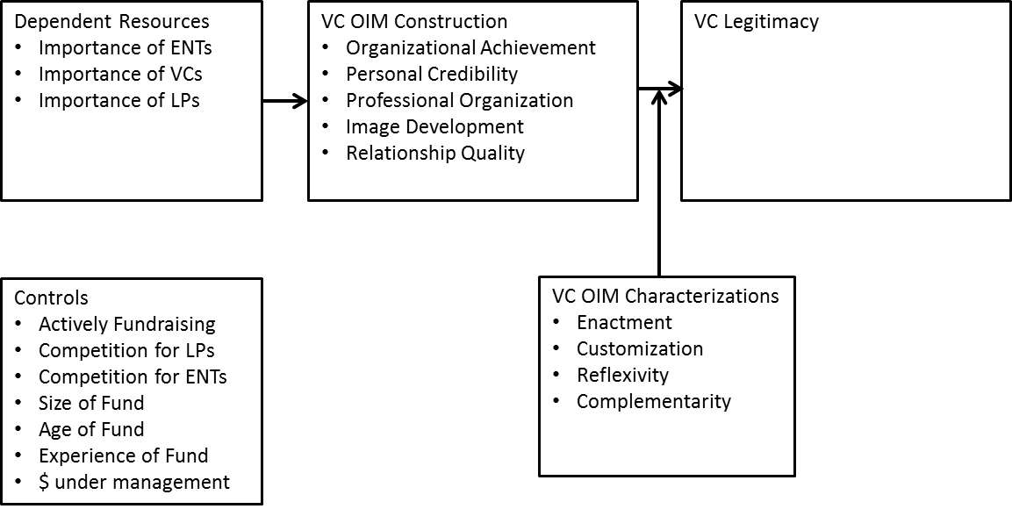

CHAPTER THREE
METHODS

This chapter focuses on introducing the methods used to test the research model and hypotheses developed in chapter two. First this section describes the following: 1) the method used to survey the VC community, 2) the source of the database used to acquire VC contact information, 3) the questionnaire used to gather data and also the procedures to maximize reliability and validity, and 4) the details on the chosen methods for testing the hypotheses and research model using OLS regression.
This research project used a survey to test the hypotheses. Survey research is a valuable and valid strategy for conducting research on strategy-related issues (Slater and Atuahene-Gima, 2004). In fact, in many cases, survey research is the only suitable means for collecting data on constructs of interest (Slater and Atuahene-Gima, 2004). However, there are numerous challenges to conducting high quality survey research such as response rate, validity and reliability (Slater and Atuahene-Gima, 2004). The survey was conducted on-line via Qualtrics. VCs were be contacted directly via Qualtrics. Access to the data is password controlled. All survey data is electronic form. Identifiers were kept separately.

Survey Development
To gather the data for testing the hypotheses the VC community was surveyed via email. The survey was developed after a series of primary interviews with venture capitalists. Using an existing network of University of Oklahoma alumni who invest in early stage ventures and who are venture capitalists, this investigator gained access to and contacted 20 successful VCs across the country. The geographic distribution was coupled with industry distribution, for example, VCs in health care, mobile, software and hardware were all included in the discussions. During telephone conversations, VCs were asked a basic question: “why are some VCs more successful than others?” Their responses yielded insight into the key success factors of venture investing, the capabilities and resources needed to be successful and areas of competitive advantage. From those interviews, and articles in the popular press, research questions were developed. Once the research questions were established, the investigator developed a survey that would help answer the research questions. Second, the investigator asked known VCs to review the survey. Once the survey was developed and based upon the feedback from the same VCs interviewed earlier, additional input was gathered from the dissertation committee regarding the theoretical and methodological validity of my survey. The full survey is located in APPENDIX C.

Participant Recruitment
The database used for contact information to recruit survey participants was the United States Venture Capital and Private Equity Database, the most comprehensive compilation of capital sources available. The Directory profiles investment firms in all 50 states, and represents a single, complete, authoritative source profiling nearly 4,000 private capital sources. The database is used by Venture Capitalists and Private Equity (PE) professionals looking to network, service providers (such as law firms, accounting firms and executive recruiters) who regularly do business with PE firms, VCs and emerging companies, plus entrepreneurs eager for a complete guide to the investors who can fund business plans. The 2013 Directory includes Online Database access. The cost for the contact information data was $595.
Once the survey was finalized, using regular post, on March 1, 2014, the investigator notified the VC community that in 3 weeks they were going to receive a survey via email. Two weeks later, a second notification was sent, via regular post, notifying the VC community that they will receive a survey via email in one week. Both letters can be found in APPENDIX A. An email was sent on March 20 to all VCs directing them to the survey, via link, and asking them to participate. Two additional reminder emails were sent on April 3 and April 17 to VCs who had not previously responded reminding them of the survey and linking them to the survey. All three emails can be found in APPENDIX B. The emails remained basically the same with the exception of the link to the survey. Some participants had difficulty identifying the survey link from the first email so the link to the survey was moved up.
The recruitment of participants, to take the survey to test the hypotheses of this dissertation, followed the process recommended by Dillman (2000: 151): 1) a brief pre-notification letter alerting respondents that an important survey will be arriving in a few days via email and that the individual’s response will be greatly appreciated, 2) the questionnaire emailed that included a detailed introduction note explaining the importance of the response, 3) a second letter sent reminding respondents that they received a survey via email and will receive a second email reminding them of the survey has yet to be completed, 4) a reminder email sent 14 days after first email with a link to the survey, 5) a final contact that may be made 28 days after the first email reminding the respondent that their survey is still available and will be for seven more days, 6) an email response sent thanking the respondents for their help upon completion. The survey was closed on April 23, 2014.
The structure of the email and the survey link followed Dillman’s (2000) recommendations for emailed surveys: 1) Personalized e-mail contacts, 2) subject line that indicates the topic; “Survey of Venture Capitalists,” 3) where their email address was found: “United States Venture Capital and Private Equity Database,” 4) state that responses are anonymous, no personal and identifiable information will be shared with the public, 5) individuals and/or organization conducting the research: “I am the Executive Director of the Center for Entrepreneurship at the University of Oklahoma,” 6) what the research results will be used for and who will receive the data: “dissertation topic and share with the general public,” 7) a brief description of the topic: “We are interested in VC branding motivation and activities,” 8) the approximate time required to complete the questionnaire: “This survey should take no more than 20 minutes of your time,” 9) a description of the incentive: “Every response will cause $25 donation to the Plaza Towers Elementary School Disaster Fund,” 10) effort was made to create an interesting but simple-to-answer question to begin the survey, 11) the survey link was available, 12) valid contact information for the researcher was provided, and 13) multiple contacts with the respondent.
Construct Validity
Constructs are concepts that have been purposely created for a special scientific purpose (Kerlinger, 1973). In the context of survey research, a construct is the abstract idea, underlying theme, or subject matter that one wishes to measure using survey questions. Some constructs are relatively simple (like political party affiliation) and can be measured using only one or a few questions, while other constructs are more complex (such as employee satisfaction) and may require a whole battery of questions to fully operationalize the construct to suit the end user's needs. Complex constructs contain multiple dimensions or facets that are bound together by some commonality that, as a whole, compose the construct (Kerlinger, 1973).
A good measure must be both valid and reliable. Reliability is a necessary but not sufficient condition for validity (Nunnally, 1967: 173). A measure is valid when differences in observed scores reflect true differences on the characteristic being measured and nothing else (Slater and Atuahene-Gima, 2004). Three dimensions of validity were considered for this dissertation: content validity, convergent validity, and discriminant validity. A measure is reliable when there is negligible measurement error in the measuring instrument (e.g. Churchill, 1979; Hinkin, 1995; Kerlinger, 1973). Since reliability is a prerequisite for validity, “Coefficient alpha absolutely (author’s emphasis) should be the first measure one calculates to assess the quality of the instrument” (Churchill, 1979: 68). The square root of coefficient alpha is the estimated correlation of the k-item test with errorless true scores (Nunnally, 1967). Nunnally (1967) first recommended a minimum acceptable standard of 0.6 for alpha but later (1978) changed it to 0.7 without explanation. Many strategy studies report use of scales with alphas less than 0.7 and sometimes less than 0.6 (Slater and Atuahene-Gima, 2004). An alpha of 0.7 is equivalent to a correlation between the scale and the “true” test score of 0.84 where the corresponding correlation for an alpha of 0.6 is 0.77 (Slater and Atuahene-Gima, 2004). “Researchers should strive for alphas of 0.7 or greater since the main reason to seek reliable measures is that estimated relationships are attenuated to the extent that the variables are measured unreliably; with measures of reliability, one can assess the degree of attenuation” (Slater and Atuahene-Gima, 2004: 228).
There are two basic approaches to specifying the domain of the construct, deductive and inductive approaches (Slater and Atuahene-Gima, 2004). The deductive approach requires a thorough review of the relevant literature to develop a theoretical definition of the construct. This definition is then used as a guide for item development. Reviewing OIM, IM, RDP and VC, constructs and items were developed for this study.
Once the construct was defined and its domain specified, attention turned to generating items that encompass the domain of the construct. Techniques for accomplishing this included literature reviews, critical incidents where several scenarios describing specific situations are developed and a sample of VCs was asked how they would respond to the situation (Slater and Atuahene-Gima, 2004). The items have slightly different shades of meaning; seeming identical statements can produce quite different responses (Churchill, 1979).
Another issue considered at this was the number of items in the measure. Scales with too few items may not achieve internal consistency or construct validity (Slater and Atuahene-Gima, 2004). However, scales with excessive items may induce respondent fatigue and response bias. In his review of studies that utilize survey data and that were published in leading management journals, Hinkin (1995) found that 50% of the scales in these studies had 3–5 items. Three to five items were designed for each construct.
After generating a sample of items that covers the domain of the construct, the measure was purified. This was done via a pretest in the context of the full study. A pretest is useful in that it provides the opportunity for representative respondents not only to complete the questionnaire but also to comment on the clarity of the items in the scales (Slater and Atuahene-Gima, 2004). For this dissertation, four VCs were asked to take the survey and responded to its ability to accurately, in their opinion, measure and describe the construct. Each took the survey and provided feedback. If additional feedback was required after subsequent alterations, the investigator made additional calls to the VCs until the questions satisfied their understanding of the construct.
Common Method Variance
This dissertation considered common method variance (CMV) because it involves examining the relationships among two or more self-reported measures of constructs of interest (Slater and Atuahene-Gima, 2004). There is the possibility that relationships among variables may be inflated for a number of reasons that we will shortly enumerate. As outgoing editor of the Journal of Applied Psychology, Campbell (1982: 692) wrote, “If there is no evident construct validity for the questionnaire measure or no variables that are measured independently of the questionnaire, I am biased against the study and believe that it contributes very little.” CMV has the potential to produce spurious results.
Generally speaking, the two primary ways to control for method biases are through (a) the design of the study’s procedures and/or (b) statistical controls (Podsakoff et al., 2003). The connection between the predictor and criterion variable may come from (a) the respondent, (b) contextual cues present in the measurement environment or within the questionnaire itself, and/or (c) the specific wording and format of the questions (Podsakoff et al., 2003).
To control for CMV via the study’s procedure, the investigator followed the processes recommended by Nunnally and Bernstein (1994) and Spector and Brannick (1995) by: 1) avoiding any implication that there is preferred response, 2) making responses to all items of equal effort, 3) paying close attention to details of item wording, 4) using items that are less subject to bias, 5) keeping the questionnaire as short as possible, without impacting research objectives, to minimize respondent fatigue, 6) providing clear instructions to the participant, and 7) randomizing the ordering of scale items.
Because one of the major causes of common method variance is obtaining the measures of both predictor and criterion variables from the same rater or source, one way of controlling for it is to collect the measures of these variables from different sources (Podsakoff et al., 2003). However, despite the obvious advantages of this approach, it is not feasible to use in all cases (Podsakoff et al., 2003). For example, researchers examining the relationships between two or more employee job attitudes cannot obtain measures of these constructs from alternative sources (Podsakoff et al., 2003). Similarly, it may not be possible to obtain archival data or to obtain archival data that adequately represent one of the constructs of interest (Podsakoff et al., 2003). Another problem is that because the data come from different sources, it must be linked together. This requires an identifying variable (e.g., such as the supervisor’s and subordinate’s names) that could compromise the anonymity of the respondents and reduce their willingness to participate or change the nature of their responses (Podsakoff et al., 2003). In addition, it can also result in the loss of information when data on both the predictor and criterion variables are not obtained (Podsakoff et al., 2003). For this dissertation, it was determined that archival data was insufficient to answer the research questions (Podsakoff et al., 2003). Additionally, due to the examination of multiple relationships between attitudes and actions, measures of the constructs could not be developed from alternative sources (Podsakoff et al., 2003).
There are several additional procedures that can be used to reduce method biases, especially at the response editing or reporting stage. Following Podsakoff et al., (2003), this dissertation allowed the respondents’ answers to be anonymous and assured respondents that there are no right or wrong answers and those participants should answer questions as honestly as possible. These procedures should reduce people’s evaluation apprehension and make them less likely to edit their responses to be more socially desirable, lenient, acquiescent, and consistent with how they think the researcher wants them to respond (Podsakoff et al., 2003). Another remedy used to control for priming effects, item-context-induced mood states, and other biases related to the question context or item embeddedness was to counterbalance the order of the measurement of the predictor and criterion variables (Podsakoff et al., 2003).
Moving beyond issues of the source and context of measurement, it is also possible to reduce method biases through the careful construction of the items themselves (Podsakoff et al., 2003). By following Tourangeau et al. (2000) to reduce item ambiguity, this dissertation: 1) defined ambiguous or unfamiliar terms, 2) avoided vague concepts and provide examples when such concepts must be used, 3) kept questions simple, specific, and concise, 4) avoided double-barreled questions, 5) decomposed questions relating to more than one possibility into simpler, more focused questions and 6) avoided complicated syntax. Podsakoff et al., (2003) cautions researchers to be careful not to sacrifice scale validity for the sake of reducing common method biases when altering the scale formats, anchors, and scale values. Therefore, although the survey was longer than planned, due to the busy nature of VCs (Gompers and Learner, 2001), ultimately the decision was made to lengthen the survey to control for CMV.
For this dissertation, the concern for CMV was due to the outcome variable originally proposed. The outcome items were to be based on a series of questions that asked the respondent their opinions on how others perceived them. For example: 1) other venture capitalists seek my/our opinion regularly, 2) other limited partners seek my/our opinion regularly, 3) other entrepreneurs outside of our portfolio of companies seek my/our opinion regularly, 4) I/we have a positive image with potential portfolio companies, 5) I/we have a positive image with entrepreneurs and 6) I/we have a positive image with current and potential Limited Partners. However, the originally conceived outcome variables were insufficient to the investigator.
At that point, using connections within the VC community, the investigator talked with several VCs and asked a very simple question: “If I don’t have access to VC returns, how can I determine legitimacy?” A series of discussion and questions and answer sessions with several VCs uncovered some very interesting criteria that might determine legitimacy. After several pilot tests, the investigator added new questions to the yet-to-be-distributed survey. The questions were designed to eliminate opinion and focus on activities. This was a strategy suggested by Podsakoff et al. (2012). When reviewing the Podsakoff et al., (2012) paper regarding common method and how to control it, they suggest three questions the researcher should address in determining method bias. First, are respondents able to provide accurate answers? Using yes or no questions rather than Likert response helps clarify the question. Additionally, the questions are not opinion based. The questions simply ask if the VC had participating in certain activities. Second, are the respondents motivated to provide accurate answers? Specifically, the more serious the social consequences of a particular response, the stronger a respondents desire to provide socially acceptable responses. The questions do not have responses that are have socially acceptable consequences. However, it is possible that the respondent, if legitimacy is determined from the questionnaire and is sought by the respondent, may seek to lie on the yes or no questions so as to appear to be more legitimate. However, although the VC industry is a professional organization (Gompers and Learner, 2001), coupled with the unlikelihood of lying and completing the survey, CMV is still possible and potential problematic. Third, are the questions ambiguous? Given the yes or no nature of the response, the accuracy of the respondent is reduced as compared to opinion or motivation questions. The likelihood of response consistency is increased. Part of the reason for the lack of concern about lying is that theoretically, the respondents could be verified for accuracy. Are they really member, have the really presented to corporate partners and did they really attend a top-tier investment banking conference? Although the ability to verify the responses is virtually zero, the slim possibility exists, and therefore could encourage honest responses. Three questions were asked to determine legitimacy: 1) Are you a member of the NAVC, 2) Have you presented at a corporate partners conference and 3) have you been invited to a top investment banker conference.
In additional to addressing CMV with study design using fact-based outcome variables, this dissertation also used a statistical method to address for CMV. The marker variable technique is used to identify CMV (Podsakoff et al., 2003; Williams, Hartman and Cavazotte, 2010). To address some of the problems with the correlation-based marker variable technique, Williams et al. (2010) recommend using a series of marker variables that share measurement characteristics with the substantive variables of interest as indicators of a latent method factor. Following their recommendations, the survey included marker variable questions that were unrelated to the research project.
This method takes advantage of a special marker-variable that is deliberately prepared and incorporated into a survey questionnaire along with the research variables of interest. In this approach, a marker-variable is implemented such that the marker-variable is theoretically unrelated to the research variables. As the marker-variable is assumed to have no relationship with the research variables, CMV can be assessed based on the correlation between the marker-variable and the indicators of interest (Malhotra et al., 2006). This dissertation added a marker-variable by including questions that ask participants to respond to: 1) I like watching football games on TV, 2) I try to attend football games and 3) Football is my favorite sport.
A three-phase confirmatory factor analysis (CFA) marker technique to identify method biases was used. Williams et al. (2010) identified several advantages of this approach over the partial correlation approach proposed by Lindell and Whitney (2001). First, it models the effects of method biases at the indicator level (rather than construct level). Second, it provides a statistical test of method bias based on model comparisons. Third, it permits a test of whether method biases affect all measures equally or differentially.
When this research proposal was presented to the investigator’s dissertation committee, there was concern with common method bias – predictor and outcome variables from the same source. Using data only from a single source, a survey could be problematic (Podsakoff et al., 2012). It was suggested that control variables from another source be included in the analysis. The VC reputation index (Lee, Pollock and Jin, 2011) was discussed and suggested. It uses six variables: 1) Average of the total dollar amount of funds under management over the prior five years, 2) Average of the number of investment funds under management in the prior five years, 3) Number of start-ups invested in over the prior five years, 4) Total dollar amount of funds invested in start-ups over the prior five years, 5) Number of companies taken public in the prior five years and 6) VC firm age (current year), to determine the reputation for the reputation of a VC firm. Unfortunately, although I had used the index before, the data is only available up until 2010. Given the fact that this project was current, 2014, and the fact that the index reviews 5 previous years’ activities, its relevance as a control was not going to be accurate. The time difference between a trailing five-year-average ending 2010 used for a 2014 OIM study caused concern. Additionally, based on previous use of the VC index, the investigator’s experience is that the number of firms covered is not comprehensive. For the study in which the data set was used previously, approximately 35% of the observations were missing a VC reputation index. In discussion with Dr. Tim Pollock, it was suggested, as a solution to missing data, that the investigator assign the missing data the lowest index rating due to the likelihood of oversight based on size rather than performance. Assigning the lowest index to missing VC firms was not a sufficient solution for this dissertation when combined with the time difference. Finally, when reviewing the contents of the index, the investigator discovered that four of the six included variables were data available from this dissertation’s questionnaire: 1) total dollar amount of funds under management, 2) average of the number of investment funds under management in the past, 3) total dollar amount of funds invested in start-ups over the prior five years, 4) VC firm age. The survey did not include: 1) number of start-ups invested in over the prior five years and 2) number of companies taken public in the prior five years, both are a part of the VC reputation index. Therefore, after recognizing the limitation of its use due to missing data and given, the fact that the trailing five-year-average ends in 2010, and similarity in variables, the investigator determined that use of the VC index as a control would not be appropriate.

Measures
VCs want to be known as industry creators and innovation enablers (Megginson and Weiss, 1991; Stuart et al., 1999; Anand and Piskorski, 2000). While VCs will be motivated to manage impressions in order to gain legitimacy and thrive by acquiring resources, impression management motivation is likely to be even stronger in certain situations. VCs interact with the environment in several ways via their portfolio companies such as their competition within their portfolio company’s industry, the portfolio company’s effort in creating a new industry, the capital markets for a portfolio company’s harvest, and the overall performance of the VC industry (Gompers and Learner, 2001; Barney, 1991; Eisenhardt and Martin, 2000; Porter, 1985). The following dependent, independent and control variables were used for this research project.
Dependent Variable
For the dependent variable this study used a uniquely constructed variable to determine legitimacy. Inspired by the seminal work of Singh, Tucker, House (1986), this study used a similar determination of legitimacy. Rather than a directory listing, the issuance of a charitable registration and size of board of directors all with 0 or 1 variables summed, as is the case with Singh, Tucker and House (1986), this study used industry relevant data for the dependent variable. Specifically, this study identified three variables demonstrating legitimacy and coded them 0 or 1 based on inclusion or not. First, membership in the National Venture Capital Association (NVCA) was coded yes = 1, no = 0. NVCA is open by invitation only to all professional venture capital or private equity organizations and corporate venture capital investors who are responsible for investing risk capital in developing companies or industries on a professional basis. Members must be actively engaged in private equity investing on a cash-for-equity basis. Further, they must invest from a dedicated pool of capital that has been allocated for the purpose of venture capital or private equity investments. The member firm must have at least $5 million under management for the sole purpose of private equity investing. The organization must employ a professional staff consisting of at least one full-time employee or full-time equivalent whose sole professional activity is direct private equity investing. Members must utilize a professional approach before and after they make an investment, including the maintenance of a continued interest in the companies they sponsor. A member’s business must be operated out of an office located in the United States. The managers of the business must be U.S. citizens or resident aliens.
Members’ business must be subject to U.S. taxation and laws. Renewal of Annual Membership in NVCA is subject to review and approval by the Membership Committee and continued compliance with the criteria above.
Second, presenting at a corporate partner conference was coded yes = 1, no = 0. Corporate partner associations establish valuable corporate connections that lead to joint ventures to shape new markets (Maula et al., 2006), potential harvest options for portfolio companies (Benson and Ziedonis, 2004), and accelerated market entry and development (Kann, 2000). By establishing these relationships, VCs enhance their ability to create valuable alliances (McNally, 1994). If a VC were to make a presentation at a conference sponsored or supported by corporate venturing, enhanced legitimacy would be attained.
Third, an invitation to a top investment banking conference would demonstrate established legitimacy with valuable Wall Street partners (Megginson and Weis, 1991). Based on annual revenue, this study listed the top 10 investment banks. Participants were asked to check all the banks who invited the VC to an investment bank sponsored event or conference.
These three measures constituted the dependent variable. A maximum score of 3 was awarded to VCs who replied yes to each of the three questions and a score of 0 was awarded to VCs who replied no to each question.
Independent Variables, mediators and conditional effects (moderators of the mediators) are categorized by: 1) resources for which VC success is posited, 2) the mediation of VC OIM image development and construction and 3) the conditional effects of VC OIM image characterizations.
Independent Variables
Importance of Entrepreneurs was measured using the following questions: 1) Portfolio companies are critical to our firm's success, 2) Our firm's success depends entirely on portfolio companies and 3) A critical function of our firm is to invest in outstanding portfolio companies.
Importance of Limited Partners was measured using the following three questions: 1) Fund raising is critical to our firm's success, 2) Our firm's success depends entirely on our ability to secure Limited Partners and 3) A critical function of our firm is to secure Limited Partners.
Importance of other VCs was measured using the following three questions: 1) Syndication is critical to our firm's success, 2) Our firm's success depends entirely on syndication and 3) A critical function of our firm is to participate in syndication opportunities
Mediators
Image development was measured using the following two questions: 1) I engage in activities to develop my/our image and 2) I spend a lot of time building my/our image.
Personal credibility was measured using the following six questions: 1) I convey my/our educational background to Limited Partners, 2) I convey my/our educational background to Entrepreneurs, 3) I convey my/our work experience to Limited Partners, 4) I convey my/our work experience to Entrepreneurs, 5) I try to make sure that Limited Partners believe in my/our personal credibility, 6) I try to make sure that Entrepreneurs believe in my/our personal credibility.
Professional organization was measured using the following three questions: 1) I treat Entrepreneurs with respect, 2) I treat Limited Partnerships with respect and 3) I treat other Venture Capitalists with respect.
Organizational achievement was measured using the following five questions: 1) I make sure Limited Partners are aware of our past successes, 2) I make sure Entrepreneurs are aware of our past successes, 3) I talk about and promote recent successes, 4) I make sure that Limited Partnerships know about my/our organizational achievements, 5) I make sure that Entrepreneurs know about my/our organizational achievements.
Stakeholder relationship quality was measured using the following three questions: 1) I spend a lot of time developing close, high-quality relationships with our Limited Partners, 2) I spend a lot of time developing close, high-quality relationships with our portfolio companies and 3) I spend a lot of time developing close, high-quality relationships with other Venture Capitalists.
Conditional Effects
Reflexivity was measured using the following three questions: 1) I signal to Entrepreneurs my/our abilities, 2) I signal to Limited Partners my/our abilities and 3) I let others know about my/our abilities.
Enactment was measured using the following three questions: 1) I am responsive to the behavior and actions expected of me, 2) I am responsive to the behavior and actions Limited Partners expect of me and 3) I am responsive to the behavior and actions Entrepreneurs expect of me.
Customization was measured using the following three questions: 1) I dress and act a certain way when visiting with Entrepreneurs, 2) I dress and act a certain way when visiting with Limited Partners and 3) I dress and act differently when professional environments change.
Complementarity was measured using the following three questions: 1) I adapt or customize my actions and behaviors to the target, 2) My image is the same regardless of the audience and 3) I always present myself/my firm in a consistent way to different stakeholders.
Controls
Numerous extraneous factors may influence long-term VC status. Using Busenitz et al. (2004), this dissertation controlled for firm level factors. First, currently fundraising activities was used to control for activities related to some firms who are raising a fund to those who are not currently fundraising LPs: “Our firm is currently raising a new fund”. Using this response as a control variable helped to isolate current activities of raising a fund compared to overall resource dependence of limited partners. Second, competition was measured with two variables: 1) competition for Limited Partners by asking: “Increasingly, our firm must compete for limited partner funding” and 2) competition for investment opportunities by asking: “Increasingly, our firm must compete for investment opportunities”. Again, these questions were asked to isolate current activities compared to general attitudes and beliefs of resource dependence on LPs and entrepreneurs. Third, this dissertation controlled for size of the firm by asking participants “The number of general partners in our firm is?” This was done to reduce and control for bias related to size advantages or disadvantages. Fourth, the age of the firm was controlled for by asking: “Our firm is ___ years old” and also by asking: “We are currently investing fund number ___” in the survey. Age was controlled for similar to number of partners, isolating experience as tactic to overcome resource dependence. Fifth, I controlled for size of the fund by asking “Our latest fund size is___.” Again, this control was included to isolate advantages or disadvantages realized by VCs due to the size of the fund that might be used to reduce resource dependence.
Analysis Methods
All hypotheses were tested using OLS regression in SPSS. The fully mediated models were tested using the Hayes Macro (Hayes, 2013). Hayes (2012) provides background on mediation, moderation, SPSS Process, when it works, and why it is a preferred statistical package. Analytically, questions of “how” are typically approached using process or mediation analysis (e.g., Baron and Kenny, 1986; Judd and Kenny, 1981; MacKinnon, Fairchild, and Fritz, 2007a), whereas questions of “when” are most often answered through moderation analysis (e.g., Aiken and West, 1991; Jaccard and Turrisi, 2003). The goal of mediation analysis is to establish the extent to which some putative causal variable X influences some outcome Y through one or more mediator variables.
“Statistical mediation and moderation analysis are widespread throughout the behavioral sciences. Increasingly, these methods are being integrated in the form of the analysis of “mediated moderation” or “moderated mediation,” or what Hayes and Preacher (in press) call conditional process modeling. Recently, methodologists have come to appreciate than an analysis that focuses on answering only “how” or “when” but not both is going to be incomplete. Although the value of combining moderation and mediation analytically was highlighted in some of the earliest work on mediation analysis, it is only in the last 10 years or so that methodologists have begun to publish more extensively on how to do so, at least in theory. Described using such terms as moderated mediation, mediated moderation, or conditional process modeling the goal is to quantify empirically and test hypotheses about the contingent nature of the mechanisms by which X exerts its influence on Y.
Mediation and moderation analyses can be combined through the construction and estimation of what Hayes and Preacher (in press) call a conditional process model. Such a model allows the direct and/or indirect effects of an independent variable X on a dependent variable Y through one or more mediators (M) to be moderated. When there is evidence of the moderation of the effect of X on M, the effect of M on Y, or both, estimation of and inference about what Preacher, Rucker, and Hayes (2007) coined the conditional indirect effect of X gives the analyst insight into the contingent nature of the independent variable’s effect on the dependent variable through the mediator(s), depending on the moderator. Such a process is often called moderated mediation, because the indirect effect or “mechanism” pathway through which X exerts it effect on Y is dependent on the value of a moderator or moderators. The statistical model requires three equations to estimate the effects of X on Y:
M1 = iM1 + a1 X + eM1

M2 = iM2 + a2 X + eM2

Y = iY + c′1X + b1M1 + b2M2 + b3V + b4VM1 + b5VM2 + e Y

The direct effect of X on Y is simply c′1, whereas the specific indirect effects of X on Y are conditional and depend on V. The conditional specific indirect effect of X on Y through M1 is estimated as the product of the unconditional effect of X on M1 and the conditional effect of M1 on Y, or a1(b1 + b4V). The conditional specific indirect effect through M2 is derived similarly as the product of the unconditional effect of X on M2 and the conditional effect of M2 on Y, or a2(b2 + b5V).
Most statistical software that is widely used by behavioral scientists does not implement the methods that are currently being advocated for modern mediation and moderation analysis plus their integration; at least not without the analyst having to engage in various variable transformations and to write code customized to their data and problem. Such a process can be laborious and difficult to do correctly without intimate familiarity with those methods. In the hopes of facilitating the wide-spread adoption of the latest techniques, methodologists have developed and published various computational tools in the form “macros” or “packages” for popular and readily-available statistical software such as SPSS, SAS and, more recently, PROCESS, a versatile modeling tool freely-available for SPSS and SAS that integrates many of the functions of existing and popular published statistical tools for mediation and moderation analysis as well as their integration.”

CHAPTER FOUR
RESULTS
Following the collection of the data specified in Chapter Three, this dissertation conducted a number of analyses to ensure the appropriateness of the data and to test the hypotheses. The following discussion describes the data analysis methods and the results of the analysis.
The survey was sent to 5,689 potential participants. This number represented to population of early stage investors in the United States. Of the 5,689 emails sent, 1,778 individuals opened the email (31%). For those who opened the email, 605 started the survey (34%). For those who started the survey, 369 actually completed the survey (60%). The investigator closed the survey on April 23, 2014.
Ultimately, the data yielded on N of 165 cases. The primary reason for lost cases was missing data and/or participant responses outside of the research scope. Of the 369 completed survey respondents, 175 were lost to missing data (47%). Of the remaining 194 cases, an additional 29 cases were lost due to investor profile. Specifically, after reviewing the website of each of the remaining 194 cases, it was determined that 29 of the 194 cases were “angel investors” or community development funds. Additionally, if a participant answered the investment strategy question: “Our firm prefers to invest in companies that are: 1) seed, 2) early stage, 3) expansion, 4) late or 5) growth without selecting the “seed” or “early stage” category, the case was removed. These removals were made because, for this study, the research questions required traditional venture capitalists that have Limited Partners. Therefore, if the respondent was an “angel investor,” (high net worth investors who invest their own funds), or a community development fund (funding provided by state tax dollars), the relationship between the VC and the LP could not be studied, because those capital providers do not have LPs. Therefore, once it was discovered that some of the respondents were either “angel investors” or community development funds, it was determined that each case was going to have to be reviewed individually via an Internet search to determine source of funding.
The initial discovery of non-LP funded VCs was made by reviewing the email address of the respondents. After observing several emails with an “.edu” or “.org” ending, it was determined that a more thorough investigation was required. Additionally, during the survey process, several emails were received from participants questioning their participation. The emails would state that after starting the survey, the participant stopped before completion because the questions related to LPs did not pertain to them. The respondents believed, rightfully so, that their organization was outside the scope of the research. Therefore, each of the 194 cases was reviewed at after close examination of the website, specifically, the reviewing of investment strategy of source of funds, it was determined that 29 of the 194 cases would not be useful in answering the proposed research questions.
The survey was designed to create several constructs that would test the proposed research questions. A factor analysis was the first multivariate technique used because it can play a unique role in the application of other multivariate techniques (Hair, 2005). Broadly speaking, factor analysis provides the tools for analyzing the structure of the interrelationships (correlations) among a large number of variables (e.g., test scores, test items, questionnaire responses) by defining sets of variables that are highly correlated, known as factors (Hair, 2005). The primary purpose of using factor analysis is to define the underlying structure among variables in the analysis (Hair, 2005). For this research project, a principal component analysis was conducted on the 28 items with oblique rotation (Oblimin) to identify the structure of the data set as well as provide a process for data reduction (Hair, 2005). The Kaiser-Meyer-Oklin measure verified for the sampling adequacy, KMO = .72, which is above the acceptable limit of .5 (Field, 2009). Bartlett’s test of sphericity Χ² (378) = 2030.895, p < .001, indicating that correlations between items were sufficiently large for PCA (Hair, 2005). An initial analysis was run to obtain eigenvalues for each component of the data. Nine components had eigenvalues over Kaiser’s criterion of 1 and in combination explained 70.78% of the variance (Appendix D for scree chart). Dropping cross-loaded questions and rotating the data using Oblique rotation (oblimin), resulted in nine factors with all loadings were greater than .49. Table 1 below shows factor loadings after rotation. To measure reliability, Cronbach’s α was equal to or greater than .612 for all factors. Table 1 below provides the Cronbach’s α for each construct. Additionally, the loading for each factor is also provided in Table 1.
A confirmatory factor analysis (CFA) provided a more rigorous test of unidimensionality (Slater and Atuahene-Gima, 2004). Three fit indices – the comparative fit index (CFI), incremental fit index (IFI), and non-normed fit index fit (NNFI) – are critically examined as part of this analysis (Slater and Atuahene-Gima, 2004). Each should have a value greater than 0.90 to demonstrate a good fit of the model to the data (Slater and Atuahene-Gima, 2004). However, high fit indices may give a false impression that the model explains much of the data when the high fit really is the result of freeing more parameters to be estimated from the data (Slater and Atuahene-Gima, 2004). Hence, a more useful index to consider is the root mean square of approximation (RMSEA) which is a parsimony index that accounts for potential artificial inflation due to the estimation of many parameters (Slater and Atuahene-Gima, 2004).
The investigator performed a confirmatory factor analysis in SPSS Amos. Results for the CFA are X² of 564.1 and 309 df, P = .000, an RMSEA .071 within the acceptable range (Hair, 2005), the GFI .819 was somewhat lower than desired and CFI .857 also was lower than desired (Hair, 2005). The CFI value is somewhat short of the .90 or .95 values often suggested, and this may in part reflect the relatively large number of indicators (28) for the variables and the resulting number of constraint parameters in the factor loading matrix (Hair, 2005; Williams et al., 2010). This limitation is addressed later in the Discussion section of the dissertation.
Table 1: Factor Loading Results of PCA
Ultimately it was determined that the data was unable to sufficiently capture and measure “stakeholder relationship quality”, “reflexivity” and “complementarity”. Even though three items were designed for each construct, no two items loaded on the same factor. The questions designed to measure each of the three constructs cross-loaded on multiple factors. This was probably due to limited construct validity and will be discussed in the limitations section of this dissertation. Therefore those constructs were dropped from the research model. The resulting research model was the following:

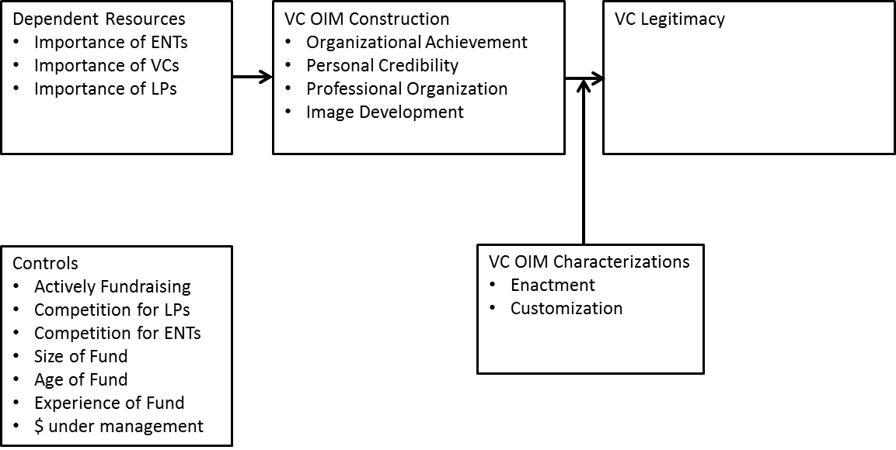

Using Podsakoff (2003) and Williams et al., (2010) as a guide, the following steps were taken to determine the effect of CMV. This study did not find any significantly correlation between the marker-variable and the nine indicators. First, using the CFA analysis of the nine factor model, a latent variable was created. The latent variable was used to determine common variance among the observed variables in the model. Paths were from the latent variable to each variable. The paths were constrained so as to determine common variance among the variables using the latent variable. Results for the analysis indicated the common variance was 6.7%, Χ² = 643, df = 313. Next a marker factor variable was created using the three football questions variables. Regression paths were estimated between the latent variable and the marker variable. The paths were fixed at the same level as between the latent variable and the nine factors. Next, covariances between the football factor and the nine factors were estimated. Results for the analysis indicated that common variance dropped slightly to 6.01%, Χ² = 702, df = 388. Based on the results of the analysis, common method bias was rather limited in this research project. Additionally, when the statistical analysis is reviewed in conjunction with the survey procedural remedies (Podsakoff et al., 2012) common method bias appears to be minimal.
Descriptive statistics, located in Table 2 below, were used to help ensure the factors met the major assumptions of multiple regression; independence of independent variables, equality of variance and normal distribution. Histograms are included in appendix E. The descriptive statistics are below. Histograms, in conjunction with descriptive statistics were used to determine what if any transformations were needed. In general, skewness and kurtosis scores that are within the range of ± 2.00 indicates a broad and near enough to a normal distribution (Field, 2005) to not introduce error into analyses. While a few of the scale scores modestly exceed this heuristic, ultimately it was determined that the use of data transformation was not needed.
Table 2: Descriptive Statistics
In addition to analyzing the descriptive statistics of the variables, it is important to carefully review the correlation matrix. Multicollinearity can be problematic in creating false significance in regression results as it destabilizes the regression (Hair, 2005). Table 3, the correlation matrix of for all control, independent, and dependent variables is below. During the post-hoc analysis, the VIF for all variables in all models was less than 1.270 for all independent variables and also for all interactions.

Table 3: Correlation Matrix

To test H1 to H4, the direct and moderating effects, OLS regression in SPSS was used. Results of the regression analysis are located below in Table 4 (for H1), Table 5 (for H2), Table 6 (for H3) and Table 7 (for H4).

Table 4: H1 Results
Regression results for H1 (Dependent Resources on VC OIM Construction) found a significant relationship for H1c, importance of entrepreneurs to signaling professional organization. However, it was negative, β = -.16, ρ < .05. All other hypotheses were not supported.

Table 5 – H2 Results

Regression results for H2 (VC OIM Construction on VC Legitimacy) found no support for all hypotheses.

Table 6a – H3a Results

Regression results for H3a (VC OIM Construction moderated by VC OIM Characterization Enactment on VC Legitimacy) found no support for any hypothesis.

Table 6a – H3a Results

Regression results for H3b (VC OIM Construction moderated by VC OIM Characterization Customization on VC Legitimacy) found a significant relationship with H3biv, but the relationship was negative. The customization of image develop decreases the likelihood of legitimacy, β = -.13, ρ < .05. The analysis found no support for the remaining H3b hypotheses.

Table 6a – H4 Results

Regression results for H4 (Dependent Resources on Legitimacy) found support for H4b, importance of VCs relates positively to increased legitimacy, β = .21, ρ < .05. H4a and H4c were not supported.
Because the research model represents a conditional process model (Hayes and Preacher, 2013), the fully mediated hypotheses (H5 to H9) were tested using the PROCESS SPSS application (Model 14) provided by Hayes (2013) with bias corrected bootstrap confidence intervals of 1000. This application allows for the testing of conditional effects using a bootstrapping procedure that addresses potential concerns with normality of the distribution of the indirect effect (MacKinnon, Lockwood and Williams, 2004).
The Process Macro can test the effects of up to ten mediators, up to four moderated mediators on a single dependent variable. This research project has three independent variables (Importance of Entrepreneurs, Importance of other VCs and Importance of LPs), four moderators (Organizational Achievement, Personal Credibility, Professional Organization and Image Development), two moderated mediators (Enactment and Customization) and one dependent variable (Legitimacy). To test all hypotheses, six models were used. Three dependent variables times two moderated mediators equals six total models used to test all hypotheses. Each model included the seven control variables (Actively Fundraising, Competition for LPs, Competition for ENTs, Size of Fund, Age of Fund, Experience of Fund and dollars under management). Model 1 and Model 2 used the dependent variable of Importance of Entrepreneurs (Process output located in APPENDIX F, Table 10 and 11) and moderating mediators of customization and enactment. Model 1 tested the moderated mediation of customization. Model 2 tested the moderation of enactment. Model 3 and Model 4 used the dependent variable of Importance of other VCs (Process output located in APPENDIX F, Table 12 and 13) and moderating mediators of customization and enactment. Model 3 tested the moderated mediation of Customization. Model 4 tested the moderated mediation of Enactment. Model 5 and Model 6 used the dependent variable of Importance of LPs (Process output located in APPENDIX F, Table 14 and 15) and moderating mediators of customization and enactment. Model 5 tested the moderated mediation of enactment. Model 6 tested the moderated mediation of customization. Hypotheses H5 to H9 were not supported. Therefore the prediction of full mediation of the relationship of resource dependence and legitimacy by OIM was not supported.
Given the expected results did not support many of the hypotheses, particularly the mediation effect, the research model warranted a re-examination. Rather than a fully mediated model, the question was raised regarding the relationship between OIM and Resource Dependence. Specifically, was the relationship based on an interaction, or a moderated model rather than a fully mediated model? Further explanation of both mediation and moderation along with the reasoning for a post-hoc analysis is provided.
As best explained by Karazsia et al. (2013), A mediator accounts for or explains (at least partially) the relation between a predictor and a criterion. Mediators answer the questions of how or why a predictor influences a criterion. As a variable that is influenced by a predictor and subsequently influences a criterion, the proposed mediator functions as both a criterion and a predictor (Holmbeck, 1997).
A moderator is a variable that affects the relation between a predictor and criterion. As such, figures that depict moderation often show a path from the moderator to the arrow that represents the relation from the predictor to the criterion: The influence is on neither the predictor nor criterion alone, but rather on the relation between them. A moderator changes the strength or direction of the relationship between the predictor and criterion. In interaction terms, the effect of a predictor on the criterion depends on the level of the moderator.
The results of this research study suggest that OIM does not answer the question of how or why VC motivations influence OIM construction. But, maybe the influence is on neither the importance of resources nor OIM to legitimacy, but rather on the relationship between the two. So the new research question is: “does resource dependence change the strength or the direction of the relationship between OIM and legitimacy. In other words, the effect of the predictor, OIM, depends on the level of the moderator, resource dependence. Specifically, the greater the resource dependence, the more likely VCs are to engage in OIM to achieve increasing legitimacy. The revised research model suggests that OIM will be used increasingly in the presence of increased resource dependence. The greater the resource dependence, the more likely OIM strategies will lead to legitimacy. The lower the dependence on resources, the less likely OIM strategies are used to achieve increased legitimacy. Therefore, the revised research model posits that OIM is a strategy to manage resource dependence. To research this new question, the following hypotheses and revised research model were developed:

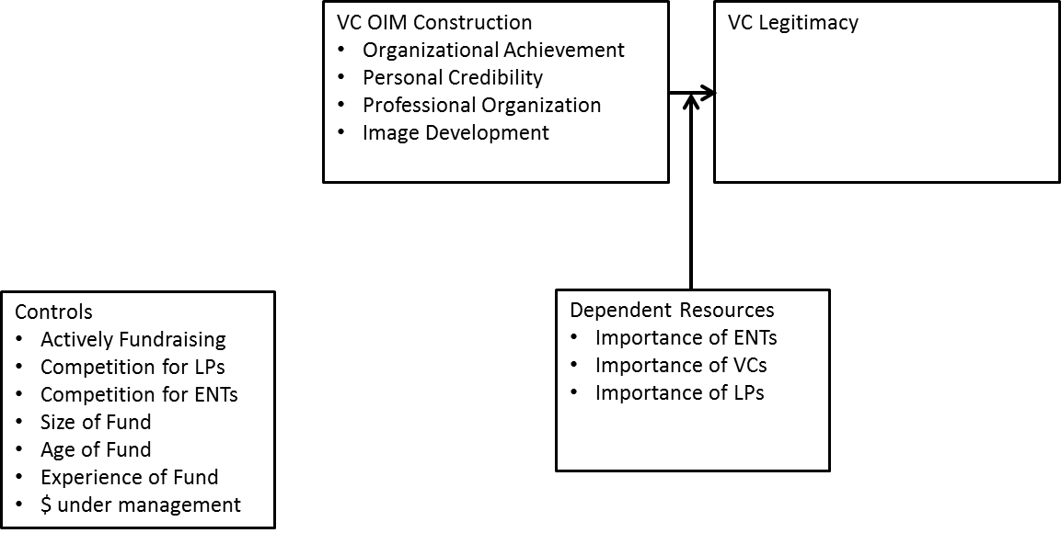

Hypothesis 1a: The more VCs signal organizational achievement the higher the level of legitimacy.

Hypothesis 1b: The more VCs signal personal credibility the higher the level of legitimacy.

Hypothesis 1c: The more VCs signal professional organization the higher the level of legitimacy.

Hypothesis 1d: The greater the level of VCs image development the higher the level of legitimacy.

Hypothesis 2a: The greater the importance of ENTs to a VC, the higher the levels of legitimacy.

Hypothesis 2b: The greater the importance of VCs to a VC, the higher the level of legitimacy.

Hypothesis 2c: The greater the importance of LPS to a VC, the higher the level of legitimacy.

Hypothesis 3a: The relationship between organizational achievement signaling and legitimacy is moderated (i) importance of entrepreneurs, (ii) importance of VCs and (iii) importance of LPs.

Hypothesis 3b: The relationship between personal credibility signaling and legitimacy is moderated by the (i) importance of entrepreneurs, (ii) importance of VCs and (iii) importance of LPs.

Hypothesis 3c: The relationship between professional organization signaling and legitimacy is moderated by the (i) importance of entrepreneurs, (ii) importance of VCs and (iii) importance of LPs.

Hypothesis 3d: The relationship between image development and legitimacy is moderated by the (i) importance of entrepreneurs, (ii) importance of VCs and (iii) importance of LPs.

The regression results from the revised research model are below in Table 7, Table 8 and Table 9.

Table 7: Regression Results for Revised Research Model, ENT Moderation
OIM construction as measured by organizational achievement, professional credibility, professional organization and image development did not significantly predict legitimacy. Therefore H1a, H1b, H1c and H1d were not supported nor was H2a found to be significant. Importance of ENTs did interact with professional organization, β = -.17, ρ < .05, increasing the R² = .03 to .25 and Δf by 5.37, p < .05. However, the relationship was negative, therefore, H3ai was not supported regarding the interaction of importance of ENTs and professional organization. Importance of ENTs interacted with image development, β = -.62, ρ < .05, increasing the R² = .03 to .25 and Δf by 5.15, p < .05. However, this relationship was also negative, therefore, H3di was also not supported, the interaction of importance of ENTs and image development. No interaction effects were found with importance of ENTs and organizational achievement and also importance of VCs with personal credibility, therefor H3bi and H3ci were not supported. Using the oblique rotation resulted in VIFs for all variables at less than 2.6 and less than 1.1 for the main and interaction effects. The Condition index was less than 20 for the interaction effect, less than 12 for the main effects, and less than 9 for the controls. These checks taken together suggest that there likely is little instability in the estimates (e.g. Belsley, Kuh and Welsch, 1980). The graphs below, Graph 1 and Graph 2, depict the interaction effects for importance of entrepreneurs with professional organization and also importance of entrepreneurs with image development.

Graph 1

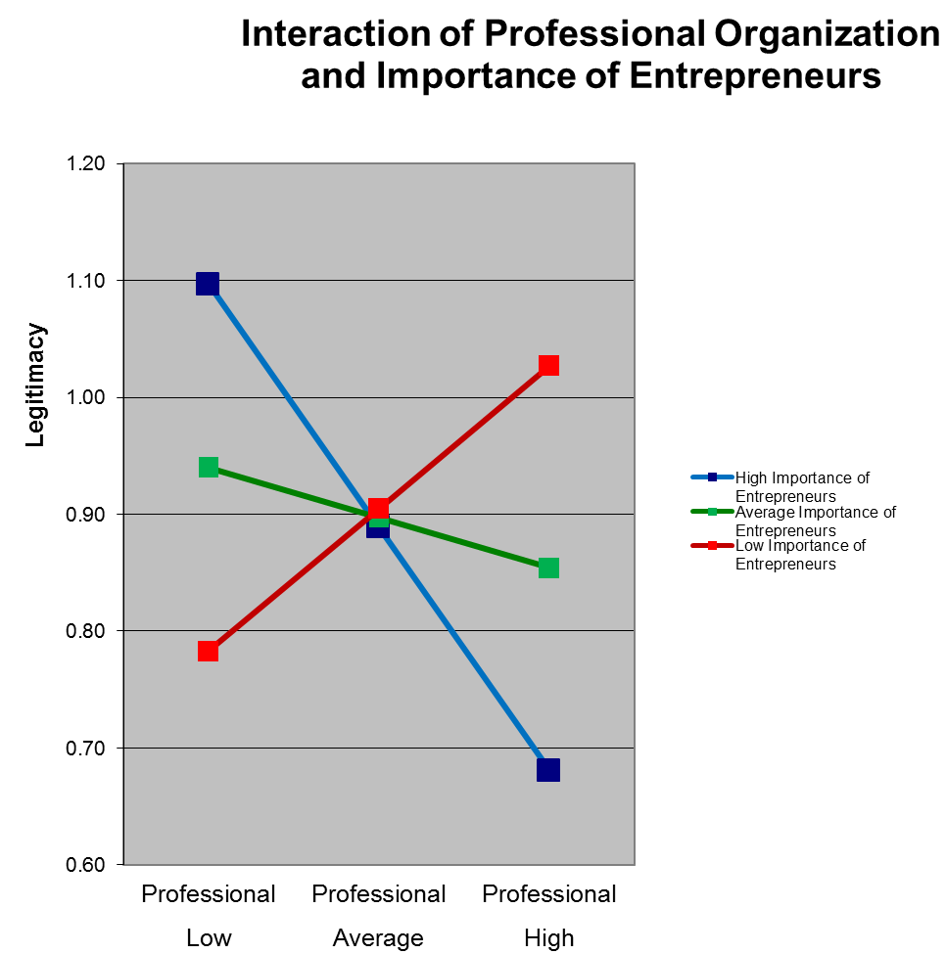

Graph 2
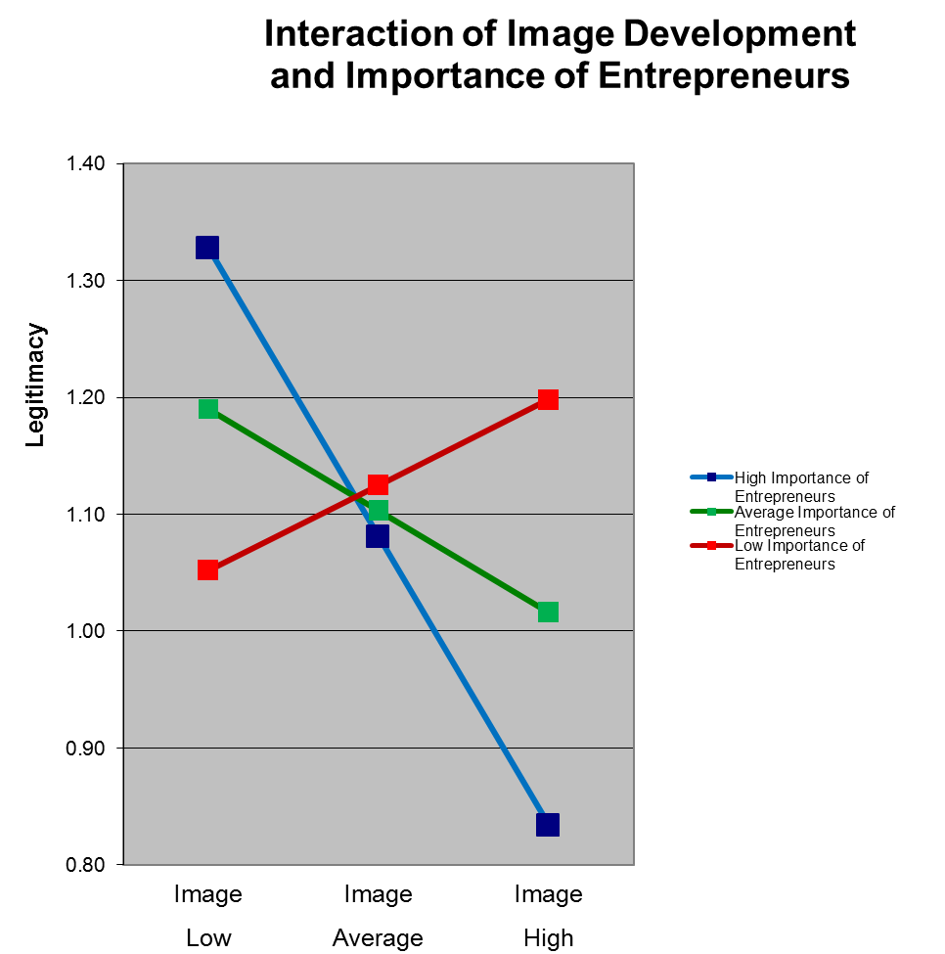

Table 8: Regression Results for Revised Research Model, VC Moderation

OIM construction as measured by organizational achievement, professional credibility, professional organization and image development did not significantly predicted legitimacy. Therefore H1a, H1b, H1c and H1d were not supported. However, H2b was supported. Additionally, the importance of VCs did interact with organizational achievement, β = .10, ρ < .05, increasing the R² = .02 to .28 and Δf by 4.00, p < .05. Therefore, H3aii was supported when interacting with importance of VCs and organizational achievement. Importance of VCs did interact with personal credibility, β = -.14, ρ < .05, increasing the R² = .02 to .28 and Δf by 4.05, p < .05. However, the relationship was negative, therefore, H3bii was not supported when interacting with importance of VCs and personal credibility. No interaction effects were found with importance of VCs and professional organization and also importance of VCs with image development, therefore H3cii and H3dii were not supported. Using the oblique rotation resulted in VIFs for all variables at less than 2.6 and less than 1.1 for the main and interaction effects. The Condition index was less than 20 for the interaction effect, less than 12 for the main effects, and less than 9 for the controls. The graphs below, Graph 3 and Graph 4, depict the interaction effects for importance of VCs with organizational achievement and also importance of VCs with personal credibility.

Graph 3
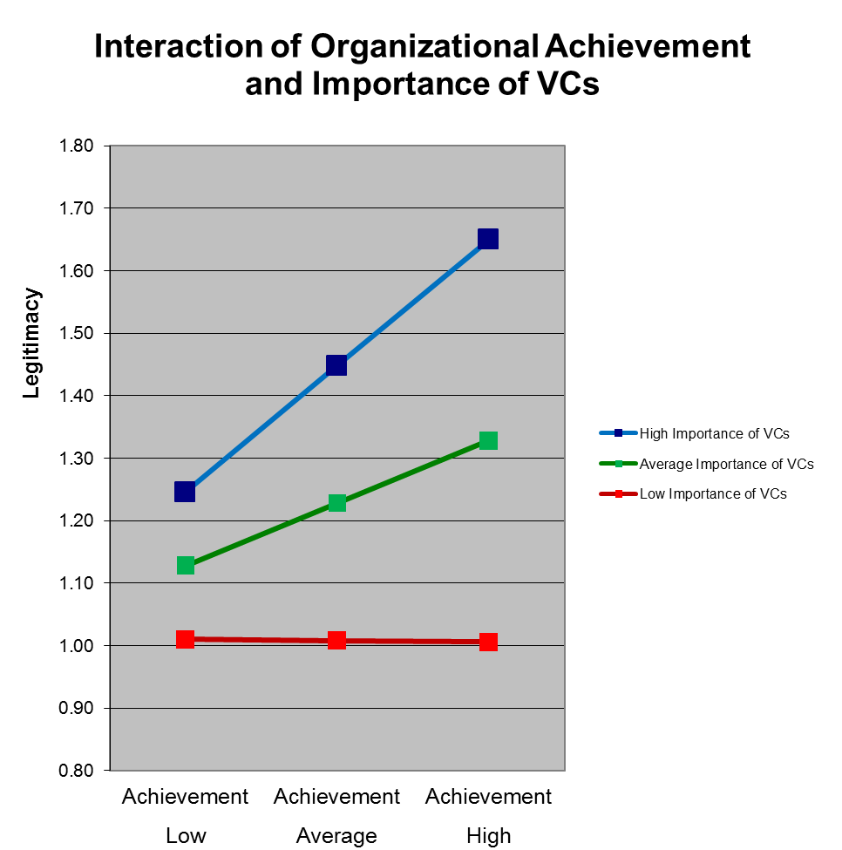

Graph 4

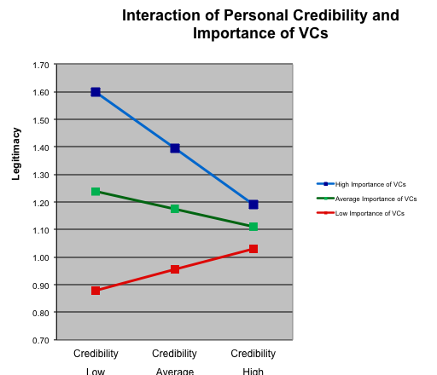

Table 9: Regression Results for Revised Research Model, LP Moderation

No interaction effects were found for importance of LPs with organizational achievement, importance of LPs with personal credibility, importance of LPs with professional organization and importance of LPs with image development. Therefore, H2c, H3aiii, H3biii, H3ciii, and H3diii were not supported.

CHAPTER FIVE
DISCUSSION
The empirical findings of the results for the original research model did not find support for a theorized model of a fully mediated relationship between OIM and resource dependence. OIM construction, (defined as organizational achievement, personal credibility, professional organization and image development) did not mediate the relationship between resource dependence, (defined as importance of entrepreneurs, importance of venture capitalists and importance of Limited Partners) and organizational legitimacy.
Although the work of Leary and Kowalski (1990) suggest motivations for impression management include the goal-relevance of the impressions, value of desired goals, and discrepancy between desired goals and current image; the likelihood of resource dependence alone fully explaining the motivation was, in hindsight, overstepping the theory proposed by Leary and Kowalski (1990). Additionally, the incorporation of the Zott and Huy (2007) model to define actions of symbolic management, was useful in organizing constructs, but was also likely stretched when applied to this proposal of a fully mediated model. The organization impression management literature research, as outlined by Bolino et al. (2008), suggested that past OIM research has examined how organizations use a wide variety of IM tactics in an effort to create specific image or to accomplish a specific goal helped this research project consider relationships between goals, OIM and legitimacy. But, again, a fully mediated model between goals, tactics and outcomes was beyond the scope of the review. Finally, the last theoretical component of the research model, resource dependence, also lacked a fully developed theoretical perspective based on full mediation. The recent Hillman et al., (2009) paper suggests the relationship resource control, ecology of the organization and interorganizational relationships as the basis for resource dependence theory. But, again, a fully mediated model was not suggested as a theoretical basis for better understanding and managing the relationships.
Therefore, given the lack of theoretical support for a fully mediated model and the results of the proposed study are theoretically contextualized, the results from the research program, although disappointing, are not surprising. Given the expected results were not supported universally; the research model warranted a re-examination. Rather than a fully mediated model, was the relationship between OIM and Resource Dependence based on an interaction, or a moderated model? Further explanation of both mediation and moderation along with the reasoning for a post-hoc analysis is further explained.
From a methodological standpoint, testing the mediated relationship also provides insights. As best explained by Karazsia et al. (2013), a mediator accounts for or explains (at least partially) the relation between a predictor and a criterion. Mediators answer the questions of how or why a predictor influences a criterion. As a variable that is influenced by a predictor and subsequently influences a criterion, the proposed mediator functions as both a criterion and a predictor (Holmbeck, 1997). For this research project, it was proposed that OIM answered the question of how or why resource dependence established legitimacy. The results do not support the proposed relationship.
Alternatively, a moderator is a variable that also affects the relationship between a predictor and criterion. As such, figures that depict moderation often show a path from the moderator to the arrow that represents the relation from the predictor to the criterion: The influence is on neither the predictor nor criterion alone, but rather on the relation between them. A moderator changes the strength or direction of the relationship between the predictor and criterion. In interaction terms, the effect of a predictor on the criterion depends on the level of the moderator.
The results of the study suggest that OIM does not answer the question of how or why VC motivations influence OIM construction. But, maybe the influence is on neither the importance of resources nor OIM to legitimacy, but rather on the relationship between the two. So the new research question is: “does resource dependence change the strength or the direction of the relationship between OIM and legitimacy. In other words, the effect of the predictor, OIM, depends on the level of the moderator, resource dependence.
It was determined, after reviewing the theoretical literature, the results and the data, that a revised research program was warranted. A post-hoc analysis suggested that the relationship between OIM and resource dependence in establishing legitimacy was in interaction relationship rather than a mediated relationship. Therefore a revised research model was proposed and new hypotheses were established. The model was tested and significant results supported one of the hypotheses.
The revised research model posited that a positive relationship exists between the interaction of resource dependence and OIM leading to increased legitimacy. Specifically, the revised research model posited that the greater the level of resource dependence would increase the effect of OIM leading to legitimacy. Although significant relationships were found, the direction of the relationship was different depending on the resource. This dissertation found resources differ in their effects on OIM.
The interaction of resource dependence (measured by importance of entrepreneurs, importance of other venture capitalists and importance of Limited Partners) with organizational impression management construction (measured by organizational achievement, personal credibility, professional organization and image development) had, for some interactions, some significant effects on the level of legitimacy. But, the results are inconclusive.
This dissertation found support for the interaction of importance of entrepreneurs interacting with a professional organization in predicting legitimacy. The interaction coefficient was significant and negative, β = -.17 at p < .05. This result at first glance is surprising. Additionally, when reviewing the interaction graph, the initial question is asked “why don’t VCs who place a high importance on entrepreneurs exhibit increased legitimacy when interacting with high levels of professional organization?” At this point, it is worth reviewing the questions that compose the professional organization construct: 1) I treat entrepreneurs with respect, 2) I treat Limited Partners with respect and 3) I treat other venture capitalists with respect. Additionally, the importance of entrepreneurs construct is composed of the questions: 1) portfolio companies are critical to our firm’s success and 2) a critical function of our firm is to invest in outstanding portfolio companies. Also, the score for legitimacy was membership with NVCA, corporate partner presentations and investment banking conferences attended. Having established the constructs, the negative interaction coefficient can be discussed.
When isolating the high importance of entrepreneur’s line that slopes negatively, the starting point should be considered. Specifically, VCs who place a high importance on entrepreneurs do not place great importance on treating others with respect when attaining higher levels of legitimacy. But, VCs who place a low importance on entrepreneurs feel a greater urgency to treat others with respect when attaining higher levels of legitimacy.
The study found support for a second interaction between importance of entrepreneurs and image development. The interaction coefficient was significant and negative, β = -.62 at p < .05. This result is also surprising. Similarly, when reviewing the interaction graph, the initial question is asked “why don’t VCs who place a high importance on entrepreneurs exhibit increased legitimacy when interacting with high levels of image development?” At this point, it is worth reviewing the questions that compose the image development construct: 1) I engage in activities to develop my/our image and 2) I spend a lot of time building my/our image. The negative interaction coefficient can be discussed.
When isolating the high importance of entrepreneur’s line that slopes negatively, the starting point should be considered. Specifically, VCs who place a high importance on entrepreneurs do not place great importance building an image when attaining higher levels of legitimacy. But, VCs who place a low importance of entrepreneurs feel a greater urgency to build an image when attaining higher levels of legitimacy.
Given the interaction relationship between both significant models, it is possible that a reciprocal causation effect is being exhibited. Specifically, once legitimacy is achieved, image development is reduced for VCs who place great importance on their relationship with VCs. This is not surprising given the circular action/reaction activities of managing impressions (Carter, 2006; Schneider, 1981; Gardner and Martinko, 1988). A post hoc test on the revised research model showed that when VC legitimacy was regressed on the interaction of image development and importance of entrepreneurs, a significant, and negative relationship was found, β = -.21 at p < .05. This result would be interpreted as once legitimacy is established, power asymmetry is reduced, and the need to implement OIM strategies to manage the environment decline.
The final discussion point related to the interaction term of importance of entrepreneurs relates to the OIM construction activities of organizational achievement and personal credibility. Neither interaction was significant. Additionally, the main effects of OIM construction were all found to be non-significant. Also, the main effect of importance of entrepreneurs was also found to be non-significant. Only the two interaction terms were significant at p < .05. Although the constructs of organizational achievement and personal credibility did not interact with importance of entrepreneurs, ironically, they were the only interaction terms when the construct importance of VCs was analyzed.
The study found support for the interaction of importance of VCs interacting with organizational achievement in predicting legitimacy. The interaction coefficient was positive and significant, β = .10, p <. 05. Unlike the interaction terms with importance of entrepreneurs, the interaction terms of importance with VCs is a less complicated interpretation. At this point, it is worth reviewing the questions that compose the organizational achievement: 1) I let others know about my/our abilities, 2) I make sure entrepreneurs are aware of our past success, 3) I talk about and promote recent success, 4) I make sure that Limited Partners know about my/our organizational achievement and 5) I make sure that entrepreneurs know about my/our organizational achievements. Additionally, the importance of VCs construct is composed of the questions: 1) syndication is critical to our firm’s success, 2) our firm’s success depends entirely on syndication and 3) a critical function of our firm is to participate in syndication opportunities. Having established the constructs, the positive interaction coefficient can be discussed.
When isolating the high importance of entrepreneur’s line that slopes positively, the starting point should be considered. Specifically, VCs who place a high importance on entrepreneurs, gain increased legitimacy when placing high importance on signaling organizational achievement. In other words, placing a greater importance on signally organization achievement, results in increased legitimacy for VCs who place a high level of importance on other VCs.
When isolating the low importance of entrepreneur’s line that slopes slightly negative, the starting point should be considered. Specifically, I propose the interpretation as, VCs who place a low importance on other VCs and who place high importance on signally organizational achievement experience marginally decreased legitimacy. In other words, placing a greater importance on signally organization achievement, does not affect legitimacy for VCs who place a low level of importance on other VCs.
The study found support for the interaction of importance of VCs interacting with personal credibility in predicting legitimacy. However, the interaction coefficient was negative and significant, β = -.14, p < .05. At this point, it is worth reviewing the questions that compose the personal credibility construct: 1) I convey my/our work experience to Limited Partners, 2) I convey my/our work experience to entrepreneurs, 3) I try to make sure that Limited Partners believe in my/our personal credibility and 4) I try to make sure that entrepreneurs believe in my/our personal credibility. Having established the constructs, the negative interaction coefficient can be discussed.
When isolating the high importance of others VCs line that slopes negatively, the starting point should be considered. Specifically, VCs who place a high importance on other VCs do not place great importance on signally personal credibility when attaining higher levels of legitimacy. But, VCs who place a low importance on other VCs feel a greater urgency to signal personal credibility when attaining higher levels of legitimacy.
When examining the results of the interactions of importance of VCs and OIM tactics, it appears as though legitimacy predicts OIM behavior, as it did with OIM tactics and importance of entrepreneurs. However, the relationship is not the same with all OIM tactics and resource dependence (importance of VCs). Specifically, with regard to higher levels of legitimacy established by the VC, the OIM tactics and behaviors are negatively related to legitimacy, regarding personal credibility, and also are positively related to legitimacy, regarding organizational achievement.
The positive relationship between organizational achievement and importance of VCs leading to legitimacy suggest that VC firms who value their relationship with other VCs, specifically syndication opportunities, and who signal organizational achievement experience increased levels of legitimacy. In other words, “we value our VC relations in order to gain exposure to quality syndication opportunities. Additionally, we signal organizational success. These beliefs and behaviors have resulted in increased organizational legitimacy.”
The negative relationship between personal credibility, importance of other VCs on legitimacy suggests something entirely different. Based on the items related to work experience and credibility, it appears once legitimacy is established, the need to actively signal personal credibility decreases. In other words, “I am legitimate, my credibility speaks for itself.” Whereas organizations that lack legitimacy signal personal credibility leading to increased legitimacy, but only for those firms who do not place high value on the resource of other VCs.
The final discussion point related to the interaction term of importance of VCs relates to the OIM construction activities of professional organization and image development. Neither interaction was significant. Additionally, the main effects of OIM construction were all found to be non-significant. However, the main effect of importance of VCs was found to be a significant main effect, β = .22, ρ < .05, for the two interaction effects and also the non-significant interaction effect with professional organization, non-significant at β = .22, ρ < .05. But, the main effect of importance of VCs was not significant in the model testing image development and importance of VCs. These three significant relationships suggest that VCs who value other VCs experience increased legitimacy.
The third interaction term, importance of Limited Partners, was tested for interaction effects with the four OIM construction tactics of: organizational achievement, personal credibility, professional organization and image development. The dependent variable was legitimacy as measured by NVCA membership, corporate partner presentation and investment banking conference participation. The questions for the LP construct were as follows: 1) our firm’s success depends entirely on our ability to secure Limited Partners and 2) a critical function of our firm is to secure Limited Partners. All direct and interaction terms were regressed on legitimacy. No significant relationships were resulting at p < .05. There are two possible explanations for finding non-significant results. First, a methodological error could have led to this result. Specifically, the following question should have been included in the survey: “Do you have limited partners in your fund.” Had I done this, I might have gathered more accurate data on the dependent resource “importance of LPs.” A deeper exploration will be covered the in limitations of the research section, but, a quick explanation is that non-limited partner funded venture capitalists received the survey. Early stage investors who lack Limited Partners include community development funds, business angels and “crowdsourcing” networks. Second, it is possible that heterogeneity of resources exist in the three interaction variables. Specifically, the importance of VCs and entrepreneurs might be greater than the importance of Limited Partners. Although all three resources are resources of dependence for venture capitalists (Gompers and Learner, 2001), the value of entrepreneurs and VCs is greater than that of Limited Partners. One explanation for this may be that VCs may believe that if fund returns are outperforming benchmarks, Limited Partners will, to some degree, find their way to the fund and invest. However, if fund returns are below or significantly below industry benchmarks, Limited Partners will cease to invest. Therefore, VCs place greater importance on the resources that generate fund returns: entrepreneurs who the VC invests and other VCs, who the VCs rely on for syndication.
When reviewing the results from all regressions results, a few themes begin to emerge related to the roles of VC resource dependence, OIM and legitimacy. Once legitimacy is established, the resource importance of entrepreneurs appears to diminish. One explanation for the result is that once VCs have established legitimacy, the entrepreneurs will find them. Therefore, spending time on OIM activities is not a focus of VCs with high levels of legitimacy. Second, the positive relationship between the resource of VCs relationships and OIM interactions (signally organizational achievement) suggest that VCs believe the source of syndication is a more dynamic environment and maintaining active OIM activities is important. Also, the constructs shed light on resource heterogeneity. The resource dependence relationships with VCs, a small network (Gompers and Learner, 2001), finds positive interactions with the establishment of achievement, and success predicting legitimacy, while the resource dependence relationship with entrepreneurs, a larger network, interacts, negatively, with image development and professional organization with respect to predicting legitimacy.
Another interpretation regarding the OIM strategies between dependent resources comes through the lens of social networks (Aldrich and Whetten, 1985). Network analyzers emphasize the importance of networks strengths in terms of strong and weak ties. People rely on strong ties for advice, assistance, and support in all areas of their lives and they are long-term, two-relationships, not governed by short-term calculations or self-interest (Aldrich, 1999). Whereas strong ties are based on trust, weak ties are superficial or casual and normally involve little emotional investment. They can be thought of as arm’s-length relations, involving persons whose handshake we seek but whose full support we cannot count on (Aldrich, 1999). In interpreting the results from the revised research model, and comparing the results from moderators “importance of entrepreneurs” to those of “importance of other VCs” in is possible to explain the close tie relationship between VCs as one OIM strategy, based on more personal interactions, while weaker ties with the pool of entrepreneurs causes a different form of OIM strategies based on weak ties – image building and respect.
The Contributions of this Research
The results of this research project were mixed and inconclusive. On one hand, a positive relationship between one indicator of resource dependence and one OIM tactic positively predicted legitimacy. But, three of the four significant interactions with other combinations were negative. This suggests that legitimacy as a predictor of OIM strategies might serve as a better foundation for future research. Additionally, when reviewing many of the articles from the popular press quoted in this dissertation, it could be argued that VCs were engaging in OIM strategies because they lacked legitimate due to poor performance. Therefore, the post-hoc analysis finding legitimacy, a resource, predicting OIM strategies is consistent with articles in the popular press. These findings suggest the role of OIM strategies are utilized by organizations, but the results from this dissertation do not offer clarity of cause and effect.
This research project makes contributions to the theories of resource dependence and organizational impression management. Organizational impression management is underdeveloped and incomplete in its definition, use and construction. This dissertation sought to clarify the conditions when OIM was utilized and specific construction of OIM processes. Additionally, the resurgence of resource dependence theory (Hillman et al., 2009) has been progressing, but several key areas, such as interorganizational relationships, have yet to be fully explored. The introduction of resource dependence moderating with interorganizational relationships introduces a strategy organizations can use to counter resource dependence and also helps define the nature of interorganizational relationships.
This dissertation integrates RDT with OIM to consider the dynamic nature of those dependencies and power as well as the multiplexity of interdependency (Hillman et al., 2009). Resource dependence theory, although in many respects quite successful, has been too readily accepted as an obligatory citation and not often enough engaged empirically, either in concert with other theories of organizations and their environments or to further develop the theory itself (Pfeffer, 2005). By applying RDT to interorganizational relationships (Katila et al., 2008), in this case, VC relationships with other VCs, VCs relationships with entrepreneurs and VC relationships with Limited Partners, this explored the role of resource dependence and OIM strategies used to overcome power asymmetry. By identifying an industry that is undergoing tremendous pressure, venture capital, and in which survival and continued success are uncertain, the possibility exists to test models of dependency. Identifying OIM as a strategy to counter to resource dependence provides organizations an option to combat power asymmetry.
Research on impression management has typically focused either on how subordinates manage impressions in order to impress their supervisors and earn higher performance ratings or how prospective employees use impression management to impress interviewers and earn jobs (e.g., Swider, Barrick, Harris, and Stoverink, 2011; Van Iddekinge, McFarland, and Raymark, 2007; Wayne and Ferris, 1990; Wayne and Liden, 1995). More recently, though, researchers have sought to understand impression management among CEOs, top managers, and corporate directors members (e.g., Park, Westphal, and Stern, 2011; Westphal and Graebner, 2010; Westphal, and Stern, 2007). Organizational representatives and spokespersons also use IM in an effort to influence the way that others view the organization as a whole (Bolino et al., 2008). Motivations and tactics of OIM have not been explored because we don’t have a clear concept of organizational level theory that provides antecedents to motivation and tactics thereby explaining changes. Although some research has worked towards a better understanding of organizational impression management (OIM), the research is incomplete. This dissertation, then, contributes to IM research by examining how impression management is used in situations other than subordinates or interviewees. This dissertation expands the organizational impression research by exploring the cross-level actions of organizational impression management enacted by VCs in resource dependence relationship seeking legitimacy. Specifically, in situations that call for more regular interaction, or tight relationships (Katila et al., 2008) such as VCs with other VCs, signaling credibility, experience, and success appear to be tactics of OIM. However, as the ties weaken (Katila et al., 2008) more generalized tactics such as respect and image development are employed.
This dissertation seeks to better understand the changing impression management strategies of venture capitalist: the motivations to manage impressions, the interactions of motivation and the construction of impression management by VCs. Unlike previous research on venture capitalists that focused on performance this dissertation seeks to understand the behavior of venture capitalists, specifically related to impression management. The study of venture capital has been extensive, but we know very little about the behavior of VCs. To date, research that has focused on VC behavior has largely focused on their pre-investment activities and their investment decision criteria and strategies (Brophy, 1986; Bygrave, 1987; Bygrave et al., 1989; Chen, 1983; Cooper and Carleton, 1979; Florida and Kenney, 1988; Gorman and Salman 1989; MacMillan et al., 1985; MacMillan et al., 1987; Robinson, 1987; Rosenstein, 1989; Sahlman, 1990; Sahlman and Stevenson, 1985; Sapienza and Timmons, 1989; Timmons and Bygrave, 1986; Tyebjee and Bruno, 1984). In contrast, this research project draws upon impression management theory to understand why VCs are motivated to use impression management, the images they seek to construct, and how certain skills facilitate the effective use of impression management. Given the significant role that VCs play in the economy and the increasing relevance of impression management in this context, understanding this issue is both timely and important. The results of this empirical study contribute to a better understanding of VC activities, motivations and behaviors.
My generalizable contributions are: 1) OIM strategies are employed and changed as a response to changes in resource distribution and changes in resource munificence within the environment, 2) OIM strategies are sometimes used to overcome power asymmetries with resource providers and 3) however, once legitimacy is established, it appears as though OIM activities decrease. Theoretical contributions are: 1) extension of OIM now used as a response to resource dependency, 2) OIM as a response to power asymmetry and environmental uncertainty, 3) cross level extension of IM and 4) Identification and definition of VC behaviors and motivations, specifically the use of OIM.
Limitations of This Research
As with any research project, this project has limitations. First, the most significant limitation is the dependent variable is not performance based. Although the performance of a VC firm is possible the greatest signal of legitimacy, obtaining VC performance data is not possible. VCs do not publically discuss their performance. Therefore, a dependent variable determining legitimacy had to be developed not using firm performance data.
Second, there were a number of methodological issues regarding the survey and data gathering process. The first and most problematic issue was the omission of a single question. The survey should have asked the question “Do you have Limited Partners?” The database purchased for the survey included all firms who made early stage venture investments. The list included community development funds, which are generally funded with taxpayer dollars. The list also included angel investor, which are generally funded by the angel investor himself. In other words, no institutional funds (endowments, pensions, and high net worth families) generally comprise community development funds and angel investor funding. The research question relied on institutional investors as a resource, by surveying early stage investors who do not rely on Limited Partners; the data analysis could have construct validity issues. To overcome the issue of non-LP backed participants, each submission was manually reviewed by inspecting the website. If the website referred to state or local funding or consisted of a single individual or two individuals who used the words “angel investors”, “we use our own funds” or “we are not a venture capital firm” then the case was omitted. However, it is possible that the inability to more clearly define LP backed firms to non-LP backed firms contributed to the lack of significant results when using the interaction construct “importance of LPs”. The author received dozens of email from individuals who, after starting the survey recognized the possibility of their participation was outside the scope of the research project. This was primarily due to the questions regarding Limited Partners. Some of the emails mentioned the participant had stopped the survey at some point and some emails mentioned that they completed the survey but I should probably omit their case. If the survey had included the question on limited partner funding, results on the construct “importance of LPs” might have been observed.
Third, the recruitment of participants also encountered some issues. First, the letter sent did not have a phone number or email address to contact the researcher. Second, the email containing the survey had the link for the survey at the very bottom. A few participants emailed the investigator asking where about the link for the survey. Some participants could not find the link in the body of the email. Reminder emails two and three placed the survey link above the signature. No emails were received inquiring as to the link of the survey for email two and three. Also, if the respondent used an apple computer or a non-windows operating system, the recruitment email was indecipherable. This was due to the host Qualtrics and fixing the problem was not possible.
Fourth, the single greatest limitation of the survey was the use of single source for independent variables and dependent variables. The potential for method bias is significant. However, the questions that constitute the dependent variable (membership in NVCA, corporate partner presentations, and investment banking conference attendance) were all yes or no questions placed at the beginning of the survey. When reviewing the Podsakoff et al., (2012) paper regarding common method and how to control it, they suggest three questions the researcher should address in determining method bias. First, are respondents able to provide accurate answers? Using yes or no questions rather than Likert response helps clarify the question. Additionally, the questions are not opinion based. The questions simply ask if they had done the following. Second, are the respondents motivated to provide accurate answers? Specifically, the more serious the social consequences of a particular response, the stronger a respondents desire to provide socially acceptable responses. The questions do not contain socially acceptable consequences. However, it is possible that the respondent, if legitimacy is determined from the questionnaire and is sought by the respondent, may seek to lie on the yes or no questions so as to appear to be more legitimate. Although given the professionalism of the industry (Gompers and Learner, 2001) and the unlikelihood of lying and completing the survey rather than simply discontinuing participation, it is possible and potentially problematic. Third, are the questions ambiguous? Given the yes or no nature of the response, the accuracy of the respondent is reduced as compared to opinion or motivation questions. The likelihood of response consistency is increased.
Fifth, another potential problem with the survey was the potential issue with focusing the behavior questions on three separate resources of dependence: entrepreneurs, Limited Partners and other venture capitalists. For example, the questions designed to establish relationship quality: 1) I spend a lot of time developing close, high-quality relationships with our Limited Partners, 2) I spend a lot of time developing close, high quality relationships with our portfolio companies and 3) I spend a lot of time developing close, high quality relationships with other venture capitalists, all cross loaded with other constructs when performing the factor analysis. It would have been better to establish the behavior of developing close relationships using non-recipient focused questions as opposed to establishing the behavior using stated recipients. If the questions had loaded by “behaviors towards LPs” and “behaviors towards VCs” the issue would not have been problematic. But, most of the constructs loaded by behavior rather than recipient. In hindsight, dropping the recipient from the behavior of the questions might have been preferable or, alternatively, creating a longer questionnaire that used three questions to establish the nature of the high quality relations with VCs, LPs, and entrepreneurs. Spending more time on pilot surveys might have been preferable because a more accurate survey might have been generated. However, given the nature of VCs, creating a longer survey would probably have decreased the participation. A more viable option would have been to possible narrow the research questions.
Sixth, when a confirmatory factor analysis was performed on the principal component factors, some of the fit indices were outside of the desired target. Results for the CFA were X² of 564.1 and 309 df, P = .000, an RMSEA .071 within the acceptable range (Hair, 2005), the GFI .819 was somewhat lower than desired and CFI .857 also was lower than desired (Hair, 2005). The CFI value was somewhat short of the .90 or .95 values suggested by Hair (2005). I suggest that the majority of the shortcomings probably can be attributed to insufficient number of items to thoroughly develop each construct. As mentioned above, the survey probably tried to measure and accomplish too much. Separating ENTs, VCs and LPs to a greater degree and asking items based on individual relationships rather than collectively grouping the resources together would probably have yielded a cleaner data set. Also, the less than ideal fit indices may be the result of the relatively large number of indicators (28) for the variables and the resulting number of constraint parameters in the factor load matrix (Hair, 2005; Williams et al., 2010). However, given the key measure, RMSEA (Hair, 2005) was within acceptable range, the factors used for the analysis, although not ideal, are acceptable constructs for testing the hypotheses.
Finally, it is possible that the results from this study are unique to the data and VC industry. The VC industry offers a unique opportunity to observe an entire industry that is under pressure due to underperformance relative to the S&P 500. The VC industry uses little human capital to make significant returns (Gompers and Learner, 2001). Many times a general partner and their assist analyst and a secretary can manage a $50 million portfolio (Gompers and Learner, 2001). VCs do not manufacture products nor do the operate businesses, they are a service industry, specifically, they are a provider of capital (Gompers and Learner, 2001). Nonetheless, I believe the data to be robust and generalizable to other industries.
Direction for Future Research
This research project helps to identify strategies used by organizations that are subject to power asymmetry and resource dependence. Specifically, this research project found support for the interaction between resource dependence and OIM behaviors leading to legitimacy.
This dissertation also offers researchers and venture capitalists a deeper understanding of the motivation, construction, and skillfulness of the organizational impression management. Venture capital scholars should seek to further explore the behaviors of venture capitalists. For example, do certain behaviors such as professional organization or image construction determine tactics used such as social media.
Also, do industries impact OIM? For example, do software and apps require a broader social media message while medical and health care VC investors develop more focused and less social OIM tactics? Also, what role does geography play, does proximity to Silicon value moderate OIM behavior for firms who invest in hardware and software but are based outside of California. Does the use of specific tactics such as social media predict legitimacy? The long-term implications of OIM of reducing resource dependence should also be explored. Does the effect of OIM diminish over time if firm performance declines? Also, does the stage of the capital impact OIM tactics. Specifically do nascent-stage investors behave differently than late stage investors? Finally, what other strategies can be used by organizations to successfully counter resource dependence.
For example, at times, the IPO market is less active; for example, in 2000 there were 200+ IPOs, but during 2011 there were just a handful—less than 20 (Kauffman, 2012). A less active IPO market creates barriers that minimize the possible harvest options for the VCs portfolio companies (Cooper and Carleton, 1979). To increase legitimacy and profit, then, VCs will signal the potential of their investment to highlight outstanding performance or potential (Megginson and Weiss, 1991; Stuart et al., 1999; Anand and Piskorski, 2000). The motivation of the signaling is to increase demand of the IPO, as the recent Facebook IPO demonstrated (Oreskovic and Oran, 2012). Additionally, if the IPO markets are not a viable option for the new venture, and it is determined a strategic acquisition is the most likely harvest option; the value of positive signals to potential bidders can be also significant.
Additionally, when IPO and acquisition options are less likely, the value of impression management is enhanced, but the value of impression management is also enhanced under conditions of very active IPO markets and acquisition markets. During technology boom times such as the 1999 to 2000 time period and the 2010 to 2011 time periods, IPO markets are artificially increased value harvest options for a VC liquidity event (Sahlman and Stevenson, 1985). These “frothy markets” present an ideal opportunity for new ventures to maximize valuations and thereby maximize returns to early investors. During times of “frothy markets”, a VC will seek to engage in impression management activities that are aimed at investment bankers who are underwriting the deal and institutional investors, who are being induced to purchase shares at the opening, during the “road show” phase of an IPO process (Sahlman and Stevenson, 1985). The VC will benefit directly from a high valuation so they are incentivized to maximize the positive signaling of the new IPO candidates potential.
The maturity of the targeted investment industry affects impression management motivation as well. New or nascent industries, those “business environments in an early stage of formation” (Santos and Eisenhardt, 2009: 644), provide significant opportunities for entrepreneurs and VCs. However, new industries also create great hazard due to uncertainty about products (Tushman and Anderson, 1986), customer adoption (Hargadon and Douglas, 2001), and an ill-structured industry (Santos and Eisenhardt, 2005). Navis and Glynn (2010) highlight the compounding problems when a new or nascent industry is being entered by a new or nascent venture. Navis and Glynn (2010) studied the hazards of the compounded hazard by researching the satellite radio industry. They offer a theoretical framework on new market emergence and legitimization. Many business-to-consumer nascent industries rely on the entrepreneur founder salesmanship to gain customer acceptance (Tripsas, 2009). But many other outlets, such as associations and loose industry ties can cooperate to legitimize an industry (Navis and Glynn, 2010). Service providers, customers and suppliers can also provide legitimacy by entering into contracts (Navis and Glynn, 2010). In a nascent industry, endorsement by a respected venture capitalist can help the entrepreneur legitimize the new venture and the nascent industry to resource providers (Megginson and Weiss, 1991). Therefore, VCs who are investing in new or nascent industries will be more motivated to manage impressions.
Finally, the investment strategy of the VC is an expected antecedent to impression management construction. In particular, the maturity of the targeted industry and the clustering of the target industry offer unique situations such that construction of impression management is affected. The maturity of the targeted entrepreneur relates to the age and size of the industry (Santos and Eisenhardt, 2005). For example, emerging industries such as those who founded Google, Apple (iTunes), Facebook and Zynga react to impression management construction that has a broader appeal and uniqueness. The role of the VC in mature industries is to provide operational support and access to industry contacts. This group knows the end user. Therefore, the new venture team can more easily assess the experience and expertise that the VC has in the industry. In other words, the function of industry knowledge is less important because the new venture team many times will understand the industry just as much as the VC.
Conclusion
Over thirty years have passed since Pfeffer and Salancik’s seminal work on resource dependence theory. During this time, resource dependence theory has been applied broadly across the research domain to explain how organizations reduce environmental interdependence and uncertainty (Hillman, et al., 2009). However, the 2003 comments of the authors: “The idea, seemingly now widely accepted, that organizations are constrained and affected by their environments and that they act to attempt to manage resource dependencies, has become almost so accepted and taken for granted that it is not rigorously explored and tested as it might be” (Pfeffer and Salancik, 2003: xxxiii) still rings true. The efforts to manage resource dependency have not been fully identified nor the implications of said efforts been studied.
This research project sought to identify a strategy that firms can use to manage resource dependence, organizational impression management. Using a micro construct, impression management, at the organizational level helps identify, frame, and measure a strategy used to counter resource dependence. OIM is used in an effort to influence the way others view the organization as a whole (Bolino et al., 2008). Specifically, OIM has been defined as any action that is intentionally designed and carried out to influence an audience’s perceptions of the organization (Elsbach, Sutton and Principe, 1998).
REFERENCES

Aiken, L. S., and West, S. G. (1991). Multiple regression: Testing and interpreting interactions. Newbury Park, CA: Sage Publications.

Albert, S., and Whetten, D. A. (1985). Organizational identity. Research in organizational behavior.

Aldrich, H. (1999). Organizations evolving. Sage.

Aldrich, H. E., and Fiol, C. M. (1994). Fools rush in? The institutional context of industry creation. Academy of management review, 19(4), 645-670.

Aldrich, H. E., and Pfeffer, J. (1976). Environments of organizations. Annual review of sociology, 79-105.

Anand, B.N., Piskorski, M.J. (2000). Why are networks important? Division of Research. Harvard Business School.

Ashford, S.J., Rothbard, N.P., Piderit, S.K., Dutton, J.E. (1998). Out on a limb: The role of context and impression management in selling gender-equity issues. Administrative Science Quarterly, 43: 23-57.

Ashforth, B.E., Gibbs, B.W. (1990). ‘The double-edge of organizational legitimation’, Organization Science, 1:177–194.

Bansal, P., and Clelland, I. (2004). Talking trash: Legitimacy, impression management, and unsystematic risk in the context of the natural environment. Academy of Management Journal, 47(1), 93-103.

Bansal, P., and Kistruck, G. (2006). Seeing is (not) believing: Managing the impressions of the firm’s commitment to the natural environment. Journal of Business Ethics, 67(2), 165-180.

Barney, J. (1991). Firm resources and sustained competitive advantage. Journal of Management, 17(1): 99-120.
Baron, R.A. (1998). Cognitive mechanisms in entrepreneurship: why and when entrepreneurs think differently than other people. Journal of Business Venturing, 12: 275–294.

Baron, R. B., and Kenny, D. A. (1986). The moderator-mediator distinction in social psychological research: Conceptual, strategic, and statistical considerations. Journal of Personality and Social Psychology, 51, 1173-1182.

Belsley, D. A., Kuh, E., and Welsch, R. E. Regression diagnostics: identifying influential data and sources of collinearity, (1980).

Benoit, W. L. (1995). Sears’ repair of its auto service image: Image restoration discourse in the corporate sector. Communication Studies, 46(1-2), 89-105.

Benson, D., and Ziedonis, R. H. (2010). Corporate venture capital and the returns to acquiring portfolio companies. Journal of Financial Economics, 98(3), 478-499.

Belsley, D. A., Kuh, E., and Welsch, R. E. (1980). Regression Diagnostics: Identifying Inﬂuential Data and Sources of Collinearity. New York: John Wiley and Sons.

Blau, P. M. (1964). Exchange and power in social life. Transaction Publishers.

Bolino, M.C., Kacmar, K.M., Turnley, W.H., Gilstrap, J.B. (2008). A multi-level review of impression management motives and behaviors. Journal of Management, 34:1080-1109.

Bolino, M. C., Kacmar, K. M., Turnley, W. H., and Gilstrap, J. B. (2008). A multi-level review of impression management motives and behaviors. Journal of Management, 34(6), 1080-1109.

Bolino, M. C., Turnley, W. H., and Bloodgood, J. M. (2002). Citizenship behavior and the creation of social capital in organizations. Academy of Management Review, 27(4), 505-522.
Bromley, D. B. (1993). Reputation, image and impression management. John Wiley and Sons.

Brophy, D.J. (1986). Venture capital research, In D.L. Sexton and R.W. Smilor (eds), The Art and Science of Entrepreneurship, 119-43. Cambridge, MA: Ballinger.

Burt, R. S. (1983). Corporate profits and cooptation.

Busenitz, L.W. (1999). Entrepreneurial Risk and Strategic Decision Making: It’s a Matter of Perspective. Journal of Applied Behavioral Science, 35: 325-340.

Busenitz, L. W., Fiet, J. O., and Moesel, D. D. (2004). Reconsidering the venture capitalists “value added” proposition: An interorganizational learning perspective. Journal of Business Venturing, 19(6), 787-807.

Busenitz, L. W. (2007) Innovation and Performance Implications of Venture Capital Involvement in the Ventures They Fund. In Landstrom, H. (Eds.), Handbook of Research on Venture Capital: A Globalizing Industry: 219-235. UK: Edward Elgar Publishing Limited.

Bygrave, W.D. (1987). Syndicated investments by venture capital firms: a networking perspective. Journal of Business Venturing, 2: 139-154.

Bygrave, W. D. (1988). The structure of the investment networks of venture capital firms. Journal of Business Venturing, 3(2), 137-157.

Bygrave, W.D., Fast, N., Khoylian, R., Vincent, L., Yue, W. (1989). Early rates of return of 131 venture capital funds started 1978-1984. Journal of Business Venturing, 4: 93-105.

Campbell, J. P. (1982). Editorial: Some remarks from the outgoing editor.

Cialdini, R. B., and De Nicholas, M. E. (1989). Self-presentation by association. Journal of personality and social psychology, 57(4), 626.

Cialdini, R. B. (1989). Indirect tactics of image management: Beyond basking. Impression management in the organization, 45, 56.

Cambridge Associates LLC. (2012). U.S. Venture capital index and selected benchmark statistics: private investments. Cambridge, Mass.: Cambridge Associates. http://www.google.com/url?sa=tandrct=jandq=andesrc=sandsource=webandcd=1andved=0CCgQFjAAandurl=http%3A%2F%2Fwww.nvca.org%2Findex.php%3Foption%3Dcom_docman%26task%3Ddoc_download%26gid%3D939andei=ElV-U8SJKZOQqAbzg4GwDQandusg=AFQjCNG-sZHFm8CA7AGzW8R4uaqEJsljHAandbvm=bv.67229260,d.b2k

Carter, S. M. (2006). The interaction of top management group, stakeholder, and situational factors on certain corporate reputation management activities. Journal of Management Studies, 43: 1145-1176.

Chatman, J., Bell, N. and Staw, B. (1986). ‘The managed thought: the role of self-justification and impression management in organizational settings’. In Sims, H. P. and Gioia, D. A. (Eds), The Thinking Organization. San Francisco, CA: Jossey-Bass.

Chen, Y.S. (1983). On the positive role of financial intermediation in allocation of venture capital in a market with imperfect information. Journal of Finance, XXXVIII(5):1543-1568.

Churchill, G. A. (1979). A paradigm for developing better measures of marketing constructs. Journal of Marketing Research, 16(1), 64–73.

Clarkson, M. E. (1995). A stakeholder framework for analyzing and evaluating corporate social performance. Academy of management review, 20(1), 92-117.

Cooper, I.A., Carleton, W.T. (1979). Dynamics of borrower-lender interaction: partitioning final payoff in venture capital finance. Journal of Finance, 34:517-529.

Coupland, C., and Brown, A. D. (2004). Constructing Organizational Identities on the Web: A Case Study of Royal Dutch/Shell*. Journal of management studies, 41(8), 1325-1347.

Davidson, W. N., Jiraporn, P., Kim, Y. S., and Nemec, C. (2004). Earnings management following duality-creating successions: Ethnostatistics, impression management, and agency theory. Academy of management journal, 47(2), 267-275.

De Chernatony, L. (2012). Creating powerful brands. Routledge.

De Chernatony, L., and Dall'Olmo Riley, F. (1998). Defining a" brand": Beyond the literature with experts' interpretations. Journal of Marketing Management, 14(5), 417-443.

Deephouse, D. L. (1996). Does isomorphism legitimate? Academy of management journal, 39(4), 1024-1039.

DeSantis Breindel, Rooney and Associates, National Venture Capital Association, NVCA Advisory Board, Dow Jones VentureSource Database. (2013). Branding and Venture Capital: Key Findings from BIG:VC. http://www.desantisbreindel.com/wp-content/uploads/Branding-and-Venture-Capital-Key-Findings-from-BIG-VC.pdf

Dillman, D. A. (2000). Mail and internet surveys: The tailored design method. New York: Wiley.

DiMaggio, P.J., Powell, W.W. (1983). The iron cage revisited: Institutional isomorphism and collective rationality in institutional fields. American Sociological Review, 48:147-160.

DiMaggio, P.J., Powell, W.W. (1991). Introduction. In W.W. Powell and P.J. DiMaggio (eds.) The new institutionalism in organizational analysis, 1-38. Chicago: University of Chicago Press.

Dowling, J., and Pfeffer, J. (1975). Organizational legitimacy: Social values and organizational behavior. Pacific sociological review, 122-136.

Dutton, J. E., and Dukerich, J. M. (1991). Keeping an eye on the mirror: Image and identity in organizational adaptation. Academy of management journal, 34(3), 517-554.

Edwards, J. R., and Lambert, L. S. (2007). Methods for integrating moderation and mediation: A general analytical framework using moderated path analysis. Psychological Methods, 12, 1-22.

Elsbach, P., and Weiss, J. (1998). Role of the bactericidal/permeability-increasing protein in host defence. Current opinion in immunology, 10(1), 45-49.

Eisenhardt, K.M., Martin, J. (2000). Dynamic capabilities: What are they? Strategic Management Journal 21(Oct-Nov (special issue)): 1105-1121.

Elsbach, K. D. (1994). Managing organizational legitimacy in the California cattle industry: The construction and effectiveness of verbal accounts. Administrative science quarterly, 57-88.

Elsbach, K. D., and Sutton, R. I. (1992). Acquiring organizational legitimacy through illegitimate actions: A marriage of institutional and impression management theories. Academy of management Journal, 35(4), 699-738.

Elsbach, K. D., Sutton, R. I., and Principe, K. E. (1998). Averting expected challenges through anticipatory impression management: A study of hospital billing. Organization Science, 9(1), 68-86.

Emerson, R. M. (1962). Power-dependence relations. American sociological review, 31-41.

Eyal, Nir, November (2013). Angel or Devil: Who’s Really Investing In Your Start-Up. http://blogs.hbr.org/2013/11/angel-or-devil-whos-really-investing-in-your-start-up/

Feldman, M.S., March, J.G. (1981). Information in organizations as signal and symbol. Administrative Science Quarterly, 26: 171-186.

Field, A. (2005). Discovering statistics using SPSS for Windows. Sage Publications.

Fligstein, N. (1997). Social skill and institutional theory. American behavioral scientist, 40(4), 397-405.

Fligstein, N. (2001). Social skill and the theory of fields. Social Theory, 19:105-125.

Florida, R., Kenney, M. (1988). Venture capital and high technology entrepreneurship. Journal of Business Venturing, 3: 301-319.

Fombrun, C., and Shanley, M. (1990). What's in a name? Reputation building and corporate strategy. Academy of management Journal, 33(2), 233-258.

Freeman, R. E. (1984). Stakeholder management: framework and philosophy. Pitman, Mansfield, MA.

Fryxell, G. E., and Wang, J. (1994). The Fortune corporate ‘reputation’ index: Reputation for what?. Journal of management, 20(1), 1-14.

Gardner, W. L., and Martinko, M. J. (1998). An organizational perspective of the effects of dysfunctional impression management. Monographs in organizational behavior and industrial relations, 23, 69-126.

Gardner, W. L., and Avolio, B. J. (1998). The charismatic relationship: A dramaturgical perspective. Academy of Management Review, 23(1), 32-58.

Ginzel, L. E., Kramer, R. M., and Sutton, R. I. (1993). Organizational impression management as a reciprocal influence process: The neglected role of the organizational audience. Research in organizational behavior, 15, 227-227.

Glynn, M. A., and Abzug, R. (2002). Institutionalizing identity: Symbolic isomorphism and organizational names. Academy of Management journal, 45(1), 267-280.

Goffman, E. (1959). The presentation of self in everyday life.
Gompers, P. 1994. The Rise and Fall of Venture Capital. Business and Economic History, 23(2) Winter.

Gompers, P., Lerner, J. (2001). The Money of Invention. Harvard Business School Press: Boston.

Gorman, M., Sahlman, W.A. (1989). What do venture capitalists do? Journal of Business Venturing, 4: 231-248.

Hair, J. F. (2005). Multivariate data analysis.

Hannan, M. T., Pólos, L., and Carroll, G. R. (2007). Logics of organization theory: Audiences, codes, and ecologies. Princeton University Press.

Hargadon, A.B., Douglas Y. (2001). When innovations meet institutions: Edison and the design of the electric light. Administrative Science Quarterly, 46: 476-501.

Hayes, A. F. (2012). PROCESS: A versatile computational tool for observed variable mediation, moderation, and conditional process modeling [White paper]. Retrieved from http://www.afhayes.com/public/process2012.pdf

Hayes, A. F., and Scharkow, M. (2013). The Relative Trustworthiness of Inferential Tests of the Indirect Effect in Statistical Mediation Analysis Does Method Really Matter? Psychological science, 24(10), 1918-1927.

Highhouse, S., Brooks, M. E., and Gregarus, G. (2009). An organizational impression management perspective on the formation of corporate reputations. Journal of Management, 35(6), 1481-1493.

Hillman, A. J., Withers, M. C., and Collins, B. J. (2009). Resource dependence theory: A review. Journal of Management, 35(6), 1404-1427.

Hinkin, T. R. (1995). A review of scale development practices in organizations. Journal of Management, 21(5), 967–988.

Holmbeck, G. N., (1997), Toward Terminology, Conceptual, and Statistical Clarity in the Study of Mediators and Moderators: Examples from the Child-Clinical and Pediatric Psychology Literatures. Journal of Consulting and Clinical Psychology, 65 (4), 599-610.

Hsu, G. (2006). Jacks of all trades and masters of none: Audiences' reactions to spanning genres in feature film production. Administrative Science Quarterly, 51(3), 420-450.

Hsu, G., and Hannan, M. T. (2005). Identities, genres, and organizational forms. Organization science, 16(5), 474-490.

Hsu, G., Hannan, M. T., and Koçak, Ö. (2009). Multiple category memberships in markets: An integrative theory and two empirical tests. American Sociological Review, 74(1), 150-169.

Jaccard, J., and Turrisi, R. (2003). Interaction effects in multiple regression (2nd Ed.). Thousand Oaks, CA: Sage Publications.

Judd, C. M., and Kenny, D. A. (1981). Process analysis: Estimating mediation in treatment evaluations. Evaluation Review, 5, 602-619.

Kann, A. (2000) Strategic venture capital investing by corporations: a framework for structuring and valuing corporate venture capital programs. Unpublished doctoral dissertation, Stanford University, CA.

Kapferer, J. N. (2012). The new strategic brand management: Advanced insights and strategic thinking.

Karazsia, B. T., Berlin, K. S., Armstrong, B., Janicke, D. M., and Darling, K. E. (2013). Integrating mediation and moderation to advance theory development and testing. Journal of pediatric psychology, jst080.

Katila, R., Rosenberger, J. D., and Eisenhardt, K. M. (2008). Swimming with sharks: Technology ventures, defense mechanisms and corporate relationships. Administrative Science Quarterly, 53(2), 295-332.

Kauffman Foundation. (2012). We Have Met the Enemy… and He is Us: Lessons from Twenty Years of the Kauffman Foundation's Investments in Venture Capital Funds and the Triumph of Hope Over Experience. http://www.kauffman.org/~/media/kauffman_org/research%20reports%20and%20covers/2012/05/we%20have%20met%20the%20enemy%20and%20he%20is%20us(1).pdf

Kennedy, M. T. (2008). Getting counted: Markets, media, and reality. American Sociological Review, 73(2), 270-295.

Kennedy, M. T. Lo, J., Lounsbury, M. (2010).‘Category currency: the changing value of conformity as a function of ongoing meaning construction’. Categories in Markets: Origins and Evolution (Research in the Sociology of Organizations, Volume 31), Emerald Group Publishing Limited, 369-397.

Kerlinger, F. (1973). Foundations of behavioral research (2nd ed.). New York: Holt, Rinehart, and Winston.

Knight, F. (1921). Risk, Uncertainty and Profit. New York: Harper and Row.

Leary, M.R., Kowalski, R.M. (1990). Impression Management: A literature review and two-component model. Psychological Bulletin, 107(1): 34-47.

Leary, M. R. (2005). Sociometer theory and the pursuit of relational value: Getting to the root of self-esteem. European review of social psychology, 16(1), 75-111.

Ledingham, J. A. (2003). Explicating relationship management as a general theory of public relations: Journal of Public Relations Research, 15(2), 181-198.

Lee, Aileen, November (2013). Welcome To The Unicorn Club: Learning From Billion-Dollar Startups. http://techcrunch.com/2013/11/02/welcome-to-the-unicorn-club/

Lee, P.M., Pollock, T.G. and Jin, K. (2011). The contingent value of venture capitalist reputation for entrepreneurial firms. Strategic Organization, 9(1): 33-69.

Lindell, M. K., and Whitney, D. J. (2001). Accounting for common method variance in cross-sectional research designs. Journal of applied psychology, 86(1), 114.

Lounsbury, M., and Glynn, M. A. (2001). Cultural entrepreneurship: Stories, legitimacy, and the acquisition of resources. Strategic management journal, 22(6‐7), 545-564.

MacKenzie, S. B., Podsakoff, P. M., and Podsakoff, N. P. (2011). Construct measurement and validation procedures in MIS and behavioral research: Integrating new and existing techniques. MIS quarterly, 35(2), 293-334.

MacKinnon, D. P., Fairchild, A. J., and Fritz, M. S. (2007). Mediation analysis. Annual Review of Psychology, 58, 593-614.

MacKinnon, D. P., Lockwood, C. M., and Williams, J. (2004). Confidence limits for the indirect effect: Distribution of the product and resampling methods. Multivariate Behavioral Research, 39, 99-128.

MacMillan, I.C., Siegel, R., Subba Narisimha, P.N. (1985). Criteria used by venture capitalists to evaluate new venture proposals. Journal of Business Venturing, 1: 119-128.

MacMillan, I.C., Zemann, L., Subba Narisimha, P.N. (1987). Criteria distinguishing successful from unsuccessful ventures in the venture screening process. Journal of Business Venturing, 2(2): 123-137.

Maurer, JG (1971) Readings In Organization Theory: Open-System Approaches. New York: Random House

McNally, Kevin N. (1994): "Sources of finance for UK venture capital funds: the role of corporate investors." Entrepreneurship & Regional Development 6.3: 275-297.

Megginson, W., Weiss, K. (1991). Venture capitalist certification in initial public offerings. Journal of Finance, 46(3): 879-903.

Meyer, J.W., Rowan, B. (1977). Institutional organizations: Formal structure as myth and ceremony. American Journal of Sociology, 83:340-363.

Meyer, J. W., and Rowan, B. (1991). Institutionalized organizations: Formal structure as myth and ceremony. In W. W. Powell and P. J. DiMaggio (Eds.), The new institutionalism in organizational analysis: 41-62. Chicago: University of Chicago Press.

Meyer, J. W., Rowan, B., Powell, W. W., and DiMaggio, P. J. (1991). The new institutionalism in organizational analysis. The new institutionalism in organizational analysis.

Mintzberg, H. (2004). Managers, not MBAs: A hard look at the soft practice of managing and management development. Berrett-Koehler Publishers.

Mäkelä, M. M., and Maula, M. V. (2006). Interorganizational Commitment in Syndicated Cross‐Border Venture Capital Investments. Entrepreneurship Theory and Practice, 30(2), 273-298.

Malhotra, N. K., Kim, S. S., and Patil, A. (2006). Common method variance in IS research: A comparison of alternative approaches and a reanalysis of past research. Management Science, 52(12), 1865-1883.

Mohamed, A. A., Gardner, W. L., and Paolillo, J. G. P. (1999). A taxonomy of organizational impression management tactics. Advances in Competitiveness Research, 7: 108-130.

National Venture Capital Association Yearbook, (2011): http://www.nvca.org/index.php?option=com_docmanandtask=cat_viewandgid=89andItemid=584

Navis, C., Glynn, M. A. (2010). How new market categories emerge: Temporal dynamics of legitimacy, identity, and entrepreneurship in satellite radio, 1990–2005. Administrative Science Quarterly, 55(3), 439-471.

Nunnally, J. C. (1967). Psychometric theory. New York: McGraw-Hill.

Nunnally, J. C., and Bernstein, I. H. (1994). Psychometric the theory.

Olsen, S. (2008, May 8.) Want a VC Deal? Go fly a kite. CNET. http://news.cnet.com/8301-10784_3-9937512-7.html

O'Reilly, Charles A.; Chatman, Jennifer. (1986). Organizational commitment and psychological attachment: The effects of compliance, identification, and internalization on prosocial behavior. Journal of Applied Psychology, Vol 71(3), Aug 1986, 492-499.

Oreskovic, A., Oran, O. (2012, May 11). Facebook's IPO already oversubscribed: source. Reuters: San Francisco. http://www.reuters.com/article/2012/05/11/us-facebook-ipo-idUSBRE8470TL20120511.

Park, S.H., Westphal, J.D., Stern, I. (2011). Set up for a Fall: The Insidious Effects of Flattery and Opinion Conformity toward Corporate Leaders. Administrative Science Quarterly, 56: 257-302.

Parsons, T., and Jones, I. (1960). Structure and process in modern societies (Vol. 3). New York: Free Press.

Penrose, E. T. (1995). The theory of the growth of the firm, 1959. Cambridge, MA.

Perlroth, N. (2012, July 22). Venture Capital Firms, Once Discreet, Learn the Promotional Game. The New York Times. http://www.nytimes.com/2012/07/23/business/venture-capital-firms-once-discreet-learn-the-promotional-game.html?pagewanted=all&_r=0

Perrow C. (1967). A framework for the comparative analysis of organizations. American Sociological Review. 32:194-208.

Pfeffer, J. Salancik (1978). The external control of organizations: A resource dependence perspective.

Pfeffer, J. (1981). Power in organizations. Marshfield, MA: Pitman.

Pfeffer, J. (1987). A resource dependence perspective on interorganizational relations. In M. S. Mizruchi, and M. Schwartz (Eds.), Intercorporate relations: The structural analysis of business: 22-55. Cambridge, UK: Cambridge University Press.

Pfeffer, J., Salancik, G.R. (2003). The External Control of Organizations. New York: Harper and Row.

Pfeffer, J., Sutton, R.I. (2000). The Knowing-Doing Gap: How smart companies turn knowledge into action. Boston: Harvard Business School Press.

Pfeffer, J. (2005). Developing Resource Dependence Theory: How Theory Is Affected By Its Environment. In Smith, K. G., and Hitt, M. A. (Eds.), Great minds in management: The process of theory developmen.: 436- 484. Oxford University Press.

Podsakoff, P. M., MacKenzie, S. B., Lee, J. Y., and Podsakoff, N. P. (2003). Common method biases in behavioral research: a critical review of the literature and recommended remedies. Journal of applied psychology, 88(5), 879.

Podsakoff, P. M., MacKenzie, S. B., and Podsakoff, N. P. (2012). Sources of method bias in social science research and recommendations on how to control it. Annual review of psychology, 63, 539-569.

Porter M. (1980). Competitive Strategy: Techniques for Analyzing Industries and Competitors. Free Press, New York.

Porter, M. E. (1985) The Competitive Advantage: Creating and Sustaining Superior Performance. NY: Free Press.

Preacher, K. J., Rucker, D. D., and Hayes, A. F. (2007). Assessing moderated mediation hypotheses: Theory, methods, and prescriptions. Multivariate Behavioral Research, 42, 185-227.

Primack, Dan, (July 17, 2013). VCs and Entrepreneurial Ego. http://finance.fortune.cnn.com/2013/07/17/vcs-and-entrepreneurial-ego/

Roberts, P. W., and Dowling, G. R. (2002). Corporate reputation and sustained superior financial performance. Strategic management journal, 23(12), 1077-1093.

Robinson, R.B. (1987). Emerging strategies in the venture capital industry. Journal of Business Venturing, 2:53-77.

Rosenstein, J. (1989). The board and strategy: venture capital and high technology. Journal of Business Venturing, 3:159-170.

Rosenstein, J., Bruno, A.V., Bygrave, W.D., Taylor, N. (1993). The CEO, venture capitalists, and the board. Journal of Business Venturing, 8: 99-113.

Rousseau, D. M. (1985). Issues of level in organizational research: Multi-level and cross-level perspectives. Research in organizational behavior, 7(1), 1-37.

Russ, G. R. (1991). Coral reef fisheries: effects and yields. The ecology of fishes on coral reefs, 601-635.
Sahlman, W.A. (1990). The structure and governance of venture-capital organizations. Journal of Financial Economics, 27(2): 473-521.

Sahlman, W.A., Stevenson, H.H. (1985). Capital market myopia. Journal of Business Venturing, 1(1): 7-30.

Santos, F.M., Eisenhardt, K.M. (2005). Organizational boundaries and theories of organization. Organization Science, 16: 491-508.

Santos, F.M., Eisenhardt, K.M. (2009). Constructing markets and shaping boundaries: Entrepreneurial power in nascent fields. Academy of Management Journal, 52: 643-671.

Sapienza, H.J., Timmons, J.A. (1989). Launching and building entrepreneurial companies: do the venture capitalist add value? In R.H. Brockhaus et al. (eds). Frontiers of Entrepreneurial Research, 245-257. Wellesley, MA: Babson College.

Schlenker, B. R. (1980). Impression management: The self-concept, social identity, and interpersonal relations. Monterey, CA: Brooks/Cole.

Schlenker, B.R. (1985). Identity and self-identification. In B.R. Schlenker (Ed.), The self and social life, 65-99. New York: McGraw-Hill.

Schlenker, B. R., and Weigold, M. F. (1992). Interpersonal processes involving impression regulation and management. Annual review of psychology, 43(1), 133-168.

Schneider, D. (1981). ‘Tactical self-presentations: toward a broader conception’. In Tedeschi, J. (Ed.), Impression Management Theory and Social Psychological Research. New York: Academic Press, 23–40.

Shane, S., and Cable, D. (2002). Network ties, reputation, and the financing of new ventures. Management Science, 48(3), 364-381.

Singh, J. V., Tucker, D. J., and House, R. J. (1986). Organizational legitimacy and the liability of newness. Administrative science quarterly, 171-193.

Slater, S. F., and Atuahene-Gima, K. (2004). Conducting survey research in strategic management. Research methodology in strategy and management, 1, 227-249.

Sorenson, O., Stuart, T.E. 2001. Syndication networks and the spatial distribution of venture capital. American Journal of Sociology, 106:1546-1588.

Spector, P. E., and Brannick, M. T. (1995). The nature and effects of method variance in organizational research. International review of industrial and organizational psychology, 10, 249-274.

Staw, B. M. (1991). Dressing up like an organization: When psychological theories can explain organizational action. Journal of Management, 17(4), 805-819.

Staw, B. M., McKechnie, P. I., and Puffer, S. M. (1983). The justification of organizational performance. Administrative Science Quarterly, 28: 582-600.

Staw, B. M., Sandelands, L. E., and Dutton, J. E. (1981). Threat-rigidity effects in organizational behavior: A multilevel analysis. Administrative Science Quarterly, 26: 501-524.

Stinchcombe, A.L. (1963), Bueaucratic and Craft Administration of Production: A Comparative Study, Administrative Science Quarterly 4 (1) 168-187.

Stinchcombe, A.L. (1965). Social structure and organizations. In J.G. March (Ed.), Handbook of Organizations, 142-193. Chicago: Rand-McNally.

Stuart, T.E., Hoang, H., Hybels, R.C. (1999). Interorganizational endorsements and the performance of entrepreneurial ventures. Administrative Science Quarterly, 44: 315-349.

Suchman, M.C. (1995). Managing legitimacy: Strategic and institutional approaches. Academy of Management Review, 20: 571-610.

Swider, B.W., Barrick, M.R., Harris, T. B., Stoverink, A.C. (2011). Managing and creating an image in the interview: The role of interviewee initial impressions. Journal of Applied Psychology, 96(6): 1275-1288.

Tedeschi, J.T., Riess, M. (1981). Identities, the phenomenal self, and laboratory research. In J.T. Tedeschi (ed.), Impression Management Theory and Social Psychological Research, 3-22. New York: Academic Press.

Tedeschi, J. T., and Norman, N. (1985). Social power, self-presentation, and the self. The self and social life, 293, 322.

Thompson, James D. (1967). Organizations in Action: Social Science Bases of Administrative Theory

Timmons, J.A., Bygrave, W.D. (1986). Venture capital’s role in financing innovation for economic growth. Journal of Business Venturing, 1: 161-176.

Tourangeau, R., Rips, L. J., and Rasinski, K. (2000). The psychology of survey response. Cambridge University Press.

Tripsas, M. (2009). Technology, identity, and inertia through the lens of ‘The Digital Photography Company.’ Organization Science, 20: 441-460.

Tushman, M.L., Anderson, P. (1986). Technological discontinuities and organizational environments. Administrative Science Quarterly, 31: 439-465.

Tushman, M. L., and Rosenkopf, L. (1992). Organizational Determinants of Technological-Change-toward a Sociology of Technological Evolution. Research in organizational behavior, 14, 311-347.

Tyebjee, T.T., Bruno, A.V. (1984). A model of venture capitalist investment activity. Management Science, 30(9), 1051-1066.

Van Iddekinge, C.H., McFarland, L.A., Raymark, P.H. (2007). Antecedents of Impression Management Use and Effectiveness in a Structured Interview. Journal of Management, 33(5): 752-773.

Wayne, S.J., Ferris, G.R. (1990). Influence tactics, affect, and exchange quality in supervisor-subordinate interactions: A laboratory experiment and field study. Journal of Applied Psychology, 75(5): 487-499.

Wayne, S.J., Liden, R.C. (1995). Effects of Impression Management on Performance Ratings: A Longitudinal Study. The Academy of Management Journal, 38: 232-260

Weber. M. (1978). Economy and society. Berkeley: University of California Press.

Westphal, J.D., Stern, I. (2007). Flattery will get you everywhere (especially if you are a male caucasian): How ingratiation, boardroom behavior, and demographic minority status affect additional board appointments at U.S. companies. Academy of Management Journal, 50: 267-288.

Westphal, J.D., Graebner, M.E. (2010). A matter of appearances: How corporate leaders manage the impressions of financial analysts about the conduct of their boards. Academy of Management Journal, 53: 14-44.

Westphal, J. D., and Zajac, E. J. (1998). The symbolic management of stockholders: Corporate governance reforms and shareholder reactions. Administrative Science Quarterly, 127-153.

Williams, L. J., Hartman, N., and Cavazotte, F. (2010). Method variance and marker variables: A review and comprehensive CFA marker technique. Organizational Research Methods, 13(3), 477-514.

Williamson, O. E. (1975). Markets and hierarchies. New York, 26-30.

Wood, D. J. (1991). Corporate social performance revisited. Academy of Management Review, 16: 691-718.

Zimmerman, M. A., and Zeitz, G. J. (2002). Beyond survival: Achieving new venture growth by building legitimacy. Academy of Management Review, 27(3), 414-431.

Zott, C., Huy, Q.N. (2007). How entrepreneurs use symbolic management to acquire resources. Administrative Science Quarterly, 52: 70-105.

Zucker, L. G. (1986). The production of trust: Institutional sources of economic structure 1840-1920. In B.M. Staw and L.L. Cummings (eds.), Research in Organizational Behavior, 8:53-111. Greenwich, CT: JAI Press.

APPENDIX A
The following survey was used to test the hypotheses. Once the VC has clicked on the link taking them to the site, the following IRB approved information and explanation appeared on the web based landing page:

University of Oklahoma
Institutional Review Board
Information Sheet to Participate in a Research Study

Department: Management and Entrepreneurship, Price College of Business

Principal Investigator: James M Wheeler

Project Title: Venture Capital Research
You are being asked to volunteer for this research study. This study is being conducted at (enter the study site). You were selected as a possible participant because you are a venture capitalist. Please read this information sheet and contact me to ask any questions that you may have before agreeing to take part in this study.

Purpose of the Research Study
The purpose of this study is to study the motivation and activities of Venture Capitalists and their firm brand and image management. In other words, what activities help you shape your brand and when are those activities most important.

Number of Participants
About 200 venture capitalists will take part in this study.

Procedures
If you agree to be in this study, you will be asked to complete a survey.

Length of Participation
The length of time of participation for completing the survey is 10-15 minutes.

Risks and Benefits

There are no risks and no benefits from being in this study.

Compensation
You will not be reimbursed for you time and participation in this study. For each completed survey, $25 will be donated to the Plaza Towers Elementary School Tornado Disaster Fund.

Confidentiality
In published reports, there will be no information included that will make it possible to identify you. Research records will be stored securely and only approved researchers will have access to the records.

Voluntary Nature of the Study
Participation in this study is voluntary. If you withdraw or decline participation, you will not be penalized or lose benefits or services unrelated to the study. If you decide to participate, you may decline to answer any question and may choose to withdraw at any time.

Contacts and Questions
If you have concerns or complaints about the research, the researcher(s) conducting this study can be contacted at:

Jim Wheeler: 405.325.7363, jwheeler@ou.edu
Mark Sharfman: 405.325.5689, msharfman@ou.edu

Contact the researcher(s) if you have questions or if you have experienced a research-related injury. If you have any questions about your rights as a research participant, concerns, or complaints about the research and wish to talk to someone other than individuals on the research team or if you cannot reach the research team, you may contact the University of Oklahoma – Norman Campus Institutional Review Board (OU-NC IRB) at 405-325-8110 or irb@ou.edu.
Please keep this information sheet for your records. By providing information to the researcher(s), I am agreeing to participate in this study.

I agree to participate
I decline
This study has been approved by the University of Oklahoma, Norman Campus IRB.
IRB Number: 4001 Approval date: March 19,2014

Q1 Our firm is currently raising a new fund
 | Strongly Disagree (1) | Disagree (2) | Neither Agree nor Disagree (3) | Agree (4) | Strongly Agree (5)
Response (1)

Q2 Increasingly, our firm must compete for limited partner funding
 | Strongly Disagree (1) | Disagree (2) | Neither Agree nor Disagree (3) | Agree (4) | Strongly Agree (5)
Response (1)

Q4 One or more of our portfolio companies is/are entering or will soon enter the IPO process
 | Strongly Disagree (1) | Disagree (2) | Neither Agree nor Disagree (3) | Agree (4) | Strongly Agree (5)
Response (1)

Q3 Increasingly, our firm must compete for investment opportunities
 | Strongly Disagree (1) | Disagree (2) | Neither Agree nor Disagree (3) | Agree (4) | Strongly Agree (5)
Response (1)

Q5 One or more of our portfolio companies is/are currently or will soon be acquired
 | Strongly Disagree (1) | Disagree (2) | Neither Agree nor Disagree (3) | Agree (4) | Strongly Agree (5)
Response (1)

Q6 Our firm invests in pre-nascent and/or yet to be established industries
 | Strongly Disagree (1) | Disagree (2) | Neither Agree nor Disagree (3) | Agree (4) | Strongly Agree (5)
Response (1)

Q7 Our firm prefers to invest in companies that are (check all that apply):
- Seed (1)
- Early Stage (2)
- Expansion (3)
- Late (4)
- Growth Equity (5)

Q8 Our firm invests in (check all that apply):
- Life Sciences (1)
- IT Consumer (2)
- IT Business (3)
- Clean Tech (4)
- Other (5)

Q9 We prefer to invest in companies that don't require "airplane travel" for site visits.
 | Strongly Disagree (1) | Disagree (2) | Neither Agree nor Disagree (3) | Agree (4) | Strongly Agree (5)
Response (1)

Q10 The average age of the founding team for our portfolio companies is
- 18-35 (1)
- 36-48 (2)
- 49+ (3)

Q11 I am:
- Male (1)
- Female (2)

Q12 The number of general partners in our firm is:
- 1-2 (1)
- 3-8 (2)
- 9+ (3)

Q13 We are located in the State of _____________ (drag your state into the box).
State
______ Alabama (1)
______ Alaska (2)
______ Arizona (3)
______ Arkansas (4)
______ California (5)
______ Colorado (6)
______ Connecticut (7)
______ Delaware (8)
______ Florida (9)
______ Georgia (10)
______ Hawaii (11)
______ Idaho (12)
______ Illinois (13)
______ Indiana (14)
______ Iowa (15)
______ Kansas (16)
______ Kentucky (17)
______ Louisiana (18)
______ Maine (19)
______ Maryland (20)
______ Massachusetts (21)
______ Michigan (22)
______ Minnesota (23)
______ Mississippi (24)
______ Missouri (25)
______ Montana (26)
______ Nebraska (27)
______ Nevada (28)
______ New Hampshire (29)
______ New Jersey (30)
______ New Mexico (31)
______ New York (32)
______ North Carolina (33)
______ North Dakota (34)
______ Ohio (35)
______ Oklahoma (36)
______ Oregon (37)
______ Pennsylvania (38)
______ Rhode Island (39)
______ South Carolina (40)
______ South Dakota (41)
______ Tennessee (42)
______ Texas (43)
______ Utah (44)
______ Vermont (45)
______ Virginia (46)
______ Washington (47)
______ West Virginia (48)
______ Wisconsin (49)
______ Wyoming (50)

Q14 Our firm is _________ years old
______ Response (1)

Q15 We are currently investing fund number ___________
______ Response (1)

Q16 I have _________ number of years of venture investing experience
______ Number of years (1)

Q17 Our latest fund size is:
- (1)
- $100-250 million (2)
- $251-500 million (3)
- $501 million+ (4)

Q18 I was born in 19__
______ Response (1)

Q19 Compared to our peers, my/our fund's performance is in the:
- Top 25% (1)
- Top 50% (2)
- Top 75% (3)

Q20 Regarding the promotion of our firm, I/we use a publicist as follows:
- Employ a full time publicist (1)
- Employ a part-time publicist (2)
- Consult a consulting publicist occasionally (3)
- Never (4)

Q21 I/we use social media to market our firm
 | Strongly Disagree (1) | Disagree (2) | Neither Agree nor Disagree (3) | Agree (4) | Strongly Agree (5)
Response (1)

Q22 I/we are active bloggers
 | Strongly Disagree (1) | Disagree (2) | Neither Agree nor Disagree (3) | Agree (4) | Strongly Agree (5)
Response (1)

Q23 I/we are active tweeters
 | Strongly Disagree (1) | Disagree (2) | Neither Agree nor Disagree (3) | Agree (4) | Strongly Agree (5)
Response (1)

Q24 I/we are in the popular press more than my/our peers
 | Strongly Disagree (1) | Disagree (2) | Neither Agree nor Disagree (3) | Agree (4) | Strongly Agree (5)
Response (1)

Q25 I like watching football games on TV
 | Strongly Disagree (1) | Disagree (2) | Neither Agree nor Disagree (3) | Agree (4) | Strongly Agree (5)
Response (1)

Q26 I try to attend football games
 | Strongly Disagree (1) | Disagree (2) | Neither Agree nor Disagree (3) | Agree (4) | Strongly Agree (5)
Response (1)

Q27 Football is my favorite sport
 | Strongly Disagree (1) | Disagree (2) | Neither Agree nor Disagree (3) | Agree (4) | Strongly Agree (5)
Response (1)

Q28 Portfolio companies are critical to our firm's success
 | Strongly Disagree (1) | Disagree (2) | Neither Agree nor Disagree (3) | Agree (4) | Strongly Agree (5)
Response (1)

Q29 Our firm's success depends entirely on portfolio companies
 | Strongly Disagree (1) | Disagree (2) | Neither Agree nor Disagree (3) | Agree (4) | Strongly Agree (5)
Response (1)

Q30 A critical function of our firm is to invest in outstanding portfolio companies
 | Strongly Disagree (1) | Disagree (2) | Neither Agree nor Disagree (3) | Agree (4) | Strongly Agree (5)
Response (1)

Q31 Fund raising is critical to our firm's success
 | Strongly Disagree (1) | Disagree (2) | Neither Agree nor Disagree (3) | Agree (4) | Strongly Agree (5)
Response (1)

Q32 Our firm's success depends entirely on our ability to secure Limited Partners
 | Strongly Disagree (1) | Disagree (2) | Neither Agree nor Disagree (3) | Agree (4) | Strongly Agree (5)
Response (1)

Q33 A critical function of our firm is to secure Limited Partners
 | Strongly Disagree (1) | Disagree (2) | Neither Agree nor Disagree (3) | Agree (4) | Strongly Agree (5)
Response (1)

Q34 Syndication is critical to our firm's success
 | Strongly Disagree (1) | Disagree (2) | Neither Agree nor Disagree (3) | Agree (4) | Strongly Agree (5)
Response (1)

Q35 Our firm's success depends entirely on syndication
 | Strongly Disagree (1) | Disagree (2) | Neither Agree nor Disagree (3) | Agree (4) | Strongly Agree (5)
Response (1)

Q36 A critical function of our firm is to participate in syndication opportunities
 | Strongly Disagree (1) | Disagree (2) | Neither Agree nor Disagree (3) | Agree (4) | Strongly Agree (5)
Response (1)

Q37 I engage in activities to develop my/our image
 | Strongly Disagree (1) | Disagree (2) | Neither Agree nor Disagree (3) | Agree (4) | Strongly Agree (5)
Response (1)

Q38 I spend a lot of time building my/our image
 | Strongly Disagree (1) | Disagree (2) | Neither Agree nor Disagree (3) | Agree (4) | Strongly Agree (5)
Response (1)

Q39 I convey my/our educational background to Limited Partners
 | Strongly Disagree (1) | Disagree (2) | Neither Agree nor Disagree (3) | Agree (4) | Strongly Agree (5)
Response (1)

Q40 I convey my/our educational background to Entrepreneurs
 | Strongly Disagree (1) | Disagree (2) | Neither Agree nor Disagree (3) | Agree (4) | Strongly Agree (5)
Response (1)

Q41 I convey my/our work experience to Limited Partners
 | Strongly Disagree (1) | Disagree (2) | Neither Agree nor Disagree (3) | Agree (4) | Strongly Agree (5)
Response (1)

Q42 I convey my/our work experience to Entrepreneurs
 | Strongly Disagree (1) | Disagree (2) | Neither Agree nor Disagree (3) | Agree (4) | Strongly Agree (5)
Response (1)

Q43 I try to make sure that Limited Partners believe in my/our personal credibility
 | Strongly Disagree (1) | Disagree (2) | Neither Agree nor Disagree (3) | Agree (4) | Strongly Agree (5)
Response (1)

Q44 I try to make sure that Entrepreneurs believe in my/our personal credibility
 | Strongly Disagree (1) | Disagree (2) | Neither Agree nor Disagree (3) | Agree (4) | Strongly Agree (5)
Response (1)

Q45 I treat Entrepreneurs with respect
 | Strongly Disagree (1) | Disagree (2) | Neither Agree nor Disagree (3) | Agree (4) | Strongly Agree (5)
Response (1)

Q46 I treat Limited Partnerships with respect
 | Strongly Disagree (1) | Disagree (2) | Neither Agree nor Disagree (3) | Agree (4) | Strongly Agree (5)
Response (1)

Q47 I treat other Venture Capitalists with respect
 | Strongly Disagree (1) | Disagree (2) | Neither Agree nor Disagree (3) | Agree (4) | Strongly Agree (5)
Response (1)

Q48 I make sure Limited Partners are aware of our past successes
 | Strongly Disagree (1) | Disagree (2) | Neither Agree nor Disagree (3) | Agree (4) | Strongly Agree (5)
Response (1)

Q49 I make sure Entrepreneurs are aware of our past successes
 | Strongly Disagree (1) | Disagree (2) | Neither Agree nor Disagree (3) | Agree (4) | Strongly Agree (5)
Response (1)

Q50 I talk about and promote recent successes
 | Strongly Disagree (1) | Disagree (2) | Neither Agree nor Disagree (3) | Agree (4) | Strongly Agree (5)
Response (1)

Q51 I make sure that Limited Partnerships know about my/our organizational achievements
 | Strongly Disagree (1) | Disagree (2) | Neither Agree nor Disagree (3) | Agree (4) | Strongly Agree (5)
Response (1)

Q52 I make sure that Entrepreneurs know about my/our organizational achievements
 | Strongly Disagree (1) | Disagree (2) | Neither Agree nor Disagree (3) | Agree (4) | Strongly Agree (5)
Response (1)

Q53 I spend a lot of time developing close, high-quality relationships with our Limited Partners
 | Strongly Disagree (1) | Disagree (2) | Neither Agree nor Disagree (3) | Agree (4) | Strongly Agree (5)
Response (1)

Q54 I spend a lot of time developing close, high-quality relationships with our portfolio companies
 | Strongly Disagree (1) | Disagree (2) | Neither Agree nor Disagree (3) | Agree (4) | Strongly Agree (5)
Response (1)

Q55 I spend a lot of time developing close, high-quality relationships with other Venture Capitalists
 | Strongly Disagree (1) | Disagree (2) | Neither Agree nor Disagree (3) | Agree (4) | Strongly Agree (5)
Response (1)

Q56 I signal to Entrepreneurs my/our abilities
 | Strongly Disagree (1) | Disagree (2) | Neither Agree nor Disagree (3) | Agree (4) | Strongly Agree (5)
Response (1)

Q57 I signal to Limited Partners my/our abilities
 | Strongly Disagree (1) | Disagree (2) | Neither Agree nor Disagree (3) | Agree (4) | Strongly Agree (5)
Response (1)

Q58 I let others know about my/our abilities
 | Strongly Disagree (1) | Disagree (2) | Neither Agree nor Disagree (3) | Agree (4) | Strongly Agree (5)
Response (1)

Q59 I am responsive to the behavior and actions expected of me
 | Strongly Disagree (1) | Disagree (2) | Neither Agree nor Disagree (3) | Agree (4) | Strongly Agree (5)
Response (1)

Q60 I am responsive to the behavior and actions Limited Partners expect of me
 | Strongly Disagree (1) | Disagree (2) | Neither Agree nor Disagree (3) | Agree (4) | Strongly Agree (5)
Response (1)

Q61 I am responsive to the behavior and actions Entrepreneurs expect of me
 | Strongly Disagree (1) | Disagree (2) | Neither Agree nor Disagree (3) | Agree (4) | Strongly Agree (5)
Response (1)

Q62 I dress and act a certain way when visiting with Entrepreneurs
 | Strongly Disagree (1) | Disagree (2) | Neither Agree nor Disagree (3) | Agree (4) | Strongly Agree (5)
Response (1)

Q63 I dress and act a certain way when visiting with Limited Partners
 | Strongly Disagree (1) | Disagree (2) | Neither Agree nor Disagree (3) | Agree (4) | Strongly Agree (5)
Response (1)

Q64 I dress and act differently when professional environments change
 | Strongly Disagree (1) | Disagree (2) | Neither Agree nor Disagree (3) | Agree (4) | Strongly Agree (5)
Response (1)

Q65 I adapt or customize my actions and behaviors to the target
 | Strongly Disagree (1) | Disagree (2) | Neither Agree nor Disagree (3) | Agree (4) | Strongly Agree (5)
Response (1)

Q66 My image is the same regardless of the audience
 | Strongly Disagree (1) | Disagree (2) | Neither Agree nor Disagree (3) | Agree (4) | Strongly Agree (5)
Response (1)

Q67 I always present myself/my firm in a consistent way to different stakeholders
 | Strongly Disagree (1) | Disagree (2) | Neither Agree nor Disagree (3) | Agree (4) | Strongly Agree (5)
Response (1)

Q68 I sit on ___ number of non-portfolio company boards
______ Response (1)

Q69 I/we are registered with the NVCA
- Yes (1)
- No (2)

Q70 I/we have presented or been a panelist at NVCA
- Yes (1)
- No (2)

Q71 I/we have held or currently hold a leadership position with NVCA
- Yes (1)
- No (2)

Q72 I/we have attended meetings/ conferences sponsored by corporate strategic partners (Corporate strategic partners are companies or corporate venture funds that might seek joint develop projects with your portfolio companies or potential portfolio companies)
- Yes (1)
- No (2)

Q73 I/we have presented or been a panelist at meetings/conferences sponsored by corporate strategic partners
- Yes (1)
- No (2)

Q74 ____% of our portfolio companies are joint ventures with corporate strategic partners
______ % (1)

Q75 _____% of our current or past corporate strategic partners that have done more than one deal with our fund
______ % (1)

Q76 I/we have attended an investment banking conference sponsored by one of the following investment banks: (check all that apply)
- Goldman Sachs and Co (1)
- J.P. Morgan Chase (2)
- Morgan Stanley (3)
- Credit Suisse (4)
- Bank of America / Merrill Lynch (5)
- Deutsche Bank (6)
- Barclays Capital (7)
- UBS (8)
- Citigroup (9)
- Lazard (10)

Q77 I/we have presented or been a panelist at an investment banking conference sponsored by one of the following investment banks: (check all that apply)
- Goldman Sachs and Co (1)
- J.P. Morgan Chase (2)
- Morgan Stanley (3)
- Credit Suisse (4)
- Bank of America /Merrill Lynch (5)
- Deutsche Bank (6)
- Barclays Capital (7)
- UBS (8)
- Citigroup (9)
- Lazard (10)

Q78 I/we are considered an expert in the venture industry
 | Strongly Disagree (1) | Disagree (2) | Neither Agree nor Disagree (3) | Agree (4) | Strongly Agree (5)
Response (1)

Q79 Other Venture Capitalists seek my/our opinion regularly
 | Strongly Disagree (1) | Disagree (2) | Neither Agree nor Disagree (3) | Agree (4) | Strongly Agree (5)
Response (1)

Q80 Other Limited Partners seek my/our opinion regularly
 | Strongly Disagree (1) | Disagree (2) | Neither Agree nor Disagree (3) | Agree (4) | Strongly Agree (5)
Response (1)

Q81 Other Entrepreneurs outside of our portfolio of companies seek my/our opinion regularly
 | Strongly Disagree (1) | Disagree (2) | Neither Agree nor Disagree (3) | Agree (4) | Strongly Agree (5)
Click to write Statement 1 (1)

Q82 I/we have a positive image with potential portfolio companies
 | Strongly Disagree (1) | Disagree (2) | Neither Agree nor Disagree (3) | Agree (4) | Strongly Agree (5)
Response (1)

Q83 I/we have a positive image with entrepreneurs
 | Strongly Disagree (1) | Disagree (2) | Neither Agree nor Disagree (3) | Agree (4) | Strongly Agree (5)
Response (1)

Q84 ___ % of our portfolio companies came to us via referral
______ % (1)

Q85 I/we originated the relationship with ____ % of our portfolio companies (in other words, we identified the opportunity and led the syndication process)
______ % (1)

Q86 I/we have a positive image with current and potential Limited Partners
 | Strongly Disagree (1) | Disagree (2) | Neither Agree nor Disagree (3) | Agree (4) | Strongly Agree (5)
Response (1)

Q87 Approximately __ % of current Limited Partners have also invested with us in our earlier funds.
______ % (1)

Q88 I/we have a positive image with other Venture Capitalists
 | Strongly Disagree (1) | Disagree (2) | Neither Agree nor Disagree (3) | Agree (4) | Strongly Agree (5)
Response (1)

Q89 For our portfolio companies where we were NOT the lead, we have board seats on ___% of those portfolio companies
______ % (1)

Q90 Do you want to receive a copy of the study that utilizes the results of the survey?
- Yes (1)
- No (2)

APPENDIX B
The first letter notifying the respondent of the upcoming survey:

March 5, 2014

Dear [Participant]:

My name is Jim Wheeler. I am the Executive Director and Co-Founder of The Center for Entrepreneurship at the University of Oklahoma, one of the top entrepreneurship programs in the country www.ou.edu/entrepreneurship. I am contacting you because we are conducting a study regarding the branding/image management activities and motivations of Venture Capitalists.

On March 20, 2014 you will receive a survey via email titled: University of Oklahoma Venture Capital Research Project.

The OU Center for Entrepreneurship will donate $25 for each completed survey to the Moore Tornado Disaster Fund. Almost one year ago a devastating F5 tornado hit the Plaza Towers Elementary School killing seven children. This disaster was in May 2013 and recovery efforts continue. This tragedy took place a few miles from the OU campus and affected many people in the community. Your participation in this survey will directly assist the Plaza Towers Elementary School.

Given the small number of qualified individuals we are contacting, we sincerely hope you will participate in our survey. Though participation is voluntary, it is this type of research that assists us in delivering first class business education to students and meaningful research results to the greater academic community. Additionally, I will share with you the results of the study upon completion.

Thank you in advance for your time and consideration.

Appreciatively,

The University of Oklahoma is an equal opportunity institution.

The second letter reminding the respondent of the survey:
March 19, 2014

Dear [Participant]:

My name is Jim Wheeler. I am the Executive Director and Co-Founder of The Center for Entrepreneurship at the University of Oklahoma, one of the top entrepreneurship programs in the country www.ou.edu/entrepreneurship. I am contacting you because we are conducting a study regarding the branding/image management activities and motivations of Venture Capitalists.

On April 3, 2014 you will receive a survey via email titled: University of Oklahoma Venture Capital Research Project. Please note; if you already completed the survey, sent March 20, you will not receive the email on April 3.

The OU Center for Entrepreneurship will donate $25 for each completed survey to the Moore Tornado Disaster Fund. Almost one year ago a devastating F5 tornado hit the Plaza Towers Elementary School killing seven children. This disaster was in May 2013 and recovery efforts continue. This tragedy took place a few miles from the OU campus and affected many people in the community. Your participation in this survey will directly assist the Plaza Towers Elementary School.

Given the small number of qualified individuals we are contacting, we sincerely hope you will participate in our survey. Though participation is voluntary, it is this type of research that assists us in delivering first class business education to students and meaningful research results to the greater academic community. Additionally, I will share with you the results of the study upon completion.

Thank you in advance for your time and consideration.

Appreciatively,

The University of Oklahoma is an equal opportunity institution.
APPENDIX C
On March 20, 2014, the following email was sent with a link to the survey:
My name is Jim Wheeler. I am the Executive Director and Co-Founder of the Center for Entrepreneurship at the University of Oklahoma, one of the top entrepreneurship programs in the country (www.ou.edu/entrepreneurship). I am contacting you regarding a survey we are conducting on the branding/image management activities and motivations of Venture Capitalists.
Given the small number of qualified individuals, we sincerely hope you will be participating in our survey. Though participation is voluntary, it is this type of research that assists us in delivering first class business education to students and meaningful research results to the greater academic community. Additionally, I will share with you the results of the study upon completion.
In appreciation of your time, the OU Center for Entrepreneurship will donate $25 for each completed survey to the Plaza Towers Elementary School Tornado Disaster Fund in Moore, Oklahoma
http://www.donorschoose.org/school/plaza-towers-elementary-school/86393/?teachers=true . Almost one year ago a devastating F5 tornado hit the Plaza Towers Elementary School killing seven children. This disaster was in May 2013 and recovery efforts continue. This tragedy took place a few miles from the OU campus and affected many people in the community. Your participation in this survey will directly assist the Plaza Towers Elementary School.
Thank you in advance for your time and consideration.
Appreciatively,
Jim Wheeler

The University of Oklahoma is an equal opportunity institution.
Follow this link to the Survey:
Take the Survey
Or copy and paste the URL below into your internet browser:
https://ousurvey.qualtrics.com/WRQualtricsSurveyEngine/?Q_SS=7VBJjjzRMhV78m9_9pJnccK8QxZGDC5and_=1
The second overall email was sent on April 3, 2014:
My name is Jim Wheeler. I am the Executive Director and Co-Founder of the Center for Entrepreneurship at the University of Oklahoma, one of the top entrepreneurship programs in the country (www.ou.edu/entrepreneurship). I am contacting you regarding a survey we are conducting on the branding/image management activities and motivations of Venture Capitalists.
On March 20, 2014 you received a survey via email titled: University of Oklahoma Venture Capital Research Project. This email serves as a reminder to you that the survey is still open and available for you to complete. Please consider completing the survey. Given the small number of qualified individuals, we sincerely hope you will be participating in our survey. Though participation is voluntary, it is this type of research that assists us in delivering first class business education to students and meaningful research results to the greater academic community. Additionally, I will share with you the results of the study upon completion.
In appreciation of your time, the OU Center for Entrepreneurship will donate $25 for each completed survey to the Plaza Towers Elementary School Tornado Disaster Fund in Moore, Oklahoma
http://www.donorschoose.org/school/plaza-towers-elementary-school/86393/?teachers=true . Almost one year ago a devastating F5 tornado hit the Plaza Towers Elementary School killing seven children. This disaster was in May 2013 and recovery efforts continue. This tragedy took place a few miles from the OU campus and affected many people in the community. Your participation in this survey will directly assist the Plaza Towers Elementary School.

Follow this link to the Survey: Take the Survey
Or copy and paste the URL below into your internet browser:
https://ousurvey.qualtrics.com/WRQualtricsSurveyEngine/?Q_SS=8jFeQbTAkoIYIvz_9pJnccK8QxZGDC5and_=1
Follow the link to opt out of future emails: Click here to unsubscribe
Thank you in advance for your time and consideration.
Appreciatively,
Jim Wheeler
The University of Oklahoma is an equal opportunity institution.

The third and final email was sent on April 17, 2014:
My name is Jim Wheeler. I am the Executive Director and Co-Founder of the Center for Entrepreneurship at the University of Oklahoma, one of the top entrepreneurship programs in the country (www.ou.edu/entrepreneurship). I am contacting you regarding a survey we are conducting on the branding/image management activities and motivations of Venture Capitalists.
On March 20 and April 3, 2014 you received a survey via email titled: University of Oklahoma Venture Capital Research Project. This email serves as a reminder to you that the survey is still open and available for you to complete. Please consider completing the survey. Given the small number of qualified individuals, we sincerely hope you will be participating in our survey. Though participation is voluntary, it is this type of research that assists us in delivering first class business education to students and meaningful research results to the greater academic community. Additionally, I will share with you the results of the study upon completion.
The survey will close April 23, 2014 at 5 PM Central time.
In appreciation of your time, the OU Center for Entrepreneurship will donate $25 for each completed survey to the Plaza Towers Elementary School Tornado Disaster Fund in Moore, Oklahoma
http://www.donorschoose.org/school/plaza-towers-elementary-school/86393/?teachers=true . Almost one year ago a devastating F5 tornado hit the Plaza Towers Elementary School killing seven children. This disaster was in May 2013 and recovery efforts continue. This tragedy took place a few miles from the OU campus and affected many people in the community. Your participation in this survey will directly assist the Plaza Towers Elementary School.

Follow this link to the Survey: Take the Survey
Or copy and paste the URL below into your internet browser:
https://ousurvey.qualtrics.com/WRQualtricsSurveyEngine/?Q_SS=8jFeQbTAkoIYIvz_9pJnccK8QxZGDC5and_=1
Follow the link to opt out of future emails: Click here to unsubscribe
Thank you in advance for your time and consideration.
Appreciatively,
Jim Wheeler
The University of Oklahoma is an equal opportunity institution.

APPENDIX D

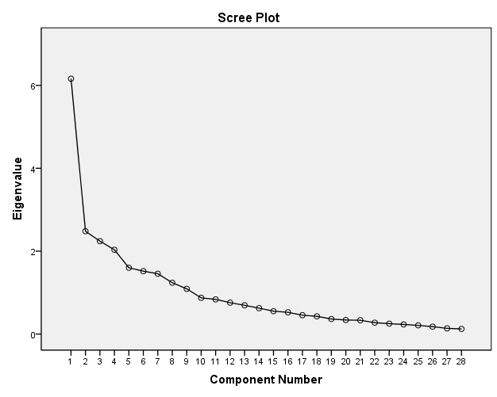

APPENDIX E

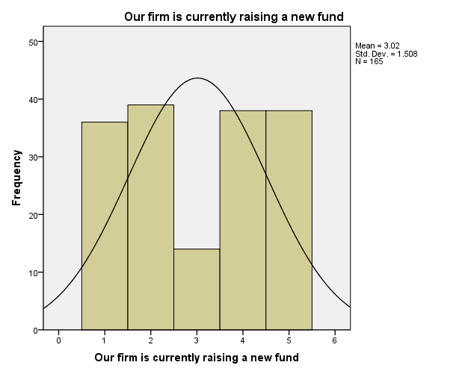

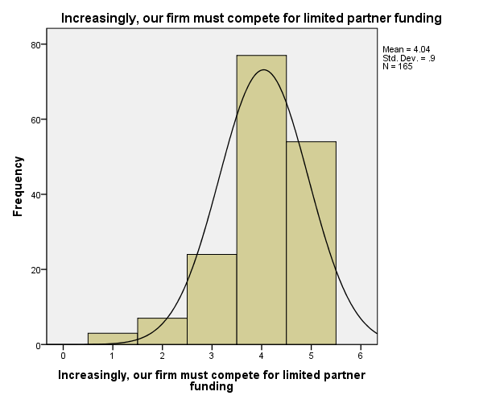

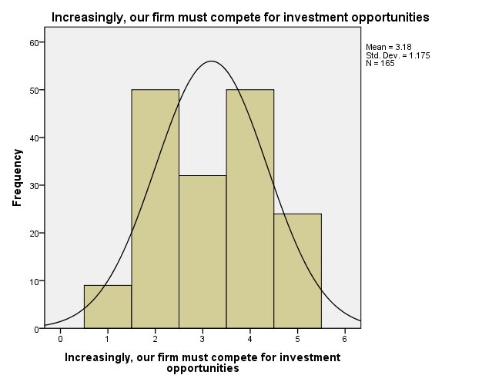

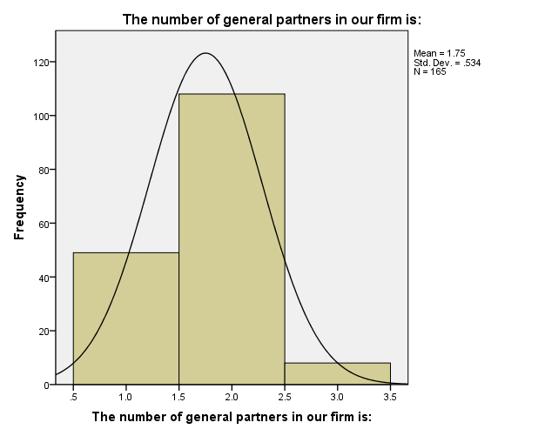

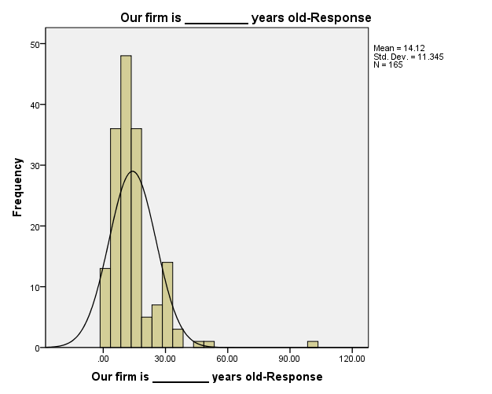

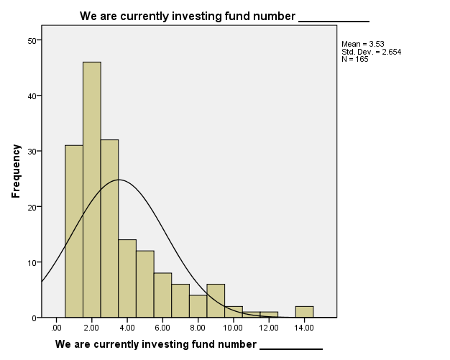

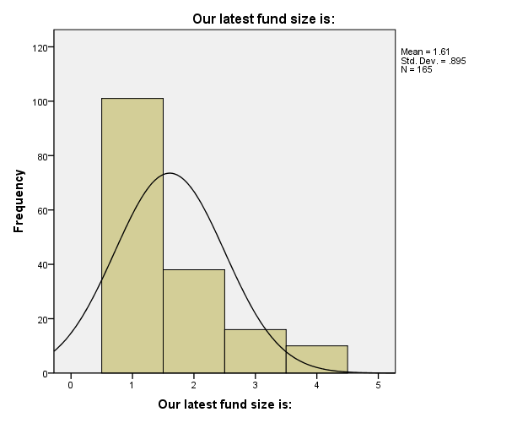

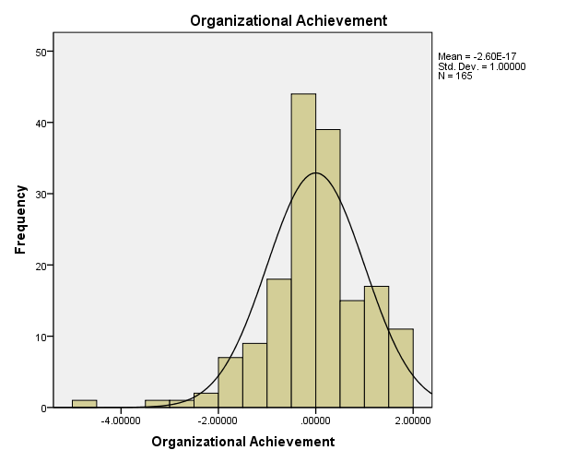

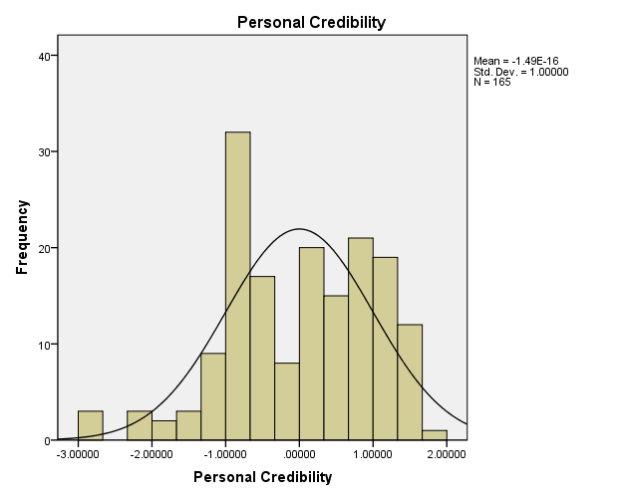

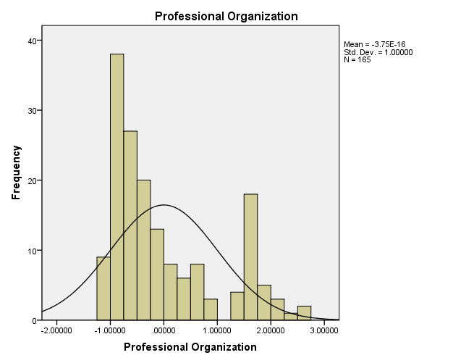

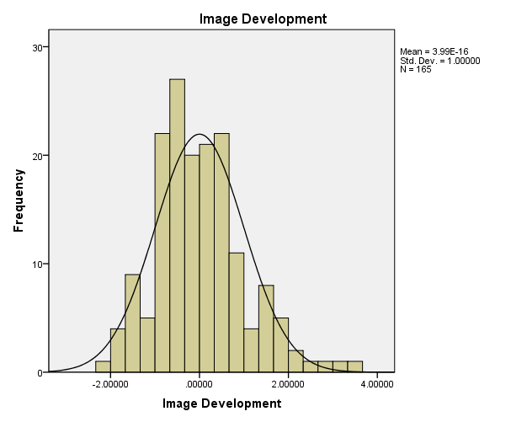

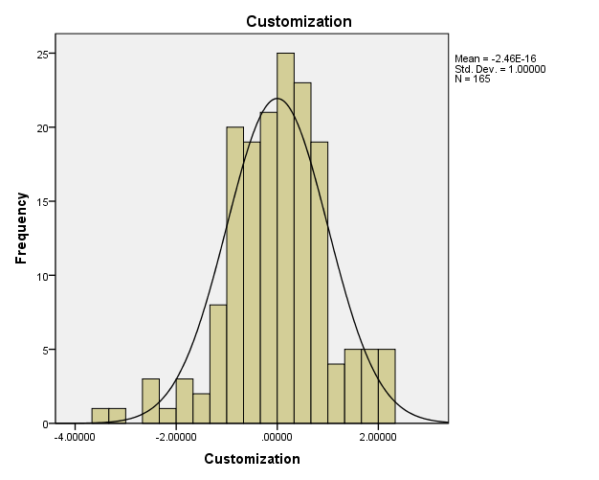

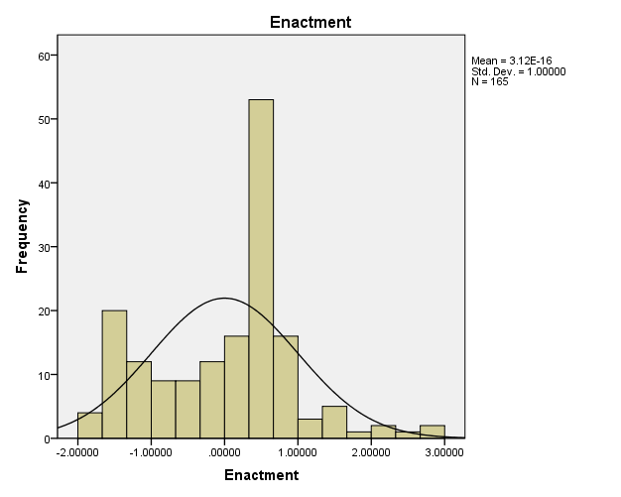

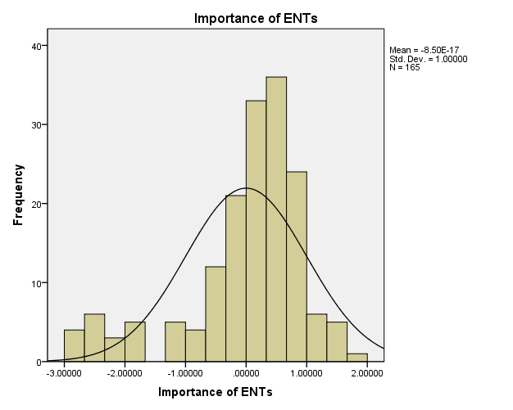

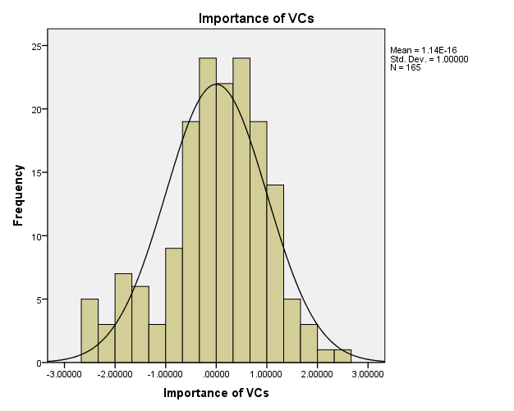

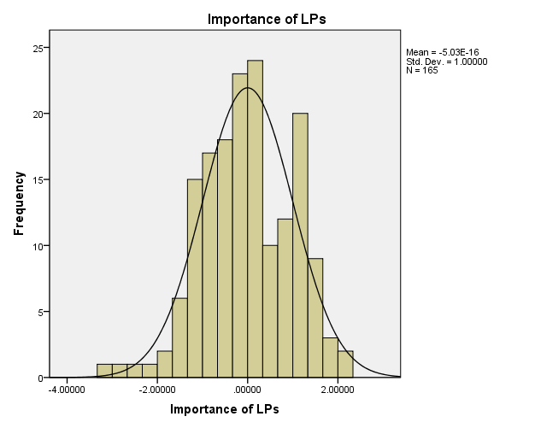

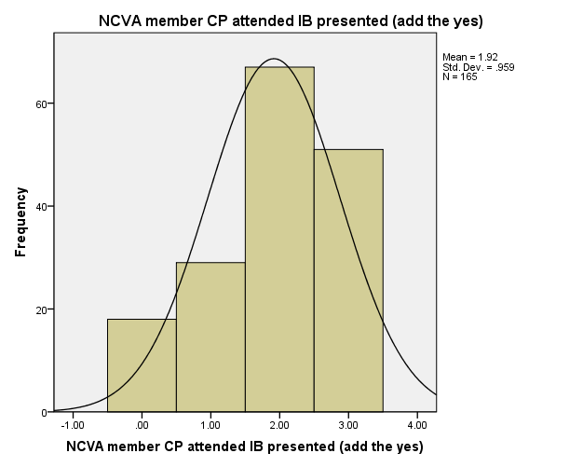

APPENDIX F

Run MATRIX procedure:

***************** PROCESS Procedure for SPSS Release 2.11 ****************

Written by Andrew F. Hayes, Ph.D. www.afhayes.com
Documentation available in Hayes (2013). www.guilford.com/p/hayes3

**************************************************************************
Model = 14
Y = NVCAattC
X = Importan of ENTs
M1 = Organiza
M2 = Personal
M3 = Professi
M4 = ImageDev
V = Customiz

Statistical Controls:
CONTROL= RaisingA CompeteF Compet_1 NumberOf AgeOfFir FundNumb SizeOfFu

Sample size
165

**************************************************************************
Outcome: Organiza

Model Summary
R R-sq F df1 df2 p
.2400 .0576 1.1923 8.0000 156.0000 .3070

Model
coeff se t p LLCI ULCI
constant -.5979 .4864 -1.2292 .2209 -1.5586 .3629
Importan .0553 .0787 .7020 .4837 -.1003 .2108
RaisingA .1179 .0545 2.1646 .0319 .0103 .2255
CompeteF .0009 .0911 .0093 .9926 -.1790 .1807
Compet_1 .0519 .0702 .7389 .4611 -.0868 .1906
NumberOf .2088 .1671 1.2497 .2133 -.1213 .5389
AgeOfFir -.0058 .0102 -.5733 .5673 -.0260 .0143
FundNumb -.0004 .0470 -.0077 .9939 -.0931 .0924
SizeOfFu -.1299 .1120 -1.1595 .2480 -.3511 .0914

**************************************************************************
Outcome: Personal

Model Summary
R R-sq F df1 df2 p
.1814 .0329 .6636 8.0000 156.0000 .7229

Model
coeff se t p LLCI ULCI
constant -.2351 .4927 -.4772 .6339 -1.2084 .7382
Importan .1260 .0798 1.5796 .1162 -.0316 .2835
RaisingA -.0415 .0552 -.7517 .4533 -.1505 .0675
CompeteF .0972 .0923 1.0541 .2934 -.0850 .2795
Compet_1 -.0508 .0711 -.7140 .4763 -.1913 .0897
NumberOf .0670 .1693 .3959 .6928 -.2674 .4014
AgeOfFir -.0043 .0103 -.4125 .6805 -.0246 .0161
FundNumb -.0261 .0476 -.5491 .5837 -.1201 .0679
SizeOfFu .1019 .1135 .8978 .3707 -.1223 .3260

**************************************************************************
Outcome: Professi

Model Summary
R R-sq F df1 df2 p
.2079 .0432 .8813 8.0000 156.0000 .5337

Model
coeff se t p LLCI ULCI
constant .5458 .4901 1.1136 .2672 -.4223 1.5138
Importan -.1630 .0793 -2.0547 .0416 -.3197 -.0063
RaisingA -.0184 .0549 -.3354 .7378 -.1268 .0900
CompeteF -.1092 .0918 -1.1896 .2360 -.2904 .0721
Compet_1 -.0214 .0707 -.3019 .7631 -.1611 .1184
NumberOf .0585 .1684 .3471 .7290 -.2742 .3911
AgeOfFir -.0049 .0103 -.4789 .6327 -.0252 .0154
FundNumb -.0117 .0473 -.2463 .8058 -.1051 .0818
SizeOfFu .0169 .1129 .1494 .8814 -.2061 .2398

**************************************************************************
Outcome: ImageDev

Model Summary
R R-sq F df1 df2 p
.2604 .0678 1.4180 8.0000 156.0000 .1929

Model
coeff se t p LLCI ULCI
constant .6630 .4838 1.3705 .1725 -.2926 1.6186
Importan -.0787 .0783 -1.0046 .3166 -.2334 .0760
RaisingA -.0151 .0542 -.2780 .7814 -.1221 .0919
CompeteF -.1750 .0906 -1.9317 .0552 -.3539 .0039
Compet_1 .0292 .0698 .4181 .6765 -.1087 .1671
NumberOf -.1985 .1662 -1.1943 .2342 -.5268 .1298
AgeOfFir .0004 .0101 .0359 .9714 -.0196 .0204
FundNumb .0332 .0467 .7101 .4787 -.0591 .1254
SizeOfFu .1385 .1114 1.2429 .2158 -.0816 .3585

**************************************************************************
Outcome: NVCAattC

Model Summary
R R-sq F df1 df2 p
.5332 .2843 3.4344 17.0000 147.0000 .0000

Model
coeff se t p LLCI ULCI
constant 1.2631 .4319 2.9245 .0040 .4096 2.1167
Organiza .0329 .0771 .4268 .6702 -.1194 .1852
Personal -.0774 .0730 -1.0595 .2911 -.2216 .0669
Professi .0104 .0732 .1421 .8872 -.1343 .1551
ImageDev -.1186 .0727 -1.6308 .1051 -.2624 .0251
Importan -.0385 .0694 -.5553 .5796 -.1757 .0986
Customiz .0855 .0760 1.1243 .2627 -.0648 .2357
int_1 -.0324 .0552 -.5863 .5585 -.1415 .0767
int_2 -.0653 .0820 -.7967 .4269 -.2273 .0967
int_3 .0829 .0947 .8749 .3831 -.1043 .2701
int_4 -.1344 .0620 -2.1682 .0317 -.2569 -.0119
RaisingA -.0529 .0501 -1.0558 .2928 -.1519 .0461
CompeteF .1480 .0819 1.8061 .0729 -.0139 .3099
Compet_1 -.0448 .0614 -.7297 .4667 -.1662 .0766
NumberOf -.2632 .1459 -1.8037 .0733 -.5515 .0252
AgeOfFir -.0073 .0090 -.8175 .4150 -.0250 .0104
FundNumb .1527 .0413 3.6995 .0003 .0711 .2343
SizeOfFu .2413 .0996 2.4223 .0166 .0444 .4381

Interactions:

int_1 Organiza X Customiz
int_2 Personal X Customiz
int_3 Professi X Customiz
int_4 ImageDev X Customiz

******************** DIRECT AND INDIRECT EFFECTS *************************

Direct effect of X on Y
Effect SE t p LLCI ULCI
-.0385 .0694 -.5553 .5796 -.1757 .0986

Conditional indirect effect(s) of X on Y at values of the moderator(s):

Mediator
Customiz Effect Boot SE BootLLCI BootULCI
Organiza -1.0000 .0036 .0103 -.0078 .0402
Organiza .0000 .0018 .0074 -.0073 .0252
Organiza 1.0000 .0000 .0089 -.0246 .0162

Mediator
Customiz Effect Boot SE BootLLCI BootULCI
Personal -1.0000 -.0015 .0176 -.0476 .0273
Personal .0000 -.0097 .0133 -.0573 .0062
Personal 1.0000 -.0180 .0202 -.0855 .0050

Mediator
Customiz Effect Boot SE BootLLCI BootULCI
Professi -1.0000 .0118 .0249 -.0302 .0763
Professi .0000 -.0017 .0156 -.0415 .0233
Professi 1.0000 -.0152 .0242 -.0918 .0148

Mediator
Customiz Effect Boot SE BootLLCI BootULCI
ImageDev -1.0000 -.0012 .0122 -.0389 .0161
ImageDev .0000 .0093 .0121 -.0043 .0472
ImageDev 1.0000 .0199 .0221 -.0095 .0843

Values for quantitative moderators are the mean and plus/minus one SD from mean.
Values for dichotomous moderators are the two values of the moderator.

******************** INDEX OF MODERATED MEDIATION ************************

Mediator
Index SE(Boot) BootLLCI BootULCI
Organiza -.0018 .0061 -.0234 .0050
Personal -.0082 .0135 -.0517 .0085
Professi -.0135 .0189 -.0701 .0128
ImageDev .0106 .0131 -.0059 .0514

******************** ANALYSIS NOTES AND WARNINGS *************************

Number of bootstrap samples for bias corrected bootstrap confidence intervals:
1000

Level of confidence for all confidence intervals in output:
95.00

------ END MATRIX -----

Run MATRIX procedure:

***************** PROCESS Procedure for SPSS Release 2.11 ****************

Written by Andrew F. Hayes, Ph.D. www.afhayes.com
Documentation available in Hayes (2013). www.guilford.com/p/hayes3

**************************************************************************
Model = 14
Y = NVCAattC
X = Importan of ENTs
M1 = Organiza
M2 = Personal
M3 = Professi
M4 = ImageDev
V = Enactmen

Statistical Controls:
CONTROL= RaisingA CompeteF Compet_1 NumberOf AgeOfFir FundNumb SizeOfFu

Sample size
165

**************************************************************************
Outcome: Organiza

Model Summary
R R-sq F df1 df2 p
.2400 .0576 1.1923 8.0000 156.0000 .3070

Model
coeff se t p LLCI ULCI
constant -.5979 .4864 -1.2292 .2209 -1.5586 .3629
Importan .0553 .0787 .7020 .4837 -.1003 .2108
RaisingA .1179 .0545 2.1646 .0319 .0103 .2255
CompeteF .0009 .0911 .0093 .9926 -.1790 .1807
Compet_1 .0519 .0702 .7389 .4611 -.0868 .1906
NumberOf .2088 .1671 1.2497 .2133 -.1213 .5389
AgeOfFir -.0058 .0102 -.5733 .5673 -.0260 .0143
FundNumb -.0004 .0470 -.0077 .9939 -.0931 .0924
SizeOfFu -.1299 .1120 -1.1595 .2480 -.3511 .0914

**************************************************************************
Outcome: Personal

Model Summary
R R-sq F df1 df2 p
.1814 .0329 .6636 8.0000 156.0000 .7229

Model
coeff se t p LLCI ULCI
constant -.2351 .4927 -.4772 .6339 -1.2084 .7382
Importan .1260 .0798 1.5796 .1162 -.0316 .2835
RaisingA -.0415 .0552 -.7517 .4533 -.1505 .0675
CompeteF .0972 .0923 1.0541 .2934 -.0850 .2795
Compet_1 -.0508 .0711 -.7140 .4763 -.1913 .0897
NumberOf .0670 .1693 .3959 .6928 -.2674 .4014
AgeOfFir -.0043 .0103 -.4125 .6805 -.0246 .0161
FundNumb -.0261 .0476 -.5491 .5837 -.1201 .0679
SizeOfFu .1019 .1135 .8978 .3707 -.1223 .3260

**************************************************************************

Outcome: Professi

Model Summary
R R-sq F df1 df2 p
.2079 .0432 .8813 8.0000 156.0000 .5337

Model
coeff se t p LLCI ULCI
constant .5458 .4901 1.1136 .2672 -.4223 1.5138
Importan -.1630 .0793 -2.0547 .0416 -.3197 -.0063
RaisingA -.0184 .0549 -.3354 .7378 -.1268 .0900
CompeteF -.1092 .0918 -1.1896 .2360 -.2904 .0721
Compet_1 -.0214 .0707 -.3019 .7631 -.1611 .1184
NumberOf .0585 .1684 .3471 .7290 -.2742 .3911
AgeOfFir -.0049 .0103 -.4789 .6327 -.0252 .0154
FundNumb -.0117 .0473 -.2463 .8058 -.1051 .0818
SizeOfFu .0169 .1129 .1494 .8814 -.2061 .2398

**************************************************************************
Outcome: ImageDev

Model Summary
R R-sq F df1 df2 p
.2604 .0678 1.4180 8.0000 156.0000 .1929

Model
coeff se t p LLCI ULCI
constant .6630 .4838 1.3705 .1725 -.2926 1.6186
Importan -.0787 .0783 -1.0046 .3166 -.2334 .0760
RaisingA -.0151 .0542 -.2780 .7814 -.1221 .0919
CompeteF -.1750 .0906 -1.9317 .0552 -.3539 .0039
Compet_1 .0292 .0698 .4181 .6765 -.1087 .1671
NumberOf -.1985 .1662 -1.1943 .2342 -.5268 .1298
AgeOfFir .0004 .0101 .0359 .9714 -.0196 .0204
FundNumb .0332 .0467 .7101 .4787 -.0591 .1254
SizeOfFu .1385 .1114 1.2429 .2158 -.0816 .3585

**************************************************************************
Outcome: NVCAattC

Model Summary
R R-sq F df1 df2 p
.5174 .2677 3.1609 17.0000 147.0000 .0001

Model
coeff se t p LLCI ULCI
constant 1.0774 .4355 2.4740 .0145 .2168 1.9380
Organiza .0770 .0786 .9799 .3287 -.0783 .2323
Personal -.1162 .0733 -1.5856 .1150 -.2610 .0286
Professi -.0480 .0813 -.5908 .5555 -.2086 .1126
ImageDev -.0454 .0776 -.5851 .5594 -.1987 .1079
Importan -.0526 .0728 -.7231 .4708 -.1965 .0912
Enactmen -.0973 .0858 -1.1344 .2585 -.2669 .0722
int_1 .0258 .0582 .4432 .6582 -.0892 .1408
int_2 .0081 .0876 .0921 .9267 -.1650 .1811
int_3 .0746 .0941 .7923 .4295 -.1114 .2606
int_4 -.1364 .0814 -1.6754 .0960 -.2973 .0245
RaisingA -.0740 .0490 -1.5103 .1331 -.1709 .0228
CompeteF .1901 .0817 2.3276 .0213 .0287 .3515
Compet_1 -.0541 .0627 -.8631 .3895 -.1780 .0698
NumberOf -.1712 .1529 -1.1201 .2645 -.4734 .1309
AgeOfFir -.0030 .0090 -.3392 .7350 -.0208 .0147
FundNumb .1336 .0416 3.2124 .0016 .0514 .2158
SizeOfFu .2165 .0999 2.1664 .0319 .0190 .4139

Interactions:

int_1 Organiza X Enactmen
int_2 Personal X Enactmen
int_3 Professi X Enactmen
int_4 ImageDev X Enactmen

******************** DIRECT AND INDIRECT EFFECTS *************************

Direct effect of X on Y
Effect SE t p LLCI ULCI
-.0526 .0728 -.7231 .4708 -.1965 .0912

Conditional indirect effect(s) of X on Y at values of the moderator(s):

Mediator
Enactmen Effect Boot SE BootLLCI BootULCI
Organiza -1.0000 .0028 .0106 -.0100 .0346
Organiza .0000 .0043 .0081 -.0039 .0362
Organiza 1.0000 .0057 .0128 -.0067 .0500

Mediator
Enactmen Effect Boot SE BootLLCI BootULCI
Personal -1.0000 -.0157 .0198 -.0872 .0070
Personal .0000 -.0146 .0148 -.0654 .0028
Personal 1.0000 -.0136 .0205 -.0801 .0101

Mediator
Enactmen Effect Boot SE BootLLCI BootULCI
Professi -1.0000 .0200 .0328 -.0466 .0930
Professi .0000 .0078 .0161 -.0234 .0430
Professi 1.0000 -.0043 .0203 -.0567 .0275

Mediator
Enactmen Effect Boot SE BootLLCI BootULCI
ImageDev -1.0000 -.0072 .0153 -.0594 .0091
ImageDev .0000 .0036 .0097 -.0077 .0381
ImageDev 1.0000 .0143 .0180 -.0101 .0652

Values for quantitative moderators are the mean and plus/minus one SD from mean.
Values for dichotomous moderators are the two values of the moderator.

******************** INDEX OF MODERATED MEDIATION ************************

Mediator
Index SE(Boot) BootLLCI BootULCI
Organiza .0014 .0085 -.0099 .0301
Personal .0010 .0138 -.0252 .0360
Professi -.0122 .0220 -.0665 .0221
ImageDev .0107 .0136 -.0078 .0490

******************** ANALYSIS NOTES AND WARNINGS *************************

Number of bootstrap samples for bias corrected bootstrap confidence intervals:
1000

Level of confidence for all confidence intervals in output:
95.00

------ END MATRIX -----

Run MATRIX procedure:

***************** PROCESS Procedure for SPSS Release 2.11 ****************

Written by Andrew F. Hayes, Ph.D. www.afhayes.com
Documentation available in Hayes (2013). www.guilford.com/p/hayes3

**************************************************************************
Model = 14
Y = NVCAattC
X = Importan of VCs
M1 = Organiza
M2 = Personal
M3 = Professi
M4 = ImageDev
V = Customiz

Statistical Controls:
CONTROL= RaisingA CompeteF Compet_1 NumberOf AgeOfFir FundNumb SizeOfFu

Sample size
165

**************************************************************************
Outcome: Organiza

Model Summary
R R-sq F df1 df2 p
.2562 .0657 1.3704 8.0000 156.0000 .2135

Model
coeff se t p LLCI ULCI
constant -.5118 .4892 -1.0462 .2971 -1.4781 .4545
Importan .1088 .0802 1.3562 .1770 -.0497 .2673
RaisingA .1174 .0541 2.1703 .0315 .0105 .2242
CompeteF -.0309 .0931 -.3319 .7404 -.2148 .1530
Compet_1 .0596 .0700 .8519 .3956 -.0787 .1979
NumberOf .2169 .1665 1.3023 .1947 -.1121 .5458
AgeOfFir -.0057 .0101 -.5667 .5717 -.0257 .0143
FundNumb -.0043 .0468 -.0914 .9273 -.0967 .0882
SizeOfFu -.1190 .1114 -1.0683 .2870 -.3391 .1011

**************************************************************************
Outcome: Personal

Model Summary
R R-sq F df1 df2 p
.1322 .0175 .3470 8.0000 156.0000 .9460

Model
coeff se t p LLCI ULCI
constant -.2497 .5017 -.4978 .6193 -1.2406 .7412
Importan .0066 .0823 .0800 .9363 -.1559 .1691
RaisingA -.0337 .0555 -.6077 .5443 -.1432 .0758
CompeteF .0893 .0955 .9355 .3510 -.0993 .2779
Compet_1 -.0466 .0718 -.6487 .5175 -.1884 .0952
NumberOf .0571 .1708 .3345 .7385 -.2802 .3944
AgeOfFir -.0031 .0104 -.2969 .7669 -.0236 .0174
FundNumb -.0281 .0480 -.5858 .5589 -.1229 .0667
SizeOfFu .1128 .1143 .9876 .3249 -.1129 .3385

**************************************************************************

Outcome: Professi

Model Summary
R R-sq F df1 df2 p
.1866 .0348 .7033 8.0000 156.0000 .6883

Model
coeff se t p LLCI ULCI
constant .4525 .4972 .9100 .3642 -.5297 1.4346
Importan -.1370 .0815 -1.6800 .0950 -.2981 .0241
RaisingA -.0237 .0550 -.4312 .6669 -.1323 .0849
CompeteF -.0646 .0946 -.6827 .4958 -.2515 .1223
Compet_1 -.0340 .0712 -.4775 .6336 -.1745 .1066
NumberOf .0563 .1693 .3324 .7401 -.2781 .3906
AgeOfFir -.0059 .0103 -.5773 .5646 -.0262 .0144
FundNumb -.0054 .0476 -.1132 .9100 -.0994 .0886
SizeOfFu -.0046 .1133 -.0409 .9674 -.2283 .2191

**************************************************************************
Outcome: ImageDev

Model Summary
R R-sq F df1 df2 p
.2849 .0812 1.7230 8.0000 156.0000 .0970

Model
coeff se t p LLCI ULCI
constant .5495 .4851 1.1328 .2590 -.4087 1.5078
Importan -.1445 .0796 -1.8163 .0712 -.3017 .0126
RaisingA -.0147 .0536 -.2743 .7842 -.1206 .0912
CompeteF -.1325 .0923 -1.4357 .1531 -.3149 .0498
Compet_1 .0187 .0694 .2697 .7877 -.1184 .1559
NumberOf -.2087 .1651 -1.2639 .2082 -.5349 .1175
AgeOfFir .0002 .0100 .0174 .9861 -.0196 .0200
FundNumb .0384 .0464 .8283 .4088 -.0532 .1301
SizeOfFu .1236 .1105 1.1189 .2649 -.0946 .3419

**************************************************************************
Outcome: NVCAattC

Model Summary
R R-sq F df1 df2 p
.5571 .3104 3.8921 17.0000 147.0000 .0000

Model
coeff se t p LLCI ULCI
constant 1.3603 .4258 3.1946 .0017 .5188 2.2018
Organiza .0269 .0757 .3552 .7230 -.1226 .1764
Personal -.0726 .0716 -1.0137 .3124 -.2140 .0689
Professi .0319 .0716 .4457 .6565 -.1095 .1733
ImageDev -.0903 .0722 -1.2509 .2130 -.2331 .0524
Importan .1715 .0707 2.4267 .0164 .0318 .3112
Customiz .0817 .0745 1.0972 .2743 -.0655 .2290
int_1 -.0203 .0544 -.3725 .7100 -.1279 .0873
int_2 -.0702 .0805 -.8726 .3843 -.2293 .0888
int_3 .0736 .0930 .7910 .4302 -.1103 .2574
int_4 -.1278 .0609 -2.0986 .0376 -.2481 -.0075
RaisingA -.0586 .0491 -1.1942 .2343 -.1556 .0384
CompeteF .1147 .0816 1.4047 .1622 -.0467 .2760
Compet_1 -.0372 .0604 -.6160 .5388 -.1565 .0821
NumberOf -.2307 .1436 -1.6060 .1104 -.5145 .0532
AgeOfFir -.0078 .0088 -.8913 .3742 -.0252 .0095
FundNumb .1466 .0406 3.6119 .0004 .0664 .2269
SizeOfFu .2411 .0976 2.4701 .0147 .0482 .4340

Interactions:

int_1 Organiza X Customiz
int_2 Personal X Customiz
int_3 Professi X Customiz
int_4 ImageDev X Customiz

******************** DIRECT AND INDIRECT EFFECTS *************************

Direct effect of X on Y
Effect SE t p LLCI ULCI
.1715 .0707 2.4267 .0164 .0318 .3112

Conditional indirect effect(s) of X on Y at values of the moderator(s):

Mediator
Customiz Effect Boot SE BootLLCI BootULCI
Organiza -1.0000 .0051 .0156 -.0141 .0558
Organiza .0000 .0029 .0109 -.0112 .0405
Organiza 1.0000 .0007 .0143 -.0320 .0321

Mediator
Customiz Effect Boot SE BootLLCI BootULCI
Personal -1.0000 .0000 .0088 -.0205 .0181
Personal .0000 -.0005 .0077 -.0220 .0132
Personal 1.0000 -.0009 .0133 -.0318 .0268

Mediator
Customiz Effect Boot SE BootLLCI BootULCI
Professi -1.0000 .0057 .0237 -.0310 .0701
Professi .0000 -.0044 .0134 -.0355 .0206
Professi 1.0000 -.0145 .0255 -.0919 .0174

Mediator
Customiz Effect Boot SE BootLLCI BootULCI
ImageDev -1.0000 -.0054 .0176 -.0541 .0242
ImageDev .0000 .0131 .0152 -.0040 .0558
ImageDev 1.0000 .0315 .0252 -.0039 .0986

Values for quantitative moderators are the mean and plus/minus one SD from mean.
Values for dichotomous moderators are the two values of the moderator.

******************** INDEX OF MODERATED MEDIATION ************************

Mediator
Index SE(Boot) BootLLCI BootULCI
Organiza -.0022 .0102 -.0307 .0107
Personal -.0005 .0082 -.0213 .0143
Professi -.0101 .0206 -.0719 .0166
ImageDev .0185 .0155 -.0015 .0647

******************** ANALYSIS NOTES AND WARNINGS *************************

Number of bootstrap samples for bias corrected bootstrap confidence intervals:
1000

Level of confidence for all confidence intervals in output:
95.00

------ END MATRIX -----

Run MATRIX procedure:

***************** PROCESS Procedure for SPSS Release 2.11 ****************

Written by Andrew F. Hayes, Ph.D. www.afhayes.com
Documentation available in Hayes (2013). www.guilford.com/p/hayes3

**************************************************************************
Model = 14
Y = NVCAattC
X = Importan of VCs
M1 = Organiza
M2 = Personal
M3 = Professi
M4 = ImageDev
V = Enactmen

Statistical Controls:
CONTROL= RaisingA CompeteF Compet_1 NumberOf AgeOfFir FundNumb SizeOfFu

Sample size
165

**************************************************************************
Outcome: Organiza

Model Summary
R R-sq F df1 df2 p
.2562 .0657 1.3704 8.0000 156.0000 .2135

Model
coeff se t p LLCI ULCI
constant -.5118 .4892 -1.0462 .2971 -1.4781 .4545
Importan .1088 .0802 1.3562 .1770 -.0497 .2673
RaisingA .1174 .0541 2.1703 .0315 .0105 .2242
CompeteF -.0309 .0931 -.3319 .7404 -.2148 .1530
Compet_1 .0596 .0700 .8519 .3956 -.0787 .1979
NumberOf .2169 .1665 1.3023 .1947 -.1121 .5458
AgeOfFir -.0057 .0101 -.5667 .5717 -.0257 .0143
FundNumb -.0043 .0468 -.0914 .9273 -.0967 .0882
SizeOfFu -.1190 .1114 -1.0683 .2870 -.3391 .1011

**************************************************************************
Outcome: Personal

Model Summary
R R-sq F df1 df2 p
.1322 .0175 .3470 8.0000 156.0000 .9460

Model
coeff se t p LLCI ULCI
constant -.2497 .5017 -.4978 .6193 -1.2406 .7412
Importan .0066 .0823 .0800 .9363 -.1559 .1691
RaisingA -.0337 .0555 -.6077 .5443 -.1432 .0758
CompeteF .0893 .0955 .9355 .3510 -.0993 .2779
Compet_1 -.0466 .0718 -.6487 .5175 -.1884 .0952
NumberOf .0571 .1708 .3345 .7385 -.2802 .3944
AgeOfFir -.0031 .0104 -.2969 .7669 -.0236 .0174
FundNumb -.0281 .0480 -.5858 .5589 -.1229 .0667
SizeOfFu .1128 .1143 .9876 .3249 -.1129 .3385

**************************************************************************

Outcome: Professi

Model Summary
R R-sq F df1 df2 p
.1866 .0348 .7033 8.0000 156.0000 .6883

Model
coeff se t p LLCI ULCI
constant .4525 .4972 .9100 .3642 -.5297 1.4346
Importan -.1370 .0815 -1.6800 .0950 -.2981 .0241
RaisingA -.0237 .0550 -.4312 .6669 -.1323 .0849
CompeteF -.0646 .0946 -.6827 .4958 -.2515 .1223
Compet_1 -.0340 .0712 -.4775 .6336 -.1745 .1066
NumberOf .0563 .1693 .3324 .7401 -.2781 .3906
AgeOfFir -.0059 .0103 -.5773 .5646 -.0262 .0144
FundNumb -.0054 .0476 -.1132 .9100 -.0994 .0886
SizeOfFu -.0046 .1133 -.0409 .9674 -.2283 .2191

**************************************************************************
Outcome: ImageDev

Model Summary
R R-sq F df1 df2 p
.2849 .0812 1.7230 8.0000 156.0000 .0970

Model
coeff se t p LLCI ULCI
constant .5495 .4851 1.1328 .2590 -.4087 1.5078
Importan -.1445 .0796 -1.8163 .0712 -.3017 .0126
RaisingA -.0147 .0536 -.2743 .7842 -.1206 .0912
CompeteF -.1325 .0923 -1.4357 .1531 -.3149 .0498
Compet_1 .0187 .0694 .2697 .7877 -.1184 .1559
NumberOf -.2087 .1651 -1.2639 .2082 -.5349 .1175
AgeOfFir .0002 .0100 .0174 .9861 -.0196 .0200
FundNumb .0384 .0464 .8283 .4088 -.0532 .1301
SizeOfFu .1236 .1105 1.1189 .2649 -.0946 .3419

**************************************************************************
Outcome: NVCAattC

Model Summary
R R-sq F df1 df2 p
.5410 .2927 3.5786 17.0000 147.0000 .0000

Model
coeff se t p LLCI ULCI
constant 1.2088 .4315 2.8011 .0058 .3560 2.0617
Organiza .0676 .0773 .8752 .3829 -.0851 .2203
Personal -.1063 .0721 -1.4743 .1425 -.2488 .0362
Professi -.0020 .0815 -.0248 .9802 -.1630 .1590
ImageDev -.0253 .0767 -.3297 .7421 -.1769 .1263
Importan .1774 .0740 2.3961 .0178 .0311 .3236
Enactmen -.0915 .0833 -1.0984 .2738 -.2562 .0731
int_1 .0051 .0577 .0889 .9293 -.1088 .1191
int_2 -.0124 .0832 -.1494 .8815 -.1769 .1520
int_3 .0177 .0957 .1846 .8538 -.1714 .2068
int_4 -.1218 .0803 -1.5175 .1313 -.2804 .0368
RaisingA -.0806 .0478 -1.6856 .0940 -.1752 .0139
CompeteF .1552 .0817 1.9001 .0594 -.0062 .3167
Compet_1 -.0460 .0617 -.7448 .4576 -.1679 .0760
NumberOf -.1584 .1502 -1.0545 .2934 -.4552 .1384
AgeOfFir -.0040 .0088 -.4569 .6484 -.0214 .0134
FundNumb .1318 .0409 3.2221 .0016 .0509 .2126
SizeOfFu .2183 .0982 2.2244 .0276 .0244 .4123

Interactions:

int_1 Organiza X Enactmen
int_2 Personal X Enactmen
int_3 Professi X Enactmen
int_4 ImageDev X Enactmen

******************** DIRECT AND INDIRECT EFFECTS *************************

Direct effect of X on Y
Effect SE t p LLCI ULCI
.1774 .0740 2.3961 .0178 .0311 .3236

Conditional indirect effect(s) of X on Y at values of the moderator(s):

Mediator
Enactmen Effect Boot SE BootLLCI BootULCI
Organiza -1.0000 .0068 .0172 -.0141 .0662
Organiza .0000 .0074 .0130 -.0051 .0587
Organiza 1.0000 .0079 .0158 -.0099 .0639

Mediator
Enactmen Effect Boot SE BootLLCI BootULCI
Personal -1.0000 -.0006 .0116 -.0291 .0197
Personal .0000 -.0007 .0109 -.0246 .0226
Personal 1.0000 -.0008 .0141 -.0345 .0268

Mediator
Enactmen Effect Boot SE BootLLCI BootULCI
Professi -1.0000 .0027 .0269 -.0603 .0551
Professi .0000 .0003 .0138 -.0334 .0263
Professi 1.0000 -.0021 .0173 -.0443 .0278

Mediator
Enactmen Effect Boot SE BootLLCI BootULCI
ImageDev -1.0000 -.0139 .0220 -.0729 .0148
ImageDev .0000 .0037 .0135 -.0175 .0407
ImageDev 1.0000 .0213 .0221 -.0061 .0832

Values for quantitative moderators are the mean and plus/minus one SD from mean.
Values for dichotomous moderators are the two values of the moderator.

******************** INDEX OF MODERATED MEDIATION ************************

Mediator
Index SE(Boot) BootLLCI BootULCI
Organiza .0006 .0102 -.0171 .0264
Personal -.0001 .0068 -.0169 .0131
Professi -.0024 .0179 -.0403 .0366
ImageDev .0176 .0174 -.0036 .0634

******************** ANALYSIS NOTES AND WARNINGS *************************

Number of bootstrap samples for bias corrected bootstrap confidence intervals:
1000

Level of confidence for all confidence intervals in output:
95.00

------ END MATRIX -----

Run MATRIX procedure:

***************** PROCESS Procedure for SPSS Release 2.11 ****************

Written by Andrew F. Hayes, Ph.D. www.afhayes.com
Documentation available in Hayes (2013). www.guilford.com/p/hayes3

**************************************************************************
Model = 14
Y = NVCAattC
X = Importan of LPs
M1 = Organiza
M2 = Personal
M3 = Professi
M4 = ImageDev
V = Enactmen

Statistical Controls:
CONTROL= RaisingA CompeteF Compet_1 NumberOf AgeOfFir FundNumb SizeOfFu

Sample size
165

**************************************************************************
Outcome: Organiza

Model Summary
R R-sq F df1 df2 p
.2591 .0672 1.4038 8.0000 156.0000 .1988

Model
coeff se t p LLCI ULCI
constant -.5078 .4886 -1.0394 .3002 -1.4729 .4573
Importan .1145 .0792 1.4464 .1501 -.0419 .2709
RaisingA .1185 .0540 2.1945 .0297 .0118 .2251
CompeteF -.0155 .0910 -.1698 .8654 -.1952 .1643
Compet_1 .0518 .0698 .7416 .4595 -.0861 .1897
NumberOf .1888 .1665 1.1343 .2584 -.1400 .5177
AgeOfFir -.0041 .0101 -.4062 .6852 -.0241 .0159
FundNumb .0019 .0468 .0401 .9681 -.0905 .0942
SizeOfFu -.1440 .1120 -1.2861 .2003 -.3653 .0772

**************************************************************************
Outcome: Personal

Model Summary
R R-sq F df1 df2 p
.2107 .0444 .9060 8.0000 156.0000 .5131

Model
coeff se t p LLCI ULCI
constant -.1102 .4945 -.2228 .8239 -1.0870 .8666
Importan .1681 .0801 2.0977 .0375 .0098 .3264
RaisingA -.0377 .0546 -.6904 .4909 -.1457 .0702
CompeteF .0711 .0921 .7720 .4413 -.1108 .2531
Compet_1 -.0496 .0707 -.7013 .4841 -.1892 .0900
NumberOf .0339 .1685 .2009 .8410 -.2990 .3667
AgeOfFir -.0013 .0103 -.1270 .8991 -.0216 .0190
FundNumb -.0235 .0473 -.4963 .6204 -.1170 .0700
SizeOfFu .0848 .1134 .7484 .4554 -.1391 .3088

**************************************************************************

Outcome: Professi

Model Summary
R R-sq F df1 df2 p
.2252 .0507 1.0422 8.0000 156.0000 .4068

Model
coeff se t p LLCI ULCI
constant .4104 .4929 .8327 .4063 -.5632 1.3839
Importan -.1871 .0799 -2.3424 .0204 -.3448 -.0293
RaisingA -.0240 .0545 -.4410 .6598 -.1316 .0836
CompeteF -.0789 .0918 -.8599 .3912 -.2603 .1024
Compet_1 -.0234 .0704 -.3323 .7401 -.1625 .1157
NumberOf .0973 .1679 .5793 .5632 -.2344 .4290
AgeOfFir -.0084 .0102 -.8231 .4117 -.0286 .0118
FundNumb -.0143 .0472 -.3024 .7628 -.1074 .0789
SizeOfFu .0339 .1130 .3001 .7645 -.1893 .2571

**************************************************************************
Outcome: ImageDev

Model Summary
R R-sq F df1 df2 p
.2693 .0725 1.5251 8.0000 156.0000 .1525

Model
coeff se t p LLCI ULCI
constant .5838 .4872 1.1984 .2326 -.3785 1.5461
Importan -.1063 .0789 -1.3467 .1800 -.2622 .0496
RaisingA -.0174 .0538 -.3225 .7475 -.1237 .0890
CompeteF -.1585 .0907 -1.7464 .0827 -.3377 .0208
Compet_1 .0285 .0696 .4087 .6833 -.1091 .1660
NumberOf -.1776 .1660 -1.0700 .2863 -.5055 .1503
AgeOfFir -.0015 .0101 -.1478 .8827 -.0215 .0185
FundNumb .0315 .0466 .6753 .5005 -.0606 .1236
SizeOfFu .1493 .1117 1.3371 .1831 -.0713 .3699

**************************************************************************
Outcome: NVCAattC

Model Summary
R R-sq F df1 df2 p
.5156 .2658 3.1305 17.0000 147.0000 .0001

Model
coeff se t p LLCI ULCI
constant 1.0962 .4393 2.4952 .0137 .2280 1.9644
Organiza .0768 .0788 .9747 .3313 -.0789 .2324
Personal -.1229 .0739 -1.6640 .0982 -.2690 .0231
Professi -.0406 .0814 -.4981 .6192 -.2015 .1204
ImageDev -.0415 .0784 -.5297 .5971 -.1965 .1134
Importan .0282 .0744 .3789 .7053 -.1188 .1752
Enactmen -.0855 .0851 -1.0043 .3169 -.2536 .0827
int_1 .0282 .0586 .4815 .6309 -.0875 .1439
int_2 -.0084 .0848 -.0991 .9212 -.1759 .1591
int_3 .0786 .0943 .8332 .4061 -.1078 .2649
int_4 -.1425 .0824 -1.7294 .0858 -.3053 .0203
RaisingA -.0790 .0488 -1.6194 .1075 -.1753 .0174
CompeteF .1931 .0816 2.3660 .0193 .0318 .3545
Compet_1 -.0555 .0628 -.8832 .3786 -.1797 .0687
NumberOf -.1728 .1536 -1.1248 .2625 -.4764 .1308
AgeOfFir -.0031 .0090 -.3480 .7284 -.0210 .0147
FundNumb .1347 .0417 3.2301 .0015 .0523 .2171
SizeOfFu .2082 .1011 2.0588 .0413 .0083 .4081

Interactions:

int_1 Organiza X Enactmen
int_2 Personal X Enactmen
int_3 Professi X Enactmen
int_4 ImageDev X Enactmen

******************** DIRECT AND INDIRECT EFFECTS *************************

Direct effect of X on Y
Effect SE t p LLCI ULCI
.0282 .0744 .3789 .7053 -.1188 .1752

Conditional indirect effect(s) of X on Y at values of the moderator(s):

Mediator
Enactmen Effect Boot SE BootLLCI BootULCI
Organiza -1.0000 .0056 .0167 -.0202 .0539
Organiza .0000 .0088 .0126 -.0041 .0617
Organiza 1.0000 .0120 .0169 -.0080 .0637

Mediator
Enactmen Effect Boot SE BootLLCI BootULCI
Personal -1.0000 -.0193 .0245 -.1064 .0073
Personal .0000 -.0207 .0175 -.0749 .0007
Personal 1.0000 -.0221 .0231 -.0998 .0069

Mediator
Enactmen Effect Boot SE BootLLCI BootULCI
Professi -1.0000 .0223 .0338 -.0399 .1057
Professi .0000 .0076 .0182 -.0232 .0537
Professi 1.0000 -.0071 .0216 -.0538 .0345

Mediator
Enactmen Effect Boot SE BootLLCI BootULCI
ImageDev -1.0000 -.0107 .0201 -.0961 .0102
ImageDev .0000 .0044 .0111 -.0078 .0419
ImageDev 1.0000 .0196 .0229 -.0053 .1076

Values for quantitative moderators are the mean and plus/minus one SD from mean.
Values for dichotomous moderators are the two values of the moderator.

******************** INDEX OF MODERATED MEDIATION ************************

Mediator
Index SE(Boot) BootLLCI BootULCI
Organiza .0032 .0112 -.0127 .0368
Personal -.0014 .0162 -.0357 .0326
Professi -.0147 .0218 -.0680 .0256
ImageDev .0151 .0185 -.0041 .0838

******************** ANALYSIS NOTES AND WARNINGS *************************

Number of bootstrap samples for bias corrected bootstrap confidence intervals:
1000

Level of confidence for all confidence intervals in output:
95.00

------ END MATRIX -----

Run MATRIX procedure:

***************** PROCESS Procedure for SPSS Release 2.11 ****************

Written by Andrew F. Hayes, Ph.D. www.afhayes.com
Documentation available in Hayes (2013). www.guilford.com/p/hayes3

**************************************************************************
Model = 14
Y = NVCAattC
X = Importan of LPs
M1 = Organiza
M2 = Personal
M3 = Professi
M4 = ImageDev
V = Customiz

Statistical Controls:
CONTROL= RaisingA CompeteF Compet_1 NumberOf AgeOfFir FundNumb SizeOfFu

Sample size
165

**************************************************************************
Outcome: Organiza

Model Summary
R R-sq F df1 df2 p
.2591 .0672 1.4038 8.0000 156.0000 .1988

Model
coeff se t p LLCI ULCI
constant -.5078 .4886 -1.0394 .3002 -1.4729 .4573
Importan .1145 .0792 1.4464 .1501 -.0419 .2709
RaisingA .1185 .0540 2.1945 .0297 .0118 .2251
CompeteF -.0155 .0910 -.1698 .8654 -.1952 .1643
Compet_1 .0518 .0698 .7416 .4595 -.0861 .1897
NumberOf .1888 .1665 1.1343 .2584 -.1400 .5177
AgeOfFir -.0041 .0101 -.4062 .6852 -.0241 .0159
FundNumb .0019 .0468 .0401 .9681 -.0905 .0942
SizeOfFu -.1440 .1120 -1.2861 .2003 -.3653 .0772

**************************************************************************
Outcome: Personal

Model Summary
R R-sq F df1 df2 p
.2107 .0444 .9060 8.0000 156.0000 .5131

Model
coeff se t p LLCI ULCI
constant -.1102 .4945 -.2228 .8239 -1.0870 .8666
Importan .1681 .0801 2.0977 .0375 .0098 .3264
RaisingA -.0377 .0546 -.6904 .4909 -.1457 .0702
CompeteF .0711 .0921 .7720 .4413 -.1108 .2531
Compet_1 -.0496 .0707 -.7013 .4841 -.1892 .0900
NumberOf .0339 .1685 .2009 .8410 -.2990 .3667
AgeOfFir -.0013 .0103 -.1270 .8991 -.0216 .0190
FundNumb -.0235 .0473 -.4963 .6204 -.1170 .0700
SizeOfFu .0848 .1134 .7484 .4554 -.1391 .3088

**************************************************************************

Outcome: Professi

Model Summary
R R-sq F df1 df2 p
.2252 .0507 1.0422 8.0000 156.0000 .4068

Model
coeff se t p LLCI ULCI
constant .4104 .4929 .8327 .4063 -.5632 1.3839
Importan -.1871 .0799 -2.3424 .0204 -.3448 -.0293
RaisingA -.0240 .0545 -.4410 .6598 -.1316 .0836
CompeteF -.0789 .0918 -.8599 .3912 -.2603 .1024
Compet_1 -.0234 .0704 -.3323 .7401 -.1625 .1157
NumberOf .0973 .1679 .5793 .5632 -.2344 .4290
AgeOfFir -.0084 .0102 -.8231 .4117 -.0286 .0118
FundNumb -.0143 .0472 -.3024 .7628 -.1074 .0789
SizeOfFu .0339 .1130 .3001 .7645 -.1893 .2571

**************************************************************************
Outcome: ImageDev

Model Summary
R R-sq F df1 df2 p
.2693 .0725 1.5251 8.0000 156.0000 .1525

Model
coeff se t p LLCI ULCI
constant .5838 .4872 1.1984 .2326 -.3785 1.5461
Importan -.1063 .0789 -1.3467 .1800 -.2622 .0496
RaisingA -.0174 .0538 -.3225 .7475 -.1237 .0890
CompeteF -.1585 .0907 -1.7464 .0827 -.3377 .0208
Compet_1 .0285 .0696 .4087 .6833 -.1091 .1660
NumberOf -.1776 .1660 -1.0700 .2863 -.5055 .1503
AgeOfFir -.0015 .0101 -.1478 .8827 -.0215 .0185
FundNumb .0315 .0466 .6753 .5005 -.0606 .1236
SizeOfFu .1493 .1117 1.3371 .1831 -.0713 .3699

**************************************************************************
Outcome: NVCAattC

Model Summary
R R-sq F df1 df2 p
.5325 .2835 3.4220 17.0000 147.0000 .0000

Model
coeff se t p LLCI ULCI
constant 1.2868 .4359 2.9521 .0037 .4253 2.1482
Organiza .0308 .0771 .3996 .6900 -.1216 .1833
Personal -.0821 .0731 -1.1240 .2628 -.2266 .0623
Professi .0202 .0734 .2744 .7841 -.1250 .1653
ImageDev -.1147 .0730 -1.5701 .1186 -.2590 .0297
Importan .0285 .0720 .3959 .6927 -.1138 .1709
Customiz .0816 .0760 1.0733 .2849 -.0686 .2318
int_1 -.0355 .0555 -.6397 .5234 -.1452 .0742
int_2 -.0647 .0820 -.7887 .4316 -.2267 .0974
int_3 .0787 .0960 .8202 .4134 -.1110 .2684
int_4 -.1383 .0624 -2.2160 .0282 -.2616 -.0150
RaisingA -.0556 .0501 -1.1112 .2683 -.1545 .0433
CompeteF .1477 .0822 1.7975 .0743 -.0147 .3102
Compet_1 -.0461 .0614 -.7503 .4543 -.1674 .0753
NumberOf -.2636 .1461 -1.8037 .0733 -.5524 .0252
AgeOfFir -.0074 .0090 -.8204 .4133 -.0251 .0104
FundNumb .1533 .0413 3.7119 .0003 .0717 .2349
SizeOfFu .2343 .0999 2.3448 .0204 .0368 .4318

Interactions:

int_1 Organiza X Customiz
int_2 Personal X Customiz
int_3 Professi X Customiz
int_4 ImageDev X Customiz

******************** DIRECT AND INDIRECT EFFECTS *************************

Direct effect of X on Y
Effect SE t p LLCI ULCI
.0285 .0720 .3959 .6927 -.1138 .1709

Conditional indirect effect(s) of X on Y at values of the moderator(s):

Mediator
Customiz Effect Boot SE BootLLCI BootULCI
Organiza -1.0000 .0076 .0146 -.0088 .0641
Organiza .0000 .0035 .0104 -.0091 .0377
Organiza 1.0000 -.0005 .0126 -.0332 .0207

Mediator
Customiz Effect Boot SE BootLLCI BootULCI
Personal -1.0000 -.0029 .0210 -.0629 .0300
Personal .0000 -.0138 .0149 -.0664 .0037
Personal 1.0000 -.0247 .0209 -.0932 .0025

Mediator
Customiz Effect Boot SE BootLLCI BootULCI
Professi -1.0000 .0110 .0310 -.0343 .0902
Professi .0000 -.0038 .0169 -.0477 .0242
Professi 1.0000 -.0185 .0282 -.1004 .0181

Mediator
Customiz Effect Boot SE BootLLCI BootULCI
ImageDev -1.0000 -.0025 .0158 -.0497 .0209
ImageDev .0000 .0122 .0152 -.0057 .0603
ImageDev 1.0000 .0269 .0260 -.0119 .0982

Values for quantitative moderators are the mean and plus/minus one SD from mean.
Values for dichotomous moderators are the two values of the moderator.

******************** INDEX OF MODERATED MEDIATION ************************

Mediator
Index SE(Boot) BootLLCI BootULCI
Organiza -.0041 .0089 -.0410 .0073
Personal -.0109 .0147 -.0556 .0092
Professi -.0147 .0243 -.0810 .0185
ImageDev .0147 .0153 -.0068 .0564

******************** ANALYSIS NOTES AND WARNINGS *************************

Number of bootstrap samples for bias corrected bootstrap confidence intervals:
1000

Level of confidence for all confidence intervals in output:
95.00

------ END MATRIX -----

APPENDIX G

