UNIVERSITY OF OKLAHOMA
GRADUATE COLLEGE

SEMIOTIC AND NARRATIVE ELEMENTS IN FRANZ LISZT’S VALLÉE D’OBERMANN

A DOCUMENT
SUBMITTED TO THE GRADUATE FACULTY
in partial fulfillment of the requirements for the
Degree of
DOCTOR OF MUSICAL ARTS

By
Omar Roy
Norman, Oklahoma
2020

SEMIOTIC AND NARRATIVE ELEMENTS IN FRANZ LISZT’S VALLÉE D’OBERMANN

A document approved for the
school of music

By the committee consisting of

Dr. Sarah Ellis, Chair

Dr. Barbara Fast

Dr. Jeongwon Ham

Dr. Sanna Pederson

Dr. Edgar O’Rear

© Copyright by oMAR ROY 2020
All Rights Reserved

ACKNOWLEDGMENTS

As I reach the conclusion of my degree, I realize how fortunate I am to be surrounded by so many incredible people, without whom I never would have come this far. First, a special thank you goes to my wife, Sarah, and my family. I could not have completed this degree without their unwavering belief in me. I would also like to thank my best friend, Drew Spacht, whose friendship has been steadfast through thick and thin. In Hungary, I offer my thanks to music publisher Editio Musica Budapest for allowing the use of their scores for examples in this document. Their editions of the highest quality and attention to detail were of the greatest importance to the accuracy of my analysis.
At the University of Oklahoma, I wish to thank all the members of my committee for their knowledge and expertise throughout my degree and the process of writing this document. Special recognition goes to Dr. Sarah Ellis not only for her patience and guidance on this project, but also for having such a profound effect on the way that I think about music. Without her, this document would not be possible. I also extend my sincere gratitude to Dr. Sanna Pederson and Dr. Edgar O’Rear whose thoughtful questions and insights pushed me to take greater ownership of my ideas. I would like to thank Dr. Jeongwon Ham, whose kindness and generosity have taught me so very much about what it means to be a musician. Finally, Dr. Jane Magrath and Dr. Barbara Fast have contributed immeasurably to my development, both academically and professionally, and I give them my sincerest appreciation for their tremendous support.
Last, but not least, I extend my heartfelt gratitude to my friends in the School of Music who brought so much joy into my life during my time in Norman, OK. I cannot imagine having completed this degree with a more dedicated and wonderful group of people.
Table of Contents

ACKNOWLEDGMENTS iv
List of Tables vii
List of Figures viii
ABSTRACT ix
CHAPTER 1: INTRODUCTION AND METHODOLOGY 1
Purpose of the Study 2
Need for the Study 3
Limitations of the Study 4
Review of Literature 4
The Musical Topic 5
Narrativity in Music 7
Related Studies 11
Methodology 14
Liszka and Frye 15
Almén, Micznik, and Tarasti 19
Markedness and the Expressive Genre 24
Sonata Form 25
Proposed Model 26
CHAPTER 2: MORPHOLOGY AND SYNTAX 29
Morphological 29
Syntactic 33
Summary 51
CHAPTER 3: SEMANTICS 52
Topics 54
Isotopies and Modalities 58
Conclusion 63
CHAPTER 4: ACTANTIAL AND NARRATIVE LEVELS 65
Actantial Level 65
Discursive Syntax and Function 65
Gestural Connotations 69
Temporal Discursive Processes 70
The Expressive Genre 73
Narrative Level 77
CHAPTER 5: CONCLUSION 79
Conclusions 80
Recommendations for Further Study 81
Appendix A 84
Appendix B 85
BIBLIOGRAPHY 86

List of Tables

Table 1.1 Liszka’s Binary Oppositions 19
Table 1.2 Basic Modalities 23
Table 2.1 Vallée d’Obermann – Formal structure 36
Table 2.2 Vallée d’Obermann – Formal structure of Exposition 37
Table 2.3 Formal Structure - Development 45
Table 2.4 Formal structure of Recapitulation and Coda 49
Table 3.1 Vallée d’Obermann – Form, Isotopies, and Topics 54
Table 4.1 Isotopies and Modalities 67
Table 4.2 Isotopies and Topics 69
Table 4.3 Form, Topics, and Keys 76

List of Figures

Figure 1.1 Northrop Frye’s Cyclical Model of Narrative 18
Figure 2.1 Vallée d’Obermann, mm. 1-4 31
Figure 2.2 Vallée d’Obermann, Motives within T 32
Figure 2.3 Vallée d’Obermann – Structural reduction Mª 32
Figure 2.4 Vallée d’Obermann – Melodic cells within Mª 33
Figure 2.5 Vallée d’Obermann – m. 20: Alteration of T to create Ce 33
Figure 2.6 Vallée d’Obermann – mm. 75-78: T^{t} – Melodic cell C^{f} 33
Figure 2.7 Vallée d’Obermann – Rhythmic Cells within T 34
Figure 2.8 Vallée d’Obermann – Enharmonic Ger⁺⁶ at m. 26 and chorale-style texture 39
Figure 2.9 Vallée d’Obermann – mm. 26-36. 40
Figure 2.10 Vallée d’Obermann – mm. 65-70 41
Figure 2.11 Vallée d’Obermann – mm. 71-74 42
Figure 2.12 Transformed theme (T^{t}) in mm. 75-78. 46
Figure 2.14 Vallée d’Obermann – Successive Transfigurations: m. 170, m. 175, m. 188, m. 192 50
Figure 2.15 Vallée d’Obermann – Subverted Plagal Motion: mm. 212-213 50
Figure 2.16 Vallée d’Obermann – mm. 214-216. 51
Figure 4.1 Vallée d’Obermann – Modality and Relative Stability 67
Figure 4.2 Vallée d’Obermann – Relationships between Isotopies and Rhetorical Mode 73

ABSTRACT

Liszt’s Vallée d’Obermann, like many piano works from his Années de Pèlerinage, is explicitly linked to extramusical sources. In this case the inspiration is ostensibly Étienne Pivert de Senancour’s novel Obermann, from which Liszt includes excerpts in the piece’s epigraph. However, epigraphs and perceived extramusical inspirations are not always reliable in understanding musical narrative. Given the uncertain nature of to what extent the narrative content of Obermann influenced Liszt’s composition, this document explores an underlying level of narrative using the analytical model set forth by Byron Almén in A Theory of Musical Narrative (2008). The analysis examines semiotic and narratological elements including the interactions of topics, temporality, narrative implications rooted in harmony, and the expressive function of these elements within Sonata form. Ultimately, the results of these discursive interactions are expressed through the assignation of a narrative archetype based on Northtrop Frye’s “cycle of mythoi.”

INTRODUCTION AND METHODOLOGY

Composers of instrumental music have often drawn inspiration from a variety of extramusical sources, sometimes even associating a composition with a specific work from another form of artistic media. This explicit association, in turn, can be used as a path to one of many possible “meanings” for a particular composition. However, does this necessarily mean that music is incapable of expressing meaning without an extramusical association? This question has sparked a decades-long dialogue in the fields of musicology and music theory, guided by studies in semiotics and hermeneutics. The work of music theorists and musicologists in applying semiotic and hermeneutic analysis to music in the 20th Century suggests an alternative approach – that Western Art music does not require an extramusical association in order to communicate meaning and, furthermore, that this genre of music is capable of expressing meaning in ways that are unique to the syntax of music. As such, theorists have been exploring the possibilities of hermeneutic interpretations of music for several decades, with early examples including the work of Edward T. Cone in the 1970s and 1980s, through the 2000s with the work of Robert Hatten, Lawrence Kramer, Carolyn Abbate, and Byron Almén, to name a few., Many of these theorists have provided ways of associating music with meanings that arise from historical, cultural, and personal contexts, while providing elements of methodology that can be added to an “analytical toolbox.” However, only a few have actually provided complete methodologies that can be used to analyze a wide array of musical styles. Most recently, Byron Almén has done so in A Theory of Musical Narrative (2008).
Considering the growing body of literature concerned with narratology as it is related to music, it is surprising that more formal studies have not addressed the music of Franz Liszt. His works often exhibit a sense of narrative trajectory and evoke “meaning” even when those works do not have extramusical associations. The influence of explicitly narrative works permeates his repertoire in both his own music and his transcriptions of various songs and opera overtures. That his works without assigned texts should exhibit the same inclination to narrativity is, thus, unsurprising. Given the relative lack of formalized studies on narrative and the music of Liszt, this study will analyze Vallée d’Obermann from Liszt’s Années de Pèlerinage as a case study of how rhetorical devices in music can create a sense of narrative when examined independently of the piece’s extramusical association.

Purpose of the Study
Many works from Liszt’s output are associated with extramusical inspirations, either explicitly or speculatively. While these extramusical inspirations are often used to draw meaning or a sense of narrative from a work, applications of semiotic and narratological analytical methods have shown that the unique syntax of music is more than capable of expressing a sense of narrative on its own terms. This document investigates the unique ways in which narrative manifests immanently in the solo piano literature of Franz Liszt. By using the framework outlined by Byron Almén in A Theory of Musical Narrative (2008) to discuss Vallée d’Obermann, I will show that works with an assigned text exhibit narrative just as readily when examined in the absence of their extramusical inspirations.
The concept of immanent narrative argues that narrative operates intrinsically in music through the perception of relevant musical expressions. My analysis establishes that Vallée d’Obermann exhibits traditional narrative markers and that the ways in which narrative operates can be revealed through an analysis of these semiotic and structural elements. In looking at a Lisztian musical narrative, a systematic and multifaceted approach to utilizing musical syntagmatic analytical tools reveals a nuanced combination of semiotic components framed and directed by structural paradigms. More specifically, this study seeks to examine the narrative implications that arise when semiotic elements interact within the framework of a Sonata structure. Furthermore, this study explicitly associates narrative expression with the formal directives of the Sonata. The underlying narrative structures revealed in this analysis could then be extrapolated and applied to other compositions by Liszt of a similar structural and expressive scope.

Need for the Study
The scholarly discussion of “how music means” is an ongoing endeavor with ever-changing analytical models. While a plethora of literature regarding hermeneutic analysis and the semiotics of music exists, many of these books are dedicated to a narrow range of concepts or, in some cases, a single topic. Byron Almén’s A Theory of Musical Narrative does not categorically explore a wide range of topics, but Almén’s emphasis on an eclectic model casts a wide net of analytical methodologies that can be incorporated into a framework of narrative analysis. At the time of this writing, very few scholarly documents exist which use Almén’s model, none of which apply Almén’s framework to the music of Franz Liszt. Almén first adapts three methodologies into his framework by noted theorists Vera Micznik, Eero Tarasti, and Susan McClary and, then, spends the latter half of his book using his model to analyze music. The natural limitations of his book are that he only explores a few works of a fairly narrow generic range and that he does not incorporate elements from methodologies of more than one theorist for any given analysis. These limitations are not necessarily shortcomings, as their absence allows for clarity in the establishment of his framework.
Of the three methodologies he adapts into his framework, the most thorough, by far, is that of Vera Micznik. Consequently, Almén’s incorporation of Micznik’s analytical methodology leads to an acutely detailed analysis based on a thorough examination of all themes and their component motives and cells, generic functions, and interactions. These interactions lead to changes in hierarchy which, in turn, result in a narrative assignment based on James Jakób Liszka’s linear adaptation of Northrop Frye’s cyclical model of narrative archetypes.
By applying Almén’s narrative framework to Vallée d’Obermann, this document will establish a formal analytical approach for narrativity in Liszt’s music, contribute to the current pool of scholarly publications surrounding Liszt’s compositions, and add to the body of literature that explores narrativity in music.

Limitations of the Study
This document uses a single composition as a case study, although the study does make references to other works, both by Liszt and other composers. Further studies in this area could include a more comprehensive overview of narrative in Liszt’s music, going beyond his output for solo piano and into his symphonic literature. While narrativity and other forms of hermeneutic analysis have largely been conducted in Classical and Romantic era music, further studies could apply structuralist and semiotic principles within Almén’s eclectic model to non-tonal music of the 20th and 21st centuries, including electroacoustic music.

Review of Literature
The number of perspectives and methodologies surrounding music and meaning are vast, yet surprisingly few are directly concerned with establishing a formal analytical methodology for narrative analysis. In what follows I identify and evaluate relevant texts that have established and directed this field of study, and also those that have served to increase the depth of the body of related work. Topic theory, in particular, plays an significant role in my analysis as its semiotic basis has direct implications on the expression of narrativity in music. Consequently, this review of literature will first examine significant texts about the musical topic, then address texts specifically related to narratology and musical narrative, and conclude with related studies in the form of applied analyses and writings about the narrative implications of formal structures.

The Musical Topic
Ratner’s Classic Music: Expression, Form, and Style is largely responsible for establishing a mainstream solidification of the musical topos, a theory that was later developed by a number of theorists thereafter, including V. Kofi Agawu and Elaine Sisman. Raymond Monelle’s concise description of topic theory in The Sense of Music is more than adequate in describing Ratner’s argument that music can portray through the structure of musical figures as part of a “semantic universe,” thus obviating the need for an associated text or descriptive title. However, Monelle also outlines several deficiencies with Ratner’s theory, stating that much of Ratner’s work is not reflective of contemporaneous theorists, as Ratner claims, and that his theory arises mostly from “his own sensitive analysis and response to the music, rather than from historical learning.” More explicitly, Ratner tends to ignore large swaths of the writings of theorists contemporary to the Classical-era works he analyzes, leading to under-informed theorizing and, sometimes, inaccurate translations. For example, Monelle notes that H.C. Koch (1749 – 1816) defines the “pastorale” style as “rustic” and generally in a moderately slow 6/8 time, and that it is related to the musette and the siciliano. This, among other elements relating to style, is information that Ratner ignores or misattributes.
Inspired by Ratner’s work, Monelle’s collection of essays in The Sense of Music further explores the semiotics of music, expounding upon topic theory and its application to musical discourse. Monelle’s essays venture into how topic is related to the Wagnerian leitmotiv, temporality, musical genre and structure, and even text relationships. Most importantly, Monelle allows for more flexibility in how topics are discussed and materialized, leading to discussions on how topical areas can be suggested by the musical texture and affect rather than explicitly formed. Chapter 4 (The Temporal Image) emphasizes the importance of the temporal perception of musical discourse. Critical to this argument is the definition of temporality as “cultural time” in the sense that the perception of time, as a cultural construct, is directly related to the perspective of the listener. This allows a listener to place musical events within a temporal framework of cultural time, and can result in the perception of time accelerating or decelerating based on musical discourse. Monelle further explores topical fields in The Musical Topic: Hunt, Military, and Pastoral (2006).
Robert Hatten’s Musical Meaning in Beethoven: Markedness, Correlation, and Interpretation addresses matters beyond the realm of topic theory, but its third and fourth chapters deal specifically with the extent to which topics can influence the emergence of meaning in a musical work. Hatten argues that the musical topic can shift into an expressive genre based on its interaction with the surrounding musical discourse. He argues that a work can move beyond the confines of a single topic, and that the topic can act as a framework that directs the expressive genre. Specifically, he references the Pastoral topic, noting that its use as an expressive genre can encompass a shift to a different affect or topical field, and that the topical shift subsequently creates an opposition, thus “marking” the non-Pastoral. Predictably, this opposition creates the need for resolution, defined by a return to the Pastoral or lack thereof. Hatten goes beyond the Pastoral expressive genre to include other expressive genres such as the “Tragic to Triumphant” and the “Tragic to Transcendent.”

Narrativity in Music
While the musical topic is one tool for identifying meaning in music, the subject of narrativity has also been discussed for several decades yielding few formalized models. A number of prominent theorists have contributed to the study of meaning in music, even though some have been opposed to the idea of “narrativity” in music citing issues of syntax (Nattiez), or of the presence of a narrator and the “past tense” (Abbate). Fred Everett Maus eschews these arguments, favoring the perspective that music fails to fulfill these requirements because music functions as its own language with its own syntax and rhetorical devices. Maus expounds on this notion in “Music as Drama” (1988) and “Music as Narrative” (1991) by drawing comparisons between manifestations of narrative in music and dramatic action., Others who have contributed to the study of narrativity include Edward T. Cone, Eero Tarasti, Anthony Newcomb, Michael Klein, and Byron Almén.Each have contributed elements of, or entire methodologies and analytical frameworks. While their literature is broad, directly related to this study are the works of Edward T. Cone, Eero Tarasti, Michael Klein, Vera Micznik, and Byron Almén.
Two early articles by Edward T. Cone explicitly discuss narrative from a hermeneutic perspective. The first, entitled Three Ways to Read a Detective Story – Or a Brahms Intermezzo (1977) explores how narrative manifests to a “reader” through successive readings of increasing hermeneutic depth. His subsequent essay Schubert’s Promissory Note: An Exercise in Musical Hermeneutics (1982) departs from this, focusing instead on the idea that a prominently placed dissonant pitch can lay the foundation for the unfolding of a musical narrative, especially when that pitch is treated as a hermeneutic window through which expressive significance or cultural identity can be assigned. Through tracking the anomalous pitch and its interaction within the musical texture and discourse, a plot take shape – the beginnings of an archetype. Indeed, this is highly similar to the approach that Almén will eventually adopt. However, Cone’s work is limited in that it relies solely on the temporal unfolding of the discourse, and the musical texture itself, delivering a focused, or narrow, perspective of narrative even in light of its lucidity.
Eero Tarasti’s A Theory of Musical Semiotics (1994) is a continuation of the semiotic tradition, specifically using Greimasian generative theory as a fundamental semiotic basis. While Tarasti does not formally espouse a “theory of narrative,” his work does lean towards a narrative approach to music. Tarasti builds off of the work of Marta Grabocz’s expressive isotopies while incorporating topic theory, as well as other rhetorical devices that express a music’s ability to generate meaning using a system of signs. Tarasti’s work is intellectually rigorous but does not exhibit the same extent of surface-level fastidiousness in dealing with the elements of the musical text itself. This is most apparent in his approach to Liszt’s Vallée d’Obermann.
Much of the analysis in this document, owes a debt to Tarasti’s own segmentation of Vallée d’Obermann. His segmentations, although clearly delineated by the work itself, are adopted in my work, as well as his characterization of the chorale-like texture found in mm. 26-34. Tarasti’s analysis vividly depicts the affect in each of the five isotopies and their narrative trajectories. He employs a prosaic approach rooted in the general expressivity of the music rather than detailed analysis of surface material, although he does reveal certain rhythmic characteristics in the primary theme. Overall, his analysis is compelling and inspiring to read. However, its loose approach to the score itself does not address several items that would result in a more lucid analysis including key relationships, the temporal relationship of basic rhythmic units across isotopies, and elements of formal structure. Additionally, key differences in my analysis yield differing rhetorical interpretations to his characterization of the closing bars as having an “unfinished” or “frustrated” quality. I will address these differences in the core of my analysis. Despite these shortcomings, evidence in the score easily supports the spirit of Tarasti’s argument. Consequently, my analysis incorporates his segmentation and approach to the use of the main theme, and seeks to support them with elements from the score.
Whereas Tarasti’s work has an intense focus on how music communicates and expresses ideas on a grand scale, Vera Micznik’s work features an alternative rigor in its attention to the minute details of the musical text. Her 1999 article entitled “The Absolute Limitations of Programme Music: The Case of Liszt's 'die Ideale'” addresses the nature of programmaticism in music through a detailed cataloging of musical data. She then examines the expression of narrative both with and without reference to its assigned program, while a third level of analysis examines the points at which the initial two analyses don’t align. Micznik’s 2001 article, “Music and Narrative Revisited: Degrees of Narrativity in Beethoven and Mahler”, yields an even more methodical analytical model, which Byron Almén neatly adapts for his own framework. Both Micznik’s approach to narrative from different perspectives and her attention to fine details of the musical content are integral components of my work. Interestingly, her analytical model reflects elements of Nattiez’s formalized global/linear processes in spite of his known opposition to the idea of “narrative” being expressed solely through musical discourse.
Most important to this study is Byron Almén whose work establishes parameters for a systematic framework of narrative analysis. His dissertation (1998) and subsequent 2003 article entitled Narrative Archetypes: A Critique, Theory, and Method of Narrative Analysis ultimately led to A Theory of Musical Narrative (2008). In A Theory of Musical Narrative, he channels James Jakob Liszka’s concept of transvaluation, which defines narrative as the result of a change in the rank order of perceived cultural units. These cultural units fit into a three-level framework that catalogs the units themselves, their interactions, and the resulting change in hierarchy as a result of those interactions. Almén takes this three-stage model, adapts it to Northrop Frye’s cyclical model of narrative, and creates a formalized framework for narrative analysis in music.
The model is inherently eclectic and acts as a structure that encourages analysis of a wide range of musical styles using a wide range of methodologies. Its overarching limitation lies in its reliance on traditional notions of narrative as espoused by Frye, who is a specialist in Romantic literature. Such a system that relies on pre-generic archetypes might fail to adequately account for narrative in postmodern/deconstructionist literature which sees the deliberate breakdown of traditional literary structures. Consequently, the same shortcomings may occur in music that has similar aims, the obvious candidate being music of the 20th and 21st century. Almén and Hatten address these limitations in “Narrative Engagement with Twentieth-Century Music: Possibilities and Limits”. While this is a legitimate concern, the music of this study takes place firmly within the Romantic period. As a result, Almén’s framework and its eclectic possibilities constitutes an ideal model for analysis. A more detailed discussion follows in the methodology subsection of this chapter.

Related Studies
Although a number of studies have incorporated narrative analysis, few have directly incorporated the model created by Almén. A Theory of Musical Narrative is unique in that it encourages analytical eclecticism, rather than trying to confine analysis to a single set of methodological parameters. An inherent limitation of this is a lack of uniformity among possible analyses, and the models he uses in his own analyses are only a small sampling of the possibilities. That being said, there are a number of articles, essays, and studies which are relevant either on the grounds of narrativity, or the music of Liszt – though, rarely, both.
In addition to Almén’s book, his dissertation provides analyses in a similar size and scope and even though it is less refined than his book, the analyses within are an ideal tutor, so to speak, in adapting his models for one’s own needs. This, his article, and his book have yielded a small number of subsequent studies of a more focused nature with varying degrees of rigor in applying elements of Almén’s framework.
Studies applying narratological analytical methods have been conducted in an array of different styles. Some studies focus on establishing a narrative archetype for a single work, while others focus on establishing a context of narrativity within a single composer or set of composers. Some track immanent narrative archetypes through a genre, and others, still, seek to further the depths of multi-level semiotic narrative analysis. Due to the nature of Almén’s model, degrees of eclecticism vary, both, across studies and within, leading to a breadth of factors contributing to the formation of a narrative archetype. These factors include formal structures such as Sonata form.
Many authors have used a dialogic approach to discuss sonata form as a catalyst for generating narrative. In Sonata Theory, Hepokoski and Darcy conceptualize Sonata form as a background set of normative procedures in which any individual piece fulfills some or all of these “action-options.” They note that the duty of sonata form is not to conform to the strictures and normative practices, but to act in dialogue with them through strategic acts of nonconformity, or deformations. This concept is also explored at length in Musical Form, Forms, and Formenlehre (2010), and I will discuss it further in the Methodology section of this chapter. Some examples that address Chopin’s Ballades include work by Michael Klein and Jim Samson. Both of these works examine the inner workings of Chopin’s Ballades and the mapping of formal sections loosely onto sections within the pieces in order to illustrate narrative. Specifically, Klein’s 2004 article Chopin’s Fourth Ballade as Musical Narrative explores the ability of musical figures to create the elusive “past tense” while also characterizing narrative as a “series of expressive states,” calling to mind the expressive isotopies of Grabocz/Tarasti. Theorists have even applied the concept of dialogic form and its capacity to illustrate narrative to composers in the 20th Century, illustrated by the work of Sarah Reichardt on Shostakovich’s String Quartets (2008) with broader applications of Sonata Theory applied more recently by Seth Monahan.
None of these studies on narrative directly address the music of Liszt. As Alan Walker notes, many narratives have been assigned to the Sonata in B minor. While these narrative adaptations of the Sonata are lucid and provide interesting perspectives, they all seek to map the musical text onto external narratives rather than define narrative as an immanent process. Other attempts at narrative analysis are rare, and often feature the same external aims. Additionally, many studies that analyze the expressive elements of Liszt’s solo piano music often do so either with reference to the associated extramusical text or historical context.
One recent and relevant study was done by Grace Yu in A Semiotic Interpretation of Liszt’s Piano Works in Light of their Extramusical Sources (2012), in which she examines pieces from Liszt’s Années de Pèlerinage and their relevant extramusical associations that result from Liszt’s travels while composing the set. In her study she applies various types of semiotic analytical methodologies to explicate meaning in her repertoire selections, including adaptations of Tarasti/Grabocz (expressive isotopies) and Almén/Frye (narrative archetypes). However, the nature of her study excludes works that might be classified as “non-programmatic” due to the lack of overt extramusical associations. My study ultimately provides the opposite of Yu’s work – an examination of a work independent of its extramusical sources.

Methodology
Vallée d’Obermann is the sixth piece in the first book of Liszt’s Années de Pèlerinage. However, its appearance in this collection is not its first publication, a situation shared by many pieces in this first book. Most of the pieces from the (colloquially) “Swiss Book” are heavily revised versions that were originally published as part of the Album d’un Voyageur. Vallée d’Obermann, in particular, featured extensive revisions throughout, with special attention paid to the introduction, which foreshadows much more of the turmoil to follow later in the piece. While the original version features a much more tumultuous and dynamic sense of drama, the revised edition included in the first installment of Années de Pèlerinage exhibits a more linear dramatic arc defined by motivic unity and dramatic pacing, if a less virtuosic one. Given Liszt’s decision to republish Vallée d’Obermann as part of a newer collection, I have selected the revised edition for this analysis.
Defining the term narrativity as it pertains to music is rather complicated as, traditionally, there exist a number of criteria related to the discourse that require fulfillment. Almén notes that many theorists in the past have confined narrativity to the domain of so-called programmatic works which “make use of reference to external characters, settings, and objects to tell a musical story.” Almén argues that listeners experience all of those sensations (struggle, conflict, resolution, etc.) from a literary narrative in works that do not qualify, necessarily, as programmatic. Of course, this notion has been explored extensively through a number of methodologies and by a number of theorists. However, Almén is the first to invoke seemingly disparate sources to synthesize his methodology for narrative analysis. The three sources that he cites are Northrop Frye’s Anatomy of Criticism (1957), Eero Tarasti’s A Theory of Musical Semiotics (1994), and James Jakob Liszka’s The Semiotic of Myth (1989). While Frye’s Anatomy of Criticism outlines the four basic archetypal narratives as a cycle, Liszka forms an adaptation of this system in a linear fashion, emphasizing the concept of transvaluation. Transvaluation, espouses narrative as a change in values and, thus, rank order of musical actors. The changes in hierarchy of musical actors then correspond with one of Frye’s pre-generic mythoi (Romance, Tragedy, Satire/Irony, or Comedy).
Using Almén’s framework, this study adapts the models of the aforementioned theorists to a three-tiered model in order to establish a clear and systematic methodology appropriate to the works in question. However, whereas Almén necessarily limits his adaptations to a single analytical system for the purposes of clarity and exemplification, I also draw from Micznik’s highly structured model based on motives, cells, and discursive strategies, and Tarasti’s semiotic model. A more detailed explanation of each methodology and how it will be adapted follows.

Liszka and Frye
Liszka’s narrative model features three tiers, ranging from highly acute analyses of surface-level material to broad spectrum assignment of an archetypal narrative plot. These three tiers are the Agential, Actantial, and Narrative levels. Central to Liszka’s theory are the notions of value and rank. At its essence, Liszka’s model tracks the individual cultural units (Agential), their interactions (Actantial), and the consequences of those interactions (Narrative). The results of these interactions are changes, or a lack thereof, in value of these cultural units. Changes in value lead to a change in hierarchy, which corresponds with a pre-generic narrative as defined by Northrup Frye and adapted by Liszka.
While Liszka notes that “valuative features need not be vested in actorial entities,” the notion of actoriality is necessary to any analysis of Liszt’s music, as much of his output relies on the interaction of “actors” in the form of musical themes and their respective motivic content. Consequently, the concept of the Agential level, actors, and individualistic agency are an integral facet of the analyses to come.
The Agential level is the most basic level of analysis. It identifies and catalogues the individual characteristics of each cultural unit, including its rank as compared to other cultural units present in a work, and its potential markedness. As applied to music, this level identifies cultural units and musical agents as appropriate to the genre. As Almén defines it, these entities are identified by their “morphological, syntactic, and semantic features.” While identification of cultural units in common practice tonal music of the Baroque through Romantic eras can easily be tied to musical entities such as themes and motives, the intentional ambiguity of the term cultural units allows for a more comprehensive oeuvre from which analysts can identify musical entities. More specifically, this allows for the consideration of topic theory. At the agential level, a topic can possess its own rank value or markedness status based on the context in which the topic manifests. Similarly, the concept of temporality can be addressed at the agential level as it pertains directly to the perception of cultural units within a musical context.
Following the taxonomical purpose of the Agential level, the Actantial level is responsible for tracking the changes in markedness and/or rank that result from the interactions of cultural units throughout the temporal unfolding of a musical work. Consequently, the initial rank evaluation at the Agential level may change throughout the musical discourse as a result of events catalogued by the Actantial level.
The Narrative level serves as a method of categorizing the events that occur throughout the musical discourse. At its essence, it examines the initial hierarchy defined by analysis at the Agential level and the final hierarchy as explicated by analysis at the Actantial level. The resulting changes in hierarchy then correspond with one of Northrup Frye’s pre-generic narratives or mythoi as adapted by Liszka. Before examining Liszka’s adaptations I will first summarize Frye’s initial model, shown in Figure 1.1.
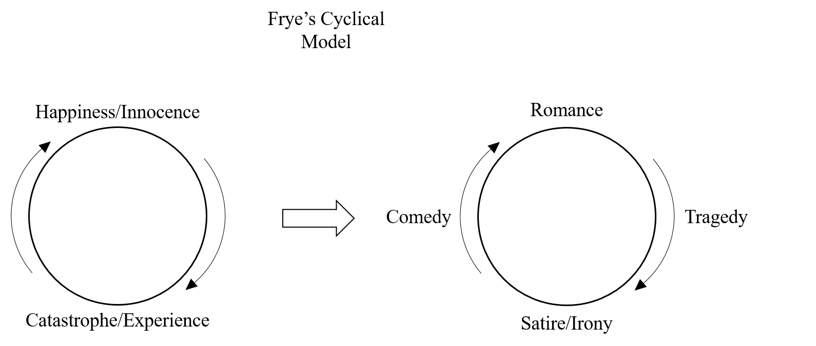
Figure 1.1 Northrop Frye’s Cyclical Model of Narrative
Frye’s initial model is cyclical and runs clockwise. At the top of the cycle are the ideals of happiness and innocence, while at the bottom lie catastrophe and experience. Correspondingly, the narrative of happiness and/or innocence is the Romance, while the narrative of catastrophe and/or experience is the Satire or Irony. The loss of innocence or happiness is the Tragedy, while the regaining of innocence or happiness is the Comedy. Missing from this model are the notions of value and hierarchy which are central to Liszka’s model.
Consequently, Liszka adapts Frye’s cyclical model into a system of binary opposition that allows for the evaluation of rank and markedness. In Liszka’s system, there exists the established norm of the “order imposing hierarchy” and the “transgressor” which seeks to oppose it. There are four possible outcomes in this binary opposition which map onto Frye’s four mythoi. Liszka’s adaptation highlights the importance of perception, and which entity is viewed in a positive light. Table 1.1 shows Liszka’s binary oppositions.
Liszka’s Binary Oppositions
Romance | Victory of an order-imposing hierarchy* over a transgressor. (Victory + Order)
Tragedy | Defeat of a transgressor* by an order-imposing hierarchy. (Defeat + Transgressor)
Satire/Irony | Defeat of an order-imposing hierarchy* by a transgressor. (Defeat + Order)
Comedy | Victory of a transgressor* over an order-imposing hierarchy. (Victory + Transgressor)
*denotes that this entity’s actions are viewed positively
Table 1.1 Liszka’s Binary Oppositions
While the overall outcomes above can be reduced to two overall resulting rank structures (either Transgression or Order-imposing Hierarchy emerging as the victor in the end rank structure), the narrative archetypes are assigned based on the initial agential evaluation and the resulting change, or lack of change, in rank. Just as Frye’s “Romance” archetype remains at the upper end of the circle, Liszka’s “Romance” begins and ends with normative procedures maintaining superior rank. Having established the four mythoi as elaborated by Frye and their oppositional adaptations by Liszka, it is now possible to examine Micznik’s two-level discursive analytical model, and how Almén adapts it into Liszka’s narrative framework.
With regard to Frye’s narrative archetypes, the nomenclature and aesthetic connotations of the four archetypes can lack the specificity necessary to more accurately depict the expressive content within a narrative. While I will ultimately argue for the Comedic narrative archetype operating in Vallée d’Obermann, it is my intent for the narrative assignation to more specifically depict, both literally and aesthetically, the expressive trajectory of the work. Consequently, this analysis will refer further refine the Comedic archetype as it applies to Vallée d’Obermann by supporting this assignation with Robert Hatten’s “Tragic to Transcendent” expressive genre.

Almén, Micznik, and Tarasti
Micznik’s two-level model features a “story” analysis (which Almén likens to the “agential” component) and the “discourse” analysis (the “actantial” component). Micznik’s “story” analysis identifies musical units and assesses their meanings in three increasingly complex semiotic levels:
- Morphological: Themes, cells, motives, and their relationships.
- Syntactic: Meanings that arise from the grammar of the music, and formal functions.
- Semantic: Meanings that arise from culturally recognizable codes, encompassing hermeneutic elements such as topics and affect.
Discourse analysis, the actantial level, examines the temporal unfolding of the music, the context of musical events, and the interactions between elements from the agential level. It also categorizes events that orient the listener and the events between these orienting moments that create forward momentum. As Almén notes, Liszka’s third level (the narrative level) is easily appended onto Micznik’s methodology. This results in the following hybridization outlined by Almén.
- “Story” (Agential Level): identifies coherent musical units (events) and explicates their stylistic meanings
  - Morphological: defines events by musical parameter, articulates their non-contextual relationships, and indicates their stable and variable elements
    - Cells
    - Motives
    - Themes
  - Syntactic: indicates meanings arising from grammatical, formal, and generic functions
  - Semantic: identifies meanings arising from conventionally recognized codes, both formal and informal (affect, character, topic, etc.)
- “Discourse” (Actantial Level): identifies strategic meanings – those arising from the temporal unfolding of the work
  - Discursive syntax and function: identifies meanings acquired by events transforming over time or appearing in different contexts, and distinguishes between those events that orient the listener and those that create momentum
  - Gestural connotations: identifies “processes of accumulation, velocity, dissolution, disorientation, etc.”
  - Temporal discursive processes: identifies meanings produced by changes of “duration, frequency, speed, and order of events” in relation to “an ‘ideal’ temporal discursive scheme”

- Liszka’s narrative level
  - Assignation of a narrative archetype
The above outline provides an analytical “checklist” of narrative elements and will serve as the framework for the final outline in the closing statements of this chapter. The highly structured and organized nature of the Almén – Micznik model allows for further hybridization at the Agential and Actantial levels. As stated before, I will draw elements from Tarasti’s semiotic model which can be applied at both the Agential and Actantial levels.
Where Micznik’s model is formal and detailed, Tarasti’s methodology in A Theory of Musical Semiotics is notably informal. Indeed, even Tarasti acknowledges this, stating that he has “purposely stopped the formalization on some level, because it is assumed that some music reveals its true essence better in a ‘softer,’ more philosophical-hermeneutical discourse.” The relatively informal nature of Tarasti’s methodology allows for a great sense of flexibility and wide range of applicability to different types of music, and features four distinct levels based on the Greimasian generative approach.
- Isotopies
- Spatiality, Temporality, and Actoriality
- Modalities
- Phemes/Semes; Figures
The first level identifies the levels of meaning in a text, and can serve as the first level of “segmentation” throughout a musical text. Tarasti is intentionally vague about the process of segmentation. Segmentation into expressive isotopies can coincide with the various formal sections of a work, changes in emotional states or textures, or shifts in topical fields. Further segmentation can occur within isotopies based on topical associations.
The second level addresses tonal centers and registers (spatiality), temporal organization (temporality, as it relates to basic perceptions of time), and thematic elements (actoriality) as well as the ability for thematic elements to exhibit a sense of agency.
The third level is the teleological emergence of the facets of spatiality, temporality, and actoriality. Tarasti outlines the basic modalities such as being (a state of rest, stability, or consonance), doing (musical action, dynamism, or dissonance), and becoming (the normal temporal process of music). He also outlines a number of other more specific modalities which can be combined in various ways to describe the musical discourse and its purpose/intent within a narrative context, outlined in Table 1.2.
Basic Modalities
Being | State of rest, stability, consonance
Doing | Musical action, event, dynamism, dissonance
Becoming | The “normal” temporal process of music
Secondary Modalities
Will | The kinetic energy of music and its tendency to move toward something
Know | Musical information, the cognitive moment of music
Can | The power and efficiency of music and its technical resources
Must | Aspects of genre and formal type
Believe | The epistemic values of music
Table 1.2 Basic Modalities

The final level is the most broad, and combines modalities with signifiers (phemes) and signified units (semes) to form a logical musical trope that coincides with certain culturally assigned values such as “struggle” or “victory” that can be assigned to isotopies, elements within isotopies, or even topical/isotopic relationships. On a larger scale, the combination of these five levels, then, generates a narrative trajectory based on the sequential progression of modalities. Critical to this sequential progression is the idea of modalization in which a specific point in the discourse acts as a catalyst for change – a point of modalization. The material preceding these points is referred to as “pre-modalization” material, while the expressive state that occurs after the point of modalization is referred to as “post-modalization.”
While it is possible to achieve a great level of detail, the purpose of Tarasti’s five levels of analysis is to generate a narrative trajectory based on how music is experienced as a temporal unfolding rather than as a collection of notation. This makes it rather appealing in the sense that it requires less “work” than an approach such as Micznik’s, which is distinctly driven by notational activity. The quasi-dichotomous relationship between Micznik’s and Tarasti’s methodologies places them seemingly at odds with one-another. However, the first three levels exhibited by Tarasti’s model mesh effectively with Micznik’s method.
At the Agential level the segmentation of music into isotopies adds expressive depth to the Syntactic analysis of Micznik’s model by assigning levels of meaning to formal sections based on the surface-level action elucidated by the Morphological analysis. This, in turn, acts as a culturally meaningful backdrop for the perception of the Semantic analysis which includes topical fields. Incorporating elements of Tarasti’s second and third levels at the Agential and Actantial levels of Micznik’s model allows an analysis to account for how music is experienced as a temporal unfolding of musical action being experienced in a narrative trajectory. In essence, it allows for immanent narrative to reveal itself while also keeping track of its components. Tarasti’s concepts of Spatiality, Temporality, and Actoriality all function at the Agential level in that they provide an adequate set of initial characteristics for hierarchical placement in a rank order, while at the Actantial level their relative changes and interactions come to the forefront. Modality assigns an expressive state to elements of an isotopy, but the sequential progression of modalities leads to interactions at the Actantial level which yield results at the Narrative level – thus leading to the incorporation, primarily, of modalization and its subsequent pre- and post- modalization categories. In addition, establishing a “rhetorical mode” as it pertains to the arena of narrative (psychodynamic/internal, external etc.) also provides an added layer of depth at the Narrative level, characterizing the work and its primary modes of rhetorical action.

Markedness and the Expressive Genre
Just as Tarasti’s isotopic segmentation benefits from the assignation of modalities, the use of topics necessitates a means by which to categorize their oppositions and to organize their interactions. As a result, markedness and the expressive genre play significant roles throughout my analysis. Hatten defines markedness as “the asymmetrical valuation of an opposition,” and notes that “marked entities have a greater (relative) specificity of meaning than do unmarked entities.” For example, Hatten argues that the minor mode has a narrower range of meaning than does the major mode, especially when the use of the minor mode occurs within the context of a work set predominantly in the major mode. Common examples of this include the use of modal mixture. These episodes or fleeting occurrences of the minor mode generally signify a “tragic or poignant perspective”, standing in contrast to the non-tragic surrounding material.
At the Agential level, markedness can highlight the expressive value and narrative importance of specific musical elements such as cells, motives, key relationships, and even topics. On a broader scale, topics and the expressive genre carry multiple functions. Hatten’s argument that a work can move beyond a single topical field naturally lends itself to marked topical oppositions. At the Actantial level, the organization and interaction of two or more topical fields form an expressive genre through their marked oppositions. Revealing an expressive genre can expose the emotional trajectory of a work and, ultimately, support the assignation of a narrative archetype. Topics can also fit within a structure that facilitates the concepts of markedness and the expressive genre, such as Sonata form.

Sonata Form
An argument central to this study is that Vallée d’Obermann is in Sonata form. James Hepokoski and Warren Darcy’s dialogic approach to sonata form will form the basis of my discussion of formal/generic functions of Vallée d’Obermann. In Sonata Theory, Hepokoski and Darcy conceptualize Sonata form as a set of traditional generic practices in which any composition fulfills some or all of these procedures. They note that the duty of sonata form is not to conform to the strictures and normative practices, but to act in dialogue with them through the use of deformations. Deformations are compositional procedures that deviate from the genre defining practices of the form and are to be taken as a sense of agency in that the musical discourse is deliberately pushing against the normative procedures. This creates structural tension that propels a sense of narrative, punctuated by the subsequent achievement or failure to achieve resolution. These deformations, to name a few, can take the form of non-standard key relationships and modulations, thematic transformation, and augmentation or diminution of melodic components at structural points in the form. This concept is also discussed at length in Musical Form, Forms, and Formenlehre (2010). In Vallée d’Obermann, Sonata form structures the narrative through the strategic placement of topical fields within and across formal sections, the use of thematic transformation and how the transformed theme relates to those topical fields, and the association of specific rhythmic cells with the expression of time.

Proposed Model
In establishing such an extensive framework, this study aims to approach narrative from a perspective of revealing underlying narrative structures and devices that operate in this composition, and to yield an overall basis of analytical approach that could be applicable to other works of similar scope by Franz Liszt. The proposed analytical model assimilates large components from both Micznik’s and Tarasti’s approaches, while appending Liszka’s adaptation of Frye’s narrative archetypes. This results in three levels of analysis, as dictated by Almen’s framework.
The first level (Agential) features morphological, syntactic, and semantic analyses. The purpose of this level is primarily to identify relevant musical features so that they can be tracked throughout the musical discourse. The morphological level identifies the primary theme, and also its component motives and cells, both rhythmic and melodic. The syntactic analysis reveals how Vallée d’Obermann adheres to and deviates from Sonata form by identifying structural boundaries, invoking Hepokoski and Darcy’s application of dialogic form. Finally, the semantic analysis divides the composition into several isotopies each with their own expressive modality, while also identifying relevant expressions of musical topics as defined by Monelle and Hatten.
The second level (Actantial) tracks the interactions and changes of the elements from the Agential level. A discursive analysis addresses interaction between modalities and topics, and the role of thematic transformation in establishing certain topical fields. Furthermore, the interaction and organization of topics within the Sonata structure result in the formation Hatten’s expressive genre. The analysis of gestural elements examines how musical textures contribute to narrative action. Last, my discussion of temporality establishes a fundamental basis for how differing concepts of time are created in the music.
The third, and final, level (Narrative) examines the changes that occur as a result of interactions at the Actantial level. Based on any changes in hierarchy, at this level I assign one of Frye’s narrative archetypes to summarize the narrative trajectory of the musical discourse. The following outline summarizes my methodology by combining elements from Tarasti’s work (italicized) into Micznik’s discursive analytical process.

- Agential Level: identifies coherent musical units (events) and explicates their stylistic meanings
  - Morphological:
    - Cells
    - Motives
    - Theme-Actors/Actoriality
  - Syntactic: indicates meanings arising from grammatical, formal, and generic functions
    - Dialog with form
    - Formal deformations/deviations from structural norms
  - Semantic: identifies meanings arising from conventionally recognized codes, both formal and informal (affect, character, topic, etc.)
    - Segmentation into isotopies
    - Assignation of modalities
- Actantial Level: identifies strategic meanings – those arising from the temporal unfolding of the work
  - Discursive syntax and function: identifies meanings acquired by events transforming over time or appearing in different contexts, and distinguishes between those events that orient the listener and those that create momentum
    - Acts of Modalization/Interaction between modalities
    - Interactions between Isotopic/Topical Fields
    - Actoriality and acts such as Thematic Transformation
  - Gestural connotations: identifies “processes of accumulation, velocity, dissolution, disorientation, etc.”
  - Temporal discursive processes: identifies meanings produced by changes of “duration, frequency, speed, and order of events” in relation to “an ‘ideal’ temporal discursive scheme”
- Liszka’s narrative level
  - Assignation of a narrative archetype

MORPHOLOGY AND SYNTAX

Much of my analysis will be at the Agential level, which catalogs the various musical events and highlights their meanings based on Morphological, Syntactic, and Semantic criteria. In this chapter I will present Vallée d’Obermann’s structural components, morphological and syntactic, of the Agential level of narrative analysis. At this level, I establish a taxonomy of the musical events as they occur throughout the work. The morphological discussion identifies the primary theme-actor and the important component cells and motives, both rhythmic and melodic, as well as the theme’s transformation. The syntactic discussion, foremost, reveals an underlying Sonata structure that directs the musical narrative through its paradigmatic practices. Additionally, I highlight the narrative significance of the Ger⁺⁶ chord as the main creator of tonal instability in the work.

Morphological
The following discussion of the morphological features of Vallée d’Obermann presents the theme-actor and shows the melodic and rhythmic cells that influence the narrative trajectory. In paying close attention to the rhythmic cells I will show key differences in the temporal basis of the theme and its transformed state, and how these rhythmic cells create differing perceptions of time.
Liszt presents the primary theme-actor (T) of this monothematic work in the left hand of first four measures of the music (Figure 2.1). The theme introduces both the primary thematic content that will act as building blocks for the entirety of the piece and an aural register that acts as a basis of comparison for the temporal unfolding of the musical discourse. This theme is eventually transformed (T^{t}) in m. 75 – the only true thematic transformation that occurs during the piece.
The theme, itself, is a symmetrical modulating four-bar phrase that displays an incredible economy of material. The first two bars contain all of the cells and subsequent motives that are used in the latter two, effectively making the closing two bars of the theme an outgrowth of the opening measures. This highlights the primacy of the opening descent that forms our first motive. Furthermore, the theme fails to clearly establish E minor as a tonality in any way.
I use the term theme-actor to highlight the sense of actoriality of the main theme, in the sense that it displays a sense of agency and self-awareness of its ability to generate discourse. For readability, throughout the document I will use the term “theme” interchangeably with the term “theme-actor.” I argue this awareness and able-ness is a direct result of the theme’s modulation in its latter half, a key aspect in the narrative created by the music.
Figure 2.1 Vallée d’Obermann, mm. 1-4

Much of the narrative content in Vallée d’Obermann is driven by the use of the motives and cells that make up the theme. Certain melodic cells in this piece, such as the descending half-step, arise from harmonic structures that have narrative significance and aid in the establishment of topical fields. On the other hand, the related rhythmic cells play a key role in defining temporal expression throughout the formal sections of the piece. The combination of melodic and rhythmic cells and the transformations applied to them act as signifiers that contribute to the dramatic unfolding of the piece, and the greater sense of narrative. The theme (T) consists of two primary motives which are nested in one another (Figure 2.2). The third motive in the piece arises as a result of the modulating nature of the theme-actor. The first motive (Mª) is a structural descending sixth and extends from the G on the downbeat of m. 1, to B on beat two of m. 2. This sixth (Figure 2.3) is then repeated, beginning on E-flat, to complete the phrase, resulting in a modulation to G minor on beat 1 of m. 4. The second motive (M^{b}), contained within the first, is an appoggiatura. Its first occurrence in the theme appears on the anacrusis to m. 2.
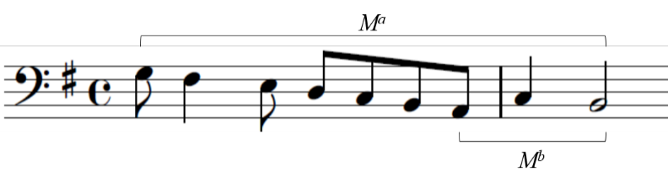
Figure 2.2 Vallée d’Obermann, Motives within T

Figure 2.3 Vallée d’Obermann – Structural reduction Ma

The third motive takes the form of a structural tritone. This occurs as a result of the modulation from E minor to G minor (m. 4), and from G minor to B-flat minor (m. 8), outlining a diminished triad. This structural motive (E – G – B-flat) eventually gives rise to a melodic cell consisting of a tritone leap.

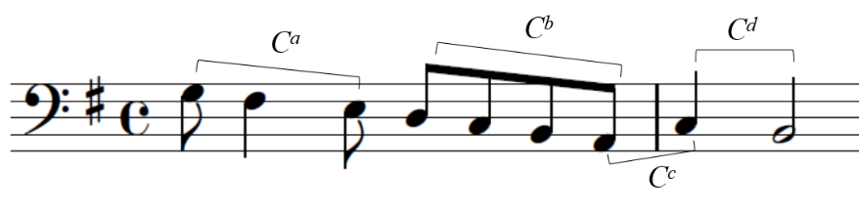
The theme is made up of a set of melodic (C^{x}) and rhythmic (R^{x}) cells, as shown in figures 2.4 and 2.7.
Figure 2.4 Vallée d’Obermann – Melodic cells within Ma

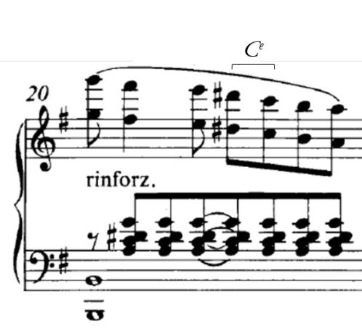
The melodic cells undergo temporal changes throughout the work, namely augmentation and diminution, to varying degrees. For example, as shown in Figure 2.5, an alteration of T (discussed in the Syntactic analysis) yields Ce (a descending augmented second). Figures 2.5 and 2.6 illustrate Ce (Figure 2.5) and the cellular result of the structural tritone, C^{f} (Figure 2.6).

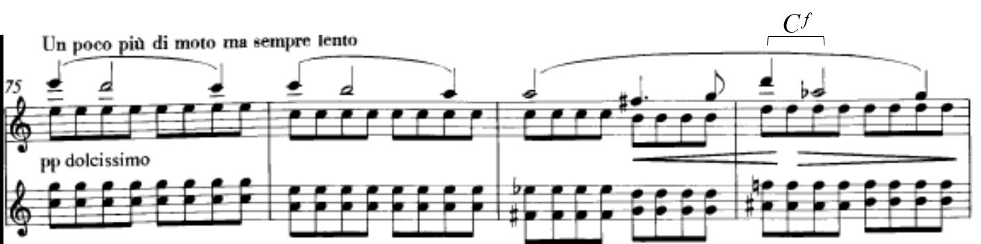
Figure 2.5 Vallée d’Obermann – m. 20: Alteration of T to create Ce
Figure 2.6 Vallée d’Obermann – mm. 75-78: Tt – Melodic cell Cf

Figure 2.7 illustrates the rhythmic cells that form the theme. As Tarasti notes, the second half of the theme is an overt rhythmic augmentation of the first two bars.
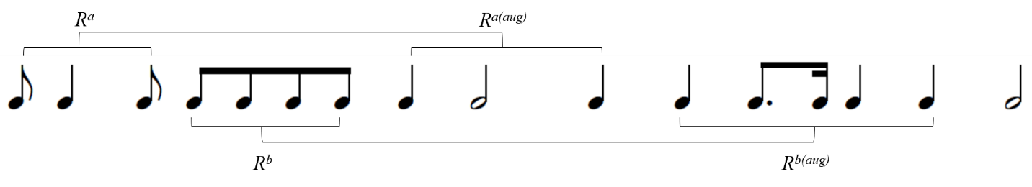
Figure 2.7 Vallée d’Obermann – Rhythmic Cells within T

Thus far, I have generated a taxonomy of the raw musical elements as a basis for comparison as interactions between all of these categories occur. While most of these elements are displayed outright, some of the elements emerge as the result of harmonic structural outlines (C^{f} ) or subtle melodic alterations (Ce). Moreover, the cataloging of these elements reveals that the initial temporal scheme of T and its component melodic cells within Mª rely on Rª whereas T^{t} relies on R^{a(aug )}(see T^{t} in Figure 2.6). The augmentation of Rª effectively doubles the length of Cª, resulting in an altered perception of the passage of time at the onset of T^{t}. The interaction of these two thematic and rhythmic elements has narrative implications that I will discuss in the Actantial analysis. For a table that contains all motives and cells, see Appendix B.

Syntactic
Although Vallée d’Obermann is principally a monothematic work, certain structural characteristics indicate a dialogue with sonata form. I address alterations from sonata form and their narrative implications with regard to the creation and subversion of the expectations of the genre. Rather than address them atemporally, the deformations are discussed as they are experienced in the musical discourse, thus lending context to the expectations that they both create and defy. I will also highlight the expressive importance of the Ger⁺⁶ chord and its use to destabilize tonality in the exposition, creating a sense of dramatic tension due to its enharmonic implications.
Table 2.1 broadly illustrates the formal sections of Vallée d’Obermann, prevailing tonal areas and the dominating musical material. As one can see, Tarasti’s segmentation of the piece into five expressive isotopies generally maps well onto Sonata structure. The exceptions to this are the fourth and fifth isotopies contained within the Recapitulation. While the discussion of isotopic expressivity is primarily relegated to the Semantic analysis, I have included these segmentations in the formal outlines present in the Syntactic analysis with the intent of illustrating how these isotopies fit within the Sonata structure. A more detailed table is included in the syntactic discussion of each formal section, along with discussions of generic functions, deformations, and important harmonic structures that have ramifications at the narrative level.

Vallée d’Obermann
Formal Section | Exposition  (mm. 1 – 74) | Development  (mm. 75 – 169) |  | Recapitulation  (mm. 170 – 214) |  | Coda  (mm. 215 – 216)
Tonal Area | E minor | C major | Varied | E major
Isotopy | Ennui | Wandering  (m. 75) | Fight/Storm  (m. 119) | Pastoral  (m. 170) | Apotheosis  (m. 204)
Musical Material | T | T^{t} | Fragments of T | T^{t} |  | T
Table 2.1 Vallée d’Obermann – Formal structure

The exposition (mm. 1 – 74) contains the most complex and intriguing rhetoric through its surface-level formal ambiguity. Accordingly, its syntactic analysis requires the most attention. The following reveals a tightly-knit structure, clearly referencing an underlying Sonata form structure, bound by generative harmonic and motivic saturation that cuts across clearly defined sections. Table 2.2 illustrates the exposition’s internal structure.
Exposition (mm. 1-74)
Section | A |  |  |  | A’
Zone | P₁ |  |  | S₁ | P₂ |  |  | S₂ | Closing
Internal Section | a | b | a’ |  | a | b | a’
mm. | 1-8 | 9-12 | 13-25 | 26-33 | 34-41 | 42-50 | 51-58 | 59-67 | 67-74
Key(s) | e, g, b-flat | f-sharp | c, e | (e), e-flat, a, e | e, g, b-flat | b-flat, e | E-flat, B | f, e | e
Isotopy | Ennui
Table 2.2 Vallée d’Obermann – Formal structure of Exposition

The exposition is written in a simple binary form (AA’) which effectively functions as a written out repeat of the exposition. Just as the second two measures of the theme-actor can be described as an outgrowth of the first two, the Exposition is organized in much the same way. The AA’ structure actually reveals that P₂ and S₂ are a modified and written out repeat of P₁ and S₁. Medial caesuras (MC) at mm. 25 and 58 separate the P and S-zones of both sections. The essential expositional closure (EEC) occurs on the downbeat of m. 67, creating an elision with the closing material. These strong cadential points are essential markers of the Sonata form. In the case of Vallée d’Obermann, hoewever, the S-zone does not adequately establish a secondary key resulting in an EEC in the Tonic, a clear deformation of the sonata form genre.
The P-zone is also a ternary structure. The a section consists of the introduction of T in a lower register and its subsequent modulations from E minor to G minor, and then to B-flat minor. The outlining of the diminished triad via shifting tonal centers ultimately results in a tritone relationship between the cadence in m. 8 and the beginning tonal area of the piece. This structural tritone relationship creates a melodic tritone cell (C^{f} ) that is a central figure to T^{t}. The b section inverts the texture, placing the melody in a higher register and begins in F-sharp minor, using the third of B-flat minor as an enharmonic C-sharp. The melodic material used here is derived from M^{b} and developed into a four-bar phrase the leads to a modified return of a, now a’ (mm. 13-25), and thus T. Liszt displays an incredible sense of economy in the level of motivic saturation by transposing T successively higher to create tension and to lead the music back to E minor. He also uses C^{d} and its inversion to create a dialogue between registers, giving a sense of actoriality both to the registers themselves and the cells – more markers of Tarasti’s notion of spatiality. Unexpectedly, the P-zone closes with a structural half-cadence with the final descent in mm. 20 – 25 ending on D-sharp, the leading tone. The music then moves to the S-zone, forgoing the standard transition section. The HC at m. 25 then stands as the close to the first half of the exposition and thus functions as a MC. This creates the expectation that the S-zone will be in the dominant key of B major. However, the music defies that expectation with an enharmonic modulation, using the V⁷ of E minor as a Ger⁺⁶ in E-flat to open the S-zone in E-flat minor and in a new, chorale-style texture (shown in Figure 2.8).
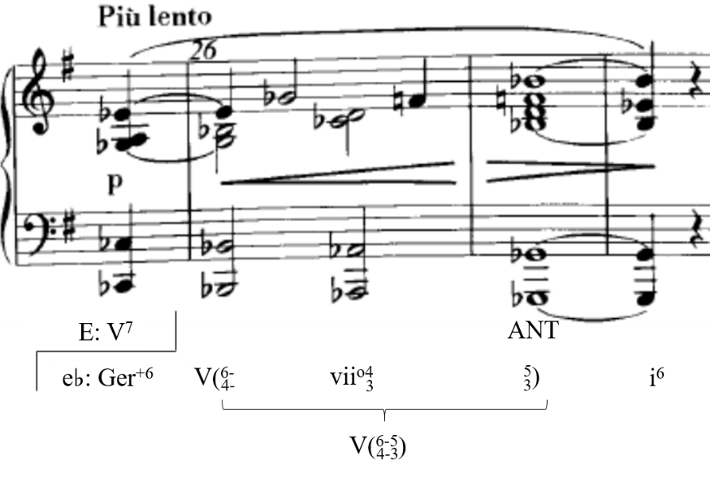
Figure 2.8 Vallée d’Obermann – Enharmonic Ger+6 at m. 26 and chorale-style texture

The Ger⁺⁶ is a central component of this composition with generative narrative implications specifically because its rules of resolution give rise to C^{d}. The very notion of the descending half-step cell is the result of the harmonic implications of scale-degree six lowering to scale-degree five, thus followed by a cadential figure. This expectation is introduced in m. 2 of T and subverted by the E-flat in m. 3 (the enharmonic leading tone, D-sharp). The aural perception of the D-sharp, in m. 3, leads to the expectation that it will resolve to E-natural. However its re-framing as the sixth scale degree of G minor subverts that expectation, leading to a descending resolution to D and rapidly shifting tonal center. The same concept of enharmonic subversion begins P_{1b} in the anacrusis to m. 10 by employing a lone D-flat (C-sharp) to establish a continuation of B-flat minor, only to be redirected by its rapid harmonization in F-sharp minor. Yet again, the same concept begins S₁ in m. 26 by reframing the D-sharp in the structural half-cadence as the third of an enharmonic Ger⁺⁶ and, consequently, the tonic of a new key (E-flat minor).
Following the establishment of E-flat minor via enharmonic modulation in mm. 26-29, modulations to A minor and E minor use the same device in mm. 29-31. An attempted establishment of E minor by another structural half cadence (mm. 31-33) creates uncertainty even though the norm, thus far, has been subversion of expectation (see Figure 2.9).
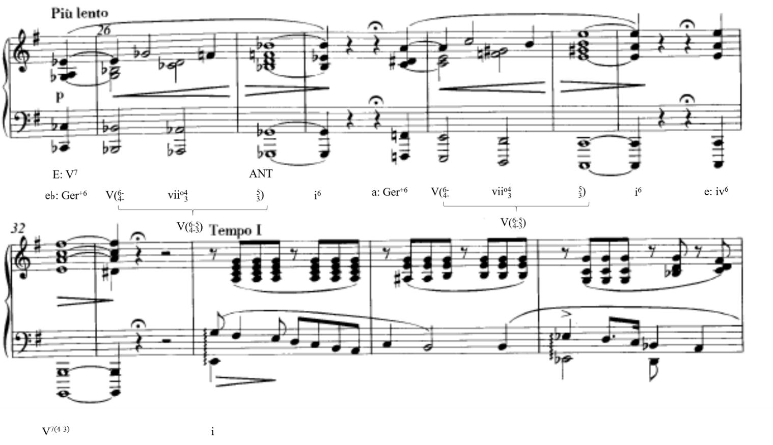
Figure 2.9 Vallée d’Obermann – mm. 26-36.

The authentic resolution to E minor in m. 34 (supported by a low E in the bass) with the entrance of modified T material via P₂ is perceptually marked due to the normalization of subverted resolution. The a section within P₂ repeats its counterpart within P₁ with minimal alterations to the texture, featuring only the addition of low bass notes working in counterpoint. P_{2b} rectifies the tonal aberration of P_{1a} by remaining in B-flat minor before a brief modulation to E minor in m. 46. The modulation to E minor, in part reinforced by the earlier resolution to E in m. 34, creates a false sense of security that is undermined by a chromatic descent to E-flat major signifying the return of T in P_{2a’}. This chromatic descent is a structural reflection of C^{d}, the descending step cell. The material in this section, in contrast to P_{1a}, has changed mode and now proceeds in major – the first attempt at transformation. Subsequent modulations to B major (the Dominant) foreshadow the re-establishment of E as a tonal center, but not before a recurrence of chorale-style S₁ material, transposed to B-flat minor to reflect the same enharmonic relationship as in m. 26. Figure 2.10 shows how the two iterations of the sequence culminate in a syncopated cadential figure that concludes on the downbeat of m. 67, resulting in the essential expositional closure in E minor. The cadence elides with the closing material, based heavily on P, and features the descending augmented second (Ce) that disrupts the stepwise descent of Mª.
The material in mm. 67-74 parallels the coda material that follows the Essential Structural Closure (ESC). Measures 67-74 also highlight the ineffectuality of cadential figures in the exposition through the continuous subversion of perfect authentic cadences (PACs). Consequently, the elided imperfect authentic cadence (IAC) of the EEC with the onset of the closing material compromises its own efficacy. 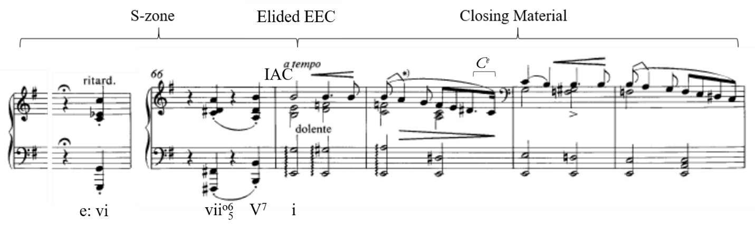
Figure 2.10 Vallée d’Obermann – mm. 65-70
Although in E minor, the music remains unstable by placing the fifth scale degree in the soprano in the phrase’s beginning, rather than the tonic. This leads to a sequence of T repetitions that culminating in plagal cadence in m. 73, with the resolution of the melodic bass occurring in an inner voice. The inner-voice resolution indirectly undermines the leading-tone resolution in the soprano in m. 71 by eliding its almost-achieved authentic tonal resolution with that of a plagal one – once again, challenging the efficacy of the leading-tone (Figure 2.11).
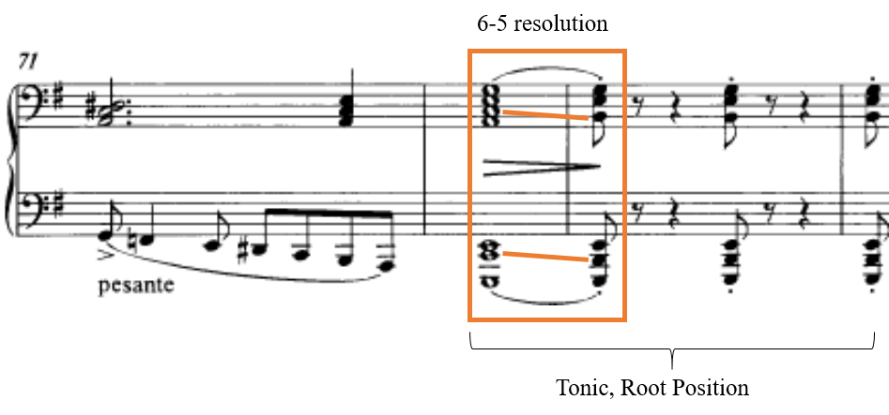
Figure 2.11 Vallée d’Obermann – mm. 71-74

The inner-voice resolution highlighted in Figure 2.11 differs with Tarasti’s analysis, as he misattributes a chord inversion at the end of his first isotopy (m. 74). Tarasti identifies the concluding chord as a tonic six-four, whereas it is actually a root position tonic chord with the third in the highest sounding voice. Additionally, in the same section (mm. 70-74), Tarasti ignores the passing of the melodic material to the bass voice, in which the melody results in a melodic resolution of scale-degrees six to five (identical to the opening iterations of the melody) in an inner voice, doubled by the chords in the right hand. This resolution is mimicked in the final two measures of the piece. However, its final declaration shifts the resolution from an inner voice to the highest sounding voice, highlighting the resolution rather than hiding it within the texture.
The through-composed nature of the exposition challenges a listener’s perception of formal structure by the continuous subversion of cadences in the Tonic. In fact, the only strict PAC in this entire space occurs in G minor in m. 4, and even that is undermined by a retardation resulting in the delayed arrival of G in the soprano. The frequent pauses result in halting progress through the section giving it a searching quality, and enharmonic elisions deceive the listener into experiencing several seemingly disparate episodes in spite of the repeated material. Furthermore, the (re)establishment of E minor (Tonic) results in a tonally closed exposition when the generic expectation is to close in a secondary key prior to entering the development. By tonally “closing” the exposition, resulting in a sense of finality rather than impending continuation, Liszt creates the opportunity for a change in discourse in the form of an immediate harmonic shift to C major, the key of the submediant.
At this point, the Syntactic analysis has uncovered some key aspects of the form that relate both to the establishment of structure and how that structure aids in the expression of narrative. In spite of what seems to be an almost “stream of consciousness” musical discourse lacking a rigorous formal structure, Liszt creates important structural markers clearly in dialogue with expositional expectation of a sonata form. These markers include the medial caesuras (mm. 25 and 59), the fully written out repeat (mm. 34-74), and the essential expositional closure (m. 74). These markers create the expectation for subsequent formal sections, as well as the ultimate rhetorical aim of resolving the problem set forth by the exposition through harmonic resolution. This resolution consists of a shift to the parallel major (hinted at by the borrowing of the enharmonic leading tone in m. 3) and the completed resolution of the Ger⁺⁶.
The development (outlined in Table 2.3) features three major sections: The preparation, the central action zone (CAZ), and the retransition. Each of these sections serves a distinct purpose in driving the musical discourse. The preparation acts as an introductory section, allowing for a new direction of discourse through a temporal and tonal shift, while the CAZ propels the narrative forward by acting as an arena of conflict. The retransition serves to drive the narrative back to the original tonal and temporal scheme in hopes of structural resolution. Liszt clearly delineates each section through a distinct change in the musical texture and increased or decreased levels of surface action.

Development (mm. 75-169)
Zone | Preparation |  | Central Action Zone |  |  | Retransition
Section | a | b | a | b | c
mm. | 75-94 | 95-118 | 119-127 | 129-138 | 139-160 | 161-169
Key(s) | C, A, c-sharp, D-flat |  | Varied |  |  | f, e(E)
Musical Material | P (T^{t}) |  | Mª and constituent Cells |  |  | S (modified), Cª
Isotopy | Wandering |  | Fight/Storm
Table 2.3 Formal Structure - Development

The preparation zone begins with a harmonic twist in which the anacrusis (G) in m. 75, previously the third of E minor, becomes the dominant of C major and ascends an interval of a sixth to begin the melody – effectively initiating the section with a condensed and inverted Mª. The theme now transformed (T^{t}) and transposed to C major, uses only the first half of T, and thus Mª, and ends on a half-cadence shown in Figure 2.12. Truncated, the theme no longer modulates and now remains harmonically. Additionally, note that the transformed theme uses R^{a(aug)} rather than Rª, creating a shift in the temporal scheme within the thematic transformation. Measures 75-118 constitute a preparation by transforming material from P and beginning in a softer dynamic. As Tarasti notes, this section moves forward unhindered, featuring none of the characteristic narrative “halts” of the exposition. The development features the only true thematic transformation in the entirety of the composition. I argue, subsequent perceived transformations in the recapitulation are more accurately described as transfigurations as T^{t} is not altered into another transformed state, rather it is amplified and elevated through increased dynamic and higher registral placement.
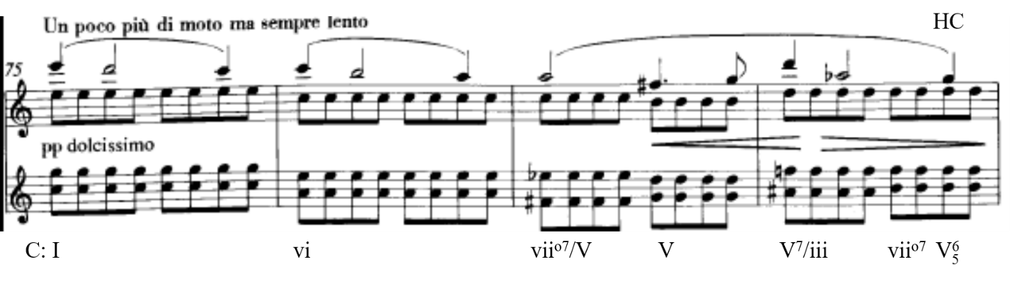
Figure 2.12 Transformed theme (T^{t}) in mm. 75-78.

The central action zone (mm. 119-169) features frequent modulation and employs the fragmentation of several melodic and rhythmic cells, both in their original form and with slight intervallic modifications. The linear progression of increasingly chaotic activity is divided into three sections, clearly delineated by expressive markings:
a (mm. 119-127): Recitativo
b (mm. 128-138): Piu mosso, agitato molto
c (mm. 139-160): Presto, tempestuoso
Sections b and c feature the sharpest increase in dramatic activity. Section b’s constant dialogue between cells and registers, and its sequential modulation through a number of keys culminate in the virtuosic outburst of c which simultaneously employs Cª and the tritone relationship through octave passagework outlining a sequence of diminished chords. Liszt effectively slows down the accumulated velocity with a pain-filled and forceful return to a chorale-style texture in mm. 155-159, paving the way for the Lento retransition.
The retransition (mm. 161 – 169) continues to emphasize Cª, but not the entirety of T or even its entire first half, leaving Mª incomplete. The final plea of Cª expands into a recitativo-like moment that outlines V⁷ in the key of E minor, echoing the contour of material from a in the central action zone, also marked Recitativo, and functioning as the dominant preparation for the double return of tonic and T. Liszt incorporates recitativo-like passages occurs in a number works, including the Ballade No. 2 in B minor and the Sonata in B minor.
To summarize, the development is constructed with three principle divisions: The Preparation (mm. 75-118) which introduces the transformation of T into T^{t}, the Central Action Zone (mm. 119-169) which features increasing amounts of emotional and rhetorical turbulence through its three subsections, and the Retransition (mm. 161-169) which, in the aftermath of the CAZ, slows down the surface action of the musical discourse and leads to the recapitulation through a recitativo-like passage.
The recapitulation, while it fits the overall structure, has the fewest traditional sonata markers. Absent are the expected double rotation of P and S material and the appropriate medial caesuras, clearly deviating from the expositional structure. Instead, the music displays much more continuity through texturally varied repetitions of T^{t} for the remainder of the work. The structural markers in the exposition expressed ineffectuality and an inability to progress – a feeling which Liszt moves beyond in the recapitulation, replacing them with constant forward motion. This forward motion is caused by the temporal shift back to the original rhythmic framework of Rª, which functions much in the same way as a transposition of S-zone material back to the tonic, resulting in a sense of temporal resolution in addition to the harmonic resolution, and the series of transfigurations of T^{t} that propel toward the work’s conclusion.
Much like the anacrusis to the development, the anacrusis to the recapitulation (m. 170) features an ascending sixth to usher in T^{t}, now transposed in E major, supported by long pedal tones in the bass. The temporal shift of R^{a(aug)} returns T^{t} to the original temporal framework of Rª. Table 2.4 shows the formal structure of the recapitulation and the following coda.

Recapitulation (mm. 170-214) |  |  |  |  | Coda  (mm. 214 – 216)
Zone | P
Section | a | b | a’
mm. | 175-183 | 184-187 | 188-214 |  | 215-216
Key(s) | E | B/b | E |  | E
Musical Material | T^{t}, T^{t(inv)} | T^{t(inv)} (Fragments) | T^{t} (Transfigurations) |  | T^{t}
Isotopy | Pastoral (175 – 204) |  |  | Apotheosis (204 – 216)
Table 2.4 Formal structure of Recapitulation and Coda

Notably absent from the recapitulation are the halting nature of the exposition and its searching quality and original material from the exposition’s P and S-zones. Instead, the entire recapitulation uses P-derived material (T^{t} and T^{t(inv)}). The section moves forward unhindered with only one distinct pause: a fermata in m. 179, just before the inversion of T^{t}. The pause, here in its solitary nature, calls to mind the frequent stops in the exposition, but does not adhere to its precedent. Instead, the inversion (T^{t(inv)}) ushers in the recapitulation’s brief b section based on the inverted theme which leads to the return of a and T^{t}.
The successive transfigurations (shown in Figure 2.13) in the recapitulation are labeled as such because the transformed theme itself (T^{t}) and its underlying modality and structure remain unchanged for the remainder of the work. This is true even though the figuration that provides harmonic support becomes increasingly triumphant by replacing the lilting texture with repeated chords. Through these transfigurations, the music flows to the essential structural closure signaled by a cadence on E major in m. 214. Despite the emphatic nature of this cadence, the harmonic close is achieved through subterfuge. Rather than initiating the end of the ESC through a PAC, the cadence is approached using Cª to generate a V⁴₂/IV, signaling a Plagal Cadence – which is again subverted through the use of Ger⁺⁶ as a dominant substitute to achieve resolution on E major (Figure 2.14).
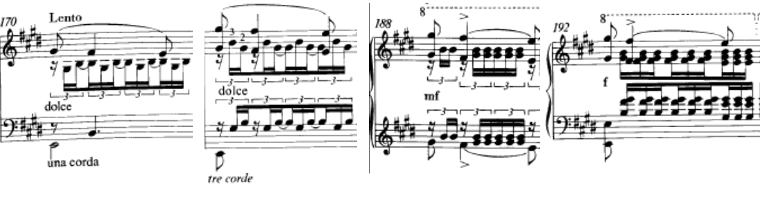
Figure 2.14 Vallée d’Obermann – Successive Transfigurations: m. 170, m. 175, m. 188, m. 192
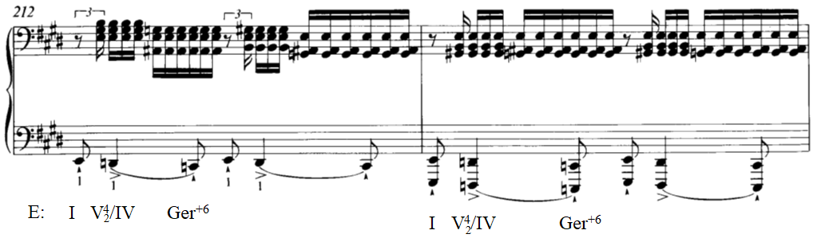
Figure 2.15 Vallée d’Obermann – Subverted Plagal Motion: mm. 212-213

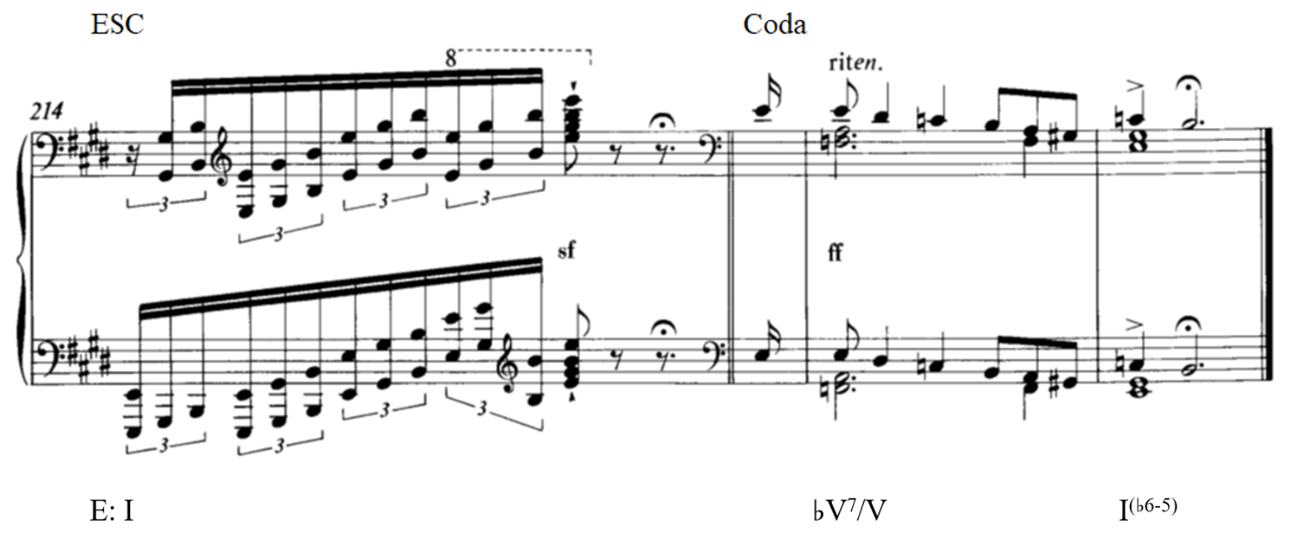
The cadence in the Tonic in m. 214 functions entirely on its own as an end to the Sonata space, signaling the ESC. The two measures that follow, consequently, fall outside of the Sonata space. Two measures do not traditionally constitute enough material to be considered a coda, but in the case of Vallée d’Obermann I argue they have a far-reaching impact at the narrative level, and are central to the perception of the Comedic narrative for two reasons. First, the coda material is aurally and notationally separated from the ESC in m. 214. A double-bar line visually separates these measures in the score by signaling the beginning of an independent section, as shown in Figure 2.15. Additionally, rests emphasized by a fermata follow the final tonic chord in m. 214, creating a clear break between the cadence and what follows. Second, the fashion in which Liszt achieves tonic resolution has an aural sense of absolute finality. The approach to the ESC begins in m. 208 with shifts to successively lower registers and saturation of Cª, which culminates in the cadence on m. 214 which is decorated by a four-octave ascending arpeggio in double octaves, punctuated by a final tonic chord.
Figure 2.16 Vallée d’Obermann – mm. 214-216.

After establishing E major as the global tonic, the marked entrance of Mª in m. 215 (complete with a return of Ce) in what appears to be the parallel minor more clearly emphasizes the resolution, this time shifting the Ger⁺⁶ chord structure to the lowered second scale degree as a tritone substitution for the dominant (labeled in Figure 2.14 as the flattened V⁷/V). Ironically, in contrast to m. 3, this D-sharp functions enharmonically as E-flat. Additionally, the ♭6-5 resolution, which was in an inner voice at the end of the exposition, is now highlighted through its placement in the soprano, supported by doubling in the tenor. Placing a ♭6-5 harmonic resolution at such a point of prominence, directly after a firm cadence in E major, might suggest a lack of rhetorical resolution. That argument would be more appropriate if the final chord was the tonic minor rather than major, thus undermining the preceding cadence. I argue the concluding E major triad suggests an assimilation of the rhetorical dissonance, rather than continued conflict.

Summary
So far, my analysis has addressed the morphological and syntactic components within the Agential level of analysis. The morphological analysis revealed that T can be broken down into several melodic and rhythmic cells, while the syntactic analysis exposed an underlying sonata form that governs the entire work. Additionally, by analyzing the cadential markers within the exposition established a consistent sense of tonal instability due to the Ger⁺⁶ chord, I identify a source of expressive tension that resonates throughout the entire work. These components will be significant in establishing the semantic elements in Vallée d’Obermann. Chapter 3, which continues the Agential analysis, will place these structural elements within a cultural context to identify what meanings may be present, and how they fit within the overarching structure of sonata form.

SEMANTICS

Similar to the purpose of the morphological analysis, my semantic analysis is largely taxonomic and aims to establish what culturally relevant elements exist in the musical discourse, and to identify meanings they may evoke due to their cultural associations. Semantically, the piece expresses a few broad categories that are discernible first by identifying the different musical topics used in the work, then by segmenting the piece into different isotopies (see Table 3.1) and exploring the expressive connotations and modalities of those isotopies. In order to understand the expressive implications of topical manifestations within isotopies, it is important first to discuss the topics themselves. The discussion of isotopies will establish expressive modalities, basic narrative signifiers such as the Order Imposing Hierarchy (Order) and the Transgressor, and introduce markers of temporality. Ultimately, in this chapter I aim to complement the structural elements of the morphological and syntactic discussions with cultural components, thus completing the Agential analysis. The combination of structural and cultural elements allows for a more fruitful examination of Actantial interactions and their narrative implications in Chapter 4.
Vallée d’Obermann: Form, Isotopies, and Topics
Formal Section | Exposition  (mm. 1-74) | Development  (mm. 75-169) |  |  | Recapitulation  (mm. 170-214) |  | Coda  (mm. 215-216)
Isotopy | Ennui  (mm. 1-74) | Wandering  (mm. 75-118) | Fight/Storm  (mm. 119-169) |  | Pastoral  (mm. 170-204) | Apotheosis  (mm. 205-216)
Topic(s) | Tragic-Chorale-Tragic | Pastoral | Tragic | Chorale | Pastoral
Table 3.1 Vallée d’Obermann – Form, Isotopies, and Topics

Topics
There are three primary topics in Vallée d’Obermann: the Tragic, the Chorale, and the Pastoral. The Tragic topic in Vallée d’Obermann features elements of the lament and is usually associated with a sense of suffering or sorrow – hallmarks of the tragic affect. Although the piece begins within the topical realm of Tragedy, and is characterized through its own signifiers, its rhetorical function lies in its marked opposition to the Pastoral topic. This topical opposition is mediated by the Chorale topic, placed between the Tragic and the Pastoral. Consequently, I will first address the governing topical fields of the Pastoral and the Tragic, and conclude with the Chorale topic. Through my analysis I will detail the markers that signify these topics in Vallée d’Obermann and their expressive implications.
The Pastoral
Due to the changing expressive approached by composers throughout different stylistic periods, the Pastoral topic evolved from a strictly governed set of signifiers to include a broader spectrum of expressive ideals. I argue that the Pastoral topic in Vallée d’Obermann functions more as a mode of expression, rather than as the strict manifestation of a historical style.
Monelle notes that signifiers such as Pastoral instrumentation (such as the use of woodwinds in instrumental music), the Siciliana meter of 12/8 or 6/8, and “the simplicity of countryfolk” function as earlier characterizations of the Pastoral. However, he also cites increasingly progressive examples ranging from Haydn to Debussy that begin to eschew even parameters that seemed fundamental to the style, such as the presence of dotted rhythms and compound meter. Given the liberties taken throughout the evolution of the Pastoral, Hatten states “any movement in a major key with a relatively simple character would qualify as pastoral.” While this statement is admittedly broad, Monelle’s notion of the “simplicity of countryfolk” provides certain guidelines, namely in his references to Hermann Jung’s analysis of Monteverdi’s Orfeo. Monelle paraphrases the following elements:
- The range of the vocal line seldom exceeds a fifth.
- The melody proceeds stepwise, seldom in leaps.
- Periodically framed, songlike phrasing and melody are preferred.
- The rhythm is limited to constantly repeated stress-patterns and dance-like schemes, often in triple time with characteristic dotted effects.
- The harmony is not expressive, distant scale-degrees are entirely missing.
- In the instrumental and vocal dance numbers, the tonality operates principally in the major area.
Similarly, Hatten argues that the Pastoral is more mildly expressive, and that music embodying this topic is more consonant, harmonically simple, and features flowing melodic lines. He further states that not all of these characteristics may be present, yet the music can still be characterized as Pastoral so long as some combination of the above characteristics persist.
In Vallée d’Obermann, the Pastoral topic is introduced by T^{t} at the onset of the development (m. 76) and the beginning of the recapitulation (m. 170). The first iteration of the theme, in the key of the submediant, is a stepwise melody with a tranquil accompaniment of slowly repeated eighth-notes chords, and a less rhythmically active descent of Mª due to the temporal shift to R^{a(aug)}. Additionally, the repetition of R^{a(aug)} coincides with the “repeated stress-patterns” indicated by Jung/Monelle. While the theme contains the Ger⁺⁶ chord (at odds with Jung’s observation that distant scale-degrees are absent in the Pastoral), it resolves properly and is surrounded by more consonant triadic harmonies. The transposition of T^{t} to the tonic major at the recapitulation, coinciding with Tarasti’s Pastoral isotopy, also signals a return to the external temporal discourse (discussed in the Actantial Analysis). This reinforces the primacy of the Pastoral, along with lilting accompaniment figures in the inner voices, and long pedal tones. Between Monelle’s paraphrase of Jung, and Hatten’s flexible interpretation of the Pastoral, I argue the Pastoral is an essential cultural element in Vallée d’Obermann.
The Tragic
Much of the piece transpires in the lamenting topical realm of the Tragic, which lies within the isotopy Ennui. The idea of the Tragic is central to the Comedic narrative arc of Vallée d’Obermann in that it provides the foundation that generates the trajectory of the work. This trajectory is created through its stark opposition to the Pastoral topic which, I argue, is the expressive goal of the work.
In Vallée d’Obermann, the Tragic and its sense of suffering arise from the minor mode and the constant use of structural and melodic descending half-steps (C^{d}), traditionally associated with lament. However, the descending sixth of Mª also expresses its own sense of sadness, and that sadness is amplified through the embedding of C^{d} as the concluding cell of the first half of T. The original version of Vallée d’Obermann from the Album d’un Voyageur supports this in its own introduction of T (m. 23). In the earlier version, the expressive instruction avec un profond sentiment de tristesse accompanies the introduction of T. The ineffectuality reflected in the lack of stable tonal resolutions compounds this tragic affect.
While the Tragic topic primarily falls within this lamenting mode of expression, several dramatic outbursts, such as those in mm. 20, 67, and the entire central action zone of the development functions as a successive evolution of the Tragic from a more passive feeling of ennui to a more active and involved sense of emotional crisis.
The Chorale
The Chorale topic in Vallée d’Obermann occurs in three places. The first two coinciding with S-type material in mm. 26 – 33, and mm. 59 – 66, where distinct textural features related to consistent vertical alignment and smooth voice leading act as clear signifiers to the Chorale. The bassline’s descending stepwise pattern resembles the contour of Cª. However there is no clear melody driving the texture, lending ambiguity to whether this texture is purely homophonic or polyphonic. This ambiguity is reflected in the enharmonic resolutions. Additionally, I argue these manifestations of the Chorale function as points of modalization where the purpose of the topical interjection serves to steer the narrative from the pre-modalizing phase, leading to a change in material post-modalization. Accounting for the religious connotations of the Chorale, this topic functions as a modalizing force with the goal of redemption or even transfiguration. However, these initial attempts ultimately fail to achieve their goal, reinforcing the ennui and ineffectuality of the Tragic topic.
The third occurrence of the Chorale topic is at the end of the central action zone in the development. Measures 156 – 161 does not directly recall the same material, but they are similar enough texturally to call to mind the previous iterations of the topic. Again, the topic functions as a modalizing force, and the listener need but wait a few more measures to hear if it achieved its expressive goal of creating resolution by moving T^{t} to the tonic, which it does achieve.
To summarize, the manifestation of these topics relies on the placement of structural (morphological and syntactic) elements within a cultural (semantic) context. The primary theme’s motives and cells and their implicit cultural associations gave rise to the Tragic topic, while the transformation of these elements create the oppositional Pastoral topic. These two topics function as broadly expressive categories, which are mediated by the Chorale topic, characterized by traditional voice leading and harmonic structures. Establishing these topics highlights the teleological relationship between the Tragic and the Pastoral, and segments this work on along cultural boundaries in addition to structural ones. This segmentation will be further broken down in the following discussion of isotopies and modalities.

Isotopies and Modalities
While the previous section identified the broader topics that occur in Vallée d’Obermann, the following identifies the expressive isotopies that result from segmenting the piece into sections governed by a more narrowly defined mode of expression. My analysis relies heavily on Eero Tarasti’s segmentation of Vallée d’Obermann which results in five isotopies that coincide with changes in affect and texture. However, while I adopt his segmentations and their titles, I expand on Tarasti’s work in two ways. First, I identify musical elements that contribute to the overall affect of the isotopy. Second, I explicitly assign basic and secondary expressive modalities to each isotopy in order to codify its narrative intent. I argue that the discourse in each isotopy coincides with the expression of specific modalities that, in turn, codify the rhetorical significance and narrative intent of each section.
Isotopy I: Ennui (Exposition)
The first isotopy, Ennui, encapsulates the Exposition, introduces the thematic material, and is, in Tarasti’s words, “fragmentary in nature, though tensional, and contains several fermate which interrupt the musical continuity.” It orients the listener by establishing the initial conditions of the expressive environment. The first cadence of the piece (m .4), though not in the tonic, firmly cements the initial modality of the piece as minor. The minor mode combined with the sorrowful and lamenting thematic material (T) contribute to the expressive environment of the Tragic topic. Additionally, the theme and Rª establish the primary temporal mode. Both tonality and temporal mode work together to form the Order Imposing Hierarchy (Order), rendering it unmarked. Embedded within T we find the Transgressor whose purpose is to undermine the Hierarchy and its sense of Order. In this case, the Transgressor is the E-flat in m. 3, enharmonically, and aurally perceived as, the leading tone (D-sharp).
The enharmonicism displayed in this context and the leading tone’s repurposing as the sixth scale degree of G minor accomplishes two things: It simultaneously reveals and undermines the Transgressor’s identity, and it creates a need for resolution in the tonic. The leading tone and its subverted melodic resolution to the tonic creates the need for structural resolution (and thus, narrative resolution). The leading tone also alludes to the parallel major (and more broadly, the major mode in general) as an ideal state and, thus, a teleological goal.
The frequent pauses followed by common-tone modulations continue to reinforce the subversion of tonal resolution and the undermining of the Transgressor. The eventual reframing of the Transgressor’s identifier (E-flat/D-sharp) becomes reabsorbed into the texture by adopting D-sharp into Mª, creating a descending Augmented 2nd (Ce) in m. 20.
The continuous hesitation as well as the frequent, and abrupt, modulations reflect a sense of ennui and ineffectuality. As the isotopy progresses, continuous returns to the main thematic material, and intensified emotions (such as the dolente marking in m. 67) move beyond ennui and suggest a more profound sense of world-weariness, or weltschmerz, and hopelessness. In this section, the harmonic dissonance is structural, stemming from the halting stagnation of the rhetoric, its lack of resolution, and its yearning for a more ideal state of being. Due to the lack of stability and constant harmonic motion created by modulating resolutions, the primary modalities expressed here are doing – will.
Isotopy II: Wandering (Development – Preparation)
Yet another enharmonicism marks the shift into the second Isotopy, now in C major. The shift into the key of the submediant coincides with a thematic transformation based on Mª, and a temporal modulation resulting in an augmentation of Rª (now R^{a(aug)}). The change in spatial register coupled with the thematic transformation and modulation effectively shift the rhetoric from the boredom and restlessness of the first isotopy to a more idealized sense of being, resulting in a more tranquil expressive state while transformed theme (T^{t}) finally introduces the Transgressor in its true form. Its expressive connotations and performance markings (pp, dolcissimo) establish the beginnings of a Pastoral topic and work together to paint T^{t} as the true ideal state of being and teleological goal, thus marking T^{t} relative to its Tragic counterpart. However, the key and placement within the sonata structure indicate its impermanence. The modulation to the key of the submediant has been associated with an expressive shift to an “internal” dialogue or even a “dream world,” hence the accompanying temporal modulation to a “slower” rate of perceived time. Consequently, while the establishment of the Pastoral ideal is the desired outcome, this is not occurring in the external reality. This momentary state of being is the discovery and acknowledgment of a consonant and stable ideal, and a foreshadowing, rather than an actual achievement of expressive primacy. With that in mind, the modalities expressed here are being – know.

Isotopy III: Fight/Storm (Development – Central Action Zone)
While Isotopy II’s narrative phrasing occurs in the slower timeframe of the inner dialogue of the submediant, Isotopy III shifts back into the external present (Rª). However, the Pastoral nature of Isotopy II disappears as the music moves forward and the Tragic topic returns, signaled by the return of fragments of Mª and its constituent cells, as well as Ce. Importantly, the return of Ce is marked by the placement of D-sharp (no longer E-flat) within the context of the dominant, pointing to the possibility of resolution. The contextual placement of the Tragic marks it as an intrusion into this internal dialogue – another attempt to subdue the Transgressor. As the discourse moves through the central action zone, the accumulation of rapid registral dialogue between cells C^{d} and Ce creates an aural picture of a struggle for dominance, especially considering the constant alteration of C^{d} alternating between a descending half and whole step. This accumulation combined with constant tremolando effects leads to the final outburst of Existential Crisis (m. 139), resolving to another instance of the Chorale topic at another point of modalization (m. 156) in another attempt to redeem and manifest resolution. The intense rhythmic action from the tremolando figures, constant registral shifts, forward momentum, and overt virtuosity result in an expression of the modalities doing – will – can – must.
Isotopy IV: Pastoral (Recapitulation)
Appropriately, Tarasti names this Isotopy in accordance with its topical expression. Here, the Transgressor has finally achieved primacy. The transformed theme (T^{t}) is transposed to E major, indicating its shift from internal to external dialogue and is reinforced by the return of Rª, signaling the return to the temporal framework of the external present. The absence of the Chorale topic in this Isotopy is a given – having fulfilled its purpose, it has taken leave from the narrative. Perceptually, the absence of the augmented second (Ce ) goes unnoticed having been corrected by the diatonic inclusion of the leading tone in the tonic major. The successive transfigurations of T^{t} introduce the can and believe modalities, while the must modality underscores the entire isotopy, due to its fulfillment of cognitive formal obligations. Additionally, the successive transfigurations of T^{t} reinforce the Pastoral topic, progressing into a cathartic apotheosis (m. 204), and Tarasti’s final Isotopy.
Isotopy V: Pantheistic Apotheosis of a Sense of Nature (Recapitulation – Coda)
Tarasti’s characterization of this segment (abbreviated as “apotheosis”) attempts to capture the thunderous ecstasy of fulfillment present in this Isotopy, expressing the being – can modalities. The descending E major scale in m. 204 highlights the absence of Ce since the discourse has completely shifted to the primacy of the major mode, absorbing the leading tone as an integral part of the scale, rather than as a marked entity. However, within this Isotopy exists a continued sense of subversion. The bassline of mm. 208 through 213 continuously reiterates Mª and its constituent cells, but its iterations in mm. 212 – 213 reinforce the minor mode, rather than major, by lowering the sixth and seventh scale degrees. Harmonically, the implied plagal cadence through V42/IV (an associative relic of the religiously inspired Chorale topic and the plagal resolution at the end of the exposition) would suggest a continued state of transfiguration. However, in spite of the triumphant ascending E major arpeggio in octaves, even the Plagal resolution is subverted by the use of Ger⁺⁶ as a dominant substitute due to the bassline descending half-step resolution of Ger⁺⁶ being a generative component of the Tragic topic in m. 2.
The undermining character of these final bars leads to the brief Coda in which the initiating half of T returns, along with Ce, and a cadence using a tritone substitution. The rather ambiguous nature of this insistent conclusion utilizing a lowered sixth scale degree in spite of the raised third questions the validity of both Pastoral primacy, the major mode, and T^{t} (collectively, a Transgressor complex).

Conclusion
The analysis at the Agential level established a taxonomy of all relevant musical elements. These elements have ranged from discrete units as small as rhythmic cells or as large as formal structures, to semiotic conceptualizations such as topics and modalities. The morphological analysis resulted in segmentation of T into component motives and melodic/rhythmic cells, which yielded key actors such as Cª and Rª, while T^{t} both utilizes and stands in contrast to these units temporally and harmonically. The syntactic analysis exposed the underlying sonata structure that provides a framework for the seemingly freely composed musical discourse, while further segmentation into isotopies and associated modalities reveals distinct expressive intent for each section, structural or isotopic. Additionally, syntactic analysis at the harmonic level within phrases revealed an integral problem in the exposition: the enharmonically resolved Ger⁺⁶ chord, and a general inability to resolve with any sense of finality. Finally, the semantic analysis placed these components within the context of culturally relevant units (topics and their implicit associations), thus establishing and reinforcing the possible meanings that result from the recognition of these units.
Throughout Vallée d’Obermann, the Tragic, Pastoral, and Chorale topics occur at critical junctures within the sonata structure. Their organization within the structure results in Actantial interactions that form the Tragic to Transcendent expressive genre – a motivating force for the Comedic narrative archetype that, in some case, relies on the shift from Tragic to Pastoral expressivity. In addition to the strategic placement within the sonata structure, these topics also fit within Tarasti’s segmentation of Vallée d’Obermann into isotopies which, as I have established, carry narrative implications. The analysis at the Actantial level will discuss both the Tragic-Transcendent expressive genre and the mapping of topical fields within isotopies, the sequential progression of expressive modalities, and other factors that contribute to the narrative trajectory of Vallée d’Obermann.

ACTANTIAL AND NARRATIVE LEVELS
While the first two chapters catalogued all cells and motives and placed them within a cultural context, this chapter addresses both the Actantial and Narrative levels of analysis. At the Actantial level, I identify the agents essential to establishing a narrative archetype and track their progress and hierarchical shifts throughout the unfolding of the musico-temporal discourse. Analysis at this level includes discussions of discursive syntax and function, gestural connotations, temporal discursive processes, and the Tragic-Transcendent expressive genre. At the Narrative level, I argue that Vallée d’Obermann fulfills the criteria of the Comedic narrative archetype using Sonata form as an expressive framework supported by the Tragic-Transcendent expressive genre.

Actantial Level
Though there are many agents at work throughout the discourse of this piece, a few broad categories present themselves as the primary agents of narrative – and, thus, the areas in which the actual temporal narrative occurs. In what follows, I examine narrative events through the lenses of discursive syntax and function, gestural connotations, and temporal discursive processes. Ultimately, this level yields a transvaluative change in hierarchy that points towards a Comedic narrative by highlighting shifts towards areas of rhetorical stability, and the temporal shifts between internal and external time. I will also discuss the organization of Vallée d’Obermann and the interactions between topical fields that form the Tragic-Transcendent expressive genre.

Discursive Syntax and Function
My discussion of discursive syntax and function examines progressions and interactions of modalities and topics, and relative stability and instability throughout the musical discourse. By examining the progressions and interactions I will establish a narrative trajectory of expressive states that move from unstable to greater stability. I will also highlight points of modalization that take place at key structural junctures, acting as significant narrative events. The shifts in stability contribute to the trajectory of the Comedic narrative archetype.
The progressive unfolding of discourse in Vallée d’Obermann results in several evolutions of expressive modalities and acts of modalization, instances of actoriality (such as the thematic transformation in m. 75), and interactions between isotopic and topical fields. The combination of these three categories of narrative events yields changes in hierarchical value that fulfill a narrative archetype.
Vallée d’Obermann: Isotopies and Modalities
Isotopy | Ennui  (mm. 1-74) | Wandering  (mm. 75-118) | Fight/Storm  (mm. 119-169) | Pastoral  (mm. 170-204) | Apotheosis  (mm. 205-216)
Modalities | doing – will | being – know | doing – will – can – must | being – can – believe – must | being – can
Table 4.1 Isotopies and Modalities

Table 4.1 illustrates the progression of expressive modalities throughout the musical discourse. The primary modalities being and doing have stable and unstable value assignations, respectively. The secondary modalities describe various qualities unique to that occurrence of the primary modality, and the relative degree of stability or instability.
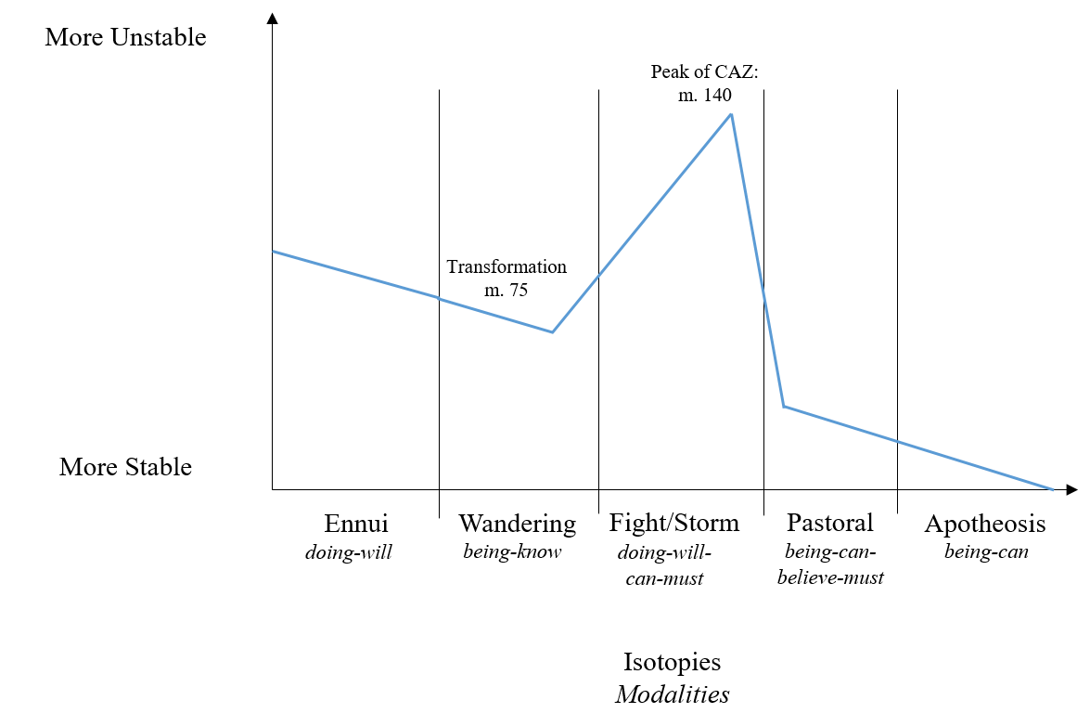
Figure 4.1 Vallée d’Obermann – Modality and Relative Stability

Figure 4.1 illustrates the changes in rhetorical stability as the music flows through the isotopies. The peaks and valleys correspond with changes of the primary modality of each isotopy, and the changes in modality act as orienting moments, even though certain modalities (doing) are associated with generating momentum. Predictably, the Fight/Storm isotopy is the most unstable both rhetorically and harmonically, and generates the most momentum coinciding with its formal responsibilities (must). Its immediate contrast with the Pastoral Isotopy and the transposition of T^{t} to the Tonic major and the modal shift to being mark m. 170 as an orienting moment that generates the “beginning of the end.”
More importantly, Figure 4.1 illustrates trends in rhetorical stability that allow for the grouping of dichotomous Isotopies. Isotopies I and II act as a “presentation” of the two primary modalities (doing, being) experiencing conflict, while Isotopies IV and V present the resolution of that conflict. Standing between them is Isotopy III, acting as the fulcrum of the narrative arc, and an important point of modalization. Modalization also occurs at the topical level through topical interactions.
Vallée d’Obermann: Isotopies and Topics
Isotopy | Ennui | Wandering | Fight/Storm |  | Pastoral | Apotheosis
Topic | Tragic – Chorale – Tragic | Pastoral | Tragic | Chorale | Pastoral
Table 4.2 Isotopies and Topics

While the majority of the Ennui Isotopy occurs in the Tragic topical field, the Chorale topic does make its appearance between bouts of suffering, shown in Table 4.2. The intrusion of the Chorale topic and its implicit association as a redeeming entity reinforces the Transgressor and undermine the Tragic by supporting the leading tone with the dominant harmony first in m. 26, and again (transposed) in m. 59. Its placement would logically position it as a purifying force, and thus a point of modalization, in the hopes that events post-modalization would point to its success. Ultimately, the use of Ger⁺⁶, one of the generators of rhetorical tension, renders this effort ineffectual. The Tragic topic returns, asserting its dominance over subsequent attempted means of resolution throughout the remainder of the Isotopy. The dominance of the Tragic creates a forward-relating establishment of the Pastoral as the ideal state of being.
The initial failure of the Chorale topic to “purify” the musical content and initiate the Pastoral topic marks it as ineffective, and thus creates the need for rhetorical resolution – either the chorale must purify the musical content, or another force should act upon the musical content such that it effects the necessary change. In the case of Vallée d’Obermann, the brief glimpse of the Pastoral topic in the Wandering Isotopy incites the more agitated occurrences of Tragic material to fuel the CAZ in the Fight/Storm Isotopy. The resulting chaos culminates in the forceful, but altered, return of Chorale-like material in mm. 156-168, before dissolving into the recitativo-like material of m. 169 that ushers in Pastoral Isotopy. This time, the Chorale is successful, and results in the establishment of a new status quo, in which the major mode and the Pastoral topic achieve primacy, thus signaling victory of the Transgressor. Furthermore, the act of topical modalization across Isotopies creates a sense of teleological continuity by unifying the musical discourse.
Thus far, I have argued for a progression of topics and modalities through states of relative stability and instability, yielding an overarching trajectory towards stability (resolution). The alternation of the doing (unstable) and being (stable) modalities corresponds with associated topical shifts from the Tragic (doing) to the Pastoral (being). These shifts take place at key structural points within sonata form that are typically associated with changes in stability, with the ultimate achievement in stable resolution occurring with the topical and modal shift at the onset of the recapitulation.

Gestural Connotations
In the following I argue there are three instances of “accumulation” in the development and recapitulation. In these instances, the musical texture becomes increasingly agitated both in terms of the density of surface-level action, as well as overall expressive affect (indicated by dynamic and expressive markings). These moments of accumulation create forward motion at key structural points (associated with the doing modality), thus propelling a narrative trajectory.
The specific instances of “accumulation” result in dramatic outbursts of increasing intensity punctuate the musical discourse in Vallée d’Obermann. The first instance occurs in the Fight/Storm Isotopy (exhibiting the doing modality), in mm. 119-127. The tremolando figures, cellular saturation, and rhythmic drive lead to the first and least intense outburst in m. 128, where T is transposed to B major. The continuation of tremolando effects, enhanced by dialog between registers, quickly leads to the second outburst in m. 139, which brings about the final dissolution into the Pastoral Isotopy. The densely packed motivic saturation of this climax in the CAZ is much more violent than the first gestural accumulation, increasing the expressive intensity of the development and driving the narrative forward.
The third, and most significant, gestural accumulation occurs not at a point of modalization, but at a post-modalization area of reinforcement in the recapitulation (expressing the being modality). After introducing T^{t} in E major, the series of transfigurations reinforce the theme with thunderous culminates in the rapid accumulation of momentum. Like the accumulations in the development, the continuous reiterations build expressive intensity and forward motion that results in the final outburst at m. 204, coinciding with the onset of the Apotheosis Isotopy that concludes the piece.
These highly active points of gestural accumulation all act as narrative catalysts to create a sense of rhetorical momentum. The development, inherently associated with instability and forward motion, uses two successive accumulations to generate narrative action in order to reach the recapitulation. The last major accumulation in the recapitulation builds and reinforces the expressive intensity around the Pastoral topic in order to create an emotional climax in the Apotheosis isotopy. Ultimately, I argue using gestures of accumulation, Liszt successfully uses the doing modalities to drive the narrative action.

Temporal Discursive Processes
Micznik, via Gérard Genette, describes temporal discursive processes as the meanings produced by changes of duration, frequency, spend, and order of events in relation to an ‘ideal’ temporal discursive scheme, which make reference to music’s use of historic formal structures and generic norms. She further identifies this as discourse “between temporal parameters set in one way at the beginning of a piece, and then transformed, distorted, or played against throughout a piece. Examination of temporal discursive processes emphasizes changes in rhythmic elements from the morphological analysis at the Agential Level while simultaneously revealing how these changes correspond with shifts in rhetorical mode (such as shifts from external to internal dialogue). In the case of Vallée d’Obermann there is one primary mode of temporal discourse that centered on the previously established rhythmic cell Rª and its augmentation, R^{a(aug)}. I argue that a shift from Rª to R^{a(aug)} results in a shift of rhetorical mode, moving from external dialogue to an internal or psychological mode of expression.
The first plaintive iteration of T and its subsequent returns throughout the exposition occur in the temporal realm of Rª as a basic representation of units of time. Its hierarchical placement as the first discursive scheme signifies it as the “ideal” temporal scheme, and a representation of the temporal “present.” Consequently, musical discourse that occurs in this temporal scheme happens in the present, as the discourse unfolds in time. The shift to R^{a(aug)}, coinciding with the entrance of T^{t} and the onset of the development (m. 75) signifies an overall change in the temporal discourse. I argue changing the temporal discourse to a “slower” basic unit of time (the quarter-note, rather than the eighth-note) while combining it with a modulation to the submediant, previously established as a shift to inner dialog, results in a perceptive shift to an “internal” time that does not progress at the same rate as the “external” time associated with the tonic and the present. Furthermore, while the temporal discourse of the melody has shifted, the accompaniment figures remain as consistent eighth-notes, tying the internal discourse to the present, albeit slower. However, the Pastoral association of T^{t} with this shift to internal time and its perception as an ideal expressive state stand at odds with one another. This shift moves away from the external present to internal time, signifying the ideal state does not yet exist in reality. The dissonance created between temporality and expression and its placement at the beginning of the development further mark its instability and the need for resolution on a structural level. Ideally, T^{t} achieves primacy and shifts rhythmically back to Rª, and tonally back to the tonic major. Ultimately, this is achieved with the recapitulation in m. 170 where the Pastoral topical field is more wholly adopted.
While clear delineations in temporal states are present, the central action zone of the development features elements of both external and internal time throughout. That the CAZ, being the most agitated and tempestuous section of the piece, should feature such a struggle between the two temporal schemes comes as no surprise given its formal obligations and its temporal placement in the Sonata structure. The temporal dissonance created by intrusions of external time into the “internal” realm creates a sense of emergence as the discourse moves from an internal to external dialog. The brief iteration in the retransition (mm. 161-169) of Cª in R^{a(aug)} effectively bookends the development before dissolving back into the external time of the present.
Establishing the clear demarcation of these temporal shifts from external to internal, and back to external time inevitably leads to the interpretation that the primary rhetorical mode is internal. The narrative implication is that the Actantial interactions between musical elements occurred on a psychological level within the “psyche” of the musical actor (T). The temporal shifts also create separate arenas of action, allowing the internal psychological manifestations to emerge into the external present.
Thus far, the Actantial analysis reveals a distinct progression of expressive modes throughout the musical discourse, which are ultimately tied to the expression of rhetorical mode. Figure 4.2 illustrates the relationship between the isotopies and their modalities, and the shifts in rhetorical mode. Correlating this figure with Figure 4.1 associates the greatest periods of instability with the internal dialogue, suggesting that the bulk of the narrative action takes place internally, and that the narrative resolution occurs externally.
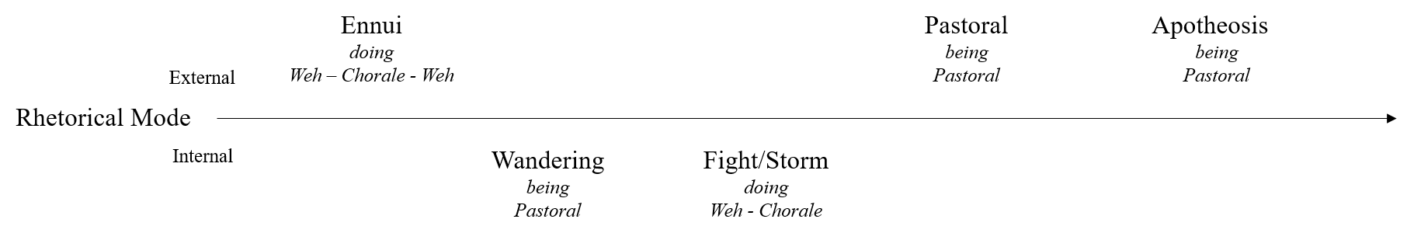
Figure 4.2 Vallée d’Obermann – Relationships between Isotopies and Rhetorical Mode

The Expressive Genre
While the expressive genre is rhetorically related to discursive syntax and function, I argue that the placement of the Tragic, Chorale, and Pastoral topics within the sonata structure and their consequent interactions form the Tragic-Transcendent expressive genre. Furthermore, I argue that the Tragic-Transcendent expressive genre is a signifier that ultimately supports the Comedic narrative. In what follows, I will define the expressive genre, set parameters for the Tragic-Transcendent expressive genre, and then illustrate the ways in which Vallée d’Obermann fulfills those parameters.
The Pastoral topic typically signifies serenity and tranquility, but Hatten also characterizes “lament or elegy” and Sturm und Drang as possible signifiers within a broader Pastoral expressive genre, in spite of their seeming opposition to the topic. This suggests that Tragic elements can occur within the Pastoral topic. The relationship between Pastoral and Tragic is one of marked opposition where one gives rise to the other such that the Tragic functions as “anti-Pastoral.” Yet, the assignation of the term “anti-Pastoral” carries the implication that the Tragic necessitates the existence of the Pastoral, and vice versa. This codependent opposition not only generates the opportunity for Hatten’s concept of the Pastoral as an expressive genre, but also narrative trajectories that incorporate the Pastoral and oppositional topics, such as the Tragic-Transcendent.
Hatten argues that the Tragic-Transcendent expressive genre is essentially a “higher” stylistic form of the Tragic-Triumphant expressive genre, though both feature a tonal shift from the minor to the major mode. Whereas the Triumphant often culminates in a sense of heroism and victory, the Transcendent reaches resolution differently. Hatten explicitly associates the Tragic-Transcendent with religious drama, and that the Tragic “may be understood as stemming from…Passion music” and that tragedy is “transcended through sacrifice at a spiritual level.” Furthermore, he characterizes the culminating victory as “transcendence…that goes beyond the conflicts of the work.” Vallée d’Obermann fulfills these criteria through an overall topical shift from Tragic to Pastoral, which creates a modal shift from minor to major. Additionally, the Chorale topic suggests spiritual, if not religious, inspiration. These elements are illustrated in Table 4.3.

Vallée d’Obermann: Form, Topics, and Keys
Formal Section | Exposition  (mm. 1-74) | Development  (mm. 75-169) |  |  | Recapitulation  (mm. 170-214) | Coda  (mm. 215-216)
Key | E minor | C major | B minor > major |  | E major
Topic(s) | Tragic-Chorale- Tragic | Pastoral | Tragic | Chorale | Pastoral
Table 4.3 Form, Topics, and Keys

Some analyses of this piece categorize the ending as a tragic reversal of the apotheosis, plunging the music back into despair. I propose an alternative reading: that this work ends in a state of Transcendence by assimilating the Ger⁺⁶ and the minor mode into the Pastoral topical field. Liszt accomplishes this through chord substitutions in the cadential material of the ESC and the Coda. In my characterization of the Pastoral as Transcendent rather than Triumphant, I rely principally on Hatten’s argument that acceptance and assimilation are signifiers of Transcendence.
The brief, two-measure coda that ends Vallée d’Obermann illustrates an assimilation of problematic material by addressing two issues: the undermining of T^{t} and its Pastoral associations, and the absence of traditional cadential material. In Figure 2.15, the reintroduction of Ce with a flat sixth scale degree implies the return of the minor mode and a relapse to the Tragic topic. Simultaneously, harmonizing the leading tone with a Ger⁺⁶ chord as a tritone substitution continues to support the idea of cadential subversion, while the notable absence of a PAC questions the narrative function of the leading tone. However, a proper leading tone resolution as part of a PAC would imply overcoming the ineffectuality that played such a large part in defining the Tragic topical field by rejecting a non-standard cadence and reverting to syntactic norms. This, in turn, would signify Triumph rather than Transcendence. Instead, it is the very acceptance of non-standard cadential patterns that signifies Transcendence.
Just prior to the coda, the bassline of mm. 212 – 213 (shown in Figure 2.14) reinforces the minor mode, rather than major, by lowering the sixth and seventh scale degrees. By doing so, this creates an implied plagal cadence through V⁴₂/IV – a relic of the religiously inspired Chorale topic that signifies its continued presence within the discourse. In Vallée d’Obermann, I argue the Chorale topic, through its capacity as an established modalizing force and its association with religion, serves to accept the absence of authentic resolution rather than overcome it. To assimilate this cadential pattern, Liszt places the Ger⁺⁶ chord after the V⁴₂/IV to create an altered plagal resolution – a resolution that already lacks a leading tone resolution through the absence of V. This chord substitution shares two common tones (C and E) with the minor subdominant (A-C-E), reinforcing its use as a substitution in the plagal cadence that concludes the sonata space.
The coda’s final iteration of Mª reinforces assimilation by incorporating both the lament signifier (C^{d} ) of the Tragic and the Pastoral’s tonic major at its conclusion (Figure 2.15). The combination of these two musical entities reinforces an acceptance of the lament as part the Pastoral. This time, as opposed to the closing of the exposition, Liszt writes C^{d} in the soprano, placing the lament signifier in a position of prominence. By doing so, the Tragic is reframed: the Tragic now appears as an integral entity of the narrative arc, and the existence of the Pastoral is contingent on the presence of its opposition.

Narrative Level
The narrative trajectories and changes in hierarchy resulting from the interactions in the Actantial Analysis ultimately bear the weight of revealing an underlying narrative archetype in Vallée d’Obermann. Having established these trajectories, and which elements achieve primacy at the end of the musical discourse, it’s possible to identify values of Order and Transgressor on higher levels. Principally, I argue the Order Imposing Hierarchy coincides with the Tragic topical field in its persistent non-resolution, while its oppositional topical field of the Pastoral coincides with the Transgressor in its efforts to undermine the Tragic.
While the Tragic initially governed the discourse, the events that occur internally result in the primacy of the Pastoral, resulting in the Tragic-Transcendent expressive genre. This expressive genre ultimately signifies the Comedic narrative. The assimilation of the Tragic into the Pastoral topic ultimately represents the transcendent victory of the Pastoral and, thus, the Transgressor has achieved Victory over the Order Imposing Hierarchy. According to the parameters set forth by Liszka, this effectively paints Vallée d’Obermann as a Comedy, having journeyed from the bottom of Frye’s cyclical model (Experience/Catastrophe) to the top (Renewed Innocence/Happiness). The implication of the major mode in the enharmonic leading tone of m. 3 first hints at the emergence of the Pastoral topic. Its more thorough manifestation in the internal dialogue through a thematic transformation within the key of the submediant support its viability and efficacy. The recapitulation asserts the Pastoral’s primacy through successive reinforcing transfigurations. Additionally, the emphasis on plagal resolution in the bars preceding the coda and the assimilation of the Ger⁺⁶ into the final cadence as a dominant substitute reframe the initial perception of “ineffectual” resolution. This new perception grants T the efficacy that it lacked in the exposition.

CONCLUSION

The analytical methods applied to Liszt’s Vallée d’Obermann illustrate that this piece expresses its sense of narrative in a uniquely emergent and reflective manner. The elements of thematic and semiotic relationships, and structure within the discourse of this narrative interact in ways at the Actantial level that reflect characteristics of Northrop Frye’s Comedic narrative archetype. This analysis supports the position that not only does narrative operate immanently in musical works without the need for their extramusical associations, but that mapping of structural and cultural elements within a formal paradigm can help to reveal a narrative archetype.
My analysis focused on three primary levels of discourse: The Agential, the Actantial, and the Narrative levels. The analysis at the Agential level catalogued all relevant musical material, revealing a set of cells and motives that function as primary actors in building expressive topical fields within the unfolding of the narrative. The taxonomic nature of this level, through illustrating the changing characteristics displayed by each actor at different structural points in the piece, illustrates the interactions that took place between these actors at the Actantial level. These interactions resulted in changes to thematic and temporal relationships, such as thematic transformation and the shift to augmented note values that represent different perceptions of time. The temporal and thematic shifts at key structural points also reflected changes in rhetorical expression from external to internal forms of dialogue, all within an overarching narrative structure. Sonata form frames the narrative perception of these elements, and organizes the structural units within culturally relevant fields such as the Tragic, Pastoral, and Chorale topics. Ultimately, I argue the use of these topical fields within sonata form create a work in the Tragic-Transcendent expressive genre.
Liszt’s use of this introspective narrative arc quite literally results in the “breaking out” of psychological and emotional struggles occurring on an internal temporal scheme. Consequently, this event serves as the emotional and psychological apotheosis of the entire work. While a general impression of this narrative arc can be easily heard in a performance, many of the notation-bound subtleties in the various stages of the narrative manifest only through a detailed analysis of the score, illuminating the difficulty of bringing these details to life in a performance.

Conclusions
At the time of this writing, no current analytical methodology can comprehensively account for immanent narrative across different composers and genres. However, it is possible that such methodologies can be established with respect to the works of a single composer – in this case, Franz Liszt. To that end, the compositional devices present in Vallée d’Obermann analyzed at the Agential, Actantial, and Narrative levels also present clearly in other works from Liszt’s output. Namely, when studying the large-scale works of Liszt, it is important to begin by identifying structural and cultural elements.
Structural elements include thematic materials and the use of form and analyzing the instances in which Liszt deviates from the normative procedures, especially with respect to Sonata structure. Hepokoski and Darcy’s principles laid out in Sonata Theory aid in identifying and reconciling these deformations, and is one available tool. Thematic relationships in Liszt’s music often take the form of fragmentation and/or thematic transformation. In the case of Vallée d’Obermann, my analysis revealed an economical use of material, fragmenting the primary theme actor into component motives and cells that propel the discourse through various isotopies, each encompassing their own expressive modality. Liszt’s treatment of thematic material often coincides with distinct cultural elements such as topical expressions that fit within the structural boundaries of the overarching form of the composition. The thematic transformation at the onset of the development and its temporal modulation, the fragmented resurgence of the Chorale topic at the retransition, and the subsequent shift of T^{t} back to the original temporal scheme are excellent examples of how Liszt ties thematic relationships directly to temporality and how cultural elements are perceived in time through a structural paradigm.
Other semiotic devices tied to narrative expression, such as the expressive genre, and their contextual meanings don’t necessarily manifest uniformly. As such, they require individual examination when appropriate. While the systematic application of the core elements to this methodology can act as a guiding framework in establishing a basis of narrative archetype, the compelling elements of narrativity lie within the nuances of the moments that are unique to a given work. Consequently, the notion that current methodologies are unequal to the task of systematic narrative analysis is not necessarily a shortcoming, but a reflection of the complexity and ineffable nature of music itself.

Recommendations for Further Study
Due to the limited nature of this study, it has only been possible to examine the devices that reveal narrative in this singular work within Liszt’s body of work. Taking into account the evocative nature of Liszt’s music, it follows that other works of his that feature a comparable scope and/or similar structural principles may also exhibit a penchant for narrative absent their assigned extramusical texts. Consequently, further application of these analytical methods could include, but are not limited to, the following works:
- Apres une lecture du Dante (from Années de pèlerinage, Deuxième année: Italie, S. 161)
- Sonata in B minor, S. 178
- Ballade No. 2 in B minor, S. 171
All three of these works exhibit many principles of sonata form and thematic transformation. Like Vallée d’Obermann, these pieces segment easily into expressive isotopies that feature the changes in affect and various modalities expressed in Chapter 1. Furthermore, a comparative study between the Ballade and the Sonata could potentially yield interesting narrative results due to their near-simultaneous composition.
These analytical methods, ideally, find use in active interpretation at a variety of stages in the development of a musician. Consequently, the potential pedagogical aim of this system of analysis is to teach interpretation based on actual elements in the score at the earliest stages possible. However, due to the in-depth analysis required for each piece and the overall cumbersome nature of the model as a whole, it would be necessary to strip away much of the vocabulary and other aspects that potentially act as barriers to accessibility. Consequently, a study aimed at examining the pedagogical applications of this system would seek to apply it in a stripped-down and practical way to teaching literature of intermediate difficulty. The necessity for a study of its application to pedagogical literature is two-fold:
- Students at this stage of musical development have often had, at the very least, a rudimentary introduction to music theory and can identify basic harmonies, rhythmic patterns, and aspects of form.
- There exists a wealth of 19th – century character pieces written for solo piano that are accessible to intermediate students. Many of these works are short and allow students to examine formal elements on a small scale. This understanding can then be built upon as a student moves on to more technically and rhetorically advanced literature.
Introducing this model, or elements of it, at this stage of a student’s musical development can enhance the learning of music beyond the simple acquisition of muscle memory by encouraging critical thinking and fastidious examination of the score. While this system is not the only method by which a student can decipher meaning from the music they are studying, it can serve as a starting point that helps them add depth to dichotomous relationships such as those between the major and minor modes. In turn, this could introduce students to the complexity of how music creates meaning through narrative elements and help to foster a sense of curiosity that will keep them interested in music long after they cease formal musical studies.

Appendix A
Outline of Model for Narrative Analysis
- Agential Level: identifies coherent musical units (events) and explicates their stylistic meanings
  - Morphological:
    - Cells
    - Motives
    - Theme-Actors/Actoriality
  - Syntactic: indicates meanings arising from grammatical, formal, and generic functions
    - Dialog with form
    - Formal deformations/deviations from structural norms
  - Semantic: identifies meanings arising from conventionally recognized codes, both formal and informal (affect, character, topic, etc.)
    - Segmentation into isotopies
    - Assignation of modalities
- Actantial Level: identifies strategic meanings – those arising from the temporal unfolding of the work
  - Discursive syntax and function: identifies meanings acquired by events transforming over time or appearing in different contexts, and distinguishes between those events that orient the listener and those that create momentum
    - Acts of Modalization/Interaction between modalities
    - Interactions between Isotopic/Topical Fields
    - Actoriality and acts such as Thematic Transformation
  - Gestural connotations: identifies “processes of accumulation, velocity, dissolution, disorientation, etc.”
  - Temporal discursive processes: identifies meanings produced by changes of “duration, frequency, speed, and order of events” in relation to “an ‘ideal’ temporal discursive scheme”
- Liszka’s narrative level
  - Assignation of a narrative archetype

Appendix B
Catalog of Melodic and Rhythmic Cells
Motives
M_{a}, M_{b}
Melodic Cells
C_{a}, C_{b}, C_{c,} C_{d}
C_{e} | 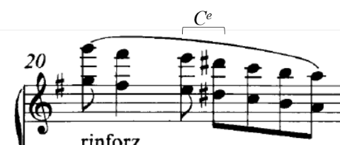
C_{f}
Rhythmic Cells

BIBLIOGRAPHY

Abbate, Carolyn. Unsung Voices: Opera and Musical Narrative in the Nineteenth Century. Princeton: Princeton University Press, 1996.

Agawu, V. Kofi. Playing with Signs: A Semiotic Interpretation of Classic Music. Princeton: Princeton University Press, 1991.

Almén, Byron Paul. “Narrative Archetypes: A Critique, Theory, and Method of Narrative Analysis.” Journal of Music Theory 47, no. 1 (2003): 1–39.

––––––. “Narrative Archetypes in Music: A Semiotic Approach.” Ph.D diss., Indiana University, 1998.

––––––. A Theory of Musical Narrative. Musical Meaning and Interpretation. Bloomington: Indiana University Press, 2008.

Almén, Byron and Robert S. Hatten. “Narrative Engagement with Twentieth-Century Music:
Possibilities and Limits.” In Music and Narrative Since 1900 edited by Michael L. Klein
and Nicholas Reyland, 59–85. Bloomington: Indiana University Press, 2013.

Arnold, Ben. The Liszt Companion. Connecticut: Greenwood Press, 2002.

Birch, Dinah, ed. “Child Harolde’s Pilgrimage.” In The Oxford Companion to English Literature. Oxford University Press, 2009.

––––––. “Senancour, Étienne Pivert De.” In The Oxford Companion to English Literature. Oxford University Press, 2009.

Brown, Eliza. "A Narratological Analysis of Pnima ... Ins Innere by Chaya Czernowin." DMA document, Northwestern University, 2015.

Chen, Yu-Wen. "The Role of Narrative in Performing Schumann and Chopin's Music." DMA document, James Madison University, 2017.

Cone, Edward T. “Schubert’s Promissory Note: An Exercise in Musical Hermeneutics.” 19th-Century Music 5, no. 3 (Spring 1982): 233–41.

———. Cone, Edward T. "Three Ways of Reading a Detective Story or a Brahms Intermezzo" The Georgia Review 31, no. 3 (1977): 554-74

Downs, Benjamin Michael. "A Critical Narrative Interpretation of John Corigliano's “Etude Fantasy”." DMA document, University of Cincinnati, 2010.

Eckerty, Christina D. "Narrative Strategies in Robert Schumann's "Davidsbuendlertaenze" and "Dichterliebe"." DMA diss., University of Missouri - Kansas City, 2008.

Frye, Northrop. Anatomy of Criticism: Four Essays. Princeton: Princeton University Press, 1957.

———. A Study of English Romanticism. New York: Random House, 1968.

Genette, Gérard. Narrative Discourse. Ithaca: Cornell University Press, 1980.

Gertsch, Emily S. "Narratives of Innocence and Experience: Plot Archetypes in Robert Schumann's Piano Quintet and Piano Quartet." PhD diss., The Florida State University, 2013.

Greimas, A.J. Structural Semantics: An Attempt at a Method. Translated by Daniele McDowell, Ronald Schleifer, and Alan Velie. Lincoln: University of Nebraska Press, 1983.

Hanslick, Eduard. On the Musically Beautiful: A Contribution Towards the Revision of the Aesthetics of Music. Translated by Geoffrey Payzant. Indiana: Hackett Publishing, 1986.

Hatten, Robert. Musical Meaning in Beethoven: Markedness, Correlation, and Interpretation. Indiana: Indiana University Press, 1994.

Hepokoski, James, and Warren Darcy. Elements of Sonata Theory: Norms, Types, and Deformations in the Late-Eighteenth-Century Sonata. New York: Oxford University Press, 2006.

James, Emma R. "Telling Tales: Narrative Semiotics in the Music of Béla Bartók." PhD diss., University of Rochester, 2016.

Kennedy, Michael. “Programme Music.” In The Oxford Dictionary of Music, edited by Joyce Bourne. Oxford University Press, 2012.

Klein, Michael. "Chopin's Fourth Ballade as Musical Narrative." Music Theory Spectrum 26, no. 1 (2004): 23-56.

———. Intertextuality in Western Art Music. Indiana: Indiana University Press, 2005.

Kramer, Lawrence. Interpreting Music. Los Angeles: Univeristy of California Press, 2011.

Lee, Bora. "Franz Liszt's “Vallée d'Obermann” from the “Années De Pèlerinage, Première Année, Suisse”: A Poetic Performance Guide." DMA document, University of Cincinnati, 2013.

Lee, Richard C. "An Agential Exploration of Tragedy and Irony in Post-1945 Orchestral Works." PhD diss., The Florida State University, 2017.

Liszt, Franz. Vallée d’Obermann. Edited by Sulyok Imre and Mező Imre. New Liszt Edition, Series I/6. Budapest, Hungary: Editio Musica Budapest, 1977.

Marzec, Katarzyna. "Prokofiev's Second Piano Concerto: Its Genesis, Form, and Narrative Structure." DMA diss., Temple University, 2013.

Maus, Fred Everett. “Classical Instrumental Music and Narrative.” In A Companion to Narrative Theory, edited by James Phelan and Peter J. Rabinowitz. Massachusetts: Blackwell Publishing, 2005.

––––––. “Music as Drama.” Music Theory Spectrum 10 (Spring 1988): 56–73.

––––––. “Music as Narrative.” Indiana Theory Review 12 (Spring–Fall, 1991): 1–34.

Merrick, Paul. “The Role of Tonality in the Swiss Book of Années de Pèlerinage.” Studia Musicologica Academiae Scientiarum Hungaricae 39, no. 2/4 (1998): 367–83.

Micznik, Vera. “The Absolute Limitations of Programme Music: The Case of Liszt’s ‘Die Ideale.’” Music & Letters 80, no. 2 (1999): 207–40.

––––––. “Music and Narrative Revisited: Degrees of Narrativity in Beethoven and Mahler.” The Journal of the Royal Music Association 126, no. 2 (2001): 193–249.

Monelle, Raymond. The Musical Topic: Hunt, Military and Pastoral. Indiana: Indiana University Press, 2006.

––––––. The Sense of Music: Semiotic Essays. Princeton: Princeton University Press, 2000.

Nattiez, Jean-Jacques. Music and Discourse: Toward a Semiology of Music. Translated by Carolyn Abbate. Princeton: Princeton University Press, 1990.

Newcomb, Anthony. “Narrative Archetypes and Mahler’s Ninth Symphony.” In Music and Text:
Critical Inquiries, edited by Steven Paul Scher, 118–136. Cambridge: Cambridge
University Press, 1992.

———. “Schumann and Late Eighteenth Century Narrative Strategies.” 19th-Century
Music 11, no. 2 (Autumn, 1987): 164–74.

Pederson, Sanna. “Defining the Term ‘Absolute Music’ Historically.” Music & Letters 90, no. 2 (2009): 240–62.

Pesic, Peter. “Schubert’s Dream.” 19th-Century Music 23, no. 2 (1999): 136–44.

Ratner, Leonard G. Classic Music: Expression, Form, and Style. New York: Schirmer, 1980.

Restrepo, Christian. "Robert Muczynski's First Piano Trio, Opus 24: A Narrative Analysis." Order No. 3582124, University of Houston, 2014.

Robertson, Gillian. "Variations on a Theme by Paganini: Narrative Archetypes in Nineteenth- and Twentieth-Century Theme-and-Variation Sets." PhD diss., The Florida State University, 2015.

Rosen, Charles. Sonata Forms. New York: W.W. Norton & Company, 1988.

Sisman, Elaine R. Mozart: The “Jupiter” Symphony. Cambridge Music Handbooks. Cambridge: Cambridge University Press, 1993.

Straus, Joseph N. “Disability and ‘Late Style’ in Music.” The Journal of Musicology 25, no. 1 (2008): 3–45.

Tarasti, Eero. A Theory of Musical Semiotics. Indiana: Indiana University Press, 1994.

Walker, Alan. Franz Liszt: The Virtuoso Years, 1811-1847. Vol. 1. New York: Cornell University Press, 1988.

———. Franz Liszt: The Weimar Years, 1848-1861. Vol. 2. New York: Cornell University Press, 1993.

———. Franz Liszt: The Final Years, 1861-1886. Vol. 3. New York: Cornell University Press, 1997.

Yu, Grace Chung-yan. "A Semiotic Interpretation of Liszt's Piano Works in Light of their Extramusical Sources." PhD diss., Indiana University, 2012.

Fred Everett Maus, “Classical Instrumental Music and Narrative,” in A Companion to Narrative Theory, ed. James Phelan and Peter J. Rabinowitz (Massachusetts: Blackwell Publishing, 2005), 468.
Abbate, Unsung Voices: Opera and Musical Narrative in the Nineteenth Century (Princeton: Princeton University Press, 1996); Almén, A Theory of Musical Narrative (Indiana: Indiana University Press, 2008); Cone, “Three Ways of Reading a Detective Story or a Brahms Intermezzo,” The Georgia Review 31, no. 3 (1977): 554–74; Hatten, Musical Meaning in Beethoven: Markedness, Correlation, and Interpretation (Indiana: Indiana University Press, 1994); Kramer, Interpreting Music (Los Angeles: Univeristy of California Press, 2011).
Joseph N. Straus, “Disability and ‘Late Style’ In Music,” The Journal of Musicology 25, no. 1 (2008): 3–45.
See Michael L. Klein and Nicholas Reyland, eds., Music and Narrative since 1900 (Indiana: Indiana University Press, 2012).
Agawu, Playing with Signs: A Semiotic Interpretation of Classic Music (Princeton: Princeton University Press, 1991); Sisman, Mozart: The “Jupiter” Symphony, Cambridge Music Handbooks (Cambridge: Cambridge University Press, 1993).
Raymond Monelle, The Sense of Music: Semiotic Essays (Princeton: Princeton University Press, 2000), 14.
Ibid, 7.
Ibid, 25-27.
Raymond Monelle, The Musical Topic: Hunt, Military and Pastoral (Bloomington: Indiana University Press, 2006).
Robert Hatten, Musical Meaning in Beethoven: Markedness, Correlation, and Interpretation (Indiana: Indiana University Press, 1994), 91.
Robert Hatten, Musical Meaning in Beethoven: Markedness, Correlation, and Interpretation (Indiana: Indiana University Press, 1994), 84-85.
Jean-Jacques Nattiez, Music and Discourse: Toward a Semiology of Music, trans. Carolyn Abbate (Princeton: Princeton University Press, 1990).
Carolyn Abbate, Unsung Voices: Opera and Musical Narrative in the Nineteenth Century (Princeton: Princeton University Press, 1996).
Fred Everett Maus, “Classical Instrumental Music and Narrative,” in A Companion to Narrative Theory, ed. James Phelan and Peter J. Rabinowitz (Massachusetts: Blackwell Publishing, 2005).
Fred Everett Maus, “Music as Drama,” Music Theory Spectrum 10, Spring (1998): 56–73.
Fred Everett Maus, “Music as Narrative,” Indiana Theory Review 12, Spring-Fall (1991): 1–34.
Almén, A Theory of Musical Narrative (Indiana: Indiana University Press, 2008); Klein, “Chopin’s Fourth Ballade as Musical Narrative,” Music Theory Spectrum 26, no. 1 (2004): 23–56; Tarasti, A Theory of Musical Semiotics (Indiana: Indiana University Press, 1994); Cone, “Three Ways of Reading a Detective Story or a Brahms Intermezzo,” The Georgia Review 31, no. 3 (1977): 554–74; Newcomb, “Schumann and Late Eighteenth Century Narrative Strategies,” 19th-Century Music 11, no. 2 (Autumn 1987): 164–74; Newcomb, “Narrative Archetypes and Mahler’s Ninth Symphony,” in Music and Text: Critical Inquiries, ed. Steven Paul Scher (Cambridge: Cambridge University Press, 1992), 118–36.
Vera Micznik, “Music and Narrative Revisited: Degrees of Narrativity in Beethoven and Mahler,” The Journal of the Royal Music Association 126, no. 2 (2001): 193–249.
Cone, “Three Ways of Reading a Detective Story or a Brahms Intermezzo.”
Edward T. Cone, “Schubert’s Promissory Note: An Exercise in Musical Hermeneutics,” 19th-Century Music 5, no. 3 (Spring 1982): 233–41. Lawrence Kramer defines this term as a point in the music that “impels or embodies interpretation.” See Kramer, Interpreting Music (Los Angeles: Univeristy of California Press, 2011) 25.
Tarasti, A Theory of Musical Semiotics
Ibid., 184.
Ibid, 191
Micznik, “Music and Narrative Revisited: Degrees of Narrativity in Beethoven and Mahler.”
Vera Micznik, “The Absolute Limitations of Programme Music: The Case of Liszt’s ‘Die Ideale,’” Music & Letters 80, no. 2 (1999): 207–40.
Byron Almén, “Narrative Archetypes in Music: A Semiotic Approach” (Ph.D., Indiana University, 1998); Almén, “Narrative Archetypes: A Critique, Theory, and Method of Narrative Analysis,” Journal of Music Theory 47, no. 1 (2003): 1–39; Almén, A Theory of Musical Narrative (Indiana: Indiana University Press, 2008).
Byron Almén and Robert Hatten, “Narrative Engagement with Twentieth-Century Music: Possibilities and Limits,” in Music and Narrative Since 1900, ed. Michael L. Klein and Nicholas Reyland (Bloomington: Indiana University Press, 2013).
Benjamin Downs, “A Critical Narrative Interpretation of John Corigliano’s ‘Etude Fantast’” (DMA document, University of Cincinnati, 2010); Kararzyna Marzec, “Prokofiev’s Second Piano Conerto: Its Genesis, Form, and Narrative Structure” (DMA dissertation, Temple University, 2013); Eliza Brown, “A Narratological Analysis of Pnima...Ins Innere by Chaya Czernowin” (DMA document, Northwestern University, 2015).
Christina D. Eckerty, “Narrative Strategies in Robert Schumann’s Davidsbuendlertaenze” (DMA diss., University of Missouri - Kansas City, 2008); Emily S. Gertsch, “Narraties of Innocence and Experience: Plot Archetrypes in Robert Schumann’s Piano Quintet and Piano Quartet” (PhD diss., The Florida State University, 2013); Chen Yu-Wen, “The Role of Narrative in Performing Schumann and Chopin’s Music” (DMA document, James Madison University, 2017).
Gillian Robertson, “Variations on a Theme by Paganini: Narrative Archetypes in Nineteenth- and Twentieth-Century Theme-and-Varation Sets” (PhD diss., The Florida State University, 2015).
Emma R. James, “Telling Tales: Narrative Semiotics in the Music of Béla Bartók” (PhD diss., University of Rochester, 2016).
James Hepokoski and Warren Darcy, Elements of Sonata Theory: Norms, Types, and Deformations in the Late-Eighteenth-Century Sonata (New York: Oxford University Press, 2006), 9-11.
William Caplin, James Hepokoski, and James Webster, Musical Form, Forms, and Formenlehre: Three Methodological Reflections, ed. Pieter Berge (Leuven University Press, 2010).
Klein, “Chopin’s Fourth Ballade as Musical Narrative,” Music Theory Spectrum 26/1 (2004): 30–31; Samson, Chopin: The Four Ballades (Cambridge: Cambridge University Press, 1992), 45–50.
Reichardt, Composing the Modern Subject: Four String Quartets by Dmitri Shostakovich (Ashgate Publishing, Ltd., 2008); Monahan, Mahler’s Symphonic Sonatas (United States: Oxford University Press, 2015).
Alan Walker, Franz Liszt: The Weimar Years, 1848-1861. Vol. 2. (New York: Cornell University Press, 1993), 150.
Axel Schmitt, “Franz Liszt and the Don Juan Fantasy: An Interpretive Study of Meaning and Dramatic Narrative” (DMA document, University of California - Los Angeles, 2004).
Aida Marc, “Analysis of Expressive Elements in the Dante Sonata” (DMA document, The University of Alabama, 2010); William Alan Lipke, “Liszt’s ‘Dante Fantasia’: An Historical and Musical Study” (DMA document, University of Cincinnati, 1990).
Grace Chung-yan Yu, “A Semiotic Interpretation of Liszt’s Piano Works in Light of Their Extramusical Sources” (PhD diss., Indiana University, 2012).
Arnold, The Liszt Companion, 75-83.
Byron Almén, “Narrative Archetypes in Music: A Semiotic Approach” (Ph.D., Indiana University, 1998), 1..
Ibid, 1.
Byron Almén, A Theory of Musical Narrative. (Indiana University Press, 2008), ix.
Ibid, 55.
See note 17.
Almén, A Theory of Musical Narrative, 229.
Robert Hatten, Musical Meaning in Beethoven: Markedness, Correlation, and Interpretation (Indiana: Indiana University Press, 1994), 84.
Almén, A Theory of Musical Narrative, 63.
Ibid, 100-101.
Eero Tarasti, A Theory of Musical Semiotics (Indiana: Indiana University Press, 1994), 48.
Ibid, 48.
Ibid, 49.
Robert Hatten, Musical Meaning in Beethoven: Markedness, Correlation, and Interpretation (Indiana: Indiana University Press, 1994), 291.
Ibid. 36
Raymond Monelle, The Sense of Music: Semiotic Essays (Princeton: Princeton University Press, 2000).
James Hepokoski and Warren Darcy, Elements of Sonata Theory: Norms, Types, and Deformations in the Late-Eighteenth-Century Sonata (New York: Oxford University Press, 2006), 9-11.
Ibid, 615-618.
The term “deformation” carries significant social connotations with regard to the concept of “ableness” and inherent musical “disability” (See: Joseph Straus “Disability and ‘Late Style’ in Music.” The Journal of Musicology 25, no. 1 (2008): 3–45). Hepokoski and Darcy note that this term does not suggest a latent “ugliness” or disability within such events, rather that the term, quite literally, shows that events have deviated from the normative formal procedures. In light of this, I use the term deformation in my analysis for the purpose of identifying non-standard formal events.
William Caplin, James Hepokoski, and James Webster, Musical Form, Forms, and Formenlehre: Three Methodological Reflections, ed. Pieter Berge (Leuven University Press, 2010).
Eero Tarasti, A Theory of Musical Semiotics (Indiana: Indiana University Press, 1994), 191.
Tarasti, A Theory of Musical Semiotics, 184.
A “medial caesura” refers to the “pause” before the onset of the S-zone, following the Transition that occurs after the P-zone, though a Transition may not always be present. The “essential expositional closure” is the characterized as the first satisfactory PAC in the new key, signaling the end of the exposition prior to moving on to new material (either closing material, or the development). See Hepokoski and Darcy, Elements of Sonata Theory: Norms, Types, and Deformations in the Late-Eighteenth-Century Sonata, 18.
Tarasti, A Theory of Musical Semiotics, 184.
Tarasti, A Theory of Musical Semiotics, 192.
Ben Arnold, The Liszt Companion (Connecticut: Greenwood Press, 2002), 80.
Hepokoski and Darcy, Elements of Sonata Theory: Norms, Types, and Deformations in the Late-Eighteenth-Century Sonata, 229-230.
While the discursive significance of this small event is disputable, it does provide a satisfying, if small, sense that the narrative has come “full circle.”
Tarasti, A Theory of Musical Semiotics, 184-193.
Raymond Monelle, The Musical Topic: Hunt, Military and Pastoral (Indiana: Indiana University Press, 2006), 207 – 220.
Ibid 237-263.
Hatten, Musical Meaning in Beethoven, 81.
Monelle, The Musical Topic: Hunt, Military and Pastoral, 220-221.
Robert Hatten, Musical Meaning in Beethoven: Markedness, Correlation, and Interpretation (Indiana: Indiana University Press, 1994), 83-84.
Tarasti, A Theory of Musical Semiotics, 184 – 193.
Ibid, 185.
Peter Pesic, “Schubert’s Dream,” 19th-Century Music 23, no. 2 (1999): 139.
See Table 1.2 for all references to expressive modalities.
See Table 1.2 for definitions of the assigned modalities.
Micznik, “Music and Narrative Revisited: Degrees of Narrativity in Beethoven and Mahler,” 235. For a more detailed discussion of temporal processes in literary narrative, see Gérard Genette, Narrative Discourse (Ithaca: Cornell University Press, 1980).
Almén, A Theory of Musical Narrative, 231.
Hatten, Musical Meaning in Beethoven: Markedness, Correlation, and Interpretation, 82-83.
Ibid, 89.
Ibid, 79.
Arnold, The Liszt Companion, 82; Paul Merrick, “The Role of Tonality in the Swiss Book of Années de Pèlerinage,” Studia Musicologica Academiae Scientiarum Hungaricae 39, no. 2/4 (1998): 380.
Italics indicate elements adapted from Eero Tarasti’s A Theory of Musical Semiotics (1994).

