UNIVERSITY OF OKLAHOMA
GRADUATE COLLEGE

USING THE INTEGRATIVE MODEL TO PREDICT SUGAR-SWEETENED BEVERAGE CONSUMPTION AMONG ADULTS ATTEMPTING WEIGHT LOSS
IN SOUTHERN OKLAHOMA

A THESIS
SUBMITTED TO THE GRADUATE FACULTY
in partial fulfillment of the requirements for the
Degree of
MASTER OF SCIENCE

By
MARIA DEL ROSARIO COLLADO RIVERA
Norman, Oklahoma
2016

USING THE INTEGRATIVE MODEL TO PREDICT SUGAR-SWEETENED BEVERAGE CONSUMPTION AMONG ADULTS ATTEMPTING WEIGHT LOSS
IN SOUTHERN OKLAHOMA

A THESIS APPROVED FOR THE
DEPARTMENT OF HEALTH AND EXERCISE SCIENCE

BY

__________________________
Dr. Paul Branscum, Chair

__________________________
Dr. Haijuan Gao

__________________________
Dr. Daniel Larson

Copyright page

Table of Contents
List of Tables………………………………………………………….….………...……v
List of Figures………………………………………………….…….……………......viii
Abstract……………………………………………………….……….…….…..….......ix
Chapter 1 Introduction ……………………………………………….….………...........1
Chapter 2 Review of the Literature …………………………...…….…….….…..........16
Chapter 3 Methods ………………………………………….……………....................42
Chapter 4 Results ………………………………………….…………….…….…........52
Chapter 5 Discussion …………………………………………..……….……………..91
References…………………………………………………….………….………….....98
Appendix A: Data Collection Materials……….…………….…….……………...…..113
Appendix B: Panel of Experts………………………………..…………………...…..119

List of Tables
Table 2.1 Constructs of the Integrative Model Defined..................................................28
Table 3.1 Demographic Data for Lawton, the state of Oklahoma, and the
United States…………………………..……………………….………….…………....43
Table 4.1 Direct measures summary of missing and N/A data.......................................54
Table 4.2 Indirect measures summary of missing and N/A data.....................................55
Table 4.3 Direct measures test-retest reliability and significance...................................62
Table 4.4 Direct measures summary of factor analysis for establishing construct validity..…….………………………………………………….………….…………....63
Table 4.5 Direct Attitudes and Perceived Norms summary of factor analysis...............64
Table 4.6 Mean and Standard Deviations for IM constructs..........................................66
Table 4.7 A summary of demographics (Categorical) ...................................................67
Table 4.8 Pairwise correlation analyses of the Integrative Model constructs.................68
Table 4.9 Variance Inflation Factors for SSB’s per day and SSB’s per week (in oz) as Predicted by Intentions, Perceived Behavioral Control, Environment and Skills and Abilities……...……….…………………………………….………….…………....….71
Table 4.10 Variance Inflation Factors for Intentions as Predicted by Perceived Behavioral Control, Perceived Norms, and Attitudes....................................................73
Table 4.11 Variance Inflation Factors for Intentions as Predicted by Perceived Behavioral Control, Injunctive Norms, Descriptive Norms, Instrumental Attitudes, and Experiential Attitudes.....................................................................................................74
Table 4.12 Parameter Estimates from the Final Regression Model for SSB’s per day (in oz) as Predicted by Intentions, Perceived Behavioral Control, Environment and Skills and Abilities: (Adjusted R² = 0.097) (n=410) ................................................................75
Table 4.13 Parameter Estimates from the Final Regression Model for SSB’s per week (in oz) as Predicted by Intentions, Perceived Behavioral Control, Environment and Skills and Abilities: (Adjusted R² = 0.158) (n=410) ...................................................,..76
Table 4.14 Parameter Estimates from the Final Regression Model for Intentions as Predicted by Perceived Behavioral Control, Perceived Norms, and Attitudes:
(Adjusted R² = 0.401) (n=410)…………………………………….…………………...77
Table 4.15 Parameter Estimates from the Final Regression Model for Intentions as Predicted by Perceived Behavioral Control, Injunctive Norms, Descriptive Norms, Instrumental Attitudes, and Experiential Attitudes: (Adjusted R² = 0.412) (n=408)......78
Table 4.16 ANOVA of Gender to Attitudes, Perceived Behavioral Control, and
Perceived Norms.............................................................................................................81
Table 4.17 ANOVA of Education to Attitudes, Perceived Behavioral Control, and Perceived Norms.............................................................................................................82
Table 4.18: Pairwise comparison for predictors of sugar sweetened beverage behavior. .........................................................................................................................................83
Table 4.19 Indirect Attitudes: Belief Strength, Outcome Evaluation, Belief-Evaluation Product, and Correlations of Belief-Evaluation Product with Direct Attitude Measure
(N = 410)……….............................................................................................................85
Table 4.20 Injunctive Norms: Injunctive Normative Beliefs, Motivation to Comply, Belief-Comply Product, and Correlations of Belief-Comply Product with Direct Injunctive Measure (N = 256) ........................................................................................87
Table 4.21 Descriptive Norms: Descriptive Normative Beliefs, Identification with Referents, Belief-Referents Product, and Correlations of Belief-Referents Product with Direct Descriptive Measure (N = 279) ...........................................................................87
Table 4.22 Perceived Behavioral Control: Control Beliefs, Perceived Power, Belief-Power Product, and Correlations of Belief-Power Product with Direct Perceived Behavioral Control Measure (N = 405) ..........................................................................89

List of Figures
Figure 2.1 Local Indicators of Spatial Association Map.................................................18
Figure 2.2 The Integrative Model....................................................................................29
Figure 4.1 Scatter Plot of the Regression Standardized Residuals for the behavior sugar sweetened beverage per day for those attempting to lose weight.……………….….....71
Figure 4.2 Scatter Plot of the Regression Standardized Residuals for the behavior sugar sweetened beverage per week for those attempting to lose weight…………….……....72
Figure 4.3 Scatter Plot of the Regression Standardized Residuals for intentions predicted by perceived behavioral control, attitudes, and perceived norms……….…..73
Figure 4.4 Scatter Plot of the Regression Standardized Residuals for intentions predicted by perceived behavioral control, injunctive norms, descriptive norms, instrumental attitudes, and experiential attitudes............................................................74

Abstract
Introduction: Adult obesity is a serious problem in the United States as approximately 68.5% of adults are overweight or obese. Obesity is caused by many factors including lifestyle behaviors, psychological and physiological circumstances, a genetic predisposition and elements of ones personal environment. One lifestyle behavior that has been strongly linked to obesity is the overconsumption of sugar-sweetened beverages (SSB). As such, theory-based lifestyle interventions aimed at decreasing SSB consumption are greatly needed for adults currently consuming them. Therefore, purpose of this study was to explore the utility of the Integrative Model (IM), for predicting intentions to abstain from SSB consumption, among adults’ activity attempting to lose weight.
Methods: An elicitation phase was conducted with a sample of individuals from the target population (n=30) to establish all the following beliefs: behavioral, injunctive normative, descriptive normative and control. Afterwards, an instrument was developed to measure the constructs of the IM related to the behavior: “stop drinking regular soda and sugary drinks for the next 6 months”. Once the instrument was developed, it was evaluated for face and content validity by a panel of 6 experts, and then pilot tested with a convenience sample of the target population to evaluate overall readability (n=10). The final survey was then administered face-to-face to the sample population (n=410). Four rounds of enter method multiple regression were performed in order to test the utility of applying the IM: In the first and second round, perceived behavioral control, intentions, skills, and environment predicted the behavior (sugar sweetened beverages (SSBs) per day (Round 1) and SSBs per week (Round 2)). In the third round, attitudes, perceived norms, and perceived behavioral control predicted intentions, and in the fourth round instrumental attitudes, experiential attitudes, injunctive norms, descriptive norms, and perceived behavioral control predicted intentions.
Results: The instrument was tested for internal consistency reliability, test-retest reliability (n=15), and construct validity, and results showed the survey was valid and reliable. According to the four regression models developed from data analyses, 9.7% of the variance of SSBs per day and 15.8% of the variance of SSBs per week was explained by intentions, perceived behavioral control, environment and skills and abilities. In the third model 40.1% of the variance of Intentions was explained by perceived behavioral control, perceived norms, and attitudes. Finally, in the fourth model, 41.2% of the variance of Intentions was explained by perceived behavioral control, injunctive norms, descriptive norms, instrumental attitudes, and experiential attitudes.
Discussion: In this study environment was shown to be the biggest predictor for current SSB consumption, therefore a focus for future interventions could be eliminating SSBs from the home environment. The second predictor for current SSB consumption was perceived behavioral control. Some individuals may face SSBs in the workplace or home and it may not be easy to eliminate those triggers, in which case perceived behavioral control strategies based on these findings may be helpful. Conclusively, this study identified this weight loss population’s specific Direct and Indirect measures that could help in the development of an intervention with the focus to stop drinking regular soda and other sugary drinks.

Chapter 1

Introduction
Obesity is the result of a positive energy status, meaning an individual gains weight from having a greater caloric intake (from foods and beverages), than their energy expenditure (from one’s basal metabolic rate and activity levels) (Giskes, 2011). In the United States, more than one-third of adults are obese, but obesity rates have remained stable between 2003-2004 and 2009-2010 (Ogden et al., 2014). Obesity is commonly expressed using one’s body mass index (BMI) (An, 2014). When a person has a BMI of 30 to 39, they are considered obese, and if the person surpasses a BMI of 40, they are considered morbidly obese (An, 2014). Researchers and clinicians use BMI to identify an individual’s risk level associated with their level of obesity. In addition to the BMI guidelines, it is recommended that the waist circumference should measure no more than 35 inches for women and no more than 40 inches for men since waist circumference has been associated with risk for cardiovascular disease, diabetes, hypertension, and other illnesses (Despres, 2012).
From 2011 to 2012, 34.9 % of adults were obese and 68.5 % were overweight or obese in the U.S. (Ogden, 2014). Middle-aged adults (40 to 59 years), have the highest obesity prevalence (39.5 percent) compared to younger adults (20 to 39 years; 30.3%), and older adults (60 years and up; 35.4%) (Ogden, 2014). Approximately 78.6 million adults are obese in the United States and annual health care costs related to obesity are approximately $190.2 billion or nearly 21% of annual medical spending (Ogden, 2014; Finkelstein, 2009; Cawley, 2012). Obesity is referred to a chronic disease that is not equally distributed throughout the U.S. Studies reveal that obesity varies among levels of education and socioeconomic status (Slack, 2014). For example, the CDC shows that obesity trends are more common in non-Hispanic blacks (47.8%) and Hispanics (42.5%) followed by non-Hispanic whites (32.6%) and non-Hispanic Asians (10.8%) (Ogden, 2014). The CDC also reports that among non-Hispanic black and Mexican-American men, those with higher incomes are more likely to be obese than those with low incomes (Ogden, 2010). However, women with higher income are less likely to have obesity than lower-income women (Ogden, 2010). According to the CDC, there is no significant correlation between obesity and education among men, however, for women, there is a trend (Ogden, 2010). Women with college degrees are less likely to have obesity than women with less education (Ogden, 2010).
Obesity leads to many distinct physiological changes such as increased body fat, cholesterol, blood pressure, fasting blood glucose and other significant metabolic indicators, that can lead to cardiovascular disease, stroke, heart attack, diabetes, metabolic disorders, and cancer (Despres, 2012). Furthermore, when obesity is not managed, the condition can progress resulting in wear on joints (Smith et al., 2014). This can lead to decreases in physical activity, which in turn, can lead to greater weight gain (Smith et al., 2014). For women, obesity can cause problems in the reproductive system (Mind/Body Health: Obesity, 2015). Obesity can also lead to many psychological problems, such as depression, which can influence obesity vice versa (Mind/Body Health: Obesity, 2015). Women are much more vulnerable to this obesity-depression cycle (Mind/Body Health: Obesity, 2015). Depression can also create stress, or come from stress, which can lead to binge eating unhealthy foods and forgoing exercise (Mind/Body Health: Obesity, 2015).
Obesity is a medical issue, with many causes including genetic, environmental, and lifestyle behaviors. Some individuals have a genetic predisposition associated with obesity. These genetic conditions include: not being able to produce leptin, decreased muscle mass and increase in fat mass (sarcopenic obesity), and type 1 diabetes (Mantzoros, 2011, Benton, 2011 & Conway, 2010). The environment can also play an important role in obesity (Mattes, 2014). Environment determinants of obesity are energy density (ED), cost, food form (i.e., beverages), food variety, portion size, eating frequency, and convenience and availability (Mattes, 2014). Furthermore, lifestyle behaviors including diet, physical activity, and sedentary behaviors also influences obesity (Nurkkala, 2015).
Defining a healthy diet can be a difficult task, as Branscum and Sharma (2014) noted that the term “healthy diet” is vague and abstract. They further noted that across many definitions of the term ‘healthy diet’ added sugars should be moderated or avoided altogether (Branscum & Sharma, 2014). It should also be noted that there is no universal definition of consuming “too much” SSBs, or what consists of a high intake. In one study, the term heavy SSB consumption, referred to consuming 500 kcal/day, equivalent to drinking more than a 1-liter, or 3.5 12-ounce cans of regular soda (Han & Powell, 2013). Researchers from that study found that Hispanics and Blacks consumed less heavy amounts of regular soda than whites (Han & Powell, 2013). However, Blacks consumed more heavy amounts of fruit drinks than whites (Han & Powell, 2013). Less educated adults were also found to be more likely to consume heavy SSBs particularly regular soda than the high-educated adult group (Han & Powell, 2013). Furthermore, low-income adults were more likely to consume heavy total SSBs, regular soda, and fruit drinks than the high-income adults (Han & Powell, 2013).
Many Americans regularly consume SSBs and high fatty foods including take-away foods in fast food restaurants (Hu, 2013; Han & Powell, 2013). Before the 1950s, that standard soft-drink bottle was 6.5 ounces, which later was increased to 12-ounce cans in the 1950s and 60’s, and then to 20-ounce bottles in the early 1990’s (The Coca-Cola Company, 2015 & Jacobson, 2005). Today, larger sizes are available such as the 1.25-liter (42-ounce) bottle that was introduced in 2011 (Fact Sheet, 2012). From the 1970s to 2001, sugary drinks increased from 4% to 9% of US daily calorie intake (Neilsen, 2005). Recently it was reported that 50% of Americans consume sugary drinks on any given day, of which 25% consumes less that 200kcal (more than one 12-oz can of soda) and 5% consumes 567 kcal daily (more than four 12-oz cans of soda) (Ogden, 2011).
There are racial and ethnic differences as well as socioeconomic differences for SSB consumption in the U.S. Among adults ≥20 years old, non-Hispanic whites consumed fewer SSB calories as a percentage of total calories (5.3%) than non-Hispanic black (8.6%) or Mexican-Americans (8.2%) (Ogden, 2011). Furthermore, people with high-incomes consume less calories from SSBs than lower income people and among adults living below 130% of the poverty line (Ogden, 2011). The mean calorie intake from SSBs was 8.8% of total calories while those living between 130% and 350% of the poverty line had a mean calorie intake from SSBs of 6.2% of total calories (Ogden, 2011). Individuals at or above the 350% poverty line had a mean calorie intake of 4.4% of total calories (Ogden, 2011).
For those trying to lose weight, SSB’s are important for decreasing and eliminating because they are high in calories (Cutting Calories, 2015). Eliminating SSBs from an individuals diet can reduce their health risks and maintain or reduce body weight (Cutting Calories, 2015). Since drinking SSBs is a common behavior for Americans, interventions are needed to help change this health behavior (Ogden, 2011). In turn, interventions focusing on behavior change should be based on behavior change theories.
Theoretical Framework of the Study
The Integrative Model (IM) was developed at a theorist workshop in 1991 by Albert Bandura, Marshall Becker, Martin Fishbein, Fredrick Kanfer, and Harry Triandis and is the most recent formulation of the Reasoned Action Approach (RAA) (Fishbein & Ajzen, 2010). The development of the RAA has been progressive (Maibach, 1995). Martin Fishbein’s early work in the 1960s was on conceptual differences between beliefs, attitude, and intention constructs in response to scholars who doubted the usefulness of the attitude construct for predicting human behavior (Maibach, 1995). This work guided the theory of reasoned action (TRA), which models beliefs about specific outcomes that predicts attitude toward the behavior and referents’ approval (motivation to comply and normative beliefs) that predicts subjective norm (Maibach, 1995). Both attitude towards the behavior and subjective norm are precursors to intentions and behavior(s) (Maibach, 1995). Icek Ajzen later proposed the TPB in the 1980s, which includes perceived behavioral control as an additional predictor of intentions and behavioral (Maibach, 1995). A recent formulation of the theory was proposed in 2000 as the integrative model of behavioral prediction, which extends the scope of the normative determinant and incorporates skills and environmental barriers as moderators of the intention–behavior relationship (Fishbein & Ajzen, 2010).
The IM is a health behavior theory, which posits an individual will most likely engage in the behavior if they have sufficient intentions, they have the necessary skills and abilities to perform the behavior, and the environment is conducive to the health behavior. Intentions are additionally influenced by attitudes, including experiential attitudes, which refers to the overall affective evaluation of the behavior (or the emotional response) and instrumental attitudes which refers to the overall cognitive evaluation of the behavior (or the thoughtful response), perceived norms (including descriptive norms which refers to the perceptions that others are or are not performing the behavior in question, and injunctive norms which is an individual’s perception that most people who are important to him/her think he/she should or should not perform a particular behavior), and perceived behavioral control (including perceived capacity which refers to the ability one has to perform a behavior, that is, to the belief that one can, is able to, or is capable of performing the behavior and perceived autonomy refers to the degree of control to perform the behavior).
Since its development, very few studies have operationalized the constructs of the IM, and applied to health behavior research. Currently no research has been done using the IM along with SSB behaviors and adults. Jordan and colleagues (2012) targeted children’s SSB consumption through their caregivers/parents (Jordan et al., 2012). Undoubtedly there is a gap in the literature using the IM in conjunction with SSB behaviors and adults.

Purpose of the Study

Interventions addressing SSB consumption are common among children, but less common among adults. Sugary drinks are important in health promotion since strong evidence indicates that the average American consumes about 151 kcal/day of SSB and that SSB intake can lead to obesity, which can lead to several health issues (Sugar-Sweetened Beverage, 2014). No study to date has used the IM to predict this health behavior. The purpose of this study was to explore to what extent the IM predicts the SSB behavioral intentions of adults attempting to lose weight.

Research Questions

The following questions were investigated in this study:
- To what extent are direct measures of the IM constructs (attitudes, perceived norms, and perceived behavioral control) associated with behavioral intentions to stop drinking regular soda and sugary drinks for the next 6 months among adults attempting to lose weight?
- To what extent are the extended direct measures of the IM constructs (experiential attitude, instrumental attitude, injunctive norms, descriptive norms, capacity and autonomy) associated with behavioral intentions to stop drinking regular soda and sugary drinks for the next 6 months among adults attempting to lose weight?
- To what extent are the IM constructs of intentions, skill/abilities, environment, and perceived behavioral control associated with current daily consumption of regular soda and sugary drinks?
- To what extent are the IM construct of intentions, skill/abilities, environment, and perceived behavioral control associated with current weekly consumption of regular soda and sugary drinks?
- To what extent are background factors, such as education level and gender, related to attitudes, perceived norms, and perceived behavioral control for the behavior “to stop drinking regular soda and sugary drinks for the next 6 months” in adults attempting to lose weight?

Research Hypotheses
The research hypotheses for this study were as follows:
Hypothesis 1: Attitudes, perceived norms, and perceived behavioral control will collectively have a significant positive relationship with behavioral intention to stop drinking regular soda and sugary drinks for the next 6 months in adults attempting to lose weight.
Null hypothesis 1: Attitudes, perceived norms, and perceived behavioral control will not collectively have a significant relationship with behavioral intention to stop drinking regular soda and sugary drinks for the next 6 months in adults attempting to lose weight.
Alternate hypothesis 1: Attitudes, perceived norms, and perceived behavioral control will collectively have a significant negative relationship with behavioral intention to stop drinking regular soda and sugary drinks for the next 6 months in adults attempting to lose weight.
Hypothesis 2: Instrumental attitudes, experiential attitudes, injunctive norms, descriptive norms, capacity and autonomy will collectively have a significant positive relationship with behavioral intention to stop drinking regular soda and sugary drinks for the next 6 months in adults attempting to lose weight.
Null hypothesis 2: Instrumental attitudes, experiential attitudes, injunctive norms, descriptive norms, capacity and autonomy will not collectively have a significant relationship with behavioral intention to stop drinking regular soda and sugary drinks for the next 6 months in adults attempting to lose weight.
Alternate hypothesis 2: Instrumental attitudes, experiential attitudes, injunctive norms, descriptive norms, capacity and autonomy will collectively have a significant negative relationship with behavioral intention to stop drinking regular soda and sugary drinks for the next 6 months in adults attempting to lose weight.
Hypothesis 3: Behavioral intentions, skill/abilities, environment and perceived behavioral control will collectively have a significant positive relationship with current daily consumption of regular soda and sugary drinks.
Null hypothesis 3: Behavioral intentions, skill/abilities, environment and perceived behavioral control will not collectively have a significant relationship with current daily consumption of regular soda and sugary drinks.
Alternate hypothesis 3: Behavioral intentions, skill/abilities, environment and perceived behavioral control will collectively have a significant negative relationship with current daily consumption of regular soda and sugary drinks.
Hypothesis 4: Behavioral intentions, skill/abilities, environment and perceived behavioral control will collectively have a significant positive relationship with current weekly consumption of regular soda and sugary drinks.
Null hypothesis 4: Behavioral intentions, skill/abilities, environment and perceived behavioral control will not collectively have a significant relationship with current weekly consumption of regular soda and sugary drinks.
Alternate hypothesis 4: Behavioral intentions, skill/abilities, environment and perceived behavioral control will collectively have a significant negative relationship with current weekly consumption of regular soda and sugary drinks.
Hypothesis 5: There will be a significant difference between men and women for attitudes, perceived norms, and perceived behavioral control to stop drinking regular soda and sugary drinks for the next 6 months in adults attempting to lose weight.
Null hypothesis 5: There will not be a significant difference between men and women for attitudes, perceived norms, and perceived behavioral control to stop drinking regular soda and sugary drinks for the next 6 months in adults attempting to lose weight.
Hypothesis 6: There will be a significant difference between educational categories for attitudes, perceived norms, and perceived behavioral control to stop drinking regular soda and sugary drinks for the next 6 months in adults attempting to lose weight.
Null hypothesis 6: There will not be a significant difference between educational categories for attitudes, perceived norms, and perceived behavioral control to stop drinking regular soda and sugary drinks for the next 6 months in adults attempting to lose weight.

Significance of the Problem
As obesity levels have remained stagnant, health care costs continue to increase. Concurrently, obesity is commonly associated with many factors related to having a negative quality of life, such as having a higher risk for cardiovascular disease, stroke, heart attack, and diabetes. SSB’s have been associated with obesity (Hu, 2013), and should be explored within the adult population using a theoretical model, to help inform future health promotion interventions. Little research has been done using the IM, a unique and relatively new model in the field of behavioral and social sciences.
Delimitations
Delimitations for this study included:
- The sample will be delimited to adults attending Dr. Jose F. Collado’s Weight Loss Program in Lawton, Oklahoma.
- The age range for participation in this study will be delimited to 18- 64 years old.
- The time frame for data collection will be January 2016-March 2016.
Limitations
The limitations for this study are the following:
- Results will be based on self-reported data, which can lead to biased or dishonest responses.
- This study will be cross-sectional, and so results cannot imply causation.
- The sampling method will be convenience sampling. Since no random sampling occurred, results may not be generalizable to other populations.

Assumptions
Assumptions of this study included:
- Participants will be able to read and fully comprehend the survey.
- Participants will respond truthfully and to the best of their ability.
- The survey will be reliable and valid at the time of testing.
Operational definitions
Operational definitions are summarized in Table 2.1. In Chapter 3 under instrumentation and description of variables the item numbers (also shown in Appendix A) and score ranks are indicated.
Behavior. IM construct defined in terms of a single, observable action with a specific target, action, context, and time (TACT) (Sharma & Romas, 2008). For the purpose of this study, the behavior was defined as: Target (sugar sweetened beverages (i.e. regular soda, sweetened coffee, sports or energy drinks, and sweetened teas)), Action (stop drinking), and Time-frame (for the next 6 months), and Context (among individuals attempting to lose weight). The behavior was operationalized in this study as individual responses to two items, asking respondents to report how many days per week they consume these types of beverages (ranges from 0 to 7 days), and approximately how many ounces they consume per day (this is an open ended question). The SSB behavior was directed towards individuals attempting to lose weight, and who were currently drinking regular soda and sugary drinks.
Skills/Abilities towards the behavior. IM construct refers to volitional control in the performance of a behavior and in the attainment of behavioral goals. In this study, this construct was operationalized as “I know how to” directed towards the behavior.
Environment towards the behavior. IM construct refers to the environmental constraints preventing behavioral performance. In this study, this construct was operationalized as “at home” or “during meals in your home” directed towards the behavior.
Intention towards the behavior. IM construct defined as an individual’s readiness to engage in a particular behavior. In this study, this construct has been operationalized as individual responses to items referring to “I will”, “I intend”, and “I will try” directed towards the behavior.
Attitudes toward the behavior. IM construct defined as the overall feeling of favorableness or un-favorableness towards a behavior. In this study, this construct was operationalized using Direct and Indirect measures. The Indirect measures were done through Behavioral Beliefs (beliefs that behavioral performance is associated with certain attributes or outcomes) and Outcome Evaluations (the value attached to a behavioral outcome or attribute). The multiplicative score of each behavioral belief and corresponding outcome evaluation further measured this construct. The Direct measures were Instrumental Attitudes (the overall cognitive evaluation of the behavior (or the thoughtful response)) and Experiential Attitudes (the overall affective evaluation of the behavior (or the emotional response)).
Perceived behavioral control (or PBC) towards the behavior. IM construct refers to one’s perceptions of the degree to which they are capable of, and have control over, performing a given behavior. In this study, this construct was operationalized using Direct and Indirect measures. The Indirect measures were done through Control Beliefs (the perceived likelihood of occurrence of each facilitating or constraining condition) and Perceived Power (the perceived effect of each condition in making performance difficult or easy). The multiplicative score of each control belief and corresponding perceived power further measured this construct. The Direct measures were done through Perceived Capacity (oftentimes referred to as Self-Efficacy) (the ability one has to perform a behavior, that is, to the belief that one can, is able to, or is capable of performing the behavior) and Perceived Autonomy (the degree of control to perform the behavior) (Example: How much control do you have over whether you perform the behavior? no control/complete control).
Perceived norms (or PN) towards the behavior. IM construct refers to the social pressure one feels to do a behavior. In this study, this construct was operationalized using Direct and Indirect measures. The Indirect measures were done through Injunctive/Descriptive Normative Beliefs (the belief about whether most important people approve or disapprove of behavior) and Motivation to Comply/Identification with Referents (the motivation to do what each referent think). The multiplicative score of each control belief and corresponding perceived power further measured this construct. The Direct measures were done through Injunctive Norms (an individual’s perception that most people who are important to him/her think he/she should or should not perform a particular behavior) and Descriptive Norms (the perceptions that others are or are not performing the behavior in question).

Chapter 2

Review of Literature

Introduction

The purpose of this study was to investigate the utility of the Integrative Model (IM) to predict the behavior to “stop drinking regular soda or sugary drinks for the next 6 months” among adults attempting to lose weight. This study conducted a literature review and consulted one systematic review. A systematic review was done first to explore how the IM has been utilized on overweight or obese adults consuming SSBs. Likewise, a recent meta-analysis on the Theory of Planned Behavior (TPB) was used to identify studies using the TPB (a precursor to the IM) with SSB consumption. A literature review was later conducted investigating the TPB and sugary beverages such as regular soda, sweetened coffee, regular sports and energy drinks, and sweetened teas. All alcohol related articles were excluded, as well as those targeting teenagers, children, and preschoolers. In this section, a presentation of what exists in the literature starting with the IM systematic review which was conducted using the key words “Integrative Model” AND “Intervention” AND “Behavioral Prediction” “Peer Reviewed”; "Reasoned Action Approach" AND “Intervention” "Peer Reviewed” through the databases PMC, PubMed, Google Scholar, PsychINFO, and JSTOR. The literature review used the key words “Theory of Planned Behavior” AND “sugar”; “Theory of Planned behavior” AND “beverage” using the databases Academic Search Elite, CINAHL Plus with Full Text, Communication Source, ERIC, Health Source: Nursing/Academic Edition, and Medline. The three different search review methods were combined in this chapter to review the current literature related to obesity in adults, SSBs, and the IM.
Adult Obesity
Ogden et al. (2014) noted that although the Centers for Disease Control and Prevention (CDC) states that more than one-third of U.S. adults are obese, it seems to have remained stable between 2003-2004 and 2009-2010. In adults (≥20 years), obesity is defined as having a BMI greater than or equal to 30; and is categorized into grade 1 (BMI 30-34), grade 2 (BMI 35-39), and grade 3 (BMI ≥ 40) (Ogden et al., 2014). BMI is calculated by taking an individuals weight in pounds and multiplying that by 703, then dividing that number by the person’s height in inches squared (Ogden et al., 2014).
Obesity is a chronic condition that contributes to many adverse health effects such as heart disease, stroke, type 2 diabetes (T2D), and certain types of cancers (An, 2014). Obesity has been termed by many as a lifelong chronic condition because scientists’ have discovered that when an individual undergoes significant weight gain, new fat cells are developed and while these adipocytes can be reduced in size with diet and exercise, they are not destroyed or removed, unless surgical operations are performed (such as liposuction) (Arner & Spalding, 2010). Therefore, when an individual tries to lose weight and their fat cells shrink, the fat cells can signal to the brain that current fat stores are inadequate, which can signal the stomach to release ghrelin, which results in hunger (Ayas, 2010).
Obesity Prevalence
Slack and colleagues (2014) conducted a study in which data was used from the CDC, U.S. Department of Agriculture (USDA), U.S. Census Bureau, and U.S. Department of Health and Human Services to investigate if adult obesity prevalence is linked to local-level factors (after controlling for state-level effects) and locate regional obesity prevalence. Counties were the unit of analysis, and researchers found that obesity prevalence in the U.S. is on track to reach 42% of the population by 2030 (Slack et al., 2014). Since obesity prevalence is not evenly distributed throughout the U.S., little is understood about the local-level factors associated with its occurrence (Slack et al., 2014). This is due to the gap in literature since chronic disease surveillance systems typically provide data at a national or state level, instead of a more localized level (Slack et al., 2014). High obesity regions are found in the Deep South, Central Appalachia, the Carolinas, and Western tribal areas shown in figure below (Slack et al., 2014).
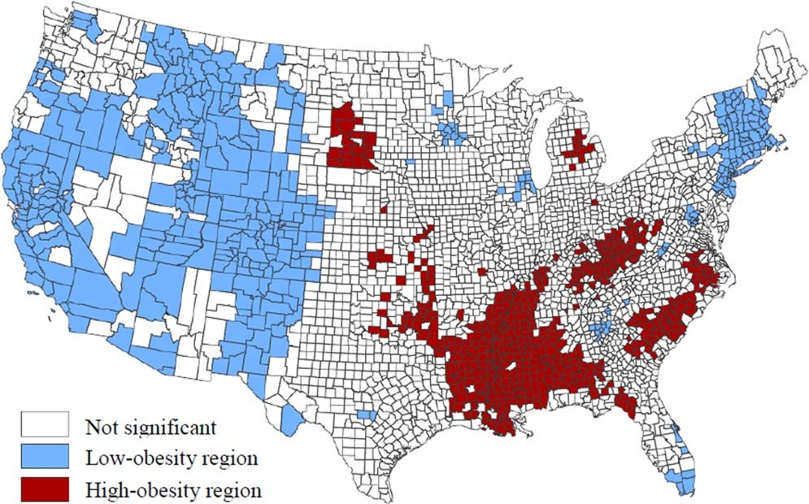

Figure 2.1: Local Indicators of Spatial Association map of significant regional concentrations of county-level adult obesity prevalence, 2009 (Slack et al., 2014). Blue and red shaded counties are central members of low and high-obesity regions, respectively (Slack et al., 2014).
Many factors have been associated with higher risk of developing obesity, such as unemployment, physical inactivity, female-headed families, number of local outpatient visits, black populations and less education (Slack et al., 2014). This implies that populations with certain economic statuses and undergo social hardships are linked with higher obesity prevalence (Slack et al., 2014). Although more doctor visits imply that more preventative care is being taken, it appears that the increased use of healthcare (due to health problems linked to obesity) is what is being measured and not preventative care. (Slack et al., 2014).
Previous literature emphasizes how smaller communities and rural areas have higher obesity prevalence (Slack et al., 2014). Slack (2014) states that minorities are at higher risk of obesity. This has been noted as an “epidemiologic paradox” which states the health status of Hispanics tends to be more similar to whites than blacks, despite Hispanics being more socioeconomically similar to blacks than whites (Slack et al., 2014). Slack (2014) conducted one of the more comprehensive studies showing that lower population size was associated higher obesity prevalence.
Consequences of Obesity
Many negative health consequences have been associated with obesity (CDC, 2015). Obesity can lead to: metabolic problems such as hypertension, dyslipidemia, type 2 diabetes, coronary heart disease, stroke, gallbladder disease, osteoarthritis, sleep apnea, breathing problems, some cancers (such as endometrial, breast, colon, kidney, gallbladder, and liver); psychosocial problems such as low quality of life, mental illness (such as clinical depression, anxiety, and other mental disorders); and mechanical problems body pain and difficulty with physical functioning (Clinical guidelines, 1998). Annual health care costs related to obesity are approximately $190.2 billion or nearly 21% of annual medical spending (Cawley, 2012).
Causes of Obesity
Obesity is a serious medical issue, with many causes including genetic, environmental, and lifestyle behaviors. With regards to genetics, four genes have been identified that predispose an individual to obesity, and many more are being identified (Choquet & Meyre, 2011). One specific genetic condition involves leptin not being produced by fat cells, thus not signaling the brain that the fat stores are too high and an individual should stop eating (Mantzoros, 2011). Another circumstance is having small muscles, which is associated with having a slower metabolism (Benton, 2011). This is prevalent in mostly women and the elderly (Benton, 2011).
With regards to environment, the type and quantity of food available, as well as daily physical activity can influence obesity. A problem in some environments is the lack of neighborhood sidewalks and safe places for recreation as well as public transportation that people can walk to instead of taking their vehicles (Oka, 2012). However, these means of transportation insufficiently encourage people to be active (Oka, 2012). Some people lack the motivation to be active outdoors due to social environment barriers such as concern over the neighborhood’s safety and fear of violent crimes (Oka, 2012). The environment therefore becomes an enabler to obesity when there are no parks, trails, sidewalks, and affordable gyms where people are physically active, as well as the social environment barriers (Oka, 2012). The same happens when the work environment requires long work hours and does not require physical labor. Means of commute to work also plays a role in obesity (Oka, 2012). Those that walk to work are less likely to gain weight (Oka, 2012). Some neighborhoods lack of access to healthy foods because they do not have supermarkets available or the neighborhood is low-income and cannot afford these healthy foods (Oka, 2012). According to another systematic review food and drink advertising can also influence food and drink-related behavior (Mills, 2013).
Other circumstances related to obesity involve psychological factors such as being bored, sad, stressed, and angry can influence eating behavior, and in some cases can cause binge eating (Kumar, 2010). Disease and illness can also lead to obesity and vice versa, diseases such as hypothyroidism, insulin resistance, sleep apnea, cancer, osteoarthritis and gallbladder disease to name some (Kumar, 2010). Both disease and illness may require medication, and certain drugs can cause excessive weight gain such as steroids and some antidepressants (Kumar, 2010).

Lifestyle behaviors, or choices that lead to obesity, include overeating, having an unhealthy diet, frequently eating, and not being physically active (Nurkkala, 2015). Less than 48% of Americans meet the CDC’s recommended amount of 2.5 hours a week of physical activity (Facts about Physical Activity, 2014). People spend much of their time watching television and/or using the computer doing either work and/or leisure activities (Thorp et al., 2011). Watching television for more than 2 hours a day has been linked to overweight and obesity (Thorp et al., 2011). Other reasons for not being active include: driving rather than walking and fewer physical demands at work and/or at home because of modern technology and conveniences (Thorp et al., 2011).
Sugar-Sweetened Beverage Prevalence & Consumption Patterns
SSB consumption has long been associated with obesity. Data from three large cohorts (Nurses’ Health Study, Health Professionals’ Follow-up Study and Women’s Genome Health Study) suggest that the more an individual consumes SSBs, the more likely the genetic effects on elevated BMI and an increased risk of obesity take place. These results imply that drinking less SSB’s, can lead to a reduction in the expression of this genetic predisposition.
Evidence also suggests that SSBs are associated with increased Type 2 diabetes and cardio-metabolic disorders (Hu, 2013). A meta-analysis consisting of 8 cohort studies evaluated SSBs and risk of type 2 diabetes and results found that the highest category of SSB intake had a 26% greater risk of developing type 2 diabetes compared to those in the lowest category (Hu, 2013). This association is consistent across all racial/ethnic groups (Caucasians, African Americans, Asians), genders, and age groups (Hu, 2013).
Sugar-sweetened beverages are the largest source of overall energy intake and the greatest source of added sugar in the U.S. diet (Hu, 2013). Systematic reviews have found strong associations among SSB consumption and weight gain or risk of being overweight and obese in children and adults (Hu, 2013). Across all age groups, currently 16% of total energy intake comes from SSB (Malik et al., 2006). SSB consumption increased by 135% from 1977 to 2001 (Malik et al., 2006). Half of the U.S. population consumes sugary drinks on any given day, 25% consumes less that 200kcal (more than one 12-oz can of soda) and 5% of the 50% consumes at least 567 kcal (more than four 12-oz cans of soda) (Ogden, 2011). Through 2007-2008, regular soda has been shown to be the most common SSB consumed (average of ≥500 kcal/day) among all ages (Han & Powell, 2013).
Soft drink consumption trends resemble that of tobacco, since both industries have a worldwide reach and aggressive marketing tactics designed to export unhealthy products to developing countries (Hu, 2013). They both share biased analysis, reviews, and provided misleading information to customers in order to increase their consumption of the unhealthy products (Hu, 2013). Furthermore, previous literature shows that low-income and low-education adults are more likely to consume regular soda (Han & Powell, 2013).
SSBs are popular amongst all ages, and individuals report consuming SSBs not only as a source of sustenance, but also as a coping mechanism to deal with stress or fatigue and to improve cognition and mood (Brownell, 2012). Reasons for consuming SSB’s have been compared to psychostimulants and opiates (Brownell, 2012). This phenomenon can further be explained as sweetened water activates neurons that release dopamine, and this neurochemical plays a major role in reinforcement learning like decision-making and action selection (Brownell, 2012). Thus, there is a behavioral, psychological, and neurobiological connection between SSB consumption and dependence (Brownell, 2012).
Current Approaches to the Problem
Randomized control trials commissioned by The World Health where used in a meta-analysis, which found that decreasing intake of added sugars will significantly reduce body weight (0.80 kg; p<0.001) (Hu, 2013). Hu (2013) debates on the role of SSB and states that several other beverages have been suggested as alternatives to SSB like plain water, 100% fruit juice, coffee, tea, and diet drinks. Different from SSB, water does not contain liquid calories, and small short-term studies show that drinking water before a meal is associated with an increase in satiety and a lower energy intake (Hu, 2013). The best alternative to SSB is water because it is readily available, cheap and has relatively no taste. In a recent analysis of 3 cohort studies, it was found that the replacement of one SSB serving for water was associated with 0.49 kg less weight gain over each 4-year period (Hu, 2013). It is currently unknown if 100% fruit juice is a healthy alternative for SSB’s, with relation to obesity prevention. While the beverage contains many vitamins and other nutrients, it also contains relatively high amounts of calories from natural sugars and should therefore be consumed with moderation (Hu, 2013). Previous studies have found positive associations with regular fruit juice consumption and weight gain (Hu, 2013).
In addition to alternatives to SSBs, coffee and tea have been associated with positive effects on T2D and cardiovascular disease risk (Hu, 2013). This could be due to their high polyphenol content (Hu, 2013). Therefore, coffee and tea may be a healthy alternative to SSBs provided that caloric sweeteners and creamers are used sparingly (Hu, 2013). One study showed that replacing one serving of SSB with one cup of coffee daily was associated with a 17% lower risk of T2D (Hu, 2013). Decaffeinated and regular coffees have similar benefits to T2D (Hu, 2013).
Diet soda is another alternative to SSB’s, since they contain little to no calories and some taste similar to their full-sugared counterpart (i.e. Classic Coca-Cola and Coke Zero). However, little is known about the long-term health effects of consuming artificial sweeteners, which provides diet soda’s sweetness (Hu, 2013). Common artificial sweeteners include aspartame, sucralose, saccharine, acesulfame potassium, and neotame that often add no calories to the beverage (Hu, 2013). While it would seem that replacing SSB’s with diet sodas would results in weight loss, several epidemiologic studies reported positive associations between diet soda consumption and weight gain and risk of metabolic syndrome and type 2 diabetes (Hu, 2013). However, the consumption of the diet soda may not be the only cause for effects mentioned since people who consume diet soda are more likely to have a higher BMI, dieting behaviors, and comorbidities (Hu, 2013). It should also be noted that the official stance of the Academy of Nutrition and Dietetics is that artificial sweeteners do not cause physical harm to the individual, and may help with weight management (Position of the American dietetic association, 2004). Randomized control trials (RCT) have showed that by substituting diet soda for regular soda weight control benefits occur, after taking into account the other factors that could influence weight gain (Hu, 2013). Artificially sweetened beverages is preferred over SSBs, however, more studies are needed to test the long-term consequences of consuming artificial sweeteners (Hu, 2013).
National and international scientific associations have provided statements supporting a reduction of sugar-sweetened beverages (Hu, 2013). The American Heart Association (AHA) recommends limiting the amount of added sugars to no more than half of daily discretionary calorie allowance (Hu, 2013). The AHA states that for most American women, that’s no more than 100 calories per day or about 6 teaspoons of sugar, and for men it’s 150 calories per day or about 9 teaspoons (Hu, 2013). With the AHA diet goal being 2,000 calories daily for an adult, sugar-sweetened beverages consumption should aim for no more than 450 calories or 36 ounces a week (Hu, 2013). The American Medical Association (AMA) does not recommend quantities, instead it only states to limit sugar-sweetened beverages (Hu, 2013). The American Diabetes Association (ADA), on the other hand stresses that SSBs like regular soda, fruit punch, fruit drinks, energy drinks, sweet tea, and others should be avoided (Hu, 2013). The ADA emphasizes that SSBs will raise blood glucose, that one 12-ounce can of regular soda has 150 calories and 40 grams of carbohydrate, which is the same amount of carbohydrate in 10 teaspoons of sugar, and that one cup of fruit punch and other sugary fruit drinks have about 100 calories (or more) and 30 grams of carbohydrate (Hu, 2013). The World Health Organization states that sugar should be limited to less that 10 % of caloric intake; this is much less than the AHA recommendation, which was less than half of caloric intake (Hu, 2013). The Institute of Medicine of the National Academies (IOM) encourages drinking water instead of SSBs, and seeks to increase access to free and safe drinking water in public places (Hu, 2013). Meanwhile, the U.S. Department of Agriculture Dietary Guidelines Advisory Committee (USDA) seeks to reduce incidence and prevalence of overweight and obesity by reducing overall calorie intake and increasing physical activity (Hu, 2013). The USDA states that Americans should avoid SSBs to meet this goal (Hu, 2013). Lastly, the Centers for Disease Control and Prevention’s (CDC) dietary recommendation, related to SSBs, states that communities should discourage SSB consumption (Hu, 2013). Overall only the AHA and the WHO suggest moderation in consumption of SSBs by providing examples (Hu, 2013). The IOM encourages substitution of SSBs with water, and the other associations and organizations say to avoid, limit, reduce, or discourage the consumption of SSBs (Hu, 2013).
Health Behavior Theory
Health behavior theories and models provide a foundation or guideline to design effective studies (Michie & Prestwich, 2010). There are a number of theories and models in the field of behavioral and social health, that contain overlapping constructs, therefore it may be useful to integrate them into one parsimonious model. The Integrative Model represents an integration of many of the traditional theories used in health promotion and health education, with the purpose to explain and predict behavior. The IM was developed in 1991 at a workshop held by the National Institute of Mental Health. The purpose of the workshop was to identify similarities and differences among some of the major theories of behavioral prediction and change to address the current concern related towards AIDS prevention. The workshop was attended by Albert Bandura (Social Cognitive Theory), Marshall Becker (Health Belief Model), Martin Fishbein (Theory of Reasoned Action), Fredrick Kanfer (Self-regulation/Self-control), and Harry Triandis (Subjective Culture and Interpersonal Relations). The Integrative Model (IM) was applied within Fishbein and Ajzen’s reasoned action approach, and included: skills, environment, intentions, attitudes (instrumental attitudes, experiential attitudes, behavioral beliefs and outcome evaluations), perceived norms (injunctive norms, descriptive norms, injunctive/descriptive Normative Beliefs, and motivation to comply/identification with referents), perceived behavioral control (perceived capacity (oftentimes referred to as self-efficacy), perceived autonomy, control beliefs, and perceived power). Table 2.1 lists and defines the major constructs of the IM.
Table 2.1: Constructs of the Integrative Model Defined
Behavior | This refers to an observable event that contains a Target, Action, Context, and Time.
Intentions | This refers to an individual’s readiness to engage in a particular behavior.
Attitudes | This refers to the overall feeling of favorableness or un-favorableness towards a behavior.  Direct Measures:  - Instrumental Attitudes refers to the overall cognitive evaluation of the behavior (or the thoughtful response).  - Experiential Attitudes refers to the overall affective evaluation of the behavior (or the emotional response).  Indirect Measures:  - Behavioral Beliefs is the belief that behavioral performance is associated with certain attributes or outcomes.  - Outcome Evaluations is the value attached to a behavioral outcome or attribute.
Perceived Norms | This refers to the social pressure one feels to enact a behavior.  Direct Measures:  - Injunctive Norms: an individual’s perception that most people who are important to him/her think he/she should or should not perform a particular behavior.  - Descriptive Norms refers to the perceptions that others are or are not performing the behavior in question.  Indirect Measures:  - Injunctive/Descriptive Normative Beliefs are beliefs that a particular referent individual or group thinks I should or should not perform the behavior in question.  - Motivation to Comply/Identification with Referents refers to the person knowing if a particular referent individual’s behavioral instruction may put little or no pressure on them to carry out that behavior.
Perceived Behavioral Control | - This refers to people’s perceptions of the degree to which they are capable of, or have control over, performing a given behavior.  - Direct Measures:  - Perceived Capacity (oftentimes referred to as Self-Efficacy) refers to the ability one has to perform a behavior, that is, to the belief that one can, is able to, or is capable of performing the behavior.  - Perceived Autonomy refers to the degree of control to perform the behavior (Example: How much control do you have over whether you perform the behavior? no control/complete control).  Indirect Measures  - Control Beliefs is the perceived likelihood of occurrence of each facilitating or constraining condition.  - Perceived Power is the perceived effect of each condition in making performance difficult or easy.
Skills and Abilities | This refers to volitional control in the performance of a behavior and in the attainment of behavioral goals. In this study, this construct has been operationalized as “I know how to” directed towards the behavior.
Environment | This refers to the environmental constraints preventing behavioral performance. In this study, this construct has been operationalized as “at home” or “during meals in your home” directed towards the behavior.

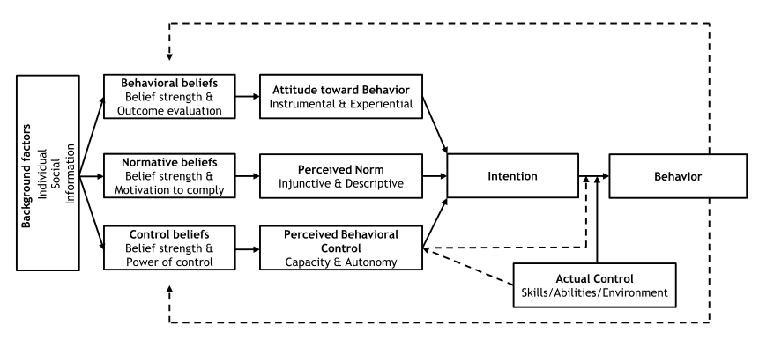
Figure 2.2: The Integrative Model (Reasoned action approach, 2013)
The IM posits that behaviors are primarily determined by intention, and intention is a function of attitude, perceived norm, and perceived behavioral control (Maibach & Yzer, 1995). ‘Attitudes towards a behavior’ refers to the overall feeling of favorableness or un-favorableness towards a behavior. Within the construct of attitudes there are two major types: instrumental attitudes and experiential attitudes. Instrumental attitude refers to the overall cognitive evaluation of the behavior (or the thoughtful response), while experiential attitude is the overall affective evaluation of the behavior (or the emotional response). Furthermore, the construct is influenced by one’s behavioral beliefs (the belief that behavioral performance is associated with certain attributes or outcomes) and outcome evaluations (the value attached to a behavioral outcome or attribute) (Fishbein & Ajzen, 2010). In addition to behavioral beliefs, some researchers use the term outcome expectancies in its place (Jordan et al., 2012). Furthermore, individuals’ who have a negative attitude towards a behavior are not likely to have intentions to enact the behavior (Fishbein & Ajzen, 2010).
Perceived norms refer to the social pressure one feels to perform a behavior. Two types of perceived norms include: injunctive and descriptive norms. Injunctive norms refer to an individual’s perception that most people who are important to him/her think he/she should or should not perform a particular behavior. Descriptive norms refer to the perceptions that others are or are not performing the behavior in question. Two more constructs make up the Indirect measures of perceived norm: injunctive/descriptive normative beliefs and motivation to comply/identification with referents. Injunctive/descriptive normative beliefs are beliefs that a particular referent individual or group thinks I should or should not perform the behavior in question. Whereas, motivation to comply/identification with referents refers to the person knowing if a particular referent individual’s behavioral instruction may put little or no pressure on them to carry out that behavior.
Perceived behavioral control (PBC) is a construct of the IM that influences intention. Two sub constructs of PBC are control beliefs defined as the amount of control one feels over performing the behavior and perceived power defined as the confidence one feels to perform the behavior despite the barriers. Perceived Capacity is oftentimes referred to as Self-Efficacy refers to the ability one has to perform a behavior, that is, to the belief that one can, is able to, or is capable of performing the behavior. Perceived Autonomy, on the other hand, refers to the degree of control to perform the behavior.
Lastly, background factors indirectly influence attitudes, perceived norms and PBC. These factors include past behavior, demographics, cultural norms, knowledge, personality, perceived risk, exposure to other intervention, and media exposure (Glanz, Rimer, & Viswanath, 2008).
The constructs of the IM can be measured directly or indirectly, including attitudes towards a behavior, perceived norms, and the capacity sub-construct of perceived behavioral control. Direct measures of Attitudes towards engaging in the behavior can be measured through items on bipolar scales (such as instrumental: good-bad, important-unimportant, beneficial-harmful, and experiential: pleasant-unpleasant, enjoyable-frustrating, satisfying-unsatisfying). Injunctive norms can be evaluated directly by evaluating the individual’s perceptions of those important to them, those who they respect, and whose opinions they value and if they believe those people want them to engage in the behavior. Semantic scales are used by the participants for self-ranking in item. The scale most used was <strongly agree (1)/strongly disagree (7)>. Descriptive norms asked the individual if most people they respect and who are also trying to lose weight do not drink regular soda and other sugary drinks. Descriptive norms asked the participant how many people similar to themselves drink regular soda and other sugary drinks.
To measure capacity, subjects were asked if they are sure and confident that they can engage in the behavior and if engaging in the behavior will be <extremely easy (1)/extremely hard (7)>. Furthermore, autonomy was measured by asking the participant if engaging in the behavior, would be <100% Up to Me (1)/0% Up to Me (7)>, and if it’s completely up to themselves to engage in the behavior. Intentions was another direct measure investigated which asked the participant if they intend to, will, or will try to engage in the behavior.
To evaluate Indirect measures of the theory constructs, survey items need to measure beliefs (behavioral beliefs, injunctive/descriptive normative beliefs, and control beliefs) and an evaluation of the beliefs (outcome evaluation, motivation to comply, identification with referents, and perceived power). To start, one must do an ‘elicitation of beliefs’ about a target behavior, and elicit the beliefs that correspond with the theories constructs. For example, behavioral beliefs correspond with the construct ‘Attitudes towards a behavior’ and are elicited by asking members of the target population what the advantages and disadvantages are for performing a specified behavior. Beliefs are then used to generate survey questions. For example, for the behavior ‘to buy a house within the next year’ a commonly cited disadvantage might be, ‘it limits my ability to move to another state. Therefore an item is generated using this behavioral belief (If I buy a house in the next year, it will make it difficult for me to move to another state <Strongly Agree (1)/Strongly Disagree (7)>) [*note: All items in this example would be measured on a 7-point semantic differential scale]. Next, an evaluation of the belief should be measured. In this case an outcome evaluation of this behavioral belief could be (Moving to another state in the next year is <Desirable/Undesirable>). The indirect measure of the “Attitudes towards a behavior” can then be generated by multiplying the belief score by the evaluation score.
Systematic Review of the Integrative Model
Little research has been done operationalizing all of the constructs of the IM, and it has never been tested in the context of SSBs among adults. In this section, a systematic review of the IM was conducted using the search terms “Integrative Model” AND “Intervention” AND “Behavioral Prediction” “Peer Reviewed”; "Reasoned Action Approach" AND “Intervention” "Peer Reviewed” through the databases PMC, PubMed, Google Scholar, PsychINFO, and JSTOR. Articles evaluating SSBs among adults were not found; however, one article discussing SSB consumption within the family and/or children was identified.
Jordan’s study conducted a survey including direct and indirect measures before and after it’s media campaign. The study’s purpose was to assess obesity- related beliefs and behaviors, identify SSB consumption patterns among caregivers and their children, determine the attitudes and beliefs that best predict intentions to eliminate SSB consumption at mealtimes, and provide the necessary theoretical and empirical findings for the development of a media campaign focused on reducing SSB consumption in the home. Caregivers/parents residing in Philadelphia (n=507) were surveyed on their beliefs related to the behavior “to eliminate SSBs for your family during meals every day” (Jordan, et al., 2012). Although indirect measures were used, no elicitation survey was administered (Jordan, et al., 2012). A survey was administered pertaining to what obesogenic behaviors the children and caregivers/parents engaged in at home. The study explored how well the IM’s construct intention predicted behavior to consume SSB at home. The survey used the constructs of the IM (intentions, attitudes, and normative pressure) with the Likert scale (Jordan et al., 2012). Outcome expectancies, however, were measure on a 3-point scale (unlikely (-1), neither (0), likely (1)) (Jordan et al., 2012). Also, injunctive normative beliefs and self-efficacy used a semantic scale (Jordan et al., 2012). Other items on the survey included: family eating patterns, daily consumptions of SSBs and non-SSBs for both the caregiver and child, and inventory of beverages at home on the day of the survey (Jordan et al., 2012). The survey also asked about campaign awareness to reduce SSB consumption, and a range of demographic questions such as ethnicity, income and education level (Jordan et al., 2012). Pre-post analysis revealed a significant increase in intention to cut back on caregiver’s SSB consumption (p < 0.05) and a significant increase in intention to reduce child’s SSB intake (p < 0.05). Results found that intentions were attitudinally driven, so it was suggested that effective messages should focus on feelings of nurturing and concern about child weight gain (Jordan et al., 2012).
To date, no research has been done using the IM in conjunction with SSB behaviors in adults. This study will attempt to fill that gap. While a few IM and TPB interventions focus on children and SSB consumption, there is little research exploring adult SSB behavior. The systematic review found health related interventions, but they did not cover SSBs or adult obesity. The systematic review revealed the subject of SSBs and obesity is not targeted to adults, but instead children.

Theory of Planned Behavior
Since no articles using the IM were found directly targeting SSBs and adults, the theory of planned behavior (TPB) was reviewed, given its inherent link to the IM. The search terms used were “TPB” AND “sugary drinks”, “TPB” AND “beverages”, through the following databases: Academic Search Elite, CINAHL Plus with Full Text, Communication Source, ERIC, Health Source: Nursing/Academic Edition, and Medline and found (n=80) articles. Only studies containing adult participants and SSB were retained (n=4). Also, a list of TPB articles were searched on Icek Azjen’s website under TPB bibliography, but only one was relevant to this research survey study.
Of the articles found through the systematic review, the first study’s objective was to examine the applicability and sufficiency of the TPB in predicting intention and self-perceived behavior with respect to avoiding between meal intakes of sugared snacks and drinks (Masalu, 2001). The Tanzanian student population of 1,123 was surveyed with a mean age of 26.4 years including 19 to 45 year-olds (Masalu, 2001). Data collection took place May-July of 1999, and a follow-up was administered four weeks later to test self-perceived sugar consumption, and the Follow-up consisted of 350 students, of which, 228 students completed the study (Masalu, 2001). The survey used the Likert scale, but does not mention how many items were used to evaluate each construct of the TPB (Masalu, 2001). All Direct constructs were measured, however Indirect measures and demographic questions were not mentioned (Masalu, 2001). Results showed that the three core constructs of the TPB are associated with intentions in the following descending order: perceived behavioral control (Pearson’s r = .52), subjective norms (Pearson’s r = .48), and attitude (Pearson’s r = .47) (Masalu, 2001). This study concluded that Tanzanian students need feeling of high control to make the decision to avoid between-meal intake of sugared snacks and drinks (Masalu, 2001). For the students to avoid sugar intake, it seems that their decision is based on required resources and obstacles, normative expectation and possible consequences of performance, in this order (Masalu, 2001).
The second study was a cross-sectional study, which administered a survey to 119 people average age of 41.4 (±13.5) years (female (66%) and white (89%) and ≤ high school education (79%)) from Virginia (Zoellner & Estabrooks, 2012). The survey consisted of 56 items with both Direct and Indirect measures, but no elicitation phase was mentioned (Zoellner & Estabrooks, 2012). The target behavior was “to drink less than 1 cup of SSB each day” (Zoellner & Estabrooks, 2012). This study is unique in that the survey evaluated participants’ mixed alcoholic drinks and meal replacement shakes/proteins drink consumption (Zoellner & Estabrooks, 2012). The instrument was pilot tested with 6 individuals from the population and included demographic questions such as: race/ethnicity, sex, age, education level, income level, health status, and self-reported height and weight (Zoellner & Estabrooks, 2012). This study included an additional construct termed implementation intentions (or the idea of advanced planning to incorporate the behavior change) (Zoellner & Estabrooks, 2012) that is influenced by behavioral intentions (Zoellner & Estabrooks, 2012). Of the 11 constructs, only normative beliefs (r =.48), perceived power (r =.48), attitudes (r =.68), subjective norms (r =.36), perceived behavioral control (r =.54), behavioral intentions (r =.84) and implementation of intentions (r = -.39) were significantly associated to its preceding construct (Zoellner & Estabrooks, 2012). Behavioral intentions had the strongest relationship with SSB intake, followed by attitudes, perceived behavioral control, and subjective norms (Zoellner & Estabrooks, 2012). In a consequent analysis, age, gender, and education level was controlled for (Zoellner & Estabrooks, 2012). The overall explained variance increased, but only slightly to 41% (F = 9.0; p < 0.01) (Zoellner & Estabrooks, 2012). No data was shown regarding these demographic variables, but they stated that there was no significance and there were no meaningful changes in interpretation of the TPB coefficients (Zoellner & Estabrooks, 2012).
The third study was a randomized control pilot trial to examine SSB intervention (SipSmartER) as compared to a physical activity intervention (MoveMore) (Zoellner & Cook, 2013). Both were 5-week interventions and included two interactive groups and three support telephone calls (Zoellner & Cook, 2013). The first objective of the study was to evaluate patient feedback on intervention content and structure (Zoellner & Cook, 2013). The second objective was to understand the potential reach and effectiveness of SipSmartER (Zoellner & Cook, 2013). A total of 25 participants from Roanoke, Virginia were randomly separated into the SipSmartER group (n=14) and MoveMore (n=11), of which 8 were overweight and 16 were obese (Zoellner & Cook, 2013). Results showed that SSB consumption reduced more among the SipSmartER group, but this was not significant (Zoellner & Cook, 2013). A survey consisting of 20 items with Direct measures was used as a pre and posttest for each program and to compare the 2 groups (Zoellner & Cook, 2013). At the end of each group session, participants completed the survey (Zoellner & Cook, 2013). No indication of a baseline survey administration was mentioned (Zoellner & Cook, 2013). Both groups had different learning sessions: SipSmartER sessions consisted of health risks, recommendations, healthier options associated with drinking SSB and the MoveMore group discussed recommendations, benefits, strategies of physical activity. There were no significant differences for any demographic variables except for education level among the groups (SipSmartER > Move-More; F = 5.57; p = 0.03) (Zoellner & Cook, 2013). Significant overall effects (not between groups) among the following constructs: affective (F=9.57 P=0.01) and instrumental attitudes (F = 10.51 P<0.01), and SSB behavioral intention (F=7.04 P=0.02) were mentioned (Zoellner & Cook, 2013).
The fourth and last study is a randomized-controlled health literacy trial based on the pilot study previously mentioned (Zoellner & Chen, 2014). The same two groups and survey were used, but the population sampled was 340 adults from Virginia (Zoellner & Chen, 2014). The study design included data collection at baseline, 6-months, and 12-months post-intervention (Zoellner & Chen, 2014). Eleven demographic questions were also included in the survey same as the second study, but included health care coverage, marital status, number of children at home, employment status, and county of residence (Zoellner & Chen, 2014). The SipSmartER group included 58 participants, and the MoveMore group did not mention how many participants (Zoellner & Chen, 2014). The SipSmartER group focuses exclusively on decreasing SSB consumption to the recommended amount of less than 8 ounces per day (Zoellner & Chen, 2014). No results were provided; only outcome, process, and summative evaluations were explained (Zoellner & Chen, 2014).
From Icek Azjen’s website, one article was found, and investigated sugar restriction on Tanzanian students, 19 to 50 years (n=981; mean age = 25 years, SD = 3.7). This study was cross-sectional and focused on the behavior “to avoid intake of sugared snacks and drinks between meals in the future” (Masalu, 2003), and the objective was to identify beliefs underlying attitudes, subjective norms and perceived behavioral control regarding sugar restriction (Masalu, 2003). This study did not mention how many items were on the survey, the time frame between pre and post survey test, or having demographic questions; but it did use both Direct and Indirect measures of the TPB constructs and an elicitation interviews took place for the development of the survey (Masalu, 2003). The participants reported their intake of soda pop, candy and cake and there were significant differences among those attempting sugar restriction and not attempting sugar restriction (p < 0.05) (Masalu, 2003). The Pearson correlation coefficients showed that subjective norms were more strongly associated with intention (r = 0.36, p < 0.001) than attitudes (r = 0.29, p < 0.001) (Masalu, 2003). Perceived behavioral control was weakly associated with intentions (r = 0.12, p < 0.001) (Masalu, 2003). Comparing the 2 groups (intenders and non-intenders) using MANOVA yielded F = 12.65, p < 0.001 with respect to the 10 behavioral beliefs (Masalu, 2003). Using MANOVA when comparing the two groups and normative beliefs yielded F = 28.93, p < 0.001 and motivation to comply F = 22.36, p < 0.001(Masalu, 2003). Both groups were highly motivated to comply to friends, relatives, doctor, and dentist (Masalu, 2003). Both groups had favorable attitudes, a high level of control, and strong intentions to restrict sugar (Masalu, 2003). Their first reporting of sugar intake was high and the second time they were low to moderate (Masalu, 2003). Feeling bored or tired and having enough pocket money were the most important barriers for the students when deciding to avoid between-meal intake of sugared snacks (Masalu, 2003).
Consequently, there is a gap in the literature for the TPB. Articles having both Direct and Indirect measures were lacking. Zoellner & Cook (2014) had more than one focus for their study: the SSB survey and physical activity. This made it difficult to achieve a successful pilot test (Zoellner & Cook, 2013; Zoellner & Chen, 2014). It might have been more efficient to separate the two and keep the main focus on the SSB survey with an intervention between pre and posttest (Zoellner & Cook, 2013). However, this study administered a survey after the two learning sessions without mention of a pretest (Zoellner & Cook, 2013), and yet Zoellner & Chen did mention a pretest at baseline (Zoellner & Chen, 2014). The results appeared to be inconclusive, because they were comparing two completely different behaviors (reducing SSBs consumption and increasing physical activity) (Zoellner & Cook, 2013; Zoellner & Chen, 2014). Masalu’s articles were more detailed and focused on the TPB Direct and Indirect measures and focused on a single behavior (Masalu, 2001; Masalu, 2003), than Zoellner’s articles which were focused on more than one behavior and the survey was lacking in Indirect measures (Zoellner & Cook, 2013; Zoellner & Chen, 2014). However, Masalu’s population is from Tanzania (Masalu, 2001; Masalu, 2003), not the U.S. like Zoellner’s (Zoellner & Cook, 2013; Zoellner & Chen, 2014), and therefore more studies are needed to explore SSB behaviors with the adult American population. The article that best supports this thesis study is Zoellner & Estabrooks since it focused on one particular behavior with an American population, however there is no mention of an elicitation survey being administered to develop the Indirect measures (Zoellner & Estabrooks, 2012).

Summary
In summary, this literature review demonstrated that previous studies have found that adulthood obesity is prevalent among minorities, low SES, and small towns. SSB consumption is a contributing factor to obesity and has become a common habit in many regions throughout the U.S. Addressing the behavior to stop drinking regular soda and sugary drink for 6 months to see how people respond, is where we can start to see if this is something that they want to change, can change, is socially acceptable and so forth. Although some articles were found using the integrative model, none addressed SSBs and adults. Although, the TPB did have some articles to contribute to the literature, they did not, however, have everything needed for a well-detailed survey driven behavior focused approach. The IM, on the other hand, is a relatively new model and considering not much has been done with it in regards to this topic, this study will help address each construct’s importance to the SSB behavior and help identify the level at which the adults are at in regards to performing this behavior.

Chapter 3
Methods
Introduction
The purpose of this study was to evaluate the utility of the Integrative Model (IM) for predicting the behavior “to stop drinking regular soda and sugary drinks (like sports or energy drinks, and sweetened teas) for the next 6 months” among adults attempting to lose weight in a weight lose clinic in Lawton, Oklahoma. In this chapter, a description of the research design, population sample, instrumentation procedures, dependent and independent variables, data collection procedures, and data analyses are explained.
Research Design & Sample
This study used a cross-sectional design to determine to what degree the variables being studied are associated to one another. The study aims to reveal to what extent the Integrative model predicts the SSB intentions to stop drinking regular soda and sugary drinks for 6 months on adults attempting to lose weight. To address the study aims, four rounds of regression were performed, and the dependent and independent variables for each round varied, based on what was being predicted (behavior or intentions) with what variables. In the first round of regression, daily SSB consumption was the dependent variable, and intention, skills/abilities, environment, and perceived behavioral control were the independent variables. In the second round of regression, weekly SSB consumption was the dependent variable, and intention, skills/abilities, environment, and perceived behavioral control were the independent variables. In the third round of regression, intentions were the dependent variable, and the core constructs of the IM were the independent variables (attitudes, perceived norms, perceived behavioral control). In the final round intentions will again be the dependent variable, however, expanded measures of the core constructs of the IM were the independent variables (instrumental attitudes, experiential attitudes, injunctive norms, descriptive norms, capacity, and autonomy).
Table 3.1: Demographic Data for Lawton, the state of Oklahoma, and the United States
 | Gender | Race | Obesity Rate | Diabetes Rate
Lawton  (Advameg, Inc., 2015) | Males- 52%  Females- 48% | White- 52.9%  Hispanic- 13.8%  Black- 19.8% | 28.7% | 9.4%
Oklahoma  (Obesity Rates, 2014) | Males- 49.5%  Females- 50.5% | White- 75.4%  Hispanic- 9.6%  Black- 7.7% | 29.2% | 10.3%
United States  (Census Bureau, 2013) | Males- 49.2%  Females- 50.8% | White- 77.5%  Hispanic- 17.4%  Black- 14.3% | 34.9% | 9.3%

Table 3.1 shows demographic data for the population of the United States, the state of Oklahoma, and the population of Lawton, Oklahoma. Since this study focused on a health behavior with an overall focus on obesity prevention, rates for obesity and diabetes are presented (Advameg, Inc., 2015; Centers for Disease Control and Prevention, 2012; Colby, 2015; Obesity Rates, 2014; Statistics, 2014: U. S. Census Bureau, 2013). The sample for this study was a convenience sample of adults attempting to lose weight in a weight loss program in Lawton, Oklahoma. The inclusion criteria for participation in the study were adults enrolled in a weight loss program age’s 18- 64 years old. Participants were recruited from Dr. Collado’s Weight Loss Program. Participants were excluded if they did not attend the weight loss program, or were not overweight. The sampling technique used for this study was non-probability, convenience sampling. Participants were included in this study if they met the inclusion criteria and assented to participate in the study.
Instrumentation & Description of Variables
For this study, a survey was developed to evaluate all constructs of the IM. The behavior under investigation was “Stop drinking regular soda and other sugary drinks (like sports or energy drinks, and sweetened teas) for the next 6 months”. This behavior has a Target (sugar sweetened beverages (i.e. regular soda and other sugary drinks like sports or energy drinks, and sweetened teas)), Action (stop drinking), and Time-frame (for the next 6 months), and Context (among individuals attempting to lose weight). In this study current daily and weekly SSB consumption was evaluated. A follow-up evaluation of the behavior (SSB consumption in 6 months) was not evaluated.
The constructs included in the instrument were intentions, attitudes (Direct measures: instrumental and experiential and Indirect measures: behavioral beliefs and outcome evaluations), perceived norms (Direct measures: injunctive and descriptive norms and Indirect measures: injunctive/descriptive normative beliefs and motivation to comply/identification with referents), perceived behavioral control (Direct measures: perceived capacity and perceived autonomy and Indirect measures: control beliefs and perceived power), skills/abilities and environment (Fishbein & Ajzen, 2010). All items were on a 7-point semantic differential scale measuring from strongly agree to strongly disagree was used to measure each construct, unless otherwise noted.
Behavioral Intentions were defined as an individual’s readiness to act toward SSB behavior (Fishbein, et al., 2010). Behavioral intention was measured using three items inquiring about the participants’ willingness to stop drinking regular soda and sugary drinks for 6 months. Intentions were assessed through items such as “I will”, “I intend”, and “I will try” directed towards the behavior using a 7-point semantic differential scale measuring from strongly agree to strongly disagree. On the survey, this construct was measured by items 51-53 and had a score that ranged from -3 (low intentions) to +3 (high intentions).
“Attitudes towards a behavior” (or simply Attitudes) were defined as the overall feeling of favorableness or un-favorableness towards a behavior (Fishbein & Ajzen, 2010). The Direct measures for attitudes: Instrumental Attitudes (items 33-35) referred to the overall cognitive evaluation of the behavior (or the thoughtful response), and Experiential Attitudes (items 36-38) referred to the overall affective evaluation of the behavior (or the emotional response) (Fishbein & Ajzen, 2010). Using Direct measures, this construct was measured by items 33-38, and had a score that ranged from -3 (strong negative attitudes) to +3 (strong positive attitudes). Using Indirect measures (through Behavioral Beliefs and Outcome Evaluations) this construct was measured by the multiplicative score of each behavioral belief (items 3-6) and corresponding outcome evaluation (items 7-10). Items ranged from -21 to +21. Interpretation of each item can be found in the results section.
Perceived norms referred to the social pressure one feels to do a behavior. There were two major types of perceived norms evaluated in this study: Injunctive Norms (items 40-42) referred to an individual’s perception that most people who are important to him/her think he/she should or should not perform a particular behavior, and Descriptive Norms (items 43-45) referred to the perceptions that others are or are not performing the behavior in question (Fishbein & Ajzen, 2010). This construct was operationalized using Direct and Indirect measures. Using Direct measures, this construct was measured by items 40-45 with a range of -3 (strong negative perceived norms) to +3 (strong positive perceived norms). Using Indirect measures (through Injunctive Normative Beliefs and Motivation to Comply and through Descriptive Normative Beliefs and Identification with Referents) this construct was measured by the multiplicative score of each (Injunctive, items 11-14 and Descriptive, item 19-21) Normative Beliefs and corresponding Motivation to Comply (items 15-18) and Identification with Referents (items 22-24). Items ranged from -21 to +21. Interpretation of each item can be found in the results section.
Perceived behavioral control referred to people’s perceptions of the degree to which they are capable of, or have control over, performing a given behavior. There are two types of PBC: Perceived Capacity (oftentimes referred to as Self-Efficacy) (items 46-48) referred to the ability one has to perform a behavior, that is, to the belief that one can, is able to, or is capable of performing the behavior, and Perceived Autonomy (items 39, 49-50) referred to the degree of control to perform the behavior (Example: How much control do you have over whether you perform the behavior? no control/complete control). Using Direct measures, this construct was measured by items 39, 46-50, and had a score that ranged from -3 (strong negative perceived behavioral control) to +3 (strong positive perceived behavioral control). Using Indirect measures (through Control Beliefs and Perceived Power) this construct was measured by the multiplicative score of each control belief (items 25-28) and corresponding perceived power (items 29-32). Items ranged from -21 to +21. Interpretation of each item can be found in the results section.
Skills/Abilities refers to volitional control in the performance of a behavior and in the attainment of behavioral goals (Fishbein & Ajzen, 2010). In this study, this construct was operationalized as “I know how to” directed towards the behavior. This construct was measured by items 54-55 and had a score that ranged from -3 (strong negative skill/abilities) to +3 (strong positive skills/abilities). Interpretation of each item can be found in the results section.
The last construct, environment refers to the environmental constraints preventing behavioral performance (Fishbein & Ajzen, 2010). In this study, this construct was operationalized as “at home” or “during meals in your home” directed towards the behavior. This construct was measured by items 56-57 and had a score that ranged from -3 (strong negative environment) to +3 (strong positive environment). Interpretation of each item can be found in the results section.
Demographic questions were included at the end of the survey since it is best to keep the easier questions last to attain quality responses. Five items were included in the demographics section and measured by items 58-62. The questions included in this section were gender, level of education, race, and BMI through height and weight. These questions have previously been found to be associated with obesity (Giskes, 2011).
First, the readability of the instrument tested using Microsoft Word using the Flesch-Kincaid grade level test, which resulted in a grade level of 3.7 and a Flesch-Kincaid Reading Ease score of 80.1 & Flesch-Kincaid Grade. The instrument was then sent to a panel of experts to establish face and content validity. Six experts determined whether the items on the instrument appeared to measure what it was supposed to measure, and if the items had been adequately sampled within each construct to represent the entire concept. Revisions were made according to reviewers’ responses, and sent for a second round of review. The panel of experts can be found in Appendix B, and comprised of: two subject experts in the Integrative Model, two experts in instrument development, and two with knowledge of the target population. After the instrument’s approval, a small pilot test with members of the target population (n=10) was conducted to test readability and ease of use.

Data Collection & Analysis Procedures
Data collection. IRB approval was obtained before any recruitment and data collection. Surveys were administered in person, as clients attended the Dr. Collado’s Weight Loss Program. Clients were approached in the waiting room and a member of the research team explained the nature of the study, and the individual decided whether or not they would like to participate in the study on the spot. Before completing the survey, participants willing to participate signed a consent form agreeing to the terms of the study. A total of 410 participants completed the survey. Some participants (n = 15) took the survey two times within two to four weeks of the first time in order to establish stability reliability.
Instrument Reliability and Validity. Two types of reliability for instrument were evaluated: internal consistency and stability. Internal consistency reliability is how much the items in each scale relate to one another. Internal consistency reliability was established using Cronbach’s alpha values. These alpha values were computed, and reliability was accepted with a value of 0.70 or higher. Stability reliability measures the instrument’s reliability at two different times. This was established by test-retesting the instrument with the same individuals and a correlation coefficient value greater than or equal to 0.70 was accepted for each set of scores (Sharma & Petosa, 2014).
Construct validity evaluated whether the instrument items measured the intended construct and was established using confirmatory factor analysis (CFA). This study used the maximum likelihood method of CFA, which computes correlation between items and produces factor scores. Experts recommend having at least 300 participants for a factor analysis (Tabachnick & Fidell, 2013).
Multiple Regression. SPSS version 22 will be used for all data analysis. Multiple regression was used to identify which constructs of the IM predict behavioral intentions and to what extent intentions, skills/ability, environment, and perceived behavioral control predict current SSB consumption. The alpha value for the independent variables will be chosen at less than and equal to 0.05 and will be greater than or equal to 0.10. The alpha values will be derived from the F-ratio, which is based on the R² change statistic (Vincent & Weir, 2012).
The following assumptions were considered when performing a multiple regression: outliers, linearity, normality, multicollinearity, and homoscedasticity. Any values greater than four standard deviations from the mean were considered outliers and were thoroughly reviewed in the data analysis. Normality was tested through skewness and kurtosis. The variance inflation factor (VIF) accounted for any possible issues with multicollinearity (Vincent & Weir, 2012). Homoscedasticity was considered through a revised scatter plot in SPSS between the predicted dependent variable scores and errors of prediction. All variables were assessed for linearity. In order to see if the relationship between the variables was linear, scatter plots were examined.
Determinants of Attitudes, Perceived Norms and Perceived Behavioral Control. After analyzing the Direct measures, the Indirect measures for Attitudes, Perceived Norms (Descriptive and Injunctive), and Perceived Behavioral Control were addressed. In order to analyze the Indirect measures, the concept of Value Expectancy Theory was studied in Fishbein and Ajzen’s book Predicting and Changing Behavior. This theory assumes that people will change a behavior if they anticipate personal benefits derived from the outcome will outweigh any “costs” experienced through enacting the behavior (Fishbein & Ajzen, 2010). This theory also takes into account immediate versus delayed benefits/outcomes (Fishbein & Ajzen, 2010). This theory was used because each construct has beliefs (Behavioral Beliefs for Attitudes; Descriptive Normative Beliefs for Perceived Norms; Injunctive Normative Beliefs for Perceived Norms; and Control Beliefs for Perceived Behavioral Control) and a corresponding outcome/benefit such as Behavioral Beliefs and Outcome Evaluations, Injunctive Normative Beliefs and Motivation to Comply, Descriptive Normative Beliefs and Identification with Referents, and Control Beliefs and Perceived Power. Each belief with corresponding outcome/benefit was measured by multiplying each corresponding item values’ together. The multiplicative score for Behavioral Beliefs and Outcome Evaluations was then correlated with total Direct Attitudes, total Instrumental Attitudes, and total Experiential Attitudes. The multiplicative score for Injunctive Normative Beliefs and Motivation to Comply was then correlated with total Direct Perceived Norms and total Injunctive Norms. The multiplicative score for Descriptive Normative Beliefs and Identification with Referents was then correlated with total Direct Perceived Norms and total Descriptive Norms. The multiplicative score for Control Beliefs and Perceived Power was then correlated with total Direct Perceived Behavioral Control.

Chapter 4
Results
Introduction
This chapter explains how the data were examined for missing data and tested for statistical assumptions, including outliers, linearity, normality, multicollinearity, and homoscedasticity. Furthermore, the process through which the validity (face, content and construct validity) and reliability (test-retest reliability, and internal consistency reliability) of the instrument were established is discussed. The results of both the direct measures and indirect measures of the IM are reported in this chapter, as well as descriptive data and results for background factors. All results in this chapter were analyzed using SPSS Version 18.
Missing Data
Before conducting analyses, missing data were first identified. While for some items missing data were unexpected, for other items missing data occurred due to giving the respondents a choice to answer the item or select N/A (not applicable). This included all items measuring injunctive normative beliefs (indirectly), two items measuring descriptive normative beliefs (indirect) and one item measuring control beliefs. Table 4.1 below shows all the direct measures and Table 4.2 shows the indirect measure’s missing and N/A data numbers and percentages. Table 4.2 (indirect) indicates that missing data was less than N/A, but the direct measures table illustrates no N/A data. The highest amount of indirect measures total missing and N/A data was Perceived Norms at 41.7%, followed by Perceived Behavioral Control 1.5%, and Attitudes 0%. The highest amount of direct measures total missing data was Perceived Norms at 0.4%, followed by either Intentions 0.2% or Skills and abilities 0.2%, and Attitudes 0%, Perceived Behavioral Control 0%, and Environment 0%. All the missing data was kept missing, however when computing total for attitudes, experiential attitudes, instrumental attitudes, perceived behavioral control, perceived norms, injunctive norms, and descriptive norms SPSS was not able to report added values when missing data was present. All totals that were missing were identified and were manually summated. This gave a total for each construct, and each construct was then divided by the total number of items added. These new totals were the variables used for all the analysis for this study.

Table 4.1 Direct measures summary of missing and N/A data
Construct and Item # Number of Number of N/A data Total
Missing data (Percent of total data)
(Percent of total data)
Direct Measures:
Attitudes 0 0 0 Instrumental 0 0 0 Experiential 0 0 0

Perceived Norms 2 (0.4) 0 2(0.4%)
Injunctive Norms 0 0 0
Descriptive Norms 2 (0.4) 0 2 (0.4%)
Item 2 1 (0.2) 0 1 (0.2%)
Item 3 1 (0.2) 0 1 (0.2%)
Perceived Behavioral Control 0 0 0
Capacity 0 0 0
Autonomy 0 0 0

Intentions 1 (0.2) 0 1 (0.2%)
Item 1 1 (0.2) 0 1 (0.2%)
Skills/Abilities 1 (0.2) 0 1 (0.2%)
Item 2 1 (0.2) 0 1 (0.2%)
Environment 0 0 0

Table 4.2 Indirect measures summary of missing and N/A data
Construct and Item # Number of Missing data Number of N/A data Total
(Percent of total data) (Percent of total data)
Indirect Measures:
Attitudes 0 0 0
Behavioral Beliefs 0 0 0
Outcome Evaluation 0 0 0
Perceived Norms 11 (0.7) 673 (41.0) 684 (41.7%)
Injunctive Normative Beliefs 0 208 (50.7) 208 (50.7%)
Item 1 0 100 (24.4) 100 (24.4%)
Item 2 0 10 (2.4) 10 (2.4%)
Item 3 0 59 (14.4) 59 (14.4%)
Item 4 0 39 (9.5) 39 (9.5%)
Motivation to Comply 0 195 (47.6) 195 (47.6%)
Item 1 0 99 (24.1) 99 (24.1%)
Item 2 0 7 (1.7) 7 (1.7%)
Item 3 0 53 (12.9) 53 (12.9%)
Item 4 0 36 (8.8) 36 (8.8%)
Descriptive Normative Beliefs 8 (2.0) 136 (33.2) 144 (35.1%)
Item 1 2 (0.5) 104 (25.4) 106 (25.9%)
Item 2 2 (0.5) 32 (7.8) 34 (8.3%)
Item 3 4 (1.0) 0 4 (1.0%)
Identification with Referents 3 (0.7) 134 (32.7) 137 (33.4%)
Item 1 1 (0.2) 103 (25.1) 104 (25.4%)
Item 2 1 (0.2) 31 (7.6) 32 (7.8%)
Item 3 1 (0.2) 0 1 (0.2%)
Perceived Behavioral Control 1 (0.2) 5 (1.2) 6 (1.5%)
Control Beliefs 0 5 (1.2) 5 (1.2%)
Item 3 0 5 (1.2) 5 (1.2%)
Perceived Power 1 (0.2) 0 1 (0.2%)
Item 2 1 (0.2) 0 1 (0.2%)

Reverse Coding
All of the items on the survey originally ranged from 1 to 7, but for data analysis to accurately correlate the sub-constructs, items were reverse coded. This was to ease data interpretation so higher scores indicated higher levels of a construct and lower scores indicated lower levels of the construct. All indirect beliefs (belief strength, injunctive normative beliefs, descriptive normative beliefs, and control beliefs) were coded from -3 to 3. All direct constructs (intentions, skills and abilities, environment, instrumental and experiential attitudes, injunctive and descriptive norms, capacity, and autonomy) were reversed coded 7 to 1. The following indirect measures were also reverse coded 7 to 1: outcome evaluation, motivation to comply, identification with referents, and perceived power.
Outliers
SSBs per day and SSBs per week were the only items that needed outlier observation and modification of all the items in the survey. These two items were developed first by adding the total regular soda, sports or energy drinks, sweetened teas, sweetened coffee, and other sugary drinks (in ounces) to equal how much the individual consumed in one day, then that number (ounces) was multiplied by the amount of day(s) in a week that they consume those beverages to equal SSB per week. Ounces per week were achieved by multiplying the day(s) by the amount (in ounces) they consumed in a day. Outliers for the item evaluating SSBs per day was determined by taking the standard deviation multiplying it by 3 and then adding that to the mean which equaled 116.13 ounces. There were a total of 6 outlier cases; therefore, the values were changed to 116 (Osborne & Overbay, 2004). Skewness and kurtosis values were below 3, indicating the variables were normally distributed. Outliers for SSBs per week were determined using the same principle described above, and it was deemed that any value over 691 ounces would be changed to 691. A total of 9 outliers were detected, and changed to 691. Skewness and kurtosis were also found acceptable for this variable.
Reliability & Validity
Internal consistency reliability was established using Cronbach’s alpha and all constructs were found consistently reliable except for descriptive norms (alpha=0.458). Descriptive norms are a relatively new construct that was not part of the TPB, therefore little work has been done with this construct. Further researched should be done to better develop scales that evaluate descriptive norms. Test-retest reliability was established through Pearson’s r, correlating survey responses from a small group of 15 individuals from time 1 to time 2. Pearson’s r was accepted for descriptive norms, perceived norms, and skill/abilities. Since few constructs were stable from time 1 to time 2, a paired samples t-test was run to evaluate whether there was a significant difference from time 1 to time 2 for each construct. The results showed no significant differences for all constructs. These results show that there could be some stability for the constructs in the instrument.
Confirmatory factor analysis was also performed, using the maximum likelihood extraction method, to establish construct validity of the scales. To establish a scale ‘valid’ two criteria needed to be met: The scale contained one Eigenvalue greater than one and the factor loading for each item on each scale was ≥0.258 (Stevens, 2009). For each scale, all Eigenvalues were greater than one, indicating a 1-factor solution, except for attitudes and perceived norms, which yielded a a two-factor solution. This suggested that there were two constructs for both attitudes and perceived norms. Results for the attitudes scale indicated that all three experiential attitudes items loaded onto one factor and the items evaluating instrumental attitudes loaded on the other. Similarly, for the perceived norms scale, the items evaluating injunctive norms loaded onto 1 factor, and the items evaluating descriptive norms loaded on the other. However, it should be noted that one item on the descriptive norms scale yielded a factor loading less than 0.258 and was removed. Lastly, perceived behavioral control along with skills/abilities and environment had a one-factor solution. With regards to perceived behavioral control, two items yielded factor loadings less than 0.258, and were therefore removed.
Direct Measures Results
Intentions. Three items evaluated intentions. One item example is, “Will you stop drinking regular soda and other sugary drinks for the next six months?” For the intentions subscale, the initial Cronbach’s alpha was 0.897. However, time 1 and time 2 pearson’s r-value for this subscale was 0.445, which was not significant for test-retest reliability. Since there was a low amount of variability of the data and small sample size, which can reportedly impact Pearson’s r-value, it was decided to conduct a paired samples t-test between time point 1 and 2 (Goodwin, & Leech, 2006). For intentions between time 1 and time 2 results were not significantly different (p=0.755), indicating that there may be some stability between testing periods. The intentions subscale was then analyzed for construct validity, and all three items loaded onto one factor with an Eigenvalue of 2.489. Individual factor loadings ranged from 0.777 to 0.933, and all items were retained based on these values.
Attitudes. Six items evaluated attitudes directly: three items evaluated instrumental attitudes and three items evaluated experiential attitudes displayed in Table 4.4. For the attitudes subscale, the initial Cronbach’s alpha was 0.814. However, between times points 1 and 2 the Pearson’s r-value was 0.308, which was not significant. Since there was a low amount of variability of the data and small sample size, which can reportedly impact Pearson’s r-value, it was decided to conduct a paired samples t-test between time point 1 and 2 (Goodwin, & Leech, 2006). Attitudes (p=0.394), experiential attitudes (p=0.433), and instrumental attitudes (p=0.433) showed insignificant results between time 1 and time 2 indicating that there may be some stability between testing periods. Factor analysis reported a two factor solution for all 6 items, and after examining the factor loadings it was apparent that the instrumental attitudes items’ factor loadings loaded onto one factor and the experiential attitude items’ loaded onto the other factor as shown in Table 4.4. This indicates construct validity of two constructs that make up the attitudes constructs, and this was confirmed in subsequent analysis. Factor loadings ranged from 0.535 to 0.910, which were all acceptable values.
Perceived norms. Three items evaluated injunctive norms and three other items evaluated descriptive norms for a total of six items evaluated perceived norms presented in Table 4.4. For the perceived norms subscale, the initial Cronbach’s alpha was 0.814. Factor analysis reported a two factor solution for all 6 items, and after examining the factor loadings it was apparent that the injunctive norms items’ factor loadings loaded onto one factor and the descriptive norms items’ loaded onto the other factor as shown in Table 4.4. This indicates construct validity of two constructs that make up the perceived norms constructs, and this was confirmed in subsequent analysis. Factor loadings ranged from 0.305 to 0.999, which were all acceptable values. It should be noted, however, that the descriptive norms item 45 (How many people similar to yourself do not drink regular soda and other sugary drinks?) did not significantly load on any scale and was therefore removed. The internal consistency reliability was rerun for both norm scales and injunctive norms contained an alpha of 0.811, but descriptive norms showed low reliability with an alpha of 0.458. Test-retest showed Pearson’s r correlation at 0.701 (p ≤ 0.01). Furthermore, the T-Test showed that perceived norms (p=0.361), injunctive norms (p=0.231), and descriptive norms (p=0.346), were all insignificant from time 1 to time 2.
Perceived behavioral control. Three items evaluated capacity and three items evaluated autonomy for a total of six items evaluated perceived behavioral control shown in Table 4.4. Factor analysis reported a two-factor solution for all 6 items, and after examining the factor loadings it was apparent that the capacity items’ factor loadings loaded onto one factor and the autonomy items’ loaded onto the other factor except for item number 39 (If I stopped drinking regular soda and other sugary drinks for the next 6 months, it would be100% Up to Me/0% Up to Me) on the survey which did not load significantly on either scale. Therefore, Autonomy item 39 was removed and factor analysis was rerun, resulting in a one-factor solution. Validity and reliability was run with all perceived behavioral control item except for item 39 and was found reliable. However, autonomy item number 49 did not correlate well with the other items on the scale and was also removed. Factor analysis was then rerun resulting in a one-factor solution as predicted and all factor loadings were significant and acceptable, ranging from 0.651 to 0.883. The final Cronbach’s alpha for the 4-item scale was 0.860 making the construct consistently reliable, and Pearson’s r (0.582) was also significant at p ≤ 0.05. Furthermore, the T-Test showed that perceived behavioral control (p = 0.913) was not significant from time 1 to time 2. Conclusively four items ended up evaluating perceived behavioral control, three items being capacity and one item being autonomy.
Skills/abilities. Two items evaluated skills and abilities like “I know how to buy non-sugary drinks at the grocery store” and “I know how to choose non-sugary drinks at the grocery store” strongly agree/strongly disagree. Reliability analysis showed an alpha level of 0.940. The Pearson’s r value (1.000) was also significant at p = 0.01. Eigenvalues were adequate (1.886), but since using 2 items the factor loadings were not computed.
Environment. Two items evaluated environment for example “How often are sugary drinks in your home?” and “How often are sugary drinks served during meals in your home?” always/never. An internal consistency reliability analysis test was first run to show an alpha level of 0.798, which established acceptable internal consistency reliability. The Pearson’s r-value for this subscale was 0.545, and was significant at the 0.05 level. This test-retest value was close to the preferred standard of 0.7, but did not meet the benchmark of ≥0.7. Eigenvalues were adequate (1.667), but since there were only two items used for the factor analysis, no factor loadings were computed. Additionally, the T-Test showed that environment (p=0.914) was not significant from time 1 to time 2.

Summary of Reliability & Validity
In conclusion, most direct measures of the constructs on this instrument were considered valid and reliable based on Cronbach’s alpha, Pearson’s r, and factor loadings, although it should be noted that a few scales were not test-retest reliable. Also, there were only two items testing both skills and abilities and environment, where as the other items had three to analyze from. More research is recommended to create more targeted items that are more differentiated yet correlated, and items that acquire varying responses. Additional focus in future research is needed in test retesting of the instrument. The following tables summarize all values for reliability and validity.

Table 4.3 Direct measures test-retest reliability and significance
Construct Time 1 x Time 2 Time 1 x Time 2
Pearson r p-value
Attitudes 0.308 0.394
Instrumental Attitudes 0.207 0.433
Experiential Attitudes 0.643** 0.433
Perceived Norms 0.701** 0.361
Descriptive Norms 0.703** 0.346
Injunctive Norms 0.579* 0.231
Perceived Behavioral Control 0.582* 0.913
Intentions 0.445 0.755
Skills/Abilities 1.000** ---
Environment 0.545* 0.914
** Correlation is significant at the 0.01 level.
* Correlation is significant at the 0.05 level.
--- The correlation and t cannot be computed because the standard error of the difference is 0.

Table 4.4 Direct measures summary of factor analysis for establishing construct validity
Variable Eigenvalue Factor Loadings
Intention 2.489
I intend to do the behavior 0.933
I will do the behavior 0.880
I will try to do the behavior 0.777
Attitudes
Instrumental: 3.314 & 1.280
Doing the behavior is
Good/Bad 0.605
Important/Unimportant 0.535
Beneficial/Harmful 0.662
Experiential:
Doing the behavior is
Pleasant/Unpleasant 0.787
Enjoyable/Frustrating 0.910
Satisfying/Unsatisfying 0.752

Perceived Norms 3.009 &1.066
Injunctive Norms:
Most people who are important to me think I should… 0.823
Most people I respect want me to… 0.904
Most people whose opinions I value want me to… 0.862
do the behavior
Descriptive Norms:
Most people I respect… 0.999
Most people who are trying to lose weight… 0.305
do not drink regular soda and other sugary drinks

Perceived Behavioral Control 2.836
Capacity:
I am sure I can do the behavior. 0.828
For me, to do the behavior will be…
Extremely Easy/Extremely Hard 0.767
I am confident that I can do the behavior. 0.883
Autonomy:
How much control do you have to do the behavior? 0.651
100% Control/0% Control

Skills/Abilities 1.886
I know how to buy non-sugary drinks at the grocery store.
I know how to choose non-sugary drinks at the grocery store.

Environment 1.667
How often are sugary drinks in your home?
How often are sugary drinks served during meals in your home?
Note: Maximum likelihood estimation used for all subscales
*Reversed Coded
Behavior: to stop drinking regular soda and other sugary drinks for the next 6 months.

Table 4.5 Direct Attitudes and Perceived Norms summary of factor analysis
Variable Eigenvalues Factor 1 Factor 2
Attitudes 3.314 & 1.280
Doing the behavior is
Good/Bad 0.503 0.605
Important/Unimportant 0.566 0.535
Beneficial/Harmful 0.442 0.662
Pleasant/Unpleasant 0.787 -0.041
Enjoyable/Frustrating 0.910 -0.256
Satisfying/Unsatisfying 0.752 -0.053

Perceived Norms 3.009 &1.066
Injunctive Norms:
Most people who are important to me think I should… 0.361 0.823
Most people I respect want me to… 0.340 0.904
Most people whose opinions I value want me to… 0.366 0.862
do the behavior
Descriptive Norms:
Most people I respect… 0.999 -0.009
Most people who are trying to lose weight… 0.305 -0.091
do not drink regular soda and other sugary drinks

Note: Maximum likelihood estimation used for all subscales
*Reversed Coded
Behavior: to stop drinking regular soda and other sugary drinks for the next 6 months.

Descriptive Data
Table 4.6 shows all possible minimum and maximum ranged from -3 to 3. Only two constructs varied on the observed minimum and maximum from this possible minimum and maximum range. Attitudes ranged from -2.17 to 3 (mean: 2.05; SD: 1.00) and instrumental attitudes ranged from 1.33 to 3 (mean: 2.67; SD: 0.72). These two constructs also had the lowest standard deviations.
The majority of the sample population had some college or an Associate Degree (48%), was Caucasian (58.3%), and female (82.4%) shown on table 4.7. The lowest sample retrieved from each category was Male (17.1%), Asian and Pacific Islander each (1%), and some high school degree (2.2%). There were also fewer new patient participants (27.6%) than returning patients participants (71.4%).
Table 4.8 is a correlation matrix that shows the relationship between all the constructs of the IM. It was expect that the two behaviors, SSBs per week and SSBs per day, would be so highly correlated (0.903; p≤.01). Perceived norms (0.136; p≤.01), injunctive (0.161; p≤.01) norms, and environment (0.244; p≤.01) were positively significantly correlated with SSBs per day. Perceived behavioral control (-0.205; p≤.01) the only construct that was negatively significantly correlated with SSBs per day. Perceived norms (0.148; p≤.01), injunctive norms (0.174; p≤.01), and environment (0.320; p≤.01) were positively significantly correlated with SSBs per week. Perceived behavioral control (-0.285; p≤.01) and skills and abilities (-0.118; p≤.05) were the only constructs that were negatively significantly correlated with SSBs per week. The constructs significantly correlated with intentions were attitudes (0.488; p≤.01), instrumental attitudes (0.407; p≤.01), experiential attitudes (0.438; p≤.01), perceived norms (0.359; p≤.01), injunctive norms (0.358; p≤.01), descriptive norms (0.197; p≤.01), and perceived behavioral control (0.500; p≤.01).

Table 4.6 Mean and Standard Deviations for IM constructs
Theoretical Possible Observed Mean (SD)
Construct Minimum-Maximum Minimum-Maximum
Attitudes -3 to 3 -2.17 to 3 2.05 (1.00)
Instrumental -3 to 3 -1.33 to 3 2.67 (0.72)
Experiential -3 to 3 -3 to 3 1.44 (1.57)
Perceived Norms -3 to 3 -3 to 3 0.59 (1.45)
Injunctive Norms -3 to 3 -3 to 3 0.66 (1.87)
Descriptive Norms -3 to 3 -3 to 3 0.47 (1.50)
Perceived Behavioral Control -3 to 3 -3 to 3 1.25 (1.42)
Intentions -3 to 3 -3 to 3 1.61 (1.42)
Skills/Abilities -3 to 3 -3 to 3 2.45 (1.29)
Environment -3 to 3 -3 to 3 0.64 (1.75)

Table 4.7 A summary of demographics (Categorical)
Gender
Female – 338
Male – 70
Missing – 2
Race
Caucasian – 239
Black/African American – 60
Hispanic – 53
American Indian/Native American – 38
Asian – 4
Pacific Islander – 4
Caucasian/Hispanic - 3
Caucasian/African American - 1
Caucasian/Asian – 2
Caucasian/Native American or American Indian – 1
African American/Asian - 1
African American/Hispanic - 1
Missing – 2

Highest Degree
Some high school - 9
High school graduate or GED - 124
Some college or an Associate Degree – 197
Bachelor’s Degree – 60
Graduate or Professional Degree – 20

Is today your first visit to the weight loss program?
Yes - 113
No - 297

Table 4.8 Pairwise correlation analyses of the Integrative Model constructs
- B(day) | - | .903** | .003 | .062 | .049 | .057 | .136** | .161** | .026 | -.205** | -.085 | .244**
- B(wk) |  | - | -.033 | .032 | .033 | .026 | .148** | .174** | .031 | -.285** | -.118* | .320**
- Bin |  |  | - | .488** | .407** | .438** | .359** | .358** | .195** | .500** | .046 | -.039
- Att |  |  |  | - | .721** | .948** | .295** | .300** | .153** | .360** | -.033 | -.029
- IA |  |  |  |  | - | .463** | .311** | .321** | .148** | .179** | -.010 | -.015
- EA |  |  |  |  |  | - | .235** | .236** | .127** | .378** | -.038 | -.030
- PN  68 |  |  |  |  |  |  | - | .922** | .688** | .131** | -.098* | .053
- IN |  |  |  |  |  |  |  | - | .355** | .091 | -.130** | .105*
- DN |  |  |  |  |  |  |  |  | - | .146** | .008 | -.068
- PBC |  |  |  |  |  |  |  |  |  | - | .062 | -.217**
- SA |  |  |  |  |  |  |  |  |  |  | - | -.152**
- ENV |  |  |  |  |  |  |  |  |  |  |  | -
Notes: **p≤.01, *p≤.05.
B(day) (Behavior per day); B(wk) (Behavior per week); BIN (Behavioral Intentions); Att (Attitudes); IA (Instrumental Attitudes); EA (Experiential Attitudes); PN (Perceived Norms); IN (Injunctive Norms); DN (Descriptive Norms); PBC (Perceived Behavioral Control); SA (Skills and Abilities); ENV (Environment)

Regression Analysis, Background Factors and Pairwise Comparisons
Four rounds of linear regression were performed using the stepwise method. The first two rounds used behavior as the dependent variable (model 1 (SSB ounces/day); model 2 (SSB ounces/week), and intentions, skills and abilities, environment, and perceived behavioral control were the independent variables. The other two rounds used intentions as the dependent variable, where the first round used perceived behavioral control, attitudes, and perceived norms as the independent variables and the second round used perceived behavioral control, injunctive norms, descriptive norms, instrumental attitudes, and experiential attitudes as the independent variables. Since, background factors are also accounted for in the Integrative Model, they are expressed in attitudes, perceived norms, and perceived behavioral control. Education and gender were also examined as background factors using a One-Way ANOVA test, comparing attitudes, perceived norms, and perceived behavioral control between groups. Lastly, a repeated measures ANOVA was completed to evaluate overall differences between levels of attitudes, perceived norms, and perceived behavioral control among the sample.
Assumption Testing
Five assumptions were tested for performing multiple regression: outliers, linearity, normality, multicollinearity, and homoscedasticity. Outliers were found for both SSBs per day and SSBs per week. Both daily and weekly outliers were determined by taking the standard deviation and multiplying it by 3 and then adding that to the mean. The outliers that fell above that number were computed to automatically change to the given number. There were 6 outlier cases for SSBs per day and 9 outlier cases for SSBs per week (Osborne & Overbay, 2004). Normality was then tested using skewness and kurtosis statistic. The variance inflation factor (VIF) was used to evaluate multicollinearity in the regression models (Vincent & Weir, 2012). Tables 4.9, 4.10, and 4.11 show that there were no multicollinearity issues since all dependent variables VIF’s fell below a 3 (Vincent & Weir, 2012). Both the first and second round of regression with SSBs per day and SSBs per week, the VIF for intentions was 1.341, perceived behavioral control was 1.405, skills and abilities was 1.026, and environment was 1.080. The third round of regression included intentions as the dependent variable and perceived behavioral control (1.150), perceived norms (1.096), and attitudes (1.238) as the independent variables. The last round of regression used intentions as the dependent variable and perceived behavioral control (1.183), injunctive norms (1.261), descriptive norms (1.162), instrumental attitudes (1.361), and experiential attitudes (1.458) as the independent variables. This study assumed that any value for direct measures is normal if it falls between 1 and 7 and values for Indirect measures between -3 and 3. Based on this rule, all variables in this study had normal distributions.
Homoscedasticity of residuals was evaluated using scatter plot between the predicted dependent variable scores and errors of prediction. Both scatter plots below in figures 4.1, 4.2, 4.3, and 4.4 show that homoscedasticity was maintained.

Figure 4.1 Scatter Plot of the Regression Standardized Residuals for the behavior sugar sweetened beverage per day for those attempting to lose weight
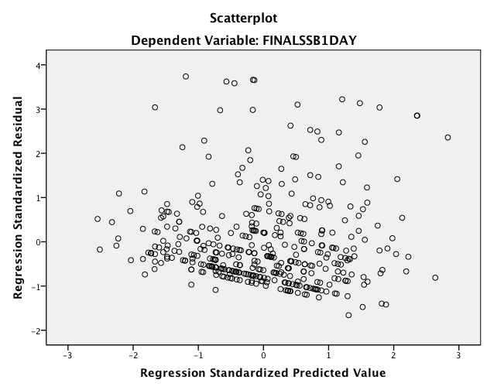
Table 4.9 Variance Inflation Factors for SSB’s per day and SSB’s per week (in oz) as Predicted by Intentions, Perceived Behavioral Control, Environment and Skills and Abilities
Independent Variables Variance Inflation Factor
(D1) (D2)
Intentions 1.341 1.341
Perceived Behavioral Control 1.405 1.405
Environment 1.080 1.080
Skills and Abilities 1.026 1.026
Dependent Variable (D1): SSB/day
Dependent Variable (D2): SSB/week

Figure 4.2 Scatter Plot of the Regression Standardized Residuals for the behavior sugar sweetened beverage per week for those attempting to lose weight
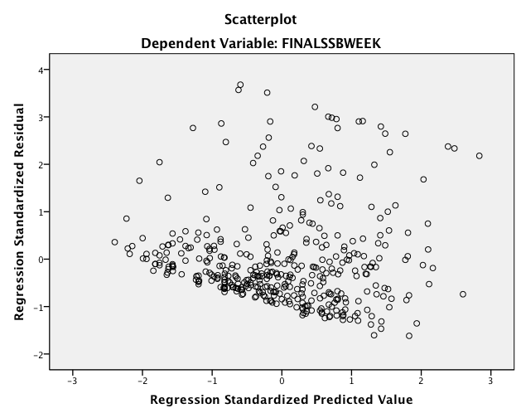

Figure 4.3 Scatter Plot of the Regression Standardized Residuals for intentions predicted by perceived behavioral control, attitudes, and perceived norms

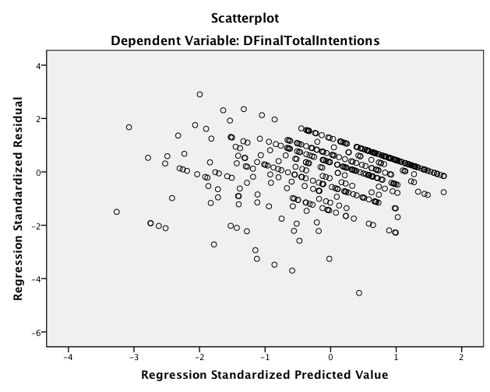
Table 4.10 Variance Inflation Factors for Intentions as Predicted by Perceived Behavioral Control, Perceived Norms, and Attitudes
Independent Variables Variance Inflation Factor
Perceived Behavioral Control 1.150
Perceived Norms 1.096
Attitudes 1.238
Dependent Variable: Intentions

Figure 4.4 Scatter Plot of the Regression Standardized Residuals for intentions predicted by perceived behavioral control, injunctive norms, descriptive norms, instrumental attitudes, and experiential attitudes
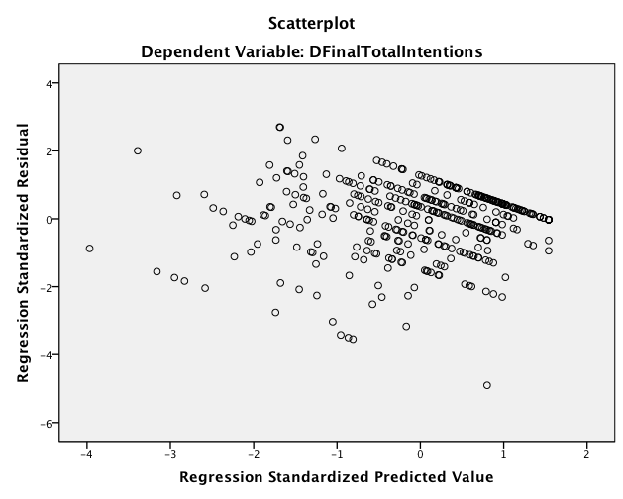
Table 4.11 Variance Inflation Factors for Intentions as Predicted by Perceived Behavioral Control, Injunctive Norms, Descriptive Norms, Instrumental Attitudes, and Experiential Attitudes
Independent Variables Variance Inflation Factor
Perceived Behavioral Control 1.183
Injunctive Norms 1.261
Descriptive Norms 1.162
Instrumental Attitudes 1.361
Experiential Attitudes 1.458
Dependent Variable: Intentions

Model 1: Predicting SSB’s per day with intentions, perceived behavioral control, environment, and skills and abilities. According to the IM, behavior was predicted by perceived behavioral control, environment, skills/abilities and intentions. All four constructs predicted 9.7% of the variance of SSB’s per day. All variables were significant except Skills/Abilities (p=0.318). According to the standardized beta-coefficients, PBC (-0.221; p<0.01) was the most influential variable, followed by environment (0.193; p<0.01) and intentions (0.125; p<0.05).

Table 4.12 Parameter Estimates from the Final Regression Model for SSB’s per day (in oz) as Predicted by Intentions, Perceived Behavioral Control, Environment and Skills and Abilities: (Adjusted R² = 0.097) (n=410)
Unstandardized Standardized
coefficients Std. coefficients
B error Beta t p-value
Constant 32.934 2.935 11.22 0.001

Intentions 2.162 0.948 0.125 2.28 0.023

Perceived Behavioral -3.831 0.972 -0.221 -3.94 0.001
Control

Environment 2.713 0.693 0.193 3.92 0.001

Skills and Abilities -0.913 0.913 -0.048 -1.00 0.318

Model 2: Predicting SSB’s per week with intentions, perceived behavioral control, environment, and skills and abilities. According to the IM, behavior was predicted by perceived behavioral control, environment, skills/abilities and intentions. All four constructs predicted 15.8% of the variance of SSB’s per week. All variables were significant except Skills/Abilities (0.150). According to the standardized beta-coefficients, PBC (-0.287; p<0.01) was the most influential variable, followed by environment (0.252; p<0.01) and intentions (0.125; p<0.05).

Table 4.13 Parameter Estimates from the Final Regression Model for SSB’s per week (in oz) as Predicted by Intentions, Perceived Behavioral Control, Environment and Skills and Abilities: (Adjusted R² = 0.158) (n=410)
Unstandardized Standardized
coefficients Std. coefficients
B error Beta t p-value
Constant 186.791 19.270 9.69 0.001

Intentions 14.750 6.226 0.125 2.37 0.018

Perceived Behavioral -33.934 6.383 -0.287 -5.32 0.001
Control

Environment 24.269 4.547 0.252 5.34 0.001

Skills and Abilities -8.650 5.997 -0.066 -1.44 0.150

Model 3: Predicting intentions with attitudes, perceived norms, and perceived behavioral control. According to the IM, intentions are predicted by attitudes, perceived norms, and perceived behavioral control. All three constructs predicted 40.1% of the variance of Intentions. All variables were significant in the regression model. According to the standardized beta-coefficients, PBC (0.365) was the most influential variable, followed by attitudes (0.290) and perceived norms (0.225); all were significant at p<0.01.

Table 4.14 Parameter Estimates from the Final Regression Model for Intentions as Predicted by Perceived Behavioral Control, Perceived Norms, and Attitudes: (Adjusted R² = 0.401) (n=410)
Unstandardized Standardized
coefficients Std. coefficients
B error Beta t p-value
Constant 0.179 0.125 1.43 0.153

Attitudes 0.411 0.060 0.290 6.80 0.001

Perceived Norms 0.221 0.039 0.225 5.60 0.001

Perceived Behavioral 0.366 0.041 0.365 8.88 0.001
Control

Model 4: Predicting intentions with instrumental attitudes, experiential attitudes, descriptive norms, injunctive norms, and perceived behavioral control. According to the IM, intentions is predicted by attitudes, perceived norms, and perceived behavioral control. In this model, the constructs of attitudes were split between instrumental and experiential attitudes, and perceived norms were split into injunctive and descriptive norms. All three constructs predicted 41.2% of the variance of Intentions. All variables were significant, except descriptive norms (0.758). According to the standardized beta-coefficients, 0.195 (instrumental attitudes), 0.148 (experiential attitudes), 0.221 (injunctive norms), and 0.387 (perceived behavioral control) were all significant at p<0.05.

Table 4.15 Parameter Estimates from the Final Regression Model for Intentions as Predicted by Perceived Behavioral Control, Injunctive Norms, Descriptive Norms, Instrumental Attitudes, and Experiential Attitudes: (Adjusted R² = 0.412) (n=408)
Unstandardized Standardized
coefficients Std. coefficients
B error Beta t p-value
Constant - 0.207 0.219 - 0.95 0.344

Perceived Behavioral 0.387 0.041 0.387 9.35 0.001
Control

Instrumental Attitudes 0.384 0.087 0.195 4.39 0.001

Experiential Attitudes 0.134 0.042 0.148 3.22 0.001

Injunctive Norms 0.168 0.032 0.221 5.18 0.001

Descriptive Norms 0.012 0.039 0.013 0.31 0.758

Effects of Gender on Attitudes, Perceived Behavioral Control, and Perceived Norms. Overall, there were 70 men and 338 women enrolled in this study. Table 4.16 shows that among attitudes (experiential and instrumental), perceived norms (injunctive and descriptive), and PBC, there was only one significant difference between men and women, which was that perceived behavioral control was significantly higher in males (1.59 +/-1.19) than females (1.17 +/- 1.46; p = 0.025*). The effect size was 0.30 (cohen’s d), which is small to moderate.
Effects of Education on Attitudes, Perceived Behavioral Control, and Perceived Norms. The education categories were put into 3 groups. The first group consisted of some high school or High school graduate or GED. The second group had some college or an Associate’s degree, and the third group completed Bachelor’s degree/ Graduate of Professional degree. Table 4.17 shows that attitudes (p=0.002), experiential attitudes (p=0.001), and injunctive norms (p=0.013) were significantly different by education level. Post hoc analyses further showed that attitudes were significant between some high school education/high school graduate/GED (2.30 +/-0.92) and some college/associates degree (1.93+/-1.04; p=0.002; d=0.36), and also between some high school education/high school graduate/GED (2.30+/-0.92) and Bachelor’s degree/Graduate of Professional degree (1.95+/-0.98; p=0.03; d=0.36). Effect sizes were small to medium, and are the same for both comparisons.
Experiential Attitudes is significant between some high school education/high school graduate/GED (1.87+/-1.47) and some college/associates degree (1.25+/-1.58; p=0.001), and also between some high school education/high school graduate/GED (1.87+/-1.47) and Bachelor’s degree/Graduate of Professional degree (1.21+/-1.58; p=0.008). The effect size was large for high school education/high school graduate/GED and some college/associates degree (p=0.001, d=1.56) and a small to moderate effect size some high school education/high school graduate/GED and Bachelor’s degree/Graduate of Professional degree (p=0.008, d=0.42). Injunctive norms is significant between some high school education/high school graduate/GED (1.04+/-1.87) and some college/associates degree (0.54+/-1.88; p=0.048, d=0.27), and also between some high school education/high school graduate/GED (1.04+/-1.87) and Bachelor’s degree/Graduate of Professional degree (0.35+/-1.78; p=0.025; d=0.38). The effect size for both of these comparisons remained between small to moderate.

Table 4.16 ANOVA of Gender to Attitudes, Perceived Behavioral Control, and Perceived Norms
 | n | Attitudes | Experiential Attitudes | Instrumental Attitudes | Perceived Norms | Injunctive Norms | Descriptive Norms | Perceived Behavioral Control
Male | 70 | 1.99 (0.99) | 1.46 (1.48) | 2.53 (0.81) | 0.75 (1.36) | 0.83 (1.84) | 0.62 (1.22) | 1.59 (1.19)
Female | 338 | 2.06 (1.01) | 1.44 (1.59) | 2.69 (0.70) | 0.55 (1.47) | 0.63 (1.88) | 0.44 (1.55) | 1.17 (1.46)
P-value  Cohen’s d |  | 0.590  -- | 0.918  -- | 0.084  -- | 0.302  -- | 0.403  -- | 0.356  -- | 0.025*  0.30

81

Table 4.17 ANOVA of Education to Attitudes, Perceived Behavioral Control, and Perceived Norms
 | n | Attitudes | Experiential Attitudes | Instrumental Attitudes | Perceived Norms | Injunctive Norms | Descriptive Norms | Perceived Behavioral Control
Some high school/ High school graduate or GED | 133 | 2.30 (0.92) ^{a, b} | 1.87 (1.47) ^{c, d} | 2.73 (0.67) | 0.83 (1.51) | 1.04 (1.87) ^{e, f} | 0.50 (1.62) | 1.31 (1.43)
Some college or an Associate’s degree | 197 | 1.93 (1.04) ª | 1.25 (1.58) ^{c} | 2.61 (0.76) | 0.51 (1.46) | 0.54 (1.88) ^{e} | 0.45 (1.50) | 1.18 (1.46)
Bachelor’s degree/ Graduate of Professional degree | 80 | 1.95 (0.98) ^{b} | 1.21 (1.58) ^{d} | 2.70 (0.69) | 0.39 (1.27) | 0.35 (1.78) ^{f} | 0.47 (1.28) | 1.29 (1.30)
p-value  82 |  | 0.002* | 0.001* | 0.269 | 0.055 | 0.013* | 0.949 | 0.702
ªp=0.002, d=0.36; ^{b}p=0.03, d=0.36; ^{c}p=0.001, d=1.56; ^{d}p=0.008, d=0.42; ^{e}p=0.048, d=0.27; ^{f}p=0.025; d=0.38

Pairwise comparison for predictors of sugar sweetened beverage behavior. Table 4.18 shows significant means differences for perceived behavioral control when compared to perceived norms (mean difference=0.659), and attitudes (mean difference=0.810), and perceived norms when compared to attitudes (mean difference=1.468). All means were significant at p<0.001. The effect size between perceived behavioral control and perceived norms was medium at 0.46. Perceived norms and attitudes have a large effect size of 1.19. Meanwhile attitudes and perceived behavioral control have an effect size moderate to large effect size.

Table 4.18: Pairwise comparison for predictors of sugar sweetened beverage behavior
Direct Measures | Mean Difference (Std. error)  Cohen’s d
Direct Measures | A | B | C
Perceived Behavioral Control (A) | _ | 0.659*(.094)  0.46 | 0.80*(.070)  0.66
Perceived Norms (B) | _ | _ | 1.468*(.074)  1.19
Attitudes (C) | _ | _ | _
*p<.00
Determinants of Attitudes, Perceived Norms, and Perceived Behavioral Control
Attitudes: Belief Strength, Outcome Evaluation, Belief-Evaluation Product, and Correlations of Belief-Evaluation Product with Direct Attitude Measure. Four items evaluated behavioral beliefs and four items evaluated the corresponding outcome evaluations. As previously discussed, each behavioral belief was multiplied by an outcome evaluation, and then correlated to total attitudes, total instrumental attitudes, and total experiential attitudes. Participants’ beliefs about losing weight (p < .01) and having more energy (p < .01) were the only two significant items of the four total items (Table 4.19). The other two items evaluated whether having more headaches (p > .01) and feeling tired more often (p > .01) resulted in insignificant negative correlations with total attitudes, total instrumental, and total experiential attitudes.

Table 4.19 Indirect Attitudes: Belief Strength, Outcome Evaluation, Belief-Evaluation Product, and Correlations of Belief-Evaluation Product with Direct Attitude Measure (N = 410)
Outcome
Behavioral Belief Belief Strength (bb_{i}) evaluation (oe_{i}) bb_{i} x oe_{i} Correlation bb_{i}oe_{i} with
M SD M SD M SD TA TIA TEA

Lose weight 1.85 1.60 6.89 0.54 12.87 11.12 0.25* 0.29* 0.18*
More headaches - 0.12 2.04 1.56 1.28 0.02 3.49 - 0.05 - 0.01 - 0.06
More energy 0.62 1.87 6.77 0.77 4.32 12.79 0.33* 0.23* 0.32*
Feeling tired more often - 0.35 1.81 1.55 1.22 - 0.31 3.40 - 0.04 - 0.02 - 0.04
Note. Belief strength can range from -3 to 3 and outcome evaluation can range from 1 to 7, and bb x oe can range from -3 to 21. TA means total attitudes, TIA means total instrumental attitudes, and TEA means total experiential attitudes.
* Significant; significant at p < .01.
85
Injunctive Norms: Injunctive Normative Beliefs, Motivation to Comply, Belief-Comply Product, and Correlations of Belief-Comply Product with Direct Injunctive Measure. Four items evaluated injunctive normative beliefs and another four items evaluated motivation to comply. Once multiplying the corresponding items to one another, that value was then correlated to total perceived norms and total injunctive norms. All four items are significantly correlated to total perceived norms and total direct measures of injunctive norms. The four items are significant at p < 0.01. Table 4.20 shows positive correlations ranging from 0.49 to 0.51.
Descriptive Norms: Descriptive Normative Beliefs, Identification with Referents, Belief-Referents Product, and Correlations of Belief-Referents Product with Direct Descriptive Measure. Three items evaluated descriptive normative beliefs and another three items evaluated identification with referents. Once multiplying the corresponding items to one another, that value was then correlated to total perceived norms and total descriptive norms. Table 4.21 depicts all three items being significantly correlated to total perceived norms (TPN) and direct measures of descriptive norms (TDN). Spouse and coworkers have a higher correlation to the TPN and TDN than friends. All items are significant at p < 0.001 except for friends which was significant at p < 0.05 when correlated to total perceived norms.
Table 4.20 Injunctive Norms: Injunctive Normative Beliefs, Motivation to Comply, Belief-Comply Product, and Correlations of Belief-Comply Product with Direct Injunctive Measure (N = 256)
Injunctive Normative Motivation to
Normative Belief Beliefs (inb_{i}) Comply (mtc_{i}) inb_{i} x mtc_{i} Correlation inb_{i}mtc_{i}
M SD M SD M SD TPN TIN
Spouse/significant other 0.57 2.10 4.59 2.15 4.46 10.70 0.51* 0.50*
Friends 0.14 1.95 3.91 1.99 2.24 8.62 0.47* 0.45*
Children 0.21 1.97 4.55 2.03 2.64 10.07 0.45* 0.45*
Parents 0.46 2.03 4.15 1.99 3.83 9.63 0.49* 0.49*
Note. Injunctive normative beliefs can range from -3 to 3 and motivation to comply can range from 1 to 7, and inb x mtc can range from -3 to 21. TPN means total perceived norms and TIN means total injunctive norms.
* Significant; significant at p < .01.

Table 4.21 Descriptive Norms: Descriptive Normative Beliefs, Identification with Referents, Belief-Referents Product, and Correlations of Belief-Referents Product with Direct Descriptive Measure (N = 279)
87
Descriptive Normative Identification with
Normative Belief Beliefs (dnb_{i}) Referents (iwr_{i}) dnb_{i} x iwr_{i} Correlation dnb_{i}iwr_{i}
M SD M SD M SD TPN TDN
Spouse 1.09 2.22 3.79 2.28 2.52 10.28 0.63** 0.85**
Coworkers 2.06 1.50 2.93 1.82 5.35 6.25 0.46** 0.76**
Friends 2.00 1.44 3.39 1.97 6.29 1.44 0.10* 0.17**
Note. Descriptive normative beliefs can range from -3 to 3 and identification with referents can range from 1 to 7, and dnb x iwr can range from -3 to 21. TPN means total perceived norms and TDN means total descriptive norms.
* Significant; **significant at p < .001 and * at p. < .05.

Perceived Behavioral Control: Control Beliefs, Perceived Power, Belief-Power Product, and Correlations of Belief-Power Product with Direct Perceived Behavioral Control Measure. Four items evaluated control beliefs and another four items evaluated perceived power. Once multiplying the corresponding items to one another, that value was then correlated to total perceived behavioral control. All four items have significant negative correlations with total perceived behavioral control. Table 4.22 shows that all the items are significant at p < 0.01.

Table 4.22 Perceived Behavioral Control: Control Beliefs, Perceived Power, Belief-Power Product, and Correlations of Belief-Power Product with Direct Perceived Behavioral Control Measure (N = 405)
Control Belief Control Beliefs (cb_{i}) Perceived Power (pp_{i}) cb_{i}pp_{i} Correlation cb_{i}pp_{i} with
M SD M SD M SD TPBC
- My family members drink sugary drinks
- in front of me 5.84 1.85 - 0.41 2.23 - 2.23 13.98 - 0.33*
- Having water available to drink 6.63 1.13 0.54 2.46 3.82 16.57 - 0.22*
- My family members bring
sugary drinks home 5.46 2.07 - 0.20 2.25 - 0.75 13.29 - 0.32*
I crave sugary drinks 4.68 2.03 0.55 2.13 5.09 10.52 - 0.41*
Note. Control beliefs can range from -3 to 3, perceived power can range from 1 to 7, and cb x pp can range from -3 to 21. TPBC means total perceived behavioral control.
* Significant; significant at p < .01.
89

Summary
These results support that the instrument was mostly reliable and valid. The regression models show that the most significant predictor of SSB consumption in this study is perceived behavioral control and environment. The most significant predictors of intentions are perceived behavioral control, attitudes, and perceived norms, with the exception of descriptive norms. There is a significant difference between males and females in regards to perceived behavioral control. Furthermore, education status is significantly discerned by attitudes, experiential attitudes, and injunctive norms. Lastly, when comparing attitudes, perceived behavioral control, and perceived norms all comparisons are significant; however perceived behavioral control and attitudes have the largest effect size.
Chapter 5
Discussion
Introduction
This discussion explains the results of the four regression models evaluated in this study that were used to answer the study’s research questions and hypotheses. Background factors are also addressed in this chapter to respond to hypotheses 5 and 6. Although there were no research questions for the Indirect measures, they were discussed in this chapter. Lastly, this chapter explains this study’s limitations, and recommendations for future practice and research.
Research Hypotheses & Results
According to the four regression models developed from data analyses 9.7% of the variance of daily SSB consumption was explained by intentions, perceived behavioral control, environment and skills and abilities, and 15.8% of the variance of weekly SSB consumption was explained by intentions, perceived behavioral control, environment and skills and abilities. Additionally, 40.1% of the variance of intentions was explained by perceived behavioral control, perceived norms, and attitudes, and 41.2% of the variance of intentions was explained by perceived behavioral control, injunctive norms, descriptive norms, instrumental attitudes, and experiential attitudes.
Environment was the strongest predictor for daily SSBs (B= 0.193; p<0.01) and weekly SSBs (B= 0.252; p<0.01) consumption. The two environment questions in the survey asked how often SSBs are in their home and how often are they served during meals in their home. These two questions ask about current SSB behavior in their home, so it makes sense that the environment would be the strongest predictor in the study. Similar studies evaluating SSB behaviors among adults that use the Theory of Planned Behavior do not include environment as a construct, therefore this cannot be compared with other studies. Furthermore, results show negative standardized beta coefficients for intentions for both daily and weekly SSB consumption, which can be interpreted as the more SSBs individuals consume, the less intentions they have for discontinuing the behavior in six months.
The second strongest predictor for SSBs per day (B= -0.221; p<0.01) and per week (B= -0.287; p<0.01) was perceived behavioral control. The standardized beta coefficient were also both negative. This can be interpreted as the more SSBs an individual consumes, the less in control they feel that they can stop drinking SSBs in the future.
Intentions was the third strongest predictor of SSBs per day (B= 0.125; p<0.05) and SSBs per week (B= 0.125; p<0.05). This can be interpreted as the more SSBs an individual consumes, the higher their intentions they have to stop drinking SSBs. Together, these results show that perceived behavioral control explains current behavior better than intentions. Theoretically, this means that this population can be targeted through their capability and autonomy to stop drinking regular soda and other sugary drinks to change their intentions. This is contradictory to most published research using the TPB. For example, a meta-analysis on the TPB showed intentions was a stronger predictor over PBC for 6 different behaviors (i.e. cancer detection, abstinence, physical activity) (McEachan, et al., 2011). Zoellner and Estabrooks (2012) also found using the TPB, the strongest predictor for SSB consumption was intentions followed by attitudes, perceived behavioral control, and perceived norms. On the other hand, Masalu and Astrom’s (2003) strongest predictor for their SSB behavior was subjective norms (perceived norms) followed by perceived behavioral control, attitudes, then intentions. It should be noted that this study differed from most, in how the behavior was defined and what group was targeted. In most studies, researchers are interested in predicting the likelihood of a behavior, and evaluates individuals that are currently engaged and not engaged in the behavior. In health promotion, since the target is health behavior change of unwanted health behaviors, it was decided to target only at risk individuals who are currently engaged in the unwanted behavior (current SSB drinkers), and evaluate what predictors are most significant for them to stop the unwanted behavior.
The first set of hypotheses tested in this study was for attitudes, perceived norms, and perceived behavioral control and if collectively they have a significant positive relationship with behavioral intentions to stop drinking regular soda and sugary drinks for the next 6 months in adults attempting to lose weight. Based on the regression analysis, this study found that all three constructs were significantly positively correlated to the behavioral intentions (p≤.01). Perceived behavioral control (0.365) was highest predictor of behavioral intentions, followed by attitudes (0.290), and then perceived norms (0.225). This can be interpreted as the more control they feel, the better their attitudes to do the behavior are, and the more social pressure to do the behavior, then the higher their intention they have to do the behavior. Perceived behavioral control was the highest predictor for intentions positively and SSBs negatively. Perceived behavioral control is a unique finding since the other studies that researched this topic with the TPB did not have the same result (Zoellner & Estabrooks, 2012; Masalu, 2003).
The second set of hypotheses evaluated whether instrumental attitudes, experiential attitudes, injunctive norms, descriptive norms, capacity, and autonomy would collectively have a significant positive relationship with behavioral intentions to stop drinking regular soda and sugary drinks for the next 6 months in adults attempting to lose weight. This was done to evaluate if the core constructs could better explain intentions, if they were evaluated independently using the sub core-constructs (i.e. attitudes versus instrumental and experiential attitudes). Results showed that all these constructs were significant (p≤.01) predictors of intentions except for descriptive norms. Furthermore, while model one predicted 40.1% of the variance of intentions, model two predicted 41.2% of the variance of intentions, showing little benefit for evaluating sub-constructs. It should be note that capacity and autonomy became one construct (perceived behavioral control) due to CFA explained in results section, therefore it was not possible to fully evaluate this hypothesis. Perceived behavioral control (PBC) was the highest predictor followed by injunctive norms, instrumental attitudes, and experiential attitudes. This hypothesis varied from the first because the second highest predictor of behavioral intentions is injunctive norms instead of attitudes. This is interesting because the prediction of the variance increased when separating all the constructs. This is showing strong evidence that there could be two underlying constructs: experiential attitudes, instrumental attitudes, injunctive norms, descriptive norms, and perceived behavioral control were one construct since two items were removed. Future research could look more into this for this reason and because descriptive norms (DN) were insignificant and DN is a relatively new construct to the model since it wasn’t included the Theory of Planned Behavior.
The third and fourth set of hypotheses tested how behavioral intentions, skills/abilities, environment and perceived behavioral control would collectively predict current daily and weekly consumption of regular soda and sugary drinks. As already explained above PBC was the most influential variable, followed by environment, and intentions. All constructs approached significance more so with weekly SSB consumption than with daily SSB consumption, that could be due to the increased amount of data provided from weekly SSB consumption. Although all were significant, skills/abilities were not; this may be due to lack of variability in responses. Overall, skill/abilities and environment were difficult to measure with just two items for each construct. In the future, perhaps additional questions such as “how often do you use food labels to check the amount of sugar in a beverage?” and “do you know how to read a food label?” could add to the skills/ability scale. Skills/abilities and environment, when compared to intentions, are underdeveloped constructs within the IM framework. More research should be done to determine if there are determinants of these two constructs, to reflect how intentions are operationalized.
The fifth set of hypotheses claimed that there would be a significant difference between men and women for attitudes, perceived norms, and perceived behavioral control to stop drinking regular soda and sugary drinks for the next 6 months in adults attempting to lose weight. Note that there is an obvious difference in the amount of men (70) versus women (338) that took part in this study. There was only one significant difference among men and women, which was PBC was higher in males. This could be that men feel more capable of, or have control over, performing the behavior than women. Now, PBC in relation to behavior was negative according to these results. So, perhaps women caused PBC and behavior to have a negative relationship.
The sixth set of hypotheses claimed that there would be a significant difference between educational categories for attitudes, perceived norms, and perceived behavioral control to stop drinking regular soda and sugary drinks for the next 6 months in adults attempting to lose weight. Three constructs (attitudes, experiential attitudes, and injunctive norms) showed significant differences among the three education categories of 1) some high school education/high school graduate/GED, 2) some college/associates degree, and 3) Bachelor’s degree/Graduate of Professional degree. There were expected differences among categories one and three for attitudes, experiential attitudes, and injunctive norms. The most significant differences were between 1 and 2 for experiential attitudes (p=0.001), followed by 1 and 2 for attitudes (p=0.002), and 1 and 3 for injunctive norms (p=0.025). High school education/high school graduate/GED had higher experiential attitudes than some college/associates degree meaning those with less than a college degree may have a stronger emotional reaction/attitude towards not drinking SSBs. This could help with develop an intervention targeting feelings (like targeting satisfaction) when performing the behavior.
Indirect measures were not included in the hypothesis, but they make up a large part of the IM. The elicitation phase helped identify all of the beliefs and referents mentioned. The Indirect measures were multiplied by their corresponding items such as belief strength with outcome evaluation, injunctive normative beliefs with motivation to comply, descriptive normative beliefs with identification with referents, and control beliefs with perceived power.
Attitudes included belief strength with outcome evaluation and the value was correlated with total attitudes (TA), total instrumental attitudes (TIA), and total experiential attitudes (TEA). The behavioral beliefs that they would lose weight and have more energy if they stopped drinking SSBs resulted in significant positive correlations with TA, TIA, and TEA. However, the behavioral beliefs that they would have more headaches and feel tired more often if they stopped drinking SSBs resulted in insignificant negative correlations with TA, TIA, and TEA. This may be because headaches and feeling tired have negative connotations. Note that recoding these negative items did not result in significant or positive correlations. Furthermore, if a health promotion message were to be developed for this population, the researchers could use messages such as, “When you stop drinking SSBs, you will lose weight or you will have more energy”. Writing messages about feeling tired more often and having headaches when you stop drinking SSBs would not be effective messages since they did not correlate with the total Direct measures.
Injunctive norms included injunctive normative beliefs (INB) with motivation to comply (MTC) and the value was correlated with total perceived norms (TPN) and total injunctive norms (TIN). All the behavioral beliefs: spouse/significant other, friends, children, parents resulted in significant positive correlations with TPN and TIN. To better understand INB, they can be described as those referents (you believe) want you to do the behavior. INB is paired with MTC, which is the motivation to do what each referent think(s). The elicitation phase helped identify these referents. Although Perceived Norms wasn’t the strongest predictor of intentions or a predictor of the SSB behaviors, this helps identify who is or who are the strongest referent(s) that could motivate this population if a campaign were conducted.
Descriptive norms included descriptive normative beliefs (DNB) with identification with referents (IWR) and the value was correlated with total perceived norms (TPN) and total descriptive norms (TDN). All the behavioral beliefs: spouse, coworkers, friends resulted in significant positive correlations with TPN and TDN. To better understand DNB, they can be described as those referents (you believe) are doing the behavior. DNB is paired with IWR, which is, essentially, do you want to be like the referent in terms of doing or not doing the behavior. The elicitation phase helped identify these referents as well since they are different from the injunctive normative beliefs referents. Spouse had the highest correlation followed by coworker and friends. Knowing this information, if an intervention were developed, the participants can be informed that by including their spouse, coworker, and friends, they can improve their behavior to stop drinking SSBs.
Perceived behavioral control included control beliefs with perceived power and the value was correlated with total perceived behavioral control (TPBC). The most significant control belief was craving sugary drinks, followed by family members drinking sugary drinks in front of them, family members bringing drinks home, and having water available to drink. All were negatively correlated with TPBC meaning that these items mentioned make it difficult for them to feel capable to stop drinking SSB. Lastly, since perceived behavioral control was a predictor of intentions and behavior for this study, these items could help target each individual’s control beliefs and weigh their perceived power in order for people to self-report, self-motivate, and amount self-affirmation.
Indirect measures have not been consistently analyzed in previous studies. One study on sleep behavior using the IM did not correlate their Indirect measures with total Direct measures, but instead correlated their Indirect measures with Intention and Behavior (Robbins & Niederdeppe, 2014). Figure 2.2 shows how the IM’s Indirect measures were not meant to be correlated with intentions and behavior. Another flaw Robbins & Niederdeppe’s study is that the referents for Injunctive Normative Beliefs and Descriptive Normative Beliefs are the same (2014). This is not always the case since those that want you to do the behavior may not always be doing the behavior. Furthermore, Masalu and Astrom’s (2003) study was also flawed because they did not use the Value Expectancy Theory to attain the multiplicative score for each item and correlated, but instead plugged the Indirect measures as if they were Direct measures.
Lastly, this study’s results predicted current behavior and not future behavior in a prospective way. Therefore, the regression models showing determinants of behavior (daily and weekly) should be carefully interpreted. This was done because participants were asked about their past behavior and their intentions, attitudes, perceived norms, and PBC to stop drinking regular soda and sugary drinks for the next six months. One limitation to the method used in this study also centers on whether the study participants were overly optimistic in their evaluation of future behavior. Participants may answer a question one way, but when the situation arises they may not perform the way they answered. For example, a participant may have answered that they have 100% control to stop drinking sugary drinks for the six months; however in real life when the sugary drink is offered to them by their parent/spouse/friend, they may not be in control. This is called hypothetical bias, where some participants have strong intentions when they take the survey; but when exposed to real life, those intentions may not be as strong (Fishbein & Ajzen, 2010). Therefore, prospective studies should be done in the future.
Background Factors
The background factors of past behavior, gender, and education level, were compared to the constructs of attitudes, experiential attitudes, instrumental attitudes, perceived norms, descriptive norms, injunctive norms, and perceived behavioral control. Background factors interlace themselves throughout the IM, and therefore are analyzed in case of significant effects with certain constructs. Two One-Way ANOVA tests were used to analyze gender and education. There was a significant difference between males and females regarding perceived behavioral control. Males (mean=1.59) had significantly more perceived behavioral control than females (mean=1.17). This tells us that men possibly feel more control in regards to not drinking SSBs.
Furthermore, there were more significant differences between education groups than gender groups. Significant differences were found among attitudes, experiential attitudes, and injunctive norms. Some high school/high school graduate or GED (mean=2.30) had higher attitudes than some college or an Associate’s degree (mean=1.93). However, Bachelor’s degree/Graduate of Professional degree (mean=1.95) had higher attitudes than some college or an Associate’s degree (mean=1.93). This resulted on opposite sides of the spectrum meaning that high and low educated people show high attitudes towards not drinking SSBs.
The same occurred again for experiential attitudes where some high school/high school graduate or GED (mean=1.88) had higher experiential attitudes than some college or an Associate’s degree (mean=1.25). However, now some college or an Associate’s degree (mean=1.25) had higher experiential attitudes than Bachelor’s degree/Graduate of Professional degree (mean=1.21). These results show that the lower their education is, the more they feel that that a positive emotional response towards not drinking SSBs.
The same as previously occurred with injunctive norms where some high school/high school graduate or GED (mean=1.04) had higher injunctive norms than some college or an Associate’s degree (mean=0.54). Again some college or an Associate’s degree (mean=0.54) had higher injunctive than Bachelor’s degree/Graduate of Professional degree (mean=0.35). According to these results, the lower their education is, the higher their perceptions will be that most people who are important to them feel that they should stop drinking SSBs.
Some significant background factors were found with some of the constructs of the IM. For the future, it may be beneficial to include an item on income. In conclusion, background factors bring forth other influences that could become a large focus for an intervention or program if deemed significant throughout all constructs. These factors can also help further evaluate the outcome of data to provide deeper insight from a multitude of possibilities.
Limitations
This study had some limitations. Firstly, this study was not randomized, which could have led to sampling bias. Since the results were based on self-reported data, there may have been dishonest or biased responses, as well as erroneous markings due to misinterpretations of the questions. These results are not generalizable to all populations since this was a convenience sampling. Also, since this was a cross-sectional research design, causation cannot be implied from these results. Lastly, test-retest did not reach the level of acceptability.
Recommendations for Future Practice
This study suggests that interventions or health promotion practices aiming toward adult obesity are necessary. The results from this study show that there is a high level of SSB consumption in weight loss patients and a demand for weight loss interventions. Intervention could target this behavior by creating support/learning groups. This study showed that environment was the most significant predictor of behavior, so interventions should firstly be focused on the environment. An intervention needs to be created that targets the highest predictors of SSB behavior: their environment, perceived behavioral control, intentions, and then the other constructs: attitudes, perceived norms, and skills and abilities should be targeted.
Recommendations for Future Research
If this study were to be recreated, pilot-testing answers should be reviewed for similar answers. If an item received the same answer from all participants, then a replacement item should be considered in order to avoid computational error. Along with self-reported surveys, another recommendation would be to include observation. Several observations were made during this study, but since this is strictly a self-report survey study and not an observational study, none were reported. Observations such as focus groups would benefit this weight loss population. The subjects would not only provide the researcher with insight, but also learn from one another and develop a type of support group. Several participants asked if they could take the survey home. This could be another future consideration for research practice. Doing this could have improved test-retest reliability by decreasing retesting time to two weeks and increasing participant retesting outcome. A take home survey could also open doors to environmental self-reporting for future interventions or programs.
Conclusion
In conclusion, bringing personal SSB consumption awareness to adults has already made an impact. Since environment was shown to be the biggest predictor for the SSB behavior, a focus can be eliminating SSBs from the household. Some individuals may face SSBs in the workplace where it’s not always easy to eliminate. In which case perceived behavioral control strategies may come into play. This type of study still requires more research. Adult SSB behavior applied to the Integrative Model is new research. Hopefully this study has filled in the literature gap for other researchers to come.
References
Advameg, Inc. (2015). Lawton, Oklahoma. Retrieved from http://www.city-data.com/city/Lawton-Oklahoma.html
An, R. (2014). Prevalence and trends of adult obesity in the US, 1999–2012. ISRN Obesity, 16.
Arner, P. & Spalding, K. L. (2010). Fat cell turnover in humans. Biochemical and Biophysical Research Communications, 396(1), 101-104.
Ayas, N. (2010). If you weigh too much, maybe you should try sleeping more. Sleep, 33(2), 143-4.
Benton, M., Whyte, M., & Dyal, B. (2011). Sarcopenic obesity: strategies for management. American Journal of Nursing, 111(12), 38-44.
Bombak, A. (2014). The contribution of applied social sciences to obesity stigma-related public health Approaches. Journal of Obesity, 1-9.
Branscum, P. & Sharma, M. (2014). Defining a healthy diet: challenges and conundrums. American Journal of Health Studies, 29(4), 271-278.
Brownell, K., Gold, Mark S., & Ahmed, S.H. (2012). Food and addiction: A comprehensive handbook. In Is sugar as addictive as cocaine? Oxford, New York: Oxford University Press, (1), 231-237.
Buhi, E., Goodson, P., Neilands, R., & Blunt, H. (2011). Adolescent sexual abstinence: a test of an integrative theoretical framework. Health Education & Behavior, 38(1), 63-79.
Cawley, J. & Meyerhoefer, C. (2012). The medical care costs of obesity: an instrumental variables approach. Journal of Health Economics, 31(1), 219-230.
Centers for Disease Control and Prevention. (2012). Diabetes interactive atlases. Retrieved from http://www.cdc.gov/diabetes/atlas/countydata/atlas.html.
Choquet, H. & Meyre, D. (2011). Genetics of obesity: What have we learned? Current Genomics, 12(3), 169-179.
NHLBI Obesity Education Initiative Expert Panel on the Identification, Evaluation, and Treatment of Obesity in Adults (US). (1998). Clinical guidelines on the identification, evaluation, and treatment of overweight and obesity in adults: the evidence report. National Institutes of Health; Bethesda, MD.
The Coca-Cola Company. (2015). History of Bottling. http://www.thecoca-colacompany.com/ourcompany/historybottling.html
Colby, S. & Ortman, J. (2015). Projections of the size and composition of the U.S. population: 2014 to 2060. Retrieved from https://www.census.gov/content/dam/Census/library/publications/2015/demo/p25-1143.pdf
Conway, B., Miller, R., Costacou, T., Fried, L., Kelsey, S., Evans, R., & Orchard, T. (2010). Temporal patterns in overweight and obesity in Type 1 diabetes. Diabetic Medicine, (27), 398-404.
Cutting Calories. (2015). Retrieved from http://www.cdc.gov/healthyweight/healthy_eating/drinks.html
Despres, J. (2012). Body fat distribution and risk of cardiovascular disease: an update. Circulation, 1301-1313.
Ethnic Differences in BMI and Disease Risk. (2012). Retrieved from http://www.hsph.harvard.edu/obesity-prevention-source/ethnic-differences-in-bmi-and-disease-risk/
Fact sheet: sugary drink supersizing and the obesity epidemic. (2012). Retrieved from https://cdn1.sph.harvard.edu/wp-content/uploads/sites/30/2012/10/sugary-drinks-and-obesity-fact-sheet-june-2012-the-nutrition-source.pdf
Facts about physical activity. (2014). Retrieved from http://www.cdc.gov/physicalactivity/data/facts.html
Finkelstein, E., Trogdon, J., Cohen, J., & Dietz, W. (2009). Annual medical spending attributable to obesity: payer-and service-specific estimates. Health Affairs, 28(5), W822-W831.
Fishbein, M. & Ajzen, I. (2010). Predicting and changing behavior: the reasoned action approach. New York, NY, Psychology Press.
Giskes, K., Lenthe, F., Avendano-Pabon, M., & Brug, J. (2011). A systematic review of environmental factors and obesogenic dietary intakes among adults: Are we getting closer to understanding obesogenic environments? Obesity Reviews, 12(5), E95-E106.
Glanz, K., Rimer, B. K., & Viswanath, K. (2008). Health behavior and health education: theory, research, and practice (4th ed.). San Francisco, CA: Jossey- Bass.
Goodwin, L. D., & Leech, N. L. (2006). Understanding correlation: Factors that affect the size of r. The Journal of Experimental Education, 74(3), 249-266.
Han, E. & Powell, L. M. (2013). Consumption patterns of sugar-sweetened beverages in the United States. Journal of the Academy of Nutrition and Dietetics, 113(1), 43-53.
HC3 research primers aid in SBCC program design - health communication capacity collaborative - social and behavior change communication. (2014). Retrieved from http://healthcommcapacity.org/hc3-research-primers-aid-in-sbcc-program-design/
Headline indicators for children’s health, development and wellbeing, 2011. (2011). Canberra: Australian Institute of Health and Welfare, 1-151.
Hu, F. (2013). Resolved: There is sufficient scientific evidence that decreasing sugar‐sweetened beverage consumption will reduce the prevalence of obesity and obesity‐related diseases. Obesity Reviews, 14(8), 606-619.
Jacobson, M. (2005). Liquid candy: how soft drinks are harming Americans' health. Center for Science in the Public Interest, 1-46.
Jordan, A., Piotrowski, J. T., Bleakley, A., & Mallya, G. (2012). Developing media interventions to reduce household sugar-sweetened beverage consumption. The ANNALS of the American Academy of Political and Social Science, 640(118), 118-134.
Kumar, D. S., Banji, D., & Harani, A. (2010). Physiological factor in obesity. American-Eurasian Journal of Toxicological Sciences, 2(3), 177-189.
Maibach, E. & Yzer, M. (1995). The Integrative Model of Behavioral Prediction as a tool for designing health messages. In Designing health messages approaches from communication theory and public health practice. Thousand Oaks, California: Sage Publications, (1), 21-40.
Malik, V. S., Schulze, M. B., & Hu, F. B. (2006). Intake of sugar-sweetened beverages and weight gain: a systematic review. The American Journal of Clinical Nutrition, 84(2), 274-288.
Mantzoros, C., Magkos, F., Brinkoetter, M., Sienkiewicz, E., Dardeno, T. A., Kim, S. Y., Hamnvik, O. P., Koniaris, A. (2011). Leptin in human physiology and pathophysiology. American Journal of Physiology - Endocrinology and Metabolism, 301(4), E567-E584.
Masalu, J. & Astrom, A. (2001). Predicting intended and self-perceived sugar restriction among Tanzanian students using the Theory of Planned Behavior. The Journal of Health Psychology, 6(4), 435-445.
Masalu, J. & Astrom, A. (2003). The use of the theory of planned behavior to explore beliefs about sugar restriction. American Journal of Health Behavior, 27(1), 15-24.
Mattes, R. & Foster, G. (2014). Food environment and obesity. Obesity, 22(12), 2459-2461.
McEachan, R. R. C. et al. (2011). Prospective prediction of health-related behaviours with the theory of planned behaviour: A meta-analysis. Health Psychology Review, 5(2), 97-144.
Michie, S. & Prestwich, A. (2010). Are interventions theory-based? Development of a theory coding scheme. Health Psychology, 29(1), 1-8.
Mills, S., Tanner, L., & Adams, J. (2013). Systematic literature review of the effects of food and drink advertising on food and drink-related behaviour, attitudes and beliefs in adult populations. Obesity Reviews, (14), 303-314.
Mind/Body Health: Obesity. (2015). Retrieved from http://www.apa.org/helpcenter/obesity.aspx
Nielsen, S. J. & Popkin, B. M. (2005). Changes in beverage intake between 1977 and 2001. American Journal of Preventative Medicine, 27(3), 205-210.
Nurkkala, M., Kaikkonen, K., Vanhala, M., Karhunen, L., Keränen, A., & Korpelainen, R. (2015). Lifestyle intervention has a beneficial effect on eating behavior and long-term weight loss in obese adults. Eating Behaviors, 18, 179-185.
Obesity Rates & Trends Overview. (2014). Retrieved from http://stateofobesity.org/obesity-rates-trends-overview/
Ogden C. L., Carroll M. D., Kit B. K., & Flegal, K. M. (2014). Prevalence of childhood and adult obesity in the United States: 2011-2012. JAMA. 311(8), 806-814.
Ogden, C. L., Kit, B. K., Caroll, M. D., & Park, S. (2011). Consumption of sugar drinks in the United States: 2005-2008. NCHS Data Brief, no 71. Hyattsville, MD. 1-8.
Ogden, C. L., Lamb, M. M., Caroll, M. D., & Flegal, K. M. (2010). Obesity and socioeconomic status in adults: United States, 2005-2008. NCHS Data Brief, no 50. Hyattsville, MD. 1-8.
Osborne, J. W. & Overbay, A. (2004). The power of outliers (and why researchers should always check for them). Practical Assessment, Research & Evaluation, 9(6). Retrieved from http://PAREonline.net/getvn.asp?v=9&n=6
Park, S., Mcguire, L. C., & Galuska, D. A. (2015). Regional Differences in Sugar-Sweetened Beverage Intake among US Adults. Journal of the Academy of Nutrition and Dietetics, 115(12), 1996-2002.
Park, S., Onufrak, S., Sherry, B., & Blanck, H. M. (2014). The relationship between health-related knowledge and sugar-sweetened beverage intake among US adults. Journal of the Academy of Nutrition and Dietetics, 114(7), 1059-1066.
Position of the American dietetic association: Use of nutritive and nonnutritive sweeteners. (2004). Journal of the American Dietetic Association, 104(2), 816-821.
Qi, Q. et al. (2012). Sugar-sweetened beverages and genetic risk of obesity. The New England Journal of Medicine, 367(15), 1387-1396.
Reasoned action approach. (2013). Retrieved from https://en.wikipedia.org/wiki/Reasoned_action_approach
Robbins, R. & Niederdeppe, J. (2014). Using the Integrative Model of Behavioral Prediction to identify promising message strategies to promote healthy sleep behavior among college students. Health Communication, 30(1), 26-38.
Rush, E.C. et al. (2007). BMI, fat and muscle differences in urban women of five ethnicities from two countries. International Journal of Obesity, 31(8), 1232-9.
Sampson, A. (2014). Using the Integrative Model to predict the parental monitoring of sugar-sweetened beverage consumption among elementary children. 1-106.
Sharma, M. & Petosa, R. L. (2014). Measurement and evaluation for health educators. Jones & Bartlett.
Sharma, M. & Romas, J. A. (2008). Theoretical foundations of health education and health promotion. Jones & Bartlett, 115-136.
Slack, T., Myers, C., Martin, C., & Heymsfield, S. (2014). The geographic concentration of US adult obesity prevalence and associated social, economic, and environmental factors. Obesity (Silver Spring), 22(3): 868-874.
Smith, S., Sumar, B., & Dixon, K. (2014). Musculoskeletal pain in overweight and obese children. International Journal of Obesity, 38(1), 11-15.
Statistics About Diabetes. (2014). Retrieved from http://www.diabetes.org/diabetes-basics/statistics/
Sugar-Sweetened Beverage Consumption Among Adults — 18 States, 2012. (2014). Morbidity and Mortality Report Retrieved from http://www.cdc.gov/mmwr/preview/mmwrhtml/mm6332a2.htm
Tabachnick, B. G. & Fidell, L. S. (2013). Using multivariate statistics (6th ed.). Boston, Massachusetts: Pearson.
Thorp, A. A., Owen, N., Neuhaus, M., & Dunstan, D. W. (2011). Sedentary behaviors and subsequent health outcomes in adults. American Journal of Preventive Medicine, 41(2), 207-215.
Trautwein, U., Marsh, H. W., Nagengast, B., Lüdtke, O., Nagy, G., & Jonkmann, K. (2012). Probing for the multiplicative term in modern expectancy–value theory: A latent interaction modeling study. Journal of Educational Psychology, 104(3), 763-777.
U. S. Census Bureau. (2013). State & county quick facts. Retrieved from http://quickfacts.census.gov/qfd/states/40000.html.
Vincent, W. & Weir, J. (2012). Statistics in kinesiology (4th ed.). Champaign, IL: Human Kinetics.
Zoellner, J., Chen, Y., Davy, B., You, W., Hedrick, V., Corsi, T., & Estabrooks, P. (2014). Talking health, a pragmatic randomized-controlled health literacy trial targeting sugar-sweetened beverage consumption among adults: Rationale, design & methods. Contemporary Clinical Trials, 37(1), 43-57.
Zoellner, J., Cook, E., Chen, Y., You, W., Davy, B., & Estabrooks, P. (2013). Mixed methods evaluation of a randomized control pilot trial targeting sugar-sweetened beverage behaviors. Open Journal of Preventive Medicine, 3(1), 51-57.
Zoellner, J., Estabrooks, P., Davy, B., Chen, Y., & You, W. (2012). Exploring the theory of planned behavior to explain sugar-sweetened beverage consumption. Journal of Nutrition Education and Behavior, 44(2), 172-177.

Appendix A: Data Collection Materials

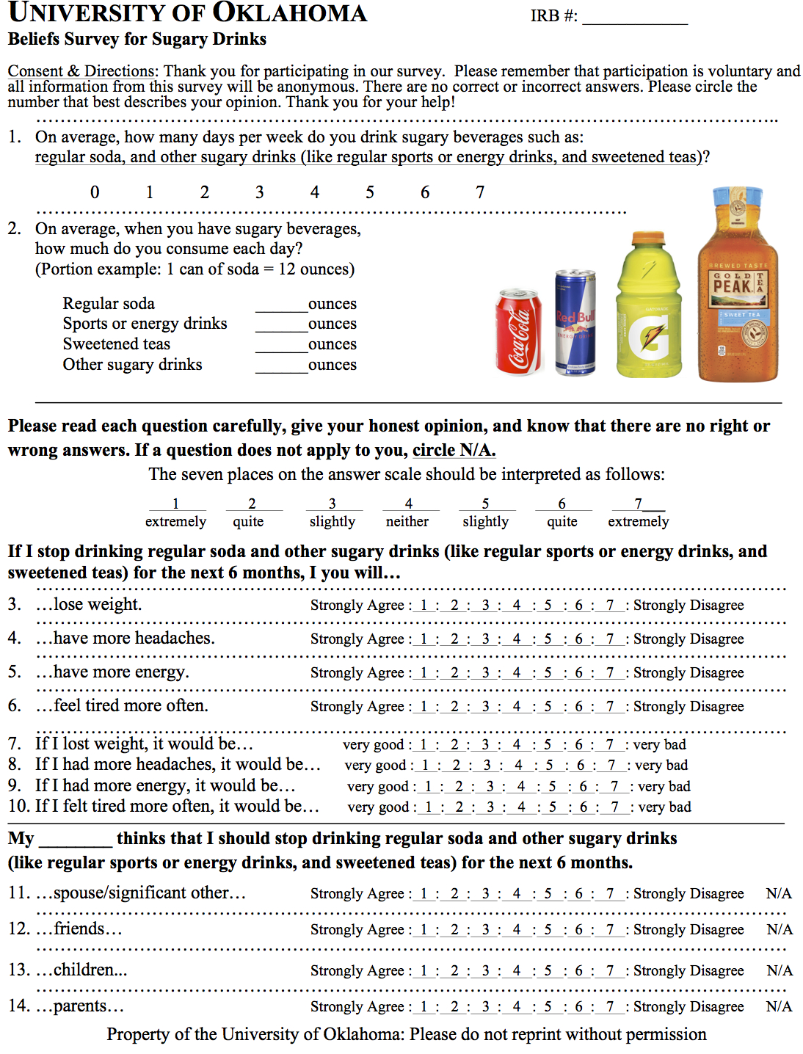

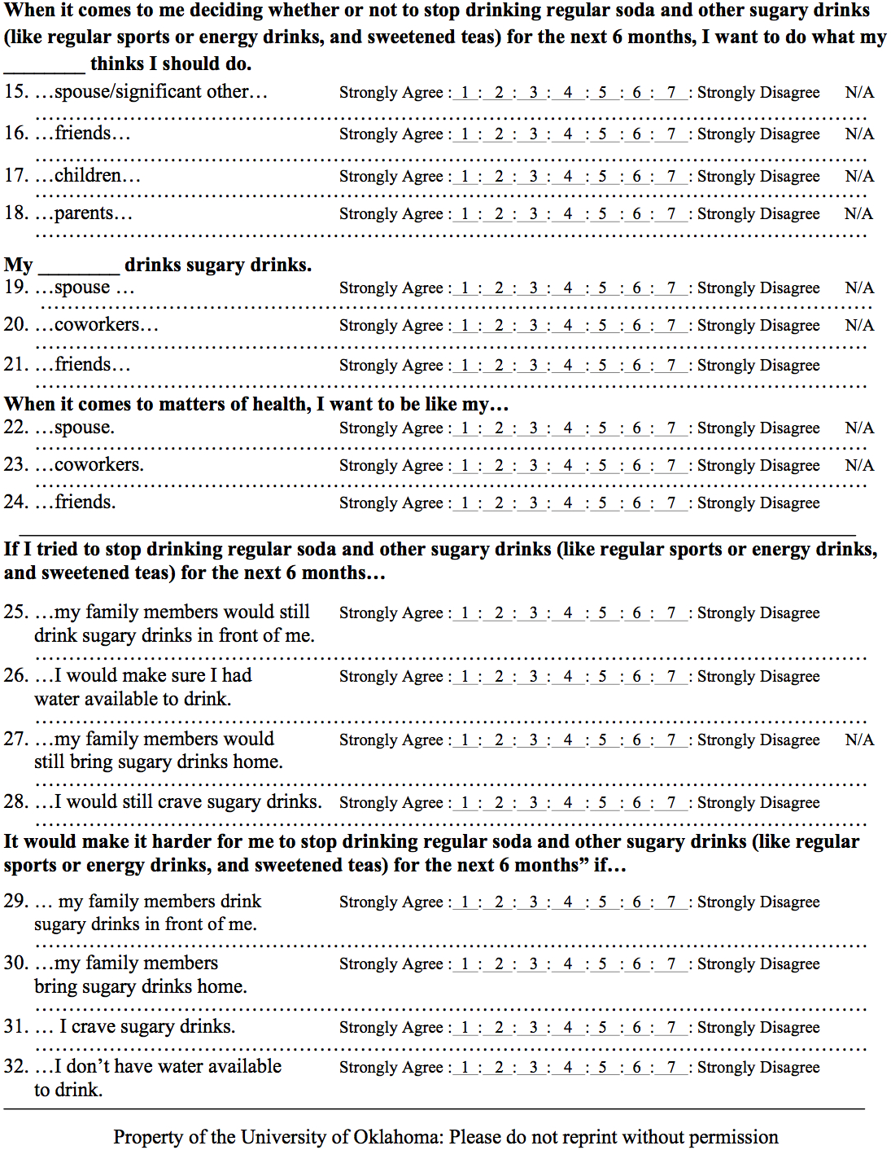

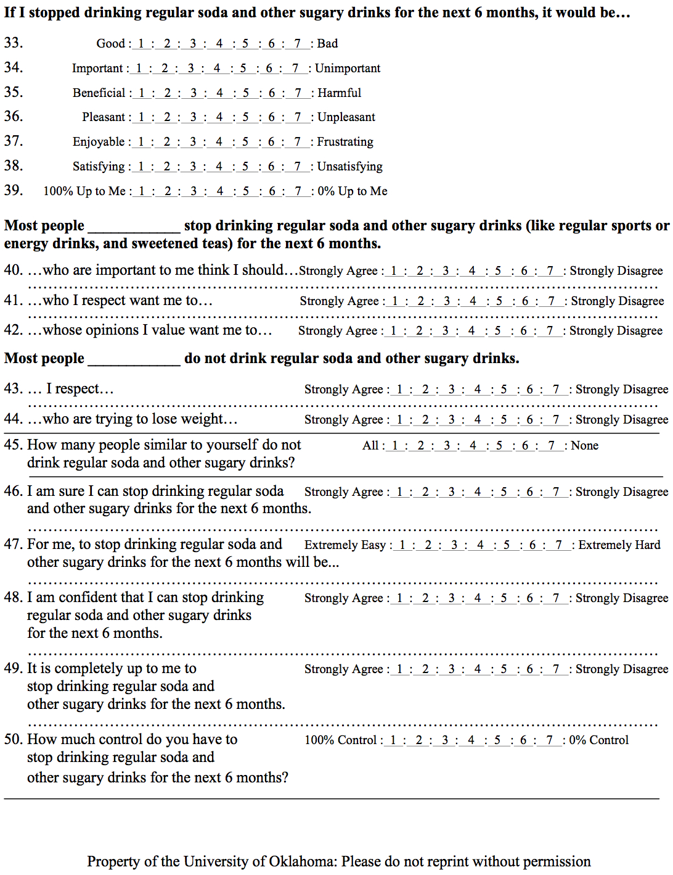

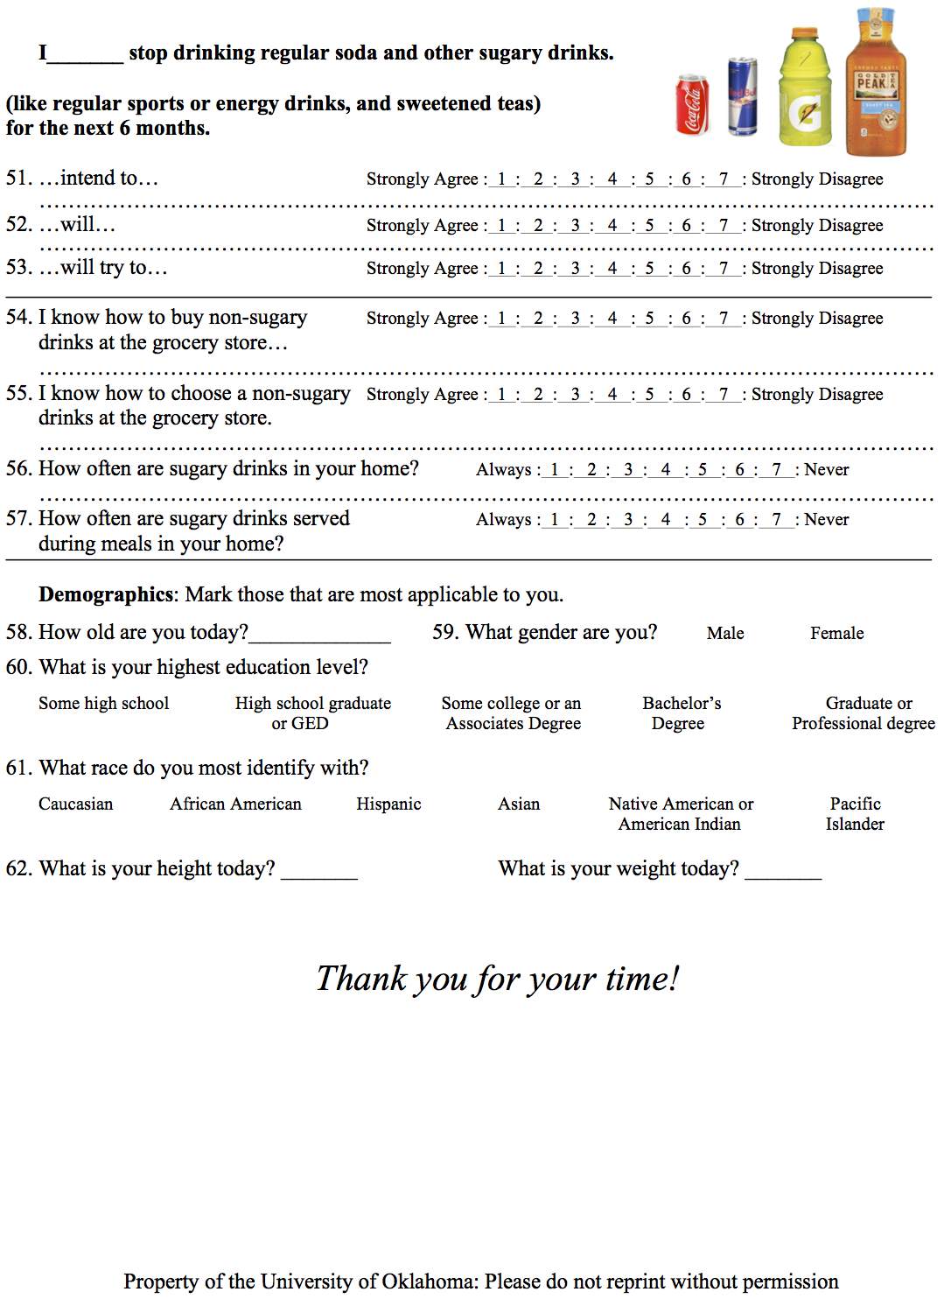

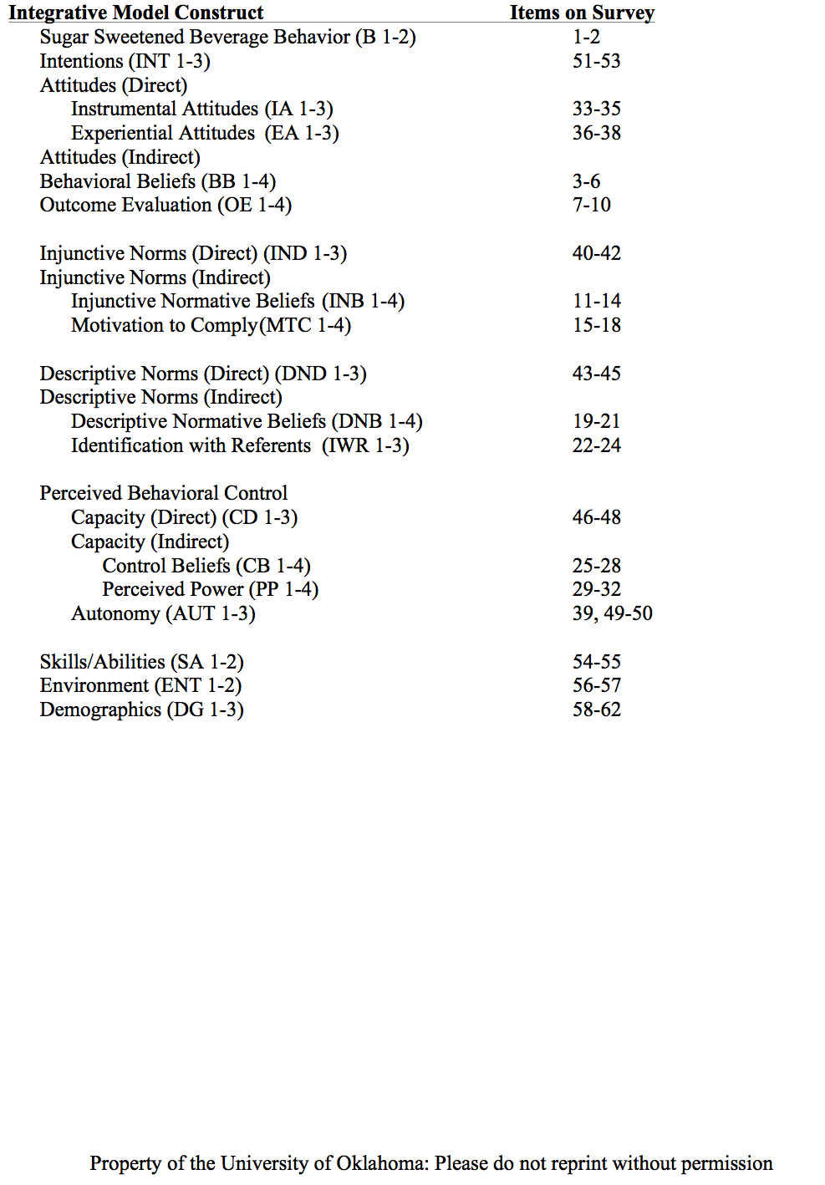
Appendix B: Panel of Experts
Paul Branscum, Ph.D., RD
Assistant Professor and Graduate Liaison
Department of Health and Exercise Science
The University of Oklahoma

Marshall Cheney, Ph.D.
Assistant Professor
Department of Health and Exercise Science
The University of Oklahoma

Haijuan Gao, Ph.D.
Assistant Professor
Department of Health and Exercise Science
The University of Oklahoma

Donna Tall Bear, M.S.
Instructor
Department of Health and Exercise Science
The University of Oklahoma

E. Laurette Taylor, Ph.D.
Associate Professor
Department of Health and Exercise Science
The University of Oklahoma

Christopher Wheldon, Ph.D.
Cancer Prevention Fellow
Division of Cancer Prevention
National Cancer Institute, NIH

